

Table of Contents
Front Matter
1. MongoDB Features and Installation
2. MongoDB CRUD Operations
3. Data Modeling and Aggregation
4. Indexes
5. Replication and Sharding
6. Multidocument Transactions
7. MongoDB Monitoring and Backup
8. MongoDB Security
Back Matter
Subhashini Chellappan and Dharanitharan Ganesan

MongoDB Recipes

With Data Modeling and Query Building Strategies

Subhashini Chellappan
Bangalore, India
Dharanitharan Ganesan
Krishnagiri, Tamil Nadu, India
Any source code or other supplementary material referenced by the author in this book is available to readers on GitHub via the book’s product page, located at www.​apress.​com/​978-1-4842-4890-4 . For more detailed information, please visit http://​www.​apress.​com/​source-code .
ISBN 978-1-4842-4890-4e-ISBN 978-1-4842-4891-1
https://doi.org/10.1007/978-1-4842-4891-1
© Subhashini Chellappan and Dharanitharan Ganesan 2020
Apress Standard
Trademarked names, logos, and images may appear in this book. Rather than use a trademark symbol with every occurrence of a trademarked name, logo, or image we use the names, logos, and images only in an editorial fashion and to the benefit of the trademark owner, with no intention of infringement of the trademark. The use in this publication of trade names, trademarks, service marks, and similar terms, even if they are not identified as such, is not to be taken as an expression of opinion as to whether or not they are subject to proprietary rights.
While the advice and information in this book are believed to be true and accurate at the date of publication, neither the authors nor the editors nor the publisher can accept any legal responsibility for any errors or omissions that may be made. The publisher makes no warranty, express or implied, with respect to the material contained herein.
Distributed to the book trade worldwide by Springer Science+Business Media New York, 233 Spring Street, 6th Floor, New York, NY 10013. Phone 1-800-SPRINGER, fax (201) 348-4505, e-mail orders-ny@springer-sbm.com, or visit www.springeronline.com. Apress Media, LLC is a California LLC and the sole member (owner) is Springer Science + Business Media Finance Inc (SSBM Finance Inc). SSBM Finance Inc is a Delaware corporation.
Introduction

Why This Book?
MongoDB is an open source, document-oriented NoSQL database written in C++. MongoDB provides high availability, automatic scaling, and high performance. The book has the following within its scope:
Introduction to NoSQL databases, features of MongoDB, and installation procedures
Complete CRUD operations and MongoDB query language examples
Demonstrations of the aggregation framework to group data and perform aggregation operations
Indexing details to improve the performance of a query
Replication and sharding features to increase data availability and avoid data loss in case of a failure
Monitoring the database and backup strategies
Security features to implement proper authentication and authorization

Who Is This Book For?
The audience for this book includes all levels of IT professionals and anyone who wants to get a good understanding of MongoDB.

How Is This Book Organized?
Chapter 1 describes NoSQL databases, various features of MongoDB, the installation procedure, and how to interact with MongoDB.
Chapter 2 describes MongoDB’s rich query language to support create, read, update, and delete (CRUD) operations.
Chapter 3 describes the aggregation framework to perform aggregation operations. The aggregation framework can group data and perform a variety of operations on that grouped data.
Chapter 4 describes indexes, types of index, index properties, and the various indexing strategies to be considered. Indexes are used to improve the performance of a query.
Chapter 5 describes the various replication and sharding strategies in MongoDB. Replication is the process of creating and managing a duplicate version of a database across servers to provide redundancy and increase the availability of data. Sharding distributes data across servers to increase availability.
Chapter 6 describes the multi-document transactions feature. Multi-document transactions help us to achieve all-or-nothing execution to maintain data integrity.
Chapter 7 describes the details of various tools to monitor a MongoDB database and procedures for backup operations. These MongoDB monitoring tools help us to understand what is happening with a database at various levels.
Chapter 8 describes the various security features in MongoDB to verify the identity of the user and access controls to determine the verified user’s access to resources and operations.

How Can I Get the Most Out of This Book?
It is easy to leverage this book for maximum gain by reading the chapters thoroughly. Get hands-on by following the step-by-step instructions provided in the recipes. Do not skip any of the demonstrations. If need be, repeat them a second time or until the concept is firmly etched in your mind. Happy learning!
Subhashini Chellappan
Dharanitharan Ganesan
Acknowledgments
The making of this book was a journey that we are glad we undertook. The journey spanned a few months, but the experience will last a lifetime. We had our families, friends, colleagues, and other well-wishers onboard for this journey and we wish to express our deepest gratitude to each one of them.
We would like to express our special thanks to our families, friends, and colleagues who provided the support that allowed us to complete this book within a limited time frame.
Special thanks are extended to our technical reviewers for the vigilant review and filling in with their expert opinion.
We would like to thank Celestin Suresh John at Apress for signing us up for this wonderful creation. We wish to acknowledge and appreciate all our coordinating editors and the team who guided us through the entire process of preparation and publication.

Table of Contents
Chapter 1:​ MongoDB Features and Installation
The Need for NoSQL Databases
What Are NoSQL Databases?​
CAP Theorem
BASE Approach
Types of NoSQL Databases
MongoDB Features
Document Database
MongoDB Is Schemaless
MongoDB Uses BSON
Rich Query Language
Aggregation Framework
Indexing
GridFS
Replication
Sharding
The mongo Shell
Terms Used in MongoDB
Data Types in MongoDB
MongoDB Installation
Recipe 1-1.​ Install MongoDB on Windows
Recipe 1-2.​ Install MongoDB on Ubuntu
Recipe 1-3.​ Install MongoDB Compass on Windows
Working with Database Commands
Recipe 1-4.​ Create Database
Recipe 1-5.​ Drop Database
Recipe 1-6.​ Display List of Databases
Recipe 1-7.​ Display the Version of MongoDB
Recipe 1-8.​ Display a List of Commands
Chapter 2:​ MongoDB CRUD Operations
Collections
Recipe 2-1.​ Create a Collection
Recipe 2-2.​ Create Capped Collections
Create Operations
Recipe 2-3.​ Insert Documents
Read Operations
Recipe 2-4.​ Query Documents
Update Operations
Recipe 2-5.​ Update Documents
Delete Operations
Recipe 2-6.​ Delete Documents
MongoDB Import and Export
Recipe 2-7.​ Work with Mongo Import
Recipe 2-8.​ Work with Mongo Export
Embedded Documents in MongoDB
Recipe 2-9.​ Query Embedded Documents
Working with Arrays
Recipe 2-10.​ Working with Arrays
Recipe 2-11.​ Query an Array of Embedded Documents
Project Fields to Return from Query
Recipe 2-12.​ Restricting the Fields Returned from a Query
Query for Null or Missing Fields
Recipe 2-13.​ To Query Null or Missing Fields
Iterate a Cursor
Recipe 2-14.​ Iterate a Cursor
Working with the limit() and skip() Methods
Recipe 2-15.​ limit() and skip() Methods
Working with Node.​js and MongoDB
Recipe 2-16.​ Node.​js and MongoDB
Chapter 3:​ Data Modeling and Aggregation
Data Models
Embedded Data Models
Normalized Data Models
Data Model Relationship Between Documents
Recipe 3-1.​ Data Model Using an Embedded Document
Recipe 3-2.​ Data Model Using Document References
Modeling Tree Structures
Recipe 3-3.​ Model Tree Structure with Parent References
Aggregation
Aggregation Pipeline
Recipe 3-4.​ Aggregation Pipeline
Map-Reduce
Recipe 3-5.​ Map-Reduce
Single-Purpose Aggregation Operations
Recipe 3-6.​ Single-Purpose Aggregation Operations
SQL Aggregation Terms and Corresponding MongoDB Aggregation Operators
Recipe 3-7.​ Matching SQL Aggregation to MongoDB Aggregation Operations
Chapter 4:​ Indexes
Recipe 4-1.​ Working with Indexes
Recipe 4-2.​ Index Types
Recipe 4-3.​ Index Properties
Recipe 4-4.​ Indexing Strategies
Chapter 5:​ Replication and Sharding
Replication
Recipe 5-1.​ Set Up a Replica Set
Sharding
Recipe 5-2.​ Sharding
Chapter 6:​ Multidocument Transactions
Multidocument Transactions in MongoDB
Limitations of Transactions
Transactions and Sessions
Recipe 6-1.​ Working with Multidocument Transactions
Recipe 6-2.​ Isolation Test Between Two Concurrent Transactions
Recipe 6-3.​ Transactions with Write Conflicts
Recipe 6-4.​ Discarding Data Changes with abortTransaction​
Chapter 7:​ MongoDB Monitoring and Backup
MongoDB Monitoring
Log File
Recipe 7-1.​ Working with MongoDB Log Files
MongoDB Performance
Recipe 7-2.​ Working with Database Profiler
Recipe 7-3.​ View Database Profiler
Recipe 7-4.​ Working with mongostat
Recipe 7-5.​ Working with mongotop
Recipe 7-6.​ Working with db.​stats()
Recipe 7-7.​ Working with db.​serverStatus()
Backup and Restore with MongoDB Tools
Recipe 7-8.​ Working with mongodump
Automatic and Regular Backup Scheduling Using mongodump
Recipe 7-9.​ Working with mongorestore
Recipe 7-10.​ Working with mongodb Query Plans
Chapter 8:​ MongoDB Security
Authentication and Authorization
Access Control
Roles
Recipe 8-1.​ Creating a Superuser and Authenticating a User
Recipe 8-2.​ Authenticating a Server in a Replica Set Using a Key File
Recipe 8-3.​ Modifying Access for the Existing User
Recipe 8-4.​ Change the Password for the Existing User
Recipe 8-5.​ Track the Activity of Users in a Cluster
Recipe 8-6.​ Encryption
Index

About the Authors and About the Technical Reviewer

About the Authors
Subhashini Chellappan

is a technology enthusiast with expertise in the big data and cloud space. She has rich experience in both academia and the software industry. Her areas of interest and expertise are centered on business intelligence, big data analytics, and cloud computing.

Dharanitharan Ganesan

has an MBA in technology management with high level of exposure and experience in big data—Apache Hadoop, Apache Spark, and various Hadoop ecosystem components. He has a proven track record of improving efficiency and productivity through the automation of various routine and administrative functions in business intelligence and big data technologies. His areas of interest and expertise are centered on machine learning algorithms, blockchain in big data, statistical modeling, and predictive analytics.

About the Technical Reviewer
Manoj Patil

has been working in the software industry for nearly 20 years. He holds an engineering degree from COEP, Pune (India) and since then has enjoyed an exciting IT journey.
As a Principal Architect at TatvaSoft, Manoj has undertaken many initiatives in the organization ranging from training and mentoring teams leading the data science and machine learning practice, to successfully designing client solutions from different functional domains.
Starting as a Java programmer, he is one of the fortunate to have worked on multiple frameworks with multiple languages as a full-stack developer. In last five years, he has worked extensively in the field of business intelligence, big data, and machine learning with the technologies like Hitachi Vantara (Pentaho), Hadoop ecosystem, tensorflow, Python-based libraries, and more.
He is passionate about learning new technologies, trends, and reviewing books. When he is not working, he is either working out or reading infinitheism literature.
Manoj would like to thank Apress for providing this opportunity to review this title and his two daughters Ayushee and Ananyaa for their understanding during the process.

© Subhashini Chellappan and Dharanitharan Ganesan 2020
S. Chellappan, D. GanesanMongoDB Recipes
https://doi.org/10.1007/978-1-4842-4891-1_1

1. MongoDB Features and Installation
Subhashini Chellappan1 and Dharanitharan Ganesan2
(1)
Bangalore, India
(2)
Krishnagiri, Tamil Nadu, India

This chapter describes NoSQL databases, various features of MongoDB, and how to interact with MongoDB. We are going to focus on the following topics:
Why NoSQL?
What are NoSQL databases?
CAP theorem.
BASE approach.
Types of NoSQL databases.
MongoDB features.
MongoDB installation on Windows.
MongoDB installation on Linux.
MongoDB Compass installation on Windows.
Terms used in MongoDB.
Data types in MongoDB.
Database commands.

The Need for NoSQL Databases
There are several database challenges for modern applications, including the following.
Modern application storage capacity exceeds the storage capabilities of the traditional relational database management system (RDBMS).
Modern applications require unknown level of scalability.
Modern applications should be available 24/7.
Data needs to be distributed globally.
Users should be able to read and write data anywhere.
Users always seek reduction of software and hardware costs.
All these challenges have given birth to the NoSQL databases.

What Are NoSQL Databases?
NoSQL databases are open source, nonrelational, distributed databases that allow organizations to analyze huge volumes of data.
The following are some of the key advantages of NoSQL databases:
Availability.
Fault tolerance.
Scalability.
NoSQL databases have the following characteristics:
They do not use SQL as a query language.
Most NoSQL databases are designed to run on clusters.
They operate without a schema, freely adding fields to the database without having to define any changes in structure first.
They are polygot persistent, meaning there are different ways to store the data based on the requirements.
They are designed in such a way that they can be scaled out.

CAP Theorem
The CAP theorem states that any distributed system can satisfy only two of these three properties:
Consistency implies that every read fetches the last write.
Availability implies that reads and writes always succeed. In other words, each nonfailing node will return a response in a reasonable amount of time.
Partition tolerance implies that the system will continue to function even when there is a data loss or system failure.
Figure 1-1 is a graphical representation of the CAP theorem.
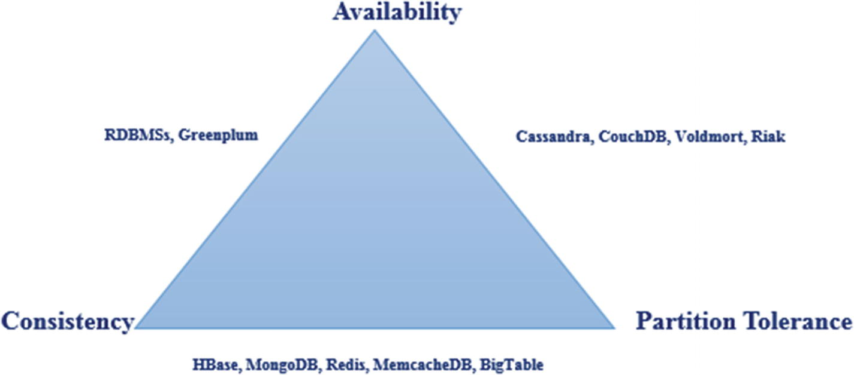
Figure 1-1CAP theorem
CAP therorem categorizes a system according to three categories:
1. | Consistency and availability.
2. | Consistency and partition tolerance.
3. | Availability and partition tolerance.
NoteThe partition tolerance property is a must for NoSQL databases.

BASE Approach
NoSQL databases are based on the BASE approach. BASE stands for:
Basic availability: The database should be available most of the time.
Soft state: Tempory inconsistency is allowed.
Eventual consistency: The system will come to a consistent state after a certain period.

Types of NoSQL Databases
NoSQL databases are generally classified into four types, as shown in Table 1-1.
Table 1-1Types of NoSQL Databases
Data Model | Example | Description
Key/Value Store | Dynamo DB, Riak | • Least complex NoSQL options.  • Key and a value.
Column Store | HBase, Big Table | • Also known as wide column store.  • Storing data tables as sections of columns of data.
Document Store | MongoDB, CouchDB | • Extends key/value idea.  • Storing data as a document.  • Complex NoSQL options.  • Each document contains a unique key that is used to retrieve the document.
Graph Database | Neo4j | • Based on graph theory.  • Storing data as nodes, edges, and properties.

MongoDB Features
MongoDB is an open source, document-oriented NoSQL database written in C++. MongoDB provides high availability, automatic scaling, and high performance. The following sections introduce the features of MongoDB.

Document Database
In MongoDB, a record is represented as a document. A document is a combination of field and value pairs. MongoDB documents are similar to JavaScript Object Notation (JSON) documents. Figure 1-2 represents a document.
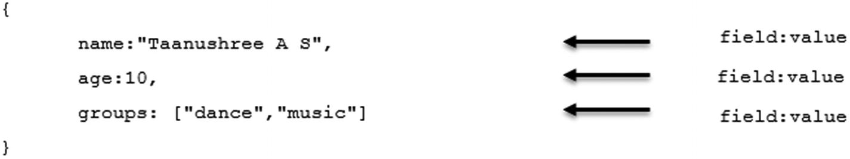
Figure 1-2A document
These are the advantages for using documents.
In many programming languages, a document corresponds to native data types.
Embedded documents help in reducing expensive joins.

MongoDB Is Schemaless
MongoDB is a schemaless database, which means a collection (like a table in an RDBMS) can hold different documents (like records in an RDBMS). This way, MongoDB provides flexibility in dealing with the schemas in a database. Refer to the following collection, Person.
{name:"Aruna M S", age:12 } //document with two fields.
{ssn:100023412, name:"Anbu M S",groups:["sports","news"]} //document with three fields.
Here, the collection Person has two documents, each with different fields, contents, and size.

MongoDB Uses BSON
JSON is an open source standard format for data interchange. Document databases use JSON format to store records. Here is an example of a JSON document.
{
name:"John",
addresses:[
{
address:"123,River Road",
status:"office"
},
{
address:"345,Mount Road",
status:"personal"
}
]
}
MongoDB represents JSON documents in a binary-encoded format, Binary JSON (BSON), behind the scenes. BSON extends the JSON model to provide additional data types such as dates that are not supported by JSON. BSON uses the _id field called ObjectId as the primary key. The value of the _id field is generated either by the MongoDB service or by an application program. Here is an example of ObjectId:
"_id": ObjectId("12e6789f4b01d67d71da3211")

Rich Query Language
MongoDB provides a rich query language to support create, read, update, and delete (CRUD) operations, data aggregation, and text searches. Let us understand how to query a collection in MongoDB with an example. Consider the following collection, Employee.
{_id: 10001, name:"Subhashini",unit:"Hadoop"}
{_id: 10002, name:"Shobana", unit:"Spark"}
To display employee details, the MongoDB query would be
db.Employee.find();
We discuss MongoDB query language in detail in Chapter 2.

Aggregation Framework
MongoDB provides an aggregation framework to perform aggregation operations. The aggregation framework can group data from multiple documents and perform variety operations on that grouped data. MongoDB provides an aggregation pipeline, the map-reduce function, and single-purpose aggregation methods to perform aggregation operations. We discuss the aggregation framework in detail in Chapter 3.

Indexing
Indexes improve the performance of query execution. MongoDB uses indexes to limit the number of documents scanned. We discuss various indexes in Chapter 4.

GridFS
GridFS is a specification for storing and retrieving large files. GridFS can be used to store files that exceed the BSON maximum document size of 16 MB. GridFS divides the file into parts known as chunks and stores them as separate documents. GridFS divides the file into chunks of 255 KB, except the last chunk, the size of which is based on the file size.

Replication
Replication is a process of copying an instance of a database to a different database server to provide redundancy and high availability. Replication provides fault tolerance against the loss of a single database server. In MongoDB, the replica set is a group of mongod processes that maintain the same data set. We discuss how to create replica sets in Chapter 5.

Sharding
A single server can be a challenge when we need to work with large data sets and high throughput applications in terms of central processing unit (CPU) and inout/output (I/O) capacity. MongoDB uses sharding to support large data sets and high-throughput operations. Sharding is a method for distributing data across multiple systems, discussed in detail in Chapter 5.

The mongo Shell
The mongo shell is an interactive JavaScript interface to MongoDB. The mongo shell is used to query, update data, and perform administrative operations. The mongo shell is a component of MongoDB distributions. When you start the mongod process, the mongo shell will be connected to a MongoDB instance.

Terms Used in MongoDB
Let us understand the terms used in MongoDB, provided in Table 1-2.
Table 1-2MongoDB Terms
Terms | MongoDB
MongoDB server | mongod
MongoDB client | mongo
Table 1-3 shows the equivalent terms used in RDBMS and MongoDB.
Table 1-3Equivalent Terms for RDBMS and MongoDB
RDBMS | MongoDB
Database | Database
Table | Collection
Record | Document
Columns | Fields or key/value pairs
ACID transactions | ACID transactions
Secondary index | Secondary index
JOINs | Embedded document, $lookup
GROUP_BY | Aggregation pipeline

Data Types in MongoDB
Table 1-4 provides a description of the data types in MongoDB.
Table 1-4MongoDB Data Types
String | Strings are UTF-8
Integer | Can be 32-bit or 64-bit
Double | To store floating-point values
Arrays | To store a list of values into one key
Timestamps | For MongoDB internal use; values are 64-bit  Record when a document has been modified or added
Date | A 64-bit integer that represents the number of milliseconds since the Unix epoch (January 1, 1970)
ObjectId | Small, unique, fast to generate, and ordered  Consist of 12 bytes, where the first four bytes are a timestamp that reflects the ObjectId’s creation
Binary data | To store binary data (images, binaries, etc.)
Null | To store NULL value
NoteRefer to the following link for data types in MongoDB: https://docs.mongodb.com/manual/reference/bson-types/

MongoDB Installation
Let us learn how to install MongoDB.

Recipe 1-1. Install MongoDB on Windows
In this recipe, we are going to discuss how to install MongoDB on Windows.

Problem
You want to install MongoDB on Windows.

Solution
Download the MongoDB msi installer from https://www.mongodb.com/download-center#enterprise.

How It Works
Let’s follow the steps in this section to install MongoDB on Windows.

Step 1: Install the msi Installer
Right-click the Windows installer, select Run as Administrator, and follow the instructions to install MongoDB.

Step 2: Create a Data Directory
Create \data\db directory in C:\ to store MongoDB data. Directory looks like “C:\data\db”.

Step 3: Start the MongoDB Server
Open the command prompt and navigate to the MongoDB installation folder. Issue the following command to start the MongoDB server, as shown in Figure 1-3.
mongod.exe
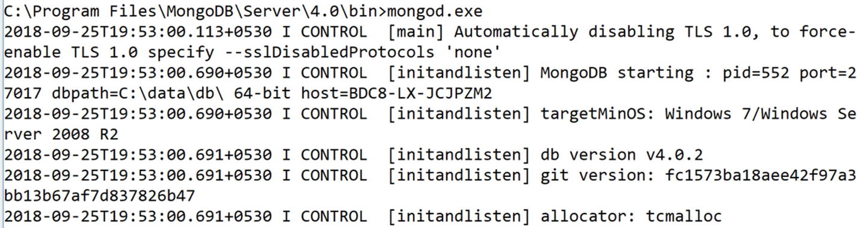
Figure 1-3Starting MongoDB Server
You should get a message that states “Waiting for connection on port 27017.”

Step 4: Start the MongoDB Client
Open another command prompt and navigate to the MongoDB installation folder. Issue the following command to start the MongoDB client, as shown in Figure 1-4.
mongo.exe
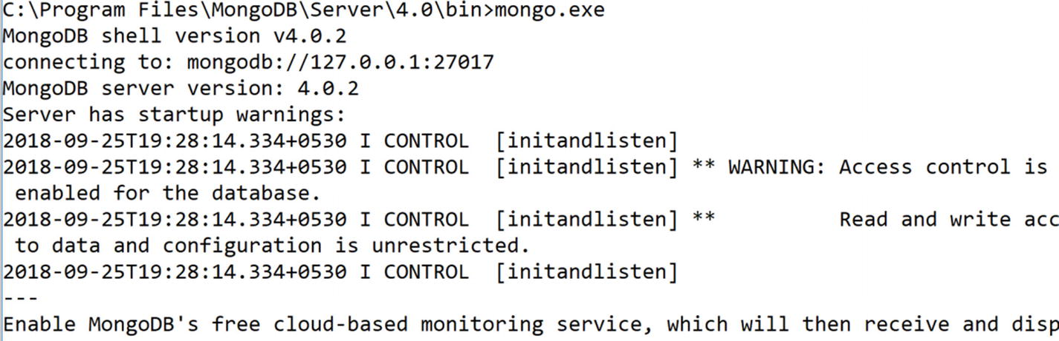
Figure 1-4Starting MongoDB Client
We can see the mongo shell.
This confirms, we have installed MongoDB on windows.

Recipe 1-2. Install MongoDB on Ubuntu
In this recipe, we are going to discuss how to install MongoDB on Ubuntu.

Problem
You want to install MongoDB on Ubuntu.

Solution
Download the MongoDB tarball from https://www.mongodb.com/download-center/community.

How It Works
Let’s follow the steps in this section to install MongoDB on Ubuntu.

Step 1: Extract the tarball
Issue the following command to untar the tarball:
tar -xzf mongodb-linux-x86_64-ubuntu1604-4.0.8.tgz

Step 2: Create a Data Directory
Create a /data/db directory as shown in Recipe 1-1.

Step 3: Start the MongoDB Server
Open the terminal, navigate to the MongoDB installation folder, and issue the following command to start the MongoDB server.
./mongod --dbpath <data directory path>

Step 4: Start the MongoDB Client
Open another terminal, navigate to the MongoDB installation folder, and issue the following command to start the MongoDB client.
./mongo.exe

Recipe 1-3. Install MongoDB Compass on Windows
In this recipe, we are going to discuss how to install MongoDB Compass on Windows. MongoDB Compass is a simple-to-use graphical user interface (GUI) for interacting with MongoDB.

Problem
You want to install MongoDB Compass on Windows.

Solution
Download the MongoDB Compass msi installer from https://www.mongodb.com/download-center#compass.

How It Works
Let’s follow the steps in this section to install MongoDB Compass on Windows.

Step 1: Install the MongoDB Compass msi Installer
Right-click the MongoDB Compass Windows installer, select Run as Administrator, and follow the instructions to install MongoDB Compass. Figure 1-5 shows the MongoDB Compass GUI.
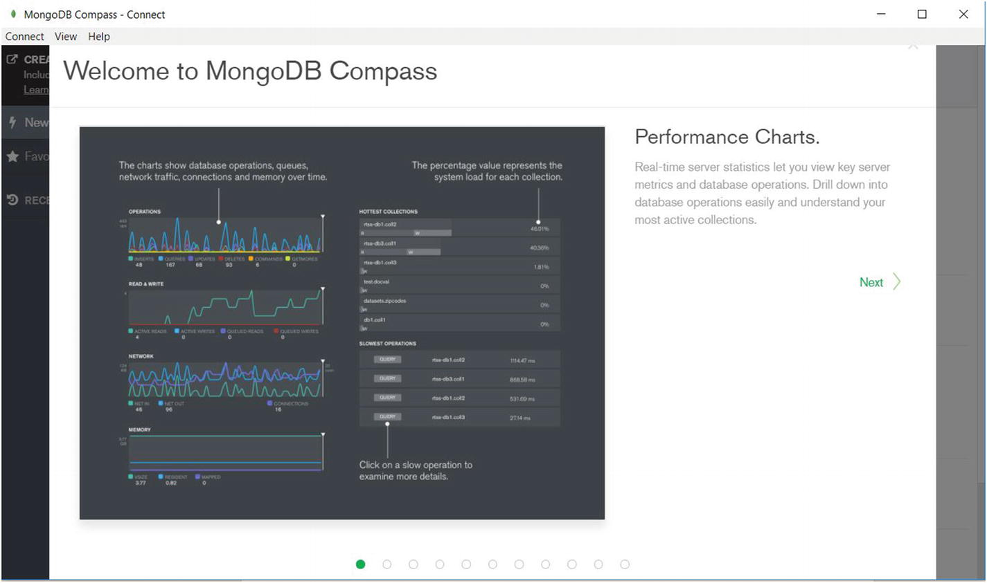
Figure 1-5MongoDB Compass GUI

Step 2: Start the MongoDB Server
Open the command prompt, navigate to the MongoDB installation folder, and issue the following command to start the MongoDB server.
mongod.exe
You should see a message that states “Waiting for connection on port 27017.”
NoteThe default port number for MongoDB is 27017.

Step 3: Connect MongoDB Compass with MongoDB Server
Click the New Connection tab. Enter the required details, as shown in Figure 1-6.
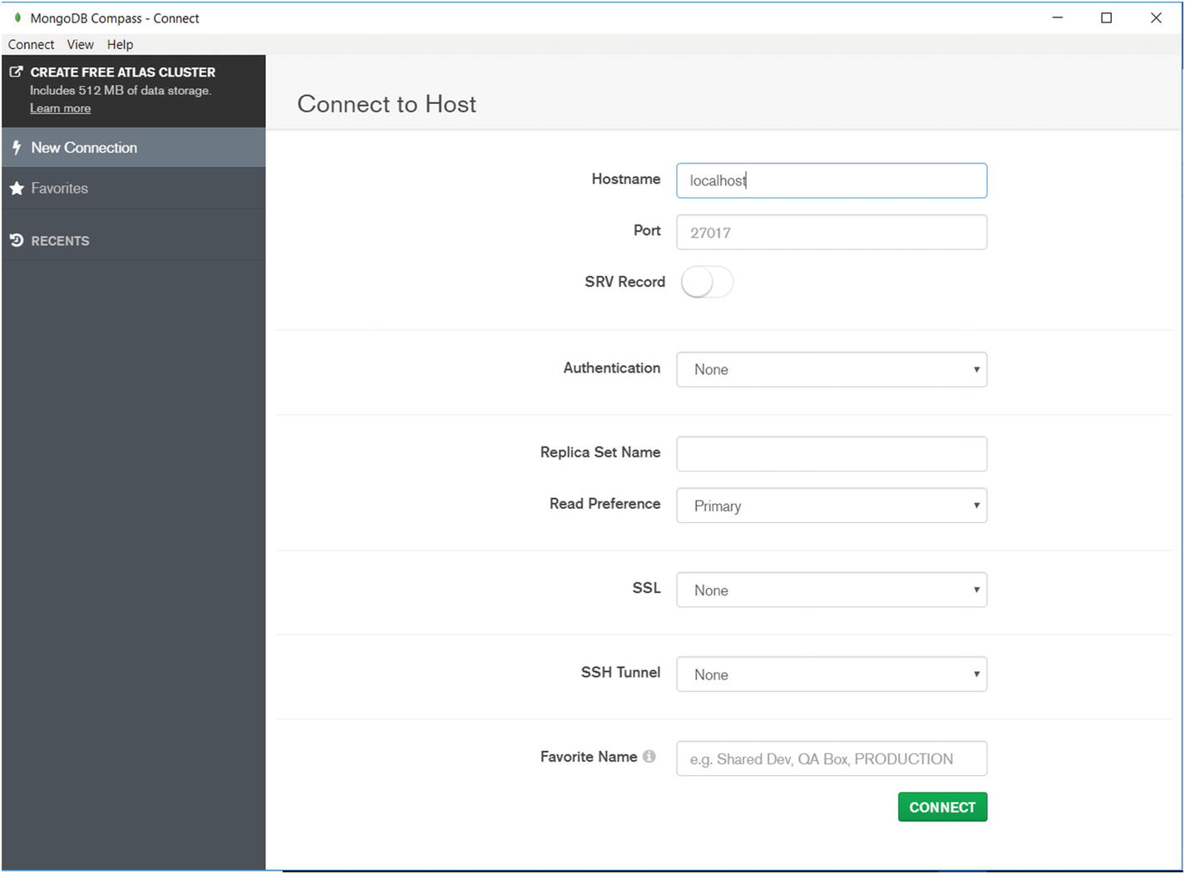
Figure 1-6New Connection page
Click Connect to connect to the MongoDB Server as shown in Figure 1-7.
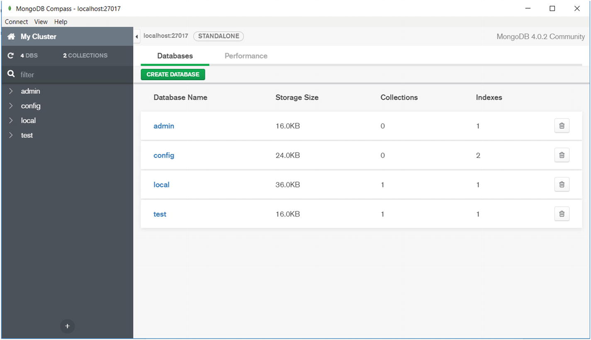
Figure 1-7Connecting MongoDB Compass to the MongoDB server
We have now connected MongoDB Compass to the MongoDB server.

Working with Database Commands
Next, we discuss database commands in MongoDB.

Recipe 1-4. Create Database
In this recipe, we are going to discuss how to create a database in MongoDB.

Problem
You want to create a database in MongoDB.

Solution
Use the following syntax to create a database in MongoDB.
use <database name>

How It Works
Let’s follow the steps in this section to create a database in MongoDB.

Step 1: Create a database
To create a database named mydb, use this command:
use mydb
Here is the output,
> use mydb
switched to db mydb
>
To confirm the existence of the database, type the following command in the mongo shell.
> db
mydb
>
This shows that you are working in the mydb database, so you know we have created a database by that name.

Recipe 1-5. Drop Database
In this recipe, we are going to discuss how to drop a database in MongoDB.

Problem
You want to drop a database in MongoDB.

Solution
Use the following syntax to drop a database in MongoDB.
db.dropDatabase()

How It Works
Let’s follow the steps in this section to drop a database in MongoDB.

Step 1: Drop a Database
To drop a database, first ensure that you are working in the database that you want to drop. Use the db.dropDatabase() method .
use mydb
Here is the output,
> use mydb
switched to db mydb
>
> db.dropDatabase()
{ "ok" : 1 }
>
We have thus dropped the database named mydb.
NoteIf no database is selected, the default database test is dropped.

Recipe 1-6. Display List of Databases
In this recipe, we are going to discuss how to display a list of databases.

Problem
You want to display a list of databases.

Solution
Use the following syntax to display a list of databases.
show dbs
show databases

How It Works
Let’s follow the steps in this section to display a list of databases.

Step 1: Display a List of Databases
Type the following command in the mongo shell.
show dbs
show databases
Here is the output,
> show dbs
admin 0.000GB
config 0.000GB
local 0.000GB
test 0.000GB
>
> show databases;
admin 0.000GB
config 0.000GB
local 0.000GB
>
We can now see the list of databases.
NoteThe newly created database mydb is not shown in the list. This is because the database needs to have at least one collection to display in the list. The default database is test.

Recipe 1-7. Display the Version of MongoDB
In this recipe, we are going to discuss how to display the version of MongoDB.

Problem
You want to display the version of MongoDB.

Solution
Use the following syntax to display the version of MongoDB.
db.version()

How It Works
Let’s follow the steps in this section to display the version of MongoDB.

Step 1: Display the Version of MongoDB
Type the following command in the mongo shell.
db.version()
Here is the output,
> db.version()
4.0.2
>
We can see that the version of MongoDB is 4.0.2.

Recipe 1-8. Display a List of Commands
In this recipe, we are going to see how to display the list of MongoDB commands.

Problem
You want to display the list of MongoDB commands.

Solution
Use the following syntax to display a list of commands.
db.help()

How It Works
Let’s follow the steps in this section to display a list of commands.

Step 1: Display a List of Commands
Type the following command in the mongo shell.
db.help()
Here is the output,
> db.help()
dB methods:
db.adminCommand(nameOrDocument) - switches to 'admin' db, and runs command [just calls db.runCommand(...)]
We can now see the list of MongoDB commands.
NoteA few scenarios where we can apply MongoDB are e-commerce product catalogs, blogs, and content management.
In next chapter, we discuss how to perform CRUD operations using MongoDB query language.
© Subhashini Chellappan and Dharanitharan Ganesan 2020
S. Chellappan, D. GanesanMongoDB Recipes
https://doi.org/10.1007/978-1-4842-4891-1_2

2. MongoDB CRUD Operations
Subhashini Chellappan1 and Dharanitharan Ganesan2
(1)
Bangalore, India
(2)
Krishnagiri, Tamil Nadu, India

In Chapter 1, we discussed MongoDB features and how to install MongoDB on Windows and Linux. We also discussed terms used in MongoDB and how to create a database. In this chapter, we are going to discuss how to perform create, read, update, and delete (CRUD) operations in MongoDB. This chapter also describes how to work with embedded document and arrays. We are going to discuss the following topics:
Collections.
MongoDB CRUD operations.
Bulk write operations.
MongoDB import and export.
Embedded documents.
Working with arrays.
Array of embedded documents.
Projection.
Dealing with null and missing values.
Working with limit() and skip().
Working with Node.js and MongoDB.

Collections
MongoDB collections are similar to tables in RDBMS. In MongoDB, collections are created automatically when we refer to them in a command. For an example, consider the following command.
db.person.insert({_id:100001,name:"Taanushree A S",age:10})
This command creates a collection named person if it is not present. If it is present, it simply inserts a document into the person collection.

Recipe 2-1. Create a Collection
In this recipe, we are going to discuss how to create a collection.

Problem
You want to create a collection named person using the db.createCollection() command.

Solution
Use the following syntax to create a collection.
db.createCollection (<name>)

How It Works
Let’s follow the steps in this section to create a collection named person.

Step 1: Create a Collection
To create a collection by the name person use the following command.
db.createCollection("person")
Here is the output,
> db.createCollection("person")
{ "ok" : 1 }
>
To confirm the existence of the collection, type the following command in the mongo shell.
> show collections
person
>
We can now see the collection named person.

Recipe 2-2. Create Capped Collections
In this recipe, we are going to discuss what a capped collection is and how to create one. Capped collections are fixed-size collection for which we can specify the maximum size of the collection in bytes and the number of documents allowed. Capped collections work similar to a circular buffer: Once it fills its allocated space, it makes room for new documents by overwriting the oldest documents in the collection.
There are some limitations of capped collections:
You can’t shard capped collections.
You can’t use the aggregation pipeline operator $out to write results to a capped collection.
You can’t delete documents from a capped collection.
Creating an index allows you to perform efficient update operations.

Problem
You want to create a capped collection named student using the db.createCollection() method .

Solution
Use the following syntax to create a collection.
db.createCollection (<name>,{capped:<boolean>,size:<number>,max:<number>})

How It Works
Let’s follow the steps in this section to create a capped collection named student.

Step 1: Create a Capped Collection
To create a capped collection named student , use the following command.
db.createCollection("student",{capped: true,size:1000,max:2})
Here, size denotes the maximum size of the collection in bytes and max denotes the maximum number of documents allowed.
Here is the output,
> db.createCollection("student",{capped: true,size:1000,max:2})
{ "ok" : 1 }
>
To check if a collection is capped, type the following command in the mongo shell.
> db.student.isCapped()
true
>
We can see that the student collection is capped. Now, we will insert few documents into the student collection, as shown next.
db.student.insert([{ "_id" : 10001, "name" : "Taanushree A S", "age" : 10 },{ "_id" : 10002, "name" : "Aruna M S", "age" : 14 }])
Here is the output,
> db.student.insert([{ "_id" : 10001, "name" : "Taanushree A S", "age" : 10 },{ "_id" : 10002, "name" : "Aruna M S", "age" : 14 }])
BulkWriteResult({
"writeErrors" : [ ],
"writeConcernErrors" : [ ],
"nInserted" : 2,
"nUpserted" : 0,
"nMatched" : 0,
"nModified" : 0,
"nRemoved" : 0,
"upserted" : [ ]
})
>

Step 2: Query a Capped Collection
To query a capped collection, use the following command.
db.student.find()
Here is the output,
> db.student.find()
{ "_id" : 10001, "name" : "Taanushree A S", "age" : 10 }
{ "_id" : 10002, "name" : "Aruna M S", "age" : 14 }
>
Here, MongoDB retrieves the results in the order of insertion. To retrieve documents in the reverse order, use sort() and set the $natural parameter to -1 as shown here.
> db.student.find().sort({$natural:-1})
{ "_id" : 10002, "name" : "Aruna M S", "age" : 14 }
{ "_id" : 10001, "name" : "Taanushree A S", "age" : 10 }
>
We can see the results are now in the reverse order.

Step 3: Insert a Document into a Full Capped Collection
Let’s see what happens when we try to insert a document into a capped collection that has reached its capacity already using the following command.
db.student.insert({_id:10003,name:"Anba V M",age:16})
Here is the output,
> db.student.insert({_id:10003,name:"Anba V M",age:16})
WriteResult({ "nInserted" : 1 })
To query the student collection, use the following command.
> db.student.find()
{ "_id" : 10002, "name" : "Aruna M S", "age" : 14 }
{ "_id" : 10003, "name" : "Anba V M", "age" : 16 }
>
Notice that the first document is overwritten by the third document, as the maximum number of documents allowed in the student capped collection is two.

Create Operations
Create operations allow us to insert documents into a collection. These insert operations target a single collection. All write operations are atomic at the level of a single document.
MongoDB provides several methods for inserting documents, listed in Table 2-1.
Table 2-1Insert Methods
db.collection.insertOne | Inserts a single document
db.collection.insertMany | Inserts multiple documents
db.collection.insert | Inserts a single document or multiple documents

Recipe 2-3. Insert Documents
In this recipe, we are going to discuss various methods to insert documents into a collection.

Problem
You want to insert documents into the collection person.

Solution
Use the following syntax to insert documents.
db.collection.insertOne()
db.collection.insertMany()

How It Works
Let’s follow the steps in this section to insert documents into the collection person.

Step 1: Insert a Single Document
To insert a single document into the collection person, use the following command.
db.person.insertOne({_id:1001,name:"Taanushree AS",age:10})
Here is the output,
> db.person.insertOne({_id:1001,name:"Taanushree AS",age:10})
{ "acknowledged" : true, "insertedId" : 1001 }
>
insertOne() returns a document that contains the newly inserted document’s _id.
If you don’t specify an _id field, MongoDB generates an _id field with an ObjectId value. The _id field act as the primary key.
Here is an example:
> db.person.insertOne({name:"Aruna MS",age:14})
{
"acknowledged" : true,
"insertedId" : ObjectId("5bac7a5113572c1fb994d2fe")
}
>

Step 2: Insert Multiple Documents
To insert multiple documents into the collection person , use the following command.
db.person.insertMany([{_id:1003,name:"Anba V M",age:16},{_id:1004,name:"shobana",age:44}])
Pass an array of documents to the insertMany() method to insert multiple documents.
Here is the output,
> db.person.insertMany([{_id:1003,name:"Anba V M",age:16},{_id:1004,name:"shobana",age:44}])
{ "acknowledged" : true, "insertedIds" : [ 1003, 1004 ] }
>

Read Operations
Read operations allow us to retrieve documents from a collection. MongoDB provides the find() method to query documents.
The syntax for the find() command is
db.collection.find()
You can specify query filters or criteria inside the find() method to query documents based on conditions.

Recipe 2-4. Query Documents
In this recipe, we are going to discuss how to retrieve documents from a collection.

Problem
You want to retrieve documents from a collection.

Solution
Use the following syntax to retrieve documents from a collection.
db.collection.find()

How It Works
Let’s follow the steps in this section to query documents in a collection.

Step 1: Select All Documents in a collection
To select all documents in a collection, use the following command.
db.person.find({})
You need to pass an empty document as a query parameter to the find() method.
Here is the output,
> db.person.find({})
{ "_id" : 1001, "name" : "Taanushree AS", "age" : 10 }
{ "_id" : ObjectId("5bac86dc773204ddade95819"), "name" : "Aruna MS", "age" : 14 }
{ "_id" : 1003, "name" : "Anba V M", "age" : 16 }
{ "_id" : 1004, "name" : "shobana", "age" : 44 }
>

Step 2: Specify Equality Conditions
To specify an equality condition, you need to use <field>:<value> expressions in the query to filter documents.
To select a document from the collection person where the name equals "shobana", here is the command:
db.person.find({name:"shobana"})
Here is the output,
> db.person.find({name:"shobana"})
{ "_id" : 1004, "name" : "shobana", "age" : 44 }
>

Step 3: Specify Conditions Using Query Operator
To select all documents from the collection person where age is greater than 10, here is the command:
db.person.find({age:{$gt:10}})
Here is the output,
> db.person.find({age:{$gt:10}})
{ "_id" : ObjectId("5bac86dc773204ddade95819"), "name" : "Aruna MS", "age" : 14 }
{ "_id" : 1003, "name" : "Anba V M", "age" : 16 }
{ "_id" : 1004, "name" : "shobana", "age" : 44 }
>

Step 4: Specify AND Conditions
In a compound query, you can specify conditions for more than one field. To select all documents in the person collection where the name equals "shobana" and the age is greater than 10, here is the command:
db.person.find({ name:"shobana",age:{$gt:10}})
Here is the output,
> db.person.find({ name:"shobana",age:{$gt:10}})
{ "_id" : 1004, "name" : "shobana", "age" : 44 }
>

Step 5: Specify OR Conditions
You can use $or in a compound query to join each clause with a logical or conjunction.
The operator $or selects the documents from the collection that match at least one of the selected conditions.
To select all documents in the person collection where the name equals "shobana" or age equals 20, here is the command:
db.person.find( { $or: [ { name: "shobana" }, { age: { $eq: 20 } } ] } )
Here is the output,
> db.person.find( { $or: [ { name: "shobana" }, { age: { $eq: 20 } } ] } )
{ "_id" : 1004, "name" : "shobana", "age" : 44 }
>

Update Operations
Update operations allow us to modify existing documents in a collection. MongoDB provides the update methods listed in Table 2-2.
Table 2-2Update Methods
db.collection.updateOne | To modify a single document
db.collection.updateMany | To modify multiple documents
db.collection.replaceOne | To replace the first matching document in the collection that matches the filter
In MongoDB, update operations target a single collection.

Recipe 2-5. Update Documents
In this recipe, we are going to discuss how to update documents.

Problem
You want to update documents in a collection.

Solution
The following methods are used to update documents in a collection.
db.collection.updateOne()
db.collection.updateMany()
db.collection.replaceOne()
Execute the following code in the mongo shell to create the student collection.
db.student.insertMany([{_id:1001,name:"John",marks:{english:35,maths:38},result:"pass"},{_id:1002,name:"Jack",marks:{english:15,maths:18},result:"fail"},{_id:1003,name:"John",marks:{english:25,maths:28},result:"pass"},{_id:1004,name:"James",marks:{english:32,maths:40},result:"pass"},{_id:1005,name:"Joshi",marks:{english:15,maths:18},result:"fail"},{_id:1006,name:"Jack",marks:{english:35,maths:36},result:"pass"}])

How It Works
Let’s follow the steps in this section to update documents in a collection.

Step 1: Update a Single Document
MongoDB provides modify operators to modify field values such as $set.
To use the update operators, pass to the update methods an update document of the form:
{
<update operator>: { <field1>: <value1>, ... },
<update operator>: { <field2>: <value2>, ... },
...
}
To update the first document where name equals joshi, execute the following command.
db.student.updateOne({name: "Joshi"},{$set:{"marks.english": 20}})
Here is the output,
> db.student.updateOne({name: "Joshi"},{$set:{"marks.english": 20}})
{ "acknowledged" : true, "matchedCount" : 1, "modifiedCount" : 1 }
>
Confirm that the field marks has been updated in the student collection:
> db.student.find({name:"Joshi"})
{ "_id" : 1005, "name" : "Joshi", "marks" : { "english" : 20, "maths" : 18 }, "result" : "fail" }
>
NoteYou cannot update the _id field.

Step 2: Update Multiple Documents
Use the following code to update all documents in the student collection where result equals fail.
db.student.updateMany( { "result":"fail" }, { $set: { "marks.english": 20, marks.maths: 20 } })
Here is the output,
> db.student.updateMany( { "result":"fail" }, { $set: {"marks.english": 20, "marks.maths": 20 }})
{ "acknowledged" : true, "matchedCount" : 2, "modifiedCount" : 2 }
>
Here, the modifiedCount is 2, which indicates that the preceding command modified two documents in the student collection.

Step 3: Replace a Document
You can replace the entire content of a document except the _id field by passing an entirely new document as the second argument to db.collection.replaceOne() as shown here.
Execute the following command to replace the first document from the student collection where name equals "John".
db.student.replaceOne( { name: "John" }, {_id:1001,name:"John",marks:{english:36,maths:39},result:"pass"})
Here is the output,
> db.student.replaceOne( { name: "John" }, {_id:1001,name:"John",marks:{english:36,maths:39},result:"pass"})
{ "acknowledged" : true, "matchedCount" : 1, "modifiedCount" : 1 }
>
NoteDo not include update operators in the replacement document. You can omit the _id field in the replacement document because the _id field is immutable. However, if you want to include the _id field, use the same value as the current value.

Delete Operations
Delete operations allow us to delete documents from a collection. MongoDB provides two delete methods, as shown in Table 2-3.
Table 2-3Delete Methods
db.collection.deleteOne | To delete a single document
db.collection.updateMany | To delete multiple documents
In MongoDB, delete operations target a single collection.

Recipe 2-6. Delete Documents
In this recipe, we discuss how to delete documents.

Problem
You want to delete documents from a collection.

Solution
The following methods are used to delete documents from a collection.
db.collection.deleteOne()
db.collection.deleteMany()

How It Works
Let’s follow the steps in this section to delete documents in a collection.

Step 1: Delete Only One Document That Matches a Condition
To delete a document from the collection student where name is John, use this code.
db.student.deleteOne({name: "John"})
Here is the output,
> db.student.deleteOne({name: "John"})
{ "acknowledged" : true, "deletedCount" : 1 }
>

Step 2: Delete All Documents That Match a Condition
To delete all documents from the collection student where name is Jack, use this code.
db.student.deleteMany({name: "Jack"})
Here is the output,
> db.student.deleteMany({name: "Jack"})
{ "acknowledged" : true, "deletedCount" : 2 }
>

Step 3: Delete All Documents from a Collection
To delete all documents from the collection student, pass an empty filter document to the db.student.deleteMany() method.
db.student.deleteMany({})
Here is the output,
> db.student.deleteMany({})
{ "acknowledged" : true, "deletedCount" : 3 }
>

MongoDB Import and Export
The MongoDB import tool allows us to import content from JSON, comma-separated value (CSV), and tab-separated value (TSV) files. MongoDB import only supports files that are UTF-8 encoded.
The MongoDB export tool allows us to export data stored in MongoDB instances as JSON or CSV files.

Recipe 2-7. Work with Mongo Import
In this recipe, we are going to discuss how to import data from a CSV file.

Problem
You want to import data from the student.csv file to the students collection.

Solution
The following command is used to perform a Mongo import.
mongoimport
NoteTo work with the Mongo import command, start the mongod process and open another command prompt to issue the mongo import command.

How It Works
Let’s follow the steps in this section to work with Mongo import.
Create a student.csv file using the following data in the C:\Sample\ directory.
_id,name,class
1,John,II
2,James,III
3,Joshi,I
Execute the following command to import data from the student.csv file to the students collection.
mongoimport --db student --collection students --type csv --headerline --file c:\Sample\student.csv
Here is the output,
C:\Program Files\MongoDB\Server\4.0\bin>mongoimport --db student --collection students --type csv --headerline --file c:\Sample\student.csv
2018-09-28T07:00:20.909+0530 connected to: localhost
2018-09-28T07:00:20.969+0530 imported 3 documents
C:\Program Files\MongoDB\Server\4.0\bin>
To confirm the existence of the students collection , issue the following commands.
> use student
switched to db student
> show collections
students
> db.students.find()
{ "_id" : 1, "name" : "John", "class" : "II" }
{ "_id" : 3, "name" : "Joshi", "class" : "I" }
{ "_id" : 2, "name" : "James", "class" : "III" }
>

Recipe 2-8. Work with Mongo Export
In this recipe, we are going to discuss how to export data from the students collection to a student.json file.

Problem
You want to export data from the students collection to a student.json file.

Solution
The following command is used to perform a Mongo export.
mongoexport
NoteTo work with the Mongo export command, start the mongod process and open another command prompt to issue the Mongo export command.

How It Works
Let’s follow the steps in this section to work with Mongo export.
Execute the following command to export data from the students collection to a student.json file.
mongoexport --db student --collection students --out C:\Sample\student.json
Here is the output,
C:\Program Files\MongoDB\Server\4.0\bin>mongoexport --db student --collection students --out C:\Sample\student.json
2018-09-28T07:11:19.446+0530 connected to: localhost
2018-09-28T07:11:19.459+0530 exported 3 records
The confirm the export, open the student.json file.
{"_id":1,"name":"John","class":"II"}
{"_id":2,"name":"James","class":"III"}
{"_id":3,"name":"Joshi","class":"I"}

Embedded Documents in MongoDB
Using embedded documents allows us to embed a document within another document. Consider this example.
{_id:1001,name:"John",marks:{english:35,maths:38},result:"pass"}
Here, the marks field contains an embedded document.
Execute the following code to create an employee database and employee collection.
use employee
db.employee.insertMany([{_id:1001,name:"John",address:{previous:"123,1st Main",current:"234,2nd Main"},unit:"Hadoop"},{_id:1002,name:"Jack", address:{previous:"Cresent Street",current:"234,Bald Hill Street"},unit:"MongoDB"},{_id:1003,name:"James", address:{previous:"Cresent Street",current:"234,Hill Street"},unit:"Spark"}])

Recipe 2-9. Query Embedded Documents
In this recipe, we are going to discuss how to query embedded documents.

Problem
You want to query embedded documents.

Solution
The following command is used to query embedded documents.
db.collection.find()
You need to pass the filter document {<field>:<value>} to the find() method where <value> is the document to match.

How It Works
Let’s follow the steps in this section to query embedded documents.

Step 1: Match an Embedded or Nested Document
To perform an equality match on the embedded document, you need to specify the exact match document in the <value> document, including the field order.
To select all documents where the address field equals the document {previous:"Cresent Street",current:"234,Bald Hill Street"}:
db.employee.find( { address: { previous:"Cresent Street",current:"234,Bald Hill Street" }} )
Here is the output,
> db.employee.find( { address: { previous:"Cresent Street",current:"234,Bald Hill Street" }} )
{ "_id" : 1002, "name" : "Jack", "address" : { "previous" : "Cresent Street", "current" : "234,Bald Hill Street" }, "unit" : "MongoDB" }
>

Step 2: Query on a Nested Field
We can use dot notation to query a field of the embedded document.
To select all documents where the previous field nested in the address field equals "Cresent Street",
db.employee.find( { "address.previous": "Cresent Street" } )
Here is the output,
> db.employee.find( { "address.previous": "Cresent Street" } )
{ "_id" : 1002, "name" : "Jack", "address" : { "previous" : "Cresent Street", "current" : "234,Bald Hill Street" }, "unit" : "MongoDB" }
{ "_id" : 1003, "name" : "James", "address" : { "previous" : "Cresent Street", "current" : "234,Hill Street" }, "unit" : "Spark" }
>

Working with Arrays
In MongoDB, we can specify field values as an array.

Recipe 2-10. Working with Arrays
In this recipe, we are going to discuss how to query an array.

Problem
You want to query an array.

Solution
The following command is used to query an array.
db.collection.find()

How It Works
Let’s follow the steps in this section to query embedded documents.

Step 1: Match an Array
Execute the code shown here to create the employeedetails collection under the employee database.
db.employeedetails.insertMany([
{ name: "John", projects: ["MongoDB", "Hadoop","Spark"], scores:[25,28,29] }, { name: "James", projects: [ "Cassandra","Spark"], scores:[26,24,23]}, { name: "Smith", projects: [ "Hadoop","MongoDB"], scores:[22,28,26]} ] )
To specify an equality condition on an array, you need to specify the exact array to match in the <value> of the query document {<field>:<value>}.
To select all documents where the projects value is an array with exactly two elements, "Hadoop" and "MongoDB", in the specified order, use the following commands.
db.employeedetails.find( { projects: ["Hadoop", "MongoDB"] } )
Here is the output,
> db.employeedetails.find( { projects: ["Hadoop", "MongoDB"] } )
{ "_id" : ObjectId("5badcbd5f10ab299920f072a"), "name" : "Smith", "projects" : [ "Hadoop", "MongoDB" ], "scores" : [ 22, 28, 26 ] }
>

Step 2: Query an Array for an Element
To query all documents where projects is an array that contains the string "MongoDB" as one of its elements, execute the following command.
db.employeedetails.find( { projects: "MongoDB" } )
Here is the output,
> db.employeedetails.find( { projects: "MongoDB" } )
{ "_id" : ObjectId("5badcbd5f10ab299920f0728"), "name" : "John", "projects" : [ "MongoDB", "Hadoop", "Spark" ], "scores" : [ 25, 28, 29 ] }
{ "_id" : ObjectId("5badcbd5f10ab299920f072a"), "name" : "Smith", "projects" : [ "Hadoop", "MongoDB" ], "scores" : [ 22, 28, 26 ] }
>

Step 3: Specify Query Operators
To query all documents where the scores field is an array that contains at least one element whose value is greater than 26 we can use the $gt operator.
db.employeedetails.find( { scores:{$gt:26} } )
Here is the output,
> db.employeedetails.find( { scores:{$gt:26} } )
{ "_id" : ObjectId("5badcbd5f10ab299920f0728"), "name" : "John", "projects" : [ "MongoDB", "Hadoop", "Spark" ], "scores" : [ 25, 28, 29 ] }
{ "_id" : ObjectId("5badcbd5f10ab299920f072a"), "name" : "Smith", "projects" : [ "Hadoop", "MongoDB" ], "scores" : [ 22, 28, 26 ] }
>

Step 4: Query an Array with Compound Filter Conditions on the Array Elements
A compound filter condition on the array can be specified as shown here.
db.employeedetails.find( { scores: { $gt: 20, $lt: 24 } } )
Here is the output,
> db.employeedetails.find( { scores: { $gt: 20, $lt: 24 } } )
{ "_id" : ObjectId("5badcbd5f10ab299920f0729"), "name" : "James", "projects" : [ "Cassandra", "Spark" ], "scores" : [ 26, 24, 23 ] }
{ "_id" : ObjectId("5badcbd5f10ab299920f072a"), "name" : "Smith", "projects" : [ "Hadoop", "MongoDB" ], "scores" : [ 22, 28, 26 ] }
>
Here, one element of the scores array can satisfy the greater than 20 condition and another element can satisfy the less than 24 condition, or a single element can satisfy both the conditions.

Step 5: Using the $elemMatch operator
The $elemMatch operator allows us to specify multiple conditions on the array elements such that at least one array element should satisfy all of the specified conditions.
db.employeedetails.find( { scores: { $elemMatch: { $gt: 23, $lt: 27 } } } )
Here is the output,
> db.employeedetails.find( { scores: { $elemMatch: { $gt: 23, $lt: 27 } } } )
{ "_id" : ObjectId("5badcbd5f10ab299920f0728"), "name" : "John", "projects" : [ "MongoDB", "Hadoop", "Spark" ], "scores" : [ 25, 28, 29 ] }
{ "_id" : ObjectId("5badcbd5f10ab299920f0729"), "name" : "James", "projects" : [ "Cassandra", "Spark" ], "scores" : [ 26, 24, 23 ] }
{ "_id" : ObjectId("5badcbd5f10ab299920f072a"), "name" : "Smith", "projects" : [ "Hadoop", "MongoDB" ], "scores" : [ 22, 28, 26 ] }
>

Step 6: Query an Array Element by Index Position
Use dot notation to query an array element by its index position.
Use this code to select all documents where the third element in the scores array is greater than 26.
db.employeedetails.find( { "scores.2": { $gt: 26 } } )
Here is the output,
> db.employeedetails.find( { "scores.2": { $gt: 26 } } )
{ "_id" : ObjectId("5badcbd5f10ab299920f0728"), "name" : "John", "projects" : [ "MongoDB", "Hadoop", "Spark" ], "scores" : [ 25, 28, 29 ] }
>

Step 7: Using the $size Operator
You can use the $size operator to query an array by number of elements.
To select all documents where the projects array has two elements, use this code.
db.employeedetails.find( { "projects": { $size: 2 } } )
Here is the output,
> db.employeedetails.find( { "projects": { $size: 2 } } )
{ "_id" : ObjectId("5badcbd5f10ab299920f0729"), "name" : "James", "projects" : [ "Cassandra", "Spark" ], "scores" : [ 26, 24, 23 ] }
{ "_id" : ObjectId("5badcbd5f10ab299920f072a"), "name" : "Smith", "projects" : [ "Hadoop", "MongoDB" ], "scores" : [ 22, 28, 26 ] }

Step 8: Using the $push Operator
You can use the $push operator to add a value to an array.
To add work location details, use this code.
db.employeedetails.update({name:"James"},{$push:{Location: "US"}})
Here is the query to check the result:
> db.employeedetails.find({name:"James"})
{ "_id" : ObjectId("5c04bef3540e90478dd92f4e"), "name" : "James", "projects" : [ "Cassandra", "Spark" ], "scores" : [ 26, 24, 23 ], "Location" : [ "US" ] }
To append multiple values to an array, use the $each operator.
db.employeedetails.update({name: "Smith"},{$push:{Location:{$each:["US","UK"]}}})
Here is the query to check the result:
> db.employeedetails.find({name:"Smith"})
{ "_id" : ObjectId("5c04bef3540e90478dd92f4f"), "name" : "Smith", "projects" : [ "Hadoop", "MongoDB" ], "scores" : [ 22, 28, 26 ], "Location" : [ "US", "UK" ] }
>

Step 9: Using the $addToSet Operator
You can use the $addToSet operator to add a value to an array. $addToSet adds a value to an array only if a value is not present. If a value is present, it does not do anything.
To add hobbies to the employeedetails collection, use this code.
db.employeedetails.update( {name: "James"}, { $addToSet: {hobbies: [ "drawing", "dancing"]} })
Here is the query to check the result:
> db.employeedetails.find({name:"James"})
{ "_id" : ObjectId("5c04bef3540e90478dd92f4e"), "name" : "James", "projects" : [ "Cassandra", "Spark" ], "scores" : [ 26, 24, 23 ], "Location" : [ "US" ], "hobbies" : [ [ "drawing", "dancing" ] ] }
>

Step 10: Using the $pop Operator
You can use the $pop operator to remove the first or last element of an array.
To remove the first element in the scores array, use this code.
db.employeedetails.update( {name: "James"},{ $pop: {scores:-1}})
Here is the query to check the result:
> db.employeedetails.find({name:"James"})
{ "_id" : ObjectId("5c04bef3540e90478dd92f4e"), "name" : "James", "projects" : [ "Cassandra", "Spark" ], "scores" : [ 24, 23 ], "Location" : [ "US" ], "hobbies" : [ [ "drawing", "dancing" ] ] }
>
To remove the last element in the scores array, use this code.
db.employeedetails.update( {name: "James"},{ $pop: {scores:1}})
Here is the query to check the result:
> db.employeedetails.find({name:"James"})
{ "_id" : ObjectId("5c04bef3540e90478dd92f4e"), "name" : "James", "projects" : [ "Cassandra", "Spark" ], "scores" : [ 24 ], "Location" : [ "US" ], "hobbies" : [ [ "drawing", "dancing" ] ] }
>

Recipe 2-11. Query an Array of Embedded Documents
In this recipe, we are going to discuss how to query an array of embedded documents.

Problem
You want to query an array of embedded documents.

Solution
The following command is used to query an array of embedded documents.
db.collection.find()

How It Works
Let’s follow the steps in this section to query an array of embedded documents.

Step 1: Query for a Document Nested in an Array
Execute the following code to create a student database and studentmarks collection.
> use student
> db.studentmarks.insertMany([{name:"John",marks:[{class: "II", total: 489},{ class: "III", total: 490 }]},{name: "James",marks:[{class: "III", total: 469 },{class: "IV", total: 450}]},{name:"Jack",marks:[{class:"II", total: 489 },{ class: "III", total: 390}]},{name:"Smith", marks:[{class: "III", total: 489}, {class: "IV", total: 490}]}, {name:"Joshi",marks:[{class: "II", total: 465}, { class: "III", total: 470}]}])
The command shown here selects all documents in the array field marks that match the specified document.
db.studentmarks.find( { "marks": {class: "II", total: 489}})
Here is the output,
> db.studentmarks.find( { "marks": {class: "II", total: 489}})
{ "_id" : ObjectId("5bae10e6f10ab299920f073f"), "name" : "John", "marks" : [ { "class" : "II", "total" : 489 }, { "class" : "III", "total" : 490 } ] }
{ "_id" : ObjectId("5bae10e6f10ab299920f0741"), "name" : "Jack", "marks" : [ { "class" : "II", "total" : 489 }, { "class" : "III", "total" : 390 } ] }
>
NoteEquality matching on the array of an embedded document requires an exact match of the specified document, including field order.

Step 2: Query for a Field Embedded in an Array of Documents
You can use dot notation to query a field embedded in an array of documents. The following command selects all documents in the marks array where at least one embedded document contains the field total that has a value that is less than 400.
db.studentmarks.find( { 'marks.total': { $lt: 400 } } )
Here is the output,
> db.studentmarks.find( { 'marks.total': { $lt: 400 } } )
{ "_id" : ObjectId("5bae10e6f10ab299920f0741"), "name" : "Jack", "marks" : [ { "class" : "II", "total" : 489 }, { "class" : "III", "total" : 390 } ] }
>

Step 3: Array Index to Query for a Field in the Embedded Document
The command shown here selects all the documents in the marks array where the first element of the document contains the field class, which has a value that is equal to "II".
db.studentmarks.find( { 'marks.0.class': "II" } )
Here is the output,
> db.studentmarks.find( { 'marks.0.class': "II" } )
{ "_id" : ObjectId("5bae10e6f10ab299920f073f"), "name" : "John", "marks" : [ { "class" : "II", "total" : 489 }, { "class" : "III", "total" : 490 } ] }
{ "_id" : ObjectId("5bae10e6f10ab299920f0741"), "name" : "Jack", "marks" : [ { "class" : "II", "total" : 489 }, { "class" : "III", "total" : 390 } ] }
{ "_id" : ObjectId("5bae10e6f10ab299920f0743"), "name" : "Joshi", "marks" : [ { "class" : "II", "total" : 465 }, { "class" : "III", "total" : 470 } ] }
>

Project Fields to Return from Query
By default, queries in MongoDB return all fields in matching documents. You can restrict the fields to be returned using a projection document.
Execute the following code to create a studentdetails collection under the student database.
db.studentdetails.insertMany( [ {name: "John", result: "pass", marks: { english: 25, maths: 23, science: 25 }, grade: [ { class: "A", total: 73 } ] },{name: "James", result: "pass", marks: { english: 24, maths: 25, science: 25 }, grade: [ { class: "A", total: 74 } ] },{name: "James", result: "fail", marks: { english: 12, maths: 13, science: 15 }, grade: [ { class: "C", total: 40 } ] }])

Recipe 2-12. Restricting the Fields Returned from a Query
In this recipe, we are going to discuss how to restrict the fields to return from a query.

Problem
You want to restrict the fields to return from a query.

Solution
The following command is used to restrict the fields to return from a query.
db.collection.find()

How It Works
Let’s follow the steps in this section to restrict the fields to return from a query.

Step 1: Return the Specified Fields and the _id Field Only
You can project the required fields by setting the <field> value to 1 in the projection document.
The command shown here returns only the _id, marks, and result fields where name equals "John" in the result set.
db.studentdetails.find( { name: "John" }, { marks: 1, result: 1 } )
Here is the output,
> db.studentdetails.find( { name: "John" }, { marks: 1, result: 1 } )
{ "_id" : ObjectId("5bae3ed2f10ab299920f0744"), "result" : "pass", "marks" : { "english" : 25, "maths" : 23, "science" : 25 } }
>

Step 2: Suppress the _id Field
You can suppress the _id field by setting its exclusion <field> to 0 in the projection document.
The following command suppresses the _id field in the result set.
db.studentdetails.find( { name: "John" }, { marks: 1, result: 1,_id:0 } )
Here is the output,
> db.studentdetails.find( { name: "John" }, { marks: 1, result: 1,_id:0 } )
{ "result" : "pass", "marks" : { "english" : 25, "maths" : 23, "science" : 25 } }
>

Step 3: Exclude More Than One Field
You can exclude fields by setting <field> to 0 in the projection document.
The following command suppresses the _id and result fields in the result set.
db.studentdetails.find( { name: "John" }, { result:0,_id:0 } )
Here is the output,
> db.studentdetails.find( { name: "John" }, { result:0,_id:0 } )
{ "name" : "John", "marks" : { "english" : 25, "maths" : 23, "science" : 25 }, "grade" : [ { "class" : "A", "total" : 73 } ] }
>

Step 4: Return a Specific Field in an Embedded Document
You can use dot notation to refer to the embedded field and set the <field> to 1 in the projection document.
Here is an example:
db.studentdetails.find( { name: "John }, { result:1, grade: 1, "marks.english": 1 })
Here is the output,
> db.studentdetails.find( { name: "John" }, { result:1, grade: 1, "marks.english": 1 })
{ "_id" : ObjectId("5bae3ed2f10ab299920f0744"), "result" : "pass", "marks" : { "english" : 25 }, "grade" : [ { "class" : "A", "total" : 73 } ] }
>

Query for Null or Missing Fields
Execute the following code to create the sample collection.
db.sample.insertMany([ { _id: 1, name: null }, { _id: 2 }])

Recipe 2-13. To Query Null or Missing Fields
In this recipe, we are going to discuss how to query null or missing values in MongoDB.

Problem
You want to query null or missing values.

Solution
The following command is used to query null or missing values.
db.collection.find()

How It Works
Let’s follow the steps in this section to query null or missing values.

Step 1: Equality Filter
The {name:null} query matches documents that either contain the name field with a value of null or do not contain the name field.
db.sample.find( { name: null } )
Here is the output,
> db.sample.insertMany([{ _id: 1, name: null }, { _id: 2 }])
{ "acknowledged" : true, "insertedIds" : [ 1, 2 ] }
>
Here, it returns both the documents.

Step 2: Type Check
The query shown here returns the documents that only contain the name field with a value of null. In BSON, set the null value to 10.
db.sample.find( { name: { $type: 10 } } )
Here is the output,
> db.sample.find( { name: { $type: 10 } } )
{ "_id" : 1, "name" : null }
>

Step 3: Existence Check
You can use the $exist operator to check for the existence of a field.
The following query returns the documents that do not contain the name field.
db.sample.find( { name: { $exists: false } } )
Here is the output,
> db.sample.find( { name: { $exists: false } } )
{ "_id" : 2 }
>

Iterate a Cursor
The db.collection.find() method of MongoDB returns a cursor. You need to iterate a cursor to access the documents. You can manually iterate a cursor in the mongo shell by assigning a cursor returned from the find() method to a variable using the var keyword.
If you are not assigning a cursor to a variable using the var keyword, it is automatically iterated up to 20 times to print the first 20 documents.

Recipe 2-14. Iterate a Cursor
In this recipe, we are going to discuss how to iterate a cursor in the mongo shell.

Problem
You want to iterate a cursor in the mongo shell.

Solution
The following syntax is used to iterate a cursor.
var myCursor = db.collection.find()
myCursor

How It Works
Let’s follow the steps in this section to iterate a cursor. First, create a numbers collection.
db.numbers.insert({_id:1,number:1});
db.numbers.insert({_id:2,number:2});
db.numbers.insert({_id:3,number:3});
db.numbers.insert({_id:4,number:4});
db.numbers.insert({_id:5,number:5});
db.numbers.insert({_id:6,number:6});
db.numbers.insert({_id:7,number:7});
db.numbers.insert({_id:8,number:8});
db.numbers.insert({_id:9,number:9});
db.numbers.insert({_id:10,number:10});
db.numbers.insert({_id:11,number:11});
db.numbers.insert({_id:12,number:12});
db.numbers.insert({_id:13,number:13});
db.numbers.insert({_id:14,number:14});
db.numbers.insert({_id:15,number:15});
db.numbers.insert({_id:16,number:16});
db.numbers.insert({_id:17,number:17});
db.numbers.insert({_id:18,number:18});
db.numbers.insert({_id:19,number:19});
db.numbers.insert({_id:20,number:20});
db.numbers.insert({_id:21,number:21});
db.numbers.insert({_id:22,number:22});
db.numbers.insert({_id:23,number:23});
db.numbers.insert({_id:24,number:24});
db.numbers.insert({_id:25,number:25});
Issue the following commands to iterate a cursor.
var myCursor = db.numbers.find()
myCursor
Here is the output,
> var myCursor = db.numbers.find()
> myCursor
{ "_id" : 1, "number" : 1 }
{ "_id" : 2, "number" : 2 }
{ "_id" : 3, "number" : 3 }
{ "_id" : 4, "number" : 4 }
{ "_id" : 5, "number" : 5 }
{ "_id" : 6, "number" : 6 }
{ "_id" : 7, "number" : 7 }
{ "_id" : 8, "number" : 8 }
{ "_id" : 9, "number" : 9 }
{ "_id" : 10, "number" : 10 }
{ "_id" : 11, "number" : 11 }
{ "_id" : 12, "number" : 12 }
{ "_id" : 13, "number" : 13 }
{ "_id" : 14, "number" : 14 }
{ "_id" : 15, "number" : 15 }
{ "_id" : 16, "number" : 16 }
{ "_id" : 17, "number" : 17 }
{ "_id" : 18, "number" : 18 }
{ "_id" : 19, "number" : 19 }
{ "_id" : 20, "number" : 20 }
Type "it" for more
> it
{ "_id" : 21, "number" : 21 }
{ "_id" : 22, "number" : 22 }
{ "_id" : 23, "number" : 23 }
{ "_id" : 24, "number" : 24 }
{ "_id" : 25, "number" : 25 }
>
You can also use the cursor method next() to access the document.
var myCursor=db.numbers.find({});
while(myCursor.hasNext()){
print(tojson(myCursor.next()));
}
Here is the output,
> var myCursor=db.numbers.find({});
> while(myCursor.hasNext()){
... print(tojson(myCursor.next()));
... }
{ "_id" : 1, "number" : 1 }
{ "_id" : 2, "number" : 2 }
{ "_id" : 3, "number" : 3 }
{ "_id" : 4, "number" : 4 }
{ "_id" : 5, "number" : 5 }
{ "_id" : 6, "number" : 6 }
{ "_id" : 7, "number" : 7 }
{ "_id" : 8, "number" : 8 }
{ "_id" : 9, "number" : 9 }
{ "_id" : 10, "number" : 10 }
{ "_id" : 11, "number" : 11 }
{ "_id" : 12, "number" : 12 }
{ "_id" : 13, "number" : 13 }
{ "_id" : 14, "number" : 14 }
{ "_id" : 15, "number" : 15 }
{ "_id" : 16, "number" : 16 }
{ "_id" : 17, "number" : 17 }
{ "_id" : 18, "number" : 18 }
{ "_id" : 19, "number" : 19 }
{ "_id" : 20, "number" : 20 }
{ "_id" : 21, "number" : 21 }
{ "_id" : 22, "number" : 22 }
{ "_id" : 23, "number" : 23 }
{ "_id" : 24, "number" : 24 }
{ "_id" : 25, "number" : 25 }
>
You can also use forEach to iterate the cursor and access the document.
var myCursor = db.numbers.find()
myCursor.forEach(printjson);
> var myCursor = db.numbers.find()
> myCursor.forEach(printjson);
{ "_id" : 1, "number" : 1 }
{ "_id" : 2, "number" : 2 }
{ "_id" : 3, "number" : 3 }
{ "_id" : 4, "number" : 4 }
{ "_id" : 5, "number" : 5 }
{ "_id" : 6, "number" : 6 }
{ "_id" : 7, "number" : 7 }
{ "_id" : 8, "number" : 8 }
{ "_id" : 9, "number" : 9 }
{ "_id" : 10, "number" : 10 }
{ "_id" : 11, "number" : 11 }
{ "_id" : 12, "number" : 12 }
{ "_id" : 13, "number" : 13 }
{ "_id" : 14, "number" : 14 }
{ "_id" : 15, "number" : 15 }
{ "_id" : 16, "number" : 16 }
{ "_id" : 17, "number" : 17 }
{ "_id" : 18, "number" : 18 }
{ "_id" : 19, "number" : 19 }
{ "_id" : 20, "number" : 20 }
{ "_id" : 21, "number" : 21 }
{ "_id" : 22, "number" : 22 }
{ "_id" : 23, "number" : 23 }
{ "_id" : 24, "number" : 24 }
{ "_id" : 25, "number" : 25 }
>

Working with the limit() and skip() Methods
The limit() method is used to limit the number of documents in the query results and the skip() method skips the given number of documents in the query result.

Recipe 2-15. limit() and skip() Methods
In this recipe, we are going to discuss how to work with the limit() and skip() methods .

Problem
You want to limit and skip the documents in a collection.

Solution
The following syntax is used to limit the number of documents in the query result.
db.collection.find().limit(2)
The following syntax is used to skip a given number of documents in the query result.
db.collection.find().skip(2)

How It Works
Let’s follow the steps in this section to work with the limit() and skip() methods. Consider the numbers collection created in Recipe 2-14.
To display the first two documents, use this code.
db.numbers.find().limit(2)
Here is the output,
> db.numbers.find().limit(2)
{ "_id" : 1, "number" : 1 }
{ "_id" : 2, "number" : 2 }
>
To skip the first five documents, use this code.
db.numbers.find().skip(5)
Here is the output,
> db.numbers.find().skip(5)
{ "_id" : 6, "number" : 6 }
{ "_id" : 7, "number" : 7 }
{ "_id" : 8, "number" : 8 }
{ "_id" : 9, "number" : 9 }
{ "_id" : 10, "number" : 10 }
{ "_id" : 11, "number" : 11 }
{ "_id" : 12, "number" : 12 }
{ "_id" : 13, "number" : 13 }
{ "_id" : 14, "number" : 14 }
{ "_id" : 15, "number" : 15 }
{ "_id" : 16, "number" : 16 }
{ "_id" : 17, "number" : 17 }
{ "_id" : 18, "number" : 18 }
{ "_id" : 19, "number" : 19 }
{ "_id" : 20, "number" : 20 }
{ "_id" : 21, "number" : 21 }
{ "_id" : 22, "number" : 22 }
{ "_id" : 23, "number" : 23 }
{ "_id" : 24, "number" : 24 }
{ "_id" : 25, "number" : 25 }
>

Working with Node.js and MongoDB
MongoDB is one of the most popular databases used with Node.js .

Recipe 2-16. Node.js and MongoDB
In this recipe, we are going to discuss how to work with Node.js and MongoDB.

Problem
You want to perform CRUD operations using Node.js.

Solution
Download the Node.js installer from https://nodejs.org/en/download/ and install it.
NoteThe given link might be changed in the future.
Next, open the command prompt and issue the below command to install mongodb database driver.
npm install mongodb

How It Works
Let’s follow the steps in this section to work with Node.js and MongoDB.

Step 1: Establishing a Connection and Creating a Collection
Save the following code in a file named connect.js.
var MongoClient = require('mongodb').MongoClient;
var url = "mongodb://localhost:27017/";
MongoClient.connect(url,{useNewUrlParser:true,useUnifiedTopology:true},function(err, db) {
if (err) throw err;
var mydb = db.db("mydb");
mydb.createCollection("employees", function(err, res) {
if (err) throw err;
console.log("Collection created!");
db.close();
});
});
Run the code by issuing this command at the terminal.
node connect.js
Here is the output,
C:\Users\DHARANI\Desktop>node connect.js
Collection created!
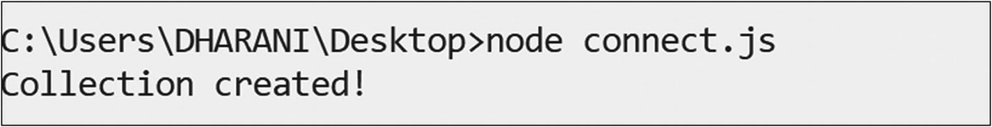

Step 2: Insert a Document
Save the code shown here in a file called insert.js.
var MongoClient = require('mongodb').MongoClient;
var url = "mongodb://localhost:27017/";
MongoClient.connect(url, {useNewUrlParser:true, useUnifiedTopology:true},function(err, db) {
if (err) throw err;
var mydb = db.db("mydb");
var myobj = { name: "Subhashini", address: "E 603 Alpyne" };
mydb.collection("employees").insertOne(myobj, function(err, res) {
if (err) throw err;
console.log("Inserted");
db.close();
});
});
Run the code by issuing the following command at the command prompt.
node insert.js
Here is the output,
> show collections
mydb
> db.employees.find()
{ "_id" : ObjectId("5c050dd8c63a253134cbd375"), "name" : "Subhashini", "address" : "E 603 Alpyne" }
>
To insert multiple documents, use this command.
var myobj = [{name:"Shobana",address: "E 608 Alpyne"},{name:"Taanu", address:"Valley Street"}];

Step 3: Query a Document
Save the following code in a file called find.js.
var MongoClient = require('mongodb').MongoClient;
var url = "mongodb://localhost:27017/";
MongoClient.connect(url, {useNewUrlParser:true, useUnifiedTopology:true}, function(err, db) {
if (err) throw err;
var mydb = db.db("mydb");
var query = {name:"Subhashini" };
mydb.collection("employees").find(query).toArray(function(err, result) {
if (err) throw err;
console.log(result);
db.close();
});
});
Run the code by issuing this command at the command prompt.
node find.js
Here is the output,
[ { _id: 5c050dd8c63a253134cbd375,
name: 'Subhashini',
address: 'E 603 Alpyne' } ]

Step 4: Update a Document
Save the code shown here in a file called update.js.
var MongoClient = require('mongodb').MongoClient;
var url = "mongodb://127.0.0.1:27017/";
MongoClient.connect(url, {useNewUrlParser:true, useUnifiedTopology:true}, function(err, db) {
if (err) throw err;
var mydb = db.db("mydb");
var query = {address:"E 603 Alpyne" };
var newvalues = { $set: {address:"New Street"}};
mydb.collection("employees").updateOne(query, newvalues, function(err, res) {
if (err) throw err;
console.log("Document Updated");
db.close();
});
});
Run the code by issuing the following command at the command prompt.
node update.js
Here is the output,
> db.employees.find({name:"Subhashini"})
{ "_id" : ObjectId("5c050dd8c63a253134cbd375"), "name" : "Subhashini", "address" : "New Street" }
>

Step 5: Delete a Document
Save the code shown here in a file called delete.js.
var MongoClient = require('mongodb').MongoClient;
var url = "mongodb://localhost:27017/";
MongoClient.connect(url, {useNewUrlParser:true, useUnifiedTopology:true}, function(err, db) {
if (err) throw err;
var mydb = db.db("mydb");
var query = {name:"Subhashini"};
mydb.collection("employees").deleteOne(query, function(err, obj) {
if (err) throw err;
console.log("Document deleted");
db.close();
});
});
Run the code by issuing the following command at the command prompt.
node delete.js
Here is the output,
Document deleted
© Subhashini Chellappan and Dharanitharan Ganesan 2020
S. Chellappan, D. GanesanMongoDB Recipes
https://doi.org/10.1007/978-1-4842-4891-1_3

3. Data Modeling and Aggregation
Subhashini Chellappan1 and Dharanitharan Ganesan2
(1)
Bangalore, India
(2)
Krishnagiri, Tamil Nadu, India

In Chapter 2, we discussed MongoDB CRUD operations, embedded documents, and arrays. In this chapter, we cover the following topics.
Data models.
Data model relationship between documents.
Modeling tree structures.
Aggregation operations.
SQL aggregation terms and corresponding MongoDB aggregation operations.

Data Models
MongoDB provides two data model designs for data modeling:
Embedded data models.
Normalized data models.

Embedded Data Models
In MongoDB, you can embed related data in a single document. This schema design is known as denormalized models. Consider the example shown in Figure 3-1.
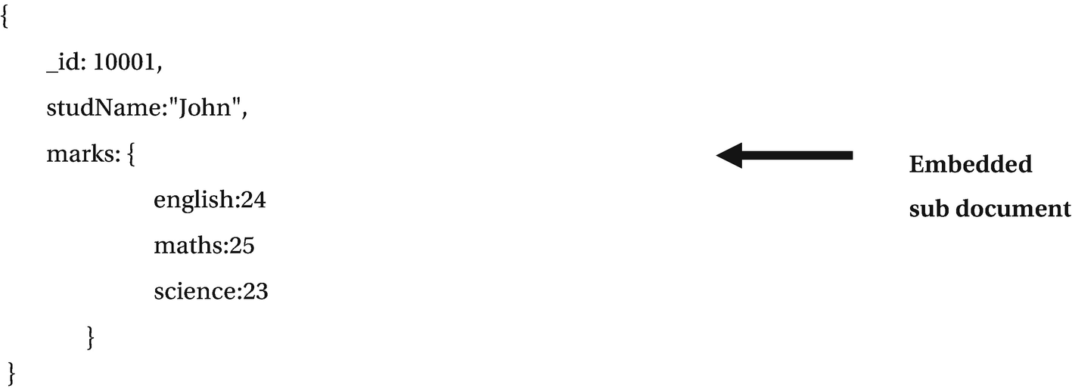
Figure 3-1A denormalized model
This embedded document model allows applications to store the related piece of information in the same records. As a result, the application requires only few queries and updates to complete common operations.
We can use embedded documents to represent both one-to-one relationships (a “contains” relationship between two entities) and one-to-many relationships (when many documents are viewed in the context of one parent).
Embedded documents provide better results in these cases:
For read operations.
When we need to retrieve related data in a single database operation.
Embedded data models update related data in a single atomic operation. Embedded document data can be accessed using dot notation.

Normalized Data Models
Normalized data models describe relationships using references, as illustrated in Figure 3-2.
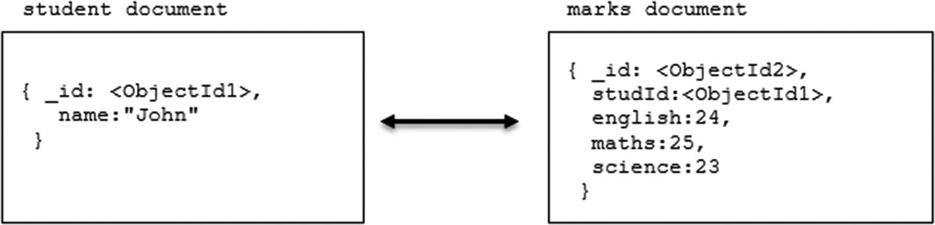
Figure 3-2Normalized data model
Normalized data models can best be used in the following circumstances:
When embedding data model results duplication of data.
To represent complex many-to-many relationships.
To model large hierarchical data sets.
Normalized data models do not provide good read performance.

Data Model Relationship Between Documents
Let’s explore a data model that uses an embedded document and references.

Recipe 3-1. Data Model Using an Embedded Document
In this recipe, we are going to discuss a data model using an embedded document.

Problem
You want to create a data model for a one-to-one relationship.

Solution
Use an embedded document.

How It Works
Let’s follow the steps in this section to design a data model for a one-to-one relationship.

Step 1: One-to-One Relationships
Consider this example.
{
_id: "James",
name: "James William"
}
{
student_id: "James",
street: "123 Hill Street",
city: "New York",
state: "US",
}
Here, we have student and address relationships in which an address belongs to the student. If we are going to retrieve address data with the name frequently, then referencing requires multiple queries to resolve references. In this scenario, we can embed address data with the student data to provide a better data model, as shown here.
{
_id: "James",
name: "James William",
address: {
street: "123 Hill Street",
city: "New York",
state: "US",
}
}
With this data model, we can retrieve complete student information with one query.

Step 2: One-to-Many Relationships
Consider this example.
{
_id: "James",
name: "James William"
}
{
student_id: "James",
street: "123 Hill Street",
city: "New York",
state: "US",
}
{
student_id: "James",
street: "234 Thomas Street",
city: "New Jersey",
state: "US",
}
Here, we have a student and multiple address relationships (a student has multiple addresses). If we are going to retrieve address data with the name frequently, then referencing requires multiple queries to resolve references. In this scenario, the optimal way to design the schema is to embed address data with the student data as shown here.
{
_id: "James",
name: "James William",
address: [{
street: "123 Hill Street",
city: "New York",
state: "US",
},
{
street: "234 Thomas Street",
city: "New Jersey",
state: "US",
}]
}
This data model allows us to retrieve complete student information with one query.

Recipe 3-2. Data Model Using Document References
In this recipe, we are going to discuss a data model using document references.

Problem
You want to create a data model for a one-to-many relationship.

Solution
Use a document reference.

How It Works
Let’s follow the steps in this section to design a data model for a one-to-many relationship.

Step 1: One-to-Many Relationships
Consider the following data model that maps a publisher and book relationship.
{
title: "Practical Apache Spark",
author: [ "Subhashini Chellappan", "Dharanitharan Ganesan" ],
published_date: ISODate("2018-11-30"),
pages: 300,
language: "English",
publisher: {
name: "Apress",
founded: 1999,
location: "US"
}
}
{
title: "MongoDB Recipes",
author: [ "Subhashini Chellappan"],
published_date: ISODate("2018-11-30"),
pages: 120,
language: "English",
publisher: {
name: "Apress",
founded: 1999,
location: "US"
}
}
Here, the publisher document is embedded inside the book document, which leads to repetition of the publisher data model.
In this scenario, we can document references to avoid repetition of data. In document references, the growth of relationships determines where to store the references. If the number of books per publisher is small, then we can store the book reference inside the publisher document as shown here.
{
name: "Apress",
founded: 1999,
location: "US",
books: [123456, 456789, ...]
}
{
_id: 123456,
title: "Practical Apache Spark",
author: [ "Subhashini Chellappan", "Dharanitharan Ganesan" ],
published_date: ISODate("2018-11-30"),
pages: 300,
language: "English"
}
{
_id: 456789,
title: "MongoDB Recipes",
author: [ "Subhashini Chellappan"],
published_date: ISODate("2018-11-30"),
pages: 120,
language: "English"
}
If the number of books per publisher is unbounded, this data model would lead to mutable, growing arrays. We can avoid this situation by storing the publisher reference inside the book document as shown here.
{
_id:"Apress",
name: "Apress",
founded: 1999,
location: "US"
}
{
_id: 123456,
title: "Practical Apache Spark",
author: [ "Subhashini Chellappan", "Dharanitharan Ganesan" ],
published_date: ISODate("2018-11-30"),
pages: 300,
language: "English",
publisher_id: "Apress"
}
{
_id: 456789,
title: "MongoDB Recipes",
author: [ "Subhashini Chellappan"],
published_date: ISODate("2018-11-30"),
pages: 120,
language: "English",
publisher_id: "Apress"
}

Step 2: Query Document References
Let’s discuss how to query document references. Consider the following collections.
db.publisher.insert({_id:"Apress",name: "Apress", founded: 1999,location:"US"})
db.authors.insertMany([{_id: 123456,title: "Practical Apache Spark",author:["Subhashini Chellappan", "Dharanitharan Ganesan" ], published_date: ISODate("2018-11-30"),pages: 300,language: "English",publisher_id: "Apress"},{_id: 456789,title: "MongoDB Recipes", author: [ "Subhashini Chellappan"],published_date: ISODate("2018-11-30"), pages: 120,language: "English",publisher_id: "Apress"}])
To perform a left outer join, use $lookup as shown here.
db.publisher.aggregate([{$lookup:{from:"authors",localField:"_id",
foreignField:"publisher_id",as:"authors_docs"}}])
Here is the output,
> db.publisher.aggregate([{$lookup:{from:"authors",localField:"_id",
... foreignField:"publisher_id",as:"authors_docs"}}])
{ "_id" : "Apress", "name" : "Apress", "founded" : 1999, "location" : "US", "authors_docs" : [ { "_id" : 123456, "title" : "Practical Apache Spark", "author" : [ "Subhashini Chellappan", "Dharanitharan Ganesan" ], "published_date" : ISODate("2018-11-30T00:00:00Z"), "pages" : 300, "language" : "English", "publisher_id" : "Apress" }, { "_id" : 456789, "title" : "MongoDB Recipes", "author" : [ "Subhashini Chellappan" ], "published_date" : ISODate("2018-11-30T00:00:00Z"), "pages" : 120, "language" : "English", "publisher_id" : "Apress" } ] }
>

Modeling Tree Structures
Let’s look at a data model that describes a tree-like structure.

Recipe 3-3. Model Tree Structure with Parent References
In this recipe, we are going to discuss a tree structure data model using parent references.

Problem
You want to create a data model for a tree structure with parent references.

Solution
Use the parent references pattern.

How It Works
Let’s follow the steps in this section to design a data model for a tree structure with parent references.

Step 1: Tree Structure with Parent References
The parent references pattern stores each tree node in a document; in addition to the tree node, the document stores the _id of the node’s parent.
Consider the following author tree model with parent references.
db.author.insert( { _id: "Practical Apache Spark", parent: "Books" } )
db.author.insert( { _id: "MongoDB Recipes", parent: "Books" } )
db.author.insert( { _id: "Books", parent: "Subhashini" } )
db.author.insert( { _id: "A Framework For Extracting Information From Web Using VTD-XML ' s XPath", parent: "Article" } )
db.author.insert( { _id: "Article", parent: "Subhashini" } )
db.author.insert( { _id: "Subhashini", parent: null } )
The tree structure of this author collection is shown in Figure 3-3.
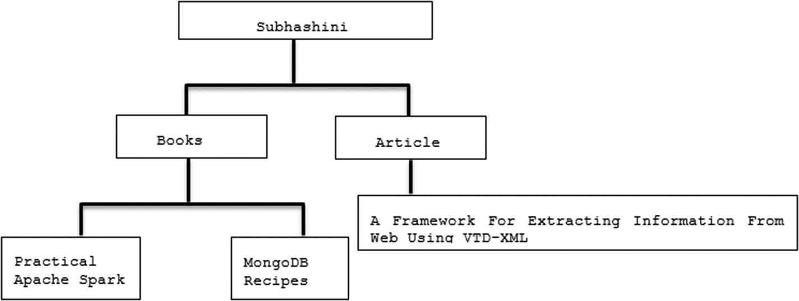
Figure 3-3Tree structure for the author collection
The following command retrieves the parent of a node MongoDB Recipes.
db.author.findOne( { _id: "MongoDB Recipes" } ).parent
Here is the output,
> db.author.findOne( { _id: "MongoDB Recipes" } ).parent
Books
>
The next command retrieves the immediate children of the parent.
db.author.find( { parent: "Subhashini" } )
Here is the output,
> db.author.find( { parent: "Subhashini" } )
{ "_id" : "Books", "parent" : "Subhashini" }
{ "_id" : "Article", "parent" : "Subhashini" }
>

Step 2: Tree Structure with Child References
The child references pattern stores each tree node in a document; in addition to the tree node, the document stores in an array the _id value(s) of the node’s children.
Consider the following author tree model with child references.
db.author.insert( { _id: "Practical Apache Spark", children: [] } )
db.author.insert( { _id: "MongoDB", children: [] } )
db.author.insert( { _id: "Books", children: [ "Practical Apache Spark", "MongoDB Recipes" ] } )
db.author.insert( { _id: " A Framework For Extracting Information From Web Using VTD-XML ' s XPath ", children: [] } )
db.author.insert( { _id: "Article", children: [ " A Framework For Extracting Information From Web Using VTD-XML ' s XPath " ] } )
db.categories.insert( { _id: "Subhashini", children: [ "Books","Article" ] } )
The following command retrieves the immediate children of node Books.
db.author.findOne( { _id: "Books" } ).children
Here is the output,
> db.author.findOne( { _id: "Books" } ).children
[ "Practical Apache Spark", "MongoDB Recipes" ]
>
The next command retrieves the MongoDB Recipes parent node and its siblings.
db.author.find( { children: "MongoDB Recipes" } )
Here is the output,
> db.author.find( { children: "MongoDB Recipes" } )
{ "_id" : "Books", "children" : [ "Practical Apache Spark", "MongoDB Recipes" ] }
>
Child references are a good choice to work with tree storage when there are no subtree operations.

Step 3: Tree Structure with an Array of Ancestors
The array of ancestors pattern stores each tree node in a document; in addition to the tree node, the document stores in an array the _id value(s) of the node’s ancestors or path.
Consider this author tree model with an array of ancestors.
db.author.insert( { _id: "Practical Apache Spark", ancestors: [ "Subhashini", "Books" ], parent: "Books" } )
db.author.insert( { _id: "MongoDB Recipes", ancestors: [ "Subhashini", "Books" ], parent: "Books" } )
db.author.insert( { _id: "Books", ancestors: [ "Subhashini" ], parent: "Subhashini" } )
db.author.insert( { _id: " A Framework For Extracting Information From Web Using VTD-XML ", ancestors: [ "Subhashini", "Article" ], parent: "Article" } )
db.author.insert( { _id: "Article", ancestors: [ "Subhashini" ], parent: "Subhashini" } )
db.author.insert( { _id: "Subhashini", ancestors: [ ], parent: null } )
The array of ancestors field stores the ancestors field and reference to the immediate parent.
To retrieve the ancestors, use this command.
db.author.findOne( { _id: "MongoDB Recipes" } ).ancestors
Here is the output,
> db.author.findOne( { _id: "MongoDB Recipes" } ).ancestors
[ "Subhashini", "Books" ]
>
Use this command to find all its descendants.
db.author.find( { ancestors: "Subhashini" } )
Here is the output,
> db.author.find( { ancestors: "Subhashini" } )
{ "_id" : "Practical Apache Spark", "ancestors" : [ "Subhashini", "Books" ], "parent" : "Books" }
{ "_id" : "MongoDB Recipes", "ancestors" : [ "Subhashini", "Books" ], "parent" : "Books" }
{ "_id" : "Books", "ancestors" : [ "Subhashini" ], "parent" : "Subhashini" }
{ "_id" : " A Framework For Extracting Information From Web Using VTD-XML ", "ancestors" : [ "Subhashini", "Article" ], "parent" : "Article" }
{ "_id" : "Article", "ancestors" : [ "Subhashini" ], "parent" : "Subhashini" }
>
This pattern provides an efficient solution to find all descendants and the ancestors of a node. The array of ancestors pattern is a good choice for working with subtrees.

Aggregation
Aggregation operations group values from multiple documents and can perform variety of operations on the grouped values to return a single result. MongoDB provides following aggregation operations:
Aggregation pipeline.
Map-reduce function.
Single-purpose aggregation methods.

Aggregation Pipeline
The aggregation pipeline is a framework for data aggregation. It is modeled based on the concept of data processing pipelines. Pipelines execute an operation on some input and use that output as an input to the next operation. Documents enter a multistage pipeline that transforms them into an aggregated result.

Recipe 3-4. Aggregation Pipeline
In this recipe, we are going to discuss how the aggregation pipeline works.

Problem
You want to work with aggregation functions.

Solution
Use this method.
db.collection.aggregate()

How It Works
Let’s follow the steps in this section to work with the aggregation pipeline.

Step 1: Aggregation Pipeline
Execute the following orders collection to perform aggregation.
db.orders.insertMany([{custID:"10001",amount:500,status:"A"},{custID:"10001",amount:250,status:"A"},{custID:"10002",amount:200,status:"A"},{custID:"10001",amount: 300, status:"D"}]);
To project only customer IDs, use this syntax.
db.orders.aggregate( [ { $project : { custID : 1 , _id : 0 } } ] )
Here is the output,
> db.orders.aggregate( [ { $project : { custID : 1 , _id : 0 } } ] )
{ "custID" : "10001" }
{ "custID" : "10001" }
{ "custID" : "10002" }
{ "custID" : "10001" }
>
To group on custID and compute the sum of amount use the following command.
db.orders.aggregate({$group:{_id:"$custID",TotalAmount:{$sum:"$amount"}}});
In the preceding example, the value of the variable is accessed by using the $ sign.
Here is the output,
> db.orders.aggregate({$group:{_id:"$custID",TotalAmount:{$sum:"$amount"}}});
{ "_id" : "10002", "TotalAmount" : 200 }
{ "_id" : "10001", "TotalAmount" : 1050 }
>
To filter on status: "A" and then group it on "custID" and compute the sum of amount, use the following command.
db.orders.aggregate({$match:{status:"A"}},{$group:{_id:"$custID",TotalAmount:{ $sum:"$amount"}}});
Here is the ouput:
>db.orders.aggregate({$match:{status:"A"}},{$group:{_id:"$custID",TotalAmount:{ $sum:"$amount"}}});
{ "_id" : "10002", "TotalAmount" : 200 }
{ "_id" : "10001", "TotalAmount" : 750 }
>
To group on "custID" and compute the average of the amount for each group, use this command.
db.orders.aggregate({$group:{_id:"$custID",AverageAmount:{$avg:"$amount"}}});
Here is the output,
> db.orders.aggregate({$group:{_id:"$custID",AverageAmount:{$avg:"$amount"}}});
{ "_id" : "10002", "AverageAmount" : 200 }
{ "_id" : "10001", "AverageAmount" : 350 }
>

Map-Reduce
MongoDB also provides map-reduce to perform aggregation operations. There are two phases in map-reduce: a map stage that processes each document and outputs one or more objects and a reduce stage that combines the output of the map operation.
A custom JavaScript function is used to perform map and reduce operations. Map-reduce is less efficient and more complex compared to the aggregation pipeline.

Recipe 3-5. Map-Reduce
In this recipe, we are going to discuss how to perform aggregation operations using map-reduce.

Problem
You want to work with aggregation operations using map-reduce.

Solution
Use a customized JavaScript function.

How It Works
Let’s follow the steps in this section to work with map-reduce.

Step 1: Map-Reduce
Execute the following orders collection to perform aggregation operations.
db.orders.insertMany([{custID:"10001",amount:500,status:"A"},{custID:"10001",amount:250,status:"A"},{custID:"10002",amount:200,status:"A"},{custID:"10001",amount: 300, status:"D"}]);
To filter on status:"A" and then group it on custID and compute the sum of amount, use the following map-reduce function.
Map function:
var map = function(){
emit (this.custID, this.amount);}
Reduce function:
var reduce = function(key, values){ return Array.sum(values) ; }
To execute the query:
db.orders.mapReduce(map, reduce,{out: "order_totals",query:{status:"A"}});
db.order_totals.find()
Here is the output,
> var map = function(){
... emit (this.custID, this.amount);}
> var reduce = function(key, values){ return Array.sum(values) ; }
> db.orders.mapReduce(map, reduce,{out: "order_totals",query:{status:"A"}});
{
"result" : "order_totals",
"timeMillis" : 82,
"counts" : {
"input" : 3,
"emit" : 3,
"reduce" : 1,
"output" : 2
},
"ok" : 1
}
> db.order_totals.find()
{ "_id" : "10001", "value" : 750 }
{ "_id" : "10002", "value" : 200 }
>

Single-Purpose Aggregation Operations
MongoDB also provides single-purpose aggregation operations such as db.collection.count() and db.collection.distinct(). These aggregate operations aggregate documents from a single collection. This functionality provides simple access to common aggregation processes.

Recipe 3-6. Single-Purpose Aggregation Operations
In this recipe, we are going to discuss how to use single-purpose aggregation operations.

Problem
You want to work with single-purpose aggregation operations.

Solution
Use these commands.
db.collection.count()
db.collection.distinct()

How It Works
Let’s follow the steps in this section to work with single-purpose aggregation operations.

Step 1: Single-Purpose Aggregation Operations
Execute the following orders collection to perform single-purpose aggregation operations.
db.orders.insertMany([{custID:"10001",amount:500,status:"A"},{custID:"10001",amount:250,status:"A"},{custID:"10002",amount:200,status:"A"},{custID:"10001",amount: 300, status:"D"}]);
Use the following syntax to find a distinct "custID".
db.orders.distinct("custID")
Here is the output,
> db.orders.distinct("custID")
[ "10001", "10002" ]
>
To count the number of documents, use this code.
db.orders.count()
Here is the output,
> db.orders.count()
4
>

SQL Aggregation Terms and Corresponding MongoDB Aggregation Operators
Table 3-1 shows SQL aggregation terms and their corresponding MongoDB aggregation operators.
Table 3-1SQL Aggregation Terms and Corresponding MongoDB Operators
SQL Term | MongoDB Operator
WHERE | $match
GROUP BY | $group
HAVING | $match
SELECT | $project
ORDER BY | $sort
LIMIT | $limit
SUM | $sum
COUNT | $sum
JOIN | $lookup

Recipe 3-7. Matching SQL Aggregation to MongoDB Aggregation Operations
In this recipe, we are going to discuss examples of matching MongoDB operations to equivalent SQL aggregation terms.

Problem
You want to understand the equivalent of MongoDB queries for any SQL queries.

Solution
Refer to Table 3-1 and use the equivalent MongoDB operator for a respective SQL clause.

How It Works
Let’s follow the steps in this section to understand the MongoDB queries for certain SQL operations.

Step 1: Converting SQL Aggregation Operations to MongoDB
Execute the following query to check the details of the orders collection.
> db.orders.find()
Here is the output,
> db.orders.find()
{ "_id" : ObjectId("5d636112eea2dccfdeafa522"), "custID" : "10001", "amount" : 500, "status" : "A" }
{ "_id" : ObjectId("5d636112eea2dccfdeafa523"), "custID" : "10001", "amount" : 250, "status" : "A" }
{ "_id" : ObjectId("5d636112eea2dccfdeafa524"), "custID" : "10002", "amount" : 200, "status" : "A" }
{ "_id" : ObjectId("5d636112eea2dccfdeafa525"), "custID" : "10001", "amount" : 300, "status" : "D" }
Now, let’s find the count of records from the orders colletion.
Imagine this is the same as an orders table in any RDBMS and the SQL to get the count of records from the table is as follows:
SELECT COUNT(*) AS count FROM orders
Use the following query to get the count of documents from the collection in MongoDB.
> db.orders.aggregate( [ { $group: { _id: null, count: { $sum: 1 } } } ] )
Here is the output,
> db.orders.aggregate( [ { $group: { _id: null, count: { $sum: 1 } } } ] )
{ "_id" : null, "count" : 4 }
© Subhashini Chellappan and Dharanitharan Ganesan 2020
S. Chellappan, D. GanesanMongoDB Recipes
https://doi.org/10.1007/978-1-4842-4891-1_4

4. Indexes
Subhashini Chellappan1 and Dharanitharan Ganesan2
(1)
Bangalore, India
(2)
Krishnagiri, Tamil Nadu, India

In Chapter 3, we discussed data modeling patterns and the aggregation framework. In this chapter, we to discuss the following topics:
Indexes.
Types of indexes.
Index properties.
The various indexing strategies to be considered.
Indexes are used to improve the performance of the query. Without indexes, MongoDB must search the entire collection to select those documents that match the query statement. MongoDB therefore uses indexes to limit the number of documents that it must scan.
Indexes are special data structures that store a small portion of the collection’s data set in an easy-to-transform format. The index stores a set of fields ordered by the value of the field. This ordering helps to improve the performance of equality matches and range-based query operations.
MongoDB defines indexes at the collection level and indexes can be created on any field of the document. MongoDB creates an index for the _id field by default.
NoteMongoDB creates a default unique index _id field, which helps to prevent inserting two documents with the same value of the _id field.

Recipe 4-1. Working with Indexes
In this recipe, we are going to discuss how to work with indexes in MongoDB.

Problem
You want to create an index.

Solution
Use the following command.
db.collection.createIndex()

How It Works
Let’s follow the steps in this section to create an index.
Consider the following employee collection.
db.employee.insert({empId:1,empName:"John",state:"KA",country:"India"})
db.employee.insert({empId:2,empName:"Smith",state:"CA",country:"US"})
db.employee.insert({empId:3,empName:"James",state:"FL",country:"US"})
db.employee.insert({empId:4,empName:"Josh",state:"TN",country:"India"})
db.employee.insert({empId:5,empName:"Joshi",state:"HYD",country:"India"})

Step 1: Create an Index
To create single-field index on the empId field, use the following command.
db.employee.createIndex({empId:1})
Here, the parameter value “1” indicates that empId field values will be stored in ascending order.
Here is the output,
> db.employee.createIndex({empId:1})
{
"createdCollectionAutomatically" : false,
"numIndexesBefore" : 1,
"numIndexesAfter" : 2,
"ok" : 1
}
>
To create an index on multiple fields, known as a compound index, use this command.
db.employee.createIndex({empId:1,empName:1})
Here is the output,
> db.employee.createIndex({empId:1,empName:1})
{
"createdCollectionAutomatically" : false,
"numIndexesBefore" : 2,
"numIndexesAfter" : 3,
"ok" : 1
}
>
To display a list of indexes, this is the syntax.
db.employee.getIndexes()
Here is the output,
> db.employee.getIndexes()
[
{
"v" : 2,
"key" : {
"_id" : 1
},
"name" : "_id_",
"ns" : "test.employee"
},
{
"v" : 2,
"key" : {
"empId" : 1
},
"name" : "empId_1",
"ns" : "test.employee"
},
{
"v" : 2,
"key" : {
"empId" : 1,
"empName" : 1
},
"name" : "empId_1_empName_1",
"ns" : "test.employee"
}
]
>
To drop a compound index, use the following command.
db.employee.dropIndex({empId:1,empName:1})
Here is the output,
> db.employee.dropIndex({empId:1,empName:1})
{ "nIndexesWas" : 3, "ok" : 1 }
>
To drop all the indexes, use this command.
db.employee.dropIndexes()
Here is the output,
> db.employee.dropIndexes()
{
"nIndexesWas" : 2,
"msg" : "non-_id indexes dropped for collection",
"ok" : 1
}
>
NoteWe can’t drop _id indexes. MongoDB creates an index for the _id field by default.

Recipe 4-2. Index Types
In this recipe, we are going to discuss various types of indexes.

Problem
You want to create different types of indexes.

Solution
Use the following command.
db.collection.createIndex()

How It Works
Let’s follow the steps in this section to create the different types of indexes shown in Figure 4-1.
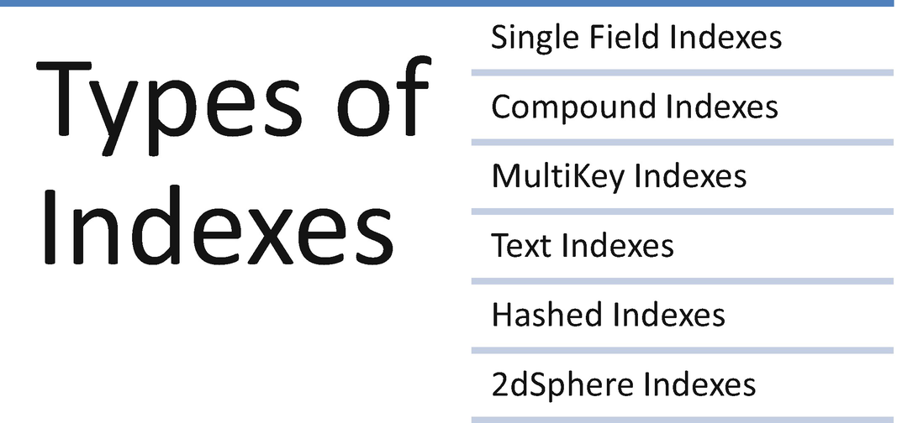
Figure 4-1Types of indexes

Step 1: Multikey Index
Multikey indexes are useful to create an index for a field that holds an array value. MongoDB creates an index key for each element in the array.
Consider the below collection, you can create if the collection is not available.
db.employeeproject.insert({empId:1001,empName:"John",projects:["Hadoop","MongoDB"]})
db.employeeproject.insert({empId:1002,empName:"James",projects:["MongoDB","Spark"]})
To create an index on the projects field, use the following command.
db.employeeproject.createIndex({projects:1})
Here is the output,
> db.employeeproject.createIndex({projects:1})
{
"createdCollectionAutomatically" : false,
"numIndexesBefore" : 1,
"numIndexesAfter" : 2,
"ok" : 1
}
NoteYou can’t create a compound multikey index.

Step 2: Text Indexes
MongoDB provides text indexes to support text search queries on string content. You can create a text index on a field that takes as its value a string or an array of string elements.
Consider this post collection.
db.post.insert({
"post_text": "Happy Learning",
"tags": [
"mongodb",
"10gen"
]
})
To create text indexes, use the following command.
db.post.createIndex({post_text:"text"})
This command creates a text index for the field post_text.
Here is the output,
> db.post.createIndex({post_text:"text"})
{
"createdCollectionAutomatically" : false,
"numIndexesBefore" : 1,
"numIndexesAfter" : 2,
"ok" : 1
}
>
To perform a search, use the command shown here.
db.post.find({$text:{$search:"Happy"}})
Here is the output,
> db.post.find({$text:{$search:"Happy"}})
{ "_id" : ObjectId("5bb215286d8d957bcedc225e"), "post_text" : "Happy Learning", "tags" : [ "mongodb", "10gen" ] }
>

Step 3: Hashed Indexes
The size of the indexes can be reduced with the help of hashed indexes. Hashed indexes store the hashes of the values of the indexed field. Hashed indexes support sharding using hashed shard keys. In hashed-based sharding, a hashed index of a field is used as the shard key to partition data across the sharded cluster. We discuss sharding in Chapter 5.
Hashed indexes do not support multikey indexes.
Consider the user collection shown here.
db.user.insert({userId:1,userName:"John"})
db.user.insert({userId:2,userName:"James"})
db.user.insert({userId:3,userName:"Jack"})
To create a hashed-based index on the field userId, use the following command.
db.user.createIndex( { userId: "hashed" } )
Here is the output,
> db.user.createIndex( { userId: "hashed" } )
{
"createdCollectionAutomatically" : false,
"numIndexesBefore" : 1,
"numIndexesAfter" : 2,
"ok" : 1
}
>

Step 4: 2dsphere Index
The 2dsphere index is useful to return queries on geospatial data.
Consider the schools collection given here.
db.schools.insert( {
name: "St.John's School",
location: { type: "Point", coordinates: [ -73.97, 40.77 ] },
} );
db.schools.insert( {
name: "St.Joseph's School",
location: { type: "Point", coordinates: [ -73.9928, 40.7193 ] },
} );
db.schools.insert( {
name: "St.Thomas School",
location: { type: "Point", coordinates: [ -73.9375, 40.8303 ] },
} );
Use the following syntax to create a 2dsphere index.
db.schools.createIndex( { location : "2dsphere" } )
The following code uses the $near operator to return documents that are at least 500 meters from and at most 1,500 meters from the specified GeoJSON point.
db.schools.find({location:{$near:{$geometry: { type: "Point", coordinates: [ -73.9667, 40.78 ] },$minDistance: 500,$maxDistance: 1500}}})
Here is the output,
> db.schools.find({location:{$near:{$geometry: { type: "Point", coordinates: [ -73.9667, 40.78 ] },$minDistance: 500,$maxDistance: 1500}}})
{ "_id" : ObjectId("5ca47a184b034d4cc1345f45"), "name" : "St.John's School", "location" : { "type" : "Point", "coordinates" : [ -73.97, 40.77 ] } }
>

Recipe 4-3. Index Properties
Indexes can also have properties. The index properties define certain characteristics and behaviors of an indexed field at runtime. For example, a unique index ensures the indexed fields do not support duplicates. In this recipe, we are going to discuss various index properties.

Problem
You want to work with index properties.

Solution
Use this command.
db.collection.createIndex()

How It Works
Let’s follow the steps in this section to work with index properties.

Step 1: TTL Indexes
Time to Live (TTL) indexes are single-field indexes that are used to remove documents from a collection after a certain amount of time. Data expiration is useful for certain types of information such as logs, machine-generated data, and so on.
Consider the sample collection shown here.
db.credit.insert({credit:16})
db.credit.insert({credit:18})
db.credit.insert({credit:12})
To create a TTL index on the field credit, issue the following command.
db.credit.createIndex( { credit: 1 }, { expireAfterSeconds: 35 } );
Here is the output,
> db.credit.createIndex( { credit: 1 }, { expireAfterSeconds:35 } );
{
"createdCollectionAutomatically" : false,
"numIndexesBefore" : 1,
"numIndexesAfter" : 2,
"ok" : 1
}
>

Step 2: Unique Indexes
A unique index ensures that the indexed fields do not contain any duplicate values. By default, MongoDB creates a unique index on the _id field.
Consider the following student collection.
db.student.insert({_id:1,studid:101,studname:"John"})
db.student.insert({_id:2,studid:102,studname:"Jack"})
db.student.insert({_id:3,studid:103,studname:"James"})
To create unique index for the field studId, use this command.
db.student.createIndex({"studid":1}, {unique:true})
Here is the output,
> db.student.createIndex({"studid":1}, {unique:true})
{
"createdCollectionAutomatically" : false,
"numIndexesBefore" : 1,
"numIndexesAfter" : 2,
"ok" : 1
}
>
When we try to insert the value studid:101,
db.student.insert([{_id:1,studid:101,studname:"John"}])
throws the following error message:
"errmsg" : "E11000 duplicate key error collection: test.student index: _id_ dup key: { : 1.0 }",

Step 3: Partial Indexes
Partial indexes are useful when you want to index the documents in a collection that meet a specific filter condition. The filter condition could be specified using any operators. For example, db.person.find( { age: { $gt: 15 } } ) can be used to find the documents that have an age greater than 15 in the person collection. Partial indexes reduce storage requirements and performance costs because they store only a subset of the documents.
Use the db.collection.createIndex() method with the partialFilterExpression option to create a partial index.
The partialFilterExpression option accepts a document that specifies the filter condition using:
equality expressions (i.e., field: value or using the $eq operator).
$exists: true expression.
$gt, $gte, $lt, and $lte expressions.
$type expressions.
$and operator at the top level only.
Consider the following documents of a person collection.
db.person.insert({personName:"John",age:16})
db.person.insert({personName:"James",age:15})
db.person.insert({personName:"John",hobbies:["sports","music"]})
To index only those documents in the person collection where the value in the age field is greater than 15, use the following command.
db.person.createIndex( { age: 1},{partialFilterExpression: { age: { $gt: 15 }}})
The query shown here uses a partial index to return those documents in the person collection where the age value is greater than 15.
db.person.find( { age: { $gt: 15 } } )
Here is the output,
> db.person.find( { age: { $gt: 15 } } )
{ "_id" : ObjectId("5ca453954b034d4cc1345f3b"), "personName" : "John", "age" : 16 }
>

Step 4: Sparse Indexes
Sparse indexes store entries only for the documents that have the indexed field, even if it contains null values. A sparse index skips any documents that do not have the indexed field. The index is considered sparse because it does not include all the documents of a collection.
Consider the following person collection.
db.person.insert({personName:"John",age:16})
db.person.insert({personName:"James",age:15})
db.person.insert({personName:"John",hobbies:["sports","music"]})
To create a sparse index on the age field, issue this command.
db.person.createIndex( { age: 1 }, { sparse: true } );
Here is the output,
> db.person.createIndex( { age: 1 }, { sparse: true } );
{
"createdCollectionAutomatically" : false,
"numIndexesBefore" : 1,
"numIndexesAfter" : 2,
"ok" : 1
}
>
To return all documents in the collection named person using the index on the age field, use hint () to specify a sparse index.
db.person.find().hint( { age: 1 } ).count();
Here is the output,
> db.person.find().hint( { age: 1 } ).count();
2
>
To perform a correct count, use this code.
db.person.find().count();
Here is the output,
> db.person.find().count();
3
>
NotePartial indexes determine the index entries based on the filter condition, whereas sparse indexes select the documents based on the existence of the indexed field.

Recipe 4-4. Indexing Strategies
We must follow different strategies to create the right index for our requirements. In this recipe, we are going to discuss various indexing strategies.

Problem
You want to learn about indexing strategies to ensure you are creating the right type of index for different purposes.

Solution
The best indexing strategy is determined by different factors, including
Type of executing query.
Number of read/write operations.
Available memory.
Figure 4-2 illustrates the different indexing strategies.
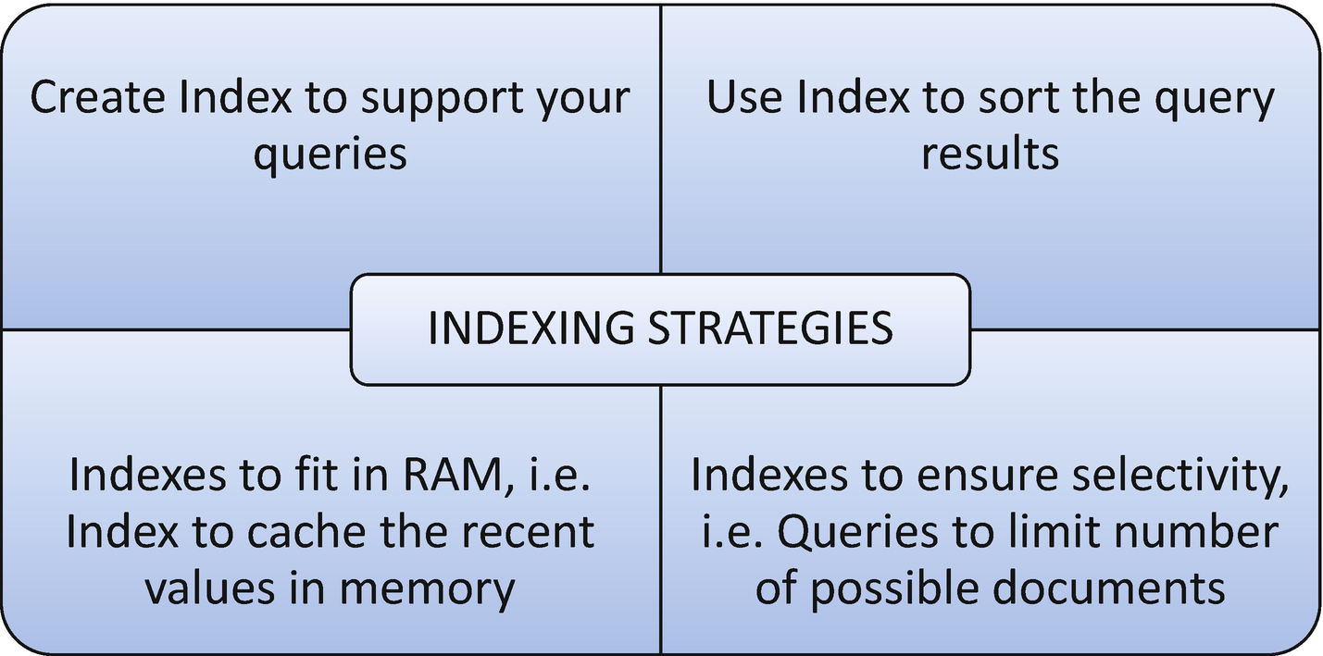
Figure 4-2Indexing strategies

How It Works
Let’s follow the steps in this section to work with different indexing strategies.

Step 1: Create an Index to Support Your Queries
Creating the right index to support the queries increases the query execution performance and results in great performance.
Create a single-field index if all the queries use the same single key to retrieve the documents.
> db.employee.createIndex({empId:1})
Create a multifield compound index if all the queries use more than one key (multiple filter condition) to retrieve the documents.
> db.employee.createIndex({empId:1,empName:1})

Step 2: Using an Index to Sort the Query Results
Sort operations use indexes for better performance. Indexes determine the sort order by fetching the documents based on the ordering in the index.
Sorting can be done in the following scenarios:
Sorting with a single-field index.
Sorting on multiple fields.

Sorting with a Single-Field Index
The index can support ascending or descending order on a single field while retrieving the documents.
> db.employee.createIndex({empId:1})
The preceding index can support ascending order sorting.
> db.employee.find().sort({empId:1})
Here is the output,
MongoDB Enterprise > db.employee.createIndex({empId:1})
{
"createdCollectionAutomatically" : false,
"numIndexesBefore" : 1,
"numIndexesAfter" : 2,
"ok" : 1
}
MongoDB Enterprise > db.employee.find()
{ "_id" : ObjectId("5d50ed688dcf280c50fde439"), "empId" : 1, "empName" : "John", "state" : "KA", "country" : "India" }
{ "_id" : ObjectId("5d50ed688dcf280c50fde43a"), "empId" : 2, "empName" : "Smith", "state" : "CA", "country" : "US" }
{ "_id" : ObjectId("5d50ed688dcf280c50fde43b"), "empId" : 3, "empName" : "James", "state" : "FL", "country" : "US" }
{ "_id" : ObjectId("5d50ed688dcf280c50fde43c"), "empId" : 4, "empName" : "Josh", "state" : "TN", "country" : "India" }
{ "_id" : ObjectId("5d50ed688dcf280c50fde43d"), "empId" : 5, "empName" : "Joshi", "state" : "HYD", "country" : "India" }
MongoDB Enterprise > db.employee.find().sort({empId:1})
{ "_id" : ObjectId("5d50ed688dcf280c50fde439"), "empId" : 1, "empName" : "John", "state" : "KA", "country" : "India" }
{ "_id" : ObjectId("5d50ed688dcf280c50fde43a"), "empId" : 2, "empName" : "Smith", "state" : "CA", "country" : "US" }
{ "_id" : ObjectId("5d50ed688dcf280c50fde43b"), "empId" : 3, "empName" : "James", "state" : "FL", "country" : "US" }
{ "_id" : ObjectId("5d50ed688dcf280c50fde43c"), "empId" : 4, "empName" : "Josh", "state" : "TN", "country" : "India" }
{ "_id" : ObjectId("5d50ed688dcf280c50fde43d"), "empId" : 5, "empName" : "Joshi", "state" : "HYD", "country" : "India" }
The same index can also support sorting of documents in descending order.
MongoDB Enterprise > db.employee.find().sort({empId:-1})
{ "_id" : ObjectId("5d50ed688dcf280c50fde43d"), "empId" : 5, "empName" : "Joshi", "state" : "HYD", "country" : "India" }
{ "_id" : ObjectId("5d50ed688dcf280c50fde43c"), "empId" : 4, "empName" : "Josh", "state" : "TN", "country" : "India" }
{ "_id" : ObjectId("5d50ed688dcf280c50fde43b"), "empId" : 3, "empName" : "James", "state" : "FL", "country" : "US" }
{ "_id" : ObjectId("5d50ed688dcf280c50fde43a"), "empId" : 2, "empName" : "Smith", "state" : "CA", "country" : "US" }
{ "_id" : ObjectId("5d50ed688dcf280c50fde439"), "empId" : 1, "empName" : "John", "state" : "KA", "country" : "India" }

Sorting on Multiple Fields
We can create a compund index to support sorting on multiple fields.
> db.employee.createIndex({empId:1,empName:1})
Here is the output,
MongoDB Enterprise > db.employee.createIndex({empId:1,empName:1})
{
"createdCollectionAutomatically" : false,
"numIndexesBefore" : 2,
"numIndexesAfter" : 3,
"ok" : 1
}
MongoDB Enterprise > db.employee.find().sort({empId:1,empName:1})
{ "_id" : ObjectId("5d50ed688dcf280c50fde439"), "empId" : 1, "empName" : "John", "state" : "KA", "country" : "India" }
{ "_id" : ObjectId("5d50ed688dcf280c50fde43a"), "empId" : 2, "empName" : "Smith", "state" : "CA", "country" : "US" }
{ "_id" : ObjectId("5d50ed688dcf280c50fde43b"), "empId" : 3, "empName" : "James", "state" : "FL", "country" : "US" }
{ "_id" : ObjectId("5d50ed688dcf280c50fde43c"), "empId" : 4, "empName" : "Josh", "state" : "TN", "country" : "India" }
{ "_id" : ObjectId("5d50ed688dcf280c50fde43d"), "empId" : 5, "empName" : "Joshi", "state" : "HYD", "country" : "India" }

Index to Hold Recent Values in Memory
When using multiple collections, we must consider the size of indexes on all collections and ensure the index fits in memory to avoid the system reading the index from the disk.
Use the following query to check the size of the index for any collection.
> db.employee.totalIndexSize()
When we ensure the index fits entirely into the RAM, that ensures faster system processing.
Here is the output,
MongoDB Enterprise > db.employee.totalIndexSize()
49152

Create Queries to Ensure Selectivity
The ability of any query to narrow down the results using the created index is called selectivity. Writing queries that limit the number of possible documents with the indexed field and the queries that are appropriately selective relative to your indexed data ensures selectivity.
> db.employee.find({empId:{$gt:1},country:"India"})
This query must scan all the documents to return the result of empId values greater than 1.
Here is the output,
MongoDB Enterprise > db.employee.find({empId:{$gt:1},country:"India"})
{ "_id" : ObjectId("5d50ed688dcf280c50fde43c"), "empId" : 4, "empName" : "Josh", "state" : "TN", "country" : "India" }
{ "_id" : ObjectId("5d50ed688dcf280c50fde43d"), "empId" : 5, "empName" : "Joshi", "state" : "HYD", "country" : "India" }
> db.employee.find({empId:4})
This query must scan only one document to return the result empId:4.
Here is the output,
MongoDB Enterprise > db.employee.find({empId:4})
{ "_id" : ObjectId("5d50ed688dcf280c50fde43c"), "empId" : 4, "empName" : "Josh", "state" : "TN", "country" : "India" }
© Subhashini Chellappan and Dharanitharan Ganesan 2020
S. Chellappan, D. GanesanMongoDB Recipes
https://doi.org/10.1007/978-1-4842-4891-1_5

5. Replication and Sharding
Subhashini Chellappan1 and Dharanitharan Ganesan2
(1)
Bangalore, India
(2)
Krishnagiri, Tamil Nadu, India

In Chapter 4, we discussed various indexes in MongoDB. In this chapter, we cover the following topics:
Replication.
Sharding.

Replication
Replication is the process of creating and managing a duplicate version of a database across servers to provide redundancy and increase availability of data.
In MongoDB, replication is achieved with the help of a replica set, a group of mongod instances that maintain the same data set. A replica set contains one primary node that is responsible for all write operations and one or more secondary nodes that replicate the primary’s oplog and apply the operations to their data sets to reflect the primary’s data set. Figure 5-1 is an illustration of a replica set.
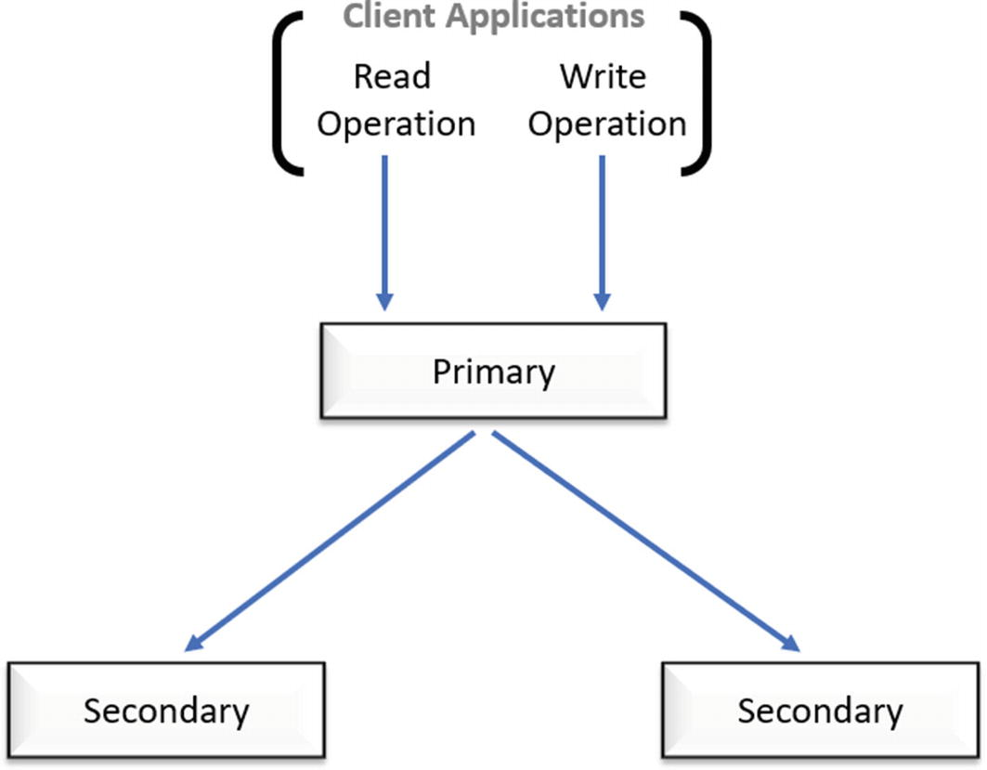
Figure 5-1A replica set

Recipe 5-1. Set Up a Replica Set
In this recipe, we are going to discuss how to set up a replica set (one primary and two secondaries) in Windows.

Problem
You want to create a replica set.

Solution
Use a group of mongod instances.

How It Works
Let’s follow the steps in this section to set up a three-member replica set.

Step 1: Three-Member Replica Set
First, create three data directories:
md c:\mongodb\repset\rs1
md c:\mongodb\repset\rs2
md c:\mongodb\repset\rs3
Here is the output,
c:\>md c:\mongodb\repset\rs1
c:\>md c:\mongodb\repset\rs2
c:\>md c:\mongodb\repset\rs3
Next, start three mongod instances as shown here (see Figures 5-2, 5-4, and 5-6).
start mongod --bind_ip hostname --dbpath c:\mongodb\repset\rs1 --port 20001 --replSet myrs
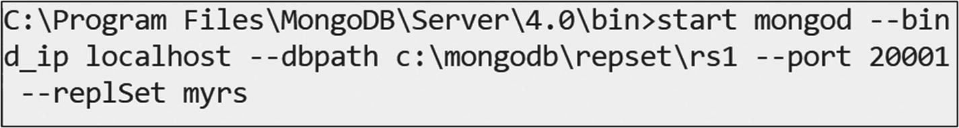
Figure 5-2Starting mongod with replica set 1
Notehostname must be replaced as with ipaddress or localhost if it is the same local machine.
Refer to Figure 5-3 for a mongod instance that is waiting for connection on port 20001.
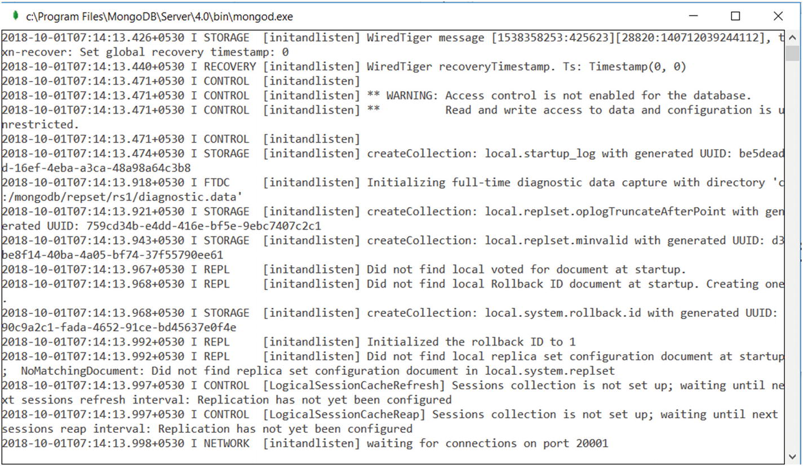
Figure 5-3mongod instance waiting for connection on port 20001
start mongod --bind_ip hostname --dbpath c:\mongodb\repset\rs2 --port 20002 --replSet myrs
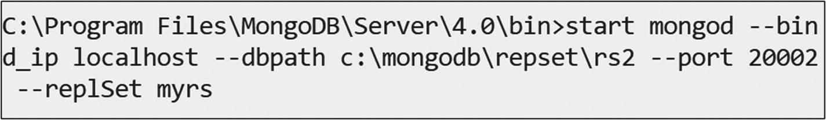
Figure 5-4Starting mongod with replica set 2
Refer to Figure 5-5 for a mongod instance that is waiting for connection on port 20002.
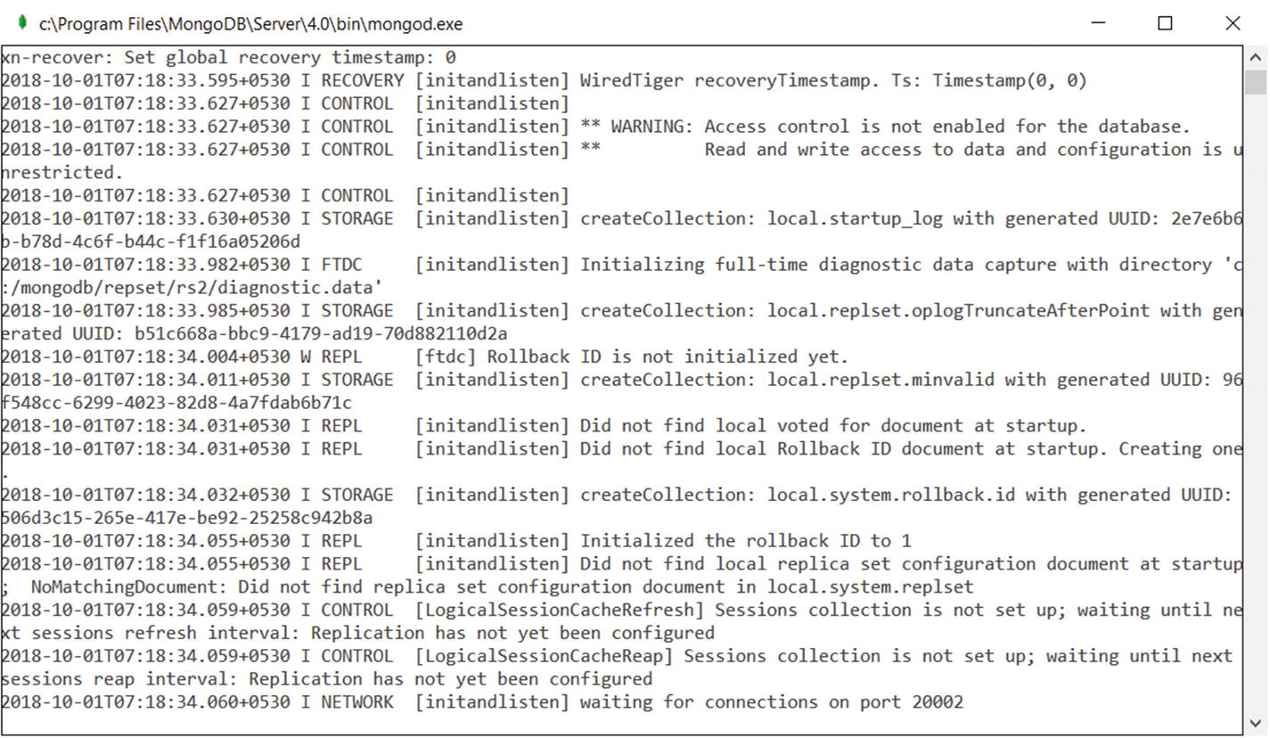
Figure 5-5mongod instance waiting for connection on port 20002
start mongod --bind_ip hostname --dbpath c:\mongodb\repset\rs3 --port 20003 --replSet myrs
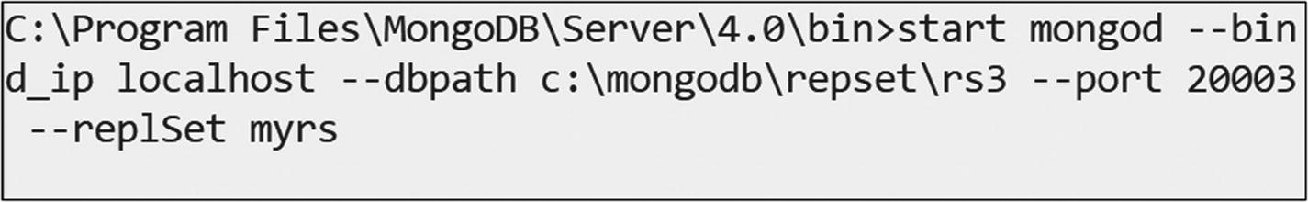
Figure 5-6Starting mongod with replica set 3
Refer Figure 5-7 for a mongod instance that is waiting for connection on port 20002.
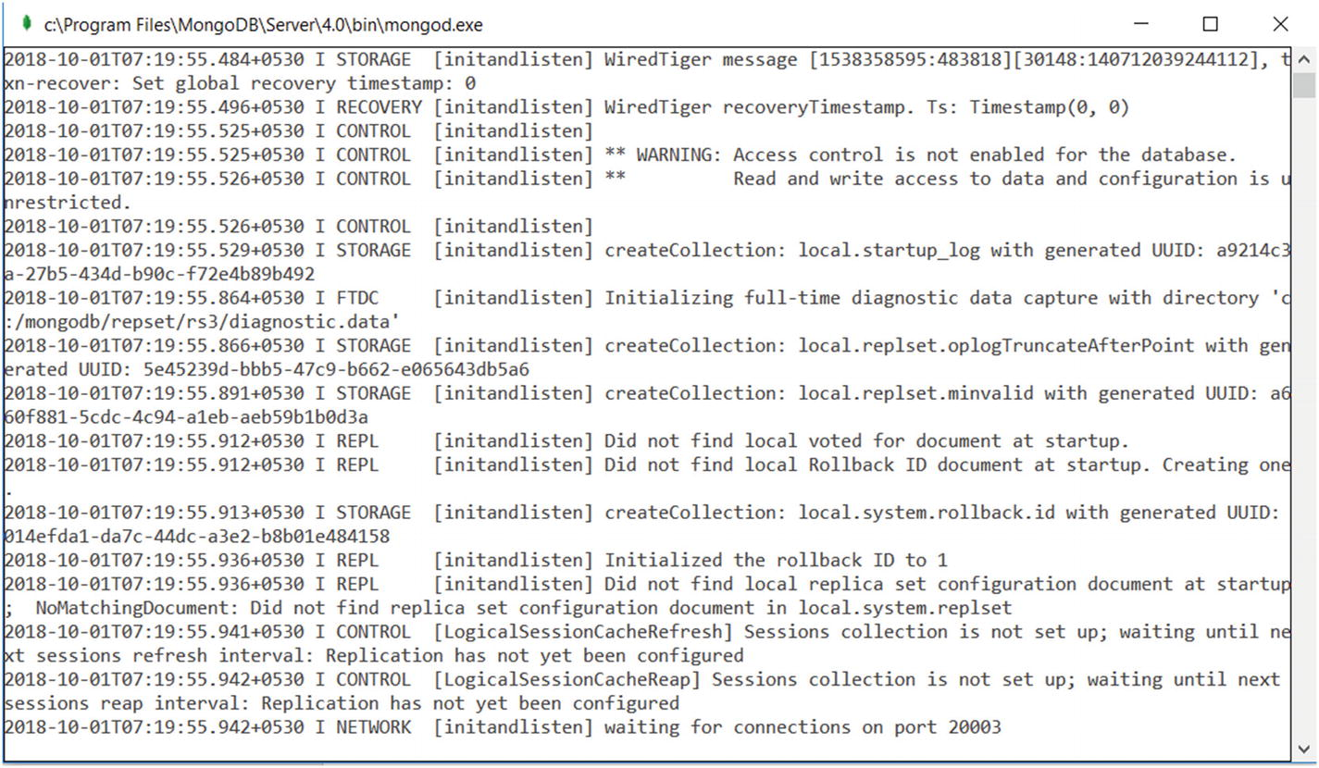
Figure 5-7mongod instance waiting for connection on port 20003
Next, issue the following command to connect to a mongod instance running on port 20001.
mongo hostname:20001
Figure 5-8 shows the mongo shell that is running on port 20001.
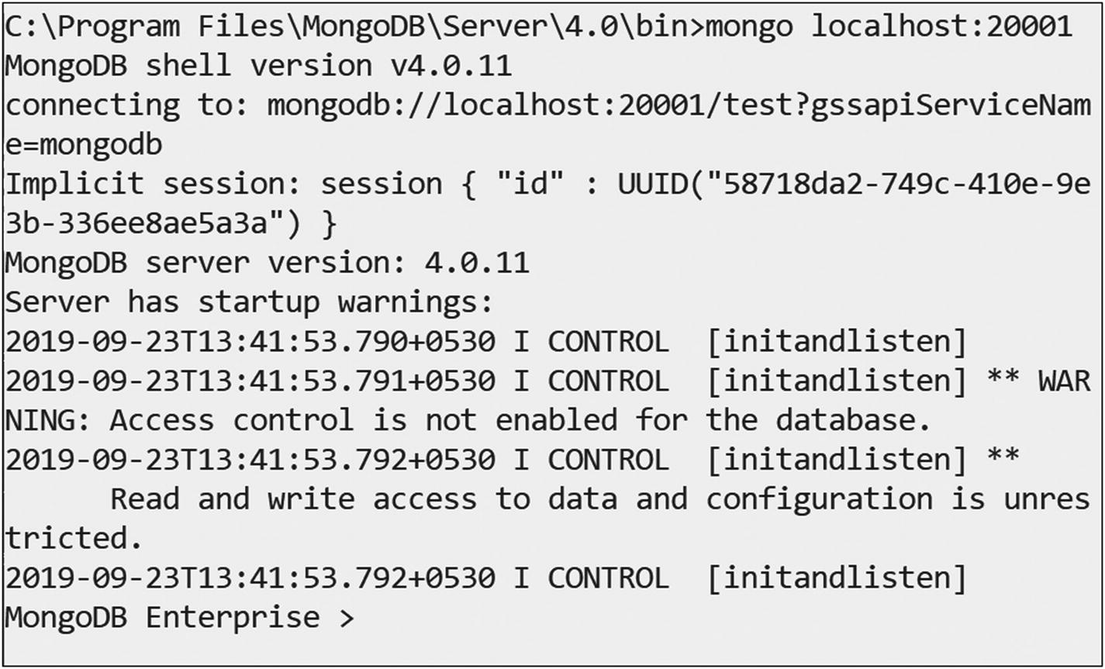
Figure 5-8Connect to mongo instance on port 20001
Issue the following command in the mongo shell to create a three-member replica set.
rs.initiate(); // to initiate replica set
Here is the output,
> rs.initiate();
{
"info2" : "no configuration specified. Using a default configuration for the set",
"me" : "hostname:20001",
"ok" : 1,
"operationTime" : Timestamp(1538362864, 1),
"$clusterTime" : {
"clusterTime" : Timestamp(1538362864, 1),
"signature" : {
"hash" : BinData(0,"AAAAAAAAAAAAAAAAAAAAAAAAAAA="),
"keyId" : NumberLong(0)
}
}
}
After initiating the replica set, we can add the secondary node by using this command.
rs.add("hostname:20002"); // to add secondary
Here is the output,
myrs:SECONDARY> rs.add("hostname:20002");
{
"ok" : 1,
"operationTime" : Timestamp(1538362927, 1),
"$clusterTime" : {
"clusterTime" : Timestamp(1538362927, 1),
"signature" : {
"hash" : BinData(0,"AAAAAAAAAAAAAAAAAAAAAAAAAAA="),
"keyId" : NumberLong(0)
}
}
}
myrs:PRIMARY>
Here, the mongod instance running on port 20001 becomes primary.
We can add another secondary node by using the following command.
rs.add("hostname:20003"); // to add secondary
Here is the output,
myrs:PRIMARY> rs.add("hostname:20003");
{
"ok" : 1,
"operationTime" : Timestamp(1538362931, 1),
"$clusterTime" : {
"clusterTime" : Timestamp(1538362931, 1),
"signature" : {
"hash" : BinData(0,"AAAAAAAAAAAAAAAAAAAAAAAAAAA="),
"keyId" : NumberLong(0)
}
}
}
myrs:PRIMARY>
Now, you can check the status of the replica set by issuing the following command.
rs.status()
Next, create a collection named employee using the primary replica node.
db.employee.insert({_id:10001,name:'Subhashini'});
db.employee.insert({_id:10002,name:'Shobana'});
Here is the output,
myrs:PRIMARY> db.employee.insert({_id:10001,name:'Subhashini'});
WriteResult({ "nInserted" : 1 })
myrs:PRIMARY> db.employee.insert({_id:10002,name:'Shobana'});
WriteResult({ "nInserted" : 1 })
myrs:PRIMARY>
Now, connect to the mongo shell running on port 20002 by issuing this command.
mongo hostname:20002
Here is the output,
myrs:SECONDARY>
Now, issue the following command to find all employees as shown here.
myrs:SECONDARY> db.employee.find()
Error: error: {
"operationTime" : Timestamp(1538364766, 1),
"ok" : 0,
"errmsg" : "not master and slaveOk=false",
"code" : 13435,
"codeName" : "NotMasterNoSlaveOk",
"$clusterTime" : {
"clusterTime" : Timestamp(1538364766, 1),
"signature" : {
"hash" : BinData(0,"AAAAAAAAAAAAAAAAAAAAAAAAAAA="),
"keyId" : NumberLong(0)
}
}
}
myrs:SECONDARY>
The output Error: error: { ........... } shows that we are getting an error message because we are trying to read data from the secondary node.
Issue the following command to perform a read operation from a secondary node.
myrs:SECONDARY> rs.slaveOk()
myrs:SECONDARY> db.employee.find()
{ "_id" : 10001, "name" : "Subhashini" }
{ "_id" : 10002, "name" : "Shobana" }
Next, try to perform a write operation from a secondary node.
myrs:SECONDARY> db.employee.insert({_id:10003,name:"Arunaa MS"})
WriteCommandError({
"operationTime" : Timestamp(1538364966, 1),
"ok" : 0,
"errmsg" : "not master",
"code" : 10107,
"codeName" : "NotMaster",
"$clusterTime" : {
"clusterTime" : Timestamp(1538364966, 1),
"signature" : {
"hash" : BinData(0,"AAAAAAAAAAAAAAAAAAAAAAAAAAA="),
"keyId" : NumberLong(0)
}
}
})
myrs:SECONDARY>
In the preceding output, WriteCommandError { ........... } shows that we are getting an error message because we can’t perform write operations in a secondary node. We can perform write operations only in the primary node.
All the secondary nodes replicate the primary’s log and apply their operations to ensure the secondary’s data set reflects the primary’s data set, as shown in Figure 5-9.
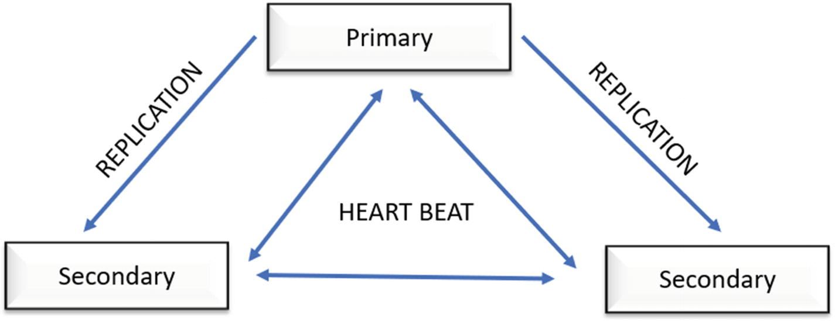
Figure 5-9Replication strategy

Step 2: Auto Failover—High Availability
Kill the primary running on port 20001 and press Enter in the mongo shell running on ports 20002 and 20003 (Figure 5-10). Any one of the secondary nodes can become primary now.
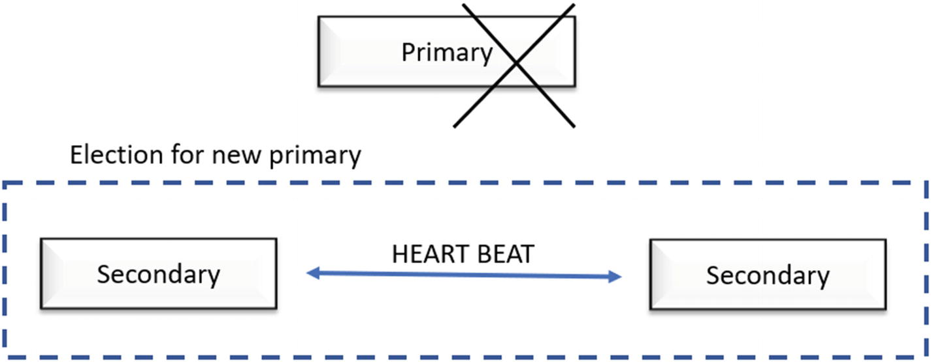
Figure 5-10Primary failover
When a primary does not communicate with other members in the replica set for a configured period (10 seconds by default), an eligible secondary node calls for an election to nominate itself as the new primary and resume its normal operation (Figure 5-11).
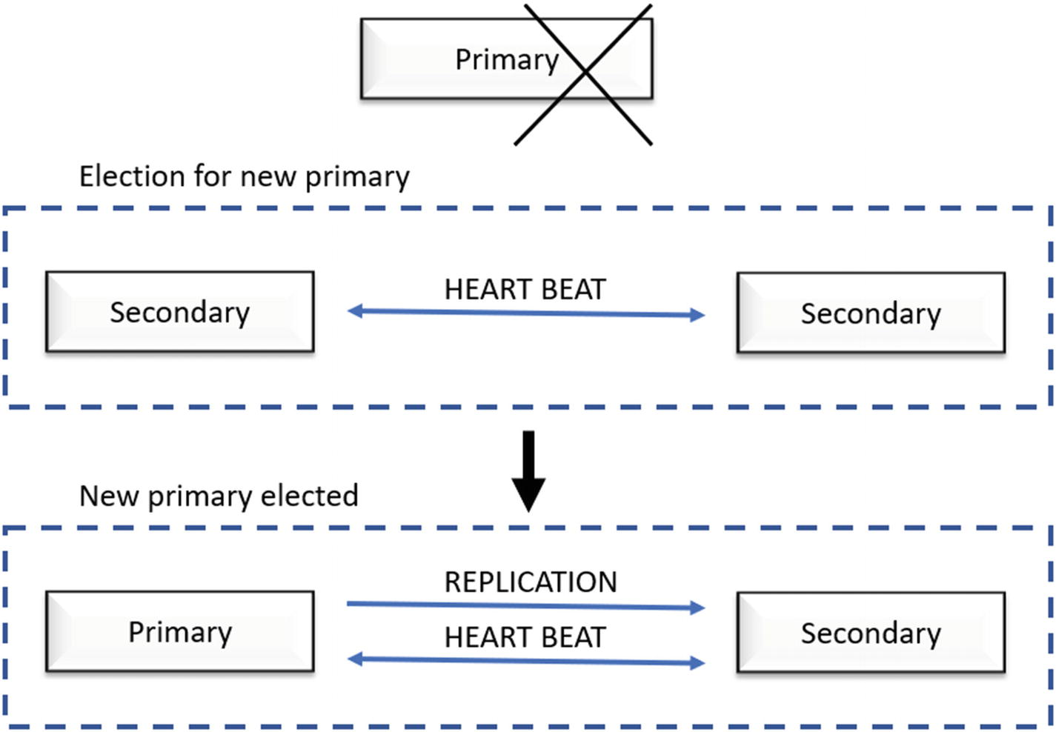
Figure 5-11Primary failover and new primary election
To enable free monitoring, run the following command.
db.enableFreeMonitoring()
To permanently disable this reminder, run the following command.
db.disableFreeMonitoring()
To check the status of free monitoring, use this command.
db.getFreeMonitoringStatus()

Sharding
Sharding is a method for distributing data across multiple machines. There are two methods for addressing system growth: vertical and horizontal scaling.
Vertical scaling: We need to increase the capacity of a single server such as using a more powerful CPU, adding more RAM, or increasing the amount of storage space.
Horizontal scaling: We need to divide the data set and distribute the workload across the servers by adding additional servers to increase the capacity as required.
MongoDB supports horizontal scaling through sharding. A MongoDB sharded cluster consists of the following components:
1. | Shard: Each shard contains a subset of the sharded data. Each shard can be deployed as a replica set.
2. | mongos: The mongos acts as a query router, providing an interface between client applications and the sharded cluster.
3. | Config servers: Config servers store metadata and configuration settings for the cluster.

Recipe 5-2. Sharding
In this recipe, we are going to discuss how to create sharding to distribute data across servers.

Problem
You want to create sharding to distribute data across servers.

Solution
The solution is a group of mongod instances .

How It Works
Let’s follow the steps in this section to set up a sharding.

Step 1: Sharded Cluster
First, create data directories for three shards as shown here.
shard1
md c:\shard_data\shard1\data1
md c:\shard_data\shard1\data2
md c:\shard_data\shard1\data3
shard2
md c:\shard_data\shard2\data1
md c:\shard_data\shard2\data2
md c:\shard_data\shard2\data3
shard3
md c:\shard_data\shard3\data1
md c:\shard_data\shard3\data2
md c:\shard_data\shard3\data3
Next, start the shards as shown here.
shard1
start mongod.exe --shardsvr --port 26017 --dbpath "c:\shard_data\shard1\data1" --replSet shard1_replset
start mongod.exe --shardsvr --port 26117 --dbpath "c:\shard_data\shard1\data2" --replSet shard1_replset
start mongod.exe --shardsvr --port 26217 --dbpath "c:\shard_data\shard1\data3" --replSet shard1_replset
Figure 5-12 shows the execution of commands.
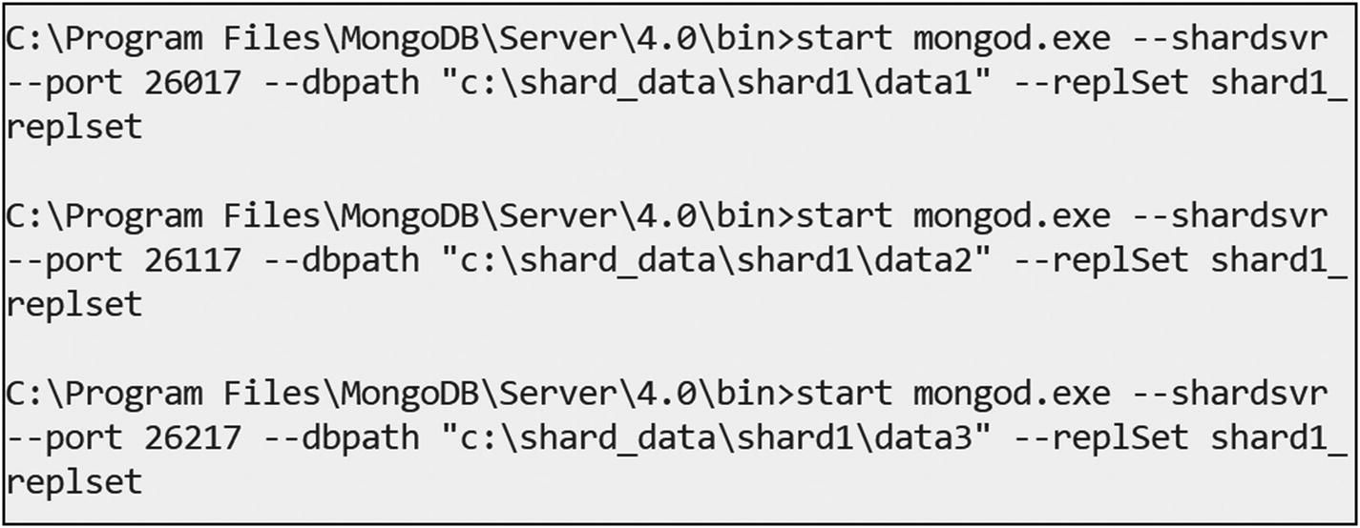
Figure 5-12Starting the shard1 server
shard2
start mongod.exe --shardsvr --port 28017 --dbpath "c:\shard_data\shard2\data1" --replSet shard2_replset
start mongod.exe --shardsvr --port 28117 --dbpath "c:\shard_data\shard2\data2" --replSet shard2_replset
start mongod.exe --shardsvr --port 28217 --dbpath "c:\shard_data\shard2\data3" --replSet shard2_replset
Figure 5-13 shows the execution of commands.
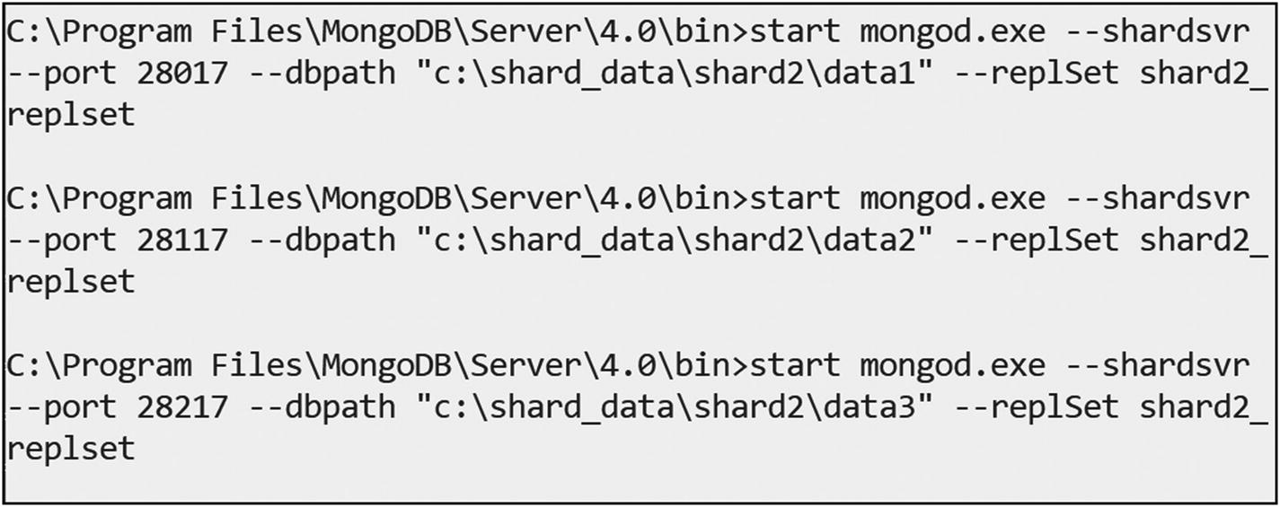
Figure 5-13Starting the shard2 server
shard3
start mongod.exe --shardsvr --port 29017 --dbpath "c:\shard_data\shard3\data1" --replSet shard3_replset
start mongod.exe --shardsvr --port 29117 --dbpath "c:\shard_data\shard3\data2" --replSet shard3_replset
start mongod.exe --shardsvr --port 29217 --dbpath "c:\shard_data\shard3\data3" --replSet shard3_replset
Figure 5-14 shows the execution of commands.
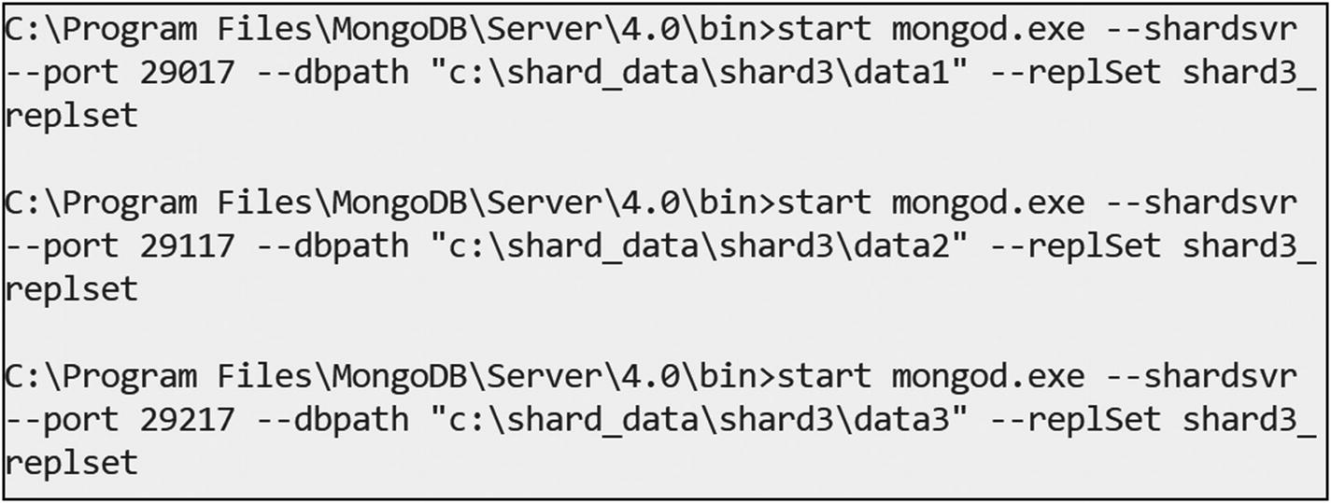
Figure 5-14Starting the shard3 server
Now, connect to one of the shard servers to enable a replica set as shown here and in Figure 5-15.
mongo.exe hostname:26017
C:\Program Files\MongoDB\Server\4.0\bin> mongo.exe localhost:26017
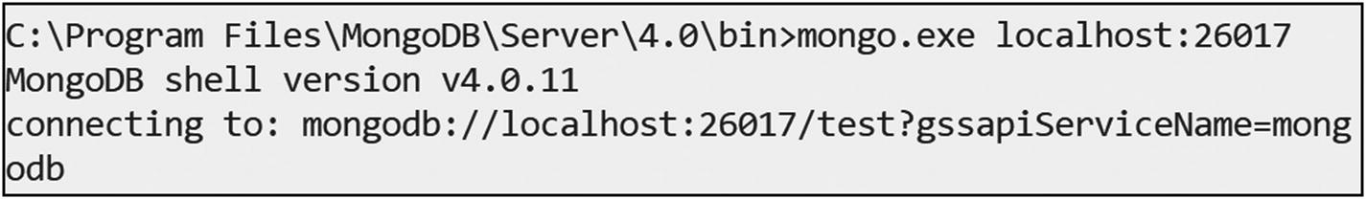
Figure 5-15Connect the shard1 server
Next initiate the replica by using the following command in mongo shell as shown here.
MongoDB Enterprise > rs.initiate(
{
_id: "shard1_replset",
members: [
{ _id : 0, host:"hostname:26017" },
{ _id : 1, host:"hostname:26117" },
{ _id : 2, host:"hostname:26217" }]}
)
Figure 5-16 is the snapshot for reference.
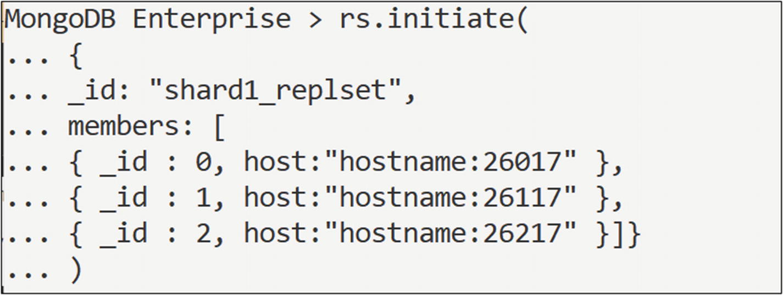
Figure 5-16Initiating the replica on the shard1 server
Now connect to another shard and initiate the replica.
C:\Program Files\MongoDB\Server\4.0\bin> mongo.exe hostname:28017
MongoDB Enterprise > rs.initiate(
{
_id: "shard2_replset",
members: [
{ _id : 0, host:"hostname:28017" },
{ _id : 1, host:"hostname:28117" },
{ _id : 2, host:"hostname:28217" }
]
}
)
Now connect to the third shard and initiate the replica,.
C:\Program Files\MongoDB\Server\4.0\bin> mongo.exe hostname:29017
MongoDB Enterprise > rs.initiate(
{
_id: "shard3_replset",
members: [
{ _id : 0, host:"hostname:29017" },
{ _id : 1, host:"hostname:29117" },
{ _id : 2, host:"hostname:29217" }
]
}
)
Now, start the config servers by using the commands that follow. Create data directories for the config servers.
md c:\shard_data\config_server1\data1
md c:\shard_data\config_server1\data2
md c:\shard_data\config_server1\data3
Start the config server with a replica set.
start mongod.exe --configsvr --port 47017 --dbpath "c:\shard_data\config_server1\data1" --replSet configserver1_replset
start mongod.exe --configsvr --port 47117 --dbpath "c:\shard_data\config_server1\data2" --replSet configserver1_replset
start mongod.exe --configsvr --port 47217 --dbpath "c:\shard_data\config_server1\data3" --replSet configserver1_replset
Figure 5-17 is a snapshot for reference to start config servers.
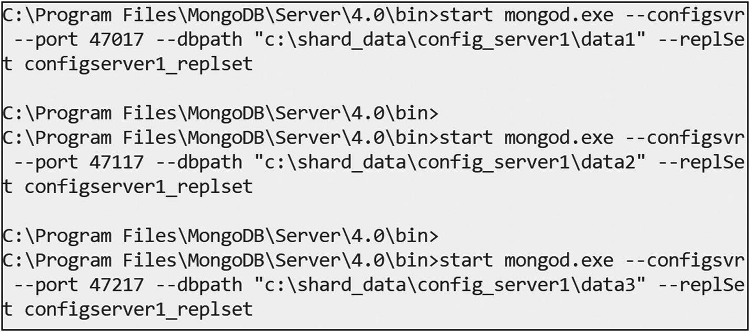
Figure 5-17Starting the config servers
Now we can connect to config servers to enable the replica set.
C:\Program Files\MongoDB\Server\4.0\bin> mongo.exe hostname:47017
Then initiate the replica set.
MongoDB Enterprise > rs.initiate(
{
_id: "configserver1_replset",
configsvr: true,
members: [
{ _id : 0, host : "hostname:47017" },
{ _id : 1, host : "hostname:47117" },
{ _id : 2, host : "hostname:47217" }
]
}
)
Start mongos as shown here.
start mongos.exe --configdb configserver1_replset/hostname:47017,hostname:47117,hostname:47217 --port 1000
Now it is time to perform sharding. Here, we are going to use one query router, one config server, and three shards.
Connect to the query router as shown here.
mongo.exe localhost:1000
Here is the output,
2018-10-01T12:47:08.929+0530 I CONTROL [main]
mongos>
Next, add the three shard servers to the config server as shown here.
sh.addShard("shard1_replset/localhost:26017,localhost:26117,localhost:26217")
Here is the output for the first shard:
mongos> sh.addShard("shard1_replset/localhost:26017,localhost:26117,localhost:26217")
{
"shardAdded" : "shard1_replset",
"ok" : 1,
"operationTime" : Timestamp(1538378773, 7),
"$clusterTime" : {
"clusterTime" : Timestamp(1538378773, 7),
"signature" : {
"hash" : BinData(0,"AAAAAAAAAAAAAAAAAAAAAAAAAAA="),
"keyId" : NumberLong(0)
}
}
}
mongos>
sh.addShard("shard2_replset/localhost:28017,localhost:28117,localhost:28217")
Here is the output for the second shard.
mongos> sh.addShard("shard2_replset/localhost:28017,localhost:28117,localhost:28217")
{
"shardAdded" : "shard2_replset",
"ok" : 1,
"operationTime" : Timestamp(1538378886, 4),
"$clusterTime" : {
"clusterTime" : Timestamp(1538378886, 6),
"signature" : {
"hash" : BinData(0,"AAAAAAAAAAAAAAAAAAAAAAAAAAA="),
"keyId" : NumberLong(0)
}
}
}
mongos>
sh.addShard("shard3_replset/localhost:29017,localhost:29117,localhost:29217")
Here is the output for the third shard.
mongos> sh.addShard("shard3_replset/localhost:29017,localhost:29117,localhost:29217")
{
"shardAdded" : "shard3_replset",
"ok" : 1,
"operationTime" : Timestamp(1538378938, 4),
"$clusterTime" : {
"clusterTime" : Timestamp(1538378938, 4),
"signature" : {
"hash" : BinData(0,"AAAAAAAAAAAAAAAAAAAAAAAAAAA="),
"keyId" : NumberLong(0)
}
}
}
Issue the following command to check the status of the sharding.
mongos> sh.status()
Now, to enable sharding for a database, use this command.
mongos> sh.enableSharding("demos")
To enable sharding for a collection, use this code.
mongos> sh.shardCollection("demos.users",{"id":1}
Here is the output,
mongos> sh.shardCollection("demos.users",{"id":1})
{
"collectionsharded" : "demos.users",
"collectionUUID" : UUID("0122f602-212e-4c79-8be7-5c7a63676c8b"),
"ok" : 1,
"operationTime" : Timestamp(1538379345, 15),
"$clusterTime" : {
"clusterTime" : Timestamp(1538379345, 15),
"signature" : {
"hash" : BinData(0,"AAAAAAAAAAAAAAAAAAAAAAAAAAA="),
"keyId" : NumberLong(0)
}
}
}
Next we can create a huge collection using the following commands.
mongos> use demos;
for(var i=0;i<10000;i++){db.users.insert({id: Math.random(), count:i, date: new Date()})}
Issue the next command to count the number of users.
mongos> db.users.count()
10000
Issue the following command to see the distribution of the user collection .
mongos> sh.status()
--- Sharding Status ---
sharding version: {
"_id" : 1,
"minCompatibleVersion" : 5,
"currentVersion" : 6,
"clusterId" : ObjectId("5bb1c63e9bbb23ade7b2dd95")
}
shards:
{ "_id" : "shard1_replset", "host" : "shard1_replset/localhost:26017,localhost:26117,localhost:26217", "state" : 1 }
{ "_id" : "shard2_replset", "host" : "shard2_replset/localhost:28017,localhost:28117,localhost:28217", "state" : 1 }
{ "_id" : "shard3_replset", "host" : "shard3_replset/localhost:29017,localhost:29117,localhost:29217", "state" : 1 }
active mongoses:
"4.0.2" : 1
autosplit:
Currently enabled: yes
balancer:
Currently enabled: yes
Currently running: no
Failed balancer rounds in last 5 attempts: 0
Migration Results for the last 24 hours:
No recent migrations
databases:
{ "_id" : "config", "primary" : "config", "partitioned" : true }
config.system.sessions
shard key: { "_id" : 1 }
unique: false
balancing: true
chunks:
shard1_replset 1
{ "_id" : { "$minKey" : 1 } } -->> { "_id" : { "$maxKey" : 1 } } on : shard1_replset Timestamp(1, 0)
{ "_id" : "demos", "primary" : "shard2_replset", "partitioned" : true, "version" : { "uuid" : UUID("52ced1e7-6afd-4554-a310-609d62c11450"), "lastMod" : 1 } }
demos.users
shard key: { "id" : 1 }
unique: false
balancing: true
chunks:
shard2_replset 1
{ "id" : { "$minKey" : 1 } } -->> { "id" : { "$maxKey" : 1 } } on : shard2_replset Timestamp(1, 0)
This shows that user data is distributed to shard1 and shard2.
NoteAll these demos are executed in a Windows environment.
Next, to shard a collection using hashed sharding, enable sharding for a database as shown here.
sh.enableSharding("sample")
Here is the output,
mongos> sh.enableSharding("sample")
{
"ok" : 1,
"operationTime" : Timestamp(1554705786, 5),
"$clusterTime" : {
"clusterTime" : Timestamp(1554705786, 5),
"signature" : {
"hash" : BinData(0,"AAAAAAAAAAAAAAAAAAAAAAAAAAA="),
"keyId" : NumberLong(0)
}
}
}
Finally, use the following command to shard a collection using hashed sharding.
sh.shardCollection("sample.users",{"id":"hashed"})
Here is the output,
mongos> sh.shardCollection("sample.users",{"id":"hashed"})
{
"collectionsharded" : "sample.users",
"collectionUUID" : UUID("4fb2750a-ec5d-4ae0-be8f-a8fbea8294ab"),
"ok" : 1,
"operationTime" : Timestamp(1554705891, 13),
"$clusterTime" : {
"clusterTime" : Timestamp(1554705891, 25),
"signature" : {
"hash" : BinData(0,"AAAAAAAAAAAAAAAAAAAAAAAAAAA="),
"keyId" : NumberLong(0)
}
}
}
© Subhashini Chellappan and Dharanitharan Ganesan 2020
S. Chellappan, D. GanesanMongoDB Recipes
https://doi.org/10.1007/978-1-4842-4891-1_6

6. Multidocument Transactions
Subhashini Chellappan1 and Dharanitharan Ganesan2
(1)
Bangalore, India
(2)
Krishnagiri, Tamil Nadu, India

In Chapter 5, we discussed replica sets and sharding in MongoDB. In this chapter, we are going to discuss multidocument transactions in MongoDB, a new feature introduced in MongoDB 4.0.

Multidocument Transactions in MongoDB
In MongoDB, a write operation on single document is atomic, even if the write operation modifies multiple embedded documents within a single document. When a single write operation (e.g., db.collection.updateMany()) modifies multiple documents, the modification of each document is atomic, but the operation as a whole is not.
Starting with version 4.0, MongoDB provides multidocument transactions for replica sets. Multidocument transactions help us to achieve all-or-nothing execution to maintain data integrity.
The multidocument transactions are atomic.
When a transaction commits, all data changes made in the transaction are saved and visible outside the transaction. The data changes are not visible outside the transaction until the transaction is committed.
When a transaction aborts, all data changes made in the transaction are discarded without ever becoming visible.
NoteMultidocument transactions are available only for a replica set. If we try to use multidocument transactions on a nonreplica set, we would get the error “Transaction numbers are only allowed on a replica set member or mongos,” as shown in Figure 6-1.
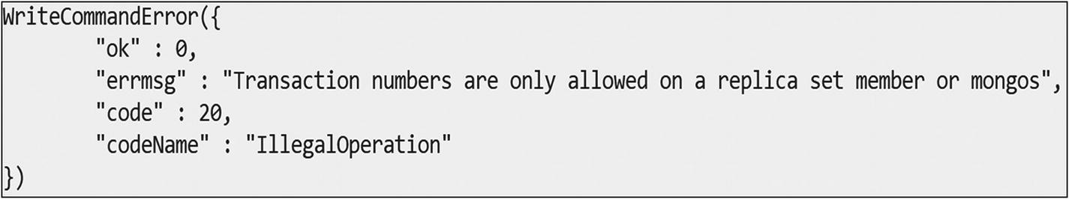
Figure 6-1Error on usage of multidocument transaction on a nonreplica set

Limitations of Transactions
Transactions do have some limitations, which are given here.
You can specify CRUD operations only on existing collections. The collections can be in different databases.
You cannot perform read/write operations on config, admin, and local databases.
You cannot write to system.* collections.
You cannot create or drop indexes inside a transaction.
You cannot perform non-CRUD operations inside a transaction.
You cannot return an operation’s query plan (i.e., explain).

Transactions and Sessions
In MongoDB, transactions are associated with sessions. MongoDB’s sessions provide a framework that supports consistency and writes that can be retried. MongoDB’s sessions are available only for replica sets and shared clusters. A session is required to start the transaction. You cannot run a transaction outside a session, and a session can run only one transaction at a time. A session is essentially a context.
There are three commands that important in working with transactions.
session.startTransaction(): To start a new transaction in the current session.
session.commitTransaction(): To save changes made by the operations in the transaction.
session.abortTransaction(): To abort the transaction without saving it.

Recipe 6-1. Working with Multidocument Transactions
In this recipe, we are going to discuss how to work with multidocument transactions .

Problem
You want to work with multidocument transactions.

Solution
Use session.startTransaction(), session.commitTransaction(), and session.abortTransaction().

How It Works
Let’s follow the steps in this section to work with multidocument transactions .

Step 1: Multidocument Transactions
To work with multidocument transactions, first we create an employee collection under the employee database as shown here.
use employee
db.createCollection("employee")
Here is the output,
myrs:PRIMARY> use employee
switched to db employee
myrs:PRIMARY> db.createCollection("employee")
{
"ok" : 1,
"operationTime" : Timestamp(1552385760, 1),
"$clusterTime" : {
"clusterTime" : Timestamp(1552385760, 1),
"signature" : {
"hash" : BinData(0,"AAAAAAAAAAAAAAAAAAAAAAAAAAA="),
"keyId" : NumberLong(0)
}
}
}
Next, insert a few documents as shown here.
db.employee.insert([{_id:1001, empName:"Subhashini"},{_id:1002, empName:"Shobana"}])
Here is the output,
myrs:PRIMARY> db.employee.insert([{_id:1001, empName:"Subhashini"},{_id:1002, empName:"Shobana"}])
BulkWriteResult({
"writeErrors" : [ ],
"writeConcernErrors" : [ ],
"nInserted" : 2,
"nUpserted" : 0,
"nMatched" : 0,
"nModified" : 0,
"nRemoved" : 0,
"upserted" : [ ]
})
Now, create a session as shown here.
session = db.getMongo().startSession()
Here is the output,
myrs:PRIMARY> session = db.getMongo().startSession()
session { "id" : UUID("55d56ef2-cab1-40c0-8d01-c2f75b5696b5") }
Next, start the transaction and insert a few documents as shown here.
session.startTransaction()
session.getDatabase("employee").employee.insert([{_id:1003,empName:"Taanushree"},{_id:1004, empName:"Aruna M S"}])
Here is the output,
myrs:PRIMARY> session.startTransaction()
myrs:PRIMARY> session.getDatabase("employee").employee.insert([{_id:1003,empName:"Taanushree"},{_id:1004, empName:"Aruna M S"}])
BulkWriteResult({
"writeErrors" : [ ],
"writeConcernErrors" : [ ],
"nInserted" : 2,
"nUpserted" : 0,
"nMatched" : 0,
"nModified" : 0,
"nRemoved" : 0,
"upserted" : [ ]
})
Now, we try to read the collection from inside and outside of the transactions . First, we will read the collection from inside the transaction.
session.getDatabase("employee").employee.find()
Here is the output,
myrs:PRIMARY> session.getDatabase("employee").employee.find()
{ "_id" : 1001, "empName" : "Subhashini" }
{ "_id" : 1002, "empName" : "Shobana" }
{ "_id" : 1003, "empName" : "Taanushree" }
{ "_id" : 1004, "empName" : "Aruna M S" }
We can see the modifications from inside the transaction.
Second, we will try to read the collection from outside of the transaction.
db.employee.find()
myrs:PRIMARY> db.employee.find()
{ "_id" : 1001, "empName" : "Subhashini" }
{ "_id" : 1002, "empName" : "Shobana" }
Because the transactions are not committed, we cannot see modifications outside the transaction .
Issue the following command to commit the transaction.
session.commitTransaction()
Here is the ouput:
myrs:PRIMARY> session.commitTransaction()
Now, we can see the modifications outside of the transaction also.
myrs:PRIMARY> db.employee.find()
{ "_id" : 1001, "empName" : "Subhashini" }
{ "_id" : 1002, "empName" : "Shobana" }
{ "_id" : 1003, "empName" : "Taanushree" }
{ "_id" : 1004, "empName" : "Aruna M S" }

Recipe 6-2. Isolation Test Between Two Concurrent Transactions
In this recipe, we are going to discuss how to perform an isolation test between two concurrent transactions.

Problem
You want to perform an isolation test between two concurrent transactions.

Solution
Use session.startTransaction(), session.commitTransaction() and session.abortTransaction().

How It Works
Let’s follow the steps in this section to perform an isolation test between two concurrent transactions.

Step 1: Isolation Test Between Two Concurrent Transactions
Create a first connection as shown here.
var session1 = db.getMongo().startSession()
session1.startTransaction()
session1.getDatabase("employee").employee.update({_id:1003},{$set:{designation: "TL" }})
Here is the output,
myrs:PRIMARY> var session1 = db.getMongo().startSession()
myrs:PRIMARY> session1.startTransaction()
myrs:PRIMARY> session1.getDatabase("employee").employee.update({_id:1003},{$set:{designation: "TL" }})
WriteResult({ "nMatched" : 1, "nUpserted" : 0, "nModified" : 1 })
Next, read the collection as shown here.
session1.getDatabase("employee").employee.find()
Here is the output,
myrs:PRIMARY> session1.getDatabase("employee").employee.find()
{ "_id" : 1001, "empName" : "Subhashini" }
{ "_id" : 1002, "empName" : "Shobana" }
{ "_id" : 1003, "empName" : "Taanushree", "designation" : "TL" }
{ "_id" : 1004, "empName" : "Aruna M S" }
Now, create a second connection and update the documents as shown here.
var session2 = db.getMongo().startSession()
session2.startTransaction()
session2.getDatabase("employee").employee.update({_id:{$in:[1001,1004]}},{$set:{designation:"SE"}},{multi:"true"})
Here is the output,
myrs:PRIMARY> var session2 = db.getMongo().startSession()
myrs:PRIMARY> session2.startTransaction()
myrs:PRIMARY> session2.getDatabase("employee").employee.update({_id:{$in:[1001,1004]}},{$set:{designation:"SE"}},{multi:"true"})
WriteResult({ "nMatched" : 2, "nUpserted" : 0, "nModified" : 2 })
Next, read the collection as shown here.
session2.getDatabase("employee").employee.find()
Here is the output,
myrs:PRIMARY> session2.getDatabase("employee").employee.find()
{ "_id" : 1001, "empName" : "Subhashini", "designation" : "SE" }
{ "_id" : 1002, "empName" : "Shobana" }
{ "_id" : 1003, "empName" : "Taanushree" }
{ "_id" : 1004, "empName" : "Aruna M S", "designation" : "SE" }
Here, the transactions are isolated, and each transaction shows the modification that it has made itself.

Recipe 6-3. Transactions with Write Conflicts
In this recipe, we are going to discuss write conflicts with transactions.

Problem
You want to see the error message for write conflicts that occurs when two transactions try to modify the same document.

Solution
Use session.startTransaction(), session.commitTransaction() and session.abortTransaction().

How It Works
Let’s follow the steps in this section to manage write conflicts between two concurrent transactions.

Step 1: Transactions with Write Conflicts
Create a first connection as shown here.
var session1 = db.getMongo().startSession()
session1.startTransaction()
session1.getDatabase("employee").employee.update({empName:"Subhashini"},{$set:{empName: "Subha" }})
Here is the output,
myrs:PRIMARY> var session1 = db.getMongo().startSession()
myrs:PRIMARY> session1.startTransaction()
myrs:PRIMARY> session1.getDatabase("employee").employee.update({empName:"Subhashini"},{$set:{empName: "Subha" }})
WriteResult({ "nMatched" : 1, "nUpserted" : 0, "nModified" : 1 })
myrs:PRIMARY>
Now, create a second connection and try to update the same document as shown here.
var session2 = db.getMongo().startSession()
session2.startTransaction()
session2.getDatabase("employee").employee.update({empName:"Subhashini"},{$set:{empName: "Subha" }})
Here is the output,
myrs:PRIMARY> var session2 = db.getMongo().startSession()
myrs:PRIMARY> session2.startTransaction()
myrs:PRIMARY> session2.getDatabase("employee").employee.update({empName:"Subhashini"},{$set:{empName: "Subha" }})
WriteCommandError({
"errorLabels" : [
"TransientTransactionError"
],
"operationTime" : Timestamp(1552405529, 1),
"ok" : 0,
"errmsg" : "WriteConflict",
"code" : 112,
"codeName" : "WriteConflict",
"$clusterTime" : {
"clusterTime" : Timestamp(1552405529, 1),
"signature" : {
"hash" : BinData(0,"AAAAAAAAAAAAAAAAAAAAAAAAAAA="),
"keyId" : NumberLong(0)
}
}
})
Here, MongoDB detects a write conflict immediately, even though the transactions are not yet committed.

Recipe 6-4. Discarding Data Changes with abortTransaction
In this recipe, we are going to discuss how to discard data changes with abortTransaction.

Problem
You want to discard data changes with abortTransaction.

Solution
Use session.startTransaction() , session.commitTransaction() , and session.abortTransaction().

How It Works
Let’s follow the steps in this section to discard data changes using the abortTransaction method.

Step 1: Discard Data Changes
Create a student collection under the student database as shown here.
use student;
db.createCollection("student")
Here is the output,
myrs:PRIMARY> use student;
switched to db student
myrs:PRIMARY> db.createCollection("student")
{
"ok" : 1,
"operationTime" : Timestamp(1552406937, 1),
"$clusterTime" : {
"clusterTime" : Timestamp(1552406937, 1),
"signature" : {
"hash" : BinData(0,"AAAAAAAAAAAAAAAAAAAAAAAAAAA="),
"keyId" : NumberLong(0)
}
}
}
myrs:PRIMARY>
Next, insert a few documents as shown here.
db.student.insert({_id:1001,name:"subhashini"})
db.student.insert({_id:1002,name:"shobana"})
Start a transaction and insert a document.
var session1 = db.getMongo().startSession()
session1.startTransaction()
session1.getDatabase("student").student.insert({_id:1003,name:"Taanushree"})
Here is the output,
myrs:PRIMARY> var session1 = db.getMongo().startSession()
myrs:PRIMARY> session1.startTransaction()
myrs:PRIMARY> session1.getDatabase("student").student.insert({_id:1003,name:"Taanushree"})
WriteResult({ "nInserted" : 1 })
myrs:PRIMARY>
Now, find the document from the collection and session.
db.student.find()
Here is the output,
myrs:PRIMARY> db.student.find()
{ "_id" : 1001, "name" : "subhashini" }
{ "_id" : 1002, "name" : "shobana" }
myrs:PRIMARY>session1.getDatabase("student").student.find()
myrs:PRIMARY> session1.getDatabase("student").student.find()
{ "_id" : 1001, "name" : "subhashini" }
{ "_id" : 1002, "name" : "shobana" }
{ "_id" : 1003, "name" : "Taanushree" }
myrs:PRIMARY>
Now, you can discard the data changes with abortTransaction as shown here.
session1.abortTransaction()
Here is the output,
myrs:PRIMARY> session1.abortTransaction()
Now, you can find the collection as shown here.
db.student.find()
myrs:PRIMARY> db.student.find()
{ "_id" : 1001, "name" : "subhashini" }
{ "_id" : 1002, "name" : "shobana" }
Here, the data changes are discarded.
NoteMultidocument transactions are only available for deployments that use WiredTiger storage engine.
© Subhashini Chellappan and Dharanitharan Ganesan 2020
S. Chellappan, D. GanesanMongoDB Recipes
https://doi.org/10.1007/978-1-4842-4891-1_7

7. MongoDB Monitoring and Backup
Subhashini Chellappan1 and Dharanitharan Ganesan2
(1)
Bangalore, India
(2)
Krishnagiri, Tamil Nadu, India

In Chapter 6, we discussed transactions in MongoDB. In this chapter, we are going to discuss the following topics:
MongoDB monitoring tools.
Backup and restore with MongoDB.

MongoDB Monitoring
MongoDB provides various tools to monitor the database. These MongoDB monitoring tools help us to understand what is happening with a database at various levels.

Log File
The first basic tool is the log file.

Recipe 7-1. Working with MongoDB Log Files
In this recipe, we are going to discuss MongoDB log files.

Problem
You want to see the MongoDB log file and set the log level.

Solution
The MongoDB log file is present in the following installation path:
c:\Program Files\MongoDB\Server\4.0\log>
Use the db.setLogLevel function to set the log level.

How It Works
Let’s follow the steps in this section to see the log file in mongo shell.

Step 1: To Display the Log File Content and Set the Log Level
Type the following command in the mongo shell .
show logs
Here is the output,
> show logs
global
startupWarnings
You can see the log entries by typing the next command.
show log global
We cannot filter the log messages in the console.
MongoDB has several logging levels, which can be set using the db.setLogLevel function.
The syntax for db.setLogLevel is
db.setLogLevel(<level>, <component>)
Here, level indicates the log verbosity level, which ranges from 0 to 5. The default log level is 0, which includes informational messages. Levels 1 to 5 increase the verbosity level to include debug messages. The second argument, component, is optional. This refers to the name of the component for which you want to set the verbosity level. The component name corresponds to the <name> from the corresponding systemLog.component.<name>.verbosity setting:
accessControl
command
control
ftdc
geo
index
network
query
replication
recovery
sharding
storage
storage.journal
transaction
write
To set the log level to 2 on the topic query, issue the following command.
db.setLogLevel(2,"query")
Here is the output,
> db.setLogLevel(2,"query")
{
"was" : {
"verbosity" : 0,
"accessControl" : {
"verbosity" : -1
},
"command" : {
"verbosity" : -1
},
"control" : {
"verbosity" : -1
},
"executor" : {
"verbosity" : -1
},
"geo" : {
"verbosity" : -1
},
"index" : {
"verbosity" : -1
},
"network" : {
"verbosity" : -1,
"asio" : {
"verbosity" : -1
},
"bridge" : {
"verbosity" : -1
}
},
"query" : {
"verbosity" : -1
},
"replication" : {
"verbosity" : -1,
"heartbeats" : {
"verbosity" : -1
},
"rollback" : {
"verbosity" : -1
}
},
"sharding" : {
"verbosity" : -1
},
"storage" : {
"verbosity" : -1,
"recovery" : {
"verbosity" : -1
},
"journal" : {
"verbosity" : -1
}
},
"write" : {
"verbosity" : -1
},
"ftdc" : {
"verbosity" : -1
},
"tracking" : {
"verbosity" : -1
},
"transaction" : {
"verbosity" : -1
}
},
"ok" : 1
}
MongoDB echoes back the previous configuration before the new setting was applied. At the top, you can see the default level, which indicates that any components that are not set will log at this level. Here, it will override only the query component. The -1 verbosity indicates that it inherits the default level from its parent.
To see the current level, issue the following command.
db. getLogComponents
Here is the output,
> db.getLogComponents()
{
"verbosity" : 0,
"accessControl" : {
"verbosity" : -1
},
"command" : {
"verbosity" : -1
},
"control" : {
"verbosity" : -1
},
"executor" : {
"verbosity" : -1
},
"geo" : {
"verbosity" : -1
},
"index" : {
"verbosity" : -1
},
"network" : {
"verbosity" : -1,
"asio" : {
"verbosity" : -1
},
"bridge" : {
"verbosity" : -1
}
},
"query" : {
"verbosity" : 2
},
"replication" : {
"verbosity" : -1,
"heartbeats" : {
"verbosity" : -1
},
"rollback" : {
"verbosity" : -1
}
},
"sharding" : {
"verbosity" : -1
},
"storage" : {
"verbosity" : -1,
"recovery" : {
"verbosity" : -1
},
"journal" : {
"verbosity" : -1
}
},
"write" : {
"verbosity" : -1
},
"ftdc" : {
"verbosity" : -1
},
"tracking" : {
"verbosity" : -1
},
"transaction" : {
"verbosity" : -1
}
}
>
Here, the query level is set to 2.
Now, issue the following query, which we’ll use to add an entry to the log file:
> db.demos.find()
>
This query will not return any results because there is no collection named demos in the test database.
Now, issue this command to see the log file.
> show log global
Here are the last few lines of log file output,
2019-02-17T16:08:43.681+0530 D QUERY [conn1] Collection test.demos does not exist. Using EOF plan: query: {} sort: {} projection: {}
2019-02-17T16:09:03.805+0530 D QUERY [conn1] Collection test.demos does not exist. Using EOF plan: query: {} sort: {} projection: {}
2019-02-17T16:09:31.633+0530 D QUERY [LogicalSessionCacheRefresh] Using idhack: { _id: { id: UUID("9d7def64-8b49-4c85-9392-01f7ab88e019"), uid: BinData(0, E3B0C44298FC1C149AFBF4C8996FB92427AE41E4649B934CA495991B7852B855) } }
You can see some additional information about the query.
Now set the query log level as -1:
> db.setLogLevel(-1,"query")
Then, issue the following query and observe the details in the log file as explained further later.
> db.demos.find({y:1})
Now check the log file by using the following command.
> show log global
Now check the end of the log file: We cannot see the extra logging information for this find query.
Use db.setLogLevel(0) to turn off the logging level.
If we do not specify the option as query or write or anything, it will be applied for all options.
The log level 5 is very detailed; levels 1 to 3 are more useful options and these are recommended unless you need all of the detailed information provided by the highest log level of 5.
Also, setting the appropriate log level helps us to improve the performance of queries by identifying the query plans logged in the log file and also by identifying the slow operations by checking the time taken to execute a query.
NoteRefer to Recipe 7-10 to learn more about MongoDB query plans.

MongoDB Performance
It is mandatory to analyze the performance of the database when we develop new applications with MongoDB. Performance degradation could happen due to hardware availability issues, number of open database connections, and database access strategies.
Performance issues indicate the database is operating at full capacity and abnormal traffic load due to an increase in the number of connections.
The database profiler can help us to understand the various operations performed on the database that cause performance degradation.

Database Profiler
The database profiler is used to collect information about the commands that are executed against a running mongod instance. The database profiler writes all the collected data to the system.profile capped collection in the admin database.
MongoDB also has a Performance Advisor tool that automatically monitors slow queries and suggests new indexes to improve query performance. A query is considered to be slow if it takes more than 100 milliseconds to execute.
NoteThe Performance Advisor tool is available in the MongoDB Atlas cluster. MongoDB Atlas is the global cloud database service for modern applications.
The profiler is turned off by default. It can be enabled on a per-database or per-instance basis at any one of the profiling levels mentioned in Table 7-1.
Table 7-1Profiling Levels
Level | Description
0 | The profiler is off and does not collect any data. This is the default profiler level.
1 | The profiler collects data for operations that take longer than the value of the slowms parameter.
2 | The profiler collects data for all operations.

Recipe 7-2. Working with Database Profiler
In this recipe, we are going to discuss how to enable database profiler and how to set the profiling level.

Problem
You want to enable database profiling with a profile level.

Solution
Use the db.setProfilingLevel() helper in the mongo shell.

How It Works
Let’s follow the steps in this section to enable the database profiler.

Step 1: Enable and Configure Database Profiler
To enable the database profiler to collect all database information use the following command.
db.setProfilingLevel(2)
Here is the output,
> db.setProfilingLevel(2)
{ "was" : 0, "slowms" : 100, "sampleRate" : 1, "ok" : 1 }
was is the key/value pair indicating the previous level of profiling.
You can specify the threshold for slow operations using the next command.
db.setProfilingLevel(1, { slowms: 30 })
Here is the output,
> db.setProfilingLevel(1, { slowms: 30 })
{ "was" : 2, "slowms" : 100, "sampleRate" : 1, "ok" : 1 }
Here, the slow operation threshold is 30 milliseconds.
To profile a random sample of slow operations, use the following command.
db.setProfilingLevel(1, { sampleRate: 0.53 })
That code sets the profiler to sample 53% of all slow operations.
NoteThe default threshold value for the slow operation is 100 milliseconds.
You can get the profiling level by issuing the following command.
db.getProfilingStatus()
Here is the output,
> db.getProfilingStatus()
{ "was" : 1, "slowms" : 30, "sampleRate" : 1 }
The was field indicates the current profiling level.
To disable the database profiler, use this command.
db.setProfilingLevel(0)
Here is the output,
> db.setProfilingLevel(0)
{ "was" : 1, "slowms" : 30, "sampleRate" : 1, "ok" : 1 }
To enable profiling for an entire mongod instance, pass the following option to the mongod instance at the time of starting it.
mongod --profile 1 --slowms 20 --slowOpSampleRate 0.5
This command sets the profiling level to 1, the slow operation threshold to 20 milliseconds, and it profiles only 50% of the slow operations.

Recipe 7-3. View Database Profiler
In this recipe, we are going to discuss how to view database profiler.

Problem
You want to view database profiler information.

Solution
Use db.system.profile.find() in the mongo shell.

How It Works
Let’s follow the steps in this section to view database profiler information.

Step 1: Enable and Configure Database Profiler
The database profiler logs information in the system.profile collection. You need to query system.collection to view profiling information.
Create an employee collection in the example database as shown here.
> use example;
switched to db example
> db.setProfilingLevel(2)
{ "was" : 0, "slowms" : 100, "sampleRate" : 1, "ok" : 1 }
> show collections
> db.employee.insert({_id:1001,name:"Subhashini"})
WriteResult({ "nInserted" : 1 })
> db.employee.insert({_id:1001,name:"Shobana"})
WriteResult({
"nInserted" : 0,
"writeError" : {
"code" : 11000,
"errmsg" : "E11000 duplicate key error collection: example.employee index: _id_ dup key: { : 1001.0 }"
}
})
> db.employee.find()
{ "_id" : 1001, "name" : "Subhashini" }
The profiler stores details in their respective keys as follows:
op: Component type (i.e., query or command).
ts: Timestamp.
ns: Collection details where the query is executed.
These options can be used to filter or sort as in the queries that follow.
To return operations performed on the employee collection, issue the following command.
> db.system.profile.find( { ns : 'example.employee' } ).pretty()
Here is the output,
{
"op" : "insert",
"ns" : "example.employee",
"command" : {
"insert" : "employee",
"ordered" : true,
"lsid" : {
"id" : UUID("93b33e8d-f561-46a1-8310-0f62d31442f1")
},
"$db" : "example"
},
"ninserted" : 1,
"keysInserted" : 1,
"numYield" : 0,
"locks" : {
"Global" : {
"acquireCount" : {
"r" : NumberLong(3),
"w" : NumberLong(3)
}
},
"Database" : {
"acquireCount" : {
"w" : NumberLong(2),
"W" : NumberLong(1)
}
},
"Collection" : {
"acquireCount" : {
"w" : NumberLong(2)
}
}
},
"responseLength" : 45,
"protocol" : "op_msg",
"millis" : 21,
"ts" : ISODate("2019-01-14T06:08:38.838Z"),
"client" : "127.0.0.1",
"appName" : "MongoDB Shell",
"allUsers" : [ ],
"user" : ""
}
{
"op" : "insert",
"ns" : "example.employee",
"command" : {
"insert" : "employee",
"ordered" : true,
"lsid" : {
"id" : UUID("93b33e8d-f561-46a1-8310-0f62d31442f1")
},
"$db" : "example"
},
"ninserted" : 0,
"keysInserted" : 0,
"numYield" : 0,
"locks" : {
"Global" : {
"acquireCount" : {
"r" : NumberLong(1),
"w" : NumberLong(1)
}
},
"Database" : {
"acquireCount" : {
"w" : NumberLong(1)
}
},
"Collection" : {
"acquireCount" : {
"w" : NumberLong(1)
}
}
},
"responseLength" : 194,
"protocol" : "op_msg",
"millis" : 2,
"ts" : ISODate("2019-01-14T06:08:50.297Z"),
"client" : "127.0.0.1",
"appName" : "MongoDB Shell",
"allUsers" : [ ],
"user" : ""
}
{
"op" : "query",
"ns" : "example.employee",
"command" : {
"find" : "employee",
"filter" : {
},
"lsid" : {
"id" : UUID("93b33e8d-f561-46a1-8310-0f62d31442f1")
},
"$db" : "example"
},
"keysExamined" : 0,
"docsExamined" : 1,
"cursorExhausted" : true,
"numYield" : 0,
"nreturned" : 1,
"locks" : {
"Global" : {
"acquireCount" : {
"r" : NumberLong(1)
}
},
"Database" : {
"acquireCount" : {
"r" : NumberLong(1)
}
},
"Collection" : {
"acquireCount" : {
"r" : NumberLong(1)
}
}
},
"responseLength" : 147,
"protocol" : "op_msg",
"millis" : 0,
"planSummary" : "COLLSCAN",
"execStats" : {
"stage" : "COLLSCAN",
"nReturned" : 1,
"executionTimeMillisEstimate" : 0,
"works" : 3,
"advanced" : 1,
"needTime" : 1,
"needYield" : 0,
"saveState" : 0,
"restoreState" : 0,
"isEOF" : 1,
"invalidates" : 0,
"direction" : "forward",
"docsExamined" : 1
},
"ts" : ISODate("2019-01-14T06:22:07.873Z"),
"client" : "127.0.0.1",
"appName" : "MongoDB Shell",
"allUsers" : [ ],
"user" : ""
}
>
To return the most recent five log entries, issue the following command.
> db.system.profile.find().limit(5).sort( { ts : -1 } ).pretty()
Notets specifies the timestamp and the value -1 specifies to sort in descending order. We can specify 1 for ascending or -1 for descending order.
To return operations slower than 5 milliseconds, use this syntax.
> db.system.profile.find( { millis : { $gt : 5 } } ).pretty()

mongostat
mongostat is a monitoring utility that provides information about a mongod instance if you are working on a single mongod instance. If you are working on a shared cluster, it shows information about a mongos instance.

Recipe 7-4. Working with mongostat
In this recipe, we are going to discuss how to use mongostat to monitor the MongoDB server.

Problem
You want to see the details of a MongoDB server.

Solution
Use the mongostat tool, which is available in the installation directory. Usually the installation directory is C:\Program Files\MongoDB\Server\4.0\bin or the custom path specified during your installation process.
Avoid navigating to the directory each time to use the mongostat tool and add the directory path to your PATH environment variable.

How It Works
Let’s follow the steps in this section to view server information using mongostat.

Step 1: mongostat Command
Issue the mongostat command by specifying the hostname and port of MongoDB server.
Here is the output,
c:\Program Files\MongoDB\Server\4.0\bin>mongostat --host localhost:27017
insert query update delete getmore command dirty used flushes vsize res qrw arw net_in net_out conn time
*0 *0 *0 *0 0 146|0 0.0% 0.0% 0 4.97G 28.0M 0|0 1|0 11.6k 4.49m 2 Feb 17 16:59:19.131
*0 *0 *0 *0 0 2|0 0.0% 0.0% 0 4.97G 28.0M 0|0 1|0 163b 63.6k 2 Feb 17 16:59:20.095
*0 *0 *0 *0 0 2|0 0.0% 0.0% 0 4.97G 28.0M 0|0 1|0 158b 61.7k 2 Feb 17 16:59:21.090
*0 *0 *0 *0 0 1|0 0.0% 0.0% 0 4.97G 28.0M 0|0 1|0 157b 61.3k 2 Feb 17 16:59:22.090
*0 *0 *0 *0 0 1|0 0.0% 0.0% 0 4.97G 28.0M 0|0 1|0 157b 61.2k 2 Feb 17 16:59:23.093
*0 *0 *0 *0 0 2|0 0.0% 0.0% 0 4.97G 28.0M 0|0 1|0 158b 61.4k 2 Feb 17 16:59:24.092
*0 *0 *0 *0 0 2|0 0.0% 0.0% 0 4.97G 28.0M 0|0 1|0 159b 62.1k 2 Feb 17 16:59:25.080
*0 *0 *0 *0 0 1|0 0.0% 0.0% 0 4.97G 28.0M 0|0 1|0 157b 61.2k 2 Feb 17 16:59:26.082
*0 *0 *0 *0 0 1|0 0.0% 0.0% 0 4.97G 28.0M 0|0 1|0 157b 61.0k 2 Feb 17 16:59:27.088
*0 *0 *0 *0 0 2|0 0.0% 0.0% 0 4.97G 28.0M 0|0 1|0 158b 61.6k 2 Feb 17 16:59:28.083
Note27017 is the default port. We can simply use mongostat without any options if we want to connect and get statistics of localhost and default port 27017. To connect a different or remote instance, specify the option -host as shown.
You can see that there are multiple columns in the output.
insert/query/update/delete: These columns show the number of insert, query, update, and delete operations per second.
getmore: This column shows the number of times the getmore operation is executed in one second.
command: This column shows the number of commands executed on the server in one second.
flushes: This column shows the number of times data was flushed to disk in one second.
mapped: This column shows the amount of memory used by the mongo process against a database. It is the same as the size of the database.
vsize (virtual size): This column represents virtual memory allocated to the entire mongod process.
res (resident memory): This column represents the physical memory used by MongoDB.
faults: This column shows the number of Linux page faults per second.
qr|qw: This column shows queued-up reads and writes that are waiting for the chance to be executed.
ar|aw: This column shows number of active clients.
netIn and netOut: These columns show the network traffic in and out of the MongoDB server within a given time frame.
conn: This column shows the number of open connections.
time: This column shows the time frame in which operations are performed.

mongotop
mongotop provides a method to track the amount of time spent by the mongod process during reads and writes. mongotop provides statistics on a per-collection level.

Recipe 7-5. Working with mongotop
In this recipe, we are going to discuss how to use mongotop to track the amount of time spent by the mongod process during reads and writes.

Problem
You want to see the amount of time spent by the mongod process during reads and writes.

Solution
Issue the mongotop command in the installation path of MongoDB.

How It Works
Let’s follow the steps in this section to view the amount of time spent during reads and writes.

Step 1: mongotop Command
Issue the following command.
c:\Program Files\MongoDB\Server\4.0\bin>mongotop
2019-02-17T21:51:25.975+0530 connected to: 127.0.0.1
ns total read write 2019-02-17T21:51:26+05:30
admin.system.roles 0ms 0ms 0ms
admin.system.version 0ms 0ms 0ms
config.system.sessions 0ms 0ms 0ms
emp.employee 0ms 0ms 0ms
employee.author 0ms 0ms 0ms
employee.authors 0ms 0ms 0ms
employee.categories 0ms 0ms 0ms
employee.employee 0ms 0ms 0ms
employee.employeedetails 0ms 0ms 0ms
employee.names 0ms 0ms 0ms

db.stats()
db.stats() provides the statistics of a single database.

Recipe 7-6. Working with db.stats()
In this recipe, we are going to discuss how to get the statistics for a single database.

Problem
You want to see the disk and memory usage estimates for a database.

Solution
Use the db.stats command to display the statistics for a database.

How It Works
Let’s follow the steps in this section to view the statistics for the database.

Step 1: db.stats() Command
Issue the following commands to display the statistics for a database named employee.
> use employee
switched to db employee
> db.stats()
{
"db" : "employee",
"collections" : 12,
"views" : 0,
"objects" : 40,
"avgObjSize" : 90.875,
"dataSize" : 3635,
"storageSize" : 401408,
"numExtents" : 0,
"indexes" : 12,
"indexSize" : 212992,
"fsUsedSize" : 208018800640,
"fsTotalSize" : 509929914368,
"ok" : 1
}
>
The details such as data size and storage size are given in bytes. To see the information in megabytes, issue the following command.
> db.stats(1000000)
{
"db" : "employee",
"collections" : 12,
"views" : 0,
"objects" : 40,
"avgObjSize" : 90.875,
"dataSize" : 0.003635,
"storageSize" : 0.401408,
"numExtents" : 0,
"indexes" : 12,
"indexSize" : 0.212992,
"fsUsedSize" : 208020.402176,
"fsTotalSize" : 509929.914368,
"ok" : 1
}
>

db.serverStatus()
db.serverStatus() returns a document that provides statistics for the state of a database process.

Recipe 7-7. Working with db.serverStatus()
In this recipe, we are going to discuss the db.serverStatus() command .

Problem
You want to see the memory status of a database.

Solution
Use the db.serverStatus() command .

How It Works
Let’s follow the steps in this section to view the statistics for the memory status of a database.

Step 1: db.serverStatus() Command
Issue following command to view the memory statistics for a database.
> db.serverStatus().mem
{
"bits" : 64,
"resident" : 85,
"virtual" : 5089,
"supported" : true,
"mapped" : 0,
"mappedWithJournal" : 0
}

Backup and Restore with MongoDB Tools
MongoDB provides mongodump and mongorestore utilities to work with BSON data dumps. These utilities are useful for creating backups for small deployments. To create resilient and nondisruptive backups for large deployments, we can use file system or block-level disk snapshot methods.
We should use a system-level tool to create a copy of the device file system that holds MongoDB files. The file system snaphots or the disk-level snapshot backup method require additional system configuration outside of MongoDB, so we do not cover this in depth in this book.
When deploying MongoDB in production, we should have a backup and failover strategy for capturing and restoring backups in the case of data loss events.

Recipe 7-8. Working with mongodump
In this recipe, we are going to discuss how to back up data using mongodump.

Problem
You want to back up data using mongodump.

Solution
Use the mongodump command.

How It Works
Let’s follow the steps in this section to back up data.
The mongodump utility makes a backup by connecting to a running mongod or mongos instance.
When you run the mongodump command without specifying any arguments, it connects to the mongodb running on localhost on port 27017 and creates a database backup named dump in the current directory.
Let us discuss how to issue the mongodump command to create a backup.
1. | Ensure mongod is running.
2. | Open a command prompt with administrator privileges, navigate to the mongodb installation folder, and type mongodump as shown here.  c:\Program Files\MongoDB\Server\4.0\bin>mongodump
3. | You can see the dump folder in the current directory as shown in Figure 7-1.
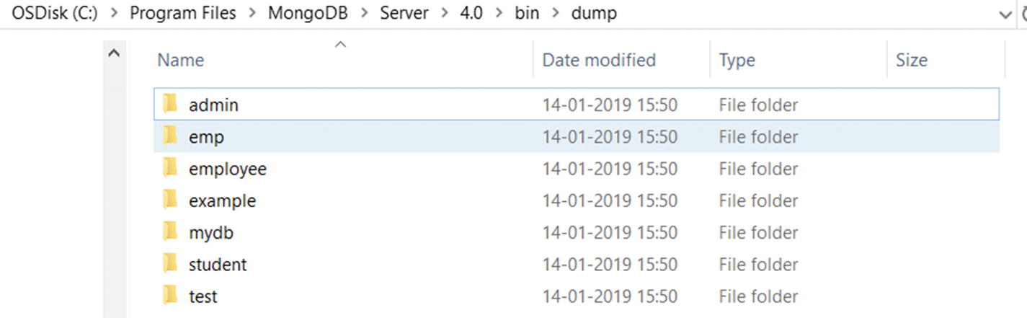
Figure 7-1MongoDB installation folder
You can specify the output directory by issuing the following command.
mkdir "c:\Program Files\MongoDB\Server\4.0\dump"
mongodump --out "c:\Program Files\MongoDB\Server"\4.0\dump
To create a backup of a collection, issue the following command.
mongodump --collection employee --db example --out "c:\Program Files\MongoDB\Server"\4.0\backup
Here is the output,
c:\Program Files\MongoDB\Server\4.0\bin>mongodump --collection employee --db example --out "c:\Program Files\MongoDB\Server"\4.0\backup
2019-01-14T18:36:28.460+0530 writing example.employee to
2019-01-14T18:36:28.465+0530 done dumping example.employee (1 document)
You can make a backup from a remote host by specifying host and port arguments as shown here.
mongodump --host sample.net --port 5017 --username user --password "pass"

Automatic and Regular Backup Scheduling Using mongodump
It is good practice to perform a regular backup of all databases in case of any hard failover. Follow these steps to perform a regular backup at a specific interval.
1. | We can create scripts to create the backup directory for the current date and time and export the database to the same directory.  For Windows, create a bat (batch script) file with the commands shown in Figure 7-2.
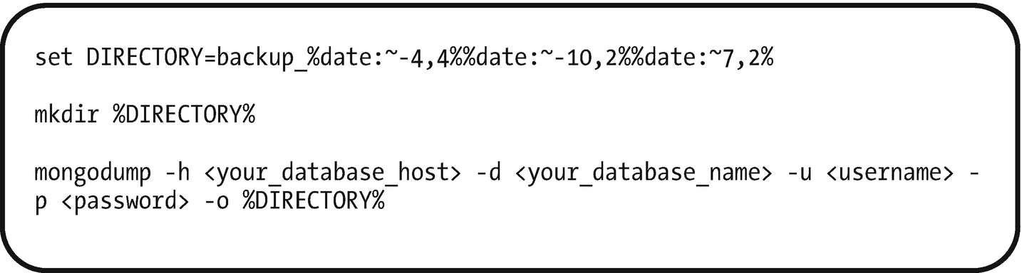
Figure 7-2Creating a batch script file in Windows
For Unix/Linux machines, create a shell script file with the commands shown in Figure 7-3.
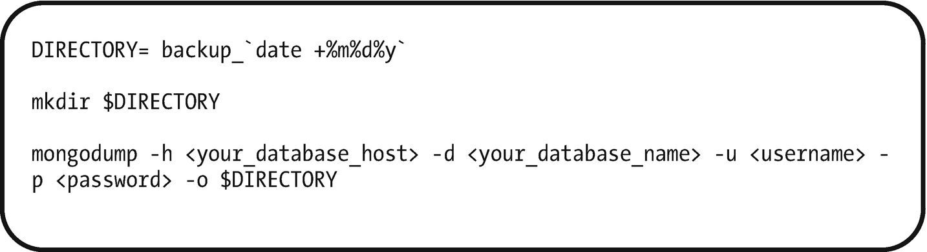
Figure 7-3Creating a shell script file in Unix/Linux

2. | Schedule the script file to execute at a certain interval. Use task scheduler or any other scheduler for Windows, and use the CRON schedule for Unix/Linux.

Recipe 7-9. Working with mongorestore
In this recipe, we are going to discuss how to restore data using mongorestore.

Problem
You want to restore data using mongorestore .

Solution
Use the mongorestore command.

How It Works
Let’s follow the steps in this section to restore data.

Step 1: Restore Data Using mongorestore
To restore data, open a command prompt and navigate to the mongodb installation folder, then issue the following command.
c:\Program Files\MongoDB\Server\4.0\bin>mongorestore dump/
Here, mongorestore imports the data present in the dump directory to the running mongod instance. By default, mongorestore looks for a database backup in the dump/ directory . We can connect to a different port of the active mongod instance and a different backup path by using this command.
mongorestore --port <port number> <path to the backup>

Step 2: Restore Data Using mongorestore to Remote Instances
By default, mongorestore connects to running instance on localhost and default port number 27017. To restore to a different host and different port, we can specify the same using the --host and --port options as shown here.
mongorestore --host <example.net> --port <myportNumber> --username myuser --password 'mypass' /backup/mongodumpfile
Specify the username and password using options --user and --password only if the remote mongod instance requires authentication.

Recipe 7-10. Working with mongodb Query Plans
In this recipe, we are going to discuss query plans to understand the MongoDB query execution details with query planner and query optimizer.

Problem
You want to understand the query execution plan.

Solution
Use the cursor.explain() command.

How It Works
Let’s follow the steps in this section to understand the query plan.

Step 1: Using explain() to Understand the Query Plan
To see the query plan during the MongoDB command execution, use cursor.explain(). Let’s assume the employee collection is available in the authors database with the data shown here.
MongoDB Enterprise > use authors
switched to db authors
MongoDB Enterprise > db.employee.find()
{ "_id" : ObjectId("5d50ed688dcf280c50fde439"), "empId" : 1, "empName" : "John", "state" : "KA", "country" : "India" }
{ "_id" : ObjectId("5d50ed688dcf280c50fde43a"), "empId" : 2, "empName" : "Smith", "state" : "CA", "country" : "US" }
{ "_id" : ObjectId("5d50ed688dcf280c50fde43b"), "empId" : 3, "empName" : "James", "state" : "FL", "country" : "US" }
{ "_id" : ObjectId("5d50ed688dcf280c50fde43c"), "empId" : 4, "empName" : "Josh", "state" : "TN", "country" : "India" }
{ "_id" : ObjectId("5d50ed688dcf280c50fde43d"), "empId" : 5, "empName" : "Joshi", "state" : "HYD", "country" : "India" }
To get the query plan while executing the command db.employee.find(), use .explain() as shown here.
MongoDB Enterprise > db.employee.find().explain()
Here is the output,
MongoDB Enterprise > db.employee.find().explain()
{
"queryPlanner" : {
"plannerVersion" : 1,
"namespace" : "authors.employee",
"indexFilterSet" : false,
"parsedQuery" : {
},
"winningPlan" : {
"stage" : "COLLSCAN",
"direction" : "forward"
},
"rejectedPlans" : [ ]
},
"serverInfo" : {
"host" : "DESKTOP-MEISTBV",
"port" : 27017,
"version" : "4.0.11",
"gitVersion" : "417d1a712e9f040d54beca8e4943edce218e9a8c"
},
"ok" : 1
}
Observe in this output that there is no parsedQuery in the query planner, and the winning plan says that it involves the complete collection scan.
Now, let’s try to add a filter to the same query and observe the query plan.
MongoDB Enterprise > db.employee.find({country:"India"})
{ "_id" : ObjectId("5d50ed688dcf280c50fde439"), "empId" : 1, "empName" : "John", "state" : "KA", "country" : "India" }
{ "_id" : ObjectId("5d50ed688dcf280c50fde43c"), "empId" : 4, "empName" : "Josh", "state" : "TN", "country" : "India" }
{ "_id" : ObjectId("5d50ed688dcf280c50fde43d"), "empId" : 5, "empName" : "Joshi", "state" : "HYD", "country" : "India" }
We have added the filter condition to retrieve only country:India. Now check the query plan for the same query with the filter condition.
MongoDB Enterprise> db.employee.find({country:"India"}).explain()
Here is the output,
MongoDB Enterprise > db.employee.find({country:"India"}).explain()
{
"queryPlanner" : {
"plannerVersion" : 1,
"namespace" : "authors.employee",
"indexFilterSet" : false,
"parsedQuery" : {
"country" : {
"$eq" : "India"
}
},
"winningPlan" : {
"stage" : "COLLSCAN",
"filter" : {
"country" : {
"$eq" : "India"
}
},
"direction" : "forward"
},
"rejectedPlans" : [ ]
},
"serverInfo" : {
"host" : "DESKTOP-MEISTBV",
"port" : 27017,
"version" : "4.0.11",
"gitVersion" : "417d1a712e9f040d54beca8e4943edce218e9a8c"
},
"ok" : 1
}
Observe in the preceding output that there is a parsed query added by the query planner as
"parsedQuery" : { "country" : {"$eq" : "India" } }

Step 2: Understanding Different Modes in explain()
The explain() method accepts queryPlanner, executionStats, or allPlansExecution as the operating mode. The default mode is queryPlanner if we don’t specify otherwise.
Use the following command to use explain() with any of these parameters as a mode.
db.employee.find().explain("queryPlanner")
Here is the output,
MongoDB Enterprise > db.employee.find().explain("queryPlanner")
{
"queryPlanner" : {
"plannerVersion" : 1,
"namespace" : "authors.employee",
"indexFilterSet" : false,
"parsedQuery" : {
},
"winningPlan" : {
"stage" : "COLLSCAN",
"direction" : "forward"
},
"rejectedPlans" : [ ]
},
"serverInfo" : {
"host" : "DESKTOP-MEISTBV",
"port" : 27017,
"version" : "4.0.11",
"gitVersion" : "417d1a712e9f040d54beca8e4943edce218e9a8c"
},
"ok" : 1
}
Now use executionStats as a operation mode to the explain() method as shown here.
db.employee.find().explain("executionStats")
Here is the output,
MongoDB Enterprise > db.employee.find().explain("executionStats")
{
"queryPlanner" : {
"plannerVersion" : 1,
"namespace" : "authors.employee",
"indexFilterSet" : false,
"parsedQuery" : {
},
"winningPlan" : {
"stage" : "COLLSCAN",
"direction" : "forward"
},
"rejectedPlans" : [ ]
},
"executionStats" : {
"executionSuccess" : true,
"nReturned" : 5,
"executionTimeMillis" : 0,
"totalKeysExamined" : 0,
"totalDocsExamined" : 5,
"executionStages" : {
"stage" : "COLLSCAN",
"nReturned" : 5,
"executionTimeMillisEstimate" : 0,
"works" : 7,
"advanced" : 5,
"needTime" : 1,
"needYield" : 0,
"saveState" : 0,
"restoreState" : 0,
"isEOF" : 1,
"invalidates" : 0,
"direction" : "forward",
"docsExamined" : 5
}
},
"serverInfo" : {
"host" : "DESKTOP-MEISTBV",
"port" : 27017,
"version" : "4.0.11",
"gitVersion" : "417d1a712e9f040d54beca8e4943edce218e9a8c"
},
"ok" : 1
}
MongoDB Enterprise >
In this output, observe the following:
"executionSuccess" : true: This shows whether the query is successfully executed or not.
"nReturned" : 5: This is the number of rows returned.
"executionTimeMillis" : 0: This is the execution time in milliseconds.
If the executionTimeMillis value is more, then it could be considered a slow query and we must rewrite the query to optimize the executiuon time by adding the required filters to retrieve only the required data. We could also consider using an index on keys for better performance.
© Subhashini Chellappan and Dharanitharan Ganesan 2020
S. Chellappan, D. GanesanMongoDB Recipes
https://doi.org/10.1007/978-1-4842-4891-1_8

8. MongoDB Security
Subhashini Chellappan1 and Dharanitharan Ganesan2
(1)
Bangalore, India
(2)
Krishnagiri, Tamil Nadu, India

In Chapter 7, we discussed monitoring and backup methods in MongoDB. In this chapter, we are going to discuss the security features of MongoDB.

Authentication and Authorization
Authentication is the process of verifying the identity of the user, whereas authorization or access control determines the verified user’s access to resources and operations.
MongoDB supports the following various authentication mechanisms for verifying the identity of the user.
SCRAM: This is the default authentication mechanism for MongoDB. It verifies the user against their username, password, and authentication database.
x.509 certificates: This mechanism uses x.509 certificates for authentication. MongoDB supports a number of authentication mechanisms that clients can use to verify their identity. These mechanisms allow MongoDB to integrate into an existing authentication system.
In addition to this, MongoDB Enterprise Edition also supports Lightweight Directory Access Protocol (LDAP) proxy authentication and Kerberos authentication.
NoteReplica sets and shared clusters require internal authentication between members when access control is enabled. Refer to Recipe 8-2 to understand the authentication process for replica sets.

Access Control
MongoDB enforces authentication to identify users and their permissions to access resources only if access control is enabled. The upcoming recipes explain the procedure to create various roles and the mechanisms to enable access control.
When you install MongoDB, it has no users. First, therefore, we need to create the admin user, which can be used to create other users.

Roles
In MongoDB, roles grant users access to MongoDB resources. MongoDB has certain built-in roles, listed in Figure 8-1, which can be assigned to any user to access resources. We can also create user-defined roles.
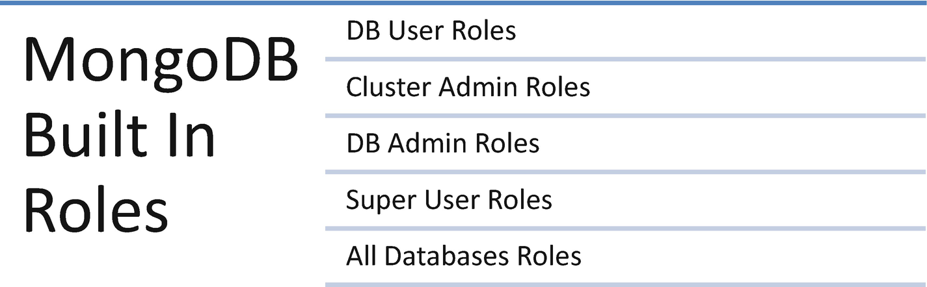
Figure 8-1MongoDB built-in roles
First, let’s look at the commonly used built-in roles.

MongoDB User Roles

read
The read role gives the holder access to read all of the user-created collections.

readwrite
The readwrite role gives access to read all of the user-created collections and also the ability to modify the nonsystem (i.e., user-created) collections.

MongoDB Admin Roles

dbAdmin
The dbAdmin role could help us to perform administrative tasks such as schema-related tasks, indexing, and collecting statistics. We cannot use this role to grant privileges for users and others’ role management.

dbOwner
We can perform any administrative tasks on a database using the dbOwner role. This role also includes the other role previliges such as the readWrite, dbAdmin, and userAdmin roles.

userAdmin
We can create and modify roles and users on the current active database.

Cluster Admin Roles

clusterAdmin
The clusterAdmin role provides cluster management access. This role also includes other role privileges, such as clusterManager, clusterMonitor, and hostManager roles.

clusterManager
This role helps us to manage and monitor user actions on the mongodb cluster.

Recipe 8-1. Creating a Superuser and Authenticating a User
In this recipe, we are going to discuss how to create a superuser and authenticate a user.

Problem
You want to create a superuser and authenticate a user.

Solution
Here are the commands:
db.createUser()
mongo --username username --password password --authenticationDatabase databasename
db.auth()

How It Works
Let’s follow the steps in this section to create a superuser.

Step 1: Create a Superuser
Connect to a mongod instance and type the following command.
> use admin
> db.createUser({user:"superUserAdmin",pwd:"1234",roles:[{role: "userAdminAnyDatabase",db:"admin"}]})
Here is the output,
> use admin
switched to db admin
> db.createUser({user:"superUserAdmin",pwd:"1234",roles:[{role: "userAdminAnyDatabase",db:"admin"}]})
Successfully added user: {
"user" : "superUserAdmin",
"roles" : [
{
"role" : "userAdminAnyDatabase",
"db" : "admin"
}
]
}
>
To authenticate using the mongo shell , do with either of the following.
Use MongoDB command-line authentication options (i.e., --username, --password, and –authenticationDatabase) when connecting to a mongod or mongos instance.
Connect to a mongod or mongos instance, then run the db.auth method against the authentication database.

Step 2: Authenticate a User
Type the following command in the terminal (command prompt) while connecting to a mongo shell.
> mongo --username superUserAdmin --password 1234 --authenticationDatabase admin
You will be connected to mongoshell. You can also use db.auth() to authenticate a user.
Connect to a mongod instance by issuing the following command.
> use admin
> db.auth("superUserAdmin","1234")
Here is the output,
> use admin
switched to db admin
> db.auth("superUserAdmin","1234")
1
>

Step 3: Create a New User with Read and Write Access Control
Type the following command to create a new user with read and write access control for the admin database.
> db.createUser(
{
user: "user1000",pwd: "abc123",
roles: [ { role: "readWriteAnyDatabase", db:"admin" } ]
}
)
Here is the output,
> db.createUser(
... {
... user: "user1000",
... pwd: "abc123",
... roles: [ { role: "readWriteAnyDatabase", db:"admin" } ]
... }
... )
Successfully added user: {
"user" : "user1000",
"roles" : [
{
"role" : "readWriteAnyDatabase",
"db" : "admin"
}
]
}
>
Now, you can restart your MongoDB with access control enabled as shown here.
mongod.exe --auth

Recipe 8-2. Authenticating a Server in a Replica Set Using a Key File
In this recipe, we are going to discuss how to authenticate a server in a replica set using a key file.

Problem
You want to authenticate a server in a replica set using a key file.

Solution
Use a replica set and a key file.

How It Works
Let’s follow the steps in this section to authenticate a server in a replica set using a key file.

Step 1: Authenticate a Server in a Replica Set Using a Key File
First, we will create a three-member replica set by following the procedure given here.
Create three data directories as shown here.
md c:\mongodb\repset\rs1
md c:\mongodb\repset\rs2
md c:\mongodb\repset\rs3
Here is the output,
c:\>md c:\mongodb\repset\rs1
c:\>md c:\mongodb\repset\rs2
c:\>md c:\mongodb\repset\rs3
Next, start three mongod instances as shown here.
start mongod --bind_ip hostname --dbpath c:\mongodb\repset\rs1 --port 20001 --replSet myrs
Figure 8-2 shows a mongod instance that is waiting for a connection on port 20001.
start mongod --bind_ip hostname --dbpath c:\mongodb\repset\rs2 --port 20002 --replSet myrs
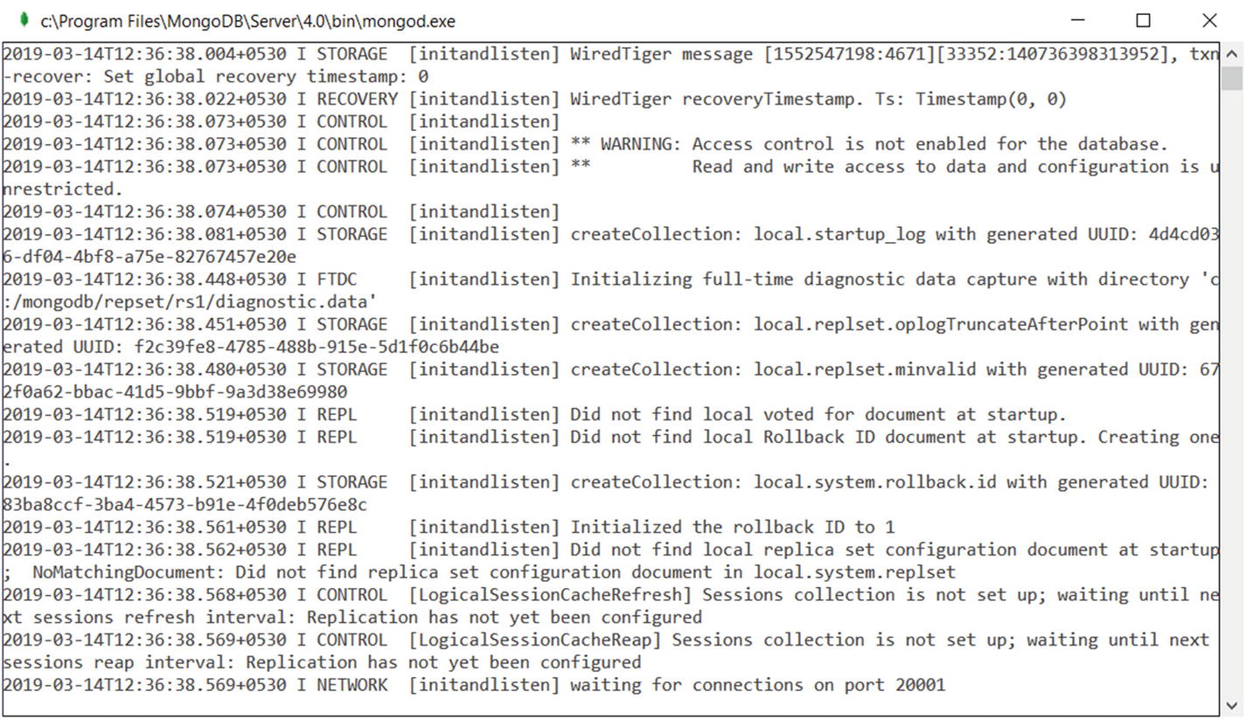
Figure 8-2A mongod instance waiting for connection on port 20001
Figure 8-3 shows a mongod instance that is waiting for connection on port 20002.
start mongod --bind_ip hostname --dbpath c:\mongodb\repset\rs3 --port 20003 --replSet myrs
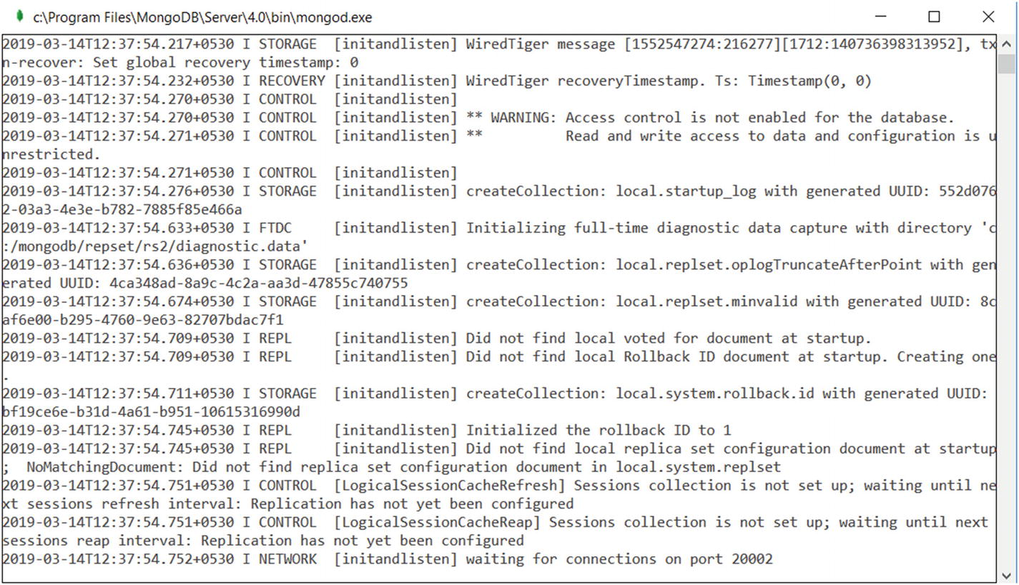
Figure 8-3A mongod instance waiting for connection on port 20002
Figure 8-4 shows a mongod instance that is waiting for connection on port 20003.
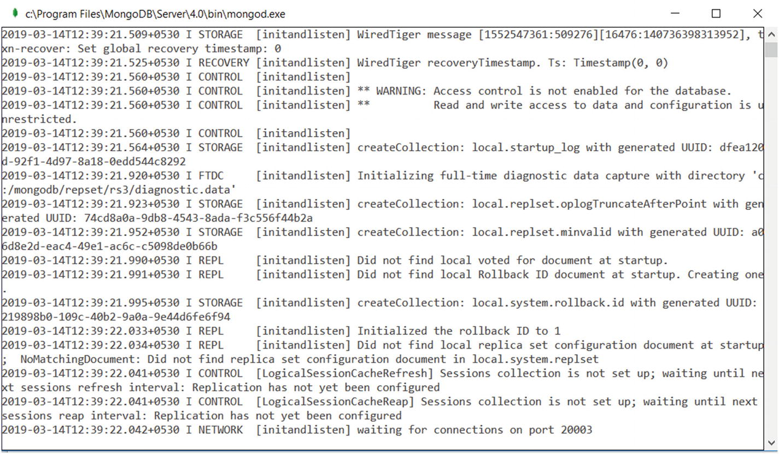
Figure 8-4A mongod instance waiting for connection on port 20003
Issue the following command to connect to a mongod instance running on port 20001.
mongo hostname:20001
Issue the following commands in the mongo shell to create a three-member replica set.
rs.initiate(); // to initiate replica set
rs.add("hostname:20002"); // to add secondary
rs.add("hostname:20003"); // to add secondary
Now, create a superuser as shown here.
use admin
db.createUser(
{
user: "subhashini",
pwd: "abc123",
roles: [ { role: "userAdminAnyDatabase", db: "admin" } ]
}
)
Here is the output,
myrs:PRIMARY> use admin
switched to db admin
myrs:PRIMARY> db.createUser(
... {
... user: "subhashini",
... pwd: "abc123",
... roles: [ { role: "userAdminAnyDatabase", db: "admin" } ]
... }
... )
Successfully added user: {
"user" : "subhashini",
"roles" : [
{
"role" : "userAdminAnyDatabase",
"db" : "admin"
}
]
}
myrs:PRIMARY>
Next, shut down all the servers. To shut down a mongod, connect each mongod using a mongo shell and issue the db.shutdownServer() on the admin database as shown here.
use admin
db.shutdownServer()
Next, generate a key file using the openssl method as shown here and copy the key file to each replica member.
openssl rand -base64 756 > /home/anyPath/keyfile
chmod 400 /home/anyPath/keyfile
NoteWe can use any method to generate the key file. To use the openssl method, you need to install openssl. Go to https://indy.fulgan.com/SSL/ to download and install the openssl package (note that this link might be changed in the future).
Figure 8-5 shows the files in the extracted openssl package.
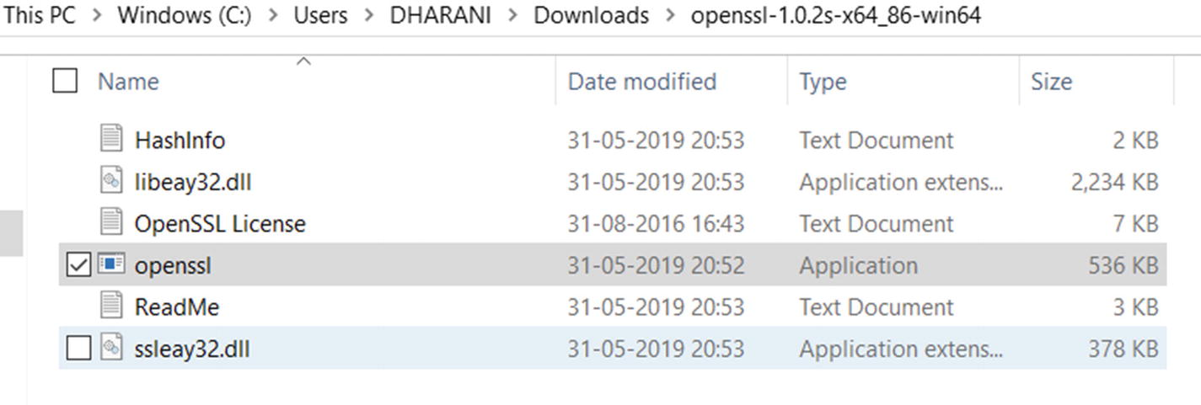
Figure 8-5Extracted files of the openssl package
Use openssl.exe to generate the keys as mentioned earlier. Also, in Windows, the generated key file permissions will not be checked. Only on the Unix platform, the key file should not have group or other permissions.
Now, start the mongod instance with access control enabled as shown here.
start mongod --bind_ip hostname --dbpath c:\mongodb\repset\rs1 --keyFile c:\mongodb\repset\rs1\keyfile --port 20001 --replSet myrs
start mongod --bind_ip hostname --dbpath c:\mongodb\repset\rs2 --keyFile c:\mongodb\repset\rs2\keyfile --port 20002 --replSet myrs
start mongod --bind_ip hostname --dbpath c:\mongodb\repset\rs3 --keyFile c:\mongodb\repset\rs3\keyfile --port 20003 --replSet myrs
Next, connect to the mongo shell and list the databases as shown here.
mongo hostname:20001
show dbs;
You might see the error message shown here.
myrs:PRIMARY> show dbs;
2019-03-14T13:08:48.704+0530 E QUERY [js] Error: listDatabases failed:{
"operationTime" : Timestamp(1552549127, 1),
"ok" : 0,
"errmsg" : "command listDatabases requires authentication",
"code" : 13,
"codeName" : "Unauthorized",
"$clusterTime" : {
"clusterTime" : Timestamp(1552549127, 1),
"signature" : {
"hash" : BinData(0,"0URBFn1xm2E642FtlhSIHv7SXoA="),
"keyId" : NumberLong("6668141343576948737")
}
}
} :
_getErrorWithCode@src/mongo/shell/utils.js:25:13
Mongo.prototype.getDBs@src/mongo/shell/mongo.js:67:1
shellHelper.show@src/mongo/shell/utils.js:876:19
shellHelper@src/mongo/shell/utils.js:766:15
@(shellhelp2):1:1
myrs:PRIMARY>
To resolve the issue, we need to authenticate to list databases as follows.
use admin
db.auth("subhashini","abc123")
show dbs;
Here is the output,
myrs:PRIMARY> use admin
switched to db admin
myrs:PRIMARY> db.auth("subhashini","abc123")
1
myrs:PRIMARY> show dbs;
admin 0.000GB
config 0.000GB
local 0.000GB
myrs:PRIMARY>

Recipe 8-3. Modifying Access for the Existing User
In this recipe, we are going to discuss how to modify access for the existing user.
Let us use the superUserAdmin user, which we created in Recipe 8-1.

Problem
We want to modify the access for superUserAdmin (created earlier).

Solution
Check the granted access (i.e., assigned roles and privileges) of the user, then revoke the permissions that are not needed or grant the new roles and privileges.

How It Works
Let’s follow the steps in this section to modify the access of superUserAdmin.

Step 1: Connect to the Instance with User superUserAdmin and to admin Database
Use the following syntax.
mongo --username superUserAdmin --password 1234 --authenticationDatabase admin
Here is the output,
> mongo --username superUserAdmin --password 1234 --authenticationDatabase admin
MongoDB shell version v4.0.11
connecting to: mongodb://127.0.0.1:27017/?authSource=admin&gssapiServiceName=mongodb
Implicit session: session { "id" : UUID("9f31da4d-ac50-438a-8dd5-2ebd4fefadbb") }
MongoDB server version: 4.0.11
>

Step 2: Identify the User’s Existing Roles
use <dbName>
db.getUser("<userName">)
Use the following commands to get the roles of superUserAdmin in the admin database.
> use admin
> db.getUser("superUserAdmin")
Here is the output,
> show dbs;
admin 0.000GB
config 0.000GB
local 0.000GB
> use admin
switched to db admin
> db.getUser("superUserAdmin")
{
"_id" : "admin.superUserAdmin",
"userId" : UUID("f109b62e-5138-487b-aa13-f183f977398c"),
"user" : "superUserAdmin",
"db" : "admin",
"roles" : [
{
"role" : "userAdminAnyDatabase",
"db" : "admin"
}
],
"mechanisms" : [
"SCRAM-SHA-1",
"SCRAM-SHA-256"
]
}
This output clearly shows the user superUserAdmin has "role" : "userAdminAnyDatabase".
NoteuserAdminAnyDatabase is a built-in role that provides the ability to perform administration operations as userAdmin on all databases except local and config.

Step 3: Grant an Additional Role to the User
Use the following commands to assign the read role for the local database for superUserAdmin.
> use admin
> db.grantRolesToUser(
"superUserAdmin",
[
{ role: "read", db: "local" }
]
)
Repeat the preceding step to identify the roles and to verify the newly added role to the user superUserAdmin.
Here is the output,
> use admin
switched to db admin
> db.grantRolesToUser(
... "superUserAdmin",
... [
... { role: "read", db: "local" }
... ]
... )
> db.getUser("superUserAdmin")
{
"_id" : "admin.superUserAdmin",
"userId" : UUID("f109b62e-5138-487b-aa13-f183f977398c"),
"user" : "superUserAdmin",
"db" : "admin",
"roles" : [
{
"role" : "read", "db" : "local"
},
{
"role" : "userAdminAnyDatabase","db" : "admin"
}
],
"mechanisms" : [
"SCRAM-SHA-1","SCRAM-SHA-256"
]
}
As you can observe, "role" : "read" is added to the "db" : "local" for the superUserAdmin user.

Step 4: Revoke an Existing Role from the User
Use this step to revoke the "role":"userAdminAnyDatabase" from the superUserAdmin user.
> use admin
> db.revokeRolesFromUser(
"superUserAdmin",
[
{ role: "userAdminAnyDatabase", db: "admin" }
]
)
Now check the existing roles by repeating the earlier step and verify that the role is removed.
> db.getUser("superUserAdmin")
Here is the output,
> db.getUser("superUserAdmin")
{
"_id" : "admin.superUserAdmin",
"userId" : UUID("f109b62e-5138-487b-aa13-f183f977398c"),
"user" : "superUserAdmin",
"db" : "admin",
"roles" : [
{
"role" : "read","db" : "local"
}
],
"mechanisms" : [
"SCRAM-SHA-1",
"SCRAM-SHA-256"
]
}
You can see that "role" : "userAdminAnyDatabase" is removed to the "db" : "admin" for the superUserAdmin user.

Recipe 8-4. Change the Password for the Existing User
In this recipe, we are going to discuss how to change the password for the superUserAdmin user.

Problem
You want to change the password for a specific user.

Solution
Use changeUserPassword() with the new password.

How It Works
Let’s follow the steps in this section to change the password of a user.

Step 1: Connect to the Instance with User superUserAdmin and to the admin Database
mongo --username superUserAdmin --password 1234 --authenticationDatabase admin
Here is the output,
> mongo --username superUserAdmin --password 1234 --authenticationDatabase admin
MongoDB shell version v4.0.11
connecting to: mongodb://127.0.0.1:27017/?authSource=admin&gssapiServiceName=mongodb
Implicit session: session { "id" : UUID("9f31da4d-ac50-438a-8dd5-2ebd4fefadbb") }
MongoDB server version: 4.0.11
>

Step 2: Change the Password
> db.changeUserPassword("superUserAdmin", "newpwd@123")
Now disconnect the instance and connect with the new password to ensure that the password has been changed.
Here is the output,
> exit
bye
C:\Program Files\MongoDB\Server\4.0\bin> mongo --username superUserAdmin --password newpwd@123 --authenticationDatabase admin
MongoDB shell version v4.0.11
connecting to: mongodb://127.0.0.1:27017/?authSource=admin&gssapiServiceName=mongodb
Implicit session: session { "id" : UUID("9676d897-719d-4857-9570-af7e982e10fe") }
MongoDB server version: 4.0.11
>

Recipe 8-5. Track the Activity of Users in a Cluster
In this recipe, we are going to discuss how to track the various activities of different users.

Problem
You want to track user activity.

Solution
Use the auditing feature.
NoteThe auditing feature is available in MongoDB Enterprise Edition only.

How It Works
Let’s follow the steps in this section to enable the auditing feature and store the audit information in different output formats like writing audit events to the console, a JSON file, or a BSON file.
We can record the operations shown in Figure 8-6 using the auditing feature
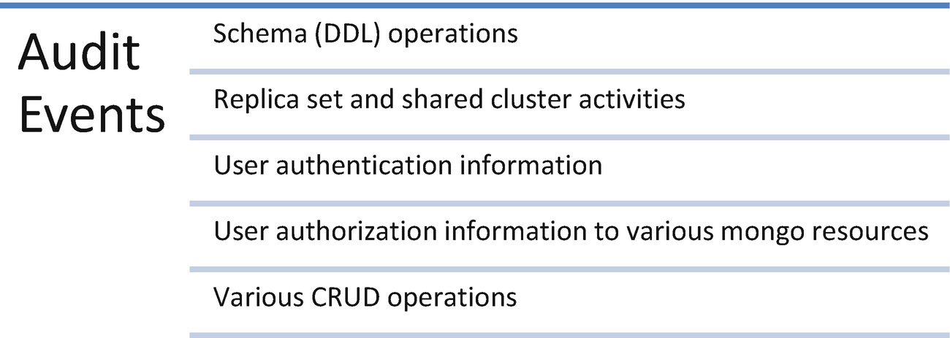
Figure 8-6Audit events

Step 1: Enable and Configure Audit Events
We can use auditDestination to enable the auditing feature and specify the output location of audit information.
Use the syslog output to print the audit events to syslog.
> mongod --dbpath data/testDB --auditDestination syslog
NoteThis syslog option is not available for Windows.
Use the console output to print the audit events to the console.
> mongod --dbpath data/testDB --auditDestination console
Use the auditFormat JSON output to print the audit events to a separate JSON file in any path.
> mongod --dbpath data/testDB --auditDestination file --auditFormat JSON --auditPath data/testDB/auditLog.json

Step 2: Create an Audit Filter
Audit filters help us to enable audit features for only certain operations. Let us say, for example, that we want to create an audit filter to log only the audit events related to authenticatation operations that are performed on the local database. Use the following filter.
{ atype: "authenticate", "param.db": "test" }
Here, atype refers to the action type and param.db refers to the monitoring database.
Use the following command to set the filter while enabling the audit feature.
> mongod --dbpath data/testDB --auth --auditDestination file --auditFilter '{atype: "authenticate", "param.db": "local"}' --auditFormat JSON --auditPath data/testDB/auditLog.json

Recipe 8-6. Encryption
In this recipe, we are going to discuss how to encrypt the data in MongoDB.

Problem
You want to encrypt the data stored or moved into MongoDB.

Solution
Use encryption at the file level and the whole database level.
NoteThe auditing feature is available in MongoDB Enterprise Edition only.

How It Works
Let’s follow the steps in this section to encrypt the data stored and decrypt while reading.

Step 1: Understanding Different Encryption Options
MongoDB offers encryption at two levels:
Encrypting data in motion.
Encrypting data in rest.

Encrypting Data in Motion
MongoDB Enterprise Edition supports Transport Layer Security (TLS) and Secure Sockets Layer (SSL) encryption techniques to secure the data being sent or received over the networks.

Encrypting Data in Rest
MongoDB Enterprise Edition supports a native storage-based symmetric key encryption technique to secure the data available on the storage system. It also provides Transparent Data Encryption (TDE), which is used to encrypt the whole database.

Step 2: Encrypting the Data at Rest Using Local Key Management
Create a 16- or 32-character string base64-encoded key file using any appropriate method. We use the openssl method as shown here.
> openssl rand -base64 32 > mongo-encryption-file
Here is the output,
C:\Users\DHARANI\Downloads\openssl-win>
openssl rand -base64 32 > mongo-encryption-file
Now we can see in Figure 8-7 the encryption file created in the same directory.
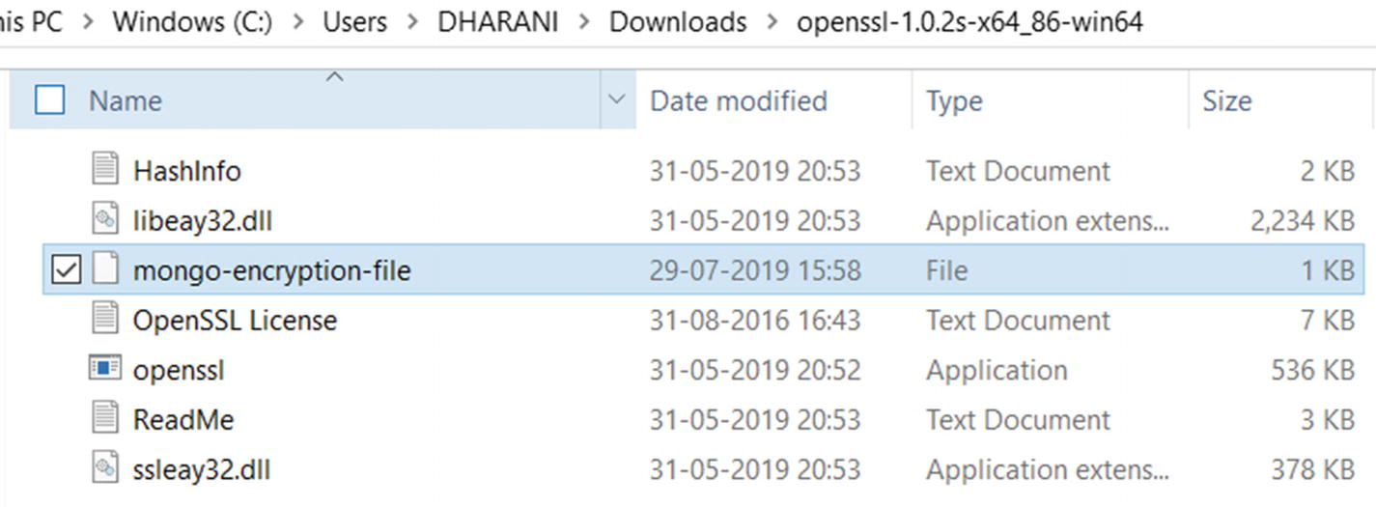
Figure 8-7The new encryption file
Now to use the encryption file to encrypt the data in the storage engine, start MongoDB with the following options.
--enableEncryption
--encryptionKeyFile <path to encryption keyfile>
> mongod --enableEncryption --encryptionKeyFile " C:\Program Files\MongoDB\Server\4.0\mongo-encryption-file"
The output is shown in Figure 8-8.
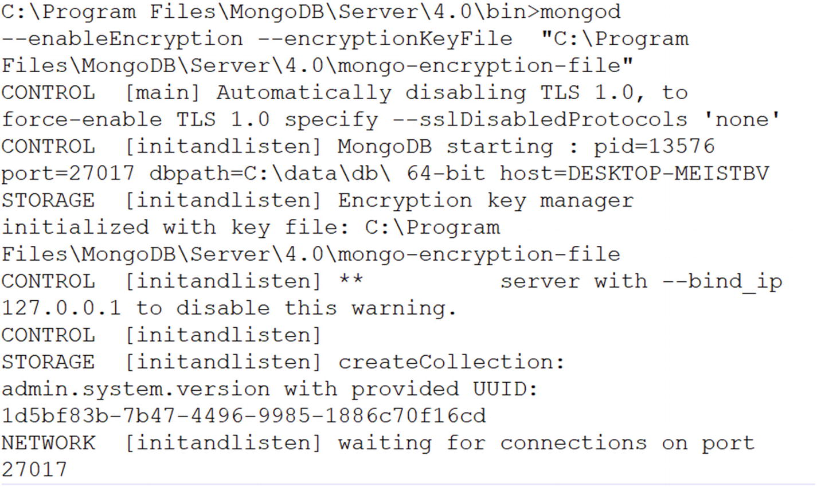
Figure 8-8The encryption output
We can check for the following line in the log to ensure the encryption key manager is successfully initialized with the specified key file.
2019-07-27T16:07:51.500+0530 I STORAGE [initandlisten] Encryption key manager initialized with key file: C:\Program Files\MongoDB\Server\4.0\mongo-encryption-file
NoteEncrypting the data using the local key file is not recommended, as the secure management of the local key file is critical.

Index

A
Aggregation operations
map-reduce
pipeline
single-purpose
SQL aggregation
SeeSQL aggregation
Array, MongoDB
compound filter conditions
index position
match
query operator
$addToSet operator
$elemMatch operator
$pop operator
$push operator
$size operator
Authentication
access control
admin roles
built-in roles
cluster admin roles
process
user roles

B
BASE approach
Binary JSON (BSON)

C
CAP theorem
Comma-separated value (CSV)
Concurrent transactions
Create, read, update, and delete (CRUD)
CRUD operations

D
Database, MongoDB
creation
displaying list
drop
version
Database profiler
mongostat
view
working
Data model
document references
one-to-many relationships
query
embedded document
one-to-many relationship
one-to-one relationship
db.createCollection() method
db.dropDatabase() method

E
Embedded data models
Encryption
data in motion
data in rest
local key management
options
output
Existing user
change password
modifying access
assign the read role
revoke
roles
superUserAdmin

F, G
find() method

H
Horizontal scaling

I
Indexes
creation
hashed
multikey
properties
partial
sparse
TTL
unique
strategies
multiple field index
selectivity
single field index
sorting
values in memory
text
2dsphere
types
insertMany() method
Isolation test

J, K
JavaScript Object Notation (JSON)

L
Lightweight Directory Access Protocol (LDAP)

M
Model tree structure, parent references
array of ancestors
author collection
child references
MongoDB
aggregation framework
array
SeeArray, MongoDB
BSON
capped collection
creation
document insertion
query
collection creation
commands
Create, read, update, and delete (CRUD) operations
database
SeeDatabase, MongoDB
data types
delete method
document
embedded documents
equality
GridFS
import
insert methods
multiple
single
installation
compass on Windows
Ubuntu
Windows
iterate cursor
limit() and skip() methods
mongo shell
Node.js
SeeNode.js, MongoDB
null or missing values
read operations
replication
restrict fields
retrieve documents
AND conditions
equality conditions
OR conditions
query operator
schemaless database
sharding
terms
update methods
multiple
replace
single
mongostat command
Monitoring
database profiler
db.serverStatus() command
db.stats() command
log files working
mongodb
cursor.explain()
explain() method
mongodump
mongorestore
data restore
remote instances
mongostat
mongotop
performance degradation
set the log level
Multidocument transactions

N, O, P, Q
Node.js, MongoDB
collection creation
delete document
insert document
query document
update document
Normalized data models
NoSQL databases
advantages
challenges
characteristics
types

R
Regular backup scheduling, mongodump
Relational database management system (RDBMS)
Replica set using a key file
data directories
error message
list databases
mongod instance
port 20001
port 20002
port 20003
openssl package
shut down
Replication
auto failover
data directories
instance waiting for connection
connect to mongo instance
starting mongod
three-member replica set
definition
strategy

S
SCRAM
session.commitTransaction()
session.startTransaction()
Sharding
data directories
config servers
connect shard1 server
query router
replica on shard1 server
shard1 server
shard2 server
shard3 server
data distribution
definition
mongod instances
sh.status()
user collection
SQL aggregation
MongoDB
terms
Superuser and authenticate a user
access control
creation

T, U
Tab-separated value (TSV)
Track user activity
audit events
create audit filter
enable and configure
Transaction
discard data changes
limitations
multidocument, working
sessions
write conflicts

V, W
Vertical scaling

X, Y, Z
x.509 certificates

