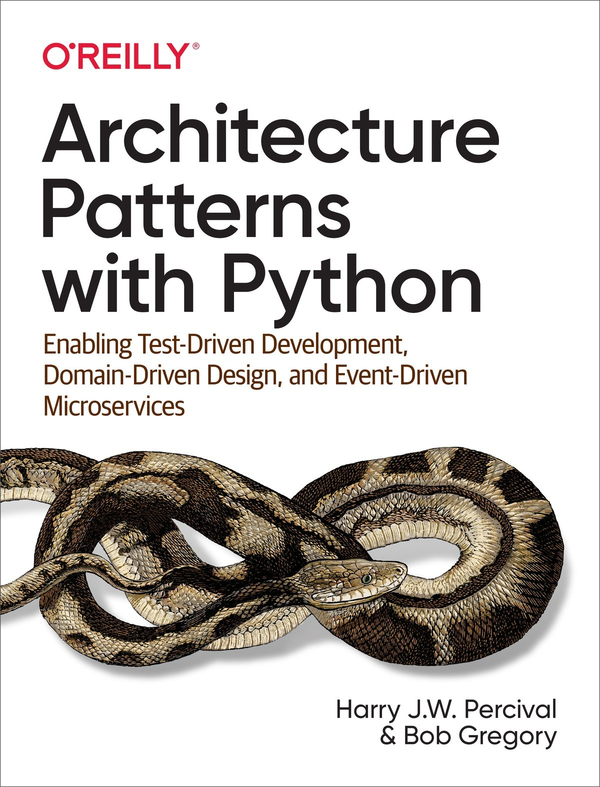

Table of Contents
Preface
Managing Complexity, Solving Business Problems
Why Python?
TDD, DDD, and Event-Driven Architecture
Who Should Read This Book
A Brief Overview of What You’ll Learn
Part I, Building an Architecture to Support Domain Modeling
Part II, Event-Driven Architecture
Addtional Content
Example Code and Coding Along
License
Conventions Used in This Book
O’Reilly Online Learning
How to Contact O’Reilly
Acknowledgments
Introduction
Why Do Our Designs Go Wrong?
Encapsulation and Abstractions
Layering
The Dependency Inversion Principle
A Place for All Our Business Logic: The Domain Model
I. Building an Architecture to Support Domain Modeling
1. Domain Modeling
What Is a Domain Model?
Exploring the Domain Language
Unit Testing Domain Models
Dataclasses Are Great for Value Objects
Value Objects and Entities
Not Everything Has to Be an Object: A Domain Service Function
Python’s Magic Methods Let Us Use Our Models with Idiomatic Python
Exceptions Can Express Domain Concepts Too
2. Repository Pattern
Persisting Our Domain Model
Some Pseudocode: What Are We Going to Need?
Applying the DIP to Data Access
Reminder: Our Model
The “Normal” ORM Way: Model Depends on ORM
Inverting the Dependency: ORM Depends on Model
Introducing the Repository Pattern
The Repository in the Abstract
What Is the Trade-Off?
Building a Fake Repository for Tests Is Now Trivial!
What Is a Port and What Is an Adapter, in Python?
Wrap-Up
3. A Brief Interlude: On Coupling and Abstractions
Abstracting State Aids Testability
Choosing the Right Abstraction(s)
Implementing Our Chosen Abstractions
Testing Edge to Edge with Fakes and Dependency Injection
Why Not Just Patch It Out?
Wrap-Up
4. Our First Use Case: Flask API and Service Layer
Connecting Our Application to the Real World
A First End-to-End Test
The Straightforward Implementation
Error Conditions That Require Database Checks
Introducing a Service Layer, and Using FakeRepository to Unit Test It
A Typical Service Function
Why Is Everything Called a Service?
Putting Things in Folders to See Where It All Belongs
Wrap-Up
The DIP in Action
5. TDD in High Gear and Low Gear
How Is Our Test Pyramid Looking?
Should Domain Layer Tests Move to the Service Layer?
On Deciding What Kind of Tests to Write
High and Low Gear
Fully Decoupling the Service-Layer Tests from the Domain
Mitigation: Keep All Domain Dependencies in Fixture Functions
Adding a Missing Service
Carrying the Improvement Through to the E2E Tests
Wrap-Up
6. Unit of Work Pattern
The Unit of Work Collaborates with the Repository
Test-Driving a UoW with Integration Tests
Unit of Work and Its Context Manager
The Real Unit of Work Uses SQLAlchemy Sessions
Fake Unit of Work for Testing
Using the UoW in the Service Layer
Explicit Tests for Commit/Rollback Behavior
Explicit Versus Implicit Commits
Examples: Using UoW to Group Multiple Operations into an Atomic Unit
Example 1: Reallocate
Example 2: Change Batch Quantity
Tidying Up the Integration Tests
Wrap-Up
7. Aggregates and Consistency Boundaries
Why Not Just Run Everything in a Spreadsheet?
Invariants, Constraints, and Consistency
Invariants, Concurrency, and Locks
What Is an Aggregate?
Choosing an Aggregate
One Aggregate = One Repository
What About Performance?
Optimistic Concurrency with Version Numbers
Implementation Options for Version Numbers
Testing for Our Data Integrity Rules
Enforcing Concurrency Rules by Using Database Transaction Isolation Levels
Pessimistic Concurrency Control Example: SELECT FOR UPDATE
Wrap-Up
Part I Recap
II. Event-Driven Architecture
8. Events and the Message Bus
Avoiding Making a Mess
First, Let’s Avoid Making a Mess of Our Web Controllers
And Let’s Not Make a Mess of Our Model Either
Or the Service Layer!
Single Responsibility Principle
All Aboard the Message Bus!
The Model Records Events
Events Are Simple Dataclasses
The Model Raises Events
The Message Bus Maps Events to Handlers
Option 1: The Service Layer Takes Events from the Model and Puts Them on the Message Bus
Option 2: The Service Layer Raises Its Own Events
Option 3: The UoW Publishes Events to the Message Bus
Wrap-Up
9. Going to Town on the Message Bus
A New Requirement Leads Us to a New Architecture
Imagining an Architecture Change: Everything Will Be an Event Handler
Refactoring Service Functions to Message Handlers
The Message Bus Now Collects Events from the UoW
Our Tests Are All Written in Terms of Events Too
A Temporary Ugly Hack: The Message Bus Has to Return Results
Modifying Our API to Work with Events
Implementing Our New Requirement
Our New Event
Test-Driving a New Handler
Implementation
A New Method on the Domain Model
Optionally: Unit Testing Event Handlers in Isolation with a Fake Message Bus
Wrap-Up
What Have We Achieved?
Why Have We Achieved?
10. Commands and Command Handler
Commands and Events
Differences in Exception Handling
Discussion: Events, Commands, and Error Handling
Recovering from Errors Synchronously
Wrap-Up
11. Event-Driven Architecture: Using Events to Integrate Microservices
Distributed Ball of Mud, and Thinking in Nouns
Error Handling in Distributed Systems
The Alternative: Temporal Decoupling Using Asynchronous Messaging
Using a Redis Pub/Sub Channel for Integration
Test-Driving It All Using an End-to-End Test
Redis Is Another Thin Adapter Around Our Message Bus
Our New Outgoing Event
Internal Versus External Events
Wrap-Up
12. Command-Query Responsibility Segregation (CQRS)
Domain Models Are for Writing
Most Users Aren’t Going to Buy Your Furniture
Post/Redirect/Get and CQS
Hold On to Your Lunch, Folks
Testing CQRS Views
“Obvious” Alternative 1: Using the Existing Repository
Your Domain Model Is Not Optimized for Read Operations
“Obvious” Alternative 2: Using the ORM
SELECT N+1 and Other Performance Considerations
Time to Completely Jump the Shark
Updating a Read Model Table Using an Event Handler
Changing Our Read Model Implementation Is Easy
Wrap-Up
13. Dependency Injection (and Bootstrapping)
Implicit Versus Explicit Dependencies
Aren’t Explicit Dependencies Totally Weird and Java-y?
Preparing Handlers: Manual DI with Closures and Partials
An Alternative Using Classes
A Bootstrap Script
Message Bus Is Given Handlers at Runtime
Using Bootstrap in Our Entrypoints
Initializing DI in Our Tests
Building an Adapter “Properly”: A Worked Example
Define the Abstract and Concrete Implementations
Make a Fake Version for Your Tests
Figure Out How to Integration Test the Real Thing
Wrap-Up
Epilogue
What Now?
How Do I Get There from Here?
Separating Entangled Responsibilities
Identifying Aggregates and Bounded Contexts
An Event-Driven Approach to Go to Microservices via Strangler Pattern
Convincing Your Stakeholders to Try Something New
Questions Our Tech Reviewers Asked That We Couldn’t Work into Prose
Footguns
More Required Reading
Wrap-Up
A. Summary Diagram and Table
B. A Template Project Structure
Env Vars, 12-Factor, and Config, Inside and Outside Containers
Config.py
Docker-Compose and Containers Config
Installing Your Source as a Package
Dockerfile
Tests
Wrap-Up
C. Swapping Out the Infrastructure: Do Everything with CSVs
Implementing a Repository and Unit of Work for CSVs
D. Repository and Unit of Work Patterns with Django
Repository Pattern with Django
Custom Methods on Django ORM Classes to Translate to/from Our Domain Model
Unit of Work Pattern with Django
API: Django Views Are Adapters
Why Was This All So Hard?
What to Do If You Already Have Django
Steps Along the Way
E. Validation
What Is Validation, Anyway?
Validating Syntax
Postel’s Law and the Tolerant Reader Pattern
Validating at the Edge
Validating Semantics
Validating Pragmatics
Index

Architecture Patterns with Python

Enabling Test-Driven Development, Domain-Driven Design, and Event-Driven Microservices
Harry Percival and Bob Gregory

Architecture Patterns with Python
by Harry Percival and Bob Gregory
Copyright © 2020 Harry Percival and Bob Gregory. All rights reserved.
Printed in the United States of America.
Published by O’Reilly Media, Inc., 1005 Gravenstein Highway North, Sebastopol, CA 95472.
O’Reilly books may be purchased for educational, business, or sales promotional use. Online editions are also available for most titles (http://oreilly.com). For more information, contact our corporate/institutional sales department: 800-998-9938 or corporate@oreilly.com.
Acquisitions Editor: Ryan Shaw
Development Editor: Corbin Collins
Production Editor: Katherine Tozer
Copyeditor: Sharon Wilkey
Proofreader: Arthur Johnson
Indexer: Ellen Troutman-Zaig
Interior Designer: David Futato
Cover Designer: Karen Montgomery
Illustrator: Rebecca Demarest
March 2020: First Edition

Revision History for the First Edition
2020-03-05: First Release
See http://oreilly.com/catalog/errata.csp?isbn=9781492052203 for release details.
The O’Reilly logo is a registered trademark of O’Reilly Media, Inc. Architecture Patterns with Python, the cover image, and related trade dress are trademarks of O’Reilly Media, Inc.
The views expressed in this work are those of the authors and do not represent the publisher’s views. While the publisher and the authors have used good faith efforts to ensure that the information and instructions contained in this work are accurate, the publisher and the authors disclaim all responsibility for errors or omissions, including without limitation responsibility for damages resulting from the use of or reliance on this work. Use of the information and instructions contained in this work is at your own risk. If any code samples or other technology this work contains or describes is subject to open source licenses or the intellectual property rights of others, it is your responsibility to ensure that your use thereof complies with such licenses and/or rights.
978-1-492-05220-3
[LSI]

Preface
You may be wondering who we are and why we wrote this book.
At the end of Harry’s last book, Test-Driven Development with Python (O’Reilly), he found himself asking a bunch of questions about architecture, such as, What’s the best way of structuring your application so that it’s easy to test? More specifically, so that your core business logic is covered by unit tests, and so that you minimize the number of integration and end-to-end tests you need? He made vague references to “Hexagonal Architecture” and “Ports and Adapters” and “Functional Core, Imperative Shell,” but if he was honest, he’d have to admit that these weren’t things he really understood or had done in practice.
And then he was lucky enough to run into Bob, who has the answers to all these questions.
Bob ended up a software architect because nobody else on his team was doing it. He turned out to be pretty bad at it, but he was lucky enough to run into Ian Cooper, who taught him new ways of writing and thinking about code.

Managing Complexity, Solving Business Problems
We both work for MADE.com, a European ecommerce company that sells furniture online; there, we apply the techniques in this book to build distributed systems that model real-world business problems. Our example domain is the first system Bob built for MADE, and this book is an attempt to write down all the stuff we have to teach new programmers when they join one of our teams.
MADE.com operates a global supply chain of freight partners and manufacturers. To keep costs low, we try to optimize the delivery of stock to our warehouses so that we don’t have unsold goods lying around the place.
Ideally, the sofa that you want to buy will arrive in port on the very day that you decide to buy it, and we’ll ship it straight to your house without ever storing it. Getting the timing right is a tricky balancing act when goods take three months to arrive by container ship. Along the way, things get broken or water damaged, storms cause unexpected delays, logistics partners mishandle goods, paperwork goes missing, customers change their minds and amend their orders, and so on.
We solve those problems by building intelligent software representing the kinds of operations taking place in the real world so that we can automate as much of the business as possible.

Why Python?
If you’re reading this book, we probably don’t need to convince you that Python is great, so the real question is “Why does the Python community need a book like this?” The answer is about Python’s popularity and maturity: although Python is probably the world’s fastest-growing programming language and is nearing the top of the absolute popularity tables, it’s only just starting to take on the kinds of problems that the C# and Java world has been working on for years. Startups become real businesses; web apps and scripted automations are becoming (whisper it) enterprise software.
In the Python world, we often quote the Zen of Python: “There should be one—and preferably only one—obvious way to do it.”1 Unfortunately, as project size grows, the most obvious way of doing things isn’t always the way that helps you manage complexity and evolving requirements.
None of the techniques and patterns we discuss in this book are new, but they are mostly new to the Python world. And this book isn’t a replacement for the classics in the field such as Eric Evans’s Domain-Driven Design or Martin Fowler’s Patterns of Enterprise Application Architecture (both published by Addison-Wesley Professional)—which we often refer to and encourage you to go and read.
But all the classic code examples in the literature do tend to be written in Java or C++/#, and if you’re a Python person and haven’t used either of those languages in a long time (or indeed ever), those code listings can be quite…trying. There’s a reason the latest edition of that other classic text, Fowler’s Refactoring (Addison-Wesley Professional), is in JavaScript.

TDD, DDD, and Event-Driven Architecture
In order of notoriety, we know of three tools for managing complexity:
Test-driven development (TDD) helps us to build code that is correct and enables us to refactor or add new features, without fear of regression. But it can be hard to get the best out of our tests: How do we make sure that they run as fast as possible? That we get as much coverage and feedback from fast, dependency-free unit tests and have the minimum number of slower, flaky end-to-end tests?
Domain-driven design (DDD) asks us to focus our efforts on building a good model of the business domain, but how do we make sure that our models aren’t encumbered with infrastructure concerns and don’t become hard to change?
Loosely coupled (micro)services integrated via messages (sometimes called reactive microservices) are a well-established answer to managing complexity across multiple applications or business domains. But it’s not always obvious how to make them fit with the established tools of the Python world—Flask, Django, Celery, and so on.

Note
Don’t be put off if you’re not working with (or interested in) microservices. The vast majority of the patterns we discuss, including much of the event-driven architecture material, is absolutely applicable in a monolithic architecture.
Our aim with this book is to introduce several classic architectural patterns and show how they support TDD, DDD, and event-driven services. We hope it will serve as a reference for implementing them in a Pythonic way, and that people can use it as a first step toward further research in this field.

Who Should Read This Book
Here are a few things we assume about you, dear reader:
You’ve been close to some reasonably complex Python applications.
You’ve seen some of the pain that comes with trying to manage that complexity.
You don’t necessarily know anything about DDD or any of the classic application architecture patterns.
We structure our explorations of architectural patterns around an example app, building it up chapter by chapter. We use TDD at work, so we tend to show listings of tests first, followed by implementation. If you’re not used to working test-first, it may feel a little strange at the beginning, but we hope you’ll soon get used to seeing code “being used” (i.e., from the outside) before you see how it’s built on the inside.
We use some specific Python frameworks and technologies, including Flask, SQLAlchemy, and pytest, as well as Docker and Redis. If you’re already familiar with them, that won’t hurt, but we don’t think it’s required. One of our main aims with this book is to build an architecture for which specific technology choices become minor implementation details.

A Brief Overview of What You’ll Learn
The book is divided into two parts; here’s a look at the topics we’ll cover and the chapters they live in.

Part I, Building an Architecture to Support Domain Modeling
Domain modeling and DDD (Chapters 1 and 7)
At some level, everyone has learned the lesson that complex business problems need to be reflected in code, in the form of a model of the domain. But why does it always seem to be so hard to do without getting tangled up with infrastructure concerns, our web frameworks, or whatever else? In the first chapter we give a broad overview of domain modeling and DDD, and we show how to get started with a model that has no external dependencies, and fast unit tests. Later we return to DDD patterns to discuss how to choose the right aggregate, and how this choice relates to questions of data integrity.
Repository, Service Layer, and Unit of Work patterns (Chapters 2, 4, and 5)
In these three chapters we present three closely related and mutually reinforcing patterns that support our ambition to keep the model free of extraneous dependencies. We build a layer of abstraction around persistent storage, and we build a service layer to define the entrypoints to our system and capture the primary use cases. We show how this layer makes it easy to build thin entrypoints to our system, whether it’s a Flask API or a CLI.
Some thoughts on testing and abstractions (Chapters 3 and 6)
After presenting the first abstraction (the Repository pattern), we take the opportunity for a general discussion of how to choose abstractions, and what their role is in choosing how our software is coupled together. After we introduce the Service Layer pattern, we talk a bit about achieving a test pyramid and writing unit tests at the highest possible level of abstraction.

Part II, Event-Driven Architecture
Event-driven architecture (Chapters 8–11)
We introduce three more mutually reinforcing patterns: the Domain Events, Message Bus, and Handler patterns. Domain events are a vehicle for capturing the idea that some interactions with a system are triggers for others. We use a message bus to allow actions to trigger events and call appropriate handlers. We move on to discuss how events can be used as a pattern for integration between services in a microservices architecture. Finally, we distinguish between commands and events. Our application is now fundamentally a message-processing system.
Command-query responsibility segregation (Chapter 12)
We present an example of command-query responsibility segregation, with and without events.
Dependency injection (Chapter 13)
We tidy up our explicit and implicit dependencies and implement a simple dependency injection framework.

Addtional Content
How do I get there from here? (Epilogue)
Implementing architectural patterns always looks easy when you show a simple example, starting from scratch, but many of you will probably be wondering how to apply these principles to existing software. We’ll provide a few pointers in the epilogue and some links to further reading.

Example Code and Coding Along
You’re reading a book, but you’ll probably agree with us when we say that the best way to learn about code is to code. We learned most of what we know from pairing with people, writing code with them, and learning by doing, and we’d like to re-create that experience as much as possible for you in this book.
As a result, we’ve structured the book around a single example project (although we do sometimes throw in other examples). We’ll build up this project as the chapters progress, as if you’ve paired with us and we’re explaining what we’re doing and why at each step.
But to really get to grips with these patterns, you need to mess about with the code and get a feel for how it works. You’ll find all the code on GitHub; each chapter has its own branch. You can find a list of the branches on GitHub as well.
Here are three ways you might code along with the book:
Start your own repo and try to build up the app as we do, following the examples from listings in the book, and occasionally looking to our repo for hints. A word of warning, however: if you’ve read Harry’s previous book and coded along with that, you’ll find that this book requires you to figure out more on your own; you may need to lean pretty heavily on the working versions on GitHub.
Try to apply each pattern, chapter by chapter, to your own (preferably small/toy) project, and see if you can make it work for your use case. This is high risk/high reward (and high effort besides!). It may take quite some work to get things working for the specifics of your project, but on the other hand, you’re likely to learn the most.
For less effort, in each chapter we outline an “Exercise for the Reader,” and point you to a GitHub location where you can download some partially finished code for the chapter with a few missing parts to write yourself.
Particularly if you’re intending to apply some of these patterns in your own projects, working through a simple example is a great way to safely practice.

Tip
At the very least, do a git checkout of the code from our repo as you read each chapter. Being able to jump in and see the code in the context of an actual working app will help answer a lot of questions as you go, and makes everything more real. You’ll find instructions for how to do that at the beginning of each chapter.

License
The code (and the online version of the book) is licensed under a Creative Commons CC BY-NC-ND license, which means you are free to copy and share it with anyone you like, for non-commercial purposes, as long as you give attribution. If you want to re-use any of the content from this book and you have any worries about the license, contact O’Reilly at permissions@oreilly.com.
The print edition is licensed differently; please see the copyright page.

Conventions Used in This Book
The following typographical conventions are used in this book:
Italic
Indicates new terms, URLs, email addresses, filenames, and file extensions.
Constant width
Used for program listings, as well as within paragraphs to refer to program elements such as variable or function names, databases, data types, environment variables, statements, and keywords.
Constant width bold
Shows commands or other text that should be typed literally by the user.
Constant width italic
Shows text that should be replaced with user-supplied values or by values determined by context.

Tip
This element signifies a tip or suggestion.

Note
This element signifies a general note.
Warning
This element indicates a warning or caution.

O’Reilly Online Learning

Note
For more than 40 years, O’Reilly Media has provided technology and business training, knowledge, and insight to help companies succeed.
Our unique network of experts and innovators share their knowledge and expertise through books, articles, conferences, and our online learning platform. O’Reilly’s online learning platform gives you on-demand access to live training courses, in-depth learning paths, interactive coding environments, and a vast collection of text and video from O’Reilly and 200+ other publishers. For more information, please visit http://oreilly.com.

How to Contact O’Reilly
Please address comments and questions concerning this book to the publisher:
O’Reilly Media, Inc.
1005 Gravenstein Highway North
Sebastopol, CA 95472
800-998-9938 (in the United States or Canada)
707-829-0515 (international or local)
707-829-0104 (fax)
We have a web page for this book, where we list errata, examples, and any additional information. You can access this page at https://oreil.ly/architecture-patterns-python.

Email bookquestions@oreilly.com to comment or ask technical questions about this book.
For more information about our books, courses, conferences, and news, see our website at http://www.oreilly.com.
Find us on Facebook: http://facebook.com/oreilly
Follow us on Twitter: http://twitter.com/oreillymedia
Watch us on YouTube: http://www.youtube.com/oreillymedia

Acknowledgments
To our tech reviewers, David Seddon, Ed Jung, and Hynek Schlawack: we absolutely do not deserve you. You are all incredibly dedicated, conscientious, and rigorous. Each one of you is immensely smart, and your different points of view were both useful and complementary to each other. Thank you from the bottom of our hearts.
Gigantic thanks also to our Early Release readers for their comments and suggestions: Ian Cooper, Abdullah Ariff, Jonathan Meier, Gil Gonçalves, Matthieu Choplin, Ben Judson, James Gregory, Łukasz Lechowicz, Clinton Roy, Vitorino Araújo, Susan Goodbody, Josh Harwood, Daniel Butler, Liu Haibin, Jimmy Davies, Ignacio Vergara Kausel, Gaia Canestrani, Renne Rocha, pedroabi, Ashia Zawaduk, Jostein Leira, Brandon Rhodes, and many more; our apologies if we missed you on this list.
Super-mega-thanks to our editor Corbin Collins for his gentle chivvying, and for being a tireless advocate of the reader. Similarly-superlative thanks to the production staff, Katherine Tozer, Sharon Wilkey, Ellen Troutman-Zaig, and Rebecca Demarest, for your dedication, professionalism, and attention to detail. This book is immeasurably improved thanks to you.
Any errors remaining in the book are our own, naturally.
1 python -c "import this"

Introduction

Why Do Our Designs Go Wrong?
What comes to mind when you hear the word chaos? Perhaps you think of a noisy stock exchange, or your kitchen in the morning—everything confused and jumbled. When you think of the word order, perhaps you think of an empty room, serene and calm. For scientists, though, chaos is characterized by homogeneity (sameness), and order by complexity (difference).
For example, a well-tended garden is a highly ordered system. Gardeners define boundaries with paths and fences, and they mark out flower beds or vegetable patches. Over time, the garden evolves, growing richer and thicker; but without deliberate effort, the garden will run wild. Weeds and grasses will choke out other plants, covering over the paths, until eventually every part looks the same again—wild and unmanaged.
Software systems, too, tend toward chaos. When we first start building a new system, we have grand ideas that our code will be clean and well ordered, but over time we find that it gathers cruft and edge cases and ends up a confusing morass of manager classes and util modules. We find that our sensibly layered architecture has collapsed into itself like an oversoggy trifle. Chaotic software systems are characterized by a sameness of function: API handlers that have domain knowledge and send email and perform logging; “business logic” classes that perform no calculations but do perform I/O; and everything coupled to everything else so that changing any part of the system becomes fraught with danger. This is so common that software engineers have their own term for chaos: the Big Ball of Mud anti-pattern (Figure P-1).
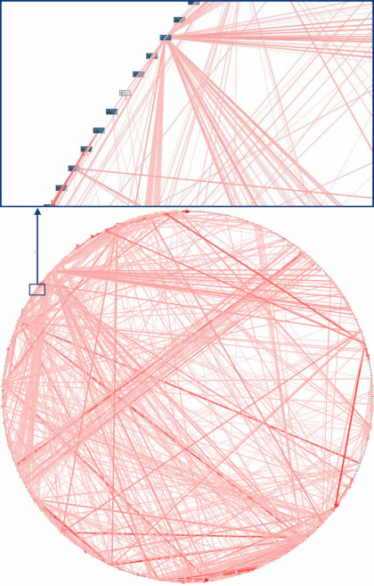
Figure P-1. A real-life dependency diagram (source: “Enterprise Dependency: Big Ball of Yarn” by Alex Papadimoulis)

Tip
A big ball of mud is the natural state of software in the same way that wilderness is the natural state of your garden. It takes energy and direction to prevent the collapse.
Fortunately, the techniques to avoid creating a big ball of mud aren’t complex.

Encapsulation and Abstractions
Encapsulation and abstraction are tools that we all instinctively reach for as programmers, even if we don’t all use these exact words. Allow us to dwell on them for a moment, since they are a recurring background theme of the book.
The term encapsulation covers two closely related ideas: simplifying behavior and hiding data. In this discussion, we’re using the first sense. We encapsulate behavior by identifying a task that needs to be done in our code and giving that task to a well-defined object or function. We call that object or function an abstraction.
Take a look at the following two snippets of Python code:
Do a search with urllib
import
json
from
urllib.request
import
urlopen
from
urllib.parse
import
urlencode
params
=
dict
(
q
=
'Sausages'
,
format
=
'json'
)
handle
=
urlopen
(
'http://api.duckduckgo.com'
+
'?'
+
urlencode
(
params
))
raw_text
=
handle
.
read
()
.
decode
(
'utf8'
)
parsed
=
json
.
loads
(
raw_text
)
results
=
parsed
[
'RelatedTopics'
]
for
r
in
results
:
if
'Text'
in
r
:
print
(
r
[
'FirstURL'
]
+
' - '
+
r
[
'Text'
])
Do a search with requests
import
requests
params
=
dict
(
q
=
'Sausages'
,
format
=
'json'
)
parsed
=
requests
.
get
(
'http://api.duckduckgo.com/'
,
params
=
params
)
.
json
()
results
=
parsed
[
'RelatedTopics'
]
for
r
in
results
:
if
'Text'
in
r
:
print
(
r
[
'FirstURL'
]
+
' - '
+
r
[
'Text'
])
Both code listings do the same thing: they submit form-encoded values to a URL in order to use a search engine API. But the second is simpler to read and understand because it operates at a higher level of abstraction.
We can take this one step further still by identifying and naming the task we want the code to perform for us and using an even higher-level abstraction to make it explicit:
Do a search with the duckduckgo module
import
duckduckgo
for
r
in
duckduckgo
.
query
(
'Sausages'
)
.
results
:
print
(
r
.
url
+
' - '
+
r
.
text
)
Encapsulating behavior by using abstractions is a powerful tool for making code more expressive, more testable, and easier to maintain.

Note
In the literature of the object-oriented (OO) world, one of the classic characterizations of this approach is called responsibility-driven design; it uses the words roles and responsibilities rather than tasks. The main point is to think about code in terms of behavior, rather than in terms of data or algorithms.1

Abstractions and ABCs
In a traditional OO language like Java or C#, you might use an abstract base class (ABC) or an interface to define an abstraction. In Python you can (and we sometimes do) use ABCs, but you can also happily rely on duck typing.
The abstraction can just mean “the public API of the thing you’re using”—a function name plus some arguments, for example.
Most of the patterns in this book involve choosing an abstraction, so you’ll see plenty of examples in each chapter. In addition, Chapter 3 specifically discusses some general heuristics for choosing abstractions.

Layering
Encapsulation and abstraction help us by hiding details and protecting the consistency of our data, but we also need to pay attention to the interactions between our objects and functions. When one function, module, or object uses another, we say that the one depends on the other. These dependencies form a kind of network or graph.
In a big ball of mud, the dependencies are out of control (as you saw in Figure P-1). Changing one node of the graph becomes difficult because it has the potential to affect many other parts of the system. Layered architectures are one way of tackling this problem. In a layered architecture, we divide our code into discrete categories or roles, and we introduce rules about which categories of code can call each other.
One of the most common examples is the three-layered architecture shown in Figure P-2.
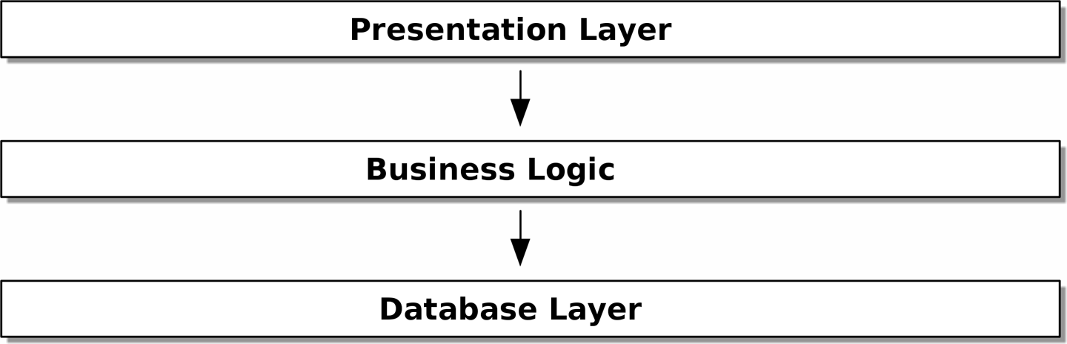
Figure P-2. Layered architecture

Layered architecture is perhaps the most common pattern for building business software. In this model we have user-interface components, which could be a web page, an API, or a command line; these user-interface components communicate with a business logic layer that contains our business rules and our workflows; and finally, we have a database layer that’s responsible for storing and retrieving data.
For the rest of this book, we’re going to be systematically turning this model inside out by obeying one simple principle.

The Dependency Inversion Principle
You might be familiar with the dependency inversion principle (DIP) already, because it’s the D in SOLID.2
Unfortunately, we can’t illustrate the DIP by using three tiny code listings as we did for encapsulation. However, the whole of Part I is essentially a worked example of implementing the DIP throughout an application, so you’ll get your fill of concrete examples.
In the meantime, we can talk about DIP’s formal definition:
High-level modules should not depend on low-level modules. Both should depend on abstractions.
Abstractions should not depend on details. Instead, details should depend on abstractions.
But what does this mean? Let’s take it bit by bit.
High-level modules are the code that your organization really cares about. Perhaps you work for a pharmaceutical company, and your high-level modules deal with patients and trials. Perhaps you work for a bank, and your high-level modules manage trades and exchanges. The high-level modules of a software system are the functions, classes, and packages that deal with our real-world concepts.
By contrast, low-level modules are the code that your organization doesn’t care about. It’s unlikely that your HR department gets excited about filesystems or network sockets. It’s not often that you discuss SMTP, HTTP, or AMQP with your finance team. For our nontechnical stakeholders, these low-level concepts aren’t interesting or relevant. All they care about is whether the high-level concepts work correctly. If payroll runs on time, your business is unlikely to care whether that’s a cron job or a transient function running on Kubernetes.
Depends on doesn’t mean imports or calls, necessarily, but rather a more general idea that one module knows about or needs another module.
And we’ve mentioned abstractions already: they’re simplified interfaces that encapsulate behavior, in the way that our duckduckgo module encapsulated a search engine’s API.
All problems in computer science can be solved by adding another level of indirection.
David Wheeler
So the first part of the DIP says that our business code shouldn’t depend on technical details; instead, both should use abstractions.
Why? Broadly, because we want to be able to change them independently of each other. High-level modules should be easy to change in response to business needs. Low-level modules (details) are often, in practice, harder to change: think about refactoring to change a function name versus defining, testing, and deploying a database migration to change a column name. We don’t want business logic changes to slow down because they are closely coupled to low-level infrastructure details. But, similarly, it is important to be able to change your infrastructure details when you need to (think about sharding a database, for example), without needing to make changes to your business layer. Adding an abstraction between them (the famous extra layer of indirection) allows the two to change (more) independently of each other.
The second part is even more mysterious. “Abstractions should not depend on details” seems clear enough, but “Details should depend on abstractions” is hard to imagine. How can we have an abstraction that doesn’t depend on the details it’s abstracting? By the time we get to Chapter 4, we’ll have a concrete example that should make this all a bit clearer.

A Place for All Our Business Logic: The Domain Model
But before we can turn our three-layered architecture inside out, we need to talk more about that middle layer: the high-level modules or business logic. One of the most common reasons that our designs go wrong is that business logic becomes spread throughout the layers of our application, making it hard to identify, understand, and change.
Chapter 1 shows how to build a business layer with a Domain Model pattern. The rest of the patterns in Part I show how we can keep the domain model easy to change and free of low-level concerns by choosing the right abstractions and continuously applying the DIP.
1 If you’ve come across class-responsibility-collaborator (CRC) cards, they’re driving at the same thing: thinking about responsibilities helps you decide how to split things up.
2 SOLID is an acronym for Robert C. Martin’s five principles of object-oriented design: single responsibility, open for extension but closed for modification, Liskov substitution, interface segregation, and dependency inversion. See “S.O.L.I.D: The First 5 Principles of Object-Oriented Design” by Samuel Oloruntoba.

Part I. Building an Architecture to Support Domain Modeling
Most developers have never seen a domain model, only a data model.
Cyrille Martraire, DDD EU 2017
Most developers we talk to about architecture have a nagging sense that things could be better. They are often trying to rescue a system that has gone wrong somehow, and are trying to put some structure back into a ball of mud. They know that their business logic shouldn’t be spread all over the place, but they have no idea how to fix it.
We’ve found that many developers, when asked to design a new system, will immediately start to build a database schema, with the object model treated as an afterthought. This is where it all starts to go wrong. Instead, behavior should come first and drive our storage requirements. After all, our customers don’t care about the data model. They care about what the system does; otherwise they’d just use a spreadsheet.
The first part of the book looks at how to build a rich object model through TDD (in Chapter 1), and then we’ll show how to keep that model decoupled from technical concerns. We show how to build persistence-ignorant code and how to create stable APIs around our domain so that we can refactor aggressively.
To do that, we present four key design patterns:
The Repository pattern, an abstraction over the idea of persistent storage
The Service Layer pattern to clearly define where our use cases begin and end
The Unit of Work pattern to provide atomic operations
The Aggregate pattern to enforce the integrity of our data
If you’d like a picture of where we’re going, take a look at Figure I-1, but don’t worry if none of it makes sense yet! We introduce each box in the figure, one by one, throughout this part of the book.
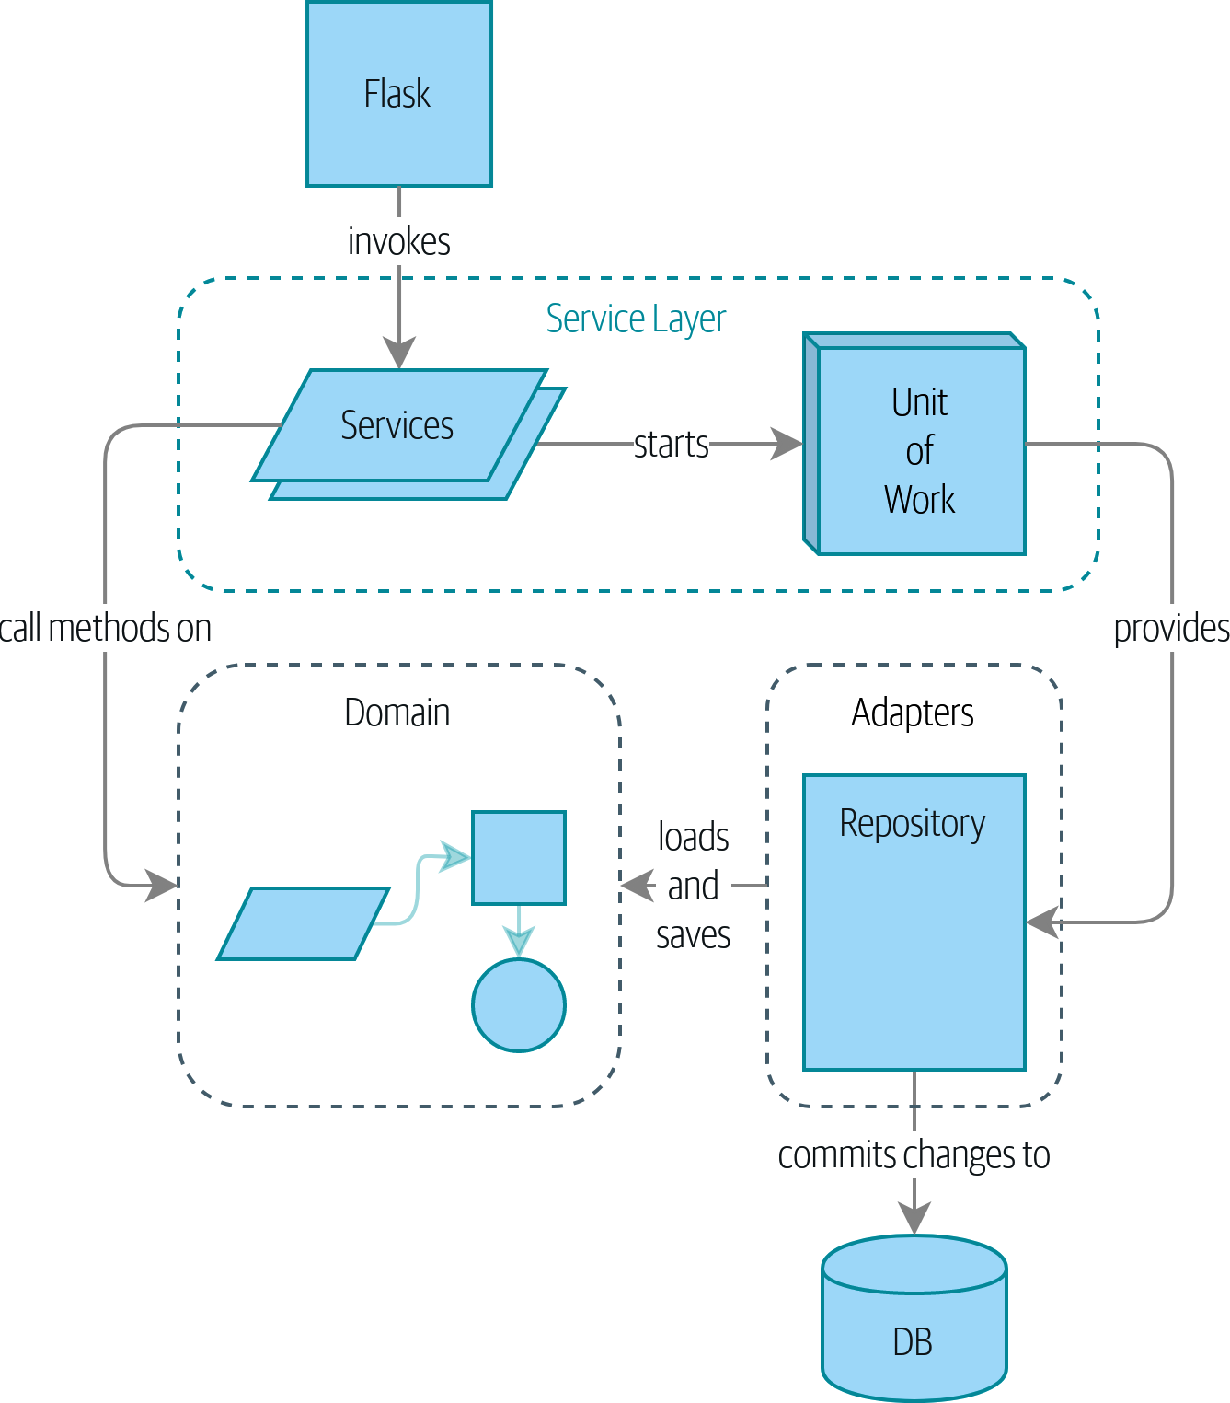
Figure I-1. A component diagram for our app at the end of Part I
We also take a little time out to talk about coupling and abstractions, illustrating it with a simple example that shows how and why we choose our abstractions.
Three appendices are further explorations of the content from Part I:
Appendix B is a write-up of the infrastructure for our example code: how we build and run the Docker images, where we manage configuration info, and how we run different types of tests.
Appendix C is a “proof is in the pudding” kind of content, showing how easy it is to swap out our entire infrastructure—the Flask API, the ORM, and Postgres—for a totally different I/O model involving a CLI and CSVs.
Finally, Appendix D may be of interest if you’re wondering how these patterns might look if using Django instead of Flask and SQLAlchemy.

Chapter 1. Domain Modeling
This chapter looks into how we can model business processes with code, in a way that’s highly compatible with TDD. We’ll discuss why domain modeling matters, and we’ll look at a few key patterns for modeling domains: Entity, Value Object, and Domain Service.
Figure 1-1 is a simple visual placeholder for our Domain Model pattern. We’ll fill in some details in this chapter, and as we move on to other chapters, we’ll build things around the domain model, but you should always be able to find these little shapes at the core.
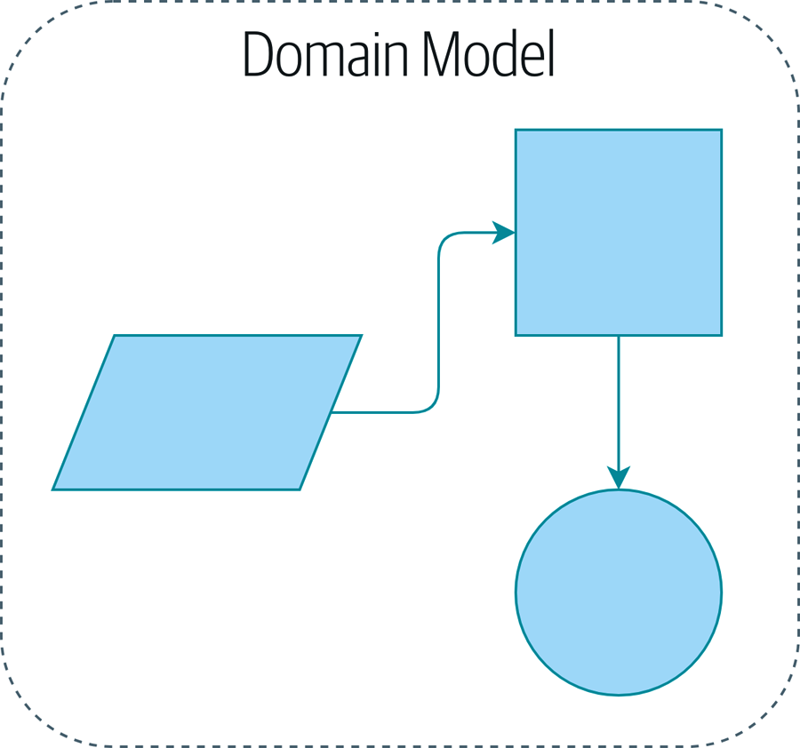
Figure 1-1. A placeholder illustration of our domain model

What Is a Domain Model?
In the introduction, we used the term business logic layer to describe the central layer of a three-layered architecture. For the rest of the book, we’re going to use the term domain model instead. This is a term from the DDD community that does a better job of capturing our intended meaning (see the next sidebar for more on DDD).
The domain is a fancy way of saying the problem you’re trying to solve. Your authors currently work for an online retailer of furniture. Depending on which system you’re talking about, the domain might be purchasing and procurement, or product design, or logistics and delivery. Most programmers spend their days trying to improve or automate business processes; the domain is the set of activities that those processes support.
A model is a map of a process or phenomenon that captures a useful property. Humans are exceptionally good at producing models of things in their heads. For example, when someone throws a ball toward you, you’re able to predict its movement almost unconsciously, because you have a model of the way objects move in space. Your model isn’t perfect by any means. Humans have terrible intuitions about how objects behave at near-light speeds or in a vacuum because our model was never designed to cover those cases. That doesn’t mean the model is wrong, but it does mean that some predictions fall outside of its domain.
The domain model is the mental map that business owners have of their businesses. All business people have these mental maps—they’re how humans think about complex processes.
You can tell when they’re navigating these maps because they use business speak. Jargon arises naturally among people who are collaborating on complex systems.
Imagine that you, our unfortunate reader, were suddenly transported light years away from Earth aboard an alien spaceship with your friends and family and had to figure out, from first principles, how to navigate home.
In your first few days, you might just push buttons randomly, but soon you’d learn which buttons did what, so that you could give one another instructions. “Press the red button near the flashing doohickey and then throw that big lever over by the radar gizmo,” you might say.
Within a couple of weeks, you’d become more precise as you adopted words to describe the ship’s functions: “Increase oxygen levels in cargo bay three” or “turn on the little thrusters.” After a few months, you’d have adopted language for entire complex processes: “Start landing sequence” or “prepare for warp.” This process would happen quite naturally, without any formal effort to build a shared glossary.

This Is Not a DDD Book. You Should Read a DDD Book.
Domain-driven design, or DDD, popularized the concept of domain modeling,1 and it’s been a hugely successful movement in transforming the way people design software by focusing on the core business domain. Many of the architecture patterns that we cover in this book—including Entity, Aggregate, Value Object (see Chapter 7), and Repository (in the next chapter)—come from the DDD tradition.
In a nutshell, DDD says that the most important thing about software is that it provides a useful model of a problem. If we get that model right, our software delivers value and makes new things possible.
If we get the model wrong, it becomes an obstacle to be worked around. In this book, we can show the basics of building a domain model, and building an architecture around it that leaves the model as free as possible from external constraints, so that it’s easy to evolve and change.
But there’s a lot more to DDD and to the processes, tools, and techniques for developing a domain model. We hope to give you a taste of it, though, and cannot encourage you enough to go on and read a proper DDD book:
The original “blue book,” Domain-Driven Design by Eric Evans (Addison-Wesley Professional)
The “red book,” Implementing Domain-Driven Design by Vaughn Vernon (Addison-Wesley Professional)
So it is in the mundane world of business. The terminology used by business stakeholders represents a distilled understanding of the domain model, where complex ideas and processes are boiled down to a single word or phrase.
When we hear our business stakeholders using unfamiliar words, or using terms in a specific way, we should listen to understand the deeper meaning and encode their hard-won experience into our software.
We’re going to use a real-world domain model throughout this book, specifically a model from our current employment. MADE.com is a successful furniture retailer. We source our furniture from manufacturers all over the world and sell it across Europe.
When you buy a sofa or a coffee table, we have to figure out how best to get your goods from Poland or China or Vietnam and into your living room.
At a high level, we have separate systems that are responsible for buying stock, selling stock to customers, and shipping goods to customers. A system in the middle needs to coordinate the process by allocating stock to a customer’s orders; see Figure 1-2.
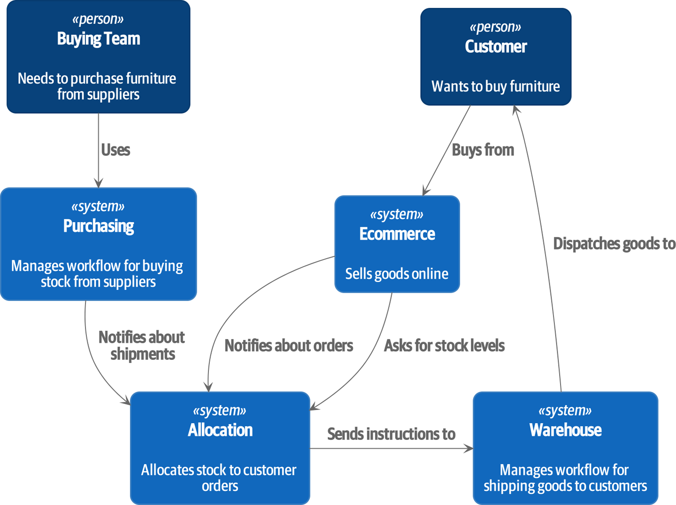
Figure 1-2. Context diagram for the allocation service

For the purposes of this book, we’re imagining that the business decides to implement an exciting new way of allocating stock. Until now, the business has been presenting stock and lead times based on what is physically available in the warehouse. If and when the warehouse runs out, a product is listed as “out of stock” until the next shipment arrives from the manufacturer.
Here’s the innovation: if we have a system that can keep track of all our shipments and when they’re due to arrive, we can treat the goods on those ships as real stock and part of our inventory, just with slightly longer lead times. Fewer goods will appear to be out of stock, we’ll sell more, and the business can save money by keeping lower inventory in the domestic warehouse.
But allocating orders is no longer a trivial matter of decrementing a single quantity in the warehouse system. We need a more complex allocation mechanism. Time for some domain modeling.

Exploring the Domain Language
Understanding the domain model takes time, and patience, and Post-it notes. We have an initial conversation with our business experts and agree on a glossary and some rules for the first minimal version of the domain model. Wherever possible, we ask for concrete examples to illustrate each rule.
We make sure to express those rules in the business jargon (the ubiquitous language in DDD terminology). We choose memorable identifiers for our objects so that the examples are easier to talk about.
“Some Notes on Allocation” shows some notes we might have taken while having a conversation with our domain experts about allocation.

Some Notes on Allocation
A product is identified by a SKU, pronounced “skew,” which is short for stock-keeping unit. Customers place orders. An order is identified by an order reference and comprises multiple order lines, where each line has a SKU and a quantity. For example:
10 units of RED-CHAIR
1 unit of TASTELESS-LAMP
The purchasing department orders small batches of stock. A batch of stock has a unique ID called a reference, a SKU, and a quantity.
We need to allocate order lines to batches. When we’ve allocated an order line to a batch, we will send stock from that specific batch to the customer’s delivery address. When we allocate x units of stock to a batch, the available quantity is reduced by x. For example:
We have a batch of 20 SMALL-TABLE, and we allocate an order line for 2 SMALL-TABLE.
The batch should have 18 SMALL-TABLE remaining.
We can’t allocate to a batch if the available quantity is less than the quantity of the order line. For example:
We have a batch of 1 BLUE-CUSHION, and an order line for 2 BLUE-CUSHION.
We should not be able to allocate the line to the batch.
We can’t allocate the same line twice. For example:
We have a batch of 10 BLUE-VASE, and we allocate an order line for 2 BLUE-VASE.
If we allocate the order line again to the same batch, the batch should still have an available quantity of 8.
Batches have an ETA if they are currently shipping, or they may be in warehouse stock. We allocate to warehouse stock in preference to shipment batches. We allocate to shipment batches in order of which has the earliest ETA.

Unit Testing Domain Models
We’re not going to show you how TDD works in this book, but we want to show you how we would construct a model from this business conversation.

Exercise for the Reader
Why not have a go at solving this problem yourself? Write a few unit tests to see if you can capture the essence of these business rules in nice, clean code.
You’ll find some placeholder unit tests on GitHub, but you could just start from scratch, or combine/rewrite them however you like.
Here’s what one of our first tests might look like:
A first test for allocation (test_batches.py)
def
test_allocating_to_a_batch_reduces_the_available_quantity
():
batch
=
Batch
(
"batch-001"
,
"SMALL-TABLE"
,
qty
=
20
,
eta
=
date
.
today
())
line
=
OrderLine
(
'order-ref'
,
"SMALL-TABLE"
,
2
)
batch
.
allocate
(
line
)
assert
batch
.
available_quantity
==
18
The name of our unit test describes the behavior that we want to see from the system, and the names of the classes and variables that we use are taken from the business jargon. We could show this code to our nontechnical coworkers, and they would agree that this correctly describes the behavior of the system.
And here is a domain model that meets our requirements:
First cut of a domain model for batches (model.py)
@dataclass
(
frozen
=
True
)
class
OrderLine
:
orderid
:
str
sku
:
str
qty
:
int
class
Batch
:
def
__init__
(
self
,
ref
:
str
,
sku
:
str
,
qty
:
int
,
eta
:
Optional
[
date
]
)
:
self
.
reference
=
ref
self
.
sku
=
sku
self
.
eta
=
eta
self
.
available_quantity
=
qty
def
allocate
(
self
,
line
:
OrderLine
)
:
self
.
available_quantity
-
=
line
.
qty
OrderLine is an immutable dataclass with no behavior.2
We’re not showing imports in most code listings, in an attempt to keep them clean. We’re hoping you can guess that this came via from dataclasses import dataclass; likewise, typing.Optional and datetime.date. If you want to double-check anything, you can see the full working code for each chapter in its branch (e.g., chapter_01_domain_model).
Type hints are still a matter of controversy in the Python world. For domain models, they can sometimes help to clarify or document what the expected arguments are, and people with IDEs are often grateful for them. You may decide the price paid in terms of readability is too high.
Our implementation here is trivial: a Batch just wraps an integer available_quantity, and we decrement that value on allocation. We’ve written quite a lot of code just to subtract one number from another, but we think that modeling our domain precisely will pay off.3
Let’s write some new failing tests:
Testing logic for what we can allocate (test_batches.py)
def
make_batch_and_line
(
sku
,
batch_qty
,
line_qty
):
return
(
Batch
(
"batch-001"
,
sku
,
batch_qty
,
eta
=
date
.
today
()),
OrderLine
(
"order-123"
,
sku
,
line_qty
)
)
def
test_can_allocate_if_available_greater_than_required
():
large_batch
,
small_line
=
make_batch_and_line
(
"ELEGANT-LAMP"
,
20
,
2
)
assert
large_batch
.
can_allocate
(
small_line
)
def
test_cannot_allocate_if_available_smaller_than_required
():
small_batch
,
large_line
=
make_batch_and_line
(
"ELEGANT-LAMP"
,
2
,
20
)
assert
small_batch
.
can_allocate
(
large_line
)
is
False
def
test_can_allocate_if_available_equal_to_required
():
batch
,
line
=
make_batch_and_line
(
"ELEGANT-LAMP"
,
2
,
2
)
assert
batch
.
can_allocate
(
line
)
def
test_cannot_allocate_if_skus_do_not_match
():
batch
=
Batch
(
"batch-001"
,
"UNCOMFORTABLE-CHAIR"
,
100
,
eta
=
None
)
different_sku_line
=
OrderLine
(
"order-123"
,
"EXPENSIVE-TOASTER"
,
10
)
assert
batch
.
can_allocate
(
different_sku_line
)
is
False
There’s nothing too unexpected here. We’ve refactored our test suite so that we don’t keep repeating the same lines of code to create a batch and a line for the same SKU; and we’ve written four simple tests for a new method can_allocate. Again, notice that the names we use mirror the language of our domain experts, and the examples we agreed upon are directly written into code.
We can implement this straightforwardly, too, by writing the can_allocate method of Batch:
A new method in the model (model.py)
def
can_allocate
(
self
,
line
:
OrderLine
)
->
bool
:
return
self
.
sku
==
line
.
sku
and
self
.
available_quantity
>=
line
.
qty
So far, we can manage the implementation by just incrementing and decrementing Batch.available_quantity, but as we get into deallocate() tests, we’ll be forced into a more intelligent solution:
This test is going to require a smarter model (test_batches.py)
def
test_can_only_deallocate_allocated_lines
():
batch
,
unallocated_line
=
make_batch_and_line
(
"DECORATIVE-TRINKET"
,
20
,
2
)
batch
.
deallocate
(
unallocated_line
)
assert
batch
.
available_quantity
==
20
In this test, we’re asserting that deallocating a line from a batch has no effect unless the batch previously allocated the line. For this to work, our Batch needs to understand which lines have been allocated. Let’s look at the implementation:
The domain model now tracks allocations (model.py)
class
Batch
:
def
__init__
(
self
,
ref
:
str
,
sku
:
str
,
qty
:
int
,
eta
:
Optional
[
date
]
):
self
.
reference
=
ref
self
.
sku
=
sku
self
.
eta
=
eta
self
.
_purchased_quantity
=
qty
self
.
_allocations
=
set
()
# type: Set[OrderLine]
def
allocate
(
self
,
line
:
OrderLine
):
if
self
.
can_allocate
(
line
):
self
.
_allocations
.
add
(
line
)
def
deallocate
(
self
,
line
:
OrderLine
):
if
line
in
self
.
_allocations
:
self
.
_allocations
.
remove
(
line
)
@property
def
allocated_quantity
(
self
)
->
int
:
return
sum
(
line
.
qty
for
line
in
self
.
_allocations
)
@property
def
available_quantity
(
self
)
->
int
:
return
self
.
_purchased_quantity
-
self
.
allocated_quantity
def
can_allocate
(
self
,
line
:
OrderLine
)
->
bool
:
return
self
.
sku
==
line
.
sku
and
self
.
available_quantity
>=
line
.
qty
Figure 1-3 shows the model in UML.
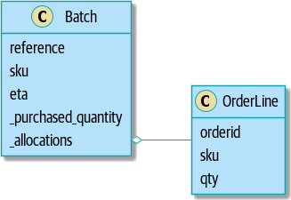
Figure 1-3. Our model in UML

Now we’re getting somewhere! A batch now keeps track of a set of allocated OrderLine objects. When we allocate, if we have enough available quantity, we just add to the set. Our available_quantity is now a calculated property: purchased quantity minus allocated quantity.
Yes, there’s plenty more we could do. It’s a little disconcerting that both allocate() and deallocate() can fail silently, but we have the basics.
Incidentally, using a set for ._allocations makes it simple for us to handle the last test, because items in a set are unique:
Last batch test! (test_batches.py)
def
test_allocation_is_idempotent
():
batch
,
line
=
make_batch_and_line
(
"ANGULAR-DESK"
,
20
,
2
)
batch
.
allocate
(
line
)
batch
.
allocate
(
line
)
assert
batch
.
available_quantity
==
18
At the moment, it’s probably a valid criticism to say that the domain model is too trivial to bother with DDD (or even object orientation!). In real life, any number of business rules and edge cases crop up: customers can ask for delivery on specific future dates, which means we might not want to allocate them to the earliest batch. Some SKUs aren’t in batches, but ordered on demand directly from suppliers, so they have different logic. Depending on the customer’s location, we can allocate to only a subset of warehouses and shipments that are in their region—except for some SKUs we’re happy to deliver from a warehouse in a different region if we’re out of stock in the home region. And so on. A real business in the real world knows how to pile on complexity faster than we can show on the page!
But taking this simple domain model as a placeholder for something more complex, we’re going to extend our simple domain model in the rest of the book and plug it into the real world of APIs and databases and spreadsheets. We’ll see how sticking rigidly to our principles of encapsulation and careful layering will help us to avoid a ball of mud.

More Types for More Type Hints
If you really want to go to town with type hints, you could go so far as wrapping primitive types by using typing.NewType:
Just taking it way too far, Bob
from
dataclasses
import
dataclass
from
typing
import
NewType
Quantity
=
NewType
(
"Quantity"
,
int
)
Sku
=
NewType
(
"Sku"
,
str
)
Reference
=
NewType
(
"Reference"
,
str
)
...
class
Batch
:
def
__init__
(
self
,
ref
:
Reference
,
sku
:
Sku
,
qty
:
Quantity
):
self
.
sku
=
sku
self
.
reference
=
ref
self
.
_purchased_quantity
=
qty
That would allow our type checker to make sure that we don’t pass a Sku where a Reference is expected, for example.
Whether you think this is wonderful or appalling is a matter of debate.4

Dataclasses Are Great for Value Objects
We’ve used line liberally in the previous code listings, but what is a line? In our business language, an order has multiple line items, where each line has a SKU and a quantity. We can imagine that a simple YAML file containing order information might look like this:
Order info as YAML
Order_reference
:
12345
Lines
:
-
sku
:
RED-CHAIR
qty
:
25
-
sku
:
BLU-CHAIR
qty
:
25
-
sku
:
GRN-CHAIR
qty
:
25
Notice that while an order has a reference that uniquely identifies it, a line does not. (Even if we add the order reference to the OrderLine class, it’s not something that uniquely identifies the line itself.)
Whenever we have a business concept that has data but no identity, we often choose to represent it using the Value Object pattern. A value object is any domain object that is uniquely identified by the data it holds; we usually make them immutable:
OrderLine is a value object
@dataclass
(
frozen
=
True
)
class
OrderLine
:
orderid
:
OrderReference
sku
:
ProductReference
qty
:
Quantity
One of the nice things that dataclasses (or namedtuples) give us is value equality, which is the fancy way of saying, “Two lines with the same orderid, sku, and qty are equal.”
More examples of value objects
from
dataclasses
import
dataclass
from
typing
import
NamedTuple
from
collections
import
namedtuple
@dataclass
(
frozen
=
True
)
class
Name
:
first_name
:
str
surname
:
str
class
Money
(
NamedTuple
):
currency
:
str
value
:
int
Line
=
namedtuple
(
'Line'
,
[
'sku'
,
'qty'
])
def
test_equality
():
assert
Money
(
'gbp'
,
10
)
==
Money
(
'gbp'
,
10
)
assert
Name
(
'Harry'
,
'Percival'
)
!=
Name
(
'Bob'
,
'Gregory'
)
assert
Line
(
'RED-CHAIR'
,
5
)
==
Line
(
'RED-CHAIR'
,
5
)
These value objects match our real-world intuition about how their values work. It doesn’t matter which £10 note we’re talking about, because they all have the same value. Likewise, two names are equal if both the first and last names match; and two lines are equivalent if they have the same customer order, product code, and quantity. We can still have complex behavior on a value object, though. In fact, it’s common to support operations on values; for example, mathematical operators:
Math with value objects
fiver
=
Money
(
'gbp'
,
5
)
tenner
=
Money
(
'gbp'
,
10
)
def
can_add_money_values_for_the_same_currency
():
assert
fiver
+
fiver
==
tenner
def
can_subtract_money_values
():
assert
tenner
-
fiver
==
fiver
def
adding_different_currencies_fails
():
with
pytest
.
raises
(
ValueError
):
Money
(
'usd'
,
10
)
+
Money
(
'gbp'
,
10
)
def
can_multiply_money_by_a_number
():
assert
fiver
*
5
==
Money
(
'gbp'
,
25
)
def
multiplying_two_money_values_is_an_error
():
with
pytest
.
raises
(
TypeError
):
tenner
*
fiver

Value Objects and Entities
An order line is uniquely identified by its order ID, SKU, and quantity; if we change one of those values, we now have a new line. That’s the definition of a value object: any object that is identified only by its data and doesn’t have a long-lived identity. What about a batch, though? That is identified by a reference.
We use the term entity to describe a domain object that has long-lived identity. On the previous page, we introduced a Name class as a value object. If we take the name Harry Percival and change one letter, we have the new Name object Barry Percival.
It should be clear that Harry Percival is not equal to Barry Percival:
A name itself cannot change…
def
test_name_equality
():
assert
Name
(
"Harry"
,
"Percival"
)
!=
Name
(
"Barry"
,
"Percival"
)
But what about Harry as a person? People do change their names, and their marital status, and even their gender, but we continue to recognize them as the same individual. That’s because humans, unlike names, have a persistent identity:
But a person can!
class
Person
:
def
__init__
(
self
,
name
:
Name
):
self
.
name
=
name
def
test_barry_is_harry
():
harry
=
Person
(
Name
(
"Harry"
,
"Percival"
))
barry
=
harry
barry
.
name
=
Name
(
"Barry"
,
"Percival"
)
assert
harry
is
barry
and
barry
is
harry
Entities, unlike values, have identity equality. We can change their values, and they are still recognizably the same thing. Batches, in our example, are entities. We can allocate lines to a batch, or change the date that we expect it to arrive, and it will still be the same entity.
We usually make this explicit in code by implementing equality operators on entities:
Implementing equality operators (model.py)
class
Batch
:
...
def
__eq__
(
self
,
other
):
if
not
isinstance
(
other
,
Batch
):
return
False
return
other
.
reference
==
self
.
reference
def
__hash__
(
self
):
return
hash
(
self
.
reference
)
Python’s __eq__ magic method defines the behavior of the class for the == operator.5
For both entity and value objects, it’s also worth thinking through how __hash__ will work. It’s the magic method Python uses to control the behavior of objects when you add them to sets or use them as dict keys; you can find more info in the Python docs.
For value objects, the hash should be based on all the value attributes, and we should ensure that the objects are immutable. We get this for free by specifying @frozen=True on the dataclass.
For entities, the simplest option is to say that the hash is None, meaning that the object is not hashable and cannot, for example, be used in a set. If for some reason you decide you really do want to use set or dict operations with entities, the hash should be based on the attribute(s), such as .reference, that defines the entity’s unique identity over time. You should also try to somehow make that attribute read-only.
Warning
This is tricky territory; you shouldn’t modify __hash__ without also modifying __eq__. If you’re not sure what you’re doing, further reading is suggested. “Python Hashes and Equality” by our tech reviewer Hynek Schlawack is a good place to start.

Not Everything Has to Be an Object: A Domain Service Function
We’ve made a model to represent batches, but what we actually need to do is allocate order lines against a specific set of batches that represent all our stock.
Sometimes, it just isn’t a thing.
Eric Evans, Domain-Driven Design
Evans discusses the idea of Domain Service operations that don’t have a natural home in an entity or value object.6 A thing that allocates an order line, given a set of batches, sounds a lot like a function, and we can take advantage of the fact that Python is a multiparadigm language and just make it a function.
Let’s see how we might test-drive such a function:
Testing our domain service (test_allocate.py)
def
test_prefers_current_stock_batches_to_shipments
():
in_stock_batch
=
Batch
(
"in-stock-batch"
,
"RETRO-CLOCK"
,
100
,
eta
=
None
)
shipment_batch
=
Batch
(
"shipment-batch"
,
"RETRO-CLOCK"
,
100
,
eta
=
tomorrow
)
line
=
OrderLine
(
"oref"
,
"RETRO-CLOCK"
,
10
)
allocate
(
line
,
[
in_stock_batch
,
shipment_batch
])
assert
in_stock_batch
.
available_quantity
==
90
assert
shipment_batch
.
available_quantity
==
100
def
test_prefers_earlier_batches
():
earliest
=
Batch
(
"speedy-batch"
,
"MINIMALIST-SPOON"
,
100
,
eta
=
today
)
medium
=
Batch
(
"normal-batch"
,
"MINIMALIST-SPOON"
,
100
,
eta
=
tomorrow
)
latest
=
Batch
(
"slow-batch"
,
"MINIMALIST-SPOON"
,
100
,
eta
=
later
)
line
=
OrderLine
(
"order1"
,
"MINIMALIST-SPOON"
,
10
)
allocate
(
line
,
[
medium
,
earliest
,
latest
])
assert
earliest
.
available_quantity
==
90
assert
medium
.
available_quantity
==
100
assert
latest
.
available_quantity
==
100
def
test_returns_allocated_batch_ref
():
in_stock_batch
=
Batch
(
"in-stock-batch-ref"
,
"HIGHBROW-POSTER"
,
100
,
eta
=
None
)
shipment_batch
=
Batch
(
"shipment-batch-ref"
,
"HIGHBROW-POSTER"
,
100
,
eta
=
tomorrow
)
line
=
OrderLine
(
"oref"
,
"HIGHBROW-POSTER"
,
10
)
allocation
=
allocate
(
line
,
[
in_stock_batch
,
shipment_batch
])
assert
allocation
==
in_stock_batch
.
reference
And our service might look like this:
A standalone function for our domain service (model.py)
def
allocate
(
line
:
OrderLine
,
batches
:
List
[
Batch
])
->
str
:
batch
=
next
(
b
for
b
in
sorted
(
batches
)
if
b
.
can_allocate
(
line
)
)
batch
.
allocate
(
line
)
return
batch
.
reference

Python’s Magic Methods Let Us Use Our Models with Idiomatic Python
You may or may not like the use of next() in the preceding code, but we’re pretty sure you’ll agree that being able to use sorted() on our list of batches is nice, idiomatic Python.
To make it work, we implement __gt__ on our domain model:
Magic methods can express domain semantics (model.py)
class
Batch
:
...
def
__gt__
(
self
,
other
):
if
self
.
eta
is
None
:
return
False
if
other
.
eta
is
None
:
return
True
return
self
.
eta
>
other
.
eta
That’s lovely.

Exceptions Can Express Domain Concepts Too
We have one final concept to cover: exceptions can be used to express domain concepts too. In our conversations with domain experts, we’ve learned about the possibility that an order cannot be allocated because we are out of stock, and we can capture that by using a domain exception:
Testing out-of-stock exception (test_allocate.py)
def
test_raises_out_of_stock_exception_if_cannot_allocate
():
batch
=
Batch
(
'batch1'
,
'SMALL-FORK'
,
10
,
eta
=
today
)
allocate
(
OrderLine
(
'order1'
,
'SMALL-FORK'
,
10
),
[
batch
])
with
pytest
.
raises
(
OutOfStock
,
match
=
'SMALL-FORK'
):
allocate
(
OrderLine
(
'order2'
,
'SMALL-FORK'
,
1
),
[
batch
])

Domain Modeling Recap
Domain modeling
This is the part of your code that is closest to the business, the most likely to change, and the place where you deliver the most value to the business. Make it easy to understand and modify.
Distinguish entities from value objects
A value object is defined by its attributes. It’s usually best implemented as an immutable type. If you change an attribute on a Value Object, it represents a different object. In contrast, an entity has attributes that may vary over time and it will still be the same entity. It’s important to define what does uniquely identify an entity (usually some sort of name or reference field).
Not everything has to be an object
Python is a multiparadigm language, so let the “verbs” in your code be functions. For every FooManager, BarBuilder, or BazFactory, there’s often a more expressive and readable manage_foo(), build_bar(), or get_baz() waiting to happen.
This is the time to apply your best OO design principles
Revisit the SOLID principles and all the other good heuristics like “has a versus is-a,” “prefer composition over inheritance,” and so on.
You’ll also want to think about consistency boundaries and aggregates
But that’s a topic for Chapter 7.
We won’t bore you too much with the implementation, but the main thing to note is that we take care in naming our exceptions in the ubiquitous language, just as we do our entities, value objects, and services:
Raising a domain exception (model.py)
class
OutOfStock
(
Exception
):
pass
def
allocate
(
line
:
OrderLine
,
batches
:
List
[
Batch
])
->
str
:
try
:
batch
=
next
(
...
except
StopIteration
:
raise
OutOfStock
(
f
'Out of stock for sku {line.sku}'
)
Figure 1-4 is a visual representation of where we’ve ended up.
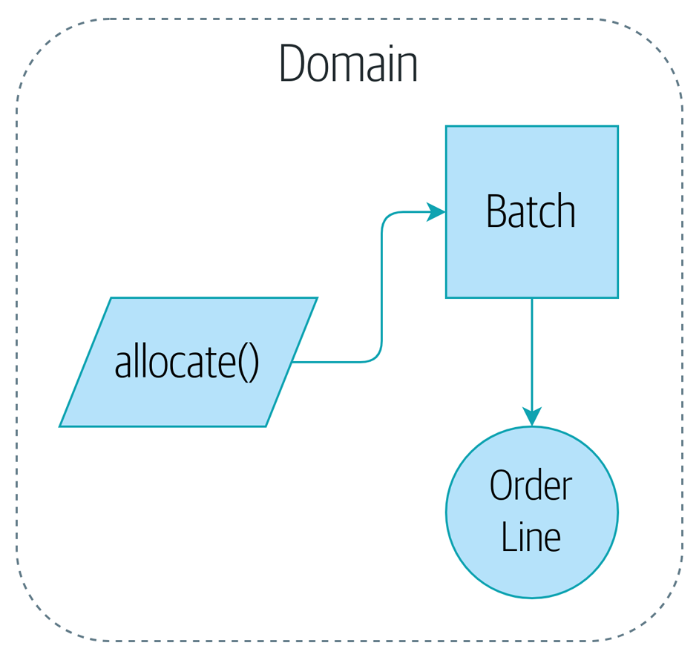
Figure 1-4. Our domain model at the end of the chapter
That’ll probably do for now! We have a domain service that we can use for our first use case. But first we’ll need a database…
1 DDD did not originate domain modeling. Eric Evans refers to the 2002 book Object Design by Rebecca Wirfs-Brock and Alan McKean (Addison-Wesley Professional), which introduced responsibility-driven design, of which DDD is a special case dealing with the domain. But even that is too late, and OO enthusiasts will tell you to look further back to Ivar Jacobson and Grady Booch; the term has been around since the mid-1980s.
2 In previous Python versions, we might have used a namedtuple. You could also check out Hynek Schlawack’s excellent attrs.
3 Or perhaps you think there’s not enough code? What about some sort of check that the SKU in the OrderLine matches Batch.sku? We saved some thoughts on validation for Appendix E.
4 It is appalling. Please, please don’t do this. —Harry
5 The __eq__ method is pronounced “dunder-EQ.” By some, at least.
6 Domain services are not the same thing as the services from the service layer, although they are often closely related. A domain service represents a business concept or process, whereas a service-layer service represents a use case for your application. Often the service layer will call a domain service.

Chapter 2. Repository Pattern
It’s time to make good on our promise to use the dependency inversion principle as a way of decoupling our core logic from infrastructural concerns.
We’ll introduce the Repository pattern, a simplifying abstraction over data storage, allowing us to decouple our model layer from the data layer. We’ll present a concrete example of how this simplifying abstraction makes our system more testable by hiding the complexities of the database.
Figure 2-1 shows a little preview of what we’re going to build: a Repository object that sits between our domain model and the database.
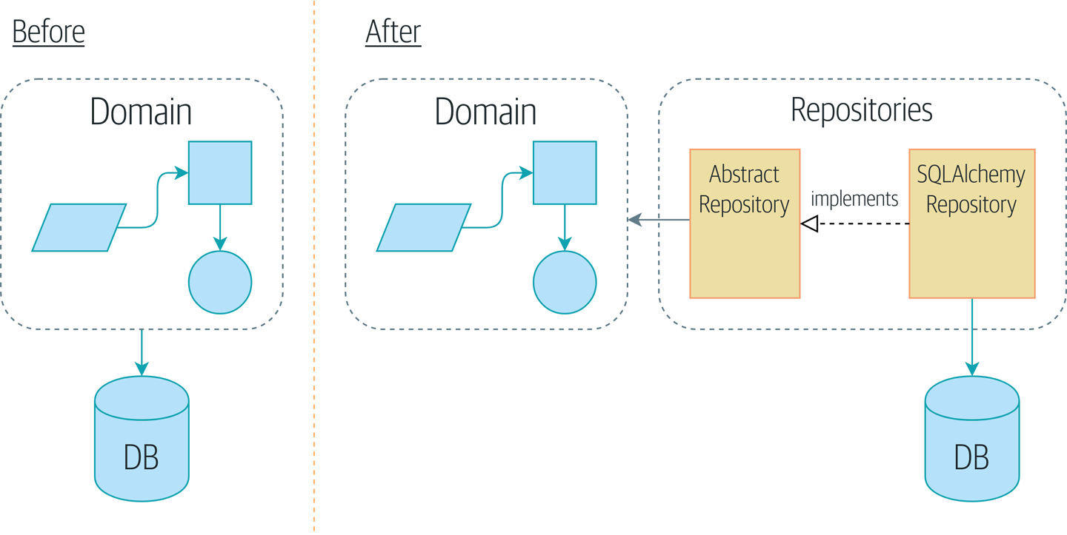
Figure 2-1. Before and after the Repository pattern

Tip
The code for this chapter is in the chapter_02_repository branch on GitHub.
git clone https://github.com/cosmicpython/code.git
cd code
git checkout chapter_02_repository
# or to code along, checkout the previous chapter:
git checkout chapter_01_domain_model

Persisting Our Domain Model
In Chapter 1 we built a simple domain model that can allocate orders to batches of stock. It’s easy for us to write tests against this code because there aren’t any dependencies or infrastructure to set up. If we needed to run a database or an API and create test data, our tests would be harder to write and maintain.
Sadly, at some point we’ll need to put our perfect little model in the hands of users and contend with the real world of spreadsheets and web browsers and race conditions. For the next few chapters we’re going to look at how we can connect our idealized domain model to external state.
We expect to be working in an agile manner, so our priority is to get to a minimum viable product as quickly as possible. In our case, that’s going to be a web API. In a real project, you might dive straight in with some end-to-end tests and start plugging in a web framework, test-driving things outside-in.
But we know that, no matter what, we’re going to need some form of persistent storage, and this is a textbook, so we can allow ourselves a tiny bit more bottom-up development and start to think about storage and databases.

Some Pseudocode: What Are We Going to Need?
When we build our first API endpoint, we know we’re going to have some code that looks more or less like the following.
What our first API endpoint will look like
@flask.route.gubbins
def
allocate_endpoint
():
# extract order line from request
line
=
OrderLine
(
request
.
params
,
...
)
# load all batches from the DB
batches
=
...
# call our domain service
allocate
(
line
,
batches
)
# then save the allocation back to the database somehow
return
201

Note
We’ve used Flask because it’s lightweight, but you don’t need to be a Flask user to understand this book. In fact, we’ll show you how to make your choice of framework a minor detail.
We’ll need a way to retrieve batch info from the database and instantiate our domain model objects from it, and we’ll also need a way of saving them back to the database.
What? Oh, “gubbins” is a British word for “stuff.” You can just ignore that. It’s pseudocode, OK?

Applying the DIP to Data Access
As mentioned in the introduction, a layered architecture is a common approach to structuring a system that has a UI, some logic, and a database (see Figure 2-2).
Figure 2-2. Layered architecture
Django’s Model-View-Template structure is closely related, as is Model-View-Controller (MVC). In any case, the aim is to keep the layers separate (which is a good thing), and to have each layer depend only on the one below it.
But we want our domain model to have no dependencies whatsoever.1 We don’t want infrastructure concerns bleeding over into our domain model and slowing our unit tests or our ability to make changes.
Instead, as discussed in the introduction, we’ll think of our model as being on the “inside,” and dependencies flowing inward to it; this is what people sometimes call onion architecture (see Figure 2-3).
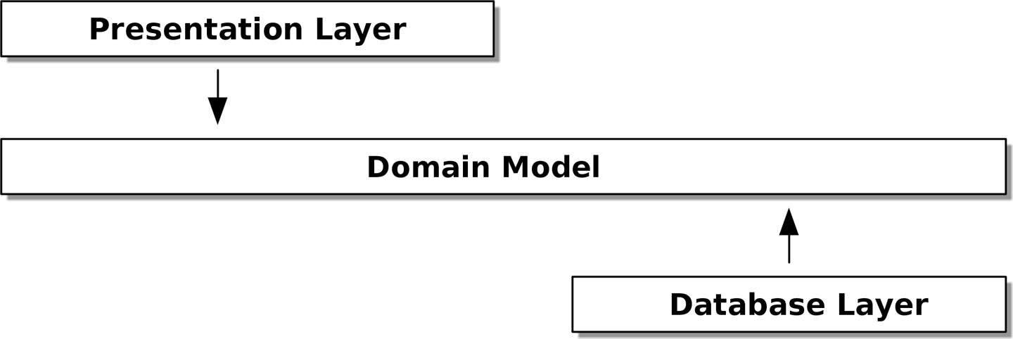
Figure 2-3. Onion architecture

Is This Ports and Adapters?
If you’ve been reading about architectural patterns, you may be asking yourself questions like this:
Is this ports and adapters? Or is it hexagonal architecture? Is that the same as onion architecture? What about the clean architecture? What’s a port, and what’s an adapter? Why do you people have so many words for the same thing?
Although some people like to nitpick over the differences, all these are pretty much names for the same thing, and they all boil down to the dependency inversion principle: high-level modules (the domain) should not depend on low-level ones (the infrastructure).2
We’ll get into some of the nitty-gritty around “depending on abstractions,” and whether there is a Pythonic equivalent of interfaces, later in the book. See also “What Is a Port and What Is an Adapter, in Python?”.

Reminder: Our Model
Let’s remind ourselves of our domain model (see Figure 2-4): an allocation is the concept of linking an OrderLine to a Batch. We’re storing the allocations as a collection on our Batch object.
Figure 2-4. Our model
Let’s see how we might translate this to a relational database.

The “Normal” ORM Way: Model Depends on ORM
These days, it’s unlikely that your team members are hand-rolling their own SQL queries. Instead, you’re almost certainly using some kind of framework to generate SQL for you based on your model objects.
These frameworks are called object-relational mappers (ORMs) because they exist to bridge the conceptual gap between the world of objects and domain modeling and the world of databases and relational algebra.
The most important thing an ORM gives us is persistence ignorance: the idea that our fancy domain model doesn’t need to know anything about how data is loaded or persisted. This helps keep our domain clean of direct dependencies on particular database technologies.3
But if you follow the typical SQLAlchemy tutorial, you’ll end up with something like this:
SQLAlchemy “declarative” syntax, model depends on ORM (orm.py)
from
sqlalchemy
import
Column
,
ForeignKey
,
Integer
,
String
from
sqlalchemy.ext.declarative
import
declarative_base
from
sqlalchemy.orm
import
relationship
Base
=
declarative_base
()
class
Order
(
Base
):
id
=
Column
(
Integer
,
primary_key
=
True
)
class
OrderLine
(
Base
):
id
=
Column
(
Integer
,
primary_key
=
True
)
sku
=
Column
(
String
(
250
))
qty
=
Integer
(
String
(
250
))
order_id
=
Column
(
Integer
,
ForeignKey
(
'order.id'
))
order
=
relationship
(
Order
)
class
Allocation
(
Base
):
...
You don’t need to understand SQLAlchemy to see that our pristine model is now full of dependencies on the ORM and is starting to look ugly as hell besides. Can we really say this model is ignorant of the database? How can it be separate from storage concerns when our model properties are directly coupled to database columns?

Django’s ORM Is Essentially the Same, but More Restrictive
If you’re more used to Django, the preceding “declarative” SQLAlchemy snippet translates to something like this:
Django ORM example
class
Order
(
models
.
Model
):
pass
class
OrderLine
(
models
.
Model
):
sku
=
models
.
CharField
(
max_length
=
255
)
qty
=
models
.
IntegerField
()
order
=
models
.
ForeignKey
(
Order
)
class
Allocation
(
models
.
Model
):
...
The point is the same—our model classes inherit directly from ORM classes, so our model depends on the ORM. We want it to be the other way around.
Django doesn’t provide an equivalent for SQLAlchemy’s classical mapper, but see Appendix D for examples of how to apply dependency inversion and the Repository pattern to Django.

Inverting the Dependency: ORM Depends on Model
Well, thankfully, that’s not the only way to use SQLAlchemy. The alternative is to define your schema separately, and to define an explicit mapper for how to convert between the schema and our domain model, what SQLAlchemy calls a classical mapping:
Explicit ORM mapping with SQLAlchemy Table objects (orm.py)
from
sqlalchemy.orm
import
mapper
,
relationship
import
model
metadata
=
MetaData
(
)
order_lines
=
Table
(
'
order_lines
'
,
metadata
,
Column
(
'
id
'
,
Integer
,
primary_key
=
True
,
autoincrement
=
True
)
,
Column
(
'
sku
'
,
String
(
255
)
)
,
Column
(
'
qty
'
,
Integer
,
nullable
=
False
)
,
Column
(
'
orderid
'
,
String
(
255
)
)
,
)
.
.
.
def
start_mappers
(
)
:
lines_mapper
=
mapper
(
model
.
OrderLine
,
order_lines
)
The ORM imports (or “depends on” or “knows about”) the domain model, and not the other way around.
We define our database tables and columns by using SQLAlchemy’s abstractions.4
When we call the mapper function, SQLAlchemy does its magic to bind our domain model classes to the various tables we’ve defined.
The end result will be that, if we call start_mappers, we will be able to easily load and save domain model instances from and to the database. But if we never call that function, our domain model classes stay blissfully unaware of the database.
This gives us all the benefits of SQLAlchemy, including the ability to use alembic for migrations, and the ability to transparently query using our domain classes, as we’ll see.
When you’re first trying to build your ORM config, it can be useful to write tests for it, as in the following example:
Testing the ORM directly (throwaway tests) (test_orm.py)
def
test_orderline_mapper_can_load_lines
(
session
)
:
session
.
execute
(
'
INSERT INTO order_lines (orderid, sku, qty) VALUES
'
'
(
"
order1
"
,
"
RED-CHAIR
"
, 12),
'
'
(
"
order1
"
,
"
RED-TABLE
"
, 13),
'
'
(
"
order2
"
,
"
BLUE-LIPSTICK
"
, 14)
'
)
expected
=
[
model
.
OrderLine
(
"
order1
"
,
"
RED-CHAIR
"
,
12
)
,
model
.
OrderLine
(
"
order1
"
,
"
RED-TABLE
"
,
13
)
,
model
.
OrderLine
(
"
order2
"
,
"
BLUE-LIPSTICK
"
,
14
)
,
]
assert
session
.
query
(
model
.
OrderLine
)
.
all
(
)
==
expected
def
test_orderline_mapper_can_save_lines
(
session
)
:
new_line
=
model
.
OrderLine
(
"
order1
"
,
"
DECORATIVE-WIDGET
"
,
12
)
session
.
add
(
new_line
)
session
.
commit
(
)
rows
=
list
(
session
.
execute
(
'
SELECT orderid, sku, qty FROM
"
order_lines
"
'
)
)
assert
rows
==
[
(
"
order1
"
,
"
DECORATIVE-WIDGET
"
,
12
)
]
If you haven’t used pytest, the session argument to this test needs explaining. You don’t need to worry about the details of pytest or its fixtures for the purposes of this book, but the short explanation is that you can define common dependencies for your tests as “fixtures,” and pytest will inject them to the tests that need them by looking at their function arguments. In this case, it’s a SQLAlchemy database session.
You probably wouldn’t keep these tests around—as you’ll see shortly, once you’ve taken the step of inverting the dependency of ORM and domain model, it’s only a small additional step to implement another abstraction called the Repository pattern, which will be easier to write tests against and will provide a simple interface for faking out later in tests.
But we’ve already achieved our objective of inverting the traditional dependency: the domain model stays “pure” and free from infrastructure concerns. We could throw away SQLAlchemy and use a different ORM, or a totally different persistence system, and the domain model doesn’t need to change at all.
Depending on what you’re doing in your domain model, and especially if you stray far from the OO paradigm, you may find it increasingly hard to get the ORM to produce the exact behavior you need, and you may need to modify your domain model.5 As so often happens with architectural decisions, you’ll need to consider a trade-off. As the Zen of Python says, “Practicality beats purity!”
At this point, though, our API endpoint might look something like the following, and we could get it to work just fine:
Using SQLAlchemy directly in our API endpoint
@flask.route.gubbins
def
allocate_endpoint
():
session
=
start_session
()
# extract order line from request
line
=
OrderLine
(
request
.
json
[
'orderid'
],
request
.
json
[
'sku'
],
request
.
json
[
'qty'
],
)
# load all batches from the DB
batches
=
session
.
query
(
Batch
)
.
all
()
# call our domain service
allocate
(
line
,
batches
)
# save the allocation back to the database
session
.
commit
()
return
201

Introducing the Repository Pattern
The Repository pattern is an abstraction over persistent storage. It hides the boring details of data access by pretending that all of our data is in memory.
If we had infinite memory in our laptops, we’d have no need for clumsy databases. Instead, we could just use our objects whenever we liked. What would that look like?
You have to get your data from somewhere
import
all_my_data
def
create_a_batch
():
batch
=
Batch
(
...
)
all_my_data
.
batches
.
add
(
batch
)
def
modify_a_batch
(
batch_id
,
new_quantity
):
batch
=
all_my_data
.
batches
.
get
(
batch_id
)
batch
.
change_initial_quantity
(
new_quantity
)
Even though our objects are in memory, we need to put them somewhere so we can find them again. Our in-memory data would let us add new objects, just like a list or a set. Because the objects are in memory, we never need to call a .save() method; we just fetch the object we care about and modify it in memory.

The Repository in the Abstract
The simplest repository has just two methods: add() to put a new item in the repository, and get() to return a previously added item.6 We stick rigidly to using these methods for data access in our domain and our service layer. This self-imposed simplicity stops us from coupling our domain model to the database.
Here’s what an abstract base class (ABC) for our repository would look like:
The simplest possible repository (repository.py)
class
AbstractRepository
(
abc
.
ABC
)
:
@abc.abstractmethod
def
add
(
self
,
batch
:
model
.
Batch
)
:
raise
NotImplementedError
@abc.abstractmethod
def
get
(
self
,
reference
)
-
>
model
.
Batch
:
raise
NotImplementedError
Python tip: @abc.abstractmethod is one of the only things that makes ABCs actually “work” in Python. Python will refuse to let you instantiate a class that does not implement all the abstractmethods defined in its parent class.7
raise NotImplementedError is nice, but it’s neither necessary nor sufficient. In fact, your abstract methods can have real behavior that subclasses can call out to, if you really want.

Abstract Base Classes, Duck Typing, and Protocols
We’re using abstract base classes in this book for didactic reasons: we hope they help explain what the interface of the repository abstraction is.
In real life, we’ve sometimes found ourselves deleting ABCs from our production code, because Python makes it too easy to ignore them, and they end up unmaintained and, at worst, misleading. In practice we often just rely on Python’s duck typing to enable abstractions. To a Pythonista, a repository is any object that has add(thing) and get(id) methods.
An alternative to look into is PEP 544 protocols. These give you typing without the possibility of inheritance, which “prefer composition over inheritance” fans will particularly like.

What Is the Trade-Off?
You know they say economists know the price of everything and the value of nothing? Well, programmers know the benefits of everything and the trade-offs of nothing.
Rich Hickey
Whenever we introduce an architectural pattern in this book, we’ll always ask, “What do we get for this? And what does it cost us?”
Usually, at the very least, we’ll be introducing an extra layer of abstraction, and although we may hope it will reduce complexity overall, it does add complexity locally, and it has a cost in terms of the raw numbers of moving parts and ongoing maintenance.
The Repository pattern is probably one of the easiest choices in the book, though, if you’re already heading down the DDD and dependency inversion route. As far as our code is concerned, we’re really just swapping the SQLAlchemy abstraction (session.query(Batch)) for a different one (batches_repo.get) that we designed.
We will have to write a few lines of code in our repository class each time we add a new domain object that we want to retrieve, but in return we get a simple abstraction over our storage layer, which we control. The Repository pattern would make it easy to make fundamental changes to the way we store things (see Appendix C), and as we’ll see, it is easy to fake out for unit tests.
In addition, the Repository pattern is so common in the DDD world that, if you do collaborate with programmers who have come to Python from the Java and C# worlds, they’re likely to recognize it. Figure 2-5 illustrates the pattern.
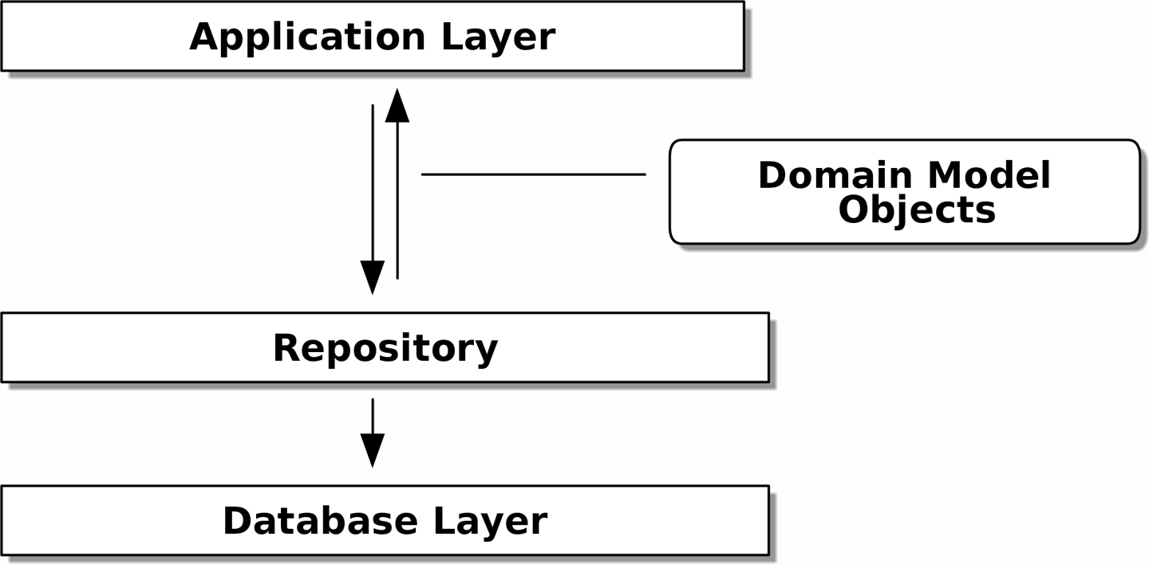
Figure 2-5. Repository pattern

As always, we start with a test. This would probably be classified as an integration test, since we’re checking that our code (the repository) is correctly integrated with the database; hence, the tests tend to mix raw SQL with calls and assertions on our own code.

Tip
Unlike the ORM tests from earlier, these tests are good candidates for staying part of your codebase longer term, particularly if any parts of your domain model mean the object-relational map is nontrivial.
Repository test for saving an object (test_repository.py)
def
test_repository_can_save_a_batch
(
session
)
:
batch
=
model
.
Batch
(
"
batch1
"
,
"
RUSTY-SOAPDISH
"
,
100
,
eta
=
None
)
repo
=
repository
.
SqlAlchemyRepository
(
session
)
repo
.
add
(
batch
)
session
.
commit
(
)
rows
=
list
(
session
.
execute
(
'
SELECT reference, sku, _purchased_quantity, eta FROM
"
batches
"
'
)
)
assert
rows
==
[
(
"
batch1
"
,
"
RUSTY-SOAPDISH
"
,
100
,
None
)
]
repo.add() is the method under test here.
We keep the .commit() outside of the repository and make it the responsibility of the caller. There are pros and cons for this; some of our reasons will become clearer when we get to Chapter 6.
We use the raw SQL to verify that the right data has been saved.
The next test involves retrieving batches and allocations, so it’s more complex:
Repository test for retrieving a complex object (test_repository.py)
def
insert_order_line
(
session
)
:
session
.
execute
(
'
INSERT INTO order_lines (orderid, sku, qty)
'
'
VALUES (
"
order1
"
,
"
GENERIC-SOFA
"
, 12)
'
)
[
[
orderline_id
]
]
=
session
.
execute
(
'
SELECT id FROM order_lines WHERE orderid=:orderid AND sku=:sku
'
,
dict
(
orderid
=
"
order1
"
,
sku
=
"
GENERIC-SOFA
"
)
)
return
orderline_id
def
insert_batch
(
session
,
batch_id
)
:
.
.
.
def
test_repository_can_retrieve_a_batch_with_allocations
(
session
)
:
orderline_id
=
insert_order_line
(
session
)
batch1_id
=
insert_batch
(
session
,
"
batch1
"
)
insert_batch
(
session
,
"
batch2
"
)
insert_allocation
(
session
,
orderline_id
,
batch1_id
)
repo
=
repository
.
SqlAlchemyRepository
(
session
)
retrieved
=
repo
.
get
(
"
batch1
"
)
expected
=
model
.
Batch
(
"
batch1
"
,
"
GENERIC-SOFA
"
,
100
,
eta
=
None
)
assert
retrieved
==
expected
# Batch.__eq__ only compares reference
assert
retrieved
.
sku
==
expected
.
sku
assert
retrieved
.
_purchased_quantity
==
expected
.
_purchased_quantity
assert
retrieved
.
_allocations
==
{
model
.
OrderLine
(
"
order1
"
,
"
GENERIC-SOFA
"
,
12
)
,
}
This tests the read side, so the raw SQL is preparing data to be read by the repo.get().
We’ll spare you the details of insert_batch and insert_allocation; the point is to create a couple of batches, and, for the batch we’re interested in, to have one existing order line allocated to it.
And that’s what we verify here. The first assert == checks that the types match, and that the reference is the same (because, as you remember, Batch is an entity, and we have a custom eq for it).
So we also explicitly check on its major attributes, including ._allocations, which is a Python set of OrderLine value objects.
Whether or not you painstakingly write tests for every model is a judgment call. Once you have one class tested for create/modify/save, you might be happy to go on and do the others with a minimal round-trip test, or even nothing at all, if they all follow a similar pattern. In our case, the ORM config that sets up the ._allocations set is a little complex, so it merited a specific test.
You end up with something like this:
A typical repository (repository.py)
class
SqlAlchemyRepository
(
AbstractRepository
):
def
__init__
(
self
,
session
):
self
.
session
=
session
def
add
(
self
,
batch
):
self
.
session
.
add
(
batch
)
def
get
(
self
,
reference
):
return
self
.
session
.
query
(
model
.
Batch
)
.
filter_by
(
reference
=
reference
)
.
one
()
def
list
(
self
):
return
self
.
session
.
query
(
model
.
Batch
)
.
all
()
And now our Flask endpoint might look something like the following:
Using our repository directly in our API endpoint
@flask.route.gubbins
def
allocate_endpoint
():
batches
=
SqlAlchemyRepository
.
list
()
lines
=
[
OrderLine
(
l
[
'orderid'
],
l
[
'sku'
],
l
[
'qty'
])
for
l
in
request
.
params
...
]
allocate
(
lines
,
batches
)
session
.
commit
()
return
201

Exercise for the Reader
We bumped into a friend at a DDD conference the other day who said, “I haven’t used an ORM in 10 years.” The Repository pattern and an ORM both act as abstractions in front of raw SQL, so using one behind the other isn’t really necessary. Why not have a go at implementing our repository without using the ORM? You’ll find the code on GitHub.
We’ve left the repository tests, but figuring out what SQL to write is up to you. Perhaps it’ll be harder than you think; perhaps it’ll be easier. But the nice thing is, the rest of your application just doesn’t care.

Building a Fake Repository for Tests Is Now Trivial!
Here’s one of the biggest benefits of the Repository pattern:
A simple fake repository using a set (repository.py)
class
FakeRepository
(
AbstractRepository
):
def
__init__
(
self
,
batches
):
self
.
_batches
=
set
(
batches
)
def
add
(
self
,
batch
):
self
.
_batches
.
add
(
batch
)
def
get
(
self
,
reference
):
return
next
(
b
for
b
in
self
.
_batches
if
b
.
reference
==
reference
)
def
list
(
self
):
return
list
(
self
.
_batches
)
Because it’s a simple wrapper around a set, all the methods are one-liners.
Using a fake repo in tests is really easy, and we have a simple abstraction that’s easy to use and reason about:
Example usage of fake repository (test_api.py)
fake_repo
=
FakeRepository
([
batch1
,
batch2
,
batch3
])
You’ll see this fake in action in the next chapter.

Tip
Building fakes for your abstractions is an excellent way to get design feedback: if it’s hard to fake, the abstraction is probably too complicated.

What Is a Port and What Is an Adapter, in Python?
We don’t want to dwell on the terminology too much here because the main thing we want to focus on is dependency inversion, and the specifics of the technique you use don’t matter too much. Also, we’re aware that different people use slightly different definitions.
Ports and adapters came out of the OO world, and the definition we hold onto is that the port is the interface between our application and whatever it is we wish to abstract away, and the adapter is the implementation behind that interface or abstraction.
Now Python doesn’t have interfaces per se, so although it’s usually easy to identify an adapter, defining the port can be harder. If you’re using an abstract base class, that’s the port. If not, the port is just the duck type that your adapters conform to and that your core application expects—the function and method names in use, and their argument names and types.
Concretely, in this chapter, AbstractRepository is the port, and SqlAlchemyRepository and FakeRepository are the adapters.

Wrap-Up
Bearing the Rich Hickey quote in mind, in each chapter we summarize the costs and benefits of each architectural pattern we introduce. We want to be clear that we’re not saying every single application needs to be built this way; only sometimes does the complexity of the app and domain make it worth investing the time and effort in adding these extra layers of indirection.
With that in mind, Table 2-1 shows some of the pros and cons of the Repository pattern and our persistence-ignorant model.
Table 2-1. Repository pattern and persistence ignorance: the trade-offs  Pros | Cons
We have a simple interface between persistent storage and our domain model.  It’s easy to make a fake version of the repository for unit testing, or to swap out different storage solutions, because we’ve fully decoupled the model from infrastructure concerns.  Writing the domain model before thinking about persistence helps us focus on the business problem at hand. If we ever want to radically change our approach, we can do that in our model, without needing to worry about foreign keys or migrations until later.  Our database schema is really simple because we have complete control over how we map our objects to tables. | An ORM already buys you some decoupling. Changing foreign keys might be hard, but it should be pretty easy to swap between MySQL and Postgres if you ever need to.  Maintaining ORM mappings by hand requires extra work and extra code.  Any extra layer of indirection always increases maintenance costs and adds a “WTF factor” for Python programmers who’ve never seen the Repository pattern before.
Figure 2-6 shows the basic thesis: yes, for simple cases, a decoupled domain model is harder work than a simple ORM/ActiveRecord pattern.8

Tip
If your app is just a simple CRUD (create-read-update-delete) wrapper around a database, then you don’t need a domain model or a repository.
But the more complex the domain, the more an investment in freeing yourself from infrastructure concerns will pay off in terms of the ease of making changes.
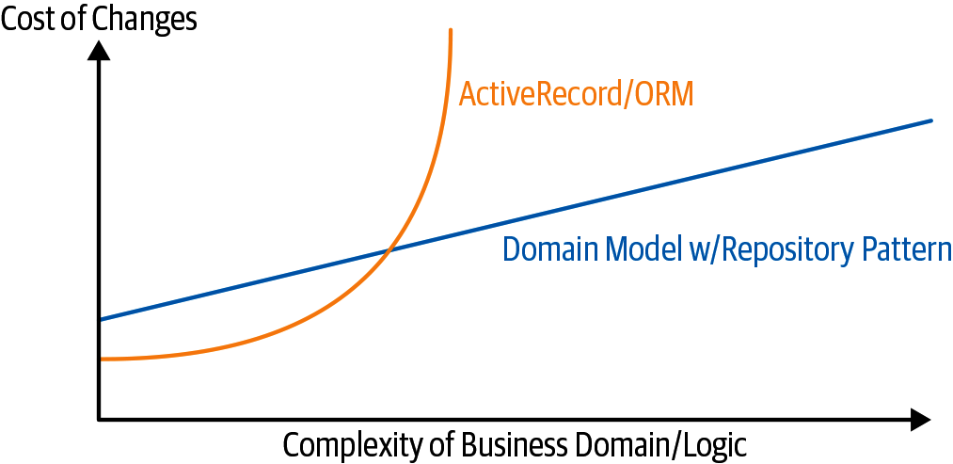
Figure 2-6. Domain model trade-offs as a diagram

Our example code isn’t complex enough to give more than a hint of what the right-hand side of the graph looks like, but the hints are there. Imagine, for example, if we decide one day that we want to change allocations to live on the OrderLine instead of on the Batch object: if we were using Django, say, we’d have to define and think through the database migration before we could run any tests. As it is, because our model is just plain old Python objects, we can change a set() to being a new attribute, without needing to think about the database until later.

Repository Pattern Recap
Apply dependency inversion to your ORM
Our domain model should be free of infrastructure concerns, so your ORM should import your model, and not the other way around.
The Repository pattern is a simple abstraction around permanent storage
The repository gives you the illusion of a collection of in-memory objects. It makes it easy to create a FakeRepository for testing and to swap fundamental details of your infrastructure without disrupting your core application. See Appendix C for an example.
You’ll be wondering, how do we instantiate these repositories, fake or real? What will our Flask app actually look like? You’ll find out in the next exciting installment, the Service Layer pattern.
But first, a brief digression.
1 I suppose we mean “no stateful dependencies.” Depending on a helper library is fine; depending on an ORM or a web framework is not.
2 Mark Seemann has an excellent blog post on the topic.
3 In this sense, using an ORM is already an example of the DIP. Instead of depending on hardcoded SQL, we depend on an abstraction, the ORM. But that’s not enough for us—not in this book!
4 Even in projects where we don’t use an ORM, we often use SQLAlchemy alongside Alembic to declaratively create schemas in Python and to manage migrations, connections, and sessions.
5 Shout-out to the amazingly helpful SQLAlchemy maintainers, and to Mike Bayer in particular.
6 You may be thinking, “What about list or delete or update?” However, in an ideal world, we modify our model objects one at a time, and delete is usually handled as a soft-delete—i.e., batch.cancel(). Finally, update is taken care of by the Unit of Work pattern, as you’ll see in Chapter 6.
7 To really reap the benefits of ABCs (such as they may be), be running helpers like pylint and mypy.
8 Diagram inspired by a post called “Global Complexity, Local Simplicity” by Rob Vens.

Chapter 3. A Brief Interlude: On Coupling and Abstractions
Allow us a brief digression on the subject of abstractions, dear reader. We’ve talked about abstractions quite a lot. The Repository pattern is an abstraction over permanent storage, for example. But what makes a good abstraction? What do we want from abstractions? And how do they relate to testing?

Tip
The code for this chapter is in the chapter_03_abstractions branch on GitHub:
git clone https://github.com/cosmicpython/code.git
git checkout chapter_03_abstractions
A key theme in this book, hidden among the fancy patterns, is that we can use simple abstractions to hide messy details. When we’re writing code for fun, or in a kata,1 we get to play with ideas freely, hammering things out and refactoring aggressively. In a large-scale system, though, we become constrained by the decisions made elsewhere in the system.
When we’re unable to change component A for fear of breaking component B, we say that the components have become coupled. Locally, coupling is a good thing: it’s a sign that our code is working together, each component supporting the others, all of them fitting in place like the gears of a watch. In jargon, we say this works when there is high cohesion between the coupled elements.
Globally, coupling is a nuisance: it increases the risk and the cost of changing our code, sometimes to the point where we feel unable to make any changes at all. This is the problem with the Ball of Mud pattern: as the application grows, if we’re unable to prevent coupling between elements that have no cohesion, that coupling increases superlinearly until we are no longer able to effectively change our systems.
We can reduce the degree of coupling within a system (Figure 3-1) by abstracting away the details (Figure 3-2).
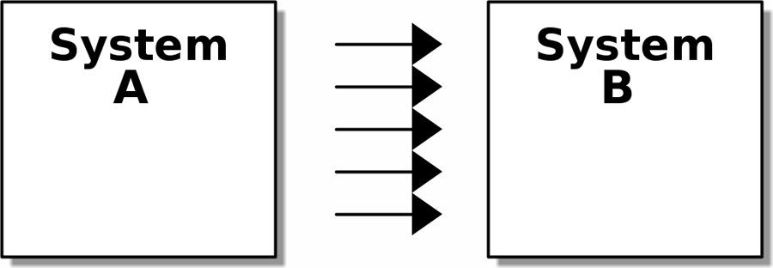
Figure 3-1. Lots of coupling

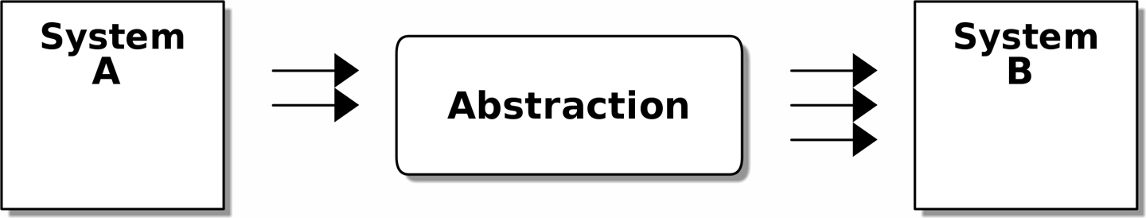
Figure 3-2. Less coupling

In both diagrams, we have a pair of subsystems, with one dependent on the other. In Figure 3-1, there is a high degree of coupling between the two; the number of arrows indicates lots of kinds of dependencies between the two. If we need to change system B, there’s a good chance that the change will ripple through to system A.
In Figure 3-2, though, we have reduced the degree of coupling by inserting a new, simpler abstraction. Because it is simpler, system A has fewer kinds of dependencies on the abstraction. The abstraction serves to protect us from change by hiding away the complex details of whatever system B does—we can change the arrows on the right without changing the ones on the left.

Abstracting State Aids Testability
Let’s see an example. Imagine we want to write code for synchronizing two file directories, which we’ll call the source and the destination:
If a file exists in the source but not in the destination, copy the file over.
If a file exists in the source, but it has a different name than in the destination, rename the destination file to match.
If a file exists in the destination but not in the source, remove it.
Our first and third requirements are simple enough: we can just compare two lists of paths. Our second is trickier, though. To detect renames, we’ll have to inspect the content of files. For this, we can use a hashing function like MD5 or SHA-1. The code to generate a SHA-1 hash from a file is simple enough:
Hashing a file (sync.py)
BLOCKSIZE
=
65536
def
hash_file
(
path
):
hasher
=
hashlib
.
sha1
()
with
path
.
open
(
"rb"
)
as
file
:
buf
=
file
.
read
(
BLOCKSIZE
)
while
buf
:
hasher
.
update
(
buf
)
buf
=
file
.
read
(
BLOCKSIZE
)
return
hasher
.
hexdigest
()
Now we need to write the bit that makes decisions about what to do—the business logic, if you will.
When we have to tackle a problem from first principles, we usually try to write a simple implementation and then refactor toward better design. We’ll use this approach throughout the book, because it’s how we write code in the real world: start with a solution to the smallest part of the problem, and then iteratively make the solution richer and better designed.
Our first hackish approach looks something like this:
Basic sync algorithm (sync.py)
import
hashlib
import
os
import
shutil
from
pathlib
import
Path
def
sync
(
source
,
dest
):
# Walk the source folder and build a dict of filenames and their hashes
source_hashes
=
{}
for
folder
,
_
,
files
in
os
.
walk
(
source
):
for
fn
in
files
:
source_hashes
[
hash_file
(
Path
(
folder
)
/
fn
)]
=
fn
seen
=
set
()
# Keep track of the files we've found in the target
# Walk the target folder and get the filenames and hashes
for
folder
,
_
,
files
in
os
.
walk
(
dest
):
for
fn
in
files
:
dest_path
=
Path
(
folder
)
/
fn
dest_hash
=
hash_file
(
dest_path
)
seen
.
add
(
dest_hash
)
# if there's a file in target that's not in source, delete it
if
dest_hash
not
in
source_hashes
:
dest_path
.
remove
()
# if there's a file in target that has a different path in source,
# move it to the correct path
elif
dest_hash
in
source_hashes
and
fn
!=
source_hashes
[
dest_hash
]:
shutil
.
move
(
dest_path
,
Path
(
folder
)
/
source_hashes
[
dest_hash
])
# for every file that appears in source but not target, copy the file to
# the target
for
src_hash
,
fn
in
source_hashes
.
items
():
if
src_hash
not
in
seen
:
shutil
.
copy
(
Path
(
source
)
/
fn
,
Path
(
dest
)
/
fn
)
Fantastic! We have some code and it looks OK, but before we run it on our hard drive, maybe we should test it. How do we go about testing this sort of thing?
Some end-to-end tests (test_sync.py)
def
test_when_a_file_exists_in_the_source_but_not_the_destination
():
try
:
source
=
tempfile
.
mkdtemp
()
dest
=
tempfile
.
mkdtemp
()
content
=
"I am a very useful file"
(
Path
(
source
)
/
'my-file'
)
.
write_text
(
content
)
sync
(
source
,
dest
)
expected_path
=
Path
(
dest
)
/
'my-file'
assert
expected_path
.
exists
()
assert
expected_path
.
read_text
()
==
content
finally
:
shutil
.
rmtree
(
source
)
shutil
.
rmtree
(
dest
)
def
test_when_a_file_has_been_renamed_in_the_source
():
try
:
source
=
tempfile
.
mkdtemp
()
dest
=
tempfile
.
mkdtemp
()
content
=
"I am a file that was renamed"
source_path
=
Path
(
source
)
/
'source-filename'
old_dest_path
=
Path
(
dest
)
/
'dest-filename'
expected_dest_path
=
Path
(
dest
)
/
'source-filename'
source_path
.
write_text
(
content
)
old_dest_path
.
write_text
(
content
)
sync
(
source
,
dest
)
assert
old_dest_path
.
exists
()
is
False
assert
expected_dest_path
.
read_text
()
==
content
finally
:
shutil
.
rmtree
(
source
)
shutil
.
rmtree
(
dest
)
Wowsers, that’s a lot of setup for two simple cases! The problem is that our domain logic, “figure out the difference between two directories,” is tightly coupled to the I/O code. We can’t run our difference algorithm without calling the pathlib, shutil, and hashlib modules.
And the trouble is, even with our current requirements, we haven’t written enough tests: the current implementation has several bugs (the shutil.move() is wrong, for example). Getting decent coverage and revealing these bugs means writing more tests, but if they’re all as unwieldy as the preceding ones, that’s going to get real painful real quickly.
On top of that, our code isn’t very extensible. Imagine trying to implement a --dry-run flag that gets our code to just print out what it’s going to do, rather than actually do it. Or what if we wanted to sync to a remote server, or to cloud storage?
Our high-level code is coupled to low-level details, and it’s making life hard. As the scenarios we consider get more complex, our tests will get more unwieldy. We can definitely refactor these tests (some of the cleanup could go into pytest fixtures, for example) but as long as we’re doing filesystem operations, they’re going to stay slow and be hard to read and write.

Choosing the Right Abstraction(s)
What could we do to rewrite our code to make it more testable?
First, we need to think about what our code needs from the filesystem. Reading through the code, we can see that three distinct things are happening. We can think of these as three distinct responsibilities that the code has:
We interrogate the filesystem by using os.walk and determine hashes for a series of paths. This is similar in both the source and the destination cases.
We decide whether a file is new, renamed, or redundant.
We copy, move, or delete files to match the source.
Remember that we want to find simplifying abstractions for each of these responsibilities. That will let us hide the messy details so we can focus on the interesting logic.2

Note
In this chapter, we’re refactoring some gnarly code into a more testable structure by identifying the separate tasks that need to be done and giving each task to a clearly defined actor, along similar lines to the duckduckgo example.
For steps 1 and 2, we’ve already intuitively started using an abstraction, a dictionary of hashes to paths. You may already have been thinking, “Why not build up a dictionary for the destination folder as well as the source, and then we just compare two dicts?” That seems like a nice way to abstract the current state of the filesystem:
source_files = {'hash1': 'path1', 'hash2': 'path2'}
dest_files = {'hash1': 'path1', 'hash2': 'pathX'}
What about moving from step 2 to step 3? How can we abstract out the actual move/copy/delete filesystem interaction?
We’ll apply a trick here that we’ll employ on a grand scale later in the book. We’re going to separate what we want to do from how to do it. We’re going to make our program output a list of commands that look like this:
("COPY", "sourcepath", "destpath"),
("MOVE", "old", "new"),
Now we could write tests that just use two filesystem dicts as inputs, and we would expect lists of tuples of strings representing actions as outputs.
Instead of saying, “Given this actual filesystem, when I run my function, check what actions have happened,” we say, “Given this abstraction of a filesystem, what abstraction of filesystem actions will happen?”
Simplified inputs and outputs in our tests (test_sync.py)
def
test_when_a_file_exists_in_the_source_but_not_the_destination
():
src_hashes
=
{
'hash1'
:
'fn1'
}
dst_hashes
=
{}
expected_actions
=
[(
'COPY'
,
'/src/fn1'
,
'/dst/fn1'
)]
...
def
test_when_a_file_has_been_renamed_in_the_source
():
src_hashes
=
{
'hash1'
:
'fn1'
}
dst_hashes
=
{
'hash1'
:
'fn2'
}
expected_actions
==
[(
'MOVE'
,
'/dst/fn2'
,
'/dst/fn1'
)]
...

Implementing Our Chosen Abstractions
That’s all very well, but how do we actually write those new tests, and how do we change our implementation to make it all work?
Our goal is to isolate the clever part of our system, and to be able to test it thoroughly without needing to set up a real filesystem. We’ll create a “core” of code that has no dependencies on external state and then see how it responds when we give it input from the outside world (this kind of approach was characterized by Gary Bernhardt as Functional Core, Imperative Shell, or FCIS).
Let’s start off by splitting the code to separate the stateful parts from the logic.
And our top-level function will contain almost no logic at all; it’s just an imperative series of steps: gather inputs, call our logic, apply outputs:
Split our code into three (sync.py)
def
sync
(
source
,
dest
)
:
# imperative shell step 1, gather inputs
source_hashes
=
read_paths_and_hashes
(
source
)
dest_hashes
=
read_paths_and_hashes
(
dest
)
# step 2: call functional core
actions
=
determine_actions
(
source_hashes
,
dest_hashes
,
source
,
dest
)
# imperative shell step 3, apply outputs
for
action
,
*
paths
in
actions
:
if
action
==
'
copy
'
:
shutil
.
copyfile
(
*
paths
)
if
action
==
'
move
'
:
shutil
.
move
(
*
paths
)
if
action
==
'
delete
'
:
os
.
remove
(
paths
[
0
]
)
Here’s the first function we factor out, read_paths_and_hashes(), which isolates the I/O part of our application.
Here is where carve out the functional core, the business logic.
The code to build up the dictionary of paths and hashes is now trivially easy to write:
A function that just does I/O (sync.py)
def
read_paths_and_hashes
(
root
):
hashes
=
{}
for
folder
,
_
,
files
in
os
.
walk
(
root
):
for
fn
in
files
:
hashes
[
hash_file
(
Path
(
folder
)
/
fn
)]
=
fn
return
hashes
The determine_actions() function will be the core of our business logic, which says, “Given these two sets of hashes and filenames, what should we copy/move/delete?”. It takes simple data structures and returns simple data structures:
A function that just does business logic (sync.py)
def
determine_actions
(
src_hashes
,
dst_hashes
,
src_folder
,
dst_folder
):
for
sha
,
filename
in
src_hashes
.
items
():
if
sha
not
in
dst_hashes
:
sourcepath
=
Path
(
src_folder
)
/
filename
destpath
=
Path
(
dst_folder
)
/
filename
yield
'copy'
,
sourcepath
,
destpath
elif
dst_hashes
[
sha
]
!=
filename
:
olddestpath
=
Path
(
dst_folder
)
/
dst_hashes
[
sha
]
newdestpath
=
Path
(
dst_folder
)
/
filename
yield
'move'
,
olddestpath
,
newdestpath
for
sha
,
filename
in
dst_hashes
.
items
():
if
sha
not
in
src_hashes
:
yield
'delete'
,
dst_folder
/
filename
Our tests now act directly on the determine_actions() function:
Nicer-looking tests (test_sync.py)
def
test_when_a_file_exists_in_the_source_but_not_the_destination
():
src_hashes
=
{
'hash1'
:
'fn1'
}
dst_hashes
=
{}
actions
=
determine_actions
(
src_hashes
,
dst_hashes
,
Path
(
'/src'
),
Path
(
'/dst'
))
assert
list
(
actions
)
==
[(
'copy'
,
Path
(
'/src/fn1'
),
Path
(
'/dst/fn1'
))]
...
def
test_when_a_file_has_been_renamed_in_the_source
():
src_hashes
=
{
'hash1'
:
'fn1'
}
dst_hashes
=
{
'hash1'
:
'fn2'
}
actions
=
determine_actions
(
src_hashes
,
dst_hashes
,
Path
(
'/src'
),
Path
(
'/dst'
))
assert
list
(
actions
)
==
[(
'move'
,
Path
(
'/dst/fn2'
),
Path
(
'/dst/fn1'
))]
Because we’ve disentangled the logic of our program—the code for identifying changes—from the low-level details of I/O, we can easily test the core of our code.
With this approach, we’ve switched from testing our main entrypoint function, sync(), to testing a lower-level function, determine_actions(). You might decide that’s fine because sync() is now so simple. Or you might decide to keep some integration/acceptance tests to test that sync(). But there’s another option, which is to modify the sync() function so it can be unit tested and end-to-end tested; it’s an approach Bob calls edge-to-edge testing.

Testing Edge to Edge with Fakes and Dependency Injection
When we start writing a new system, we often focus on the core logic first, driving it with direct unit tests. At some point, though, we want to test bigger chunks of the system together.
We could return to our end-to-end tests, but those are still as tricky to write and maintain as before. Instead, we often write tests that invoke a whole system together but fake the I/O, sort of edge to edge:
Explicit dependencies (sync.py)
def
sync
(
reader
,
filesystem
,
source_root
,
dest_root
)
:
source_hashes
=
reader
(
source_root
)
dest_hashes
=
reader
(
dest_root
)
for
sha
,
filename
in
src_hashes
.
items
(
)
:
if
sha
not
in
dest_hashes
:
sourcepath
=
source_root
/
filename
destpath
=
dest_root
/
filename
filesystem
.
copy
(
destpath
,
sourcepath
)
elif
dest_hashes
[
sha
]
!=
filename
:
olddestpath
=
dest_root
/
dest_hashes
[
sha
]
newdestpath
=
dest_root
/
filename
filesystem
.
move
(
olddestpath
,
newdestpath
)
for
sha
,
filename
in
dst_hashes
.
items
(
)
:
if
sha
not
in
source_hashes
:
filesystem
.
delete
(
dest_root
/
filename
)
Our top-level function now exposes two new dependencies, a reader and a filesystem.
We invoke the reader to produce our files dict.
We invoke the filesystem to apply the changes we detect.

Tip
Although we’re using dependency injection, there is no need to define an abstract base class or any kind of explicit interface. In this book, we often show ABCs because we hope they help you understand what the abstraction is, but they’re not necessary. Python’s dynamic nature means we can always rely on duck typing.
Tests using DI
class
FakeFileSystem
(
list
)
:
def
copy
(
self
,
src
,
dest
)
:
self
.
append
(
(
'
COPY
'
,
src
,
dest
)
)
def
move
(
self
,
src
,
dest
)
:
self
.
append
(
(
'
MOVE
'
,
src
,
dest
)
)
def
delete
(
self
,
dest
)
:
self
.
append
(
(
'
DELETE
'
,
src
,
dest
)
)
def
test_when_a_file_exists_in_the_source_but_not_the_destination
(
)
:
source
=
{
"
sha1
"
:
"
my-file
"
}
dest
=
{
}
filesystem
=
FakeFileSystem
(
)
reader
=
{
"
/source
"
:
source
,
"
/dest
"
:
dest
}
synchronise_dirs
(
reader
.
pop
,
filesystem
,
"
/source
"
,
"
/dest
"
)
assert
filesystem
==
[
(
"
COPY
"
,
"
/source/my-file
"
,
"
/dest/my-file
"
)
]
def
test_when_a_file_has_been_renamed_in_the_source
(
)
:
source
=
{
"
sha1
"
:
"
renamed-file
"
}
dest
=
{
"
sha1
"
:
"
original-file
"
}
filesystem
=
FakeFileSystem
(
)
reader
=
{
"
/source
"
:
source
,
"
/dest
"
:
dest
}
synchronise_dirs
(
reader
.
pop
,
filesystem
,
"
/source
"
,
"
/dest
"
)
assert
filesystem
==
[
(
"
MOVE
"
,
"
/dest/original-file
"
,
"
/dest/renamed-file
"
)
]
Bob loves using lists to build simple test doubles, even though his coworkers get mad. It means we can write tests like assert foo not in database.
Each method in our FakeFileSystem just appends something to the list so we can inspect it later. This is an example of a spy object.
The advantage of this approach is that our tests act on the exact same function that’s used by our production code. The disadvantage is that we have to make our stateful components explicit and pass them around. David Heinemeier Hansson, the creator of Ruby on Rails, famously described this as “test-induced design damage.”
In either case, we can now work on fixing all the bugs in our implementation; enumerating tests for all the edge cases is now much easier.

Why Not Just Patch It Out?
At this point you may be scratching your head and thinking, “Why don’t you just use mock.patch and save yourself the effort?"”
We avoid using mocks in this book and in our production code too. We’re not going to enter into a Holy War, but our instinct is that mocking frameworks, particularly monkeypatching, are a code smell.
Instead, we like to clearly identify the responsibilities in our codebase, and to separate those responsibilities into small, focused objects that are easy to replace with a test double.

Note
You can see an example in Chapter 8, where we mock.patch() out an email-sending module, but eventually we replace that with an explicit bit of dependency injection in Chapter 13.
We have three closely related reasons for our preference:
Patching out the dependency you’re using makes it possible to unit test the code, but it does nothing to improve the design. Using mock.patch won’t let your code work with a --dry-run flag, nor will it help you run against an FTP server. For that, you’ll need to introduce abstractions.
Tests that use mocks tend to be more coupled to the implementation details of the codebase. That’s because mock tests verify the interactions between things: did we call shutil.copy with the right arguments? This coupling between code and test tends to make tests more brittle, in our experience.
Overuse of mocks leads to complicated test suites that fail to explain the code.

Note
Designing for testability really means designing for extensibility. We trade off a little more complexity for a cleaner design that admits novel use cases.

Mocks Versus Fakes; Classic-Style Versus London-School TDD
Here’s a short and somewhat simplistic definition of the difference between mocks and fakes:
Mocks are used to verify how something gets used; they have methods like assert_called_once_with(). They’re associated with London-school TDD.
Fakes are working implementations of the thing they’re replacing, but they’re designed for use only in tests. They wouldn’t work “in real life”; our in-memory repository is a good example. But you can use them to make assertions about the end state of a system rather than the behaviors along the way, so they’re associated with classic-style TDD.
We’re slightly conflating mocks with spies and fakes with stubs here, and you can read the long, correct answer in Martin Fowler’s classic essay on the subject called “Mocks Aren’t Stubs”.
It also probably doesn’t help that the MagicMock objects provided by unittest.mock aren’t, strictly speaking, mocks; they’re spies, if anything. But they’re also often used as stubs or dummies. There, we promise we’re done with the test double terminology nitpicks now.
What about London-school versus classic-style TDD? You can read more about those two in Martin Fowler’s article that we just cited, as well as on the Software Engineering Stack Exchange site, but in this book we’re pretty firmly in the classicist camp. We like to build our tests around state both in setup and in assertions, and we like to work at the highest level of abstraction possible rather than doing checks on the behavior of intermediary collaborators.3
Read more on this in “On Deciding What Kind of Tests to Write”.
We view TDD as a design practice first and a testing practice second. The tests act as a record of our design choices and serve to explain the system to us when we return to the code after a long absence.
Tests that use too many mocks get overwhelmed with setup code that hides the story we care about.
Steve Freeman has a great example of overmocked tests in his talk “Test-Driven Development”. You should also check out this PyCon talk, “Mocking and Patching Pitfalls”, by our esteemed tech reviewer, Ed Jung, which also addresses mocking and its alternatives. And while we’re recommending talks, don’t miss Brandon Rhodes talking about “Hoisting Your I/O”, which really nicely covers the issues we’re talking about, using another simple example.

Tip
In this chapter, we’ve spent a lot of time replacing end-to-end tests with unit tests. That doesn’t mean we think you should never use E2E tests! In this book we’re showing techniques to get you to a decent test pyramid with as many unit tests as possible, and with the minimum number of E2E tests you need to feel confident. Read on to “Recap: Rules of Thumb for Different Types of Test” for more details.

So Which Do We Use In This Book? Functional or Object-Oriented Composition?
Both. Our domain model is entirely free of dependencies and side effects, so that’s our functional core. The service layer that we build around it (in Chapter 4) allows us to drive the system edge to edge, and we use dependency injection to provide those services with stateful components, so we can still unit test them.
See Chapter 13 for more exploration of making our dependency injection more explicit and centralized.

Wrap-Up
We’ll see this idea come up again and again in the book: we can make our systems easier to test and maintain by simplifying the interface between our business logic and messy I/O. Finding the right abstraction is tricky, but here are a few heuristics and questions to ask yourself:
Can I choose a familiar Python data structure to represent the state of the messy system and then try to imagine a single function that can return that state?
Where can I draw a line between my systems, where can I carve out a seam to stick that abstraction in?
What is a sensible way of dividing things into components with different responsibilities? What implicit concepts can I make explicit?
What are the dependencies, and what is the core business logic?
Practice makes less imperfect! And now back to our regular programming…
1 A code kata is a small, contained programming challenge often used to practice TDD. See “Kata—The Only Way to Learn TDD” by Peter Provost.
2 If you’re used to thinking in terms of interfaces, that’s what we’re trying to define here.
3 Which is not to say that we think the London school people are wrong. Some insanely smart people work that way. It’s just not what we’re used to.

Chapter 4. Our First Use Case: Flask API and Service Layer
Back to our allocations project! Figure 4-1 shows the point we reached at the end of Chapter 2, which covered the Repository pattern.
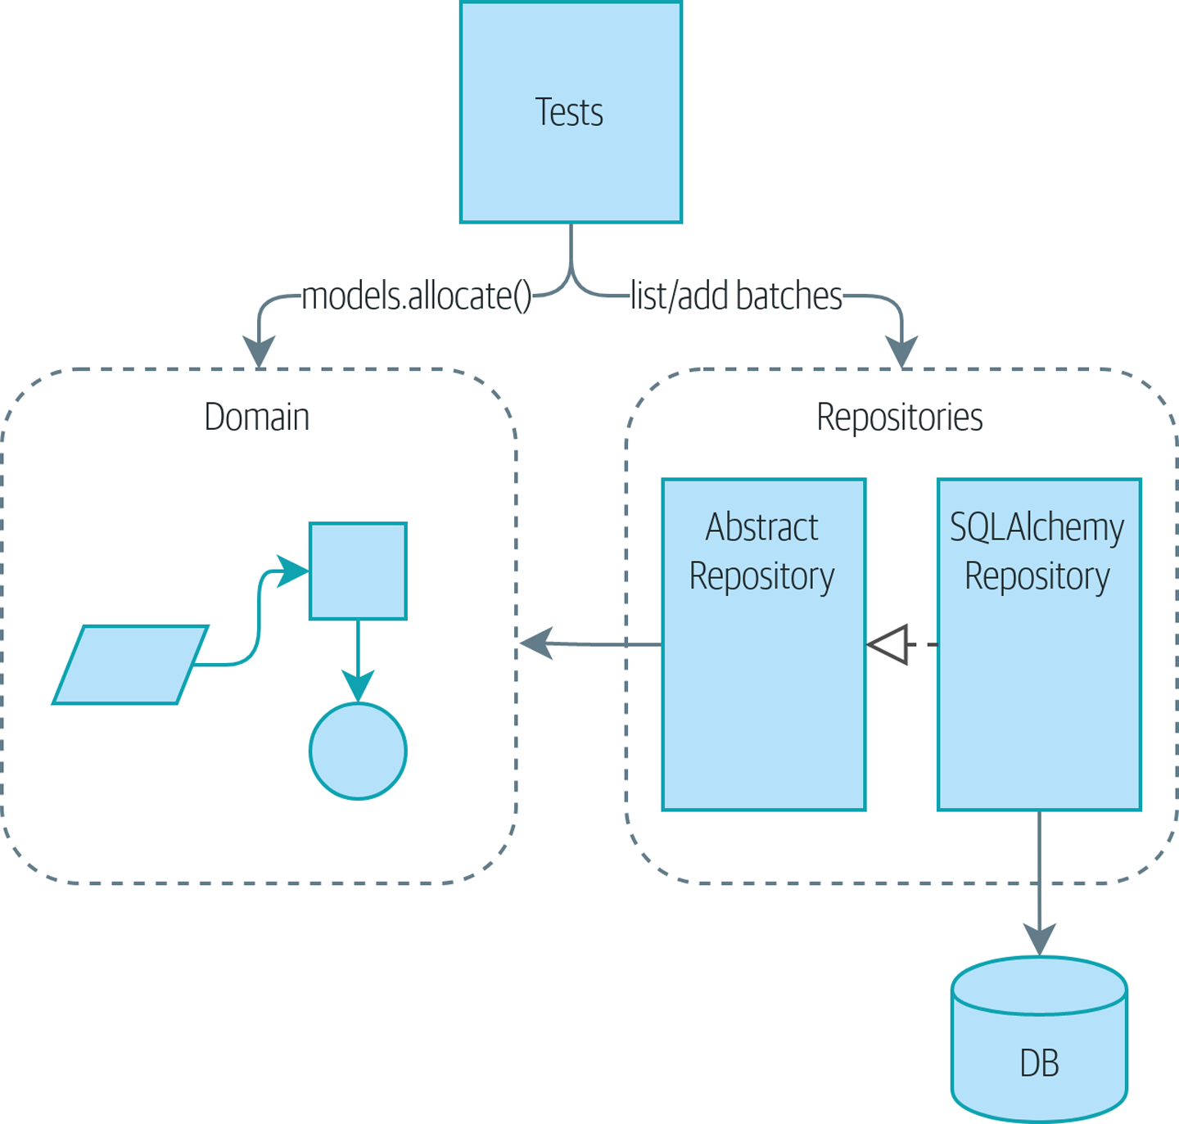
Figure 4-1. Before: we drive our app by talking to repositories and the domain model
In this chapter, we discuss the differences between orchestration logic, business logic, and interfacing code, and we introduce the Service Layer pattern to take care of orchestrating our workflows and defining the use cases of our system.
We’ll also discuss testing: by combining the Service Layer with our repository abstraction over the database, we’re able to write fast tests, not just of our domain model but of the entire workflow for a use case.
Figure 4-2 shows what we’re aiming for: we’re going to add a Flask API that will talk to the service layer, which will serve as the entrypoint to our domain model. Because our service layer depends on the AbstractRepository, we can unit test it by using FakeRepository but run our production code using SqlAlchemyRepository.
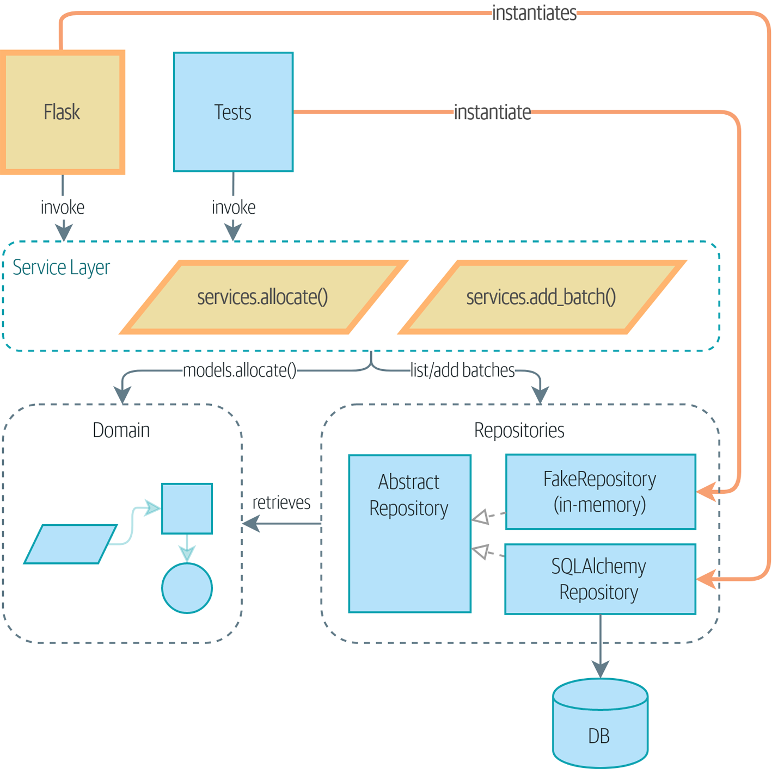
Figure 4-2. The service layer will become the main way into our app
In our diagrams, we are using the convention that new components are highlighted with bold text/lines (and yellow/orange color, if you’re reading a digital version).

Tip
The code for this chapter is in the chapter_04_service_layer branch on GitHub:
git clone https://github.com/cosmicpython/code.git
cd code
git checkout chapter_04_service_layer
# or to code along, checkout Chapter 2:
git checkout chapter_02_repository

Connecting Our Application to the Real World
Like any good agile team, we’re hustling to try to get an MVP out and in front of the users to start gathering feedback. We have the core of our domain model and the domain service we need to allocate orders, and we have the repository interface for permanent storage.
Let’s plug all the moving parts together as quickly as we can and then refactor toward a cleaner architecture. Here’s our plan:
Use Flask to put an API endpoint in front of our allocate domain service. Wire up the database session and our repository. Test it with an end-to-end test and some quick-and-dirty SQL to prepare test data.
Refactor out a service layer that can serve as an abstraction to capture the use case and that will sit between Flask and our domain model. Build some service-layer tests and show how they can use FakeRepository.
Experiment with different types of parameters for our service layer functions; show that using primitive data types allows the service layer’s clients (our tests and our Flask API) to be decoupled from the model layer.

A First End-to-End Test
No one is interested in getting into a long terminology debate about what counts as an end-to-end (E2E) test versus a functional test versus an acceptance test versus an integration test versus a unit test. Different projects need different combinations of tests, and we’ve seen perfectly successful projects just split things into “fast tests” and “slow tests.”
For now, we want to write one or maybe two tests that are going to exercise a “real” API endpoint (using HTTP) and talk to a real database. Let’s call them end-to-end tests because it’s one of the most self-explanatory names.
The following shows a first cut:
A first API test (test_api.py)
@pytest.mark.usefixtures
(
'
restart_api
'
)
def
test_api_returns_allocation
(
add_stock
)
:
sku
,
othersku
=
random_sku
(
)
,
random_sku
(
'
other
'
)
earlybatch
=
random_batchref
(
1
)
laterbatch
=
random_batchref
(
2
)
otherbatch
=
random_batchref
(
3
)
add_stock
(
[
(
laterbatch
,
sku
,
100
,
'
2011-01-02
'
)
,
(
earlybatch
,
sku
,
100
,
'
2011-01-01
'
)
,
(
otherbatch
,
othersku
,
100
,
None
)
,
]
)
data
=
{
'
orderid
'
:
random_orderid
(
)
,
'
sku
'
:
sku
,
'
qty
'
:
3
}
url
=
config
.
get_api_url
(
)
r
=
requests
.
post
(
f
'
{url}/allocate
'
,
json
=
data
)
assert
r
.
status_code
==
201
assert
r
.
json
(
)
[
'
batchref
'
]
==
earlybatch
random_sku(), random_batchref(), and so on are little helper functions that generate randomized characters by using the uuid module. Because we’re running against an actual database now, this is one way to prevent various tests and runs from interfering with each other.
add_stock is a helper fixture that just hides away the details of manually inserting rows into the database using SQL. We’ll show a nicer way of doing this later in the chapter.
config.py is a module in which we keep configuration information.
Everyone solves these problems in different ways, but you’re going to need some way of spinning up Flask, possibly in a container, and of talking to a Postgres database. If you want to see how we did it, check out Appendix B.

The Straightforward Implementation
Implementing things in the most obvious way, you might get something like this:
First cut of Flask app (flask_app.py)
from
flask
import
Flask
,
jsonify
,
request
from
sqlalchemy
import
create_engine
from
sqlalchemy.orm
import
sessionmaker
import
config
import
model
import
orm
import
repository
orm
.
start_mappers
()
get_session
=
sessionmaker
(
bind
=
create_engine
(
config
.
get_postgres_uri
()))
app
=
Flask
(
__name__
)
@app.route
(
"/allocate"
,
methods
=
[
'POST'
])
def
allocate_endpoint
():
session
=
get_session
()
batches
=
repository
.
SqlAlchemyRepository
(
session
)
.
list
()
line
=
model
.
OrderLine
(
request
.
json
[
'orderid'
],
request
.
json
[
'sku'
],
request
.
json
[
'qty'
],
)
batchref
=
model
.
allocate
(
line
,
batches
)
return
jsonify
({
'batchref'
:
batchref
}),
201
So far, so good. No need for too much more of your “architecture astronaut” nonsense, Bob and Harry, you may be thinking.
But hang on a minute—there’s no commit. We’re not actually saving our allocation to the database. Now we need a second test, either one that will inspect the database state after (not very black-boxy), or maybe one that checks that we can’t allocate a second line if a first should have already depleted the batch:
Test allocations are persisted (test_api.py)
@pytest.mark.usefixtures
(
'restart_api'
)
def
test_allocations_are_persisted
(
add_stock
):
sku
=
random_sku
()
batch1
,
batch2
=
random_batchref
(
1
),
random_batchref
(
2
)
order1
,
order2
=
random_orderid
(
1
),
random_orderid
(
2
)
add_stock
([
(
batch1
,
sku
,
10
,
'2011-01-01'
),
(
batch2
,
sku
,
10
,
'2011-01-02'
),
])
line1
=
{
'orderid'
:
order1
,
'sku'
:
sku
,
'qty'
:
10
}
line2
=
{
'orderid'
:
order2
,
'sku'
:
sku
,
'qty'
:
10
}
url
=
config
.
get_api_url
()
# first order uses up all stock in batch 1
r
=
requests
.
post
(
f
'{url}/allocate'
,
json
=
line1
)
assert
r
.
status_code
==
201
assert
r
.
json
()[
'batchref'
]
==
batch1
# second order should go to batch 2
r
=
requests
.
post
(
f
'{url}/allocate'
,
json
=
line2
)
assert
r
.
status_code
==
201
assert
r
.
json
()[
'batchref'
]
==
batch2
Not quite so lovely, but that will force us to add the commit.

Error Conditions That Require Database Checks
If we keep going like this, though, things are going to get uglier and uglier.
Suppose we want to add a bit of error handling. What if the domain raises an error, for a SKU that’s out of stock? Or what about a SKU that doesn’t even exist? That’s not something the domain even knows about, nor should it. It’s more of a sanity check that we should implement at the database layer, before we even invoke the domain service.
Now we’re looking at two more end-to-end tests:
Yet more tests at the E2E layer (test_api.py)
@pytest.mark.usefixtures
(
'
restart_api
'
)
def
test_400_message_for_out_of_stock
(
add_stock
)
:
sku
,
smalL_batch
,
large_order
=
random_sku
(
)
,
random_batchref
(
)
,
random_orderid
(
)
add_stock
(
[
(
smalL_batch
,
sku
,
10
,
'
2011-01-01
'
)
,
]
)
data
=
{
'
orderid
'
:
large_order
,
'
sku
'
:
sku
,
'
qty
'
:
20
}
url
=
config
.
get_api_url
(
)
r
=
requests
.
post
(
f
'
{url}/allocate
'
,
json
=
data
)
assert
r
.
status_code
==
400
assert
r
.
json
(
)
[
'
message
'
]
==
f
'
Out of stock for sku {sku}
'
@pytest.mark.usefixtures
(
'
restart_api
'
)
def
test_400_message_for_invalid_sku
(
)
:
unknown_sku
,
orderid
=
random_sku
(
)
,
random_orderid
(
)
data
=
{
'
orderid
'
:
orderid
,
'
sku
'
:
unknown_sku
,
'
qty
'
:
20
}
url
=
config
.
get_api_url
(
)
r
=
requests
.
post
(
f
'
{url}/allocate
'
,
json
=
data
)
assert
r
.
status_code
==
400
assert
r
.
json
(
)
[
'
message
'
]
==
f
'
Invalid sku {unknown_sku}
'
In the first test, we’re trying to allocate more units than we have in stock.
In the second, the SKU just doesn’t exist (because we never called add_stock), so it’s invalid as far as our app is concerned.
And sure, we could implement it in the Flask app too:
Flask app starting to get crufty (flask_app.py)
def
is_valid_sku
(
sku
,
batches
):
return
sku
in
{
b
.
sku
for
b
in
batches
}
@app.route
(
"/allocate"
,
methods
=
[
'POST'
])
def
allocate_endpoint
():
session
=
get_session
()
batches
=
repository
.
SqlAlchemyRepository
(
session
)
.
list
()
line
=
model
.
OrderLine
(
request
.
json
[
'orderid'
],
request
.
json
[
'sku'
],
request
.
json
[
'qty'
],
)
if
not
is_valid_sku
(
line
.
sku
,
batches
):
return
jsonify
({
'message'
:
f
'Invalid sku {line.sku}'
}),
400
try
:
batchref
=
model
.
allocate
(
line
,
batches
)
except
model
.
OutOfStock
as
e
:
return
jsonify
({
'message'
:
str
(
e
)}),
400
session
.
commit
()
return
jsonify
({
'batchref'
:
batchref
}),
201
But our Flask app is starting to look a bit unwieldy. And our number of E2E tests is starting to get out of control, and soon we’ll end up with an inverted test pyramid (or “ice-cream cone model,” as Bob likes to call it).

Introducing a Service Layer, and Using FakeRepository to Unit Test It
If we look at what our Flask app is doing, there’s quite a lot of what we might call orchestration—fetching stuff out of our repository, validating our input against database state, handling errors, and committing in the happy path. Most of these things don’t have anything to do with having a web API endpoint (you’d need them if you were building a CLI, for example; see Appendix C), and they’re not really things that need to be tested by end-to-end tests.
It often makes sense to split out a service layer, sometimes called an orchestration layer or a use-case layer.
Do you remember the FakeRepository that we prepared in Chapter 3?
Our fake repository, an in-memory collection of batches (test_services.py)
class
FakeRepository
(
repository
.
AbstractRepository
):
def
__init__
(
self
,
batches
):
self
.
_batches
=
set
(
batches
)
def
add
(
self
,
batch
):
self
.
_batches
.
add
(
batch
)
def
get
(
self
,
reference
):
return
next
(
b
for
b
in
self
.
_batches
if
b
.
reference
==
reference
)
def
list
(
self
):
return
list
(
self
.
_batches
)
Here’s where it will come in useful; it lets us test our service layer with nice, fast unit tests:
Unit testing with fakes at the service layer (test_services.py)
def
test_returns_allocation
(
)
:
line
=
model
.
OrderLine
(
"
o1
"
,
"
COMPLICATED-LAMP
"
,
10
)
batch
=
model
.
Batch
(
"
b1
"
,
"
COMPLICATED-LAMP
"
,
100
,
eta
=
None
)
repo
=
FakeRepository
(
[
batch
]
)
result
=
services
.
allocate
(
line
,
repo
,
FakeSession
(
)
)
assert
result
==
"
b1
"
def
test_error_for_invalid_sku
(
)
:
line
=
model
.
OrderLine
(
"
o1
"
,
"
NONEXISTENTSKU
"
,
10
)
batch
=
model
.
Batch
(
"
b1
"
,
"
AREALSKU
"
,
100
,
eta
=
None
)
repo
=
FakeRepository
(
[
batch
]
)
with
pytest
.
raises
(
services
.
InvalidSku
,
match
=
"
Invalid sku NONEXISTENTSKU
"
)
:
services
.
allocate
(
line
,
repo
,
FakeSession
(
)
)
FakeRepository holds the Batch objects that will be used by our test.
Our services module (services.py) will define an allocate() service-layer function. It will sit between our allocate_endpoint() function in the API layer and the allocate() domain service function from our domain model.1
We also need a FakeSession to fake out the database session, as shown in the following code snippet.
A fake database session (test_services.py)
class
FakeSession
():
committed
=
False
def
commit
(
self
):
self
.
committed
=
True
This fake session is only a temporary solution. We’ll get rid of it and make things even nicer soon, in Chapter 6. But in the meantime the fake .commit() lets us migrate a third test from the E2E layer:
A second test at the service layer (test_services.py)
def
test_commits
():
line
=
model
.
OrderLine
(
'o1'
,
'OMINOUS-MIRROR'
,
10
)
batch
=
model
.
Batch
(
'b1'
,
'OMINOUS-MIRROR'
,
100
,
eta
=
None
)
repo
=
FakeRepository
([
batch
])
session
=
FakeSession
()
services
.
allocate
(
line
,
repo
,
session
)
assert
session
.
committed
is
True

A Typical Service Function
We’ll write a service function that looks something like this:
Basic allocation service (services.py)
class
InvalidSku
(
Exception
)
:
pass
def
is_valid_sku
(
sku
,
batches
)
:
return
sku
in
{
b
.
sku
for
b
in
batches
}
def
allocate
(
line
:
OrderLine
,
repo
:
AbstractRepository
,
session
)
-
>
str
:
batches
=
repo
.
list
(
)
if
not
is_valid_sku
(
line
.
sku
,
batches
)
:
raise
InvalidSku
(
f
'
Invalid sku {line.sku}
'
)
batchref
=
model
.
allocate
(
line
,
batches
)
session
.
commit
(
)
return
batchref
Typical service-layer functions have similar steps:
We fetch some objects from the repository.
We make some checks or assertions about the request against the current state of the world.
We call a domain service.
If all is well, we save/update any state we’ve changed.
That last step is a little unsatisfactory at the moment, as our service layer is tightly coupled to our database layer. We’ll improve that in Chapter 6 with the Unit of Work pattern.

Depend on Abstractions
Notice one more thing about our service-layer function:
def
allocate
(
line
:
OrderLine
,
repo
:
AbstractRepository
,
session
)
->
str
:
It depends on a repository. We’ve chosen to make the dependency explicit, and we’ve used the type hint to say that we depend on AbstractRepository. This means it’ll work both when the tests give it a FakeRepository and when the Flask app gives it a SqlAlchemyRepository.
If you remember “The Dependency Inversion Principle”, this is what we mean when we say we should “depend on abstractions.” Our high-level module, the service layer, depends on the repository abstraction. And the details of the implementation for our specific choice of persistent storage also depend on that same abstraction. See Figures 4-3 and 4-4.
See also in Appendix C a worked example of swapping out the details of which persistent storage system to use while leaving the abstractions intact.
But the essentials of the service layer are there, and our Flask app now looks a lot cleaner:
Flask app delegating to service layer (flask_app.py)
@app.route
(
"
/allocate
"
,
methods
=
[
'
POST
'
]
)
def
allocate_endpoint
(
)
:
session
=
get_session
(
)
repo
=
repository
.
SqlAlchemyRepository
(
session
)
line
=
model
.
OrderLine
(
request
.
json
[
'
orderid
'
]
,
request
.
json
[
'
sku
'
]
,
request
.
json
[
'
qty
'
]
,
)
try
:
batchref
=
services
.
allocate
(
line
,
repo
,
session
)
except
(
model
.
OutOfStock
,
services
.
InvalidSku
)
as
e
:
return
jsonify
(
{
'
message
'
:
str
(
e
)
}
)
,
400
return
jsonify
(
{
'
batchref
'
:
batchref
}
)
,
201
We instantiate a database session and some repository objects.
We extract the user’s commands from the web request and pass them to a domain service.
We return some JSON responses with the appropriate status codes.
The responsibilities of the Flask app are just standard web stuff: per-request session management, parsing information out of POST parameters, response status codes, and JSON. All the orchestration logic is in the use case/service layer, and the domain logic stays in the domain.
Finally, we can confidently strip down our E2E tests to just two, one for the happy path and one for the unhappy path:
E2E tests only happy and unhappy paths (test_api.py)
@pytest.mark.usefixtures
(
'restart_api'
)
def
test_happy_path_returns_201_and_allocated_batch
(
add_stock
):
sku
,
othersku
=
random_sku
(),
random_sku
(
'other'
)
earlybatch
=
random_batchref
(
1
)
laterbatch
=
random_batchref
(
2
)
otherbatch
=
random_batchref
(
3
)
add_stock
([
(
laterbatch
,
sku
,
100
,
'2011-01-02'
),
(
earlybatch
,
sku
,
100
,
'2011-01-01'
),
(
otherbatch
,
othersku
,
100
,
None
),
])
data
=
{
'orderid'
:
random_orderid
(),
'sku'
:
sku
,
'qty'
:
3
}
url
=
config
.
get_api_url
()
r
=
requests
.
post
(
f
'{url}/allocate'
,
json
=
data
)
assert
r
.
status_code
==
201
assert
r
.
json
()[
'batchref'
]
==
earlybatch
@pytest.mark.usefixtures
(
'restart_api'
)
def
test_unhappy_path_returns_400_and_error_message
():
unknown_sku
,
orderid
=
random_sku
(),
random_orderid
()
data
=
{
'orderid'
:
orderid
,
'sku'
:
unknown_sku
,
'qty'
:
20
}
url
=
config
.
get_api_url
()
r
=
requests
.
post
(
f
'{url}/allocate'
,
json
=
data
)
assert
r
.
status_code
==
400
assert
r
.
json
()[
'message'
]
==
f
'Invalid sku {unknown_sku}'
We’ve successfully split our tests into two broad categories: tests about web stuff, which we implement end to end; and tests about orchestration stuff, which we can test against the service layer in memory.

Exercise for the Reader
Now that we have an allocate service, why not build out a service for deallocate? We’ve added an E2E test and a few stub service-layer tests for you to get started on GitHub.
If that’s not enough, continue into the E2E tests and flask_app.py, and refactor the Flask adapter to be more RESTful. Notice how doing so doesn’t require any change to our service layer or domain layer!

Tip
If you decide you want to build a read-only endpoint for retrieving allocation info, just do “the simplest thing that can possibly work,” which is repo.get() right in the Flask handler. We’ll talk more about reads versus writes in Chapter 12.

Why Is Everything Called a Service?
Some of you are probably scratching your heads at this point trying to figure out exactly what the difference is between a domain service and a service layer.
We’re sorry—we didn’t choose the names, or we’d have much cooler and friendlier ways to talk about this stuff.
We’re using two things called a service in this chapter. The first is an application service (our service layer). Its job is to handle requests from the outside world and to orchestrate an operation. What we mean is that the service layer drives the application by following a bunch of simple steps:
Get some data from the database
Update the domain model
Persist any changes
This is the kind of boring work that has to happen for every operation in your system, and keeping it separate from business logic helps to keep things tidy.
The second type of service is a domain service. This is the name for a piece of logic that belongs in the domain model but doesn’t sit naturally inside a stateful entity or value object. For example, if you were building a shopping cart application, you might choose to build taxation rules as a domain service. Calculating tax is a separate job from updating the cart, and it’s an important part of the model, but it doesn’t seem right to have a persisted entity for the job. Instead a stateless TaxCalculator class or a calculate_tax function can do the job.

Putting Things in Folders to See Where It All Belongs
As our application gets bigger, we’ll need to keep tidying our directory structure. The layout of our project gives us useful hints about what kinds of object we’ll find in each file.
Here’s one way we could organize things:
Some subfolders
.
├── config.py
├── domain
│ ├── __init__.py
│ └── model.py
├── service_layer
│ ├── __init__.py
│ └── services.py
├── adapters
│ ├── __init__.py
│ ├── orm.py
│ └── repository.py
├── entrypoints
│ ├── __init__.py
│ └── flask_app.py
└── tests
├── __init__.py
├── conftest.py
├── unit
│ ├── test_allocate.py
│ ├── test_batches.py
│ └── test_services.py
├── integration
│ ├── test_orm.py
│ └── test_repository.py
└── e2e
└── test_api.py
Let’s have a folder for our domain model. Currently that’s just one file, but for a more complex application, you might have one file per class; you might have helper parent classes for Entity, ValueObject, and Aggregate, and you might add an exceptions.py for domain-layer exceptions and, as you’ll see in Part II, commands.py and events.py.
We’ll distinguish the service layer. Currently that’s just one file called services.py for our service-layer functions. You could add service-layer exceptions here, and as you’ll see in Chapter 5, we’ll add unit_of_work.py.
Adapters is a nod to the ports and adapters terminology. This will fill up with any other abstractions around external I/O (e.g., a redis_client.py). Strictly speaking, you would call these secondary adapters or driven adapters, or sometimes inward-facing adapters.
Entrypoints are the places we drive our application from. In the official ports and adapters terminology, these are adapters too, and are referred to as primary, driving, or outward-facing adapters.
What about ports? As you may remember, they are the abstract interfaces that the adapters implement. We tend to keep them in the same file as the adapters that implement them.

Wrap-Up
Adding the service layer has really bought us quite a lot:
Our Flask API endpoints become very thin and easy to write: their only responsibility is doing “web stuff,” such as parsing JSON and producing the right HTTP codes for happy or unhappy cases.
We’ve defined a clear API for our domain, a set of use cases or entrypoints that can be used by any adapter without needing to know anything about our domain model classes—whether that’s an API, a CLI (see Appendix C), or the tests! They’re an adapter for our domain too.
We can write tests in “high gear” by using the service layer, leaving us free to refactor the domain model in any way we see fit. As long as we can still deliver the same use cases, we can experiment with new designs without needing to rewrite a load of tests.
And our test pyramid is looking good—the bulk of our tests are fast unit tests, with just the bare minimum of E2E and integration tests.

The DIP in Action
Figure 4-3 shows the dependencies of our service layer: the domain model and AbstractRepository (the port, in ports and adapters terminology).
When we run the tests, Figure 4-4 shows how we implement the abstract dependencies by using FakeRepository (the adapter).
And when we actually run our app, we swap in the “real” dependency shown in Figure 4-5.
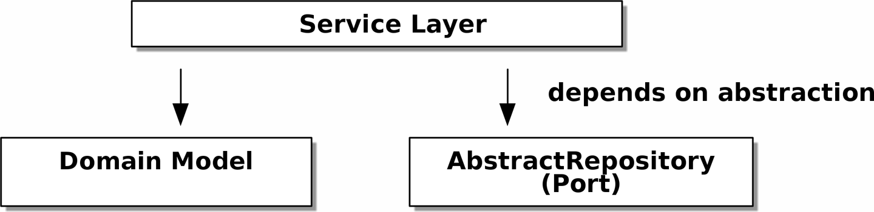
Figure 4-3. Abstract dependencies of the service layer

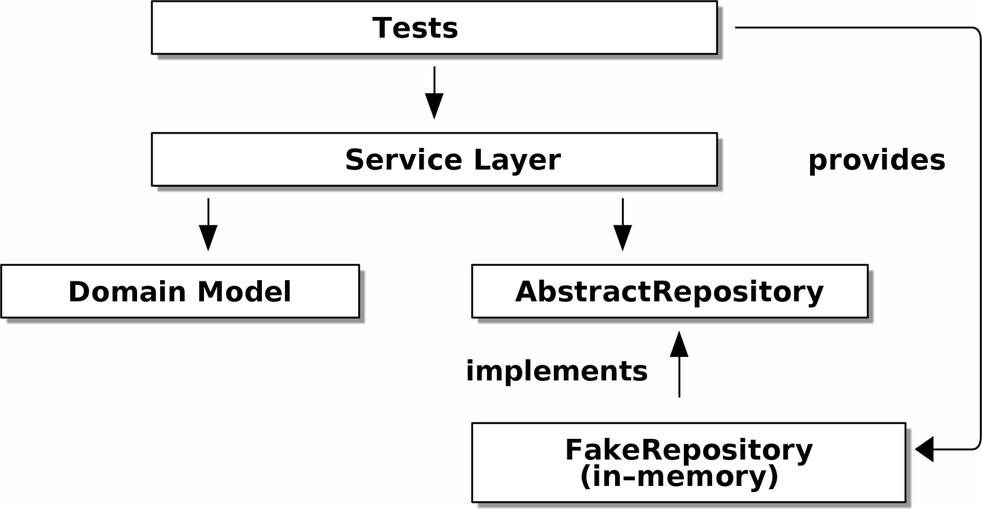
Figure 4-4. Tests provide an implementation of the abstract dependency

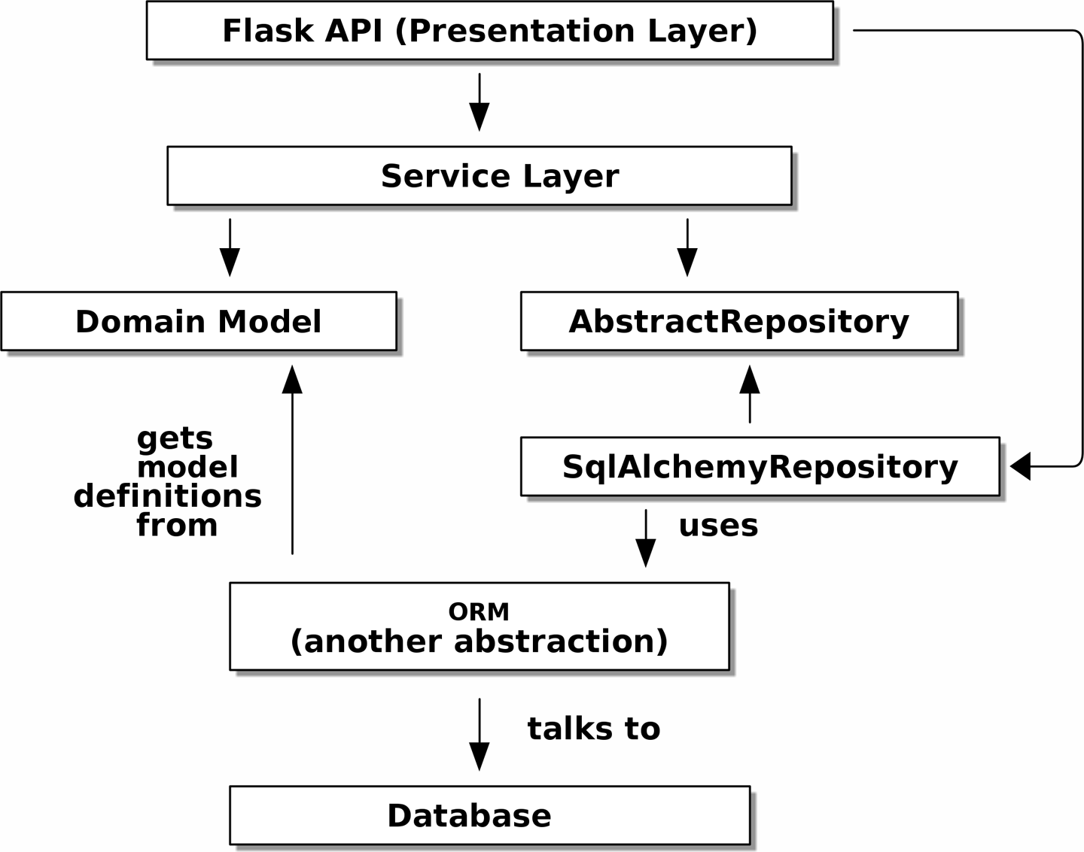
Figure 4-5. Dependencies at runtime

Wonderful.
Let’s pause for Table 4-1, in which we consider the pros and cons of having a service layer at all.
Table 4-1. Service layer: the trade-offs  Pros | Cons
We have a single place to capture all the use cases for our application.  We’ve placed our clever domain logic behind an API, which leaves us free to refactor.  We have cleanly separated “stuff that talks HTTP” from “stuff that talks allocation.”  When combined with the Repository pattern and FakeRepository, we have a nice way of writing tests at a higher level than the domain layer; we can test more of our workflow without needing to use integration tests (read on to Chapter 5 for more elaboration on this). | If your app is purely a web app, your controllers/view functions can be the single place to capture all the use cases.  It’s yet another layer of abstraction.  Putting too much logic into the service layer can lead to the Anemic Domain anti-pattern. It’s better to introduce this layer after you spot orchestration logic creeping into your controllers.  You can get a lot of the benefits that come from having rich domain models by simply pushing logic out of your controllers and down to the model layer, without needing to add an extra layer in between (aka “fat models, thin controllers”).
But there are still some bits of awkwardness to tidy up:
The service layer is still tightly coupled to the domain, because its API is expressed in terms of OrderLine objects. In Chapter 5, we’ll fix that and talk about the way that the service layer enables more productive TDD.
The service layer is tightly coupled to a session object. In Chapter 6, we’ll introduce one more pattern that works closely with the Repository and Service Layer patterns, the Unit of Work pattern, and everything will be absolutely lovely. You’ll see!
1 Service-layer services and domain services do have confusingly similar names. We tackle this topic later in “Why Is Everything Called a Service?”.

Chapter 5. TDD in High Gear and Low Gear
We’ve introduced the service layer to capture some of the additional orchestration responsibilities we need from a working application. The service layer helps us clearly define our use cases and the workflow for each: what we need to get from our repositories, what pre-checks and current state validation we should do, and what we save at the end.
But currently, many of our unit tests operate at a lower level, acting directly on the model. In this chapter we’ll discuss the trade-offs involved in moving those tests up to the service-layer level, and some more general testing guidelines.

Harry Says: Seeing a Test Pyramid in Action Was a Light-Bulb Moment
Here are a few words from Harry directly:
I was initially skeptical of all Bob’s architectural patterns, but seeing an actual test pyramid made me a convert.
Once you implement domain modeling and the service layer, you really actually can get to a stage where unit tests outnumber integration and end-to-end tests by an order of magnitude. Having worked in places where the E2E test build would take hours (“wait ‘til tomorrow,” essentially), I can’t tell you what a difference it makes to be able to run all your tests in minutes or seconds.
Read on for some guidelines on how to decide what kinds of tests to write and at which level. The high gear versus low gear way of thinking really changed my testing life.

How Is Our Test Pyramid Looking?
Let’s see what this move to using a service layer, with its own service-layer tests, does to our test pyramid:
Counting types of tests
$
grep -c test_ test_*.py
tests/unit/test_allocate.py:4
tests/unit/test_batches.py:8
tests/unit/test_services.py:3
tests/integration/test_orm.py:6
tests/integration/test_repository.py:2
tests/e2e/test_api.py:2
Not bad! We have 15 unit tests, 8 integration tests, and just 2 end-to-end tests. That’s already a healthy-looking test pyramid.

Should Domain Layer Tests Move to the Service Layer?
Let’s see what happens if we take this a step further. Since we can test our software against the service layer, we don’t really need tests for the domain model anymore. Instead, we could rewrite all of the domain-level tests from Chapter 1 in terms of the service layer:
Rewriting a domain test at the service layer (tests/unit/test_services.py)
# domain-layer test:
def
test_prefers_current_stock_batches_to_shipments
():
in_stock_batch
=
Batch
(
"in-stock-batch"
,
"RETRO-CLOCK"
,
100
,
eta
=
None
)
shipment_batch
=
Batch
(
"shipment-batch"
,
"RETRO-CLOCK"
,
100
,
eta
=
tomorrow
)
line
=
OrderLine
(
"oref"
,
"RETRO-CLOCK"
,
10
)
allocate
(
line
,
[
in_stock_batch
,
shipment_batch
])
assert
in_stock_batch
.
available_quantity
==
90
assert
shipment_batch
.
available_quantity
==
100
# service-layer test:
def
test_prefers_warehouse_batches_to_shipments
():
in_stock_batch
=
Batch
(
"in-stock-batch"
,
"RETRO-CLOCK"
,
100
,
eta
=
None
)
shipment_batch
=
Batch
(
"shipment-batch"
,
"RETRO-CLOCK"
,
100
,
eta
=
tomorrow
)
repo
=
FakeRepository
([
in_stock_batch
,
shipment_batch
])
session
=
FakeSession
()
line
=
OrderLine
(
'oref'
,
"RETRO-CLOCK"
,
10
)
services
.
allocate
(
line
,
repo
,
session
)
assert
in_stock_batch
.
available_quantity
==
90
assert
shipment_batch
.
available_quantity
==
100
Why would we want to do that?
Tests are supposed to help us change our system fearlessly, but often we see teams writing too many tests against their domain model. This causes problems when they come to change their codebase and find that they need to update tens or even hundreds of unit tests.
This makes sense if you stop to think about the purpose of automated tests. We use tests to enforce that a property of the system doesn’t change while we’re working. We use tests to check that the API continues to return 200, that the database session continues to commit, and that orders are still being allocated.
If we accidentally change one of those behaviors, our tests will break. The flip side, though, is that if we want to change the design of our code, any tests relying directly on that code will also fail.
As we get further into the book, you’ll see how the service layer forms an API for our system that we can drive in multiple ways. Testing against this API reduces the amount of code that we need to change when we refactor our domain model. If we restrict ourselves to testing only against the service layer, we won’t have any tests that directly interact with “private” methods or attributes on our model objects, which leaves us freer to refactor them.

Tip
Every line of code that we put in a test is like a blob of glue, holding the system in a particular shape. The more low-level tests we have, the harder it will be to change things.

On Deciding What Kind of Tests to Write
You might be asking yourself, “Should I rewrite all my unit tests, then? Is it wrong to write tests against the domain model?” To answer those questions, it’s important to understand the trade-off between coupling and design feedback (see Figure 5-1).
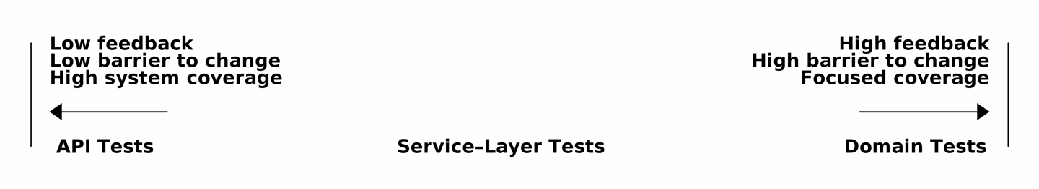
Figure 5-1. The test spectrum

Extreme programming (XP) exhorts us to “listen to the code.” When we’re writing tests, we might find that the code is hard to use or notice a code smell. This is a trigger for us to refactor, and to reconsider our design.
We only get that feedback, though, when we’re working closely with the target code. A test for the HTTP API tells us nothing about the fine-grained design of our objects, because it sits at a much higher level of abstraction.
On the other hand, we can rewrite our entire application and, so long as we don’t change the URLs or request formats, our HTTP tests will continue to pass. This gives us confidence that large-scale changes, like changing the database schema, haven’t broken our code.
At the other end of the spectrum, the tests we wrote in Chapter 1 helped us to flesh out our understanding of the objects we need. The tests guided us to a design that makes sense and reads in the domain language. When our tests read in the domain language, we feel comfortable that our code matches our intuition about the problem we’re trying to solve.
Because the tests are written in the domain language, they act as living documentation for our model. A new team member can read these tests to quickly understand how the system works and how the core concepts interrelate.
We often “sketch” new behaviors by writing tests at this level to see how the code might look. When we want to improve the design of the code, though, we will need to replace or delete these tests, because they are tightly coupled to a particular implementation.

High and Low Gear
Most of the time, when we are adding a new feature or fixing a bug, we don’t need to make extensive changes to the domain model. In these cases, we prefer to write tests against services because of the lower coupling and higher coverage.
For example, when writing an add_stock function or a cancel_order feature, we can work more quickly and with less coupling by writing tests against the service layer.
When starting a new project or when hitting a particularly gnarly problem, we will drop back down to writing tests against the domain model so we get better feedback and executable documentation of our intent.
The metaphor we use is that of shifting gears. When starting a journey, the bicycle needs to be in a low gear so that it can overcome inertia. Once we’re off and running, we can go faster and more efficiently by changing into a high gear; but if we suddenly encounter a steep hill or are forced to slow down by a hazard, we again drop down to a low gear until we can pick up speed again.

Fully Decoupling the Service-Layer Tests from the Domain
We still have direct dependencies on the domain in our service-layer tests, because we use domain objects to set up our test data and to invoke our service-layer functions.
To have a service layer that’s fully decoupled from the domain, we need to rewrite its API to work in terms of primitives.
Our service layer currently takes an OrderLine domain object:
Before: allocate takes a domain object (service_layer/services.py)
def
allocate
(
line
:
OrderLine
,
repo
:
AbstractRepository
,
session
)
->
str
:
How would it look if its parameters were all primitive types?
After: allocate takes strings and ints (service_layer/services.py)
def
allocate
(
orderid
:
str
,
sku
:
str
,
qty
:
int
,
repo
:
AbstractRepository
,
session
)
->
str
:
We rewrite the tests in those terms as well:
Tests now use primitives in function call (tests/unit/test_services.py)
def
test_returns_allocation
():
batch
=
model
.
Batch
(
"batch1"
,
"COMPLICATED-LAMP"
,
100
,
eta
=
None
)
repo
=
FakeRepository
([
batch
])
result
=
services
.
allocate
(
"o1"
,
"COMPLICATED-LAMP"
,
10
,
repo
,
FakeSession
())
assert
result
==
"batch1"
But our tests still depend on the domain, because we still manually instantiate Batch objects. So, if one day we decide to massively refactor how our Batch model works, we’ll have to change a bunch of tests.

Mitigation: Keep All Domain Dependencies in Fixture Functions
We could at least abstract that out to a helper function or a fixture in our tests. Here’s one way you could do that, adding a factory function on FakeRepository:
Factory functions for fixtures are one possibility (tests/unit/test_services.py)
class
FakeRepository
(
set
):
@staticmethod
def
for_batch
(
ref
,
sku
,
qty
,
eta
=
None
):
return
FakeRepository
([
model
.
Batch
(
ref
,
sku
,
qty
,
eta
),
])
...
def
test_returns_allocation
():
repo
=
FakeRepository
.
for_batch
(
"batch1"
,
"COMPLICATED-LAMP"
,
100
,
eta
=
None
)
result
=
services
.
allocate
(
"o1"
,
"COMPLICATED-LAMP"
,
10
,
repo
,
FakeSession
())
assert
result
==
"batch1"
At least that would move all of our tests’ dependencies on the domain into one place.

Adding a Missing Service
We could go one step further, though. If we had a service to add stock, we could use that and make our service-layer tests fully expressed in terms of the service layer’s official use cases, removing all dependencies on the domain:
Test for new add_batch service (tests/unit/test_services.py)
def
test_add_batch
():
repo
,
session
=
FakeRepository
([]),
FakeSession
()
services
.
add_batch
(
"b1"
,
"CRUNCHY-ARMCHAIR"
,
100
,
None
,
repo
,
session
)
assert
repo
.
get
(
"b1"
)
is
not
None
assert
session
.
committed

Tip
In general, if you find yourself needing to do domain-layer stuff directly in your service-layer tests, it may be an indication that your service layer is incomplete.
And the implementation is just two lines:
A new service for add_batch (service_layer/services.py)
def
add_batch
(
ref
:
str
,
sku
:
str
,
qty
:
int
,
eta
:
Optional
[
date
],
repo
:
AbstractRepository
,
session
,
):
repo
.
add
(
model
.
Batch
(
ref
,
sku
,
qty
,
eta
))
session
.
commit
()
def
allocate
(
orderid
:
str
,
sku
:
str
,
qty
:
int
,
repo
:
AbstractRepository
,
session
)
->
str
:
...

Note
Should you write a new service just because it would help remove dependencies from your tests? Probably not. But in this case, we almost definitely would need an add_batch service one day anyway.
That now allows us to rewrite all of our service-layer tests purely in terms of the services themselves, using only primitives, and without any dependencies on the model:
Services tests now use only services (tests/unit/test_services.py)
def
test_allocate_returns_allocation
():
repo
,
session
=
FakeRepository
([]),
FakeSession
()
services
.
add_batch
(
"batch1"
,
"COMPLICATED-LAMP"
,
100
,
None
,
repo
,
session
)
result
=
services
.
allocate
(
"o1"
,
"COMPLICATED-LAMP"
,
10
,
repo
,
session
)
assert
result
==
"batch1"
def
test_allocate_errors_for_invalid_sku
():
repo
,
session
=
FakeRepository
([]),
FakeSession
()
services
.
add_batch
(
"b1"
,
"AREALSKU"
,
100
,
None
,
repo
,
session
)
with
pytest
.
raises
(
services
.
InvalidSku
,
match
=
"Invalid sku NONEXISTENTSKU"
):
services
.
allocate
(
"o1"
,
"NONEXISTENTSKU"
,
10
,
repo
,
FakeSession
())
This is a really nice place to be in. Our service-layer tests depend on only the service layer itself, leaving us completely free to refactor the model as we see fit.

Carrying the Improvement Through to the E2E Tests
In the same way that adding add_batch helped decouple our service-layer tests from the model, adding an API endpoint to add a batch would remove the need for the ugly add_stock fixture, and our E2E tests could be free of those hardcoded SQL queries and the direct dependency on the database.
Thanks to our service function, adding the endpoint is easy, with just a little JSON wrangling and a single function call required:
API for adding a batch (entrypoints/flask_app.py)
@app.route
(
"/add_batch"
,
methods
=
[
'POST'
])
def
add_batch
():
session
=
get_session
()
repo
=
repository
.
SqlAlchemyRepository
(
session
)
eta
=
request
.
json
[
'eta'
]
if
eta
is
not
None
:
eta
=
datetime
.
fromisoformat
(
eta
)
.
date
()
services
.
add_batch
(
request
.
json
[
'ref'
],
request
.
json
[
'sku'
],
request
.
json
[
'qty'
],
eta
,
repo
,
session
)
return
'OK'
,
201

Note
Are you thinking to yourself, POST to /add_batch? That’s not very RESTful! You’re quite right. We’re being happily sloppy, but if you’d like to make it all more RESTy, maybe a POST to /batches, then knock yourself out! Because Flask is a thin adapter, it’ll be easy. See the next sidebar.
And our hardcoded SQL queries from conftest.py get replaced with some API calls, meaning the API tests have no dependencies other than the API, which is also nice:
API tests can now add their own batches (tests/e2e/test_api.py)
def
post_to_add_batch
(
ref
,
sku
,
qty
,
eta
):
url
=
config
.
get_api_url
()
r
=
requests
.
post
(
f
'{url}/add_batch'
,
json
=
{
'ref'
:
ref
,
'sku'
:
sku
,
'qty'
:
qty
,
'eta'
:
eta
}
)
assert
r
.
status_code
==
201
@pytest.mark.usefixtures
(
'postgres_db'
)
@pytest.mark.usefixtures
(
'restart_api'
)
def
test_happy_path_returns_201_and_allocated_batch
():
sku
,
othersku
=
random_sku
(),
random_sku
(
'other'
)
earlybatch
=
random_batchref
(
1
)
laterbatch
=
random_batchref
(
2
)
otherbatch
=
random_batchref
(
3
)
post_to_add_batch
(
laterbatch
,
sku
,
100
,
'2011-01-02'
)
post_to_add_batch
(
earlybatch
,
sku
,
100
,
'2011-01-01'
)
post_to_add_batch
(
otherbatch
,
othersku
,
100
,
None
)
data
=
{
'orderid'
:
random_orderid
(),
'sku'
:
sku
,
'qty'
:
3
}
url
=
config
.
get_api_url
()
r
=
requests
.
post
(
f
'{url}/allocate'
,
json
=
data
)
assert
r
.
status_code
==
201
assert
r
.
json
()[
'batchref'
]
==
earlybatch

Wrap-Up
Once you have a service layer in place, you really can move the majority of your test coverage to unit tests and develop a healthy test pyramid.

Recap: Rules of Thumb for Different Types of Test
Aim for one end-to-end test per feature
This might be written against an HTTP API, for example. The objective is to demonstrate that the feature works, and that all the moving parts are glued together correctly.
Write the bulk of your tests against the service layer
These edge-to-edge tests offer a good trade-off between coverage, runtime, and efficiency. Each test tends to cover one code path of a feature and use fakes for I/O. This is the place to exhaustively cover all the edge cases and the ins and outs of your business logic.1
Maintain a small core of tests written against your domain model
These tests have highly focused coverage and are more brittle, but they have the highest feedback. Don’t be afraid to delete these tests if the functionality is later covered by tests at the service layer.
Error handling counts as a feature
Ideally, your application will be structured such that all errors that bubble up to your entrypoints (e.g., Flask) are handled in the same way. This means you need to test only the happy path for each feature, and to reserve one end-to-end test for all unhappy paths (and many unhappy path unit tests, of course).
A few things will help along the way:
Express your service layer in terms of primitives rather than domain objects.
In an ideal world, you’ll have all the services you need to be able to test entirely against the service layer, rather than hacking state via repositories or the database. This pays off in your end-to-end tests as well.
Onto the next chapter!
1 A valid concern about writing tests at a higher level is that it can lead to combinatorial explosion for more complex use cases. In these cases, dropping down to lower-level unit tests of the various collaborating domain objects can be useful. But see also Chapter 8 and “Optionally: Unit Testing Event Handlers in Isolation with a Fake Message Bus”.

Chapter 6. Unit of Work Pattern
In this chapter we’ll introduce the final piece of the puzzle that ties together the Repository and Service Layer patterns: the Unit of Work pattern.
If the Repository pattern is our abstraction over the idea of persistent storage, the Unit of Work (UoW) pattern is our abstraction over the idea of atomic operations. It will allow us to finally and fully decouple our service layer from the data layer.
Figure 6-1 shows that, currently, a lot of communication occurs across the layers of our infrastructure: the API talks directly to the database layer to start a session, it talks to the repository layer to initialize SQLAlchemyRepository, and it talks to the service layer to ask it to allocate.

Tip
The code for this chapter is in the chapter_06_uow branch on GitHub:
git clone https://github.com/cosmicpython/code.git
cd code
git checkout chapter_06_uow
# or to code along, checkout Chapter 4:
git checkout chapter_04_service_layer
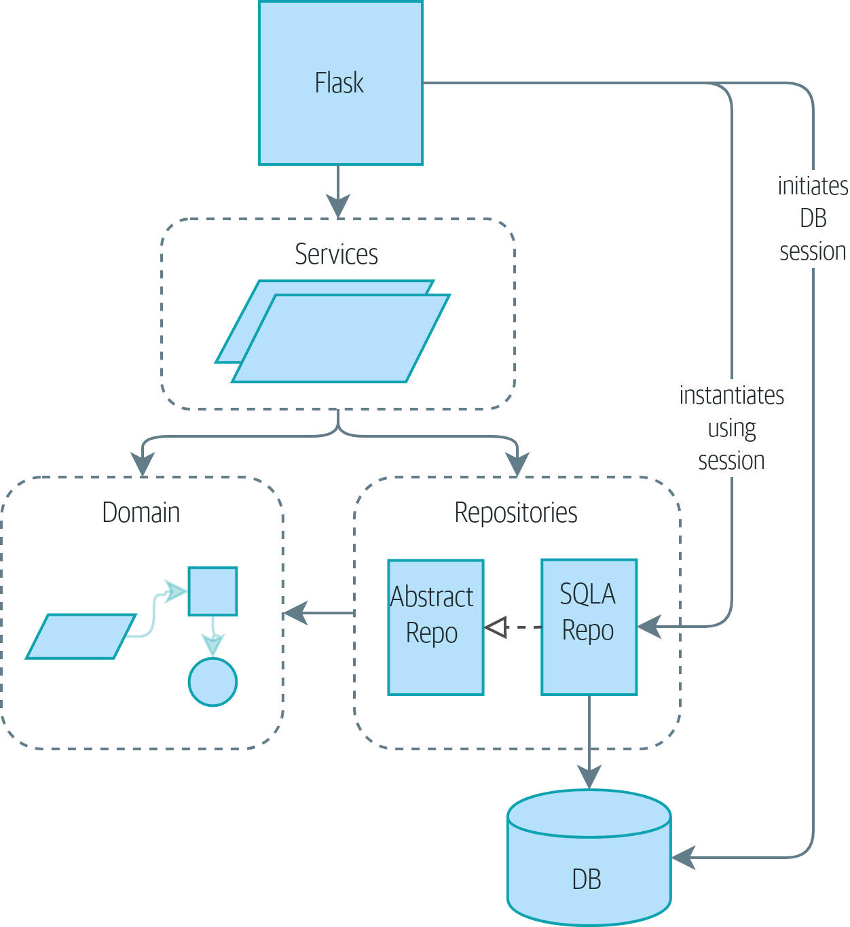
Figure 6-1. Without UoW: API talks directly to three layers
Figure 6-2 shows our target state. The Flask API now does only two things: it initializes a unit of work, and it invokes a service. The service collaborates with the UoW (we like to think of the UoW as being part of the service layer), but neither the service function itself nor Flask now needs to talk directly to the database.
And we’ll do it all using a lovely piece of Python syntax, a context manager.
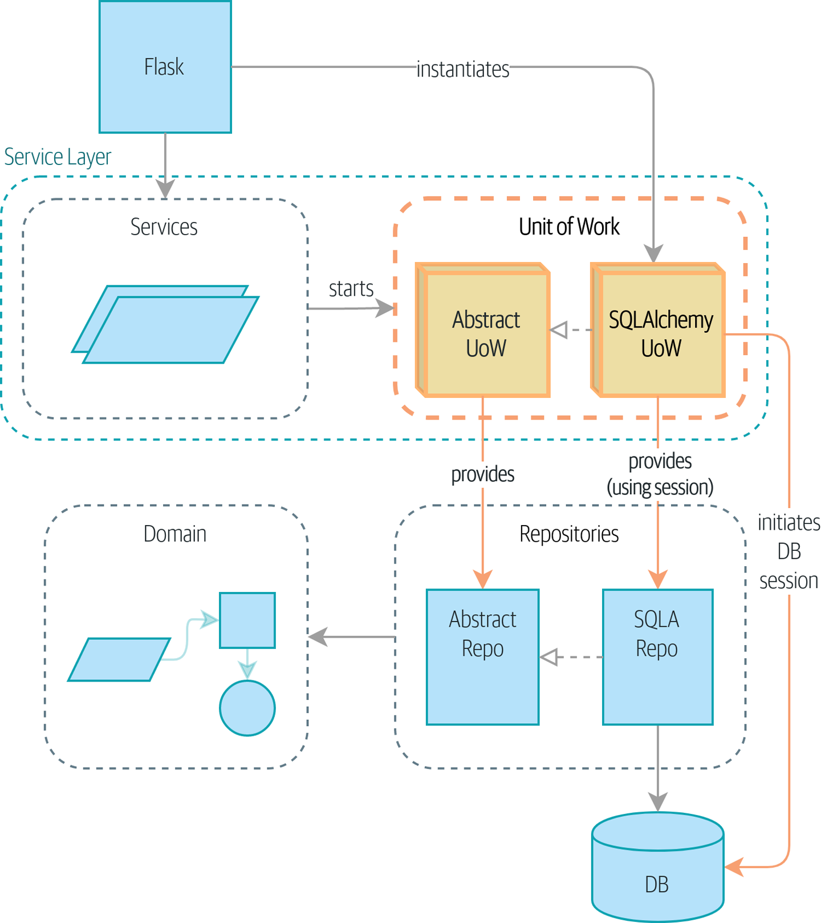
Figure 6-2. With UoW: UoW now manages database state

The Unit of Work Collaborates with the Repository
Let’s see the unit of work (or UoW, which we pronounce “you-wow”) in action. Here’s how the service layer will look when we’re finished:
Preview of unit of work in action (src/allocation/service_layer/services.py)
def
allocate
(
orderid
:
str
,
sku
:
str
,
qty
:
int
,
uow
:
unit_of_work
.
AbstractUnitOfWork
)
-
>
str
:
line
=
OrderLine
(
orderid
,
sku
,
qty
)
with
uow
:
batches
=
uow
.
batches
.
list
(
)
.
.
.
batchref
=
model
.
allocate
(
line
,
batches
)
uow
.
commit
(
)
We’ll start a UoW as a context manager.
uow.batches is the batches repo, so the UoW provides us access to our permanent storage.
When we’re done, we commit or roll back our work, using the UoW.
The UoW acts as a single entrypoint to our persistent storage, and it keeps track of what objects were loaded and of the latest state.1
This gives us three useful things:
A stable snapshot of the database to work with, so the objects we use aren’t changing halfway through an operation
A way to persist all of our changes at once, so if something goes wrong, we don’t end up in an inconsistent state
A simple API to our persistence concerns and a handy place to get a repository

Test-Driving a UoW with Integration Tests
Here are our integration tests for the UOW:
A basic “round-trip” test for a UoW (tests/integration/test_uow.py)
def
test_uow_can_retrieve_a_batch_and_allocate_to_it
(
session_factory
)
:
session
=
session_factory
(
)
insert_batch
(
session
,
'
batch1
'
,
'
HIPSTER-WORKBENCH
'
,
100
,
None
)
session
.
commit
(
)
uow
=
unit_of_work
.
SqlAlchemyUnitOfWork
(
session_factory
)
with
uow
:
batch
=
uow
.
batches
.
get
(
reference
=
'
batch1
'
)
line
=
model
.
OrderLine
(
'
o1
'
,
'
HIPSTER-WORKBENCH
'
,
10
)
batch
.
allocate
(
line
)
uow
.
commit
(
)
batchref
=
get_allocated_batch_ref
(
session
,
'
o1
'
,
'
HIPSTER-WORKBENCH
'
)
assert
batchref
==
'
batch1
'
We initialize the UoW by using our custom session factory and get back a uow object to use in our with block.
The UoW gives us access to the batches repository via uow.batches.
We call commit() on it when we’re done.
For the curious, the insert_batch and get_allocated_batch_ref helpers look like this:
Helpers for doing SQL stuff (tests/integration/test_uow.py)
def
insert_batch
(
session
,
ref
,
sku
,
qty
,
eta
):
session
.
execute
(
'INSERT INTO batches (reference, sku, _purchased_quantity, eta)'
' VALUES (:ref, :sku, :qty, :eta)'
,
dict
(
ref
=
ref
,
sku
=
sku
,
qty
=
qty
,
eta
=
eta
)
)
def
get_allocated_batch_ref
(
session
,
orderid
,
sku
):
[[
orderlineid
]]
=
session
.
execute
(
'SELECT id FROM order_lines WHERE orderid=:orderid AND sku=:sku'
,
dict
(
orderid
=
orderid
,
sku
=
sku
)
)
[[
batchref
]]
=
session
.
execute
(
'SELECT b.reference FROM allocations JOIN batches AS b ON batch_id = b.id'
' WHERE orderline_id=:orderlineid'
,
dict
(
orderlineid
=
orderlineid
)
)
return
batchref

Unit of Work and Its Context Manager
In our tests we’ve implicitly defined an interface for what a UoW needs to do. Let’s make that explicit by using an abstract base class:
Abstract UoW context manager (src/allocation/service_layer/unit_of_work.py)
class
AbstractUnitOfWork
(
abc
.
ABC
)
:
batches
:
repository
.
AbstractRepository
def
__exit__
(
self
,
*
args
)
:
self
.
rollback
(
)
@abc.abstractmethod
def
commit
(
self
)
:
raise
NotImplementedError
@abc.abstractmethod
def
rollback
(
self
)
:
raise
NotImplementedError
The UoW provides an attribute called .batches, which will give us access to the batches repository.
If you’ve never seen a context manager, __enter__ and __exit__ are the two magic methods that execute when we enter the with block and when we exit it, respectively. They’re our setup and teardown phases.
We’ll call this method to explicitly commit our work when we’re ready.
If we don’t commit, or if we exit the context manager by raising an error, we do a rollback. (The rollback has no effect if commit() has been called. Read on for more discussion of this.)

The Real Unit of Work Uses SQLAlchemy Sessions
The main thing that our concrete implementation adds is the database session:
The real SQLAlchemy UoW (src/allocation/service_layer/unit_of_work.py)
DEFAULT_SESSION_FACTORY
=
sessionmaker
(
bind
=
create_engine
(
config
.
get_postgres_uri
(
)
,
)
)
class
SqlAlchemyUnitOfWork
(
AbstractUnitOfWork
)
:
def
__init__
(
self
,
session_factory
=
DEFAULT_SESSION_FACTORY
)
:
self
.
session_factory
=
session_factory
def
__enter__
(
self
)
:
self
.
session
=
self
.
session_factory
(
)
# type: Session
self
.
batches
=
repository
.
SqlAlchemyRepository
(
self
.
session
)
return
super
(
)
.
__enter__
(
)
def
__exit__
(
self
,
*
args
)
:
super
(
)
.
__exit__
(
*
args
)
self
.
session
.
close
(
)
def
commit
(
self
)
:
self
.
session
.
commit
(
)
def
rollback
(
self
)
:
self
.
session
.
rollback
(
)
The module defines a default session factory that will connect to Postgres, but we allow that to be overridden in our integration tests so that we can use SQLite instead.
The __enter__ method is responsible for starting a database session and instantiating a real repository that can use that session.
We close the session on exit.
Finally, we provide concrete commit() and rollback() methods that use our database session.

Fake Unit of Work for Testing
Here’s how we use a fake UoW in our service-layer tests:
Fake UoW (tests/unit/test_services.py)
class
FakeUnitOfWork
(
unit_of_work
.
AbstractUnitOfWork
)
:
def
__init__
(
self
)
:
self
.
batches
=
FakeRepository
(
[
]
)
self
.
committed
=
False
def
commit
(
self
)
:
self
.
committed
=
True
def
rollback
(
self
)
:
pass
def
test_add_batch
(
)
:
uow
=
FakeUnitOfWork
(
)
services
.
add_batch
(
"
b1
"
,
"
CRUNCHY-ARMCHAIR
"
,
100
,
None
,
uow
)
assert
uow
.
batches
.
get
(
"
b1
"
)
is
not
None
assert
uow
.
committed
def
test_allocate_returns_allocation
(
)
:
uow
=
FakeUnitOfWork
(
)
services
.
add_batch
(
"
batch1
"
,
"
COMPLICATED-LAMP
"
,
100
,
None
,
uow
)
result
=
services
.
allocate
(
"
o1
"
,
"
COMPLICATED-LAMP
"
,
10
,
uow
)
assert
result
==
"
batch1
"
.
.
.
FakeUnitOfWork and FakeRepository are tightly coupled, just like the real UnitofWork and Repository classes. That’s fine because we recognize that the objects are collaborators.
Notice the similarity with the fake commit() function from FakeSession (which we can now get rid of). But it’s a substantial improvement because we’re now faking out code that we wrote rather than third-party code. Some people say, “Don’t mock what you don’t own”.
In our tests, we can instantiate a UoW and pass it to our service layer, rather than passing a repository and a session. This is considerably less cumbersome.

Don’t Mock What You Don’t Own
Why do we feel more comfortable mocking the UoW than the session? Both of our fakes achieve the same thing: they give us a way to swap out our persistence layer so we can run tests in memory instead of needing to talk to a real database. The difference is in the resulting design.
If we cared only about writing tests that run quickly, we could create mocks that replace SQLAlchemy and use those throughout our codebase. The problem is that Session is a complex object that exposes lots of persistence-related functionality. It’s easy to use Session to make arbitrary queries against the database, but that quickly leads to data access code being sprinkled all over the codebase. To avoid that, we want to limit access to our persistence layer so each component has exactly what it needs and nothing more.
By coupling to the Session interface, you’re choosing to couple to all the complexity of SQLAlchemy. Instead, we want to choose a simpler abstraction and use that to clearly separate responsibilities. Our UoW is much simpler than a session, and we feel comfortable with the service layer being able to start and stop units of work.
“Don’t mock what you don’t own” is a rule of thumb that forces us to build these simple abstractions over messy subsystems. This has the same performance benefit as mocking the SQLAlchemy session but encourages us to think carefully about our designs.

Using the UoW in the Service Layer
Here’s what our new service layer looks like:
Service layer using UoW (src/allocation/service_layer/services.py)
def
add_batch
(
ref
:
str
,
sku
:
str
,
qty
:
int
,
eta
:
Optional
[
date
]
,
uow
:
unit_of_work
.
AbstractUnitOfWork
)
:
with
uow
:
uow
.
batches
.
add
(
model
.
Batch
(
ref
,
sku
,
qty
,
eta
)
)
uow
.
commit
(
)
def
allocate
(
orderid
:
str
,
sku
:
str
,
qty
:
int
,
uow
:
unit_of_work
.
AbstractUnitOfWork
)
-
>
str
:
line
=
OrderLine
(
orderid
,
sku
,
qty
)
with
uow
:
batches
=
uow
.
batches
.
list
(
)
if
not
is_valid_sku
(
line
.
sku
,
batches
)
:
raise
InvalidSku
(
f
'
Invalid sku {line.sku}
'
)
batchref
=
model
.
allocate
(
line
,
batches
)
uow
.
commit
(
)
return
batchref
Our service layer now has only the one dependency, once again on an abstract UoW.

Explicit Tests for Commit/Rollback Behavior
To convince ourselves that the commit/rollback behavior works, we wrote a couple of tests:
Integration tests for rollback behavior (tests/integration/test_uow.py)
def
test_rolls_back_uncommitted_work_by_default
(
session_factory
):
uow
=
unit_of_work
.
SqlAlchemyUnitOfWork
(
session_factory
)
with
uow
:
insert_batch
(
uow
.
session
,
'batch1'
,
'MEDIUM-PLINTH'
,
100
,
None
)
new_session
=
session_factory
()
rows
=
list
(
new_session
.
execute
(
'SELECT * FROM "batches"'
))
assert
rows
==
[]
def
test_rolls_back_on_error
(
session_factory
):
class
MyException
(
Exception
):
pass
uow
=
unit_of_work
.
SqlAlchemyUnitOfWork
(
session_factory
)
with
pytest
.
raises
(
MyException
):
with
uow
:
insert_batch
(
uow
.
session
,
'batch1'
,
'LARGE-FORK'
,
100
,
None
)
raise
MyException
()
new_session
=
session_factory
()
rows
=
list
(
new_session
.
execute
(
'SELECT * FROM "batches"'
))
assert
rows
==
[]

Tip
We haven’t shown it here, but it can be worth testing some of the more “obscure” database behavior, like transactions, against the “real” database—that is, the same engine. For now, we’re getting away with using SQLite instead of Postgres, but in Chapter 7, we’ll switch some of the tests to using the real database. It’s convenient that our UoW class makes that easy!

Explicit Versus Implicit Commits
Now we briefly digress on different ways of implementing the UoW pattern.
We could imagine a slightly different version of the UoW that commits by default and rolls back only if it spots an exception:
A UoW with implicit commit… (src/allocation/unit_of_work.py)
class
AbstractUnitOfWork
(
abc
.
ABC
)
:
def
__enter__
(
self
)
:
return
self
def
__exit__
(
self
,
exn_type
,
exn_value
,
traceback
)
:
if
exn_type
is
None
:
self
.
commit
(
)
else
:
self
.
rollback
(
)
Should we have an implicit commit in the happy path?
And roll back only on exception?
It would allow us to save a line of code and to remove the explicit commit from our client code:
...would save us a line of code (src/allocation/service_layer/services.py)
def
add_batch
(
ref
:
str
,
sku
:
str
,
qty
:
int
,
eta
:
Optional
[
date
],
uow
):
with
uow
:
uow
.
batches
.
add
(
model
.
Batch
(
ref
,
sku
,
qty
,
eta
))
# uow.commit()
This is a judgment call, but we tend to prefer requiring the explicit commit so that we have to choose when to flush state.
Although we use an extra line of code, this makes the software safe by default. The default behavior is to not change anything. In turn, that makes our code easier to reason about because there’s only one code path that leads to changes in the system: total success and an explicit commit. Any other code path, any exception, any early exit from the UoW’s scope leads to a safe state.
Similarly, we prefer to roll back by default because it’s easier to understand; this rolls back to the last commit, so either the user did one, or we blow their changes away. Harsh but simple.

Examples: Using UoW to Group Multiple Operations into an Atomic Unit
Here are a few examples showing the Unit of Work pattern in use. You can see how it leads to simple reasoning about what blocks of code happen together.

Example 1: Reallocate
Suppose we want to be able to deallocate and then reallocate orders:
Reallocate service function
def
reallocate
(
line
:
OrderLine
,
uow
:
AbstractUnitOfWork
)
-
>
str
:
with
uow
:
batch
=
uow
.
batches
.
get
(
sku
=
line
.
sku
)
if
batch
is
None
:
raise
InvalidSku
(
f
'
Invalid sku {line.sku}
'
)
batch
.
deallocate
(
line
)
allocate
(
line
)
uow
.
commit
(
)
If deallocate() fails, we don’t want to call allocate(), obviously.
If allocate() fails, we probably don’t want to actually commit the deallocate() either.

Example 2: Change Batch Quantity
Our shipping company gives us a call to say that one of the container doors opened, and half our sofas have fallen into the Indian Ocean. Oops!
Change quantity
def
change_batch_quantity
(
batchref
:
str
,
new_qty
:
int
,
uow
:
AbstractUnitOfWork
)
:
with
uow
:
batch
=
uow
.
batches
.
get
(
reference
=
batchref
)
batch
.
change_purchased_quantity
(
new_qty
)
while
batch
.
available_quantity
<
0
:
line
=
batch
.
deallocate_one
(
)
uow
.
commit
(
)
Here we may need to deallocate any number of lines. If we get a failure at any stage, we probably want to commit none of the changes.

Tidying Up the Integration Tests
We now have three sets of tests, all essentially pointing at the database: test_orm.py, test_repository.py, and test_uow.py. Should we throw any away?

└── tests
├── conftest.py
├── e2e
│ └── test_api.py
├── integration
│ ├── test_orm.py
│ ├── test_repository.py
│ └── test_uow.py
├── pytest.ini
└── unit
├── test_allocate.py
├── test_batches.py
└── test_services.py
You should always feel free to throw away tests if you think they’re not going to add value longer term. We’d say that test_orm.py was primarily a tool to help us learn SQLAlchemy, so we won’t need that long term, especially if the main things it’s doing are covered in test_repository.py. That last test, you might keep around, but we could certainly see an argument for just keeping everything at the highest possible level of abstraction (just as we did for the unit tests).

Exercise for the Reader
For this chapter, probably the best thing to try is to implement a UoW from scratch. The code, as always, is on GitHub. You could either follow the model we have quite closely, or perhaps experiment with separating the UoW (whose responsibilities are commit(), rollback(), and providing the .batches repository) from the context manager, whose job is to initialize things, and then do the commit or rollback on exit. If you feel like going all-functional rather than messing about with all these classes, you could use @contextmanager from contextlib.
We’ve stripped out both the actual UoW and the fakes, as well as paring back the abstract UoW. Why not send us a link to your repo if you come up with something you’re particularly proud of?

Tip
This is another example of the lesson from Chapter 5: as we build better abstractions, we can move our tests to run against them, which leaves us free to change the underlying details.

Wrap-Up
Hopefully we’ve convinced you that the Unit of Work pattern is useful, and that the context manager is a really nice Pythonic way of visually grouping code into blocks that we want to happen atomically.
This pattern is so useful, in fact, that SQLAlchemy already uses a UoW in the shape of the Session object. The Session object in SQLAlchemy is the way that your application loads data from the database.
Every time you load a new entity from the database, the session begins to track changes to the entity, and when the session is flushed, all your changes are persisted together. Why do we go to the effort of abstracting away the SQLAlchemy session if it already implements the pattern we want?
Table 6-1 discusses some of the trade-offs.
Table 6-1. Unit of Work pattern: the trade-offs  Pros | Cons
We have a nice abstraction over the concept of atomic operations, and the context manager makes it easy to see, visually, what blocks of code are grouped together atomically.  We have explicit control over when a transaction starts and finishes, and our application fails in a way that is safe by default. We never have to worry that an operation is partially committed.  It’s a nice place to put all your repositories so client code can access them.  As you’ll see in later chapters, atomicity isn’t only about transactions; it can help us work with events and the message bus. | Your ORM probably already has some perfectly good abstractions around atomicity. SQLAlchemy even has context managers. You can go a long way just passing a session around.  We’ve made it look easy, but you have to think quite carefully about things like rollbacks, multithreading, and nested transactions. Perhaps just sticking to what Django or Flask-SQLAlchemy gives you will keep your life simpler.
For one thing, the Session API is rich and supports operations that we don’t want or need in our domain. Our UnitOfWork simplifies the session to its essential core: it can be started, committed, or thrown away.
For another, we’re using the UnitOfWork to access our Repository objects. This is a neat bit of developer usability that we couldn’t do with a plain SQLAlchemy Session.

Unit of Work Pattern Recap
The Unit of Work pattern is an abstraction around data integrity
It helps to enforce the consistency of our domain model, and improves performance, by letting us perform a single flush operation at the end of an operation.
It works closely with the Repository and Service Layer patterns
The Unit of Work pattern completes our abstractions over data access by representing atomic updates. Each of our service-layer use cases runs in a single unit of work that succeeds or fails as a block.
This is a lovely case for a context manager
Context managers are an idiomatic way of defining scope in Python. We can use a context manager to automatically roll back our work at the end of a request, which means the system is safe by default.
SQLAlchemy already implements this pattern
We introduce an even simpler abstraction over the SQLAlchemy Session object in order to “narrow” the interface between the ORM and our code. This helps to keep us loosely coupled.
Lastly, we’re motivated again by the dependency inversion principle: our service layer depends on a thin abstraction, and we attach a concrete implementation at the outside edge of the system. This lines up nicely with SQLAlchemy’s own recommendations:
Keep the life cycle of the session (and usually the transaction) separate and external. The most comprehensive approach, recommended for more substantial applications, will try to keep the details of session, transaction, and exception management as far as possible from the details of the program doing its work.
SQLALchemy “Session Basics” Documentation
1 You may have come across the use of the word collaborators to describe objects that work together to achieve a goal. The unit of work and the repository are a great example of collaborators in the object-modeling sense. In responsibility-driven design, clusters of objects that collaborate in their roles are called object neighborhoods, which is, in our professional opinion, totally adorable.

Chapter 7. Aggregates and Consistency Boundaries
In this chapter, we’d like to revisit our domain model to talk about invariants and constraints, and see how our domain objects can maintain their own internal consistency, both conceptually and in persistent storage. We’ll discuss the concept of a consistency boundary and show how making it explicit can help us to build high-performance software without compromising maintainability.
Figure 7-1 shows a preview of where we’re headed: we’ll introduce a new model object called Product to wrap multiple batches, and we’ll make the old allocate() domain service available as a method on Product instead.
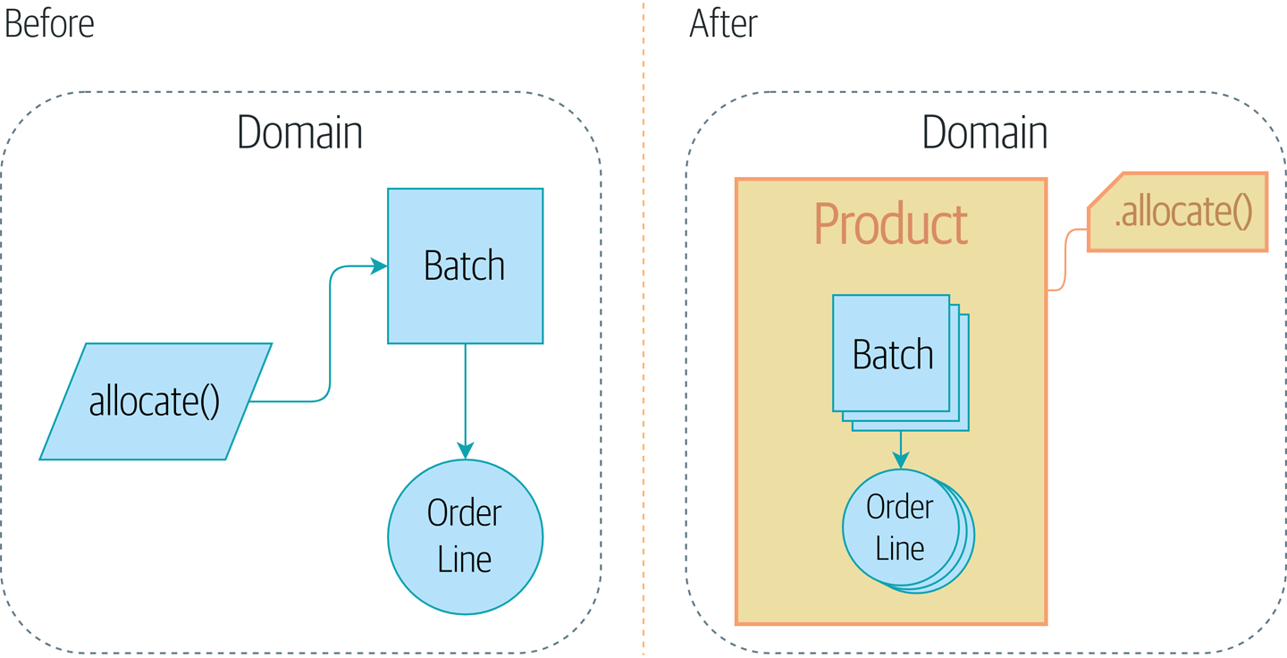
Figure 7-1. Adding the Product aggregate
Why? Let’s find out.

Tip
The code for this chapter is in the appendix_csvs branch on GitHub:
git clone https://github.com/cosmicpython/code.git
cd code
git checkout appendix_csvs
# or to code along, checkout the previous chapter:
git checkout chapter_06_uow

Why Not Just Run Everything in a Spreadsheet?
What’s the point of a domain model, anyway? What’s the fundamental problem we’re trying to address?
Couldn’t we just run everything in a spreadsheet? Many of our users would be delighted by that. Business users like spreadsheets because they’re simple, familiar, and yet enormously powerful.
In fact, an enormous number of business processes do operate by manually sending spreadsheets back and forth over email. This “CSV over SMTP” architecture has low initial complexity but tends not to scale very well because it’s difficult to apply logic and maintain consistency.
Who is allowed to view this particular field? Who’s allowed to update it? What happens when we try to order –350 chairs, or 10,000,000 tables? Can an employee have a negative salary?
These are the constraints of a system. Much of the domain logic we write exists to enforce these constraints in order to maintain the invariants of the system. The invariants are the things that have to be true whenever we finish an operation.

Invariants, Constraints, and Consistency
The two words are somewhat interchangeable, but a constraint is a rule that restricts the possible states our model can get into, while an invariant is defined a little more precisely as a condition that is always true.
If we were writing a hotel-booking system, we might have the constraint that double bookings are not allowed. This supports the invariant that a room cannot have more than one booking for the same night.
Of course, sometimes we might need to temporarily bend the rules. Perhaps we need to shuffle the rooms around because of a VIP booking. While we’re moving bookings around in memory, we might be double booked, but our domain model should ensure that, when we’re finished, we end up in a final consistent state, where the invariants are met. If we can’t find a way to accommodate all our guests, we should raise an error and refuse to complete the operation.
Let’s look at a couple of concrete examples from our business requirements; we’ll start with this one:
An order line can be allocated to only one batch at a time.
The business
This is a business rule that imposes an invariant. The invariant is that an order line is allocated to either zero or one batch, but never more than one. We need to make sure that our code never accidentally calls Batch.allocate() on two different batches for the same line, and currently, there’s nothing there to explicitly stop us from doing that.

Invariants, Concurrency, and Locks
Let’s look at another one of our business rules:
We can’t allocate to a batch if the available quantity is less than the quantity of the order line.
The business
Here the constraint is that we can’t allocate more stock than is available to a batch, so we never oversell stock by allocating two customers to the same physical cushion, for example. Every time we update the state of the system, our code needs to ensure that we don’t break the invariant, which is that the available quantity must be greater than or equal to zero.
In a single-threaded, single-user application, it’s relatively easy for us to maintain this invariant. We can just allocate stock one line at a time, and raise an error if there’s no stock available.
This gets much harder when we introduce the idea of concurrency. Suddenly we might be allocating stock for multiple order lines simultaneously. We might even be allocating order lines at the same time as processing changes to the batches themselves.
We usually solve this problem by applying locks to our database tables. This prevents two operations from happening simultaneously on the same row or same table.
As we start to think about scaling up our app, we realize that our model of allocating lines against all available batches may not scale. If we process tens of thousands of orders per hour, and hundreds of thousands of order lines, we can’t hold a lock over the whole batches table for every single one—we’ll get deadlocks or performance problems at the very least.

What Is an Aggregate?
OK, so if we can’t lock the whole database every time we want to allocate an order line, what should we do instead? We want to protect the invariants of our system but allow for the greatest degree of concurrency. Maintaining our invariants inevitably means preventing concurrent writes; if multiple users can allocate DEADLY-SPOON at the same time, we run the risk of overallocating.
On the other hand, there’s no reason we can’t allocate DEADLY-SPOON at the same time as FLIMSY-DESK. It’s safe to allocate two products at the same time because there’s no invariant that covers them both. We don’t need them to be consistent with each other.
The Aggregate pattern is a design pattern from the DDD community that helps us to resolve this tension. An aggregate is just a domain object that contains other domain objects and lets us treat the whole collection as a single unit.
The only way to modify the objects inside the aggregate is to load the whole thing, and to call methods on the aggregate itself.
As a model gets more complex and grows more entity and value objects, referencing each other in a tangled graph, it can be hard to keep track of who can modify what. Especially when we have collections in the model as we do (our batches are a collection), it’s a good idea to nominate some entities to be the single entrypoint for modifying their related objects. It makes the system conceptually simpler and easy to reason about if you nominate some objects to be in charge of consistency for the others.
For example, if we’re building a shopping site, the Cart might make a good aggregate: it’s a collection of items that we can treat as a single unit. Importantly, we want to load the entire basket as a single blob from our data store. We don’t want two requests to modify the basket at the same time, or we run the risk of weird concurrency errors. Instead, we want each change to the basket to run in a single database transaction.
We don’t want to modify multiple baskets in a transaction, because there’s no use case for changing the baskets of several customers at the same time. Each basket is a single consistency boundary responsible for maintaining its own invariants.
An AGGREGATE is a cluster of associated objects that we treat as a unit for the purpose of data changes.
Eric Evans, Domain-Driven Design blue book
Per Evans, our aggregate has a root entity (the Cart) that encapsulates access to items. Each item has its own identity, but other parts of the system will always refer to the Cart only as an indivisible whole.

Tip
Just as we sometimes use _leading_underscores to mark methods or functions as “private,” you can think of aggregates as being the “public” classes of our model, and the rest of the entities and value objects as “private.”

Choosing an Aggregate
What aggregate should we use for our system? The choice is somewhat arbitrary, but it’s important. The aggregate will be the boundary where we make sure every operation ends in a consistent state. This helps us to reason about our software and prevent weird race issues. We want to draw a boundary around a small number of objects—the smaller, the better, for performance—that have to be consistent with one another, and we need to give this boundary a good name.
The object we’re manipulating under the covers is Batch. What do we call a collection of batches? How should we divide all the batches in the system into discrete islands of consistency?
We could use Shipment as our boundary. Each shipment contains several batches, and they all travel to our warehouse at the same time. Or perhaps we could use Warehouse as our boundary: each warehouse contains many batches, and counting all the stock at the same time could make sense.
Neither of these concepts really satisfies us, though. We should be able to allocate DEADLY-SPOONs and FLIMSY-DESKs at the same time, even if they’re in the same warehouse or the same shipment. These concepts have the wrong granularity.
When we allocate an order line, we’re interested only in batches that have the same SKU as the order line. Some sort of concept like GlobalSkuStock could work: a collection of all the batches for a given SKU.
It’s an unwieldy name, though, so after some bikeshedding via SkuStock, Stock, ProductStock, and so on, we decided to simply call it Product—after all, that was the first concept we came across in our exploration of the domain language back in Chapter 1.
So the plan is this: when we want to allocate an order line, instead of Figure 7-2, where we look up all the Batch objects in the world and pass them to the allocate() domain service…
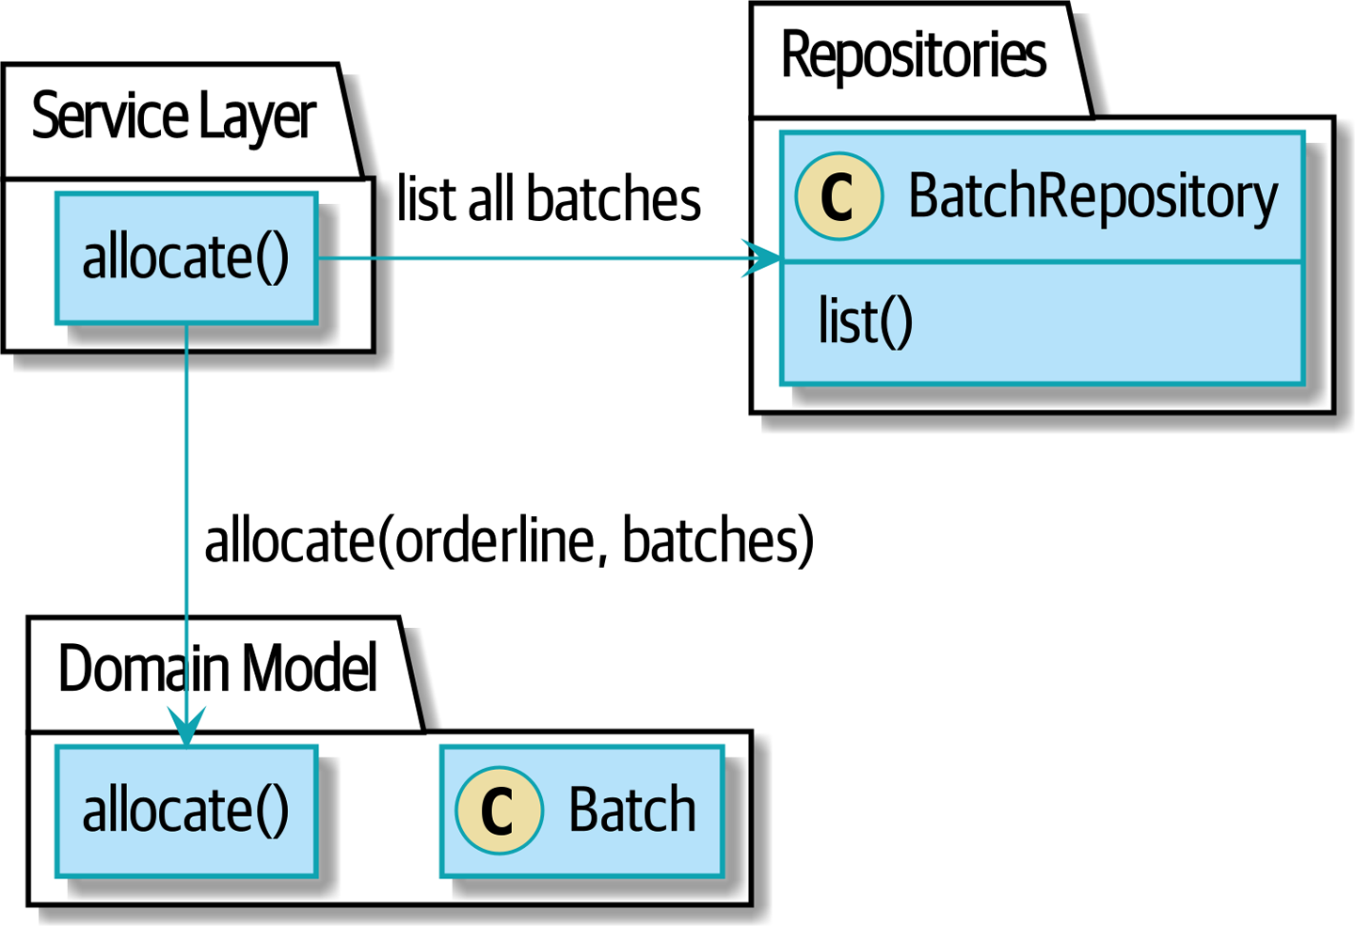
Figure 7-2. Before: allocate against all batches using the domain service

…we’ll move to the world of Figure 7-3, in which there is a new Product object for the particular SKU of our order line, and it will be in charge of all the batches for that SKU, and we can call a .allocate() method on that instead.
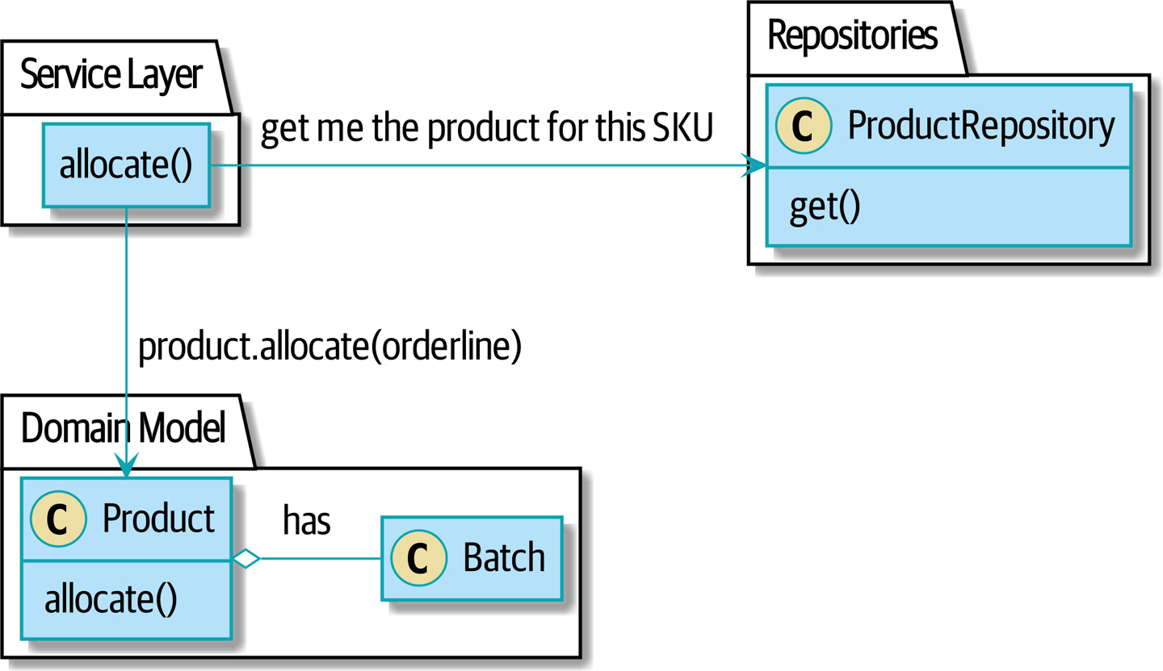
Figure 7-3. After: ask Product to allocate against its batches

Let’s see how that looks in code form:
Our chosen aggregate, Product (src/allocation/domain/model.py)
class
Product
:
def
__init__
(
self
,
sku
:
str
,
batches
:
List
[
Batch
]
)
:
self
.
sku
=
sku
self
.
batches
=
batches
def
allocate
(
self
,
line
:
OrderLine
)
-
>
str
:
try
:
batch
=
next
(
b
for
b
in
sorted
(
self
.
batches
)
if
b
.
can_allocate
(
line
)
)
batch
.
allocate
(
line
)
return
batch
.
reference
except
StopIteration
:
raise
OutOfStock
(
f
'
Out of stock for sku {line.sku}
'
)
Product’s main identifier is the sku.
Our Product class holds a reference to a collection of batches for that SKU.
Finally, we can move the allocate() domain service to be a method on the Product aggregate.

Note
This Product might not look like what you’d expect a Product model to look like. No price, no description, no dimensions. Our allocation service doesn’t care about any of those things. This is the power of bounded contexts; the concept of a product in one app can be very different from another. See the following sidebar for more discussion.

Aggregates, Bounded Contexts, and Microservices
One of the most important contributions from Evans and the DDD community is the concept of bounded contexts.
In essence, this was a reaction against attempts to capture entire businesses into a single model. The word customer means different things to people in sales, customer service, logistics, support, and so on. Attributes needed in one context are irrelevant in another; more perniciously, concepts with the same name can have entirely different meanings in different contexts. Rather than trying to build a single model (or class, or database) to capture all the use cases, it’s better to have several models, draw boundaries around each context, and handle the translation between different contexts explicitly.
This concept translates very well to the world of microservices, where each microservice is free to have its own concept of “customer” and its own rules for translating that to and from other microservices it integrates with.
In our example, the allocation service has Product(sku, batches), whereas the ecommerce will have Product(sku, description, price, image_url, dimensions, etc...). As a rule of thumb, your domain models should include only the data that they need for performing calculations.
Whether or not you have a microservices architecture, a key consideration in choosing your aggregates is also choosing the bounded context that they will operate in. By restricting the context, you can keep your number of aggregates low and their size manageable.
Once again, we find ourselves forced to say that we can’t give this issue the treatment it deserves here, and we can only encourage you to read up on it elsewhere. The Fowler link at the start of this sidebar is a good starting point, and either (or indeed, any) DDD book will have a chapter or more on bounded contexts.

One Aggregate = One Repository
Once you define certain entities to be aggregates, we need to apply the rule that they are the only entities that are publicly accessible to the outside world. In other words, the only repositories we are allowed should be repositories that return aggregates.

Note
The rule that repositories should only return aggregates is the main place where we enforce the convention that aggregates are the only way into our domain model. Be wary of breaking it!
In our case, we’ll switch from BatchRepository to ProductRepository:
Our new UoW and repository (unit_of_work.py and repository.py)
class
AbstractUnitOfWork
(
abc
.
ABC
):
products
:
repository
.
AbstractProductRepository
...
class
AbstractProductRepository
(
abc
.
ABC
):
@abc.abstractmethod
def
add
(
self
,
product
):
...
@abc.abstractmethod
def
get
(
self
,
sku
)
->
model
.
Product
:
...
The ORM layer will need some tweaks so that the right batches automatically get loaded and associated with Product objects. The nice thing is, the Repository pattern means we don’t have to worry about that yet. We can just use our FakeRepository and then feed through the new model into our service layer to see how it looks with Product as its main entrypoint:
Service layer (src/allocation/service_layer/services.py)
def
add_batch
(
ref
:
str
,
sku
:
str
,
qty
:
int
,
eta
:
Optional
[
date
],
uow
:
unit_of_work
.
AbstractUnitOfWork
):
with
uow
:
product
=
uow
.
products
.
get
(
sku
=
sku
)
if
product
is
None
:
product
=
model
.
Product
(
sku
,
batches
=
[])
uow
.
products
.
add
(
product
)
product
.
batches
.
append
(
model
.
Batch
(
ref
,
sku
,
qty
,
eta
))
uow
.
commit
()
def
allocate
(
orderid
:
str
,
sku
:
str
,
qty
:
int
,
uow
:
unit_of_work
.
AbstractUnitOfWork
)
->
str
:
line
=
OrderLine
(
orderid
,
sku
,
qty
)
with
uow
:
product
=
uow
.
products
.
get
(
sku
=
line
.
sku
)
if
product
is
None
:
raise
InvalidSku
(
f
'Invalid sku {line.sku}'
)
batchref
=
product
.
allocate
(
line
)
uow
.
commit
()
return
batchref

What About Performance?
We’ve mentioned a few times that we’re modeling with aggregates because we want to have high-performance software, but here we are loading all the batches when we only need one. You might expect that to be inefficient, but there are a few reasons why we’re comfortable here.
First, we’re purposefully modeling our data so that we can make a single query to the database to read, and a single update to persist our changes. This tends to perform much better than systems that issue lots of ad hoc queries. In systems that don’t model this way, we often find that transactions slowly get longer and more complex as the software evolves.
Second, our data structures are minimal and comprise a few strings and integers per row. We can easily load tens or even hundreds of batches in a few milliseconds.
Third, we expect to have only 20 or so batches of each product at a time. Once a batch is used up, we can discount it from our calculations. This means that the amount of data we’re fetching shouldn’t get out of control over time.
If we did expect to have thousands of active batches for a product, we’d have a couple of options. For one, we could use lazy-loading for the batches in a product. From the perspective of our code, nothing would change, but in the background, SQLAlchemy would page through data for us. This would lead to more requests, each fetching a smaller number of rows. Because we need to find only a single batch with enough capacity for our order, this might work pretty well.

Exercise for the Reader
You’ve just seen the main top layers of the code, so this shouldn’t be too hard, but we’d like you to implement the Product aggregate starting from Batch, just as we did.
Of course, you could cheat and copy/paste from the previous listings, but even if you do that, you’ll still have to solve a few challenges on your own, like adding the model to the ORM and making sure all the moving parts can talk to each other, which we hope will be instructive.
You’ll find the code on GitHub. We’ve put in a “cheating” implementation in the delegates to the existing allocate() function, so you should be able to evolve that toward the real thing.
We’ve marked a couple of tests with @pytest.skip(). After you’ve read the rest of this chapter, come back to these tests to have a go at implementing version numbers. Bonus points if you can get SQLAlchemy to do them for you by magic!
If all else failed, we’d just look for a different aggregate. Maybe we could split up batches by region or by warehouse. Maybe we could redesign our data access strategy around the shipment concept. The Aggregate pattern is designed to help manage some technical constraints around consistency and performance. There isn’t one correct aggregate, and we should feel comfortable changing our minds if we find our boundaries are causing performance woes.

Optimistic Concurrency with Version Numbers
We have our new aggregate, so we’ve solved the conceptual problem of choosing an object to be in charge of consistency boundaries. Let’s now spend a little time talking about how to enforce data integrity at the database level.

Note
This section has a lot of implementation details; for example, some of it is Postgres-specific. But more generally, we’re showing one way of managing concurrency issues, but it is just one approach. Real requirements in this area vary a lot from project to project. You shouldn’t expect to be able to copy and paste code from here into production.
We don’t want to hold a lock over the entire batches table, but how will we implement holding a lock over just the rows for a particular SKU?
One answer is to have a single attribute on the Product model that acts as a marker for the whole state change being complete and to use it as the single resource that concurrent workers can fight over. If two transactions read the state of the world for batches at the same time, and both want to update the allocations tables, we force both to also try to update the version_number in the products table, in such a way that only one of them can win and the world stays consistent.
Figure 7-4 illustrates two concurrent transactions doing their read operations at the same time, so they see a Product with, for example, version=3. They both call Product.allocate() in order to modify a state. But we set up our database integrity rules such that only one of them is allowed to commit the new Product with version=4, and the other update is rejected.

Tip
Version numbers are just one way to implement optimistic locking. You could achieve the same thing by setting the Postgres transaction isolation level to SERIALIZABLE, but that often comes at a severe performance cost. Version numbers also make implicit concepts explicit.
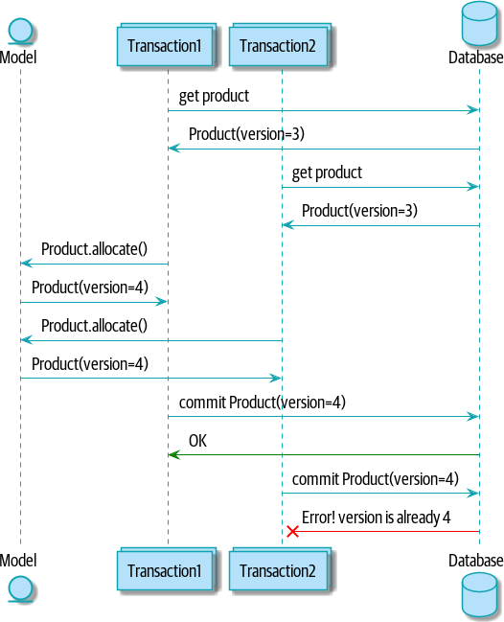
Figure 7-4. Sequence diagram: two transactions attempting a concurrent update on Product

Optimistic Concurrency Control and Retries
What we’ve implemented here is called optimistic concurrency control because our default assumption is that everything will be fine when two users want to make changes to the database. We think it’s unlikely that they will conflict with each other, so we let them go ahead and just make sure we have a way to notice if there is a problem.
Pessimistic concurrency control works under the assumption that two users are going to cause conflicts, and we want to prevent conflicts in all cases, so we lock everything just to be safe. In our example, that would mean locking the whole batches table, or using SELECT FOR UPDATE—we’re pretending that we’ve ruled those out for performance reasons, but in real life you’d want to do some evaluations and measurements of your own.
With pessimistic locking, you don’t need to think about handling failures because the database will prevent them for you (although you do need to think about deadlocks). With optimistic locking, you need to explicitly handle the possibility of failures in the (hopefully unlikely) case of a clash.
The usual way to handle a failure is to retry the failed operation from the beginning. Imagine we have two customers, Harry and Bob, and each submits an order for SHINY-TABLE. Both threads load the product at version 1 and allocate stock. The database prevents the concurrent update, and Bob’s order fails with an error. When we retry the operation, Bob’s order loads the product at version 2 and tries to allocate again. If there is enough stock left, all is well; otherwise, he’ll receive OutOfStock. Most operations can be retried this way in the case of a concurrency problem.
Read more on retries in “Recovering from Errors Synchronously” and “Footguns”.

Implementation Options for Version Numbers
There are essentially three options for implementing version numbers:
version_number lives in the domain; we add it to the Product constructor, and Product.allocate() is responsible for incrementing it.
The service layer could do it! The version number isn’t strictly a domain concern, so instead our service layer could assume that the current version number is attached to Product by the repository, and the service layer will increment it before it does the commit().
Since it’s arguably an infrastructure concern, the UoW and repository could do it by magic. The repository has access to version numbers for any products it retrieves, and when the UoW does a commit, it can increment the version number for any products it knows about, assuming them to have changed.
Option 3 isn’t ideal, because there’s no real way of doing it without having to assume that all products have changed, so we’ll be incrementing version numbers when we don’t have to.1
Option 2 involves mixing the responsibility for mutating state between the service layer and the domain layer, so it’s a little messy as well.
So in the end, even though version numbers don’t have to be a domain concern, you might decide the cleanest trade-off is to put them in the domain:
Our chosen aggregate, Product (src/allocation/domain/model.py)
class
Product
:
def
__init__
(
self
,
sku
:
str
,
batches
:
List
[
Batch
]
,
version_number
:
int
=
0
)
:
self
.
sku
=
sku
self
.
batches
=
batches
self
.
version_number
=
version_number
def
allocate
(
self
,
line
:
OrderLine
)
-
>
str
:
try
:
batch
=
next
(
b
for
b
in
sorted
(
self
.
batches
)
if
b
.
can_allocate
(
line
)
)
batch
.
allocate
(
line
)
self
.
version_number
+
=
1
return
batch
.
reference
except
StopIteration
:
raise
OutOfStock
(
f
'
Out of stock for sku {line.sku}
'
)
There it is!

Tip
If you’re scratching your head at this version number business, it might help to remember that the number isn’t important. What’s important is that the Product database row is modified whenever we make a change to the Product aggregate. The version number is a simple, human-comprehensible way to model a thing that changes on every write, but it could equally be a random UUID every time.

Testing for Our Data Integrity Rules
Now to make sure we can get the behavior we want: if we have two concurrent attempts to do allocation against the same Product, one of them should fail, because they can’t both update the version number.
First, let’s simulate a “slow” transaction using a function that does allocation and then does an explicit sleep:2
time.sleep can reproduce concurrency behavior (tests/integration/test_uow.py)
def
try_to_allocate
(
orderid
,
sku
,
exceptions
):
line
=
model
.
OrderLine
(
orderid
,
sku
,
10
)
try
:
with
unit_of_work
.
SqlAlchemyUnitOfWork
()
as
uow
:
product
=
uow
.
products
.
get
(
sku
=
sku
)
product
.
allocate
(
line
)
time
.
sleep
(
0.2
)
uow
.
commit
()
except
Exception
as
e
:
print
(
traceback
.
format_exc
())
exceptions
.
append
(
e
)
Then we have our test invoke this slow allocation twice, concurrently, using threads:
An integration test for concurrency behavior (tests/integration/test_uow.py)
def
test_concurrent_updates_to_version_are_not_allowed
(
postgres_session_factory
)
:
sku
,
batch
=
random_sku
(
)
,
random_batchref
(
)
session
=
postgres_session_factory
(
)
insert_batch
(
session
,
batch
,
sku
,
100
,
eta
=
None
,
product_version
=
1
)
session
.
commit
(
)
order1
,
order2
=
random_orderid
(
1
)
,
random_orderid
(
2
)
exceptions
=
[
]
# type: List[Exception]
try_to_allocate_order1
=
lambda
:
try_to_allocate
(
order1
,
sku
,
exceptions
)
try_to_allocate_order2
=
lambda
:
try_to_allocate
(
order2
,
sku
,
exceptions
)
thread1
=
threading
.
Thread
(
target
=
try_to_allocate_order1
)
thread2
=
threading
.
Thread
(
target
=
try_to_allocate_order2
)
thread1
.
start
(
)
thread2
.
start
(
)
thread1
.
join
(
)
thread2
.
join
(
)
[
[
version
]
]
=
session
.
execute
(
"
SELECT version_number FROM products WHERE sku=:sku
"
,
dict
(
sku
=
sku
)
,
)
assert
version
==
2
[
exception
]
=
exceptions
assert
'
could not serialize access due to concurrent update
'
in
str
(
exception
)
orders
=
list
(
session
.
execute
(
"
SELECT orderid FROM allocations
"
"
JOIN batches ON allocations.batch_id = batches.id
"
"
JOIN order_lines ON allocations.orderline_id = order_lines.id
"
"
WHERE order_lines.sku=:sku
"
,
dict
(
sku
=
sku
)
,
)
)
assert
len
(
orders
)
==
1
with
unit_of_work
.
SqlAlchemyUnitOfWork
(
)
as
uow
:
uow
.
session
.
execute
(
'
select 1
'
)
We start two threads that will reliably produce the concurrency behavior we want: read1, read2, write1, write2.
We assert that the version number has been incremented only once.
We can also check on the specific exception if we like.
And we double-check that only one allocation has gotten through.

Enforcing Concurrency Rules by Using Database Transaction Isolation Levels
To get the test to pass as it is, we can set the transaction isolation level on our session:
Set isolation level for session (src/allocation/service_layer/unit_of_work.py)
DEFAULT_SESSION_FACTORY
=
sessionmaker
(
bind
=
create_engine
(
config
.
get_postgres_uri
(),
isolation_level
=
"REPEATABLE READ"
,
))

Tip
Transaction isolation levels are tricky stuff, so it’s worth spending time understanding the Postgres documentation.3

Pessimistic Concurrency Control Example: SELECT FOR UPDATE
There are multiple ways to approach this, but we’ll show one. SELECT FOR UPDATE produces different behavior; two concurrent transactions will not be allowed to do a read on the same rows at the same time:
SELECT FOR UPDATE is a way of picking a row or rows to use as a lock (although those rows don’t have to be the ones you update). If two transactions both try to SELECT FOR UPDATE a row at the same time, one will win, and the other will wait until the lock is released. So this is an example of pessimistic concurrency control.
Here’s how you can use the SQLAlchemy DSL to specify FOR UPDATE at query time:
SQLAlchemy with_for_update (src/allocation/adapters/repository.py)
def
get
(
self
,
sku
):
return
self
.
session
.
query
(
model
.
Product
)
\
.
filter_by
(
sku
=
sku
)
\
.
with_for_update
()
\
.
first
()
This will have the effect of changing the concurrency pattern from
read1, read2, write1, write2(fail)
to
read1, write1, read2, write2(succeed)
Some people refer to this as the “read-modify-write” failure mode. Read “PostgreSQL Anti-Patterns: Read-Modify-Write Cycles” for a good overview.
We don’t really have time to discuss all the trade-offs between REPEATABLE READ and SELECT FOR UPDATE, or optimistic versus pessimistic locking in general. But if you have a test like the one we’ve shown, you can specify the behavior you want and see how it changes. You can also use the test as a basis for performing some performance experiments.

Wrap-Up
Specific choices around concurrency control vary a lot based on business circumstances and storage technology choices, but we’d like to bring this chapter back to the conceptual idea of an aggregate: we explicitly model an object as being the main entrypoint to some subset of our model, and as being in charge of enforcing the invariants and business rules that apply across all of those objects.
Choosing the right aggregate is key, and it’s a decision you may revisit over time. You can read more about it in multiple DDD books. We also recommend these three online papers on effective aggregate design by Vaughn Vernon (the “red book” author).
Table 7-1 has some thoughts on the trade-offs of implementing the Aggregate pattern.
Table 7-1. Aggregates: the trade-offs  Pros | Cons
Python might not have “official” public and private methods, but we do have the underscores convention, because it’s often useful to try to indicate what’s for “internal” use and what’s for “outside code” to use. Choosing aggregates is just the next level up: it lets you decide which of your domain model classes are the public ones, and which aren’t.  Modeling our operations around explicit consistency boundaries helps us avoid performance problems with our ORM.  Putting the aggregate in sole charge of state changes to its subsidiary models makes the system easier to reason about, and makes it easier to control invariants. | Yet another new concept for new developers to take on. Explaining entities versus value objects was already a mental load; now there’s a third type of domain model object?  Sticking rigidly to the rule that we modify only one aggregate at a time is a big mental shift.  Dealing with eventual consistency between aggregates can be complex.

Aggregates and Consistency Boundaries Recap
Aggregates are your entrypoints into the domain model
By restricting the number of ways that things can be changed, we make the system easier to reason about.
Aggregates are in charge of a consistency boundary
An aggregate’s job is to be able to manage our business rules about invariants as they apply to a group of related objects. It’s the aggregate’s job to check that the objects within its remit are consistent with each other and with our rules, and to reject changes that would break the rules.
Aggregates and concurrency issues go together
When thinking about implementing these consistency checks, we end up thinking about transactions and locks. Choosing the right aggregate is about performance as well as conceptual organization of your domain.

Part I Recap
Do you remember Figure 7-5, the diagram we showed at the beginning of Part I to preview where we were heading?
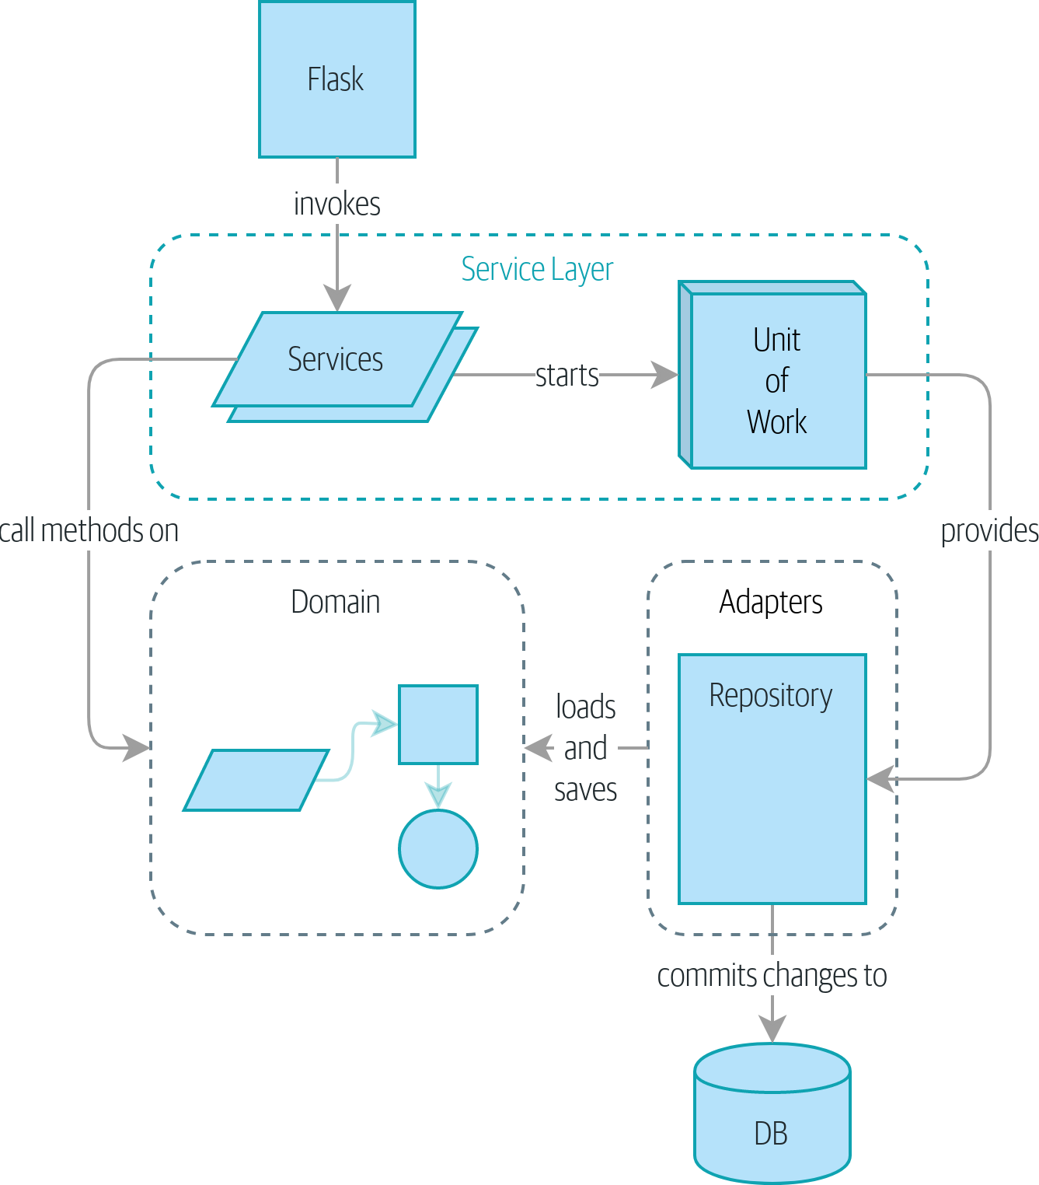
Figure 7-5. A component diagram for our app at the end of Part I
So that’s where we are at the end of Part I. What have we achieved? We’ve seen how to build a domain model that’s exercised by a set of high-level unit tests. Our tests are living documentation: they describe the behavior of our system—the rules upon which we agreed with our business stakeholders—in nice readable code. When our business requirements change, we have confidence that our tests will help us to prove the new functionality, and when new developers join the project, they can read our tests to understand how things work.
We’ve decoupled the infrastructural parts of our system, like the database and API handlers, so that we can plug them into the outside of our application. This helps us to keep our codebase well organized and stops us from building a big ball of mud.
By applying the dependency inversion principle, and by using ports-and-adapters-inspired patterns like Repository and Unit of Work, we’ve made it possible to do TDD in both high gear and low gear and to maintain a healthy test pyramid. We can test our system edge to edge, and the need for integration and end-to-end tests is kept to a minimum.
Lastly, we’ve talked about the idea of consistency boundaries. We don’t want to lock our entire system whenever we make a change, so we have to choose which parts are consistent with one another.
For a small system, this is everything you need to go and play with the ideas of domain-driven design. You now have the tools to build database-agnostic domain models that represent the shared language of your business experts. Hurrah!

Note
At the risk of laboring the point—we’ve been at pains to point out that each pattern comes at a cost. Each layer of indirection has a price in terms of complexity and duplication in our code and will be confusing to programmers who’ve never seen these patterns before. If your app is essentially a simple CRUD wrapper around a database and isn’t likely to be anything more than that in the foreseeable future, you don’t need these patterns. Go ahead and use Django, and save yourself a lot of bother.
In Part II, we’ll zoom out and talk about a bigger topic: if aggregates are our boundary, and we can update only one at a time, how do we model processes that cross consistency boundaries?
1 Perhaps we could get some ORM/SQLAlchemy magic to tell us when an object is dirty, but how would that work in the generic case—for example, for a CsvRepository?
2 time.sleep() works well in our use case, but it’s not the most reliable or efficient way to reproduce concurrency bugs. Consider using semaphores or similar synchronization primitives shared between your threads to get better guarantees of behavior.
3 If you’re not using Postgres, you’ll need to read different documentation. Annoyingly, different databases all have quite different definitions. Oracle’s SERIALIZABLE is equivalent to Postgres’s REPEATABLE READ, for example.

Part II. Event-Driven Architecture
I’m sorry that I long ago coined the term “objects” for this topic because it gets many people to focus on the lesser idea.
The big idea is “messaging."…The key in making great and growable systems is much more to design how its modules communicate rather than what their internal properties and behaviors should be.
Alan Kay
It’s all very well being able to write one domain model to manage a single bit of business process, but what happens when we need to write many models? In the real world, our applications sit within an organization and need to exchange information with other parts of the system. You may remember our context diagram shown in Figure II-1.
Faced with this requirement, many teams reach for microservices integrated via HTTP APIs. But if they’re not careful, they’ll end up producing the most chaotic mess of all: the distributed big ball of mud.
In Part II, we’ll show how the techniques from Part I can be extended to distributed systems. We’ll zoom out to look at how we can compose a system from many small components that interact through asynchronous message passing.
We’ll see how our Service Layer and Unit of Work patterns allow us to reconfigure our app to run as an asynchronous message processor, and how event-driven systems help us to decouple aggregates and applications from one another.
Figure II-1. But exactly how will all these systems talk to each other?
We’ll look at the following patterns and techniques:
Domain Events
Trigger workflows that cross consistency boundaries.
Message Bus
Provide a unified way of invoking use cases from any endpoint.
CQRS
Separating reads and writes avoids awkward compromises in an event-driven architecture and enables performance and scalability improvements.
Plus, we’ll add a dependency injection framework. This has nothing to do with event-driven architecture per se, but it tidies up an awful lot of loose ends.

Chapter 8. Events and the Message Bus
So far we’ve spent a lot of time and energy on a simple problem that we could easily have solved with Django. You might be asking if the increased testability and expressiveness are really worth all the effort.
In practice, though, we find that it’s not the obvious features that make a mess of our codebases: it’s the goop around the edge. It’s reporting, and permissions, and workflows that touch a zillion objects.
Our example will be a typical notification requirement: when we can’t allocate an order because we’re out of stock, we should alert the buying team. They’ll go and fix the problem by buying more stock, and all will be well.
For a first version, our product owner says we can just send the alert by email.
Let’s see how our architecture holds up when we need to plug in some of the mundane stuff that makes up so much of our systems.
We’ll start by doing the simplest, most expeditious thing, and talk about why it’s exactly this kind of decision that leads us to the Big Ball of Mud.
Then we’ll show how to use the Domain Events pattern to separate side effects from our use cases, and how to use a simple Message Bus pattern for triggering behavior based on those events. We’ll show a few options for creating those events and how to pass them to the message bus, and finally we’ll show how the Unit of Work pattern can be modified to connect the two together elegantly, as previewed in Figure 8-1.
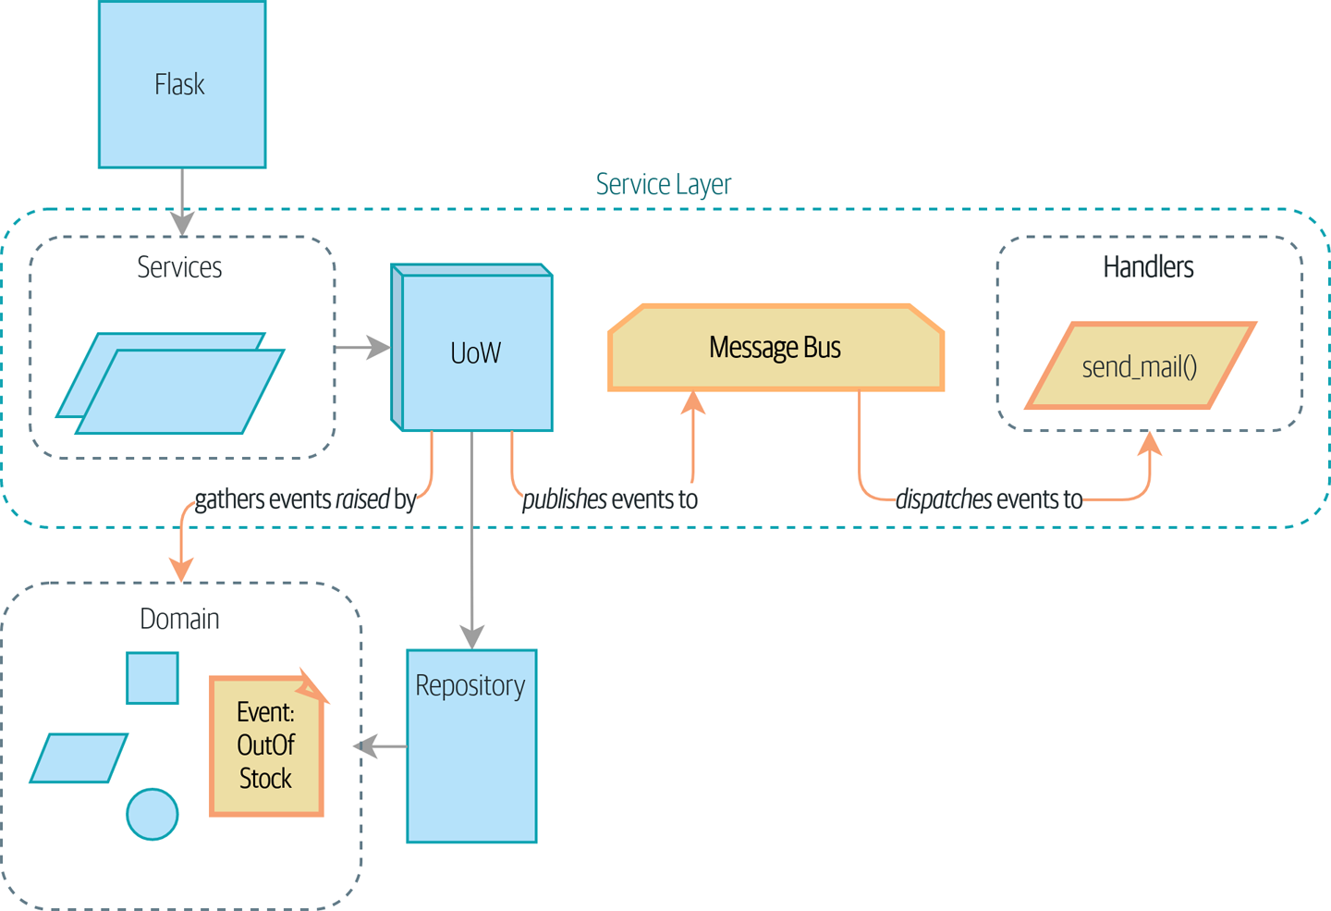
Figure 8-1. Events flowing through the system

Tip
The code for this chapter is in the chapter_08_events_and_message_bus branch on GitHub:
git clone https://github.com/cosmicpython/code.git
cd code
git checkout chapter_08_events_and_message_bus
# or to code along, checkout the previous chapter:
git checkout chapter_07_aggregate

Avoiding Making a Mess
So. Email alerts when we run out of stock. When we have new requirements like ones that really have nothing to do with the core domain, it’s all too easy to start dumping these things into our web controllers.

First, Let’s Avoid Making a Mess of Our Web Controllers
As a one-off hack, this might be OK:
Just whack it in the endpoint—what could go wrong? (src/allocation/entrypoints/flask_app.py)
@app.route
(
"/allocate"
,
methods
=
[
'POST'
])
def
allocate_endpoint
():
line
=
model
.
OrderLine
(
request
.
json
[
'orderid'
],
request
.
json
[
'sku'
],
request
.
json
[
'qty'
],
)
try
:
uow
=
unit_of_work
.
SqlAlchemyUnitOfWork
()
batchref
=
services
.
allocate
(
line
,
uow
)
except
(
model
.
OutOfStock
,
services
.
InvalidSku
)
as
e
:
send_mail
(
'out of stock'
,
'stock_admin@made.com'
,
f
'{line.orderid} - {line.sku}'
)
return
jsonify
({
'message'
:
str
(
e
)}),
400
return
jsonify
({
'batchref'
:
batchref
}),
201
…but it’s easy to see how we can quickly end up in a mess by patching things up like this. Sending email isn’t the job of our HTTP layer, and we’d like to be able to unit test this new feature.

And Let’s Not Make a Mess of Our Model Either
Assuming we don’t want to put this code into our web controllers, because we want them to be as thin as possible, we may look at putting it right at the source, in the model:
Email-sending code in our model isn’t lovely either (src/allocation/domain/model.py)
def
allocate
(
self
,
line
:
OrderLine
)
->
str
:
try
:
batch
=
next
(
b
for
b
in
sorted
(
self
.
batches
)
if
b
.
can_allocate
(
line
)
)
#...
except
StopIteration
:
email
.
send_mail
(
'stock@made.com'
,
f
'Out of stock for {line.sku}'
)
raise
OutOfStock
(
f
'Out of stock for sku {line.sku}'
)
But that’s even worse! We don’t want our model to have any dependencies on infrastructure concerns like email.send_mail.
This email-sending thing is unwelcome goop messing up the nice clean flow of our system. What we’d like is to keep our domain model focused on the rule “You can’t allocate more stuff than is actually available.”
The domain model’s job is to know that we’re out of stock, but the responsibility of sending an alert belongs elsewhere. We should be able to turn this feature on or off, or to switch to SMS notifications instead, without needing to change the rules of our domain model.

Or the Service Layer!
The requirement “Try to allocate some stock, and send an email if it fails” is an example of workflow orchestration: it’s a set of steps that the system has to follow to achieve a goal.
We’ve written a service layer to manage orchestration for us, but even here the feature feels out of place:
And in the service layer, it’s out of place (src/allocation/service_layer/services.py)
def
allocate
(
orderid
:
str
,
sku
:
str
,
qty
:
int
,
uow
:
unit_of_work
.
AbstractUnitOfWork
)
->
str
:
line
=
OrderLine
(
orderid
,
sku
,
qty
)
with
uow
:
product
=
uow
.
products
.
get
(
sku
=
line
.
sku
)
if
product
is
None
:
raise
InvalidSku
(
f
'Invalid sku {line.sku}'
)
try
:
batchref
=
product
.
allocate
(
line
)
uow
.
commit
()
return
batchref
except
model
.
OutOfStock
:
email
.
send_mail
(
'stock@made.com'
,
f
'Out of stock for {line.sku}'
)
raise
Catching an exception and reraising it? It could be worse, but it’s definitely making us unhappy. Why is it so hard to find a suitable home for this code?

Single Responsibility Principle
Really, this is a violation of the single responsibility principle (SRP).1 Our use case is allocation. Our endpoint, service function, and domain methods are all called allocate, not allocate_and_send_mail_if_out_of_stock.

Tip
Rule of thumb: if you can’t describe what your function does without using words like “then” or “and,” you might be violating the SRP.
One formulation of the SRP is that each class should have only a single reason to change. When we switch from email to SMS, we shouldn’t have to update our allocate() function, because that’s clearly a separate responsibility.
To solve the problem, we’re going to split the orchestration into separate steps so that the different concerns don’t get tangled up.2 The domain model’s job is to know that we’re out of stock, but the responsibility of sending an alert belongs elsewhere. We should be able to turn this feature on or off, or to switch to SMS notifications instead, without needing to change the rules of our domain model.
We’d also like to keep the service layer free of implementation details. We want to apply the dependency inversion principle to notifications so that our service layer depends on an abstraction, in the same way as we avoid depending on the database by using a unit of work.

All Aboard the Message Bus!
The patterns we’re going to introduce here are Domain Events and the Message Bus. We can implement them in a few ways, so we’ll show a couple before settling on the one we like most.

The Model Records Events
First, rather than being concerned about emails, our model will be in charge of recording events—facts about things that have happened. We’ll use a message bus to respond to events and invoke a new operation.

Events Are Simple Dataclasses
An event is a kind of value object. Events don’t have any behavior, because they’re pure data structures. We always name events in the language of the domain, and we think of them as part of our domain model.
We could store them in model.py, but we may as well keep them in their own file (this might be a good time to consider refactoring out a directory called domain so that we have domain/model.py and domain/events.py):
Event classes (src/allocation/domain/events.py)
from
dataclasses
import
dataclass
class
Event
:
pass
@dataclass
class
OutOfStock
(
Event
)
:
sku
:
str
Once we have a number of events, we’ll find it useful to have a parent class that can store common attributes. It’s also useful for type hints in our message bus, as you’ll see shortly.
dataclasses are great for domain events too.

The Model Raises Events
When our domain model records a fact that happened, we say it raises an event.
Here’s what it will look like from the outside; if we ask Product to allocate but it can’t, it should raise an event:
Test our aggregate to raise events (tests/unit/test_product.py)
def
test_records_out_of_stock_event_if_cannot_allocate
(
)
:
batch
=
Batch
(
'
batch1
'
,
'
SMALL-FORK
'
,
10
,
eta
=
today
)
product
=
Product
(
sku
=
"
SMALL-FORK
"
,
batches
=
[
batch
]
)
product
.
allocate
(
OrderLine
(
'
order1
'
,
'
SMALL-FORK
'
,
10
)
)
allocation
=
product
.
allocate
(
OrderLine
(
'
order2
'
,
'
SMALL-FORK
'
,
1
)
)
assert
product
.
events
[
-
1
]
==
events
.
OutOfStock
(
sku
=
"
SMALL-FORK
"
)
assert
allocation
is
None
Our aggregate will expose a new attribute called .events that will contain a list of facts about what has happened, in the form of Event objects.
Here’s what the model looks like on the inside:
The model raises a domain event (src/allocation/domain/model.py)
class
Product
:
def
__init__
(
self
,
sku
:
str
,
batches
:
List
[
Batch
]
,
version_number
:
int
=
0
)
:
self
.
sku
=
sku
self
.
batches
=
batches
self
.
version_number
=
version_number
self
.
events
=
[
]
# type: List[events.Event]
def
allocate
(
self
,
line
:
OrderLine
)
-
>
str
:
try
:
#...
except
StopIteration
:
self
.
events
.
append
(
events
.
OutOfStock
(
line
.
sku
)
)
# raise OutOfStock(f'Out of stock for sku {line.sku}')
return
None
Here’s our new .events attribute in use.
Rather than invoking some email-sending code directly, we record those events at the place they occur, using only the language of the domain.
We’re also going to stop raising an exception for the out-of-stock case. The event will do the job the exception was doing.

Note
We’re actually addressing a code smell we had until now, which is that we were using exceptions for control flow. In general, if you’re implementing domain events, don’t raise exceptions to describe the same domain concept. As you’ll see later when we handle events in the Unit of Work pattern, it’s confusing to have to reason about events and exceptions together.

The Message Bus Maps Events to Handlers
A message bus basically says, “When I see this event, I should invoke the following handler function.” In other words, it’s a simple publish-subscribe system. Handlers are subscribed to receive events, which we publish to the bus. It sounds harder than it is, and we usually implement it with a dict:
Simple message bus (src/allocation/service_layer/messagebus.py)
def
handle
(
event
:
events
.
Event
):
for
handler
in
HANDLERS
[
type
(
event
)]:
handler
(
event
)
def
send_out_of_stock_notification
(
event
:
events
.
OutOfStock
):
email
.
send_mail
(
'stock@made.com'
,
f
'Out of stock for {event.sku}'
,
)
HANDLERS
=
{
events
.
OutOfStock
:
[
send_out_of_stock_notification
],
}
# type: Dict[Type[events.Event], List[Callable]]

Note
Note that the message bus as implemented doesn’t give us concurrency because only one handler will run at a time. Our objective isn’t to support parallel threads but to separate tasks conceptually, and to keep each UoW as small as possible. This helps us to understand the codebase because the “recipe” for how to run each use case is written in a single place. See the following sidebar.

Is This Like Celery?
Celery is a popular tool in the Python world for deferring self-contained chunks of work to an asynchronous task queue. The message bus we’re presenting here is very different, so the short answer to the above question is no; our message bus has more in common with a Node.js app, a UI event loop, or an actor framework.
If you do have a requirement for moving work off the main thread, you can still use our event-based metaphors, but we suggest you use external events for that. There’s more discussion in Table 11-1, but essentially, if you implement a way of persisting events to a centralized store, you can subscribe other containers or other microservices to them. Then that same concept of using events to separate responsibilities across units of work within a single process/service can be extended across multiple processes—which may be different containers within the same service, or totally different microservices.
If you follow us in this approach, your API for distributing tasks is your event classes—or a JSON representation of them. This allows you a lot of flexibility in who you distribute tasks to; they need not necessarily be Python services. Celery’s API for distributing tasks is essentially “function name plus arguments,” which is more restrictive, and Python-only.

Option 1: The Service Layer Takes Events from the Model and Puts Them on the Message Bus
Our domain model raises events, and our message bus will call the right handlers whenever an event happens. Now all we need is to connect the two. We need something to catch events from the model and pass them to the message bus—the publishing step.
The simplest way to do this is by adding some code into our service layer:
The service layer with an explicit message bus (src/allocation/service_layer/services.py)
from
.
import
messagebus
.
.
.
def
allocate
(
orderid
:
str
,
sku
:
str
,
qty
:
int
,
uow
:
unit_of_work
.
AbstractUnitOfWork
)
-
>
str
:
line
=
OrderLine
(
orderid
,
sku
,
qty
)
with
uow
:
product
=
uow
.
products
.
get
(
sku
=
line
.
sku
)
if
product
is
None
:
raise
InvalidSku
(
f
'
Invalid sku {line.sku}
'
)
try
:
batchref
=
product
.
allocate
(
line
)
uow
.
commit
(
)
return
batchref
finally
:
messagebus
.
handle
(
product
.
events
)
We keep the try/finally from our ugly earlier implementation (we haven’t gotten rid of all exceptions yet, just OutOfStock).
But now, instead of depending directly on an email infrastructure, the service layer is just in charge of passing events from the model up to the message bus.
That already avoids some of the ugliness that we had in our naive implementation, and we have several systems that work like this one, in which the service layer explicitly collects events from aggregates and passes them to the message bus.

Option 2: The Service Layer Raises Its Own Events
Another variant on this that we’ve used is to have the service layer in charge of creating and raising events directly, rather than having them raised by the domain model:
Service layer calls messagebus.handle directly (src/allocation/service_layer/services.py)
def
allocate
(
orderid
:
str
,
sku
:
str
,
qty
:
int
,
uow
:
unit_of_work
.
AbstractUnitOfWork
)
-
>
str
:
line
=
OrderLine
(
orderid
,
sku
,
qty
)
with
uow
:
product
=
uow
.
products
.
get
(
sku
=
line
.
sku
)
if
product
is
None
:
raise
InvalidSku
(
f
'
Invalid sku {line.sku}
'
)
batchref
=
product
.
allocate
(
line
)
uow
.
commit
(
)
if
batchref
is
None
:
messagebus
.
handle
(
events
.
OutOfStock
(
line
.
sku
)
)
return
batchref
As before, we commit even if we fail to allocate because the code is simpler this way and it’s easier to reason about: we always commit unless something goes wrong. Committing when we haven’t changed anything is safe and keeps the code uncluttered.
Again, we have applications in production that implement the pattern in this way. What works for you will depend on the particular trade-offs you face, but we’d like to show you what we think is the most elegant solution, in which we put the unit of work in charge of collecting and raising events.

Option 3: The UoW Publishes Events to the Message Bus
The UoW already has a try/finally, and it knows about all the aggregates currently in play because it provides access to the repository. So it’s a good place to spot events and pass them to the message bus:
The UoW meets the message bus (src/allocation/service_layer/unit_of_work.py)
class
AbstractUnitOfWork
(
abc
.
ABC
)
:
.
.
.
def
commit
(
self
)
:
self
.
_commit
(
)
self
.
publish_events
(
)
def
publish_events
(
self
)
:
for
product
in
self
.
products
.
seen
:
while
product
.
events
:
event
=
product
.
events
.
pop
(
0
)
messagebus
.
handle
(
event
)
@abc.abstractmethod
def
_commit
(
self
)
:
raise
NotImplementedError
.
.
.
class
SqlAlchemyUnitOfWork
(
AbstractUnitOfWork
)
:
.
.
.
def
_commit
(
self
)
:
self
.
session
.
commit
(
)
We’ll change our commit method to require a private ._commit() method from subclasses.
After committing, we run through all the objects that our repository has seen and pass their events to the message bus.
That relies on the repository keeping track of aggregates that have been loaded using a new attribute, .seen, as you’ll see in the next listing.

Note
Are you wondering what happens if one of the handlers fails? We’ll discuss error handling in detail in Chapter 10.
Repository tracks aggregates that pass through it (src/allocation/adapters/repository.py)
class
AbstractRepository
(
abc
.
ABC
)
:
def
__init__
(
self
)
:
self
.
seen
=
set
(
)
# type: Set[model.Product]
def
add
(
self
,
product
:
model
.
Product
)
:
self
.
_add
(
product
)
self
.
seen
.
add
(
product
)
def
get
(
self
,
sku
)
-
>
model
.
Product
:
product
=
self
.
_get
(
sku
)
if
product
:
self
.
seen
.
add
(
product
)
return
product
@abc.abstractmethod
def
_add
(
self
,
product
:
model
.
Product
)
:
raise
NotImplementedError
@abc.abstractmethod
def
_get
(
self
,
sku
)
-
>
model
.
Product
:
raise
NotImplementedError
class
SqlAlchemyRepository
(
AbstractRepository
)
:
def
__init__
(
self
,
session
)
:
super
(
)
.
__init__
(
)
self
.
session
=
session
def
_add
(
self
,
product
)
:
self
.
session
.
add
(
product
)
def
_get
(
self
,
sku
)
:
return
self
.
session
.
query
(
model
.
Product
)
.
filter_by
(
sku
=
sku
)
.
first
(
)
For the UoW to be able to publish new events, it needs to be able to ask the repository for which Product objects have been used during this session. We use a set called .seen to store them. That means our implementations need to call super().__init__().
The parent add() method adds things to .seen, and now requires subclasses to implement ._add().
Similarly, .get() delegates to a ._get() function, to be implemented by subclasses, in order to capture objects seen.

Note
The use of ._underscorey() methods and subclassing is definitely not the only way you could implement these patterns. Have a go at the Exercise for the Reader in this chapter and experiment with some alternatives.
After the UoW and repository collaborate in this way to automatically keep track of live objects and process their events, the service layer can be totally free of event-handling concerns:
Service layer is clean again (src/allocation/service_layer/services.py)
def
allocate
(
orderid
:
str
,
sku
:
str
,
qty
:
int
,
uow
:
unit_of_work
.
AbstractUnitOfWork
)
->
str
:
line
=
OrderLine
(
orderid
,
sku
,
qty
)
with
uow
:
product
=
uow
.
products
.
get
(
sku
=
line
.
sku
)
if
product
is
None
:
raise
InvalidSku
(
f
'Invalid sku {line.sku}'
)
batchref
=
product
.
allocate
(
line
)
uow
.
commit
()
return
batchref
We do also have to remember to change the fakes in the service layer and make them call super() in the right places, and to implement underscorey methods, but the changes are minimal:
Service-layer fakes need tweaking (tests/unit/test_services.py)
class
FakeRepository
(
repository
.
AbstractRepository
):
def
__init__
(
self
,
products
):
super
()
.
__init__
()
self
.
_products
=
set
(
products
)
def
_add
(
self
,
product
):
self
.
_products
.
add
(
product
)
def
_get
(
self
,
sku
):
return
next
((
p
for
p
in
self
.
_products
if
p
.
sku
==
sku
),
None
)
...
class
FakeUnitOfWork
(
unit_of_work
.
AbstractUnitOfWork
):
...
def
_commit
(
self
):
self
.
committed
=
True

Exercise for the Reader
Are you finding all those ._add() and ._commit() methods “super-gross,” in the words of our beloved tech reviewer Hynek? Does it “make you want to beat Harry around the head with a plushie snake”? Hey, our code listings are only meant to be examples, not the perfect solution! Why not go see if you can do better?
One composition over inheritance way to go would be to implement a wrapper class:
A wrapper adds functionality and then delegates (src/adapters/repository.py)
class
TrackingRepository
:
seen
:
Set
[
model
.
Product
]
def
__init__
(
self
,
repo
:
AbstractRepository
)
:
self
.
seen
=
set
(
)
# type: Set[model.Product]
self
.
_repo
=
repo
def
add
(
self
,
product
:
model
.
Product
)
:
self
.
_repo
.
add
(
product
)
self
.
seen
.
add
(
product
)
def
get
(
self
,
sku
)
-
>
model
.
Product
:
product
=
self
.
_repo
.
get
(
sku
)
if
product
:
self
.
seen
.
add
(
product
)
return
product
By wrapping the repository, we can call the actual .add() and .get() methods, avoiding weird underscorey methods.
See if you can apply a similar pattern to our UoW class in order to get rid of those Java-y _commit() methods too. You can find the code on GitHub.
Switching all the ABCs to typing.Protocol is a good way to force yourself to avoid using inheritance. Let us know if you come up with something nice!
You might be starting to worry that maintaining these fakes is going to be a maintenance burden. There’s no doubt that it is work, but in our experience it’s not a lot of work. Once your project is up and running, the interface for your repository and UoW abstractions really don’t change much. And if you’re using ABCs, they’ll help remind you when things get out of sync.

Wrap-Up
Domain events give us a way to handle workflows in our system. We often find, listening to our domain experts, that they express requirements in a causal or temporal way—for example, “When we try to allocate stock but there’s none available, then we should send an email to the buying team.”
The magic words “When X, then Y” often tell us about an event that we can make concrete in our system. Treating events as first-class things in our model helps us make our code more testable and observable, and it helps isolate concerns.
And Table 8-1 shows the trade-offs as we see them.
Table 8-1. Domain events: the trade-offs  Pros | Cons
A message bus gives us a nice way to separate responsibilities when we have to take multiple actions in response to a request.  Event handlers are nicely decoupled from the “core” application logic, making it easy to change their implementation later.  Domain events are a great way to model the real world, and we can use them as part of our business language when modeling with stakeholders. | The message bus is an additional thing to wrap your head around; the implementation in which the unit of work raises events for us is neat but also magic. It’s not obvious when we call commit that we’re also going to go and send email to people.  What’s more, that hidden event-handling code executes synchronously, meaning your service-layer function doesn’t finish until all the handlers for any events are finished. That could cause unexpected performance problems in your web endpoints (adding asynchronous processing is possible but makes things even more confusing).  More generally, event-driven workflows can be confusing because after things are split across a chain of multiple handlers, there is no single place in the system where you can understand how a request will be fulfilled.  You also open yourself up to the possibility of circular dependencies between your event handlers, and infinite loops.
Events are useful for more than just sending email, though. In Chapter 7 we spent a lot of time convincing you that you should define aggregates, or boundaries where we guarantee consistency. People often ask, “What should I do if I need to change multiple aggregates as part of a request?” Now we have the tools we need to answer that question.
If we have two things that can be transactionally isolated (e.g., an order and a product), then we can make them eventually consistent by using events. When an order is canceled, we should find the products that were allocated to it and remove the allocations.

Domain Events and the Message Bus Recap
Events can help with the single responsibility principle
Code gets tangled up when we mix multiple concerns in one place. Events can help us to keep things tidy by separating primary use cases from secondary ones. We also use events for communicating between aggregates so that we don’t need to run long-running transactions that lock against multiple tables.
A message bus routes messages to handlers
You can think of a message bus as a dict that maps from events to their consumers. It doesn’t “know” anything about the meaning of events; it’s just a piece of dumb infrastructure for getting messages around the system.
Option 1: Service layer raises events and passes them to message bus
The simplest way to start using events in your system is to raise them from handlers by calling bus.handle(some_new_event) after you commit your unit of work.
Option 2: Domain model raises events, service layer passes them to message bus
The logic about when to raise an event really should live with the model, so we can improve our system’s design and testability by raising events from the domain model. It’s easy for our handlers to collect events off the model objects after commit and pass them to the bus.
Option 3: UoW collects events from aggregates and passes them to message bus
Adding bus.handle(aggregate.events) to every handler is annoying, so we can tidy up by making our unit of work responsible for raising events that were raised by loaded objects. This is the most complex design and might rely on ORM magic, but it’s clean and easy to use once it’s set up.
In Chapter 9, we’ll look at this idea in more detail as we build a more complex workflow with our new message bus.
1 This principle is the S in SOLID.
2 Our tech reviewer Ed Jung likes to say that the move from imperative to event-based flow control changes what used to be orchestration into choreography.

Chapter 9. Going to Town on the Message Bus
In this chapter, we’ll start to make events more fundamental to the internal structure of our application. We’ll move from the current state in Figure 9-1, where events are an optional side effect…
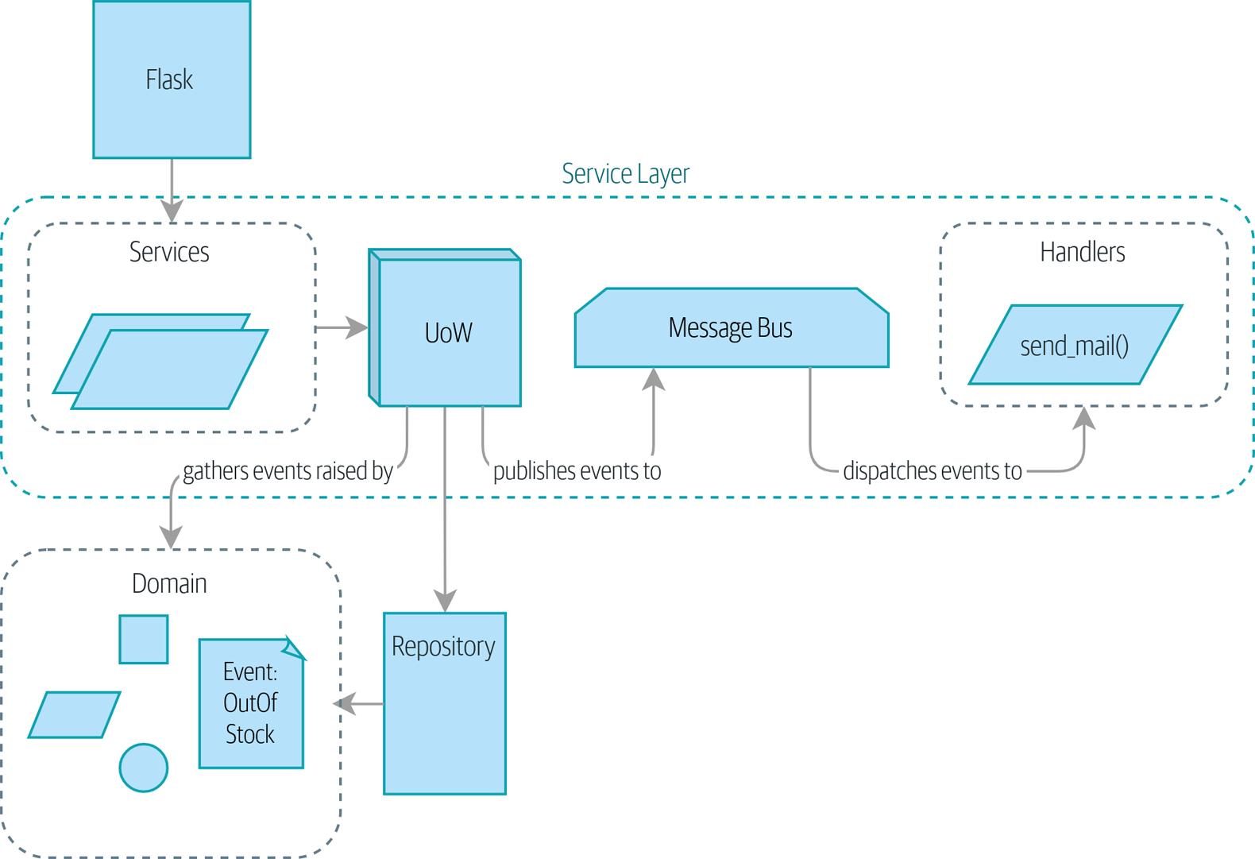
Figure 9-1. Before: the message bus is an optional add-on
…to the situation in Figure 9-2, where everything goes via the message bus, and our app has been transformed fundamentally into a message processor.
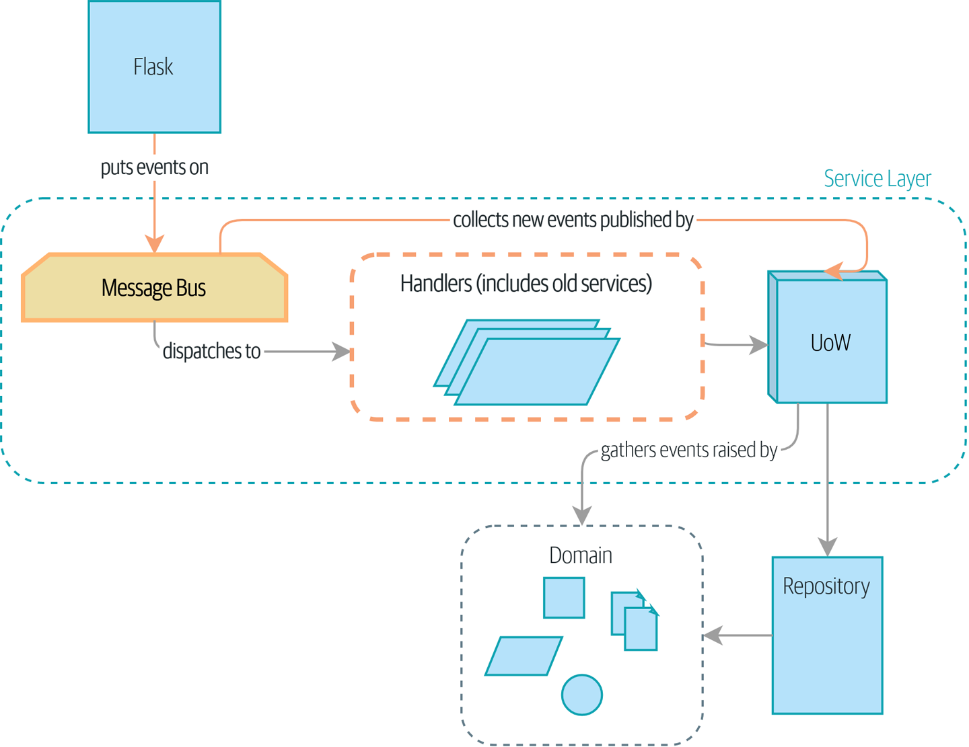
Figure 9-2. The message bus is now the main entrypoint to the service layer

Tip
The code for this chapter is in the chapter_09_all_messagebus branch on GitHub:
git clone https://github.com/cosmicpython/code.git
cd code
git checkout chapter_09_all_messagebus
# or to code along, checkout the previous chapter:
git checkout chapter_08_events_and_message_bus

A New Requirement Leads Us to a New Architecture
Rich Hickey talks about situated software, meaning software that runs for extended periods of time, managing a real-world process. Examples include warehouse-management systems, logistics schedulers, and payroll systems.
This software is tricky to write because unexpected things happen all the time in the real world of physical objects and unreliable humans. For example:
During a stock-take, we discover that three SPRINGY-MATTRESSes have been water damaged by a leaky roof.
A consignment of RELIABLE-FORKs is missing the required documentation and is held in customs for several weeks. Three RELIABLE-FORKs subsequently fail safety testing and are destroyed.
A global shortage of sequins means we’re unable to manufacture our next batch of SPARKLY-BOOKCASE.
In these types of situations, we learn about the need to change batch quantities when they’re already in the system. Perhaps someone made a mistake on the number in the manifest, or perhaps some sofas fell off a truck. Following a conversation with the business,1 we model the situation as in Figure 9-3.
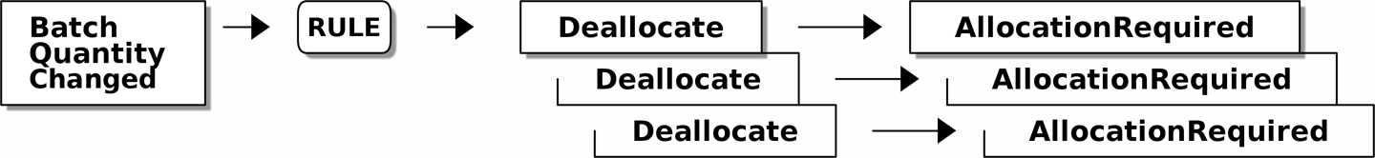
Figure 9-3. Batch quantity changed means deallocate and reallocate

An event we’ll call BatchQuantityChanged should lead us to change the quantity on the batch, yes, but also to apply a business rule: if the new quantity drops to less than the total already allocated, we need to deallocate those orders from that batch. Then each one will require a new allocation, which we can capture as an event called AllocationRequired.
Perhaps you’re already anticipating that our internal message bus and events can help implement this requirement. We could define a service called change_batch_quantity that knows how to adjust batch quantities and also how to deallocate any excess order lines, and then each deallocation can emit an AllocationRequired event that can be forwarded to the existing allocate service, in separate transactions. Once again, our message bus helps us to enforce the single responsibility principle, and it allows us to make choices about transactions and data integrity.

Imagining an Architecture Change: Everything Will Be an Event Handler
But before we jump in, think about where we’re headed. There are two kinds of flows through our system:
API calls that are handled by a service-layer function
Internal events (which might be raised as a side effect of a service-layer function) and their handlers (which in turn call service-layer functions)
Wouldn’t it be easier if everything was an event handler? If we rethink our API calls as capturing events, the service-layer functions can be event handlers too, and we no longer need to make a distinction between internal and external event handlers:
services.allocate() could be the handler for an AllocationRequired event and could emit Allocated events as its output.
services.add_batch() could be the handler for a BatchCreated event.2
Our new requirement will fit the same pattern:
An event called BatchQuantityChanged can invoke a handler called change_batch_quantity().
And the new AllocationRequired events that it may raise can be passed on to services.allocate() too, so there is no conceptual difference between a brand-new allocation coming from the API and a reallocation that’s internally triggered by a deallocation.
All sound like a bit much? Let’s work toward it all gradually. We’ll follow the Preparatory Refactoring workflow, aka “Make the change easy; then make the easy change”:
We refactor our service layer into event handlers. We can get used to the idea of events being the way we describe inputs to the system. In particular, the existing services.allocate() function will become the handler for an event called AllocationRequired.
We build an end-to-end test that puts BatchQuantityChanged events into the system and looks for Allocated events coming out.
Our implementation will conceptually be very simple: a new handler for BatchQuantityChanged events, whose implementation will emit AllocationRequired events, which in turn will be handled by the exact same handler for allocations that the API uses.
Along the way, we’ll make a small tweak to the message bus and UoW, moving the responsibility for putting new events on the message bus into the message bus itself.

Refactoring Service Functions to Message Handlers
We start by defining the two events that capture our current API inputs—AllocationRequired and BatchCreated:
BatchCreated and AllocationRequired events (src/allocation/domain/events.py)
@dataclass
class
BatchCreated
(
Event
):
ref
:
str
sku
:
str
qty
:
int
eta
:
Optional
[
date
]
=
None
...
@dataclass
class
AllocationRequired
(
Event
):
orderid
:
str
sku
:
str
qty
:
int
Then we rename services.py to handlers.py; we add the existing message handler for send_out_of_stock_notification; and most importantly, we change all the handlers so that they have the same inputs, an event and a UoW:
Handlers and services are the same thing (src/allocation/service_layer/handlers.py)
def
add_batch
(
event
:
events
.
BatchCreated
,
uow
:
unit_of_work
.
AbstractUnitOfWork
):
with
uow
:
product
=
uow
.
products
.
get
(
sku
=
event
.
sku
)
...
def
allocate
(
event
:
events
.
AllocationRequired
,
uow
:
unit_of_work
.
AbstractUnitOfWork
)
->
str
:
line
=
OrderLine
(
event
.
orderid
,
event
.
sku
,
event
.
qty
)
...
def
send_out_of_stock_notification
(
event
:
events
.
OutOfStock
,
uow
:
unit_of_work
.
AbstractUnitOfWork
,
):
email
.
send
(
'stock@made.com'
,
f
'Out of stock for {event.sku}'
,
)
The change might be clearer as a diff:
Changing from services to handlers (src/allocation/service_layer/handlers.py)
def add_batch(
- ref: str, sku: str, qty: int, eta: Optional[date],
- uow: unit_of_work.AbstractUnitOfWork
+ event: events.BatchCreated, uow: unit_of_work.AbstractUnitOfWork
):
with uow:
- product = uow.products.get(sku=sku)
+ product = uow.products.get(sku=event.sku)
...
def allocate(
- orderid: str, sku: str, qty: int,
- uow: unit_of_work.AbstractUnitOfWork
+ event: events.AllocationRequired, uow: unit_of_work.AbstractUnitOfWork
) -> str:
- line = OrderLine(orderid, sku, qty)
+ line = OrderLine(event.orderid, event.sku, event.qty)
...
+
+def send_out_of_stock_notification(
+ event: events.OutOfStock, uow: unit_of_work.AbstractUnitOfWork,
+):
+ email.send(
...
Along the way, we’ve made our service-layer’s API more structured and more consistent. It was a scattering of primitives, and now it uses well-defined objects (see the following sidebar).

From Domain Objects, via Primitive Obsession, to Events as an Interface
Some of you may remember “Fully Decoupling the Service-Layer Tests from the Domain”, in which we changed our service-layer API from being in terms of domain objects to primitives. And now we’re moving back, but to different objects? What gives?
In OO circles, people talk about primitive obsession as an anti-pattern: avoid primitives in public APIs, and instead wrap them with custom value classes, they would say. In the Python world, a lot of people would be quite skeptical of that as a rule of thumb. When mindlessly applied, it’s certainly a recipe for unnecessary complexity. So that’s not what we’re doing per se.
The move from domain objects to primitives bought us a nice bit of decoupling: our client code was no longer coupled directly to the domain, so the service layer could present an API that stays the same even if we decide to make changes to our model, and vice versa.
So have we gone backward? Well, our core domain model objects are still free to vary, but instead we’ve coupled the external world to our event classes. They’re part of the domain too, but the hope is that they vary less often, so they’re a sensible artifact to couple on.
And what have we bought ourselves? Now, when invoking a use case in our application, we no longer need to remember a particular combination of primitives, but just a single event class that represents the input to our application. That’s conceptually quite nice. On top of that, as you’ll see in Appendix E, those event classes can be a nice place to do some input validation.

The Message Bus Now Collects Events from the UoW
Our event handlers now need a UoW. In addition, as our message bus becomes more central to our application, it makes sense to put it explicitly in charge of collecting and processing new events. There was a bit of a circular dependency between the UoW and message bus until now, so this will make it one-way:
Handle takes a UoW and manages a queue (src/allocation/service_layer/messagebus.py)
def
handle
(
event
:
events
.
Event
,
uow
:
unit_of_work
.
AbstractUnitOfWork
)
:
queue
=
[
event
]
while
queue
:
event
=
queue
.
pop
(
0
)
for
handler
in
HANDLERS
[
type
(
event
)
]
:
handler
(
event
,
uow
=
uow
)
queue
.
extend
(
uow
.
collect_new_events
(
)
)
The message bus now gets passed the UoW each time it starts up.
When we begin handling our first event, we start a queue.
We pop events from the front of the queue and invoke their handlers (the HANDLERS dict hasn’t changed; it still maps event types to handler functions).
The message bus passes the UoW down to each handler.
After each handler finishes, we collect any new events that have been generated and add them to the queue.
In unit_of_work.py, publish_events() becomes a less active method, collect_new_events():
UoW no longer puts events directly on the bus (src/allocation/service_layer/unit_of_work.py)
-from . import messagebus
-
class AbstractUnitOfWork(abc.ABC):
@@ -23,13 +21,11 @@ class AbstractUnitOfWork(abc.ABC):
def commit(self):
self._commit()
- self.publish_events()
- def publish_events(self):
+ def collect_new_events(self):
for product in self.products.seen:
while product.events:
- event = product.events.pop(0)
- messagebus.handle(event)
+ yield product.events.pop(0)
The unit_of_work module now no longer depends on messagebus.
We no longer publish_events automatically on commit. The message bus is keeping track of the event queue instead.
And the UoW no longer actively puts events on the message bus; it just makes them available.

Our Tests Are All Written in Terms of Events Too
Our tests now operate by creating events and putting them on the message bus, rather than invoking service-layer functions directly:
Handler tests use events (tests/unit/test_handlers.py)
class TestAddBatch:
def test_for_new_product(self):
uow = FakeUnitOfWork()
- services.add_batch("b1", "CRUNCHY-ARMCHAIR", 100, None, uow)
+ messagebus.handle(
+ events.BatchCreated("b1", "CRUNCHY-ARMCHAIR", 100, None), uow
+ )
assert uow.products.get("CRUNCHY-ARMCHAIR") is not None
assert uow.committed
...
class TestAllocate:
def test_returns_allocation(self):
uow = FakeUnitOfWork()
- services.add_batch("batch1", "COMPLICATED-LAMP", 100, None, uow)
- result = services.allocate("o1", "COMPLICATED-LAMP", 10, uow)
+ messagebus.handle(
+ events.BatchCreated("batch1", "COMPLICATED-LAMP", 100, None), uow
+ )
+ result = messagebus.handle(
+ events.AllocationRequired("o1", "COMPLICATED-LAMP", 10), uow
+ )
assert result == "batch1"

A Temporary Ugly Hack: The Message Bus Has to Return Results
Our API and our service layer currently want to know the allocated batch reference when they invoke our allocate() handler. This means we need to put in a temporary hack on our message bus to let it return events:
Message bus returns results (src/allocation/service_layer/messagebus.py)
def handle(event: events.Event, uow: unit_of_work.AbstractUnitOfWork):
+ results = []
queue = [event]
while queue:
event = queue.pop(0)
for handler in HANDLERS[type(event)]:
- handler(event, uow=uow)
+ results.append(handler(event, uow=uow))
queue.extend(uow.collect_new_events())
+ return results
It’s because we’re mixing the read and write responsibilities in our system. We’ll come back to fix this wart in Chapter 12.

Modifying Our API to Work with Events
Flask changing to message bus as a diff (src/allocation/entrypoints/flask_app.py)
@app.route("/allocate", methods=['POST'])
def allocate_endpoint():
try:
- batchref = services.allocate(
- request.json['orderid'],
- request.json['sku'],
- request.json['qty'],
- unit_of_work.SqlAlchemyUnitOfWork(),
+ event = events.AllocationRequired(
+ request.json['orderid'], request.json['sku'], request.json['qty'],
)
+ results = messagebus.handle(event, unit_of_work.SqlAlchemyUnitOfWork())
+ batchref = results.pop(0)
except InvalidSku as e:
Instead of calling the service layer with a bunch of primitives extracted from the request JSON…
We instantiate an event.
Then we pass it to the message bus.
And we should be back to a fully functional application, but one that’s now fully event-driven:
What used to be service-layer functions are now event handlers.
That makes them the same as the functions we invoke for handling internal events raised by our domain model.
We use events as our data structure for capturing inputs to the system, as well as for handing off of internal work packages.
The entire app is now best described as a message processor, or an event processor if you prefer. We’ll talk about the distinction in the next chapter.

Implementing Our New Requirement
We’re done with our refactoring phase. Let’s see if we really have “made the change easy.” Let’s implement our new requirement, shown in Figure 9-4: we’ll receive as our inputs some new BatchQuantityChanged events and pass them to a handler, which in turn might emit some AllocationRequired events, and those in turn will go back to our existing handler for reallocation.
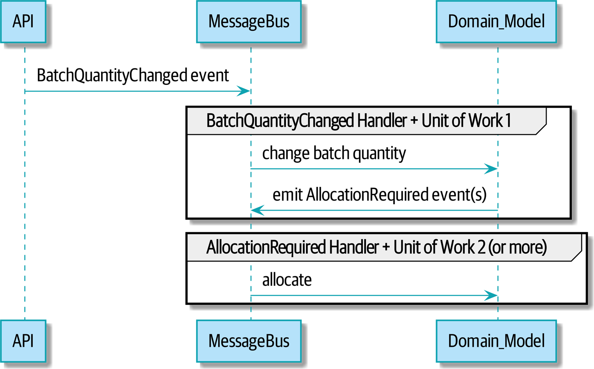
Figure 9-4. Sequence diagram for reallocation flow

Warning
When you split things out like this across two units of work, you now have two database transactions, so you are opening yourself up to integrity issues: something could happen that means the first transaction completes but the second one does not. You’ll need to think about whether this is acceptable, and whether you need to notice when it happens and do something about it. See “Footguns” for more discussion.

Our New Event
The event that tells us a batch quantity has changed is simple; it just needs a batch reference and a new quantity:
New event (src/allocation/domain/events.py)
@dataclass
class
BatchQuantityChanged
(
Event
):
ref
:
str
qty
:
int

Test-Driving a New Handler
Following the lessons learned in Chapter 4, we can operate in “high gear” and write our unit tests at the highest possible level of abstraction, in terms of events. Here’s what they might look like:
Handler tests for change_batch_quantity (tests/unit/test_handlers.py)
class
TestChangeBatchQuantity
:
def
test_changes_available_quantity
(
self
)
:
uow
=
FakeUnitOfWork
(
)
messagebus
.
handle
(
events
.
BatchCreated
(
"
batch1
"
,
"
ADORABLE-SETTEE
"
,
100
,
None
)
,
uow
)
[
batch
]
=
uow
.
products
.
get
(
sku
=
"
ADORABLE-SETTEE
"
)
.
batches
assert
batch
.
available_quantity
==
100
messagebus
.
handle
(
events
.
BatchQuantityChanged
(
"
batch1
"
,
50
)
,
uow
)
assert
batch
.
available_quantity
==
50
def
test_reallocates_if_necessary
(
self
)
:
uow
=
FakeUnitOfWork
(
)
event_history
=
[
events
.
BatchCreated
(
"
batch1
"
,
"
INDIFFERENT-TABLE
"
,
50
,
None
)
,
events
.
BatchCreated
(
"
batch2
"
,
"
INDIFFERENT-TABLE
"
,
50
,
date
.
today
(
)
)
,
events
.
AllocationRequired
(
"
order1
"
,
"
INDIFFERENT-TABLE
"
,
20
)
,
events
.
AllocationRequired
(
"
order2
"
,
"
INDIFFERENT-TABLE
"
,
20
)
,
]
for
e
in
event_history
:
messagebus
.
handle
(
e
,
uow
)
[
batch1
,
batch2
]
=
uow
.
products
.
get
(
sku
=
"
INDIFFERENT-TABLE
"
)
.
batches
assert
batch1
.
available_quantity
==
10
assert
batch2
.
available_quantity
==
50
messagebus
.
handle
(
events
.
BatchQuantityChanged
(
"
batch1
"
,
25
)
,
uow
)
# order1 or order2 will be deallocated, so we'll have 25 - 20
assert
batch1
.
available_quantity
==
5
# and 20 will be reallocated to the next batch
assert
batch2
.
available_quantity
==
30
The simple case would be trivially easy to implement; we just modify a quantity.
But if we try to change the quantity to less than has been allocated, we’ll need to deallocate at least one order, and we expect to reallocate it to a new batch.

Implementation
Our new handler is very simple:
Handler delegates to model layer (src/allocation/service_layer/handlers.py)
def
change_batch_quantity
(
event
:
events
.
BatchQuantityChanged
,
uow
:
unit_of_work
.
AbstractUnitOfWork
):
with
uow
:
product
=
uow
.
products
.
get_by_batchref
(
batchref
=
event
.
ref
)
product
.
change_batch_quantity
(
ref
=
event
.
ref
,
qty
=
event
.
qty
)
uow
.
commit
()
We realize we’ll need a new query type on our repository:
A new query type on our repository (src/allocation/adapters/repository.py)
class
AbstractRepository
(
abc
.
ABC
):
...
def
get
(
self
,
sku
)
->
model
.
Product
:
...
def
get_by_batchref
(
self
,
batchref
)
->
model
.
Product
:
product
=
self
.
_get_by_batchref
(
batchref
)
if
product
:
self
.
seen
.
add
(
product
)
return
product
@abc.abstractmethod
def
_add
(
self
,
product
:
model
.
Product
):
raise
NotImplementedError
@abc.abstractmethod
def
_get
(
self
,
sku
)
->
model
.
Product
:
raise
NotImplementedError
@abc.abstractmethod
def
_get_by_batchref
(
self
,
batchref
)
->
model
.
Product
:
raise
NotImplementedError
...
class
SqlAlchemyRepository
(
AbstractRepository
):
...
def
_get
(
self
,
sku
):
return
self
.
session
.
query
(
model
.
Product
)
.
filter_by
(
sku
=
sku
)
.
first
()
def
_get_by_batchref
(
self
,
batchref
):
return
self
.
session
.
query
(
model
.
Product
)
.
join
(
model
.
Batch
)
.
filter
(
orm
.
batches
.
c
.
reference
==
batchref
,
)
.
first
()
And on our FakeRepository too:
Updating the fake repo too (tests/unit/test_handlers.py)
class
FakeRepository
(
repository
.
AbstractRepository
):
...
def
_get
(
self
,
sku
):
return
next
((
p
for
p
in
self
.
_products
if
p
.
sku
==
sku
),
None
)
def
_get_by_batchref
(
self
,
batchref
):
return
next
((
p
for
p
in
self
.
_products
for
b
in
p
.
batches
if
b
.
reference
==
batchref
),
None
)

Note
We’re adding a query to our repository to make this use case easier to implement. So long as our query is returning a single aggregate, we’re not bending any rules. If you find yourself writing complex queries on your repositories, you might want to consider a different design. Methods like get_most_popular_products or find_products_by_order_id in particular would definitely trigger our spidey sense. Chapter 11 and the epilogue have some tips on managing complex queries.

A New Method on the Domain Model
We add the new method to the model, which does the quantity change and deallocation(s) inline and publishes a new event. We also modify the existing allocate function to publish an event:
Our model evolves to capture the new requirement (src/allocation/domain/model.py)
class
Product
:
...
def
change_batch_quantity
(
self
,
ref
:
str
,
qty
:
int
):
batch
=
next
(
b
for
b
in
self
.
batches
if
b
.
reference
==
ref
)
batch
.
_purchased_quantity
=
qty
while
batch
.
available_quantity
<
0
:
line
=
batch
.
deallocate_one
()
self
.
events
.
append
(
events
.
AllocationRequired
(
line
.
orderid
,
line
.
sku
,
line
.
qty
)
)
...
class
Batch
:
...
def
deallocate_one
(
self
)
->
OrderLine
:
return
self
.
_allocations
.
pop
()
We wire up our new handler:
The message bus grows (src/allocation/service_layer/messagebus.py)
HANDLERS
=
{
events
.
BatchCreated
:
[
handlers
.
add_batch
],
events
.
BatchQuantityChanged
:
[
handlers
.
change_batch_quantity
],
events
.
AllocationRequired
:
[
handlers
.
allocate
],
events
.
OutOfStock
:
[
handlers
.
send_out_of_stock_notification
],
}
# type: Dict[Type[events.Event], List[Callable]]
And our new requirement is fully implemented.

Optionally: Unit Testing Event Handlers in Isolation with a Fake Message Bus
Our main test for the reallocation workflow is edge-to-edge (see the example code in “Test-Driving a New Handler”). It uses the real message bus, and it tests the whole flow, where the BatchQuantityChanged event handler triggers deallocation, and emits new AllocationRequired events, which in turn are handled by their own handlers. One test covers a chain of multiple events and handlers.
Depending on the complexity of your chain of events, you may decide that you want to test some handlers in isolation from one another. You can do this using a “fake” message bus.
In our case, we actually intervene by modifying the publish_events() method on FakeUnitOfWork and decoupling it from the real message bus, instead making it record what events it sees:
Fake message bus implemented in UoW (tests/unit/test_handlers.py)
class
FakeUnitOfWorkWithFakeMessageBus
(
FakeUnitOfWork
):
def
__init__
(
self
):
super
()
.
__init__
()
self
.
events_published
=
[]
# type: List[events.Event]
def
publish_events
(
self
):
for
product
in
self
.
products
.
seen
:
while
product
.
events
:
self
.
events_published
.
append
(
product
.
events
.
pop
(
0
))
Now when we invoke messagebus.handle() using the FakeUnitOfWorkWithFakeMessageBus, it runs only the handler for that event. So we can write a more isolated unit test: instead of checking all the side effects, we just check that BatchQuantityChanged leads to AllocationRequired if the quantity drops below the total already allocated:
Testing reallocation in isolation (tests/unit/test_handlers.py)
def
test_reallocates_if_necessary_isolated
():
uow
=
FakeUnitOfWorkWithFakeMessageBus
()
# test setup as before
event_history
=
[
events
.
BatchCreated
(
"batch1"
,
"INDIFFERENT-TABLE"
,
50
,
None
),
events
.
BatchCreated
(
"batch2"
,
"INDIFFERENT-TABLE"
,
50
,
date
.
today
()),
events
.
AllocationRequired
(
"order1"
,
"INDIFFERENT-TABLE"
,
20
),
events
.
AllocationRequired
(
"order2"
,
"INDIFFERENT-TABLE"
,
20
),
]
for
e
in
event_history
:
messagebus
.
handle
(
e
,
uow
)
[
batch1
,
batch2
]
=
uow
.
products
.
get
(
sku
=
"INDIFFERENT-TABLE"
)
.
batches
assert
batch1
.
available_quantity
==
10
assert
batch2
.
available_quantity
==
50
messagebus
.
handle
(
events
.
BatchQuantityChanged
(
"batch1"
,
25
),
uow
)
# assert on new events emitted rather than downstream side-effects
[
reallocation_event
]
=
uow
.
events_published
assert
isinstance
(
reallocation_event
,
events
.
AllocationRequired
)
assert
reallocation_event
.
orderid
in
{
'order1'
,
'order2'
}
assert
reallocation_event
.
sku
==
'INDIFFERENT-TABLE'
Whether you want to do this or not depends on the complexity of your chain of events. We say, start out with edge-to-edge testing, and resort to this only if necessary.

Exercise for the Reader
A great way to force yourself to really understand some code is to refactor it. In the discussion of testing handlers in isolation, we used something called FakeUnitOfWorkWithFakeMessageBus, which is unnecessarily complicated and violates the SRP.
If we change the message bus to being a class,3 then building a FakeMessageBus is more straightforward:
An abstract message bus and its real and fake versions
class
AbstractMessageBus
:
HANDLERS
:
Dict
[
Type
[
events
.
Event
],
List
[
Callable
]]
def
handle
(
self
,
event
:
events
.
Event
):
for
handler
in
self
.
HANDLERS
[
type
(
event
)]:
handler
(
event
)
class
MessageBus
(
AbstractMessageBus
):
HANDLERS
=
{
events
.
OutOfStock
:
[
send_out_of_stock_notification
],
}
class
FakeMessageBus
(
messagebus
.
AbstractMessageBus
):
def
__init__
(
self
):
self
.
events_published
=
[]
# type: List[events.Event]
self
.
handlers
=
{
events
.
OutOfStock
:
[
lambda
e
:
self
.
events_published
.
append
(
e
)]
}
So jump into the code on GitHub and see if you can get a class-based version working, and then write a version of test_reallocates_if_necessary_isolated() from earlier.
We use a class-based message bus in Chapter 13, if you need more inspiration.

Wrap-Up
Let’s look back at what we’ve achieved, and think about why we did it.

What Have We Achieved?
Events are simple dataclasses that define the data structures for inputs and internal messages within our system. This is quite powerful from a DDD standpoint, since events often translate really well into business language (look up event storming if you haven’t already).
Handlers are the way we react to events. They can call down to our model or call out to external services. We can define multiple handlers for a single event if we want to. Handlers can also raise other events. This allows us to be very granular about what a handler does and really stick to the SRP.

Why Have We Achieved?
Our ongoing objective with these architectural patterns is to try to have the complexity of our application grow more slowly than its size. When we go all in on the message bus, as always we pay a price in terms of architectural complexity (see Table 9-1), but we buy ourselves a pattern that can handle almost arbitrarily complex requirements without needing any further conceptual or architectural change to the way we do things.
Here we’ve added quite a complicated use case (change quantity, deallocate, start new transaction, reallocate, publish external notification), but architecturally, there’s been no cost in terms of complexity. We’ve added new events, new handlers, and a new external adapter (for email), all of which are existing categories of things in our architecture that we understand and know how to reason about, and that are easy to explain to newcomers. Our moving parts each have one job, they’re connected to each other in well-defined ways, and there are no unexpected side effects.
Table 9-1. Whole app is a message bus: the trade-offs  Pros | Cons
Handlers and services are the same thing, so that’s simpler.  We have a nice data structure for inputs to the system. | A message bus is still a slightly unpredictable way of doing things from a web point of view. You don’t know in advance when things are going to end.  There will be duplication of fields and structure between model objects and events, which will have a maintenance cost. Adding a field to one usually means adding a field to at least one of the others.
Now, you may be wondering, where are those BatchQuantityChanged events going to come from? The answer is revealed in a couple chapters’ time. But first, let’s talk about events versus commands.
1 Event-based modeling is so popular that a practice called event storming has been developed for facilitating event-based requirements gathering and domain model elaboration.
2 If you’ve done a bit of reading about event-driven architectures, you may be thinking, “Some of these events sound more like commands!” Bear with us! We’re trying to introduce one concept at a time. In the next chapter, we’ll introduce the distinction between commands and events.
3 The “simple” implementation in this chapter essentially uses the messagebus.py module itself to implement the Singleton Pattern.

Chapter 10. Commands and Command Handler
In the previous chapter, we talked about using events as a way of representing the inputs to our system, and we turned our application into a message-processing machine.
To achieve that, we converted all our use-case functions to event handlers. When the API receives a POST to create a new batch, it builds a new BatchCreated event and handles it as if it were an internal event. This might feel counterintuitive. After all, the batch hasn’t been created yet; that’s why we called the API. We’re going to fix that conceptual wart by introducing commands and showing how they can be handled by the same message bus but with slightly different rules.

Tip
The code for this chapter is in the chapter_10_commands branch on GitHub:
git clone https://github.com/cosmicpython/code.git
cd code
git checkout chapter_10_commands
# or to code along, checkout the previous chapter:
git checkout chapter_09_all_messagebus

Commands and Events
Like events, commands are a type of message—instructions sent by one part of a system to another. We usually represent commands with dumb data structures and can handle them in much the same way as events.
The differences between commands and events, though, are important.
Commands are sent by one actor to another specific actor with the expectation that a particular thing will happen as a result. When we post a form to an API handler, we are sending a command. We name commands with imperative mood verb phrases like “allocate stock” or “delay shipment.”
Commands capture intent. They express our wish for the system to do something. As a result, when they fail, the sender needs to receive error information.
Events are broadcast by an actor to all interested listeners. When we publish BatchQuantityChanged, we don’t know who’s going to pick it up. We name events with past-tense verb phrases like “order allocated to stock” or “shipment delayed.”
We often use events to spread the knowledge about successful commands.
Events capture facts about things that happened in the past. Since we don’t know who’s handling an event, senders should not care whether the receivers succeeded or failed. Table 10-1 recaps the differences.
Table 10-1. Events versus commands | Event | Command
Named | Past tense | Imperative mood
Error handling | Fail independently | Fail noisily
Sent to | All listeners | One recipient
What kinds of commands do we have in our system right now?
Pulling out some commands (src/allocation/domain/commands.py)
class
Command
:
pass
@dataclass
class
Allocate
(
Command
)
:
orderid
:
str
sku
:
str
qty
:
int
@dataclass
class
CreateBatch
(
Command
)
:
ref
:
str
sku
:
str
qty
:
int
eta
:
Optional
[
date
]
=
None
@dataclass
class
ChangeBatchQuantity
(
Command
)
:
ref
:
str
qty
:
int
commands.Allocate will replace events.AllocationRequired.
commands.CreateBatch will replace events.BatchCreated.
commands.ChangeBatchQuantity will replace events.BatchQuantityChanged.

Differences in Exception Handling
Just changing the names and verbs is all very well, but that won’t change the behavior of our system. We want to treat events and commands similarly, but not exactly the same. Let’s see how our message bus changes:
Dispatch events and commands differently (src/allocation/service_layer/messagebus.py)
Message
=
Union
[
commands
.
Command
,
events
.
Event
]
def
handle
(
message
:
Message
,
uow
:
unit_of_work
.
AbstractUnitOfWork
)
:
results
=
[
]
queue
=
[
message
]
while
queue
:
message
=
queue
.
pop
(
0
)
if
isinstance
(
message
,
events
.
Event
)
:
handle_event
(
message
,
queue
,
uow
)
elif
isinstance
(
message
,
commands
.
Command
)
:
cmd_result
=
handle_command
(
message
,
queue
,
uow
)
results
.
append
(
cmd_result
)
else
:
raise
Exception
(
f
'
{message} was not an Event or Command
'
)
return
results
It still has a main handle() entrypoint that takes a message, which may be a command or an event.
We dispatch events and commands to two different helper functions, shown next.
Here’s how we handle events:
Events cannot interrupt the flow (src/allocation/service_layer/messagebus.py)
def
handle_event
(
event
:
events
.
Event
,
queue
:
List
[
Message
]
,
uow
:
unit_of_work
.
AbstractUnitOfWork
)
:
for
handler
in
EVENT_HANDLERS
[
type
(
event
)
]
:
try
:
logger
.
debug
(
'
handling event
%s
with handler
%s
'
,
event
,
handler
)
handler
(
event
,
uow
=
uow
)
queue
.
extend
(
uow
.
collect_new_events
(
)
)
except
Exception
:
logger
.
exception
(
'
Exception handling event
%s
'
,
event
)
continue
Events go to a dispatcher that can delegate to multiple handlers per event.
It catches and logs errors but doesn’t let them interrupt message processing.
And here’s how we do commands:
Commands reraise exceptions (src/allocation/service_layer/messagebus.py)
def
handle_command
(
command
:
commands
.
Command
,
queue
:
List
[
Message
]
,
uow
:
unit_of_work
.
AbstractUnitOfWork
)
:
logger
.
debug
(
'
handling command
%s
'
,
command
)
try
:
handler
=
COMMAND_HANDLERS
[
type
(
command
)
]
result
=
handler
(
command
,
uow
=
uow
)
queue
.
extend
(
uow
.
collect_new_events
(
)
)
return
result
except
Exception
:
logger
.
exception
(
'
Exception handling command
%s
'
,
command
)
raise
The command dispatcher expects just one handler per command.
If any errors are raised, they fail fast and will bubble up.
return result is only temporary; as mentioned in “A Temporary Ugly Hack: The Message Bus Has to Return Results”, it’s a temporary hack to allow the message bus to return the batch reference for the API to use. We’ll fix this in Chapter 12.
We also change the single HANDLERS dict into different ones for commands and events. Commands can have only one handler, according to our convention:
New handlers dicts (src/allocation/service_layer/messagebus.py)
EVENT_HANDLERS
=
{
events
.
OutOfStock
:
[
handlers
.
send_out_of_stock_notification
],
}
# type: Dict[Type[events.Event], List[Callable]]
COMMAND_HANDLERS
=
{
commands
.
Allocate
:
handlers
.
allocate
,
commands
.
CreateBatch
:
handlers
.
add_batch
,
commands
.
ChangeBatchQuantity
:
handlers
.
change_batch_quantity
,
}
# type: Dict[Type[commands.Command], Callable]

Discussion: Events, Commands, and Error Handling
Many developers get uncomfortable at this point and ask, “What happens when an event fails to process? How am I supposed to make sure the system is in a consistent state?” If we manage to process half of the events during messagebus.handle before an out-of-memory error kills our process, how do we mitigate problems caused by the lost messages?
Let’s start with the worst case: we fail to handle an event, and the system is left in an inconsistent state. What kind of error would cause this? Often in our systems we can end up in an inconsistent state when only half an operation is completed.
For example, we could allocate three units of DESIRABLE_BEANBAG to a customer’s order but somehow fail to reduce the amount of remaining stock. This would cause an inconsistent state: the three units of stock are both allocated and available, depending on how you look at it. Later, we might allocate those same beanbags to another customer, causing a headache for customer support.
In our allocation service, though, we’ve already taken steps to prevent that happening. We’ve carefully identified aggregates that act as consistency boundaries, and we’ve introduced a UoW that manages the atomic success or failure of an update to an aggregate.
For example, when we allocate stock to an order, our consistency boundary is the Product aggregate. This means that we can’t accidentally overallocate: either a particular order line is allocated to the product, or it is not—there’s no room for inconsistent states.
By definition, we don’t require two aggregates to be immediately consistent, so if we fail to process an event and update only a single aggregate, our system can still be made eventually consistent. We shouldn’t violate any constraints of the system.
With this example in mind, we can better understand the reason for splitting messages into commands and events. When a user wants to make the system do something, we represent their request as a command. That command should modify a single aggregate and either succeed or fail in totality. Any other bookkeeping, cleanup, and notification we need to do can happen via an event. We don’t require the event handlers to succeed in order for the command to be successful.
Let’s look at another example (from a different, imaginary projet) to see why not.
Imagine we are building an ecommerce website that sells expensive luxury goods. Our marketing department wants to reward customers for repeat visits. We will flag customers as VIPs after they make their third purchase, and this will entitle them to priority treatment and special offers. Our acceptance criteria for this story reads as follows:
Given
a customer with two orders in their history,
When
the customer places a third order,
Then
they should be flagged as a VIP.
When
a customer first becomes a VIP
Then
we should send them an email to congratulate them
Using the techniques we’ve already discussed in this book, we decide that we want to build a new History aggregate that records orders and can raise domain events when rules are met. We will structure the code like this:
VIP customer (example code for a different project)
class
History
:
# Aggregate
def
__init__
(
self
,
customer_id
:
int
)
:
self
.
orders
=
set
(
)
# Set[HistoryEntry]
self
.
customer_id
=
customer_id
def
record_order
(
self
,
order_id
:
str
,
order_amount
:
int
)
:
entry
=
HistoryEntry
(
order_id
,
order_amount
)
if
entry
in
self
.
orders
:
return
self
.
orders
.
add
(
entry
)
if
len
(
self
.
orders
)
==
3
:
self
.
events
.
append
(
CustomerBecameVIP
(
self
.
customer_id
)
)
def
create_order_from_basket
(
uow
,
cmd
:
CreateOrder
)
:
with
uow
:
order
=
Order
.
from_basket
(
cmd
.
customer_id
,
cmd
.
basket_items
)
uow
.
orders
.
add
(
order
)
uow
.
commit
(
)
# raises OrderCreated
def
update_customer_history
(
uow
,
event
:
OrderCreated
)
:
with
uow
:
history
=
uow
.
order_history
.
get
(
event
.
customer_id
)
history
.
record_order
(
event
.
order_id
,
event
.
order_amount
)
uow
.
commit
(
)
# raises CustomerBecameVIP
def
congratulate_vip_customer
(
uow
,
event
:
CustomerBecameVip
)
:
with
uow
:
customer
=
uow
.
customers
.
get
(
event
.
customer_id
)
email
.
send
(
customer
.
email_address
,
f
'
Congratulations {customer.first_name}!
'
)
The History aggregate captures the rules indicating when a customer becomes a VIP. This puts us in a good place to handle changes when the rules become more complex in the future.
Our first handler creates an order for the customer and raises a domain event OrderCreated.
Our second handler updates the History object to record that an order was created.
Finally, we send an email to the customer when they become a VIP.
Using this code, we can gain some intuition about error handling in an event-driven system.
In our current implementation, we raise events about an aggregate after we persist our state to the database. What if we raised those events before we persisted, and committed all our changes at the same time? That way, we could be sure that all the work was complete. Wouldn’t that be safer?
What happens, though, if the email server is slightly overloaded? If all the work has to complete at the same time, a busy email server can stop us from taking money for orders.
What happens if there is a bug in the implementation of the History aggregate? Should we fail to take your money just because we can’t recognize you as a VIP?
By separating out these concerns, we have made it possible for things to fail in isolation, which improves the overall reliability of the system. The only part of this code that has to complete is the command handler that creates an order. This is the only part that a customer cares about, and it’s the part that our business stakeholders should prioritize.
Notice how we’ve deliberately aligned our transactional boundaries to the start and end of the business processes. The names that we use in the code match the jargon used by our business stakeholders, and the handlers we’ve written match the steps of our natural language acceptance criteria. This concordance of names and structure helps us to reason about our systems as they grow larger and more complex.

Recovering from Errors Synchronously
Hopefully we’ve convinced you that it’s OK for events to fail independently from the commands that raised them. What should we do, then, to make sure we can recover from errors when they inevitably occur?
The first thing we need is to know when an error has occurred, and for that we usually rely on logs.
Let’s look again at the handle_event method from our message bus:
Current handle function (src/allocation/service_layer/messagebus.py)
def
handle_event
(
event
:
events
.
Event
,
queue
:
List
[
Message
],
uow
:
unit_of_work
.
AbstractUnitOfWork
):
for
handler
in
EVENT_HANDLERS
[
type
(
event
)]:
try
:
logger
.
debug
(
'handling event
%s
with handler
%s
'
,
event
,
handler
)
handler
(
event
,
uow
=
uow
)
queue
.
extend
(
uow
.
collect_new_events
())
except
Exception
:
logger
.
exception
(
'Exception handling event
%s
'
,
event
)
continue
When we handle a message in our system, the first thing we do is write a log line to record what we’re about to do. For our CustomerBecameVIP use case, the logs might read as follows:
Handling event CustomerBecameVIP(customer_id=12345)
with handler <function congratulate_vip_customer at 0x10ebc9a60>
Because we’ve chosen to use dataclasses for our message types, we get a neatly printed summary of the incoming data that we can copy and paste into a Python shell to re-create the object.
When an error occurs, we can use the logged data to either reproduce the problem in a unit test or replay the message into the system.
Manual replay works well for cases where we need to fix a bug before we can re-process an event, but our systems will always experience some background level of transient failure. This includes things like network hiccups, table deadlocks, and brief downtime caused by deployments.
For most of those cases, we can recover elegantly by trying again. As the proverb says, “If at first you don’t succeed, retry the operation with an exponentially increasing back-off period.”
Handle with retry (src/allocation/service_layer/messagebus.py)
from
tenacity
import
Retrying
,
RetryError
,
stop_after_attempt
,
wait_exponential
.
.
.
def
handle_event
(
event
:
events
.
Event
,
queue
:
List
[
Message
]
,
uow
:
unit_of_work
.
AbstractUnitOfWork
)
:
for
handler
in
EVENT_HANDLERS
[
type
(
event
)
]
:
try
:
for
attempt
in
Retrying
(
stop
=
stop_after_attempt
(
3
)
,
wait
=
wait_exponential
(
)
)
:
with
attempt
:
logger
.
debug
(
'
handling event
%s
with handler
%s
'
,
event
,
handler
)
handler
(
event
,
uow
=
uow
)
queue
.
extend
(
uow
.
collect_new_events
(
)
)
except
RetryError
as
retry_failure
:
logger
.
error
(
'
Failed to handle event
%s
times, giving up!,
retry_failure
.
last_attempt
.
attempt_number
)
continue
Tenacity is a Python library that implements common patterns for retrying.
Here we configure our message bus to retry operations up to three times, with an exponentially increasing wait between attempts.
Retrying operations that might fail is probably the single best way to improve the resilience of our software. Again, the Unit of Work and Command Handler patterns mean that each attempt starts from a consistent state and won’t leave things half-finished.
Warning
At some point, regardless of tenacity, we’ll have to give up trying to process the message. Building reliable systems with distributed messages is hard, and we have to skim over some tricky bits. There are pointers to more reference materials in the epilogue.

Wrap-Up
In this book we decided to introduce the concept of events before the concept of commands, but other guides often do it the other way around. Making explicit the requests that our system can respond to by giving them a name and their own data structure is quite a fundamental thing to do. You’ll sometimes see people use the name Command Handler pattern to describe what we’re doing with Events, Commands, and Message Bus.
Table 10-2 discusses some of the things you should think about before you jump on board.
Table 10-2. Splitting commands and events: the trade-offs  Pros | Cons
Treating commands and events differently helps us understand which things have to succeed and which things we can tidy up later.  CreateBatch is definitely a less confusing name than BatchCreated. We are being explicit about the intent of our users, and explicit is better than implicit, right? | The semantic differences between commands and events can be subtle. Expect bikeshedding arguments over the differences.  We’re expressly inviting failure. We know that sometimes things will break, and we’re choosing to handle that by making the failures smaller and more isolated. This can make the system harder to reason about and requires better monitoring.
In Chapter 11 we’ll talk about using events as an integration pattern.

Chapter 11. Event-Driven Architecture: Using Events to Integrate Microservices
In the preceding chapter, we never actually spoke about how we would receive the “batch quantity changed” events, or indeed, how we might notify the outside world about reallocations.
We have a microservice with a web API, but what about other ways of talking to other systems? How will we know if, say, a shipment is delayed or the quantity is amended? How will we tell the warehouse system that an order has been allocated and needs to be sent to a customer?
In this chapter, we’d like to show how the events metaphor can be extended to encompass the way that we handle incoming and outgoing messages from the system. Internally, the core of our application is now a message processor. Let’s follow through on that so it becomes a message processor externally as well. As shown in Figure 11-1, our application will receive events from external sources via an external message bus (we’ll use Redis pub/sub queues as an example) and publish its outputs, in the form of events, back there as well.
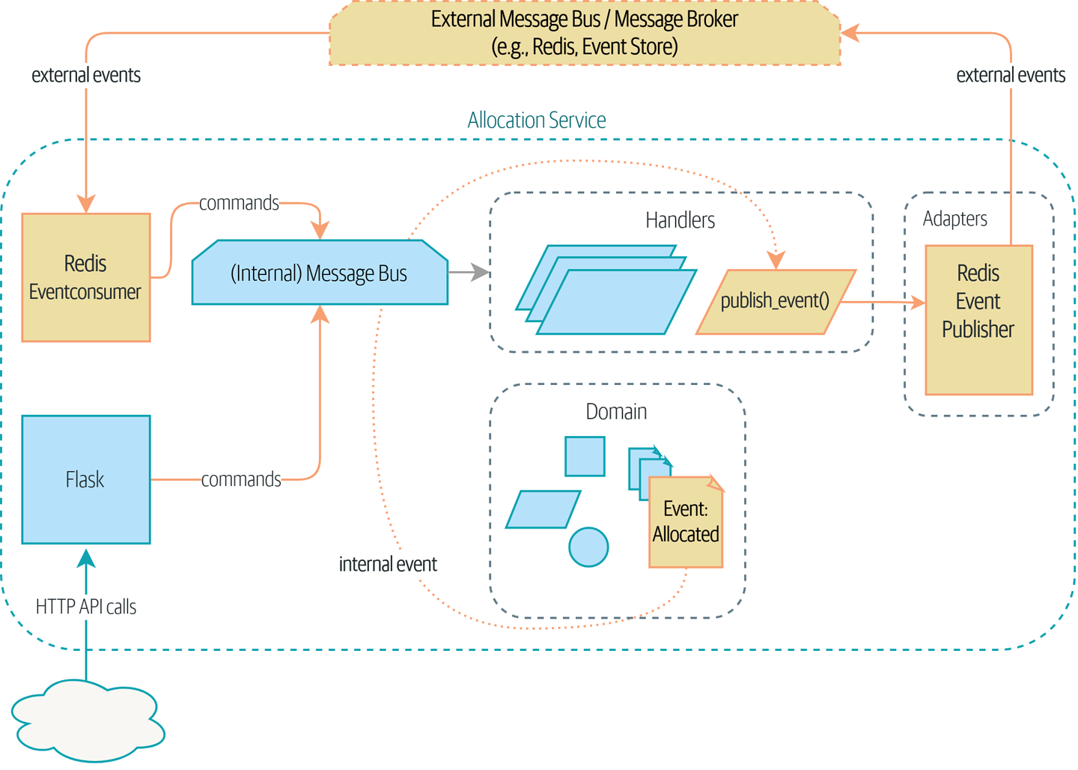
Figure 11-1. Our application is a message processor

Tip
The code for this chapter is in the chapter_11_external_events branch on GitHub:
git clone https://github.com/cosmicpython/code.git
cd code
git checkout chapter_11_external_events
# or to code along, checkout the previous chapter:
git checkout chapter_10_commands

Distributed Ball of Mud, and Thinking in Nouns
Before we get into that, let’s talk about the alternatives. We regularly talk to engineers who are trying to build out a microservices architecture. Often they are migrating from an existing application, and their first instinct is to split their system into nouns.
What nouns have we introduced so far in our system? Well, we have batches of stock, orders, products, and customers. So a naive attempt at breaking up the system might have looked like Figure 11-2 (notice that we’ve named our system after a noun, Batches, instead of Allocation).
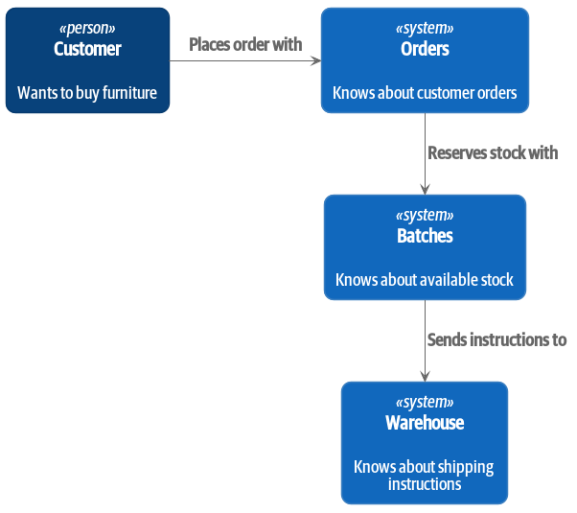
Figure 11-2. Context diagram with noun-based services

Each “thing” in our system has an associated service, which exposes an HTTP API.
Let’s work through an example happy-path flow in Figure 11-3: our users visit a website and can choose from products that are in stock. When they add an item to their basket, we will reserve some stock for them. When an order is complete, we confirm the reservation, which causes us to send dispatch instructions to the warehouse. Let’s also say, if this is the customer’s third order, we want to update the customer record to flag them as a VIP.
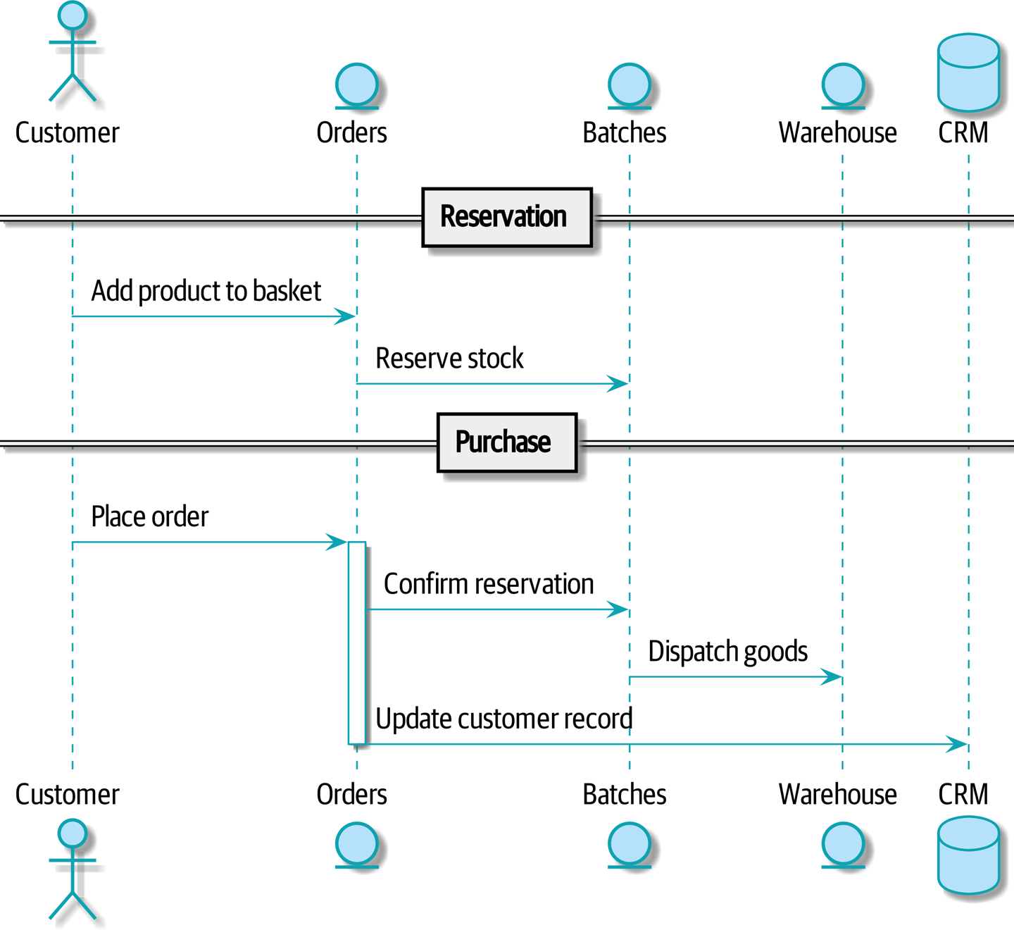
Figure 11-3. Command flow 1

We can think of each of these steps as a command in our system: ReserveStock, ConfirmReservation, DispatchGoods, MakeCustomerVIP, and so forth.
This style of architecture, where we create a microservice per database table and treat our HTTP APIs as CRUD interfaces to anemic models, is the most common initial way for people to approach service-oriented design.
This works fine for systems that are very simple, but it can quickly degrade into a distributed ball of mud.
To see why, let’s consider another case. Sometimes, when stock arrives at the warehouse, we discover that items have been water damaged during transit. We can’t sell water-damaged sofas, so we have to throw them away and request more stock from our partners. We also need to update our stock model, and that might mean we need to reallocate a customer’s order.
Where does this logic go?
Well, the Warehouse system knows that the stock has been damaged, so maybe it should own this process, as shown in Figure 11-4.
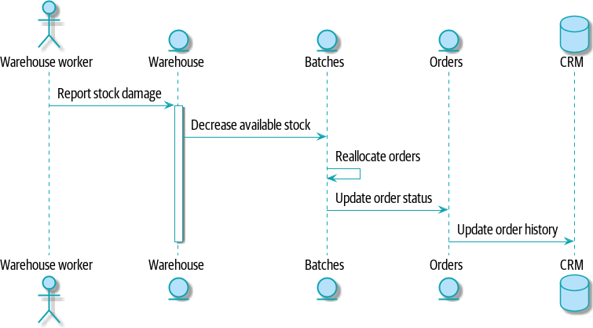
Figure 11-4. Command flow 2

This sort of works too, but now our dependency graph is a mess. To allocate stock, the Orders service drives the Batches system, which drives Warehouse; but in order to handle problems at the warehouse, our Warehouse system drives Batches, which drives Orders.
Multiply this by all the other workflows we need to provide, and you can see how services quickly get tangled up.

Error Handling in Distributed Systems
“Things break” is a universal law of software engineering. What happens in our system when one of our requests fails? Let’s say that a network error happens right after we take a user’s order for three MISBEGOTTEN-RUG, as shown in Figure 11-5.
We have two options here: we can place the order anyway and leave it unallocated, or we can refuse to take the order because the allocation can’t be guaranteed. The failure state of our batches service has bubbled up and is affecting the reliability of our order service.
When two things have to be changed together, we say that they are coupled. We can think of this failure cascade as a kind of temporal coupling: every part of the system has to work at the same time for any part of it to work. As the system gets bigger, there is an exponentially increasing probability that some part is degraded.
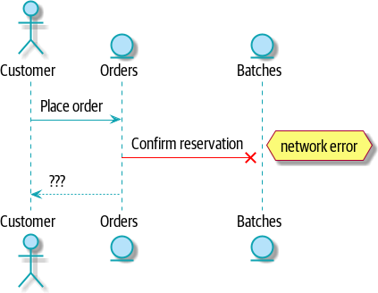
Figure 11-5. Command flow with error

Connascence
We’re using the term coupling here, but there’s another way to describe the relationships between our systems. Connascence is a term used by some authors to describe the different types of coupling.
Connascence isn’t bad, but some types of connascence are stronger than others. We want to have strong connascence locally, as when two classes are closely related, but weak connascence at a distance.
In our first example of a distributed ball of mud, we see Connascence of Execution: multiple components need to know the correct order of work for an operation to be successful.
When thinking about error conditions here, we’re talking about Connascence of Timing: multiple things have to happen, one after another, for the operation to work.
When we replace our RPC-style system with events, we replace both of these types of connascence with a weaker type. That’s Connascence of Name: multiple components need to agree only on the name of an event and the names of fields it carries.
We can never completely avoid coupling, except by having our software not talk to any other software. What we want is to avoid inappropriate coupling. Connascence provides a mental model for understanding the strength and type of coupling inherent in different architectural styles. Read all about it at connascence.io.

The Alternative: Temporal Decoupling Using Asynchronous Messaging
How do we get appropriate coupling? We’ve already seen part of the answer, which is that we should think in terms of verbs, not nouns. Our domain model is about modeling a business process. It’s not a static data model about a thing; it’s a model of a verb.
So instead of thinking about a system for orders and a system for batches, we think about a system for ordering and a system for allocating, and so on.
When we separate things this way, it’s a little easier to see which system should be responsible for what. When thinking about ordering, really we want to make sure that when we place an order, the order is placed. Everything else can happen later, so long as it happens.

Note
If this sounds familiar, it should! Segregating responsibilities is the same process we went through when designing our aggregates and commands.
Like aggregates, microservices should be consistency boundaries. Between two services, we can accept eventual consistency, and that means we don’t need to rely on synchronous calls. Each service accepts commands from the outside world and raises events to record the result. Other services can listen to those events to trigger the next steps in the workflow.
To avoid the Distributed Ball of Mud anti-pattern, instead of temporally coupled HTTP API calls, we want to use asynchronous messaging to integrate our systems. We want our BatchQuantityChanged messages to come in as external messages from upstream systems, and we want our system to publish Allocated events for downstream systems to listen to.
Why is this better? First, because things can fail independently, it’s easier to handle degraded behavior: we can still take orders if the allocation system is having a bad day.
Second, we’re reducing the strength of coupling between our systems. If we need to change the order of operations or to introduce new steps in the process, we can do that locally.

Using a Redis Pub/Sub Channel for Integration
Let’s see how it will all work concretely. We’ll need some way of getting events out of one system and into another, like our message bus, but for services. This piece of infrastructure is often called a message broker. The role of a message broker is to take messages from publishers and deliver them to subscribers.
At MADE.com, we use Event Store; Kafka or RabbitMQ are valid alternatives. A lightweight solution based on Redis pub/sub channels can also work just fine, and because Redis is much more generally familiar to people, we thought we’d use it for this book.

Note
We’re glossing over the complexity involved in choosing the right messaging platform. Concerns like message ordering, failure handling, and idempotency all need to be thought through. For a few pointers, see “Footguns”.
Our new flow will look like Figure 11-6: Redis provides the BatchQuantityChanged event that kicks off the whole process, and our Allocated event is published back out to Redis again at the end.
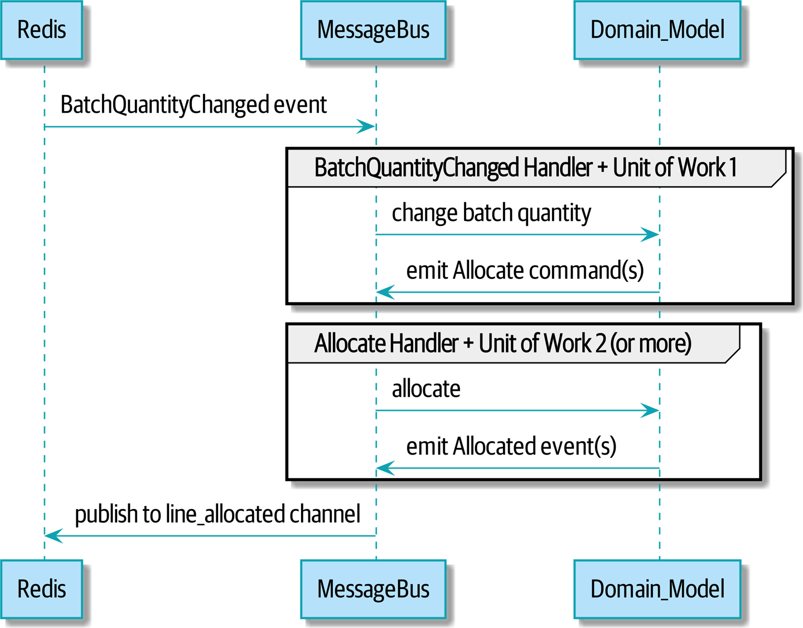
Figure 11-6. Sequence diagram for reallocation flow

Test-Driving It All Using an End-to-End Test
Here’s how we might start with an end-to-end test. We can use our existing API to create batches, and then we’ll test both inbound and outbound messages:
An end-to-end test for our pub/sub model (tests/e2e/test_external_events.py)
def
test_change_batch_quantity_leading_to_reallocation
(
)
:
# start with two batches and an order allocated to one of them
orderid
,
sku
=
random_orderid
(
)
,
random_sku
(
)
earlier_batch
,
later_batch
=
random_batchref
(
'
old
'
)
,
random_batchref
(
'
newer
'
)
api_client
.
post_to_add_batch
(
earlier_batch
,
sku
,
qty
=
10
,
eta
=
'
2011-01-02
'
)
api_client
.
post_to_add_batch
(
later_batch
,
sku
,
qty
=
10
,
eta
=
'
2011-01-02
'
)
response
=
api_client
.
post_to_allocate
(
orderid
,
sku
,
10
)
assert
response
.
json
(
)
[
'
batchref
'
]
==
earlier_batch
subscription
=
redis_client
.
subscribe_to
(
'
line_allocated
'
)
# change quantity on allocated batch so it's less than our order
redis_client
.
publish_message
(
'
change_batch_quantity
'
,
{
'
batchref
'
:
earlier_batch
,
'
qty
'
:
5
}
)
# wait until we see a message saying the order has been reallocated
messages
=
[
]
for
attempt
in
Retrying
(
stop
=
stop_after_delay
(
3
)
,
reraise
=
True
)
:
with
attempt
:
message
=
subscription
.
get_message
(
timeout
=
1
)
if
message
:
messages
.
append
(
message
)
print
(
messages
)
data
=
json
.
loads
(
messages
[
-
1
]
[
'
data
'
]
)
assert
data
[
'
orderid
'
]
==
orderid
assert
data
[
'
batchref
'
]
==
later_batch
You can read the story of what’s going on in this test from the comments: we want to send an event into the system that causes an order line to be reallocated, and we see that reallocation come out as an event in Redis too.
api_client is a little helper that we refactored out to share between our two test types; it wraps our calls to requests.post.
redis_client is another little test helper, the details of which don’t really matter; its job is to be able to send and receive messages from various Redis channels. We’ll use a channel called change_batch_quantity to send in our request to change the quantity for a batch, and we’ll listen to another channel called line_allocated to look out for the expected reallocation.
Because of the asynchronous nature of the system under test, we need to use the tenacity library again to add a retry loop—first, because it may take some time for our new line_allocated message to arrive, but also because it won’t be the only message on that channel.

Redis Is Another Thin Adapter Around Our Message Bus
Our Redis pub/sub listener (we call it an event consumer) is very much like Flask: it translates from the outside world to our events:
Simple Redis message listener (src/allocation/entrypoints/redis_eventconsumer.py)
r
=
redis
.
Redis
(
*
*
config
.
get_redis_host_and_port
(
)
)
def
main
(
)
:
orm
.
start_mappers
(
)
pubsub
=
r
.
pubsub
(
ignore_subscribe_messages
=
True
)
pubsub
.
subscribe
(
'
change_batch_quantity
'
)
for
m
in
pubsub
.
listen
(
)
:
handle_change_batch_quantity
(
m
)
def
handle_change_batch_quantity
(
m
)
:
logging
.
debug
(
'
handling
%s
'
,
m
)
data
=
json
.
loads
(
m
[
'
data
'
]
)
cmd
=
commands
.
ChangeBatchQuantity
(
ref
=
data
[
'
batchref
'
]
,
qty
=
data
[
'
qty
'
]
)
messagebus
.
handle
(
cmd
,
uow
=
unit_of_work
.
SqlAlchemyUnitOfWork
(
)
)
main() subscribes us to the change_batch_quantity channel on load.
Our main job as an entrypoint to the system is to deserialize JSON, convert it to a Command, and pass it to the service layer—much as the Flask adapter does.
We also build a new downstream adapter to do the opposite job—converting domain events to public events:
Simple Redis message publisher (src/allocation/adapters/redis_eventpublisher.py)
r
=
redis
.
Redis
(
*
*
config
.
get_redis_host_and_port
(
)
)
def
publish
(
channel
,
event
:
events
.
Event
)
:
logging
.
debug
(
'
publishing: channel=
%s
, event=
%s
'
,
channel
,
event
)
r
.
publish
(
channel
,
json
.
dumps
(
asdict
(
event
)
)
)
We take a hardcoded channel here, but you could also store a mapping between event classes/names and the appropriate channel, allowing one or more message types to go to different channels.

Our New Outgoing Event
Here’s what the Allocated event will look like:
New event (src/allocation/domain/events.py)
@dataclass
class
Allocated
(
Event
):
orderid
:
str
sku
:
str
qty
:
int
batchref
:
str
It captures everything we need to know about an allocation: the details of the order line, and which batch it was allocated to.
We add it into our model’s allocate() method (having added a test first, naturally):
Product.allocate() emits new event to record what happened (src/allocation/domain/model.py)
class
Product
:
...
def
allocate
(
self
,
line
:
OrderLine
)
->
str
:
...
batch
.
allocate
(
line
)
self
.
version_number
+=
1
self
.
events
.
append
(
events
.
Allocated
(
orderid
=
line
.
orderid
,
sku
=
line
.
sku
,
qty
=
line
.
qty
,
batchref
=
batch
.
reference
,
))
return
batch
.
reference
The handler for ChangeBatchQuantity already exists, so all we need to add is a handler that publishes the outgoing event:
The message bus grows (src/allocation/service_layer/messagebus.py)
HANDLERS
=
{
events
.
Allocated
:
[
handlers
.
publish_allocated_event
],
events
.
OutOfStock
:
[
handlers
.
send_out_of_stock_notification
],
}
# type: Dict[Type[events.Event], List[Callable]]
Publishing the event uses our helper function from the Redis wrapper:
Publish to Redis (src/allocation/service_layer/handlers.py)
def
publish_allocated_event
(
event
:
events
.
Allocated
,
uow
:
unit_of_work
.
AbstractUnitOfWork
,
):
redis_eventpublisher
.
publish
(
'line_allocated'
,
event
)

Internal Versus External Events
It’s a good idea to keep the distinction between internal and external events clear. Some events may come from the outside, and some events may get upgraded and published externally, but not all of them will. This is particularly important if you get into event sourcing (very much a topic for another book, though).

Tip
Outbound events are one of the places it’s important to apply validation. See Appendix E for some validation philosophy and examples.

Exercise for the Reader
A nice simple one for this chapter: make it so that the main allocate() use case can also be invoked by an event on a Redis channel, as well as (or instead of) via the API.
You will likely want to add a new E2E test and feed through some changes into redis_eventconsumer.py.

Wrap-Up
Events can come from the outside, but they can also be published externally—our publish handler converts an event to a message on a Redis channel. We use events to talk to the outside world. This kind of temporal decoupling buys us a lot of flexibility in our application integrations, but as always, it comes at a cost.
Event notification is nice because it implies a low level of coupling, and is pretty simple to set up. It can become problematic, however, if there really is a logical flow that runs over various event notifications...It can be hard to see such a flow as it’s not explicit in any program text....This can make it hard to debug and modify.
Martin Fowler, “What do you mean by ‘Event-Driven’”
Table 11-1 shows some trade-offs to think about.
Table 11-1. Event-based microservices integration: the trade-offs  Pros | Cons
Avoids the distributed big ball of mud.  Services are decoupled: it’s easier to change individual services and add new ones. | The overall flows of information are harder to see.  Eventual consistency is a new concept to deal with.  Message reliability and choices around at-least-once versus at-most-once delivery need thinking through.
More generally, if you’re moving from a model of synchronous messaging to an async one, you also open up a whole host of problems having to do with message reliability and eventual consistency. Read on to “Footguns”.

Chapter 12. Command-Query Responsibility Segregation (CQRS)
In this chapter, we’re going to start with a fairly uncontroversial insight: reads (queries) and writes (commands) are different, so they should be treated differently (or have their responsibilities segregated, if you will). Then we’re going to push that insight as far as we can.
If you’re anything like Harry, this will all seem extreme at first, but hopefully we can make the argument that it’s not totally unreasonable.
Figure 12-1 shows where we might end up.

Tip
The code for this chapter is in the chapter_12_cqrs branch on GitHub.
git clone https://github.com/cosmicpython/code.git
cd code
git checkout chapter_12_cqrs
# or to code along, checkout the previous chapter:
git checkout chapter_11_external_events
First, though, why bother?
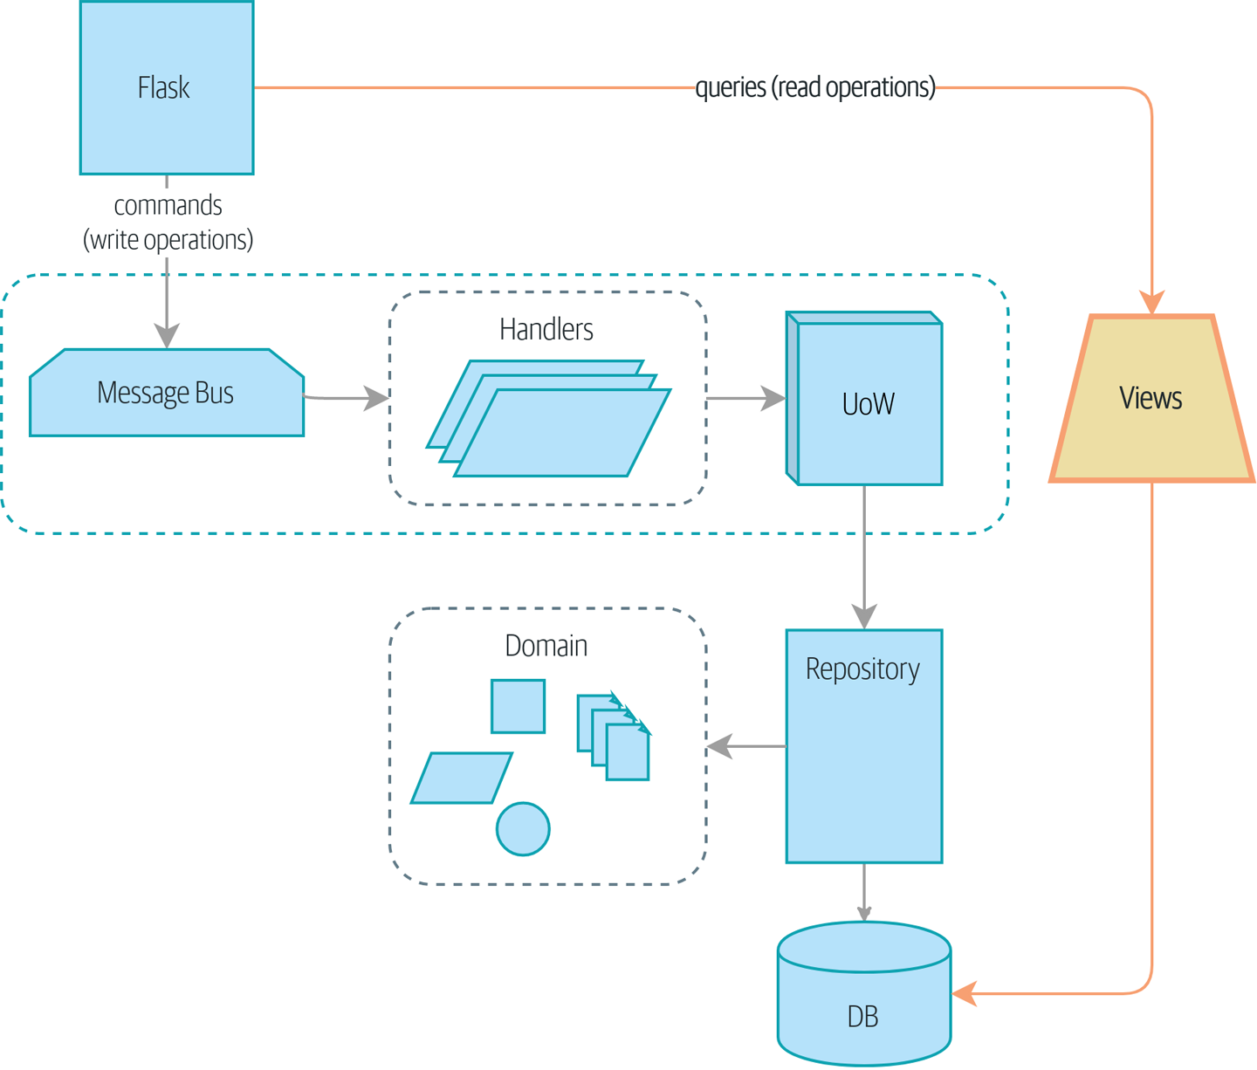
Figure 12-1. Separating reads from writes

Domain Models Are for Writing
We’ve spent a lot of time in this book talking about how to build software that enforces the rules of our domain. These rules, or constraints, will be different for every application, and they make up the interesting core of our systems.
In this book, we’ve set explicit constraints like “You can’t allocate more stock than is available,” as well as implicit constraints like “Each order line is allocated to a single batch.”
We wrote down these rules as unit tests at the beginning of the book:
Our basic domain tests (tests/unit/test_batches.py)
def
test_allocating_to_a_batch_reduces_the_available_quantity
():
batch
=
Batch
(
"batch-001"
,
"SMALL-TABLE"
,
qty
=
20
,
eta
=
date
.
today
())
line
=
OrderLine
(
'order-ref'
,
"SMALL-TABLE"
,
2
)
batch
.
allocate
(
line
)
assert
batch
.
available_quantity
==
18
...
def
test_cannot_allocate_if_available_smaller_than_required
():
small_batch
,
large_line
=
make_batch_and_line
(
"ELEGANT-LAMP"
,
2
,
20
)
assert
small_batch
.
can_allocate
(
large_line
)
is
False
To apply these rules properly, we needed to ensure that operations were consistent, and so we introduced patterns like Unit of Work and Aggregate that help us commit small chunks of work.
To communicate changes between those small chunks, we introduced the Domain Events pattern so we can write rules like “When stock is damaged or lost, adjust the available quantity on the batch, and reallocate orders if necessary.”
All of this complexity exists so we can enforce rules when we change the state of our system. We’ve built a flexible set of tools for writing data.
What about reads, though?

Most Users Aren’t Going to Buy Your Furniture
At MADE.com, we have a system very like the allocation service. In a busy day, we might process one hundred orders in an hour, and we have a big gnarly system for allocating stock to those orders.
In that same busy day, though, we might have one hundred product views per second. Each time somebody visits a product page, or a product listing page, we need to figure out whether the product is still in stock and how long it will take us to deliver it.
The domain is the same—we’re concerned with batches of stock, and their arrival date, and the amount that’s still available—but the access pattern is very different. For example, our customers won’t notice if the query is a few seconds out of date, but if our allocate service is inconsistent, we’ll make a mess of their orders. We can take advantage of this difference by making our reads eventually consistent in order to make them perform better.

Is Read Consistency Truly Attainable?
This idea of trading consistency against performance makes a lot of developers nervous at first, so let’s talk quickly about that.
Let’s imagine that our “Get Available Stock” query is 30 seconds out of date when Bob visits the page for ASYMMETRICAL-DRESSER. Meanwhile, though, Harry has already bought the last item. When we try to allocate Bob’s order, we’ll get a failure, and we’ll need to either cancel his order or buy more stock and delay his delivery.
People who’ve worked only with relational data stores get really nervous about this problem, but it’s worth considering two other scenarios to gain some perspective.
First, let’s imagine that Bob and Harry both visit the page at the same time. Harry goes off to make coffee, and by the time he returns, Bob has already bought the last dresser. When Harry places his order, we send it to the allocation service, and because there’s not enough stock, we have to refund his payment or buy more stock and delay his delivery.
As soon as we render the product page, the data is already stale. This insight is key to understanding why reads can be safely inconsistent: we’ll always need to check the current state of our system when we come to allocate, because all distributed systems are inconsistent. As soon as you have a web server and two customers, you have the potential for stale data.
OK, let’s assume we solve that problem somehow: we magically build a totally consistent web application where nobody ever sees stale data. This time Harry gets to the page first and buys his dresser.
Unfortunately for him, when the warehouse staff tries to dispatch his furniture, it falls off the forklift and smashes into a zillion pieces. Now what?
The only options are to either call Harry and refund his order or buy more stock and delay delivery.
No matter what we do, we’re always going to find that our software systems are inconsistent with reality, and so we’ll always need business processes to cope with these edge cases. It’s OK to trade performance for consistency on the read side, because stale data is essentially unavoidable.
We can think of these requirements as forming two halves of a system: the read side and the write side, shown in Table 12-1.
For the write side, our fancy domain architectural patterns help us to evolve our system over time, but the complexity we’ve built so far doesn’t buy anything for reading data. The service layer, the unit of work, and the clever domain model are just bloat.
Table 12-1. Read versus write | Read side | Write side
Behavior | Simple read | Complex business logic
Cacheability | Highly cacheable | Uncacheable
Consistency | Can be stale | Must be transactionally consistent

Post/Redirect/Get and CQS
If you do web development, you’re probably familiar with the Post/Redirect/Get pattern. In this technique, a web endpoint accepts an HTTP POST and responds with a redirect to see the result. For example, we might accept a POST to /batches to create a new batch and redirect the user to /batches/123 to see their newly created batch.
This approach fixes the problems that arise when users refresh the results page in their browser or try to bookmark a results page. In the case of a refresh, it can lead to our users double-submitting data and thus buying two sofas when they needed only one. In the case of a bookmark, our hapless customers will end up with a broken page when they try to GET a POST endpoint.
Both these problems happen because we’re returning data in response to a write operation. Post/Redirect/Get sidesteps the issue by separating the read and write phases of our operation.
This technique is a simple example of command-query separation (CQS). In CQS we follow one simple rule: functions should either modify state or answer questions, but never both. This makes software easier to reason about: we should always be able to ask, “Are the lights on?” without flicking the light switch.

Note
When building APIs, we can apply the same design technique by returning a 201 Created, or a 202 Accepted, with a Location header containing the URI of our new resources. What’s important here isn’t the status code we use but the logical separation of work into a write phase and a query phase.
As you’ll see, we can use the CQS principle to make our systems faster and more scalable, but first, let’s fix the CQS violation in our existing code. Ages ago, we introduced an allocate endpoint that takes an order and calls our service layer to allocate some stock. At the end of the call, we return a 200 OK and the batch ID. That’s led to some ugly design flaws so that we can get the data we need. Let’s change it to return a simple OK message and instead provide a new read-only endpoint to retrieve allocation state:
API test does a GET after the POST (tests/e2e/test_api.py)
@pytest.mark.usefixtures
(
'postgres_db'
)
@pytest.mark.usefixtures
(
'restart_api'
)
def
test_happy_path_returns_202_and_batch_is_allocated
():
orderid
=
random_orderid
()
sku
,
othersku
=
random_sku
(),
random_sku
(
'other'
)
earlybatch
=
random_batchref
(
1
)
laterbatch
=
random_batchref
(
2
)
otherbatch
=
random_batchref
(
3
)
api_client
.
post_to_add_batch
(
laterbatch
,
sku
,
100
,
'2011-01-02'
)
api_client
.
post_to_add_batch
(
earlybatch
,
sku
,
100
,
'2011-01-01'
)
api_client
.
post_to_add_batch
(
otherbatch
,
othersku
,
100
,
None
)
r
=
api_client
.
post_to_allocate
(
orderid
,
sku
,
qty
=
3
)
assert
r
.
status_code
==
202
r
=
api_client
.
get_allocation
(
orderid
)
assert
r
.
ok
assert
r
.
json
()
==
[
{
'sku'
:
sku
,
'batchref'
:
earlybatch
},
]
@pytest.mark.usefixtures
(
'postgres_db'
)
@pytest.mark.usefixtures
(
'restart_api'
)
def
test_unhappy_path_returns_400_and_error_message
():
unknown_sku
,
orderid
=
random_sku
(),
random_orderid
()
r
=
api_client
.
post_to_allocate
(
orderid
,
unknown_sku
,
qty
=
20
,
expect_success
=
False
,
)
assert
r
.
status_code
==
400
assert
r
.
json
()[
'message'
]
==
f
'Invalid sku {unknown_sku}'
r
=
api_client
.
get_allocation
(
orderid
)
assert
r
.
status_code
==
404
OK, what might the Flask app look like?
Endpoint for viewing allocations (src/allocation/entrypoints/flask_app.py)
from
allocation
import
views
.
.
.
@app.route
(
"
/allocations/<orderid>
"
,
methods
=
[
'
GET
'
]
)
def
allocations_view_endpoint
(
orderid
)
:
uow
=
unit_of_work
.
SqlAlchemyUnitOfWork
(
)
result
=
views
.
allocations
(
orderid
,
uow
)
if
not
result
:
return
'
not found
'
,
404
return
jsonify
(
result
)
,
200
All right, a views.py, fair enough; we can keep read-only stuff in there, and it’ll be a real views.py, not like Django’s, something that knows how to build read-only views of our data…

Hold On to Your Lunch, Folks
Hmm, so we can probably just add a list method to our existing repository object:
Views do…raw SQL? (src/allocation/views.py)
from
allocation.service_layer
import
unit_of_work
def
allocations
(
orderid
:
str
,
uow
:
unit_of_work
.
SqlAlchemyUnitOfWork
):
with
uow
:
results
=
list
(
uow
.
session
.
execute
(
'SELECT ol.sku, b.reference'
' FROM allocations AS a'
' JOIN batches AS b ON a.batch_id = b.id'
' JOIN order_lines AS ol ON a.orderline_id = ol.id'
' WHERE ol.orderid = :orderid'
,
dict
(
orderid
=
orderid
)
))
return
[{
'sku'
:
sku
,
'batchref'
:
batchref
}
for
sku
,
batchref
in
results
]
Excuse me? Raw SQL?
If you’re anything like Harry encountering this pattern for the first time, you’ll be wondering what on earth Bob has been smoking. We’re hand-rolling our own SQL now, and converting database rows directly to dicts? After all the effort we put into building a nice domain model? And what about the Repository pattern? Isn’t that meant to be our abstraction around the database? Why don’t we reuse that?
Well, let’s explore that seemingly simpler alternative first, and see what it looks like in practice.
We’ll still keep our view in a separate views.py module; enforcing a clear distinction between reads and writes in your application is still a good idea. We apply command-query separation, and it’s easy to see which code modifies state (the event handlers) and which code just retrieves read-only state (the views).

Tip
Splitting out your read-only views from your state-modifying command and event handlers is probably a good idea, even if you don’t want to go to full-blown CQRS.

Testing CQRS Views
Before we get into exploring various options, let’s talk about testing. Whichever approaches you decide to go for, you’re probably going to need at least one integration test. Something like this:
An integration test for a view (tests/integration/test_views.py)
def
test_allocations_view
(
sqlite_session_factory
)
:
uow
=
unit_of_work
.
SqlAlchemyUnitOfWork
(
sqlite_session_factory
)
messagebus
.
handle
(
commands
.
CreateBatch
(
'
sku1batch
'
,
'
sku1
'
,
50
,
None
)
,
uow
)
messagebus
.
handle
(
commands
.
CreateBatch
(
'
sku2batch
'
,
'
sku2
'
,
50
,
today
)
,
uow
)
messagebus
.
handle
(
commands
.
Allocate
(
'
order1
'
,
'
sku1
'
,
20
)
,
uow
)
messagebus
.
handle
(
commands
.
Allocate
(
'
order1
'
,
'
sku2
'
,
20
)
,
uow
)
# add a spurious batch and order to make sure we're getting the right ones
messagebus
.
handle
(
commands
.
CreateBatch
(
'
sku1batch-later
'
,
'
sku1
'
,
50
,
today
)
,
uow
)
messagebus
.
handle
(
commands
.
Allocate
(
'
otherorder
'
,
'
sku1
'
,
30
)
,
uow
)
messagebus
.
handle
(
commands
.
Allocate
(
'
otherorder
'
,
'
sku2
'
,
10
)
,
uow
)
assert
views
.
allocations
(
'
order1
'
,
uow
)
==
[
{
'
sku
'
:
'
sku1
'
,
'
batchref
'
:
'
sku1batch
'
}
,
{
'
sku
'
:
'
sku2
'
,
'
batchref
'
:
'
sku2batch
'
}
,
]
We do the setup for the integration test by using the public entrypoint to our application, the message bus. That keeps our tests decoupled from any implementation/infrastructure details about how things get stored.

“Obvious” Alternative 1: Using the Existing Repository
How about adding a helper method to our products repository?
A simple view that uses the repository (src/allocation/views.py)
from
allocation
import
unit_of_work
def
allocations
(
orderid
:
str
,
uow
:
unit_of_work
.
AbstractUnitOfWork
)
:
with
uow
:
products
=
uow
.
products
.
for_order
(
orderid
=
orderid
)
batches
=
[
b
for
p
in
products
for
b
in
p
.
batches
]
return
[
{
'
sku
'
:
b
.
sku
,
'
batchref
'
:
b
.
reference
}
for
b
in
batches
if
orderid
in
b
.
orderids
]
Our repository returns Product objects, and we need to find all the products for the SKUs in a given order, so we’ll build a new helper method called .for_order() on the repository.
Now we have products but we actually want batch references, so we get all the possible batches with a list comprehension.
We filter again to get just the batches for our specific order. That, in turn, relies on our Batch objects being able to tell us which order IDs it has allocated.
We implement that last using a .orderid property:
An arguably unnecessary property on our model (src/allocation/domain/model.py)
class
Batch
:
...
@property
def
orderids
(
self
):
return
{
l
.
orderid
for
l
in
self
.
_allocations
}
You can start to see that reusing our existing repository and domain model classes is not as straightforward as you might have assumed. We’ve had to add new helper methods to both, and we’re doing a bunch of looping and filtering in Python, which is work that would be done much more efficiently by the database.
So yes, on the plus side we’re reusing our existing abstractions, but on the downside, it all feels quite clunky.

Your Domain Model Is Not Optimized for Read Operations
What we’re seeing here are the effects of having a domain model that is designed primarily for write operations, while our requirements for reads are often conceptually quite different.
This is the chin-stroking-architect’s justification for CQRS. As we’ve said before, a domain model is not a data model—we’re trying to capture the way the business works: workflow, rules around state changes, messages exchanged; concerns about how the system reacts to external events and user input. Most of this stuff is totally irrelevant for read-only operations.

Tip
This justification for CQRS is related to the justification for the Domain Model pattern. If you’re building a simple CRUD app, reads and writes are going to be closely related, so you don’t need a domain model or CQRS. But the more complex your domain, the more likely you are to need both.
To make a facile point, your domain classes will have multiple methods for modifying state, and you won’t need any of them for read-only operations.
As the complexity of your domain model grows, you will find yourself making more and more choices about how to structure that model, which make it more and more awkward to use for read operations.

“Obvious” Alternative 2: Using the ORM
You may be thinking, OK, if our repository is clunky, and working with Products is clunky, then I can at least use my ORM and work with Batches. That’s what it’s for!
A simple view that uses the ORM (src/allocation/views.py)
from
allocation
import
unit_of_work
,
model
def
allocations
(
orderid
:
str
,
uow
:
unit_of_work
.
AbstractUnitOfWork
):
with
uow
:
batches
=
uow
.
session
.
query
(
model
.
Batch
)
.
join
(
model
.
OrderLine
,
model
.
Batch
.
_allocations
)
.
filter
(
model
.
OrderLine
.
orderid
==
orderid
)
return
[
{
'sku'
:
b
.
sku
,
'batchref'
:
b
.
batchref
}
for
b
in
batches
]
But is that actually any easier to write or understand than the raw SQL version from the code example in “Hold On to Your Lunch, Folks”? It may not look too bad up there, but we can tell you it took several attempts, and plenty of digging through the SQLAlchemy docs. SQL is just SQL.
But the ORM can also expose us to performance problems.

SELECT N+1 and Other Performance Considerations
The so-called SELECT N+1 problem is a common performance problem with ORMs: when retrieving a list of objects, your ORM will often perform an initial query to, say, get all the IDs of the objects it needs, and then issue individual queries for each object to retrieve their attributes. This is especially likely if there are any foreign-key relationships on your objects.

Note
In all fairness, we should say that SQLAlchemy is quite good at avoiding the SELECT N+1 problem. It doesn’t display it in the preceding example, and you can request eager loading explicitly to avoid it when dealing with joined objects.
Beyond SELECT N+1, you may have other reasons for wanting to decouple the way you persist state changes from the way that you retrieve current state. A set of fully normalized relational tables is a good way to make sure that write operations never cause data corruption. But retrieving data using lots of joins can be slow. It’s common in such cases to add some denormalized views, build read replicas, or even add caching layers.

Time to Completely Jump the Shark
On that note: have we convinced you that our raw SQL version isn’t so weird as it first seemed? Perhaps we were exaggerating for effect? Just you wait.
So, reasonable or not, that hardcoded SQL query is pretty ugly, right? What if we made it nicer…
A much nicer query (src/allocation/views.py)
def
allocations
(
orderid
:
str
,
uow
:
unit_of_work
.
SqlAlchemyUnitOfWork
):
with
uow
:
results
=
list
(
uow
.
session
.
execute
(
'SELECT sku, batchref FROM allocations_view WHERE orderid = :orderid'
,
dict
(
orderid
=
orderid
)
))
...
…by keeping a totally separate, denormalized data store for our view model?
Hee hee hee, no foreign keys, just strings, YOLO (src/allocation/adapters/orm.py)
allocations_view
=
Table
(
'allocations_view'
,
metadata
,
Column
(
'orderid'
,
String
(
255
)),
Column
(
'sku'
,
String
(
255
)),
Column
(
'batchref'
,
String
(
255
)),
)
OK, nicer-looking SQL queries wouldn’t be a justification for anything really, but building a denormalized copy of your data that’s optimized for read operations isn’t uncommon, once you’ve reached the limits of what you can do with indexes.
Even with well-tuned indexes, a relational database uses a lot of CPU to perform joins. The fastest queries will always be SELECT * from mytable WHERE key = :value.
More than raw speed, though, this approach buys us scale. When we’re writing data to a relational database, we need to make sure that we get a lock over the rows we’re changing so we don’t run into consistency problems.
If multiple clients are changing data at the same time, we’ll have weird race conditions. When we’re reading data, though, there’s no limit to the number of clients that can concurrently execute. For this reason, read-only stores can be horizontally scaled out.

Tip
Because read replicas can be inconsistent, there’s no limit to how many we can have. If you’re struggling to scale a system with a complex data store, ask whether you could build a simpler read model.
Keeping the read model up to date is the challenge! Database views (materialized or otherwise) and triggers are a common solution, but that limits you to your database. We’d like to show you how to reuse our event-driven architecture instead.

Updating a Read Model Table Using an Event Handler
We add a second handler to the Allocated event:
Allocated event gets a new handler (src/allocation/service_layer/messagebus.py)
EVENT_HANDLERS
=
{
events
.
Allocated
:
[
handlers
.
publish_allocated_event
,
handlers
.
add_allocation_to_read_model
],
Here’s what our update-view-model code looks like:
Update on allocation (src/allocation/service_layer/handlers.py)
def
add_allocation_to_read_model
(
event
:
events
.
Allocated
,
uow
:
unit_of_work
.
SqlAlchemyUnitOfWork
,
):
with
uow
:
uow
.
session
.
execute
(
'INSERT INTO allocations_view (orderid, sku, batchref)'
' VALUES (:orderid, :sku, :batchref)'
,
dict
(
orderid
=
event
.
orderid
,
sku
=
event
.
sku
,
batchref
=
event
.
batchref
)
)
uow
.
commit
()
Believe it or not, that will pretty much work! And it will work against the exact same integration tests as the rest of our options.
OK, you’ll also need to handle Deallocated:
A second listener for read model updates
events
.
Deallocated
:
[
handlers
.
remove_allocation_from_read_model
,
handlers
.
reallocate
],
...
def
remove_allocation_from_read_model
(
event
:
events
.
Deallocated
,
uow
:
unit_of_work
.
SqlAlchemyUnitOfWork
,
):
with
uow
:
uow
.
session
.
execute
(
'DELETE FROM allocations_view '
' WHERE orderid = :orderid AND sku = :sku'
,
Figure 12-2 shows the flow across the two requests.
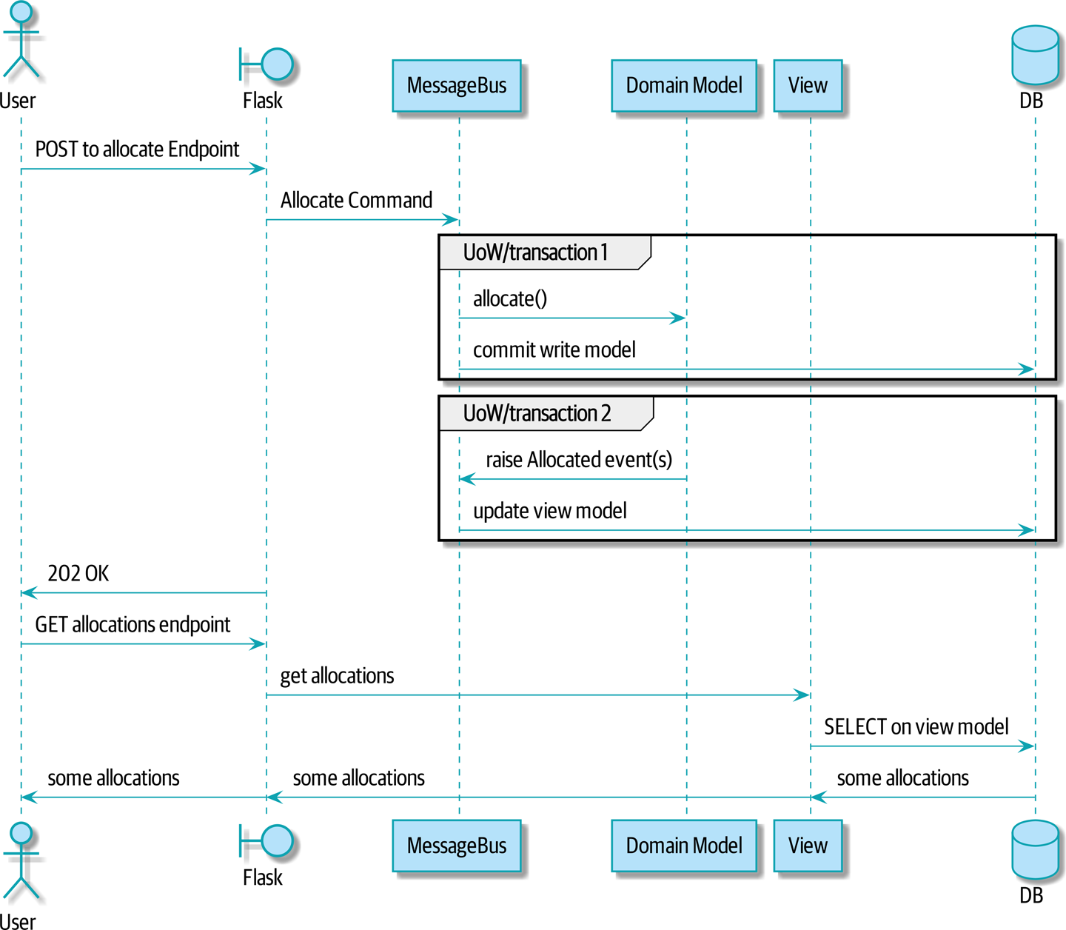
Figure 12-2. Sequence diagram for read model

In Figure 12-2, you can see two transactions in the POST/write operation, one to update the write model and one to update the read model, which the GET/read operation can use.

Rebuilding from Scratch
“What happens when it breaks?” should be the first question we ask as engineers.
How do we deal with a view model that hasn’t been updated because of a bug or temporary outage? Well, this is just another case where events and commands can fail independently.
If we never updated the view model, and the ASYMMETRICAL-DRESSER was forever in stock, that would be annoying for customers, but the allocate service would still fail, and we’d take action to fix the problem.
Rebuilding a view model is easy, though. Since we’re using a service layer to update our view model, we can write a tool that does the following:
Queries the current state of the write side to work out what’s currently allocated
Calls the add_allocate_to_read_model handler for each allocated item
We can use this technique to create entirely new read models from historical data.

Changing Our Read Model Implementation Is Easy
Let’s see the flexibility that our event-driven model buys us in action, by seeing what happens if we ever decide we want to implement a read model by using a totally separate storage engine, Redis.
Just watch:
Handlers update a Redis read model (src/allocation/service_layer/handlers.py)
def
add_allocation_to_read_model
(
event
:
events
.
Allocated
,
_
):
redis_eventpublisher
.
update_readmodel
(
event
.
orderid
,
event
.
sku
,
event
.
batchref
)
def
remove_allocation_from_read_model
(
event
:
events
.
Deallocated
,
_
):
redis_eventpublisher
.
update_readmodel
(
event
.
orderid
,
event
.
sku
,
None
)
The helpers in our Redis module are one-liners:
Redis read model read and update (src/allocation/adapters/redis_eventpublisher.py)
def
update_readmodel
(
orderid
,
sku
,
batchref
):
r
.
hset
(
orderid
,
sku
,
batchref
)
def
get_readmodel
(
orderid
):
return
r
.
hgetall
(
orderid
)
(Maybe the name redis_eventpublisher.py is a misnomer now, but you get the idea.)
And the view itself changes very slightly to adapt to its new backend:
View adapted to Redis (src/allocation/views.py)
def
allocations
(
orderid
):
batches
=
redis_eventpublisher
.
get_readmodel
(
orderid
)
return
[
{
'batchref'
:
b
.
decode
(),
'sku'
:
s
.
decode
()}
for
s
,
b
in
batches
.
items
()
]
And the exact same integration tests that we had before still pass, because they are written at a level of abstraction that’s decoupled from the implementation: setup puts messages on the message bus, and the assertions are against our view.

Tip
Event handlers are a great way to manage updates to a read model, if you decide you need one. They also make it easy to change the implementation of that read model at a later date.

Exercise for the Reader
Implement another view, this time to show the allocation for a single order line.
Here the trade-offs between using hardcoded SQL versus going via a repository should be much more blurry. Try a few versions (maybe including going to Redis), and see which you prefer.

Wrap-Up
Table 12-2 proposes some pros and cons for each of our options.
As it happens, the allocation service at MADE.com does use “full-blown” CQRS, with a read model stored in Redis, and even a second layer of cache provided by Varnish. But its use cases are quite a bit different from what we’ve shown here. For the kind of allocation service we’re building, it seems unlikely that you’d need to use a separate read model and event handlers for updating it.
But as your domain model becomes richer and more complex, a simplified read model become ever more compelling.
Table 12-2. Trade-offs of various view model options  Option | Pros | Cons
Just use repositories | Simple, consistent approach. | Expect performance issues with complex query patterns.
Use custom queries with your ORM | Allows reuse of DB configuration and model definitions. | Adds another query language with its own quirks and syntax.
Use hand-rolled SQL | Offers fine control over performance with a standard query syntax. | Changes to DB schema have to be made to your hand-rolled queries and your ORM definitions. Highly normalized schemas may still have performance limitations.
Create separate read stores with events | Read-only copies are easy to scale out. Views can be constructed when data changes so that queries are as simple as possible. | Complex technique. Harry will be forever suspicious of your tastes and motives.
Often, your read operations will be acting on the same conceptual objects as your write model, so using the ORM, adding some read methods to your repositories, and using domain model classes for your read operations is just fine.
In our book example, the read operations act on quite different conceptual entities to our domain model. The allocation service thinks in terms of Batches for a single SKU, but users care about allocations for a whole order, with multiple SKUs, so using the ORM ends up being a little awkward. We’d be quite tempted to go with the raw-SQL view we showed right at the beginning of the chapter.
On that note, let’s sally forth into our final chapter.

Chapter 13. Dependency Injection (and Bootstrapping)
Dependency injection (DI) is regarded with suspicion in the Python world. And we’ve managed just fine without it so far in the example code for this book!
In this chapter, we’ll explore some of the pain points in our code that lead us to consider using DI, and we’ll present some options for how to do it, leaving it to you to pick which you think is most Pythonic.
We’ll also add a new component to our architecture called bootstrap.py; it will be in charge of dependency injection, as well as some other initialization stuff that we often need. We’ll explain why this sort of thing is called a composition root in OO languages, and why bootstrap script is just fine for our purposes.
Figure 13-1 shows what our app looks like without a bootstrapper: the entrypoints do a lot of initialization and passing around of our main dependency, the UoW.

Tip
If you haven’t already, it’s worth reading Chapter 3 before continuing with this chapter, particularly the discussion of functional versus object-oriented dependency management.
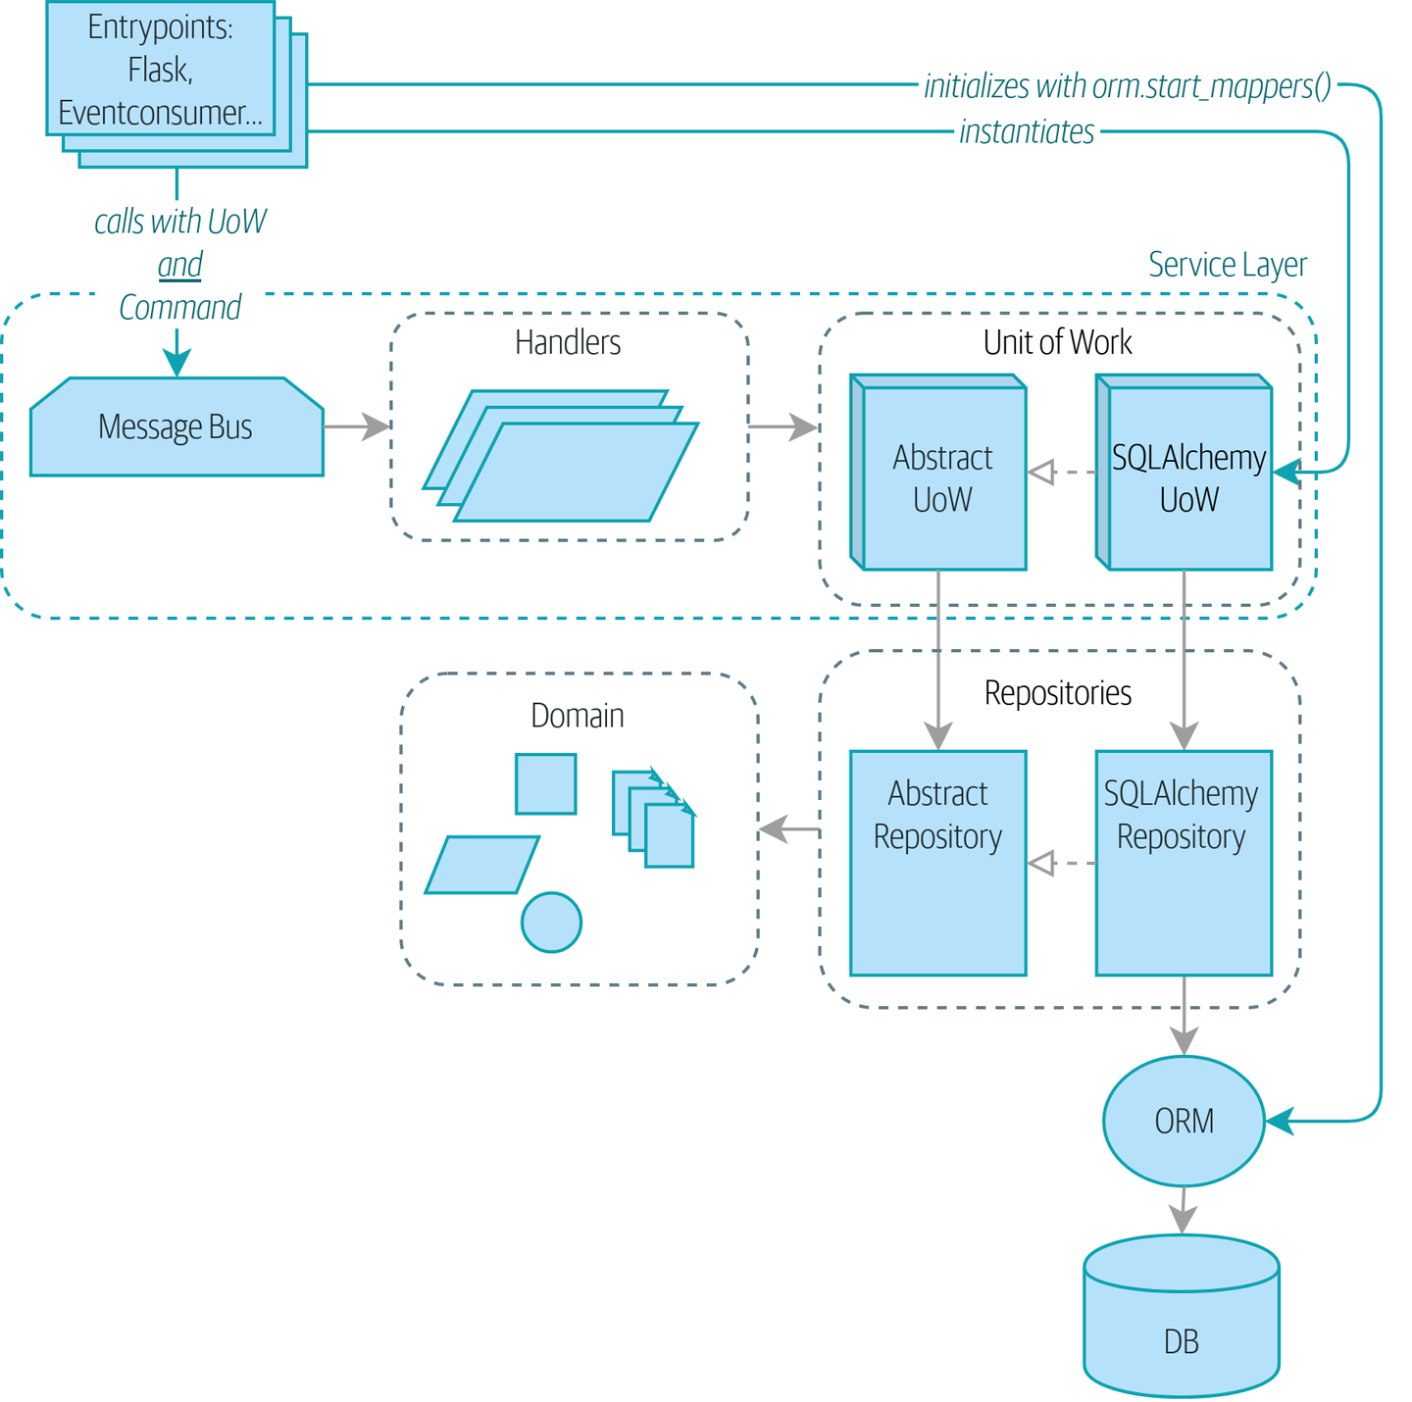
Figure 13-1. Without bootstrap: entrypoints do a lot

Tip
The code for this chapter is in the chapter_13_dependency_injection branch on GitHub:
git clone https://github.com/cosmicpython/code.git
cd code
git checkout chapter_13_dependency_injection
# or to code along, checkout the previous chapter:
git checkout chapter_12_cqrs
Figure 13-2 shows our bootstrapper taking over those responsibilities.
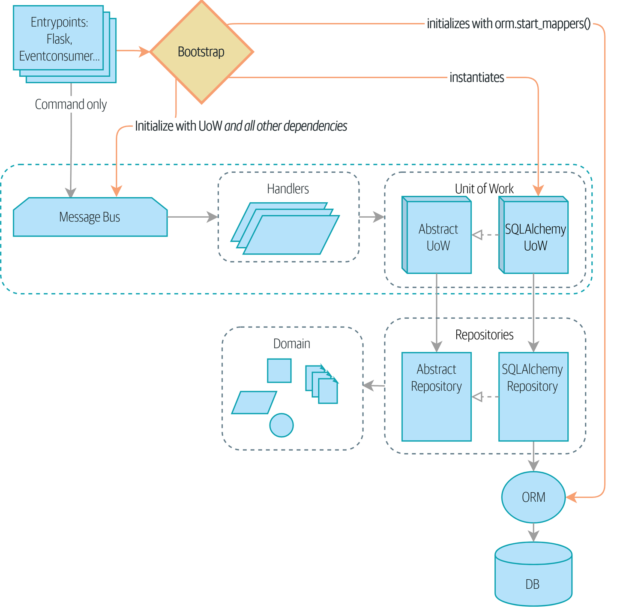
Figure 13-2. Bootstrap takes care of all that in one place

Implicit Versus Explicit Dependencies
Depending on your particular brain type, you may have a slight feeling of unease at the back of your mind at this point. Let’s bring it out into the open. We’ve shown you two ways of managing dependencies and testing them.
For our database dependency, we’ve built a careful framework of explicit dependencies and easy options for overriding them in tests. Our main handler functions declare an explicit dependency on the UoW:
Our handlers have an explicit dependency on the UoW (src/allocation/service_layer/handlers.py)
def
allocate
(
cmd
:
commands
.
Allocate
,
uow
:
unit_of_work
.
AbstractUnitOfWork
):
And that makes it easy to swap in a fake UoW in our service-layer tests:
Service-layer tests against a fake UoW: (tests/unit/test_services.py)
uow
=
FakeUnitOfWork
()
messagebus
.
handle
([
...
],
uow
)
The UoW itself declares an explicit dependency on the session factory:
The UoW depends on a session factory (src/allocation/service_layer/unit_of_work.py)
class
SqlAlchemyUnitOfWork
(
AbstractUnitOfWork
):
def
__init__
(
self
,
session_factory
=
DEFAULT_SESSION_FACTORY
):
self
.
session_factory
=
session_factory
...
We take advantage of it in our integration tests to be able to sometimes use SQLite instead of Postgres:
Integration tests against a different DB (tests/integration/test_uow.py)
def
test_rolls_back_uncommitted_work_by_default
(
sqlite_session_factory
)
:
uow
=
unit_of_work
.
SqlAlchemyUnitOfWork
(
sqlite_session_factory
)
Integration tests swap out the default Postgres session_factory for a SQLite one.

Aren’t Explicit Dependencies Totally Weird and Java-y?
If you’re used to the way things normally happen in Python, you’ll be thinking all this is a bit weird. The standard way to do things is to declare our dependency implicitly by simply importing it, and then if we ever need to change it for tests, we can monkeypatch, as is Right and True in dynamic languages:
Email sending as a normal import-based dependency (src/allocation/service_layer/handlers.py)
from
allocation.adapters
import
email
,
redis_eventpublisher
.
.
.
def
send_out_of_stock_notification
(
event
:
events
.
OutOfStock
,
uow
:
unit_of_work
.
AbstractUnitOfWork
,
)
:
email
.
send
(
'
stock@made.com
'
,
f
'
Out of stock for {event.sku}
'
,
)
Hardcoded import
Calls specific email sender directly
Why pollute our application code with unnecessary arguments just for the sake of our tests? mock.patch makes monkeypatching nice and easy:
mock dot patch, thank you Michael Foord (tests/unit/test_handlers.py)
with
mock
.
patch
(
"allocation.adapters.email.send"
)
as
mock_send_mail
:
...
The trouble is that we’ve made it look easy because our toy example doesn’t send real email (email.send_mail just does a print), but in real life, you’d end up having to call mock.patch for every single test that might cause an out-of-stock notification. If you’ve worked on codebases with lots of mocks used to prevent unwanted side effects, you’ll know how annoying that mocky boilerplate gets.
And you’ll know that mocks tightly couple us to the implementation. By choosing to monkeypatch email.send_mail, we are tied to doing import email, and if we ever want to do from email import send_mail, a trivial refactor, we’d have to change all our mocks.
So it’s a trade-off. Yes, declaring explicit dependencies is unnecessary, strictly speaking, and using them would make our application code marginally more complex. But in return, we’d get tests that are easier to write and manage.
On top of that, declaring an explicit dependency is an example of the dependency inversion principle—rather than having an (implicit) dependency on a specific detail, we have an (explicit) dependency on an abstraction:
Explicit is better than implicit.
The Zen of Python
The explicit dependency is more abstract (src/allocation/service_layer/handlers.py)
def
send_out_of_stock_notification
(
event
:
events
.
OutOfStock
,
send_mail
:
Callable
,
):
send_mail
(
'stock@made.com'
,
f
'Out of stock for {event.sku}'
,
)
But if we do change to declaring all these dependencies explicitly, who will inject them, and how? So far, we’ve really been dealing with only passing the UoW around: our tests use FakeUnitOfWork, while Flask and Redis eventconsumer entrypoints use the real UoW, and the message bus passes them onto our command handlers. If we add real and fake email classes, who will create them and pass them on?
That’s extra (duplicated) cruft for Flask, Redis, and our tests. Moreover, putting all the responsibility for passing dependencies to the right handler onto the message bus feels like a violation of the SRP.
Instead, we’ll reach for a pattern called Composition Root (a bootstrap script to you and me),1 and we’ll do a bit of “manual DI” (dependency injection without a framework). See Figure 13-3.2
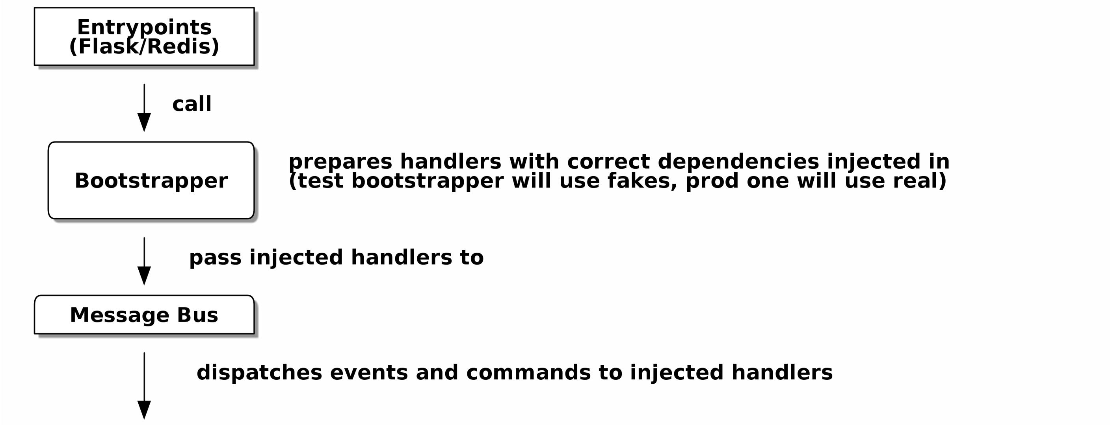
Figure 13-3. Bootstrapper between entrypoints and message bus

Preparing Handlers: Manual DI with Closures and Partials
One way to turn a function with dependencies into one that’s ready to be called later with those dependencies already injected is to use closures or partial functions to compose the function with its dependencies:
Examples of DI using closures or partial functions
# existing allocate function, with abstract uow dependency
def
allocate
(
cmd
:
commands
.
Allocate
,
uow
:
unit_of_work
.
AbstractUnitOfWork
)
:
line
=
OrderLine
(
cmd
.
orderid
,
cmd
.
sku
,
cmd
.
qty
)
with
uow
:
.
.
.
# bootstrap script prepares actual UoW
def
bootstrap
(
.
.
)
:
uow
=
unit_of_work
.
SqlAlchemyUnitOfWork
(
)
# prepare a version of the allocate fn with UoW dependency captured in a closure
allocate_composed
=
lambda
cmd
:
allocate
(
cmd
,
uow
)
# or, equivalently (this gets you a nicer stack trace)
def
allocate_composed
(
cmd
)
:
return
allocate
(
cmd
,
uow
)
# alternatively with a partial
import
functools
allocate_composed
=
functools
.
partial
(
allocate
,
uow
=
uow
)
# later at runtime, we can call the partial function, and it will have
# the UoW already bound
allocate_composed
(
cmd
)
The difference between closures (lambdas or named functions) and functools.partial is that the former use late binding of variables, which can be a source of confusion if any of the dependencies are mutable.
Here’s the same pattern again for the send_out_of_stock_notification() handler, which has different dependencies:
Another closure and partial functions example
def
send_out_of_stock_notification
(
event
:
events
.
OutOfStock
,
send_mail
:
Callable
,
):
send_mail
(
'stock@made.com'
,
...
# prepare a version of the send_out_of_stock_notification with dependencies
sosn_composed
=
lambda
event
:
send_out_of_stock_notification
(
event
,
email
.
send_mail
)
...
# later, at runtime:
sosn_composed
(
event
)
# will have email.send_mail already injected in

An Alternative Using Classes
Closures and partial functions will feel familiar to people who’ve done a bit of functional programming. Here’s an alternative using classes, which may appeal to others. It requires rewriting all our handler functions as classes, though:
DI using classes
# we replace the old `def allocate(cmd, uow)` with:
class
AllocateHandler
:
def
__init__
(
self
,
uow
:
unit_of_work
.
AbstractUnitOfWork
)
:
self
.
uow
=
uow
def
__call__
(
self
,
cmd
:
commands
.
Allocate
)
:
line
=
OrderLine
(
cmd
.
orderid
,
cmd
.
sku
,
cmd
.
qty
)
with
self
.
uow
:
# rest of handler method as before
.
.
.
# bootstrap script prepares actual UoW
uow
=
unit_of_work
.
SqlAlchemyUnitOfWork
(
)
# then prepares a version of the allocate fn with dependencies already injected
allocate
=
AllocateHandler
(
uow
)
.
.
.
# later at runtime, we can call the handler instance, and it will have
# the UoW already injected
allocate
(
cmd
)
The class is designed to produce a callable function, so it has a call method.
But we use the init to declare the dependencies it requires. This sort of thing will feel familiar if you’ve ever made class-based descriptors, or a class-based context manager that takes arguments.
Use whichever you and your team feel more comfortable with.

A Bootstrap Script
We want our bootstrap script to do the following:
Declare default dependencies but allow us to override them
Do the “init” stuff that we need to get our app started
Inject all the dependencies into our handlers
Give us back the core object for our app, the message bus
Here’s a first cut:
A bootstrap function (src/allocation/bootstrap.py)
def
bootstrap
(
start_orm
:
bool
=
True
,
uow
:
unit_of_work
.
AbstractUnitOfWork
=
unit_of_work
.
SqlAlchemyUnitOfWork
(
)
,
send_mail
:
Callable
=
email
.
send
,
publish
:
Callable
=
redis_eventpublisher
.
publish
,
)
-
>
messagebus
.
MessageBus
:
if
start_orm
:
orm
.
start_mappers
(
)
dependencies
=
{
'
uow
'
:
uow
,
'
send_mail
'
:
send_mail
,
'
publish
'
:
publish
}
injected_event_handlers
=
{
event_type
:
[
inject_dependencies
(
handler
,
dependencies
)
for
handler
in
event_handlers
]
for
event_type
,
event_handlers
in
handlers
.
EVENT_HANDLERS
.
items
(
)
}
injected_command_handlers
=
{
command_type
:
inject_dependencies
(
handler
,
dependencies
)
for
command_type
,
handler
in
handlers
.
COMMAND_HANDLERS
.
items
(
)
}
return
messagebus
.
MessageBus
(
uow
=
uow
,
event_handlers
=
injected_event_handlers
,
command_handlers
=
injected_command_handlers
,
)
orm.start_mappers() is our example of initialization work that needs to be done once at the beginning of an app. We also see things like setting up the logging module.
We can use the argument defaults to define what the normal/production defaults are. It’s nice to have them in a single place, but sometimes dependencies have some side effects at construction time, in which case you might prefer to default them to None instead.
We build up our injected versions of the handler mappings by using a function called inject_dependencies(), which we’ll show next.
We return a configured message bus ready for use.
Here’s how we inject dependencies into a handler function by inspecting it:
DI by inspecting function signatures (src/allocation/bootstrap.py)
def
inject_dependencies
(
handler
,
dependencies
)
:
params
=
inspect
.
signature
(
handler
)
.
parameters
deps
=
{
name
:
dependency
for
name
,
dependency
in
dependencies
.
items
(
)
if
name
in
params
}
return
lambda
message
:
handler
(
message
,
*
*
deps
)
We inspect our command/event handler’s arguments.
We match them by name to our dependencies.
We inject them as kwargs to produce a partial.

Even-More-Manual DI with Less Magic
If you’re finding the preceding inspect code a little harder to grok, this even simpler version may appeal to you.
Harry wrote the code for inject_dependencies() as a first cut of how to do “manual” dependency injection, and when he saw it, Bob accused him of overengineering and writing his own DI framework.
It honestly didn’t even occur to Harry that you could do it any more plainly, but you can, like this:
Manually creating partial functions inline (src/allocation/bootstrap.py)
injected_event_handlers
=
{
events
.
Allocated
:
[
lambda
e
:
handlers
.
publish_allocated_event
(
e
,
publish
),
lambda
e
:
handlers
.
add_allocation_to_read_model
(
e
,
uow
),
],
events
.
Deallocated
:
[
lambda
e
:
handlers
.
remove_allocation_from_read_model
(
e
,
uow
),
lambda
e
:
handlers
.
reallocate
(
e
,
uow
),
],
events
.
OutOfStock
:
[
lambda
e
:
handlers
.
send_out_of_stock_notification
(
e
,
send_mail
)
]
}
injected_command_handlers
=
{
commands
.
Allocate
:
lambda
c
:
handlers
.
allocate
(
c
,
uow
),
commands
.
CreateBatch
:
\
lambda
c
:
handlers
.
add_batch
(
c
,
uow
),
commands
.
ChangeBatchQuantity
:
\
lambda
c
:
handlers
.
change_batch_quantity
(
c
,
uow
),
}
Harry says he couldn’t even imagine writing out that many lines of code and having to look up that many function arguments manually. This is a perfectly viable solution, though, since it’s only one line of code or so per handler you add, and thus not a massive maintenance burden even if you have dozens of handlers.
Our app is structured in such a way that we always want to do dependency injection in only one place, the handler functions, so this super-manual solution and Harry’s inspect()-based one will both work fine.
If you find yourself wanting to do DI in more things and at different times, or if you ever get into dependency chains (in which your dependencies have their own dependencies, and so on), you may get some mileage out of a “real” DI framework.
At MADE, we’ve used Inject in a few places, and it’s fine, although it makes Pylint unhappy. You might also check out Punq, as written by Bob himself, or the DRY-Python crew’s dependencies.

Message Bus Is Given Handlers at Runtime
Our message bus will no longer be static; it needs to have the already-injected handlers given to it. So we turn it from being a module into a configurable class:
MessageBus as a class (src/allocation/service_layer/messagebus.py)
class
MessageBus
:
def
__init__
(
self
,
uow
:
unit_of_work
.
AbstractUnitOfWork
,
event_handlers
:
Dict
[
Type
[
events
.
Event
]
,
List
[
Callable
]
]
,
command_handlers
:
Dict
[
Type
[
commands
.
Command
]
,
Callable
]
,
)
:
self
.
uow
=
uow
self
.
event_handlers
=
event_handlers
self
.
command_handlers
=
command_handlers
def
handle
(
self
,
message
:
Message
)
:
self
.
queue
=
[
message
]
while
self
.
queue
:
message
=
self
.
queue
.
pop
(
0
)
if
isinstance
(
message
,
events
.
Event
)
:
self
.
handle_event
(
message
)
elif
isinstance
(
message
,
commands
.
Command
)
:
self
.
handle_command
(
message
)
else
:
raise
Exception
(
f
'
{message} was not an Event or Command
'
)
The message bus becomes a class…
…which is given its already-dependency-injected handlers.
The main handle() function is substantially the same, with just a few attributes and methods moved onto self.
Using self.queue like this is not thread-safe, which might be a problem if you’re using threads, because the bus instance is global in the Flask app context as we’ve written it. Just something to watch out for.
What else changes in the bus?
Event and command handler logic stays the same (src/allocation/service_layer/messagebus.py)
def
handle_event
(
self
,
event
:
events
.
Event
)
:
for
handler
in
self
.
event_handlers
[
type
(
event
)
]
:
try
:
logger
.
debug
(
'
handling event
%s
with handler
%s
'
,
event
,
handler
)
handler
(
event
)
self
.
queue
.
extend
(
self
.
uow
.
collect_new_events
(
)
)
except
Exception
:
logger
.
exception
(
'
Exception handling event
%s
'
,
event
)
continue
def
handle_command
(
self
,
command
:
commands
.
Command
)
:
logger
.
debug
(
'
handling command
%s
'
,
command
)
try
:
handler
=
self
.
command_handlers
[
type
(
command
)
]
handler
(
command
)
self
.
queue
.
extend
(
self
.
uow
.
collect_new_events
(
)
)
except
Exception
:
logger
.
exception
(
'
Exception handling command
%s
'
,
command
)
raise
handle_event and handle_command are substantially the same, but instead of indexing into a static EVENT_HANDLERS or COMMAND_HANDLERS dict, they use the versions on self.
Instead of passing a UoW into the handler, we expect the handlers to already have all their dependencies, so all they need is a single argument, the specific event or command.

Using Bootstrap in Our Entrypoints
In our application’s entrypoints, we now just call bootstrap.bootstrap() and get a message bus that’s ready to go, rather than configuring a UoW and the rest of it:
Flask calls bootstrap (src/allocation/entrypoints/flask_app.py)
-from allocation import views
+from allocation import bootstrap, views
app = Flask(__name__)
-orm.start_mappers()
+bus = bootstrap.bootstrap()
@app.route("/add_batch", methods=['POST'])
@@ -19,8 +16,7 @@ def add_batch():
cmd = commands.CreateBatch(
request.json['ref'], request.json['sku'], request.json['qty'], eta,
)
- uow = unit_of_work.SqlAlchemyUnitOfWork()
- messagebus.handle(cmd, uow)
+ bus.handle(cmd)
return 'OK', 201
We no longer need to call start_orm(); the bootstrap script’s initialization stages will do that.
We no longer need to explicitly build a particular type of UoW; the bootstrap script defaults take care of it.
And our message bus is now a specific instance rather than the global module.3

Initializing DI in Our Tests
In tests, we can use bootstrap.bootstrap() with overridden defaults to get a custom message bus. Here’s an example in an integration test:
Overriding bootstrap defaults (tests/integration/test_views.py)
@pytest.fixture
def
sqlite_bus
(
sqlite_session_factory
)
:
bus
=
bootstrap
.
bootstrap
(
start_orm
=
True
,
uow
=
unit_of_work
.
SqlAlchemyUnitOfWork
(
sqlite_session_factory
)
,
send_mail
=
lambda
*
args
:
None
,
publish
=
lambda
*
args
:
None
,
)
yield
bus
clear_mappers
(
)
def
test_allocations_view
(
sqlite_bus
)
:
sqlite_bus
.
handle
(
commands
.
CreateBatch
(
'
sku1batch
'
,
'
sku1
'
,
50
,
None
)
)
sqlite_bus
.
handle
(
commands
.
CreateBatch
(
'
sku2batch
'
,
'
sku2
'
,
50
,
date
.
today
(
)
)
)
.
.
.
assert
views
.
allocations
(
'
order1
'
,
sqlite_bus
.
uow
)
==
[
{
'
sku
'
:
'
sku1
'
,
'
batchref
'
:
'
sku1batch
'
}
,
{
'
sku
'
:
'
sku2
'
,
'
batchref
'
:
'
sku2batch
'
}
,
]
We do still want to start the ORM…
…because we’re going to use a real UoW, albeit with an in-memory database.
But we don’t need to send email or publish, so we make those noops.
In our unit tests, in contrast, we can reuse our FakeUnitOfWork:
Bootstrap in unit test (tests/unit/test_handlers.py)
def
bootstrap_test_app
(
)
:
return
bootstrap
.
bootstrap
(
start_orm
=
False
,
uow
=
FakeUnitOfWork
(
)
,
send_mail
=
lambda
*
args
:
None
,
publish
=
lambda
*
args
:
None
,
)
No need to start the ORM…
…because the fake UoW doesn’t use one.
We want to fake out our email and Redis adapters too.
So that gets rid of a little duplication, and we’ve moved a bunch of setup and sensible defaults into a single place.

Exercise for the Reader 1
Change all the handlers to being classes as per the DI using classes example, and amend the bootstrapper’s DI code as appropriate. This will let you know whether you prefer the functional approach or the class-based approach when it comes to your own projects.

Building an Adapter “Properly”: A Worked Example
To really get a feel for how it all works, let’s work through an example of how you might “properly” build an adapter and do dependency injection for it.
At the moment, we have two types of dependencies:
Two types of dependencies (src/allocation/service_layer/messagebus.py)
uow
:
unit_of_work
.
AbstractUnitOfWork
,
send_mail
:
Callable
,
publish
:
Callable
,
The UoW has an abstract base class. This is the heavyweight option for declaring and managing your external dependency. We’d use this for the case when the dependency is relatively complex.
Our email sender and pub/sub publisher are defined as functions. This works just fine for simple dependencies.
Here are some of the things we find ourselves injecting at work:
An S3 filesystem client
A key/value store client
A requests session object
Most of these will have more-complex APIs that you can’t capture as a single function: read and write, GET and POST, and so on.
Even though it’s simple, let’s use send_mail as an example to talk through how you might define a more complex dependency.

Define the Abstract and Concrete Implementations
We’ll imagine a more generic notifications API. Could be email, could be SMS, could be Slack posts one day.
An ABC and a concrete implementation (src/allocation/adapters/notifications.py)
class
AbstractNotifications
(
abc
.
ABC
):
@abc.abstractmethod
def
send
(
self
,
destination
,
message
):
raise
NotImplementedError
...
class
EmailNotifications
(
AbstractNotifications
):
def
__init__
(
self
,
smtp_host
=
DEFAULT_HOST
,
port
=
DEFAULT_PORT
):
self
.
server
=
smtplib
.
SMTP
(
smtp_host
,
port
=
port
)
self
.
server
.
noop
()
def
send
(
self
,
destination
,
message
):
msg
=
f
'Subject: allocation service notification
\n
{message}'
self
.
server
.
sendmail
(
from_addr
=
'allocations@example.com'
,
to_addrs
=
[
destination
],
msg
=
msg
)
We change the dependency in the bootstrap script:
Notifications in message bus (src/allocation/bootstrap.py)
def bootstrap(
start_orm: bool = True,
uow: unit_of_work.AbstractUnitOfWork = unit_of_work.SqlAlchemyUnitOfWork(),
- send_mail: Callable = email.send,
+ notifications: AbstractNotifications = EmailNotifications(),
publish: Callable = redis_eventpublisher.publish,
) -> messagebus.MessageBus:

Make a Fake Version for Your Tests
We work through and define a fake version for unit testing:
Fake notifications (tests/unit/test_handlers.py)
class
FakeNotifications
(
notifications
.
AbstractNotifications
):
def
__init__
(
self
):
self
.
sent
=
defaultdict
(
list
)
# type: Dict[str, List[str]]
def
send
(
self
,
destination
,
message
):
self
.
sent
[
destination
]
.
append
(
message
)
...
And we use it in our tests:
Tests change slightly (tests/unit/test_handlers.py)
def
test_sends_email_on_out_of_stock_error
(
self
):
fake_notifs
=
FakeNotifications
()
bus
=
bootstrap
.
bootstrap
(
start_orm
=
False
,
uow
=
FakeUnitOfWork
(),
notifications
=
fake_notifs
,
publish
=
lambda
*
args
:
None
,
)
bus
.
handle
(
commands
.
CreateBatch
(
"b1"
,
"POPULAR-CURTAINS"
,
9
,
None
))
bus
.
handle
(
commands
.
Allocate
(
"o1"
,
"POPULAR-CURTAINS"
,
10
))
assert
fake_notifs
.
sent
[
'stock@made.com'
]
==
[
f
"Out of stock for POPULAR-CURTAINS"
,
]

Figure Out How to Integration Test the Real Thing
Now we test the real thing, usually with an end-to-end or integration test. We’ve used MailHog as a real-ish email server for our Docker dev environment:
Docker-compose config with real fake email server (docker-compose.yml)
version
:
"3"
services
:
redis_pubsub
:
build
:
context
:
.
dockerfile
:
Dockerfile
image
:
allocation-image
...
api
:
image
:
allocation-image
...
postgres
:
image
:
postgres:9.6
...
redis
:
image
:
redis:alpine
...
mailhog
:
image
:
mailhog/mailhog
ports
:
-
"11025:1025"
-
"18025:8025"
In our integration tests, we use the real EmailNotifications class, talking to the MailHog server in the Docker cluster:
Integration test for email (tests/integration/test_email.py)
@pytest.fixture
def
bus
(
sqlite_session_factory
)
:
bus
=
bootstrap
.
bootstrap
(
start_orm
=
True
,
uow
=
unit_of_work
.
SqlAlchemyUnitOfWork
(
sqlite_session_factory
)
,
notifications
=
notifications
.
EmailNotifications
(
)
,
publish
=
lambda
*
args
:
None
,
)
yield
bus
clear_mappers
(
)
def
get_email_from_mailhog
(
sku
)
:
host
,
port
=
map
(
config
.
get_email_host_and_port
(
)
.
get
,
[
'
host
'
,
'
http_port
'
]
)
all_emails
=
requests
.
get
(
f
'
http://{host}:{port}/api/v2/messages
'
)
.
json
(
)
return
next
(
m
for
m
in
all_emails
[
'
items
'
]
if
sku
in
str
(
m
)
)
def
test_out_of_stock_email
(
bus
)
:
sku
=
random_sku
(
)
bus
.
handle
(
commands
.
CreateBatch
(
'
batch1
'
,
sku
,
9
,
None
)
)
bus
.
handle
(
commands
.
Allocate
(
'
order1
'
,
sku
,
10
)
)
email
=
get_email_from_mailhog
(
sku
)
assert
email
[
'
Raw
'
]
[
'
From
'
]
==
'
allocations@example.com
'
assert
email
[
'
Raw
'
]
[
'
To
'
]
==
[
'
stock@made.com
'
]
assert
f
'
Out of stock for {sku}
'
in
email
[
'
Raw
'
]
[
'
Data
'
]
We use our bootstrapper to build a message bus that talks to the real notifications class.
We figure out how to fetch emails from our “real” email server.
We use the bus to do our test setup.
Against all the odds, this actually worked, pretty much at the first go!
And that’s it really.

Exercise for the Reader 2
You could do two things for practice regarding adapters:
Try swapping out our notifications from email to SMS notifications using Twilio, for example, or Slack notifications. Can you find a good equivalent to MailHog for integration testing?
In a similar way to what we did moving from send_mail to a Notifications class, try refactoring our redis_eventpublisher that is currently just a Callable to some sort of more formal adapter/base class/protocol.

Wrap-Up
Once you have more than one adapter, you’ll start to feel a lot of pain from passing dependencies around manually, unless you do some kind of dependency injection.
Setting up dependency injection is just one of many typical setup/initialization activities that you need to do just once when starting your app. Putting this all together into a bootstrap script is often a good idea.
The bootstrap script is also good as a place to provide sensible default configuration for your adapters, and as a single place to override those adapters with fakes for your tests.
A dependency injection framework can be useful if you find yourself needing to do DI at multiple levels—if you have chained dependencies of components that all need DI, for example.
This chapter also presented a worked example of changing an implicit/simple dependency into a “proper” adapter, factoring out an ABC, defining its real and fake implementations, and thinking through integration testing.

DI and Bootstrap Recap
In summary:
Define your API using an ABC.
Implement the real thing.
Build a fake and use it for unit/service-layer/handler tests.
Find a less fake version you can put into your Docker environment.
Test the less fake “real” thing.
Profit!
These were the last patterns we wanted to cover, which brings us to the end of Part II. In the epilogue, we’ll try to give you some pointers for applying these techniques in the Real WorldTM.
1 Because Python is not a “pure” OO language, Python developers aren’t necessarily used to the concept of needing to compose a set of objects into a working application. We just pick our entrypoint and run code from top to bottom.
2 Mark Seemann calls this Pure DI or sometimes Vanilla DI.
3 However, it’s still a global in the flask_app module scope, if that makes sense. This may cause problems if you ever find yourself wanting to test your Flask app in-process by using the Flask Test Client instead of using Docker as we do. It’s worth researching Flask app factories if you get into this.

Epilogue

What Now?
Phew! We’ve covered a lot of ground in this book, and for most of our audience all of these ideas are new. With that in mind, we can’t hope to make you experts in these techniques. All we can really do is show you the broad-brush ideas, and just enough code for you to go ahead and write something from scratch.
The code we’ve shown in this book isn’t battle-hardened production code: it’s a set of Lego blocks that you can play with to make your first house, spaceship, and skyscraper.
That leaves us with two big tasks. We want to talk about how to start applying these ideas for real in an existing system, and we need to warn you about some of the things we had to skip. We’ve given you a whole new arsenal of ways to shoot yourself in the foot, so we should discuss some basic firearms safety.

How Do I Get There from Here?
Chances are that a lot of you are thinking something like this:
“OK Bob and Harry, that’s all well and good, and if I ever get hired to work on a green-field new service, I know what to do. But in the meantime, I’m here with my big ball of Django mud, and I don’t see any way to get to your nice, clean, perfect, untainted, simplistic model. Not from here.”
We hear you. Once you’ve already built a big ball of mud, it’s hard to know how to start improving things. Really, we need to tackle things step by step.
First things first: what problem are you trying to solve? Is the software too hard to change? Is the performance unacceptable? Have you got weird, inexplicable bugs?
Having a clear goal in mind will help you to prioritize the work that needs to be done and, importantly, communicate the reasons for doing it to the rest of the team. Businesses tend to have pragmatic approaches to technical debt and refactoring, so long as engineers can make a reasoned argument for fixing things.

Tip
Making complex changes to a system is often an easier sell if you link it to feature work. Perhaps you’re launching a new product or opening your service to new markets? This is the right time to spend engineering resources on fixing the foundations. With a six-month project to deliver, it’s easier to make the argument for three weeks of cleanup work. Bob refers to this as architecture tax.

Separating Entangled Responsibilities
At the beginning of the book, we said that the main characteristic of a big ball of mud is homogeneity: every part of the system looks the same, because we haven’t been clear about the responsibilities of each component. To fix that, we’ll need to start separating out responsibilities and introducing clear boundaries. One of the first things we can do is to start building a service layer (Figure E-1).
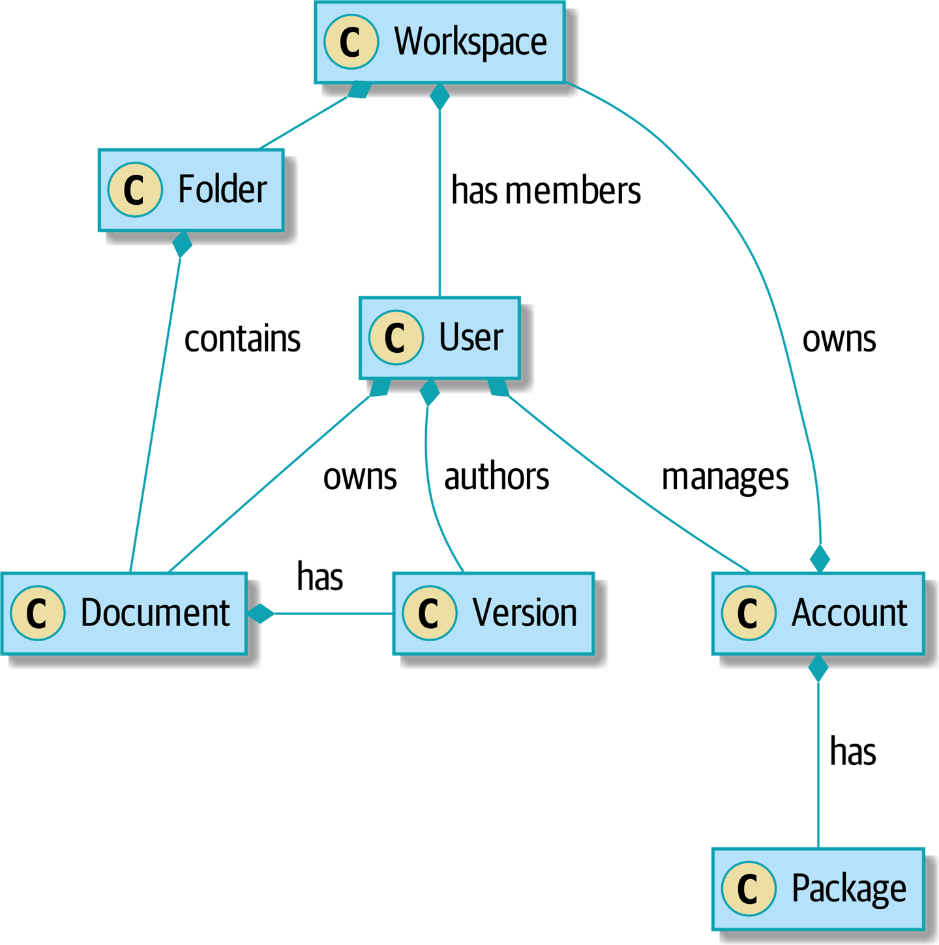
Figure E-1. Domain of a collaboration system

This was the system in which Bob first learned how to break apart a ball of mud, and it was a doozy. There was logic everywhere—in the web pages, in manager objects, in helpers, in fat service classes that we’d written to abstract the managers and helpers, and in hairy command objects that we’d written to break apart the services.
If you’re working in a system that’s reached this point, the situation can feel hopeless, but it’s never too late to start weeding an overgrown garden. Eventually, we hired an architect who knew what he was doing, and he helped us get things back under control.
Start by working out the use cases of your system. If you have a user interface, what actions does it perform? If you have a backend processing component, maybe each cron job or Celery job is a single use case. Each of your use cases needs to have an imperative name: Apply Billing Charges, Clean Abandoned Accounts, or Raise Purchase Order, for example.
In our case, most of our use cases were part of the manager classes and had names like Create Workspace or Delete Document Version. Each use case was invoked from a web frontend.
We aim to create a single function or class for each of these supported operations that deals with orchestrating the work to be done. Each use case should do the following:
Start its own database transaction if needed
Fetch any required data
Check any preconditions (see the Ensure pattern in Appendix E)
Update the domain model
Persist any changes
Each use case should succeed or fail as an atomic unit. You might need to call one use case from another. That’s OK; just make a note of it, and try to avoid long-running database transactions.

Note
One of the biggest problems we had was that manager methods called other manager methods, and data access could happen from the model objects themselves. It was hard to understand what each operation did without going on a treasure hunt across the codebase. Pulling all the logic into a single method, and using a UoW to control our transactions, made the system easier to reason about.

Case Study: Layering an Overgrown System
Many years ago, Bob worked for a software company that had outsourced the first version of its application, an online collaboration platform for sharing and working on files.
When the company brought development in-house, it passed through several generations of developers’ hands, and each wave of new developers added more complexity to the code’s structure.
At its heart, the system was an ASP.NET Web Forms application, built with an NHibernate ORM. Users would upload documents into workspaces, where they could invite other workspace members to review, comment on, or modify their work.
Most of the complexity of the application was in the permissions model because each document was contained in a folder, and folders allowed read, write, and edit permissions, much like a Linux filesystem.
Additionally, each workspace belonged to an account, and the account had quotas attached to it via a billing package.
As a result, every read or write operation against a document had to load an enormous number of objects from the database in order to test permissions and quotas. Creating a new workspace involved hundreds of database queries as we set up the permissions structure, invited users, and set up sample content.
Some of the code for operations was in web handlers that ran when a user clicked a button or submitted a form; some of it was in manager objects that held code for orchestrating work; and some of it was in the domain model. Model objects would make database calls or copy files on disk, and the test coverage was abysmal.
To fix the problem, we first introduced a service layer so that all of the code for creating a document or workspace was in one place and could be understood. This involved pulling data access code out of the domain model and into command handlers. Likewise, we pulled orchestration code out of the managers and the web handlers and pushed it into handlers.
The resulting command handlers were long and messy, but we’d made a start at introducing order to the chaos.

Tip
It’s fine if you have duplication in the use-case functions. We’re not trying to write perfect code; we’re just trying to extract some meaningful layers. It’s better to duplicate some code in a few places than to have use-case functions calling one another in a long chain.
This is a good opportunity to pull any data-access or orchestration code out of the domain model and into the use cases. We should also try to pull I/O concerns (e.g., sending email, writing files) out of the domain model and up into the use-case functions. We apply the techniques from Chapter 3 on abstractions to keep our handlers unit testable even when they’re performing I/O.
These use-case functions will mostly be about logging, data access, and error handling. Once you’ve done this step, you’ll have a grasp of what your program actually does, and a way to make sure each operation has a clearly defined start and finish. We’ll have taken a step toward building a pure domain model.
Read Working Effectively with Legacy Code by Michael C. Feathers (Prentice Hall) for guidance on getting legacy code under test and starting separating responsibilities.

Identifying Aggregates and Bounded Contexts
Part of the problem with the codebase in our case study was that the object graph was highly connected. Each account had many workspaces, and each workspace had many members, all of whom had their own accounts. Each workspace contained many documents, which had many versions.
You can’t express the full horror of the thing in a class diagram. For one thing, there wasn’t really a single account related to a user. Instead, there was a bizarre rule requiring you to enumerate all of the accounts associated to the user via the workspaces and take the one with the earliest creation date.
Every object in the system was part of an inheritance hierarchy that included SecureObject and Version. This inheritance hierarchy was mirrored directly in the database schema, so that every query had to join across 10 different tables and look at a discriminator column just to tell what kind of objects you were working with.
The codebase made it easy to “dot” your way through these objects like so:
user
.
account
.
workspaces
[
0
]
.
documents
.
versions
[
1
]
.
owner
.
account
.
settings
[
0
];
Building a system this way with Django ORM or SQLAlchemy is easy but is to be avoided. Although it’s convenient, it makes it very hard to reason about performance because each property might trigger a lookup to the database.

Tip
Aggregates are a consistency boundary. In general, each use case should update a single aggregate at a time. One handler fetches one aggregate from a repository, modifies its state, and raises any events that happen as a result. If you need data from another part of the system, it’s totally fine to use a read model, but avoid updating multiple aggregates in a single transaction. When we choose to separate code into different aggregates, we’re explicitly choosing to make them eventually consistent with one another.
A bunch of operations required us to loop over objects this way—for example:
# Lock a user's workspaces for nonpayment
def
lock_account
(
user
):
for
workspace
in
user
.
account
.
workspaces
:
workspace
.
archive
()
Or even recurse over collections of folders and documents:
def
lock_documents_in_folder
(
folder
):
for
doc
in
folder
.
documents
:
doc
.
archive
()
for
child
in
folder
.
children
:
lock_documents_in_folder
(
child
)
These operations killed performance, but fixing them meant giving up our single object graph. Instead, we began to identify aggregates and to break the direct links between objects.

Note
We talked about the infamous SELECT N+1 problem in Chapter 12, and how we might choose to use different techniques when reading data for queries versus reading data for commands.
Mostly we did this by replacing direct references with identifiers.
Before aggregates:
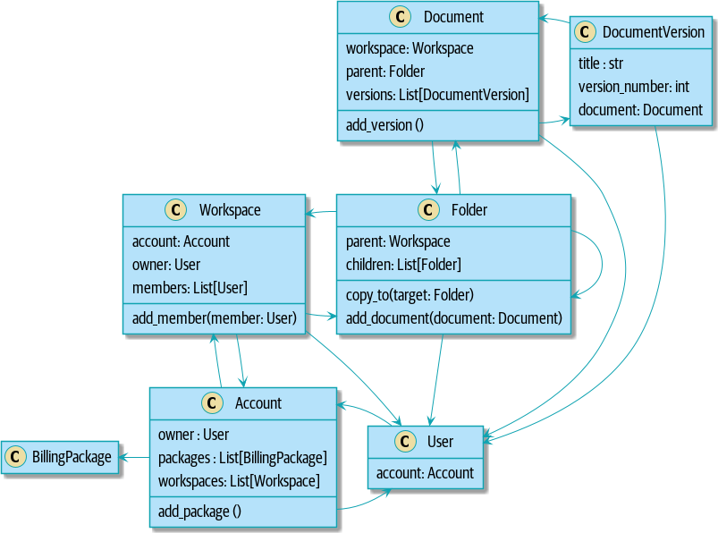

After modeling with aggregates:
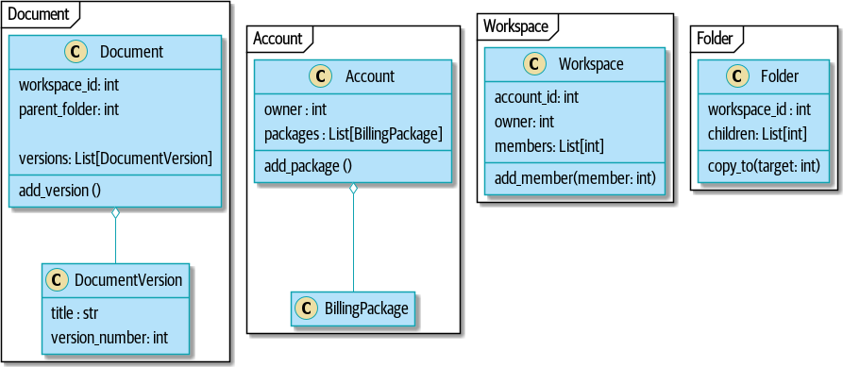

Tip
Bidirectional links are often a sign that your aggregates aren’t right. In our original code, a Document knew about its containing Folder, and the Folder had a collection of Documents. This makes it easy to traverse the object graph but stops us from thinking properly about the consistency boundaries we need. We break apart aggregates by using references instead. In the new model, a Document had reference to its parent_folder but had no way to directly access the Folder.
If we needed to read data, we avoided writing complex loops and transforms and tried to replace them with straight SQL. For example, one of our screens was a tree view of folders and documents.
This screen was incredibly heavy on the database, because it relied on nested for loops that triggered a lazy-loaded ORM.

Tip
We use this same technique in Chapter 11, where we replace a nested loop over ORM objects with a simple SQL query. It’s the first step in a CQRS approach.
After a lot of head-scratching, we replaced the ORM code with a big, ugly stored procedure. The code looked horrible, but it was much faster and helped to break the links between Folder and Document.
When we needed to write data, we changed a single aggregate at a time, and we introduced a message bus to handle events. For example, in the new model, when we locked an account, we could first query for all the affected workspaces via SELECT id FROM workspace WHERE account_id = ?.
We could then raise a new command for each workspace:
for
workspace_id
in
workspaces
:
bus
.
handle
(
LockWorkspace
(
workspace_id
))

An Event-Driven Approach to Go to Microservices via Strangler Pattern
The Strangler Fig pattern involves creating a new system around the edges of an old system, while keeping it running. Bits of old functionality are gradually intercepted and replaced, until the old system is left doing nothing at all and can be switched off.
When building the availability service, we used a technique called event interception to move functionality from one place to another. This is a three-step process:
Raise events to represent the changes happening in a system you want to replace.
Build a second system that consumes those events and uses them to build its own domain model.
Replace the older system with the new.
We used event interception to move from Figure E-2…
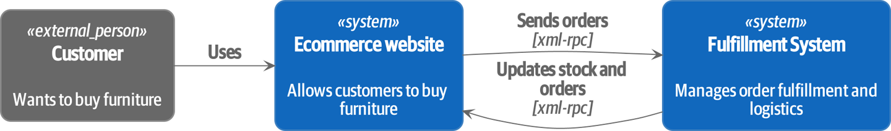
Figure E-2. Before: strong, bidirectional coupling based on XML-RPC

to Figure E-3.
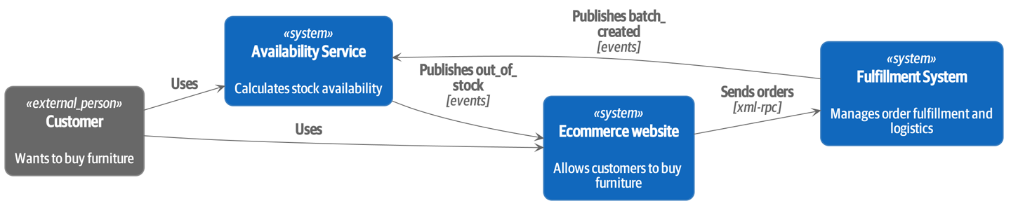
Figure E-3. After: loose coupling with asynchronous events (you can find a high-resolution version of this diagram at cosmicpython.com)

Practically, this was a several month-long project. Our first step was to write a domain model that could represent batches, shipments, and products. We used TDD to build a toy system that could answer a single question: “If I want N units of HAZARDOUS_RUG, how long will they take to be delivered?”

Tip
When deploying an event-driven system, start with a “walking skeleton.” Deploying a system that just logs its input forces us to tackle all the infrastructural questions and start working in production.

Case Study: Carving Out a Microservice to Replace a Domain
MADE.com started out with two monoliths: one for the frontend ecommerce application, and one for the backend fulfillment system.
The two systems communicated through XML-RPC. Periodically, the backend system would wake up and query the frontend system to find out about new orders. When it had imported all the new orders, it would send RPC commands to update the stock levels.
Over time this synchronization process became slower and slower until, one Christmas, it took longer than 24 hours to import a single day’s orders. Bob was hired to break the system into a set of event-driven services.
First, we identified that the slowest part of the process was calculating and synchronizing the available stock. What we needed was a system that could listen to external events and keep a running total of how much stock was available.
We exposed that information via an API, so that the user’s browser could ask how much stock was available for each product and how long it would take to deliver to their address.
Whenever a product ran out of stock completely, we would raise a new event that the ecommerce platform could use to take a product off sale. Because we didn’t know how much load we would need to handle, we wrote the system with a CQRS pattern. Whenever the amount of stock changed, we would update a Redis database with a cached view model. Our Flask API queried these view models instead of running the complex domain model.
As a result, we could answer the question “How much stock is available?” in 2 to 3 milliseconds, and now the API frequently handles hundreds of requests a second for sustained periods.
If this all sounds a little familiar, well, now you know where our example app came from!
Once we had a working domain model, we switched to building out some infrastructural pieces. Our first production deployment was a tiny system that could receive a batch_created event and log its JSON representation. This is the “Hello World” of event-driven architecture. It forced us to deploy a message bus, hook up a producer and consumer, build a deployment pipeline, and write a simple message handler.
Given a deployment pipeline, the infrastructure we needed, and a basic domain model, we were off. A couple months later, we were in production and serving real customers.

Convincing Your Stakeholders to Try Something New
If you’re thinking about carving a new system out of a big ball of mud, you’re probably suffering problems with reliability, performance, maintainability, or all three simultaneously. Deep, intractable problems call for drastic measures!
We recommend domain modeling as a first step. In many overgrown systems, the engineers, product owners, and customers no longer speak the same language. Business stakeholders speak about the system in abstract, process-focused terms, while developers are forced to speak about the system as it physically exists in its wild and chaotic state.

Case Study: The User Model
We mentioned earlier that the account and user model in our first system were bound together by a “bizarre rule.” This is a perfect example of how engineering and business stakeholders can drift apart.
In this system, accounts parented workspaces, and users were members of workspaces. Workspaces were the fundamental unit for applying permissions and quotas. If a user joined a workspace and didn’t already have an account, we would associate them with the account that owned that workspace.
This was messy and ad hoc, but it worked fine until the day a product owner asked for a new feature:
When a user joins a company, we want to add them to some default workspaces for the company, like the HR workspace or the Company Announcements workspace.
We had to explain to them that there was no such thing as a company, and there was no sense in which a user joined an account. Moreover, a “company” might have many accounts owned by different users, and a new user might be invited to any one of them.
Years of adding hacks and work-arounds to a broken model caught up with us, and we had to rewrite the entire user management function as a brand-new system.
Figuring out how to model your domain is a complex task that’s the subject of many decent books in its own right. We like to use interactive techniques like event storming and CRC modeling, because humans are good at collaborating through play. Event modeling is another technique that brings engineers and product owners together to understand a system in terms of commands, queries, and events.

Tip
Check out www.eventmodeling.org and www.eventstorming.org for some great guides to visual modeling of systems with events.
The goal is to be able to talk about the system by using the same ubiquitous language, so that you can agree on where the complexity lies.
We’ve found a lot of value in treating domain problems as TDD kata. For example, the first code we wrote for the availability service was the batch and order line model. You can treat this as a lunchtime workshop, or as a spike at the beginning of a project. Once you can demonstrate the value of modeling, it’s easier to make the argument for structuring the project to optimize for modeling.

Case Study: David Seddon on Taking Small Steps
Hi, I’m David, one of the tech reviewers on this book. I’ve worked on several complex Django monoliths, and so I’ve known the pain that Bob and Harry have made all sorts of grand promises about soothing.
When I was first exposed to the patterns described here, I was rather excited. I had successfully used some of the techniques already on smaller projects, but here was a blueprint for much larger, database-backed systems like the one I work on in my day job. So I started trying to figure out how I could implement that blueprint at my current organization.
I chose to tackle a problem area of the codebase that had always bothered me. I began by implementing it as a use case. But I found myself running into unexpected questions. There were things that I hadn’t considered while reading that now made it difficult to see what to do. Was it a problem if my use case interacted with two different aggregates? Could one use case call another? And how was it going to exist within a system that followed different architectural principles without resulting in a horrible mess?
What happened to that oh-so-promising blueprint? Did I actually understand the ideas well enough to put them into practice? Was it even suitable for my application? Even if it was, would any of my colleagues agree to such a major change? Were these just nice ideas for me to fantasize about while I got on with real life?
It took me a while to realize that I could start small. I didn’t need to be a purist or to get it right the first time: I could experiment, finding what worked for me.
And so that’s what I’ve done. I’ve been able to apply some of the ideas in a few places. I’ve built new features whose business logic can be tested without the database or mocks. And as a team, we’ve introduced a service layer to help define the jobs the system does.
If you start trying to apply these patterns in your work, you may go through similar feelings to begin with. When the nice theory of a book meets the reality of your codebase, it can be demoralizing.
My advice is to focus on a specific problem and ask yourself how you can put the relevant ideas to use, perhaps in an initially limited and imperfect fashion. You may discover, as I did, that the first problem you pick might be a bit too difficult; if so, move on to something else. Don’t try to boil the ocean, and don’t be too afraid of making mistakes. It will be a learning experience, and you can be confident that you’re moving roughly in a direction that others have found useful.
So, if you’re feeling the pain too, give these ideas a try. Don’t feel you need permission to rearchitect everything. Just look for somewhere small to start. And above all, do it to solve a specific problem. If you’re successful in solving it, you’ll know you got something right—and others will too.

Questions Our Tech Reviewers Asked That We Couldn’t Work into Prose
Here are some questions we heard during drafting that we couldn’t find a good place to address elsewhere in the book:
Do I need to do all of this at once? Can I just do a bit at a time?
No, you can absolutely adopt these techniques bit by bit. If you have an existing system, we recommend building a service layer to try to keep orchestration in one place. Once you have that, it’s much easier to push logic into the model and push edge concerns like validation or error handling to the entrypoints.
It’s worth having a service layer even if you still have a big, messy Django ORM because it’s a way to start understanding the boundaries of operations.
Extracting use cases will break a lot of my existing code; it’s too tangled
Just copy and paste. It’s OK to cause more duplication in the short term. Think of this as a multistep process. Your code is in a bad state now, so copy and paste it to a new place and then make that new code clean and tidy.
Once you’ve done that, you can replace uses of the old code with calls to your new code and finally delete the mess. Fixing large codebases is a messy and painful process. Don’t expect things to get instantly better, and don’t worry if some bits of your application stay messy.
Do I need to do CQRS? That sounds weird. Can’t I just use repositories?
Of course you can! The techniques we’re presenting in this book are intended to make your life easier. They’re not some kind of ascetic discipline with which to punish yourself.
In our first case-study system, we had a lot of View Builder objects that used repositories to fetch data and then performed some transformations to return dumb read models. The advantage is that when you hit a performance problem, it’s easy to rewrite a view builder to use custom queries or raw SQL.
How should use cases interact across a larger system? Is it a problem for one to call another?
This might be an interim step. Again, in the first case study, we had handlers that would need to invoke other handlers. This gets really messy, though, and it’s much better to move to using a message bus to separate these concerns.
Generally, your system will have a single message bus implementation and a bunch of subdomains that center on a particular aggregate or set of aggregates. When your use case has finished, it can raise an event, and a handler elsewhere can run.
Is it a code smell for a use case to use multiple repositories/aggregates, and if so, why?
An aggregate is a consistency boundary, so if your use case needs to update two aggregates atomically (within the same transaction), then your consistency boundary is wrong, strictly speaking. Ideally you should think about moving to a new aggregate that wraps up all the things you want to change at the same time.
If you’re actually updating only one aggregate and using the other(s) for read-only access, then that’s fine, although you could consider building a read/view model to get you that data instead—it makes things cleaner if each use case has only one aggregate.
If you do need to modify two aggregates, but the two operations don’t have to be in the same transaction/UoW, then consider splitting the work out into two different handlers and using a domain event to carry information between the two. You can read more in these papers on aggregate design by Vaughn Vernon.
What if I have a read-only but business-logic-heavy system?
View models can have complex logic in them. In this book, we’ve encouraged you to separate your read and write models because they have different consistency and throughput requirements. Mostly, we can use simpler logic for reads, but that’s not always true. In particular, permissions and authorization models can add a lot of complexity to our read side.
We’ve written systems in which the view models needed extensive unit tests. In those systems, we split a view builder from a view fetcher, as in Figure E-4.
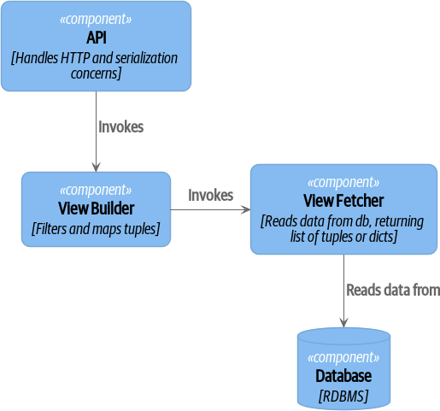
Figure E-4. A view builder and view fetcher (you can find a high-resolution version of this diagram at cosmicpython.com)

+ This makes it easy to test the view builder by giving it mocked data (e.g., a list of dicts). “Fancy CQRS” with event handlers is really a way of running our complex view logic whenever we write so that we can avoid running it when we read.
Do I need to build microservices to do this stuff?
Egads, no! These techniques predate microservices by a decade or so. Aggregates, domain events, and dependency inversion are ways to control complexity in large systems. It just so happens that when you’ve built a set of use cases and a model for a business process, moving it to its own service is relatively easy, but that’s not a requirement.
I’m using Django. Can I still do this?
We have an entire appendix just for you: Appendix D!

Footguns
OK, so we’ve given you a whole bunch of new toys to play with. Here’s the fine print. Harry and Bob do not recommend that you copy and paste our code into a production system and rebuild your automated trading platform on Redis pub/sub. For reasons of brevity and simplicity, we’ve hand-waved a lot of tricky subjects. Here’s a list of things we think you should know before trying this for real.
Reliable messaging is hard
Redis pub/sub is not reliable and shouldn’t be used as a general-purpose messaging tool. We picked it because it’s familiar and easy to run. At MADE, we run Event Store as our messaging tool, but we’ve had experience with RabbitMQ and Amazon EventBridge.
Tyler Treat has some excellent blog posts on his site bravenewgeek.com; you should read at least read “You Cannot Have Exactly-Once Delivery” and “What You Want Is What You Don’t: Understanding Trade-Offs in Distributed Messaging”.
We explicitly choose small, focused transactions that can fail independently
In Chapter 8, we update our process so that deallocating an order line and reallocating the line happen in two separate units of work. You will need monitoring to know when these transactions fail, and tooling to replay events. Some of this is made easier by using a transaction log as your message broker (e.g., Kafka or EventStore). You might also look at the Outbox pattern.
We don’t discuss idempotency
We haven’t given any real thought to what happens when handlers are retried. In practice you will want to make handlers idempotent so that calling them repeatedly with the same message will not make repeated changes to state. This is a key technique for building reliability, because it enables us to safely retry events when they fail.
There’s a lot of good material on idempotent message handling, try starting with “How to Ensure Idempotency in an Eventual Consistent DDD/CQRS Application” and “(Un)Reliability in Messaging”.
Your events will need to change their schema over time
You’ll need to find some way of documenting your events and sharing schema with consumers. We like using JSON schema and markdown because it’s simple but there is other prior art. Greg Young wrote an entire book on managing event-driven systems over time: Versioning in an Event Sourced System (Leanpub).

More Required Reading
A few more books we’d like to recommend to help you on your way:
Clean Architectures in Python by Leonardo Giordani (Leanpub), which came out in 2019, is one of the few previous books on application architecture in Python.
Enterprise Integration Patterns by Gregor Hohpe and Bobby Woolf (Addison-Wesley Professional) is a pretty good start for messaging patterns.
Monolith to Microservices by Sam Newman (O’Reilly), and Newman’s first book, Building Microservices (O’Reilly). The Strangler Fig pattern is mentioned as a favorite, along with many others. These are good to check out if you’re thinking of moving to microservices, and they’re also good on integration patterns and the considerations of async messaging-based integration.

Wrap-Up
Phew! That’s a lot of warnings and reading suggestions; we hope we haven’t scared you off completely. Our goal with this book is to give you just enough knowledge and intuition for you to start building some of this for yourself. We would love to hear how you get on and what problems you’re facing with the techniques in your own systems, so why not get in touch with us over at www.cosmicpython.com?

Appendix A. Summary Diagram and Table
Here’s what our architecture looks like by the end of the book:
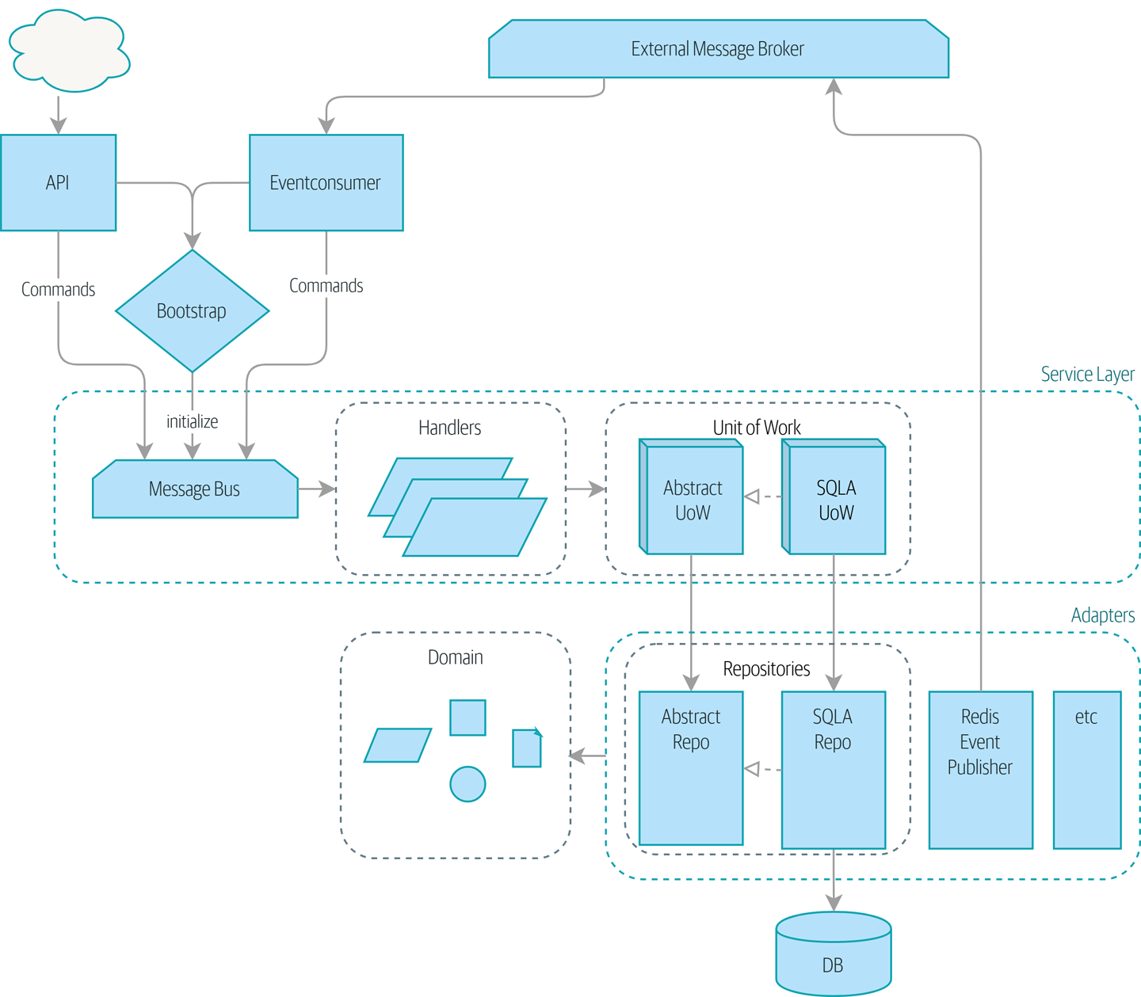

Table A-1 recaps each pattern and what it does.
Table A-1. The components of our architecture and what they all do  Layer | Component | Description
Domain  Defines the business logic. | Entity | A domain object whose attributes may change but that has a recognizable identity over time.
Value object | An immutable domain object whose attributes entirely define it. It is fungible with other identical objects.
Aggregate | Cluster of associated objects that we treat as a unit for the purpose of data changes. Defines and enforces a consistency boundary.
Event | Represents something that happened.
Command | Represents a job the system should perform.
Service Layer  Defines the jobs the system should perform and orchestrates different components. | Handler | Receives a command or an event and performs what needs to happen.
Unit of work | Abstraction around data integrity. Each unit of work represents an atomic update. Makes repositories available. Tracks new events on retrieved aggregates.
Message bus (internal) | Handles commands and events by routing them to the appropriate handler.
Adapters (Secondary)  Concrete implementations of an interface that goes from our system to the outside world (I/O). | Repository | Abstraction around persistent storage. Each aggregate has its own repository.
Event publisher | Pushes events onto the external message bus.
Entrypoints (Primary adapters)  Translate external inputs into calls into the service layer. | Web | Receives web requests and translates them into commands, passing them to the internal message bus.
Event consumer | Reads events from the external message bus and translates them into commands, passing them to the internal message bus.
N/A | External message bus (message broker) | A piece of infrastructure that different services use to intercommunicate, via events.

Appendix B. A Template Project Structure
Around Chapter 4, we moved from just having everything in one folder to a more structured tree, and we thought it might be of interest to outline the moving parts.

Tip
The code for this appendix is in the appendix_project_structure branch on GitHub:
git clone https://github.com/cosmicpython/code.git
cd code
git checkout appendix_project_structure
The basic folder structure looks like this:
Project tree
.
├── Dockerfile
├── Makefile
├── README.md
├── docker-compose.yml
├── license.txt
├── mypy.ini
├── requirements.txt
├── src
│ ├── allocation
│ │ ├── __init__.py
│ │ ├── adapters
│ │ │ ├── __init__.py
│ │ │ ├── orm.py
│ │ │ └── repository.py
│ │ ├── config.py
│ │ ├── domain
│ │ │ ├── __init__.py
│ │ │ └── model.py
│ │ ├── entrypoints
│ │ │ ├── __init__.py
│ │ │ └── flask_app.py
│ │ └── service_layer
│ │ ├── __init__.py
│ │ └── services.py
│ └── setup.py
└── tests
├── conftest.py
├── e2e
│ └── test_api.py
├── integration
│ ├── test_orm.py
│ └── test_repository.py
├── pytest.ini
└── unit
├── test_allocate.py
├── test_batches.py
└── test_services.py
Our docker-compose.yml and our Dockerfile are the main bits of configuration for the containers that run our app, and they can also run the tests (for CI). A more complex project might have several Dockerfiles, although we’ve found that minimizing the number of images is usually a good idea.1
A Makefile provides the entrypoint for all the typical commands a developer (or a CI server) might want to run during their normal workflow: make build, make test, and so on.2 This is optional. You could just use docker-compose and pytest directly, but if nothing else, it’s nice to have all the “common commands” in a list somewhere, and unlike documentation, a Makefile is code so it has less tendency to become out of date.
All the source code for our app, including the domain model, the Flask app, and infrastructure code, lives in a Python package inside src,3 which we install using pip install -e and the setup.py file. This makes imports easy. Currently, the structure within this module is totally flat, but for a more complex project, you’d expect to grow a folder hierarchy that includes domain_model/, infrastructure/, services/, and api/.
Tests live in their own folder. Subfolders distinguish different test types and allow you to run them separately. We can keep shared fixtures (conftest.py) in the main tests folder and nest more specific ones if we wish. This is also the place to keep pytest.ini.

Tip
The pytest docs are really good on test layout and importability.
Let’s look at a few of these files and concepts in more detail.

Env Vars, 12-Factor, and Config, Inside and Outside Containers
The basic problem we’re trying to solve here is that we need different config settings for the following:
Running code or tests directly from your own dev machine, perhaps talking to mapped ports from Docker containers
Running on the containers themselves, with “real” ports and hostnames
Different container environments (dev, staging, prod, and so on)
Configuration through environment variables as suggested by the 12-factor manifesto will solve this problem, but concretely, how do we implement it in our code and our containers?

Config.py
Whenever our application code needs access to some config, it’s going to get it from a file called config.py. Here are a couple of examples from our app:
Sample config functions (src/allocation/config.py)
import
os
def
get_postgres_uri
(
)
:
host
=
os
.
environ
.
get
(
'
DB_HOST
'
,
'
localhost
'
)
port
=
54321
if
host
==
'
localhost
'
else
5432
password
=
os
.
environ
.
get
(
'
DB_PASSWORD
'
,
'
abc123
'
)
user
,
db_name
=
'
allocation
'
,
'
allocation
'
return
f
"
postgresql://{user}:{password}@{host}:{port}/{db_name}
"
def
get_api_url
(
)
:
host
=
os
.
environ
.
get
(
'
API_HOST
'
,
'
localhost
'
)
port
=
5005
if
host
==
'
localhost
'
else
80
return
f
"
http://{host}:{port}
"
We use functions for getting the current config, rather than constants available at import time, because that allows client code to modify os.environ if it needs to.
config.py also defines some default settings, designed to work when running the code from the developer’s local machine.4
An elegant Python package called environ-config is worth looking at if you get tired of hand-rolling your own environment-based config functions.

Tip
Don’t let this config module become a dumping ground that is full of things only vaguely related to config and that is then imported all over the place. Keep things immutable and modify them only via environment variables. If you decide to use a bootstrap script, you can make it the only place (other than tests) that config is imported to.

Docker-Compose and Containers Config
We use a lightweight Docker container orchestration tool called docker-compose. It’s main configuration is via a YAML file (sigh):5
docker-compose config file (docker-compose.yml)
version
:
"
3
"
services
:
app
:
build
:
context
:
.
dockerfile
:
Dockerfile
depends_on
:
-
postgres
environment
:
-
DB_HOST=postgres
-
DB_PASSWORD=abc123
-
API_HOST=app
-
PYTHONDONTWRITEBYTECODE=1
volumes
:
-
./src:/src
-
./tests:/tests
ports
:
-
"
5005:80
"
postgres
:
image
:
postgres:9.6
environment
:
-
POSTGRES_USER=allocation
-
POSTGRES_PASSWORD=abc123
ports
:
-
"
54321:5432
"
In the docker-compose file, we define the different services (containers) that we need for our app. Usually one main image contains all our code, and we can use it to run our API, our tests, or any other service that needs access to the domain model.
You’ll probably have other infrastructure services, including a database. In production you might not use containers for this; you might have a cloud provider instead, but docker-compose gives us a way of producing a similar service for dev or CI.
The environment stanza lets you set the environment variables for your containers, the hostnames and ports as seen from inside the Docker cluster. If you have enough containers that information starts to be duplicated in these sections, you can use environment_file instead. We usually call ours container.env.
Inside a cluster, docker-compose sets up networking such that containers are available to each other via hostnames named after their service name.
Pro tip: if you’re mounting volumes to share source folders between your local dev machine and the container, the PYTHONDONTWRITEBYTECODE environment variable tells Python to not write .pyc files, and that will save you from having millions of root-owned files sprinkled all over your local filesystem, being all annoying to delete and causing weird Python compiler errors besides.
Mounting our source and test code as volumes means we don’t need to rebuild our containers every time we make a code change.
The ports section allows us to expose the ports from inside the containers to the outside world6—these correspond to the default ports we set in config.py.

Note
Inside Docker, other containers are available through hostnames named after their service name. Outside Docker, they are available on localhost, at the port defined in the ports section.

Installing Your Source as a Package
All our application code (everything except tests, really) lives inside an src folder:
The src folder
├── src
│ ├── allocation
│ │ ├── config.py
│ │ └── ...
│ └── setup.py
Subfolders define top-level module names. You can have multiple if you like.
And setup.py is the file you need to make it pip-installable, shown next.
pip-installable modules in three lines (src/setup.py)
from
setuptools
import
setup
setup
(
name
=
'allocation'
,
version
=
'0.1'
,
packages
=
[
'allocation'
],
)
That’s all you need. packages= specifies the names of subfolders that you want to install as top-level modules. The name entry is just cosmetic, but it’s required. For a package that’s never actually going to hit PyPI, it’ll do fine.7

Dockerfile
Dockerfiles are going to be very project-specific, but here are a few key stages you’ll expect to see:
Our Dockerfile (Dockerfile)
FROM
python:3.8-alpine
RUN
apk
add
--no-cache
--virtual
.build-deps
gcc
postgresql-dev
musl-dev
python3-dev
RUN
apk
add
libpq
COPY
requirements.txt
/tmp/
RUN
pip
install
-r
/tmp/requirements.txt
RUN
apk
del
--no-cache
.build-deps
RUN
mkdir
-p
/src
COPY
src/
/src/
RUN
pip
install
-e
/src
COPY
tests/
/tests/
WORKDIR
/src
ENV
FLASK_APP=allocation/entrypoints/flask_app.py FLASK_DEBUG=1 PYTHONUNBUFFERED=1
CMD
flask run --host=0.0.0.0 --port=80
Installing system-level dependencies
Installing our Python dependencies (you may want to split out your dev from prod dependencies; we haven’t here, for simplicity)
Copying and installing our source
Optionally configuring a default startup command (you’ll probably override this a lot from the command line)

Tip
One thing to note is that we install things in the order of how frequently they are likely to change. This allows us to maximize Docker build cache reuse. I can’t tell you how much pain and frustration underlies this lesson. For this and many more Python Dockerfile improvement tips, check out “Production-Ready Docker Packaging”.

Tests
Our tests are kept alongside everything else, as shown here:
Tests folder tree
└── tests
├── conftest.py
├── e2e
│ └── test_api.py
├── integration
│ ├── test_orm.py
│ └── test_repository.py
├── pytest.ini
└── unit
├── test_allocate.py
├── test_batches.py
└── test_services.py
Nothing particularly clever here, just some separation of different test types that you’re likely to want to run separately, and some files for common fixtures, config, and so on.
There’s no src folder or setup.py in the test folders because we usually haven’t needed to make tests pip-installable, but if you have difficulties with import paths, you might find it helps.

Wrap-Up
These are our basic building blocks:
Source code in an src folder, pip-installable using setup.py
Some Docker config for spinning up a local cluster that mirrors production as far as possible
Configuration via environment variables, centralized in a Python file called config.py, with defaults allowing things to run outside containers
A Makefile for useful command-line, um, commands
We doubt that anyone will end up with exactly the same solutions we did, but we hope you find some inspiration here.
1 Splitting out images for production and testing is sometimes a good idea, but we’ve tended to find that going further and trying to split out different images for different types of application code (e.g., Web API versus pub/sub client) usually ends up being more trouble than it’s worth; the cost in terms of complexity and longer rebuild/CI times is too high. YMMV.
2 A pure-Python alternative to Makefiles is Invoke, worth checking out if everyone on your team knows Python (or at least knows it better than Bash!).
3 “Testing and Packaging” by Hynek Schlawack provides more information on src folders.
4 This gives us a local development setup that “just works” (as much as possible). You may prefer to fail hard on missing environment variables instead, particularly if any of the defaults would be insecure in production.
5 Harry is a bit YAML-weary. It’s everywhere, and yet he can never remember the syntax or how it’s supposed to indent.
6 On a CI server, you may not be able to expose arbitrary ports reliably, but it’s only a convenience for local dev. You can find ways of making these port mappings optional (e.g., with docker-compose.override.yml).
7 For more setup.py tips, see this article on packaging by Hynek.

Appendix C. Swapping Out the Infrastructure: Do Everything with CSVs
This appendix is intended as a little illustration of the benefits of the Repository, Unit of Work, and Service Layer patterns. It’s intended to follow from Chapter 6.
Just as we finish building out our Flask API and getting it ready for release, the business comes to us apologetically, saying they’re not ready to use our API and asking if we could build a thing that reads just batches and orders from a couple of CSVs and outputs a third CSV with allocations.
Ordinarily this is the kind of thing that might have a team cursing and spitting and making notes for their memoirs. But not us! Oh no, we’ve ensured that our infrastructure concerns are nicely decoupled from our domain model and service layer. Switching to CSVs will be a simple matter of writing a couple of new Repository and UnitOfWork classes, and then we’ll be able to reuse all of our logic from the domain layer and the service layer.
Here’s an E2E test to show you how the CSVs flow in and out:
A first CSV test (tests/e2e/test_csv.py)
def
test_cli_app_reads_csvs_with_batches_and_orders_and_outputs_allocations
(
make_csv
):
sku1
,
sku2
=
random_ref
(
's1'
),
random_ref
(
's2'
)
batch1
,
batch2
,
batch3
=
random_ref
(
'b1'
),
random_ref
(
'b2'
),
random_ref
(
'b3'
)
order_ref
=
random_ref
(
'o'
)
make_csv
(
'batches.csv'
,
[
[
'ref'
,
'sku'
,
'qty'
,
'eta'
],
[
batch1
,
sku1
,
100
,
''
],
[
batch2
,
sku2
,
100
,
'2011-01-01'
],
[
batch3
,
sku2
,
100
,
'2011-01-02'
],
])
orders_csv
=
make_csv
(
'orders.csv'
,
[
[
'orderid'
,
'sku'
,
'qty'
],
[
order_ref
,
sku1
,
3
],
[
order_ref
,
sku2
,
12
],
])
run_cli_script
(
orders_csv
.
parent
)
expected_output_csv
=
orders_csv
.
parent
/
'allocations.csv'
with
open
(
expected_output_csv
)
as
f
:
rows
=
list
(
csv
.
reader
(
f
))
assert
rows
==
[
[
'orderid'
,
'sku'
,
'qty'
,
'batchref'
],
[
order_ref
,
sku1
,
'3'
,
batch1
],
[
order_ref
,
sku2
,
'12'
,
batch2
],
]
Diving in and implementing without thinking about repositories and all that jazz, you might start with something like this:
A first cut of our CSV reader/writer (src/bin/allocate-from-csv)
#!/usr/bin/env python
import
csv
import
sys
from
datetime
import
datetime
from
pathlib
import
Path
from
allocation
import
model
def
load_batches
(
batches_path
):
batches
=
[]
with
batches_path
.
open
()
as
inf
:
reader
=
csv
.
DictReader
(
inf
)
for
row
in
reader
:
if
row
[
'eta'
]:
eta
=
datetime
.
strptime
(
row
[
'eta'
],
'
%Y
-
%m
-
%d
'
)
.
date
()
else
:
eta
=
None
batches
.
append
(
model
.
Batch
(
ref
=
row
[
'ref'
],
sku
=
row
[
'sku'
],
qty
=
int
(
row
[
'qty'
]),
eta
=
eta
))
return
batches
def
main
(
folder
):
batches_path
=
Path
(
folder
)
/
'batches.csv'
orders_path
=
Path
(
folder
)
/
'orders.csv'
allocations_path
=
Path
(
folder
)
/
'allocations.csv'
batches
=
load_batches
(
batches_path
)
with
orders_path
.
open
()
as
inf
,
allocations_path
.
open
(
'w'
)
as
outf
:
reader
=
csv
.
DictReader
(
inf
)
writer
=
csv
.
writer
(
outf
)
writer
.
writerow
([
'orderid'
,
'sku'
,
'batchref'
])
for
row
in
reader
:
orderid
,
sku
=
row
[
'orderid'
],
row
[
'sku'
]
qty
=
int
(
row
[
'qty'
])
line
=
model
.
OrderLine
(
orderid
,
sku
,
qty
)
batchref
=
model
.
allocate
(
line
,
batches
)
writer
.
writerow
([
line
.
orderid
,
line
.
sku
,
batchref
])
if
__name__
==
'__main__'
:
main
(
sys
.
argv
[
1
])
It’s not looking too bad! And we’re reusing our domain model objects and our domain service.
But it’s not going to work. Existing allocations need to also be part of our permanent CSV storage. We can write a second test to force us to improve things:
And another one, with existing allocations (tests/e2e/test_csv.py)
def
test_cli_app_also_reads_existing_allocations_and_can_append_to_them
(
make_csv
):
sku
=
random_ref
(
's'
)
batch1
,
batch2
=
random_ref
(
'b1'
),
random_ref
(
'b2'
)
old_order
,
new_order
=
random_ref
(
'o1'
),
random_ref
(
'o2'
)
make_csv
(
'batches.csv'
,
[
[
'ref'
,
'sku'
,
'qty'
,
'eta'
],
[
batch1
,
sku
,
10
,
'2011-01-01'
],
[
batch2
,
sku
,
10
,
'2011-01-02'
],
])
make_csv
(
'allocations.csv'
,
[
[
'orderid'
,
'sku'
,
'qty'
,
'batchref'
],
[
old_order
,
sku
,
10
,
batch1
],
])
orders_csv
=
make_csv
(
'orders.csv'
,
[
[
'orderid'
,
'sku'
,
'qty'
],
[
new_order
,
sku
,
7
],
])
run_cli_script
(
orders_csv
.
parent
)
expected_output_csv
=
orders_csv
.
parent
/
'allocations.csv'
with
open
(
expected_output_csv
)
as
f
:
rows
=
list
(
csv
.
reader
(
f
))
assert
rows
==
[
[
'orderid'
,
'sku'
,
'qty'
,
'batchref'
],
[
old_order
,
sku
,
'10'
,
batch1
],
[
new_order
,
sku
,
'7'
,
batch2
],
]
And we could keep hacking about and adding extra lines to that load_batches function, and some sort of way of tracking and saving new allocations—but we already have a model for doing that! It’s called our Repository and Unit of Work patterns.
All we need to do (“all we need to do”) is reimplement those same abstractions, but with CSVs underlying them instead of a database. And as you’ll see, it really is relatively straightforward.

Implementing a Repository and Unit of Work for CSVs
Here’s what a CSV-based repository could look like. It abstracts away all the logic for reading CSVs from disk, including the fact that it has to read two different CSVs (one for batches and one for allocations), and it gives us just the familiar .list() API, which provides the illusion of an in-memory collection of domain objects:
A repository that uses CSV as its storage mechanism (src/allocation/service_layer/csv_uow.py)
class
CsvRepository
(
repository
.
AbstractRepository
):
def
__init__
(
self
,
folder
):
self
.
_batches_path
=
Path
(
folder
)
/
'batches.csv'
self
.
_allocations_path
=
Path
(
folder
)
/
'allocations.csv'
self
.
_batches
=
{}
# type: Dict[str, model.Batch]
self
.
_load
()
def
get
(
self
,
reference
):
return
self
.
_batches
.
get
(
reference
)
def
add
(
self
,
batch
):
self
.
_batches
[
batch
.
reference
]
=
batch
def
_load
(
self
):
with
self
.
_batches_path
.
open
()
as
f
:
reader
=
csv
.
DictReader
(
f
)
for
row
in
reader
:
ref
,
sku
=
row
[
'ref'
],
row
[
'sku'
]
qty
=
int
(
row
[
'qty'
])
if
row
[
'eta'
]:
eta
=
datetime
.
strptime
(
row
[
'eta'
],
'
%Y
-
%m
-
%d
'
)
.
date
()
else
:
eta
=
None
self
.
_batches
[
ref
]
=
model
.
Batch
(
ref
=
ref
,
sku
=
sku
,
qty
=
qty
,
eta
=
eta
)
if
self
.
_allocations_path
.
exists
()
is
False
:
return
with
self
.
_allocations_path
.
open
()
as
f
:
reader
=
csv
.
DictReader
(
f
)
for
row
in
reader
:
batchref
,
orderid
,
sku
=
row
[
'batchref'
],
row
[
'orderid'
],
row
[
'sku'
]
qty
=
int
(
row
[
'qty'
])
line
=
model
.
OrderLine
(
orderid
,
sku
,
qty
)
batch
=
self
.
_batches
[
batchref
]
batch
.
_allocations
.
add
(
line
)
def
list
(
self
):
return
list
(
self
.
_batches
.
values
())
And here’s what a UoW for CSVs would look like:
A UoW for CSVs: commit = csv.writer (src/allocation/service_layer/csv_uow.py)
class
CsvUnitOfWork
(
unit_of_work
.
AbstractUnitOfWork
):
def
__init__
(
self
,
folder
):
self
.
batches
=
CsvRepository
(
folder
)
def
commit
(
self
):
with
self
.
batches
.
_allocations_path
.
open
(
'w'
)
as
f
:
writer
=
csv
.
writer
(
f
)
writer
.
writerow
([
'orderid'
,
'sku'
,
'qty'
,
'batchref'
])
for
batch
in
self
.
batches
.
list
():
for
line
in
batch
.
_allocations
:
writer
.
writerow
(
[
line
.
orderid
,
line
.
sku
,
line
.
qty
,
batch
.
reference
]
)
def
rollback
(
self
):
pass
And once we have that, our CLI app for reading and writing batches and allocations to CSV is pared down to what it should be—a bit of code for reading order lines, and a bit of code that invokes our existing service layer:
Allocation with CSVs in nine lines (src/bin/allocate-from-csv)
def
main
(
folder
):
orders_path
=
Path
(
folder
)
/
'orders.csv'
uow
=
csv_uow
.
CsvUnitOfWork
(
folder
)
with
orders_path
.
open
()
as
f
:
reader
=
csv
.
DictReader
(
f
)
for
row
in
reader
:
orderid
,
sku
=
row
[
'orderid'
],
row
[
'sku'
]
qty
=
int
(
row
[
'qty'
])
services
.
allocate
(
orderid
,
sku
,
qty
,
uow
)
Ta-da! Now are y’all impressed or what?
Much love,
Bob and Harry

Appendix D. Repository and Unit of Work Patterns with Django
Suppose you wanted to use Django instead of SQLAlchemy and Flask. How might things look? The first thing is to choose where to install it. We put it in a separate package next to our main allocation code:

├──
src
│
├──
allocation
│
│
├──
__init__
.
py
│
│
├──
adapters
│
│
│
├──
__init__
.
py
...
│
├──
djangoproject
│
│
├──
alloc
│
│
│
├──
__init__
.
py
│
│
│
├──
apps
.
py
│
│
│
├──
migrations
│
│
│
│
├──
0001
_initial
.
py
│
│
│
│
└──
__init__
.
py
│
│
│
├──
models
.
py
│
│
│
└──
views
.
py
│
│
├──
django_project
│
│
│
├──
__init__
.
py
│
│
│
├──
settings
.
py
│
│
│
├──
urls
.
py
│
│
│
└──
wsgi
.
py
│
│
└──
manage
.
py
│
└──
setup
.
py
└──
tests
├──
conftest
.
py
├──
e2e
│
└──
test_api
.
py
├──
integration
│
├──
test_repository
.
py
...

Tip
The code for this appendix is in the appendix_django branch on GitHub:
git clone https://github.com/cosmicpython/code.git
cd code
git checkout appendix_django

Repository Pattern with Django
We used a plug-in called pytest-django to help with test database management.
Rewriting the first repository test was a minimal change—just rewriting some raw SQL with a call to the Django ORM/QuerySet language:
First repository test adapted (tests/integration/test_repository.py)
from
djangoproject.alloc
import
models
as
django_models
@pytest.mark.django_db
def
test_repository_can_save_a_batch
():
batch
=
model
.
Batch
(
"batch1"
,
"RUSTY-SOAPDISH"
,
100
,
eta
=
date
(
2011
,
12
,
25
))
repo
=
repository
.
DjangoRepository
()
repo
.
add
(
batch
)
[
saved_batch
]
=
django_models
.
Batch
.
objects
.
all
()
assert
saved_batch
.
reference
==
batch
.
reference
assert
saved_batch
.
sku
==
batch
.
sku
assert
saved_batch
.
qty
==
batch
.
_purchased_quantity
assert
saved_batch
.
eta
==
batch
.
eta
The second test is a bit more involved since it has allocations, but it is still made up of familiar-looking Django code:
Second repository test is more involved (tests/integration/test_repository.py)
@pytest.mark.django_db
def
test_repository_can_retrieve_a_batch_with_allocations
():
sku
=
"PONY-STATUE"
d_line
=
django_models
.
OrderLine
.
objects
.
create
(
orderid
=
"order1"
,
sku
=
sku
,
qty
=
12
)
d_b1
=
django_models
.
Batch
.
objects
.
create
(
reference
=
"batch1"
,
sku
=
sku
,
qty
=
100
,
eta
=
None
)
d_b2
=
django_models
.
Batch
.
objects
.
create
(
reference
=
"batch2"
,
sku
=
sku
,
qty
=
100
,
eta
=
None
)
django_models
.
Allocation
.
objects
.
create
(
line
=
d_line
,
batch
=
d_batch1
)
repo
=
repository
.
DjangoRepository
()
retrieved
=
repo
.
get
(
"batch1"
)
expected
=
model
.
Batch
(
"batch1"
,
sku
,
100
,
eta
=
None
)
assert
retrieved
==
expected
# Batch.__eq__ only compares reference
assert
retrieved
.
sku
==
expected
.
sku
assert
retrieved
.
_purchased_quantity
==
expected
.
_purchased_quantity
assert
retrieved
.
_allocations
==
{
model
.
OrderLine
(
"order1"
,
sku
,
12
),
}
Here’s how the actual repository ends up looking:
A Django repository (src/allocation/adapters/repository.py)
class
DjangoRepository
(
AbstractRepository
):
def
add
(
self
,
batch
):
super
()
.
add
(
batch
)
self
.
update
(
batch
)
def
update
(
self
,
batch
):
django_models
.
Batch
.
update_from_domain
(
batch
)
def
_get
(
self
,
reference
):
return
django_models
.
Batch
.
objects
.
filter
(
reference
=
reference
)
.
first
()
.
to_domain
()
def
list
(
self
):
return
[
b
.
to_domain
()
for
b
in
django_models
.
Batch
.
objects
.
all
()]
You can see that the implementation relies on the Django models having some custom methods for translating to and from our domain model.1

Custom Methods on Django ORM Classes to Translate to/from Our Domain Model
Those custom methods look something like this:
Django ORM with custom methods for domain model conversion (src/djangoproject/alloc/models.py)
from
django.db
import
models
from
allocation.domain
import
model
as
domain_model
class
Batch
(
models
.
Model
)
:
reference
=
models
.
CharField
(
max_length
=
255
)
sku
=
models
.
CharField
(
max_length
=
255
)
qty
=
models
.
IntegerField
(
)
eta
=
models
.
DateField
(
blank
=
True
,
null
=
True
)
@staticmethod
def
update_from_domain
(
batch
:
domain_model
.
Batch
)
:
try
:
b
=
Batch
.
objects
.
get
(
reference
=
batch
.
reference
)
except
Batch
.
DoesNotExist
:
b
=
Batch
(
reference
=
batch
.
reference
)
b
.
sku
=
batch
.
sku
b
.
qty
=
batch
.
_purchased_quantity
b
.
eta
=
batch
.
eta
b
.
save
(
)
b
.
allocation_set
.
set
(
Allocation
.
from_domain
(
l
,
b
)
for
l
in
batch
.
_allocations
)
def
to_domain
(
self
)
-
>
domain_model
.
Batch
:
b
=
domain_model
.
Batch
(
ref
=
self
.
reference
,
sku
=
self
.
sku
,
qty
=
self
.
qty
,
eta
=
self
.
eta
)
b
.
_allocations
=
set
(
a
.
line
.
to_domain
(
)
for
a
in
self
.
allocation_set
.
all
(
)
)
return
b
class
OrderLine
(
models
.
Model
)
:
#...
For value objects, objects.get_or_create can work, but for entities, you probably need an explicit try-get/except to handle the upsert.2
We’ve shown the most complex example here. If you do decide to do this, be aware that there will be boilerplate! Thankfully it’s not very complex boilerplate.
Relationships also need some careful, custom handling.

Note
As in Chapter 2, we use dependency inversion. The ORM (Django) depends on the model and not the other way around.

Unit of Work Pattern with Django
The tests don’t change too much:
Adapted UoW tests (tests/integration/test_uow.py)
def
insert_batch
(
ref
,
sku
,
qty
,
eta
)
:
django_models
.
Batch
.
objects
.
create
(
reference
=
ref
,
sku
=
sku
,
qty
=
qty
,
eta
=
eta
)
def
get_allocated_batch_ref
(
orderid
,
sku
)
:
return
django_models
.
Allocation
.
objects
.
get
(
line__orderid
=
orderid
,
line__sku
=
sku
)
.
batch
.
reference
@pytest.mark.django_db
(
transaction
=
True
)
def
test_uow_can_retrieve_a_batch_and_allocate_to_it
(
)
:
insert_batch
(
'
batch1
'
,
'
HIPSTER-WORKBENCH
'
,
100
,
None
)
uow
=
unit_of_work
.
DjangoUnitOfWork
(
)
with
uow
:
batch
=
uow
.
batches
.
get
(
reference
=
'
batch1
'
)
line
=
model
.
OrderLine
(
'
o1
'
,
'
HIPSTER-WORKBENCH
'
,
10
)
batch
.
allocate
(
line
)
uow
.
commit
(
)
batchref
=
get_allocated_batch_ref
(
'
o1
'
,
'
HIPSTER-WORKBENCH
'
)
assert
batchref
==
'
batch1
'
@pytest.mark.django_db
(
transaction
=
True
)
def
test_rolls_back_uncommitted_work_by_default
(
)
:
.
.
.
@pytest.mark.django_db
(
transaction
=
True
)
def
test_rolls_back_on_error
(
)
:
.
.
.
Because we had little helper functions in these tests, the actual main bodies of the tests are pretty much the same as they were with SQLAlchemy.
The pytest-django mark.django_db(transaction=True) is required to test our custom transaction/rollback behaviors.
And the implementation is quite simple, although it took me a few tries to find which invocation of Django’s transaction magic would work:
UoW adapted for Django (src/allocation/service_layer/unit_of_work.py)
class
DjangoUnitOfWork
(
AbstractUnitOfWork
)
:
def
__enter__
(
self
)
:
self
.
batches
=
repository
.
DjangoRepository
(
)
transaction
.
set_autocommit
(
False
)
return
super
(
)
.
__enter__
(
)
def
__exit__
(
self
,
*
args
)
:
super
(
)
.
__exit__
(
*
args
)
transaction
.
set_autocommit
(
True
)
def
commit
(
self
)
:
for
batch
in
self
.
batches
.
seen
:
self
.
batches
.
update
(
batch
)
transaction
.
commit
(
)
def
rollback
(
self
)
:
transaction
.
rollback
(
)
set_autocommit(False) was the best way to tell Django to stop automatically committing each ORM operation immediately, and to begin a transaction.
Then we use the explicit rollback and commits.
One difficulty: because, unlike with SQLAlchemy, we’re not instrumenting the domain model instances themselves, the commit() command needs to explicitly go through all the objects that have been touched by every repository and manually update them back to the ORM.

API: Django Views Are Adapters
The Django views.py file ends up being almost identical to the old flask_app.py, because our architecture means it’s a very thin wrapper around our service layer (which didn’t change at all, by the way):
Flask app → Django views (src/djangoproject/alloc/views.py)
os
.
environ
[
'DJANGO_SETTINGS_MODULE'
]
=
'djangoproject.django_project.settings'
django
.
setup
()
@csrf_exempt
def
add_batch
(
request
):
data
=
json
.
loads
(
request
.
body
)
eta
=
data
[
'eta'
]
if
eta
is
not
None
:
eta
=
datetime
.
fromisoformat
(
eta
)
.
date
()
services
.
add_batch
(
data
[
'ref'
],
data
[
'sku'
],
data
[
'qty'
],
eta
,
unit_of_work
.
DjangoUnitOfWork
(),
)
return
HttpResponse
(
'OK'
,
status
=
201
)
@csrf_exempt
def
allocate
(
request
):
data
=
json
.
loads
(
request
.
body
)
try
:
batchref
=
services
.
allocate
(
data
[
'orderid'
],
data
[
'sku'
],
data
[
'qty'
],
unit_of_work
.
DjangoUnitOfWork
(),
)
except
(
model
.
OutOfStock
,
services
.
InvalidSku
)
as
e
:
return
JsonResponse
({
'message'
:
str
(
e
)},
status
=
400
)
return
JsonResponse
({
'batchref'
:
batchref
},
status
=
201
)

Why Was This All So Hard?
OK, it works, but it does feel like more effort than Flask/SQLAlchemy. Why is that?
The main reason at a low level is because Django’s ORM doesn’t work in the same way. We don’t have an equivalent of the SQLAlchemy classical mapper, so our ActiveRecord and our domain model can’t be the same object. Instead we have to build a manual translation layer behind the repository. That’s more work (although once it’s done, the ongoing maintenance burden shouldn’t be too high).
Because Django is so tightly coupled to the database, you have to use helpers like pytest-django and think carefully about test databases, right from the very first line of code, in a way that we didn’t have to when we started out with our pure domain model.
But at a higher level, the entire reason that Django is so great is that it’s designed around the sweet spot of making it easy to build CRUD apps with minimal boilerplate. But the entire thrust of our book is about what to do when your app is no longer a simple CRUD app.
At that point, Django starts hindering more than it helps. Things like the Django admin, which are so awesome when you start out, become actively dangerous if the whole point of your app is to build a complex set of rules and modeling around the workflow of state changes. The Django admin bypasses all of that.

What to Do If You Already Have Django
So what should you do if you want to apply some of the patterns in this book to a Django app? We’d say the following:
The Repository and Unit of Work patterns are going to be quite a lot of work. The main thing they will buy you in the short term is faster unit tests, so evaluate whether that benefit feels worth it in your case. In the longer term, they decouple your app from Django and the database, so if you anticipate wanting to migrate away from either of those, Repository and UoW are a good idea.
The Service Layer pattern might be of interest if you’re seeing a lot of duplication in your views.py. It can be a good way of thinking about your use cases separately from your web endpoints.
You can still theoretically do DDD and domain modeling with Django models, tightly coupled as they are to the database; you may be slowed by migrations, but it shouldn’t be fatal. So as long as your app is not too complex and your tests not too slow, you may be able to get something out of the fat models approach: push as much logic down to your models as possible, and apply patterns like Entity, Value Object, and Aggregate. However, see the following caveat.
With that said, word in the Django community is that people find that the fat models approach runs into scalability problems of its own, particularly around managing interdependencies between apps. In those cases, there’s a lot to be said for extracting out a business logic or domain layer to sit between your views and forms and your models.py, which you can then keep as minimal as possible.

Steps Along the Way
Suppose you’re working on a Django project that you’re not sure is going to get complex enough to warrant the patterns we recommend, but you still want to put a few steps in place to make your life easier, both in the medium term and if you want to migrate to some of our patterns later. Consider the following:
One piece of advice we’ve heard is to put a logic.py into every Django app from day one. This gives you a place to put business logic, and to keep your forms, views, and models free of business logic. It can become a stepping-stone for moving to a fully decoupled domain model and/or service layer later.
A business-logic layer might start out working with Django model objects and only later become fully decoupled from the framework and work on plain Python data structures.
For the read side, you can get some of the benefits of CQRS by putting reads into one place, avoiding ORM calls sprinkled all over the place.
When separating out modules for reads and modules for domain logic, it may be worth decoupling yourself from the Django apps hierarchy. Business concerns will cut across them.

Note
We’d like to give a shout-out to David Seddon and Ashia Zawaduk for talking through some of the ideas in this appendix. They did their best to stop us from saying anything really stupid about a topic we don’t really have enough personal experience of, but they may have failed.
For more thoughts and actual lived experience dealing with existing applications, refer to the epilogue.
1 The DRY-Python project people have built a tool called mappers that looks like it might help minimize boilerplate for this sort of thing.
2 @mr-bo-jangles suggested you might be able to use update_or_create, but that’s beyond our Django-fu.

Appendix E. Validation
Whenever we’re teaching and talking about these techniques, one question that comes up over and over is “Where should I do validation? Does that belong with my business logic in the domain model, or is that an infrastructural concern?”
As with any architectural question, the answer is: it depends!
The most important consideration is that we want to keep our code well separated so that each part of the system is simple. We don’t want to clutter our code with irrelevant detail.

What Is Validation, Anyway?
When people use the word validation, they usually mean a process whereby they test the inputs of an operation to make sure that they match certain criteria. Inputs that match the criteria are considered valid, and inputs that don’t are invalid.
If the input is invalid, the operation can’t continue but should exit with some kind of error. In other words, validation is about creating preconditions. We find it useful to separate our preconditions into three subtypes: syntax, semantics, and pragmatics.

Validating Syntax
In linguistics, the syntax of a language is the set of rules that govern the structure of grammatical sentences. For example, in English, the sentence “Allocate three units of TASTELESS-LAMP to order twenty-seven” is grammatically sound, while the phrase “hat hat hat hat hat hat wibble” is not. We can describe grammatically correct sentences as well formed.
How does this map to our application? Here are some examples of syntactic rules:
An Allocate command must have an order ID, a SKU, and a quantity.
A quantity is a positive integer.
A SKU is a string.
These are rules about the shape and structure of incoming data. An Allocate command without a SKU or an order ID isn’t a valid message. It’s the equivalent of the phrase “Allocate three to.”
We tend to validate these rules at the edge of the system. Our rule of thumb is that a message handler should always receive only a message that is well-formed and contains all required information.
One option is to put your validation logic on the message type itself:
Validation on the message class (src/allocation/commands.py)
from
schema
import
And
,
Schema
,
Use
@dataclass
class
Allocate
(
Command
)
:
_schema
=
Schema
(
{
'
orderid
'
:
int
,
sku
:
str
,
qty
:
And
(
Use
(
int
)
,
lambda
n
:
n
>
0
)
}
,
ignore_extra_keys
=
True
)
orderid
:
str
sku
:
str
qty
:
int
@classmethod
def
from_json
(
cls
,
data
)
:
data
=
json
.
loads
(
data
)
return
cls
(
*
*
_schema
.
validate
(
data
)
)
The schema library lets us describe the structure and validation of our messages in a nice declarative way.
The from_json method reads a string as JSON and turns it into our message type.
This can get repetitive, though, since we need to specify our fields twice, so we might want to introduce a helper library that can unify the validation and declaration of our message types:
A command factory with schema (src/allocation/commands.py)
def
command
(
name
,
*
*
fields
)
:
schema
=
Schema
(
And
(
Use
(
json
.
loads
)
,
fields
)
,
ignore_extra_keys
=
True
)
cls
=
make_dataclass
(
name
,
fields
.
keys
(
)
)
cls
.
from_json
=
lambda
s
:
cls
(
*
*
schema
.
validate
(
s
)
)
return
cls
def
greater_than_zero
(
x
)
:
return
x
>
0
quantity
=
And
(
Use
(
int
)
,
greater_than_zero
)
Allocate
=
command
(
orderid
=
int
,
sku
=
str
,
qty
=
quantity
)
AddStock
=
command
(
sku
=
str
,
qty
=
quantity
The command function takes a message name, plus kwargs for the fields of the message payload, where the name of the kwarg is the name of the field and the value is the parser.
We use the make_dataclass function from the dataclass module to dynamically create our message type.
We patch the from_json method onto our dynamic dataclass.
We can create reusable parsers for quantity, SKU, and so on to keep things DRY.
Declaring a message type becomes a one-liner.
This comes at the expense of losing the types on your dataclass, so bear that trade-off in mind.

Postel’s Law and the Tolerant Reader Pattern
Postel’s law, or the robustness principle, tells us, “Be liberal in what you accept, and conservative in what you emit.” We think this applies particularly well in the context of integration with our other systems. The idea here is that we should be strict whenever we’re sending messages to other systems, but as lenient as possible when we’re receiving messages from others.
For example, our system could validate the format of a SKU. We’ve been using made-up SKUs like UNFORGIVING-CUSHION and MISBEGOTTEN-POUFFE. These follow a simple pattern: two words, separated by dashes, where the second word is the type of product and the first word is an adjective.
Developers love to validate this kind of thing in their messages, and reject anything that looks like an invalid SKU. This causes horrible problems down the line when some anarchist releases a product named COMFY-CHAISE-LONGUE or when a snafu at the supplier results in a shipment of CHEAP-CARPET-2.
Really, as the allocation system, it’s none of our business what the format of a SKU might be. All we need is an identifier, so we can simply describe it as a string. This means that the procurement system can change the format whenever they like, and we won’t care.
This same principle applies to order numbers, customer phone numbers, and much more. For the most part, we can ignore the internal structure of strings.
Similarly, developers love to validate incoming messages with tools like JSON Schema, or to build libraries that validate incoming messages and share them among systems. This likewise fails the robustness test.
Let’s imagine, for example, that the procurement system adds new fields to the ChangeBatchQuantity message that record the reason for the change and the email of the user responsible for the change.
Since these fields don’t matter to the allocation service, we should simply ignore them. We can do that in the schema library by passing the keyword arg ignore_extra_keys=True.
This pattern, whereby we extract only the fields we care about and do minimal validation of them, is the Tolerant Reader pattern.

Tip
Validate as little as possible. Read only the fields you need, and don’t overspecify their contents. This will help your system stay robust when other systems change over time. Resist the temptation to share message definitions between systems: instead, make it easy to define the data you depend on. For more info, see Martin Fowler’s article on the Tolerant Reader pattern.

Is Postel Always Right?
Mentioning Postel can be quite triggering to some people. They will tell you that Postel is the precise reason that everything on the internet is broken and we can’t have nice things. Ask Hynek about SSLv3 one day.
We like the Tolerant Reader approach in the particular context of event-based integration between services that we control, because it allows for independent evolution of those services.
If you’re in charge of an API that’s open to the public on the big bad internet, there might be good reasons to be more conservative about what inputs you allow.

Validating at the Edge
Earlier, we said that we want to avoid cluttering our code with irrelevant details. In particular, we don’t want to code defensively inside our domain model. Instead, we want to make sure that requests are known to be valid before our domain model or use-case handlers see them. This helps our code stay clean and maintainable over the long term. We sometimes refer to this as validating at the edge of the system.
In addition to keeping your code clean and free of endless checks and asserts, bear in mind that invalid data wandering through your system is a time bomb; the deeper it gets, the more damage it can do, and the fewer tools you have to respond to it.
Back in Chapter 8, we said that the message bus was a great place to put cross-cutting concerns, and validation is a perfect example of that. Here’s how we might change our bus to perform validation for us:
Validation
class
MessageBus
:
def
handle_message
(
self
,
name
:
str
,
body
:
str
):
try
:
message_type
=
next
(
mt
for
mt
in
EVENT_HANDLERS
if
mt
.
__name__
==
name
)
message
=
message_type
.
from_json
(
body
)
self
.
handle
([
message
])
except
StopIteration
:
raise
KeyError
(
f
"Unknown message name {name}"
)
except
ValidationError
as
e
:
logging
.
error
(
f
'invalid message of type {name}
\n
'
f
'{body}
\n
'
f
'{e}'
)
raise
e
Here’s how we might use that method from our Flask API endpoint:
API bubbles up validation errors (src/allocation/flask_app.py)
@app.route
(
"/change_quantity"
,
methods
=
[
'POST'
])
def
change_batch_quantity
():
try
:
bus
.
handle_message
(
'ChangeBatchQuantity'
,
request
.
body
)
except
ValidationError
as
e
:
return
bad_request
(
e
)
except
exceptions
.
InvalidSku
as
e
:
return
jsonify
({
'message'
:
str
(
e
)}),
400
def
bad_request
(
e
:
ValidationError
):
return
e
.
code
,
400
And here’s how we might plug it in to our asynchronous message processor:
Validation errors when handling Redis messages (src/allocation/redis_pubsub.py)
def
handle_change_batch_quantity
(
m
,
bus
:
messagebus
.
MessageBus
):
try
:
bus
.
handle_message
(
'ChangeBatchQuantity'
,
m
)
except
ValidationError
:
print
(
'Skipping invalid message'
)
except
exceptions
.
InvalidSku
as
e
:
print
(
f
'Unable to change stock for missing sku {e}'
)
Notice that our entrypoints are solely concerned with how to get a message from the outside world and how to report success or failure. Our message bus takes care of validating our requests and routing them to the correct handler, and our handlers are exclusively focused on the logic of our use case.

Tip
When you receive an invalid message, there’s usually little you can do but log the error and continue. At MADE we use metrics to count the number of messages a system receives, and how many of those are successfully processed, skipped, or invalid. Our monitoring tools will alert us if we see spikes in the numbers of bad messages.

Validating Semantics
While syntax is concerned with the structure of messages, semantics is the study of meaning in messages. The sentence “Undo no dogs from ellipsis four” is syntactically valid and has the same structure as the sentence “Allocate one teapot to order five,"” but it is meaningless.
We can read this JSON blob as an Allocate command but can’t successfully execute it, because it’s nonsense:
A meaningless message
{
"orderid"
:
"superman"
,
"sku"
:
"zygote"
,
"qty"
:
-
1
}
We tend to validate semantic concerns at the message-handler layer with a kind of contract-based programming:
Preconditions (src/allocation/ensure.py)
"""
This module contains preconditions that we apply to our handlers.
"""
class
MessageUnprocessable
(
Exception
)
:
def
__init__
(
self
,
message
)
:
self
.
message
=
message
class
ProductNotFound
(
MessageUnprocessable
)
:
""""
This exception is raised when we try to perform an action on a product
that doesn't exist in our database.
"""
"
def
__init__
(
self
,
message
)
:
super
(
)
.
__init__
(
message
)
self
.
sku
=
message
.
sku
def
product_exists
(
event
,
uow
)
:
product
=
uow
.
products
.
get
(
event
.
sku
)
if
product
is
None
:
raise
ProductNotFound
(
event
)
We use a common base class for errors that mean a message is invalid.
Using a specific error type for this problem makes it easier to report on and handle the error. For example, it’s easy to map ProductNotFound to a 404 in Flask.
product_exists is a precondition. If the condition is False, we raise an error.
This keeps the main flow of our logic in the service layer clean and declarative:
Ensure calls in services (src/allocation/services.py)
# services.py
from
allocation
import
ensure
def
allocate
(
event
,
uow
):
line
=
mode
.
OrderLine
(
event
.
orderid
,
event
.
sku
,
event
.
qty
)
with
uow
:
ensure
.
product_exists
(
uow
,
event
)
product
=
uow
.
products
.
get
(
line
.
sku
)
product
.
allocate
(
line
)
uow
.
commit
()
We can extend this technique to make sure that we apply messages idempotently. For example, we want to make sure that we don’t insert a batch of stock more than once.
If we get asked to create a batch that already exists, we’ll log a warning and continue to the next message:
Raise SkipMessage exception for ignorable events (src/allocation/services.py)
class
SkipMessage
(
Exception
):
""""
This exception is raised when a message can't be processed, but there's no
incorrect behavior. For example, we might receive the same message multiple
times, or we might receive a message that is now out of date.
"""
"
def
__init__
(
self
,
reason
):
self
.
reason
=
reason
def
batch_is_new
(
self
,
event
,
uow
):
batch
=
uow
.
batches
.
get
(
event
.
batchid
)
if
batch
is
not
None
:
raise
SkipMessage
(
f
"Batch with id {event.batchid} already exists"
)
Introducing a SkipMessage exception lets us handle these cases in a generic way in our message bus:
The bus now knows how to skip (src/allocation/messagebus.py)
class
MessageBus
:
def
handle_message
(
self
,
message
):
try
:
...
except
SkipMessage
as
e
:
logging
.
warn
(
f
"Skipping message {message.id} because {e.reason}"
)
There are a couple of pitfalls to be aware of here. First, we need to be sure that we’re using the same UoW that we use for the main logic of our use case. Otherwise, we open ourselves to irritating concurrency bugs.
Second, we should try to avoid putting all our business logic into these precondition checks. As a rule of thumb, if a rule can be tested inside our domain model, then it should be tested in the domain model.

Validating Pragmatics
Pragmatics is the study of how we understand language in context. After we have parsed a message and grasped its meaning, we still need to process it in context. For example, if you get a comment on a pull request saying, “I think this is very brave,” it may mean that the reviewer admires your courage—unless they’re British, in which case, they’re trying to tell you that what you’re doing is insanely risky, and only a fool would attempt it. Context is everything.

Validation Recap
Validation means different things to different people
When talking about validation, make sure you’re clear about what you’re validating. We find it useful to think about syntax, semantics, and pragmatics: the structure of messages, the meaningfulness of messages, and the business logic governing our response to messages.
Validate at the edge when possible
Validating required fields and the permissible ranges of numbers is boring, and we want to keep it out of our nice clean codebase. Handlers should always receive only valid messages.
Only validate what you require
Use the Tolerant Reader pattern: read only the fields your application needs and don’t overspecify their internal structure. Treating fields as opaque strings buys you a lot of flexibility.
Spend time writing helpers for validation
Having a nice declarative way to validate incoming messages and apply preconditions to your handlers will make your codebase much cleaner. It’s worth investing time to make boring code easy to maintain.
Locate each of the three types of validation in the right place
Validating syntax can happen on message classes, validating semantics can happen in the service layer or on the message bus, and validating pragmatics belongs in the domain model.

Tip
Once you’ve validated the syntax and semantics of your commands at the edges of your system, the domain is the place for the rest of your validation. Validation of pragmatics is often a core part of your business rules.
In software terms, the pragmatics of an operation are usually managed by the domain model. When we receive a message like “allocate three million units of SCARCE-CLOCK to order 76543,” the message is syntactically valid and semantically valid, but we’re unable to comply because we don’t have the stock available.
Index

Symbols
@abc.abstractmethod, The Repository in the Abstract

A
abstract base classes (ABCs)
ABC for the repository, The Repository in the Abstract
defining for notifications, Define the Abstract and Concrete Implementations
switching to typing.Protocol, Option 3: The UoW Publishes Events to the Message Bus
using duck typing and protocols instead of, The Repository in the Abstract
using for ports, What Is a Port and What Is an Adapter, in Python?
abstract methods, The Repository in the Abstract
abstractions, A Brief Interlude: On Coupling and Abstractions-Wrap-Up
abstracting state to aid testability, Abstracting State Aids Testability-Abstracting State Aids Testability
AbstractRepository, service function depending on, A Typical Service Function
AbstractUnitOfWork, Unit of Work and Its Context Manager
choosing right abstraction, Choosing the Right Abstraction(s)-Implementing Our Chosen Abstractions
explicit dependencies are more abstract, Aren’t Explicit Dependencies Totally Weird and Java-y?
implementing chosen abstraction, Implementing Our Chosen Abstractions-Wrap-Up
edge-to-edge testing with fakes and dependency injection, Testing Edge to Edge with Fakes and Dependency Injection-Testing Edge to Edge with Fakes and Dependency Injection
not using mock.patch for testing, Why Not Just Patch It Out?
simplifying interface between business logic and I/O, Wrap-Up
using to reduce coupling, A Brief Interlude: On Coupling and Abstractions
adapters
building adapter and doing dependency injection for it, Building an Adapter “Properly”: A Worked Example-Wrap-Up
defining abstract and concrete implementations, Define the Abstract and Concrete Implementations
defined, What Is a Port and What Is an Adapter, in Python?
Django views, API: Django Views Are Adapters
exercise for the reader, Figure Out How to Integration Test the Real Thing
ports-and-adapters inspired patterns, Part I Recap
putting into folder, Putting Things in Folders to See Where It All Belongs
Aggregate pattern, What Is an Aggregate?
aggregates
about, What Is an Aggregate?
acting as consistency boundaries, Discussion: Events, Commands, and Error Handling
and consistency boundaries recap, Wrap-Up
changing multiple aggregates in a request, Wrap-Up
choosing an aggregrate, Choosing an Aggregate-Choosing an Aggregate
exercise for the reader, What About Performance?
History aggregate recording orders and raising domain events, Discussion: Events, Commands, and Error Handling
identifying aggregates and bounded contexts, Identifying Aggregates and Bounded Contexts-An Event-Driven Approach to Go to Microservices via Strangler Pattern
one aggregrate = one repository, One Aggregate = One Repository
optimistic concurrency with version numbers, Optimistic Concurrency with Version Numbers-Implementation Options for Version Numbers
performance and, What About Performance?
Product aggregate, Aggregates and Consistency Boundaries
pros and cons or trade-offs, Wrap-Up
query on repository returning single aggregate, Implementation
raising events about, Discussion: Events, Commands, and Error Handling
repository keeping track of aggregates passing through it, Option 3: The UoW Publishes Events to the Message Bus
testing for data integrity rules, Testing for Our Data Integrity Rules-Pessimistic Concurrency Control Example: SELECT FOR UPDATE
testing Product object to raise events, The Model Raises Events
UoW collecting events from and passing them to message bus, Wrap-Up
allocate service
allocating against all batches with, Choosing an Aggregate
moving to be a method on Product aggregate, Choosing an Aggregate
Allocated event, Our New Outgoing Event
AllocationRequired event, Refactoring Service Functions to Message Handlers
passing to services.allocate, Imagining an Architecture Change: Everything Will Be an Event Handler
Anemic Domain anti-pattern, The DIP in Action
APIs
adding API for adding a batch, Carrying the Improvement Through to the E2E Tests
Django views as adapters, API: Django Views Are Adapters
end-to-end test of allocate API, A First End-to-End Test
modifying API to work with events, A Temporary Ugly Hack: The Message Bus Has to Return Results
using repository directly in API endpoint, What Is the Trade-Off?
without Unit of Work pattern, talking directly to three layers, Unit of Work Pattern
application services, Why Is Everything Called a Service?
architecture, summary diagram and table, Summary Diagram and Table-Summary Diagram and Table
asynchronous messaging, temporal decoupling with, The Alternative: Temporal Decoupling Using Asynchronous Messaging
atomic operations, Unit of Work Pattern
Unit of Work as abstraction over, Wrap-Up
using Unit of Work to group operations into atomic unit, Examples: Using UoW to Group Multiple Operations into an Atomic Unit-Example 2: Change Batch Quantity

B
Ball of Mud pattern, A Brief Interlude: On Coupling and Abstractions
distributed ball of mud and thinking in nouns, Distributed Ball of Mud, and Thinking in Nouns-Distributed Ball of Mud, and Thinking in Nouns
separating responsibilities, Separating Entangled Responsibilities
BatchCreated event, Refactoring Service Functions to Message Handlers
services.add_batch as handler for, Imagining an Architecture Change: Everything Will Be an Event Handler
batches
allocating against all batches using domain service, Choosing an Aggregate
asking Product to allocate against, Choosing an Aggregate
batch quantities changed means deallocate and reallocate, A New Requirement Leads Us to a New Architecture
collection of, Choosing an Aggregate
BatchQuantityChanged event
implementing, Our New Event
invoking handler change_batch_quantity, Imagining an Architecture Change: Everything Will Be an Event Handler
Bernhardt, Gary, Implementing Our Chosen Abstractions
bootstrapping, Dependency Injection (and Bootstrapping)
bootstrapping script, capabilities of, A Bootstrap Script
changing notifications dependency in bootstrap script, Define the Abstract and Concrete Implementations
dependency injection and bootstrap recap, Wrap-Up
dependency injection with, Aren’t Explicit Dependencies Totally Weird and Java-y?
initializing dependency injection in tests, Initializing DI in Our Tests
using in entrypoints, Using Bootstrap in Our Entrypoints
using to build message bus that talks to real notification class, Figure Out How to Integration Test the Real Thing
bounded contexts, Choosing an Aggregate
identifying aggregates and, Identifying Aggregates and Bounded Contexts-An Event-Driven Approach to Go to Microservices via Strangler Pattern
product concept and, Choosing an Aggregate
business logic
abstractions simplifying interface with messy I/O, Wrap-Up
separating from state in code, Implementing Our Chosen Abstractions
business logic layer, What Is a Domain Model?
business rules
invariants, concurrency, and locks, Invariants, Concurrency, and Locks
invariants, constraints, and consistency, Invariants, Constraints, and Consistency

C
Celery tool, The Message Bus Maps Events to Handlers
change_batch_quantity
handler tests for, Test-Driving a New Handler
implementation, handler delegating to model layer, Implementation
choreography, Single Responsibility Principle
classes, dependency injection using, An Alternative Using Classes
classical mapping, Inverting the Dependency: ORM Depends on Model
closures
dependency injection using, Preparing Handlers: Manual DI with Closures and Partials
difference from partial functions, Preparing Handlers: Manual DI with Closures and Partials
cohesion, high, between coupled elements, A Brief Interlude: On Coupling and Abstractions
collaborators, The Unit of Work Collaborates with the Repository
collections, What Is an Aggregate?
Command Handler pattern, Wrap-Up
command-query responsibility segregation (CQRS), Command-Query Responsibility Segregation (CQRS)-Wrap-Up
building read-only views into our data, Hold On to Your Lunch, Folks
changing read model implementation to use Redis, Changing Our Read Model Implementation Is Easy
denormalized copy of your data optimized for read operations, Time to Completely Jump the Shark
domain model not optimized for read operations, Your Domain Model Is Not Optimized for Read Operations
domain models for writing, Domain Models Are for Writing
full-blown CQRS versus simpler options, Wrap-Up
Post/Redirect/Get pattern and CQS, Post/Redirect/Get and CQS
read side and write side, Most Users Aren’t Going to Buy Your Furniture
reads, Most Users Aren’t Going to Buy Your Furniture
consistency of, Most Users Aren’t Going to Buy Your Furniture
rebuilding view model from scratch, Updating a Read Model Table Using an Event Handler
SELECT N+1 and other performance problems, SELECT N+1 and Other Performance Considerations
simple view using existing repository, “Obvious” Alternative 1: Using the Existing Repository
testing views, Testing CQRS Views
trade-offs for view model options, Wrap-Up
updating read model table using event handler, Time to Completely Jump the Shark
view that uses the ORM, “Obvious” Alternative 2: Using the ORM
commands, Commands and Command Handler-Wrap-Up
command flow to reserve stock, confirm reservation, dispatch goods, and make customer VIP, Distributed Ball of Mud, and Thinking in Nouns
command flow when warehouse knows stock is damaged, Distributed Ball of Mud, and Thinking in Nouns
command flow with error, Error Handling in Distributed Systems
command handler logic in message bus, Message Bus Is Given Handlers at Runtime
events versus, Commands and Events-Commands and Events
events, commands, and error handling, Discussion: Events, Commands, and Error Handling-Discussion: Events, Commands, and Error Handling
recovering from errors synchronously, Recovering from Errors Synchronously
exception handling, Differences in Exception Handling
handlers for, Differences in Exception Handling
in our system now, Commands and Events
program output as list of commands, Choosing the Right Abstraction(s)
splitting commands and events, trade-offs, Wrap-Up
commits
commit method, The Real Unit of Work Uses SQLAlchemy Sessions
explicit tests for, Explicit Tests for Commit/Rollback Behavior
explicit versus implicit, Explicit Versus Implicit Commits
component diagram at end of Part One, Part I Recap
composition over inheritance in TrackingRepository wrapper class, Option 3: The UoW Publishes Events to the Message Bus
composition root, Dependency Injection (and Bootstrapping), Aren’t Explicit Dependencies Totally Weird and Java-y?
concurrency, Invariants, Concurrency, and Locks
aggregates and concurrency issues, Wrap-Up
allowing for greatest degree of, What Is an Aggregate?
enforcing rules using database transactions, Enforcing Concurrency Rules by Using Database Transaction Isolation Levels
integration test for, Testing for Our Data Integrity Rules
not provided by message bus implementation, The Message Bus Maps Events to Handlers
optimistic concurrency with version numbers, Optimistic Concurrency with Version Numbers-Implementation Options for Version Numbers
pessimistic concurrency example, SELECT FOR UPDATE, Pessimistic Concurrency Control Example: SELECT FOR UPDATE
reproducing behavior with time.sleep function, Testing for Our Data Integrity Rules
connascence, Error Handling in Distributed Systems
consistency, Invariants, Constraints, and Consistency
attainment of read consistency, Most Users Aren’t Going to Buy Your Furniture
eventually consistent reads, Most Users Aren’t Going to Buy Your Furniture
consistency boundaries, Aggregates and Consistency Boundaries, What Is an Aggregate?
aggregates acting as, Discussion: Events, Commands, and Error Handling
microservices as, The Alternative: Temporal Decoupling Using Asynchronous Messaging
recap, Wrap-Up
constraints, Invariants, Constraints, and Consistency
context manager, Unit of Work Pattern
starting Unit of Work as, The Unit of Work Collaborates with the Repository
Unit of Work and, Unit of Work and Its Context Manager-Fake Unit of Work for Testing
control flow, using exceptions for, The Model Raises Events
coupling, A Brief Interlude: On Coupling and Abstractions
avoiding inappropriate coupling, Error Handling in Distributed Systems
disadvantages of, A Brief Interlude: On Coupling and Abstractions
domain logic coupled with I/O, Abstracting State Aids Testability
failure cascade as temporal coupling, Error Handling in Distributed Systems
in tests that use mocks, Why Not Just Patch It Out?
reducing by abstracting away details, A Brief Interlude: On Coupling and Abstractions
separating what you want to do from how to do it, Choosing the Right Abstraction(s)
temporal decoupling using asynchronous messaging, The Alternative: Temporal Decoupling Using Asynchronous Messaging
trade-off between design feedback and, On Deciding What Kind of Tests to Write
CQRS (see command-query responsibility segregation)
CQS (command-query separation), Post/Redirect/Get and CQS
CRUD wrapper around a database, Part I Recap
CSV over SMTP architecture, Why Not Just Run Everything in a Spreadsheet?
CSVs, doing everything with, Swapping Out the Infrastructure: Do Everything with CSVs-Implementing a Repository and Unit of Work for CSVs

D
data access, applying dependency inversion principle to, Applying the DIP to Data Access
data integrity
issues arising from splitting operation across two UoWs, Implementing Our New Requirement
testing for, Testing for Our Data Integrity Rules-Pessimistic Concurrency Control Example: SELECT FOR UPDATE
data storage, Repository pattern and, Repository Pattern
databases
SQLAlchemy adding session for Unit of Work, The Real Unit of Work Uses SQLAlchemy Sessions
testing allocations persisted to database, The Straightforward Implementation
testing transactions against real database, Explicit Tests for Commit/Rollback Behavior
Unit of Work pattern managing state for, Unit of Work Pattern
dataclasses
events, Events Are Simple Dataclasses
use for message types, Recovering from Errors Synchronously
use for value objects, Dataclasses Are Great for Value Objects
deallocate service, building (exerise), A Typical Service Function
dependencies
abstract dependencies of service layer, The DIP in Action
testing, The DIP in Action
circular dependencies between event handlers, Wrap-Up
depending on abstractions, A Typical Service Function
edge-to-edge testing with dependency injection, Testing Edge to Edge with Fakes and Dependency Injection-Testing Edge to Edge with Fakes and Dependency Injection
keeping all domain dependencies in fixture functions, Mitigation: Keep All Domain Dependencies in Fixture Functions
none in domain model, Applying the DIP to Data Access
real service layer dependencies at runtime, The DIP in Action
service layer dependency on abstract UoW, Using the UoW in the Service Layer
UoW no longer dependent on message bus, The Message Bus Now Collects Events from the UoW
dependency chains, A Bootstrap Script
dependency injection, Dependency Injection (and Bootstrapping)-An Alternative Using Classes
by inspecting function signatures, A Bootstrap Script
explicit dependencies are better than implicit dependencies, Aren’t Explicit Dependencies Totally Weird and Java-y?
implicit versus explicit dependencies, Implicit Versus Explicit Dependencies
manual creation of partial functions inline, A Bootstrap Script
manual DI with closures or partial functions, Preparing Handlers: Manual DI with Closures and Partials
recap of DI and bootstrap, Wrap-Up
using classes, An Alternative Using Classes
using DI framework, A Bootstrap Script
dependency inversion principle, Applying the DIP to Data Access, Wrap-Up
declaring explicit dependency as example of, Aren’t Explicit Dependencies Totally Weird and Java-y?
ORM depends on the data model, Inverting the Dependency: ORM Depends on Model
dictionaries
dictionary of hashes to paths, Implementing Our Chosen Abstractions
for filesystem operations, Choosing the Right Abstraction(s)
HANDLERS dicts for commands and events, Differences in Exception Handling
directory structure, putting project into folders, Putting Things in Folders to See Where It All Belongs
Distributed Ball of Mud anti-pattern
and thinking in nouns, Distributed Ball of Mud, and Thinking in Nouns-Distributed Ball of Mud, and Thinking in Nouns
avoiding, The Alternative: Temporal Decoupling Using Asynchronous Messaging
Django, Repository and Unit of Work Patterns with Django-Steps Along the Way
applying patterns to Django app, What to Do If You Already Have Django
steps along the way, Steps Along the Way
installing, Repository and Unit of Work Patterns with Django
ORM example, The “Normal” ORM Way: Model Depends on ORM
Repository pattern with, Repository Pattern with Django-Custom Methods on Django ORM Classes to Translate to/from Our Domain Model
Unit of Work pattern with, Unit of Work Pattern with Django-Unit of Work Pattern with Django
using, difficulty of, Why Was This All So Hard?
views are adapters, API: Django Views Are Adapters
Docker dev environment with real fake email server, Figure Out How to Integration Test the Real Thing
domain driven design (DDD), Domain Modeling, What Is a Domain Model?
(see also domain model; domain modeling)
Aggregate pattern, What Is an Aggregate?
bounded contexts, Choosing an Aggregate
choosing the right aggregate, references on, Wrap-Up
domain, defined, What Is a Domain Model?
Repository pattern and, What Is the Trade-Off?
Domain Events pattern, Events and the Message Bus
domain exceptions, Exceptions Can Express Domain Concepts Too
domain language, Exploring the Domain Language
domain layer
fully decoupling service layer from, Fully Decoupling the Service-Layer Tests from the Domain-Adding a Missing Service
tests moving to service layer, Should Domain Layer Tests Move to the Service Layer?
reasons for, Should Domain Layer Tests Move to the Service Layer?
domain model, Reminder: Our Model-Introducing the Repository Pattern
deciding whether to write tests against, On Deciding What Kind of Tests to Write
Django custom ORM methods for conversion, Custom Methods on Django ORM Classes to Translate to/from Our Domain Model
email sending code in, avoiding, And Let’s Not Make a Mess of Our Model Either
events from, passing to message bus in service layer, Option 1: The Service Layer Takes Events from the Model and Puts Them on the Message Bus
folder for, Putting Things in Folders to See Where It All Belongs
getting benefits of rich model, The DIP in Action
invariants, constraints, and consistency, Invariants, Constraints, and Consistency
maintaining small core of tests written against, Wrap-Up
new method on, change_batch_quantity, A New Method on the Domain Model
not optimized for read operations, Your Domain Model Is Not Optimized for Read Operations
persisting, Persisting Our Domain Model
raising events, The Model Raises Events
raising events and service layer passing them to message bus, Wrap-Up
trade-offs as a diagram, Wrap-Up
translating to relational database
normal ORM way, model depends on ORM, The “Normal” ORM Way: Model Depends on ORM
ORM depends on the model, Inverting the Dependency: ORM Depends on Model
using spreadsheets instead of, Why Not Just Run Everything in a Spreadsheet?
writing data, Domain Models Are for Writing
writing tests against, High and Low Gear
domain modeling, Domain Modeling-Exceptions Can Express Domain Concepts Too
domain language, Exploring the Domain Language
functions for domain services, Not Everything Has to Be an Object: A Domain Service Function-Exceptions Can Express Domain Concepts Too
unit testing domain models, Unit Testing Domain Models-Value Objects and Entities
dataclasses for value objects, Dataclasses Are Great for Value Objects
value objects and entities, Value Objects and Entities
domain services, Not Everything Has to Be an Object: A Domain Service Function, Why Is Everything Called a Service?
function for, Not Everything Has to Be an Object: A Domain Service Function
driven adapters, Putting Things in Folders to See Where It All Belongs
duck typing, The Repository in the Abstract
for ports, What Is a Port and What Is an Adapter, in Python?

E
E2E tests (see end-to-end tests)
eager loading, SELECT N+1 and Other Performance Considerations
edge-to-edge testing, Implementing Our Chosen Abstractions-Testing Edge to Edge with Fakes and Dependency Injection
Effective Aggregate Design (Vernon), Wrap-Up
email alerts, sending when out of stock, Avoiding Making a Mess-Or the Service Layer!
end-to-end tests
aiming for one test per feature, Wrap-Up
decoupling of service layer from domain, carrying through to, Carrying the Improvement Through to the E2E Tests
of allocate API, A First End-to-End Test
replacement with unit tests, Why Not Just Patch It Out?
__enter__ and __exit__ magic methods, Unit of Work and Its Context Manager, The Real Unit of Work Uses SQLAlchemy Sessions
entities
defined, Value Objects and Entities
identity equality, Value Objects and Entities
value objects versus, Exceptions Can Express Domain Concepts Too
entrypoints, Putting Things in Folders to See Where It All Belongs
__eq__magic method, Value Objects and Entities
equality operators, implementing on entities, Value Objects and Entities
error handling
counting as a feature, Wrap-Up
events, commands, and, Discussion: Events, Commands, and Error Handling-Discussion: Events, Commands, and Error Handling
in distributed systems, Error Handling in Distributed Systems-The Alternative: Temporal Decoupling Using Asynchronous Messaging
errors, recovering from synchronously, Recovering from Errors Synchronously
Evans, Eric, What Is an Aggregate?
event handlers
imagined architecture in which everything is an event handler, Imagining an Architecture Change: Everything Will Be an Event Handler
in message bus, Message Bus Is Given Handlers at Runtime
managing updates to read model, Changing Our Read Model Implementation Is Easy
updating read model table using, Time to Completely Jump the Shark
event storming, A New Requirement Leads Us to a New Architecture
event-driven architecture
going to microservices via Strangler pattern, An Event-Driven Approach to Go to Microservices via Strangler Pattern-An Event-Driven Approach to Go to Microservices via Strangler Pattern
using events to integrate microservices, Event-Driven Architecture: Using Events to Integrate Microservices-Wrap-Up
events
changing schema over time, Footguns
commands versus, Commands and Events-Differences in Exception Handling
events, commands, and error handling, Discussion: Events, Commands, and Error Handling-Discussion: Events, Commands, and Error Handling
internal versus external, Internal Versus External Events
splitting command and events, trade-offs, Wrap-Up
events and the message bus, Events and the Message Bus-Wrap-Up
domain events and message bus recap, Wrap-Up
domain model raising events, The Model Raises Events
events as simple dataclasses, Events Are Simple Dataclasses
events flowing through the system, Events and the Message Bus
message bus mapping events to handlers, The Message Bus Maps Events to Handlers
pros and cons or trade-offs, Wrap-Up
recording events, The Model Records Events
sending email alerts when out of stock, Avoiding Making a Mess-Or the Service Layer!
avoiding messing up domain model, And Let’s Not Make a Mess of Our Model Either
avoiding messing up web controllers, First, Let’s Avoid Making a Mess of Our Web Controllers
out of place in the service layer, Or the Service Layer!
violating the single responsibility principle, Single Responsibility Principle
service layer raising its own events, Option 2: The Service Layer Raises Its Own Events
service layer with explicit message bus, Option 1: The Service Layer Takes Events from the Model and Puts Them on the Message Bus
transforming our app into message processor, Going to Town on the Message Bus-Why Have We Achieved?
imagined architecture, everything will be an event handler, Imagining an Architecture Change: Everything Will Be an Event Handler
implementing the new requirement, Implementing Our New Requirement-Test-Driving a New Handler
modifying API to work with events, A Temporary Ugly Hack: The Message Bus Has to Return Results
new requirement and new architecture, A New Requirement Leads Us to a New Architecture
refactoring service functions to message handlers, Refactoring Service Functions to Message Handlers
temporary hack, message bus returning results, A Temporary Ugly Hack: The Message Bus Has to Return Results
test driving new handler, Test-Driving a New Handler
tests writtern to in terms of events, Our Tests Are All Written in Terms of Events Too
unit testing event handlers with fake message bus, Optionally: Unit Testing Event Handlers in Isolation with a Fake Message Bus
whole app as message bus, trade-offs, Why Have We Achieved?
UoW publishes events to message bus, Option 3: The UoW Publishes Events to the Message Bus
eventually consistent reads, Most Users Aren’t Going to Buy Your Furniture
exception handling, differences for events and commands, Differences in Exception Handling
exceptions
expressing domain concepts, Exceptions Can Express Domain Concepts Too
using for control flow, The Model Raises Events
external events, The Message Bus Maps Events to Handlers, Event-Driven Architecture: Using Events to Integrate Microservices-Wrap-Up
extreme programming (XP), exhortation to listen to the code, On Deciding What Kind of Tests to Write

F
faking
FakeNotifications for unit testing, Make a Fake Version for Your Tests
FakeRepository, Introducing a Service Layer, and Using FakeRepository to Unit Test It
adding fixture function on, Mitigation: Keep All Domain Dependencies in Fixture Functions
new query type on, Implementation
using to unit test the service layer, Introducing a Service Layer, and Using FakeRepository to Unit Test It
fakes versus mocks, Why Not Just Patch It Out?
FakeSession, using to unit test the service layer, Introducing a Service Layer, and Using FakeRepository to Unit Test It
FakeUnitOfWork for service layer testing, Fake Unit of Work for Testing
faking I/O in edge-to-edge test, Testing Edge to Edge with Fakes and Dependency Injection
tweaking fakes in service layer to call super and implement underscorey methods, Option 3: The UoW Publishes Events to the Message Bus
filesystems
writing code to synchronize source and target directories, Abstracting State Aids Testability-Abstracting State Aids Testability
choosing right abstraction, Choosing the Right Abstraction(s)-Implementing Our Chosen Abstractions
implementing chosen abstraction, Implementing Our Chosen Abstractions-Wrap-Up
fixture functions, keeping all domain dependencies in, Mitigation: Keep All Domain Dependencies in Fixture Functions
Flask framework, Some Pseudocode: What Are We Going to Need?
API endpoint, What Is the Trade-Off?
calling bootstrap in entrypoints, Using Bootstrap in Our Entrypoints
endpoint for viewing allocations, Post/Redirect/Get and CQS
Flask API and service layer, Our First Use Case: Flask API and Service Layer-The DIP in Action
app delegating to service layer, A Typical Service Function
connecting the app to real world, Connecting Our Application to the Real World
different types of services, Why Is Everything Called a Service?
end-to-end tests for happy and unhappy paths, A Typical Service Function
error conditions requiring database checks, Error Conditions That Require Database Checks
first API end-to-end test, A First End-to-End Test-A First End-to-End Test
first cut of the app, The Straightforward Implementation-The Straightforward Implementation
introducing service layer and fake repo to unit test it, Introducing a Service Layer, and Using FakeRepository to Unit Test It-A Typical Service Function
putting project into folders, Putting Things in Folders to See Where It All Belongs
service layer benefits, Wrap-Up
service layer dependencies, The DIP in Action
service layer pros and cons, The DIP in Action
typical service layer function, A Typical Service Function
putting API endpoint in front of allocate domain service, Connecting Our Application to the Real World
Fowler, Martin, Why Not Just Patch It Out?, Wrap-Up
Freeman, Steve, Why Not Just Patch It Out?
Functional Core, Imperative Shell (FCIS), Implementing Our Chosen Abstractions
functions, Exceptions Can Express Domain Concepts Too
for domain services, Not Everything Has to Be an Object: A Domain Service Function
service layer, A Typical Service Function

G
"Global Complexity, Local Simplicity" post, Wrap-Up
__gt__ magic method, Python’s Magic Methods Let Us Use Our Models with Idiomatic Python

H
handlers
event and command handlers in message bus, Message Bus Is Given Handlers at Runtime
new HANDLERS dicts for commands and events, Differences in Exception Handling
__hash__ magic method, Value Objects and Entities
hashing a file, Abstracting State Aids Testability
dictionary of hashes to paths, Choosing the Right Abstraction(s)
hoisting I/O, Why Not Just Patch It Out?

I
I/O
disentangling details from program logic, Implementing Our Chosen Abstractions
domain logic tightly coupled to, Abstracting State Aids Testability
simplifying interface with business logic using abstractions, Wrap-Up
idempotent message handling, Footguns
identity equality (entities), Value Objects and Entities
implicit versus explicit commits, Explicit Versus Implicit Commits
importing dependenies, Aren’t Explicit Dependencies Totally Weird and Java-y?
inheritance, avoiding use of with wrapper class, Option 3: The UoW Publishes Events to the Message Bus
integration tests
for concurrency behavior, Testing for Our Data Integrity Rules
test-driving Unit of Work with, Test-Driving a UoW with Integration Tests
interfaces, Python and, What Is a Port and What Is an Adapter, in Python?
invariants
invariants, concurrency, and locks, Invariants, Concurrency, and Locks
invariants, constraints, and consistency, Invariants, Constraints, and Consistency
protecting while allowing concurrency, What Is an Aggregate?
inward-facing adapters, Putting Things in Folders to See Where It All Belongs
isolation levels (transaction), Enforcing Concurrency Rules by Using Database Transaction Isolation Levels

J
Jung, Ed, Why Not Just Patch It Out?

K
katas, A Brief Interlude: On Coupling and Abstractions

L
layered architecture, Applying the DIP to Data Access
case study, layering an overgrown system, Separating Entangled Responsibilities
locks on database tables, Invariants, Concurrency, and Locks
optimistic locking, Optimistic Concurrency with Version Numbers, Optimistic Concurrency with Version Numbers
pessimistic locking, Optimistic Concurrency with Version Numbers
London-school versus classic-style TDD, Why Not Just Patch It Out?

M
magic methods
allowing use of domain model with idiomatic Python, Python’s Magic Methods Let Us Use Our Models with Idiomatic Python
__enter__ and __exit__, Unit of Work and Its Context Manager
__eq__, Value Objects and Entities
__hash__, Value Objects and Entities
MagicMock objects, Why Not Just Patch It Out?
mappers, Inverting the Dependency: ORM Depends on Model
message brokers, Using a Redis Pub/Sub Channel for Integration
message bus
abstract message bus and its real and fake versions, Optionally: Unit Testing Event Handlers in Isolation with a Fake Message Bus
before, message buse as optional add-on, Going to Town on the Message Bus
Celery and, The Message Bus Maps Events to Handlers
class given handlers at runtime, Message Bus Is Given Handlers at Runtime
dispatching events and commands differently, Differences in Exception Handling
event and command handler logic staying the same, Message Bus Is Given Handlers at Runtime
getting custom with overridden bootstrap defaults, Initializing DI in Our Tests
handler publishing outgoing event, Our New Outgoing Event
handle_event method, Recovering from Errors Synchronously
handle_event with retries, Recovering from Errors Synchronously
mapping events to handlers, The Message Bus Maps Events to Handlers
now collecting events from UoW, The Message Bus Now Collects Events from the UoW
now the main entrypoint to service layer, Going to Town on the Message Bus
pros and cons or trade-offs, Wrap-Up
recap, Wrap-Up
Redis pub/sub listener as thin adapter around, Redis Is Another Thin Adapter Around Our Message Bus
returning results in temporary hack, A Temporary Ugly Hack: The Message Bus Has to Return Results
service layer raising events and calling messagebus.handle, Option 2: The Service Layer Raises Its Own Events
service layer with explicit message bus, Option 1: The Service Layer Takes Events from the Model and Puts Them on the Message Bus
Unit of Work publishing events to, Option 3: The UoW Publishes Events to the Message Bus
unit testing event handlers with fake message bus, Optionally: Unit Testing Event Handlers in Isolation with a Fake Message Bus
whole app as, trade-offs, Why Have We Achieved?
wiring up new event handlers to, A New Method on the Domain Model
Message Bus pattern, Events and the Message Bus
messaging
asynchronous, temporal decoupling with, The Alternative: Temporal Decoupling Using Asynchronous Messaging
idempotent message handling, Footguns
reliable messaging is hard, Footguns
using Redis pub/sub channel for microservices integration, Using a Redis Pub/Sub Channel for Integration
microservices
bounded contexts and, Choosing an Aggregate
event-based integration, Event-Driven Architecture: Using Events to Integrate Microservices-Wrap-Up
distributed Ball of Mud and thinking in nouns, Distributed Ball of Mud, and Thinking in Nouns-Distributed Ball of Mud, and Thinking in Nouns
error handling in distributed systems, Error Handling in Distributed Systems-The Alternative: Temporal Decoupling Using Asynchronous Messaging
temporal decoupling using asynchronous messaging, The Alternative: Temporal Decoupling Using Asynchronous Messaging
testing with end-to-end test, Test-Driving It All Using an End-to-End Test-Internal Versus External Events
trade-offs, Wrap-Up
using Redis pub/sub channel for ntegration, Using a Redis Pub/Sub Channel for Integration
event-driven approach, using Strangler pattern, An Event-Driven Approach to Go to Microservices via Strangler Pattern-An Event-Driven Approach to Go to Microservices via Strangler Pattern
minimum viable product, Persisting Our Domain Model
mock.patch method, Why Not Just Patch It Out?, Aren’t Explicit Dependencies Totally Weird and Java-y?
mocking
avoiding use of mock.patch, Why Not Just Patch It Out?
don't mock what you don't own, Fake Unit of Work for Testing
mocks versus fakes, Why Not Just Patch It Out?
overmocked tests, pitfalls of, Why Not Just Patch It Out?
"Mocks Aren't Stubs" (Fowler), Why Not Just Patch It Out?
model (domain), What Is a Domain Model?

N
named tuples, Dataclasses Are Great for Value Objects
(see also dataclasses)
nouns, splitting system into, Distributed Ball of Mud, and Thinking in Nouns-Distributed Ball of Mud, and Thinking in Nouns

O
object neighborhoods, The Unit of Work Collaborates with the Repository
object-oriented composition, Why Not Just Patch It Out?
object-oriented design principles, Exceptions Can Express Domain Concepts Too
object-relational mappers (ORMs), The “Normal” ORM Way: Model Depends on ORM
associating right batches with Product objects, One Aggregate = One Repository
Django ORM example, The “Normal” ORM Way: Model Depends on ORM
Django, custom methods to translate to/from domain model, Custom Methods on Django ORM Classes to Translate to/from Our Domain Model
ORM depends on the data model, Inverting the Dependency: ORM Depends on Model
testing the ORM, Inverting the Dependency: ORM Depends on Model
orm.start_mappers function, A Bootstrap Script
Repository pattern and, What Is the Trade-Off?
SELECT N+1 performance problem, SELECT N+1 and Other Performance Considerations
simple view using the ORM, “Obvious” Alternative 2: Using the ORM
SQLAlchemy, model depends on ORM, The “Normal” ORM Way: Model Depends on ORM
onion architecture, Applying the DIP to Data Access
optimistic concurrency with version numbers, Optimistic Concurrency with Version Numbers-Implementation Options for Version Numbers
orchestration, Introducing a Service Layer, and Using FakeRepository to Unit Test It
changing to choreography, Single Responsibility Principle
using application service, Why Is Everything Called a Service?
orchestration layer (see service layer)
Outbox pattern, Footguns

P
partial functions
dependency injection with, Preparing Handlers: Manual DI with Closures and Partials
difference from closures, Preparing Handlers: Manual DI with Closures and Partials
manually creating inline, A Bootstrap Script
patterns, deciding whether you need to use them, Part I Recap
PEP 544 protocols, The Repository in the Abstract
performance
consistency boundaries and, Aggregates and Consistency Boundaries, Wrap-Up
impact of using aggregates, Choosing an Aggregate, What About Performance?
persistence ignorance, The “Normal” ORM Way: Model Depends on ORM
trade-offs, Wrap-Up
pessimistic concurrency, Optimistic Concurrency with Version Numbers
example, SELECT FOR UPDATE, Pessimistic Concurrency Control Example: SELECT FOR UPDATE
ports
defined, What Is a Port and What Is an Adapter, in Python?
ports-and-adapters inspired patterns, Part I Recap
putting in folder with adapters, Putting Things in Folders to See Where It All Belongs
Post/Redirect/Get pattern, Post/Redirect/Get and CQS
command-query separation (CQS), Post/Redirect/Get and CQS
PostgreSQL
Anti-Patterns: Read-Modify-Write Cycles, Pessimistic Concurrency Control Example: SELECT FOR UPDATE
documentation for transaction isolation levels, Enforcing Concurrency Rules by Using Database Transaction Isolation Levels
managing concurrency issues, Optimistic Concurrency with Version Numbers
SERIALIZABLE transaction isolation level, Optimistic Concurrency with Version Numbers
preparatory refactoring workflow, Imagining an Architecture Change: Everything Will Be an Event Handler
primitives
moving from domain objects to, in service layer, Refactoring Service Functions to Message Handlers
primitive obsession, Refactoring Service Functions to Message Handlers
Product object, Aggregates and Consistency Boundaries
acting as consistency boundary, Discussion: Events, Commands, and Error Handling
asking Product to allocate against its batches, Choosing an Aggregate
code for, Choosing an Aggregate
service layer using, One Aggregate = One Repository
two transactions attempting concurrent update on, Optimistic Concurrency with Version Numbers
version numbers implemented on, Implementation Options for Version Numbers
ProductRepository object, One Aggregate = One Repository
projects
organizing into folders, Putting Things in Folders to See Where It All Belongs
template project structure, A Template Project Structure-Wrap-Up
protocols, abstract base classes, duck typing, and, The Repository in the Abstract
publish-subscribe system
message bus as
handlers subscribed to receive events, The Message Bus Maps Events to Handlers
publishing step, Option 1: The Service Layer Takes Events from the Model and Puts Them on the Message Bus
using Redis pub/sub channel for microservices integration, Using a Redis Pub/Sub Channel for Integration
PyCon talk on Mocking Pitfalls, Why Not Just Patch It Out?
pytest
@pytest.skip, What About Performance?
fixtures, Abstracting State Aids Testability
pytest-django plug-in, Repository Pattern with Django, Why Was This All So Hard?
session argument, Inverting the Dependency: ORM Depends on Model

Q
queries, Command-Query Responsibility Segregation (CQRS)
(see also command-query responsibility segregation)
questions from tech reviewers, Questions Our Tech Reviewers Asked That We Couldn’t Work into Prose-Footguns

R
read-modify-write failure mode, Pessimistic Concurrency Control Example: SELECT FOR UPDATE
reallocate service function, Example 1: Reallocate
reallocation
sequence diagram for flow, Implementing Our New Requirement
testing in isolation using fake message bus, Optionally: Unit Testing Event Handlers in Isolation with a Fake Message Bus
Redis pub/sub channel, using for microservices integration, Using a Redis Pub/Sub Channel for Integration
testing pub/sub model, Test-Driving It All Using an End-to-End Test
publishing outgoing event, Our New Outgoing Event
Redis as thin adapter around message bus, Redis Is Another Thin Adapter Around Our Message Bus
Redis, changing read model implementation to use, Changing Our Read Model Implementation Is Easy
repositories
adding list method to existing repository object, Hold On to Your Lunch, Folks
CSV-based repository, Implementing a Repository and Unit of Work for CSVs
new query type on our repository, Implementation
one aggregrate = one repository, One Aggregate = One Repository
repository keeping track of aggregates passing through it, Option 3: The UoW Publishes Events to the Message Bus
service layer function depending on abstract repository, A Typical Service Function
simple view using existing repository, “Obvious” Alternative 1: Using the Existing Repository
TrackerRepository wrapper class, Option 3: The UoW Publishes Events to the Message Bus
Unit of Work collaborating with, The Unit of Work Collaborates with the Repository
Repository pattern, Repository Pattern, Introducing the Repository Pattern-Wrap-Up
and persistence ignorance, trade-offs, Wrap-Up
building fake repository for tests, Building a Fake Repository for Tests Is Now Trivial!
ORMs and, What Is the Trade-Off?
recap of important points, Wrap-Up
simplest possible repository, The Repository in the Abstract
testing the repository with retrieving a complex object, What Is the Trade-Off?
testing the repository with saving an object, What Is the Trade-Off?
trade-offs, What Is the Trade-Off?
typical repository, What Is the Trade-Off?
using repository directly in API endpoint, What Is the Trade-Off?
with Django, Repository Pattern with Django-Custom Methods on Django ORM Classes to Translate to/from Our Domain Model
resources, additional required reading, More Required Reading
responsibilities of code, Choosing the Right Abstraction(s)
separating responsibilities, Separating Entangled Responsibilities
case study, layering overgrown system, Separating Entangled Responsibilities
retries
message bus handle_event with, Recovering from Errors Synchronously
optimistic concurrency control and, Optimistic Concurrency with Version Numbers
Tenacity library for, Recovering from Errors Synchronously
Rhodes, Brandon, Why Not Just Patch It Out?
rollbacks, Unit of Work and Its Context Manager
explicit tests for, Explicit Tests for Commit/Rollback Behavior
rollback method, The Real Unit of Work Uses SQLAlchemy Sessions

S
seams, Wrap-Up
secondary adapters, Putting Things in Folders to See Where It All Belongs
Seemann, Mark, blog post, Applying the DIP to Data Access
SELECT * FROM WHERE queries, Time to Completely Jump the Shark
SELECT FOR UPDATE statement, Optimistic Concurrency with Version Numbers
pessimistic concurrency control example with, Pessimistic Concurrency Control Example: SELECT FOR UPDATE
SELECT N+1, SELECT N+1 and Other Performance Considerations
service functions
making them event handlers, Imagining an Architecture Change: Everything Will Be an Event Handler
refactoring to message handlers, Refactoring Service Functions to Message Handlers
service layer, Our First Use Case: Flask API and Service Layer-The DIP in Action
benefits of, Wrap-Up
benefits to test-driven development, Wrap-Up
connecting our application to real world, Connecting Our Application to the Real World
dependencies of, The DIP in Action
real dependencies at runtime, The DIP in Action
testing, The DIP in Action
difference between domain service and, Why Is Everything Called a Service?
domain layer tests moving to, Should Domain Layer Tests Move to the Service Layer?
reasons for, Should Domain Layer Tests Move to the Service Layer?
end-to-end test of allocate API, testing happy and unhappy paths, A Typical Service Function
error conditions requiring database checks in Flask app, Error Conditions That Require Database Checks
first cut of Flask app, The Straightforward Implementation-The Straightforward Implementation
Flask app delegating to, A Typical Service Function
from domain objects to primitives to events as interface, Refactoring Service Functions to Message Handlers
fully decoupling from the domain, Fully Decoupling the Service-Layer Tests from the Domain-Adding a Missing Service
introducing and using FakeRepository to unit test it, Introducing a Service Layer, and Using FakeRepository to Unit Test It-Why Is Everything Called a Service?
message bus as main entrypoint, Going to Town on the Message Bus
pros and cons or trade-offs, The DIP in Action
putting project in folders, Putting Things in Folders to See Where It All Belongs
raising events and passing them to message bus, Wrap-Up
raising its own events, Option 2: The Service Layer Raises Its Own Events
sending email alerts when out of stock, avoiding, Or the Service Layer!
taking events from model and putting them on message bus, Option 1: The Service Layer Takes Events from the Model and Puts Them on the Message Bus
totally free of event handling concerns, Option 3: The UoW Publishes Events to the Message Bus
tweaking fakes in to call super and implement underscorey methods, Option 3: The UoW Publishes Events to the Message Bus
typical service function, A Typical Service Function
using Product objects, One Aggregate = One Repository
using Unit of Work in, Using the UoW in the Service Layer
using, test pyramid and, How Is Our Test Pyramid Looking?
writing bulk of tests against, Wrap-Up
writing tests against, High and Low Gear
service-layer services vs. domain services, Not Everything Has to Be an Object: A Domain Service Function
services
application service and domain service, Why Is Everything Called a Service?
service layer tests only using services, Adding a Missing Service
Session object, Wrap-Up
set, fake repository as wrapper around, Building a Fake Repository for Tests Is Now Trivial!
simplifying abstractions, Choosing the Right Abstraction(s)
single responsibility principle (SRP), Single Responsibility Principle
Singleton pattern, messagebus.py implementing, Optionally: Unit Testing Event Handlers in Isolation with a Fake Message Bus
situated software, A New Requirement Leads Us to a New Architecture
Software Engineering Stack Exchange site, Why Not Just Patch It Out?
spreadsheets, using instead of domain model, Why Not Just Run Everything in a Spreadsheet?
spy objects, Testing Edge to Edge with Fakes and Dependency Injection
SQL
generating for domain model objects, The “Normal” ORM Way: Model Depends on ORM
helpers for Unit of Work, Test-Driving a UoW with Integration Tests
ORM and Repository pattern as abstractions in front of, What Is the Trade-Off?
raw SQL in views, Hold On to Your Lunch, Folks
repository test for retrieving complex object, What Is the Trade-Off?
repository test for saving an object, What Is the Trade-Off?
SQLAlchemy
database session for Unit of Work, The Real Unit of Work Uses SQLAlchemy Sessions
not mocking, Fake Unit of Work for Testing
declarative syntax, model depends on ORM, The “Normal” ORM Way: Model Depends on ORM
explicit ORM mapping with SQLAlchemy Table objects, Inverting the Dependency: ORM Depends on Model
SELECT N+1 problem and, SELECT N+1 and Other Performance Considerations
Session object, Wrap-Up
using directly in API endpoint, Inverting the Dependency: ORM Depends on Model
using DSL to specify FOR UPDATE, Pessimistic Concurrency Control Example: SELECT FOR UPDATE
stakeholders, convincing to try something new, Convincing Your Stakeholders to Try Something New-Questions Our Tech Reviewers Asked That We Couldn’t Work into Prose
state
abstracting to aid testability, Abstracting State Aids Testability-Abstracting State Aids Testability
splitting off from logic in the program, Implementing Our Chosen Abstractions
storage, Repository Pattern
(see also repositories; Repository pattern)
permanent, UoW providing entrypoint to, The Unit of Work Collaborates with the Repository
Strangler pattern, going to microservices via, An Event-Driven Approach to Go to Microservices via Strangler Pattern-An Event-Driven Approach to Go to Microservices via Strangler Pattern
stubbing, mocks and stubs, Why Not Just Patch It Out?
super function, Option 3: The UoW Publishes Events to the Message Bus
tweaking fakes in service layer to call, Option 3: The UoW Publishes Events to the Message Bus
synchronous execution of event-handling code, Wrap-Up

T
temporal coupling, Error Handling in Distributed Systems
temporal decoupling using asynchronous messaging, The Alternative: Temporal Decoupling Using Asynchronous Messaging
Tenacity library, Recovering from Errors Synchronously
test doubles
mocks versus fakes, Why Not Just Patch It Out?
mocks versus stubs, Why Not Just Patch It Out?
using lists to build, Testing Edge to Edge with Fakes and Dependency Injection
"Test-Driven Development: That's Not What We Meant", Why Not Just Patch It Out?
test-driven development (TDD), TDD in High Gear and Low Gear-Wrap-Up
benefits of service layer to, Wrap-Up
classic versus London-school, Why Not Just Patch It Out?
deciding what kinds of tests to write, On Deciding What Kind of Tests to Write
domain layer tests moving to service layer, Should Domain Layer Tests Move to the Service Layer?
fully decoupling service layer from the domain, Fully Decoupling the Service-Layer Tests from the Domain-Adding a Missing Service
adding missing service, Adding a Missing Service
carrying improvement through to E2E tests, Carrying the Improvement Through to the E2E Tests
keeping all domain dependencies in fixture functions, Mitigation: Keep All Domain Dependencies in Fixture Functions
high and low gear, High and Low Gear
test pyramid with service layer added, How Is Our Test Pyramid Looking?
test pyramid, examining, TDD in High Gear and Low Gear
types of tests, rules of thumb for, Wrap-Up
unit tests operating at lower level, acting directly on model, TDD in High Gear and Low Gear
testing
abstracting state to aid testability, Abstracting State Aids Testability-Abstracting State Aids Testability
after implementing chosen abstraction, Implementing Our Chosen Abstractions-Wrap-Up
avoiding use of mock.patch, Why Not Just Patch It Out?-Wrap-Up
edge-to-edge testing with fakes and dependency injection, Testing Edge to Edge with Fakes and Dependency Injection-Testing Edge to Edge with Fakes and Dependency Injection
end-to-end test of pub/sub model, Test-Driving It All Using an End-to-End Test
fake database session at service layer, Introducing a Service Layer, and Using FakeRepository to Unit Test It
fake UoW for service layer testing, Fake Unit of Work for Testing
for data integrity rules, Testing for Our Data Integrity Rules-Pessimistic Concurrency Control Example: SELECT FOR UPDATE
integration test for CQRS view, Testing CQRS Views
integration test for overriding bootstrap defaults, Initializing DI in Our Tests
integration tests for rollback behavior, Explicit Tests for Commit/Rollback Behavior
tests folder tree, Tests
tests written in terms of events, Our Tests Are All Written in Terms of Events Too
handler tests for change_batch_quantity, Test-Driving a New Handler
unit testing event handlers with fake message bus, Optionally: Unit Testing Event Handlers in Isolation with a Fake Message Bus
Unit of Work with integration tests, Test-Driving a UoW with Integration Tests
tidying up tests, Tidying Up the Integration Tests
unit test for bootstrap, Initializing DI in Our Tests
unit testing with fakes at service layer, Introducing a Service Layer, and Using FakeRepository to Unit Test It
time.sleep function, Testing for Our Data Integrity Rules
reproducing concurrency behavior with, Testing for Our Data Integrity Rules
transactions
concurrent, attempting update on Product, Optimistic Concurrency with Version Numbers
simulating a slow transaction, Testing for Our Data Integrity Rules
Unit of Work and, Wrap-Up
using to enforce concurrency rules, Enforcing Concurrency Rules by Using Database Transaction Isolation Levels
type hints, Unit Testing Domain Models, Unit Testing Domain Models

U
underscorey methods
avoiding by implementing TrackingRepository wrapper class, Option 3: The UoW Publishes Events to the Message Bus
tweaking fakes in service layer to implement, Option 3: The UoW Publishes Events to the Message Bus
Unit of Work pattern, The Repository in the Abstract, Unit of Work Pattern-Wrap-Up
and its context manager, Unit of Work and Its Context Manager
fake UoW for testing, Fake Unit of Work for Testing
real UoW using SQLAlchemy session, The Real Unit of Work Uses SQLAlchemy Sessions
benefits of using, Wrap-Up
collaboration with repository, The Unit of Work Collaborates with the Repository
explicit tests for commit/rollback behavior, Explicit Tests for Commit/Rollback Behavior
explicit versus implicit commits, Explicit Versus Implicit Commits
fake message bus implemented in UoW, Optionally: Unit Testing Event Handlers in Isolation with a Fake Message Bus
getting rid of underscorey methods in UoW class, Option 3: The UoW Publishes Events to the Message Bus
managing database state, Unit of Work Pattern
message bus now collecting events from UoW, The Message Bus Now Collects Events from the UoW
modifying to connect domain events and message bus, Events and the Message Bus
pros and cons or trade-offs, Wrap-Up
recap of important points, Wrap-Up
splitting operations across two UoWs, Implementing Our New Requirement
test driving with integration tests, Test-Driving a UoW with Integration Tests
tidying up integration tests, Tidying Up the Integration Tests
UoW and product repository, One Aggregate = One Repository
UoW collecting events from aggregates and passing them to message bus, Wrap-Up
UoW for CSVs, Implementing a Repository and Unit of Work for CSVs
UoW managing success or failure of aggregate update, Discussion: Events, Commands, and Error Handling
UoW publishing events to message bus, Option 3: The UoW Publishes Events to the Message Bus
using UoW in service layer, Using the UoW in the Service Layer
using UoW to group multiple operations into atomic unit, Examples: Using UoW to Group Multiple Operations into an Atomic Unit-Example 2: Change Batch Quantity
changing batch quantity example, Example 2: Change Batch Quantity
reallocate function example, Example 1: Reallocate
with Django, Unit of Work Pattern with Django-Unit of Work Pattern with Django
without, API talking directly to three layers, Unit of Work Pattern
unit testing, Introducing a Service Layer, and Using FakeRepository to Unit Test It
(see also test-driven development; testing)
of domain models, Unit Testing Domain Models-Value Objects and Entities
unit tests replacing end-to-end tests, Why Not Just Patch It Out?
unittest.mock function, Why Not Just Patch It Out?
UoW (see Unit of Work pattern)
use-case layer (see service layer)

V
validation, Validation-Validating Pragmatics
value objects
defined, Dataclasses Are Great for Value Objects
and entities, Value Objects and Entities
entities versus, Exceptions Can Express Domain Concepts Too
math with, Dataclasses Are Great for Value Objects
using dataclasses for, Dataclasses Are Great for Value Objects
Vens, Rob, Wrap-Up
Vernon, Vaughn, Wrap-Up
version numbers
implementation options for, Implementation Options for Version Numbers
in the products table, implementing optimistic locking, Optimistic Concurrency with Version Numbers
views
Django views as adapters, API: Django Views Are Adapters
keeping totally separate, denormalized datastore for view model, Time to Completely Jump the Shark
read-only, Post/Redirect/Get and CQS
rebuilding view model from scratch, Updating a Read Model Table Using an Event Handler
simple view that uses the ORM, “Obvious” Alternative 2: Using the ORM
simple view that uses the repository, “Obvious” Alternative 1: Using the Existing Repository
testing CQRS views, Testing CQRS Views
trade-offs for view model options, Wrap-Up
updating read model table using event handler, Time to Completely Jump the Shark

W
web controllers, sending email alerts via, avoiding, Avoiding Making a Mess

About the Authors
Harry Percival spent a few years being deeply unhappy as a management consultant. Soon he rediscovered his true geek nature and was lucky enough to fall in with a bunch of XP fanatics, working on pioneering the sadly defunct Resolver One spreadsheet. He worked at PythonAnywhere LLP, spreading the gospel of TDD worldwide at talks, workshops, and conferences. He is now with MADE.com.
Bob Gregory is a UK-based software architect with MADE.com. He has been building event-driven systems with domain-driven design for more than a decade.

Colophon
The animal on the cover of Architecture Patterns with Python is a Burmese python (Python bivitattus). As you might expect, the Burmese python is native to Southeast Asia. Today it lives in jungles and marshes in South Asia, Myanmar, China, and Indonesia; it’s also invasive in Florida’s Everglades.
Burmese pythons are one of the world’s largest species of snakes. These nocturnal, carnivorous constrictors can grow to 23 feet and 200 pounds. Females are larger than males. They can lay up to a hundred eggs in one clutch. In the wild, Burmese pythons live an average of 20 to 25 years.
The markings on a Burmese python begin with an arrow-shaped spot of light brown on top of the head and continue along the body in rectangles that stand out against its otherwise tan scales. Before they reach their full size, which takes two to three years, Burmese pythons live in trees hunting small mammals and birds. They also swim for long stretches of time—going up to 30 minutes without air.
Because of habitat destruction, the Burmese python has a conservation status of Vulnerable. Many of the animals on O’Reilly’s covers are endangered; all of them are important to the world.
The color illustration is by Jose Marzan, based on a black-and-white engraving from Encyclopedie D’Histoire Naturelle. The cover fonts are URW Typewriter and Guardian Sans. The text font is Adobe Minion Pro; the heading font is Adobe Myriad Condensed; and the code font is Dalton Maag’s Ubuntu Mono.

