

Table of Contents
Python Feature Engineering Cookbook
Contributors
About the author
About the reviewers
Preface
Who this book is for
What this book covers
To get the most out of this book
Download the example code files
Download the color images
Conventions used
Sections
Getting ready
How to do it…
How it works…
There’s more…
See also
Get in touch
Reviews
Share Your Thoughts
Download a Free PDF copy of this book
Chapter 1: Imputing Missing Data
Technical requirements
Removing observations with missing data
How to do it...
How it works...
Performing mean or median imputation
How to do it...
How it works...
Imputing categorical variables
How to do it...
How it works...
Replacing missing values with an arbitrary number
How to do it...
How it works...
Finding extreme values for imputation
How to do it...
How it works...
Marking imputed values
How to do it...
How it works...
Performing multivariate imputation by chained equations
How to do it...
How it works...
See also
Estimating missing data with nearest neighbors
How to do it...
How it works...
Chapter 2: Encoding Categorical Variables
Technical requirements
Creating binary variables through one-hot encoding
How to do it...
How it works...
There’s more...
Performing one-hot encoding of frequent categories
How to do it...
How it works...
There’s more...
Replacing categories with counts or the frequency of observations
How to do it...
How it works...
Replacing categories with ordinal numbers
How to do it...
How it works...
There’s more...
Performing ordinal encoding based on the target value
How to do it...
How it works...
See also
Implementing target mean encoding
How to do it...
How it works…
There’s more…
Encoding with the Weight of Evidence
How to do it...
How it works...
See also
Grouping rare or infrequent categories
How to do it...
How it works...
Performing binary encoding
How to do it...
How it works...
See also
Chapter 3: Transforming Numerical Variables
Transforming variables with the logarithm function
Getting ready
How to do it...
How it works...
There’s more…
Transforming variables with the reciprocal function
How to do it...
How it works...
Using the square root to transform variables
How to do it...
How it works…
Using power transformations
How to do it...
How it works...
Performing Box-Cox transformation
How to do it...
How it works...
There’s more…
Performing Yeo-Johnson transformation
How to do it...
How it works...
There’s more…
Chapter 4: Performing Variable Discretization
Technical requirements
Performing equal-width discretization
How to do it...
How it works…
See also
Implementing equal-frequency discretization
How to do it...
How it works…
Discretizing the variable into arbitrary intervals
How to do it...
How it works...
Performing discretization with k-means clustering
How to do it...
How it works...
See also
Implementing feature binarization
Getting ready
How to do it...
How it works…
Using decision trees for discretization
How to do it...
How it works...
There’s more...
Chapter 5: Working with Outliers
Technical requirements
Visualizing outliers with boxplots
How to do it...
How it works…
Finding outliers using the mean and standard deviation
How to do it...
How it works…
Finding outliers with the interquartile range proximity rule
How to do it...
How it works…
Removing outliers
How to do it...
How it works...
Capping or censoring outliers
How to do it...
How it works...
There’s more...
Capping outliers using quantiles
How to do it...
How it works...
Chapter 6: Extracting Features from Date and Time Variables
Technical requirements
Extracting features from dates with pandas
Getting ready
How to do it...
How it works...
There’s more…
See also
Extracting features from time with pandas
Getting ready
How to do it...
How it works...
There’s more…
Capturing the elapsed time between datetime variables
How to do it...
How it works...
See also
Working with time in different time zones
How to do it...
How it works...
See also
Automating feature extraction with Feature-engine
How to do it...
How it works...
Chapter 7: Performing Feature Scaling
Technical requirements
Standardizing the features
How to do it...
How it works...
Scaling to the maximum and minimum values
How to do it...
How it works...
Scaling with the median and quantiles
How to do it...
How it works...
Performing mean normalization
How to do it...
How it works…
There’s more...
Implementing maximum absolute scaling
Getting ready
How to do it...
How it works...
There’s more...
Scaling to vector unit length
How to do it...
How it works...
Chapter 8: Creating New Features
Technical requirements
Combining features with mathematical functions
Getting ready
How to do it...
How it works...
See also
Comparing features to reference variables
How to do it…
How it works...
See also
Performing polynomial expansion
Getting ready
How to do it...
How it works...
There’s more...
See also
Combining features with decision trees
Getting ready
How to do it...
How it works...
Creating periodic features from cyclical variables
Getting ready
How to do it…
How it works…
See also
Creating spline features
Getting ready
How to do it…
How it works…
See also
Chapter 9: Extracting Features from Relational Data with Featuretools
Technical requirements
Setting up an entity set and creating features automatically
Getting ready
How to do it...
How it works...
See also
Creating features with general and cumulative operations
Getting ready
How to do it...
How it works...
Combining numerical features
How to do it...
How it works...
Extracting features from date and time
How to do it...
How it works...
There’s more...
Extracting features from text
Getting ready
How to do it...
How it works...
Creating features with aggregation primitives
Getting ready
How to do it...
How it works...
Chapter 10: Creating Features from a Time Series with tsfresh
Technical requirements
Extracting features automatically from a time series
Getting ready
How to do it...
How it works...
See also
Creating and selecting features for a time series
How to do it...
How it works...
See also
Tailoring feature creation to different time series
How to do it...
How it works...
Creating pre-selected features
How to do it...
How it works...
Embedding feature creation in a scikit-learn pipeline
How to do it...
How it works...
See also
Chapter 11: Extracting Features from Text Variables
Technical requirements
Counting characters, words, and vocabulary
Getting ready
How to do it...
How it works...
There’s more...
See also
Estimating text complexity by counting sentences
Getting ready
How to do it...
How it works...
There’s more...
Creating features with bag-of-words and n-grams
Getting ready
How to do it...
How it works...
See also
Implementing term frequency-inverse document frequency
Getting ready
How to do it...
How it works...
See also
Cleaning and stemming text variables
Getting ready
How to do it...
How it works...
Index
Why subscribe?
Other Books You May Enjoy
Packt is searching for authors like you
Share Your Thoughts
Download a Free PDF copy of this book


BIRMINGHAM—MUMBAI

Python Feature Engineering Cookbook
Copyright © 2022 Packt Publishing
All rights reserved. No part of this book may be reproduced, stored in a retrieval system, or transmitted in any form or by any means, without the prior written permission of the publisher, except in the case of brief quotations embedded in critical articles or reviews.
Every effort has been made in the preparation of this book to ensure the accuracy of the information presented. However, the information contained in this book is sold without warranty, either express or implied. Neither the author, nor Packt Publishing or its dealers and distributors, will be held liable for any damages caused or alleged to have been caused directly or indirectly by this book.
Packt Publishing has endeavored to provide trademark information about all of the companies and products mentioned in this book by the appropriate use of capitals. However, Packt Publishing cannot guarantee the accuracy of this information.
Publishing Product Manager: Ali Abidi
Senior Editor: Nathanya Dias
Technical Editor: Sweety Pagaria
Copy Editor: Safis Editing
Project Coordinator: Farheen Fathima
Proofreader: Safis Editing
Indexer: Pratik Shirodkar
Production Designer: Alishon Mendonca
Marketing Coordinator: Shifa Ansari
First published: January 2020
Second edition: October 2022
Production reference: 1211022
Published by Packt Publishing Ltd.
Livery Place
35 Livery Street
Birmingham
B3 2PB, UK.
ISBN 978-1-80461-130-2
www.packt.com

Contributors

About the author
Soledad Galli is a data scientist, instructor, and software developer with more than 10 years of experience in world-class academic institutions and renowned businesses. She has developed and put into production machine learning models to assess insurance claims and credit risk and prevent fraud. She teaches multiple online courses on machine learning, which have enrolled 44,000+ students worldwide and consistently receive good student reviews. She is also the developer and maintainer of the open source Python library Feature-engine, which is currently downloaded 100,000+ times per month. Soledad received a Data Science Leaders Award in 2018 and was recognized as one of LinkedIn’s voices in data science and analytics in 2019.

About the reviewers
Edoardo Argiolas was born in Sardinia, Italy, in 1996. He studied a humanities major in Cagliari and subsequently enrolled at the physics university in the town, where he graduated in 2018. He then moved to Turin, northern Italy, where he continued his education as a physics of complex systems student and started developing his affinity with programming as well as AI. As part of his MSc curriculum, he spent one semester at the University of Groningen, Netherlands, and later worked as a developer intern at ASML in Eindhoven. Having attained his master’s degree, he landed his first full-time job in March 2022 as a software engineer at Italian financial giant Intesa Sanpaolo, where he contributed to the Python backend of the upcoming cloud-native ISY bank.
Morgan Sell works as a data scientist for a Fortune 5 company where he designs experiments, applying behavioral economics and machine learning. Additionally, he has performed user segmentation and developed predictive models for a consumer fintech start-up. Moreover, Morgan has created economic/statistical models to operate solar and wind projects and raise financing for the construction of the projects. Morgan is a core contributor to the Feature-engine package. When Morgan is not applying data science to solve problems, he enjoys surfing, snowboarding, and adventure travel.
Hector Patiño has been involved with machine learning for geosciences since 2015, especially for subjects related to satellite imagery. He has strong knowledge of Python and SQL and is an experienced user of PostgreSQL, ArcGIS, QGIS, and more GIS-related software. He has experience as a backend developer with Django and Django REST framework for the COVID-19 vaccination process in the state of Cundinamarca in Colombia. He also enjoys solving regex puzzles. He lives in Cúcuta, Colombia, with his dog, Kanvas, and his husband. He loves playing tennis.

Table of Contents
Preface
1
Imputing Missing Data

Technical requirements

Removing observations with missing data

How to do it...

How it works...

Performing mean or median imputation

How to do it...

How it works...

Imputing categorical variables

How to do it...

How it works...

Replacing missing values with an arbitrary number

How to do it...

How it works...

Finding extreme values for imputation

How to do it...

How it works...

Marking imputed values

How to do it...

How it works...

Performing multivariate imputation by chained equations

How to do it...

How it works...

See also

Estimating missing data with nearest neighbors

How to do it...

How it works...
2
Encoding Categorical Variables

Technical requirements

Creating binary variables through one-hot encoding

How to do it...

How it works...

There’s more...

Performing one-hot encoding of frequent categories

How to do it...

How it works...

There’s more...

Replacing categories with counts or the frequency of observations

How to do it...

How it works...

Replacing categories with ordinal numbers

How to do it...

How it works...

There’s more...

Performing ordinal encoding based on the target value

How to do it...

How it works...

See also

Implementing target mean encoding

How to do it...

How it works…

There’s more…

Encoding with the Weight of Evidence

How to do it...

How it works...

See also

Grouping rare or infrequent categories

How to do it...

How it works...

Performing binary encoding

How to do it...

How it works...

See also
3
Transforming Numerical Variables

Transforming variables with the logarithm function

Getting ready

How to do it...

How it works...

There’s more…

Transforming variables with the reciprocal function

How to do it...

How it works...

Using the square root to transform variables

How to do it...

How it works…

Using power transformations

How to do it...

How it works...

Performing Box-Cox transformation

How to do it...

How it works...

There’s more…

Performing Yeo-Johnson transformation

How to do it...

How it works...

There’s more…
4
Performing Variable Discretization

Technical requirements

Performing equal-width discretization

How to do it...

How it works…

See also

Implementing equal-frequency discretization

How to do it...

How it works…

Discretizing the variable into arbitrary intervals

How to do it...

How it works...

Performing discretization with k-means clustering

How to do it...

How it works...

See also

Implementing feature binarization

Getting ready

How to do it...

How it works…

Using decision trees for discretization

How to do it...

How it works...

There’s more...
5
Working with Outliers

Technical requirements

Visualizing outliers with boxplots

How to do it...

How it works…

Finding outliers using the mean and standard deviation

How to do it...

How it works…

Finding outliers with the interquartile range proximity rule

How to do it...

How it works…

Removing outliers

How to do it...

How it works...

Capping or censoring outliers

How to do it...

How it works...

There’s more...

Capping outliers using quantiles

How to do it...

How it works...
6
Extracting Features from Date and Time Variables

Technical requirements

Extracting features from dates with pandas

Getting ready

How to do it...

How it works...

There’s more…

See also

Extracting features from time with pandas

Getting ready

How to do it...

How it works...

There’s more…

Capturing the elapsed time between datetime variables

How to do it...

How it works...

See also

Working with time in different time zones

How to do it...

How it works...

See also

Automating feature extraction with Feature-engine

How to do it...

How it works...
7
Performing Feature Scaling

Technical requirements

Standardizing the features

How to do it...

How it works...

Scaling to the maximum and minimum values

How to do it...

How it works...

Scaling with the median and quantiles

How to do it...

How it works...

Performing mean normalization

How to do it...

How it works…

There’s more...

Implementing maximum absolute scaling

Getting ready

How to do it...

How it works...

There’s more...

Scaling to vector unit length

How to do it...

How it works...
8
Creating New Features

Technical requirements

Combining features with mathematical functions

Getting ready

How to do it...

How it works...

See also

Comparing features to reference variables

How to do it…

How it works...

See also

Performing polynomial expansion

Getting ready

How to do it...

How it works...

There’s more...

See also

Combining features with decision trees

Getting ready

How to do it...

How it works...

Creating periodic features from cyclical variables

Getting ready

How to do it…

How it works…

See also

Creating spline features

Getting ready

How to do it…

How it works…

See also
9
Extracting Features from Relational Data with Featuretools

Technical requirements

Setting up an entity set and creating features automatically

Getting ready

How to do it...

How it works...

See also

Creating features with general and cumulative operations

Getting ready

How to do it...

How it works...

Combining numerical features

How to do it...

How it works...

Extracting features from date and time

How to do it...

How it works...

There’s more...

Extracting features from text

Getting ready

How to do it...

How it works...

Creating features with aggregation primitives

Getting ready

How to do it...

How it works...
10
Creating Features from a Time Series with tsfresh

Technical requirements

Extracting features automatically from a time series

Getting ready

How to do it...

How it works...

See also

Creating and selecting features for a time series

How to do it...

How it works...

See also

Tailoring feature creation to different time series

How to do it...

How it works...

Creating pre-selected features

How to do it...

How it works...

Embedding feature creation in a scikit-learn pipeline

How to do it...

How it works...

See also
11
Extracting Features from Text Variables

Technical requirements

Counting characters, words, and vocabulary

Getting ready

How to do it...

How it works...

There’s more...

See also

Estimating text complexity by counting sentences

Getting ready

How to do it...

How it works...

There’s more...

Creating features with bag-of-words and n-grams

Getting ready

How to do it...

How it works...

See also

Implementing term frequency-inverse document frequency

Getting ready

How to do it...

How it works...

See also

Cleaning and stemming text variables

Getting ready

How to do it...

How it works...
Index
Other Books You May Enjoy

Preface
Python Feature Engineering Cookbook, Second Edition, covers almost every aspect of feature engineering for tabular data, including missing data imputation, categorical encoding, variable transformation, discretization, scaling, and the handling of outliers. It also discusses how to extract features from date and time, text, time series, and relational datasets.
This book will take the pain out of feature engineering by showing you how to use open source Python libraries to accelerate the feature engineering process via multiple practical, hands-on recipes. Throughout the book, you will transform and create new features utilizing pandas, scikit-learn, and also the four major open source feature engineering libraries: Feature-engine, Category Encoders, Featuretools, and tsfresh.

Who this book is for
This book is for machine learning and data science students and professionals, as well as software engineers working on machine learning model deployment, who want to learn more about how to transform their data and create new features to train better machine learning models.

What this book covers
Chapter 1, Imputing Missing Data, discusses various techniques to fill in missing values with estimates of missing data that are suitable for numerical and categorical features.
Chapter 2, Encoding Categorical Variables, introduces various widely used techniques to transform categorical variables into numbers. It starts by describing commonly used methods such as one-hot and ordinal encoding, then it moves on to domain-specific methods such as the weight of the evidence, and finally, it shows you how to encode variables that are highly cardinal.
Chapter 3, Transforming Numerical Variables, explain when we need to transform variables for use in machine learning models and then discusses common transformations and their suitability, based on variable characteristics.
Chapter 4, Performing Variable Discretization, introduces discretization and when it is useful, and then moves on to describe various discretization methods and their advantages and limitations. It covers the basic equal-with and equal-frequency discretization procedures, as well as discretization using decision trees and k-means.
Chapter 5, Working with Outliers, shows commonly used methods to remove outliers from the variables. You will learn how to detect outliers, how to cap variables at a given arbitrary value, and how to remove outliers.
Chapter 6, Extracting Features from Date and Time, describes how to create features from dates and time variables. It covers how to extract date and time components from features, as well as how to combine datetime variables and how to work with different time zones.
Chapter 7, Performing Feature Scaling, covers methods to put the variables on a similar scale. It discusses standardization, how to scale to maximum and minimum values, and how to perform more robust forms of variable scaling.
Chapter 8, Creating New Features, describes multiple methods with which we can combine existing variables to create new features. It shows the use of mathematical operations and also decision trees to create variables from two or more existing features.
Chapter 9, Extracting Features from Relational Data with Featuretools, introduces relational datasets and then moves on to explain how we can create features at different data aggregation levels, utilizing Featuretools. You will learn how to automatically create dozens of features from numerical and categorical variables, datetime, and text.
Chapter 10, Creating Features from Time Series with tsfresh, discusses how to automatically create several hundreds of features from time series data, for use in supervised classification or regression. You will learn how to automatically create and select relevant features from your time series with tsfresh.
Chapter 11, Extracting Features from Text Variables, covers simple methods to clean and extract value from short pieces of text. You will learn how to count words, sentences, characters, and lexical diversity. You will discover how to clean your text pieces and how to create feature matrices by counting words.

To get the most out of this book
Python Feature Engineering Cookbook will give you the practice, tools, and techniques to streamline your feature engineering pipelines and simplify and improve the quality of your code. The book discusses feature engineering methods to transform and create features to train machine learning models using Python. Therefore, some knowledge of machine learning and Python programming will be an asset.
The recipes have been tested in the following library versions: category-encoders == 2.4.0, Feature-engine == 1.4.0, featuretools == 1.4.0, 1.5.0, matplotlib==3.4.2, numpy==1.22.0, pandas==1.5.0, scikit-learn==1.1.0, scipy==1.7.0, seaborn==0.11.1, statsmodels==0.12.2, and tsfresh==0.19.0.
Software/hardware covered in the book | OS requirements
Python 3.3 or greater | Windows, macOS, or Linux
Jupyter Notebook | Windows, macOS, or Linux
Note that earlier versions or newer versions than those displayed in the table may prevent code from running. If you are using newer versions, make sure to check their documentation online for changes in parameter names. That usually solves the issue.
If you are using the digital version of this book, we advise you to type the code yourself or access the code via the GitHub repository (link available in the next section). Doing so will help you avoid any potential errors related to the copying and pasting of code.

Download the example code files
You can download the example code files for this book from GitHub at https://github.com/PacktPublishing/Python-Feature-Engineering-Cookbook-Second-Edition. If there’s an update to the code, it will be updated in the existing GitHub repository.
We also have other code bundles from our rich catalog of books and videos available at https://github.com/PacktPublishing/. Check them out!

Download the color images
We also provide a PDF file that has color images of the screenshots/diagrams used in this book. You can download it here: https://packt.link/UXyxc.

Conventions used
There are a number of text conventions used throughout this book.
Code in text: Indicates code words in text, database table names, folder names, filenames, file extensions, pathnames, dummy URLs, user input, and Twitter handles. Here is an example: “Next, we applied the fit_transform() method to replace missing data in the train set and the transform() method to replace missing data in the test set.”
A block of code is set as follows:
X_train = pd.DataFrame(
X_train,
columns=numeric_vars + remaining_vars,
)
Any command-line input or output is written as follows:
pip install feature-engine
Bold: Indicates a new term, an important word, or words that you see on screen. For example, words in menus or dialog boxes appear in the text like this. Here is an example: “Click on crx.data to download the data.”
Tips or Important notes
Appear like this.

Sections
In this book, you will find several headings that appear frequently (Getting ready, How to do it..., How it works..., There’s more..., and See also).
To give clear instructions on how to complete a recipe, use these sections as follows:

Getting ready
This section tells you what to expect in the recipe and describes how to set up any software or any preliminary settings required for the recipe.

How to do it…
This section contains the steps required to follow the recipe.

How it works…
This section usually consists of a detailed explanation of what happened in the previous section.

There’s more…
This section consists of additional information about the recipe in order to make you more knowledgeable about the recipe.

See also
This section provides helpful links to other useful information for the recipe.

Get in touch
Feedback from our readers is always welcome.
General feedback: If you have questions about any aspect of this book, mention the book title in the subject of your message and email us at customercare@packtpub.com.
Errata: Although we have taken every care to ensure the accuracy of our content, mistakes do happen. If you have found a mistake in this book, we would be grateful if you would report this to us. Please visit www.packtpub.com/support/errata, select your book, click on the Errata Submission Form link, and enter the details.
Piracy: If you come across any illegal copies of our works in any form on the internet, we would be grateful if you would provide us with the location address or website name. Please contact us at copyright@packt.com with a link to the material.
If you are interested in becoming an author: If there is a topic that you have expertise in and you are interested in either writing or contributing to a book, please visit authors.packtpub.com.

Reviews
Please leave a review. Once you have read and used this book, why not leave a review on the site that you purchased it from? Potential readers can then see and use your unbiased opinion to make purchase decisions, we at Packt can understand what you think about our products, and our authors can see your feedback on their book. Thank you!
For more information about Packt, please visit packt.com.

Share Your Thoughts
Once you’ve read Python Feature Engineering Cookbook, we’d love to hear your thoughts! Please click here to go straight to the Amazon review page for this book and share your feedback.
Your review is important to us and the tech community and will help us make sure we’re delivering excellent quality content.

Download a Free PDF copy of this book
Thanks for purchasing this book!
Do you like to read on the go but are unable to carry your print books everywhere?
Is your eBook purchase not compatible with the device of your choice?
Don’t worry, now with every Packt book you get a DRM-free PDF version of that book at no cost.
Read anywhere, any place, on any device. Search, copy, and paste code from your favorite technical books directly into your application.
The perks don’t stop there, you can get exclusive access to discounts, newsletters, and great free content in your inbox daily
Follow these simple steps to get the benefits:
Scan the QR code or visit the link below


https://packt.link/free-ebook/9781804611302
Submit your proof of purchase
That’s it! We’ll send your free PDF and other benefits to your email directly

1

Imputing Missing Data
Missing data, that is, the absence of values for certain observations, is an unavoidable problem in most data sources. Scikit-learn, the most commonly used Python library for machine learning, does not support missing values as input to machine learning models. Thus, we must remove observations with missing data or transform them into permitted values.
The act of replacing missing data with statistical estimates of missing values is called imputation. The goal of any imputation technique is to produce a complete dataset. There are multiple imputation methods that we can use, depending on whether the data is missing at random, the proportion of missing values, and the machine learning model we intend to use. In this chapter, we will discuss several imputation methods.
This chapter will cover the following recipes:
Removing observations with missing data
Performing mean or median imputation
Imputing categorical variables
Replacing missing values with an arbitrary number
Finding extreme values for imputation
Marking imputed values
Performing multivariate imputation by chained equations
Estimating missing data with nearest neighbors

Technical requirements
In this chapter, we will use the Matplotlib, pandas, NumPy, scikit-learn, and feature-engine Python libraries. If you need to install Python, the free Anaconda Python distribution (https://www.anaconda.com/) comes with most numerical computing libraries out of the box.
Feature-engine can be installed with pip:
pip install feature-engine
If you use Anaconda, you can install feature-engine with conda:
conda install -c conda-forge feature_engine
We will use the Credit Approval dataset from the UCI Machine Learning Repository (https://archive.ics.uci.edu/). To prepare the dataset, follow these steps:
Visit https://archive.ics.uci.edu/ml/machine-learning-databases/credit-screening/.
Click on crx.data to download the data.
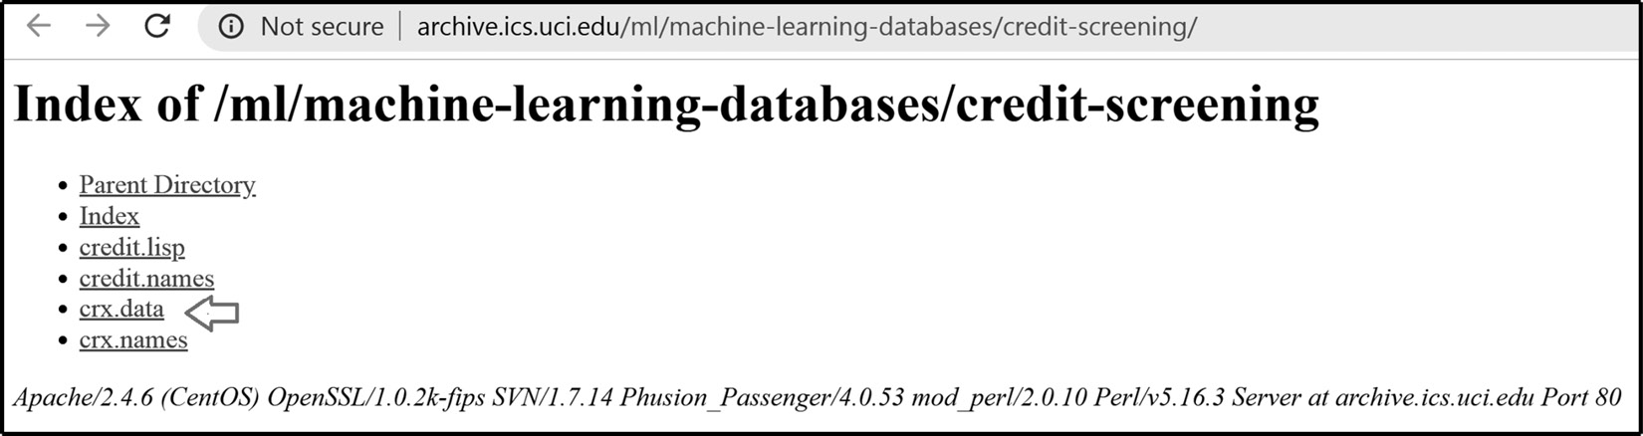
Figure 1.1 – Screenshot of the dataset download page
Save crx.data to the folder where you will run the following commands.
Open a Jupyter notebook and run the following commands.
Import the required Python libraries:
import random
import numpy as np
import pandas as pd
Load the data into a pandas DataFrame:
data = pd.read_csv("crx.data", header=None)
Create a list with variable names:
varnames = [f"A{s}" for s in range(1, 17)]
Add the variable names to the DataFrame:
data.columns = varnames
Replace the question marks (?) in the dataset with NumPy NaN values:
data = data.replace("?", np.nan)
Cast some numerical variables as float data types:
data[" A2"] = data["A2"].astype("float")
data[" A14"] = data["A14"].astype("float")
Encode the target variable as binary:
data["A16"] = data["A16"].map({"+":1, "-":0})
Rename the target variable:
data.rename(columns={"A16": "target"}, inplace=True)
We will introduce missing data at random places in four variables.
Add missing values at random positions in four variables:
random.seed(9001)
values = list(set([random.randint(0, len(data)) for p in range(0, 100)]))
data.loc[values, ["A3", "A8", "A9", "A10"]] = np.nan
Save your prepared data:
data.to_csv("credit_approval_uci.csv", index=False)
Note
Make sure you store the dataset in the same folder from which you will execute the code in the recipes.
Now, you are ready to carry on with the recipes in this chapter.

Removing observations with missing data
Complete Case Analysis (CCA), also called list-wise deletion of cases, consists of discarding observations with missing data. CCA can be applied to both categorical and numerical variables. With CCA, we preserve the distribution of the variables after the imputation, provided the data is missing at random and only in a small proportion of observations. However, if data is missing for many variables, CCA may lead to the removal of a large portion of the dataset.

How to do it...
Let’s begin by making some imports and loading the dataset:
Let’s import the pandas and matplotlib libraries:
import matplotlib.pyplot as plt
import pandas as pd
Load the dataset that we prepared in the Technical requirements section:
data = pd.read_csv("credit_approval_uci.csv")
Find the proportion of missing values per variable, sort them in ascending order, and then make a bar plot, rotating the ticks on the xaxis and adding a title and the y-axis label:
with plt.style.context("seaborn"):
data.isnull().mean().sort_values(
ascending=True).plot.bar(rot=45)
plt.ylabel("Proportion of missing data")
plt.title("Proportion of missing data per variable")
The preceding code block returns the following bar plot:
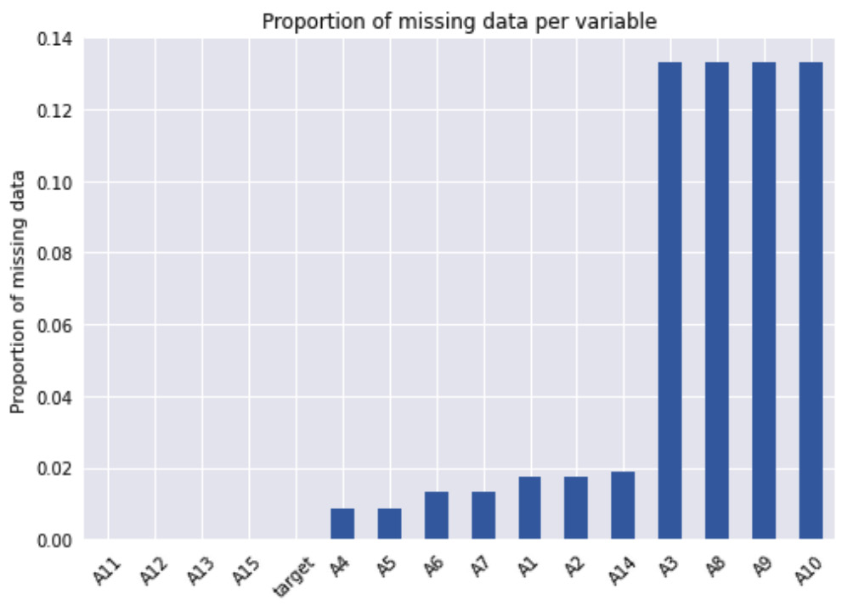
Figure 1.2 – Proportion of missing data per variable
Now, we’ll remove observations if they have missing values in any variable:
data_cca = data.dropna()
Note
The dropna() method drops observations with any missing value by default. We can remove observations with missing data in a subset of variables like this: data.dropna(subset=["A3", "A4"]).
Let’s print and compare the size of the original and complete case datasets:
print(f"Total number of observations: {len(data)}")
print(f"Number of observations without missing data{len(
data_cca)}")
We removed more than 100 observations with missing data, as shown in the following output:
Total number of observations: 690
Number of observations without missing data 564
To drop observations with missing data utilizing feature-engine, let’s import the required transformer:
from feature_engine.imputation import DropMissingData
Set up the imputer to automatically find the variables with missing data:
cca = DropMissingData(variables=None, missing_only=True)
Make the transformer identify the variables with missing data:
cca.fit(data)
Let’s inspect the variables with missing data:
cca.variables_
The preceding command returns the names of the variables with missing data:
['A1', 'A2', 'A3', 'A4', 'A5', 'A6', 'A7', 'A8', 'A9', 'A10', 'A14']
Remove observations with missing data in the previous variables:
data_cca = cca.transform(data)
Use the code in step 3 to corroborate the absence of missing data in the complete case dataset.
Tip
To remove observations with missing data in a subset of variables, use DropMissingData(variables=['A3', 'A4']). To remove observations with missing values in at least 5% of the variables, use DropMissingData(threshold=0.95).

How it works...
In this recipe, we identified and plotted the proportion of missing data in each variable and then removed all observations with missing values.
We used the pandas isnull() and mean() methods to determine the proportion of missing observations in each variable. The isnull() method created a Boolean vector per variable with the True and False values to indicate whether a value is missing. The mean() method took the average of these values and returned the proportion of missing data. The pandas sort_values()method ordered the variables from that with the least to that with the most missing data. We then used the pandas plot.bar()method to create a bar plot. To remove observations with missing values in any variable, we used the pandas dropna()method, thereby obtaining a complete case dataset.
Finally, we removed missing data using feature-engine’s DropMissingData(), which automatically identified and stored the variables with missing data from the train set when we called the fit() method. With the transform() method, the imputer removed observations with missing data in those variables.

Performing mean or median imputation
Mean or median imputation consists of replacing missing values with the mean or median variable. The mean or median is calculated using a train set, and these values are used to impute missing data in train and test sets, as well as in all future data we intend to use with the machine learning model. Scikit-learn and feature-engine transformers learn the mean or median from the train set and store these parameters for future use out of the box. In this recipe, we will perform mean and median imputation using pandas, scikit-learn, and feature-engine.
Tip
Use mean imputation if variables are normally distributed and median imputation otherwise. Mean and median imputation may distort the distribution of the original variables if there is a high percentage of missing data.

How to do it...
Let’s begin this recipe:
First, we’ll import pandas and the required functions and classes from scikit-learn and feature-engine:
import pandas as pd
from sklearn.model_selection import train_test_split
from sklearn.impute import SimpleImputer
from sklearn.compose import ColumnTransformer
from feature_engine.imputation import MeanMedianImputer
Let’s load the dataset that we prepared in the Technical requirements section:
data = pd.read_csv("credit_approval_uci.csv")
Then, separate the data into train and test sets and their respective targets:
X_train, X_test, y_train, y_test = train_test_split(
data.drop("target", axis=1),
data["target"],
test_size=0.3,
random_state=0,
)
Capture the numerical variables in a list. To do this, we exclude all variables cast as objects:
numeric_vars = X_train.select_dtypes(exclude="O").columns.to_list()
If you execute numeric_vars, you will see the names of the numerical variables: ['A2', 'A3', 'A8', 'A11', 'A14', 'A15'].
Capture the median values of the numerical variables in a dictionary:
median_values = X_train[numeric_vars].median().to_dict()
Note how we calculate the median using the train set. We will use these values to replace missing data in the train and test sets.
Tip
If instead of the median we want to capture the mean, we use pandas mean().
If you execute median_values, you will see a dictionary with the median value per variable: {'A2': 28.835, 'A3': 2.75, 'A8': 1.0, 'A11': 0.0, 'A14': 160.0, 'A15': 6.0}.
Let’s replace missing data with the median:
X_train = X_train.fillna(value=median_values)
X_test = X_test.fillna(value=median_values)
If you execute X_train[numeric_vars].isnull().sum() after the imputation, the number of missing values in the numerical variables should be 0.
Tip
The fillna() method returns a new dataset with imputed values by default. We can also replace missing data in the original DataFrame by setting inplace to True: X_train.fillna(value=median_values, inplace=True).
Now, let’s impute missing values with the median using scikit-learn. First, we separate the original dataset into train and test sets as we did in step 3.
Next, we capture the non-numerical variables in a list:
remaining_vars = [var for var in X_train.columns if var not in numeric_vars]
Let’s set up the imputer to replace missing data with the median:
imputer = SimpleImputer(strategy="median")
Mean imputation
To perform mean imputation, set SimpleImputer() like this: imputer = SimpleImputer(strategy = "mean").
Indicate which variables we want to impute using the ColumnTransformer() auxiliary class:
ct = ColumnTransformer(
[("imputer",imputer, numeric_vars)],
remainder="passthrough"
)
Fit SimpleImputer() to the train set so that it learns the median values of the variables:
ct.fit(X_train)
Inspect the learned median values:
ct.named_transformers_.imputer.statistics_
The previous command returns the median values per variable:
array([28.835, 2.75, 1., 0., 160., 6.])
Let’s replace missing values with the median:
X_train = ct.transform(X_train)
X_test = ct.transform(X_test)
SimpleImputer() returns NumPy arrays. Let’s transform the array into a DataFrame:
X_train = pd.DataFrame(
X_train,
columns=numeric_vars + remaining_vars,
)
Finally, let’s perform median imputation using feature-engine. First, split the dataset into train and test sets, as in step 3. Next, let’s set up the imputer to replace missing data in numerical variables with the median:
imputer = MeanMedianImputer(
imputation_method="median",
variables=numeric_vars,
)
Tip
To perform mean imputation, change imputation_method to "mean".
Fit the imputer so that it learns the median values for the specified variables:
imputer.fit(X_train)
Inspect the learned medians:
imputer.imputer_dict_
The previous command returns the median values in a dictionary:
{'A2': 28.835, 'A3': 2.75, 'A8': 1.0, 'A11': 0.0, 'A14': 160.0, 'A15': 6.0}
Finally, let’s replace the missing values with the median:
X_train = imputer.transform(X_train)
X_test = imputer.transform(X_test)
Feature-engine’s MeanMedianImputer() returns a DataFrame. You can check that the imputed variables do not contain missing values using X_train[numeric_vars].isnull().mean().

How it works...
In this recipe, we replaced missing data with the variable’s median values using pandas, scikit-learn, and feature-engine.
The mean or median values should be learned from the train set variables. Thus, we divided the dataset into train and test sets using scikit-learn’s train_test_split() function. The function takes the predictor variables, the target, the fraction of observations to retain in the test set, and a random_state value for reproducibility as arguments. We obtained a train set with 70% of the original observations and a test set with 30% of the original observations. The 70:30 split was done at random.
To impute missing data with pandas, in step 6, we created a dictionary with the numerical variable names as keys and their medians as values, utilizing the training set. To capture the median, we used pandas median(), and to return a dictionary, we used pandas to_dict(). To replace missing data with the median, we used the pandas fillna()method in the train and test sets, passing the dictionary with the median values per variable as a parameter.
To replace the missing values using scikit-learn, we used SimpleImputer() with strategy set to "median". To impute only numerical variables, we used ColumnTransformer(), which takes the imputer and the numerical variable names in a list as parameters. With the passthrough argument set to "remainder", we make ColumnTransformer() return all the variables in the final output, the imputed ones followed by the remaining ones.
With the fit() method, SimpleImputer() learned the median of each numerical variable in the train set and stored them in its statistics_ attribute. With transform(), the transformer replaced the missing values with the medians.
To replace missing values with feature-engine, we set up MeanMedianImputer() with imputation_method set to "median" and passed the names of the variables to impute in a list. With the fit() method, the transformer learned and stored the median values of the specified variables in a dictionary in its imputer_dict_ attribute. With the transform() method, the missing values were replaced, returning a pandas DataFrame.
Note
SimpleImputer() operates on the entire DataFrame and returns NumPy arrays. To impute just a subset of variables, we need to use ColumnTransformer(). In contrast, MeanMedianImputer() can take an entire DataFrame and yet it will only impute the specified variables, returning a pandas DataFrame.

Imputing categorical variables
Categorical variables usually contain strings as values, instead of numbers. We replace missing data in categorical variables with the most frequent category, or with a different string. Frequent categories are estimated using the train set and then used to impute values in the train, test, and future datasets. Thus, we need to learn and store these values, which we can do using scikit-learn and feature-engine’s out-of-the-box transformers. In this recipe, we will replace missing data in categorical variables with the most frequent category, or with an arbitrary string.

How to do it...
To begin, let’s make a few imports and prepare the data:
Let’s import pandas and the required functions and classes from scikit-learn and feature-engine:
import pandas as pd
from sklearn.model_selection import train_test_split
from sklearn.impute import SimpleImputer
from sklearn.compose import ColumnTransformer
from feature_engine.imputation import CategoricalImputer
Then, load the dataset that we prepared in the Technical requirements section:
data = pd.read_csv("credit_approval_uci.csv")
Separate the data into train and test sets and their respective targets:
X_train, X_test, y_train, y_test = train_test_split(
data.drop("target", axis=1),
data["target"],
test_size=0.3,
random_state=0,)
Let’s capture the categorical variables in a list:
categorical_vars = X_train.select_dtypes(
include="O").columns.to_list()
Now, capture the most frequent category per categorical variable in a dictionary:
frequent_values = X_train[
categorical_vars].mode().iloc[0].to_dict()
Then, replace missing values with the frequent categories:
X_train = X_train.fillna(value=frequent_values)
X_test = X_test.fillna(value=frequent_values)
Tip
fillna() returns a new dataset with imputed values by default. We can replace missing data in the original DataFrame by executing X_train.fillna(value=frequent_values, inplace=True).
To replace missing data with a specific string, let’s create an imputation dictionary with the categorical variable names as the keys and an arbitrary string as the values:
imputation_dict = {var: "no_data" for var
in categorical_vars}
Now, we can use this dictionary and the code in step 6 to replace missing data.
Tip
With the pandas value_counts() or unique() methods over each categorical variable, we can see the string added by the imputation. Try executing, for example, X_train["A1"].value_counts().
Now, let’s impute missing values by the most frequent category using scikit-learn. First, we separate the original dataset into train and test sets as we did in step 3.
Make a list with the numerical variables:
imputation_dict = {var: "no_data" for var
in categorical_vars}
Set up the imputer to find the most frequent category:
imputer = SimpleImputer(strategy='most_frequent')
Tip
SimpleImputer() will learn the mode for numerical and categorical variables alike. But in practice, mode imputation is done for categorical variables only.
Let’s indicate, using ColumnTransformer(), which variables to impute:
ct = ColumnTransformer(
[("imputer",imputer, categorical_vars)],
remainder="passthrough"
)
Fit the imputer to the train set so that it learns the most frequent values:
ct.fit(X_train)
Inspect the most frequent values learned by the imputer:
ct.named_transformers_.imputer.statistics_
The previous command returns the most frequent values per variable:
array(['b', 'u', 'g', 'c', 'v', 't', 'f', 'f', 'g'], dtype=object)
Let’s replace missing values with the frequent categories:
X_train = ct.transform(X_train)
X_test = ct.transform(X_test)
SimpleImputer() will return a NumPy array. Let’s transform it into a pandas DataFrame:
X_train = pd.DataFrame(
X_train,
columns=categorical_vars + remaining_vars,
)
Note that the imputed variables will be the first columns in the array.
Tip
To impute missing data with a string instead of the most frequent category, set SimpleImputer(), as follows:
imputer = SimpleImputer(
strategy="constant", fill_value="missing"
).
Finally, let’s impute missing values using feature-engine. First, we need to separate the data into train and test sets, just like we did in step 3.
Next, let’s set up the imputer to replace missing data in categorical variables by their most frequent value:
imputer = CategoricalImputer(
imputation_method="frequent",
variables=categorical_vars,
)
Tip
With the variables parameter set to None, CategoricalImputer() will automatically find all categorical variables in the train set for imputation.
Fit the imputer to the train set so that it learns the most frequent categories:
imputer.fit(X_train)
Tip
To impute categorical variables with a specific string, we set imputation_method to "missing" and fill_value to the desired string.
Inspect the learned frequent categories:
imputer.imputer_dict_
We can see the dictionary with the most frequent values in the following output:
{'A1': 'b', 'A4': 'u', 'A5': 'g', 'A6': 'c', 'A7': 'v', 'A9': 't', 'A10': 'f', 'A12': 'f', 'A13': 'g'}
Finally, let’s replace the missing values with frequent categories:
X_train = imputer.transform(X_train)
X_test = imputer.transform(X_test)
CategoricalImputer() returns a pandas DataFrame with the imputed values.

How it works...
In this recipe, we replaced the missing values of categorical variables with the most frequent categories or an arbitrary string, using pandas, scikit-learn, and feature-engine.
To impute missing data with pandas, in step 5, we created a dictionary with the variable names as keys and the frequent categories as values. To capture the frequent categories, we used pandas mode(), and to return a dictionary, we used pandas to_dict(). To replace missing data with the mode, we used the pandas fillna()method, passing the dictionary with the variables and their frequent categories as parameters.
Tip
A variable can have more than one mode. If this is the case, we may want to choose a different imputation method.
To replace missing data with an arbitrary string, we created a dictionary with the "no_data" value for each variable and used this dictionary as an argument to the pandas fillna()method.
To replace the missing values using scikit-learn, we used SimpleImputer()with strategy set to "frequent". To impute only categorical variables, we used ColumnTransformer(), which takes the imputer and the variable list as arguments. With the passthrough argument set to "remainder", ColumnTransformer() returned all the variables in the final output, the imputed ones first followed by the remaining ones.
With the fit() method, SimpleImputer() learned the frequent categories for each categorical variable and stored them in its statistics_ attribute. With the transform() method, missing data was replaced with the learned parameters.
SimpleImputer() returns a NumPy array by default. We converted this array into a pandas DataFrame. We had to pass the variable names in the correct order: the imputed variables are located first in the array, followed by the remaining variables.
To replace missing values with feature-engine, we set up CategoricalImputer() with imputation_method set to "frequent" and passed the names of the variables to impute in a list. With the fit() method, the transformer learned and stored the most frequent categories of the specified variables in a dictionary in its imputer_dict_ attribute. With the transform() method, the missing values were replaced with the learned parameters.
Tip
Note that, unlike SimpleImputer(), CategoricalImputer() will only impute categorical variables, unless specifically told not to do so by setting the ignore_format parameter to True.

Replacing missing values with an arbitrary number
Arbitrary number imputation consists of replacing missing data with an arbitrary value. Commonly used values include 999, 9999, or -1 for positive distributions. This method is suitable for numerical variables. For categorical variables, the equivalent method is to replace missing data with an arbitrary string, as described in the Imputing categorical variables recipe.
When replacing missing values with arbitrary numbers, we need to be careful not to select a value close to the mean, the median, or any other common value of the distribution.
Tip
Arbitrary number imputation can be used when data is not missing at random, when we are building non-linear models, and when the percentage of missing data is high. This imputation technique distorts the original variable distribution.
In this recipe, we will impute missing data with arbitrary numbers using pandas, scikit-learn, and feature-engine.

How to do it...
Let’s begin by importing the necessary tools and loading the data:
Import pandas and the required functions and classes:
import pandas as pd
from sklearn.model_selection import train_test_split
from sklearn.impute import SimpleImputer
from feature_engine.imputation import ArbitraryNumberImputer
Let’s load the dataset that we prepared in the Technical requirements section:
data = pd.read_csv("credit_approval_uci.csv")
Separate the data into train and test sets:
X_train, X_test, y_train, y_test = train_test_split(
data.drop("target", axis=1),
data["target"],
test_size=0.3,
random_state=0,
)
We will select arbitrary values greater than the maximum value of the distribution. Let’s find the maximum value of four numerical variables:
X_train[['A2','A3', 'A8', 'A11']].max()
The following is the output of the preceding code block:
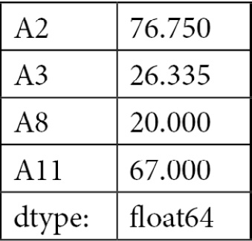
Figure 1.3 – Maximum value of each variable
Replace the missing values with 99, which is bigger than the maximum values of the numerical variables in step 4:
X_train[["A2", "A3", "A8", "A11"]] = X_train[[
"A2", "A3", "A8", "A11"]].fillna(99)
X_test[["A2", "A3", "A8", "A11"]] = X_test[[
"A2", "A3", "A8", "A11"]].fillna(99)
Tip
To impute different variables with different values using pandas fillna(), pass a dictionary with the keys as variables and the values as arbitrary numbers, for example, imputation_dict = {"A2": -1, "A3": -1, "A8": 999, "A11": 9999}.
Now, we’ll impute missing values with an arbitrary number using scikit-learn. First, we separate the data into train and test sets as in step 3.
Let’s set up the imputer to replace missing values with 99:
imputer = SimpleImputer(
strategy='constant', fill_value=99
)
Tip
If your dataset contains categorical variables, SimpleImputer() will add 99 to those variables as well if any values are missing.
Fit the imputer to a slice of the train set containing the variables to impute:
imputer.fit(X_train[["A2", "A3", "A8", "A11"]])
Replace the missing values with 99 in the desired variables:
X_train[["A2", "A3", "A8", "A11"]] = imputer.transform(
X_train[["A2", "A3", "A8", "A11"]])
X_test[["A2", "A3", "A8", "A11"]] = imputer.transform(
X_test[["A2", "A3", "A8", "A11"]])
To finish, let’s impute missing values using feature-engine. First, we separate the data into train and test sets, just like we did in step 3.
Next, let’s set up the imputer to replace missing values with 99, specifying the variables to impute:
imputer = ArbitraryNumberImputer(
arbitrary_number=99,
variables=["A2", "A3", "A8", "A11"],
)
Tip
ArbitraryNumberImputer() can automatically select all numerical variables in the train set if we set the variables parameter to None.
Finally, let’s replace the missing values with 99:
X_train = imputer.fit_transform(X_train)
X_test = imputer.transform(X_test)
Tip
If you want to impute different variables with different numbers, pass a dictionary with the variable names as keys and the arbitrary numbers as values to ArbitraryNumberImputer.
We have now replaced missing data with arbitrary numbers using three different open source libraries.

How it works...
In this recipe, we replaced missing values in numerical variables with an arbitrary number using pandas, scikit-learn, and feature-engine.
To determine which arbitrary value to use, we inspected the maximum values of four numerical variables using the pandas max()method. Next, we chose the value 99, because it was greater than the maximum values of the selected variables. In step 5, we replaced missing data in the four numerical variables with the pandas fillna()method, passing 99 as an argument.
To replace missing values using scikit-learn, we utilized SimpleImputer(), with strategy set to "constant", and specified 99 in the fill_value argument. Next, we fitted the imputer to a slice of the train set with the numerical variables and also replaced missing values using the transform() method in a slice of the train and test sets containing the numerical variables. In doing so, we replaced the variables with their imputed version in the original data and avoided having to convert the resulting NumPy array back into a DataFrame.
Finally, we replaced missing values with ArbitraryValueImputer() from feature-engine, specifying the value 99 and the variables to impute as parameters. Next, we applied the fit_transform() method to replace missing data in the train set and the transform() method to replace missing data in the test set.

Finding extreme values for imputation
Replacing missing values with a value at the end of the variable distribution (extreme values) is equivalent to replacing them with an arbitrary value, but instead of identifying the arbitrary values manually, these values are automatically selected as those at the very end of the variable distribution. Missing data can be replaced with a value that is greater or smaller than the remaining values in the variable. To select a value that is greater, we can use the mean plus a factor of the standard deviation, or the 75th quantile + (IQR * 1.5), where IQR is the IQR given by the 75th quantile - the 25th quantile. To replace missing data with values that are smaller than the remaining values, we can use the mean minus a factor of the standard deviation, or the 25th quantile – (IQR * 1.5).
Note
End-of-tail imputation may distort the distribution of the original variables, so it may not be suitable for linear models.
In this recipe, we will implement end-of-tail or extreme value imputation using pandas and feature-engine.

How to do it...
To begin this recipe, let’s import the necessary tools and load the data:
Let’s import pandas and the required function and class:
import pandas as pd
from sklearn.model_selection import train_test_split
from feature_engine.imputation import EndTailImputer
Load the dataset we prepared in the Technical requirements section:
data = pd.read_csv("credit_approval_uci.csv")
Capture the numerical variables in a list, excluding the target:
numeric_vars = [
var for var in data.select_dtypes(
exclude="O").columns.to_list() if var !="target"
]
Separate the data into train and test sets, keeping only the numerical variables:
X_train, X_test, y_train, y_test = train_test_split(
data[numeric_vars],
data["target"],
test_size=0.3,
random_state=0,
)
Calculate the IQR for all numerical variables:
IQR = X_train.quantile(0.75) - X_train.quantile(0.25)
If we execute IQR, we will see a pandas Series containing its values:
A2 16.4200
A3 6.5825
A8 2.8350
A11 3.0000
A14 212.0000
A15 450.0000
target 1.0000
dtype: float64
Let’s create a dictionary with the variable names as keys and the imputation replacements as values, returned by adding 1.5 times the IQR to the 75th quantile:
imputation_dict = (
X_train.quantile(0.75) + 1.5 * IQR).to_dict()
Tip
If we want to use the Gaussian approximation instead of the IQR proximity rule, we can calculate the value to replace missing data using imputation_dict = (X_train.mean() + 3 * X_train.std()).to_dict().
Finally, let’s replace missing data:
X_train = X_train.fillna(value=imputation_dict)
X_test = X_test.fillna(value=imputation_dict)
Note how we calculated the value to impute the missing data using the variables in the train set and then used these to impute train and test sets.
Tip
We can also replace missing data with values at the left tail of the distribution using value = X_train[var].quantile(0.25) - 1.5 * IQR or value = X_train[var].mean() - 3*X_train[var].std().
To finish, let’s impute missing values using feature-engine. First, we need to separate the data into train and test sets, just like in step 4 of this recipe.
Next, let’s set up the imputer to estimate a value at the right of the distribution using the IQR proximity rule, specifying the variables to impute:
imputer = EndTailImputer(
imputation_method="iqr",
tail="right",
fold=3,
variables=None,
)
Tip
To use the mean and standard deviation to calculate the replacement values, we need to set imputation_method="Gaussian". We can use 'left' or 'right' in the tail argument to specify the side of the distribution where we’ll place the missing values.
Let’s fit EndTailImputer() to the train set so that it learns the parameters:
imputer.fit(X_train)
Let’s inspect the learned values:
imputer.imputer_dict_
The previous command returns a dictionary with the imputation values per variable:
{'A2': 88.18,
'A3': 27.31,
'A8': 11.504999999999999,
'A11': 12.0,
'A14': 908.0,
'A15': 1800.0}
Finally, let’s replace the missing values:
X_train = imputer.transform(X_train)
X_test = imputer.transform(X_test)
Remember that you can corroborate that the missing values were replaced by using X_train[['A2','A3', 'A8', 'A11', 'A14', 'A15']].isnull().mean().

How it works...
In this recipe, we replaced the missing values in numerical variables with a number at the end of the distribution using pandas and feature-engine.
We first calculated the values at the end of the distributions manually according to the formulas described in the introduction to this recipe. We determined the quantiles using pandas quantile() and the mean and standard deviation using pandas mean() and std(). Next, we used pandas fillna() to replace the missing values.
To replace missing values with EndTailImputer() from feature-engine, we set distribution to 'iqr' to calculate the values with the IQR proximity rule and tail to 'right' to place values at the right tail. We also specified the variables to impute in a list. With the fit() method, the imputer learned and stored the values to use for the imputation in a dictionary in the imputer_dict_ attribute. With the transform() method, the missing values were replaced, returning DataFrames.

Marking imputed values
A missing indicator is a binary variable that takes the value 1 or True to indicate whether a value was missing, or 0 or False otherwise. It is common practice to replace missing observations with the mean, median, or most frequent category while simultaneously marking those missing observations with missing indicators. In this recipe, we will learn how to add missing indicators using pandas, scikit-learn, and feature-engine.

How to do it...
Let’s begin by making some imports and loading the data:
Let’s import the required libraries, functions, and classes:
import pandas as pd
import numpy as np
from sklearn.model_selection import train_test_split
from sklearn.impute import SimpleImputer
from sklearn.compose import ColumnTransformer
from sklearn.pipeline import Pipeline
from feature_engine.imputation import(
AddMissingIndicator, CategoricalImputer,
MeanMedianImputer
)
Load the dataset that we prepared in the Technical requirements section:
data = pd.read_csv("credit_approval_uci.csv")
Separate the data into train and test sets:
X_train, X_test, y_train, y_test = train_test_split(
data.drop("target", axis=1),
data["target"],
test_size=0.3,
random_state=0,
)
Capture the variable names in a list:
varnames = ["A1", "A3", "A4", "A5", "A6", "A7", "A8"]
Create names for the missing indicators in a list:
indicators = [f"{var}_na" for var in varnames]
If we execute indicators, we will see the names of the new variables: ['A1_na', 'A3_na', 'A4_na', 'A5_na', 'A6_na', 'A7_na', 'A8_na'].
Add the missing indicators with the 1 or 0 value:
X_train[indicators] = X_train[varnames].isna().astype(int)
X_test[indicators] = X_test[varnames].isna().astype(int)
Tip
If you want the indicators to have the True and False values, remove astype(int) in step 6.
Let’s inspect the result of the preceding code block:
X_train.head()
We can see the newly added variables at the end of the DataFrame:
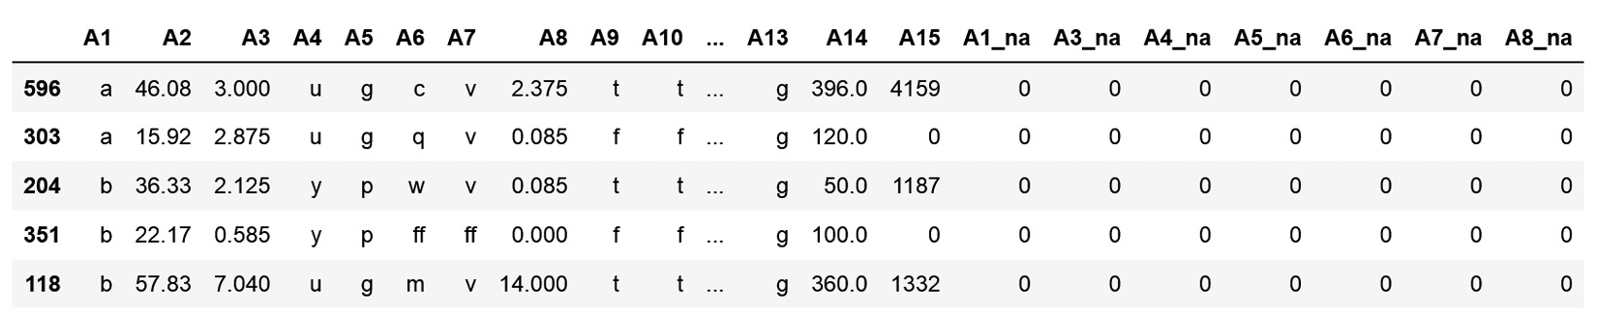
Figure 1.4 – DataFrame with the missing indicators
Now, let’s add missing indicators using feature-engine instead. First, we need to divide the data, just like we did in step 3.
Next, set up the imputer to add binary indicators to every variable with missing data:
imputer = AddMissingIndicator(
variables=None, missing_only=True
)
Fit the imputer to the train set so that it finds the variables with missing data:
imputer.fit(X_train)
If we execute imputer.variables_, we will find the variables for which missing indicators will be added.
Finally, let’s add the missing indicators:
X_train = imputer.transform(X_train)
X_test = imputer.transform(X_test)
Create a pipeline to add missing indicators to categorical and numerical variables, then impute categorical variables with the most frequent category, and numerical variables with the mean:
pipe = Pipeline(
[
("ind",
AddMissingIndicator(missing_only=True)
),
("cat",
CategoricalImputer(
imputation_method="frequent")
),
("num", MeanMedianImputer()),
]
)
Note
Feature-engine imputers automatically identify all numerical or categorical variables, modifying only the appropriate variables. So there is no need to slice the data or pass the variable names as arguments to the transformers in this case.
Now, let’s add the indicators and impute missing values:
X_train = pipe.fit_transform(X_train)
X_test = pipe.transform(X_test)
Use X_train.isnull().sum() to corroborate that there is no data missing.
Finally, let’s add missing indicators and simultaneously impute numerical and categorical variables with the mean and most frequent categories respectively, utilizing scikit-learn.
Make a list with the names of the numerical and categorical variables:
numvars = X_train.select_dtypes(
exclude="O").columns.to_list()
catvars = X_train.select_dtypes(
include="O").columns.to_list()
Set up a pipeline to perform mean and frequent category imputation while marking the missing data:
pipe = ColumnTransformer(
[
(
"num_imputer",
SimpleImputer(
strategy="mean",
add_indicator=True
),
numvars
),
(
"cat_imputer",
SimpleImputer(
strategy="most_frequent",
add_indicator=True
),
catvars,
),
]
)
Now, let’s carry out the imputation:
X_train = pipe.fit_transform(X_train)
X_test = pipe.transform(X_test)
X_train is a NumPy array with the numerical variables and their missing indicators first, followed by the categorical variables with their indicators.

How it works...
To add missing indicators using pandas, we used the isna() method, which created a new vector assigning the value of True if there was a missing value or False otherwise. We followed isna() with astype(int) to convert the Boolean vectors into binary vectors with values 1 and 0.
To add a missing indicator with feature-engine, we used AddMissingIndicator() and fitted it to the train set, so that the transformer identifies the variables with missing data. Then, we used the transform() method to add missing indicators to the train and test sets.
Finally, we added missing indicators and replaced missing data with the mean and most frequent category using scikit-learn. Utilizing Pipeline, we lined up two instances of SimpleImputer(), the first to impute data with the mean and the second to impute data with the most frequent category. In both cases, we set the add_indicator parameter to True, so that SimpleImputer() also added the missing indicators. We wrapped SimpleImputer() with ColumnTransformer() to specifically modify numerical or categorical variables.

Performing multivariate imputation by chained equations
Multivariate imputation methods, as opposed to univariate imputation, use multiple variables to estimate the missing values. In other words, the missing values of a variable are modeled based on the other variables in the dataset. Multivariate Imputation by Chained Equations (MICE) models each variable with missing values as a function of the remaining variables and uses that estimate for imputation.
The following steps are required to perform MICE:
A simple univariate imputation is performed for every variable with missing data, for example, median imputation.
One specific variable is selected, say, var_1, and the missing values are set back to missing.
A model is trained to predict var_1 using the remaining variables as input features.
The missing values of var_1 are replaced with the new estimates.
Steps 2 to 4 are repeated for each of the remaining variables.
Once all the variables have been modeled based on the rest, a cycle of imputation is concluded. Multiple imputation cycles are carried out, typically 10. The idea is that by the end of the cycles, the distribution of the imputation parameters should have converged, which means that we should have found the best estimates for the missing data.
In this recipe, we will implement MICE using scikit-learn.

How to do it...
To begin the recipe, let’s import the required libraries and load the data:
Let’s import the required Python libraries and a function to split the data:
import pandas as pd
import matplotlib.pyplot as plt
from sklearn.model_selection import train_test_split
Import a regression algorithm from scikit-learn:
from sklearn.linear_model import BayesianRidge
Import IterativeImputer to carry out multivariate imputation:
from sklearn.experimental import enable_iterative_imputer
from sklearn.impute import IterativeImputer
Load the dataset that we prepared in the Technical requirements section only with some numerical variables:
variables = ["A2", "A3", "A8", "A11", "A14", "A15", "target"]
data = pd.read_csv("credit_approval_uci.csv",
usecols=variables)
Divide the data into train and test sets:
X_train, X_test, y_train, y_test = train_test_split(
data.drop("target", axis=1),
data["target"],
test_size=0.3,
random_state=0,
)
Let’s create a MICE imputer using Bayes regression, specifying the number of iteration cycles and setting random_state for reproducibility:
imputer = IterativeImputer(
estimator= BayesianRidge(),
max_iter=10,
random_state=0,
)
Tip
IterativeImputer() contains other useful arguments. For example, we can specify the first imputation strategy using the initial_strategy parameter. We can choose from the mean, median, mode, or arbitrary imputation. We can also specify how we want to cycle over the variables, either randomly or from the one with the fewest missing values to the one with the most.
Let’s fit IterativeImputer() to the train set so that it trains the estimators to predict the missing values in each variable:
imputer.fit(X_train)
Tip
We can use any regression model to estimate the missing data with IterativeImputer().
Finally, let’s fill in missing values in both the train and test set:
X_train = imputer.transform(X_train)
X_test = imputer.transform(X_test)
Remember that scikit-learn returns NumPy arrays and not DataFrames. To corroborate the lack of missing data, we can execute pd.DataFrame(X_train).isnull().sum().

How it works...
In this recipe, we performed multivariate imputation using IterativeImputer() from scikit-learn. We specified Bayes regression as the estimator and carried out 10 rounds of imputation over the entire dataset. By default, the first imputation round is done with the mean of the variable. We fitted IterativeImputer() to the train set so that each variable was modeled based on the remaining variables in the dataset. Next, we transformed the train and test sets with the transform() method in order to replace missing data with their estimates.
Note
This transformer can only impute missing data in numerical variables based on numerical variables.

See also
To learn more about MICE, take a look at the following links:
A multivariate technique for multiplying imputing missing values using a sequence of regression models: https://www.researchgate.net/publication/244959137_A_Multivariate_Technique_for_Multiply_Imputing_Missing_Values_Using_a_Sequence_of_Regression_Models.
Multiple Imputation by Chained Equations: What is it and how does it work?: https://www.jstatsoft.org/article/download/v045i03/550.

Estimating missing data with nearest neighbors
In imputation with K-Nearest Neighbors (KNN), missing values are replaced with the mean value from their k closest neighbors. The neighbors of each observation are found utilizing distances like the Euclidean distance, and the replacement value can be estimated as the mean or weighted mean of the neighbor’s value, where further neighbors have less influence on the replacement value. In this recipe, we will perform KNN imputation using scikit-learn.

How to do it...
To proceed with the recipe, let’s import the required libraries and prepare the data:
Let’s import the required libraries, classes, and functions:
import matplotlib.pyplot as plt
import pandas as pd
from sklearn.model_selection import train_test_split
from sklearn.impute import KNNImputer
Let’s load the dataset that we prepared in the Technical requirements section only with some numerical variables:
variables = ["A2", "A3", "A8", "A11", "A14", "A15", "target"]
data = pd.read_csv("credit_approval_uci.csv",
usecols=variables)
Let’s divide the data into train and test sets:
X_train, X_test, y_train, y_test = train_test_split(
data.drop("target", axis=1),
data["target"],
test_size=0.3,
random_state=0,
)
Set up the imputer to find the closest 5 neighbors, utilizing Euclidean distance and weighting the neighbors so that the furthest neighbors have a smaller influence over the value of the replacement:
imputer = KNNImputer(n_neighbors=5,weights="distance")
Find the closest neighbors:
imputer.fit(X_train)
Replace the missing values with the weighted mean of the values shown by the neighbors:
X_train = imputer.transform(X_train)
X_test = imputer.transform(X_test)
The result is a NumPy array with the missing data replaced.

How it works...
In this recipe, we replaced missing data with the average value shown by each observation’s closest k neighbors. We set up KNNImputer() to find each observation’s five closest neighbors based on the Euclidean distance. The replacement values were estimated as the weighted average of the values shown by the five closest neighbors. With transform(), the imputer replaced the missing data.

2

Encoding Categorical Variables
Categorical variables are those whose values are selected from a group of categories or labels. For example, the Gender variable with the values of Male and Female is categorical, and so is the marital status variable with the values of never married, married, divorced, and widowed. In some categorical variables, the labels have an intrinsic order; for example, in the Student’s grade variable, the values of A, B, C, and Fail are ordered, with A being the highest grade and Fail being the lowest. These are called ordinal categorical variables. Variables in which the categories do not have an intrinsic order are called nominal categorical variables, such as the City variable, with the values of London, Manchester, Bristol, and so on.
The values of categorical variables are often encoded as strings. To train mathematical or machine learning models, we need to transform those strings into numbers. The act of replacing strings with numbers is called categorical encoding. In this chapter, we will discuss multiple categorical encoding methods.
This chapter will cover the following recipes:
Creating binary variables through one-hot encoding
Performing one-hot encoding of frequent categories
Replacing categories with counts or the frequency of observations
Replacing categories with ordinal numbers
Performing ordinal encoding based on the target value
Implementing target mean encoding
Encoding with the Weight of Evidence
Grouping rare or infrequent categories
Performing binary encoding

Technical requirements
In this chapter, we will use the pandas, NumPy, and Matplotlib Python libraries, as well as scikit-learn and Feature-engine. For guidelines on how to obtain these libraries, visit the Technical requirements section of Chapter 1, Imputing Missing Data.
We will also use the open-source Category Encoders Python library, which can be installed using pip:
pip install category_encoders
To learn more about Category Encoders, visit the following link: https://contrib.scikit-learn.org/category_encoders/.
We will also use the Credit Approval dataset, which is available in the UCI Machine Learning Repository at https://archive.ics.uci.edu/ml/datasets/credit+approval.
To prepare the dataset, follow these steps:
Visit http://archive.ics.uci.edu/ml/machine-learning-databases/credit-screening/ and click on crx.data to download the data:
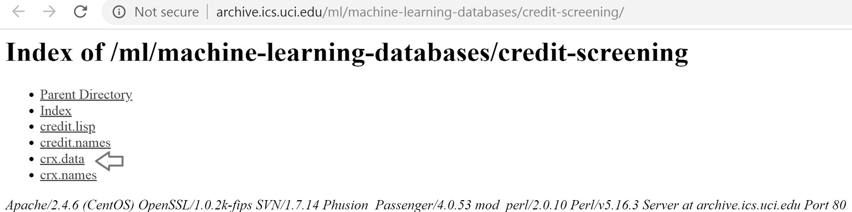
Figure 2.1 – The index directory for the Credit Approval dataset
Save crx.data to the folder where you will run the following commands.
After downloading the data, open up a Jupyter Notebook and run the following commands.
Import the required libraries:
import random
import numpy as np
import pandas as pd
Load the data:
data = pd.read_csv("crx.data", header=None)
Create a list containing the variable names:
varnames = [f"A{s}" for s in range(1, 17)]
Add the variable names to the DataFrame:
data.columns = varnames
Replace the question marks in the dataset with NumPy NaN values:
data = data.replace("?", np.nan)
Cast some numerical variables as float data types:
data["A2"] = data["A2"].astype("float")
data["A14"] = data["A14"].astype("float")
Encode the target variable as binary:
data["A16"] = data["A16"].map({"+": 1, "-": 0})
Rename the target variable:
data.rename(columns={"A16": "target"}, inplace=True)
Make lists that contain categorical and numerical variables:
cat_cols = [
c for c in data.columns if data[c].dtypes=="O"]
num_cols = [
c for c in data.columns if data[c].dtypes!= "O"]
Fill in the missing data:
data[num_cols] = data[num_cols].fillna(0)
data[cat_cols] = data[cat_cols].fillna("Missing")
Save the prepared data:
data.to_csv("credit_approval_uci.csv", index=False)
You can find a Jupyter Notebook that contains these commands in this book’s GitHub repository at https://github.com/PacktPublishing/Python-Feature-Engineering-Cookbook-Second-Edition/blob/main/ch02-categorical-encoding/donwload-prepare-store-credit-approval-dataset.ipynb.
Note
Some libraries require that you have already imputed missing data, for which you can use any of the recipes from Chapter 1, Imputing Missing Data.

Creating binary variables through one-hot encoding
In one-hot encoding, we represent a categorical variable as a group of binary variables, where each binary variable represents one category. The binary variable takes a value of 1 if the category is present in an observation, or 0 otherwise.
The following table shows the one-hot encoded representation of the Gender variable with the categories of Male and Female:
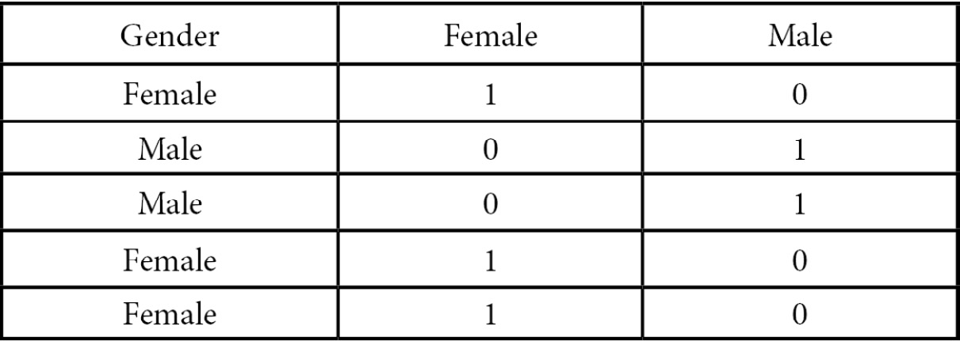
Figure 2.2 – One-hot encoded representation of the Gender variable
As shown in Figure 2.2, from the Gender variable, we can derive the binary variable of Female, which shows the value of 1 for females, or the binary variable of Male, which takes the value of 1 for the males in the dataset.
For the categorical variable of Color with the values of red, blue, and green, we can create three variables called red, blue, and green. These variables will take the value of 1 if the observation is red, blue, or green, respectively, or 0 otherwise.
A categorical variable with k unique categories can be encoded using k-1 binary variables. For Gender, k is 2 as it contains two labels (male and female), so we only need to create one binary variable (k - 1 = 1) to capture all of the information. For the Color variable, which has three categories (k=3; red, blue, and green), we need to create two (k - 1 = 2) binary variables to capture all the information so that the following occurs:
If the observation is red, it will be captured by the red variable (red = 1, blue = 0).
If the observation is blue, it will be captured by the blue variable (red = 0, blue = 1)
If the observation is green, it will be captured by the combination of red and blue (red = 0, blue = 0)
Encoding into k-1 binary variables is well-suited for linear models. There are a few occasions in which we may prefer to encode the categorical variables with k binary variables:
When training decision trees since they do not evaluate the entire feature space at the same time
When selecting features recursively
When determining the importance of each category within a variable
In this recipe, we will compare the one-hot encoding implementations of pandas, scikit-learn, Feature-engine, and Category Encoders.

How to do it...
First, let’s make a few imports and get the data ready:
Import pandas and the train_test_split function from scikit-learn:
import pandas as pd
from sklearn.model_selection import train_test_split
Let’s load the Credit Approval dataset:
data = pd.read_csv("credit_approval_uci.csv")
Let’s separate the data into train and test sets:
X_train, X_test, y_train, y_test = train_test_split(
data.drop(labels=["target"], axis=1),
data["target"],
test_size=0.3,
random_state=0,
)
Let’s inspect the unique categories of the A4 variable:
X_train["A4"].unique()
We can see the unique values of A4 in the following output:
array(['u', 'y', 'Missing', 'l'], dtype=object)
Let’s encode A4 into k-1 binary variables using pandas and then inspect the first five rows of the resulting DataFrame:
dummies = pd.get_dummies(X_train["A4"], drop_first=True)
dummies.head()
Note
With pandas get_dummies(), we can either ignore or encode missing data through the dummy_na parameter. By setting dummy_na=True, missing data will be encoded in a new binary variable. To encode the variable into k dummies, use drop_first=False instead.
Here, we can see the output of step 5, where each label is now a binary variable:
l u y
596 0 1 0
303 0 1 0
204 0 0 1
351 0 0 1
118 0 1 0
Now, let’s encode all of the categorical variables into k-1 binaries, capturing the result in a new DataFrame:
X_train_enc = pd.get_dummies(X_train, drop_first=True)
X_test_enc = pd.get_dummies(X_test, drop_first=True)
Note
The get_dummies method from pandas will automatically encode all variables of the object or type. We can encode a subset of the variables by passing the variable names in a list to the columns parameter.
Let’s inspect the first five rows of the binary variables created in step 6:
X_train_enc.head()
Note
When encoding more than one variable, get_dummies() captures the variable name – say, A1 – and places an underscore followed by the category name to identify the resulting binary variables.
We can see the binary variables in the following output:
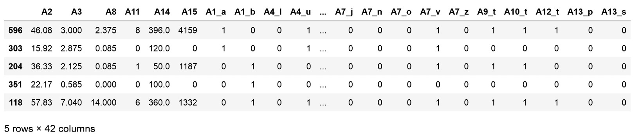
Figure 2.3 – Transformed DataFrame showing the dummy variables on the right
Note
The get_dummies() method will create one binary variable per seen category. Hence, if there are more categories in the train set than in the test set, get_dummies() will return more columns in the transformed train set than in the transformed test set, and vice versa. To avoid this, it is better to carry out one-hot encoding with scikit-learn or Feature-engine, as we will discuss later in this recipe.
Let’s concatenate the binary variables to the original dataset:
X_test_enc = pd.concat([X_test, X_test_enc], axis=1)
Now, let’s drop the categorical variables from the data:
X_test_enc.drop(
labels=X_test_enc.select_dtypes(
include="O").columns,
axis=1,
inplace=True,
)
And that’s it! Now, we can use our categorical variables to train mathematical models. To inspect the result, use X_test_enc.head().
Now, let’s do one-hot encoding using scikit-learn.
Import the encoder from scikit-learn:
from sklearn.preprocessing import OneHotEncoder
Let’s set up the transformer. By setting drop to "first", we encode into k-1 binary variables, and by setting sparse to False, the transformer will return a NumPy array (instead of a sparse matrix):
encoder = OneHotEncoder(drop="first", sparse=False)
Tip
We can encode variables into k dummies by setting the drop parameter to None. We can also encode into k-1 if variables contain two categories and into k if variables contain more than two categories by setting the drop parameter to “if_binary”. The latter is useful because encoding binary variables into k dummies is redundant.
First, let’s create a list containing the variable names:
vars_categorical = X_train.select_dtypes(
include="O").columns.to_list()
Let’s fit the encoder to a slice of the train set with the categorical variables:
encoder.fit(X_train[vars_categorical])
Let’s inspect the categories for which dummy variables will be created:
encoder.categories_
We can see the result of the preceding command here:
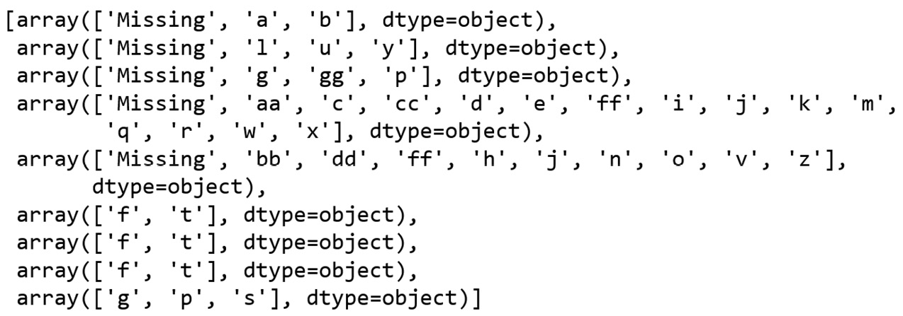
Figure 2.4 – Arrays with the categories that will be encoded into binary variables, one array per variable
Note
Scikit-learn’s OneHotEncoder() will only encode the categories learned from the train set. If there are new categories in the test set, we can instruct the encoder to ignore them or to return an error by setting the handle_unknown parameter to 'ignore' or 'error', respectively.
Let’s create the NumPy arrays with the binary variables for the train and test sets:
X_train_enc = encoder.transform(
X_train[vars_categorical])
X_test_enc = encoder.transform(
X_test[vars_categorical])
Let’s extract the names of the binary variables:
encoder.get_feature_names_out()
We can see the binary variable names that were returned in the following output:
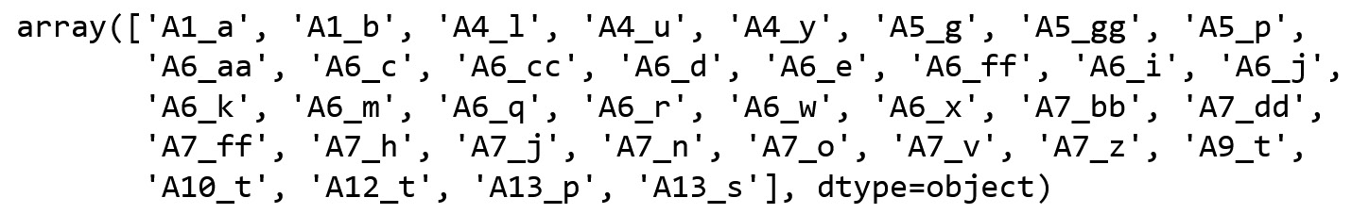
Figure 2.5 – Arrays with the names of the one-hot encoded variables
Let’s convert the array into a pandas DataFrame and add the variable names:
X_test_enc = pd.DataFrame(X_test_enc)
X_test_enc.columns = encoder.get_feature_names_out()
To concatenate the one-hot encoded data to the original dataset, we need to make their indexes match:
X_test_enc.index = X_test.index
Now, we are ready to concatenate the one-hot encoded variables to the original data and then remove the categorical variables using steps 8 and 9 from this recipe.
To follow up, let’s perform one-hot encoding with Feature-engine.
Let’s import the encoder from Feature-engine:
from feature_engine.encoding import OneHotEncoder
Next, let’s set up the encoder so that it returns k-1 binary variables:
ohe_enc = OneHotEncoder(drop_last=True)
Tip
Feature-engine automatically finds the categorical variables. To encode only a subset of the variables, we can pass the variable names in a list: OneHotCategoricalEncoder(variables=["A1", "A4"]). To encode numerical variables, we can set the ignore_format parameter to True or cast the variables as the object type. This is useful because sometimes, numerical variables are used to represent categories, such as postcodes.
Let’s fit the encoder to the train set so that it learns the categories and variables to encode:
ohe_enc.fit(X_train)
Let’s explore the variables that will be encoded:
ohe_enc.variables_
The transformer found and stored the variables of the object or categorical type, as shown in the following output:
['A1', 'A4', 'A5', 'A6', 'A7', 'A9', 'A10', 'A12', 'A13']
Note
Feature-engine’s OneHotEncoder has the option to encode most variables into k dummies, while only returning k-1 dummies for binary variables. For this behavior, set the drop_last_binary parameter to True.
Let’s explore the categories for which dummy variables will be created:
ohe_enc.encoder_dict_
The following dictionary contains the categories that will be encoded in each variable:
{'A1': ['a', 'b'],
'A4': ['u', 'y', 'Missing'],
'A5': ['g', 'p', 'Missing'],
'A6': ['c', 'q', 'w', 'ff', 'm', 'i', 'e', 'cc', 'x',
'd', 'k', 'j', 'Missing', 'aa'],
'A7': ['v', 'ff', 'h', 'dd', 'z', 'bb', 'j', 'Missing',
'n'],
'A9': ['t'],
'A10': ['t'],
'A12': ['t'],
'A13': ['g', 's']}
Let’s encode the categorical variables in train and test sets:
X_train_enc = ohe_enc.transform(X_train)
X_test_enc = ohe_enc.transform(X_test)
Tip
Feature-engine’s OneHotEncoder() returns a copy of the original dataset plus the binary variables and without the original categorical variables. Thus, this data is ready to train machine learning models.
If we execute X_train_enc.head(), we will see the following DataFrame:
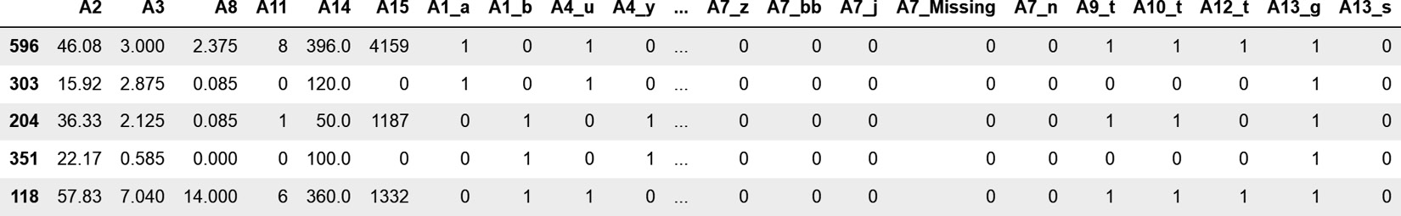
Figure 2.6 – Transformed DataFrame with the one-hot encoded variables on the right
Note how the A4 categorical variable was replaced with A4_u, A4_y, and so on.
Note
We can get the names of all the variables in the transformed dataset by executing ohe_enc.get_feature_names_out().

How it works...
In this recipe, we performed a one-hot encoding of categorical variables using pandas, scikit-learn, Feature-engine, and Category Encoders.
With get_dummies() from pandas, we automatically created binary variables for each of the categories in the categorical variables.
The OneHotEncoder transformers from the scikit-learn and Feature-engine libraries share the fit() and transform() methods. With fit(), the encoders learned the categories for which the dummy variables should be created. With transform(), they returned the binary variables either in a NumPy array or added them to the original DataFrame.
Tip
One-hot encoding expands the feature space. From nine original categorical variables, we created 36 binary ones. If our datasets contain many categorical variables or highly cardinal variables, we will easily increase the feature space dramatically, which increases the computational cost of training machine learning models or obtaining their predictions and may also deteriorate their performance.

There’s more...
We can also perform one-hot encoding using OneHotEncoder from the Category Encoders library.
OneHotEncoder() from Feature-engine and Category Encoders can automatically identify and encode categorical variables – that is, those of the object or categorical type. So does pandas get_dummies(). Scikit-learn’s OneHotEncoder(), on the other hand, will encode all variables in the dataset.
With pandas, Feature-engine, and Category Encoders, we can only encode a subset of the variables, indicating their names in a list. With scikit-learn, we need to use an additional class, ColumnTransformer(), to slice the data before the transformation.
With Feature-engine and Category Encoders, the dummy variables are added to the original dataset and the categorical variables are removed after the encoding. With scikit-learn and pandas, we need to manually perform these procedures.
Finally, using OneHotEncoder() from scikit-learn, Feature-engine, and Category Encoders, we can perform the encoding step within a scikit-learn pipeline, which is more convenient if we have various feature engineering steps or want to put the pipelines into production. pandas get_dummies() is otherwise well suited for data analysis and visualization.

Performing one-hot encoding of frequent categories
One-hot encoding represents each variable’s category with a binary variable. Hence, one-hot encoding of highly cardinal variables or datasets with multiple categorical features can expand the feature space dramatically. This, in turn, may increase the computational cost of using machine learning models or deteriorate their performance. To reduce the number of binary variables, we can perform one-hot encoding of the most frequent categories. One-hot encoding the top categories is equivalent to treating the remaining, less frequent categories as a single, unique category.
In this recipe, we will implement one-hot encoding of the most popular categories using pandas and Feature-engine.

How to do it...
First, let’s import the necessary Python libraries and get the dataset ready:
Import the required Python libraries, functions, and classes:
import pandas as pd
import numpy as np
from sklearn.model_selection import train_test_split
from feature_engine.encoding import OneHotEncoder
Let’s load the dataset and divide it into train and test sets:
data = pd.read_csv("credit_approval_uci.csv")
X_train, X_test, y_train, y_test = train_test_split(
data.drop(
labels=["target"], axis=1),
data["target"],
test_size=0.3,
random_state=0,
)
Tip
The most frequent categories need to be determined in the train set. This is to avoid data leakage.
Let’s inspect the unique categories of the A6 variable:
X_train["A6"].unique()
The unique values of A6 are displayed in the following output:
array(['c', 'q', 'w', 'ff', 'm', 'i', 'e', 'cc', 'x', 'd', 'k', 'j', 'Missing, 'aa', 'r'], dtype=object)
Let’s count the number of observations per category of A6, sort them in decreasing order, and then display the five most frequent categories:
X_train["A6"].value_counts().sort_values(
ascending=False).head(5)
We can see the five most frequent categories and the number of observations per category in the following output:
c 93 q 56 w 48 i 41 ff 38
Name: A6, dtype: int64
Now, let’s capture the most frequent categories of A6 in a list by using the code in step 4 inside a list comprehension:
top_5 = [
x for x in X_train["A6"].value_counts().sort_values(
ascending=False).head(5).index
]
Now, let’s add a binary variable per top category to the train and test sets:
for label in top_5:
X_train[f"A6_{label}"] = np.where(
X_train["A6"] ==label, 1, 0)
X_test[f"A6_{label}"] = np.where(
X_test["A6"] ==label, 1, 0)
Let’s display the top 10 rows of the original and encoded variable, A6, in the train set:
X_train[["A6"] + [f"A6_{label}" for label in top_5]].head(10)
In the output of step 7, we can see the A6 variable, followed by the binary variables:
A6 A6_c A6_q A6_w A6_i A6_ff 596 c 1 0 0 0 0 303 q 0 1 0 0 0 204 w 0 0 1 0 0 351 ff 0 0 0 0 1 118 m 0 0 0 0 0 247 q 0 1 0 0 0 652 i 0 0 0 1 0 513 e 0 0 0 0 0 230 cc 0 0 0 0 0 250 e 0 0 0 0 0
We can automate one-hot encoding of frequent categories with Feature-engine. First, let’s load and divide the dataset, as we did in step 2.
Let’s set up the one-hot encoder to encode the five most frequent categories of the A6 and A7 variables:
ohe_enc = OneHotEncoder(
top_categories=5,
variables=["A6", "A7"]
)
Tip
Feature-engine’s OneHotEncoder() will encode all categorical variables in the dataset by default unless we specify the variables to encode, as we did in step 8.
Let’s fit the encoder to the train set so that it learns and stores the most frequent categories of A6 and A7:
ohe_enc.fit(X_train)
Note
The number of frequent categories to encode is arbitrarily determined by the user.
Finally, let’s encode A6 and A7 in the train and test sets:
X_train_enc = ohe_enc.transform(X_train)
X_test_enc = ohe_enc.transform(X_test)
You can view the new binary variables in the DataFrame by executing X_train_enc.head(). You can also find the top five categories learned by the encoder by executing ohe_enc.encoder_dict_.
Note
Feature-engine replaces the original variable with the binary ones returned by one-hot encoding, leaving the dataset ready to use in machine learning.

How it works...
In this recipe, we performed one-hot encoding of the five most popular categories using NumPy and Feature-engine.
In the first part of this recipe, we worked with the A6 categorical variable. We inspected its unique categories with pandas unique(). Next, we counted the number of observations per category using pandas value_counts(),which returned a pandas series with the categories as the index and the number of observations as values. Next, we sorted the categories from the one with the most to the one with the least observations using pandas sort_values(). Next, we reduced the series to the five most popular categories by using pandas head(). Then, we used this series in a list comprehension to capture the name of the most frequent categories. After that, we looped over each category, and with NumPy’s where() method, we created binary variables by placing a value of 1 if the observation showed the category, or 0 otherwise.
To perform a one-hot encoding of the five most popular categories of the A6 and A7 variables with Feature-engine, we used OneHotEncoder(), indicating 5 in the top_categories argument, and passing the variable names in a list to the variables argument. With fit(), the encoder learned the top categories from the train set and stored them in its encoder_dict_ attribute. Then, with transform(), OneHotEncoder() replaced the original variables with the set of binary ones.

There’s more...
This recipe is based on the winning solution of the KDD 2009 cup, Winning the KDD Cup Orange Challenge with Ensemble Selection (http://proceedings.mlr.press/v7/niculescu09/niculescu09.pdf), where the authors limited one-hot encoding to the 10 most frequent categories of each variable.

Replacing categories with counts or the frequency of observations
In count or frequency encoding, we replace the categories with the count or the fraction of observations showing that category. That is, if 10 out of 100 observations show the category blue for the Color variable, we would replace blue with 10 when doing count encoding, or with 0.1 if performing frequency encoding. These encoding methods, which capture the representation of each label in a dataset, are very popular in data science competitions. The assumption is that the number of observations per category is somewhat predictive of the target.
Tip
Note that if two different categories are present in the same number of observations, they will be replaced by the same value, which leads to information loss.
In this recipe, we will perform count and frequency encoding using pandas, Feature-engine, and Category Encoders.

How to do it...
Let’s begin by making some imports and preparing the data:
Import pandas and the required function:
import pandas as pd
from sklearn.model_selection import train_test_split
Let’s load the dataset and divide it into train and test sets:
data = pd.read_csv("credit_approval_uci.csv")
X_train, X_test, y_train, y_test = train_test_split(
data.drop(labels=["target"], axis=1),
data["target"],
test_size=0.3,
random_state=0,
)
Let’s count the number of observations per category of the A7 variable and capture it in a dictionary:
counts = X_train["A7"].value_counts().to_dict()
Tip
To encode categories with their frequency, execute X_train["A6"].value_counts(normalize=True).to_dict().
If we execute print(counts), we can observe the count of observations per category:
{'v': 277, 'h': 101, 'ff': 41, 'bb': 39, 'z': 7, 'dd': 5, 'j': 5, 'Missing': 4,, 'n': 3, 'o': 1}
Let’s replace the categories in A7 with the counts:
X_train["A7"] = X_train["A7"].map(counts)
X_test["A7"] = X_test["A7"].map(counts)
Go ahead and inspect the data by executing X_train.head() to corroborate that the categories have been replaced by the counts.
Now, let’s carry out count encoding using Feature-engine. First, let’s load and divide the dataset, as we did in step 2.
Let’s import the count encoder from Feature-engine:
from feature_engine.encoding import CountFrequencyEncoder
Let’s set up the encoder so that it encodes all categorical variables with the count of observations:
count_enc = CountFrequencyEncoder(
encoding_method="count", variables=None,
)
Tip
CountFrequencyEncoder() will automatically find and encode all categorical variables in the train set. To encode only a subset of the variables, we can pass the variable names in a list to the variables argument.
Let’s fit the encoder to the train set so that it stores the number of observations per category per variable:
count_enc.fit(X_train)
Tip
The dictionaries with the category-to-counts pairs are stored in the encoder_dict_ attribute and can be displayed by executing count_enc.encoder_dict_.
Finally, let’s replace the categories with counts in the train and test sets:
X_train_enc = count_enc.transform(X_train)
X_test_enc = count_enc.transform(X_test)
Tip
If there are categories in the test set that were not present in the train set, the transformer will replace those with np.nan and return a warning to make you aware of this. A good idea to prevent this behavior is to group infrequent labels, as described in the Grouping rare or infrequent categories recipe.
The encoder returns pandas DataFrames with the strings of the categorical variables replaced with the counts of observations, leaving the variables ready to use in machine learning models.
To wrap up this recipe, let’s encode the variables using Category Encoders.
Let’s import the encoder from Category Encoders:
from category_encoders.count import CountEncoder
Let’s set up the encoder so that it encodes all categorical variables with the count of observations:
count_enc = CountEncoder(cols=None)
Note
CountEncoder()automatically finds and encodes all categorical variables in the train set. To encode only a subset of the categorical variables, we can pass the variable names in a list to the cols argument. To replace the categories by frequency instead, we need to set the Normalize parameter to True.
Let’s fit the encoder to the train set so that it counts and stores the number of observations per category per variable:
count_enc.fit(X_train)
Tip
The values used to replace the categories are stored in the mapping attribute and can be displayed by executing count_enc.mapping.
Finally, let’s replace the categories with counts in the train and test sets:
X_train_enc = count_enc.transform(X_train)
X_test_enc = count_enc.transform(X_test)
Note
Categories present in the test set that were not seen in the train set are referred to as unknown categories. CountEncoder() has different options to handle unknown categories, including returning an error, treating them as missing data, or replacing them with an indicated integer. CountEncoder() can also automatically group categories with few observations.
The encoder returns pandas DataFrames with the strings of the categorical variables replaced with the counts of observations, leaving the variables ready to use in machine learning models.

How it works...
In this recipe, we replaced categories by the count of observations using pandas, Feature-engine, and Category Encoders.
Using pandas value_counts(), we determined the number of observations per category of the A7 variable, and with pandas to_dict(), we captured these values in a dictionary, where each key was a unique category, and each value the number of observations for that category. With pandas map() and using this dictionary, we replaced the categories with the observation counts in both the train and test sets.
To perform count encoding with Feature-engine, we used CountFrequencyEncoder() and set encoding_method to 'count'. We left the variables argument set to None so that the encoder automatically finds all of the categorical variables in the dataset. With the fit() method, the transformer found the categorical variables and stored the observation counts per category in the encoder_dict_ attribute. With the transform() method, the transformer replaced the categories with the counts, returning a pandas DataFrame.
Finally, we performed count encoding with CountEncoder() by setting Normalize to False. We left the cols argument set to None so that the encoder automatically finds the categorical variables in the dataset. With the fit() method, the transformer found the categorical variables and stored the category to count mappings in the mapping attribute. With the transform() method, the transformer replaced the categories with the counts in, returning a pandas DataFrame.

Replacing categories with ordinal numbers
Ordinal encoding consists of replacing the categories with digits from 1 to k (or 0 to k-1, depending on the implementation), where k is the number of distinct categories of the variable. The numbers are assigned arbitrarily. Ordinal encoding is better suited for non-linear machine learning models, which can navigate through the arbitrarily assigned digits to find patterns that relate to the target.
In this recipe, we will perform ordinal encoding using pandas, scikit-learn, and Feature-engine.

How to do it...
First, let’s import the necessary Python libraries and prepare the dataset:
Import pandas and the data split function:
import pandas as pd
from sklearn.model_selection import train_test_split
Let’s load the dataset and divide it into train and test sets:
data = pd.read_csv("credit_approval_uci.csv")
X_train, X_test, y_train, y_test = train_test_split(
data.drop(labels=["target"], axis=1),
data["target"],
test_size=0.3,
random_state=0,
)
To encode the A7 variable, let’s make a dictionary of category-to-integer pairs:
ordinal_mapping = {k: i for i, k in enumerate(
X_train["A7"].unique(), 0)
}
If we execute print(ordinal_mapping), we will see the digits that will replace each category:
{'v': 0, 'ff': 1, 'h': 2, 'dd': 3, 'z': 4, 'bb': 5, 'j': 6, 'Missing': 7, 'n': 8, 'o': 9}
Now, let’s replace the categories with numbers in the original variables:
X_train["A7"] = X_train["A7"].map(ordinal_mapping)
X_test["A7"] = X_test["A7"].map(ordinal_mapping)
With print(X_train["A7"].head(10)), we can see the result of the preceding operation, where the original categories were replaced by numbers:
596 0
303 0
204 0
351 1
118 0
247 2
652 0
513 3
230 0
250 4
Name: A7, dtype: int64
Next, let’s carry out ordinal encoding using scikit-learn. First, we need to divide the data into train and test sets, as we did in step 2.
Let’s import the required classes:
from sklearn.preprocessing import OrdinalEncoder
from sklearn.compose import ColumnTransformer
Tip
Do not confuse OrdinalEncoder() with LabelEncoder() from scikit-learn. The former is intended to encode predictive features, whereas the latter is intended to modify the target variable.
Let’s set up the encoder:
enc = OrdinalEncoder()
Note
Scikit-learn’s OrdinalEncoder() will encode the entire dataset. To encode only a selection of variables, we need to use scikit-learn’s ColumnTransformer().
Let’s make a list containing the categorical variables to encode:
vars_categorical = X_train.select_dtypes(
include="O").columns.to_list()
Let’s make a list containing the remaining variables:
vars_remainder = X_train.select_dtypes(
exclude="O").columns.to_list()
Now, let’s set up ColumTransformer() to encode the categorical variables. By setting the remainder parameter to "passthrough", we make ColumnTransformer() concatenate the variables that are not encoded at the back of the encoded features:
ct = ColumnTransformer(
[("encoder", enc, vars_categorical)],
remainder="passthrough",
)
Let’s fit the encoder to the train set so that it creates and stores representations of categories to digits:
ct.fit(X_train)
By executing ct.named_transformers_["encoder"].categories_, you can visualize the unique categories per variable.
Now, let’s encode the categorical variables in the train and test sets:
X_train_enc = ct.transform(X_train)
X_test_enc = ct.transform(X_test)
Remember that scikit-learn returns a NumPy array.
Let’s transform the arrays into pandas DataFrames by adding the columns:
X_train_enc = pd.DataFrame(
X_train_enc, columns=vars_categorical+vars_remainder)
X_test_enc = pd.DataFrame(
X_test_enc, columns=vars_categorical+vars_remainder)
Note
Note that, with ColumnTransformer(), the variables that were not encoded will be returned to the right of the DataFrame, following the encoded variables. You can visualize the output of step 12 with X_train_enc.head().
Now, let’s do ordinal encoding with Feature-engine. First, we must divide the dataset, as we did in step 2.
Let’s import the encoder:
from feature_engine.encoding import OrdinalEncoder
Let’s set up the encoder so that it replaces categories with arbitrary integers in the categorical variables specified in step 7:
enc = OrdinalEncoder(encoding_method="arbitrary", variables=vars_categorical)
Note
Feature-engine’s OrdinalEncoder automatically finds and encodes all categorical variables if the variables parameter is left set to None. Alternatively, it will encode the variables indicated in the list. In addition, Feature-engine’s OrdinalEncoder() can assign the integers according to the target mean value (see the Performing ordinal encoding based on the target value recipe).
Let’s fit the encoder to the train set so that it learns and stores the category-to-integer mappings:
enc.fit(X_train)
Tip
The category to integer mappings are stored in the encoder_dict_ attribute and can be accessed by executing enc.encoder_dict_.
Finally, let’s encode the categorical variables in the train and test sets:
X_train_enc = enc.transform(X_train)
X_test_enc = enc.transform(X_test)
Feature-engine returns pandas DataFrames where the values of the original variables are replaced with numbers, leaving the DataFrame ready to use in machine learning models.

How it works...
In this recipe, we replaced categories with integers assigned arbitrarily.
With pandas unique(), we returned the unique values of the A7 variable, and using Python’s list comprehension syntax, we created a dictionary of key-value pairs, where each key was one of the A7 variable’s unique categories, and each value was the digit that would replace the category. Finally, we used pandas map() to replace the strings in A7 with the integers.
Next, we carried out ordinal encoding using scikit-learn’s OrdinalEncoder() and used ColumnTransformer() to select the columns to encode. With the fit() method, the transformer created the category-to-integer mappings based on the categories in the train set. With the transform() method, the categories were replaced with integers, returning a NumPy array. ColumnTransformer() sliced the DataFrame into the categorical variables to encode, and then concatenated the remaining variables at the right of the encoded features.
To perform ordinal encoding with Feature-engine, we used OrdinalEncoder(), indicating that the integers should be assigned arbitrarily in encoding_method and passing a list with the variables to encode in the variables argument. With the fit() method, the encoder assigned integers to each variable’s categories, which were stored in the encoder_dict_ attribute. These mappings were then used by the transform() method to replace the categories in the train and test sets, returning DataFrames.

There’s more...
You can also carry out ordinal encoding with OrdinalEncoder() from Category Encoders.
The transformers from Feature-engine and Category Encoders can automatically identify and encode categorical variables – that is, those of the object or categorical type. They also allow us to encode only a subset of the variables.
scikit-learn’s transformer will otherwise encode all variables in the dataset. To encode just a subset, we need to use an additional class, ColumnTransformer(), to slice the data before the transformation.
Feature-engine and Category Encoders return pandas DataFrames, whereas scikit-learn returns NumPy arrays.
Finally, each class has additional functionality. For example, with scikit-learn, we can encode only a subset of the categories, whereas Feature-engine allows us to replace categories with integers that are assigned based on the target mean value. On the other hand, Category Encoders can automatically handle missing data and offers alternative options to work with unseen categories.

Performing ordinal encoding based on the target value
In the previous recipe, we replaced categories with integers, which were assigned arbitrarily. We can also assign integers to the categories given the target values. To do this, first, we must calculate the mean value of the target per category. Next, we must order the categories from the one with the lowest to the one with the highest target mean value. Finally, we must assign digits to the ordered categories, starting with 0 to the first category up to k-1 to the last category, where k is the number of distinct categories.
This encoding method creates a monotonic relationship between the categorical variable and the response and therefore makes the variables more adequate for use in linear models.
In this recipe, we will encode categories while following the target value using pandas and Feature-engine.

How to do it...
First, let’s import the necessary Python libraries and get the dataset ready:
Import the required Python libraries, functions, and classes:
import pandas as pd
import matplotlib.pyplot as plt
from sklearn.model_selection import train_test_split
Let’s load the dataset and divide it into train and test sets:
data = pd.read_csv("credit_approval_uci.csv")
X_train, X_test, y_train, y_test = train_test_split(
data.drop(labels=["target"], axis=1),
data["target"],
test_size=0.3,
random_state=0,
)
Let’s determine the mean target value per category in A7, then sort the categories from that with the lowest to that with the highest target value:
y_train.groupby(X_train["A7"]).mean().sort_values()
The following is the output of the preceding command:
A7
o 0.000000
ff 0.146341
j 0.200000
dd 0.400000
v 0.418773
bb 0.512821
h 0.603960
n 0.666667
z 0.714286
Missing 1.000000
Name: target, dtype: float64
Now, let’s repeat the computation in step 3, but this time, let’s retain the ordered category names:
ordered_labels = y_train.groupby(
X_train["A7"]).mean().sort_values().index
To display the output of the preceding command, we can execute print(ordered_labels):
Index(['o', 'ff', 'j', 'dd', 'v', 'bb', 'h', 'n', 'z', 'Missing'], dtype='object', name='A7')
Let’s create a dictionary of category-to-integer pairs, using the ordered list we created in step 4:
ordinal_mapping = {
k: i for i, k in enumerate(
ordered_labels, 0)
}
We can visualize the result of the preceding code by executing print(ordinal_mapping):
{'o': 0, 'ff': 1, 'j': 2, 'dd': 3, 'v': 4, 'bb': 5, 'h': 6, 'n': 7, 'z': 8, 'Missing': 9}
Let’s use the dictionary we created in step 5 to replace the categories in A7 in the train and test sets, returning the encoded features as new columns:
X_train["A7_enc"] = X_train["A7"].map(ordinal_mapping)
X_test["A7_enc"] = X_test["A7"].map(ordinal_mapping)
Tip
Note that if the test set contains a category not present in the train set, the preceding code will introduce np.nan.
To better understand the monotonic relationship concept, let’s plot the relationship of the categories of the A7 variable with the target before and after the encoding.
Let’s plot the mean target response per category of the A7 variable:
y_train.groupby(X_train["A7"]).mean().plot()
plt.title("Relationship between A7 and the target")
plt.ylabel("Mean of target")
plt.show()
We can see the non-monotonic relationship between categories of A7 and the target in the following plot:
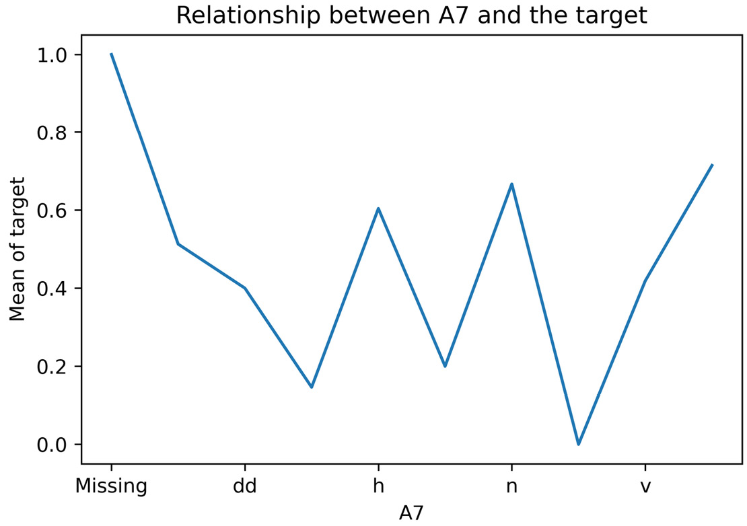
Figure 2.7 – Relationship between the categories of A7 and the target
Let’s plot the mean target value per category in the encoded variable:
y_train.groupby(X_train["A7_enc"]).mean().plot()
plt.title("Relationship between A7 and the target")
plt.ylabel("Mean of target")
plt.show()
The encoded variable shows a monotonic relationship with the target – the higher the mean target value, the higher the digit assigned to the category:
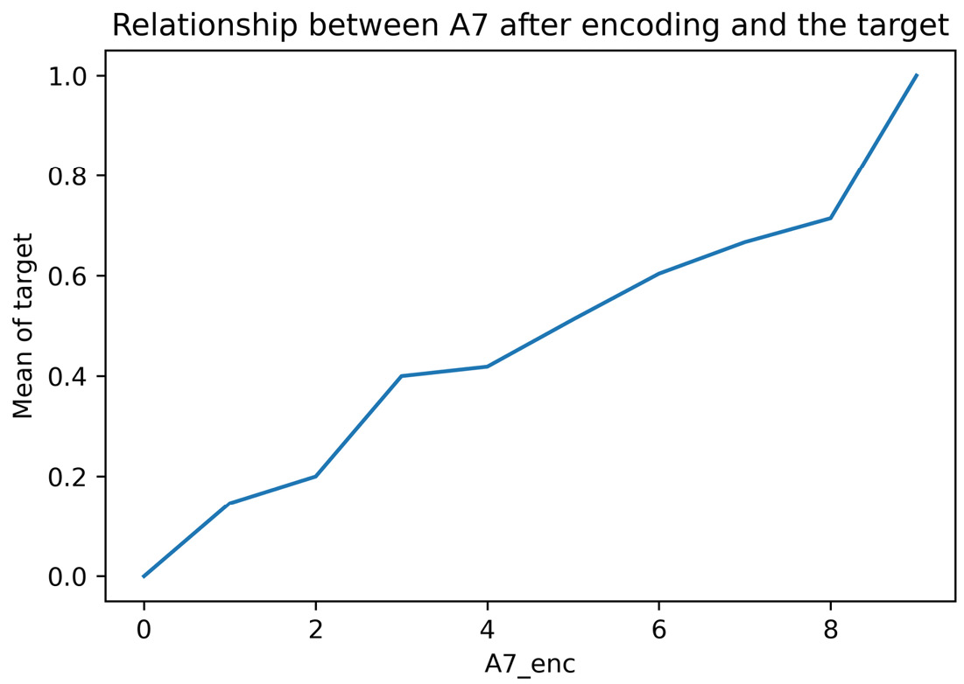
Figure 2.8 – Relationship between A7 and the target after the encoding
Now, let’s perform ordered ordinal encoding using Feature-engine. First, we must divide the dataset into train and test sets, as we did in step 2.
Let’s import the encoder:
from feature_engine.encoding import OrdinalEncoder
Next, let’s set up the encoder so that it assigns integers by following the target value to all categorical variables in the dataset:
ordinal_enc = OrdinalEncoder(
encoding_method="ordered",
variables=None)
Tip
OrdinalEncoder() will find and encode all categorical variables automatically. Alternatively, we can indicate which variables to encode by passing their names in a list to the variables argument.
Let’s fit the encoder to the train set so that it finds the categorical variables, and then stores the category and integer mappings:
ordinal_enc.fit(X_train, y_train)
Tip
When fitting the encoder, we need to pass the train set and the target, like with many scikit-learn predictor classes.
Finally, let’s replace the categories with numbers in the train and test sets:
X_train_enc = ordinal_enc.transform(X_train)
X_test_enc = ordinal_enc.transform(X_test)
Tip
A list of the categorical variables is stored in the variables_ attribute of OrdinalEncoder() and the dictionaries with the category-to-integer mappings in the encoder_dict_ attribute. When fitting the encoder, we need to pass the train set and the target, like with many scikit-learn predictor classes.
Go ahead and check the monotonic relationship between other encoded categorical variables and the target by using the code in step 7 and changing the variable name in the groupby() method.

How it works...
In this recipe, we replaced the categories with integers according to the target mean.
In the first part of this recipe, we worked with the A7 categorical variable. With pandas groupby(), we grouped the data based on the categories of A7, and with pandas mean(), we determined the mean value of the target for each of the categories of A7. Next, we ordered the categories with pandas sort_values() from the ones with the lowest to the ones with the highest target mean response. The output of this operation was a pandas Series, with the categories as indices and the target mean as values. With pandas index, we captured the ordered categories in an array; then, with Python dictionary comprehension, we created a dictionary of category-to-integer pairs. Finally, we used this dictionary to replace the category with integers using pandas map() in the train and test sets.
Then, we plotted the relationship of the original and encoded variables with the target to visualize the monotonic relationship after the transformation. We determined the mean target value per category of A7 using pandas groupby(), followed by pandas mean(), as described in the preceding paragraph. We followed up with pandas plot() to create a plot of category versus target mean value. We added a title and y labels with Matplotlib’s title() and ylabel() methods.
To perform the encoding with Feature-engine, we used OrdinalEncoder() and indicated "ordered" in the encoding_method argument. We left the argument variables set to None so that the encoder automatically detects all categorical variables in the dataset. With the fit() method, the encoder found the categorical variables to encode and assigned digits to their categories, according to the target mean value. The variables to encode and dictionaries with category-to-digit pairs were stored in the variables_ and encoder_dict_ attributes, respectively. Finally, using the transform() method, the transformer replaced the categories with digits in the train and test sets, returning pandas DataFrames.

See also
For an implementation of this recipe with Category Encoders, visit this book’s GitHub repository.

Implementing target mean encoding
Mean encoding or target encoding maps each category to the probability estimate of the target attribute. If the target is binary, the numerical mapping is the posterior probability of the target conditioned to the value of the category. If the target is continuous, the numerical representation is given by the expected value of the target given the value of the category.
In its simplest form, the numerical representation for each category is given by the mean value of the target variable for a particular category group. For example, if we have a City variable, with the categories of London, Manchester, and Bristol, and we want to predict the default rate (the target takes values 0 and 1); if the default rate for London is 30%, we replace London with 0.3; if the default rate for Manchester is 20%, we replace Manchester with 0.2; and so on. If the target is continuous – say we want to predict income – then we would replace London, Manchester, and Bristol with the mean income earned in each city.
In mathematical terms, if the target is binary, the replacement value, S, is determined like so:
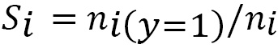
Here, the numerator is the number of observations with a target value of 1 for category i and the denominator is the number of observations with a category value of i.
If the target is continuous, S, this is determined by the following formula:
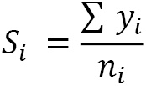
Here, the numerator is the sum of the target across observations in category i and ni is the total number of observations in category i.
These formulas provide a good approximation of the target estimate if there is a sufficiently large number of observations with each category value – in other words, if ni is large. However, in most datasets, categorical variables will only have categorical values present in a few observations. In these cases, target estimates derived from the precedent formulas can be unreliable.
To mitigate poor estimates returned for rare categories, the target estimates can be determined as a mixture of two probabilities: those returned by the preceding formulas and the prior probability of the target based on the entire training set. The two probabilities are blended using a weighting factor, which is a function of the category group size:
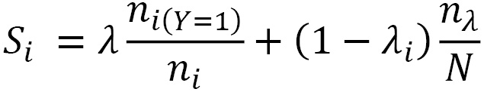
In this formula, ny is the total number of cases where the target takes a value of 1, N is the size of the train set, and 𝛌 is the weighting factor.
When the category group is large, 𝛌 approximates 1, so more weight is given to the first term of the equation. When the category group size is small, then 𝛌 tends to 0, so the estimate is mostly driven by the second term of the equation – that is, the target’s prior probability. In other words, if the group size is small, knowing the value of the category does not tell us anything about the value of the target.
The weighting factor, 𝛌, is a function of the group size, k, and a smoothing parameter, f, controls the rate of transition between the first and second term of the preceding equation:
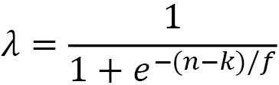
Here, k is half of the minimal size for which we fully trust the first term of the equation. The f parameter is selected by the user either arbitrarily or with optimization.
Tip
Mean encoding was designed to encode highly cardinal categorical variables without expanding the feature space. For more details, check out the following article: Micci-Barreca D. A Preprocessing Scheme for High-Cardinality Categorical Attributes in Classification and Prediction Problems. ACM SIGKDD Explorations Newsletter, 2001.
In this recipe, we will perform mean encoding using pandas, Feature-engine, and Category Encoders.

How to do it...
In the first part of this recipe, we will replace categories with the target mean value, regardless of the number of observations per category. We will use pandas and Feature-engine to do this. In the second part of this recipe, we will introduce the weighting factor using Category Encoders. Let’s begin with this recipe:
Import pandas and the data split function:
import pandas as pd
from sklearn.model_selection import train_test_split
Let’s load the dataset and divide it into train and test sets:
data = pd.read_csv("credit_approval_uci.csv")
X_train, X_test, y_train, y_test = train_test_split(
data.drop(labels=["target"], axis=1),
data["target"],
test_size=0.3,
random_state=0,
)
Let’s determine the mean target value per category of the A7 variable and then store them in a dictionary:
mapping = y_train.groupby(X_train["A7"]).mean().to_dict()
We can display the content of the dictionary by executing print(mapping):
{'Missing': 1.0,
'bb': 0.5128205128205128,
'dd': 0.4,
'ff': 0.14634146341463414,
'h': 0.6039603960396039,
'j': 0.2,
'n': 0.6666666666666666,
'o': 0.0,
'v': 0.4187725631768953,
'z': 0.7142857142857143}
Let’s replace the categories with the mean target value using the dictionary we created in step 3 in the train and test sets:
X_train["A7"] = X_train["A7"].map(mapping)
X_test["A7"] = X_test["A7"].map(mapping)
You can inspect the encoded A7 variable by executing X_train["A7"].head().
Now, let’s perform target encoding with Feature-engine. First, we must split the data, as we did in step 2.
Let’s import the encoder:
from feature_engine.encoding import MeanEncoder
Let’s set up the target mean encoder to encode all categorical variables:
mean_enc = MeanEncoder(variables=None)
Tip
MeanEncoder() will find and encode all categorical variables by default. Alternatively, we can indicate the variables to encode by passing their names in a list to the variables argument.
Let’s fit the transformer to the train set so that it learns and stores the mean target value per category per variable. Note that we need to pass both the train set and target to fit the encoder:
mean_enc.fit(X_train, y_train)
Finally, let’s encode the train and test sets:
X_train_enc = mean_enc.transform(X_train)
X_test_enc = mean_enc.transform(X_test)
Tip
The category-to-number pairs are stored as a dictionary of dictionaries in the encoder_dict_ attribute. To display the stored parameters, execute mean_enc.encoder_dict_.
Feature-engine returns pandas DataFrames containing the categorical variables, ready to use in machine learning models.
To wrap up, let’s implement mean encoding with Category Encoders blending the probabilities.
Let’s import the encoder:
from category_encoders.target_encoder import TargetEncoder
Let’s set up the encoder so that it encodes all categorical variables using blended probabilities when there are less than 25 observations in the category group:
mean_enc = TargetEncoder(
cols=None, min_samples_leaf=25,
smoothing=1.0
)
Tip
TargetEncoder() finds categorical variables automatically by default. Alternatively, we can indicate the variables to encode by passing their names in a list to the cols argument. The smoothing parameter controls the blend of the prior and posterior probability. Higher values decrease the contribution of the posterior probability to the encoding.
Let’s fit the transformer to the train set so that it learns and stores the numerical representations for each category:
mean_enc.fit(X_train, y_train)
Note
The min_samples_leaf parameter refers to the minimum number of observations per category that a group should have to solely use the posterior probability. It is the equivalent of k in our weighting factor formula. In the original article, k was set to ½ of min_samples_leaf. Category encoders expose this value and thus, we can optimize it with cross-validation.
Finally, let’s encode the train and test sets:
X_train_enc = mean_enc.transform(X_train)
X_test_enc = mean_enc.transform(X_test)
Category Encoders returns pandas DataFrames by default, where the original categorical variable values are replaced by their numerical representation. You can inspect the results by executing X_train_enc.head().

How it works…
In this recipe, we replaced the categories with the mean target value using pandas, Feature-engine, and Category Encoders.
With pandas groupby(), using the A7 categorical variable, followed by pandas mean() over the target variable, we created a pandas Series with the categories as indices and the target mean as values. With pandas to_dict(), we converted this Series into a dictionary. Finally, we used this dictionary to replace the categories in the train and test sets using pandas map().
To perform the encoding with Feature-engine, we used MeanEncoder(). With fit(), the transformer found and stored the categorical variables and the mean target value per category. With transform(), categories were replaced with numbers in the train and test sets, returning pandas DataFrames.
Finally, we used TargetEncoder() from Category Encoders to replace categories with a blend of prior and posterior probability estimates of the target. We set min_samples_leaf to 25, which meant that if a category group had 25 observations or more, then the posterior probability was used for the encoding; alternatively, a blend of probabilities was used for the encoding. With fit(), the transformer found the categorical variables and the numerical representation of the categories, while with transform(), the categories were replaced with numbers, returning pandas DataFrames with their encoded values.

There’s more…
There is an alternative way to return better target estimates when the category groups are small. The replacement value for each category is determined as follows:
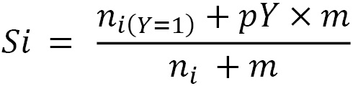
Here, ni(Y=1) is the target mean for category i and ni is the number of observations with category i. The target prior is given by pY and m is the weighting factor. With this adjustment, the only parameter that we have to set is the weight, m. If m is large, then more importance is given to the target’s prior probability. This adjustment affects target estimates for all categories but mostly for those with fewer observations because, in such cases, m could be much larger than ni in the formula’s denominator.
For an implementation of this encoding using MEstimateEncoder(), visit this book’s GitHub repository.

Encoding with the Weight of Evidence
The Weight of Evidence (WoE) was developed primarily for credit and financial industries to facilitate variable screening and exploratory analysis and to build more predictive linear models to evaluate the risk of loan defaults.
The WoE is computed from the basic odds ratio:
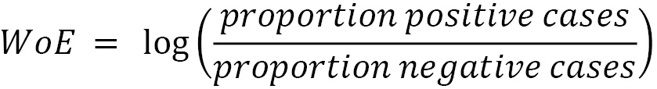
Here, positive and negative refer to the values of the target being 1 or 0, respectively. The proportion of positive cases per category is determined as the sum of positive cases per category group divided by the total positive cases in the training set, and the proportion of negative cases per category is determined as the sum of negative cases per category group divided by the total number of negative observations in the training set.
The WoE has the following characteristics:
WoE = 0 if p(positive) / p(negative) = 1; that is, if the outcome is random
WoE > 0 if p(positive) > p(negative)
WoE < 0 if p(negative) > p(positive)
This allows us to directly visualize the predictive power of the category in the variable: the higher the WoE, the more likely the event will occur. If the WoE is positive, the event is likely to occur:
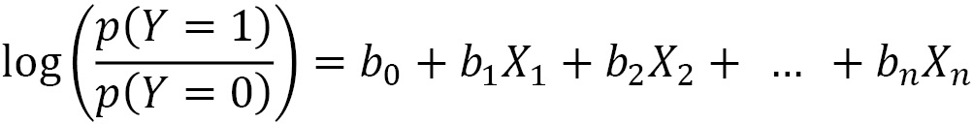
Logistic regression models a binary response, Y, based on X predictor variables, assuming that there is a linear relationship between X and the log of odds of Y.
Here, log (p(Y=1)/p(Y=0)) is the log of odds. As you can see, the WoE encodes the categories in the same scale – that is, the log of odds – as the outcome of the logistic regression.
Therefore, by using WoE, the predictors are prepared and coded on the same scale, and the parameters in the logistic regression model – that is, the coefficients – can be directly compared.
In this recipe, we will perform WoE encoding using pandas and Feature-engine.

How to do it...
Let’s begin by making some imports and preparing the data:
Import the required libraries and functions:
import numpy as np
import pandas as pd
from sklearn.model_selection import train_test_split
Let’s load the dataset and divide it into train and test sets:
data = pd.read_csv("credit_approval_uci.csv")
X_train, X_test, y_train, y_test = train_test_split(
data.drop(labels=["target"], axis=1),
data["target"],
test_size=0.3,
random_state=0,
)
Let’s get the inverse of the target values to be able to calculate the negative cases:
neg_y_train = pd.Series(
np.where(y_train == 1, 0, 1),
index=y_train.index
)
Let’s determine the number of observations where the target variable takes a value of 1 or 0:
total_pos = y_train.sum()
total_neg = neg_y_train.sum()
Now, let’s calculate the numerator and denominator of the WoE’s formula, which we discussed earlier in this recipe:
pos = y_train.groupby(
X_train["A1"]).sum() / total_pos
neg = neg_y_train.groupby(
X_train["A1"]).sum() / total_neg
Now, let’s calculate the WoE per category:
woe = np.log(pos/neg)
We can display the series with the category to WoE pairs by executing print(woe):
A1
Missing 0.203599
a 0.092373
b -0.042410
dtype: float64
Finally, let’s replace the categories of A1 with the WoE:
X_train["A1"] = X_train["A1"].map(woe)
X_test["A1"] = X_test["A1"].map(woe)
You can inspect the encoded variable by executing X_train["A1"].head().
Now, let’s perform WoE encoding using Feature-engine. First, we need to separate the data into train and test sets, as we did in step 2.
Let’s import the encoder:
from feature_engine.encoding import WoEEncoder
Next, let’s set up the encoder so that we can encode three categorical variables:
woe_enc = WoEEncoder(variables = ["A1", "A9", "A12"])
Tip
Feature-engine’s WoEEncoder() will return an error if p(0)=0 for any category because the division by 0 is not defined. To avoid this error, we can group infrequent categories, as we will discuss in the next recipe, Grouping rare or infrequent categories.
Let’s fit the transformer to the train set so that it learns and stores the WoE of the different categories:
woe_enc.fit(X_train, y_train)
Tip
We can display the dictionaries with the categories to WoE pairs by executing woe_enc.encoder_dict_.
Finally, let’s encode the three categorical variables in the train and test sets:
X_train_enc = woe_enc.transform(X_train)
X_test_enc = woe_enc.transform(X_test)
Feature-engine returns pandas DataFrames containing the encoded categorical variables ready to use in machine learning models.

How it works...
First, with pandas sum(), we determined the total number of positive and negative cases. Next, using pandas groupby(), we determined the fraction of positive and negative cases per category. And with that, we calculated the WoE per category.
Finally, we automated the procedure with Feature-engine. We used WoEEncoder(), which learned the WoE per category with the fit() method, and then used transform(), which replaced the categories with the corresponding numbers.

See also
For an implementation of WoE with Category Encoders, visit this book’s GitHub repository.

Grouping rare or infrequent categories
Rare categories are those present only in a small fraction of the observations. There is no rule of thumb to determine how small a small fraction is, but typically, any value below 5% can be considered rare.
Infrequent labels often appear only on the train set or only on the test set, thus making the algorithms prone to overfitting or being unable to score an observation. In addition, when encoding categories to numbers, we only create mappings for those categories observed in the train set, so we won’t know how to encode new labels. To avoid these complications, we can group infrequent categories into a single category called Rare or Other.
In this recipe, we will group infrequent categories using pandas and Feature-engine.

How to do it...
First, let’s import the necessary Python libraries and get the dataset ready:
Import the necessary Python libraries, functions, and classes:
import numpy as np
import pandas as pd
from sklearn.model_selection import train_test_split
from feature_engine.categorical_encoders import RareLabelEncoder
Let’s load the dataset and divide it into train and test sets:
data = pd.read_csv("credit_approval_uci.csv")
X_train, X_test, y_train, y_test = train_test_split(
data.drop(labels=["target"], axis=1),
data["target"],
test_size=0.3,
random_state=0,
)
Let’s capture the fraction of observations per category in A7 in a variable:
freqs = X_train["A7"].value_counts(normalize=True)
We can see the percentage of observations per category of A7, expressed as decimals, in the following output after executing print(freqs):
v 0.573499
h 0.209110
ff 0.084886
bb 0.080745
z 0.014493
dd 0.010352
j 0.010352
Missing 0.008282
n 0.006211
o 0.002070
Name: A7, dtype: float64
If we consider those labels present in less than 5% of the observations as rare, then z, dd, j, Missing, n, and o are rare categories.
Let’s create a list containing the names of the categories present in more than 5% of the observations:
frequent_cat = [
x for x in freqs.loc[freqs > 0.05].index.values]
If we execute print(frequent_cat), we will see the frequent categories of A7:
['v', 'h', 'ff', 'bb'].
Let’s replace rare labels – that is, those present in <= 5% of the observations – with the "Rare" string:
X_train["A7"] = np.where(
X_train["A7"].isin(frequent_cat),
X_train["A7"], "Rare"
)
X_test["A7"] = np.where(
X_test["A7"].isin(frequent_cat),
X_test["A7"], "Rare"
)
Let’s determine the percentage of observations in the encoded variable:
X_train["A7"].value_counts(normalize=True)
We can see that the infrequent labels have now been re-grouped into the Rare category:
v 0.573499 h 0.209110 ff 0.084886 bb 0.080745 Rare 0.051760 Name: A7, dtype: float64
Now, let’s group rare labels using Feature-engine. First, we must divide the dataset into train and test sets, as we did in step 2.
Let’s create a rare label encoder that groups categories present in less than 5% of the observations, provided that the categorical variable has more than four distinct values:
rare_encoder = RareLabelEncoder(tol=0.05, n_categories=4)
Let’s fit the encoder so that it finds the categorical variables and then learns their most frequent categories:
rare_encoder.fit(X_train)
Tip
Upon fitting, the transformer will raise warnings, indicating that many categorical variables have less than four categories, thus their values will not be grouped. The transformer just lets you know that this is happening.
We can display the frequent categories per variable by executing rare_encoder.encoder_dict_, as well as the variables that will be encoded by executing rare_encoder.variables_.
Finally, let’s group rare labels in the train and test sets:
X_train_enc = rare_encoder.transform(X_train)
X_test_enc = rare_encoder.transform(X_test)
Now that we have grouped rare labels, we are ready to encode the categorical variables, as we’ve done in other recipes in this chapter.

How it works...
In this recipe, we grouped infrequent categories using pandas and Feature-engine.
We determined the fraction of observations per category of the A7 variable using pandas value_counts() by setting the normalize parameter to True. Using list comprehension, we captured the names of the variables present in more than 5% of the observations. Finally, using NumPy’s where(), we searched each row of A7, and if the observation was one of the frequent categories in the list, which we checked using the pandas isin() method, its value was kept; otherwise, its original value was replaced with "Rare".
We automated the preceding steps for multiple categorical variables using Feature-engine. For this, we used Feature-engine’s RareLabelEncoder(). By setting tol to 0.05, we retained categories present in more than 5% of the observations. By setting n_categories to 4, we only group rare categories in variables with more than four unique values. With the fit() method, the transformer identified the categorical variables and then learned and stored their frequent categories. With the transform() method, the transformer replaced infrequent categories with the "Rare" string.

Performing binary encoding
Binary encoding is a categorical encoding technique that uses binary code – that is, a sequence of zeroes and ones – to represent the different categories of the variable. How does it work? First, the categories are arbitrarily replaced with ordinal numbers, as shown in the intermediate step of the following table. Then, those numbers are converted into binary code. For example, integer 1 can be represented as sequence 10, integer 2 as 01, integer 3 as 11, and integer 0 as 00. The digits in the two positions of the binary string become the columns, which are the encoded representations of the original variable:
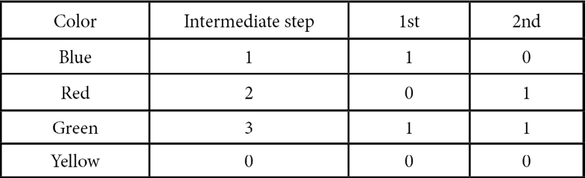
Figure 2.9 – Table showing the steps required for binary encoding of the color variable
Binary encoding encodes the data in fewer dimensions than one-hot encoding. In our example, the Color variable would be encoded into k-1 categories by one-hot encoding – that is, three variables – but with binary encoding, we can represent the variable with only two features. More generally, we determine the number of binary features needed to encode a variable as log2(number of distinct categories); in our example, log2(4) = 2 binary features.
Binary encoding is an alternative method to one-hot encoding where we do not lose information about the variable, yet we obtain fewer features after the encoding. This is particularly useful when we have highly cardinal variables. For example, if a variable contains 128 unique categories, with one-hot encoding, we would need 127 features to encode the variable, whereas with binary encoding, we would only need 7 (log2(128)=7). Thus, this encoding prevents the feature space from exploding. In addition, binary-encoded features are also suitable for linear models. On the downside, the derived binary features lack human interpretability, so if we need to interpret the decisions made by our models, this encoding method may not be a suitable option.
In this recipe, we will learn how to perform binary encoding using Category Encoders.

How to do it...
First, let’s import the necessary Python libraries and get the dataset ready:
Import the required Python library, function, and class:
import pandas as pd
from sklearn.model_selection import train_test_split
from category_encoders.binary import BinaryEncoder
Let’s load the dataset and divide it into train and test sets:
data = pd.read_csv("credit_approval_uci.csv")
X_train, X_test, y_train, y_test = train_test_split(
data.drop(labels=["target"], axis=1),
data["target"],
test_size=0.3,
random_state=0,
)
Let’s inspect the unique categories in A7:
X_train["A7"].unique()
In the following output, we can see that A7 has 10 different categories:
array(['v', 'ff', 'h', 'dd', 'z', 'bb', 'j', 'Missing', 'n', 'o'], dtype=object)
Let’s create a binary encoder to encode A7:
encoder = BinaryEncoder(cols=["A7"], drop_invariant=True)
Tip
BinaryEncoder(), as well as other encoders from the Category Encoders package, allow us to select the variables to encode. We simply pass the column names in a list to the cols argument.
Let’s fit the transformer to the train set so that it calculates how many binary variables it needs and creates the variable-to-binary code representations:
encoder.fit(X_train)
Finally, let’s encode A7 in the train and test sets:
X_train_enc = encoder.transform(X_train)
X_test_enc = encoder.transform(X_test)
We can display the top rows of the transformed train set by executing print(X_train_enc.head()), which returns the following output:
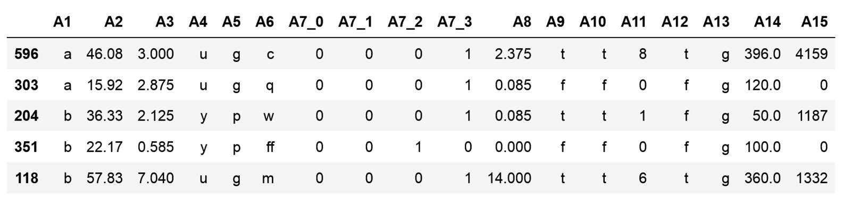
Figure 2.10 – DataFrame with the variables after binary encoding
Binary encoding returned four binary variables for A7, which are A7_0, A7_1, A7_2, and A7_3, instead of the nine that would have been returned by one-hot encoding.

How it works...
In this recipe, we performed binary encoding using the Category Encoders package. First, we loaded the dataset and divided it into train and test sets using train_test_split() from scikit-learn. Next, we used BinaryEncoder() to encode the A7 variable. With the fit() method, BinaryEncoder() created a mapping from category to set of binary columns, and with the transform() method, the encoder encoded the A7 variable in both the train and test sets.
Tip
With one-hot encoding, we would have created nine binary variables (k-1 = 10 unique categories - 1 = 9) to encode all of the information in A7. With binary encoding, we can represent the variable in fewer dimensions by using log2(10)=3.3; that is, we only need four binary variables.

See also
For more information about BinaryEncoder(), visit https://contrib.scikit-learn.org/category_encoders/binary.html.
For a nice example of the output of binary encoding, check out the following resource: https://stats.stackexchange.com/questions/325263/binary-encoding-vs-one-hot-encoding.
For a comparative study of categorical encoding techniques for neural network classifiers, visit https://www.researchgate.net/publication/320465713_A_Comparative_Study_of_Categorical_Variable_Encoding_Techniques_for_Neural_Network_Classifiers.

3

Transforming Numerical Variables
Statistical methods used in data analysis make certain assumptions about the data. For example, in the general linear model, it is assumed that the values of the dependent variable (the target) are independent, that there is a linear relationship between the target and the independent (predictor) variables, and that the residuals – that is, the difference between the predictions and the real values of the target – are normally distributed and centered at 0. When these assumptions are not met, the resulting probabilistic statements might not be accurate. To correct for failure in the assumptions and thus improve the performance of the models, we can transform variables before the analysis.
Variable transformation consists of replacing the original variable values with a function of that variable. More generally, transforming variables with mathematical functions helps reduce variable skewness, improve the value spread, and sometimes unmask linear and additive relationships between predictors and the target. Commonly used mathematical transformations include the logarithm, reciprocal, power, square, and cube root transformations, as well as the Box-Cox and Yeo-Johnson transformations. This set of transformations is commonly referred to as variance stabilizing transformations. Variance stabilizing transformations intend to bring the distribution of the variable to a more symmetric – that is, Gaussian – shape. In this chapter, we will discuss when to use each transformation and then implement them using NumPy, SciPy, scikit-learn, and Feature-engine.
This chapter will cover the following recipes:
Transforming variables with the logarithm function
Transforming variables with the reciprocal function
Using the square root to transform variables
Using power transformations
Performing Box-Cox transformation
Performing Yeo-Johnson transformation

Transforming variables with the logarithm function
The logarithm function is a powerful transformation for dealing with positive data with a right-skewed distribution (observations accumulate at lower values of the variable). A common example is variable income, with a heavy accumulation of values toward smaller salaries. The log transform has a strong effect on the shape of the variable distribution.
In this recipe, we will perform logarithmic transformation using NumPy, scikit-learn, and Feature-engine. We will also create a diagnostic plot function to evaluate the effect of the transformation on the variable distribution.

Getting ready
To evaluate the variable distribution and understand whether a transformation improves value spread and stabilizes the variance, we can visually inspect the data with histograms and Quantile-Quantile (Q-Q) plots. A Q-Q plot helps us determine whether two variables show a similar distribution. In a Q-Q plot, we plot the quantiles of one variable against the quantiles of the second variable. If we plot the quantiles of the variable of interest against the expected quantiles of the normal distribution, then we can determine whether our variable is also normally distributed. If the variable is normally distributed, the points in the Q-Q plot will fall along a 45-degree diagonal.
Note
A quantile is the fraction of points below a given value. Thus, the 0.2 quantile is the point in the distribution at which 20% of the observations fall below and 80% above that value.

How to do it...
Let’s begin by importing the libraries and getting the dataset ready:
Import the required Python libraries and dataset:
import numpy as np
import pandas as pd
import matplotlib.pyplot as plt
import scipy.stats as stats
from sklearn.datasets import fetch_california_housing
Let’s load the California housing dataset into a pandas DataFrame:
X, y = fetch_california_housing(return_X_y=True,
as_frame=True)
Let’s explore the distributions of all the variables in the dataset by plotting histograms with pandas:
X.hist(bins=30, figsize=(12, 12))
plt.show()
In the following output, we can see that the MedInc variable shows a mild right-skewed distribution, variables such as AveRooms and Population are heavily right-skewed, and that the HouseAge variable shows an even spread of values across its range:
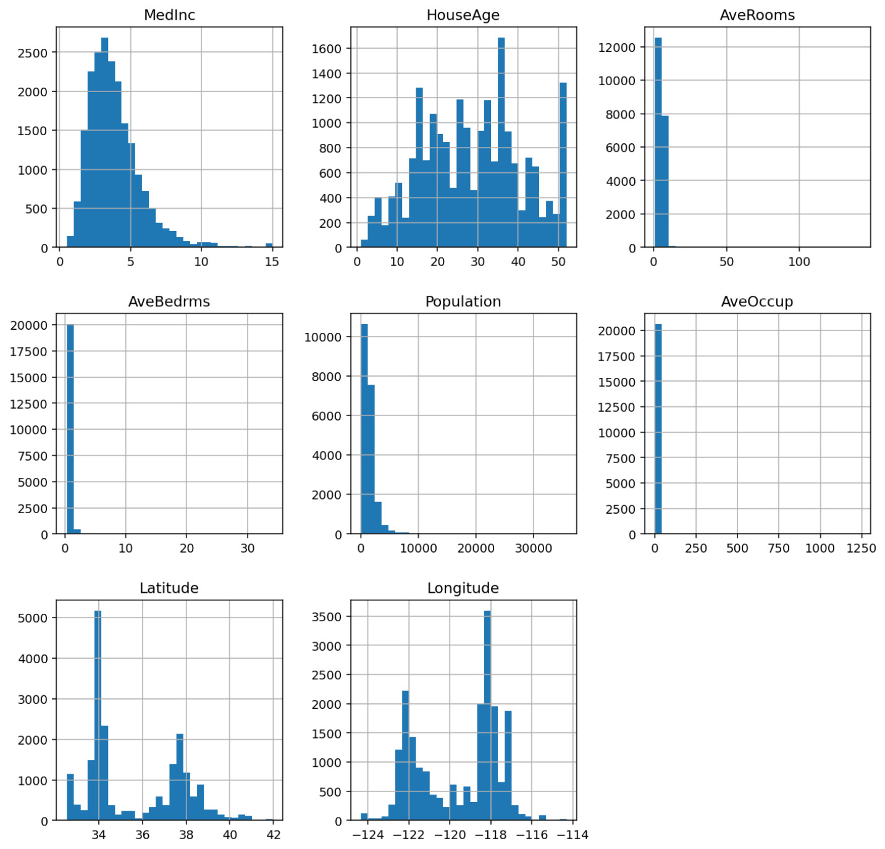
Figure 3.1 – Histograms with the distribution of the numerical variables
To evaluate the effect of the transformation on the variable distribution, we’ll create a function that takes a DataFrame and a variable name as inputs and plots a histogram next to a Q-Q plot:
def diagnostic_plots(df, variable):
plt.figure(figsize=(15,6))
plt.subplot(1, 2, 1)
df[variable].hist(bins=30)
plt.title(f"Histogram of {variable}")
plt.subplot(1, 2, 2)
stats.probplot(df[variable], dist="norm", plot=plt)
plt.title(f"Q-Q plot of {variable}")
plt.show()
Now, let’s plot the distribution of the MedInc variable:
diagnostic_plots(X, "MedInc")
The following output shows that MedInc has a mild right-skewed distribution:
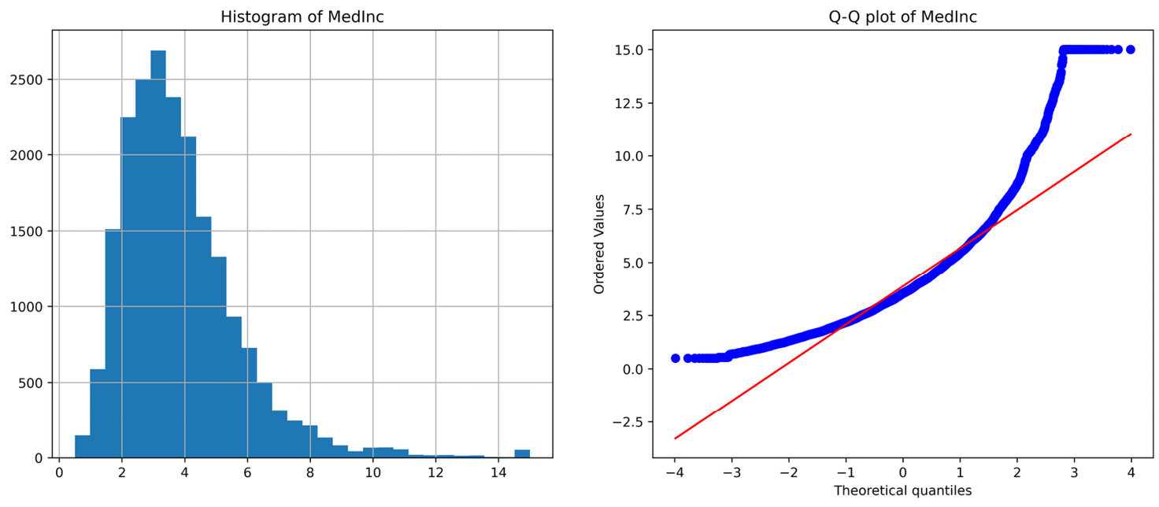
Figure 3.2 – Histogram and Q-Q plot of the MedInc variable
Now, let’s transform the data with the logarithm.
First, let’s make a copy of the original DataFrame using pandas copy():
X_tf = X.copy()
We’ve created a copy so that we can modify the values in the copy and not in the original DataFrame, which we need for the rest of this recipe.
Note
If we execute X_tf = X instead of using pandas copy(), X_tf will not be a copy of the DataFrame; instead, it will be another view of the same data. Therefore, changes made in X_tf will be reflected in X as well.
Let’s make a list with the variables that we want to transform:
variables = ["MedInc", "AveRooms", "AveBedrms", "Population"]
Let’s apply the logarithmic transformation with NumPy to the variables from step 7 and capture the transformed variables in the new DataFrame:
X_tf[variables] = np.log(X[variables])
Note
Remember that the logarithm transformation can only be applied to strictly positive variables. If the variables have zero or negative values, sometimes, it is useful to add a constant to make those values positive. We could add a constant value of 1 using X_tf[variables] = np.log(X[variables] + 1).
Let’s check the distribution of MedInc after the transformation with the diagnostic function from step 4:
diagnostic_plots(X_tf, "MedInc")
In the following output, we can see that the logarithmic transformation returned a more evenly distributed variable that approximates the theoretical normal distribution in the Q-Q plot better:
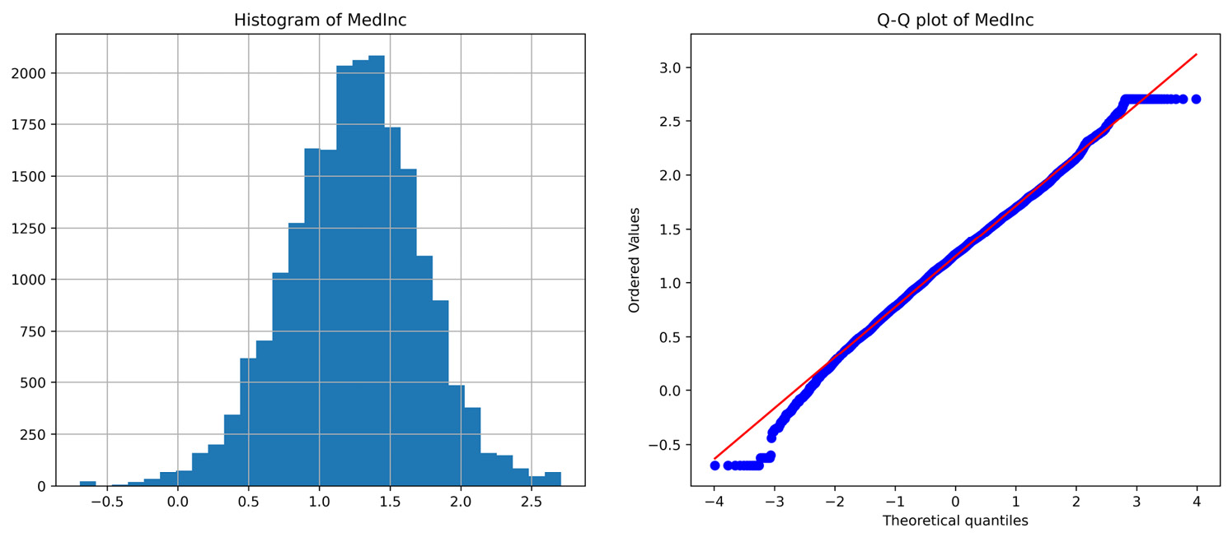
Figure 3.3 – Histogram and Q-Q plot of the MedInc variable after the log transformation
Go ahead and plot the other transformed variables to familiarize yourself with the effect of the log transform on distributions.
Now, let’s apply the logarithmic transformation with scikit-learn.
Let’s import FunctionTransformer():
from sklearn.preprocessing import FunctionTransformer
Before we proceed, we need to take a copy of the original dataset, as we did in step 6.
Let’s set up the transformer so that we can apply the logarithm and also revert the transformed variable to its original representation:
transformer = FunctionTransformer(np.log,
inverse_func=np.exp)
Note
If we set up FunctionTransformer() with the default parameter, validate=False, we don’t need to fit the transformer before transforming the data. If we set validate=True, the transformer will check the input data to the fit method. The latter is useful when fitting the transformer with a DataFrame so that it learns and stores the variable names.
Let’s transform the positive variables from step 7:
X_tf[variables] = transformer.transform(X[variables])
Note
Scikit-learn transformers return NumPy arrays by default. In this case, we assigned the results of the array directly to our existing DataFrame. Go ahead and check the results of the transformation with the diagnostic function from step 4.
Because we set up the exponential function in the inverse function of FunctionTransformer() in step 11, we can revert the transformed variables to their original representations, as follows:
X_tf[variables] = transformer.inverse_transform(
X_tf[variables])
If you check the distribution by executing diagnostic_plots(X_tf, "MedInc"), you should see a plot identical to that returned by step 5.
Note
To add a constant value to the variables, in case they are not strictly positive, we can set up FunctionTransformer() using transformer = FunctionTransformer(lambda x: np.log(x + 1)).
Now, let’s do logarithm transformation with Feature-engine.
Let’s import LogTransformer():
from feature_engine.transformation import LogTransformer
Let’s set up the transformer so that it modifies the variables from step 7 and then fits them to the dataset:
lt = LogTransformer(variables = variables)
lt.fit(X)
Note
If the variables argument is left as None, LogTransformer() identifies and applies the logarithm to all the numerical variables in the dataset.
Alternatively, we can indicate which variables to modify, as we did in step 15.
Finally, let’s transform the data:
X_tf = lt.transform(X)
Note that X_tf is a pandas DataFrame that contains the original variables, where only the variables in the list from step 7 were transformed by the logarithm.
Feature-engine’s LogTransformer() comes with the inverse_transform functionality out of the box to revert the transformed variable to its original representation:
X_tf = lt.inverse_transform(X_tf)
If you check the distribution of the variables after step 17, they should be identical to those of the original data.
Note
Feature-engine has a dedicated transformer that adds constant values to the variables before the log transform. Check the There’s more… section later in this recipe for more details.

How it works...
In this recipe, we applied the logarithm transformation to a subset of positive variables using NumPy, scikit-learn, and Feature-engine.
To compare the effect of the transformation on the variable distribution, we created a diagnostic function to plot a histogram next to a Q-Q plot. To create the Q-Q plot, we used scipy.stats.probplot(), which plotted the quantiles of our variable of interest in the y axis versus the quantiles of a theoretical normal distribution, which we indicated by setting the dist parameter to norm in the x axis. We used Matplotlib to display the plot by setting the plot parameter to plt.
To follow up with the commands used to display the plots, with plt.figure() and figsize, we adjusted the size of the figure and, with plt.subplot(), we organized the two plots in 1 row with 2 columns – that is, one plot next to the other. The numbers within plt.subplot() indicated the number of rows, the number of columns, and the place of the plot in the figure, respectively. We placed the histogram in position 1 and the Q-Q plot in position 2 – that is, left and right, respectively.
To test the function, we plotted a histogram and a Q-Q plot for the MedInc variable before the transformation and observed that MedInc was not normally distributed: most observations were at the left of the histogram and the values deviated from the 45-degree line in the Q-Q plot at both ends of the distribution.
Next, using np.log(), we applied the logarithm to a slice of the DataFrame with four positive variables. To evaluate the effect of the transformation, we plotted a histogram and Q-Q plot of the transformed MedInc variable. We observed that, after the log transformation, the values were more centered in the histogram and that, in the Q-Q plot, they only deviated from the 45-degree line toward the far ends of the distribution.
Next, we used FunctionTransformer() from scikit-learn, which applies any user-defined function to a dataset and returns the result of the operation in a NumPy array. We passed np.log() as an argument to apply the log transformation and Numpy’s exp() for the inverse transformation to FunctionTransfomer(). With the transform() method, we transformed a slice of the DataFrame with the positive variables. Finally, with inverse_transform(), we reverted the variable values to their original representation.
Finally, we used Feature-engine’s LogTransformer() to specify the variables to transform in a list as an argument. The fit() method of the transformer checked that the variables were numerical and positive, and the transform() method called np.log() under the hood to transform the indicated variables. With inverse_transform(), we reverted the transformed variables to their original representations.

There’s more…
Feature-engine has a dedicated transformer for adding a constant value to variables that are not strictly positive, before applying the logarithm: LogCpTransformer(). The advantages of this transformer are that it can (i) add the same constant to all variables, as we saw in this recipe, (ii) automatically identify the minimum value required to make the variables positive, or (iii) add different arbitrary values defined by the user to different variables.
You can find a code implementation of LogCpTransformer() in this book’s GitHub repository: https://github.com/PacktPublishing/Python-Feature-Engineering-Cookbook-Second-Edition/blob/main/ch03-variable-transformation/Recipe-6-Yeo-Johnson-transformation.ipynb.

Transforming variables with the reciprocal function
The reciprocal function is defined as 1/x. The reciprocal transformation is often useful when we have ratios – that is, values resulting from the division of two variables. Examples of this are population density – that is, people per area – and, as we will see in this recipe, house occupancy – that is, the number of occupants per house.
The reciprocal transformation is not defined for the value 0, and although defined for negative values, it is mainly useful for transforming positive variables.
In this recipe, we will implement the reciprocal transformation using NumPy, scikit-learn, and Feature-engine, and compare its effect on variable distribution using histograms and a Q-Q plot.

How to do it...
Let’s begin by importing the libraries and getting the dataset ready:
Import the required Python libraries and data:
import numpy as np
import pandas as pd
import matplotlib.pyplot as plt
import scipy.stats as stats
from sklearn.datasets import fetch_california_housing
Let’s load the California housing dataset:
X, y = fetch_california_housing(return_X_y=True,
as_frame=True)
To evaluate variable distributions, we’ll create a function that takes a DataFrame and a variable name as inputs and plots a histogram next to a Q-Q plot:
def diagnostic_plots(df, variable):
plt.figure(figsize=(15,6))
plt.subplot(1, 2, 1)
df[variable].hist(bins=30)
plt.title(f"Histogram of {variable}")
plt.subplot(1, 2, 2)
stats.probplot(df[variable], dist="norm", plot=plt)
plt.title(f"Q-Q plot of {variable}")
plt.show()
Now, let’s plot the distribution of the AveOccup variable, which specifies the average occupancy of the house:
diagnostic_plots(X, "AveOccup")
The AveOccup variable shows a very strong right-skewed distribution, as shown in the following output:
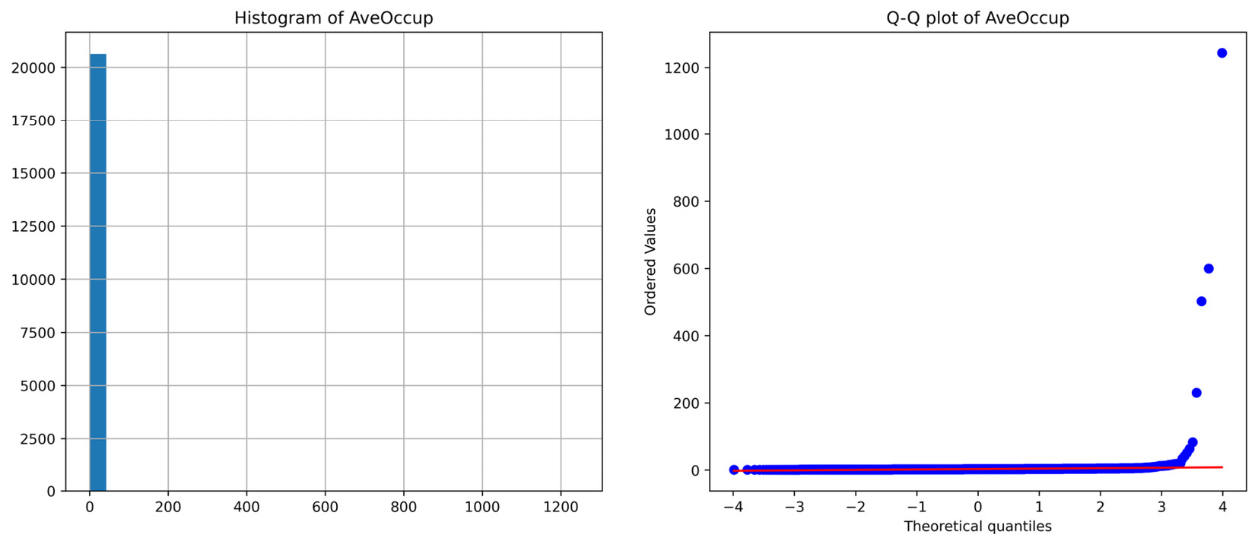
Figure 3.4 – Histogram and Q-Q plot of the AveOccup variable
Note
The AveOccup variable refers to the average number of household members – that is, the ratio between the number of people and the number of houses in a certain area. This is a promising variable for a reciprocal transformation. You can find more details about the variables and the dataset by executing data = fetch_california_housing() followed by print(data.DESCR).
Now, let’s apply the reciprocal transformation with NumPy.
First, let’s make a copy of the original DataFrame so that we can modify the values in the copy and not in the original one, which we need for the rest of this recipe:
X_tf = X.copy()
Note
Remember that executing X_tf = X, instead of using pandas copy(), creates an additional view of the same data. Therefore, changes that are made in X_tf will be reflected in X as well.
Let’s apply the reciprocal transformation to the AveOccup variable:
X_tf["AveOccup"] = np.reciprocal(X_tf["AveOccup"])
Let’s check the distribution of the AveOccup variable after the transformation with the diagnostic function we created in step 3:
diagnostic_plots(X_tf, "AveOccup")
Note
After the transformation, AveOccup is now the ratio of the number of houses and the number of people in a certain area – in other words, houses per citizen.
Here, we can see a dramatic change in the distribution of the AveOccup variable after the reciprocal transformation:
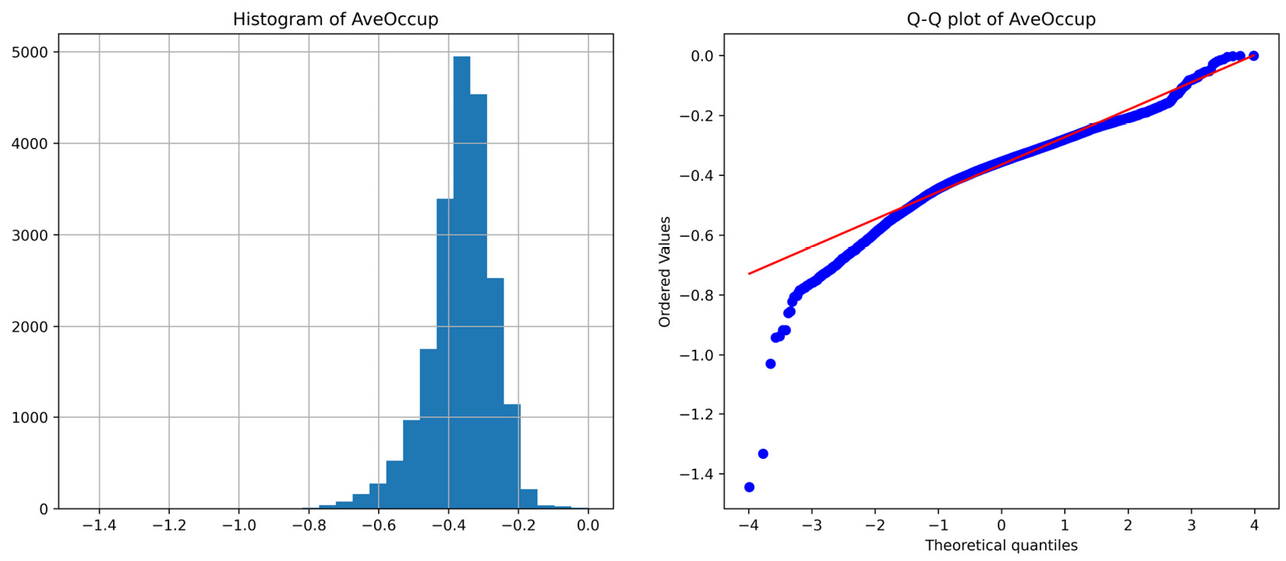
Figure 3.5 – Histogram and Q-Q plot of the AveOccup variable after the reciprocal transformation
Now, let’s apply the reciprocal transformation with scikit-learn. We need to make a new copy of the data, as we did in step 5.
Let’s import FunctionTransformer():
from sklearn.preprocessing import FunctionTransformer
Let’s set up the transformer by passing np.reciprocal as an argument:
transformer = FunctionTransformer(np.reciprocal)
Note
By default, FunctionTransformer() does not need to be fit before transforming the data.
Now, let’s transform the variable of interest after making a copy of the original dataset:
X_tf = X.copy()
X_tf["AveOccup"] = transformer.transform(X["AveOccup"])
You can check the effect of the transformation using the function from step 3.
Note
Note that the inverse of the reciprocal function is the reciprocal function, so if you transform the transformed data, you revert it to its original representation.
Now, let’s apply the reciprocal transformation with Feature-engine.
Let’s import ReciprocalTransformer():
from feature_engine.transformation import ReciprocalTransformer
We must set up the transformer so that it modifies the AveOccup variable and then fit it to the dataset:
rt = ReciprocalTransformer(variables="AveOccup")
rt.fit(X)
Note
If the variables argument is None, the transformer applies the reciprocal function to all the numerical variables in the dataset. If some of the variables contain a value of 0, the transformer will raise an error.
Let’s transform the selected variable in our dataset:
X_tf = rt.transform(X)
ReciprocalTransformer() will return a new pandas DataFrame containing the original variables, where the variable indicated in step 12 is transformed with the reciprocal function.

How it works...
In this recipe, we applied the reciprocal transformation using NumPy, scikit-learn, and Feature-engine.
To evaluate the variable distribution, we used the function to plot a histogram next to a Q-Q plot, which we described in the How it works… section of the Transforming variables with the logarithm function recipe, earlier in this chapter.
We plotted the histogram and Q-Q plot of the AveOccup variable, which showed a heavy right-skewed distribution; most of its values were at the left of the histogram and they deviated from the 45-degree line toward the right end of the distribution in the Q-Q plot.
To carry out the reciprocal transformation, we applied np.reciprocal() to the variable. After the transformation, AveOccup’s values were more evenly distributed across the value range and followed the theoretical quantiles of the normal distribution in the Q-Q plot more closely.
Next, we used np.reciprocal() from within scikit-learn’s FunctionTransformer(). The advantage of applying the reciprocal transformation this way is that we can line up this transformation step within a scikit-learn pipeline.
Finally, we used Feature-engine’s ReciprocalTransformer() while specifying the variable to transform. The fit() method checked that the variables were numerical, while the transform() method called np.reciprocal() under the hood to transform the variables, returning a pandas DataFrame. Feature-engine’s ReciprocalTransformer() provides functionality to revert the variable to its original representation out of the box via the inverse_transform() method.
Using the transformers from scikit-learn or Feature-engine, instead of np.reciprocal(), allows us to carry out this transformation as an additional step of a feature engineering pipeline within the Pipeline object from scikit-learn. The difference between FunctionTransformer() and ReciprocalTransformer() is that the first one can apply any user-specified transformation, whereas the latter only applies the reciprocal function. scikit-learn also returns Numpy arrays by default and transforms all variables in the dataset, whereas Feature-engine returns pandas DataFrames and can modify subsets of variables within the data.

Using the square root to transform variables
The square root transformation, √x, as well as its variations, the Anscombe transformation, √(x+3/8), and the Freeman-Tukey transformation, √x + √(x+1), are variance stabilizing transformations that transform a variable with a Poisson distribution into one with an approximately standard Gaussian distribution. The square root transformation is a form of power transformation where the exponent is 1/2 and is only defined for positive values.
The Poisson distribution is a probability distribution that indicates the number of times an event is likely to occur. In other words, it is a count distribution. It is right-skewed and its variance equals its mean. Examples of variables that could follow a Poisson distribution are the number of financial items of a customer, such as the number of current accounts or credit cards, the number of passengers in a vehicle, and the number of occupants in a household.
In this recipe, we will implement square root transformations using NumPy, scikit-learn, and Feature-engine.

How to do it...
In this recipe, we will create a toy dataset with two variables whose values are drawn from a Poisson distribution:
Let’s begin by importing the necessary libraries:
import numpy as np import pandas as pd
import scipy.stats as stats
Let’s create a DataFrame with two variables drawn from a Poisson distribution with mean values of 2 and 3, respectively, and 10000 observations:
df = pd.DataFrame()
df["counts1"] = stats.poisson.rvs(mu=3, size=10000)
df["counts2"] = stats.poisson.rvs(mu=2, size=10000)
Let’s create a function that takes a DataFrame and a variable name as inputs and plots a bar graph with the number of observations per value next to a Q-Q plot:
def diagnostic_plots(df, variable):
plt.figure(figsize=(15,6))
plt.subplot(1, 2, 1)
df[variable].value_counts().sort_index(). plot.bar()
plt.title(f"Histogram of {variable}")
plt.subplot(1, 2, 2)
stats.probplot(df[variable], dist="norm", plot=plt)
plt.title(f"Q-Q plot of {variable}")
plt.show()
Let’s create a bar plot and a Q-Q plot for one of the variables in the data using the function from step 3:
diagnostic_plots(df, "counts1")
Here, we can see the Poisson distribution in the output:
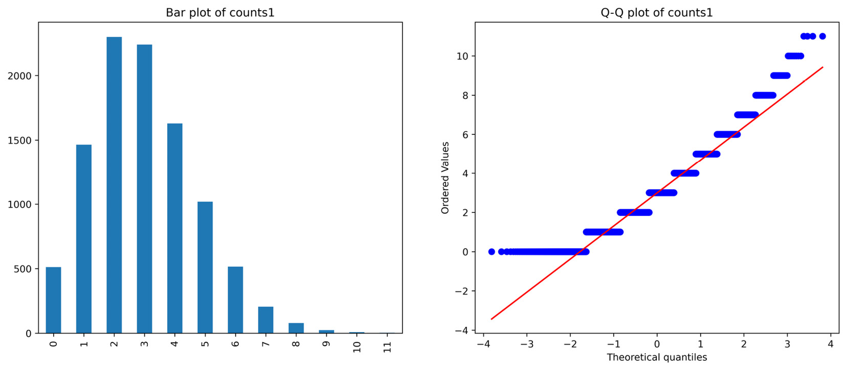
Figure 3.6 – Bar and Q-Q plots of the counts1 variable
Now, let’s make a copy of the toy dataset:
df_tf = df.copy()
Let’s apply the square root transformation to both variables:
df_tf[["counts1", "counts2"]] = np.sqrt(
df[["counts1","counts2"]])
Let’s round the values to 2 decimals for nicer visualization:
df_tf[["counts1", "counts2"]] = np.round(
df_tf[["counts1", "counts2"]], 2)
If we plot the variable distribution as we did in step 4, we will see a more stabilized variance, as the dots in the Q-Q plot follow the 45-degree diagonal more closely:
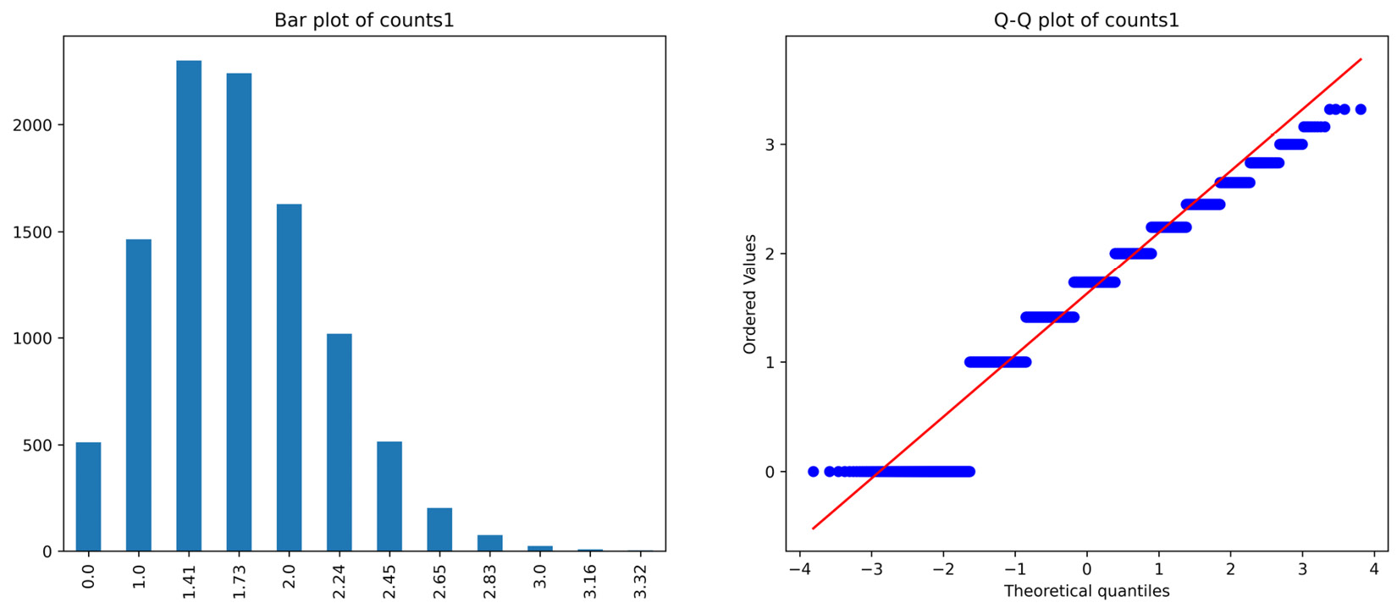
Figure 3.7 – Bar and Q-Q plots of the counts1 variable after the square root transformation
Now, let’s apply the square root transformation with scikit-learn.
Let’s import FunctionTransformer() and set up it to perform a square root transformation:
from sklearn.preprocessing import FunctionTransformer
transformer = FunctionTransformer(np.sqrt)
Note
If we wanted to round the values as we did in step 7, we can set up the transformer using transformer = FunctionTransformer(func=lambda x: np.round(np.sqrt(x), 2)).
After making a copy of the data, as we did in step 5, we can go ahead and transform the variables:
df_tf = transformer.transform(df[["counts1", "counts2"]])
To apply the square root with Feature-engine instead, we must import PowerTransformer() and set it up, passing 0.5 as the exponent:
from feature_engine.transformation import PowerTransformer
root_t = PowerTransformer(exp=1/2)
Next, we must fit the transformer to the data:
root_t.fit(df)
Note
The transformer automatically identifies the numerical variables, which we can explore by executing root_t.variables_.
Finally, we must transform the data:
df_tf = root_t.transform(df)
PowerTransformer() will return a new pandas DataFrame containing the original variables, where the variables from step 9 are transformed with the square root function.

How it works…
In this recipe, we applied power transformations using NumPy, scikit-learn, and Feature-engine.
To apply power functions with NumPy, we created a copy of the original DataFrame with copy() from pandas. Next, we used the power() method on a slice of the dataset with the variables to transform and capture the transformed variables in the new DataFrame. This procedure returned a pandas DataFrame containing the original variables, where MedInc and Population were transformed with a power of 0.3.
To apply an exponential transformation with scikit-learn, we used FunctionTransformer(), which applies a user-defined function. We set up the transformer with np.power() within a lambda function while using 0.3 as the exponent. The transform() method applied the power transformation to a slice of the dataset and the returned values were assigned to the variables in the copy of the DataFrame. This way, we captured the values directly in the DataFrame. Otherwise, scikit-learn returns the values of the NumPy array by default.
Finally, we used Feature-engine’s PowerTransformer(). We set up the transformer with a list of the variables to transform and the exponent, which in this case is 0.3. The fit() method checked that the indicated variables were numerical and that the transform() method applied the transformation, returning a DataFrame with the transformed variables among the original variables in the dataset.

Using power transformations
Power functions are mathematical transformations that follow 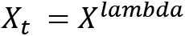, where lambda can take any value. The square and cube root transformations are special cases of power transformations where lambda is 1/2 or 1/3, respectively. The challenge resides in finding the value for the lambda parameter. The Box-Cox transformation, which is a generalization of the power transformations, finds the optimal lambda via maximum likelihood. We will discuss the Box-Cox transformation in the following recipe. In practice, we try different lambdas and visually inspect the variable distribution to determine which one offers the best transformation. In general, if the data is right-skewed – that is, observations accumulate toward lower values – we use lambda <1, while if the data is left-skewed – that is, there are more observations around higher values – then we use lambda >1.
In this recipe, we will carry out power transformations using NumPy, scikit-learn, and Feature-engine.

How to do it...
Let’s begin by importing the libraries and getting the dataset ready:
Import the required Python libraries and classes:
import numpy as np
import pandas as pd
from sklearn.datasets import fetch_california_housing
from sklearn.preprocessing import FunctionTransformer
from feature_engine.transformation import PowerTransformer
Let’s load the California housing dataset into a pandas DataFrame:
X, y = fetch_california_housing(
return_X_y=True, as_frame=True)
Let’s make a copy of the DataFrame so that we can modify the values in the copy and not in the original, which we need for the rest of this recipe:
X_tf = X.copy()
To evaluate variable distributions, we’ll create a function that takes a DataFrame and a variable name as inputs and plots a histogram next to a Q-Q plot:
def diagnostic_plots(df, variable):
plt.figure(figsize=(15,6))
plt.subplot(1, 2, 1)
df[variable].hist(bins=30)
plt.title(f"Histogram of {variable}")
plt.subplot(1, 2, 2)
stats.probplot(df[variable], dist="norm", plot=plt)
plt.title(f"Q-Q plot of {variable}")
plt.show()
Let’s plot the distribution of the Population variable with the function from step 4:
diagnostic_plots(X, "Population")
In the plots returned by the preceding command, we can see that Population is heavily skewed to the right:
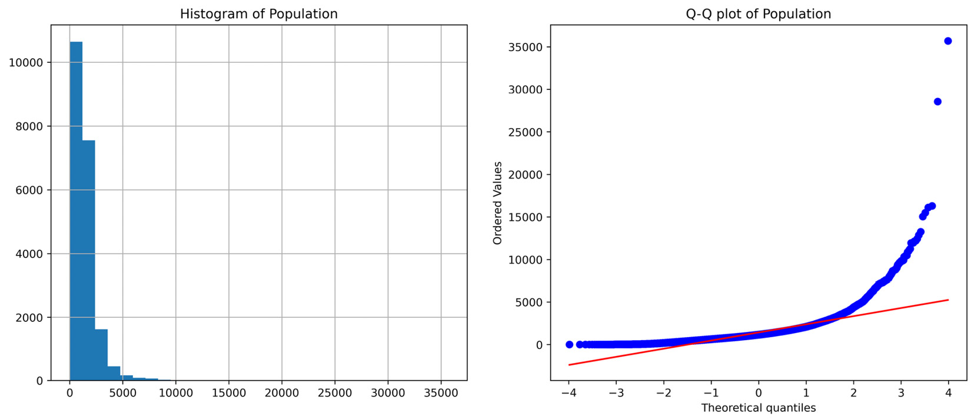
Figure 3.8 – Histogram and Q-Q plot of the Population variable
Now, let’s apply a power transformation to the MedInc and Population variables. As both are skewed to the right, an exponent of <1 might return a better spread of the variable values.
Let’s capture the variables to transform in a list and then apply a power transformation where the exponent is 0.3:
variables = ["MedInc", "Population"]
X_tf[variables] = np.power(X[variables], 0.3)
Note
With np.power(), we can apply any power transformation by changing the value of the exponent in the second position of the method.
Let’s examine the change in the distribution of Population:
diagnostic_plots(X_tf, "Population")
As shown in the plots returned by the preceding command, Population is now more evenly distributed across the value range and follows the quantiles of the normal distribution more closely:
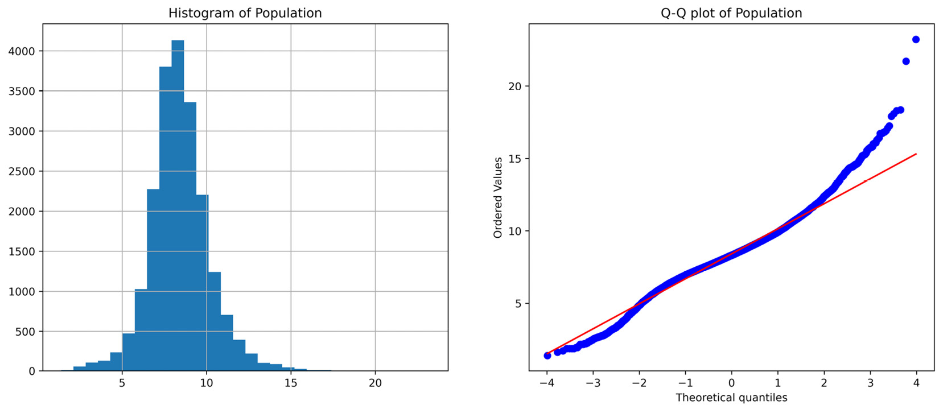
Figure 3.9 – Histogram and Q-Q plot of the Population variable after the transformation
Now, let’s apply a power transformation with scikit-learn.
Let’s set up FunctionTransformer() with a power transformation, as we did in step 6, within a lambda function:
transformer = FunctionTransformer(
lambda x: np.power(x,0.3))
After making a copy of the data, as we did in step 3, we can transform the variables:
X_tf[variables] = transformer.transform(X[variables])
That’s it – we can now examine the variable distribution. Finally, let’s perform an exponential transformation with Feature-engine.
Let’s set up PowerTransformer() with an exponent of 0.3 and the variables to transform. Then, we’ll fit it to the data:
power_t = PowerTransformer(variables=variables, exp=0.3)
power_t.fit(X)
Note
If we don’t define the variables to transform, PowerTransformer() will select all the numerical variables in the DataFrame.
Finally, let’s transform the variables in our dataset:
X_tf = power_t.transform(X)
The transformer returns a DataFrame containing the original variables, and the two variables specified in step 6 are transformed with the power function.

How it works...
In this recipe, we applied power transformations using NumPy, scikit-learn, and Feature-engine.
To apply power functions with NumPy, we created a copy of the original DataFrame with pandas copy(). Next, we used the power() method on a slice of the dataset containing the variables to transform and captured the transformed variables in the new DataFrame. This procedure returned a pandas DataFrame containing the original variables, where MedInc and Population were transformed with a power of 0.3.
To apply an exponential transformation with scikit-learn, we used FunctionTransformer(), which applies a user-defined function. We set up the transformer with np.power() within a lambda function while using 0.3 as the exponent. The transform() method applied the power transformation to a slice of the dataset and the returned values were assigned to the variables in the copy of the DataFrame. This way, we captured the values directly in the DataFrame. Otherwise, scikit-learn returns the values of the NumPy array by default.
Finally, we used Feature-engine’s PowerTransformer(). We set up the transformer with a list of the variables to transform and an exponent of 0.3. The fit() method checked that the indicated variables were numerical and the transform() method applied the transformation, returning a DataFrame with the transformed variables among the original variables in the dataset.

Performing Box-Cox transformation
The Box-Cox transformation is a generalization of the power family of transformations and is defined as follows:
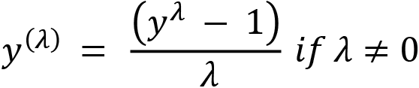
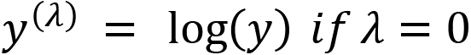
Here, y is the variable and λ is the transformation parameter. It includes important special cases of transformations, including untransformed (λ = 1), the logarithm (λ = 0), the reciprocal (λ = - 1), the square root (when λ = 0.5, it applies a scaled and shifted version of the square root function) and the cube root.
In the Box-Cox transformation, several values of λ are evaluated using the maximum likelihood, and the λ parameter that returns the best transformation is selected.
In this recipe, we will perform Box-Cox transformation using scikit-learn and Feature-engine.
Note
The Box-Cox transformation can only be used on positive variables. If your variables have negative values, try the Yeo-Johnson transformation, which is described in the next recipe, Performing Yeo-Johnson transformation. Alternatively, you can shift the variable distribution by adding a constant before the transformation.

How to do it...
Let’s begin by importing the necessary libraries and getting the dataset ready:
Import the required Python libraries and classes:
import numpy as np
import pandas as pd
import scipy.stats as stats
from sklearn.datasets import fetch_california_housing
from sklearn.preprocessing import PowerTransformer
from feature_engine.transformation import BoxCoxTransformer
Let’s load the California housing dataset into a pandas DataFrame:
X, y = fetch_california_housing(
return_X_y=True, as_frame=True)
Let’s drop the Latitude and Longitude variables as we don’t use them in machine learning models:
X.drop(labels=["Latitude", "Longitude"], axis=1, inplace=True)
Let’s inspect the variable distributions with histograms:
X.hist(bins=30, figsize=(12, 12), layout=(3, 3))
plt.show()
In the following output, we can see that the MedInc variable shows a mild right-skewed distribution, variables such as AveRooms and Population are heavily right-skewed, and the HouseAge variable shows an even spread of values across its range:
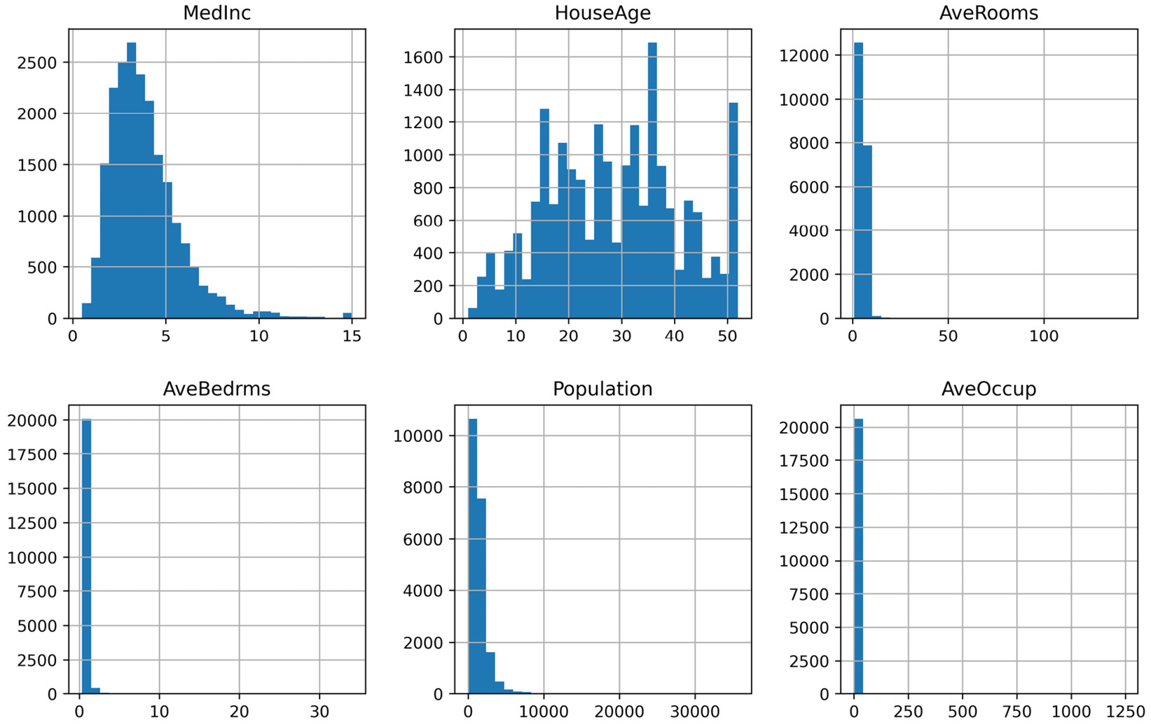
Figure 3.10 – Histograms of the numerical variables
Let’s capture the variable names in a list since we will use these in the following step:
variables = list(X.columns)
Let’s create a function that will plot Q-Q plots for all the variables in the data in 2 rows with 3 plots each:
def make_qqplot(df):
plt.figure(figsize=(10, 6), constrained_layout=True)
for i in range(6):
# location in figure
ax = plt.subplot(2, 3, i + 1)
# variable to plot
var = variables[i]
# q-q plot
stats.probplot((df[var]), dist="norm", plot=plt)
# add variable name as title
ax.set_title(var)
plt.show()
Now, let’s display the Q-Q plots using the preceding function:
make_qqplot(X)
From this, we can corroborate that the variables are not normally distributed in the output of step 7:
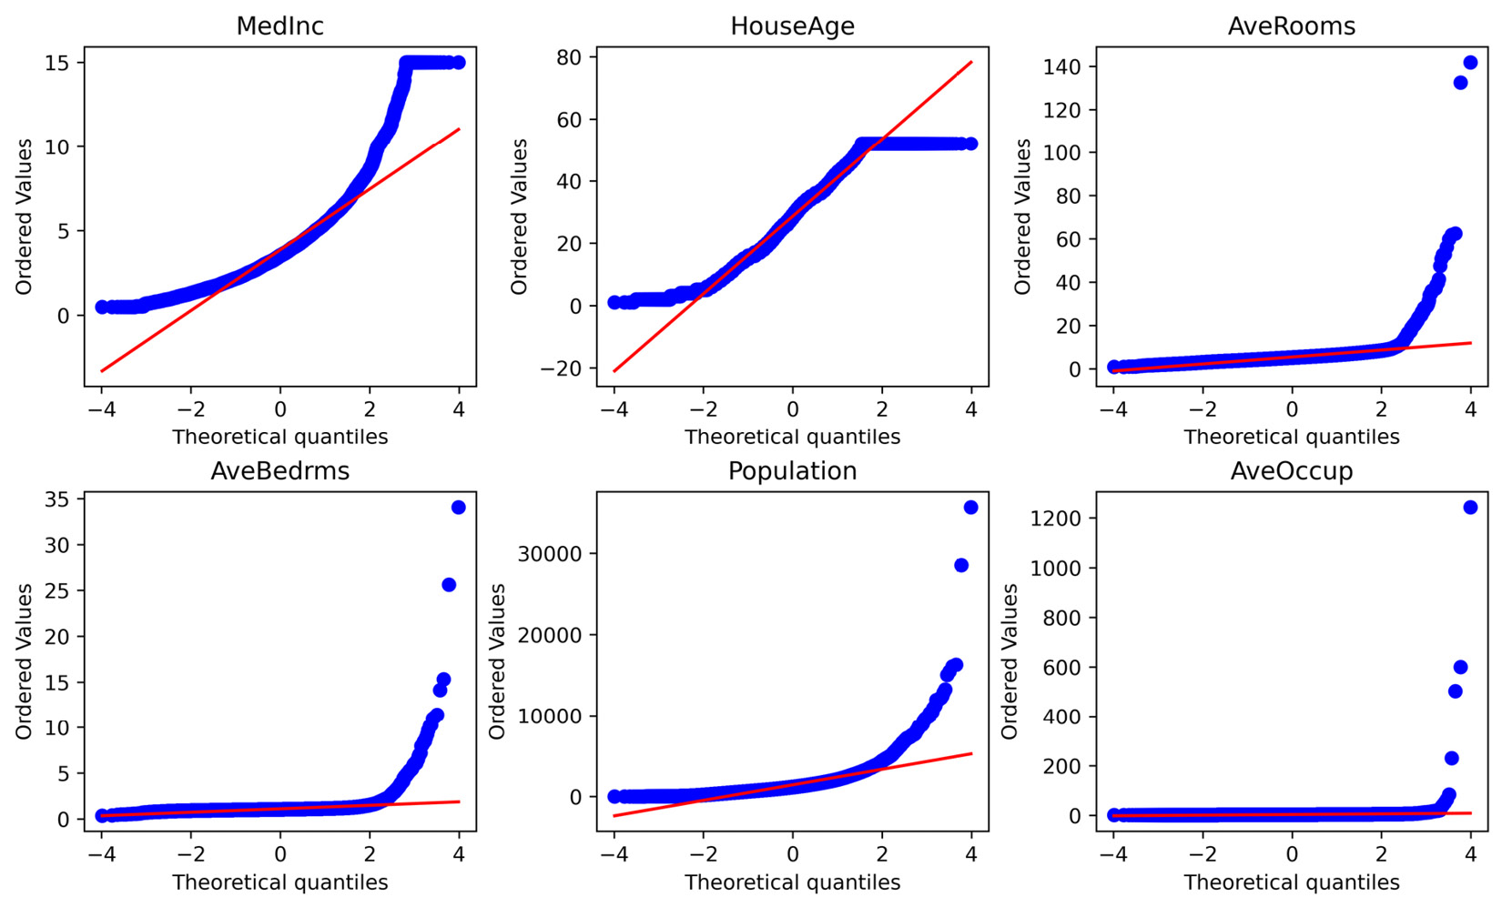
Figure 3.11 – Q-Q plots of the numerical variables
Next, let’s carry out the Box-Cox transformation using scikit-learn’s PowerTransformer().
Let’s set up PowerTransformer() so that it carries out the Box-Cox transformation and fits it to the data so that it finds the optimal λ parameter:
transformer = PowerTransformer(
method="box-cox", standardize=False)
transformer.fit(X)
Note
The λ parameter should be learned from the train set and then used to transform the train and test sets. Thus, remember to separate your data into train and test sets before fitting PowerTransformer().
Now, let’s transform the dataset:
X_tf = transformer.transform(X)
Scikit-learn returns a NumPy array containing the transformed variables. Let’s convert it into a pandas DataFrame:
X_tf = pd.DataFrame(X_tf, columns=variables)
Note
Scikit-learn’s PowerTransformer() stores the learned lambdas in its lambdas_ attribute, which you can display by executing transformer.lambdas_.
Let’s inspect the distributions of the transformed data with histograms:
X_tf.hist(bins=30, figsize=(12, 12), layout=(3, 3))
plt.show()
In the following output, we can see that the variables have a more even spread across their range:
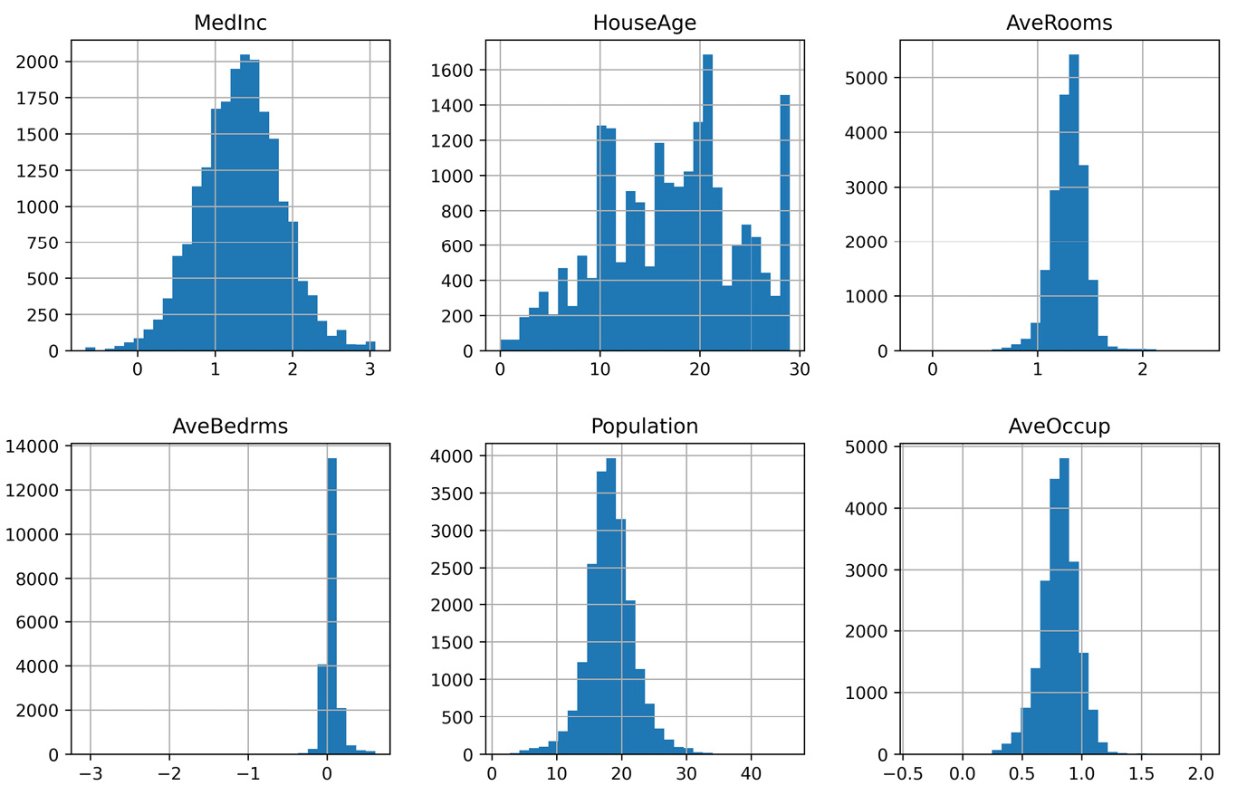
Figure 3.12 – Histograms of the variables after the transformation
Now, let’s return Q-Q plots of the transformed variables:
make_qqplot(X_tf)
In the following output, we can see that, after the transformation, the variables follow the theoretical normal distribution more closely:
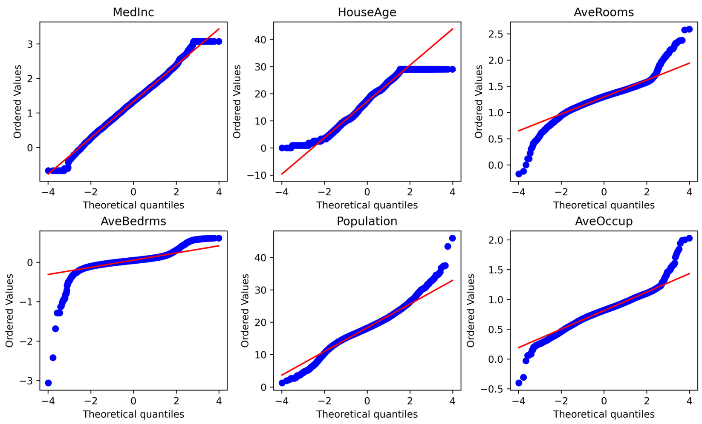
Figure 3.13 – Q-Q plots of the variables after the transformation
Now, let’s implement the Box-Cox transformation with Feature-engine.
Let’s set up BoxCoxTransformer() so that it transforms all the variables in the dataset, and then fits them to the data:
bct = BoxCoxTransformer()
bct.fit(X)
Now, let’s go ahead and transform the variables:
X_tf = bct.transform(X)
The transformation returns a pandas DataFrame containing the modified variables.
Note
PowerTransformer() from scikit-learn will transform the entire dataset. On the other hand, BoxCoxTransformer() from Feature-engine will only modify a subset of the variables: those indicated in the parameter variables when setting up the transformer. If None, the transformer automatically identifies all numerical variables.
The optimal lambdas for the Box-Cox transformation are stored in the lambda_dict_ attribute. Let’s inspect them:
bct.lambda_dict_
The output of the preceding line of code is as follows:
{'MedInc': 0.09085449361507383,
'HouseAge': 0.8093980940712507,
'AveRooms': -0.2980048976549959,
'AveBedrms': -1.6290002625859639,
'Population': 0.23576757812051324,
'AveOccup': -0.4763032278973292}
Now, you know how to implement the Box-Cox transformation with two different Python libraries.

How it works...
In this recipe, using scikit-learn and Feature-engine, we applied the Box-Cox transformation to a subset of variables of the California housing dataset.
Scikit-learn’s PowerTransformer() can apply both Box-Cox and Yeo-Johnson transformations, so we specified the transformation when setting up the transformer by passing the "box-cox" string. Next, we fit the transformer to the data so that the transformer learned the optimal lambdas for each variable. The learned lambdas were stored in the lambdas_ attribute. Finally, we used the transform() method on a slice of the dataset to return the transformed variables in a NumPy array.
Finally, we applied the Box-Cox transformation using Feature-engine. We initialized BoxCoxTransformer(), leaving the parameter variables set the None. Due to this, the transformer automatically found the numerical variables in the data. We fit the transformer to the data so that it learned the optimal lambdas per variable, which were stored in lambda_dict_, and transformed the variables using the transform() method. Feature-engine’s BoxCoxTransformer() can take the entire DataFrame as input, and it will only transform the selected variables, returning the entire DataFrame with the selected variables transformed.

There’s more…
We can apply the Box-Cox transformation with the SciPy library. For a code implementation, visit this book’s GitHub repository: https://github.com/PacktPublishing/Python-Feature-Engineering-Cookbook-Second-Edition/blob/main/ch03-variable-transformation/Recipe-6-Yeo-Johnson-transformation.ipynb.

Performing Yeo-Johnson transformation
The Yeo-Johnson transformation is an extension of the Box-Cox transformation that is no longer constrained to positive values. In other words, the Yeo-Johnson transformation can be used on variables with zero and negative values, as well as positive values. These transformations are defined as follows:
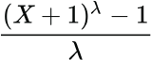; if λ ≠ 0 and X >= 0
ln(X + 1 ); if λ = 0 and X >= 0
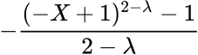; if λ ≠ 2 and X < 0
-ln(-X + 1); if λ = 2 and X < 0
When the variable has only positive values, then the Yeo-Johnson transformation is like the Box-Cox transformation of the variable plus one. If the variable has only negative values, then the Yeo-Johnson transformation is like the BoxCox transformation of the negative of the variable plus one at the power of 2. If the variable has a mix of positive and negative values, the Yeo-Johnson transformation applies different powers to the positive and negative values.
In this recipe, we will perform the Yeo-Johnson transformation using scikit-learn and Feature-engine.

How to do it...
Let’s begin by importing the necessary libraries and getting the dataset ready:
Import the required Python libraries and classes:
import numpy as np import pandas as pd
import scipy.stats as stats
from sklearn.datasets import fetch_california_housing
from sklearn.preprocessing import PowerTransformer
from feature_engine.transformation import YeoJohnsonTransformer
Let’s load the California housing dataset into a pandas DataFrame and then drop the Latitude and Longitude variables:
X, y = fetch_california_housing(
return_X_y=True, as_frame=True)
X.drop(labels=["Latitude", "Longitude"], axis=1,
inplace=True)
Note
We can evaluate the variable distribution with histograms and Q-Q plots, as we did in steps 4 to 7 of the Performing Box-Cox transformation recipe.
Now, let’s apply the Yeo-Johnson transformation with scikit-learn.
Let’s set up PowerTransformer() with the yeo-johnson transformation:
transformer = PowerTransformer(method="yeo-johnson")
Let’s fit the transformer to the data:
transformer.fit(X)
Note
The λ parameter should be learned from the train set and then used to transform the train and test sets. Thus, remember to separate your data into train and test sets before fitting PowerTransformer().
Now, let’s transform the dataset and return a NumPy array containing the transformed variables:
X_tf = transformer.transform(X)
Note
PowerTransformer() stores the learned parameters in its lambda_ attribute, which you can return by executing transformer.lambdas_.
We can convert the NumPy array into a pandas DataFrame and then display the histograms and Q-Q plot of the transformed variables, as we did in steps 10 to 12 of the Performing Box-Cox transformation recipe.
Finally, let’s implement the Yeo-Johnson transformation with Feature-engine.
Let’s set up YeoJohnsonTransformer() so that it modifies all numerical variables and then fits them to the data:
yjt = YeoJohnsonTransformer()
yjt.fit(X)
Note
If the variables argument is left set to None, the transformer selects and transforms all the numerical variables in the dataset. Alternatively, we can pass the names of the variables to modify in a list.
Note that, compared to PowerTransformer() from scikit-learn, the Feature-engine’s transformer can take the entire DataFrame as an argument of the fit () method, and yet it will only modify the selected variables.
Let’s transform the variables:
X_tf = yjt.transform(X)
YeoJohnsonTrasnformer() stores the best parameters per variable in its lambda_dict_ attribute, which we can display as follows:
yjt.lambda_dict_
The preceding code outputs the following dictionary:
{'MedInc': -0.1985098937827175,
'HouseAge': 0.8081480895997063,
'AveRooms': -0.5536698033957893,
'AveBedrms': -4.3940822236920365,
'Population': 0.23352363517075606,
'AveOccup': -0.9013456270549428}
Now, you know how to implement the Yeo-Johnson transformation with two different open source libraries.

How it works...
In this recipe, we applied the Yeo-Johnson transformation using scikit-learn and Feature-engine.
scikit-learn’s PowerTransformer() can apply both Box-Cox and Yeo-Johnson transformations, so we specified the transformation with the yeo-johnson string. The standardize argument allowed us to determine whether we wanted to standardize (scale) the transformed values. Next, we fit the transformer to the DataFrame so that the transformer learned the optimal lambdas for each variable. PowerTransformer() stored the learned lambdas in its lambdas_ attribute. Finally, we used the transform() method to return the transformed variables in a NumPy array.
After that, we applied the Yeo-Johnson transformation using Feature-engine. We set up YeoJohnsonTransformer() so that it transforms all numerical variables in the data. We fitted the transformer to the data so that it learned the optimal lambdas per variable, which were stored in lambda_dict_, and finally transformed the variables using the transform() method. Feature-engine’s YeoJohnnsonTransformer() can take the entire DataFrame as input, yet it will only transform the selected variables, returning a new pandas DataFrame.

There’s more…
We can apply the Yeo-Johnson transformation with the SciPy library. For a code implementation, visit this book’s GitHub repository: https://github.com/PacktPublishing/Python-Feature-Engineering-Cookbook-Second-Edition/blob/main/ch03-variable-transformation/Recipe-6-Yeo-Johnson-transformation.ipynb.

4

Performing Variable Discretization
Discretization is the process of transforming continuous variables into discrete features by creating a set of contiguous intervals, also called bins, that span the range of the variable values. Subsequently, these intervals or bins are treated as categorical data.
Many machine learning models, such as decision trees and Naïve Bayes, work better with discrete attributes. In fact, decision tree-based models make decisions based on discrete partitions over the attributes. During induction, a decision tree evaluates all possible feature values to find the best cut-point. Therefore, the more values the feature has, the longer the induction time of the tree. In this sense, discretization can improve model performance and reduce the time it takes to train the models.
Discretization has additional advantages. Data is reduced and simplified; discrete features can be easier to understand by domain experts. Discretization can change the distribution of skewed variables; if sorting observations across bins with equal frequency, the values are spread more homogeneously across the range. Additionally, discretization can minimize the influence of outliers by placing them at lower or higher intervals, together with the remaining inlier values of the distribution. Overall, discretization reduces and simplifies data, making the learning process faster and yielding more accurate results.
Discretization can also lead to a loss of information, for example, by combining values that are strongly associated with different classes or target values into the same bin. Therefore, the aim of a discretization algorithm is to find the minimal number of intervals without a significant loss of information. In practice, many discretization procedures require the user to input the number of intervals into which the values will be sorted. Then, the job of the algorithm is to find the cut-points for those intervals. Among these procedures, we find the most widely used equal-width and equal-frequency discretization methods. Discretization methods based on decision trees otherwise are able to find the optimal number of partitions, as well as the cut-points.
Discretization procedures can be classified as supervised and unsupervised. Unsupervised discretization methods do not use any information, other than the variable distribution, to create the contiguous bins. On the other hand, supervised methods use target information to create the intervals.
In this chapter, we will discuss widely used supervised and unsupervised discretization procedures that are available in established open source libraries. Among these, we will cover equal-width, equal-frequency, arbitrary, k-means, and decision tree-based discretization. More elaborate methods, such as ChiMerge and CAIM, are out of scope, as their implementation is not yet available open source.
This chapter will cover the following recipes:
Performing equal-width discretization
Implementing equal-frequency discretization
Discretizing the variable into arbitrary intervals
Performing discretization with k-means clustering
Implementing feature binarization
Using decision trees for discretization

Technical requirements
In addition to the numerical computing libraries such as pandas, NumPy, Matplotlib, scikit-learn, and Feature-engine, we will also use the Yellowbrick library. You can install Yellowbrick with pip:
pip install yellowbrick
For more details about Yellowbrick, please visit the documentation at https://www.scikit-yb.org/en/latest/index.html.

Performing equal-width discretization
Equal-width discretization is the simplest discretization method, which consists of dividing the range of observed values for a variable into k equally sized intervals, where k is supplied by the user. The interval width for the X variable is given by the following:
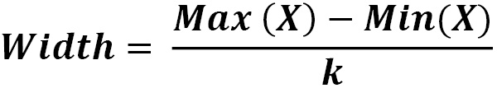
Then, if the values of the variable vary between 0 and 100, we can create five bins like this: width = (100-0) / 5 = 20; the bins will be 0–20, 20–40, 40–60, and 80–100. The first and final bins (0–20 and 80–100) can be expanded to accommodate values smaller than 0 or greater than 100, by extending the limits to minus and plus infinity.
In this recipe, we will carry out equal-width discretization using pandas, scikit-learn, and Feature-engine.

How to do it...
First, let’s import the necessary Python libraries and get the dataset ready:
Import the Python libraries and the data:
import numpy as np
import pandas as pd
import matplotlib.pyplot as plt
from sklearn.datasets import fetch_california_housing
from sklearn.model_selection import train_test_split
Let’s load the predictor and target variables of the California housing dataset:
X, y = fetch_california_housing(
return_X_y=True, as_frame=True)
Note
The cut-points for the intervals should be learned using variables in the train set only and then they should be used to discretize the variables in the train and test sets.
Let’s divide the data into train and test sets:
X_train, X_test, y_train, y_test = train_test_split(
X, y, test_size=0.3, random_state=0,
)
Next, we will divide the HouseAge continuous variable into 10 intervals using pandas and the formula described at the beginning of the recipe.
Let’s capture the minimum and maximum values of HouseAge:
var = "HouseAge"
min_value = int(X_train[var].min())
max_value = int(X_train[var].max())
Let’s determine the interval width, which is the variable’s value range divided by the number of bins:
width = int((max_value - min_value) / 10)
If we execute print(width), we will obtain 5, which is the size of the intervals.
Now we need to define the interval limits in a list:
interval_limits = [i for i in range(
min_value, max_value, width)]
If we now execute print( interval_limits), we will see the interval limits:
[1, 6, 11, 16, 21, 26, 31, 36, 41, 46, 51]
Let’s expand the limits of the first and last interval to accommodate smaller or greater values:
interval_limits[0] = -np.inf
interval_limits[-1] = np.inf
To divide a pandas series into intervals, we will use the pandas cut() method using the interval limits from step 6, for both the train and test sets:
var_disc = "HouseAge_disc"
X_train[var_disc] = pd.cut(
x=X_train[var], bins=interval_limits,
include_lowest=True)
X_test[var_disc] = pd.cut(
x=X_test[var], bins=interval_limits,
include_lowest=True)
Tip
We set include_lowest=True to include the lowest value in the first interval. Through the parameter labels, we can return the bins as integers (default), as interval limits, or replace them with user-specified labels.
Let’s print the top 10 observations of the discretized and original variables, side by side:
print(X_train[[var, var_disc]].head(10))
In following the output, we can see that the value of 52 was allocated to the 46–infinite interval, the value of 43 was allocated to the 41–46 interval, and so on:
HouseAge HouseAge_disc 1989 52.0 (46.0, inf]256 43.0 (41.0, 46.0]7887 17.0 (16.0, 21.0]4581 17.0 (16.0, 21.0]1993 50.0 (46.0, inf]10326 11.0 (6.0, 11.0]10339 14.0 (11.0, 16.0]12992 17.0 (16.0, 21.0]10458 6.0 (-inf, 6.0]1700 10.0 (6.0, 11.0]
Note
The parentheses and brackets in the intervals denote whether a value has been included or not in the interval. For example, the (41, 46] interval contains all values greater than 41 and smaller than or equal to 46.
In equal-width discretization, a different number of observations is allocated to each interval.
Let’s make a bar plot with the proportion of observations across the HouseAge intervals in the train and test sets:
# determine proportion of observations per bin
t1 = X_train[var_disc].value_counts(normalize=True, sort=False)
t2 = X_test[var_disc].value_counts(normalize=True, sort=False)
# concatenate proportions
tmp = pd.concat([t1, t2], axis=1)
tmp.columns = ['train', 'test']
# plot
tmp.plot.bar(figsize=(8,5))
plt.xticks(rotation=45)
plt.ylabel('Number of observations per bin')
plt.title("HouseAge")
plt.show()
In the following output, we can see that the proportion of observations per interval is approximately the same in the train and test sets, but different across intervals:
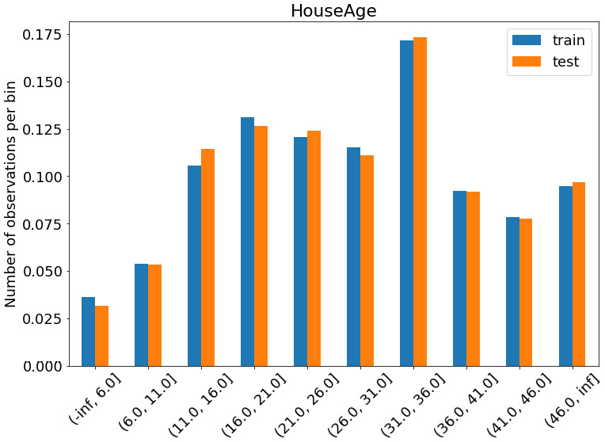
Figure 4.1 – Proportion of observations per interval
With Feature-engine, we can perform equal-width discretization in fewer lines of code and for many variables at a time.
First, let’s divide the data into train and test sets, as shown in step 3:
X_train, X_test, y_train, y_test = train_test_split(
X,
y,
test_size=0.3,
random_state=0,
)
Next, let’s import the discretizer:
from feature_engine.discretisation import EqualWidthDiscretiser
Let’s create an equal-width discretizer to sort three continuous variables into eight intervals, thus returning the interval limits after the transformation:
variables = ['MedInc', 'HouseAge', 'AveRooms']
disc = EqualWidthDiscretiser(
bins=8,
variables=variables,
return_boundaries=True,
)
Note
The EqualWidthDiscretiser() transformer returns an integer indicating whether the value was sorted in the first, second, or eighth bin, by default. That is the equivalent of ordinal encoding, which we described in the Replacing categories with ordinal numbers recipe of Chapter 2, Encoding Categorical Variables. We can set return_object=True to return the variables as objects and then use any of the Feature-engine or Category Encoders transformers. Alternatively, you can return the interval limits as we did in step 13.
Let’s fit the discretizer to the train set so that it learns the cut-points for each variable:
disc.fit(X_train)
We can inspect the cut-points in the disc.binner_dict_ attribute. Note that Feature-engine will automatically extend the limits of the lower and upper intervals to infinite, to accommodate potential outliers in future data.
Let’s discretize the variables in the train and test sets:
train_t = disc.transform(X_train)
test_t = disc.transform(X_test)
EqualWidthDiscretiser() returns a dataframe where the indicated variables are discretized. If we run test_t.head() from a Jupyter notebook, we will see the following output where the original variable values are replaced by the intervals:
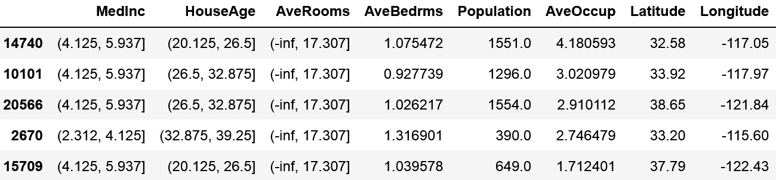
Figure 4.2 – The dataframe with the discretized variables
Now, let’s make bar plots with the proportion of observations per interval to better understand the effect of equal-width discretization:
plt.figure(figsize=(6, 12), constrained_layout=True)
for i in range(3):
# location of plot in figure
ax = plt.subplot(3, 1, i + 1)
# the variable to plot
var = variables[i]
# determine proportion of observations per bin
t1 = train_t[var].value_counts(normalize=True,
sort=False)
t2 = test_t[var].value_counts(normalize=True,
sort=False)
# concatenate proportions
tmp = pd.concat([t1, t2], axis=1)
tmp.columns = ['train', 'test']
# sort the intervals
tmp.sort_index(inplace=True)
# make plot
tmp.plot.bar(ax=ax)
plt.xticks(rotation=45)
plt.ylabel('Observations per bin')
# add variable name as title
ax.set_title(var)
plt.show()
The intervals contain a different number of observations, as shown in the following plots:
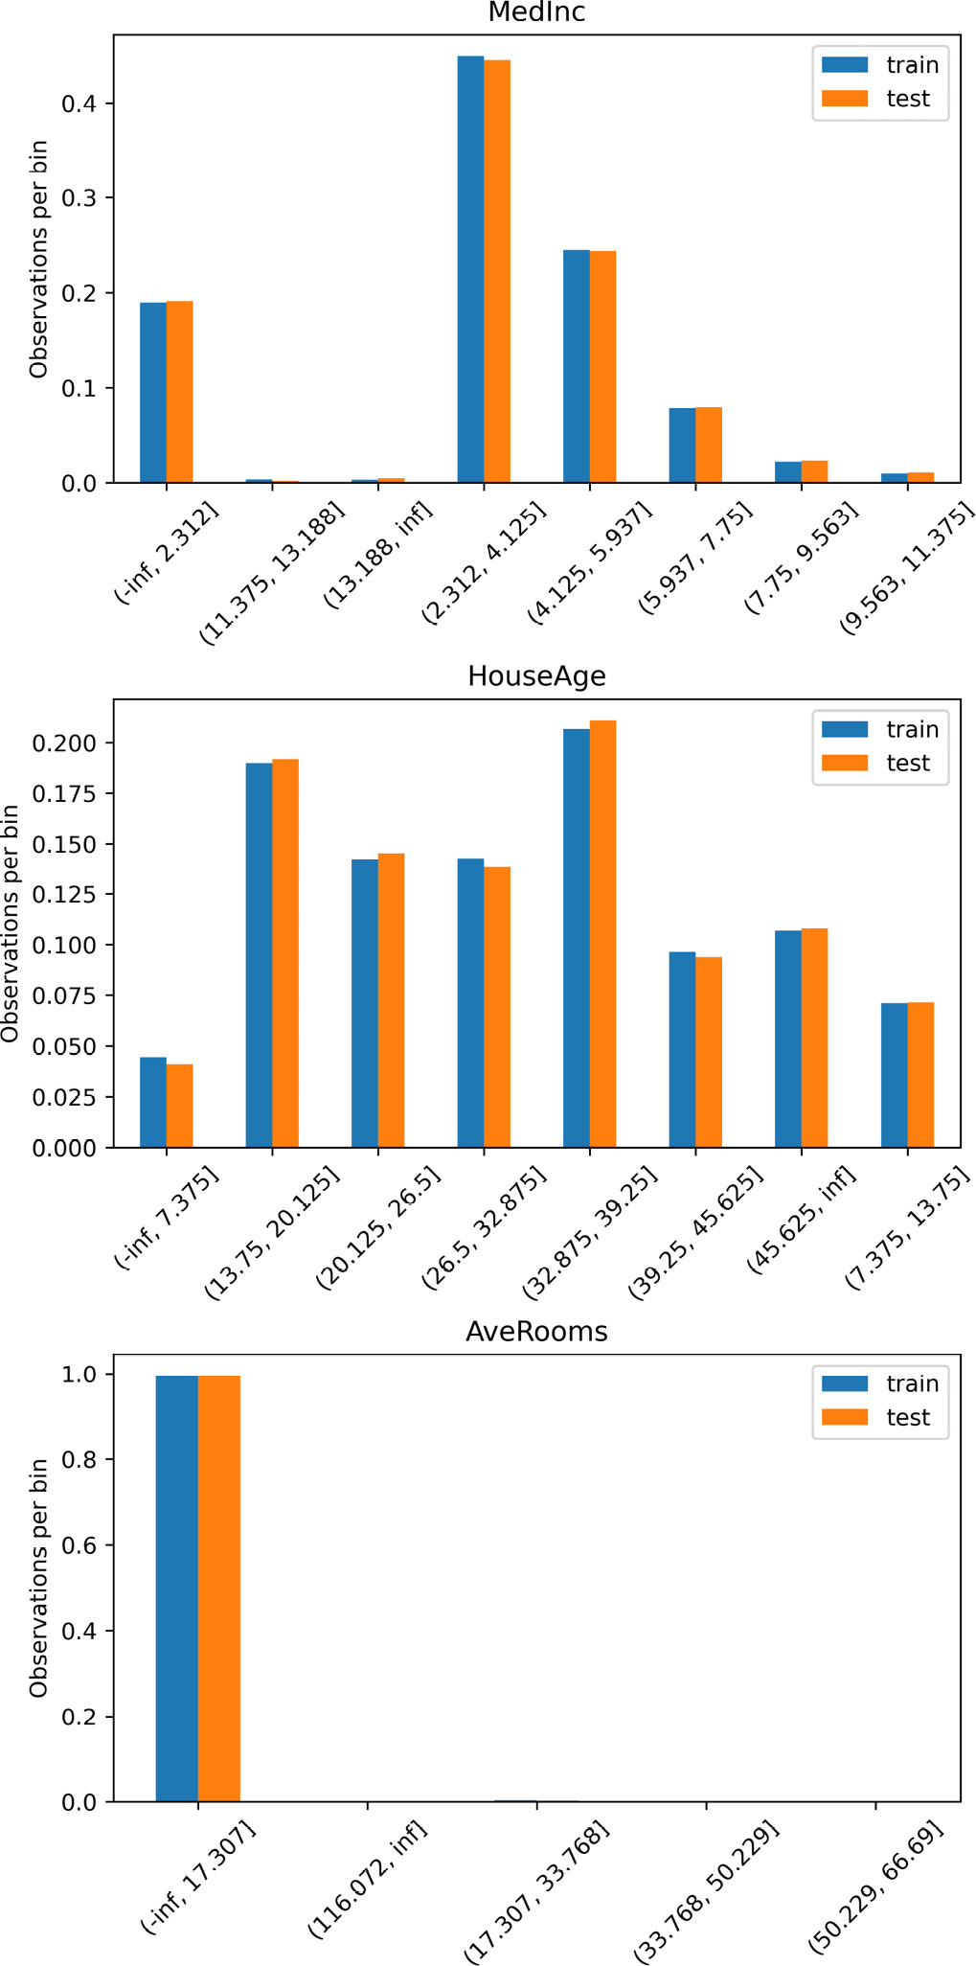
Figure 4.3 – Bar plots with the proportion of observations per interval
Now, let’s implement equal-width discretization with scikit-learn.
Import classes from scikit-learn:
from sklearn.compose import ColumnTransformer
from sklearn.preprocessing import kBinsDiscretizer
Let’s set up an equal-width discretizer by setting its strategy to uniform:
disc = kBinsDiscretizer(n_bins=8, encode='ordinal', strategy='uniform')
Note
The kBinsDiscretiser() class can return the bins as integers by setting encoding='ordinal' or one-hot encoding by setting encoding='onehot-dense'.
Let’s use ColumnTransformer() to apply the discretization to a slice of the dataframe with the selected variables:
ct = ColumnTransformer(
[("discretizer", disc, variables)],
remainder="passthrough",
)
Note
The remainder parameter is used to indicate whether we want to keep all the variables in the dataframe after the transformation, in which case we use passthrough, or only the transformed ones, in which case we use drop.
Let’s fit the discretizer to the train set so that the transformer learns the interval limits for each variable:
ct.fit(X_train)
Finally, let’s transform the train and test sets:
train_t = ct.transform(X_train)
test_t = ct.transform(X_test)
We can inspect the cut-points learned by the transformer by executing ct.named_transformers_["discretizer"].bin_edges_.
Remember that scikit-learn returns NumPy arrays.
Let’s convert the array into a pandas dataframe:
output_vars = variables + ['AveBedrms', 'Population', 'AveOccup',"Latitud", "Longitude"]
train_t = pd.DataFrame(train_t, columns = output_vars)
test_t = pd.DataFrame(test_t, columns = output_vars)
That’s it. Now we can make the bar plots as shown in step 14 or use the data to train machine learning models.

How it works…
In this recipe, we sorted the variable values into equidistant intervals. To perform discretization with pandas, we calculated the maximum and minimum values of the HouseAge variable using the pandas methods of max() and min(), capturing the results as integers. Then, we estimated the interval width by dividing the value range, that is, the maximum values minus the minimum values, by the number of arbitrary bins. With the width and the minimum and maximum values, we captured the interval limits in a list. We used this list with pandas cut() to allocate the variable values into the intervals.
After discretization, the intervals are normally treated as categorical values. By default, pandas cut() returns the interval values as ordered integers, which is the equivalent of ordinal encoding. Through the labels parameter, we can modify this behavior to return the interval boundaries or user-defined labels.
We created a bar plot with the fraction of observations per interval. We used pandas value_counts() to obtain the fraction of observations per interval. To plot these proportions, first, we concatenated the train and test series using pandas concat() in a temporary dataframe, and then we assigned the column names of train and test to it. Finally, we used pandas’ plot.bar() to display a bar plot. We rotated the labels with Matplotlib’s xticks() method and added the y legend with ylabel() and the title with title().
To perform equal-width discretization with Feature-engine, we used EqualWidthDiscretiser(), which takes the number of bins and the variables to discretize as arguments. Using the fit() method, the discretizer learned the interval limits for each variable. With the transform() method, the discretizer sorted the values into each bin.
EqualWidthDiscretiser() offers a few options to follow up the discretization with encoding. By default, it will return the bins as sorted integers, which is the equivalent of ordinal encoding. Alternatively, it can return the interval boundaries as with pandas cut(). To follow up the discretization with any other encoding procedure available in Feature-engine or Category Encoders, we need to return the bins cast as objects, which can be achieved by setting return_object to True.
We followed the discretization with bar plots to identify the fraction of observation per interval, for each of the transformed variables. Because the HouseAge variable had a fairly homogeneous value spread before the transformation, with the equal-width discretization, we allocated values to all the intervals. However, some of the intervals of the MedInc and AveRooms variables, which had skewed distributions, contained very few observations. In particular, even though we wanted to create eight bins for AveRooms, there were enough values to create only five, and most values of the variables were allocated to the first interval. Therefore, equal-width discretization for very skewed variables incurs an important loss of information.
Finally, we discretized three continuous variables into equal-width bins with KBinsDiscretizer() from scikit-learn, indicating the number of bins and setting strategy to uniform. With the fit() method, the transformer learned the limits of the intervals, and with the transform() method, the transformer sorted the values into each interval, returning a NumPy array with the discretized variables. The values of the discretized variables were integers representing the intervals. KBinsDiscretizer can return the intervals as ordinal numbers or as one-hot-encoded variables. The behavior can be modified through the encode parameter.
To apply the discretization to a subset of variables, we used ColumnTransformer(), which sliced the data into the selected variables, then applied the discretizer to this slice of data, and finally concatenated the remaining variables to the transformed ones in a NumPy array.

See also
For a comparison of equal-width discretization with more sophisticated methods, see Dougherty J, Kohavi R, Sahami M. Supervised and unsupervised discretization of continuous features. In: Proceedings of the 12th international conference on machine learning. San Francisco: Morgan Kaufmann; 1995. p. 194–202.

Implementing equal-frequency discretization
Equal-width discretization is easy to compute. However, if the variables are skewed, then there will be many empty bins or bins with only a few values, while most observations will be allocated to a few intervals. This could result in a loss of information. This problem can be solved by adaptively finding the interval cut-points so that each interval contains a similar fraction of observations.
Equal-frequency discretization divides the values of the variable into intervals that carry the same proportion of observations. The interval width is determined by quantiles. Quantiles are values that divide data into equal portions. For example, the median is a quantile that divides the data into two halves. Quartiles divide the data into 4 portions, and percentiles divide the data into 100 portions. As a result, the intervals will most likely have different widths. The number of intervals is defined by the user.
Equal-frequency discretization is particularly useful for skewed variables as it spreads the observations over the different bins equally. In this recipe, we will perform equal-frequency discretization using pandas, scikit-learn, and Feature-engine.

How to do it...
First, let’s import the necessary Python libraries and get the dataset ready:
Import the required Python libraries and classes:
import pandas as pd
import matplotlib.pyplot as plt
from sklearn.datasets import fetch_california_housing
from sklearn.model_selection import train_test_split
Let’s load the California housing dataset into a dataframe:
X, y = fetch_california_housing(
return_X_y=True, as_frame=True)
The interval boundaries or quantiles should be learned using variables in the train set only.
Let’s divide the data into train and test sets:
X_train, X_test, y_train, y_test = train_test_split(
X, y, test_size=0.3, random_state=0,
)
Let’s implement equal-frequency discretization with pandas.
To divide the HouseAge variable into eight quantiles, we use pandas qcut(), which returns both, the discretized variable and the quantile limits. We capture them as a column of the dataframe and an individual variable, respectively:
var = "HouseAge"
var_disc = "House_disc"
X_train[var_disc], interval_limits = pd.qcut(
x=X_train[var], q=8, labels=None, retbins=True,
)
We can visualize the cut-points for the intervals by executing print(interval_limits):
array([ 1., 14., 18., 24., 29., 34., 37., 44., 52.])
Let’s print the top 10 observations of the discretized and original variables, side by side:
print(X_train[[var, var_disc]].head(10))
In the following output, we can see that the value of 52 was allocated to the 44–52 interval, the value of 43 was allocated to the 37–44 interval, and so on:
HouseAge House_disc
1989 52.0 (44.0, 52.0]
256 43.0 (37.0, 44.0]
7887 17.0 (14.0, 18.0]
4581 17.0 (14.0, 18.0]
1993 50.0 (44.0, 52.0]
10326 11.0 (0.999, 14.0]
10339 14.0 (0.999, 14.0]
12992 17.0 (14.0, 18.0]
10458 6.0 (0.999, 14.0]
1700 10.0 (0.999, 14.0]
Now, let’s discretize HouseAge in the test set, using pandas cut() with the interval limits determined in step 4:
X_test[var_disc] = pd.cut(
x = X_test[var], bins=interval_limits)
In equal-frequency discretization, similar fractions of observations are allocated to each interval.
Let’s make a bar plot with the proportion of observations across the HouseAge intervals in the train and test sets:
# determine proportion of observations per bin
t1 = X_train[var_disc].value_counts(normalize=True)
t2 = X_test[var_disc].value_counts(normalize=True)
# concatenate proportions
tmp = pd.concat([t1, t2], axis=1)
tmp.columns = ['train', 'test']
tmp.sort_index(inplace=True)
# plot
tmp.plot.bar()
plt.xticks(rotation=45)
plt.ylabel('Number of observations per bin')
plt.title("HouseAge")
plt.show()
In the output of the preceding code block, we can see that most bins contain a similar fraction of observations, as expected:
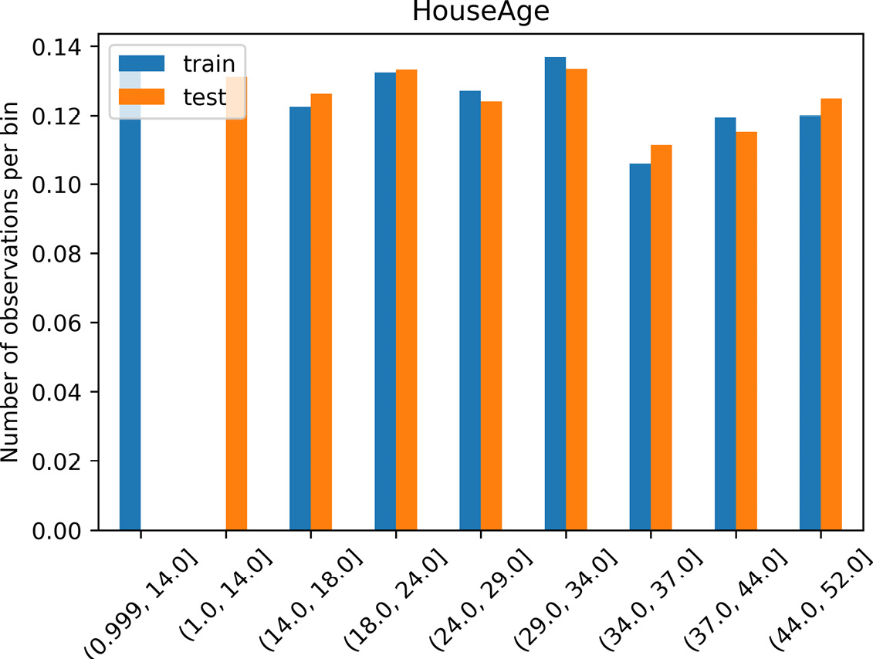
Figure 4.4 – The proportion of observations per interval of HouseAge
Note
Note that the limits for the first interval in the test set and train set differ, being 0.99–14 and 1–14, respectively. This occurred because the minimum value observed in the train set was 1, whereas, in the test set, it was smaller than 1. Therefore, the cut-point was modified to accommodate all values. Alternatively, we can set the limits of the first and last intervals to minus and plus infinity, as we did in the Performing equal width discretization recipe.
With Feature-engine, we can perform equal frequency for many variables at the same time. First, let’s divide the data into train and test sets, as shown in step 3. Next, let’s set up a discretizer.
Let’s import the discretizer:
from feature_engine.discretisation import EqualFrequencyDiscretiser
Let’s set up the transformer to discretize three continuous variables into eight quantiles, returning the interval limits after the transformation:
variables = ['MedInc', 'HouseAge', 'AveRooms']
disc = EqualFrequencyDiscretiser(
q=8, variables =variables,
return_boundaries=True)
Let’s fit the discretizer to the train set so that it learns the interval limits:
disc.fit(X_train)
The transformer stores the limits of the intervals for each variable in a dictionary in its disc.binner_dict_ attribute. Feature-engine will automatically extend the limits of the lower and upper intervals to infinite, to accommodate potential outliers in future data.
Let’s transform the variables in the train and test sets:
train_t = disc.transform(X_train)
test_t = disc.transform(X_test)
Note
The EqualFrequencyDiscretiser() class returns an integer indicating whether the value was sorted in the first, second, or eighth bin, by default. That is the equivalent of ordinal encoding, which we described in the Replacing categories with ordinal numbers recipe of Chapter 2, Encoding Categorical Variables. If we want to follow up the discretization with a different type of encoding, we can set return_object=True to return the variables cast as objects and then use any of the Feature-engine or Category Encoders transformers. Alternatively, we can return the interval limits, as we did in step 9.
Now, let’s make bar plots with the fraction of observations per interval to better understand the effect of equal-frequency discretization:
plt.figure(figsize=(6, 12), constrained_layout=True)
for i in range(3):
# location of plot in figure
ax = plt.subplot(3, 1, i + 1)
# the variable to plot
var = variables[i]
# determine proportion of observations per bin
t1 = train_t[var].value_counts(normalize=True)
t2 = test_t[var].value_counts(normalize=True)
# concatenate proportions
tmp = pd.concat([t1, t2], axis=1)
tmp.columns = ['train', 'test']
# sort the intervals
tmp.sort_index(inplace=True)
# make plot
tmp.plot.bar(ax=ax)
plt.xticks(rotation=45)
plt.ylabel("Observations per bin")
# add variable name as title
ax.set_title(var)
plt.show()
The intervals have a similar proportion of observations, as shown in the following output:
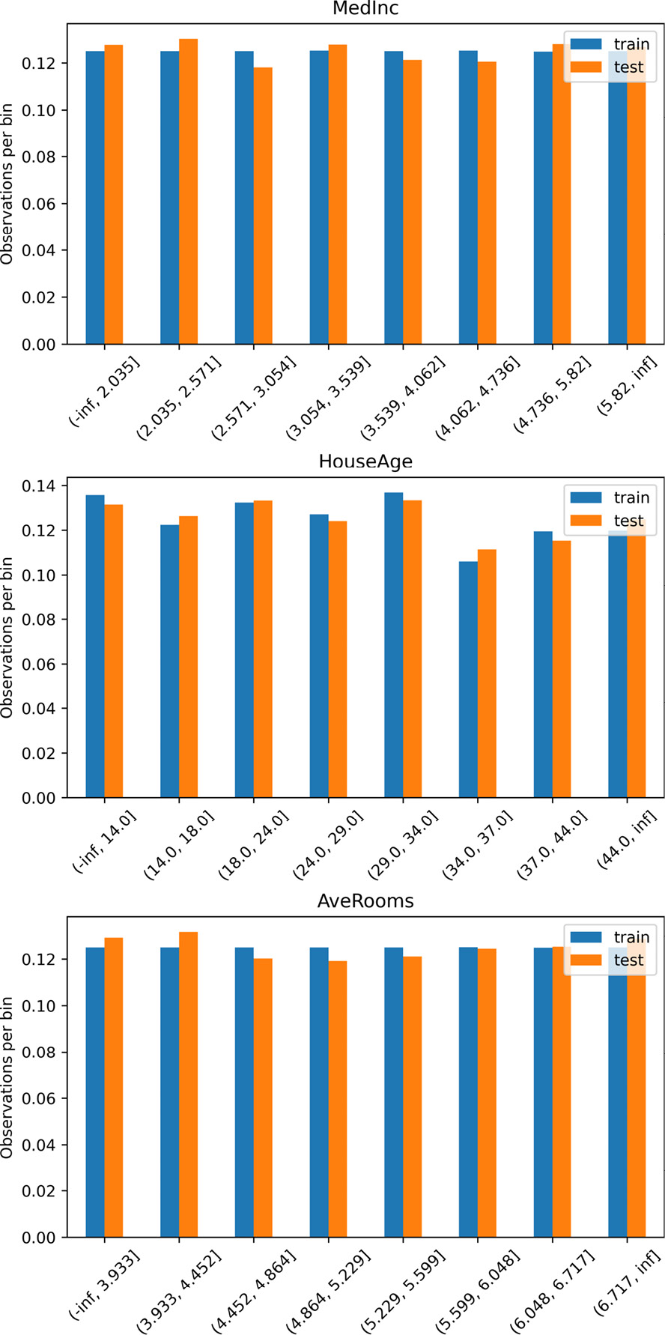
Figure 4.5 – The proportion of observations per interval
Now, let’s carry out equal-frequency discretization with scikit-learn.
Let’s import the transformer:
from sklearn.preprocessing import KBinsDiscretizer
Let’s set up an equal-frequency discretizer by setting strategy to quantile and the number of bins to 8:
disc = KBinsDiscretizer(n_bins=8, encode='ordinal', strategy='quantile')
Let’s fit the discretizer to a slice of the train set containing the variables to transform so that it learns the interval limits:
disc.fit(X_train[variables])
Note
Scikit-learn’s KBinsDiscretiser() will discretize all of the variables in the dataset, so we only need to use the transformer in the slice of the dataframe that contains the variables of interest. In the Performing equal-width discretization recipe, we used the discretizer within ColumnTransformer() as an alternative implementation.
Let’s make a copy of the dataframe where we will capture the discretized variables:
train_t = X_train.copy()
test_t = X_test.copy()
Finally, let’s transform the variables in both train and test sets:
train_t[variables] = disc.transform(X_train[variables])
test_t[variables] = disc.transform(X_test[variables])
Tip
We can inspect the cut-points by executing disc.bin_edges_.
Scikit-learn returns a NumPy array, the values which we assigned directly to the variables in our dataframe.

How it works…
With equal-frequency discretization, we sorted the variable values into intervals with a similar proportion of observations.
We used pandas qcut() to determine the limits of the intervals based on train set variable quantiles and sorted the values of the HouseAge variable into those intervals. Next, we used those limits together with pandas cut() to discretize HouseAge in the test set. Note that pandas qcut(), like pandas cut(), returned the interval values as ordered integers. Through the labels parameter, we can modify this behavior to return the interval boundaries or user-defined labels.
To perform equal-frequency discretization with Feature-engine, we used EqualFrequencyDiscretiser() and indicated the number of quantiles and the variables to discretize as arguments. With fit(), the discretizer learned and stored the interval limits in its binner_dict_ attribute. With transform(), the observations were allocated to the bins. The values of the discretized variables are integers, representing the 1st, 2nd, 3rd, and so on bins.
The EqualFrequencyDiscretiser() class offers a few options to follow up the discretization with encoding. By default, it will return the bins as sorted integers, which is the equivalent of ordinal encoding. Alternatively, it can return the interval boundaries as with pandas cut(). To follow up the discretization with any other encoding procedure available in Feature-engine or Category Encoders, we need to return the variables cast as objects, which can be achieved by setting return_object to True.
To understand the effect of the discretization, we performed bar plots with the fraction of observation per interval. The variables showed a similar fraction of observations in each of the intervals, in contrast to what we observed after performing equal-width discretization in the previous recipe, where the skewed MedInc and AveRooms variables showed a few intervals that were almost empty.
Note
With equal-frequency discretization, many occurrences of values within a small continuous range could cause observations with very similar values, resulting in different intervals. This would not happen with equal-width discretization.
Finally, we discretized variables with KBinsDiscretizer() from scikit-learn, indicating the number of bins and setting strategy to quantile. With the fit() method, the transformer learned and stored the cut-points in its bin_edges_ attribute, and with the transform() method, the discretizer sorted the values of the variables to each interval. Note that, differently from EqualFrequencyDiscretiser(), KBinsDiscretizer() will transform all of the variables in the dataset. To avoid this, we only applied the discretizer on a slice of the data with the variables to modify. Scikit-learns KBinsDiscretizer() has the option to return the intervals as ordinal numbers or one-hot encoding. The behavior can be modified through the encode parameter.

Discretizing the variable into arbitrary intervals
In various industries, it is common to group variable values into segments that make sense for the business. For example, we might want to group the variable age in intervals representing children, young adults, middle-aged people, and retired people. Alternatively, we might group ratings into bad, good, and excellent. On other occasions, if we know that the variable is in a certain scale, for example, logarithmic, we might want to define the interval cut-points within that scale.
In this recipe, we will discretize a variable into pre-defined user intervals using pandas and Feature-engine.

How to do it...
First, let’s import the necessary Python libraries and get the dataset ready:
Import the required Python libraries and classes:
import numpy as np
import pandas as pd
import matplotlib.pyplot as plt
from sklearn.datasets import fetch_california_housing
Let’s load the California housing dataset into a pandas dataframe:
X, y = fetch_california_housing(
return_X_y=True, as_frame=True)
Let’s plot a histogram of the Population variable to find out its value range:
X["Population"].hist(bins=30)
plt.title("Population")
plt.ylabel("Number of observations")
plt.show()
Population values vary from 0 to, approximately, 40,000:
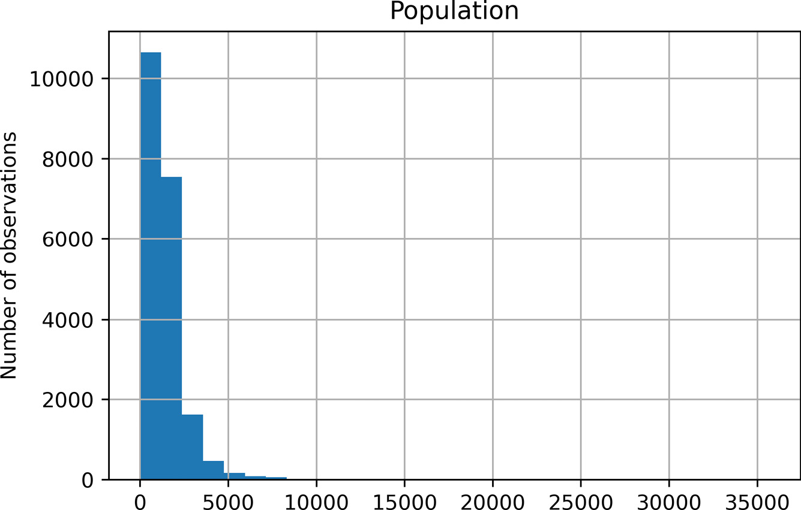
Figure 4.6 – A histogram of the Population variable
Let’s create a list with arbitrary interval limits, setting the upper limit to infinity to accommodate bigger values:
intervals = [0, 200, 500, 1000, 2000, np.Inf]
Let’s create a list with the interval limits as strings:
labels = ["0-200", "200-500", "500-1000", "1000-2000", ">2000"]
Let’s discretize the Population variable into the pre-defined limits from step 4, where the intervals take the values we created in step 5 as values:
X["Population_range"] = pd.cut(
X["Population"],
bins=intervals,
labels=labels,
include_lowest=True,
)
Now, let’s discretize Population into pre-defined intervals and capture it in a new variable that takes the interval limits as values:
X["Population_limits"] = pd.cut(
X["Population"],
bins=intervals,
labels=None,
include_lowest=True,
)
Let’s inspect the first five rows of the original and discretized variables:
X[['Population', 'Population_range',
'Population_limits']].head()
In the last two columns of the dataframe, we see the discretized variables: the first one with the strings we created in step 5 as values, and the second one with the interval limits:
Population Population_range Population_limits
0 322.0 200-500 (200.0, 500.0]
1 2401.0 >2000 (2000.0, inf]
2 496.0 200-500 (200.0, 500.0]
3 558.0 500-1000 (500.0, 1000.0]
4 565.0 500-1000 (500.0, 1000.0]
Note
We only need one of the variable versions, either the one with the value range or the one with the interval limits. In this recipe, I create both to highlight the different options offered by pandas.
Finally, we can count and plot the number of observations within each interval:
X['Population_range'].value_counts().sort_index().plot.bar()
plt.xticks(rotation=0)
plt.ylabel("Number of observations")
plt.title("Population")
plt.show()
The number of observations per interval varies, as shown in the output of the proceeding code block:
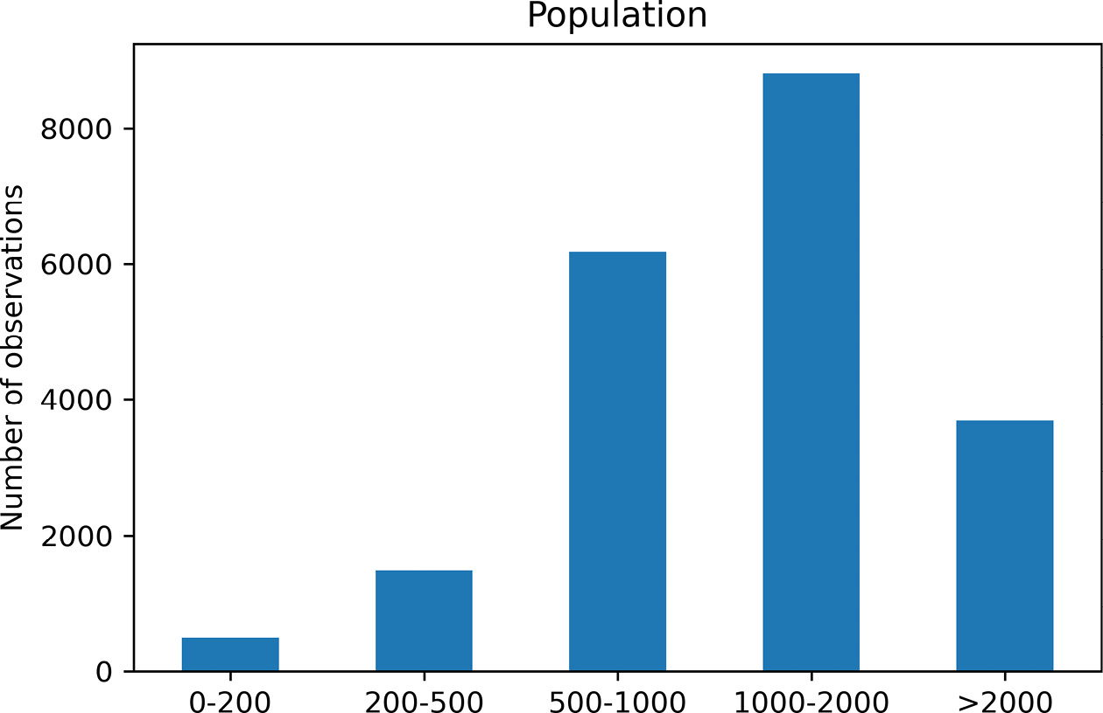
Figure 4.7 – The proportion of observations per interval
To wrap up the recipe, let’s carry out arbitrary discretization utilizing Feature-engine. First, we need to reload the California housing dataset, as we did in step 2.
Let’s import the transformer:
from feature_engine.discretisation import
ArbitraryDiscretiser
Let’s set up the transformer by using a dictionary with the variables to modify, in this case, Population and the interval limits in a list:
discretizer = ArbitraryDiscretiser(
binning_dict={"Population": intervals},
return_boundaries=True,
)
Now we can go ahead and discretize the variable:
X_t = discretizer.fit_transform(X)
Now, if we execute X_t.head(), we will see the following output, where the Population variable has been discretized:
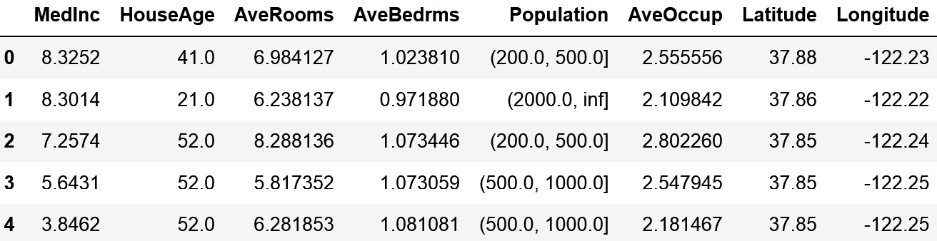
Figure 4.8 – A dataframe containing the discretized variable
The advantage of using Feature-engine is that we can discretize multiple variables in the dataframe at the same time.

How it works...
In this recipe, we sorted the values of a variable into user-defined intervals. First, we plotted a histogram of the Population variable, to get an idea of the range of values of the variable. Next, we arbitrarily determined and captured the limits of the intervals in a list: we created intervals that vary from 0–200, 200–500, 500–1000, 1000–2000, and more than 2,000, by setting the upper limit to infinite with np.Inf. Next, we created a list with the interval names as strings.
Using the pandas cut() method and passing the list with the interval limits, we sorted the variable values into the pre-defined bins. We executed the command twice; in the first run, we set the labels argument to the list that contained the label names as strings, and in the second run, we set the labels argument to None. We captured the returned output in two variables: the first one displaying the interval limits as values and the second one with interval names as values. Finally, we counted the number of observations per variable using the pandas value_counts() method.
Finally, we automated the procedure with ArbitraryDiscretiser() from Feature-engine. This transformer takes a dictionary with the variables to discretize as keys, and the interval limits in a list as values, and then uses pandas cut under the hood to discretize the variables. With fit(), the transformer does not learn any parameters but checks that the variables are numerical. With transform(), the variables indicated in the dictionary are discretized.

Performing discretization with k-means clustering
The aim of a discretization procedure is to find a set of cut-points that partition a variable into a small number of intervals that have good class coherence. To create partitions that group similar observations, we can use clustering algorithms, such as k-means.
In discretization using k-means clustering, the partitions are the clusters identified by the k-means algorithm. The k-means clustering algorithm has two main steps. In the initialization step, k observations are chosen randomly as the initial centers of the k clusters, and the remaining data points are assigned to the closest cluster. The proximity to the cluster is measured by a distance measure such as the Euclidean distance. In the iteration step, the centers of the clusters are re-computed as the average points of all of the observations within the cluster, and the observations are reassigned to the newly created closest cluster. The iteration step continues until the optimal k centers are found.
Discretization with k-means requires one parameter, which is k, the number of clusters. There are a few methods to determine the optimal number of clusters: one of them is the elbow method, which we will use in this recipe. This method consists of training several k-means algorithms over the data using different values of k, and then determining the explained variation returned by the clustering. In the next step, we plot the explained variation as a function of the number of clusters, k, and pick the elbow of the curve as the number of clusters to use. The elbow is the inflection point that indicates that increasing the number of k further does not significantly increase the variance explained by the model. There are different metrics to quantify the explained variation. We will use the sum of square distances from each point to its assigned center.
In this recipe, we will use Yellowbrick to determine the optimal number of clusters and then carry out k-means discretization with scikit-learn.

How to do it...
First, let’s import the necessary Python libraries and get the dataset ready:
Import the required Python libraries and classes:
import pandas as pd
from sklearn.cluster import KMeans
from sklearn.datasets import fetch_california_housing
from sklearn.model_selection import train_test_split
from sklearn.preprocessing import KBinsDiscretizer
from yellowbrick.cluster import KElbowVisualizer
Let’s load the California housing dataset into a pandas dataframe:
X, y = fetch_california_housing(
return_X_y=True, as_frame=True)
The k-means optimal clusters should be determined using the train set, so let’s divide the data into train and test sets:
X_train, X_test, y_train, y_test = train_test_split(
X, y, test_size=0.3, random_state=0,
)
Let’s make a list with the variables to transform:
variables = ['MedInc', 'HouseAge', 'AveRooms']
Let’s set up a k-means clustering algorithm:
k_means = KMeans(random_state=10)
Now, using Yellowbrick’s visualizer and the elbow method, let’s find the optimal number of clusters for each variable:
for variable in variables:
# set up a visualizer
visualizer = KElbowVisualizer(
k_means, k=(4,12), metric='distortion',
timings=False
)
# Fit the data to the visualizer
visualizer.fit(X_train[variable].to_frame())
# Finalize and render the figure
visualizer.show()
In the following plots, we can see that the optimal number of clusters is six for each variable:
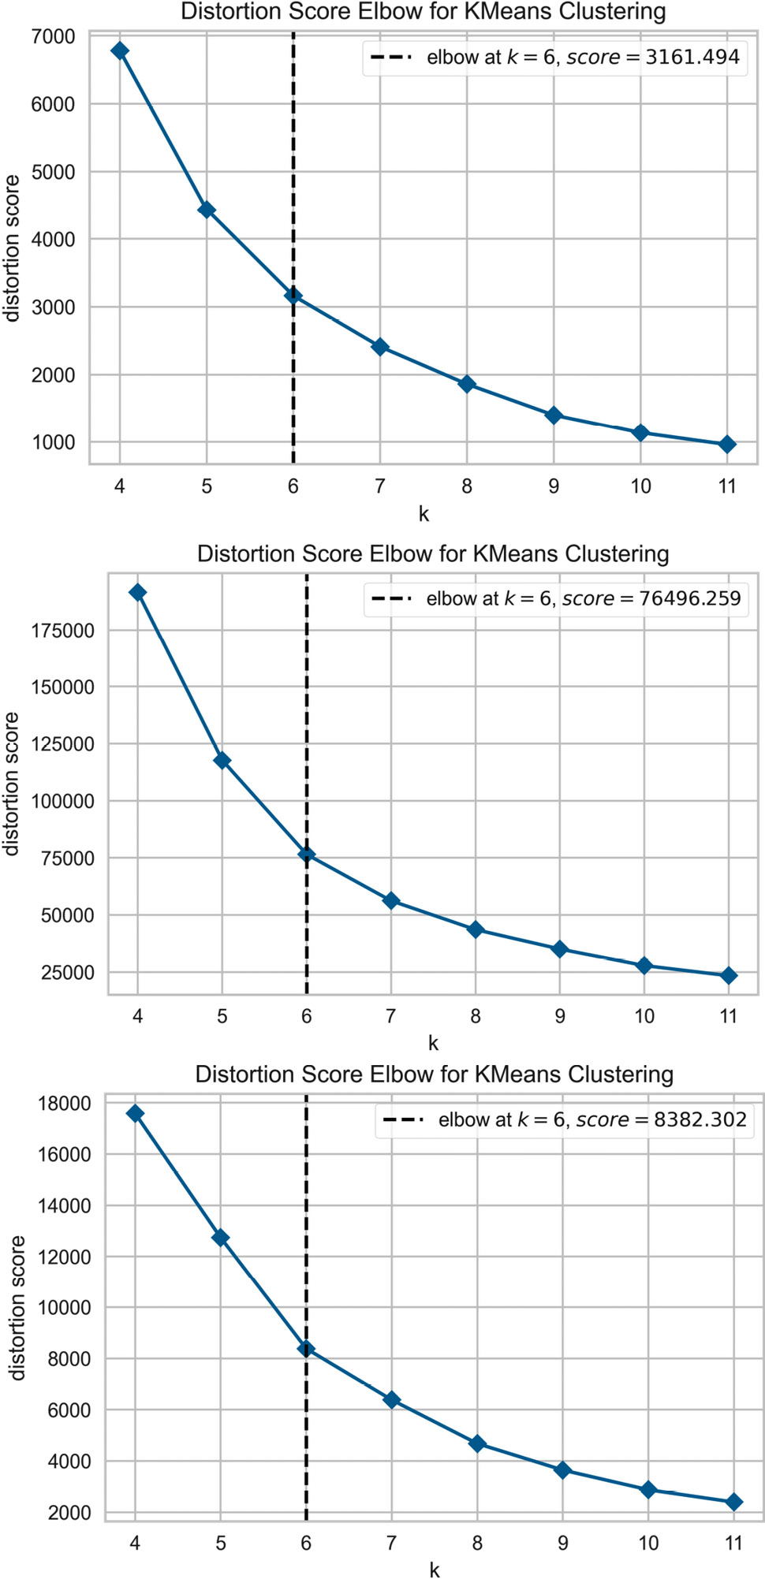
Figure 4.9 – Number of clusters versus the variability for the MedInc, HouseAge, and AveRooms variables from top to bottom
Let’s set up a discretizer that uses k-means clustering to create six partitions and returns the clusters as one-hot-encoded variables:
k = 6
disc = KBinsDiscretizer(n_bins=k, encode="onehotdense", strategy="kmeans")
Let’s fit the discretizer to the slice of the dataframe that contains the variables that we want to discretize. This is so that the transformer finds the optimal clusters for each variable:
disc.fit(X_train[variables])
Tip
If we had a different optimal number of clusters for different variables, we would have to set up one instance of the discretizer for each variable group with the same value of k, either by repeating steps 7 and 8 or by using ColumnTransformer() from scikit-learn to slice the dataframe into the requited variable group.
Let’s inspect the cut-points:
disc.bin_edges_
Each array contains the cut-points for the six clusters for each of the three variables, MedInc, HouseAge, and AveRooms:
array([array([0.4999, 2.49587954, 3.66599029, 4.95730115, 6.67700141, 9.67326677, 15.0001]),
array([1., 11.7038878, 19.88430419, 27.81472503, 35.39424098, 43.90930314, 52.]),
array([0.84615385, 4.84568771, 6.62222005, 15.24138445, 37.60664483, 92.4473438, 132.53333333])], dtype=object)
Let’s obtain the discretized form of the original variables in the train test sets:
train_features = disc.transform(X_train[variables])
test_features = disc.transform(X_test[variables])
With print(test_features), we can inspect the Numpy array returned by the discretizer, containing 18 binary variables corresponding to the one-hot-encoded transformation of the 6 clusters returned for each of the 3 numerical variables:
array([[0., 0., 1., ..., 0., 0., 0.],
[0., 0., 0., ..., 0., 0., 0.],
[0., 0., 1., ..., 0., 0., 0.],
...,
[0., 0., 0., ..., 0., 0., 0.],
[1., 0., 0., ..., 0., 0., 0.],
[0., 0., 1., ..., 0., 0., 0.]])
Now, let’s concatenate the new features to the original dataframe.
Let’s create names for the new features:
var_names = [
f"{var}_cluster_{i}"
for var in variables
for i in range(k)
]
By executing print(var_names), we see the following names:
['MedInc_cluster_0',
'MedInc_cluster_1',
'MedInc_cluster_2',
'MedInc_cluster_3',
'MedInc_cluster_4',
'MedInc_cluster_5',
'HouseAge_cluster_0',
'HouseAge_cluster_1',
'HouseAge_cluster_2',
'HouseAge_cluster_3',
'HouseAge_cluster_4',
'HouseAge_cluster_5',
'AveRooms_cluster_0',
'AveRooms_cluster_1',
'AveRooms_cluster_2',
'AveRooms_cluster_3',
'AveRooms_cluster_4',
'AveRooms_cluster_5']
Let’s concatenate the new features to the original dataframe:
X_train = pd.concat([
X_train,
pd.DataFrame(train_features, columns=var_names,
index=X_train.index)
], axis=1)
X_test = pd.concat([
X_test,
pd.DataFrame(test_features, columns=var_names,
index=X_test.index)
], axis=1)
And finally, let’s drop the original variables:
X_train.drop(labels=variables, axis=1, inplace=True)
X_test.drop(labels=variables, axis=1, inplace=True)
Now, we are done with the discretization using k-means clustering.

How it works...
In this recipe, we performed discretization with k-means clustering. First, we identified the optimal number of clusters utilizing the elbow method. With KElbowVisualizer() from Yellowbrick, we identified the optimal cluster number for three variables.
To perform k-means discretization, we used KBinsDiscretizer() from scikit-learn, setting strategy to kmeans and the number of clusters to six in the n_bins argument. With the fit() method, the transformer learned the cluster boundaries using the k-means algorithm. With the transform() method, the discretizer sorted the values of the variable to their corresponding cluster, returning a NumPy array with the discretized variables, which we converted into a dataframe.

See also
Discretization with k-means was described in Palaniappan and Hong, Discretization of Continuous Valued Dimensions in OLAP Data Cubes. International Journal of Computer Science and Network Security, VOL.8 No.11, November 2008.
To learn more about the elbow method, visit the Yellowbrick documentation and references therein: https://www.scikit-yb.org/en/latest/api/cluster/elbow.html.
For other ways of determining the fit of k-means clustering, check out the additional visualizers in Yellowbrick: https://www.scikit-yb.org/en/latest/api/cluster/index.html.

Implementing feature binarization
Some datasets contain sparse variables. Sparse variables are those where the majority of the values are 0. The classical example of sparse variables are those derived from text data through the bag-of-words model, where each variable is a word, and each value represents the number of times the word appears in a certain document. Given that a document contains a limited number of words, whereas the feature space contains the words that appear across all documents, most documents, that is, most rows, will show the value of 0 for most columns. But words are not the sole example. If we think about house details data, the variable number of saunas will also be 0 for most houses. In summary, some variables have very skewed distributions, where most observations show the same value, usually 0, and only a few observations show different, usually higher, values.
A more robust representation of these sparse or highly skewed variables is to binarize them by clipping all values greater than 1 to 1. In fact, binarization is commonly performed on text count data, where we consider the presence or absence of a feature rather than a quantified number of occurrences of a word.
In this recipe, we will perform binarization using scikit-learn.

Getting ready
We will use a dataset consisting of a bag of words, which is available in the UCI Machine Learning Repository (https://archive.ics.uci.edu/ml/datasets/Bag+of+Words).
To prepare the dataset, follow these steps:
Visit https://archive.ics.uci.edu/ml/machine-learning-databases/bag-of-words/.
Click on docword.enron.txt.gz to download the data.
Unzip docword.enron.txt.gz and save docword.enron.txt in the folder where you will run the following commands.
Then, click on vocab.enron.txt to download the word names.
Save vocab.enron.txt in the folder where you will run the following commands.
After you’ve downloaded the data, open a Jupyter notebook and run the following commands.
Import pandas:
import pandas as pd
Load the data into a pandas dataframe and assign the column names:
data = pd.read_csv(
"docword.enron.txt", sep=" ",
skiprows=3, header=None)
data.columns = ["docID", "wordID", "count"]
Load the words:
words = pd.read_csv("vocab.enron.txt", header=None)
words.columns = ["words"]
Select 10 words at random:
words = words.sample(10, random_state=290917)
Merge the word counts to the 10 selected words:
data = words.merge(
data, left_index=True, right_on="wordID")
Reconstitute the bag of words:
bow = data.pivot(index="docID", columns="words",
values="count")
bow.fillna(0, inplace=True)
bow.reset_index(inplace=True, drop=True)
Save the data:
bow.to_csv("bag_of_words.csv", index=False)
Now, you are ready to carry on with the recipe.
You can find the instructions to download, prepare, and store the dataset in the notebook of our repository at https://github.com/PacktPublishing/Python-Feature-Engineering-Cookbook-Second-Edition/blob/main/ch04-discretization/donwload-prepare-store-enron-data.ipynb.

How to do it...
Let’s begin by importing the libraries and getting the data loaded:
Let’s import the required Python libraries, classes, and datasets:
import pandas as pd
import matplotlib.pyplot as plt
from sklearn.model_selection import train_test_split
from sklearn.preprocessing import Binarizer
from feature_engine.wrappers import SklearnTransformerWrapper
Let’s load the data that we prepared in the Getting ready section:
data = pd.read_csv("bag_of_words.csv")
Let’s display histograms to visualize the sparsity of the variables:
data.hist(bins=30, figsize=(20, 20), layout=(3,4))
plt.show()
In the following histograms, we can see that the words appear 0 times in most documents:
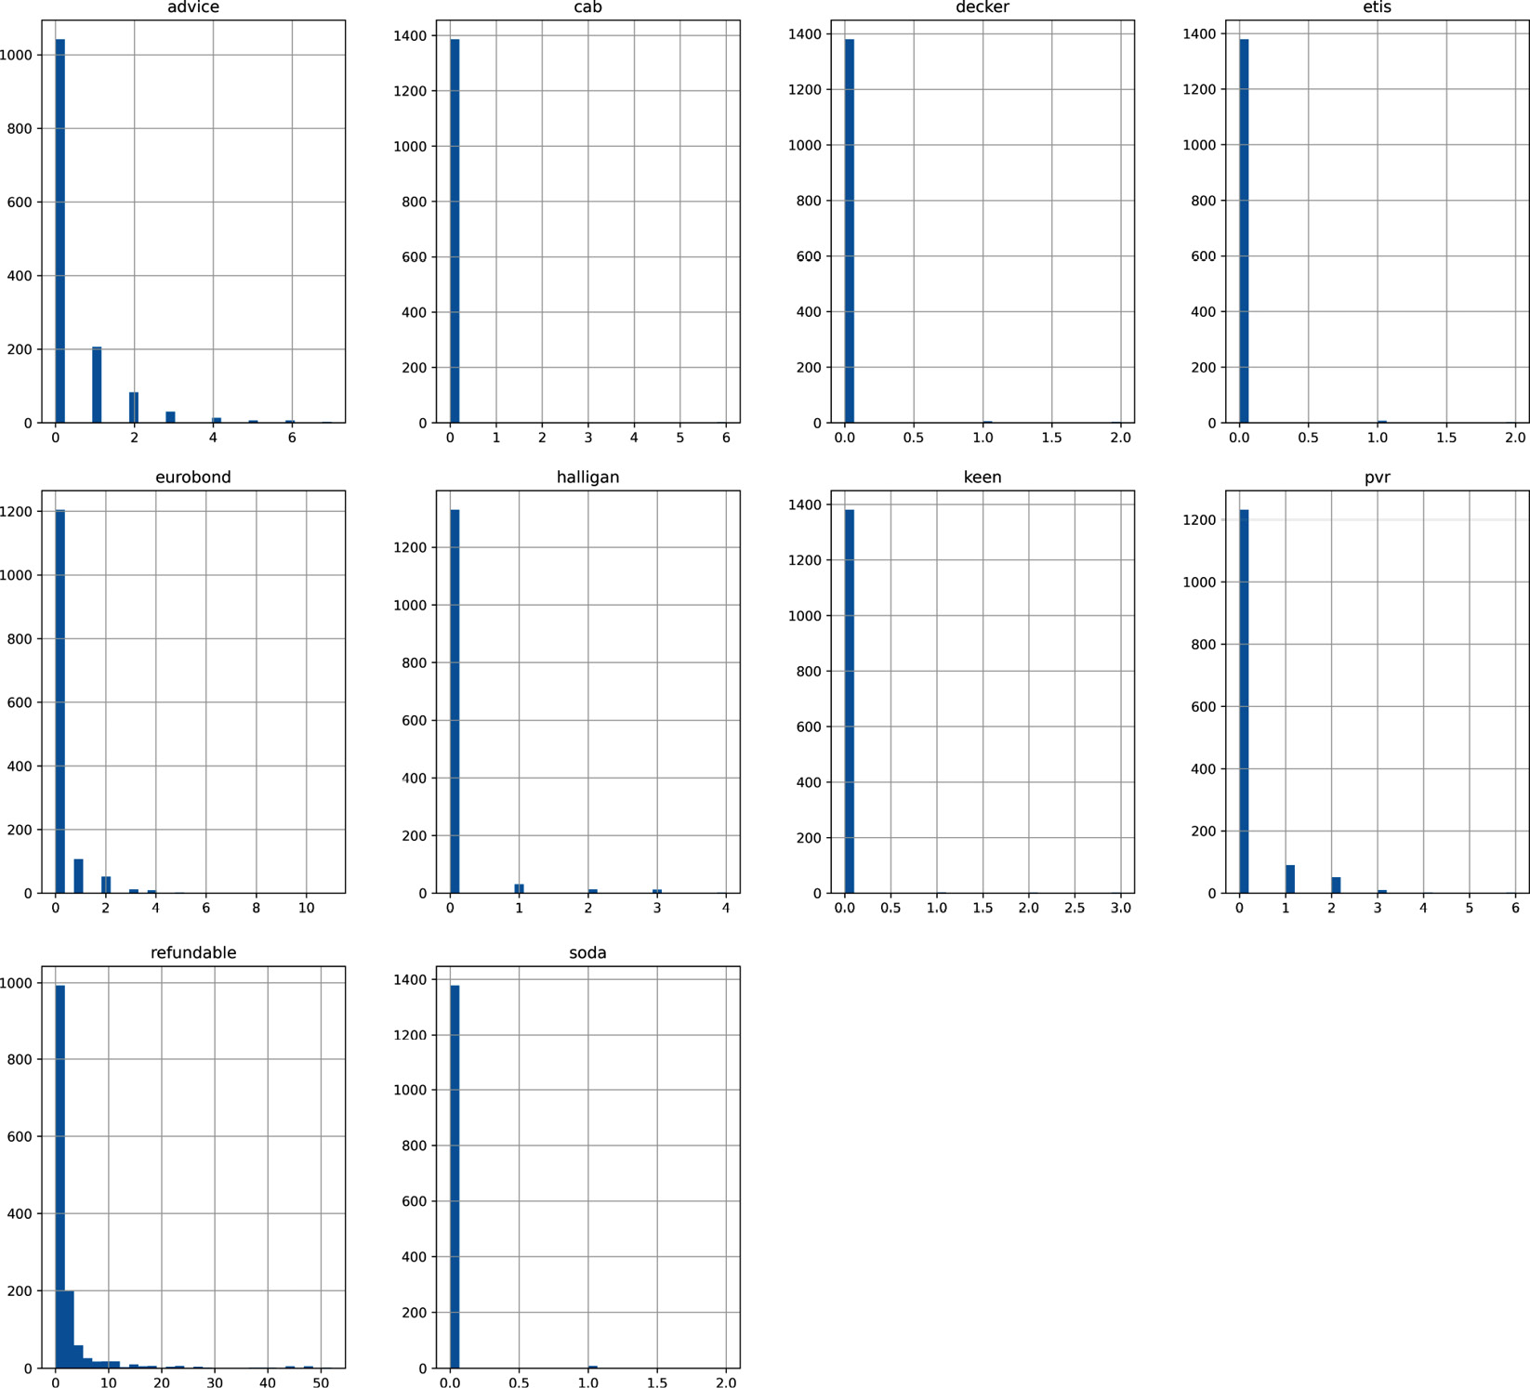
Figure 4.10 – A histogram of the sparse variables
To perform binarization, let’s set up binarizer to clip all values greater than 1, to 1:
binarizer = Binarizer(threshold = 0)
Binarizer() from scikit-learn will return a NumPy array by default, so to return a dataframe, let’s wrap it with the Feature-engine wrapper:
wrapper = SklearnTransformerWrapper(transformer=binarizer)
Note
SklearnTransformerWrapper, when wrapping classes that work with numerical variables, such as Binarizer(), will select all the numerical variables by default. Alternatively, we can indicate the variables to transform through the variables parameter.
Let’s binarize the variables:
data_t = wrapper.fit_transform(data)
We can explore the variables that will be transformed by executing print(wrapper.variables_):
['advice',
'cab',
'decker',
'etis',
'eurobond',
'halligan',
'keen',
'pvr',
'refundable',
'soda']
Now we can explore the distribution of the binarized variables by displaying the histograms as in step 3, or better, by creating bar plots.
Let’s create a bar plot with the number of observations per bin per variable:
variables = data_t.columns.to_list()
plt.figure(figsize=(20, 20), constrained_layout=True)
for i in range(10):
# location in figure
ax = plt.subplot(3, 4, i + 1)
# variable to plot
var = variables[i]
# determine proportion of observations per bin
t = data_t[var].value_counts(normalize=True)
t.plot.bar(ax=ax)
plt.xticks(rotation=45)
plt.ylabel("Observations per bin")
# add variable name as title
ax.set_title(var)
plt.show()
In the following plot, we can see the binarized variables, where most occurrences show the value of 0:
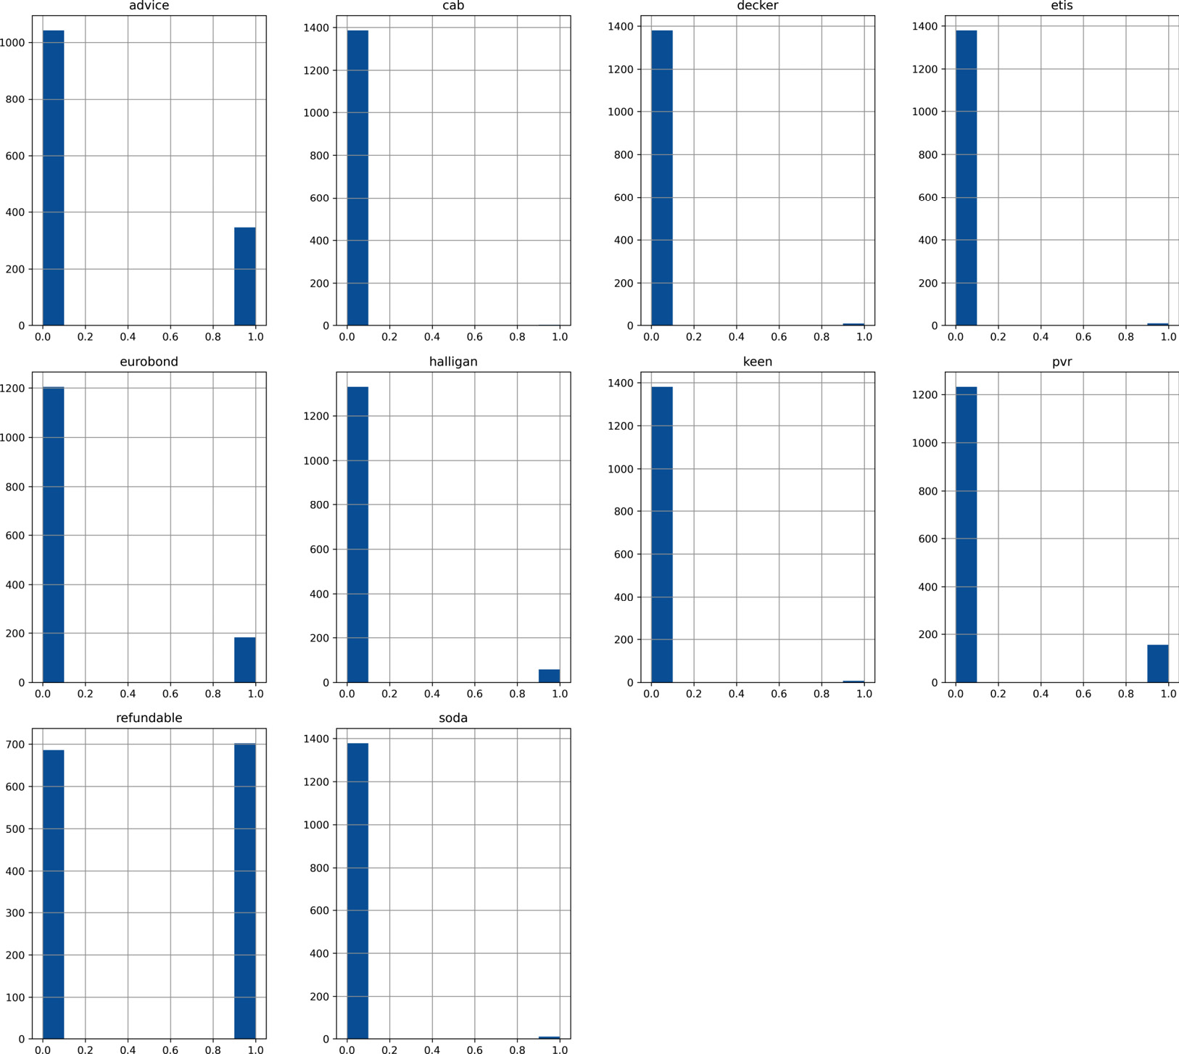
Figure 4.11 – The proportion of observations per interval
That’s it; now our variables have a more succinct representation of the data.

How it works…
In this recipe, we changed the representation of sparse variables to consider the presence or absence of an occurrence, which, in our case, is a word. The data consisted of a bag of words, where each variable is a word, each row is a document, and the values represent the number of times a word appears in a document. Most words do not appear in most documents; therefore, most values in the data are 0. We corroborated the sparsity of our data with histograms.
Binarizer() from scikit-learn mapped values greater than the threshold, which, in our case, is 0, to the value 1, while values less than or equal to the threshold were mapped to 0. Binarizer() has the fit() and transform() methods, where fit() does not do anything and transform() binarizes the variables. Binarizer() modifies all variables in a dataset returning NumPy arrays. To return a pandas dataframe instead, we wrapped Binarizer() with SklearnTransformerWrapper() from Feature-engine. The wrapper found all numerical variables automatically, and applied Binarizer() to them, returning a pandas dataframe. The wrapper has the option to apply Binarizer() to only a subset of the variables; it does this by passing the variable names in a list when initializing the transformer.
Note
SklearnTransformerWrapper() is an alternative to ColumnTransformer() from scikit-learn and can wrap many transformers from this library.

Using decision trees for discretization
Decision tree methods discretize continuous attributes during the learning process. A decision tree evaluates all possible values of a feature and selects the cut-point that maximizes the class separation, by utilizing a performance metric such as the entropy or Gini impurity. Then, it repeats the process for each node of the first data separation, along with each node of the subsequent data splits, until a certain stopping criterion has been reached. Therefore, by design, decision trees can find the set of cut-points that partition a variable into intervals with good class coherence.
Discretization with decision trees consists of using a decision tree to identify the optimal partitions for each continuous variable. In the Feature-engine implementation of this method, the decision tree is fit using the variable to discretize, and the target. After fitting, the decision tree is able to assign each observation to one of the N end leaves, generating a discrete output, the values of which are the predictions at each of its leaves. Therefore, with Feature-engine, the values of continuous features are replaced by the predictions of a decision tree.
In this recipe, we will perform decision tree-based discretization manually using scikit-learn and then automate the procedure with Feature-engine.

How to do it...
Let’s begin by importing some libraries and getting the data loaded:
Let’s import the required Python libraries, classes, and datasets:
import pandas as pd
import matplotlib.pyplot as plt
from sklearn.datasets import fetch_california_housing
from sklearn.model_selection import train_test_split
from sklearn.tree import DecisionTreeRegressor, plot_tree
Let’s load the California housing dataset into a pandas dataframe:
X, y = fetch_california_housing(return_X_y=True,
as_frame=True)
Let’s divide the data into train and test sets:
X_train, X_test, y_train, y_test = train_test_split(
X, y, test_size=0.3, random_state=0,
)
Let’s assemble a decision tree to predict the house price, setting the maximum depth to 3 and random_state for reproducibility:
tree_model = DecisionTreeRegressor(
max_depth=3, random_state=0)
Note
For binary classification, we would use DecisionTreeClassifier() instead.
Let’s fit the decision tree using the MedInc variable to predict the target:
tree_model.fit(X_train['MedInc'].to_frame(), y_train)
Note
Scikit-learn predictors take dataframes as inputs. A single variable is a pandas series, so we need to use the to_frame() method to transform it into a dataframe and make it compatible with scikit-learn.
Now, let’s replace the values of MedInc with the predictions of the decision tree:
X_train['MedInc_tree'] = tree_model.predict(
X_train['MedInc'].to_frame())
X_test['MedInc_tree'] = tree_model.predict(
X_test['MedInc'].to_frame())
Note
If we created a classification tree, we would use predict_proba() and retain the second column of the array, which is the probability of the target being 1.
Let’s explore the end leaves, that is, the partitions the tree created:
X_test['MedInc_tree'].unique()
The decision tree produced eight different prediction outputs for all of the observations of the MedInc variable:
array([2.27113313, 2.76842266, 1.51756502, 3.46323449, 1.91725491, 1.14863215, 4.31789332, 4.87645172])
In many cases, this discretization method returns a monotonic relation between the discretized variable and the target, so let’s make a line plot to visualize this relationship:
y_test.groupby(X_test["MedInc_tree"]).mean().plot()
plt.title("Monotonic relationship between discretized MedInc and target")
plt.ylabel("Median Price")
We can observe the monotonic relationship between the tree-derived partitions and the target in the output of the preceding code block:
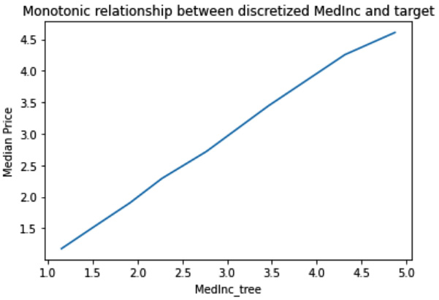
Figure 4.12 – The monotonic relationship between the discretized variable and the target
Also, we can explore the number of observations per end leave:
X_test["MedInc_tree"] = np.round(
X_test["MedInc_tree"],2)
X_test.groupby(
["MedInc_tree"])["MedInc"].count().plot.bar()
plt.title("Median Income")
plt.ylabel("Number of observations")
We can see the number of observations per prediction in the following bar plot:
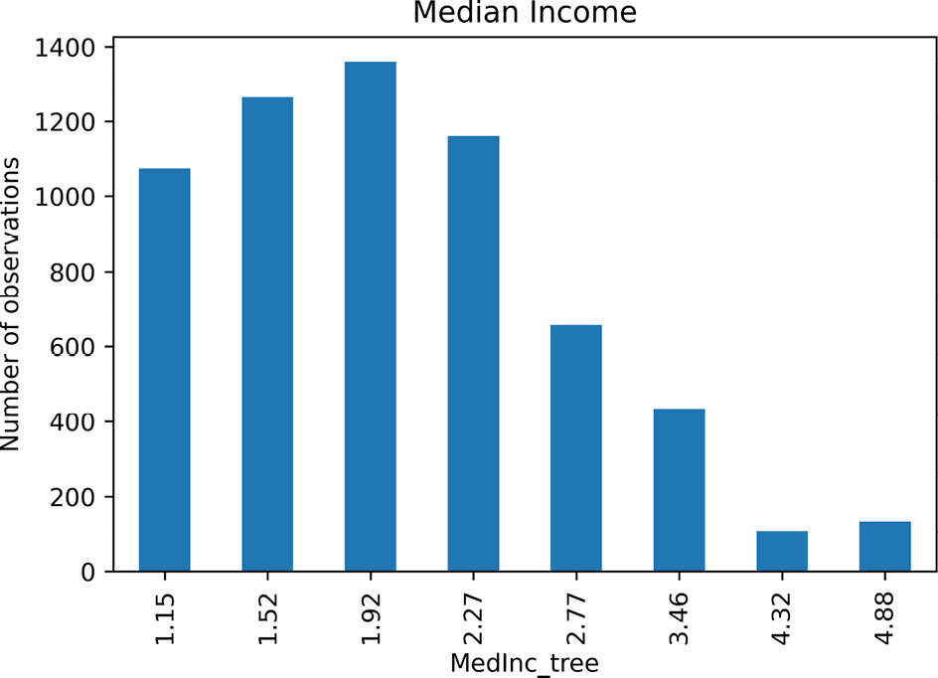
Figure 4.13 – The number of observations per bin
To better understand how the decision tree made the partitions, let’s display them:
fig = plt.figure(figsize=(20, 6))
plot_tree(tree_model, fontsize=10, proportion=True)
plt.show()
In the following display, we can see how the decision tree partitioned the variable based on cut-points that maximized the entropy into eight final leaves or bins for our method:
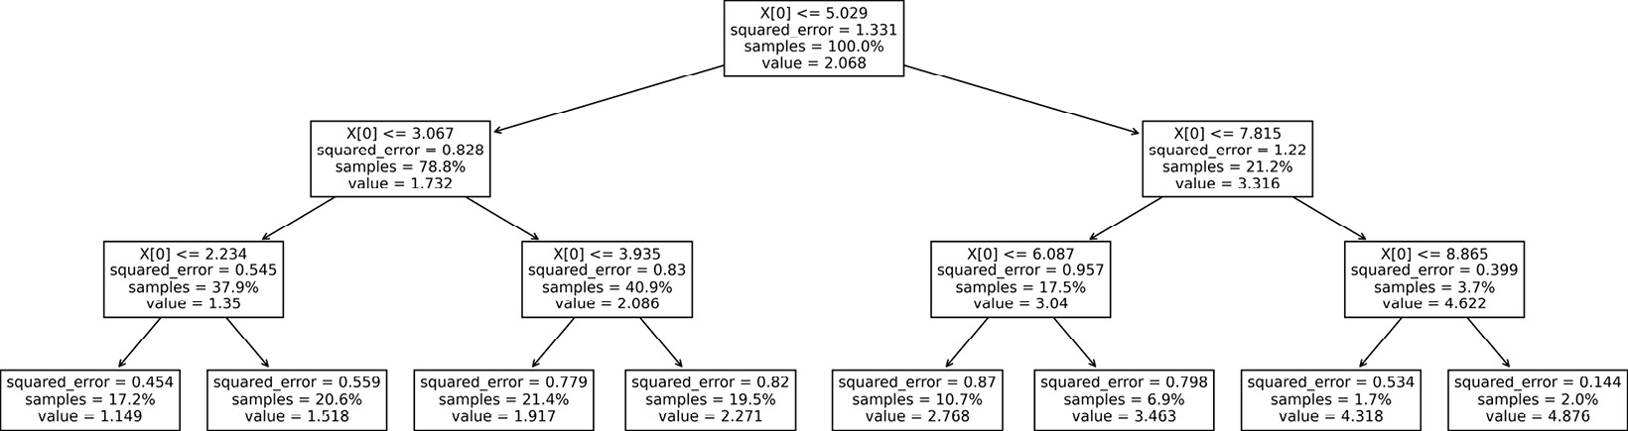
Figure 4.14 – A diagram of the decision tree
Now, let’s implement decision tree discretization with Feature-engine. With Feature-engine, we can discretize multiple variables at the same time, while searching for the best hyperparameters for the decision trees using cross-validation.
First, we need to divide the dataset into train and test sets, just as we did in step 3.
Let’s import the discretizer:
from feature_engine.discretisation import DecisionTreeDiscretiser
Let’s capture all variables except the latitude and longitude in a list:
variables = list(X.columns)[:-2]
Now, let’s set up the decision tree discretizer, which will optimize the hyperparameter’s maximum depth and minimum samples per leaf based on the negative mean square error metric using three-fold cross-validation:
treeDisc = DecisionTreeDiscretiser(
cv=3,
scoring='neg_mean_squared_error',
variables=variables,
regression=True,
param_grid={'max_depth': [1, 2, 3],
"min_samples_leaf": [10, 20, 50]},
)
Let’s fit() the discretizer using the train set and the target so that it finds the best decision trees for each of the variables:
treeDisc.fit(X_train, y_train)
Let’s inspect the best parameters for the tree trained for the MedInc variable:
treeDisc.binner_dict_["MedInc"].best_params_
The output of the preceding code shows that the optimal depth for the decision tree is 3 and the optimal samples per leaf is 10:
{'max_depth': 3, 'min_samples_leaf': 10}
Let’s transform the variables in the train and test sets:
train_t = treeDisc.transform(X_train)
test_t = treeDisc.transform(X_test)
Finally, we can explore the number of observations per partition for three of the discretized variables:
plt.figure(figsize=(6, 12), constrained_layout=True)
for i in range(3):
# location in figure
ax = plt.subplot(3, 1, i + 1)
# variable to plot
var = variables[i]
# determine proportion of observations per bin
t1 = train_t[var].value_counts(normalize=True)
t2 = test_t[var].value_counts(normalize=True)
# concatenate proportions
tmp = pd.concat([t1, t2], axis=1)
tmp.columns = ["train", "test"]
# order the intervals
tmp.sort_index(inplace=True)
tmp.plot.bar(ax=ax)
plt.xticks(rotation=45)
plt.ylabel('Observations per bin')
# add variable name as title
ax.set_title(var)
plt.show()
We can see the number of observations per bin in the output of the preceding code:
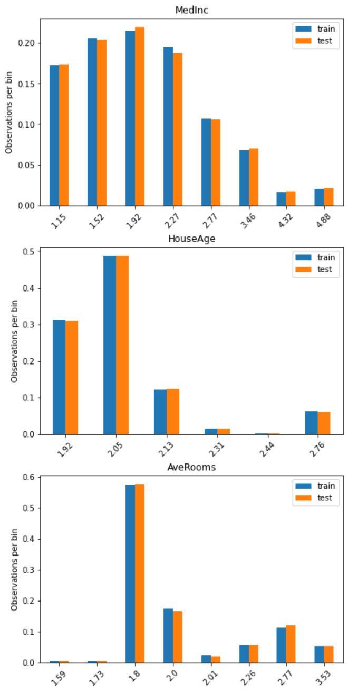
Figure 4.15 – The number of observations per bin
As evidenced in the plots, discretization with decision trees returns a different fraction of observations at each node or bin.

How it works...
To perform discretization with decision trees, first, we chose a variable, MedInc, and fit a decision tree for regression using DecisionTreeRegressor() from scikit-learn. We used to_frame() to transform the pandas series with the variable into a dataframe and make the data compatible with the scikit-learn predictors. We used the fit() method to make the tree learn how to predict the target from MedInc. With the predict() method, the tree estimated the target from MedInc in the train and test sets. The decision tree returned eight distinct values, which were its predictions. These outputs represented the bins or partitions of the discretized variable.
To visualize the monotonic relationship between the tree outputs and the target, we created a plot of the bins predicted by the tree versus the mean target value for each of these bins. We used the pandas groupby() method to group the observations per bin and then calculated the target mean in each bin. With pandas plot(), we plotted the relationship between the bins and target.
To perform decision tree discretization using Feature-engine, we used DecisionTreeDiscretiser() indicating the cross-validation fold, the performance metric, and the hyperparameter space to optimize each tree. With the fit() method, the discretizer fit the best tree for each of the variables. With the transform() method, we obtained the discretized variables in the train and test sets.

There’s more...
Feature-engine’s implementation is inspired by the winning solution of the KDD 2009 data science competition. The winners created new features by obtaining predictions of decision trees based on continuous features. You can find more details in the Winning the KDD Cup Orange Challenge with Ensemble Selection article, on page 27 of the article series available at http://www.mtome.com/Publications/CiML/CiML-v3-book.pdf.
For a review of discretization techniques, you might find the following articles useful:
Dougherty et al, Supervised and Unsupervised Discretization of Continuous Features, Machine Learning: Proceedings of the 12th International Conference, 1995, (https://ai.stanford.edu/~ronnyk/disc.pdf).
Lu et al, Discretization: An Enabling Technique, Data Mining, and Knowledge Discovery, 6, 393–423, 2002, (https://www.researchgate.net/publication/220451974_Discretization_An_Enabling_Technique).
Garcia et al, A Survey of Discretization Techniques: Taxonomy and Empirical Analysis in Supervised Learning, IEEE Transactions on Knowledge in Data Engineering 25 (4), 2013, (https://ieeexplore.ieee.org/document/6152258).

5

Working with Outliers
An outlier is a data point that is significantly different from the remaining data. Statistical parameters such as the mean and variance are sensitive to outliers. Outliers may also affect the performance of some machine learning models, such as linear regression models. In these cases, we may want to remove or engineer the outliers in our variables.
How can we engineer outliers? One way to handle outliers is to perform variable discretization with any of the techniques we covered in Chapter 4, Performing Variable Discretization. With discretization, the outliers will fall in the lower or upper intervals and, therefore, will be treated as the remaining lower or higher values of the variable. An alternative way to handle outliers is to assume that the information is missing, treat the outliers together with the remaining missing data, and carry out any of the missing imputation techniques described in Chapter 1, Imputing Missing Data. We can also remove observations with outliers from the dataset or cap the maximum and minimum values of the variables, as we will discuss throughout this chapter.
Note
Sometimes, outliers can be very informative. In these cases, we don’t want to remove them from the data. This chapter does not focus on these scenarios. The techniques discussed in this chapter are tailored to the management of outliers in those cases where they negatively affect the performance of the machine learning models.
In this chapter, we will first discuss how to identify outliers in a dataset, and then we will describe how to remove outliers or how to cap variables at maximum or minimum values.
This chapter will cover the following recipes:
Visualizing outliers with boxplots
Finding outliers using the mean and standard deviation
Finding outliers with the interquartile range proximity rule
Removing outliers
Capping or censoring outliers
Capping outliers using quantiles

Technical requirements
In this chapter, we will use the Python libraries NumPy, pandas, Matplotlib, seaborn, and Feature-engine.

Visualizing outliers with boxplots
In this recipe, we will identify outliers using boxplots. Boxplots produce a box that encloses the observations within the 75th and 25th quantiles, or in other words, within the Inter-Quartile Range (IQR). The IQR is given through the following equation:
According to the IQR proximity rule, a value is an outlier if it falls outside the following boundaries:
In a boxplot, these boundaries are indicated by their whiskers. Thus, values outside the whiskers are considered outliers. Outliers are highlighted with asterisks.

How to do it...
We will create the boxplots utilizing the Seaborn library. Let’s begin the recipe by importing the Python libraries and loading the dataset as follows:
Import the required Python libraries as follows:
import pandas as pd
import matplotlib.pyplot as plt
import seaborn as sns
sns.set(style="darkgrid")
from sklearn.datasets import fetch_california_housing
Let’s load the California house prices dataset from scikit-learn as follows:
X, y = fetch_california_housing(
return_X_y=True, as_frame=True)
Let’s make a boxplot of the MedInc variable to visualize outliers as follows:
plt.figure(figsize=(3,6))
sns.boxplot(y=X["MedInc"])
plt.title("Boxplot")
plt.show()
The outliers are the asterisks sitting outside the whiskers, which delimit IQR proximity rule boundaries.
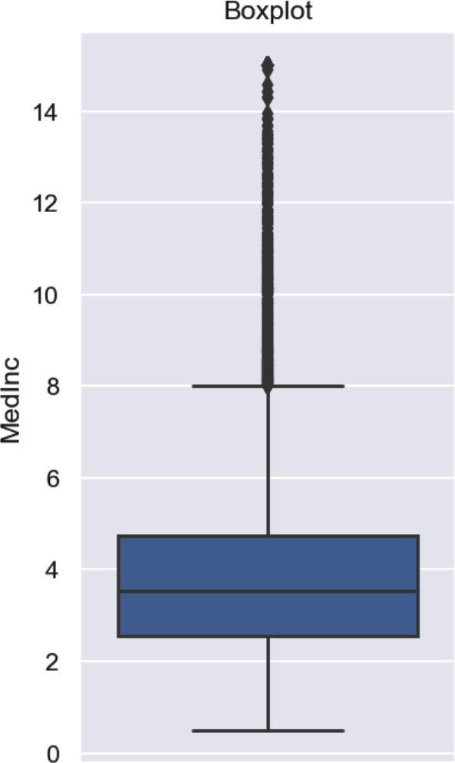
Figure 5.1 – A boxplot
Let’s now create a function to plot a boxplot on top of a histogram:
def plot_boxplot_and_hist(data, variable):
#figure composed of two matplotlib.Axes
objects (ax_box and ax_hist)
f, (ax_box, ax_hist) = plt.subplots(
2, sharex=True,
gridspec_kw={"height_ratios": (0.50, 0.85)}
)
# assigning a graph to each ax
sns.boxplot(x=data[variable], ax=ax_box)
sns.histplot(data=data, x=variable, ax=ax_hist)
# Remove x axis name for the boxplot
ax_box.set(xlabel='')
plt.title(variable)
plt.show()
Let’s now use the previous function to create the plots for the MedInc variable:
plot_boxplot_and_hist(X, "MedInc")
We see in the following plot that most outliers lie on the right tail, or higher values, of the distribution as people with high-income salaries are unusual in this dataset:
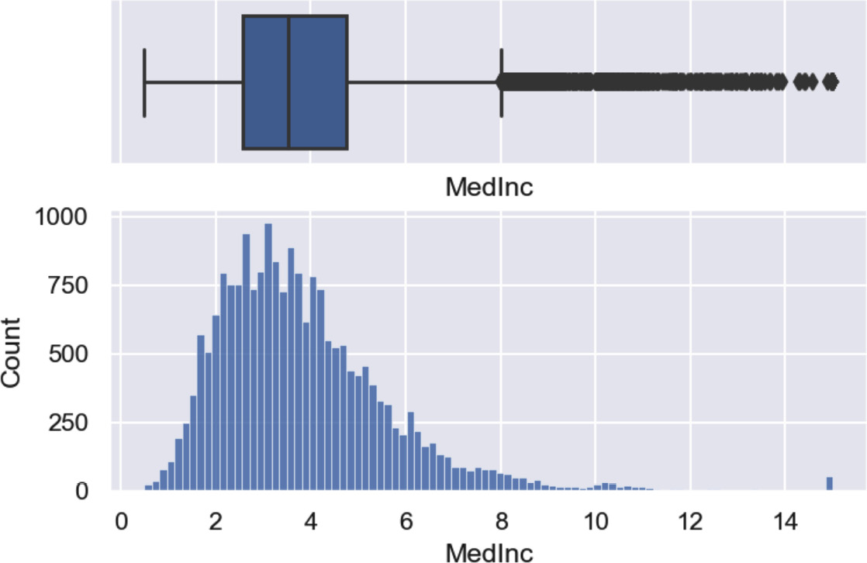
Figure 5.2 – A boxplot and a histogram
That’s it! We now know how to identify outliers visually utilizing boxplots.

How it works…
In this recipe, we used the boxplot method from seaborn to create the boxplots. In the y-axis of the plot, we obtained the values of the variable. The asterisks highlighted extremely high values compared with the rest of the observations.
We then combined seaborn’s boxplot with seaborn’s histplot to create a histogram under the boxplot. The plots shared the x-axis with the values of the observations. The y-axis of the histogram contained the number of observations per interval. The variable was left-skewed, with most of the values in the lower range. The outliers lie only on the right tail of the distribution.

Finding outliers using the mean and standard deviation
In normally distributed variables, more than 99% of the observations lie within the interval comprising the mean plus or minus three times the standard deviation. Thus, any values beyond those limits can be considered outliers. In this recipe, we will identify outliers as those observations that lie outside of this interval.

How to do it...
Let’s begin the recipe by importing the Python libraries and loading the dataset:
Import the required Python libraries:
import numpy as np
import pandas as pd
from sklearn.datasets import load_breast_cancer
Let’s load the Breast Cancer dataset from scikit-learn:
breast_cancer = load_breast_cancer()
X = pd.DataFrame(
breast_cancer.data,
columns=breast_cancer.feature_names
)
Let’s create a function that returns the mean plus and minus fold times the standard deviation, where fold is a parameter to the function:
def find_limits(df, variable, fold):
lower_limit = df[variable].mean() - fold *
df[variable].std()
upper_limit = df[variable].mean() + fold *
df[variable].std()
return lower_limit, upper_limit
Let’s use the function to capture the extreme limits of the mean smoothness variable, which follows approximately a Gaussian distribution:
lower_limit, upper_limit = find_limits(
X, "mean smoothness", 3)
If we now execute lower_limit or upper_limit, we will see the values 0.0541 and 0.13855, corresponding to the limits beyond which we can consider a value an outlier.
Let’s create a Boolean vector that flags observations with values beyond the limits:
outliers = np.where(
(X["mean smoothness"] > upper_limit) |
(X["mean smoothness"] < lower_limit),
True,
False,
)
If we now execute outliers.sum(), we will see the value 5, indicating that there are five outliers or observations that are smaller or greater than the extreme values found with the mean and the standard deviation.

How it works…
With the pandas mean() and std()methods, we captured the mean and standard deviation of the variable. To find the outliers, we used NumPy’s where() method, which produced a Boolean vector with True if the value was an outlier. The where() function scanned the rows of the variable, and if the value was greater than the upper limit, or smaller than the lower limit, it was assigned True, and alternatively False. Finally, we used pandas sum() over this Boolean vector to calculate the total number of outliers.

Finding outliers with the interquartile range proximity rule
If the variables are not normally distributed variables, we can identify outliers utilizing the IQR proximity rule. According to the IQR rule, data points that fall below the 25th quantile - 1.5 times the IQR, or beyond the 75th quantile + 1.5 times the IQR, are outliers.
Note
We described the IQR in the Visualizing outliers with boxplots recipe.
In this recipe, we will identify outliers utilizing the IQR proximity rule.

How to do it...
Let’s begin the recipe by importing the Python libraries and loading the dataset:
Import the required Python libraries:
import numpy as np
import pandas as pd
from sklearn.datasets import fetch_california_housing
Let’s load the California housing dataset from scikit-learn:
X, y = fetch_california_housing(
return_X_y=True, as_frame=True)
Let’s create a function that returns the 25th quantile - 1.5 times the IQR, or the 75th quantile + 1.5 times the IQR:
def find_limits(df, variable, fold):
IQR = df[variable].quantile(0.75) - df[variable].
quantile(0.25)
lower_limit = df[variable].quantile(0.25) - (IQR *
fold)
upper_limit = df[variable].quantile(0.75) + (IQR *
fold)
return lower_limit, upper_limit
Let’s use the function to capture the extreme limits of the MedInc variable:
lower_limit, upper_limit = find_limits(X, "MedInc", 3)
If we now execute lower_limit or upper_limit, we will see the values -3.9761 and 11.2828, corresponding to the limits beyond which we can consider a value an outlier.
Let’s create a Boolean vector with True for values beyond the limits:
outliers = np.where(
(X["MedInc"] > upper_limit) |
(X["MedInc"] < lower_limit),
True,
False,
)
If we now execute outliers.sum(), we will see the value 140, indicating that there are 140 outliers or observations that are smaller or greater than the extreme values found with the IQR proximity rule.

How it works…
The pandas quantile()method calculates any quantile of the variable. We calculated the 25th and 75th quantile by passing 0.25 and 0.75 as arguments to quantile. The rest of the recipe is exactly as we described in the previous recipe, Finding outliers using the mean and standard deviation.

Removing outliers
Trimming, or truncating, is the process of removing observations with outliers in one or more variables in the dataset. There are three commonly used methods to set the boundaries beyond which a value can be considered an outlier. If the variable is normally distributed, the boundaries are given by the mean plus or minus three times the standard deviation, as approximately 99% of the data will be distributed between those limits. For normally as well as not normally distributed variables, we can determine the limits using the IQR proximity rule or by directly setting the limits to the 5th and 95th quantiles. In this recipe, we are going to use the IQR proximity rule to identify and then remove outliers, using pandas, and then we will automate this process for multiple variables, utilizing Feature-engine.

How to do it...
Let’s first import the Python libraries and load the data:
Let’s import the Python libraries, functions, and classes:
import numpy as np
import pandas as pd
from sklearn.datasets import fetch_california_housing
from sklearn.model_selection import train_test_split
from feature_engine.outliers import OutlierTrimmer
Let’s load the California housing dataset from scikit-learn and separate it into a training and a testing set:
X, y = fetch_california_housing(
return_X_y=True, as_frame=True)
X_train, X_test, y_train, y_test = train_test_split(
X,
y,
test_size=0.3,
random_state=0,
)
Let’s create a function to find the boundaries of a variable distribution using the interquartile range proximity rule:
def find_limits(df, variable, fold):
IQR = df[variable].quantile(0.75) - df[variable].
quantile(0.25)
lower_limit = df[variable].quantile(0.25) - (IQR *
fold)
upper_limit = df[variable].quantile(0.75) + (IQR *
fold)
return lower_limit, upper_limit
Note
We can replace the code in the preceding function with that described in the Finding outliers using the mean and standard deviation recipe to find the boundaries using the mean and the standard deviation. Alternatively, we can set the lower limit to df[variable].quantile(0.05) and the upper limit to df[variable].quantile(0.95).
Let’s use the function from step 3 to determine the limits of the MedInc variable:
lower_limit, upper_limit = find_limits(X_train, "MedInc", 3)
Let’s retain the observations whose value is greater than or equal to (ge) the lower limit in the train and test sets:
inliers = X_train["MedInc"].ge(lower_limit)
X_train = X_train.loc[inliers]
inliers = X_test["MedInc"].ge(lower_limit)
X_test = X_test.loc[inliers]
Let’s retain the observations whose value is lower than or equal to (le) the upper limit:
inliers = X_train["MedInc"].le(upper_limit)
X_train = X_train.loc[inliers]
inliers = X_test["MedInc"].le(upper_limit)
X_test = X_test.loc[inliers]
With pd.shape, we can corroborate that the training and testing sets are smaller in size after removing the outliers.
Now, we will remove outliers across multiple variables utilizing Feature-engine. First, we need to separate the data into a training and a testing set as we did in step 2.
Let’s set up a transformer to remove outliers in three variables by determining the limits with the IQR rule:
trimmer = OutlierTrimmer(
variables = ["MedInc", "HouseAge", "Population"],
capping_method="iqr",
tail="both",
fold=1.5,
)
Let’s fit the transformer to the data so that it learns those limits:
trimmer.fit(X_train)
By executing trimmer.left_tail_caps_, we can visualize the lower limits for the three variables: {'MedInc': -0.6776500000000012, 'HouseAge': -10.5, and 'Population': -626.0}. By executing trimmer.right_tail_caps_, we can see the upper limits for those variables: {'MedInc': 7.984350000000001, 'HouseAge': 65.5, and 'Population': 3134.0}.
Finally, let’s remove outliers from the train and test sets:
X_train_enc = trimmer.transform(X_train)
X_test_enc = trimmer.transform(X_test)
To finish with the recipe, let’s compare the distribution of a variable before and after removing outliers.
Let’s import matplotlib and seaborn and create a function to display a boxplot on top of a histogram:
import matplotlib.pyplot as plt
import seaborn as sns
def plot_boxplot_and_hist(data, variable):
f, (ax_box, ax_hist) = plt.subplots(
2, sharex=True, gridspec_kw={"height_ratios":
(0.50, 0.85)}
)
sns.boxplot(x=data[variable], ax=ax_box)
sns.histplot(data=data, x=variable, ax=ax_hist)
ax_box.set(xlabel="")
plt.title(variable)
plt.show()
Note
We discussed the code in step 10 in the Visualizing outliers with boxplots recipe earlier in this chapter.
Let’s now display the distribution of the MedInc variable before removing the outliers:
plot_boxplot_and_hist(X_train, "MedInc")
In the following plot, we see that MedInc is skewed and presents outliers at the maximum values:
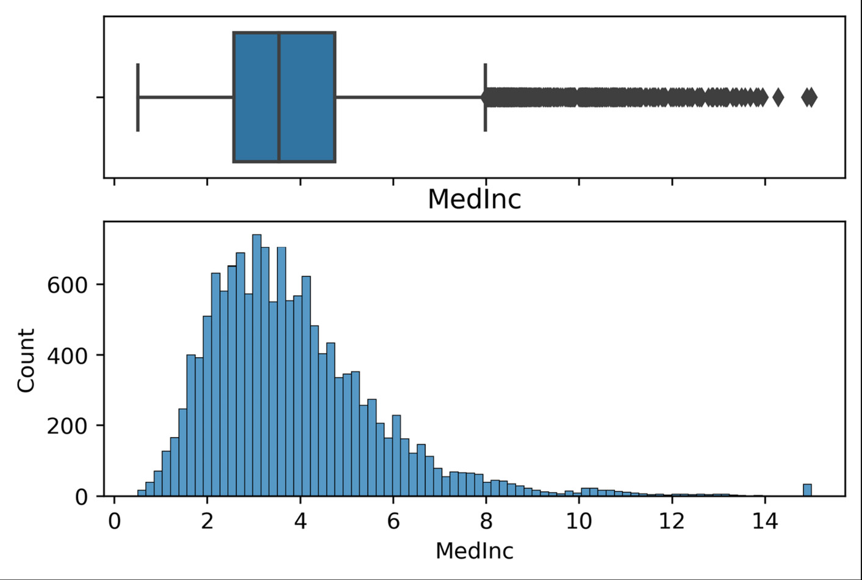
Figure 5.3 – The boxplot and the histogram before removing outliers
Finally, let’s display the distribution of the same variable after removing the outliers:
plot_boxplot_and_hist(X_train_enc, "MedInc")
In the following plot, we see that we’ve removed the extreme maximum values of MedInc, and note that the histogram seems more evenly distributed:
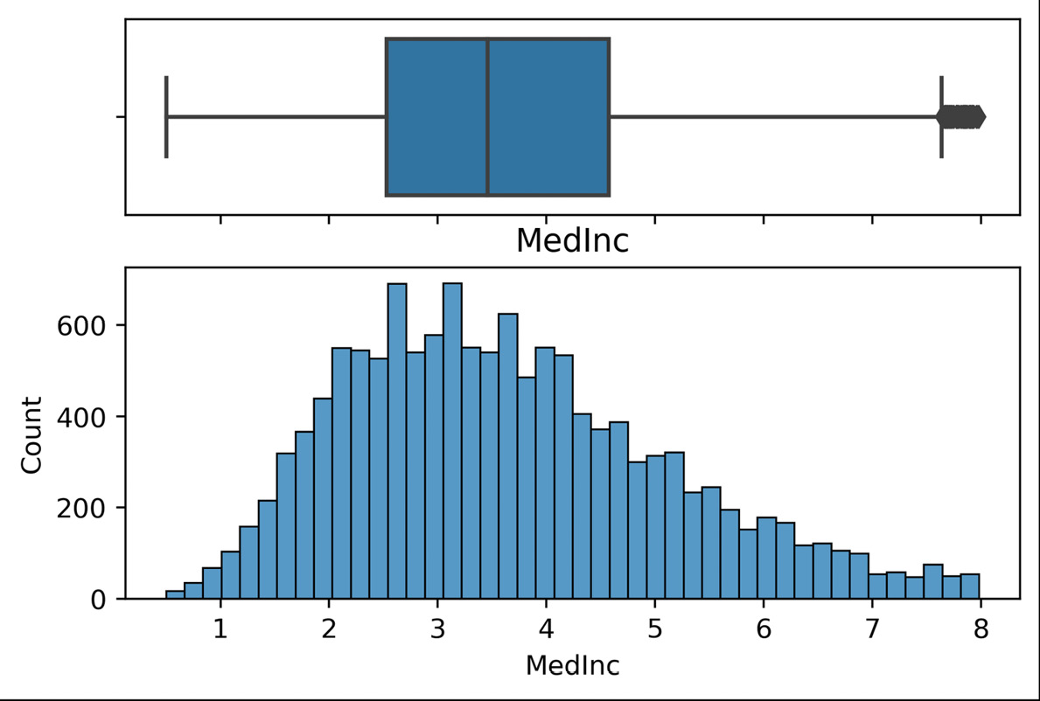
Figure 5.4 – The boxplot and the histogram after removing outliers
Note that the boxplot still highlights outliers in the variable. This is not uncommon. When we remove outliers, the values of the median and quantiles change and, therefore, values that were not flagged as outliers may now be beyond the whiskers.

How it works...
We created a function to find the boundaries according to the IQR proximity rule, as described in the Finding outliers with the inter-quartile range proximity rule recipe. With pandas ge(), we created a Boolean vector with True for the observations that are greater than or equal (that is, ge) to the lower limit. With pandas le(), we created another Boolean vector with True for those observations whose values are lower than or equal (that is, le) to the upper limit. With pandas loc and the Boolean vectors, we removed the outliers from the data.
We used Feature-engine to remove outliers simultaneously from multiple variables. The OutlierTrimmer() transformer can identify outliers based on the mean and standard deviation, IQR proximity rule, or quantiles. It can also change the width of the inliers interval through the fold parameter that multiplies the IQR or the standard deviation, and it can find outliers at both tails of the distribution or just at one end. By setting the capping_method='iqr' parameter, OutlierTrimmer() calculated the boundaries using the IQR proximity rule. With fold set to 3, the IQR was multiplied by three to find the limits. With tails set to "both", outliers were flagged at both ends of the variable’s distribution. To cap outliers at either end, we can pass "left" or "right" to the tails argument. With the fit() method, the transformer learned and stored the limits for each variable. With the transform() method, it removed the outliers from the data.

Capping or censoring outliers
Capping or censoring is the process of transforming the data by limiting the extreme values, as in the outliers, to a certain maximum or minimum arbitrary value. With this procedure, the outliers are not removed but are instead replaced by other values. A typical strategy involves setting outliers to a specified percentile. For example, we can set all data below the 5th percentile to the value at the 5th percentile and all data greater than the 95th percentile to the value at the 95th percentile. Alternatively, we can cap the variable at the limits determined by the IQR proximity rule or at the mean plus and minus three times the standard deviation. In this recipe, we will cap variables at arbitrary values determined by the mean plus and minus three times the standard deviation using pandas and Feature-engine.

How to do it...
Let’s first import the Python libraries and load the data:
Import the required Python libraries:
import numpy as np
import pandas as pd
from sklearn.datasets import load_breast_cancer
from sklearn.model_selection import train_test_split
from feature_engine.outliers import Winsorizer
Let’s load the Breast Cancer dataset from scikit-learn and then separate it into a train and a test set:
X = pd.DataFrame(
breast_cancer.data,
columns=breast_cancer.feature_names)
y = breast_cancer.target
X_train, X_test, y_train, y_test = train_test_split(
X,
y,
test_size=0.3,
random_state=0,
)
Let’s create a function that returns the mean plus and minus fold times the standard deviation, where fold is a parameter to the function:
def find_limits(df, variable, fold):
lower_limit = df[variable].mean() - fold *
df[variable].std()
upper_limit = df[variable].mean() + fold *
df[variable].std()
return lower_limit, upper_limit
Let’s use the function to capture the extreme limits of the mean smoothness variable, which follows approximately a Gaussian distribution:
lower_limit, upper_limit = find_limits(X_train, "worst
smoothness", 3)
lower_limit, upper_limit
Now let’s cap the values at the lower and upper limits:
X_train["worst smoothness"].clip(lower=lower_limit, upper=upper_limit, inplace=True)
X_test["worst smoothness"].clip(lower=lower_limit, upper=upper_limit, inplace=True)
Let’s check that the values were censored:
X_train["worst smoothness"].min(), X_train["worst smoothness"].max()
The previous command returns the minimum and maximum values of the variable, which now coincide with the upper and lower limits we identified in step 4: (0.07117, 0.20149734880520967).
Now, we will cap multiple variables simultaneously utilizing Feature-engine. First, we need to separate the data into a training and testing set as we did in step 2.
Let’s set up a transformer to cap two variables at the limits determined with the mean and standard deviation:
capper = Winsorizer(
variables=["worst smoothness", "worst texture"],
capping_method="gaussian",
tail="both",
fold=3,
)
Let’s fit the transformer to the data so that it learns those limits:
capper.fit(X_train)
By executing capper.left_tail_caps_, we can visualize the lower limits for the three variables: {'worst smoothness': 0.06356074164705164, 'worst texture': 7.092123638591499}. By executing capper.right_tail_caps_, we can see the upper limits for those variables: {'worst smoothness': 0.20149734880520967, 'worst texture': 43.97692158753917}.
Finally, let’s remove outliers from the train and test sets:
X_train = capper.transform(X_train)
X_test = capper.transform(X_test)
If we now execute X_train[capper.variables_].max(), we’ll see the maximum values coincide with the upper limits:
worst smoothness 0.201497
worst texture 43.976922
dtype: float64
That’s it! We’ve now capped variables at the minimum and maximum values.

How it works...
With the function described in the Finding outliers using the mean and standard deviation recipe, we identified the outliers. With pandas clip(), we capped the values of the variable at those values.
We used Feature-engine to cap outliers in multiple variables simultaneously. The Winsorizer() transformer can identify outliers based on the mean and standard deviation, the IQR proximity rule, or by using percentiles. It can also change the width of the interval through the fold parameter that multiplies the IQR or the standard deviation, and it can find outliers at both tails of the distribution or just one.
By setting the capping_method='gaussian' parameter, Winsorizer() calculated the boundaries using the mean and the standard deviation. With fold set to 3, the standard deviation was multiplied by three to find the limits. With tails set to "both", outliers were flagged at both ends of the variables distribution. With the fit() method, the transformer learned and stored the limits for each variable. With the transform() method, it capped the variable values at those limits. Finally, we used pandas max() to corroborate that the variables were capped.

There’s more...
Winsorizer() caps the variables at values estimated using statistical parameters of the variables. Feature-engine also has the ArbitraryOutlierCapper() transformer, which allows us to cap variables at arbitrary values. To learn more about the arbitrary capper from Feature-engine, visit https://feature-engine.readthedocs.io/en/latest/api_doc/outliers/ArbitraryOutlierCapper.html.

Capping outliers using quantiles
When capping outliers, we clip the variable extreme values to a certain maximum or minimum value determined by some statistical parameter. A typical strategy involves setting outliers to a specified percentile. For example, we can set all data below the 5th percentile to the value at the 5th percentile and all data greater than the 95th percentile to the value at the 95th percentile. In this recipe, we will cap variables at arbitrary values determined by the percentiles using pandas and Feature-engine.

How to do it...
Let’s first import the Python libraries and load the data:
Import the required Python libraries:
import pandas as pd
from sklearn.datasets import load_breast_cancer
from sklearn.model_selection import train_test_split
from feature_engine.outliers import Winsorizer
Let’s load the Breast Cancer dataset from scikit-learn:
breast_cancer = load_breast_cancer()
X = pd.DataFrame(
breast_cancer.data,
columns=breast_cancer.feature_names)
y = breast_cancer.target
Let’s separate the data into a train set and a test set:
X_train, X_test, y_train, y_test = train_test_split(
X,
y,
test_size=0.3,
random_state=0,
)
Let’s cap the variable’s minimum and maximum values to the 5th and 95th percentile:
for variable in X_train.columns:
lower_limit = X_train[variable].quantile(0.05)
upper_limit = X_train[variable].quantile(0.95)
X_train[variable].clip(
lower=lower_limit,upper=upper_limit, inplace=True)
X_test[variable].clip(
lower=lower_limit, upper=upper_limit, inplace=True)
That’s it, now the variables have been clipped to their respective 5th and 95th percentiles.
We will cap multiple variables simultaneously utilizing Feature-engine. First, we need to separate the data into a training setand a testing set as we did in step 2.
Let’s set up a transformer to cap two variables at the 5th and 95th percentiles:
capper = Winsorizer(
variables = ["worst smoothness", "worst texture"],
capping_method="quantiles",
tail="both",
fold=0.05,
)
Tip
To cap variables at the 10th and 90th percentiles, we need to set fold=0.1.
Let’s fit the transformer to the data so that it learns those limits:
capper.fit(X_train)
By executing capper.left_tail_caps_, we can visualize the lower limits for the three variables: {'worst smoothness': 0.0960535, 'worst texture': 16.7975}. By executing capper.right_tail_caps_, we can see the upper limits for those variables: {'worst smoothness': 0.17321499999999998, 'worst texture': 36.2775}.
Finally, let’s remove outliers from the train and test sets:
X_train = capper.transform(X_train)
X_test = capper.transform(X_test)
If we now execute X_train[capper.variables_].max(), we’ll see the maximum values coincide with the upper limits:
worst smoothness 0.173215
worst texture 36.277500
dtype: float64
That’s it! We’ve now capped variables at the minimum and maximum values.

How it works...
With pandas quantile(), we found the 5th and 95th percentiles of each variable. With pandas clip(), we capped the values of the variable at those values.
We used Feature-engine to cap outliers in multiple variables simultaneously based on quantiles by setting capping_method to "quantiles" and fold to 0.05. With tails set to "both", outliers were capped at both ends of the variables distribution. With the fit() method, the transformer learned and stored the limits for each variable. With the transform() method, it capped the variable values at those limits. Finally, we used pandas max() to corroborate that the variables were capped.

6

Extracting Features from Date and Time Variables
Date and time variables are those that contain information about dates, times, or both. In programming, we refer to these variables as datetime variables. Examples of datetime variables include date of birth, the time of an event, and date of last payment. The cardinality of datetime variables is usually very high. This means they contain a multitude of unique values, each corresponding to a specific combination of date and/or time. Therefore, we do not utilize datetime variables in their raw format in machine learning models. Instead, we enrich the dataset by extracting multiple features from these variables. In this chapter, we will learn how to extract new features from date and time by utilizing the pandas dt module. Later on, we will automate feature extraction over multiple variables with Feature-engine.
This chapter will cover the following recipes:
Extracting features from dates with pandas
Extracting features from time with pandas
Capturing elapsed time between datetime variables
Working with time in different time zones
Automating feature extraction with Feature-engine

Technical requirements
In this chapter, we will use the pandas, NumPy, and Feature-engine Python libraries.

Extracting features from dates with pandas
datetime variables can take dates, time, or dates and time as values. They are not used in their raw format to build machine learning algorithms. Instead, we create additional features from them, and we can enrich the dataset dramatically by extracting information from the date and time.
The pandas Python library contains a lot of capabilities for working with dates and time. pandas dt is the accessor object to the datetime properties of a pandas Series. To access the pandas dt functionality, the variables should be cast in a data type that supports these operations, such as datetime or timedelta.
Tip
Often, the datetime variables are cast as objects, particularly when the data is loaded from a CSV file. Therefore, to extract the date and time features that we will discuss throughout this chapter, it is necessary to recast the variables as datetime.
In this recipe, we will learn how to extract features from dates by utilizing pandas.

Getting ready
The following are some of the features that we can extract from the date part of the datetime variable off the shelf using pandas:
pandas.Series.dt.year
pandas.Series.dt.quarter
pandas.Series.dt.month
pandas.Series.dt.isocalendar().week
pandas.Series.dt.day
pandas.Series.dt.day_of_week
pandas.Series.dt.weekday
pandas.Series.dt.dayofyear
pandas.Series.dt.day_of_year
We can use the features we’ve obtained with pandas to create even more features, such as the semester or whether it is the weekend. We will learn how to do this in the next section.

How to do it...
To proceed with the recipe, let’s import pandas and NumPy, and create a toy DataFrame:
Import pandas and numpy:
import numpy as np
import pandas as pd
Let’s create 20 datetime values beginning from 2019-03-05 at midnight, followed by increments of 1 day. Then, we must capture the values in a DataFrame and display the top five rows:
rng_ = pd.date_range("2019-03-05", periods=20, freq="D")
data = pd.DataFrame({"date": rng_})
data.head()
Our variable contains only dates, as shown in the following output:
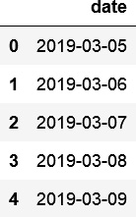
Figure 6.1 – First five rows of a toy DataFrame with a datetime variable
Tip
We can check the data format of the variable by executing data["date"].dtypes. If the variable is cast as an object, we can convert it into datetime format by executing data["date_dt"] = pd.to_datetime(data["date"]).
Let’s extract the year part of the date in a new column and display the top five rows of the resulting DataFrame:
data["year"] = data["date"].dt.year
data.head()
We can see the new variable, year, in the following screenshot:
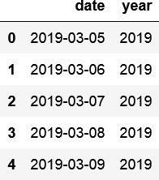
Figure 6.2 – First five rows of a toy DataFrame with the new year variable
Let’s extract the quarter out of the date into a new column and display the top five rows:
data["quarter"] = data["date"].dt.quarter
data[["date", "quarter"]].head()
We can see the new variable, quarter, in the following output:
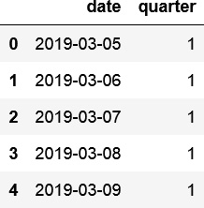
Figure 6.3 – First five rows of a toy DataFrame with the new quarter variable
With quarter, we can now create the semester feature:
data["semester"] = np.where(data["quarter"]<3, 1, 2)
Tip
To familiarize yourself with the distinct values of the new variables, you can use pandas unique() – for example, df["quarter"].unique() or df["semester"].unique().
Let’s extract the month part of the date in a new column and display the top five rows of the DataFrame:
data["month"] = data["date"].dt.month
data[["date", "month"]].head()
We can see month in the newly created variable in the following output:
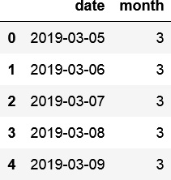
Figure 6.4 – First five rows of a toy DataFrame with the new month variable
We can extract the week number (in a year) that the date corresponds to like so:
data["week"] = data["date"].dt.isocalendar().week
We can see the week variable in the following output:
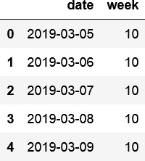
Figure 6.5 – First five rows of a toy DataFrame with the new week variable
Let’s extract the day of the month, which can take values between 1 and 31, and capture it in a new column. Then, we will display the top rows of the DataFrame:
data["day_mo"] = data["date"].dt.day
data[["date", "day_mo"]].head()
We can see the day of the month in the new variable in the following output:
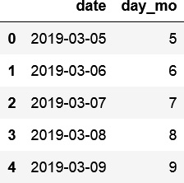
Figure 6.6 – First five rows of a toy DataFrame with the new variable
Let’s extract the day of the week, with values between 0 and 6 (from Monday to Sunday), in a new column, then display the top rows:
data["day_week"] = data["date"].dt.dayofweek
data[["date", "day_mo", "day_week"]].head()
We can see the day of the week in the new variable in the following output:
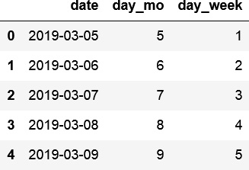
Figure 6.7 – First five rows of a toy DataFrame with the new variables derived from days
Next, let’s create a binary variable that indicates whether the date was a weekend. Then, we will display the DataFrame’s top rows:
data["is_weekend"] = (
data["date"].dt.dayofweek > 4).astype(int)
data[["date", "day_week", "is_weekend"]].head()
We can see the new is_weekend variable in the following output:
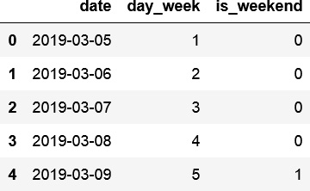
Figure 6.8 – First five rows of a toy DataFrame with the new is_weekend variable
With that, we have created many new features from the date part of a datetime variable using pandas. These features are useful for data analysis, visualization, and machine learning.

How it works...
In this recipe, we extracted the many date-related features from a datetime variable by using the dt module from pandas. First, we created a toy DataFrame with a variable that contained both the date and time in its values. To create the toy DataFrame, we used the pandas date_range() method to create a range of values starting from an arbitrary date and increasing this by intervals of 1 day. With the periods argument, we indicated the number of values to create in the range – that is, the number of dates. With the freq argument, we indicated the size of the steps between the dates. We used D for days in our example. Finally, we transformed the date range into a DataFrame with the pandas DataFrame() class.
To extract the different parts of the date, we used pandas dt module to access the datetime properties of a pandas Series, and then utilized the different properties required: year, month, and quarter to capture the year, month, and quarter in new columns of the DataFrame, respectively. To find the semester, we used the where() method from NumPy in combination with the newly created quarter variable. NumPy’s where() method scanned the values of this quarter variable. If they were smaller than 3, it returned a value of 1 for the first semester; otherwise, it returned a value of 2.
To extract the different representations of days and weeks, we utilized the isocalender().week, day, and dayofweek properties. To create a binary variable indicating whether the date was a weekend, we used the where() method from NumPy in combination with the newly created day_week variable. NumPy’s where() method scanned the name of each day, and if they were smaller than 5, it assigned a value of 0; otherwise, it assigned a value of 1. With that, we created multiple features that we can use for data analysis and machine learning.

There’s more…
pandas also offers the following methods out of the box to create Boolean vectors to highlight the beginning or end of a month, a quarter, or a year, and also whether it is a leap year:
pandas.Series.dt.is_month_start
pandas.Series.dt.is_month_end
pandas.Series.dt.is_quarter_start
pandas.Series.dt.is_quarter_end
pandas.Series.dt.is_year_start
pandas.Series.dt.is_year_end
pandas.Series.dt.is_leap_year
pandas.Series.dt.days_in_month
We can also return the number of days in a specific month with pd.dt.days_in_month and the day in a year (from 1 to 365) with pd.dt.dayofyear.
For more details, visit the pandas datetime documentation: https://pandas.pydata.org/pandas-docs/stable/user_guide/timeseries.html#time-date-components.

See also
To learn how to create different datetime ranges with pandas date_ranges(), visit https://pandas.pydata.org/pandas-docs/stable/user_guide/timeseries.html#offset-aliases.
To learn more about pandas dt, visit https://pandas.pydata.org/pandas-docs/stable/reference/series.html#datetime-properties.

Extracting features from time with pandas
Some events occur more often at certain times of the day – for example, fraudulent activity is more likely to occur during the night or early morning. Air pollutant concentration also changes with the time of the day, with peaks at rush hour when there are more vehicles on the streets. Therefore, deriving time features is extremely useful. In this recipe, we will extract different time parts of a datetime variable by utilizing pandas and NumPy.

Getting ready
The following are some of the features that we can extract offtheshelf using pandas:
pandas.Series.dt.hour
pandas.Series.dt.minute
pandas.Series.dt.second

How to do it...
To proceed with this recipe, we must import the necessary libraries and create a toy dataset:
Let’s import pandas and numpy:
import numpy as np
import pandas as pd
Let’s create 20 datetime observations, beginning from 2019-03-05 at midnight followed by increments of 1 hour, 15 minutes, and 10 seconds. Next, we must capture the range in a DataFrame and display the top five rows:
rng_ = pd.date_range("2019-03-05", periods=20, freq="1h15min10s")
df = pd.DataFrame({"date": rng_})
df.head()
In the following screenshot, we can see the variable we just created, with a date part and a time part, and the values increasing by intervals of 1 hour, 15 minutes, and 10 seconds:
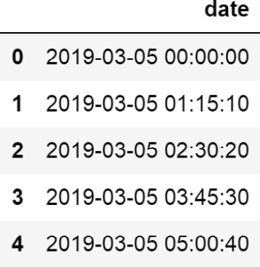
Figure 6.9 – First five rows of a toy DataFrame with a datetime variable
Let’s extract the hour, minute, and second parts of the time into three new columns, then display the DataFrame’s top five rows:
df["hour"] = df["date"].dt.hour
df["min"] = df["date"].dt.minute
df["sec"] = df["date"].dt.second
df.head()
We can see the different time parts in the new columns of the DataFrame:
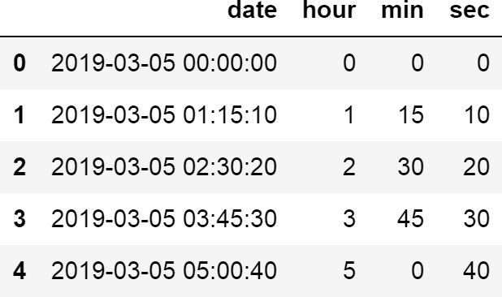
Figure 6.10 – First five rows of the toy DataFrame with the variables derived from time
Note
Remember that pandas dt needs a datetime object to work. You can change the data type of an object variable into datetime using pandas to_datetime().
Let’s perform the same operations that we did in step 3 but now in one line of code:
df[["h", "m", "s"]] = pd.DataFrame([(x.hour, x.minute,
x.second) for x in df["date"]])
df.head()
We can see the newly created variables in the following screenshot:
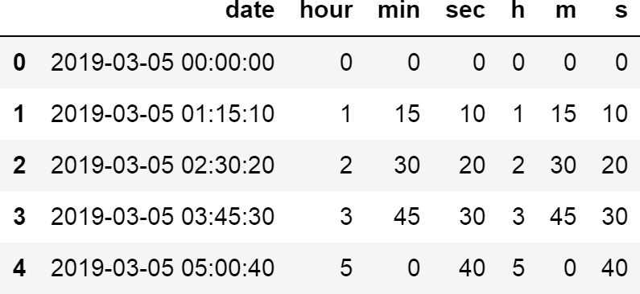
Figure 6.11 – First five rows of the toy DataFrame with the variables derived from time
Note
Remember that you can display the unique values of a variable with pandas unique(), for example, by executing df['hour'].unique().
Finally, let’s create a binary variable that flags whether the event occurred in the morning, between 6 A.M. and 12 P.M:
df["is_morning"] = np.where(
(df["hour"] < 12) & (df["hour"] > 6), 1, 0 )
df.head()
We can see the is_morning variable in the following screenshot:
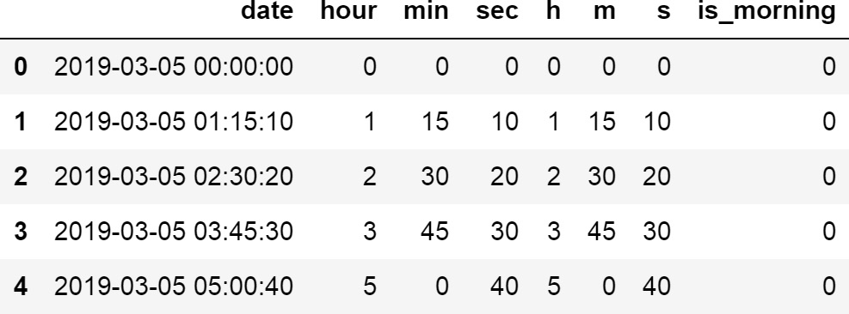
Figure 6.12 – First five rows of the toy DataFrame with the new variables derived from time
With that, we have extracted multiple features from the time part of a datetime variable. These features can be used for data analysis as well as to build machine learning models.

How it works...
In this recipe, we created features that capture representations of time. First, we created a toy DataFrame with a datetime variable. We used the pandas date_range() method to create a range of 20 values starting from an arbitrary date and increased this by intervals of 1 hour, 15 minutes, and 10 seconds. We used the '1h15min10s' string as the frequency term for the freq argument to indicate the desired increments. Next, we transformed the date range into a DataFrame with the pandas DataFrame() method.
To extract the different time parts, we used pandas dt to access the time properties: hour, minute, and second. To create a binary variable to indicate whether the time was in the morning, we used the where() method from NumPy in combination with the hour variable. NumPy’s where() method scanned the hour variable; if its values were smaller than 12 and bigger than 6, it assigned a value of 1; otherwise, it assigned a value of 0. With these operations, we added several features to the DataFrame that can be used for data analysis and to train machine learning models.

There’s more…
We can also extract microseconds and nanoseconds with the following pandas properties:
pandas.Series.dt.microsecond
pandas.Series.dt.nanosecond
For more details, visit https://pandas.pydata.org/pandas-docs/stable/user_guide/timeseries.html#time-date-components.

Capturing the elapsed time between datetime variables
datetime variables offer value individually, though they may offer additional value collectively when used with other datetime variables to derive important insights. A common example consists of deriving the age at the time of an event from the date of birth and date of event variables. We can combine several datetime variables to derive the time that has passed and create more meaningful features. In this recipe, we will learn how to capture the time between two datetime variables in different formats and the time between a datetime variable and the current time by utilizing pandas, NumPy, and the datetime library.

How to do it...
To proceed with this recipe, we must import the necessary libraries and create a toy dataset:
Let’s begin by importing pandas, numpy, and datetime:
import datetime
import numpy as np
import pandas as pd
Let’s create two datetime variables with 20 values each, in which values start from 2019-05-03 and increase in intervals of 1 hour and 1 month, respectively. Then, we must capture the variables in a DataFrame, add column names, and display the top rows:
rng_hr = pd.date_range("2019-03-05", periods=20, freq="H")
rng_month = pd.date_range("2019-03-05", periods=20, freq="M")
df = pd.DataFrame({"date1": rng_hr, "date2": rng_month})
df.head()
We can see the first five rows of the created variables in the following output:
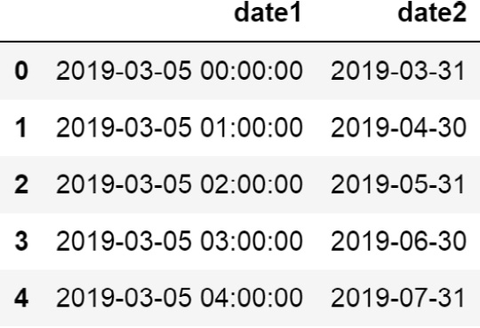
Figure 6.13 – First five rows of the toy DataFrame
Let’s capture the difference in days between the two variables in a new feature, and then display the DataFrame’s top rows:
df["elapsed_days"] = (df["date2"] - df["date1"]).dt.days
df.head()
We can see the difference in days in the following output:
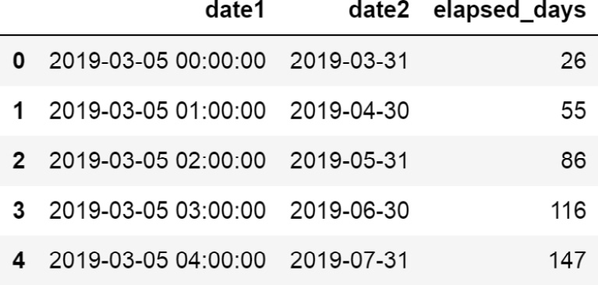
Figure 6.14 – First five rows of the toy DataFrame with the new variable
Let’s capture the difference in months between the two datetime variables in a new feature and then display the DataFrame’s top rows:
df["months_passed"] = (
(df["date2"] - df["date1"]) / np.timedelta64(1, "M"))
df["months_passed"] = np.round(df["months_passed"],0)
df.head()
We can see the difference in months between the variables in the following screenshot:
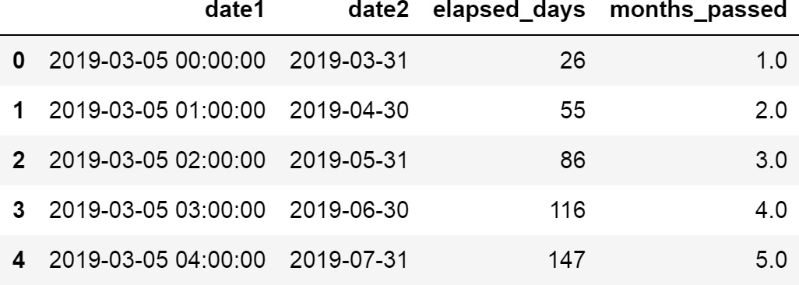
Figure 6.15 – DataFrame with the time difference in different units
Now, let’s calculate the time in between the variables in minutes and seconds and then display the DataFrame’s top rows:
df["diff_seconds"] = (
df["date2"] - df["date1"])/np.timedelta64(1, "s")
df["diff_minutes"] = (
df["date2"] - df["date1"])/ np.timedelta64(1,"m")
df.head()
We can see the new variables in the following output:
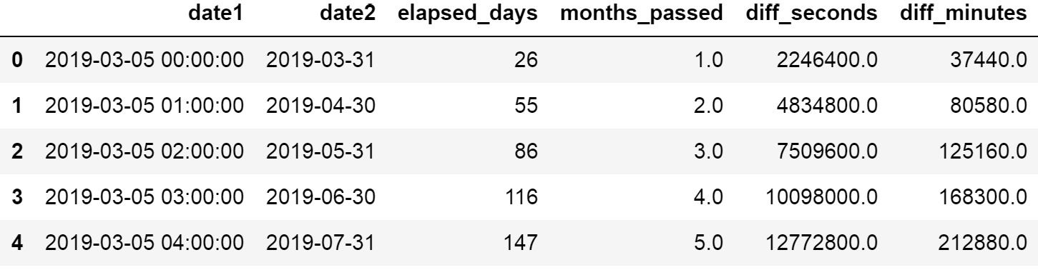
Figure 6.16 – DataFrame with the time difference in different units
Finally, let’s calculate the difference between one variable and the current day, and then display the first five rows of the DataFrame:
df["to_today"] = (
datetime.datetime.today() - df["date1"])
df.head()
We can see the new variable in the final column of the DataFrame in the following screenshot:
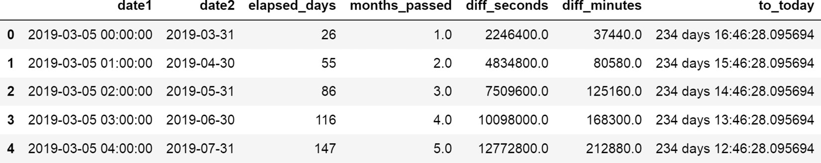
Figure 6.17 – DataFrame with the new variables
Note
The to_today variable on your computer will be different from the one in this book, due to the difference between the current date (at the time of writing) and when you execute the code.
That’s it! We’ve now enriched our dataset with new features that were created by comparing two datetime variables.

How it works...
In this recipe, we captured different representations of the time between two datetime variables. To proceed with this recipe, we created a toy DataFrame with two variables, each with 20 dates starting at an arbitrary date. The first variable increased in intervals of 1 hour, while the second variable increased in intervals of 1 month. We created the variables with pandas date_range(), which we covered extensively in the previous recipes in this chapter.
To determine the difference between the variables – that is, to determine the time between them – we directly subtracted one datetime variable from the other – that is, one pandas Series from the other. The difference between the two pandas Series returns a new pandas Series. To capture the difference in days, we used pandas dt, followed by days. To convert the time difference into months, we used the timedelta() method from NumPy and indicated we wanted the difference in months, passing M in the second argument of the method. To capture the difference in seconds and minutes, we passed the s and m strings to timedelta(), respectively.
Note
NumPy’s timedelta() method complements pandas datetime. The arguments for NumPy’s timedelta method are a number – 1, in our example – to represent the number of units, and a datetime unit, such as (D)ay, (M)onth, (Y)ear, (h)ours, (m)inutes, or (s)econds.
Finally, we captured the difference from one datetime variable to today’s date. We obtained the date and time of today using the built-in Python library, datetime, while using the datetime.today() method. We subtracted one of the datetime variables from our DataFrame for today’s date and captured the difference in days, hours, minutes, seconds, and nanoseconds, which is the default value of the operation.

See also
To learn more about NumPy’s timedelta, visit https://numpy.org/devdocs/reference/arrays.datetime.html#datetime-and-timedelta-arithmetic.

Working with time in different time zones
Some organizations operate internationally; therefore, the information they collect about events may be recorded alongside the time zone of the area where the event took place. To be able to compare events that occurred across different time zones, we need to set all of the variables within the same zone. In this recipe, we will learn how to unify the time zones of a datetime variable and then learn how to reassign a variable to a different time zone using pandas.

How to do it...
To proceed with this recipe, we must import pandas and then create a toy DataFrame with two variables, each one containing a date and time in different time zones:
Import pandas:
import pandas as pd
Let’s create a toy DataFrame with one variable with values in different time zones:
df = pd.DataFrame()
df['time1'] = pd.concat([
pd.Series(
pd.date_range(
start='2015-06-10 09:00', freq='H',
periods=3,
tz='Europe/Berlin')),
pd.Series(
pd.date_range(
start='2015-09-10 09:00', freq='H',
periods=3,
tz='US/Central'))
], axis=0)
Now, let’s add another datetime variable to the DataFrame, which also contains values in different time zones, and then display the resulting DataFrame:
df['time2'] = pd.concat([
pd.Series(
pd.date_range(
start='2015-07-01 09:00', freq='H',
periods=3,
tz='Europe/Berlin')),
pd.Series(
pd.date_range(
start='2015-08-01 09:00', freq='H',
periods=3,
tz='US/Central'))
], axis=0)
df
We can see the toy DataFrame with the variables in the different time zones in the following screenshot:
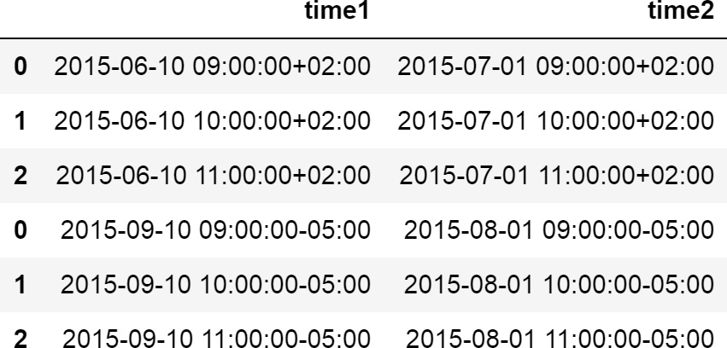
Figure 6.18 – Toy DataFrame with two datetime variables in different time zones
Note
The time zone is indicated with the +02 and -05 values, respectively.
To work with different time zones, first, we must unify the time zone to the central time zone setting, utc = True:
df['time1_utc'] = pd.to_datetime(df['time1'], utc=True)
df['time2_utc'] = pd.to_datetime(df['time2'], utc=True)
df
Note how, in the new variables, utc is zero, whereas in the previous variables, it varies:
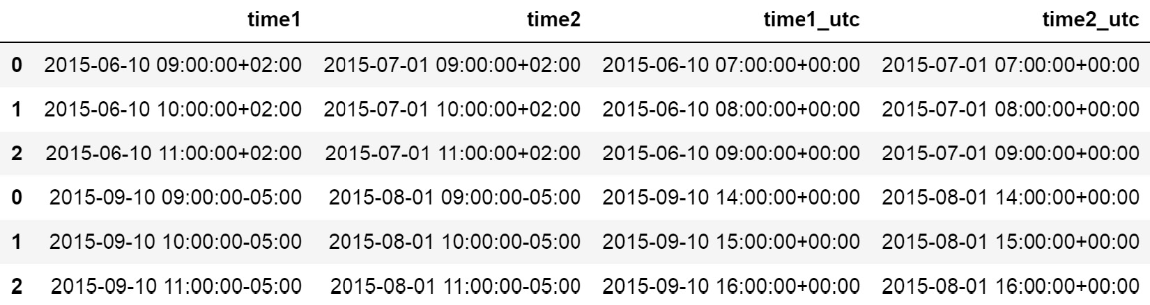
Figure 6.19 – The variables have now been unified to the central time zone (UTC)
Now, let’s calculate the difference in days between the variables and then display the DataFrame:
df['elapsed_days'] = (
df['time2_utc'] - df['time1_utc']). dt.days
df['elapsed_days'].head()
We can see the time between the values of the variables in the DataFrame in the following output:
0 21
1 21
2 21
0 -40
1 -40
Name: elapsed_days, dtype: int64
Finally, let’s change the time zone of the datetime variables to alternative ones and display the new variables:
df['time1_london'] = df[
'time1_utc'].dt.tz_convert('Europe/London')
df['time2_berlin'] = df[
'time1_utc'].dt.tz_convert('Europe/Berlin')
df[['time1_london', 'time2_berlin']]
We can see the variables in their respective time zones in the following screenshot:
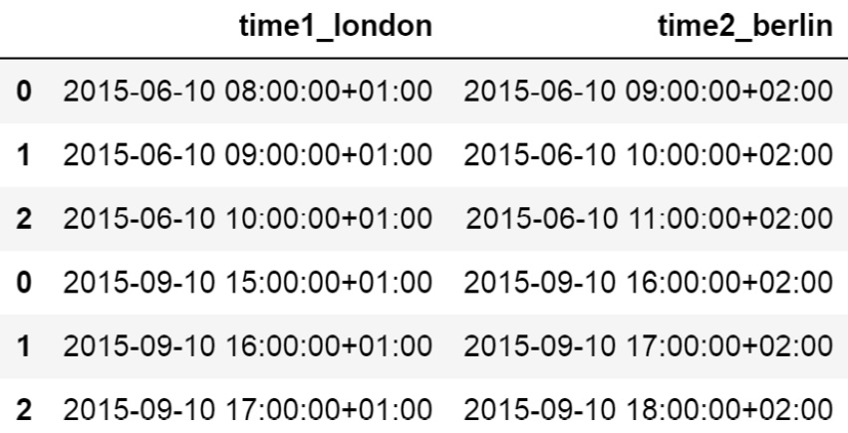
Figure 6.20 – The variables reformatted into different time zones
Note how, when changing time zones, not only do the values of the zone change – that is, the +01 and +02 values in the preceding screenshot – but the value of the hour changes as well.

How it works...
In this recipe, we changed the time zone of the variables and performed operations with variables in different time zones. To begin, we created a DataFrame with two variables, the values of which started at an arbitrary date and increased hourly; these were set in different time zones. To combine the different time zone variables in one column within the DataFrame, we concatenated the series returned by pandas date_range() by utilizing the pandas concat() method. We set the axis argument to 0, to indicate we wanted to concatenate the series vertically in one column. We covered the arguments of pandas date_range() extensively in former recipes in this chapter; see, for example, the Extracting features from dates with pandas and Extracting features from time with pandas recipes for more details.
To reset the time zone of the variables to the central zone, we used the pandas to_datetime() method and passed utc=True. Finally, we determined the time difference between the variables by subtracting one series from the other and capturing the difference in days. To reassign a different time zone, we used the pandas tz_convert() method, indicating the new time zone as an argument.

See also
To learn more about the _datetime() method, visit https://pandas.pydata.org/pandas-docs/stable/reference/api/pandas.to_datetime.html.
To learn more about the pandas tz_convert() method, visit https://pandas.pydata.org/pandas-docs/stable/reference/api/pandas.Series.dt.tz_convert.html.

Automating feature extraction with Feature-engine
Feature-engine is a Python library dedicated to engineering and selecting features and is well-suited to working with pandas DataFrames. The DatetimeFeatures() class from Feature-engine can extract features from date and time automatically by using the pandas dt module under the hood. This transformer allows you to extract the following features:
Month
Quarter
Semester
Year
Week
Day of week
Day of month
Day of year
Weekend
Month start
Month end
Quarter start
Quarter end
Year start
Year end
Leap year
Days in month
Hour
Minute
Second
In this recipe, we will automatically create features from date and time by utilizing Feature-engine.

How to do it...
To proceed with this recipe, we must import the necessary libraries and create a toy dataset:
Let’s begin by importing pandas and DatetimeFeatures():
import pandas as pd
from feature_engine.datetime import DatetimeFeatures
Let’s create 20 datetime values, with values beginning from 2019-03-05 at midnight followed by increments of 1 day. Then, we must capture the value range in a DataFrame:
rng_ = pd.date_range('2019-03-05', periods=20, freq='D')
data = pd.DataFrame({'date': rng_})
Let’s set up the transformer to create the default date and time features automatically:
dtfs = DatetimeFeatures(
variables=None,
features_to_extract=None,
)
Note
DatetimeFeatures() automatically finds all the variables of the datetime type, or that could be parsed as datetime when the parameter variable is set to None. Alternatively, you can pass a variable list, with the names of the variables for which you want to create the date and time features.
Let’s add the date and time features to the data:
dft = dtfs.fit_transform(data)
Let’s capture the names of the new variables in a list:
vars_ = [v for v in dft.columns if "date" in v]
Note
DatetimeFeatures() names the new features with the original variable name plus the type of feature created, for example, date_day_of_week.
If we execute dft[vars_].head(), we will see the new variables, as shown in the following output:
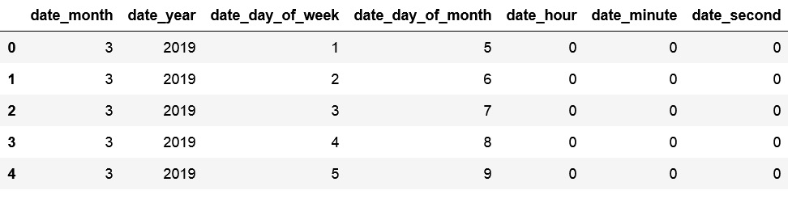
Figure 6.21 – DataFrame returned by DatetimeFeatures() with the new variables
Note
We can create specific features by passing their names to features_to_extract, for example, dtfs = DatetimeFeatures(features_to_extract=["week", "year"]). We can also extract all possible features by setting that parameter to "all". If features_to_extract=None, Feature-engine will return default features, predefined in the transformer.
DatetimeFeatures() can also create features from variable values in different time zones. Let’s learn how to correctly set up the transformer in this situation.
Let’s create a toy DataFrame with one variable with values in different time zones:
df = pd.DataFrame()
df["time"] = pd.concat(
[
pd.Series(
pd.date_range(
start="2014-08-01 09:00", freq="H",
periods=3, tz="Europe/Berlin"
)
),
pd.Series(
pd.date_range(
start="2014-08-01 09:00", freq="H",
periods=3, tz="US/Central"
)
),
],
axis=0,
)
If we execute df, we will see the toy DataFrame, as shown in the following screenshot:
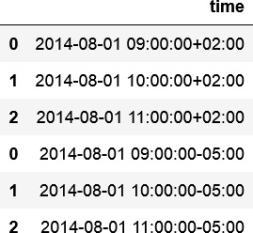
Figure 6.22 – DataFrame with a variable with values in different time zones
Now, let’s set up DatetimeFeatures() so that it extracts three specific features, indicating utc=True so that it transforms the variable into the central time zone:
dfts = DatetimeFeatures(
features_to_extract=["day_of_week", "hour",
"minute"],
drop_original=False,
utc=True,
)
Now, we can create the new features:
dft = dfts.fit_transform(df)
DatetimeFeatures() will put all timestamps in UTC before deriving the features. With dft.head(), we can see the resulting DataFrame:
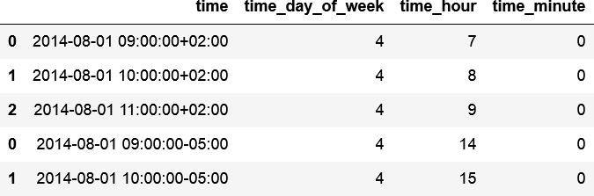
Figure 6.23 – DataFrame with the original and new variables
With that, we’ve created multiple date and time-related features in a few lines of code. Feature-engine offers a great alternative to manually creating features per feature with pandas.

How it works...
DatetimeFeatures() extracts several date and time features from datetime variables automatically by utilizing pandas dt under the hood. It works with variables whose original data types are datetime, as well as with object-like and categorical variables, provided that they can be parsed into datetime format. DatetimeFeatures() can extract all features when we set the features_to_extract parameter to "all" or a specific subset predefined by the class when we leave the parameter set to None. Alternatively, we can pass the names of the features to extract into a list.
DatetimeFeatures() automatically finds the datetime variables, although we can define them in a list and pass them to the parameter variables.
With the fit() method, the transformer does not learn any parameters; instead, it checks that the variables that are entered by the user are or can be parsed into datetime format. If the user does not indicate the variables, it finds the datetime variables automatically. With transform(), DatetimeFeatures() adds the date and time-derived variables to the DataFrame.

7

Performing Feature Scaling
Many machine learning algorithms are sensitive to the scale of the features. In particular, the coefficients of linear models depend on the scale of the feature; that is, changing the feature scale will change the coefficient’s value. In linear models, as well as and algorithms that depend on distance calculations, such as clustering and principal component analysis, features with bigger value ranges tend to dominate over features with smaller ranges. Therefore, having features within a similar scale allows us to compare feature importance and also helps algorithms converge faster, thus improving performance and training times.
Scaling techniques will divide the variables by some constant; therefore, it is important to highlight that no matter the scaling method, the shape of the variable distribution does not change. If what you want is to change the distribution shape, check out Chapter 3, Transforming Numerical Variables.
In this chapter, we will describe different methods you can use to put the features on the same scale, highlighting the characteristics of each method and the variable distributions for which they are better suited.
This chapter will cover the following recipes:
Standardizing the features
Scaling to the maximum and minimum values
Scaling with the median and quantiles
Performing mean normalization
Implementing maximum absolute scaling
Scaling to vector unit length

Technical requirements
The main libraries that we use in this chapter are scikit-learn for scaling and pandas to handle the data and make a few plots.

Standardizing the features
Standardization is the process of centering the variable at 0 and standardizing the variance to 1. To standardize features, we subtract the mean from each observation and then divide the result by the standard deviation:
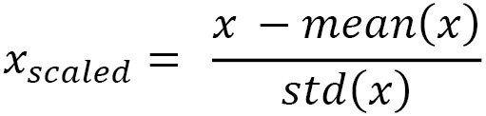
The result of the preceding transformation is called the z-score and represents how many standard deviations a given observation deviates from the mean. In this recipe, we will implement standardization with scikit-learn.

How to do it...
To begin, we will import the required packages, load the dataset, and prepare the train and test sets:
Import the required Python packages, classes, and functions:
import matplotlib.pyplot as plt
import pandas as pd
from sklearn.datasets import fetch_california_housing
from sklearn.model_selection import train_test_split
from sklearn.preprocessing import StandardScaler
Let’s load the California housing dataset from scikit-learn into a dataframe, and drop the Latitude and Longitude variables as we would not use them as such in predictive models:
X, y = fetch_california_housing(
return_X_y=True, as_frame=True)
X.drop(labels=["Latitude", "Longitude"], axis=1, inplace=True)
Now, let’s divide the data into train and test sets:
X_train, X_test, y_train, y_test = train_test_split(X, y, test_size=0.3, random_state=0)
Next, we’ll set up a standard scaler using StandardScaler() from scikit-learn and fit it to the train set so that it learns each variable’s mean and standard deviation:
scaler = StandardScaler() scaler.fit(X_train)
Now, let’s standardize the train and test sets with the trained scaler:
X_train_scaled = scaler.transform(X_train)
X_test_scaled = scaler.transform(X_test)
StandardScaler() stores the mean and standard deviation needed to standardize the variables. Let’s visualize the learned parameters.
First, we’ll print the mean values that were learned by the scaler:
scaler.mean_
The mean values per variable can be seen in the following output:
array([3.86666741e+00, 2.86187016e+01, 5.42340368e+00, 1.09477484e+00,1.42515732e+03, 3.04051776e+00])
Now, let’s print the standard deviation values that were learned by the scaler:
scaler.scale_
The standard deviation of each variable can be seen in the following output:
array([1.89109236e+00, 1.25962585e+01, 2.28754018e+00, 4.52736275e-01,1.14954037e+03, 6.86792905e+00])
Scikit-learn scalers, just like any scikit-learn transformer, return NumPy arrays.
Let’s convert the arrays into dataframes:
X_train_scaled = pd.DataFrame(
X_train_scaled, columns=X_train.columns)
X_test_scaled = pd.DataFrame(
X_test_scaled, columns=X_test.columns)
Now we can compare the transformed data with the original data to visualize the changes.
Let’s print the main statistics from the original variables:
X_test.describe()
In the output of the preceding command, we can see that the data is not centered at 0 and the variance varies among the variables:
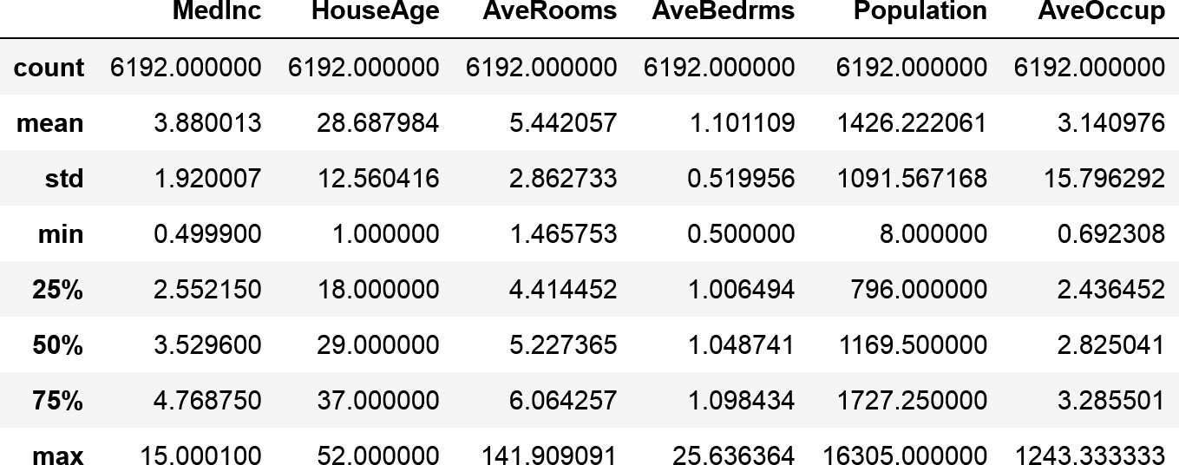
Figure 7.1 – Statistical parameters of the original variables
Let’s now print the main statistics from the transformed variables:
X_test_scaled.describe()
In the output of the preceding command, we can see that the data is now centered at 0 and the variance is 1:
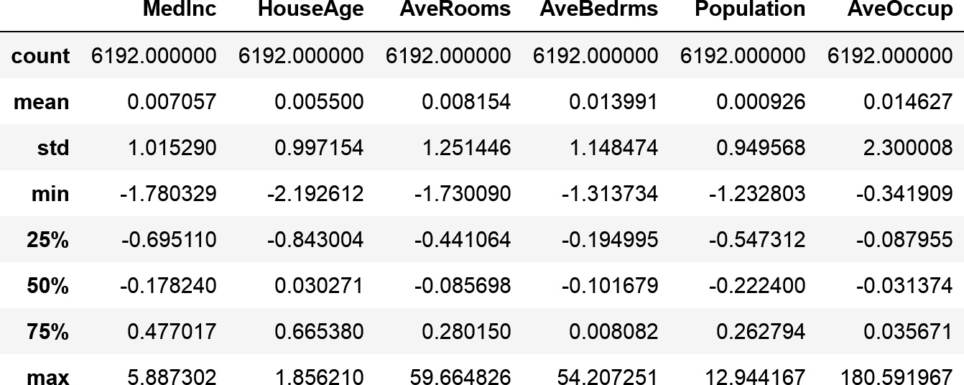
Figure 7.2 – Statistical parameters of the scaled variables
Finally, let’s plot a histogram of the original distributions:
X_test.hist(bins=20, figsize=(20, 20))
plt.show()
In the following output, we see the distribution of each variable:
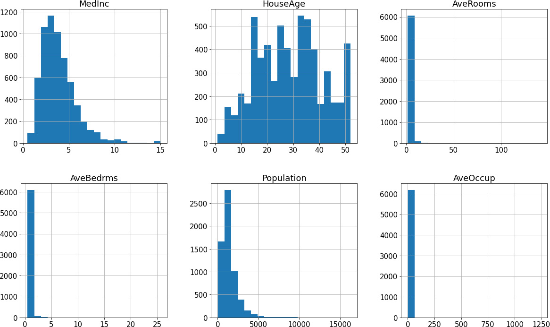
Figure 7.3 – Histograms of the original variables
And now, let’s plot a histogram of the scaled variables:
X_test_scaled.hist(bins=20, figsize=(20, 20))
plt.show()
In the following output, we see that after the scaling, the shape of the variable’s distribution remains the same:
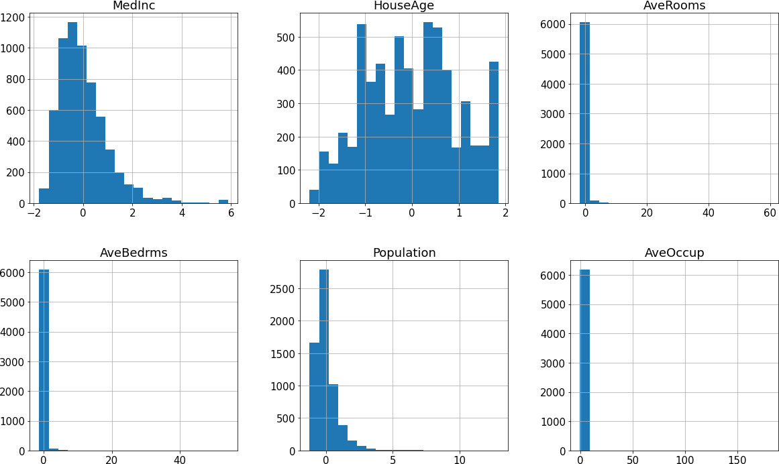
Figure 7.4 – Histograms of the scaled variables
We now have the variables of our data on a similar scale.

How it works...
In this recipe, we standardized the variables of the California housing dataset by utilizing scikit-learn. We split the data into train and test because the parameters for the standardization should be learned from the train set.
To standardize these features, we used StandardScaler(). Using the fit() method, the scaler learned each variable’s mean and standard deviation and stored them in its mean_ and scale_ attributes. Using the transform() method, the scaler standardized the variables in the train and test sets, returning NumPy arrays.

Scaling to the maximum and minimum values
Scaling to the minimum and maximum values squeezes the values of the variables between 0 and 1. To implement this scaling technique, we subtract the minimum value from all the observations and divide the result by the value range, that is, the difference between the maximum and minimum values:
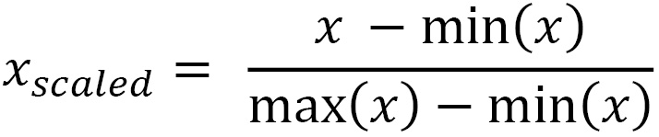
In this recipe, we will implement scaling to the minimum and maximum values by utilizing scikit-learn.

How to do it...
To begin, we will import the required packages, load the dataset, and prepare the train and test sets:
Import pandas and the required scikit-learn classes and functions:
import pandas as pd
from sklearn.datasets import fetch_california_housing
from sklearn.model_selection import train_test_split
from sklearn.preprocessing import MinMaxScaler
Let’s load the California housing dataset from scikit-learn into a pandas dataframe:
X, y = fetch_california_housing(
return_X_y=True, as_frame=True
)
X.drop(labels=["Latitude", "Longitude"], axis=1, inplace=True)
Let’s divide the data into train and test sets:
X_train, X_test, y_train, y_test = train_test_split(
X,
y,
test_size=0.3,
random_state=0,
)
Let’s set up the scaler and then fit it to the train set so that it learns each variable’s minimum and maximum values:
scaler = MinMaxScaler()
scaler.fit(X_train)
Finally, let’s scale the variables in the train and test sets with the trained scaler:
X_train_scaled = scaler.transform(X_train)
X_test_scaled = scaler.transform(X_test)
Tip
MinMaxScaler() stores the maximum and minimum values and the value ranges in its data_max_, min_, and data_range_ attributes, respectively.
We can now transform these NumPy arrays into pandas dataframes and compare the variable distributions and their values before and after the transformation, as we did in steps 8 to 12 of the Standardizing the features recipe.

How it works...
In this recipe, we scaled the numerical variables of the California housing dataset that comes with scikit-learn to their minimum and maximum values.
The MinMaxScaler() from scikit-learn learned the minimum and maximum values of each variable when we called the fit() method and stored these parameters in its data_max_, min_, and data_range attributes. With the transform() method, the scaler removed the minimum value from each variable in the train and test sets and divided the result by the value range, returning NumPy arrays.
After the transformation, the minimum and maximum values of each variable were 0 and 1, respectively.
Tip
If you want to scale only a subset of variables, you can use either ColumnTransformer() from scikit-learn or SklearnTransformerWrapper() from Feature-engine together with MinMaxScaler().

Scaling with the median and quantiles
When scaling variables to the median and quantiles, the median value is removed from the observations, and the result is divided by the Inter-Quartile Range (IQR). The IQR is the difference between the 1st quartile and the 3rd quartile, or, in other words, the difference between the 25th quantile and the 75th quantile:
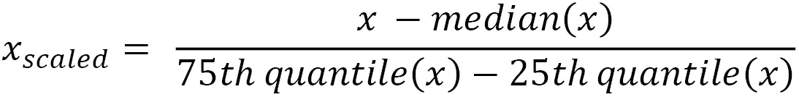
This method is known as robust scaling because it produces more robust estimates for the center and value range of the variable and is recommended if the data contains outliers. In this recipe, we will implement scaling with the median and IQR by utilizing scikit-learn.

How to do it...
To begin, we will import the required packages, load the dataset, and prepare the train and test sets:
Import pandas and the required scikit-learn classes and functions:
import pandas as pd
from sklearn.datasets import fetch_california_housing
from sklearn.model_selection import train_test_split
from sklearn.preprocessing import RobustScaler
Let’s load the California housing dataset from scikit-learn into a pandas dataframe:
X, y = fetch_california_housing(
return_X_y=True, as_frame=True)
X.drop(labels=["Latitude", "Longitude"], axis=1, inplace=True))
Let’s divide the data into train and test sets:
X_train, X_test, y_train, y_test = train_test_split(
X,
y,
test_size=0.3,
random_state=0,
)
To perform scaling to the median and quantiles, we use RobustScaler() from scikit-learn and fit it to the train set so that it learns and stores the median and IQR:
scaler = RobustScaler()
scaler.fit(X_train)
Finally, let’s scale the variables in the train and test sets with the trained scaler:
X_train_scaled = scaler.transform(X_train)
X_test_scaled = scaler.transform(X_test)
We can go ahead and print the variable median values stored by RobustScaler():
scaler.center_
The medians that are stored in the center_ attribute of RobustScaler() can be seen in the following output:
array([3.53910000e+00, 2.90000000e+01, 5.22931763e+00, 1.04878049e+00,1.16500000e+03, 2.81635506e+00])
Now, let’s output the IQR stored in RobustScaler():
scaler.scale_
We can see the IQR for each variable in the following output:
array([2.16550000e+00, 1.90000000e+01, 1.59537022e+00, 9.41284380e-02,9.40000000e+02, 8.53176853e-01])
We can now transform these NumPy arrays into pandas dataframes and compare the variable distributions and their values before and after the transformation, as we did in steps 8 to 12 of the Standardizing the features recipe.

How it works...
In this recipe, we scaled the numerical variables of the California housing dataset from scikit-learn to the median and IQR. First, we divided it into train and test sets.
To scale the features, we created an instance of RobustScaler(). With the fit() method, the scaler learned the median and IQR for each variable from the train set. With the transform() method, the scaler subtracted the median from each variable in the train and test sets and divided the result by the IQR, returning NumPy arrays with the scaled variables.
After the transformation, the median values of the variables are centered at 0, but the overall shape of the distributions did not change.
You can check the distributions in our repository at https://github.com/PacktPublishing/Python-Feature-Engineering-Cookbook-Second-Edition/blob/main/ch07-scaling/Recipe-3-robust-scaling.ipynb.

Performing mean normalization
In mean normalization, we center the variable at 0 and rescale the distribution to the value range. This procedure involves subtracting the mean from each observation and then dividing the result by the difference between the minimum and maximum values:
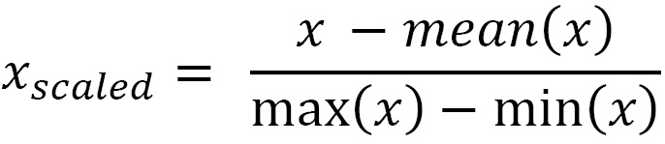
In this recipe, we will implement mean normalization with pandas and then with scikit-learn.

How to do it...
We’ll begin by importing the required libraries, loading the dataset, and preparing the train and test sets:
Import pandas and the required scikit-learn class and function:
import pandas as pd
from sklearn.datasets import fetch_california_housing
from sklearn.model_selection import train_test_split
Let’s load the California housing dataset from scikit-learn into a pandas dataframe:
X, y = fetch_california_housing(
return_X_y=True, as_frame=True)
X.drop(labels=["Latitude", "Longitude"], axis=1, inplace=True)
Let’s divide the data into train and test sets:
X_train, X_test, y_train, y_test = train_test_split(
X,
y,
test_size=0.3,
random_state=0,
)
Let’s learn the mean values from the variables in the train set using the following:
means = X_train.mean(axis=0)
Note
We set the axis to 0 to indicate we want the mean across all the rows, that is, across all the observations, which is the mean of each variable. If we set axis to 1 instead, pandas will calculate the mean value per observation across all the columns.
By executing print(mean), we can see the mean values per variable:
MedInc 3.866667
HouseAge 28.618702
AveRooms 5.423404
AveBedrms 1.094775
Population 1425.157323
AveOccup 3.040518
dtype: float64
Now, let’s capture the difference between the maximum and minimum values per variable:
ranges = X_train.max(axis=0)-X_train.min(axis=0)
By executing print(ranges), we can see the value ranges per variable:
MedInc 14.500200
HouseAge 51.000000
AveRooms 131.687179
AveBedrms 33.733333
Population 35679.000000
AveOccup 598.964286
dtype: float64
Note
The pandas mean(), max(), and min() methods return a pandas Series.
Now, we’ll implement the mean normalization of the train and test sets by utilizing the learned parameters:
X_train_scaled = (X_train - means) / ranges
X_test_scaled = (X_test - means) / ranges
Tip
In order to transform future data, you will need to store these parameters, for example, in a .txt or .csv file.
Note that this procedure returns pandas dataframes of the transformed train and test sets. You can go ahead and compare the variables before and after the transformations using the commands from steps 9 to 12 of the Standardizing the features recipe.

How it works…
In this recipe, we standardized the numerical variables of the California housing dataset from scikit-learn. We loaded the dataset and divided it into train and test sets using the train_test_split() function from scikit-learn. To implement mean normalization, we captured the mean values of the numerical variables in the train set using the pandas mean() method. Next, we determined the difference between the maximum and minimum values of the numerical variables in the train set by utilizing the pandas max() and min() methods. Finally, we used the pandas Series with the mean values and the value ranges to implement normalization. We subtracted the mean from each observation in our train and test sets and divided the result by the value ranges. This returned the normalized variables in a pandas dataframe.

There’s more...
There is no dedicated scikit-learn transformer to implement mean normalization, but we combine the use of two transformers to do so. This is convenient if you want to implement this transformation within a pipeline.
To do this, we need to import pandas and load the data, just like we did in steps 1 to 3 in the How to do it... section of this recipe. Then, follow these steps:
Import the scikit-learn transformers:
from sklearn.preprocessing import StandardScaler, RobustScaler
Let’s set up StandardScaler() so that it learns and subtracts the mean but does not divide the result by the standard deviation:
scaler_mean = StandardScaler(
with_mean=True, with_std=False)
Now, let’s set up RobustScaler() so that it does not remove the median from the values but divides them by the value range, that is, the difference between the maximum and minimum values:
scaler_minmax = RobustScaler(
with_centering=False,
with_scaling=True,
quantile_range=(0, 100)
)
Tip
To divide by the difference between the minimum and maximum values, we need to specify (0, 100) in the quantile_range argument of RobustScaler().
Let’s fit the scalers to the train set so that they learn and store the mean, maximum, and minimum values:
scaler_mean.fit(X_train)
scaler_minmax.fit(X_train)
Finally, let’s apply mean normalization to the train and test sets:
X_train_scaled = scaler_minmax.transform(
scaler_mean.transform(X_train)
)
X_test_scaled = scaler_minmax.transform(
scaler_mean.transform(X_test)
)
We transformed the data with StandardScaler() to remove the mean and then transformed the resulting NumPy array with RobustScaler() to divide the result by the range between the minimum and maximum values. We described the functionality of StandardScaler() in the Standardizing the features recipe of this chapter and RobustScaler() in the Scaling with the median and quantiles recipe of this chapter.
Tip
MinMaxScaler() stores the maximum and minimum values and the value ranges in its data_max_, min_, and data_range_ attributes.

Implementing maximum absolute scaling
Maximum absolute scaling scales the data to its maximum value; that is, it divides every observation by the maximum value of the variable:
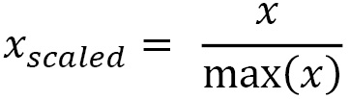
As a result, the maximum value of each feature will be 1.0. Note that maximum absolute scaling does not center the data. It was specifically designed for scaling sparse data. In this recipe, we will implement maximum absolute scaling with scikit-learn.
Tip
Scikit-learn recommends using this transformer on data that is centered at 0 or on sparse data.

Getting ready
Maximum absolute scaling was specifically designed to scale sparse data. Thus, we will use a bag-of-words dataset that contains sparse variables for the recipe. In this dataset, the variables are words, the observations are documents, and the values are the number of times each word appears in the document. Most entries in the data are 0.
For guidelines on how to download, prepare, and store the dataset, please check out the Getting ready section of the Implementing feature binarization recipe in Chapter 4, Performing Variable Discretization. Alternatively, you can download and run this notebook at https://github.com/solegalli/Python-Feature-Engineering-Cookbook-Second-Edition/blob/main/ch04-discretization/donwload-prepare-store-enron-data.ipynb.

How to do it...
Let’s begin by importing the required packages and loading the dataset:
Import the required libraries and the scaler:
import matplotlib.pyplot as plt
import pandas as pd
from sklearn.preprocessing import MaxAbsScaler
Let’s load the bag-of-words dataset:
data = pd.read_csv("bag_of_words.csv"))
Note
Although we omit this step in the recipe, remember that the maximum absolute values should be learned from a training dataset only. So, remember to split the dataset into train and test sets when carrying out your analysis.
Let’s set up the maximum absolute scaler and fit it to the data so that it learns the variable’s maximum values:
scaler = MaxAbsScaler()
scaler.fit(data)
Now, let’s scale the variables by utilizing the trained scaler:
X_train_scaled = scaler.transform(data)
Tip
MaxScaler() stores the maximum values in its max_abs_ attribute.
Let’s display the maximum values stored by the scaler:
scaler.max_abs_
In the output of the preceding command, we see the maximum number of times each word appeared in a document:
array([ 7., 6., 2., 2., 11., 4., 3., 6., 52., 2.])
Let’s convert the NumPy array into a dataframe:
data_scaled = pd.DataFrame(
data_scaled, columns=data.columns)
And now, let’s plot the distributions of the original and scaled variables.
Let’s make a histogram with the bag of words before carrying out the scaling:
data.hist(bins=20, figsize=(20, 20))
plt.show()
In the following output, we see the number of times each word appears in a document:
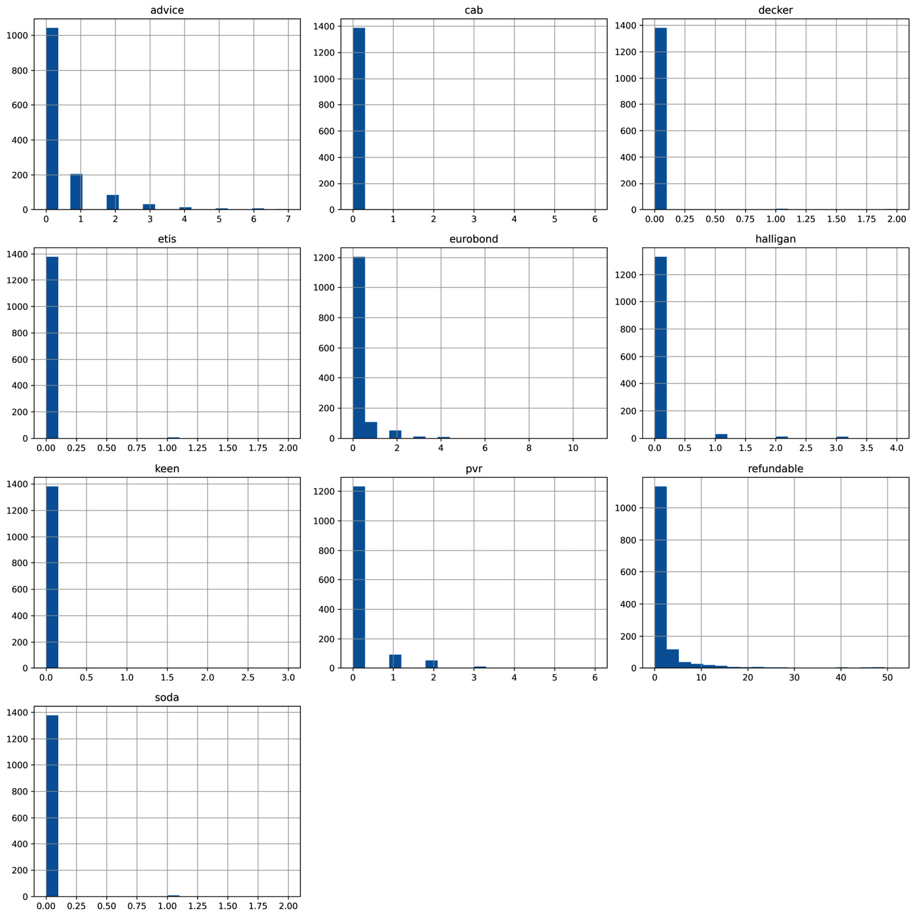
Figure 7.5 – Histograms with different word counts
Now, let’s make a histogram with the scaled variables:
data_scaled.hist(bins=20, figsize=(20, 20))
plt.show()
In the following output, we can corroborate the change of scale of the variables, but their distribution shape remains the same:
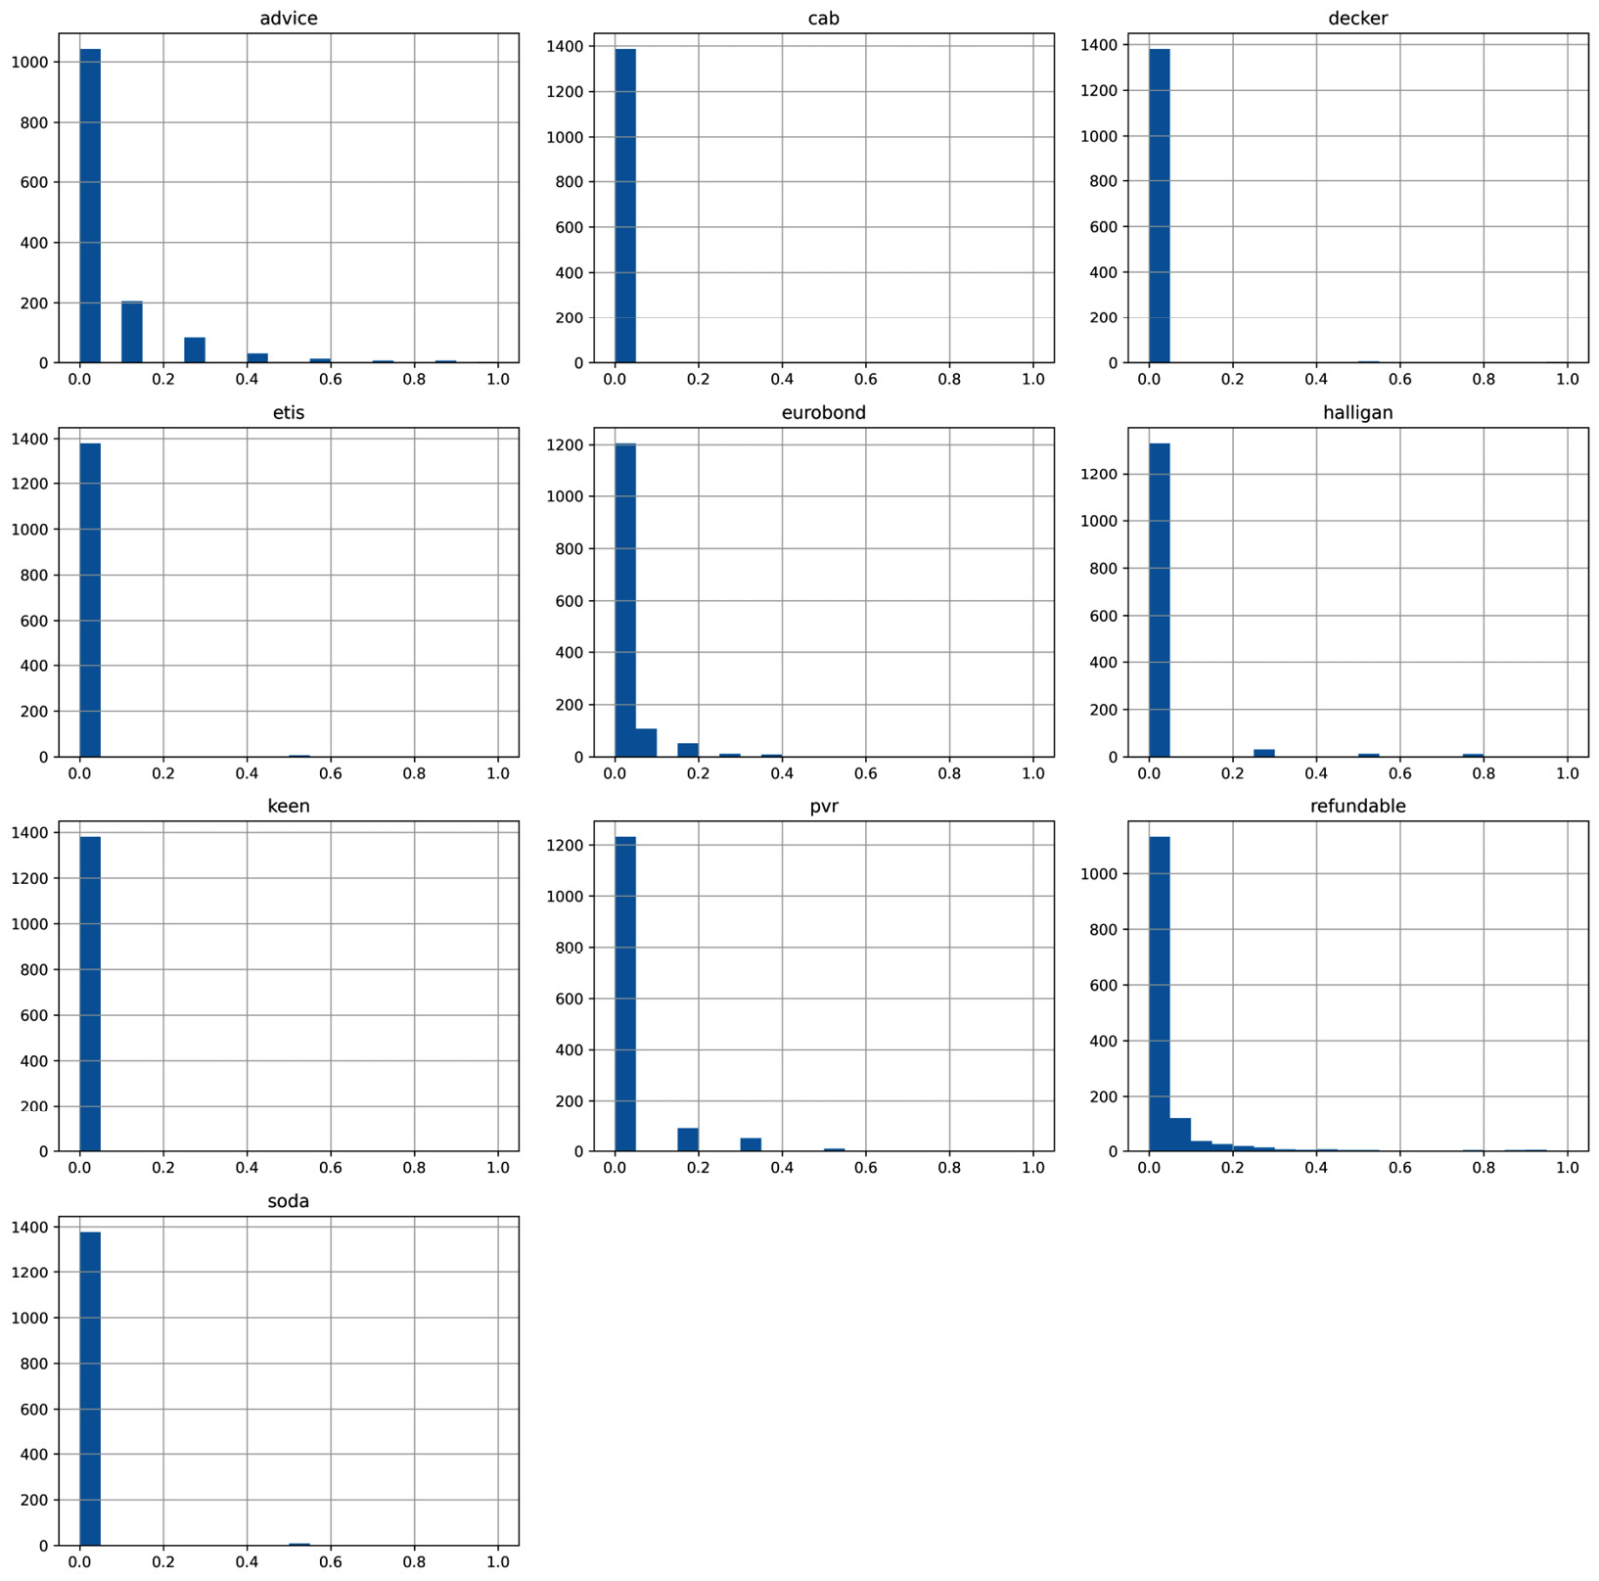
Figure 7.6 – Histograms of the word counts after the transformation
Let’s move on to the next section!

How it works...
In this recipe, we scaled the sparse variables of a bag of words to their maximum values. To scale the features, we created an instance of MaxAbsScaler(). With the fit() method, the scaler learned the maximum values for each variable and stored them in its max_abs_ attribute. With the transform() method, the scaler divided the variables by their maximum values, returning a NumPy array.

There’s more...
If you want to center the variable distributions at 0 and then scale them to their absolute maximum, you can do so by combining the use of two scikit-learn transformers:
Let’s import the required libraries, transformers, and functions:
import pandas as pd
from sklearn.datasets import fetch_california_housing
from sklearn.model_selection import train_test_split
from sklearn.preprocessing import MaxAbsScaler, StandardScaler
Let’s load the California housing dataset and split it into train and test sets:
X, y = fetch_california_housing(
return_X_y=True, as_frame=True)
X.drop(labels=["Latitude", "Longitude"], axis=1, inplace=True)
X_train, X_test, y_train, y_test = train_test_split(X, y, test_size=0.3, random_state=0)
Let’s set up StandardScaler() from scikit-learn so that it learns and subtracts the mean but does not divide the result by the standard deviation:
scaler_mean = StandardScaler(
with_mean=True, with_std=False)
Now, let’s set up MaxAbsScaler() with its default parameters:
scaler_maxabs = MaxAbsScaler()
Let’s fit the scalers to the train set so that they learn the required parameters:
scaler_mean.fit(X_train)
scaler_maxabs.fit(scaler_mean.transform(X_train))
Finally, let’s transform the train and test sets:
X_train_scaled = scaler_maxabs.transform(
scaler_mean.transform(X_train))
X_test_scaled = scaler_maxabs.transform(
scaler_mean.transform(X_test))
We transformed the datasets with StandardScaler() to remove the mean and then transformed the returned NumPy arrays with MaxAbsScaler() to scale the variables to their maximum values.

Scaling to vector unit length
When scaling to vector unit length, we scale individual samples or observations so that the transformed vector has a length of 1, or in other words, a norm of 1. Note that this scaling technique scales each individual observation and not each individual variable. To be clear, in all the scaling methods that we discussed so far in the chapter, the algorithms learned some parameters from each variable and then used those parameters to shift or rescale the distribution of the variables. On the contrary, when we scale to the unit length, we seek to normalize each observation individually, contemplating their values across all features.
Scaling to the unit norm is achieved by dividing each observation vector by either the Manhattan distance (l1 norm) or the Euclidean distance (l2 norm) of the vector. The Manhattan distance is given by the sum of the absolute components of the vector:
The Euclidean distance is given by the square root of the square sum of the component of the vector:
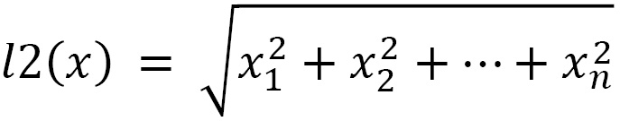
Here, x1, x2, and xn are the values of variables 1, 2, and n for each observation.
Scaling to the unit norm can be used when utilizing kernels to quantify similarity for text classification and clustering. In this recipe, we will implement scaling to vector unit length using scikit-learn.

How to do it...
To begin, we’ll import the required packages, load the dataset, and prepare the train and test sets:
Import the required Python packages, classes, and functions:
import numpy as np import pandas as pd
from sklearn.datasets import fetch_california_housing
from sklearn.model_selection import train_test_split
from sklearn.preprocessing import Normalizer
Let’s load the California housing dataset from scikit-learn into a pandas dataframe:
X, y = fetch_california_housing(
return_X_y=True, as_frame=True)
X.drop(labels=["Latitude", "Longitude"], axis=1, inplace=True)
Let’s divide the data into train and test sets:
X_train, X_test, y_train, y_test = train_test_split(
X,
y,
test_size=0.3,
random_state=0,
)
Let’s set up Normalizer() from scikit-learn to scale each observation to the Manhattan distance or l1:
scaler = Normalizer(norm='l1')
Tip
To normalize utilizing the Euclidean distance, you need to set the norm to l2 using scaler = Normalizer(norm='l2').
Let’s transform the train and test sets; that is, we’ll divide each observation vector by its norm:
X_train_scaled = scaler.fit_transform(X_train)
X_test_scaled = scaler.transform(X_test)
We can calculate the length, that is, the Manhattan distance of each observation vector, using linalg() from NumPy:
np.round(np.linalg.norm(X_train_scaled, ord=1, axis=1), 1)
Tip
You need to set ord=1 for the Manhattan distance or ord=2 for the Euclidean distance as arguments of NumPy’s linalg(), depending on whether you scaled the features to the l1 or l2 norm.
We can see the normalized observation vectors in the following output:
array([1., 1., 1., ..., 1., 1., 1.])
As expected, the feature length for each observation is 1.
Tip
You can compare the output of step 7 with the distance of the unscaled data by executing np.round( np.linalg.norm(X_train, ord=1, axis=1), 1).

How it works...
In this recipe, we scaled the numerical variables of the California housing dataset from scikit-learn to the vector unit norm by utilizing the Manhattan or Euclidean distance. To scale the features, we created an instance of Normalizer() from scikit-learn and set the norm to l1 for the Manhattan distance. For the Euclidean distance, we set the norm to l2. Then, we applied the fit() method, although there were no parameters to be learned, as this normalization procedure depends exclusively on the values of the features for each observation. Finally, with the transform() method, the scaler divided each observation by its norm. This returned a NumPy array with the scaled dataset.

8

Creating New Features
We can create valuable features by combining two or more variables. For example, in finance, the disposable income, which is the total income minus the acquired debt for any one month, might be more predictive of credit risk than just the income. Similarly, the total acquired debt of a person across financial products, such as a car loan, a mortgage, and credit cards, might be more predictive of credit risk than any debt considered individually. In these examples, we used domain knowledge of the data to craft the new variables, and the new variables were created by adding or subtracting existing features.
In some cases, a variable may not have a linear or monotonic relationship with the target, but a polynomial combination might. For example, if our variable has a quadratic relationship with the target, 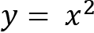, we can convert that into a linear relationship by squaring the original variable. We can also obtain better variable relationships with the target by transforming the variables through splines, or by using decision trees.
In this chapter, we will create new features using multiple mathematical functions that will be applied based on domain knowledge, and then automate feature creation by combining existing features with polynomial functions or decision trees or by creating new features using splines.
This chapter will cover the following recipes:
Combining features with mathematical functions
Comparing features to reference variables
Performing polynomial expansion
Combining features with decision trees
Creating periodic features from cyclical variables
Creating spline features

Technical requirements
In this chapter, we will use the Python libraries pandas, NumPy, Matplotlib, scikit-learn, and Feature-engine.

Combining features with mathematical functions
New features can be created by combining existing variables with mathematical and statistical functions. At the beginning of this chapter, we mentioned that we can calculate the total debt by summing up the debt across individual financial products, as follows:
Total debt = car loan debt + credit card debt + mortgage debt
We can also derive other insightful features using alternative statistical operations. For example, we can determine the maximum debt of a customer across financial products or the average time users have spent on a web page:
maximum debt = max(car loan balance, credit card balance, mortgage balance)
average time on page = mean(time spent user 1, time spent user 2, time spent user 3)
We can, in principle, use any mathematical or statistical operation to create new features, such as the product, mean, standard deviation, or maximum or minimum values, to name a few. In this recipe, we will implement these mathematical operations using pandas and Feature-engine.

Getting ready
In this recipe, we will use the Breast Cancer dataset that comes with scikit-learn, which contains information about the morphology of cell nuclei in tissue samples, and a target indicating whether they are cancerous cells. The features are computed from digitized images of breast cells, and they describe the characteristics of the cell nuclei in those images.
To become familiar with the dataset, run the following commands in a Jupyter Notebook or Python console:
from sklearn.datasets import load_breast_cancer data = load_breast_cancer()print(data.DESCR)
The preceding code block should print out a description of the dataset and an interpretation of its variables.

How to do it...
In this recipe, we will create new features by combining variables using multiple mathematical operations:
Let’s begin by loading the necessary libraries, classes, and data:
import pandas as pd
from feature_engine.creation import MathFeatures from sklearn.datasets import load_breast_cancer
Let’s load the Breast Cancer dataset into a pandas DataFrame:
data = load_breast_cancer()df = pd.DataFrame(data.data, columns=data.feature_names)
In the following code lines, we will create new features by combining variables using multiple mathematical operations.
Let’s begin by creating a list with the subset of features that we want to combine:
features = [
"mean smoothness",
"mean compactness",
"mean concavity",
"mean concave points",
"mean symmetry",
]
The features in step 3 represent the mean characteristics of cell nuclei in the images. It might be useful to obtain the mean across all examined characteristics.
Let’s get the mean value of the features and then display the resulting feature:
df["mean_features"] = df[features].mean(axis=1)
df["mean_features"].head()
The following output shows the mean value of the features:
0 0.21702
1 0.10033
2 0.16034
3 0.20654
4 0.14326
Name: mean_features, dtype: float64
Similarly, to capture the general variability of the cell nuclei, let’s determine the standard deviation of the mean characteristics, and then display the resulting feature:
df["std_features"] = df[features].std(axis=1)
df["std_features"].head()
The following output shows the standard deviation of features:
0 0.080321
1 0.045671
2 0.042333
3 0.078097
4 0.044402
Name: std_features, dtype: float64
Tip
When we craft new features based on domain knowledge, we know exactly how we want to combine the variables. We could also combine features with multiple operations and then evaluate whether they are predictive using, for example, a feature selection algorithm or by deriving feature importance from the machine learning model.
Let’s make a list containing mathematical functions that we want to use to combine the features:
math_func = ["sum", "prod", "mean", "std", "max", "min"]
Now, let’s apply the previous functions to combine the features, and capture the resulting variables in a new DataFrame:
df_t = df[features].agg(math_func, axis="columns")
If we execute df_t.head(), we will see the DataFrame with the newly created features:
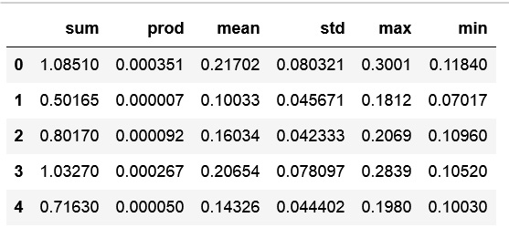
Figure 8.1 – DataFrame with the newly created features
Note
pandas agg can apply multiple functions to combine features. It can take a list of strings with the function names, as we did in step 7, a list of NumPy functions, such as np.log, and also Python functions that you create.
We can create the same features that we created with pandas automatically by using Feature-engine.
Let’s create a list by using the name of the output features:
new_feature_names = ["sum_f", "prod_f", "mean_f", "std_f", "max_f", "min_f"]
Let’s set up the MathFeatures() transformer so that it applies the functions in step 6 to the features from step 3, and names the new features with the strings from step 8:
create = MathFeatures(
variables=features,
func=math_func,
new_variables_names=new_feature_names,
)
Now, let’s create the new features, add them to the original DataFrame, and capture it in a new variable:
df_t = create.fit_transform(df)
We can display the input and output features by executing df_t[features + new_feature_names].head():
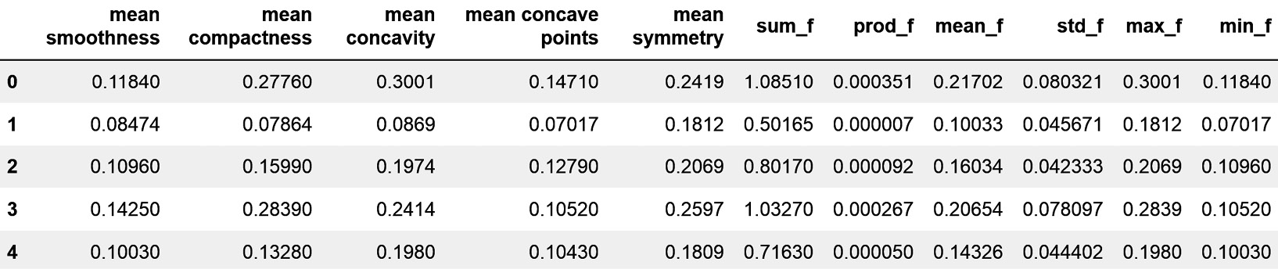
Figure 8.2 – DataFrame with the input features and the newly created variables
While pandas agg returns a DataFrame with the features resulting from the operation, Feature-engine goes one step further, by concatenating the new features to the original DataFrame.

How it works...
The pandas library has plenty of built-in operations to return the desired mathematical and statistical computations over the indicated axis – that is, across the rows or the columns of a DataFrame. In this recipe, we leveraged the power of pandas to create new features from existing ones. First, we made a list containing the names of the features we wanted to combine. Next, we applied those features over a slice of the DataFrame using the pandas mean() and std() methods, though we could apply any of the sum(), prod(), max(), and min() methods. These methods return the mean, standard deviation, sum, product, and maximum and minimum values of those features, respectively. To perform these operations across the columns, we added the axis=1 argument within the methods.
With pandas agg(), we applied several of the mathematical combinations simultaneously. pandas agg() takes, as arguments, a list of strings corresponding to the methods to apply and the axis property that the operations should be applied to, which can be either 1 for columns or 0 for rows. pandas agg() returned a pandas DataFrame with the feature combination as columns.
Finally, we created the same features by combining variables with Feature-engine. We used the MathFeatures() transformer, which takes the features to combine and the functions to apply as input; it also has the option to indicate the names of the new features. When we used fit(), the transformer did not learn parameters but checked that the variables were indeed numerical. transform()used pandas.agg under the hood to apply the mathematical functions to combine the variables.

See also
To find out more about the mathematical operations supported by pandas, go to https://pandas.pydata.org/pandas-docs/stable/reference/frame.html#computations-descriptive-stats.
To learn more about pandas aggregate, go to https://pandas.pydata.org/pandas-docs/stable/reference/api/pandas.DataFrame.aggregate.html.

Comparing features to reference variables
In the previous recipe, Combining features with mathematical functions, we created new features by applying mathematical or statistical functions, such as the sum or the mean, to a group of variables. Some mathematical operations, however, such as subtraction or division, make more sense when performed between two features, or when considering multiple features against one reference variable. These operations are very useful to derive ratios, such as the debt-to-income ratio:
debt-to-income ratio = total debt / total income
Alternatively, we can use them for differences, for example, to calculate disposable income:
disposable income = income - total debt
In this recipe, we will learn how to create new features via subtraction or division while utilizing pandas, and then automate the procedure for multiple variables by using Feature-engine.

How to do it…
Let’s begin by loading the necessary Python libraries and the Breast Cancer dataset from scikit-learn:
Let’s load the necessary libraries, classes, and data:
import pandas as pd
from feature_engine.creation import RelativeFeatures from sklearn.datasets import load_breast_cancer
Let’s load the Breast Cancer dataset into a pandas DataFrame:
data = load_breast_cancer()df = pd.DataFrame(data.data, columns=data.feature_names)
In the Breast Cancer dataset, there are features for capturing the worst and mean characteristics of the cell nuclei of breast cells. For example, for each image, we have the worst compactness observed in all nuclei and the mean compactness of all nuclei. A feature that captures the difference between the worst and the mean value could be predictive of tumor malignancy.
Let’s capture the difference between two features, the worst compactness and mean compactness of cell nuclei, in a new variable and display its values:
df["difference"] = df["worst compactness"].sub(df["mean compactness"])
df["difference"].head()
In the following code block, we can see the values of the difference between the features:
0 0.38800
1 0.10796
2 0.26460
3 0.58240
4 0.07220
Name: difference, dtype: float64
Note
We can perform the same calculation by executing df["difference"] = df["worst compactness"] - (df["mean compactness"]).
Similarly, the ratio between the worst and the average characteristic of the cell nuclei might be indicative of malignancy.
Now, let’s create a new feature with the ratio between the worst and mean radius of the nuclei, and then display its values:
df["quotient"] = df["worst radius"].div(
df["mean radius"])
df["quotient"].head()
In the following code block, we can see the values of the ratio between the features:
0 1.410784
1 1.214876
2 1.197054
3 1.305604
4 1.110892
Name: quotient, dtype: float64
Note
We can calculate the ratio by executing an alternative command – that is, df["quotient"] = df["worst radius"] / (df["mean radius"]).
We can also capture the ratio of every nuclei morphology characteristic and the mean radius or mean area of the nuclei. Let’s begin by capturing these subsets of variables into lists.
Make a list of the features in the numerator:
features = ["mean smoothness",
"mean compactness", "mean concavity",
"mean symmetry"]
Make a list of the features in the denominator:
reference = ["mean radius", "mean area"]
Note
We can create features by dividing all of the features in step 5 with one of the features in step 6 with pandas by executing df[features].sub(df["mean radius"]).
Let’s set up Feature-engine’s RelativeFeatures() so that it subtracts or divides every feature from step 5 against the features from step 6:
creator = RelativeFeatures(
variables=features,
reference=reference,
func=["sub", "div"],
)
Note
Subtracting the features from step 5 and step 6 does not make biological sense, but we will do it anyway to demonstrate the power of the RelativeFeatures() transformer.
Let’s add the new features to the DataFrame and capture it in a new variable:
df_t = creator.fit_transform(df)
Let’s capture the names of the new features in a list:
new_features = [
f for f in df_t.columns if f not in creator.feature_names_in_}
Tip
The feature_names_in_ attribute is a fairly new attribute that’s now available in most scikit-learn transformers and all Feature-engine transformers and stores the name of the variables in the DataFrame that were used to fit the transformer. When using transform() over a DataFrame, the transformers will check that the features match those used in the training set while using this attribute.
If we execute print(new_features), we will see a list containing the names of the features after the combinations. Note that the features contain the variables on the left- and right-hand sides of the equation, plus the function that was applied to them to create the new feature:
['mean smoothness_sub_mean radius',
'mean compactness_sub_mean radius',
'mean concavity_sub_mean radius',
'mean symmetry_sub_mean radius',
'mean smoothness_sub_mean area',
'mean compactness_sub_mean area',
'mean concavity_sub_mean area',
'mean symmetry_sub_mean area',
'mean smoothness_div_mean radius',
'mean compactness_div_mean radius',
'mean concavity_div_mean radius',
'mean symmetry_div_mean radius',
'mean smoothness_div_mean area',
'mean compactness_div_mean area',
'mean concavity_div_mean area',
'mean symmetry_div_mean area']
Finally, we can display the first five rows of the resulting variables by executing df_t[new_features].head():
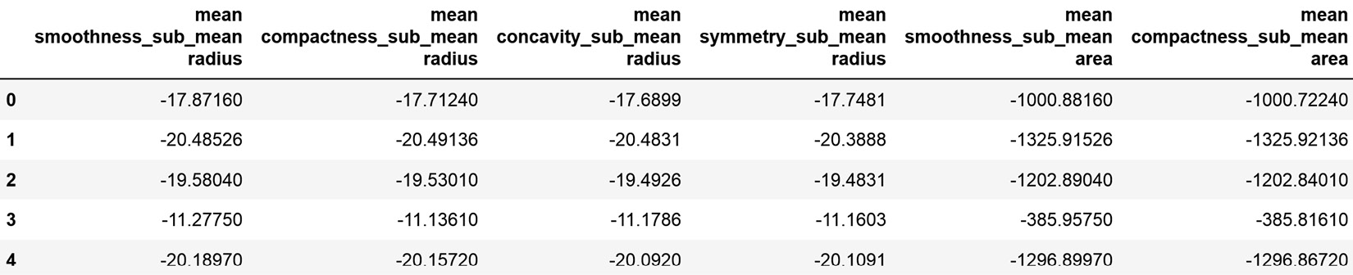
Figure 8.3 – DataFrame with the newly created features
Feature-engine adds new features at the back of the original DataFrame and automatically adds variable names to those features. By doing so, Feature-engine automates much of the manual work that we would do with pandas.

How it works...
The pandas library has plenty of built-in operations to compare one feature or a subset of features to a single reference variable. In this recipe, we used the pandas sub() and div() methods to determine the difference or the ratio between two variables or a subset of variables and one reference feature.
To subtract one variable from another, we applied the sub() method to a pandas Series with the first variable, passing the second pandas Series with the second variable within the method, which returned a third pandas Series with the second variable subtracted from the first one. To divide one variable from another, we used the div() method, which works identically – that is, it divides the variable on the left by the variable passed as an argument of div().
Next, we combined several variables with two reference variables automatically via subtraction or division by utilizing the ReferenceFeatures() transformer from Feature-engine. ReferenceFeatures() takes the variables to combine, the reference variables, and the functions to use to combine the former with the latter. When using fit(), the transformer did not learn parameters but checked that the variables were numerical. transform() added the new features to the DataFrame.
Note
ReferenceFeatures() can also add, multiply, get the module, or get the power of a group of variables by a group of reference variables. You can find out more in its documentation: https://feature-engine.readthedocs.io/en/latest/api_doc/creation/RelativeFeatures.html.

See also
To learn more about the binary operations supported by pandas, go to https://pandas.pydata.org/pandas-docs/stable/reference/frame.html#binary-operator-functions.

Performing polynomial expansion
Existing variables can be combined to create new insightful features. We discussed how to combine variables using mathematical and statistical operations in the previous two recipes, Combining features with mathematical functions and Combining features to reference variables. A combination of one feature with itself – that is, a polynomial combination of the same feature – can also return more predictive features. For example, in cases where the target has a quadratic relation with a variable, creating a second-degree polynomial of the feature allows us to use it in a linear model, as shown in the following figure:
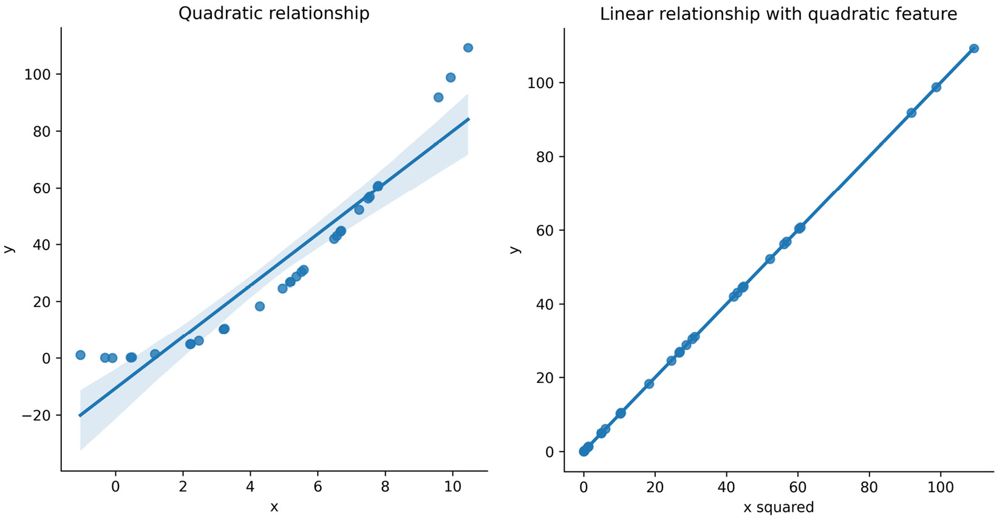
Figure 8.4 – Change in the relationship between a target and a predictor variable after squaring the values of the latter
In the plot on the left, due to the quadratic relationship between the target, y, and the variable, x, there is a poor linear fit. Yet, in the plot on the right, we appreciate how the x_squared variable, which is a quadratic combination of x, shows a linear relationship with the target, y, and therefore improves the performance of the linear model, which predicts y from x_squared.
With similar logic, polynomial combinations of the same or different variables can return new variables that convey additional information and capture feature interaction and can, therefore, result in useful inputs for our linear models. We can create polynomial variables automatically using scikit-learn, and, in this recipe, we will learn how to do so.

Getting ready
Polynomial expansion serves to automate the creation of new features, capture feature interaction, and capture potential non-linear relationships between the original variables and the target. To create polynomial features, we need to determine which features to combine and which polynomial degree to use.
Note
High polynomial degrees or a large number of features to combine will return an enormous number of new features. High polynomial degrees may also result in overfitting.
The PolynomialFeatures() transformer from scikit-learn creates polynomial combinations of the features with a degree less than or equal to the specified degree, automatically. To follow up easily with this recipe, let’s understand the output of the PolynomialFeatures() transformer from scikit-learn, when used to create second- and third-degree polynomial combinations of three variables.
Second-degree polynomial combinations of three variables – a, b, and c – will return the following new features:
1, a, b, c, ab, ac, bc, a2, b2, c2
From the previous features, a, b, and c are the original variables; ab, ac, and bc are the products of those features; and a2, b2, and c2 are the squared values of the original features. The PolynomialFeatures() transformer also returns the bias term 1, which we would probably exclude when creating features.
Tip
The resulting features – ab, ac, and bc – are called interactions or feature interactions of degree 2. The degree reflects the number of variables combined. The result combines a maximum of two variables because we indicated a second-degree polynomial as the maximum allowed combination.
Third-degree polynomial combinations of the three variables – a, b, and c – will return the following new features:
1, a, b, c, ab, ac, bc, abc, a2b, a2c, b2a, b2c, c2a, c2b, a3, b3, c3
Among the returned features, in addition to those returned by the second-degree polynomial combination, we now have the third-degree combinations of the features with themselves (a3, b3, and c3); the squared values of every feature combined linearly with a second feature (a2b, a2c, b2a, b2c, c2a, and c2b); and the product of the three features (abc). Note how we have all possible interactions of degrees 1, 2, and 3 and the bias term 1.
Now that we understand the output of the polynomial expansion, let’s jump into the recipe.

How to do it...
In this recipe, we will create features via polynomial expansion using a toy dataset so that we become familiar with the returned variables. Creating features via polynomial expansion of a real dataset is identical to what we will discuss in this recipe. Follow these steps:
Let’s import the required libraries, classes, and data:
import numpy as np
import pandas as pd
import matplotlib.pyplot as plt
from sklearn.preprocessing import PolynomialFeatures
Let’s create a DataFrame containing one variable with values from 1 to 10:
df = pd.DataFrame(np.linspace(0, 10, 11), columns=["var"])
Let’s set up the transformer to create all possible combinations up to a third-degree polynomial of the single variable and exclude the bias term from the result – that is, we will exclude the value 1:
poly = PolynomialFeatures(
degree=3,
interaction_only=False,
include_bias=False)
Now, let’s create the polynomial combinations and display the result:
dft = poly.fit_transform(df)
dft
The new features are returned in a NumPy array, where we can see the original feature followed by its values squared and then its values to the power of three:
array([[ 0., 0., 0.],
[ 1., 1., 1.],
[ 2., 4., 8.],
[ 3., 9., 27.],
[ 4., 16., 64.],
[ 5., 25., 125.],
[ 6., 36., 216.],
[ 7., 49., 343.],
[ 8., 64., 512.],
[ 9., 81., 729.],
[ 10., 100., 1000.]])
We can obtain the name of the new features as follows:
poly.get_feature_names_out()
The previous command returns the names of the new features, where ^ indicates the degree of the polynomial combination:
array(['var', 'var^2', 'var^3'], dtype=object)
Now, let’s capture the array from step 4 in a pandas DataFrame, add the feature names from step 5 as column names, and plot the new feature values against the original variable:
dft = pd.DataFrame(
dft, columns=poly.get_feature_names_out())
plt.plot(df["var"], dft)
plt.legend(dft.columns)
plt.xlabel("original variable")
plt.ylabel("new variables")
plt.show()
Here, we can see the relationship that the polynomial features have with the original feature values:
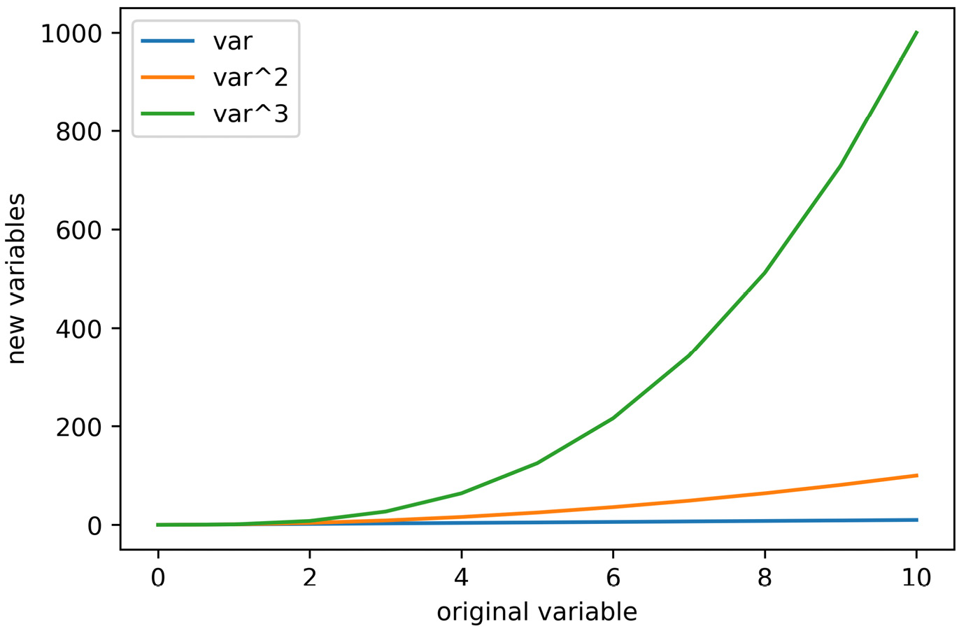
Figure 8.5 – Relationship between the polynomial expansion features and the original variable values
Let’s add two additional variables to our toy dataset, with values from 1 to 10:
df["col"] = np.linspace(0, 5, 11)
df["feat"] = np.linspace(0, 5, 11)
Next, let’s combine the three features in the dataset with polynomial expansion up to the second degree, but this time, we will only return features produced by combining at least two different variables:
poly = PolynomialFeatures(
degree=2, interaction_only=True, include_bias=False)
dft = poly.fit_transform(df)
Let’s capture the feature combinations in a DataFrame and add the feature names:
dft = pd.DataFrame(
dft, columns=poly.get_feature_names_out()
)
If we execute df, we will see the features resulting from the polynomial expansion, which contain the original features plus all possible combinations of the three variables:
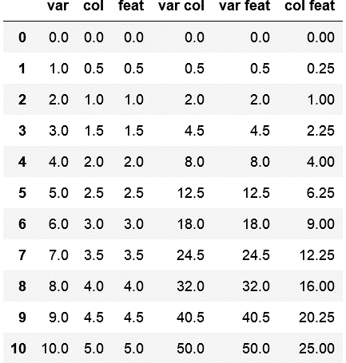
Figure 8.6 – DataFrame with the original features plus all possible combinations of two features
Tip
Go ahead and create third-degree polynomial combinations of the features, returning only the interactions or all possible features to get a better sense of the output of PolynomialFeatures().
With that, we’ve learned how to expand the feature space by combining existing features either with themselves or with other features in the data. Creating features via polynomial expansion using a real dataset is, in essence, identical. If we want to combine only a subset of the features, we can select the features to combine by utilizing ColumnTransformer().

How it works...
In this recipe, we created new features by using polynomial combinations of three variables in a toy dataset. To create these polynomial features, we used the PolynomialFeatures() transformer from scikit-learn, which generates a new feature matrix consisting of all polynomial combinations of the indicated features with a degree less than or equal to the specified degree, by default. By setting degree to 3, we were able to create all possible polynomial combinations of degree 3 or smaller. To retain all of the terms of the expansion, we set interaction_only to False. To avoid returning the bias term, we set the include_bias parameter to False.
Note
Setting the interaction_only term to True only returns the interaction terms – that is, the variables that contain combinations of two or more variables.
The fit() method learned all of the possible feature combinations based on the parameters specified. At this stage, the transformer did not perform actual mathematical computations. The transform() method performed the mathematical computations with the features to create the new variables. With the get_feature_names() method, we could identify the terms of the expansion – that is, how each new feature was calculated.

There’s more...
Now, let’s create features by performing polynomial expansion on a subset of variables in the Breast Cancer dataset:
Let’s import the necessary libraries, classes, and data:
import pandas as pd
from sklearn.datasets import load_breast_cancer
from sklearn.compose import ColumnTransformer
from sklearn.model_selection import train_test_split
from sklearn.preprocessing import PolynomialFeatures
Let’s load the data and separate it into train and test sets:
data = load_breast_cancer()
df = pd.DataFrame(data.data, columns=data.feature_names)
X_train, X_test, y_train, y_test = train_test_split(
df, data.target, test_size=0.3, random_state=0
)
Let’s make a list with the features to combine:
features = ["mean smoothness", "mean compactness", "mean concavity"]
Let’s set up the transformer to create all possible combinations up to the third degree:
poly = PolynomialFeatures(
degree=3, interaction_only=False, include_bias=False)
Let’s set up the column transformer to create features only from those specified in step 3:
ct = ColumnTransformer([("poly", poly, features)])
Let’s create the polynomial features:
train_t = ct.transform(X_train)
test_t = ct.transform(X_test)
And that’s it. By executing ct.get_feature_names_out(), we obtain the names of the new features. By executing test_t = pd.DataFrame(test_t, columns=ct.get_feature_names_out()) we capture the features in a DataFrame; then, we can display their values with pandas.head().

See also
To learn more about PolynomialFeatures() from scikit-learn, go to https://scikit-learn.org/stable/modules/generated/sklearn.preprocessing.PolynomialFeatures.html.
You can use the Python gplearn package to automatically map out other relationships between the variables and the target: https://gplearn.readthedocs.io/en/stable/intro.html.

Combining features with decision trees
In the winning solution of the KDD competition in 2009, the authors created new features by combining two or more variables using decision trees. When examining the variables, they noticed that some features had a high level of mutual information with the target yet low correlation, indicating that the relationship with the target was not monotonic. While these features were predictive when used in tree-based algorithms, linear models could not take advantage of them. Hence, to use these features in linear models, they replaced the features with the outputs of decision trees trained on the individual features, or combinations of two or three variables, to return new features with a monotonic relationship with the target.
So, in short, combining features with decision trees is particularly useful for deriving features that are monotonic with the target, which is convenient for linear models. The procedure consists of training a decision tree using a subset of the features – typically one, two, or three at a time – and then using the prediction of the tree as a new feature.
In this recipe, we will learn how to create new features with decision trees using pandas and scikit-learn.

Getting ready
You can find more details about this procedure and the overall winning solution of the 2009 KDD data competition in this article: http://proceedings.mlr.press/v7/niculescu09/niculescu09.pdf.
In this recipe, we will combine two features of the California Housing dataset, and then evaluate the relationship between the original and new features with the target to understand more about the intended output of this feature engineering technique.

How to do it...
Let’s begin by importing the required libraries and getting the dataset ready:
Import pandas and the required functions, classes, and datasets from scikit-learn:
import numpy as np
import pandas as pd
import matplotlib.pyplot as plt
from sklearn.datasets import fetch_california_housing
from sklearn.model_selection import train_test_split
from sklearn.tree import DecisionTreeRegressor
from sklearn.model_selection import GridSearchCV
Let’s load the California Housing dataset and its target into a pandas DataFrame:
X, y = fetch_california_housing(
return_X_y=True, as_frame=True)
Let’s separate the dataset into train and test sets:
X_train, X_test, y_train, y_test = train_test_split(X, y, test_size=0.3, random_state=0)
Note
Remember to set random_state, as indicated in step 3, for reproducibility.
In the following lines, we are going to create a new feature from two variables in the dataset using a decision tree. We are going to build this decision tree within GridSearch() so that we can optimize the tree’s depth.
Let’s create a dictionary with the parameter to optimize and a few of the potential values it can take:
param_grid = {"max_depth ": [2, 3, 4, None]}
Note
To find out which other parameters you can optimize, go to https://scikit-learn.org/stable/modules/generated/sklearn.tree.DecisionTreeRegressor.html.
Let’s set up the decision tree within a scikit-learn GridSearch() with five-fold cross-validation, add the dictionary with the parameter to optimize that we created in step 4, and indicate that we want to optimize the mean squared error of the model:
tree_model = GridSearchCV(
DecisionTreeRegressor(random_state=0),
cv=5,
scoring="neg_mean_squared_error",
param_grid=param_grid,
)
Note
We are using DecisionTreeRegressor() from scikit-learn because the target in this dataset is continuous. If you have a binary target or are performing classification, use DecisionTreeClassifier() instead. Note that you will have to change the scoring metric to one permitted for classification.
Let’s make a list containing the variables we want to combine:
variables = ["AveRooms", "AveBedrms"]
Now, let’s train the decision tree using the selected features:
tree_model.fit(X_train[variables], y_train)
Let’s add the new feature that’s returned by the decision tree in the train and test sets:
X_train["new_feat"] = tree_model.predict(
X_train[variables])
X_test["new_feat"] = tree_model.predict(
X_test[variables])
With that, we have created a new feature by combining the information of two existing features using a decision tree. Let’s explore the relationship between the original and new features with the target.
Let’s make a scatter plot of each feature individually against the target, and then the new feature against the target, and display them side by side. The y-axis, which will contain the values of the target variable, will be the same for all plots:
fig, axs = plt.subplots(1, 3, figsize=(12, 4), sharey=True)
axs[0].scatter(X_test["AveRooms"], y_test)
axs[0].set_ylabel("House price")
axs[0].set_xlabel("AveRooms")
axs[1].scatter(X_test["AveBedrms"], y_test)
axs[1].set_xlabel("AveBedrms")
axs[2].scatter(X_test["new_feat"], y_test)
axs[2].set_xlabel("new_feat")
plt.show()
We can begin to appreciate the monotonic relationship between the new variable and the target in the right-hand plot, where there isn’t a clear relationship between the original features and the target:
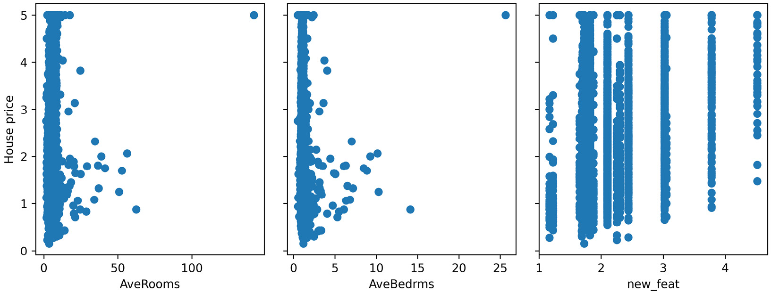
Figure 8.7 – Scatter plots between the original or new variables and the target
Finally, let’s print out the correlation between the original features and the new variable with the target:
for var in variables + ["new_feat"]:
corr = np.corrcoef(X_test[var], y_test)[0, 1]
corr = np.round(corr, 3)
print(f"Correlation between {var} and the target:
{corr}")
As shown in the following output, the new feature has a higher correlation with the target, so it should be more predictive when used in linear models:
Correlation between AveRooms and the target: 0.141
Correlation between AveBedrms and the target: -0.033
Correlation between new_feat and the target: 0.466
I hope I have given you a flavor of the power of combining features with decision trees and how to do so using Python and scikit-learn.

How it works...
In this recipe, we combined two variables into a new feature while utilizing a decision tree. We loaded the dataset from scikit-learn and then separated the data into train and test sets using the train_test_split() function. Next, we created a dictionary with the decision tree parameter to optimize as the key, and a list of the values to examine as values.
Next, we created an instance of a decision tree for regression by using DecisionTreeRegressor() from scikit-learn inside GridSearch(), indicating the cross-validation fold, the metric to optimize, and the dictionary with the parameters and values to examine. Next, we fit the decision tree using the two variables that we wanted to combine, and, finally, with the predict() method, we obtained the predictions derived by the tree from those two features, which we captured as a new feature in the DataFrame.
Then, we compared the relationship of the original or new feature with the target through scatter plots and by evaluating their correlation.

Creating periodic features from cyclical variables
Some features are periodic, for example, the hours in a day, the months in a year, and the days in a week. They all start at a certain value, say January, go up to a certain other value, say December, and then start over from the beginning. Some features are numeric, such as the hours, and some can be represented with numbers, such as the months, with values of 1 to 12. Yet, this numeric representation does not capture the periodicity or cyclical nature of the variable. For example, December (12) is closer to January (1) than June (6); however, this relationship is not captured by the numerical representation of the feature. But we could change it if we transformed these variables with sine and cosine, two naturally periodic functions.
Encoding cyclical features with the sine and cosine functions allows linear models to leverage the cyclical nature of features and reduce their modeling error. In this recipe, we will create new features from periodic variables that capture the cyclical nature of the feature.

Getting ready
Trigonometric functions, such as sine and cosine, are periodic, with values cycling between -1 and 1 every 2π cycles:
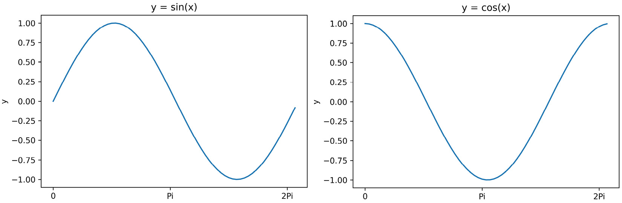
Figure 8.8 – Sine and cosine functions
We can capture the periodicity of a cyclical variable by applying a trigonometric transformation after normalizing the variable values between 0 and 2π:
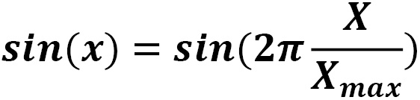
Dividing the variable’s values by its maximum will normalize it between 0 and 1, whereas multiplying it by 2π will rescale the variable between 0 and 2π.
Should we use sine? Or should we use cosine? The thing is, we need to use both to encode all the values of the variables unequivocally. Since sine and cosine circle between 0 and 1, they will take a value of 0 for more than 1 value of x. For example, the sine of 0 returns 0, and so does the sine of π. So, if we encode a variable with just the sine, we wouldn’t be able to distinguish between the values 0 and π anymore. However, because the sine and the cosine are out of phase, the cosine of 0 returns 1, whereas the cosine of π returns -1. Hence, by encoding the variable with the two functions, we are now able to distinguish between 0 and 1, which would take (0,1) and (0,-1) as values for the sine and cosine functions, respectively.

How to do it…
In this recipe, first, we will transform the hour variable in a toy DataFrame with the sine and the cosine to get a sense of the new variable representation. Then, we will automate feature creation from multiple cyclical variables using Feature-engine:
Let’s begin by importing the necessary libraries:
import numpy as np
import pandas as pd
import matplotlib.pyplot as plt
Let’s create a toy DataFrame with one variable – hour – with values between 0 and 23:
df = pd.DataFrame([i for i in range(24)], columns=["hour"])
Next, we will create two features using the sine and cosine transformations, after normalizing the variable values between 0 and 2π:
df["hour_sin"] = np.sin(
df["hour"] / df["hour"].max() * 2 * np.pi)
df["hour_cos"] = np.cos(
df["hour"] / df["hour"].max() * 2 * np.pi)
If we execute df.head(), we will see the original and new features:
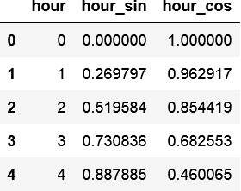
Figure 8.9 – DataFrame with the hour variable and the new features obtained by the sine and cosine transformations
Let’s make a scatter plot between the hour and its sine-transformed values:
plt.scatter(df["hour"], df["hour_sin"])
plt.ylabel("Sine of hour")
plt.xlabel("Hour")
plt.title("Sine transformation")
In the following plot, we can see how the values of the hour circle between -1 and 1, just like the sine function after the transformation:
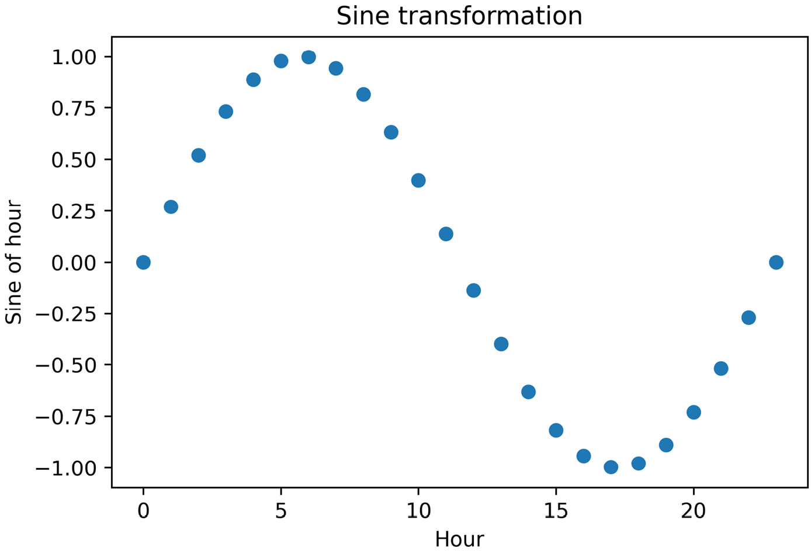
Figure 8.10 – Scatter plot of the hour versus its sine transformed values
Now, let’s make a scatter plot between the hour and its cosine transformation:
plt.scatter(df["hour"], df["hour_cos"])
plt.ylabel("Cosine of hour")
plt.xlabel("Hour")
plt.title("Cosine transformation")
In the following plot, we can see how the values of the hour circle between -1 and 1, just like the cosine function after the transformation:
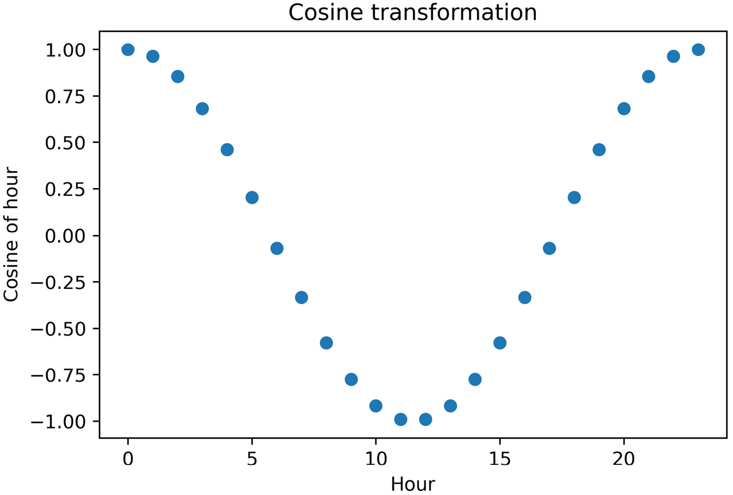
Figure 8.11 – Scatter plot of the hour versus its cosine-transformed values
Finally, we can reconstitute the cyclical nature of the hour, which is now captured by the two new features.
Let’s plot the values of the sine versus the cosine of the hour and overlay the original values of the hour on a color map:
fig, ax = plt.subplots(figsize=(7, 5))
sp = ax.scatter(df["hour_sin"], df["hour_cos"], c=df["hour"])
ax.set(
xlabel="sin(hour)",
ylabel="cos(hour)",
)
_ = fig.colorbar(sp)
In the following plot, we can see how the two trigonometric transformations of the hour reflect the cyclical nature of the hour, in a plot that reminds us of a clock:
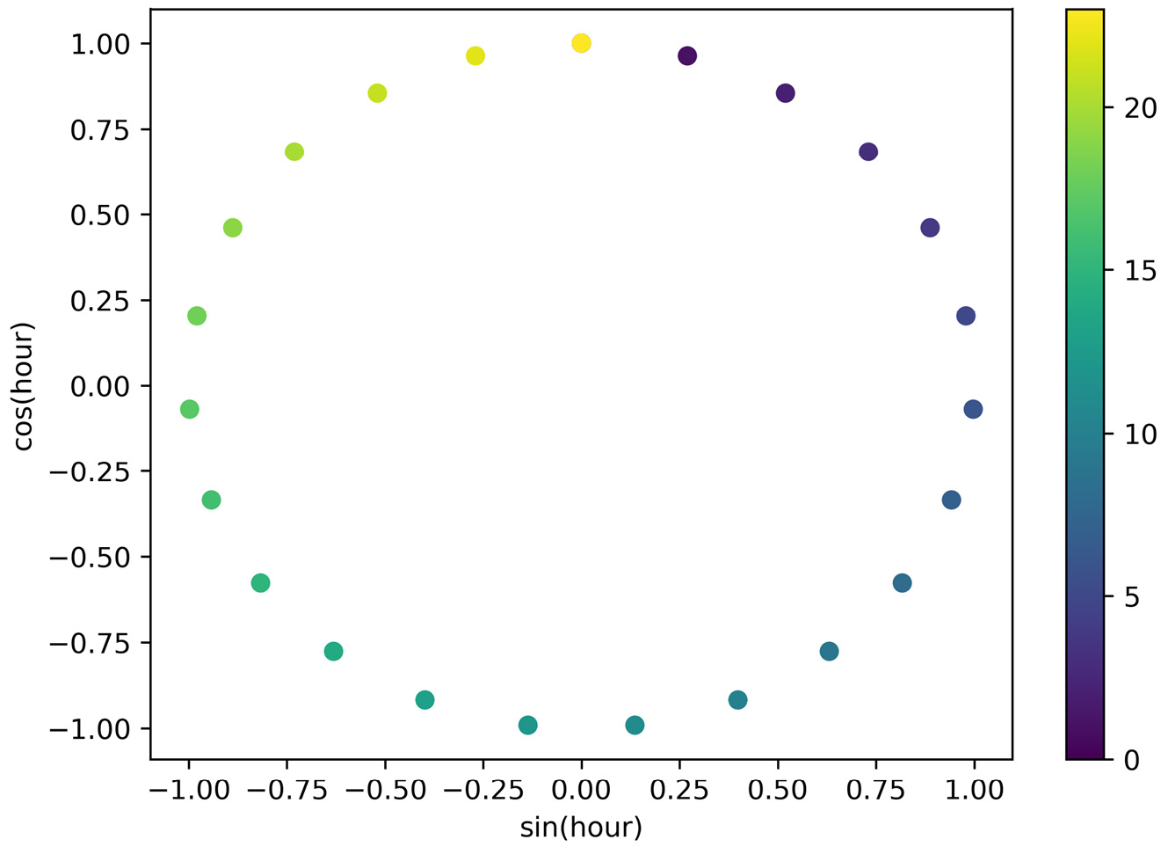
Figure 8.12 – Scatter plot of the trigonometric transformation of the hour
Note
The code implementation and idea for this plot were taken from scikit-learn’s documentation: https://scikit-learn.org/stable/auto_examples/applications/plot_cyclical_feature_engineering.html#trigonometric-features.
Now that we understand the nature and effect of the transformation, let’s create new features using the sine and cosine transformations from multiple variables automatically. We will use Feature-engine’s CyclicalFeatures.
Let’s import CyclicalFeatures:
from feature_engine.creation import CyclicalFeatures
Let’s create a toy DataFrame that contains the hour, month, and week variables, whose values vary between 0 and 24, 1 and 12, and 0 and 6, respectively:
df = pd.DataFrame()
df["hour"] = pd.Series([i for i in range(24)])
df["month"] = pd.Series([i for i in range(1, 13)]*2)
df["week"] = pd.Series([i for i in range(7)]*4)
Now, if we execute df.head(), we will see the first five rows of the toy DataFrame:
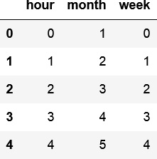
Figure 8.13 – Toy DataFrame with three cyclical features
Let’s set up the transformer so that it creates the sine and cosine features from these variables:
cyclic = CyclicalFeatures(
variables=None,
drop_original=False,
)
Note
By setting variables to None, the transformer will create the trigonometric features from all numerical variables. Alternatively, we can pass the subset of cyclical variables in a list. We can retain or drop the original variables after creating the cyclical features using the drop_original parameter.
To finish, let’s add the features to the DataFrame and capture it in a new variable:
dft = cyclic.fit_transform(df)
Now, if we execute dft.head(), we will see the original and new features:
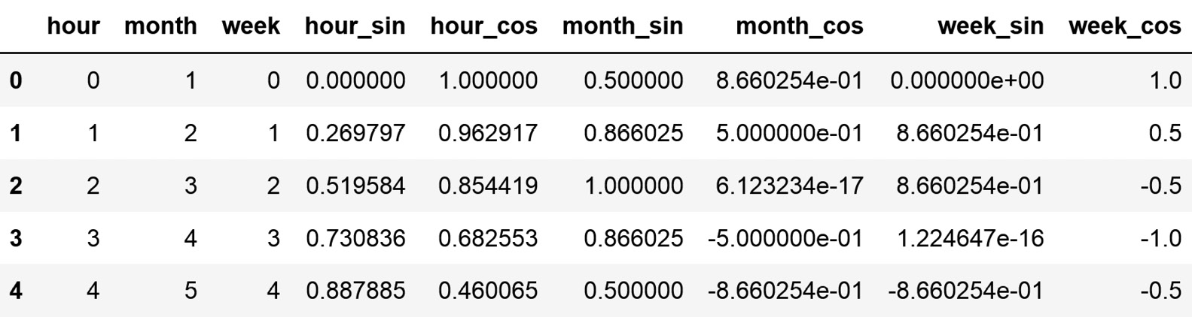
Figure 8.14 – DataFrame with cyclical features plus the features created through the sine and cosine functions
And that’s it – we’ve created features by using the sine and cosine transformation automatically from multiple variables and added them directly to the original DataFrame.

How it works…
In this recipe, we encoded cyclical features by values obtained from the sine and cosine functions applied to the normalized values of the variable. First, we normalized the variable values between 0 and 2 π. To do this, we divided the variable values by the variable maximum value, which we obtained with pandas.max(), to scale the variables between 0 and 1. Next, we multiplied those values by 2π, using numpy.pi. Finally, we used np.sin and np.cos to apply the sine and cosine transformations, respectively.
To automate these procedures for multiple variables, we used Feature-engine’s CyclicalFeatures. With fit(), the transformer learned the maximum values of each variable, and with transform(), it added the features resulting from the sine and cosine transformations to the DataFrame.

See also
More details about cyclical features can be found in Feature-engine’s documentation: https://scikit-learn.org/stable/modules/generated/sklearn.tree.DecisionTreeRegressor.html.

Creating spline features
Linear models expect a linear relationship between the predictor variables and the target. However, we can use linear models to model non-linear effects if we first transform the features. In the Performing polynomial expansion recipe, we saw how we can unmask linear patterns by creating features with polynomial functions. In this recipe, we will discuss the use of splines.
Splines are used to mathematically reproduce flexible shapes. They consist of piecewise low-degree polynomial functions. To create splines, we must place knots at several values of x within its value range. These knots indicate where the pieces of the function join together. Then, we fit low-degree polynomials to the data between two consecutive knots.
There are several types of splines, such as smoothing splines, regression splines, and B-splines. scikit-learn supports the use of B-splines to create features. The procedure to fit and therefore return the spline values for a certain variable based on a polynomial degree and the number of knots exceeds the scope of this recipe. For more details, check out the resources in the See also section of this recipe. In this recipe, we’ll get a sense of what splines are and how we can use them to improve the performance of linear models.

Getting ready
Let’s get a sense of what splines are. In the following figure, on the left, we can see a spline of degree 1. It consists of two linear pieces – one from 2.5 to 5 and the other from 5 to 7.5. There are three knots: 2.5, 5, and 7.5. And outside the interval of 2.5 to 7.5, the spline takes a value of 0. The latter is characteristic of splines; they are only non-negative between certain values. On the right-hand side of the figure, we can see three splines of degree 1. We can construct as many splines as we want by introducing more knots:
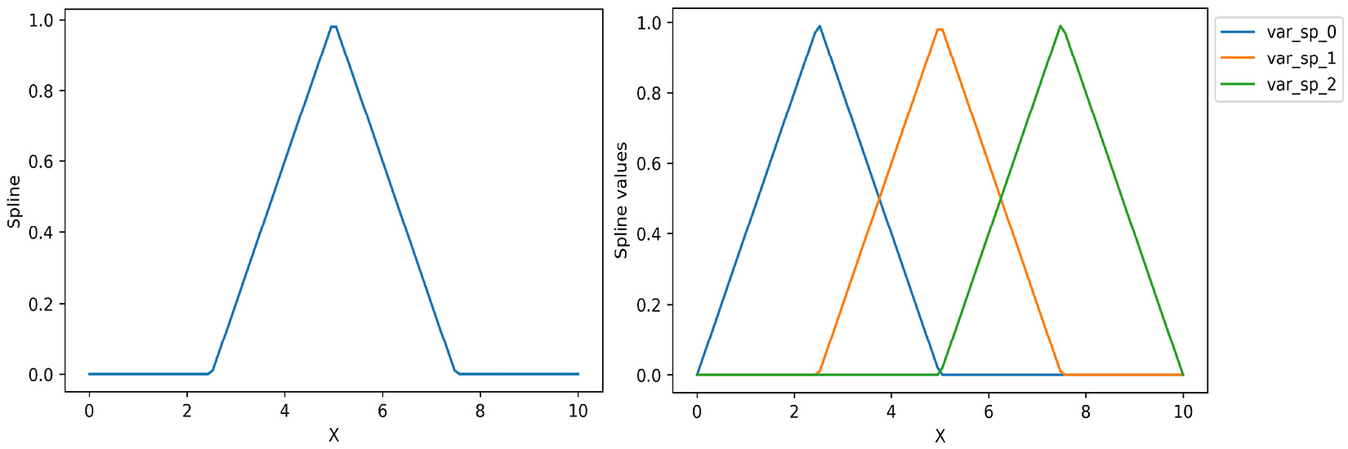
Figure 8.15 – Splines of degree 1
In the following figure, on the left, we can see a quadratic spline, also known as a spline of degree 2. It is based on four adjacent knots: 0, 2.5, 5, and 7.5. On the right-hand side of the figure, we can see several splines of degree 2:
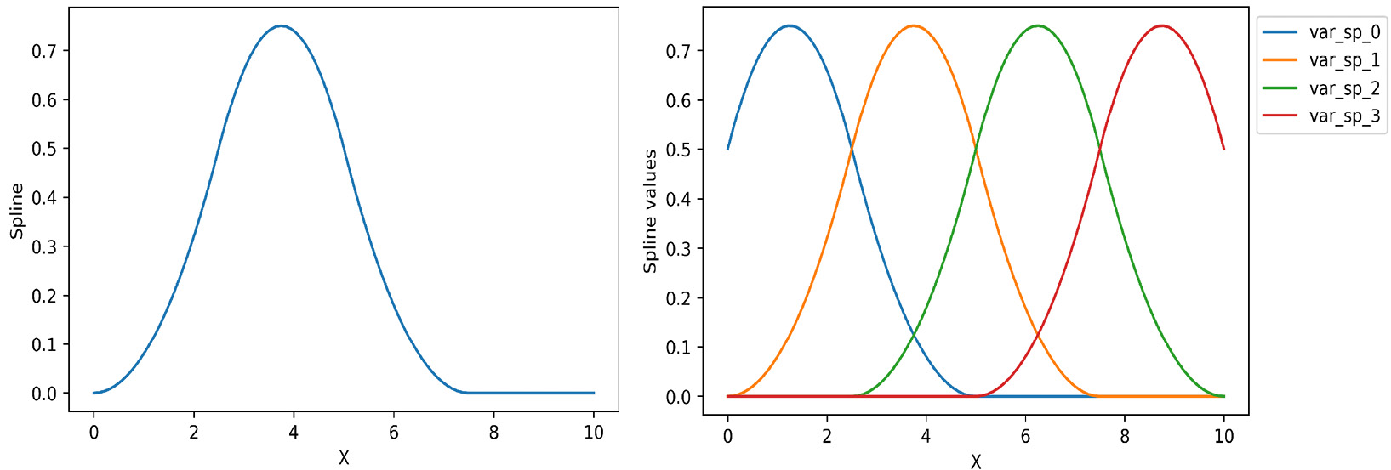
Figure 8.16 – Splines of degree 2
We can use splines to model non-linear functions and we will learn how to do this in the next section.

How to do it…
In this recipe, we will use splines to model the sine function. Once we have gotten a sense of what splines are and how we can use them to fit non-linear covariates through a linear model, we will use splines for regression in a real dataset:
Note
The idea to model the sine function with splines was taken from scikit-learn’s documentation: https://scikit-learn.org/stable/auto_examples/linear_model/plot_polynomial_interpolation.html.
Let’s begin by importing the necessary libraries and classes:
import numpy as np
import pandas as pd
import matplotlib.pyplot as plt
from sklearn.linear_model import Ridge
from sklearn.preprocessing import SplineTransformer
Let’s create a training set, X, with 20 values between -1 and 11, and the target variable, y, which is the sine of X:
X = np.linspace(-1, 11, 20)
y = np.sin(X)
Let’s plot the relationship between X and y:
plt.plot(X, y)
plt.ylabel("y")
plt.xlabel("X")
In the following plot, we can see the sine function of X:
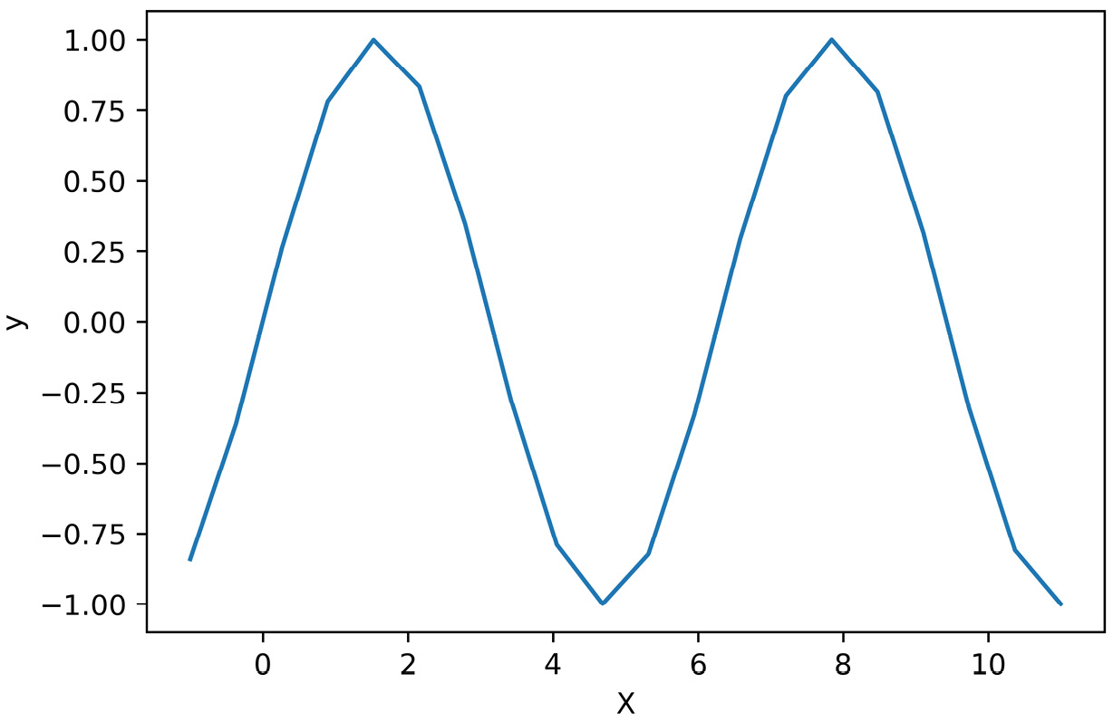
Figure 8.17 – Relationship between the predictor and the target variable
Let’s fit a linear model to predict y from X by utilizing Ridge regression, and then obtain the predictions of the model:
linmod = Ridge(random_state=10)
linmod.fit(X.reshape(-1, 1), y)
pred = linmod.predict(X.reshape(-1, 1))
Now, let’s plot the relationship between X and y, and overlay the predictions:
plt.plot(X, y)
plt.plot(X, pred)
plt.ylabel("y")
plt.xlabel("X")
plt.legend(["y", "linear"], bbox_to_anchor=(1, 1), loc="upper left")
In the following figure, we can see that the linear model returned a very poor fit of the non-linear relationship between X and y:
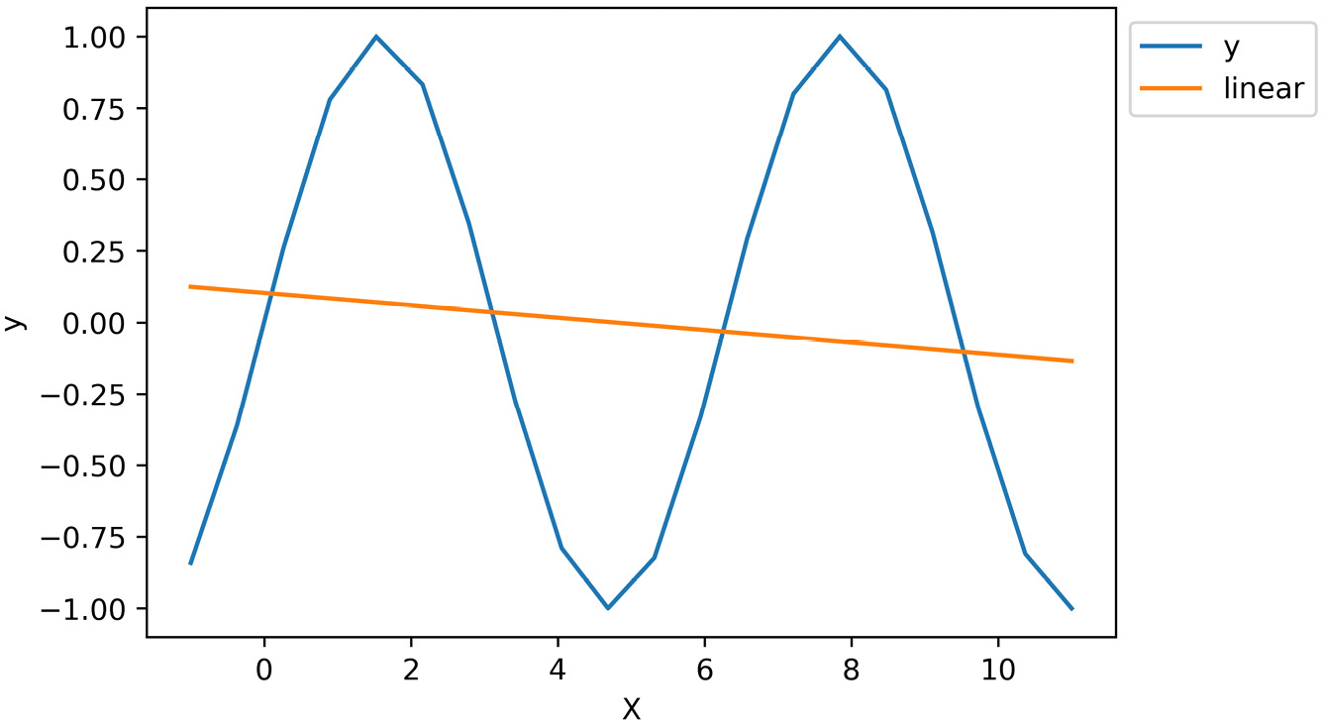
Figure 8.18 – The linear fit between X and y
Now, let’s set up SplineTransformer to obtain spline features from X by utilizing third-degree polynomials and five knots at equidistant places within the values of X:
spl = SplineTransformer(degree=3, n_knots=5)
Let’s obtain the spline features and convert the NumPy array into a pandas DataFrame, adding the names of the spline basis functions:
X_t = spl.fit_transform(X.reshape(-1, 1))
X_df = pd.DataFrame(
X_t, columns = spl.get_feature_names_out(
["var"]
)
)
By executing X_df.head(), we can see the spline features:
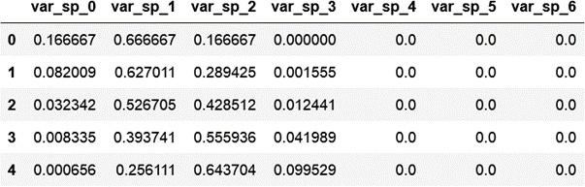
Figure 8.19 – DataFrame with the splines
Note
SplineTransformer returns a new feature matrix of features consisting of n_splines = n_knots + degree – 1.
Now, let’s plot the splines against the values of X:
plt.plot(X, X_t)
plt.legend(
spl.get_feature_names_out(["var"]),
bbox_to_anchor=(1, 1),
loc="upper left")
plt.xlabel("X")
plt.ylabel("Splines values")
plt.title("Splines")
plt.show()
In the following figure, we can see the relationship between the different splines and the values of the predictor variable, X:
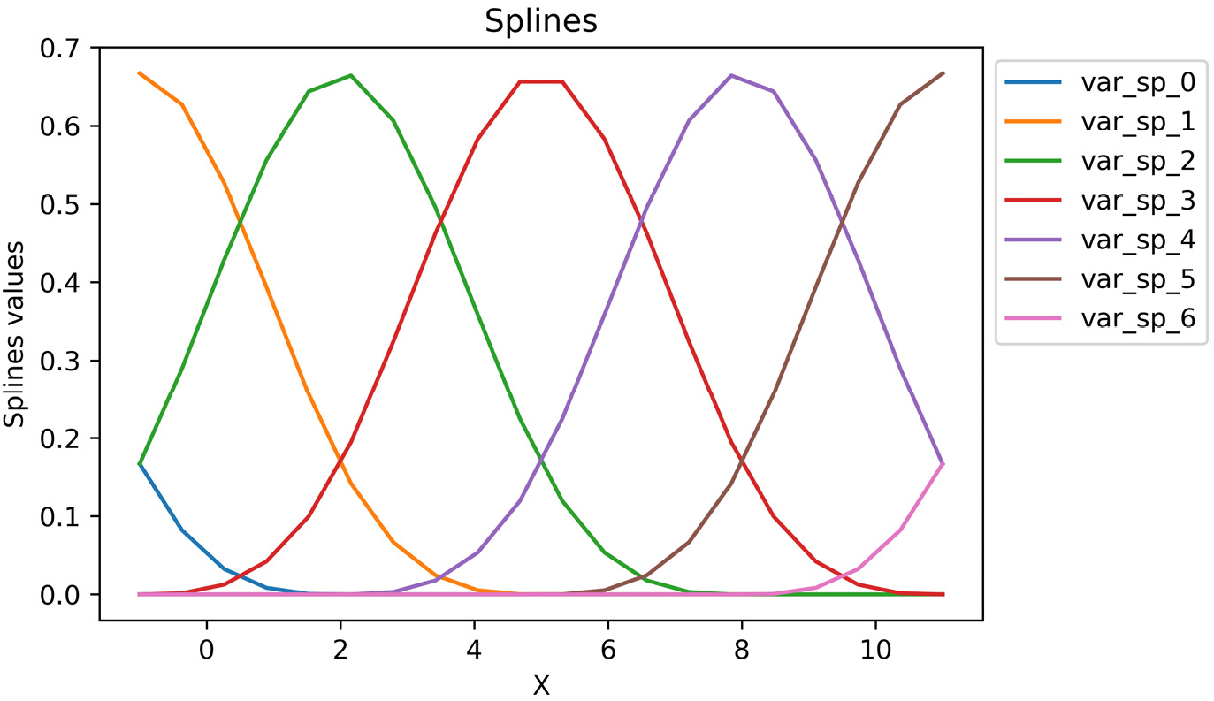
Figure 8.20 – Splines plotted against the values of the predictor variable, X
Now, let’s fit a linear model to predict y from the spline features obtained from X by utilizing Ridge regression, and then obtain the predictions of the model:
linmod = Ridge(random_state=10)
linmod.fit(X_t, y)
pred = linmod.predict(X_t)
Now, let’s plot the relationship between X and y, and overlay the predictions:
plt.plot(X, y)
plt.plot(X, pred)
plt.ylabel("y")
plt.xlabel("X")
plt.legend(["y", "splines"], bbox_to_anchor=(1, 1), loc="upper left")
In the following figure, we can see that by utilizing spline features as input, Ridge regression can better predict the shape of y:
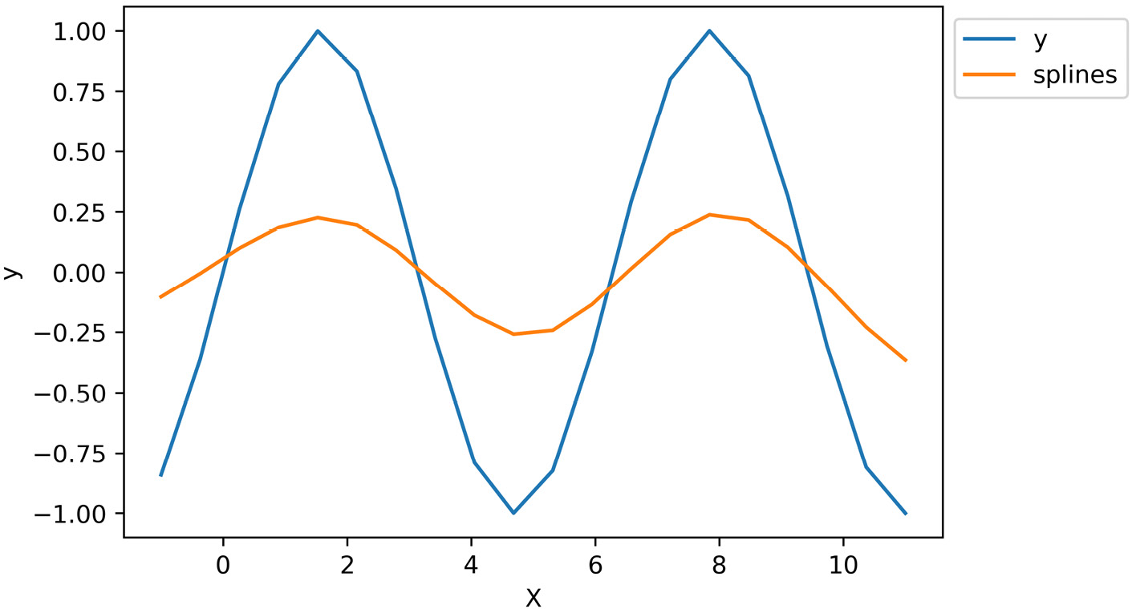
Figure 8.21 – The linear fit between the splines from X and y
Tip
Increasing the number of knots of the degree of the polynomial increases the flexibility of the spline curves. Try creating splines from higher polynomial degrees and see how the predictions of the Ridge regression change.
Now that we understand what the splines features are and how we can use them to predict non-linear effects, let’s try them out on a real dataset.
Let’s import some additional classes and functions from scikit-learn:
from sklearn.datasets import fetch_california_housing
from sklearn.compose import ColumnTransformer
from sklearn.model_selection import cross_validate
Let’s load the California Housing dataset, drop two variables that we won’t use for modeling, and plot histograms of the remaining predictors:
X, y = fetch_california_housing(
return_X_y=True, as_frame=True)
X.drop(["Latitude", "Longitude"], axis=1, inplace=True)
X.hist(bins=20, figsize=(10,10))
plt.show()
In the following figure, we can see the distribution of the predictors:
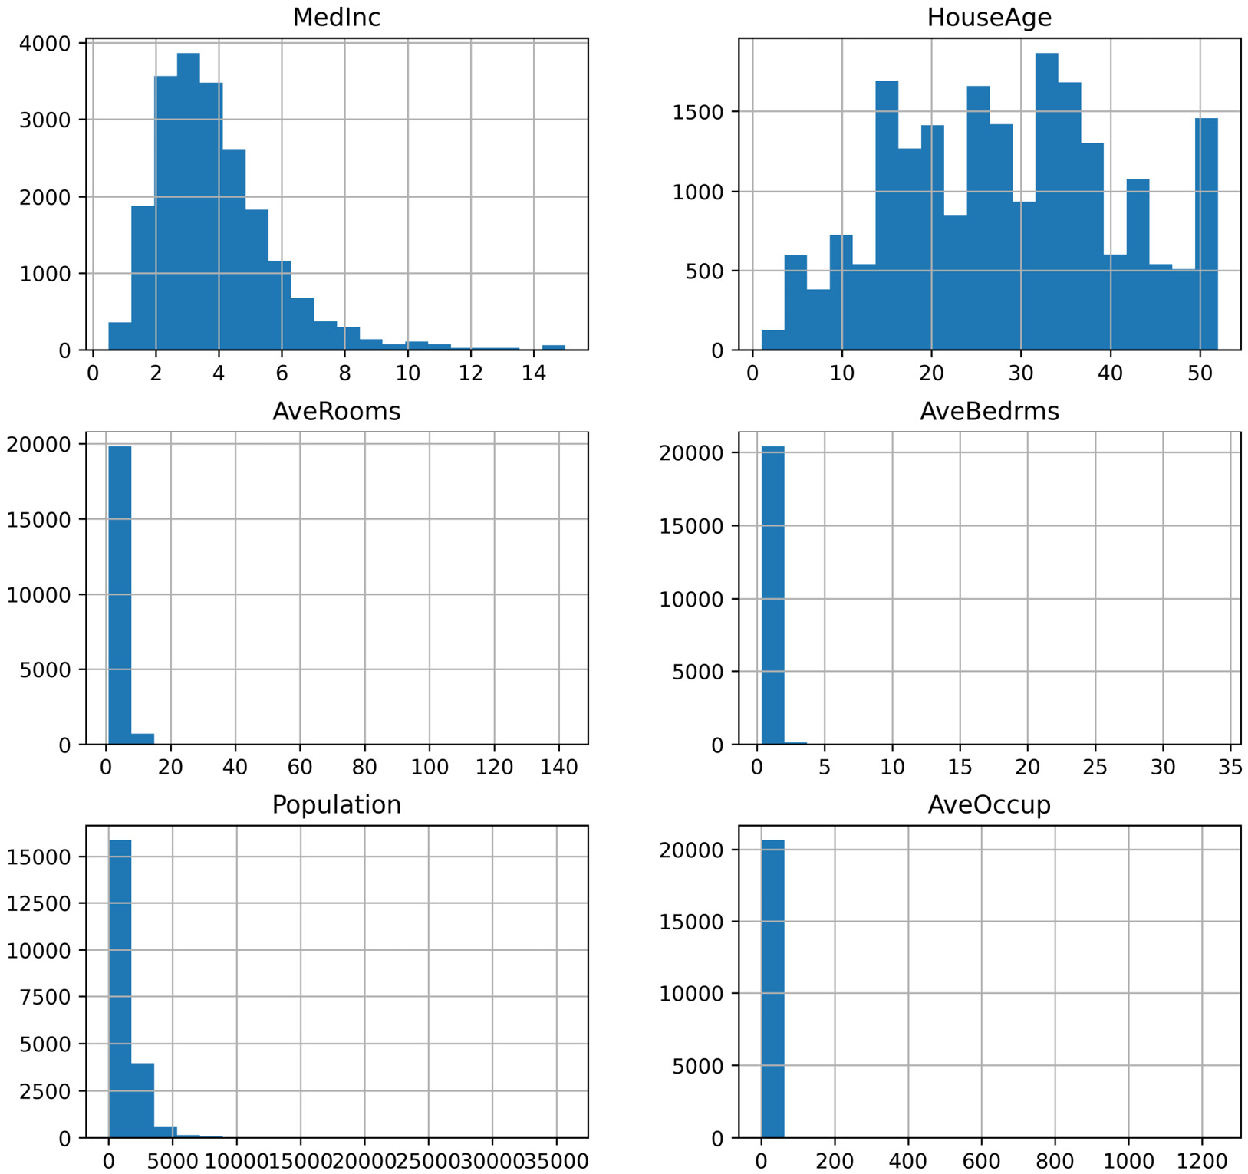
Figure 8.22 – Histograms of the predictor variables
Here, we used splines to model frequencies. The distributions of the last four variables resemble frequencies. So, let’s create spline features from them and see whether they improve the performance of a linear model.
First, we will fit a Ridge regression to predict house prices based on the existing variables by utilizing cross-validation and obtain the performance of the model to set up the benchmark:
linmod = Ridge(random_state=10)
cv = cross_validate(linmod, X, y)
mean_, std_ = np.mean(
cv["test_score"]), np.std(cv["test_score"])
print(f"Model score: {mean_} +- {std_}")
The previous commands return the following model performance, where the values are R2:
Model score: 0.490618615960575 +- 0.03617289854929812
Now, let’s set up the transformers to obtain spline features from four variables by utilizing third-degree polynomials and 50 knots, and then fit them to the data:
spl = SplineTransformer(degree=3, n_knots=50)
ct = ColumnTransformer(
[("splines", spl, ["AveRooms", "AveBedrms",
"Population", "AveOccup"])],
remainder="passthrough",
)
ct.fit(X, y)
Now, let’s fit a Ridge regression to predict house prices based on the existing variables plus the polynomial features by using cross-validation, and then obtain the performance of the model:
cv = cross_validate(linmod, ct.transform(X), y)
mean_, std_ = np.mean(
cv["test_score"]), np.std(cv["test_score"])
print(f"Model score: {mean_} +- {std_}")
The previous commands return the following model performance, where the values are R2:
Model score: 0.5553526813919297 +- 0.02244513992785257
As we can see, by using splines instead of the original variables, we can improve the performance of the linear regression model.

How it works…
In this recipe, we created new features based on splines. First, we used a toy variable, with values from -1 to 11, and then we obtained splines from a real dataset. The procedure in both cases is identical: we used SplineTransformer from scikit-learn. SplineTransformer takes the degree property of the polynomial and the number of knots (n_knots) as input and returns the splines that better fit the data. The knots are placed at equidistant values of X by default, but through the knots parameter, we can choose to place them uniformly distributed at the quantiles of X instead, or pass an array with the specific values of X that should be used as knots.
Note
The number, spacing, and position of the knots are arbitrarily set by the user and are the parameters that influence the shape of the splines the most. When using splines in regression models, we can optimize these parameters in a randomized search with cross-validation.
With fit(), the transformer computes the knots of the splines. With transform(), it returns the array of B-splines. The transformer returns n_splines=n_knots + degree – 1.
Finally, we used ColumnTransformer to derive splines from a subset of features. ColumnTransformer applies SplineTransformer to the subset of variables. Because we set remainder to "passthrough", ColumnTransformer concatenated the features that were not used to obtain splines to the resulting matrix of splines. By doing this, we fitted a Ridge regression with the splines plus the MedInc and HouseAge variables and managed to improve the linear model’s performance.

See also
To find out more about the math underlying B-splines, check out the following articles:
Perperoglou, et al. A review of spline function procedures in R (https://bmcmedresmethodol.biomedcentral.com/articles/10.1186/s12874-019-0666-3). BMC Med Res Methodol 19, 46 (2019).
Eilers and Marx. Flexible Smoothing with B-splines and Penalties (https://projecteuclid.org/journals/statistical-science/volume-11/issue-2/Flexible-smoothing-with-B-splines-and-penalties/10.1214/ss/1038425655.full.
For an example of how to use B-splines to model time series data, check out the following page in scikit-learn’s documentation: https://scikit-learn.org/stable/auto_examples/applications/plot_cyclical_feature_engineering.html#periodic-spline-features.

9

Extracting Features from Relational Data with Featuretools
In previous chapters, we worked with data organized in rows and columns, where the columns are the variables, the rows are the observations, and each observation is independent. In this chapter, we will focus on creating features from relational datasets. In relational datasets, data is structured across various tables, which can be joined together via unique identifiers. These unique identifiers indicate the relationships that exist between the different tables.
A classic example of relational data is that held by retail companies. One table can contain information about customers, such as names and addresses. A second table can contain information about the purchases made by the customers, such as the type and number of items bought per purchase. A third table can contain information about the customers’ interactions with the company’s website, with variables such as session duration, the mobile device used, and the pages visited. The customers, the purchases, and the sessions are identified with unique identifiers. These unique identifiers allow us to put these tables together, and in this way, we can get information about the customers’ purchases or sessions.
If we want to know more about the types of customers we have (that is, customer segmentation) or make predictions about whether they would buy a product, we can create features that aggregate or summarize the information across the different tables at the customer level. For example, we can create features that capture the maximum amount spent by the customer on a purchase, the number of purchases they have made, the time between sessions, or the average session duration. The number of features we can create and the ways in which we can aggregate this information are plentiful.
In this chapter, we will discuss some common ways of creating aggregated views of relational data utilizing the Python library Featuretools. We will begin by setting up various data tables and their relationships and automatically creating features, and next, we will follow up with more detail on the different features that we can create.
In this chapter, we will cover the following recipes:
Setting up an entity set and creating features automatically
Creating features with general and cumulative operations
Combining numerical features
Extracting features from date and time
Extracting features from text
Creating features with aggregation primitives

Technical requirements
In this chapter, we will use pandas, matplotlib, and the open source Python library Featuretools. You can install Featuretools with pip:
pip install featuretools
Otherwise, you can do so with conda:
conda install -c conda-forge featuretools
Make sure you have Featuretools version 1.14.0 or greater to run this notebook. The code was tested using versions 1.14.0 and 1.15.0.
Note
We will work with the Online Retail II dataset from the UCI Machine Learning Repository: https://archive.ics.uci.edu/ml/datasets/Online+Retail+II. Dua, D. and Graff, C. (2019). UCI Machine Learning Repository (http://archive.ics.uci.edu/ml). Irvine, CA: The University of California, School of Information and Computer Science.
To download the Online Retail II dataset, follow these steps:
Go to https://archive.ics.uci.edu/ml/machine-learning-databases/00502/.
Click on online_retail_II.xlsx to download the data.
Save online_retail_II.xlsx to the folder from which you will run the following commands.
After you’ve downloaded the dataset, open a Jupyter notebook and execute the following:
Import pandas:
import pandas as pd
The data is spread across two Excel sheets. Load them into a single dataframe:
file = "online_retail_II.xlsx"
df_1 = pd.read_excel(file, sheet_name="Year 2009-2010")
df_2 = pd.read_excel(file, sheet_name="Year 2010-2011")
df = pd.concat([df_1, df_2])
Step 2 may raise an error if you don’t have the openpyxl library installed. Go ahead and install it to proceed with the data preparation. Select the data corresponding to the United Kingdom and then drop the Country column:
df = df[df["Country"]=="United Kingdom"]
df.drop("Country", axis=1, inplace=True)
Remove any rows without a given Customer ID:
df.dropna(subset=["Customer ID"], inplace=True)
Rename the dataframe’s columns:
df.columns = [
"invoice",
"stock_code",
"description",
"quantity",
"invoice_date",
"price",
"customer_id",
]
Reset the index of the dataframe:
df.reset_index(inplace=True, drop=True)
Re-order the columns and save the data:
ordered_cols = [
"customer_id",
"invoice",
"invoice_date",
"stock_code",
"description",
"quantity",
"price",
]
df[ordered_cols].to_csv("retail.csv", index=False)
Make sure you install Featuretools and download and prepare the dataset before proceeding with this chapter since we will be using both throughout.

Setting up an entity set and creating features automatically
Relational datasets or databases contain data spread across multiple tables and the relationships between tables are dictated by a unique identifier that tells us how we can join those tables. To automate feature creation with Featuretools, first, we need to enter the different data tables and establish their relationships within what is called an entity set. The entity set then informs Featuretools how these tables are connected so that the library can automatically create features based on those relationships.
We will work with a dataset containing information about customers, invoices, and products. First, we will set up an entity set highlighting the relationships between these three items. This entity set will be the starting point for the remaining recipes in this chapter. Next, we will create features automatically by aggregating the data at the customer, invoice, and product levels, utilizing the default parameters from Featuretools.
In this recipe, you will learn how to correctly set up an entity set and extract a bunch of features automatically for each entity. In the upcoming recipes, we will delve deeper into the different types of features that we can create with Featuretools.

Getting ready
In this recipe, we will use the Online Retail II dataset from the UCI Machine Learning repository. In this table, there are customers, which are businesses that buy in bulk from the retail company. The customers are identified with the unique identifier customer_id. Each customer makes one or more purchases, which are flagged by the unique identifier invoice, containing the invoice number. In each invoice, there are one or more items that have been bought by the customer. Each item or product sold by the company is also identified with a unique stock code.
Thus, the data has the following relations:
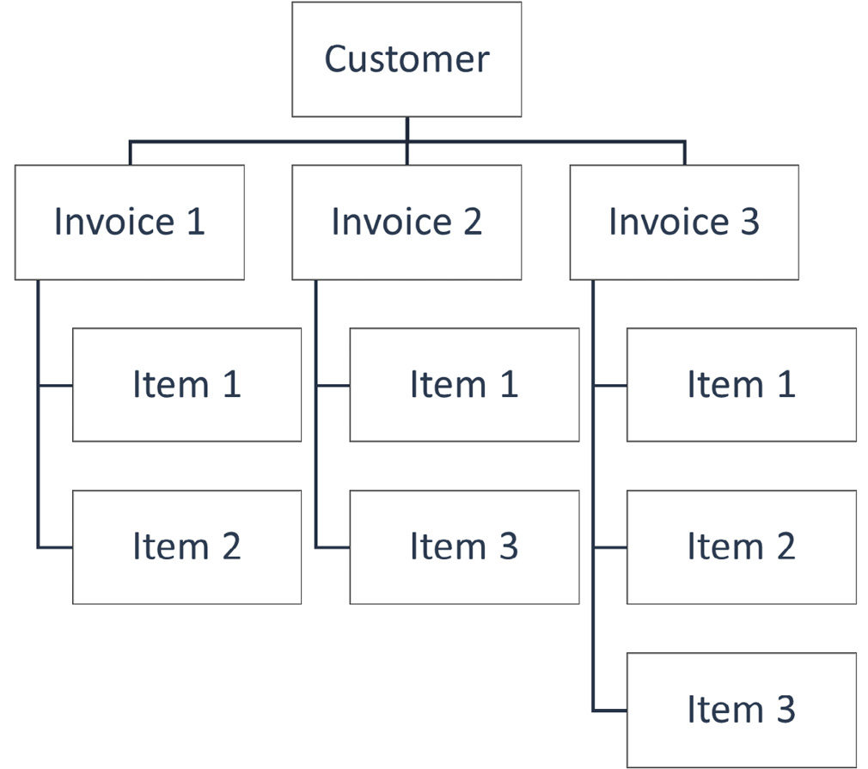
Figure 9.1 – Diagram showing the relationships between the data
Each customer made one or more purchases, identified by the invoice number. Each invoice contains one or more items, identified by the stock code. Each item can be bought by one or more customers and is therefore present in several invoices. With these relationships in mind, let’s proceed to the recipe.

How to do it...
In this recipe, we will set up an entity set with the data, and then highlight the different relationships in the dataset. Finally, we will create features by aggregating the information in the dataset at the customer, invoice, and product levels:
Let’s import the required libraries:
import matplotlib.pyplot as plt
import pandas as pd
import featuretools as ft
from woodwork.logical_types import Categorical
Let’s load the dataset that we prepared in the Technical requirements section and display the first five rows of it:
df = pd.read_csv(
"retail.csv", parse_dates=["invoice_date"])
df.head()
In the following screenshot, we can see the unique identifiers for customers (customer_id) and invoices (invoice), and additional information about the items bought in each invoice, such as the item’s code, description, quantity, and unit price, as well as the date of the invoice:
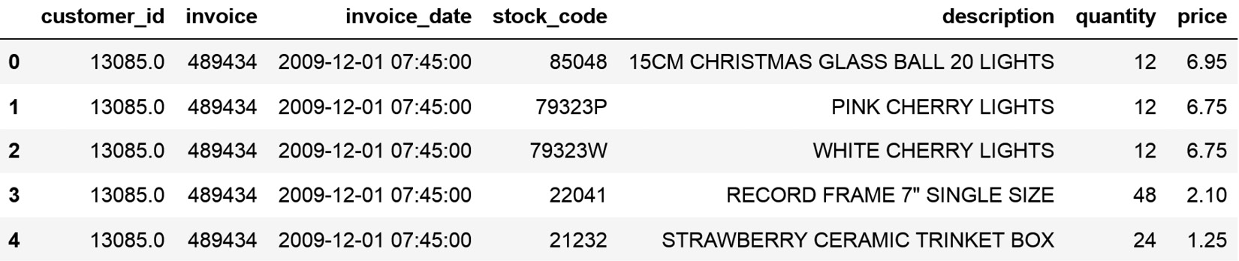
Figure 9.2 – Online Retail dataframe
Tip
Use pandas unique() to identify the number of unique items, customers, and invoices – for example, by executing df["customer_id"].nunique().
Let’s initialize an entity set with an arbitrary name, such as data:
es = ft.EntitySet(id="data")
Let’s add the dataframe to the entity set. Note that we give the dataframe a name (data), we need to add a unique identifier for each row, which we call rows, and since we do not have a unique row identifier, we will create this additional column when setting the entity set. Finally, we indicate that invoice_date is of the datetime type and customer_id is Categorical:
es = es.add_dataframe(
dataframe=df,
dataframe_name="data",
index="rows",
make_index=True,
time_index="invoice_date",
logical_types={ "customer_id": Categorical},
)
Next, we add the relationship between the original data and invoices. To do this, we indicate the original or base dataframe, which we called data in step 4, we give the new dataframe a name, invoices, we add the unique identifier for invoices, and we add the column containing customer_id to this dataframe:
es.normalize_dataframe(
base_dataframe_name="data",
new_dataframe_name="invoices",
index="invoice",
copy_columns=["customer_id"],
)
Tip
We copy the customer_id variable to the invoices data because we want to create a subsequent relationship between customers and invoices.
Now, we add the second relationship, which is between customers and invoices. To do this, we indicate the base dataframe, which we named invoices in step 5, we give the new dataframe a name, customers, and add the unique customer identifier:
es.normalize_dataframe(
base_dataframe_name="invoices",
new_dataframe_name="customers",
index="customer_id",
)
We can add a third relationship between the original data and the products:
es.normalize_dataframe(
base_dataframe_name="data",
new_dataframe_name="items",
index="stock_code",
)
Let’s display the information in the entity set:
es
The entity set contains four dataframes: the original data, the invoices dataframe, the customers dataframe, and the product or items dataframe. The entity also contains the relationships between invoices or items with the original data, as well as between customers and invoices:
Entityset: data
DataFrames:
data [Rows: 741301, Columns: 8]
invoices [Rows: 40505, Columns: 3]
customers [Rows: 5410, Columns: 2]
items [Rows: 4631, Columns: 2]
Relationships:
data.invoice -> invoices.invoice
invoices.customer_id -> customers.customer_id
data.stock_code -> items.stock_code
Let’s display the invoices dataframe:
es["invoices"].head()
We see in the following output that Featuretools automatically created a dataframe containing the invoice’s unique identifier, followed by the customer’s unique identifier and the first date registered for each invoice:
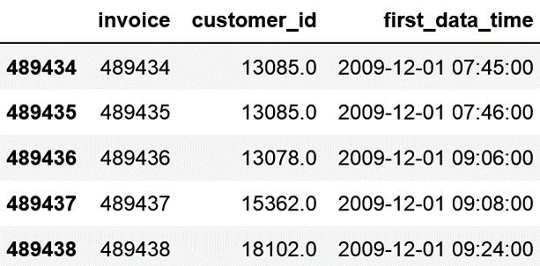
Figure 9.3 – Dataframe with information at the invoice level
Let’s now display the customers dataframe:
es["customers"].head()
We can see in the following output that Featuretools automatically created a dataframe containing the customer’s unique identifier, followed by the date of the first invoice for this customer:
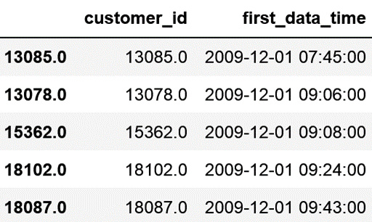
Figure 9.4 – Dataframe with information at the customer level
Tip
Go ahead and display the dataframe containing the products by executing es["items"].head(). You can also evaluate the size of the different dataframes using pandas shape. You will notice that the number of rows in each dataframe coincides with the number of unique invoices, customers, and products.
We can also display the relationships between these data tables:
es.plot()
Note
To visualize the data relationships, you need to have Graphviz installed. If you don’t, follow the instructions in the Featuretools documentation to install it per your operating system: https://featuretools.alteryx.com/en/stable/install.html#installing-graphviz.
In the following output, we can see the relational datasets and their relationships:
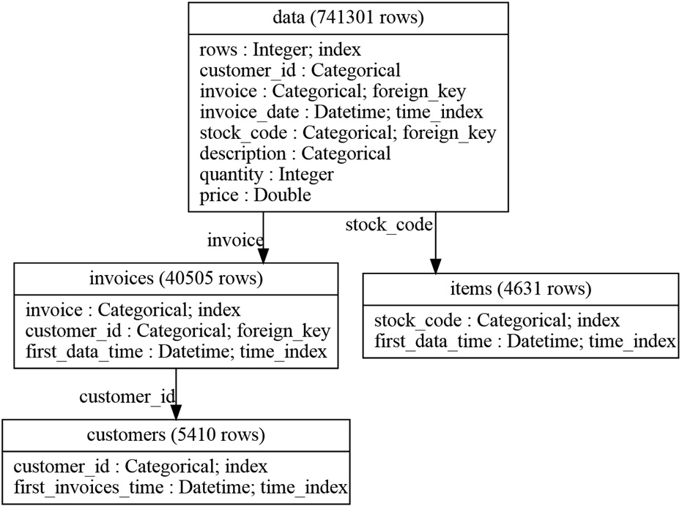
Figure 9.5 – Relationships between invoices, customers, and products within our dataset
After entering the data and their relationships, we can start automatically creating features for each one of our new dataframes, that is, customers, invoices, and products, using the default parameters from Featuretools.
Let’s create features by aggregating the data at the customer level. To do this, we set up the deep feature synthesis (dfs) class from Featuretools, indicating customers as the target dataframe. When creating features, we want to ignore the two columns with unique identifiers:
feature_matrix, feature_defs = ft.dfs(
entityset=es,
target_dataframe_name="customers",
ignore_columns={
"invoices":["invoice"],
"invoices":["customer_id"],
}
)
Note
The former block of code triggered the creation of 114 features with different aggregations of data at the customer level. The feature_matrix variable is a dataframe with the feature values and feature_defs is a list of the names of the new features. Go ahead and execute feature_defs or visit our accompanying GitHub repository (https://github.com/PacktPublishing/Python-Feature-Engineering-Cookbook-Second-Edition/blob/main/ch09-featuretools/Recipe1-Setting-up-an-entitity-set.ipynb) to check the names of the created features. You will find more details about these features in the How it works… section.
Let’s display the name of five of the created features:
feature_defs[5:10]
In the following output, we can see 5 of the 114 features created by Featuretools:
[<Feature: MIN(data.price)>,
<Feature: MIN(data.quantity)>,
<Feature: MODE(data.description)>,
<Feature: MODE(data.stock_code)>,
<Feature: NUM_UNIQUE(data.description)>]
Note
Featuretools names the new features with the function used to create them, followed by the dataframe that was used to perform the aggregation, followed by the aggregated variable name. Thus, MIN(data.quantity) is equivalent to df.groupby(["customer_id"])["quantity"].min(). We will give more details in the How it works… section.
Let’s display the first five rows of the dataframe containing five of the created features:
feature_matrix[feature_matrix.columns[5:10]].head()
In the following output, we can see the first five rows containing the values of the five new features:
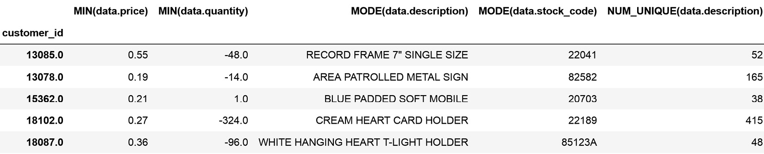
Figure 9.6 – Dataframe with five features created by aggregating the data at the customer level
Similarly, we can create features automatically by aggregating information at the invoice level:
feature_matrix, feature_defs = ft.dfs(
entityset=es,
target_dataframe_name="invoices",
ignore_columns = {"data": ["customer_id"]},
max_depth = 1,
)
The previous step returns 24 features – let’s display their names:
feature_defs
We can see the names of the features in the following output:
[<Feature: customer_id>,
<Feature: COUNT(data)>,
<Feature: MAX(data.price)>,
<Feature: MAX(data.quantity)>,
<Feature: MEAN(data.price)>,
<Feature: MEAN(data.quantity)>,
<Feature: MIN(data.price)>,
<Feature: MIN(data.quantity)>,
<Feature: MODE(data.description)>,
<Feature: MODE(data.stock_code)>,
<Feature: NUM_UNIQUE(data.description)>,
<Feature: NUM_UNIQUE(data.stock_code)>,
<Feature: SKEW(data.price)>,
<Feature: SKEW(data.quantity)>,
<Feature: STD(data.price)>,
<Feature: STD(data.quantity)>,
<Feature: SUM(data.price)>,
<Feature: SUM(data.quantity)>,
<Feature: DAY(first_data_time)>,
<Feature: MONTH(first_data_time)>,
<Feature: WEEKDAY(first_data_time)>,
<Feature: YEAR(first_data_time)>]
Tip
Go ahead and display the dataframe containing the new features by executing feature_matrix.head() or check our accompanying GitHub repository for the result.
To wrap up, by using the code from step 16 and changing the target dataframe name from invoices to items, go ahead and create features automatically at the product level.

How it works...
In this recipe, we set up an entity set containing the data and the relationships between some of its variables (unique identifiers). After that, we automatically created features by aggregating the information in the dataset for each of the unique identifiers. We used two main classes from Featuretools, EntitySet and dfs, to create the features. Let’s discuss each of these in more detail.
EntitySet stores the data, the logical types of the variables, and the relationships between the variables. The variable types (whether numeric or categorical) are automatically assigned by Featuretools. We can also set up specific variable types when adding a dataframe to the entity set. In step 4, we added the data to the entity set and set the logical type of customer id to Categorical.
EntitySet has the add_dataframe method, which we used in step 4 to add a new dataframe. When using this method, we need to specify the unique identifier, and if there is none, then we need to create one, as we did in step 4, by setting make_index to True. Note that in the index parameter from add_dataframe, we passed the "rows" string. With this configuration, EntitySet added the "rows" column containing the unique identifier for each row to the dataframe, which is a new sequence of integers starting with 0.
Note
Instead of using the add_dataframe method to add a dataframe to an entity set, we can add it by executing es["df_name"]=df, where "df_name" is the name we want to give to the dataframe and df is the dataframe we want to add.
EntitySet has the normalize_dataframe method, which is used to create a new dataframe and relationship from unique values of an existing column. The method takes the name of the dataframe to which the new dataframe will be related and a name for the new dataframe. We also need to indicate the unique identifier for the new dataframe in the index parameter. By default, this method creates a new dataframe containing the unique identifier, followed by a datetime column containing the first date each unique identifier was registered. We can add more columns to this dataframe by using the copy_columns parameters as we did in step 5. Adding more columns to the new dataframe is useful if we want to follow up with relationships to this new dataframe, as we did in step 6.
EntitySet has also the plot() method, which displays the existing relationships in the entity set. In Figure 9.5, we saw the relationships between our data tables; the invoices and items (products) tables were related to the original data, whereas the customers table was related to the invoices table, which was in turn, related to the original data.
Note
The relationship between the tables dictates how the features will be created. The invoices and items tables are related to the original data. Thus, we can only create features with depth 1. The customers table is, on the other hand, related to invoices, which is related to data. Thus, we can create features with depth 2. That means that new features will consist of aggregations from the entire dataset, or aggregations for invoices first, which will then be subsequently aggregated for customers. We can regulate the features to create with the max_depth parameter in dfs.
After setting up the data and the relationships, we used dfs from Featuretools to automatically create features. When creating features with dfs, we need to set the target dataframe, that is, the data table for which the features should be created. The dfs class creates features by transforming and aggregating existing variables, through what are called transform and aggregate primitives.
A transform primitive transforms variables. For example, from datetime variables, using a transform primitive, dfs extracts the month, year, day, and week values.
An aggregate primitive aggregates information for a unique identifier. Aggregate primitives use mathematical operations such as the mean, standard deviation, maximum and minimum values, the sum, and the skew coefficient for numerical variables. For categorical variables, aggregate primitives use the mode and the count of unique items. For unique identifiers, aggregate primitives count the number of occurrences.
With the functionality of transform and aggregate primitives in mind, let’s try to understand the features that we created in this recipe. We used the default parameters of dfs to create the default features.
Note
For more details on the default features offered by Featuretools, visit https://featuretools.alteryx.com/en/stable/generated/featuretools.dfs.html#featuretools.dfs.
We first created features for each customer. Featuretools returned 114 features for each customer. Because the customers data is related to the invoices data, which is related to the entire dataset, the features were created by aggregating data at two levels. First, the data was aggregated for each customer using the entire dataset. Next, the data was aggregated for each invoice first, and then the pre-aggregated data was aggregated again for each customer.
Featuretools names the new features with the function used to aggregate the data, for example, COUNT, MEAN, STD, and SKEW, among others. Next, it uses the data that was used for the aggregation and follows it with the variable that was aggregated. For example, the MEAN(data.quantity) feature contains the mean quantity of items bought by the customer calculated from the entire dataset, which is the equivalent of df.groupby("customer_id"])["quantity"].mean(), if you are familiar with pandas. On the other hand, the MEAN(invoices.MEAN(data.quantity)) feature first takes the mean quantity of items for each invoice, that is, df.groupby("invoice"])["quantity"].mean(), and from the resulting series, it takes the mean value, considering the invoices for a particular customer.
For categorical features, Featuretools determines the mode and the unique values. For example, from the description variable, we’ve got the NUM_UNIQUE(data.description) and MODE(data.description) features. The description is just the name of the item. Thus, these features highlight the number of unique items the customer bought and the item the customer bought the most times.
Note
Note something interesting: the NUM_UNIQUE(data.description) and MODE(data.description) variables are numeric after the aggregation. Thus, Featuretools creates more features by using numerical aggregations of these variables. In this way, the MAX(invoices.NUM_UNIQUE(data.description) feature first finds the number of unique items per invoice, and then returns the maximum from those values for a particular customer, considering all the customer’s invoices.
From datetime features, Featuretools extracts date components by default. Remember that the customers dataframe contains the customer_id variable and the date of the first invoice for each customer, as we saw in the output of step 10. From this datetime feature, Featuretools created the DAY(first_invoices_time), MONTH(first_invoices_time), WEEKDAY(first_invoices_time), and YEAR(first_invoices_time) features containing the different date parts.
Finally, Featuretools also returned the total number of invoices per customer (COUNT(invoices)) and the total number of rows (COUNT(data)) per customer.

See also
For more details into what inspired Featuretools, check the original article Deep Feature Synthesis: Towards Automating Data Science Endeavors by Kanter and Veeramachanen at https://www.jmaxkanter.com/papers/DSAA_DSM_2015.pdf.

Creating features with general and cumulative operations
Featuretools uses what are called transform primitives to create features. Transform primitives take one or more columns in a dataset as input and return one or more columns as output. They are applied to a single dataframe.
Featuretools divides its transform primitives into various categories depending on the type of operation they perform or the type of variable they modify. For example, general transform primitives apply mathematical operations, such as the square root, the sine, and the cosine. Cumulative transform primitives create new features by comparing a row’s value to the previous row’s value. For example, the cumulative sum, cumulative mean, and cumulative minimum and maximum values belong to this category, as well as the difference between row values. There is another cumulative transformation that can be applied to datetime variables, which is the time since previous, which determines the time passed between two consecutive timestamps.
In this recipe, we will create features using the general and cumulative transform primitives in Featuretools.

Getting ready
General variable transformations are useful when we want to change the distribution of a variable, as we saw in Chapter 3, Transforming Numerical Variables, or in the Creating periodic features from cyclical variables recipe in Chapter 8, Creating New Features. From the transformations described in those chapters, Featuretools supports the square root transformation and the sine and cosine (albeit without the normalization between 0 and 2p).
With a cumulative transformation, we can, for example, get the total number of items bought per invoice by adding up the item’s quantity in each row at the invoice level. To understand the features that we will create in this recipe, let’s create them with pandas first:
Let’s import pandas:
Import numpy as np
import pandas as pd
Let’s load the dataset that we prepared in the Technical requirements section:
df = pd.read_csv(
"retail.csv", parse_dates=["invoice_date"])
Let’s capture the two numerical variables, price and quantity, in a list:
numeric_vars = ["quantity", "price"]
Let’s capture the names of the cumulative functions in a list:
func = ["cumsum", "cummax", "diff"]
Let’s create a list with new names for the variables that we will create:
new_names = [f"{var}_{function}"
for function in func for var in numeric_vars]
Let’s create new variables using the cumulative functions from step 4, applied to the variables from step 3, and add them to the dataframe:
df[new_names] = df.groupby("invoice")[numeric_vars].agg(func)
The previous step returns the cumulative sum or cumulative maximum value, or the difference between rows, within each invoice. As soon as it encounters a new invoice number, it starts afresh. To better understand the result, execute df[df["invoice"] == "489434" ][numeric_vars + new_names] and compare the result to that of df[df["invoice"] == "489435" ][numeric_vars + new_names].
Let’s now apply the sine and cosine transformation to the entire dataframe.
Let’s create a list with names for the new variables:
new_names = [f"{var}_{function}" for function in ["sin", "cos"] for var in numeric_vars]
Let’s transform the price and quantity with the sine and cosine:
df[new_names] = df[numeric_vars].agg([np.sin, np.cos])
The transformation in step 8 was applied to the entire dataset, irrespective of the invoice number. You can inspect the result by executing df[new_names].head().
With these feature creation procedures in mind, let’s automate the process with Featuretools.

How to do it...
We will apply cumulative transformations within each invoice and general transformations to the entire dataset:
First, we’ll import pandas, featuretools, and the Categorical logical type:
import pandas as pd
import featuretools as ft
from woodwork.logical_types import Categorical
Let’s load the dataset that we prepared in the Technical requirements section:
df = pd.read_csv(
"retail.csv", parse_dates=["invoice_date"])
Let’s set up an entity set:
es = ft.EntitySet(id="data")
Let’s add the dataframe to the entity set:
es = es.add_dataframe(
dataframe=df,
dataframe_name="data",
index="rows",
make_index=True,
time_index="invoice_date",
logical_types={"customer_id": Categorical},
)
Let’s create a new dataframe with a relationship to the dataframe from step 4:
es.normalize_dataframe(
base_dataframe_name="data",
new_dataframe_name="invoices",
index="invoice",
copy_columns=["customer_id"],
)
Note
For more details about steps 4 and 5, visit the Setting up an entity set and creating features automatically recipe.
Let’s make a list with the cumulative transformations to perform:
cum_primitives = ["cum_sum",
"cum_max", "diff", "time_since_previous"]
Note
You can find Featuretools-supported cumulative transformations at this link: https://featuretools.alteryx.com/en/stable/api_reference.html#cumulative-transform-primitives.
Let’s make a list of the general transformations to carry out:
general_primitives = ["sine"]
Note
You can find Featuretools-supported general transformations at this link: https://featuretools.alteryx.com/en/stable/api_reference.html#general-transform-primitives.
Finally, let’s create the features. We use the dfs class, setting the original dataframe as the target dataframe, that is, the one whose variables we want to modify. Note that we pass an empty list to the agg_primitives parameter; this is to avoid returning the default aggregation primitives. We pass the general primitive from step 7 to the trans_primitives parameter and the cumulative primitives from step 6 to the groupby_trans_primitives parameter:
feature_matrix, feature_defs = ft.dfs(
entityset=es,
target_dataframe_name="data",
agg_primitives=[],
trans_primitives=general_primitives,
groupby_trans_primitives = cum_primitives,
ignore_dataframes = ["invoices"],
)
Tip
Featuretools will automatically apply the cumulative primitive transformations after grouping by invoice because of the relationship we set up in step 5.
Let’s now display the name of the created features:
feature_defs
In the following output, we can see the name of the features that we created, including the sine and cosine of the price and quantity and the cumulative transformations of these variables after grouping them by invoice number:
[<Feature: customer_id>,
<Feature: invoice>,
<Feature: stock_code>,
<Feature: description>,
<Feature: quantity>,
<Feature: price>,
<Feature: SINE(price)>,
<Feature: SINE(quantity)>,
<Feature: CUM_MAX(price) by invoice>,
<Feature: CUM_MAX(quantity) by invoice>,
<Feature: CUM_SUM(price) by invoice>,
<Feature: CUM_SUM(quantity) by invoice>,
<Feature: DIFF(price) by invoice>,
<Feature: DIFF(quantity) by invoice>,
<Feature: TIME_SINCE_PREVIOUS(invoice_date) by invoice>]
As you can see from the previous list, the new features were appended as new columns to the original dataframe and returned in a new variable. You can display the final dataframe by executing feature_matrix.head(), which will return the following dataframe:
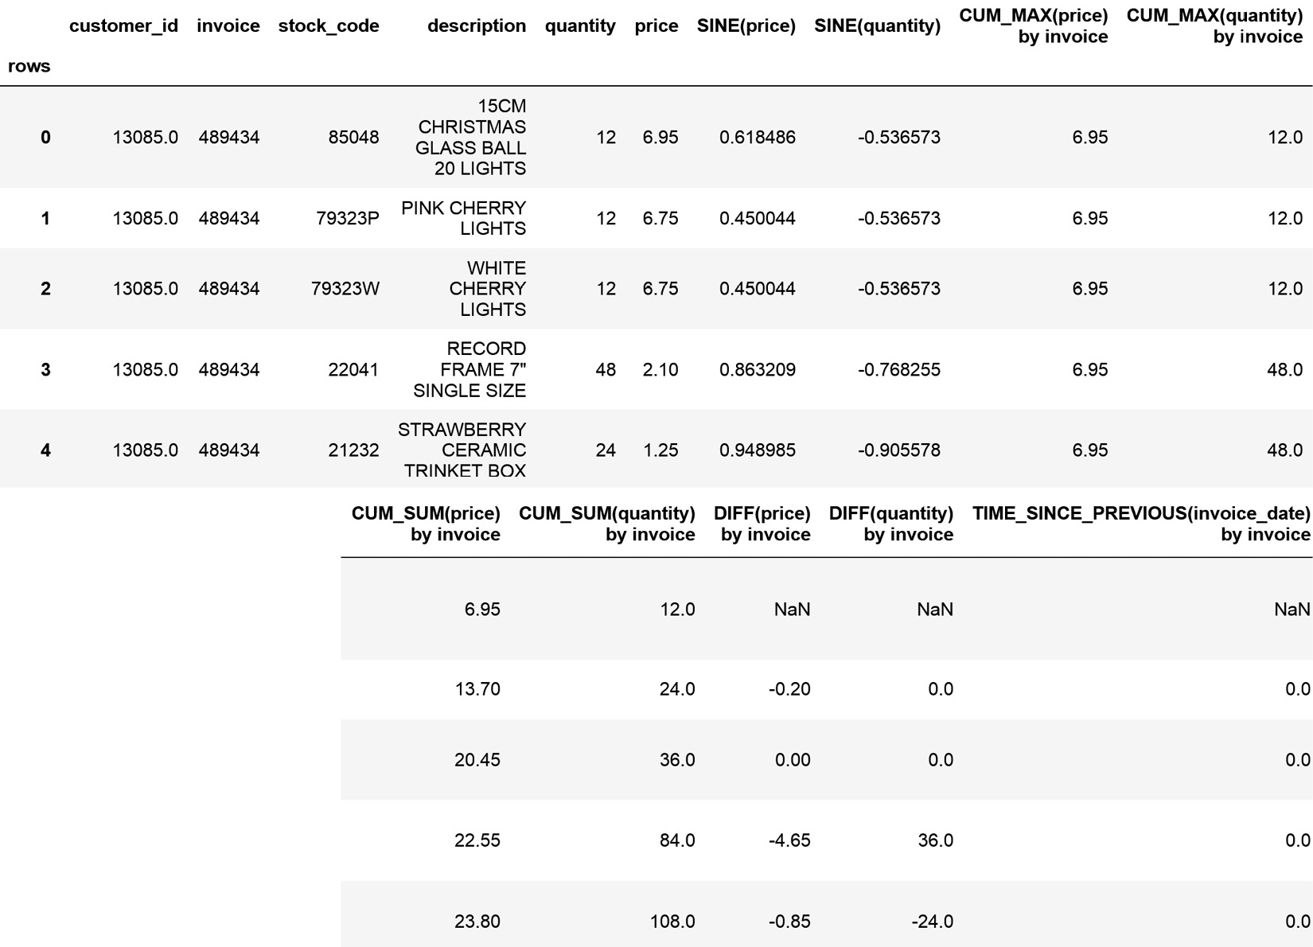
Figure 9.7 – Dataframe with the original and new features
For more details about the created features, check the How it works… section.

How it works...
To create features using general and cumulative transformations with Featuretools, first, we need to set up an entity set with the data and define the relationships between its variables. We described how to set up an entity set in the Setting up and entity set and creating features automatically recipe.
To apply cumulative and general transforms, we used the dfs class from Featuretools. We applied general transformation to the entire dataframe without grouping anything by a specific variable. To do this, we passed a list of strings that identify each transformation to the trans_primitives parameter from dfs.
We applied cumulative transformation after grouping by invoice. To do this, we passed a list of strings that identify each transformation to the groupby_trans_primitives parameter from dfs. Featuretools knows it should group by invoice because we established this unique identifier by using the normalize_dataframe method from EntitySet in step 5.
Finally, we did not want features created from the variables in the invoices dataframe; thus, we set dfs to ignore this dataframe.
The dfs class returned two variables, the dataframe with the original and new features and the name of the features in a list. The new features are named with the operations applied to create them, such as SINE, COSINE, CUM_MAX, or DIFF, followed by the variable to which the transformation was applied, and when corresponding, the variable that was used for grouping.
Note that Featuretools automatically recognizes and selects the variables over which the transformations should be applied. The sine, cosine, cumulative sum, maximum, and difference were applied to numerical variables, whereas the time_since_previous transformation was applied to the datetime variable.

Combining numerical features
In Chapter 8, Creating New Features, we saw that we can create new features by combining variables with mathematical operations. Featuretools supports a number of operations to combine variables, including addition, division, modulo, and multiplication. In this recipe, we will learn how to combine these features with Featuretools.

How to do it...
Let’s begin by importing the libraries and getting the dataset ready:
First, we’ll import pandas, featuretools, and the Categorical logical type:
import pandas as pd
import featuretools as ft
from woodwork.logical_types import Categorical
Let’s load the dataset that we prepared in the Technical requirements section:
df = pd.read_csv(
"retail.csv", parse_dates=["invoice_date"])
Let’s set up an entity set:
es = ft.EntitySet(id="data")
Let’s add the dataframe to the entity set:
es = es.add_dataframe(
dataframe=df,
dataframe_name="data",
index="rows",
make_index=True,
time_index="invoice_date",
logical_types={"customer_id": Categorical},
)
Let’s create a new dataframe with a relationship to the dataframe from step 4:
es.normalize_dataframe(
base_dataframe_name="data",
new_dataframe_name="invoices",
index="invoice",
copy_columns=["customer_id"],
)
Note
For more details about steps 4 and 5, visit the Setting up an entity set and creating features automatically recipe.
We will multiply the quantity and price variables, which reflect the number of items bought and the unit price, respectively, to obtain the total amount paid:
feature_matrix, feature_defs = ft.dfs(
entityset=es,
target_dataframe_name="data",
agg_primitives=[],
trans_primitives=["multiply_numeric"],
primitive_options={
("multiply_numeric"): {
'include_columns': {
'data': ["quantity", "price"]
}
}
},
ignore_dataframes=["invoices"],
)
Let’s now display the name of the new features:
feature_defs
In the following output, we can see the feature names, the last one of which corresponds to the combination of the price and quantity variables:
[<Feature: customer_id>,
<Feature: invoice>,
<Feature: stock_code>,
<Feature: description>,
<Feature: quantity>,
<Feature: price>,
<Feature: price * quantity>]
To finish off, let’s inspect the new dataframe created in step 6:
feature_matrix.head()
In the following output, we can see that the new feature was appended to the end of the original dataframe:
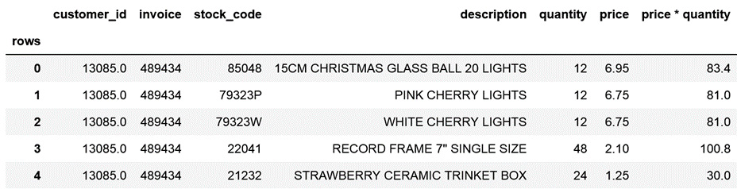
Figure 9.8 – Dataframe with the new feature from the combination of price with quantity
Combining features with Featuretools may seem like a lot of work, compared to the (df["price"].mul(df["quantity"])) pandas functionality. The real power comes in when we create new features in this way and follow it up with aggregations at the invoice or customer level.

How it works...
To multiply features, we used the MultiplyNumeric primitive from Featuretools (https://primitives.featurelabs.com/#MultiplyNumeric), which can be accessed from dfs using the multiply_numeric string. We set the former string to the trans_primitive parameter and then used the primitive_options parameter to specify which variables to multiply. Note that in addition, we passed an empty list to the agg_primitives parameter to override the default aggregation primitives, and we ignored the features coming from the invoices dataframe.

Extracting features from date and time
In Chapter 6, Extracting Features from Date and Time, we created various features from the date and time parts of datetime variables using pandas and Feature-engine. We can also extract multiple features from datetime variables, automatically utilizing Featuretools.
Featuretools supports the creation of various features from datetime variables using its datetime transform primitives. These primitives include the creation of features such as year, month, and day, and also other features such as is it lunch time or is it weekday?
Note
For more details on the features that can be created using datetime variables, visit https://featuretools.alteryx.com/en/stable/api_reference.html#datetime-transform-primitives.
In this recipe, we will automatically create multiple features from a datetime variable with Featuretools.

How to do it...
Let’s begin by importing the libraries and getting the dataset ready:
First, we’ll import pandas, featuretools, and the Categorical logical type:
import pandas as pd
import featuretools as ft
from woodwork.logical_types import Categorical
Let’s load the dataset that we prepared in the Technical requirements section:
df = pd.read_csv(
"retail.csv", parse_dates=["invoice_date"])
Let’s set up an entity set:
es = ft.EntitySet(id="data")
Let’s add the dataframe to the entity set:
es = es.add_dataframe(
dataframe=df,
dataframe_name="data",
index="rows",
make_index=True,
time_index="invoice_date",
logical_types={"customer_id": Categorical},
)
Let’s create a new dataframe with a relationship to the dataframe from step 4:
es.normalize_dataframe(
base_dataframe_name="data",
new_dataframe_name="invoices",
index="invoice",
copy_columns=["customer_id"],
)
Note
For more details about steps 4 and 5, visit the Setting up an entity set and creating features automatically recipe.
Let’s make a list with string names that identify the features we want to create:
date_primitives = ["day", "year", "month", "weekday",
"days_in_month", "part_of_day",
"is_federal_holiday",
"hour", "minute"]
Let’s now create date and time features from the invoice date variable:
feature_matrix, feature_defs = ft.dfs(
entityset=es,
target_dataframe_name="invoices",
agg_primitives=[],
trans_primitives=date_primitives,
)
Note
In step 3, we entered the invoice date variable as a time variable. Thus, Featuretools will use this variable to create the date- and time-related features.
Let’s display the name of the created features:
feature_defs
In the following output, we can see the name of the original and time features:
[<Feature: customer_id>,
<Feature: DAY(first_data_time)>,
<Feature: DAYS_IN_MONTH(first_data_time)>,
<Feature: HOUR(first_data_time)>,
<Feature: IS_FEDERAL_HOLIDAY(first_data_time)>,
<Feature: MINUTE(first_data_time)>,
<Feature: MONTH(first_data_time)>,
<Feature: PART_OF_DAY(first_data_time)>,
<Feature: WEEKDAY(first_data_time)>,
<Feature: YEAR(first_data_time)>]
Let’s now display the resulting dataframe containing the original and new features:
feature_matrix.head()
In the following output, we can see the dataframe with the original and time features:
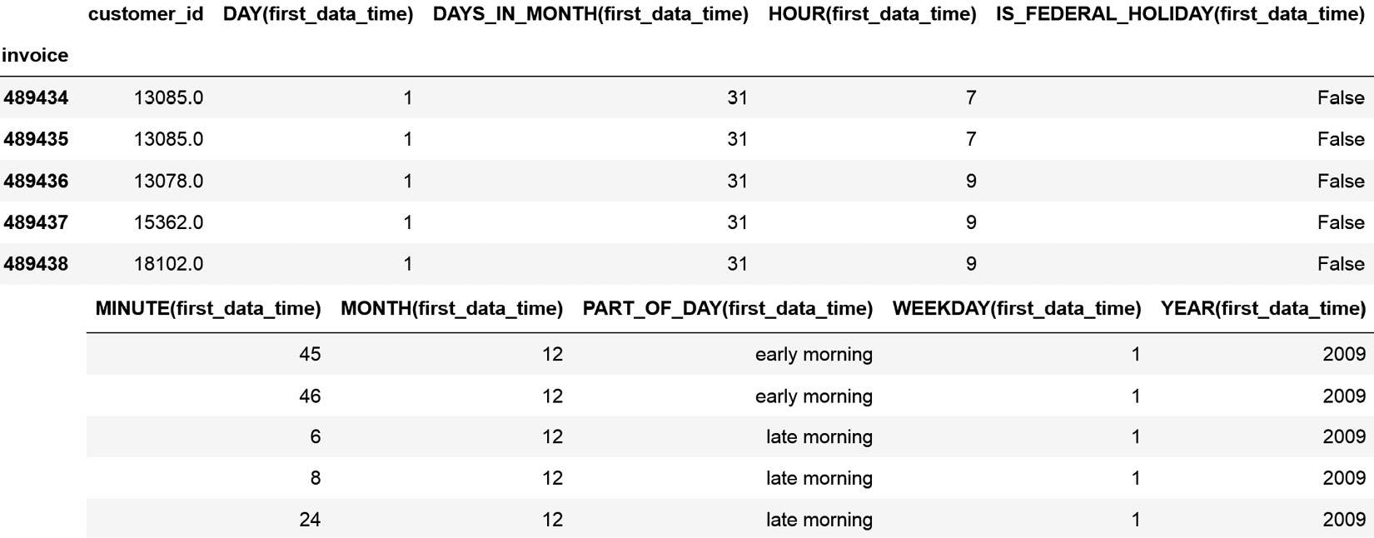
Figure 9.9 – Dataframe with the original and time features
Note that some of the created features are numeric, such as HOUR or DAY, some are Booleans, such as IS_FEDERAL_HOLIDAY, and some are categorical, such as PART_OF_DAY.

How it works...
To create features from datetime variables, we used datetime transform primitives from Featuretools (https://featuretools.alteryx.com/en/stable/api_reference.html#datetime-transform-primitives). These primitives can be accessed from dfs using the strings we specified in step 6 with the trans_primitive parameter. Note that in addition, we passed an empty list to the agg_primitives parameter to override the default aggregation primitives, and we ignored the features coming from the invoices dataframe.
Tip
We override the aggregation primitives in order to focus on the features we want to discuss in the recipe. However, in practice, when creating features with Featuretools, we will most likely use a combination of transform and aggregate primitives.

There’s more...
Featuretools supports additional time-related features, which you can find by carefully inspecting the primitive list at https://primitives.featurelabs.com/#MultiplyNumeric. One example is the DistanceToHoliday primitive (https://primitives.featurelabs.com/#DistanceToHoliday), which returns the time between a date and a specified holiday. Let’s see how we can use this cool primitive.
First, we need to import pandas and Featuretools and set up the entity set as we did in steps 1 to 5 in the How to do it... section:
Let’s import the primitive to calculate the distance to a holiday:
from featuretools.primitives import DistanceToHoliday
Let’s prepare the primitive by specifying that we are interested in the UK’s bank holidays and that in particular, we want to know how long it is until Boxing Day:
distance_to_boxing_day = DistanceToHoliday(
holiday="Boxing Day", country="UK")
Let’s now add that feature to the dataframe:
feature_matrix, feature_defs = ft.dfs(
entityset=es,
target_dataframe_name="invoices",
agg_primitives=[],
trans_primitives=[distance_to_boxing_day],
verbose=True,
)
Let’s print the name of the returned features:
feature_defs
In the following output, we can see the names of the original and new features in the resulting dataframe:
[<Feature: customer_id>,
<Feature: DISTANCE_TO_HOLIDAY(first_data_time, holiday=Boxing Day, country=UK)>]
Tip
Note that we do not have the price or description variables, among other things, because we transformed the invoices dataset in step 2 and not the entire dataframe.
Finally, let’s display the resulting data:
feature_matrix.head()
We can see the resulting dataframe with the distance to Boxing Day in the following output:
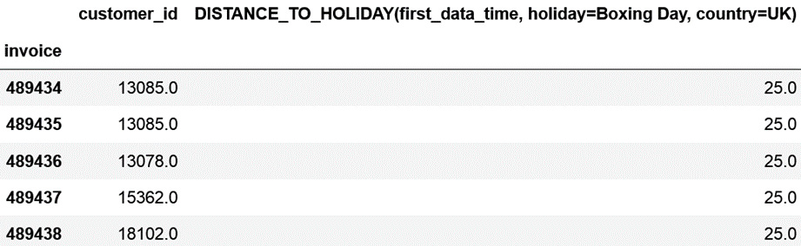
Figure 9.10 – Dataframe with the distance to Boxing Day
To find out which holidays exist in the UK and are supported by Featuretools, we need to import HolidayUtil:
from featuretools.primitives.utils import HolidayUtil
Next, we need to specify that we are interested in the UK:
holidayUtil = HolidayUtil("UK")
Finally, we will capture the holidays in a list and then display them:
available_holidays = list(
set(holidayUtil.federal_holidays.values()))
available_holidays
We can see the following holidays for the UK:
['Good Friday',
'Boxing Day',
"St. Patrick's Day [Northern Ireland]",
"New Year's Day",
'Golden Jubilee of Elizabeth II',
'Millennium Celebrations',
'Christmas Day',
'Late Summer Bank Holiday [England/Wales/Northern
Ireland]',
'Platinum Jubilee of Elizabeth II',
'New Year Holiday [Scotland]',
'Battle of the Boyne [Northern Ireland]',
'May Day',
'Boxing Day (Observed)',
'Silver Jubilee of Elizabeth II',
'Summer Bank Holiday [Scotland]',
'Christmas Day (Observed)',
'Wedding of Charles and Diana',
'Diamond Jubilee of Elizabeth II',
"St. Patrick's Day [Northern Ireland] (Observed)",
'Easter Monday [England/Wales/Northern Ireland]',
'State Funeral of Queen Elizabeth II',
'New Year Holiday [Scotland] (Observed)',
'Wedding of William and Catherine',
"St. Andrew's Day [Scotland]",
"New Year Holiday [Scotland], New Year's Day
(Observed)",
'Spring Bank Holiday',
"New Year's Day (Observed)"]
With this list in mind, you can pick and choose the holidays that make sense for your business.

Extracting features from text
In Chapter 11, Extracting Features from Text Variables, we will discuss various features that we can extract from pieces of text utilizing pandas and scikit-learn. We can also extract multiple features from text automatically by utilizing Featuretools.
Featuretools supports the creation of two basic features from text as part of its default functionality, which are the number of characters and the number of words in a piece of text. In addition, there is an accompanying Python library, Natural Language Processing (NLP) primitives, which contains a lot more functionality to create more advanced features for use with text. Among these functions, we find primitives for counting the number of stop words and punctuation and calculating the amount of whitespace and uppercase, as well as more complex functions for deriving the diversity score or the polarity score.
Note
For a complete list of the functions available, visit https://featuretools.alteryx.com/en/stable/api_reference.html#natural-language-processing-primitives.
In this recipe, we will automatically create multiple features from a text variable, utilizing Featuretools default functionality first, and then utilizing primitives from the NLP Primitives library.

Getting ready
To follow along with this recipe, you need to install the NLP Primitives library, which you can do with pip:
pip install nlp_primitives
Otherwise, you can use conda:
conda install -c conda-forge nlp-primitives
Note
For more details, visit the NLP Primitives GitHub repository: https://github.com/alteryx/nlp_primitives.

How to do it...
Let’s begin by importing the libraries and getting the dataset ready:
First, we’ll import pandas, featuretools, and the logical types:
import pandas as pd
import featuretools as ft
from woodwork.logical_types import (
Categorical,
NaturalLanguage,
)
Let’s load the dataset that we prepared in the Technical requirements section:
df = pd.read_csv(
"retail.csv", parse_dates=["invoice_date"])
Let’s set up an entity set:
es = ft.EntitySet(id="data")
Let’s add the dataframe to the entity set, highlighting that the description variable is a text variable:
es = es.add_dataframe(
dataframe=df,
dataframe_name="data",
index="rows",
make_index=True,
time_index="invoice_date",
logical_types={
"customer_id": Categorical,
"description": NaturalLanguage,
}
)
Note
For Featuretools text primitives to work, we need to indicate which variables are text by using the NaturalLanguage logical type.
Let’s create a new dataframe with a relationship to the dataframe from step 4:
es.normalize_dataframe(
base_dataframe_name="data",
new_dataframe_name="invoices",
index="invoice",
copy_columns=["customer_id"],
)
Note
For more details about steps 4 and 5, visit the Setting up an entity set and creating features automatically recipe.
Let’s make a list with string names that identify the text features we want to create:
text_primitives = ["num_words", "num_characters"]
Let’s now extract the text features from the description variable:
feature_matrix, feature_defs = ft.dfs(
entityset=es,
target_dataframe_name="data",
agg_primitives=[],
trans_primitives=text_primitives,
ignore_dataframes=["invoices"],
)
Let’s display the name of the created features:
feature_defs
In the following output, we can see the name of the original features, followed by those created from the description variable:
[<Feature: customer_id>,
<Feature: invoice>,
<Feature: stock_code>,
<Feature: quantity>,
<Feature: price>,
<Feature: NUM_CHARACTERS(description)>,
<Feature: NUM_WORDS(description)>]
Let’s now display the resulting dataframe:
feature_matrix.head()
In the following output, we can see the dataframe with the original data and the features created from the text:
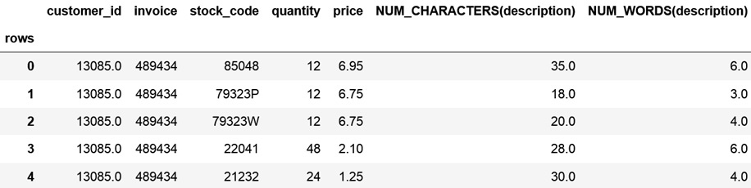
Figure 9.11 – Dataframe with the original data and the date and time features
Note that Featuretools removes the original text variable, description, and in its place, it returns the new features.
To follow up, let’s create more interesting features. To do this, we need to have the NLP Primitives library installed.
Let’s import a few text primitives:
from nlp_primitives import (
DiversityScore,
MeanCharactersPerWord,
PunctuationCount,
)
Let’s now add the text primitives from step 10 to our list of primitives from step 6:
text_primitives = text_primitives + [
DiversityScore,
MeanCharactersPerWord,
PunctuationCount,
]
To create the text primitives, you need to execute the code from step 7 after executing steps 10 and 11. After that, go ahead and display the names of the new features by executing feature_defs.
To finish off the recipe, let’s display the new features created after executing the code from step 7 with the primitives from step 11:
new_vars = feature_matrix.columns[5:10]
feature_matrix[new_vars].head()
In the following output, we can see the dataframe with new features created from the description variable:
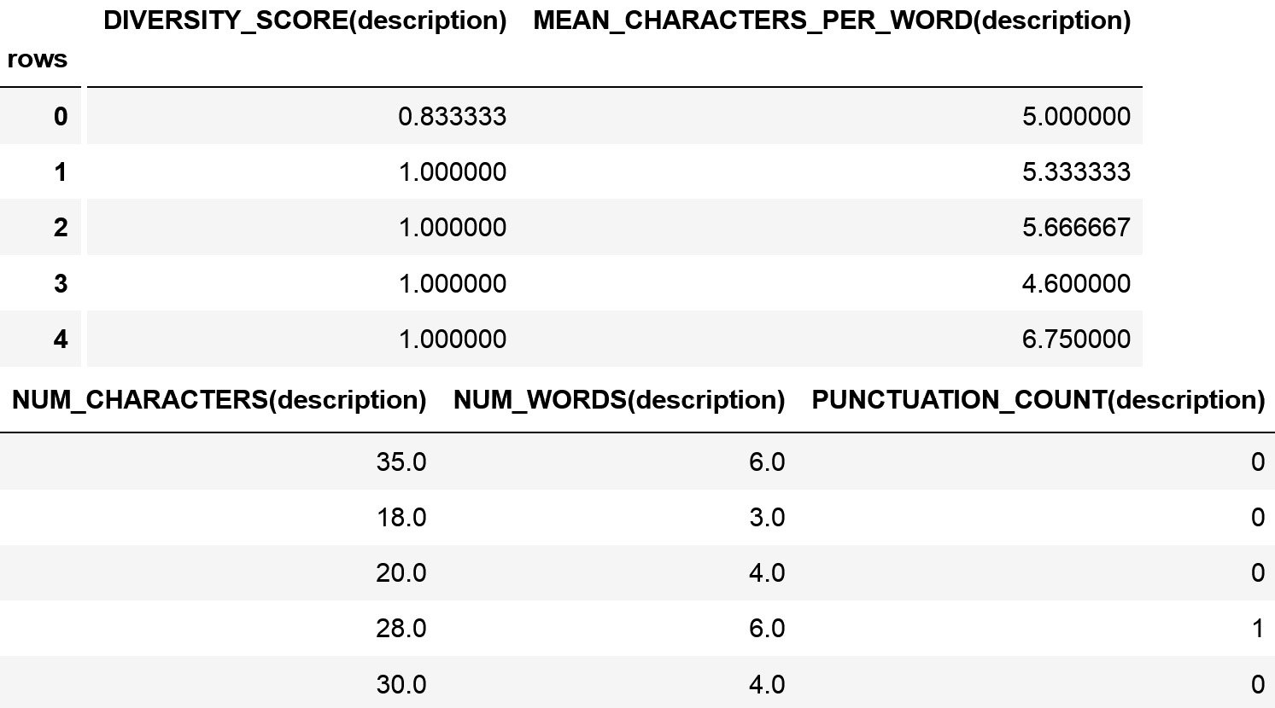
Figure 9.12 – Dataframe with the new text features
Go ahead and compare the new features with the original variable to understand their output better.

How it works...
To create features from text variables, first, we used the Featuretools built-in functionality for counting the number of words and characters, and then we used additional NLP primitives available in the NLP Primitives library.
The default primitives can be accessed from dfs with the strings we specified in step 6 using the trans_primitives parameter. The additional primitives need to be imported from NLP Primitives and then passed on to the trans_primitives parameter from dfs. With this, dfs is able to tap into the functionality of these primitives to create new features from the text. The NLP Primitives library uses the nltk Python library under the hood.

Creating features with aggregation primitives
Throughout this chapter, we’ve created features automatically by transforming existing variables into new features. For example, we extracted date and time parts from datetime variables, we counted the number of words, characters, and punctuation in a text, and we combined numerical features into new variables. To create these features, we worked with transform primitives.
Featuretools also supports aggregation primitives. These primitives take related observations as input and return a single value. For example, if we have a numerical variable, price, related to an invoice, an aggregation primitive would take all the price observations for a single invoice and return a single value, such as the mean price or the sum (that is, the total amount paid), for that particular invoice.
Tip
The Featuretools aggregation functionality is the equivalent of groupby in pandas, followed by pandas functions such as mean, sum, std, and count, among others.
Some aggregation primitives work with numerical variables, such as the mean, sum, or maximum and minimum values. Other aggregation primitives are specific to categorical variables, such as the number of unique values and the most frequent value (mode).
Note
For a complete list of supported aggregation primitives, visit https://featuretools.alteryx.com/en/stable/api_reference.html#aggregation-primitives.
In this recipe, first, we will create multiple features by aggregating existing variables, and then we will combine creating new features with transform primitives and subsequently aggregating them with aggregation primitives.

Getting ready
In this recipe, we will use the Online Retail II dataset from the UCI Machine Learning Repository. This dataset has information about items, invoices, and customers. To follow along with this recipe, it is important to understand the nature of and the relationships between these entities and how to correctly set up an entity set with Featuretools, which we described in the Setting up an entity set and creating features automatically recipe.

How to do it...
Let’s begin by importing the libraries and getting the dataset ready:
First, we’ll import pandas, featuretools, and the logical types:
import pandas as pd
import featuretools as ft
from woodwork.logical_types import (
Categorical,NaturalLanguage)
Let’s load the dataset that we prepared in the Technical requirements section:
df = pd.read_csv(
"retail.csv", parse_dates=["invoice_date"])
Let’s set up an entity set:
es = ft.EntitySet(id="data")
Let’s add the dataframe to the entity set, highlighting that the description variable is a text variable, the customer_id is Categorical, and the invoice date is a datetime feature:
es = es.add_dataframe(
dataframe=df,
dataframe_name="data",
index="rows",
make_index=True,
time_index="invoice_date",
logical_types={
"customer_id": Categorical,
"description": NaturalLanguage,
}
)
Let’s create a new dataframe with a relationship to the dataframe from step 4:
es.normalize_dataframe(
base_dataframe_name="data",
new_dataframe_name="invoices",
index="invoice",
copy_columns=["customer_id"],
)
Now, we add the second relationship, which is between customers and invoices. To do this, we indicate the base dataframe, which we called invoices in step 5, we give the new dataframe a name, customers, and add the unique customer identifier:
es.normalize_dataframe(
base_dataframe_name="invoices",
new_dataframe_name="customers",
index="customer_id",
)
Note
For more details about steps 4 to 5, visit the Setting up an entity set and creating features automatically recipe.
Let’s make a list with string names that identify the aggregation primitives we want to use:
agg_primitives = ["mean", "max", "min", "sum"]
Let’s create features by aggregating the data at the customer level. To do this, we set up the dfs class from Featuretools, indicating customers as the target dataframe and passing the aggregation primitives from step 7 and an empty list to the trans_primitives parameter to prevent dfs from returning the default transformations:
feature_matrix, feature_defs = ft.dfs(
entityset=es,
target_dataframe_name="customers",
agg_primitives=agg_primitives,
trans_primitives=[],
)
Let’s display the name of the created features:
feature_defs
In the following output, we can see the name features that were aggregated at the customer level:
[<Feature: MAX(data.price)>,
<Feature: MAX(data.quantity)>,
<Feature: MEAN(data.price)>,
<Feature: MEAN(data.quantity)>,
<Feature: MIN(data.price)>,
<Feature: MIN(data.quantity)>,
<Feature: SUM(data.price)>,
<Feature: SUM(data.quantity)>,
<Feature: MAX(invoices.MEAN(data.price))>,
<Feature: MAX(invoices.MEAN(data.quantity))>,
<Feature: MAX(invoices.MIN(data.price))>,
<Feature: MAX(invoices.MIN(data.quantity))>,
<Feature: MAX(invoices.SUM(data.price))>,
<Feature: MAX(invoices.SUM(data.quantity))>,
<Feature: MEAN(invoices.MAX(data.price))>,
<Feature: MEAN(invoices.MAX(data.quantity))>,
<Feature: MEAN(invoices.MEAN(data.price))>,
<Feature: MEAN(invoices.MEAN(data.quantity))>,
<Feature: MEAN(invoices.MIN(data.price))>,
<Feature: MEAN(invoices.MIN(data.quantity))>,
<Feature: MEAN(invoices.SUM(data.price))>,
<Feature: MEAN(invoices.SUM(data.quantity))>,
<Feature: MIN(invoices.MAX(data.price))>,
<Feature: MIN(invoices.MAX(data.quantity))>,
<Feature: MIN(invoices.MEAN(data.price))>,
<Feature: MIN(invoices.MEAN(data.quantity))>,
<Feature: MIN(invoices.SUM(data.price))>,
<Feature: MIN(invoices.SUM(data.quantity))>,
<Feature: SUM(invoices.MAX(data.price))>,
<Feature: SUM(invoices.MAX(data.quantity))>,
<Feature: SUM(invoices.MEAN(data.price))>,
<Feature: SUM(invoices.MEAN(data.quantity))>,
<Feature: SUM(invoices.MIN(data.price))>,
<Feature: SUM(invoices.MIN(data.quantity))>]
Note
Remember that Featuretools names the features with the function used to create them, followed by the dataframe that was used in the computation, followed by the variable that was used in the computation. Thus, MAX(data.price) is the maximum price seen in the dataset for each customer. On the other hand, MEAN(invoices.MAX(data.price)) is the mean value of all maximum prices observed in each invoice for a particular customer. That is, if a customer has six invoices, first, we find the maximum price for each of the six invoices, and then take the average of those values.
Let’s now display the resulting dataframe containing the original data and new features:
feature_matrix.head()
In the following output, we can see some of the variables in the dataframe returned by dfs:
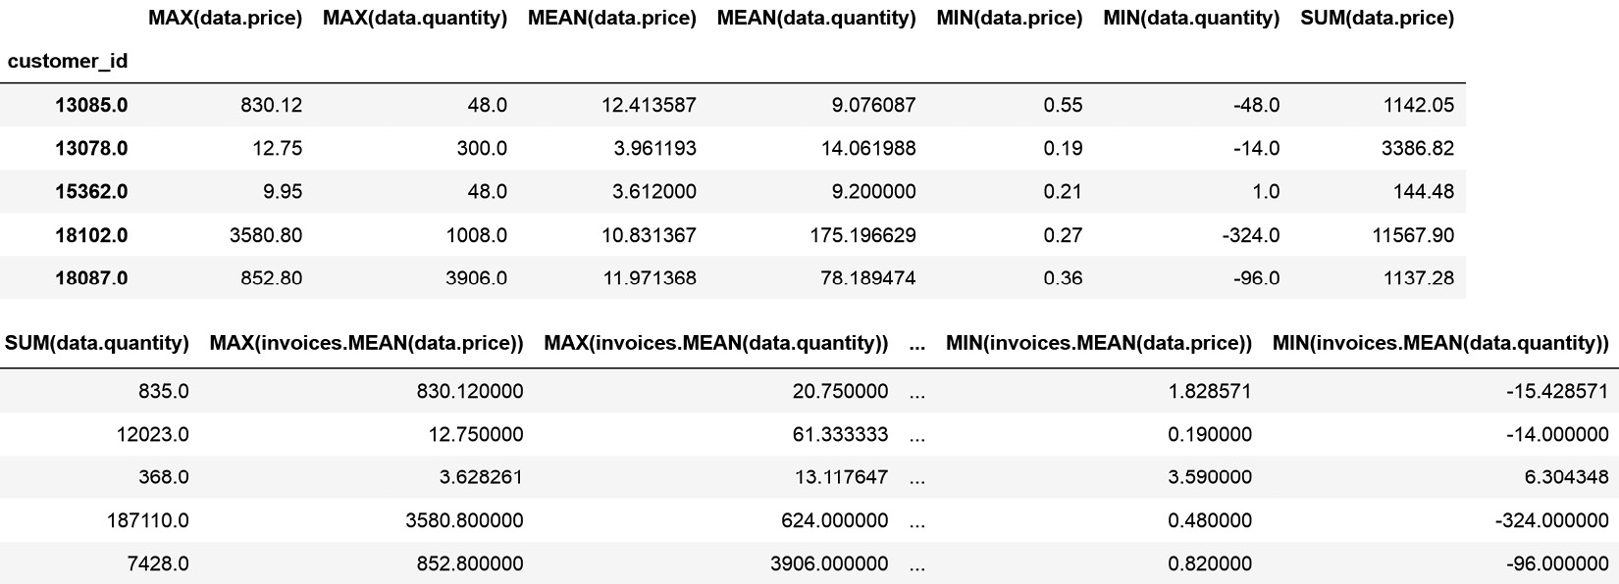
Figure 9.13 – Dataframe with some of the original and new features for each customer
Note
Due to space limitations, we can’t display the entire output of step 9, so make sure you execute it on your computer or visit our accompanying GitHub repository for more details: https://github.com/PacktPublishing/Python-Feature-Engineering-Cookbook-Second-Edition/blob/main/ch09-featuretools/Recipe6-Creating-features-with-aggregation-primitives.ipynb.
To follow up, let’s combine the recipes that we’ve discussed throughout the chapter with the aggregation functions from this recipe. First, we will create new features from existing variables and then aggregate those features, along with the existing variables, at the customer level:
Let’s make lists with date and text primitives:
trans_primitives = ["month", "weekday", "num_words"]
Let’s make a list with an aggregation primitive:
agg_primitives = ["mean"]
Let’s now automatically create features by transforming and aggregating the variables:
feature_matrix, feature_defs = ft.dfs(
entityset=es,
target_dataframe_name="customers",
agg_primitives=agg_primitives,
trans_primitives=trans_primitives,
max_depth=3,
)
The code from step 13 triggers the creation of the features and their subsequent aggregation at the customer level.
Let’s display the names of the new features:
feature_defs
In the following output, we can see the names of the created variables:
[<Feature: MEAN(data.price)>,
<Feature: MEAN(data.quantity)>,
<Feature: MONTH(first_invoices_time)>,
<Feature: WEEKDAY(first_invoices_time)>,
<Feature: MEAN(invoices.MEAN(data.price))>,
<Feature: MEAN(invoices.MEAN(data.quantity))>,
<Feature: MEAN(data.NUM_WORDS(description))>,
<Feature: MEAN(invoices.MEAN(data.NUM_
WORDS(description)))>] WORDS(description)))>]
Note that in our recipes, we keep the creation of features to a minimum due to space limitations, but you can create as many features as you want and enrich your datasets dramatically with the functionality built into Featuretools.

How it works...
In this recipe, we brought together the creation of features using transform primitives, which we discussed throughout the chapter, with the creation of features using aggregation primitives.
To create features with Featuretools automatically, first, we need to enter the data into an entity set and establish the relationships between the data. We discussed how to set up an entity set in the Setting up an entity set and creating features automatically recipe.
To aggregate existing features, we used the dfs class. We created a list with string names that can be used to access the aggregation primitives from dfs using the agg_primitives parameter. To aggregate existing variables without creating new features, we passed an empty list to the trans_primitives parameter of dfs.
The customers dataframe is the child of the invoice dataframe, which is in turn, the child of the original data. Thus, dfs created aggregations from the original data and the pre-aggregated data for each invoice. Thus, the MEAN(data.price) feature consists of the mean price for an item bought by a customer calculated from the entire data, whereas MEAN(invoices.MEAN(data.price)) calculates the mean price per invoice first and then takes the mean of those values for a customer. Thus, if a customer has five invoices, first, Featuretools calculates the mean price paid for each of those invoices and then takes the mean of those values. As such, MEAN(data.price) and MEAN(invoices.MEAN(data.price)) are not the same feature.
Note
An aggregate primitive aggregates information for a unique identifier. Aggregate primitives use mathematical operations such as the mean, standard deviation, maximum and minimum values, the sum, and the skew coefficient for numerical variables. For categorical variables, aggregate primitives use the mode and the count of unique items. For unique identifiers, aggregate primitives count the number of occurrences.
Next, we combined the creation of new features from date and text variables with aggregation. First, we defined a list of strings that can be used to access the transform primitives using the trans_primitives parameter of dfs. Then, we set up dfs with this list and passed a list with a string for an aggregation primitive to the agg_primitives parameter.
In the output of step 13, we got a list of the new features. From these, we can identify the features created from the first invoice date for each customer, such as MONTH(first_invoices_time) and WEEKDAY(first_invoices_time). We can also see features that were aggregated from features created from text, such as MEAN(data.NUM_WORDS(description)) and MEAN(invoices.MEAN(data.NUM_WORDS(description))). Finally, we can see the aggregations of existing numerical variables, such as MEAN(data.price) and MEAN(invoices.MEAN(data.price)).

10

Creating Features from a Time Series with tsfresh
Throughout this book, we’ve discussed feature engineering methods and tools suitable for tabular data and relational datasets. In this chapter, we will focus on time series data. A time series is a sequence of observations taken sequentially over time. Examples of time series are energy generation and demand, temperature, air pollutant concentration, stock prices, and sales revenue. Each of these examples constitutes a variable, and their values change over time.
The availability of cheap sensors that can measure motion, movement, humidity, or temperature, among several other things, has dramatically increased the availability of temporally annotated data. These time series can then be used in classification tasks. For example, based on the electricity fingerprint of a household at a given time interval, we can infer whether a certain appliance was being used. Based on the signal of an ultrasound sensor, we can determine the probability of a failure in a pipeline. And based on the characteristics of a sound wavelength, we can anticipate whether a listener will like the song. We can also use time series in regression tasks. For example, we can use the signal returned by machinery sensors to predict the remaining useful life of the device.
To use time series in traditional supervised machine learning models, each time series needs to be mapped into a well-defined feature vector that captures the characteristics of the time series. These characteristics, which are based on the distribution of the time series data points, can be captured by simple mathematical operations such as the mean and the standard deviation. We can also describe time series based on their correlation properties, stationarity, entropy, and non-linear time series analysis functions that decompose the time series signal through, for example, Fourier or wavelet transformations.
Creating features from time series can be very time-consuming because we may need to consider the many algorithms that can be used for signal processing and time series analysis to identify and extract meaningful features. The tsfresh Python package, which stands for Time Series FeatuRe Extraction on the Basis of Scalable Hypothesis tests, accelerates this process by combining 63 time series characterization methods, which compute more than 750 features automatically. The tsfresh library also provides a feature selection algorithm that identifies the most predictive features for a given time series. Thus, tsfresh narrows the gap between signal processing experts and machine learning practitioners by providing a tool that automatically applies complex time series methods to extract features that describe the time series.
In this chapter, we will learn how to automatically create hundreds of features from time series data by utilizing tsfresh. Then, we will discuss how to select the most relevant features, how to optimize feature creation, and how to embed the creation of features from time series within a scikit-learn pipeline to classify time series.
In this chapter, we will cover the following recipes:
Extracting features automatically from a time series
Creating and selecting features from a time series
Tailoring feature creation to a different time series
Creating pre-selected features
Embedding feature creation into a scikit-learn pipeline

Technical requirements
In this chapter, we will use the open source tsfresh Python library. You can install tsfresh with pip by executing pip install tsfresh.
Note
If you have an old Microsoft operating system, you may need to update Microsoft C++ Build Tools to proceed with tsfresh’s installation. Follow the steps in this thread to do so: https://stackoverflow.com/questions/64261546/how-to-solve-error-microsoft-visual-c-14-0-or-greater-is-required-when-inst.
Throughout the recipes in this chapter, we will work with the Occupancy Detection dataset, available in the UCI Machine Learning Repository: http://archive.ics.uci.edu/ml/datasets/Occupancy+Detection+#.
Note
The dataset was described in Accurate occupancy detection of an office room from light, temperature, humidity, and CO2 measurements using statistical learning models. Luis M. Candanedo, Veronique Feldheim. Energy and Buildings. Volume 112, 15 January 2016. Pages 28-39.
To download the Occupancy Detection dataset, follow these steps:
Go to http://archive.ics.uci.edu/ml/machine-learning-databases/00357/.
Click on occupancy_data.zip to download the data.
Unzip the file from step 2.
Save the datatraining.txt file, which is inside the folder from step 3 to the folder where you will run the commands in the coming paragraph.
After you’ve downloaded the dataset, open a Jupyter Notebook and perform the following steps:
Import pandas:
import pandas as pd
Load the data into a DataFrame:
df = pd.read_table(
"datatraining.txt", sep=",", parse_dates=["date"])
Select the data between the dates indicated in the following code snippet:
df = df[(df["date"] >= "2015-02-04 18:00:00") &
(df["date"] < "2015-02-10 09:00:00")]
Rename the DataFrame’s columns:
df.columns = [
"date",
"temperature",
"humidity",
"light",
"co2",
"humidity_ratio",
"occupancy"
]
We will add a unique identifier to highlight each hour of data:
ls = []
c = 0
for i in range(len(df)):
if i % 60 == 0:
c = c+1
ls.append(c)
df['id']=ls
Note
In this dataset, there are 135 hours of records at 1-minute intervals. Each hour of records is marked with a unique integer in step 5. Thus, the first hour of records takes the value 1, the records in the second hour take the value 2, and so on.
Re-order the columns and save the data:
df[["id"]+columns[0:-1]].to_csv("occupancy.csv", index=False)
The occupancy variable takes a value of 1 when someone was in the office at any given minute. Let’s create a new target variable that indicates that the office was occupied if people were in the office for more than 30 minutes:
occ = (df.groupby(
"id") ["occupancy"].mean()>0.5).astype (int)
Save the target variable:
occ.to_csv("occupancy_target.csv", index=True)
The Occupancy Detection dataset contains time series data taken at 1-minute intervals. These variables measure the temperature, humidity, CO2 level, and light consumption within an office. The dataset also contains a target variable, indicating whether someone was in the office at any given minute. We modified this target in step 7, to indicate whether the office was occupied for more than 30 minutes at any given hour. We also added an additional variable in step 5, with a unique identifier for each hour in the data.
You probably noticed that the dataset and the target variable have different numbers of rows. The dataset contains 135 hours of records at 1-minute intervals – that is, 8,100 rows. The target has only 135 rows, with a label indicating whether the office was occupied in each of the 135 hours.
Tip
Check out the notebook in this book’s GitHub repository for plots of the different time series in this dataset: https://github.com/PacktPublishing/Python-Feature-Engineering-Cookbook-Second-Edition/blob/main/ch10-tsfresh/prepare-occupancy-dataset.ipynb.

Extracting features automatically from a time series
Time series are data points indexed in time order. Based on a time series sequence, we can predict several things. For example, we can predict whether a pipeline will fail, a music genre, whether a person is sick, or, as we will do in this recipe, whether an office is occupied.
To train regression or classification models with traditional machine learning algorithms, we require a dataset of size M x N, where M is the number of rows and N is the number of features or columns. However, with time series data, what we have is a collection of M time series. And each time series has multiple rows indexed in time. To use time series in supervised learning models, each time series needs to be mapped into a well-defined feature vector, N, as shown in the following diagram:
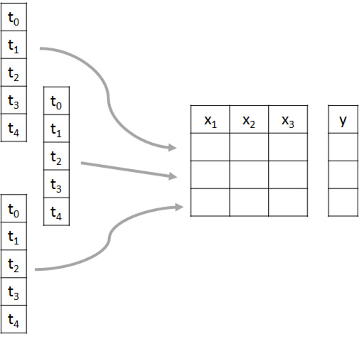
Figure 10.1 – Diagram showing the process of feature creation from a time series for classification or regression
These feature vectors, which are represented as x1, x2, and x3 in Figure 10.1, should capture the characteristics of the time series. For example, x1 could be the mean value of the time series and x2 its variance. We can create many features to characterize the time series concerning the distribution of data points, correlation properties, stationarity, or entropy, among others. Therefore, the feature vector, N, can be constructed by applying a series of characterization methods that take a time series as input and return one or more scalars as output. The mean (or the sum operations) takes the time series sequence and returns a single scalar, with the mean value of the time series or the sum of its values. We can also fit a linear trend to the time series sequence, which will return two scalars – one with the slope and one with the intercept.
The tsfresh library applies 63 characterization methods to a time series, each of which returns one or more scalars, therefore resulting in more than 750 features for any given time series. In this recipe, we will use tsfresh to transform time series data into an M x N feature table, which we will then use to predict office occupancy.

Getting ready
In this recipe, we will use the Occupancy Detection dataset that we prepared in the Technical requirements section. This dataset contains time series data taken at 1-minute intervals. The variables measure the temperature, humidity, CO2 level, and light consumption within an office. There are 135 hours of measurements, and each hour is flagged with a unique identifier. We also created a target variable that indicates in which of these 135 hours the office was occupied. Let’s load the data and make some plots to understand its structure:
Let’s load pandas and matplotlib:
import matplotlib.pyplot as plt
import pandas as pd
Let’s load the dataset and display the first five rows:
X = pd.read_csv("occupancy.csv", parse_dates=["date"])
X.head()
In the following screenshot, you can see the dataset, which contains a unique identifier for the first hour of records, followed by the date and time of the measurements, and values for five time series capturing temperature, humidity, lights, and CO2 levels in the office:
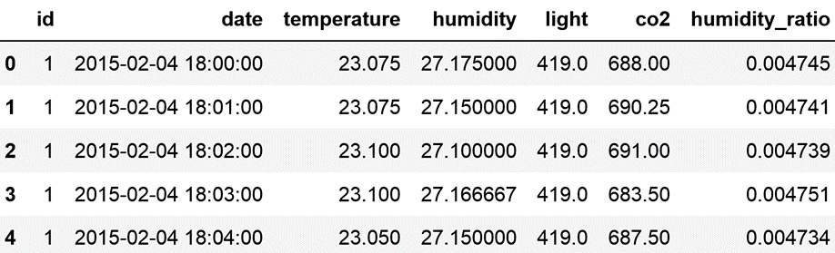
Figure 10.2 – DataFrame with the time series data
Let’s create a function to plot the time series from step 2 for a given hour:
def plot_timeseries(n_id):
fig, axes = plt.subplots(nrows=2, ncols=3,
figsize=(20, 10))
X[X["id"] == n_id]["temperature"].plot(ax=axes[0, 0],
title="temperature")
X[X["id"] == n_id]["humidity"].plot(ax=axes[0, 1],
title="humidity
X[X["id"] == n_id]["light"].plot(ax=axes[0, 2],
title="light")
X[X["id"] == n_id]["co2"].plot(ax=axes[1, 0],
title="co2")
X[X["id"] == n_id]["humidity_ratio"].plot(ax=axes[1,
1], title="humidity_ratio")
plt.show()
Let’s plot the time series corresponding to an hour when the office was not occupied:
plot_timeseries(2)
In the following screenshot, we can see the time series values during the second hour of records, when the office was empty:
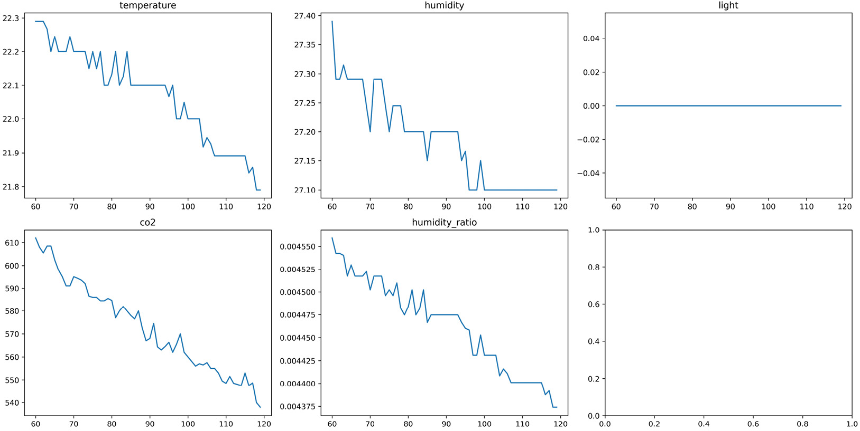
Figure 10.3 – Time series values during the second hour of data
Note that the lights were off, and that is why we can see the flat line at 0 in the plot of light consumption in the top-right corner.
Now, let’s plot the time series data corresponding to an hour when the office was occupied:
plot_timeseries(15)
In the following screenshot, we can see the time series values during the fifteenth hour of records, when the office was occupied:
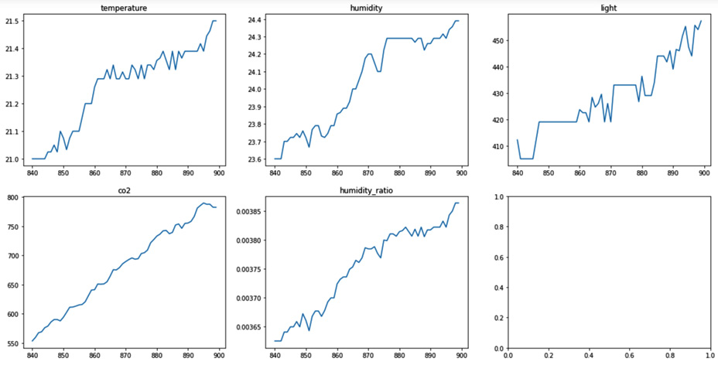
Figure 10.3 – Time series values during the fifteenth hour of data
Notice that the lights were on this time.
I hope these plots make it easier to understand what we will do in the recipe. From each of these 60-minute time series, we will create more than 750 features that capture their characteristics. We will create these features automatically, using tsfresh.

How to do it...
We will begin by automatically creating hundreds of features from one time series, lights, and then use those features to predict whether the office was occupied at any given hour:
Let’s import the required Python libraries and functions:
import pandas as pd
from sklearn.linear_model import LogisticRegression
from sklearn.metrics import classification_report
from sklearn.model_selection import train_test_split
from tsfresh import extract_features
from tsfresh.utilities.dataframe_functions import impute
Let’s load the dataset that we prepared in the Technical requirements section:
X = pd.read_csv("occupancy.csv", parse_dates=["date"])
Let’s load the target variable and then convert it into a pandas series:
y = pd.read_csv("occupancy_target.csv", index_col="id")
y = pd.Series(y["occupancy"])
Note
We convert the target into a pandas series because tsfresh only accepts pandas series or NumPy arrays as target variables.
Let’s create hundreds of features automatically for each hour of records using tsfresh, and then display the shape of the resulting matrix. To create features from the light variable, we need to pass the DataFrame containing this variable and the unique identifier for each time series:
features = extract_features(
X[["id", "light"]], column_id="id")
features.shape
The output of the previous step is (135, 789). Each row represents an hour of records. The tsfresh library created 789 features that characterize light consumption at any given hour. Go ahead and execute features.head() to get a view of the resulting DataFrame. For space reasons, we can’t display the entire DataFrame in the book. So, instead, we will explore some of the features.
Let’s display five of the created features:
feats = features.columns[10:15]
feats
In the output of step 5, we can see the names of five features that were created by simple mathematical operations such as the mean, variance, or standard deviation of the light consumption at any given hour, the length of the time series, or the coefficient of variation:
Index(['light__mean', 'light__length', 'light__standard_deviation',
'light__variation_coefficient', 'light__variance'],
dtype='object')
Now, let’s display the values of the features from step 5 for the first 5 hours of records:
features[feats].head()
We can see the new features that were created for the first 5 hours of light consumption in the following DataFrame:
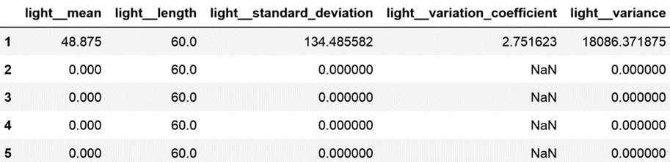
Figure 10.4 – Features created for each hour of light consumption
In Figure 10.4, we can see that the lights were on in the first hour of records, and then off in the following 4 hours, by inspecting the mean value of light consumption. The length of the time series is 60 because we have 60 minutes of records – one for each hour.
Note
The tsfresh library applies 63 feature creation methods to a time series. Based on the characteristics of the time series, such as its length or its variability, some of the methods will return missing values or infinite values. For example, in Figure 10.4, we can see that the variation coefficient could not be calculated for those hours where the light consumption is constant. And the variance is also 0 in those cases. In fact, for our particular dataset, many of the resulting features contain only NAN values and are therefore unsuitable for training machine learning models.
The tsfresh library offers an imputation function to quickly impute features, should they have NAN values. Let’s go ahead and impute our features:
impute(features)
Now, let’s use these features to train a logistic regression model and predict whether the office was occupied. Let’s begin by separating the dataset into train and test sets:
X_train, X_test, y_train, y_test = train_test_split(
features,
y,
test_size=0.1,
random_state=42,
)
Now, let’s set up and train a logistic regression model, and then evaluate its performance:
cls = LogisticRegression(random_state=10, C=0.01)
cls.fit(X_train, y_train)
print(classification_report(y_test, cls.predict(X_test)))
In the following output, we can see the evaluation metrics that are commonly used for classification analysis, which suggests that the created features are useful for predicting office occupancy:
precision recall f1-score support
0 1.00 0.91 0.95 11
1 0.75 1.00 0.86 3
accuracy 0.93 14
macro avg 0.88 0.95 0.90 14
weighted avg 0.95 0.93 0.93 14
To finish off, let’s create features automatically for each of the time series in our dataset and then display the shape of the resulting DataFrame. This time, we will perform the imputation automatically after extracting the features:
features = extract_features(
X,
column_id="id",
impute_function=impute,
column_sort="date",
)
features.shape
Note
In step 10, we indicated that we want to sort our time series based on the timestamp containing the time and date of the measurement, by passing the datetime variable to the column_sort parameter. This is useful if our time series are not equidistant or not ordered in time. If we leave this parameter set to None, tsfresh assumes that the time series are ordered and equidistant.
The output of step 10 consists of a DataFrame with 135 rows, containing 3,945 features that characterize the five original time series – temperature, light, humidity and its ratio, and CO2 in the office. These features were imputed in step 10, so you can go ahead and use these DataFrames to train another logistic regression model to predict office occupancy.

How it works...
In this recipe, we used tsfresh to automatically create hundreds of features for each of the five time series, and then used those features to train a logistic regression model to predict whether an office was occupied.
To create features with tsfresh, each time series that we want to extract features from must be marked with a unique identifier. In our dataset, that was the id variable.
To create features for each time series, in step 4, we used the extract_features function from tsfresh and passed the DataFrame containing the time series that we want to extract the features from – that is, lights – and the unique identifier for each hour of light consumption records. Note that we had to pass id to the column_id parameter.
The extract_features function has many parameters, some of which we will discuss in upcoming recipes. In this recipe, we used the additional column_sort parameter. In step 4, we left it set to None, so tsfresh assumed that the data was ordered in time and that the time stamps were equidistant. In step 10, we passed the date variable as the sorting variable.
Tip
In our dataset, we could have either left column_sort set to None or passed the date variable because our time series were indeed ordered in time and the timestamps were equidistant. Otherwise, be mindful of this parameter.
The extract features function also accepts the impute function through the impute_function parameter, to automatically remove infinite and NAN values from the created features.
Note
For more details about the extract_features function, visit https://tsfresh.readthedocs.io/en/latest/api/tsfresh.feature_extraction.html#module-tsfresh.feature_extraction.extraction.
The impute method, which can be used independently, as we did in step 7, or within the extract_features function, as we did in step 10, will replace NAN values and infinite values introduced in the features automatically. It will replace NAN, -Inf, and Inf values with the variable’s median, minimum, or maximum values, respectively. If the feature contains only NAN values, they will be replaced by zeroes. The imputation occurs in place – that is, in the same DataFrame that is being imputed.
Now, let’s discuss the output of the feature creation process. The extract features function returns a DataFrame containing as many rows as there are unique identifiers in the data. In our case, it returned a DataFrame with 135 rows. The columns of the resulting DataFrame correspond to the 789 values that were returned by 63 characterization methods, applied to each of the 135 60-minute time series.
In step 5, we explored some of the resulting features, which captured the time serie mean, variance, and coefficient of variation, as well as their length. Let’s explore a few more of the resulting features.
Some of the created variables are very self-explanatory. For example, the 'light__skewness' and 'light__kurtosis' variables contain the skewness and kurtosis coefficients, which characterize the data distribution. The 'light__has_duplicate_max', 'light__has_duplicate_min', and 'light__has_duplicate' variables indicate whether the time series has duplicated values or duplicated minimum and maximum values. The 'light__quantile__q_0.1', 'light__quantile__q_0.2', and 'light__quantile__q_0.3' variable return the different quantile values of the time series. Finally, the 'light__autocorrelation__lag_0', 'light__autocorrelation__lag_1', and 'light__autocorrelation__lag_2' variables return the autocorrelation of the time series with its past values lagged by 0, 1, or 2 steps, which may be useful in forecasting.
Other characterization methods return features obtained from signal processing algorithms, such as the continuous wavelet transform for the Ricker wavelet, which returns the 'light__cwt_coefficients__coeff_0__w_2__widths_(2, 5, 10, 20)', 'light__cwt_coefficients__coeff_0__w_5__widths_(2, 5, 10, 20)', 'light__cwt_coefficients__coeff_0__w_10__widths_(2, 5, 10, 20)', and 'light__cwt_coefficients__coeff_0__w_20__widths_(2, 5, 10, 20)' features, among others.
Note
We can’t discuss each of these feature characterization methods or their outputs in detail in the book because they are too many. You can find more details about the transformations supported by tsfresh and their formulation at https://tsfresh.readthedocs.io/en/latest/api/tsfresh.feature_extraction.html.
Some of the features that are automatically created by tsfresh may not make sense or even be possible to calculate for some time series because they require a certain length or data variability, or the time series must meet certain distribution assumptions. Therefore, the suitability of the features will depend on the nature of the time series.
Tip
We can decide which features to extract from our time series based on domain knowledge, or by creating all possible features and then applying feature selection algorithms.

See also
For more details on the tsfresh library, check out its original article: Christ, Braun, Neuffer, and Kempa-Liehr (2018). Time Series FeatuRe Extraction on basis of Scalable Hypothesis tests (tsfresh – A Python package). Neurocomputing 307 (2018). Pages 72-77. https://dl.acm.org/doi/10.1016/j.neucom.2018.03.067.

Creating and selecting features for a time series
In the previous recipe, we automatically extracted several hundred features from a time series variable using tsfresh. If we have more than one time series variable, we can easily end up with a dataset that contains thousands of features.
When we create classification and regression models to solve real-life problems, we often want our models to take a small number of relevant features as input to produce their predictions. Simpler models have many advantages. First, their output is easier to interpret for the end users of the models. Second, simpler models are cheaper to store and faster to train. They also return their outputs faster.
The tsfresh library provides a highly parallel feature selection algorithm based on non-parametric statistical hypothesis tests, which can be executed at the back of the feature creation procedure to quickly remove irrelevant features. The feature selection procedure utilizes different tests for different features.
Under the hood, tsfresh uses the following tests:
Fisher’s exact test of independence if both the feature and the target are binary
Kolmogorov-Smirnov test if either the feature or the target is binary
Kendall rank test, if neither the feature nor target is binary
The advantage of these tests is that they are non-parametric, and thus make no assumption on the underlying distribution of the variables being tested.
The result of these tests is a vector of p-values that measures the significance of the association between each feature and the target. These p-values are then evaluated based on the Benjamini-Yekutieli procedure to decide which features to keep.
Note
For more details about tsfresh’s feature selection procedure, check the original article: Christ, Kempa-Liehr, Feindt: Distributed and parallel time series feature extraction for industrial big data applications. Asian Machine Learning Conference (ACML) 2016, Workshop on Learning on Big Data (WLBD), Hamilton (New Zealand), ArXiv, https://arxiv.org/abs/1610.07717v1.
In this recipe, we will automatically create hundreds of features from various time series, and then select the most relevant features by utilizing tsfresh.

How to do it...
We will begin by automatically creating and selecting features from one time series, lights, and then we will automate the procedure for multiple time series. We will use the extracted features to predict whether the office was occupied at any given hour:
Let’s import the required Python libraries and functions:
import pandas as pd
from sklearn.linear_model import LogisticRegression
from sklearn.metrics import classification_report
from sklearn.model_selection import train_test_split
from tsfresh import (
extract_features,
extract_relevant_features,
select_features,
)
from tsfresh.utilities.dataframe_functions import impute
Let’s load the dataset and the target variable that we prepared in the Technical requirements section into a DataFrame and a pandas series, respectively:
X = pd.read_csv("occupancy.csv", parse_dates=["date"])
y = pd.read_csv("occupancy_target.csv", index_col="id")
y = pd.Series(y["occupancy"])
Let’s create hundreds of features automatically for each hour of records of light use, and impute the resulting features:
features = extract_features(
X[["id", "light"]],
column_id="id",
impute_function=impute,
)
The output of the previous step is a DataFrame that consists of 135 rows and 789 columns called features, which means that 789 features were created from each hour of light consumption.
Note
For more details about step 3, or the Occupancy Detection dataset, check out the Extracting features automatically from a time series recipe of this chapter.
Now, let’s select the features based on the non-parametric tests that we mentioned in the introduction of this recipe, and then display the number of selected features:
features = select_features(features, y)
len(features)
The output of step 4 is 135, which means that from the 789 features created in step 3, only 135 are statistically significant. Go ahead and execute features.head() to display the first five rows of the resulting DataFrame.
For space reasons, we will only display the first five of the selected features:
feats = features.columns[0:5]
features[feats].head()
We can see the values of the first five features for the first 5 hours of light consumption in the following DataFrame:
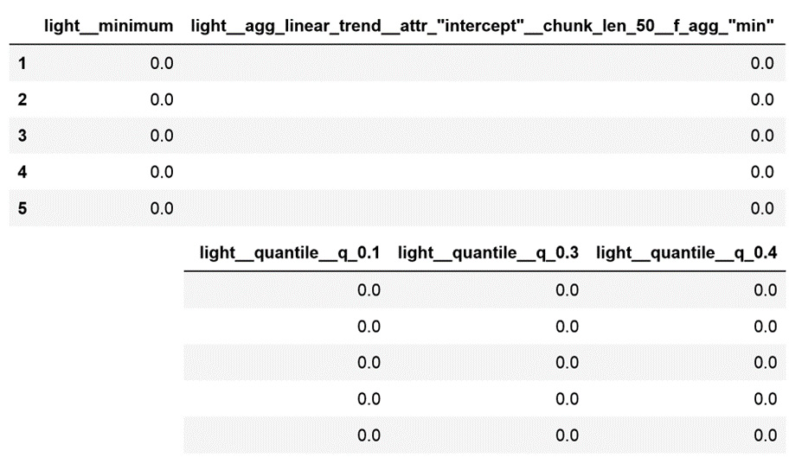
Figure 10.5 – DataFrame with five of the selected features created for each hour of light consumption
Check the discussion in the How it works… section for a more detailed analysis of the DataFrame from step 5.
Now, we will use the features from step 4 to train a logistic regression model and predict whether the office was occupied. Let’s begin by separating the dataset into train and test sets:
X_train, X_test, y_train, y_test = train_test_split(
features,
y,
test_size=0.1,
random_state=42,
)
Now, let’s set up and train a logistic regression model, and then evaluate its performance:
cls = LogisticRegression(
random_state=10, C=0.1, max_iter=1000)
cls.fit(X_train, y_train)
print(classification_report(y_test, cls.predict(X_test)))
In the following output, we can see the evaluation metrics that are commonly used for classification analysis. These suggest that the selected features are useful for predicting office occupancy:
precision recall f1-score support
0 1.00 0.91 0.95 11
1 0.75 1.00 0.86 3
accuracy 0.93 14
macro avg 0.88 0.95 0.90 14
weighted avg 0.95 0.93 0.93 14
Tip
Go ahead and compare the results from step 7 with those of step 9 in the Extracting features automatically from a time series recipe of this chapter. You will see that we obtained similar performance, with only a fraction of the features.
We can trigger the feature creation and feature selection procedures by using one single function, extract_relevant_features, and therefore combine steps 3 and 4. Now, let’s create features automatically for the five time series in our dataset, then select the most relevant features, and finally display the shape of the resulting DataFrame:
features = extract_relevant_features(
X,
y,
column_id="id",
column_sort="date",
)
features.shape
Note
The parameters of extract_relevant_features are very similar to those of extract_features. Note, however, that the former will automatically perform imputation to be able to proceed with the feature selection. We discussed the parameters of extract_features in the Extracting features automatically from time series recipe of this chapter.
The output of step 7 consists of a DataFrame with 135 rows, containing only 969 features from the original 3,945 that are returned by default by tsfresh. Go ahead and use this DataFrame to train another logistic regression model to predict office occupancy.

How it works...
In this recipe, we created hundreds of features from a time series and then selected the most relevant features based on non-parametric statistical tests. The feature creation and selection procedures were carried out automatically by tsfresh.
To create the features, we used tsfresh’s extract_features function, which we described in detail in the Extracting features automatically from a time series recipe of this chapter.
To select features, we used the select_features function, also from tsfresh. This function applies different statistical tests, depending on the nature of the feature and the target. Briefly, if the feature and target are binary, it tests their relationship with Fisher’s exact test. If either the feature or the target is binary, and the other variable is continuous, it tests their relationship by using the Kolmogorov-Smirnov test. If neither the features nor the target is binary, it uses the Kendall rank test.
The result of these tests is a vector with one p-value per feature. Next, tsfresh applies the Benjamini-Yekutieli procedure, which aims to reduce the false discovery rate, to select which features to keep based on the p-values. This feature selection procedure has some advantages, the main one being that statistical tests are fast to compute, and therefore the selection algorithm is scalable and can be parallelized.
From Figure 10.5, however, we can immediately detect one of the limitations of tsfresh’s selection procedure: it is unable to remove redundant features. We know from the Extracting features automatically from a time series recipe that if the lights are off, then most likely the office is empty. Therefore, many of the features that capture one aspect of this pattern (lights off) will be important to predict occupancy, and redundant at the same time. Note that in Figure 10.5, the different quantiles of light consumption contain identical values, so they are identical features. We only need one of them to train a machine learning model; we can get rid of the rest.
Note
The limitations of the tsfresh algorithm are shared by all filter selection methods. Because these methods evaluate each feature individually, they can’t assess their interaction with other features, and as such, return redundant features as part of their selection procedure.
Finally, in step 8, we combined the feature creation step (step 3) and the feature selection step (step 4) into one function. The extract_relevant_features function applies the extract_features function to create the features from each time series and imputes them. Next, it applies the select_features function to return a DataFrame containing one row per unique identifier, and the features that were selected for each time series. Note that different features can be selected for different time series.

See also
The selection algorithm from tsfresh offers a quick method to remove irrelevant features. However, it does not find the best feature subset for the classification or regression task. Other feature selection methods can be applied at the back of tsfresh that can reduce the feature space further.
Note
For more details on feature selection algorithms, check out the book Feature Selection in Machine Learning with Python, by Soledad Galli on Leanpub: https://leanpub.com/feature-selection-in-machine-learning/.

Tailoring feature creation to different time series
The tsfresh library extracts many features based on the time series characteristics and distribution, such as their correlation properties, stationarity, entropy, and non-linear time series analysis functions, which decompose the time series signal through, for example, Fourier or wavelet transformations. Depending on the nature of the time series, some of these transformations make more sense than others. For example, wavelength decomposition methods can make sense for time series resulting from signals or sensors but are unsuitable for time series representing sales or stock prices.
In this recipe, we will discuss how to optimize the tsfresh feature extraction procedure to create specific features for each time series, and then use these features to predict office occupancy.

How to do it...
The tsfresh library accesses the methods that will be used to create features through a dictionary that contains the method’s names as keys, and if they are based on a parameter, it has the parameter as a value. The library comes with some predefined dictionaries. We’ll explore these predefined dictionaries first, which can be accessed through the settings module:
Let’s import the required Python libraries and functions and the settings module:
import pandas as pd
from sklearn.linear_model import LogisticRegression
from sklearn.metrics import classification_report
from sklearn.model_selection import train_test_split
from tsfresh.feature_extraction import extract_features
from tsfresh.feature_extraction import settings
Let’s load the dataset and the target variable that we prepared in the Technical requirements section into a DataFrame and a pandas series, respectively:
X = pd.read_csv("occupancy.csv", parse_dates=["date"])
y = pd.read_csv("occupancy_target.csv", index_col="id")
y = pd.Series(y["occupancy"])
The tsfresh library has three main dictionaries that control the feature creation output: settings.ComprehensiveFCParameters, settings.EfficientFCParameters, and settings.MinimalFCParameters. Let’s explore the dictionary that returns the smaller number of features.
Let’s instantiate the dictionary that returns the smaller number of features and then display the feature creation methods that will be applied by this configuration:
minimal_feat = settings.MinimalFCParameters()
minimal_feat.items()
In the output of step 2, we can see a dictionary with the feature extraction method names as keys, and the parameters used by those methods, if any, as values:
ItemsView({'sum_values': None, 'median': None, 'mean': None, 'length': None, 'standard_deviation': None, 'variance': None, 'root_mean_square': None, 'maximum': None, 'absolute_maximum': None, 'minimum': None})
Note
Go ahead and explore the other two predefined dictionaries, settings.ComprehensiveFCParameters and settings.EfficientFCParameters, by adapting the code from step 3.
Now, let’s use the dictionary from step 3 to extract only those features from the light time series and then display the shape of the resulting DataFrame:
features = extract_features(
X[["id", "light"]],
column_id="id",
default_fc_parameters=minimal_feat,
)
features.shape
The output of step 4 is (135, 10), which means that only 10 features were created for each of the 135 hours of light consumption data.
Let’s display the resulting DataFrame:
features.head()
We can see the values of the features for the first 5 hours of light consumption in the following DataFrame:
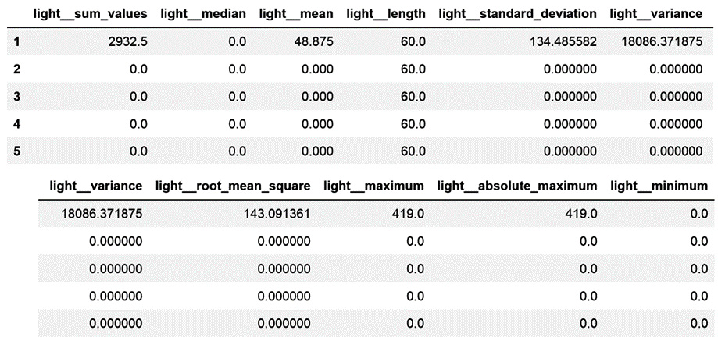
Figure 10.6 – DataFrame with the features created for each hour of light consumption
Now, we will use these features to train a logistic regression model and predict whether the office was occupied.
Let’s begin by separating the dataset into train and test sets:
X_train, X_test, y_train, y_test = train_test_split(
features,
y,
test_size=0.1,
random_state=42,
)
Now, let’s set up and train a logistic regression model, and then evaluate its performance:
cls = LogisticRegression(random_state=10, C=0.01)
cls.fit(X_train, y_train)
print(classification_report(y_test, cls.predict(X_test)))
In the following output, we can see the evaluation metrics that are commonly used for classification analysis. These suggest that the selected features are useful for predicting office occupancy:
precision recall f1-score support
0 1.00 0.91 0.95 11
1 0.75 1.00 0.86 3
accuracy 0.93 14
macro avg 0.88 0.95 0.90 14
weighted avg 0.95 0.93 0.93 14
Tip
Because light consumption is a very good indicator of office occupancy, with very simple features, we can obtain a predictive logistic regression model.
Now, let’s learn how to specify the creation of different features for different time series.
Let’s create a dictionary with the names of the methods that we want to use to create features from the light time series. We enter the method’s names as keys, and if the methods take a parameter, we pass it as an additional dictionary to the corresponding key; otherwise, we pass None as the values:
light_feat = {
"sum_values": None,
"median": None,
"standard_deviation": None,
"quantile": [{"q": 0.2}, {"q": 0.7}],
}
Now, let’s create a dictionary with the features that we want to create from the co2 time series:
co2_feat = {
"root_mean_square": None,
"number_peaks": [{"n": 1}, {"n": 2}],
}
Let’s combine these dictionaries into a new dictionary:
kind_to_fc_parameters = {
"light": light_feat,
"co2": co2_feat,
}
Finally, let’s use the dictionary from step 10 to create the features from both time series:
features = extract_features(
X[["id", "light", "co2"]],
column_id="id",
kind_to_fc_parameters=kind_to_fc_parameters,
)
The output of step 11 consists of a DataFrame with 135 rows and 8 features. If we execute features.columns, we will see the names of the created features:
Index(['light__sum_values', 'light__median',
'light__standard_deviation',
'light__quantile__q_0.2',
'light__quantile__q_0.7',
'co2__root_mean_square',
'co2__number_peaks__n_1',
'co2__number_peaks__n_2'],
dtype='object')
Note that in the output from step 11, different variables have been created from each of the light and co2 time series.

How it works...
In this recipe, we created a subset of the possible features for our time series data. First, we created features specified in a predefined dictionary that comes with tsfresh. Next, we created our own dictionary, specifying the creation of different features for different time series.
The tsfresh package comes with some predefined dictionaries that can be accessed through the settings module. The MinimalFCParameters directory triggers the creation of 10 simple features based on basic statistical parameters of the time series distribution. In step 3, we displayed the names of the methods that are used to create each one of these 10 variables. Among these, the "sum_values" method will return the sum of the time series values, whereas the "mean" method will return its mean value. These methods do not need additional parameters to create the features, so for each of the keys corresponding to their names, we used None as the values.
The predefined EfficientFCParameters dictionary applies the methods that are fast to compute, whereas the ComprehensiveFCParameters dictionary returns all possible features.
Note
For more details about these dictionaries, check out the tsfresh documentation at https://tsfresh.readthedocs.io/en/latest/text/feature_extraction_settings.html.
By using these predefined dictionaries in the default_fc_parameters parameter of tsfresh’s extract_features function, we can create specific features from one or more time series, as we did in step 4. Note that default_fc_parameters instructs extract_features to create the same features from all the time series.
To create different features for different time series, we can use the kind_to_fc_parameters parameter of tsfresh’s extract_features function. This parameter takes a dictionary with dictionaries, where each dictionary specifies parameters for one time series.
In step 8, we created a dictionary to specify the creation of features from the light time series. Note that the "sum_values" and "mean" methods take None as values, but the quantile method needs additional parameters corresponding to the quantiles that should be returned from the time series.
In step 9, we created a dictionary to specify the creation of features from the co2 time series. In step 10, we combined both dictionaries into one that takes the name of the time series as keys and the feature creation dictionaries as values. Then, we used this dictionary in kind_to_fc_parameters of tsfresh’s extract_features function.
This way of specifying features is suitable if we use domain knowledge to create the features, or if we only create a small number of features. But do we need to type each method by hand into a dictionary if we want to create multiple features for various time series? Not really. In the following recipe, we will learn how to specify which features to create based on features selected by Lasso.

Creating pre-selected features
In the Creating and selecting features for a time series recipe, we learned how to select relevant features using tsfresh. We also discussed how we can use additional feature selection procedures to further reduce the number of features created from our time series.
In this recipe, we will create and select features using tsfresh. Next, we will reduce the feature space by utilizing Lasso regularization. Then, we will learn how to create a dictionary from the selected feature names to trigger the creation of those features from future time series.

How to do it...
Let’s begin by importing the necessary libraries and getting the dataset ready:
Let’s import the required libraries and functions:
import pandas as pd
from sklearn.feature_selection import SelectFromModel
from sklearn.linear_model import LogisticRegression
from tsfresh import (
extract_features,
extract_relevant_features,
)
from tsfresh.feature_extraction import settings
Let’s load the Occupancy Detection dataset that we prepared in the Technical requirements section and its target variable:
X = pd.read_csv("occupancy.csv", parse_dates=["date"])
y = pd.read_csv("occupancy_target.csv", index_col="id")
y = pd.Series(y["occupancy"])
Let’s create and select features for our five time series and then display the shape of the resulting DataFrame:
features = extract_relevant_features(
X,
y,
column_id="id",
column_sort="date",
)
features.shape
The output of step 2 is (135, 969), indicating that 969 features were returned from the five original time series, for each hour of records.
Note
We discussed the function from step 3 in the Extracting features automatically from a time series and Creating and selecting features for a time series recipes.
Now, let’s select features using Lasso regularization. First, let’s set up a logistic regression with Lasso regularization, which is the "l1" penalty, and some additional parameters that I set arbitrarily:
cls = LogisticRegression(
penalty="l1",
solver="liblinear",
random_state=10,
C=0.05,
max_iter=1000,
)
Next, we must set up a transformer that will select the features based on the coefficients from the logistic regression model from step 4:
selector = SelectFromModel(cls)
Let’s train the logistic regression model and select the features:
selector.fit(features, y)
Now, let’s capture the selected features in a new variable and display their names:
features = selector.get_feature_names_out()
features
In the following output, we can see the names of the selected features:
array(['light__sum_of_reoccurring_data_points',
'co2__spkt_welch_density__coeff_2', 'co2__
variance',
'temperature__c3__lag_1', 'temperature__abs_
energy',
'temperature__c3__lag_2', 'temperature__c3__
lag_3',
'co2__sum_of_reoccurring_data_points',
'light__spkt_welch_density__coeff_8', 'light__
variance',
'light__agg_linear_trend__attr_"slope"__chunk_
len_50__f_agg_"var"',
'light__agg_linear_trend__attr_"intercept"__chunk_
len_10__f_agg_"var"'],
dtype=object)
Note that Lasso regularization selected features created by different feature characterization methods from the time series – that is, light, co2, and temperature.
To create the features from step 6 from our dataset, we need to capture their names and the parameters they use in a dictionary. We can do this automatically from the feature names with tsfresh:
kind_to_fc_parameters = settings.from_columns(
selector.get_feature_names_out(),
)
Let’s display the dictionary that we just created:
kind_to_fc_parameters
In the output of step 9, we can see the dictionary that was created from the names of the features from step 6:
{'light':
{'sum_of_reoccurring_data_points': None,
'spkt_welch_density': [{'coeff': 8}],
'variance': None,
'agg_linear_trend': [
{'attr': 'slope','chunk_len': 50,'f_agg': 'var'},
{'attr': 'intercept', 'chunk_len': 10,'f_agg':'var'}
]
},
'co2':
{'spkt_welch_density': [{'coeff': 2}],
'variance': None,
'sum_of_reoccurring_data_points': None
},
'temperature': {'c3': [{'lag': 1}, {'lag': 2}, {'lag':3}],
'abs_energy': None}
}
Now, we can use the dictionary from step 7 together with the extract_features function to create only those features from our dataset:
features = extract_features(
X,
column_id="id",
column_sort="date",
kind_to_fc_parameters=kind_to_fc_parameters,
)
The new DataFrame, which can be displayed by executing features.head(), only contains the 12 selected features. Go ahead and corroborate the result on your computer, or check this book’s GitHub repository.

How it works...
In this recipe, we created 969 features from five time series. Next, we reduced the feature space to 12 features by using Lasso regularization. Finally, we captured the specifications of the selected features in a dictionary so that, looking forward, we only create those features from our time series.
To automatically create and select features with tsfresh, we used the extract_relevant_features function, which we described in detail in the Creating and selecting features for a time series recipe.
Lasso regularization has the intrinsic ability to reduce some of the coefficients of the logistic regression model to zero. The contribution of the features whose coefficient is zero to the prediction of office occupancy is null and can therefore be removed. The SelectFromModel() class can identify and remove those features. We set up an instance of SelectFromModel() with a logistic regression model that used Lasso regularization to find the model coefficients. With the fit() method, SelectFromModel() trained the logistic regression model using the 969 features created from our time series and identified those whose coefficients were different from zero. Then, with the get_feature_names_out() method, we captured the names of the selected features in a new variable.
To create only the 12 features selected by Lasso regularization, we created a dictionary from the variable names by using the from_columns() function from tsfresh. This function returned a dictionary with the variables from which features were selected as keys. The values were additional dictionaries, containing the methods used to create features as keys, and the parameters used, if any, as values. To create the new features, we used this dictionary together with the exctract_features function.
Note
Note that in step 8, we passed the entire dataset to the extract_features function. The resulting features only contained features extracted from three of the five time series.

Embedding feature creation in a scikit-learn pipeline
Throughout this chapter, we discussed how to automatically create and select features from time series data by utilizing tsfresh. Then, we used these features to train a classification model to predict whether an office was occupied at any given hour.
The tsfresh library offers wrapper classes around its main functions, extract_features and extract_relevant_features, to make features that have been created from time series compatible with the scikit-learn pipeline.
In this recipe, we will line up the process of creating features with tsfresh and training a logistic regression model in a scikit-learn pipeline.

How to do it...
Let’s begin by importing the necessary libraries and getting the dataset ready:
Let’s import the required libraries and functions:
import pandas as pd
from sklearn.pipeline import Pipeline
from sklearn.linear_model import LogisticRegression
from sklearn.model_selection import train_test_split
from sklearn.metrics import classification_report
from tsfresh.transformers import RelevantFeatureAugmenter
Let’s load the Occupancy Detection dataset that we prepared in the Technical requirements section and its target variable:
X = pd.read_csv("occupancy.csv", parse_dates=["date"])
y = pd.read_csv("occupancy_target.csv", index_col="id")
y = pd.Series(y["occupancy"])
Let’s create an empty DataFrame that contains the index of the target variable:
tmp = pd.DataFrame(index=y.index)
Now, let’s split the DataFrame from step 3 and the target from step 2 into train and test sets:
X_train, X_test, y_train, y_test = train_test_split(tmp, y)
Note
X_train and X_test are containers where the features created by tsfresh will be added. They are crucial for the functionality of RelevantFeatureAugmenter().
Let’s create a dictionary containing the specifications of the features that should be created from each time series. I have defined the features arbitrarily this time:
kind_to_fc_parameters = {
"light": {
"c3": [{"lag": 3}, {"lag": 2}, {"lag": 1}],
"abs_energy": None,
"sum_values": None,
"fft_coefficient": [
{"attr": "real", "coeff": 0},
{"attr": "abs", "coeff": 0}],
"spkt_welch_density": [
{"coeff": 2}, {"coeff":5}, {"coeff": 8}
],
"agg_linear_trend": [
{"attr": "intercept",
"chunk_len": 50, "f_agg": "var"},
{"attr": "slope",
"chunk_len": 50, "f_agg":"var"},
],
"change_quantiles": [
{"f_agg": "var", "isabs": False,
"qh": 1.0,"ql": 0.8},
{"f_agg": "var", "isabs": True,
"qh": 1.0,"ql": 0.8},
],
},
"co2": {
"fft_coefficient": [
{"attr": "real", "coeff": 0},
{"attr": "abs", "coeff": 0}],
"c3": [{"lag": 3}, {"lag": 2}, {"lag": 1}],
"sum_values": None,
"abs_energy": None,
"sum_of_reoccurring_data_points": None,
"sum_of_reoccurring_values": None,
},
"temperature": {"c3": [{"lag": 1},
{"lag": 2},{"lag": 3}], "abs_energy": None},
}
Note
We discussed the parameters of the dictionary from step 5 in the Tailoring feature creation to a different time series recipe.
Let’s set up RelevantFeatureAugmenter(), which is a wrapper around the extract_relevant_features function, to create the features specified in step 5:
augmenter = RelevantFeatureAugmenter(
column_id="id",
column_sort="date",
kind_to_fc_parameters=kind_to_fc_parameters,
)
Note
To create all possible features, use the FeatureAugmenter() class instead in step 6.
Let’s combine the feature creation instance from step 6 with a logistic regression model in a scikit-learn pipeline:
pipe = Pipeline(
[
("augmenter", augmenter),
("classifier", LogisticRegression(
random_state=10, C=0.01)),
]
)
Now, let’s tell RelevantFeatureAugmenter() which dataset it needs to use to create the features:
pipe.set_params(augmenter__timeseries_container=X)
Now, let’s fit the pipeline, which will trigger the feature creation process, followed by the training of the logistic regression model:
pipe.fit(X_train, y_train)
Now, let’s obtain predictions using the time series in the test set, and evaluate the model’s performance through a classification report:
print(classification_report(
y_test, pipe.predict(X_test)))
We can see the output of step 10 here:
precision recall f1-score support
0 0.96 1.00 0.98 27
1 1.00 0.86 0.92 7
accuracy 0.97 34
macro avg 0.98 0.93 0.95 34
weighted avg 0.97 0.97 0.97 34
The values of the classification report suggest that the extracted features are suitable for predicting whether the office is occupied at any given hour.

How it works...
In this recipe, we combined creating features from a time series with tsfresh with training a machine learning algorithm from the scikit-learn library in a pipeline.
The tsfresh library offers two wrappers around its main functions to make the feature creation process compatible with the scikit-learn pipeline. In this recipe, we used the RelevantFeatureAugmenter() class, which wraps the extract_relevant_features function to create and then select features from a time series.
The default functionality of RelevantFeatureAugmenter() is as follows. With the fit() method, RelevantFeatureAugmenter() creates and selects features. The name of the selected features are then stored internally in the transformer. With the transform() method, RelevantFeatureAugmenter()creates the selected features from the time series.
We overrode the default functionality of RelevantFeatureAugmenter() by passing a dictionary with the features we wanted to create to its kind_to_fc_parameters parameter. Therefore, with transform(), RelevantFeatureAugmenter() created the indicated features from the time series.
To create all features from the time series, tsfresh offers the FeatureAugmenter() class, which has the same functionality as RelevantFeatureAugmenter(), but without the feature selection step.
Both RelevantFeatureAugmenter() and FeatureAugmenter() need two DataFrames to work. The first DataFrame contains the time series data with the unique identifiers (we loaded this DataFrame in step 2). The second DataFrame should be empty and contain the unique identifiers in its index (we created this DataFrame in step 3). After the features were created by the transform() method, they were added to this second DataFrame.
Note how, in step 9, we fit the pipeline by using the empty DataFrame, but in step 8, we set up RelevantFeatureAugmenter() to extract features from the raw time series data.
When we fit() the pipeline, we created features from our raw time series and trained a logistic regression model with the resulting features. With the predict() method, we created features from the test set, and the subsequent logistic regression predictions based on those features.

See also
For more details about the classes and procedures used in this recipe, visit the following links:
The tsfresh documentation: https://tsfresh.readthedocs.io/en/latest/api/tsfresh.transformers.html#tsfresh.transformers.relevant_feature_augmenter.RelevantFeatureAugmenter
A Jupyter Notebook with a demo: https://github.com/blue-yonder/tsfresh/blob/main/notebooks/examples/02%20sklearn%20Pipeline.ipynb

11

Extracting Features from Text Variables
Text can be part of the variables in our datasets. For example, in insurance, information about an incident may come from free text fields in a form. On a website that gathers customer reviews, some information may come from short text descriptions provided by the users. Text data does not show the tabular pattern of the datasets we have worked with throughout this book. Instead, information in texts can vary in length and content, and the writing style may be different. We can still extract a lot of information from text variables to use as predictive features in machine learning models. The techniques we will cover in this chapter belong to the realm of Natural Language Processing (NLP). NLP is a subfield of linguistics and computer science, concerned with the interactions between computer and human language, or, in other words, how to program computers to understand human language. NLP includes a multitude of techniques to understand the syntax, semantics, and discourse of text, and therefore to do this field justice, it would require a book in itself.
In this chapter, we will discuss those techniques that will allow us to quickly extract features from short pieces of text, to complement our predictive models. Specifically, we will discuss how to capture a piece of text’s complexity by looking at some statistical parameters of the text, such as the word length and count, the number of words and unique words used, the number of sentences, and so on. We will use the pandas and scikit-learn libraries, and we will make a shallow dive into a very useful Python NLP toolkit called Natural Language Toolkit (NLTK).
This chapter will cover the following recipes:
Counting characters, words, and vocabulary
Estimating text complexity by counting sentences
Creating features with bag-of-words and n-grams
Implementing term frequency-inverse document frequency
Cleaning and stemming text variables

Technical requirements
In this chapter, we will use the pandas, Matplotlib, and scikit-learn Python libraries. We will also use NLTK from Python, a comprehensive library for NLP and text analysis. You can find the instructions to install NLTK here: http://www.nltk.org/install.html. If you are using the Python Anaconda distribution, follow these instructions to install NLTK: https://anaconda.org/anaconda/nltk.
After you have installed NLTK, open up a Python console and execute the following:
import nltk
nltk.download('punkt')
nltk.download('stopwords')
These commands will download the necessary data for you to be able to run the recipes in this chapter successfully.
Note
If you haven’t downloaded these or other data sources necessary for NLTK functionality, NLTK will raise an error. Read the error message carefully because it will direct you to download the data required to run the command you are trying to execute.

Counting characters, words, and vocabulary
One of the salient characteristics of text is its complexity. Long descriptions are more likely to contain more information than short descriptions. Texts rich in different, unique words are more likely to be richer in detail than texts that repeat the same words over and over. In the same way, when we speak, we use many short words such as articles and prepositions to build the sentence structure, yet the main concept is often derived from the nouns and adjectives we use, which tend to be longer words. So, as you can see, even without reading the text, we can start inferring how much information the text provides by determining the number of words, the number of unique words, the lexical diversity, and the length of those words. In this recipe, we will learn how to extract these features from a text variable using pandas.

Getting ready
We are going to use the 20 Newsgroup dataset that comes with scikit-learn, which comprises around 1,800 news posts on 20 different topics. More details about this dataset can be found in these links:
Scikit-learn dataset website: z
Home page for the 20 Newsgroup dataset: http://qwone.com/~jason/20Newsgroups/
Before jumping into the recipe, let’s become familiar with the features we are going to derive from these text pieces. We mentioned that longer descriptions, more words in the article, a greater variety of unique words, and longer words tend to correlate with the amount of information the article provides. Hence, we can capture text complexity by extracting the following information:
The total number of characters in the text
The total number of words
The total number of unique words
Lexical diversity = total number of words / number of unique words
Word average length = number of characters / number of words
In this recipe, we will extract these numerical features using pandas, which is equipped with multiple pieces of string processing functionality that can be accessed via the str vectorized string functions for series.

How to do it...
Let’s begin by loading pandas and getting the dataset ready to use:
Load pandas and the dataset from scikit-learn:
import pandas as pd
from sklearn.datasets import fetch_20newsgroups
Let’s load the train set part of the 20 Newsgroup dataset into a pandas DataFrame:
data = fetch_20newsgroups(subset='train')
df = pd.DataFrame(data.data, columns=['text'])
Tip
You can print out an example of a text variable in the DataFrame by executing print(df['text'][1]). Change the number between [] to navigate through different texts. Note how every text description is a single string composed of letters, numbers, punctuation, and spaces.
Now that we have the text in a pandas DataFrame, we are ready to extract the features.
Let’s capture the number of characters in each text piece in a new column:
df['num_char'] = df['text'].str.len()
Tip
You can remove trailing whitespaces, including new lines, in a string before counting the number of characters by adding the strip() method before the len() method: df['num_char'] = df['text'].str.strip().str.len().
Let’s capture the number of words in each text in a new column:
df['num_words'] = df['text'].str.split().str.len()
Let’s capture the number of unique words in each text in a new column:
df['num_vocab'] = df['text'].str.lower().str.split().apply(
set).str.len()
Note
Python will interpret the same word as two different words if one has a capital letter. To avoid this behavior, we can introduce the lower() method before the split() method.
Let’s create a feature that captures the lexical diversity – that is, the total number of words to the number of unique words:
df['lexical_div'] = df['num_words'] / df['num_vocab']
Let’s calculate the average word length by dividing the number of characters by the number of words:
df['ave_word_length'] = df['num_char'] / df['num_words']
If we execute df.head(), we will see the first five rows of data with the text and the newly created features:
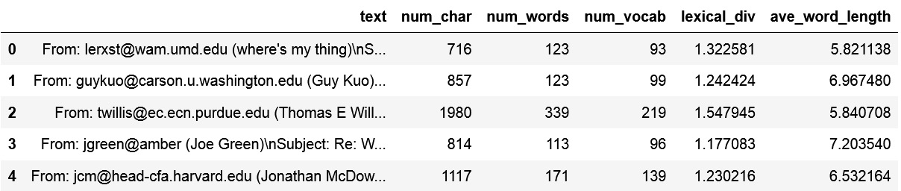
Figure 11.1 – DataFrame view with the text variable and the new features
With that, we have extracted five different features that capture the text complexity, which we can use as inputs for our machine learning algorithms. With df.head(), you can peek at the values of the first five rows of the created features.
Note
In this recipe, we created new features straight away from the raw data, without doing any data cleaning, removing punctuation, or even stemming words. Note that these are steps that are performed ahead of most NLP standard procedures. To learn more about this, visit the Cleaning and stemming text variables recipe at the end of this chapter.

How it works...
In this recipe, we created five new features that capture text complexity by utilizing pandas str to access built-in pandas functionality to work with strings. We worked with the text column of the train subset of the 20 Newsgroup dataset that comes with scikit-learn. Each row in this dataset is composed of a string with text.
We used pandas str, followed by len(), to count the number of characters in each string – that is, the total number of letters, numbers, symbols, and spaces. We also combined str.len() with str.strip() to remove trailing whitespaces at the beginning and end of the string and in new lines, before counting the number of characters.
To count the number of words, we used pandas str, followed by split(), to divide the string into a list of words. The split() method creates a list of words by breaking the string at the whitespaces between words. Next, we counted those words with pandas str.len(), obtaining the number of words per string.
Note
We can alter the behavior of str.split() by passing the string or character that we would like to have the strings divided by. For example, df['text'].str.split(';') divides a string at each occurrence of ;.
To determine the number of unique words, we used pandas str.split() to divide the string into a list of words. Next, we applied the built-in Python set() method within pandas apply() to return a set of words; remember that a set contains unique occurrences of the elements in a list – that is, unique words. Next, we counted those words with pandas str.len() to return the vocabulary, or, in other words, the number of unique words in the string. Python interprets words that are written in uppercase differently from those in lowercase; therefore, we introduced the pandas lower() method to set all the characters in lowercase before splitting the string and counting the number of unique words.
To create the lexical diversity and average word length features, we simply performed a vectorized division of two pandas Series. And that’s it: we created five new features with information about the complexity of the text.

There’s more...
We can get a glimpse of the distribution of the newly created features in each of the 20 different news topics present in the dataset by introducing some simple visualizations. To make histogram plots of the newly created features, after you have run all of the steps in the How it works... section of this recipe, follow these steps:
Import matplotlib:
import matplotlib.pyplot as plt
Add the target with the news topics to the 20 Newsgroup DataFrame:
df['target'] = data.target
Create a function that displays a histogram of a feature of your choice for each of the news topics:
def plot_features(df, text_var):
nb_rows = 5
nb_cols = 4
fig, axs = plt.subplots(
nb_rows, nb_cols,figsize=(12, 12))
plt.subplots_adjust(wspace=None, hspace=0.4)
n = 0
for i in range(0, nb_rows):
for j in range(0, nb_cols):
axs[i, j].hist(df[df.target==n][text_
var], bins=30)
axs[i, j].set_title(text_var + ' | ' +
str(n))
n += 1
plt.show()
Run the function for the number of words feature:
plot_features(df, 'num_words')
The preceding code block returns a plot where you can see the distribution of the number of words in each of the 20 news topics, numbered from 0 to 19 in the plot title:
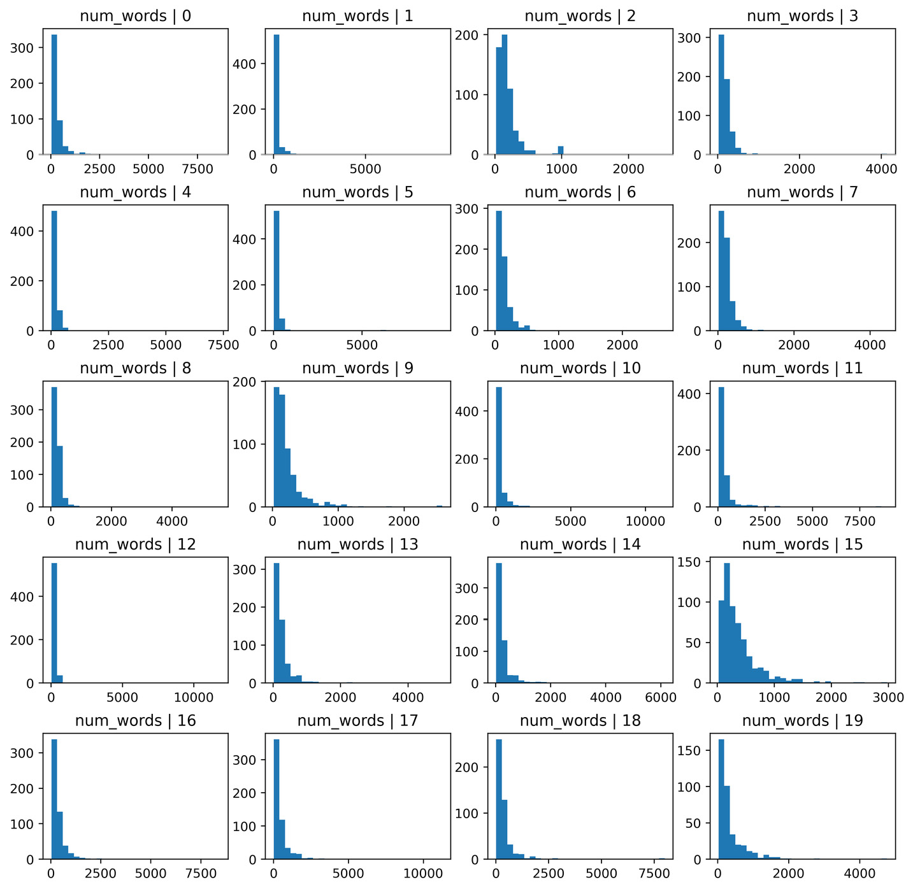
Figure 11.2 – Histograms of the features extracted from text
The number of words shows a different distribution, depending on the news topics. Therefore, this feature is likely useful in a classification algorithm to predict the topic of the text.

See also
To learn more about the built-in string processing functionality from pandas str, go to https://pandas.pydata.org/pandas-docs/stable/user_guide/text.html#method-summary.

Estimating text complexity by counting sentences
One aspect of a piece of text we can capture in features is its complexity. Usually, longer descriptions that contain multiple sentences spread over several paragraphs tend to provide more information than descriptions with very few sentences. Therefore, capturing the number of sentences may provide some insight into the amount of information provided by the text. This process is called sentence tokenization. Tokenization is the process of splitting a string into a list of pieces or tokens. In the Counting characters, words, and vocabulary recipe, we did word tokenization – that is, we divided the string into words. In this recipe, we will divide the string into sentences, and then we will count them. We will use the NLTK Python library, which provides this functionality.

Getting ready
In this recipe, we will use the NLTK Python library. For guidelines on how to install NLTK, check out the Technical requirements section of this chapter.

How to do it...
Let’s begin by importing the required libraries and dataset:
Load pandas, the sentence tokenizer from NLTK, and the dataset from scikit-learn:
import pandas as pd
from nltk.tokenize import sent_tokenize
from sklearn.datasets import fetch_20newsgroups
To understand the functionality of the sentence tokenizer from NLTK, let’s create a variable that contains a string with multiple sentences:
text = """
The alarm rang at 7 in the morning as it usually did on Tuesdays. She rolled over, stretched her arm, and stumbled to the button till she finally managed to switch it off. Reluctantly, she got up and went for a shower. The water was cold as the day before the engineers did not manage to get the boiler working. Good thing it was still summer.
Upstairs, her cat waited eagerly for his morning snack. Miaow! He voiced with excitement as he saw her climb the stairs.
"""
Now, let’s separate the string we created in step 2 into sentences using the NLTK sentence tokenizer:
sent_tokenize(text)
Tip
If you encounter an error in step 3, read the error message carefully and download the data source required by NLTK, as described in the error message. For more details, check out the Technical requirements section.
The sentence tokenizer will return the list of sentences shown in the following output:
['\nThe alarm rang at 7 in the morning as it usually did on Tuesdays.',
'She rolled over,\nstretched her arm, and stumbled to the button till she finally managed to switch it off.',
'Reluctantly, she got up and went for a shower.',
'The water was cold as the day before the engineers\ndid not manage to get the boiler working.',
'Good thing it was still summer.',
'Upstairs, her cat waited eagerly for his morning snack.',
'Miaow!',
'He voiced with excitement\nas he saw her climb the stairs.']
Note
The escape character followed by the letter \n indicates a new line.
Let’s count the number of sentences in the text variable:
len(sent_tokenize(text))
The code in the preceding line returns 8, which is the number of sentences in our text variable. Now, let’s determine the number of sentences in an entire DataFrame.
Let’s load the train subset of the 20 Newsgroup dataset into a pandas DataFrame:
data = fetch_20newsgroups(subset='train')
df = pd.DataFrame(data.data, columns=['text'])
To speed up the following steps, we will only work with the first 10 rows of the DataFrame:
df = df.loc[1:10]
Let’s also remove the first part of the text, which contains information about the email sender, subject, and other details we are not interested in. Most of this information comes before the word Lines followed by :, so let’s split the string at Lines: and capture the second part of the string:
df['text'] = df['text'].str.split('Lines:').apply(
lambda x: x[1])
Finally, let’s create a variable that captures the number of sentences per text variable:
df['num_sent'] = df['text'].apply(
sent_tokenize).apply(len)
With the df command, you can display the entire DataFrame with the text variable and the new feature containing the number of sentences per text:
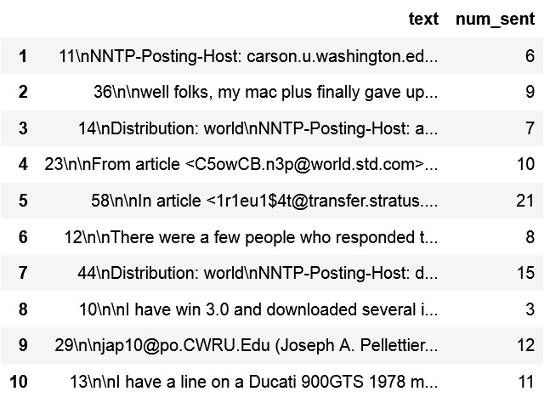
Figure 11.3 – DataFrame with the text variable and the number of sentences per text
Now, we can use this new feature in machine learning algorithms.

How it works...
In this recipe, we separated a string with text into sentences using sent_tokenizer from the NLTK library. sent_tokenizer has been pre-trained to recognize capitalization and different types of punctuation that signal the beginning and the end of a sentence.
First, we applied sent_tokenizer to a manually created string to become familiar with its functionality. The tokenizer divided the text into a list of seven sentences. We combined the tokenizer with the built-in Python len() method to count the number of sentences in the string.
Next, we loaded a dataset with text and, to speed up the computation, we only retained the first 10 rows of the DataFrame using pandas loc[]. Next, we removed the first part of the text, which contained information about the email sender and subject. To do this, we split the string at Line: using pandas str.split(), which returned a list with two elements – the strings before and after Line:. Utilizing a lambda function within pandas apply(), we retained the second part of the text – that is, the second string in the list returned by pandas split().
Finally, we applied sent_tokenizer to each row in the DataFrame with the pandas apply() method, to separate the strings into sentences, and then applied the built-in Python len() method to the list of sentences to return the number of sentences per string. This way, we created a new feature that contains the number of sentences per text.

There’s more...
NLTK has functionality for word tokenization among other useful features, which we can use instead of pandas to count and return the number of words. You can find out more about NLTK’s functionality here:
Python 3 Text Processing with NLTK 3 Cookbook, by Jacob Perkins, Packt Publishing
NLTK documentation: http://www.nltk.org/

Creating features with bag-of-words and n-grams
A Bag-of-Words (BoW) is a simplified representation of a piece of text that captures the words that are present in the text and the number of times each word appears in the text. So, for the text string Dogs like cats, but cats do not like dogs, the derived BoW is as follows:
dogs | like | cats | but | do | not
2 | 2 | 2 | 1 | 1 | 1
Figure 11.4 – BoW derived from the sentence “Dogs like cats, but cats do not like dogs”
Here, each word becomes a variable, and the value of the variable represents the number of times the word appears in the string. As you can see, BoW captures multiplicity but does not retain word order or grammar. That is why it is a simple, yet useful, way of extracting features and capturing some information about the texts we are working with.
To capture some syntax, BoW can be used together with n-grams. An n-gram is a contiguous sequence of n items in a given text. Continuing with the sentence Dogs like cats, but cats do not like dogs, the derived 2-grams are as follows:
Dogs like
like cats
cats but
but do
do not
like dogs
We can create, together with a BoW, a bag of n-grams, where the additional variables are given by the 2-grams and the values for each 2-grams are the number of times they appear in each string; for this particular example, the value is 1. So, our final BoW with 2-grams would look like this:
dogs | like | cats | but | do | not | dogs like | like cats | cats but | but do | do not | like dogs
2 | 2 | 2 | 1 | 1 | 1 | 1 | 1 | 1 | 1 | 1 | 1
Figure 11.5 – BoW with 2-grams
In this recipe, we will learn how to create BoWs with or without n-grams using scikit-learn.

Getting ready
Before jumping into this recipe, let’s get familiar with some of the parameters of a BoW that we can adjust to make the BoW more or less comprehensive. When creating a BoW over several pieces of text, a new feature is created for each unique word that appears at least once in any of the text pieces we are analyzing. If the word appears only in one piece of text, it will show a value of 1 for that particular text and 0 for all of the others.
Therefore, BoWs tend to be sparse matrices, where most of the values are zeros. Also, the number of columns – that is, the number of words – can be quite large if we work with huge text corpora, and even bigger if we also include n-grams. To limit the number of columns created and the sparsity of the returned matrix, we can choose to retain words that appear across multiple texts; or, in other words, we can retain words that appear in, at least, a certain percentage of texts.
To reduce the number of columns and sparsity of the BoW, we should also work with words in the same case – for example, lowercase – as Python will identify words in a different case as different words. We can also reduce the number of columns and sparsity by removing stop words. Stop words are very frequently used words that make sentences flow, but that, per se, do not carry any useful information. Examples of stop words are pronouns such as I, you, and he, as well as prepositions and articles.
In this recipe, we will learn how to set words in lowercase, remove stop words, retain words with a minimum acceptable frequency, and capture n-grams all together with a single transformer from scikit-learn: CountVectorizer().

How to do it...
Let’s begin by loading the necessary libraries and getting the dataset ready:
Load pandas, CountVectorizer, and the dataset from scikit-learn:
import pandas as pd
from sklearn.datasets import fetch_20newsgroups
from sklearn.feature_extraction.text import CountVectorizer
Let’s load the train set part of the 20 Newsgroup dataset into a pandas DataFrame:
data = fetch_20newsgroups(subset='train')
df = pd.DataFrame(data.data, columns=['text'])
To make interpreting the results easier, let’s remove punctuation and numbers from the text variable:
df['text'] = df['text'].str.replace(
'[^\w\s]','', regex=True).str.replace(
'\d+','', regex=True)
Now, let’s set up CountVectorizer() so that, before creating the BoW, it puts the text in lowercase, removes stop words, and retains words that appear at least in 5% of the text pieces:
vectorizer = CountVectorizer(
lowercase=True,
stop_words='english',
ngram_range=(1, 1),
min_df=0.05)
Note
To introduce n-grams as part of the returned columns, we can change the value of ngrams_range to, for example, (1,2). The tuple provides the lower and upper boundaries of the range of n-values for different n-grams to be extracted. In the case of (1,2), CountVectorizer() will return single words and arrays of two consecutive words.
Let’s fit CountVectorizer() so that it learns which words should be used in the BoW:
vectorizer.fit(df['text'])
Now, let’s create the BoW:
X = vectorizer.transform(df['text'])
Finally, let’s capture the BoW in a DataFrame with the corresponding feature names:
bagofwords = pd.DataFrame(
X.toarray(),
columns = vectorizer.get_feature_names_out()
)
With that, we have created a pandas DataFrame that contains words as columns and the number of times they appeared in each text as values. You can inspect the result by executing bagofwords.head():
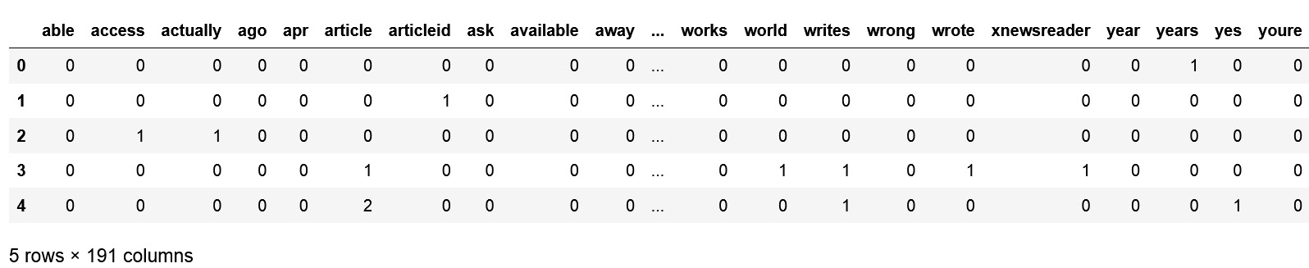
Figure 11.6 – DataFrame with the BoW
We can use this BoW as input for a machine learning model.

How it works...
CountVectorizer() from scikit-learn converts a collection of text documents into a matrix of token counts. These tokens can be individual words or arrays of two or more consecutive words – that is, n-grams. In this recipe, we created a BoW from a text variable in a DataFrame.
We loaded the 20 Newsgroup text dataset from scikit-learn and removed punctuation and numbers from the text rows using pandas replace(), which can be accessed through pandas str, to replace digits, '\d+', or symbols, '[^\w\s]', with empty strings, ''. Then, we used CountVectorizer() to create the BoW. We set the lowercase parameter to True, to put the words in lowercase before extracting the BoW. We set the stop_words argument to english to ignore stop words – that is, to avoid stop words in the BoW. We set ngram_range to the (1,1) tuple to return only single words as columns. Finally, we set min_df to 0.05 to return words that appear in at least 5% of the texts, or, in other words, in 5 % of the rows in the DataFrame.
After setting up the transformer, we used the fit() method to allow the transformer to find the words that fulfill the preceding criteria. Finally, using the transform() method, the transformer returned an object containing the BoW with its feature names, which we captured in a pandas DataFrame.

See also
For more details about CountVectorizer(), visit the scikit-learn documentation at https://scikit-learn.org/stable/modules/generated/sklearn.feature_extraction.text.CountVectorizer.html.

Implementing term frequency-inverse document frequency
Term Frequency-Inverse Document Frequency (TF-IDF) is a numerical statistic that captures how relevant a word is in a document concerning the entire collection of documents. What does this mean? Some words will appear a lot within a text document as well as across documents, for example, the English words the, a, and is. These words generally convey little information about the actual content of the document and don’t make it stand out from the crowd. TF-IDF provides a way to weigh the importance of a word by contemplating how many times it appears in a document, concerning how often it appears across documents. Hence, commonly occurring words such as the, a, and is will have a low weight, and words more specific to a topic, such as leopard, will have a higher weight.
TF-IDF is the product of two statistics: term frequency and inverse document frequency. Term frequency is, in its simplest form, the count of the word in an individual text. So, for term t, the term frequency is calculated as tf(t) = count(t) and is determined text by text. The inverse document frequency is a measure of how common the word is across all documents and is usually calculated on a logarithmic scale. A common implementation is given by the following:
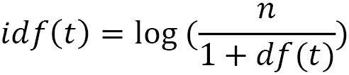
Here, n is the total number of documents, and df(t) is the number of documents in which the term t appears. The bigger the value of df(t), the lower the weighting for the term.
TF-IDF can be also used together with n-grams. Similarly, to weight an n-gram, we compound the n-gram frequency in a certain document by the times the n-gram appears across all documents.
In this recipe, we will learn how to extract features using TF-IDF with or without n-grams using scikit-learn.

Getting ready
The scikit-learn implementation of TF-IDF uses a slightly different way to calculate the IDF statistic. For more details on the exact formula, visit the scikit-learn documentation: https://scikit-learn.org/stable/modules/feature_extraction.html#tfidf-term-weighting.
TF-IDF shares the characteristics of BoW when creating the term matrix – that is, high feature space and sparsity. To reduce the number of features and sparsity, we can remove stop words, set the characters to lowercase, and retain words that appear in a minimum percentage of observations. If you are unfamiliar with these terms, visit the Creating features with bag-of-words and n-grams recipe in this chapter for a recap.
In this recipe, we will learn how to set words in lowercase, remove stop words, retain words with a minimum acceptable frequency, capture n-grams, and then return the TF-IDF statistic of words, all using a single transformer from scikit-learn: TfidfVectorizer().

How to do it...
Let’s begin by loading the necessary libraries and getting the dataset ready:
Load pandas, TfidfVectorizer, and the dataset from scikit-learn:
import pandas as pd
from sklearn.datasets import fetch_20newsgroups
from sklearn.feature_extraction.text import TfidfVectorizer
Let’s load the train set part of the 20 Newsgroup dataset into a pandas DataFrame:
data = fetch_20newsgroups(subset='train')
df = pd.DataFrame(data.data, columns=['text'])
To make interpreting the results easier, let’s remove punctuation and numbers from the text variable:
df['text'] = df['text'].str.replace(
'[^\w\s]','', regex=True).str.replace(
'\d+','', regex=True)
Now, let’s set up TfidfVectorizer() from scikit-learn so that, before creating the TF-IDF metrics, it puts all text in lowercase, removes stop words, and retains words that appear in at least 5% of the text pieces:
vectorizer = TfidfVectorizer(
lowercase=True,
stop_words='english',
ngram_range=(1, 1),
min_df=0.05)
Note
To introduce n-grams as part of the returned columns, we can change the value of ngrams_range to, for example, (1,2). The tuple provides the lower and upper boundaries of the range of n-values for different n-grams to be extracted. In the case of (1,2), TfidfVectorizer() will return single words and arrays of two consecutive words as columns.
Let’s fit TfidfVectorizer() so that it learns which words should be introduced as columns of the TF-IDF matrix:
vectorizer.fit(df['text'])
Now, let’s create the TF-IDF matrix:
X = vectorizer.transform(df['text'])
Finally, let’s capture the TF-IDF matrix in a DataFrame with the corresponding feature names:
tfidf = pd.DataFrame(
X.toarray(),
columns = vectorizer.get_feature_names_out()
)
With that, we have created a pandas DataFrame that contains words as columns and the TF-IDF as values. You can inspect the result by executing tfidf.head():
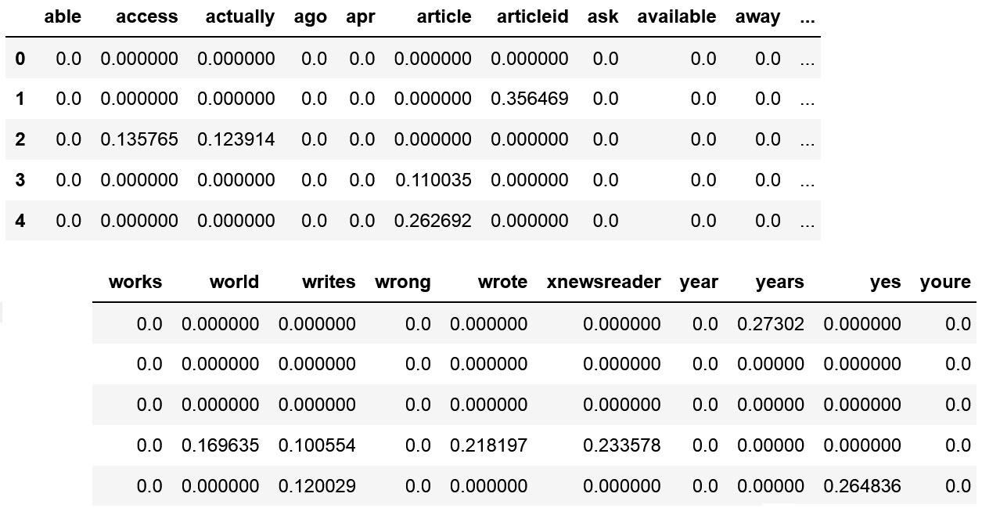
Figure 11.7 – DataFrame with features resulting from TF-IDF
Now, we can use this term frequency DataFrame to train machine learning models.

How it works...
In this recipe, we extracted the TF-IDF values of words present in at least 5% of the documents by utilizing TfidfVectorizer() from scikit-learn.
We loaded the 20 Newsgroup text dataset from scikit-learn and then removed punctuation and numbers from the text rows using pandas replace(), which can be accessed through pandas str, to replace digits, '\d+', or symbols, '[^\w\s]', with empty strings, ''. Then, we used TfidfVectorizer() to create TF-IDF statistics for words. We set the lowercase parameter to True to put words in lowercase before making the calculations. We set the stop_words argument to english to avoid stop words in the returned matrix. We set ngram_range to the (1,1) tuple to return single words as features. Finally, we set the min_df argument to 0.05 to return words that appear at least in 5% of the texts or, in other words, in 5% of the rows.
After setting up the transformer, we applied the fit() method to let the transformer find the words to retain in the final term matrix. With the transform() method, the transformer returned an object with the words and their TF-IDF values, which we then captured in a pandas DataFrame with the appropriate feature names. Now, we can use these features in machine learning algorithms.

See also
For more details on TfidfVectorizer(), visit the scikit-learn documentation at https://scikit-learn.org/stable/modules/generated/sklearn.feature_extraction.text.TfidfVectorizer.html.

Cleaning and stemming text variables
Some variables in our dataset can be created based on free text fields, which are manually completed by users. People have different writing styles, and we use a variety of punctuation marks, capitalization patterns, and verb conjugations to convey the content, as well as the emotions around it. We can extract information from text without taking the trouble to read it by creating statistical parameters that summarize the text’s complexity, keywords, and relevance of words in a document. We discussed these methods in the preceding recipes of this chapter. Yet, to derive these statistics and aggregated features, we should clean the text variables first.
Text cleaning or text preprocessing involves punctuation removal, the elimination of stop words, character case setting, and word stemming. Punctuation removal consists of deleting characters that are not letters, numbers, or spaces; in some cases, we also remove numbers. The elimination of stop words refers to removing common words that are used in our language to allow for the sentence structure and flow, but that individually convey little or no information. Examples of stop words include articles such as the and a for the English language, as well as pronouns such as I, you, and they, and commonly used verbs in their various conjugations, such as the verbs to be and to have, as well as the auxiliary verbs would and do.
To allow computers to identify words correctly, it is also necessary to set all the words in the same case, since the words Toy and toy would be identified as different by a computer, due to the capital T in the first one. Finally, to focus on the message of the text and not count them as different words that convey similar meanings if it weren’t for their conjugation, we may also want to introduce word stemming as part of the preprocessing pipeline. Word stemming refers to reducing each word to its root or base so that the words playing, plays, and played become play, which, in essence, convey the same or very similar meaning.
In this recipe, we will learn how to remove punctuation and stop words, set words in lowercase, and perform word stemming with pandas and NLTK.

Getting ready
We are going to use the NLTK stem package to perform word stemming, which incorporates different algorithms to stem words from English and other languages. Each method differs in the algorithm it uses to find the root of the word; therefore, they may output slightly different results. I recommend that you read more about it, try different methods, and choose the one that serves the project you are working on.
More information about NLTK stemmers can be found here: https://scikit-learn.org/stable/modules/generated/sklearn.feature_extraction.text.TfidfVectorizer.html.

How to do it...
Let’s begin by loading the necessary libraries and getting the dataset ready:
Load pandas, stopwords, and SnowballStemmer from NLTK and the dataset from scikit-learn:
import pandas as pd
from nltk.corpus import stopwords
from nltk.stem.snowball import SnowballStemmer
from sklearn.datasets import fetch_20newsgroups
Let’s load the train set part of the 20 Newsgroup dataset into a pandas DataFrame:
data = fetch_20newsgroups(subset='train')
df = pd.DataFrame(data.data, columns=['text'])
Now, let’s begin with the text cleaning.
Note
Print some example text with the print(df['text'][10]) command, right after executing each line of code in this recipe, so that you can visualize the changes introduced to the text.
First, let’s remove the punctuation:
df["text"] = df['text'].str.replace('[^\w\s]','')
Tip
You can also remove the punctuation using the built-in string module from Python. First, import the module by executing import string and then execute df['text'] = df['text'].str.replace('[{}]'.format(string.punctuation), '').
We can also remove characters that are numbers, leaving only letters, as follows:
df['text'] = df['text'].str.replace('\d+', '', regex=True)
Now, let’s set all cases in lowercase:
df['text'] = df['text'].str.lower()
Now, let’s remove stop words.
Note
Step 6 may fail if you did not download the nltk library stopwords. Visit the Technical requirements section for more details.
Let’s create a function that splits a string into a list of words, then removes the stop words from the list if the words are within NLTK’s English stop words list, and finally, concatenates the remaining words back into a string:
def remove_stopwords(text):
stop = set(stopwords.words('english'))
text = [word
for word in text.split() if word not in stop]
text = ' '.join(x for x in text)
return text
Note
To be able to process the data with scikit-learn’s CountVectorizer() or TfidfVectorizer(), we need the text to be in string format. Therefore, after removing the stop words, we need to return the words as a single string. We have transformed NLTK’s stop words list into a set because sets are faster to scan than lists. This improves the computation time.
Now, let’s use the function we created in step 6 to remove stop words from the text variable:
df['text'] = df['text'].apply(remove_stopwords)
Finally, let’s stem the words in our data. We will use SnowballStemmer from NLTK to do so.
Let’s create an instance of SnowballStemer for the English language:
stemmer = SnowballStemmer("english")
Tip
Try the stemmer in a single word to see how it works; for example, run stemmer.stem('running'). You should see run as the result of that command. Try different words!
Let’s create a function that splits a string into a list of words, then applies stemmer to each word, and finally concatenates the stemmed word list back into a string:
def stemm_words(text):
text = [stemmer.stem(word) for word in text.split()]
text = ' '.join(x for x in text)
return text
Let’s use the function we created in step 9 to stem the words in our data:
df['text'] = df['text'].apply(stemm_words)
Now, our text is ready to create features based on character and word counts, as well as create BoWs or TF-IDF matrices, as described in the previous recipes of this chapter.
If we execute print(df['text'][10]), we will see a text example after cleaning:
irwincmptrclonestarorg irwin arnstein subject recommend duc summari what worth distribut usa expir sat may gmt organ computrac inc richardson tx keyword ducati gts much line line ducati gts model k clock run well paint bronzebrownorang fade leak bit oil pop st hard accel shop fix tran oil leak sold bike owner want think like k opinion pleas email thank would nice stabl mate beemer ill get jap bike call axi motor tuba irwin honk therefor computracrichardsontx irwincmptrclonestarorg dod r
Note
Note that the only feature that needs to be derived before removing punctuation is the count of the sentences, as punctuation and capitalization are needed to define the boundaries of each sentence.

How it works...
In this recipe, we removed punctuation, numbers, and stop words from a text variable, set the words in lowercase, and finally, stemmed the words to their root. We removed punctuation and numbers from the text variable using pandas replace(), which can be accessed through pandas str, to replace digits, '\d+', or symbols, '[^\w\s]', with empty strings, ''. Alternatively, we can use the punctuation module from the built-in string package.
Tip
Run string.punctuation in your Python console after importing string to visualize the symbols that will be replaced by empty strings.
Next, utilizing pandas string processing functionality through str, we set all of the words to lowercase with the lower() method. To remove stop words from the text, we used the stopwords module from NLTK, which contains a list of words that are considered frequent – that is, the stop words. We created a function that takes a string and splits it into a list of words using pandas str.split(), and then, with list comprehension, we looped over the words in the list and retained the non-stop words. Finally, with the join() method, we concatenated the retained words back into a string. We used the built-in Python set() method over the NLTK stop words list to improve computation efficiency since it is faster to iterate over sets than over lists. Finally, with pandas apply(), we applied the function to each row of our text data.
Tip
Run stopwords.words('english') in your Python console after importing stopwords from NLTK to visualize the list with the stop words that will be removed.
Finally, we stemmed the words using SnowballStemmer from NLTK. stemmer works one word at a time. Therefore, we created a function that takes a string and splits it into a list of words using pandas str.split(). In a list comprehension, we applied stemmer word per word, and then concatenated the list of stemmed words back into a string, using the join() method. With pandas apply(), we applied the function to stem words to each row of the DataFrame.
The cleaning steps we performed in this recipe resulted in strings containing the original text, without punctuation or numbers, in lowercase, without common words, and with the root of the word instead of its conjugated form. The data, as it is returned, can be used to derive features, as described in the Counting characters, words, and vocabulary recipe, or to create BoWs and TI-IDF matrices, as described in the Creating features with bag-of-words and n-grams and Implementing term frequency-inverse document frequency recipes.

Index
As this ebook edition doesn't have fixed pagination, the page numbers below are hyperlinked for reference only, based on the printed edition of this book.
Symbols
20 Newsgroups
reference link 332
-Inf value 308
A
aggregate primitive 267
aggregation primitives
features, creating 289-295
reference link 289
arbitrary capper
reference link 168
arbitrary intervals
variable, discretizing 128-132
arbitrary number
used, for replacing missing values 16-19
Asian Machine Learning Conference (ACML) 310
automatic feature extraction
from time series 300-309
AveOccup variable 86
average occupancy 86
average word length feature 335
B
Bag-of-Words (BoW) 341
reference link 139
used, for creating features 341-344
BinaryEncoder()
reference link 75
binary encoding
performing 72-75
reference link 75
binary operations
reference link 227
binary variable
creating, through one-hot encoding 36-43
Box-Cox transformation 98
performing 97-104
BoxCoxTransformer() 103
boxplots
used, for visualizing outliers 154-156
C
categorical encoding 33
categorical encoding techniques, for neural network classifiers
reference link 75
categorical variables
imputing 11-15
categories
replacing, with counts or frequency encoding 48
characterization methods 301
characters
counting 332-335
Complete Case Analysis (CCA) 3
continuous wavelet 309
counts or frequency encoding
used, for replacing categories 48
CountVectorizer() 351
reference link 345
cumulative operations
features, creating 269-274
cumulative transformation
reference link 272
cumulative transform primitives 269
cyclical features
reference link 245
cyclical variables
used, for creating periodic features 238-245
D
datetime properties
reference link 178
datetime transform primitives 278
reference link 281
datetime variable
elapsed time, capturing between 182-185
features, extracting 278-283
date variable
features, extracting with pandas 172-177
debt-to-income ratio 222
decision tree
features, combining 234-238
using, for discretization 144-151
deep feature synthesis (dfs) 264
discretization 109
decision tree, using 144-151
performing, with k-means clustering 133-138
E
elbow method 138
reference link 138
entity set 258
features automatically, creating 258-268
setting up 258-268
EqualFrequencyDiscretiser() class 124
equal-frequency discretization
implementing 120-127
EqualWidthDiscretiser() transformer 115
equal-width discretization
performing 110-120
extreme values
finding, for imputation 19-22
F
feature binarization
implementing 139-144
feature creation
embedding, in scikit-learn pipeline 325-328
tailoring, to different time series 315-320
feature-engine
implementing 151
used, for automating feature extraction 190-194
feature extraction
automating, with feature-engine 190-194
feature_names_in_ attribute
reference link 225
features
creating, with Bag-of-Words (BoW) 341-344
creating, with n-grams 34-344
standardizing 196-200
Featuretools
reference link 263
G
general operations
features, creating 269-274
general transformation
reference link 272
general transform primitives 269
gplearn package
reference link 234
H
histograms
features, extracting from text 336, 337
I
imputation 1
imputed values
marking 22-26
infrequent categories
grouping 69-72
Inf value 308
Inter-Quartile Range (IQR) 154, 202
interquartile range proximity rule
used, for finding outliers 158-160
K
k-means clustering
used, for performing discretization 133-138
K-Nearest Neighbors (KNN) 30
used, for estimating missing data 30, 31
L
lexical diversity 334, 335
list-wise deletion 3
logarithm function
used, for transforming variables 78-84
M
mathematical functions
features, combining 218-222
reference link 222
maximum absolute scaling
implementing 208-214
maximum values
scaling 200-202
mean compactness 223
mean deviation
used, for finding outliers 157, 158
mean imputation
performing 6-10
mean normalization
performing 204-208
median
scaling with 202-204
median imputation
performing 6-10
method summary
reference link 337
minimum values
scaling 200-202
missing data
estimating, with K-Nearest Neighbors (KNN) 30, 31
used, for removing observations 3-6
missing values
replacing, with arbitrary number 16-19
Multivariate Imputation by Chained Equations (MICE) 27
performing 27-29
reference link 29
N
NAN value 308
Natural Language Processing (NLP) 284
Natural Language Toolkit (NLTK) 341
URL 341
n-grams
used, for creating features 341-344
NLTK stemmers
reference link 349
number of characters 284
number of words 284
numerical features
combining 275-277
O
observations
removing, with missing data 3-6
one-hot encoding
performing 44-47
used, for creating binary variable 36-43
Online Retail II dataset 256
ordinal encoding
performing, on target value 59-61
outliers
capping 165-167
capping, with quantiles 168-170
censoring 165-167
finding, with interquartile range proximity rule 158-160
finding, with mean deviation 157, 158
finding, with standard deviation 157
removing 160-164
visualizing, with boxplots 154-156
P
pandas
methods 178
used, for extracting date variable features 172-177
used, for extracting time variable features 178-181
pandas aggregate
reference link 222
periodic features
creating, from cyclical variables 238-245
polynomial expansion
performing 227-234
PolynomialFeatures()
reference link 234
power transformations
using 93-97
PowerTransformer() 103
pre-selected features
creating 320-324
Q
Quantile-Quantile (Q-Q) plot 78
quantiles
scaling with 202-204
used, for capping outliers 168-170
R
rare categories 69
grouping 69-72
reciprocal function
used, for transforming variables 85-89
reference variables
features, comparing 222-226
robust scaling 203
S
scikit-learn dataset
reference link 332
scikit-learn pipeline
feature creation, embedding 325-328
sentence tokenization 338
text complexity, estimating 338-341
spline features
creating 245-254
square root
using, for transforming variables 89-93
standard deviation
used, for finding outliers 157, 158
stop words 342, 350
T
target mean encoding
implementing 61-66
Term Frequency-Inverse Document Frequency (TF-IDF)
implementing 345-348
text
used, for extracting text 284-288
text complexity
estimating, by sentence tokenization 338-341
text variables
cleaning 348-353
stemming 348-353
Tfidf term weighting
reference link 345
TfidfVectorizer() 351
reference link 348
time/date components
reference link 178
time series
automatic feature extraction 301-309
features, creating 310-314
features, selecting 310-314
specific features, creating 315-320
time since previous 269
time variable
features, extracting with pandas 178-181
working with, in time zones 186-189
to_datetime() method
reference link 189
transform primitives 267, 269, 289
tsfresh documentation
reference link 320
tsfresh library 301, 310
tests, using 310
tz_convert() method
reference link 189
V
variable
discretizing, into arbitrary intervals 128-132
transforming, with logarithm function 78-84
transforming, with reciprocal function 85-89
transforming, with square root 90-93
variance stabilizing transformations 77
variation coefficient 306
vector unit length
scaling 214-216
vocabulary
counting 332-335
W
Weight of Evidence (WoE) 66
encoding 66-69
words
counting 332-335
Workshop on Learning on Big Data (WLBD) 310
worst compactness 223
Y
Yeo-Johnson transformation
performing 104-107
reference link 107

Packt.com
Subscribe to our online digital library for full access to over 7,000 books and videos, as well as industry leading tools to help you plan your personal development and advance your career. For more information, please visit our website.

Why subscribe?
Spend less time learning and more time coding with practical eBooks and Videos from over 4,000 industry professionals
Improve your learning with Skill Plans built especially for you
Get a free eBook or video every month
Fully searchable for easy access to vital information
Copy and paste, print, and bookmark content
Did you know that Packt offers eBook versions of every book published, with PDF and ePub files available? You can upgrade to the eBook version at packt.com and as a print book customer, you are entitled to a discount on the eBook copy. Get in touch with us at customercare@packtpub.com for more details.
At www.packt.com, you can also read a collection of free technical articles, sign up for a range of free newsletters, and receive exclusive discounts and offers on Packt books and eBooks.

Other Books You May Enjoy
If you enjoyed this book, you may be interested in these other books by Packt:



Data Cleaning and Exploration with Machine Learning
Michael Walker
ISBN: 978-1-80324-167-8
Explore essential data cleaning and exploration techniques to be used before running the most popular machine learning algorithms
Understand how to perform preprocessing and feature selection, and how to set up the data for testing and validation
Model continuous targets with supervised learning algorithms
Model binary and multiclass targets with supervised learning algorithms
Execute clustering and dimension reduction with unsupervised learning algorithms
Understand how to use regression trees to model a continuous target



Production-Ready Applied Deep Learning
Tomasz Palczewski, Jaejun (Brandon) Lee, Lenin Mookiah
ISBN: 978-1-80324-366-5
Understand how to develop a deep learning model using PyTorch and TensorFlow
Convert a proof-of-concept model into a production-ready application
Discover how to set up a deep learning pipeline in an efficient way using AWS
Explore different ways to compress a model for various deployment requirements
Develop Android and iOS applications that run deep learning on mobile devices
Monitor a system with a deep learning model in production
Choose the right system architecture for developing and deploying a model

Packt is searching for authors like you
If you’re interested in becoming an author for Packt, please visit authors.packtpub.com and apply today. We have worked with thousands of developers and tech professionals, just like you, to help them share their insight with the global tech community. You can make a general application, apply for a specific hot topic that we are recruiting an author for, or submit your own idea.

Share Your Thoughts
Now you’ve finished Python Feature Engineering Cookbook, we’d love to hear your thoughts! If you purchased the book from Amazon, please click here to go straight to the Amazon review page for this book and share your feedback or leave a review on the site that you purchased it from.
Your review is important to us and the tech community and will help us make sure we’re delivering excellent quality content.

Download a Free PDF copy of this book
Thanks for purchasing this book!
Do you like to read on the go but are unable to carry your print books everywhere?
Is your eBook purchase not compatible with the device of your choice?
Don’t worry, now with every Packt book you get a DRM-free PDF version of that book at no cost.
Read anywhere, any place, on any device. Search, copy, and paste code from your favorite technical books directly into your application.
The perks don’t stop there, you can get exclusive access to discounts, newsletters, and great free content in your inbox daily
Follow these simple steps to get the benefits:
Scan the QR code or visit the link below

https://packt.link/free-ebook/9781804611302
Submit your proof of purchase
That’s it! We’ll send your free PDF and other benefits to your email directly

