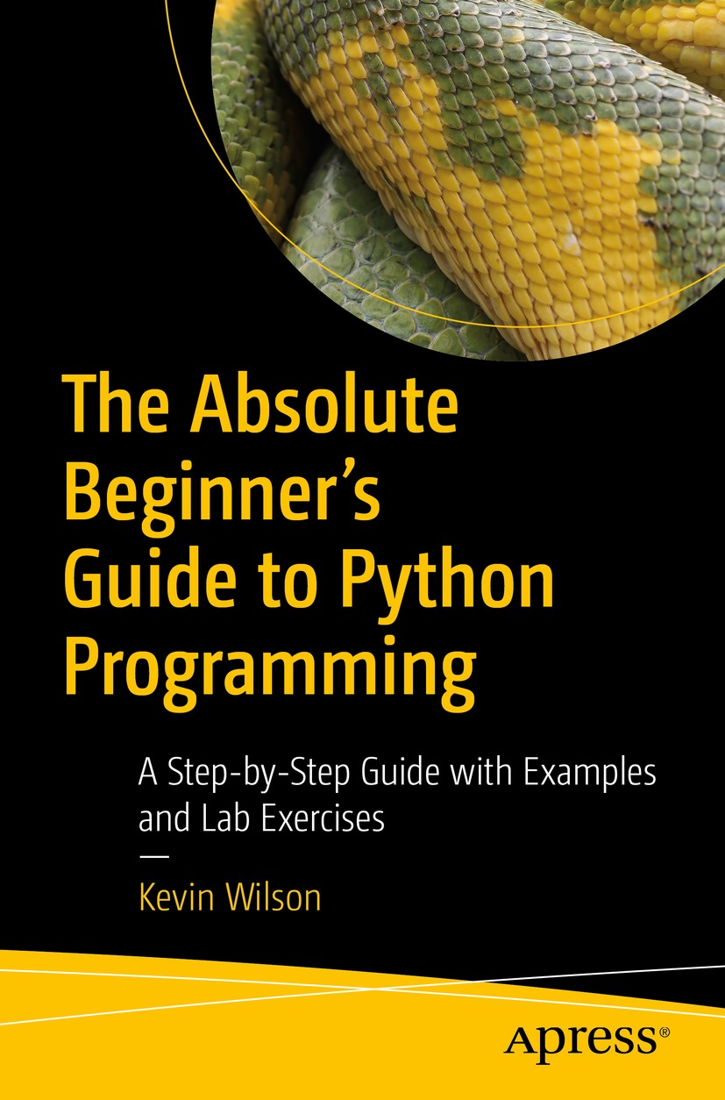

Table of Contents
Front Matter
1. Introduction to Computer Programming
2. The Basics
3. Working with Data
4. Flow Control
5. Handling Files
6. Using Functions
7. Using Modules
8. Exception Handling
9. Object-Oriented Programming
10. Building an Interface
11. Developing a Game
12. Python Web Development
Back Matter
Kevin Wilson

The Absolute Beginner's Guide to Python Programming

A Step-by-Step Guide with Examples and Lab Exercises

Kevin Wilson
London, UK
ISBN 978-1-4842-8715-6e-ISBN 978-1-4842-8716-3
https://doi.org/10.1007/978-1-4842-8716-3
© Kevin Wilson 2022
Apress Standard
The use of general descriptive names, registered names, trademarks, service marks, etc. in this publication does not imply, even in the absence of a specific statement, that such names are exempt from the relevant protective laws and regulations and therefore free for general use.
The publisher, the authors and the editors are safe to assume that the advice and information in this book are believed to be true and accurate at the date of publication. Neither the publisher nor the authors or the editors give a warranty, expressed or implied, with respect to the material contained herein or for any errors or omissions that may have been made. The publisher remains neutral with regard to jurisdictional claims in published maps and institutional affiliations.
This Apress imprint is published by the registered company APress Media, LLC, part of Springer Nature.
The registered company address is: 1 New York Plaza, New York, NY 10004, U.S.A.
Introduction
The aim of this book is to provide a first course in the use of Python to develop programs.
It provides a foundation for those who wish to write computer programs based on sound programming principles, and because the book is intended to be a primer, it allows the beginner to become comfortable with basic programming tasks.
As it is a first course, no previous experience of computer programming is assumed.
Throughout the book, we’ll explore the Python programming language with worked examples and lab exercises for you to complete yourself. For this purpose, we’ve included all the source code for this book in the following repository: github.com/apress/absolute-beginners-guide-python
Any source code or other supplementary material referenced by the author in this book is available to readers on GitHub (https://github.com/Apress). For more detailed information, please visit http://www.apress.com/source-code.
Table of Contents
Chapter 1:​ Introduction to Computer Programming
What Is Python
Getting Started
Setting Up
Install on Windows
Install on MacOS
Install on Linux
Summary
Chapter 2:​ The Basics
Language Classification
Low-Level Language
High-Level Language
Python Language Syntax
Reserved Words
Identifiers
Indentation
Comments
Input
Output
Escape Characters
Writing a Program
Lab Exercises
Summary
Chapter 3:​ Working with Data
Variables
Local Variables
Global Variables
Basic Data Types
Integers
Floating Point Numbers
Strings
Lists
Two-Dimensional Lists
Sets
Tuples
Dictionaries
Program Input
Program Output
Casting Data Types
Arithmetic Operators
Operator Precedence
Performing Arithmetic
Comparison Operators
Boolean Operators
Bitwise Operators
Lab Exercises
Summary
Chapter 4:​ Flow Control
Sequence
Selection
if.​.​.​ else
elif
Iteration (Loops)
For Loop
While Loop
Break and Continue
Lab Exercises
Summary
Chapter 5:​ Handling Files
File Types
Text File
Binary
Text File Operations
Open Files
Write to a File
Read from a File
Binary File Operations
Open Files
Write to a File
Read a File
Random File Access
Lab Exercises
Summary
Chapter 6:​ Using Functions
Declaring Functions
Scope
Recursion
Lab Exercises
Summary
Chapter 7:​ Using Modules
Importing Modules
Creating Your Own Modules
Lab Exercises
Summary
Chapter 8:​ Exception Handling
Types of Exception
Catching Exceptions
Raising Your Own Exceptions
Summary
Chapter 9:​ Object-Oriented Programming
Principles of OOP
Encapsulation
Inheritance
Polymorphism
Abstraction
Classes and Objects
Class Inheritance
Polymorphic Classes
Method Overriding
Lab Exercises
Summary
Chapter 10:​ Building an Interface
Creating a Window
Adding Widgets
Menus
The Canvas
Images
Buttons
Message Boxes
Text Field
Listbox
Checkbox
Labels
Label Frame
Interface Design
Summary
Chapter 11:​ Developing a Game
Installing Pygame
Opening a Window
Adding an Image
The Game Loop
The Event Loop
Shapes
Basic Animation
Summary
Chapter 12:​ Python Web Development
Web Servers
Install the Web Server
Set Up Python Support
Executing a Script
Python Web Frameworks
Summary
Appendix A:​ Quick Reference
Data Types
Numeric Operators
Comparison Operators
Boolean Operators
String Operators
List Operators
Dictionary Operators
String Methods
List Methods
Dictionary Methods
Functions
Files
Conditional
Multi-conditional
While Loop
For Loop
Loop Control
Modules
Built-In Functions
Declare a Class
Child Class
Create Object
Call Object Method
Access Object Attributes
Exceptions
Index
About the Author
Kevin Wilson
With over 20 years’ experience in the computer industry, Kevin Wilson has made a career out of technology and showing others how to use it. After earning a master’s degree in computer science, software engineering, and multimedia systems, Kevin has held various positions in the IT industry including graphic and web design, digital film and photography, programming and software engineering, developing and managing corporate networks, building computer systems, and IT support. He currently teaches computer science at college and works as an IT trainer in England while researching for his Ph.D.

About the Technical Reviewer
Joos Korstanje

is a data scientist, with over five years of industry experience in developing machine-learning tools. He has a double M.Sc. in applied data science and environmental science and has extensive experience working with geodata use cases. He currently works at Disneyland Paris, where he develops machine learning for a variety of tools. His project experience includes forecasting, recommender engines, optimization, machine learning on GPS tracking data, and more. Joos is also an active blogger on Medium and has worked on multiple book publications.

© The Author(s), under exclusive license to APress Media, LLC, part of Springer Nature 2022
K. WilsonThe Absolute Beginner's Guide to Python Programming
https://doi.org/10.1007/978-1-4842-8716-3_1

1. Introduction to Computer Programming
Kevin Wilson1
(1)
London, UK

What is a computer program? A computer is a device that processes instructions to achieve a task. This set of instructions is called a computer program.
A computer program usually takes some data such as a string or a number and performs calculations to produce results. We usually refer to the data as the program’s input and the results as the program’s output.
To write computer programs, we use a computer programming language. There are many different languages such as BASIC, C, C++, and Python. In this guide, we are going to concentrate on the Python programming language.
Every computer program manipulates data to produce a result, so most languages allow the programmer to choose names for each item of data. These items are called variables or constants . A variable, as the name suggests, is an item that can contain different values as the program is executed. A constant stays the same.
For example, if we wrote a program to calculate the volume of a sphere, we could have variables for the radius and one for the result. We can also have a constant for the value of Pi as it never changes.
In larger programs, we often need to make decisions based on user input, a calculated result, or condition. In this case, we use an if statement. This is called selection.
Some blocks of code might also need to be repeated; in this case, we use a loop. This is called repetition.
The Python programming language has specific facilities to enable us to implement the concepts outlined earlier. Many of these will be introduced throughout this book.

What Is Python
Python is a high-level language developed by Guido van Rossum in the late 1980s and is used in web development, scientific applications, gaming, AI, and is well suited to education for teaching computer programming.
Python is designed to be an easily readable language. Therefore, it uses an uncluttered formatting style and often uses English keywords where other languages use a symbol.
Python is an interpreted programming language, meaning Python programs are written in a text editor and then put through a Python interpreter to be executed.
Python is used in the field of artificial intelligence and can be found in many day-to-day applications. Streaming services such as Spotify use Python for data analysis, particularly users’ listening habits in order to offer suggestions on which artist to follow, other music a particular user might be interested in, and so on. Python is also used within Netflix’s machine-learning algorithms for recommending relevant content to users, monitoring browsing habits, and marketing.
In the world of games development, Python is used as a companion language, meaning Python scripts are used to add customizations to the core gaming engine, script AI behaviors, or server side elements. The performance of Python isn’t fast enough for coding graphics-intensive, higher-end games; however, you can create simple games with Python using the pygame module.
Python is used in web development and allows a web developer to develop dynamic web apps very quickly.
Python is a multi-platform language and is available for Windows, MacOS, Linux, and the Raspberry Pi.
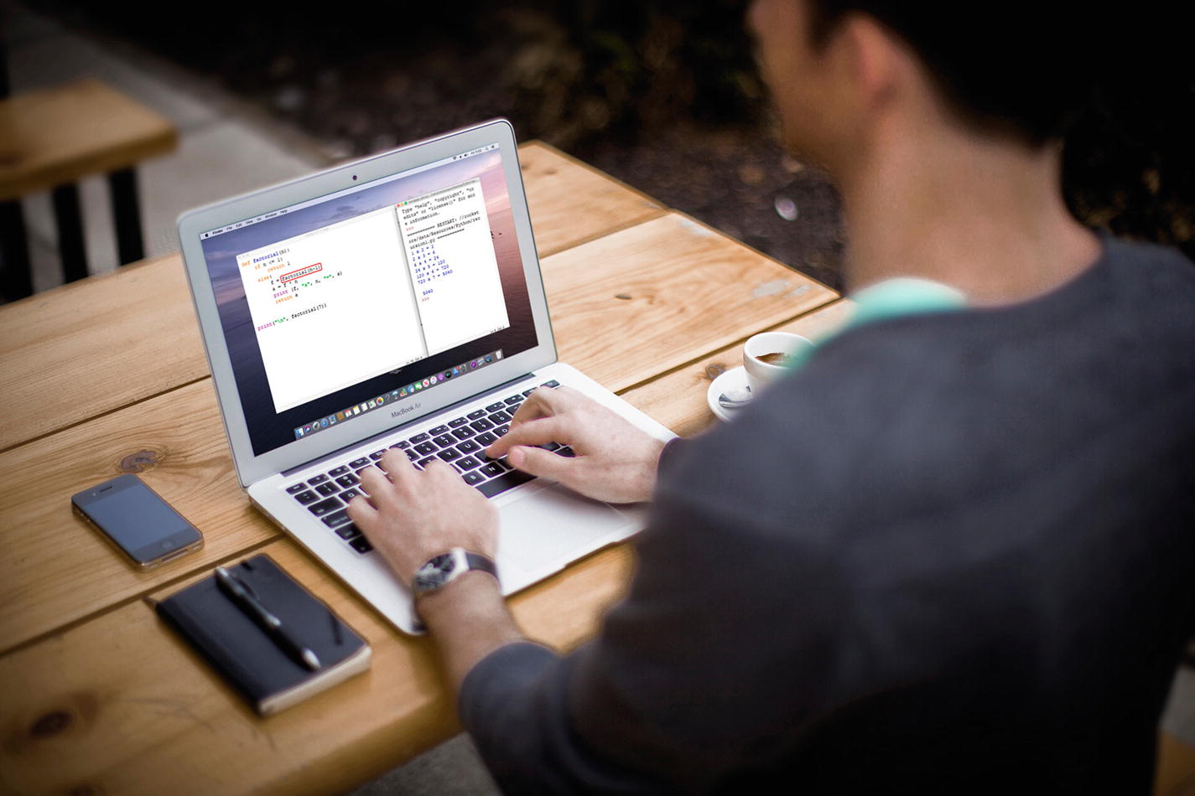
To start coding, you’ll need a computer – either Windows, MacOS, or Linux – and an integrated development environment (IDE) with the Python interpreter.

Getting Started
In this section, we’ll take a look at how to install the Python interpreter and development environment. You can install Python on Windows, Mac, or Linux.

Setting Up
Before we start writing programs, we need to set up our development environment. We’ll take a look at installing Python on Windows, Mac, and Linux.

Install on Windows
In our lab, we’re using Windows workstations, so we’ll need to install the Python integrated development environment for Windows.
Open your web browser and navigate to the following website:
www.​python.​org/​downloads/​windows
From the Downloads page, select the “executable installer” of the latest stable release.
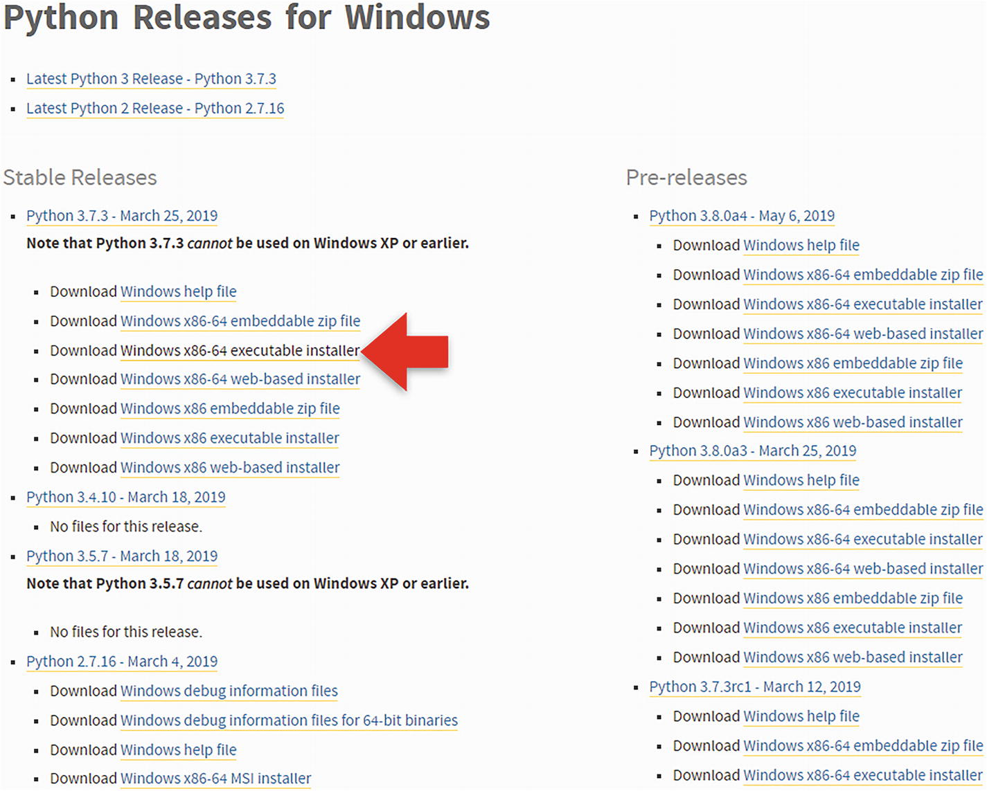
Click “run” when prompted by your browser. Or click “python-x.x.x-amd64.exe” if you’re using Chrome.
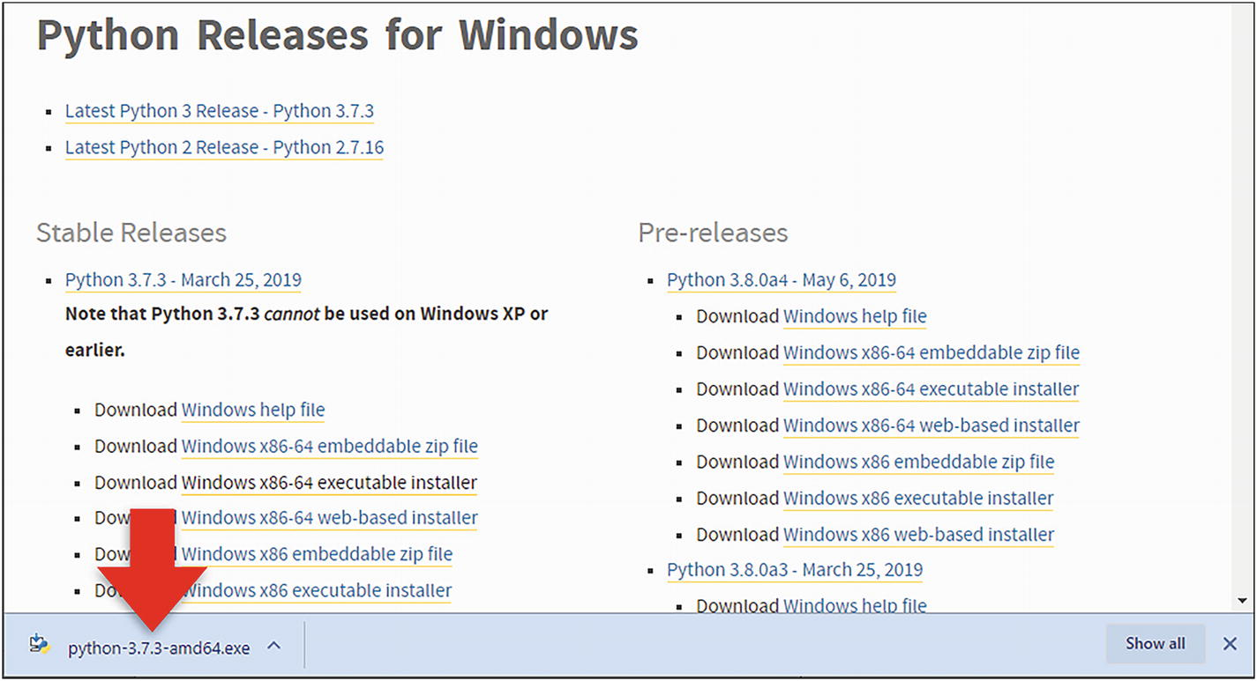
Once the installer starts, make sure “Add Python 3.x to PATH” is selected , and then click “Customize installation” to run through the steps to complete the installation.
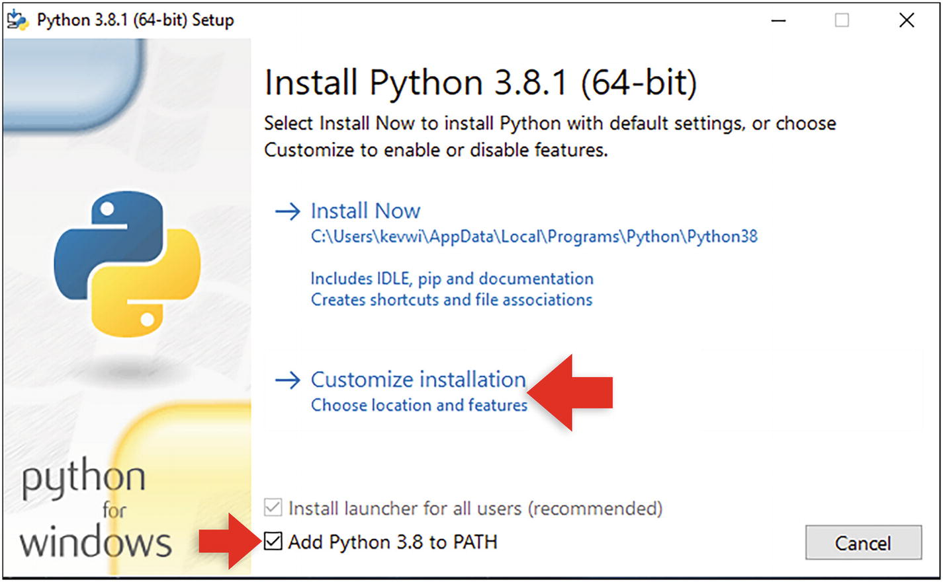
Make sure you select all the tick boxes for all the optional features.
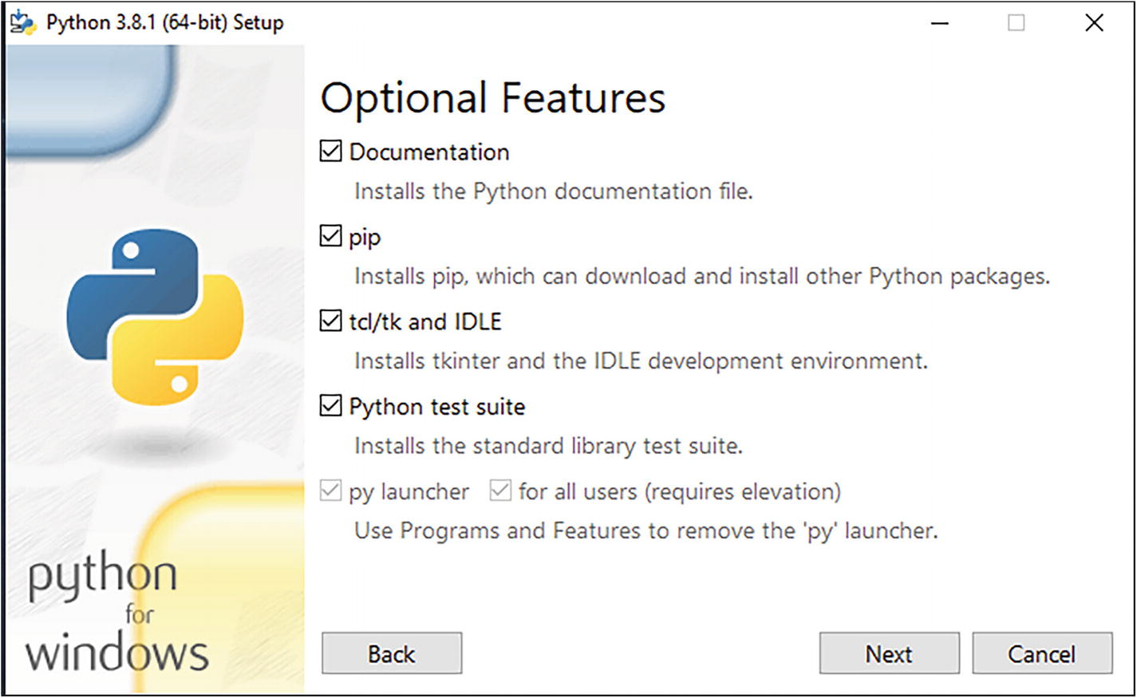
Click “Next.”
Make sure “Install for all users” is selected at the top of the dialog box. Click “Install” to begin.
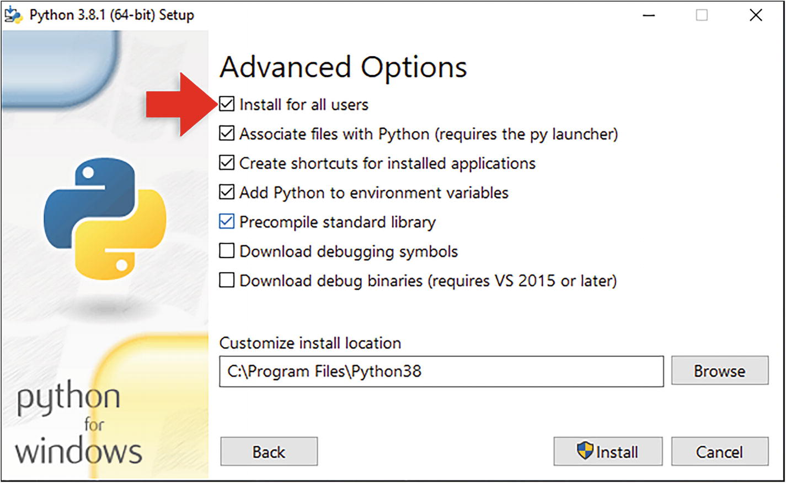
Click “Disable path length limit” to make sure Python runs smoothly on Windows and allow long filenames.
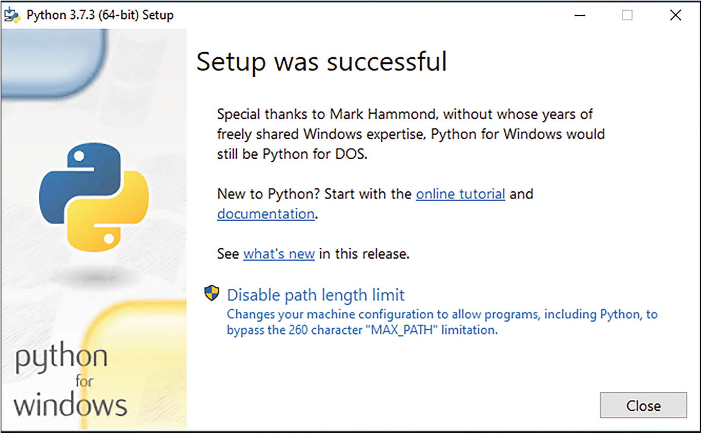
Click “Close” to finish the installation.
You’ll find the Python integrated development environment (IDLE) and the Python interpreter in the Python folder on your start menu.
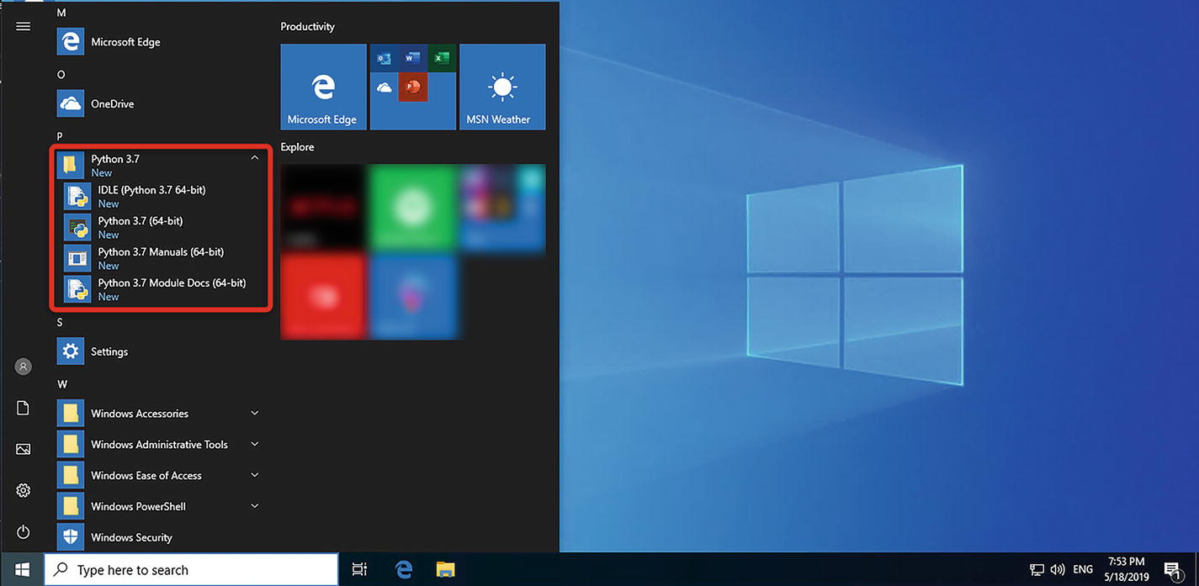
To write our programs, we’ll use IDLE Python. This is Python’s integrated development environment.
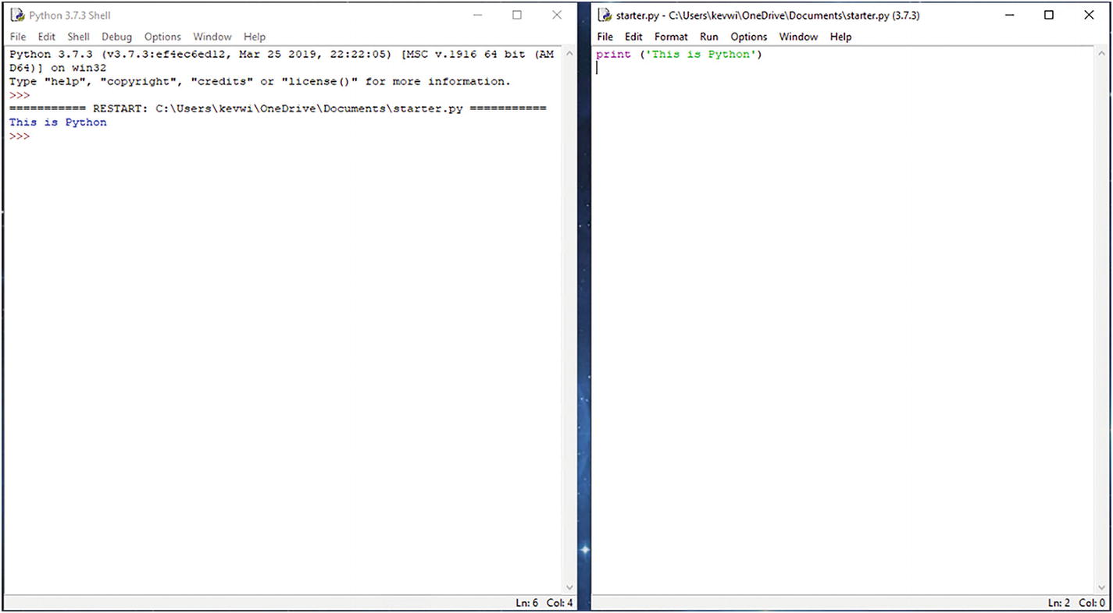
Here, you can write your code in the editor and then execute and debug your code. You’ll also notice the code editor provides syntax highlighting, meaning keywords and text are highlighted in different colors, making code easier to read.

Install on MacOS
To install Python 3 with the official installer, open your web browser and navigate to the following website:
www.​python.​org/​downloads/​macos
Click Download Python.
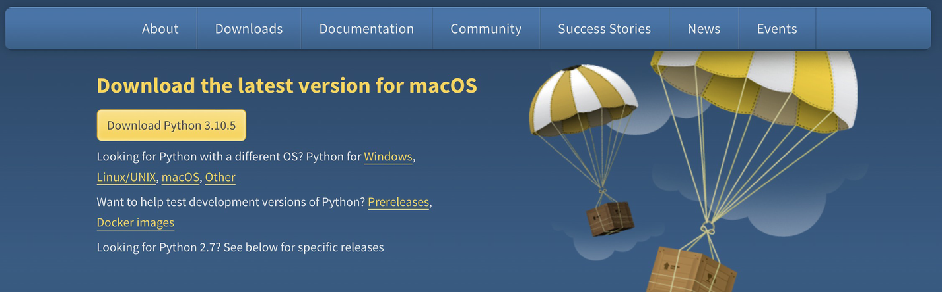
You’ll find the package in your Downloads folder. Double-click on the package to begin the installation.
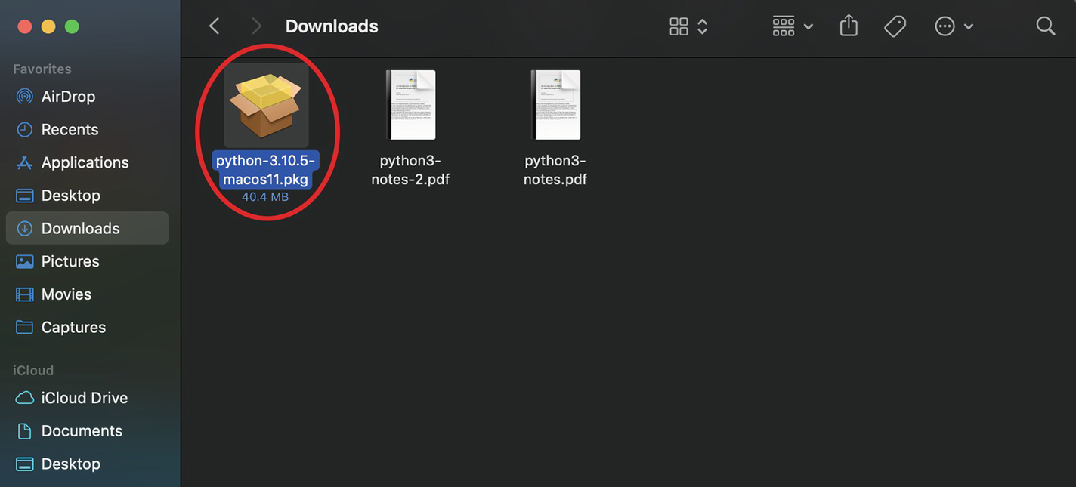
Run through the installation wizard. Click “Continue.”
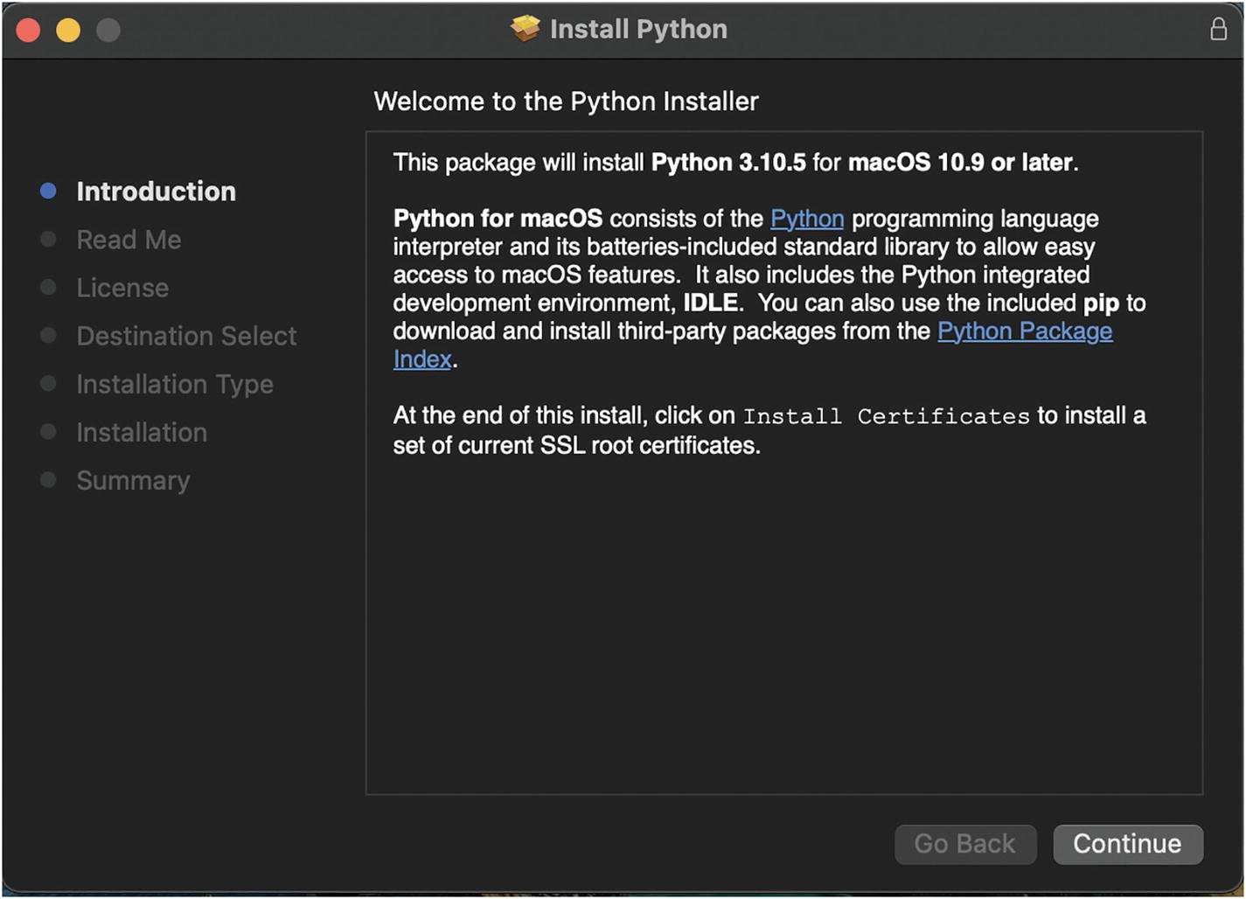
Once the installation is complete, you’ll find Python in the Applications folder in Finder or on the launchpad.

Install on Linux
If you are running a Linux distribution such as Ubuntu or have a Raspberry Pi, you can install Python using the terminal. You’ll find the terminal app in your applications. You can also press Control+Alt+T on your keyboard.
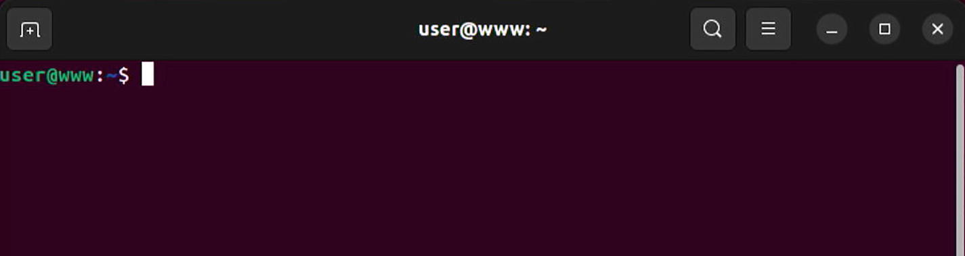
At the terminal command prompt, type the following commands. Press Enter after each line.
sudo apt update
sudo apt upgrade
Type the following command to install Python:
sudo apt install python3 -y
Once the Python is installed, we need to install IDLE, the development environment. To do this, type the following command at the prompt:
sudo apt-get install idle3 -y
Once installed, you’ll find IDLE in your applications.
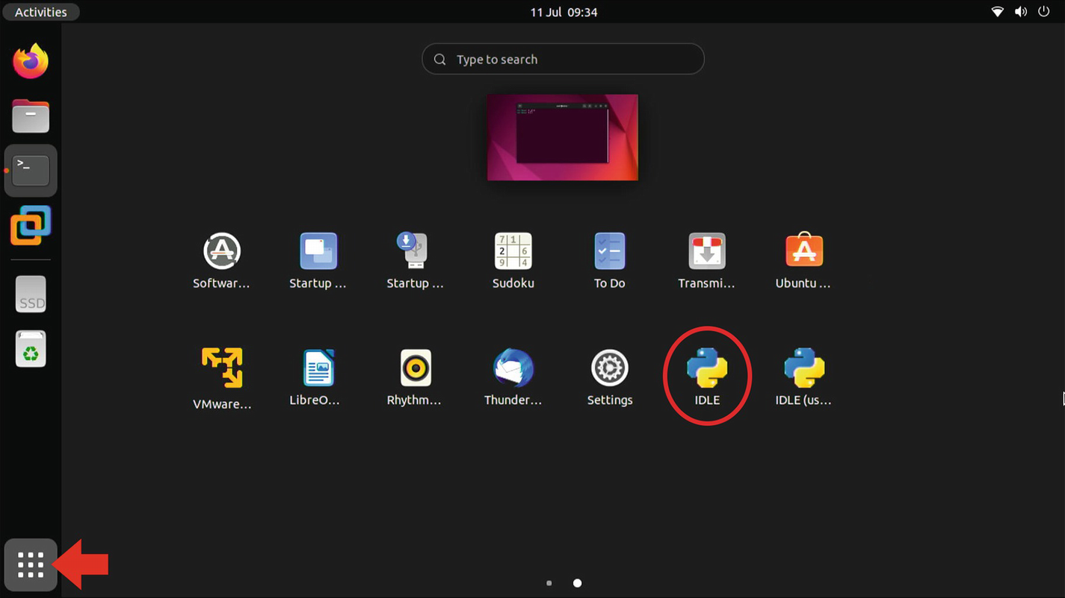
Or you can type the following command at the prompt:
idle
Arrange your windows so you can see your code window and the shell.
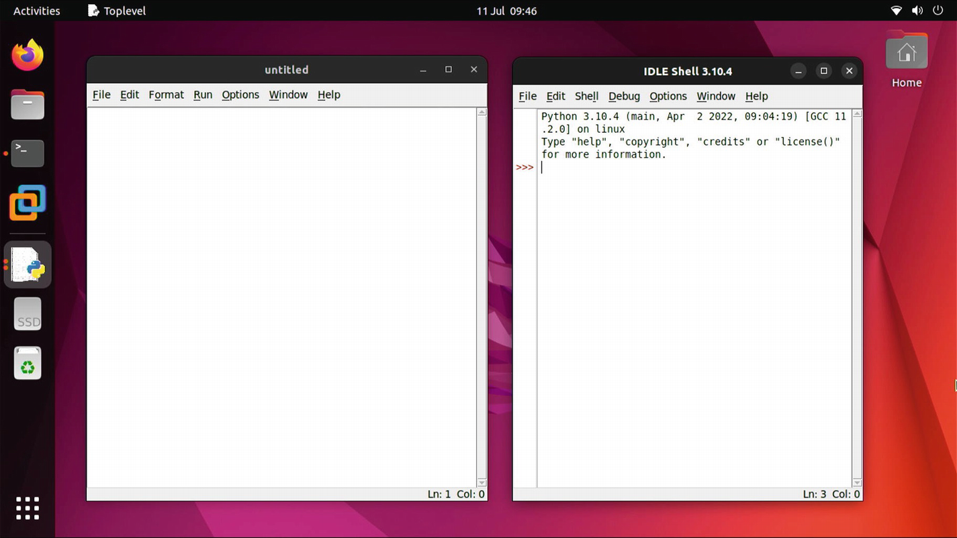

Summary
Python is a high-level language whose code is executed by an interpreter to produce output.
Python is a multi-platform language and is available for Windows, MacOS, Linux, and the Raspberry Pi.
To write our programs, we use IDLE Python. This is Python’s integrated development environment.
© The Author(s), under exclusive license to APress Media, LLC, part of Springer Nature 2022
K. WilsonThe Absolute Beginner's Guide to Python Programming
https://doi.org/10.1007/978-1-4842-8716-3_2

2. The Basics
Kevin Wilson1
(1)
London, UK

Python programs are written in a text editor, such as Notepad, PyCharm, or the code editor in Python’s integrated development environment (IDLE), and saved with a .py file extension.
You then use the Python interpreter to execute the code saved in the file.
Let’s start at the beginning.

Language Classification
There are different levels of programming language: low-level languages and high-level languages.

Low-Level Language
A low-level language is a programming language whose functions often refer directly to the processor’s instructions and is commonly written in machine code or assembly language. Assembly language is known as a second-generation programming language , machine code being the first generation.
Let’s take a look at a simple program. Here, we have a little adder program written in assembly language for our processor, and might look something like this:
LDA 12H
ADD 07H
STA 09H
STP
Code is written in assembly language and then assembled into machine code using an assembler before it is executed.
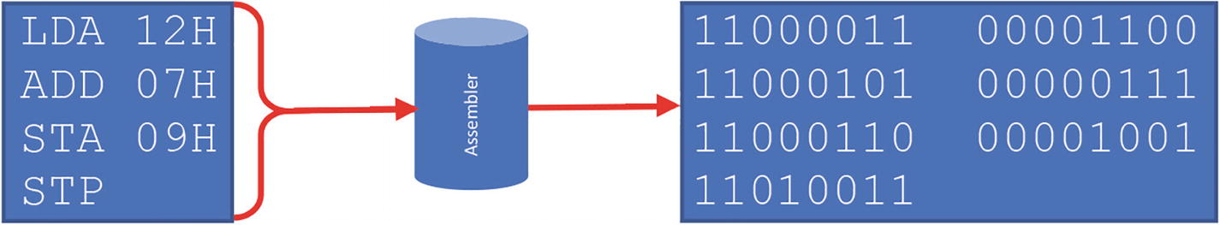
Figure 2-1Code assembled into machine code by assembler
Each assembly language instruction corresponds to a sequence of binary numbers in machine code. The numbers, characters, addresses, and other data are converted into their machine code equivalents.
So, LDA could be represented by the binary code 11000011; the number 1210 is 00001100 in binary.
The assembled machine code is then executed by the processor.

High-Level Language
Python is an example of a high-level language . Rather than dealing directly with processor registers and memory addresses, high-level languages deal with variables, human-readable statements, loops, and functions.
High-level language code is either compiled into a machine code executable program or interpreted. Languages such as C or C++ are often compiled, meaning the code is written and then converted into an executable file. This makes them ideal for software development to write applications such as Microsoft Word that run on a computer.
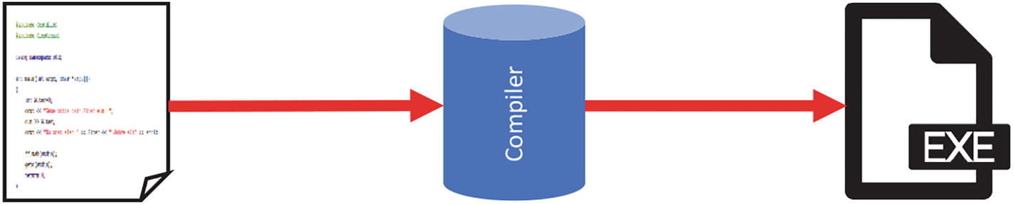
Figure 2-2Code compiled into machine code by compiler
Python is an interpreted language, meaning the code you write is translated into machine code directly, making it well suited to web development.
Here, you can see the interpreter executes the code line by line while accessing any data required by the program and then displays the output directly onto the screen.
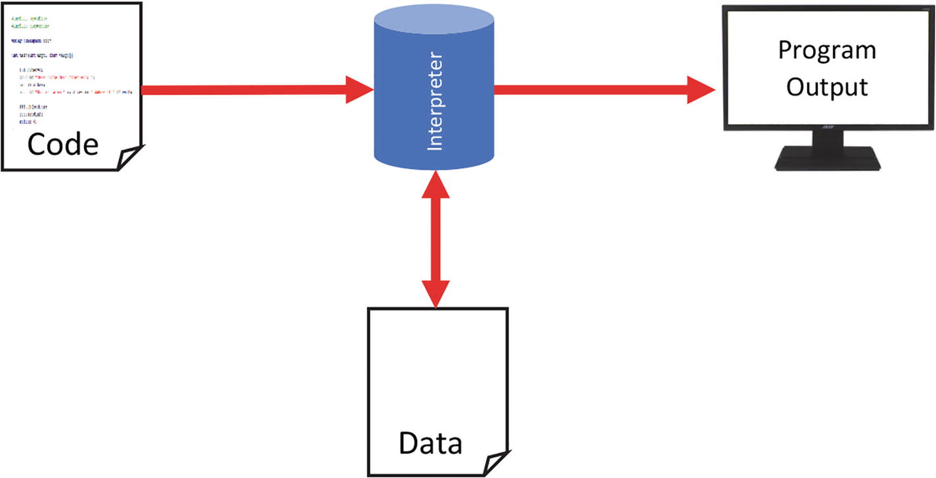
Figure 2-3Code interpreted by interpreter for execution
When you attempt to run your program, the interpreter will convert and execute your code, but will only do this if it doesn’t contain any errors.
If there are syntax errors, an error in the Python grammar, the interpreter will stop and highlight the error.
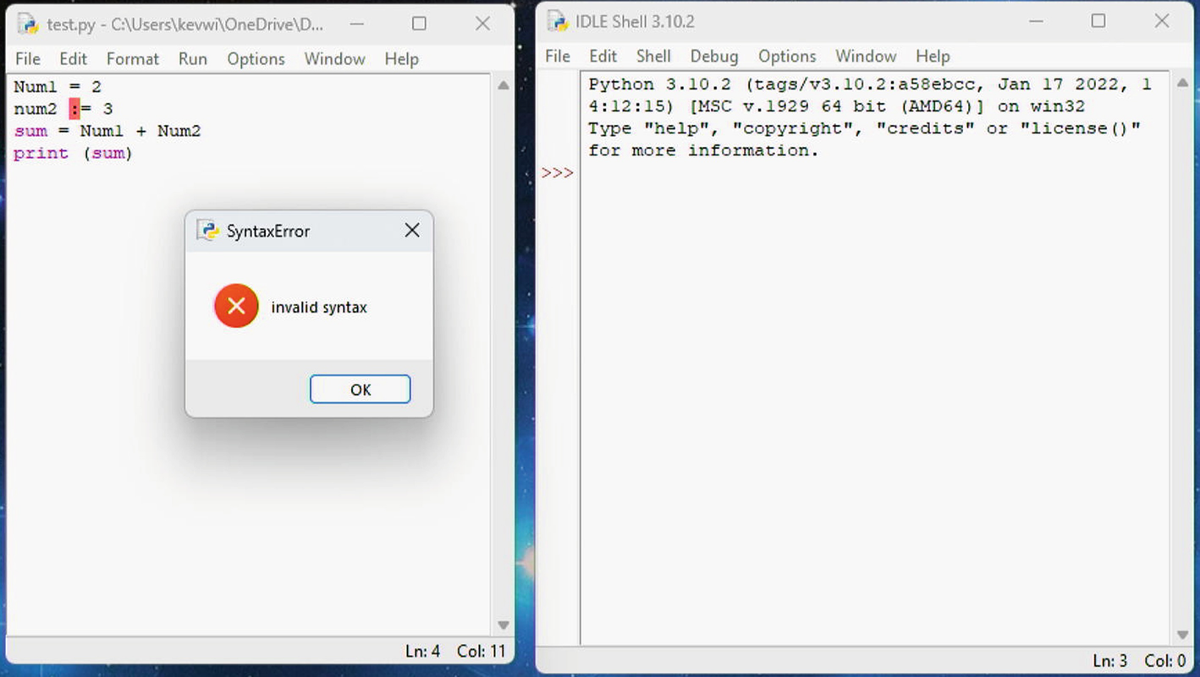
If your program runs, there could still be errors. These could be logical errors and can produce unexpected results and are sometimes called bugs in the program. This could be a divide by 0 error which can cause the program to crash.
The process of eliminating these errors is called debugging.

Python Language Syntax
The syntax defines how a program is written and interpreted and forms the basis of writing code.

Reserved Words
These are words reserved by the programming language that define the syntax and structure. Here are some of the most common ones:
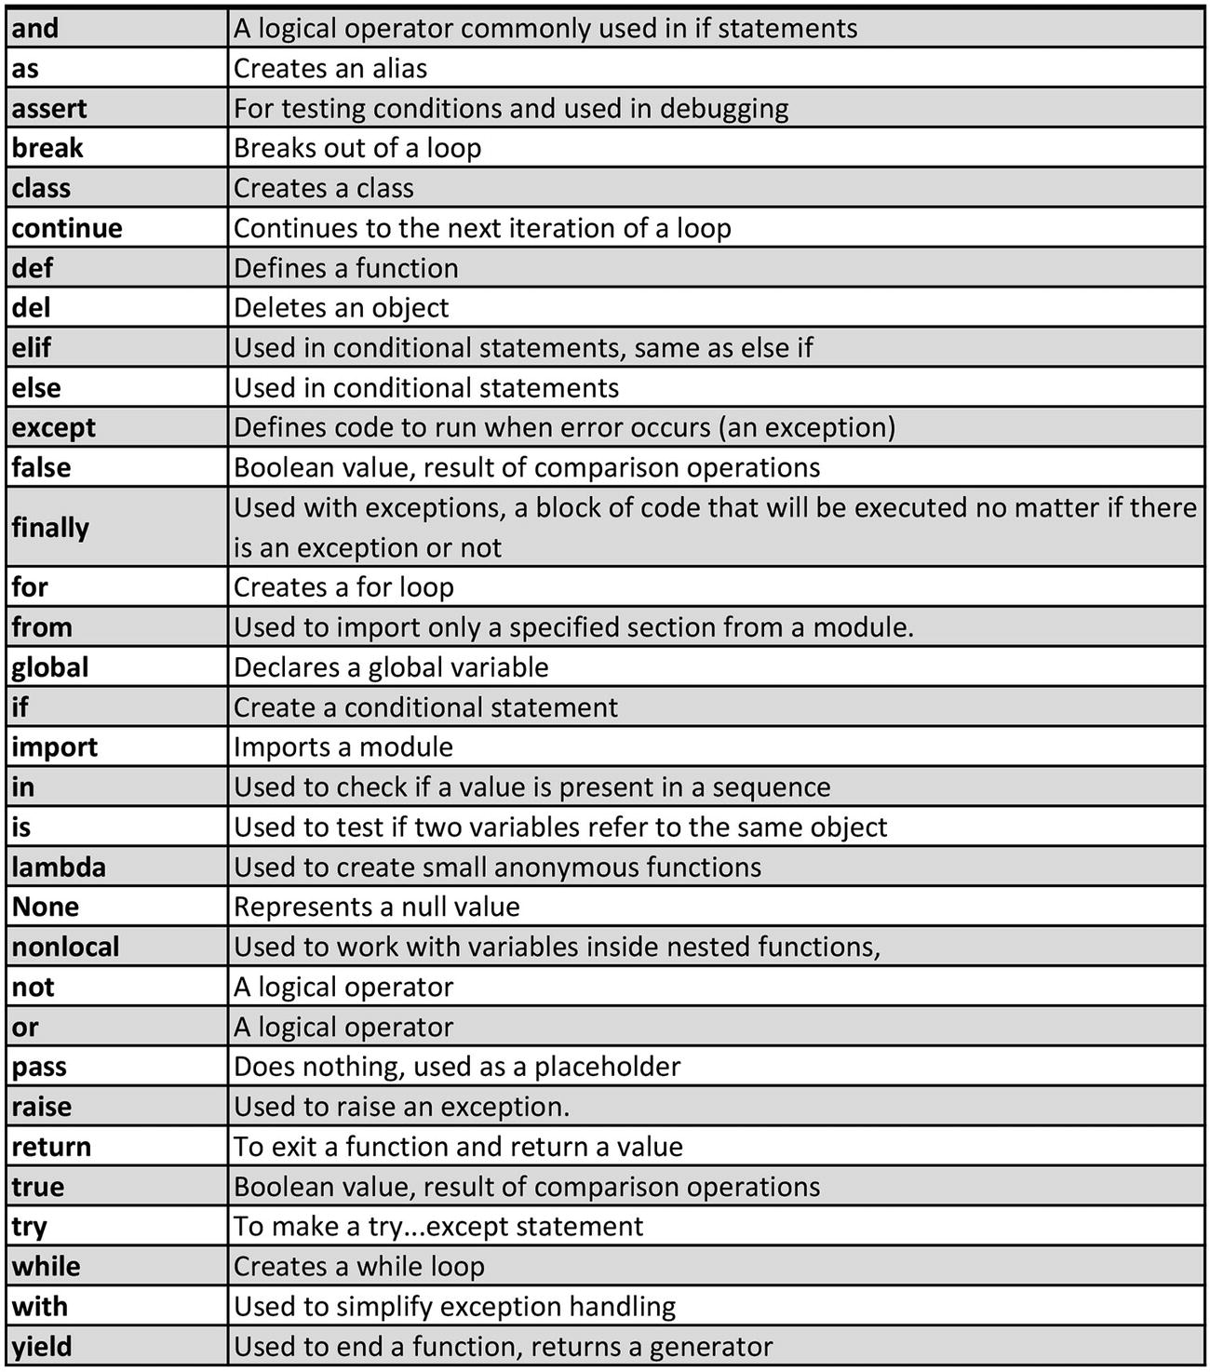
For example , the word “while” indicates a while loop. The word “if” defines an “if statement.” You can’t use a reserved word as a variable name or function name.

Identifiers
An identifier is a name given to a class, function, or a variable. Identifiers can be a combination of uppercase or lowercase letters, numbers, or an underscore (_). Try to keep the identifiers meaningful, so that they describe what they’re used for.
printData, firstVariable, _count, userCount

Indentation
Most other programming languages such as C and C++ use braces { } to define a block of code. Python uses indentation . Use the tab key.
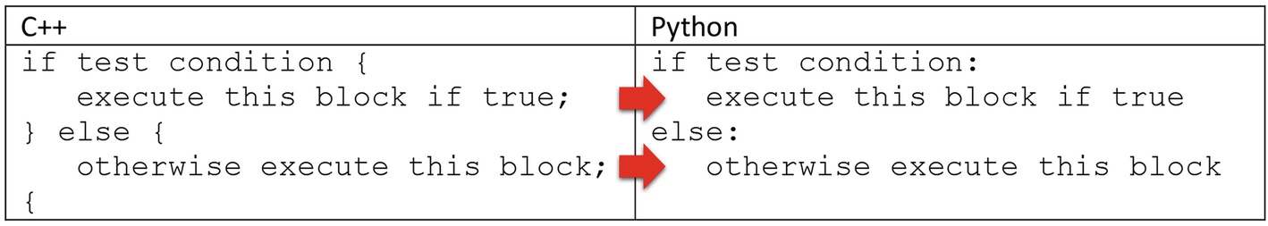

Comments
A comment is an explanation or annotation in the source code of a computer program for the purpose of making the source code easier for other programmers to understand. Comments are intended to be human readable for the programmer’s benefit and are ignored by the Python interpreter during execution.
Comments are very important while writing a program. You should clearly document all your code using comments, so other developers working on a project can better understand what your code is doing.
Use the hash character (#) to write single-line comments:
# Prompt user for two numbers
a = input ('Enter first number: ')
b = input ('Enter second number: ')
If you need to write a block describing the functionality, then use a triple quote before and after the comment block.
For example:
""" Prompt user for two numbers
one after the other using a text input """
a = input ('Enter first number: ')
b = input ('Enter second number: ')

Input
You can obtain input from the user using the input( ) function. This function prompts the user to type in some data.
number = input ('Enter a number: ')

Output
You can display information on the screen with the print( ) function. You can print the contents of a variable or enclose a string within the parameters of the print( ) function. For example:
print (number)

Escape Characters
An escape character tells the interpreter to perform a specific operation such as a line break or tab or a reserved character such as a quote mark or apostrophe.
Escape characters start with the a backslash (\) and are used to format a string. Table 2-1 lists escape characters and their function.
Table 2-1Escape characters
Escape Character | Function
\n | Line break
\t | Tab (horizontal indentation)
\ | New line in a multiline string
\\ | Backslash
\’ | Apostrophe or single quote
\” | Double quote
For example, you could use the tab escape and break line character to format some text:
print("John \t 45 \nJoanne \t 15")
The output to this line would look something like this:
John 45
Joanne 15

Writing a Program
To write a program , open IDLE Python from the start menu. Select the File menu and then click “New File.”
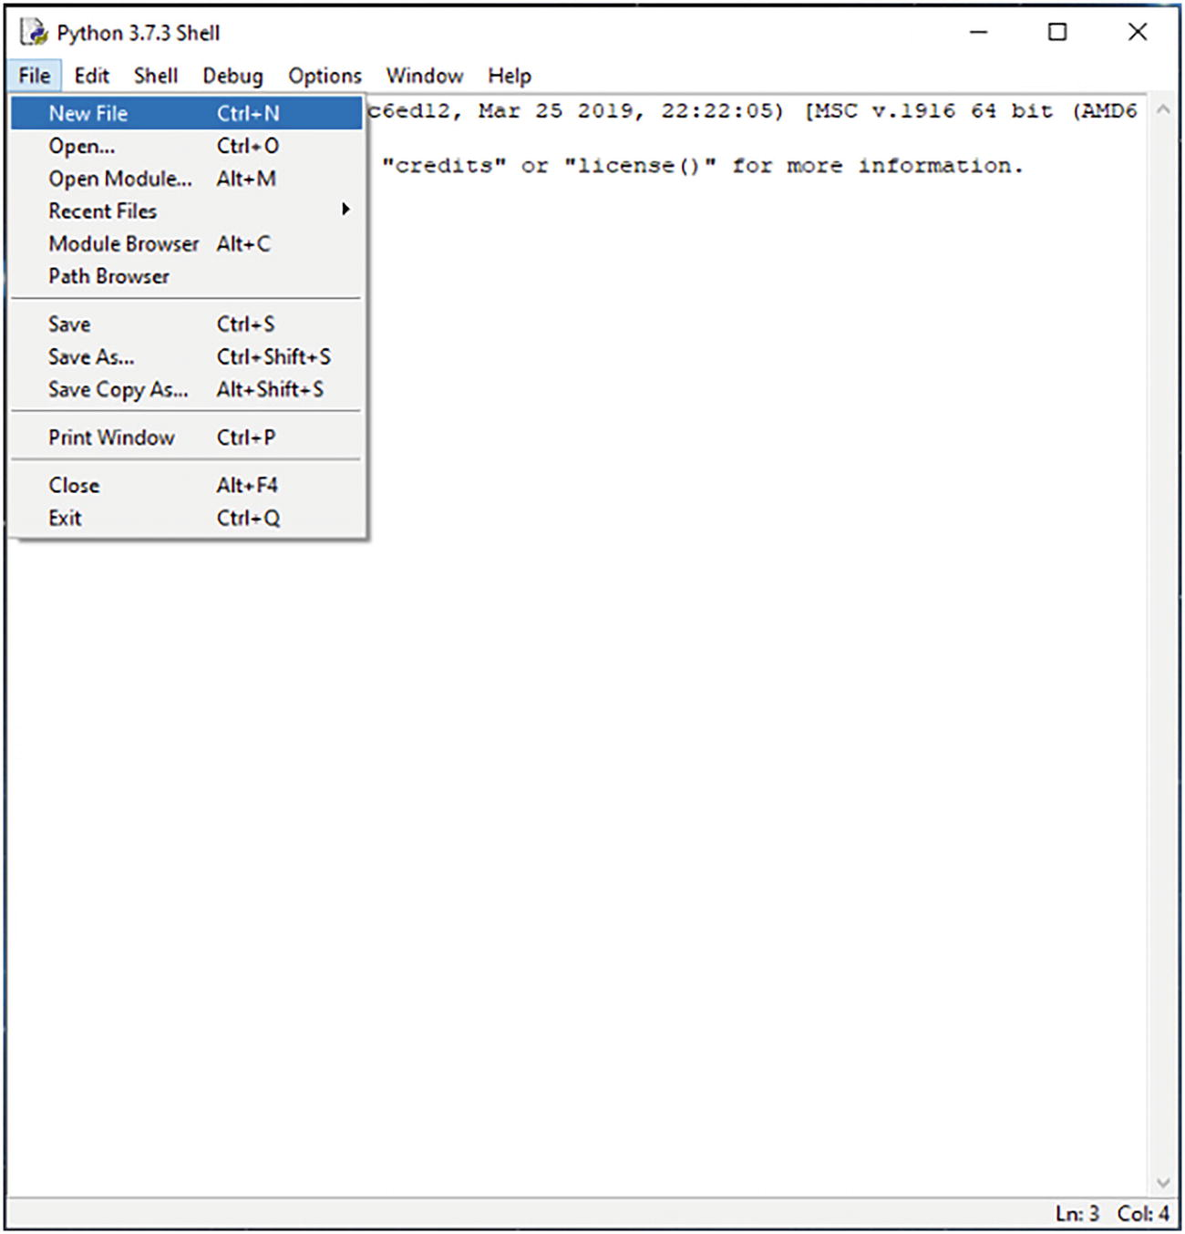
A new blank window will appear. This is the code editor. Here, you can write all your Python code.
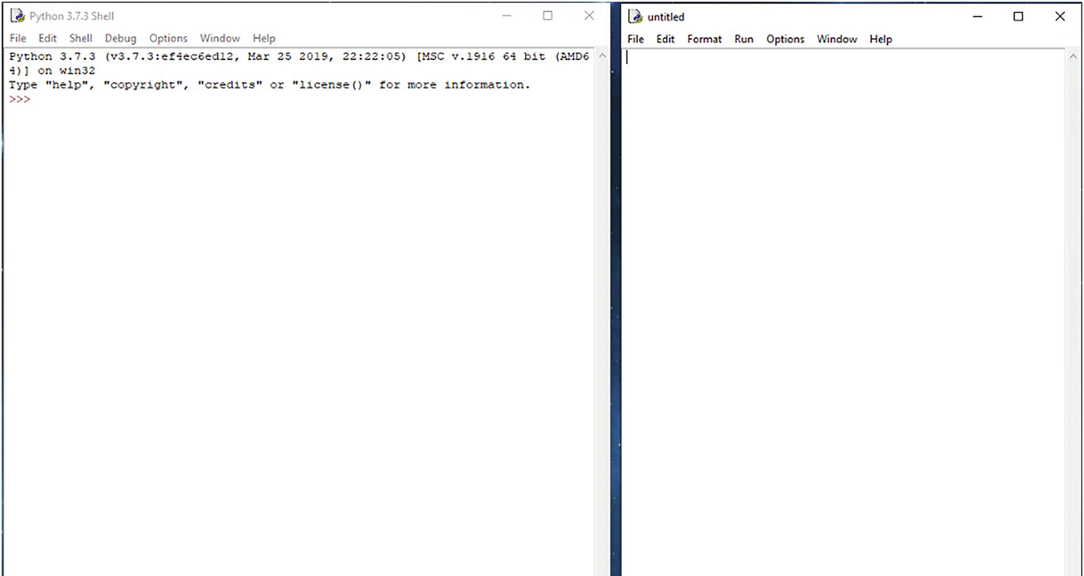
Arrange your windows as shown here, with the Python Shell on the left-hand side (or right if you prefer) – this is where you’ll see the results of your programs. Put the code editor window next to the Python Shell window.
For our first program, we’re going to write something that adds two numbers together and then displays the result.
First, we need two variables to store the numbers. We’ll use “a” and “b.” We’ll assign the number 5 to each variable.
a = 5
b = 5
Next, we need a piece of code that will add the two numbers together and store the result. In this case, the values assigned to the variables “a” and “b” will be added together and stored in the variable “result.”
result = a + b
Next, we’ll need a function to print the result on the screen:
print (result)
Let’s put it all together in a program.
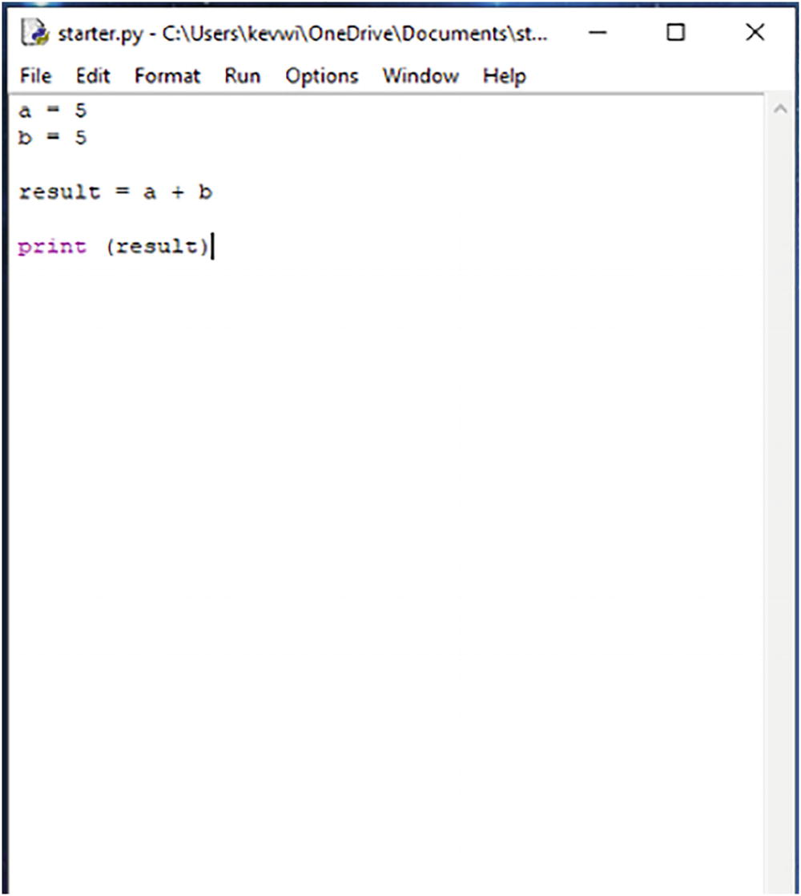
To run the program , press F5, or go to the “Run” menu in your code editor and click “Run Module.”
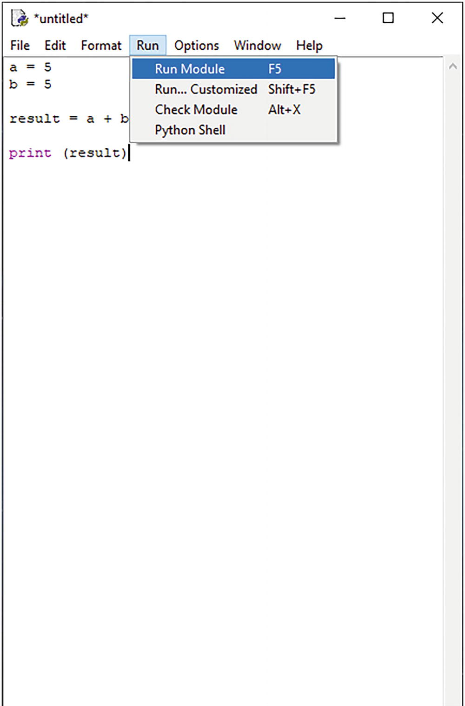
You can see in the following image the output of the program, in this case “10.”
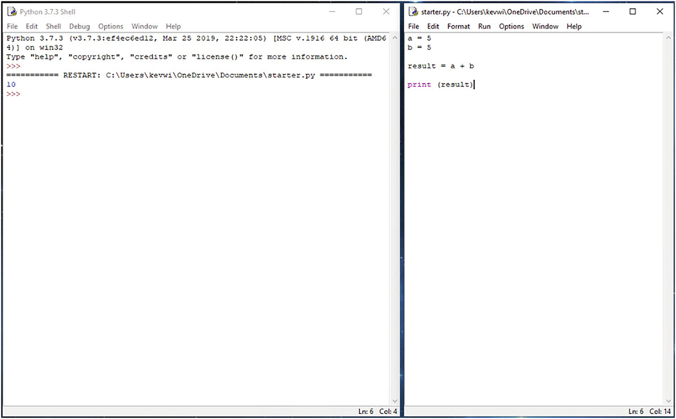
This particular program isn’t very useful. It would be much better if we could allow the user to enter the numbers they want to add together. To do this, we’ll need to add a function that will prompt the user for a value.
We’ll use the input function. We can replace the variables “a” and “b” from the previous program with the input function.
a = input ('Enter first number: ')
b = input ('Enter second number: ')
Now, because the input function reads the values entered as text (called a string), we need to convert these to numbers. So we need to modify the code that adds the two numbers together. We can use the int function – this converts the text to an integer which is a fancy name for a whole number.
result = int(a) + int(b)
Let’s put it all together in a program.
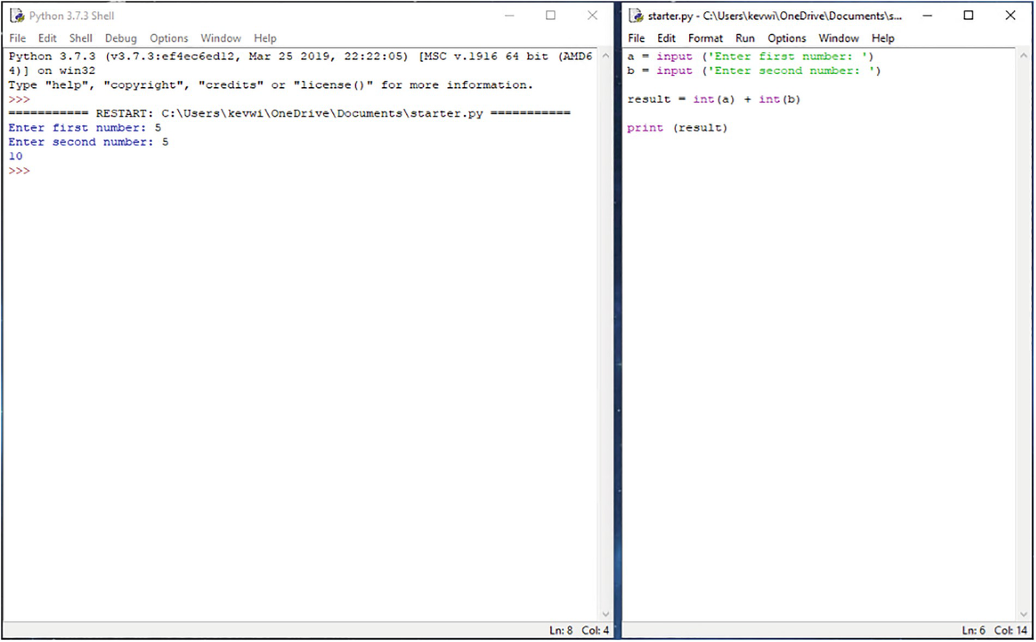
You can see in the following image the output of the program . The program prompted the user for two numbers, added them together, and then displayed the result underneath.

Lab Exercises
What is the output produced by the following code fragment ?
num1 = 2
num2 = 3
print (num1 + num2)
What is the output produced by the following code fragment?
num1 = 2
num2 = 3
print ("num 1 + num 2 = ", num1 + num2)
Find the errors in the following program:
Num1 = 2
num2 := 3
Sum = num1 + num2;
printf(sum)
Which of the following identifiers are valid and which are invalid? Why?
Num1
time-of-day
tax_rate
x5
int
7th_Rec
yield
How do you write comments in your code? Explain with an example.
Why should you include comments?

Summary
Python programs are written in a text editor, such as Notepad, PyCharm, or the code editor in Python’s development environment (IDLE), and saved with a .py file extension.
Python is an example of a high-level language.
Python is an interpreted language, meaning the code you write is translated into machine code directly, making it well suited to web development.
An identifier is a name given to a class, function, or a variable.
Python uses indentation to mark a block of code. Use the tab key to indent.
A comment is an explanation or annotation in the source code of a computer program for the purpose of making the source code easier for other programmers to understand.
You can obtain input from the user using the input( ) function.
You can display information on the screen with the print( ) function.
© The Author(s), under exclusive license to APress Media, LLC, part of Springer Nature 2022
K. WilsonThe Absolute Beginner's Guide to Python Programming
https://doi.org/10.1007/978-1-4842-8716-3_3

3. Working with Data
Kevin Wilson1
(1)
London, UK

You can store and manipulate all different types of data: a number, a string, list, and so on. With Python, you don't need to declare all your variables before you use them.

Variables
A variable is a labeled location in memory that is used to store values within a computer program. There are two types of variables: local and global.

Local Variables
Variables defined within a function are called local variables , as they are local to that particular function. These variables can only be seen by the function in which they are defined. These variables have local scope. Figure 3-1 shows an example of local variables.
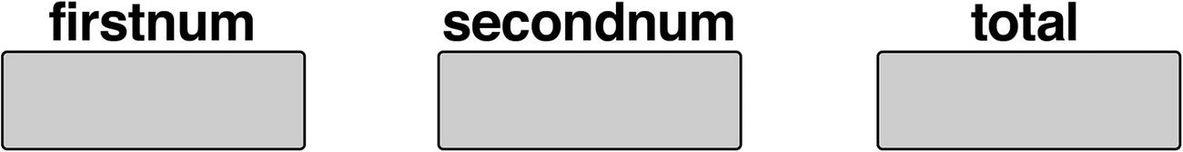
Figure 3-1An example of local variables

Global Variables
Global variables are defined in the main body of the program outside any particular functions. These variables can be seen by any function and are said to have global scope.
Here in the example below, “a” and “b” are global variables, while “firstnum,” “secondnum,” and “sum” are local variables.
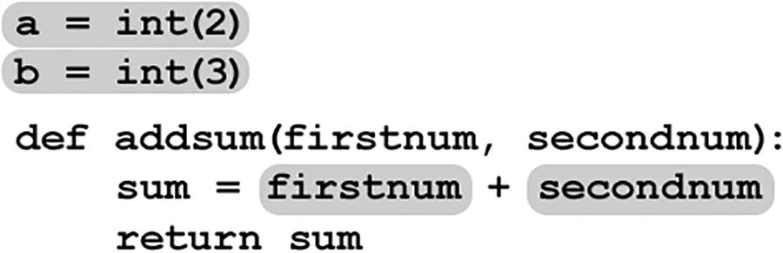
You would not be able to access the variables “firstnum,” “secondnum,” and “sum” from outside the “addnum” function.

Basic Data Types
A variable can store various types of data, called a data type . Let’s introduce some of the basic types we'll be looking at.

Integers
An integer is a whole number and can be positive or negative. Integers can usually be of unlimited length.
score = 45

Floating Point Numbers
A floating point number , sometimes called a real number, is a number that has a decimal point:
temperature = 44.7

Strings
In Python code , a string must be enclosed in quotes “...” or ‘...’:
name = "John Myers"

Lists
A list is an ordered sequence of data items usually of the same type, each identified by an index (shown in the circles). This is known as a one-dimensional list.
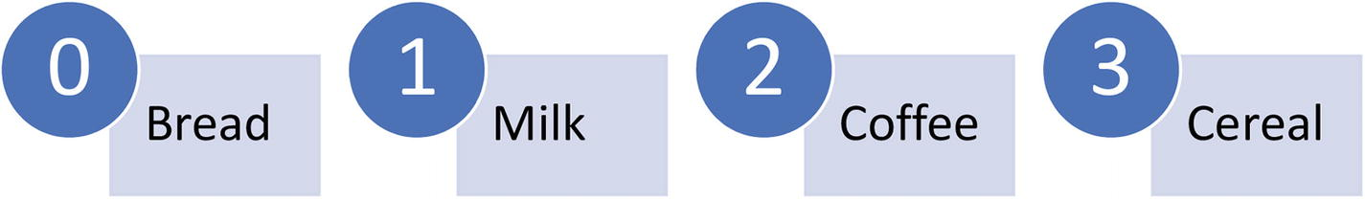
Lists are known as arrays in other programming languages, and you can create one like this – list elements are enclosed in square brackets [ ]:
shoppingList = ['bread', 'milk', 'coffee', 'cereal']
To reference an item in a list, put the reference in square brackets :
print (shoppingList[1])
You can assign another value to an item in the list (e.g., change cereal):
shoppingList[3] = "chocolate"
You would end up with something like this:
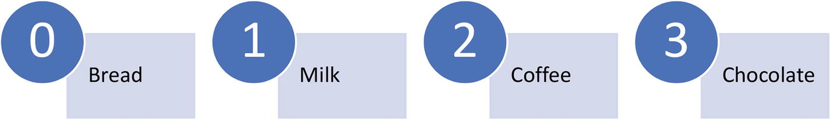
Let's look at a program. Open the file list1.py. Here, we've created a list and initialized it with some data.
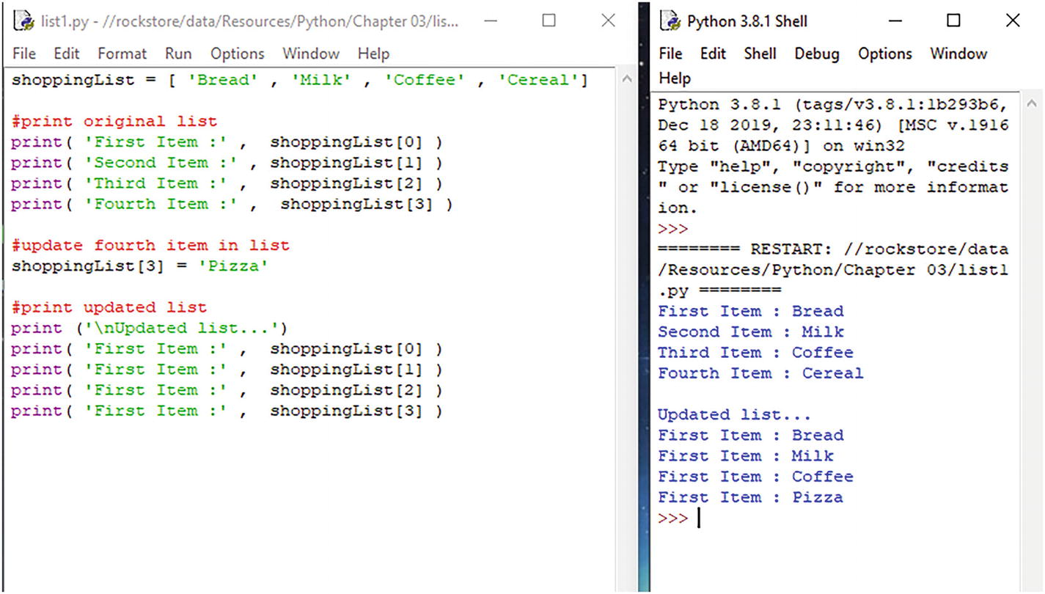
We can output data from the list using a print statement and a reference to the item in the shopping list:
print (shoppingList[3])
We can also update an item in the list using the reference :
shoppingList[3] = 'pizza'

Two-Dimensional Lists
Two-dimensional lists are visualized as a grid similar to a table with rows and columns. Each column in the grid is numbered starting with 0. Similarly, each row is numbered starting with 0. Each cell in the grid is identified by an index – the row index followed by the column index (shown in the circles).
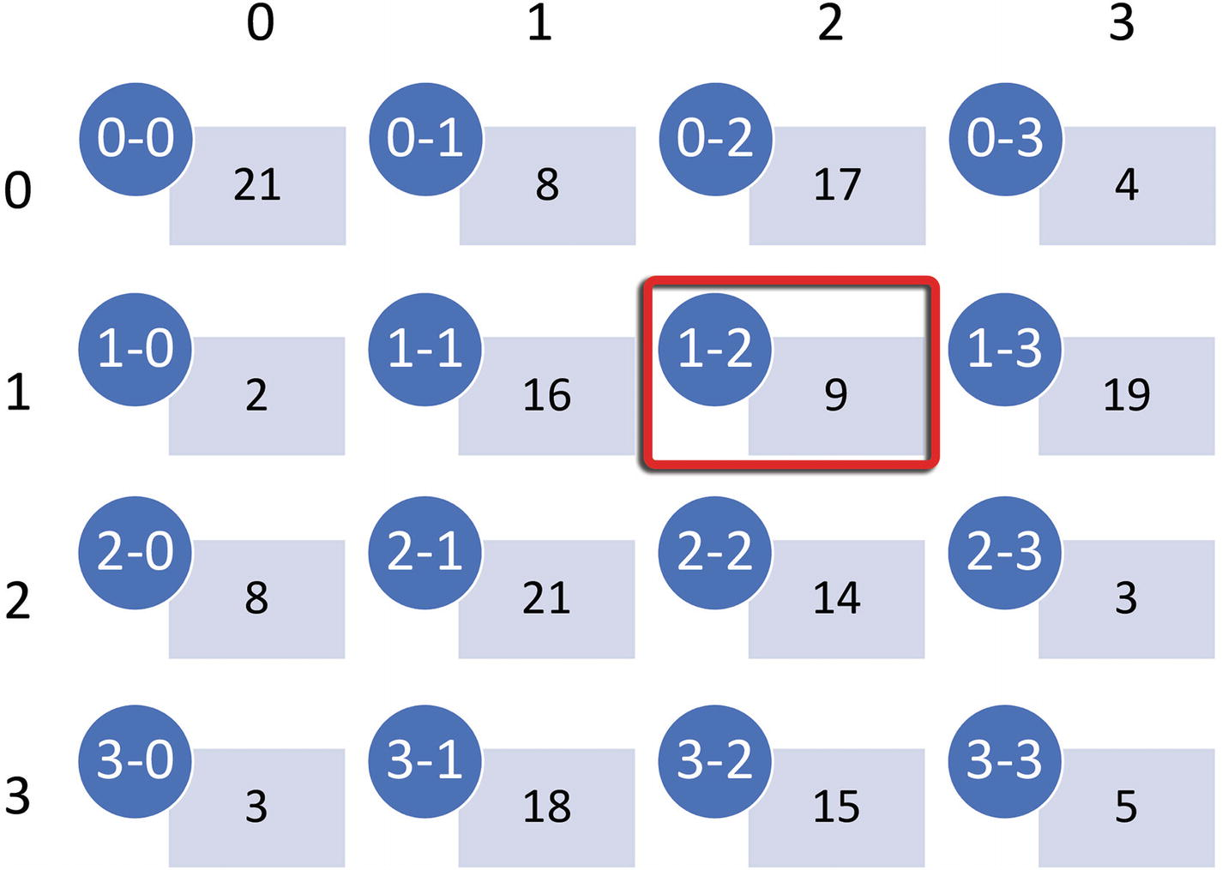
You could declare the earlier list as
scoreSheet = [
[ 21, 8, 17, 4 ],
[ 2, 16, 9, 19 ],
[ 8, 21, 14, 3 ],
[ 3, 18, 15, 5 ]
]
To reference an item in a two-dimensional list, put both the references in square brackets (first the row index, then the column index):
print (scoreSheet[1][2]) #circled above
You can change items in the list, put both the references in square brackets (first the row index, then the column index), and then assign the value:
scoreSheet [0][3] = 21
Let’s take a look at a program. Open the file list2d.py. Here, we've declared our shoreSheet list and initialized it with some data .
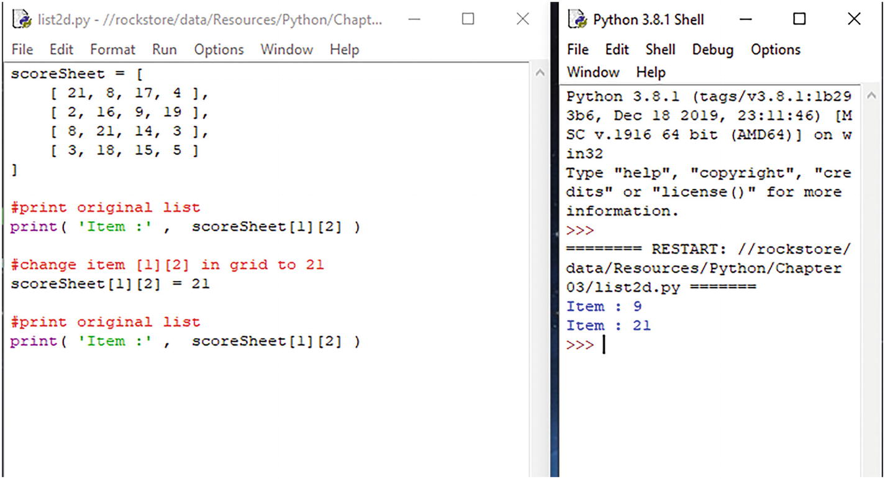
We can add an item to a particular location in the list:
scoreSheet [1][2] = 21
We can also output data stored at a particular location :
print (scoreSheet[1][2])

Sets
A set is an unordered collection of unique items enclosed in curly braces { }. Sets can contain different types.
You can create a set like this:
setName = {1, 6, 2, 9}
Two things to note about sets. Firstly, you can’t index individual elements in the set as it is an unordered data type. Secondly, you can’t change individual values in the set like you can with lists. However, you can add or remove items. Use the .add()method, and type the data to add, in the parentheses .
setName.add('item to add')
Let’s take a look at a program. Open the file sets.py. Here, we've created a set with some animal names. We can output the data in the set.
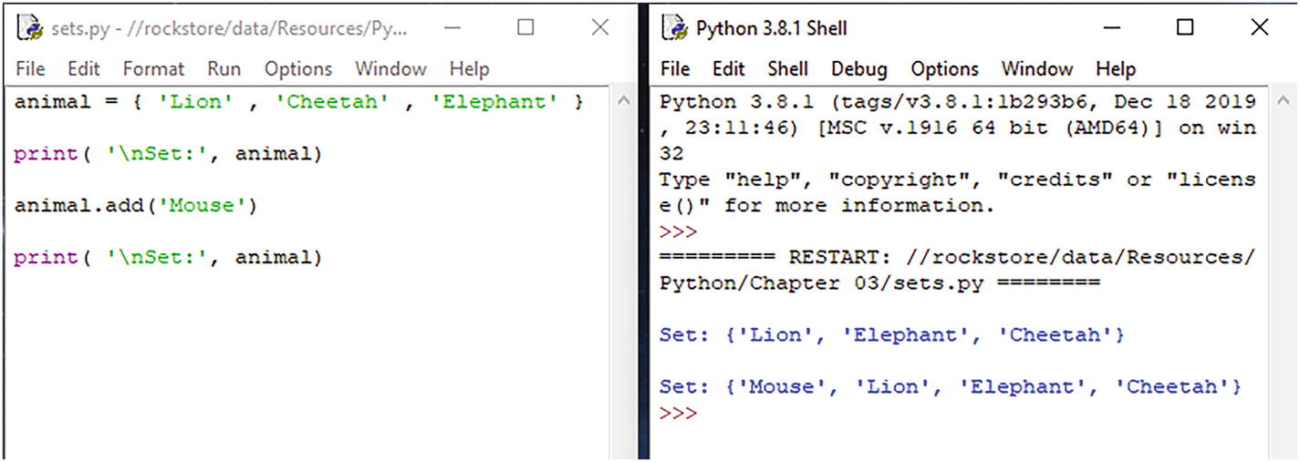
We can also add an item to the set using the .add() method .

Tuples
A tuple is similar to a list and is a sequence of items each identified by an index. As with lists, the index starts with 0 not 1.
In contrast to lists, items in a tuple can’t be changed once assigned, and tuples can contain different types of data.
To create a tuple, enclose the items inside parentheses ( ):
userDetails = (1, 'John', '123 May Road')
Use a tuple when you want to store a data of a different type, such a sign in details for your website.
Let’s take a look at a program. Open the file tuple.py. Here, we've created a tuple with some colors.
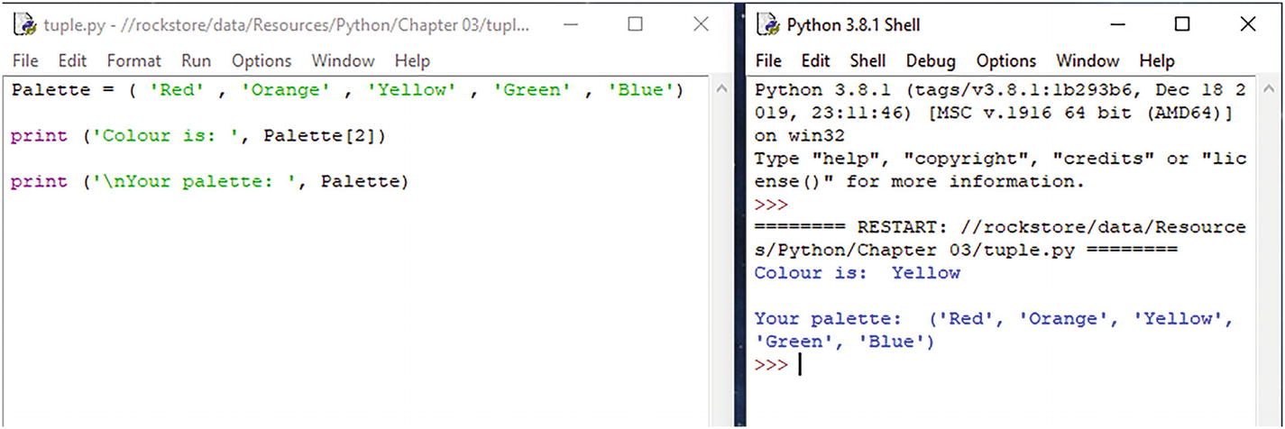
We can output the data in the tuple using a print statement :
print (Palette[2])

Dictionaries
A dictionary is an unordered collection of items, each identified by a key.
To create a dictionary, enclose the items inside braces { }. Identify each item with a key using a colon.
dictionary = { 1: 'Dave',
2: 'Jo'
3: 'Jane'
}
To read a value, put the key in square brackets:
print (dictionary[1])
To change or add a value, put the key in square brackets. For example, change “jo” to “mike.”
dictionary[2] = 'Mike'
Let’s take a look at a program. Open the file dictionary.py. Here, we've created a dictionary with some user data .
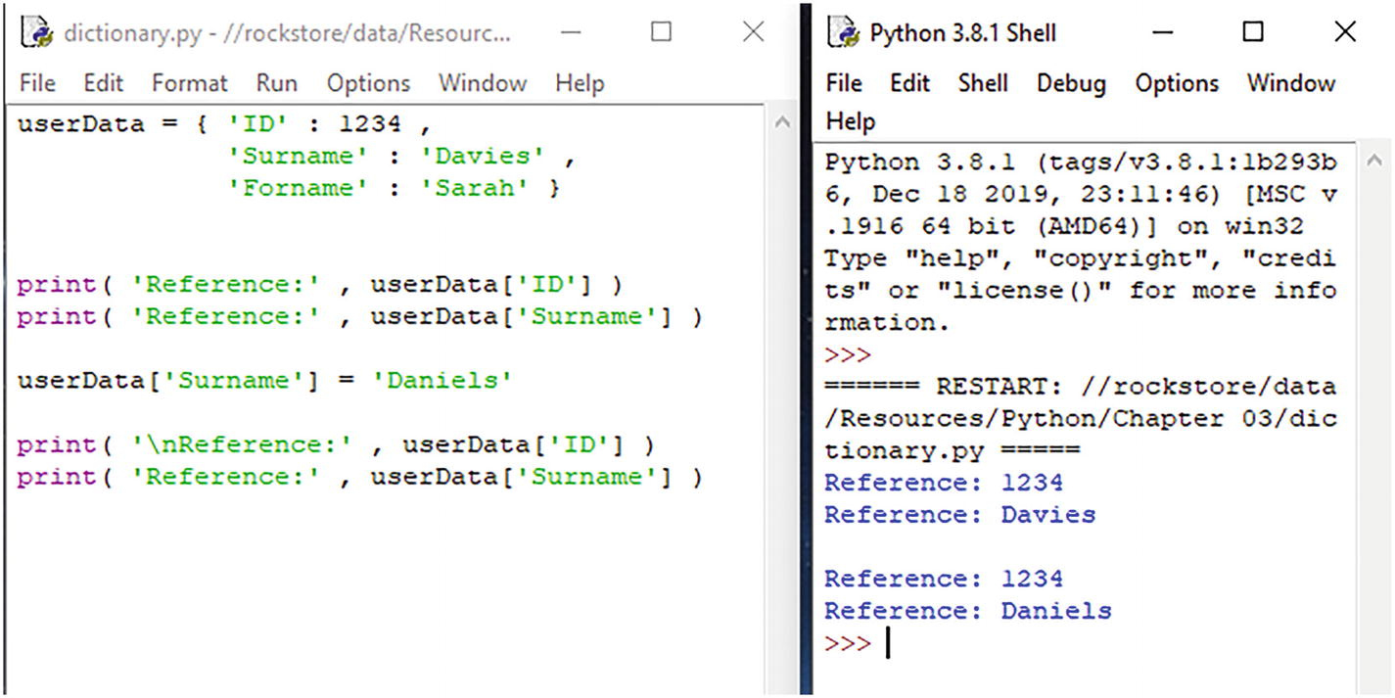
We can reference the data using the key, for example, “ID”:
print (userData['ID'])

Program Input
One of the main reasons for writing a program is so you can run it multiple times with various different data.
Instead of hard coding the input data into a variable as we’ve done previously, it would be better to prompt the user for the input or retrieve it from a file (see later).
Instead of writing
a = 7
we can use the input() function to prompt the user for a number:
a = input ('Enter a number: ')
It’s a good idea to separate your data from the actual program.
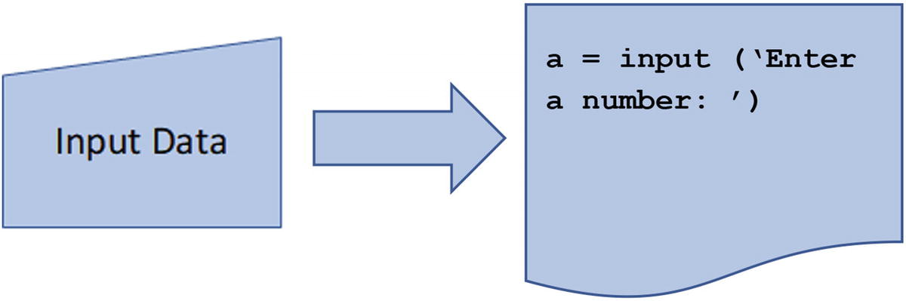
Figure 3-2Input data into a program

Program Output
Any result calculated by the program needs to be displayed to the user in a meaningful way. We can either output the data to the screen using the print() function, or we can write the data to a file (see later).
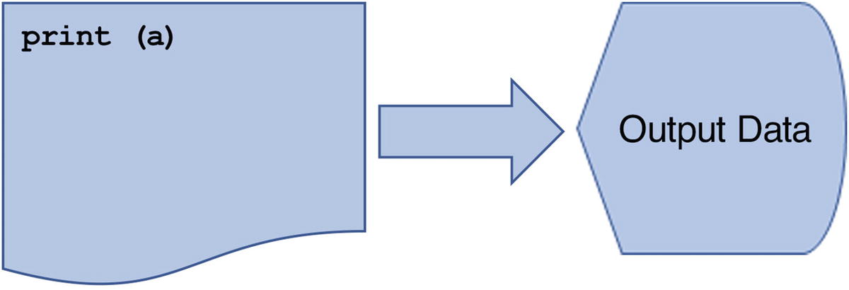
Figure 3-3Data output from program

Casting Data Types
Variables can contain various types of data such as text (called a string), a whole number (called an integer), or a floating point number (numbers with decimal points).
With Python, you don’t have to declare all your variables before you use them. However, you might need to convert variables to different types. This is known as type casting .
Python has two types of type conversion: implicit and explicit.
With implicit type conversion, Python automatically converts one data type to another.
With explicit type conversion, the programmer converts the data type to the required data type using a specific function. You can use the following functions to cast your data types:
int( ) converts data to an integer
long( ) converts data to a long integer
float( ) converts data to a floating point number
str( ) converts data to a string
For example, we use the input( ) function to prompt the user for some data :
a = input ('Enter first number: ')
This example would prompt the user for some data and then store the data in the “a” variable as a string.
This might sound ok, but what if we wanted to perform some arithmetic on the data? We can't do that if the data is stored as a string. We’d have to type cast the data in the variable as an integer or a float.
int(a)
or
float(a)

Arithmetic Operators
Within the Python language, there are some arithmetic operators you can use.
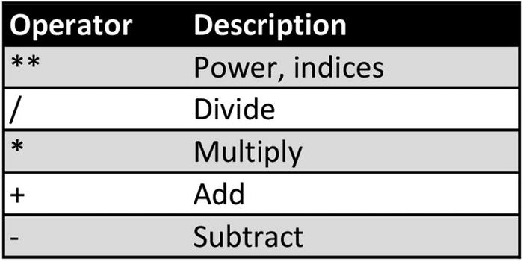

Operator Precedence
BIDMAS (sometimes called BODMAS ) is an acronym commonly used to remember mathematical operator precedence – that is, the order in which you evaluate each operator:
1. | Brackets ( )
2. | Indices (sqrt, power, squared2, cubed3, etc.) **
3. | Divide /
4. | Multiply *
5. | Add +
6. | Subtract -

Performing Arithmetic
If you wanted to add 20% sales tax to a price of £12.95, you could do something like this:
total = 12.95 + 12.95 * 20 / 100
According to the precedence list given earlier, you would first evaluate the “divide” operator:
20 / 100 = 0.2
Next is multiply:
12.95 * 0.2 = 2.59
Finally addition:
12.95 + 2.59 = 15.54

Comparison Operators
These are used to compare values and are commonly used in conditional statements or constructing loops.
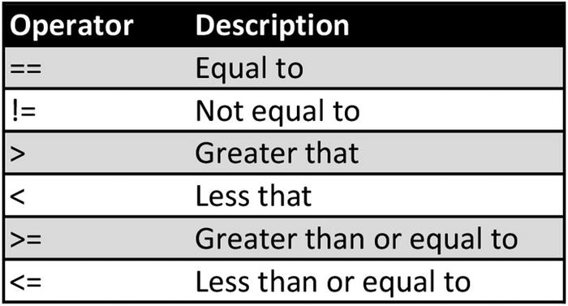
For example, comparing two values in an “if” statement, you could write something like this:
if a > 10:
print ("You've gone over 10...")

Boolean Operators
Also known as logical operators and are commonly used in conditional statements (if...) or constructing loops (while... for...).
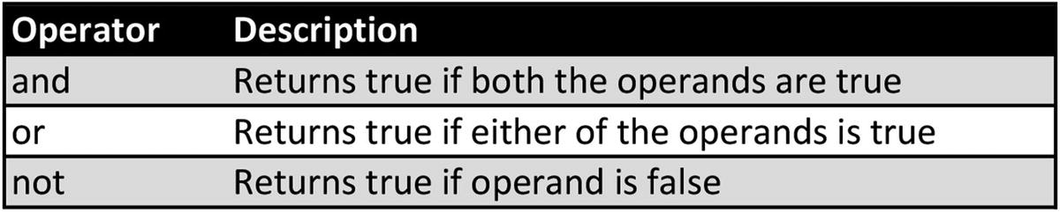
For example, you could join two comparisons in an “if” statement using “and,” like this:
if a >= 0 and a <= 10:
print ("Your number is between 0 and 10")
else
print ("Out of range - must be between 0 & 10")
Using the 'and' operator would mean both conditions (a >= 0) and
(a <= 10) must be true .

Bitwise Operators
Bitwise operators are used to compare binary numbers:
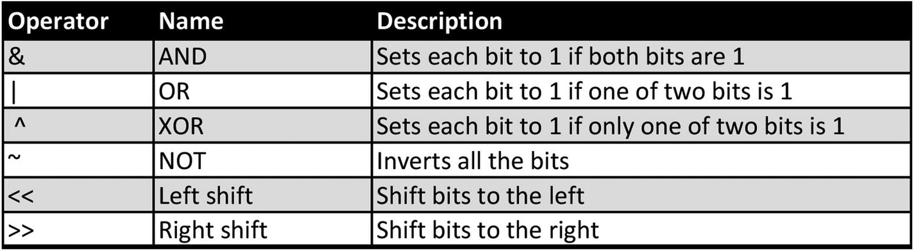
You can apply the bitwise operators:
a >> 2 #shift bits of 'a' left by 2 units
a << 2 #shift bits of 'a' right by 2 units
a & b #perform AND operation on bits

Lab Exercises
Write a program that accepts a length in inches and prints the length in centimeters (1 inch = 2.54cm).
Write a program that accepts your forename, surname, and year of birth and adds them to an array.
Write a program that converts temperatures from Celsius to Fahrenheit:
F = C × 9/5 + 32
Write a program that calculates the volume of a sphere:
V = 4/3 πr3
Write a program to calculate and display an employee’s gross and net pay. In this scenario, tax is deducted from the gross pay at a rate of 20% to give the net pay.
Write a program that stores a shopping list of ten items. Print the whole list to the screen, and then print items 2 and 8.
Extend the previous program, to insert an item into the list.
What is a Boolean operator? Write a program to demonstrate.
What is a comparison operator? Write a program to demonstrate.
What is data type casting? Why do we need it? Write a program to demonstrate.

Summary
A variable is a labeled location in memory that is used to store values within a computer program
Variables defined within a function are called local variables, as they are local to that particular function.
Global variables are defined in the main body of the program outside any particular functions.
An integer is a whole number and can be positive or negative. Integers can usually be of unlimited length.
A floating point number, sometimes called a real number, is a number that has a decimal point.
A string must be enclosed in quotes.
A list is an ordered sequence of data items usually of the same type, each identified by an index.
A set is an unordered collection of unique items enclosed in curly braces.
A tuple is similar to a list and is a sequence of items each identified by an index. Items in a tuple can’t be changed once assigned and tuples can contain different types of data.
A dictionary is an unordered collection of items, each identified by a key.
We can use the input() function to prompt the user for a number.
Converting variables to different types is known as type casting.
© The Author(s), under exclusive license to APress Media, LLC, part of Springer Nature 2022
K. WilsonThe Absolute Beginner's Guide to Python Programming
https://doi.org/10.1007/978-1-4842-8716-3_4

4. Flow Control
Kevin Wilson1
(1)
London, UK

Flow control is controlling the order in which statements or function calls of a program are executed.
There are three control structures: sequence, selection, and iteration.
Python has various control structures such as while loops, for loops, and if statements, which are used to determine which section of code is executed according to certain conditions.

Sequence
A computer program is a set of step-by-step instructions that are carried out in sequence to achieve a task or solve a problem. The sequence can contain any number of instructions, but no instruction can be skipped in the sequence. Figure 4-1 illustrates this.
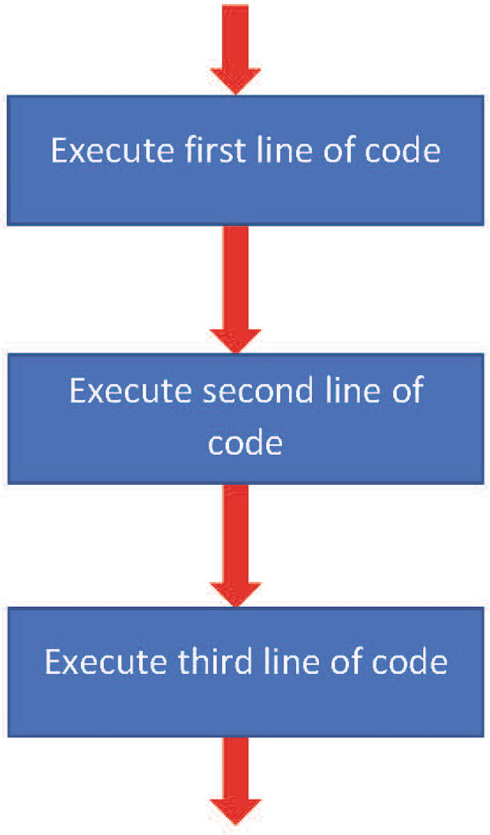
Figure 4-1A computer program’s step-by-step sequence
The interpreter will follow and execute each line of code in sequence until the end of the program.
Let’s have a look at a program. Open adder.py. This program has four statements.
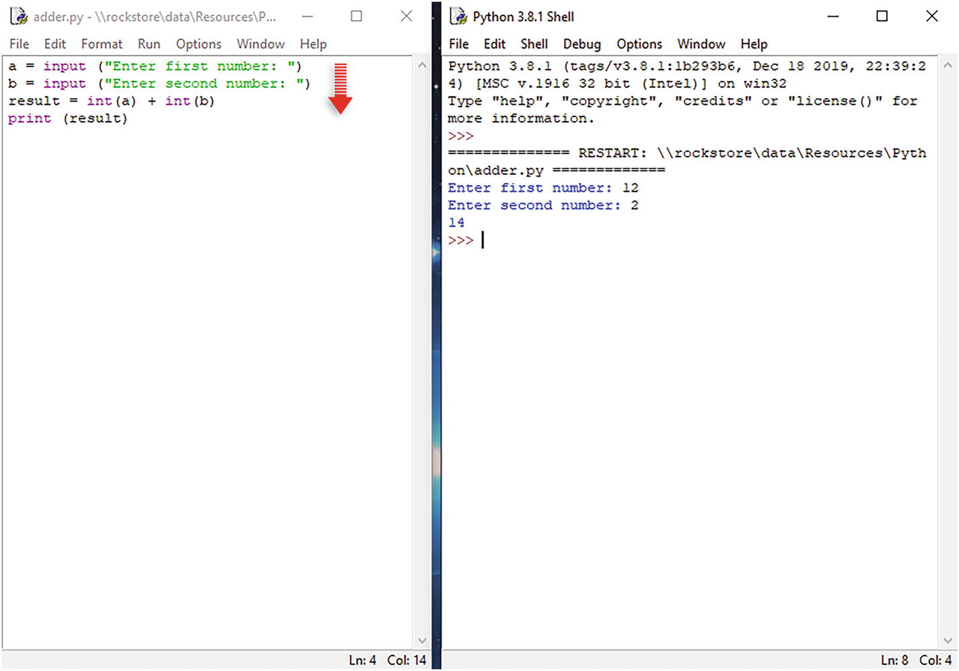
Once you execute the program, the instructions are carried out in sequence .
Let’s try another example. Open inchestocm.py.
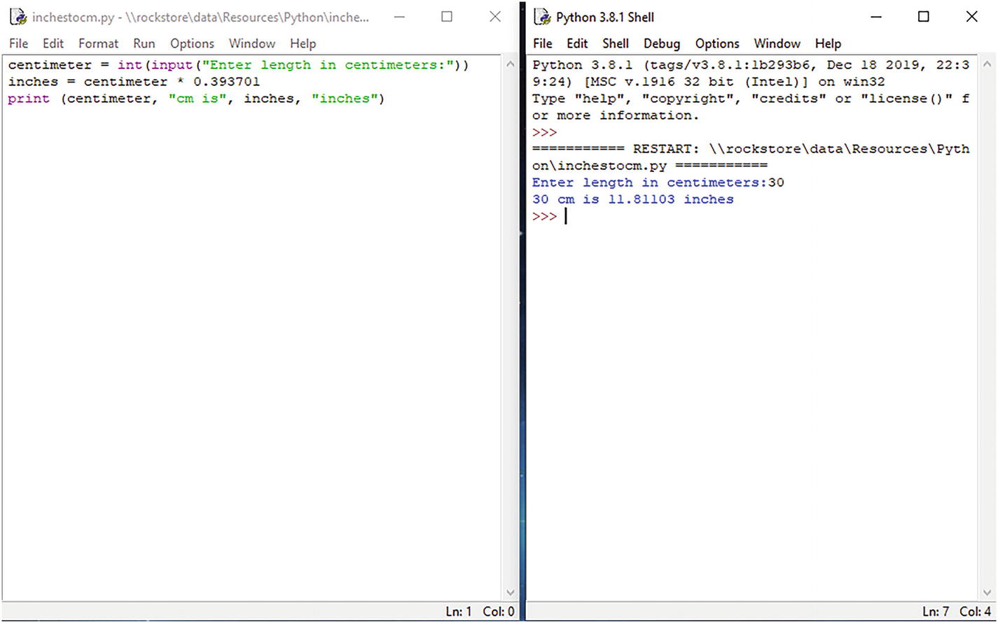

Selection
In most computer programs, there are certain points where a decision must be made. This decision is based on a condition, and that condition can be either true or false.

if... else
If statements are used if a decision is to be made. If the condition is true, then the if statement will execute the first block of code; if the condition is false, the if statement will execute the “else” block of code if included.
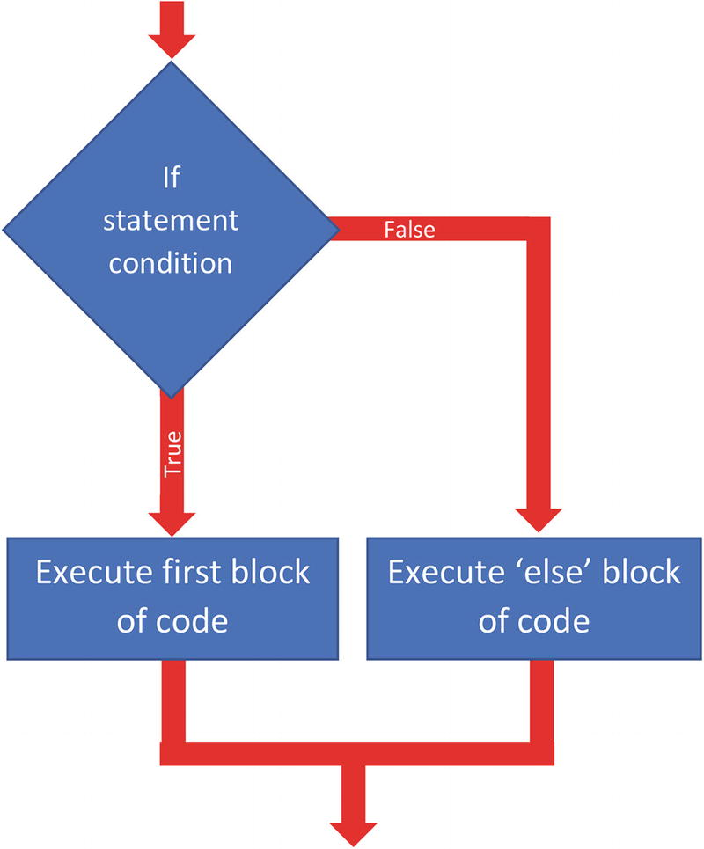
Figure 4-2An if… else statement
So, for example:
if num >= 0: #condition
print("Positive or Zero") #first block
else:
print("Negative number") #else block
Let’s have a look at a program. Open selection.py. Here, we can see a very simple if statement to determine whether a test score is a pass or fail. The pass mark is 70, so we need an if statement to return a pass message if the value entered is greater than 70. Remember that we also need to cast the variable “mark” as an integer (int).
If you enter a value greater than 70, the Python interpreter will execute the first block of the “if statement .”
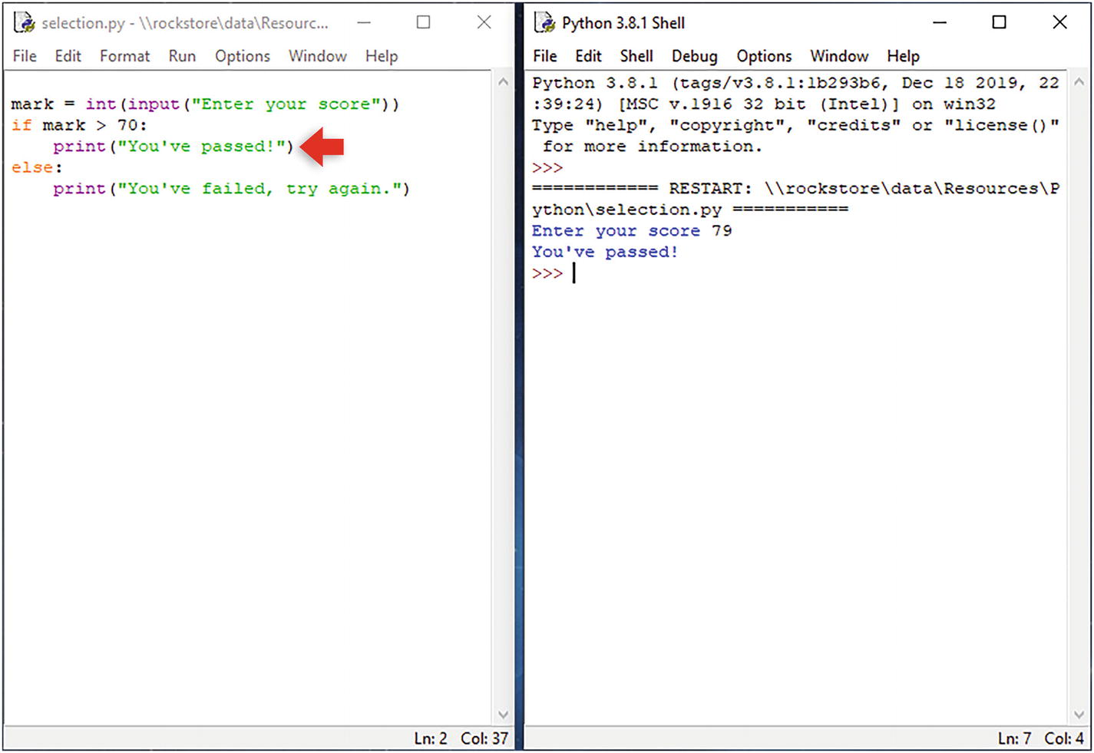
If you enter a value below 70, the Python interpreter will execute the “else block” of the “if statement .”
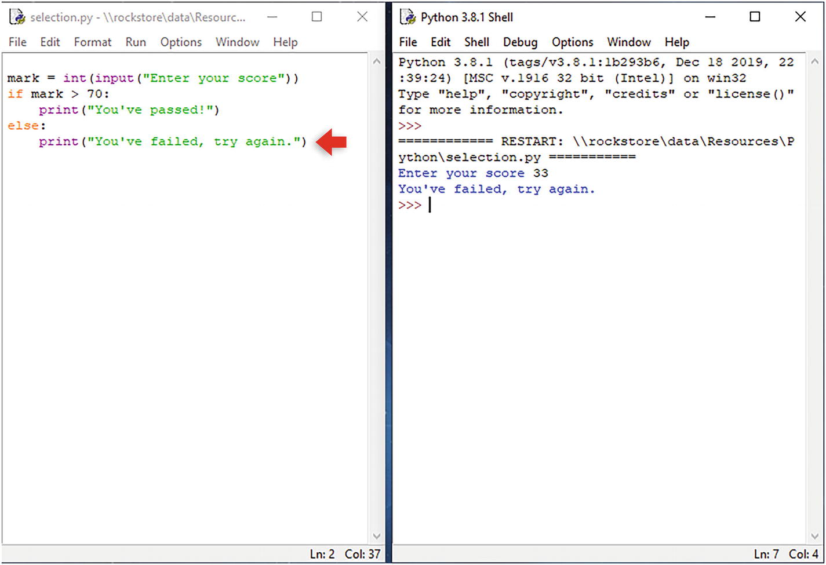

elif
Use the elif statement if multiple decisions are to be made. Each decision (or condition) will have a set of instructions to be executed.
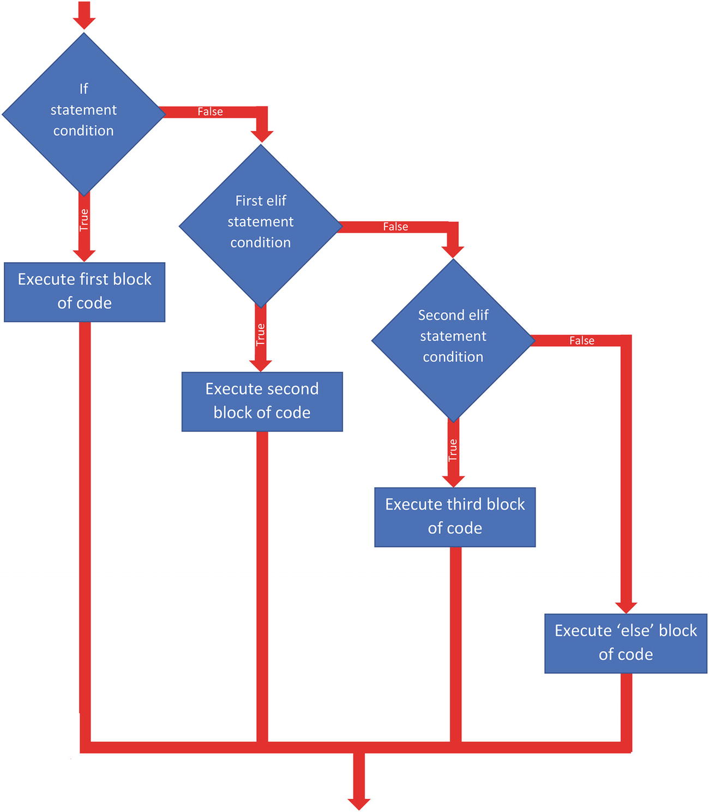
Figure 4-3An elif statement
So, for example:
if condition: #if condition
[statements] #first block of code
elif condition: #first elif statement
[statements] #second block of code
elif condition: #second elif statement
[statements] #third block of code
else:
[statements] #else block of code
Let’s have a look at a program. Open multiselection.py .
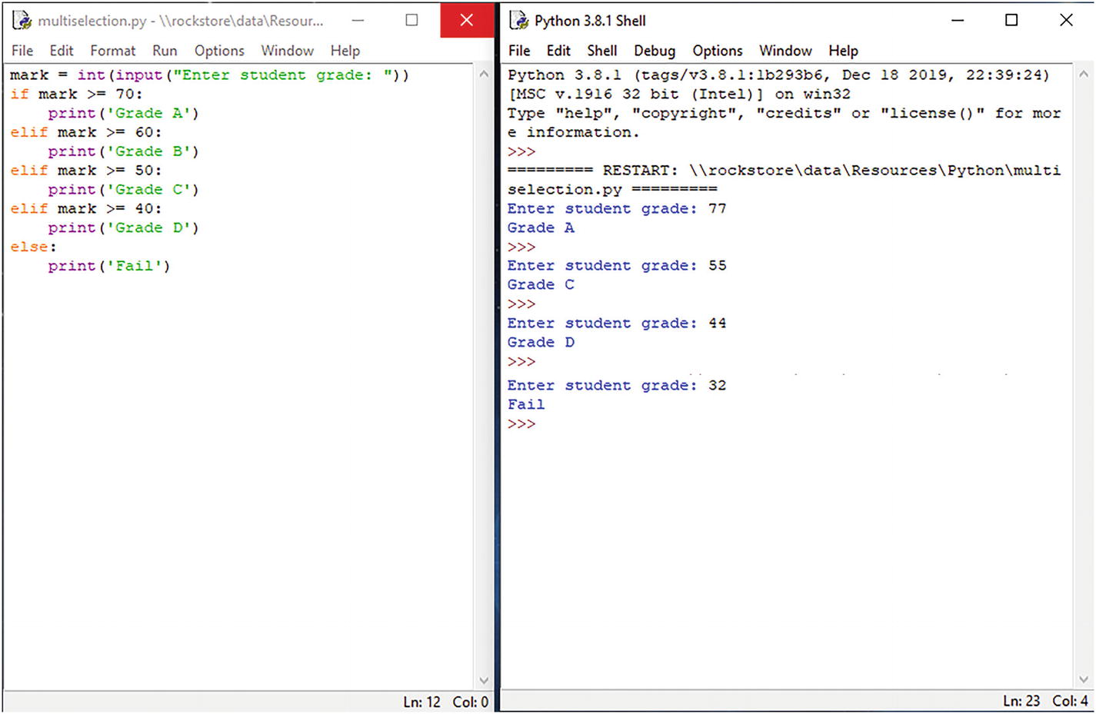
If we analyze the elif statement, we can see how it works. For the first condition, any number entered above 70 will execute the first block .
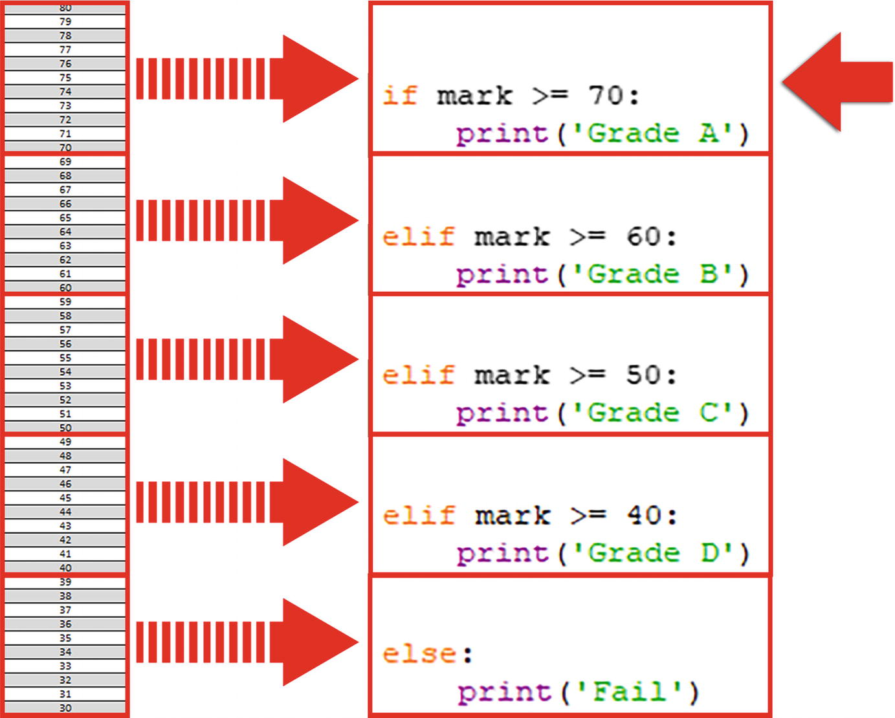
Any number between 60 and 69, the interpreter will execute the second block.
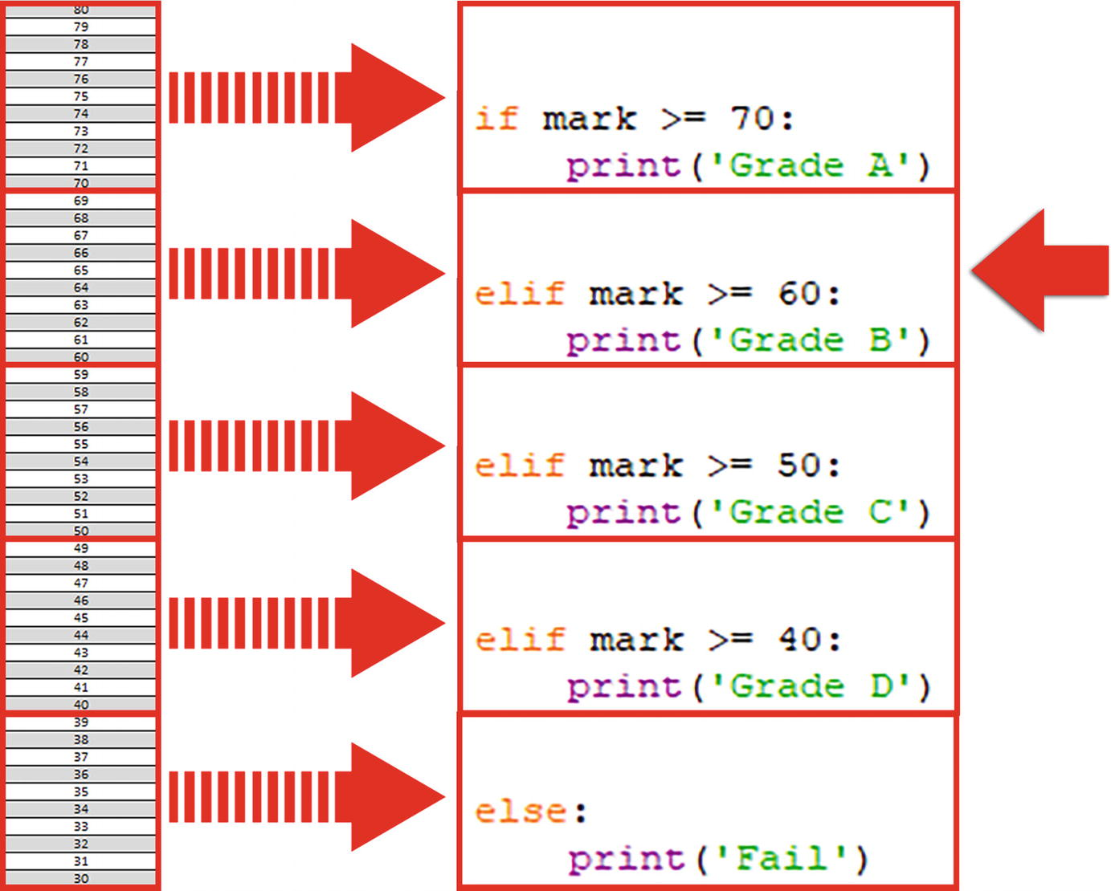
Similarly for the other conditions, 50–59 and 40–49.
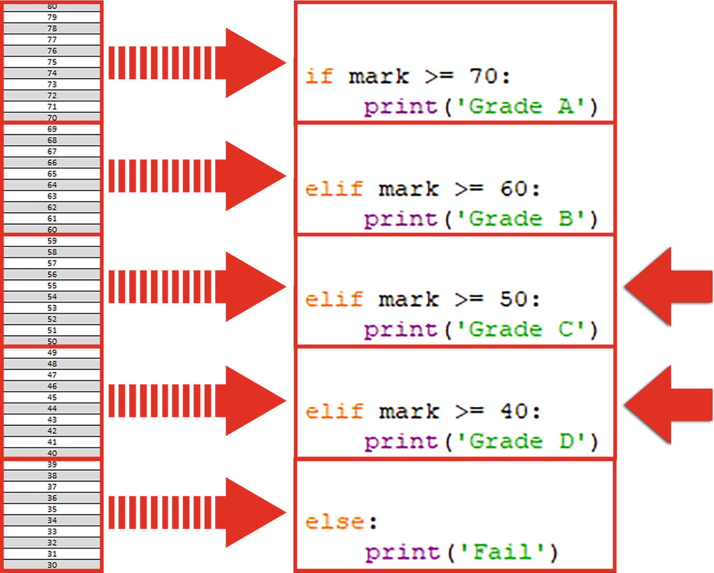
If any condition is not met by the above “elif” statements, the interpreter will execute the “else” block at the end .
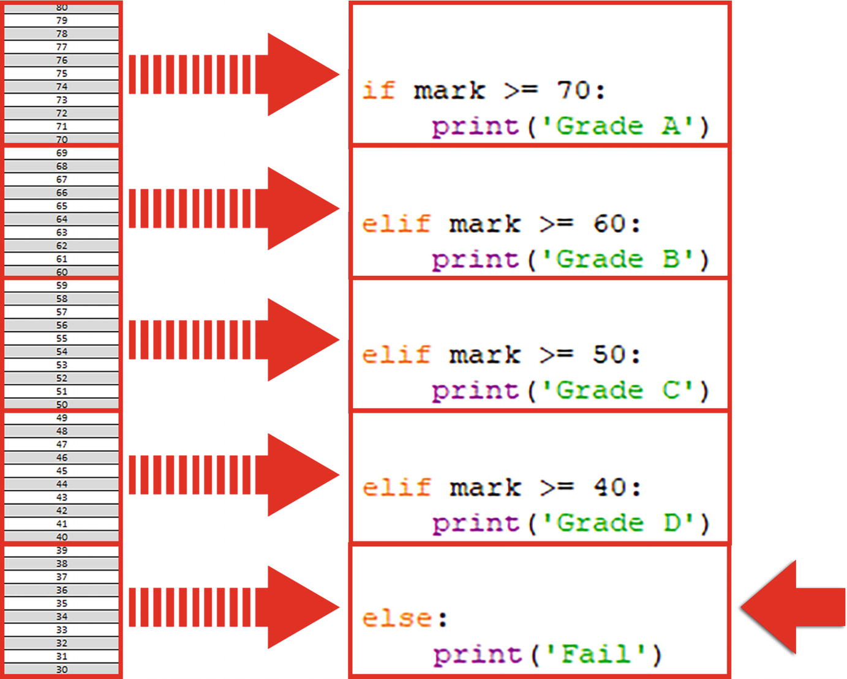

Iteration (Loops)
A loop is a set of statements that are repeated until a specific condition is met. We will look at two types of loops: the for loop and the while loop.

For Loop
A for loop executes a set of statements for each item in a sequence such as a list or string or a range. It allows a code block to be repeated a specific number of times.
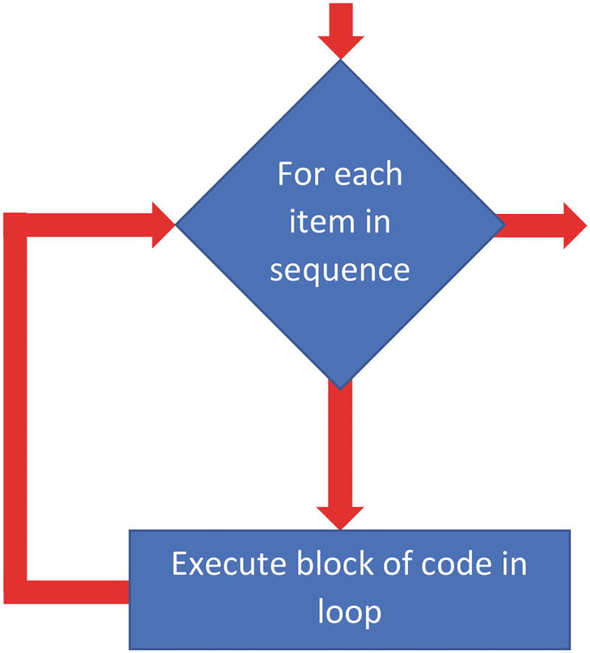
Figure 4-4A for loop
This particular loop will print out each name in the list on a new line:
list = ['john', 'lucy', 'kate', 'mike']
for val in list:
print (val) #block of code in loop
Let’s have a look at a program. Open forloop.py. The for loop contains a loop condition. In this example, the loop will execute for each item in the fruitlist [sequence].
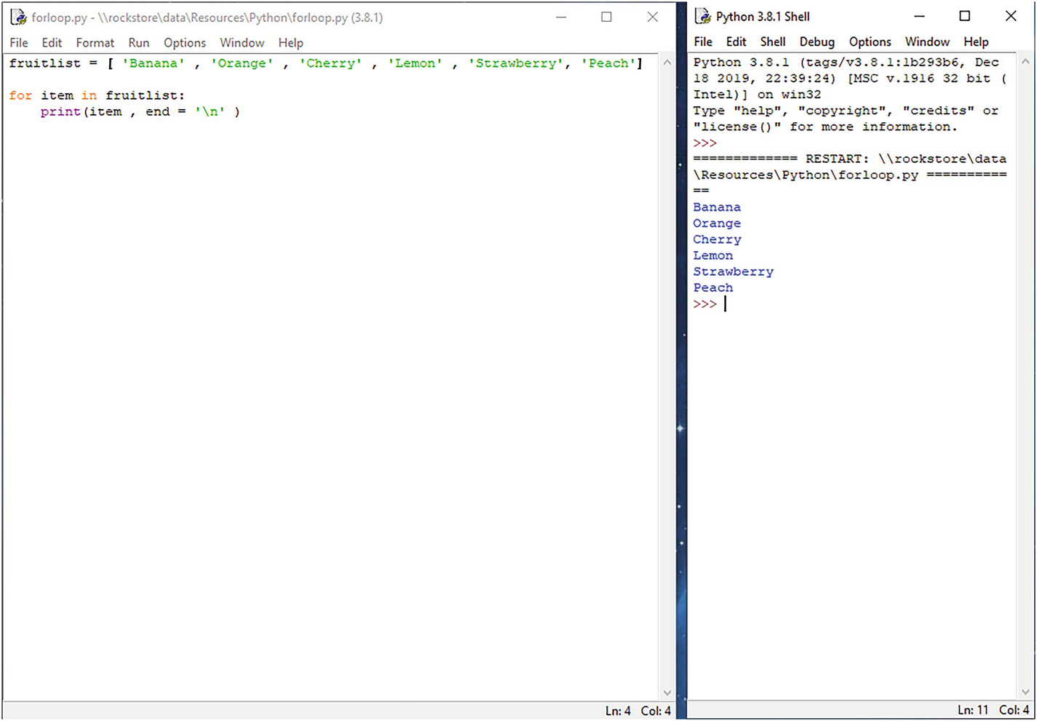
The “item” variable in the “for loop” statement is a pointer or counter to the current value or item in the sequence .
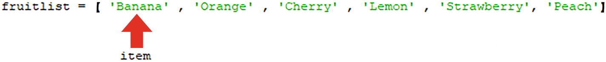
For each of these “items,” the interpreter will execute everything inside the loop, in this example the “print” statement:
print (item, end='\n')
The interpreter will test the condition in the for loop again, and if it is true, the interpreter will execute everything inside the loop again. In each iteration of the loop, the counter moves to the next value or item.
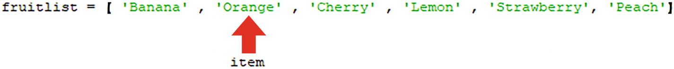
At the end of the sequence, the loop condition becomes false, so the loop terminates .
Let’s look at another example. Open forloop2.py.
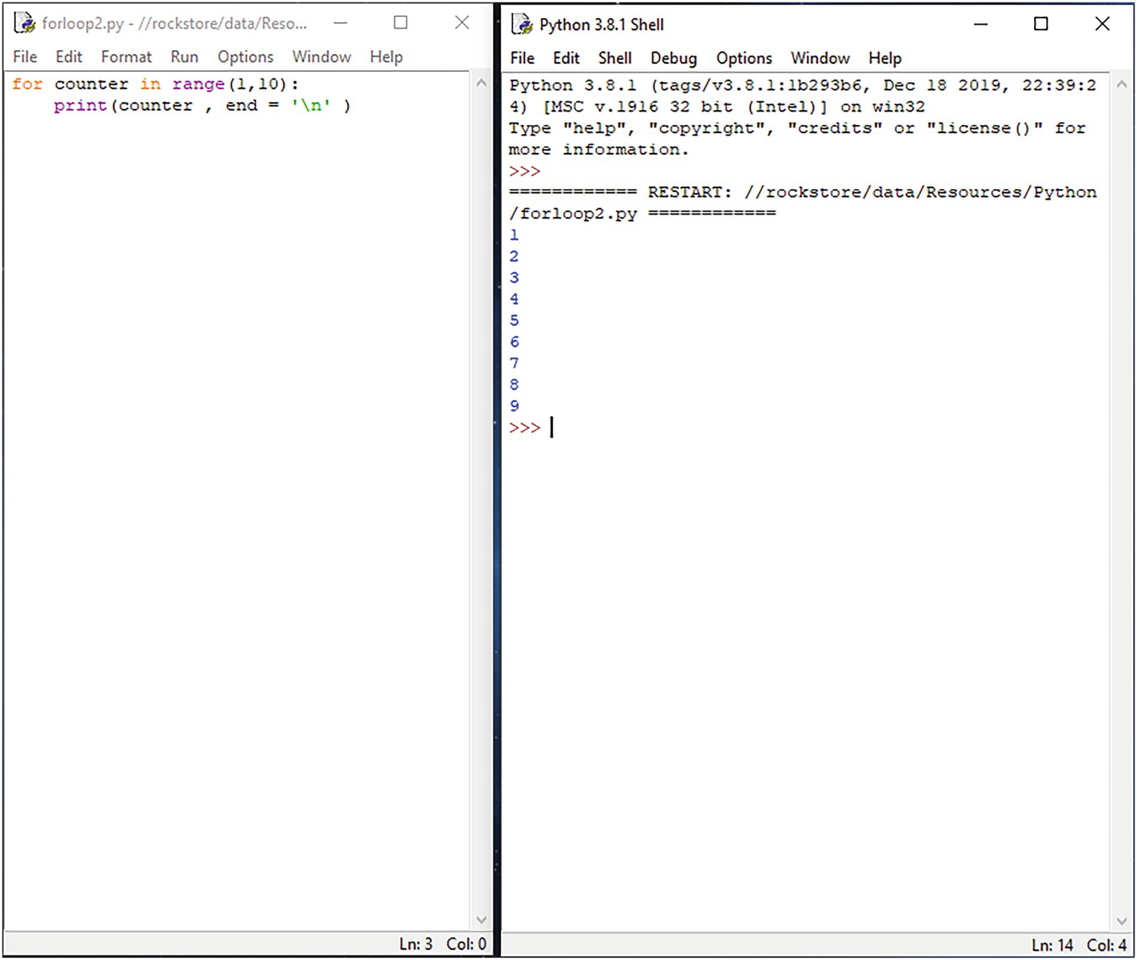
When you run through the program, you can see what it’s doing.
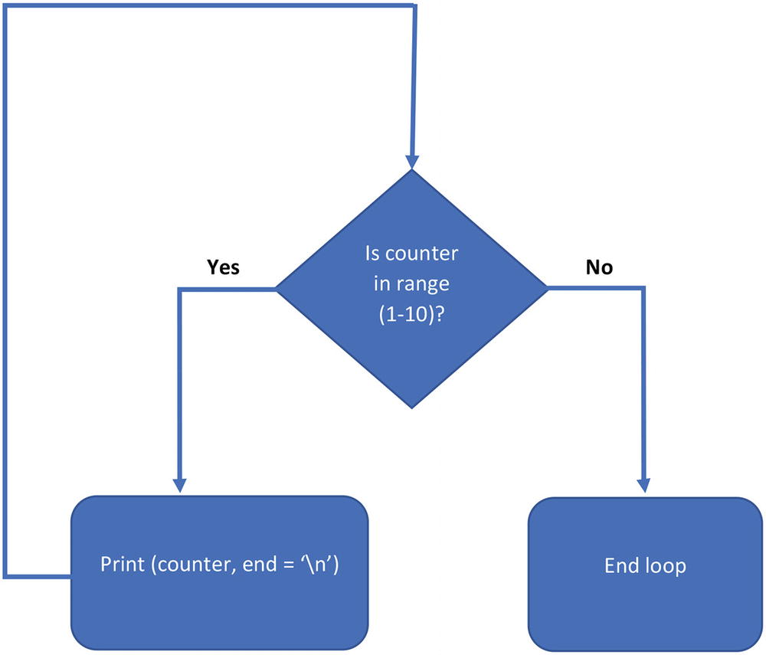

While Loop
A while loop executes a set of statements while a certain condition is true. It allows the set of statements in the code block to be repeated an unknown number of times and will continue to repeat while the condition is true.
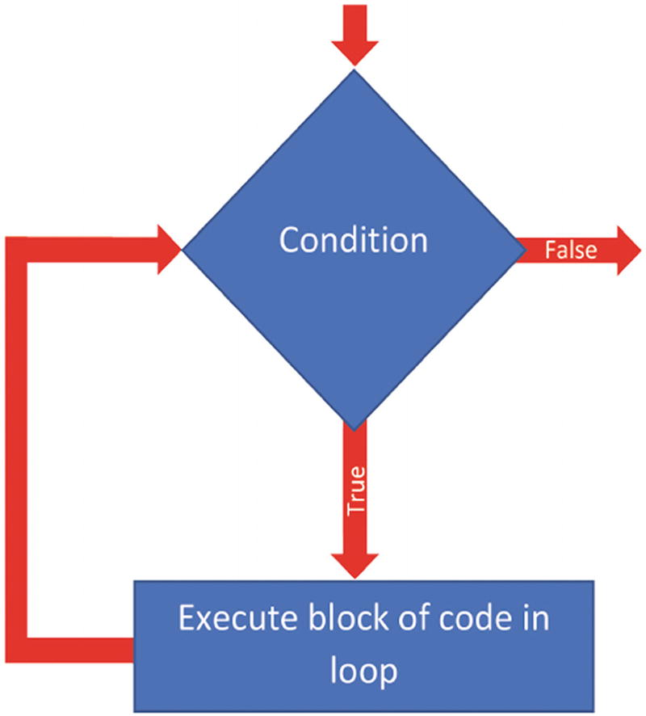
Figure 4-5A while loop
This particular loop will keep prompting the user for a string until the user enters the word “fire”:
userInput = ''
while userInput != 'fire':
userInput = input ('Enter passcode: ')
Let’s have a look at a program. Open whileloop.py. The while loop contains a loop condition .
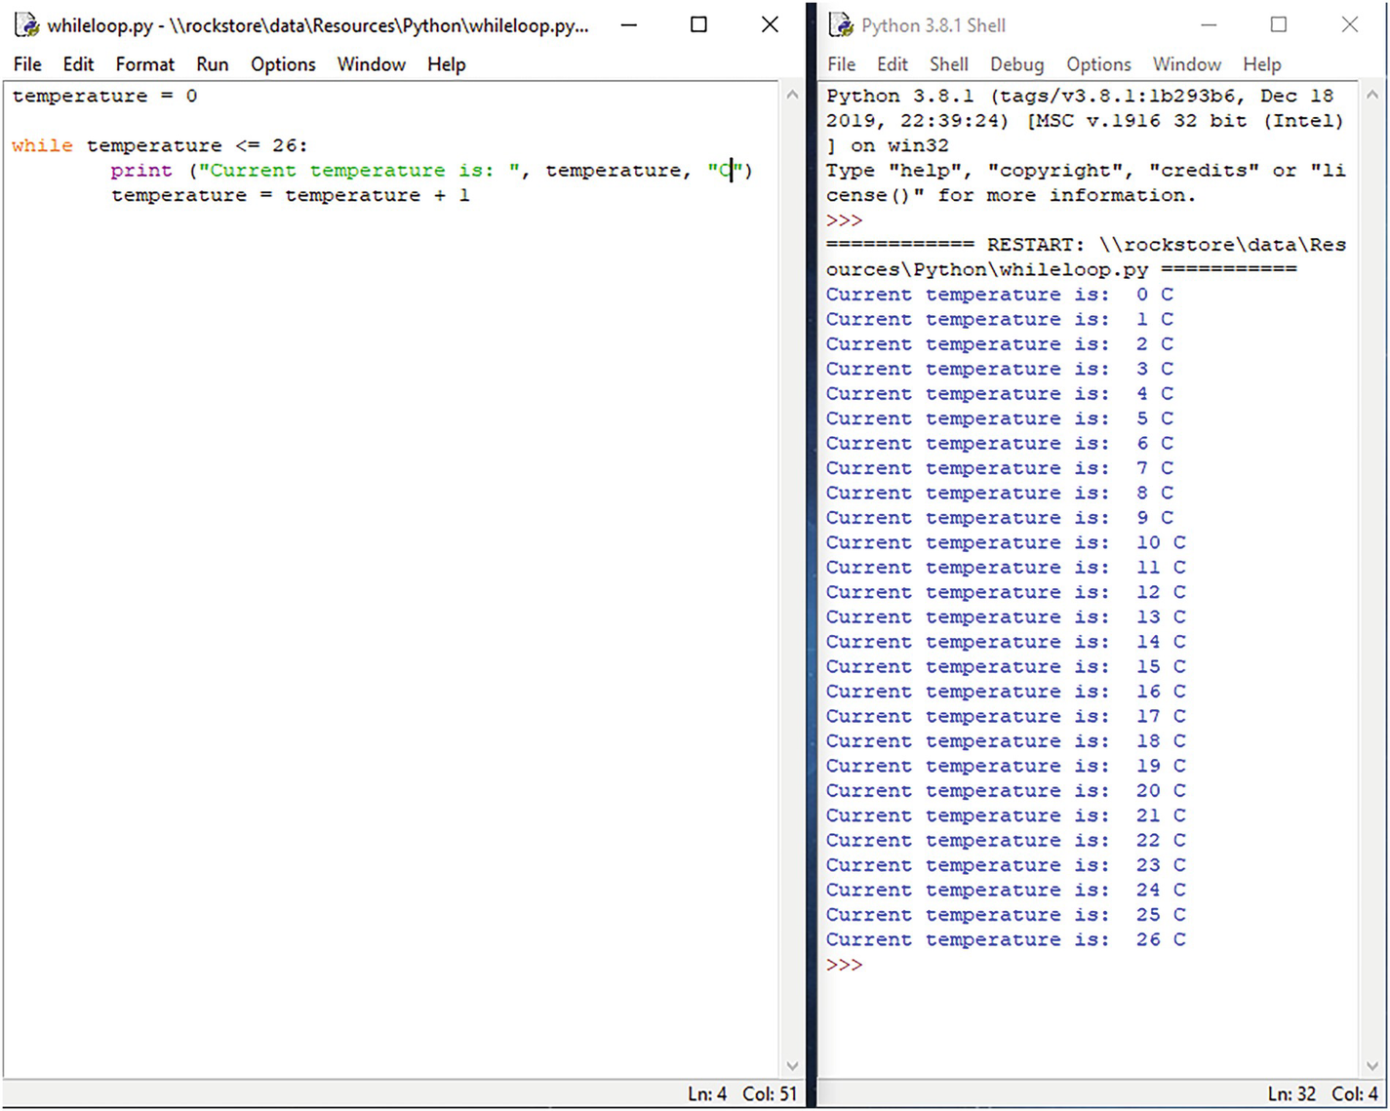
When you run through the program, you can see what it’s doing:
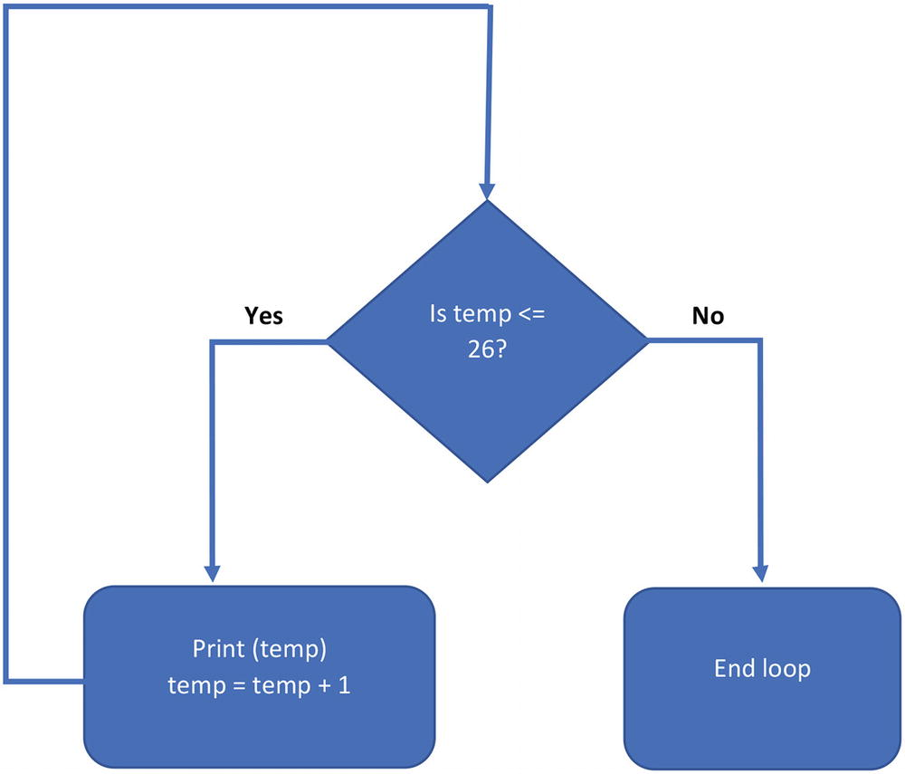

Break and Continue
The break statement breaks out of a loop. In this example, the loop breaks when the counter is equal to 5.
while (counter < 10):
if counter == 5:
break
counter = counter + 1
The continue statement jumps back to the top of the loop without executing the rest of the code after the continue keyword. In this example, the loop restarts when “number” is even.
myList = [1, 2, 3, 4, 5, 6, 7, 8]
for number in myList:
if number % 2 == 0: #if number even
continue
print(number)

Lab Exercises
Take a look at the following exercises and use what you’ve learned to solve the problems.
1. | Write a program to print the numbers 1–10 to the screen.
2. | Write a program to print a list of names to the screen.
3. | Write a program to calculate and print the squares of the numbers from 1 to 10. Use tabs to display them in a table.
4. | Write a program that accepts a number from the user until a negative number is entered.
5. | Write a program that accepts an integer and prints the specified range it belongs to:
Range 1: 0 to 10
Range 2: 11 to 20
Range 3: 21 to 30
Range 4: 31 to 40

Summary
Flow control is controlling the order in which statements or function calls of a program are executed.
Sequence is the set of step-by-step instructions carried out in order to achieve a task or solve a problem.
Selection is the point at which a decision is to be made. For this, we use IF statements.
Iteration is where we need to repeat several lines of code multiple times. For this, we use WHILE and FOR loops.
Use FOR loop if you know how many times you’re going to execute the loop, such as processing a range or list.
If you need to repeat code until a condition is to be met, use a WHILE loop.
The break statement breaks out of a loop.
© The Author(s), under exclusive license to APress Media, LLC, part of Springer Nature 2022
K. WilsonThe Absolute Beginner's Guide to Python Programming
https://doi.org/10.1007/978-1-4842-8716-3_5

5. Handling Files
Kevin Wilson1
(1)
London, UK

Since the computer’s memory (RAM) is volatile, it loses any stored data when the power is turned off. So any data that needs to be stored permanently must be saved in a file.
A file is a named location on a disk drive that is used to store data. Each file is identified by its filename.
Python contains inbuilt functions for reading data from files, as well as creating and writing to files.
In this chapter, we’ll take a look at how to open files, how to read from a file, and how to write to a file.
We’ll take a look at the difference between text files and binary files, as well as random access.

File Types
There are two types of files: text files and binary files. By default, Python reads and writes data in a text file.

Text File
A text file stores sequences of characters: plain text files, HTML files, and program source code.
Use these file modes when opening a file in text mode:
“r” opens a file for reading, error if the file does not exist.
“a” opens a file for appending, creates the file if it does not exist.
“w” opens a file for writing, creates the file if it does not exist.
“r+” opens a file for both reading and writing.

Binary
A binary file is stored in the same format as the computer’s memory (RAM): any images such as jpeg, audio, or program executable files.
Use these file modes when opening a file in binary mode:
“rb” opens a file for binary reading, error if the file does not exist.
“ab” opens a file for binary appending, creates the file if it does not exist.
“wb” opens a file for writing, creates the file if it does not exist.
“rb+” opens a file for both reading and writing.

Text File Operations
By default, Python opens files as text files. Text files contain readable characters as shown in the following example:
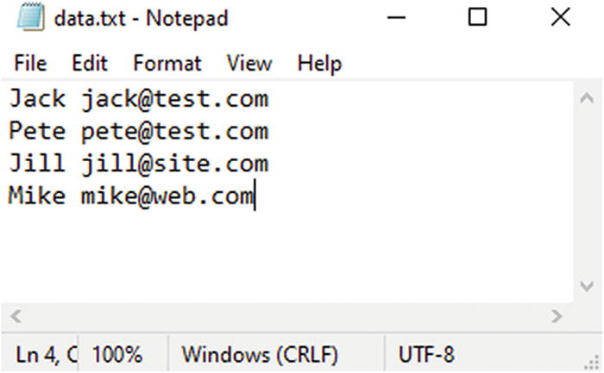
Figure 5-1Example of a text file

Open Files
To open a file, use the open( ) method :
file = open('filename.txt', 'file mode')
When you open a file, put the filename and the file mode in the parameters of the open( ) method.
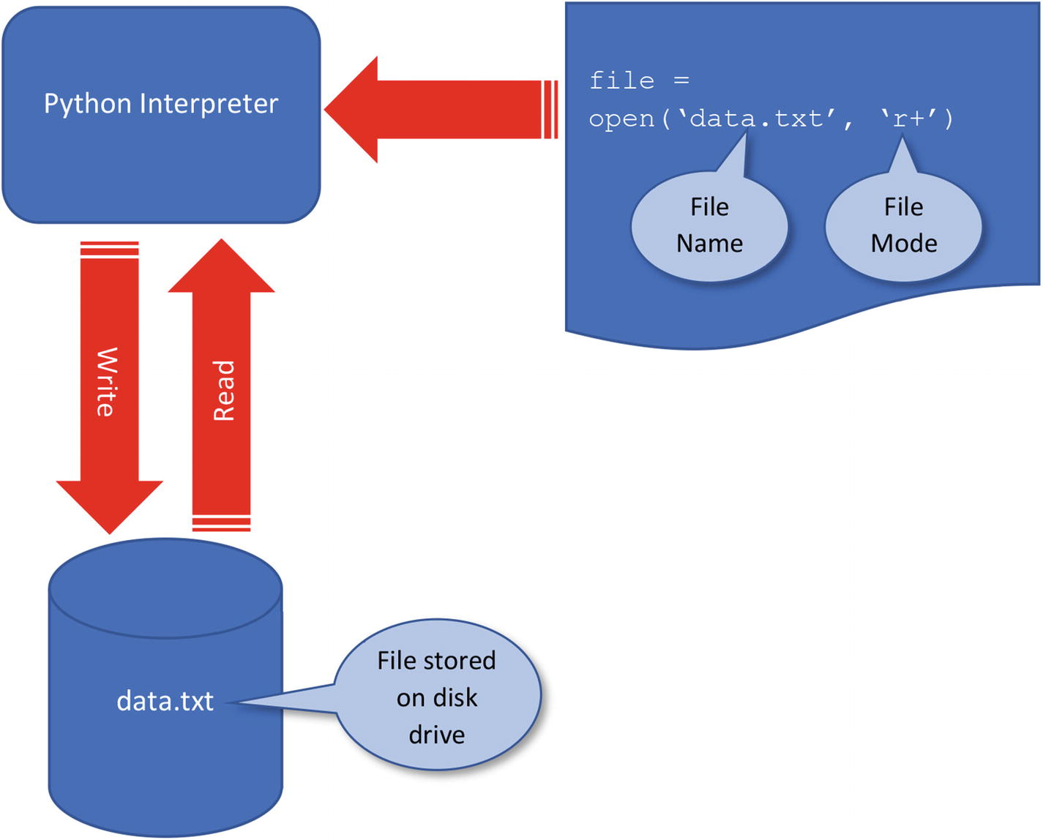
Figure 5-2How a file is accessed in Python
The file mode tells the Python interpreter what you intend to do with the file, that is, read, write, or append:
“r” opens a file for reading, error if the file does not exist.
“a” opens a file for appending, creates the file if it does not exist.
“w” opens a file for writing, creates the file if it does not exist.
“r+” opens a file for both reading and writing.
This depends on the purpose of your program. It’s good practice to open your file, perform your operations, and then close the file.

Write to a File
To write data to a file, use the .write( ) method :
file.write("Data to write to the file...")
When opening a file for writing, use either of the following:
“a” opens a file for appending, creates the file if it does not exist. Adds new data to the end of file.
“w” opens a file for writing, creates the file if it does not exist. Overwrites any existing data in file.
Let’s take a look at a program. Open file.py.
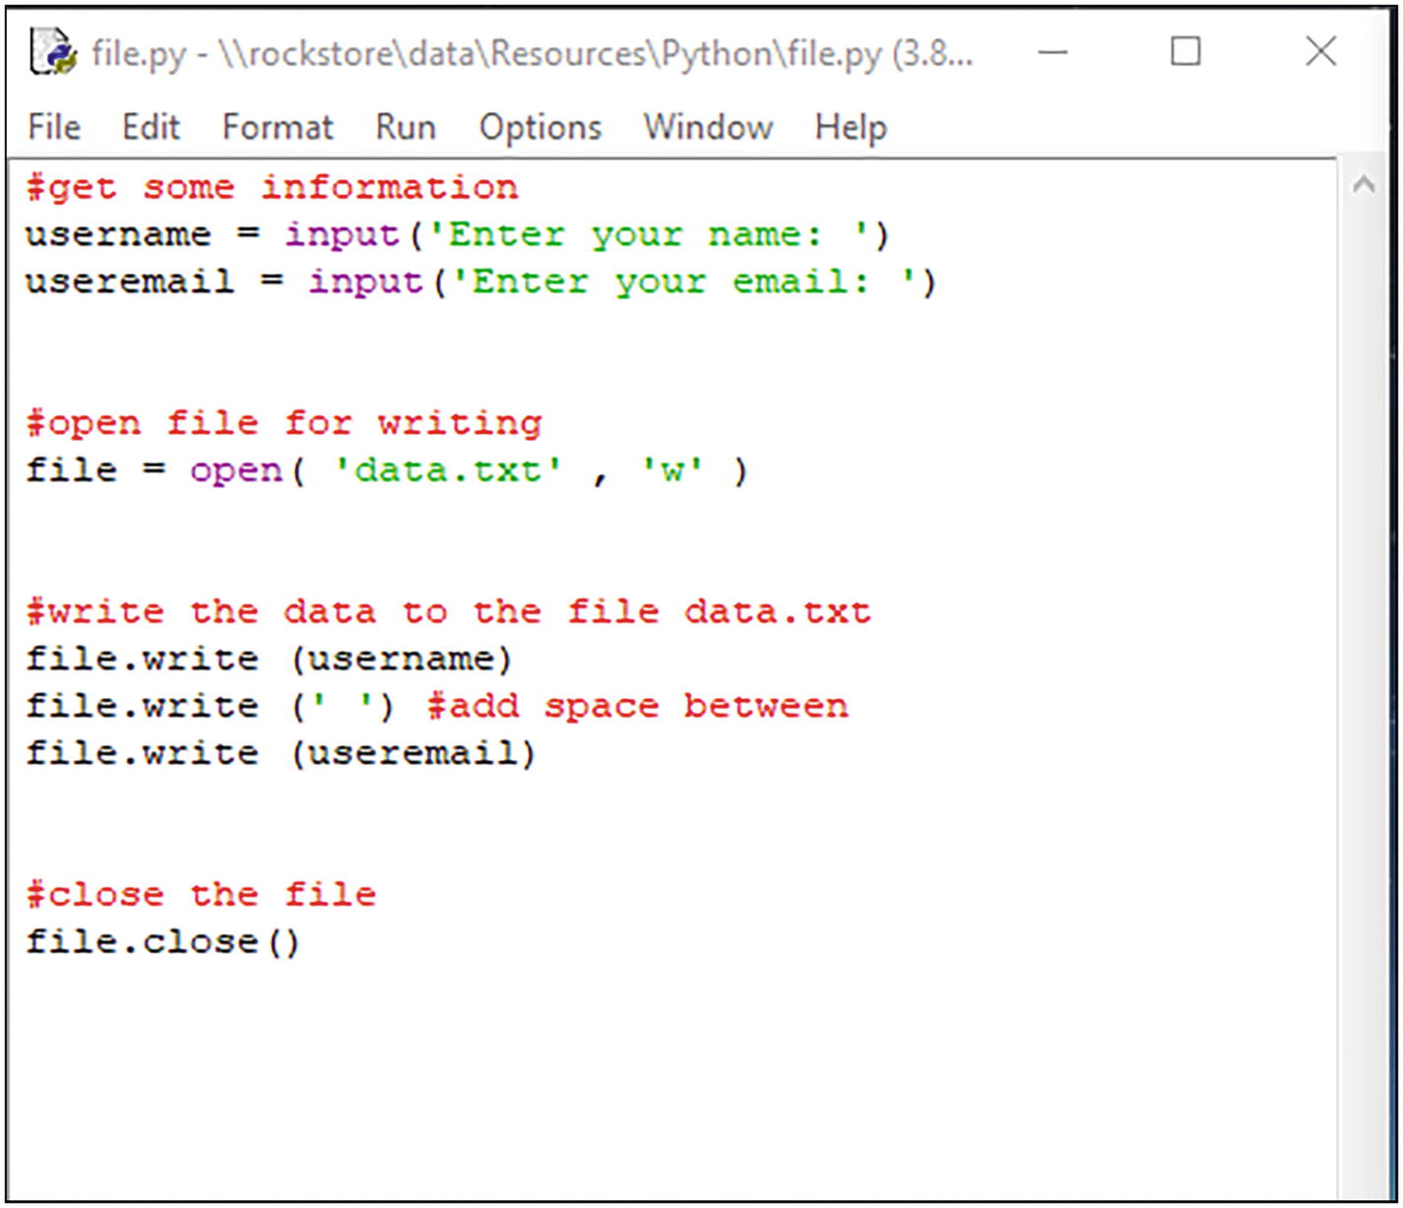
Here, we get some information from the user (a username and an email address):
username = input('Enter your name: ')
useremail = input('Enter your email: ')
Next, we open a file called “data.txt” for writing and assign it to an object called “file.”
file = open('data.txt', 'w')
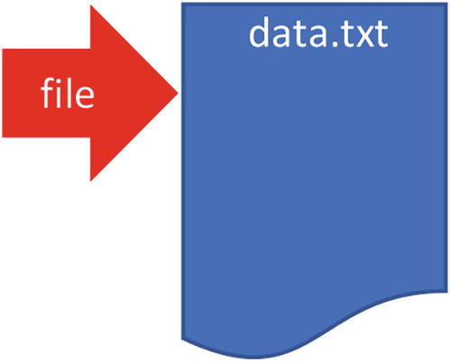
We then write the username and email address to the file using the file object’s .write method .
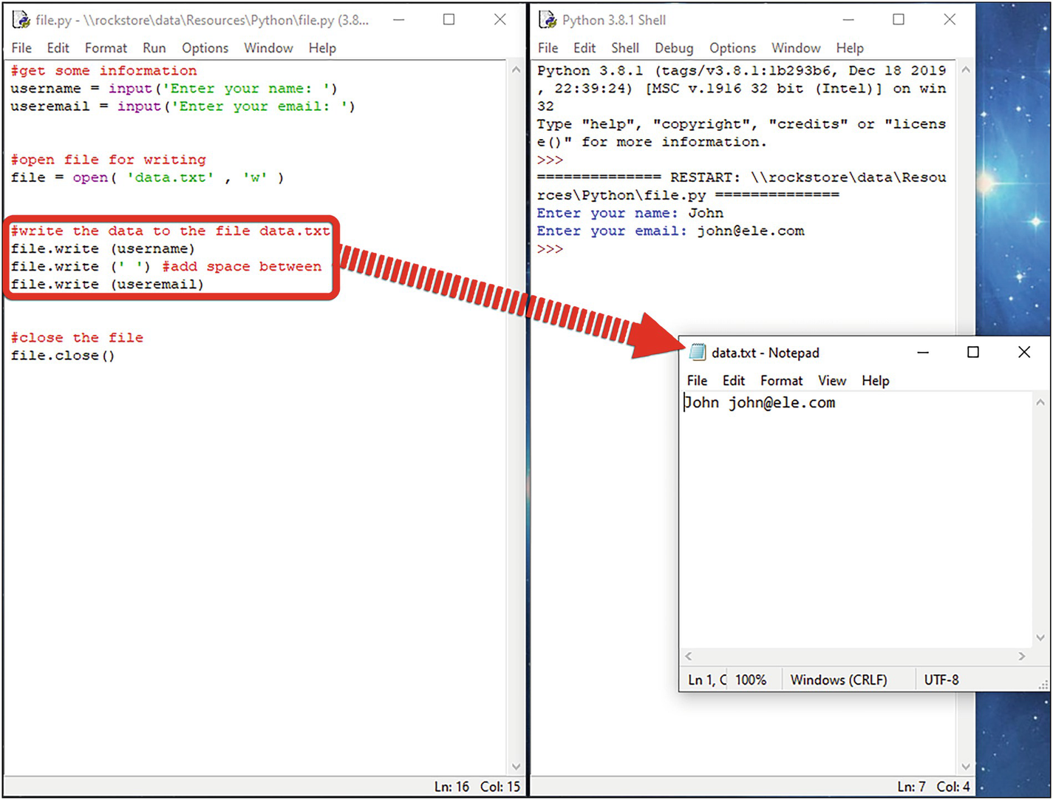
Now remember, the ‘w’ file mode opens a file for writing. This also means any new data will overwrite any data already stored in the file.
After we’ve completed our file operations, we close the file :
file.close()

Read from a File
To read data from a file, use the .read() method to read the whole file:
fileContent = fileName.read( )
Use the .readline() method to read a line at a time:
nextLine = fileName.readline( )
When opening a file for writing, use either of the following:
“r” opens a file for reading, error if the file does not exist.
“r+” opens a file for both reading and writing.
Let’s take a look at a program. Open fileread.py.
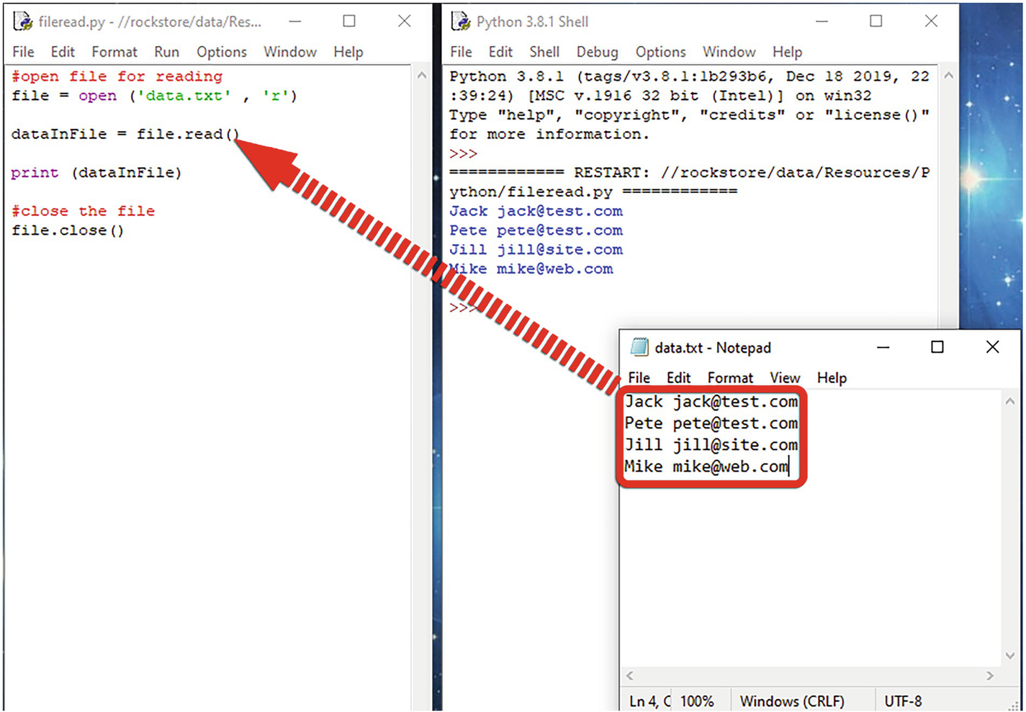
Here, we open a file called “data.txt” and assign it to an object called “file.”
Next , we read the data using the “file” object’s .read method and finally close the file.

Binary File Operations
Most digital data is stored in binary files as they are much smaller and faster than text files.
Binary files are not readable by humans as shown in the following example.
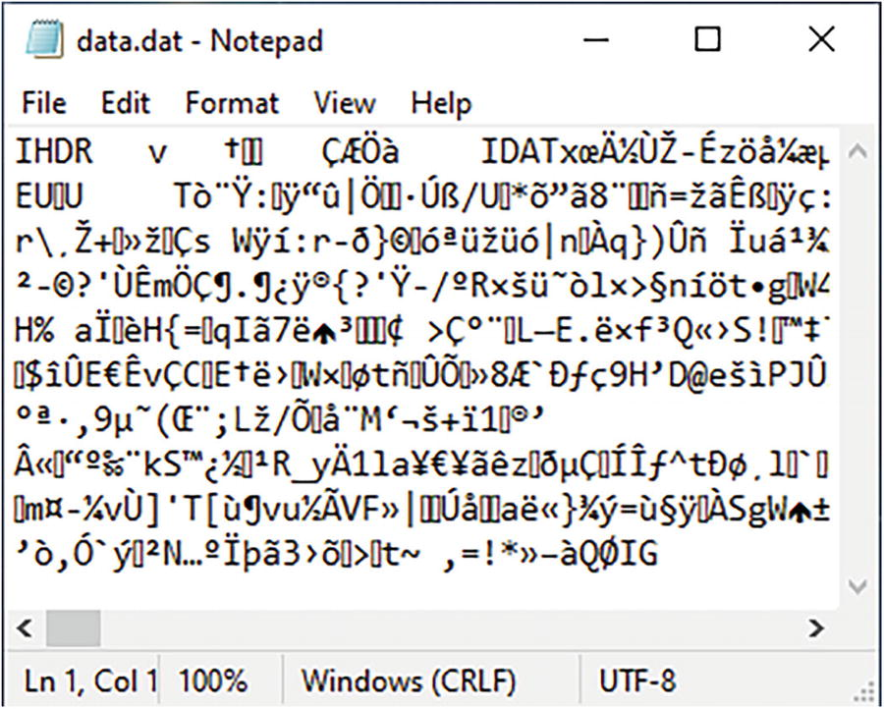
Figure 5-3Example of a binary file

Open Files
To open a file, use the open() method :
file = open('filename.dat', 'file mode')
When you open a file, put the filename and the file mode in the parameters of the open()method.
The file mode tells the Python interpreter what you intend to do with the file, that is, read, write, or append:
“rb” opens a file for reading, error if the file does not exist.
“ab” opens a file for appending, creates the file if it does not exist.
“wb” opens a file for writing, creates the file if it does not exist.
“rb+” opens a file for both reading and writing.
This depends on the purpose of your program.
It’s good practice to open your file, perform your operations , and then close the file.

Write to a File
The .write() method writes data in text format, and if you try to write data in binary mode using this method, you’ll get an error message when you run your program.
To write your data in binary format, first we need to convert it to a sequence of bytes. We can do this with the pickle module using a process called pickling. Pickling is the process where data objects such as integers, strings, lists, and dictionaries are converted into a byte stream.
To write to a file, use the pickle.dump() method:
pickle.dump (data-to-be-written, file-to-write-to)
Let’s take a look at a program. Open filewritebin.py. First, we need to include the pickle module. You can do this by using an import command.
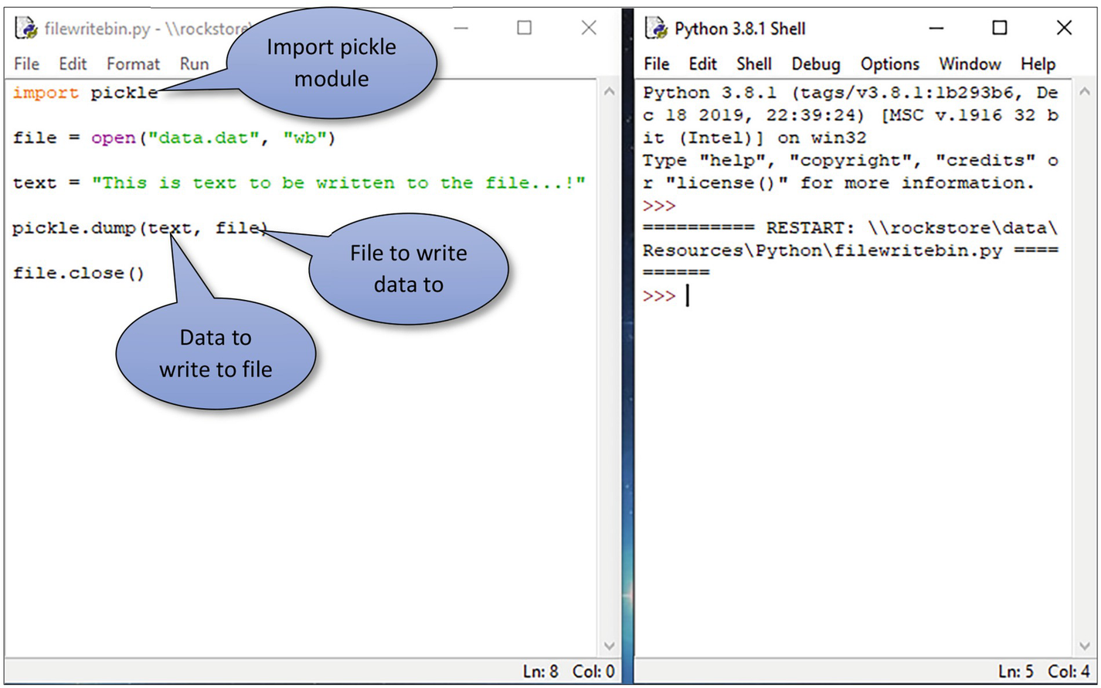
Next, we open a file in the usual way, except we set the file mode to binary write (wb).
Now, to write the data to the file, we pickle the “text” object using the pickle.dump() method and finally close the file.

Read a File
Remember when we wrote our data to our binary file, we used a process called pickling. Well, to read the data from the file, we use a similar process.
To read a file, use the pickle.read() method :
pickle.read (file-to-read-from)
Let’s take a look at a program. Open filereadbin.py. First, we need to include the pickle module. You can do this using an import command.
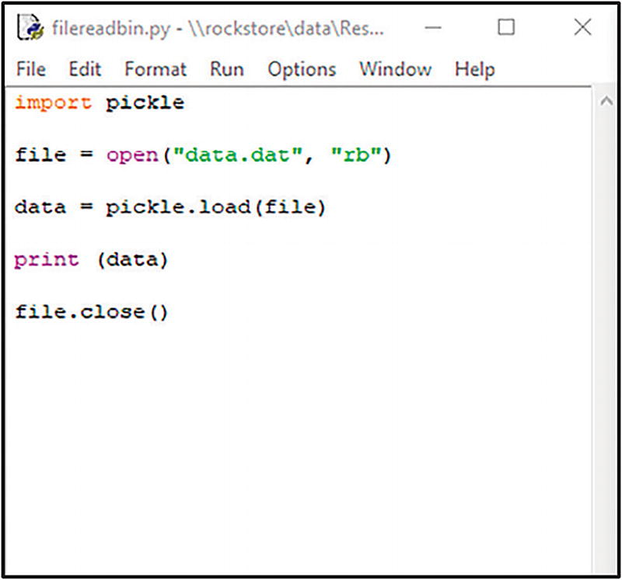
When your run the program , the data is read and assigned to the “data” variable.
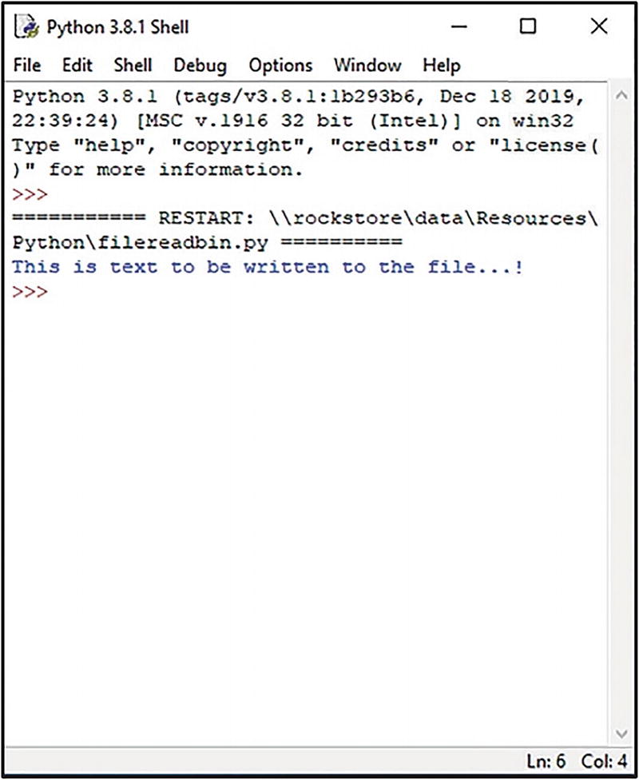

Random File Access
When a file is opened, the Python interpreter allocates a pointer within the file. This pointer determines the position in the file from where reading or writing will take place. The pointer can be moved to any location in the file.
To move the file pointer, use the .seek() method :
file.seek(position-in-file, whence)
The first parameter (position-in-file) determines how many bytes to move. A positive value will move the pointer forward; a negative value will move the pointer backward. The position in the file is called an offset. In a file, each position could contain one byte or one character. Remember, the numbering system starts with 0.
Using our text file as an example file.seek(5) would move the file pointer to the sixth byte:
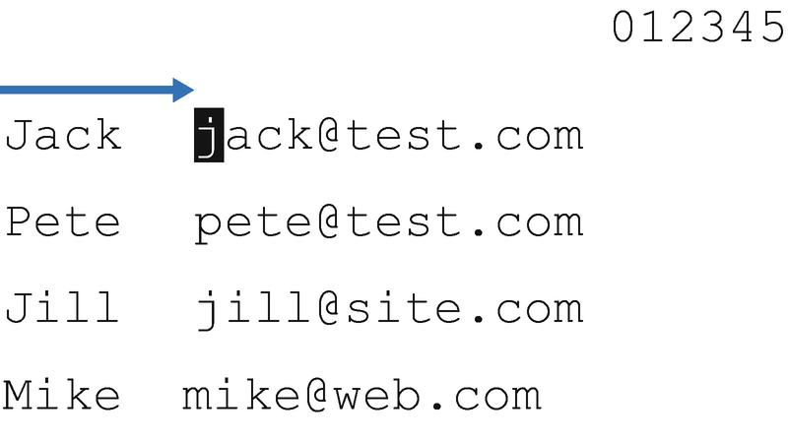
The second parameter (whence) determines where in the file to start from and accepts one of the three values :
0 – Sets the start point to the beginning of the file (the default)
1 – Sets the start point to the current position
2 – Sets the start point to the end of the file
To find the current position of the file pointer in the file, use the .tell() method:
file.tell()
Let’s take a look at a program. Here, we’re going to start reading the first line of the data.txt file starting from the sixth byte or character.
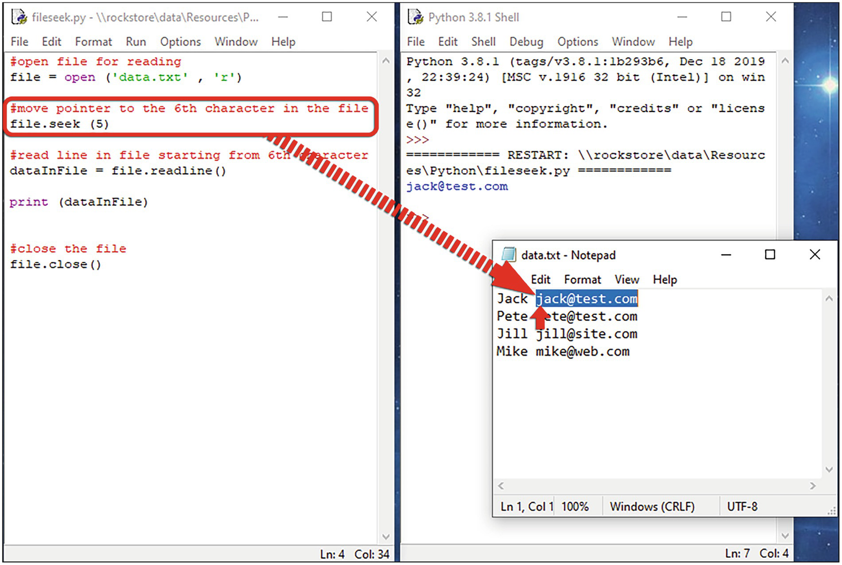

Lab Exercises
Take a look at the following exercises and use what you’ve learned to solve the problems.
1. | Write a program that gets a string from the user and then writes it to a file along with the user’s name.
2. | Modify the program from exercise 1 so that it appends the data to the file rather than overwriting.
3. | Write a program to write a list of names to a file.
4. | Write a program to read a file line by line and store it in a list.
5. | What is the difference between a text file and a binary file?

Summary
A file is a named location on a disk drive that is used to store data. Each file is identified by its filename.
There are two types of files: text files and binary files. By default, Python reads and writes data in a text file.
A text file stores sequences of characters.
A binary file is stored in the same format as the computer’s memory (RAM).
Use the open( ) method to open a file.
To write data to a file, use the .write( ) method.
To read data from a file, use the .read() method to read the whole file.
To write to a binary file, first we need to convert it to a sequence of bytes. This is called pickling.
© The Author(s), under exclusive license to APress Media, LLC, part of Springer Nature 2022
K. WilsonThe Absolute Beginner's Guide to Python Programming
https://doi.org/10.1007/978-1-4842-8716-3_6

6. Using Functions
Kevin Wilson1
(1)
London, UK

Functions help break a program into smaller pieces. This avoids repetition of code, making larger programs more efficient and easier to maintain.
A function is a block of code that is only executed when called within a program.
You can pass data to the function. This data is known as a parameter or argument.
Arguments or parameters are specified inside parentheses after the function name, for example:
functionName(parameters)
A function can return data as a result.

Declaring Functions
You can declare a new function using the def keyword followed by the function name:
def functionName(parameters):
code to be executed in function
If the function takes parameters, you can include these in parenthesis next to the function name.
So, for example, if we wrote a function to add two numbers together, we could write something like this:
def addNum(num_1, num_2):
return num_1 + num_2
This function takes two numbers as parameters, adds them together, and returns the result.
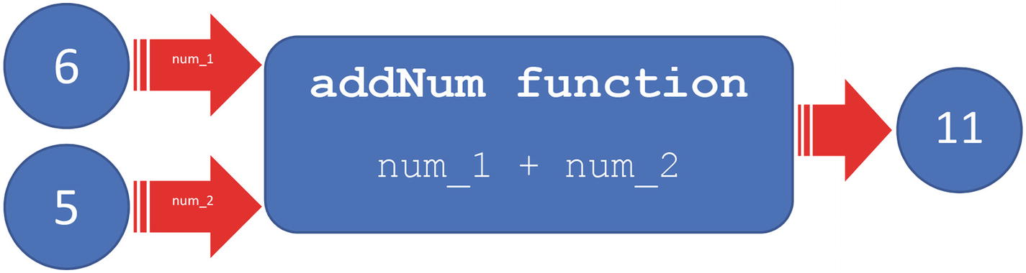
You can call the function like this:
result = addNum(6, 5)
For smaller programs , you can declare your functions in the same file – usually at the top, but as programs become larger and more complex, you should declare your functions in a separate file and then include the file in your main script. This allows you to modularize and reuse code – it is good programming practice for larger projects.
We can declare our addNum function in our myfunctions.py file and include it in our functionsmain.py file. To include functions in another script, use the import keyword:
import myfunctions
Let’s have a look at a program. Open functions.py. Here, at the top of the script, we’ve defined a simple function to add two numbers together.
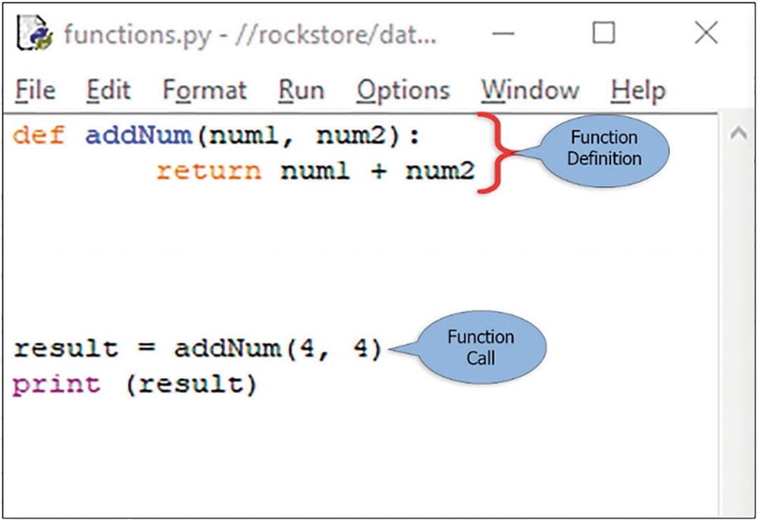
At the bottom of the script , we call our function addNum and pass two values (4, 4). We use the “return” keyword to return the result.
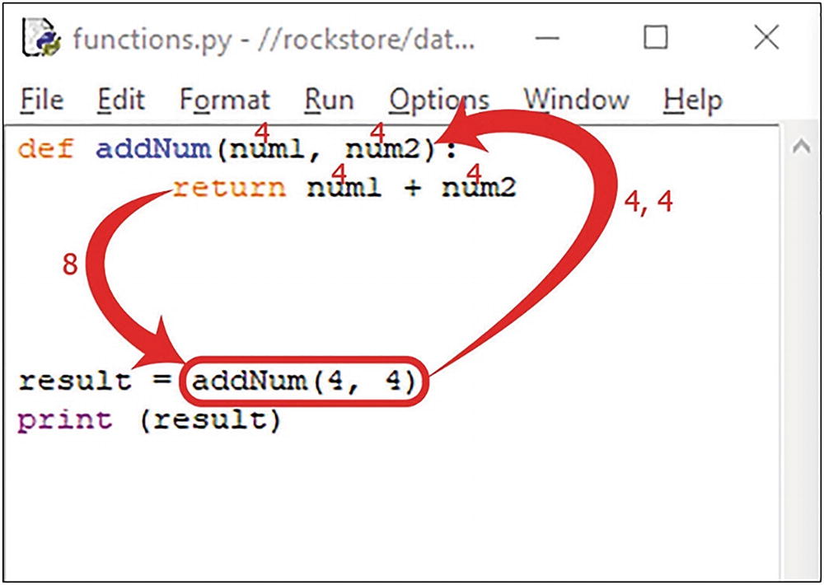
The result from the function is then assigned to the variable “result.” Finally, we print the contents of the variable “result” to the screen, so we can see what is happening.

Scope
The part of a program where a variable is accessible is called its scope. In this section, we’re going to take a look at the local scope and the global scope .
If a variable is only available from inside the region it is created, for example, a variable created inside a function, it belongs to the local scope of that function and can only be used inside that function. This is called local scope .
A variable created in the main body of the Python code is a global variable and belongs to the global scope . Global variables are available from within any scope, global and local.

Recursion
A recursive function is a function that can call itself. This enables the function to repeat itself several times.
Recursive programs can also be written using iteration, so why bother with recursion? Recursive programs allow programmers to write efficient code using a minimal amount of code.
Recursion works well for algorithms such as traversing a binary tree or a sort algorithm and generating fractals. However, if performance is vital, it is better to use iteration, as recursion can be a lot slower.
Open the file recursion1.py. Here, we have a recursive function that calculates the factorial of a number. Remember, to calculate the factorial, you multiply all the numbers from 1 to the given number.
def factorial(n):
if n <= 1:
return 1
else:
a = n * factorial(n-1)
return a
factorial(4)
When we call the factorial function and pass a positive integer, it will recursively call itself by decreasing the number by one each time.
For example , if we entered 4, the program will call factorial(3), factorial(2), and factorial(1).
Each time the factorial function is called, it pushes another entry onto the call stack.
The recursion ends when the number reduces to 1. This is called the base condition.
When the functions return, each call is popped off the stack and evaluated.
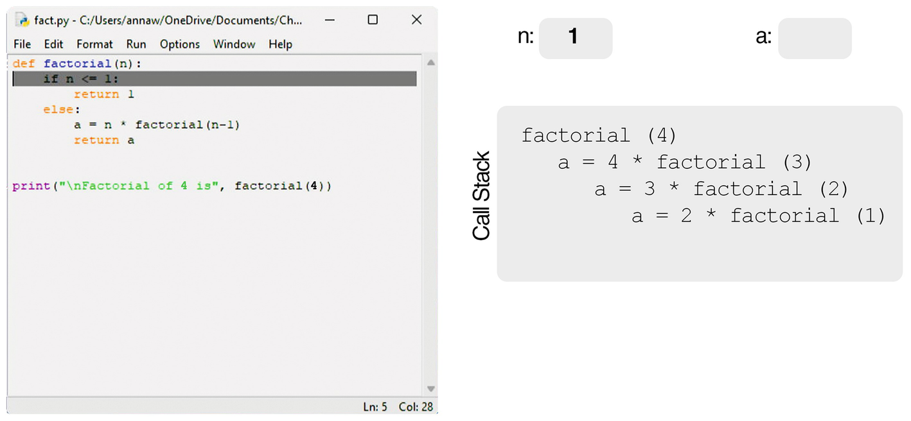
Figure 6-1An example of a recursive program during execution
Here’s another example , a recursive function to print out the Fibonacci numbers.
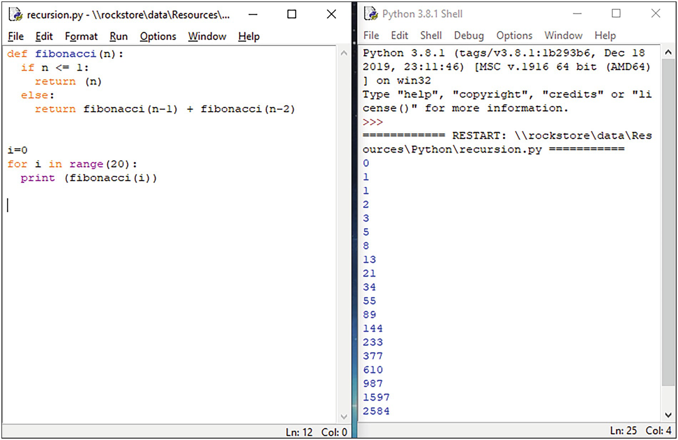

Lab Exercises

1. | Write a program that accepts a number from the user and uses a function to square the number and then return the result. Print the result to the screen.
2. | Write a function that returns the larger of two numbers. Test the function and print the results to the screen.
3. | What is the difference between a local and a global variable?
4. | What makes a function recursive?
5. | Write a program that prints first ten positive numbers using a recursive function.

Summary
Functions help break a program into smaller pieces.
You can declare a new function using the def keyword.
Parameters or arguments are data passed to the function.
The part of a program where a variable is accessible is called its scope. We have taken a look at the local scope and the global scope.
Local scope variables are only accessible to the function in which they’re defined.
Global scope variables are available anywhere.
A recursive function is a function that can call itself.
© The Author(s), under exclusive license to APress Media, LLC, part of Springer Nature 2022
K. WilsonThe Absolute Beginner's Guide to Python Programming
https://doi.org/10.1007/978-1-4842-8716-3_7

7. Using Modules
Kevin Wilson1
(1)
London, UK

When developing more complex Python applications, as the program grows in size, it's a good idea to split it up into several files for easier maintenance and reusability of the code. To do this, we use modules.
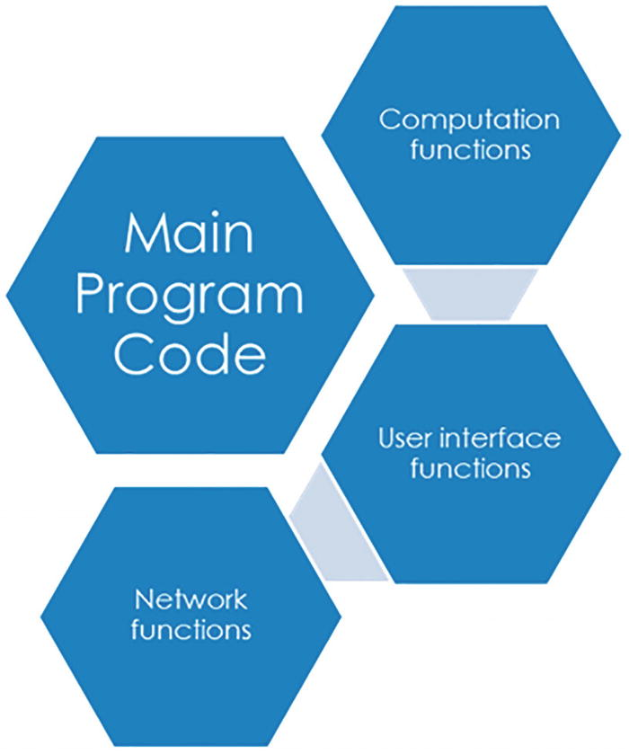
Figure 7-1An example of how a large program can be broken down into modules
Modules are simply files with the .py extension, containing code that can be imported into another program.
In doing this, we can build up a code library that contains a set of functions that you want to include when developing larger applications.
In this section, we'll take a look at how to create modules and include them in our Python programs.

Importing Modules
Python has a whole library of modules you can import into your programs. Here are some common built-in modules you can use:
math – Mathematical functions
turtle – Turtle graphics
tkinter – GUI interface toolkit
pygame – Toolkit for creating games and other multimedia applications.
To import the modules into your code, use the import keyword. In this example, I’m going to use the import keyword to import the turtle graphics module into a Python program. To do this, we enter the following line at the top of the program:
import turtle
This statement imports all the turtle graphics functions into the program.
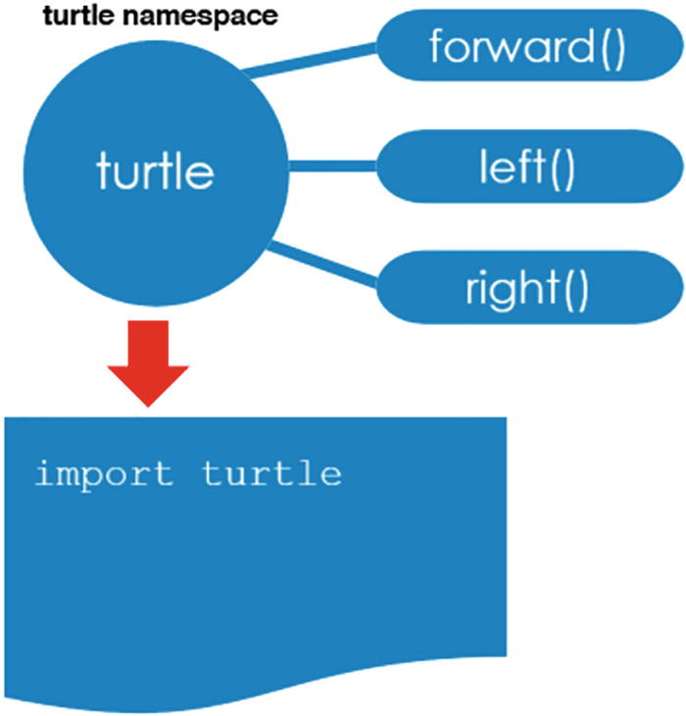
Figure 7-2How to import a module into a program
Turtle graphics operate much like a drawing board, in which you can execute various commands to move a turtle around. We can use functions like forward() and right() . The turtle will travel along the path that you define using these functions, leaving a pen mark behind it.
When we import a module, we are making it available in our program as a separate namespace. In other words, each module has its own private namespace which usually has the same name as the module. This namespace holds all the names of functions and variables declared in that module. This means that we have to refer to the function in a particular module using the dot notation .
moduleName.functionName()
For example:
turtle.forward(100)
turtle is the name of the module we imported earlier, and forward() is a function defined within the module.
Let’s put this into a program. In the following, we have our import statement to import all the turtle graphics modules. Below that, we have a statement that moves the turtle forward and one to finish the program.
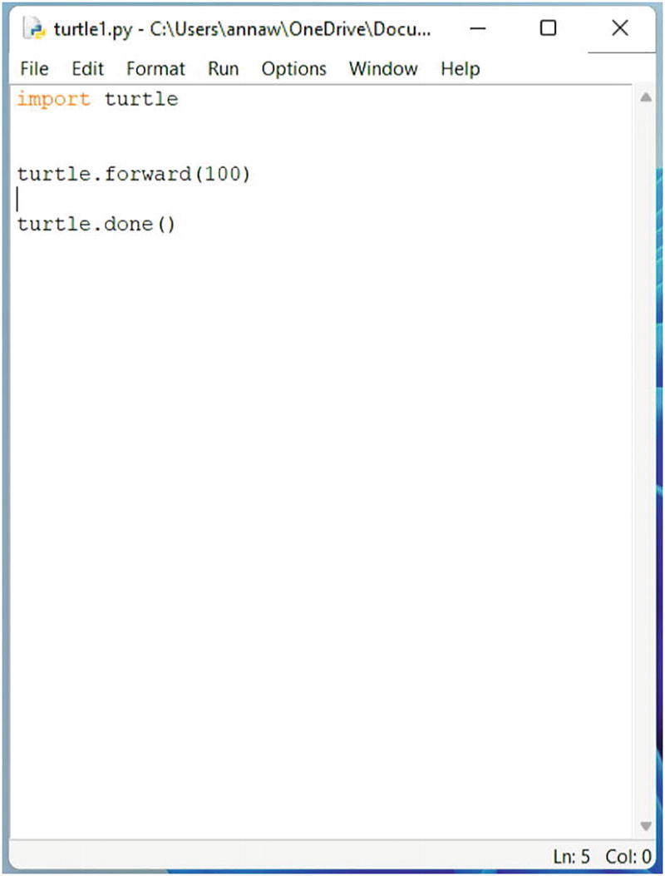
Notice that we use the dot notation to access the functions in the turtle module:
moduleName.functionName()
We want to access the forward function , so we specify the module name it’s in (turtle), followed by a dot, and then the name of the function we want (forward). So we get
turtle.forward(100)
This will move the turtle 100 pixels forward.
Here, we can see the output to the program: the turtle has moved 100 pixels to the right.
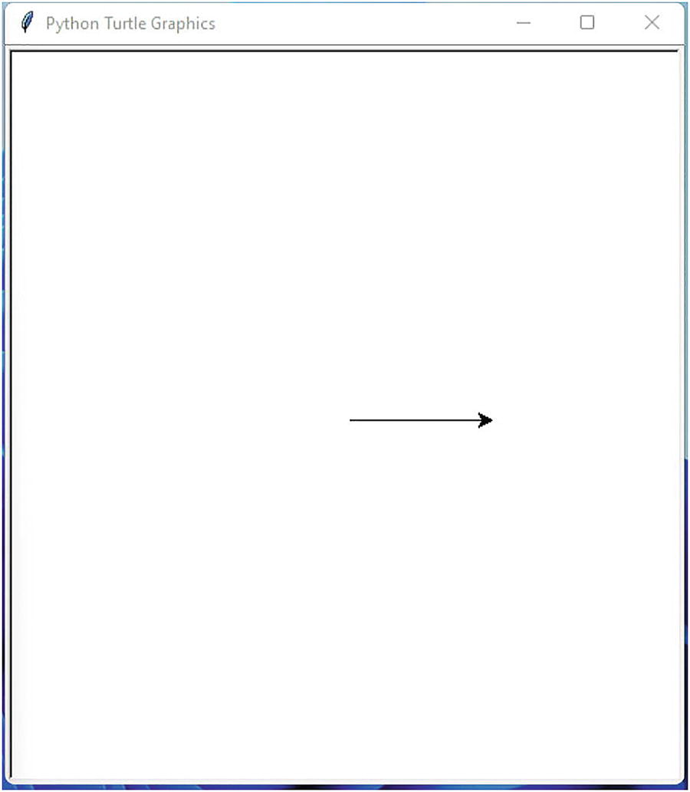
We can complete the program to draw a square.
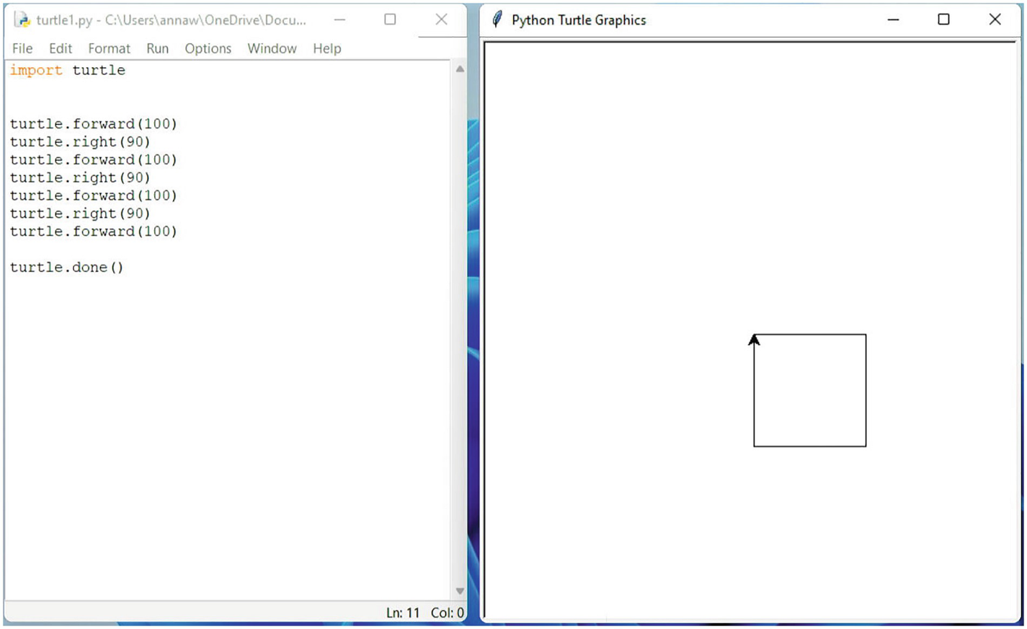
Try out some of the other turtle commands .
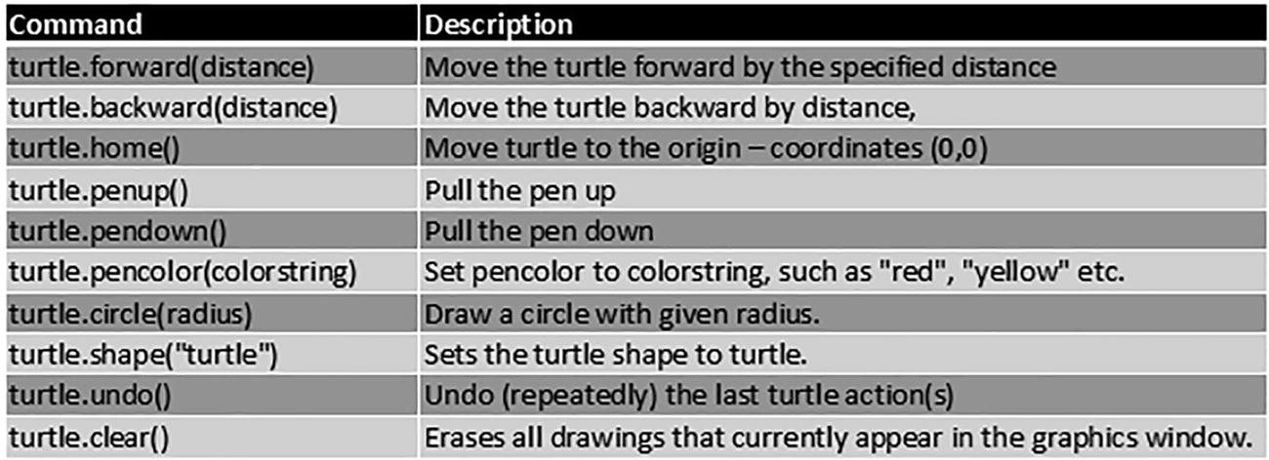

Creating Your Own Modules
You can declare and store your functions in a separate file and import them into your main program.
All function definitions can be stored in a file, for example, myfunctions.py.
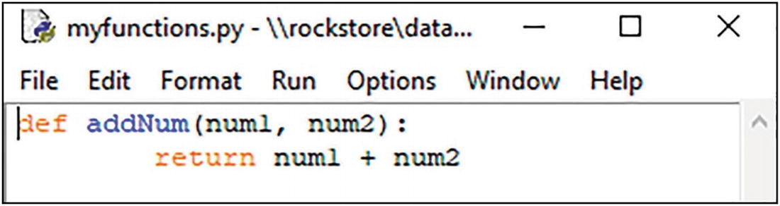
The main program could be called functionmain.py. At the top of the main program script, you’ll need to import your functions stored in the other file (myfunctions.py). Strip off the file extension (.py).
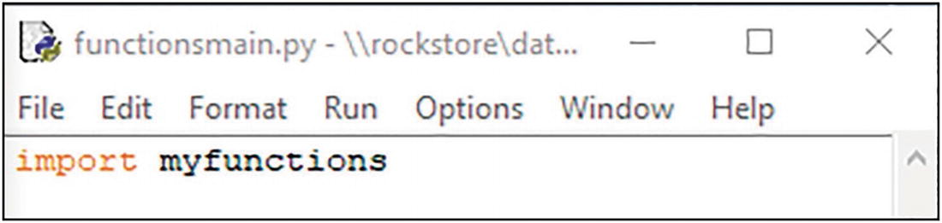
This is called a module . Any functions declared will be included in the main program. You can include these functions in any program you need to. This makes maintenance easier.
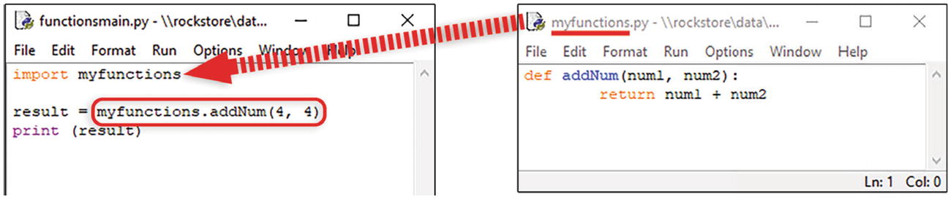
Now, to call any functions from that module, you need to specify the module name followed by the function name.
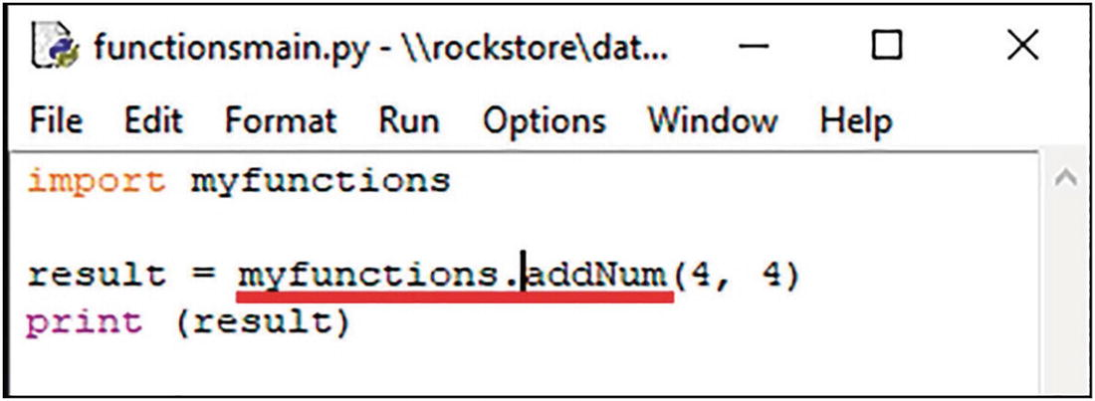

Lab Exercises

1. | Write a function that accepts a number from the user and uses a function to square the number and then return the result.
2. | Save this file as a module.
3. | Import the module you just created into a new program.
4. | Call the function in the module.
5. | Create a new program and import the turtle graphics module.
6. | Experiment with drawing different shapes using some of the turtle graphics methods.
7. | Use the turtle commands to draw some shapes.

Summary
Modules are simply files with the .py extension, containing code that can be imported into another program.
You can import modules using the import keyword.
When we import a module, we are making it available in our program as a separate namespace. This means that we have to refer to the function in a particular module using the dot notation.
© The Author(s), under exclusive license to APress Media, LLC, part of Springer Nature 2022
K. WilsonThe Absolute Beginner's Guide to Python Programming
https://doi.org/10.1007/978-1-4842-8716-3_8

8. Exception Handling
Kevin Wilson1
(1)
London, UK

An exception is an error that occurs during execution of a program, sometimes called a runtime error. This could be a “file not found” error if you are trying to load a file that doesn’t exist, or a “type error” if you type text into a field when the program is expecting a number.
Exceptions are useful for handling errors encountered with file handling, network access, and data input.
These errors can be handled gracefully using Python’s exception handling procedures.

Types of Exception
Here’s a list of built-in exceptions according to the Python documentation.
Table 8-1Built in Python Exceptions
Exception | Cause
AssertionError | Raised when assert statement fails
AttributeError | Raised when attribute assignment or reference fails
EOFError | Raised when the input() function hits end-of-file condition
FileNotFoundError | Raised when a file or directory is requested but doesn’t exist. Corresponds to errno ENOENT
FloatingPointError | Raised when a floating point operation fails
GeneratorExit | Raised when a generator's close() method is called
ImportError | Raised when the imported module is not found
IndexError | Raised when index of a sequence is out of range
KeyError | Raised when a key is not found in a dictionary
KeyboardInterrupt | Raised when the user hits interrupt key (Ctrl+C or delete)
MemoryError | Raised when an operation runs out of memory
NameError | Raised when a variable is not found in local or global scope
NotImplementedError | Raised by abstract methods
OSError | Raised when system operation causes system-related error
OverflowError | Raised when result of an arithmetic operation is too large to be represented
ReferenceError | Raised when a weak reference proxy is used to access a garbage collected referent
RuntimeError | Raised when an error does not fall under any other category
StopIteration | Raised by next() function to indicate that there is no further item to be returned by iterator
SyntaxError | Raised by parser when syntax error is encountered
IndentationError | Raised when there is incorrect indentation
TabError | Raised when indentation consists of inconsistent tabs and spaces
SystemError | Raised when interpreter detects internal error
SystemExit | Raised by sys.exit() function
TypeError | Raised when a function or operation is applied to an object of incorrect type
UnboundLocalError | Raised when a reference is made to a local variable in a function or method, but no value has been bound to that variable
UnicodeError | Raised when a Unicode-related encoding or decoding error occurs
UnicodeEncodeError | Raised when a Unicode-related error occurs during encoding
UnicodeDecodeError | Raised when a Unicode-related error occurs during decoding
UnicodeTranslateError | Raised when a Unicode-related error occurs during translating
ValueError | Raised when a function gets argument of correct type but improper value
ZeroDivisionError | Raised when second operand of division or modulo operation is zero
Whenever an exception occurs, the interpreter halts the execution of the program and raises an exception error as shown in the table.
You can catch these exceptions using the try and except keywords and provide code to handle the error.

Catching Exceptions
If we run the following code , the Python interpreter will raise a FileNotFoundError exception because there is no file called “file.txt”. This will cause the program to crash.
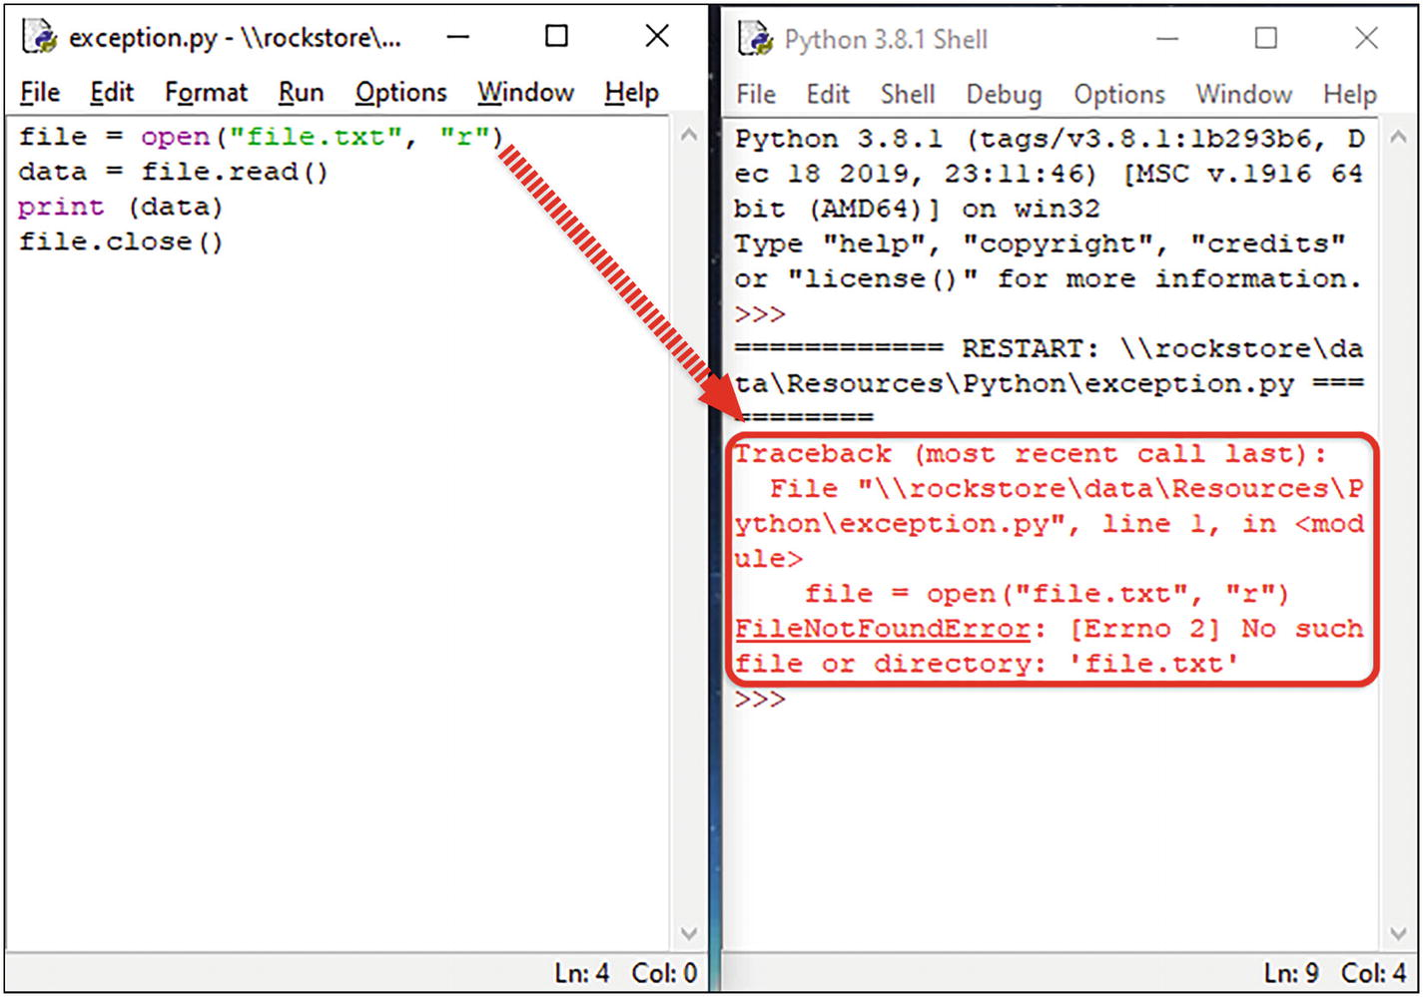
You can catch exceptions using the try and except keywords. Just put your code in the “try” block and your error handling code for each exception in the “exception” block as shown here:
try:
# Code to execute as normal
except [exception (see table above)]:
# Code to deal with exception
The try block contains the code to execute. The except block contains the code to handle the error.
Let’s take a look at the program again. We can take our code and place it in the “try’” block. Then add an “except” block to deal with the error. If we look at the error message in the shell, we see this is a FileNotFoundError. We can add this after the “except” keyword.
Now, when we run the program, we get a simple message rather than an ugly error.
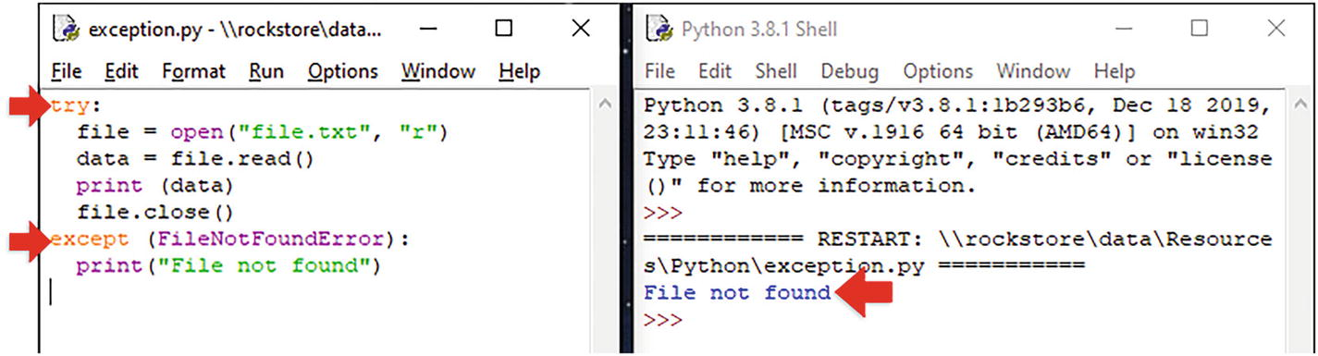
Use the finally block to perform any clean up. The finally statement runs regardless of whether the try statement produces an exception or not.
try:
file = open("file.txt", "r") data = file.read()
except FileNotFoundError: print("File not found")
finally: f.close()

Raising Your Own Exceptions
Use the raise keyword to force a specified exception to occur followed by the type of error using the table in Table 8-1 at the beginning of this chapter.
if number < 0:
raise ValueError ("Negative numbers only.")
Here in the file raise.py, we’ve raised a ValueError exception .
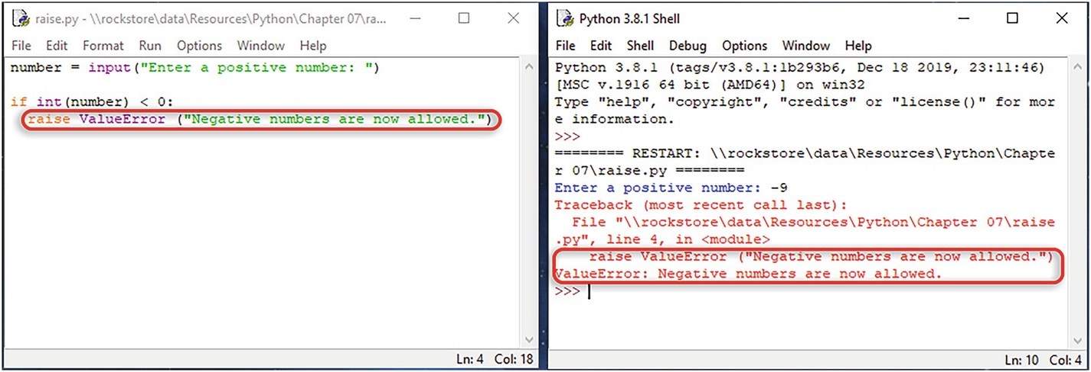

Summary
An exception is an error that occurs during execution of a program, sometimes called a runtime error.
You can catch exceptions using the try and except keywords.
© The Author(s), under exclusive license to APress Media, LLC, part of Springer Nature 2022
K. WilsonThe Absolute Beginner's Guide to Python Programming
https://doi.org/10.1007/978-1-4842-8716-3_9

9. Object-Oriented Programming
Kevin Wilson1
(1)
London, UK

Python is an object-oriented programming language. This means that the program design is based around objects, rather than functions and logic.
Each object is created using a blueprint known as a class . Each class has attributes to contain the data an object needs to work with.
Each class also contains functions, called methods that perform operations on objects.
An object is an instance of a class. So, you could have a class called “car” and use it to define an object called “merc.”
You’ll need the source files in the directory Chapter08.

Principles of OOP
The four principles of OOP are encapsulation, inheritance, polymorphism, and abstraction.

Encapsulation
With encapsulation , you restrict access to methods and attributes within a certain class. This prevents accidental modification of data and unwanted changes to other objects.

Inheritance
A class can inherit all the methods and attributes from another class. If a class called “person” had the attributes name, age, and dob, we could use this class to define two other child classes called “student” and “staff.” Both inherit the methods and attributes from the “person” class.

Polymorphism
Polymorphism allows us to define methods in the child class with the same name as defined in the parent class. This is known as method overriding.
Polymorphism also allows us to define methods that can take many forms.

Abstraction
Abstraction is the process of reducing objects to their essence so that only the necessary elements are represented. In other words, you remove all irrelevant information about an object in order to reduce its complexity.

Classes and Objects
You can define a class using the class keyword:
class <class-name> :
<class attributes and methods>
Here, we have created a class called Person:
class Person :
All classes have a function called init () which is automatically executed when the class is initiated. Use the init () function to initialize attributes.
def init (self, name, dob, email):
self.name = name
self.dob = dob
self.email = email
The self keyword represents the current instance of the class (i.e., the object created from the class). By using the self keyword, you can access the attributes of the object itself.
When you declare a method, you pass the current instance of the class (i.e., the object itself), along with any other parameters required, to the method:
def getAge(self):
currentDate = date.today()
age = currentDate.year - self.dob.year
return age
When you need to use any attribute, you use self followed by the attribute name :
self.attribute-name
So, for example:
self.email
Let’s take a look at a program. Open the file class.py. Here, we’ve defined our “Person” class.
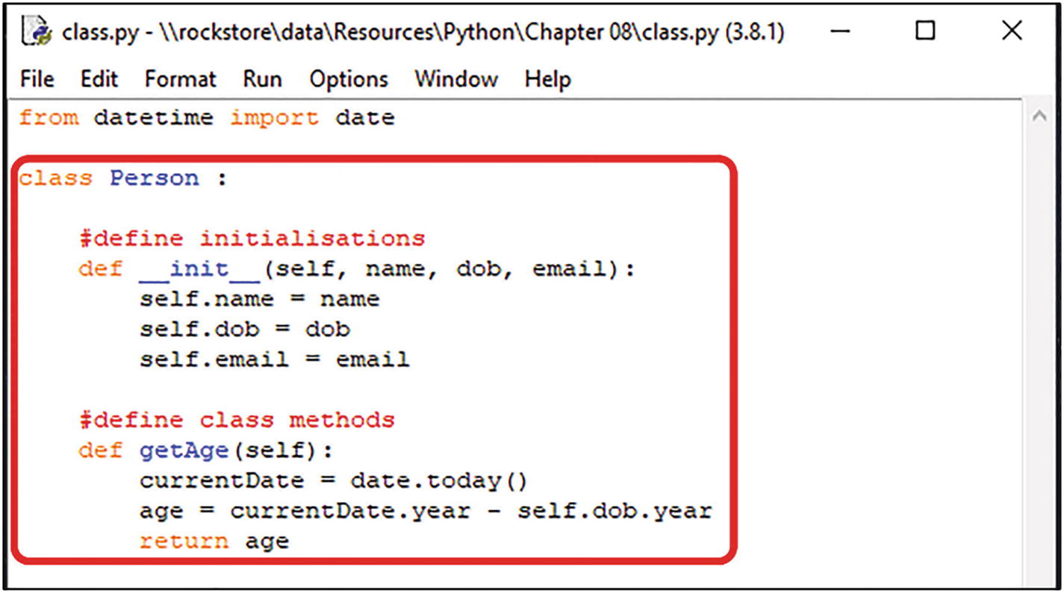
To create an object from the class, call the class Person(...) and pass any data using parenthesis ( ). Assign the new object to a variable, for example, person.
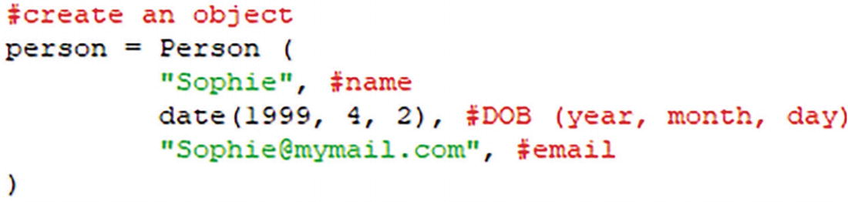
To use the object , use the dot notation:
classname.method()
or
classname.attribute
So in our example, to use the attributes we use the dot notation, with the object name followed by the attribute name as we can see here:
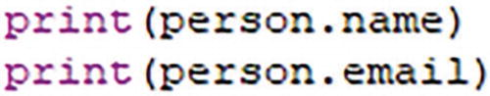
Similarly, if we want to use the methods of an object, we use the dot notation, with the object name followed by the method name as we can see here:

Class Inheritance
We mentioned earlier that inheritance means a class can inherit all the methods and attributes from another class.
As we can see in Figure 9-1, we have a parent or super class called Person and two child (or sub) classes called Student and Staff.
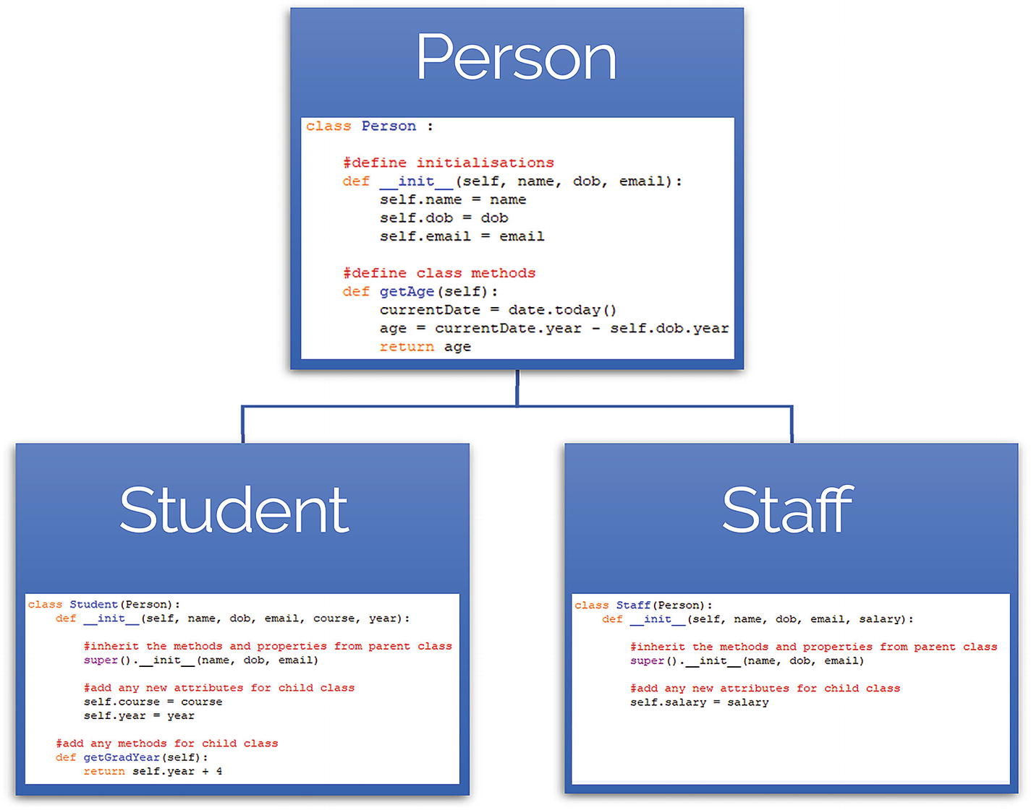
Figure 9-1How a class inherits properties from its parent
The child classes inherit all the attributes and methods of the parent classes. Child classes can include any additional attributes and methods that are not accessible from other classes.
To create a child class , declare the class as normal, except include the parent class in parenthesis after the class name. So
class child-class(parent-class):
If you want to inherit all the methods and properties from the parent, use super() :
super(). init (name, dob, email)
Open the file inherit.py. Here, we’ve created a class called person . We’ve also created two child classes called student and staff.
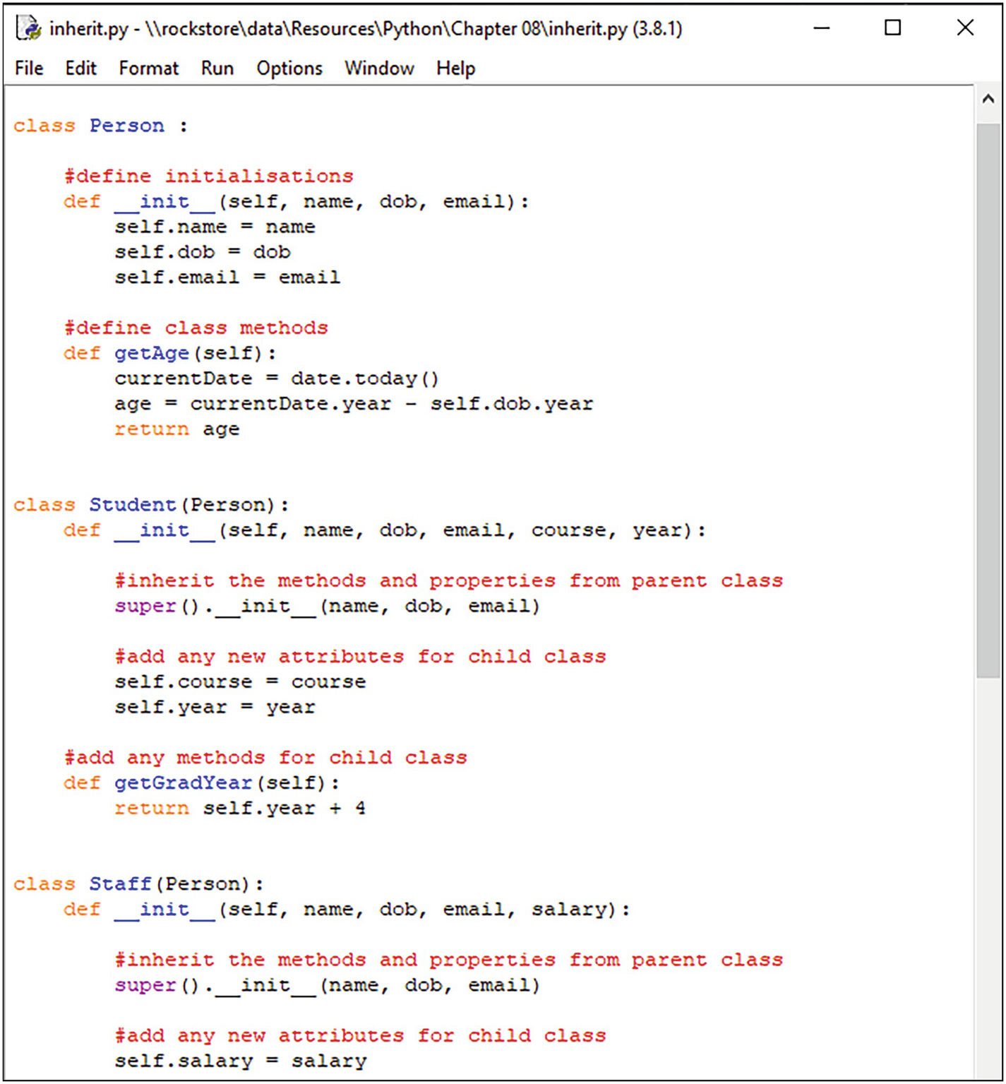
We can create a lecturer object from the class Staff.
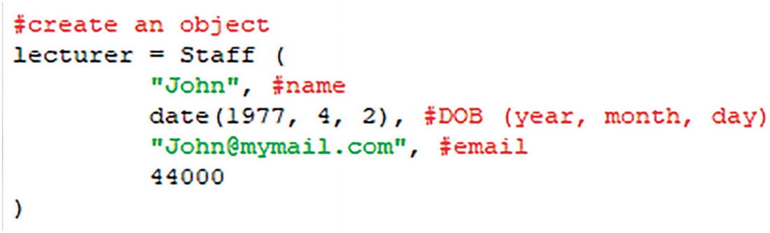
To reference our attributes, we use the dot notation .
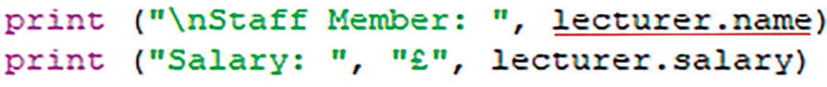

Polymorphic Classes
In this example, we’re going to create two classes. To be polymorphic , each of these classes needs to have an interface in common. So we define methods for each class that have the same name. In this case, we can define a method that calculates the area in each class (triangle, square, and circle as we can see in Figure 9-2).
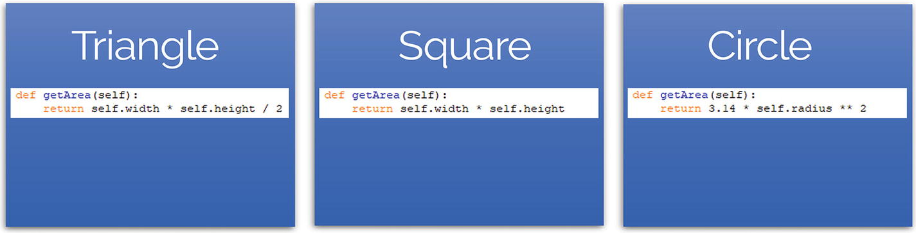
Figure 9-2An example of how classes can contain the same method
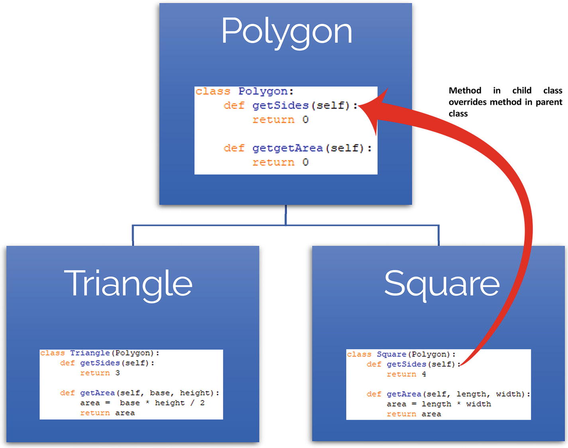
Figure 9-3How a method in a child class can override the method defined in the parent class
Open the file polyclass.py. Here, we’ve defined a class for triangle, square, and circle. Notice each class has a method called getArea().
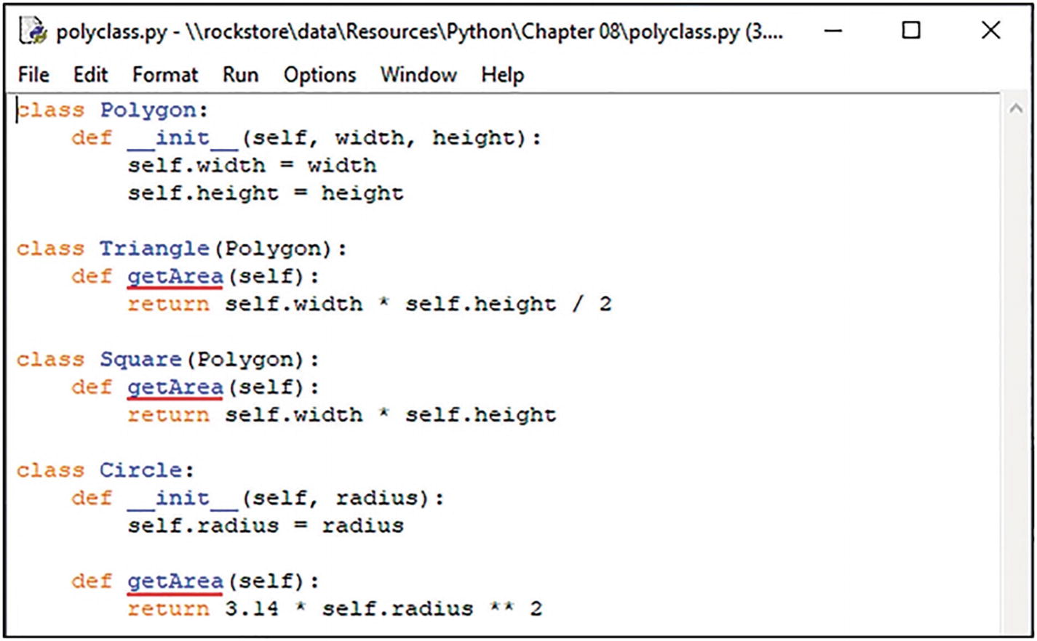
This means we can call the .getArea() method for each object created.
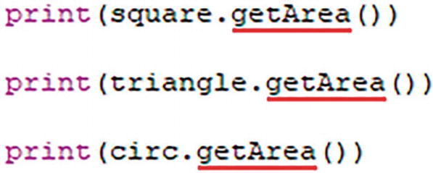

Method Overriding
With method overriding , you can define a method with the same name in the child class as in the parent class. The method in the child class overrides the method in its parent class.****
Have a look at methodoverride.py. Here, we’ve defined the classes discussed earlier. The methods in the child classes have the same name as in the parent class. Each method is redefined and specific to the class. Let’s see what happens when we create our objects and call the methods.
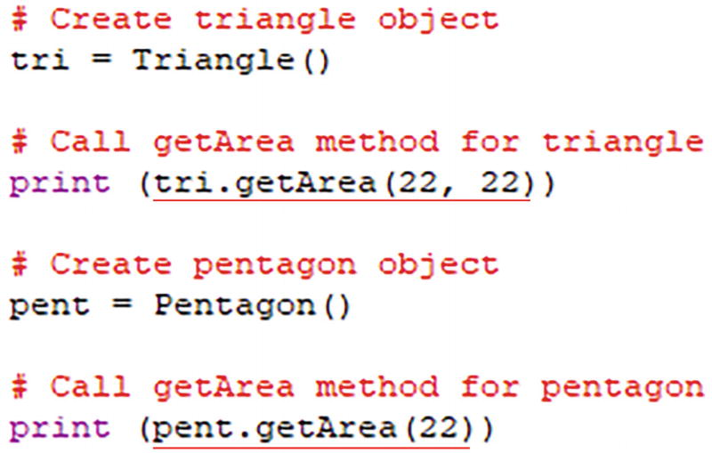
Give it a try .

Lab Exercises

1. | Declare a new class called Vehicle without any attributes and methods.
2. | Add some attributes to the Vehicle class such as  Name  Speed  Mileage
3. | Add a method to the Vehicle class to return the vehicle name.
4. | Create a child class called Car that will inherit all the variables and methods of the Vehicle class.
5. | Create a child class called Taxi.
6. | Add a method to the Taxi class to collect the fair.

Summary
Python is an object-oriented programming language.
A class is a blueprint for an object.
Each class has attributes to contain the data an object needs to work with.
Each class contains functions, called methods that perform operations on objects.
Encapsulation restrict access to methods and attributes within a certain class.
A class can inherit all the methods and attributes from another class. Child classes inherit methods and attributes from the parent.
Polymorphism allows us to define methods in the child class with the same name as defined in the parent class.
Abstraction is the process of reducing objects to their essence so that only the necessary elements are represented.
You can define a class using the class keyword.
To use methods defined in an object, use the dot notation.
Method overriding allows you to define a method with the same name in the child class as in the parent class.
© The Author(s), under exclusive license to APress Media, LLC, part of Springer Nature 2022
K. WilsonThe Absolute Beginner's Guide to Python Programming
https://doi.org/10.1007/978-1-4842-8716-3_10

10. Building an Interface
Kevin Wilson1
(1)
London, UK

Modern computer applications are built with graphical user interfaces in mind. The user interacts with the application using windows, icons, menus, and a mouse pointer rather than console-based I/O.
To create a graphical user interface using Python, you’ll need to use Tkinter (Tk interface). This module is bundled with standard distributions of Python for all platforms.

Creating a Window
The first thing you need to do is import the Tkinter module into your program. To do this, use
from tkinter import *
To create a window , use the Tk() method:
window = Tk()
Add a title:
window.title('Window Title')
Set the initial size and position of the window. Use the .geometry() method .
window.geometry("800x600+50+20")
The first two numbers, in this case “800x600,” set the window size . Set this to the desired window size in pixels. This could be 1280x720, 1920x1080, and so on.
The second two numbers, in this case “50+20,” set the initial position of the window on the screen using x and y coordinates.
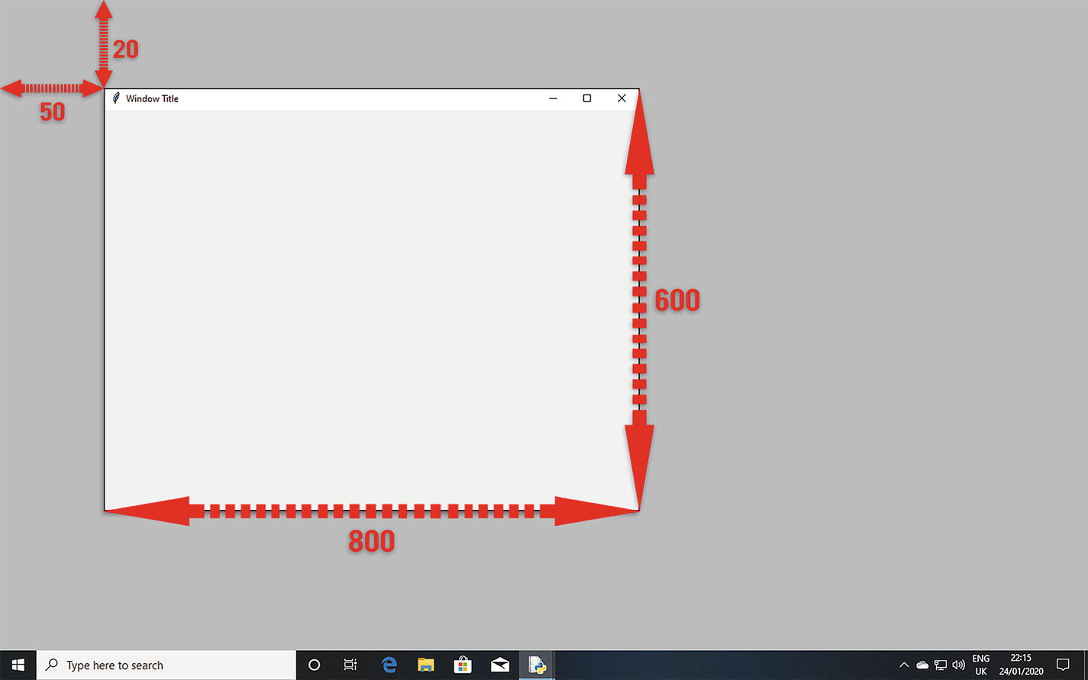
Let’s take a look at a program. Open window.py. Here, we’ve created a window. You can do this using the Tk() function and assign it to a window object.
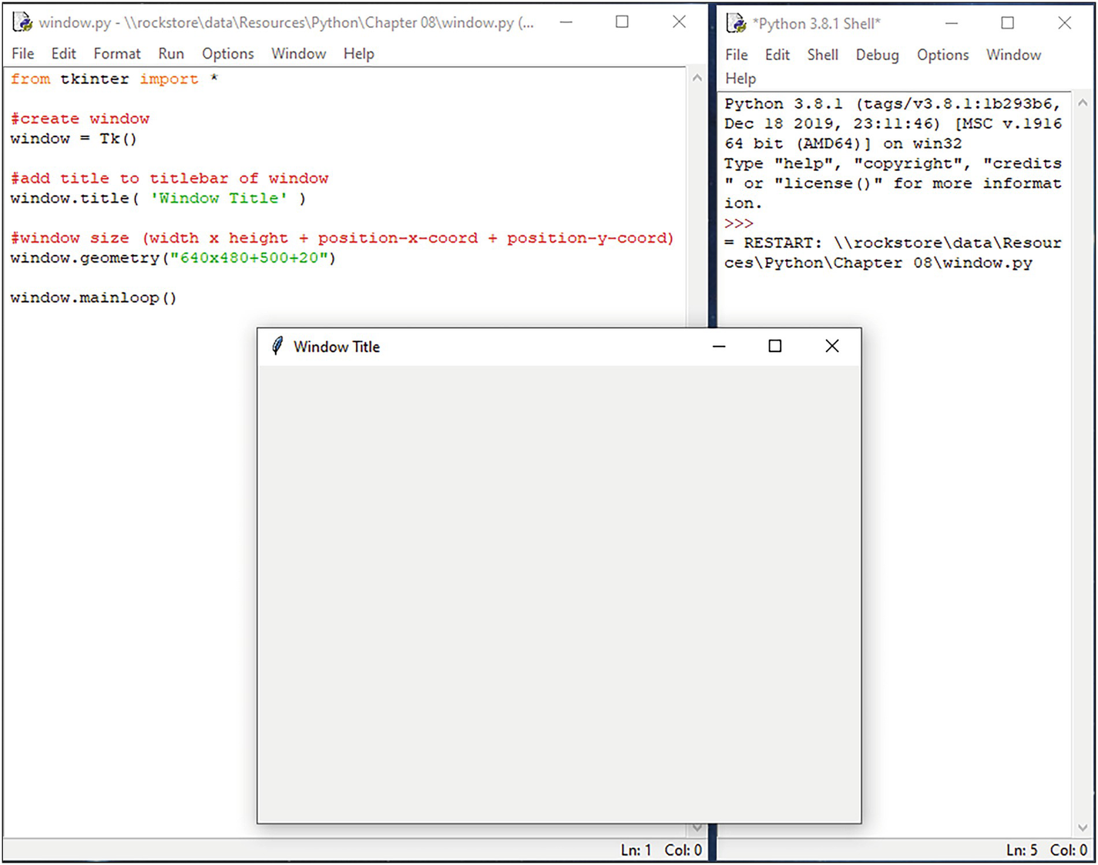
We’ve sized the window, so that is 640 pixels wide by 480 pixels high. We’ve also positioned the window 500 pixels across from the top left by 20 pixels down. You can do this using the .geometry() method . This is the initial size and position of the window on screen.
We’ve also added a window title. You can do this using the .title() method . This helps to identify your app.
Finally, to make the window appear, we need to enter the Tkinter event loop. You can do this with the .mainloop() method :
window.mainloop()
This is an infinite loop used to run the application and is called an event loop. The .mainloop() method waits for an event such as a keypress or mouse click events from the window system and dispatches them to the application widgets (frames, buttons, menus, etc.).

Adding Widgets
Widgets are standard items for building a graphical user interface using Tkinter.

Menus
Let’s add a menu . You can create a menu bar using the Menu() function. Assign it to an object (e.g., menubar) and attach it to your main window.
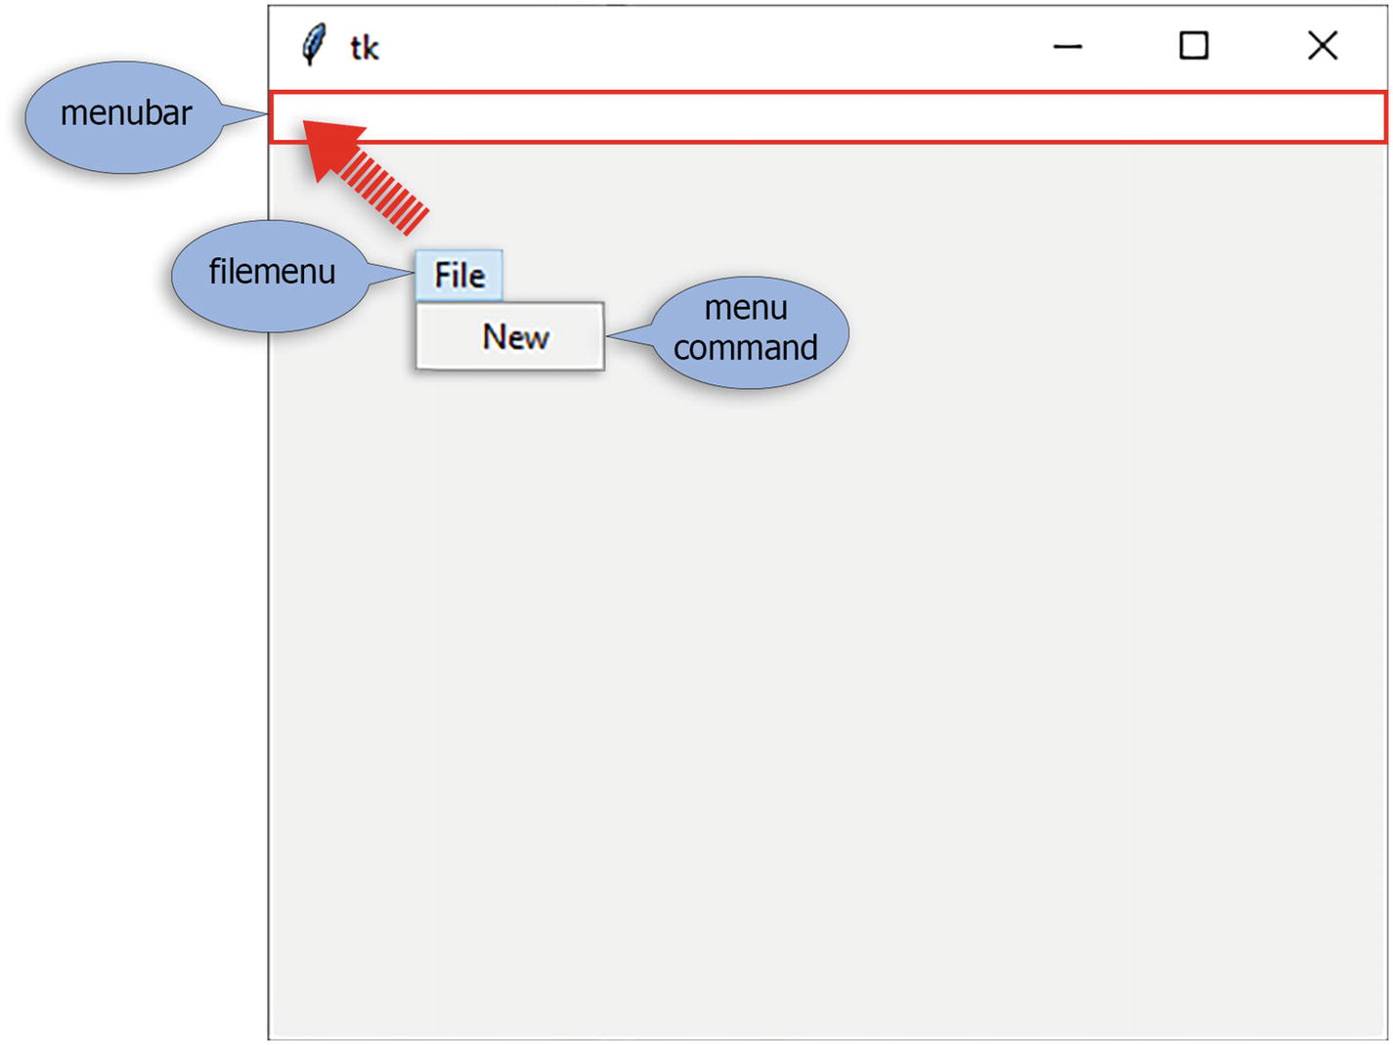
Now you need to create the individual menus (such as “file,” “edit,” etc.) on the menubar.
filemenu = Menu(menubar-to-add-to, menu-style)
Add the menus to the menubar:
menubar.add_cascade(menu-label, menu-to-add-to)
For each menu you create (e.g., filemenu), you need to create each menu command (such as “new,” “save,” “exit,” etc.):
filemenu.add_command(command-label, function)
Finally, add the menubar you’ve created to the main window:
window.config(menu-to-add)
Let’s take a look at a program. Open the file menu.py. Here, we’ve written the program as described earlier.
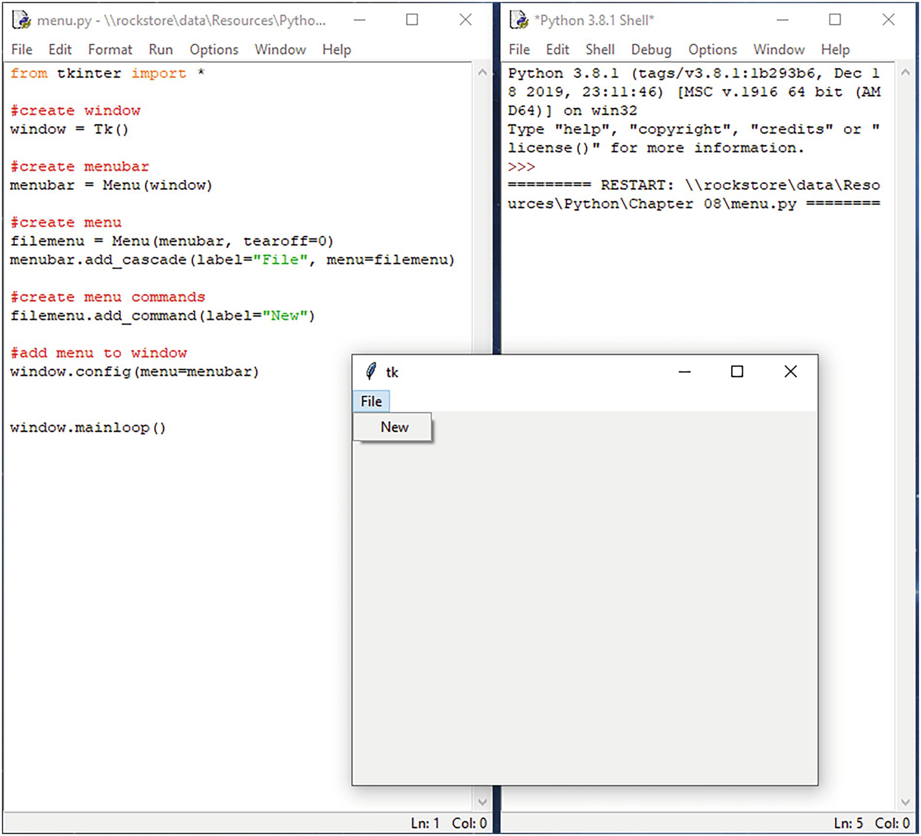

The Canvas
The canvas is used to draw and create graphics and layouts. This is where you place your graphics, text, buttons, and other widgets to create your interface.
To create a canvas, use
myCanvas = Tkinter.Canvas (parent-window, bg="sky blue", height=300, width=300)
Use parent-window to attach the canvas to your window. Use height and width to size your canvas.
Use bg to set the background color. Open colorchart.py and run the program. This will create the color chart shown here.
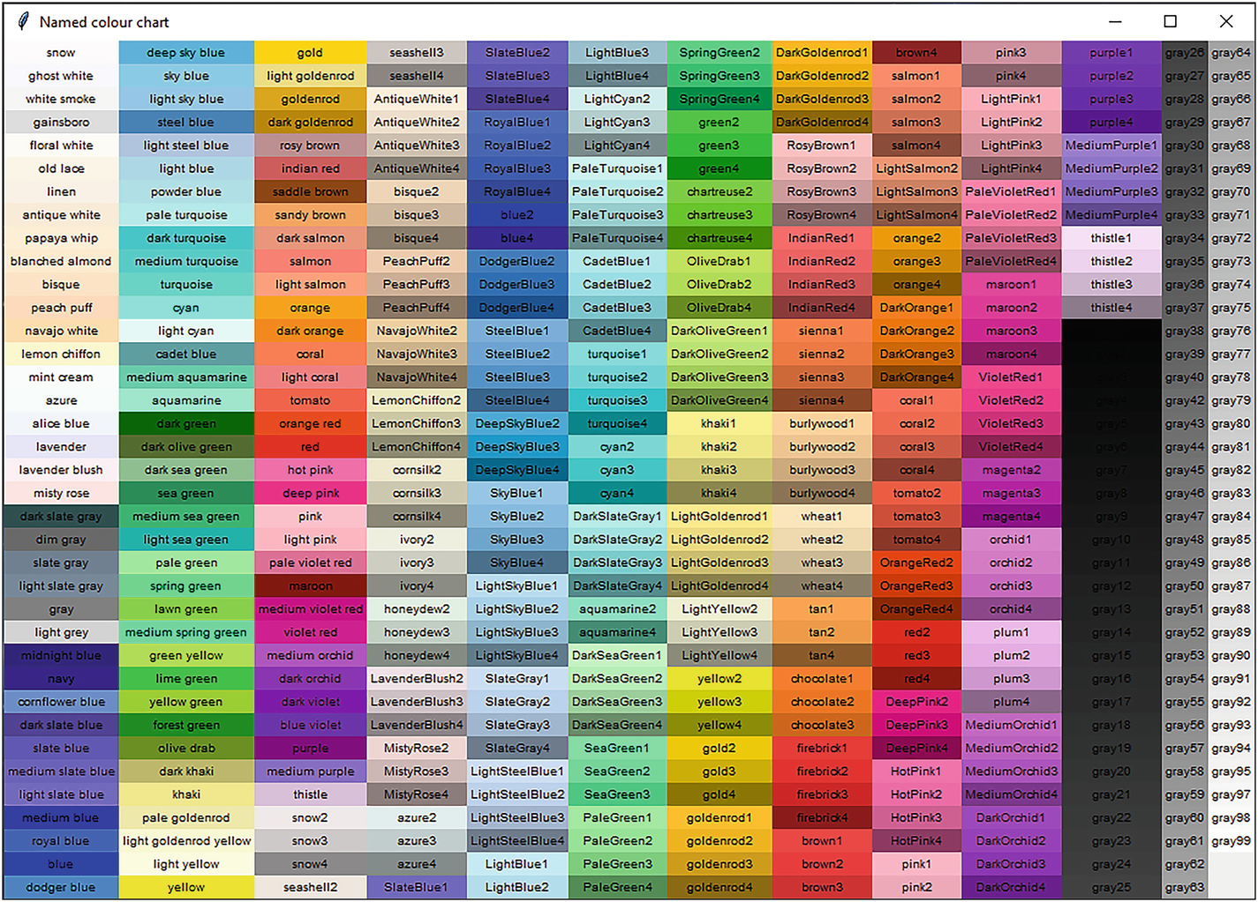
Select the name of the color from the chart to use in the bg parameter .
Let’s draw a shape on the canvas:
rect = myCanvas.create_rectangle
(100, 100, 25, 50, fill="yellow")
The first two numbers are the x and y coordinates on the canvas. The second two numbers are the length and width.

You can also draw a polygon.
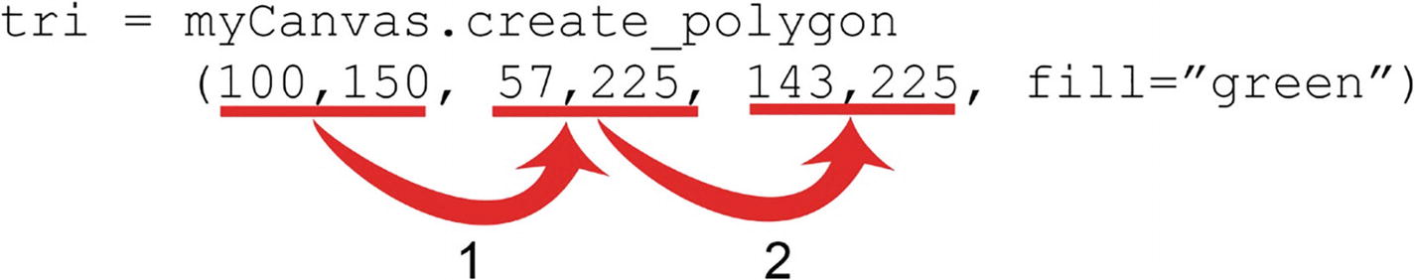
In this example , we’re creating a triangle. A triangle has three sides, so we need to draw three lines. The first two numbers indicate the start point of the first line; the second two numbers indicate the end point of the first line, and so on. Let’s take a look.
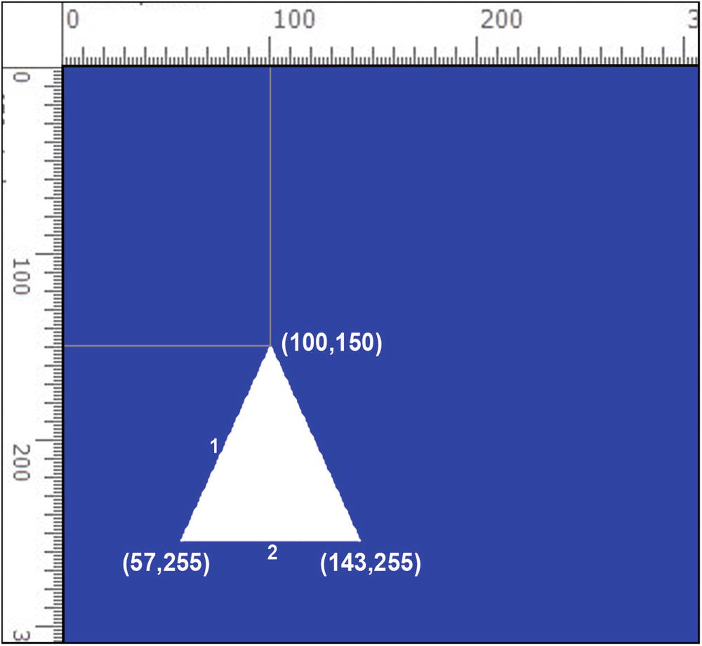
Try drawing a pentagon . A pentagon has five sides, so you need to draw five lines:
pent = myCanvas.create_polygon
(100,150, 52,185, 71,240, 129,240, 148,185,
fill="lime green")

Images
You can add images to your canvas. Have a look at images.py. To load the image, use the PhotoImage() function.
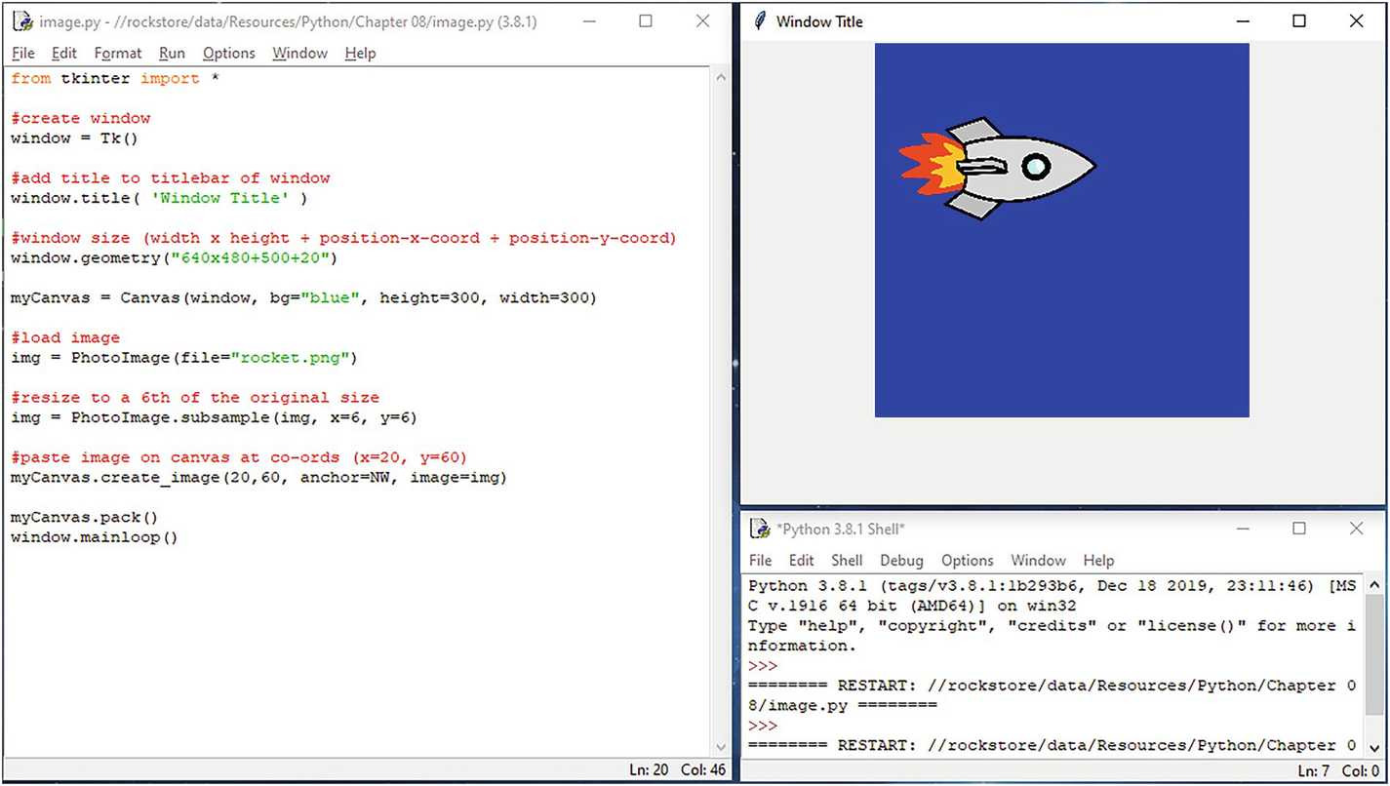
To paste the image on your canvas, use the .create_image() method.

Buttons
You can add command buttons to your canvas. To do this, use the Button() function.
Have a look at buttons.py:
myButton = Button(window, text="label", command)
Use window to specify the name of the window the button is to go on.
Use command to specify the function you want to call to handle what the button does. You can call existing functions or define your own functions to do this.
Use the .pack method to add the button to your window:
myButton.pack()

Message Boxes
You can add message boxes to your programs. To do this, you will need to import the message box functions from the Tkinter module. You can do this using the import command:
from tkinter import messagebox
You can create different types of message boxes: an info box, a warning box, an error box, and a box that asks for a yes/no response.
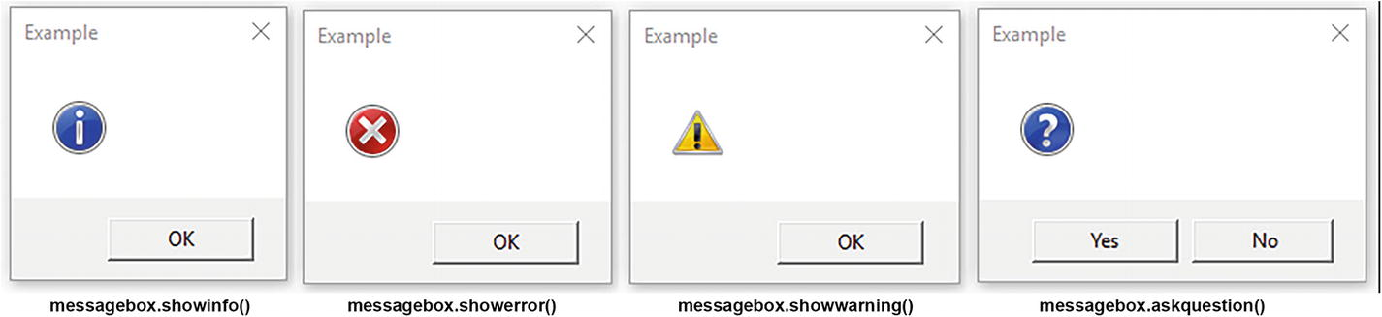

messagebox.showinfo('Message Title', 'Message')
If you’re asking the user for a yes/no response, you’ll need to process this:
response = messagebox.askquestion
('Message Box' , 'Question...')
if response == 'yes' :
executed if user clicks 'yes'
else :
executed if user clicks 'no'
Let’s have a look at messagebox.py.
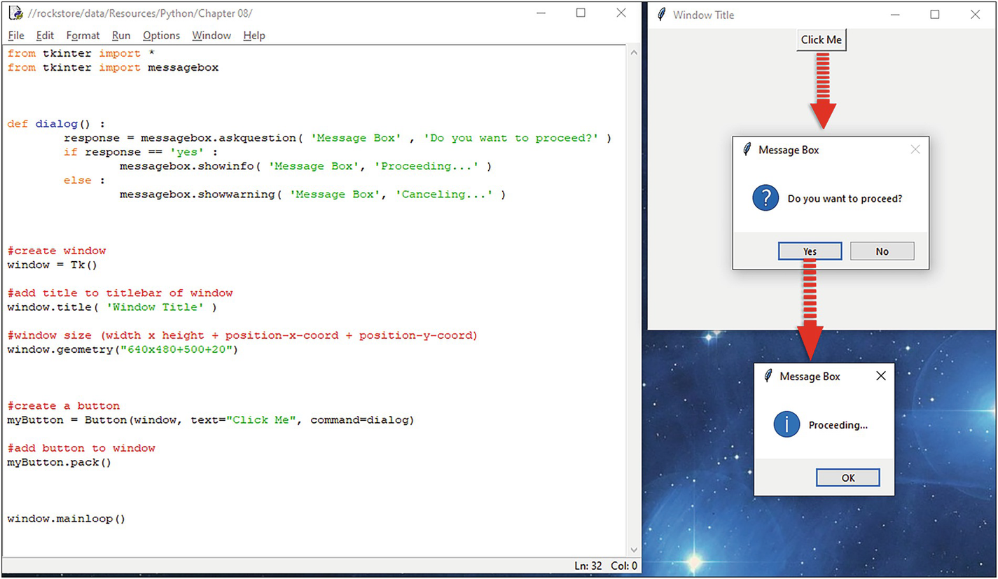

Text Field
Use the Entry() function to create your text field :
userInput = Entry( window )
Use the .pack() method to add the field to your window:
userInput.pack()
To get the data from the text field, use the .get() method:
userInput.get()
Let’s add these to the program. Have a look at textfield.py. Here, we’ve added a text field to the canvas under the command button.
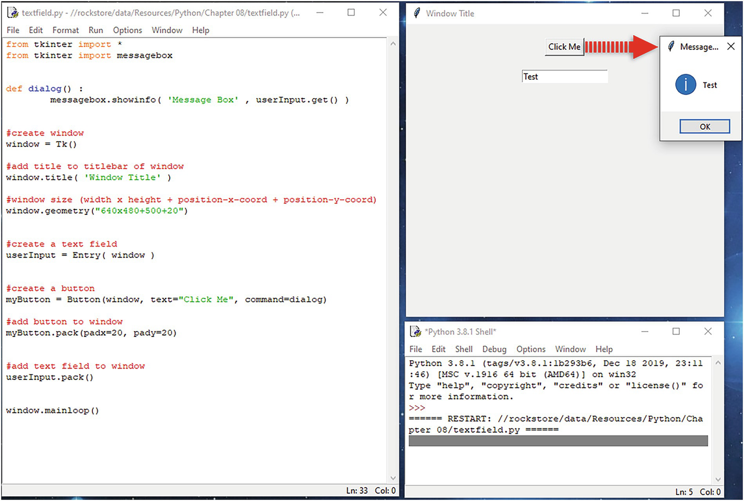
We’ve also added code in the dialog() function to get the data from the text field and display it in a message box.
The dialog() f unction is called when the “Click Me” button is clicked.
Run the program and see what it does.

Listbox
Use the Listbox() function to create your listbox :
list = Listbox(window)
Use the .insert() method to add items to the listbox:
list.insert(1, 'Item One')
Use the .pack() method to add the listbox to your window. Use the padx and pady parameters to add some padding to space out your listbox in the window.
list.pack(padx=20, pady=20)
Use the .curselection() method to get the index of the item selected by the user. Remember, the first item’s index is 0.
selectedItem = list.curselection()
Use the .get() method to return the item:
list.get (selectedItem)
Let’s take a look at a program. Open listbox.py.
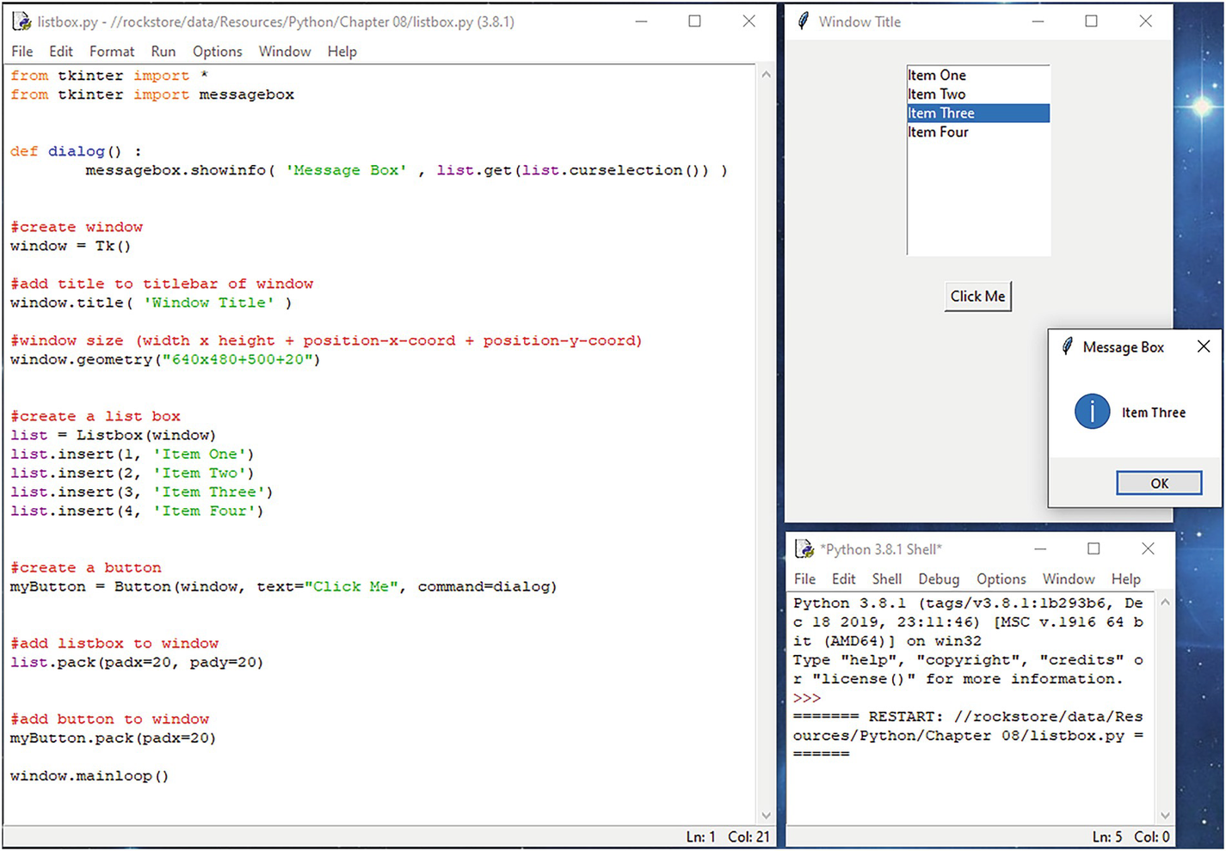

Checkbox
Use the Checkbutton()function to create each of your checkboxes :
box1 = Checkbutton(window, text="Red",
variable=box1Checked, onvalue=1)
You’ll need to create a variable for each checkbox to assign its “onvalue” if the user clicks the checkbox:
box1Checked = IntVar()
The variables you created will either be 1 or 0. Onvalue is set to 1, so the variable will be set to 1 when the user clicks the checkbox. Use the .get() method to get the value.
if box1Checked.get() == 1:
messagebox.showinfo( 'Msg' , "Red" )
Use the .pack() method to add each of your checkboxes to your window:
box1.pack()
Let’s take a look at a program. Open checkbox.py.
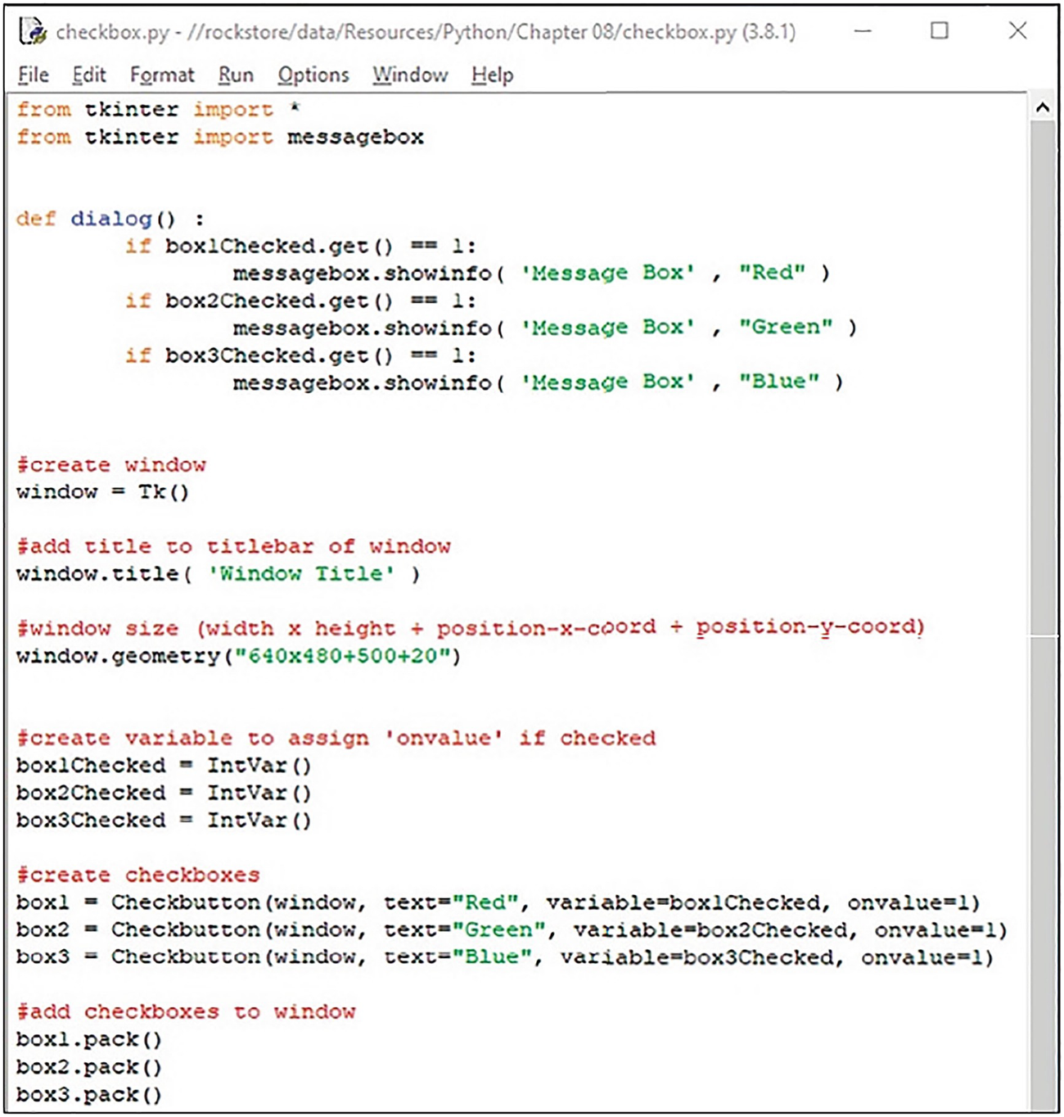
When you run the program , you can select any of the checkboxes. When you click the button, the function reads which checkbox is selected and returns the value.
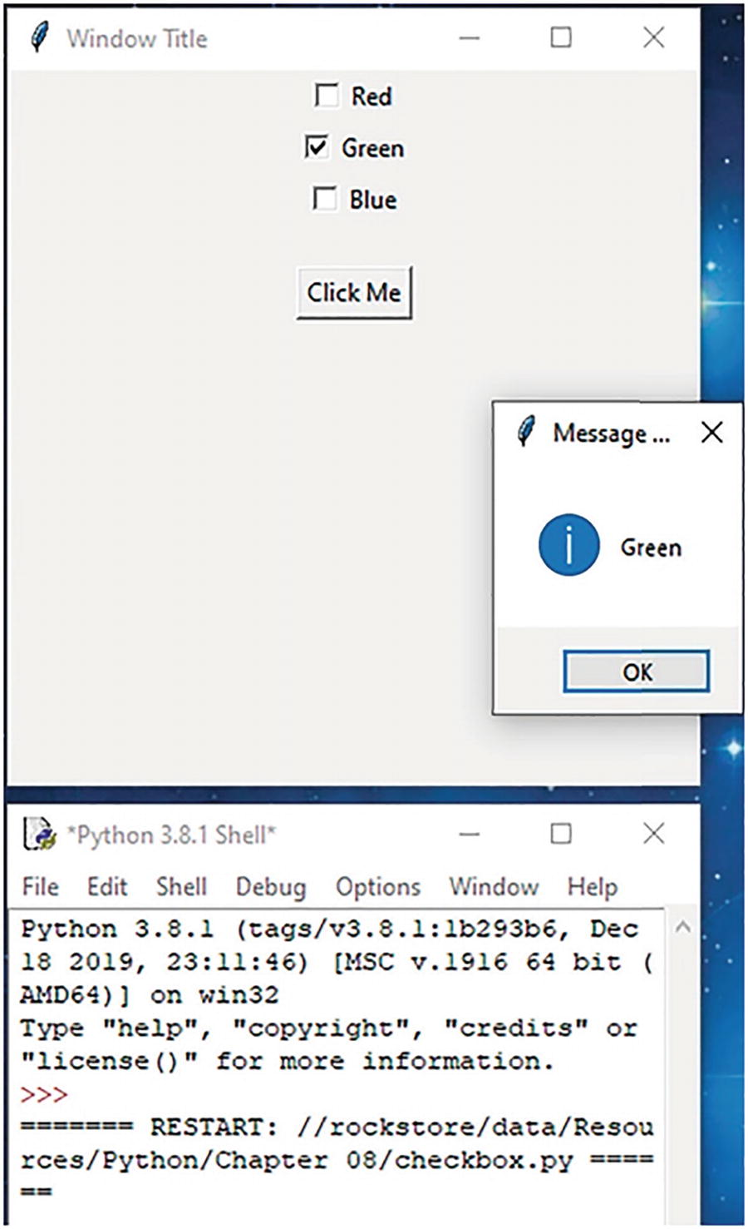

Labels
You can create labels to label text fields and other items on your interface. To do this, use Label():
textLabel = Label(window, text="Enter Name:")
Use pack() to add the label to your window:
textLabel.pack()

Label Frame
The LabelFrame is used to group related widgets, such as checkboxes, radio buttons, or text fields.
First, you need to create your label frame group. You can do this with LabelFrame() as follows:
group1 = LabelFrame(window, text="label", padx=5, pady=5)
Use the first parameter window to attach the group to your main window. Next, you need to add your widgets to your group. You can do this in the usual way, except you need to specify in the widget functions which widget to attach to. So to add our text label, specify the widget to attach to using the first parameter (our labelframe defined earlier is called group1, so use group1 underlined in the following).
textLabel = Label(group1, text="Name: ")
Add your widgets to your window in the usual way:
textLabel.pack(side=LEFT)
Let’s take a look at a program. Open labelframe.py.
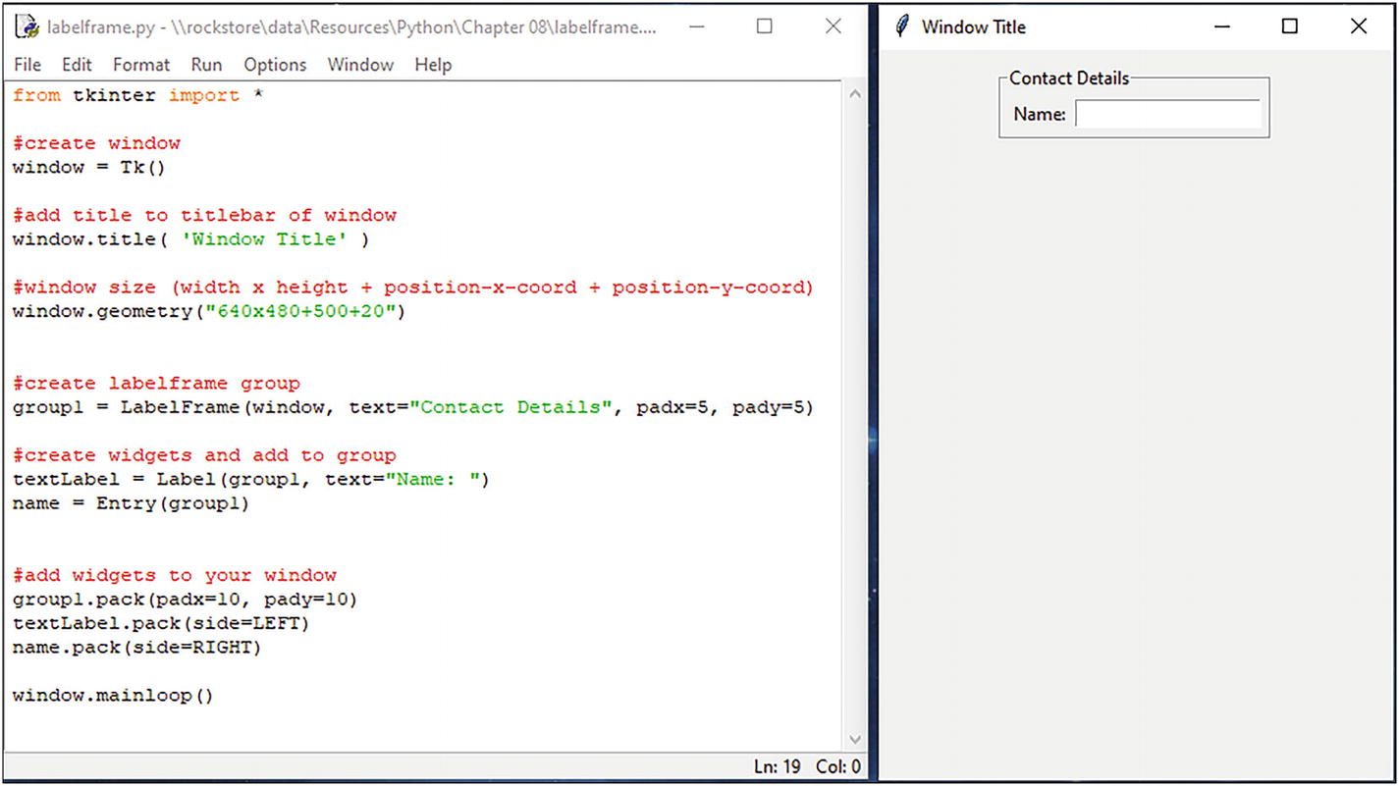
Here, we’ve created a text label and a text field inside the labelframe group (group1).

Interface Design
Now that we know how to create a window, menus, and add different types of widgets, we’ll take a look at how to lay them out in the window to create a usable interface.
You can do this using the grid layout manager. Let’s take a look at an example. Open the file gridlayout.py.
Use the .grid() method to place the widgets in the window according to the grid layout. Use row and column parameters to specify which cell in the grid to place the widget. Use the padx and pady parameters to add some spacing around your widgets in the grid.
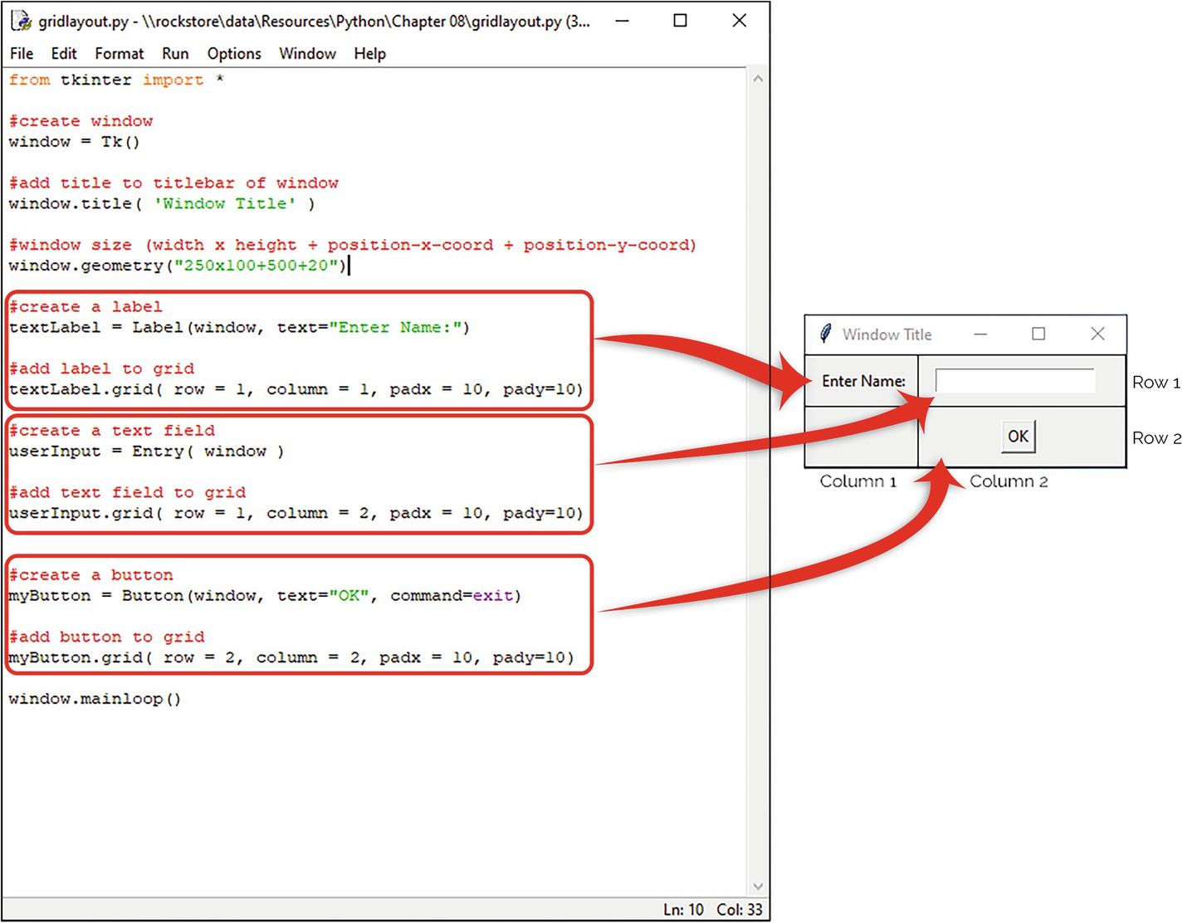
Here, we’ve placed a text label in row 1, column 1. There is a text field in row 1, column 2. We’ve placed a command button in row 2, column 2.
When you run the program, you’ll see the result as shown here:
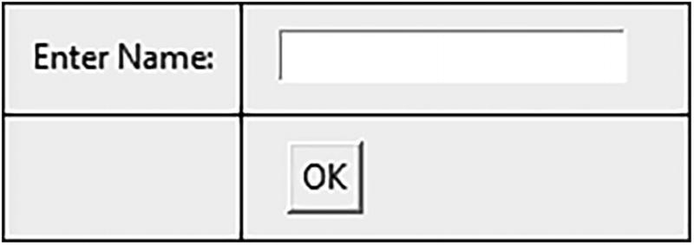
Let’s design a simple interface for a unit converter app. To design this interface, we’ll divide the window up into three rows and five columns.
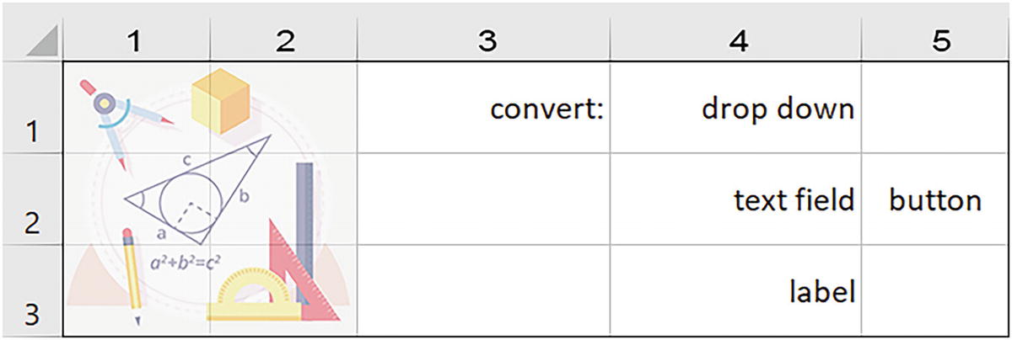
Now, we’ll place a logo on the left-hand side and span it across two columns and down three rows:
img = PhotoImage(file="logo.png")
imgLbl = Label(window, image=img)
imgLbl.grid( row = 1, column = 1, padx = 10,
pady=10, columnspan=2, rowspan=3)
We’ll also place a label in row 1, column 3:
textLabel = Label(window, text="Convert:")
textLabel.grid( row = 1, column = 3,
padx = 10, pady=10)
A drop-down box in row 1, column 4:
conversions.grid( row = 1, column = 4, padx = 10, pady=10)
A text field in row 2, column 4, with a button in row 2, column 5:
userInput.grid( row = 2, column = 4, padx = 10, pady=10)
A label at the bottom in row 3, column 4, to show the result:
textLabel.grid( row = 3, column = 4, padx = 10, pady=5)
Add a command button to row 2, column 6:
myButton.grid( row = 2, column = 6,
padx = 10, pady=10)
Let’s take a look at the program. Open the file converter.py. Here, we’re adding the widgets to the grid using the .grid() method .
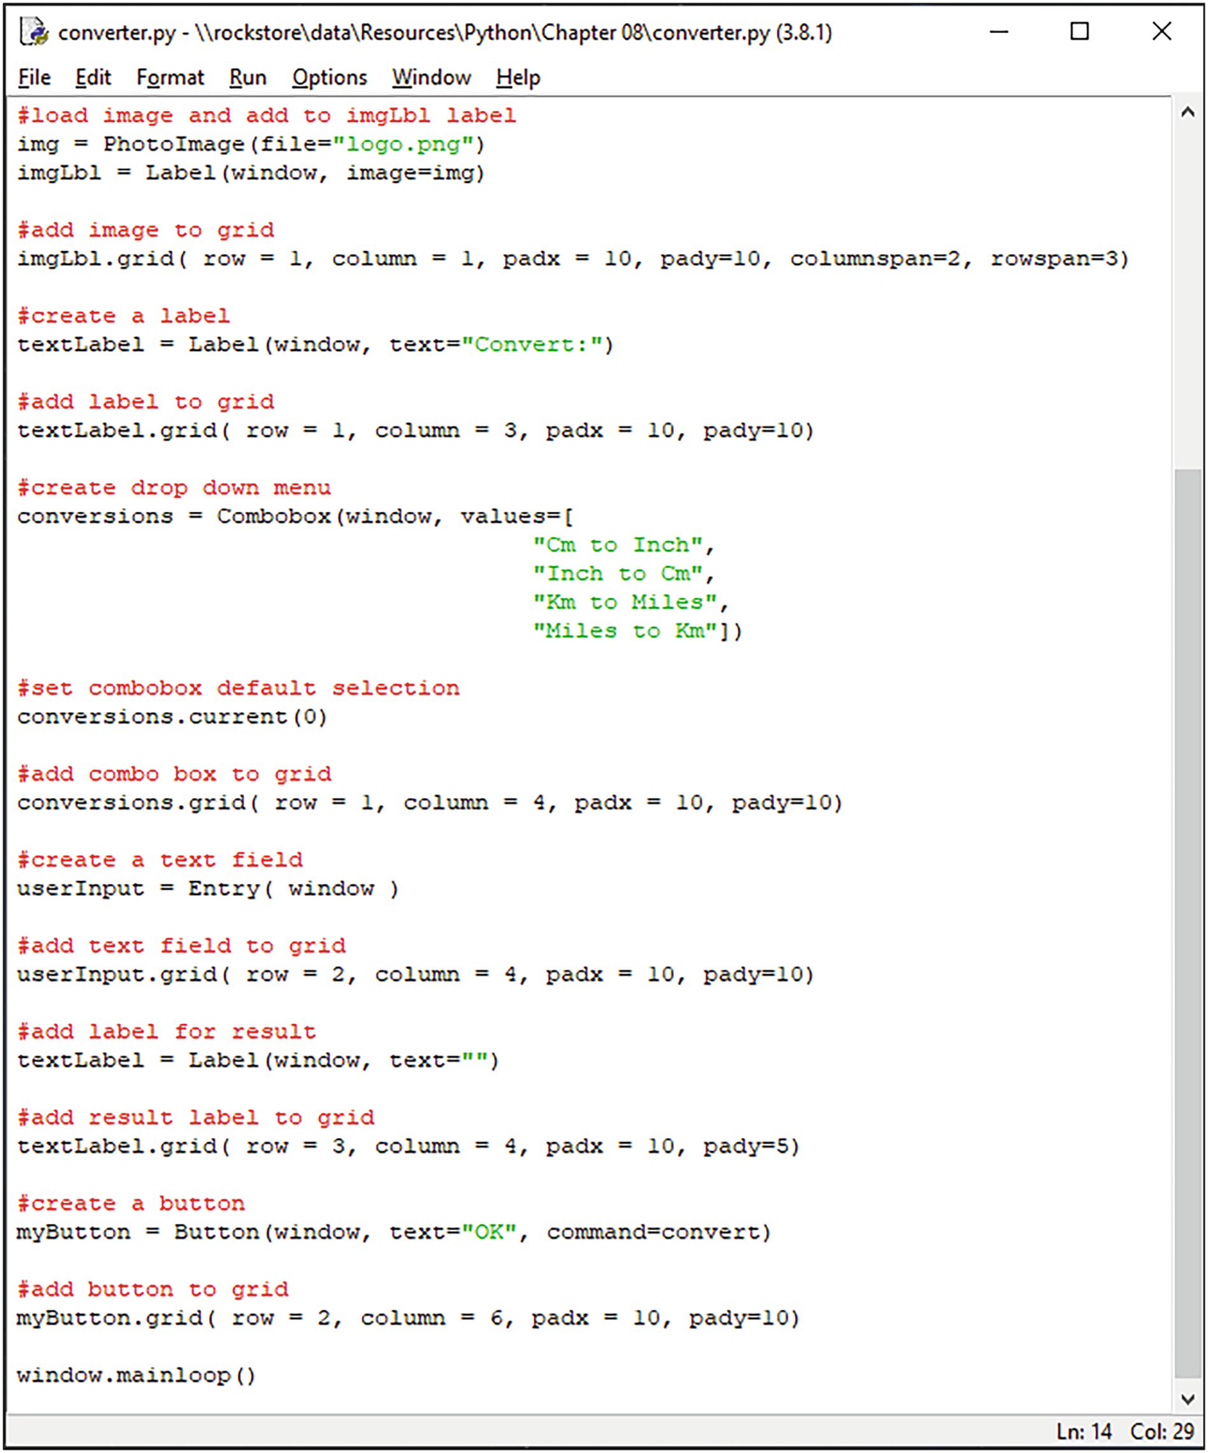
We’ve used the padx and pady parameters to space out the widgets in the grid layout.
That’s the interface sorted. As it stands, the program won’t do anything if you click the button or enter a number into the text field.
We need to write a function to take care of this and call it when the button is clicked.
Declare the function in the usual way. We’ll call this one convert() .
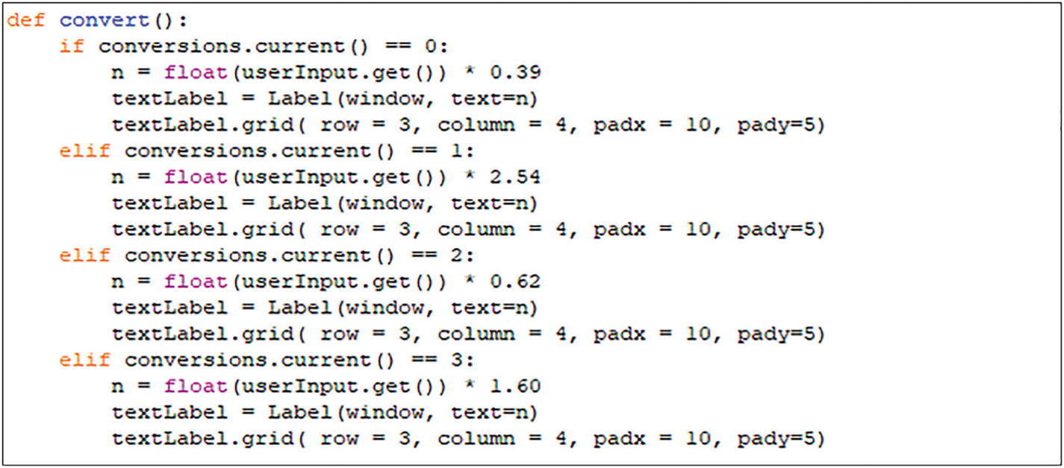
You’ll need to read the selection from the combo box. You can do this with the .current() method . The first item in the combo box has an index of 0, the second is 1, and so on. Use an if statement to separate the calculations for each selection in the combo box.
if conversions.current() == 0:
Next, you’ll need to get the data from the text field. You can do this with a .get() method on the text field. Remember to cast the data type to a float, as the data from a text field is a string.
n = float (userInput.get())
Perform the calculation and return the result to the blank text label in row 3, column 4, of the grid.
Now, when you run the program , you’ll get a nicely laid out interface.
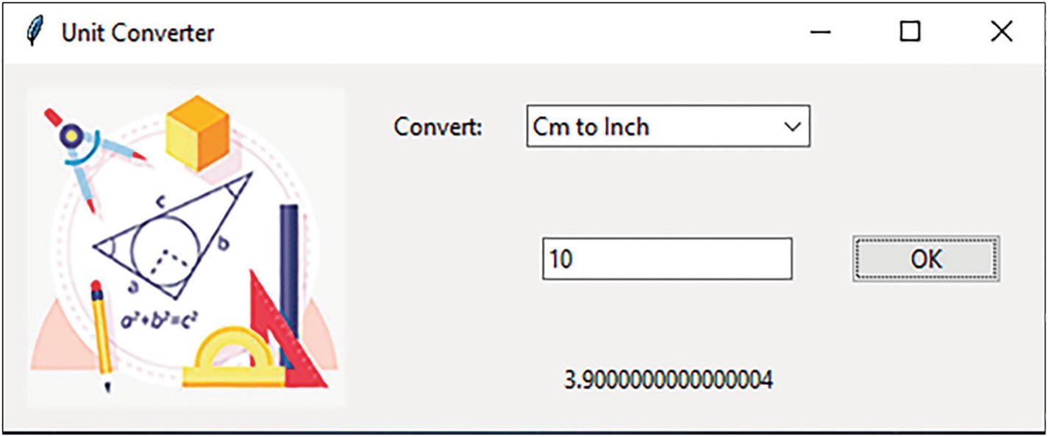

Summary
In this chapter, you learned the following:
To create a graphical user interface using Python, you’ll need to use Tkinter (Tk interface).
Widgets are standard items for building a graphical user interface using Tkinter.
The canvas is used to draw and create graphics and layouts. This is where you place your graphics, text, buttons, and other widgets to create your interface.
© The Author(s), under exclusive license to APress Media, LLC, part of Springer Nature 2022
K. WilsonThe Absolute Beginner's Guide to Python Programming
https://doi.org/10.1007/978-1-4842-8716-3_11

11. Developing a Game
Kevin Wilson1
(1)
London, UK

To start creating your own games using Python, you’ll need to use the pygame module. This module isn’t bundled with standard distributions of Python, so you’ll need to install it before you start.
Pygame is a library of Python modules designed for writing computer games. Pygame adds functionality to create fully featured games and multimedia applications using the Python language.
This chapter will cover the basic modules and functions that Pygame provides. We’ll use these functions to create a very simple interactive game

Installing Pygame
To install the module, open a command prompt. Make sure you run this as an administrator. On the command prompt, type
pip install pygame
Once you press Enter, the install will begin.
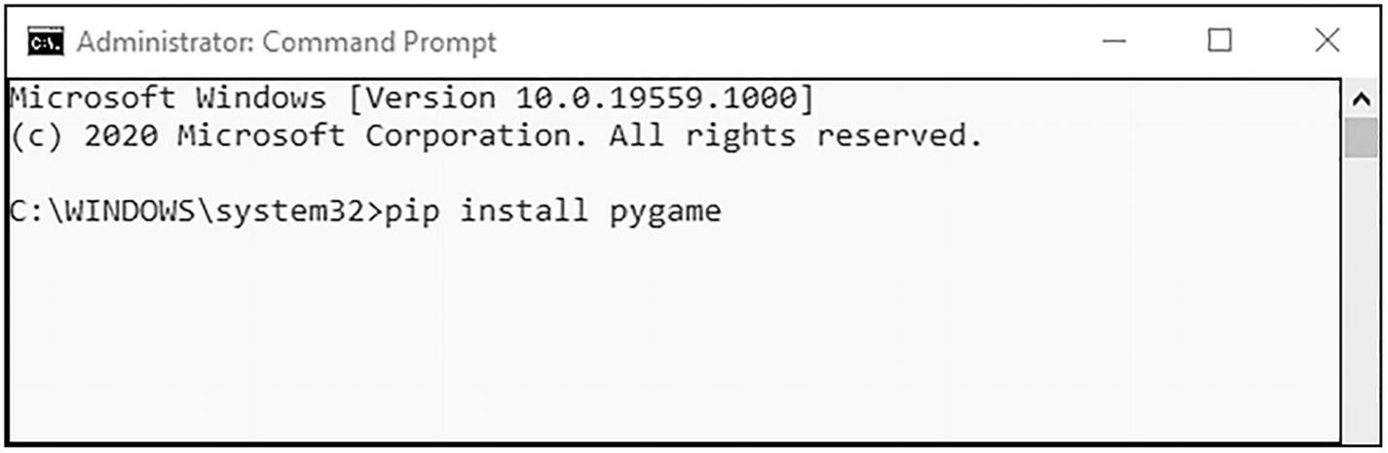
Allow the pip utility to download and install the module.
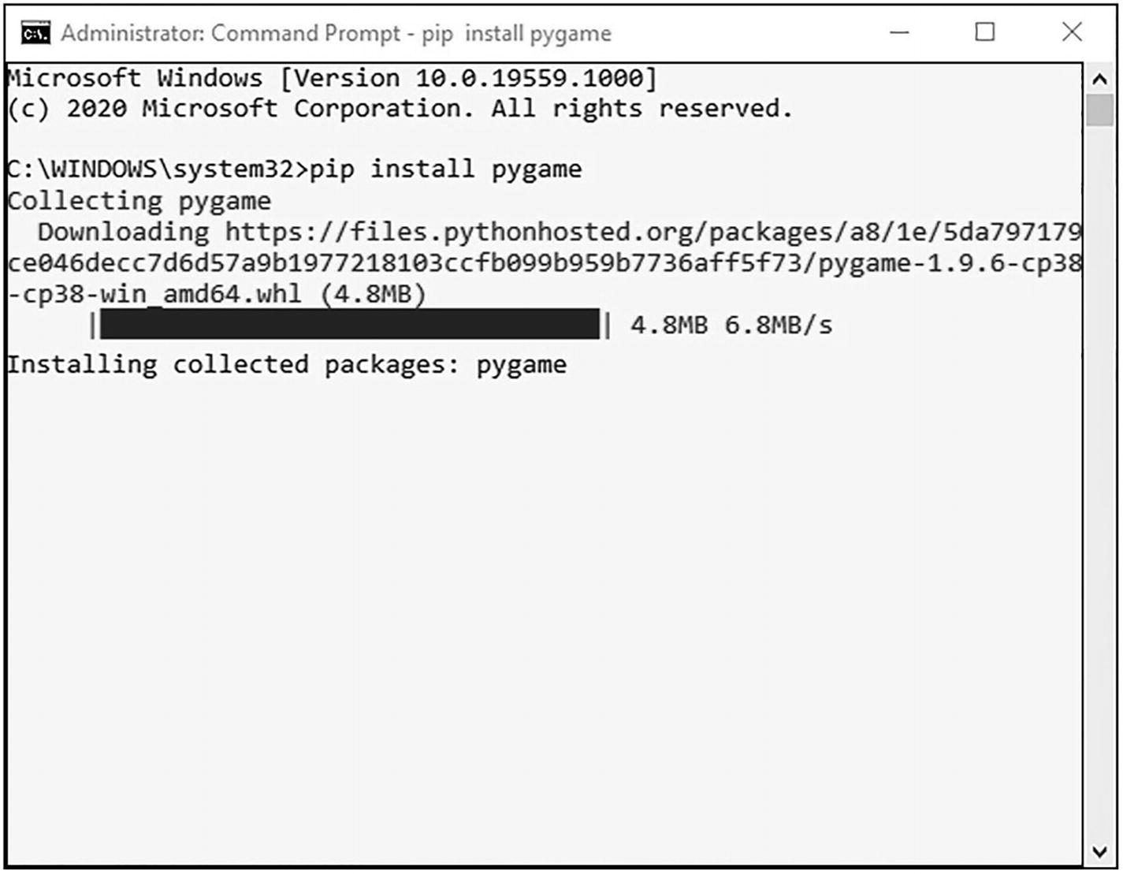
Once the process is complete, you can start using pygame.

Opening a Window
The first thing you’ll need to do is import the pygame module :
import pygame
Initialize pygame using the .init() method:
pygame.init()
Open a window. This sets the window size 640 pixels wide by 480 pixels high. This could also be 800x600, 1920x1080, and so on.
gamewindow = pygame.display.set_mode((640,480))
Set the window’s title. This is the title that appears in the title bar of the window.
pygame.display.set_caption("Game Window")
You should always end your pygame scripts with the .quit() method:
pygame.quit()
Let’s take a look at the program so far.
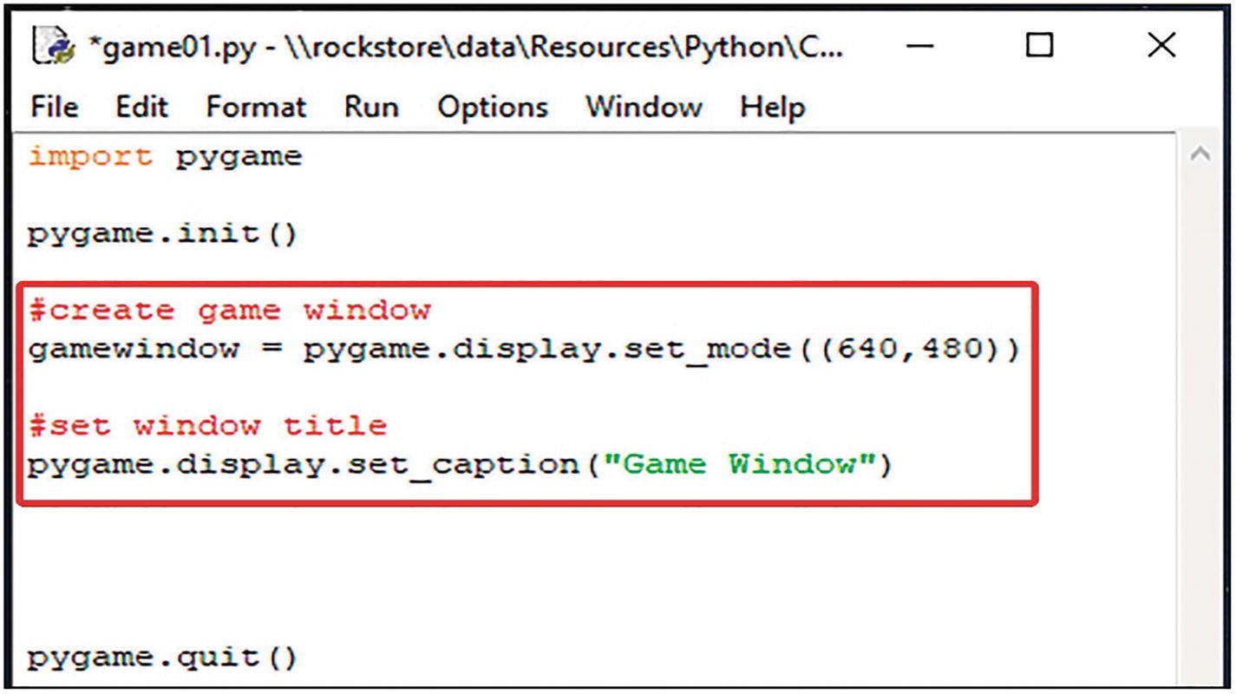
If you run this program , the game window will initialize, open, and then immediately close. This is fine since there is no other code to execute.

Adding an Image
Let’s add an image to the game window. This is going to be our character in the game. In this case, we’re going to use a space rocket. We can add the image load statement to our program.
sprite = pygame.image.load('rocket.png')
Paste the image (sprite) onto the game window using the .blit() method, and assign the initial position on the screen (x, y):
gamewindow.blit(sprite, (x,y))
Update the display to show the image:
pygame.display.update()
Let’s take a look at the program .
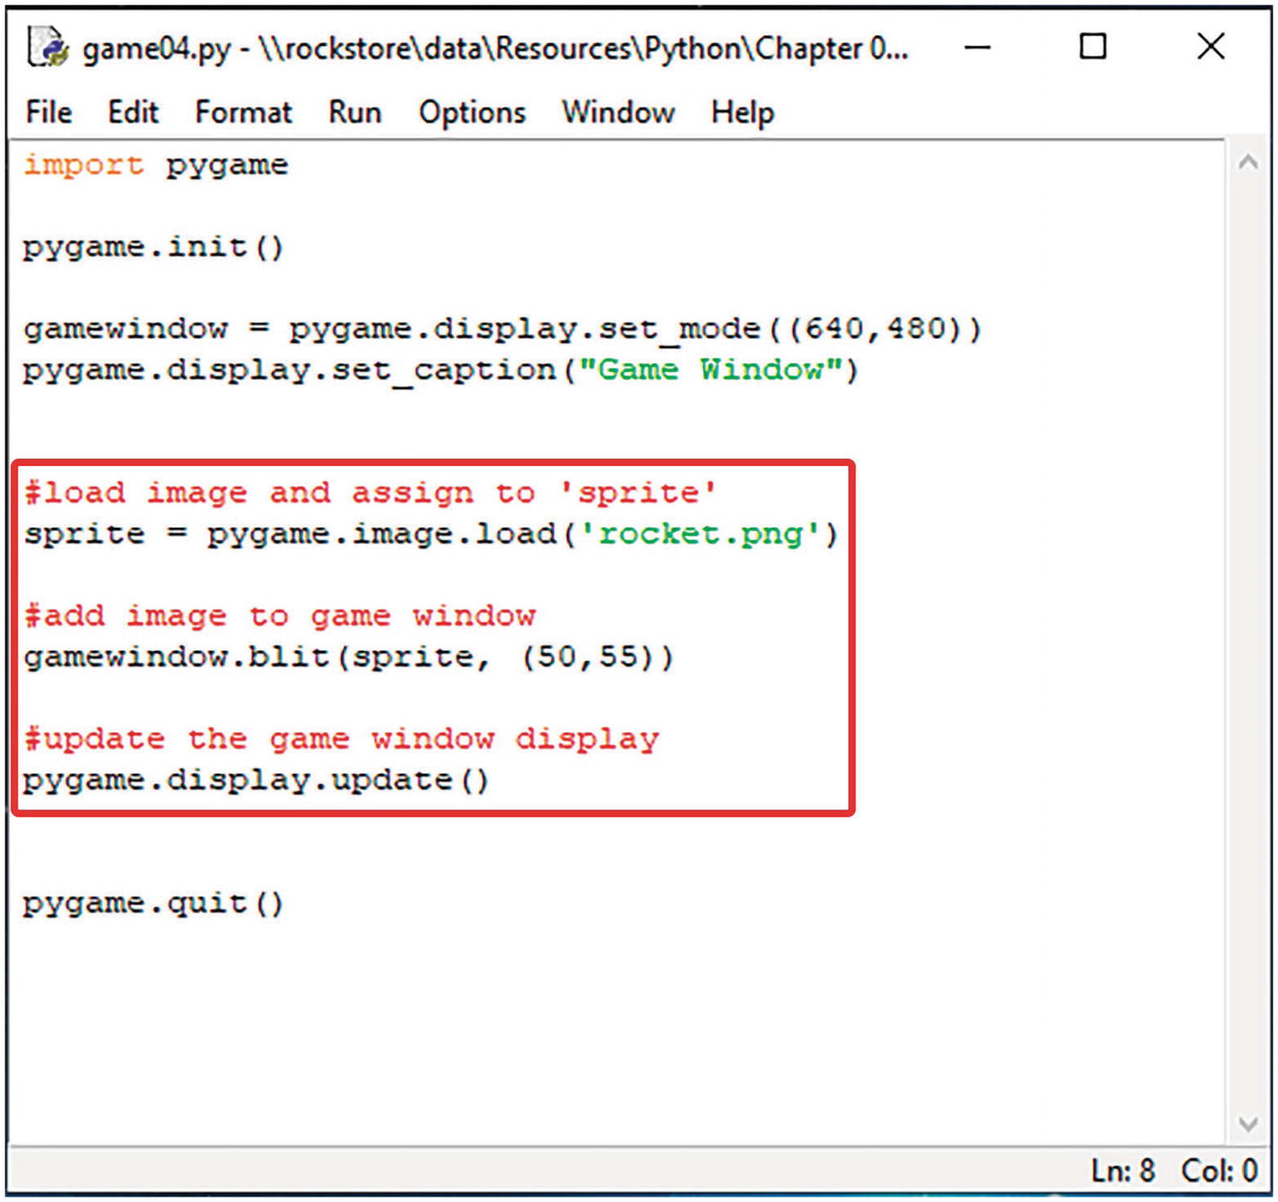

The Game Loop
Now, let’s get our rocket ship to actually do something. To do this, we need to create a game loop to draw our sprites, update the screen, and keep the program running.
We can take the following two statements and add them to our game loop. For this bit, we’ll use a while loop.
gamewindow.blit(sprite, (x,y))
Update the display to show the image:
pygame.display.update()
Put these inside the while loop:
while running == 1:
gamewindow.blit(sprite, (x,y))
pygame.display.update()
We’ll also need to initialize some variables – x and y, the initial position on the screen, and running – to indicate whether the program is running or not:
running = 1
x = 250
y = 280
Let’s take a look at the program.
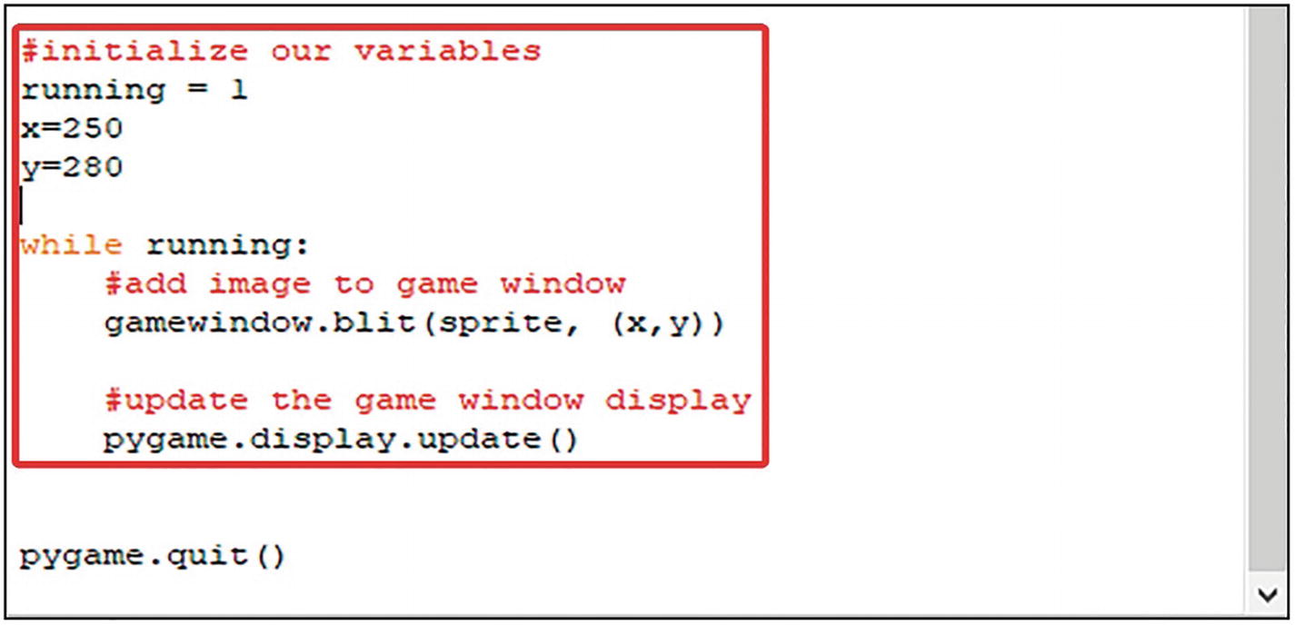

The Event Loop
In this simple game, we want the rocket ship to move left and right when the user presses the left and right arrow keys on the keyboard. To do this, we need something to handle these events.
To do this, we can put a for loop inside our while loop (the game loop). We’re monitoring for each event that occurs. You can use the .get() method to read each event.
for event in pygame.event.get():
Now inside the for loop, we need some selection depending on which key is pressed. We can use an if statement for this.
First, we need to check whether a key has been pressed:
if event.type == pygame.KEYDOWN:
Inside this if statement, we need to identify which key has been pressed. You can use another if statement.
if event.key == pygame.K_LEFT:
We do the same for all other keys we’re going to use. Just add elif statements to the if statement.
Let’s take a look.
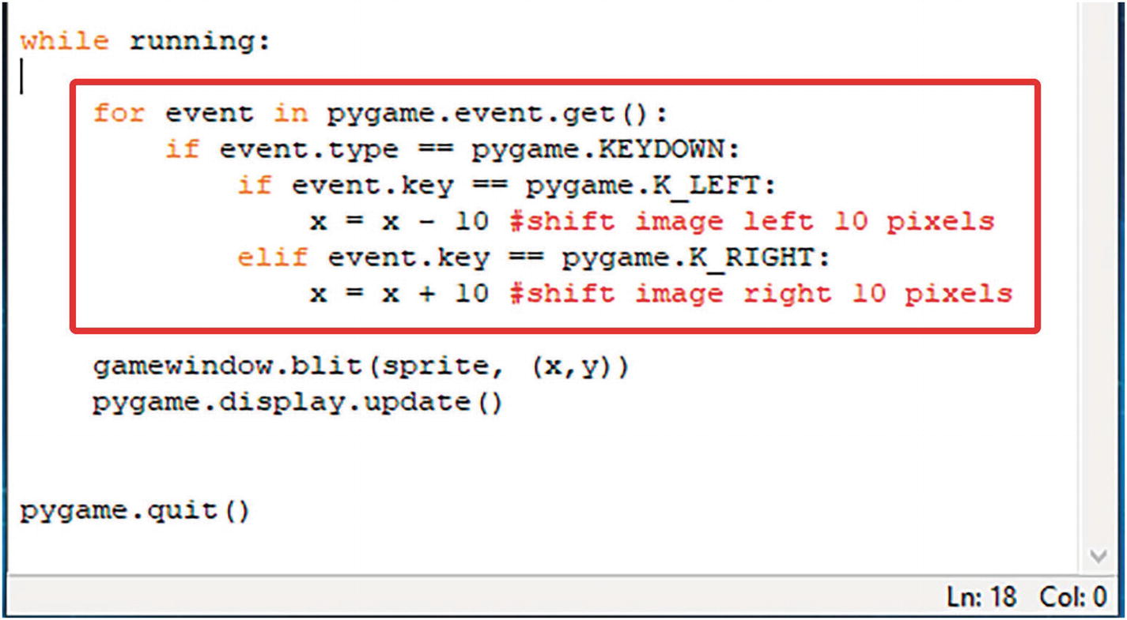
Now, when we run the program , you’ll see your rocket move left when you press the left key and right when you press the right key.
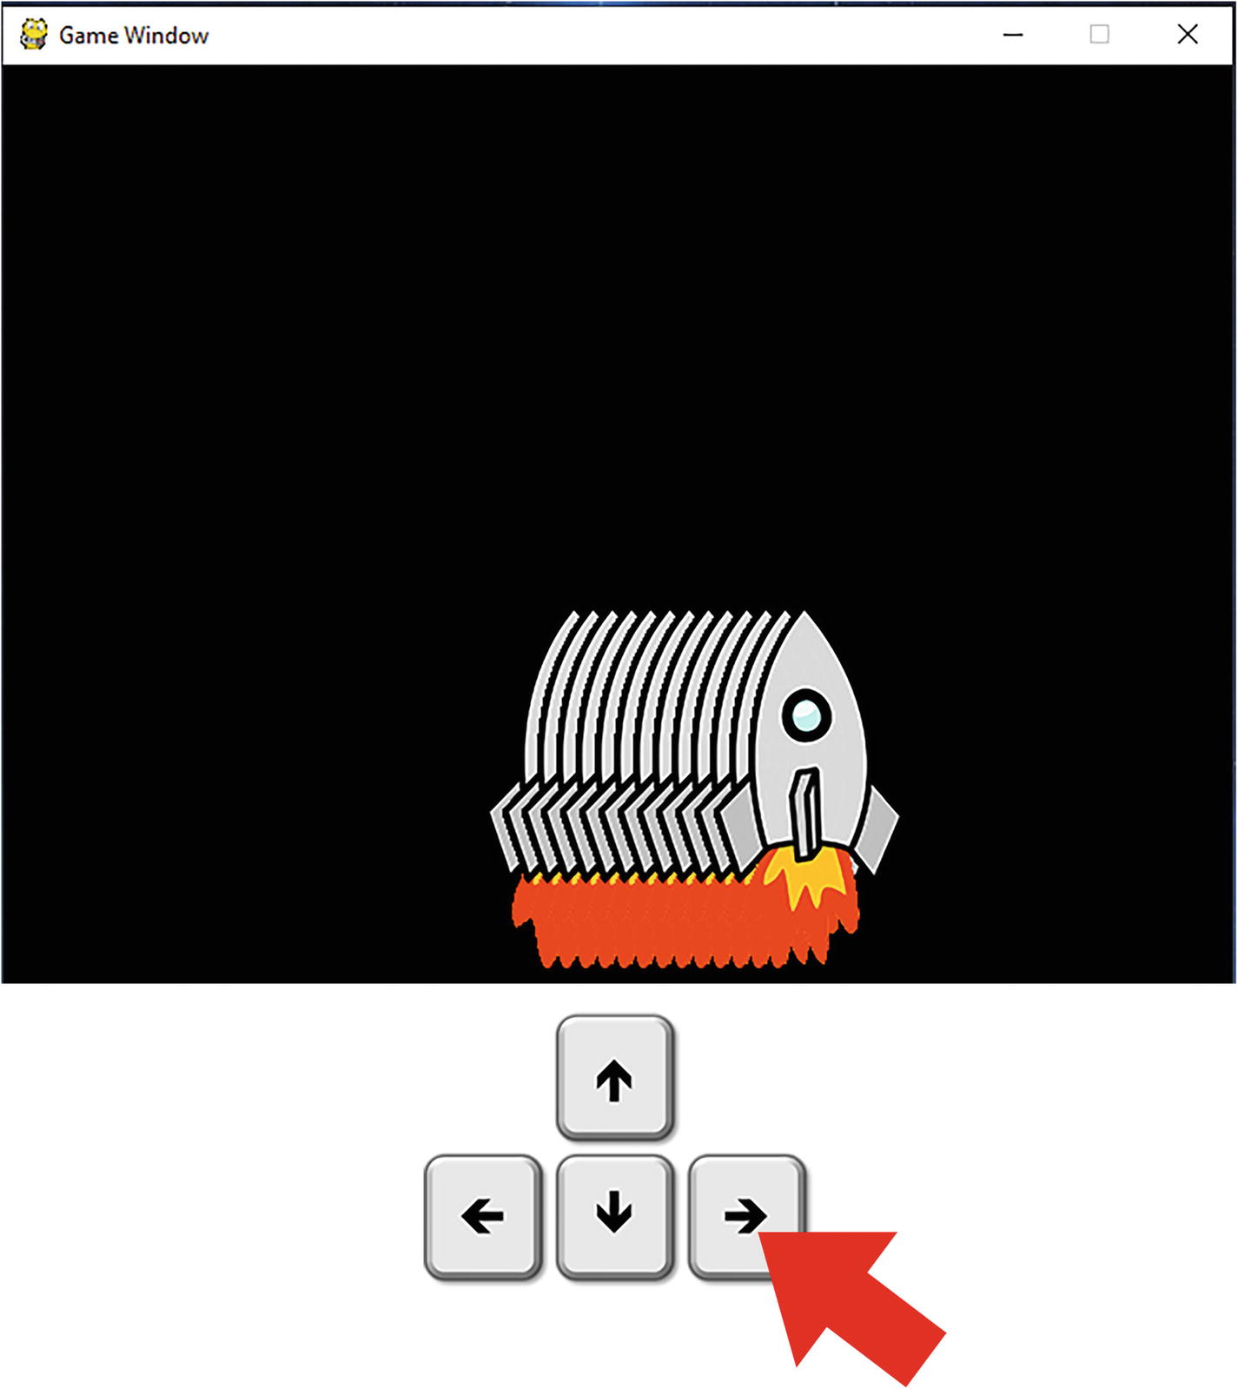
You’ll also notice something else. The image repeats on the screen. To fix this, you need to clear the screen (refresh) each time you move the object. You can use
gamewindow.fill((0,0,0))
This returns the screen to black at the end of each iteration of the game loop (while loop).
It is also good practice to include a quit event in your event loop, so the program terminates gracefully:
if event.type == pygame.QUIT:
running = 0
This will set our running variable to 0, meaning the game loop will terminate and the program will close. This event will happen when you click the close icon on the top right of the window.
Let’s take a look at the program so far.
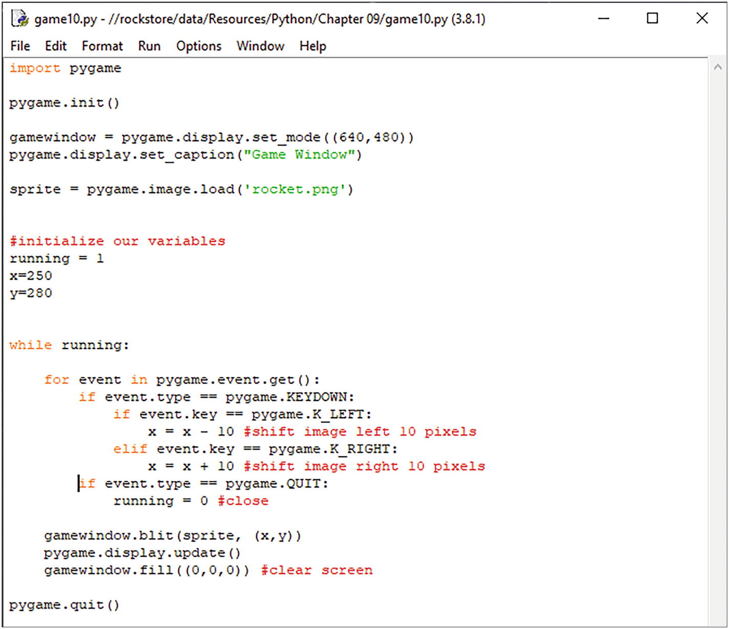
You’ll also notice that the rocket doesn’t move when you hold the key down. This is because the key-repeat feature is turned off. To turn this on, add the following line before your game loop:
pygame.key.set_repeat(1, 25)
The first parameter is the delay before the key event is repeated. The second parameter is the interval between repeats.

Shapes
You can add shapes such as circles, ellipses, rectangles, and other polygons.
To draw a rectangle, use the .rect() method. Specify the surface or window you want to draw on, the color, and then specify the x and y position, followed by the width and length of the rectangle.
pygame.draw.rect(gamewindow, colour,
(x, y, width, length), thickness)
To draw an ellipse, use the .ellipse() method. When drawing an ellipse, you’re actually drawing it inside an invisible rectangle. This is why you specify width and length when drawing your ellipse.
pygame.draw.ellipse(gamewindow, colour,
(x, y, width, length), thickness)
To draw a circle, use the .circle() method. Specify the surface or window you want to draw on, the color, and then specify the x and y position, followed by the radius of the circle.
pygame.draw.circle(gamewindow, colour,
(x, y), radius, thickness)
Have a look at shapes.py.
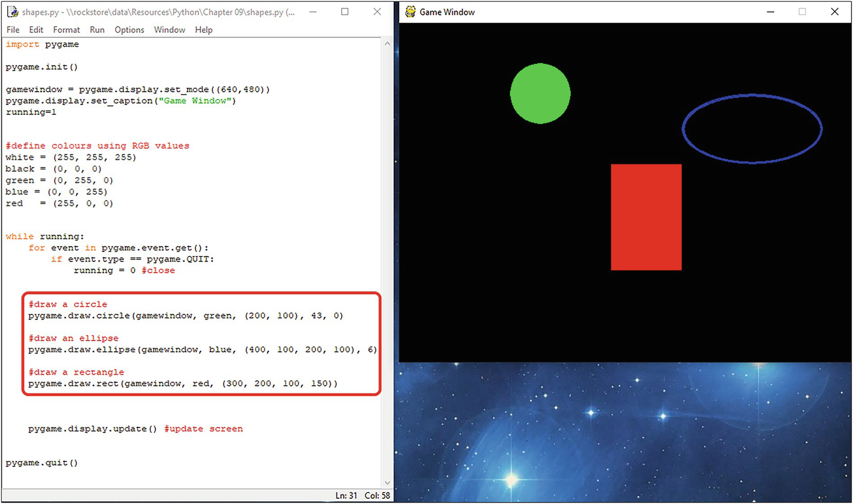

Basic Animation
To demonstrate basic animation, we’re going to move our ufo object on the screen.
First, we need to load in our image. You can do this using the .load() method as we’ve done before.
ufo = pygame.image.load('ufo.png')
Now, because an image is loaded onto a surface object by default, we can’t move it or manipulate it. To get around this, we assign the image to a rectangle. You can do this using the .rect() method .
ufo_rect = ufo.get_rect()
We also need to define some speed and direction variables. We can do this with a list. This is a list containing the [x, y] coordinates on the screen (speed[0] is x, speed[1] is y).
speed = [10, 0]
To move the object, use the .move_ip() method :
ufo_rect.move_ip(speed)
Let’s take a look at the program. Have a look at anim02.py.
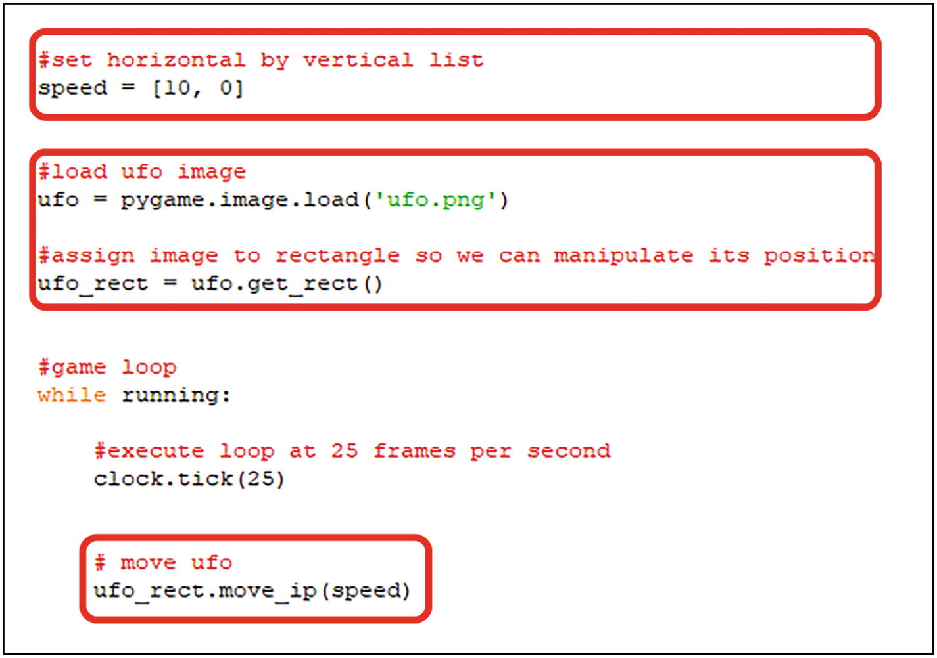
Now, when you run this program, the ufo will fly from left to right across the screen.
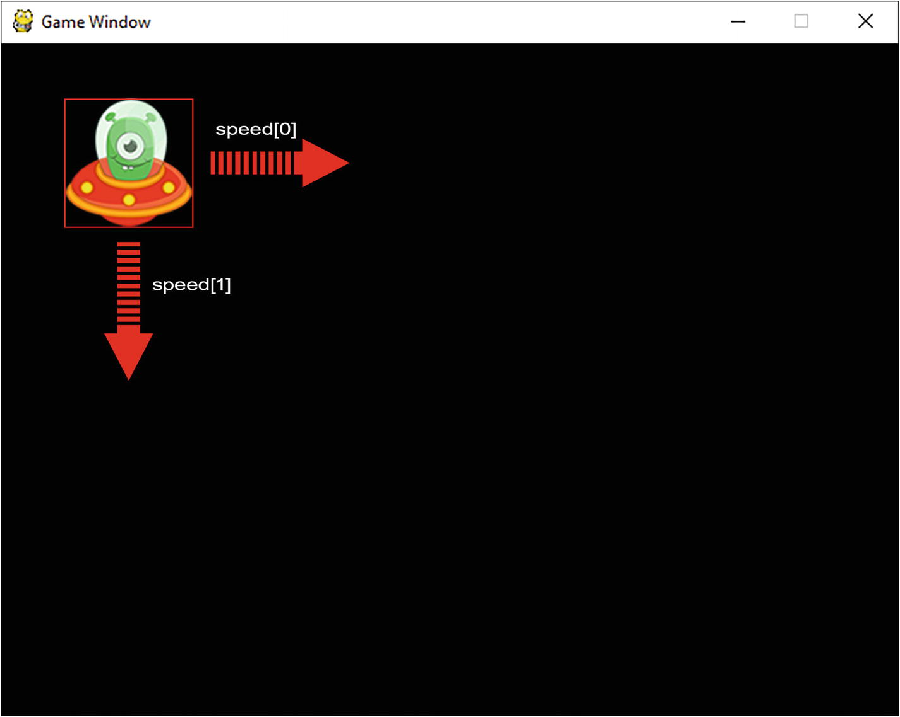
Because we set speed = [10, 0], this means we move our ufo ten pixels along the x axis each time we execute ufo_rect.move_ ip(speed) in the game loop.
If we set speed = [0, 10], this means we move our ufo ten pixels along the y axis each time we execute ufo_rect.move_ ip(speed) in the game loop.
Try changing the values in the program anim02.py and see what happens:
speed = [??, ??]
Try larger values.
Let’s take our program a step further. Let’s make the ufo bounce around the screen.
To do this, we need to check whether the left edge, right edge, top edge, and bottom edge of the ufo_rect go beyond the edges of the screen. We can use if statements for this.
If the left edge of the ufo goes off left edge, reverse x direction.
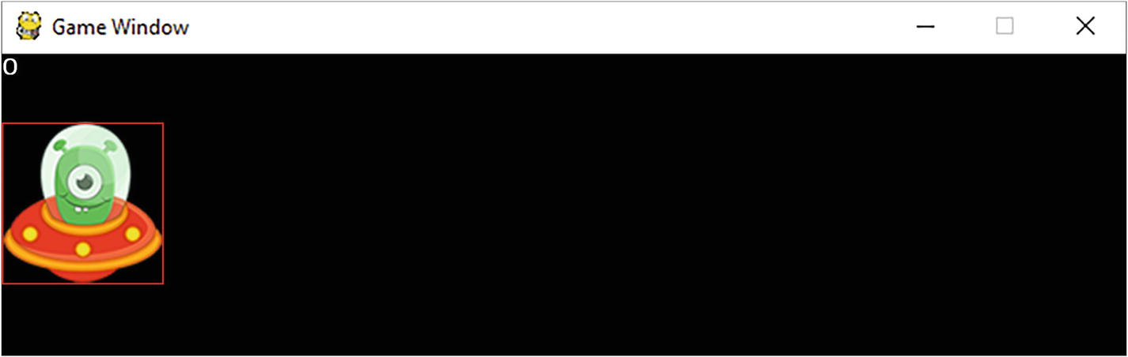
To reverse the direction , all you need to do is change the speed[0] to a negative number:
if ufo_rect.left < 0: speed[0] = -speed[0]
If the right edge of the ufo goes off right edge, reverse x direction.
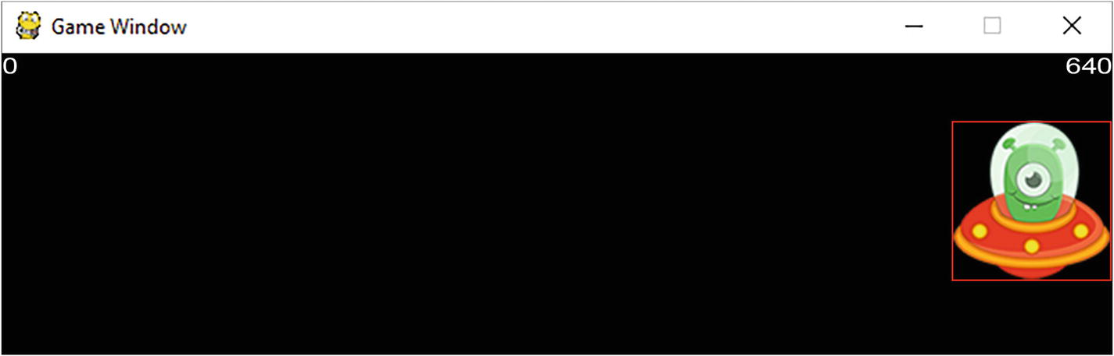
Again, change the speed[0] to a negative number:
if ufo_rect.right > 640: speed[0] = -speed[0]
Do the same with the top and bottom. Give it a try.
Let’s take a look at the program . Open anim03.py. Here, you’ll see the ufo bounce around the screen.
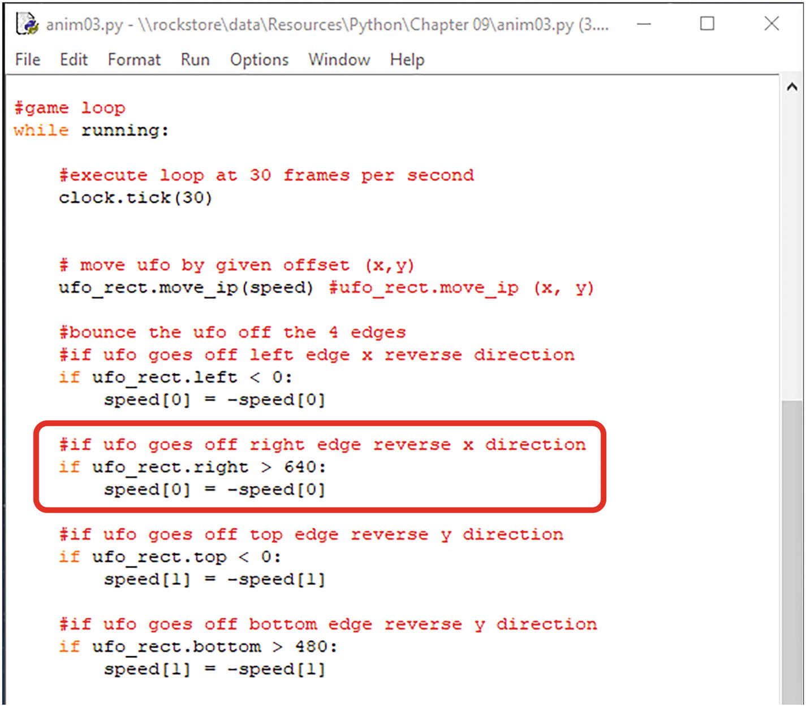
When the ufo moves toward the right wall, x (speed[0]) is increasing and y (speed[1]) is increasing.
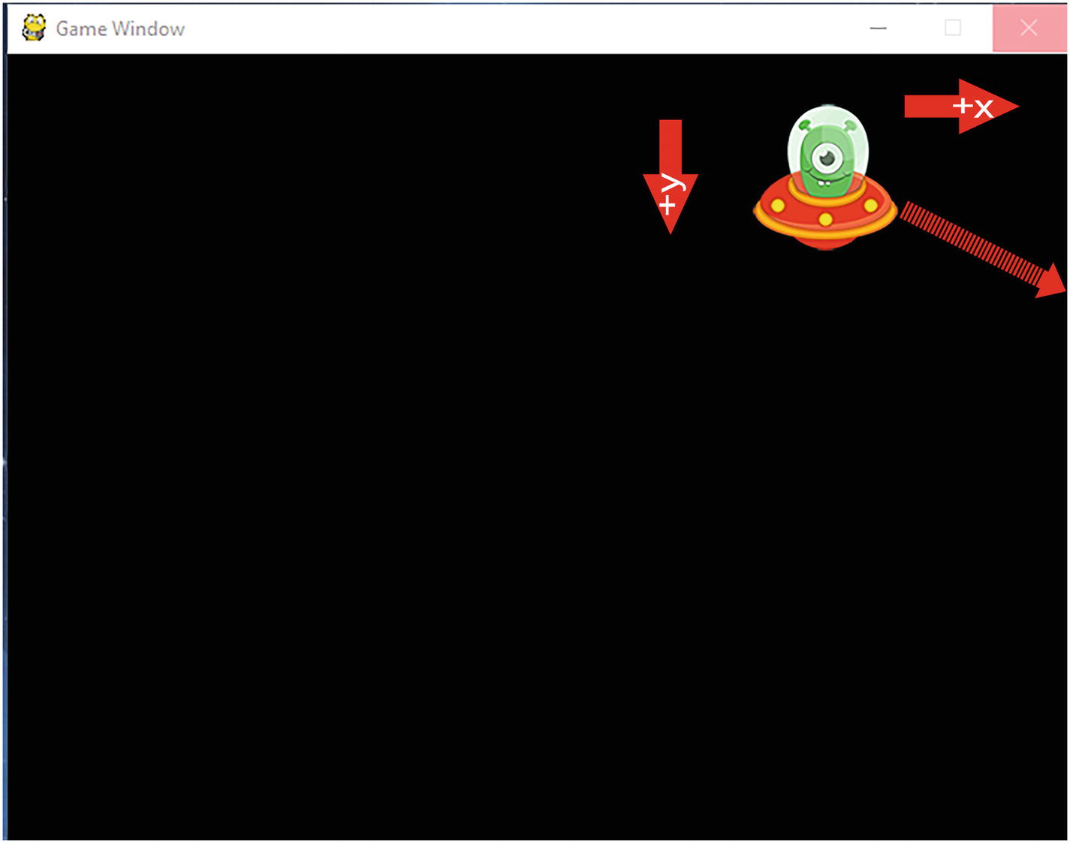
When the ufo hits the right wall, we change the direction of x (speed[0]), but not y (speed[1]).
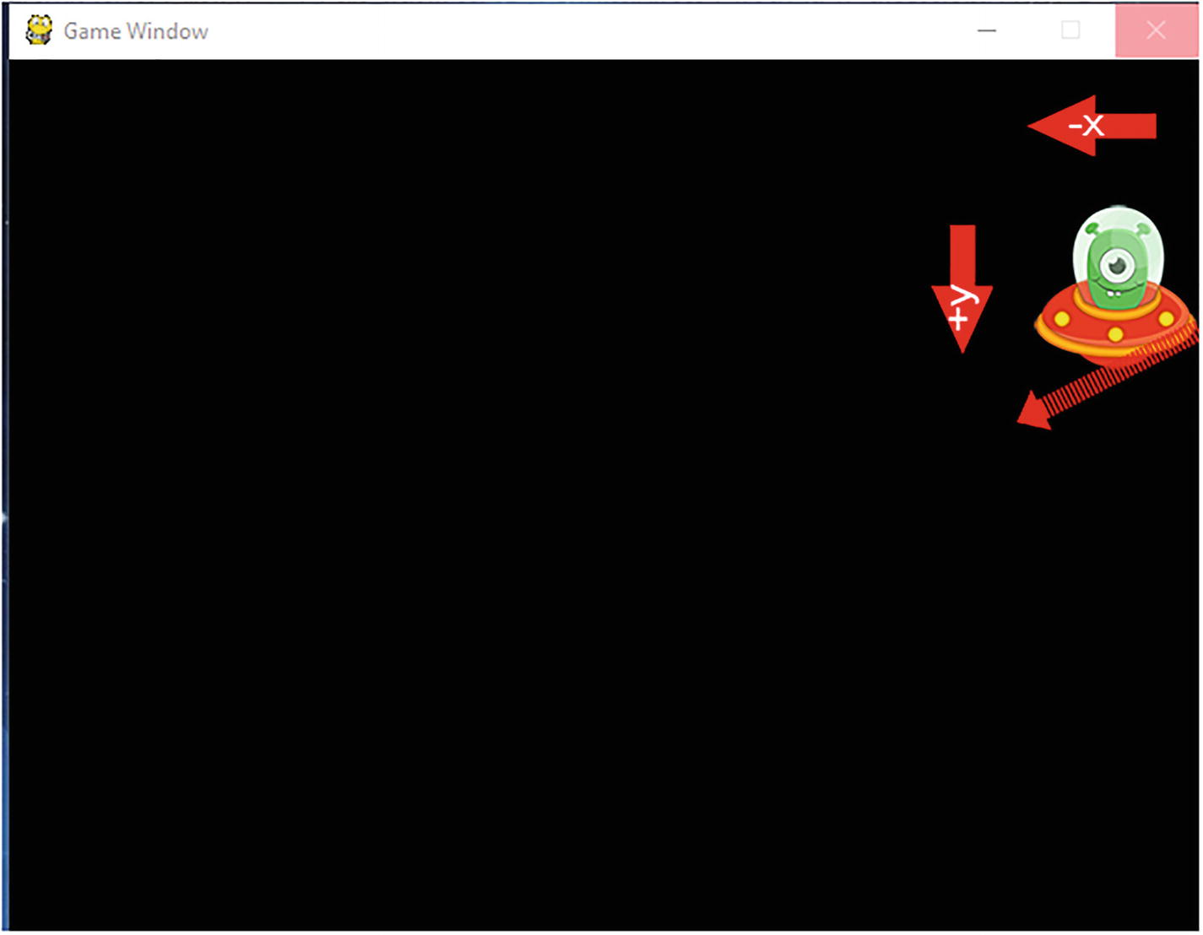
Now x (speed[0]) is decreasing, but y (speed[1]) is still increasing. Similarly for the other three sides.
What happens if you change the speed[ ] variables?
speed = [??, ??]
How would we add another ufo?
How would we add our rocket ship from the previous section?
To animate a character, you need to load your frames into a list:
frames = [pygame.image.load('frame1.png'),
pygame.image.load('frame2.png'),
pygame.image.load('frame3.png')]
Now, inside your main game loop, you can draw the frame using the .blit() method to draw the frame from the frames list:
gamewindow.blit(frames[counter], (x,y))
Select next frame in list, and loop back to first frame at the end of the list. We can do this with the len() function to return the number of frames in the list and modulus division.
counter = (counter + 1) % len(frames)
Let’s take a look at the program . Open spriteanim.py.
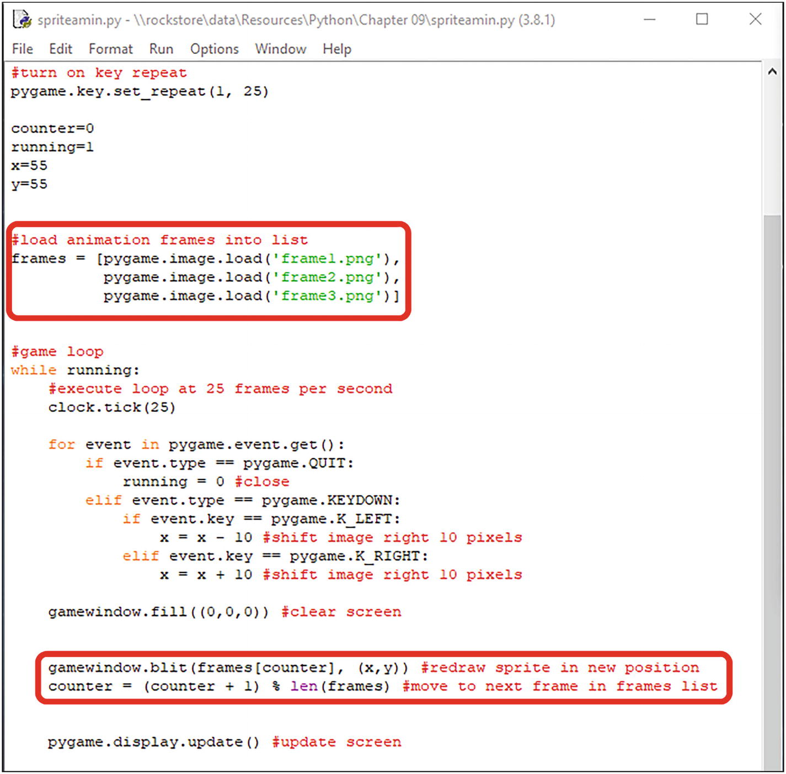
With this particular animation, we have three frames to animate the flame effect on the rocket.
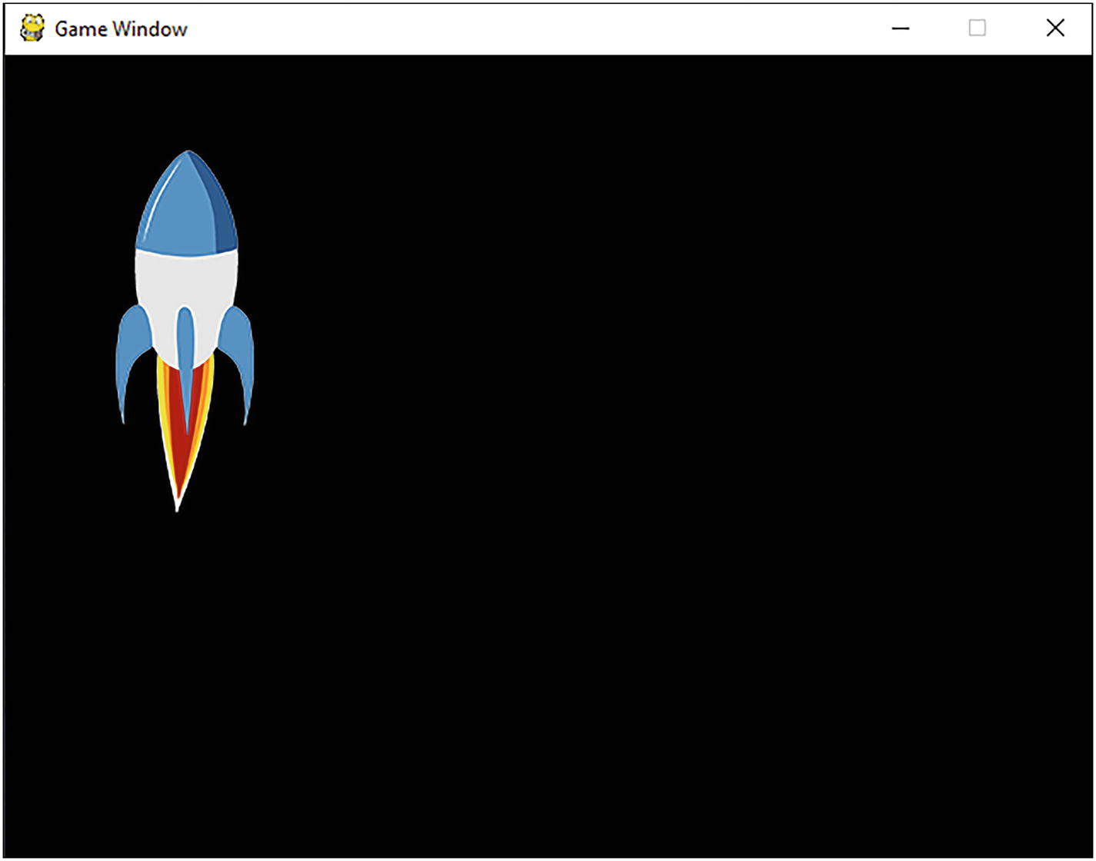

Summary
In this chapter, you learned that
Pygame is a library of Python modules designed for writing computer games. Pygame adds functionality to create fully featured games and multimedia applications using the Python language.
The game loop is used to draw our sprites, update the screen, and keep the program running.
The event loop checks for events such as a keypress.
The refresh rate is how fast the screen is redrawn.
© The Author(s), under exclusive license to APress Media, LLC, part of Springer Nature 2022
K. WilsonThe Absolute Beginner's Guide to Python Programming
https://doi.org/10.1007/978-1-4842-8716-3_12

12. Python Web Development
Kevin Wilson1
(1)
London, UK

Python is widely used for developing large-scale web applications that are not possible to build using .NET and PHP.
Python supports features that are executed with different frameworks such as Django, Flask, Pyramid, and CherryPy commonly used in sites such Spotify and Mozilla.
You’ll also need the source files in the directory Chapter11.

Web Servers
Most Python web applications are executed on a web server through an interface called WSGI (web server gateway interface ). Other Python scripts are executed through CGI (common gateway interface ).
Here, we’ve installed the Python interpreter and enabled the WSGI adapter module for the Apache web server.
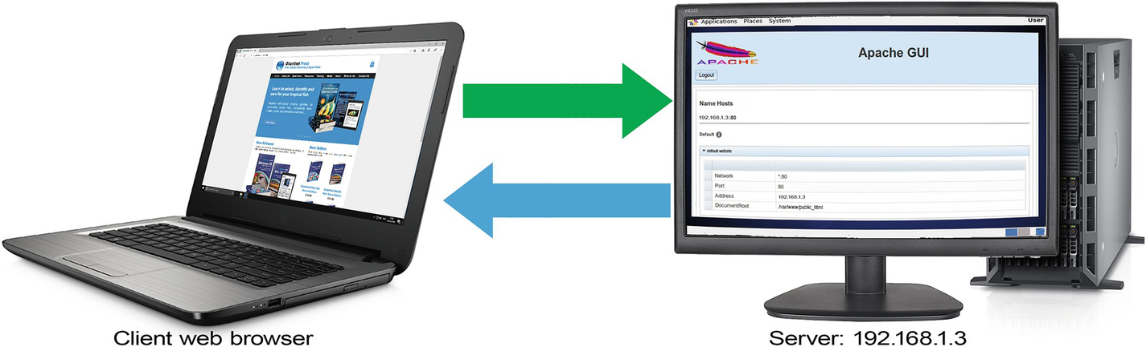
Figure 12-1An example of connecting to a web server on another machine
For this section, you’ll need access to a web server with Python support.
There is a free web server available from Aprelium called Abyss Web Server X1 that you can install on your computer to develop and test websites:
aprelium.com/downloads/
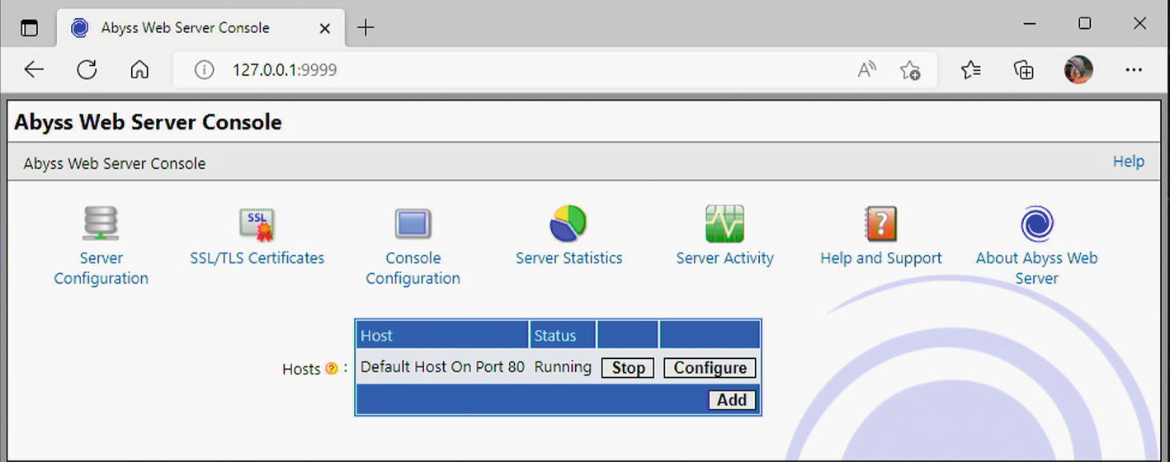
Figure 12-2The Aprelium web server running on a local computer

Install the Web Server

1. | Open the directory where you have saved the software package.
2. | Double-click the software package icon.
3. | Deselect components you do not want to install. Auto start enables Abyss Web Server auto starting when a Windows session starts – deselect this. Start Menu Shortcuts enables adding Abyss Web Server shortcuts in the Start Menu. Documentation installs help files.
4. | Click Next.
5. | Choose a directory where you want to install Abyss Web Server files. From now on, <Abyss Web Server directory> will refer to this directory.
6. | Click Install.

Set Up Python Support

1. | Open the Abyss Web Server’s Console. Make sure the web server is running, then open your web browser, then enter the following in the address field at the top: 127.0.0.1:9999.  Type in the admin password you created when you installed the server.
2. | In the Hosts table, click Configure in the row corresponding to the host to which you want to add Python support.
3. | Select Scripting Parameters.
4. | Check Enable Scripts Execution.
5. | Click Add in the Interpreters table.
6. | Set Interface to CGI/ISAPI.
7. | In the Interpreter field, click Browse..., go to the directory where you have installed Python, and click on python.exe.
8. | Check Use the associated extensions to automatically update the Script Paths .
9. | Click Add in the Associated Extensions table.
10. | Enter py in the Extension field and click OK.
11. | Click OK on interpreters screen.
12. | Click OK in the Scripting Parameters screen.
13. | Select Index Files.
14. | Click Add in the Index Files table.
15. | Enter index.pj in the File Name field, click OK. Then click OK in the index files screen.
16. | Click Restart to restart the server.
Upload your scripts to your public_html directory on the server; then on your computer, open a web browser and enter the URL to your script:
http://server-name/script-name.py
For example:
http://titan/script.py
If you’re using aprelium personal server on your own computer you can use
http://localhost/script.py
To start writing your Python scripts , you’ll need to tell the web server where to find the Python interpreter. This is usually
#!/python/python
or on a Linux server
#!/usr/bin/python
This is the first line of your script.

Executing a Script
Let’s take a look at an example. Have a look at script.py. Here, we’ve written a script to output a simple HTML page.
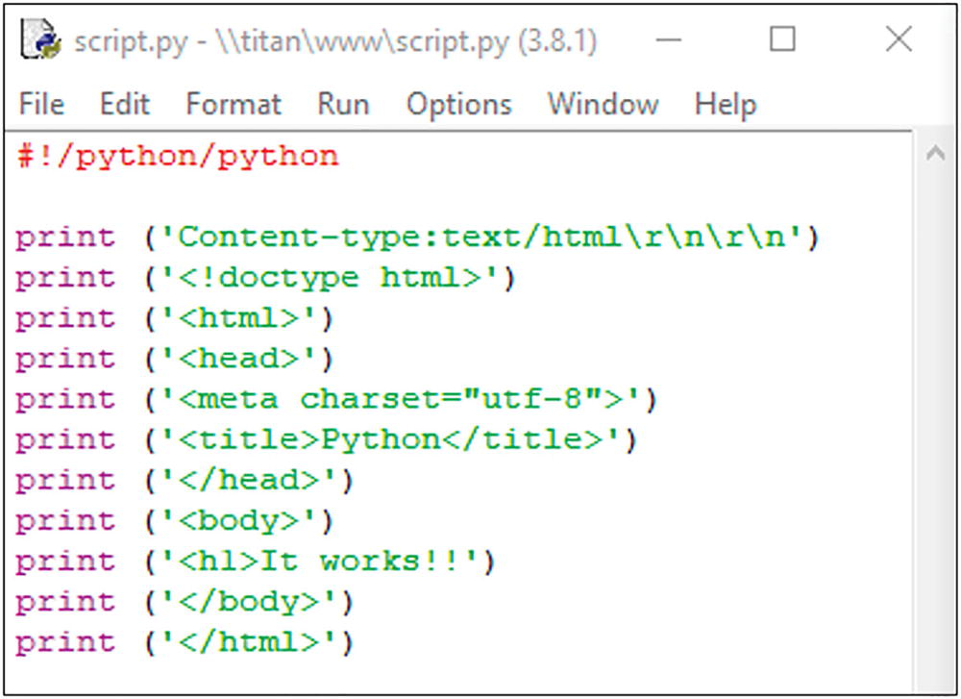
This page simply outputs the heading “It works!!.” Upload the script into your public_html directory on your web server, and then navigate to the script URL using your web browser on your computer.
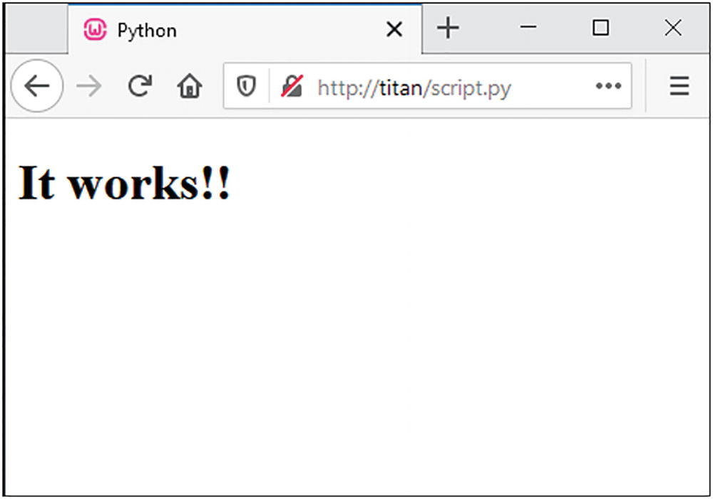
In our lab URL , this would be
http://titan/script.py
Let’s take a look at a practical example. Here, we’re creating a simple contact form . The user is presented with an HTML form that asks for their name, email address, and a message.
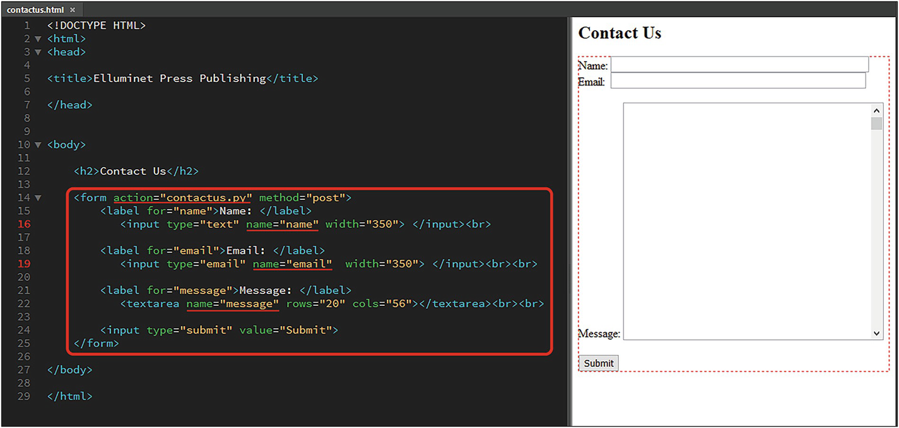
When the user clicks the “Submit” button, the HTML form calls a Python script called contactus.py .
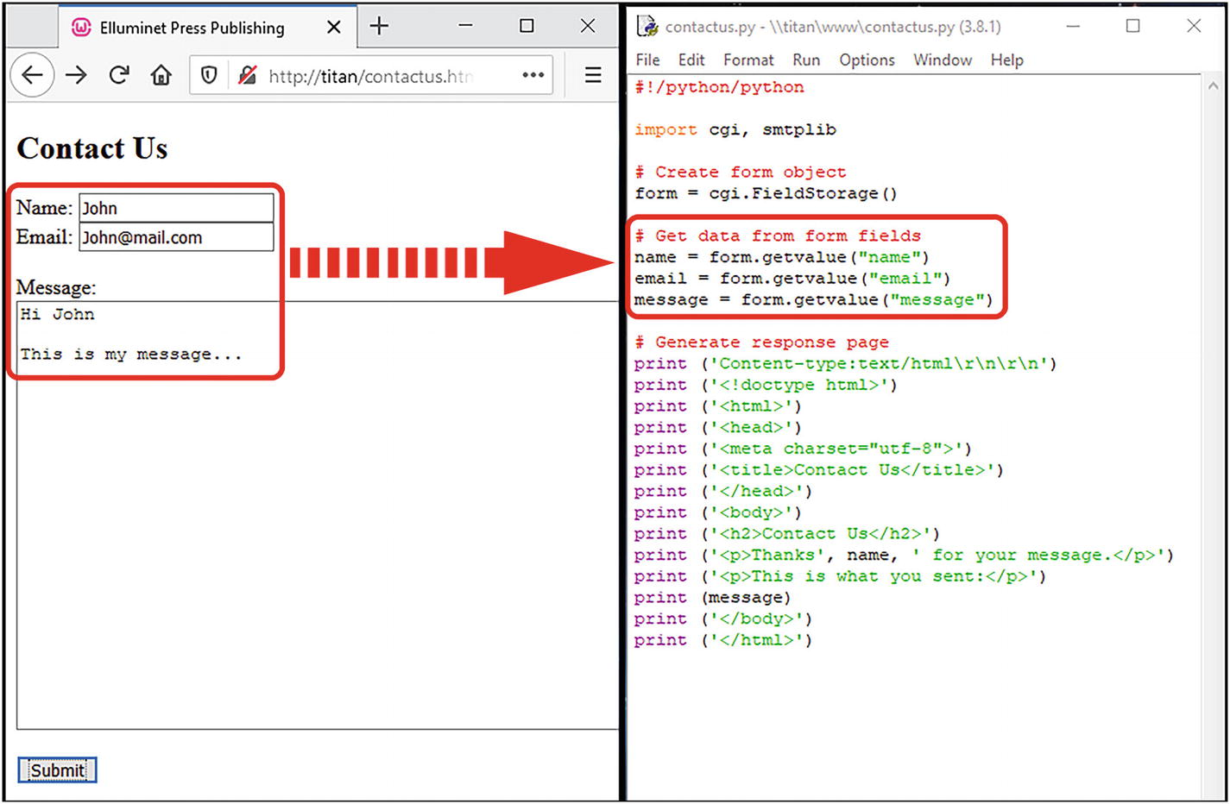
The Python script processes the data passed from the HTML form and stores it in a form object.
We can then get the values passed from the HTML form and store them in this object.
The Python script generates another HTML page using print statements for the response to the user.
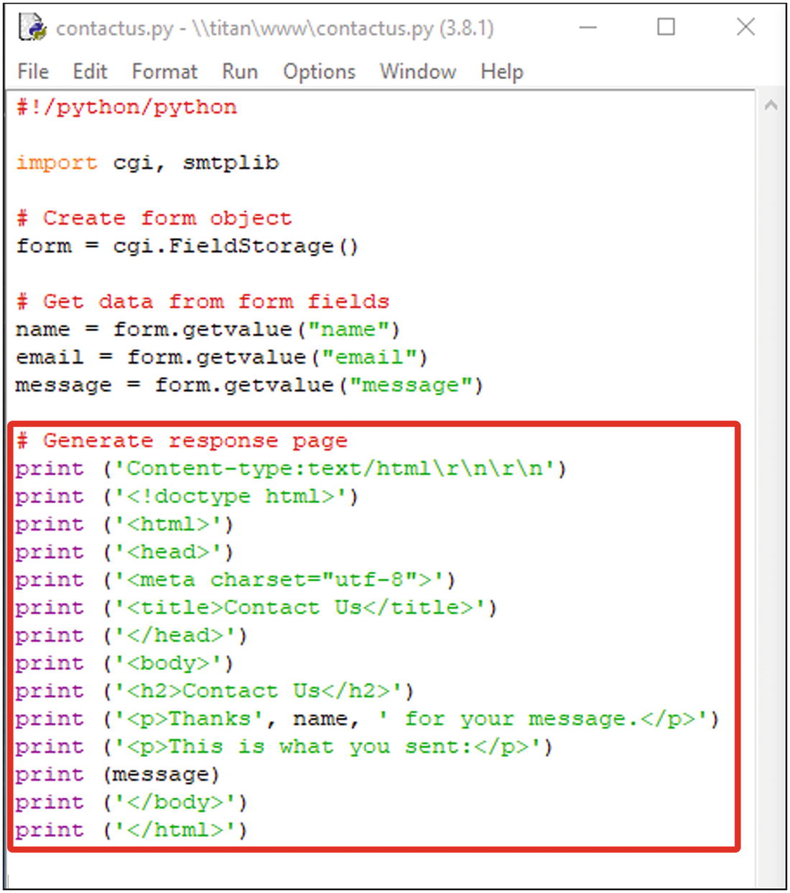
You can see the output in the following browser.
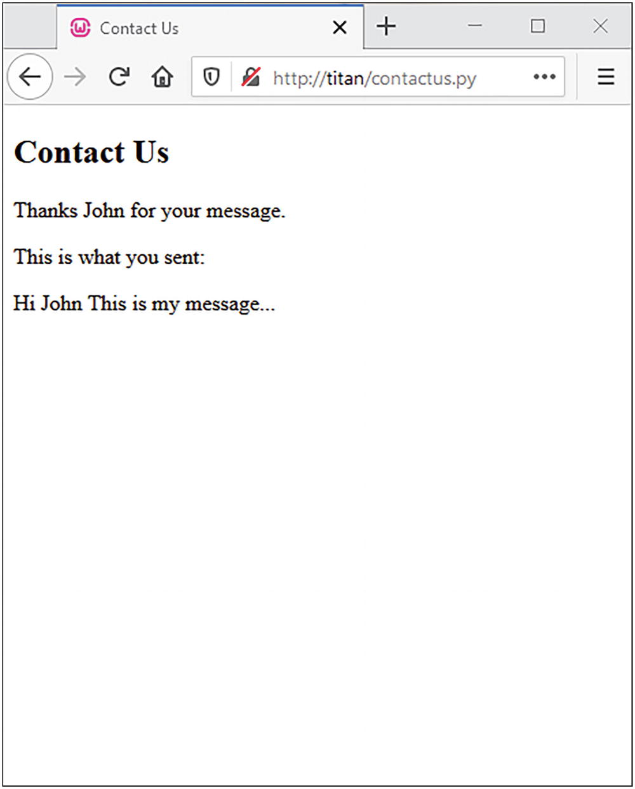

Python Web Frameworks
If you are using Python in web development, you’ll more than likely be using a Python web framework rather than the old CGI we looked at in the previous section.
A Python web framework is a collection of tools, libraries, and technologies that allow you to build a web application.
One example of a Python web framework is Django (pronounced “Jango”).
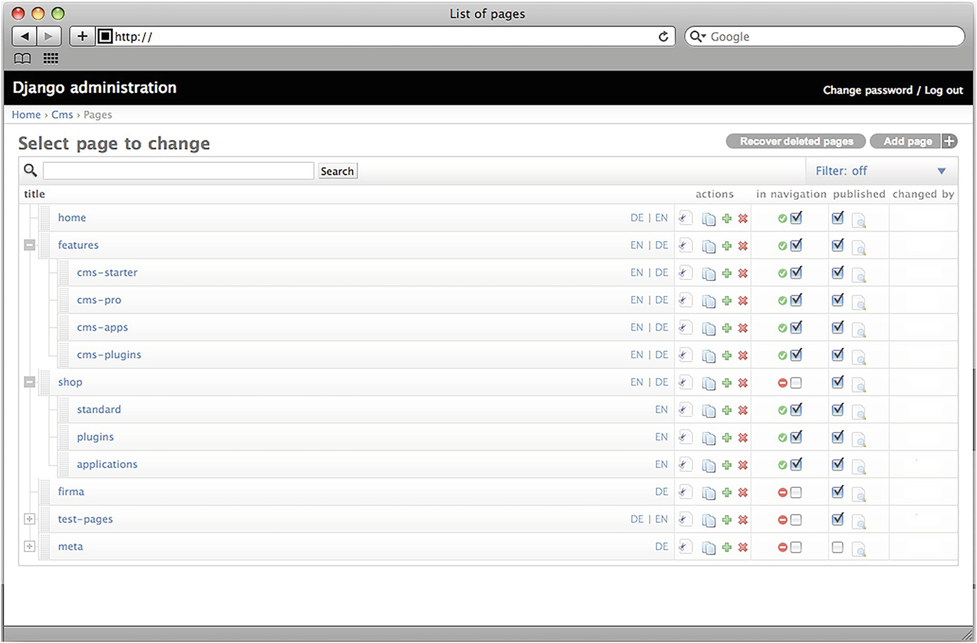
Another example is Flask . Let’s take a look at how to create a simple web app using this framework.
The first thing you’ll need to do is install the Flask module if you haven’t already done so. Use the following command in the admin command prompt:
pip install Flask
Use this if you’re on a Linux-based machine:
sudo pip install Flask
Let’s create an app. First thing we need to do is create our main program. To do this, we create a new file called app.py . We’ve included all these files in the Flask directory in the resource files.
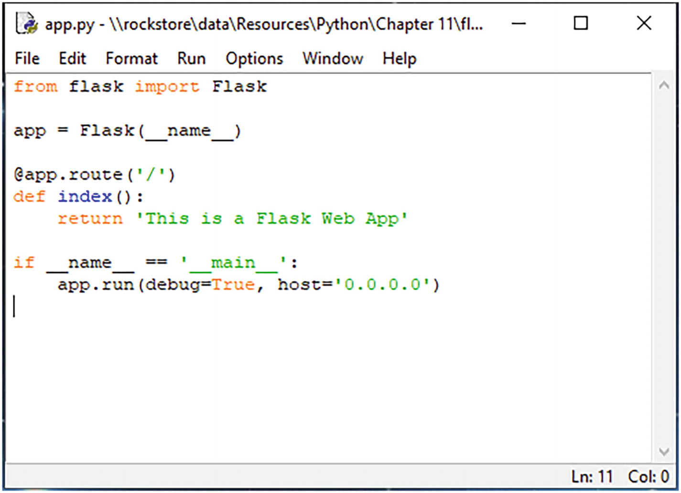
Here, we’ve imported our Flask module.
Modern web apps use a technique called routing . This means instead of having a URL to a page
localhost/resources.php
we use a route
localhost/resources/
So our first route is the root of our website and is usually the index page. We use @app.route('/') to determine this.
The “/” means the root of the website:
http://localhost:5000/
def index() is the name you give to the route defined earlier. This one is called index, because it’s the index (or home page) of the website.
host='0.0.0.0' means the app is accessible from any machine on the network.
To run and test the app , we need to open it using the development environment. This is a simple web server that allows you to open the app in a web browser for testing.
To do this, open your app directory in the command prompt. In this particular example, the app files are in OneDrive/Documents/Flask.
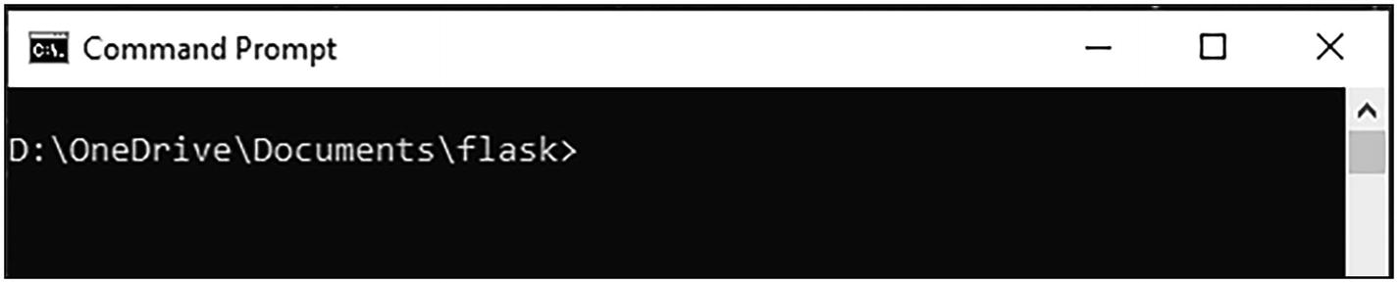
To start the app, type
python app.py
Once you press Enter, the server will start.
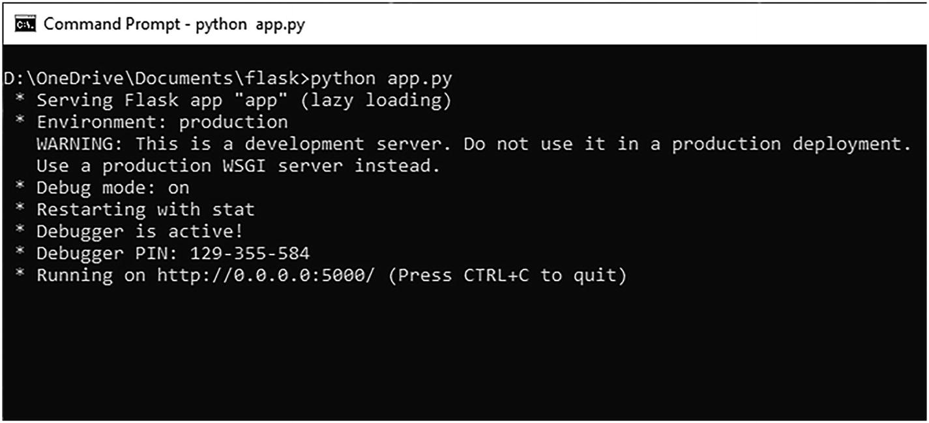
You can open the app in a web browser. On your own workstation, you can use localhost: 5000 :
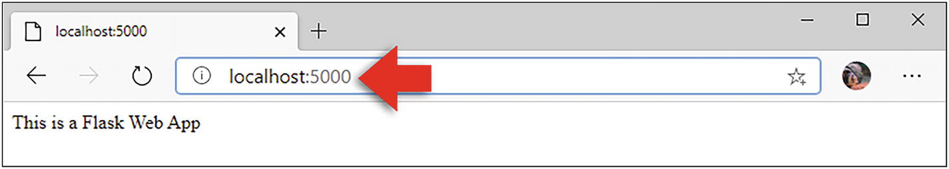
To add another page, add another route.
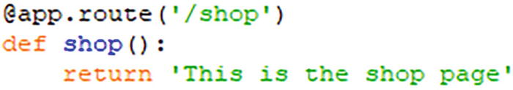
Now in the web browser, you can use
localhost:5000/shop
Now that we have our base app, we can develop web pages for the app to call. These web pages are called templates and we store these in a template directory. Here’s a simple HTML page we’ve created and saved in the templates directory.
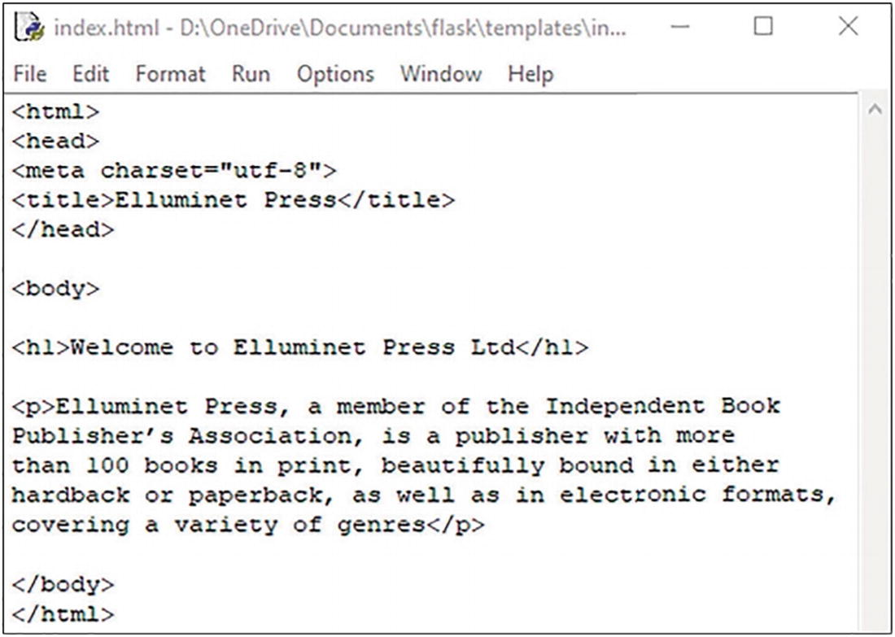
Let’s call our HTML page from our app. We can use the render_ template() function .
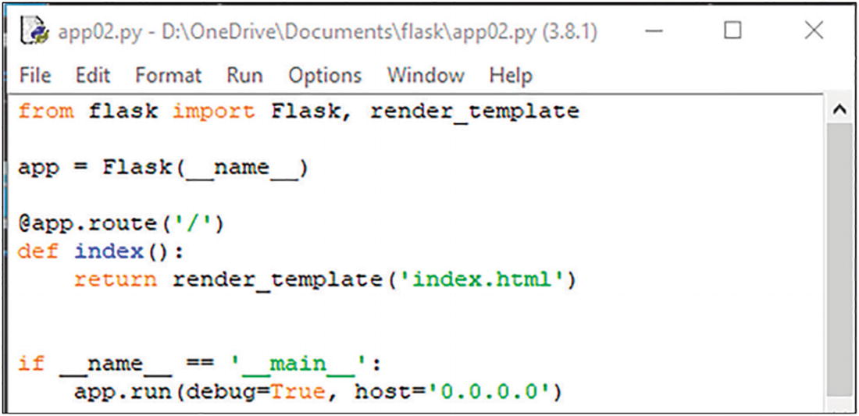
When we view the page in a browser, we’ll see a rendered version of the HTML page.
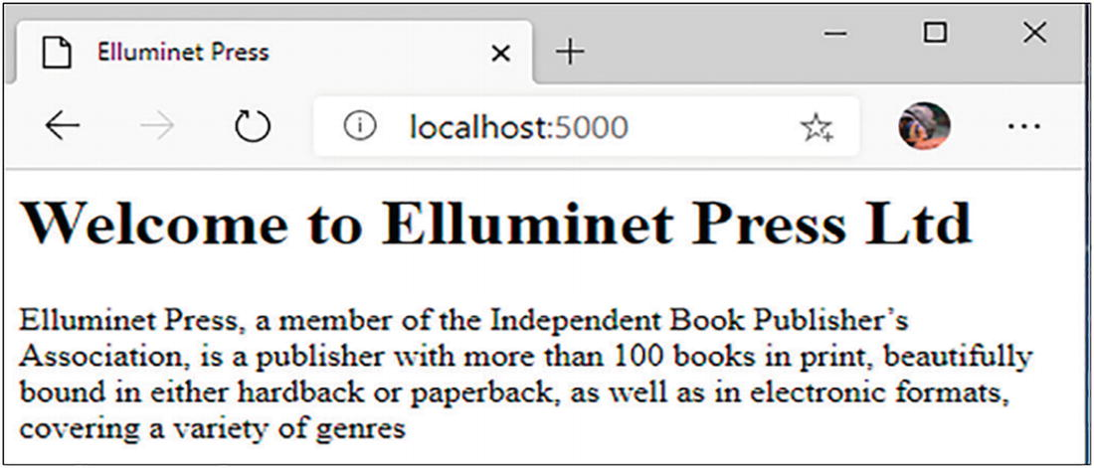
You can pass variables to your HTML templates. To do this, embed the variable using {{variable-name}} in your HTML.
Then add the variable as a parameter to the render_template() function:
render_template('index.html', variable-name = "...")
Let’s take a look at an example. Open the file app3.py and index2.html .
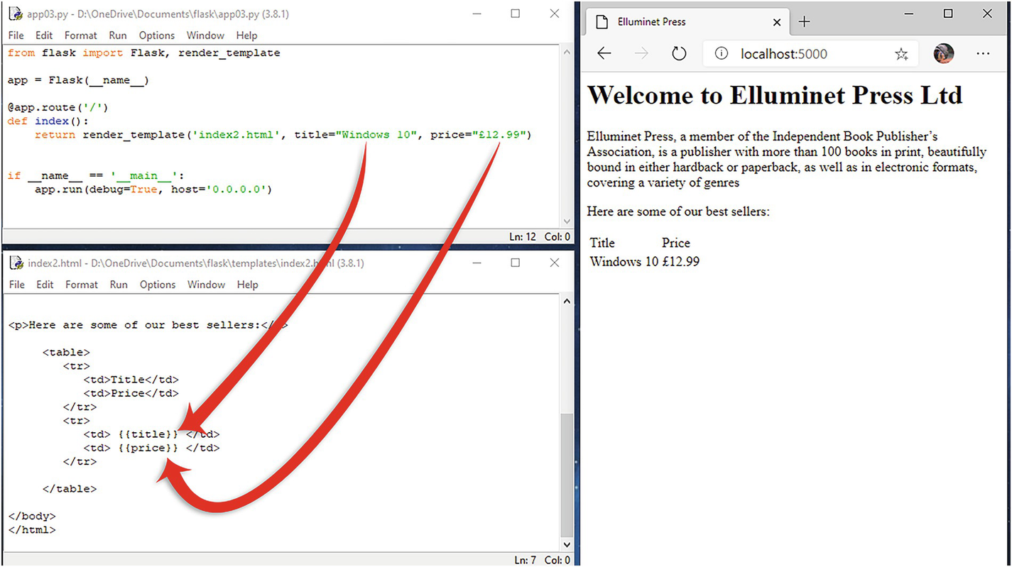
Here , we’ve passed the title and price as variables to the HTML template.
You can add images to your templates using HTML and CSS code. You can also embed Python code.

Summary
In this chapter, you learned that
Django, Flask, Pyramid, and CherryPy are common Python web development frameworks.
Most Python web applications are executed on a web server through an interface called WSGI (web server gateway interface).

Appendix A: Quick Reference
Some of the most commonly used data types, operators, methods, functions, and loop constructs to help you when writing your programs.

Data Types

int = 45
float = 45.2123
str = "this is a string"
list = [ item1, item2, ... ]
tuple = ( item1, item2, ... )
dict = { key1:item1, key2:item2, ...}
bool = True / False

Numeric Operators

Division /
Modulus Division %
Multiplication *
Exponent **
Addition +
Subtraction -

Comparison Operators

Equal to ==
Not equal to !=
Greater than >
Greater than or equal to >=
Less than <
Less than or equal to <=

Boolean Operators

not
and
or

String Operators

retrieve char at index string[index]
retrieve char in range string[a:b]

List Operators

define list list = []
assign x to list list[index] = x
retrieve from list list[index]
retrieve last item list[-1]
return items in range list[a:b]

Dictionary Operators

define dictionary dict = {}
assign x to key in dict dict[key] = x
retrieve item at key dict[key]

String Methods

convert to uppercase .upper()
convert to lowercase .lower()
return length of x .len(x)
Count times x occurs .count(x)

List Methods

add x to end of list .append(x)
insert x at y .insert(y,x)
pop item at x off list .pop(x)
clear all items .clear()
remove x from list .remove(x)

Dictionary Methods

return value at key .get(key)
remove item .pop(item)
display all values .values()

Functions

def function(<parameters>):
<function code>
return <data>

Files

open file open(<file>,<mode>)
read file .read()
read 1 line at a time .readline()
close file .close()
write data to file .write(<data>)
loop through lines for line in file:
<code>

Conditional

if <condition> :
<code>
else:
<code>

Multi-conditional

if <condition> :
<code>
elif <condition> :
<code>

While Loop

while <condition>:
<code>

For Loop

for <variable> in range:
<code>

Loop Control

break current loop break
continue to next iteration continue

Modules

import module
from module import *

Built-In Functions

get input from console input()
print data to console print(x)
convert x to integer int(x)
convert x to float float(x)
convert x to string str(x)
convert x to list list(x)
range a-b increments of c range(a,b,c)

Declare a Class

class class-name:
def_____init_____(self, <parameters>):
<initialize attributes>
<methods>

Child Class

class child-class(parent-class):

Create Object

object = class-name(<parameters>)

Call Object Method

object.method-name(<parameters>)

Access Object Attributes

object-name.attribute-name

Exceptions

try:
# Code to execute as normal except
exception (exception name]:
# Code to deal with exception
Index
A
Animation
.blit() method
direction
edges
frames
len() function
.load() method
.move_ip() method
program
.rect () method
speed
values
Arithmetic operators
performing
precedence
B
BIDMAS
Binary file
file modes
open() method
pickle.dump() method
pickle.read() method
.write() method
Bitwise operators
BODMAS
Boolean operators
break statement
C
Classes
Class inheritance
child class
definition
dot notation
lecturer object
Person class
super() class
Common gateway interface (CGI)
Comparison operators
Computer programming
install on Linux
install on MacOS
install on windows
languages
Python
variables/constants
continue statement
D
Data type
casting
dictionary
floating point number
integer
lists
sets
strings
tuples
E
elif statement
else statements
Exceptions
catching
definition
raising
types
uses
F
File access
.seek() method
text file
values
Flow control
for loop
Functions
declaration
definition
recursive
G
Global variables
Graphical user interface
designing
command button
convert() function
.current() method
.get() method
.grid() method
label
logo
Program, run
text field
window
.geometry() method
.grid() method
parameters
result
Tk() function
Tkinter
widgets
SeeWidgets
window
creation
.mainloop() method
position
size
.title() method
H
High-level language
I, J, K
if statements
Input data
Integrated development environment (IDE)
Integrated development environment (IDLE)
Iteration
for loop
while loop
L
Language classification
high-level
low-level
Lists
Local variables
Logical operators
Low-level language
M, N
Method overriding
Modules
creation
definition
importing
dot notation
forward() function
import keyword
namespace
output
right () function
turtle commands
O
Object-oriented programming (OOP)
abstraction
encapsulation
inheritance
polymorphism
Objects
Output data
P, Q
Polymorphic classes
Polymorphism
Pygame
event loop
elif statements
.get() method
if statement
parameters
program
termination
game loop
image, adding
installation
window, opening
Python
Python language syntax
code fragment
comments
escape character
identifiers
indentation
input
output
reserved words
write a program
Python supports
R
Recursive function
S
Scope
global
local
script.py
contact form
contactus.py
HTML
output
uploading
URL
Selection
elif statements
if/else statements
Sequence
Sets
Second-generation programming language
Shapes
Streaming services
Strings
T, U
Text file
characters
.close( ) method
file modes
open( ) method
.read() method
.write ( ) method
Two-dimensional lists
V
Variables
global
local
W, X, Y, Z
Web frameworks
app3.py/index2.html
definition
Django
Flask
render_ template() function
templates
variable, adding
web app
app.py
def index()
Flask module
localhost
routing
run/test
Web server gateway interface (WSGI)
Web servers
Abyss Web Server X1
connections
installation
while loop
Widgets
buttons
canvas
checkboxes
images
LabelFrame
labels
listbox
menus
message boxes
text field

