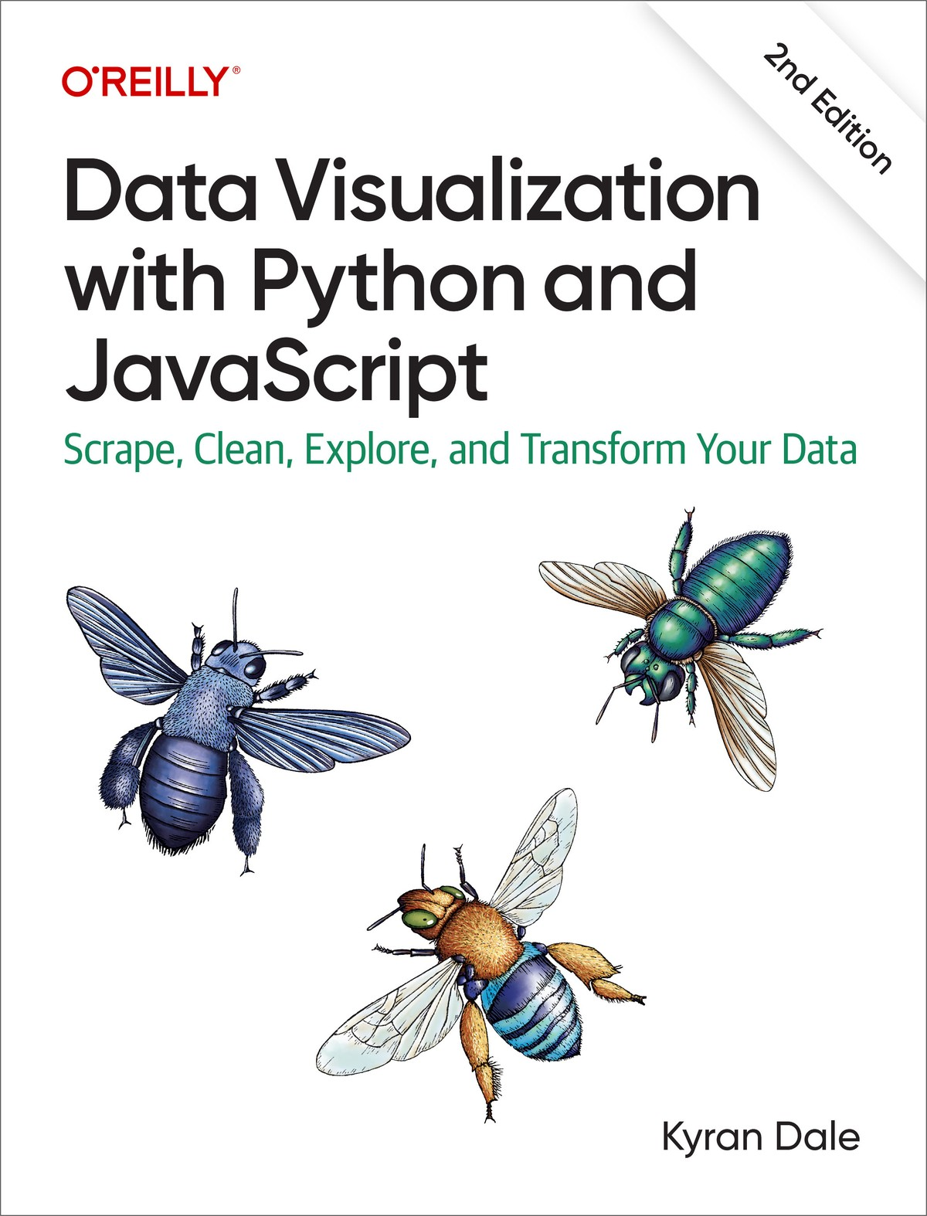

Table of Contents
Preface
Part I: Basic Toolkit
Part II: Getting Your Data
Part III: Cleaning and Exploring Data with pandas
Part IV: Delivering the Data
Part V: Visualizing Your Data with D3 and Plotly
The Second Edition
Conventions Used in This Book
Using Code Examples
O’Reilly Online Learning
How to Contact Us
Acknowledgments
Second Edition
Introduction
Who This Book Is For
Minimal Requirements to Use This Book
Why Python and JavaScript?
Why Not Python in the Browser?
Why Python for Data Processing
Python’s Getting Better All the Time
What You’ll Learn
The Choice of Libraries
Preliminaries
The Dataviz Toolchain
1. Scraping Data with Scrapy
2. Cleaning Data with pandas
3. Exploring Data with pandas and Matplotlib
4. Delivering Your Data with Flask
5. Transforming Data into Interactive Visualizations with Plotly and D3
Smaller Libraries
Using the Book
A Little Bit of Context
Summary
Recommended Books
I. Basic Toolkit
1. Development Setup
The Accompanying Code
Python
Anaconda
Installing Extra Libraries
Virtual Environments
JavaScript
Content Delivery Networks
Installing Libraries Locally
Databases
Getting MongoDB Up and Running
Easy MongoDB with Docker
Integrated Development Environments
Summary
2. A Language-Learning Bridge Between Python and JavaScript
Similarities and Differences
Interacting with the Code
Python
JavaScript
Basic Bridge Work
Style Guidelines, PEP 8, and use strict
CamelCase Versus Underscore
Importing Modules, Including Scripts
JavaScript Modules
Keeping Your Namespaces Clean
Outputting “Hello World!”
Simple Data Processing
String Construction
Significant Whitespace Versus Curly Brackets
Comments and Doc-Strings
Declaring Variables Using let or var
Strings and Numbers
Booleans
Data Containers: dicts, objects, lists, Arrays
Functions
Iterating: for Loops and Functional Alternatives
Conditionals: if, else, elif, switch
File Input and Output
Classes and Prototypes
Differences in Practice
Method Chaining
Enumerating a List
Tuple Unpacking
Collections
Underscore
Functional Array Methods and List Comprehensions
Map, Reduce, and Filter with Python’s Lambdas
JavaScript Closures and the Module Pattern
A Cheat Sheet
Summary
3. Reading and Writing Data with Python
Easy Does It
Passing Data Around
Working with System Files
CSV, TSV, and Row-Column Data Formats
JSON
Dealing with Dates and Times
SQL
Creating the Database Engine
Defining the Database Tables
Adding Instances with a Session
Querying the Database
Easier SQL with Dataset
MongoDB
Dealing with Dates, Times, and Complex Data
Summary
4. Webdev 101
The Big Picture
Single-Page Apps
Tooling Up
The Myth of IDEs, Frameworks, and Tools
A Text-Editing Workhorse
Browser with Development Tools
Terminal or Command Prompt
Building a Web Page
Serving Pages with HTTP
The DOM
The HTML Skeleton
Marking Up Content
CSS
JavaScript
Data
Chrome DevTools
The Elements Tab
The Sources Tab
Other Tools
A Basic Page with Placeholders
Positioning and Sizing Containers with Flex
Filling the Placeholders with Content
Scalable Vector Graphics
The <g> Element
Circles
Applying CSS Styles
Lines, Rectangles, and Polygons
Text
Paths
Scaling and Rotating
Working with Groups
Layering and Transparency
JavaScripted SVG
Summary
II. Getting Your Data
5. Getting Data Off the Web with Python
Getting Web Data with the Requests Library
Getting Data Files with Requests
Using Python to Consume Data from a Web API
Consuming a RESTful Web API with Requests
Getting Country Data for the Nobel Dataviz
Using Libraries to Access Web APIs
Using Google Spreadsheets
Using the Twitter API with Tweepy
Scraping Data
Why We Need to Scrape
Beautiful Soup and lxml
A First Scraping Foray
Getting the Soup
Selecting Tags
Crafting Selection Patterns
Caching the Web Pages
Scraping the Winners’ Nationalities
Summary
6. Heavyweight Scraping with Scrapy
Setting Up Scrapy
Establishing the Targets
Targeting HTML with Xpaths
Testing Xpaths with the Scrapy Shell
Selecting with Relative Xpaths
A First Scrapy Spider
Scraping the Individual Biography Pages
Chaining Requests and Yielding Data
Caching Pages
Yielding Requests
Scrapy Pipelines
Scraping Text and Images with a Pipeline
Specifying Pipelines with Multiple Spiders
Summary
III. Cleaning and Exploring Data with pandas
7. Introduction to NumPy
The NumPy Array
Creating Arrays
Array Indexing and Slicing
A Few Basic Operations
Creating Array Functions
Calculating a Moving Average
Summary
8. Introduction to pandas
Why pandas Is Tailor-Made for Dataviz
Why pandas Was Developed
Categorizing Data and Measurements
The DataFrame
Indices
Rows and Columns
Selecting Groups
Creating and Saving DataFrames
JSON
CSV
Excel Files
SQL
MongoDB
Series into DataFrames
Summary
9. Cleaning Data with pandas
Coming Clean About Dirty Data
Inspecting the Data
Indices and pandas Data Selection
Selecting Multiple Rows
Cleaning the Data
Finding Mixed Types
Replacing Strings
Removing Rows
Finding Duplicates
Sorting Data
Removing Duplicates
Dealing with Missing Fields
Dealing with Times and Dates
The Full clean_data Function
Adding the born_in column
Merging DataFrames
Saving the Cleaned Datasets
Summary
10. Visualizing Data with Matplotlib
pyplot and Object-Oriented Matplotlib
Starting an Interactive Session
Interactive Plotting with pyplot’s Global State
Configuring Matplotlib
Setting the Figure’s Size
Points, Not Pixels
Labels and Legends
Titles and Axes Labels
Saving Your Charts
Figures and Object-Oriented Matplotlib
Axes and Subplots
Plot Types
Bar Charts
Scatter Plots
seaborn
FacetGrids
PairGrids
Summary
11. Exploring Data with pandas
Starting to Explore
Plotting with pandas
Gender Disparities
Unstacking Groups
Historical Trends
National Trends
Prize Winners Per Capita
Prizes by Category
Historical Trends in Prize Distribution
Age and Life Expectancy of Winners
Age at Time of Award
Life Expectancy of Winners
Increasing Life Expectancies over Time
The Nobel Diaspora
Summary
IV. Delivering the Data
12. Delivering the Data
Serving the Data
Organizing Your Flask Files
Serving Data with Flask
Delivering Data Files
Dynamic Data with Flask APIs
A Simple Data API with Flask
Using Static or Dynamic Delivery
Summary
13. RESTful Data with Flask
The Tools for a RESTful Job
Creating the Database
A Flask RESTful Data Server
Serializing with marshmallow
Adding our RESTful API Routes
Posting Data to the API
Extending the API with MethodViews
Paginating the Data Returns
Deploying the API Remotely with Heroku
CORS
Consuming the API Using JavaScript
Summary
V. Visualizing Your Data with D3 and Plotly
14. Bringing Your Charts to the Web with Matplotlib and Plotly
Static Charts with Matplotlib
Adapting to Screen Sizes
Using Remote Images or Assets
Charting with Plotly
Basic Charts
Plotly Express
Plotly Graph-Objects
Mapping with Plotly
Adding Custom Controls with Plotly
From Notebook to Web with Plotly
Native JavaScript Charts with Plotly
Fetching JSON Files
User-Driven Plotly with JavaScript and HTML
Summary
15. Imagining a Nobel Visualization
Who Is It For?
Choosing Visual Elements
Menu Bar
Prizes by Year
A Map Showing Selected Nobel Countries
A Bar Chart Showing Number of Winners by Country
A List of the Selected Winners
A Mini-Biography Box with Picture
The Complete Visualization
Summary
16. Building a Visualization
Preliminaries
Core Components
Organizing Your Files
Serving the Data
The HTML Skeleton
CSS Styling
The JavaScript Engine
Importing the Scripts
Modular JS with Imports
Basic Data Flow
The Core Code
Initializing the Nobel Prize Visualization
Ready to Go
Data-Driven Updates
Filtering Data with Crossfilter
Running the Nobel Prize Visualization App
Summary
17. Introducing D3—​The Story of a Bar Chart
Framing the Problem
Working with Selections
Adding DOM Elements
Leveraging D3
Measuring Up with D3’s Scales
Quantitative Scales
Ordinal Scales
Unleashing the Power of D3 with Data Binding/Joining
Updating the DOM with Data
Putting the Bar Chart Together
Axes and Labels
Transitions
Updating the Bar Chart
Summary
18. Visualizing Individual Prizes
Building the Framework
Scales
Axes
Category Labels
Nesting the Data
Adding the Winners with a Nested Data-Join
A Little Transitional Sparkle
Updating the Bar Chart
Summary
19. Mapping with D3
Available Maps
D3’s Mapping Data Formats
GeoJSON
TopoJSON
Converting Maps to TopoJSON
D3 Geo, Projections, and Paths
Projections
Paths
graticules
Putting the Elements Together
Updating the Map
Adding Value Indicators
Our Completed Map
Building a Simple Tooltip
Updating the Map
Summary
20. Visualizing Individual Winners
Building the List
Building the Bio-Box
Updating the Winners List
Summary
21. The Menu Bar
Creating HTML Elements with D3
Building the Menu Bar
Building the Category Selector
Adding the Gender Selector
Adding the Country Selector
Wiring Up the Metric Radio Button
Summary
22. Conclusion
Recap
Part I: Basic Toolkit
Part II: Getting Your Data
Part III: Cleaning and Exploring Data with pandas
Part IV: Delivering the Data
Part V: Visualizing Your Data with D3 and Plotly
Future Progress
Visualizing Social Media Networks
Machine-Learning Visualizations
Final Thoughts
A. D3’s enter/exit Pattern
The enter Method
Accessing the Bound Data
Index
About the Author

Data Visualization with Python and JavaScript
Scrape, Clean, Explore, and Transform Your Data
Second Edition
Kyran Dale

Data Visualization with Python and JavaScript
by Kyran Dale
Copyright © 2023 Kyran Dale Limited. All rights reserved.
Published by O’Reilly Media, Inc., 1005 Gravenstein Highway North, Sebastopol, CA 95472.
O’Reilly books may be purchased for educational, business, or sales promotional use. Online editions are also available for most titles (http://oreilly.com). For more information, contact our corporate/institutional sales department: 800-998-9938 or corporate@oreilly.com.
- Acquisitions Editor: Michelle Smith
- Development Editor: Shira Evans
- Production Editor: Kristen Brown
- Copyeditor: Liz Wheeler
- Proofreader: Piper Editorial Consulting, LLC
- Indexer: Ellen Troutman-Zaig
- Interior Designer: David Futato
- Cover Designer: Karen Montgomery
- Illustrator: Kate Dullea
- July 2016: First Edition
- December 2022: Second Edition

Revision History for the Second Edition
- 2022-12-07: First Release
See http://oreilly.com/catalog/errata.csp?isbn=9781098111878 for release details.
The O’Reilly logo is a registered trademark of O’Reilly Media, Inc. Data Visualization with Python and JavaScript, the cover image, and related trade dress are trademarks of O’Reilly Media, Inc.
While the publisher and the author have used good faith efforts to ensure that the information and instructions contained in this work are accurate, the publisher and the author disclaim all responsibility for errors or omissions, including without limitation responsibility for damages resulting from the use of or reliance on this work. Use of the information and instructions contained in this work is at your own risk. If any code samples or other technology this work contains or describes is subject to open source licenses or the intellectual property rights of others, it is your responsibility to ensure that your use thereof complies with such licenses and/or rights.
978-1-098-11187-8
[LSI]

Preface
The chief ambition of this book is to describe a data visualization (dataviz) toolchain that, in the era of the internet, is starting to predominate. The guiding principle of this toolchain is that whatever insightful nuggets you have managed to mine from your data deserve a home on the web browser. Being on the web means you can easily choose to distribute your dataviz to a select few (using authentication or restricting to a local network) or the whole world. This is the big idea of the internet and one that dataviz is embracing at a rapid pace. And that means that the future of dataviz involves JavaScript, the only first-class language of the web browser. But JavaScript does not yet have the data-processing stack needed to refine raw data, which means data visualization is inevitably a multilanguage affair. I hope this book provides support for my belief that Python is the natural complementary language to JavaScript’s monopoly of browser visualizations.
Although this book is a big one (that fact is felt most keenly by the author right now), it has had to be very selective, leaving out a lot of really cool Python and JavaScript dataviz tools and focusing on the ones that provide the best building blocks. The number of helpful libraries I couldn’t cover reflects the enormous vitality of the Python and JavaScript data science ecosystems. Even while the book was being written, brilliant new Python and JavaScript libraries were being introduced, and the pace continues.
All data visualization is essentially transformative, and showing the journey from one reflection of a dataset (HTML tables and lists) to a more modern, engaging, interactive, and, fundamentally, browser-based one provides a good way to introduce key data visualization tools in a working context. The challenge is to transform a basic Wikipedia list of Nobel Prize winners into a modern, interactive, browser-based visualization. Thus, the same dataset is presented in a more accessible, engaging form.
The journey from unprocessed data to a fairly rich, user-driven visualization informs the choice of best-of-breed tools. First, we need to get our dataset. Often this is provided by a colleague or client, but to increase the challenge and learn some pretty vital dataviz skills along the way, we learn how to scrape the dataset from the web (Wikipedia’s Nobel Prize pages) using Python’s powerful Scrapy library. This unprocessed dataset then needs to be refined and explored, and there isn’t a much better ecosystem for this than Python’s pandas. Along with Matplotlib in support and driven by a Jupyter notebook, pandas is becoming the gold standard for this kind of forensic data work. With clean data stored (to SQL with SQLAlchemy and SQLLite) and explored, the cherry-picked data stories can be visualized. I cover the use of Matplotlib and Plotly to embed static and dynamic charts from Python to a web page. But for something more ambitious, the supreme dataviz library for the web is the JavaScript-based D3. We cover the essentials of D3 while using them to produce our showpiece Nobel data visualization.
This book is a collection of tools forming a chain, with the creation of the Nobel visualization providing a guiding narrative. You should be able to dip into relevant chapters when and if the need arises; the different parts of the book are self-contained so you can quickly review what you’ve learned when required.
This book is divided into five parts. The first part introduces a basic Python and JavaScript dataviz toolkit, while the next four show how to retrieve raw data, clean it, explore it, and finally transform it into a modern web visualization. Let’s summarize the key lessons of each part now.

Part I: Basic Toolkit
Our basic toolkit consists of:
- A language-learning bridge between Python and JavaScript. This is designed to smooth the transition between the two languages, highlighting their many similarities and setting the scene for the bilingual process of modern dataviz. With the advent of the latest JavaScript,1 Python and JavaScript have even more in common, making switching between them that much less stressful.
- Being able to read from and write to the key data formats (e.g., JSON and CSV) and databases (both SQL and NoSQL) with ease is one of Python’s great strengths. We see how easy it is to pass data around in Python, translating formats and changing databases as we go. This fluid movement of data is the main lubricant of any dataviz toolchain.
- We cover the basic web development (webdev) skills needed to start producing modern, interactive, browser-based dataviz. By focusing on the concept of the single-page application rather than building whole websites, we minimize conventional webdev and place the emphasis on programming your visual creations in JavaScript. An introduction to Scalable Vector Graphics (SVG), the chief building block of D3 visualizations, sets the scene for the creation of our Nobel Prize visualization in Part V.

Part II: Getting Your Data
In this part of the book, we look at how to get data from the web using Python, assuming a nice, clean data file hasn’t been provided to the data visualizer:
- If you’re lucky, a clean file in an easily usable data format (i.e., JSON or CSV) is at an open URL, a simple HTTP request away. Alternatively, there may be a dedicated web API for your dataset, with any luck a RESTful one. As an example, we look at using the Twitter API (via Python’s Tweepy library). We also see how to use Google spreadsheets, a widely used data-sharing resource in dataviz.
- Things get more involved when the data of interest is present on the web in human-readable form, often in HTML tables, lists, or hierarchical content blocks. In this case, you have to resort to scraping, getting the raw HTML content and then using a parser to make its embedded content available. We see how to use Python’s lightweight Beautiful Soup scraping library and the much more featureful and heavyweight Scrapy, the biggest star in the Python scraping firmament.

Part III: Cleaning and Exploring Data with pandas
In this part, we turn the big guns of pandas, Python’s powerful programmatic spreadsheet, onto the problem of cleaning and then exploring datasets. We first see how pandas is part of Python’s NumPy ecosystem, which leverages the power of very fast, powerful low-level array processing libraries, while making them accessible. The focus is on using pandas to clean and then explore our Nobel Prize dataset:
- Most data, even that which comes from official web APIs, is dirty. And making it clean and usable will occupy far more of your time as a data visualizer than you probably anticipated. Taking the Nobel dataset as an example, we progressively clean it, searching for dodgy dates, anomalous datatypes, missing fields, and all the common grime that needs cleaning before you can start to explore and then transform your data into a visualization.
- With our clean (as we can make it) Nobel Prize dataset in hand, we see how easy it is to use pandas and Matplotlib to interactively explore data, easily creating inline charts, slicing the data every which way, and generally getting a feel for it, while looking for those interesting nuggets you want to deliver with visualization.

Part IV: Delivering the Data
In this part, we see how easy it is to create a minimal data API using Flask, to deliver data both statically and dynamically to the web browser:
First, we see how to use Flask to serve static files and then how to roll your own basic data API, serving data from a local database. Flask’s minimalism allows you to create a very thin data-serving layer between the fruits of your Python data processing and their eventual visualization on the browser.
The glory of open source software is that you can often find robust, easy-to-use libraries that solve your problem better than you could. In the second chapter of this part, we see how easy it is to use best-of-breed Python (Flask) libraries to craft a robust, flexible RESTful API, ready to serve your data online. We also cover the easy online deployment of this data server using Heroku, a favorite of Pythonistas.

Part V: Visualizing Your Data with D3 and Plotly
In the first chapter of this part, we see how to take the fruits of your pandas-driven exploration, in the form of charts or maps, and put them on the web, where they belong. Matplotlib can produce publication-standard static charts while Plotly brings user controls and dynamic charts to the table. We see how to take a Plotly chart directly from a Jupyter notebook and put it in a web page.
The part of the book that covers D3 is some of the most challenging, but you may well end up being employed to construct the kind of multielement visualizations it produces. One of the joys of D3 is the huge number of examples that can easily be found online, but most of them demonstrate a single technique and there are few showing how to orchestrate multiple visual elements. In these D3 chapters, we see how to synchronize the update of a timeline (featuring all the Nobel Prizes), a map, a bar chart, and a list as the user filters the Nobel Prize dataset or changes the prize-winning metric (absolute or per capita).
Mastery of the core themes demonstrated in these chapters should allow you to let loose your imagination and learn by doing. I’d recommend choosing some data close to your heart and designing a D3 creation around it.

The Second Edition
I was a little reluctant when O’Reilly offered me the opportunity of writing a second edition of this book. The first edition ended up larger than anticipated, and updating and augmenting it was potentially a lot of work. However, after reviewing the status of the libraries covered and changes to the Python and JavaScript dataviz ecosystem, it was clear that most of the libraries used (e.g., Scrapy, NumPy, pandas) were still solid choices and needed fairly small updates.
D3 was the library that had changed the most, but these changes had made D3 both easier to use and easier to teach. JavaScript modules were also solidly in place, making the code cleaner and more familiar to a Pythonista.
A few Python libraries no longer seemed like solid choices and a couple had been deprecated. The first edition dealt fairly extensively with MongoDB, a NoSQL database. I now think that good old-fashioned SQL is a better fit for dataviz work and that the minimal file-based, serverless SQLite represents a dataviz sweet spot if a database is required.
Rather than replace the deprecated RESTful data server with another Python library, I thought it would be particularly instructive to build a simple one from scratch, demonstrating the use of some brilliant Python libraries, such as marshmallow, which are useful in many dataviz scenarios.
With the time available for updating the book, I made the decision to use the first book’s dataset for demonstrating exploration and analysis with Matplotlib and pandas, focusing on updating all the libraries to their current (as of mid-2022) versions. This allowed time to be spent on new material, chief of which is a chapter dedicated to Python’s Plotly library, which allows you to easily transfer exploratory work from a Jupyter notebook to a web presentation with user interactions. A particular strength of this approach is the availability of Mapbox maps, a rich mapping ecosystem.
The main thrust of the second edition was:
- To bring all the libraries up to date.
- To remove and/or replace libraries that hadn’t stood the test of time.
- To add some new material suggested by changes in the fast-developing world of Python and JavaScript dataviz.
The metaphor of the dataviz toolchain still holds good, I think, and the transformative pipeline, from raw, unprocessed web data through exploratory dataviz-driven analysis to polished web visualization, remains a good way to learn the key tools of the job.

Conventions Used in This Book
The following typographical conventions are used in this book:
Italic
Indicates new terms, URLs, email addresses, filenames, and file extensions.
Constant width
Used for program listings, as well as within paragraphs to refer to program elements such as variable or function names, databases, datatypes, environment variables, statements, and keywords.
Constant width bold
Shows commands or other text that should be typed literally by the user.
Constant width italic
Shows text that should be replaced with user-supplied values or by values determined by context.
Tip
This element signifies a tip or suggestion.
Note
This element signifies a general note.
Warning
This element indicates a warning or caution.

Using Code Examples

Supplemental material (code examples, exercises, etc.) is available for download at https://github.com/Kyrand/dataviz-with-python-and-js-ed-2.
This book is here to help you get your job done. In general, if example code is offered with this book, you may use it in your programs and documentation. You do not need to contact us for permission unless you’re reproducing a significant portion of the code. For example, writing a program that uses several chunks of code from this book does not require permission. Selling or distributing a CD-ROM of examples from O’Reilly books does require permission. Answering a question by citing this book and quoting example code does not require permission. Incorporating a significant amount of example code from this book into your product’s documentation does require permission.
We appreciate, but do not require, attribution. An attribution usually includes the title, author, publisher, and ISBN. For example: “Data Visualization with Python and JavaScript, second edition, by Kyran Dale (O’Reilly). Copyright 2023 Kyran Dale Limited, 978-1-098-11187-8.”
If you feel your use of code examples falls outside fair use or the permission given above, feel free to contact us at permissions@oreilly.com.

O’Reilly Online Learning
Note
For more than 40 years, O’Reilly Media has provided technology and business training, knowledge, and insight to help companies succeed.
Our unique network of experts and innovators share their knowledge and expertise through books, articles, and our online learning platform. O’Reilly’s online learning platform gives you on-demand access to live training courses, in-depth learning paths, interactive coding environments, and a vast collection of text and video from O’Reilly and 200+ other publishers. For more information, visit https://oreilly.com.

How to Contact Us
Please address comments and questions concerning this book to the publisher:
O’Reilly Media, Inc.
1005 Gravenstein Highway North
Sebastopol, CA 95472
800-998-9938 (in the United States or Canada)
707-829-0515 (international or local)
707-829-0104 (fax)
We have a web page for this book, where we list errata, examples, and any additional information. You can access this page at https://oreil.ly/dvpj_2e.
Email bookquestions@oreilly.com to comment or ask technical questions about this book.
For news and information about our books and courses, visit https://oreilly.com.
Find us on LinkedIn: https://linkedin.com/company/oreilly-media
Follow us on Twitter: https://twitter.com/oreillymedia
Watch us on YouTube: https://www.youtube.com/oreillymedia

Acknowledgments
Thanks first to Meghan Blanchette, who set the ball rolling and steered that ball through its first very rough chapters. Dawn Schanafelt then took the helm and did the bulk of the very necessary editing. Kristen Brown did a brilliant job taking the book through production, aided by Gillian McGarvey’s impressively tenacious copyediting. Working with such talented, dedicated professionals has been an honor and a privilege—and an education: the book would have been so much easier to write if I’d known then what I know now. Isn’t that always the way?
Many thanks to Amy Zielinski for making the author look better than he deserves.
The book benefited from some very helpful feedback. So many thanks to Christophe Viau, Tom Parslow, Peter Cook, Ian Macinnes, and Ian Ozsvald.
I’d also like to thank the valiant bug hunters who answered my appeal during this book’s early release. At time of writing, these are Douglas Kelley, Pavel Suk, Brigham Hausman, Marco Hemken, Noble Kennamer, Manfredi Biasutti, Matthew Maldonado, and Geert Bauwens.

Second Edition
Primary thanks must go to Shira Evans for shepherding the book from conception to realization. Gregory Hyman did a great job keeping me abreast of early releases and providing feedback. Once again, I was lucky to have Kristen Brown bring the book through production.
I’d also like to thank my tech reviewers Jordan Goldmeier, Drew Winstel, and Jess Males for great advice.
1 There are many versions of JavaScript based on ECMAScript, but the most significant version, which provides the bulk of new functionality, is ECMAScript 6.

Introduction
This book aims to get you up to speed with what is, in my opinion, the most powerful data visualization stack going: Python and JavaScript. You’ll learn enough about big libraries like pandas and D3 to start crafting your own web data visualizations and refining your own toolchain. Expertise will come with practice, but this book presents a shallow learning curve to basic competence.
Note
If you’re reading this, I’d love to hear any feedback you have. Please post it to pyjsdataviz@kyrandale.com. Thanks a lot.
You’ll also find a working copy of the Nobel visualization the book literally and figuratively builds toward at my website.
The bulk of this book tells one of the innumerable tales of data visualization, one carefully selected to showcase some powerful Python and JavaScript libraries and tools which together form a toolchain. This toolchain gathers raw, unrefined data at its start and delivers a rich, engaging web visualization at its end. Like all tales of data visualization, it is a tale of transformation—in this case, transforming a basic Wikipedia list of Nobel Prize winners into an interactive visualization, bringing the data to life and making exploration of the prize’s history easy and fun.
Whatever data you have and whatever story you want to tell with it, the natural home for the visualizations you transform it into is the web. As a delivery platform, it is orders of magnitude more powerful than what came before, and this book aims to smooth the passage from desktop- or server-based data analysis and processing to the web.
Working with these two powerful languages doesn’t only deliver powerful web visualizations—it’s also fun and engaging.
Many potential dataviz programmers assume there is a big divide between web development and doing what they would like to do, which is program in Python and JavaScript. Web development involves loads of arcane knowledge about markup languages, style scripts, and administration, and can’t be done without tools with strange names like Webpack or Gulp. These days, that big divide can be collapsed to a thin and very permeable membrane, allowing you to focus on what you do well: programming stuff (see Figure I-1) with minimal effort, relegating the web servers to data delivery.
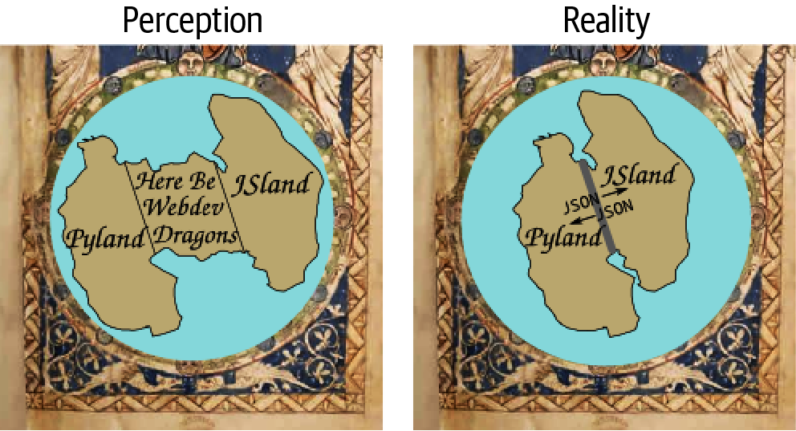

Figure I-1. Here be webdev dragons

Who This Book Is For
First off, this book is for anyone with a reasonable grasp of Python or JavaScript who wants to explore one of the most exciting areas in the data-processing ecosystem right now: the exploding field of data visualization for the web. It’s also about addressing some specific challenges that, in my experience, are quite common.
When you get commissioned to write a technical book, chances are your editor will sensibly caution you to think in terms of pain points that your book could address. The two key pain points of this book are best illustrated by way of a couple of stories, including one of my own and one that has been told to me in various guises by JavaScripters I know.
Many years ago, as an academic researcher, I came across Python and fell in love. I had been writing some fairly complex simulations in C++, and Python’s simplicity and power was a breath of fresh air from all the boilerplate Makefiles, declarations, definitions, and the like. Programming became fun. Python was the perfect glue, playing nicely with my C++ libraries (Python wasn’t then and still isn’t a speed demon) and doing, with consummate ease, all the stuff that is such a pain in low-level languages (e.g., file I/O, database access, and serialization). I started to write all my graphical user interfaces (GUIs) and visualizations in Python, using wxPython, PyQt, and a whole load of other refreshingly easy toolsets. Unfortunately, although some of these tools are pretty cool and I would love to share them with the world, the effort required to package them, distribute them, and make sure they still work with modern libraries represents a hurdle I’m unlikely to overcome.
At the time, there existed what in theory was the perfect universal distribution system for the software I’d so lovingly crafted—namely, the web browser. Web browsers were (and are) available on pretty much every computer on Earth, with their own built-in, interpreted programming language: write once, run everywhere. But Python didn’t play in the web browsers’ sandpit, and browsers were incapable of ambitious graphics and visualizations, being pretty much limited to static images and the odd jQuery transformation. JavaScript was a “toy” language tied to a very slow interpreter that was good for little DOM tricks but certainly nothing approaching what I could do on the desktop with Python. So that route was discounted, out of hand. My visualizations wanted to be on the web, but there was no route to it.
Fast forward a decade or so and, thanks to an arms race initiated by Google and their V8 engine, JavaScript is now orders of magnitude faster; in fact, it’s now an awful lot faster than Python.1 HTML has also tidied up its act a bit, in the guise of HTML5. It’s a lot nicer to work with, with much less boilerplate code. What were loosely followed and distinctly shaky protocols like Scalable Vector Graphics (SVG) have firmed up nicely, thanks to powerful visualization libraries, D3 in particular. Modern browsers are obliged to work nicely with SVG and, increasingly, 3D in the form of WebGL and its children such as THREE.js. The visualizations I was doing in Python are now possible on your local web browser, and the payoff is that, with very little effort, they can be made accessible to every desktop, laptop, smartphone, and tablet in the world.
So why aren’t Pythonistas flocking to get their data out there in a form they dictate? After all, the alternative to crafting it yourself is leaving it to somebody else, something most data scientists I know would find far from ideal. Well, first there’s that term web development, connoting complicated markup, opaque stylesheets, a whole slew of new tools to learn, IDEs to master. And then there’s JavaScript itself, a strange language, thought of as little more than a toy until recently and having something of the neither fish nor fowl to it. I aim to take those pain points head-on and show that you can craft modern web visualizations (often single-page apps) with a very minimal amount of HTML and CSS boilerplate, allowing you to focus on the programming, and that JavaScript is an easy leap for the Pythonista. But you don’t have to leap; Chapter 2 is a language bridge that aims to help Pythonistas and JavaScripters bridge the divide between the languages by highlighting common elements and providing simple translations.
The second story is a common one among JavaScript data visualizers I know. Processing data in JavaScript is far from ideal. There are few heavyweight libraries, and although recent functional enhancements to the language make data munging much more pleasant, there’s still no real data-processing ecosystem to speak of. So, there’s a distinct asymmetry between the hugely powerful visualization libraries available (D3, as ever, is the paramount library), and the ability to clean and process any data delivered to the browser. All of this mandates doing your data cleaning, processing, and exploring in another language or with a toolkit like Tableau, and this often devolves into piecemeal forays into vaguely remembered Matlab, the steepish learning curve that is R, or a Java library or two.
Toolkits like Tableau, although very impressive, are often ultimately frustrating for programmers. There’s no way to replicate in a GUI the expressive power of a good, general-purpose programming language. Plus, what if you want to create a little web server to deliver your processed data? That means learning at least one new web development-capable language.
In other words, JavaScripters starting to stretch their data visualization are looking for a complementary data-processing stack that requires the least investment of time and has the shallowest learning curve.

Minimal Requirements to Use This Book
I always feel reluctant to place restrictions on people’s explorations, particularly in the context of programming and the web, which is chock-full of autodidacts (how else would one learn with the halls of academia being light years behind the trends?), learning fast and furiously, gloriously uninhibited by the formal constraints that used to apply to learning. Python and JavaScript are pretty much as simple as it gets, programming-language-wise, and are both top candidates for best first language. There isn’t a huge cognitive load in interpreting the code.
In that spirit, there are expert programmers who, without any experience of Python and JavaScript, could consume this book and be writing custom libraries within a week.
For beginner programmers, fresh to Python or JavaScript, this book is probably too advanced for you, and I recommend taking advantage of the plethora of books, web resources, screencasts, and the like that make learning so easy these days. Focus on a personal itch, a problem you want to solve, and learn to program by doing—it’s the only way.
For people who have programmed a bit in either Python or JavaScript, my advised threshold to entry is that you have used a few libraries together, understand the basic idioms of your language, and can look at a piece of novel code and generally get a hook on what’s going on—​in other words, Pythonistas who can use a few modules of the standard library, and JavaScripters who have used the odd library and would understand a few lines of its source code.

Why Python and JavaScript?
Why JavaScript is an easy question to answer. For now and the foreseeable future, there is only one first-class, browser-based programming language. There have been various attempts to extend, augment, and usurp, but good old, plain-vanilla JS is still preeminent. If you want to craft modern, dynamic, interactive visualizations and, at the touch of a button, deliver them to the world, at some point you are going to run into JavaScript. You might not need to achieve mastery, but basic competence is a fundamental price of entry into one of the most exciting areas of modern data science. This book will get you into the ballpark.

Why Not Python in the Browser?
There have been recent initiatives to run a limited version of Python in the browser. For example, Pyodide is a port of CPython to WebAssembly. These are impressive and interesting, but right now the main way to make web charts in Python is to have them automatically converted by an intermediate library.
There are currently some very impressive initiatives aimed at enabling Python-produced visualizations, often built on Matplotlib, to run in the browser. They achieve this by converting the Python code into JavaScript based on the canvas or svg drawing contexts. The most popular and mature of these are Plotly and Bokeh. In Chapter 14, you’ll see how to use Plotly to generate charts in a Jupyter notebook and transfer them to a web page. For many use cases this is a great dataviz tool to have in your toolbox.
While there is some brilliant coding behind these JavaScript converters and many solid use cases, they do have big limitations:
- Automated code conversion may well do the job, but the code produced is usually pretty impenetrable for a human being.
- Adapting and customizing the resulting plots using the powerful browser-based JavaScript development environment can be painful. We’ll see how this pain can be mitigated in Chapter 14 by using Plotly’s JS API.
- You are limited to the subset of plot types currently available in the libraries.
- Interactivity is very basic at the moment. Customizing user controls is best done in JavaScript, using the browser’s developer tools.
Bear in mind that the people building these libraries have to be JavaScript experts, so if you want to understand anything of what they’re doing and eventually express yourself, then you’ll have to get up to scratch with some JavaScript.

Why Python for Data Processing
Why you should choose Python for your data-processing needs is a little more involved. For a start, there are good alternatives as far as data processing is concerned. Let’s deal with a few candidates for the job, starting with the enterprise behemoth Java.

Java
Among the other main, general-purpose programming languages, only Java offers anything like the rich ecosystem of libraries that Python does, with considerably more native speed too. But while Java is a lot easier to program in than languages like C++, it isn’t, in my opinion, a particularly nice language to program in, having rather too much in the way of tedious boilerplate code and excessive verbiage. This sort of thing starts to weigh heavily after a while and makes for a hard slog at the code face. As for speed, Python’s default interpreter is slow, but Python is a great glue language that plays nicely with other languages. This ability is demonstrated by the big Python data-processing libraries like NumPy (and its dependent, pandas), SciPy, and the like, which use C++ and Fortran libraries to do the heavy lifting while providing the ease of use of a simple scripting language.

R
The venerable R has, until recently, been the tool of choice for many data scientists and is probably Python’s main competitor in the space. Like Python, R benefits from a very active community, some great tools like the plotting library ggplot2, and a syntax specially crafted for data science and statistics. But this specialism is a double-edged sword. Because R was developed for a specific purpose, it means that if, for example, you wish to write a web server to serve your R-processed data, you have to skip out to another language with all the attendant learning overheads, or try to hack something together in a round-hole/square-peg sort of way. Python’s general-purpose nature and its rich ecosystem mean one can do pretty much everything required of a data-processing pipeline (JS visuals aside) without having to leave its comfort zone. Personally, it is a small sacrifice to pay for a little syntactic clunkiness.

Others
There are other alternatives to doing your data processing with Python, but none of them come close to the flexibility and power afforded by a general-purpose, easy-to-use programming language with a rich ecosystem of libraries. For example, mathematical programming environments such as Matlab and Mathematica have active communities and a plethora of great libraries, but they hardly count as general purpose, because they are designed to be used within a closed garden. They are also proprietary, which means a significant initial investment and a different vibe to Python’s resoundingly open source environment.
GUI-driven dataviz tools like Tableau are great creations but will quickly frustrate someone used to freedom in programming. They tend to work great as long as you are singing from their songsheet, as it were. Deviations from the designated path get painful very quickly.

Python’s Getting Better All the Time
As things stand, I think a very good case can be made for Python being the budding data scientist’s language of choice. But things are not standing still; in fact, Python’s capabilities in this area are growing at an astonishing rate. To put it in perspective, I have been programming in Python for over 20 years and have grown used to being surprised if I can’t find a Python module to help solve a problem at hand, but I find myself surprised at the growth of Python’s data-processing abilities, with a new, powerful library appearing weekly. To give an example, Python has traditionally been weak on statistical analysis libraries, with R being far ahead. Recently a number of powerful modules, such as statsmodels, have started to close this gap fast.
Python is a thriving data-processing ecosystem with a pretty much unmatched general purpose, and it’s getting better week by week. It’s understandable why so many in the community are in a state of such excitement—it’s pretty exhilarating.
As far as visualization in the browser, the good news is that there’s more to JavaScript than its privileged, nay, exclusive place in the web ecosystem. Thanks to an interpreter arms race that has seen performance increase in staggering leaps and bounds and some powerful visualization libraries such as D3, which would complement any language out there, JavaScript now has serious chops.
In short, Python and JavaScript are wonderful complements for data visualization on the web, each needing the other to provide a vital missing component.

What You’ll Learn
There are some big Python and JavaScript libraries in our dataviz toolchain, and comprehensive coverage of them all would require a number of books. Nevertheless, I think that the fundamentals of most libraries, and certainly the ones covered here, can be grasped fairly quickly. Expertise takes time and practice but the basic knowledge needed to be productive is, so to speak, low-hanging fruit.
In that sense, this book aims to give you a solid backbone of practical knowledge, strong enough to take the weight of future development. I aim to make the learning curve as shallow as possible and get you over the initial climb with the practical skills needed to start refining your art.
This book emphasizes pragmatism and best practice. It’s going to cover a fair amount of ground, and there isn’t enough space for many theoretical diversions. I cover those aspects of the libraries in the toolchain that are most commonly used, and point you to resources for the other issues. Most libraries have a hard core of functions, methods, classes, and the like that are the chief, functional subset. With these at your disposal, you can actually do stuff. Eventually, you’ll find an itch you can’t scratch with those, at which time good books, documentation, and online forums will be your friend.

The Choice of Libraries
I had three things in mind while choosing the libraries used in the book:
- Open source and free as in beer—you shouldn’t have to invest any extra money to learn with this book.
- Longevity—generally well-established, community-driven, and popular.
- Best of breed (assuming good support and an active community), at the sweet spot between popularity and utility.
The skills you learn here should be relevant for a long time. Generally, the obvious candidates have been chosen—libraries that write their own ticket, as it were. Where appropriate, I will highlight the alternative choices and give a rationale for my selection.

Preliminaries
A few preliminary chapters are needed before beginning the transformative journey of our Nobel dataset through the toolchain. These cover the basic skills necessary to make the rest of the toolchain chapters run more fluidly. The first few chapters cover the following:
Chapter 2, “A Language-Learning Bridge Between Python and JavaScript”
Building a language bridge between Python and JavaScript
Chapter 3, “Reading and Writing Data with Python”
How to pass around data with Python, through various file formats and databases
Chapter 4, “Webdev 101”
Covering the basic web development needed by the book
These chapters are part tutorial, part reference, and it’s fine to skip straight to the beginning of the toolchain, dipping back where needed.

The Dataviz Toolchain
The main part of the book demonstrates the data visualization toolchain, following the journey of a dataset of Nobel Prize winners from raw, freshly scraped data to engaging, interactive JavaScript visualization. During the collection process, the refinement and transformation of a number of big libraries are demonstrated, summarized in Figure I-2. These libraries are the industrial lathes of our toolchain: rich, mature tools that demonstrate the power of the Python+JavaScript dataviz stack. The following sections contain a brief introduction to the five stages of our toolchain and their major libraries.
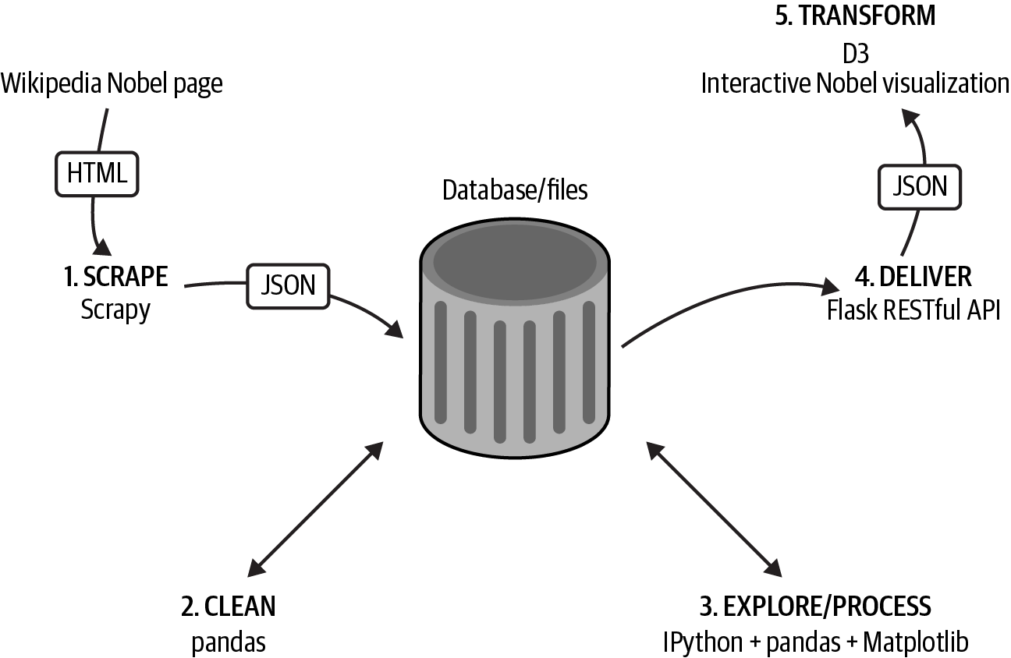

Figure I-2. The dataviz toolchain

1. Scraping Data with Scrapy
The first challenge for any data visualizer is getting hold of the data they need, whether inspired by a request or to scratch a personal itch. If you’re very lucky, this will be delivered to you in pristine form, but more often than not you have to go find it. I’ll cover the various ways you can use Python to get data off the web (e.g., web APIs or Google spreadsheets). The Nobel Prize dataset for the toolchain demonstration is scraped from its Wikipedia pages using Scrapy.2
Python’s Scrapy is an industrial-strength scraper that does all the data throttling and media pipelining, which are indispensable if you plan on scraping significant amounts of data. Scraping is often the only way to get the data you are interested in, and once you’ve mastered Scrapy’s workflow, all those previously off-limits datasets are only a spider away.3

2. Cleaning Data with pandas
The dirty secret of dataviz is that pretty much all data is dirty, and turning it into something you can use may well occupy a lot more time than anticipated. This is an unglamorous process that can easily steal over half your time, which is all the more reason to get good at it and use the right tools.
pandas is a huge player in the Python data-processing ecosystem. It’s a Python data-analysis library whose chief component is the DataFrame, essentially a programmatic spreadsheet. pandas extends NumPy, Python’s powerful numeric library, into the realm of heterogeneous datasets, the kind of categorical, temporal, and ordinal information that data visualizers have to deal with.
As well as being great for interactively exploring your data (using its built-in Matplotlib plots), pandas is well suited to the drudge work of cleaning data, making it easy to locate duplicate records, fix dodgy date-strings, find missing fields, and so on.

3. Exploring Data with pandas and Matplotlib
Before beginning the transformation of your data into a visualization, you need to understand it. The patterns, trends, and anomalies hidden in the data will inform the stories you are trying to tell with it, whether that’s explaining a recent rise in year-by-year widget sales or demonstrating global climate change.
In conjunction with IPython, the Python interpreter on steroids, pandas and Matplotlib (with additions such as seaborn) provide a great way to explore your data interactively, generating rich, inline plots from the command line, slicing and dicing your data to reveal interesting patterns. The results of these explorations can then be easily saved to file or database to be passed on to your JavaScript visualization.

4. Delivering Your Data with Flask
Once you’ve explored and refined your data, you’ll need to serve it to the web browser, where a JavaScript library like D3 can transform it. One of the great strengths of using a general-purpose language like Python is that it’s as comfortable rolling a web server in a few lines of code as it is crunching through large datasets with special-purpose libraries like NumPy and SciPy.4 Flask is Python’s most popular lightweight server and is perfect for creating small, RESTful5 APIs that can be used by JavaScript to get data from the server, in files or databases, to the browser. As I’ll demonstrate, you can roll a RESTful API in a few lines of code, capable of delivering data from SQL or NoSQL databases.

5. Transforming Data into Interactive Visualizations with Plotly and D3
Once the data is cleaned and refined, we have the visualization phase, where selected reflections of the dataset are presented, perhaps allowing the user to explore them interactively. Depending on the data, this might involve conventional charts, maps, or novel visualizations.
Plotly is a brilliant charting library that allows you to develop your charts in Python and transfer them to the web. As we’ll see in Chapter 14, it also has a JavaScript API that mimics the Python one, giving you a native JS charting library for free.
D3 is JavaScript’s powerhouse visualization library, arguably one of the most powerful visualization tools irrespective of language. We’ll use D3 to create a novel Nobel Prize visualization with multiple elements and user interaction, allowing people to explore the dataset for items of interest. D3 can be challenging to learn, but I’ll bring you quickly up to speed and get you ready to start honing your skills in the doing.

Smaller Libraries
In addition to the big libraries covered, there is a large supporting cast of smaller libraries. These are the indispensable smaller tools, the hammers and spanners of the toolchain. Python in particular has an incredibly rich ecosystem, with small, specialized libraries for almost every conceivable job. Among the strong supporting cast, some particularly deserving of mention are:
Requests
Python’s go-to HTTP library, fully deserving its motto “HTTP for humans.” Requests is far superior to urllib2, one of Python’s included batteries.
SQLAlchemy
The best Python SQL toolkit and object-relational mapper (ORM) there is. It’s feature-rich and makes working with the various SQL-based databases a relative breeze.
seaborn
A great addition to Python’s plotting powerhouse Matplotlib, it adds some very useful plot types including some statistical ones of particular use to data visualizers. It also adds arguably superior aesthetics, overriding the Matplotlib defaults.
Crossfilter
Even though JavaScript’s data-processing libraries are a work in progress, a few really useful ones have emerged recently, with Crossfilter being a standout. It enables very fast filtering of row-columnar datasets and is ideally suited to dataviz work, which is unsurprising because one of its creators is Mike Bostock, the father of D3.
marshmallow
A brilliant and very handy library that converts complex datatypes like objects to and from native Python datatypes.

Using the Book
Although the book’s different parts follow a process of data transformation, this book doesn’t need to be read cover to cover. The first part provides a basic toolkit for Python- and JavaScript-based web dataviz and will inevitably have content that is familiar to many readers. Cherry-pick for the stuff you don’t know and dip back as required (there will be link-backs further on, as required). The language-learning bridge between Python and JavaScript will be unnecessary for those seasoned in both languages, although there may still be some useful nuggets.
The remaining parts of the book, following our toolchain as it transforms a fairly uninspiring web list into a fully fledged, interactive D3 visualization, are essentially self-contained. If you want to dive immediately into Part III and some data cleaning and exploration with pandas, go right ahead, but be aware that it assumes the existence of a dirty Nobel Prize dataset. You can see how that was produced by Scrapy later if that fits your schedule. Equally, if you want to dive straight into creating the Nobel-viz app in parts Part IV and Part V, be aware that they assume a clean Nobel Prize dataset.
Whatever route you take, I suggest eventually aiming to acquire all the basic skills covered in the book if you intend to make dataviz your profession.

A Little Bit of Context
This is a practical book and assumes that the reader has a pretty good idea of what he or she wants to visualize and how that visualization should look and feel, as well as a desire to get cracking on it, unencumbered by too much theory. Nevertheless, drawing on the history of data visualization can both clarify the central themes of the book and add valuable context. It can also help explain why now is such an exciting time to be entering the field, as technological innovation is driving novel dataviz forms, and people are grappling with the problem of presenting the increasing amount of multidimensional data generated by the internet.
Data visualization has an impressive body of theory behind it, and there are some great books out there that I recommend you read (see “Recommended Books” for a little selection). The practical benefit of understanding the way humans visually harvest information cannot be overstated. It can be easily demonstrated, for example, that a pie chart is almost always a bad way of presenting comparative data and a simple bar chart is far preferable. By conducting psychometric experiments, we now have a pretty good idea of how to trick the human visual system and make relationships in the data harder to grasp. Conversely, we can show that some visual forms are close to optimal for amplifying contrast. The literature, at its very least, provides some useful rules of thumb that suggest good candidates for any particular data narrative.
In essence, good dataviz tries to present data, collected from measurements in the world (empirical) or as the product of abstract mathematical explorations (e.g., the beautiful fractal patterns of the Mandelbrot set), in such a way as to draw out or emphasize any patterns or trends that might exist. These patterns can be simple (e.g., average weight by country), or the product of sophisticated statistical analysis (e.g., data clustering in a higher dimensional space).
In its untransformed state, we can imagine this data floating as a nebulous cloud of numbers or categories. Any patterns or correlations are entirely obscure. It’s easy to forget, but the humble spreadsheet (Figure I-3 a) is a data visualization—the ordering of data into row-columnar form is an attempt to tame it, make its manipulation easier, and highlight discrepancies (e.g., actuarial bookkeeping). Of course, most people are not adept at spotting patterns in rows of numbers, so more accessible, visual forms were developed to engage with our visual cortex, the prime human conduit for information about the world. Enter the bar chart, pie chart,6 and line chart. More imaginative ways were employed to distill statistical data in a more accessible form, one of the most famous being Charles Joseph Minard’s visualization of Napoleon’s disastrous Russian campaign of 1812 (Figure I-3 b).
The lighter tan-colored stream in Figure I-3 b shows the advance of Napoleon’s army on Moscow; the black line shows the retreat. The thickness of the stream represents the size of Napoleon’s army, thinning as casualties mounted. A temperature chart below is used to indicate the temperature at locations along the way. Note the elegant way in which Minard has combined multidimensional data (casualty statistics, geographical location, and temperature) to give an impression of the carnage, which would be hard to grasp in any other way (imagine trying to jump from a chart of casualties to a list of locations and making the necessary connections). I would argue that the chief problem of modern interactive dataviz is exactly the same as that faced by Minard: how to move beyond conventional one-dimensional bar charts (perfectly good for many things) and develop new ways to communicate cross-dimensional patterns effectively.
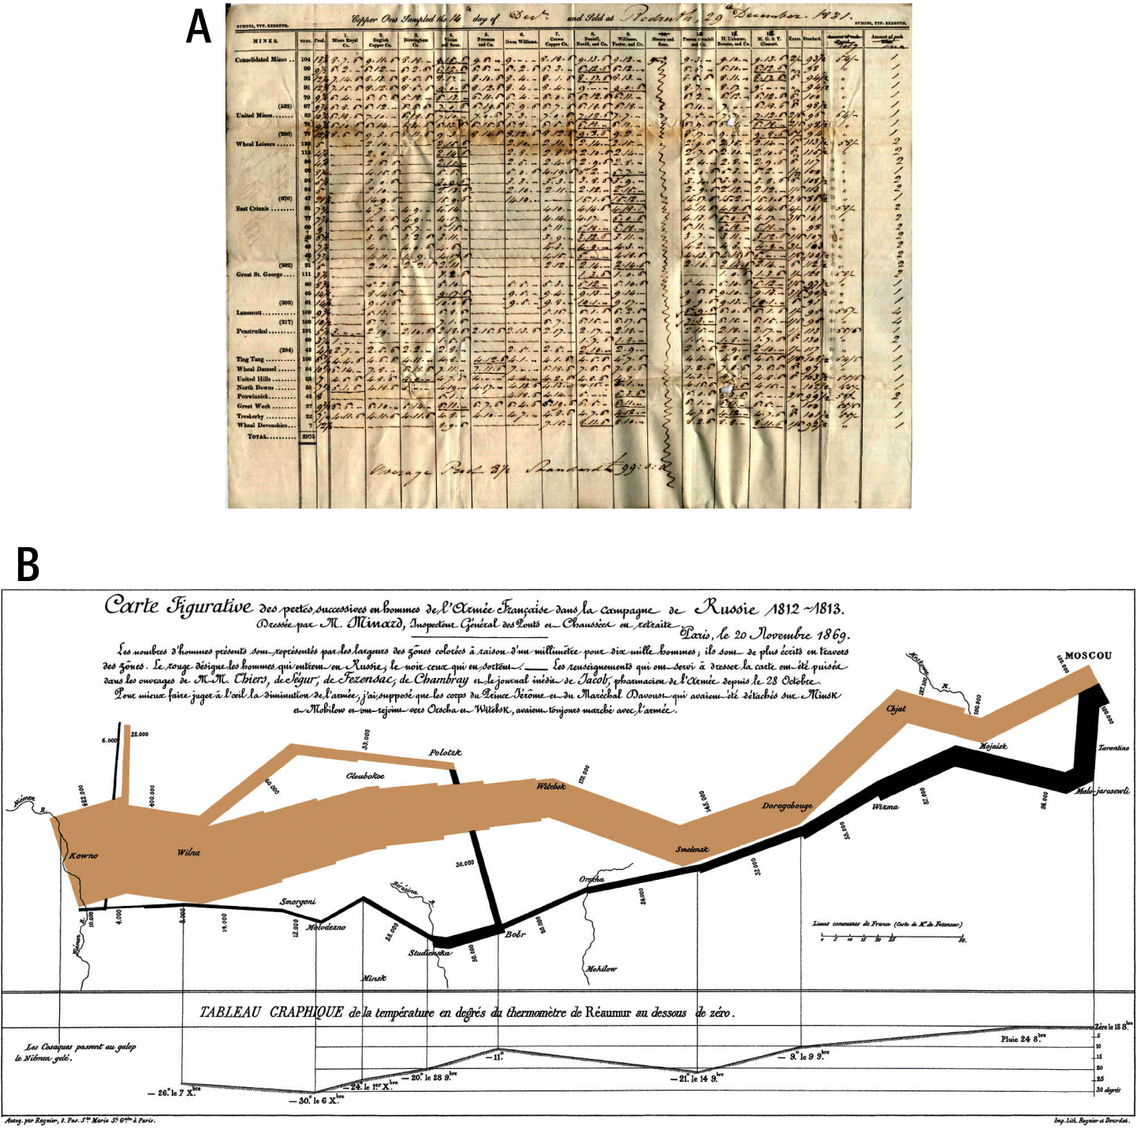

Figure I-3. (a) An early spreadsheet and (b) Charles Joseph Minard’s visualization of Napoleon’s Russian campaign of 1812
Until quite recently, most of our experience of charts was not much different from those of Charles Joseph Minard’s audience. They were pre-rendered and inert, and showed one reflection of the data, hopefully an important and insightful one but nevertheless under total control of the author. In this sense, the replacement of real ink points with computer screen pixels was only a change in the scale of distribution.
The leap to the internet just replaced newsprint with pixels, the visualization still being unclickable and static. Recently, the combination of some powerful visualization libraries (D3 being preeminent among them) and a massive improvement in JavaScript’s performance have opened the way to a new type of visualization, one that is easily accessible and dynamic, and actually encourages exploration and discovery. The clear distinction between data exploration and presentation is blurred. This new type of data visualization is the focus of this book and the reason why dataviz for the web is such an exciting area right now. People are trying to create new ways to visualize data and make it more accessible/useful to the end user. This is nothing short of a revolution.

Summary
Dataviz on the web is an exciting place to be right now, with innovations in interactive visualizations coming thick and fast, and many (if not most) of them being developed with D3. JavaScript is the only browser-based language, so the cool visuals are by necessity being coded in it (or converted into it). But JavaScript lacks the tools or environment necessary for the less dramatic but just as vital element of modern dataviz: the aggregation, curation, and processing of the data. This is where Python rules the roost, providing a general-purpose, concise, and eminently readable programming language with access to an increasing stable of first-class data-processing tools. Many of these tools leverage the power of very fast, low-level libraries, making Python data processing fast as well as easy.
This book introduces some of those heavyweight tools, as well as a host of other smaller but equally vital tools. It also shows how Python and JavaScript in concert represent the best dataviz stack out there for anyone wishing to deliver their visualizations to the internet.
Up next is the first part of the book, covering the preliminary skills needed for the toolchain. You can work through it now or skip ahead to Part II and the start of the toolchain, referring back when needed.

Recommended Books
Here are a few key data visualization books to whet your appetite, covering the gamut from interactive dashboards to beautiful and insightful infographics.
- Bertin, Jacques. Semiology of Graphics: Diagrams, Networks, Maps. Esri Press, 2010.
- Cairo, Alberto. The Functional Art. New Riders, 2012.
- Few, Stephen. Information Dashboard Design: Displaying Data for At-a-Glance Monitoring, 2nd Ed. Analytics Press, 2013.
- Rosenberg, Daniel and Anthony Grafton. Cartographies of Time: A History of the Timeline. Princeton Architectural Press, 2012.
- Tufte, Edward. The Visual Display of Quantitative Information, 2nd Ed. Graphics Press, 2001.
- Wexler, Steve. The Big Book of Dashboards. Wiley, 2017.
- Wilke, Claus. Fundamentals of Data Visualization. O’Reilly, 2019. (Free online version.)
1 See the Benchmarks Game website for a fairly jaw-dropping comparison.
2 Web scraping is a computer software technique to extract information from websites, usually involving getting and parsing web pages.
3 Scrapy’s controllers are called spiders.
4 The scientific Python library, part of the NumPy ecosystem.
5 REST is short for Representational State Transfer, the dominant style for HTTP-based web APIs and much recommended.
6 William Playfair’s Statistical Breviary of 1801 having the dubious distinction of originating the pie chart.

Part I. Basic Toolkit
This first part of the book provides a basic toolkit for the toolchain to come and is part tutorial, part reference. Given the fairly wide range of knowledge in the target audience, there will probably be things covered that you already know. My advice is just to cherry-pick the material to fill any gaps in your knowledge and maybe skim what you already know as a refresher.
If you’re confident you already have the basic toolkit at hand, feel free to skip to the start of our journey along the toolchain in Part II.
Tip
You can find the code for this part of the book at the book’s GitHub repo.

Chapter 1. Development Setup
This chapter covers the downloads and software installations needed to use this book, and sketches out a recommended development environment. As you’ll see, this isn’t as onerous as it might once have been. I’ll cover Python and JavaScript dependencies separately and give a brief overview of cross-language IDEs.

The Accompanying Code
There’s a GitHub repository for the bulk of the code covered in this book, including the full Nobel Prize visualization. To get hold of it, just perform a git clone to a suitable local directory:
$ git clone https://github.com/Kyrand/dataviz-with-python-and-js-ed-2.git
This should create a local dataviz-with-python-and-js-v2 directory with the key source code covered by the book.

Python
The bulk of the libraries covered in the book are Python-based, but what might have been a challenging attempt to provide comprehensive installation instructions for the various operating systems and their quirks is made much easier by the existence of Anaconda, a Python platform that bundles together most of the popular analytics libraries in a convenient package. The book assumes you are using Python 3, which was released in 2008 and is now firmly established.

Anaconda
Installing some of the bigger Python libraries used to be a challenge all in itself, particularly those such as NumPy that depend on complex low-level C and Fortran packages. That’s a great deal easier now and most will happily install using Python’s easy_install with a pip command:
$
pip
install
NumPy
But some big number-crunching libraries are still tricky to install. Dependency management and versioning (you might need to use different versions of Python on the same machine) can make things trickier still, and this is where Anaconda comes into its own. It does all the dependency checking and binary installs so you don’t have to. It’s also a very convenient resource for a book like this.
To get your free Anaconda install, just navigate your browser to the Anaconda site, choose the version for your operating system (ideally at least Python 3.5), and follow the instructions. Windows and OS X get a graphical installer (just download and double-click), whereas Linux requires you to run a little bash script:
$ bash Anaconda3-2021.11-Linux-x86_64.sh
Here’s the latest installing instructions:
- For Windows
- For macOS
- For Linux
I recommend sticking to defaults when installing Anaconda.
The official check guide can be found at the Anaconda site. Windows and macOS users can use the Anaconda’s Navigator GUI or, along with Linux users, use the Conda command-line interface.

Installing Extra Libraries
Anaconda contains almost all the Python libraries covered in this book (see the Anaconda documentation for the full list of Anaconda library packages). Where we need a non-Anaconda library, we can use pip (short for Pip Installs Python), the de facto standard for installing Python libraries. Using pip to install is as easy as can be. Just call pip install followed by the name of the package from the command line and it should be installed or, with any luck, give a sensible error:
$ pip install dataset

Virtual Environments
Virtual environments provide a way of creating a sandboxed development environment with a particular Python version and/or set of third-party libraries. Using these virtual environments avoids polluting your global Python with these installs and gives you a lot more flexibility (you can play with different package versions or change your Python version if need be). The use of virtual environments is becoming a best practice in Python development, and I strongly suggest that you follow it.
Anaconda comes with a conda system command that makes creating and using virtual environments easy. Let’s create a special one for this book, based on the full Anaconda package:
$ conda create --name pyjsviz anaconda
...
#
# To activate this environment, use:
# $ source activate pyjsviz
#
# To deactivate this environment, use:
# $ source deactivate
#
As the final message says, to use this virtual environment you need only source activate it (for Windows machines, you can leave out the source):
$
source
activate pyjsviz
discarding /home/kyran/anaconda/bin from PATH
prepending /home/kyran/.conda/envs/pyjsviz/bin to PATH
(
pyjsviz
)
$
Note that you get a helpful cue at the command line to let you know which virtual environment you’re using.
The conda command can do a lot more than just facilitate virtual environments, combining the functionality of Python’s pip installer and virtualenv command, among other things. You can get a full rundown in the Anaconda documentation.
If you’re confident with standard Python virtual environments, these have been made a lot easier to work with by their incorporation in Python’s Standard Library. To create a virtual environment from the command line:
$ python -m venv python-js-viz
This creates a python-js-viz directory containing the various elements of the virtual environment. This includes some activation scripts. To activate the virtual environment with macOS or Linux, run the activate script:
$
source
python-js-viz/bin/activate
On Windows machines, run the .bat file:
$ python-js-viz/Scripts/activate.bat
You can then use pip to install Python libraries to the virtual environment, avoiding polluting your global Python distribution:
$
(
python-js-viz
)
pip install NumPy
To install all the libraries required by this book, you can use the requirements.txt file in the book’s GitHub repo:
$
(
python-js-viz
)
pip install -r requirements.txt
You can find information on the virtual environment in the Python documentation.

JavaScript
The good news is that you don’t need much JavaScript software at all. The only must-have is the Chrome/Chromium web browser, which is used in this book. It offers the most powerful set of developer tools of any current browser and is cross-platform.
To download Chrome, just go to the home page and download the version for your operating system. This should be automatically detected.
All the JavaScript libraries used in this book can be found in the accompanying GitHub repo, but there are generally two ways to deliver them to the browser. You can use a content delivery network (CDN), which efficiently caches a copy of the library retrieved from the delivery network. Alternatively, you can use a local copy of the library served to the browser. Both of these methods use the script tag in an HTML document.

Content Delivery Networks
With CDNs, rather than having the libraries installed on your local machine, the JavaScript is retrieved by the browser over the web, from the closest available server. This should make things very fast—faster than if you served the content yourself.
To include a library via CDN, you use the usual <script> tag, typically placed at the bottom of your HTML page. For example, the following call adds a current version of D3:
<
script
src
=
"https://cdnjs.cloudflare.com/ajax/libs/d3/7.1.1/d3.min.js"
charset
=
"utf-8"
>
</
script
>

Installing Libraries Locally
If you need to install JavaScript libraries locally, because, for example, you anticipate doing some offline development work or can’t guarantee an internet connection, there are a number of fairly simple ways to do so.
You can just download the separate libraries and put them in your local server’s static folder. This is a typical folder structure. Third-party libraries go in the static/libs directory off root, like so:
nobel_viz/
└── static
├── css
├── data
├── libs
│ └── d3.min.js
└── js
If you organize things this way, to use D3 in your scripts now requires a local file reference with the <script> tag:
<
script
src
=
"/static/libs/d3.min.js"
></
script
>

Databases
The recommended database for small to medium-sized dataviz projects is the brilliant, serverless, file-based, SQL-based SQLite. This database is used throughout the dataviz toolchain demonstrated in the book and is the only database you really need.
The book also covers basic Python interactions with MongoDB, the most popular nonrelational, or NoSQL database:
SQLite
SQLite should come as standard with macOS and Linux machines. For Windows, follow this guide.
MongoDB
You can find installation instructions for the various operating systems in the MongoDB documentation.
Note that we’ll be using Python’s SQLAlchemy SQL library either directly or through libraries that build on it. This means we can convert any SQLite examples to another SQL backend (e.g., MySQL or PostgreSQL) by changing a configuration line or two.

Getting MongoDB Up and Running
MongoDB can be a little trickier to install than some databases. As mentioned, you can follow this book perfectly well without going through the hassle of installing the server-based MongoDB, but if you want to try it out or find yourself needing to use it at work, here are some installation notes:
For OS X users, check out the official docs for MongoDB installation instructions.
This Windows-specific guide from the official docs should get your MongoDB server up and running. You will probably need to use administrator privileges to create the necessary data directories and so on.
More often than not these days, you’ll be installing MongoDB to a Linux-based server, most commonly an Ubuntu variant, which uses the deb file format to deliver its packages. The official MongoDB docs do a good job covering an Ubuntu install.
MongoDB uses a data directory to store to and, depending how you install it, you may need to create this yourself. On OS X and Linux boxes, the default is a data directory off the root directory, which you can create using mkdir as a superuser (sudo):
$ sudo mkdir /data
$ sudo mkdir /data/db
You’ll then want to set ownership to yourself:
$ sudo chown 'whoami' /data/db
With Windows, installing the MongoDB Community Edition, you can create the necessary data directory with the following command:
$ cd C:\
$ md "\data\db"
The MongoDB server will often be started by default on Linux boxes; otherwise, on Linux and OS X the following command will start a server instance:
$ mongod
On Windows Community Edition, the following, run from a command prompt, will start a server instance:
C:\mongodb\bin\mongod.exe

Easy MongoDB with Docker
MongoDB can be tricky to install. For example, current Ubuntu variants (> version 22.04) have incompatible SSL libs. If you have Docker installed, a working development DB on the default port 27017 is only a single command away:
$ sudo docker run -dp 27017:27017 -v local-mongo:/data/db
--name local-mongo --restart=always mongo
This nicely side-steps local library incompatibilities and the like.

Integrated Development Environments
As I explain in “The Myth of IDEs, Frameworks, and Tools”, you don’t need an IDE to program in Python or JavaScript. The development tools provided by modern browsers, Chrome in particular, mean you only really need a good code editor to have pretty much the optimal setup.
One caveat here is that these days intermediate to advanced JavaScript tends to involve frameworks like React, Vue, and Svelte that do benefit from the bells and whistles provided by a decent IDE, particularly handling multiformat files (where HTML, CSS, and JS are all embedded together). The good news is that the freely available Visual Studio Code (VSCode) has become the de facto standard for modern web development. It’s got plug-ins for pretty much everything and a very large and active community, so questions tend to be answered and bugs hunted down fast.
For Python, I have tried a few dedicated IDEs but they’ve never stuck. The main itch I was trying to scratch was finding a decent debugging system. Setting breakpoints in Python with a text editor isn’t particularly elegant, and using the command-line debugger pdb feels a little too old school sometimes. Nevertheless, Python does have a pretty good logging system included, which takes the edge off its rather clunky default debugging. VSCode is pretty good for Python programming, but there are some Python-specific IDEs that are arguably a little smoother.
In no particular order, here are a few that I’ve tried and not disliked:
PyCharm
This option offers solid code assistance and good debugging and would probably top a favorite IDE poll of seasoned Pythonistas.
PyDev
If you like Eclipse and can tolerate its rather large footprint, this might well be for you.
Wing Python IDE
This is a solid bet, with a great debugger and incremental improvements over a decade-and-a-half’s worth of development.

Summary
With free, packaged Python distributions such as Anaconda, and the inclusion of sophisticated JavaScript development tools in freely available web browsers, the necessary Python and JavaScript elements of your development environment are a couple of clicks away. Add a favorite editor and a database of choice,1 and you are pretty much good to go. There are additional libraries, such as node.js, that can be useful but don’t count as essential. Now that we’ve established our programming environment, the next chapters will teach the preliminaries needed to start our journey of data transformation along the toolchain, starting with a language bridge between Python and JavaScript.
1 SQLite is great for development purposes and doesn’t need a server running on your machine.

Chapter 2. A Language-Learning Bridge Between Python and JavaScript
Probably the most ambitious aspect of this book is that it deals with two programming languages. Moreover, it only requires that you are competent in one of these languages. This is only possible because Python and JavaScript (JS) are fairly simple languages with much in common. The aim of this chapter is to draw out those commonalities and use them to make a learning bridge between the two languages such that core skills acquired in one can easily be applied to the other.
After showing the key similarities and differences between the two languages, I’ll show how to set up a learning environment for Python and JS. The bulk of the chapter will then deal with core syntactical and conceptual differences, followed by a selection of patterns and idioms that I use often while doing data visualization work.

Similarities and Differences
Syntax differences aside, Python and JavaScript actually have a lot in common. After a short while, switching between them can be almost seamless.1 Let’s compare the two from a data visualizer’s perspective:
These are the chief similarities:
- They both work without needing a compilation step (i.e., they are interpreted).
- You can use both with an interactive interpreter, which means you can type in lines of code and see the results right away.
- Both have garbage collection, which means they manage program memory automatically.
- Neither language has header files, package boilerplate, and so on, as compared to languages like C++, Java, etc.
- Both can happily be developed with a text editor or lightweight IDE.
- In both, functions are first-class citizens, which can be passed as arguments.
These are the key differences:
- Possibly the biggest difference is that JavaScript is single-threaded and non-blocking, using asynchronous I/O. This means that simple things like file access involve the use of a callback function, passed to another function and called on completion of some code, usually asynchronously.
- JS is used essentially in web development and until relatively recently was browser-bound,2 but Python is used almost everywhere.
- JS is the only first-class language in web browsers, Python being excluded.
- Python has a comprehensive standard library, whereas JS has a limited set of utility objects (e.g., JSON, Math).
- Python has fairly classical object-oriented classes, whereas JS uses prototype objects.
- JS lacks heavyweight general-purpose data-processing libs.3
The differences here emphasize the need for this book to be bilingual. The JavaScript monopoly on browser dataviz needs the complement of a conventional data-processing stack. And Python has the best there is.

Interacting with the Code
One of the great advantages of Python and JavaScript is that because they are interpreted on the fly, you can interact with them. Python’s interpreter can be run from the command line, whereas JavaScript’s is generally accessed from the web browser through a console, usually available from the built-in development tools. In this section, we’ll see how to fire up a session with the interpreter and start trying out your code.

Python
By far, the best command-line Python interpreter is IPython, which comes in three shades: the basic terminal version, an enhanced graphical version, and a browser-based notebook. Since IPython version 4.0, the latter two have been spun out into project Jupyter. The Jupyter notebook is a rather brilliant and fairly recent innovation, providing a browser-based interactive computational environment. The great boon of the notebook is session persistence and the possibility of web access.4 The ease with which one can share programming sessions, complete with embedded data visualizations, makes the notebook a fantastic teaching tool as well as a great way to recover programming context. That’s why the Python chapters of this book have accompanying Jupyter notebooks.
To start a Jupyter notebook just run jupyter at the command line:
$ jupyter notebook
[I 15:27:44.553 NotebookApp] Serving notebooks from local
directory:
...
[I 15:27:44.553 NotebookApp] http://localhost:8888/?token=5e09...
Then open a browser tab at the URL specified (http://localhost:8888 in this case) and start reading or writing Python notebooks.

JavaScript
There are lots of options for trying out JavaScript code without starting a server, though the latter isn’t that difficult. Because the JavaScript interpreter comes embedded in all modern web browsers, there are a number of sites that let you try out bits of JavaScript along with HTML and CSS and see the results. CodePen is a good option. These sites are great for sharing code and trying out snippets, and usually allow you to add libraries such as D3.js with a few mouse-clicks.
If you want to try out code one-liners or quiz the state of live code, browser-based consoles are your best bet. With Chrome, you can access the console with the key combo Ctrl-Shift-J (Command + Option + J on a Mac). As well as trying little JS snippets, the console allows you to drill down into any objects in scope, revealing their methods and properties. This is a great way to quiz the state of a live object and search for bugs.
One disadvantage of using online JavaScript editors is losing the power of your favorite editing environment, with linting, familiar keyboard shortcuts, and the like (see Chapter 4). Online editors tend to be rudimentary, to say the least. If you anticipate an extensive JavaScript session and want to use your favorite editor, the best bet is to run a local server.
First, create a project directory—called sandpit, for example—and add a minimal HTML file that includes a JS script:
sandpit
├── index.html
└── script.js
The index.html file need only be a few lines long, with an optional div placeholder on which to start building your visualization or just trying out a little DOM manipulation:
<!-- index.html -->
<!DOCTYPE html>
<
meta
charset
=
"utf-8"
>
<
div
id
=
'viz'
></
div
>
<
script
type
=
"text/javascript"
src
=
"script.js"
async
></
script
>
You can then add a little JavaScript to your script.js file:
// script.js
let
data
=
[
3
,
7
,
2
,
9
,
1
,
11
];
let
sum
=
0
;
data
.
forEach
(
function
(
d
){
sum
+=
d
;
});
console
.
log
(
'Sum = '
+
sum
);
// outputs 'Sum = 33'
Start your development server in the project directory using Python’s http module:
$ python -m http.server 8000
Serving HTTP on 0.0.0.0 port 8000 ...
Then open your browser at http://localhost:8000, press Ctrl-Shift-J (Cmd-Opt-J on OS X) to access the console and you should see Figure 2-1, showing the logged output of the script (see Chapter 4 for further details).
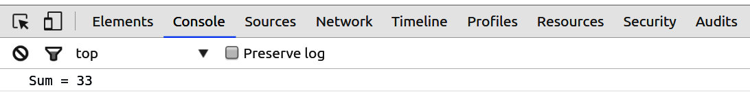

Figure 2-1. Outputting to the Chrome console
Now that we’ve established how to run the demo code, let’s start building a bridge between Python and JavaScript. First, we’ll cover the basic differences in syntax. As you’ll see, they’re fairly minor and easily absorbed.

Basic Bridge Work
In this section, I’ll contrast the basic nuts and bolts of programming in the two languages.

Style Guidelines, PEP 8, and use strict
Where JavaScript style guidelines are a bit of a free-for-all (with people often defaulting to those used by a big library like React), Python has a Python Enhancement Proposal (PEP) dedicated to it. I’d recommend getting acquainted with PEP-8 but not submitting totally to its leadership. It’s right about most things, but there’s room for some personal choice here. There’s a handy online checker called PEP8 Online, which will pick up any infractions of PEP-8. Many Pythonistas are turning to the Black Python code formatter, which takes over formatting duties in accordance with PEP-8.
In Python, you should use four spaces to indent a code block. JavaScript is less strict, but two spaces is the most common indent.
One recent addition to JavaScript (ECMAScript 5) is the 'use strict' directive, which imposes strict mode. This mode enforces some good JavaScript practice, which includes catching accidental global declarations, and I thoroughly recommend its use. To use it, just place the string at the top of your function or module:
(
function
(
foo
){
'use strict'
;
// ...
}(
window
.
foo
=
window
.
foo
||
{}));

CamelCase Versus Underscore
JS conventionally uses CamelCase (e.g., processStudentData) for its variables, whereas Python, in accordance with PEP-8, uses underscores (e.g., process_student_data) in its variable names (see Section B in Examples 2-3 and 2-4). By convention (and convention is more important in the Python ecosystem than it is in JS), Python uses capitalized CamelCase for class declarations (see the following example), uppercase for constants, and underscores for everything else:
FOO_CONST
=
10
class
FooBar
(
object
):
# ...
def
foo_bar
():
baz_bar
=
'some string'

Importing Modules, Including Scripts
Using other libraries in your code, either your own or third-party, is fundamental to modern programming, which makes it all the more surprising that until relatively recently JavaScript didn’t have a dedicated way of doing it.5 Python has a simple import system that, on the whole, works pretty well.
The good news on the JavaScript front is that since ECMAScript 6, JavaScript has addressed this issue, with the addition of import and export statements for encapsulated modules. We now have JavaScript modules (typically with the .mjs suffix) that can import and export encapsulated functions and objects, a huge step forward. In Part V, we’ll see how easy these are to work with.
While getting comfortable with JS you’ll probably want to import third-party libraries using the script tag, which will typically see them added to the global namespace as an object. For example, in order to use D3 you add the following script tag to your HTML entry file (typically index.html):
<!DOCTYPE html>
<
meta
charset
=
"utf-8"
>
<
script
src
=
"http://d3js.org/d3.v7.min.js"
></
script
>
You can now use the D3 library like this:
let
r
=
d3
.
range
(
0
,
10
,
2
)
console
.
log
(
r
)
// out: [0, 2, 4, 6, 8]
Python comes with “batteries included,” a comprehensive set of libraries covering everything from extended data containers (collections) to working with the family of CSV files (csv). If you want to use one of these, just import it using the import keyword:
In
[
1
]:
import
sys
In
[
2
]:
sys
.
platform
Out
[
2
]:
'linux'
If you don’t want to import the whole library or want to use an alias, you can use the as and from keywords instead:
import
pandas
as
pd
from
csv
import
DictWriter
,
DictReader
from
numpy
import
*
df
=
pd
.
read_json
(
'
data.json
'
)
reader
=
DictReader
(
'
data.csv
'
)
md
=
median
(
[
12
,
56
,
44
,
33
]
)
This imports all the variables from the module into the current namespace and is almost always a bad idea. One of the variables could mask an existing one, and it goes against the Python best practice of explicit being better than implicit. One exception to this rule is if you are using the Python interpreter interactively. In this limited context, it may make sense to import all functions from a library to cut down on key presses; for example, importing all the math functions (from math import *) if doing some Python math hacking.
If you import a nonstandard library, Python uses sys.path to try to find it. sys.path consists of:
- The directory containing the importing module (current directory)
- The PYTHONPATH variable, containing a list of directories
- The installation-dependent default, where libraries installed using pip or easy_install will usually be placed
Big libraries are often packaged, divided into submodules. These submodules are accessed by dot notation:
import
matplotlib.pyplot
as
plt
Packages are constructed from the filesystem via __init__.py files, usually empty, as shown in Example 2-1. The presence of an init file makes the directory visible to Python’s import system.

Example 2-1. Building a Python package
mypackage
├──
__init__.py
...
├──
core
│
└──
__init__.py
│
...
...
└──
io
├──
__init__.py
└──
api.py
...
└──
tests
└──
__init__.py
└──
test_data.py
└──
test_excel.py
...
...
You would import this module using from mypackage.io.tests import test_excel.
You can access packages on sys.path from the root directory (that’s mypackage in Example 2-1) using dot notation. A special case of import is intrapackage references. The test_excel.py submodule in Example 2-1 can import submodules from the mypackage package both absolutely and relatively:
from
mypackage
.
io
.
tests
import
test_data
from
.
import
test_data
import
test_data
from
.
.
io
import
api
Imports the test_data.py module absolutely, from the package’s head directory.
An explicit (. import) and implicit relative import.
A relative import from a sibling package of tests.

JavaScript Modules
JavaScript now has modules with import and export of encapsulated variables. JS cherry-picked its import syntax, using a lot of stuff that will be familiar to Pythonistas but, in my opinion, improving on it. Here’s a brief run-down:
Let’s say we have a JS entry-point module index.js, which wants to use some functions or objects from a library module libFoo.js in a lib directory. The file structure looks like this:
.
├── index.mjs
└── lib
└── libFoo.mjs
In libFoo.mjs we export a dummy function and can use export default to export a single object for the module, typically an API with, for example, utility methods:
// lib/libFoo.mjs
export
let
findOdds
=
(
a
)
=>
{
return
a
.
filter
(
x
=>
x
%
2
)
}
let
api
=
{
findOdds
}
export
default
api
An example of object creation with shorthand property name, equivalent to {findOdds: findOdds}
To import the exported functions and objects from our index module we use the import statement, which allows us to import the default API or select exported variables by name using curly brackets:
// index.mjs
import
api
from
'./lib/libFoo.mjs'
import
{
findOdds
}
from
'./lib/libFoo.mjs'
let
odds
=
findOdds
([
2
,
4
,
24
,
33
,
5
,
66
,
24
])
console
.
log
(
'Odd numbers: '
,
odds
)
odds
=
api
.
findOdds
([
12
,
43
,
22
,
39
,
52
,
21
])
console
.
log
(
'Odd numbers: '
,
odds
)
JS imports also support aliasing, which can be a great code sanitizer:
// index.mjs
import
api
as
foo
from
'./lib/libFoo.mjs'
import
{
findOdds
as
odds
}
from
'./lib/libFoo.mjs'
// ...
As you can see, JavaScript imports and exports are very similar to Python’s, though a little more user-friendly in my experience. You can see more details in Mozilla’s documentation for exports and imports.

Keeping Your Namespaces Clean
The variables defined in Python modules are encapsulated, which means that unless you import them explicitly (e.g., from foo import baa), you will be accessing them from the imported module’s namespace using dot notation (e.g., foo.baa). This modularization of the global namespace is quite rightly seen as a very good thing and plays to one of Python’s key tenets: the importance of explicit statements over implicit. When analyzing someone’s Python code you should be able to see exactly where a class, function, or variable has come from. Just as importantly, preserving the namespace limits the chance of conflicting or masking variables—a big potential problem as codebases get larger.
In the past one of the main criticisms of JavaScript, and a fair one, was that it played fast and loose with namespace conventions. The most egregious example of this is that variables declared outside of functions or missing the var keyword6 are global rather than confined to the script in which they are declared. With modern, modular JavaScript you get Python-like encapsulation with imported and exported variables.
JS modules are a relatively recent game changer—a common pattern used in the past and one that you may well run into is the creation of a self-calling function in order to isolate local variables from the global namespace. This makes all variables declared via var local to the script/function, preventing them from polluting the global namespace. The JavaScript let keyword, which is block-scoped, is pretty much always preferable to var. Any objects, functions, and variables you want to make available to other scripts can be attached to an object that is part of the global namespace.
Example 2-2 demonstrates a module pattern. The boilerplate head and tail (labeled and ) effectively create an encapsulated module. This pattern is far from a perfect solution to modular JavaScript but was the best compromise I knew of until ECMAScript 6’s dedicated import system was adopted by all major browsers.

Example 2-2. A module pattern for JavaScript
(
function
(
nbviz
)
{
'use strict'
;
// ...
nbviz
.
updateTimeChart
=
function
(
data
)
{
.
.
}
// ...
}
(
window
.
nbviz
=
window
.
nbviz
||
{
}
)
)
;
Receives the global nbviz object.
Attaches the updateTimeChart method to the global nbviz object, effectively exporting it.
If an nbviz object exists in the global (window) namespace, pass it into the module function; otherwise, add it to the global namespace.

Outputting “Hello World!”
By far the most popular initial demonstration of any programming language is getting it to print or communicate “Hello World!” in some form, so let’s start with getting output from Python and JavaScript.
Python’s output couldn’t be much simpler:
print
(
'Hello World!'
)
JavaScript has no print function, but you can log output to the browser console:
console
.
log
(
'Hello World!'
)

Simple Data Processing
A good way to get an overview of the language differences is to see the same function written in both. Examples 2-3 and 2-4 show a small, contrived example of data munging in Python and JavaScript, respectively. We’ll use these to compare Python and JS syntax and label them with capital letters (A, B…​) to allow comparison of the code blocks.

Example 2-3. Simple data transformation with Python
# A
student_data
=
[
{
'name'
:
'Bob'
,
'id'
:
0
,
'scores'
:[
68
,
75
,
56
,
81
]},
{
'name'
:
'Alice'
,
'id'
:
1
,
'scores'
:[
75
,
90
,
64
,
88
]},
{
'name'
:
'Carol'
,
'id'
:
2
,
'scores'
:[
59
,
74
,
71
,
68
]},
{
'name'
:
'Dan'
,
'id'
:
3
,
'scores'
:[
64
,
58
,
53
,
62
]},
]
# B
def
process_student_data
(
data
,
pass_threshold
=
60
,
merit_threshold
=
75
):
""" Perform some basic stats on some student data. """
# C
for
sdata
in
data
:
av
=
sum
(
sdata
[
'scores'
])
/
float
(
len
(
sdata
[
'scores'
]))
if
av
>
merit_threshold
:
sdata
[
'assessment'
]
=
'passed with merit'
elif
av
>=
pass_threshold
:
sdata
[
'assessment'
]
=
'passed'
else
:
sdata
[
'assessment'
]
=
'failed'
# D
print
(
f
"
{
sdata
[
'name'
]
}
's (id:
{
sdata
[
'id'
]
}
) final assessment is:
\
{
sdata
[
'assessment'
]
.
upper
()
}
"
)
# For Python versions before 3.7, the old-style string formatting is equivalent
# print("%s's (id: %d) final assessment is: %s"%(sdata['name'],\
# sdata['id'], sdata['assessment'].upper())) sdata['name'], sdata['id'],\
# sdata['assessment'].upper()))
print
(
f
"
{
sdata
[
'name'
]
}
's (id:
{
sdata
[
'id'
]
}
) final assessment is:
\
{
sdata
[
'assessment'
]
.
upper
()
}
"
)
sdata
[
'average'
]
=
av
# E
if
__name__
==
'__main__'
:
process_student_data
(
student_data
)

Example 2-4. Simple data munging with JavaScript
let
studentData
=
[
{
name
:
'Bob'
,
id
:
0
,
'scores'
:
[
68
,
75
,
76
,
81
]
}
,
{
name
:
'Alice'
,
id
:
1
,
'scores'
:
[
75
,
90
,
64
,
88
]
}
,
{
'name'
:
'Carol'
,
id
:
2
,
'scores'
:
[
59
,
74
,
71
,
68
]
}
,
{
'name'
:
'Dan'
,
id
:
3
,
'scores'
:
[
64
,
58
,
53
,
62
]
}
,
]
;
// B
function
processStudentData
(
data
,
passThreshold
,
meritThreshold
)
{
passThreshold
=
typeof
passThreshold
!==
'undefined'
?
\
passThreshold
:
60
;
meritThreshold
=
typeof
meritThreshold
!==
'undefined'
?
\
meritThreshold
:
75
;
// C
data
.
forEach
(
function
(
sdata
)
{
let
av
=
sdata
.
scores
.
reduce
(
function
(
prev
,
current
)
{
return
prev
+
current
;
}
,
0
)
/
sdata
.
scores
.
length
;
if
(
av
>
meritThreshold
)
{
sdata
.
assessment
=
'passed with merit'
;
}
else
if
(
av
>=
passThreshold
)
{
sdata
.
assessment
=
'passed'
;
}
else
{
sdata
.
assessment
=
'failed'
;
}
// D
console
.
log
(
sdata
.
name
+
"'s (id: "
+
sdata
.
id
+
") final assessment is: "
+
sdata
.
assessment
.
toUpperCase
(
)
)
;
sdata
.
average
=
av
;
}
)
;
}
// E
processStudentData
(
studentData
)
;
Note the deliberate and valid inconsistency in the object keys with some quoted and some unquoted.

String Construction
The D sections in Examples 2-3 and 2-4 show the standard way to print output to the console or terminal. JavaScript has no print statement but will log to the browser’s console through the console object:
console
.
log
(
sdata
.
name
+
"'s (id: "
+
sdata
.
id
+
") final assessment is: "
+
sdata
.
assessment
.
toUpperCase
());
Note that the integer variable id is coerced to a string, allowing concatenation. Python doesn’t perform this implicit coercion, so attempting to add a string to an integer in this way gives an error. Instead, explicit conversion to string form is achieved through one of the str or repr functions.
In section A of Example 2-3, the output string is constructed with C type formatting. String (%s) and integer (%d) placeholders are provided by a final tuple (%(…​)):
print
(
"
%s
's (id:
%d
) final assessment is:
%s
"
%
(
sdata
[
'name'
],
sdata
[
'id'
],
sdata
[
'assessment'
]
.
upper
()))
These days, I rarely use Python’s print statement, opting for the much more powerful and flexible logging module, which is demonstrated in the following code block. It takes a little more effort to use, but it is worth it. Logging gives you the flexibility to direct output to a file and/or the screen, adjusting the logging level to prioritize certain information, and a whole load of other useful things. Check out the details in the Python documentation.
import
logging
logger
=
logging
.
getLogger
(
__name__
)
/
/
.
.
.
logger
.
debug
(
'
Some useful debugging output
'
)
logger
.
info
(
'
Some general information
'
)
/
/
IN
INITIAL
MODULE
logging
.
basicConfig
(
level
=
logging
.
DEBUG
)
Creates a logger with the name of this module.
Setting the logging level to “debug” provides the most detailed information available (see the Python documentation for further details).

Significant Whitespace Versus Curly Brackets
The syntactic feature most associated with Python is significant whitespace. Whereas languages like C and JavaScript use whitespace for readability and could easily be condensed into one line,7 in Python leading spaces are used to indicate code blocks and removing them changes the meaning of the code. The extra effort required to maintain correct code alignment is more than compensated for by increased readability—you spend far longer reading than writing code, and the easy reading of Python is probably the main reason why the Python library ecosystem is so healthy. Four spaces is pretty much mandatory (see PEP-8) and my personal preference is for what are known as soft tabs, where your editor inserts (and deletes) multiple spaces instead of a tab character.8
In the following code, the indentation of the return statement must be four spaces by convention:9
def
doubler
(
x
):
return
x
*
2
# |<-this spacing is important
JavaScript doesn’t care about the number of spaces between statements and variables, using curly brackets to demark code blocks; the two doubler functions in this code are equivalent:
let
doubler
=
function
(
x
){
return
x
*
2
;
}
let
doubler
=
function
(
x
){
return
x
*
2
;}
Much is made of Python’s whitespace, but most good coders I know set up their editors to enforce indented code blocks and a consistent look and feel. Python merely enforces this good practice. And, to reiterate, I believe the extreme readability of Python code contributes as much to Python’s supremely healthy ecosystem as its simple syntax.

Comments and Doc-Strings
To add comments to code, Python uses hashes, #:
# ex.py, a single informative comment
data
=
{}
# Our main data-ball
By contrast, JavaScript uses the C language convention of double backslashes (//) or /* …​ */ for multiline comments:
// script.js, a single informative comment
/* A multiline comment block for
function descriptions, library script
headers, and the like */
let
data
=
{};
// Our main data-ball
In addition to comments, and in keeping with its philosophy of readability and transparency, Python has documentation strings (doc-strings) by convention. The process_student_data function in Example 2-3 has a triple-quoted line of text at its top that will automatically be assigned to the function’s __doc__ attribute. You can also use multiline doc-strings:
def
doubler
(
x
):
"""This function returns double its input."""
return
2
*
x
def
sanitize_string
(
s
):
"""This function replaces any string spaces
with '-' after stripping any whitespace
"""
return
s
.
strip
()
.
replace
(
' '
,
'-'
)
Doc-strings are a great habit to get into, particularly if you are working collaboratively. They are understood by most decent Python editing toolsets and are also used by such automated documentation libraries as Sphinx. The string-literal doc-string is accessible as the doc property of a function or class.

Declaring Variables Using let or var
JavaScript uses let or var to declare variables. Generally speaking, let is almost always the right choice.
Strictly speaking, JS statements should be terminated with a semicolon as opposed to Python’s newline. You will see examples where the semicolon is dispensed with, and modern browsers will usually do the right thing here. There are a few edge cases that could necessitate the use of a semicolon (e.g., it can trip up code minifiers and compressors that remove whitespace), but generally I find that the loss of clutter and improvement in readability are a worthwhile compromise to coding without the semicolons.
Tip
JavaScript has variable hoisting, which means variables declared with var are processed before any other code. This means declaring them anywhere in the function is equivalent to declaring them at the top. This can result in weird errors and confusion. Explicitly placing vars at the top avoids this, but it’s better to use the modern let and have scoped declarations.

Strings and Numbers
The name strings used in the student data (see Section A of Examples 2-3 and 2-4) will be interpreted as UCS-2 (the parent of unicode UTF-16) in JavaScript,10 and Unicode (UTF-8 by default) in Python 3.11
Both languages allow single and double quotes for strings. If you want to include a single or double quote in the string, then enclose with the alternative, like so:
pub_name
=
"The Brewer's Tap"
The scores in Section A of Example 2-4 are stored as JavaScript’s one numeric type, double-precision 64-bit (IEEE 754) floating-point numbers. Although JavaScript has a parseInt conversion function, when used with floats,12 it is really just a rounding operator, similar to floor. The type of the parsed number is still number:
let
x
=
parseInt
(
3.45
);
// 'cast' x to 3
typeof
(
x
);
// "number"
Python has two numeric types: the 32-bit int, to which the student scores are cast, and a float equivalent (IEE 754) to JS’s number. This means that Python can represent any integer, whereas JavaScript is more limited.13 Python’s casting changes type:
foo
=
3.4
# type(foo) -> float
bar
=
int
(
3.4
)
# type(bar) -> int
The nice thing about Python and JavaScript numbers is that they are easy to work with and usually do what you want. If you need something more efficient, Python has the NumPy library, which allows fine-grained control of your numeric types (you’ll learn more about NumPy in Chapter 7). In JavaScript, aside from some cutting-edge projects, you’re pretty much stuck with 64-bit floats.

Booleans
Python differs from the JavaScript and the C class languages in using named Boolean operators. Other than that, they work pretty much as expected. This table gives a comparison:
Python | bool | True | False | not | and | or
JavaScript | boolean | true | false | ! | && | ||
Python’s capitalized True and False is an obvious trip-up for any JavaScripter and vice versa, but any decent syntax highlighting should catch that, as should your code linter.
Rather than always returning Boolean true or false, both Python and JavaScript and/or expressions return the result of one of the arguments, which may of course be a Boolean value. Table 2-1 shows how this works, using Python to demonstrate.
Table 2-1. Python’s Boolean operators  Operation | Result
x or y | if x is false, then y, else x
x and y | if x is false, then x, else y
not x | if x is false, then True, else False
This fact allows for some occasionally useful variable assignments:
rocket_launch
=
True
(
rocket_launch
==
True
and
'All OK'
)
or
'We have a problem!'
Out
:
'All OK'
rocket_launch
=
False
(
rocket_launch
==
True
and
'All OK'
)
or
'We have a problem!'
Out
:
'We have a problem!'

Data Containers: dicts, objects, lists, Arrays
Roughly speaking, JavaScript objects can be used like Python dicts, and Python lists like JavaScript arrays. Python also has a tuple container, which functions like an immutable list. Here are some examples:
# Python
d
=
{
'name'
:
'Groucho'
,
'occupation'
:
'Ruler of Freedonia'
}
l
=
[
'Harpo'
,
'Groucho'
,
99
]
t
=
(
'an'
,
'immutable'
,
'container'
)
// JavaScript
d
=
{
'name'
:
'Groucho'
,
'occupation'
:
'Ruler of Freedonia'
}
l
=
[
'Harpo'
,
'Groucho'
,
99
]
As shown in Section A of Examples 2-3 and 2-4, while Python’s dict keys must be quote-marked strings (or hashable types), JavaScript allows you to omit the quotes if the property is a valid identifier (i.e., not containing special characters such as spaces and dashes). So in our studentData objects, JS implicitly converts the property 'name' to string form.
The student data declarations look pretty much the same and, in practice, are used pretty much the same too. The key difference to note is that while the curly-bracketed containers in the JS studentData look like Python dicts, they are actually a shorthand declaration of JS objects, a somewhat different data container.
In JS data visualization, we tend to use arrays of objects as the chief data container and here, JS objects function much as a Pythonista would expect. In fact, as demonstrated in the following code, we get the advantage of both dot notation and key-string access, the former being preferred where applicable (keys with spaces or dashes needing quoted strings):
let
foo
=
{
bar
:
3
,
baz
:
5
};
foo
.
bar
;
// 3
foo
[
'baz'
];
// 5, same as Python
It’s good to be aware that although they can be used like Python dictionaries, JavaScript objects are much more than just containers (aside from primitives like strings and numbers, pretty much everything in JavaScript is an object).14 But in most dataviz examples you see, they are used very much like Python dicts.
Table 2-2 converts basic list operations.
Table 2-2. Lists and arrays  JavaScript array (a) | Python list (l)
a.length | len(l)
a.push(item) | l.append(item)
a.pop() | l.pop()
a.shift() | l.pop(0)
a.unshift(item) | l.insert(0, item)
a.slice(start, end) | l[start:end]
a.splice(start, howMany, i1, …​) | l[start:end] = [i1, …​]

Functions
The B sections of Examples 2-3 and 2-4 show a function declaration. Python uses def to indicate a function:
def
process_student_data
(
data
,
pass_threshold
=
60
,
merit_threshold
=
75
):
""" Perform some basic stats on some student data. """
...
whereas JavaScript uses function:
function
processStudentData
(
data
,
passThreshold
=
60
,
meritThreshold
=
75
){
...
}
Both have a list of parameters. With JS, the function code block is indicated by the curly brackets { …​ }; with Python, the code block is defined by a colon and indentation.
JS has an alternative way of defining a function called the function expression, which you may see in this example:
let
processStudentData
=
function
(
...){...}
There is now a shortened form, which is becoming more popular:
let
processStudentData
=
(
...)
=>
{...}
The differences are subtle enough not to worry about for now.15
Function parameters is an area where Python’s handling is more sophisticated than JavaScript’s. As you can see in process_student_data (Section B in Example 2-3), Python allows default arguments for the parameters. In JavaScript, all parameters not used in the function call are declared as undefined.

Iterating: for Loops and Functional Alternatives
The C sections in Examples 2-3 and 2-4 shows our first key difference between Python and JavaScript—their handling of for loops.
Python’s for loops are simple, intuitive, and effective on any iterator, such as arrays and dicts. One gotcha with dicts is that standard iteration is by key, not items. For example:
foo
=
{
'a'
:
3
,
'b'
:
2
}
for
x
in
foo
:
print
(
x
)
# outputs 'a' 'b'
To iterate over the key-value pairs, use the dict’s items method like so:
for
x
in
foo
.
items
():
print
(
x
)
# outputs key-value tuples ('a', 3) ('b' 2)
You can assign the key-values in the for statement for convenience. For example:
for
key
,
value
in
foo
.
items
():
Because Python’s for loop works on anything with the correct iterator plumbing, you can do cool things like loop over file lines:
for
line
in
open
(
'data.txt'
):
print
(
line
)
Coming from Python, JS’s for loop is a pretty horrible, unintuitive thing. Here’s an example:
for
(
let
i
in
[
'a'
,
'b'
,
'c'
]){
console
.
log
(
i
)
}
// outputs 1, 2, 3
JS’s for .. in returns the index of the array’s items, not the items themselves. To compound matters, for the Pythonista, the order of iteration is not guaranteed, so the indices could be returned in nonconsecutive order.
Shifting between Python and JS for loops is hardly seamless, demanding you keep on the ball. The good news is that you hardly need to use JS for loops these days. In fact, I almost never find the need. That’s because JS has recently acquired some very powerful first-class functional abilities, which have more expressive power and less scope for confusion with Python and, once you get used to them, quickly become indispensable.16
Section C in Example 2-4 demonstrates forEach(), one of the functional methods available to modern JavaScript arrays.17 forEach() iterates over the array’s items, sending them in turn to an anonymous callback function defined in the first argument, where they can be processed. The true expressive power of these functional methods comes from chaining them (maps, filters, etc.), but already we have a cleaner, more elegant iteration with none of the awkward bookkeeping of old.
The callback function receives the index and the original array as an optional second argument:
data
.
forEach
(
function
(
currentValue
,
index
){...})
Until recently even iterating over an object’s key-value pairs was fairly tricky. Unlike Python’s dicts, objects could have inherited properties from the prototyping chain, so you had to use a hasOwnProperty guard to filter these out. You may well come across code like this:
let
obj
=
{
a
:
3
,
b
:
2
,
c
:
4
};
for
(
let
prop
in
obj
)
{
if
(
obj
.
hasOwnProperty
(
prop
)
)
{
console
.
log
(
"o."
+
prop
+
" = "
+
obj
[
prop
]);
}
}
// out: o.a = 3, o.b = 2, o.c = 4
Whereas JS arrays have a set of native functional iterator methods (map, reduce, filter, every, sum, reduceRight), objects—in their guise as pseudodictionaries—don’t. The good news is that the object class has recently acquired some useful additional methods that fill this gap. So you can iterate through the key-value pairs using the entries method:
let
obj
=
{
a
:
3
,
b
:
2
,
c
:
4
}
;
for
(
const
[
key
,
value
]
of
Object
.
entries
(
object1
)
)
{
console
.
log
(
`
${
key
}
:
${
value
}
`
)
;
}
// out: a: 3
// b: 2 ...
Note the string template form ${foo} for printing variables.

Conditionals: if, else, elif, switch
Section C in Examples 2-3 and 2-4 shows Python and JavaScript conditionals in action. Aside from JavaScript’s use of brackets, the statements are very similar; the only real difference being Python’s extra elif keyword, a convenient conjunction of else if.
Though much requested, Python does not have the switch statement found in most high-level languages. JS does, allowing you to do this:
switch
(
expression
){
case
value1
:
// execute if expression === value1
break
;
// optional end expression
case
value2
:
//...
default
:
// if other matches fail
}
The good news for Pythonistas is that with 3.10 Python gets a very powerful pattern-matching conditional that can function as a switch statement but do a whole lot more. So we can do this to switch between cases:
for
value
in
[
value1
,
value2
,
value3
]:
match
value
:
case
value1
:
# do foo
case
value2
:
# do baa
case
value3
:
# do baz

File Input and Output
Browser-based JavaScript has no real equivalent of file input and output (I/O), but Python’s is as simple as could be:
# READING A FILE
f
=
open
(
"data.txt"
)
# open file for reading
for
line
in
f
:
# iterate over file lines
print
(
line
)
lines
=
f
.
readlines
()
# grab all lines in file into array
data
=
f
.
read
()
# read all of file as single string
# WRITING TO A FILE
f
=
open
(
"data.txt"
,
'w'
)
# use 'w' to write, 'a' to append to file
f
.
write
(
"this will be written as a line to the file"
)
f
.
close
()
# explicitly close the file
One much recommended best practice is to use Python’s with, as context manager when opening files. This ensures they are closed automatically when leaving the block, essentially providing syntactic sugar for a try, except, finally block. Here’s how to open a file using with, as:
with
open
(
"data.txt"
)
as
f
:
lines
=
f
.
readlines
()
...
JavaScript does, however, have the roughly analogous fetch method for fetching a resource from the network, based on its URL. So to fetch a dataset from the website’s server, in the static/data directory you do this:
fetch
(
'/static/data/nobel_winners.json'
)
.
then
(
function
(
response
)
{
console
.
log
(
response
.
json
())
})
Out
:
[{
name
:
'Albert Einstein'
,
category
:
'Physics'
...},]
The Fetch API is thoroughly documented at Mozilla.

Classes and Prototypes
Possibly the cause of more confusion that any other topic is JavaScript’s choice of prototypes rather than classical classes as its chief object-oriented programming (OOP) element. This does require some adaption for a Pythonista, where classes are ubiquitous, but in practice this learning curve is, in my experience, short and fairly shallow.
I remember, when I first started my forays into more advanced languages like C++, falling for the promise of OOP, particularly class-based inheritance. Polymorphism was all the rage and shape classes were being subclassed to rectangles and ellipses, which were in turn subclassed to more specialized squares and circles.
It didn’t take long to realize that the clean class divisions found in the textbooks were rarely found in real programming and that trying to balance generic and specific APIs quickly became fraught. In this sense, I find composition and mix-ins much more useful as programming concepts than attempts at extended subclassing, and often avoid all these by using functional programming techniques, particularly in JavaScript. Nevertheless, the class/prototype distinction is an obvious difference between the two languages, and the more you understand its nuances, the better you’ll code.18
Python’s classes are fairly simple affairs and, as with most of the language, easy to use. I tend to think of them these days as a handy way to encapsulate data with a convenient API, and rarely extend subclassing beyond one generation. Here’s a simple example:
class
Citizen
(
object
)
:
def
__init__
(
self
,
name
,
country
)
:
self
.
name
=
name
self
.
country
=
country
def
__str__
(
self
)
:
return
f
'
Citizen
{
self
.
name
}
from
{
self
.
country
}
'
def
print_details
(
self
)
:
print
(
f
'
Citizen
{
self
.
name
}
from
{
self
.
country
}
'
)
groucho
=
Citizen
(
'
Groucho M.
'
,
'
Freedonia
'
)
print
(
groucho
)
# or groucho.print_details()
# Out:
# Citizen Groucho M. from Freedonia
Python classes have a number of double-underscored special methods, __init__ being the most common, called when the class instance is created. All instance methods have a first, explicit self argument (you could name it something else, but it’s a very bad idea), which refers to the instance. In this case, we use it to set name and country properties.
You can override the class’s string method, which is used when the print function is called on an instance.
Creates a new Citizen instance, initialized with name and country.
Python follows a fairly classical pattern of class inheritance. It’s easy to do, which is probably why Pythonistas make a lot of use of it. Let’s customize the Citizen class to create a (Nobel Prize) Winner class with a couple of extra properties:
class
Winner
(
Citizen
)
:
def
__init__
(
self
,
name
,
country
,
category
,
year
)
:
super
(
)
.
__init__
(
name
,
country
)
self
.
category
=
category
self
.
year
=
year
def
__str__
(
self
)
:
return
'
Nobel winner
%s
from
%s
, category
%s
, year
%s
'
\
%
(
self
.
name
,
self
.
country
,
self
.
category
,
\
str
(
self
.
year
)
)
w
=
Winner
(
'
Albert E.
'
,
'
Switzerland
'
,
'
Physics
'
,
1921
)
w
.
print_details
(
)
# Out:
# Nobel prizewinner Albert E. from Switzerland, category Physics,
# year 1921
We want to reuse the superclass Citizen’s __init__ method, using this Winner instance as self. The super method scales the inheritance tree one branch from its first argument, supplying the second as instance to the class-instance method.
I think the best article I have read on the key difference between JavaScript’s prototypes and classical classes is Reginald Braithwaite’s “OOP, JavaScript, and so-called Classes”. This quote sums up the difference between classes and prototypes as nicely as any I’ve found:
The difference between a prototype and a class is similar to the difference between a model home and a blueprint for a home.
When you instantiate a C++ or Python class, a blueprint is followed, creating an object and calling its various constructors in the inheritance tree. In other words, you start from scratch and build a nice, pristine new class instance.
With JavaScript prototypes, you start with a model home (object) that has rooms (methods). If you want a new living room, you can just replace the old one with something in better colors. If you want a new conservatory, then just make an extension. But rather than building from scratch with a blueprint, you’re adapting and extending an existing object.
With that necessary theory out of the way and the reminder that object inheritance is useful to know but hardly ubiquitous in dataviz, let’s see a simple JavaScript prototype object in Example 2-5.

Example 2-5. A simple JavaScript object
let
Citizen
=
function
(
name
,
country
)
{
this
.
name
=
name
;
this
.
country
=
country
;
}
;
Citizen
.
prototype
=
{
logDetails
:
function
(
)
{
console
.
log
(
`
Citizen
${
this
.
name
}
from
${
this
.
country
}
`
)
;
}
}
;
let
c
=
new
Citizen
(
'Groucho M.'
,
'Freedonia'
)
;
c
.
logDetails
(
)
;
Out
:
Citizen
Groucho
M
.
from
Freedonia
typeof
(
c
)
#
object
This function is essentially an initializer, invoked by the new operator.
this is an implicit reference to the calling context of the function. For now, it behaves as you would expect and even though it looks a little like Python’s self, the two are quite different, as we’ll see.
The methods specified here will both override any prototypical methods up the inheritance chain and be inherited by any objects derived from Citizen.
new is used to create a new object, set its prototype to that of the Citizen constructor function, and then call the Citizen constructor function on the new object.
JavaScript has recently acquired some syntactic sugar allowing classes to be declared. This essentially wraps the object-based form (see Example 2-5) in something more familiar to programmers coming from class-based languages like Java and C#. I think it’s fair to say that classes haven’t really taken off in frontend, browser-based JavaScript, having been usurped somewhat by new frameworks with an emphasis on reusable components (e.g., React, Vue, Svelte). Here’s how we would implement the Citizen Object shown in Example 2-5:
class
Citizen
{
constructor
(
name
,
country
)
{
this
.
name
=
name
this
.
country
=
country
}
logDetails
()
{
console
.
log
(
`Citizen
${
this
.
name
}
from
${
this
.
country
}
`
)
}
}
const
c
=
new
Citizen
(
'Groucho M.'
,
'Freedonia'
)
self Versus this
At first glance, it would be easy enough to assume that Python’s self and JavaScript’s this are essentially the same, the latter being an implicit version of the former, which is supplied to all class instance methods. Actually, this and self are significantly different. Let’s use our bilingual Citizen class to demonstrate.
Python’s self is a variable supplied to each class method (you can call it anything you like, but it’s not advisable), representing the class instance. But this is a keyword that refers to the object calling the method. This calling object can be different from the method’s object instance, and JavaScript provides the call, bind, and apply function methods to allow you to exploit this fact.
Let’s use the call method to change the calling object of a print_details method and therefore the reference for this, used in the method to get the citizen’s name:
let
groucho
=
new
Citizen
(
'Groucho M.'
,
'Freedonia'
);
let
harpo
=
new
Citizen
(
'Harpo M.'
,
'Freedonia'
);
groucho
.
logDetails
.
call
(
harpo
);
// Out:
// "Citizen Harpo M. from Freedonia"
So JavaScript’s this is a much more malleable proxy than Python’s self, offering more freedom but also the responsibility of tracking calling context and, should you use it, making sure new is always used in creating objects.19
I included Example 2-5, which shows new in JavaScript object instantiation, because you will run into its use a fair deal. But the syntax is already a little awkward and gets quite a bit worse when you try to do inheritance. ECMAScript 5 introduced the Object.create method, a better way to create objects and to implement inheritance. I’d recommend using it in your own code, but new will probably crop up in some third-party libraries.
Let’s use Object.create to create a Citizen and its Winner inheritor. To emphasize, JavaScript has many ways to do this, but Example 2-6 shows the cleanest I have found and my personal pattern.

Example 2-6. Prototypical inheritance with Object.create
let
Citizen
=
{
setCitizen
:
function
(
name
,
country
)
{
this
.
name
=
name
;
this
.
country
=
country
;
return
this
;
}
,
printDetails
:
function
(
)
{
console
.
log
(
'Citizen '
+
this
.
name
+
' from '
,
\
+
this
.
country
)
;
}
}
;
let
Winner
=
Object
.
create
(
Citizen
)
;
Winner
.
setWinner
=
function
(
name
,
country
,
category
,
year
)
{
this
.
setCitizen
(
name
,
country
)
;
this
.
category
=
category
;
this
.
year
=
year
;
return
this
;
}
;
Winner
.
logDetails
=
function
(
)
{
console
.
log
(
'Nobel winner '
+
this
.
name
+
' from '
+
this
.
country
+
', category '
+
this
.
category
+
', year '
+
this
.
year
)
;
}
;
let
albert
=
Object
.
create
(
Winner
)
.
setWinner
(
'Albert Einstein'
,
'Switzerland'
,
'Physics'
,
1921
)
;
albert
.
logDetails
(
)
;
// Out:
// Nobel winner Albert Einstein from Switzerland, category
// Physics, year 1921
Citizen is now an object rather than a constructor function. Think of this as the base house for any new buildings such as Winner.
To reiterate, prototypical inheritance is not seen that often in JavaScript dataviz, particularly the 800-pound gorilla D3 with its emphasis on declarative and functional patterns, with raw unencapsulated data being used to stamp its impression on the web page.
The tricky class/prototype comparison concludes this section on basic syntactic differences. Now let’s look at some common patterns seen in dataviz work with Python and JS.

Differences in Practice
The syntactic differences between JS and Python are important to know and are thankfully outweighed by their syntactic similarities. The meat and potatoes of imperative programming, loops, conditionals, data declaration, and manipulation is much the same. This is all the more so in the specialized domain of data processing and data visualization where the languages’ first-class functions allow common idioms.
What follows is a less-than-comprehensive list of some important patterns and idioms seen in Python and JavaScript, from the perspective of a data visualizer. Where possible, a translation between the two languages is given.

Method Chaining
A common JavaScript idiom is method chaining, popularized by its most-used library, jQuery, and much used in D3. Method chaining involves returning an object from its own method in order to call another method on the result, using dot notation:
let
sel
=
d3
.
select
(
'#viz'
)
.
attr
(
'width'
,
'600px'
)
.
attr
(
'height'
,
'400px'
)
.
style
(
'background'
,
'lightgray'
)
;
The attr method returns the D3 selection that called it, which is then used to call another attr method.
Method chaining is not much seen in Python, which generally advocates one statement per line in keeping with simplicity and readability.

Enumerating a List
Often it’s useful to iterate through a list while keeping track of the item’s index. Python has the very handy built-in enumerate function for just this reason:
names
=
[
'Alice'
,
'Bob'
,
'Carol'
]
for
i
,
n
in
enumerate
(
names
):
print
(
f
'
{
i
}
:
{
n
}
'
)
Out:
0: Alice
1: Bob
2: Carol
JavaScript’s list methods, such as forEach and the functional map, reduce, and filter, supply the iterated item and its index to the callback function:
let
names
=
[
'Alice'
,
'Bob'
,
'Carol'
];
names
.
forEach
(
function
(
n
,
i
){
console
.
log
(
i
+
': '
+
n
);
});
Out:
0: Alice
1: Bob
2: Carol

Tuple Unpacking
One of the first cool tricks Python initiates uses tuple unpacking to switch variables:
(
a
,
b
)
=
(
b
,
a
)
Note that the brackets are optional. This can be put to more practical purpose as a way of reducing the temporary variables, such as in a Fibonacci function:
def
fibonacci
(
n
):
x
,
y
=
0
,
1
for
i
in
range
(
n
):
print
(
x
)
x
,
y
=
y
,
x
+
y
# fibonacci(6) -> 0, 1, 1, 2, 3, 5
If you want to ignore one of the unpacked variables, use an underscore:
winner
=
'
Albert Einstein
'
,
'
Physics
'
,
1921
,
'
Swiss
'
name
,
_
,
_
,
nationality
=
winner
print
(
f
'
{
name
}
,
{
nationality
}
'
)
# Albert Einstein, Swiss
Python 3 has an * operator that means, in this case, we could unpack our variables with this: name, *_, nationality = winner
The JavaScript language is adapting rapidly and has recently acquired some very powerful destructuring abilities. With the addition of the spread operator (...), this enables some very succinct data manipulation:
let
a
,
b
,
rem
[
a
,
b
]
=
[
1
,
2
]
// swap variables
[
a
,
b
]
=
[
b
,
a
]
// using the spread operator
[
a
,
b
,
...
rem
]
=
[
1
,
2
,
3
,
4
,
5
,
6
,
]
// rem = [3, 4, 5, 6]
Unlike in Python, you still need to declare any variables you are going to use.

Collections
One of the most useful Python “batteries” is the collections module. This provides some specialized container datatypes to augment Python’s standard set. It has a deque, which provides a list-like container with fast appends and pops at either end; an OrderedDict, which remembers the order entries were added; a defaultdict, which provides a factory function to set the dictionary’s default; and a Counter container for counting hashable objects, among others. I find myself using the last three a lot. Here are a few examples:
from
collections
import
Counter
,
defaultdict
,
OrderedDict
items
=
[
'
F
'
,
'
C
'
,
'
C
'
,
'
A
'
,
'
B
'
,
'
A
'
,
'
C
'
,
'
E
'
,
'
F
'
]
cntr
=
Counter
(
items
)
print
(
cntr
)
cntr
[
'
C
'
]
-
=
1
print
(
cntr
)
Out
:
Counter
(
{
'
C
'
:
3
,
'
A
'
:
2
,
'
F
'
:
2
,
'
B
'
:
1
,
'
E
'
:
1
}
)
Counter
(
{
'
A
'
:
2
,
'
C
'
:
2
,
'
F
'
:
2
,
'
B
'
:
1
,
'
E
'
:
1
}
)
d
=
defaultdict
(
int
)
for
item
in
items
:
d
[
item
]
+
=
1
d
Out
:
defaultdict
(
<
type
'
int
'
>
,
{
'
A
'
:
2
,
'
C
'
:
3
,
'
B
'
:
1
,
'
E
'
:
1
,
'
F
'
:
2
}
)
OrderedDict
(
sorted
(
d
.
items
(
)
,
key
=
lambda
i
:
i
[
1
]
)
)
Out
:
OrderedDict
(
[
(
'
B
'
,
1
)
,
(
'
E
'
,
1
)
,
(
'
A
'
,
2
)
,
(
'
F
'
,
2
)
,
(
'
C
'
,
3
)
]
)
Sets the dictionary default to an integer, with value 0 by default.
If the item-key doesn’t exist, its value is set to the default of 0 and 1 added to that.
Gets the list of items in the dictionary d as key-value tuple pairs, sorts using the integer value, and then creates an OrderedDict with the sorted list.
The OrderedDict remembers the (sorted) order of the items as they were added to it.
You can get more details on the collections module in the Python documentation.
If you want to replicate some of Python’s collections function using more conventional JavaScript libraries, Underscore (or its functionally identical replacement Lodash20) is a good place to start. These libraries offer some enhanced functional programming utilities. Let’s take a quick look at this very handy tool.

Underscore
Underscore is probably the most popular JavaScript library after the ubiquitous jQuery and offers a bevy of functional programming utilities for the JavaScript dataviz programmer. The easiest way to use Underscore is to use a content delivery network (CDN) to load it remotely (these loads will be cached by your browser, making things very efficient for common libraries), like so:
<
script
src
=
"https://cdnjs.cloudflare.com/ajax/libs/
underscore.js/1.13.1/underscore-min.js"
></
script
>
Underscore has loads of useful functions. There is, for example, a countBy method, which serves the same purpose as the Python’s collections counter just discussed:
let
items
=
[
'F'
,
'C'
,
'C'
,
'A'
,
'B'
,
'A'
,
'C'
,
'E'
,
'F'
]
;
_
.
countBy
(
items
)
Out
:
Object
{
F
:
2
,
C
:
3
,
A
:
2
,
B
:
1
,
E
:
1
}
Now you see why the library is called Underscore.
As we’ll now see, the inclusion in modern JavaScript of native functional methods (map, reduce, filter) and a forEach iterator for arrays has made Underscore slightly less indispensable, but it still has some great utilities to augment vanilla JS. With a little chaining, you can produce extremely terse but very powerful code. Underscore was my introduction to functional programming in JavaScript, and the idioms are just as appealing today. Check out Underscore’s repertoire of utilities on their website.
Let’s have a look at Underscore in action, tackling a more involved task:
journeys
=
[
{
period
:
'morning'
,
times
:
[
44
,
34
,
56
,
31
]
}
,
{
period
:
'evening'
,
times
:
[
35
,
33
]
,
}
,
{
period
:
'morning'
,
times
:
[
33
,
29
,
35
,
41
]
}
,
{
period
:
'evening'
,
times
:
[
24
,
45
,
27
]
}
,
{
period
:
'morning'
,
times
:
[
18
,
23
,
28
]
}
]
;
let
groups
=
_
.
groupBy
(
journeys
,
'period'
)
;
let
mTimes
=
_
.
pluck
(
groups
[
'morning'
]
,
'times'
)
;
mTimes
=
_
.
flatten
(
mTimes
)
;
let
average
=
function
(
l
)
{
let
sum
=
_
.
reduce
(
l
,
function
(
a
,
b
)
{
return
a
+
b
}
,
0
)
;
return
sum
/
l
.
length
;
}
;
console
.
log
(
'Average morning time is '
+
average
(
mTimes
)
)
;
Out
:
Average
morning
time
is
33.81818181818182
Our array of morning times arrays ([[44, 34, 56, 31], [33...]]) needs to be flattened into a single array of numbers.

Functional Array Methods and List Comprehensions
I find myself using Underscore a lot less since the addition, with ECMAScript 5, of functional methods to JavaScript arrays. I don’t think I’ve used a conventional for loop since then, which, given the ugliness of JS for loops, is a very good thing.
Once you get used to processing arrays functionally, it’s hard to consider going back. Combined with JS’s anonymous functions, it makes for very fluid, expressive programming. It’s also an area where method chaining seems very natural. Let’s look at a highly contrived example:
let
nums
=
[
1
,
2
,
3
,
4
,
5
,
6
,
7
,
8
,
9
,
10
]
;
let
sum
=
nums
.
filter
(
x
=>
x
%
2
)
.
map
(
x
=>
x
*
x
)
.
reduce
(
(
total
,
current
)
=>
total
+
current
,
0
)
;
console
.
log
(
'Sum of the odd squares is '
+
sum
)
;
Filters the list for odd numbers (i.e., returning 1 for the modulus (%) 2 operation).
map produces a new list by applying a function to each member (i.e., [1, 3, 5...] → [1, 9, 25...]).
reduce processes the resultant mapped list in sequence, providing the current (in this case, summed) value (total) and the item value (current). By default, the initial value of the first argument (total) is 0 but we provide it explicitly here, as the second argument.
Python’s powerful list comprehensions can emulate the previous example easily enough:
nums
=
range
(
10
)
odd_squares
=
[
x
*
x
for
x
in
nums
if
x
%
2
]
sum
(
odd_squares
)
Out
:
165
Python has a handy built-in range function, which can also take a start, end, and step (e.g., range(2, 8, 2) → (2, 4, 6)).
The if condition tests for oddness of x, and any numbers passing this filter are squared and inserted into the list.
Python also has a built-in and often used sum statement.
Tip
Python’s list comprehensions can use recursive control structures, such as applying a second for/if expression to the iterated items. Although this can create terse and powerful lines of code, it goes against the grain of Python’s readability and I discourage its use. Even simple list comprehensions are less than intuitive and, as much as it appeals to the leet hacker in all of us, you risk creating incomprehensible code.
Python’s list comprehensions work well for basic filtering and mapping. They do lack the convenience of JavaScript’s anonymous functions (which are fully fledged, with their own scope, control blocks, exception handling, etc.), but there are arguments against the use of anonymous functions. For example, they are not reusable and, being unnamed, they make it hard to follow exceptions and debug. See Ultimate Courses for some persuasive arguments. Having said that, for libraries like D3, replacing the small, throwaway anonymous functions used to set DOM attributes and properties with named ones would be far too onerous and would just add to the boilerplate.
Python does have functional lambda expressions, which we’ll look at in the next section, but for full functional processing in Python by necessity and JavaScript for best practice, we can use named functions to increase our control scope. For our simple odd-squares example, named functions are a contrivance—but note that they increase the first-glance readability of the list comprehension, which becomes much more important as your functions get more complex:
items
=
[
1
,
2
,
3
,
4
,
5
]
def
is_odd
(
x
):
return
x
%
2
def
sq
(
x
):
return
x
*
x
sum
([
sq
(
x
)
for
x
in
items
if
is_odd
(
x
)])
With JavaScript, a similar contrivance can also increase readability and facilitate DRY code:21
let
isOdd
=
function
(
x
){
return
x
%
2
;
};
sum
=
l
.
filter
(
isOdd
)
...

Map, Reduce, and Filter with Python’s Lambdas
Although Python lacks anonymous functions, it does have lambdas, which are nameless expressions that take arguments. Though lacking the bells and whistles of JavaScript’s anonymous functions, these are a powerful addition to Python’s functional programming repertoire, especially when combined with its functional methods.
Note
Python’s functional built-ins (map, reduce, filter methods, and lambda expressions) have a checkered past. It’s no secret that the creator of Python wanted to remove them from the language. The clamor of disapproval led to their reluctant preservation. With the recent trend toward functional programming, this looks like a very good thing. They’re not perfect but are far better than nothing. And given JavaScript’s strong functional emphasis, they’re a good way to leverage skills acquired in that language.
Python’s lambdas take a number of parameters and return an operation on them, using a colon separator to define the function block, in much the same way that standard Python functions, only pared to the bare essentials and with an implicit return. The following example shows a few lambdas employed in functional programming:
from
functools
import
reduce
# if using Python 3+
nums
=
[
0
,
1
,
2
,
3
,
4
,
5
,
6
,
7
,
8
,
9
]
odds
=
filter
(
lambda
x
:
x
%
2
,
nums
)
odds_sq
=
map
(
lambda
x
:
x
*
x
,
odds
)
reduce
(
lambda
x
,
y
:
x
+
y
,
odds_sq
)
Out
:
165
Here, the reduce method provides two arguments to the lambda, which uses them to return the expression after the colon.

JavaScript Closures and the Module Pattern
One of the key concepts in JavaScript is that of the closure, which is essentially a nested function declaration that uses variables declared in an outer (but not global) scope that are kept alive after the function is returned. Closures allow for a number of very useful programming patterns and are a common feature of the language.
Let’s look at possibly the most common usage of closures and one we’ve already seen exploited in our module pattern (Example 2-2): exposing a limited API while having access to essentially private member variables.
A simple example of a closure is this little counter:
function
Counter
(
inc
)
{
let
count
=
0
;
let
add
=
function
(
)
{
count
+=
inc
;
console
.
log
(
'Current count: '
+
count
)
;
}
return
add
;
}
let
inc2
=
Counter
(
2
)
;
inc2
(
)
;
Out
:
Current
count
:
2
inc2
(
)
;
Out
:
Current
count
:
4
The add function gets access to the essentially private, outer-scope count and inc variables.
This returns an add function with the closure variables, count (0) and inc (2).
Calling inc2 calls add, updating the closed count variable.
We can extend the Counter to add a little API. This technique is the basis of JavaScript modules and many simple libraries, particularly when using script-based JavaScript.22 In essence, it selectively exposes public methods while hiding private methods and variables, which is generally seen as good practice in the programming world:
function
Counter
(
inc
)
{
let
count
=
0
let
api
=
{}
api
.
add
=
function
()
{
count
+=
inc
console
.
log
(
'Current count: '
+
count
);
}
api
.
sub
=
function
()
{
count
-=
inc
console
.
log
(
'Current count: '
+
count
)
}
api
.
reset
=
function
()
{
count
=
0
;
console
.
log
(
'Count reset to 0'
)
}
return
api
}
cntr
=
Counter
(
3
);
cntr
.
add
()
// Current count: 3
cntr
.
add
()
// Current count: 6
cntr
.
sub
()
// Current count: 3
cntr
.
reset
()
// Count reset to 0
Closures have all sorts of uses in JavaScript and I’d recommend getting your head around them—you’ll see them a lot as you start investigating other people’s code. These are three particularly good web articles that provide a lot of good use cases for closures:
- Mozilla’s introduction
- “JavaScript Module Pattern: In-Depth” by Ben Cherry
- “Use Cases for JavaScript Closures” by Juriy Zaytsev
Python has closures, but they are not used nearly as much as JavaScript’s, perhaps because of a few quirks that, though surmountable, make for some slightly awkward code. To demonstrate, Example 2-7 tries to replicate the previous JavaScript counter.

Example 2-7. A first-pass attempt at a Python counter closure
def
get_counter
(
inc
):
count
=
0
def
add
():
count
+=
inc
print
(
'Current count: '
+
str
(
count
))
return
add
If you create a counter with get_counter (Example 2-7) and try to run it, you’ll get an UnboundLocalError:
cntr
=
get_counter
(
2
)
cntr
()
Out
:
...
UnboundLocalError
:
local
variable
'count'
referenced
before
assignment
Interestingly, although we can read the value of count within the add function (comment out the count += inc line to try it), attempts to change it throw an error. This is because attempts to assign a value to something in Python assume it is local in scope. There is no count local to the add function and so an error is thrown.
In Python 3, we can get around the error in Example 2-7 by using the nonlocal keyword to tell Python that count is in a nonlocal scope:
...
def
add
():
nonlocal
count
count
+=
inc
...
If you are obliged to use Python 2+ (please try and upgrade), we can use a little dictionary hack to allow mutation of our closed variables:
def
get_counter
(
inc
):
vars
=
{
'count'
:
0
}
def
add
():
vars
[
'count'
]
+=
inc
print
(
'Current count: '
+
str
(
vars
[
'count'
]))
return
add
This hack works because we are not assigning a new value to vars but are instead mutating an existing container, which is perfectly valid even if it is out of local scope.
As you can see, with a bit of effort, JavaScripters can transfer their closure skills to Python. The use cases are similar, but Python, being a richer language with lots of useful batteries included, has more options to apply to the same problem. Probably the most common use of closures is in Python’s decorators.
Decorators are essentially function wrappers that extend the function’s utility without having to alter the function itself. They’re a relatively advanced concept, but you can find a user-friendly introduction on The Code Ship website.
This concludes my cherry-picked selection of patterns and hacks that I find myself using a lot in dataviz work. You’ll doubtless acquire your own, but I hope these give you a leg up.

A Cheat Sheet
As a handy reference guide, Figures 2-2 to 2-7 include a set of cheat sheets to translate basic operations between Python and JavaScript.
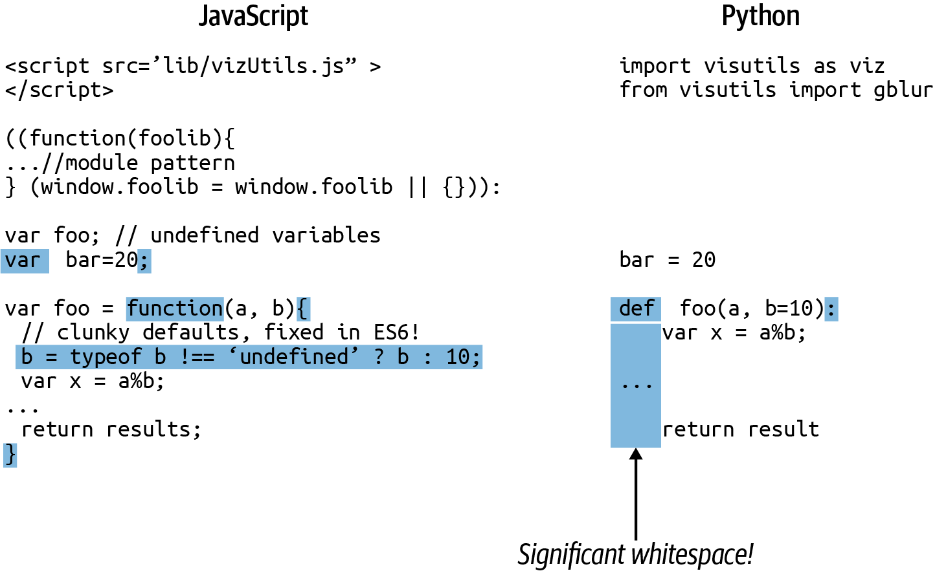

Figure 2-2. Some basic syntax
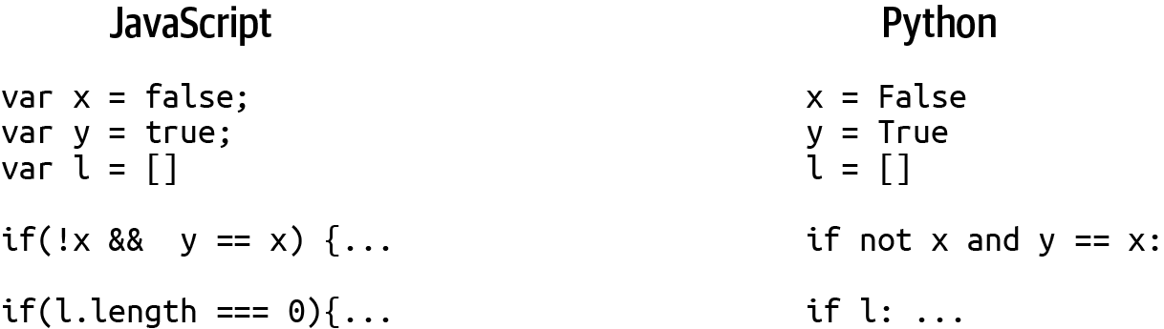

Figure 2-3. Booleans
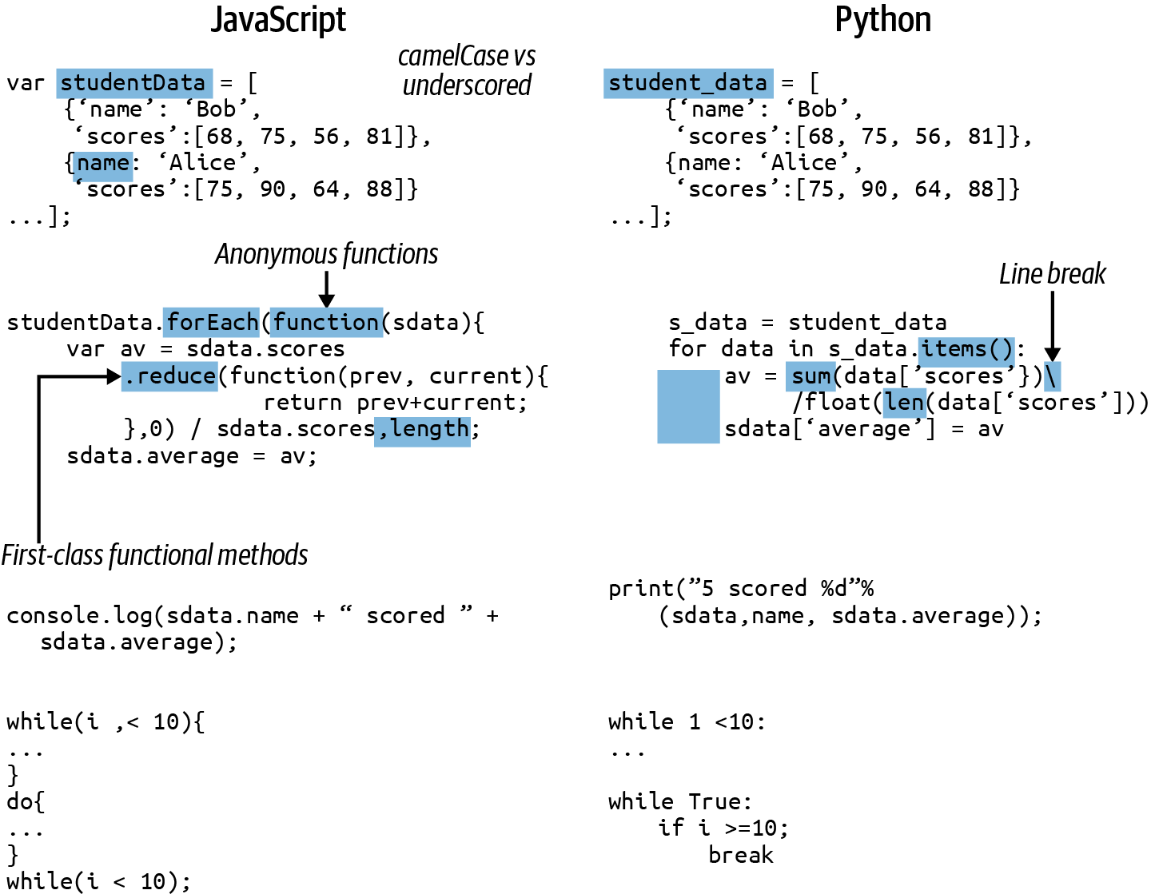

Figure 2-4. Loops and iterations
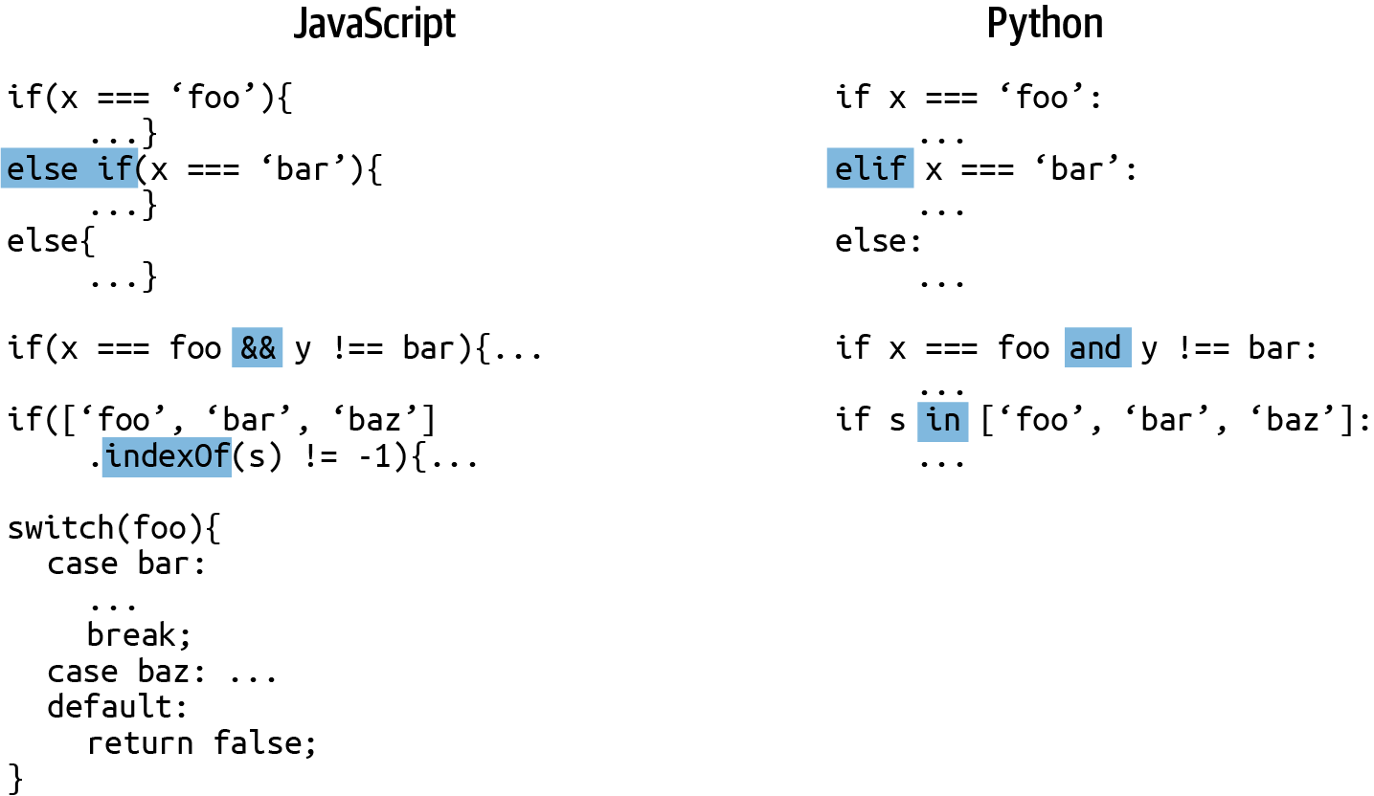

Figure 2-5. Conditionals
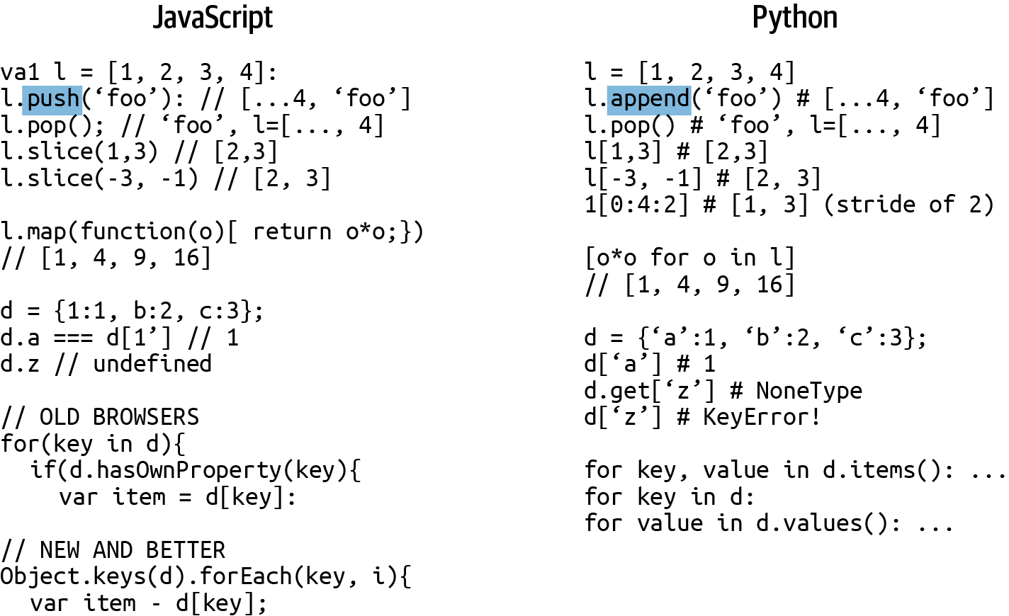

Figure 2-6. Containers
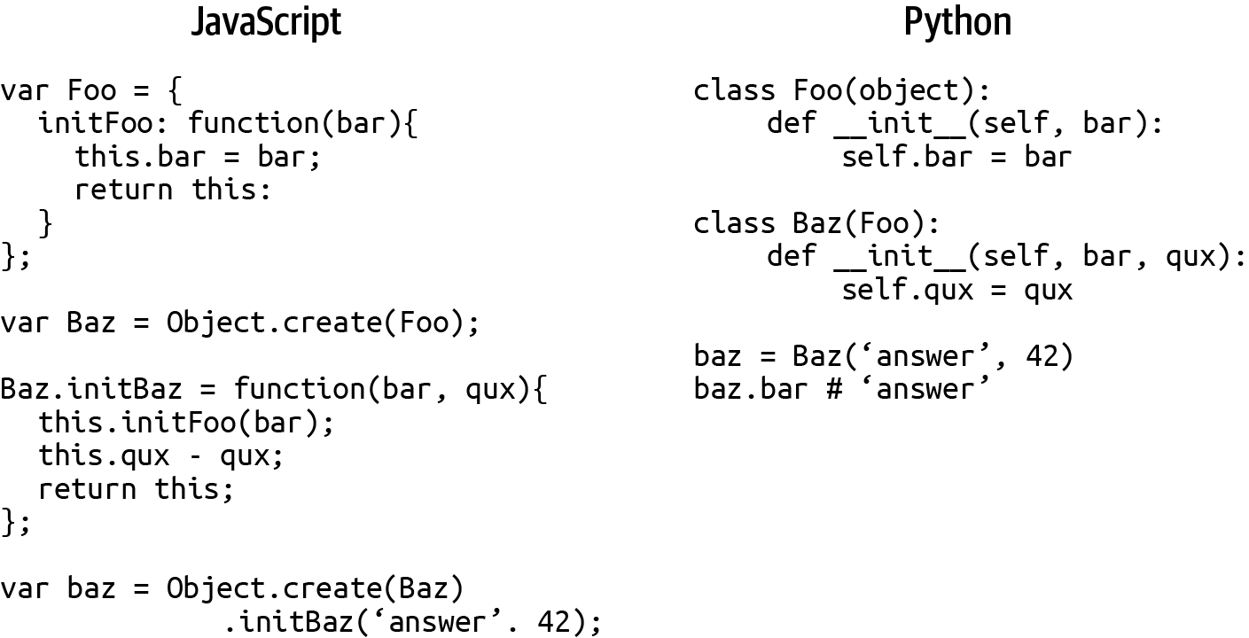

Figure 2-7. Classes and prototypes

Summary
I hope this chapter has shown that JavaScript and Python have a lot of common syntax and that most common idioms and patterns from one of the languages can be expressed in the other without too much fuss. The meat and potatoes of programming—iteration, conditionals, and basic data manipulation—is simple in both languages, and the translation of functions is straightforward. If you can program in one to any degree of competency, the threshold to entry for the other is low. That’s the huge appeal of these simple scripting languages, which have a lot of common heritage.
I provided a list of patterns, hacks, and idioms I find myself using frequently in dataviz work. I’m sure this list has its idiosyncrasies, but I’ve tried to tick the obvious boxes.
Treat this as part tutorial, part reference for the chapters to come. Anything not covered here will be dealt with when introduced.
1 One particularly annoying little gotcha is that while Python uses pop to remove a list item, it uses append—not push—to add an item. JavaScript uses push to add an item, whereas append is used to concatenate arrays.
2 The ascent of node.js has extended JavaScript to the server.
3 This is changing with libraries like TensorFlow.js and Danfo.js (a JavaScript pandas-alike based on TensorFlow), but JS is still well behind Python, R, and others.
4 At the cost of running a Python interpreter on the server.
5 The constraint of having to deliver JS scripts over the web via HTTP is largely responsible for this.
6 You can eliminate the possibility of a missing var by using the ECMAScript 5 'use strict' directive.
7 This is actually done by JavaScript compressors to reduce the file size of downloaded web pages.
8 The soft versus hard tab debate generates controversy, with much heat and little light. PEP-8 stipulates spaces, which is good enough for me.
9 It could be two or even three spaces, but this number must be consistent throughout the module.
10 The quite fair assumption that JavaScript uses UTF-16 has been the cause of much bug-driven misery. See this blog post by Mathias Bynens for an interesting analysis.
11 The change to Unicode strings in Python 3 is a big one. Given the confusion that often attends Unicode de/encoding, it’s worth reading a little bit about it. Python 2 used strings of bytes.
12 parseInt can do quite a bit more than round. For example, parseInt(12.5px) gives 12, first removing the px and then casting the string to a number. It also has a second radix argument to specify the base of the cast. See the Mozilla documentation for the specifics.
13 Because all numbers in JavaScript are floating point, it can only support 53-bit integers. Using larger integers (such as the commonly used 64-bit) can result in discontinuous integers. See this 2ality blog post for further information.
14 This makes iterating over their properties a little trickier than it might be. See this Stack Overflow thread for more details.
15 For the curious, there’s a nice summation in a blog post by Angus Croll.
16 This is one area where JS beats Python hands-down and which finds many of us wishing for similar functionality in Python.
17 Added with ECMAScript 5 and available on all modern browsers.
18 I mentioned to a talented programmer friend that I was faced with the challenge of explaining prototypes to Python programmers, and he pointed out that most JavaScripters could probably do with some pointers too. There’s a lot of truth in this and many JSers do manage to be productive by using prototypes in a classy way, hacking their way around the edge cases.
19 This is another reason to use ECMAScript 5’s 'use strict;' injunction, which calls attention to such mistakes.
20 My personal choice for performance reasons.
21 Don’t Repeat Yourself (DRY) is a solid coding convention.
22 Modern JavaScript has proper modules that can import and export encapsulated variables. There is an overhead to using these as they currently require a build phase to make ready for the browser.

Chapter 3. Reading and Writing Data with Python
One of the fundamental skills of any data visualizer is the ability to move data around. Whether your data is in an SQL database, a comma-separated value (CSV) file, or in some more esoteric form, you should be comfortable reading the data, converting it, and writing it into a more convenient form if need be. One of Python’s great strengths is how easy it makes manipulating data in this way. The focus of this chapter is to bring you up to speed with this essential aspect of our dataviz toolchain.
This chapter is part tutorial, part reference, and sections of it will be referred to in later chapters. If you know the fundamentals of reading and writing Python data, you can cherry-pick parts of the chapter as a refresher.

Easy Does It
I remember when I started programming back in the day (using low-level languages like C) how awkward data manipulation was. Reading from and writing to files was an annoying mixture of boilerplate code, hand-rolled improvisations, and the like. Reading from databases was equally difficult, and as for serializing data, the memories are still painful. Discovering Python was a breath of fresh air. It wasn’t a speed demon, but opening a file was pretty much as simple as it could be:
file
=
open
(
'data.txt'
)
Back then, Python made reading from and writing to files refreshingly easy, and its sophisticated string processing made parsing the data in those files just as easy. It even had an amazing module called Pickle that could serialize pretty much any Python object.
In the years since, Python has added robust, mature modules to its standard library that make dealing with CSV and JSON files, the standard for web dataviz work, just as easy. There are also some great libraries for interacting with SQL databases such as SQLAlchemy, my thoroughly recommended go-to. The newer NoSQL databases are also well served. MongoDB is the most popular of these newer document-based databases, and Python’s PyMongo library, which is demonstrated later in the chapter, makes interacting with it a relative breeze.

Passing Data Around
A good way to demonstrate how to use the key data-storage libraries is to pass a single data packet among them, reading and writing it as we go. This will give us an opportunity to see in action the key data formats and databases employed by data visualizers.
The data we’ll be passing around is probably the most commonly used in web visualizations, a list of dictionary-like objects (see Example 3-1). This dataset is transferred to the browser in JSON form, which is, as we’ll see, easily converted from a Python dictionary.

Example 3-1. Our target list of data objects
nobel_winners
=
[
{
'category'
:
'Physics'
,
'name'
:
'Albert Einstein'
,
'nationality'
:
'Swiss'
,
'gender'
:
'male'
,
'year'
:
1921
},
{
'category'
:
'Physics'
,
'name'
:
'Paul Dirac'
,
'nationality'
:
'British'
,
'gender'
:
'male'
,
'year'
:
1933
},
{
'category'
:
'Chemistry'
,
'name'
:
'Marie Curie'
,
'nationality'
:
'Polish'
,
'gender'
:
'female'
,
'year'
:
1911
}
]
We’ll start by creating a CSV file from the Python list shown in Example 3-1 as a demonstration of reading (opening) and writing system files.
The following sections assume you’re in a working (root) directory with a data subdirectory at hand. You can run the code from a Python interpreter or file.

Working with System Files
In this section, we’ll create a CSV file from a Python list of dictionaries (Example 3-1). Typically, you would do this using the csv module, which we’ll demonstrate after this section, so this is just a way of demonstrating basic Python file manipulation.
First, let’s open a new file, using w as a second argument to indicate we’ll be writing data to it.
f
=
open
(
'data/nobel_winners.csv'
,
'w'
)
Now we’ll create our CSV file from the nobel_winners dictionary (Example 3-1):
cols
=
nobel_winners
[
0
]
.
keys
(
)
cols
=
sorted
(
cols
)
with
open
(
'
data/nobel_winners.csv
'
,
'
w
'
)
as
f
:
f
.
write
(
'
,
'
.
join
(
cols
)
+
'
\n
'
)
for
o
in
nobel_winners
:
row
=
[
str
(
o
[
col
]
)
for
col
in
cols
]
f
.
write
(
'
,
'
.
join
(
row
)
+
'
\n
'
)
Gets our data columns from the keys of the first object (i.e., ['category', 'name', ... ]).
Sorts the columns in alphabetical order.
Uses Python’s with statement to guarantee the file is closed on leaving the block or if any exceptions occur.
join creates a concatenated string from a list of strings (cols here), joined by the initial string (i.e., “category,name,..”).
Creates a list using the column keys to the objects in nobel_winners.
Now that we’ve created our CSV file, let’s use Python to read it and make sure everything is correct:
with
open
(
'data/nobel_winners.csv'
)
as
f
:
for
line
in
f
.
readlines
():
print
(
line
)
Out
:
category
,
name
,
nationality
,
gender
,
year
Physics
,
Albert
Einstein
,
Swiss
,
male
,
1921
Physics
,
Paul
Dirac
,
British
,
male
,
1933
Chemistry
,
Marie
Curie
,
Polish
,
female
,
1911
As the previous output shows, our CSV file is well formed. Let’s use Python’s built-in csv module to first read it and then create a CSV file the right way.

CSV, TSV, and Row-Column Data Formats
Comma-separated values (CSV) or their tab-separated cousins (TSV) are probably the most ubiquitous file-based data formats and, as a data visualizer, these will often be the forms you’ll receive to work your magic with. Being able to read and write CSV files and their various quirky variants, such as pipe- or semicolon-separated or those using ` in place of the standard double quotes, is a fundamental skill; Python’s csv module is capable of doing pretty much all your heavy lifting here. Let’s put it through its paces reading and writing our nobel_winners data:
nobel_winners
=
[
{
'category'
:
'Physics'
,
'name'
:
'Albert Einstein'
,
'nationality'
:
'Swiss'
,
'gender'
:
'male'
,
'year'
:
1921
},
...
]
Writing our nobel_winners data (see Example 3-1) to a CSV file is a pretty simple affair. csv has a dedicated DictWriter class that will turn our dictionaries into CSV rows. The only piece of explicit bookkeeping we have to do is write a header to our CSV file, using the keys of our dictionaries as fields (i.e., “category, name, nationality, gender”):
import
csv
with
open
(
'
data/nobel_winners.csv
'
,
'
w
'
)
as
f
:
fieldnames
=
nobel_winners
[
0
]
.
keys
(
)
fieldnames
=
sorted
(
fieldnames
)
writer
=
csv
.
DictWriter
(
f
,
fieldnames
=
fieldnames
)
writer
.
writeheader
(
)
for
w
in
nobel_winners
:
writer
.
writerow
(
w
)
You need to explicitly tell the writer which fieldnames to use (in this case, the 'category', 'name', etc., keys).
We’ll sort the CSV header fields alphabetically for readability.
Writes the CSV-file header (“category, name,…​”).
You’ll probably be reading CSV files more often than writing them.1 Let’s read back the nobel_winners.csv file we just wrote.
If you just want to use csv as a superior and eminently adaptable file line reader, a couple of lines will produce a handy iterator, which can deliver your CSV rows as lists of strings:
with
open
(
'
data/nobel_winners.csv
'
)
as
f
:
reader
=
csv
.
reader
(
f
)
for
row
in
reader
:
print
(
row
)
Out
:
[
'
category
'
,
'
name
'
,
'
nationality
'
,
'
gender
'
,
'
year
'
]
[
'
Physics
'
,
'
Albert Einstein
'
,
'
Swiss
'
,
'
male
'
,
'
1921
'
]
[
'
Physics
'
,
'
Paul Dirac
'
,
'
British
'
,
'
male
'
,
'
1933
'
]
[
'
Chemistry
'
,
'
Marie Curie
'
,
'
Polish
'
,
'
female
'
,
'
1911
'
]
Iterates over the reader object, consuming the lines in the file.
Note that the numbers are read in string form. If you want to manipulate them numerically, you’ll need to convert any numeric columns to their respective type, which is integer years in this case.
A more convenient way to consume CSV data is to convert the rows into Python dictionaries. This record form is also the one we are using as our conversion target (a list of dicts). csv has a handy DictReader for just this purpose:
import
csv
with
open
(
'
data/nobel_winners.csv
'
)
as
f
:
reader
=
csv
.
DictReader
(
f
)
nobel_winners
=
list
(
reader
)
nobel_winners
Out
:
[
OrderedDict
(
[
(
'
category
'
,
'
Physics
'
)
,
(
'
name
'
,
'
Albert Einstein
'
)
,
(
'
nationality
'
,
'
Swiss
'
)
,
(
'
gender
'
,
'
male
'
)
,
(
'
year
'
,
'
1921
'
)
]
)
,
OrderedDict
(
[
(
'
category
'
,
'
Physics
'
)
,
(
'
name
'
,
'
Paul Dirac
'
)
,
(
'
nationality
'
,
'
British
'
)
,
.
.
.
]
)
]
Inserts all of the reader items into a list.
As the output shows, we just need to cast the dicts year attributes to integers to make nobel_winners conform to the chapter’s target data (Example 3-1), thus:
for
w
in
nobel_winners
:
w
[
'year'
]
=
int
(
w
[
'year'
])
For more flexibility we can easily create a Python datetime from the year column:
from
datetime
import
datetime
dt
=
datetime
.
strptime
(
'1947'
,
'
%Y
'
)
dt
# datetime.datetime(1947, 1, 1, 0, 0)
The csv readers don’t infer datatypes from your file, and instead interpret everything as a string. pandas, Python’s preeminent data-hacking library, will try to guess the correct type of the data columns, usually successfully. We’ll see this in action in the later dedicated pandas chapters.
csv has a few useful arguments to help parse members of the CSV family:
dialect
By default, 'excel'; specifies a set of dialect-specific parameters. excel-tab is a sometimes-used alternative.
delimiter
Files are usually comma-separated, but they could use |, : or ' ' instead.
quotechar
By default, double quotes are used, but you occasionally find | or ` instead.
You can find the full set of csv parameters in the online Python docs.
Now that we’ve successfully written and read our target data using the csv module, let’s pass on our CSV-derived nobel_winners dict to the json module.

JSON
In this section, we’ll write and read our nobel_winners data using Python’s json module. Let’s remind ourselves of the data we’re using:
nobel_winners
=
[
{
'category'
:
'Physics'
,
'name'
:
'Albert Einstein'
,
'nationality'
:
'Swiss'
,
'gender'
:
'male'
,
'year'
:
1921
},
...
]
For data primitives such as strings, integers, and floats, Python dictionaries are easily saved (or dumped, in the JSON vernacular) into JSON files, using the json module. The dump method takes a Python container and a file pointer, saving the former to the latter:
import
json
with
open
(
'data/nobel_winners.json'
,
'w'
)
as
f
:
json
.
dump
(
nobel_winners
,
f
)
open
(
'data/nobel_winners.json'
)
.
read
()
Out: '[{"category": "Physics", "name": "Albert Einstein",
"gender": "male", "year": 1921,
"nationality": "Swiss"}, {"category": "Physics",
"nationality": "British", "year": 1933, "name": "Paul Dirac",
"gender": "male"}, {"category": "Chemistry", "nationality":
"Polish", "year": 1911, "name": "Marie Curie", "gender":
"female"}]'
Reading (or loading) a JSON file is just as easy. We just pass the opened JSON file to the json module’s load method:
import
json
with
open
(
'
data/nobel_winners.json
'
)
as
f
:
nobel_winners
=
json
.
load
(
f
)
nobel_winners
Out
:
[
{
'
category
'
:
'
Physics
'
,
'
name
'
:
'
Albert Einstein
'
,
'
nationality
'
:
'
Swiss
'
,
'
gender
'
:
'
male
'
,
'
year
'
:
1921
}
,
.
.
.
}
]
Note that, unlike in our CSV file conversion, the integer type of the year column is preserved.
json has the methods loads and dumps, which are counterparts to the file access methods, loading JSON strings to Python containers and dumping Python containers to JSON strings.

Dealing with Dates and Times
Trying to dump a datetime object to json produces a TypeError:
from
datetime
import
datetime
json
.
dumps
(
datetime
.
now
())
Out
:
...
TypeError
:
datetime
.
datetime
(
2021
,
9
,
13
,
10
,
25
,
52
,
586792
)
is
not
JSON
serializable
When serializing simple datatypes such as strings or numbers, the default json encoders and decoders are fine. But for more specialized data such as dates, you will need to do your own encoding and decoding. This isn’t as hard as it sounds and quickly becomes routine. Let’s first look at encoding your Python datetimes into sensible JSON strings.
The easiest way to encode Python data containing datetimes is to create a custom encoder like the one shown in Example 3-2, which is provided to the json.dumps method as a cls argument. This encoder is applied to each object in your data in turn and converts dates or datetimes to their ISO-format string (see “Dealing with Dates, Times, and Complex Data”).

Example 3-2. Encoding a Python datetime to JSON
import
datetime
import
json
class
JSONDateTimeEncoder
(
json
.
JSONEncoder
)
:
def
default
(
self
,
obj
)
:
if
isinstance
(
obj
,
(
datetime
.
date
,
datetime
.
datetime
)
)
:
return
obj
.
isoformat
(
)
else
:
return
json
.
JSONEncoder
.
default
(
self
,
obj
)
def
dumps
(
obj
)
:
return
json
.
dumps
(
obj
,
cls
=
JSONDateTimeEncoder
)
Subclasses a JSONEncoder in order to create a customized date-handling one.
Tests for a datetime object and if true, returns the isoformat of any dates or datetimes (e.g., 2021-11-16T16:41:14.650802).
Uses the cls argument to set a custom date encoder.
Let’s see how our new dumps method copes with some datetime data:
now_str
=
dumps
({
'time'
:
datetime
.
datetime
.
now
()})
now_str
Out
:
'{"time": "2021-11-16T16:41:14.650802"}'
The time field is correctly converted into an ISO-format string, ready to be decoded into a JavaScript Date object (see “Dealing with Dates, Times, and Complex Data” for a demonstration).
While you could write a generic decoder to cope with date strings in arbitrary JSON files,2 it’s probably not advisable. Date strings come in so many weird and wonderful varieties that this is a job best done by hand on what is pretty much always a known dataset.
The venerable strptime method, part of the datetime.datetime package, is good for the job of turning a time string in a known format into a Python datetime instance:
In
[
0
]
:
from
datetime
import
datetime
In
[
1
]
:
time_str
=
'
2021/01/01 12:32:11
'
In
[
2
]
:
dt
=
datetime
.
strptime
(
time_str
,
'
%Y
/
%m
/
%d
%H
:
%M
:
%S
'
)
In
[
3
]
:
dt
Out
[
2
]
:
datetime
.
datetime
(
2021
,
1
,
1
,
12
,
32
,
11
)
strptime tries to match the time string to a format string using various directives such as %Y (year with century) and %H (hour as a zero-padded decimal number). If successful, it creates a Python datetime instance. See the Python docs for a full list of the directives available.
If strptime is fed a time string that does not match its format, it throws a handy ValueError:
dt
=
datetime
.
strptime
(
'1/2/2021 12:32:11'
,
'
%Y
/
%m
/
%d
%H
:
%M
:
%S
'
)
-----------------------------------------------------------
ValueError
Traceback
(
most
recent
call
last
)
<
ipython
-
input
-
111
-
af657749a9fe
>
in
<
module
>
()
---->
1
dt
=
datetime
.
strptime
(
'1/2/2021 12:32:11'
,
\
'
%Y
/
%m
/
%d
%H
:
%M
:
%S
'
)
...
ValueError
:
time
data
'1/2/2021 12:32:11'
does
not
match
format
'
%Y
/
%m
/
%d
%H
:
%M
:
%S
'
So to convert date fields of a known format into datetimes for a data list of dictionaries, you could do something like this:
data
=
[
{
'id'
:
0
,
'date'
:
'2020/02/23 12:59:05'
},
{
'id'
:
1
,
'date'
:
'2021/11/02 02:32:00'
},
{
'id'
:
2
,
'date'
:
'2021/23/12 09:22:30'
},
]
for
d
in
data
:
try
:
d
[
'date'
]
=
datetime
.
strptime
(
d
[
'date'
],
\
'
%Y
/
%m
/
%d
%H
:
%M
:
%S
'
)
except
ValueError
:
print
(
'Oops! - invalid date for '
+
repr
(
d
))
# Out:
# Oops! - invalid date for {'id': 2, 'date': '2021/23/12 09:22:30'}
Now that we’ve dealt with the two most popular data file formats, let’s shift to the big guns and see how to read our data from and write our data to SQL and NoSQL databases.

SQL
For interacting with an SQL database, SQLAlchemy is the most popular and, in my opinion, best Python library. It allows you to use raw SQL instructions if speed and efficiency is an issue, but also provides a powerful object-relational mapping (ORM) that allows you to operate on SQL tables using a high-level, Pythonic API, treating them essentially as Python classes.
Reading and writing data using SQL while allowing the user to treat that data as a Python container is a complicated process, and though SQLAlchemy is considerably more user-friendly than a low-level SQL engine, it is still a fairly complex library. I’ll cover the basics here, using our data as a target, but encourage you to spend a little time reading some of the rather excellent documentation on SQLAlchemy. Let’s remind ourselves of the nobel_winners dataset we’re aiming to write and read:
nobel_winners
=
[
{
'category'
:
'Physics'
,
'name'
:
'Albert Einstein'
,
'nationality'
:
'Swiss'
,
'gender'
:
'male'
,
'year'
:
1921
},
...
]
Let’s first write our target data to an SQLite file using SQLAlchemy, starting by creating the database engine.

Creating the Database Engine
The first thing you need to do when starting an SQLAlchemy session is to create a database engine. This engine will establish a connection with the database in question and perform any conversions needed to the generic SQL instructions generated by SQLAlchemy and the data being returned.
There are engines for pretty much every popular database, as well as a memory option, which holds the database in RAM, allowing fast access for testing.3 The great thing about these engines is that they are interchangeable, which means you could develop your code using the convenient file-based SQLite database and then switch during production to something a little more industrial, such as PostgreSQL, by changing a single config string. Check SQLAlchemy for the full list of engines available.
The form for specifying a database URL is:
dialect+driver://username:password@host:port/database
So, to connect to a 'nobel_winners' MySQL database running on localhost requires something like the following. Note that create_engine does not actually make any SQL requests at this point, but merely sets up the framework for doing so:4
engine
=
create_engine
(
'mysql://kyran:mypsswd@localhost/nobel_winners'
)
We’ll use a file-based SQLite database, setting the echo argument to True, which will output any SQL instructions generated by SQLAlchemy. Note the use of three backslashes after the colon:
from
sqlalchemy
import
create_engine
engine
=
create_engine
(
'sqlite:///data/nobel_winners.db'
,
echo
=
True
)
SQLAlchemy offers various ways to engage with databases, but I recommend using the more recent declarative style unless there are good reasons to go with something more low-level and fine-grained. In essence, with declarative mapping, you subclass your Python SQL-table classes from a base, and SQLAlchemy introspects their structure and relationships. See SQLAlchemy for more details.

Defining the Database Tables
We first create a Base class using declarative_base. This base will be used to create table classes, from which SQLAlchemy will create the database’s table schemas. You can use these table classes to interact with the database in a fairly Pythonic fashion:
from
sqlalchemy.ext.declarative
import
declarative_base
Base
=
declarative_base
()
Note that most SQL libraries require you to formally define table schemas. This is in contrast to such schema-less NoSQL variants as MongoDB. We’ll take a look at the Dataset library later in this chapter, which enables schemaless SQL.
Using this Base, we define our various tables—in our case, a single Winner table. Example 3-3 shows how to subclass Base and use SQLAlchemy’s datatypes to define a table schema. Note the __tablename__ member, which will be used to name the SQL table and as a keyword to retrieve it, and the optional custom __repr__ method, which will be used when printing a table row.

Example 3-3. Defining an SQL database table
from
sqlalchemy
import
Column
,
Integer
,
String
,
Enum
//
...
class
Winner
(
Base
):
__tablename__
=
'winners'
id
=
Column
(
Integer
,
primary_key
=
True
)
category
=
Column
(
String
)
name
=
Column
(
String
)
nationality
=
Column
(
String
)
year
=
Column
(
Integer
)
gender
=
Column
(
Enum
(
'male'
,
'female'
))
def
__repr__
(
self
):
return
"<Winner(name='
%s
', category='
%s
', year='
%s
')>"
\
%
(
self
.
name
,
self
.
category
,
self
.
year
)
Having declared our Base subclass in Example 3-3, we supply its metadata create_all method with our database engine to create our database.5 Because we set the echo argument to True when creating the engine, we can see the SQL instructions generated by SQLAlchemy from the command line:
Base
.
metadata
.
create_all
(
engine
)
2021
-
11
-
16
17
:
58
:
34
,
700
INFO
sqlalchemy
.
engine
.
Engine
BEGIN
(
implicit
)
...
CREATE
TABLE
winners
(
id
INTEGER
NOT
NULL
,
category
VARCHAR
,
name
VARCHAR
,
nationality
VARCHAR
,
year
INTEGER
,
gender
VARCHAR
(
6
),
PRIMARY
KEY
(
id
)
)
...
2021
-
11
-
16
17
:
58
:
34
,
742
INFO
sqlalchemy
.
engine
.
Engine
COMMIT
With our new winners table declared, we can start adding winner instances to it.

Adding Instances with a Session
Now that we have created our database, we need a session to interact with:
from
sqlalchemy.orm
import
sessionmaker
Session
=
sessionmaker
(
bind
=
engine
)
session
=
Session
()
We can now use our Winner class to create instances and table rows and add them to the session:
albert
=
Winner
(
*
*
nobel_winners
[
0
]
)
session
.
add
(
albert
)
session
.
new
Out
:
IdentitySet
(
[
<
Winner
(
name
=
'
Albert Einstein
'
,
category
=
'
Physics
'
,
year
=
'
1921
'
)
>
]
)
Python’s handy ** operator unpacks our first nobel_winners member into key-value pairs: (name='Albert Einstein', category='Physics'...).
new is the set of any items that have been added to this session.
Note that all database insertions and deletions take place in Python. It’s only when we use the commit method that the database is altered.
Tip
Use as few commits as possible, allowing SQLAlchemy to work its magic behind the scenes. When you commit, your various database manipulations should be summarized by SQLAlchemy and communicated in an efficient fashion. Commits involve establishing a database handshake and negotiating transactions, which is often a slow process and one you want to limit as much as possible, leveraging SQLAlchemy’s bookkeeping abilities to full advantage.
As the new method shows, we have added a Winner to the session. We can remove the object using expunge, leaving an empty IdentitySet:
session
.
expunge
(
albert
)
session
.
new
Out
:
IdentitySet
(
[
]
)
Removes the instance from the session (there is an expunge_all method that removes all new objects added to the session).
At this point, no database insertions or deletions have taken place. Let’s add all the members of our nobel_winners list to the session and commit them to the database:
winner_rows
=
[
Winner
(
**
w
)
for
w
in
nobel_winners
]
session
.
add_all
(
winner_rows
)
session
.
commit
()
Out
:
INFO
:
sqlalchemy
.
engine
.
base
.
Engine
:
BEGIN
(
implicit
)
...
INFO
:
sqlalchemy
.
engine
.
base
.
Engine
:
INSERT
INTO
winners
(
name
,
category
,
year
,
nationality
,
gender
)
VALUES
(
?
,
?
,
?
,
?
,
?
)
INFO
:
sqlalchemy
.
engine
.
base
.
Engine
:(
'Albert Einstein'
,
'Physics'
,
1921
,
'Swiss'
,
'male'
)
...
INFO
:
sqlalchemy
.
engine
.
base
.
Engine
:
COMMIT
Now that we’ve committed our nobel_winners data to the database, let’s see what we can do with it and how to re-create the target list in Example 3-1.

Querying the Database
To access data, you use the session’s query method, the result of which can be filtered, grouped, and intersected, allowing the full range of standard SQL data retrieval. You can check out available querying methods in the SQLAlchemy docs. For now, I’ll quickly run through some of the most common queries on our Nobel dataset.
Let’s first count the number of rows in our winners table:
session
.
query
(
Winner
)
.
count
()
Out
:
3
Next, let’s retrieve all Swiss winners:
result
=
session
.
query
(
Winner
)
.
filter_by
(
nationality
=
'
Swiss
'
)
list
(
result
)
Out
:
[
<
Winner
(
name
=
'
Albert Einstein
'
,
category
=
'
Physics
'
,
\
year
=
'
1921
'
)
>
]
filter_by uses keyword expressions; its SQL expressions counterpart is filter—for example, filter(Winner.nationality == Swiss). Note the Boolean equivalence == used in filter.
Now let’s get all non-Swiss physics winners:
result
=
session
.
query
(
Winner
)
.
filter
(
\
Winner
.
category
==
'Physics'
,
\
Winner
.
nationality
!=
'Swiss'
)
list
(
result
)
Out
:
[
<
Winner
(
name
=
'Paul Dirac'
,
category
=
'Physics'
,
year
=
'1933'
)
>
]
Here’s how to get a row based on ID number:
session
.
query
(
Winner
)
.
get
(
3
)
Out
:
<
Winner
(
name
=
'Marie Curie'
,
category
=
'Chemistry'
,
year
=
'1911'
)
>
Now let’s retrieve winners ordered by year:
res
=
session
.
query
(
Winner
)
.
order_by
(
'year'
)
list
(
res
)
Out
:
[
<
Winner
(
name
=
'Marie Curie'
,
category
=
'Chemistry'
,
\
year
=
'1911'
)
>
,
<
Winner
(
name
=
'Albert Einstein'
,
category
=
'Physics'
,
\
year
=
'1921'
)
>
,
<
Winner
(
name
=
'Paul Dirac'
,
category
=
'Physics'
,
year
=
'1933'
)
>
]
To reconstruct our target list requires a little effort when converting the Winner objects returned by our session query into Python dicts. Let’s write a little function to create a dict from an SQLAlchemy class. We’ll use a little table introspection to get the column labels (see Example 3-4).

Example 3-4. Converts an SQLAlchemy instance to a dict
def
inst_to_dict
(
inst
,
delete_id
=
True
)
:
dat
=
{
}
for
column
in
inst
.
__table__
.
columns
:
dat
[
column
.
name
]
=
getattr
(
inst
,
column
.
name
)
if
delete_id
:
dat
.
pop
(
'
id
'
)
return
dat
Accesses the instance’s table class to get a list of column objects.
If delete_id is true, remove the SQL primary ID field.
We can use Example 3-4 to reconstruct our nobel_winners target list:
winner_rows
=
session
.
query
(
Winner
)
nobel_winners
=
[
inst_to_dict
(
w
)
for
w
in
winner_rows
]
nobel_winners
Out
:
[{
'category'
:
'Physics'
,
'name'
:
'Albert Einstein'
,
'nationality'
:
'Swiss'
,
'gender'
:
'male'
,
'year'
:
1921
},
...
]
You can update database rows easily by changing the property of their reflected objects:
marie
=
session
.
query
(
Winner
)
.
get
(
3
)
marie
.
nationality
=
'
French
'
session
.
dirty
Out
:
IdentitySet
(
[
<
Winner
(
name
=
'
Marie Curie
'
,
category
=
'
Chemistry
'
,
year
=
'
1911
'
)
>
]
)
Fetches Marie Curie, nationality Polish.
dirty shows any changed instances not yet committed to the database.
Let’s commit Marie’s changes and check that her nationality has changed from Polish to French:
session
.
commit
()
Out
:
INFO
:
sqlalchemy
.
engine
.
base
.
Engine
:
UPDATE
winners
SET
nationality
=
?
WHERE
winners
.
id
=
?
INFO
:
sqlalchemy
.
engine
.
base
.
Engine
:(
'French'
,
3
)
...
session
.
dirty
Out
:
IdentitySet
([])
session
.
query
(
Winner
)
.
get
(
3
)
.
nationality
Out
:
'French'
In addition to updating database rows, you can delete the results of a query:
session
.
query
(
Winner
)
.
filter_by
(
name
=
'Albert Einstein'
)
.
delete
()
Out
:
INFO
:
sqlalchemy
.
engine
.
base
.
Engine
:
DELETE
FROM
winners
WHERE
winners
.
name
=
?
INFO
:
sqlalchemy
.
engine
.
base
.
Engine
:(
'Albert Einstein'
,)
1
list
(
session
.
query
(
Winner
))
Out
:
[
<
Winner
(
name
=
'Paul Dirac'
,
category
=
'Physics'
,
year
=
'1933'
)
>
,
<
Winner
(
name
=
'Marie Curie'
,
category
=
'Chemistry'
,
\
year
=
'1911'
)
>
]
You can also drop the whole table if required, using the declarative class’s __table__ attribute:
Winner
.
__table__
.
drop
(
engine
)
In this section, we’ve dealt with a single winners table, without any foreign keys or relationship to any other tables, akin to a CSV or JSON file. SQLAlchemy adds the same level of convenience in dealing with many-to-one, one-to-many, and other database table relationships as it does to basic querying using implicit joins, by supplying the query method with more than one table class or explicitly using the query’s join method. Check out the examples in the SQLAlchemy docs for more details.

Easier SQL with Dataset
One library I’ve found myself using a fair deal recently is Dataset, a module designed to make working with SQL databases a little easier and more Pythonic than existing powerhouses like SQLAlchemy.6 Dataset tries to provide the same degree of convenience you get when working with schema-less NoSQL databases such as MongoDB by removing a lot of the formal boilerplate, such as schema definitions, which are demanded by the more conventional libraries. Dataset is built on top of SQLAlchemy, which means it works with pretty much all major databases and can exploit the power, robustness, and maturity of that best-of-breed library. Let’s see how it deals with reading and writing our target dataset (from Example 3-1).
Let’s use the SQLite nobel_winners.db database we’ve just created to put Dataset through its paces. First, we connect to our SQL database, using the same URL/file format as SQLAlchemy:
import
dataset
db
=
dataset
.
connect
(
'sqlite:///data/nobel_winners.db'
)
To get our list of winners, we grab a table from our db database, using its name as a key, and then use the find method without arguments to return all winners:
wtable
=
db
[
'winners'
]
winners
=
wtable
.
find
()
winners
=
list
(
winners
)
winners
#Out:
#[OrderedDict([(u'id', 1), ('name', 'Albert Einstein'),
# ('category', 'Physics'), ('year', 1921), ('nationality',
# 'Swiss'), ('gender', 'male')]), OrderedDict([('id', 2),
# ('name', 'Paul Dirac'), ('category', 'Physics'),
# ('year', 1933), ('nationality', 'British'), ('gender',
# 'male')]), OrderedDict([('id', 3), ('name', 'Marie
# Curie'), ('category', 'Chemistry'), ('year', 1911),
# ('nationality', 'Polish'), ('gender', 'female')])]
Note that the instances returned by Dataset’s find method are OrderedDicts. These useful containers are an extension of Python’s dict class and behave just like dictionaries except that they remember the order in which items were inserted, meaning you can guarantee the result of iteration, pop the last item inserted, and more. This is a very handy additional functionality.
Tip
One of the most useful Python “batteries” for data manipulators is collections, which is where Dataset’s OrderedDicts come from. The defaultdict and Counter classes are particularly useful. Check out what’s available in the Python docs.
Let’s re-create our winners table with Dataset, first dropping the existing one:
wtable
=
db
[
'winners'
]
wtable
.
drop
()
wtable
=
db
[
'winners'
]
wtable
.
find
()
#Out:
#[]
To re-create our dropped winners table, we don’t need to define a schema as with SQLAlchemy (see “Defining the Database Tables”). Dataset will infer that from the data we add, doing all the SQL creation implicitly. This is the kind of convenience one is used to when working with collection-based NoSQL databases. Let’s use our nobel_winners dataset (Example 3-1) to insert some winner dictionaries. We use a database transaction and the with statement to efficiently insert our objects and then commit them:7
with
db
as
tx
:
tx
[
'
winners
'
]
.
insert_many
(
nobel_winners
)
Use the with statement to guarantee the transaction tx is committed to the database.
Let’s check that everything has gone well:
list
(
db
[
'winners'
]
.
find
())
Out
:
[
OrderedDict
([(
'id'
,
1
),
(
'name'
,
'Albert Einstein'
),
(
'category'
,
'Physics'
),
(
'year'
,
1921
),
(
'nationality'
,
'Swiss'
),
(
'gender'
,
'male'
)]),
...
]
The winners have been correctly inserted and their order of insertion preserved by the OrderedDict.
Dataset is great for basic SQL-based work, particularly retrieving data you might wish to process or visualize. For more advanced manipulation, it allows you to drop down into SQLAlchemy’s core API using the query method.
Now that we’ve covered the basics of working with SQL databases, let’s see how Python makes working with the most popular NoSQL database just as painless.

MongoDB
Document-centric datastores like MongoDB offer a lot of convenience to data wranglers. As with all tools, there are good and bad use cases for NoSQL databases. If you have data that has already been refined and processed and don’t anticipate needing SQL’s powerful query language based on optimized table joins, MongoDB will probably prove easier to work with initially. MongoDB is a particularly good fit for web dataviz because it uses binary JSON (BSON) as its data format. An extension of JSON, BSON can deal with binary data and datetime objects, and plays very nicely with JavaScript.
Let’s remind ourselves of the target dataset we’re aiming to write and read:
nobel_winners
=
[
{
'category'
:
'Physics'
,
'name'
:
'Albert Einstein'
,
'nationality'
:
'Swiss'
,
'gender'
:
'male'
,
'year'
:
1921
},
...
]
Creating a MongoDB collection with Python is the work of a few lines:
from
pymongo
import
MongoClient
client
=
MongoClient
(
)
db
=
client
.
nobel_prize
coll
=
db
.
winners
Creates a Mongo client, using the default host and ports.
Creates or accesses the nobel_prize database.
If a winners collection exists, this will retrieve it; otherwise (as in our case), it creates it.
Using Constants for MongoDB Access
Accessing and creating a MongoDB database with Python involves the same operation, using dot notation and square-bracket key access:
db
=
client
.
nobel_prize
db
=
client
[
'nobel_prize'
]
This is all very convenient, but it means a single spelling mistake, such as noble_prize, could both create an unwanted database and cause future operations to fail to update the correct one. For this reason, I advise using constant strings to access your MongoDB databases and collections:
DB_NOBEL_PRIZE
=
'nobel_prize'
COLL_WINNERS
=
'winners'
db
=
client
[
DB_NOBEL_PRIZE
]
coll
=
db
[
COLL_WINNERS
]
MongoDB databases run on localhost port 27017 by default but could be anywhere on the web. They also take an optional username and password. Example 3-5 shows how to create a simple utility function to access our database, with standard defaults.

Example 3-5. Accessing a MongoDB database
from
pymongo
import
MongoClient
def
get_mongo_database
(
db_name
,
host
=
'
localhost
'
,
\
port
=
27017
,
username
=
None
,
password
=
None
)
:
""" Get named database from MongoDB with/out authentication """
# make Mongo connection with/out authentication
if
username
and
password
:
mongo_uri
=
'
mongodb://
%s
:
%s
@
%s
/
%s
'
%
\
(
username
,
password
,
host
,
db_name
)
conn
=
MongoClient
(
mongo_uri
)
else
:
conn
=
MongoClient
(
host
,
port
)
return
conn
[
db_name
]
We specify the database name in the MongoDB URI (Uniform Resource Identifier) as the user may not have general privileges for the database.
We can now create a Nobel Prize database and add our target dataset (Example 3-1). Let’s first get a winners collection, using the string constants for access:
db
=
get_mongo_database
(
DB_NOBEL_PRIZE
)
coll
=
db
[
COLL_WINNERS
]
Inserting our Nobel Prize dataset is then as easy as can be:
coll
.
insert_many
(
nobel_winners
)
coll
.
find
()
Out
:
[{
'_id'
:
ObjectId
(
'61940b7dc454e79ffb14cd25'
),
'category'
:
'Physics'
,
'name'
:
'Albert Einstein'
,
'nationality'
:
'Swiss'
,
'year'
:
1921
,
'gender'
:
'male'
},
{
'_id'
:
ObjectId
(
'61940b7dc454e79ffb14cd26'
),
...
}
...
]
The resulting array of ObjectIds can be used for future retrieval, but MongoDB has already left its stamp on our nobel_winners list, adding a hidden id property.8
Tip
MongoDB’s ObjectIds have quite a bit of hidden functionality, being a lot more than a simple random identifier. You can, for example, get the generation time of the ObjectId, which gives you access to a handy timestamp:
import
bson
oid
=
bson
.
ObjectId
()
oid
.
generation_time
Out
:
datetime
.
datetime
(
2015
,
11
,
4
,
15
,
43
,
23.
..
Find the full details in the MongoDB BSON documentation.
Now that we’ve got some items in our winners collection, MongoDB makes finding them very easy, with its find method taking a dictionary query:
res
=
coll
.
find
({
'category'
:
'Chemistry'
})
list
(
res
)
Out
:
[{
'_id'
:
ObjectId
(
'55f8326f26a7112e547879d6'
),
'category'
:
'Chemistry'
,
'name'
:
'Marie Curie'
,
'nationality'
:
'Polish'
,
'gender'
:
'female'
,
'year'
:
1911
}]
There are a number of special dollar-prefixed operators that allow for sophisticated querying. Let’s find all the winners after 1930 using the $gt (greater-than) operator:
res
=
coll
.
find
({
'year'
:
{
'$gt'
:
1930
}})
list
(
res
)
Out
:
[{
'_id'
:
ObjectId
(
'55f8326f26a7112e547879d5'
),
'category'
:
'Physics'
,
'name'
:
'Paul Dirac'
,
'nationality'
:
'British'
,
'gender'
:
'male'
,
'year'
:
1933
}]
You can also use a Boolean expression, for instance, to find all winners after 1930 or all female winners:
res
=
coll
.
find
({
'$or'
:[{
'year'
:
{
'$gt'
:
1930
}},
\
{
'gender'
:
'female'
}]})
list
(
res
)
Out
:
[{
'_id'
:
ObjectId
(
'55f8326f26a7112e547879d5'
),
'category'
:
'Physics'
,
'name'
:
'Paul Dirac'
,
'nationality'
:
'British'
,
'gender'
:
'male'
,
'year'
:
1933
},
{
'_id'
:
ObjectId
(
'55f8326f26a7112e547879d6'
),
'category'
:
'Chemistry'
,
'name'
:
'Marie Curie'
,
'nationality'
:
'Polish'
,
'gender'
:
'female'
,
'year'
:
1911
}]
You can find the full list of available query expressions in the MongoDB documentation.
As a final test, let’s turn our new winners collection back into a Python list of dictionaries. We’ll create a utility function for the task:
def
mongo_coll_to_dicts
(
dbname
=
'
test
'
,
collname
=
'
test
'
,
\
query
=
{
}
,
del_id
=
True
,
*
*
kw
)
:
db
=
get_mongo_database
(
dbname
,
*
*
kw
)
res
=
list
(
db
[
collname
]
.
find
(
query
)
)
if
del_id
:
for
r
in
res
:
r
.
pop
(
'
_id
'
)
return
res
An empty query dict {} will find all documents in the collection. del_id is a flag to remove MongoDB’s ObjectIds from the items by default.
We can now create our target dataset:
mongo_coll_to_dicts
(
DB_NOBEL_PRIZE
,
COLL_WINNERS
)
Out
:
[{
'category'
:
'Physics'
,
'name'
:
'Albert Einstein'
,
'nationality'
:
'Swiss'
,
'gender'
:
'male'
,
'year'
:
1921
},
...
]
MongoDB’s schema-less databases are great for fast prototyping in solo work or small teams. There will probably come a point, particularly with large codebases, when a formal schema becomes a useful reference and sanity check; when you are choosing a data model, the ease with which document forms can be adapted is a bonus. Being able to pass Python dictionaries as queries to PyMongo and having access to client-side generated ObjectIds are a couple of other conveniences.
We’ve now passed the nobel_winners data in Example 3-1 through all our required file formats and databases. Let’s consider the special case of dealing with dates and times before summing up.

Dealing with Dates, Times, and Complex Data
The ability to deal comfortably with dates and times is fundamental to dataviz work but can be quite tricky. There are many ways to represent a date or datetime as a string, each one requiring a separate encoding or decoding. For this reason it’s good to settle on one format in your own work and encourage others to do the same. I recommend using the International Standard Organization (ISO) 8601 time format as your string representation for dates and times, and using the Coordinated Universal Time (UTC) form.9 Here are a few examples of ISO 8601 date and datetime strings:
2021-09-23 | A date (Python/C format code '%Y-%m-%d')
2021-09-23T16:32:35Z | A UTC (Z after time) date and time ('T%H:%M:%S')
2021-09-23T16:32+02:00 | A positive two-hour (+02:00) offset from UTC (e.g., Central European Time)
Note the importance of being prepared to deal with different time zones. These are not always on lines of longitude (see Wikipedia’s Time Zone entry), and often the best way to derive an accurate time is by using UTC time plus a geographic location.
ISO 8601 is the standard used by JavaScript and is easy to work with in Python. As web data visualizers, our key concern is in creating a string representation that can be passed between Python and JavaScript using JSON and encoded and decoded easily at both ends.
Let’s take a date and time in the shape of a Python datetime, convert it into a string, and then see how that string can be consumed by JavaScript.
First, we produce our Python datetime:
from
datetime
import
datetime
d
=
datetime
.
now
()
d
.
isoformat
()
Out
:
'2021-11-16T22:55:48.738105'
This string can then be saved to JSON or CSV, read by JavaScript, and used to create a Date object:
// JavaScript
d
=
new
Date
(
'2021-11-16T22:55:48.738105'
)
>
Tue
Nov
16
2021
22
:
55
:
48
GMT
+
0000
(
Greenwich
Mean
Time
)
We can return the datetime to ISO 8601 string form with the toISOString method:
// JavaScript
d
.
toISOString
()
>
'2021-11-16T22:55:48.738Z'
Finally, we can read the string back into Python.
If you know that you’re dealing with an ISO-format time string, Python’s dateutil module should do the job.10 But you’ll probably want to sanity check the result:
from
dateutil
import
parser
d
=
parser
.
parse
(
'2021-11-16T22:55:48.738Z'
)
d
Out
:
datetime
.
datetime
(
2021
,
11
,
16
,
22
,
55
,
48
,
738000
,
\
tzinfo
=
tzutc
())
Note that we’ve lost some resolution in the trip from Python to JavaScript and back again, the latter dealing in milliseconds, not microseconds. This is unlikely to be an issue in any dataviz work but is good to bear in mind just in case some strange temporal errors occur.

Summary
This chapter aimed to make you comfortable using Python to move data around the various file formats and databases that a data visualizer might expect to bump into. Using databases effectively and efficiently is a skill that takes a while to learn, but you should now be comfortable with basic reading and writing for the large majority of dataviz use cases.
Now that we have the vital lubrication for our dataviz toolchain, let’s get up to scratch on the basic web development skills you’ll need for the chapters ahead.
1 I recommend using JSON over CSV as your preferred data format.
2 The Python module dateutil has a parser that will parse most dates and times sensibly, and might be a good basis for this.
3 On a cautionary note, it is probably a bad idea to use different database configurations for testing and production.
4 See details on SQLAlchemy of this lazy initialization.
5 This assumes the database doesn’t already exist. If it does, Base will be used to create new insertions and to interpret retrievals.
6 Dataset’s official motto is “Databases for lazy people.” It is not part of the standard Anaconda package, so you’ll want to install it using pip from the command line: $ pip install dataset.
7 See this documentation for further details of how to use transactions to group updates.
8 One of the cool things about MongoDB is that the ObjectIds are generated on the client side, removing the need to quiz the database for them.
9 To get the actual local time from UTC, you can store a time zone offset or, better still, derive it from a geocoordinate; this is because time zones do not follow lines of longitude very exactly.
10 To install, just run pip install python-dateutil. dateutil is a pretty powerful extension of Python’s datetime; check it out on Read the Docs.

Chapter 4. Webdev 101
This chapter introduces the core web-development knowledge you will need to understand the web pages you scrape for data and to structure those you want to deliver as the skeleton of your JavaScripted visualizations. As you’ll see, a little knowledge goes a long way in modern webdev, particularly when your focus is building self-contained visualizations and not entire websites (see “Single-Page Apps” for more details).
The usual caveats apply: this chapter is part reference, part tutorial. There will probably be stuff here you know already, so feel free to skip over it and get to the new material.

The Big Picture
The humble web page, the basic building block of the World Wide Web (WWW)—that fraction of the internet consumed by humans—​is constructed from files of various types. Apart from the multimedia files (images, videos, sound, etc.), the key elements are textual, consisting of Hypertext Markup Language (HTML), Cascading Style Sheets (CSS), and JavaScript. These three, along with any necessary data files, are delivered using the Hypertext Transfer Protocol (HTTP) and used to build the page you see and interact with in your browser window, which is described by the Document Object Model (DOM), a hierarchical tree off which your content hangs. A basic understanding of how these elements interact is vital to building modern web visualizations, and the aim of this chapter is to get you quickly up to speed.
Web development is a big field, and the aim here is not to turn you into a full-fledged web developer. I assume you want to limit the amount of webdev you have to do as much as possible, focusing only on that fraction necessary to build a modern visualization. In order to build the sort of visualizations showcased at d3js.org, published in the New York Times, or incorporated in basic interactive data dashboards, you actually need surprisingly little webdev fu. The result of your labors should be easy to add to a larger website by someone dedicated to that job. In the case of small, personal websites, it’s easy enough to incorporate the visualization yourself.

Single-Page Apps
Single-page applications (SPAs) are web applications (or whole sites) that are dynamically assembled using JavaScript, often building upon a lightweight HTML backbone and CSS styles that can be applied dynamically using class and ID attributes. Many modern data visualizations fit this description, including the Nobel Prize visualization this book builds toward.
Often self-contained, the SPA’s root folder can be easily incorporated in an existing website or stand alone, requiring only an HTTP server such as Apache or NGINX.
Thinking of our data visualizations in terms of SPAs removes a lot of the cognitive overhead from the webdev aspect of JavaScript visualizations, allowing us to focus on programming challenges. The skills required to put the visualization on the web are still fairly basic and quickly amortized. Often it will be someone else’s job.

Tooling Up
As you’ll see, the webdev needed to make modern data visualizations requires no more than a decent text editor, modern browser, and a terminal (Figure 4-1). I’ll cover what I see as the minimal requirements for a webdev-ready editor and nonessential but nice-to-have features.
My browser development tools of choice are Chrome’s web-developer kit, freely available on all platforms. It has a lot of tab-delineated functionality, the following of which I’ll cover in this chapter:
- The Elements tab, which allows you to explore the structure of a web page, its HTML content, CSS styles, and DOM presentation
- The Sources tab, where most of your JavaScript debugging will take place
You’ll need a terminal for output, starting your local web server, and maybe sketching ideas with the IPython interpreter. These days I tend to use browser-based Jupyter notebooks as my Python dataviz sketchpad—one of the key advantages being that the session persists in the form of a notebook (.ipynb) file, which you can use to restart the session at later dates. You also get to iteratively explore your data with embedded charts. We’ll be putting this to good use in Part III.
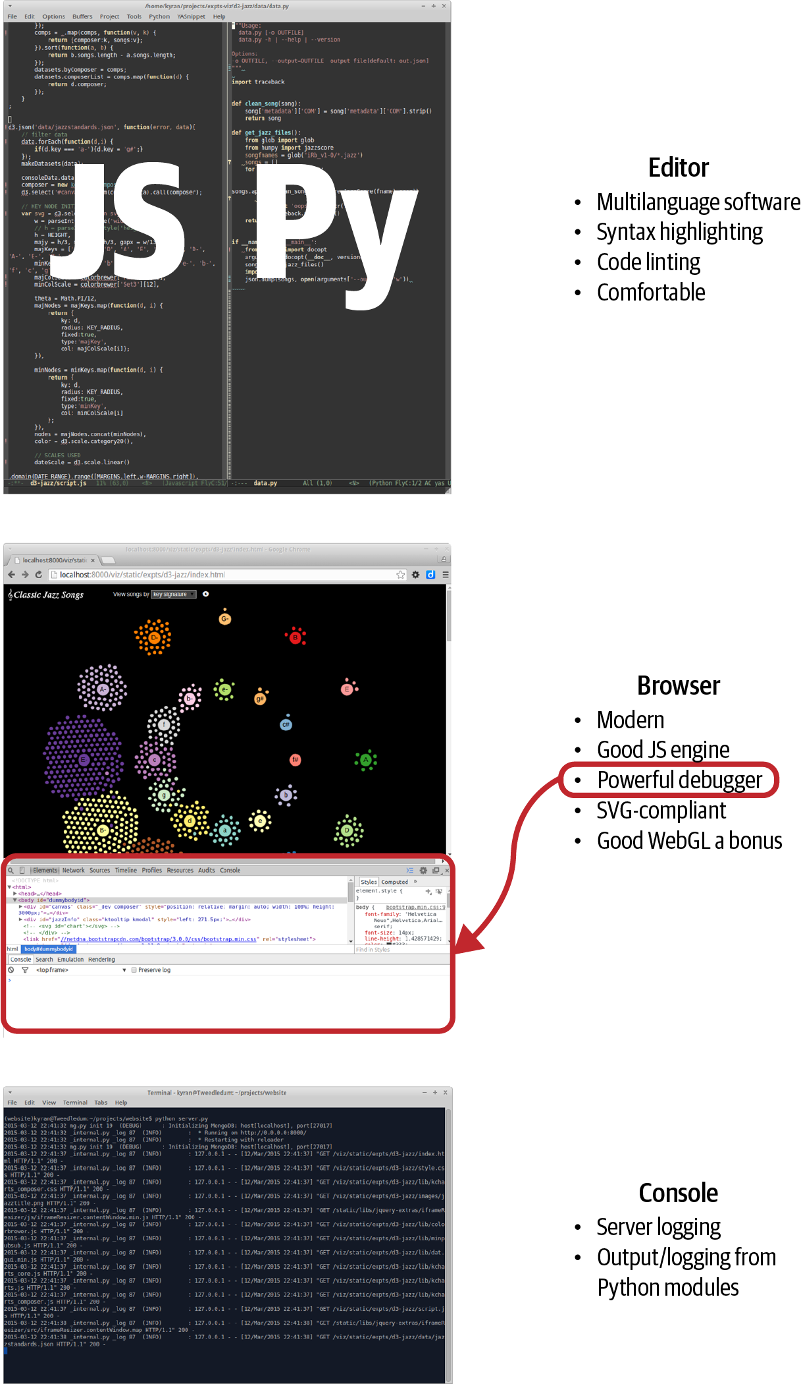

Figure 4-1. Primary webdev tools
Before dealing with what you do need, let’s deal with a few things you don’t need when setting out, laying a couple of myths to rest on the way.

The Myth of IDEs, Frameworks, and Tools
There is a common assumption among the prospective JavaScripter that to program for the web requires a complex toolset, primarily an Intelligent Development Environment (IDE), as used by enterprise—​and other—​coders everywhere. This is potentially expensive and presents another learning curve. The good news is that you can create professional-level web dataviz with nothing more than a decent text editor. In fact, until you start dealing with modern JavaScript frameworks (and I would hold off on that while you get your webdev legs) an IDE doesn’t provide much advantage, while usually being less performant. More good news is that the free as in beer lightweight Visual Studio Code IDE (VSCode) has become the de facto standard for web development. If you already use VSCode or want a few more bells and whistles, it’s a good workhorse for following this book.
There is also a common myth that one cannot be productive in JavaScript without using a framework of some kind.1 At the moment, a number of these frameworks are vying for control of the JS ecosystem, most sponsored by the various huge companies that created them. These frameworks come and go at a dizzying rate, and my advice for anyone starting out in JavaScript is to ignore them entirely while you develop your core skills. Use small, targeted libraries, such as those in the jQuery ecosystem or Underscore’s functional programming extensions, and see how far you can get before needing a my way or the highway framework. Only lock yourself into a framework to meet a clear and present need, not because the current JS groupthink is raving about how great it is.2 Another important consideration is that D3, the prime web dataviz library, doesn’t really play well with any of the bigger frameworks I know, particularly the ones that want control over the DOM. Making D3 framework-compliant is an advanced skill.
Another thing you’ll find if you hang around webdev forums, Reddit lists, and Stack Overflow is a huge range of tools constantly clamoring for attention. There are JS+CSS minifiers and watchers to automatically detect file changes and reload web pages during development, among others. While a few of these have their place, in my experience there are a lot of flaky tools that probably cost more time in hair-tearing than they gain in productivity. To reiterate, you can be very productive without these things and should only reach for one to scratch an urgent itch. Some are keepers, but very few are even remotely essential for data visualization work.

A Text-Editing Workhorse
First and foremost among your webdev tools is a text editor that you are comfortable with and which can, at the very least, do syntax highlighting for multiple languages—​in our case, HTML, CSS, JavaScript, and Python. You can get away with a plain, nonhighlighting editor, but in the long run it will prove to be a pain. Things like syntax highlighting, code linting, intelligent indentation, and the like remove a huge cognitive load from the process of programming, so much so that I see their absence as a limiting factor. These are my minimal requirements for a text editor:
- Syntax highlighting for all languages you use
- Configurable indentation levels and types for languages (e.g., Python 4 soft tabs, JavaScript 2 soft tabs)
- Multiple windows/panes/tabs to allow easy navigation around your codebase
- A decent code linter (see Figure 4-2)
If you are using a relatively advanced text editor, all the above should come as standard with the exception of code linting, which may require a bit of configuration.
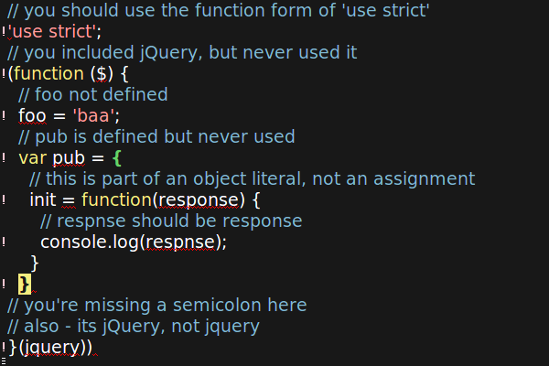

Figure 4-2. A running code linter analyzes the JavaScript continuously, highlighting syntax errors in red and adding an ! to the left of the offending line

Browser with Development Tools
One of the reasons a full-fledged IDE is less vital in modern webdev is that the best place to do debugging is in the web browser itself, and such is the pace of change there that any IDE attempting to emulate that context will have its work cut out for it. On top of this, modern web browsers have evolved a powerful set of debugging and development tools. The best among these is Chrome DevTools, which offers a huge amount of functionality, from sophisticated (certainly to a Pythonista) debugging (parametric breakpoints, variable watches, etc.) to memory and processor optimization profiling, device emulation (want to know what your web page looks like on a smartphone or tablet?), and a whole lot more. Chrome DevTools is my debugger of choice and will be used in this book. Like everything covered, it’s free to use.

Terminal or Command Prompt
The terminal or command line is where you initiate the various servers and probably output useful logging information. It’s also where you’ll try out Python modules or run a Python interpreter (IPython being in many ways the best).

Building a Web Page
There are four elements to a typical web visualization:
- An HTML skeleton, with placeholders for our programmatic visualization
- Cascading Style Sheets (CSS), which define the look and feel (e.g., border widths, colors, font sizes, placement of content blocks)
- JavaScript to build the visualization
- Data to be transformed
The first three of these are just text files, created using our favorite editor and delivered to the browser by the web server (see Chapter 12). Let’s examine each in turn.

Serving Pages with HTTP
The delivery of the HTML, CSS, and JS files that are used to make a particular web page (and any related data files, multimedia, etc.) is negotiated between a server and browser using the Hypertext Transfer Protocol. HTTP provides a number of methods, the most commonly used being GET, which requests a web resource, retrieving data from the server if all goes well or throwing an error if it doesn’t. We’ll be using GET, along with Python’s requests module, to scrape some web page content in Chapter 6.
To negotiate the browser-generated HTTP requests, you’ll need a server. In development, you can run a little server locally using Python’s built-in web server (one of the batteries included), part of the http module. You start the server at the command line, with an optional port number (default 8000), like this:
$ python -m http.server 8080
Serving HTTP on 0.0.0.0 port 8080 (http://0.0.0.0:8080/) ...
This server is now serving content locally on port 8080. You can access the site it is serving by going to the URL http://localhost:8080 in your browser.
The http.server module is a nice thing to have and OK for demos and the like, but it lacks a lot of basic functionality. For this reason, as we’ll see in Part IV, it’s better to master the use of a proper development (and production) server like Flask (this book’s server of choice).

The DOM
The HTML files you send through HTTP are converted at the browser end into a Document Object Model, or DOM, which can in turn be adapted by JavaScript because this programmatic DOM is the basis of dataviz libraries like D3. The DOM is a tree structure, represented by hierarchical nodes, the top node being the main web page or document.
Essentially, the HTML you write or generate with a template is converted by the browser into a tree hierarchy of nodes, each one representing an HTML element. The top node is called the Document Object, and all other nodes descend in a parent-child fashion. Programmatically manipulating the DOM is at the heart of such libraries as jQuery and the mighty D3, so it’s vital to have a good mental model of what’s going on. A great way to get the feel for the DOM is to use a web tool such as Chrome DevTools (my recommended toolset) to inspect branches of the tree.
Whatever you see rendered on the web page, the bookkeeping of the object’s state (displayed or hidden, matrix transform, etc.) is being done with the DOM. D3’s powerful innovation was to attach data directly to the DOM and use it to drive visual changes (Data-Driven Documents).

The HTML Skeleton
A typical web visualization uses an HTML skeleton, and builds the visualization on top of it using JavaScript.
HTML is the language used to describe the content of a web page. It was first proposed by physicist Tim Berners-Lee in 1980 while he was working at the CERN particle accelerator complex in Switzerland. It uses tags such as <div>, <img>, and <h> to structure the content of the page, while CSS is used to define the look and feel.3 The advent of HTML5 has reduced the boilerplate considerably, but the essence has remained essentially unchanged over those thirty years.
Fully specced HTML used to involve a lot of rather confusing header tags, but with HTML5 some thought was put into a more user-friendly minimalism. This is pretty much the minimal requirement for a starting template:4
<!DOCTYPE html>
<
meta
charset
=
"utf-8"
>
<
body
>
<!-- page content -->
</
body
>
So we need only declare the document HTML, our character set 8-bit Unicode, and a <body> tag below which to add our page content. This is a big improvement on the bookkeeping required before and provides a very low threshold to entry as far as creating the documents that will be turned into web pages goes. Note the comment tag form: <!-- comment -->.
More realistically, we would probably want to add some CSS and JavaScript. You can add both directly to an HTML document by using the <style> and <script> tags like this:
<!DOCTYPE html>
<
meta
charset
=
"utf-8"
>
<
style
>
/* CSS */
</style>
<
body
>
<!-- page content -->
<
script
>
// JavaScript...
</
script
>
</
body
>
This single-page HTML form is often used in examples such as the visualizations at d3js.org. It’s convenient to have a single page to deal with when demonstrating code or keeping track of files, but generally I’d suggest separating the HTML, CSS, and JavaScript elements into separate files. The big win here, apart from easier navigation as the codebase gets larger, is that you can take full advantage of your editor’s specific language enhancements such as solid syntax highlighting and code linting (essentially syntax checking on the fly). While some editors and libraries claim to deal with embedded CSS and JavaScript, I haven’t found an adequate one.
To use CSS and JavaScript files, we just include them in the HTML using <link> and <script> tags like this:
<!DOCTYPE html>
<
meta
charset
=
"utf-8"
>
<
link
rel
=
"stylesheet"
href
=
"style.css"
/>
<
body
>
<!-- page content -->
<
script
type
=
"text/javascript"
src
=
"script.js"
></
script
>
</
body
>

Marking Up Content
Visualizations often use a small subset of the available HTML tags, usually building the page programmatically by attaching elements to the DOM tree.
The most common tag is the <div>, marking a block of content. <div>s can contain other <div>s, allowing for a tree hierarchy, the branches of which are used during element selection and to propagate user interface (UI) events such as mouse clicks. Here’s a simple <div> hierarchy:
<
div
id
=
"my-chart-wrapper"
class
=
"chart-holder dev"
>
<
div
id
=
"my-chart"
class
=
"bar chart"
>
this is a placeholder, with parent #my-chart-wrapper
</
div
>
</
div
>
Note the use of id and class attributes. These are used when you’re selecting DOM elements and to apply CSS styles. IDs are unique identifiers; each element should have only one and there should be only one occurrence of any particular ID per page. The class can be applied to multiple elements, allowing bulk selection, and each element can have multiple classes.
For textual content, the main tags are <p>, <h*>, and <br>. You’ll be using these a lot. This code produces Figure 4-3:
<
h2
>
A Level-2 Header
</
h2
>
<
p
>
A paragraph of body text with a line break here..
</
br
>
and a second paragraph...
</
p
>
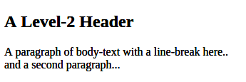

Figure 4-3. An h2 header and text
Header tags are reverse-ordered by size from the largest <h1>.
<div>, <h*>, and <p> are what is known as block elements. They normally begin and end with a new line. The other class of tag is inline elements, which display without line breaks. Images <img>, hyperlinks <a>, and table cells <td> are among these, which include the <span> tag for inline text:
<
div
id
=
"inline-examples"
>
<
img
src
=
"path/to/image.png"
id
=
"prettypic"
>
<
p
>
This is a
<
a
href
=
"link-url"
>
link
<
/
a
>
to
<
span
class
=
"url"
>
link-url
<
/
span
>
<
/
p
>
<
/
div
>
Note that we don’t need a closing tag for images.
The span and link are continuous in the text.
Other useful tags include lists, ordered <ol> and unordered <ul>:
<
div
style
=
"display: flex; gap: 50px"
>
<
div
>
<
h3
>
Ordered (ol) list
<
/
h3
>
<
ol
>
<
li
>
First Item
<
/
li
>
<
li
>
Second Item
<
/
li
>
<
/
ol
>
<
/
div
>
<
div
>
<
h3
>
Unordered (ul) list
<
/
h3
>
<
ul
>
<
li
>
First Item
<
/
li
>
<
li
>
Second Item
<
/
li
>
<
/
ul
>
<
/
div
>
<
/
div
>
Here we apply a CSS style directly (inline) on the div tag. See “Positioning and Sizing Containers with Flex” for an introduction to the flex display property.
Figure 4-4 shows the rendered lists.
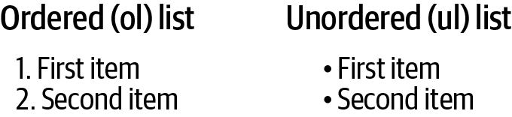

Figure 4-4. HTML lists
HTML also has a dedicated <table> tag, useful if you want to present raw data in your visualization. This HTML produces the header and row in Figure 4-5:
<
table
id
=
"chart-data"
>
<
tr
>
<
th
>
Name
<
/
th
>
<
th
>
Category
<
/
th
>
<
th
>
Country
<
/
th
>
<
/
tr
>
<
tr
>
<
td
>
Albert Einstein
<
/
td
>
<
td
>
Physics
<
/
td
>
<
td
>
Switzerland
<
/
td
>
<
/
tr
>
<
/
table
>
The header row
The first row of data
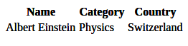

Figure 4-5. An HTML table
When you are making web visualizations, the most often used of the previous tags are the textual tags, which provide instructions, information boxes, and so on. But the meat of our JavaScript efforts will probably be devoted to building DOM branches rooted on the Scalable Vector Graphics (SVG) <svg> and <canvas> tags. On most modern browsers, the <canvas> tag also supports a 3D WebGL context, allowing OpenGL visualizations to be embedded in the page.5
We’ll deal with SVG, the focus of this book and the format used by the mighty D3 library, in “Scalable Vector Graphics”. Now let’s look at how we add style to our content blocks.

CSS
CSS, short for Cascading Style Sheets, is a language for describing the look and feel of a web page. Though you can hardcode style attributes into your HTML, it’s generally considered bad practice.6 It’s much better to label your tag with an id or class and use that to apply styles in the stylesheet.
The key word in CSS is cascading. CSS follows a precedence rule so that in the case of a clash, the latest style overrides earlier ones. This means the order of inclusion for sheets is important. Usually, you want your stylesheet to be loaded last so that you can override both the browser defaults and styles defined by any libraries you are using.
Figure 4-6 shows how CSS is used to apply styles to the HTML elements. First, you select the element using hashes (#) to indicate a unique ID and dots (.) to select members of a class. You then define one or more property/value pairs. Note that the font-family property can be a list of fallbacks, in order of preference. Here we want the browser default font-family of serif (capped strokes) to be replaced with the more modern sans-serif, with Helvetica Neue as our first choice.
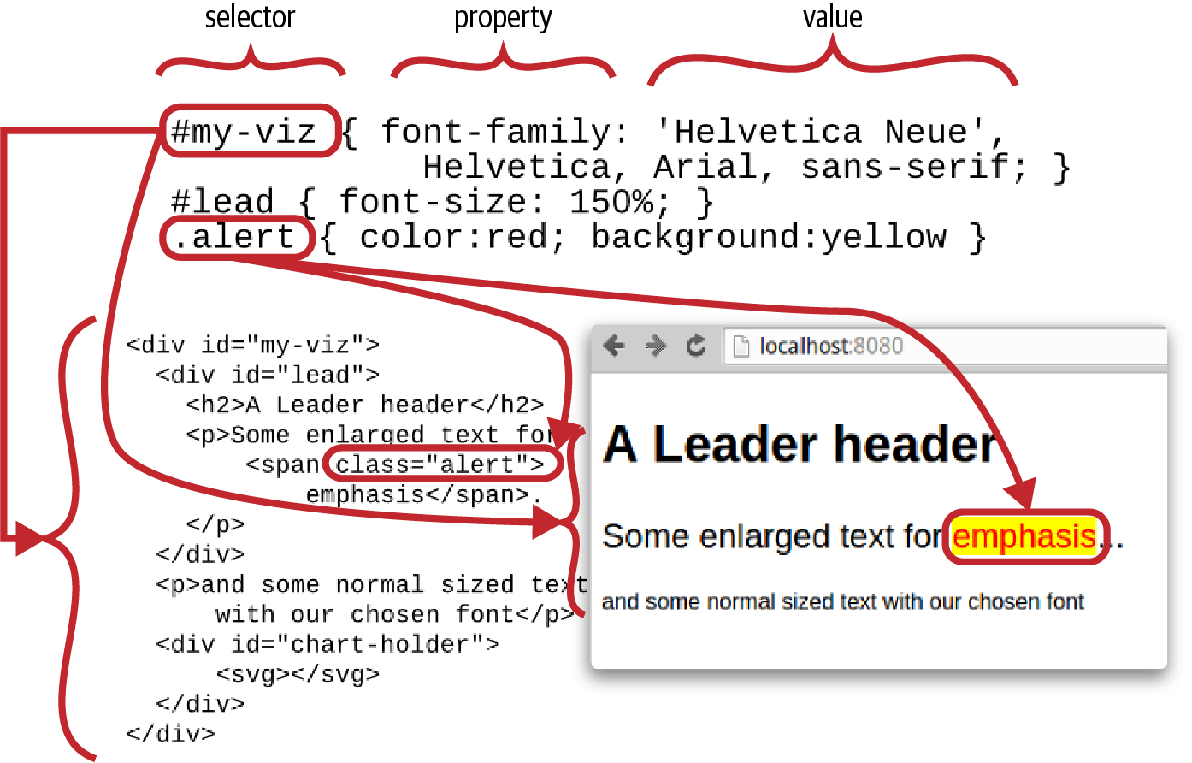

Figure 4-6. Styling the page with CSS
Understanding CSS precedence rules is key to successfully applying styles. In a nutshell, the order is:
!important after CSS property trumps all.
The more specific the better (i.e., IDs override classes).
The order of declaration: last declaration wins, subject to 1 and 2.
So, for example, say we have a <span> of class alert:
<
span
class
=
"alert"
id
=
"special-alert"
>
something to be alerted to
</
span
>
Putting the following in our style.css file will make the alert text red and bold:
.alert
{
font-weight
:
bold
;
color
:
red
}
If we then add this to the style.css, the ID color black will override the class color red, while the class font-weight remains bold:
#special-alert
{
background
:
yellow
;
color
:
black
}
To enforce the color red for alerts, we can use the !important directive:7
.alert
{
font-weight
:
bold
;
color
:
red
!important
}
If we then add another stylesheet, style2.css, after style.css:
<
link
rel
=
"stylesheet"
href
=
"style.css"
type
=
"text/css"
/>
<
link
rel
=
"stylesheet"
href
=
"style2.css"
type
=
"text/css"
/>
with style2.css containing the following:
.alert
{
font-weight
:
normal
}
then the font-weight of the alert will be reverted to normal because the new class style was declared last.

JavaScript
JavaScript is the only browser-based programming language, with an interpreter included in all modern browsers. In order to do anything remotely advanced (and that includes all modern web visualizations), you should have a JavaScript grounding. TypeScript is a superset of JavaScript that provides strong typing and is currently gaining a lot of traction. TypeScript compiles to and presupposes competence in JavaScript.
99% of all coded web visualization examples, the ones you should aim to be learning from, are in JavaScript, and voguish alternatives have a way of fading with time. In essence, good competence in (if not mastery of) JavaScript is a prerequisite for interesting web visualizations.
The good news for Pythonistas is that JavaScript is actually quite a nice language once you’ve tamed a few of its more awkward quirks.8 As I showed in Chapter 2, JavaScript and Python have a lot in common and it’s usually easy to translate from one to the other.

Data
The data needed to fuel your web visualization will be provided by the web server as static files (e.g., JSON or CSV files) or dynamically through some kind of web API (e.g., RESTful APIs), usually retrieving the data server-side from a database. We’ll be covering all these forms in Part IV.
Although a lot of data used to be delivered in XML form, modern web visualization is predominantly about JSON and, to a lesser extent, CSV or TSV files.
JSON (short for JavaScript Object Notation) is the de facto web visualization data standard and I recommend you learn to love it. It obviously plays very nicely with JavaScript, but its structure will also be familiar to Pythonistas. As we saw in “JSON”, reading and writing JSON data with Python is a snap. Here’s a little example of some JSON data:
{
"firstName"
:
"Groucho"
,
"lastName"
:
"Marx"
,
"siblings"
:
[
"Harpo"
,
"Chico"
,
"Gummo"
,
"Zeppo"
],
"nationality"
:
"American"
,
"yearOfBirth"
:
1890
}

Chrome DevTools
The arms race in JavaScript engines in recent years, which has produced huge increases in performance, has been matched by an increasingly sophisticated range of development tools built into the various browsers. Firefox’s Firebug led the pack for a while but Chrome DevTools have surpassed it, and are adding functionality all the time. There’s now a huge amount you can do with Chrome’s tabbed tools, but here I’ll introduce the two most useful tabs, the HTML+CSS-focused Elements and the JavaScript-focused Sources. Both of these work in complement to Chrome’s developer console, demonstrated in “JavaScript”.

The Elements Tab
To access the Elements tab, select More Tools→Developer Tools from the righthand options menu or use the Ctrl-Shift-I keyboard shortcut (Cmd-Option-I in Mac).
Figure 4-7 shows the Elements tab at work. You can select DOM elements on the page by using the lefthand magnifying glass and see their HTML branch in the left panel. The right panel allows you to see CSS styles applied to the element and look at any event listeners that are attached or DOM properties.
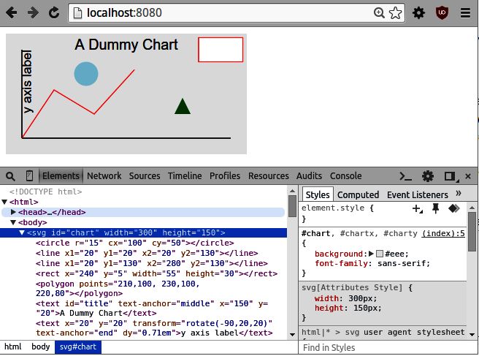

Figure 4-7. Chrome DevTools Elements tab
One really cool feature of the Elements tab is that you can interactively change element styling for both CSS styles and attributes.9 This is a great way to refine the look and feel of your data visualizations.
Chrome’s Elements tab provides a great way to explore the structure of a page, finding out how the different elements are positioned. This is good way to get your head around positioning content blocks with the position and float properties. Seeing how the pros apply CSS styles is a really good way to up your game and learn some useful tricks.

The Sources Tab
The Sources tab allows you to see any JavaScript included in the page. Figure 4-8 shows the tab at work. In the lefthand panel, you can select a script or an HTML file with embedded <script> tagged JavaScript. As shown, you can place a breakpoint in the code, load the page, and, on break, see the call stack and any scoped or global variables. These breakpoints are parametric, so you can set conditions for them to trigger, which is handy if you want to catch and step through a particular configuration. On break, you have the standard to step in, out, and over functions, and so on.
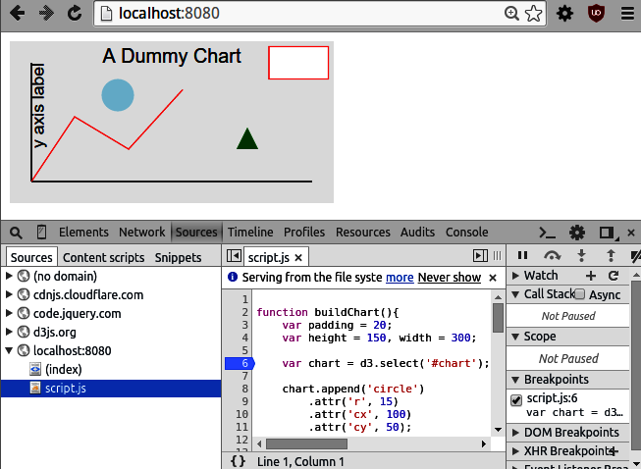

Figure 4-8. Chrome DevTools Sources tab
The Sources tab is a fantastic resource and greatly reduces the need for console logging10 when trying to debug JavaScript. In fact, where JS debugging was once a major pain point, it is now almost a pleasure.

Other Tools
There’s a huge amount of functionality in those Chrome DevTools tabs, and they are being updated almost daily. You can do memory and CPU timelines and profiling, monitor your network downloads, and test out your pages for different form factors. But you’ll spend the large majority of your time as a data visualizer in the Elements and Sources tabs.

A Basic Page with Placeholders
Now that we have covered the major elements of a web page, let’s put them together. Most web visualizations start off as HTML and CSS skeletons, with placeholder elements ready to be fleshed out with a little JavaScript plus data (see “Single-Page Apps”).
We’ll first need our HTML skeleton, using the code in Example 4-1. This consists of a tree of <div> content blocks defining three chart elements: a header, main, and sidebar section. We’ll save this file as index.html.

Example 4-1. The file index.html, our HTML skeleton
<!DOCTYPE html>
<
meta
charset
=
"utf-8"
>
<
link
rel
=
"stylesheet"
href
=
"style.css"
type
=
"text/css"
/>
<
body
>
<
div
id
=
"chart-holder"
class
=
"dev"
>
<
div
id
=
"header"
>
<
h2
>
A Catchy Title Coming Soon...
</
h2
>
<
p
>
Some body text describing what this visualization is all
about and why you should care.
</
p
>
</
div
>
<
div
id
=
"chart-components"
>
<
div
id
=
"main"
>
A placeholder for the main chart.
</
div
><
div
id
=
"sidebar"
>
<
p
>
Some useful information about the chart,
probably changing with user interaction.
</
p
>
</
div
>
</
div
>
</
div
>
<
script
src
=
"script.js"
></
script
>
</
body
>
Now that we have our HTML skeleton, we want to style it using some CSS. This will use the classes and IDs of our content blocks to adjust size, position, background color, etc. To apply our CSS, in Example 4-1 we import a style.css file, shown in Example 4-2.

Example 4-2. The style.css file, providing our CSS styling
body
{
background
:
#ccc
;
font-family
:
Sans
-
serif
;
}
div
.dev
{
border
:
solid
1px
red
;
}
div
.dev
div
{
border
:
dashed
1px
green
;
}
div
#chart-holder
{
width
:
600px
;
background
:
white
;
margin
:
auto
;
font-size
:
16px
;
}
div
#chart-components
{
height
:
400px
;
position
:
relative
;
}
div
#main
,
div
#sidebar
{
position
:
absolute
;
}
div
#main
{
width
:
75%
;
height
:
100%
;
background
:
#eee
;
}
div
#sidebar
{
right
:
0
;
width
:
25%
;
height
:
100%
;
}
This dev class is a handy way to see the border of any visual blocks, which is useful for visualization work.
Makes chart-components the relative parent.
Makes the main and sidebar positions relative to chart-components.
Positions this block flush with the right wall of chart-components.
We use absolute positioning of the main and sidebar chart elements (Example 4-2). There are various ways to position the content blocks with CSS, but absolute positioning gives you explicit control over their placement, which is a must if you want to get the look just right.
After specifying the size of the chart-components container, the main and sidebar child elements are sized and positioned using percentages of their parent. This means any changes to the size of chart-components will be reflected in its children.
With our HTML and CSS defined, we can examine the skeleton by firing up Python’s single-line HTTP server in the project directory containing the index.html and style.css files defined in Examples 4-1 and 4-2, like so:
$ python -m http.server
8000
Serving HTTP on
0
.0.0.0 port
8000
...
Figure 4-9 shows the resulting page with the Elements tab open, displaying the page’s DOM tree.
The chart’s content blocks are now positioned and sized correctly, ready for JavaScript to add some engaging content.
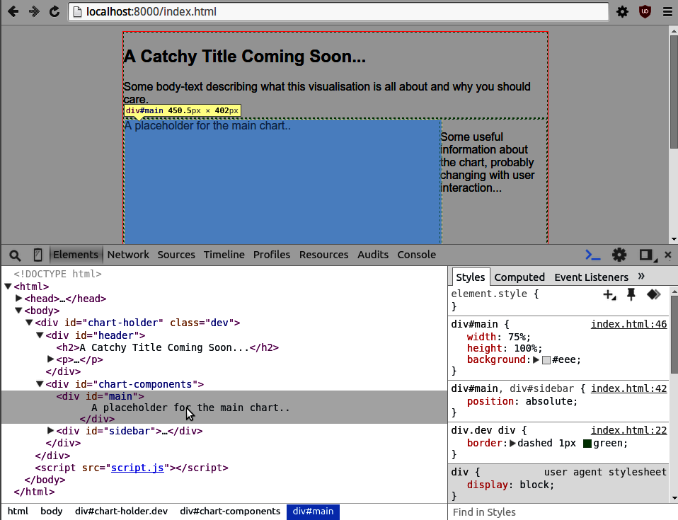

Figure 4-9. Building a basic web page

Positioning and Sizing Containers with Flex
Historically positioning and sizing content (usually <div> containers) with CSS was somewhat of a dark art. It didn’t help that there were a lot of cross-browser incompatibilities and disagreements about what constituted padding or margins. But even allowing for that, the CSS properties used seemed pretty ad-hoc. Often achieving what seems to be a perfectly reasonable positioning or sizing ambition turned out to involve arcane CSS knowledge, hidden in the deep recesses of a Stack Overflow thread. One example being centering a div in the horizontal and vertical.11 This has all changed with the advent of the CSS flex-box, which uses some powerful new CSS properties to provide almost all the sizing and positioning you’ll ever need.
Flex-boxes aren’t quite one CSS property to rule them all—the absolute positioning demonstrated in the previous section still has its place, particularly with data visualizations—but they are a collection of very powerful properties which, more often than not, represent the simplest, and sometimes the only, way to achieve a particular placing/sizing mission. Effects that used to require CSS expertise are now well within the grasp of a relative newbie and the icing on the cake is that flex-boxes play really well with variable screen ratios—the power of the flex. With that in mind, let’s see what can be done with the basic set of flex properties.
First, we’ll use a little HTML to create a container div with three child divs (boxes). The child boxes will be of class box with an ID to enable specific CSS to be applied:
<
div
class
=
"container"
id
=
"top-container"
>
<
div
class
=
"box"
id
=
"box1"
>
box 1
</
div
>
<
div
class
=
"box"
id
=
"box2"
>
box 2
</
div
>
<
div
class
=
"box"
id
=
"box3"
>
box 3
</
div
>
</
div
>
The initial CSS gives the container a red border, width, and height (600x400). The boxes are 100 pixels wide and high (80 pixels plus 10 pixels padding) and have a green border. A novel CSS property is the container’s display: flex, which establishes a flex display context. The result of this can be seen in Figure 4-10 (display: flex), which shows the boxes presented in a row rather than the default column, where each box occupies its own row:
.container
{
display
:
flex
;
width
:
600px
;
height
:
400px
;
border
:
2px
solid
red
;
}
.box
{
border
:
2px
solid
green
;
font-size
:
28px
;
padding
:
10px
;
width
:
80px
;
height
:
80px
;
}
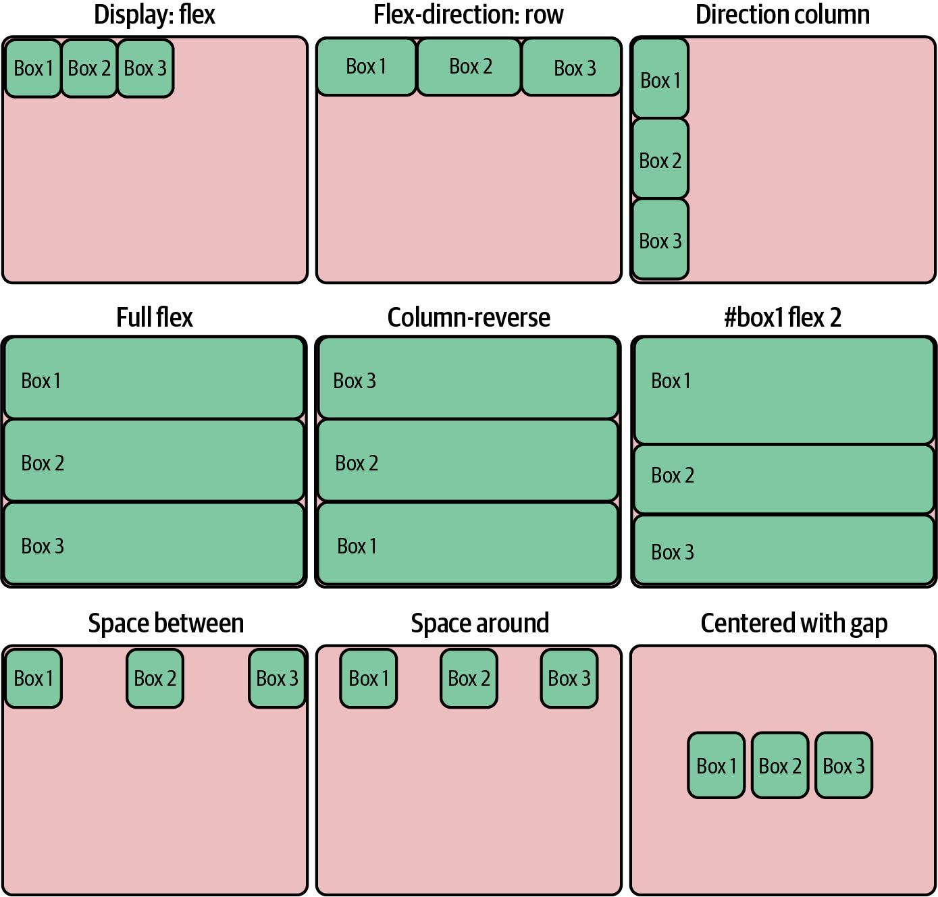

Figure 4-10. Positioning and sizing with flex-boxes
Flex displays respond to children with the flex property by expanding their size to fit the available space. If we make the boxes flexible, they respond by expanding to fill the container row. Figure 4-10 (flex-direction: row) shows the result. Note that the flex property overrides the boxes’ width property, allowing them to expand:
.box
{
/* ... */
flex
:
1
;
}
The flex-direction property is row by default. By setting it to column, the boxes are placed in a column and the height property is overridden to allow them to expand to fit the container’s height. Figure 4-10 (direction column) shows the result:
.container
{
/* ... */
flex-direction
:
column
;
}
Removing or commenting out the width and height properties from the boxes makes them fully flexible, able to expand in the horizontal and vertical, producing Figure 4-10 (full flex):
.box
{
/* ... */
/* width: 80px;
height: 80px; */
flex
:
1
;
}
If you want to reverse the order of the flex-boxes, there are a row-reverse and column-reverse flex-direction. Figure 4-10 (column reverse) shows the result of reversing the columns:
.container
{
/* ... */
flex-direction
:
column
-
reverse
;
}
The value of the boxes’ flex property represents a sizing weight. Initially all the boxes have a weight of one, which makes them of equal size. If we give the first box a weight of two, it will occupy half (2 / (1 + 1 + 2)) the available space in the row or column direction specified. Figure 4-10 (#box1 flex 2) shows the result of increasing box1’s flex value:
#box1
{
flex
:
2
;
}
If we return the 100-pixel height and width (including padding) constraints to the boxes and remove their flex property, we can demonstrate the power of flex display positioning. We’ll also need to remove the flex directive from box1:
.box
{
width
:
80px
;
height
:
80px
;
/* flex: 1; */
}
#box1
{
/* flex: 2; */
}
With fixed-size content, flex displays have a number of properties that allow precise placement of the content. This sort of manipulation used to involve all manner of tricky CSS hacks. First, let’s distribute the boxes evenly in their container, using row-based spacing. The magic property is justify-content with the value space-between; Figure 4-10 (space between) shows the result:
.container
{
/* ... */
flex-direction
:
row
;
justify-content
:
space
-
between
;
}
There is a space-around complement to space-between, which spaces the content by adding equal padding to left and right. Figure 4-10 (space around) shows the result:
.container
{
/* ... */
justify-content
:
space
-
around
;
}
By combining the justify-content and align-items properties, we can achieve the holy grail of CSS positioning, centering the content in the vertical and the horizontal. We’ll add a gap of 20 pixels between the boxes using the flex display’s gap property:
.container
{
/* ... */
gap
:
20px
;
justify-content
:
center
;
align-items
:
center
;
}
Figure 4-10 (centered with gap) shows our content sitting squarely in the middle of its container.
Another great thing about the flex display is that it is fully recursive. divs can both have a display flex property and be flex content. This makes achieving complex content layouts a breeze. Let’s see a little demonstration of nested flex-boxes, to make the point clear.
We’ll first use some HTML to build a nested tree of boxes (including the main container box). We’ll give each box and container an ID and class:
<
div
class
=
"main-container"
>
<
div
class
=
"container"
id
=
"top-container"
>
<
div
class
=
"box"
id
=
"box1"
>
box 1
</
div
>
<
div
class
=
"box"
id
=
"box2"
>
box 2
</
div
>
</
div
>
<
div
class
=
"container"
id
=
"middle-container"
>
<
div
class
=
"box"
id
=
"box3"
>
box 3
</
div
>
</
div
>
<
div
class
=
"container"
id
=
"bottom-container"
>
<
div
class
=
"box"
id
=
"box4"
>
box 4
</
div
>
<
div
class
=
"box"
id
=
"box5"
>
<
div
class
=
"box"
id
=
"box6"
>
box 6
</
div
>
<
div
class
=
"box"
id
=
"box7"
>
box 7
</
div
>
</
div
>
</
div
>
</
div
>
The following CSS gives the main container a height of 800 pixels (it will fill the available width by default), a flex display, and a flex-direction of column, making it stack its flex content.
There are three containers to be stacked, which are both flexible and provide a flex display for their content. The boxes have a red border and are fully flexible (no width or height specified). By default all boxes have a flex weight of one.
The middle container has a fixed width box (width 66%) and uses justify-content: center to center it.
The bottom container has a flex value of 2, making it twice the height of its siblings. It has two boxes of equal weight, one of which (box 5) contains two boxes that are stacked (flex-direction: column). The fairly complex layout (see Figure 4-11) is achieved with impressively little CSS and is easily adapted by changing a few flex display properties:
.main-container
{
height
:
800px
;
padding
:
10px
;
border
:
2px
solid
green
;
display
:
flex
;
flex-direction
:
column
;
}
.container
{
flex
:
1
;
display
:
flex
;
}
.box
{
flex
:
1
;
border
:
2px
solid
red
;
padding
:
10px
;
font-size
:
30px
;
}
#middle-container
{
justify-content
:
center
;
}
#box3
{
width
:
66%
;
flex
:
initial
;
}
#bottom-container
{
flex
:
2
;
}
#box5
{
display
:
flex
;
flex-direction
:
column
;
}
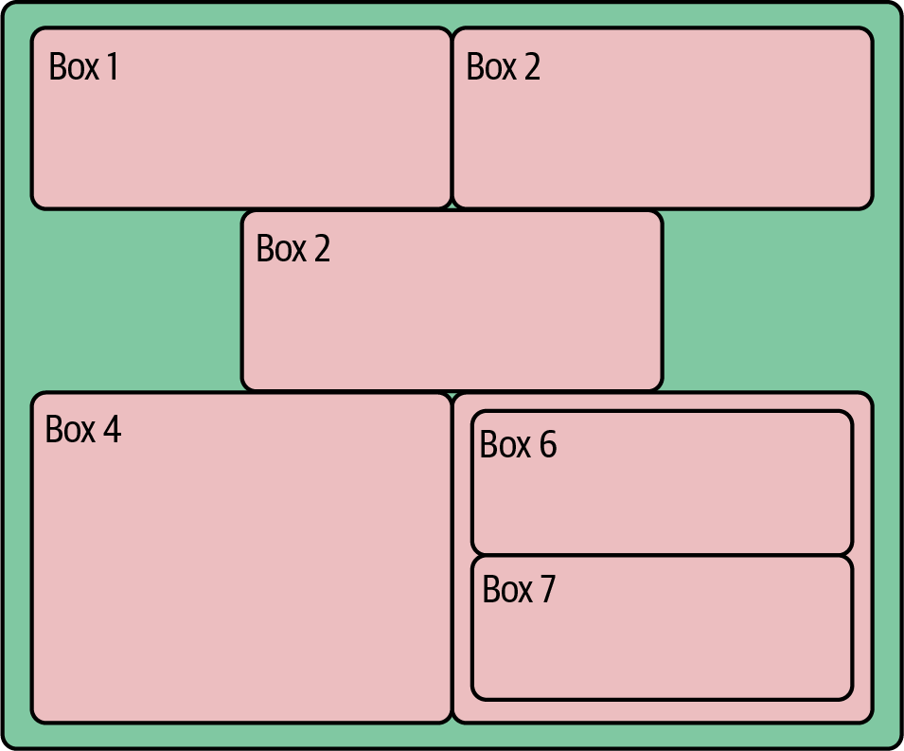

Figure 4-11. Nested flex-boxes
Flex-boxes provide a very powerful sizing and positioning context for your HTML content that responds to container size and can be easily adapted. If you want your content in a column rather than a row, then a single property change makes it so. For more precise positioning and sizing control there is the CSS grid layout, but I would recommend focusing your initial energies on the flex display—it represents the best return on your learning investment in CSS right now. For further examples, see the CSS-Tricks article on flex-boxes and this handy cheat sheet.

Filling the Placeholders with Content
With our content blocks defined in HTML and positioned with CSS, a modern data visualization uses JavaScript to construct its interactive charts, menus, tables, and the like. There are many ways to create visual content (aside from image or multimedia tags) in your modern browser, the main ones being:
- Scalable Vector Graphics (SVG) using special HTML tags
- Drawing to a 2D canvas context
- Drawing to a 3D canvas WebGL context, allowing a subset of OpenGL commands
- Using modern CSS to create animations, graphic primitives, and more
Because SVG is the language of choice for D3, in many ways the biggest JavaScript dataviz library, many of the cool web data visualizations you have seen, such as those by the New York Times, are built using it. Broadly speaking, unless you anticipate having lots (>1,000) of moving elements in your visualization or need to use a specific canvas-based library, SVG is probably the way to go.
By using vectors instead of pixels to express its primitives, SVG will generally produce cleaner graphics that respond smoothly to scaling operations. It’s also much better at handling text, a crucial consideration for many visualizations. Another key advantage of SVG is that user interaction (e.g., mouse hovering or clicking) is native to the browser, being part of the standard DOM event handling.12 A final point in its favor is that because the graphic components are built on the DOM, you can inspect and adapt them using your browser’s development tools (see “Chrome DevTools”). This can make debugging and refining your visualizations much easier than trying to find errors in the canvas’s relatively black box.
canvas graphics contexts come into their own when you need to move beyond simple graphic primitives like circles and lines, such as when incorporating images like PNGs and JPGs. canvas is usually considerably more performant than SVG, so anything with lots of moving elements13 is better off rendered to a canvas. If you want to be really ambitious or move beyond 2D graphics, you can even unleash the awesome power of modern graphics cards by using a special form of canvas context, the OpenGL-based WebGL context. Just bear in mind that what would be simple user interaction with SVG (e.g., clicking on a visual element) often has to be derived from mouse coordinates manually, which adds a tricky layer of complexity.
The Nobel Prize data visualization realized at the end of this book’s toolchain is built primarily with D3, so SVG graphics are the focus of this book. Being comfortable with SVG is fundamental to modern web-based dataviz, so let’s explore a little primer.

Scalable Vector Graphics
All SVG creations start with an <svg> root tag. All graphical elements, such as circles and lines, and groups thereof, are defined on this branch of the DOM tree. Example 4-3 shows a little SVG context we’ll use in upcoming demonstrations, a light-gray rectangle with ID chart. We also include the D3 library, loaded from d3js.org and a script.js JavaScript file in the project folder.

Example 4-3. A basic SVG context
<!DOCTYPE html>
<
meta
charset
=
"utf-8"
>
<!-- A few CSS style rules -->
<
style
>
svg
#chart
{
background
:
lightgray
;
}
</style>
<
svg
id
=
"chart"
width
=
"300"
height
=
"225"
>
</
svg
>
<!-- Third-party libraries and our JS script. -->
<
script
src
=
"http://d3js.org/d3.v7.min.js"
></
script
>
<
script
src
=
"script.js"
></
script
>
Now that we’ve got our little SVG canvas in place, let’s start doing some drawing.

The <g> Element
We can group shapes within our <svg> element by using the group <g> element. As we’ll see in “Working with Groups”, shapes contained in a group can be manipulated together, including changing their position, scale, or opacity.

Circles
Creating SVG visualizations, from the humblest little static bar chart to full-fledged interactive, geographic masterpieces, involves putting together elements from a fairly small set of graphical primitives such as lines, circles, and the very powerful paths. Each of these elements will have its own DOM tag, which will update as it changes.14 For example, its x and y attributes will change to reflect any translations within its <svg> or group (<g>) context.
Let’s add a circle to our <svg> context to demonstrate:
<
svg
id
=
"chart"
width
=
"300"
height
=
"225"
>
<
circle
r
=
"15"
cx
=
"100"
cy
=
"50"
></
circle
>
</
svg
>
With a little CSS to provide the circle’s fill color:
#chart
circle
{
fill
:
lightblue
}
This produces Figure 4-12. Note that the y coordinate is measured from the top of the <svg> '#chart' container, a common graphic convention.
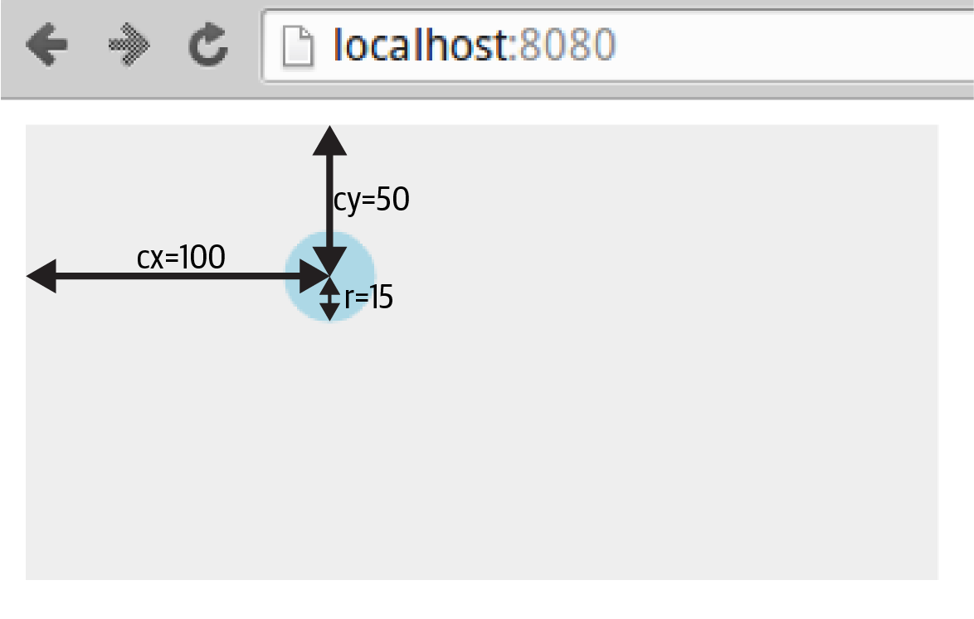

Figure 4-12. An SVG circle
Now let’s see how we go about applying styles to SVG elements.

Applying CSS Styles
The circle in Figure 4-12 is fill-colored light blue using CSS styling rules:
#chart
circle
{
fill
:
lightblue
}
In modern browsers, you can set most visual SVG styles using CSS, including fill, stroke, stroke-width, and opacity. So if we wanted a thick, semitransparent green line (with ID total) we could use the following CSS:
#chart
line
#total
{
stroke
:
green
;
stroke-width
:
3px
;
opacity
:
0
.
5
;
}
You can also set the styles as attributes of the tags, though CSS is generally preferable:
<
svg
>
<
circle
r
=
"15"
cx
=
"100"
cy
=
"50"
fill
=
"lightblue"
></
circle
>
</
svg
>
Tip
Which SVG features can be set by CSS and which can’t is a source of some confusion and plenty of gotchas. The SVG spec distinguishes between element properties and attributes, the former being more likely to be found among the valid CSS styles. You can investigate the valid CSS properties using Chrome’s Elements tab and its autocomplete. Also, be prepared for some surprises. For example, SVG text is colored by the fill, not color, property.
For fill and stroke, there are various color conventions you can use:
- Named HTML colors, such as lightblue
- Using HTML hex codes (#RRGGBB); for example, white is #FFFFFF
- RGB values; for example, red = rgb(255, 0, 0)
- RGBA values, where A is an alpha channel (0–1); for example, half-transparent blue is rgba(0, 0, 255, 0.5)
In addition to adjusting the color’s alpha channel with RGBA, you can fade the SVG elements using their opacity property. Opacity is used a lot in D3 animations.
Stroke width is measured in pixels by default but can use points.

Lines, Rectangles, and Polygons
We’ll add a few more elements to our chart to produce Figure 4-13.
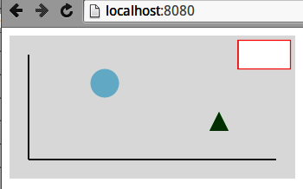

Figure 4-13. Adding a few elements to our dummy chart
First, we’ll add a couple of simple axis lines to our chart, using the <line> tag. Line positions are defined by a start coordinate (x1, y1) and an end one (x2, y2):
<
svg
>
<
line
x1
=
"20"
y1
=
"20"
x2
=
"20"
y2
=
"130"
></
line
>
<
line
x1
=
"20"
y1
=
"130"
x2
=
"280"
y2
=
"130"
></
line
>
</
svg
>
We’ll also add a dummy legend box in the top-right corner using an SVG rectangle. Rectangles are defined by x and y coordinates relative to their parent container, and a width and height:
<
svg
>
<
rect
x
=
"240"
y
=
"5"
width
=
"55"
height
=
"30"
></
rect
>
</
svg
>
You can create irregular polygons using the <polygon> tag, which takes a list of coordinate pairs. Let’s make a triangle marker in the bottom right of our chart:
<
svg
>
<
polygon
points
=
"210,100, 230,100, 220,80"
></
polygon
>
</
svg
>
We’ll style the elements with a little CSS:
#chart
circle
{
fill
:
lightblue
}
#chart
line
{
stroke
:
#555555
;
stroke-width
:
2
}
#chart
rect
{
stroke
:
red
;
fill
:
white
}
#chart
polygon
{
fill
:
green
}
Now that we’ve got a few graphical primitives in place, let’s see how we add some text to our dummy chart.

Text
One of the key strengths of SVG over the rasterized canvas context is how it handles text. Vector-based text tends to look a lot clearer than its pixelated counterparts and benefits from smooth scaling too. You can also adjust stroke and fill properties, just like any SVG element.
Let’s add a bit of text to our dummy chart: a title and labeled y-axis (see Figure 4-14).
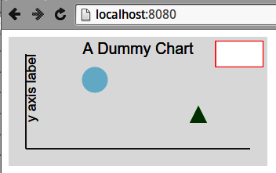

Figure 4-14. Some SVG text
We place text using x and y coordinates. One important property is the text-anchor, which stipulates where the text is placed relative to its x position. The options are start, middle, and end; start is the default.
We can use the text-anchor property to center our chart title. We set the x coordinates at half the chart width and then set the text-anchor to middle:
<
svg
>
<
text
id
=
"title"
text-anchor
=
"middle"
x
=
"150"
y
=
"20"
>
A Dummy Chart
</
text
>
</
svg
>
As with all SVG primitives, we can apply scaling and rotation transforms to our text. To label our y-axis, we’ll need to rotate the text to the vertical (Example 4-4). By convention, rotations are clockwise by degree, so we’ll want a counterclockwise, –90 degree rotation. By default rotations are around the (0,0) point of the element’s container (<svg> or group <g>). We want to rotate our text around its own position, so first translate the rotation point using the extra arguments to the rotate function. We also want to first set the text-anchor to the end of the y axis label string to rotate about its endpoint.

Example 4-4. Rotating text
<
svg
>
<
text
x
=
"20"
y
=
"20"
transform
=
"rotate(-90,20,20)"
text-anchor
=
"end"
dy
=
"0.71em"
>
y axis label
</
text
>
</
svg
>
In Example 4-4, we make use of the text’s dy attribute, which, along with dx, can be used to make fine adjustments to the text’s position. In this case, we want to lower it so that when rotated counterclockwise it will be to the right of the y-axis.
SVG text elements can also be styled with CSS. Here we set the font-family of the chart to sans-serif and the font-size to 16px, using the title ID to make that a little bigger:
#chart
{
background
:
#eee
;
font-family
:
sans-serif
;
}
#chart
text
{
font-size
:
16px
}
#chart
text
#title
{
font-size
:
18px
}
Note that the text elements inherit font-family and font-size from the chart’s CSS; you don’t have to specify a text element.

Paths
Paths are the most complicated and powerful SVG element, enabling the creation of multiline, multicurve component paths that can be closed and filled, creating pretty much any shape you want. A simple example is adding a little chart line to our dummy chart to produce Figure 4-15.
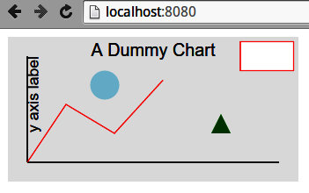

Figure 4-15. A red line path from the chart axis
The red path in Figure 4-15 is produced by the following SVG:
<
svg
>
<
path
d
=
"M20 130L60 70L110 100L160 45"
></
path
>
</
svg
>
The path’s d attribute specifies the series of operations needed to make the red line. Let’s break it down:
- “M20 130”: move to coordinate (20, 130)
- “L60 70”: draw a line to (60, 70)
- “L110 100”: draw a line to (110, 100)
- “L160 45”: draw a line to (160, 45)
You can imagine d as a set of instructions to a pen to move to a point, with M raising the pen from the canvas.
A little CSS styling is needed. Note that the fill is set to none; otherwise, to create a fill area, the path would be closed, drawing a line from its end to beginning points, and any enclosed areas filled in with the default color black:
#chart
path
{
stroke
:
red
;
fill
:
none
}
As well as the moveto 'M' and lineto 'L', the path has a number of other commands to draw arcs, Bézier curves, and the like. SVG arcs and curves are commonly used in dataviz work, with many of D3’s libraries making use of them.15 Figure 4-16 shows some SVG elliptical arcs created by the following code:
<
svg
id
=
"chart"
width
=
"300"
height
=
"150"
>
<
path
d
=
"M40 40
A30 40
0 0 1
80 80
A50 50 0 0 1 160 80
A30 30 0 0 1 190 80
"
>
<
/
svg
>
Having moved to position (40, 40), draw an elliptical arc with x-radius 30, y-radius 40, and endpoint (80, 80).
The first flag (0) sets the x axis rotation, in this case the conventional zero. See the Mozilla developer site for a visual demonstration. The last two flags (0, 1) are large-arc-flag, specifying which arc of the ellipse to use, and sweep-flag, which specifies which of the two possible ellipses defined by start and endpoints to use.
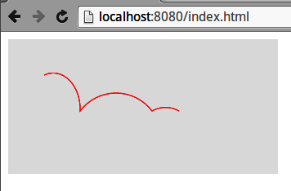

Figure 4-16. Some SVG elliptical arcs
The key flags used in the elliptical arc (large-arc-flag and sweep-flag) are, like most things geometric, better demonstrated than described. Figure 4-17 shows the effect of changing the flags for the same relative beginning and endpoints, like so:
<
svg
id
=
"chart"
width
=
"300"
height
=
"150"
>
<
path
d
=
"M40 80
A30 40 0 0 1 80 80
A30 40 0 0 0 120 80
A30 40 0 1 0 160 80
A30 40 0 1 1 200 80
"
>
</
svg
>
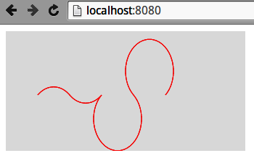

Figure 4-17. Changing the elliptic-arc flags
As well as lines and arcs, the path element offers a number of Bézier curves, including quadratic, cubic, and compounds of the two. With a little work, these can create any line path you want. There’s a nice run-through on SitePoint with good illustrations.
For the definitive list of path elements and their arguments, go to the World Wide Web Consortium (W3C) source. And for a nice round-up, see Jakob Jenkov’s introduction.

Scaling and Rotating
As befits their vector nature, all SVG elements can be transformed by geometric operations. The most commonly used are rotate, translate, and scale, but you can also apply skewing using skewX and skewY or use the powerful, multipurpose matrix transform.
Let’s demonstrate the most popular transforms, using a set of identical rectangles. The transformed rectangles in Figure 4-18 are achieved like so:
<
svg
id
=
"chart"
width
=
"300"
height
=
"150"
>
<
rect
width
=
"20"
height
=
"40"
transform
=
"translate(60, 55)"
fill
=
"blue"
/>
<
rect
width
=
"20"
height
=
"40"
transform
=
"translate(120, 55),
rotate(45)"
fill
=
"blue"
/>
<
rect
width
=
"20"
height
=
"40"
transform
=
"translate(180, 55),
scale(0.5)"
fill
=
"blue"
/>
<
rect
width
=
"20"
height
=
"40"
transform
=
"translate(240, 55),
rotate(45),scale(0.5)"
fill
=
"blue"
/>
</
svg
>
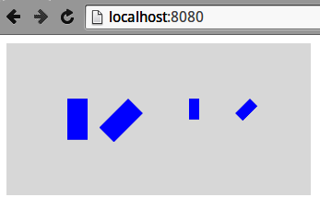

Figure 4-18. Some SVG transforms: rotate(45), scale(0.5), scale(0.5), then rotate(45)
Note
The order in which transforms are applied is important. A rotation of 45 degrees clockwise followed by a translation along the x-axis will see the element moved southeasterly, whereas the reverse operation moves it to the left and then rotates it.

Working with Groups
Often when you are constructing a visualization, it’s helpful to group the visual elements. A couple of particular uses are:
- When you require local coordinate schemes (e.g., if you have a text label for an icon and you want to specify its position relative to the icon, not the whole <svg> canvas).
- If you want to apply a scaling and/or rotation transformation to a subset of the visual elements.
SVG has a group <g> tag for this, which you can think of as a mini canvas within the <svg> canvas. Groups can contain groups, allowing for very flexible geometric mappings.16
Example 4-5 groups shapes in the center of the canvas, producing Figure 4-19. Note that the position of circle, rect, and path elements is relative to the translated group.

Example 4-5. Grouping SVG shapes
<
svg
id
=
"chart"
width
=
"300"
height
=
"150"
>
<
g
id
=
"shapes"
transform
=
"translate(150,75)"
>
<
circle
cx
=
"50"
cy
=
"0"
r
=
"25"
fill
=
"red"
/>
<
rect
x
=
"30"
y
=
"10"
width
=
"40"
height
=
"20"
fill
=
"blue"
/>
<
path
d
=
"M-20 -10L50 -10L10 60Z"
fill
=
"green"
/>
<
circle
r
=
"10"
fill
=
"yellow"
>
</
g
>
</
svg
>
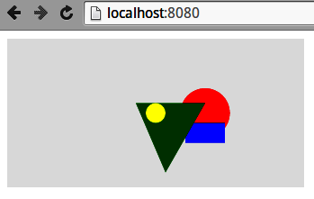

Figure 4-19. Grouping shapes with SVG <g>` tag
If we now apply a transform to the group, all shapes within it will be affected. Figure 4-20 shows the result of scaling Figure 4-19 by a factor of 0.75 and then rotating it 90 degrees, which we achieve by adapting the transform attribute, like so:
<
svg
id
=
"chart"
width
=
"300"
height
=
"150"
>
<
g
id
=
"shapes"
,
transform
=
"translate(150,75),scale(0.5),rotate(90)"
>
...
</
svg
>
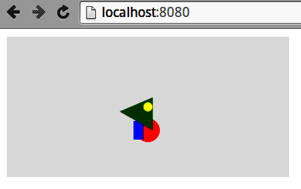

Figure 4-20. Transforming an SVG group

Layering and Transparency
The order in which the SVG elements are added to the DOM tree is important, with later elements taking precedence, layering over others. In Figure 4-19, for example, the triangle path obscures the red circle and blue rectangle and is in turn obscured by the yellow circle.
Manipulating the DOM ordering is an important part of JavaScripted dataviz (e.g., D3’s insert method allows you to place an SVG element before an existing one).
Element transparency can be manipulated using the alpha channel of rgba(R,G,B,A) colors or the more convenient opacity property. Both can be set using CSS. For overlaid elements, opacity is cumulative, as demonstrated by the color triangle in Figure 4-21, produced by the following SVG:
<
style
>
#chart
circle
{
opacity
:
0
.
33
}
</style>
<
svg
id
=
"chart"
width
=
"300"
height
=
"150"
>
<
g
transform
=
"translate(150, 75)"
>
<
circle
cx
=
"0"
cy
=
"-20"
r
=
"30"
fill
=
"red"
/>
<
circle
cx
=
"17.3"
cy
=
"10"
r
=
"30"
fill
=
"green"
/>
<
circle
cx
=
"-17.3"
cy
=
"10"
r
=
"30"
fill
=
"blue"
/>
</
g
>
</
svg
>
The SVG elements demonstrated here were handcoded in HTML, but in data visualization work they are almost always added programmatically. Thus the basic D3 workflow is to add SVG elements to a visualization, using data files to specify their attributes and properties.
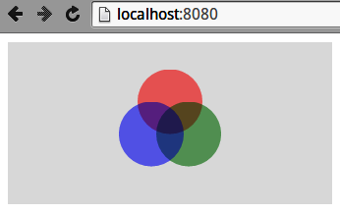

Figure 4-21. Manipulating opacity with SVG

JavaScripted SVG
The fact that SVG graphics are described by DOM tags has a number of advantages over a black box such as the <canvas> context. For example, it allows nonprogrammers to create or adapt graphics and is a boon for debugging.
In web dataviz, pretty much all your SVG elements will be created with JavaScript, through a library such as D3. You can inspect the results of this scripting using the browser’s Elements tab (see “Chrome DevTools”), which is a great way to refine and debug your work (e.g., nailing an annoying visual glitch).
As a little taster for things to come, let’s use D3 to scatter a few red circles on an SVG canvas. The dimensions of the canvas and circles are contained in a data object sent to a chartCircles function.
We use a little HTML placeholder for the <svg> element:
<!DOCTYPE html>
<
meta
charset
=
"utf-8"
>
<
style
>
#chart
{
background
:
lightgray
;
}
#chart
circle
{
fill
:
red
}
</style>
<
body
>
<
svg
id
=
"chart"
></
svg
>
<
script
src
=
"http://d3js.org/d3.v7.min.js"
></
script
>
<
script
src
=
"script.js"
></
script
>
</
body
>
With our placeholder SVG chart element in place, a little D3 in the script.js file is used to turn some data into the scattered circles (see Figure 4-22):
// script.js
var
chartCircles
=
function
(
data
)
{
var
chart
=
d3
.
select
(
'#chart'
)
;
// Set the chart height and width from data
chart
.
attr
(
'height'
,
data
.
height
)
.
attr
(
'width'
,
data
.
width
)
;
// Create some circles using the data
chart
.
selectAll
(
'circle'
)
.
data
(
data
.
circles
)
.
enter
(
)
.
append
(
'circle'
)
.
attr
(
'cx'
,
function
(
d
)
{
return
d
.
x
}
)
.
attr
(
'cy'
,
d
=>
d
.
y
)
.
attr
(
'r'
,
d
=>
d
.
r
)
;
}
;
var
data
=
{
width
:
300
,
height
:
150
,
circles
:
[
{
'x'
:
50
,
'y'
:
30
,
'r'
:
20
}
,
{
'x'
:
70
,
'y'
:
80
,
'r'
:
10
}
,
{
'x'
:
160
,
'y'
:
60
,
'r'
:
10
}
,
{
'x'
:
200
,
'y'
:
100
,
'r'
:
5
}
,
]
}
;
chartCircles
(
data
)
;
This is the modern shorthand arrow-based anonymous function, equivalent to the long form on the previous line. D3 makes use of a lot of these for accessing the properties of bound data objects, so this new syntax is a big win.
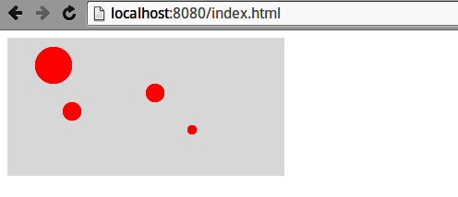

Figure 4-22. D3-generated circles
We’ll see exactly how D3 works its magic in Chapter 17. For now, let’s summarize what we’ve learned in this chapter.

Summary
This chapter provided a basic set of modern web-development skills for the budding data visualizer. It showed how the various elements of a web page (HTML, CSS stylesheets, JavaScript, and media files) are delivered by HTTP and, on being received by the browser, combined to become the web page the user sees. We saw how content blocks are described, using HTML tags such as div and p, and then styled and positioned using CSS. We also covered Chrome’s Elements and Sources tabs, which are the key browser development tools. Finally we had a little primer in SVG, the language in which most modern web data visualizations are expressed. These skills will be extended when our toolchain reaches its D3 visualization and new ones will be introduced in context.
1 There are some interesting alternatives to full-blown frameworks currently generating a buzz, such as Alpine.js and htmx, which play well with Python web servers like Django and Flask.
2 I bear the scars so you don’t have to.
3 You can code style in HTML tags using the style attribute, but it’s generally bad practice. It’s better to use classes and ids defined in CSS.
4 As demonstrated by Mike Bostock, with a hat-tip to Paul Irish.
5 OpenGL (Open Graphics Language) and its web counterpart WebGL are cross-platform APIs for rendering 2D and 3D vector graphics (see the Wikipedia page for details).
6 This is not the same as programmatically setting styles, which is a hugely powerful technique that allows styles to adapt to user interaction.
7 This is generally considered bad practice and is usually an indication of poorly structured CSS. Use with extreme caution, as it can make life very difficult for code developers.
8 These are succinctly discussed in Douglas Crockford’s famously short JavaScript: The Good Parts (O’Reilly).
9 Being able to play with attributes is particularly useful when trying to get Scalable Vector Graphics (SVG) to work.
10 Logging is a great way of tracking data flow through your app. I recommend you adopt a consistent approach here.
11 Here’s a thread showing the many and varied solutions to the problem, none of which could be called elegant.
12 With a canvas graphic context, you generally have to contrive your own event handling.
13 This number changes with time and the browser in question, but as a rough rule of thumb, SVG often starts to strain in the low thousands.
14 You should be able to use your browser’s development tools to see the tag attributes updating in real time.
15 Mike Bostock’s chord diagram is a nice example, and uses D3’s chord function.
16 For example, a body group can contain an arm group, which can contain a hand group, which can contain finger elements.

Part II. Getting Your Data
In this part of the book, we start our journey along the dataviz toolchain (see Figure II-1), beginning with a couple of chapters on how to get your data if it hasn’t been provided for you.
In Chapter 5 we see how to get data off the web, using Python’s Requests library to grab web-based files and consume RESTful APIs. We also see how to use a couple of Python libraries that wrap more complex web APIs, namely Twitter (with Python’s Tweepy) and Google Docs. The chapter ends with an example of lightweight web scraping with the Beautiful Soup library.
In Chapter 6 we use Scrapy, Python’s industrial-strength web scraper, to get the Nobel Prize dataset we’ll be using for our web visualization. With this dirty dataset to hand, we’re ready for the next part of the book, Part III.
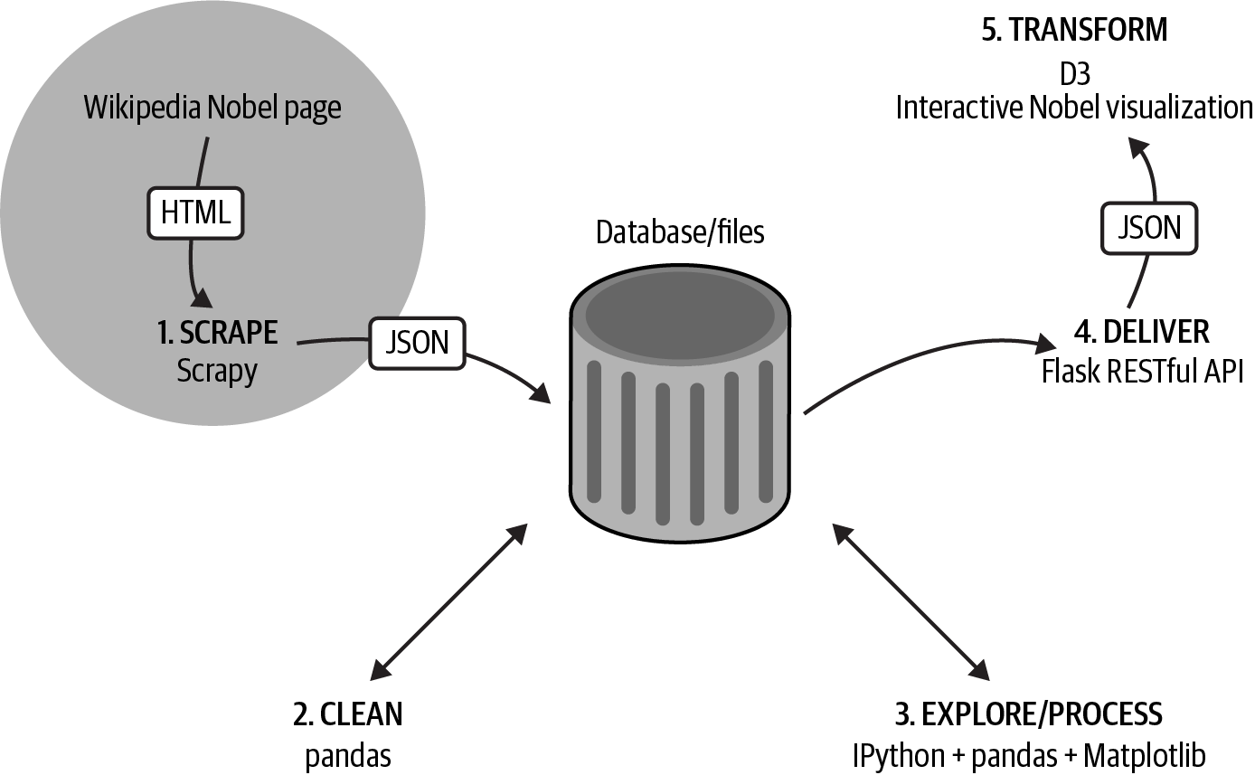

Figure II-1. Our dataviz toolchain: getting the data
Tip
You can find the code for this part of the book at the book’s GitHub repo.

Chapter 5. Getting Data Off the Web with Python
A fundamental part of the data visualizer’s skill set is getting the right dataset in as clean a form as possible. Sometimes you will be given a nice, clean dataset to analyze but often you will be tasked with either finding the data and/or cleaning the data supplied.
And more often than not these days, getting data involves getting it off the web. There are various ways you can do this, and Python provides some great libraries that make sucking up the data easy.
The main ways to get data off the web are:
- Get a raw data file in a recognized data format (e.g., JSON or CSV) over HTTP.
- Use a dedicated API to get the data.
- Scrape the data by getting web pages via HTTP and parsing them locally for the required data.
This chapter will deal with these ways in turn, but first let’s get acquainted with the best Python HTTP library out there: Requests.

Getting Web Data with the Requests Library
As we saw in Chapter 4, the files that are used by web browsers to construct web pages are communicated via the Hypertext Transfer Protocol (HTTP), first developed by Tim Berners-Lee. Getting web content in order to parse it for data involves making HTTP requests.
Negotiating HTTP requests is a vital part of any general-purpose language, but getting web pages with Python used to be a rather irksome affair. The venerable urllib2 library was hardly user-friendly, with a very clunky API. Requests, courtesy of Kenneth Reitz, changed that, making HTTP a relative breeze and fast establishing itself as the go-to Python HTTP library.
Requests is not part of the Python standard library1 but is part of the Anaconda package (see Chapter 1). If you’re not using Anaconda, the following pip command should do the job:
$ pip install requests
Downloading/unpacking requests
...
Cleaning up...
If you’re using a Python version prior to 2.7.9 (I strongly recommend using Python 3+ wherever possible), then using Requests may generate some Secure Sockets Layer (SSL) warnings. Upgrading to newer SSL libraries should fix this:2
$ pip install --upgrade ndg-httpsclient
Now that you have Requests installed, you’re ready to perform the first task mentioned at the beginning of this chapter and grab some raw data files off the web.

Getting Data Files with Requests
A Python interpreter session is a good way to put Requests through its paces, so find a friendly local command line, fire up IPython, and import requests:
$ ipython
Python 3.8.9 (default, Apr 3 2021, 01:02:10)
...
In [1]: import requests
To demonstrate, let’s use the library to download a Wikipedia page. We use the Requests library’s get method to get the page and, by convention, assign the result to a response object:
response
=
requests
.
get
(
\
"https://en.wikipedia.org/wiki/Nobel_Prize"
)
Let’s use Python’s dir method to get a list of the response object’s attributes:
dir
(
response
)
Out:
...
['content',
'cookies',
'elapsed',
'encoding',
'headers',
...
'iter_content',
'iter_lines',
'json',
'links',
...
'status_code',
'text',
'url']
Most of these attributes are self-explanatory and together provide a lot of information about the HTTP response generated. You’ll use a small subset of these attributes generally. Firstly, let’s check the status of the response:
response
.
status_code
Out
:
200
As all good minimal web developers know, 200 is the HTTP status code for OK, indicating a successful transaction. Other than 200, the most common codes are:
401 (Unauthorized)
Attempting unauthorized access
400 (Bad Request)
Trying to access the web server incorrectly
403 (Forbidden)
Similar to 401 but no login opportunity was available
404 (Not Found)
Trying to access a web page that doesn’t exist
500 (Internal Server Error)
A general-purpose, catchall error
So, for example, if we made a spelling mistake with our request, asking to see the SNoble_Prize page, we’d get a 404 (Not Found) error:
not_found_response
=
requests
.
get
(
\
"http://en.wikipedia.org/wiki/SNobel_Prize"
)
not_found_response
.
status_code
Out
:
404
With our 200 OK response, from the correctly spelled request, let’s look at some of the info returned. A quick overview can be had with the headers property:
response
.
headers
Out: {
'date': 'Sat, 23 Oct 2021 23:58:49 GMT',
'server': 'mw1435.eqiad.wmnet',
'content-encoding': 'gzip', ...
'last-modified': 'Sat, 23 Oct 2021 17:14:09 GMT', ...
'content-type': 'text/html; charset=UTF-8'...
'content-length': '88959'
}
This shows, among other things, that the page returned was gzip-encoded and 87 KB in size with content-type of text/html, encoded with Unicode UTF-8.
Since we know text has been returned, we can use the text property of the response to see what it is:
response
.
text
#Out: u'<!DOCTYPE html>\n<html lang="en"
#dir="ltr" class="client-nojs">\n<head>\n<meta charset="UTF-8"
#/>\n<title>Nobel Prize - Wikipedia, the free
#encyclopedia</title>\n<script>document.documentElement... =
This shows that we do indeed have our Wikipedia HTML page, with some inline JavaScript. As we’ll see in “Scraping Data”, in order to make sense of this content, we’ll need a parser to read the HTML and provide the content blocks.
Now that we’ve grabbed a raw page off the web, let’s see how to use Requests to consume a web data API.

Using Python to Consume Data from a Web API
If the data file you need isn’t on the web, there may well be an Application Programming Interface (API) serving the data you need. Using this will involve making a request to the appropriate server to retrieve your data in a fixed format or one you get to specify in the request.
The most popular data formats for web APIs are JSON and XML, though a number of esoteric formats exist. For the purposes of the JavaScripting data visualizer, JavaScript Object Notation (JSON) is obviously preferred (see “Data”). Lucky for us, it is also starting to predominate.
There are different approaches to creating a web API, and for a few years there was a little war of the architectures among the three main types of APIs inhabiting the web:
REST
Short for REpresentational State Transfer, using a combination of HTTP verbs (GET, POST, etc.) and Uniform Resource Identifiers (URIs; e.g., /user/kyran) to access, create, and adapt data.
XML-RPC
A remote procedure call (RPC) protocol using XML encoding and HTTP transport.
SOAP
Short for Simple Object Access Protocol, using XML and HTTP.
This battle seems to be resolving in a victory for RESTful APIs, and this is a very good thing. Quite apart from RESTful APIs being more elegant, and easier to use and implement (see Chapter 13), some standardization here makes it much more likely that you will recognize and quickly adapt to a new API that comes your way. Ideally, you will be able to reuse existing code. There is a new player on the scene in the form of GraphQL, which bills itself as a better REST, but as a datavizzer you’re far more likely to be consuming conventional RESTful APIs.
Most access and manipulation of remote data can be summed up by the acronym CRUD (create, retrieve, update, delete), originally coined to describe all the major functions implemented in relational databases. HTTP provides CRUD counterparts with the POST, GET, PUT, and DELETE verbs and the REST abstraction builds on this use of these verbs, acting on a Universal Resource Identifier (URI).
Discussions about what is and isn’t a proper RESTful interface can get quite involved, but essentially the URI (e.g., https://example.com/api/items/2) should contain all the information required in order to perform a CRUD operation. The particular operation (e.g., GET or DELETE) is specified by the HTTP verb. This excludes architectures such as SOAP, which place stateful information in metadata on the requests header. Imagine the URI as the virtual address of the data and CRUD as all the operations you can perform on it.
As data visualizers keen to lay our hands on some interesting datasets, we are avid consumers here, so our HTTP verb of choice is GET, and the examples that follow will focus on the fetching of data with various well-known web APIs. Hopefully, some patterns will emerge.
Although the two constraints of stateless URIs and the use of the CRUD verbs is a nice constraint on the shape of RESTful APIs, there still manage to be many variants on the theme.

Consuming a RESTful Web API with Requests
Requests has a fair number of bells and whistles based around the main HTTP request verbs. For a good overview, see the Requests quickstart. For the purposes of getting data, you’ll use GET and POST pretty much exclusively, with GET being by a long way the most used verb. POST allows you to emulate web forms, including login details, field values, etc. in the request. For those occasions where you find yourself driving a web form with, for example, lots of options selectors, Requests makes automation with POST easy. GET covers pretty much everything else, including the ubiquitous RESTful APIs, which provide an increasing amount of the well-formed data available on the web.
Let’s look at a more complicated use of Requests, getting a URL with arguments. The Organisation for Economic Cooperation and Development (OECD) provides some useful datasets on its site. These datasets provide mainly economic measures and statistics for the member countries of the OECD, and such data can form the basis of many interesting visualizations. The OECD provides a few of its own, such as one allowing you to compare your country with others in the OECD.
The OECD web API is described in this documentation, and queries are constructed with the dataset name (dsname) and some dot-separated dimensions, each of which can be a number of + separated values. The URL can also take standard HTTP parameters initiated by a ? and separated by &:
<root_url>/<dsname>/<dim 1>.<dim 2>...<dim n>
/all?param1=foo&param2=baa..
<dim 1> = 'AUS'+'AUT'+'BEL'...
So the following is a valid URL:
http://stats.oecd.org/sdmx-json/data/QNA
/AUS+AUT.GDP+B1_GE.CUR+VOBARSA.Q
/all?startTime=2009-Q2&endTime=2011-Q4
Specifies the QNA (Quarterly National Accounts) dataset.
Four dimensions, by location, subject, measure, and frequency.
Data from the second quarter of 2009 to the fourth quarter of 2011.
Let’s construct a little Python function to query the OECD’s API (Example 5-1).

Example 5-1. Making a URL for the OECD API
OECD_ROOT_URL
=
'
http://stats.oecd.org/sdmx-json/data
'
def
make_OECD_request
(
dsname
,
dimensions
,
params
=
None
,
\
root_dir
=
OECD_ROOT_URL
)
:
""" Make a URL for the OECD API and return a response """
if
not
params
:
params
=
{
}
dim_args
=
[
'
+
'
.
join
(
d
)
for
d
in
dimensions
]
dim_str
=
'
.
'
.
join
(
dim_args
)
url
=
root_dir
+
'
/
'
+
dsname
+
'
/
'
+
dim_str
+
'
/all
'
print
(
'
Requesting URL:
'
+
url
)
return
requests
.
get
(
url
,
params
=
params
)
You shouldn’t use mutable values, such as {}, for Python function defaults. See this Python guide for an explanation of this gotcha.
We first use a Python list comprehension and the join method to create a list of dimensions, with members concatenated with plus signs (e.g., [USA+AUS, …​ ]). join is then used again to concatenate the members of dim_str with periods.
Note that requests’ get can take a parameter dictionary as its second argument, using it to make the URL query string.
We can use this function like so, to grab economic data for the USA and Australia from 2009 to 2010:
response
=
make_OECD_request
(
'QNA'
,
((
'USA'
,
'AUS'
),(
'GDP'
,
'B1_GE'
),(
'CUR'
,
'VOBARSA'
),
(
'Q'
)),
{
'startTime'
:
'2009-Q1'
,
'endTime'
:
'2010-Q1'
})
Requesting URL: http://stats.oecd.org/sdmx-json/data/QNA/
USA+AUS.GDP+B1_GE.CUR+VOBARSA.Q/all
Now, to look at the data, we just check that the response is OK and have a look at the dictionary keys:
if
response
.
status_code
==
200
:
json
=
response
.
json
()
json
.
keys
()
Out
:
[
u
'header'
,
u
'dataSets'
,
u
'structure'
]
The resulting JSON data is in the SDMX format, designed to facilitate the communication of statistical data. It’s not the most intuitive format around, but it’s often the case that datasets have a less than ideal structure. The good news is that Python is a great language for knocking data into shape. For Python’s pandas library (see Chapter 8), there is pandaSDMX, which currently handles the XML-based format.
The OECD API is essentially RESTful with all of the query being contained in the URL and the HTTP verb GET specifying a fetch operation. If a specialized Python library isn’t available to use the API (e.g., Tweepy for Twitter), then you’ll probably end up writing something like Example 5-1. Requests is a very friendly, well-designed library and can cope with pretty much all the manipulations required to use a web API.

Getting Country Data for the Nobel Dataviz
There are some national statistics that will come in handy for the Nobel Prize visualization we’re using our toolchain to build. Population sizes, three-letter international codes (e.g., GDR, USA), and geographic centers are potentially useful when you are visualizing an international prize and its distribution. REST countries is a handy RESTful web resource with various international stats. Let’s use it to grab some data.
Requests to REST countries take the following form:
https://restcountries.com/v3.1/<field>/<name>?<params>
As with the OECD API (see Example 5-1), we can make a simple calling function to allow easy access to the API’s data, like so:
REST_EU_ROOT_URL
=
"
https://restcountries.com/v3.1
"
def
REST_country_request
(
field
=
'
all
'
,
name
=
None
,
params
=
None
)
:
headers
=
{
'
User-Agent
'
:
'
Mozilla/5.0
'
}
if
not
params
:
params
=
{
}
if
field
==
'
all
'
:
response
=
requests
.
get
(
REST_EU_ROOT_URL
+
'
/all
'
)
return
response
.
json
(
)
url
=
'
%s
/
%s
/
%s
'
%
(
REST_EU_ROOT_URL
,
field
,
name
)
print
(
'
Requesting URL:
'
+
url
)
response
=
requests
.
get
(
url
,
params
=
params
,
headers
=
headers
)
if
not
response
.
status_code
==
200
:
raise
Exception
(
'
Request failed with status code
'
\
+
str
(
response
.
status_code
)
)
return
response
.
json
(
)
# JSON encoded data
It’s usually a good idea to specify a valid User-Agent in the header of your request. Some sites will reject the request otherwise.
Before returning the response, make sure it has an OK (200) HTTP code; otherwise, raise an exception with a helpful message.
With the REST_country_request function in hand, let’s get a list of all the countries using the US dollar as currency:
response
=
REST_country_request
(
'currency'
,
'usd'
)
response
Out
:
[{
u
'alpha2Code'
:
u
'AS'
,
u
'alpha3Code'
:
u
'ASM'
,
u
'altSpellings'
:
[
u
'AS'
,
...
u
'capital'
:
u
'Pago Pago'
,
u
'currencies'
:
[
u
'USD'
],
u
'demonym'
:
u
'American Samoan'
,
...
u
'latlng'
:
[
12.15
,
-
68.266667
],
u
'name'
:
u
'Bonaire'
,
...
u
'name'
:
u
'British Indian Ocean Territory'
,
...
u
'name'
:
u
'United States Minor Outlying Islands'
,
...
]}]
The full dataset at REST countries is pretty small, so for convenience we’ll store a copy as a JSON file. We’ll be using this in later chapters in both exploratory and presentational dataviz:
import
json
country_data
=
REST_country_request
()
# all world data
with
open
(
'data/world_country_data.json'
,
'w'
)
as
json_file
:
json
.
dump
(
country_data
,
json_file
)
Now that we’ve rolled a couple of our own API consumers, let’s take a look at some dedicated libraries that wrap some of the larger web APIs in an easy-to-use form.

Using Libraries to Access Web APIs
Requests is capable of negotiating with pretty much all web APIs, but as the APIs start adding authentication and the data structures become more complicated, a good wrapper library can save a lot of hassle and reduce the tedious bookkeeping. In this section, I’ll cover a couple of the more popular wrapper libraries to give you a feel for the workflow and some useful starting points.

Using Google Spreadsheets
It’s becoming more common these days to have live datasets in the cloud. So, for example, you might find yourself required to visualize aspects of a Google spreadsheet that is the shared data pool for a group. My preference is to get this data out of the Google-plex and into pandas to start exploring it (see Chapter 11), but a good library will let you access and adapt the data in place, negotiating the web traffic as required.
gspread is the best known Python library for accessing Google spreadsheets and makes doing so a relative breeze.
You’ll need OAuth 2.0 credentials to use the API.3 The most up-to-date guide can be found on the Google Developers site. Following those instructions should provide a JSON file containing your private key.
You’ll need to install gspread and the latest google-auth client library. Here’s how to do it with pip:
$ pip install gspread
$ pip install --upgrade google-auth
Depending on your system, you may also need pyOpenSSL:
$ pip install PyOpenSSL
Read the docs for more details and troubleshooting.
Note
Google’s API assumes that the spreadsheets you are trying to access are owned or shared by your API account, not your personal one. The email address to share the spreadsheet with is available at your Google developers console and in the JSON credentials key needed to use the API. It should look something like account-1@My Project…​iam.gserviceaccount.com.
With those libraries installed, you should be able to access any of your spreadsheets with just a few lines. I’m using the Microbe-scope spreadsheet. Example 5-2 shows how to load the spreadsheet.

Example 5-2. Opening a Google spreadsheet
import
gspread
gc
=
gspread
.
service_account
(
\
filename
=
'
data/google_credentials.json
'
)
ss
=
gc
.
open
(
"
Microbe-scope
"
)
The JSON credentials file is the one provided by Google services, usually of the form My Project-b8ab5e38fd68.json.
Here we’re opening the spreadsheet by name. Alternatives are open_by_url or open_by_id. See the gspread documentation for details.
Now that we’ve got our spreadsheet, we can see the worksheets it contains:
ss
.
worksheets
()
Out
:
[
<
Worksheet
'bugs'
id
:
0
>
,
<
Worksheet
'outrageous facts'
id
:
430583748
>
,
<
Worksheet
'physicians per 1,000'
id
:
1268911119
>
,
<
Worksheet
'amends'
id
:
1001992659
>
]
ws
=
ss
.
worksheet
(
'bugs'
)
With the worksheet bugs selected from the spreadsheet, gspread allows you to access and change column, row, and cell values (assuming the sheet isn’t read-only). So we can get the values in the second column with the col_values command:
ws
.
col_values
(
1
)
Out
:
[
None
,
'grey = not plotted'
,
'Anthrax (untreated)'
,
'Bird Flu (H5N1)'
,
'Bubonic Plague (untreated)'
,
'C.Difficile'
,
'Campylobacter'
,
'Chicken Pox'
,
'Cholera'
,
...
]
Tip
If you get a BadStatusLine error while accessing a Google spreadsheet with gspread, it is probably because the session has expired. Reopening the spreadsheet should get things working again. This outstanding gspread issue provides more information.
Although you can use gspread’s API to plot directly, using a plot library like Matplotlib, I prefer to send the whole sheet to pandas, Python’s powerhouse programmatic spreadsheet. This is easily achieved with gspread’s get_all_records, which returns a list of item dictionaries. This list can be used directly to initialize a pandas DataFrame (see “The DataFrame”):
df
=
pd
.
DataFrame
(
ws
.
get_all_records
(
expected_headers
=
[]))
df
.
info
()
Out
:
<
class
'
pandas
.
core
.
frame
.
DataFrame
'>
Int64Index
:
41
entries
,
0
to
40
Data
columns
(
total
23
columns
):
41
non
-
null
object
average
basic
reproductive
rate
41
non
-
null
object
case
fatality
rate
41
non
-
null
object
infectious
dose
41
non
-
null
object
...
upper
R0
41
non
-
null
object
viral
load
in
acute
stage
41
non
-
null
object
yearly
fatalities
41
non
-
null
object
dtypes
:
object
(
23
)
memory
usage
:
7.5
+
KB
In Chapter 11, we’ll see how to interactively explore a DataFrame’s data.

Using the Twitter API with Tweepy
The advent of social media has generated a lot of data and an interest in visualizing the social networks, trending hashtags, and media storms contained in them. Twitter’s broadcast network is probably the richest source of cool data visualizations, and its API provides tweets4 filtered by user, hashtag, date, and the like.
Python’s Tweepy is an easy-to-use Twitter library that provides a number of useful features, such as a StreamListener class for streaming live Twitter updates. To start using it, you’ll need a Twitter access token, which you can acquire by following the instructions at the Twitter docs to create your Twitter application. Once this application is created, you can get the keys and access tokens for your app by clicking on the link at your Twitter app page.
Tweepy typically requires the four authorization elements shown here:
# The user credential variables to access Twitter API
access_token
=
"2677230157-Ze3bWuBAw4kwoj4via2dEntU86...TD7z"
access_token_secret
=
"DxwKAvVzMFLq7WnQGnty49jgJ39Acu...paR8ZH"
consumer_key
=
"pIorGFGQHShuYQtIxzYWk1jMD"
consumer_secret
=
"yLc4Hw82G0Zn4vTi4q8pSBcNyHkn35BfIe...oVa4P7R"
With those defined, accessing tweets could hardly be easier. Here we create an OAuth auth object using our tokens and keys and use it to start an API session. We can then grab the latest tweets from our timeline:
In
[
0
]:
import
tweepy
auth
=
tweepy
.
OAuthHandler
(
consumer_key
,
\
consumer_secret
)
auth
.
set_access_token
(
access_token
,
access_token_secret
)
api
=
tweepy
.
API
(
auth
)
public_tweets
=
api
.
home_timeline
()
for
tweet
in
public_tweets
:
print
(
tweet
.
text
)
RT @Glinner: Read these tweets https://t.co/QqzJPsDxUD
Volodymyr Bilyachat https://t.co/VIyOHlje6b +1 bmeyer
#javascript
RT @bbcworldservice: If scientists edit genes to
make people healthier does it change what it means to be
human? https://t.co/Vciuyu6BCx h…
RT @ForrestTheWoods:
Launching something pretty cool tomorrow. I'm excited. Keep
...
Tweepy’s API class offers a lot of convenience methods, which you can check out in the Tweepy docs. A common visualization is using a network graph to show patterns of friends and followers among Twitter subpopulations. The Tweepy method followers_ids (get all users following) and friends_ids (get all users being followed) can be used to construct such a network:
my_follower_ids
=
api
.
get_follower_ids
(
)
followers_tree
=
{
'
followers
'
:
[
]
}
for
id
in
my_follower_ids
:
# get the followers of your followers
try
:
follower_ids
=
api
.
get_follower_ids
(
user_id
=
id
)
except
tweepy
.
errors
.
Unauthorized
:
print
(
"
Unauthorized to access user
%d
'
s followers
"
\
%
(
id
)
)
followers_tree
[
'
followers
'
]
.
append
(
\
{
'
id
'
:
id
,
'
follower_ids
'
:
follower_ids
}
)
Gets a list of your followers’ IDs (e.g., [1191701545, 1554134420, …​]).
The first argument to follower_ids can be a user ID or screen name.
Note that you will probably run into rate-limit errors if you try and construct a network for anyone with more than a hundred followers (see this Stack Overflow thread for an explanation). To overcome this you will need to implement some basic rate limiting to reduce your request count to 180 per 15 minutes. Alternatively, you can pay Twitter for a premium account.
By mapping followers of followers, you can create a network of connections that might just reveal something interesting about groups and subgroups clustered about a particular individual or subject. There’s a nice example of just such a Twitter analysis on Gabe Sawhney’s blog.
One of the coolest features of Tweepy is its StreamListener class, which makes it easy to collect and process filtered tweets in real time. Live updates of Twitter streams have been used by many memorable visualizations (see these examples from FlowingData and DensityDesign for some inspiration). Let’s set up a little stream to record tweets mentioning Python, JavaScript, and dataviz. We’ll just print the results to the screen (in on_data) here, but you would normally cache them in a file or database (or do both with SQLite):
import
json
class
MyStream
(
tweepy
.
Stream
):
""" Customized tweet stream """
def
on_data
(
self
,
tweet
):
"""Do something with the tweet data..."""
print
(
tweet
)
def
on_error
(
self
,
status
):
return
True
# keep stream open
stream
=
MyStream
(
consumer_key
,
consumer_secret
,
\
access_token
,
access_token_secret
)
# Start the stream with track list of keywords
stream
.
filter
(
track
=
[
'python'
,
'javascript'
,
'dataviz'
])
Now that we’ve had a taste of the kind of APIs you might run into during your search for interesting data, let’s look at the primary technique you’ll use if, as is often the case, no one is providing the data you want in a neat, user-friendly form: scraping data with Python.

Scraping Data
Scraping is the chief metaphor used for the practice of getting data that wasn’t designed to be programmatically consumed off the web. It is a pretty good metaphor because scraping is often about getting the balance right between removing too much and too little. Creating procedures that extract just the right data, as cleanly as possible, from web pages is a craft skill and often a fairly messy one at that. But the payoff is access to visualizable data that often cannot be acquired in any other way. Approached in the right way, scraping can even have an intrinsic satisfaction.

Why We Need to Scrape
In an ideal virtual world, online data would be organized in a library, with everything cataloged through a sophisticated Dewey decimal system for the web page. Unfortunately for the keen data hunter, the web has grown organically, often unconstrained by considerations of easy data access for the budding data visualizer. So, in reality, the web resembles a big mound of data, some of it clean and usable (and thankfully this percentage is increasing) but much of it poorly formed and designed for human consumption. And humans are able to parse the kind of messy, poorly formed data that our relatively dumb computers have problems with.5
Scraping is about fashioning selection patterns that grab the data we want and leave the rest behind. If we’re lucky, the web pages containing the data will have helpful pointers, like named tables, specific identities in preference to generic classes, and so on. If we’re unlucky, then these pointers will be missing and we will have to resort to using other patterns or, in the worst case, ordinal specifiers such as third table in the main div. These are obviously pretty fragile, and will break if somebody adds a table above the third.
In this section, we’ll tackle a little scraping task, to get the same Nobel Prize winners data. We’ll use Python’s best-of-breed Beautiful Soup for this lightweight scraping foray, saving the heavy guns of Scrapy for the next chapter.
Note
The fact that data and images are on the web does not mean that they are necessarily free to use. For our scraping examples we’ll be using Wikipedia, which allows full reuse under the Creative Commons license. It’s a good idea to make sure anything you scrape is available and, if in doubt, contact the site maintainer. You may be required to at least cite the original author.

Beautiful Soup and lxml
Python’s key lightweight scraping tools are Beautiful Soup and lxml. Their primary selection syntax is different but, confusingly, each can use the other’s parsers. The consensus seems to be that lxml’s parser is considerably faster, but Beautiful Soup’s might be more robust when dealing with poorly formed HTML. Personally, I’ve found lxml to be robust enough and its syntax, based on xpaths, more powerful and often more intuitive. I think for someone coming from web development, familiar with CSS and jQuery, selection based on CSS selectors is much more natural. Depending on your system, lxml is usually the default parser for Beautiful Soup. We’ll be using it in the following sections.
Beautiful Soup is part of the Anaconda packages (see Chapter 1) and easily installed with pip:
$ pip install beautifulsoup4
$ pip install lxml

A First Scraping Foray
Armed with Requests and Beautiful Soup, let’s give ourselves a little task to get the names, years, categories, and nationalities of all the Nobel Prize winners. We’ll start at the main Wikipedia Nobel Prize page. Scrolling down shows a table with all the laureates by year and category, which is a good start to our minimal data requirements.
Some kind of HTML explorer is pretty much a must for web scraping, and the best I know is Chrome’s web developer’s Elements tab (see “The Elements Tab”). Figure 5-1 shows the key elements involved in quizzing a web page’s structure. We need to know how to select the data of interest, in this case a Wikipedia table, while avoiding other elements on the page. Crafting good selector patterns is the key to effective scraping, and highlighting the DOM element using the element inspector gives us both the CSS pattern and, with a right-click, the xpath. The latter is a particularly powerful syntax for DOM element selection and the basis of our industrial-strength scraping solution, Scrapy.
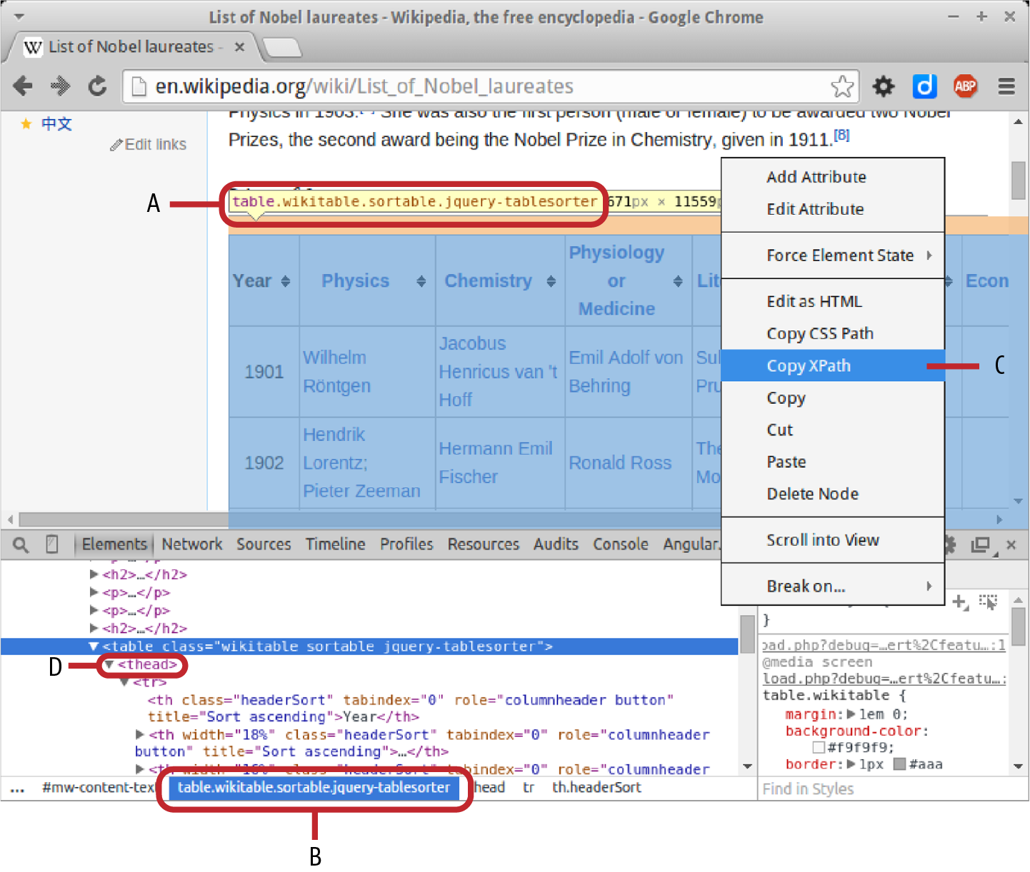

Figure 5-1. Wikipedia’s main Nobel Prize page: A and B show the wikitable’s CSS selector. Right-clicking and selecting C (Copy XPath) gives the table’s xpath (//*[@id="mw-content-text"]/table[1]). D shows a thead tag generated by jQuery.

Getting the Soup
The first thing you need to do before scraping the web page of interest is to parse it with Beautiful Soup, converting the HTML into a tag tree hierarchy or soup:
from
bs4
import
BeautifulSoup
import
requests
BASE_URL
=
'
http://en.wikipedia.org
'
# Wikipedia will reject our request unless we add
# a 'User-Agent' attribute to our http header.
HEADERS
=
{
'
User-Agent
'
:
'
Mozilla/5.0
'
}
def
get_Nobel_soup
(
)
:
""" Return a parsed tag tree of our Nobel prize page """
# Make a request to the Nobel page, setting valid headers
response
=
requests
.
get
(
BASE_URL
+
'
/wiki/List_of_Nobel_laureates
'
,
headers
=
HEADERS
)
# Return the content of the response parsed by Beautiful Soup
return
BeautifulSoup
(
response
.
content
,
"
lxml
"
)
The second argument specifies the parser we want to use, namely lxml’s.
With our soup in hand, let’s see how to find our target tags.

Selecting Tags
Beautiful Soup offers a few ways to select tags from the parsed soup, with subtle differences that can be confusing. Before demonstrating the selection methods, let’s get the soup of our Nobel Prize page:
soup
=
get_Nobel_soup
()
Our target table (see Figure 5-1) has two defining classes, wikitable and sortable (there are some unsortable tables on the page). We can use Beautiful Soup’s find method to find the first table tag with those classes. find takes a tag name as its first argument and a dictionary with class, ID, and other identifiers as its second:
In
[
3
]:
soup
.
find
(
'table'
,
{
'class'
:
'wikitable sortable'
})
Out
[
3
]:
<
table
class
=
"wikitable sortable"
>
<
tr
>
<
th
>
Year
</
th
>
...
Although we have successfully found our table by its classes, this method is not very robust. Let’s see what happens when we change the order of our CSS classes:
In
[
4
]:
soup
.
find
(
'table'
,
{
'class'
:
'sortable wikitable'
})
# nothing returned
So find cares about the order of the classes, using the class string to find the tag. If the classes were specified in a different order—​something that might well happen during an HTML edit, then the find fails. This fragility makes it difficult to recommend the Beautiful Soup selectors, such as find and find_all. When doing quick hacking, I find lxml’s CSS selectors easier and more intuitive.
Using the soup’s select method (available if you specified the lxml parser when creating it), you can specify an HTML element using its CSS class, ID, and so on. This CSS selector is converted into the xpath syntax lxml uses internally.6
To get our wikitable, we just select a table in the soup, using the dot notation to indicate its classes:
In
[
5
]:
soup
.
select
(
'table.sortable.wikitable'
)
Out
[
5
]:
[
<
table
class
=
"wikitable sortable"
>
<
tr
>
<
th
>
Year
</
th
>
...
]
Note that select returns an array of results, finding all the matching tags in the soup. lxml provides the select_one convenience method if you are selecting just one HTML element. Let’s grab our Nobel table and see what headers it has:
In
[
8
]:
table
=
soup
.
select_one
(
'table.sortable.wikitable'
)
In
[
9
]:
table
.
select
(
'th'
)
Out
[
9
]:
[
<
th
>
Year
</
th
>
,
<
th
width
=
"18%"
><
a
href
=
"/wiki/..._in_Physics..</a></th>,
<
th
width
=
"16%"
><
a
href
=
"/wiki/..._in_Chemis..</a></th>,
...
]
As a shorthand for select, you can call the tag directly on the soup; so these two are equivalent:
table
.
select
(
'th'
)
table
(
'th'
)
With lxml’s parser, Beautiful Soup provides a number of different filters for finding tags, including the simple string name we’ve just used, searching by regular expression, using a list of tag names, and more. See this comprehensive list for more details.
As well as lxml’s select and select_one, there are 10 BeautfulSoup convenience methods for searching the parsed tree. These are essentially variants on find and find_all that specify which parts of the tree they search. For example, find_parent and find_parents, rather than looking for descendants down the tree, look for parent tags of the tag being searched. All 10 methods are available in the Beautiful Soup official docs.
Now that we know how to select our Wikipedia table and are armed with lxml’s selection methods, let’s see how to craft some selection patterns to get the data we want.

Crafting Selection Patterns
Having successfully selected our data table, we now want to craft some selection patterns to scrape the required data. Using the HTML explorer, you can see that the individual winners are contained in <td> cells, with an href <a> link to Wikipedia’s bio pages (in the case of individuals). Here’s a typical target row with CSS classes that we can use as targets to get the data in the <td> cells:
<
tr
>
<
td
align
=
"center"
>
1901
</
td
>
<
td
>
<
span
class
=
"sortkey"
>
Röntgen, Wilhelm
</
span
>
<
span
class
=
"vcard"
>
<
span
class
=
"fn"
>
<
a
href
=
"/wiki/Wilhelm_R%C3%B6ntgen"
\
title
=
"Wilhelm Röntgen"
>
Wilhelm Röntgen
</
a
>
</
span
>
</
span
>
</
td
>
<
td
>
...
</
tr
>
If we loop through these data cells, keeping track of their row (year) and column (category), then we should be able to create a list of winners with all the data we specified except nationality.
The following get_column_titles function scrapes our table for the Nobel category column headers, ignoring the first Year column. Often the header cell in a Wikipedia table contains a web-linked 'a' tag; all the Nobel categories fit this model, pointing to their respective Wikipedia pages. If the header is not clickable, we store its text and a null href:
def
get_column_titles
(
table
)
:
""" Get the Nobel categories from the table header """
cols
=
[
]
for
th
in
table
.
select_one
(
'
tr
'
)
.
select
(
'
th
'
)
[
1
:
]
:
link
=
th
.
select_one
(
'
a
'
)
# Store the category name and any Wikipedia link it has
if
link
:
cols
.
append
(
{
'
name
'
:
link
.
text
,
\
'
href
'
:
link
.
attrs
[
'
href
'
]
}
)
else
:
cols
.
append
(
{
'
name
'
:
th
.
text
,
'
href
'
:
None
}
)
return
cols
We loop through the table head, ignoring the first Year column ([1:]). This selects the column headers shown in Figure 5-2.
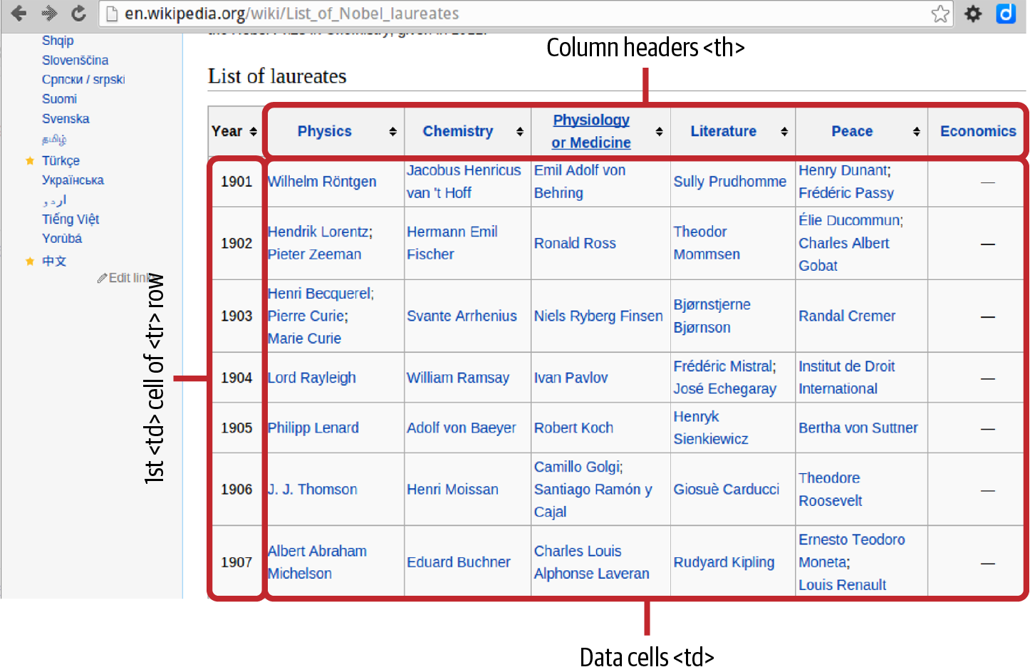

Figure 5-2. Wikipedia’s table of Nobel Prize winners
Let’s make sure get_column_titles is giving us what we want:
get_column_titles
(
table
)
Out
:
[
{
'
name
'
:
'
Physics
'
,
\
'
href
'
:
'
/wiki/List_of_Nobel_laureates_in_Physics
'
}
,
{
'
name
'
:
'
Chemistry
'
,
\
'
href
'
:
'
/wiki/List_of_Nobel_laureates_in_Chemistry
'
}
,
.
.
.
]
def
get_Nobel_winners
(
table
)
:
cols
=
get_column_titles
(
table
)
winners
=
[
]
for
row
in
table
.
select
(
'
tr
'
)
[
1
:
-
1
]
:
year
=
int
(
row
.
select_one
(
'
td
'
)
.
text
)
# Gets 1st <td>
for
i
,
td
in
enumerate
(
row
.
select
(
'
td
'
)
[
1
:
]
)
:
for
winner
in
td
.
select
(
'
a
'
)
:
href
=
winner
.
attrs
[
'
href
'
]
if
not
href
.
startswith
(
'
#endnote
'
)
:
winners
.
append
(
{
'
year
'
:
year
,
'
category
'
:
cols
[
i
]
[
'
name
'
]
,
'
name
'
:
winner
.
text
,
'
link
'
:
winner
.
attrs
[
'
href
'
]
}
)
return
winners
Gets all the Year rows, starting from the second, corresponding to the rows in Figure 5-2.
Finds the <td> data cells shown in Figure 5-2.
Iterating through the Year rows, we take the first Year column and then iterate over the remaining columns, using enumerate to keep track of our index, which will map to the category column names. We know that all the winner names are contained in an <a> tag but that there are occasional extra <a> tags beginning with #endnote, which we filter for. Finally we append a year, category, name, and link dictionary to our data array. Note that the winner selector has an attrs dictionary containing, among other things, the <a> tag’s href.
Let’s confirm that get_Nobel_winners delivers a list of Nobel Prize winner dictionaries:
get_Nobel_winners
(
table
)
[{'year': 1901,
'category': 'Physics',
'name': 'Wilhelm Röntgen',
'link': '/wiki/Wilhelm_R%C3%B6ntgen'},
{'year': 1901,
'category': 'Chemistry',
'name': "Jacobus Henricus van 't Hoff",
'link': '/wiki/Jacobus_Henricus_van_%27t_Hoff'},
{'year': 1901,
'category': 'Physiologyor Medicine',
'name': 'Emil Adolf von Behring',
'link': '/wiki/Emil_Adolf_von_Behring'},
{'year': 1901,
...}]
Now that we have the full list of Nobel Prize winners and links to their Wikipedia pages, we can use these links to scrape data from the individuals’ biographies. This will involve making a largish number of requests, and it’s not something we really want to do more than once. The sensible and respectful7 thing is to cache the data we scrape, allowing us to try out various scraping experiments without returning to Wikipedia.

Caching the Web Pages
It’s easy enough to rustle up a quick cacher in Python, but as often as not it’s easier still to find a better solution written by someone else and kindly donated to the open source community. Requests has a nice plug-in called requests-cache that, with a few lines of configuration, will take care of all your basic caching needs.
First, we install the plug-in using pip:
$ pip install --upgrade requests-cache
requests-cache uses monkey patching to dynamically replace parts of the requests API at runtime. This means it can work transparently. You just have to install its cache and then use requests as usual, with all the caching being taken care of. Here’s the simplest way to use requests-cache:
import
requests
import
requests_cache
requests_cache
.
install_cache
()
# use requests as usual...
The install_cache method has a number of useful options, including allowing you to specify the cache backend (sqlite, memory, mongdb, or redis) or set an expiry time (expiry_after) in seconds on the caching. So the following creates a cache named nobel_pages with an sqlite backend and pages that expire in two hours (7,200 s):
requests_cache
.
install_cache
(
'nobel_pages'
,
\
backend
=
'sqlite'
,
expire_after
=
7200
)
requests-cache will serve most of your caching needs and couldn’t be much easier to use. For more details, see the official docs where you’ll also find a little example of request throttling, which is a useful technique when doing bulk scraping.

Scraping the Winners’ Nationalities
With caching in place, let’s try getting the winners’ nationalities, using the first 50 for our experiment. A little get_winner_nationality() function will use the winner links we stored earlier to scrape their page and then use the info-box shown in Figure 5-3 to get the Nationality attribute.
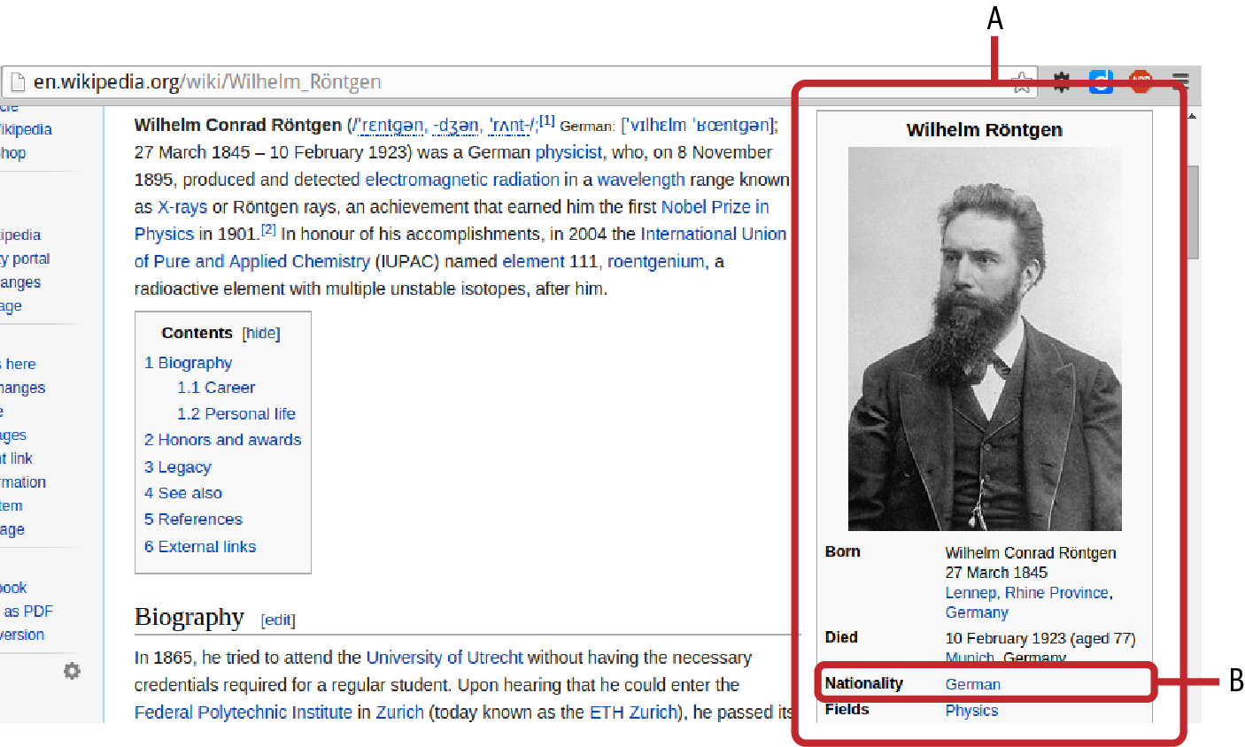

Figure 5-3. Scraping a winner’s nationality
Note
When scraping, you are looking for reliable patterns and repeating elements with useful data. As we’ll see, the Wikipedia info-boxes for individuals are not such a reliable source, but clicking on a few random links certainly gives that impression. Depending on the size of the dataset, it’s good to perform a few experimental sanity checks. You can do this manually but, as mentioned at the start of the chapter, this won’t scale or improve your craft skills.
Example 5-3 takes one of the winner dictionaries we scraped earlier and returns a name-labeled dictionary with a Nationality key if one is found. Let’s run it on the first 50 winners and see how often a Nationality attribute is missing.

Example 5-3. Scraping the winner’s country from their biography page
HEADERS
=
{
'
User-Agent
'
:
'
Mozilla/5.0
'
}
def
get_winner_nationality
(
w
)
:
""" scrape biographic data from the winner's wikipedia page """
response
=
requests
.
get
(
'
http://en.wikipedia.org
'
\
+
w
[
'
link
'
]
,
headers
=
HEADERS
)
content
=
response
.
content
.
decode
(
'
utf-8
'
)
soup
=
BeautifulSoup
(
content
)
person_data
=
{
'
name
'
:
w
[
'
name
'
]
}
attr_rows
=
soup
.
select
(
'
table.infobox tr
'
)
for
tr
in
attr_rows
:
try
:
attribute
=
tr
.
select_one
(
'
th
'
)
.
text
if
attribute
==
'
Nationality
'
:
person_data
[
attribute
]
=
tr
.
select_one
(
'
td
'
)
.
text
except
AttributeError
:
pass
return
person_data
We use a CSS selector to find all the <tr> rows of the table with class infobox.
Cycles through the rows looking for a Nationality field.
Example 5-4 shows that 14 of the 50 first winners failed our attempt to scrape their nationality. In the case of the Institut de Droit International, national affiliation may well be moot, but Theodore Roosevelt is about as American as they come. Clicking on a few of the names shows the problem (see Figure 5-4). The lack of a standardized biography format means synonyms for Nationality are often employed, as in Marie Curie’s Citizenship; sometimes no reference is made, as with Niels Finsen; and Randall Cremer has nothing but a photograph in his info-box. We can discard the info-boxes as a reliable source of winners’ nationalities but, as they appeared to be the only regular source of potted data, this sends us back to the drawing board. In the next chapter, we’ll see a successful approach using Scrapy and a different start page.

Example 5-4. Testing for scraped nationalities
wdata
=
[]
# test first 50 winners
for
w
in
winners
[:
50
]:
wdata
.
append
(
get_winner_nationality
(
w
))
missing_nationality
=
[]
for
w
in
wdata
:
# if missing 'Nationality' add to list
if
not
w
.
get
(
'Nationality'
):
missing_nationality
.
append
(
w
)
# output list
missing_nationality
[{
'name'
:
'Theodor Mommsen'
},
{
'name'
:
'Élie Ducommun'
},
{
'name'
:
'Charles Albert Gobat'
},
{
'name'
:
'Pierre Curie'
},
{
'name'
:
'Marie Curie'
},
{
'name'
:
'Niels Ryberg Finsen'
},
...
{
'name'
:
'Theodore Roosevelt'
},
...
]
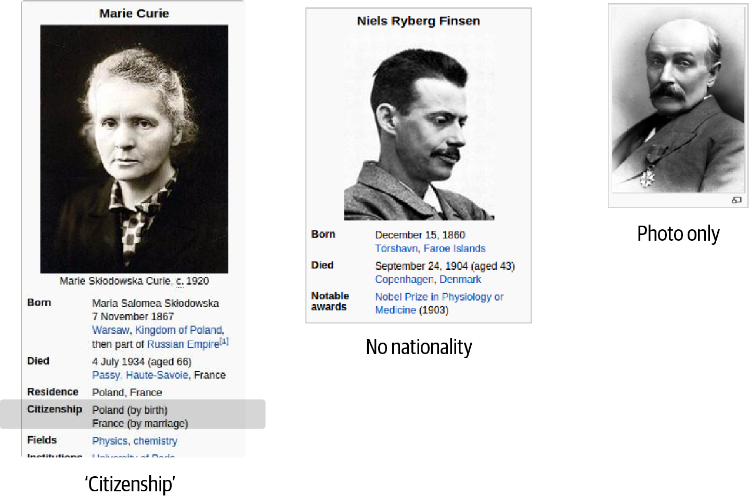

Figure 5-4. Winners without a recorded nationality
Although Wikipedia is a relative free-for-all, production-wise, where data is designed for human consumption, you can expect a lack of rigor. Many sites have similar gotchas and as the datasets get bigger, more tests may be needed to find the flaws in a collection pattern.
Although our first scraping exercise was a little artificial in order to introduce the tools, I hope it captured something of the slightly messy spirit of web scraping. The ultimately abortive pursuit of a reliable Nationality field for our Nobel dataset could have been forestalled by a bit of web browsing and manual HTML-source trawling. However, if the dataset were significantly larger and the failure rate a bit smaller, then programmatic detection, which gets easier and easier as you become acquainted with the scraping modules, really starts to deliver.
This little scraping test was designed to introduce Beautiful Soup, and shows that collecting the data we seek requires a little more thought, which is often the case with scraping. In the next chapter, we’ll wheel out the big gun, Scrapy, and, with what we’ve learned in this section, harvest the data we need for our Nobel Prize visualization.

Summary
In this chapter, we’ve seen examples of the most common ways in which data can be sucked out of the web and into Python containers, databases, or pandas datasets. Python’s Requests library is the true workhorse of HTTP negotiation and a fundamental tool in our dataviz toolchain. For simpler, RESTful APIs, consuming data with Requests is a few lines of Python away. For the more awkward APIs, such as those with potentially complicated authorization, a wrapper library like Tweepy (for Twitter) can save a lot of hassle. Decent wrappers can also keep track of access rates and, where necessary, throttle your requests. This is a key consideration, particularly when there is the possibility of blacklisting unfriendly consumers.
We also started our first forays into data scraping, which is often a necessary fallback where no API exists and the data is for human consumption. In the next chapter, we’ll get all the Nobel Prize data needed for the book’s visualization using Python’s Scrapy, an industrial-strength scraping library.
1 This is actually a deliberate policy of the developers.
2 There are some platform dependencies that might still generate errors. This Stack Overflow thread is a good starting point if you still have problems.
3 OAuth1 access has been deprecated recently.
4 The free API is currently limited to around 350 requests per hour.
5 Much of modern machine learning and artificial intelligence (AI) research is dedicated to creating computer software that can cope with messy, noisy, fuzzy, informal data but, as of this book’s publication, there’s no off-the-shelf solution I know of.
6 This CSS selection syntax should be familiar to anyone who’s used JavaScript’s jQuery library and is also similar to that used by D3.
7 When scraping, you’re using other people’s web bandwidth, which ultimately costs them money. It’s just good manners to try to limit your number of requests.

Chapter 6. Heavyweight Scraping with Scrapy
As your scraping goals get more ambitious, hacking solutions with Beautiful Soup and requests can get very messy very fast. Managing the scraped data as requests spawn more requests gets tricky, and if your requests are being made synchronously, things start to slow down rapidly. A whole load of problems you probably hadn’t anticipated start to make themselves known. It’s at this point that you want to turn to a powerful, robust library that solves all these problems and more. And that’s where Scrapy comes in.
Where Beautiful Soup is a very handy little penknife for fast and dirty scraping, Scrapy is a Python library that can do large-scale data scrapes with ease. It has all the things you’d expect, like built-in caching (with expiration times), asynchronous requests via Python’s Twisted web framework, user-agent randomization, and a whole lot more. The price for all this power is a fairly steep learning curve, which this chapter is intended to smooth, using a simple example. I think Scrapy is a powerful addition to any dataviz toolkit and really opens up possibilities for web data collection.
In “Scraping Data”, we managed to scrape a dataset containing all the Nobel Prize winners by name, year, and category. We did a speculative scrape of the winners’ linked biography pages, which showed that extracting the country of nationality was going to be difficult. In this chapter, we’ll set the bar on our Nobel Prize data a bit higher and aim to scrape objects of the form shown in Example 6-1.

Example 6-1. Our targeted Nobel JSON object
{
"category"
:
"Physiology or Medicine"
,
"country"
:
"Argentina"
,
"date_of_birth': "
8
October
1927
",
"date_of_death': "
24
March
2002
",
"gender"
:
"male"
,
"link"
:
"http:\/\/en.wikipedia.org\/wiki\/C%C3%A9sar_Milstein"
,
"name"
:
"C
\u00e9
sar Milstein"
,
"place_of_birth"
:
"Bah
\u00ed
a Blanca , Argentina"
,
"place_of_death"
:
"Cambridge , England"
,
"text"
:
"C
\u00e9
sar Milstein , Physiology or Medicine, 1984"
,
"year"
:
1984
}
In addition to this data, we’ll aim to scrape prizewinners’ photos (where applicable) and some potted biographical data (see Figure 6-1). We’ll be using the photos and body text to add a little character to our Nobel Prize visualization.
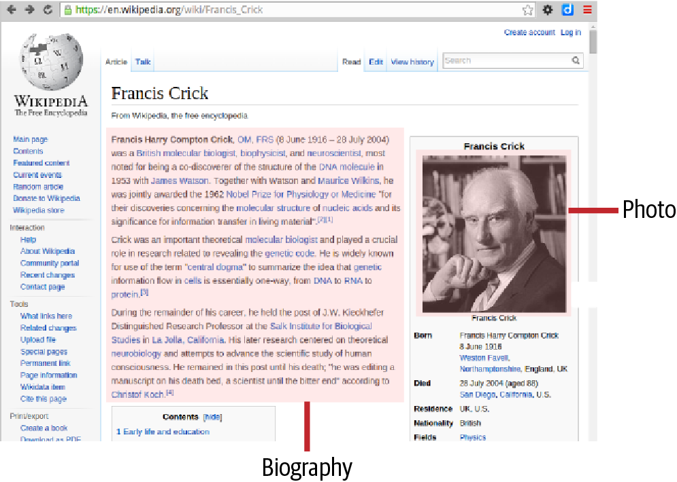

Figure 6-1. Scraping targets for the prizewinners’ pages

Setting Up Scrapy
Scrapy should be one of the Anaconda packages (see Chapter 1), so you should already have it on hand. If that’s not the case, then you can install it with the following conda command line:
$ conda install -c https://conda.anaconda.org/anaconda scrapy
If you’re not using Anaconda, a quick pip install will do the job:1
$ pip install scrapy
With Scrapy installed, you should have access to the scrapy command. Unlike the vast majority of Python libraries, Scrapy is designed to be driven from the command line within the context of a scraping project, defined by configuration files, scraping spiders, pipelines, and so on. Let’s generate a fresh project for our Nobel Prize scraping, using the startproject option. This is going to generate a project folder, so make sure you run it from a suitable work directory:
$ scrapy startproject nobel_winners
New Scrapy project
'nobel_winners'
created
in
:
/home/kyran/workspace/.../scrapy/nobel_winners
You can start your first spider with:
cd
nobel_winners
scrapy genspider example example.com
As the output of startproject says, you’ll want to switch to the nobel_winners directory in order to start driving Scrapy.
Let’s take a look at the project’s directory tree:
nobel_winners
├── nobel_winners
│ ├── __init__.py
│ ├── items.py
│ ├── middlewares.py
│ ├── pipelines.py
│ ├── settings.py
│ └── spiders
│ └── __init__.py
└── scrapy.cfg
As shown, the project directory has a subdirectory with the same name and a config file scrapy.cfg. The nobel_winners subdirectory is a Python module (containing an __init__.py file) with a few skeleton files and a spiders directory, which will contain your scrapers.

Establishing the Targets
In “Scraping Data”, we tried to scrape the Nobel winners’ nationalities from their biography pages but found they were missing or inconsistently labeled in many cases (see Chapter 5). Rather than get the country data indirectly, a little Wikipedia searching shows a way through. There is a page that lists winners by country. The winners are presented in titled, ordered lists (see Figure 6-2), not in tabular form, which makes recovering our basic name, category, and year data a little harder. Also the data organization is not ideal (e.g., the country header titles and winner lists aren’t in useful, separate blocks). As we’ll see, a few well-structured Scrapy queries will easily net us the data we need.
Figure 6-2 shows the starting page for our first spider along with the key elements it will be targeting. A list of country name titles (A) is followed by an ordered list (B) of their Nobel Prize–winning citizens.
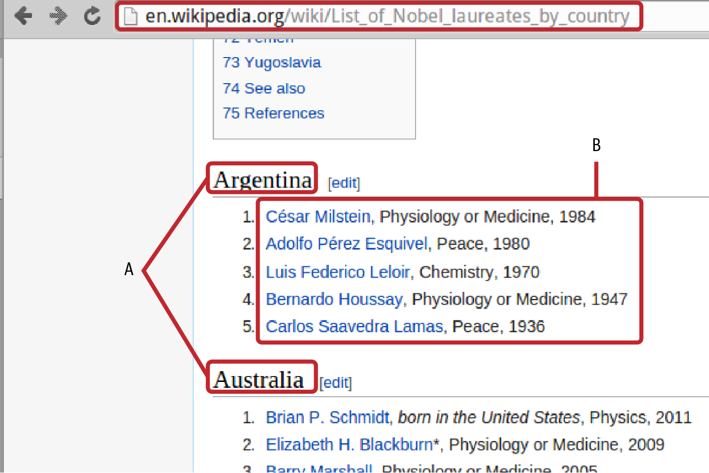

Figure 6-2. Scraping Wikipedia’s Nobel Prizes by nationality
In order to scrape the list data, we need to fire up our Chrome browser’s DevTools (see “The Elements Tab”) and inspect the target elements using the Elements tab and its inspector (magnifying glass). Figure 6-3 shows the key HTML targets for our first spider: header titles (h2) containing a country name and followed by an ordered list (ol) of winners (li).
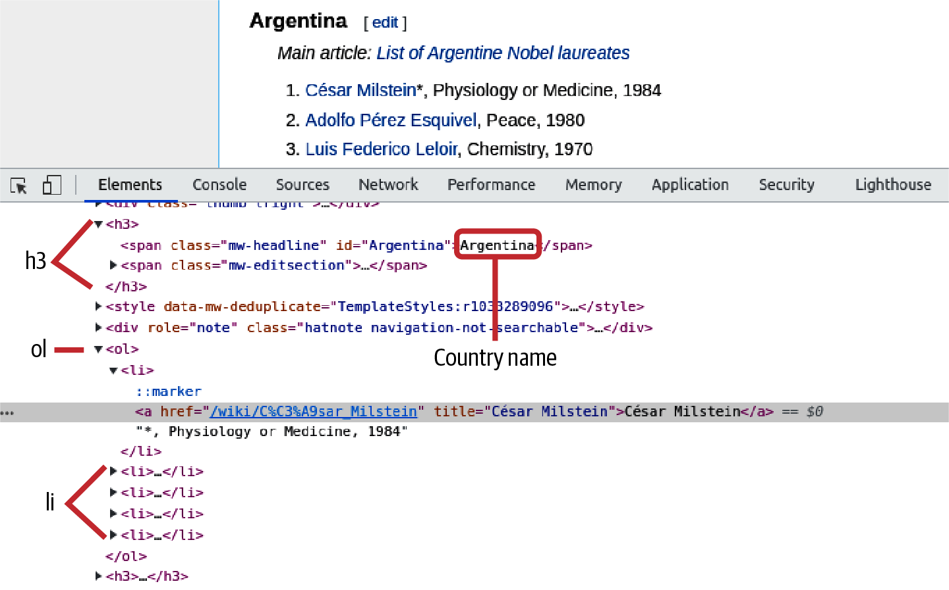

Figure 6-3. Finding the HTML targets for the wikilist

Targeting HTML with Xpaths
Scrapy uses xpaths to define its HTML targets. Xpath is a syntax for describing parts of an X(HT)ML document, and while it can get rather complicated, the basics are straightforward and will often solve the job at hand.
You can get the xpath of an HTML element by using Chrome’s Elements tab to hover over the source and then right-clicking and selecting Copy XPath. For example, in the case of our Nobel Prize wikilist’s country names (h3 in Figure 6-3), selecting the xpath of Argentina (the first country) gives the following:
//*[@id="mw-content-text"]/div[1]/h3[1]
We can use the following xpath rules to decode it:
//E
Element <E> anywhere in the document (e.g., //img gets all images on the page)
//E[@id="foo"]
Select element <E> with ID foo
//*[@id="foo"]
Select any element with ID foo
//E/F[1]
First child element <F> of element <E>
//E/*[1]
First child of element <E>
Following these rules shows that our Argentinian title //*[@id="mw-content-text"]/div[1]/h3[1] is the first header (h2) child of the first div of the DOM element with ID mw-content-text. This is equivalent to the following HTML:
<
div
id
=
"mw-content-text"
>
<
div
>
<
h2
>
...
</
h2
>
</
div
>
...
</
div
>
Note that unlike Python, the xpaths don’t use a zero-based index but make the first member 1.

Testing Xpaths with the Scrapy Shell
Getting your xpath targeting right is crucial to good scraping and can involve a degree of iteration. Scrapy makes this process much easier by providing a command-line shell, which takes a URL and creates a response context in which you can try out your xpaths, like so:
$ scrapy shell
https://en.wikipedia.org/wiki/List_of_Nobel_laureates_by_country
2021
-12-09
14
:31:06
[
scrapy.utils.log
]
INFO: Scrapy
2
.5.1 started
(
bot: nobel_winners
)
...
2021
-12-09
14
:31:07
[
scrapy.core.engine
]
INFO: Spider opened
2021
-12-09
14
:31:07
[
scrapy.core.engine
]
DEBUG: Crawled
(
200
)
<GET https://en.wikip...List_of_Nobel_laureates_by_country>
(
referer: None
)
[
s
]
Available Scrapy objects:
[
s
]
crawler <scrapy.crawler.Crawler object at 0x3a8f510>
[
s
]
item
{}
[
s
]
request <GET https://...Nobel_laureates_by_country>
[
s
]
response <
200
https://...Nobel_laureates_by_country>
[
s
]
settings <scrapy.settings.Settings object at 0x34a98d0>
[
s
]
spider <DefaultSpider
'default'
at 0x3f59190>
[
s
]
Useful shortcuts:
[
s
]
shelp
()
Shell
help
(
print this
help
)
[
s
]
fetch
(
url
[
,
redirect
=
True
])
Fetch URL and update
local
objects
(
by default, redirects are followed
)
[
s
]
fetch
(
req
)
Fetch a scrapy.Request and update
[
s
]
view
(
response
)
View response
in
a browser
In
[
1
]
:
Now we have an IPython-based shell with code-complete and syntax highlighting in which to try out our xpath targeting. Let’s grab all the <h3> headers on the wiki page:
In [1]: h3s = response.xpath('//h3')
The resulting h3s is a SelectorList, a specialized Python list object. Let’s see how many headers we have:
In [2]: len(h3s)
Out[2]: 91
We can grab the first Selector object and query its methods and properties in the Scrapy shell by pressing Tab after appending a dot:
In [3] h3 = h3s[0]
In [4] h3.
attrib get re remove ...
css getall re_first remove_namespaces ...
extract namespaces register_namespace response ...
You’ll often use the extract method to get the raw result of the xpath selector:
In [5]: h3.extract()
Out[6]:
u'<h3>
<span class="mw-headline" id="Argentina">Argentina</span>
<span class="mw-editsection">
<span class="mw-editsection-bracket">
...
</h3>'
This shows that our country headers start on the first <h3> and contain a span with class mw-headline. We can use the presence of the mw-headline class as a filter for our country headers and the contents as our country label. Let’s try out an xpath, using the selector’s text method to extract the text from the mw-headline span. Note that we use the xpath method of the <h3> selector, which makes the xpath query relative to that element:
In [7]: h3_arg = h3
In [8]: country = h3_arg.xpath(\
'span[@class="mw-headline"]/text()')\
.extract()
In [9]: country
Out[9]: ['Argentina']
The extract method returns a list of possible matches, in our case the single 'Argentina' string. By iterating through the h3s list, we can now get our country names.
Assuming we have a country’s <h3> header, we now need to get the <ol> ordered list of Nobel winners following it (Figure 6-2 B). Handily, the xpath following-sibling selector can do just that. Let’s grab the first ordered list after the Argentina header:
In [10]: ol_arg = h3_arg.xpath('following-sibling::ol[1]')
Out[10]: ol_arg
[<Selector xpath='following-sibling::ol[1]' data=u'<ol><li>
<a href="/wiki/C%C3%A9sar_Milst'>]
Looking at the truncated data for ol_arg shows that we have selected an ordered list. Note that even though there’s only one Selector, xpath still returns a SelectorList. For convenience, you’ll generally just select the first member directly:
In [11]: ol_arg = h2_arg.xpath('following-sibling::ol[1]')[0]
Now that we’ve got the ordered list, let’s get a list of its member <li> elements (as of mid 2022):
In [12]: lis_arg = ol_arg.xpath('li')
In [13]: len(lis_arg)
Out[13]: 5
Let’s examine one of those list elements using extract. As a first test, we’re looking to scrape the name of the winner and capture the list element’s text:
In [14]: li = lis_arg[0] # select the first list element
In [15]: li.extract()
Out[15]:
'<li><a href="/wiki/C%C3%A9sar_Milstein"
title="C\xe9sar Milstein">C\xe9sar Milstein</a>,
Physiology or Medicine, 1984</li>'
Extracting the list element shows a standard pattern: a hyperlinked name to the winner’s Wikipedia page followed by a comma-separated winning category and year. A robust way to get the winning name is just to select the text of the list element’s first <a> tag:
In [16]: name = li.xpath('a//text()')[0].extract()
In [17]: name
Out[17]: 'César Milstein'
It’s often useful to get all the text in, for example, a list element, stripping the various HTML <a>, <span>, and other tags. descendant-or-self gives us a handy way of doing this, producing a list of the descendants’ text:
In [18]: list_text = li.xpath('descendant-or-self::text()')\
.extract()
In [19]: list_text
Out[19]: ['César Milstein', '*, Physiology or Medicine, 1984']
We can get the full text by joining the list elements together:
In [20]: ' '.join(list_text)
Out[20]: 'César Milstein *, Physiology or Medicine, 1984'
Note that the first item of list_text is the winner’s name, giving us another way to access it if, for example, it were missing a hyperlink.
Now that we’ve established the xpaths to our scraping targets (the name and link text of the Nobel Prize winners), let’s incorporate them into our first Scrapy spider.

Selecting with Relative Xpaths
As just shown, Scrapy xpath selections return lists of selectors which, in turn, have their own xpath methods. When using the xpath method, it’s important to be clear about relative and absolute selections. Let’s make the distinction clear using the Nobel page’s table of contents as an example.
The table of contents has the following structure:
<
div
id
=
'toc'
...
>
...
<
ul
...
>
<
li
...
>
<
a
href
=
'Argentina'
>
...
</
a
>
</
li
>
...
</
ul
>
...
</
div
>
We can select the table of contents of the Nobel wiki page using a standard xpath query on the response, and getting the div with ID toc:
In [21]: toc = response.xpath('//div[@id="toc"]')[0]
If we want to get all the country <li> list tags, we can use a relative xpath on the selected toc div. Looking at the HTML in Figure 6-3 shows that the unordered list ul of countries is the first list member of the second list item of the table of content’s top list. This list can be selected by the following equivalent xpaths, both selecting children of the current toc selection relatively:
In [22]: lis = toc.xpath('.//ul/li[2]/ul/li')
In [23]: lis = toc.xpath('ul/li[2]/ul/li')
In [24]: len(lis)
Out[24]: 81 # the number of countries in the table of contents (July 2022)
A common mistake is to use a nonrelative xpath selector on the current selection, which selects from the whole document, in this case getting all unordered (<ul>) <li> tags:
In [25]: lis = toc.xpath('//ul/li')
In [26]: len(lis)
OUt[26]: 271
Errors made from mistaking relative and nonrelative queries crop up a lot in the forums, so it’s good to be very aware of the distinction and watch those dots.
Tip
Getting the right xpath expression for your target element(s) can be a little tricky, and those difficult edge cases can demand a complex nest of clauses. The use of a well-written cheat sheet can be a great help here, and thankfully there are many good xpath ones. A very nice selection can be found at devhints.io.

A First Scrapy Spider
Armed with a little xpath knowledge, let’s produce our first scraper aiming to get the country and link text for the winners (Figure 6-2 A and B).
Scrapy calls its scrapers spiders, each of which is a Python module placed in the spiders directory of your project. We’ll call our first scraper nwinner_list_spider.py:
.
├── nobel_winners
│ ├── __init__.py
│ ├── items.py
│ ├── middlewares.py
│ ├── pipelines.py
│ ├── settings.py
│ └── spiders
│ |── __init__.py
│ └── nwinners_list_spider.py <---
└── scrapy.cfg
Spiders are subclassed scrapy.Spider classes, and any placed in the spiders directory will be automatically detected by Scrapy and made accessible by name to the scrapy command.
The basic Scrapy spider shown in Example 6-2 follows a pattern you’ll be using with most of your spiders. First, you subclass a Scrapy item to create fields for your scraped data (section A in Example 6-2). You then create a named spider by subclassing scrapy.Spider (section B in Example 6-2). You will use the spider’s name when calling scrapy from the command line. Each spider has a parse method, which deals with the HTTP requests to a list of start URLs contained in a start_url class attribute. In our case, the start URL is the Wikipedia page for Nobel laureates by country.

Example 6-2. A first Scrapy spider
# nwinners_list_spider.py
import
scrapy
import
re
# A. Define the data to be scraped
class
NWinnerItem
(
scrapy
.
Item
)
:
country
=
scrapy
.
Field
(
)
name
=
scrapy
.
Field
(
)
link_text
=
scrapy
.
Field
(
)
# B Create a named spider
class
NWinnerSpider
(
scrapy
.
Spider
)
:
""" Scrapes the country and link text of the Nobel-winners. """
name
=
'
nwinners_list
'
allowed_domains
=
[
'
en.wikipedia.org
'
]
start_urls
=
[
"
http://en.wikipedia.org ... of_Nobel_laureates_by_country
"
]
# C A parse method to deal with the HTTP response
def
parse
(
self
,
response
)
:
h3s
=
response
.
xpath
(
'
//h3
'
)
for
h3
in
h3s
:
country
=
h3
.
xpath
(
'
span[@class=
"
mw-headline
"
]
'
\
'
text()
'
)
.
extract
(
)
if
country
:
winners
=
h2
.
xpath
(
'
following-sibling::ol[1]
'
)
for
w
in
winners
.
xpath
(
'
li
'
)
:
text
=
w
.
xpath
(
'
descendant-or-self::text()
'
)
\
.
extract
(
)
yield
NWinnerItem
(
country
=
country
[
0
]
,
name
=
text
[
0
]
,
link_text
=
'
'
.
join
(
text
)
)
Gets all the <h3> headers on the page, most of which will be our target country titles.
Where possible, gets the text of the <h3> element’s child <span> with class mw-headline.
Gets the list of country winners.
The parse method in Example 6-2 receives the response from an HTTP request to the Wikipedia Nobel Prize page and yields Scrapy items, which are then converted to JSON objects and appended to the output file, a JSON array of objects.
Let’s run our first spider to make sure we’re correctly parsing and scraping our Nobel data. First, navigate to the nobel_winners root directory (containing the scrapy.cfg file) of the scraping project. Let’s see what scraping spiders are available:
$ scrapy list
nwinners_list
As expected, we have one nwinners_list spider sitting in the spiders directory. To start it scraping, we use the crawl command and direct the output to a nwinners.json file. By default, we get a lot of Python logging information accompanying the crawl:
$ scrapy crawl nwinners_list -o nobel_winners.json
2021- ... [scrapy] INFO: Scrapy started (bot: nobel_winners)
...
2021- ... [nwinners_list] INFO: Closing spider (finished)
2021- ... [nwinners_list] INFO: Dumping Scrapy stats:
{'downloader/request_bytes': 1147,
'downloader/request_count': 4,
'downloader/request_method_count/GET': 4,
'downloader/response_bytes': 66459,
...
'item_scraped_count': 1169,
2021- ... [scrapy.core.engine] INFO: Spider closed (finished)
We scraped 1,169 Nobel winners from the page.
The output of the scrapy crawl shows 1,169 items successfully scraped. Let’s look at our JSON output file to make sure things have gone according to plan:
$ head nobel_winners.json
[{"country": "Argentina",
"link_text": "C\u00e9sar Milstein , Physiology or Medicine,"\
" 1984",
"name": "C\u00e9sar Milstein"},
{"country": "Argentina",
"link_text": "Adolfo P\u00e9rez Esquivel , Peace, 1980",
"name": "Adolfo P\u00e9rez Esquivel"},
...
As you can see, we have an array of JSON objects with the four key fields present and correct.
Now that we have a spider that successfully scrapes the list data for all the Nobel winners on the page, let’s start refining it to grab all the data we are targeting for our Nobel Prize visualization (see Example 6-1 and Figure 6-1).
First, let’s add all the data we plan to scrape as fields to our scrapy.Item:
...
class
NWinnerItem
(
scrapy
.
Item
):
name
=
scrapy
.
Field
()
link
=
scrapy
.
Field
()
year
=
scrapy
.
Field
()
category
=
scrapy
.
Field
()
country
=
scrapy
.
Field
()
gender
=
scrapy
.
Field
()
born_in
=
scrapy
.
Field
()
date_of_birth
=
scrapy
.
Field
()
date_of_death
=
scrapy
.
Field
()
place_of_birth
=
scrapy
.
Field
()
place_of_death
=
scrapy
.
Field
()
text
=
scrapy
.
Field
()
...
It’s also sensible to simplify the code a bit and use a dedicated function, process_winner_li, to process the winners’ link text. We’ll pass a link selector and country name to it and return a dictionary containing the scraped data:
...
def
parse
(
self
,
response
):
h3s
=
response
.
xpath
(
'//h3'
)
for
h3
in
h3s
:
country
=
h3
.
xpath
(
'span[@class="mw-headline"]/text()'
)
\
.
extract
()
if
country
:
winners
=
h3
.
xpath
(
'following-sibling::ol[1]'
)
for
w
in
winners
.
xpath
(
'li'
):
wdata
=
process_winner_li
(
w
,
country
[
0
])
...
Embracing Regexes
Some people, when confronted with a problem, think “I know, I’ll use regular expressions.” Now they have two problems.
Jamie Zawinskie
The preceding quote is a hoary old classic but does sum up how many people feel about regular expressions (regexes). Regexes use a sequence of characters to define a search expression used for string matching. Both Python and JavaScript have built-in handling of them.
In Python, the re module provides a number of regex methods. A common task might be to find all the email addresses in a document, recognizing email strings by the form foo@bar.com. Let’s create a regex to find them, breaking down the process:2
In
[
12
]:
txt
=
'Feel free to contact me at '
\
' pyjdataviz@kyrandale.com with any feedback.'
In
[
13
]:
re
.
findall
(
r
'[\w\.-]+@[\w\.-]+'
,
txt
)
Out
[
13
]:
[
'pyjdataviz@kyrandale.com'
]
The findall method takes a regex string (with an r prepended) as its first argument and the text to search as its second. The email search pattern uses the following rules:
\w | Matches an alphanumeric string containing numbers and upper and lowercase letters (regex shorthand is [0-9a-zA-Z_])
\ | Escapes a special character
\. | Matches a dot
- | Matches a hyphen
+ | Matches one or more of the square-bracketed strings
Taken together, these rules match any two strings connected by @ and containing alphanumeric characters or dots or hyphens. This is obviously a pretty broad pattern (e.g., .@. would provide a match) that you might want to refine. For example, you could use r'[\w\.-]@gmail.com if you were searching for only Gmail addresses.
Although the syntax of regexes can be challenging at first, the fact is that web scraping is often about pattern-matching messy and underspecified data, and a regex is pretty much tailor-made for many of the jobs that crop up. You can probably hack your way around them, but embracing them a little will make your life that much easier, and the good news is that a little goes a long way. See Example 6-3 for some examples.
The process_winner_li method is shown in Example 6-3. A wdata dictionary is filled with information extracted from the winner’s li tag, using a couple of regexes to find the prize year and category.

Example 6-3. Processing a winner’s list item
# ...
import
re
BASE_URL
=
'
http://en.wikipedia.org
'
# ...
def
process_winner_li
(
w
,
country
=
None
)
:
"""
Process a winner's <li> tag, adding country of birth or
nationality, as applicable.
"""
wdata
=
{
}
# get the href link-address from the <a> tag
wdata
[
'
link
'
]
=
BASE_URL
+
w
.
xpath
(
'
a/@href
'
)
.
extract
(
)
[
0
]
text
=
'
'
.
join
(
w
.
xpath
(
'
descendant-or-self::text()
'
)
\
.
extract
(
)
)
# get comma-delineated name and strip trailing whitespace
wdata
[
'
name
'
]
=
text
.
split
(
'
,
'
)
[
0
]
.
strip
(
)
year
=
re
.
findall
(
'
\
d
{4}
'
,
text
)
if
year
:
wdata
[
'
year
'
]
=
int
(
year
[
0
]
)
else
:
wdata
[
'
year
'
]
=
0
print
(
'
Oops, no year in
'
,
text
)
category
=
re
.
findall
(
'
Physics|Chemistry|Physiology or Medicine|Literature|
'
\
'
Peace|Economics
'
,
text
)
if
category
:
wdata
[
'
category
'
]
=
category
[
0
]
else
:
wdata
[
'
category
'
]
=
'
'
print
(
'
Oops, no category in
'
,
text
)
if
country
:
if
text
.
find
(
'
*
'
)
!=
-
1
:
wdata
[
'
country
'
]
=
'
'
wdata
[
'
born_in
'
]
=
country
else
:
wdata
[
'
country
'
]
=
country
wdata
[
'
born_in
'
]
=
'
'
# store a copy of the link's text-string for any manual corrections
wdata
[
'
text
'
]
=
text
return
wdata
To grab the href attribute from the list item’s <a> tag (<li><a href=/wiki…​>[winner name]</a>…​), we use the xpath attribute referent @.
Here, we use re, Python’s built-in regex library, to find the four-digit year strings in the list item’s text.
Another use of the regex library to find the Nobel Prize category in the text.
An asterisk following the winner’s name is used to indicate that the country is the winner’s by birth—​not nationality—​at the time of the prize (e.g., "William Lawrence Bragg*, Physics, 1915" in the list for Australia).
Example 6-3 returns all the winners’ data available on the main Wikipedia Nobels by Country page—that is, the name, year, category, country (country of birth or country of nationality when awarded the prize), and a link to the individual winners’ pages. We’ll need to use this last information to get those biographical pages and use them to scrape our remaining target data (see Example 6-1 and Figure 6-1).

Scraping the Individual Biography Pages
The main Wikipedia Nobels by Country page gave us a lot of our target data, but the winner’s date of birth, date of death (where applicable), and gender are still to be scraped. It is hoped that this information is available, either implicitly or explicitly, on their biography pages (for nonorganization winners). Now’s a good time to fire up Chrome’s Elements tab and take a look at those pages to work out how we’re going to extract the desired data.
We saw in the last chapter (Chapter 5) that the visible information boxes on individual’s pages are not a reliable source of information and are often missing entirely. Until recently,3 a hidden persondata table (see Figure 6-4) gave fairly reliable access to such information as place of birth, date of death, and the like. Unfortunately, this handy resource has been deprecated.4 The good news is that this is part of an attempt to improve the categorization of biographical information by giving it a dedicated space in Wikidata, Wikipedia’s central storage for its structured data.
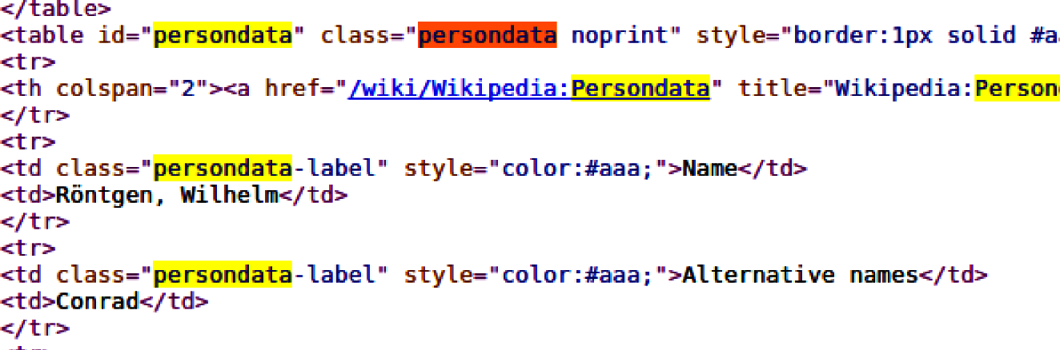

Figure 6-4. A Nobel Prize winner’s hidden persondata table
Examining Wikipedia’s biography pages with Chrome’s Elements tab shows a link to the relevant Wikidata item (see Figure 6-5), which takes you to the biographical data held at https://www.wikidata.org. By following this link, we can scrape whatever we find there, which we hope will be the bulk of our target data—​significant dates and places (see Example 6-1).
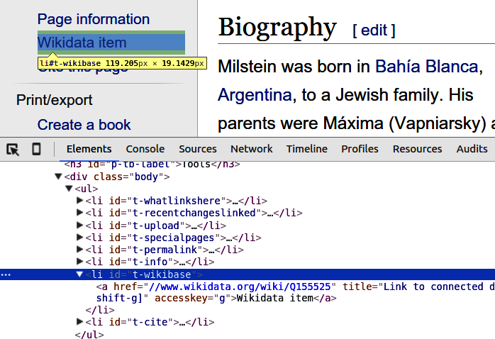

Figure 6-5. Hyperlink to the winner’s Wikidata
Following the link to Wikidata shows a page containing fields for the data we are looking for, such as the date of birth of our prize winner. As Figure 6-6 shows, the properties are embedded in a nest of computer-generated HTML, with related codes, which we can use as a scraping identifier (e.g., date of birth has the code P569).
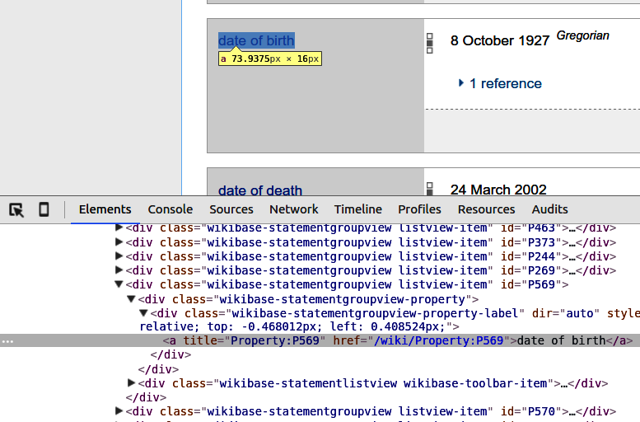

Figure 6-6. Biographical properties at Wikidata
As Figure 6-7 shows, the actual data we want, in this case a date string, is contained in a further nested branch of HTML, within its respective property tag. By selecting the div and right-clicking, we can store the element’s xpath and use that to tell Scrapy how to get the data it contains.
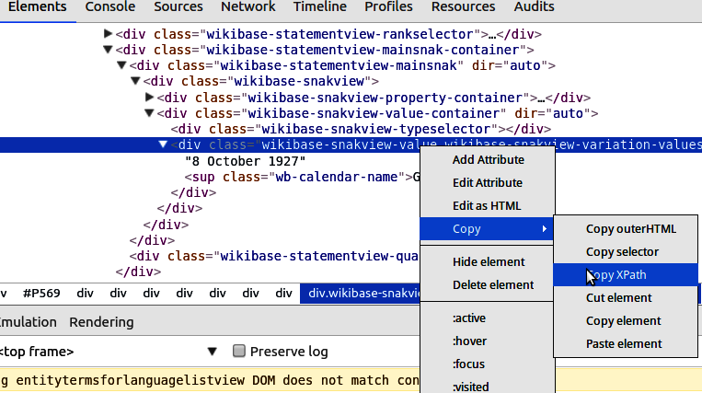

Figure 6-7. Getting the xpath for a Wikidata property
Now that we have the xpaths necessary to find our scraping targets, let’s put it all together and see how Scrapy chains requests, allowing for complex, multipage scraping operations.

Chaining Requests and Yielding Data
In this section we’ll see how to chain Scrapy requests, allowing us to follow hyperlinks, scraping data as we go. First, let’s enable Scrapy’s page caching. While experimenting with xpath targets, we want to limit the number of calls to Wikipedia, and it’s good manners to store our fetched pages. Unlike some datasets out there, our Nobel Prize winners change but once a year.5

Caching Pages
As you might expect, Scrapy has a sophisticated caching system that gives you fine-grained control over your page caching (e.g., allowing you to choose between database or filesystem storage backends, how long before your pages are expired, etc.). It is implemented as middleware enabled in our project’s settings.py module. There are various options available but for the purposes of our Nobel scraping, simply setting HTTPCACHE_ENABLED to True will suffice:
# -*- coding: utf-8 -*-
# Scrapy settings for nobel_winners project
#
# This file contains only the most important settings by
# default. All the other settings are documented here:
#
# http://doc.scrapy.org/en/latest/topics/settings.html
#
BOT_NAME
=
'nobel_winners'
SPIDER_MODULES
=
[
'nobel_winners.spiders'
]
NEWSPIDER_MODULE
=
'nobel_winners.spiders'
# Crawl responsibly by identifying yourself
# (and your website) on the user-agent
#USER_AGENT = 'nobel_winners (+http://www.yourdomain.com)'
HTTPCACHE_ENABLED
=
True
Check out the full range of Scrapy middleware in Scrapy’s documentation.
Having ticked the caching box, let’s see how to chain Scrapy requests.

Yielding Requests
Our existing spider’s parse method cycles through the Nobel winners, using the process_winner_li method to scrape the country, name, year, category, and biography-hyperlink fields. We now want to use the biography hyperlinks to generate a Scrapy request that will fetch the bio pages and send them to a custom method for scraping.
Scrapy implements a Pythonic pattern for chaining requests, using Python’s yield statement to create a generator,6 allowing Scrapy to easily consume any extra page requests we make. Example 6-4 shows the pattern in action.

Example 6-4. Yielding a request with Scrapy
class
NWinnerSpider
(
scrapy
.
Spider
)
:
name
=
'
nwinners_full
'
allowed_domains
=
[
'
en.wikipedia.org
'
]
start_urls
=
[
"
https://en.wikipedia.org/wiki/List_of_Nobel_laureates
"
\
"
_by_country
"
]
def
parse
(
self
,
response
)
:
h3s
=
response
.
xpath
(
'
//h3
'
)
for
h3
in
h3s
:
country
=
h3
.
xpath
(
'
span[@class=
"
mw-headline
"
]/text()
'
)
.
extract
(
)
if
country
:
winners
=
h2
.
xpath
(
'
following-sibling::ol[1]
'
)
for
w
in
winners
.
xpath
(
'
li
'
)
:
wdata
=
process_winner_li
(
w
,
country
[
0
]
)
request
=
scrapy
.
Request
(
wdata
[
'
link
'
]
,
callback
=
self
.
parse_bio
,
dont_filter
=
True
)
request
.
meta
[
'
item
'
]
=
NWinnerItem
(
*
*
wdata
)
yield
request
def
parse_bio
(
self
,
response
)
:
item
=
response
.
meta
[
'
item
'
]
.
.
.
Makes a request to the winner’s biography page, using the link (wdata[link]) scraped from process_winner_li.
Sets the callback function to handle the response.
Creates a Scrapy Item to hold our Nobel data and initializes it with the data just scraped from process_winner_li. This Item data is attached to the metadata of the request to allow any response access to it.
By yielding the request, we make the parse method a generator of consumable requests.
This method handles the callback from our bio-link request. In order to add scraped data to our Scrapy Item, we first retrieve it from the response metadata.
Our investigation of the Wikipedia pages in “Scraping the Individual Biography Pages” showed that we need to locate a winner’s Wikidata link from their biography page and use it to generate a request. We will then scrape the date, place, and gender data from the response.
Example 6-5 shows parse_bio and parse_wikidata, the two methods used to scrape our winners’ biographical data. parse_bio uses the scraped Wikidata link to request the Wikidata page, yielding the request as it in turn was yielded in the parse method. At the end of the request chain, parse_wikidata retrieves the item and fills in any of the fields available from Wikidata, eventually yielding the item to Scrapy.

Example 6-5. Parsing the winners’ biography data
# ...
def
parse_bio
(
self
,
response
)
:
item
=
response
.
meta
[
'
item
'
]
href
=
response
.
xpath
(
"
//li[@id=
'
t-wikibase
'
]/a/@href
"
)
.
extract
(
)
if
href
:
url
=
href
[
0
]
wiki_code
=
url
.
split
(
'
/
'
)
[
-
1
]
request
=
scrapy
.
Request
(
href
[
0
]
,
\
callback
=
self
.
parse_wikidata
,
\
dont_filter
=
True
)
request
.
meta
[
'
item
'
]
=
item
yield
request
def
parse_wikidata
(
self
,
response
)
:
item
=
response
.
meta
[
'
item
'
]
property_codes
=
[
{
'
name
'
:
'
date_of_birth
'
,
'
code
'
:
'
P569
'
}
,
{
'
name
'
:
'
date_of_death
'
,
'
code
'
:
'
P570
'
}
,
{
'
name
'
:
'
place_of_birth
'
,
'
code
'
:
'
P19
'
,
'
link
'
:
True
}
,
{
'
name
'
:
'
place_of_death
'
,
'
code
'
:
'
P20
'
,
'
link
'
:
True
}
,
{
'
name
'
:
'
gender
'
,
'
code
'
:
'
P21
'
,
'
link
'
:
True
}
]
for
prop
in
property_codes
:
link_html
=
'
'
if
prop
.
get
(
'
link
'
)
:
link_html
=
'
/a
'
# select the div with a property-code id
code_block
=
response
.
xpath
(
'
//*[@id=
"
%s
"
]
'
%
(
prop
[
'
code
'
]
)
)
# continue if the code_block exists
if
code_block
:
# We can use the css selector, which has superior class
# selection
values
=
code_block
.
css
(
'
.wikibase-snakview-value
'
)
# the first value corresponds to the code property\
# (e.g., '10 August 1879')
value
=
values
[
0
]
prop_sel
=
value
.
xpath
(
'
.
%s
/text()
'
%
link_html
)
if
prop_sel
:
item
[
prop
[
'
name
'
]
]
=
prop_sel
[
0
]
.
extract
(
)
yield
item
Extracts the link to Wikidata identified in Figure 6-5.
Extracts the wiki_code from the URL, e.g., http://wikidata.org/wiki/Q155525 → Q155525.
Uses the Wikidata link to generate a request with our spider’s parse_wikidata as a callback to deal with the response.
These are the property codes we found earlier (see Figure 6-6), with names corresponding to fields in our Scrapy item, NWinnerItem. Those with a True link attribute are contained in <a> tags.
Finally we yield the item, which at this point should have all the target data available from Wikipedia.
With our request chain in place, let’s check that the spider is scraping our required data:
$ scrapy crawl nwinners_full
2021
-...
[
scrapy
]
... started
(
bot: nobel_winners
)
...
2021
-...
[
nwinners_full
]
DEBUG: Scraped from
<
200
https://www.wikidata.org/wiki/Q155525>
{
'born_in'
:
''
,
'category'
: u
'Physiology or Medicine'
,
'date_of_birth'
: u
'8 October 1927'
,
'date_of_death'
: u
'24 March 2002'
,
'gender'
: u
'male'
,
'link'
: u
'http://en.wikipedia.org/wiki/C%C3%A9sar_Milstein'
,
'name'
: u
'C\xe9sar Milstein'
,
'country'
: u
'Argentina'
,
'place_of_birth'
: u
'Bah\xeda Blanca'
,
'place_of_death'
: u
'Cambridge'
,
'text'
: u
'C\xe9sar Milstein , Physiology or Medicine, 1984'
,
'year'
:
1984
}
2021
-...
[
nwinners_full
]
DEBUG: Scraped from
<
200
https://www.wikidata.org/wiki/Q193672>
{
'born_in'
:
''
,
'category'
: u
'Peace'
,
'date_of_birth'
: u
'1 November 1878'
,
'date_of_death'
: u
'5 May 1959'
,
'gender'
: u
'male'
,
'link'
: u
'http://en.wikipedia.org/wiki/Carlos_Saavedra_Lamas'
,
...
Things are looking good. With the exception of the born_in field, which is dependent on a name in the main Wikipedia Nobel Prize winners list having an asterisk, we’re getting all the data we were targeting. This dataset is now ready to be cleaned by pandas in the coming chapter.
Now that we’ve scraped our basic biographical data for the Nobel Prize winners, let’s go scrape our remaining targets, some biographical body text, and a picture of the great man or woman, where available.

Scrapy Pipelines
In order to add a little personality to our Nobel Prize visualization, it would be good to have a little biographical text and an image of the winner. Wikipedia’s biographical pages generally provide these things, so let’s go about scraping them.
Up to now, our scraped data has been text strings. In order to scrape images in their various formats, we need to use a Scrapy pipeline. Pipelines provide a way of postprocessing the items we have scraped, and you can define any number of them. You can write your own or take advantage of those already provided by Scrapy, such as the ImagesPipeline we’ll be using.
In its simplest form, a pipeline need only define a process_item method. This receives the scraped items and the spider object. Let’s write a little pipeline to reject genderless Nobel Prize winners (so we can omit prizes given to organizations rather than individuals) using our existing nwinners_full spider to deliver the items. First, we add a DropNonPersons pipeline to the pipelines.py module of our project:
# nobel_winners/nobel_winners/pipelines.py
# Define your item pipelines here
#
# Don't forget to add your pipeline to the ITEM_PIPELINES setting
# See: http://doc.scrapy.org/en/latest/topics/item-pipeline.html
from
scrapy
.
exceptions
import
DropItem
class
DropNonPersons
(
object
)
:
""" Remove non-person winners """
def
process_item
(
self
,
item
,
spider
)
:
if
not
item
[
'
gender
'
]
:
raise
DropItem
(
"
No gender for
%s
"
%
item
[
'
name
'
]
)
return
item
If our scraped item failed to find a gender property at Wikidata, it is probably an organization such as the Red Cross. Our visualization is focused on individual winners, so here we use DropItem to remove the item from our output stream.
We need to return the item to further pipelines or for saving by Scrapy.
As mentioned in the pipelines.py header, in order to add this pipeline to the spiders of our project, we need to register it in the settings.py module by adding it to a dict of pipelines and setting it to active (1):
# nobel_winners/nobel_winners/settings.py
BOT_NAME
=
'nobel_winners'
SPIDER_MODULES
=
[
'nobel_winners.spiders'
]
NEWSPIDER_MODULE
=
'nobel_winners.spiders'
HTTPCACHE_ENABLED
=
True
ITEM_PIPELINES
=
{
'nobel_winners.pipelines.DropNonPersons'
:
300
}
Now that we’ve got the basic workflow for our pipelines, let’s add a useful one to our project.

Scraping Text and Images with a Pipeline
We now want to scrape the winners’ biographies and photos (see Figure 6-1), where available. We can scrape the biographical text using the same method as our last spider, but the photos are best dealt with by an image pipeline.
We could easily write our own pipeline to take a scraped image URL, request it from Wikipedia, and save to disk, but to do it properly requires a bit of care. For example, we would like to avoid reloading an image that was recently downloaded or hasn’t changed in the meantime. Some flexibility in specifying where to store the images is a useful feature. It would also be good to have the option of converting the images into a common format (e.g., JPG or PNG) or of generating thumbnails. Luckily, Scrapy provides an ImagesPipeline object with all this functionality and more. This is one of its media pipelines, which includes a FilesPipeline for dealing with general files.
We could add the image and biography-text scraping to our existing nwinners_full spider, but that’s starting to get a little large, and segregating this character data from the more formal categories makes sense. So we’ll create a new spider called nwinners_minibio that will reuse parts of the previous spider’s parse method in order to loop through the Nobel winners.
As usual, when creating a Scrapy spider, our first job is to get the xpaths for our scraping targets—​in this case, where available that’s the first part of the winners’ biographical text and a photograph of them. To do this, we fire up Chrome Elements and explore the HTML source of the biography pages looking for the targets shown in Figure 6-8.
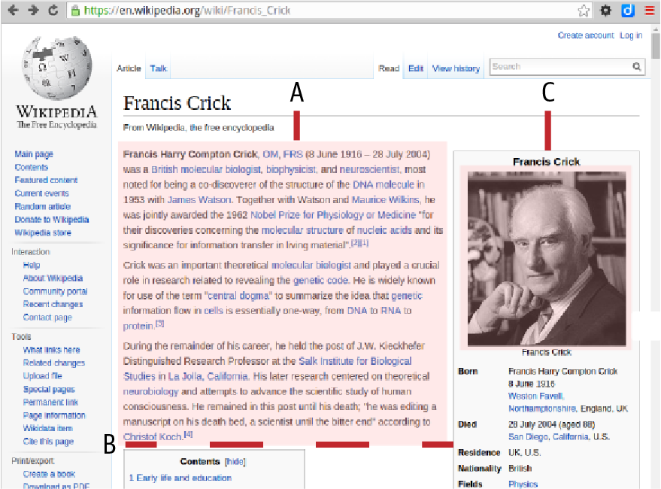

Figure 6-8. The target elements for our biography scraping: the first part of the biography (A) marked by a stop point (B), and the winner’s photograph (C)

Example 6-6. Scraping the biographical text
<
div
id
=
"mw-content-text"
>
<
div
class
=
"mw-parser-output"
>
...
<
table
class
=
"infobox biography vcard"
>
...
</
table
>
/* target paragraphs: */
<
p
>
...
</
p
>
<
p
>
...
</
p
>
<
p
>
...
</
p
>
<
div
id
=
"toc"
>
...
</
div
>
...
</
div
>
</
div
>
Investigating with Chrome Elements (see Example 6-6) shows the biographical text (Figure 6-8 A) is contained in child paragraphs of the div with class mw-parser-output, which is a child of the div with ID mw-content-text. The paragraphs are sandwiched between a table with class infobox and a table-of-contents div with ID toc. We can use the xpath following-sibling and preceding-sibling operators to craft a selector that captures the target paragraphs:
ps
=
response
.
xpath
(
\
'
//*[@id=
"
mw-content-text
"
]/div/table/following-sibling::p
'
'
[not(preceding-sibling::div[@id=
"
toc
"
])]
'
)
.
extract
(
)
All paragraphs following the first table in the child div of the div with ID mw-content-text.
Exclude (not) all paragraphs that have a preceding sibling div with ID toc.
Testing this with the Scrapy shell shows it consistently captures the Nobel winners’ mini-bios.
Further exploration of the winners’ pages shows that their photos (Figure 6-8 C) are contained in a table of class infobox and are the only image tags (<img>) in that table:
<
table
class
=
"infobox biography vcard"
>
...
<
img
alt
=
"Francis Crick crop.jpg"
src
=
"//upload..."
/>
...
</
table
>
The xpath '//table[contains(@class,"infobox")]//img/@src will get the source address of the image.
As with our first spider, we first need to declare a Scrapy Item to hold our scraped data. We’ll scrape the bio link and name of the winner, which we can use as identifiers for the image and text. We also need somewhere to store our image-urls (though we will only scrape one bio image, I’ll cover the multiple-image use case), the resultant images references (a file path), and a bio_image field to store the particular image we’re interested in:
import
scrapy
import
re
BASE_URL
=
'http://en.wikipedia.org'
class
NWinnerItemBio
(
scrapy
.
Item
):
link
=
scrapy
.
Field
()
name
=
scrapy
.
Field
()
mini_bio
=
scrapy
.
Field
()
image_urls
=
scrapy
.
Field
()
bio_image
=
scrapy
.
Field
()
images
=
scrapy
.
Field
()
...
Now we reuse the scraping loop over our Nobel Prize winners (see Example 6-4 for details), this time yielding a request to our new get_mini_bio method, which will scrape the image URLs and bio text:
class
NWinnerSpiderBio
(
scrapy
.
Spider
):
name
=
'nwinners_minibio'
allowed_domains
=
[
'en.wikipedia.org'
]
start_urls
=
[
"https://en.wikipedia.org/wiki/List_of_Nobel_"
\
"laureates_by_country"
]
def
parse
(
self
,
response
):
filename
=
response
.
url
.
split
(
'/'
)[
-
1
]
h3s
=
response
.
xpath
(
'//h3'
)
for
h3
in
h3s
:
country
=
h3
.
xpath
(
'span[@class="mw-headline"]'
\
'text()'
)
.
extract
()
if
country
:
winners
=
h3
.
xpath
(
'following-sibling::ol[1]'
)
for
w
in
winners
.
xpath
(
'li'
):
wdata
=
{}
wdata
[
'link'
]
=
BASE_URL
+
\
w
.
xpath
(
'a/@href'
)
.
extract
()[
0
]
# Process the winner's bio page with
# the get_mini_bio method
request
=
scrapy
.
Request
(
wdata
[
'link'
],
callback
=
self
.
get_mini_bio
)
request
.
meta
[
'item'
]
=
NWinnerItemBio
(
**
wdata
)
yield
request
Our get_mini_bio method will add any available photo URLs to the image_urls list and add all paragraphs of the biography up to the <p></p> stop point to the item’s mini_bio field:
.
.
.
def
get_mini_bio
(
self
,
response
)
:
""" Get the winner's bio text and photo """
BASE_URL_ESCAPED
=
'
http:
\
/
\
/en.wikipedia.org
'
item
=
response
.
meta
[
'
item
'
]
item
[
'
image_urls
'
]
=
[
]
img_src
=
response
.
xpath
(
\
'
//table[contains(@class,
"
infobox
"
)]//img/@src
'
)
if
img_src
:
item
[
'
image_urls
'
]
=
[
'
http:
'
+
\
img_src
[
0
]
.
extract
(
)
]
ps
=
response
.
xpath
(
'
//*[@id=
"
mw-content-text
"
]/div/table/
'
'
following-sibling::p[not(preceding-sibling::div[@id=
"
toc
"
])]
'
)
\
.
extract
(
)
# Concatenate the biography paragraphs for a mini_bio string
mini_bio
=
'
'
for
p
in
ps
:
mini_bio
+
=
p
# correct for wiki-links
mini_bio
=
mini_bio
.
replace
(
'
href=
"
/wiki
'
,
'
href=
"
'
+
BASE_URL
+
'
/wiki
"
'
)
mini_bio
=
mini_bio
.
replace
(
'
href=
"
#
'
,
\
'
href=
"
'
+
item
[
'
link
'
]
+
'
#
"
'
)
item
[
'
mini_bio
'
]
=
mini_bio
yield
item
Targets the first (and only) image in the table of class infobox and gets its source (src) attribute (e.g., <img src='//upload.wikime⁠dia.org/​.../Max_Perutz.jpg'...).
Grab our mini-bio paragraphs in a sibling sandwich.
Replaces Wikipedia’s internal hrefs (e.g., /wiki/…​) with the full addresses our visualization will need.
With our bio-scraping spider defined, we need to create its complementary pipeline, which will take the image URLs scraped and convert them into saved images. We’ll use Scrapy’s images pipeline for this job.
The ImagesPipeline shown in Example 6-7 has two main methods, get_media_requests, which generates the requests for the image URLs, and item_completed, called after the requests have been consumed.

Example 6-7. Scraping images with the image pipeline
import
scrapy
from
itemadapter
import
ItemAdapter
from
scrapy
.
pipelines
.
images
import
ImagesPipeline
from
scrapy
.
exceptions
import
DropItem
class
NobelImagesPipeline
(
ImagesPipeline
)
:
def
get_media_requests
(
self
,
item
,
info
)
:
for
image_url
in
item
[
'
image_urls
'
]
:
yield
scrapy
.
Request
(
image_url
)
def
item_completed
(
self
,
results
,
item
,
info
)
:
image_paths
=
[
img
[
'
path
'
]
for
ok
,
img
in
results
if
ok
]
if
not
image_paths
:
raise
DropItem
(
"
Item contains no images
"
)
adapter
=
ItemAdapter
(
item
)
adapter
[
'
bio_image
'
]
=
image_paths
[
0
]
return
item
This takes any image URLs scraped by our nwinners_minibio spider and generates an HTTP request for their content.
After the image URL requests have been made, the results are delivered to the item_completed method.
This Python list comprehension filters the list of result tuples (of form [(True, Image), (False, Image) …​]) for those that were successful and stores their file paths relative to the directory specified by the IMAGES_STORE variable in settings.py.
We use a Scrapy item adapter, which provides a common interface for working with supported item types.
Now that we have the spider and pipeline defined, we just need to add the pipeline to our settings.py module and set the IMAGES_STORE variable to the directory we want to save the images in:
# nobel_winners/nobel_winners/settings.py
...
ITEM_PIPELINES
=
{
'nobel_winners.pipelines'
\
'.NobelImagesPipeline'
:
300
}
IMAGES_STORE
=
'images'
Let’s run our new spider from the nobel_winners root directory of our project, and check its output:
$ scrapy crawl nwinners_minibio -o minibios.json
...
2021
-12-13
17
:18:05
[
scrapy.core.scraper
]
DEBUG: Scraped from
<
200
https://en.wikipedia.org/wiki/C%C3%A9sar_Milstein>
{
'bio_image'
:
'full/65ac9541c305ab4728ed889385d422a2321a117d.jpg'
,
'image_urls'
:
[
'http://upload.wikimedia...
150px-Milstein_lnp_restauraci%C3%B3n.jpg'
]
,
'link'
:
'http://en.wikipedia.org/wiki/C%C3%A9sar_Milstein'
,
'mini_bio'
:
'<p><b>César Milstein</b>, <a ...'
'href="http://en.wikipedia.org/wiki/Order_of_the_...'
'title="Order of the Companions of Honour">CH</a>'
'href="http://en.wikipedia.org/wiki/Royal_Society'
'Society">FRS</a><sup id="cite_ref-frs_2-1" class'
...>
'href="http://en.wikipedia.org/wiki/C%C3%A9sar_Mi'
'(8 October 1927 – 24 March 2002) was an <a ...>'
'href="http://en.wikipedia.org/wiki/Argentine" '
...
The spider is correctly harvesting mini-bios and, using its image pipeline, photos of the Nobel winners. The image was stored in image_urls and successfully processed, loading the JPG file stored in the images directory we specified with IMAGE_STORE with a relative path (full/a5f763b828006e704cb291411b8b643bfb1886c.jpg). The filename is, conveniently enough, a SHA1 hash of the image’s URL, which allows the image pipeline to check for existing images, enabling it to prevent redundant requests.
A quick listing of our images directory shows a nice array of Wikipedia Nobel Prize winner images, ready to be used in our web visualization:
$
(
nobel_winners
)
tree images
images
└── full
├── 0512ae11141584da1262661992a1b05dfb20dd52.jpg
├── 092a92689118c16b15b1613751af422439df2850.jpg
├── 0b6a8ca56e6ff115b7d30087df9c21da09684db1.jpg
├── 1197aa95299a1fec983b3dbdeaeb97a1f7e545c9.jpg
├── 1f6fb8e9e2241733da47328291b25bd1a78fa588.jpg
├── 272cf1b089c7a28ea0109ad8655bc3ef1c03fb52.jpg
├── 28dcc7978d9d5710f0c29d6dfcf09caa7e13a1d0.jpg
...
As we’ll see in Chapter 16, we will be placing these in the static folder of our web app, ready to be accessed via the winner’s bio_image field.
With our images and biography text to hand, we’ve successfully scraped all the targets we set ourselves at the beginning of the chapter (see Example 6-1 and Figure 6-1). Now, it’s time for a quick summary before moving on to clean this inevitably dirty data with help from pandas.

Specifying Pipelines with Multiple Spiders
The pipelines enabled in settings.py are applied to all spiders in our Scrapy project. Often, if you have a number of spiders, you’ll want to be able to specify which pipelines are applied on a spider-by-spider basis. There are a number of ways to achieve this, but the best I’ve seen is to use the spiders’ custom_settings class property to set the ITEM_PIPELINES dictionary instead of setting it in settings.py. In the case of our nwinners_minibio spider, this means adapting the NWinnerSpiderBio class like so:
class
NWinnerSpiderBio
(
scrapy
.
Spider
):
name
=
'nwinners_minibio'
allowed_domains
=
[
'en.wikipedia.org'
]
start_urls
=
[
"http://en.wikipedia.org/wiki"
\
"List_of_Nobel_laureates_by_country"
]
custom_settings
=
{
'ITEM_PIPELINES'
:
\
{
'nobel_winners.pipelines.NobelImagesPipeline'
:
1
}
}
# ...
Now the NobelImagesPipeline pipeline will only be applied while scraping the Nobel Prize winners’ biographies.

Summary
In this chapter, we produced two Scrapy spiders that managed to grab the simple statistical dataset of our Nobel Prize winners plus some biographical text (and, where available, a photograph, to add some color to the stats). Scrapy is a powerful library that takes care of everything you could need in a full-fledged scraper. Although the workflow requires more effort to implement than doing some hacking with Beautiful Soup, Scrapy has far more power and comes into its own as your scraping ambitions increase. All Scrapy spiders follow the standard recipe demonstrated here, and the workflow should become routine after you program a few.
I hope this chapter has conveyed the rather hacky, iterative nature of scraping, and some of the quiet satisfaction that can be had when producing relatively clean data from the unpromising mound of stuff so often found on the web. The fact is that now and for the foreseeable future, the large majority of interesting data (the fuel for the art and science of data visualization) is trapped in a form that is unusable for the web-based visualizations that this book focuses on. Scraping is, in this sense, an emancipating endeavor.
The data we scraped, much of it human-edited, will certainly have some errors—​from badly formatted dates to categorical anomalies to missing fields. Making that data presentable is the focus of the next pandas-based chapters. But first, we need a little introduction to pandas and its building block, NumPy.
1 See the Scrapy install docs for platform-specific details.
2 There are some handy online tools for testing regexes, some of them programming-language-specific. Pyregex is a good Python one, with a handy cheat sheet included.
3 The author got stung by this removal.
4 See Wikipedia for an explanation.
5 Strictly speaking, there are edits being made continually by the Wikipedia community, but the fundamental details should be stable until the next set of prizes.
6 See Jeff Knupp’s blog, “Everything I Know About Python”, for a nice rundown of Python generators and the use of yield.

Part III. Cleaning and Exploring Data with pandas
In this part of the book, in the second phase of our toolchain (see Figure III-1), we take the Nobel Prize dataset we just scraped with Scrapy in Chapter 6 and first clean it up, then explore it for interesting nuggets. The principal tools we’ll be using are the large Python libraries Matplotlib and pandas.
Note
The second edition of this book is using the same Nobel dataset scraped in the first. It was felt that available time was better spent writing new material and updating all the libraries than changing the exploration and analysis. Dataviz usually involves working with older datasets, and the few additional Nobel winners don’t change the substance of the material at all.
pandas will be introduced in the next couple of chapters, along with its building block, NumPy. In Chapter 9, we’ll use pandas to clean the Nobel dataset. Then in Chapter 11, in conjunction with Python’s plotting library Matplotlib, we’ll use it to explore it.
In Part IV, we’ll see how to deliver the freshly cleaned Nobel Prize dataset to the browser, using Python’s Flask web server.
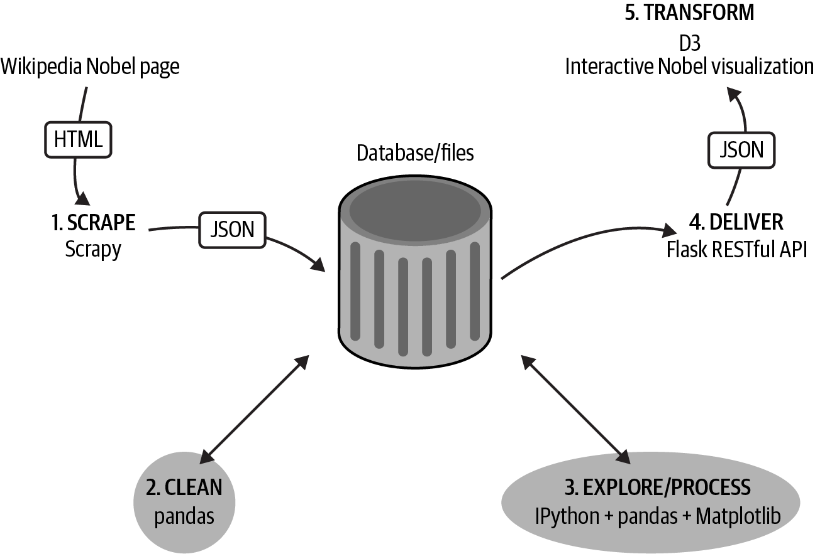

Figure III-1. Our dataviz toolchain: cleaning and exploring the data
Tip
You can find the code for this part of the book at the book’s GitHub repo.

Chapter 7. Introduction to NumPy
This chapter aims to introduce the Numeric Python library (NumPy) to those unacquainted. NumPy is the key building block of pandas, the powerhouse data analysis library that we will be using in the upcoming chapters to clean and explore our recently scraped Nobel Prize dataset (see Chapter 6). A basic understanding of NumPy’s core elements and principles is important if you are to get the most out of pandas. Therefore, the emphasis of the chapter is to provide a foundation for the upcoming introduction to pandas.
NumPy is a Python module that allows access to very fast, multidimensional array manipulation, implemented by low-level libraries written in C and Fortran.1 Python’s native performance with large quantities of data is relatively slow, but NumPy allows you to perform parallel operations on large arrays all at once, making it very fast. Given that NumPy is the chief building block of most of the heavyweight Python data-processing libraries, pandas included, it’s hard to argue with its status as linchpin of the Python data-processing world.
In addition to pandas, NumPy’s huge ecosystem includes Science Python (SciPy), which supplements NumPy with hardcore science and engineering modules; scikit-learn, which adds a host of modern machine-learning algorithms in such domains as classification and feature extraction; and many other specialized libraries that use NumPy’s multidimensional arrays as their primary data objects. In this sense, basic NumPy mastery can massively extend your Python range in the data-processing realm.
The key to understanding NumPy is its arrays. If you understand how these work and how to manipulate them, then a lot of other stuff should follow painlessly.2 The next few sections will cover basic array manipulation with a few examples of NumPy in action, setting the scene for the introduction of pandas’s datasets in Chapter 8.

The NumPy Array
Everything in NumPy is built around its homogeneous3, multidimensional ndarray object. Operations on these arrays are performed using very fast, compiled libraries, allowing NumPy to massively outperform native Python. Among other things you can perform standard arithmetic on these arrays, much as you would a Python int or float.4 In the following code, a whole array is added to itself as easily and as quickly as adding two integers:
import
numpy
as
np
a
=
np
.
array
(
[
1
,
2
,
3
]
)
a
+
a
# output array([2, 4, 6])
The standard way to use the NumPy library and much preferred to "from numpy import *".5
Automatically converts a Python list of numbers.
Behind the scenes, NumPy can leverage the massively parallel computation available to modern CPUs allowing, for example, large matrices (2D arrays) to be crunched in acceptable times.
The key properties of the NumPy ndarray are its number of dimensions (ndim), shape (shape), and numeric type (dtype). The same array of numbers can be reshaped in place, which will sometimes involve changing the array’s number of dimensions. Let’s demonstrate some reshaping with a little eight-member array. We’ll use a print_array_details method to output the key array properties:
def
print_array_details
(
a
):
print
(
'Dimensions:
%d
, shape:
%s
, dtype:
%s
'
\
%
(
a
.
ndim
,
a
.
shape
,
a
.
dtype
))
First, we’ll create our one-dimensional array. As the printed details show, by default this has a 64-bit integer numeric type (int64):
In
[
1
]:
a
=
np
.
array
([
1
,
2
,
3
,
4
,
5
,
6
,
7
,
8
])
In
[
2
]:
a
Out
[
2
]:
array
([
1
,
2
,
3
,
4
,
5
,
6
,
7
,
8
])
In
[
3
]:
print_array_details
(
a
)
Dimensions
:
1
,
shape
:
(
8
,),
dtype
:
int64
Using the reshape method, we can change the shape and number of dimensions of a. Let’s reshape a into a two-dimensional array composed of two four-member arrays:
In
[
4
]:
a
=
a
.
reshape
([
2
,
4
])
In
[
5
]:
a
Out
[
5
]:
array
([[
1
,
2
,
3
,
4
],
[
5
,
6
,
7
,
8
]])
In
[
6
]:
print_array_details
(
a
)
Dimensions
:
2
,
shape
:
(
2
,
4
),
dtype
:
int64
An eight-member array can also be reshaped into a three-dimensional array:
In
[
7
]:
a
=
a
.
reshape
([
2
,
2
,
2
])
In
[
8
]:
a
Out
[
8
]:
array
([[[
1
,
2
],
[
3
,
4
]],
[[
5
,
6
],
[
7
,
8
]]])
In
[
9
]:
print_array_details
(
a
)
Dimensions
:
3
,
shape
:
(
2
,
2
,
2
),
dtype
:
int64
The shape and numeric type can be specified on creation of the array or later. The easiest way to change an array’s numeric type is by using the astype method to make a resized copy of the original with the new type:6
In
[
0
]
:
x
=
np
.
array
(
[
[
1
,
2
,
3
]
,
[
4
,
5
,
6
]
]
,
np
.
int32
)
In
[
1
]
:
x
.
shape
Out
[
1
]
:
(
2
,
3
)
In
[
2
]
:
x
.
shape
=
(
6
,
)
In
[
3
]
:
x
Out
[
3
]
:
array
(
[
1
,
2
,
3
,
4
,
5
,
6
]
,
dtype
=
int32
)
In
[
4
]
x
=
x
.
astype
(
'
int64
'
)
In
[
5
]
:
x
.
dtype
Out
[
5
]
:
dtype
(
'
int64
'
)
The array will convert a nested list of numbers into a suitably shaped multidimensional form.

Creating Arrays
As well as creating arrays with lists of numbers, NumPy provides some utility functions to create arrays with a specific shape. zeros and ones are the most common functions used, creating prefilled arrays. Here’s a couple of examples. Note that the default dtype of these methods is a 64-bit float (float64):
In
[
32
]:
a
=
np
.
zeros
([
2
,
3
])
In
[
33
]:
a
Out
[
33
]:
array
([[
0.
,
0.
,
0.
],
[
0.
,
0.
,
0.
]])
In
[
34
]:
a
.
dtype
Out
[
34
]:
dtype
(
'float64'
)
In
[
35
]:
np
.
ones
([
2
,
3
])
Out
[
35
]:
array
([[
1.
,
1.
,
1.
],
[
1.
,
1.
,
1.
]])
The faster empty method just takes a memory block without the fill overhead, leaving the initialization up to you. This means you don’t know and can’t guarantee what values the array has, unlike np.zeros, so use with caution:
empty_array
=
np
.
empty
((
2
,
3
))
# create an uninitialized array
empty_array
Out
[
3
]:
array
([[
6.93185732e-310
,
2.52008024e-316
,
4.71690401e-317
],
[
2.38085057e-316
,
6.93185752e-310
,
6.93185751e-310
]])
Another useful utility function is random, found along with some useful siblings in NumPy’s random module. This creates a shaped random array:
>>
>
np
.
random
.
random
(
(
2
,
3
)
)
>>
>
Out
:
array
(
[
[
0.97519667
,
0.94934859
,
0.98379541
]
,
[
0.10407003
,
0.35752882
,
0.62971186
]
]
)
A 2×3 array of random numbers within the range 0 <= x < 1.
The handy linspace creates a specified number of evenly spaced samples over a set interval. arange is similar but uses a step-size argument:
np
.
linspace
(
2
,
10
,
5
)
# 5 numbers in range 2-10
Out
:
array
(
[
2.
,
4.
,
6.
,
8.
,
10.
]
)
np
.
arange
(
2
,
10
,
2
)
# from 2 to 10 (exlusive) with step-size 2.
Out
:
array
(
[
2
,
4
,
6
,
8
]
)
Note that unlike arange, linspace is inclusive of the upper value and that the array’s datatype is the default float64.

Array Indexing and Slicing
One-dimensional arrays are indexed and sliced much as Python lists:
a
=
np
.
array
([
1
,
2
,
3
,
4
,
5
,
6
])
a
[
2
]
# Out: 3
a
[
3
:
5
]
# Out: array([4, 5])
# every second item from 0-4 set to 0
a
[:
4
:
2
]
=
0
# Out: array([0, 2, 0, 4, 5, 6])
a
[::
-
1
]
# Out: array([6, 5, 4, 0, 2, 0]), reversed
Indexing multidimensional arrays is similar to the 1-D form. Each dimension has its own indexing/slicing operation and these are specified in a comma-separated tuple.7 Figure 7-1 shows how this works.
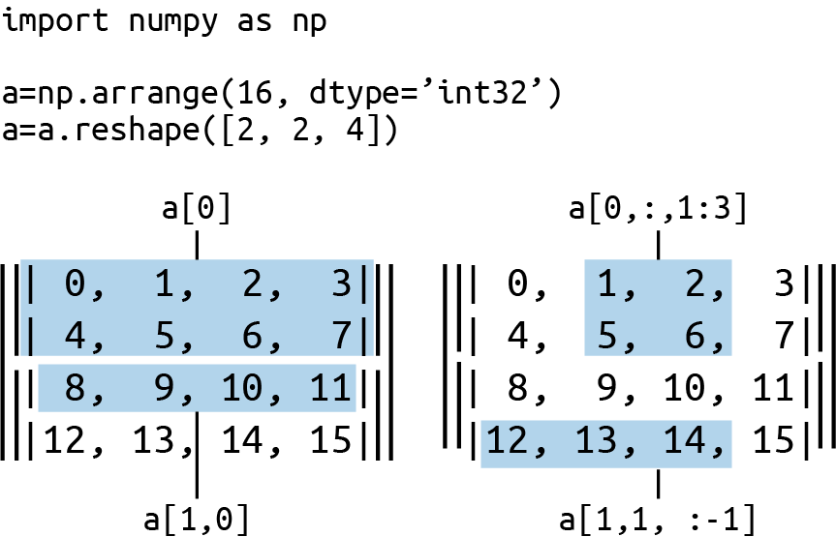

Figure 7-1. Multidimensional indexing with NumPy
Note that if the number of objects in the selection tuple is less than the number of dimensions, the remaining dimensions are assumed to be fully selected (:). Ellipsis can also be used as a shorthand for full selection of all indices, expanding to the required number of : objects. We will use a three-dimensional array to demonstrate:
a
=
np
.
arange
(
8
)
a
.
shape
=
(
2
,
2
,
2
)
a
Out
:
array
([[[
0
,
1
],
[
2
,
3
]],
[[
4
,
5
],
[
6
,
7
]]])
NumPy has a handy array_equal method, which compares arrays by shape and elements. We can use it to show the equivalence of the following array selections, taking the second subarray of axis 0:
a1
=
a
[
1
]
a1
Out
:
array
([[
4
,
5
],
[
6
,
7
]])
Testing for equivalence:
np
.
array_equal
(
a1
,
a
[
1
,:])
Out
:
True
np
.
array_equal
(
a1
,
a
[
1
,:,:])
Out
:
True
# Taking the first element of the subarrays
# array([[0, 2], [4, 6]])
np
.
array_equal
(
a
[
...
,
0
],
a
[:,:,
0
])
Out
:
True

A Few Basic Operations
One of the really cool things about NumPy arrays is that you can perform basic (and not so basic) math operations in much the same way that you would with normal numeric variables. Figure 7-2 shows the use of some overloaded arithmetic operators on a two-dimensional array. The simple mathematical operations are applied to all members of the array. Note that where the array is divided by a floating-point value (2.0), the result is automatically converted to a float type (float64). Being able to manipulate arrays as easily as single numbers is a huge strength of NumPy and a large part of its expressive power.
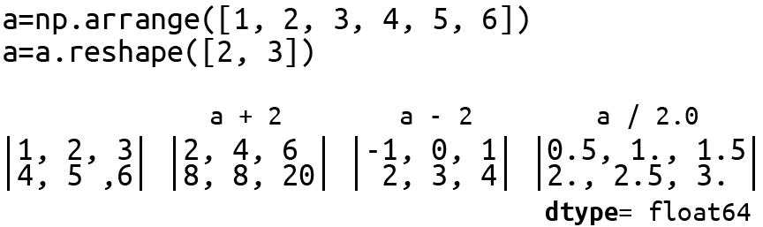

Figure 7-2. A few basic math operations on a two-dimensional NumPy array
Boolean operators work in a similar way to the arithmetic ones. As we’ll see in the next chapter, this is a very useful way to create the Boolean masks often used in pandas. Here’s a little example:
a
=
np
.
array
([
45
,
65
,
76
,
32
,
99
,
22
])
a
<
50
Out
[
69
]:
array
([
True
,
False
,
False
,
True
,
False
,
True
]
,
dtype
=
bool
)
Arrays also have a number of useful methods, a selection of which is demonstrated in Example 7-1. You can get a comprehensive rundown in the official NumPy docs.

Example 7-1. Some array methods
a
=
np
.
arange
(
8
)
.
reshape
(
(
2
,
4
)
)
# array([[0, 1, 2, 3],
# [4, 5, 6, 7]])
a
.
min
(
axis
=
1
)
# array([0, 4])
a
.
sum
(
axis
=
0
)
# array([4, 6, 8, 10])
a
.
mean
(
axis
=
1
)
# array([ 1.5, 5.5 ])
a
.
std
(
axis
=
1
)
# array([ 1.11803399, 1.11803399])
Average along second axis.
The standard deviation of [0, 1, 2, 3],…​
There are also a large number of built-in array functions. Example 7-2 demonstrates a selection of these, and you will find a comprehensive list of NumPy’s built-in mathematical routines at the official NumPy site.

Example 7-2. Some NumPy array math functions
# Trigonometric functions
pi
=
np
.
pi
a
=
np
.
array
(
[
pi
,
pi
/
2
,
pi
/
4
,
pi
/
6
]
)
np
.
degrees
(
a
)
# radians to degrees
# Out: array([ 180., 90., 45., 30.,])
sin_a
=
np
.
sin
(
a
)
# Out: array([ 1.22464680e-16, 1.00000000e+00,
# 7.07106781e-01, 5.00000000e-01])
# Rounding
np
.
round
(
sin_a
,
7
)
# round to 7 decimal places
# Out: array([ 0., 1., 0.7071068, 0.5 ])
# Sums, products, differences
a
=
np
.
arange
(
8
)
.
reshape
(
(
2
,
4
)
)
# array([[0, 1, 2, 3],
# [4, 5, 6, 7]])
np
.
cumsum
(
a
,
axis
=
1
)
# cumulative sum along second axis
# array([[ 0, 1, 3, 6],
# [ 4, 9, 15, 22]])
np
.
cumsum
(
a
)
# without axis argument, array is flattened
# array([ 0, 1, 3, 6, 10, 15, 21, 28])
Note the floating-point rounding error for sin(pi).

Creating Array Functions
Whether you’re using pandas or one of the many Python data-processing libraries, such as SciPy, scikit-learn, or PyTorch, chances are the core data structure being used is the NumPy array. The ability to craft little array processing functions is therefore a great addition to your data-processing toolkit and the data visualization toolchain. Often a short internet search will turn up a community solution, but there’s a lot of satisfaction to be gained from crafting your own, besides being a great way to learn. Let’s see how we can harness the NumPy array to calculate a moving average. A moving average is a series of averages based on a moving window of the last n values, where n is variable, also known as a moving mean or rolling mean.

Calculating a Moving Average
Example 7-3 shows the few lines needed to calculate a moving average on a one-dimensional NumPy array.8 As you can see, it’s nice and concise, but there’s a fair amount going on in those few lines. Let’s break it down a bit.

Example 7-3. A moving average with NumPy
def
moving_average
(
a
,
n
=
3
):
ret
=
np
.
cumsum
(
a
,
dtype
=
float
)
ret
[
n
:]
=
ret
[
n
:]
-
ret
[:
-
n
]
return
ret
[
n
-
1
:]
/
n
The function receives an array a and number n specifying the size of the moving window.
We first calculate the cumulative sum of the array using NumPy’s built-in method:
a
=
np
.
arange
(
6
)
# array([0, 1, 2, 3, 4, 5])
csum
=
np
.
cumsum
(
a
)
csum
# Out: array([0, 1, 3, 6, 10, 15])
Starting at the nth index of the cumulative sum array, we subtract the i–nth value for all i, which means i now has the sum of the last n values of a, inclusive. Here’s an example with a window of size three:
# a = array([0, 1, 2, 3, 4, 5])
# csum = array([0, 1, 3, 6, 10, 15])
csum
[
3
:]
=
csum
[
3
:]
-
csum
[:
-
3
]
# csum = array([0, 1, 3, 6, 9, 12])
Comparing the array a with the final array csum, index 5 is now the sum of the window [3, 4, 5].
Because a moving average only makes sense for index (n–1) onward, it only remains to return these values, divided by the window size n to give the average.
The moving_average function takes a bit of time to get but is a good example of the concision and expressiveness that can be achieved with NumPy arrays and array slicing. You could easily write the function in vanilla Python, but it would likely be a fair bit more involved and, crucially, be much slower for arrays of significant size.
Putting the function to work:
a
=
np
.
arange
(
10
)
moving_average
(
a
,
4
)
# Out[98]: array([ 1.5, 2.5, 3.5, 4.5, 5.5, 6.5, 7.5])

Summary
This chapter laid the foundations of NumPy, focusing on its building block, the NumPy array or ndarray. Being proficient with NumPy is a core skill for any Pythonista working with data. It underpins most of Python’s hardcore data-processing stack, so for this reason alone, you should be comfortable with its array manipulations.
Being comfortable with NumPy will make pandas work that much easier and open up the rich NumPy ecosystem of scientific, engineering, machine learning, and statistical algorithmics to your pandas workflow. Although pandas hides its NumPy arrays behind data containers such as its DataFrame and Series, which are adapted to deal with heterogeneous data, these containers behave for the most part like NumPy arrays and will generally do the right thing when asked. Knowing that ndarrays are at its core also helps when you are trying to frame problems for pandas—​ultimately the requested data manipulation has to play nicely with NumPy. Now that we’ve got its building blocks in place, let’s see how pandas extends the homogeneous NumPy array into the realm of heterogeneous data, where much of data visualization work takes place.
1 Python’s scripted ease of use comes at the cost of raw speed. By wrapping fast, low-level libraries, initiatives like NumPy aim for simple, cruft-free programming and blinding performance.
2 NumPy is used to implement some very advanced math, so don’t expect to understand everything you see online—​just the building blocks.
3 This means NumPy deals with arrays of the same datatype (dtype) rather than Python lists, for example, which can have strings, numbers, dates, etc.
4 This assumes the arrays meet shape and type constraints.
5 Importing all module variables into your namespace using * is almost always a bad idea.
6 A more memory-efficient and performant way involves manipulating the array’s view, but it does involve some extra steps. See this Stack Overflow article for some examples and a discussion of the pros and cons.
7 There is a shorthand dot notation (e.g., [..1:3]) to select all indices.
8 NumPy has a convolve method, which is the easiest way to calculate a simple moving average but less instructive. Also, pandas has a number of specialized methods for this.

Chapter 8. Introduction to pandas
pandas is a key element in our dataviz toolchain, as we will use it for both cleaning and exploring our recently scraped dataset (see Chapter 6). The last chapter introduced NumPy, the Python array processing library that is the foundation of pandas. Before we move on to applying pandas, this chapter will introduce its key concepts and show how it interacts with existing data files and database tables. The rest of your pandas learning will be on the job over the next couple of chapters.

Why pandas Is Tailor-Made for Dataviz
Take any dataviz, whether web-based or in print, and chances are that the data visualized was at one point stored in row-columnar form in a spreadsheet like Excel, a CSV file, or HDF5. There are certainly visualizations, like network graphs, for which row-columnar data is not the best form, but they are in the minority. pandas is tailor-made to manipulate row-columnar data tables with its core datatype, the DataFrame, which is best thought of as a very fast, programmatic spreadsheet.

Why pandas Was Developed
First revealed by Wes Kinney in 2008, pandas was built to solve a particular problem—​namely, that while Python was great for manipulating data, it was weak in the area of data analysis and modeling, certainly compared with big hitters like R.
pandas is designed to work with the kind of heterogenous1 data found in row-columnar spreadsheets, but cleverly manages to leverage some of the speed of NumPy’s homogeneous numeric arrays used by mathematicians, physicists, computer graphics, and the like. Combined with the Jupyter notebook and the Matplotlib plotting library (with auxiliary libraries like seaborn), pandas represents a first-class interactive data analysis tool. Because it’s part of the NumPy ecosystem, its data modeling is easily enhanced by such libraries as SciPy, statsmodels, and scikit-learn, to name but a few.

Categorizing Data and Measurements
I’ll cover the core concepts of pandas in the next section, focusing on the DataFrame and how to get your data into and out of it via the common datastores, CSV files, and SQL databases. But first let’s take a little diversion to consider what we really mean by the heterogeneous datasets that pandas was designed to work with and that are the mainstay of data visualizers.
Chances are that a visualization, maybe a bar chart or line graph used to illustrate an article or a modern web dashboard, presents the results of measurements in the real world, the price of commodities as they change over time, changes in rainfall over a year, voting intentions by ethnic group, and so forth. These measurements can be broadly broken into two groups, numerical and categorical. Numerical values can be divided into interval and ratio scales, and categorical values can in turn be divided into nominal and ordinal measurements. This gives four broad categories of observation available to the data visualizer.
Let’s take a set of tweets as an example in order to draw out these measurement categories. Each tweet has various data fields:
{
"text"
:
"#Python and #JavaScript sitting in a tree..."
,
"id"
:
2103303030333004303
,
"favorited"
:
true
,
"filter_level"
:
"medium"
,
"created_at"
:
"Wed Mar 23 14:07:43 +0000 2015"
,
"retweet_count"
:
23
,
"coordinates"
:
[
-
97.5
,
45.3
]
...
}
The text and id fields are unique indicators. The former might contain categorical information (e.g., the category of tweets containing the #Python hashtag), and the latter might be used to create a category (e.g., the set of all users retweeting this tweet), but they are not per se visualizable fields.
favorited is Boolean, categorical information, dividing the tweets into two sets. This would count as a nominal category, as it can be counted but not ordered.
filter_level is also categorical information, but it is ordinal. There is an order, low→medium→high, to the filter levels.
The created_at field is a timestamp, a numerical value on an interval scale. We would probably want to order the tweets on this scale, something pandas does automatically, and then maybe box into broader intervals, say by the day or week. Again, pandas makes this trivial.
retweet_count is likewise on a numerical scale, but it is a ratio one. A ratio scale, as opposed to an interval scale, has a meaningful concept of zero—​in this case, no retweets. Our created_at timestamp, on the other hand, can have an arbitrary baseline (e.g., unixtime or Gregorian year 0), much in the same way as temperature scales, with 0 degrees Celsius being the same as 273.15 degrees Kelvin.
coordinates, if available, has two numerical scales for longitude and latitude. Both are interval scales, though, as it doesn’t make much sense to speak of ratios of degrees.
So a small subset of our humble tweet’s fields contains heterogeneous information covering all the generally accepted divisions of measurement. Whereas the NumPy array is generally used for homogeneous, numerical number crunching, pandas is designed to deal with categorical data, time series, and items that reflect the heterogeneous nature of real-world data. This makes it a great fit for the data visualization.
Now that we know the type of data pandas is designed to deal with, let’s look at the data structures it uses.

The DataFrame
The first step in a pandas session is usually to load some data into a DataFrame. We’ll cover the various ways we can do this in a later section. For now, let’s read our nobel_winners.json JSON data from a file. read_json returns a DataFrame, parsed from the JSON file specified. By convention, DataFrame variables start with df:
import
pandas
as
pd
df
=
pd
.
read_json
(
'data/nobel_winners.json'
)
With our DataFrame in hand, let’s inspect its content. A quick way to get the row-columnar structure of the DataFrame is to use its head method to show (by default) the top five items. Figure 8-1 shows the output from a Jupyter notebook, with key elements of the DataFrame highlighted.
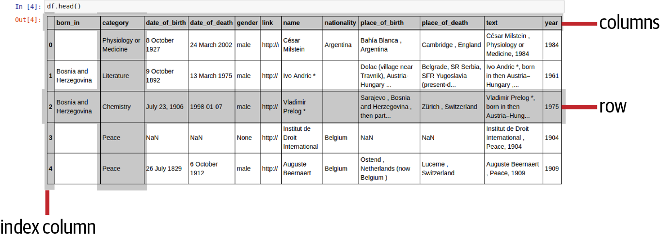

Figure 8-1. The key elements of a pandas DataFrame

Indices
The DataFrame’s columns are indexed by a columns property, which is a pandas index instance. Let’s select the columns in Figure 8-1:
In
[
0
]:
df
.
columns
Out
[
0
]:
Index
([
'born_in'
,
'category'
,
...
],
dtype
=
'object'
)
Initially, pandas rows have a single numeric index (pandas can handle multiple indices if necessary) that can be accessed by the index property. This is a memory-saving RangeIndex by default:
In
[
1
]:
df
.
index
Out
[
1
]:
RangeIndex
(
start
=
0
,
stop
=
1052
,
step
=
1
)
As well as integers, row indices can be strings, DatetimeIndices, or PeriodIndices for time-based data, and so on. Often, to aid selections, a column of the DataFrame will be set to the index via the set_index method. In the following code, we first use the set_index method to set our Nobel DataFrame’s index to the name column and then use the loc method to select a row by the index label (name in this case):
In
[
2
]
df
=
df
.
set_index
(
'
name
'
)
In
[
3
]
df
.
loc
[
'
Albert Einstein
'
]
Out
[
3
]
:
born_in
category
country
date_of_birth
date_of_death
\
name
Albert
Einstein
Physics
Switzerland
1879
-
03
-
14
1955
-
04
-
18
Albert
Einstein
Physics
Germany
1879
-
03
-
14
1955
-
04
-
18
[
.
.
.
]
df
=
df
.
reset_index
(
)
Set the index to the name column.
You can now select a row by the name label.
Return the index to original integer-based state.

Rows and Columns
The rows and columns of a DataFrame are stored as pandas Series, a heterogeneous counterpart to NumPy’s array. These are essentially a labeled one-dimensional array that can contain any datatype from integers, strings, and floats to Python objects and lists.
There are two ways to select a row from the DataFrame. We’ve seen the loc method, which selects by label. There’s also an iloc method, which selects by position. So to select the row in Figure 8-1, we grab row number two:
In
[
4
]
df
.
iloc
[
2
]
Out
[
4
]:
name
Vladimir
Prelog
*
born_in
Bosnia
and
Herzegovina
category
Chemistry
country
date_of_birth
July
23
,
1906
...
year
1975
Name
:
2
,
dtype
:
object
You can grab a column of your DataFrame using dot notation2 or conventional array access by keyword string. This returns a pandas Series with all the column fields with their DataFrame indices preserved:
In
[
9
]
gender_col
=
df
.
gender
# or df['gender']
In
[
10
]
type
(
gender_col
)
Out
[
10
]
pandas
.
core
.
series
.
Series
In
[
11
]
gender_col
.
head
()
# grab the Series' first five items
Out
[
11
]:
0
male
#index, object
1
male
2
male
3
None
4
male
Name
:
gender
,
dtype
:
object

Selecting Groups
There are various ways we can select groups (or subsets of rows) of our DataFrame. Often we want to select all rows with a specific column value (e.g., all rows with category Physics). One way to do this is to use the DataFrame’s groupby method to group a column (or list of columns) and then use the get_group method to select the required group. Let’s use these two methods to select all Nobel Physics Prize winners:
cat_groups
=
df
.
groupby
(
'category'
)
cat_groups
#Out[-] <pandas.core.groupby.generic.DataFrameGroupBy object ...>
cat_groups
.
groups
.
keys
()
#Out[-]: dict_keys(['', 'Chemistry', 'Economics', 'Literature',\
# 'Peace', 'Physics', 'Physiology or Medicine'])
...
In
[
14
]
phy_group
=
cat_groups
.
get_group
(
'Physics'
)
In
[
15
]
phy_group
.
head
()
Out
[
15
]:
name
born_in
category
country
date_of_birth
\
13
François
Englert
Physics
Belgium
6
November
1932
19
Niels
Bohr
Physics
Denmark
7
October
1885
23
Ben
Roy
Mottelson
Physics
Denmark
July
9
,
1926
24
Aage
Bohr
Physics
Denmark
19
June
1922
47
Alfred
Kastler
Physics
France
3
May
1902
...
Another way to select row subsets is to use a Boolean mask to create a new DataFrame. You can apply Boolean operators to all rows in a DataFrame in much the same way as you can to all members of a NumPy array:
In
[
16
]
df
.
category
==
'Physics'
Out
[
16
]:
0
False
1
False
...
1047
True
...
The resulting Boolean mask can then be applied to the original DataFrame to select a subset of its rows:
In
[
17
]:
df
[
df
.
category
==
'Physics'
]
Out
[
17
]:
name
born_in
category
country
\
13
François
Englert
Physics
Belgium
19
Niels
Bohr
Physics
Denmark
23
Ben
Roy
Mottelson
Physics
Denmark
24
Aage
Bohr
Physics
Denmark
...
1047
Brian
P
.
Schmidt
Physics
Australia
...
We’ll cover a lot more examples of data selections in the coming chapters. For now, let’s see how we create DataFrames from existing data and how to save the results of our data frame manipulations.

Creating and Saving DataFrames
The easiest way to create a DataFrame is to use a Python dictionary. It’s also a way you won’t be using very often, as you will likely be accessing your data from files or databases. Nevertheless, it has its use cases.
By default, we specify the columns separately, in the following example creating three rows with name and category columns:
df
=
pd
.
DataFrame
({
'name'
:
[
'Albert Einstein'
,
'Marie Curie'
,
\
'William Faulkner'
],
'category'
:
[
'Physics'
,
'Chemistry'
,
'Literature'
]
})
We can use the from_dict method to allow us to use our preferred record-based object arrays. from_dict has an orient argument to allow us to specify record-like data, but pandas is smart enough to work out the data form:
df
=
pd
.
DataFrame
.
from_dict
(
[
{
'
name
'
:
'
Albert Einstein
'
,
'
category
'
:
'
Physics
'
}
,
{
'
name
'
:
'
Marie Curie
'
,
'
category
'
:
'
Chemistry
'
}
,
{
'
name
'
:
'
William Faulkner
'
,
'
category
'
:
'
Literature
'
}
]
)
Here we pass in an array of objects, each corresponding to a row in our DataFrame.
The methods just shown produce an identical DataFrame:
df
.
head
()
Out
:
name
category
0
Albert
Einstein
Physics
1
Marie
Curie
Chemistry
2
William
Faulkner
Literature
As mentioned, you probably won’t be creating DataFrames from Python containers directly. Instead, you will probably use one of the pandas data-reading methods.
pandas has an impressive array of read_[format]/to_[format] methods, covering most conceivable data-loading use cases, from CSV through binary HDF5 to SQL databases. We’ll cover the subset most relevant to dataviz work. For a full list, see the pandas documentation.
Note that by default pandas will try to convert the loaded data sensibly. The convert_axes (try to convert the axes to the proper dtypes), dtype (guess datatype), and convert_dates arguments to the read methods are all True by default. See the pandas documentation for an example of the available options, in this case for reading JSON files into a DataFrame.
Let’s cover file-based DataFrames first, then see how to interact with (No)SQL databases.

JSON
Loading data from our preferred JSON format is trivial in pandas:
df
=
pd
.
read_json
(
'file.json'
)
There are various forms the JSON file can take, specified by an optional orient argument, one of [split, records, index, columns, values]. An array of records, our standard form, will be detected:
[{
"name"
:
"Albert Einstein"
,
"category"
:
"Physics"
,
...},
{
"name"
:
"Marie Curie"
,
"category"
:
"Chemistry"
,
...
}
...
]
The default for a JSON object is columns, in the form:
{
"name"
:
{
"0"
:
"Albert Einstein"
,
"1"
:
"Marie Curie"
...
},
"category"
:
{
"1"
,
"Physics"
,
"2"
:
"Chemistry"
...
}}
As discussed, for web-based visualization work, particularly D3, record-based JSON arrays are the most common way of passing row-columnar data to the browser.
Note
Note that you will need valid JSON files to work with pandas because the read_json method and Python JSON parsers in general tend to be fairly unforgiving, and exceptions not as informative as they might be.3 A common JSON error is failing to enclose keys in double-quote marks or using single quotes where double quotes are expected. The latter is particularly common for those coming from languages where single- and double-string quotes are essentially interchangeable and one reason why you should never build JSON documents yourself—​always use an official or well-respected library.
There are various ways to store DataFrames in JSON, but the format that will play most nicely with any dataviz work is the array of records. This is the most common form of D3 data and the one I recommend outputting from pandas.4 Writing a DataFrame as records to JSON is then simply a case of specifying the orient field in the to_json method:
df
=
pd
.
read_json
(
'
data.json
'
)
# ... Perform data-cleaning operations
json
=
df
.
to_json
(
'
data_cleaned.json
'
,
orient
=
'
records
'
)
Out
:
[
{
"
name
"
:
"
Albert Einstein
"
,
"
category
"
:
"
Physics
"
,
.
.
.
}
,
{
"
name
"
:
"
Marie Curie
"
,
"
category
"
:
"
Chemistry
"
,
.
.
.
}
.
.
.
]
Override the default save to store the JSON as dataviz-friendly records.
We also have the parameters date_format (epoch timestamp, iso for ISO8601, etc.), double_precision, and default_handler to call if the object cannot be converted into JSON using pandas’s parser. Check the pandas documentation for more details.

CSV
As befits pandas’s data-table ethos, its handling of CSV files is sophisticated enough to cope with pretty much all conceivable data. Conventional CSV files, which is the large majority, will load without parameters:
# data.csv:
# name,category
# "Albert Einstein",Physics
# "Marie Curie",Chemistry
df
=
pd
.
read_csv
(
'data.csv'
)
df
Out
:
name
category
0
Albert
Einstein
Physics
1
Marie
Curie
Chemistry
Although you might expect all CSV files to be comma-separated, you will often find files with a CSV suffix with different delimiters such as semicolons or pipes (|). They may also use idiosyncratic quoting for strings containing spaces or special characters. In this case, we can specify any nonstandard elements in our read request. We’ll use Python’s handy StringIO module to emulate reading from a file:5
from
io
import
StringIO
data
=
"
`Albert Einstein`| Physics
\n
`Marie Curie`| Chemistry
"
df
=
pd
.
read_csv
(
StringIO
(
data
)
,
sep
=
'
|
'
,
names
=
[
'
name
'
,
'
category
'
]
,
skipinitialspace
=
True
,
quotechar
=
"
`
"
)
df
Out
:
name
category
0
Albert
Einstein
Physics
1
Marie
Curie
Chemistry
The fields are pipe-separated, not the default comma-separated.
Here we provide the missing column headers.
We have the same degree of flexibility when saving CSV files, here setting the encoding to Unicode utf-8:
df
.
to_csv
(
'data.csv'
,
encoding
=
'utf-8'
)
For full coverage of the CSV options, see the pandas documentation.

Excel Files
pandas uses Python’s xlrd module to read Excel 2003 (.xls) and the openpyxl module to read Excel 2007+ (.xlsx) files. The latter is an optional dependency that will need installing:
$ pip install openpyxl
Excel documents have multiple named sheets, each of which can be passed to a DataFrame. There are two ways to read a datasheet into a DataFrame. The first is by creating and then parsing an ExcelFile object:
dfs
=
{
}
xls
=
pd
.
ExcelFile
(
'
data/nobel_winners.xlsx
'
)
# load Excel file
dfs
[
'
WinnersSheet1
'
]
=
xls
.
parse
(
'
WinnersSheet1
'
,
na_values
=
[
'
NA
'
]
)
dfs
[
'
WinnersSheet2
'
]
=
xls
.
parse
(
'
WinnersSheet2
'
,
index_col
=
1
,
na_values
=
[
'
-
'
]
,
skiprows
=
3
)
Grab a sheet by name and save to a dictionary.
Specify the column, by position, to use as DataFrame’s row labels.
A list of additional strings to recognize as NaN.
The number of rows (e.g., metadata) to skip before processing.
Alternatively you can use the read_excel method, which is a convenience method for loading multiple spreadsheets:
dfs
=
pd
.
read_excel
(
'data/nobel_winners.xlsx'
,
[
'WinnersSheet1'
,
'WinnersSheet2'
],
index_col
=
None
,
na_values
=
[
'NA'
])
Let’s check the content of the second Excel sheet using the resulting DataFrame:
In
:
dfs
[
'WinnersSheet2'
]
.
head
()
Out
:
category
nationality
year
name
gender
0
Peace
American
1906
Theodore
Roosevelt
male
1
Literature
South
African
1991
Nadine
Gordimer
female
2
Chemistry
Bosnia
and
Herzegovina
1975
Vladamir
Prelog
male
The only reason not to use read_excel is if you need different arguments for reading each Excel sheet.
You can specify sheets by index or name using the second (sheetname) parameter. sheetname can be a single name string or index (beginning at 0) or a mixed list. By default sheetname is 0, returning the first sheet. Example 8-1 shows some variations. Setting sheetname to None returns a sheetname-keyed dictionary of DataFrames.

Example 8-1. Loading Excel sheets
# return the first datasheet
df
=
pd
.
read_excel
(
'nobel_winners.xls'
)
# return a named sheet
df
=
pd
.
read_excel
(
'nobel_winners.xls'
,
'WinnersSheet3'
)
# first sheet and sheet named 'WinnersSheet3'
df
=
pd
.
read_excel
(
'nobel_winners.xls'
,
[
0
,
'WinnersSheet3'
])
# all sheets loaded into a name-keyed dictionary
dfs
=
pd
.
read_excel
(
'nobel_winners.xls'
,
sheetname
=
None
)
The parse_cols parameter lets you select the sheet columns to be parsed. Setting parse_cols to an integer value selects all columns up to that ordinal. Setting parse_cols to a list of integers allows you to select specific columns:
# parse up to the fifth column
pd
.
read_excel
(
'nobel_winners.xls'
,
'WinnersSheet1'
,
parse_cols
=
4
)
# parse the second and fourth columns
pd
.
read_excel
(
'nobel_winners.xls'
,
'WinnersSheet1'
,
parse_cols
=
[
1
,
3
])
For more information on read_excel, see the pandas documentation.
You can save a DataFrame to the sheet of an Excel file with the to_excel method, giving the Excel filename and a sheetname, 'nobel_winners' and 'WinnersSheet1', respectively, in this example:
df
.
to_excel
(
'nobel_winners.xlsx'
,
sheet_name
=
'WinnersSheet1'
)
There are various options similar to to_csv covered in the pandas docs. Because pandas Panels and Excel files can store multiple DataFrames, there is a Panel to_excel method to write all its DataFrames to an Excel file.
If you need to select multiple DataFrames to write to a shared Excel file, you can use an ExcelWriter object:
with
pd
.
ExcelWriter
(
'nobel_winners.xlsx'
)
as
writer
:
df1
.
to_excel
(
writer
,
sheet_name
=
'WinnersSheet1'
)
df2
.
to_excel
(
writer
,
sheet_name
=
'WinnersSheet2'
)

SQL
By preference pandas uses Python’s SQLAlchemy module to do the database abstraction. If using SQLAlchemy, you’ll also need the driver library for your database.
The easiest way to load a database table or the results of an SQL query is with the read_sql method. Let’s use our preferred SQLite database and read its winners table into a DataFrame:
import
sqlalchemy
engine
=
sqlalchemy
.
create_engine
(
'
sqlite:///data/nobel_winners.db
'
)
df
=
pd
.
read_sql
(
'
winners
'
,
engine
)
df
Out
:
index
category
country
date_of_birth
0
4
Peace
Belgium
1829
-
07
-
26
.
.
.
name
place_of_birth
0
Auguste
Beernaert
Ostend
,
Netherlands
(
now
Belgium
)
.
.
.
Here, we use an existing SQLite (file-based) database. SQLAlchemy can create engines for all the commonly used databases, for example mysql://USER:PASSWORD@localhost/db.
Read the contents of the 'nobel_winners' SQL table into a DataFrame. read_sql is a convenience wrapper around the read_sql_table and read_sql_query methods and will do the right thing depending on its first argument.
Writing DataFrames to an SQL database is simple enough. Using the engine we just created, we can add a copy of the winners table to our SQLite database:
# save DataFrame df to nobel_winners SQL table
df
.
to_sql
(
'winners_copy'
,
engine
,
if_exists
=
'replace'
)
If you encounter errors due to packet-size limitations, the chunksize parameter can set the number of rows to be written at a time:
# write 500 rows at a time
df
.
to_sql
(
'winners_copy'
,
engine
,
chunksize
=
500
)
pandas will do the sensible thing and try to map your data to a suitable SQL type, inferring the datatype of objects. If necessary, the default type can be overridden in the load call:
from
sqlalchemy
.
types
import
String
df
.
to_sql
(
'
winners_copy
'
,
engine
,
dtype
=
{
'
year
'
:
String
}
)
Override pandas’s inference, and specify year as a String column.
Further details of pandas-SQL interaction can be found in the pandas documentation.

MongoDB
For dataviz work, there’s a lot to be said for the convenience of document-based NoSQL databases like MongoDB. In MongoDB’s case, things are even better, as it uses a binary form of JSON for its datastore—​namely BSON, short for binary JSON. Since JSON is our data glue of choice, as it connects our web dataviz with its backend server, there’s a good reason to consider storing your datasets in Mongo. It also plays nicely with pandas.
As we’ve seen, pandas DataFrames convert nicely to and from JSON format, so getting a Mongo document collection into a pandas DataFrame is a pretty easy affair:
import
pandas
as
pd
from
pymongo
import
MongoClient
client
=
MongoClient
(
)
db
=
client
.
nobel_prize
cursor
=
db
.
winners
.
find
(
)
df
=
pd
.
DataFrame
(
list
(
cursor
)
)
df
# _
Create a Mongo client, using the default host and ports.
Get the nobel_prize database.
Find all documents in the winner collection.
Load all documents from the cursor into a list and use to create a DataFrame.
The winners collection is empty at this point—let’s fill it with some DataFrame data.
It’s just as easy to insert a DataFrame’s records into a MongoDB database. Here, we use the get_mongo_database method we defined in Example 3-5 to get our nobel_prize database and save the DataFrame to its winners collection:
db
=
get_mongo_database
(
'
nobel_prize
'
)
records
=
df
.
to_dict
(
'
records
'
)
db
[
collection
]
.
insert_many
(
records
)
Converts the DataFrame to a dict, using the records argument to convert the rows into individual objects.
For PyMongo version 2, use the insert method.
pandas doesn’t have MongoDB convenience methods comparable to to_csv or read_csv, but it’s easy enough to roll a couple of utility functions to convert from MongoDB to DataFrames and back again:
def
mongo_to_dataframe
(
db_name
,
collection
,
query
=
{
}
,
\
host
=
'
localhost
'
,
port
=
27017
,
\
username
=
None
,
password
=
None
,
\
no_id
=
True
)
:
""" create a DataFrame from mongodb collection """
db
=
get_mongo_database
(
db_name
,
host
,
port
,
username
,
\
password
)
cursor
=
db
[
collection
]
.
find
(
query
)
df
=
pd
.
DataFrame
(
list
(
cursor
)
)
if
no_id
:
del
df
[
'
_id
'
]
return
df
def
dataframe_to_mongo
(
df
,
db_name
,
collection
,
\
host
=
'
localhost
'
,
port
=
27017
,
\
username
=
None
,
password
=
None
)
:
""" save a DataFrame to mongodb collection """
db
=
get_mongo_database
(
db_name
,
host
,
port
,
username
,
\
password
)
records
=
df
.
to_dict
(
'
records
'
)
db
[
collection
]
.
insert_many
(
records
)
Mongo’s _id field will be included in the DataFrame. By default, remove the column.
Having inserted the DataFrame’s records into Mongo, let’s make sure they have been successfully stored:
db
=
get_mongo_database
(
'
nobel_prize
'
)
list
(
db
.
winners
.
find
(
)
)
[
{
'
_id
'
:
ObjectId
(
'
62fcf2fb0e7fe50ac4393912
'
)
,
'
id
'
:
1
,
'
category
'
:
'
Physics
'
,
'
name
'
:
'
Albert Einstein
'
,
'
nationality
'
:
'
Swiss
'
,
'
year
'
:
1921
,
'
gender
'
:
'
male
'
}
,
{
'
_id
'
:
ObjectId
(
'
62fcf2fb0e7fe50ac4393913
'
)
,
'
id
'
:
2
,
'
category
'
:
'
Physics
'
,
'
name
'
:
'
Paul Dirac
'
,
'
nationality
'
:
'
British
'
,
'
year
'
:
1933
,
'
gender
'
:
'
male
'
}
,
{
'
_id
'
:
ObjectId
(
'
62fcf2fb0e7fe50ac4393914
'
)
,
'
id
'
:
3
,
'
category
'
:
'
Chemistry
'
,
'
name
'
:
'
Marie Curie
'
,
'
nationality
'
:
'
Polish
'
,
'
year
'
:
1911
,
'
gender
'
:
'
female
'
}
]
The collection’s find method returns a cursor, which we convert to a Python list to see the contents.
Another way to create DataFrames is to build them from a collection of Series. Let’s have a look at that, taking the opportunity to explore Series in more detail.

Series into DataFrames
Series are the building block of pandas’s DataFrames. They can be manipulated independently with methods that mirror those of the DataFrame and they can be combined to form DataFrames, as we’ll see in the subsection.
The key idea with pandas Series is the index. These indices function as labels for the heterogeneous data contained in, say, a row of data. When pandas operates on more than one data object, these indices are used to align the fields.
Series can be created in one of three ways. The first is from a Python list or NumPy array:
s
=
pd
.
Series
([
1
,
2
,
3
,
4
])
# Series(np.arange(4))
Out
:
0
1
# index, value
1
2
2
3
3
4
dtype
:
int64
Note that integer indices are automatically created for our Series. If we were adding a row of data to a DataFrame (table), we would want to specify the column indices by passing them as a list of integers or labels:
s
=
pd
.
Series
([
1
,
2
,
3
,
4
],
index
=
[
'a'
,
'b'
,
'c'
,
'd'
])
s
Out
:
a
1
b
2
c
3
d
4
dtype
:
int64
Note that the length of the index array should match the length of the data array.
We can specify both data and index using a Python dict:
s
=
pd
.
Series
({
'a'
:
1
,
'b'
:
2
,
'c'
:
3
})
Out
:
a
1
b
2
c
3
dtype
:
int64
If we pass an index array along with the dict, pandas will do the sensible thing, matching the indices to the data array. Any unmatched indices will be set to NaN (not a number), and any unmatched data discarded. Note one consequence of having fewer elements than indices is that the series is cast to a float64 type:
s
=
pd
.
Series
({
'a'
:
1
,
'b'
:
2
},
index
=
[
'a'
,
'b'
,
'c'
])
Out
:
a
1.0
b
2.0
c
NaN
dtype
:
float64
s
=
pd
.
Series
({
'a'
:
1
,
'b'
:
2
,
'c'
:
3
},
index
=
[
'a'
,
'b'
])
Out
:
a
1
b
2
dtype
:
int64
Finally, we can pass a single, scalar value as data to the Series, provided we also specify an index. The scalar value is then applied to all indices:
pd
.
Series
(
9
,
{
'a'
,
'b'
,
'c'
})
Out
:
a
9
b
9
c
9
dtype
:
int64
Series are like NumPy arrays (ndarray), which means they can be passed to most NumPy functions:
s
=
pd
.
Series
([
1
,
2
,
3
,
4
],
[
'a'
,
'b'
,
'c'
,
'd'
])
np
.
sqrt
(
s
)
Out
:
a
1.000000
b
1.414214
c
1.732051
d
2.000000
dtype
:
float64
Slicing operations work as they would with Python lists or ndarrays, but note that the index labels are preserved:
s
[
1
:
3
]
Out
:
b
2
c
3
dtype
:
int64
Unlike NumPy’s arrays, pandas’s series can take data of multiple types. Adding two series demonstrates this utility with numbers being added while strings are concatenated:
pd
.
Series
([
1
,
2.1
,
'foo'
])
+
pd
.
Series
([
2
,
3
,
'bar'
])
Out
:
0
3
# 1 + 2
1
5.1
# 2.1 + 3
2
foobar
# strings correctly concatenated
dtype
:
object
The ability to create and manipulate individual Series is particularly important when you are interacting with the NumPy ecosystem, manipulating data from a DataFrame, or creating visualizations outside of pandas’s Matplotlib wrapper.
As Series are the building block of DataFrames, it’s easy to join them together to create a DataFrame, using pandas’s concat method:
names
=
pd
.
Series
(
[
'
Albert Einstein
'
,
'
Marie Curie
'
]
,
\
name
=
'
name
'
)
categories
=
pd
.
Series
(
[
'
Physics
'
,
'
Chemistry
'
]
,
\
name
=
'
category
'
)
df
=
pd
.
concat
(
[
names
,
categories
]
,
axis
=
1
)
df
.
head
(
)
Out
:
name
category
0
Albert
Einstein
Physics
1
Marie
Curie
Chemistry
We use the names and categories series to provide the data and column names (the series name property) for a DataFrame.
Concatenate the two Series using the axis argument of 1 to indicate that the Series are columns.
Along with the many ways to create DataFrames from files and databases just discussed, you should now have a solid grounding in getting data into and out of DataFrames.

Summary
This chapter laid a foundation for the two pandas-based chapters to come. The core concepts of pandas—​the DataFrame, Index, and Series—were discussed and we saw why pandas is such a good fit with the type of real-world data that data visualizers deal with, extending the NumPy ndarray by allowing the storage of heterogeneous data and adding a powerful indexing system.
With pandas’s core data structures under our belts, the next few chapters will show you how to use them to clean and process your dataset of Nobel Prize winners, extending your knowledge of the pandas toolkit and showing you how to go about applying it in a data visualization context.
Now that we know how to get data into and out of a DataFrame, it’s time to see what pandas can do with it. We’ll first see how to give your data a clean bill of health, discovering and fixing anomalies such as duplicate rows, missing fields, and corrupted data.
1 The columns in a typical spreadsheet will typically have different datatypes (dtypes), like floats, date-times, integers etc.
2 Only if the column name is a string without spaces.
3 If you have problems, you might try a subset of your data in JSONLint’s validator for better feedback.
4 D3 takes a number of other data formats, such as hierarchical (tree type) data or node and link graph formats. Here’s an example of a tree hierarchy specified in JSON.
5 I recommend using this approach if you want to get a feel for the CSV or JSON parsers. It’s much more convenient than managing local files.

Chapter 9. Cleaning Data with pandas
The previous two chapters introduced pandas and NumPy, the Numeric Python library it extends. Armed with basic pandas know-how, we’re ready to start the cleaning stage of our toolchain, aiming to find and eliminate the dirty data in our scraped dataset (see Chapter 6). This chapter will also extend your pandas knowledge, introducing new methods in a working context.
In Chapter 8, we covered the core components of pandas: the DataFrame, a programmatic spreadsheet capable of dealing with the many different datatypes found in the real world, and its building block, the Series, a heterogeneous extension of NumPy’s homogeneous ndarray. We also covered how to read from and write to different datastores, including JSON, CSV files, MongoDB, and SQL databases. Now we’ll start to put pandas through its paces, showing how it can be used to clean dirty data. I’ll introduce the key elements of data cleaning using our dirty Nobel Prize dataset as an example.
I’ll take it slowly, introducing key pandas concepts in a working environment. Let’s first establish why cleaning data is such an important part of a data visualizer’s work.

Coming Clean About Dirty Data
I think it’s fair to say that most people entering the field of data visualization underestimate, often by a fairly large factor, the amount of time they’re going to spend trying to make their data presentable. The fact is that getting clean datasets that are a pleasure to transform into cool visualizations could well take over half your time. Data in the wild is very rarely pristine, often bearing the sticky paw prints of mistaken manual data entry, missing whole fields due to oversight or parsing errors and/or mixed datetime formats.
For this book, and to pose a properly meaty challenge, our Nobel Prize dataset has been scraped from Wikipedia, a manually edited website with fairly informal guidelines. In this sense, the data is bound to be dirty—​humans make mistakes even when the environment is a good deal more forgiving. But even data from the official APIs of, for example, large social media sites, is often flawed, with missing or incomplete fields, scar tissue from countless changes to the data schemas, deliberate mis-entry, and the like.
So cleaning data is a fundamental part of the job of a data visualizer, stealing time from all the cool stuff you’d rather be doing—​which is an excellent reason to get really good at it and free up that drudge time for more meaningful pursuits. And a large part of getting good at cleaning data is choosing the right toolset, which is where pandas comes in. It’s a great way to slice and dice even fairly large datasets,1 and being comfortable with it could save you a lot of time. That is where this chapter comes in.
To recap, scraping the Nobel data from Wikipedia using Python’s Scrapy library (see Chapter 6) produced an array of JSON objects of the form:
{
"category"
:
"Physics"
,
"name"
:
"Albert Einstein"
,
"gender"
:
"male"
,
"place_of_birth"
:
"Ulm , Baden-W\u00fcrttemberg ,
German Empire"
,
"date_of_death"
:
"1955-04-18"
,
...
}
The job of this chapter is to turn that array into as clean a data source as possible before we explore it with pandas in the next chapter.
There are many forms of dirty data, most commonly:
- Duplicate entries/rows
- Missing fields
- Misaligned rows
- Corrupted fields
- Mixed datatypes in a column
We’ll now probe our Nobel Prize data for these kinds of anomalies.
First, we need to load our JSON data into a DataFrame, as shown in the previous chapter (see “Creating and Saving DataFrames”). We can open the JSON data file directly:
import
pandas
as
pd
df
=
pd
.
read_json
(
open
(
'data/nobel_winners_dirty.json'
))
Now that we’ve got our dirty scraped data into a DataFrame, let’s get a broad overview of what we have.

Inspecting the Data
The pandas DataFrame has a number of methods and properties that give a quick overview of the data contained within. The most general is info, which gives a neat summary of the number of data entries by column:
df
.
info
()
<
class
'
pandas
.
core
.
frame
.
DataFrame
'>
RangeIndex
:
1052
entries
,
0
to
1051
Data
columns
(
total
12
columns
):
# Column Non-Null Count Dtype
---
------
--------------
-----
0
born_in
1052
non
-
null
object
1
category
1052
non
-
null
object
2
country
1052
non
-
null
object
3
date_of_birth
1044
non
-
null
object
4
date_of_death
1044
non
-
null
object
5
gender
1040
non
-
null
object
6
link
1052
non
-
null
object
7
name
1052
non
-
null
object
8
place_of_birth
1044
non
-
null
object
9
place_of_death
1044
non
-
null
object
10
text
1052
non
-
null
object
11
year
1052
non
-
null
int64
dtypes
:
int64
(
1
),
object
(
11
)
memory
usage
:
98.8
+
KB
You can see that some fields are missing entries. For example, although there are 1,052 rows in our DataFrame, there are only 1,040 gender attributes. Note also the handy memory_usage—pandas DataFrames are held in RAM, so as datasets increase in size, this number gives a nice indication of how close we are to our machine-specific memory limits.
DataFrame’s describe method gives a handy statistical summary of relevant columns:
df
.
describe
()
Out
:
year
count
1052.000000
mean
1968.729087
std
33.155829
min
1809.000000
25
%
1947.000000
50
%
1975.000000
75
%
1996.000000
max
2014.000000
As you can see, by default only numerical columns are described. Already we can see an error in the data, the minimum year being 1809, which is impossible when the first Nobel was awarded in 1901.
describe takes an include parameter that allows us to specify the column datatypes (dtypes) to be assessed. Other than year, the columns in our Nobel Prize dataset are all objects, which are pandas’s default, catchall dtype, capable of representing any numbers, strings, data times, and more. Example 9-1 shows how to get their stats.

Example 9-1. Describing the DataFrame
In
[
140
]
:
df
.
describe
(
include
=
[
'
object
'
]
)
Out
[
140
]
:
born_in
category
date_of_birth
date_of_death
gender
\
count
1052
1052
1044
1044
1040
unique
40
7
853
563
2
top
Physio
.
.
9
May
1947
male
freq
910
250
4
362
983
link
name
\
count
1052
1052
unique
893
998
top
http
:
/
/
eg
/
wiki
/
.
.
.
Daniel
Kahneman
freq
4
2
country
place_of_birth
place_of_death
\
count
1052
1044
1044
unique
59
735
410
top
United
States
freq
350
29
409
.
.
.
The include argument is a list (or single item) of columnar dtypes to summarize.
There’s quite a lot of useful information to be gleaned from the output of Example 9-1, such as that there are 59 unique nationalities with the United States, at 350, being the largest group.
One interesting tidbit is that of 1,044 recorded dates of birth, only 853 are unique, which could mean any number of things. Possibly some auspicious days saw the birth of more than one laureate or, wearing our data-cleaning hats, it’s more likely that there are some duplicated winners or that some dates are wrong or have only recorded the year. The duplicated winners hypothesis is confirmed by the observation that of 1,052 name counts, only 998 are unique. Now there have been a few multiple winners but not enough to account for 54 duplicates.
DataFrame’s head and tail methods provide another easy way to get a quick feel for the data. By default, they display the top or bottom five rows, but we can set that number by passing an integer as the first argument. Example 9-2 shows the result of using head with our Nobel DataFrame.

Example 9-2. Sampling the first five DataFrame rows
df
.
head
(
)
Out
:
born_in
category
date_of_bi
.
.
0
Physiology
or
Medicine
8
October
1.
.
1
Bosnia
and
Herzegovina
Literature
9
October
1.
.
2
Bosnia
and
Herzegovina
Chemistry
July
23
,
1.
.
3
Peace
.
.
4
Peace
26
July
1.
.
date_of_death
gender
.
.
0
24
March
2002
male
http
:
/
/
en
.
wikipedia
.
org
/
wiki
/
C
%
C3
%
A
.
.
1
13
March
1975
male
http
:
/
/
en
.
wikipedia
.
org
/
wi
.
.
2
1998
-
01
-
07
male
http
:
/
/
en
.
wikipedia
.
org
/
wiki
/
Vl
.
.
3
NaN
None
http
:
/
/
en
.
wikipedia
.
org
/
wiki
/
Institu
.
.
4
6
October
1912
male
http
:
/
/
en
.
wikipedia
.
org
/
wiki
/
Auguste
.
.
name
country
\
0
César
Milstein
Argentina
1
Ivo
Andric
*
2
Vladimir
Prelog
*
3
Institut
de
Droit
International
Belgium
4
Auguste
Beernaert
Belgium
These rows have an entry for the born_in field and an asterisk by their name.
The date_of_death field has a different time format than the other rows.
The first five winners in Example 9-2 show a couple of useful things. First, we see the names in rows 1 and 2 are marked by an asterisk and have an entry in the born_in field . Second, note that row 2 has a different time format for date_of_death than the others, and that there are both month-day and day-month time formats in the date_of_birth field . This kind of inconsistency is a perennial problem for human-edited data, particularly dates and times. We’ll see how to fix it with pandas later.
Example 9-1 gives an object count of 1,052 for the born_in field, indicating no empty fields, but head shows only rows 1 and 2 have content. This suggests that the missing fields are an empty string or space, both of which count as data to pandas. Let’s change them to a noncounted NaN, which will make more sense of the numbers. But first we’re going to need a little primer in pandas data selection.

Indices and pandas Data Selection
Before beginning to clean our data, let’s do a quick recap of basic pandas data selection, using the Nobel Prize dataset as an example.
pandas indexes by rows and columns. Usually column indices are specified by the data file, SQL table, and so on, but, as shown in the last chapter, we can set or override these when the DataFrame is created by using the names argument to pass a list of column names. The columns index is accessible as a DataFrame property:
# Our Nobel dataset's columns
df
.
columns
Out
:
Index
([
'born_in'
,
'category'
,
'date_of_birth'
,
...
'place_of_death'
,
'text'
,
'year'
],
dtype
=
'object'
)
By default, pandas specifies a zero-base integer index for the rows, but we can override this by passing a list in the index parameter on creation of the DataFrame or afterward by setting the index property directly. More often we want to use one or more2 of the DataFrame’s columns as an index. We can do this using the set_index method. If you want to return to the default index, you can use the reset_index method, as shown in Example 9-3.

Example 9-3. Setting the DataFrame’s index
# set the name field as index
df
=
df
.
set_index
(
'
name
'
)
df
.
head
(
2
)
Out
:
born_in
category
\
name
César
Milstein
Physiology
or
Medicine
Ivo
Andric
*
Bosnia
and
Herzegovina
Literature
.
.
.
df
.
reset_index
(
inplace
=
True
)
df
.
head
(
2
)
Out
:
name
born_in
category
\
0
César
Milstein
Physiology
or
Medicine
1
Ivo
Andric
*
Bosnia
and
Herzegovina
Literature
Sets the frame’s index to its name column. Set the result back to df.
The rows are now indexed by name.
Resets the index to its integer. Note that we change it in place this time.
The index is now by integer position.
Note
There are two ways to change a pandas DataFrame or Series: by altering the data in place or by assigning a copy. There is no guarantee that in place is faster, plus method-chaining requires that the operation return a changed object. Generally, I use the df = df.foo(...) form, but most mutating methods have an inplace argument df.foo(..., inplace=True).
Now that we understand the row-columnar indexing system, let’s start selecting slices of the DataFrame.
We can select a column of the DataFrame by dot notation (where no spaces or special characters are in the name) or square-bracket notation. Let’s take a look at that born_in column:
bi_col
=
df
.
born_in
# or bi = df['born_in']
bi_col
Out
:
0
1
Bosnia
and
Herzegovina
2
Bosnia
and
Herzegovina
3
...
1051
Name
:
born_in
,
Length
:
1052
,
dtype
:
object
type
(
bi_col
)
Out
:
pandas
.
core
.
series
.
Series
Note that the column selection returns a pandas Series, with the DataFrame indexing preserved.
DataFrames and Series share the same methods for accessing rows/members. iloc selects by integer position, and loc selects by label. Let’s use iloc to grab the first row of our DataFrame:
# access the first row
df
.
iloc
[
0
]
Out
:
name
César
Milstein
born_in
category
Physiology
or
Medicine
...
# set the index to 'name' and access by name-label
df
.
set_index
(
'name'
,
inplace
=
True
)
df
.
loc
[
'Albert Einstein'
]
Out
:
born_in
category
country
...
name
Albert
Einstein
Physics
Switzerland
...
Albert
Einstein
Physics
Germany
...
...

Selecting Multiple Rows
Standard Python array slicing can be used with a DataFrame to select multiple rows:
# select the first 10 rows
df
[
0
:
10
]
Out
:
born_in
category
date_of_b
..
0
Physiology
or
Medicine
8
October
..
1
Bosnia
and
Herzegovina
Literature
9
October
..
...
9
Peace
1910
-
0.
.
# select the last four rows
df
[
-
4
:]
Out
:
born_in
category
date_of_birth
date_
..
1048
Peace
November
1
,
1878
May
..
1049
Physiology
or
Medicine
1887
-
04
-
10
19.
.
1050
Chemistry
1906
-
9
-
6
1.
.
1051
Peace
November
26
,
1931
..
The standard way to select multiple rows based on a conditional expression (e.g., is the value of the column value greater than x) is to create a Boolean mask and use it in a selector. Let’s find all the Nobel Prize winners after the year 2000. First, we create a mask by performing a Boolean expression on each of the rows:
mask
=
df
.
year
>
2000
mask
Out
:
0
False
1
False
.
.
.
13
True
.
.
.
1047
True
1048
False
.
.
.
Name
:
year
,
Length
:
1052
,
dtype
:
bool
True for all rows where the year field is greater than 2000.
The resulting Boolean mask shares our DataFrame’s index and can be used to select all True rows:
mask
=
df
.
year
>
2000
winners_since_2000
=
df
[
mask
]
winners_since_2000
.
count
(
)
Out
:
.
.
.
year
202
# number of winners since 2000
dtype
:
int64
winners_since_2000
.
head
(
)
Out
:
.
.
.
text
year
13
François
Englert
,
Physics
,
2013
2013
32
Christopher
A
.
Pissarides
,
Economics
,
2010
2010
66
Kofi
Annan
,
Peace
,
2001
2001
87
Riccardo
Giacconi
*
,
Physics
,
2002
2002
88
Mario
Capecchi
*
,
Physiology
or
Medicine
,
2007
2007
This will return a DataFrame containing only those rows where the Boolean mask array is True.
Boolean masking is a very powerful technique capable of selecting any subset of the data you need. I recommend setting a few targets to practice constructing the right Boolean expressions. Generally, we dispense with the intermediate mask creation:
winners_since_2000
=
df
[
df
.
year
>
2000
]
Now that we can select individual and multiple rows by slicing or using a Boolean mask, in the next sections we’ll see how we can change our DataFrame, purging it of dirty data as we go.

Cleaning the Data
Now that we know how to access our data, let’s see how we can change it for the better, starting with what looks like empty born_in fields we saw in Example 9-2. If we look at the count of the born_in columns, it doesn’t show any missing rows, which it would were any fields missing or NaN (not a number):
In
[
0
]:
df
.
born_in
.
describe
()
Out
[
0
]:
count
1052
unique
40
top
freq
910
Name
:
born_in
,
dtype
:
object

Finding Mixed Types
Note that pandas stores all string-like data using the dtype object. A cursory inspection suggests that the column is a mixture of empty and country-name strings. We can quickly check that all the column members are strings by mapping the Python type function to all members using the apply method and then making a set of the resulting list of column members by type:
In
[
1
]:
set
(
df
.
born_in
.
apply
(
type
))
Out
[
1
]:
{
str
}
This shows that all of the born_in column members are strings of type str. Now let’s replace any empty strings with an empty field.

Replacing Strings
We want to replace these empty strings with a NaN, to prevent them being counted.3 The pandas replace method is tailor-made for this and can be applied to the whole DataFrame or individual Series:
import
numpy
as
np
bi_col
.
replace
(
'
'
,
np
.
nan
,
inplace
=
True
)
bi_col
Out
:
0
NaN
1
Bosnia
and
Herzegovina
2
Bosnia
and
Herzegovina
3
NaN
.
.
.
bi_col
.
count
(
)
Out
:
142
Our empty '' strings have been replaced with NumPy’s NaN.
Unlike the empty strings, the NaN fields are discounted.
After replacing the empty strings with NaNs, we get a true count of 142 for the born_in field.
Let’s replace all empty strings in our DataFrame with discounted NaNs:
df
.
replace
(
''
,
np
.
nan
,
inplace
=
True
)
pandas allows sophisticated replacement of strings (and other objects) in columns (e.g., allowing you to craft regular expressions or regexes, which are applied to whole Series, typically DataFrame columns). Let’s look at a little example, using the asterisk-marked names in our Nobel Prize DataFrame.
Example 9-2 showed that some of our Nobel Prize names are marked with an asterisk, denoting that these winners are recorded by country of birth, not country at the time of winning the prize:
df
.
head
()
Out
:
...
name
country
\
0
César
Milstein
Argentina
1
Ivo
Andric
*
2
Vladimir
Prelog
*
3
Institut
de
Droit
International
Belgium
4
Auguste
Beernaert
Belgium
Let’s set ourselves the task of cleaning up those names by removing the asterisks and stripping any remaining whitespace.
pandas Series have a handy str member, which provides a number of useful string methods to be performed on the array. Let’s use it to check how many asterisked names we have:
df
[
df
.
name
.
str
.
contains
(
r
'
\
*
'
)
]
[
'
name
'
]
Out
:
1
Ivo
Andric
*
2
Vladimir
Prelog
*
.
.
.
1041
John
Warcup
Cornforth
*
1046
Elizabeth
H
.
Blackburn
*
Name
:
name
,
Length
:
142
,
dtype
:
object
We use str’s contains method on the name column. Note that we have to escape the asterisk ('\*') as this is a regex string. The Boolean mask is then applied to our Nobel Prize DataFrame and the resulting names listed.
142 of our 1,052 rows have a name containing *.
To clean up the names, let’s replace the asterisks with an empty string and strip any whitespace from the resulting names:
df
.
name
=
df
.
name
.
str
.
replace
(
'
*
'
,
'
'
,
regex
=
True
)
# strip the whitespace from the names
df
.
name
=
df
.
name
.
str
.
strip
(
)
Removes all asterisks in the name fields and return the result to the DataFrame. Note that we have to explicitly set the regex flag to True.
A quick check shows that the names are now clean:
df
[
df
.
name
.
str
.
contains
(
'\*'
)]
Out
:
Empty
DataFrame
pandas Series have an impressive number of string-handling functions, enabling you to search and adapt your string columns. You can find a full list of these in the API docs.

Removing Rows
To recap, the 142 winners with born_in fields are duplicates, having an entry in the Wikipedia biography page by both the country they were born in and their country when given the prize. Although the former could form the basis of an interesting visualization,4 for our visualization we want each individual prize represented once only and so need to remove these from our DataFrame.
We want to create a new DataFrame using only those rows with a NaN born_in field. You might naively assume that a conditional expression comparing the born_in field to NaN would work here, but by definition5 NaN Boolean comparisons always return False:
np
.
nan
==
np
.
nan
Out
:
False
As a result, pandas provides the dedicated isnull method to check for discounted (null) fields:
df
=
df
[
df
.
born_in
.
isnull
(
)
]
df
.
count
(
)
Out
:
born_in
0
# all entries now empty
category
910
.
.
.
dtype
:
int64
isnull produces a Boolean mask with True for all rows with an empty born_in field.
The born_in column is no longer of use, so let’s remove it for now:6
df
=
df
.
drop
(
'
born_in
'
,
axis
=
1
)
drop takes a single label or index (or list of same) as a first argument and an axis argument to indicate row (0 and default) or column (1) index.

Finding Duplicates
Now, a quick internet search shows that 889 people and organizations have received the Nobel Prize up to 2015. With 910 remaining rows, we still have a few duplicates or anomalies to account for.
pandas has a handy duplicated method for finding matching rows. This matches by column name or list of column names. Let’s get the list of all duplicates by name:
dupes_by_name
=
df
[
df
.
duplicated
(
'
name
'
)
]
dupes_by_name
.
count
(
)
Out
:
.
.
.
year
46
dtype
:
int64
duplicated returns a Boolean array with True for the first occurrence of any rows with the same name field.
Now, a few people have won the Nobel Prize more than once but not 46, which means 40-odd winners are duplicated. Given that the Wikipedia page we scraped listed prize winners by country, the best bet is winners being “claimed” by more than one country.
Let’s look at some of the ways we can find duplicates by name in our Nobel Prize DataFrame. Some of these are pretty inefficient, but it’s a nice way to demonstrate a few pandas functions.
By default, duplicated indicates (Boolean True) all duplicates after the first occurrence, but setting the keep option to last sets the first occurrence of duplicated rows to True. By combining these two calls using a Boolean or (|), we can get the full list of duplicates:
all_dupes
=
df
[
df
.
duplicated
(
'name'
)
\
|
df
.
duplicated
(
'name'
,
keep
=
'last'
)]
all_dupes
.
count
()
Out
:
...
year
92
dtype
:
int64
We could also get all the duplicates by testing whether our DataFrame rows have a name in the list of duplicate names. pandas has a handy isin method for this:
all_dupes
=
df
[
df
.
name
.
isin
(
dupes_by_name
.
name
)
]
all_dupes
.
count
(
)
Out
:
.
.
.
year
92
dtype
:
int64
dupes_by_name.name is a column Series containing all the duplicated names.
We can also find all duplicates by using pandas’s powerful groupby method, which groups our DataFrame’s rows by column or list of columns. It returns a list of key-value pairs with the column value(s) as key and list of rows as values:
for
name
,
rows
in
df
.
groupby
(
'
name
'
)
:
print
(
'
name:
%s
, number of rows:
%d
'
%
(
name
,
len
(
rows
)
)
)
name
:
A
.
Michael
Spence
,
number
of
rows
:
1
name
:
Aage
Bohr
,
number
of
rows
:
1
name
:
Aaron
Ciechanover
,
number
of
rows
:
1
.
.
.
groupby returns an iterator of (group name, group) tuples.
In order to get all duplicate rows, we merely need to check the length of the list of rows returned by key. Anything greater than one has name duplicates. Here we use pandas’s concat method, which takes a list of row lists and creates a DataFrame with all the duplicated rows. A Python list constructor is used to filter for groups with more than one row:
pd
.
concat
(
[
g
for
_
,
g
in
df
.
groupby
(
'
name
'
)
\
if
len
(
g
)
>
1
]
)
[
'
name
'
]
Out
:
121
Aaron
Klug
131
Aaron
Klug
615
Albert
Einstein
844
Albert
Einstein
.
.
.
489
Yoichiro
Nambu
773
Yoichiro
Nambu
Name
:
name
,
Length
:
92
,
dtype
:
object
Create a Python list by filtering the name row groups for those with more than one row (i.e., duplicated names).
Different Paths to the Same Goal
With a large library like pandas, there are usually a number of ways to achieve the same thing. With small datasets like our Nobel Prize winners, any one will do, but for large datasets there could be significant performance implications. Just because pandas will do what you ask doesn’t mean it’s necessarily efficient. With a lot of complex data manipulation going on behind the scenes, it’s a good idea to be prepared to be flexible and alert to inefficient approaches.

Sorting Data
Now that we have our all_dupes DataFrame, with all duplicated rows by name, let’s use it to demonstrate pandas’s sort method.
pandas provides a sophisticated sort method for the DataFrame and Series classes, capable of sorting on multiple column names:
df2
=
pd
.
DataFrame
(
\
{
'
name
'
:
[
'
zak
'
,
'
alice
'
,
'
bob
'
,
'
mike
'
,
'
bob
'
,
'
bob
'
]
,
\
'
score
'
:
[
4
,
3
,
5
,
2
,
3
,
7
]
}
)
df2
.
sort_values
(
[
'
name
'
,
'
score
'
]
,
\
ascending
=
[
1
,
0
]
)
Out
:
name
score
1
alice
3
5
bob
7
2
bob
5
4
bob
3
3
mike
2
0
zak
4
Sorts the DataFrame first by name, then by score within those subgroups. Older pandas versions use sort, now deprecated.
Sorts the names in alphabetical ascending order; sorts scores from high to low.
Let’s sort the DataFrame of all_dupes by name and then look at the name, country, and year columns:
In
[
306
]:
all_dupes
.
sort_values
(
'name'
)
\
[[
'name'
,
'country'
,
'year'
]]
Out
[
306
]:
name
country
year
121
Aaron
Klug
South
Africa
1982
131
Aaron
Klug
United
Kingdom
1982
844
Albert
Einstein
Germany
1921
615
Albert
Einstein
Switzerland
1921
...
910
Marie
Curie
France
1903
919
Marie
Curie
France
1911
706
Marie
Skłodowska
-
Curie
Poland
1903
709
Marie
Skłodowska
-
Curie
Poland
1911
...
650
Ragnar
Granit
Sweden
1967
960
Ragnar
Granit
Finland
1809
...
396
Sidney
Altman
United
States
1990
995
Sidney
Altman
Canada
1989
...
[
92
rows
x
3
columns
]
This output shows that, as expected, some winners have been attributed twice for the same year with different countries. It also reveals a few other anomalies. Although Marie Curie did win a Nobel Prize twice, she’s included here with both French and Polish nationalities.7 The fairest thing here is to split the spoils between Poland and France while settling on the single compound surname. We have also found our anomalous year of 1809 at row 960. Sidney Altman is both duplicated and given the wrong year of 1990.

Removing Duplicates
Let’s go about removing the duplicates we just identified and start compiling a little cleaning function.
Views Versus Copies
It’s very important when working with pandas to be clear whether you are altering a view or copy of your DataFrame, Series, and so on. The following seems like a natural way to change the country field of a row (Marie Curie’s) but gives a potentially confusing warning:
df
[
'
country
'
]
[
709
]
=
'
France
'
-
c
:
1
:
SettingWithCopyWarning
:
A
value
is
trying
to
be
set
on
a
copy
of
a
slice
from
a
DataFrame
See
the
caveats
in
the
documentation
:
http
:
/
/
pandas
.
pydata
.
org
/
pandas
-
docs
/
stable
/
.
.
.
Set the country of row 709, Marie Curie, from Poland to France.
This is all the more confusing when you find that it has worked as expected:
df
[
'country'
][
709
]
Out
:
'France'
It turns out that such chained operations are discouraged by the pandas devs because it’s easy to unintentionally alter a copy of the datatype, not the original (view).8
These warnings9 are there to encourage best practice, which is to use the loc (by label) and iloc (by integer position) methods:
df
.
loc
[
709
,
'country'
]
=
'France'
Tip
Changing rows by numeric index is fine if you know your dataset is stable and don’t anticipate running any of your cleaning scripts again. But if, as in the case of our scraped Nobel Prize data, you may want to run the same cleaning script on an updated dataset, it’s much better to use stable indicators (i.e., grab the row with name Marie Curie and year 1911, not index 919).
A more robust way of changing the country of a specific row is to use stable column values to select the row rather than its index. This means if the index value changes the cleaning script should still work. So to change Marie Curie’s 1911 prize country to France, we can use a Boolean mask with the loc method to select a row and then set its country column to France. Note that we specify the Unicode for the Polish ł:
df
.
loc
[(
df
.
name
==
'Marie Sk
\u0142
odowska-Curie'
)
&
\
(
df
.
year
==
1911
),
'country'
]
=
'France'
As well as changing Marie Curie’s country, we want to remove or drop some rows from our DataFrame, based on column values. There are two ways we can do this, firstly by using the DataFrame’s drop method, which takes a list of index labels, or by creating a new DataFrame with a Boolean mask that filters the rows we want to drop. If we use drop, we can use the inplace argument to change the existing DataFrame.
In the following code, we drop our duplicate Sidney Altman row by creating a DataFrame with the single row we want (remember, index labels are preserved) and passing that index to the drop method and changing the DataFrame in place:
df
.
drop
(
df
[(
df
.
name
==
'Sidney Altman'
)
&
\
(
df
.
year
==
1990
)]
.
index
,
inplace
=
True
)
Another way to remove the row is to use the same Boolean mask with a logical not (~) to create a new DataFrame with all rows except the one(s) we’re selecting:
df
=
df
[
~
((
df
.
name
==
'Sidney Altman'
)
&
(
df
.
year
==
1990
))]
Let’s add this change and all current modifications to a clean_data method:
def
clean_data
(
df
):
df
=
df
.
replace
(
''
,
np
.
nan
)
df
=
df
[
df
.
born_in
.
isnull
()]
df
=
df
.
drop
(
'born_in'
,
axis
=
1
)
df
.
drop
(
df
[
df
.
year
==
1809
]
.
index
,
inplace
=
True
)
df
=
df
[
~
(
df
.
name
==
'Marie Curie'
)]
df
.
loc
[(
df
.
name
==
'Marie Sk
\u0142
odowska-Curie'
)
&
\
(
df
.
year
==
1911
),
'country'
]
=
'France'
df
=
df
[
~
((
df
.
name
==
'Sidney Altman'
)
&
\
(
df
.
year
==
1990
))]
return
df
We now have a mix of valid duplicates (those few multiple Nobel Prize winners) and those with dual country. For the purposes of our visualization, we want each prize to count only once, so we have to discard half the dual-country prizes. The easiest way is to use the duplicated method, but because we collected the winners alphabetically by country, this would favor those nationalities with first letters earlier in the alphabet. Short of a fair amount of research and debate, the fairest way seems to pick one out at random and discard it. There are various ways to do this, but the simplest is to randomize the order of the rows before using drop_duplicates, a pandas method that drops all duplicated rows after the first encountered or, with the take_last argument set to True, all before the last.
NumPy has a number of very useful methods in its random module, of which permutation is perfect for randomizing the row index. This method takes an array (or pandas index) of values and shuffles them. We can then use the DataFrame reindex method to apply the shuffled result. Note that we drop those rows sharing both name and year, which will preserve the legitimate double winners with different years for their prizes:
df
=
df
.
reindex
(
np
.
random
.
permutation
(
df
.
index
)
)
df
=
df
.
drop_duplicates
(
[
'
name
'
,
'
year
'
]
)
df
=
df
.
sort_index
(
)
df
.
count
(
)
Out
:
.
.
.
year
865
dtype
:
int64
Create a shuffled version of df’s index and reindex df with it.
Drop all duplicates sharing name and year.
Return the index to sorted-by-integer position.
If our data wrangling has been successful, we should have only valid duplicates left, those vaunted double-prize winners. Let’s list the remaining duplicates to check:
In
:
df
[
df
.
duplicated
(
'
name
'
)
|
df
.
duplicated
(
'
name
'
,
keep
=
'
last
'
)
]
\
.
sort_values
(
by
=
'
name
'
)
\
[
[
'
name
'
,
'
country
'
,
'
year
'
,
'
category
'
]
]
Out
:
name
country
year
category
548
Frederick
Sanger
United
Kingdom
1958
Chemistry
580
Frederick
Sanger
United
Kingdom
1980
Chemistry
292
John
Bardeen
United
States
1956
Physics
326
John
Bardeen
United
States
1972
Physics
285
Linus
C
.
Pauling
United
States
1954
Chemistry
309
Linus
C
.
Pauling
United
States
1962
Peace
706
Marie
Skłodowska
-
Curie
Poland
1903
Physics
709
Marie
Skłodowska
-
Curie
France
1911
Chemistry
We combine duplicates from the first with the last to get them all. If using an older version of pandas, you may need to use the argument take_last=True.
A quick internet check shows that we have the correct four double-prize winners.
Assuming we’ve caught the unwanted duplicates,10 let’s move on to other “dirty” aspects of the data.

Dealing with Missing Fields
Let’s see where we stand as far as null fields are concerned by counting our DataFrame:
df
.
count
(
)
Out
:
category
864
country
865
date_of_birth
857
date_of_death
566
gender
857
link
865
name
865
place_of_birth
831
place_of_death
524
text
865
year
865
dtype
:
int64
A missing category field
Eight missing gender fields
We appear to be missing a category field, which suggests a data entry mistake. If you remember, while scraping our Nobel Prize data we checked the category against a valid list (see Example 6-3). One of them appears to have failed this check. Let’s find out which one it is by grabbing the row where the category field is null and showing its name and text columns:
df
[
df
.
category
.
isnull
()][[
'name'
,
'text'
]]
Out
:
name
text
922
Alexis
Carrel
Alexis
Carrel
,
Medicine
,
1912
We saved the original link text for our winners and, as you can see, Alexis Carrel was listed as winning the Nobel prize for Medicine, when it should have been Physiology or Medicine. Let’s correct that now:
...
df
.
loc
[
df
.
name
==
'Alexis Carrel'
,
'category'
]
=
\
'Physiology or Medicine'
We are also missing gender for eight winners. Let’s list them:
df
[
df
.
gender
.
isnull
()][
'name'
]
Out
:
3
Institut
de
Droit
International
156
Friends
Service
Council
267
American
Friends
Service
Committee
(
The
Quakers
)
574
Amnesty
International
650
Ragnar
Granit
947
Médecins
Sans
Frontières
1000
Pugwash
Conferences
on
Science
and
World
Affairs
1033
International
Atomic
Energy
Agency
Name
:
name
,
dtype
:
object
With the exception of Ragnar Granit, all these are genderless (missing person data) institutions. The focus of our visualization is on individual winners, so we’ll remove these while establishing Ragnar Granit’s gender11:
...
def
clean_data
(
df
):
...
df
.
loc
[
df
.
name
==
'Ragnar Granit'
,
'gender'
]
=
'male'
df
=
df
[
df
.
gender
.
notnull
()]
# remove genderless entries
Let’s see where those changes leave us by performing another count on our DataFrame:
df
.
count
()
Out
:
category
858
date_of_birth
857
# missing field
...
year
858
dtype
:
int64
Having removed all the institutions, all entries should have at least a date of birth. Let’s find the missing entry and fix it:
df
[
df
.
date_of_birth
.
isnull
()][
'name'
]
Out
:
782
Hiroshi
Amano
Name
:
name
,
dtype
:
object
Probably because Hiroshi Amano is a very recent (2014) winner, his date of birth was not available to be scraped. A quick web search establishes Amano’s date of birth, which we add to the DataFrame by hand:
...
df
.
loc
[
df
.
name
==
'Hiroshi Amano'
,
'date_of_birth'
]
=
\
'11 September 1960'
We now have 858 individual winners. Let’s do a final count to see where we stand:
df
.
count
()
Out
:
category
858
country
858
date_of_birth
858
date_of_death
566
gender
858
link
858
name
858
place_of_birth
831
place_of_death
524
text
858
year
858
dtype
:
int64
The key fields of category, date_of_birth, gender, country, and year are all filled and there’s a healthy amount of data in the remaining stats. All in all, there’s enough clean data to form the basis for a rich visualization.
Now let’s put on the finishing touches by making our temporal fields more usable.

Dealing with Times and Dates
Currently the date_of_birth and date_of_death fields are represented by strings. As we’ve seen, Wikipedia’s informal editing guidelines have led to a number of different time formats. Our original DataFrame shows an impressive variety of formats in the first 10 entries:
df
[[
'name'
,
'date_of_birth'
]]
Out
[
14
]:
name
date_of_birth
4
Auguste
Beernaert
26
July
1829
...
8
Corneille
Heymans
28
March
1892
...
...
...
1047
Brian
P
.
Schmidt
February
24
,
1967
1048
Carlos
Saavedra
Lamas
November
1
,
1878
1049
Bernardo
Houssay
1887
-
04
-
10
1050
Luis
Federico
Leloir
1906
-
9
-
6
1051
Adolfo
Pérez
Esquivel
November
26
,
1931
[
858
rows
x
2
columns
]
In order to compare the date fields (for example, subtracting the prize year from date of birth to give the winners’ ages), we need to get them into a format that allows such operations. Unsurprisingly, pandas is good with parsing messy dates and times, converting them by default into the NumPy datetime64 object, which has a slew of useful methods and operators.
Converting a time column to datetime64, we use pandas’s to_datetime method:
pd
.
to_datetime
(
df
.
date_of_birth
,
errors
=
'
raise
'
)
Out
:
4
1829
-
07
-
26
5
1862
-
08
-
29
.
.
.
1050
1906
-
09
-
06
1051
1931
-
11
-
26
Name
:
date_of_birth
,
Length
:
858
,
dtype
:
datetime64
[
ns
]
The errors default is ignore, but we want them flagged.
By default to_datetime ignores errors, but here we want to know if pandas has been unable to parse a date_of_birth, giving us the opportunity to fix it manually. Thankfully, the conversion passes without error.
Let’s fix our DataFrame’s date_of_birth column before moving on:
In
:
df
.
date_of_birth
=
pd
.
to_datetime
(
df
.
date_of_birth
,
errors
=
'coerce'
)
Running to_datetime on the date_of_birth field raises a ValueError and an unhelpful one at that, giving no indication of the entry that triggered it:
In
[
143
]:
pd
.
to_datetime
(
df
.
date_of_death
,
errors
=
'raise'
)
--------------------------------------------------------------
ValueError
Traceback
(
most
recent
call
last
)
...
301
if
arg
is
None
:
ValueError
:
month
must
be
in
1..12
One naive way to find the bad dates would be to iterate through our rows of data, and catch and display any errors. pandas has a handy iterrows method that provides a row iterator. Combined with a Python try-except block, this successfully finds our problem date fields:
for
i
,
row
in
df
.
iterrows
(
)
:
try
:
pd
.
to_datetime
(
row
.
date_of_death
,
errors
=
'
raise
'
)
except
:
print
(
f
"
{
row
.
date_of_death
.
ljust
(
30
)
}
(
{
row
[
'
name
'
]
}
,
{
i
}
)
"
)
Run to_datetime on the individual row and catch any errors.
We left-justify the date of death in a text column of width 30 to make the output easier to read. pandas rows have a masking Name property, so we use string-key access with ['name'].
This lists the offending rows:
1968-23-07 (Henry Hallett Dale, 150)
May 30, 2011 (aged 89) (Rosalyn Yalow, 349)
living (David Trimble, 581)
Diederik Korteweg (Johannes Diderik van der Waals, 746)
living (Shirin Ebadi, 809)
living (Rigoberta Menchú, 833)
1 February 1976, age 74 (Werner Karl Heisenberg, 858)
which is a good demonstration of the kind of data errors you get with collaborative editing.
Although the last method works, whenever you find yourself iterating through rows of a pandas DataFrame, you should pause for a second and try to find a better way, one that exploits the multirow array handling that is a fundamental aspect of pandas’s efficiency.
A better way to find the bad dates exploits the fact that pandas’s to_datetime method has a coerce argument, which, if True, converts any date exceptions to NaT (not a time), the temporal equivalent of NaN. We can then create a Boolean mask out of the resulting DataFrame based on the NaT date rows, producing Figure 9-1:
with_death_dates
=
df
[
df
.
date_of_death
.
notnull
(
)
]
bad_dates
=
pd
.
isnull
(
pd
.
to_datetime
(
\
with_death_dates
.
date_of_death
,
errors
=
'
coerce
'
)
)
with_death_dates
[
bad_dates
]
[
[
'
category
'
,
'
date_of_death
'
,
\
'
name
'
]
]
Gets all rows with non-null date fields.
Creates a Boolean mask for all bad dates in with_death_dates by checking against null (NaT) after coercing failed conversions to NaT. For older pandas versions, you may need to use coerce=True.
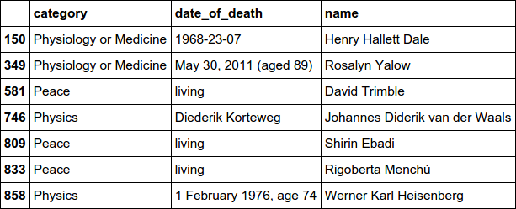

Figure 9-1. The unparseable date fields
Depending on how fastidious you want to be, these can be corrected by hand or coerced to NumPy’s time equivalent of NaN, NaT. We’ve got more than 500 valid dates of death, which is enough to get some interesting time stats, so we’ll run to_datetime again and force errors to null:
df
.
date_of_death
=
pd
.
to_datetime
(
df
.
date_of_death
,
\
errors
=
'coerce'
)
Now that we have our time fields in a usable format, let’s add a field for the age of the winner on receiving his/her Nobel Prize. In order to get the year value of our new dates, we need to tell pandas that it’s dealing with a date column, using the DatetimeIndex method. Note that this gives a crude estimation of award age and may be off by a year. For the purposes of the next chapter’s dataviz exploration, this is more than adequate:
df
[
'
award_age
'
]
=
df
.
year
-
pd
.
DatetimeIndex
(
df
.
date_of_birth
)
\
.
year
Convert the column to a DatetimeIndex, an ndarray of datetime64 data, and use the year property.
Let’s use our new award_age field to see the youngest recipients of the Nobel Prize:
# use +sort+ for older pandas
df
.
sort_values
(
'
award_age
'
)
.
iloc
[
:
10
]
\
[
[
'
name
'
,
'
award_age
'
,
'
category
'
,
'
year
'
]
]
Out
:
name
award_age
category
year
725
Malala
Yousafzai
17.0
Peace
2014
525
William
Lawrence
Bragg
25.0
Physics
1915
626
Georges
J
.
F
.
Köhler
30.0
Phys
.
.
.
Medicine
1976
294
Tsung
-
Dao
Lee
31.0
Physics
1957
858
Werner
Karl
Heisenberg
31.0
Physics
1932
247
Carl
Anderson
31.0
Physics
1936
146
Paul
Dirac
31.0
Physics
1933
877
Rudolf
Mössbauer
32.0
Physics
1961
226
Tawakkol
Karman
32.0
Peace
2011
804
Mairéad
Corrigan
32.0
Peace
1976
For activism for female education, I’d recommend reading more about Malala’s inspirational story.
Now that we have our date fields in a manipulable form, let’s have a look at the full clean_data function, which summarizes this chapter’s cleaning efforts.

The Full clean_data Function
For manually edited data like scraped Wikipedia datasets, it’s unlikely that you’ll catch all the errors on a first pass. So expect to pick up a few during the data exploration phase. Nevertheless, our Nobel Prize dataset is looking very usable. We’ll declare it clean enough and the job of this chapter done. Example 9-4 shows the steps we used to achieve this cleaning feat.

Example 9-4. The full Nobel Prize dataset cleaning function
def
clean_data
(
df
)
:
df
=
df
.
replace
(
'
'
,
np
.
nan
)
df_born_in
=
df
[
df
.
born_in
.
notnull
(
)
]
df
=
df
[
df
.
born_in
.
isnull
(
)
]
df
=
df
.
drop
(
'
born_in
'
,
axis
=
1
)
df
.
drop
(
df
[
df
.
year
==
1809
]
.
index
,
inplace
=
True
)
df
=
df
[
~
(
df
.
name
==
'
Marie Curie
'
)
]
df
.
loc
[
(
df
.
name
==
'
Marie Sk
\u0142
odowska-Curie
'
)
&
\
(
df
.
year
==
1911
)
,
'
country
'
]
=
'
France
'
df
=
df
[
~
(
(
df
.
name
==
'
Sidney Altman
'
)
&
(
df
.
year
==
1990
)
)
]
df
=
df
.
reindex
(
np
.
random
.
permutation
(
df
.
index
)
)
df
=
df
.
drop_duplicates
(
[
'
name
'
,
'
year
'
]
)
df
=
df
.
sort_index
(
)
df
.
loc
[
df
.
name
==
'
Alexis Carrel
'
,
'
category
'
]
=
\
'
Physiology or Medicine
'
df
.
loc
[
df
.
name
==
'
Ragnar Granit
'
,
'
gender
'
]
=
'
male
'
df
=
df
[
df
.
gender
.
notnull
(
)
]
# remove institutional prizes
df
.
loc
[
df
.
name
==
'
Hiroshi Amano
'
,
'
date_of_birth
'
]
=
\
'
11 September 1960
'
df
.
date_of_birth
=
pd
.
to_datetime
(
df
.
date_of_birth
)
df
.
date_of_death
=
pd
.
to_datetime
(
df
.
date_of_death
,
\
errors
=
'
coerce
'
)
df
[
'
award_age
'
]
=
df
.
year
-
pd
.
DatetimeIndex
(
df
.
date_of_birth
)
\
.
year
return
df
,
df_born_in
Makes a DataFrame containing the rows with born_in fields.
Removes duplicates from the DataFrame after randomizing the row order.
Converts the date columns to the practical datetime64 datatype.
We return a DataFrame with the deleted born_in field; this data will provide an interesting visualization in the next chapter.

Adding the born_in column
While cleaning the winners DataFrame we removed the born_in column (see “Removing Rows”). As we’ll see in the next chapter, this column has some interesting data that can be correlated with the winners’ country (of prize-winning origin) to tell an interesting story or two. The clean_data function returns the born_in data as a DataFrame. Let’s see how we can add this data to our freshly cleaned DataFrame. First, we’ll read in our original, dirty dataset and apply our data cleaning function:
df
=
pd
.
read_json
(
open
(
'data/nobel_winners_dirty.json'
))
df_clean
,
df_born_in
=
clean_data
(
df
)
Now we’ll clean up the name field of the df_born_in DataFrame by removing the asterisks, stripping any whitespace and then removing any duplicate rows by name. Finally, we’ll set the index of the DataFrame to its name column:
# clean up name column: '* Aaron Klug' -> 'Aaron Klug'
df_born_in
.
name
=
dfbi
.
name
.
str
.
replace
(
'
*
'
,
'
'
,
regex
=
False
)
df_born_in
.
name
=
dfbi
.
name
.
str
.
strip
(
)
df_born_in
.
drop_duplicates
(
subset
=
[
'
name
'
]
,
inplace
=
True
)
df_born_in
.
set_index
(
'
name
'
,
inplace
=
True
)
We now have a df_born_in DataFrame that we can query by name:
In
:
df_born_in
[
'Eugene Wigner'
]
Out
:
born_in
Hungary
category
Physics
...
year
1963
Name
:
Eugene
Wigner
,
dtype
:
object
Now we’ll write a little Python function to return the born_in field by name of our df_born_in DataFrame if it exists, otherwise returning a NumPy nan:
def
get_born_in
(
name
):
try
:
born_in
=
df_born_in
.
loc
[
name
][
'born_in'
]
# We'll print out these rows as a sanity-check
print
(
'name:
%s
, born in:
%s
'
%
(
name
,
born_in
))
except
:
born_in
=
np
.
nan
return
born_in
We can now create a born_in column to our main DataFrame by applying this get_born_in function to each row, using the name field:
In
:
df_wbi
=
df_clean
.
copy
()
In
:
df_wbi
[
'born_in'
]
=
df_wbi
[
'name'
]
.
apply
(
get_born_in
)
Out
:
...
name
:
Christian
de
Duve
,
born
in
:
United
Kingdom
name
:
Ilya
Prigogine
,
born
in
:
Russia
...
name
:
Niels
Kaj
Jerne
,
born
in
:
United
Kingdom
name
:
Albert
Schweitzer
,
born
in
:
Germany
...
Finally, let’s make sure we’ve successfully added a born_in column to our DataFrame:
In
:
df_wbi
.
info
()
Out
:
<
class
'
pandas
.
core
.
frame
.
DataFrame
'>
Int64Index
:
858
entries
,
4
to
1051
Data
columns
(
total
13
columns
):
# Column Non-Null Count Dtype
---
------
--------------
-----
0
category
858
non
-
null
object
...
12
born_in
102
non
-
null
object
dtypes
:
datetime64
[
ns
](
2
),
int64
(
2
),
object
(
9
)
memory
usage
:
93.8
+
KB
Note that if there were no duplicate names among our Nobel winners, we could create the born_in column by simply setting the index of df and df_born_in to name and creating the column directly:
# this won't work with duplicate names in our index
In
:
df_wbi
[
'born_in'
]
=
df_born_in
.
born_in
Out
:
...
ValueError
:
cannot
reindex
from
a
duplicate
axis
The use of apply can be inefficient for large datasets, but it provides a very flexible way of creating new columns based on the existing ones.

Merging DataFrames
At this point, we can also create a merged database of our clean winners data and the image and biography dataset we scraped in “Scraping Text and Images with a Pipeline”. This will provide a good opportunity to demonstrate pandas’s ability to merge DataFrames. The following code shows how to merge df_clean and the bio dataset:
# Read the Scrapy bio-data into a DataFrame
df_winners_bios
=
pd
.
read_json
(
\
open
(
'
data/scrapy_nwinners_minibio.json
'
)
)
df_clean_bios
=
pd
.
merge
(
df_wbi
,
df_winners_bios
,
\
how
=
'
outer
'
,
on
=
'
link
'
)
pandas’s merge takes two DataFrames and merges them based on shared column name(s) (link, in this case). The how argument specifies how to determine which keys are to be included in the resulting table and works in the same way as SQL joins. In this case, outer specifies a FULL_OUTER_JOIN.
Merging the two DataFrames results in redundancies in our merged dataset, with more than the 858 winning rows:
df_clean_bios
.
count
()
Out
:
award_age
1023
category
1023
...
bio_image
978
mini_bio
1086
We can easily remove these by using drop_duplicates to remove any rows that share a link and year field after removing any rows without a name field:
df_clean_bios
=
df_clean_bios
[
~
df_clean_bios
.
name
.
isnull
()]
\
.
drop_duplicates
(
subset
=
[
'link'
,
'year'
])
A quick count shows that we now have the right number of winners with images for 770 and a mini_bio for all but one:
df_clean_bios
.
count
()
award_age
858
category
858
...
born_in
102
bio_image
770
mini_bio
857
dtype
:
int64
While we’re cleaning our dataset, let’s see which winner is missing a mini_bio field:
df_clean_bios
[
df_clean_bios
.
mini_bio
.
isnull
()]
Out
:
...
link
name
\
229
http
:
//
en
.
wikipedia
.
org
/
wiki
/
L
%
C3
%
AA_
%
C3
...
Lê
Ðức
Thọ
...
It turns out to be a Unicode error in creating the Wikipedia link for Lê Ðức Thọ, the Vietnamese Peace Prize winner. This can be corrected by hand.
The df_clean_bios DataFrame includes an array of image URLs we scraped from Wikipedia. We won’t be using these, and they would have to be converted to JSON in order to save them to SQL. Let’s drop the images_url column to make our dataset as uncluttered as possible:
df_clean_bios
.
drop
(
'image_urls'
,
axis
=
1
,
inplace
=
True
)
Now our dataset is cleaned and streamlined, let’s save it in a couple of handy formats.

Saving the Cleaned Datasets
Now we have the datasets required for our upcoming exploration with pandas, let’s save them in a couple of formats ubiquitous in data visualization, SQL and JSON.
First, we’ll save our cleaned DataFrame with born_in field and merged biographies as a JSON file using pandas’s handy to_json method:
df_clean_bios
.
to_json
(
'
data/nobel_winners_cleaned.json
'
,
\
orient
=
'
records
'
,
date_format
=
'
iso
'
)
We set the orient argument to records to store an array of row-objects and specify 'iso' as the string encoding for our date format.
Let’s save a copy of our clean DataFrame to an SQLite nobel_prize database in a local data directory. We’ll use this to demonstrate the Flask-based REST web API in Chapter 13. Three lines of Python and the DataFrame’s to_sql method do the job succinctly (see “SQL” for more details):
import
sqlalchemy
engine
=
sqlalchemy
.
create_engine
(
\
'sqlite:///data/nobel_winners_clean.db'
)
df_clean_bios
.
to_sql
(
'winners'
,
engine
,
if_exists
=
'replace'
)
Let’s make sure we’ve successfully created the database by reading the contents back into a DataFrame:
df_read_sql
=
pd
.
read_sql
(
'winners'
,
engine
)
df_read_sql
.
info
()
Out
:
<
class
'
pandas
.
core
.
frame
.
DataFrame
'>
RangeIndex
:
858
entries
,
0
to
857
Data
columns
(
total
16
columns
):
# Column Non-Null Count Dtype
---
------
--------------
-----
0
index
858
non
-
null
int64
1
category
858
non
-
null
object
2
country
858
non
-
null
object
3
date_of_birth
858
non
-
null
datetime64
[
ns
]
[
...
]
14
bio_image
770
non
-
null
object
15
mini_bio
857
non
-
null
object
dtypes
:
datetime64
[
ns
](
2
),
float64
(
2
),
int64
(
1
),
object
(
11
)
memory
usage
:
107.4
+
KB
With our cleaned data in the database, we’re ready to start exploring it in the next chapter.

Summary
In this chapter, you learned how to clean a fairly messy dataset, producing data that will be much nicer to explore and generally work with. Along the way, a number of new pandas methods and techniques were introduced to extend the last chapter’s introduction to basic pandas.
In the next chapter, we will use our newly minted dataset to start getting a feel for the Nobel Prize recipients, their country, gender, age, and any interesting correlations (or lack thereof) we can find.
1 Large is a very relative term, but pandas will take pretty much whatever will fit in your computer’s RAM memory, which is where DataFrames live.
2 pandas supports multiple indices using the MultiIndex object. This provides a very powerful way of refining higher-dimensional data. Check out the details in the pandas documentation.
3 By default, pandas uses NumPy’s NaN (not a number) float to designate missing values.
4 One interesting visualization might be charting the migration of Nobel Prize winners from their homelands.
5 See IEEE 754 and Wikipedia.
6 As you’ll see in the next chapter, the born_in fields contain some interesting information about the movements of Nobel Prize winners. We’ll see how to add this data to the cleaned dataset at the end of this chapter.
7 While France was Curie’s adopted country, she retained Polish citizenship and named her first discovered radioactive isotope polonium after her home country.
8 Some users dismiss such warnings as nannying paranoia. See the discussion on Stack Overflow.
9 They can be turned off with pd.options.mode.chained_assignment = None # default=warn.
10 Depending on the dataset, the cleaning phase is unlikely to catch all transgressors.
11 Although Granit’s gender is not specified in the person data, his Wikipedia biography uses the male gender.

Chapter 10. Visualizing Data with Matplotlib
As a data visualizer, one of the best ways to come to grips with your data is to visualize it interactively, using the full range of charts and plots that have evolved to summarize and refine datasets. Conventionally, the fruits of this exploratory phase are then presented as static figures, but increasingly they are used to construct more engaging interactive web-based charts, such as the cool D3 visualizations you have probably seen (one of which we’ll be building in Part V).
Python’s Matplotlib and its family of extensions (such as the statistically focused seaborn) form a mature and very customizable plotting ecosystem. Matplotlib plots can be used interactively by IPython (the Qt and notebook versions), providing a very powerful and intuitive way of finding interesting nuggets in your data. In this chapter, we’ll introduce Matplotlib and one of its great extensions, seaborn.

pyplot and Object-Oriented Matplotlib
Matplotlib can be more than a little confusing, especially if you start randomly sampling examples online. The main complicating factor is that there are two main ways to create plots, which are similar enough to be confused but different enough to lead to a lot of frustrating errors. The first way uses a global state machine to interact directly with Matplotlib’s pyplot module. The second, object-oriented approach uses the more familiar notion of figure and axes classes to provide a programmatic alternative. I’ll clarify their differences in the sections ahead, but as a rough rule of thumb, if you’re working interactively with single plots, pyplot’s global state is a convenient shortcut. For all other occasions, it makes sense to explicitly declare your figures and axes using the object-oriented approach.

Starting an Interactive Session
We will be using a Jupyter notebook for our interactive visualization. Use the following command to start a session:
$ jupyter notebook
You can then use one of the Matplotlib magic commands within the IPython session to enable interactive Matplotlib. On its own, %matplotlib will use the default GUI backend to create a plotting window, but you can specify the backend directly. The following should work on standard and Qt console IPython:1
%matplotlib [qt | osx | wx ...]
To get inline graphics in the notebook or Qt console, you can use the inline directive. Note that with inline plots, you can’t amend them after creation, unlike the standalone Matplotlib window:
%matplotlib inline
Whether you are using Matplotlib interactively or in Python programs, you’ll use similar imports:
import
numpy
as
np
import
pandas
as
pd
import
matplotlib.pyplot
as
plt
Note
You will find many examples of Matplotlib using pylab. pylab is a convenience module that bulk-imports matplotlib.pyplot (for plotting) and NumPy in a single namespace. pylab is pretty much deprecated now, but even were it not, I’d still recommend avoiding this namespace and merging and importing pyplot and numpy explicitly.
While NumPy and pandas are not mandatory, Matplotlib is designed to play well with them, handling NumPy arrays and, by association, pandas Series.
The ability to create inline plots is key to enjoyable interaction with Matplotlib, and we achieve this in IPython with the following “magic”2 injunction:
In [0]: %matplotlib inline
Your Matplotlib plots will now be inserted into your IPython workflow. This works with Qt and notebook versions. In notebooks, the plots are incorporated into the active cell.
Amending Plots
In inline mode, after a Jupyter notebook cell or (multiline) input has been run, the drawing context is flushed. This means you cannot change the plot from a previous cell or input using the gcf (get current figure) method but have to repeat all the plot commands with any additions or amendments in a new input/cell.

Interactive Plotting with pyplot’s Global State
The pyplot module provides a global state that you can manipulate interactively.3 This is intended for use in interactive data exploration and is best when you are creating simple plots, usually containing single figures. pyplot is convenient and many of the examples you’ll see use it, but for more complex plotting Matplotlib’s object-oriented API (which we’ll see shortly) comes into its own. Before demoing use of the global plot, let’s create some random data to display, courtesy of pandas’s useful period_range method:
from
datetime
import
datetime
x
=
pd
.
period_range
(
datetime
.
now
(
)
,
periods
=
200
,
freq
=
'
d
'
)
x
=
x
.
to_timestamp
(
)
.
to_pydatetime
(
)
y
=
np
.
random
.
randn
(
200
,
3
)
.
cumsum
(
0
)
Creates a pandas datetime index with 200 day (d) elements, starting from the current time (datetime.now()).
Converts datetime index to Python datetimes.
Creates three 200-element random arrays summed along the 0 axis.
We now have a y-axis with 200 time slots and three random arrays for the complementary x values. These are provided as separate arguments to the (line)plot method:
plt
.
plot
(
x
,
y
)
This gives us the not particularly inspiring chart shown in Figure 10-1. Note how Matplotlib deals naturally with a multidimensional NumPy line array.
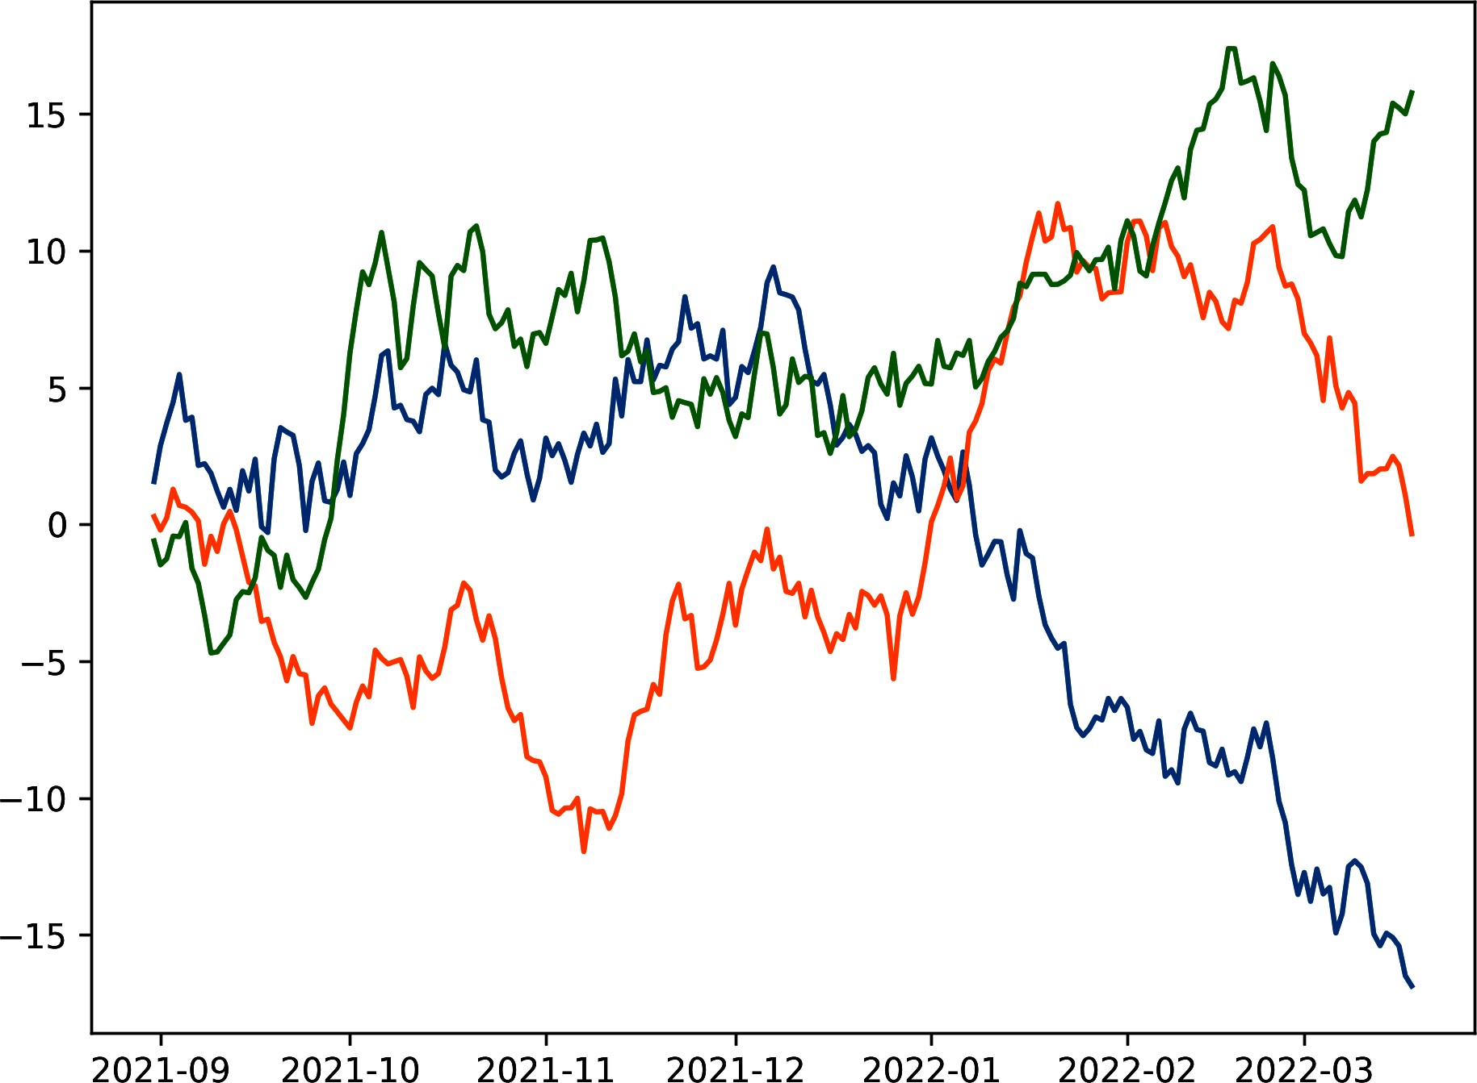

Figure 10-1. Default line plot
Although Matplotlib’s defaults are, by general consensus, less than ideal, one of its strengths is the sheer amount of customization you can perform. This is why there is a rich ecosystem of chart libraries that wrap Matplotlib with better defaults, more attractive color schemes, and more. Let’s see some of this customization in action by using vanilla Matplotlib to tailor our default plot.

Configuring Matplotlib
Matplotlib provides a wide range of configurations, which can be specified in a matplotlibrc file or dynamically, through the dictionary-like rcParams variable. Here we change the width and default color of our plot lines:
import
matplotlib
as
mpl
mpl
.
rcParams
[
'lines.linewidth'
]
=
2
mpl
.
rcParams
[
'lines.color'
]
=
'r'
# red
You can find a sample matplotlibrc file at the main site.
As well as using the rcParams variable, you can use the gcf (get current figure) method to grab the currently active figure and manipulate it directly.
Let’s see a little example of configuration, setting the current figure’s size.

Setting the Figure’s Size
If your plot’s default readability is poor or the width-to-height ratio suboptimal, you will want to change its size. By default, Matplotlib uses inches for its plotting size. This makes sense when you consider the many backends (often vector-graphic-based) that Matplotlib can save to. Here we show two ways to use pyplot to set the figure size to eight by four inches, using rcParams and gcf:
# Two ways to set the figure size to 8 by 4 inches
plt
.
rcParams
[
'figure.figsize'
]
=
(
8
,
4
)
plt
.
gcf
()
.
set_size_inches
(
8
,
4
)

Points, Not Pixels
Matplotlib uses points, not pixels, to measure the size of its figures. This is the accepted measure for print-quality publications, and Matplotlib is used to deliver publication-quality images.
By default a point is approximately 1/72 of an inch wide, but Matplotlib allows you to adjust this by changing the dots-per-inch (dpi) for any figures generated. The higher this number, the better the quality of the image. For the purpose of the inline figures shown interactively during IPython sessions, the resolution is usually a product of the backend engine being used to generate the plots (e.g., Qt, WxAgg, tkinter). See the Matplotlib documentation for an explanation of backends.

Labels and Legends
Figure 10-1 needs, among other things, to tell us what the lines mean. Matplotlib has a handy legend box for line labeling, which, like most things Matplotlib, is heavily configurable. Labeling our three lines involves a little indirection as the plot method only takes one label, which it applies to all lines generated. Usefully, the plot command returns all Line2D objects created. These can be used by the legend method to set individual labels.
Because this plot will be appearing in black and white (if you’re reading the print version of this book), we need a way to distinguish the lines other than the default colors. The easiest way to do this with Matplotlib is to create the lines sequentially, specifying x and y values and a line style.4 We’ll make our line styles solid (-), dashed (--), and dash-dotted (-.). Note the use of NumPy’s column indexing (see Figure 7-1):
#plots = plt.plot(x,y)
plots
=
plt
.
plot
(
x
,
y
[:,
0
],
'-'
,
x
,
y
[:,
1
],
'--'
,
x
,
y
[:,
2
],
'-.'
)
plots
Out
:
[
<
matplotlib
.
lines
.
Line2D
at
0x9b31a90
>
,
<
matplotlib
.
lines
.
Line2D
at
0x9b4da90
>
,
<
matplotlib
.
lines
.
Line2D
at
0x9b4dcd0
>
]
The legend method can set labels, suggest a location for the legend box, and configure a number of other things:
plt
.
legend
(
plots
,
(
'
foo
'
,
'
bar
'
,
'
baz
'
)
,
loc
=
'
best
'
,
framealpha
=
0.5
,
prop
=
{
'
size
'
:
'
small
'
,
'
family
'
:
'
monospace
'
}
)
Sets the labels for our three plots.
Using the best location should avoid obscuring lines.
Sets the legend’s transparency.
Here we adjust the font properties of the legend.5

Titles and Axes Labels
Adding a title and label for your axes is as easy as can be:
plt
.
title
(
'Random trends'
)
plt
.
xlabel
(
'Date'
)
plt
.
ylabel
(
'Cum. sum'
)
You can add some text with the figtext method:6
plt
.
figtext
(
0.995
,
0.01
,
'
© Acme designs 2022
'
,
ha
=
'
right
'
,
va
=
'
bottom
'
)
The location of the text proportionate to figure size.
Horizontal (ha) and vertical (va) alignment.
The complete code is shown in Example 10-1 and the resulting chart in Figure 10-2.

Example 10-1. Customized line chart
plots
=
plt
.
plot
(
x
,
y
[
:
,
0
]
,
'
-
'
,
x
,
y
[
:
,
1
]
,
'
--
'
,
x
,
y
[
:
,
2
]
,
'
-.
'
)
plt
.
legend
(
plots
,
(
'
foo
'
,
'
bar
'
,
'
baz
'
)
,
loc
=
'
best,
framealpha
=
0.25
,
prop
=
{
'
size
'
:
'
small
'
,
'
family
'
:
'
monospace
'
}
)
plt
.
gcf
(
)
.
set_size_inches
(
8
,
4
)
plt
.
title
(
'
Random trends
'
)
plt
.
xlabel
(
'
Date
'
)
plt
.
ylabel
(
'
Cum. sum
'
)
plt
.
grid
(
True
)
plt
.
figtext
(
0.995
,
0.01
,
'
© Acme Designs 2021
'
,
ha
=
'
right
'
,
va
=
'
bottom
'
)
plt
.
tight_layout
(
)
This will add a dotted grid to the figure, marking the axis ticks.
The tight_layout method should guarantee that all your plot elements are within the figure box. Otherwise, you might find tick-labels or legends truncated.
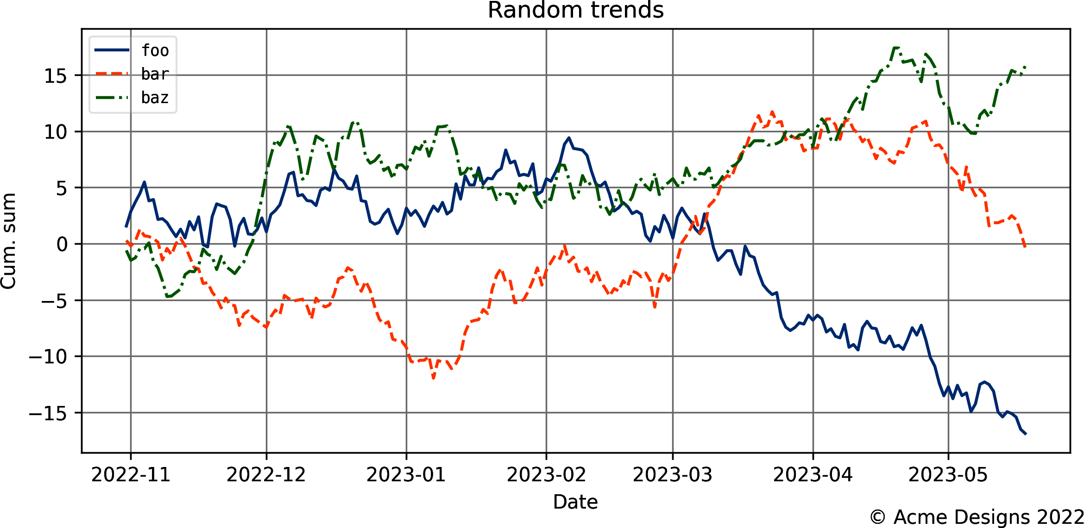

Figure 10-2. Customized line chart
We used the tight_layout method in Example 10-1 to prevent plot elements from being obscured or truncated. tight_layout has been known to cause problems with some systems, particularly macOS. If you have any problems, this issue thread may help. As of now, the best advice is to use the set_tight_layout method on the current figure:
plt
.
gcf
()
.
set_tight_layout
(
True
)

Saving Your Charts
One area where Matplotlib shines is in saving your plots, providing many output formats.7 The available formats depend on the backends available, but generally PNG, PDF, PS, EPS, and SVG are supported. PNG stands for Portable Network Graphics and is the most popular format for distributing web images. The other formats are vector-based, which can scale smoothly without pixelation artifacts. For high-quality print work, this is probably what you want.
Saving is as simple as this:
plt
.
tight_layout
()
# force plot into figure dimensions
plt
.
savefig
(
'mpl_3lines_custom.svg'
)
You can set the format explicitly using format="svg", but Matplotlib understands the .svg suffix. To avoid truncated labels, use the tight_layout method.8

Figures and Object-Oriented Matplotlib
As just shown, interactively manipulating pyplot’s global state works fine for quick data sketching and single-plot work. However, if you want to have more control over your charts, Matplotlib’s figure and axes Object-Oriented (OO) approach is the way to go. Most of the more advanced plotting demos you see will be done this way.
In essence, with OO Matplotlib we are dealing with a figure, which you can think of as a drawing canvas with one or more axes (or plots) embedded in it. Both figures and axes have properties that can be independently specified. In this sense, the interactive pyplot route discussed earlier was plotting to a single axis of a global figure.
We can create a figure by using pyplot’s figure method:
fig
=
plt
.
figure
(
figsize
=
(
8
,
4
),
# figure size in inches
dpi
=
200
,
# dots per inch
tight_layout
=
True
,
# fit axes, labels, etc. to canvas
linewidth
=
1
,
edgecolor
=
'r'
# 1 pixel wide, red border
)
As you can see, figures share a subset of properties with the global pyplot module. These can be set on creation of the figure or through similar methods (i.e., fig.text() as opposed to plt.fig_text()). Each figure can have multiple axes, each of which is analogous to the single, global plot state but with the considerable advantage that multiple axes can exist on one figure, each with independent properties.

Axes and Subplots
The figure.add_axes method allows precise control over the position of axes within a figure (e.g., enabling you to embed a smaller plot within the main). Positioning of plot elements uses a 0 → 1 coordinate system, where 1 is the width or height of the figure. You can specify the position using a four-element list or tuple to set bottom-left and top-right bounds:
# h = height, w = width
fig
.
add_axes
([
0.2
,
0.2
,
#[bottom(h*0.2), left(w*0.2),
0.8
,
0.8
])
# top(h*0.8), right(w*0.8)]
Example 10-2 shows the code needed to insert smaller axes into larger ones, using our random test data. The result is shown in Figure 10-3.

Example 10-2. A plot insert with figure.add_axes
fig
=
plt
.
figure
(
figsize
=
(
8
,
4
)
)
# --- Main Axes
ax
=
fig
.
add_axes
(
[
0.1
,
0.1
,
0.8
,
0.8
]
)
ax
.
set_title
(
'
Main Axes with Insert Child Axes
'
)
ax
.
plot
(
x
,
y
[
:
,
0
]
)
ax
.
set_xlabel
(
'
Date
'
)
ax
.
set_ylabel
(
'
Cum. sum
'
)
# --- Inserted Axes
ax
=
fig
.
add_axes
(
[
0.15
,
0.15
,
0.3
,
0.3
]
)
ax
.
plot
(
x
,
y
[
:
,
1
]
,
color
=
'
g
'
)
# 'g' for green
ax
.
set_xticks
(
[
]
)
;
This selects the first column of our random NumPy y-data.
Removes the x ticks and labels from our embedded plot.
Although add_axes gives us a lot of scope for fine-tuning the appearance of our charts, most of the time Matplotlib’s built-in grid-layout system makes life much easier.9 The simplest option is to use figure.subplots, which allows you to specify row-column layouts of equal-sized plots. If you want a grid with different-sized plots, the gridspec module is your go-to.
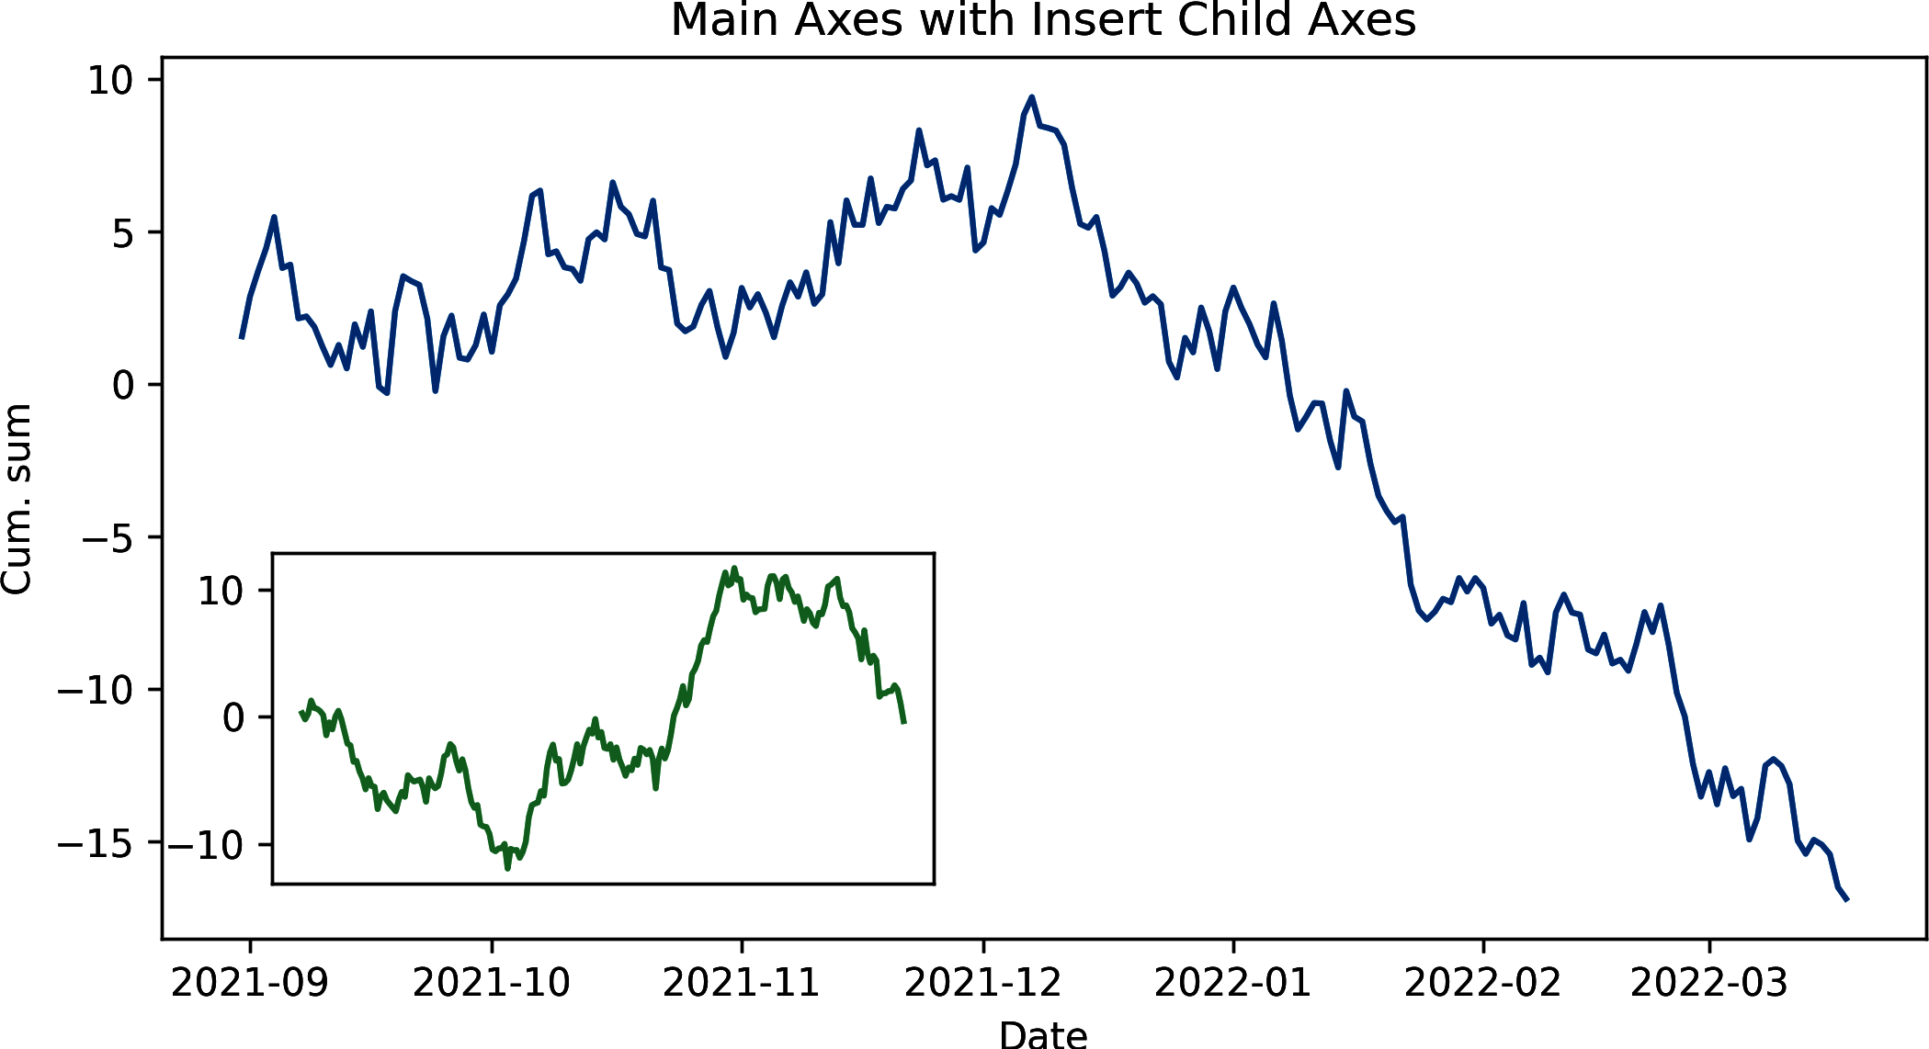

Figure 10-3. Inserted plot with figure.add_axes
Calling subplots without arguments returns a figure with single axes. This is closest in use to using the pyplot state machine shown in “Interactive Plotting with pyplot’s Global State”. Example 10-3 shows the figure and axes equivalent to the pyplot demo in Example 10-1, producing the chart in Figure 10-2. Note the use of “setter” methods for figure and axes.

Example 10-3. Plotting with single figure and axes
figure
,
ax
=
plt
.
subplots
()
plots
=
ax
.
plot
(
x
,
y
,
label
=
''
)
figure
.
set_size_inches
(
8
,
4
)
ax
.
legend
(
plots
,
(
'foo'
,
'bar'
,
'baz'
),
loc
=
'best'
,
framealpha
=
0.25
,
prop
=
{
'size'
:
'small'
,
'family'
:
'monospace'
})
ax
.
set_title
(
'Random trends'
)
ax
.
set_xlabel
(
'Date'
)
ax
.
set_ylabel
(
'Cum. sum'
)
ax
.
grid
(
True
)
figure
.
text
(
0.995
,
0.01
,
'© Acme Designs 2022'
,
ha
=
'right'
,
va
=
'bottom'
)
figure
.
tight_layout
()
Calling subplots with arguments for number of rows (nrows) and columns (ncols) (as shown in Example 10-4) allows multiple plots to be placed on a grid layout (see the results in Figure 10-4). The call to subplots returns the figure and an array of axes, in row-column order. In the example, we specify one column so axes is a single array of three stacked axes.

Example 10-4. Using subplots
fig
,
axes
=
plt
.
subplots
(
nrows
=
3
,
ncols
=
1
,
sharex
=
True
,
sharey
=
True
,
figsize
=
(
8
,
8
)
)
labelled_data
=
zip
(
y
.
transpose
(
)
,
(
'
foo
'
,
'
bar
'
,
'
baz
'
)
,
(
'
b
'
,
'
g
'
,
'
r
'
)
)
fig
.
suptitle
(
'
Three Random Trends
'
,
fontsize
=
16
)
for
i
,
ld
in
enumerate
(
labelled_data
)
:
ax
=
axes
[
i
]
ax
.
plot
(
x
,
ld
[
0
]
,
label
=
ld
[
1
]
,
color
=
ld
[
2
]
)
ax
.
set_ylabel
(
'
Cum. sum
'
)
ax
.
legend
(
loc
=
'
upper left
'
,
framealpha
=
0.5
,
prop
=
{
'
size
'
:
'
small
'
}
)
axes
[
-
1
]
.
set_xlabel
(
'
Date
'
)
Specifies a subplot grid of three rows by one column.
We want to share x- and y-axes, automatically adjusting limits for easy comparison.
Switch y to row-column and zip the line data, labels, and line colors together.
Labels the last of the shared x-axes.
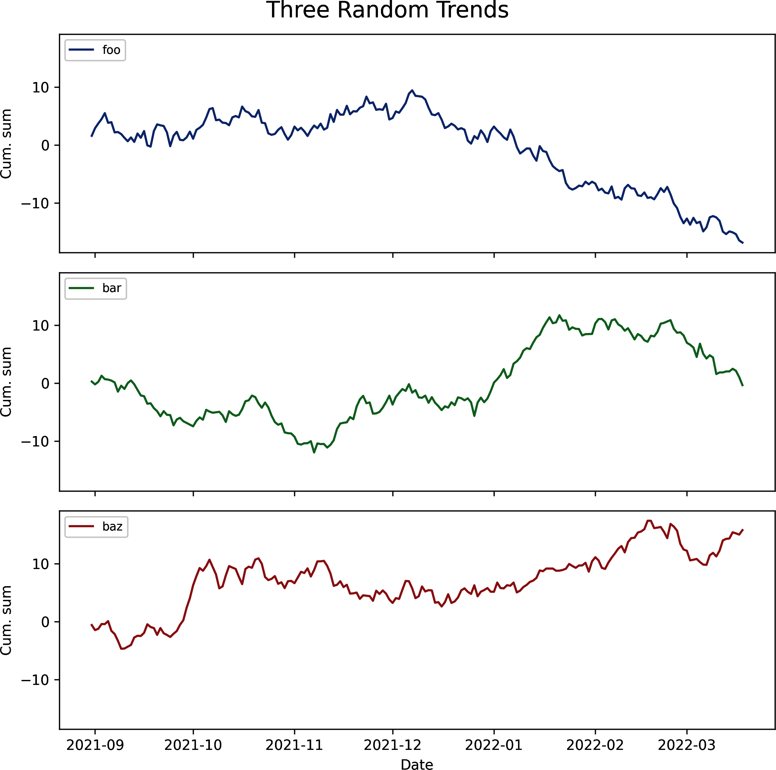

Figure 10-4. Three subplots
We make use of Python’s handy zip method to produce three dictionaries with line data. zip takes lists or tuples of length n and returns n lists, formed by matching the elements by order:
letters
=
[
'a'
,
'b'
]
numbers
=
[
1
,
2
]
zip
(
letters
,
numbers
)
Out
:
[(
'a'
,
1
),
(
'b'
,
2
)]
In the for loop, we use enumerate to supply an index i, which we use to select an axis by row, using our zipped labelled_data to provide the plot properties.
Note the shared x- and y-axes specified in the subplots call in Example 10-4 (2). This allows easy comparison of the three charts, particularly on the now normalized y-axis. To avoid redundant x labels, we only call set_xlabel on the last row, using Python’s handy negative indexing.
Now that we’ve covered the two ways in which IPython and Matplotlib engage interactively, using the global state (accessed through plt) and the object-oriented API, let’s look at a few of the common plot types you’ll use to explore your datasets.

Plot Types
As well as the line plot just demonstrated, Matplotlib has a number of plot types available. I’ll now demonstrate a few of the ones commonly used in exploratory data visualization.

Bar Charts
The humble bar chart is a staple for a lot of visual data exploration. As with most of Matplotlib charts, there’s a good deal of customization possible. We’ll now run through a few variants to give you the gist.
The code in Example 10-5 produces the bar chart in Figure 10-5. Note that you have to specify your own bar and label locations. This kind of flexibility is beloved by hardcore Matplotlibbers and is pretty easy to get the hang of. Nevertheless, it’s the sort of thing that can get tedious. It’s trivial to write some helper methods here, and there are many libraries that wrap Matplotlib and make things a little more user-friendly. As we’ll see in Chapter 11, pandas’s built-in Matplotlib-based plots are quite a bit simpler to use.

Example 10-5. A simple bar chart
labels
=
[
"
Physics
"
,
"
Chemistry
"
,
"
Literature
"
,
"
Peace
"
]
foo_data
=
[
3
,
6
,
10
,
4
]
bar_width
=
0.5
xlocations
=
np
.
array
(
range
(
len
(
foo_data
)
)
)
+
bar_width
plt
.
bar
(
xlocations
,
foo_data
,
width
=
bar_width
)
plt
.
yticks
(
range
(
0
,
12
)
)
plt
.
xticks
(
xlocations
,
labels
)
plt
.
title
(
"
Prizes won by Fooland
"
)
plt
.
gca
(
)
.
get_xaxis
(
)
.
tick_bottom
(
)
plt
.
gca
(
)
.
get_yaxis
(
)
.
tick_left
(
)
plt
.
gcf
(
)
.
set_size_inches
(
(
8
,
4
)
)
Here we create the middle bar locations, two bar_width’s apart.
We’re hardcoding the x values for demonstration purposes—usually you will want to calculate ranges on the fly.
This places tick labels at the middle of the bars.
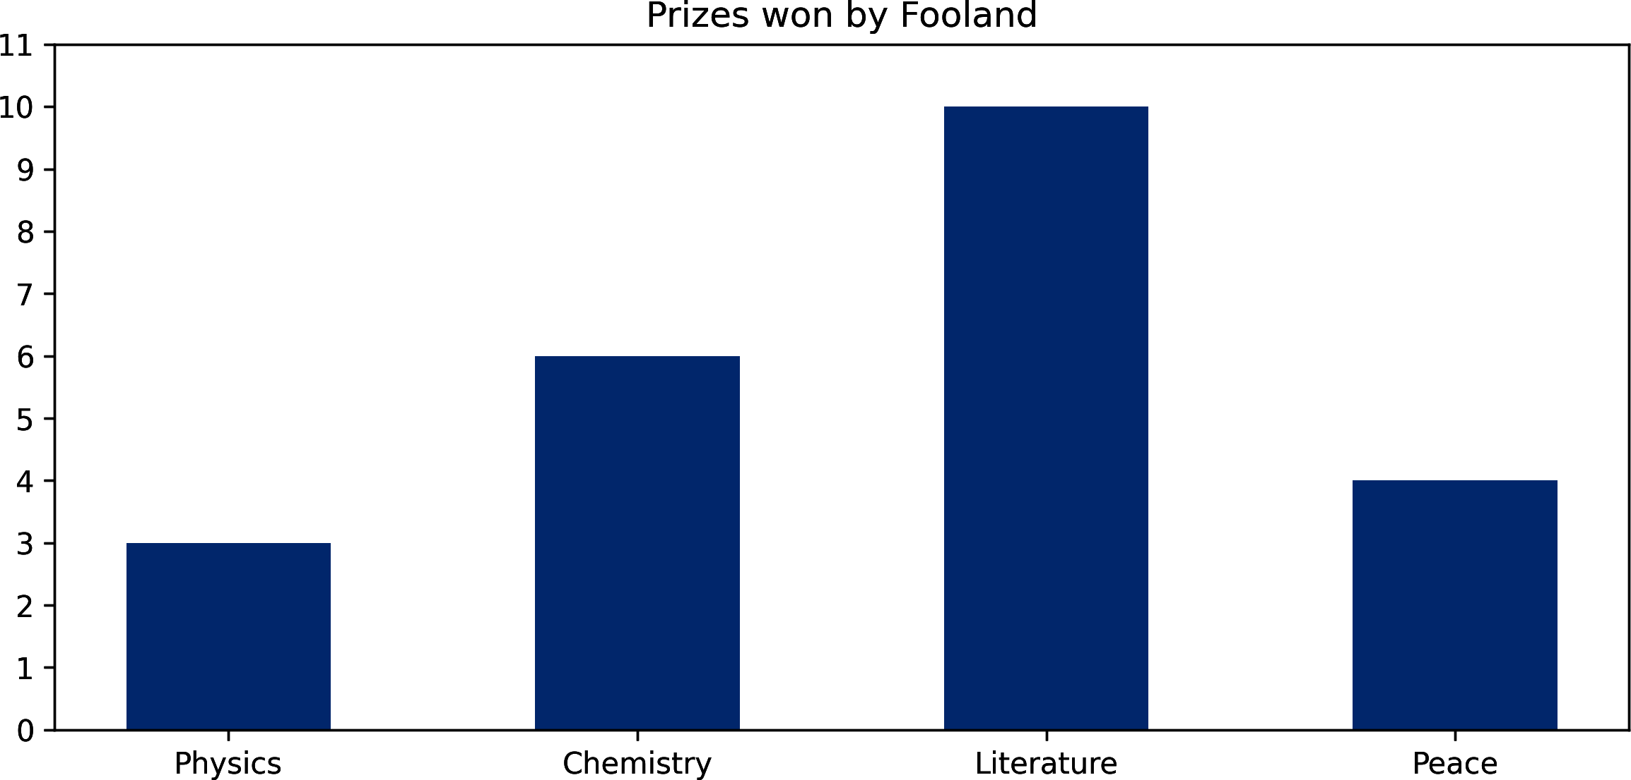

Figure 10-5. A simple bar chart
Bar charts with multiple groups are particularly useful. In Example 10-6, we add some more country data (for a mythical Barland) and use the subplots method to produce grouped bar charts (see Figure 10-6). Once again we specify the bar locations manually, adding two bar groups—this time with ax.bar. Note that our axes’ x-limits are automatically rescaled in a sensible fashion, at increments of 0.5:
ax
.
get_xlim
()
# Out: (-0.5, 3.5)
Use the respective setter methods (set_xlim, in this case) if autoscaling doesn’t achieve the desired look.

Example 10-6. Creating a grouped bar chart
labels
=
[
"
Physics
"
,
"
Chemistry
"
,
"
Literature
"
,
"
Peace
"
]
foo_data
=
[
3
,
6
,
10
,
4
]
bar_data
=
[
8
,
3
,
6
,
1
]
fig
,
ax
=
plt
.
subplots
(
figsize
=
(
8
,
4
)
)
bar_width
=
0.4
xlocs
=
np
.
arange
(
len
(
foo_data
)
)
ax
.
bar
(
xlocs
-
bar_width
,
foo_data
,
bar_width
,
color
=
'
#fde0bc
'
,
label
=
'
Fooland
'
)
ax
.
bar
(
xlocs
,
bar_data
,
bar_width
,
color
=
'
peru
'
,
label
=
'
Barland
'
)
#--- ticks, labels, grids, and title
ax
.
set_yticks
(
range
(
12
)
)
ax
.
set_xticks
(
ticks
=
range
(
len
(
foo_data
)
)
)
ax
.
set_xticklabels
(
labels
)
ax
.
yaxis
.
grid
(
True
)
ax
.
legend
(
loc
=
'
best
'
)
ax
.
set_ylabel
(
'
Number of prizes
'
)
fig
.
suptitle
(
'
Prizes by country
'
)
fig
.
tight_layout
(
pad
=
2
)
fig
.
savefig
(
'
mpl_barchart_multi.png
'
,
dpi
=
200
)
With a width of 1 for our two-bar groups, this bar width gives 0.1 bar padding.
Matplotlib supports standard HTML colors, taking hex values or a name.
We use the pad argument to specify padding around the figure as a fraction of the font size.
This saves the figure at the high resolution of 200 dots per inch.
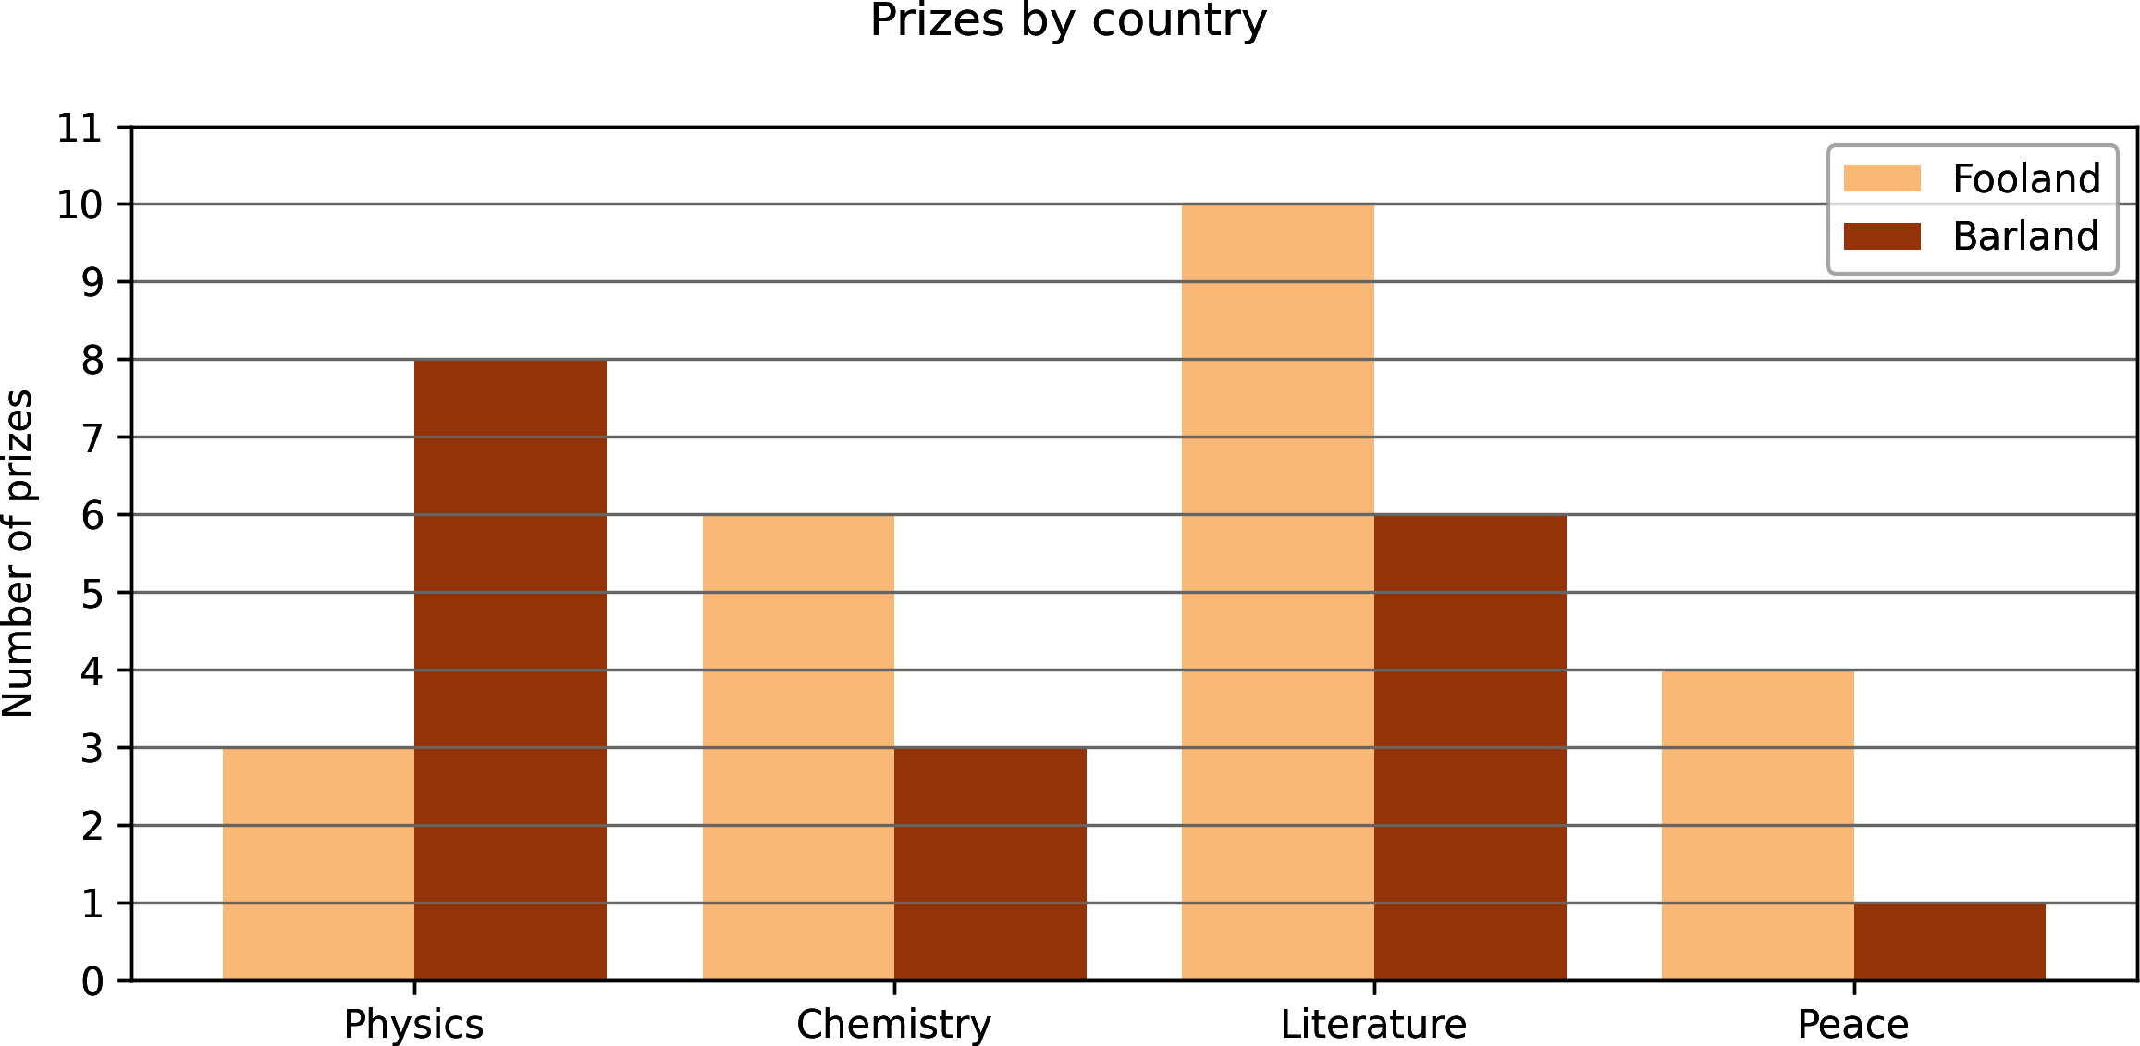

Figure 10-6. Grouped bar charts
It’s often useful to use horizontal bars, particularly if there are a lot of them and/or you are using tick labels, which are likely to run into one another if placed on the same line. Turning Figure 10-6 on its side is easy enough, requiring only that we replace the bar method with its horizontal counterpart barh and switch the axis labels and limits (see Example 10-7 and the resulting chart Figure 10-7).

Example 10-7. Converting Example 10-6 to horizontal bars
# ...
ylocs
=
np
.
arange
(
len
(
foo_data
)
)
ax
.
barh
(
ylocs
-
bar_width
,
foo_data
,
bar_width
,
color
=
'
#fde0bc
'
,
label
=
'
Fooland
'
)
ax
.
barh
(
ylocs
,
bar_data
,
bar_width
,
color
=
'
peru
'
,
label
=
'
Barland
'
)
# --- labels, grids and title, then save
ax
.
set_xticks
(
range
(
12
)
)
ax
.
set_yticks
(
ticks
=
ylocs
-
bar_width
/
2
)
ax
.
set_yticklabels
(
labels
)
ax
.
xaxis
.
grid
(
True
)
ax
.
legend
(
loc
=
'
best
'
)
ax
.
set_xlabel
(
'
Number of prizes
'
)
# ...
To create a horizontal bar chart, we use barh in place of bar.
A horizontal chart necessitates swapping the horizontal and vertical axes.
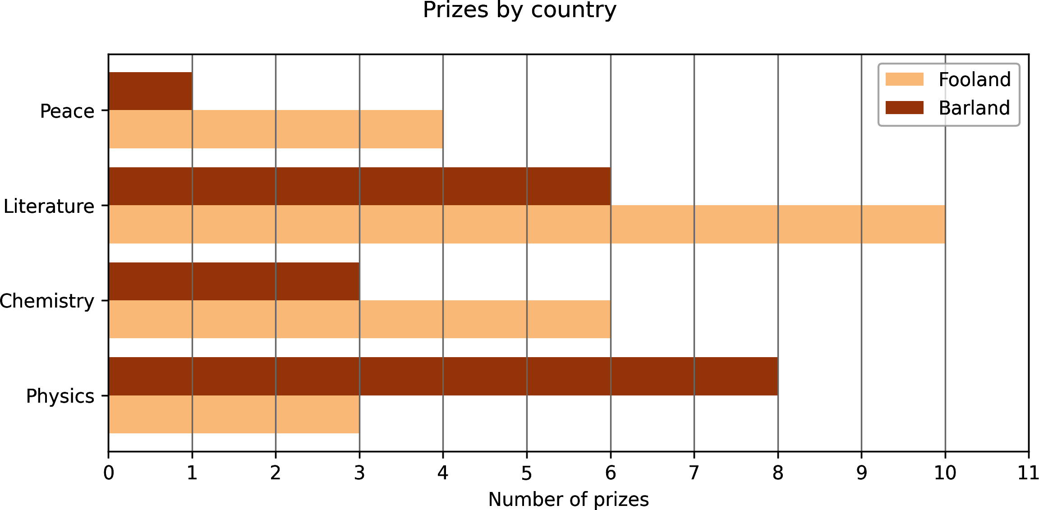

Figure 10-7. Turning the bars on their side
Stacked bars are easy to achieve in Matplotlib.10 Example 10-8 converts Figure 10-6 to a stacked form; Figure 10-8 shows the result. The trick is to use the bottom argument to bar to set the bottom of the raised bars as the top of the previous group.

Example 10-8. Converting Example 10-6 to stacked bars
# ...
bar_width
=
0.8
xlocs
=
np
.
arange
(
len
(
foo_data
)
)
ax
.
bar
(
xlocs
,
foo_data
,
bar_width
,
color
=
'
#fde0bc
'
,
label
=
'
Fooland
'
)
ax
.
bar
(
xlocs
,
bar_data
,
bar_width
,
color
=
'
peru
'
,
label
=
'
Barland
'
,
bottom
=
foo_data
)
# --- labels, grids and title, then save
ax
.
set_yticks
(
range
(
18
)
)
ax
.
set_xticks
(
ticks
=
xlocs
)
ax
.
set_xticklabels
(
labels
)
# ...
The foo_data and bar_data bar groups share the same x-locations.
The bottom of the bar_data group is the top of the foo_data, providing stacked bars.
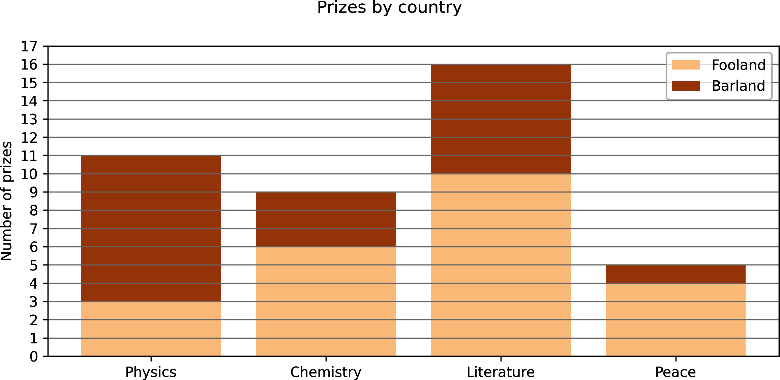

Figure 10-8. Stacked bar chart

Scatter Plots
Another useful chart is the scatter plot, which takes 2D arrays of points with options for point size, color, and more.
Example 10-9 shows the code for a quick scatter plot, using Matplotlib autoscaling for x and y limits. We create a noisy line by adding normally distributed random numbers (sigma of 10). Figure 10-9 shows the resulting chart.

Example 10-9. A simple scatter plot
num_points
=
100
gradient
=
0.5
x
=
np
.
array
(
range
(
num_points
)
)
y
=
np
.
random
.
randn
(
num_points
)
*
10
+
x
*
gradient
fig
,
ax
=
plt
.
subplots
(
figsize
=
(
8
,
4
)
)
ax
.
scatter
(
x
,
y
)
fig
.
suptitle
(
'
A Simple Scatterplot
'
)
randn gives normally distributed random numbers, which we scale to be within 0 and 10 and to which we then add an x-dependent value.
The equally sized x and y arrays provide the point coordinates.
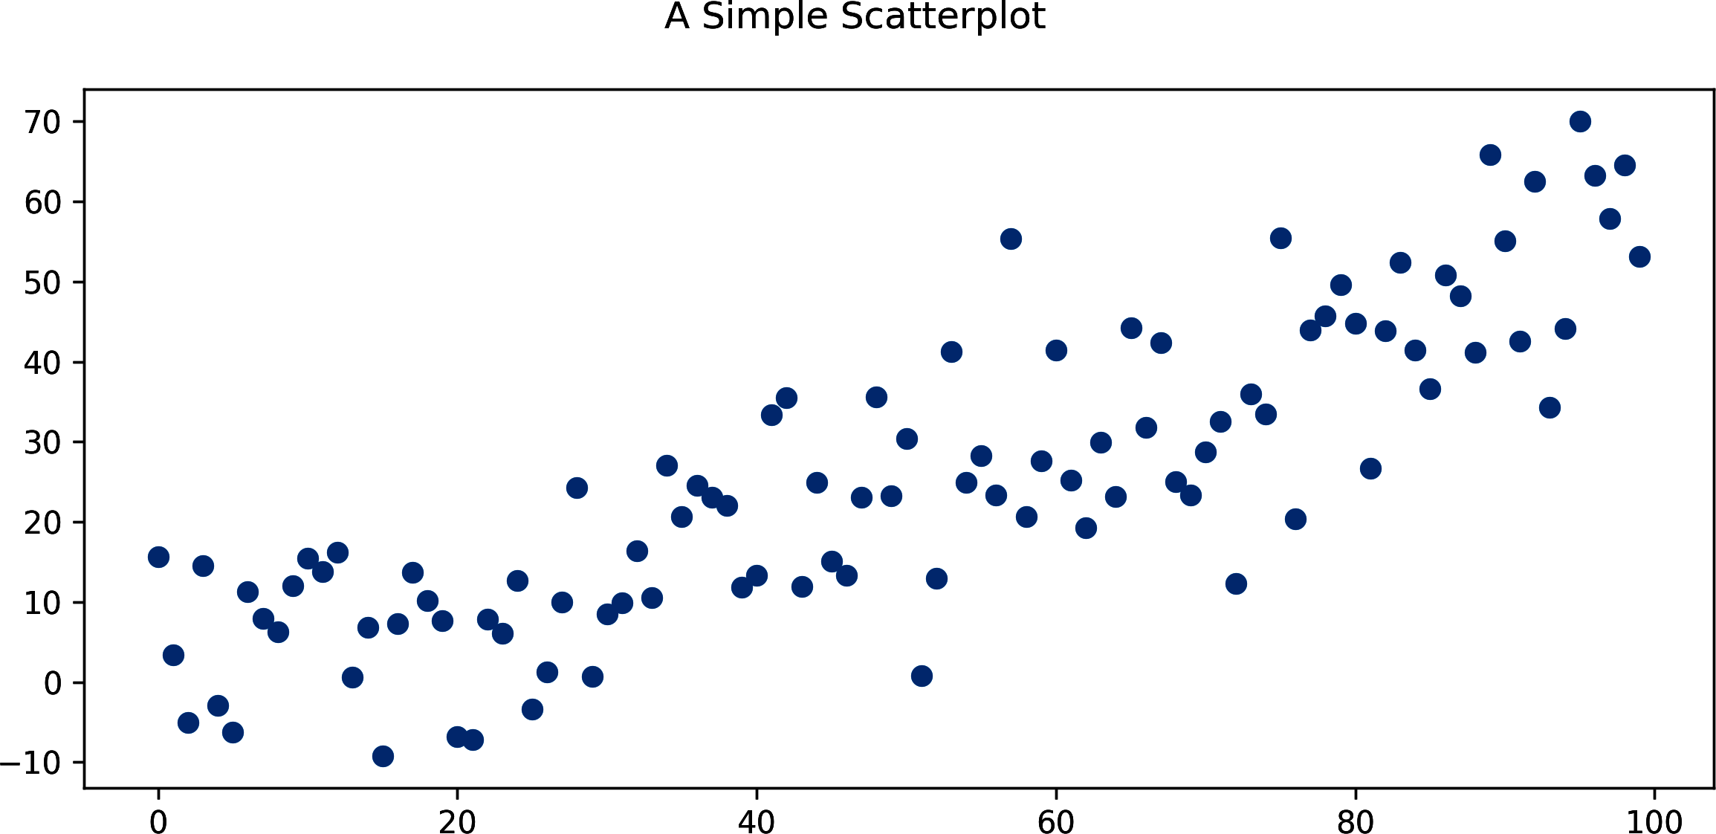

Figure 10-9. A simple scatter plot
We can adjust the size and color of individual points by passing an array of marker sizes and color indices to the current default colormap. One thing to note, which can be confusing, is that we are specifying the area of the markers’ bounding boxes, not the circles’ diameters. This means if we want points to double the diameter of the circles, we must increase the size by a factor of four.11 In Example 10-10, we add size and color information to our simple scatter plot, producing Figure 10-10.

Example 10-10. Adjusting point size and color
num_points
=
100
gradient
=
0.5
x
=
np
.
array
(
range
(
num_points
)
)
y
=
np
.
random
.
randn
(
num_points
)
*
10
+
x
*
gradient
fig
,
ax
=
plt
.
subplots
(
figsize
=
(
8
,
4
)
)
colors
=
np
.
random
.
rand
(
num_points
)
size
=
np
.
pi
*
(
2
+
np
.
random
.
rand
(
num_points
)
*
8
)
*
*
2
ax
.
scatter
(
x
,
y
,
s
=
size
,
c
=
colors
,
alpha
=
0.5
)
fig
.
suptitle
(
'
Scatterplot with Color and Size Specified
'
)
This produces 100 random color values between 0 and 1 for the default colormap.
We use the power notation ** to square values between 2 and 10, the width range for our markers.
We use the alpha argument to make our markers half-transparent.
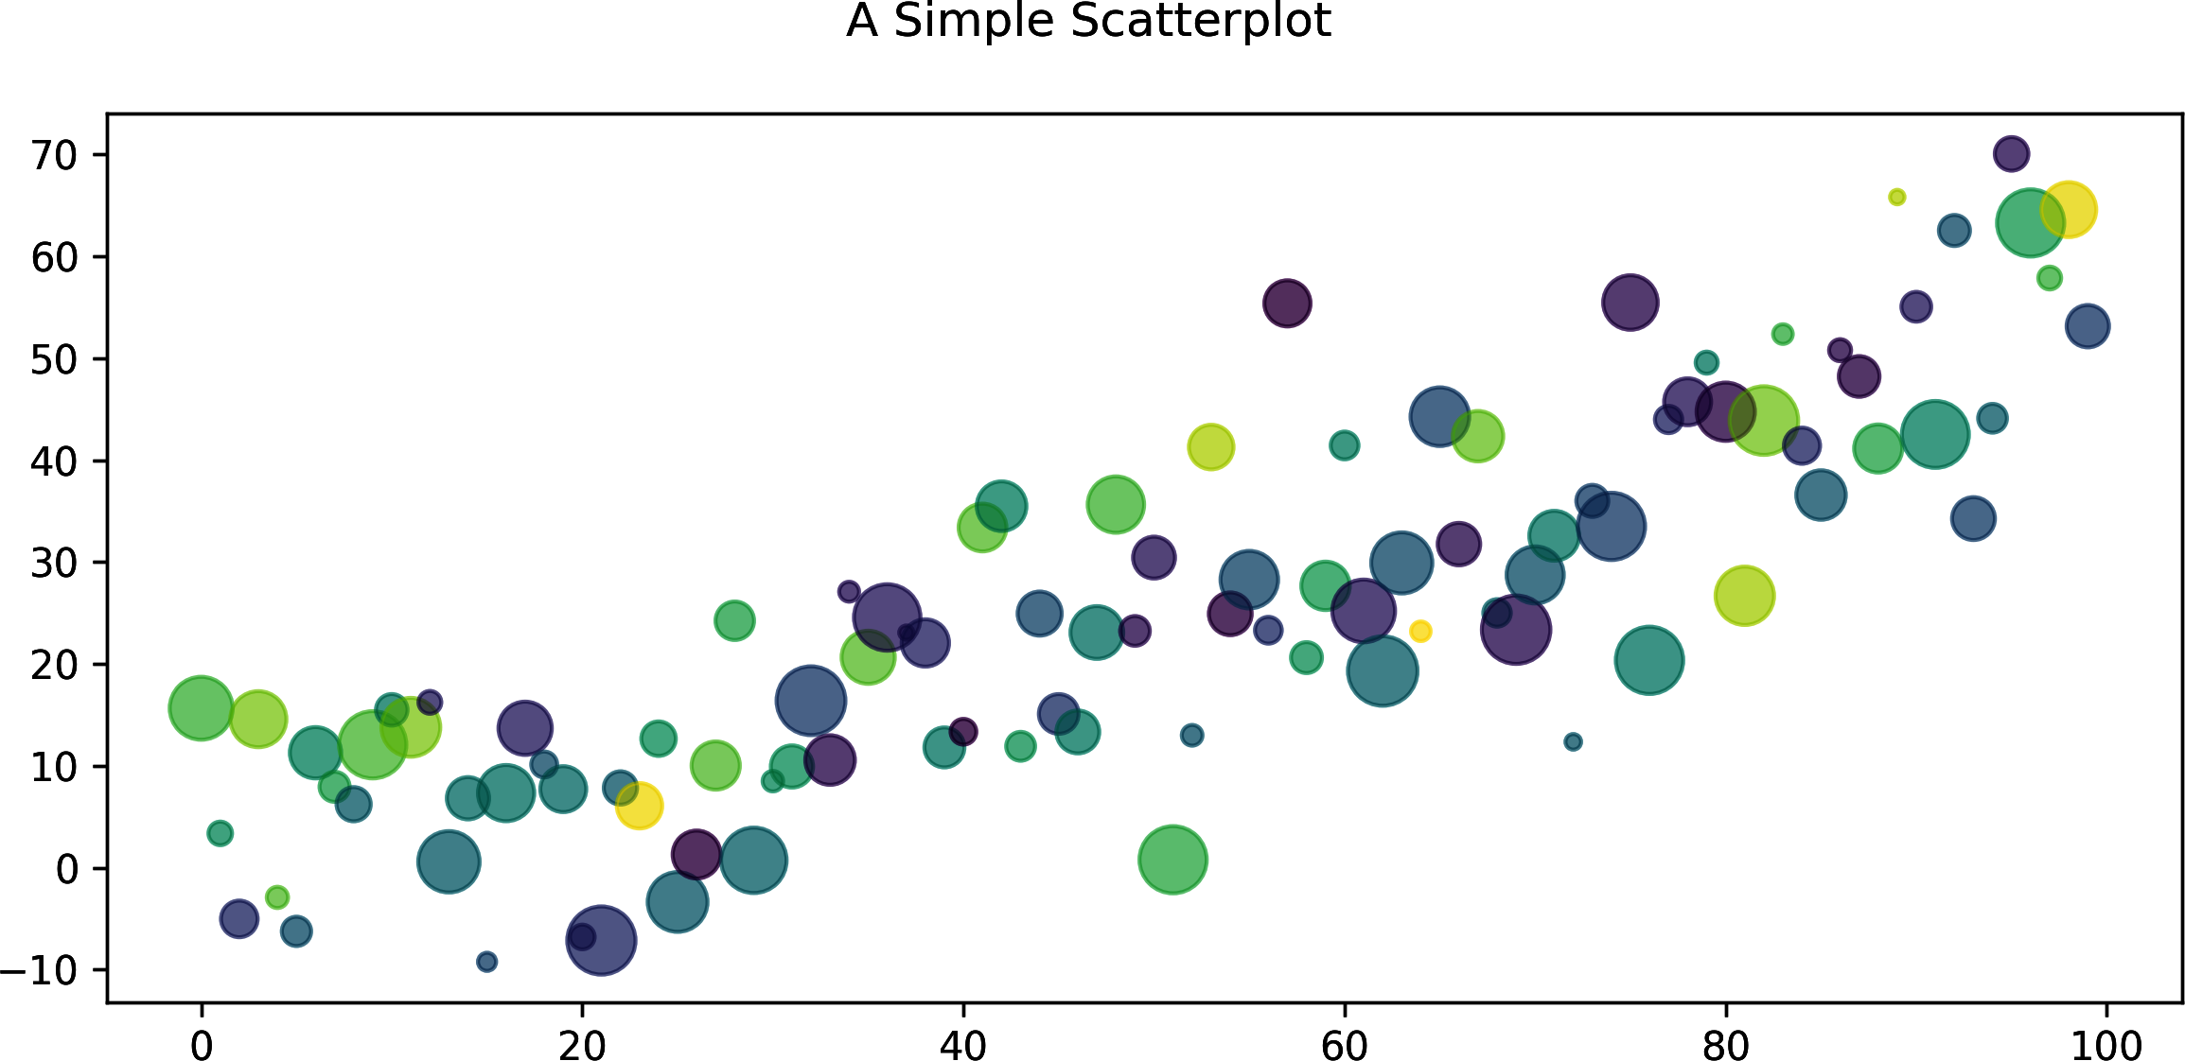

Figure 10-10. Adjusting point size and color
Matplotlib Colormaps
Matplotlib has a huge variety of colormaps available, the choice of which can significantly improve the quality of your visualization. See the colormap docs for details.

Adding a regression line
A regression line is a simple predictive model of the correlation between two variables, in this case the x and y coordinates of our scatter plot. The line is essentially a best fit through the points of the plot, and adding one to a scatter plot is a useful dataviz technique and a good way to demo Matplotlib and NumPy interaction.
In Example 10-11 NumPy’s very useful polyfit function is used to generate the gradient and constant of a best-fit line for the points defined by the x and y arrays. We then plot this line on the same axes as the scatter plot (see Figure 10-11).

Example 10-11. Scatter plot with regression line
num_points
=
100
gradient
=
0.5
x
=
np
.
array
(
range
(
num_points
)
)
y
=
np
.
random
.
randn
(
num_points
)
*
10
+
x
*
gradient
fig
,
ax
=
plt
.
subplots
(
figsize
=
(
8
,
4
)
)
ax
.
scatter
(
x
,
y
)
m
,
c
=
np
.
polyfit
(
x
,
y
,
1
)
ax
.
plot
(
x
,
m
*
x
+
c
)
fig
.
suptitle
(
'
Scatterplot With Regression-line
'
)
We use NumPy’s polyfit in 1D to get a line gradient (m) and constant (c) for a best-fit line through our random points.
Use the gradient and constant to plot a line on the scatter plot’s axes (y = mx + c).
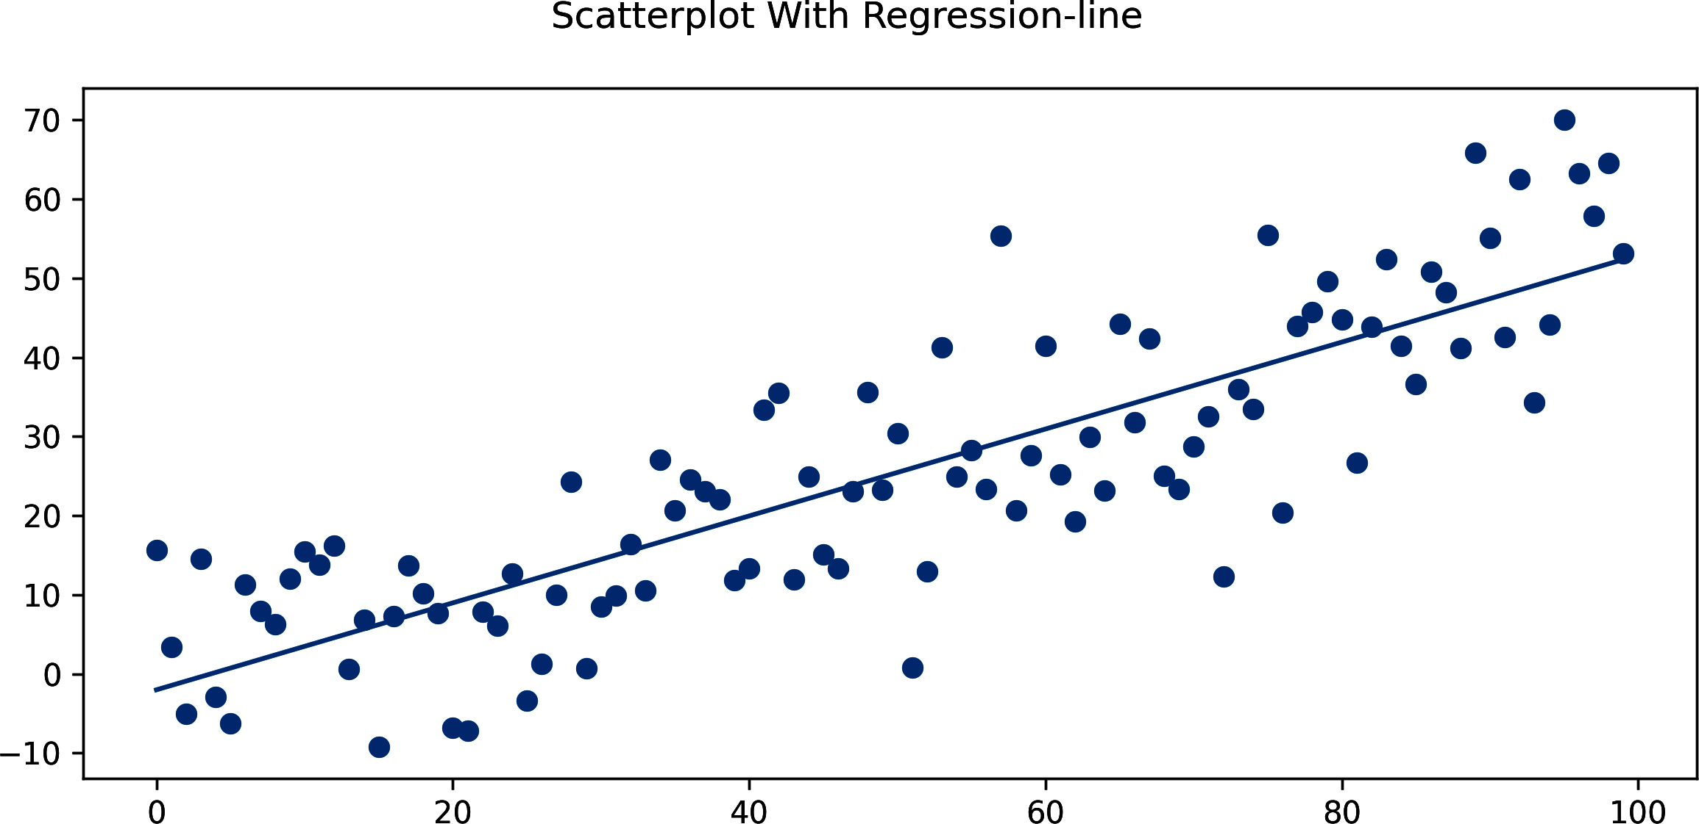

Figure 10-11. Scatter plot with regression line
It’s generally a good idea to plot confidence intervals when doing line regression. This gives an idea of how reliable the line fit is, based on the number and distribution of the points. Confidence intervals can be achieved with Matplotlib and NumPy, but it is a little awkward. Luckily, there is a library built on Matplotlib that has extra, specialized functions for statistical analysis and data visualization and, in the opinion of many, looks a lot better than Matplotlib’s defaults. That library is seaborn, which we are going to take a quick look at now.

seaborn
There are a number of libraries that wrap the powerful plotting abilities of Matplotlib in a more user-friendly guise12 and, as important for us data visualizers, play nicely with pandas.
Bokeh is an interactive visualization library with the web in mind, producing browser-rendered output and therefore playing very nicely with IPython notebook. It’s a great achievement, with a design philosophy similar to D3’s.13
But for the kind of interactive, exploratory dataviz necessary to get a feel for your data and suggest visualizations, I recommend seaborn. seaborn extends Matplotlib with some powerful statistical plots and is well integrated with the PyData stack, playing nicely with NumPy, pandas, and the statistical routines found in SciPy and statsmodels.
One of the nice things about seaborn is that it doesn’t hide the Matplotlib API, allowing you to tweak your charts with Matplotlib’s extensive tools. In this sense, it’s not a replacement for Matplotlib and the relevant skills, but a very impressive extension.
To work with seaborn, simply extend your standard Matplotlib imports:
import
numpy
as
np
import
pandas
as
pd
import
seaborn
as
sns
# relies on matplotlib
import
matplotlib
as
mpl
import
matplotlib.pyplot
as
plt
Matplotlib provides a number of plotting styles that can be invoked by calling a use method with a style key. Let’s set the current style to seaborn’s default, which will provide a subtle gray grid to the charts:
matplotlib
.
style
.
use
(
'seaborn'
)
You can check out all available styles and their visual effects in the Matplotlib documentation.
Many of seaborn’s functions are designed to accept a pandas DataFrame, allowing you to specify, for example, the column values describing 2D scattered points. Let’s take our existing x and y arrays from Example 10-9 and use them to make some dummy data:
data
=
pd
.
DataFrame
({
'dummy x'
:
x
,
'dummy y'
:
y
})
We now have some data with columns of x ('dummy x') and y ('dummy y') values. Example 10-12 demonstrates the use of seaborn’s dedicated linear regression plot lmplot, which produces the chart in Figure 10-12. Note that for some seaborn plots, to adjust figure size we pass a size (height) in inches and an aspect ratio (width/height). Note also that seaborn shares pyplot’s global context.

Example 10-12. Linear regression plot with seaborn
data
=
pd
.
DataFrame
(
{
'
dummy x
'
:
x
,
'
dummy y
'
:
y
}
)
sns
.
lmplot
(
data
=
data
,
x
=
'
dummy x
'
,
y
=
'
dummy y
'
,
height
=
4
,
aspect
=
2
)
plt
.
tight_layout
(
)
plt
.
savefig
(
'
mpl_scatter_seaborn.png
'
)
The x and y arguments specify the column names of the DataFrame data that define the coordinates of the plot points.
To set figure size, we provide the height in inches and an aspect ratio of width/height. Here we’ll use a ratio of two to better fit this book’s page format.
seaborn shares the pyplot global context, allowing you to save its plots as you would Matplotlib’s.
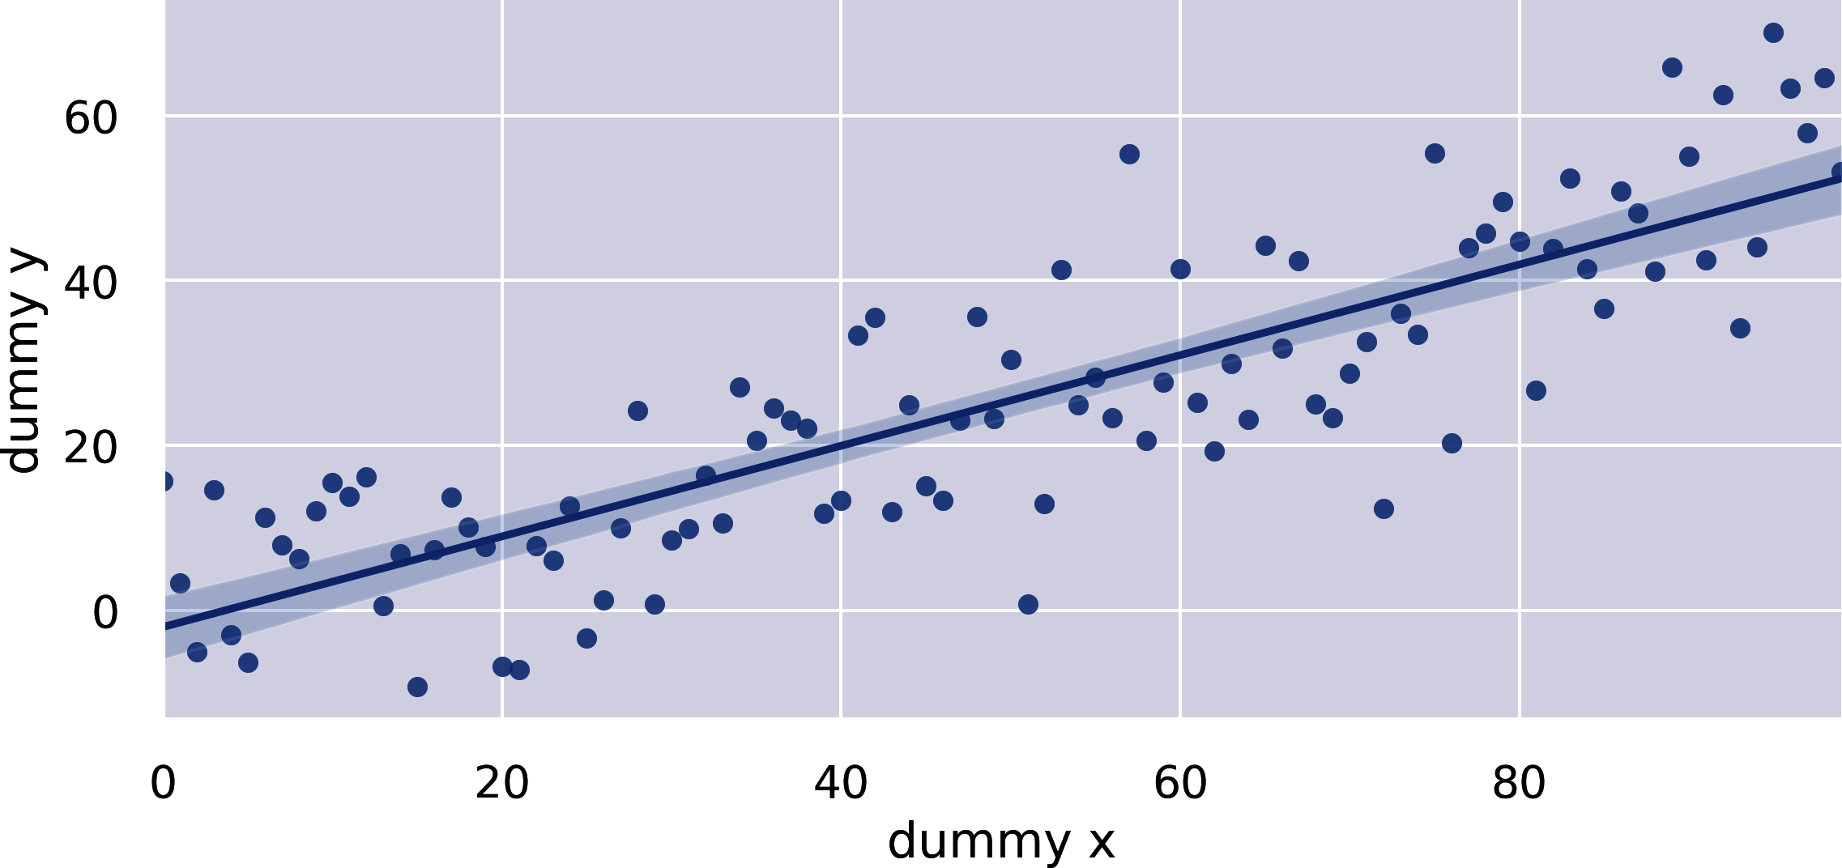

Figure 10-12. Linear regression plot with seaborn
As you would expect from a library that places an emphasis on attractive-looking plots, seaborn allows a lot of visual customization. Let’s make a few changes to the look of Figure 10-12 and adjust the confidence interval to the standard error estimate of 68% (see Figure 10-13 for the result):
sns
.
lmplot
(
data
=
data
,
x
=
'
dummy x
'
,
y
=
'
dummy y
'
,
height
=
4
,
aspect
=
2
,
scatter_kws
=
{
"
color
"
:
"
slategray
"
}
,
line_kws
=
{
"
linewidth
"
:
2
,
"
linestyle
"
:
'
--
'
,
"
color
"
:
"
seagreen
"
}
,
markers
=
'
D
'
,
ci
=
68
)
Provide the scatter plot component’s keyword arguments, setting our points’ color to slate gray.
Provide the line plot component’s keyword arguments, setting line width and style.
Set the plot markers to diamonds using Matplotlib marker code D.
We set a confidence interval of 68%, the standard error estimate.
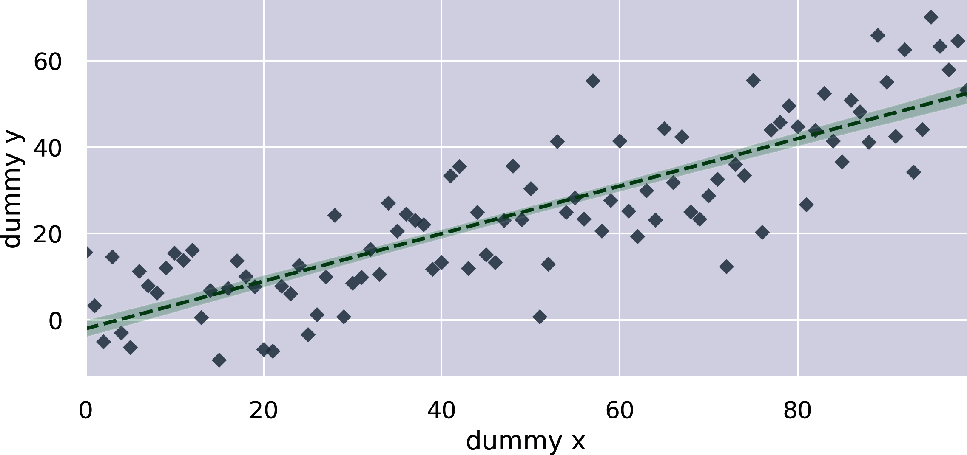

Figure 10-13. Customizing the seaborn scatter plot
seaborn offers a number of useful plots beyond Matplotlib’s basic set. Let’s take a look at one of the most interesting, using seaborn’s FacetGrid to plot reflections of multidimensional data.

FacetGrids
Often referred to as “lattice” or “trellis” plotting, the ability to draw multiple instances of the same plot on different subsets of your dataset is a good way to get a bird’s-eye view of your data. Large amounts of information can be presented in one plot, and relationships between the different dimensions can be quickly apprehended. This technique is related to the small multiples popularized by Edward Tufte.
FacetGrids require the data to be in the form of a pandas DataFrame (see “The DataFrame”) and in a form referred to by Hadley Wickham, creator of ggplot2, as “tidy,” meaning each column in the DataFrame should be a variable and each row an observation.
Let’s use Tips, one of seaborn’s test datasets,14 to show a FacetGrid in action. Tips is a small set of data showing the distribution of tips by various dimensions, such as day of the week or whether the customer was a smoker.15 First, let’s load our Tips dataset into a pandas DataFrame using the load_dataset method:
In
[
0
]:
tips
=
sns
.
load_dataset
(
'tips'
)
Out
[
0
]:
total_bill
tip
sex
smoker
day
time
size
0
16.99
1.01
Female
No
Sun
Dinner
2
1
10.34
1.66
Male
No
Sun
Dinner
3
2
21.01
3.50
Male
No
Sun
Dinner
3
3
23.68
3.31
Male
No
Sun
Dinner
2
...
To create a FacetGrid, we specify the tips DataFrame and a column of interest, such as the smoking status of the customer. This column will be used to create our plot groups. There are two categories in the smoker column ('smoker=Yes' and 'smoker=No'), which means there will be two charts in our facet-grid. We then use the grid’s map method to create multiple scatter plots of tip size against total bill:
g
=
sns
.
FacetGrid
(
tips
,
col
=
"
smoker
"
,
height
=
4
,
aspect
=
1
)
g
.
map
(
plt
.
scatter
,
"
total_bill
"
,
"
tip
"
)
map takes a plot class, in this case scatter, and two (tips) dimensions required for this scatter plot.
This produces the two scatter plots shown in Figure 10-14, one for each smoker status, with tips and total bills correlated.
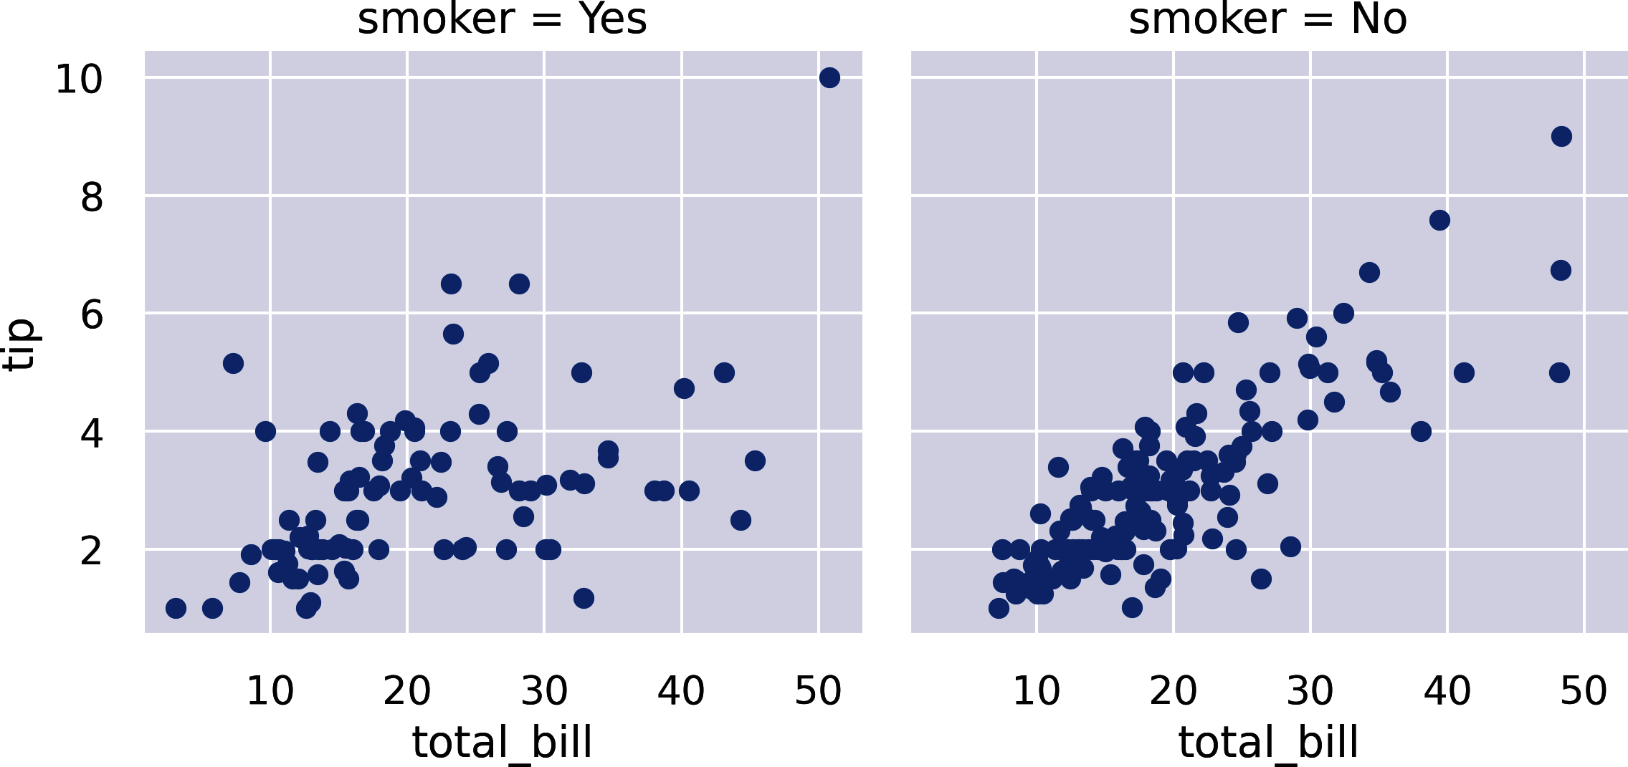

Figure 10-14. A seaborn FacetGrid using scatter plots
We can include another dimension of the tips data by specifying the marker to be used in our scatter plots. Let’s make it a red diamond for females and a blue square for males:
pal
=
dict
(
Female
=
'
red
'
,
Male
=
'
blue
'
)
g
=
sns
.
FacetGrid
(
tips
,
col
=
"
smoker
"
,
hue
=
"
sex
"
,
hue_kws
=
{
"
marker
"
:
[
"
D
"
,
"
s
"
]
}
,
palette
=
pal
,
height
=
4
,
aspect
=
1
,
)
g
.
map
(
plt
.
scatter
,
"
total_bill
"
,
"
tip
"
,
alpha
=
.4
)
g
.
add_legend
(
)
;
Adds a marker color (hue) for the sex dimension with diamond (D) and square (s) shapes, and uses our color palette (pal) to make them red and blue.
You can see the resulting FacetGrid in Figure 10-15.
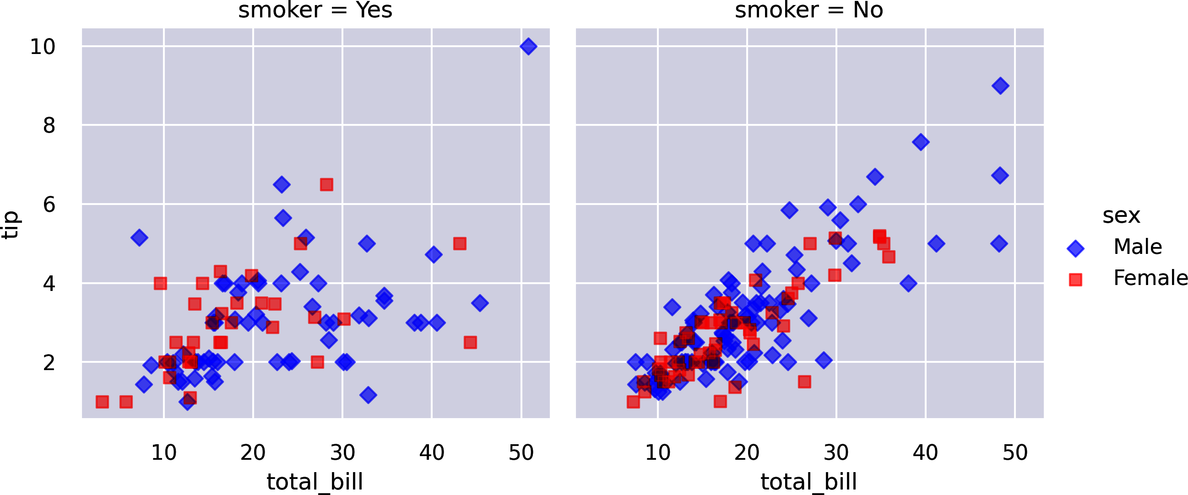

Figure 10-15. Scatter plot with diamond and square markers for sex
We can use rows as well as columns to create subsets of the data by dimension. Combining the two allows, with the help of a regplot,16 five dimensions to be explored:
pal
=
dict
(
Female
=
'
red
'
,
Male
=
'
blue
'
)
g
=
sns
.
FacetGrid
(
tips
,
col
=
"
smoker
"
,
row
=
"
time
"
,
hue
=
"
sex
"
,
hue_kws
=
{
"
marker
"
:
[
"
D
"
,
"
s
"
]
}
,
palette
=
pal
,
height
=
4
,
aspect
=
1
,
)
g
.
map
(
sns
.
regplot
,
"
total_bill
"
,
"
tip
"
,
alpha
=
.4
)
g
.
add_legend
(
)
;
Adds a time row to separate tips by lunch and dinner.
Figure 10-16 shows four regplots producing a linear-regression model fit with confidence intervals for female and male hue-groups. The plot titles show the data subset being used, each row having the same time and smoker status.
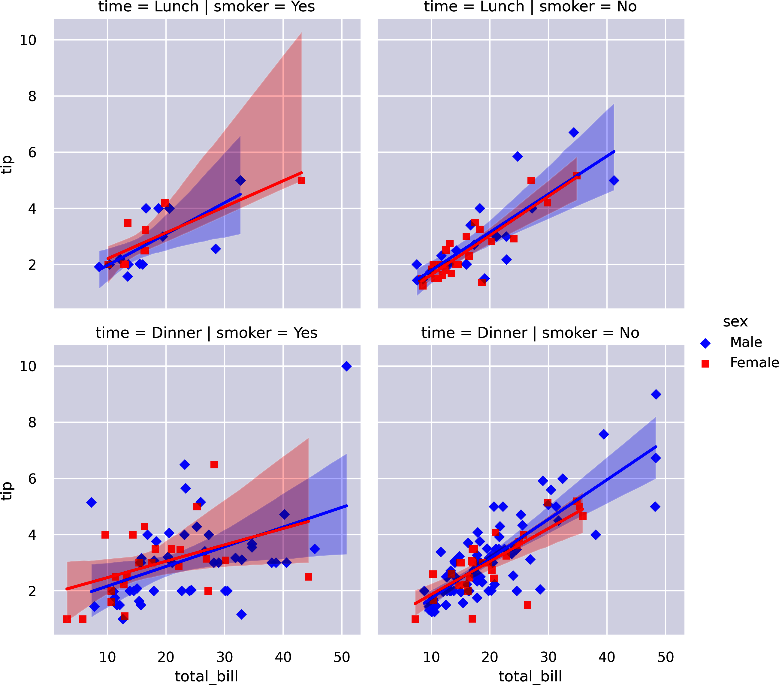

Figure 10-16. Visualizing five dimensions
We can achieve the same effect using the lmplot we saw in Example 10-12, which wraps the functionality of FacetGrid and regplot for convenience. The following code produces Figure 10-16:
pal
=
dict
(
Female
=
'
red
'
,
Male
=
'
blue
'
)
sns
.
lmplot
(
x
=
"
total_bill
"
,
y
=
"
tip
"
,
hue
=
"
sex
"
,
markers
=
[
"
D
"
,
"
s
"
]
,
col
=
"
smoker
"
,
row
=
"
time
"
,
data
=
tips
,
palette
=
pal
,
height
=
4
,
aspect
=
1
)
;
Note the use of a markers keyword as opposed to the kws_hue dictionary we used with the FacetGrid plot.
lmplot offers a nice shortcut to producing FacetGrid regplots, but FacetGrid’s map allows you to use the full panoply of seaborn and Matplotlib charts to create plots on dimensional subsets. It’s a very powerful technique and a great way to drill down into your data.

PairGrids
PairGrids are another rather cool seaborn plot type that provide a way to quickly assess multidimensional data. Unlike with FacetGrids, you don’t divide the dataset into subsets that are then compared by designated dimensions. With PairGrids, the dataset’s dimensions are all compared pair-wise in a square grid. By default all dimensions are compared, but you can specify which ones get plotted by providing a list to the vars parameter when declaring the PairGrid.17
Let’s demonstrate the utility of this pair-wise comparison by using the classic Iris dataset, showing some vital statistics for a set containing members of three Iris species. First, we’ll load the example dataset:
In
[
0
]:
iris
=
sns
.
load_dataset
(
'iris'
)
In
[
1
]:
iris
.
head
()
Out
[
1
]:
sepal_length
sepal_width
petal_length
petal_width
species
0
5.1
3.5
1.4
0.2
setosa
1
4.9
3.0
1.4
0.2
setosa
2
4.7
3.2
1.3
0.2
setosa
...
To capture the relationship between petal and sepal dimensions by species, we first create a PairGrid object, set its hue to species, and then use its mapping methods to create plots on and off the diagonal of the pair-wise grid, producing the charts in Figure 10-17:
sns
.
set_theme
(
font_scale
=
1.5
)
g
=
sns
.
PairGrid
(
iris
,
hue
=
"
species
"
)
g
.
map_diag
(
plt
.
hist
)
g
.
map_offdiag
(
plt
.
scatter
)
g
.
add_legend
(
)
;
Tweaks the font size using seaborn’s set_theme method (see the documentation for the full list of available tweaks).
Sets the markers and subbars to be colored by species.
Places histograms of the species’ dimensions on the grid’s diagonal.
Uses standard scatter plots to compare the dimensions of the diagonal.
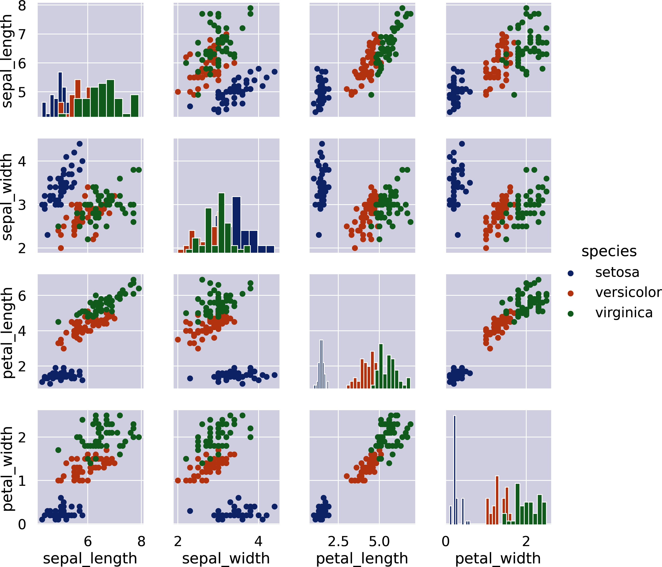

Figure 10-17. PairGrid summation of Iris measures
As you can see in Figure 10-17, a few lines of seaborn go a long way in creating a richly informative set of plots correlating the different Iris metrics. This plot is known as a scatter-plot matrix and is a great way of finding linear correlations between pairs of variables in a multivariate set. As it stands, there is redundancy in the grid: for example, plots for sepal_width-petal_length and petal_length-septal_width. PairGrid gives you the opportunity to use the redundant plots above or below the main diagonal to provide a different reflection of the data. Check out some of the examples at the seaborn docs for more info.18
I’ve covered a few of the seaborn plots in this section, and you’ll be seeing a few more when we explore our Nobel Prize dataset in the next chapter. But seaborn has a lot of other very handy and very powerful plotting tools, mainly of a statistical nature. For further investigation, I’d recommend starting with the main seaborn documentation. There are some nice examples, a well-documented API, and some good tutorials that should complement what you’ve learned in this chapter.

Summary
This chapter introduced Matplotlib, Python’s plotting powerhouse. It’s a big, mature library with lots of documentation and an active community. If you have a particular customization in mind, chances are there’s an example out there somewhere. I’d recommend firing up a Jupyter notebook and playing around with a dataset.
We saw how seaborn extends Matplotlib with some useful statistical methods and that it has what many consider to be superior aesthetics. It also allows access to the Matplotlib figure and axes internals, allowing full customization if required.
In the next chapter, we’ll use Matplotlib along with pandas to explore our freshly scraped and cleaned Nobel dataset. We’ll use some of the plot types demonstrated in this chapter and see a few useful new ones.
1 If you have errors trying to start a GUI session, try changing the backend setting (e.g., if using macOS and %matplotlib qt doesn’t work, try %matplotlib osx).
2 IPython has a large number of such functions to enable a whole slew of useful extras to the vanilla Python interpreter. Check them out on the IPython website.
3 This was inspired by MATLAB.
4 You can find details of Matplotlib’s line styles in its documentation.
5 See the docs for more details.
6 See the Matplotlib website for details.
7 As well as providing many formats, it also understands LaTeX math mode, which is a language that will allow you to use mathematical symbols in the titles, legends, and the like. This is one of the reasons Matplotlib is much beloved by academics, as it is quite capable of journal-quality images.
8 More details are available on the Matplotlib website.
9 The handy tight_layout option assumes grid-layout subplots.
10 It’s questionable whether stacked bar charts are a particularly good way of appreciating groups of data. See Solomon Messing’s blog for a nice discussion and one example of “good” use.
11 Setting marker size, rather than width or radius, is actually a good default, making it proportional to whatever value we are trying to reflect.
12 It’s generally agreed that Matplotlib’s defaults aren’t that great and making them better is an easy win for any wrapper.
13 Both D3 and Bokeh tip their hats to the classic visualization text, Leland Wilkinson’s The Grammar of Graphics (Springer).
14 seaborn has a number of handy datasets, which you can find on GitHub.
15 The Tips dataset uses sex as a category, whereas the datasets in this book have used gender. In the past these tended to be used interchangeably, but this is no longer the case. See this Yale School of Medicine article for an explanation.
16 regplot, short for regression plot, is equivalent to lmplot, used in Example 10-12. The latter combines regplot and FacetGrid for convenience.
17 There are also x_vars and y_vars parameters enabling you to specify nonsquare grids.
18 For the curious, there’s a D3 example that builds a scatter-plot matrix at the bl.ocks.org site.

Chapter 11. Exploring Data with pandas
In the previous chapter, we cleaned the Nobel Prize dataset that we scraped from Wikipedia in Chapter 6. Now it’s time to start exploring our shiny new dataset, looking for interesting patterns, stories to tell, and anything else that could form the basis for an interesting visualization.
First off, let’s try to clear our minds and take a long, hard look at the data to hand to get a broad idea of the visualizations suggested. Example 11-1 shows the form of the Nobel dataset, with categorical, temporal, and geographical data.

Example 11-1. Our cleaned Nobel Prize dataset
[{
'category'
:
'Physiology or Medicine'
,
'date_of_birth'
:
'8 October 1927'
,
'date_of_death'
:
'24 March 2002'
,
'gender'
:
'male'
,
'link'
:
'http://en.wikipedia.org/wiki/C%C3%A9sar_Milstein'
,
'name'
:
'César Milstein'
'country'
:
'Argentina'
,
'place_of_birth'
:
'Bahía Blanca, Argentina'
,
'place_of_death'
:
'Cambridge , England'
,
'year'
:
1984
,
'born_in'
:
NaN
},
...
]
The data in Example 11-1 suggests a number of stories we might want to investigate, among them:
- Gender disparities among the prize winners
- National trends (e.g., which country has most prizes in Economics)
- Details about individual winners, such as their average age on receiving the prize or life expectancy
- Geographical journey from place of birth to adopted country using the born_in and country fields
These investigative lines form the basis for the coming sections, which will probe the dataset by asking questions of it, such as “How many women other than Marie Curie have won the Nobel Prize for Physics?”, “Which countries have the most prizes per capita rather than absolute?”, and “Is there a historical trend to prizes by nation, a changing of the guard from old (science) world (big European nations) to new (US and upcoming Asian nations)?” Before beginning our explorations, let’s ready our tools and load our Nobel Prize dataset.

Starting to Explore
To start our exploration, let’s fire up a Jupyter notebook from the command line:
$ jupyter notebook
We’ll use the magic matplotlib command to enable inline plotting:
%
matplotlib
inline
Then import the standard set of data exploration modules:
import
pandas
as
pd
import
numpy
as
np
import
matplotlib.pyplot
as
plt
import
json
import
matplotlib
import
seaborn
as
sns
Now we’ll make a few adjustments to the plotting parameters and the general look and feel of the charts. Make sure to change the style before adjusting figure sizes, fonts, and the rest:
matplotlib
.
style
.
use
(
'
seaborn
'
)
plt
.
rcParams
[
'
figure.figsize
'
]
=
(
8
,
4
)
plt
.
rcParams
[
'
font.size
'
]
=
'
14
'
We’ll use the seaborn theming for our charts, arguably more attractive than Matplotlib’s default.
Sets the default plotting size to eight inches by four.
At the end of Chapter 9, we saved our clean dataset as a JSON file. Let’s load the clean data into a pandas DataFrame, ready to begin exploring.
df
=
pd
.
read_json
(
open
(
'data/nobel_winners_cleaned.json'
))
Let’s get some basic information about our dataset’s structure:
df
.
info
()
<
class
'
pandas
.
core
.
frame
.
DataFrame
'>
RangeIndex
:
858
entries
,
0
to
857
Data
columns
(
total
13
columns
):
# Column Non-Null Count Dtype
---
------
--------------
-----
0
category
858
non
-
null
object
1
country
858
non
-
null
object
2
date_of_birth
858
non
-
null
object
3
date_of_death
559
non
-
null
object
4
gender
858
non
-
null
object
5
link
858
non
-
null
object
6
name
858
non
-
null
object
7
place_of_birth
831
non
-
null
object
8
place_of_death
524
non
-
null
object
9
text
858
non
-
null
object
10
year
858
non
-
null
int64
11
award_age
858
non
-
null
int64
12
born_in
102
non
-
null
object
13
bio_image
770
non
-
null
object
14
mini_bio
857
non
-
null
object
dtypes
:
int64
(
2
),
object
(
13
)
memory
usage
:
100.7
+
KB
Note that our dates of birth and death columns have the standard pandas datatype of object. In order to make date comparisons, we’ll need to convert those to the datetime type, datetime64. We can use pandas’s to_datetime method to achieve this conversion:
df
.
date_of_birth
=
pd
.
to_datetime
(
df
.
date_of_birth
)
df
.
date_of_death
=
pd
.
to_datetime
(
df
.
date_of_death
)
Running df.info() should now show two datetime columns:
df
.
info
(
)
.
.
.
date_of_birth
858
non
-
null
datetime64
[
ns
,
UTC
]
date_of_death
559
non
-
null
datetime64
[
ns
,
UTC
]
.
.
.
UTC (Coordinated Universal Time in English) is the primary time standard by which the world regulates clocks and time. It’s almost always desirable to work to this standard.
to_datetime usually works without needing extra arguments and should throw an error if given non time-based data, but it’s worth checking the converted columns to make sure. In the case of our Nobel Prize dataset, everything checks out.

Plotting with pandas
Both pandas Series and DataFrames have integrated plotting, which wraps the most common Matplotlib charts, a few of which we explored in the last chapter. This makes it easy to get quick visual feedback as you interact with your DataFrame. And if you want to visualize something a little more complicated, the pandas containers will play nicely with vanilla Matplotlib. You can also adapt the plots produced by pandas using standard Matplotlib customizations.
Let’s look at an example of pandas’s integrated plotting, starting with a basic plot of gender disparity in Nobel Prize wins. Notoriously, the Nobel Prize has been distributed unequally among the genders. Let’s get a quick feel for that disparity by using a bar plot on the gender category. Example 11-2 produces Figure 11-1, showing the huge difference, with males receiving 811 of the 858 prizes in our dataset.

Example 11-2. Using pandas’s integrated plotting to see gender disparities
by_gender
=
df
.
groupby
(
'gender'
)
by_gender
.
size
()
.
plot
(
kind
=
'bar'
)
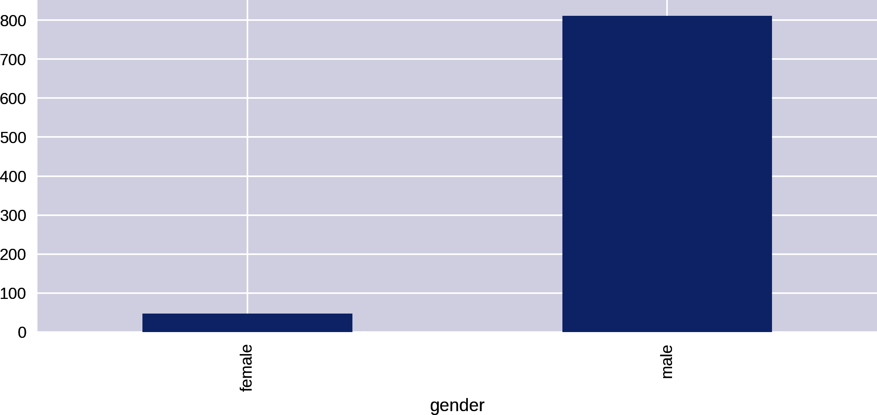

Figure 11-1. Prize counts by gender
In Example 11-2, the Series produced by the gender group’s size method has its own integrated plot method, which turns the raw numbers into a chart:
by_gender
.
size
()
Out
:
gender
female
47
male
811
dtype
:
int64
In addition to the default line plot, the pandas plot method takes a kind argument to select among other possible plots. Among the more commonly used are:
- bar or barh (h for horizontal) for bar plots
- hist for a histogram
- box for a box plot
- scatter for scatter plots
You can find a full list of pandas’s integrated plots in the docs as well as some pandas plotting functions that take DataFrames and Series as arguments.
Let’s extend our investigation into gender disparities and start extending our plotting know-how.

Gender Disparities
Let’s break down the gender numbers shown in Figure 11-1 by category of prize. pandas’s groupby method can take a list of columns to group by, with each group being accessed by multiple keys:
by_cat_gen
=
df
.
groupby
(
[
'
category
'
,
'
gender
'
]
)
by_cat_gen
.
get_group
(
(
'
Physics
'
,
'
female
'
)
)
[
[
'
name
'
,
'
year
'
]
]
Gets a group using a category and gender key:
Out:
name year
269 Maria Goeppert-Mayer 1963
612 Marie Skłodowska-Curie 1903
Using the size method to get the size of these groups returns a Series with a MultiIndex that labels the values by both category and gender:
by_cat_gen
.
size
()
Out:
category gender
Chemistry female 4
male 167
Economics female 1
male 74
...
Physiology or Medicine female 11
male 191
dtype: int64
We can plot this multi-indexed Series directly, using hbar as the kind argument to produce a horizontal bar chart. This code produces Figure 11-2.
by_cat_gen
.
size
()
.
plot
(
kind
=
'barh'
)
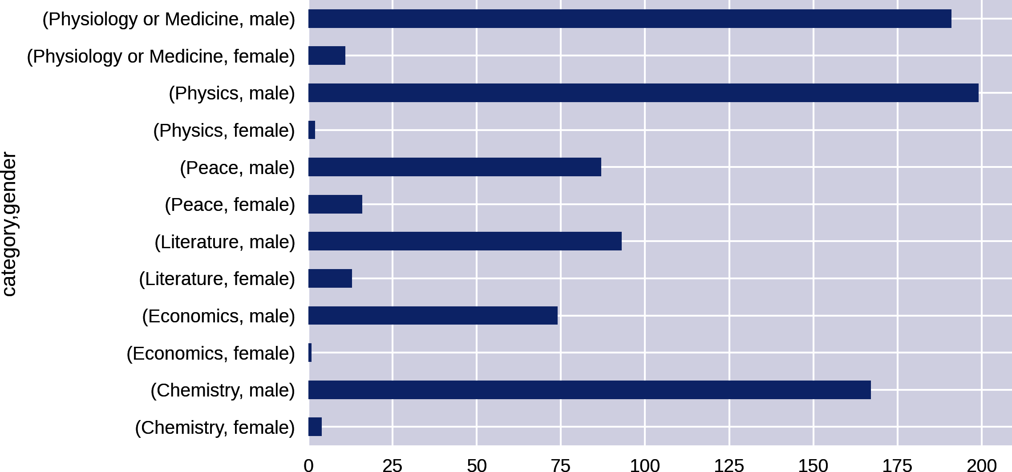

Figure 11-2. Plotting multikey groups
Figure 11-2 is a little crude and makes comparing gender disparities harder than it should be. Let’s go about refining our charts to make those disparities clearer.

Unstacking Groups
Figure 11-2 isn’t the easiest chart to read, even were we to improve the sorting of the bars. Handily, pandas Series has a cool unstack method that takes the multiple indices—​in this case, gender and category—​and uses them as columns and indices, respectively, to create a new DataFrame. Plotting this DataFrame gives a much more usable plot, as it compares prize wins by gender. The following code produces Figure 11-3:
by_cat_gen
.
size
()
.
unstack
()
.
plot
(
kind
=
'barh'
)
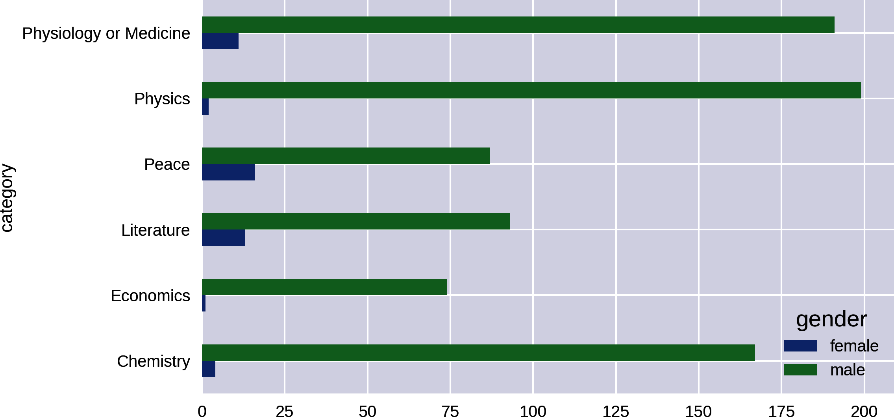

Figure 11-3. Unstacked Series of group sizes
Figure 11-3 shows a huge discrepancy between male and female prize numbers. Let’s make the data a little more concrete by using pandas to produce a chart showing the percentage of female winners by category. We’ll also order the category bars by prize haul.
First, we’ll unstack the by_cat_gen group to produce a cat_gen_sz DataFrame:
cat_gen_sz
=
by_cat_gen
.
size
()
.
unstack
()
cat_gen_sz
.
head
()
gender female male
category
Chemistry 4 167
Economics 1 74
Literature 13 93
Peace 16 87
Physics 2 199
We’ll do the pandas manipulation in two stages for demonstration purposes, using two new columns to store our new data. First, we’ll make a column containing the ratio of female winners to the total number of winners:
cat_gen_sz
[
'
ratio
'
]
=
cat_gen_sz
.
female
/
\
(
cat_gen_sz
.
female
+
cat_gen_sz
.
male
)
cat_gen_sz
.
head
(
)
The awkward forward slash stops Python breaking, but this is a division operation.
ender female male ratio
category
Chemistry 4 167 0.023392
Economics 1 74 0.013333
Literature 13 93 0.122642
Peace 16 87 0.155340
Physics 2 199 0.009950
With the ratio column in place, we can create a column containing percentage of female winners by multiplying that ratio by 100:
cat_gen_sz
[
'female_pc'
]
=
cat_gen_sz
[
'ratio'
]
*
100
Let’s plot these female percentages on a horizontal bar chart, setting an x-limit of 100 (%) and sorting the categories by prize number:
cat_gen_sz
=
cat_gen_sz
.
sort_values
(
by
=
'female_pc'
,
ascending
=
True
)
ax
=
cat_gen_sz
[[
'female_pc'
]]
.
plot
(
kind
=
'barh'
)
ax
.
set_xlim
([
0
,
100
])
ax
.
set_xlabel
(
'
% o
f female winners'
)
You can see the new plot in Figure 11-4, clearly showing the discrepancy in prize totals by gender.
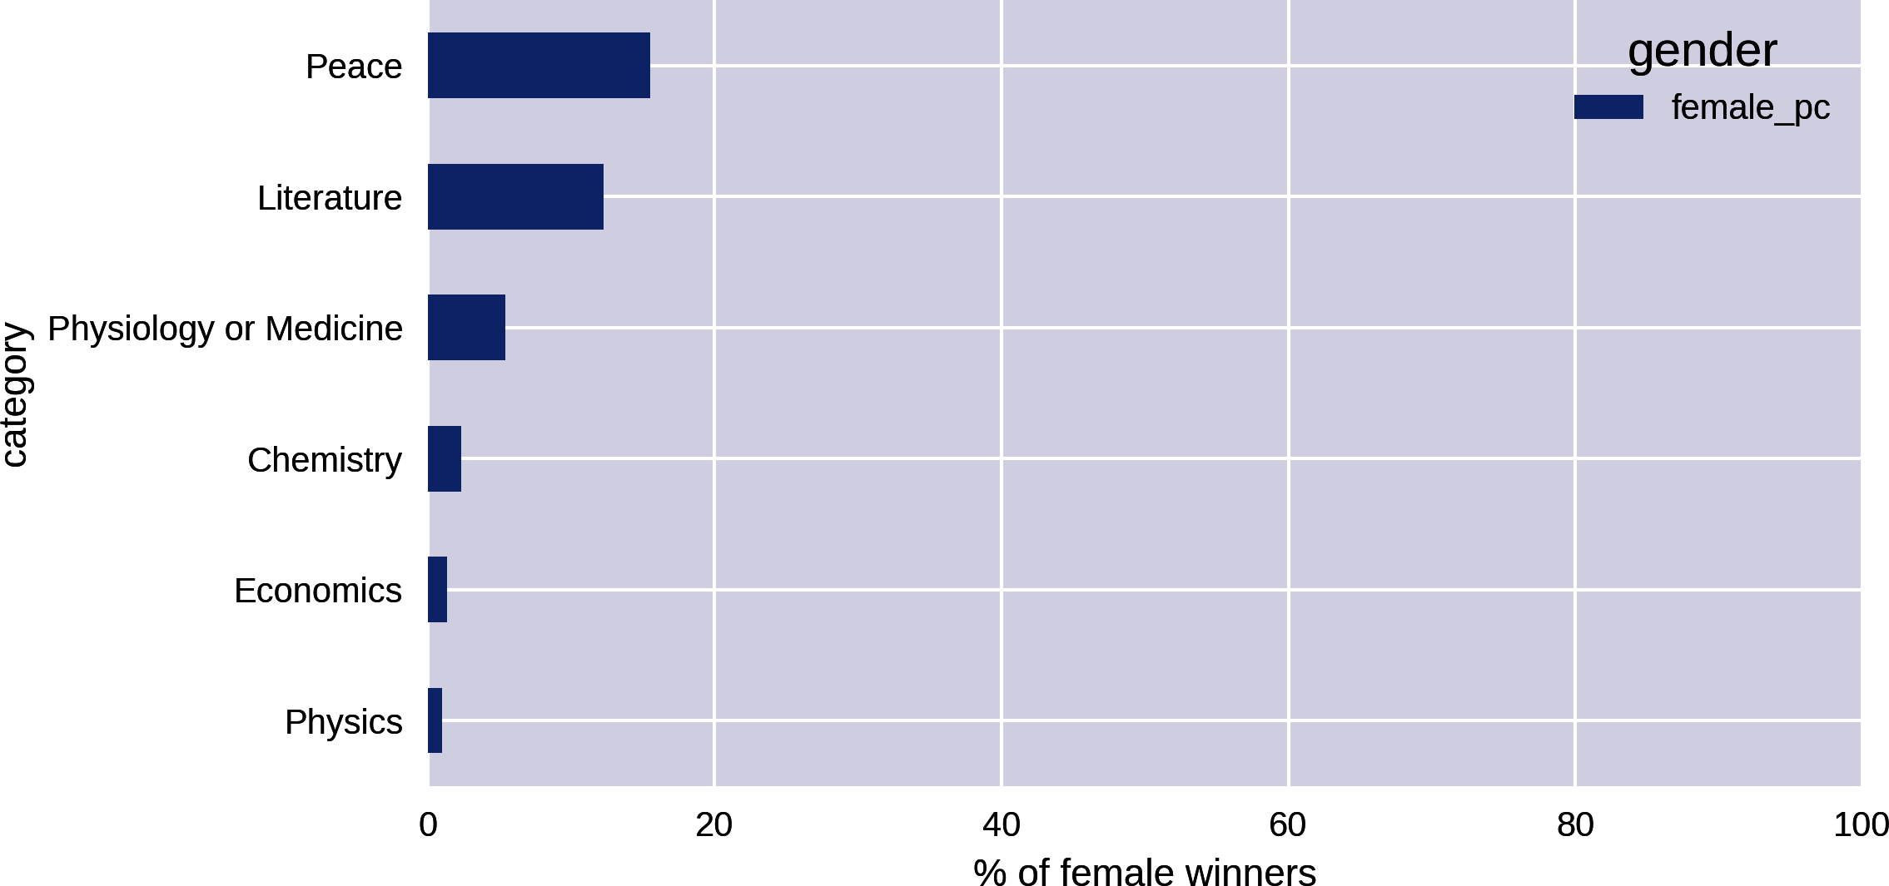

Figure 11-4. Percentage of winning females by prize category
Ignoring Economics, a recent and contentious addition to the Nobel Prize categories, Figure 11-4 shows that the largest discrepancy in the number of male and female prize winners is in Physics, with only two female winners. Let’s remind ourselves who they are:
df
[(
df
.
category
==
'Physics'
)
&
(
df
.
gender
==
'female'
)]
\
[[
'name'
,
'country'
,
'year'
]]
Out:
name country year
269 Maria Goeppert-Mayer United States 1963
612 Marie Skłodowska-Curie Poland 1903
While most people will have heard of Marie Curie, who is actually one of the four illustrious winners of two Nobel Prizes, few have heard of Maria Goeppert-Mayer.1 This ignorance is surprising, given the drive to encourage women into science. I would want my visualization to enable people to discover and learn a little about Maria Goeppert-Mayer.

Historical Trends
It would be interesting to see if there has been any increase in female prize allocation in recent years. One way to visualize this would be as grouped bars over time. Let’s run up a quick plot, using unstack as in Figure 11-3 but using the year and gender columns:
by_year_gender
=
df
.
groupby
([
'year'
,
'gender'
])
year_gen_sz
=
by_year_gender
.
size
()
.
unstack
()
year_gen_sz
.
plot
(
kind
=
'bar'
,
figsize
=
(
16
,
4
))
Figure 11-5, the hard-to-read plot produced, is only functional. The trend of female prize distributions can be observed, but the plot has many problems. Let’s use Matplotlib’s and pandas’s eminent flexibility to fix them.
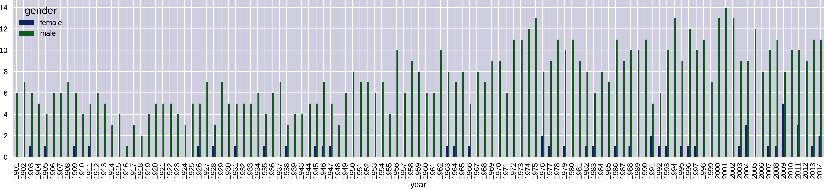

Figure 11-5. Prizes by year and gender
The first thing we need to do is reduce the number of x-axis labels. By default, Matplotlib will label each bar or bar group of a bar plot, which in the case of our hundred years of prizes creates a mess of labels. What we need is the ability to thin out the number of axis labels as desired. There are various ways to do this in Matplotlib; I’ll demonstrate the one I’ve found to be most reliable. It’s the sort of thing you’re going to want to reuse, so it makes sense to stick it in a dedicated function. Example 11-3 shows a function to reduce the number of ticks on our x-axis.

Example 11-3. Reducing the number of x-axis labels
def
thin_xticks
(
ax
,
tick_gap
=
10
,
rotation
=
45
)
:
""" Thin x-ticks and adjust rotation """
ticks
=
ax
.
xaxis
.
get_ticklocs
(
)
ticklabels
=
[
l
.
get_text
(
)
for
l
in
ax
.
xaxis
.
get_ticklabels
(
)
]
# Sets the new tick locations and labels at an interval
# of tick_gap (default +10+):
ax
.
xaxis
.
set_ticks
(
ticks
[
:
:
tick_gap
]
)
ax
.
xaxis
.
set_ticklabels
(
ticklabels
[
:
:
tick_gap
]
,
rotation
=
rotation
)
ax
.
figure
.
show
(
)
Gets the existing locations and labels of the x-ticks, currently one per bar.
Rotates the labels for readability, by default on an upward diagonal.
As well as needing to reduce the number of ticks, the x-axis in Figure 11-5 has a discontinuous range, missing the years 1939–1945 of WWII, during which no Nobel Prizes were presented. We want to see such gaps, so we need to set the x-axis range manually to include all years from the start of the Nobel Prize to the current day.
The current unstacked group sizes use an automatic year index:
by_year_gender
=
df
.
groupby
([
'year'
,
'gender'
])
by_year_gender
.
size
()
.
unstack
()
Out
:
gender
female
male
year
1901
NaN
6.0
1902
NaN
7.0
...
2014
2.0
11.0
[
111
rows
x
2
columns
]
In order to see any gaps in the prize distribution, all we have to do is reindex this Series with one containing the full range of years:
new_index
=
pd
.
Index
(
np
.
arange
(
1901
,
2015
)
,
name
=
'
year
'
)
by_year_gender
=
df
.
groupby
(
[
'
year
'
,
'
gender
'
]
)
year_gen_sz
=
by_year_gender
.
size
(
)
.
unstack
(
)
.
reindex
(
new_index
)
Here we create a full-range index named year, covering all the Nobel Prize years.
We replace our discontinuous index with the new continuous one.
Another problem with Figure 11-5 is the excessive number of bars. Although we do get male and female bars side by side, it looks messy and has aliasing artifacts too. It’s better to have dedicated male and female plots but stacked so as to allow easy comparison. We can achieve this using the subplotting method we saw in “Axes and Subplots”, using the pandas data but customizing the plot using our Matplotlib know-how. Example 11-4 shows how to do this, producing the plot in Figure 11-6.

Example 11-4. Stacked gender prizes by year
new_index
=
pd
.
Index
(
np
.
arange
(
1901
,
2015
)
,
name
=
'
year
'
)
by_year_gender
=
df
.
groupby
(
[
'
year
'
,
'
gender
'
]
)
year_gen_sz
=
by_year_gender
.
size
(
)
.
unstack
(
)
.
reindex
(
new_index
)
fig
,
axes
=
plt
.
subplots
(
nrows
=
2
,
ncols
=
1
,
sharex
=
True
,
sharey
=
True
,
figsize
=
(
16
,
8
)
)
ax_f
=
axes
[
0
]
ax_m
=
axes
[
1
]
fig
.
suptitle
(
'
Nobel Prize-winners by gender
'
,
fontsize
=
16
)
ax_f
.
bar
(
year_gen_sz
.
index
,
year_gen_sz
.
female
)
ax_f
.
set_ylabel
(
'
Female winners
'
)
ax_m
.
bar
(
year_gen_sz
.
index
,
year_gen_sz
.
male
)
ax_m
.
set_ylabel
(
'
Male winners
'
)
ax_m
.
set_xlabel
(
'
Year
'
)
Creates two axes, on a two (row) by one (column) grid.
We’ll share the x- and y-axes, which will make comparisons between the two plots sensible.
We provide the axis’s bar chart (bar) method with the continuous year index and the unstacked gender columns.
The take-home from our investigation into gender distributions is that there is a huge discrepancy but, as shown by Figure 11-6, a slight improvement in recent years. Moreover, with Economics being an outlier, the difference is greatest in the sciences. Given the fairly small number of female prize winners, there’s not a lot more to be seen here.
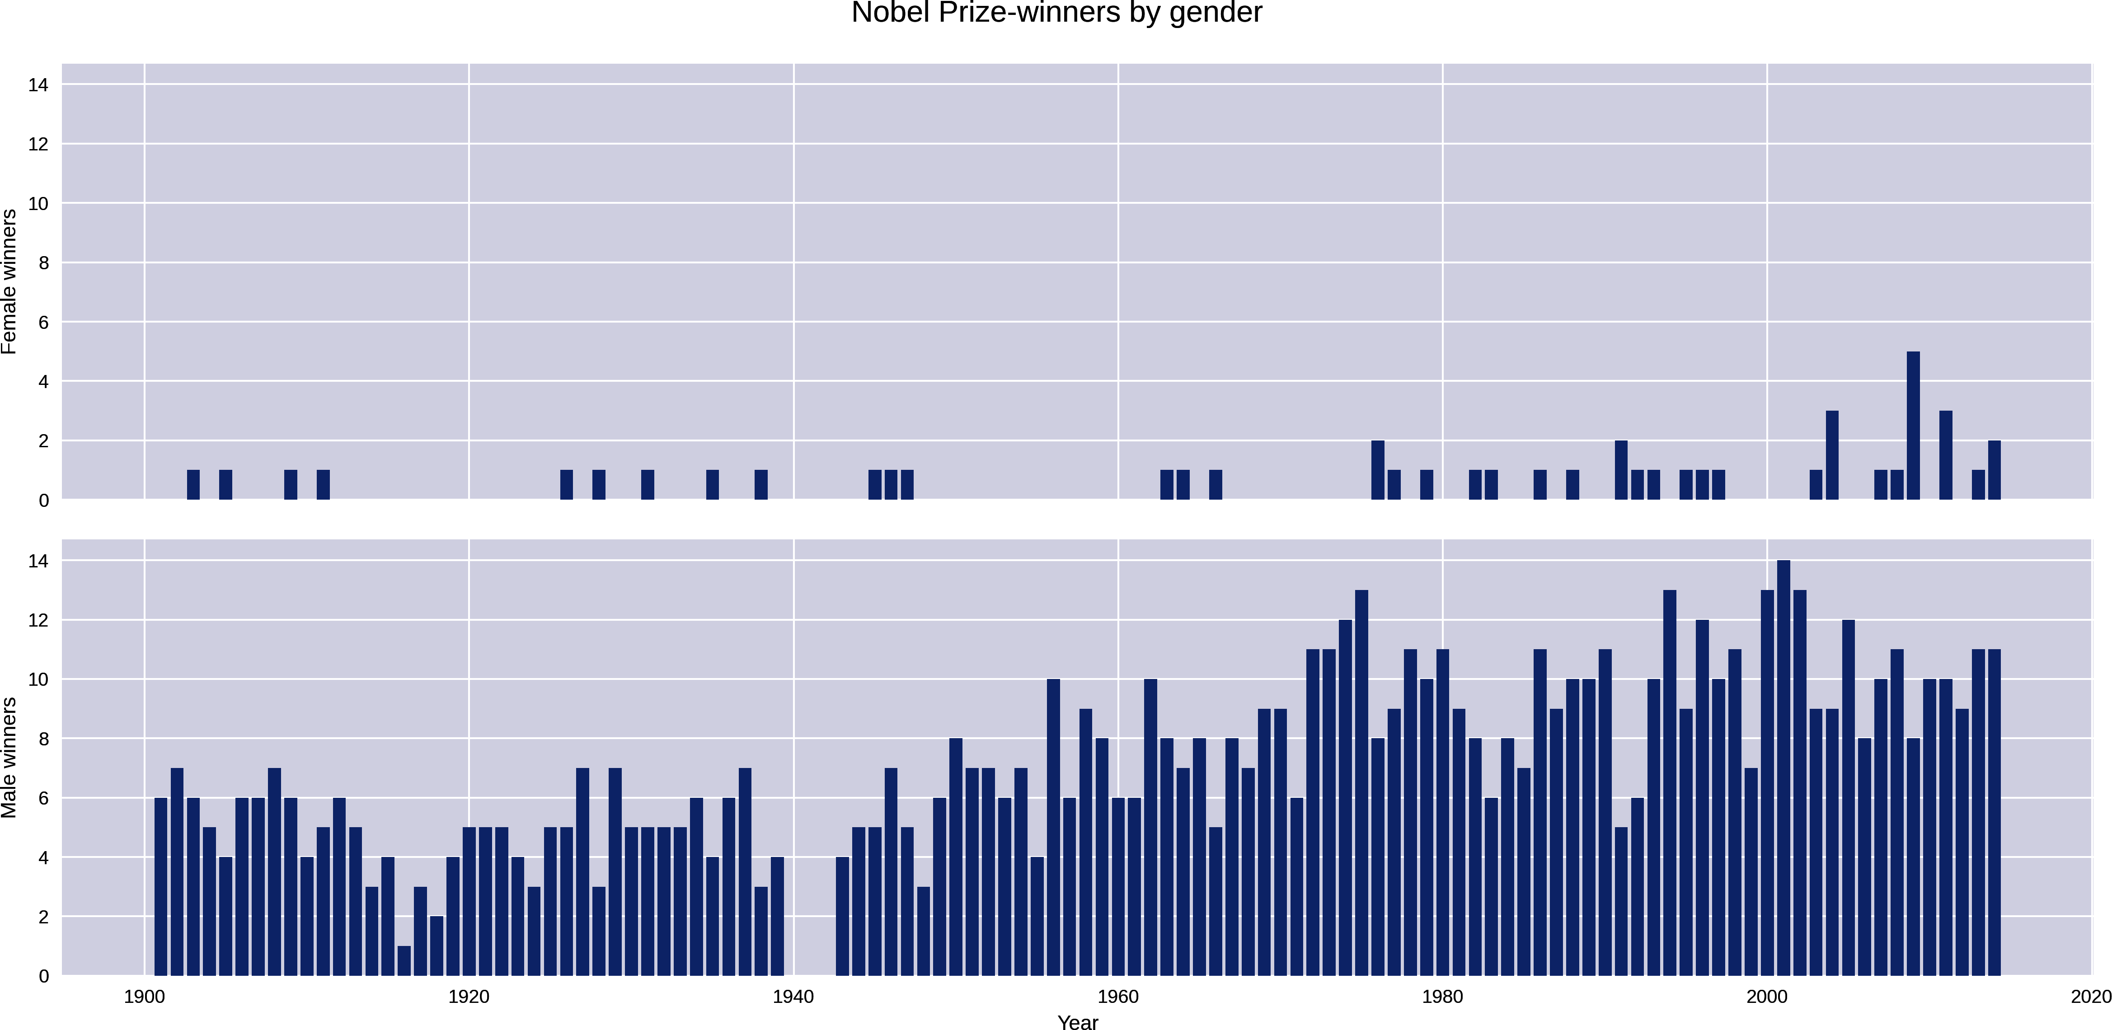

Figure 11-6. Prizes by year and gender, on two stacked axes
Let’s now take a look at national trends in prize wins and see if there are any interesting nuggets for visualization.

National Trends
The obvious starting point in looking at national trends is to plot the absolute number of prize winners. This is easily done in one line of pandas, broken up here for ease of reading:
df
.
groupby
(
'country'
)
.
size
()
.
order
(
ascending
=
False
)
.
plot
(
kind
=
'bar'
,
figsize
=
(
12
,
4
))
This produces Figure 11-7, showing the United States with the lion’s share of prizes.
The absolute number of prizes will be bound to favor countries with large populations. Let’s look at a fairer comparison, visualizing prizes per capita.
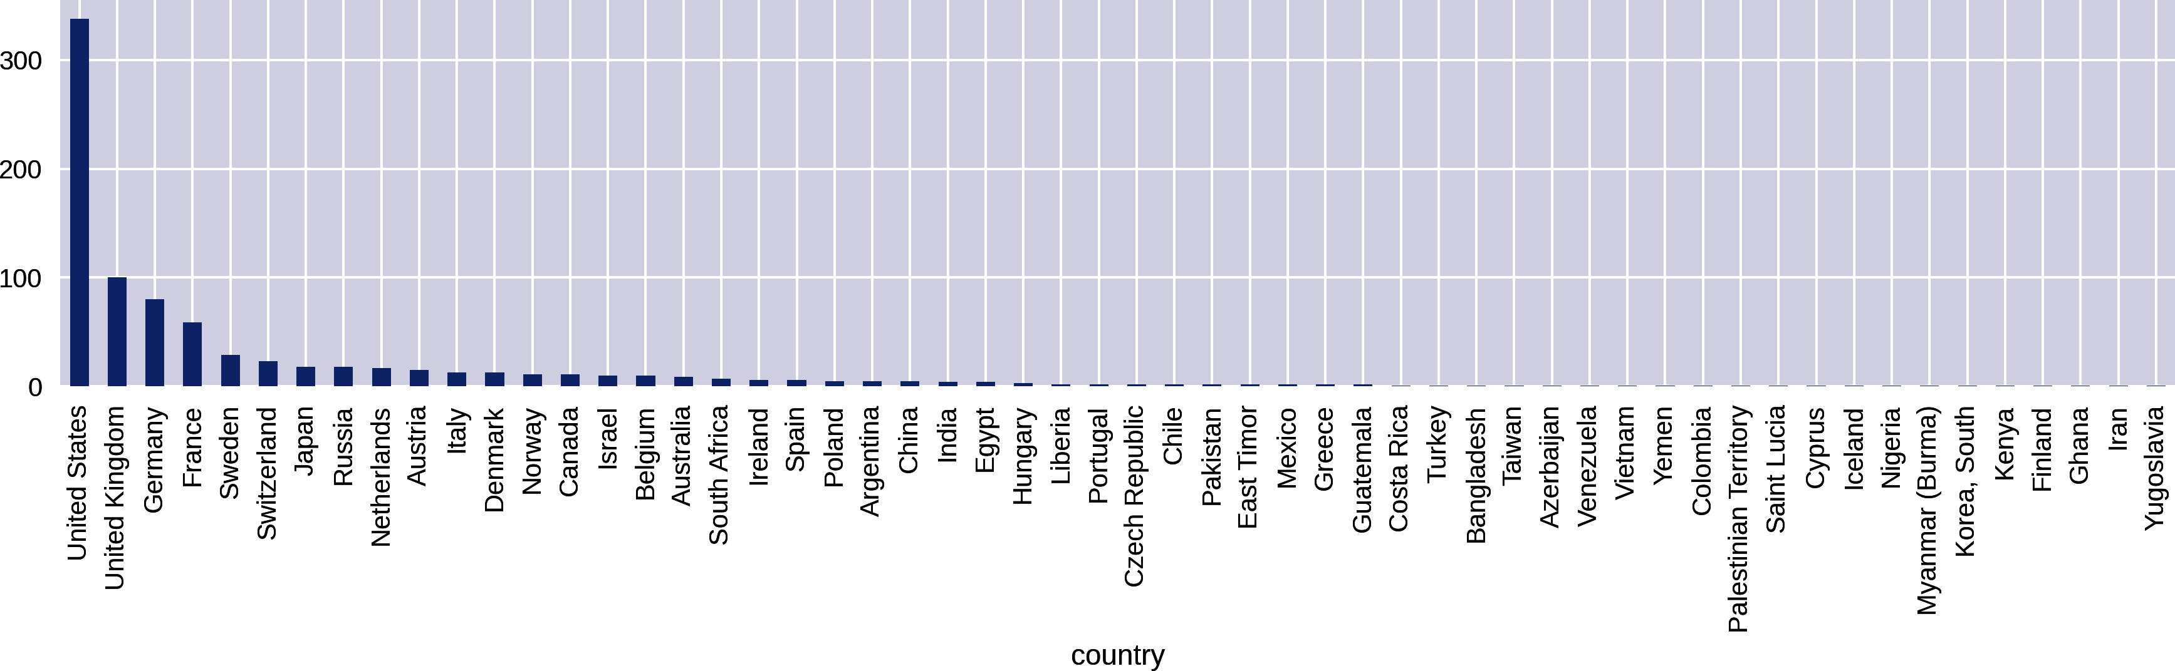

Figure 11-7. Absolute prize wins by country

Prize Winners Per Capita
The absolute number of prize winners is bound to favor larger countries, which raises the question, how do the numbers stack up if we account for population sizes? In order to test prize haul per capita, we need to divide the absolute prize numbers by population size. In “Getting Country Data for the Nobel Dataviz”, we downloaded some country data from the web and stored it as a JSON file. Let’s retrieve it now and use it to produce a plot of prizes relative to population size.
First, let’s get the national group sizes, with country names as index labels:
nat_group
=
df
.
groupby
(
'country'
)
ngsz
=
nat_group
.
size
()
ngsz
.
index
Out
:
Index
([
u
'Argentina'
,
u
'Australia'
,
u
'Austria'
,
u
'Azerbaijan'
,
...
])
Now let’s load our country data into a DataFrame and remind ourselves of the data it contains:
df_countries
=
pd
.
read_json
(
'data/winning_country_data.json'
,
\
orient
=
'index'
)
df_countries
.
loc
[
'Japan'
]
# countries indexed by name
Out
:
gini
38.1
name
Japan
alpha3Code
JPN
area
377930.0
latlng
[
36.0
,
138.0
]
capital
Tokyo
population
127080000
Name
:
Japan
,
dtype
:
object
Our country dataset is already indexed to its name column. If we add to it the ngsz national group-size Series, which also has a country name index, the two will combine on the shared indices, giving our country data a new nobel_wins column. We can then use this new column to create a nobel_wins_per_capita by dividing it by population size:
df_countries
=
df_countries
.
set_index
(
'name'
)
df_countries
[
'nobel_wins'
]
=
ngsz
df_countries
[
'nobel_wins_per_capita'
]
=
\
df_countries
.
nobel_wins
/
df_countries
.
population
We now need only to sort the df_countries DataFrame by its new nobel_wins_per_cap column and plot the Nobel Prize wins per capita, producing Figure 11-8:
df
.
countries
.
sort_values
(
by
=
'nobel_wins_per_capita'
,
\
ascending
=
False
)
.
nobel_per_capita
.
plot
(
kind
=
'bar'
,
\
figsize
=
(
12
,
4
))
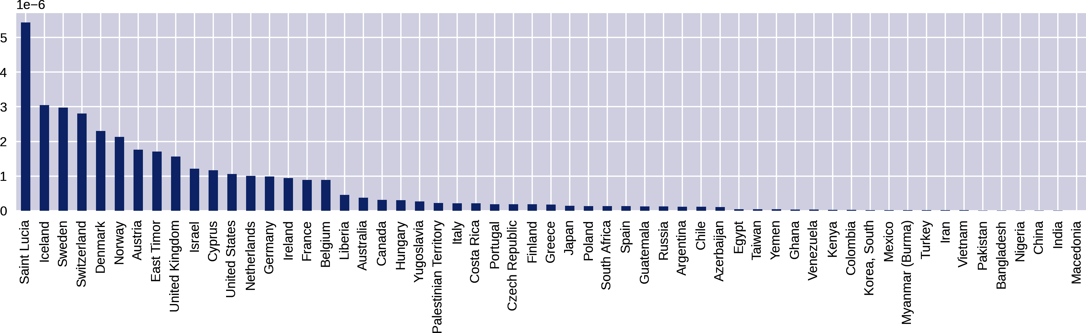

Figure 11-8. National prize numbers per capita
This shows the Caribbean island of Saint Lucia taking top place. Home to the Nobel Prize–winning poet Derek Walcott, its small population of 175,000 gives it a high Nobel Prizes per capita.
Let’s see how things stack up with the larger countries by filtering the results for countries that have won more than two Nobel Prizes:
df_countries
[
df_countries
.
nobel_wins
>
2
]
\
.
sort_values
(
by
=
'nobel_wins_per_capita'
,
ascending
=
False
)
\
.
nobel_wins_per_capita
.
plot
(
kind
=
'bar'
)
The results in Figure 11-9 show the Scandinavian countries and Switzerland punching above their weight.
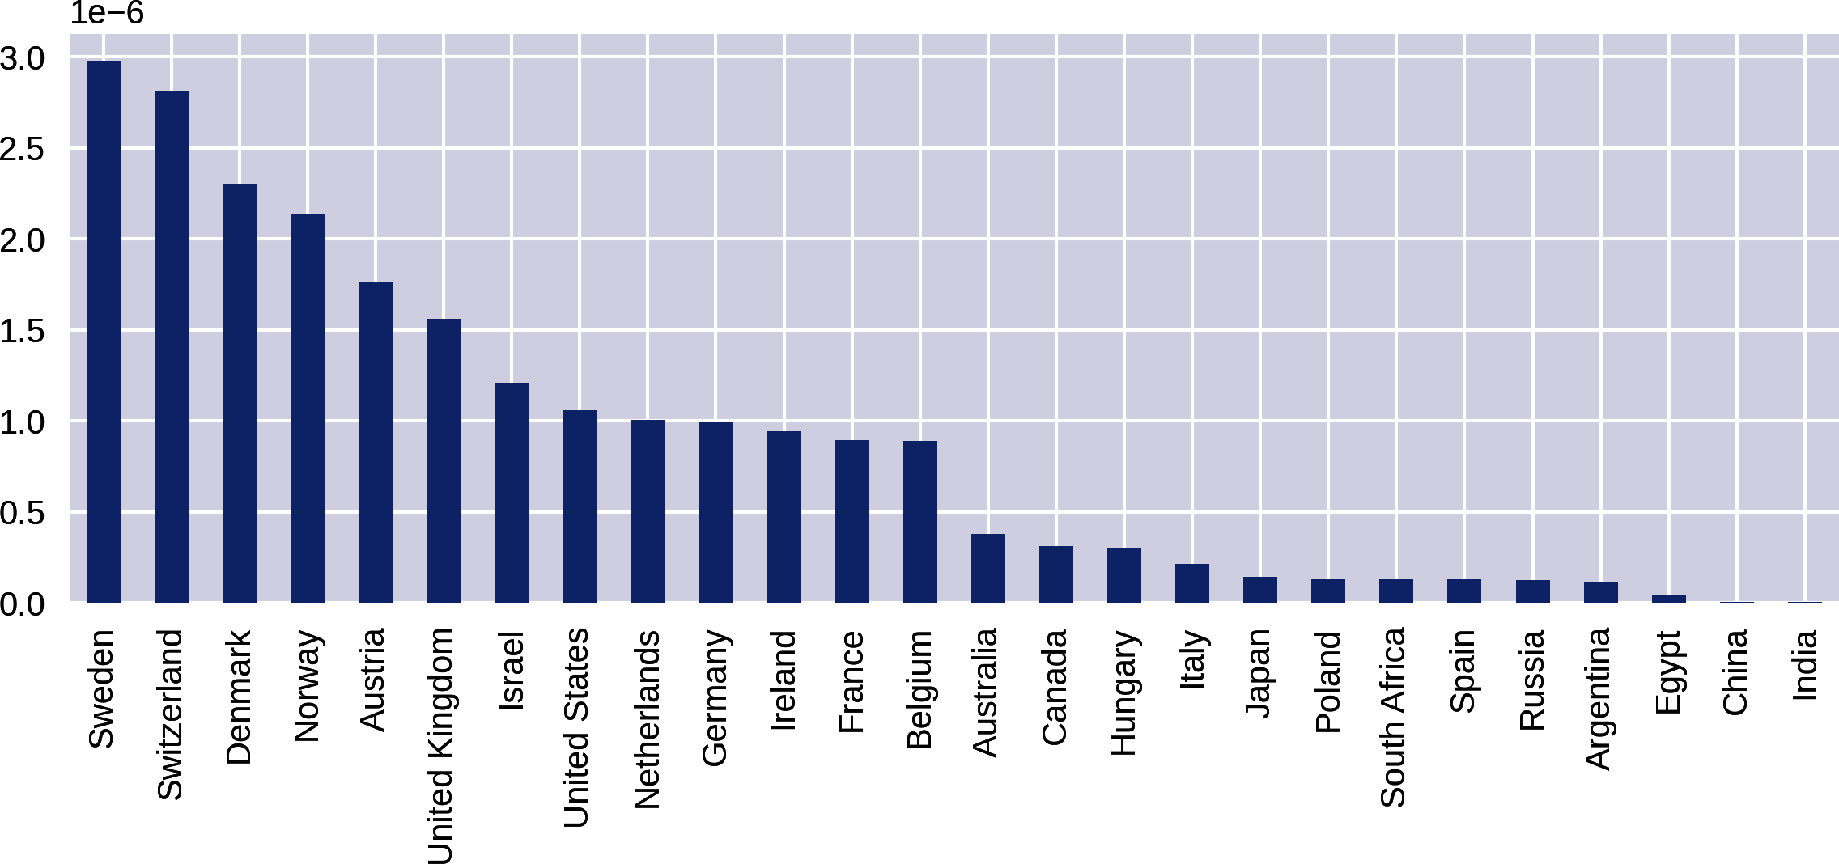

Figure 11-9. National prize numbers per capita, filtered for three or more wins
Changing the metric for national prize counts from absolute to per capita makes a big difference. Let’s now refine our search a little and focus on the prize categories, looking for interesting nuggets there.

Prizes by Category
Let’s drill down a bit into the absolute prize data and look at wins by category. This will require grouping by country and category columns, getting the size of those groups, unstacking the resulting Series and then plotting the columns of the resulting DataFrame. First, we get our categories with country group sizes:
nat_cat_sz
=
df
.
groupby
([
'country'
,
'category'
])
.
size
()
.
unstack
()
nat_cat_sz
Out
:
category
Chemistry
Economics
Literature
Peace
\
...
country
Argentina
1
NaN
NaN
2
Australia
NaN
1
1
NaN
Austria
3
1
1
2
Azerbaijan
NaN
NaN
NaN
NaN
Bangladesh
NaN
NaN
NaN
1
We then use the nat_cat_sz DataFrame to produce subplots for the six Nobel Prize categories:
COL_NUM
=
2
ROW_NUM
=
3
fig
,
axes
=
plt
.
subplots
(
ROW_NUM
,
COL_NUM
,
figsize
=
(
12
,
12
)
)
for
i
,
(
label
,
col
)
in
enumerate
(
nat_cat_sz
.
items
(
)
)
:
ax
=
axes
[
i
/
/
COL_NUM
,
i
%
COL_NUM
]
col
=
col
.
order
(
ascending
=
False
)
[
:
10
]
col
=
col
.
sort_values
(
ascending
=
True
)
col
.
plot
(
kind
=
'
barh
'
,
ax
=
ax
)
ax
.
set_title
(
label
)
plt
.
tight_layout
(
)
items returns an iterator for the DataFrames columns in form of (column_label, column) tuples.
Python 3 acquired the handy integer division operator //, which returns the rounded-down integer value of the division.
order orders the column’s Series by first making a copy. It is the equivalent of sort(inplace=False).
Having sliced off the largest 10 countries, we now reverse the order to make the bar chart, which plots from bottom to top, presenting the largest countries at the top.
tight_layout should prevent label overlaps among the subplots. If you have any problems with tight_layout, see the end of “Titles and Axes Labels”.
This produces the plots in Figure 11-10.
A couple of interesting nuggets from Figure 11-10 are the United States’ overwhelming dominance of the Economics prize, reflecting a post-WWII economic consensus, and France’s leadership of the Literature prize.
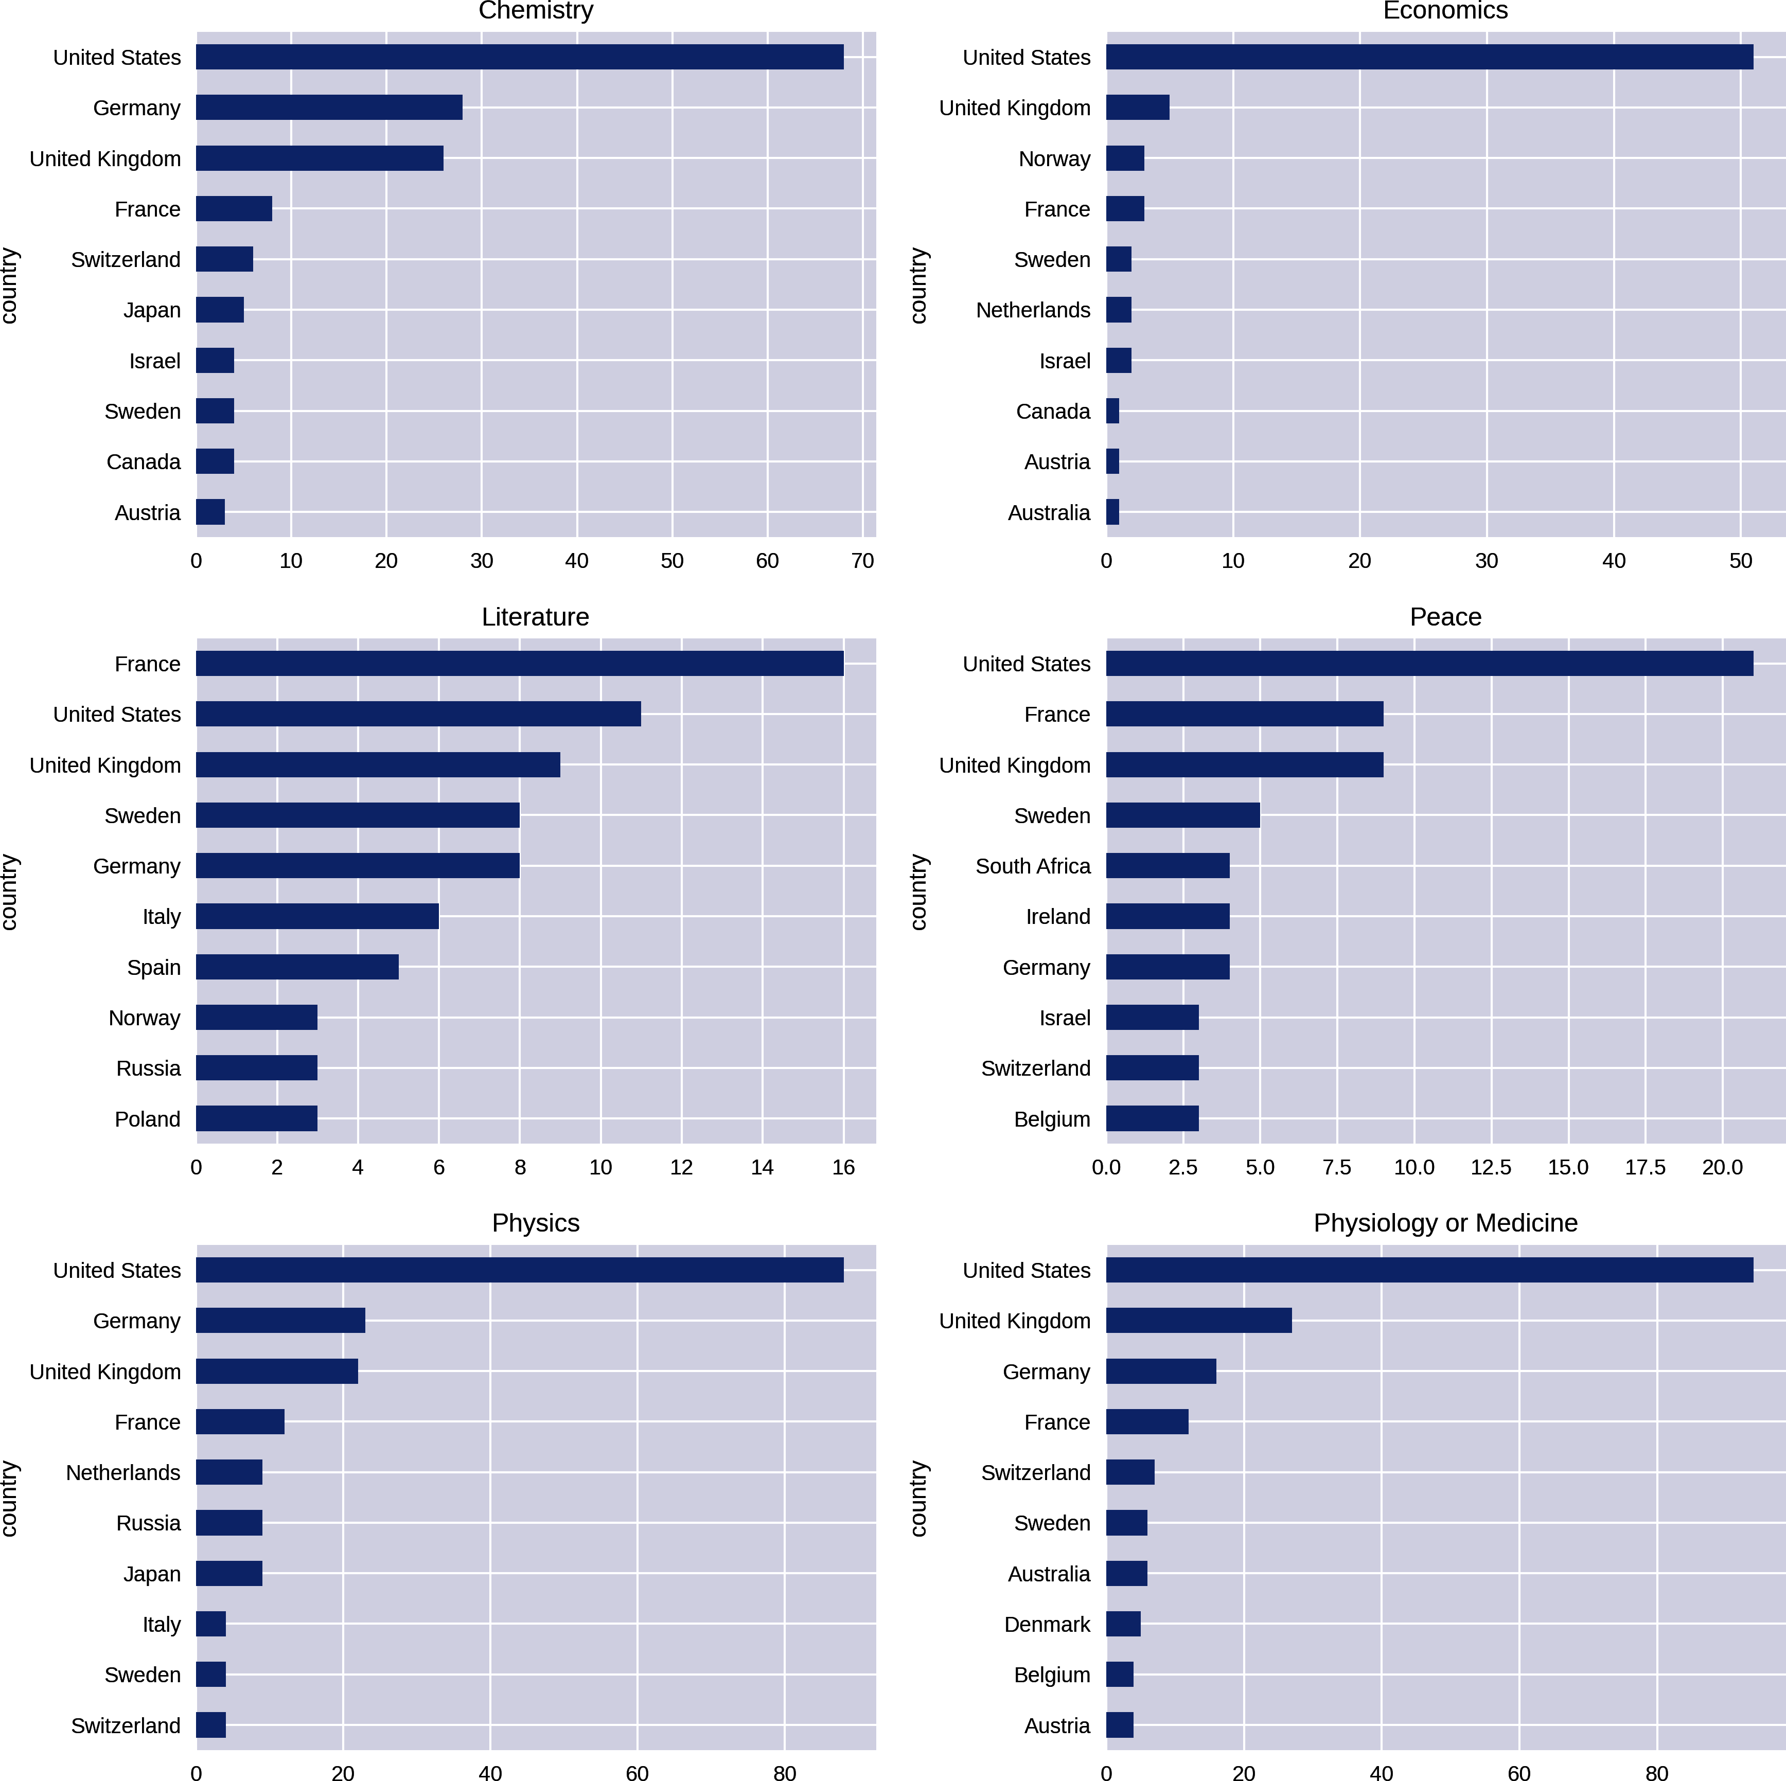

Figure 11-10. Prizes by country and category

Historical Trends in Prize Distribution
Now that we know the aggregate prize stats by country, are there any interesting historical trends to the prize distribution? Let’s explore this with some line plots.
First, let’s increase the default font size to 20 points to make the plot labels more legible:
plt
.
rcParams
[
'font.size'
]
=
20
We’re going to be looking at prize distribution by year and country, so we’ll need a new unstacked DataFrame based on these two columns. As previously, we add a new_index to give continuous years:
new_index
=
pd
.
Index
(
np
.
arange
(
1901
,
2015
),
name
=
'year'
)
by_year_nat_sz
=
df
.
groupby
([
'year'
,
'country'
])
\
.
size
()
.
unstack
()
.
reindex
(
new_index
)
The trend we’re interested in is the cumulative sum of Nobel Prizes by country over its history. We can further explore trends in individual categories, but for now we’ll look at the total for all. pandas has a handy cumsum method for just this. Let’s take the United States column and plot it:
by_year_nat_sz
[
'United States'
]
.
cumsum
()
.
plot
()
This produces the chart in Figure 11-11.
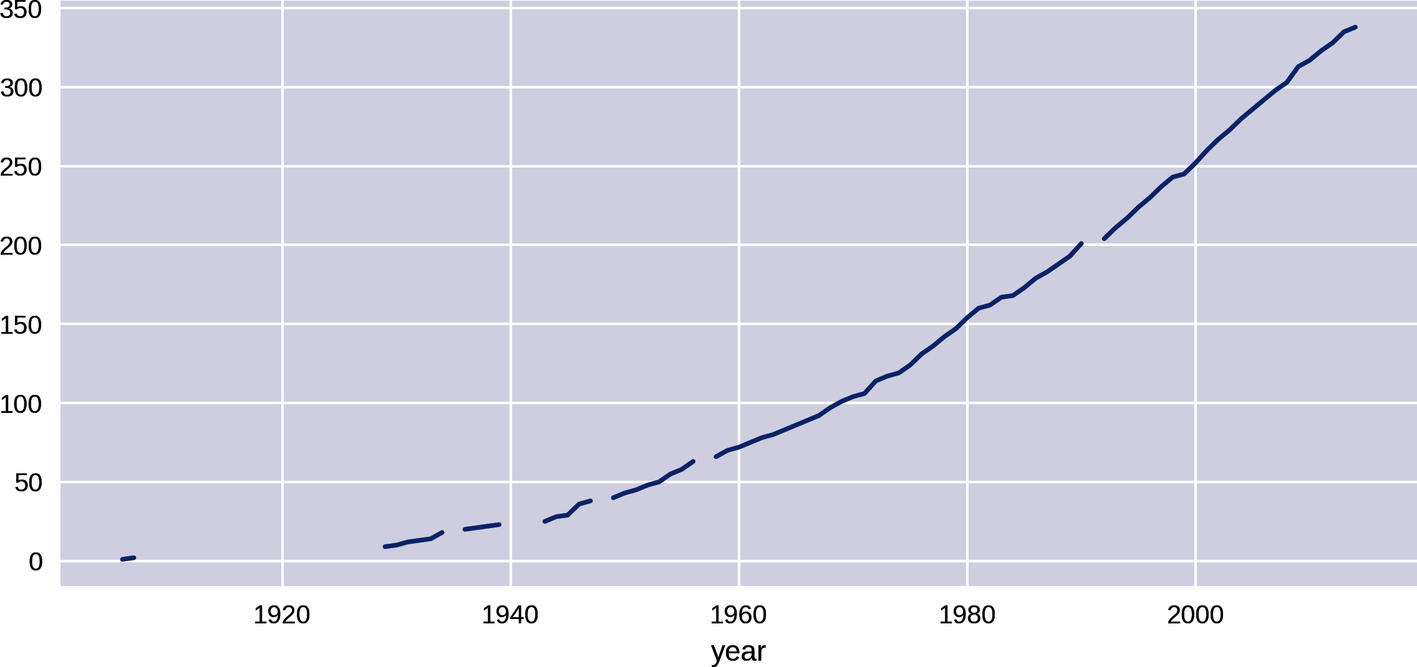

Figure 11-11. Cumulative sum of US prize winners over time
The gaps in the line plot are where the fields are NaN, years when the US won no prizes. The cumsum algorithm returns NaN here. Let’s fill those in with a zero to remove the gaps:
by_year_nat_sz
[
'United States'
]
.
fillna
(
0
)
.
cumsum
()
.
plot
()
This produces the cleaner chart shown in Figure 11-12.
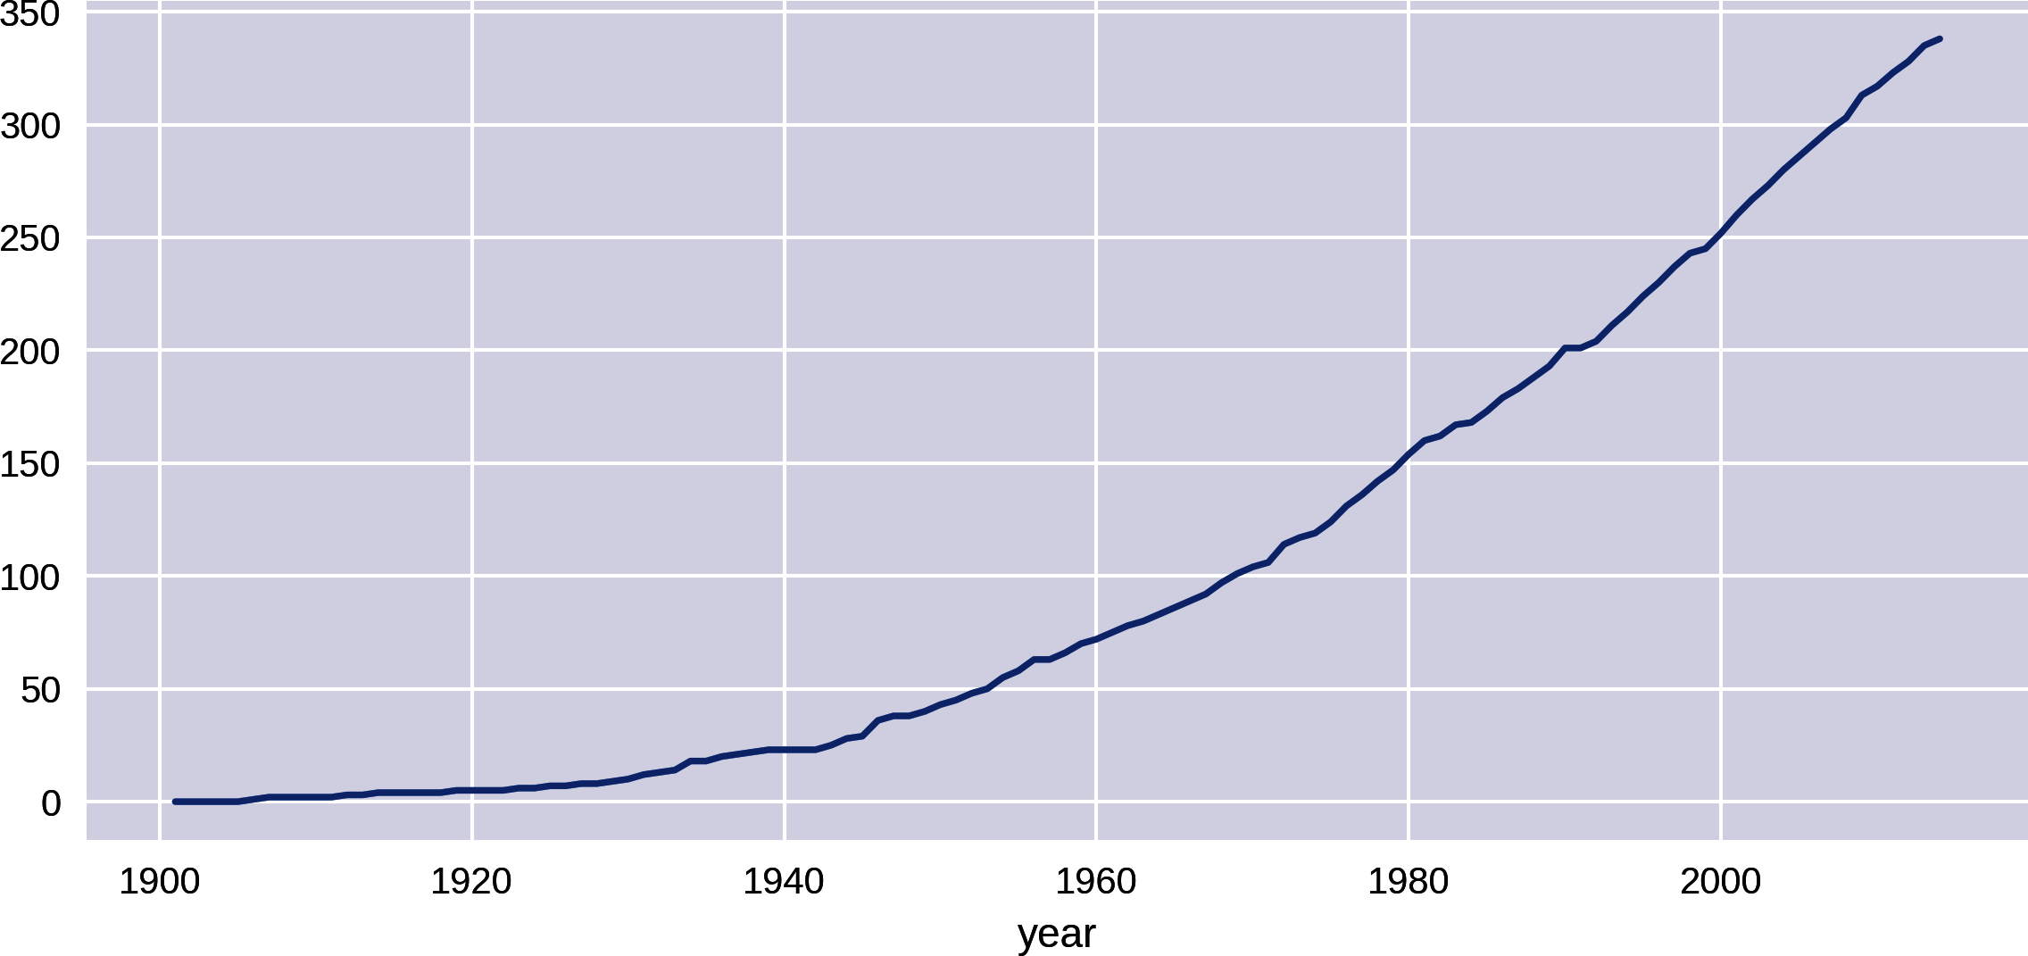

Figure 11-12. Cumulative sum of US prize winners over time
Let’s compare the US prize rate with that of the rest of the world:
by_year_nat_sz
=
df
.
groupby
(
[
'
year
'
,
'
country
'
]
)
.
size
(
)
.
unstack
(
)
.
fillna
(
0
)
not_US
=
by_year_nat_sz
.
columns
.
tolist
(
)
not_US
.
remove
(
'
United States
'
)
by_year_nat_sz
[
'
Not US
'
]
=
by_year_nat_sz
[
not_US
]
.
sum
(
axis
=
1
)
ax
=
by_year_nat_sz
[
[
'
United States
'
,
'
Not US
'
]
]
\
.
cumsum
(
)
.
plot
(
style
=
[
'
-
'
,
'
--
'
]
)
Gets the list of country column names and removes United States.
Uses our list of non-US country names to create a 'Not_US' column, the sum of all the prizes for countries in the not_US list.
By default, the lines in pandas plots are colored. In order to distinguish them in the printed book, we can use the style argument to make one line solid (-) and the other dashed (--), using the Matplotlib line styles (see the docs for details).
This code produces the chart shown in Figure 11-13.
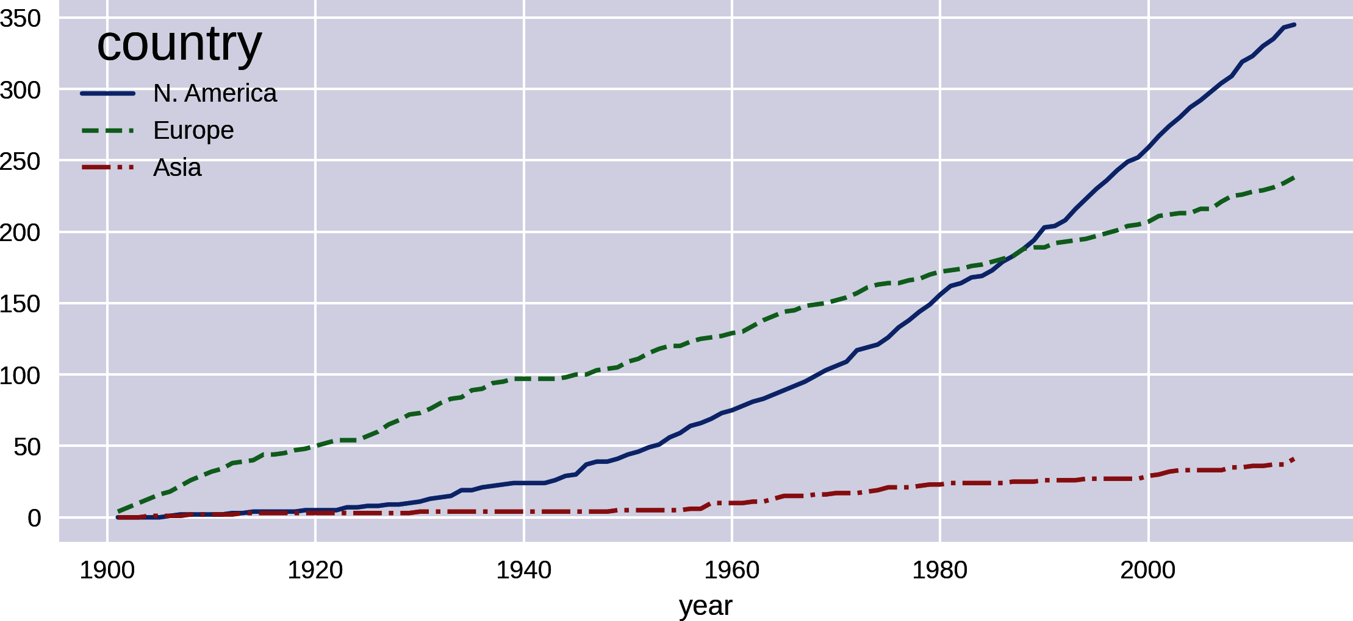

Figure 11-13. United States versus rest of world prize hauls
Where the 'Not_US' haul shows a steady increase over the years of the prize, the US shows a rapid increase around the end of World War II. Let’s investigate that further, looking at regional differences. We’ll focus on the two or three largest winners for North America, Europe, and Asia:
by_year_nat_sz
=
df
.
groupby
(
[
'
year
'
,
'
country
'
]
)
\
.
size
(
)
.
unstack
(
)
.
reindex
(
new_index
)
.
fillna
(
0
)
regions
=
[
{
'
label
'
:
'
N. America
'
,
'
countries
'
:
[
'
United States
'
,
'
Canada
'
]
}
,
{
'
label
'
:
'
Europe
'
,
'
countries
'
:
[
'
United Kingdom
'
,
'
Germany
'
,
'
France
'
]
}
,
{
'
label
'
:
'
Asia
'
,
'
countries
'
:
[
'
Japan
'
,
'
Russia
'
,
'
India
'
]
}
]
for
region
in
regions
:
by_year_nat_sz
[
region
[
'
label
'
]
]
=
\
by_year_nat_sz
[
region
[
'
countries
'
]
]
.
sum
(
axis
=
1
)
by_year_nat_sz
[
[
r
[
'
label
'
]
for
r
in
regions
]
]
.
cumsum
(
)
\
.
plot
(
style
=
[
'
-
'
,
'
--
'
,
'
-.
'
]
)
# solid, dashed, dash-dotted line style
Our continental country list created by selecting the biggest two or three winners in the three continents compared.
Creates a new column with a region label for each dict in the regions list, summing its countries members.
Plots the cumulative sum of all the new region columns.
This gives us the plot in Figure 11-14. The rate of Asia’s prize haul has increased slightly over the years, but the main point of note is North America’s huge increase in prizes around the mid-1940s, overtaking a declining Europe in total prizes around the mid-1980s.

Figure 11-14. Historical prize trends by region
Let’s expand the detail of the previous national plots by summarizing the prize rates for the 16 biggest winners, excluding the outlying United States:
COL_NUM
=
4
ROW_NUM
=
4
by_nat_sz
=
df
.
groupby
(
'
country
'
)
.
size
(
)
by_nat_sz
.
sort_values
(
ascending
=
False
,
\
inplace
=
True
)
fig
,
axes
=
plt
.
subplots
(
COL_NUM
,
ROW_NUM
,
\
sharex
=
True
,
sharey
=
True
,
figsize
=
(
12
,
12
)
)
for
i
,
nat
in
enumerate
(
by_nat
.
index
[
1
:
17
]
)
:
ax
=
axes
[
i
/
COL_NUM
,
i
%
ROW_NUM
]
by_year_nat_sz
[
nat
]
.
cumsum
(
)
.
plot
(
ax
=
ax
)
ax
.
set_title
(
nat
)
Sorts our country groups from highest to lowest win-hauls.
Gets a 4×4 grid of axes with shared x- and y-axes for normalized comparison.
Enumerates over the sorted index from the second row (1), excluding the US (0).
Selects the nat country name column and plots its cumulative sum of prizes on the grid axis ax.
This produces Figure 11-15, which shows some nations like Japan, Australia, and Israel on the rise historically, while others flatten off.
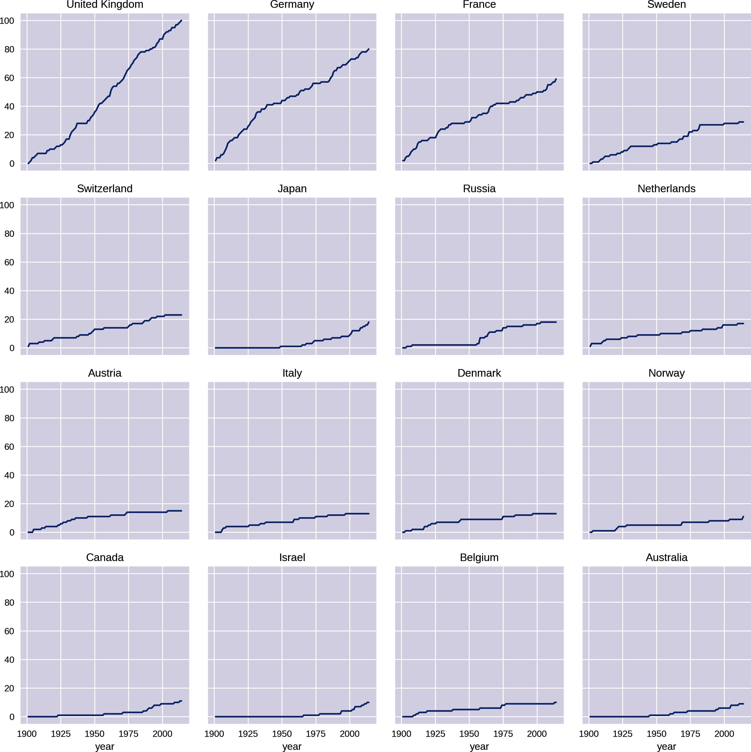

Figure 11-15. Prize rates for the 16 largest national winners after the US
Another good way to summarize national prize rates over time is by using a heatmap and dividing the totals by decade. The seaborn library provides a good heatmap. Let’s import it and use its set method to increase the font size of its labels by scaling them:
import
seaborn
as
sns
sns
.
set
(
font_scale
=
1.3
)
The division of data into chunks is also known as binning, as it creates bins of data. pandas has a handy cut method for just this job, taking a column of continuous values—​in our case, Nobel Prize years—​and returning ranges of a specified size. You can supply the DataFrame’s groupby method with the result of cut and it will group by the range of indexed values. The following code produces Figure 11-16:
bins
=
np
.
arange
(
df
.
year
.
min
(
)
,
df
.
year
.
max
(
)
,
10
)
by_year_nat_binned
=
df
.
groupby
(
'
country
'
,
\
[
pd
.
cut
(
df
.
year
,
bins
,
precision
=
0
)
]
)
\
.
size
(
)
.
unstack
(
)
.
fillna
(
0
)
plt
.
figure
(
figsize
=
(
8
,
8
)
)
sns
.
heatmap
(
\
by_year_nat_binned
[
by_year_nat_binned
.
sum
(
axis
=
1
)
>
2
]
,
\
cmap
=
'
rocket_r
'
)
Gets our bin ranges for the decades from 1901 (1901, 1911, 1921…​).
Cuts our Nobel Prize years into decades using the bins ranges with precision set to 0, to give integer years.
Before heatmapping, we filter for those countries with over two Nobel Prizes.
We use the continuous rocket_r heatmap to highlight the differences. Check out all the pandas color palettes in the seaborn documentation.
Figure 11-16 captures some interesting trends, such as Russia’s brief flourishing in the 1950s, which petered out around the 1980s.
Now that we’ve investigated the Nobel Prize nations, let’s turn our attention to the individual winners. Are there any interesting things we can discover about them using the data at hand?
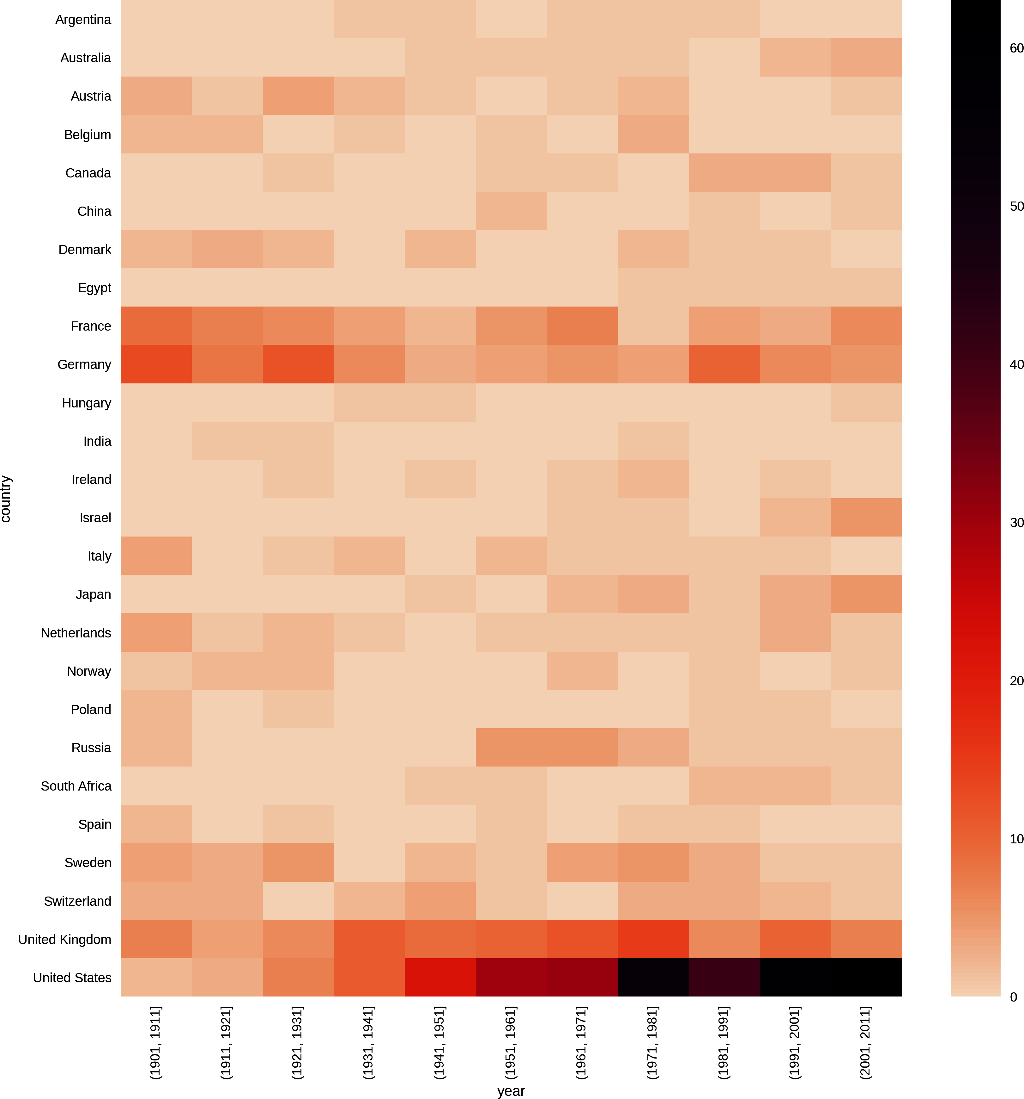

Figure 11-16. Nations’ Nobel Prize hauls by decade

Age and Life Expectancy of Winners
We have the date of birth for all our winners and the date of death for 559 of them. Combined with the year in which they won their prizes, we have a fair amount of individual data to mine. Let’s investigate the age distribution of winners and try to glean some idea of the winners’ longevity.

Age at Time of Award
In Chapter 9, we added an 'award_age' column to our Nobel Prize dataset by subtracting the winners’ ages from their prize years. A quick and easy win is to use pandas’s histogram plot to assess this distribution:
df
[
'award_age'
]
.
hist
(
bins
=
20
)
Here we require that the age data be divided into 20 bins. This produces Figure 11-17, showing that the early ’60s is a sweet spot for the prize and if you haven’t achieved it by 100, it probably isn’t going to happen. Note the outlier around 20, which is the 17-year-old recipient of the Peace Prize, Malala Yousafzai.
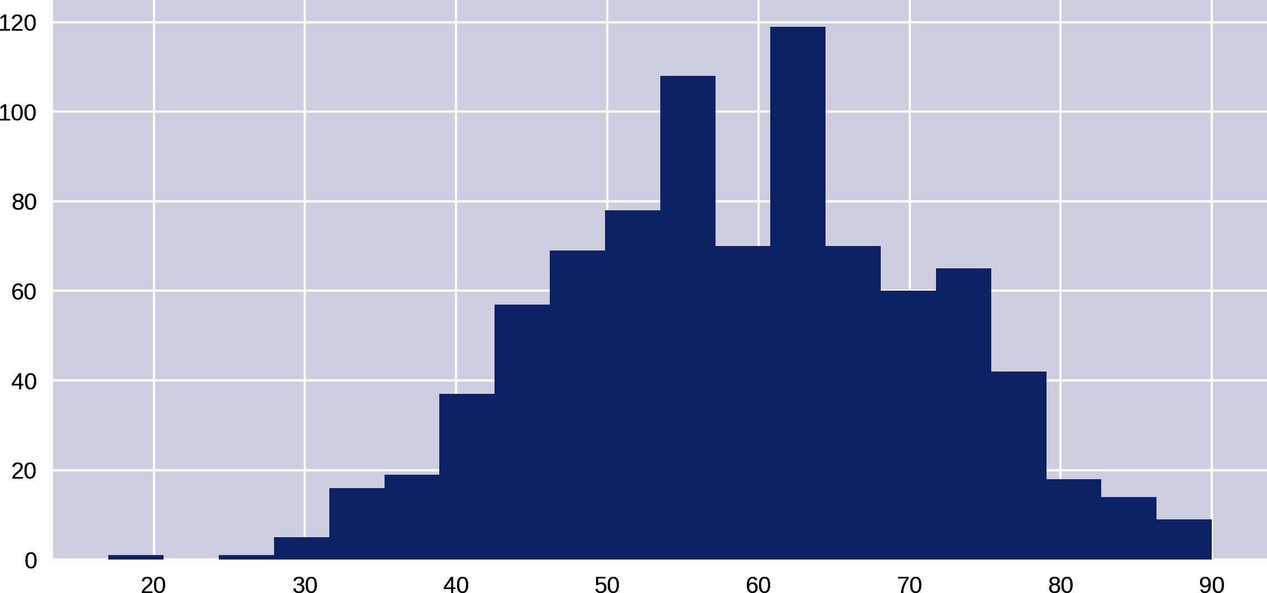

Figure 11-17. Distribution of ages at time of award
We can use seaborn’s displot to get a better feel for the distribution, adding a kernel density estimate (KDE)2 to the histogram. The following one-liner produces Figure 11-18, showing that our sweet spot is around 60 years of age:
sns
.
displot
(
df
[
'award_age'
],
kde
=
True
,
height
=
4
,
aspect
=
2
)
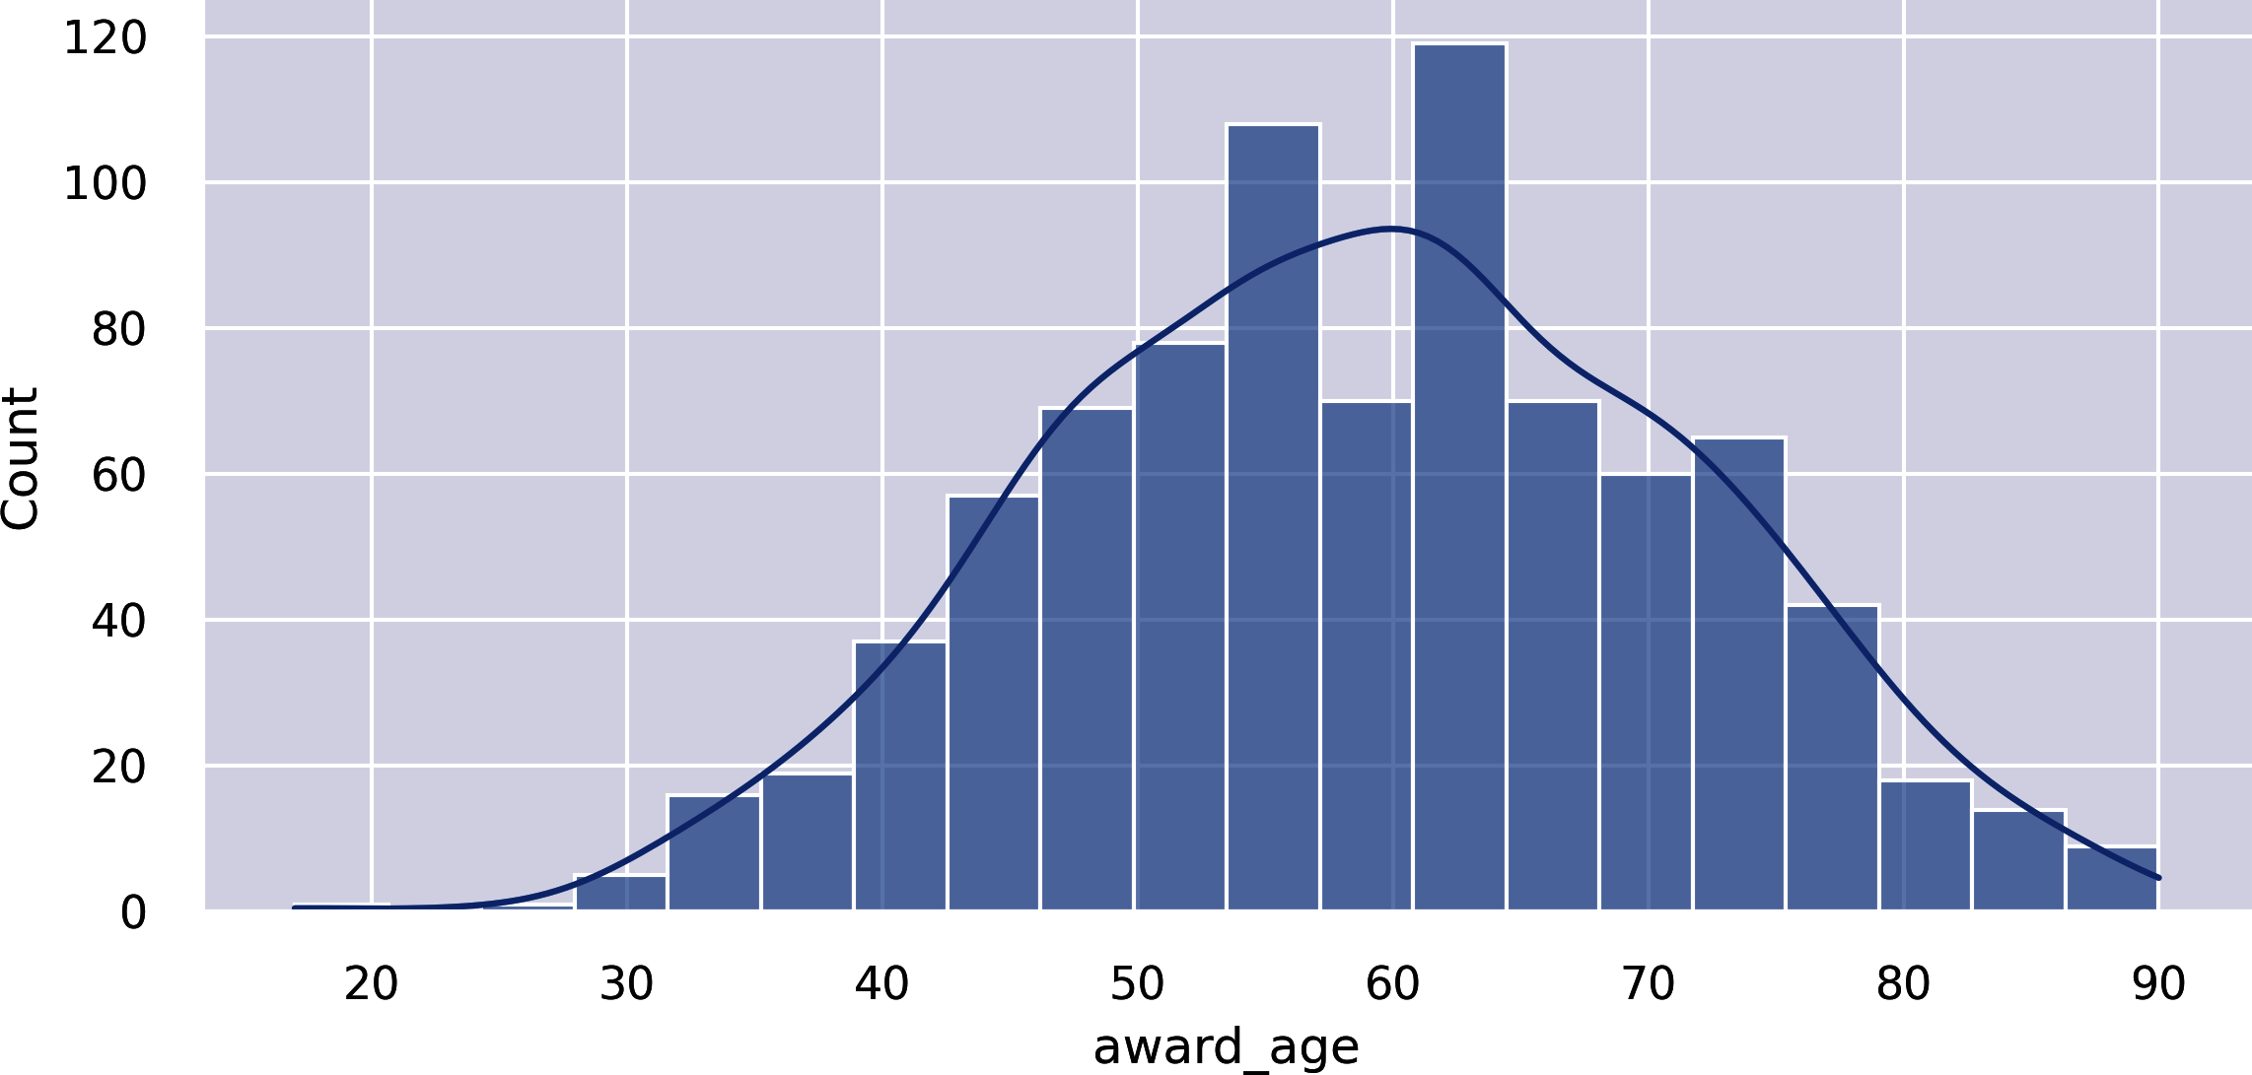

Figure 11-18. Distribution of ages at time of award with KDE superimposed
A box plot is a good way of visualizing continuous data, showing the quartiles, the first and third marking the edges of the box and the second quartile (or median average) marking the line in the box. Generally, as in Figure 11-19, the horizontal end lines (known as the whisker ends) indicate the max and min of the data. Let’s use a seaborn box plot and divide the prizes by gender:
sns
.
boxplot
(
df
,
x
=
'gender'
,
y
=
'award_age'
)
This produces Figure 11-19, which shows that the distributions by gender are similar, with women having a slightly lower average age. Note that with far fewer female prize winners, their statistics are subject to a good deal more uncertainty.
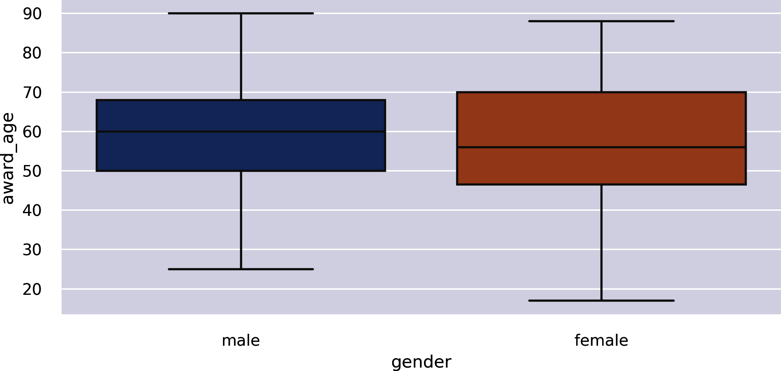

Figure 11-19. Ages of prize winners by gender
seaborn’s rather nice violin plot combines the conventional box plot with a kernel density estimation to give a more refined view of the breakdown by age and gender. The following code produces Figure 11-20:
sns
.
violinplot
(
data
=
df
,
x
=
'gender'
,
y
=
'award_age'
)
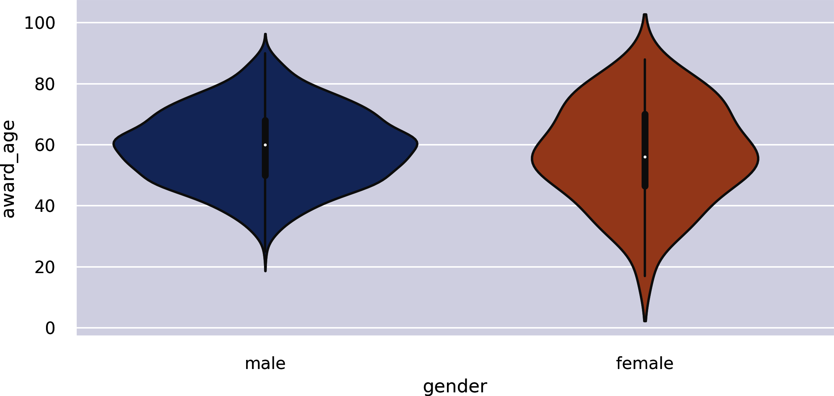

Figure 11-20. Violin plots of prize-age distribution by gender

Life Expectancy of Winners
Now let’s look at the longevity of Nobel Prize winners, by subtracting the available dates of death from their respective dates of birth. We’ll store this data in a new 'age_at_death' column:
df
[
'
age_at_death
'
]
=
(
df
.
date_of_death
-
df
.
date_of_birth
)
\
.
dt
.
days
/
365
datetime64 data can be added and subtracted in a sensible fashion, producing a pandas timedelta column. We can use its dt method to get the interval in days, dividing this by 365 to get the age at death as a float.
We make a copy of the 'age_at_death' column,3 removing all empty NaN rows. This can then be used to make the histogram and KDE shown in Figure 11-21:
age_at_death
=
df
[
df
.
age_at_death
.
notnull
(
)
]
.
age_at_death
sns
.
displot
(
age_at_death
,
bins
=
40
,
kde
=
True
,
aspect
=
2
,
height
=
4
)
Removes all NaNs to clean the data and reduce plotting errors (e.g., distplot fails with NaNs).
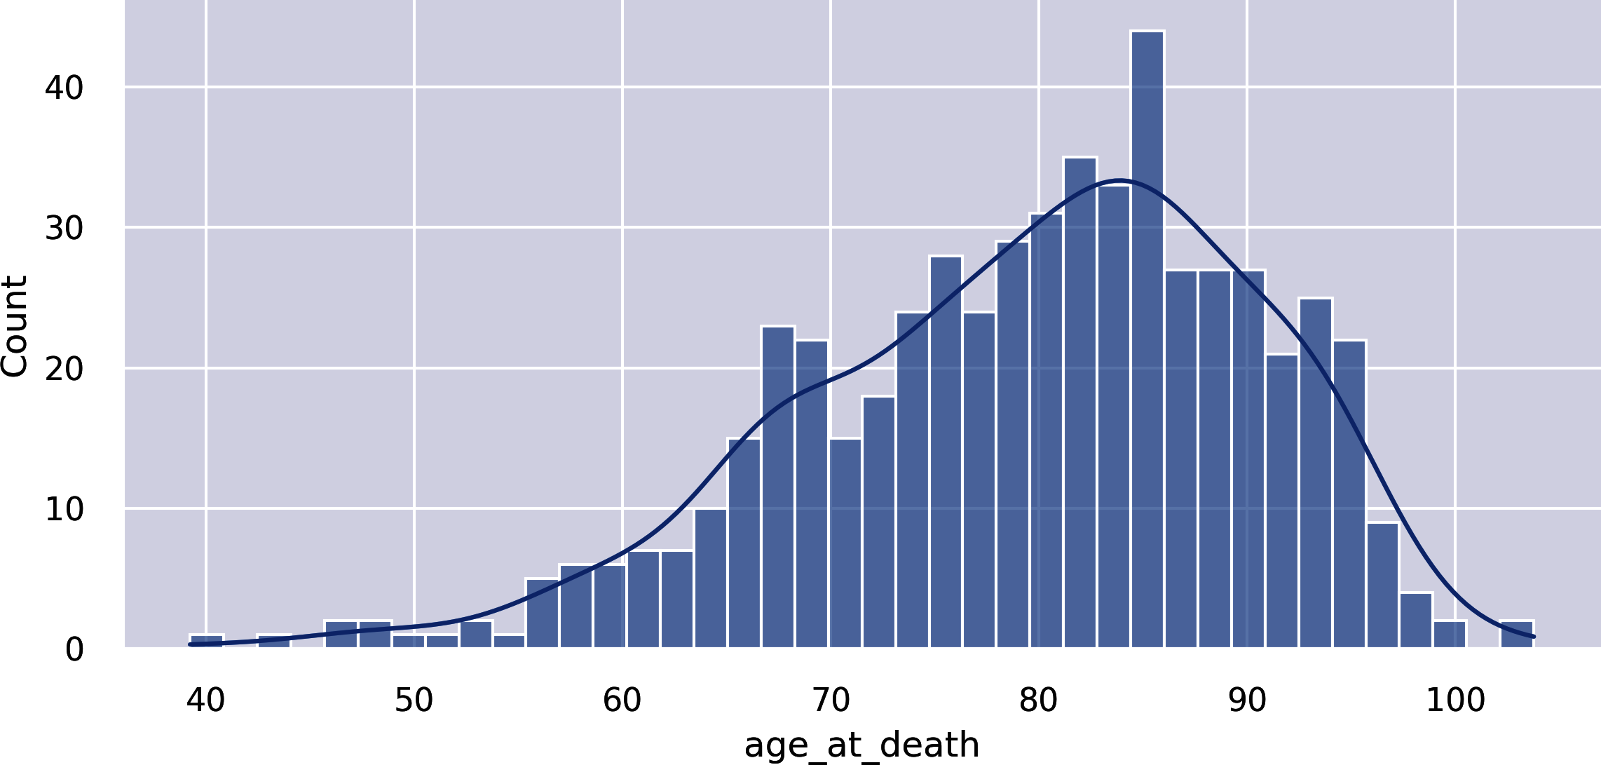

Figure 11-21. Life expectancy of the Nobel Prize winners
Figure 11-21 shows the Nobel Prize winners to be a remarkably long-lived bunch, with an average age in the early 80s. This is all the more impressive given that the large majority of winners are men, who have significantly lower average life expectancies4 in the general population than women. One contributary factor to this longevity is the selection bias we saw earlier. Nobel Prize winners aren’t generally honored until they’re in their late 50s and 60s, which removes the subpopulation who died before having the chance to be acknowledged, pushing up the longevity figures.
Figure 11-21 shows some centenarians among the prize winners. Let’s find them:
df[df.age_at_death > 100][['name', 'category', 'year']]
Out:
name category year
101 Ronald Coase Economics 1991
328 Rita Levi-Montalcini Physiology or Medicine 1986
Now let’s superimpose a couple of KDEs to show differences in mortality for male and female recipients:
df_temp
=
df_temp
[
df
.
age_at_death
.
notnull
(
)
]
sns
.
kdeplot
(
df_temp
[
df_temp
.
gender
==
'
male
'
]
.
age_at_death
,
shade
=
True
,
label
=
'
male
'
)
sns
.
kdeplot
(
df_temp
[
df_temp
.
gender
==
'
female
'
]
.
age_at_death
,
shade
=
True
,
label
=
'
female
'
)
plt
.
legend
(
)
Creates a DataFrame with only valid 'age_at_death' fields.
This produces Figure 11-22, which, allowing for the small number of female winners and flatter distribution, shows the male and female averages to be close. Female Nobel Prize winners seem to live relatively shorter lives than their counterparts in the general population.
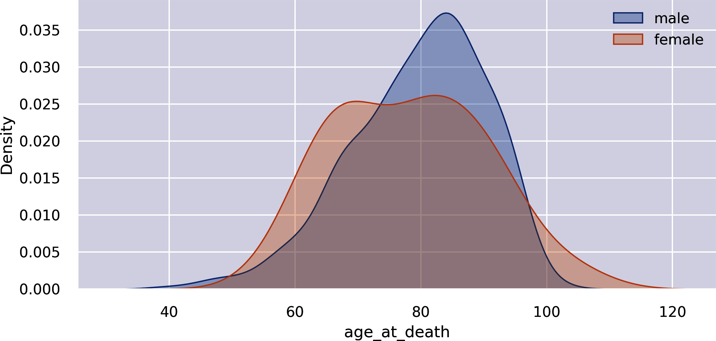

Figure 11-22. Nobel Prize winner life expectancies by gender
A violin plot provides another perspective, shown in Figure 11-23:
sns
.
violinplot
(
data
=
df
,
x
=
'gender'
,
y
=
'age_at_death'
,
\
aspect
=
2
,
height
=
4
)
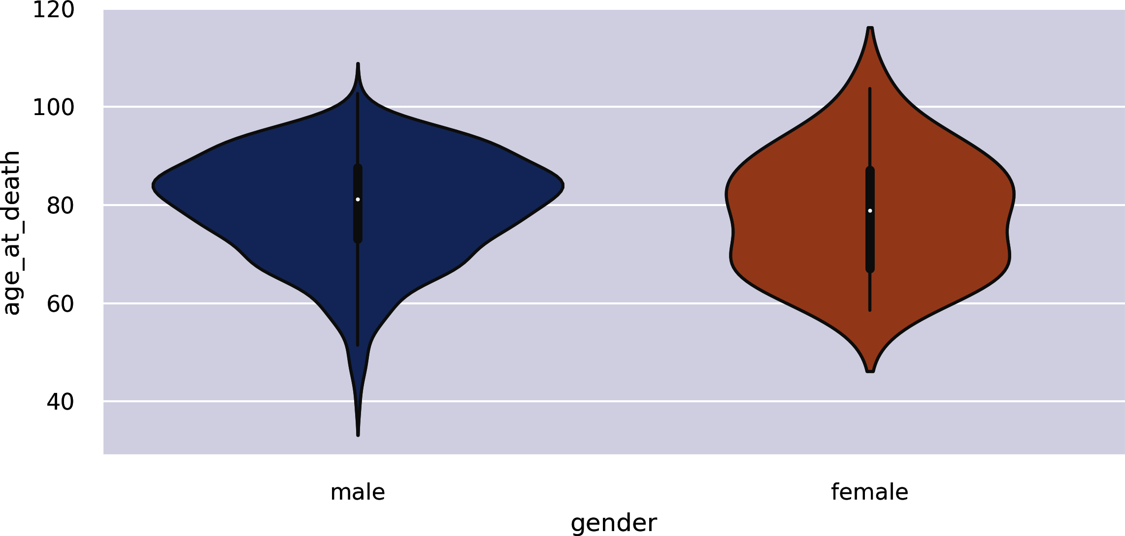

Figure 11-23. Winner life expectancies by gender

Increasing Life Expectancies over Time
Let’s do a little historical demographic analysis by seeing if there’s a correlation between the date of birth of our Nobel Prize winners and their life expectancy. We’ll use one of seaborn’s lmplots to provide a scatter plot and line-fitting with confidence intervals (see “seaborn”):
df_temp
=
df
[
df
.
age_at_death
.
notnull
(
)
]
data
=
pd
.
DataFrame
(
{
'
age at death
'
:
df_temp
.
age_at_death
,
'
date of birth
'
:
df_temp
.
date_of_birth
.
dt
.
year
}
)
sns
.
lmplot
(
data
=
data
,
x
=
'
date of birth
'
,
y
=
'
age at death
'
,
height
=
6
,
aspect
=
1.5
)
Creates a temporary DataFrame, removing all the rows with no 'age_at_death' field.
Creates a new DataFrame with only the two columns of interest from the refined df_temp. We grab only the year from the date_of_birth, using its dt accessor.
This produces Figure 11-24, showing an increase in life expectancy of a decade or so over the prize’s duration.
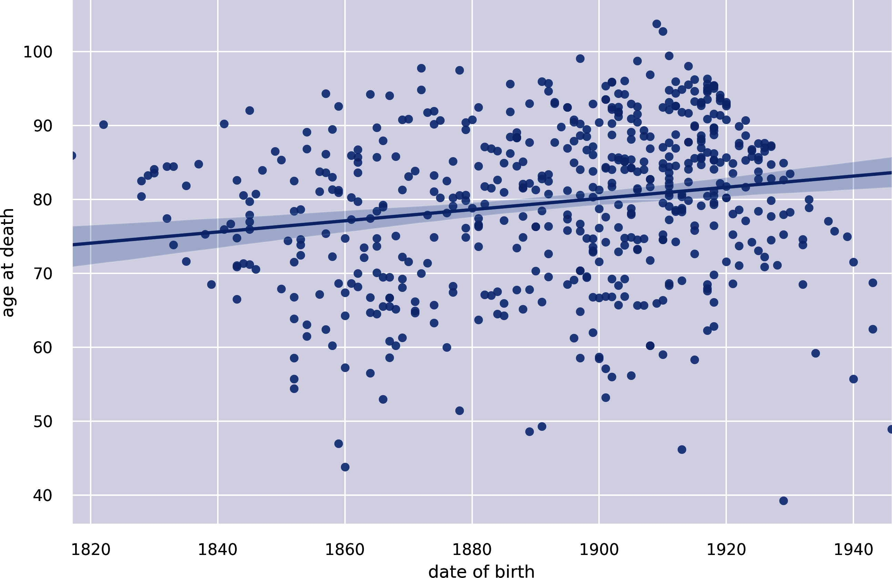

Figure 11-24. Correlating date of birth with age at death

The Nobel Diaspora
While cleaning our Nobel Prize dataset in Chapter 9, we found duplicate entries recording the winner’s place of birth and country at time of winning. We preserved these, giving us 104 winners whose country at time of winning was different from their country of birth. Is there a story to tell here?
A good way to visualize the movement patterns from the winners’ country of birth to their adopted country is by using a heatmap to show all born_in/country pairs. The following code produces the heatmap in Figure 11-25:
by_bornin_nat
=
df
[
df
.
born_in
.
notnull
(
)
]
.
groupby
(
\
[
'
born_in
'
,
'
country
'
]
)
.
size
(
)
.
unstack
(
)
by_bornin_nat
.
index
.
name
=
'
Born in
'
by_bornin_nat
.
columns
.
name
=
'
Moved to
'
plt
.
figure
(
figsize
=
(
12
,
12
)
)
ax
=
sns
.
heatmap
(
by_bornin_nat
,
vmin
=
0
,
vmax
=
8
,
cmap
=
"
crest
"
,
\
linewidth
=
0.5
)
ax
.
set_title
(
'
The Nobel Diaspora
'
)
Selects all rows with a 'born_in' field, and forms groups on this and the country column.
We rename the row index and column names to make them more descriptive.
seaborn’s heatmap attempts to set the correct bounds for the data, but in this case, we must manually adjust the limits (vmin and vmax) to see all the cells.
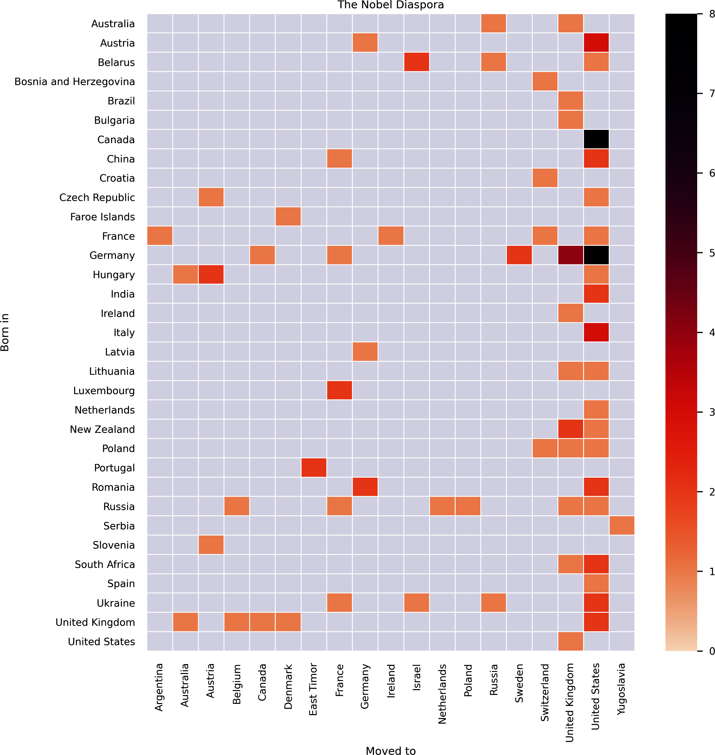

Figure 11-25. The Nobel Prize diaspora
Figure 11-25 shows some interesting patterns, which tell a tale of persecution and sanctuary. First, the United States is the overwhelming recipient of relocated Nobel winners, followed by the United Kingdom. Note that the biggest contingents for both (except cross-border traffic from Canada) are from Germany. Italy, Hungary, and Austria are the next largest groups. Examining the individuals in these groups shows that the majority were displaced as a result of the rise of antisemitic fascist regimes in the run-up to World War II and the increasing persecution of Jewish minorities.
To take an example, all four of the Nobel winners who moved from Germany to the United Kingdom were German research scientists with Jewish ancestry who moved in response to the Nazis’ rise to power:
df
[(
df
.
born_in
==
'Germany'
)
&
(
df
.
country
==
'United Kingdom'
)]
[[
'name'
,
'date_of_birth'
,
'category'
]]
Out
:
name
date_of_birth
category
119
Ernst
Boris
Chain
1906
-
06
-
19
Physiology
or
Medicine
484
Hans
Adolf
Krebs
1900
-
08
-
25
Physiology
or
Medicine
486
Max
Born
1882
-
12
-
11
Physics
503
Bernard
Katz
1911
-
03
-
26
Physiology
or
Medicine
Ernst Chain pioneered the industrial production of penicillin. Hans Krebs discovered the Krebs cycle, one of the most important discoveries in biochemistry, which regulates the energy production of cells. Max Born was one of the pioneers of quantum mechanics, and Bernard Katz uncovered the fundamental properties of synaptic junctions in neurons.
There are many such illustrious names among the winning emigrants. One interesting discovery is the number of prize winners who were part of the famous Kindertransport, an organized rescue effort that took place nine months before the outbreak of WWII and saw ten thousand Jewish children from Germany, Austria, Czechoslovakia, and Poland transported to the United Kingdom. Of these children, four went on to win a Nobel Prize.

Summary
In this chapter, we explored our Nobel Prize dataset, probing the key fields of gender, category, country, and year (of prize) looking for interesting trends and stories we can tell or enable visually. We used a fair number of Matplotlib (by way of pandas) and seaborn’s plots, from basic bar charts to more complicated statistical summaries like violin plots and heatmaps. Mastery of these tools and the others in the Python chart armory will allow you to quickly get the feel of your datasets, which is a prerequisite to building a visualization around them. We found more than enough stories in the data to suggest a web visualization. In the next chapter, we will imagine and design just such a Nobel Prize winner visualization, cherry-picking the nuggets gained in this chapter.
1 Anecdotally, no one I have asked in person or in talk audiences has known the name of the other female Nobel Prize winner for Physics.
2 See Wikipedia for details. Essentially the data is smoothed and a probability density function derived.
3 We are ignoring leap years and other subtle, complicating factors in deriving years from days.
4 Depending on the country, this is around five to six years. See Our World in Data for some stats.

Part IV. Delivering the Data
In this part of the book, we’ll see how to deliver our select Nobel Prize dataset, recently cleaned and explored, to the browser, wherein JavaScript and D3 will turn it into an engaging, interactive visualization (see Figure IV-1).
The great thing about using a general-purpose library like Python is that you can as easily roll a web server in a few, impressively succinct lines, as mine your data with powerful data-processing libraries.
The key server tool in our toolchain is Flask, Python’s powerful but lightweight web framework. In Chapter 12, we’ll see how to serve your data statically (serving system files) and dynamically, usually as a database selection specified in the request. In Chapter 13, we’ll see how two Flask-based libraries make creating a RESTful web API the work of a few lines of Python.
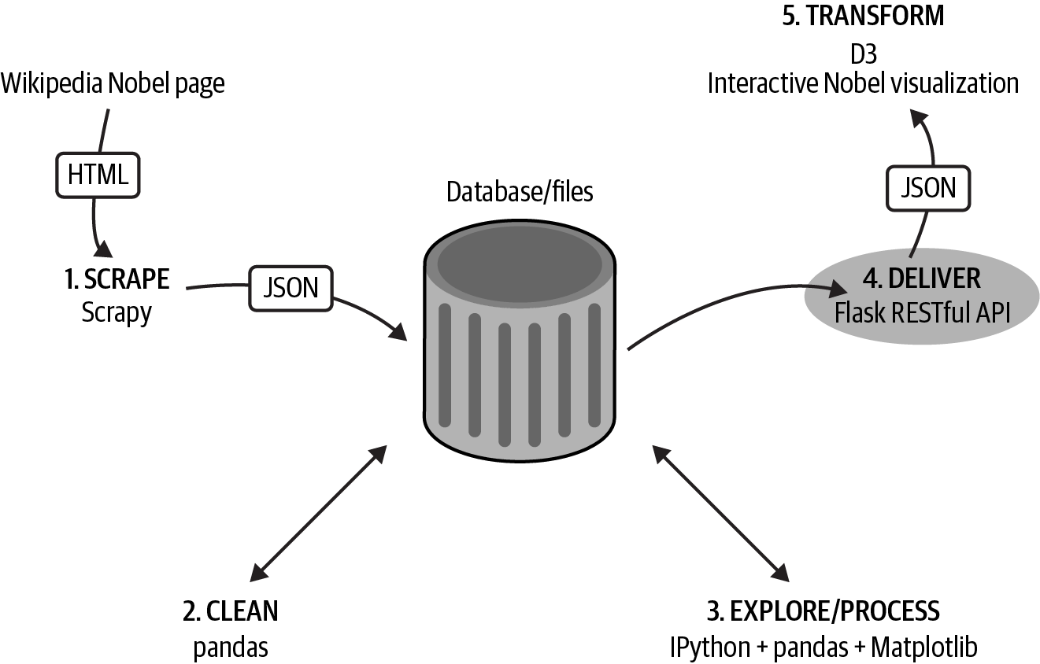

Figure IV-1. Delivering the data
Tip
You can find the code for this part of the book at the book’s GitHub repo.

Chapter 12. Delivering the Data
Chapter 6 showed how to grab your data of interest from the web with a web scraper. We used Scrapy to fetch a dataset of Nobel Prize winners and then in Chapters 9 and 11 we cleaned and explored the Nobel Prize dataset using pandas.
This chapter will show you how to deliver data statically or dynamically from a Python server to JavaScript on the client browser, using our Nobel Prize dataset as an example. This data is stored in the JSON format and consists of a list of Nobel Prize–winner objects like the one shown in Example 12-1.

Example 12-1. Our Nobel Prize JSON data, scraped and then cleaned
[
{
"category"
:
"Physiology or Medicine"
,
"country"
:
"Argentina"
,
"date_of_birth"
:
"1927-10-08T00:00:00.000Z"
,
"date_of_death"
:
"2002-03-24T00:00:00.000Z"
,
"gender"
:
"male"
,
"link"
:
"http:\/\/en.wikipedia.org\/wiki\/C%C3%A9sar_Milstein"
,
"name"
:
"C\u00e9sar Milstein"
,
"place_of_birth"
:
"Bah\u00eda Blanca , Argentina"
,
"place_of_death"
:
"Cambridge , England"
,
"text"
:
"C\u00e9sar Milstein , Physiology or Medicine, 1984"
,
"year"
:
1984
,
"award_age"
:
57
,
"born_in"
:
""
,
"bio_image"
:
"full/6bf65058d573e07b72231407842018afc98fd3ea.jpg"
,
"mini_bio"
:
"<p><b>César Milstein</b>, <a href='http://en.w..."
}
[
'...'
]
]
As with the rest of this book, the emphasis will be on minimizing the amount of web development so you can get down to the business of building the web visualization in JavaScript.
Tip
A good rule of thumb is to aim to do as much data manipulation as possible with Python—it’s much less painful than equivalent operations in JavaScript. Following from this, the data delivered should be as close as possible to the form it will be consumed in (i.e., for D3 this will usually be a JSON array of objects, such as the one we produced in Chapter 9).

Serving the Data
You’ll need a web server to process HTTP requests from the browser, for the initial static HTML and CSS files used to build the web page, and for any subsequent AJAX requests for data. During development, this server will typically be running on a port of localhost (on most systems this has an IP address of 127.0.0.1). Conventionally, an index.html HTML file is used to initialize the website or, in our case, the single-page application (SPA) constituting our web visualization.
The Single-Line Servers
While developing or running demos that depend on static content, it is often handy to have a little web server that just delivers the HTML, CSS, JavaScript, and JSON files to a browser running locally, usually on port 8000 or 8080. Python has a built-in solution with the http.server module, which can be fired up from the root directory of your project with:
$ python -m http.server 8000
Serving HTTP on 0.0.0.0 port 8000 (http://0.0.0.0:8000/) ...
Node provides an alternative dev server with http-server, installed using npm install -g http-server and run from your project root like so:
viz $ http-server
Starting up http-server, serving ./
...
Available on:
http://127.0.0.1:8080
...
Hit CTRL-C to stop the server
Serving your SPA with a single-line server can be fine for visualization prototyping and sketching out ideas but gives you no control over even basic server functionality, such as URL routing or the use of dynamic templates. Thankfully, Python has a great little web server that provides all the functionality a web visualizer could need without sacrificing our aim to minimize the boilerplate standing between our Python-processed data and JavaScripted visualization masterwork. Flask is the mini web server in question and a worthy addition to our best-of-breed toolchain.

Organizing Your Flask Files
How to organize your project files is one of those really useful bits of information that is often neglected in tutorials and the like, possibly because things can get opinionated fast and at the end of the day, it’s a personal preference. Nevertheless, good file organization can really pay off, especially when you start collaborating.
Figure 12-1 gives a rough idea of where your files should go as you move from the basic dataviz JavaScript prototype using a one-line server labeled basic, through a more complex project labeled basic+, to a typical, simple Flask setup labeled flask_project.
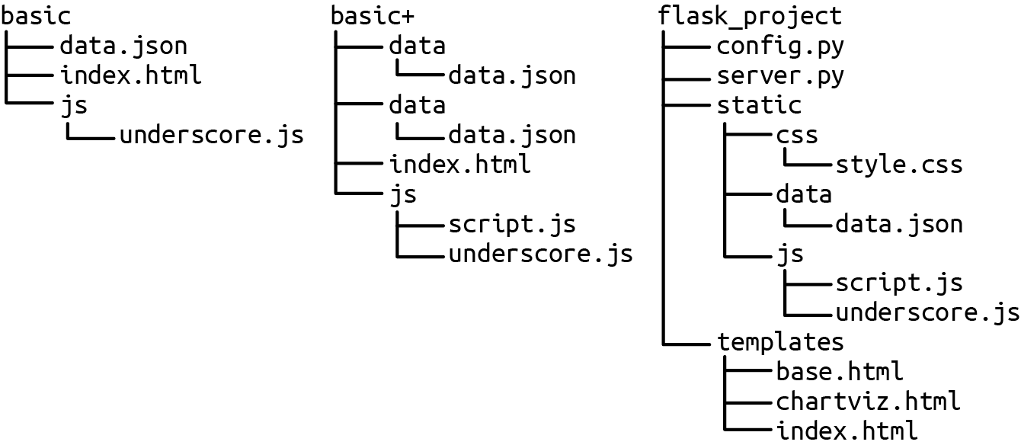

Figure 12-1. Organizing your server project files
The key thing with file organization is consistency. It helps enormously to have the position of files in your procedural memory.

Serving Data with Flask
If you’re using Python’s Anaconda packages (see Chapter 1), then Flask is already available to you. Otherwise, a simple pip install should make it available:
$ pip install Flask
With the Flask modules in hand, we can set up a server with a few lines to serve the universal programming greeting:
# server.py
from
flask
import
Flask
app
=
Flask
(
__name__
)
@app
.
route
(
"
/
"
)
def
hello
(
)
:
return
"
Hello World!
"
if
__name__
==
"
__main__
"
:
app
.
run
(
port
=
8000
,
debug
=
True
)
Flask routes allow you to direct your web traffic. This is the root route (i.e., http://localhost:8000).
Sets the localhost port the server will run on (default 5000). In debug mode, Flask will provide useful logging to screen and in the event of an error, a browser-based report.
Now, just go to the directory containing nobel_viz.py and run the module:
$ python server.py
* Serving Flask app
'server'
(
lazy loading
)
* Environment: production
WARNING: This is a development server. Do not use it
in
a production deployment.
Use a production WSGI server instead.
* Debug mode: off
* Running on http://127.0.0.1:8000/
(
Press CTRL+C to quit
)
You can now go to your web browser of choice and see the emphatic result shown in Figure 12-2.
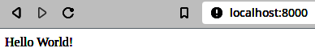

Figure 12-2. A simple message served to the browser
Templating with Jinja2
By default, Flask uses the powerful and fairly intuitive Jinja2 templating library, which can use Python variables to configure an HTML page. The following code shows a little template that loops through an array of winners to create an unordered list:
<!-- testj2.html -->
<!DOCTYPE html>
<
meta
charset
=
"utf-8"
>
<
body
>
<
h2
>
\{{ heading \}}
</
h2
>
<
ul
>
{% for winner in winners %}
<
li
><
a
href
=
"{{ 'http://wikipedia.com/wiki/'
+ winner.name }}"
>
{{ winner.name }}
</
a
>
{{ ', category: ' + winner.category }}
</
li
>
{% endfor %}
</
ul
>
</
body
>
When using Jinja2 with Flask, you will typically use the render_template method to produce an HTML response from a template in the project’s templates (by default) directory. Any arguments made to render_template after its first template file reference are made available to the template. So with testj2.html in our project’s template directory, the following code will render the template when the user visits the /demolist address, producing the list shown in Figure 12-3:
# server_jinja.py
# ...
app
=
Flask
(
__name__
)
# ...
winners
=
[
{
'name'
:
'Albert Einstein'
,
'category'
:
'Physics'
},
{
'name'
:
'V.S. Naipaul'
,
'category'
:
'Literature'
},
{
'name'
:
'Dorothy Hodgkin'
,
'category'
:
'Chemistry'
}
]
@app
.
route
(
'/winners'
)
def
winners_list
():
return
render_template
(
'testj2.html'
,
heading
=
"A little winners' list"
,
winners
=
winners
)
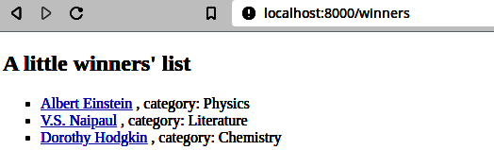
Figure 12-3. A winners list rendered from the testj2.html template
Jinja2 is a powerful and mature templating language with comprehensive docs, which makes it a cinch to use data to render HTML pages server-side.
As we’ll see in “Dynamic Data with Flask APIs”, pattern matching with Flask routing makes it trivial to roll out a simple web API. It’s also easy to use templates to generate dynamic web pages as shown in Figure 12-4. Templates can be useful in visualizations for composing essentially static HTML pages server-side, but generally you’ll be delivering a simple HTML backbone on which to build a visualization with JavaScript. With the visualization being configured in JavaScript, the chief job of the server (aside from delivering the static files needed to seed the process) is to dynamically negotiate data (usually providing it) with the browser’s and JavaScript AJAX requests.
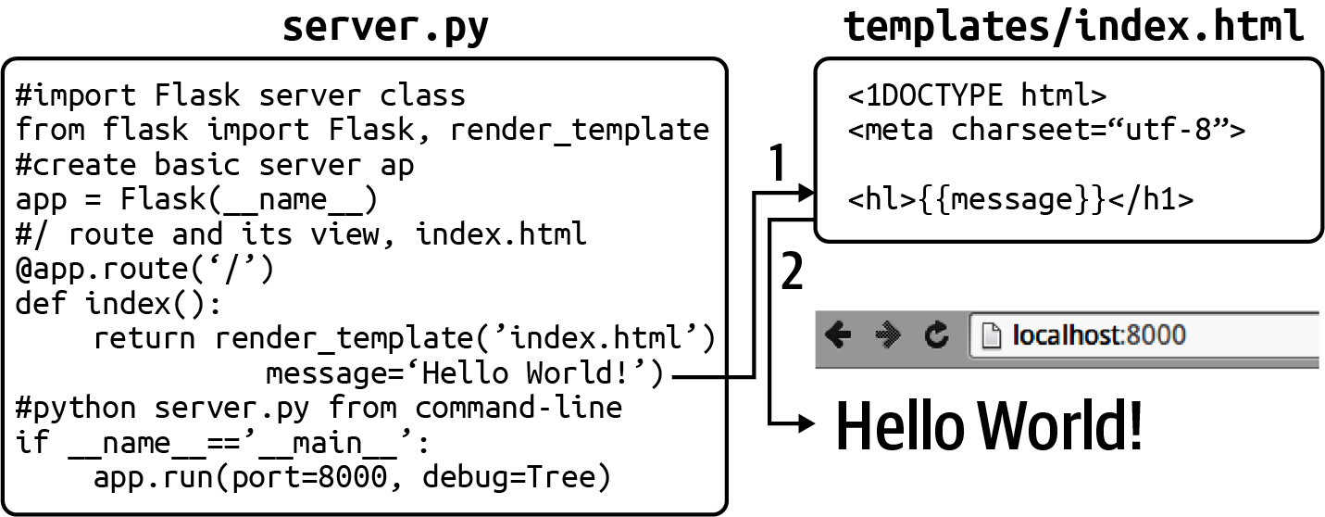

Figure 12-4. (1) An index.html template is used to create a web page using a message variable, which is then (2) served to the browser
Flask is perfectly capable of delivering full websites, with powerful HTML templating, blueprints for modularizing large sites and supporting common usage patterns, and a slew of useful plug-ins and extensions. The Flask user’s guide is a good starting point for learning more, and the API specifics can be found in this subsection of the guide. The single-page apps that characterize most web visualizations don’t need a lot of bells and whistles server-side to deliver the necessary static files. Our key interest in Flask is its ability to provide simple, efficient data servers, with robust RESTful web APIs available in a few lines of Python. But before dipping our toes in data APIs, let’s look at how we deliver and use file-based data assets such as JSON and CSV files.

Delivering Data Files
Many websites that don’t need the overhead of dynamically configured data choose to deliver their data in a static form, which essentially means that all the HTML files and, crucially, data (usually in JSON or CSV format), exist as files on the server’s filesystem, ready to be delivered without, for example, making calls to a database.
Static pages are easy to cache, meaning their delivery can be much faster. It can also be more secure, as those database calls can be a common attack vector for nefarious hackers (e.g., injection attacks). The price paid for this increased speed and security is a loss of flexibility. Being limited to a set of preassembled pages means prohibiting user interactions that might demand multivariate combinations of data.
For the budding data visualizer, there is an attraction in supplying static data. You can easily create a standalone project without needing a web API and are able to deliver your work (in progress) as a single folder of HTML, CSS, and JSON files.
The simplest example of data-driven web visualizations with static files is probably that seen in the many cool D3 examples at https://bl.ocks.org/mbostock.1 They follow a similar structure to the basic page we discussed in “A Basic Page with Placeholders”.
Although the examples use <script> and <style> tags to embed JavaScript and CSS in the HTML page, I’d recommend keeping your CSS and JavaScript in separate files, where you get the advantages of a decent format-aware editor and easier debugging.
Example 12-2 shows such an index.html basic page with <h2> and <div> data placeholders and a <script> tag that loads a local script.js file. As we’re only setting the font-family style, we’ll inline the CSS in the page. With our nobel_winners.json dataset in a data subdirectory, this gives us the following file structure:
viz
├── data
│ └── nobel_winners.json
├── index.html
└── script.js

Example 12-2. A basic HTML page with data placeholders
<!DOCTYPE html>
<
meta
charset
=
"utf-8"
>
<
style
>
body
{
font-family
:
sans-serif
;
}
</style>
<
h2
id
=
'data-title'
></
h2
>
<
div
id
=
'data'
>
<
pre
></
pre
>
</
div
>
<
script
src
=
"lib/d3.v7.min.js"
></
script
>
<
script
src
=
"script.js"
></
script
>
The static data file for these examples consists of a single JSON file (nobel_winners.json) sitting in a data subdirectory. Consuming this data requires a JavaScript AJAX call to our server. D3 provides convenient libraries for making AJAX calls, with D3’s format-specific json, csv, and tsv methods being handier for web visualizers.
Example 12-3 shows how to load data with D3’s json method using a callback function. Behind the scenes, D3 is using JavaScript’s Fetch API to fetch the data. This returns a JavaScript Promise, which can be resolved using its then method, returning the data unless an error has occurred.

Example 12-3. Using D3’s json method to load data
d3
.
json
(
"data/nobel_winners_cleaned.json"
)
.
then
(
(
data
)
=>
{
d3
.
select
(
"h2#data-title"
)
.
text
(
"All the Nobel-winners"
)
;
d3
.
select
(
"div#data pre"
)
.
html
(
JSON
.
stringify
(
data
,
null
,
4
)
)
;
}
)
;
JavaScript’s JSON.stringify method is a handy way to prettify a JavaScript object for output. Here we insert some whitespace to indent the output by four spaces.
If you run a one-line server (e.g., python -m http.server) in your viz directory and open the localhost page in your web browser, you should see something similar to Figure 12-5, indicating the data has been successfully delivered to JavaScript, ready to be visualized.
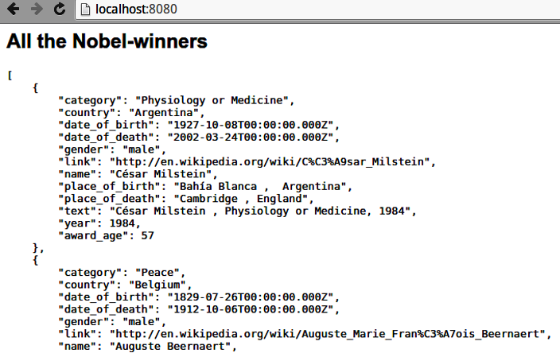

Figure 12-5. Delivering JSON to the browser
The nobel_winners.json dataset we’re using isn’t particularly large, but if we were to start adding biographical body text or other textual data, it could easily grow to a size that strains available browser bandwidth and starts to make the user wait uncomfortably. One strategy to limit loading times is to break the data down into subsets based on one of the dimensions. An obvious way to do this with our data is to store the winners by country. A few lines of pandas does the job of creating a suitable data directory:
import
pandas
as
pd
df_winners
=
pd
.
read_json
(
'
data/nobel_winners.json
'
)
for
name
,
group
in
df_winners
.
groupby
(
'
country
'
)
:
group
.
to_json
(
'
data/winners_by_country
'
+
name
+
'
.json
'
,
\
orient
=
'
records
'
)
Groups the winners DataFrame by country and iterates over the group name and members.
This should give us a winners_by_country data subdirectory:
$ ls data/winners_by_country
Argentina.json Azerbaijan.json Canada.json
Colombia.json Czech Republic.json Egypt.json ...
We can now consume our data by country using a little tailor-made function:
let
loadCountryWinnersJSON
=
function
(
country
)
{
d3
.
json
(
"data/winners_by_country/"
+
country
+
".json"
)
.
then
(
function
(
data
)
{
d3
.
select
(
"h2#data-title"
).
text
(
"All the Nobel-winners from "
+
country
);
d3
.
select
(
"div#data pre"
).
html
(
JSON
.
stringify
(
data
,
null
,
4
));
})
.
catch
((
error
)
=>
console
.
log
(
error
));
};
The following function call will select all the Australian Nobel Prize winners, producing Figure 12-6:
loadCountryWinnersJSON
(
'Australia'
);
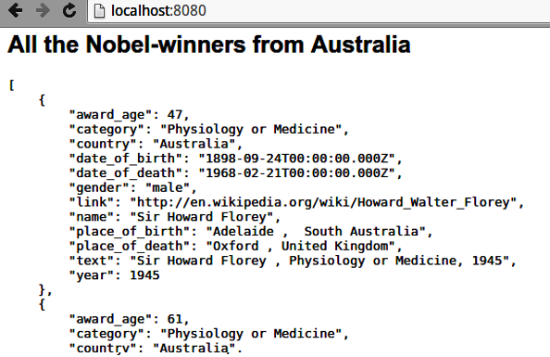

Figure 12-6. Selecting winners by country
For the right visualization, the ability to select winners by country could reduce the data bandwidth and subsequent lag, but what if we wanted winners by year or gender? Each division by dimension (categorical, temporal, etc.) would require its own subdirectory, creating a mess of files and all the bookkeeping that entails. What if we wanted to make fine-grained requests for data (e.g., all US prize winners since 2000)? At this point, we need a data server that can respond dynamically to such requests, usually driven by user interaction. The next section will show you how to start crafting such a server with Flask.

Dynamic Data with Flask APIs
Delivering data to web pages with JSON or CSV files is the basis for many of the most impressive dataviz examples seen on the web and is perfect for small demos and prototypes. But there are constraints to the form, most obviously in the size of the datasets that can be realistically delivered. As the datasets increase in size and the files start to tip into megabytes, page loading slows down and user frustration mounts with every spin of the spinner. For much dataviz, particularly dashboards or exploratory charts, it makes sense to deliver the data as needed and in response to user requests generated by a user interface of some form. For this kind of data delivery a small data server is often perfect for the job, and Python’s Flask has everything you need to craft one of these.
If we’re delivering data dynamically, we’re going to need some kind of API to enable our JavaScript to request data.

A Simple Data API with Flask
Using Dataset (see “Easier SQL with Dataset”), we can easily adapt our existing server for an SQL database. Here we use Dataset for convenience and the specialized JSON encoder (see Example 3-2) to convert Python datatimes to a JSON-friendly ISO string:
# server_sql.py
from
flask
import
Flask
,
request
,
abort
import
dataset
import
json
import
datetime
app
=
Flask
(
__name__
)
db
=
dataset
.
connect
(
'
sqlite:///data/nobel_winners.db
'
)
@app
.
route
(
'
/api/winners
'
)
def
get_country_data
(
)
:
print
'
Request args:
'
+
str
(
dict
(
request
.
args
)
)
query_dict
=
{
}
for
key
in
[
'
country
'
,
'
category
'
,
'
year
'
]
:
arg
=
request
.
args
.
get
(
key
)
if
arg
:
query_dict
[
key
]
=
arg
winners
=
list
(
db
[
'
winners
'
]
.
find
(
*
*
query_dict
)
)
if
winners
:
return
dumps
(
winners
)
abort
(
404
)
# resource not found
class
JSONDateTimeEncoder
(
json
.
JSONEncoder
)
:
def
default
(
self
,
obj
)
:
if
isinstance
(
obj
,
(
datetime
.
date
,
datetime
.
datetime
)
)
:
return
obj
.
isoformat
(
)
else
:
return
json
.
JSONEncoder
.
default
(
self
,
obj
)
def
dumps
(
obj
)
:
return
json
.
dumps
(
obj
,
cls
=
JSONDateTimeEncoder
)
if
__name__
==
'
__main__
'
:
app
.
run
(
port
=
8000
,
debug
=
True
)
Restricts our database queries to keys in this list.
request.args gives us access to the arguments of the request (e.g., '?country=Australia&category=Chemistry').
dataset’s find method requires our argument dictionary to be unpacked with ** (i.e., find(country='Australia', category='Literature')). We convert the iterator to a list, ready to serialize.
This is the specialized JSON encoder detailed in Example 3-2.
We can test this little API with curl after starting the server (python server_sql.py). Let’s get all Japanese Physics prizewinners:
$ curl -d category=Physics -d country=Japan
--get http://localhost:8000/api/
[{"index": 761, "category": "Physics", "country": "Japan",
"date_of_birth": "1907-01-23T00:00:00", "date_of_death": "1981-09-08T00:00:00",
"gender": "male", "link": "http://en.wikipedia.org/wiki/Hideki_Yukawa",
"name": "Hideki Yukawa", "place_of_birth": "Tokyo , Japan",
"place_of_death": "Kyoto , Japan", "text": "Hideki Yukawa , Physics, 1949",
"year": 1949, "award_age": 42}, {"index": 762, "category": "Physics",
"country": "Japan", "date_of_birth": "1906-03-31T00:00:00",
"date_of_death": "1979-07-08T00:00:00", "gender": "male", ... }]
You’ve now seen how easy it is to start creating a simple API. There are lots of ways one can extend it, but for fast and dirty prototyping, this is a handy little form.
But what if you want pagination, authentication, and a host of other things a sophisticated RESTful API would provide? In the next chapter, we’ll see how easy it is to extend our simple data API into something more powerful and extendible, using some brilliant Python libraries like marmalade.

Using Static or Dynamic Delivery
When to use static or dynamic delivery is highly dependent on context and is an inevitable compromise. Bandwidths vary regionally and with devices. For example, if you’re developing a visualization that should be accessible from a smartphone in a rural context, the data constraints are very different from those of an in-house data app running on a local network.
The ultimate guide is user experience. If a little wait at the beginning while the data caches leads to a lightning-fast JavaScript dataviz, then purely static delivery may well be the answer. If you are allowing the user to cut and slice a large, multivariate dataset, then this probably won’t be possible without an annoyingly long wait time. As a rough rule of thumb, any dataset less than 200 KB should be fine with purely static delivery. As you move into the megabytes of data and beyond, you’ll probably need a database-driven API from which to fetch your data.

Summary
This chapter explained the rudiments of static data delivery of files on the web server, and dynamic delivery of data, sketching the basis of a simple Flask-based RESTful web server. Although Flask makes rolling a basic data API pretty trivial, adding such bells and whistles as pagination, selective data queries, and the full complement of HTTP verbs requires a little more work. In the first edition of this book I turned to some off-the-shelf Python RESTful libraries, but these tend to have a short expiry date, probably because it’s so easy to string together some single-purpose Python libraries to achieve the same end, with more flexibility. It’s also a great way to learn those tools, so building just such a RESTful API is the topic of the next chapter.
1 Mike Bostock, D3’s creator, is a big advocate of examples. Here’s a great talk where he emphasizes the role examples have played in the success of D3.

Chapter 13. RESTful Data with Flask
In “A Simple Data API with Flask”, we saw how to build a very simple data API with Flask and Dataset. For many simple data visualizations this kind of quick and dirty API is fine, but as the data demands become more advanced it helps to have an API that respects some conventions for retrieval and, sometimes, creation, update and delete.1 In “Using Python to Consume Data from a Web API”, we covered the types of web API and why RESTful2 APIs are acquiring a well-deserved prominence. In this chapter, we’ll see how easy it is to combine a few Flask libraries into a flexible RESTful API.

The Tools for a RESTful Job
As seen in “A Simple Data API with Flask”, the basics of a data API are pretty simple. It needs a server, which accepts HTTP requests such as GET to retrieve or more advanced verbs like POST (to add) or DELETE. These requests are on routes like api/winners that are then dealt with by functions provided. In these functions data is retrieved from a backend database, possibly filtered using data parameters (e.g., strings like ?category=comic&name=Groucho appended to the URL calls). This data then needs to be returned or serialized in some requested format, pretty much always JSON-based. For this round trip of data, the Flask/Python ecosystem provides some perfect libraries:
- Flask to do the server work
- Flask SQLAlchemy, a Flask extension that integrates SQLAlchemy, our preferred Python SQL library with object-relational mapper (ORM)
- Flask-Marshmallow, a Flask extension that adds support for marshmallow, a powerful Python library for object serialization
You can install the required extensions with pip:
$ pip install Flask-SQLALchemy flask-marshmallow marshmallow-sqlalchemy

Creating the Database
In “Saving the Cleaned Datasets”, we saw how easy it is to save a pandas DataFrame to SQL using the to_sql method. This is a very convenient way to store a DataFrame, but the table produced lacks a primary key field, which uniquely specifies a table row. It’s good form to have a primary key, and for the purposes of creating or deleting rows via our Web API, is pretty much essential. For this reason we’ll create our SQL table by another route.
First, we build an SQLite database with SQLAlchemy, adding a primary-key ID to the winners table:
from
sqlalchemy
import
Column
,
Integer
,
String
,
Text
from
sqlalchemy
.
ext
.
declarative
import
declarative_base
from
sqlalchemy
.
orm
import
sessionmaker
Base
=
declarative_base
(
)
class
Winner
(
Base
)
:
__tablename__
=
'
winners
'
id
=
Column
(
Integer
,
primary_key
=
True
)
category
=
Column
(
String
)
country
=
Column
(
String
)
date_of_birth
=
Column
(
String
)
# string form dates
date_of_death
=
Column
(
String
)
# ...
# create SQLite database and start a session
engine
=
sqlalchemy
.
create_engine
(
'
sqlite:///data/nobel_winners_cleaned_api.db
'
)
Base
.
metadata
.
create_all
(
engine
)
Session
=
sessionmaker
(
bind
=
engine
)
session
=
Session
(
)
We specify the all-important primary key to disambiguate our winners.
Note that we are going to store the dates as strings to limit any problems serializing datetime objects. We’ll convert those DataFrame columns before committing the rows to the database:
df
[
'date_of_birth'
]
=
df
[
'date_of_birth'
]
.
astype
(
str
)
df
[
'date_of_death'
]
=
dl
[
'date_of_death'
]
.
astype
(
str
)
df
.
date_of_birth
#0 1927-10-08
#4 1829-07-26
#5 1862-08-29
..
We can now iterate through our DataFrame’s rows, adding them to the database as dictionary records and then commit all of them, relatively efficiently, as one transaction:
for
d
in
df_tosql
.
to_dict
(
orient
=
'records'
):
session
.
add
(
Winner
(
**
d
))
session
.
commit
()
With our well-formed database to hand, let’s see how to easily serve it with Flask.

A Flask RESTful Data Server
This will be a standard Flask server, similar to the one seen in “Serving Data with Flask”. First, we import the standard Flask modules along with the SQLALchemy and marshmallow extensions and create our Flask app:
from
flask
import
Flask
,
request
,
jsonify
from
flask_sqlalchemy
import
SQLAlchemy
from
flask_marshmallow
import
Marshmallow
# Init app
app
=
Flask
(
__name__
)
Now some database-specific declarations, initializing SQLAlchemy with the Flask app:
app
.
config
[
'SQLALCHEMY_DATABASE_URI'
]
=
\
'sqlite:///data/nobel_winners_cleaned_api_test.db'
db
=
SQLAlchemy
(
app
)
We can now use the db instance to define our winners table, subclassed from the base declarative model. This matches the schema used to create the winners table in the last section:
class
Winner
(
db
.
Model
):
__tablename__
=
'winners'
id
=
db
.
Column
(
db
.
Integer
,
primary_key
=
True
)
category
=
db
.
Column
(
db
.
String
)
country
=
db
.
Column
(
db
.
String
)
date_of_birth
=
db
.
Column
(
db
.
String
)
date_of_death
=
db
.
Column
(
db
.
String
)
gender
=
db
.
Column
(
db
.
String
)
link
=
db
.
Column
(
db
.
String
)
name
=
db
.
Column
(
db
.
String
)
place_of_birth
=
db
.
Column
(
db
.
String
)
place_of_death
=
db
.
Column
(
db
.
String
)
text
=
db
.
Column
(
db
.
Text
)
year
=
db
.
Column
(
db
.
Integer
)
award_age
=
db
.
Column
(
db
.
Integer
)
def
__repr__
(
self
):
return
"<Winner(name='
%s
', category='
%s
', year='
%s
')>"
\
%
(
self
.
name
,
self
.
category
,
self
.
year
)

Serializing with marshmallow
marshmallow is a really useful little Python library that does one job and does it well. To quote the documentation:
marshmallow is an ORM/ODM/framework-agnostic library for converting complex datatypes, such as objects, to and from native Python datatypes.
marshmallow uses Schemas, similar to SQLALchemy’s, to enable deserializing input data to app-level objects and validation of that input data. For our purposes here its key asset is its ability to take data from our SQLite database, provided by SQLAlchemy, and turn it into JSON-compliant data.
To use Flask-Marshmallow we first create a marshmallow instance (ma), initialized with the Flask app. We then use this to create a marshmallow schema, using the SQLAlchemy Winner model as its base. The schema also has a fields property that allows you to specify which (database) fields to serialize:
ma
=
Marshmallow
(
app
)
class
WinnerSchema
(
ma
.
Schema
)
:
class
Meta
:
model
=
Winner
fields
=
(
'
category
'
,
'
country
'
,
'
date_of_birth
'
,
'
date_of_death
'
,
'
gender
'
,
'
link
'
,
'
name
'
,
'
place_of_birth
'
,
'
place_of_death
'
,
'
text
'
,
'
year
'
,
'
award_age
'
)
winner_schema
=
WinnerSchema
(
)
winners_schema
=
WinnerSchema
(
many
=
True
)
The database fields to serialize.
We declare two schema instances, one for returning single records and one for multiple records.

Adding our RESTful API Routes
Now the backbone is in place, let’s craft a few Flask routes to define a small RESTful API. For a first test, we’ll make a route that returns all the Nobel winners in our database table:
@app
.
route
(
'
/winners/
'
)
def
winner_list
(
)
:
all_winners
=
Winner
.
query
.
all
(
)
result
=
winners_schema
.
jsonify
(
all_winners
)
return
result
Database query for all rows in the winners table.
The marshmallow schema for many rows takes the all-winners result and serializes it to JSON.
We’ll test the API with some command-line curl:
$ curl http://localhost:5000/winners/
[
{
"award_age"
:
57
,
"category"
:
"Physiology or Medicine"
,
"country"
:
"Argentina"
,
"date_of_birth"
:
"1927-10-08"
,
"date_of_death"
:
"2002-03-24"
,
"gender"
:
"male"
,
"link"
:
"http://en.wikipedia.org/wiki/C%C3%A9sar_Milstein"
,
"name"
:
"C\u00e9sar Milstein"
,
"place_of_birth"
:
"Bah\u00eda Blanca , Argentina"
,
"place_of_death"
:
"Cambridge , England"
,
"text"
:
"C\u00e9sar Milstein , Physiology or Medicine, 1984"
,
"year"
:
1984
}
,
{
"award_age"
:
80
,
"category"
:
"Peace"
, ...
}
...
]
So we now have an API endpoint to return all the winners. What about being able to retrieve individuals by ID (our primary key for the winners table)? To do this, we retrieve the ID from the API call, using Flask’s route pattern-matching, and use it to make a specific database query. We then serialize this to JSON using our single-row marshmallow schema:
@app
.
route
(
'
/winners/<id>/
'
)
def
winner_detail
(
id
)
:
winner
=
Winner
.
query
.
get_or_404
(
id
)
result
=
winner_schema
.
jsonify
(
winner
)
return
result
Flask-SQLAlchemy provides a default 404 error message, which can be serialized to JSON by marshmallow if the query is invalid.
Testing with curl shows the expected single JSON object returned:
$ curl http://localhost:5000/winners/10/
{
"award_age"
:
60
,
"category"
:
"Chemistry"
,
"country"
:
"Belgium"
,
"date_of_birth"
:
"1917-01-25"
,
"date_of_death"
:
"2003-05-28"
,
"gender"
:
"male"
,
"link"
:
"http://en.wikipedia.org/wiki/Ilya_Prigogine"
,
"name"
:
"Ilya Prigogine"
,
"place_of_birth"
:
"Moscow , Russia"
,
"place_of_death"
:
"Brussels , Belgium"
,
"text"
:
"Ilya Prigogine , born in Russia , Chemistry, 1977"
,
"year"
:
1977
}
Being able to retrieve all the winners on a single API call isn’t particularly useful. Let’s add the ability to filter those results with some arguments provided on the request. These arguments are the ones found on the URL query string, starting with a ? and separated by &s, which follows the endpoint, e.g., http://nobel.net/api/winners?category=Physics&year=1980. Flask provides a request.args object that has a to_dict method, returning a dictionary of URL arguments.3 We can use this to specify our data table filters, which can be applied as key-value pairs using SQLAlchemy’s to_filter method, which can be applied to queries. Here’s a simple implementation:
@app
.
route
(
'
/winners/
'
)
def
winner_list
(
)
:
valid_filters
=
(
'
year
'
,
'
category
'
,
'
gender
'
,
'
country
'
,
'
name
'
)
filters
=
request
.
args
.
to_dict
(
)
args
=
{
name
:
value
for
name
,
value
in
filters
.
items
(
)
if
name
in
valid_filters
}
# This for loop does the same job as the dict
# comprehension above
# args = {}
# for vf in valid_filters:
# if vf in filters:
# args[vf] = filters.get(vf)
app
.
logger
.
info
(
f
'
Filtering with the fields:
{
args
}
'
)
all_winners
=
Winner
.
query
.
filter_by
(
*
*
args
)
result
=
winners_schema
.
jsonify
(
all_winners
)
return
result
These are the fields we will allow filtering on.
We iterate through the filter fields provided and use the valid ones to create our filter dictionary. Here we use a Python dictionary comprehension to construct the args dictionary.
Use Python’s dictionary unpacking to specify method parameters.
Let’s test our filtering abilty with curl, using the -d (data) arguments to specify our query parameters:
$ curl -d
category
=
Physics -d
year
=
1933
--get http://localhost:5000/winners/
[
{
"award_age"
:
31
,
"category"
:
"Physics"
,
"country"
:
"United Kingdom"
,
"date_of_birth"
:
"1902-08-08"
,
"date_of_death"
:
"1984-10-20"
,
"gender"
:
"male"
,
"link"
:
"http://en.wikipedia.org/wiki/Paul_Dirac"
,
"name"
:
"Paul Dirac"
,
"place_of_birth"
:
"Bristol , England"
,
"place_of_death"
:
"Tallahassee, Florida , US"
,
"text"
:
"Paul Dirac , Physics, 1933"
,
"year"
:
1933
}
,
{
"award_age"
:
46
,
"category"
:
"Physics"
,
"country"
:
"Austria"
,
"date_of_birth"
:
"1887-08-12"
,
"date_of_death"
:
"1961-01-04"
,
"gender"
:
"male"
,
"link"
:
"http://en.wikipedia.org/wiki/Erwin_Schr%C3%B6dinger"
,
"name"
:
"Erwin Schr\u00f6dinger"
,
"place_of_birth"
:
"Erdberg, Vienna, Austria"
,
"place_of_death"
:
"Vienna, Austria"
,
"text"
:
"Erwin Schr\u00f6dinger , Physics, 1933"
,
"year"
:
1933
}
]
We now have fairly fine-grained filtering on our winners dataset, and for many data visualizations, that would be enough to provide a large, user-driven dataset, fetching data from the RESTful API as required. The ability to post or create data entries from the API or a web form is one of those requirements that crops up now and again and is a good to know. It means you can use the API as a central data pool and add to it from various locations. It’s also very easy to do with Flask and our extensions.

Posting Data to the API
Flask routes take an optional methods argument, which specifies the HTTP verbs accepted. The GET verb is the default, but by setting it to POST we can post data to this route with the packet available on the request object, in this case as JSON encoded data.
We add another /winners endpoint, with a methods array containing POST, then use the JSON data to make a winner_data dict that is used to create an entry in the winners table. This is then added to the database session and finally committed. The new entry is returned using marshmallow’s serializing:
@app
.
route
(
'/winners/'
,
methods
=
[
'POST'
])
def
add_winner
():
valid_fields
=
winner_schema
.
fields
winner_data
=
{
name
:
value
for
name
,
value
in
request
.
json
.
items
()
if
name
in
valid_fields
}
app
.
logger
.
info
(
f
"Creating a winner with these fields:
{
winner_data
}
"
)
new_winner
=
Winner
(
**
winner_data
)
db
.
session
.
add
(
new_winner
)
db
.
session
.
commit
()
return
winner_schema
.
jsonify
(
new_winner
)
Testing with curl returns the expected result:
$
curl
http://localhost:5000/winners/
\
-X
POST
\
-H
"Content-Type: application/json"
\
-d
'{"category":"Physics","year":2021,
"name":"Syukuro Manabe","country":"Japan"}'
{
"award_age"
:
null,
"category"
:
"Physics"
,
"country"
:
"Japan"
,
"date_of_birth"
:
null,
"date_of_death"
:
null,
"gender"
:
null,
"link"
:
null,
"name"
:
"Syukuro Manabe"
,
"place_of_birth"
:
null,
"place_of_death"
:
null,
"text"
:
null,
"year"
:
2021
}
The input data is a JSON encoded string.
Perhaps more useful for data management is an API endpoint enabling a winner’s data to be updated. For this we can use the HTTP PATCH verb called on an individual URL. As with the POST to create a new winner, we cycle through the request.json dictionary and use any valid fields, in this case all available to marshmallow’s serializer, to update the attributes of the winner by ID:
@app
.
route
(
'/winners/<id>/'
,
methods
=
[
'PATCH'
])
def
update_winner
(
id
):
winner
=
Winner
.
query
.
get_or_404
(
id
)
valid_fields
=
winner_schema
.
fields
winner_data
=
{
name
:
value
for
name
,
value
in
request
.
json
.
items
()
if
name
in
valid_fields
}
app
.
logger
.
info
(
f
"Updating a winner with these fields:
{
winner_data
}
"
)
for
k
,
v
in
winner_data
.
items
():
setattr
(
winner
,
k
,
v
)
db
.
session
.
commit
()
return
winner_schema
.
jsonify
(
winner
)
Here we use this API patch point to update, for the purposes of demonstration, the name and prize year of a Nobel winner:
$
curl
http://localhost:5000/winners/3/
\
-X
PATCH
\
-H
"Content-Type: application/json"
\
-d
'{"name":"Morris Maeterlink","year":"1912"}'
{
"award_age"
:
49
,
"category"
:
"Literature"
,
"country"
:
"Belgium"
,
"date_of_birth"
:
"1862-08-29"
,
"date_of_death"
:
"1949-05-06"
,
"gender"
:
"male"
,
"link"
:
"http://en.wikipedia.org/wiki/Maurice_Maeterlinck"
,
"name"
:
"Morris Maeterlink"
,
"place_of_birth"
:
"Ghent , Belgium"
,
"place_of_death"
:
"Nice , France"
,
"text"
:
"Maurice Maeterlinck , Literature, 1911"
,
"year"
:
1912
}
The original details.
At this point we have built a useful, targeted API able to fetch data according to fine-grained filters and update or create winners. If you wanted to add more endpoints covering a few more database tables, the Flask routing boilerplate and associated methods can get a little messy. Flask MethodViews provide a way of encapsulating our endpoint API calls in a single class instance, making things cleaner and more extendible. It’s easy to transfer our existing API to MethodViews and the reduced cognitive load will pay off as your APIs get more involved.

Extending the API with MethodViews
We can reuse the bulk of our API’s code, and shifting it to MethodViews loses a pleasing amount of boilerplate too. MethodViews encapsulate endpoints and their associated HTTP verbs (GET, POST, etc.) in a single class instance, which can be easily extended and adapted. To shift our winners table to a dedicated resource, we can just lift the existing Flask route methods into a MethodView class and make a few minor adjustments. First, we’ll need to import the MethodView class:
#...
from
flask.views
import
MethodView
#...
The SQLAlchemy model and marshmallow schemas don’t need changing. Now we create a MethodView instance for our winners collection with methods for the relevant HTTP verbs. We can reuse the existing route methods. We then use the Flask app’s add_url_rule method to provide an endpoint, which the view will handle:
class
WinnersListView
(
MethodView
):
def
get
(
self
):
valid_filters
=
(
'year'
,
'category'
,
'gender'
,
'country'
,
'name'
)
filters
=
request
.
args
.
to_dict
()
args
=
{
name
:
value
for
name
,
value
in
filters
.
items
()
if
name
in
valid_filters
}
app
.
logger
.
info
(
'Filtering with the
%s
fields'
%
(
str
(
args
)))
all_winners
=
Winner
.
query
.
filter_by
(
**
args
)
result
=
winners_schema
.
jsonify
(
all_winners
)
return
result
def
post
(
self
):
valid_fields
=
winner_schema
.
fields
winner_data
=
{
name
:
value
for
name
,
value
in
request
.
json
.
items
()
if
name
in
valid_fields
}
app
.
logger
.
info
(
"Creating a winner with these fields:
%s
"
%
str
(
winner_data
))
new_winner
=
Winner
(
**
winner_data
)
db
.
session
.
add
(
new_winner
)
db
.
session
.
commit
()
return
winner_schema
.
jsonify
(
new_winner
)
app
.
add_url_rule
(
"/winners/"
,
view_func
=
WinnersListView
.
as_view
(
"winners_list_view"
))
To create HTTP methods for individual table entries follows the same pattern. We’ll add a delete method for good measure. Successful HTTP deletes should return the 204 (no content) HTTP code and an empty content package:
class
WinnerView
(
MethodView
)
:
def
get
(
self
,
winner_id
)
:
winner
=
Winner
.
query
.
get_or_404
(
winner_id
)
result
=
winner_schema
.
jsonify
(
winner
)
return
result
def
patch
(
self
,
winner_id
)
:
winner
=
Winner
.
query
.
get_or_404
(
winner_id
)
valid_fields
=
winner_schema
.
fields
winner_data
=
{
name
:
value
for
name
,
value
in
request
.
json
.
items
(
)
if
name
in
valid_fields
}
app
.
logger
.
info
(
"
Updating a winner with these fields:
%s
"
%
str
(
winner_data
)
)
for
k
,
v
in
winner_data
.
items
(
)
:
setattr
(
winner
,
k
,
v
)
db
.
session
.
commit
(
)
return
winner_schema
.
jsonify
(
winner
)
def
delete
(
self
,
winner_id
)
:
winner
=
Winner
.
query
.
get_or_404
(
winner_id
)
db
.
session
.
delete
(
winner
)
db
.
session
.
commit
(
)
return
'
'
,
204
app
.
add_url_rule
(
"
/winners/<winner_id>
"
,
view_func
=
WinnerView
.
as_view
(
"
winner_view
"
)
)
The named, pattern-matched arguments are passed to all the MethodViews methods.
Let’s use curl to delete one of our winners, specifying a verbose output:
$ curl http://localhost:5000/winners/858 -X DELETE -v
* Trying 127.0.0.1...
* Connected to localhost (127.0.0.1) port 5000 (#0)
> DELETE /winners/858 HTTP/1.1
> Host: localhost:5000
> User-Agent: curl/7.47.0
> Accept: */*
>
* HTTP 1.0, assume close after body
< HTTP/1.0 204 NO CONTENT
< Content-Type: application/json
< Server: Werkzeug/2.0.2 Python/3.8.9
< Date: Sun, 27 Mar 2022 15:35:51 GMT
<
* Closing connection 0
By using MethodViews on dedicated endpoints, we cut out a lot of Flask’s routing boilerplate and make the codebase easier to work with and extend. By way of example, let’s see how to add a very handy API feature, the ability to paginate or chunk data.

Paginating the Data Returns
If you have large datasets and anticipate large result sets, the ability to receive that data in paginated chunks is a very useful API feature; for many use cases, a vital one.
SQLAlchemy has a handy paginate method that can be called on queries to return pages of data of a specified page size. To add pagination to our winners API, we just need to add a couple of query parameters to specify the page and page size. We’ll use _page and _page-size and prefix them with an underscore to distinguish them from any filter queries we may apply.
Here’s the adapted get method:
class
WinnersListView
(
MethodView
)
:
def
get
(
self
)
:
valid_filters
=
(
'
year
'
,
'
category
'
,
'
gender
'
,
'
country
'
,
'
name
'
)
filters
=
request
.
args
.
to_dict
(
)
args
=
{
name
:
value
for
name
,
value
in
filters
.
items
(
)
if
name
in
valid_filters
}
app
.
logger
.
info
(
f
'
Filtering with the
{
args
}
fields
'
)
page
=
request
.
args
.
get
(
"
_page
"
,
1
,
type
=
int
)
per_page
=
request
.
args
.
get
(
"
_per-page
"
,
20
,
type
=
int
)
winners
=
Winner
.
query
.
filter_by
(
*
*
args
)
.
paginate
(
page
,
per_page
)
winners_dumped
=
winners_schema
.
dump
(
winners
.
items
)
results
=
{
"
results
"
:
winners_dumped
,
"
filters
"
:
args
,
"
pagination
"
:
{
"
count
"
:
winners
.
total
,
"
page
"
:
page
,
"
per_page
"
:
per_page
,
"
pages
"
:
winners
.
pages
,
}
,
}
make_pagination_links
(
'
winners
'
,
results
)
return
jsonify
(
results
)
# ...
The pagination parameters with sensible defaults.
Here we use SQLAlchemy’s paginate method with our page and per_page pagination variables.
We return our paginated results and anything else that makes sense. In the pagination dict we provide useful feedback—the page being returned and the size of the total dataset.
We’ll use this function to add some handy URLs to fetch previous or next pages.
By convention it’s useful to return URL endpoints for previous and next pages, to allow easy consumption of the total dataset. We have a little make_pagination_links function for this, which adds these convenient URLs to the pagination dictionary. We’ll use Python’s urllib library to construct our URL’s query string:
#...
import
urllib
.
parse
#...
def
make_pagination_links
(
url
,
results
)
:
pag
=
results
[
'
pagination
'
]
query_string
=
urllib
.
parse
.
urlencode
(
results
[
'
filters
'
]
)
page
=
pag
[
'
page
'
]
if
page
>
1
:
prev_page
=
url
+
'
?_page=
%d
&_per-page=
%d
%s
'
%
(
page
-
1
,
pag
[
'
per_page
'
]
,
query_string
)
else
:
prev_page
=
'
'
if
page
<
pag
[
'
pages
'
]
:
next_page
=
url
+
'
?_page=
%d
&_per-page=
%d
%s
'
%
(
page
+
1
,
pag
[
'
per_page
'
]
,
query_string
)
else
:
next_page
=
'
'
pag
[
'
prev_page
'
]
=
prev_page
pag
[
'
next_page
'
]
=
next_page
We’ll remake our query string from the filter queries, e.g., &category=Chemistry&year=1976. urllib’s parse module turns the filters dict into a correctly formatted URL query.
Add previous and next page URLs where applicable, appending any filter queries to the result.
Let’s use curl to test our paginated data. We’ll add a filter to get all the Nobel Prize–winning physicists:
$ curl -d category=Physics --get http://localhost:5000/winners/
{
"filters": {
"category": "Physics"
},
"pagination": {
"count": 201,
"next_page": "?_page=2&_per-page=20&category=Physics",
"page": 1,
"pages": 11,
"per_page": 20,
"prev_page": ""
},
"results": [
{
"award_age": 81,
"category": "Physics",
"country": "Belgium",
"date_of_birth": "1932-11-06",
"date_of_death": "NaT",
"gender": "male",
"link": "http://en.wikipedia.org/wiki/Fran%C3%A7ois_Englert",
"name": "Fran\u00e7ois Englert",
"place_of_birth": "Etterbeek , Brussels , Belgium",
"place_of_death": null,
"text": "Fran\u00e7ois Englert , Physics, 2013",
"year": 2013
},
{
"award_age": 37,
"category": "Physics",
"country": "Denmark",
"date_of_birth": "1885-10-07",
"date_of_death": "1962-11-18",
"gender": "male",
"link": "http://en.wikipedia.org/wiki/Niels_Bohr",
"name": "Niels Bohr",
...
}]}
This is a first page, so no previous pages are available, but the next page’s URL is provided to allow easy consumption of the data.
A results array containing the first 20 physicists in the winners table.
With powerful libraries like marshmallow integrated as Flask extensions, it’s easy enough to roll your own API without needing to resort to a dedicated RESTful Flask library which, experience suggests, might not be around too long.

Deploying the API Remotely with Heroku
Having a local development data server like the one we just built is great for prototyping, testing data flow, and all number of dataviz things dealing with datasets too large to comfortably be consumed as a JSON (or equivalent) file. But it does mean that anyone trying out visualization needs to run a local data server, which is just one more thing to think about. This is where it can be very useful to put the data server on the web as a remote resource. There are various ways this can be done, but possibly the favorite among Pythonistas, including myself, is Heroku, a cloud service that makes deploying a Flask server pretty trivial. Let’s demo this by putting our Nobel data server on the web.
First, you’ll need to create a free Heroku account. You’ll then need to install the Heroku client tools for your OS.
With the tools installed, you can log into Heroku by running login from the command line:
$ heroku login
heroku: Press any key to open up the browser to login or q to exit
› Warning: If browser does not open, visit
› https://cli-auth.heroku.com/auth/browser/***
heroku: Waiting for login...
Logging in... done
Logged in as me@example.com
Now you’re logged in, we’re going to create a Heroku app and deploy it to the web. First, we create an app directory (heroku_api) and put our Flask API api_rest.py file in it. We’ll also need a Procfile, a requirements.txt file, and the nobel_winners_cleaned_api.db SQLite database to be served:
heroku_api
├── api_rest.py
├── data
│ ├── nobel_winners_cleaned_api.db
├── Procfile
└── requirements.txt
The Procfile is used by Heroku to know what and how to deploy. In this case we’re going to use Python’s Gunicorn WSGI HTTP server to negotiate web traffic with our Flask app and run it as a Heroku app. The Procfile looks like this:
web: gunicorn api_rest:app
As well as the Procfile, Heroku needs to know the Python libraries to install for the app. These are found in the requirements.txt file:
Flask==2.0.2
gunicorn==20.1.0
Flask-Cors==3.0.10
flask-marshmallow==0.14.0
Flask-SQLAlchemy==2.5.1
Jinja2==3.0.1
marshmallow==3.15.0
marshmallow-sqlalchemy==0.28.0
SQLAlchemy==1.4.26
Werkzeug==2.0.2
With the Heroku config files in place, we can create a Heroku app by running create from the command line.
We’ll now use git to initialize a Git directory and add the existing files:
$ git init
$ git add .
$ git commit -m "First commit"
With git initialized, we just create our Heroku app:4
$ heroku create flask-rest-pyjs2
To deploy to Heroku is now just a git push away:
$ git push heroku master
Every time you make changes to the local codebase, just push them to Heroku and the site will update.
Let’s test the API with curl by getting the first page of the Physics winners:
$ curl -d category=Physics --get
https://flask-rest-pyjs2.herokuapp.com/winners/
{"filters":{"category":"Physics"},"pagination":{"count":201,
"next_page":"winners/?_page=2&_per-page=20&category=Physics","page":1,
"pages":11,"per_page":20,"prev_page":""},"results":[{"award_age":81,
"category":"Physics","country":"Belgium","date_of_birth":"1932-11-06",
"date_of_death":"NaT","gender":"male","link":"http://en.wikipedia.org/wiki/
Fran%C3%A7ois_Englert","name":"Fran\u00e7ois Englert", ... }

CORS
In order to consume the API from a web browser, we’ll need to handle Cross-Origin Resource Sharing (CORS) constraints on server data requests. We’ll use a Flask CORS extension and run it in default, allowing requests from any domain to access the data server. This just requires adding a couple of lines to our Flask app:
# ...
from
flask_cors
import
CORS
# Init app
app
=
Flask
(
__name__
)
CORS
(
app
)
The Flask-CORS library can be used to specify which domains are allowed to access which resources. We’re allowing general access here.

Consuming the API Using JavaScript
To use the data server from a web app/page, we just use fetch to request the data. This example consumes all the paginated data by continuing to fetch pages until the next_page property is an empty string:
let
data
async
function
init
(
)
{
data
=
await
getData
(
'winners/?category=Physics&country=United States'
)
console
.
log
(
`
${
data
.
length
}
US Physics winners:
`
,
data
)
// Send the data to a suitable charting function
drawChart
(
data
)
}
init
(
)
async
function
getData
(
ep
=
'winners/?category=Physics'
)
{
let
API_URL
=
'https://flask-rest-pyjs2.herokuapp.com/'
let
data
=
[
]
while
(
true
)
{
let
response
=
await
fetch
(
API_URL
+
ep
)
.
then
(
res
=>
res
.
json
(
)
)
.
then
(
data
=>
{
return
data
}
)
ep
=
response
.
pagination
.
next_page
data
=
data
.
concat
(
response
.
results
)
// add the page results
if
(
!
ep
)
break
// no next-page so break out of the loop
}
return
data
}
The data coming from the server is asynchronous, so we use async functions to consume it.
await waits for the asynchronous Promise to resolve itself, providing its value.
We convert the response data to JSON, passing it on the next then call, which returns the server data.
The JS call outputs the expected result to console:
89 US Physics winners:
[{
award_age: 42
category: "Physics"
country: "United States"
date_of_birth: "1969-12-16"
date_of_death: "NaT"
gender: "male"
link: "http://en.wikipedia.org/wiki/Adam_G._Riess"
name: "Adam G. Riess"
place_of_birth: "Washington, D.C., United States"
place_of_death: null
text: "Adam G. Riess , Physics, 2011"
year: 2011
}, ...
}]
We now have a web-based RESTful data API that can be accessed from anywhere (subject to our CORS restrictions). As you’ve seen, the low overhead and ease of use make Heroku hard to beat. It’s been going a while and has become a very refined setup.

Summary
I hope this chapter has demonstrated that with a handful of powerful extensions it’s easy to roll your own RESTful API. It would take a lot more work and a few tests to make it industrial standard, but for most dataviz assignments this API would provide the ability to deal with large datasets and allow the user free exploration. At the very least it shows how easy it is to throw together a development server, allowing you to quickly test out visualization approaches for user-refined datasets. Dashboards is one area where this kind of remote fetching of data is expected.
The ability to easily deploy the API remotely with Heroku means large datasets can be sliced and diced without having to run local data servers—perfect for demonstrating ambitious dataviz to clients or colleagues.
1 These create, read, update and delete methods form the CRUD acronym.
2 Essentially, RESTful means resources being identified by a stateless, cacheable URI/URL and manipulated by HTTP verbs such as GET or POST. See Wikipedia’s take and this Stack Overflow thread for a little debate.
3 Technically URL query strings form a multidictionary, which allows multiple occurrences of the same key. For the purposes of our API we expect to have only one instance of each key, making conversion to a dictionary fine.
4 You can do this from the Heroku dashboard and then use git remote - <app_name> to attach the current Git directory to the app.

Part V. Visualizing Your Data with D3 and Plotly
In this part of the book, we take our hard-won Nobel Prize dataset, scraped from the web in Chapter 6 and cleaned in Chapter 9, and turn it into a modern, engaging, interactive web visualization using the Python- and JS-based Plotly library and D3, the heavyweight JS dataviz library (see Figure V-1).
We’ll cover the realization of the D3 Nobel Prize dataviz in some detail, acquiring D3 and JavaScript knowledge as we go. First, let’s imagine what our visualization should be, using insights gained in Chapter 11.
You can find the Python and JavaScript source code for this visualization in the nobel_viz directory of the book’s GitHub repo (see “The Accompanying Code” for details).
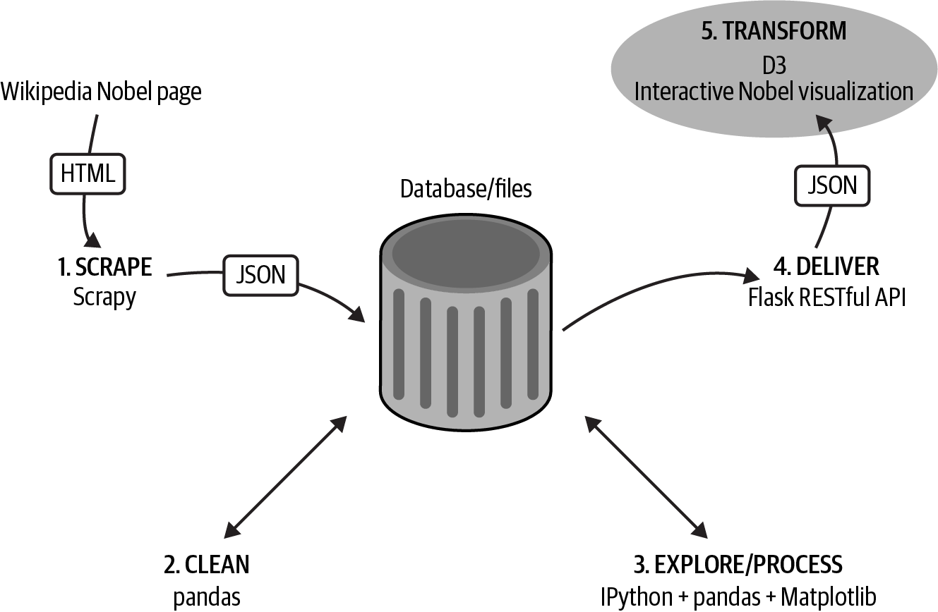

Figure V-1. Our dataviz toolchain: getting the data
Tip
You can find the code for this part of the book at the book’s GitHub repo.

Chapter 14. Bringing Your Charts to the Web with Matplotlib and Plotly
In this chapter, we’ll see how to bring the fruits of your pandas data cleaning and exploration to the web. Often a good static visualization is a great way to present data, and we’ll start by showing how you can use Matplotlib to do just that. Sometimes user interaction can really enrich a data visualization—we’ll see how Python’s Plotly library can be used to create interactive visualizations in a Jupyter notebook and transfer these, user interactions (UI) and all, to a web page.
We’ll also see how learning Plotly’s Python library gives you competence with a native JavaScript library, which can really extend the possibilities of your web dataviz. We’ll demonstrate this by creating some simple JS UIs to update our native Plotly charts.

Static Charts with Matplotlib
Often the best chart for the job is a static chart where full editorial control lies with the creator. One of Matplotlib’s strengths is its ability to produce print-quality charts in a comprehensive range of formats, from high-definition web PNGs to SVG renderings, with vector primitives that scale perfectly with document size.
For web graphics the ubiquitous, recommended format is the portable network graphics (PNG) format which, as the name suggests, was designed for the job. Let’s select a few charts from our Nobel exploration (see Chapter 11) and deliver them to the web as PNGs, making a little presentation on the way.
In “National Trends”, we saw that measuring national prize hauls by absolute numbers gave a very different picture of a per-capita measurement, taking into account population sizes. We produced a couple of bar charts showing this. Now let’s turn this exploratory find into a presentation. We’ll use vertical bar charts to make the country names easier to read.
We take the Matplotlib axis returned by the pandas plot method and use it to make a few adaptations, changing its face color to light gray (#eee) and adding a label or two:
ax
=
df_countries
[
df_countries
.
nobel_wins
>
2
]
\
.
sort_values
(
by
=
'
nobel_wins_per_capita
'
,
ascending
=
True
)
\
.
nobel_wins_per_capita
.
plot
(
kind
=
'
barh
'
,
\
figsize
=
(
5
,
10
)
,
title
=
"
Relative prize numbers
"
)
ax
.
set_xlabel
(
"
Nobel prizes per capita
"
)
ax
.
set_facecolor
(
"
#eee
"
)
plt
.
tight_layout
(
)
plt
.
savefig
(
"
country_relative_prize_numbers.png
"
)
Threshold for countries with at least three prizes.
We want a horizontal bar chart of kind barh.
Using the tight_layout method reduces the chances of chart elements being lost in the saved figure.
We perform the same operation for the absolute numbers, producing two horizontal bar chart PNGs. To present these on the web, we’ll use some of the HTML and CSS taught in Chapter 4:
<!-- index.html -->
<
div
class
=
"main"
>
<
h1
class
=
'title'
>
The Nobel Prize
<
/
h1
>
<
h2
>
A few exploratory nuggets
<
/
h2
>
<
div
class
=
"intro"
>
<
p
>
Some nuggets of data mined from a dataset of Nobel prize
winners (2016).
<
/
p
>
<
/
div
>
<
div
class
=
"container"
id
=
"by-country-container"
>
<
div
class
=
"info-box"
>
<
p
>
These two charts compare Nobel prize winners by
country. [...] that Sweden, winner by a relative
metric, hosts the prize.
<
/
p
>
<
/
div
>
<
div
class
=
"chart-wrapper"
id
=
"by-country"
>
<
div
class
=
"chart"
>
<
img
src
=
"images/country_absolute_prize_numbers.png"
alt
=
""
>
<
/
div
>
<
div
class
=
"chart"
>
<
img
src
=
"images/country_relative_prize_numbers.png"
alt
=
""
>
<
/
div
>
<
/
div
>
<
/
div
>
<
/
div
>
The images are in a subdirectory relative to index.html
After title, subtitle, and intro, we have a main container, within which there is a chart-wrapper div with two charts and an information box.
We’ll use a little CSS to size, position, and style the content. The key CSS is the use of flex-boxes to distribute the charts and info-box in a row and make them of equal width by giving the chart-wrapper a flex weight of two and the info-box a flex weight of one:
html
,
body
{
height
:
100%
;
font-family
:
Georgia
,
serif
;
background
:
#fff1e5
;
font-size
:
1.2em
;
}
h1
.title
{
font-size
:
2.1em
;
}
.main
{
padding
:
10px
;
padding-bottom
:
100px
;
min-width
:
800px
;
max-width
:
1200px
;
}
.container
{
display
:
flex
;
}
.chart-wrapper
{
display
:
flex
;
flex
:
2
;
}
.chart
{
flex
:
1
;
padding
:
0
1.5em
;
}
.chart
img
{
max-height
:
600px
;
}
.info-box
{
font-family
:
sans-serif
;
flex
:
1
;
font-size
:
0.7em
;
padding
:
0
1.5em
;
background
:
#ffebd9
;
}
The chart and info-box children of this container are under flex control.
Chart-wrapper is twice the width of the info-box.
Figure 14-1 (left) shows the resulting web page.
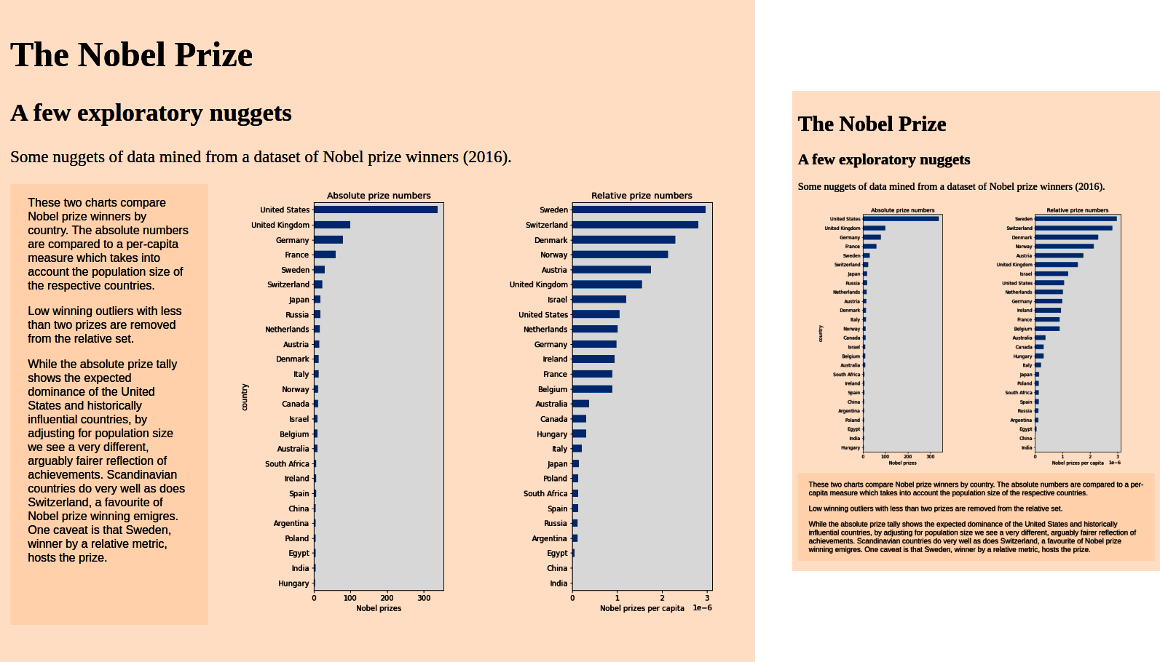

Figure 14-1. A couple of static charts

Adapting to Screen Sizes
One challenge for modern web development and associated dataviz is adapting to the many devices now used to access the web. Much of the time the ability of smartphones and tablets to pan and pinch/zoom means the same visualization can be used on all devices. Making visualizations adaptable is not easy and suffers from combinatorial explosion quite quickly. Often a compromise composition is the best way to proceed.
But there are occasions where an easy win is achievable using the CSS media property to adapt style to device screen size, usually using changing screen width to trigger the use of specialized styles. We’ll use the Nobel web page we just created to demonstrate this.
The default chart layout in Figure 14-1 is fine for most laptop or PC screens, but as the width of the device is reduced, the charts and info-box become a little cluttered and the info-box elongates to contain the text. By triggering a flex-box change at a set width of 1,000 pixels, we can make the visualization easier to consume on a small screen device.
Here we add a media-screen trigger to apply a different flex-direction value to devices 1,000 or less pixels wide. Rather than displaying info-box and charts in a row, we display them in a column and reverse the order to put the info-box on the bottom. The result is shown in Figure 14-1 (right):
/* When the browser is 1000 pixels wide or less */
@media
screen
and
(
max-width
:
1000px
)
{
#by-country-container
{
flex-direction
:
column
-
reverse
;
}
}

Using Remote Images or Assets
You can use remote assets such as Dropbox or Google-hosted images by getting their shared link and using it as the image source. For example, the following img tags use Dropbox images for Figure 14-1 rather than locally hosted ones:
<
div
class
=
"chart"
>
<
img
src
=
"https://www.dropbox.com/s/422ugyhvfc0zg99/
country_absolute_prize_numbers.png?raw=1"
alt
=
""
>
</
div
>
<
div
class
=
"chart"
>
<
img
src
=
"https://www.dropbox.com/s/n6rfr9kvuvir7gi/
country_relative_prize_numbers.png?raw=1"
alt
=
""
>
</
div
>

Charting with Plotly
For static charts, presented as PNGs or SVGs, Matplotlib is eminently customizable, though its API could be more intuitive. But if you want your charts to have any dynamic/interactive elements, for example the ability to change or filter the dataset with buttons or selectors, then you will need a different charting library, and this is where Plotly1 comes in.
Plotly is a Python- (and other languages) based charting library that, like Matplotlib, can be used during interactive Jupyter notebook sessions. It offers a wide range of chart forms, some of which aren’t found in the Matplotlib stable, and is arguably easier to configure than Matploblib. For this reason alone it’s a useful tool to have, but where Plotly shines is its ability to export these charts, along with any scripted interactive widgets, to the web.
As mentioned, user interactions and dynamic charts are often surplus to requirements, but even in this case Plotly has some nice value-adds like tool-tipped information which, for example, gives specific information about a bar-group on mouse-over.

Basic Charts
Let’s see how Plotly does things by replicating one of the Matploblib charts from “Historical Trends in Prize Distribution”. First, we’ll create a DataFrame from the Nobel Prize dataset showing cumulative prizes for three geographical regions:
new_index
=
pd
.
Index
(
np
.
arange
(
1901
,
2015
),
name
=
'year'
)
by_year_nat_sz
=
df
.
groupby
([
'year'
,
'country'
])
\
.
size
()
.
unstack
()
.
reindex
(
new_index
)
.
fillna
(
0
)
# Our continental country list created by selecting the biggest
# two or three winners in the three continents compared.
regions
=
[
{
'label'
:
'N. America'
,
'countries'
:[
'United States'
,
'Canada'
]},
{
'label'
:
'Europe'
,
'countries'
:[
'United Kingdom'
,
'Germany'
,
'France'
]},
{
'label'
:
'Asia'
,
'countries'
:[
'Japan'
,
'Russia'
,
'India'
]}
]
# Creates a new column with a region label for each dict in the
# regions list, summing its countries members.
for
region
in
regions
:
by_year_nat_sz
[
region
[
'label'
]]
=
\
by_year_nat_sz
[
region
[
'countries'
]]
.
sum
(
axis
=
1
)
# Creates a new DataFrame using the cumulative sum of the
# new region columns.
df_regions
=
by_year_nat_sz
[[
r
[
'label'
]
for
r
in
regions
]]
.
\
cumsum
()
This gives us a df_regions DataFrame with columnar cumulative sums:
df_regions
country N. America Europe Asia
year
1901 0.0 4.0 0.0
1902 0.0 7.0 0.0
1903 0.0 10.0 0.0
1904 0.0 13.0 1.0
1905 0.0 15.0 1.0
... ... ... ...
2010 327.0 230.0 36.0
2011 333.0 231.0 36.0
...

Plotly Express
Plotly provides an express module that enables fast chart sketches, great for exploratory iteration in a notebook. This module has high-level objects for line charts, bar charts, etc. and can take pandas DataFrames as arguments interpreting columnar data.2 The regional DataFrame we just created can be used directly by Plotly Express to build a line chart in a couple of lines. This produces the chart in Figure 14-2 (left):
# load the express module
import
plotly.express
as
px
# use the line method with a suitable DataFrame
fig
=
px
.
line
(
df_regions
)
fig
.
show
()
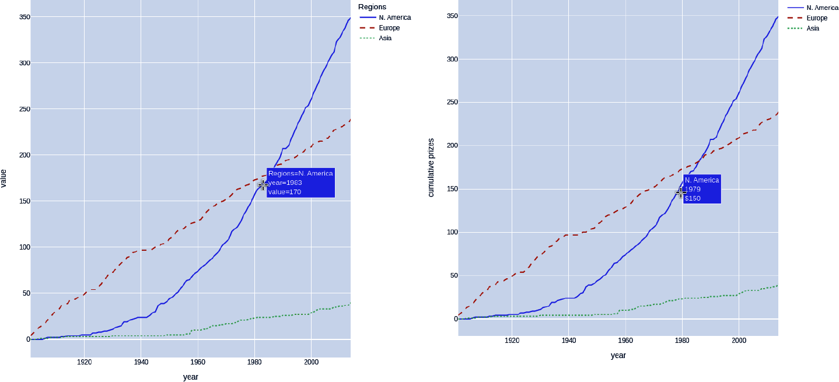

Figure 14-2. Cumulative prizes with Plotly
Note the row index label that is used for the x-axis by default and the tooltip that appears on mouse-over showing, in this case, information about the line section.
Another thing to note is that the legend label is taken from the grouping index, in this case country. We can easily fix this by relabeling it to something more sensible, in this case Regions:
fig
=
px
.
line
(
df_regions
,
labels
=
{
'
country
'
:
'
Regions
'
}
)
line_dash
=
'
country
'
,
line_dash_sequence
=
[
'
solid
'
,
'
dash
'
,
'
dot
'
]
)
)
fig
.
show
(
)
Plotly colors the lines by default, but in order to distinguish them in the print version of this book, we can adjust their styles. To do this, we set the line_dash argument to the country group and the line_dash_sequence to the line styles we want.3
Plotly Express is easy to use and brings some novel charts into play.4 For quick data sketches it competes with pandas’s Matplotlib wrapper, which works directly on DataFrames. But if you want more control over your plots and to really exploit Plotly’s advantages, I recommend focusing on using Plotly figures and graph-objects. This API is more complex but significantly more powerful. It is also mirrored by the JavaScript API, which means you’re essentially learning two libraries—a very useful thing as we’ll see later in the chapter.

Plotly Graph-Objects
Using Plotly graph-objects involves a little more boilerplate code, but the pattern is essentially the same whether creating bar charts, violin plots, maps, etc. The idea is to use an array of graph-objects such as scattered points (lines in line mode), bars, candles, boxes, etc., as data for the figure. A layout object is used to provide other chart features.
The following code produces the chart in Figure 14-2 (right). Note the customized tooltip on mouse-over:
import
plotly
.
graph_objs
as
go
traces
=
[
]
for
region
in
regions
:
name
=
region
[
'
label
'
]
traces
.
append
(
go
.
Scatter
(
x
=
df_regions
.
index
,
# years
y
=
df_regions
[
name
]
,
# cum. prizes
name
=
name
,
mode
=
"
lines
"
,
hovertemplate
=
f
"
{
name
}
<br>%
{{
x
}}
<br>$%
{{
y
}}
<extra></extra>
"
line
=
dict
(
dash
=
[
'
solid
'
,
'
dash
'
,
'
dot
'
]
[
len
(
traces
)
]
)
)
)
layout
=
go
.
Layout
(
height
=
600
,
width
=
600
,
\
xaxis_title
=
"
year
"
,
yaxis_title
=
"
cumulative prizes
"
)
fig
=
go
.
Figure
(
traces
,
layout
)
fig
.
show
(
)
We’ll create an array of line graph-objects to use as our figure’s data.
In line mode scatter objects points are connected.
You can provide an HTML string template that will appear on mouse-hover. x and y variables at that point are provided.
The Scatter object has a line property that allows you to set various line properties like color, line style, line shape, etc.5 In order to distinguish our lines in the black-and-white print book, we want to set their style. To do this we use the size (len) of the traces array as an index to an array of styles, setting the line styles in sequence.
As well as data, we provide a layout object, defining things like the chart’s dimension, x-axis titles, and much more.
Create a figure using our array of graph-objects and the layout.

Mapping with Plotly
Another of Plotly’s big strengths is its mapping libraries and particularly its ability to integrate the Mapbox ecosystem, one of the most powerful tile-based mapping resources for the web. Mapbox’s tiling system is fast and efficient and opens up the possibility of ambitious mapping visualizations.
Let’s demonstrate some Plotly mapping using our Nobel Prize dataset and aiming to visualize the global distribution of prizes.
First, we’ll make a DataFrame with the prizes tallies by category for the winning countries and add a Total column by aggregating the category numbers:
df_country_category
=
df
.
groupby
([
'country'
,
'category'
])
\
.
size
()
.
unstack
()
df_country_category
[
'Total'
]
=
df_country_category
.
sum
(
1
)
df_country_category
.
head
(
3
)
# top three rows
#category Chemistry Economics Literature Peace Physics \
#country
#Argentina 1.0 NaN NaN 2.0 NaN
#Australia NaN 1.0 1.0 NaN 1.0
#Austria 3.0 1.0 1.0 2.0 4.0
#
#category Physiology or Medicine Total
#country
#Argentina 2.0 5.0
#Australia 6.0 9.0
#Austria 4.0 15.0
We’ll use that Total column to threshold the rows, limiting the countries to those that have won the Nobel at least three times. We’ll make a copy of this slice to avoid any pandas DataFrame errors if trying to change a view:
df_country_category
=
df_country_category
.
\
loc
[
df_country_category
.
Total
>
2
]
.
copy
()
df_country_category
With the prize tallies by country to hand we need some geographical data, namely the coordinates of the centroids (centers) of the countries. This is an opportunity to demo Geopy, a cool little Python library that does just that job, among many geographical others.
First, install with pip or equivalent:
!pip install geopy
Now we can use the Nominatim module to provide locations based on our country name strings. We create a geolocator by providing a user-agent string:
from
geopy.geocoders
import
Nominatim
geolocator
=
Nominatim
(
user_agent
=
"nobel_prize_app"
)
Using the geolocator, we can loop through a few countries in the DataFrame index to show the geo date available:
for
name
in
df_country_category
.
index
[:
5
]:
location
=
geolocator
.
geocode
(
name
)
print
(
"Name: "
,
name
)
print
(
"Coords: "
,
(
location
.
latitude
,
location
.
longitude
))
print
(
"Raw details: "
,
location
.
raw
)
#Name: Argentina
#Coords: (-34.9964963, -64.9672817)
#Raw details: {'place_id': 284427148, 'licence': 'Data ©
#OpenStreetMap contributors, ODbL 1.0. https://osm.org/
#copyright', 'osm_type': 'relation', 'osm_id': 286393,
#'boundingbox': ['-55.1850761', '-21.7808568', '-73.5605371',
#[...] }
Let’s add geographic latitude (Lat) and longitude (Lon) columns to our DataFrame using our geolocator:
lats
=
{}
lons
=
{}
for
name
in
df_country_category
.
index
:
location
=
geolocator
.
geocode
(
name
)
if
location
:
lats
[
name
]
=
location
.
latitude
lons
[
name
]
=
location
.
longitude
else
:
print
(
"No coords for
%s
"
%
name
)
df_country_category
.
loc
[:,
'Lat'
]
=
pd
.
Series
(
lats
)
df_country_category
.
loc
[:,
'Lon'
]
=
pd
.
Series
(
lons
)
df_country_category
#category Chemistry Economics Literature Peace Physics \
#country
#Argentina 1.0 NaN NaN 2.0 NaN
#Australia NaN 1.0 1.0 NaN 1.0
#
#category Physiology or Medicine Total Lat Lon
#country
#Argentina 2.0 5.0 -34.996496 -64.967282
#Australia 6.0 9.0 -24.776109 134.755000
We’re going to use some map markers to reflect the prize numbers for various countries. We want the size of the circle to reflect the prize sum, so we will need a little function to get the appropriate radius. We’ll have a scale parameter to allow hand-tweaking of the marker size:
def
calc_marker_radius
(
size
,
scale
=
5
):
return
np
.
sqrt
(
size
/
np
.
pi
)
*
scale
As with the basic charts, there is a Plotly Express mapping option, which allows for fast map creation using a pandas DataFrame. Express has a dedicated scatter_mapbox method that returns a figure object. Here we use this figure to make some updates to the map layout, using one of the free map styles (carto-positron) provided by Plotly (see Figure 14-3):
import
plotly
.
express
as
px
init_notebook_mode
(
connected
=
True
)
size
=
df_country_category
[
'
Total
'
]
.
apply
(
calc_marker_radius
,
args
=
(
16
,
)
)
fig
=
px
.
scatter_mapbox
(
df_country_category
,
lat
=
"
Lat
"
,
lon
=
"
Lon
"
,
hover_name
=
df_country_category
.
index
,
hover_data
=
[
'
Total
'
]
,
color_discrete_sequence
=
[
"
olive
"
]
,
zoom
=
0.7
,
size
=
size
)
fig
.
update_layout
(
mapbox_style
=
"
carto-positron
"
,
width
=
800
,
height
=
450
)
fig
.
update_layout
(
margin
=
{
"
r
"
:
0
,
"
t
"
:
0
,
"
l
"
:
0
,
"
b
"
:
0
}
)
fig
.
show
(
)
Create an array of sizes for the radii of the circular markers.
The mapbox takes an array of latitudes and longitudes for marker placement, as well as our calculated size array. Zoom indicates the position of the camera above the Earth with 0.7 as a standard global default.
hover_name gives the title of the mouse-over tooltip and data any extra info we want, in this case the Total column.
Plotly provides a number of free-to-use mapping style tile-sets.
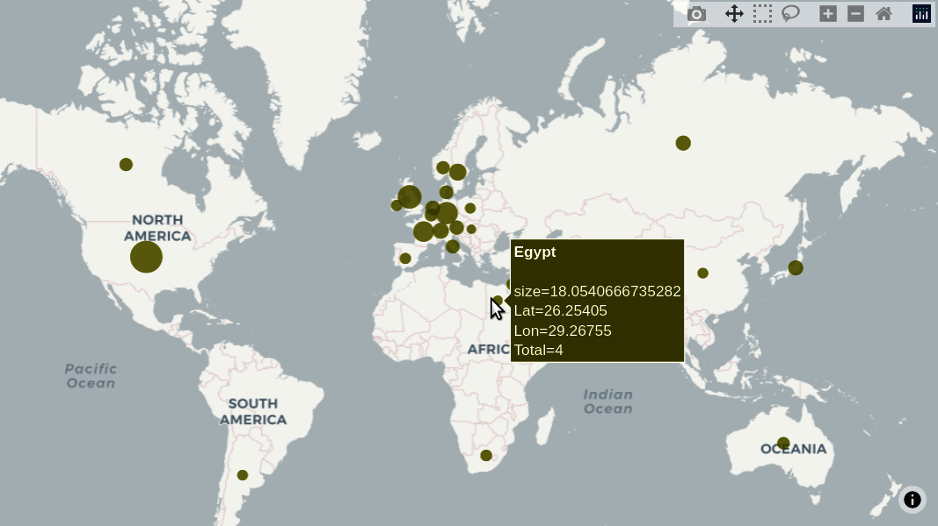

Figure 14-3. Fast mapping with Plotly Express
As with basic charts Plotly also offers a more powerful data+layout mapping option that follows the familiar recipe, creating an array of charts traces and a layout to specify things like legend boxes, titles, map zoom, etc. Here’s how to make our Nobel map:
mapbox_access_token
=
"
pk.eyJ1Ij...JwFsbg
"
df_cc
=
df_country_category
site_lat
=
df_cc
.
Lat
site_lon
=
df_cc
.
Lon
totals
=
df_cc
.
Total
locations_name
=
df_cc
.
index
layout
=
go
.
Layout
(
title
=
'
Nobel prize totals by country
'
,
hovermode
=
'
closest
'
,
showlegend
=
False
,
margin
=
{
'
l
'
:
0
,
'
t
'
:
0
,
'
b
'
:
0
,
'
r
'
:
0
}
,
mapbox
=
dict
(
accesstoken
=
mapbox_access_token
,
# we can set map details here including center, pitch and bearing..
# try playing with these.
# bearing=0,
# # center=dict(
# # lat=38,
# # lon=-94
# # ),
# pitch=0,
zoom
=
0.7
,
style
=
'
light
'
)
,
width
=
875
,
height
=
450
)
traces
=
[
go
.
Scattermapbox
(
lat
=
site_lat
,
lon
=
site_lon
,
mode
=
'
markers
'
,
marker
=
dict
(
size
=
totals
.
apply
(
calc_marker_radius
,
args
=
(
7
,
)
)
,
color
=
'
olive
'
,
opacity
=
0.8
)
,
text
=
[
f
'
{
locations_name
[
i
]
}
won
{
int
(
x
)
}
total prizes
'
\
for
i
,
x
in
enumerate
(
totals
)
]
,
hoverinfo
=
'
text
'
)
]
fig
=
go
.
Figure
(
traces
,
layout
=
layout
)
fig
.
show
(
)
Plotly offers a number of free, open-streetmap-based mapsets, but to use Mapbox-specific layers, you need to get a Mapbox access token. These tokens are free to use for personal use.
We’ll store the DataFrame’s columns and index in a more user-friendly form.
The map produced is shown in Figure 14-4 (left). Note the customized tooltip, produced on mouse-over. Figure 14-4 (right) shows the result of some user interaction, panning and zooming to highlight European prize distributions.
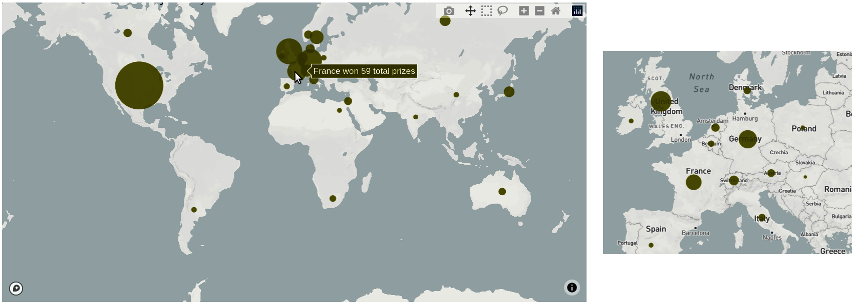

Figure 14-4. Mapping with Plotly’s graph-objects
Let’s extend the map to add some custom controls, using buttons to select prize categories to visualize.

Adding Custom Controls with Plotly
One of the cool features of Plotly’s interactive maps is the ability to add custom controls in Python that can be ported to the web as HTML+JS controls. The control API is a little clunky, in my opinion, and limited to a small set of controls, but the ability to add dataset selectors, sliders, filters, and the like is a great asset. Here we’ll add a few buttons to our Nobel map, allowing the user to filter the dataset by category.
Before proceeding we need to replace the non-numbers from the prizes by country and category DataFrame with zero to avoid Plotly labeling errors. You can see these in the first two rows:
df_country_category
.
head
(
2
)
# Out:
# category Chemistry Economics Literature Peace Physics \
# country
# Argentina 1.0 NaN NaN 2.0 NaN
# Australia NaN 1.0 1.0 NaN 1.0
A single line of pandas fills these NaNs with zero, making the change in place:
df_country_category
.
fillna
(
0
,
inplace
=
True
)
This will involve a slightly different Plotly pattern than the one used up to now. We’ll first create our figure with layout and then add the data traces using add_trace by iterating through the Nobel categories, adding buttons to the button array as we go.
We’ll then add these buttons to the layout using its update method:
# ...
categories
=
[
'
Total
'
,
'
Chemistry
'
,
'
Economics
'
,
'
Literature
'
,
\
'
Peace
'
,
'
Physics
'
,
'
Physiology or Medicine
'
,
]
# ...
colors
=
[
'
#1b9e77
'
,
'
#d95f02
'
,
'
#7570b3
'
,
'
#e7298a
'
,
'
#66a61e
'
,
'
#e6ab02
'
,
'
#a6761d
'
]
buttons
=
[
]
# ... DEFINE LAYOUT AS BEFORE
fig
=
go
.
Figure
(
layout
=
layout
)
default_category
=
'
Total
'
for
i
,
category
in
enumerate
(
categories
)
:
visible
=
False
if
category
==
default_category
:
visible
=
True
fig
.
add_trace
(
go
.
Scattermapbox
(
lat
=
site_lat
,
lon
=
site_lon
,
mode
=
'
markers
'
,
marker
=
dict
(
size
=
df_cc
[
category
]
.
apply
(
calc_marker_radius
,
args
=
(
7
,
)
)
,
color
=
colors
[
i
]
,
opacity
=
0.8
)
,
text
=
[
f
'
{
locations_name
[
i
]
}
prizes for
{
category
}
:
{
int
(
x
)
}
'
\
for
i
,
x
in
enumerate
(
df_cc
[
category
]
)
]
,
hoverinfo
=
'
text
'
,
visible
=
visible
)
,
)
# We start with a mask array of Boolean False, one for each category (inc. Total)
# In Python [True] * 3 == [True, True, True]
mask
=
[
False
]
*
len
(
categories
)
# We now set the mask index corresponding to the current category to True
# i.e. button 'Chemistry' has mask [False, True, False, False, False, False]
mask
[
categories
.
index
(
category
)
]
=
True
# Now we can use that Boolean mask to add a button to our button list
buttons
.
append
(
dict
(
label
=
category
,
method
=
"
update
"
,
args
=
[
{
"
visible
"
:
mask
}
]
,
)
,
)
fig
.
layout
.
update
(
updatemenus
=
[
dict
(
type
=
"
buttons
"
,
direction
=
"
down
"
,
active
=
0
,
x
=
0.0
,
xanchor
=
'
left
'
,
y
=
0.65
,
showactive
=
True
,
# show the last button clicked
buttons
=
buttons
)
]
)
fig
.
show
(
)
The category marker sets are initially invisible—only the default Total is shown.
We use the mask to set a visibility array for this button that will only make the associated category data markers visible.
We now add the buttons to our layout, adjusting direction (down) and positioning using x and y to place the center of the button group vertically, with the button-box anchored on the left.
Clicking on a button (see Figure 14-5) shows the data markers associated with that category by applying the button’s visibility mask. While this feels a little awkward, it is a solid way to filter the data by button-press. Unlike the JavaScript+HTML controls we’ll look at later in the chapter, there’s not a lot you can do in the way of styling to the buttons.
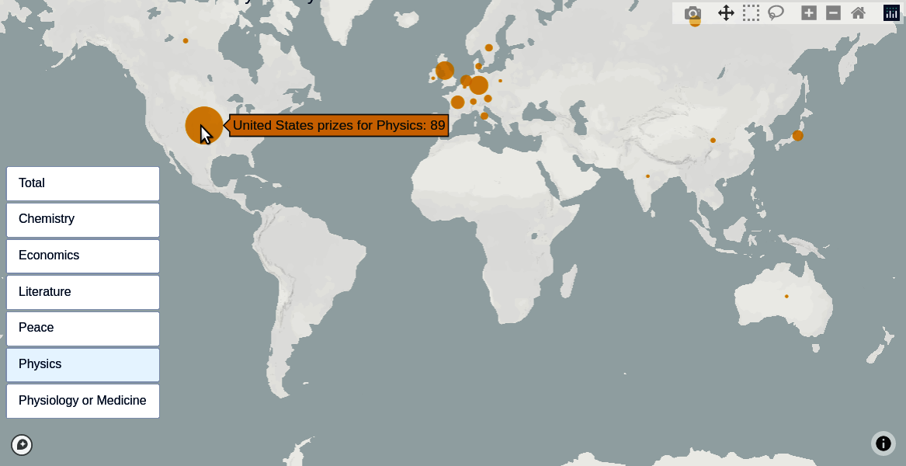

Figure 14-5. Adding custom controls to a Plotly map

From Notebook to Web with Plotly
Now we’ve got our Plotly charts displaying in the notebook, let’s see how to transfer them to a little web presentation. We’re going to use the plot function from Plotly’s offline module to generated the embeddable HTML+JS required, so let’s first import it:
from
plotly.offline
import
plot
Using plot, we can create an embeddable string from the figure that can be lifted straight to the web. It contains the necessary HTML and JavaScript tags to bootstrap Plotly’s JavaScript library and create the chart:
embed_string
=
plot
(
fig
,
output_type
=
'div'
,
include_plotlyjs
=
"cdn"
)
embed_string
#'<div> <script type="text/javascript">window.PlotlyConfig
#= {MathJaxConfig: \'local\'};</script>\n <script src="https://cdn.plot.ly/
#plotly-2.9.0.min.js"></script> <div
#id="195b2d71-f59d-4f8a-a40a-3b8c797a918b" class="plotly-graph-div"
#style="height:600px; width:600px;"></div> <script type="text/
#javascript"> [...] </script>
#</div>'
If we tidy up that string we see it breaks down to four components, an HTML div tag with the chart’s ID and some JavaScript, containing the newPlot call with data and layout passed in as parameters:
<
div
>
<!-- (1) JavaScript Plotly config, placed with JavaScript (.js) file -->
<
script
type
=
"text/javascript"
>
window
.
PlotlyConfig
=
{
MathJaxConfig
:
'local'
};
</
script
>
<!-- (2) Place bottom of HTML file to import the Plotly library
from the cloud (content delivery network) -->
<
script
src
=
"https://cdn.plot.ly/plotly-2.9.0.min.js"
></
script
>
<!-- create a content div for the chart, with ID tag (to be inflated)
(3) !! Put this div in the HTML section of the code-pen !! -->
<
div
id
=
"4dbeae4f-ed9b-4dc1-9c69-d4bb2a20eaa7"
class
=
"plotly-graph-div"
style
=
"height:100%; width:100%;"
></
div
>
<
script
type
=
"text/javascript"
>
// (4) Everything within this tag goes to a JavaScript (.js) file -->
window
.
PLOTLYENV
=
window
.
PLOTLYENV
||
{};
// Grab the 'div' tag above by ID and call Plotly's JS API on it, using the
// embedded data and annotations
if
(
document
.
getElementById
(
"4dbeae4f-ed9b-4dc1-9c69-d4bb2a20eaa7"
))
{
Plotly
.
newPlot
(
"4dbeae4f-ed9b-4dc1-9c69-d4bb2a20eaa7"
,
[{
"mode"
:
"lines"
,
"name"
:
"Korea, South"
,
"x"
:
[
0
,
1
,
2
,
3
,
4
,
5
,
6
,
7
,
8
,
9
,
10
,
11
,
12
,...]}])
};
</
script
>
</
div
>
Although we could just paste the HTML+JS into a web page and see the chart rendered, it’s better practice to separate JS and HTML concerns. First, we place the chart div in a little web page with a few headers, add some containers for info-boxes, etc.:
<!-- index.html -->
<
div
class
=
"main"
>
<
h1
class
=
'title'
>
The Nobel Prize
<
/
h1
>
<
h2
>
From notebook to the web with Plotly
<
/
h2
>
<
div
class
=
"intro"
>
<
p
>
Some nuggets of data mined [...]
<
/
p
>
<
/
div
>
<
div
class
=
"container"
id
=
"by-country-container"
>
<
div
class
=
"info-box"
>
<
p
>
This chart shows the cumulative Nobel prize wins by region, taking the
two or three highest winning countries from each.[...]
<
/
p
>
<
/
div
>
<
div
class
=
"chart-wrapper"
id
=
"by-country"
>
<
div
id
=
"bd54c166-3733-4b20-9bb9-694cfff4a48e"
class
=
"plotly-graph-div"
style
=
"height:100%; width:100%;"
>
<
/
div
>
<
/
div
>
<
/
div
>
<
/
div
>
<
script
scr
=
"scripts/plotly_charts.js"
>
<
/
script
>
<
script
src
=
"https://cdn.plot.ly/plotly-2.9.0.min.js"
>
<
/
script
>
The div container produced by Plotly with an ID corresponding to the JavaScripted chart.
The script tag produced by Plotly to import the JS charting library.
We take the content of the remaining two JavaScript tags and place it in a plotly_charts.js JS file:
// scripts/plotly_charts.js
window
.
PLOTLYENV
=
window
.
PLOTLYENV
||
{
}
;
if
(
document
.
getElementById
(
"bd54c166-3733-4b20-9bb9-694cfff4a48e"
)
)
{
Plotly
.
newPlot
(
"bd54c166-3733-4b20-9bb9-694cfff4a48e"
,
[
{
"hovertemplate"
:
"N. America<br>%{x}<br>$%{y}<extra></extra>"
,
"mode"
:
"lines"
,
"name"
:
"N. America"
,
"x"
:
[
1901
,
1902
,
1903
,
1904
,
1905
,
1906
,
1907
,
1908
,
1909
,
1910
,
1911
,
1912
,
1913
,
1914
,
1915
,
1916
,
1917
,
1918
,
1919
,
1920
,
1921
,
1922
,
...
]
}
]
)
}
Checks that the div with correct ID is present.
Plotly’s newPlot method will build the chart in the identified container.
An array of chart-objects, in this case containing all the data (x and y arrays) necessary to transfer the chart from notebook to web page.
On page load the Plotly library’s newPlot method is run using the embedding data and layout and the chart built with JS in the div container specified by ID. This produces the web page shown in Figure 14-6.
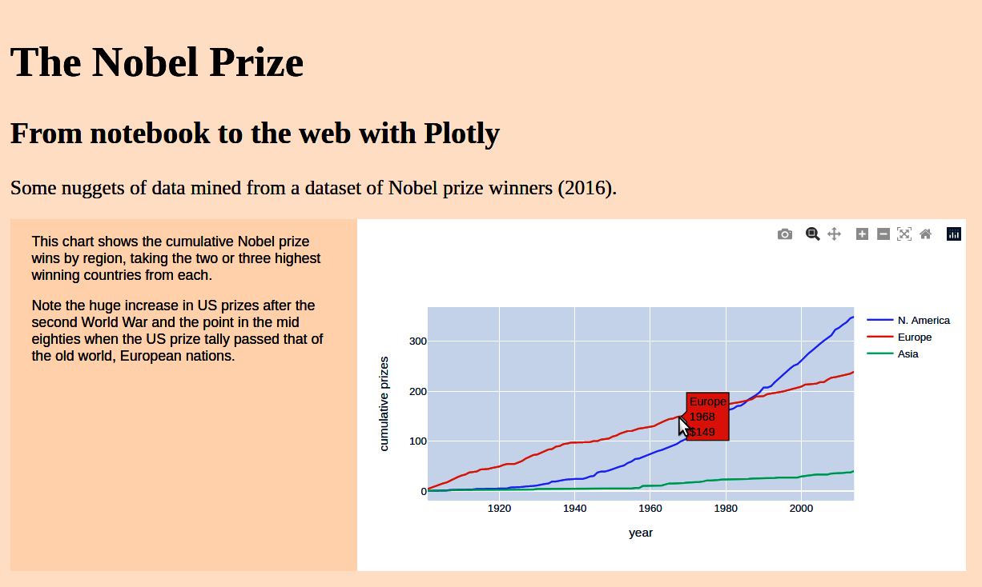

Figure 14-6. From notebook to web with Plotly
All charts produced in Python with Plotly can be transferred to the web in this way. If you plan on using more than a couple, I recommend having separate JS files for each chart as the embedded data can lead to very long files.

Native JavaScript Charts with Plotly
Being able to easily shift a favored chart from notebook to web is great, but if you need to make refinements it involves moving back and forth from notebook to webdev. This can get annoying after a while. One really cool thing about Plotly is that you are learning a JavaScript charting library for free, as it were. The Python and JS figure patterns are very similar, so it’s easy to both convert chart code from Python to JS and start writing JS charts from scratch. Let’s demonstrate this by converting a seaborn chart to JavaScripted Plotly.
In “Age at Time of Award”, we produced some violin plots using seaborn. To transfer these to the web, we’ll first need some data. One useful method for shifting small datasets is to convert a refined dataset to JSON and just copy the string produced, pasting it into a JS file and then parsing the string to a JS object. First, we use pandas to create a small dataset with only the award_age and gender columns, then produce the required JSON array of objects:
df_select
=
df
[[
'gender'
,
'award_age'
]]
df_select
.
to_json
(
orient
=
'records'
)
#'[{"gender":"male","award_age":57},{"gender":"male","award_age":80},
#{"gender":"male","award_age":49},{"gender":"male","award_age":59},
#{"gender":"male","award_age":49},{"gender":"male","award_age":46},...}]'
We can take the JSON string, paste it into a JS file, and use the built-in JSON library to parse the string into a JS array of objects:
let
data
=
JSON
.
parse
(
'[{"gender":"male","award_age":57}
'
,{
"gender"
:
"male"
,
"award_age"
:
80
},
'
'
{
"gender"
:
"male"
,
"award_age"
:
49
},{
"gender"
:
"male"
,
"award_age"
:
59
},
'
'
{
"gender"
:
"male"
,
"award_age"
:
48
},
...
]
'
)
With the data to hand, we’ll need a little HTML scaffold with a chart container, ID award_age, to contain the Plotly chart:
<
div
class
=
"main"
>
<
h1
class
=
'title'
>
The Nobel Prize
<
/
h1
>
<!-- ... -->
<
div
class
=
"chart-wrapper"
>
<
div
class
=
'chart'
id
=
'award_age'
>
<
/
div
>
<
/
div
>
<
/
div
>
<
script
src
=
"https://cdn.plot.ly/plotly-2.9.0.min.js"
>
<
/
script
>
We’ll use this container’s ID to tell Plotly where to build the chart.
We can now build our first JS-native Plotly chart. The pattern matches that seen with the Python Plotly plots in our notebook. First, we create a data array (traces) with some chart-objects, then a layout to provide titles, labels, colors, etc. Then we use newPlot to build the chart. The main difference with Python is that the first parameter of newPlot is the ID of the container within which to build the chart:
var
traces
=
[
{
type
:
'violin'
,
x
:
data
.
map
(
d
=>
d
.
gender
)
,
y
:
data
.
map
(
d
=>
d
.
award_age
)
,
points
:
'none'
,
box
:
{
visible
:
true
}
,
line
:
{
color
:
'green'
,
}
,
meanline
:
{
visible
:
true
}
,
}
]
var
layout
=
{
title
:
"Nobel Prize Violin Plot"
,
yaxis
:
{
zeroline
:
false
}
}
Plotly
.
newPlot
(
'award_age'
,
traces
,
layout
)
;
As per the usual Plotly pattern, we first create an array of chart-objects.
We use the JS array’s map method with shorthand arrow functions to produce arrays of winners’ genders and ages.
Plotly will render the chart to our div container with ID 'award_age'.
The violin chart produced is shown in Figure 14-7.
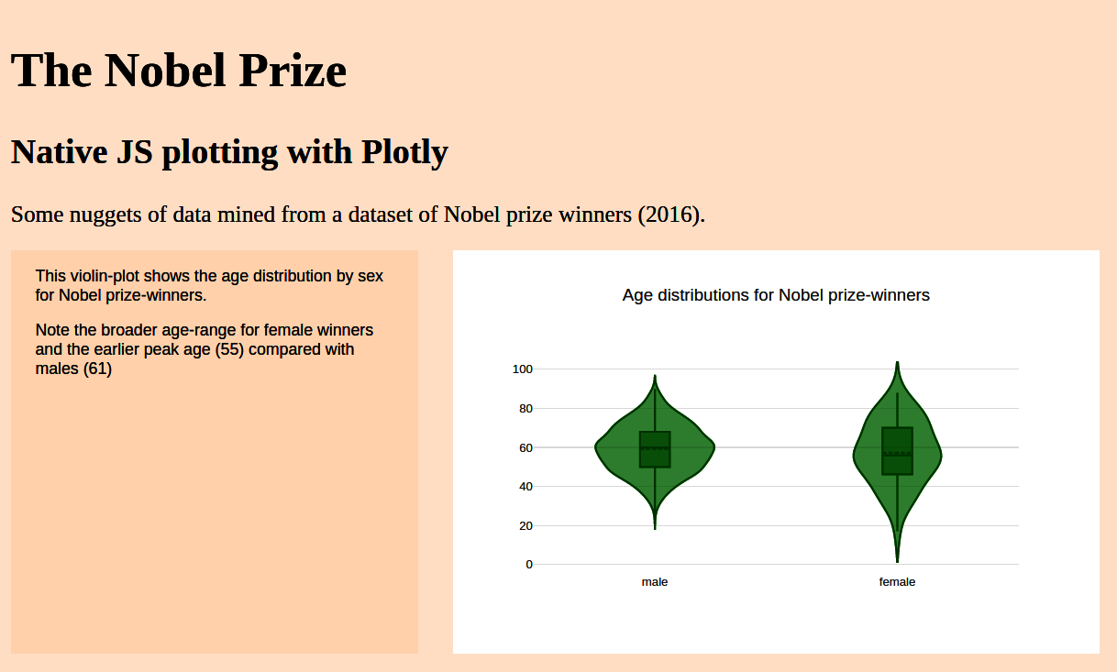

Figure 14-7. Violin plot with Plotly JS
As you can see, the Plotly’s JS API matches the Python one and is, if anything, more succinct. Separating data delivery from chart construction makes the codebase much easier to work with and means tweaking and refinement don’t require a return to the Python API. For small data sketches, parsing JSON strings gets the job done fast.
But if you want to have larger datasets to hand and to really leverage the power of the JS web context, the standard data delivery is through JSON files.6 For datasets of a few megabytes, this offers the most flexibility for datavizzers.

Fetching JSON Files
Another way of getting data to your web pages is to export a DataFrame to JSON and then use JavaScript to fetch it, do any necessary further processing, and then pass it on to a native JS chart library (or D3). This is a very flexible workflow and provides the most freedom for JS data visualizations.
The separation of powers, allowing Python to focus on its data-processing strength and JavaScript its superior data-visualizing ability, provides a dataviz sweet spot and is the most common way of producing ambitious web dataviz.
First, we’ll save our Nobel winners DataFrame to JSON using the dedicated method. Generally we’ll want the data in the form of arrays of objects, which requires an orient parameter of 'records':
df
.
to_json
(
'nobel_winners.json'
,
orient
=
'records'
)
With the JSON dataset to hand, lets use it to produce a Plotly chart using the JavaScript API as in the previous section. We’ll need a little HTML, including an ID’ed container to build the chart in and a script link to import our JS code:
<!-- index.html -->
<
link
rel
=
"stylesheet"
href
=
"styles/index.css"
>
<
div
class
=
"main"
>
<
h1
class
=
'title'
>
The Nobel Prize
<
/
h1
>
<!-- ... -->
<
div
class
=
"chart-wrapper"
>
<
div
class
=
'chart'
id
=
'gender-category'
>
<
/
div
>
<
/
div
>
<
/
div
>
<
/
div
>
<
script
src
=
"https://cdn.plot.ly/plotly-2.9.0.min.js"
>
<
/
script
>
<
script
src
=
"https://cdnjs.cloudflare.com/ajax/libs/d3/7.4.2/d3.min.js"
>
<
/
script
>
<
script
src
=
"scripts/index.js"
>
<
/
script
>
We’ll use the ID to tell Plotly where to build the chart.
Import the index JS file from scripts folder.
In our JS entry point we use D3’s json utility method to import the Nobel winners dataset and convert it to an array of JS objects. We then hand off the data to a makeChart function where Plotly will work its magic:
// scripts/index.js
d3
.
json
(
'data/nobel_winners.json'
).
then
(
data
=>
{
console
.
log
(
"Dataset: "
,
data
)
makeChart
(
data
)
})
The console shows our array of winners:
[
{category: 'Physiology or Medicine', country: 'Argentina',
date_of_birth: -1332806400000, date_of_death: 1016928000000,
gender: 'male', …},
{category: 'Peace', country: 'Belgium',
date_of_birth: -4431715200000, date_of_death: -1806278400000,
gender: 'male', …}
[...]
]
In the makeChart function we use D3’s very handy rollup method to group our Nobel dataset by gender and category, and then provide the group sizes by taking the length of the arrays of members returned:
function
makeChart
(
data
)
{
let
cat_groups
=
d3
.
rollup
(
data
,
v
=>
v
.
length
,
d
=>
d
.
gender
,
d
=>
d
.
category
)
let
male
=
cat_groups
.
get
(
'male'
)
let
female
=
cat_groups
.
get
(
'female'
)
let
categories
=
[
...
male
.
keys
(
)
]
.
sort
(
)
let
traceM
=
{
y
:
categories
,
x
:
categories
.
map
(
c
=>
male
.
get
(
c
)
)
,
name
:
"male prize total"
,
type
:
'bar'
,
orientation
:
'h'
}
let
traceF
=
{
y
:
categories
,
x
:
categories
.
map
(
c
=>
female
.
get
(
c
)
)
,
name
:
"female prize total"
,
type
:
'bar'
,
orientation
:
'h'
}
let
traces
=
[
traceM
,
traceF
]
let
layout
=
{
barmode
:
'group'
,
margin
:
{
l
:
160
}
}
Plotly
.
newPlot
(
'gender-category'
,
traces
,
layout
)
}
From the array of winner objects, rollup groups by gender, then category, and then gives the array size/length of the resulting groups as a JS Map: {male: {Physics: 199, Economics: 74, ...}, female: {...}}.
We use the JS ... spread operator to produce an array from the category keys, which is then sorted to produce our horizontal bar chart’s y values.
We map the sorted categories to their group values to provide the bar chart heights.
We increase the left margin for our horizontal bar chart to accommodate long labels.
The bar chart produced is shown in Figure 14-8. With the full Nobel winners dataset available, it’s easy to spin off a whole range of charts without having to switch context from Python to JS. The Plotly API is pretty intuitive and discoverable, making it a great addition to the dataviz toolset. Let’s see how easy it is to extend it with a few HTML+JS custom controls.
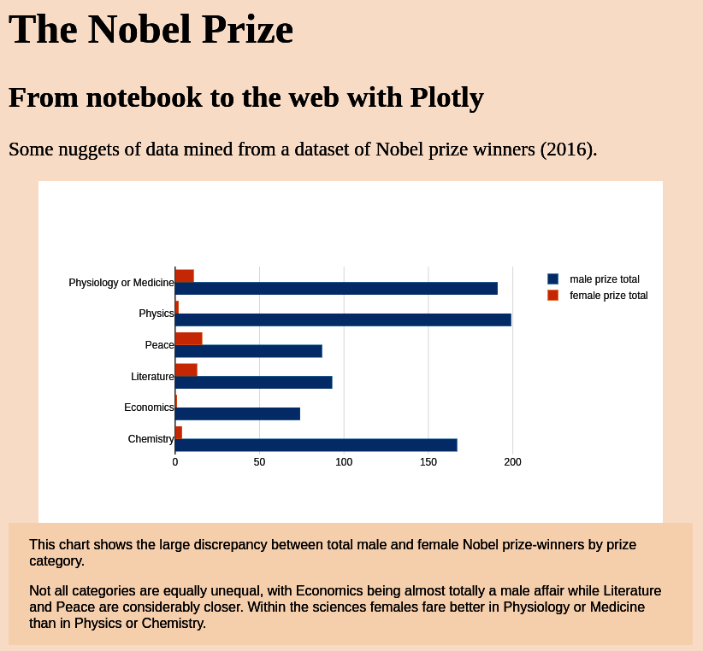

Figure 14-8. Bar chart with Plotly JS

User-Driven Plotly with JavaScript and HTML
As we saw in “Adding Custom Controls with Plotly”, Plotly allows you to add custom controls such as buttons or dropdowns in Python, which can be transferred to the web as JS-driven HTML controls. Although this is a really useful feature of Plotly, it is a little limited, particularly in terms of placement and styling of these widgets. An alternative way to update Plotly web charts is to use native JS+HTML controls to change the charts, filtering the datasets or adapting the styling. It turns out this is pretty easy to do and, with a little JS know-how, it represents a more flexible and powerful control setup.
Let’s demonstrate some JS custom control using one of the charts we just built in “Native JavaScript Charts with Plotly”. We’ll add a dropdown to allow the user to change the x-axis group shown. The two obvious options are the existing breakdown by gender and one grouping the ages by prize category.
First, we’ll add an HTML dropdown (select) to the page and center it using some flex-box CSS:
<
div
class
=
"main"
>
<
h1
class
=
'title'
>
The Nobel Prize
<
/
h1
>
<
h2
>
From notebook to the web with Plotly
<
/
h2
>
<!-- ... -->
<
div
class
=
"container"
>
<!-- ... -->
<
div
class
=
"chart-wrapper"
>
<
div
class
=
'chart'
id
=
'violin-group'
>
<
/
div
>
<
/
div
>
<
/
div
>
<
div
id
=
"chart-controls"
>
<
div
id
=
"nobel-group-select-holder"
>
<
label
for
=
"nobel-group"
>
Group:
<
/
label
>
<
select
name
=
"nobel-group"
id
=
"nobel-group"
>
<
/
select
>
<
/
div
>
<
/
div
>
<
/
div
>
This select tag with contain option tags that will be added with JS and D3.
A little CSS will center any controls in the controls container and adapt the font style:
#chart-controls
{
display
:
flex
;
justify-content
:
center
;
font-family
:
sans-serif
;
font-size
:
0.7em
;
margin
:
20px
0
;
}
select
{
padding
:
2px
;
}
Now that we’ve some HTML to build upon, we’ll use some JS and D3 to add the select tags to our group controls. But first we’ll adapt the Plotly charting function to allow it to be updated with new groups. The JSON data is imported as before, but now the data is stored as a local variable and used to update a Plotly violin chart. This updateChart function uses Plotly’s update method to create the plot. This works like newPlot but is intended to be called when data or layout changes, efficiently redrawing the plot to reflect any changes.
We also have a new selectedGroup variable, which will be used in the dropdown select to change the field being plotted:
let
data
d3
.
json
(
"data/nobel_winners.json"
)
.
then
(
(
_data
)
=>
{
console
.
log
(
_data
)
;
data
=
_data
updateChart
(
)
;
}
)
;
let
selectedGroup
=
'gender'
function
updateChart
(
)
{
var
traces
=
[
{
type
:
"violin"
,
x
:
data
.
map
(
(
d
)
=>
d
[
selectedGroup
]
)
,
y
:
data
.
map
(
(
d
)
=>
d
.
award_age
)
,
points
:
"none"
,
box
:
{
visible
:
true
}
,
line
:
{
color
:
"green"
}
,
meanline
:
{
visible
:
true
}
}
]
;
var
layout
=
{
title
:
"Age distributions of the Nobel prizewinners"
,
yaxis
:
{
zeroline
:
false
}
,
xaxis
:
{
categoryorder
:
'category ascending'
}
}
;
Plotly
.
update
(
"violin-group"
,
traces
,
layout
)
;
}
The selectedGroup variable allows the x-axis group to be changed by the user.
We want the prize groups to be presented in alphabetical order (starting with Chemistry), so make this change to the layout.
In place of newPlot we call update, which has the same signature but is used to reflect changes to data (traces) or layout.
With the updateChart method to hand, we now need to add the select options and a callback function to be called when the user changes the prize group:
let
availableGroups
=
[
'gender'
,
'category'
]
availableGroups
.
forEach
(
(
g
)
=>
{
d3
.
select
(
"#nobel-group"
)
.
append
(
"option"
)
.
property
(
"selected"
,
g
===
selectedGroup
)
.
attr
(
"value"
,
g
)
.
text
(
g
)
;
}
)
;
d3
.
select
(
"#nobel-group"
)
.
on
(
"change"
,
function
(
e
)
{
selectedGroup
=
d3
.
select
(
this
)
.
property
(
"value"
)
;
updateChart
(
)
;
}
)
;
For each of the available groups, we use D3 to select the dropdown by ID and append an <option> tag with text and value set to the group string.
This ensures that the initial selection is the value of selectedGroup by setting the selected attribute to true.
We use D3 to add a callback function when a selection is made. Here we get the value of the option (gender or category) and use it to set the selectedGroup variable. We then update the chart to reflect this change.
With the wiring now complete, we have a group dropdown that changes the violin plot to reflect the group chosen. Figure 14-9 shows the result of selecting the prize category group. Note that Plotly helpfully rotates the category group labels to prevent overlap.
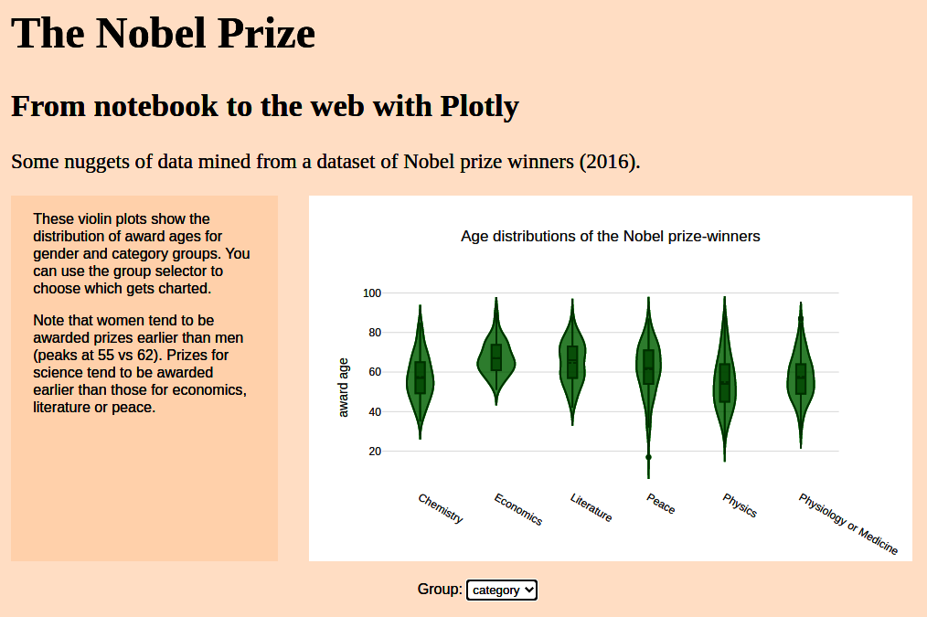

Figure 14-9. Adding a dropdown to control Plotly
We’ll be seeing more HTML controls in action in later chapters where buttons and radio-boxes are demoed. Creating controls in JS is a lot more flexible than the Python-driven options at the cost of a small amount of web-dev fu.

Summary
In this chapter, we’ve seen how to turn the best charts from your notebook explorations into a web presentation. There are many options available, from static PNGs, with maybe some extra Matplotlib styling, to interactive Plotly charts, using custom JavaScript controls. Data can be embedded in the Plotly chart calls, produced using Plotly’s offline library, or imported as a JSON string (nice for data sketches) or file.
Plotly is a good charting library, and in learning the Python API you pretty much learn the JS API as well—a big plus. For conventional and some specialized (e.g., machine learning) charts, it’s a great option. For anything a little more bespoke or complex, D3 offers a lot more power, as we’ll see in the upcoming chapters.
1 Bokeh is a worthy alternative.
2 You can easily transpose your DataFrames to the required columnar form using the DataFrame’s T operator.
3 See https://oreil.ly/zUyxK for Plotly’s line style options.
4 See the Plotly site for some demos.
5 See https://oreil.ly/8UDgA for further details.
6 For more advanced, user-driven dataviz with large datasets, a data server with API is another route.

Chapter 15. Imagining a Nobel Visualization
In Chapter 13, we explored the Nobel Prize dataset, looking for interesting stories to tell based on aspects of the data that should engage and educate. We found some interesting nuggets, among them:
- Maria Goeppert, the only female physicist other than Marie Curie to win a Physics Nobel
- The post-WWII surge of American Nobel prizes, passing the declining tallies of the three biggest European winners: the UK, Germany, and France
- The difference in continental prize distributions
- The dominance of the Scandinavian countries when prize tallies are adjusted for population size
These and a number of other narratives require particular types of visualization. Comparison of Nobel Prize numbers by nation is probably best achieved by means of a conventional bar chart, whereas geographic prize distributions demand a map. In this chapter, we will try to design a modern, interactive visualization that incorporates some of the key stories we discovered while exploring the dataset.

Who Is It For?
The first consideration when imagining a visualization is its target audience. A visualization intended for display in a gallery or museum will likely be very different from one intended for an in-house dashboard, even though they could use the same dataset. The Nobel Prize visualization anticipated for this book has as its chief constraint that it teach a key subset of D3 and the JavaScript needed to create a modern interactive web visualization. It is a fairly informal dataviz and should entertain and inform. It does not require a specialist audience.

Choosing Visual Elements
The first constraint on our Nobel Prize visualization is that it be simple enough to teach and provide a set of the key D3 skills. But even if that constraint was not in place, it is probably sensible to limit the scope of any visualization. This scope depends very much on the context,1 but, as in many learning contexts, less is often more. Too much interactivity risks overwhelming the user and diluting the impact of any stories we might wish to tell.
With this in mind, let’s look at the key elements we want to include and how these are to be visually arranged.
A menu bar of some sort is a must, allowing the user to engage with the visualization and manipulate the data. Its functionality will depend on the stories we choose to tell, but it will certainly provide some way to explore or filter the dataset.
Ideally, the visualization should display each prize by year and this display should update itself as the user refines the data through the menu bar. Given that national and regional trends are of interest, a map should be included, highlighting the prize-winning countries selected and giving some indication of their tally. A bar chart is the best way to compare the number of prizes by country, and this too should adapt dynamically to any data changes. There should also be a choice of measuring the absolute number of prizes by country or per capita, taking into account the respective population sizes.
In order to personalize the visualization, we should be able to select individual winners, showing any available picture and the short biography we scraped from Wikipedia. This requires a list of currently selected winners and a window in which to display the selected individual.
The aforementioned elements provide enough scope to tell the key stories we discovered in the last chapter, and with a bit of finessing should fit into a standard form factor.2
Our Nobel Prize visualization uses a fixed size for all devices, which means compromising larger devices with higher resolutions in order to accommodate smaller ones, such as last-generation smartphones or tablets. I find that for a lot of visualization work, a fixed size gives you much-needed control over specific placement of visual content blocks, information boxes, labels, and so on. For some visualizations, particularly multielement dashboards, a different approach may be required. Responsive web design (RWD) attempts to adapt the look and feel of your visualization to optimize for the specific device. Some popular CSS libraries such as Bootstrap detect the device size (e.g., a tablet with resolution of 1,280×800 pixels) and change the stylesheet applied in order to get the most out of the available screen real estate. Specifying a fixed size for your visualization and using absolute positioning within it is the way to go if you require pinpoint control of the placement of your visual elements. However, you should be aware of the challenges of RWD, particularly when required to build multicomponent dashboards and the like.
Now let’s aim to pin down the look, feel, and requirements of the individual elements of our Nobel Prize visualization, beginning with the main user control, the menu bar.

Menu Bar
An interactive visualization is driven by the user selecting from options, clicking on things, manipulating sliders, and so on. These allow the user to define the scope of the visualization, which is why we’ll deal with them first. Our user controls will appear as a toolbar at the top of the visualization.
A standard way to drive interesting discoveries is to allow the user to filter the data in key dimensions. The obvious options for our Nobel Prize visualization are category, gender, and country, the focus of our exploration in the last chapter. These filters should be cumulative, so, for example, selecting gender female and category Physics should return the two winning female physicists. In addition to those filters, we should have a radio button to choose between absolute and per capita numbers of national prize winners.
Figure 15-1 shows a menu bar that meets our requirements. Placed at the top of our visualization, it has selectors to filter our required dimensions and a radio button to select our national winner metric, either absolute or per capita.
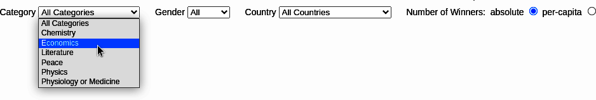

Figure 15-1. The user’s controls
The menu bar will sit atop the key component of our visualization, a chart showing all the Nobel Prizes over time. Let’s describe that next.

Prizes by Year
The last chapter showed a lot of interesting historical trends in the Nobel Prizes by country. We also saw that although female recipients have increased recently, they are way behind in the sciences. One way of allowing these trends to be discovered is to show all the Nobel Prizes on a timeline and provide a filter to select the prizes by gender, country, and category (using the menu bar just discussed).
If we make our visualization 1,000 pixels wide, then, with 114 years of prizes to cover, we are allowed around 8 pixels per prize, enough to differentiate them. The highest number of prizes awarded in any one year is 14, in the year 2000, giving a minimal height for this element of 8×14 pixels, around 120. A circle, color-coded by category, seems a good way to represent the individual prizes, giving us a chart something like the one shown in Figure 15-2.
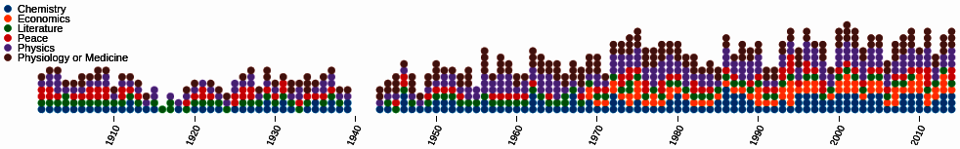

Figure 15-2. A timeline of Nobel Prizes by year, color-coded by category
The individual prizes are the essence of the visualization, so we’ll place this timeline prominently at the top above our central element, which should be a map, reflecting the international nature of the prize and allowing the user to see any global trends.

A Map Showing Selected Nobel Countries
Mapping is one of D3’s strengths, with many global projections available, from the classic Mercator to 3D spherical presentations.3 Though maps are obviously engaging, they are also often overused and inappropriate when presenting nongeographical data. For example, unless you’re careful, large geographical areas, such as countries in Europe or states of the US, tend to outweigh smaller ones even when the latter have far larger populations. When you are presenting demographic information, this skew is hard to avoid and misrepresentation can result.4
But the Nobel Prize is an international one and the distribution of prizes by continent is of interest, making a global map a good way to depict the filtered data. If we superimpose a filled circle at the center of each country to reflect the prize measure (absolute or per capita), then we avoid skewing in favor of the larger land masses. In Europe, with many relatively small countries by land mass, these circles will intersect. By making them slightly transparent,5 we can still see the superimposed circles and, by adding the opacities, give a sense of prize density. Figure 15-3 demonstrates this.
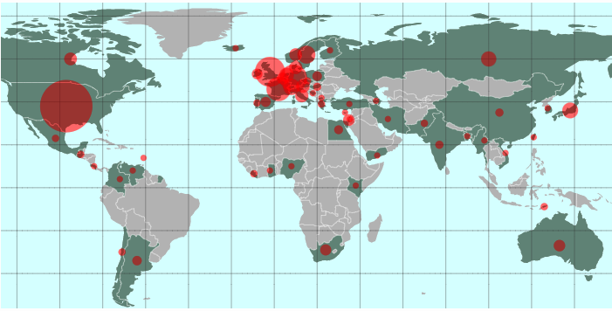

Figure 15-3. Global distribution of prizes
We’ll provide a little tooltip for the map, both as a way of demonstrating how to build this handy visual component and also to help a little with naming the countries. Figure 15-4 shows what we’re aiming for.
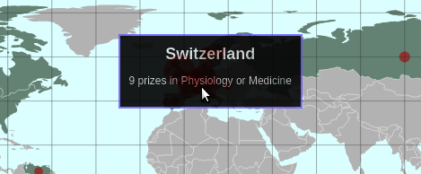

Figure 15-4. A simple tooltip for our Nobel Prize map
The last of the larger elements will be placed below the map: a bar chart allowing the user to make clear comparisons of the number of Nobel Prizes by country.

A Bar Chart Showing Number of Winners by Country
There is a lot of evidence that bar charts are great for making numeric comparisons.6 A reconfigurable bar chart gives our visualization a lot of flexibility, allowing it to present the results of user-directed data filtering, choice of metric (i.e., absolute versus per capita counts), and more.
Figure 15-5 shows the bar chart we’ll use to compare the prize hauls of chosen countries. Both the axes ticks and bars should respond dynamically to user interaction, driven by the menu bar (see Figure 15-1). An animated transition between bar chart states would be good and (as we’ll see in “Transitions”) pretty much comes free with D3. As well as being attractive, there’s reason to think such transitions are also effective communicators. See this Stanford University paper on the effectiveness of animated transitions in data visualization for some insights.
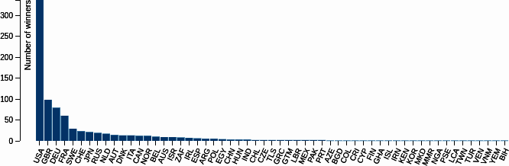

Figure 15-5. A bar chart component
To the side of the map and bar chart, we’ll place a list of currently selected winners and a biography box, allowing the user to discover something about individual winners.

A List of the Selected Winners
We want the user to be able to select individual winners, displaying a mini-biography and picture when available. The easiest way to achieve this is to have a list box, showing the currently selected winners, filtered from the full dataset using the menu bar selectors. Ordering these by year, in descending order, is a sensible default. And although we could allow the list to be sorted by column, it seems an unnecessary complication.
A simple HTML table with column headers should do the job here. It will look something like Figure 15-6.
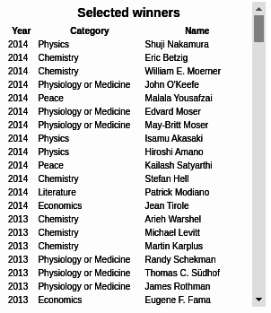

Figure 15-6. A list of selected winners
The list will have clickable rows, allowing the user to select an individual winner to be displayed in our last element, a small biography box.

A Mini-Biography Box with Picture
The Nobel Prize is given to individuals, each with a story to tell. To both humanize and enrich our visualization, we should use the individual mini-biographies and images we scraped from Wikipedia (see Chapter 6) to display the result of selecting an individual from our list element.
Figure 15-7 shows a biography box with a colored top border indicating the category of prize, with colors shared by our time chart (Figure 15-2), a top-right photograph (when available), and the first few paragraphs of Wikipedia’s biographic entry.
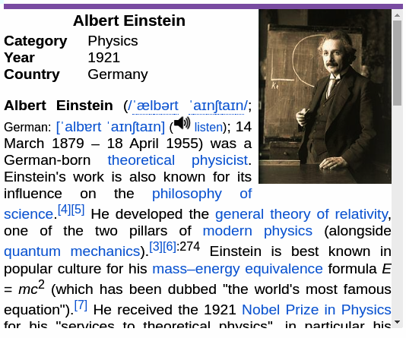

Figure 15-7. A mini-biography of the selected winner with picture, if available
The bio-box completes our set of visual components. We can now put them together in our specified 1,000×800 pixel frame.

The Complete Visualization
Figure 15-8 shows our complete Nobel Prize visualization with the five key elements plus the topmost user controls arranged to fit in a 1,000×800 pixel frame. Because we decided our timeline should take pride of place and the global map rather demanded the center, the other elements order themselves. The bar chart needs extra width to accommodate the labeled bars of all 58 countries, while the list of selected winners and mini-bio fit nicely to the right.
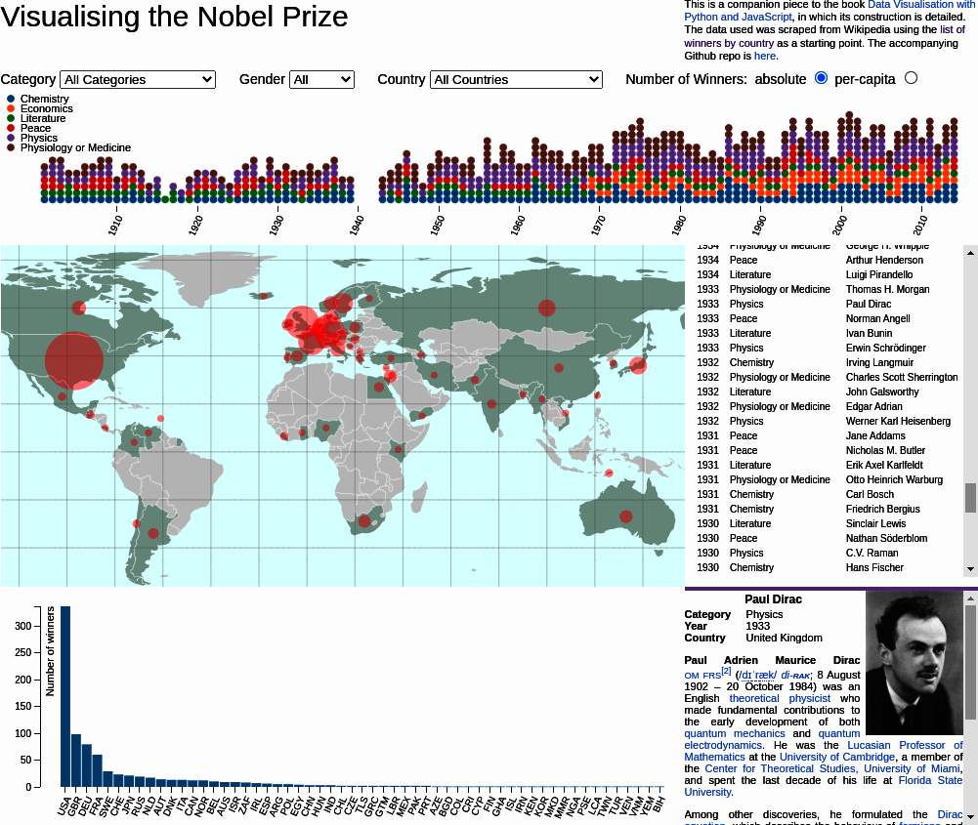

Figure 15-8. The complete Nobel Prize visualization
Let’s summarize our imaginings before proceeding to the next chapter, where we’ll see how to realize them.

Summary
In this chapter, we imagined our Nobel visualization, establishing a minimal set of visual elements necessary to tell the key stories discovered during our explorations of the last chapter. These fit neatly into our complete creation, shown in Figure 15-8. In the next chapters, I will show you how to build the individual elements and how to stitch them together to form a modern, interactive web visualization. We’ll start with a gentle introduction to D3, by way of the simple story of a bar chart.
1 A specialized dashboard, designed for experts, could tolerate more functionality than a general-purpose educational visualization.
2 With a pixel measure, it’s worth keeping track of changing device resolutions. As of May 2022, pretty much all devices will accommodate a 1,000×800 pixel visualization.
3 These 3D orthographic projections are “fake” in the sense that they do not use a 3D graphics context, such as WebGL. There are some nice examples from Jason Davies, observablehq, and nullschool.
4 See xkcd for an example.
5 By adjusting the alpha channel in the RGBA code with the CSS property opacity, from 0 (none) to 1 (full).
6 See Stephen Few’s insightful blog post.

Chapter 16. Building a Visualization
In Chapter 15, we used the results of our pandas exploration of the Nobel Prize dataset (see Chapter 11) to imagine a visualization. Figure 16-1 shows the visualization we imagined, and in this chapter we’ll see how to go about building it, leveraging the power of JavaScript and D3.

Figure 16-1. Our target, a Nobel Prize visualization
I’ll show how the visual elements we conceived combine to transform our freshly cleaned and processed Nobel dataset into an interactive web visualization, deployable to billions of devices at the flick of a switch. But before going into the details, let’s have a look at the core components of a modern web visualization.

Preliminaries
Before beginning to build the Nobel visualization, let’s consider the core components that will be used and how we will organize our files.

Core Components
As we saw in “A Basic Page with Placeholders”, building a modern web visualization requires four key components:
- An HTML skeleton upon which to hang our JavaScripted creation
- One or more CSS files to govern the look and feel of the dataviz
- The JavaScript files themselves, including any third-party libraries you might need (D3 being our biggest dependency)
- And last but not least, the data to be transformed, ideally in the JSON or CSV (if wholly static data) format
Before we start looking at our dataviz components, let’s get the file structure for our Nobel Prize visualization (Nobel-viz) project in place and establish how we’re going to feed data to our visualization.

Organizing Your Files
Example 16-1 shows the structure of our project directory. By convention we have an index.html file in the root directory with a static directory containing all the libraries and assets (images and data) used for our visualization.

Example 16-1. Our Nobel-viz project’s file structure
nobel_viz
├──
index.html
└──
static
├──
css
│
└──
style.css
├──
data
│
├──
nobel_winners_biopic.json
│
├──
winning_country_data.json
│
├──
world-110m.json
│
└──
world-country-names-nobel.csv
├──
images
│
└──
winners
│
└──
full
│
├──
002b4f05aa3758e2d6acadde4ed80aa991ed6357.jpg
│
├──
00d7ed381db8b5d18edc84694b7f9ce14ee57c5b.jpg
│
├──
...
└──
js
├──
nbviz_bar.mjs
├──
nbviz_core.mjs
├──
nbviz_details.mjs
├──
nbviz_main.mjs
├──
nbviz_map.mjs
├──
nbviz_menu.mjs
└──
nbviz_time.mjs
└──
libs
├──
crossfilter.min.js
├──
d3.min.js
└──
topojson.min.js
The static data files we’ll be using, including a TopoJSON world map (see Chapter 19) and the country data we grabbed from the web (see “Getting Country Data for the Nobel Dataviz”).
The Nobel Prize winners’ photos we scraped using Scrapy in “Scraping Text and Images with a Pipeline”.
The js subdirectory contains our Nobel-viz JavaScript module files (.mjs), separated into core elements and starting with nbviz_.

Serving the Data
The full Nobel dataset with the mini-biographies that we scraped in Chapter 6 amounts to around three megabytes of data, considerably less when compressed for web transport. By the standards of modern web pages, that’s not a huge amount of data. In fact, average web page size is somewhere around 2MB to 3MB.1 Nevertheless it’s approaching a point where we might consider breaking it into smaller chunks that could be loaded on a need-to-use basis. We could also serve the data dynamically from a web server (see Chapter 13) with a database like SQLite. As it is, the small inconvenience of an initial wait time is compensated by speedy performance thereafter, as all the data is cached by the browser. It also makes things a lot simpler having just one initial fetching of data.
For our Nobel visualization we’ll serve all the data from a data directory (see Example 16-1, #2), fetched as the app is initialized.

The HTML Skeleton
Although our Nobel visualization has a number of dynamic components, the HTML skeleton required is surprisingly simple. This demonstrates a core theme of the book—that you need very little conventional web development to set the stage for programming data visualizations.
The index.html file, which creates the visualization on loading, is shown in Example 16-2. The three components are:
A CSS stylesheet style.css, setting fonts, content-block positions, and the like, is imported.
HTML placeholders for our visual elements with IDs of the form nobel-[foo].
The JavaScript; first third-party libraries, then our original scripts.
We’ll cover the individual HTML sections in detail in the coming chapters, but I wanted you to see what is essentially the entire nonprogrammatic element of the Nobel Prize visualization. With this skeleton in place, you can then turn to the job of creative programming, something D3 encourages and excels at. As you get used to defining your content blocks in HTML, and fixing dimensions and positioning with CSS, you’ll find you spend more and more time doing what you love best: manipulating data with code.
Tip
I find it helpful to treat the identified placeholders, such as the map holder <div id="nobel-map"></div>, as panels owned by their respective elements. We set the dimension and relative positioning of these frames in the main CSS or JS2 file and the elements, such as our dynamic map, adapt themselves to the size of their frame. This allows a nonprogramming designer to change the look and feel of the visualization through CSS styling.

Example 16-2. The index.html access file to our single-page visualization
<!DOCTYPE html>
<
meta
charset
=
"utf-8"
>
<
title
>
Visualizing the Nobel Prize
</
title
>
<!-- 1. IMPORT THE visualization'S CSS STYLING -->
<
link
rel
=
"stylesheet"
href
=
"static/css/style.css"
media
=
"screen"
/>
<
body
>
<
div
id
=
'chart'
>
<!-- 2. A HEADER WITH TITLE AND SOME EXPLANATORY INFO -->
<
div
id
=
'title'
>
Visualizing the Nobel Prize
</
div
>
<
div
id
=
"info"
>
This is a companion piece to the book
<
a
href
=
'http://'
>
Data visualization with Python and JavaScript
</
a
>
, in which
its construction is detailed. The data used was scraped
Wikipedia using the
<
a
href
=
'https://en.wikipedia.org/wiki
/List_of_Nobel_laureates_by_country'
>
list of winners by country
</
a
>
as a starting point. The
accompanying GitHub repo is
<
a
href
=
'http://github.com/Kyrand/dataviz-with-python-and-js-ed-2'
>
here
</
a
>
.
</
div
>
<!-- 3. THE PLACEHOLDERS FOR OUR VISUAL COMPONENTS -->
<
div
id
=
"nbviz"
>
<!-- BEGIN MENU BAR -->
<
div
id
=
"nobel-menu"
>
<
div
id
=
"cat-select"
>
Category
<
select
></
select
>
</
div
>
<
div
id
=
"gender-select"
>
Gender
<
select
>
<
option
value
=
"All"
>
All
</
option
>
<
option
value
=
"female"
>
Female
</
option
>
<
option
value
=
"male"
>
Male
</
option
>
</
select
>
</
div
>
<
div
id
=
"country-select"
>
Country
<
select
></
select
>
</
div
>
<
div
id
=
'metric-radio'
>
Number of Winners:
&nbsp;
<
form
>
<
label
>
absolute
<
input
type
=
"radio"
name
=
"mode"
value
=
"0"
checked
>
</
label
>
<
label
>
per-capita
<
input
type
=
"radio"
name
=
"mode"
value
=
"1"
>
</
label
>
</
form
>
</
div
>
</
div
>
<!-- END MENU BAR -->
<!-- BEGIN NOBEL-VIZ COMPONENTS -->
<
div
id
=
'chart-holder'
class
=
'_dev'
>
<!-- TIME LINE OF PRIZES -->
<
div
id
=
"nobel-time"
></
div
>
<!-- MAP AND TOOLTIP -->
<
div
id
=
"nobel-map"
>
<
div
id
=
"map-tooltip"
>
<
h2
></
h2
>
<
p
></
p
>
</
div
>
</
div
>
<!-- LIST OF WINNERS -->
<
div
id
=
"nobel-list"
>
<
h2
>
Selected winners
</
h2
>
<
table
>
<
thead
>
<
tr
>
<
th
id
=
'year'
>
Year
</
th
>
<
th
id
=
'category'
>
Category
</
th
>
<
th
id
=
'name'
>
Name
</
th
>
</
tr
>
</
thead
>
<
tbody
>
</
tbody
>
</
table
>
</
div
>
<!-- BIOGRAPHY BOX -->
<
div
id
=
"nobel-winner"
>
<
div
id
=
"picbox"
></
div
>
<
div
id
=
'winner-title'
></
div
>
<
div
id
=
'infobox'
>
<
div
class
=
'property'
>
<
div
class
=
'label'
>
Category
</
div
>
<
span
name
=
'category'
></
span
>
</
div
>
<
div
class
=
'property'
>
<
div
class
=
'label'
>
Year
</
div
>
<
span
name
=
'year'
></
span
>
</
div
>
<
div
class
=
'property'
>
<
div
class
=
'label'
>
Country
</
div
>
<
span
name
=
'country'
></
span
>
</
div
>
</
div
>
<
div
id
=
'biobox'
></
div
>
<
div
id
=
'readmore'
>
<
a
href
=
'#'
>
Read more at Wikipedia
</
a
>
</
div
>
</
div
>
<!-- NOBEL BAR CHART -->
<
div
id
=
"nobel-bar"
></
div
>
</
div
>
<!-- END NOBEL-VIZ COMPONENTS -->
</
div
>
</
div
>
<!-- 4. THE JAVASCRIPT FILES -->
<!-- THIRD-PARTY JAVASCRIPT LIBRARIES, MAINLY D3 -->
<
script
src
=
"libs/d3.min.js"
></
script
>
<!-- ... -->
<!-- THE MAIN JAVASCRIPT MODULE FOR OUR NOBEL ELEMENTS -->
<
script
src
=
"static/js/nbviz_main.mjs"
></
script
>
</
body
>
The HTML skeleton (Example 16-2) defines the hierarchical structure of our Nobel-viz components, but their visual sizing and positioning are set in the style.css file. In the next section, we’ll see how this is done and look at the general styling of our visualization.

CSS Styling
We’ll deal with the styling of the individual chart components of our chart (Figure 16-1) in their respective chapters. This section will cover the remaining nonspecific CSS, most importantly the sizing and positioning of our elements’ content blocks (panels).
The size of a visualization can be a tricky choice. There are many more device formats out there these days, with smartphones, tablets, mobile devices, etc. having a variety of different resolutions, such as “retina,”3 and full HD (1,920×1,080). So pixel sizes are much more varied than they used to be, and pixel density becomes a more meaningful metric. Most devices perform pixel scaling to compensate for this, which is why you can still read the text on a smartphone even though it has as many pixels as a large desktop monitor. Also, most handheld devices have pinch-and-zoom and pan, allowing the user to easily focus on regions of a larger dataviz. For our Nobel dataviz we’ll choose a compromise resolution of 1,280×800 pixels, which should look OK on most desktop monitors and be usable in landscape mode on a mobile device, including our 50-pixel-high top-most user controls.
First, we set some general styles we want applied to the whole document using the body selector; a sans-serif font, an off-white background, and some link detailing are specified. We also set the width of the visualization and its margins:
body
{
font-family
:
"Helvetica Neue"
,
Helvetica
,
Arial
,
sans-serif
;
background
:
#fefefe
;
width
:
1000px
;
margin
:
0
auto
;
/* top and bottom 0, left and right auto */
}
a
:link
{
color
:
royalblue
;
text-decoration
:
none
;
}
a
:hover
{
text-decoration
:
underline
;
}
This color is just off full-white (#ffffff) and should help to make the page slightly less bright and easier on the eyes.
The default underlined hyperlinks look a bit fussy in my opinion, so we remove decoration.
There are three main div content blocks to our Nobel-viz, which we position absolutely within the #chart div (their relative parent). These are the main title (#title) , some information on the visualization (#info), and the main container (#nbviz). The title and info are placed by eye and the main container is placed 90 pixels from the page top to allow them room, and given a width of 100% to make it expand to the available space. The following CSS achieves this:
#nbviz
{
position
:
absolute
;
top
:
90px
;
width
:
100%
;
}
#title
{
position
:
absolute
;
font-size
:
30px
;
font-weight
:
100
;
top
:
20px
;
}
#info
{
position
:
absolute
;
font-size
:
11px
;
top
:
18px
;
width
:
300px
;
right
:
0px
;
line-height
:
1
.
2
;
}
The chart-holder is given a height of 750 px, a width of 100% its parent, and a position property of relative, meaning the absolute positioning of its child panels will be relative to its top-left corner. The bottom of our charts is padded by 20 pixels:
#chart-holder
{
width
:
100%
;
height
:
750px
;
position
:
relative
;
padding
:
0
0
20px
0
;
/* top right bottom left */
}
#chart-holder
svg
{
width
:
100%
;
height
:
100%
;
}
We want the SVG contexts for our components to expand to fit their containers.
Allowing for the Nobel-viz’s height constraint of 750 pixels, the width/height ratio of two for our equirectangular map,4 and the need to fit over 100 years’ worth of Nobel Prize circular indicators into our time chart, playing with the dimensions suggests Figure 16-2 as a good compromise for the size of our visual elements.
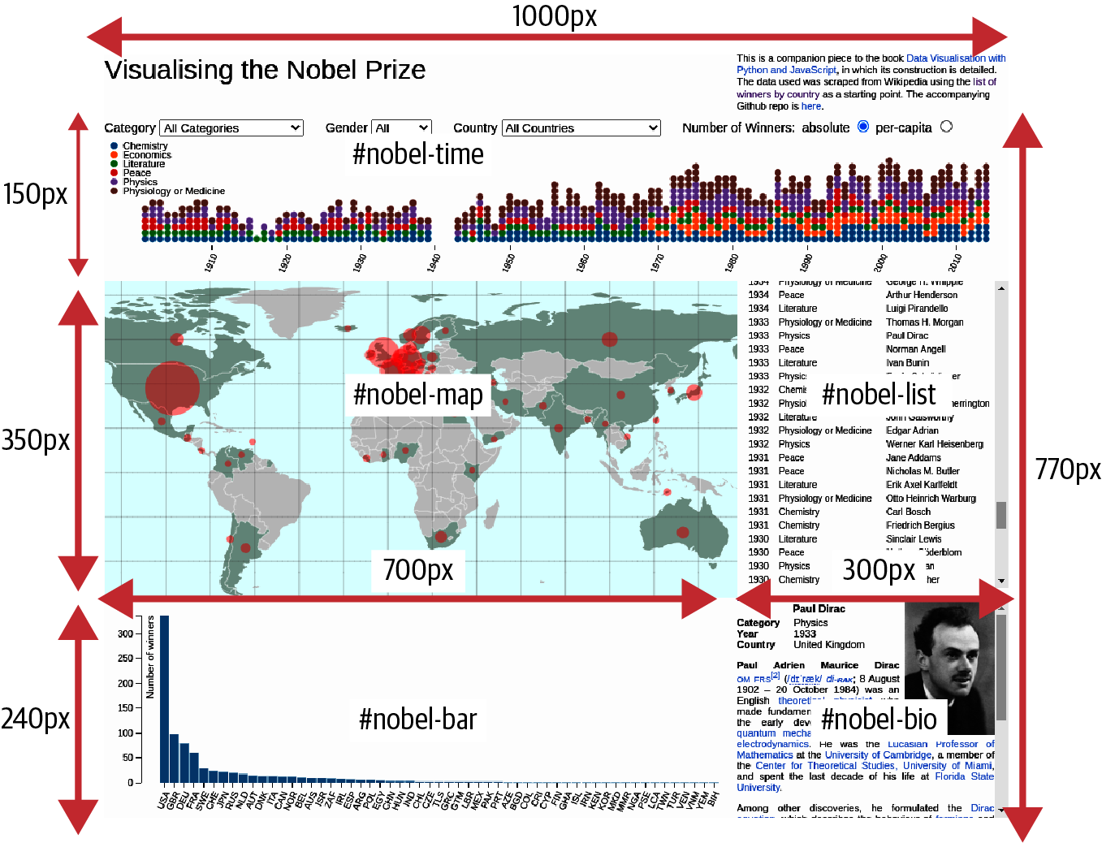

Figure 16-2. The Nobel-viz’s dimensions
This CSS positions and sizes the components as shown in Figure 16-2:
#nobel-map
,
#nobel-winner
,
#nobel-bar
,
#nobel-time
,
#nobel-list
{
position
:
absolute
;
}
#nobel-time
{
top
:
0
;
height
:
150px
;
width
:
100%
;
}
#nobel-map
{
background
:
azure
;
top
:
160px
;
width
:
700px
;
height
:
350px
;
}
#nobel-winner
{
top
:
510px
;
left
:
700px
;
height
:
240px
;
width
:
300px
;
}
#nobel-bar
{
top
:
510px
;
height
:
240px
;
width
:
700px
;
}
#nobel-list
{
top
:
160px
;
height
:
340px
;
width
:
290px
;
left
:
700px
;
padding-left
:
10px
;
}
We want absolute, manually adjusted positioning, relative to the chart-holder parent container.
The timeline runs the full width of the visualization.
You can use padding to let the components “breathe.”
The other CSS styles are specific to the individual components and will be covered in their respective chapters. With the preceding CSS, we have an HTML skeleton on which to flesh out our visualization with JavaScript.

The JavaScript Engine
With a visualization of any size, it’s good to start imposing some modularity early on. Many of the D3 examples on the web5 are one-page solutions, combining HTML, CSS, JS, and even data on one page. Though this is great for teaching by example, as the codebase increases, things will degenerate fast, making changes a slog and increasing the chance of namespace collisions and the like.

Importing the Scripts
We include the JavaScript files for our visualization using <script> tags placed at the bottom of the <body> tag in our entry index.html file, as shown in Example 16-2:
<!DOCTYPE html>
<
meta
charset
=
"utf-8"
>
...
<
body
>
...
<!-- THIRD-PARTY JAVASCRIPT LIBRARIES, MAINLY D3 BASED -->
<
script
src
=
"static/libs/d3.min.js"
>
<
/
script
>
<
script
src
=
"static/libs/topojson.min.js"
>
<
/
script
>
<
script
src
=
"static/libs/crossfilter.min.js"
>
<
/
script
>
<!-- THE JAVASCRIPT FOR OUR NOBEL ELEMENTS -->
<
script
src
=
"static/js/nbviz_main.mjs"
>
<
/
script
>
<
/
body
>
We use local copies of the third-party libraries.
The main entry point for our Nobel app, where it requests its first datasets and sets the display ball rolling. This module imports all the others used by the visualization.
Content Delivery Networks
One thing you’ll see a lot of if you look at the script tags in (typically) index.html pages is the use of Content Delivery Networks (CDNs) to provide cacheable libraries efficiently using a central store. So you might use Cloudflare’s CDN to import D3:app-name:
<
script
src
=
"https://cdnjs.cloudflare.com/ajax/libs/d3/7.3.1/d3.js"
></
script
>
CDNs are a very efficient way to import libraries and if you’re using a lot of them and they are relatively heavyweight, it can provide tangible benefits. But certainly for development purposes it’s good to use a local copy of the library, and this is what we do, with the three libraries used in the visualization being retrieved from a libs subdirectory of static.

Modular JS with Imports
In the first edition of this book, a common but rather hacky pattern was used to establish an nbviz namespace within which to place functions, variables, constants, etc. used by the various components of the Nobel dataviz. Here’s an example, as you may well run into similar patterns in the wild:
/* js/nbviz_core.js
/* global $, _, crossfilter, d3 */
(
function
(
nbviz
)
{
//... MODULES PRIVATE VARS ETC..
nbviz
.
foo
=
function
(
)
{
//...
}
;
}
(
window
.
nbviz
=
window
.
nbviz
||
{
}
)
)
;
Defining variables as global will prevent them triggering JSLint errors.
Exposes this function to other scripts as part of shared nbviz namespace.
Uses the nbviz object if available, and creates it otherwise.
Each JS script was encapsulated with this pattern and all required scripts were included with a <script> tag in the main index.html entry point. With the arrival of cross-browser support for JS modules, we have a much cleaner, modern way of including our JavaScript with modular imports familiar to any Pythonista (see “JavaScript Modules”).
We now have only to include our main JS module in index.html, and that will import all the other modules required:
// static/js/nbviz_main.mjs
import
nbviz
from
'./nbviz_core.mjs'
import
{
initMenu
}
from
'./nbviz_menu.mjs'
import
{
initMap
}
from
'./nbviz_map.mjs'
import
'./nbviz_bar.mjs'
import
'./nbviz_details.mjs'
import
'./nbviz_time.mjs'
These are imported to initialize their update callbacks. We’ll see how that works later in the chapter.
In the coming chapters, the JavaScript/D3 used to produce the visualization’s elements will be explained in detail. First, we’ll deal with the flow of data through the Nobel-viz, from the (data) server to the client browser and within the client, driven by user interaction.

Basic Data Flow
There are many ways to deal with data in a project of any complexity. For interactive apps, and particularly data visualizations, I find the most robust pattern is to have a central data object to cache current data. In addition to the cached data, we also have some active reflections or subsets of this dataset, stored in the main data object. For example, in our Nobel-viz a user can select a number of subsets of the data (e.g., only those winners in the Physics category).
If a different data reflection is triggered by the user, such as by choosing the per capita prize metric, a flag6 is set (in this case, valuePerCapita is set to 0 or 1). We then update all the visual components, and those that depend on valuePerCapita adapt accordingly. The size of the map indicators changes and the bar chart reorganizes.
The key idea is to make sure the visual elements are synchronized to any user-driven data changes. A reliable way to do this is to have a single update method (here called onDataChange) that is called whenever a user does something to change the data. This method alerts all the active visual elements to the changed data and they respond accordingly.
Let’s now see how the app’s code fits together, starting with the shared core utilities.

The Core Code
The first JavaScript file loaded is nbviz_core.js. This script contains any code we might want to share among the other scripts. For example, we have a categoryFill method that returns a specific color for each category. This is used by both the timeline component and as a border in the biography box. This core code includes functions we might want to isolate for testing, or simply to make other modules less cluttered.
Tip
Often in programming we use string constants as dictionary keys and comparatives, and in generated labels. It’s easy to slip into the bad habit of typing these strings when required, but a much better way is to define a constant variable instead. For example, rather than 'if option === "All Categories"', we use 'if option === nbviz.ALL_CATS'. In the former option, mistyping 'All Categories' will not flag an error, an accident waiting to happen. Having a const also means only one edit is needed to change all occurrences of the string. JavaScript has a newish const keyword that makes enforcing constancy a bit easier, though it only prevents variables from being reassigned. See the Mozilla documentation for some examples and a breakdown of const limitations.
Example 16-3 shows the code shared between the other modules. Anything intended to be used by other modules is attached to the shared nbviz namespace.

Example 16-3. Shared codebase in nbviz_core.js
let
nbviz
=
{
}
nbviz
.
ALL_CATS
=
'All Categories'
nbviz
.
TRANS_DURATION
=
2000
// time in ms for our visual transitions
nbviz
.
MAX_CENTROID_RADIUS
=
30
nbviz
.
MIN_CENTROID_RADIUS
=
2
nbviz
.
COLORS
=
{
palegold
:
'#E6BE8A'
}
// any named colors used
nbviz
.
data
=
{
}
// our main data store
nbviz
.
valuePerCapita
=
0
// metric flag
nbviz
.
activeCountry
=
null
nbviz
.
activeCategory
=
nbviz
.
ALL_CATS
nbviz
.
CATEGORIES
=
[
"Chemistry"
,
"Economics"
,
"Literature"
,
"Peace"
,
"Physics"
,
"Physiology or Medicine"
]
;
// takes a category like Physics and returns a color
nbviz
.
categoryFill
=
function
(
category
)
{
var
i
=
nbviz
.
CATEGORIES
.
indexOf
(
category
)
;
return
d3
.
schemeCategory10
[
i
]
;
}
;
let
nestDataByYear
=
function
(
entries
)
{
//...
}
;
nbviz
.
makeFilterAndDimensions
=
function
(
winnersData
)
{
//...
}
;
nbviz
.
filterByCountries
=
function
(
countryNames
)
{
//...
}
;
nbviz
.
filterByCategory
=
function
(
cat
)
{
//...
}
;
nbviz
.
getCountryData
=
function
(
)
{
// ...
}
;
nbviz
.
callbacks
=
[
]
nbviz
.
onDataChange
=
function
(
)
{
nbviz
.
callbacks
.
forEach
(
(
cb
)
=>
cb
(
)
)
}
export
default
nbviz
We use one of D3’s built-in color schemes to provide our prize category colors. schemeCategory10 is an array of 10 color hex codes (['#1f77b4', '#ff7f0e',...]), which we access using the category indices.
This and the following empty methods will be explained in detail in the following chapters in a use context.
This function is called when the dataset changes (after initialization of the app, this is user-driven) to update the Nobel-viz elements. Update callbacks set by the component modules and stored in the callbacks array are called in turn, triggering any necessary visual changes. See “Basic Data Flow” for details.
The nbviz object, with utility functions, constants, and variables, is the default export for this module, imported by other modules, thus import nbviz from ​./⁠nbviz_core.
With the core code at hand, let’s see how our app is initialized by fetching static resources using D3’s utility methods.

Initializing the Nobel Prize Visualization
In order to start the app, we need some data. We use D3’s json and csv helper functions to load the data and convert it to JavaScript objects and arrays. The Promise.all7 method is used to fire off these data fetches simultaneously, wait for all four to be resolved, and then deliver the data to a specified handler function, in this case ready:
// static/js/nbviz_main.mjs
//...
Promise
.
all
(
[
d3
.
json
(
'static/data/world-110m.json'
)
,
d3
.
csv
(
'static/data/world-country-names-nobel.csv'
)
,
d3
.
json
(
'static/data/winning_country_data.json'
)
,
d3
.
json
(
'static/data/nobel_winners_biopic.json'
)
,
]
)
.
then
(
ready
)
function
ready
(
[
worldMap
,
countryNames
,
countryData
,
winnersData
]
)
{
// STORE OUR COUNTRY-DATA DATASET
nbviz
.
data
.
countryData
=
countryData
nbviz
.
data
.
winnersData
=
winnersData
//...
}
Fire off simultaneous requests for the four data files. The static files consist of a world map (110m resolution) and some country data we’ll be using in the visualization.
The array returned to ready uses JavaScript destructuring to assign the sequential data to its respective variables.
If our data requests are successful, the ready function receives the requested data and we’re ready to start sending data to the visual elements.

Ready to Go
After the deferred requests for data made by the Promise.all method are resolved, it calls the specified ready function, passing the datasets as arguments in the order in which they were added.
The ready function is shown in Example 16-4. If the data has downloaded without error, we use the winners’ data to create the active filter (courtesy of the Crossfilter library) we will use to allow the user to select subsets of the Nobel winners based on category, gender, and country. We then call some initializer methods, and finally use the onDataChange method to trigger a drawing of the visual elements of dataviz, updating bar chart, map, timeline, and so on. The schematic in Figure 16-3 shows the way in which data changes propagate.

Example 16-4. The ready function is called when the initial data requests have resolved
//...
function
ready
(
[
worldMap
,
countryNames
,
countryData
,
winnersData
]
)
{
// STORE OUR COUNTRY-DATA DATASET
nbviz
.
data
.
countryData
=
countryData
nbviz
.
data
.
winnersData
=
winnersData
// MAKE OUR FILTER AND ITS DIMENSIONS
nbviz
.
makeFilterAndDimensions
(
winnersData
)
// INITIALIZE MENU AND MAP
initMenu
(
)
initMap
(
worldMap
,
countryNames
)
// TRIGGER UPDATE WITH FULL WINNERS' DATASET
nbviz
.
onDataChange
(
)
}
This method uses the freshly loaded Nobel Prize dataset to create the filter we will use to allow the user to select subsets of the data to visualize. See “Filtering Data with Crossfilter” for details.
We’ll see how the makeFilterAndDimensions method (Example 16-4, ) works when we cover the Crossfilter library in “Filtering Data with Crossfilter”. For now, we’ll assume we have a means of getting the data currently selected by the user via some menu selectors (e.g., selecting all female winners).
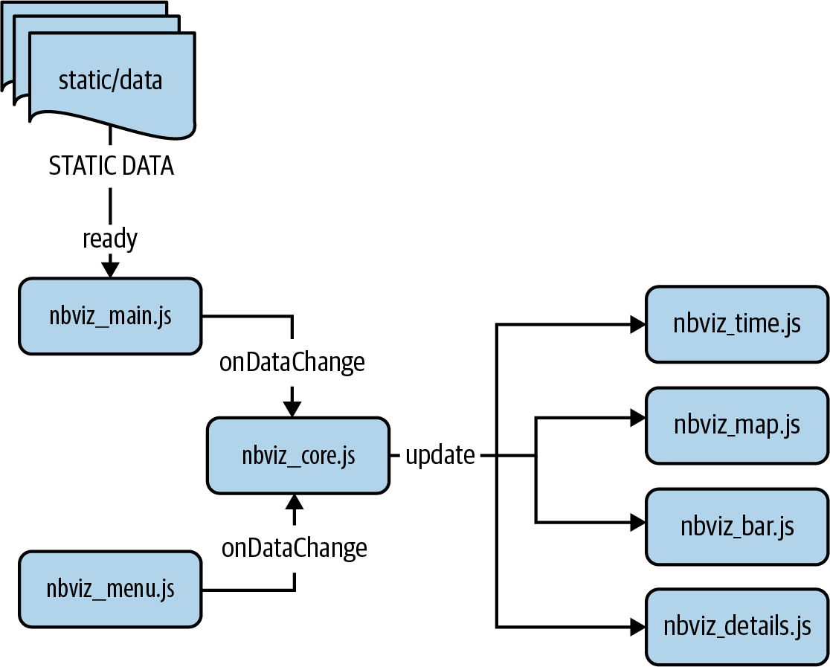

Figure 16-3. The app’s main data flow

Data-Driven Updates
After the menu and map have been initialized in the ready function (we’ll see how that works in their respective chapters: Chapter 19 for the map and Chapter 21 for the menu), we trigger an update of the visual elements with the onDataChange method defined in nbviz_core.js. onDataChange (see Example 16-5) is a shared function that is called whenever the set of displayed data changes in response to user interaction, or when the user chooses a different country prize metric (e.g., measuring per capita rather than absolute numbers).

Example 16-5. Function called to update the visual elements when selected data is changed
// nbviz_core.js
nbviz
.
callbacks
=
[
]
nbviz
.
onDataChange
=
function
(
)
{
nbviz
.
callbacks
.
forEach
(
(
cb
)
=>
cb
(
)
)
}
Each component module that needs updating appends its callback to this array.
On data change the component callbacks are called in turn, triggering any visual changes necessary to reflect the new data.
When the modules are first imported, they add their callbacks to the callbacks array in the core module. Here’s the bar chart, for example:
// nbviz_bar.mjs
import
nbviz
from
'./nbviz_core.mjs'
// ...
nbviz
.
callbacks
.
push
(
(
)
=>
{
let
data
=
nbviz
.
getCountryData
(
)
updateBarChart
(
data
)
}
)
When the main core update function calls this callback function, the country data is used by the local update function to change the bar chart.
The main dataset, consumed by the timeline, map, and bar chart, is produced by the getCountryData method, which groups the prize winners by country and adds some national information, namely population size and international alphacode. Example 16-6 breaks this method down.

Example 16-6. Creating the main country dataset
nbviz
.
getCountryData
=
function
(
)
{
var
countryGroups
=
nbviz
.
countryDim
.
group
(
)
.
all
(
)
;
// make main data-ball
var
data
=
countryGroups
.
map
(
function
(
c
)
{
var
cData
=
nbviz
.
data
.
countryData
[
c
.
key
]
;
var
value
=
c
.
value
;
// if per capita value then divide by pop. size
if
(
nbviz
.
valuePerCapita
)
{
value
=
value
/
cData
.
population
;
}
return
{
key
:
c
.
key
,
// e.g., Japan
value
:
value
,
// e.g., 19 (prizes)
code
:
cData
.
alpha3Code
,
// e.g., JPN
}
;
}
)
.
sort
(
function
(
a
,
b
)
{
return
b
.
value
-
a
.
value
;
// descending
}
)
;
return
data
;
}
;
countryDim is one of our Crossfilter dimensions (see “Filtering Data with Crossfilter”), here providing group key, value counts (e.g., {key:Argentina, value:5}).
We use the array’s map method to create a new array with added components from our country dataset.
Fetches country data using our group key (e.g., Australia).
If the valuePerCapita radio-switch is on then we divide the number of prizes by the size of the country’s population, giving a fairer, relative prize tally.
Uses Array’s sort method to make the array descending by value.
The update methods of our Nobel-viz elements all make use of data filtered by the Crossfilter library. Let’s see how that’s done now.

Filtering Data with Crossfilter
Developed by D3’s creators, Mike Bostock and Jason Davies, Crossfilter8 is a highly optimized library for exploring large, multivariate datasets using JavaScript. It’s very fast and can easily handle datasets far larger than our Nobel Prize dataset. We’ll be using it to filter our dataset of winners by the dimensions of category, gender, and country.
The choice of Crossfilter is slightly ambitious, but I wanted to show it in action as I’ve found it to be so useful personally. It’s also the basis of dc.js, the very popular D3 charting library, which testifies to its usefulness. Although Crossfilter can be a little difficult to grasp, especially when we start intersecting dimensional filters, most use cases follow a basic pattern that is quickly absorbed. If you ever find yourself trying to cut and slice large datasets, Crossfilter’s optimizations will prove a boon.

Creating the filter
On initializing the Nobel-viz, the makeFilterAndDimensions method defined in nbviz_core.js is called from the ready method in nbviz_main.js (see “Ready to Go”). makeFilterAndDimensions uses the freshly loaded Nobel Prize dataset to create a Crossfilter filter and some dimensions (e.g., prize category) based on it.
We first create our filter using the dataset of Nobel Prize winners fetched on initialization. Let’s remind ourselves what that looks like:
[{
name
:
"C\u00e9sar Milstein"
,
category
:
"Physiology or Medicine"
,
gender
:
"male"
,
country
:
"Argentina"
,
year
:
1984
},
{
name
:
"Auguste Beernaert"
,
category
:
"Peace"
,
gender
:
"male"
,
country
:
"Belgium"
,
year
:
1909
},
...
}];
To create our filter, call the crossfilter function with the array of winner objects:
nbviz
.
makeFilterAndDimensions
=
function
(
winnersData
){
// ADD OUR FILTER AND CREATE CATEGORY DIMENSIONS
nbviz
.
filter
=
crossfilter
(
winnersData
);
//...
};
Crossfilter works by allowing you to create dimensional filters on your data. You do so by applying a function to the objects. At its simplest, this creates a dimension based on a single category—for example, by gender. Here we create the gender dimension we’ll use to filter Nobel Prizes:
nbviz
.
makeFilterAndDimensions
=
function
(
winnersData
){
//...
nbviz
.
genderDim
=
nbviz
.
filter
.
dimension
(
function
(
o
)
{
return
o
.
gender
;
});
//...
}
This dimension now has an efficient ordering of our dataset by the gender field. We can use it like this, to return all objects with gender female:
nbviz
.
genderDim
.
filter
(
'female'
)
;
var
femaleWinners
=
nbviz
.
genderDim
.
top
(
Infinity
)
;
femaleWinners
.
length
// 47
filter takes a single value or, where appropriate, a range (e.g., [5, 21]—all values between 5 and 21). It can also take a Boolean function of the values.
Once the filter is applied, top returns the specified number of ordered objects. Specifying Infinity9 returns all the filtered data objects.
Crossfilter really comes into its own when we start applying multiple dimensional filters, allowing us to slice and dice the data into any subsets we require, all achieved with impressive speed.10
Let’s clear the gender dimension and add a new one, filtering by prize-winning category. To reset a dimension,11 apply the filter method without arguments:
nbviz
.
genderDim
.
filter
();
nbviz
.
genderDim
.
top
(
Infinity
)
// the full Array[858] of objects
We’ll now create a new prize category dimension:
nbviz
.
categoryDim
=
nbviz
.
filter
.
dimension
(
function
(
o
)
{
return
o
.
category
;
});
We can now filter the gender and category dimensions in sequence, allowing us to find, for example, all female Physics prize winners:
nbviz
.
genderDim
.
filter
(
'female'
);
nbviz
.
categoryDim
.
filter
(
'Physics'
);
nbviz
.
genderDim
.
top
(
Infinity
);
// Out:
// [
// {name:"Marie Sklodowska-Curie", category:"Physics",...
// {name:"Maria Goeppert-Mayer", category:"Physics",...
// ]
Note that we can turn the filters on and off selectively. So, for example, we can remove the Physics category filter, meaning the gender dimension now contains all the female Nobel Prize winners:
nbviz
.
categoryDim
.
filter
();
nbviz
.
genderDim
.
top
(
Infinity
);
// Array[47] of objects
In our Nobel-viz, these filter operations will be driven by the user making selections from the topmost menu bar.
As well as returning the filtered subsets, Crossfilter can perform grouping operations on the data. We use this to get the national prize aggregates for the bar chart and map indicators:
nbviz
.
genderDim
.
filter
(
)
;
// reset gender dimension
var
countryGroup
=
nbviz
.
countryDim
.
group
(
)
;
countryGroup
.
all
(
)
;
// Out:
// [
// {key:"Argentina", value:5},
// {key:"Australia", value:9},
// {key:"Austria", value:14},
// ...]
Group takes an optional function as an argument, but the default is generally what you want.
Returns all groups by key and value. Do not modify the returned array.12
value is the total number of Nobel Prize winners for Argentina.
To create our Crossfilter filter and dimensions, we use the makeFilterAndDimensions method, defined in nbviz_core.js. Example 16-7 shows the whole method. Note that the order in which the filters are created isn’t important—their intersection will still be the same.

Example 16-7. Making our Crossfilter filter and dimensions
nbviz
.
makeFilterAndDimensions
=
function
(
winnersData
)
{
// ADD OUR FILTER AND CREATE CATEGORY DIMENSIONS
nbviz
.
filter
=
crossfilter
(
winnersData
)
;
nbviz
.
countryDim
=
nbviz
.
filter
.
dimension
(
function
(
o
)
{
return
o
.
country
;
}
)
;
nbviz
.
categoryDim
=
nbviz
.
filter
.
dimension
(
function
(
o
)
{
return
o
.
category
;
}
)
;
nbviz
.
genderDim
=
nbviz
.
filter
.
dimension
(
function
(
o
)
{
return
o
.
gender
;
}
)
;
}
;
We’re using the full JavaScript functions for teaching clarity, but these days the shortened form would likely be used: o => o.country.

Running the Nobel Prize Visualization App
To run the Nobel visualization we need a web server that can access the root index.html file. For development purposes we can make use of Python’s built-in http module to kick off the required server. In the root directory containing our index file, run:
$ python -m http.server 8080
Serving HTTP on 0.0.0.0 port 8080 ...
Now open up a browser window and go to http:localhost:8080 and you should see Figure 16-4.

Figure 16-4. The finished Nobel-viz app

Summary
In this chapter, we sketched out how to implement the visualization we imagined in Chapter 15. The backbone was assembled from HTML, CSS, and JavaScript building blocks, and the data feed to the app and data flow within it described. In the following chapters, we’ll see how the individual components of our Nobel-viz use the data sent to them to create our interactive visualization. We’ll start with a big chapter, which will introduce the fundamentals of D3 while showing how to build the bar chart component of our app. This should set you up for the subsequent D3-focused chapters.
1 See these SpeedCurve and Web Almanac posts for some analysis of average web page size.
2 I would advise saving JavaScripted styling for special occasions, doing as much as possible with vanilla CSS.
3 Currently around 2,560×1,600 pixels.
4 See “Projections” for a comparison of the different geometric projections. Given the constraint of showing all Nobel Prize–winning countries, the equirectangular projection proved most effective.
5 See the collection at D3’s GitHub.
6 In our app, I’m keeping things as simple as possible; as the number of UI options increases, it’s sensible to store flags, ranges, etc. in a dedicated object.
7 You can read more about Promise.all in the Mozilla documentation.
8 See this Square page for an impressive example.
9 JavaScript’s Infinity is a numeric value representing infinity.
10 Crossfilter was designed to update millions of records in real time, in response to user input.
11 This will clear all the filters on this dimension.
12 See the Crossfilter GitHub page.

Chapter 17. Introducing D3—​The Story of a Bar Chart
In Chapter 16, we imagined our Nobel Prize visualization by breaking it into component elements. In this chapter, I will gently introduce you to D3 by showing you how to build the bar chart we need (Figure 17-1).

Figure 17-1. This chapter’s target bar chart
D3 is much more than a charting library. It’s a library you use to build charting libraries, among other things. So why am I introducing you to D3 by way of that ultra-conventional visualization, the bar chart? First, because there should be a little thrill in crafting one from scratch for the first time, having total control over the look and feel of the chart and being unconstrained by whatever prejudices a particular charting library has. And second, because it just happens to be a great way to cover the fundamental elements of D3, particularly data joining and the enter-exit-remove update pattern, now nicely encapsulated by D3’s newish join method. If you get those fundamentals in place, you’re well on your way to employing the full power and expressivity D3 offers, and producing something more novel than a bar chart.
We’ll be using some of the webdev covered in Chapter 4, particularly the SVG graphics that are D3’s specialty (see “Scalable Vector Graphics”). You can try out the code snippets using an online editor like CodePen’s or VizHub’s (which also has a huge number of curated dataviz examples).
Before we begin building the bar chart, let’s consider its elements.

Framing the Problem
A bar chart has three key components: the axes, legends, and labels, and, of course, the bars. As we’re producing a modern, interactive bar chart component, we’ll need the axes and bars to transform in response to user interaction—​namely, filtering the set of prize winners via the top selectors (see Figure 15-1).
We’ll build the chart one step at a time, ending with D3 transitions, which can make your D3 creations more engaging and attractive. But first we’ll cover the basics of D3:
- Selecting DOM elements in your web page
- Getting and setting their attributes, properties, and styles
- Appending and inserting DOM elements
With these basics firmly in place, we’ll move on to the joys of data binding, where D3 begins to flex its muscles.

Working with Selections
Selections are the backbone of D3. Using jQuery-like CSS selectors, D3 can select and manipulate individual and grouped DOM elements. All D3 chained operations begin by selecting a DOM element or set of elements using the select and selectAll methods. select returns the first matching element; selectAll returns the set of matching elements.
Figure 17-2 shows examples of D3 selections, using the select and selectAll methods. These selections are used to change the height attribute of one or more bars. The select method returns the first rect (ID barL) with class bar, whereas selectAll can return any combination of the rects depending on the query provided.
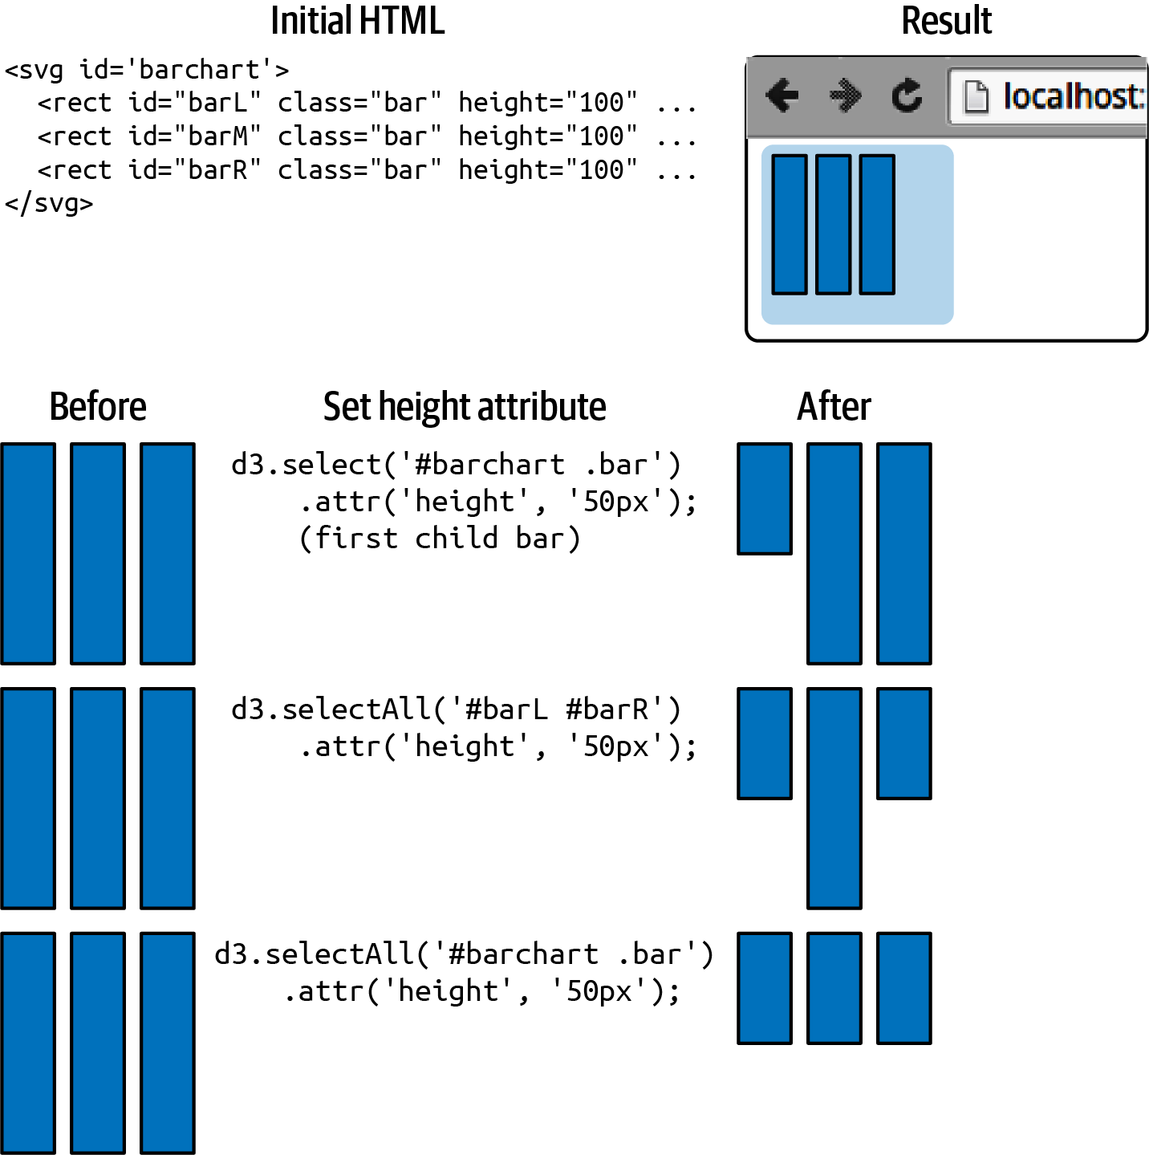

Figure 17-2. Selecting elements and changing attributes: three rectangles are built with the initial HTML. Selections are then made and the height attributes of one or more bars are adjusted.
In addition to setting attributes (the named strings on the DOM elements; e.g., id or class), D3 allows you to set elements’ CSS styles, properties (e.g., whether a checkbox is checked), text, and HTML.
Figure 17-3 shows all the ways in which a DOM element can be changed with D3. With these few methods, you can achieve pretty much any look and feel you want.
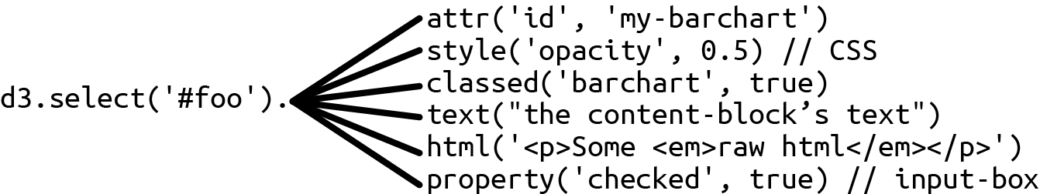

Figure 17-3. Changing a DOM element with D3
Figure 17-4 shows how we can apply CSS styling by adding a class to the element or directly setting a style. We first select the middle bar using its ID barM. The classed method is then used to apply a yellow highlight (see the CSS) and the height attribute set to 50 px. The style method is then used to apply a red fill to the bar directly.
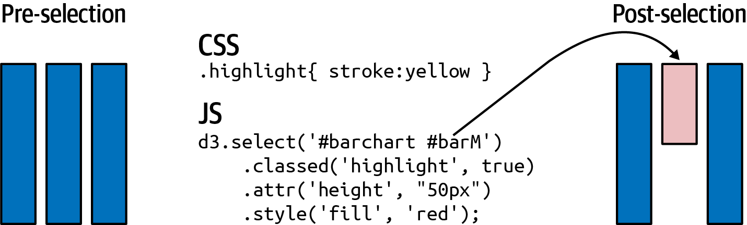

Figure 17-4. Setting attributes and style
D3’s text method sets the text content of applicable DOM tags, such as div, p, h* headers, and SVG text elements. To see the text method in action, let’s create a little title placeholder with some HTML:
<!DOCTYPE html>
<meta charset="utf-8">
<style>font-family: sans-serif;</style>
<body>
<h2 id="title">title holder</h2>
</body>
Figure 17-5 (before) shows the resulting browser page.
Now let’s create a fancy-title CSS class with a large, bold font:
.fancy-title
{
font-size
:
24px
;
font-weight
:
bold
;
}
We can now use D3 to select the title header, add the fancy-title class to it, and then set its text to My Bar Chart:
d3
.
select
(
'#title'
)
.
classed
(
'fancy-title'
,
true
)
.
text
(
'My Bar Chart'
);
Figure 17-5 (after) shows the resulting enlarged and emboldened title.
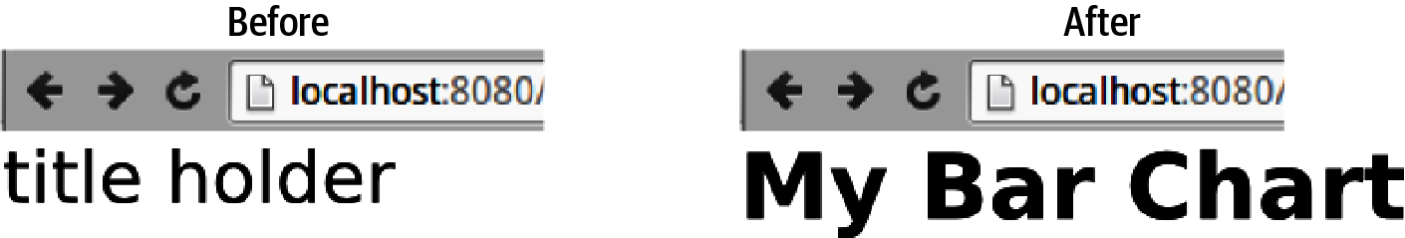

Figure 17-5. Setting text and style with D3
In addition to setting the properties of DOM elements, we can use selections to get those properties. Leaving out the second argument to one of the methods listed in Figure 17-3 allows you to get information about the web page’s setup.
Figure 17-6 shows how to get the key properties from an SVG rectangle. As we’ll see, getting attributes like width and height from an SVG element can be very useful for programmatic adaptation and adjustment.
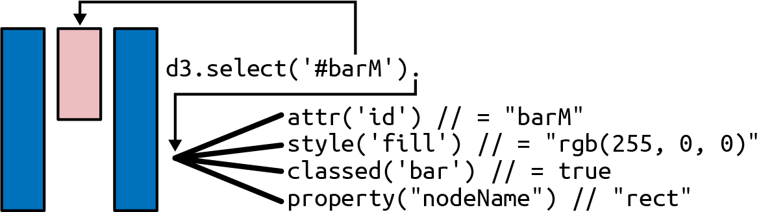

Figure 17-6. Getting a rect bar’s details
Figure 17-7 demonstrates the html and text getter methods. After creating a little list (ID silly-list), we use D3 to select it and get various properties. The html method returns the HTML of the list’s child <li> tags, while the text method returns the text contained in the list, with the HTML tags stripped. Note that for parent tags, the formatting of any text returned is a little messy, but maybe good enough for a string search or two.
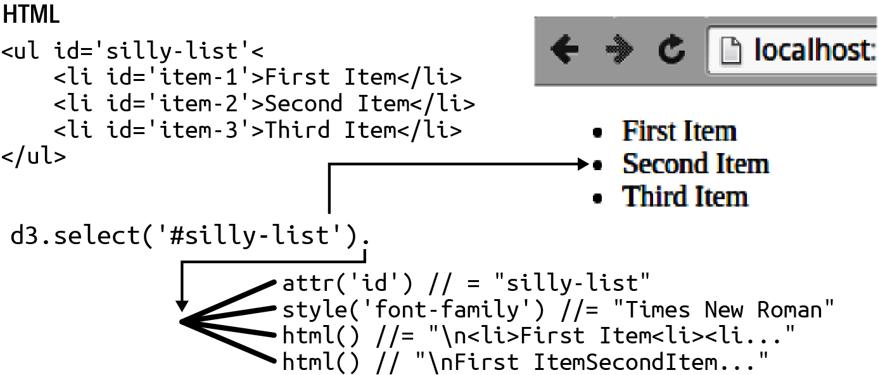

Figure 17-7. Getting HTML and text from a list tag
So far we’ve been manipulating the attributes, styles, and properties of existing DOM elements. This is a useful skill, but D3 comes into its own when we start creating DOM elements programmatically using its append and insert methods. Let’s look at these now.

Adding DOM Elements
We’ve seen how to select and manipulate the attributes, styles, and properties of DOM elements. Now we’ll see how D3 allows us to append and insert elements, programmatically adapting the DOM tree.
We’ll start with a little HTML skeleton containing a nobel-bar placeholder:
<!DOCTYPE html>
<
meta
charset
=
"utf-8"
>
<
link
rel
=
"stylesheet"
href
=
"style.css"
/
>
<
body
>
<
div
id
=
'nobel-bar'
>
<
/
div
>
<
script
src
=
"https://cdnjs.cloudflare.com/ajax/libs/d3/7.3.1/d3.min.js"
>
<
/
script
>
<
script
type
=
"text/javascript"
src
=
"script.js"
>
<
/
script
>
<
/
body
>
The script.js file is where we’ll add our bar chart’s JavaScript code.
Let’s set the size of the nobel-bar element with a little CSS, placed in style.css:
#nobel-bar
{
width
:
600px
;
height
:
400px
;
}
.bar
{
fill
:
blue
;
/* blue bars for the chapter */
}
Usually the first thing one does when creating a chart with D3 is to provide an SVG frame for it. This involves appending an <svg> canvas element to a div chartholder and then appending a <g> group to the <svg> to hold specific chart elements (in our case, the chart bars). This group has margins to accommodate axes, axes labels, and titles.
Getting the Dimensions of an Element
It’s very common when programming in D3, or any other JavaScript visualization library, to require the width and height of an SVG or HTML element to use as the basis for setting the size of component elements. One way of doing this is to use D3’s style component to grab the CSS dimensions and then use the parseInt function to get an integer value:
/* CSS: #nobel-bar { width: 600px }; */
var
width
=
parseInt
(
d3
.
select
(
'#nobel-bar'
)
.
style
(
'width'
)
,
10
)
;
The result of calling the style method is the string '600px', which we can convert to the number 600 using the parseInt function.
This method works pretty well as a rule, although the parseInt feels a bit hacky, turning the string '600px' into the number 600. It will also fail if the width is specified by a percentage of the parent container.
Arguably, a better, more robust approach is to get the dimensions of the bounding box of the HTML or SVG element in question. These give both the width, height, and relative position of the element, using the node method to get the DOM element:
let
ele
=
d3
.
select
(
"#chart-holder"
)
// For an HTML element, starting with the D3 +ele+ selection
let
bRect
=
ele
.
node
().
getBoundingClientRect
();
// e.g., bRect is {width: 600, height: 400, ... }
// For an SVG element use the getBBox method:
let
bBox
=
eleSVG
.
node
().
getBBox
();
// e.g., bBox is {width: 600, height: 400, x: 100, y: 100}
Conventionally, you will specify the margin of your chart in a margin object and then use that and the CSS-specified width and height of the chart container to derive the width and height of your chart group. The required JavaScript looks like Example 17-1.

Example 17-1. Getting our bar chart’s dimensions
var
chartHolder
=
d3
.
select
(
"#nobel-bar"
)
;
var
margin
=
{
top
:
20
,
right
:
20
,
bottom
:
30
,
left
:
40
}
;
var
boundingRect
=
chartHolder
.
node
(
)
.
getBoundingClientRect
(
)
;
var
width
=
boundingRect
.
width
-
margin
.
left
-
margin
.
right
,
height
=
boundingRect
.
height
-
margin
.
top
-
margin
.
bottom
;
Gets the bounding rectangle for our Nobel bar chart’s panel, using it to set the width and height of its bar container group.
With the width and height of our bar group in hand, we use D3 to build our chart’s frame, appending the required <svg> and <g> tags and specifying the size of the SVG canvas and translation of the bar group:
d3
.
select
(
'#nobel-bar'
).
append
(
"svg"
)
.
attr
(
"width"
,
width
+
margin
.
left
+
margin
.
right
)
.
attr
(
"height"
,
height
+
margin
.
top
+
margin
.
bottom
)
.
append
(
"g"
).
classed
(
'chart'
,
true
)
.
attr
(
"transform"
,
"translate("
+
margin
.
left
+
","
+
margin
.
top
+
")"
);
This changes the HTML of the nobel-bar content block:
...
<
div
id
=
"nobel-bar"
>
<
svg
width
=
"600"
height
=
"400"
>
<
g
class
=
"chart"
transform
=
"translate(40, 20)"
></
g
>
</
svg
>
</
div
>
...
The resulting SVG framework is shown in Figure 17-8. The <svg> element’s width and height are the sum of its child group and the surrounding margins. The child group is offset using transform to translate it margin.left pixels to the right and margin.top pixels down (by SVG convention, in the positive y direction).
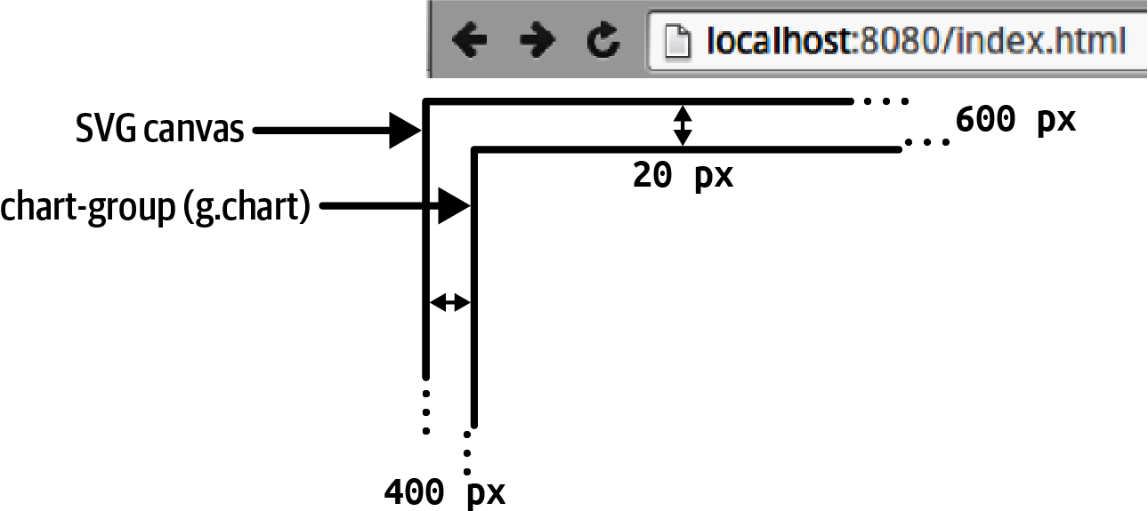

Figure 17-8. Building our bar chart’s frame
With our frame in place, let’s use append to add a few bars. We’ll use a little dummy data: an array of objects with the top slice of Nobel Prize–winning countries by prize number:
var
nobelData
=
[
{
key
:
'United States'
,
value
:
336
},
{
key
:
'United Kingdom'
,
value
:
98
},
{
key
:
'Germany'
,
value
:
79
},
{
key
:
'France'
,
value
:
60
},
{
key
:
'Sweden'
,
value
:
29
},
{
key
:
'Switzerland'
,
value
:
23
},
{
key
:
'Japan'
,
value
:
21
},
{
key
:
'Russia'
,
value
:
19
},
{
key
:
'Netherlands'
,
value
:
17
},
{
key
:
'Austria'
,
value
:
14
}
];
To build a crude bar chart,1 we can iterate through the nobelData array, appending a bar to the chart group as we go. Example 17-2 demonstrates this. After building a basic frame for our chart, we iterate through the nobelData array, using the value fields to set the bar’s height and y-position. Figure 17-9 shows how the object values are used to append bars to our chart group. Note that because SVG uses a downward y-axis, you have to displace the bars by the height of the bar chart minus that of the bar in order to put the bar chart the right way up. As we’ll see later, by using D3’s scales, we can limit such geometric bookkeeping.

Example 17-2. Building a crude bar chart with append
var
buildCrudeBarchart
=
function
(
)
{
var
chartHolder
=
d3
.
select
(
"#nobel-bar"
)
;
var
margin
=
{
top
:
20
,
right
:
20
,
bottom
:
30
,
left
:
40
}
;
var
boundingRect
=
chartHolder
.
node
(
)
.
getBoundingClientRect
(
)
;
var
width
=
boundingRect
.
width
-
margin
.
left
-
margin
.
right
,
height
=
boundingRect
.
height
-
margin
.
top
-
margin
.
bottom
;
var
barWidth
=
width
/
nobelData
.
length
;
var
svg
=
d3
.
select
(
'#nobel-bar'
)
.
append
(
"svg"
)
.
attr
(
"width"
,
width
+
margin
.
left
+
margin
.
right
)
.
attr
(
"height"
,
height
+
margin
.
top
+
margin
.
bottom
)
.
append
(
"g"
)
.
classed
(
'chart'
,
true
)
.
attr
(
"transform"
,
"translate("
+
margin
.
left
+
","
+
margin
.
top
+
")"
)
;
nobelData
.
forEach
(
function
(
d
,
i
)
{
svg
.
append
(
'rect'
)
.
classed
(
'bar'
,
true
)
.
attr
(
'height'
,
d
.
value
)
.
attr
(
'width'
,
barWidth
)
.
attr
(
'y'
,
height
-
d
.
value
)
.
attr
(
'x'
,
i
*
(
barWidth
)
)
;
}
)
;
}
;
Iterates through each of the objects in nobelData, the forEach method providing object and array index to an anonymous function.
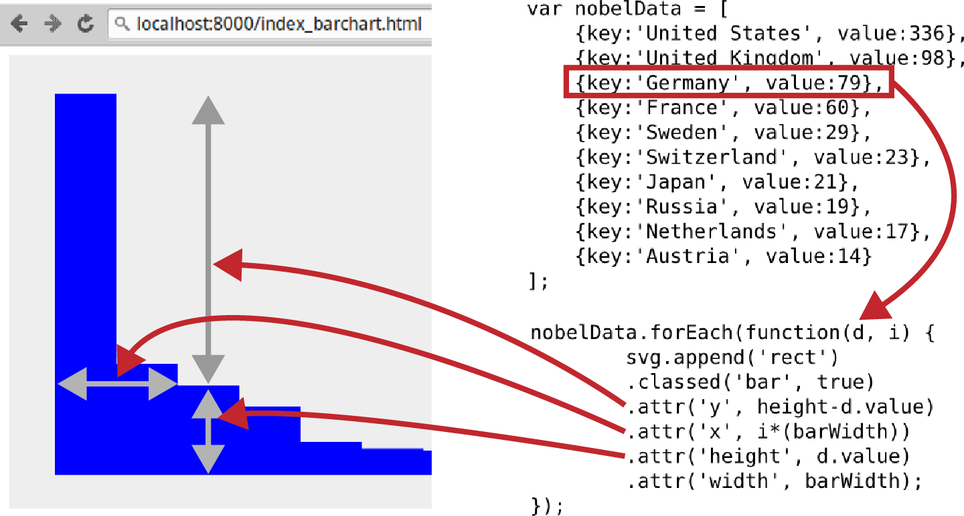

Figure 17-9. Programming a basic bar chart with D3
The other way in which D3 can add elements to the DOM tree is with its insert method. insert works like append but adds a second selector argument to allow you to place elements before a particular position in an sequence of tags, such as at the beginning of an ordered list. Figure 17-10 demonstrates the use of insert: list items in the silly-list are selected just like append and then a second argument (e.g., ':first-child') specifies the element to insert before.
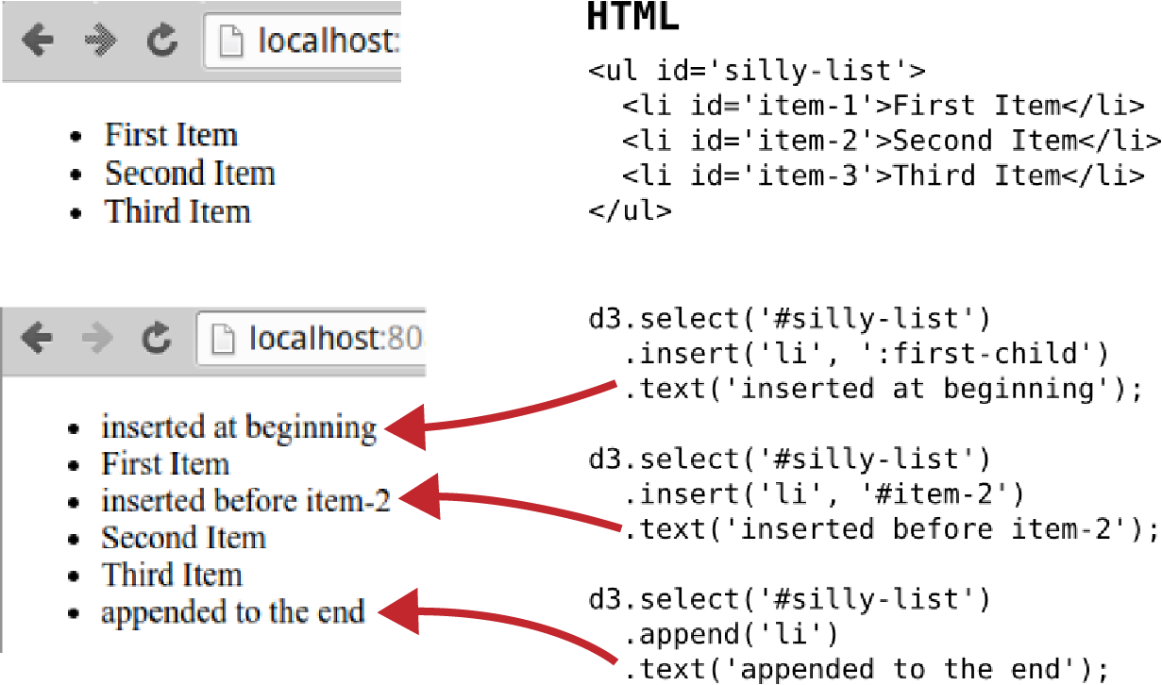

Figure 17-10. Using D3’s insert method to add list items
For SVG elements, positioned directly within their parent group using x and y coordinates, insert might seem redundant. But, as discussed in “Layering and Transparency”, DOM ordering is important in SVG as elements are layered, meaning that the last element in the DOM tree overlays any previous. We’ll see an example of this in Chapter 19 where we have a grid overlay (or graticule) for our world map. We want this grid to be drawn above all other map elements so use insert to place those elements before it.
Our crude bar chart in Figure 17-9 is crying out for a little refinement. Let’s see how we can improve things, first with D3’s powerful scale objects and then with D3’s biggest idea, data binding.

Leveraging D3
In Example 17-2, we built a basic, no-frills bar chart with D3. This chart had a number of problems. First, looping through the data array is a bit clunky. What if we wanted to adapt the dataset for our chart? We’d need some way of adding or removing bars in response and then updating the resulting bars with the new data and redrawing everything. We’d also need to keep scaling the bar dimensions in x and y to reflect the different number of bars and a different maximum bar value. That’s quite a lot of bookkeeping already, and things could get messy fast. Also, where do we keep the changing datasets? Every data-driven change to our chart would require passing the dataset around and then constructing a loop to iterate over elements. It feels as if the data exists outside the chained D3 workflow when it really needs to be integral to it.
The solution to elegantly integrating our dataset with D3 lies in the concept of data binding, D3’s biggest idea. The scaling problems are sorted by one of D3’s most useful utility libraries: scale. We’ll take a look at these now and then unleash the power of D3 with some data binding.

Measuring Up with D3’s Scales
The fundamental idea behind D3’s scales is a mapping from an input domain to an output range. This simple procedure can remove a lot of the persnickety aspects of building charts, visualizations, and the like. As you get more comfortable with scales, you’ll find more and more situations where you can apply them. Mastering them is a key component to relaxed, effortless D3.
D3 provides a lot of scales, dividing them into three main categories: quantitative, ordinal, and time2 scales. There are exotic mappings to suit most conceivable situations, but you’ll probably find yourself using the linear and ordinal scales much of the time.
In use, D3 scales can appear slightly strange because they are part object, part function. What this means is that after creating your scale, you can call various methods on it to set its properties (e.g., domain to set its domain), but you can also call it as a function with a domain argument to return a range value. The following example should make the distinction clear:
var
scale
=
d3
.
scaleLinear
(
)
;
// create a linear scale
scale
.
domain
(
[
0
,
1
]
)
.
range
(
[
0
,
100
]
)
;
scale
(
0.5
)
// returns 50
We use the scale’s domain and range methods to map from 0 → 1 to 0 → 100.
We call the scale like a function with a domain argument of 0.5, returning a range value of 50.
Let’s look at the two main D3 scales, the quantitative and the ordinal, showing how we use them to build our bar chart as we go.

Quantitative Scales
A D3 quantitative scale you’ll usually employ when building line charts, bar charts, scatter plots, and the like is linear, mapping a continuous domain to a continuous range. For example, we want our bar heights to be a linear function of the nobelData values. The range of values to be mapped to is between the maximum and minimum height of the bars in pixels (400 pixels to 0 pixels) and the domain to be mapped from is between the smallest conceivable value (0) and, in our case, the largest value in the array (336 US winners). In the following code, we first use D3’s max method to get the largest value in our nobelData array, using that to specify the end of our domain:
let
maxWinners
=
d3
.
max
(
nobelData
,
function
(
d
)
{
return
+
d
.
value
;
}
)
;
let
yScale
=
d3
.
scaleLinear
(
)
.
domain
(
[
0
,
maxWinners
]
)
/* [0, 336] */
.
range
(
[
height
,
0
]
)
;
If there’s a chance, as is common with JSON encoded data, that the value is a string, prefixing + coerces it to a number.
One little trick to note is that our range decreases from its maximum. This is because we want to use it to specify a positive displacement along the SVG downward y-axis in order to make the bar chart’s y-axis point upward (i.e., the smaller the bar height, the larger the y displacement required). Conversely, you can see that the largest bar (the US winners tally) isn’t displaced at all (see Figure 17-11).
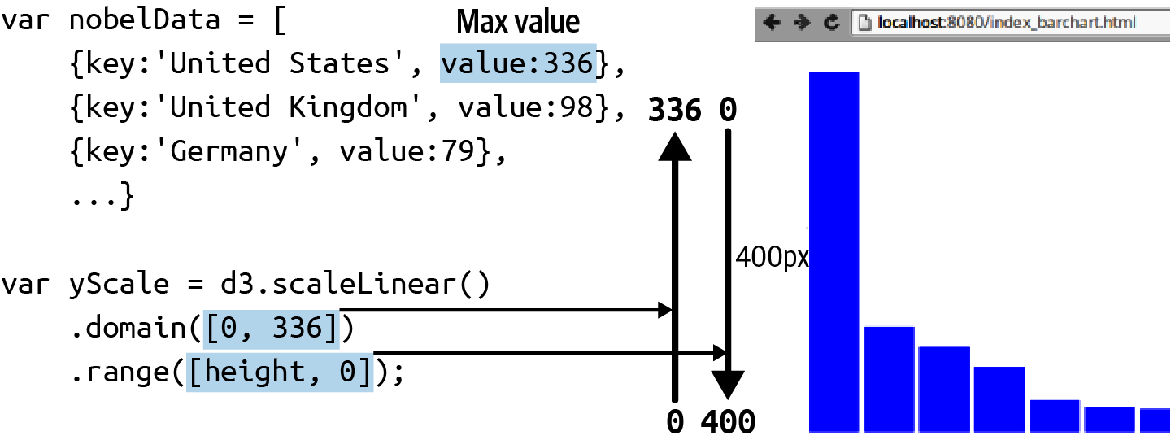

Figure 17-11. Using D3’s linear scale to fix the domain and range of our bar chart’s y-axis
We’re using the simplest possible linear scale for our bar chart’s y-axis, mapping from one numeric range to another, but D3’s linear scales can do a lot more. The key to understanding this is D3’s interpolate method.3 This takes two values and returns an interpolator between them. So, for the range of our yScale in Figure 17-11, interpolate returns a numeric interpolator for the values 400 and 0:
var
numInt
=
d3
.
interpolate
(
400
,
0
)
;
numInt
(
0
)
;
// 400
numInt
(
0.5
)
;
// 200
numInt
(
1
)
;
// 0
Interpolators have a default domain of [0,1].
The interpolate method can deal with more than just numbers. Strings, color codes, and even objects are handled sensibly. You can also specify more than two numbers for your domain array—just make sure that domain and range arrays are the same size.4 We can combine these two facts to create a useful colormap:5
var
color
=
d3
.
scaleLinear
()
.
domain
([
-
1
,
0
,
1
])
.
range
([
"red"
,
"green"
,
"blue"
]);
color
(
0
)
// "#008000" green's hex code
color
(
0.5
)
// "004080" slate blue
D3’s linear scales have a lot of useful utility methods and rich functionality. The numeric maps will probably be your workhorse scale, but I recommend reading the D3 docs to fully appreciate how flexible the linear scales are. On that web page, you’ll find D3’s other quantitative scales, to suit almost every quantitative occasion:
- Power scales, similar to linear but with exponential transform (e.g., sqrt).
- Log scales, similar to linear but with logarithmic transform.
- Quantize scales, a variant of linear with a discrete range; that is, although the input is continuous, the output is divided into segments or buckets (e.g., [1, 2, 3, 4, 5]).
- Quantile scales, often used for color palettes, are similar to quantize scales but have discrete or bucketed domains as well as ranges.
- Identity scales, linear with the same domain and range (fairly esoteric).
Quantitative scales are great for manipulating continuously valued quantities, but often we want to get values based on a discrete domain (e.g., names or categories). D3 has a specialized set of ordinal scales to meet this need.

Ordinal Scales
Ordinal scales take an array of values as their domain and map these to discrete or continuous ranges, producing a single mapped value for each. To explicitly create a one-to-one mapping, we use the scale’s range method:
var
oScale
=
d3
.
scaleOrdinal
()
.
domain
([
'a'
,
'b'
,
'c'
,
'd'
,
'e'
])
.
range
([
1
,
2
,
3
,
4
,
5
]);
oScale
(
'c'
);
// 3
In the case of our bar chart, we want to map an array of indices to a continuous range, to provide our bars’ x-coordinates. For this, we can use the band scale scaleBand range or the rangeRound methods, the latter snapping output values to individual pixels. Here, we use rangeRound to map an array of numbers to a continuous range, rounding to integer pixel values:
var
oScale
=
d3
.
scaleBand
()
.
domain
([
1
,
2
,
3
,
4
,
5
])
.
rangeRound
([
0
,
400
]);
oScale
(
3
)
// 160
oScale
(
5
)
// 320
In building our original crude bar chart (Example 17-2), we used a barWidth variable to size the bars. Implementing padding between the bars would have required a padding variable and necessary adjustments to barWidth and the bar positions. With our new ordinal band scale, we get these things for free, removing the fiddly bookkeeping. Calling the xScale’s bandwidth method provides the calculated bar widths. We can also use the scale’s padding method to specify the padding between the bars as a fraction of the space occupied by each bar. The bandwidth value is adjusted accordingly. Here are some examples of this in action:
var
oScale
=
d3
.
scaleBand
(
)
.
domain
(
[
1
,
2
]
)
;
oScale
.
rangeRound
(
[
0
,
100
]
)
;
oScale
(
2
)
;
// 50
oScale
.
bandwidth
(
)
;
// 50
oScale
.
rangeRound
(
[
0
,
100
]
)
;
oScale
.
padding
(
0.1
)
// pBpBp
oScale
(
1
)
;
// 5
oScale
(
2
)
;
// 52
oScale
.
bandwidth
(
)
;
// 42, the padded bar width
Stores the scale with a fixed domain; useful if we anticipate the range changing.
rangeRound snaps (rounds) the output values to integers.
We specify a padding (p) factor of 0.1 * allocated bar(B)-space.
Figure 17-12 shows our bar chart’s band x-scale with a padding factor of 0.1. The continuous range is 600 (pixels), which is the width of the bar chart, and the domain is an array of integers representing the individual bars. As shown, providing xScale with a bar’s index number returns its position on the x-axis.
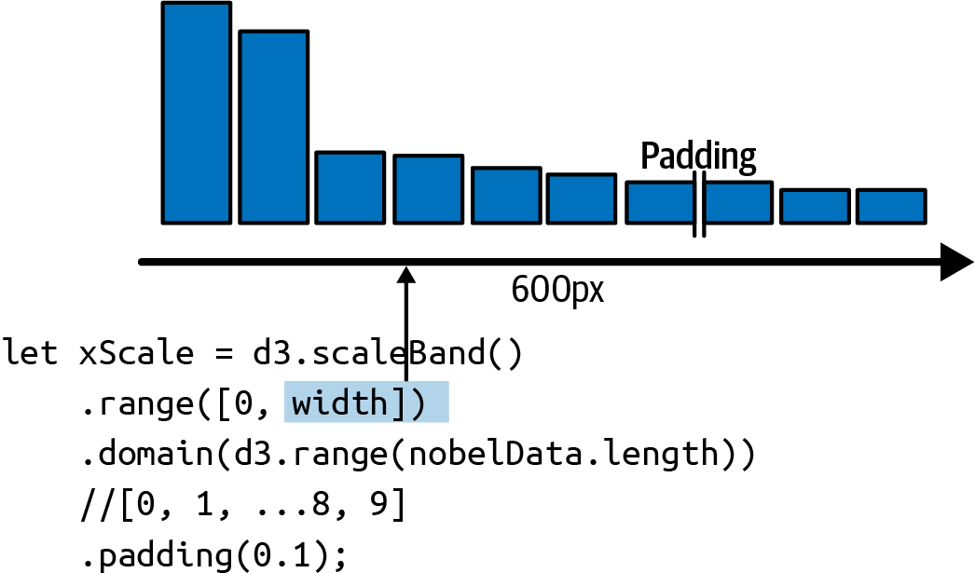

Figure 17-12. Setting the domain and range of our bar chart’s x-scale, using a padding factor of 0.1
Armed with our D3 scales, let’s turn to D3’s central concept, binding data to the DOM in order to drive changes to it.

Unleashing the Power of D3 with Data Binding/Joining
D3 stands for Data-Driven Documents, and up to now we haven’t really been driving with our data. In order to unleash D3, we need to embrace its big idea, which is binding or joining (both terms are used online) the data in our dataset to its respective DOM elements and updating the web page (document) based on this integration. This small step of joining data to the DOM enables a huge amount of functionality when combined with the most powerful D3 methods, enter and exit.
After a number of iterations, D3 (version 5 and above) now provides the join method, which considerably simplifies the use of enter and exit. The join method will be the focus of this chapter.
In order to interpret the thousands of examples online that use the older enter, exit, remove update patterns, it helps to know a little more about what’s going on under the hood when D3 joins data. See Appendix A for details.

Updating the DOM with Data
I think it’s fair to say that using D3 to update the DOM with new data has not been particularly easy to grasp historically (footnote: You really appreciate this when you try to teach it or write a book chapter on it). There have been a number of implementations such as the general update pattern that have themselves gone through a number of incompatible forms. This means a lot of popular examples on the web, using older version of D3, will steer you down the wrong path.
Tip
Although you may anticipate building one-off charts, with a single data-binding process, it’s good to get into the habit of asking yourself, “What if I need to change the data dynamically?” If the answer is not immediately obvious, you have probably implemented a bad D3 design. Catching yourself in the act means you can do a little code audit and make the necessary changes before things start to deteriorate. It’s good to kick yourself out of this habit, but also, because D3 is somewhat of a craft skill, constantly reaffirming that best practice will pay off when you need it.
The good news is that recent versions of D3 have solidified the basic methods and made them a lot simpler as well. So employing enter, exit, and remove, the three key D3 methods used in data-joining, can now be done with a single join method, which has sensible defaults. In this section, we’ll see how to use these four methods to update our bar chart in response to new data, in this case Nobel Prize–winning countries.
Probably the most fundamental concept behind D3 is that of the data-join. In essence, a dataset (usually an array of data objects) is used to create some visual elements, e.g., the rectangular bars of a bar chart. Any change to this data is reflected in a changing visualization, e.g., the number of bars in the bar chart or the heights or placement of existing bars. We can break this operation into three stages:
Create a visual element for any data without one using enter.
Update the attributes and styles of these and, if required, any existing elements.
Remove any old visual elements that no longer have any data joined to them using the exit and remove methods.
Whereas in the past D3 required you to implement the update pattern yourself, using enter, exit, and (briefly) a merge method, the new join method combines these methods in one user-friendly package. Often you can just call it with a single argument, specifying the visual element to be joined to the data (e.g., an SVG rect or circle), but it also has more fine-grained control, allowing you to pass in enter, exit, and update callback functions.
Let’s see how easy it now is to join data and visual elements by joining some horizontal bars, constructed of SVG rectangles, to our dummy Nobel dataset. We’ll join the following dataset to the group of rectangles and use it to create some horizontal bars. You can find a working code example in CodePen.
let
nobelData
=
[
{
key
:
"United States"
,
value
:
336
},
{
key
:
"United Kingdom"
,
value
:
98
},
{
key
:
"Germany"
,
value
:
79
},
{
key
:
"France"
,
value
:
60
},
{
key
:
"Sweden"
,
value
:
29
},
{
key
:
"Switzerland"
,
value
:
23
},
{
key
:
"Japan"
,
value
:
21
}
];
We’ll use a little HTML and CSS to create an SVG group to put the bars in and a bar class with blue fill:
<
div
id
=
"nobel-bars"
>
<
svg
width
=
"600"
height
=
"400"
>
<
g
class
=
"bars"
transform
=
"translate(40, 20)"
></
g
>
</
svg
>
</
div
>
<
style
>
.bar
{
fill
:
blue
;
}
</style>
With data and HTML scaffold to hand, let’s see D3’s join in action. We’ll create an updateBars function that will accept a data array of key-value countries and join it to some SVG rectangles.
The updateBars function accepts a data array and first adds it to a selection of class 'bar' using the data method. As seen in Example 17-3, it then joins this bars selection to some SVG rectangles, using the join method.

Example 17-3. Joining our country data to some SVG bars
function
updateBars
(
data
)
{
// select and store the SVG bars group
let
svg
=
d3
.
select
(
"#nobel-bars g"
)
;
let
bars
=
svg
.
selectAll
(
".bar"
)
.
data
(
data
)
;
bars
.
join
(
"rect"
)
.
classed
(
"bar"
,
true
)
.
attr
(
"height"
,
10
)
.
attr
(
"width"
,
d
=>
d
.
value
)
.
attr
(
"y"
,
function
(
d
,
i
)
{
return
i
*
12
;
}
)
;
}
This joins all existing bars data to SVG rect elements.
join returns all existing rects, which we then update using their joined data.
After calling the join method, D3 is doing the sensible thing, using enter, exit, and remove to keep the data and visual elements in sync. Let’s demonstrate this by calling the updateBars function a few times with changing data. First, we’ll slice the first four members of our Nobel dataset and use those to update the bars:
updateBars
(
nobelData
.
slice
(
0
,
4
));
That produces the bars shown here:
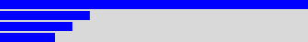
Now let’s update the data-join, using only the first two members of the Nobel data array:
updateBars
(
nobelData
.
slice
(
0
,
2
));
Calling this method produces the two bars shown in the preceding image. Behind the scenes, D3’s bookkeeping has removed the redundant rectangles which, with a smaller dataset, are no longer joined to any data.
Now let’s go the other way and see what happens if we use a bigger dataset, this time the first six members of the Nobel array:
updateBars
(
nobelData
.
slice
(
0
,
6
));
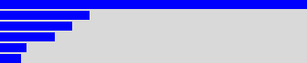
Once again, D3 does the expected thing (see preceding image), this time appending new rectangles to join to the new data objects.
Having demonstrated that D3’s join successfully keeps data and visual elements in sync, adding and removing rectangles as required, we have the basis for our Nobel bar chart.

Putting the Bar Chart Together
Now let’s put together what we’ve currently learned in this chapter and build the main elements of our bar chart. We’ll be putting D3’s scales to good use here.
First, we’ll select the container for our bar chart by ID #nobel-bar and use its dimensions (from boundingClientRectangle) and some margin settings to get the width and height of the chart:
let
chartHolder
=
d3
.
select
(
'#nobel-bar'
)
let
margin
=
{
top
:
20
,
right
:
20
,
bottom
:
35
,
left
:
40
}
let
boundingRect
=
chartHolder
.
node
().
getBoundingClientRect
()
let
width
=
boundingRect
.
width
-
margin
.
left
-
margin
.
right
,
height
=
boundingRect
.
height
-
margin
.
top
-
margin
.
bottom
// some left-padding for the y-axis label
var
xPaddingLeft
=
20
Now we’ll set our scales using the width and height:
let
xScale
=
d3
.
scaleBand
()
.
range
([
xPaddingLeft
,
width
])
// left-padding for y-label
.
padding
(
0.1
)
let
yScale
=
d3
.
scaleLinear
().
range
([
height
,
0
])
Now we’ll create our SVG chart group using width, height, and margins and store it to a variable:
var
svg
=
chartHolder
.
append
(
'svg'
)
.
attr
(
'width'
,
width
+
margin
.
left
+
margin
.
right
)
.
attr
(
'height'
,
height
+
margin
.
top
+
margin
.
bottom
)
.
append
(
'g'
)
.
attr
(
'transform'
,
'translate('
+
margin
.
left
+
','
+
margin
.
top
+
')'
)
With our HTML and SVG scaffold in place, let’s adapt the updateBars function (see Example 17-3) to respond to changes in our real Nobel data. The update function will receive a data array of the form:
[
{
key
:
'United States'
,
value
:
336
,
code
:
'USA'
}
{
key
:
'United Kingdom'
,
value
:
98
,
code
:
'GBR'
}
{
key
:
'Germany'
,
value
:
79
,
code
:
'DEU'
}
...
]
On being called with new data, the updateBarchart function first filters out any zero prize-winning countries and then updates the x and y scale domains to reflect the number of bars/countries and the maximum prizes won, as seen in Example 17-4.

Example 17-4. Updating the bar chart
let
updateBarChart
=
function
(
data
)
{
// filter out any countries with zero prizes by value
data
=
data
.
filter
(
function
(
d
)
{
return
d
.
value
>
0
})
// change the scale domains to reflect the newly filtered data
// this produces an array of country codes: ['USA', 'DEU', 'FRA' ...]
xScale
.
domain
(
data
.
map
(
d
=>
d
.
code
)
)
// we want to scale the highest number of prizes won, e.g., USA: 336
yScale
.
domain
([
0
,
d3
.
max
(
data
,
d
=>
d
.
value
)
])
// ...
}
With updated scales we can use a data-join to create the bars necessary for the data provided. This is essentially the same as the function shown in Example 17-3 but using scales to size the bars and with a customized entry method, to add a class and left-padding to newly minted bars:
let
bars
=
svg
.
selectAll
(
'.bar'
)
.
data
(
data
)
.
join
(
(
enter
)
=>
{
return
enter
.
append
(
'rect'
)
.
attr
(
'class'
,
'bar'
)
.
attr
(
'x'
,
xPaddingLeft
)
}
)
.
attr
(
'x'
,
d
=>
xScale
(
d
.
code
)
)
.
attr
(
'width'
,
xScale
.
bandwidth
(
)
)
.
attr
(
'y'
,
d
=>
yScale
(
d
.
value
)
)
.
attr
(
'height'
,
d
=>
height
-
yScale
(
d
.
value
)
)
We customize the enter method to add a bar` class to the rectangle. Note that we need to return the enter object to use after the join call.
We now have a bar chart that responds to changes in the data, initiated in this case by the user. Filtering the data for all Chemistry prizes shows the result in Figure 17-13. Although lacking a few crucial elements, the hard work has been done building a bar chart. Now let’s add axes and some cool transitional effects to make the finishing touches.
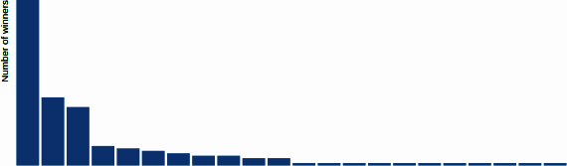

Figure 17-13. Final bar chart

Axes and Labels
Now that we have a working update pattern, we will add the axes and axes labels that any self-respecting bar chart needs.
D3 doesn’t offer a lot in the way of high-level chart elements, encouraging you to roll your own. But it does provide a convenient axis object, which takes the sting out of having to craft the SVG elements yourself. It’s easy to use and, as you would expect, plays nicely with our data update patterns, allowing for axes ticks and labels that change in response to the data presented.
D3 Axes
D3 axes can be confusing at first, feeling just a little bit magical. It’s best to think of them as a plug-in6 that generates the correct axis HTML (lines, ticks, tick labels, etc.) for you and which can respond sensibly to changes in data (i.e., if you change the range of your scales, the axes can change in response using nice, smooth transitions that look pretty cool).
Generally with a D3 axis, you will create an SVG group to hold it and then call the axis on it, having set the scale it will represent. During the call, the axis object will stamp the correct HTML on the DOM. So, as a simple demo, the following code describes a simple chart setup with an SVG x-axis group and a D3 axis. Calling the axis on the axis group generates the HTML lines and text needed for an axis (find a working example in CodePen).
<!DOCTYPE html>
<
meta
charset
=
"utf-8"
>
<
script
src
=
"static/libs/d3.min.js"
>
<
/
script
>
<
style
>
svg
{
width
:
600px
;
height
:
400px
}
</style>
<
body
>
<
svg
>
<
g
id
=
'chart'
transform
=
'translate(20,20)'
>
<
g
id
=
'x-axis'
>
<
/
g
>
<
/
g
>
<
/
svg
>
<
script
>
var
scale
=
d3
.
scaleLinear
(
)
.
domain
(
[
0
,
10
]
)
.
range
(
[
0
,
400
]
)
var
xaxis
=
d3
.
axisBottom
(
)
.
scale
(
scale
)
d3
.
select
(
'#x-axis'
)
.
call
(
xaxis
)
<
/
script
>
<
/
body
>
Creates a scale with a domain of 0 to 10 and a range of 400 (pixels).
Creates a D3 bottom axis, using the scale just defined.
Calling the D3 axis on our x-axis group creates the axis HTML branch shown in Figure 17-15, which looks like Figure 17-14.
Figure 17-14. A simple D3 axis
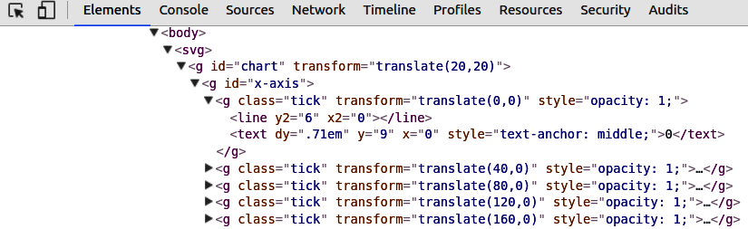
Figure 17-15. The HTML branch created by a D3 axis instance
Using the call method on a selection is a common D3 technique to create plug-ins such as tooltips and brushes. There are loads of examples on bl.ocks.org like this one by Charl Botha. The main takeaway is that it’s not magic and it’s certainly important that you understand the basics of what’s happening during that call method.
In order to define our x and y axes, we need to know what ranges and domains we want our axes to represent. In our case, it’s the same one as the ranges and domains of our x and y scales, so we supply these to the axes’ scale method. D3 axes also allow you to specify their orientation, which will fix the relative position of ticks and tick labels. With our bar chart, we want the x-axis on the bottom and the y-axis on the left. Our ordinal x-axis will have a label for each bar, but with our y-axis, the choice of tick numbers is arbitrary. Ten seems like a reasonable number, so we set that using the ticks method. The following code shows how we declare our bar chart’s axes:
let
xAxis
=
d3
.
axisBottom
(
)
.
scale
(
xScale
)
let
yAxis
=
d3
.
axisLeft
(
)
.
scale
(
yScale
)
.
ticks
(
10
)
.
tickFormat
(
function
(
d
)
{
if
(
nbviz
.
valuePerCapita
)
{
return
d
.
toExponential
(
)
}
return
d
}
)
We want the format of our tick labels to change with our chosen metric, per capita or absolute. Per capita produces a very small number that is best represented in exponential form (e.g., 0.000005 → 5e-6). The tickFormat method allows you to take the data value at each tick and return the desired tick string.
We’ll also need a little bit of CSS to style the axes correctly, removing the default fill, setting the stroke color to black, and making the shape render crisply. We’ll also specify the font size and family while we’re at it:
/* style.css */
.axis
{
font
:
10px
sans-serif
;
}
.axis
path
,
.axis
line
{
fill
:
none
;
stroke
:
#000
;
shape-rendering
:
crispEdges
;
}
Now that we have our axis generators, we need a couple of SVG groups to hold the axes they produce. Let’s add these to our main svg selector as groups with sensible class names:
svg
.
append
(
"g"
)
.
attr
(
"class"
,
"x axis"
)
.
attr
(
"transform"
,
"translate(0,"
+
height
+
")"
)
;
svg
.
append
(
"g"
)
.
attr
(
"class"
,
"y axis"
)
;
By SVG’s convention, y is measured from the top down, so we want our bottom-oriented x-axis translated from the chart’s top by height pixels.
Our bar chart’s axes have fixed ranges (the width and height of the chart), but their domains will change as the user filters the dataset. For example, the number of (country) bars will be reduced if the user filters the data by Economics category: this will change the domain of the ordinal x-scale (number of bars) and the quantitative y-scale (maximum number of winners). We want the displayed axes to change with these changing domains, with a nice transition for good measure.
Example 17-5 shows how the axes are updated. First, we update our scale domains using the new data (A). These new scale domains are reflected when the axes generators (which are linked to them) are called on their respective axis groups.

Example 17-5. Updating our bar chart’s axes
let
updateBarChart
=
function
(
data
)
{
// A. Update scale domains with new data
xScale
.
domain
(
data
.
map
(
d
=>
d
.
code
)
)
;
yScale
.
domain
(
[
0
,
d3
.
max
(
data
,
d
=>
+
d
.
value
)
]
)
// B. Use the axes generators with the new scale domains
svg
.
select
(
'.x.axis'
)
.
call
(
xAxis
)
.
selectAll
(
"text"
)
.
style
(
"text-anchor"
,
"end"
)
.
attr
(
"dx"
,
"-.8em"
)
.
attr
(
"dy"
,
".15em"
)
.
attr
(
"transform"
,
"rotate(-65)"
)
;
svg
.
select
(
'.y.axis'
)
.
call
(
yAxis
)
;
// ...
}
Calling the D3 axis on our x-axis group element builds all the necessary axis SVG in it, including ticks and tick labels. D3 axis uses an internal update pattern to enable transitions to newly bound data.
After creating the x-axis, we perform some SVG manipulations of the text labels generated. First, we select the text elements of the axis, the tick labels. We then place their text anchors at the end of the element and shift their position a bit. This is because the text is rotated about its anchor and we want to rotate about the end of the country labels, now positioned under the tick lines. The result of our manipulations is shown in Figure 17-16. Note that without rotating our labels, they would merge into one another.
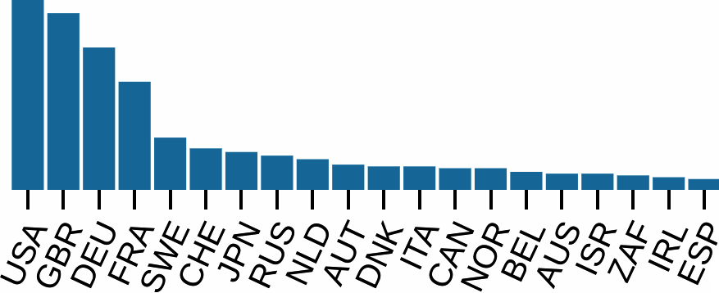

Figure 17-16. Reoriented tick labels on the x-axis
Now that we have our working axes, let’s add a little label to the x-axis and then see how the bar chart copes with our real data:
let
xPaddingLeft
=
20
let
xScale
=
d3
.
scaleBand
(
)
.
range
(
[
xPaddingLeft
,
width
]
)
.
padding
(
0.1
)
//...
svg
.
append
(
"g"
)
.
attr
(
"class"
,
"y axis"
)
.
append
(
"text"
)
.
attr
(
'id'
,
'y-axis-label'
)
.
attr
(
"transform"
,
"rotate(-90)"
)
.
attr
(
"y"
,
6
)
.
attr
(
"dy"
,
".71em"
)
.
style
(
"text-anchor"
,
"end"
)
.
text
(
'Number of winners'
)
;
A left padding constant, in pixels, to make way for the y-axis label.
Rotates the text anticlockwise to the upright position.
dy is a relative coordinate [relative to the y coordinate just specified (6)]. By using the em unit (relative to font size), we can make handy adjustments to the text margin and baseline.
Figure 17-17 shows the result of filtering our Nobel Prize winners dataset for Chemistry winners, using our category selector filter. The bar widths increase to reflect the reduced number of countries, and both axes adapt to the new dataset.
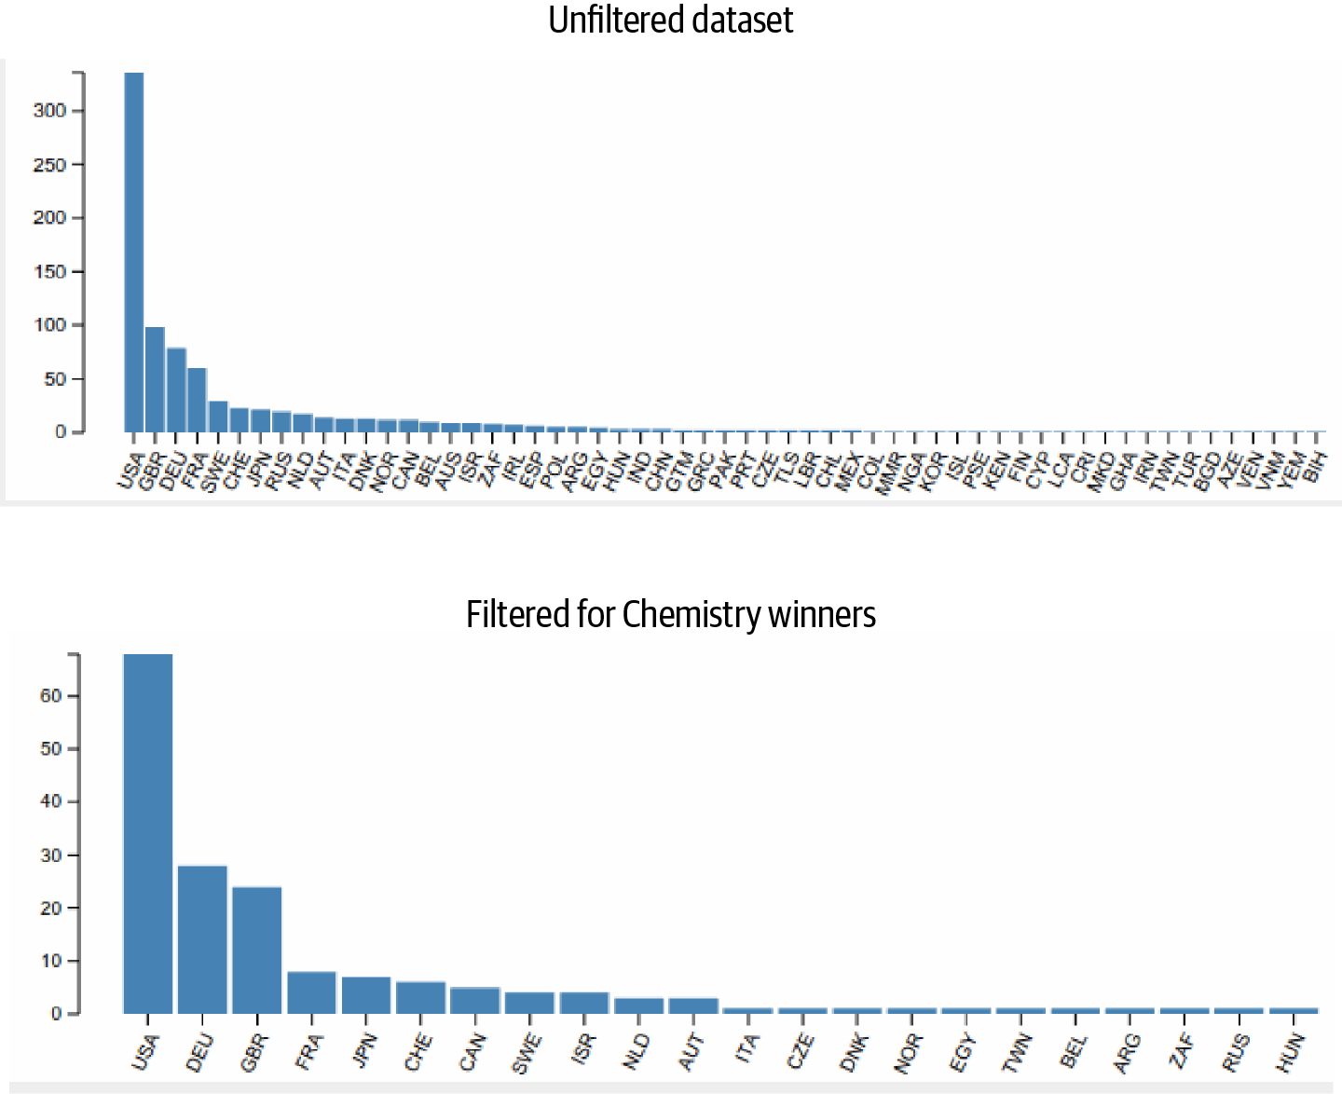

Figure 17-17. The Nobel Prize bar chart before and after we apply the category filter for Chemistry winners
We now have a working bar chart, using the update pattern to adjust itself as the user-driven dataset changes. But although it’s functional, the transition in response to data change is visually stark, even jarring. One way to make the change much more engaging and even informative would be to have the chart update continuously over a short time period, with preserved country bars moving from their old to new position while simultaneously adapting their height and width. Such continuous transitions really add life to a visualization and are seen in many of the most impressive D3 pieces. The good news is that transitions are tightly integrated into D3’s workflow, which means you can achieve these cool visual effects for the cost of a few lines of code.

Transitions
As it stands, our bar chart is perfectly functional. It responds to data changes by adding or removing bar elements and then updating them using the new data. But the immediate change from one reflection of the data to another feels a little stark and visually jarring.
D3’s transitions provide the ability to smooth the visual update of our elements, making them change continuously over a set time period. This can be both aesthetically appealing and, on occasion, informative.7 The important thing is that D3 transitions can be very engaging for the user, which is reason enough to want to master them.
Figure 17-18 shows the effect we are aiming at. When the bar chart is updated with a newly selected dataset, we want the bars of any countries present before and after the transition to morph smoothly from their old to new positions and dimensions.8 So in Figure 17-18 the bar for France grows from start to finish over the course of the transition—​say, a couple of seconds—​with intermediate bars of increasing width and height. The axes ticks and labels will adapt too as the x and y scales change.
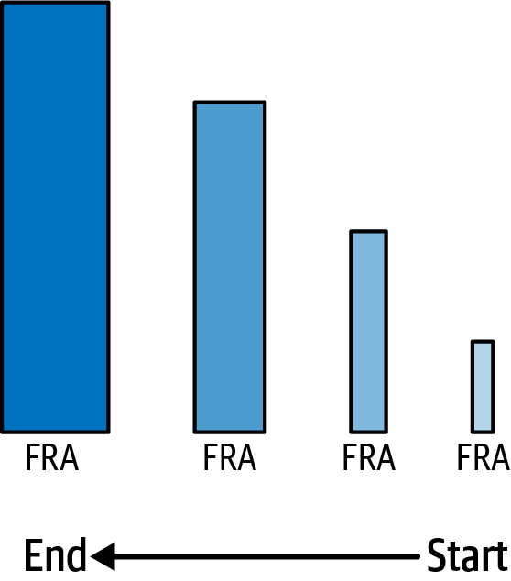

Figure 17-18. Smooth bar transitions on update
The effect shown in Figure 17-18 is surprisingly easy to achieve but involves understanding the precise way data is joined in D3. By default, when new data is bound to existing DOM elements, it is done by array index. Figure 17-19 shows how this works, using our selected bars as an example. The first bar (B0), previously bound to the USA’s data, is now bound to France’s. It stays in first position and updates its size and tick label. Essentially, the USA’s bar becomes France’s.9
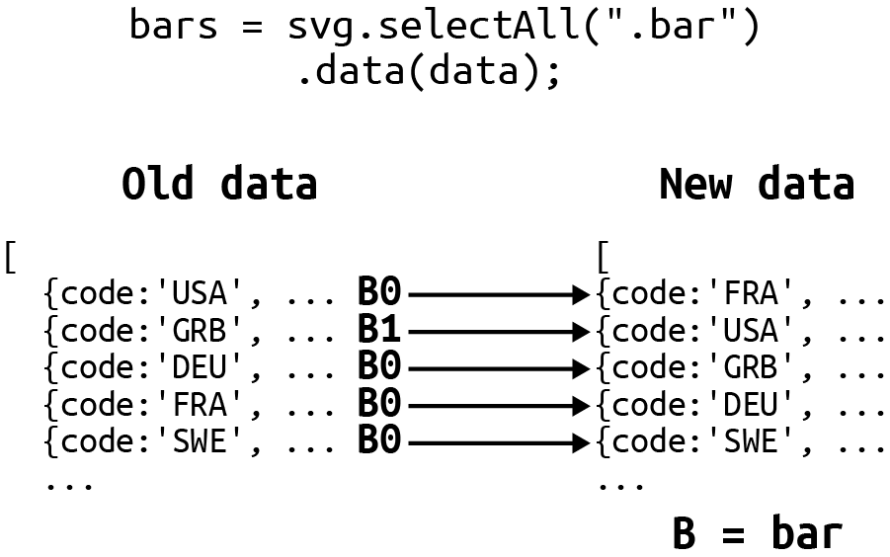

Figure 17-19. By default, new data is joined by index
In order to get continuity during our transitions (i.e., for the USA bar to move to its new position while changing to its new height and width), we need the new data to be bound by a unique key, not the index. D3 allows you to specify a function as a second argument to the data method, which returns a key from the object data to use to bind the new data to the correct respective bars, assuming they still exist. Figure 17-20 shows how this is done. Now, the first bar (0) is bound to the new USA data, changing its position by index as well as its width and height to that of the new American bar.
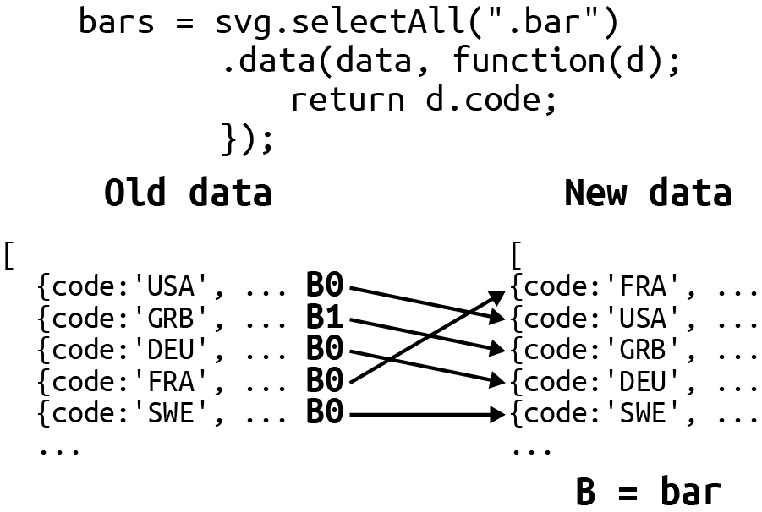

Figure 17-20. Using an object key to join new data
Joining the data by key gives us the correct start and endpoints for our national bars. Now all we need is a way to create a smooth transition between them. We can do this by using a couple of D3’s coolest methods, transition and duration. By calling these before we change our bar dimension and position attributes, D3 magically performs a smooth transition between them, as shown in Figure 17-18. Adding transitions to our bar chart update requires only a few lines of code:
// nbviz_core.mjs
nbviz
.
TRANS_DURATION
=
2000
// time in milliseconds
// nbviz_bar.mjs
import
nbviz
from
.
/
nbviz_core
.
mjs
//...
svg
.
select
(
'.x.axis'
)
.
transition
(
)
.
duration
(
nbviz
.
TRANS_DURATION
)
.
call
(
xAxis
)
//...
//...
svg
.
select
(
'.y.axis'
)
.
transition
(
)
.
duration
(
nbviz
.
TRANS_DURATION
)
.
call
(
yAxis
)
;
//...
var
bars
=
svg
.
selectAll
(
".bar"
)
.
data
(
data
,
d
=>
d
.
code
)
//...
let
bars
=
svg
.
selectAll
(
'.bar'
)
.
data
(
data
,
(
d
)
=>
d
.
code
)
.
join
(
// ...
)
.
classed
(
'active'
,
function
(
d
)
{
return
d
.
key
===
nbviz
.
activeCountry
}
)
.
transition
(
)
.
duration
(
nbviz
.
TRANS_DURATION
)
.
attr
(
"x"
,
(
d
)
=>
xScale
(
d
.
code
)
)
.
attr
(
"width"
,
xScale
.
bandwidth
(
)
)
.
attr
(
"y"
,
(
d
)
=>
yScale
(
d
.
value
)
)
.
attr
(
"height"
,
(
d
)
=>
height
-
yScale
(
d
.
value
)
)
;
A transition with duration of two seconds, which is our TRANS_DURATION constant of 2000 (ms).
Using the data object’s code property to make the continuous data-joins.
The x, y, width, and height attributes will be smoothly morphed from current values to those defined here.
Transitions will work on most obvious attributes and styles of an existing DOM element.10
The transitions just shown perform a smooth change of the attributes from starting point to end goal, but D3 allows for a lot of tuning for these effects. You can, for example, use the delay method to specify the time before the transition starts. This delay can also be a function of the data.
Probably the most useful extra transitioning method is ease, which allows you to specify the way in which the elements’ attributes are updated over the transition’s duration. The default easing function is CubicInOut, but you can also specify things like quad, which speeds things up as the transition progresses, or bounce and elastic, which do pretty much what it says on the tin, giving a bouncy feel to the change. There’s also sin, which speeds up at the beginning and slows down toward the end. See easings.net for a nice description of different easing functions and observablehq for a comprehensive runthrough of D3’s easing functions, assisted by interactive charts.
If the easing functions available to D3 don’t suit your needs or you’re feeling particularly ambitious, as with most things D3 you can roll your own to fit any subtle requirements. The tween method provides the fine-grained control you might need.
With a working join-based update pattern and some cool transitions, we have completed our Nobel-viz bar chart. There’s always room for refinement, but this bar chart will more than do the job. Let’s summarize what we’ve learned in this rather large chapter before moving on to the other components of our Nobel Prize visualization.

Updating the Bar Chart
When the bar chart module is imported, it appends a callback function to the callbacks array in the core module. When data is updated in response to user interaction, this callback function is called and the bar chart updated with new country data:
nbviz
.
callbacks
.
push
(
(
)
=>
{
let
data
=
nbviz
.
getCountryData
(
)
updateBarChart
(
data
)
}
)
This anonymous function is called in the core module when data is updated.

Summary
This has been a large and quite challenging chapter. D3 isn’t the easiest library to learn, but I have smoothed the learning curve by breaking things down into digestible chunks. Take your time absorbing the fundamental ideas and, crucially, start setting yourself little objectives to stretch your D3 knowledge. I think D3 is very much an art form and, more than most libraries, one learns while doing.
The key elements to understanding D3 and applying it effectively are the update pattern and the data binding involved. If you understand this at a fundamental level, most of D3’s other pyrotechnics slot nicely into place. Focus on the data, enter, exit, and remove methods and make sure you really understand what’s going on. It’s the only way to advance from much of the cut-and-paste style of D3 programming, which is initially productive (there being so many cool examples out there), but will eventually frustrate. Use your browser’s developer console (currently Chrome and Chromium have the best tools here) to inspect DOM elements, to see what data is bound to them via the __data__ variable. If it doesn’t match your expectations, you’ll learn a lot by finding out why.
You should now have a pretty good grounding in D3’s core techniques. In the next chapter, we’ll aim to challenge those new skills with a rather more ambitious chart, our Nobel Prize timeline.
1 We’ll be dealing with axes, labels, and the like later in the chapter when we put D3 into top gear and start binding data.
2 See D3’s GitHub page for a comprehensive list.
3 See the D3 docs for full details.
4 D3 will truncate whichever is bigger.
5 D3 has many built-in colormaps and sophisticated color handling with RGB, HCL, etc. We’ll see a few of these in action in the coming chapters.
6 Axes follow a similar pattern to that proposed by Mike Bostock in Towards Reusable Charts, using the JavaScript objects’ call method to build HTML on the selected DOM element(s).
7 For example, when we change our measurement of Nobel Prize wins by country from absolute to per capita, the large amount of movement displayed as the country bars change their order emphasizes the difference between the two metrics.
8 In animation and computer graphics circles, this effect is known as tweening (see this Wikipedia page).
9 See Mike Bostock’s nice demonstration of object constancy at his site.
10 Transitions only apply to existing elements—you can’t fade in the creation of a DOM element, for example. You could, however, fade it in and out using the opacity CSS style.

Chapter 18. Visualizing Individual Prizes
In Chapter 17 you learned the basics of D3, how to select and change DOM elements, how to add new ones, and how to apply the data update pattern, which is the axis around which interactive D3 spins. In this chapter, I will expand on what you’ve learned so far and show you how to build a fairly novel visual element, showing all the individual Nobel Prizes by year (Figure 18-1). This Nobel timeline will allow us to expand on the knowledge of the last chapter, demonstrating a number of new techniques including more advanced data manipulation.
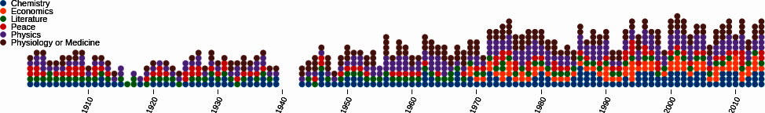

Figure 18-1. This chapter’s target chart, a timeline of Nobel Prizes
Let’s start by showing how we build the HTML framework for our timeline chart.

Building the Framework
Our target chart’s construction is similar to that of our Nobel Prize bar chart, which we covered in detail in the last chapter. We first use D3 to select our <div> container with ID nobel-time, then use the width and height of the container, along with our specified margins, to create our svg chart group:
import
nbviz
from
'./nbviz_core.mjs'
let
chartHolder
=
d3
.
select
(
'#nobel-time'
);
let
margin
=
{
top
:
20
,
right
:
20
,
bottom
:
30
,
left
:
40
};
let
boundingRect
=
chartHolder
.
node
()
.
getBoundingClientRect
();
let
width
=
boundingRect
.
width
-
margin
.
left
-
margin
.
right
,
height
=
boundingRect
.
height
-
margin
.
top
-
margin
.
bottom
;
let
svg
=
chartHolder
.
append
(
"svg"
)
.
attr
(
"width"
,
width
+
margin
.
left
+
margin
.
right
)
.
attr
(
"height"
,
height
+
margin
.
top
+
margin
.
bottom
)
.
append
(
'g'
)
.
attr
(
"transform"
,
"translate("
+
margin
.
left
+
","
+
margin
.
top
+
")"
);
// ...
})
With our svg chart group in place, let’s add the scales and axes.

Scales
To place the circular indicators, we use two ordinal scales (Example 18-1). The x-scale uses the rangeRoundBands method to specify a 10% padding between the circles. Because we use the x-scale to set the circles’ diameters, the height of our y-scale’s range is manually adjusted to accommodate all the indicators, allowing a little padding between them. We use rangeRoundPoints to round to integer pixel coordinates.

Example 18-1. The chart’s two ordinal band scales, for x and y axes
let
xScale
=
d3
.
scaleBand
(
)
.
range
(
[
0
,
width
]
)
.
padding
(
0.1
)
.
domain
(
d3
.
range
(
1901
,
2015
)
)
let
yScale
=
d3
.
scaleBand
(
)
.
range
(
[
height
,
0
]
)
.
domain
(
d3
.
range
(
15
)
)
We’re using a padding factor of 0.1, which is approximately 10% of an indicator’s diameter.
The domain is [0, …​, 15] with 15 being the historical maximum number of prizes given in any one year.
Unlike our bar chart from the last chapter, both ranges and domains of this chart are fixed. The domain of the xScale is the years over which the Nobel Prize has run, and that of the yScale is from zero to the maximum number of prizes in any given year (14 in the year 2000). Neither of these will change in response to user interaction, so we define them outside the update method.

Axes
With a maximum of 14 prizes in any one year and with a circular indicator for each, it is easy to make a prize count by eye if necessary. Given this, the emphasis on providing a relative indicator of prize distribution (e.g., showing the spurt in post-WWII US science prizes), and the long length of the chart, a y-axis is redundant for our chart.
For the x-axis, labeling the decades’ starts seems about right. It reduces visual clutter and is also the standard human way of charting historical trends. Example 18-2 shows the construction of our x-axis, using D3’s handy axis object. We override the tick values using the tickValues method, filtering the domain range (1900–2015) to return only those dates ending with zero.

Example 18-2. Making the x-axis, with tick labels per decade
let
xAxis
=
d3
.
axisBottom
(
)
.
scale
(
xScale
)
.
tickValues
(
xScale
.
domain
(
)
.
filter
(
function
(
d
,
i
)
{
return
!
(
d
%
10
)
}
)
)
We only want to tick every 10th year, so we create tick values by filtering the x-scale domain values and using their index to select only those that are divisible by 10. These give 0 for modulus (%) 10, to which we apply the not Boolean operator (!) to produce true, which passes the filter.
This returns true for years ending in 0, giving a tick label at the start of every decade.
As with the scales, we don’t anticipate the axes changing,1 so we can add them before receiving the dataset in the updateTimeChart function:
svg
.
append
(
"g"
)
// group to hold the axis
.
attr
(
"class"
,
"x axis"
)
.
attr
(
"transform"
,
"translate(0,"
+
height
+
")"
)
.
call
(
xAxis
)
.
selectAll
(
"text"
)
.
style
(
"text-anchor"
,
"end"
)
.
attr
(
"dx"
,
"-.8em"
)
.
attr
(
"dy"
,
".15em"
)
.
attr
(
"transform"
,
"rotate(-65)"
)
;
Calls our D3 axis on the svg group, with the axis object taking care of building the axis elements.
As in “Axes and Labels”, we rotate the axis tick labels to place them diagonally.
With axes and scales taken care of, we need only add a little legend with our colored category labels before moving on to the cool, interactive elements of the chart.

Category Labels
The last of our static components is a legend, containing the category labels shown in Figure 18-2.
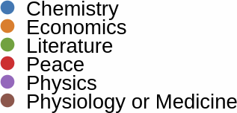

Figure 18-2. Categories legend
To create the legend, we first create a group, class labels, to hold the labels. We bind our nbviz.CATEGORIES data to a label selection on this labels group, enter the bound data, and attach a group for each category, displaced on the y-axis by index:
let
catLabels
=
chartHolder
.
select
(
'svg'
)
.
append
(
'g'
)
.
attr
(
'transform'
,
"translate(10, 10)"
)
.
attr
(
'class'
,
'labels'
)
.
selectAll
(
'label'
)
.
data
(
nbviz
.
CATEGORIES
)
.
join
(
'g'
)
.
attr
(
'transform'
,
function
(
d
,
i
)
{
return
"translate(0,"
+
i
*
10
+
")"
;
}
)
;
We join our array of categories (["Chemistry", "Economics", …​]) to the label group using the standard data followed by join methods.
Creates a group for each category, spaced vertically 10 pixels apart.
Now that we have our catLabels selection, let’s add a circular indicator (matching those seen in the timeline) and text label to each of its groups:
catLabels
.
append
(
'circle'
)
.
attr
(
'fill'
,
(
nbviz
.
categoryFill
)
)
.
attr
(
'r'
,
xScale
.
bandwidth
(
)
/
2
)
;
catLabels
.
append
(
'text'
)
.
text
(
d
=>
d
)
.
attr
(
'dy'
,
'0.4em'
)
.
attr
(
'x'
,
10
)
;
We use our shared categoryFill method to return a color based on the bound category.
The x scales bandwidth method returns the distance between two category labels. We will use half of this to get the radius for our circular label markers.
The categoryFill function (Example 18-3) is defined in nbviz_core.js and is used by the app to provide colors for the categories. D3 provides a number of color schemes in the form of arrays of color hex codes, which can be used as our SVG fill colors. You can see a demo of the color schemes on Observable. We are dealing with categories, so we’ll use the Category10 set.

Example 18-3. Setting the category colors
// nbviz_core.js
nbviz
.
CATEGORIES
=
[
"Physiology or Medicine"
,
"Peace"
,
"Physics"
,
"Literature"
,
"Chemistry"
,
"Economics"
]
;
nbviz
.
categoryFill
=
function
(
category
)
{
var
i
=
nbviz
.
CATEGORIES
.
indexOf
(
category
)
;
return
d3
.
schemeCategory10
[
i
]
;
}
;
D3’s schemeCategory10 is an array of 10 color hex codes (['#1f77b4', '#ff7f0e',...]) that we can apply using the prize category index.
Now that we’ve covered all the static elements of our time chart, let’s look at how we knock it into usable form with D3’s nest library.

Nesting the Data
In order to create this timeline component, we need to reorganize our flat array of winners objects into a form that will allow us to bind it to the individual Nobel Prizes in our timeline. What we need, to make binding this data with D3 as smooth as possible, is an array of prize objects by year, with the year groups available as arrays. Let’s demonstrate the conversion process with our Nobel Prize dataset.
The following is the flat Nobel Prize dataset we begin with, ordered by year:
[
{
"year"
:
1901
,
"name"
:
"Wilhelm Conrad R\\u00f6ntgen"
,...},
{
"year"
:
1901
,
"name"
:
"Jacobus Henricus van \'t Hoff"
,...},
{
"year"
:
1901
,
"name"
:
"Sully Prudhomme"
,...},
{
"year"
:
1901
,
"name"
:
"Fr\\u00e9d\\u00e9ric Passy"
,...},
{
"year"
:
1901
,
"name"
:
"Henry Dunant"
,...},
{
"year"
:
1901
,
"name"
:
"Emil Adolf von Behring"
,...},
{
"year"
:
1902
,
"name"
:
"Theodor Mommsen"
,...},
{
"year"
:
1902
,
"name"
:
"Hermann Emil Fischer"
,...},
...
];
We want to take this data and convert it to the following nested format, an array of objects with year keys and winners-by-year values:
[
{
"key"
:
"1901"
,
"values"
:
[
{
"year"
:
1901
,
"name"
:
"Wilhelm Conrad R\\u00f6ntgen"
,...},
{
"year"
:
1901
,
"name"
:
"Jacobus Henricus van \'t Hoff"
,...},
{
"year"
:
1901
,
"name"
:
"Sully Prudhomme"
,...},
{
"year"
:
1901
,
"name"
:
"Fr\\u00e9d\\u00e9ric Passy"
,...},
{
"year"
:
1901
,
"name"
:
"Henry Dunant"
,...},
{
"year"
:
1901
,
"name"
:
"Emil Adolf von Behring"
,...}
]
},
{
"key"
:
"1902"
,
"values"
:
[
{
"year"
:
1902
,
"name"
:
"Theodor Mommsen"
,...},
{
"year"
:
1902
,
"name"
:
"Hermann Emil Fischer"
,...},
...
]
},
...
];
We can iterate through this nested array and join the year groups in turn, each one represented by a column of indicators in our timeline.
We can make use of one D3 group utility method in order to group the Nobel prizes by year. group takes an array of data and returns an object grouped by the property specified in a callback function, in our case the year of the prize. So we group our entries by year like this:
let
nestDataByYear
=
function
(
entries
)
{
let
yearGroups
=
d3
.
group
(
entries
,
d
=>
d
.
year
)
// ...
}
Here we use a modern JavaScript lambda shorthand function, equivalent to function(d) { return d.year }.
This grouping returns the array of entries of the form:
[
// yearGroups
{
1913
:
[{
year
:
1913
,
...},
{
year
:
1913
,
...},
...]},
{
1921
:
[{
year
:
1921
,
...},
{
year
:
1921
,
...},
...]},
...
]
Now in order to convert this map to the required array of key-values objects, we’ll make use of JavaScript’s Array object and its from method. We pass in our yearGroups map and a converter function that takes the individual groups in the form of a [key, values] array and converts them to a {key: key, values: values} object. We are again using the destructuring assignment syntax to map our key and values:
let
keyValues
=
Array
.
from
(
yearGroups
,
[
key
,
values
]
=>
{
key
,
values
})
We now have the required function to group our filtered winning prize entries by year in the key-values form required:
nbviz
.
nestDataByYear
=
function
(
entries
)
{
let
yearGroups
=
d3
.
group
(
entries
,
(
d
)
=>
d
.
year
)
;
let
keyValues
=
Array
.
from
(
yearGroups
,
(
[
key
,
values
]
)
=>
{
let
year
=
key
;
let
prizes
=
values
;
prizes
=
prizes
.
sort
(
(
p1
,
p2
)
=>
(
p1
.
category
>
p2
.
category
?
1
:
-
1
)
)
;
return
{
key
:
year
,
values
:
prizes
}
;
}
)
;
return
keyValues
;
}
;
We use the JavaScript array’s sort method to sort the prizes alphabetically by category. This will make it easier to compare year with year. sort expects a positive or negative numerical value, which we produce using the Boolean alphanumeric string comparison.

Adding the Winners with a Nested Data-Join
In “Putting the Bar Chart Together” of the last chapter, we saw how D3’s newish join method makes it easy to synchronize changes in data, in that case number of prizes by country, with the visualization of that data, in that case bars in a bar chart. Our winners-by-year chart is essentially a bar chart where the individual bars are represented by prizes (circle markers). Now we’ll see how this can easily be accomplished by using two data-joins and the nested dataset produced in the last section.
The nested data is first passed from onDataChange to our time chart’s updateTimeChart method. We then use our first data-join to create the year groups, positioning them using our ordinal x scale, which mapped years to pixel positions (see Example 18-1) and naming them by year:
nbviz
.
updateTimeChart
=
function
(
data
)
{
let
years
=
svg
.
selectAll
(
'.year'
)
.
data
(
data
,
d
=>
d
.
key
)
years
.
join
(
'g'
)
.
classed
(
'year'
,
true
)
.
attr
(
'name'
,
d
=>
d
.
key
)
.
attr
(
'transform'
,
function
(
year
)
{
return
'translate('
+
xScale
(
+
year
.
key
)
+
',0)'
}
)
//...
}
We want to join the year data to its respective column by its year key, not the default array index, which will change if there are year gaps in our nested array, as there often will be for the user-selected datasets.
Our first data-join uses the key-values array to produce the circle-bar groups by year.
Let’s use Chrome’s Elements tab to see the changes we’ve made from this first data-join. Figure 18-3 shows our year groups nestled nicely in their parent chart group.
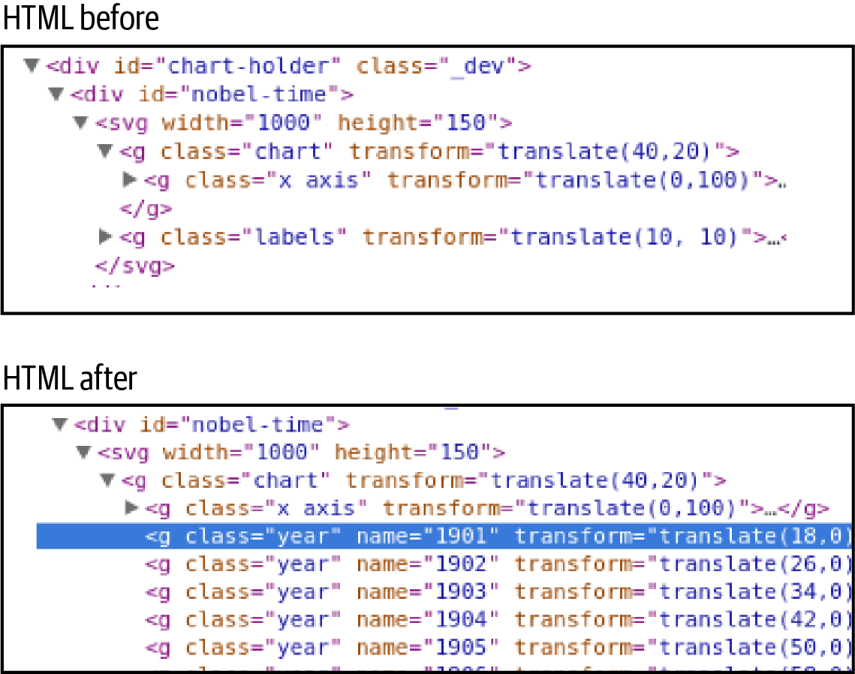

Figure 18-3. The result of creating our year groups during the first data-join
Let’s check to make sure our nested data has been bound correctly to its respective year groups. In Figure 18-4, we select a group element by its year name and inspect it. As required, the correct data has been bound by year, showing an array of data objects for the six Nobel Prize winners of 1901.
Having joined our year group data to their respective groups, we can now join those values to the circular marker groups representing each year. The first thing we need to do is select all the year groups with the key-values data we just added and bind the values array (the prizes for that year) to some winner placeholders, which will soon be joined to some circle markers. This is achieved by the following D3 calls:
let
winners
=
svg
.
selectAll
(
'.year'
)
.
selectAll
(
'circle'
)
.
data
(
d
=>
d
.
values
,
d
=>
d
.
name
)
;
We’ll be creating a circle marker for each prize in the values array.
We’ll use the values array to create the circles with D3’s join.
We use an optional key to track the circles/winners by name—this will be useful for transition effects, as we’ll see later on.
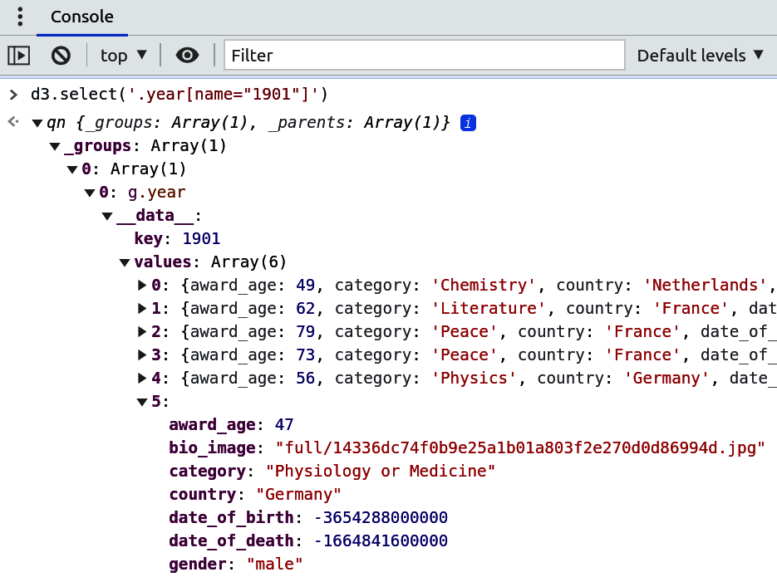

Figure 18-4. Checking the results of our first data-join with Chrome’s console
Now that we’ve created our circle placeholders with winning entry data, it only remains to join these to a circle using D3’s join method. This will keep track of any changes to the data and make sure circles are created and destroyed in sync. The rest of the impressively succinct code required is as follows in Example 18-4.

Example 18-4. A second data-join to produce the prizes’ circle indicators
winners
.
join
(
(
enter
)
=>
{
return
enter
.
append
(
'circle'
)
.
attr
(
'cy'
,
height
)
}
)
.
attr
(
'fill'
,
function
(
d
)
{
return
nbviz
.
categoryFill
(
d
.
category
)
}
)
.
attr
(
'cx'
,
xScale
.
bandwidth
(
)
/
2
)
.
attr
(
'r'
,
xScale
.
bandwidth
(
)
/
2
)
.
attr
(
"cy"
,
(
d
,
i
)
=>
yScale
(
i
)
)
;
A custom enter method is used to append any new circles needed and give them a default y position at the bottom (y is down for SVG) of the chart.
A little helper method returns a color given the prize’s category.
The year group already has the correct x position, so we only need to use the bandwidth of the bars to set the radius and center the circle in the middle of the bar. The y-scale is used to set the height of the bar by index i in the winners array.
The code in Example 18-4 does the job of building our prize time chart, creating new indicator circles if required and placing them, along with any existing ones, at their correct position, as designated by their array index (see Figure 18-5).
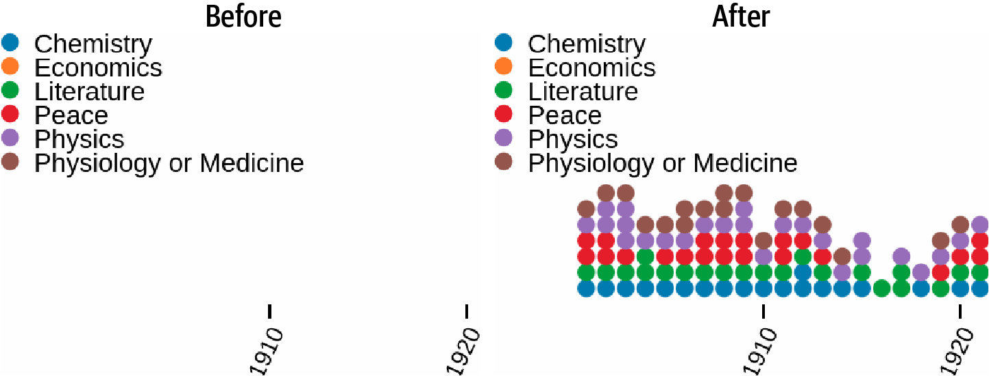

Figure 18-5. The result of our successful second data-join
Although we have produced a perfectly usable timeline, which will respond to user-driven changes in the data, the transition is a little stark and unengaging.2 Let’s now see a great demonstration of D3’s power: how the addition of two lines of code can buy a rather cool visual effect as our timeline changes state.

A Little Transitional Sparkle
As things stand, when the user selects a new dataset,3 the update pattern in Example 18-4 instantly sets the position of the relevant circles. What we now want to do is to animate this repositioning, smoothing it out over a couple of seconds.
Any user-driven filtering will either leave some existing indicators (e.g., when we select only the Chemistry prizes from all categories), add some new ones (e.g., changing our category from Physics to Chemistry), or do both. An edge case is when the filtering leaves nothing (e.g., selecting female Economics winners). This means we need to decide what existing indicators should do and how to animate the positioning of new indicators.
Figure 18-6 shows what we want to happen on selecting a subset of the existing data, in this case filtering all Nobel Prizes to include only those Physics winners. On the user’s selection of the Physics category, all indicators except the Physics ones are removed by the exit and remove methods. Meanwhile, the existing Physics indicators begin a two-second transition from their current position to an end position, dictated by their array index.
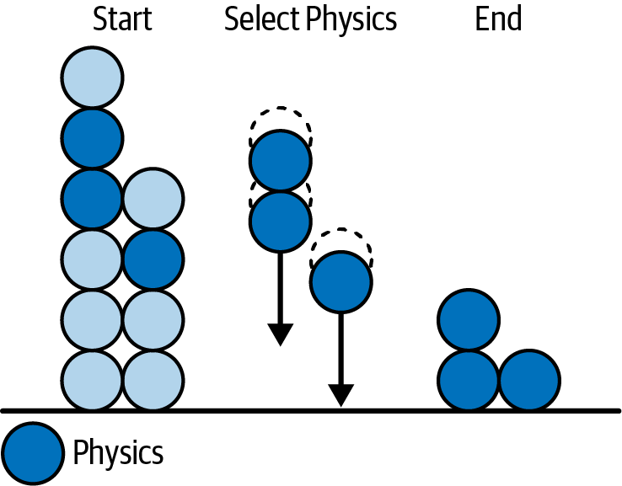

Figure 18-6. Transition on selecting a subset of the existing data
It may surprise you to discover that both these visual effects, moving existing bars smoothly into their new place and growing any new bars from the bottom of the chart, can be achieved by the addition of only two lines to our existing code. This is a big testimony to the power of D3’s data-joining concept and its mature design.
To achieve the required transitions, we add calls to transition and duration methods before setting the y position (cy attribute) of the circle marker. These smooth the repositioning of the circle, easing it in over two seconds (2000ms):
winners
.
join
(
(
enter
)
=>
{
return
enter
.
append
(
'circle'
)
.
attr
(
'cy'
,
height
)
}
)
.
attr
(
'fill'
,
function
(
d
)
{
return
nbviz
.
categoryFill
(
d
.
category
)
}
)
.
attr
(
'cx'
,
xScale
.
bandwidth
(
)
/
2
)
.
attr
(
'r'
,
xScale
.
bandwidth
(
)
/
2
)
.
transition
(
)
.
duration
(
2000
)
.
attr
(
"cy"
,
(
d
,
i
)
=>
yScale
(
i
)
)
;
Any new circles start at the bottom of the chart.
All circles are eased into their y position over a duration of 2000ms.
As you can see, D3 makes it really easy to add cool visual effects to your data transitions. This is a testimony to its solid theoretical foundations. We now have our complete timeline chart, which transitions smoothly in response to data changes initiated by the user.

Updating the Bar Chart
When the time chart module is imported, it appends a callback function to the callbacks array in the core module. When data is updated in response to user interaction, this callback function is called and the time chart updated with new country data, nested by year:
nbviz
.
callbacks
.
push
(
(
)
=>
{
let
data
=
nbviz
.
nestDataByYear
(
nbviz
.
countryDim
\
.
top
(
Infinity
)
)
updateTimeChart
(
data
)
}
)
This anonymous function is called in the core module when data is updated.

Summary
Following on from the bar chart in Chapter 17, this chapter extended the update pattern, showing how to use a second data-join on nested data to create a novel chart. It’s important to emphasize that this ability to create novel visualizations is D3’s great strength: you are not tied to the particular functionality of a conventional charting library but can achieve unique transformations of your data. As our Nobel Prize bar chart showed, it’s easy to build conventional dynamic charts, but D3 allows for so much more.
We also saw how easy it is to liven up your visualizations with engaging transformations once a solid update pattern is in place.
In the next chapter, we will build the map component of our Nobel-viz using D3’s impressive topographic library.
1 D3 has some handy brushes that make selecting portions of the x- or y-axis easy. Combined with transitions, this can make for an engaging and intuitive way to increase the resolution of large datasets. See this bl.ocks.org page for a good example.
2 As discussed in “Transitions”, the visual transition from one dataset to another can be both informative and lend a sense of continuity to the visualization, making it more appealing.
3 For example, filtering the prizes by category to show only the Physics winners.

Chapter 19. Mapping with D3
Building and customizing map visualizations is one of D3’s core strengths. It has some very sophisticated libraries, allowing for all kinds of projections, from the workhorse Mercator and orthographic to more esoteric ones such as Conic Equidistant. Mapping seems to be something of an obsession for Mike Bostock and Jason Davies, D3’s core devs, and their attention to detail is striking. If you have a mapping problem, chances are D3 can do the heavy lifting required.1 In this chapter, we’ll use our Nobel Prize visualization (Nobel-viz) map (Figure 19-1) to introduce the core D3 mapping concepts.

Figure 19-1. This chapter’s target element

Available Maps
The most popular mapping format is the aging shapefile, developed for geographic information system (GIS) software. There are many free and proprietary desktop programs2 to manipulate and produce shapefiles.
Unfortunately, shapefiles were not designed for the web, which would far rather deal in a JSON-based map format, and demands small, efficient representations to limit bandwidth and related lag.
The good news is that there are many convenient ways to convert shapefiles to our preferred TopoJSON format,3 meaning you can manipulate your shapefiles in software and then convert them to a web-friendly format. The standard way of finding maps for web dataviz is to first look for TopoJSON or GeoJSON versions, then search among the richer pool of shapefiles, and, as a last resort, roll your own using a shapefile, or equivalent, editor. Depending on how much map visualization you intend to do, there will probably be an off-the-shelf solution. For things like world maps or continental projections (e.g., the popular Albers USA), you can usually find a number of solutions with different degrees of accuracy.
For our Nobel map, we want a global mapping, at least showing all 58 Nobel Prize–winning nations, with labeled shapes for pretty much all of them. Luckily, D3 provides a number of example world maps, one at 50m grid resolution, the other a smaller 110m resolution map. The latter is fine for our fairly crude requirements.4

D3’s Mapping Data Formats
D3 makes use of two JSON-based geometric data formats, GeoJSON and TopoJSON, an extension of GeoJSON devised by Mike Bostock that encodes topology. GeoJSON is more intuitive to read, but TopoJSON is far more efficient in most cases. Typically, maps are converted to TopoJSON for web delivery, where size is an important consideration. The TopoJSON is then converted to GeoJSON via D3 on the browser, to simplify SVG path creation, feature optimization, and so on.
Note
There is a nice summation of the differences between TopoJSON and GeoJSON on Stack Overflow.
Let’s have a look at the two formats now. Understanding their basic structure is important and a little effort there will pay off, especially as your mapping endeavors become more ambitious.

GeoJSON
GeoJSON files contain one type object, one of Point, MultiPoint, LineString, MultiLineString, Polygon, MultiPolygon, GeometryCollection, Feature, or FeatureCollection. The case of the type member values must be CamelCase, as shown here. They may also contain a crs member, specifying a particular coordinate reference system.
FeatureCollections are the largest GeoJSON container, and maps with more than one region are usually specified with these. FeatureCollections contain a features array, each element of which is a GeoJSON object of a type listed in the previous paragraph.
Example 19-1 shows a typical FeatureCollection containing an array of country maps, the boundaries of which are specified by Polygons.

Example 19-1. The GeoJSON mapping data format
{
"type"
:
"FeatureCollection"
,
"features"
:
[
{
"type"
:
"Feature"
,
"id"
:
"AFG"
,
"properties"
:
{
"name"
:
"Afghanistan"
}
,
"geometry"
:
{
"type"
:
"Polygon"
,
"coordinates"
:
[
[
[
61.210817
,
35.650072
]
,
[
62.230651
,
35.270664
]
,
...
]
]
}
}
,
...
{
"type"
:
"Feature"
,
"id"
:
"ZWE"
,
"properties"
:
{
"name"
:
"Zimbabwe"
}
,
"geometry"
:
{
"type"
:
"Polygon"
,
"coordinates"
:
[
[
[
...
]
]
]
}
}
]
}
Each GeoJSON file contains a single object with a type and containing…​
…​an array of features—​in this case, country objects…​
…​with coordinate-based, polygonal geometry.
Note that the geographic coordinates are given in [longitude, latitude] pairs, the reverse of conventional geographic positioning. This is because GeoJSON uses an [X,Y] coordinate scheme.
Although GeoJSON is more succinct than shapefiles and in the preferred JSON format, there is a lot of redundancy in the encoding of maps. For example, shared boundaries are specified twice and the floating-point coordinate format is fairly inflexible and, for many jobs, too precise. The TopoJSON format was designed to address these issues and produce a far more efficient way of delivering maps to the browser.

TopoJSON
Developed by Mike Bostock, TopoJSON is an extension to GeoJSON that encodes topology, stitching geometries together from a shared pool of line segments called arcs. Because they reuse these arcs, TopoJSON files are typically 80% smaller than their GeoJSON equivalents! In addition, taking a topological approach to map representation enables a number of techniques that use topology. One of these is topology-preserving shape simplification,5 which can eliminate 95% of map points while retaining sufficient detail. Cartograms and automatic map coloring are also facilitated. Example 19-2 shows the structure of a TopoJSON file.

Example 19-2. Structure of our TopoJSON world map
{
"type"
:
"Topology"
,
"objects"
:
{
"countries"
:
{
"type"
:
"GeometryCollection"
,
"geometries"
:
[
{
"_id"
:
24
,
"arcs"
:
[
[
6
,
7
,
8
]
,
[
10
,
11
,
12
]
]
,
...
...
}
]
}
,
"land"
:
{
...
}
,
}
,
"arcs"
:
[
[
[
67002
,
72360
]
,
[
284
,
-
219
]
,
[
209
.
.
]
]
,
/*<-- arc*/
number
0
[
[
70827
,
73379
]
,
[
50
,
-
165
]
]
,
...
/*<-- arc number 1*/
]
"transform"
:
{
"scale"
:
[
0.003600036
...
,
0.001736468
...
,
]
,
"translate"
:
[
-
180
,
-
90
]
}
}
TopoJSON objects have a Topology type and must contain an objects object and an array of arcs.
In this case, the objects are countries and land, both being arc-defined GeometryCollections.
Each geometry (in this case defining a country shape) is defined by a number of arc paths, comprising continuous arcs referenced by their index in the arcs array .
An array of component arcs used to construct the objects. The arcs are referenced by index.
Numbers needed to quantize positions as integers rather than floats.
The smaller size of the TopoJSON format is obviously a big advantage if you have to fetch it to your web browser. Often only the GeoJSON format is available, so the ability to convert this to TopoJSON is a handy one. D3 provides a small command-line utility to do just this. Called geo2topo, it is part of the TopoJSON package and can be installed via node.

Converting Maps to TopoJSON
You can install TopoJSON via the node repositories (see Chapter 1), using the -g flag to make it a global6 install:
$ npm install -g topojson
With topojson installed, converting an existing GeoJSON into TopoJSON is as easy as can be. Here we call geo2topo from the command line on a GeoJSON geo_input.json file, specifying an output file topo_output.json:
$ geo2topo -o topo_output.json geo_input.json
Alternatively, you can pipe the result to a file:
$ geo2topo geo_input.json > topo_output.json
geo2topo has a number of useful options, such as quantization, which allows you to specify your map’s precision. Playing around with this option can result in a much smaller file with little perceptible reduction in quality. You can see the full spec on the geo2topo command-line reference. If you want to convert your map files programmatically, there is a handy Python library for the job, topojson.py. You can find it on GitHub.
Now that we’ve got our map data in a light, efficient, web-optimized format, let’s see how we use JavaScript to turn it into interactive web maps.

D3 Geo, Projections, and Paths
D3 has a client-side topojson library, dedicated to dealing with TopoJSON data. This converts the optimized, arc-based TopoJSON to the coordinate-based GeoJSON, ready to be manipulated by D3’s projections and paths, objects in the d3.geo library.
Example 19-3 shows the process of extracting the GeoJSON features needed by our Nobel map from the TopoJSON world-100m.json map. This provides us with the coordinate-based polygons representing our countries and their borders.
In order to extract the GeoJSON features we require from the TopoJSON world object just delivered to the browser, we use topojson’s feature and mesh methods. feature returns the GeoJSON Feature or FeatureCollection for the specified object and mesh the GeoJSON MutliLineString geometry object representing the mesh for the specified object.
The feature and mesh methods take as their first argument the TopoJSON object and as their second a reference to the feature we want to extract (land and countries in Example 19-3). In our world map, countries is a FeatureCollection with a features array of countries (Example 19-3, ).
The mesh method has a third argument, which specifies a filter function, taking as arguments the two geometry objects (a and b) sharing the mesh arc. If the arc is unshared, then a and b are the same, allowing us to filter out external borders in our world map (Example 19-3, ).

Example 19-3. Extracting our TopoJSON features
// nbviz_main.mjs
import
{
initMap
}
from
'./nbviz_map.mjs'
Promise
.
all
(
[
d3
.
json
(
'static/data/world-110m.json'
)
,
d3
.
csv
(
'static/data/world-country-names-nobel.csv'
)
,
// ...
]
)
.
then
(
ready
)
function
ready
(
[
worldMap
,
countryNames
,
countryData
,
winnersData
]
)
{
// ...
nbviz
.
initMap
(
worldMap
,
countryNames
)
}
// nbviz_map.mjs
export
let
initMap
=
function
(
world
,
names
)
{
// EXTRACT OUR REQUIRED FEATURES FROM THE TOPOJSON
let
land
=
topojson
.
feature
(
world
,
world
.
objects
.
land
)
,
countries
=
topojson
.
feature
(
world
,
world
.
objects
.
countries
)
.
features
,
borders
=
topojson
.
mesh
(
world
,
world
.
objects
.
countries
,
function
(
a
,
b
)
{
return
a
!==
b
;
}
)
;
// ...
}
Load the map data using D3’s helper functions and send on to a ready function to initiate the map chart.
Uses topojson to extract our desired features from the TopoJSON data, delivering them in the GeoJSON format.
Filters for only internal borders, shared between countries. If an arc is only used by one geometry (in this case, a country), then a and b are identical.
Map presentation in D3 generally follows a standard pattern. We first create a D3 projection, using one of D3’s many and varied alternatives. We then create a path using this projection. This path is then used to convert the features and meshes extracted from our TopoJSON object into the SVG paths displayed in the browser window. Let’s now look at the rich subject of D3 projections.

Projections
Probably the chief challenge for maps, since the time it was appreciated that the Earth is spheroidal, is that of representing a three-dimensional globe, or significant parts of it, in a two-dimensional form. In 1569, the Flemish cartographer Gerardus Mercator famously resolved this by extending lines from the Earth’s center to significant boundary coordinates and then projecting them onto a surrounding cylinder. This had the useful property of representing lines of constant course, known as rhumb lines, as straight line segments, a very useful feature for the seafaring navigators intended to use the map. Unfortunately, the projection process distorts distances and size, magnifying the scale as one moves from the equator to the pole. As a result of this, the huge African continent appears not much bigger than Greenland when in reality it is around 14 times the size.
All projections are, like Mercator’s, a compromise, and what’s great about D3 is that the rich array of choices means one can balance these compromises to find the right projection for the job.7 Figure 19-2 shows some alternative projections for our Nobel map, including the equirectangular one chosen for the final visualization. The constraint was to show all Nobel Prize–winning countries within the rectangular window and to try to maximize the space available, particularly in Europe where there are many countries that are small geographically but have a relatively large prize haul.
To create a D3 projection, just use one of the applicable d3.geo methods:
let
projection
=
d3
.
geoEquirectangular
()
// ...
D3 projections have a number of useful methods. It’s common to use the translate method to translate the map by half the width and height of the container, overriding the default of [480, 250]. You can also set the precision, which affects the degree of adaptive resampling used in the projection. Adaptive resampling is a clever technique to increase the accuracy of projected lines while still performing efficiently.8 The scale of the map and its center’s longitude and latitude can be set by the scale and center methods.
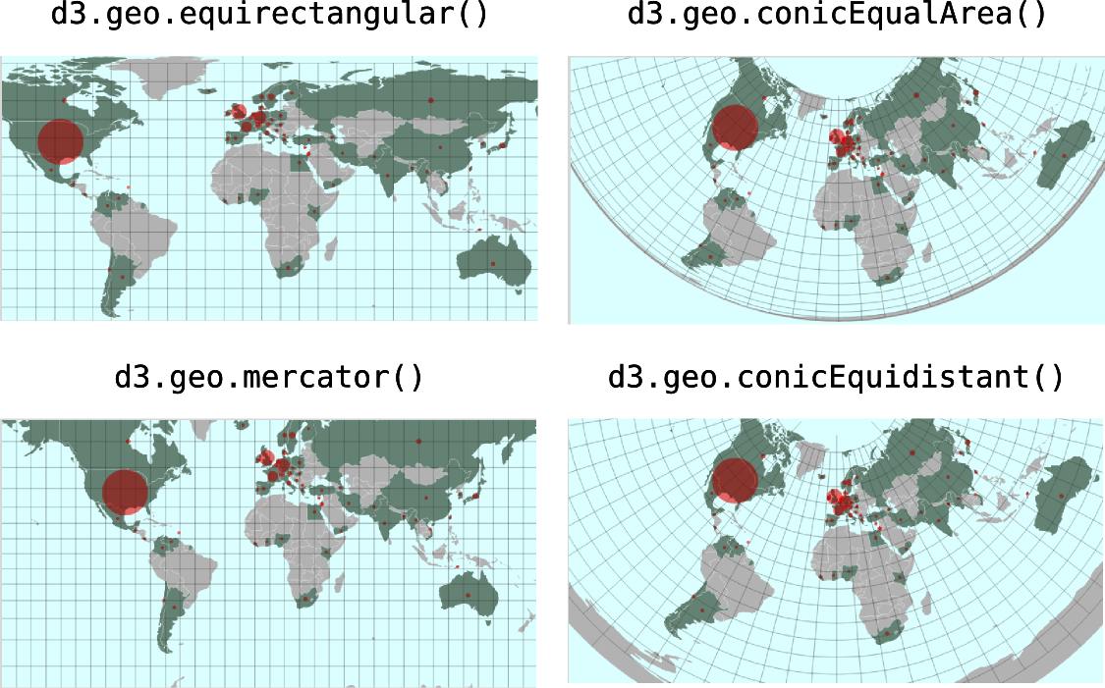

Figure 19-2. Some alternative mapping projections for the Nobel map
Putting the projection methods together, the following code is that used by our Nobel-viz world equirectangular map. Note that it’s hand-tweaked to maximize the space given to Nobel Prize–winning countries. The two poles are truncated, there being no winners in either the Arctic or Antarctic (note that equirectangular maps assume a width/height ratio of 2):
let
projection
=
d3
.
geoEquirectangular
(
)
.
scale
(
193
*
(
height
/
480
)
)
.
center
(
[
15
,
15
]
)
.
translate
(
[
width
/
2
,
height
/
2
]
)
.
precision
(
.
1
)
;
Enlarged slightly; the default height is 480 and scale 153.
Centered at 15 degrees east, 15 degrees north.
With our equirectangular projection defined, let’s see how you use it to create a path, which will in turn be used to create the SVG maps.

Paths
Once you’ve settled on an appropriate projection for your map, you use it to create a D3 geographic path generator, which is a specialized variant of the SVG path generator (d3.svg.path). This path takes any GeoJSON feature or geometry object, such as a FeatureCollection, Polygon, or Point, and returns the SVG path data string for the d element. For example, with our map borders object, the geographic border coordinates describing a MultiLineString are converted into path coordinates for SVG.
Generally, we create our path and set its projection in one go:
var
projection
=
d3
.
geoEquirectangular
()
// ...
var
path
=
d3
.
geoPath
()
.
projection
(
projection
);
Typically, we use the path as a function to generate the d attribute to an SVG path, using GeoJSON data bound using the datum method (used to bind a single object—not array—and shorthand for data([object])). So to use the borders data we just extracted using topojson.mesh to draw our country borders, we use the following:
// BOUNDRY MARKS
svg
.
insert
(
"path"
,
".graticule"
)
.
datum
(
borders
)
.
attr
(
"class"
,
"boundary"
)
.
attr
(
"d"
,
path
)
;
We want to insert the borders SVG before (below) the map’s graticule (grid) overlay.
Figure 19-3 shows output from the Chrome Console for the TopoJSON borders object, extracted from our world-map data, and the resultant path generated by our d3.geo path, using the equirectangular projection.
The geo-path generator is the mainstay of D3 map presentations. I recommend playing around with different projections with simple geometries to get a feel for things, investigating the astonishing number of examples found at bl.ocks.org and the docs on D3’s GitHub page, and checking out this great little demo.
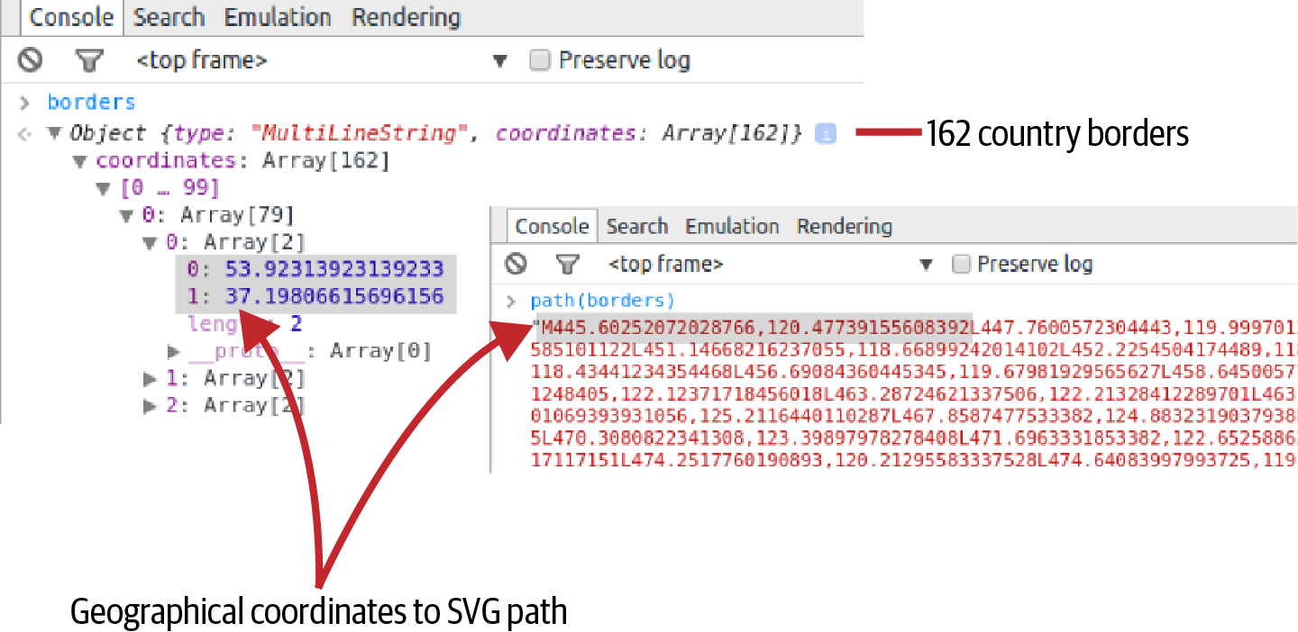

Figure 19-3. Path generator, from geometry to SVG path
Now let’s look at one of the useful d3.geo components you’ll use in your maps, the graticule (or map grid).

graticules
A useful component of d3.geo and one used in our Nobel map is the graticule, one of the geo shape generators.9 This creates a global mesh of meridians (lines of longitude) and parallels (lines of latitude), spaced by default at 10 degrees. When our path is applied to this graticule, it generates a suitably projected grid, as shown back in Figure 19-1.
Example 19-4 shows how to add a graticule to your map. Note that if you want your grid to overlay your map paths, then its SVG path should come after the map paths in the DOM tree. As you’ll see, you can use D3’s insert method to enforce this order.

Example 19-4. Creating a graticule
var
graticule
=
d3
.
geo
.
graticule
(
)
.
step
(
[
20
,
20
]
)
;
svg
.
append
(
"path"
)
.
datum
(
graticule
)
.
attr
(
"class"
,
"graticule"
)
.
attr
(
"d"
,
path
)
;
Create a graticule, setting the grid spacing to 20 degrees.
Note the datum shorthand for data([graticule]).
Use the path generator to receive the graticule data and return a grid path.
Now that we have our grid overlay and the ability to turn our map file into SVG paths with the required projection, let’s put the elements together.

Putting the Elements Together
Using the projection, path, and graticule components discussed, we’ll now create the basic map. This map is intended to respond to user events, highlighting those countries represented by the selected winners, and reflecting the number of winners with a filled red circle at the countries’ centers. We’ll deal with this interactive update separately.
Example 19-5 shows the code required to build a basic global map. It follows what should now be a familiar pattern, getting the mapContainer from its div container (ID nobel-map), appending an <svg> tag to it, and then proceeding to add SVG elements, which in this case are D3-generated map paths.
Our map has fixed components (e.g., the choice of projection and path) that are not dependent on any data change and are defined outside the initializing nbviz.initMap method. nbviz.initMap is called when the visualization is initialized with data from the server. It receives the TopoJSON world object and uses it to build the basic map with the path object. Figure 19-4 shows the result.

Example 19-5. Building the map basics
// DIMENSIONS AND SVG
let
mapContainer
=
d3
.
select
(
'#nobel-map'
)
;
let
boundingRect
=
mapContainer
.
node
(
)
.
getBoundingClientRect
(
)
;
let
width
=
boundingRect
.
width
height
=
boundingRect
.
height
;
let
svg
=
mapContainer
.
append
(
'svg'
)
;
// OUR CHOSEN PROJECTION
let
projection
=
d3
.
geo
.
equirectangular
(
)
.
scale
(
193
*
(
height
/
480
)
)
.
center
(
[
15
,
15
]
)
.
translate
(
[
width
/
2
,
height
/
2
]
)
.
precision
(
.
1
)
;
// CREATE PATH WITH PROJECTION
let
path
=
d3
.
geoPath
(
)
.
projection
(
projection
)
;
// ADD GRATICULE
var
graticule
=
d3
.
geoGraticule
(
)
.
step
(
[
20
,
20
]
)
;
svg
.
append
(
"path"
)
.
datum
(
graticule
)
.
attr
(
"class"
,
"graticule"
)
.
attr
(
"d"
,
path
)
;
// A RADIUS SCALE FOR OUR CENTROID INDICATORS
var
radiusScale
=
d3
.
scaleSqrt
(
)
.
range
(
[
nbviz
.
MIN_CENTROID_RADIUS
,
nbviz
.
MAX_CENTROID_RADIUS
]
)
;
// OBJECT TO MAP COUNTRY NAME TO GEOJSON OBJECT
var
cnameToCountry
=
{
}
;
// INITIAL MAP CREATION, USING DOWNLOADED MAP DATA
export
let
initMap
=
function
(
world
,
names
)
{
// EXTRACT OUR REQUIRED FEATURES FROM THE TOPOJSON
var
land
=
topojson
.
feature
(
world
,
world
.
objects
.
land
)
,
countries
=
topojson
.
feature
(
world
,
world
.
objects
.
countries
)
.
features
,
borders
=
topojson
.
mesh
(
world
,
world
.
objects
.
countries
,
function
(
a
,
b
)
{
return
a
!==
b
;
}
)
;
// CREATE OBJECT MAPPING COUNTRY NAMES TO GEOJSON SHAPES
var
idToCountry
=
{
}
;
countries
.
forEach
(
function
(
c
)
{
idToCountry
[
c
.
id
]
=
c
;
}
)
;
names
.
forEach
(
function
(
n
)
{
cnameToCountry
[
n
.
name
]
=
idToCountry
[
n
.
id
]
;
}
)
;
// MAIN WORLD MAP
svg
.
insert
(
"path"
,
".graticule"
)
.
datum
(
land
)
.
attr
(
"class"
,
"land"
)
.
attr
(
"d"
,
path
)
;
// COUNTRY PATHS
svg
.
insert
(
"g"
,
".graticule"
)
.
attr
(
"class"
,
'countries'
)
;
// COUNTRIES VALUE-INDICATORS
svg
.
insert
(
"g"
)
.
attr
(
"class"
,
"centroids"
)
;
// BOUNDARY LINES
svg
.
insert
(
"path"
,
".graticule"
)
.
datum
(
borders
)
.
attr
(
"class"
,
"boundary"
)
.
attr
(
"d"
,
path
)
;
}
;
world TopoJSON object with the country features with a names array connecting country names to country feature IDs (e.g., {id:36, name: 'Australia'}).
Object that, if given country-name key, returns its respective GeoJSON geometry.
Note that we insert this path before the graticule grid, keeping the grid overlay on top.
Uses datum to assign the whole land object to our path.
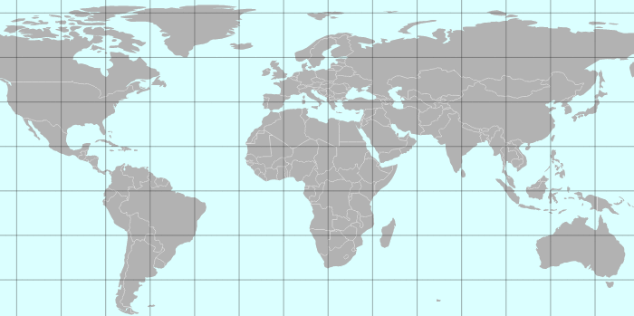

Figure 19-4. The basic map
With our map shapes in place, we can use a little CSS to style Figure 19-4, adding a light azure for the oceans and light gray for the land. The graticule is a half-transparent dark gray and the country boundaries white:
/* NOBEL-MAP STYLES */
#nobel-map
{
background
:
azure
;
}
.graticule
{
fill
:
none
;
stroke
:
#777
;
stroke-width
:
.5px
;
stroke-opacity
:
.
5
;
}
.land
{
fill
:
#ddd
;
}
.boundary
{
fill
:
none
;
stroke
:
#fff
;
stroke-width
:
.5px
;
}
With the SVG map assembled, let’s see how we use the winners dataset to draw the Nobel Prize–winning countries and the red indicator for number of wins.

Updating the Map
The first time our Nobel map gets updated is when the visualization is initialized. At this point the selected dataset is unfiltered, containing all the Nobel Prize winners. Subsequently, in response to filters applied by the user (e.g., all the Chemistry winners or those from France), the dataset will change and our map changes to reflect that.
So updating the map involves sending it a dataset of the Nobel Prize–winning countries with their current prize haul, dependent on the user filters applied. To do this, we use an updateMap method:
let
updateMap
=
function
(
countryData
)
{
//...
}
The countryData array has this form:
[
{
code
:
"USA"
,
key
:
"United States"
,
population
:
319259000
,
value
:
336
}
,
// ... 56 more countries
]
The number of winners for the US in the currently selected dataset.
We want to convert this array before sending it to our D3 map. The following code does this job, providing an array of country objects with properties geo (the country’s GeoJSON geometry), name (the country name), and number (the country’s number of Nobel Prize winners):
let
mapData
=
countryData
.
filter
(
d
=>
d
.
value
>
0
)
.
map
(
function
(
d
)
{
return
{
geo
:
cnameToCountry
[
d
.
key
]
,
name
:
d
.
key
,
number
:
d
.
value
}
}
)
;
Filters out countries with no winners—​we only display winning countries on the map.
Uses the country’s key (its name in this case) to retrieve its GeoJSON feature.
We want to display a red circular indicator at the center of our winning countries, indicating the number of prizes won. The circles’ areas should be proportional to the number of prizes won (absolute or per capita), which means (by circle area = pi × radius-squared) their radius should be a function of the square root of that prize number. D3 provides a handy sqrt scale for just such a need, allowing you to set a domain (min and max prize number in this case) and a range (min and max indicator radius).
Let’s see a quick example of the sqrt scale in action. In the following code, we set a scale with a domain between 0 and 100 and a zero-based range with a maximum area of 25 (5 × 5). This means calling the scale with 50 (half the range) should give the square root of half the maximum area (12.5):
var
sc
=
d3
.
scaleSqrt
().
domain
([
0
,
100
]).
range
([
0
,
5
]);
sc
(
50
)
// returns 3.5353..., the square root of 12.5
To create our indicator radius scale, we create a sqrt scale using the maximum and minimum radii specified in nbviz_core.js to set its range:
var
radiusScale
=
d3
.
scaleSqrt
()
.
range
([
nbviz
.
MIN_CENTROID_RADIUS
,
nbviz
.
MAX_CENTROID_RADIUS
]);
In order to get the domain to our scales, we use this mapData to get the maximum number of winners per country and use that value as the domain’s upper value, with 0 for its lower:
var
maxWinners
=
d3
.
max
(
mapData
.
map
(
d
=>
d
.
number
))
// DOMAIN OF VALUE-INDICATOR SCALE
radiusScale
.
domain
([
0
,
maxWinners
]);
To add our country shapes to the existing map, we bind mapData to a selection on the countries group of class country and implement an update pattern (see “Updating the DOM with Data”) to first add any country shapes required by the mapData. Instead of removing unbound country paths, we use the CSS opacity property to make the bound countries visible and the unbound invisible. A two-second transition is used to make these countries fade in and out appropriately. Example 19-6 shows the update pattern.

Example 19-6. Updating the country shapes
let
countries
=
svg
.
select
(
'.countries'
)
.
selectAll
(
'.country'
)
.
data
(
mapData
,
d
=>
d
.
name
)
// Use a data-join to make selected countries visible
// and fade them in over TRANS_DURATION milliseconds
countries
.
join
(
(
enter
)
=>
{
return
enter
.
append
(
'path'
)
.
attr
(
'd'
,
function
(
d
)
{
return
path
(
d
.
geo
)
}
)
.
attr
(
'class'
,
'country'
)
.
attr
(
'name'
,
d
=>
d
.
name
)
.
on
(
'mouseenter'
,
function
(
event
,
d
)
{
d3
.
select
(
this
)
.
classed
(
'active'
,
true
)
}
)
.
on
(
'mouseout'
,
function
(
d
)
{
d3
.
select
(
this
)
.
classed
(
'active'
,
false
)
}
)
}
,
(
update
)
=>
update
,
(
exit
)
=>
{
return
exit
.
classed
(
'visible'
,
false
)
.
transition
(
)
.
duration
(
nbviz
.
TRANS_DURATION
)
.
style
(
'opacity'
,
0
)
}
)
.
classed
(
'visible'
,
true
)
.
transition
(
)
.
duration
(
nbviz
.
TRANS_DURATION
)
.
style
(
'opacity'
,
1
)
Use the GeoJSON data to create country map shapes using our path object.
UI placeholders, which set the SVG paths to class active on mouse-over. Note that we use the function keyword here as opposed to the usual arrow notation shorthand (⇒). This is because we wish to use D3 to access the DOM element (map region) entered by the mouse using the this keyword, which is not available with arrow functions.
A customized exit function that fades out (sets opacity to 0) the country shape over 2000 (TRANS_DURATION) milliseconds.
Any new countries are faded in (opacity 1) over 2000 (TRANS_DURATION) ms.
Note that we add a CSS country class to freshly entered countries, setting their color to a light green. In addition to this, the mouse events are used to class the country active if the cursor is over it, highlighting it with a darker green. Here are the CSS classes:
.country
{
fill
:
rgb
(
175
,
195
,
186
);
/* light green */
}
.country.active
{
fill
:
rgb
(
155
,
175
,
166
);
/* dark green */
}
The update pattern shown in Example 19-6 will smoothly transition from old to new datasets, produced in response to user-applied filters and passed to updateMap. All we need now is to add similarly responsive filled circular indicators, centered on the active countries and reflecting their current value, either an absolute or relative (per capita) measure of their Nobel Prize haul.

Adding Value Indicators
To add our circular value indicators, we want an update pattern that mirrors that used to create our country SVG paths. We want to bind to the mapData dataset and append, update, and remove our indicator circles accordingly. As with the country shapes, we’ll adjust the indicators’ opacity to add and remove them from the map.
The indicators need to be placed at the center of their respective countries. D3’s path generator provides a number of useful utility methods for dealing with GeoJSON geometries. One of them is centroid, which computes the projected centroid for the specified feature:
// Given the GeoJSON of country (country.geo)
// calculate x, y coords of center
var
center
=
path
.
centroid
(
country
.
geo
);
// center = [x, y]
While path.centroid does a pretty good job as a rule, and is very useful for labeling shape, boundaries, and so on, it can produce strange results, particularly with highly concave geometries. Handily, the world country data we stored in “Getting Country Data for the Nobel Dataviz” contains the central coordinates of all our Nobel Prize countries.
We’ll first write a little method to retrieve those given a mapData object:
var
getCentroid
=
function
(
d
)
{
var
latlng
=
nbviz
.
data
.
countryData
[
d
.
name
]
.
latlng
;
return
projection
(
[
latlng
[
1
]
,
latlng
[
0
]
]
)
;
}
;
Get the latitude and longitude of our country’s center by name, using the stored world country data.
Use our equirectangular projection to turn these into SVG coordinates.
As shown in Example 19-7, we bind our mapData to the selection of all elements of class centroid in the centroids group we added in Example 19-5. The data is bound via the name key.

Example 19-7. Adding prize-haul indicators to the Nobel countries’ centroids
let
updateMap
=
function
(
countryData
)
{
//...
// BIND MAP DATA WITH NAME KEY
let
centroids
=
svg
.
select
(
'.centroids'
)
.
selectAll
(
'.centroid'
)
.
data
(
mapData
,
d
=>
d
.
name
)
// JOIN DATA TO CIRCLE INDICATORS
centroids
.
join
(
(
enter
)
=>
{
return
enter
.
append
(
"circle"
)
.
attr
(
"class"
,
"centroid"
)
.
attr
(
"name"
,
(
d
)
=>
d
.
name
)
.
attr
(
"cx"
,
(
d
)
=>
getCentroid
(
d
)
[
0
]
)
.
attr
(
"cy"
,
(
d
)
=>
getCentroid
(
d
)
[
1
]
)
}
,
(
update
)
=>
update
,
(
exit
)
=>
exit
.
style
(
"opacity"
,
0
)
)
.
classed
(
"active"
,
(
d
)
=>
d
.
name
===
nbviz
.
activeCountry
)
.
transition
(
)
.
duration
(
nbviz
.
TRANS_DURATION
)
.
style
(
"opacity"
,
1
)
.
attr
(
"r"
,
(
d
)
=>
radiusScale
(
+
d
.
number
)
)
}
;
Binds the map data to the centroid elements using the name key.
Uses the getCentroid function to return pixel positions for the geocoordinates of the countries’ centers.
This 2000 ms transition fades the circular marker in by increasing its opacity while simultaneously transitioning to its new radius.
Using a bit of CSS, we can make the indicators red and slightly transparent, allowing map details and, where they are densely packed in Europe, other indicators to show through. If the country is selected by the user, using the country filter on the UI bar, it is classed as active and given a golden hue. Here’s the CSS to do that:
.centroid
{
fill
:
red
;
fill-opacity
:
0
.
3
;
pointer-events
:
none
;
}
.centroid
.active
{
fill
:
goldenrod
;
fill-opacity
:
0
.
6
;
}
This allows mouse events to propagate to country shapes below the circles, allowing the user to still click on them.
The active centroid indicators we just added are the last element of our Nobel Prize map. Now let’s take a look at the complete article.

Our Completed Map
With the country and indicator update patterns in place, our map should respond to user-driven filtering with a smooth transition. Figure 19-5 shows the result of selecting Nobel Prizes for Economics. Only winning countries remain highlighted and the value indicators are resized, reflecting American dominance of this category.
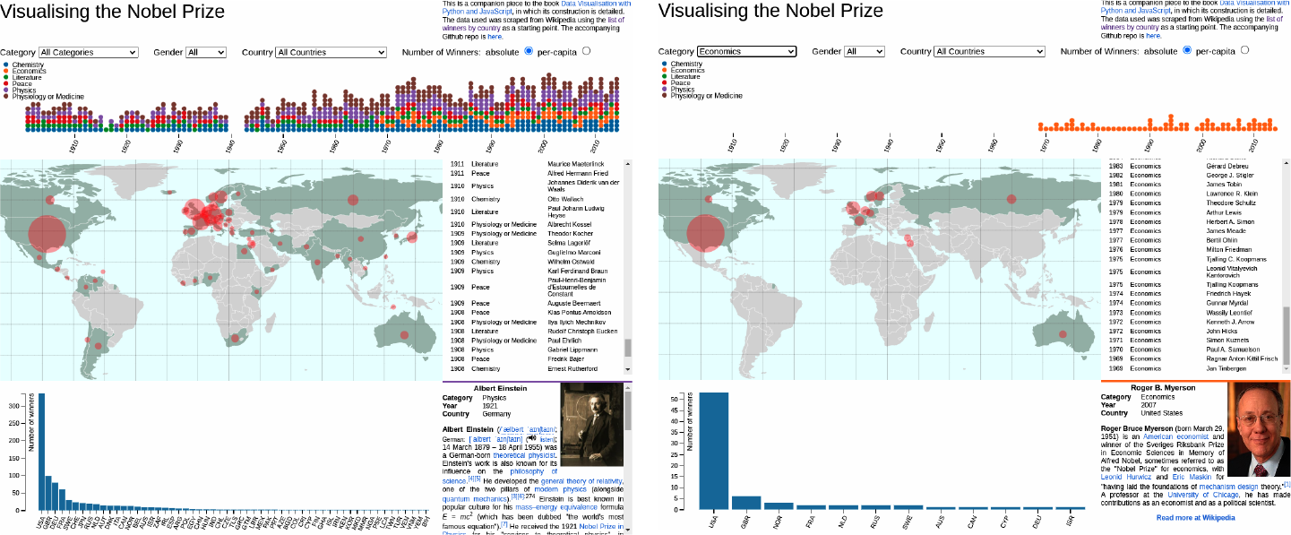

Figure 19-5. (left) Shows the map with the full Nobel dataset; (right) prizes are filtered by category, showing the Economics winners (and the dominance of the US economists)
The map as it stands in not interactive but does show when a user hovers over a particular country with a mouse, by calling the mouseenter and mouseout callback functions and adding or removing an active class. These callbacks could easily be used to add more functionality to the map, such as tooltips or the use of the countries as clickable data filters. Let’s now use these to build a simple tooltip, to show the country the mouse is hovering over and some simple prize information.

Building a Simple Tooltip
Tooltips and other interactive widgets are the kind of thing commonly demanded of data visualizers and though they can get quite involved, particularly if they themselves are interactive (e.g., menus that appear on mouse hover), there are some simple recipes that are very handy to know. In this section, I’ll show how to build a simple but pretty effective tooltip. Figure 19-6 shows what we’re aiming to build.

Figure 19-6. A simple tooltip for our Nobel Prize map
Let’s remind ourselves of our current countries update, where mouseenter and mouseout event handlers are added during a data-join:
// ENTER AND APPEND ANY NEW COUNTRIES
countries
.
join
((
enter
)
=>
{
return
enter
.
append
(
'path'
)
// ...
.
on
(
'mouseenter'
,
function
(
d
)
{
d3
.
select
(
this
).
classed
(
'active'
,
true
);
})
.
on
(
'mouseout'
,
function
(
d
)
{
d3
.
select
(
this
).
classed
(
'active'
,
false
);
})
})
;
In order to add a tooltip to our map, we need to do three things:
Create a tooltip box in HTML with placeholders for the information we want to display—​in this case, country name and number of wins in the selected prize category.
Display this HTML box over the mouse when the user moves it into a country and hide it when they move the mouse out.
Update the box when displayed using the data bound to the country underneath the mouse.
We create the HTML for the tooltip by adding a content block to the Nobel-viz map section, with ID map-tooltip, an <h2> header for its title, and a <p> tag for the tooltip’s text:
<!-- index.html -->
<!-- ... -->
<
div
id
=
"nobel-map"
>
<
div
id
=
"map-tooltip"
>
<
h2
></
h2
>
<
p
></
p
>
</
div
>
<!-- ... -->
We’ll also need some CSS for the tooltip’s look and feel, added to our style.css file:
/* css/style.css */
/* MAP TOOLTIP */
#map-tooltip
{
position
:
absolute
;
pointer-events
:
none
;
color
:
#eee
;
font-size
:
12px
;
opacity
:
0
.
7
;
/* a little transparent */
background
:
#222
;
border
:
2px
solid
#555
;
border-color
:
goldenrod
;
padding
:
10px
;
left
:
-999px
;
}
#map-tooltip
h2
{
text-align
:
center
;
padding
:
0px
;
margin
:
0px
;
}
Setting pointer-events to none effectively lets you click on things underneath the tooltip.
Initially, the tooltip is hidden far to the (virtual) left of the browser window, using a large negative x index.
With our tooltip’s HTML in place and the element hidden to the left of the browser window (left is –9999 pixels), we just need to extend our mousein and mouseout callback functions to display or hide the tooltip. The mousein function, called when the user moves the mouse into a country, does most of the work:
// ...
countries
.
join
(
(
enter
)
=>
{
.
append
(
'path'
)
.
attr
(
'class'
,
'country'
)
.
on
(
'mouseenter'
,
function
(
event
)
{
var
country
=
d3
.
select
(
this
)
;
// don't do anything if the country is not visible
if
(
!
country
.
classed
(
'visible'
)
)
{
return
;
}
// get the country data object
var
cData
=
country
.
datum
(
)
;
// if only one prize, use singular 'prize'
var
prize_string
=
(
cData
.
number
===
1
)
?
' prize in '
:
' prizes in '
;
// set the header and text of the tooltip
tooltip
.
select
(
'h2'
)
.
text
(
cData
.
name
)
;
tooltip
.
select
(
'p'
)
.
text
(
cData
.
number
+
prize_string
+
nbviz
.
activeCategory
)
;
// set the border color according to selected
// prize category
var
borderColor
=
(
nbviz
.
activeCategory
===
nbviz
.
ALL_CATS
)
?
'goldenrod'
:
nbviz
.
categoryFill
(
nbviz
.
activeCategory
)
;
tooltip
.
style
(
'border-color'
,
borderColor
)
;
var
mouseCoords
=
d3
.
pointer
(
event
)
;
var
w
=
parseInt
(
tooltip
.
style
(
'width'
)
)
,
h
=
parseInt
(
tooltip
.
style
(
'height'
)
)
;
tooltip
.
style
(
'top'
,
(
mouseCoords
[
1
]
-
h
)
+
'px'
)
;
tooltip
.
style
(
'left'
,
(
mouseCoords
[
0
]
-
w
/
2
)
+
'px'
)
;
d3
.
select
(
this
)
.
classed
(
'active'
,
true
)
;
}
)
.
on
(
'mouseout'
,
function
(
d
)
{
tooltip
.
style
(
'left'
,
'-9999px'
)
d3
.
select
(
this
)
.
classed
(
'active'
,
false
)
}
)
}
,
// ...
)
D3’s pointer method returns the mouse coordinates from the event object (here, relative to the parent map group) in pixels, which we can use to position the tooltip.
We get the computed width and height of the tooltip box, which has been adjusted to accommodate our country title and prize string.
We use the mouse coordinates and the width and height of the tooltip box to position the box centered horizontally and roughly above the mouse cursor (the width and height don’t include our 10 pixels of padding around the tooltip’s <div>).
When the mouse leaves a country, we vanish the tooltip by placing it to the far left of the map.
With the mouseenter callback function written, we now only need a mouseout to hide the tooltip by placing it far to the left of the browser window:
countries
.
join
(
(
enter
)
=>
{
.
append
(
'path'
)
.
attr
(
'class'
,
'country'
)
.
on
(
'mouseenter'
,
function
(
event
)
{
// ...
}
)
.
on
(
'mouseout'
,
function
(
d
)
{
tooltip
.
style
(
'left'
,
'-9999px'
)
d3
.
select
(
this
)
.
classed
(
'active'
,
false
)
}
)
}
,
// ...
)
When the mouse leaves the country we shift the tooltip far to the left, out of the browser viewport, and remove the 'active' class from the country, returning it to the default country color.
With the mouseenter and mouseout functions operating in concert, you should see the tooltip appearing and disappearing where needed, just as shown in Figure 19-6.

Updating the Map
When the map module is imported, it appends a callback function to the callbacks array in the core module. When data is updated in response to user interaction, this callback function is called and the bar chart updated with new country data:
nbviz
.
callbacks
.
push
(
(
)
=>
{
let
data
=
nbviz
.
getCountryData
(
)
updateMap
(
data
)
}
)
This anonymous function is called in the core module when data is updated.
Now that we’ve built the map component of our Nobel dataviz, let’s summarize what we’ve learned before moving on to show how user input drives the visualization.

Summary
D3 mapping is a rich area, with many varied projections and lots of utility methods to help with manipulating geometries. But building a map follows a fairly standard procedure, as demonstrated in the chapter: you first choose your projection—say, a Mercator or maybe the Albers conic projection commonly used for mapping the US. You then use this projection to create a D3 path generator, which turns GeoJSON features into SVG paths, creating the map you see. The GeoJSON will normally be extracted from more efficient TopoJSON data.
This chapter also demonstrated how easy it is with D3 to interactively highlight your map and deal with cursor movements. Taken together, the basic set of skills should allow you to start building your own mapping visualizations.
Now that we’ve constructed all of our SVG-based graphical elements, let’s see how well D3 works with conventional HTML elements by building our winners list and an individual’s biography box.
1 The math of geometric projections, for example, can get complicated fast.
2 I use and thoroughly recommend the open source QGIS.
3 Python’s topojson.py and the TopoJSON command-line program.
4 As we’ll see, it does lack a couple of our Nobel Prize countries, but these are too small to be clickable and we have the coordinates of their centers, allowing for a visual cue to be overlaid.
5 See this site by Mike Bostock for a very cool example.
6 By installing globally, you can use the geo2topo command in any directory.
7 The extended set of D3 projections is part of an extension of D3, not in the main library.
8 See https://oreil.ly/oAppn for a nice demonstration.
9 See the D3 GitHub for a full list.

Chapter 20. Visualizing Individual Winners
We want our Nobel Prize visualization (Nobel-viz) to include a list of currently selected winners and a biography box (aka bio-box) to display the details of an individual winner (see Figure 20-1). By clicking on a winner in the list, the user can see his or her details in the bio-box. In this chapter, we’ll see how to build the list and bio-box, how to repopulate the list when the user selects new data (with the menu bar filters), and how to make the list clickable.
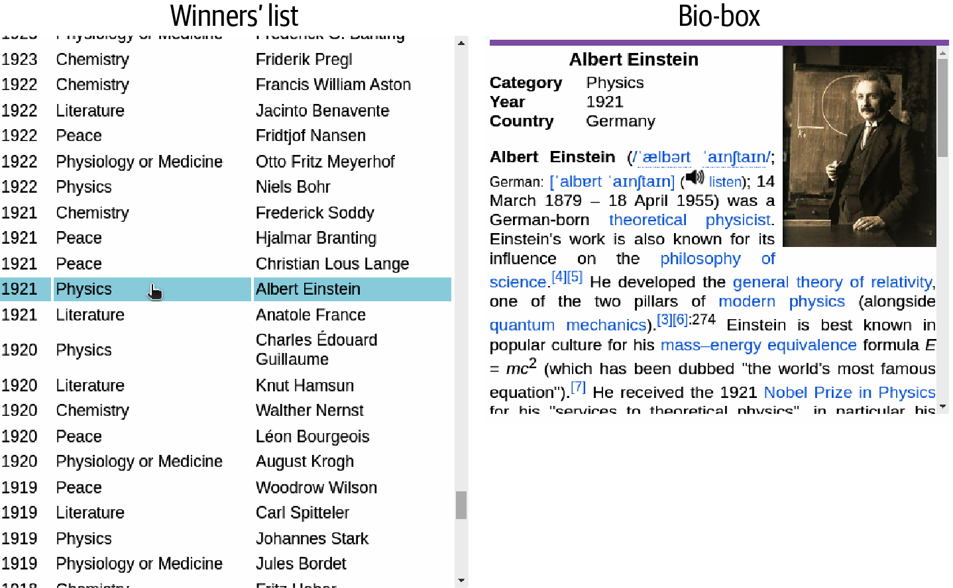

Figure 20-1. The chapter’s target elements
As this chapter will demonstrate, D3 isn’t just for building SVG visualizations. You can bind data to any DOM element and use it to change its attributes and properties or its event-handling callback functions. D3’s data joining and event handling (achieved via the on method) play very well with common user interfaces such as the clickable list of this chapter and selection boxes.1
Let’s deal first with the list of winners and how it is built with the dataset of currently selected winners.

Building the List
We build our list of winners (see Figure 20-1) using an HTML table with Year, Category, and Name columns. The basic skeleton of this list is provided in the Nobel-viz’s index.html file:
<!DOCTYPE html>
<
meta
charset
=
"utf-8"
>
<
body
>
...
<
div
id
=
"nobel-list"
>
<
h2
>
Selected winners
</
h2
>
<
table
>
<
thead
>
<
tr
>
<
th
id
=
'year'
>
Year
</
th
>
<
th
id
=
'category'
>
Category
</
th
>
<
th
id
=
'name'
>
Name
</
th
>
</
tr
>
</
thead
>
<
tbody
>
</
tbody
>
</
table
>
</
div
>
...
</
body
>
We’ll use a little CSS in style.css to style this table, adjusting the width of the columns and their font size:
/* WINNERS LIST */
#nobel-list
{
overflow
:
scroll
;
overflow-x
:
hidden
;
}
#nobel-list
table
{
font-size
:
10px
;
}
#nobel-list
table
th
#year
{
width
:
30px
}
#nobel-list
table
th
#category
{
width
:
120px
}
#nobel-list
table
th
#name
{
width
:
120px
}
#nobel-list
h2
{
font-size
:
14px
;
margin
:
4px
;
text-align
:
center
}
overflow: scroll clips the content of the list (keeping it within our nobel-list container) and adds a scroll bar so we can access all the winners. overflow-x: hidden inhibits the addition of a horizontal scroll bar.
In order to create the list, we will add <tr> row elements (containing a <td> data tag for each column) to the table’s <tbody> element for each winner in the current dataset, producing something like this:
...
<
tbody
>
<
tr
>
<
td
>
2014
</
td
>
<
td
>
Chemistry
</
td
>
<
td
>
Eric Betzig
</
td
>
</
tr
>
...
</
tbody
>
...
To create these rows, an updateList method will be called by our central onDataChange when the app is initialized and subsequently when the user applies a data filter and the list of winners changes (see “Basic Data Flow”). The data received by updateList will have the following structure:
// data =
[{
name
:
"C\u00e9sar Milstein"
,
category
:
"Physiology or Medicine"
,
gender
:
"male"
,
country
:
"Argentina"
,
year
:
1984
_id
:
"5693be6c26a7113f2cc0b3f4"
},
...
]
Example 20-1 shows the updateList method. The data received is first sorted by year and then, after any existing rows have been removed, used to build the table rows.

Example 20-1. Building the selected winners list
let
updateList
=
function
(
data
)
{
let
tableBody
,
rows
,
cells
// Sort the winners' data by year
data
=
data
.
sort
(
function
(
a
,
b
)
{
return
+
b
.
year
-
+
a
.
year
}
)
// select table-body from index.html
tableBody
=
d3
.
select
(
'#nobel-list tbody'
)
// create place-holder rows bound to winners' data
rows
=
tableBody
.
selectAll
(
'tr'
)
.
data
(
data
)
rows
.
join
(
(
enter
)
=>
{
// create any new rows required
return
enter
.
append
(
'tr'
)
.
on
(
'click'
,
function
(
event
,
d
)
{
console
.
log
(
'You clicked a row '
+
JSON
.
stringify
(
d
)
)
displayWinner
(
d
)
}
)
}
,
(
update
)
=>
update
,
(
exit
)
=>
{
return
exit
.
transition
(
)
.
duration
(
nbviz
.
TRANS_DURATION
)
.
style
(
'opacity'
,
0
)
.
remove
(
)
}
)
cells
=
tableBody
.
selectAll
(
'tr'
)
.
selectAll
(
'td'
)
.
data
(
function
(
d
)
{
return
[
d
.
year
,
d
.
category
,
d
.
name
]
}
)
// Append data cells, then set their text
cells
.
join
(
'td'
)
.
text
(
d
=>
d
)
// Display a random winner if data is available
if
(
data
.
length
)
{
displayWinner
(
data
[
Math
.
floor
(
Math
.
random
(
)
*
data
.
length
)
]
)
}
}
A now familiar join pattern, using the bound winners’ data to create and update list items.
When the user clicks on a row, this click-handler function will pass the winner data bound to that row to a displayWinner method, which will update the bio-box accordingly.
This custom exit function fades out any excess rows over the transition period of two seconds, reducing their opacity to zero before removing them.
First, we use a winner’s data to create an array of data with year, category, and name, which will be used to create the row’s <td> data cells…​
…​we then join this array to the row’s data cells (td) and use it to set their text.
Each time the data is changed, we select a winner at random from the new dataset and display him or her in the bio-box.
As the user moves the cursor over a row in our winners table, we want to highlight the row and also to change the style of pointer to cursor to indicate that the row is clickable. Both of these details are fixed by the following CSS, added to our style.css file:
#nobel-list
tr
:hover
{
cursor
:
pointer
;
background
:
lightblue
;
}
Our updateList method calls a displayWinner method to build a winner’s biography box when a row is clicked or when the data changes (with a random choice). Let’s now see how the bio-box is built.

Building the Bio-Box
The bio-box uses a winner’s object to fill in the details of a little mini-biography. The bio-box’s HTML skeleton is provided in the index.html file consisting of content blocks for the biographical elements and a readmore footer providing a Wikipedia link to further information on the winner:
<!DOCTYPE html>
<
meta
charset
=
"utf-8"
>
<
body
>
...
<
div
id
=
"nobel-winner"
>
<
div
id
=
"picbox"
></
div
>
<
div
id
=
'winner-title'
></
div
>
<
div
id
=
'infobox'
>
<
div
class
=
'property'
>
<
div
class
=
'label'
>
Category
</
div
>
<
span
name
=
'category'
></
span
>
</
div
>
<
div
class
=
'property'
>
<
div
class
=
'label'
>
Year
</
div
>
<
span
name
=
'year'
></
span
>
</
div
>
<
div
class
=
'property'
>
<
div
class
=
'label'
>
Country
</
div
>
<
span
name
=
'country'
></
span
>
</
div
>
</
div
>
<
div
id
=
'biobox'
></
div
>
<
div
id
=
'readmore'
>
<
a
href
=
'#'
>
Read more at Wikipedia
</
a
></
div
>
</
div
>
...
</
body
>
A little CSS in style.css sets the positions of the list and bio-box elements, sizes their content blocks, and provides borders and font specifics:
/* WINNER INFOBOX */
#nobel-winner
{
font-size
:
11px
;
overflow
:
auto
;
overflow-x
:
hidden
;
border-top
:
4px
solid
;
}
#nobel-winner
#winner-title
{
font-size
:
12px
;
text-align
:
center
;
padding
:
2px
;
font-weight
:
bold
;
}
#nobel-winner
#infobox
.label
{
display
:
inline-block
;
width
:
60px
;
font-weight
:
bold
;
}
#nobel-winner
#biobox
{
font-size
:
11px
;
}
#nobel-winner
#biobox
p
{
text-align
:
justify
;
}
#nobel-winner
#picbox
{
float
:
right
;
margin-left
:
5px
;
}
#nobel-winner
#picbox
img
{
width
:
100px
;
}
#nobel-winner
#readmore
{
font-weight
:
bold
;
text-align
:
center
;
}
With our content blocks in place, we need to make a callback to our data API to get the data needed to fill them. Example 20-2 shows the displayWinner method used to build the box.

Example 20-2. Updating a selected winner’s biography box
let
displayWinner
=
function
(
wData
)
{
// store the winner's bio-box element
let
nw
=
d3
.
select
(
'#nobel-winner'
)
nw
.
select
(
'#winner-title'
)
.
text
(
wData
.
name
)
nw
.
style
(
'border-color'
,
nbviz
.
categoryFill
(
wData
.
category
)
)
nw
.
selectAll
(
'.property span'
)
.
text
(
function
(
d
)
{
var
property
=
d3
.
select
(
this
)
.
attr
(
'name'
)
return
wData
[
property
]
}
)
nw
.
select
(
'#biobox'
)
.
html
(
wData
.
mini_bio
)
// Add an image if available, otherwise remove the old one
if
(
wData
.
bio_image
)
{
nw
.
select
(
'#picbox img'
)
.
attr
(
'src'
,
'static/images/winners/'
+
wData
.
bio_image
)
.
style
(
'display'
,
'inline'
)
}
else
{
nw
.
select
(
'#picbox img'
)
.
style
(
'display'
,
'none'
)
}
nw
.
select
(
'#readmore a'
)
.
attr
(
'href'
,
'http://en.wikipedia.org/wiki/'
+
wData
.
name
)
}
Our nobel-winner element has a top border (CSS: border-top: 4px solid), which we will color according to the winner’s category, using the categoryFill method defined in nbviz_core.js.
We select the <span> tags of all the divs with class property. These are of the form <span name=category></span>. We use the span’s name attribute to retrieve the correct property from our Nobel winner’s data and use it to set the tag’s text.
Here we set the src (source) attribute on our winner’s image if one is available. We use the image tag’s display attribute to hide it (setting it to none) if no image is available or show it (the default inline) if one is.
Our winner’s name was scraped from Wikipedia and can be used to retrieve their Wikipedia page.

Updating the Winners List
When the details (winners list and bio) module is imported, it appends a callback function to the callbacks array in the core module. When data is updated in response to user interaction, this callback function is called and the list updated with new country data, using Crossfilter’s country dimension:
nbviz
.
callbacks
.
push
(
(
)
=>
{
let
data
=
nbviz
.
countryDim
.
top
(
Infinity
)
updateList
(
data
)
}
)
This anonymous function is called in the core module when data is updated.
Now that we’ve seen how we add a bit of personality to our Nobel-viz by allowing users to display a winner’s biography, let’s summarize this chapter before moving on to see how the menu bar is built.

Summary
In this chapter, we saw how D3 can be used to build conventional HTML constructions, not just SVG graphics. D3 is just as at home building lists, tables, and the like as it is displaying circles or changing the rotation of a line. Wherever there is changing data that needs to be reflected by elements of a web page, D3 is likely able to solve the problem elegantly and efficiently.
With our winners list and biography box covered, we’ve seen how all the visual elements in our Nobel-viz are built. It only remains to see how the visualization’s menu bar is built and how the changes it enables, to both the dataset and the measure of prizes, are reflected by these visual elements.
1 We’ll cover selection boxes (as data filters) in Chapter 21.

Chapter 21. The Menu Bar
The previous chapters showed how to build the visual components of our interactive Nobel Prize visualization, the time chart to display all Nobel Prize winners by year, a map to show geographic distributions, a list to display the currently selected winners, and a bar chart to compare absolute and per capita wins by country. In this chapter, we will see how the user interacts with the visualization by using selectors and buttons (see Figure 21-1) to create a filtered dataset that is then reflected by the visual components. For example, selecting Physics in the category-select box filters will display only Physics prize winners in the Nobel Prize visualization (Nobel-viz) elements. The filters in our menu bar are cumulative, so we can, for example, select only those female chemists from France to have won the Nobel Prize.1
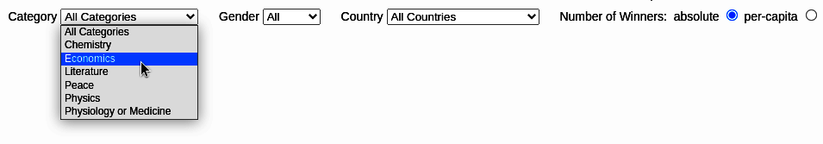

Figure 21-1. This chapter’s target menu bar
In the sections ahead, I will show you how to use D3 to build the menu bar and how JavaScript callbacks are used to respond to user-driven changes.

Creating HTML Elements with D3
Many people think of D3 as a specialized tool for creating SVG visualizations composed of graphical primitives such as lines and circles. Though D3 is great for this (the best there is), it’s equally at home creating conventional HTML elements such as tables or selector boxes. For tricky, data-driven HTML complexes like hierarchical menus, D3’s nested data-joins are an ideal way to create the DOM elements and the callbacks to deal with user selections.
We saw in Chapter 20 how easy it is to create table rows from a selected dataset or fill in the details of a biography box with a winner’s data. In this chapter, we’ll show how to populate selectors with options based on changing datasets and how to attach callback functions to user interface elements such as selectors and radio boxes.
Tip
If you have stable HTML elements (e.g., a select box whose options are not dependent on changing data), it’s best to write them in HTML and then use D3 to attach any callback functions you need to deal with user input. As with CSS styling, you should do as much as possible in vanilla HTML. It keeps the codebase cleaner and is easier to understand by other devs and non-devs. In this chapter, I stretch this rule a bit to demonstrate the creation of HTML elements, but it’s pretty much always the way to go.

Building the Menu Bar
As discussed in “The HTML Skeleton”, our Nobel-viz is built on HTML <div> placeholders, fleshed out with JavaScript and D3. As shown in Example 21-1, our menu bar is built on the nobel-menu <div>, placed above the main chart holder, and consists of three selector filters (by the winners’ category, gender, and country) and a couple of radio buttons to select the country prize-winning metric (absolute or per capita).

Example 21-1. The HTML skeleton for the menu bar
<!-- ... -->
<
body
>
<!-- ... -->
<!-- THE PLACEHOLDERS FOR OUR VISUAL COMPONENTS -->
<
div
id
=
"nbviz"
>
<!-- BEGIN MENU BAR -->
<
div
id
=
"nobel-menu"
>
<
div
id
=
"cat-select"
>
Category
<
select
></
select
>
</
div
>
<
div
id
=
"gender-select"
>
Gender
<
select
>
<
option
value
=
"All"
>
All
</
option
>
<
option
value
=
"female"
>
Female
</
option
>
<
option
value
=
"male"
>
Male
</
option
>
</
select
>
</
div
>
<
div
id
=
"country-select"
>
Country
<
select
></
select
>
</
div
>
<
div
id
=
'metric-radio'
>
Number of Winners:
&nbsp;
<
form
>
<
label
>
absolute
<
input
type
=
"radio"
name
=
"mode"
value
=
"0"
checked
>
</
label
>
<
label
>
per-capita
<
input
type
=
"radio"
name
=
"mode"
value
=
"1"
>
</
label
>
</
form
>
</
div
>
</
div
>
<!-- END MENU BAR -->
<
div
id
=
'chart-holder'
>
<!-- ... -->
</
body
>
Now we’ll add the UI elements in turn, starting with the selector filters.

Building the Category Selector
In order to build the category selector, we’re going to need a list of option strings. Let’s create that list using the CATEGORIES list defined in nbviz_core.js:
import
nbviz
from
'./nbviz_core.mjs'
let
catList
=
[
nbviz
.
ALL_CATS
]
.
concat
(
nbviz
.
CATEGORIES
)
Creates the category selector’s list ['All Categories', 'Chemistry', 'Economics', …​ ] by concatenating the list ['All Categories'] and the list ['Chemistry', 'Economics', …​ ].
We’re now going to use this category list to make the options tags. We’ll first use D3 to grab the #cat-select select tag:
//...
let
catSelect
=
d3
.
select
(
'#cat-select select'
);
With catSelect to hand, let’s use a standard D3 data-join to turn our catList list of categories into HTML option tags:
catSelect
.
selectAll
(
'option'
)
.
data
(
catList
)
.
join
(
'option'
)
.
attr
(
'value'
,
d
=>
d
)
.
html
(
d
=>
d
)
;
After data binding, append an option for each catList member.
We are setting the option’s value attribute and text to a category (e.g., <option value="Peace">Peace</option>).
The result of the preceding append operations is the following cat-select DOM element:
<
div
id
=
"cat-select"
>
"Category "
<
select
>
<
option
value
=
"All Categories"
>
All Categories
</
option
>
<
option
value
=
"Chemistry"
>
Chemistry
</
option
>
<
option
value
=
"Economics"
>
Economics
</
option
>
<
option
value
=
"Literature"
>
Literature
</
option
>
<
option
value
=
"Peace"
>
Peace
</
option
>
<
option
value
=
"Physics"
>
Physics
</
option
>
<
option
value
=
"Physiology or Medicine"
>
Physiology or Medicine
</
option
>
</
select
>
</
div
>
Now that we have our selector, we can use D3’s on method to attach an event-handler callback function, triggered when the selector is changed:
catSelect
.
on
(
'change'
,
function
(
d
)
{
let
category
=
d3
.
select
(
this
)
.
property
(
'value'
)
;
nbviz
.
filterByCategory
(
category
)
;
nbviz
.
onDataChange
(
)
;
}
)
;
this is the select tag, with the value property as the selected category option.
We call the filterByCategory method defined in nbviz_core.js to filter our dataset for prizes in the category selected.
onDataChange triggers the visual-component update methods that will change to reflect our newly filtered dataset.
Figure 21-2 is a schematic of our select callback. Selecting Physics calls the anonymous callback function attached to our selector’s change event. This function initiates the update of the Nobel-viz’s visual elements.
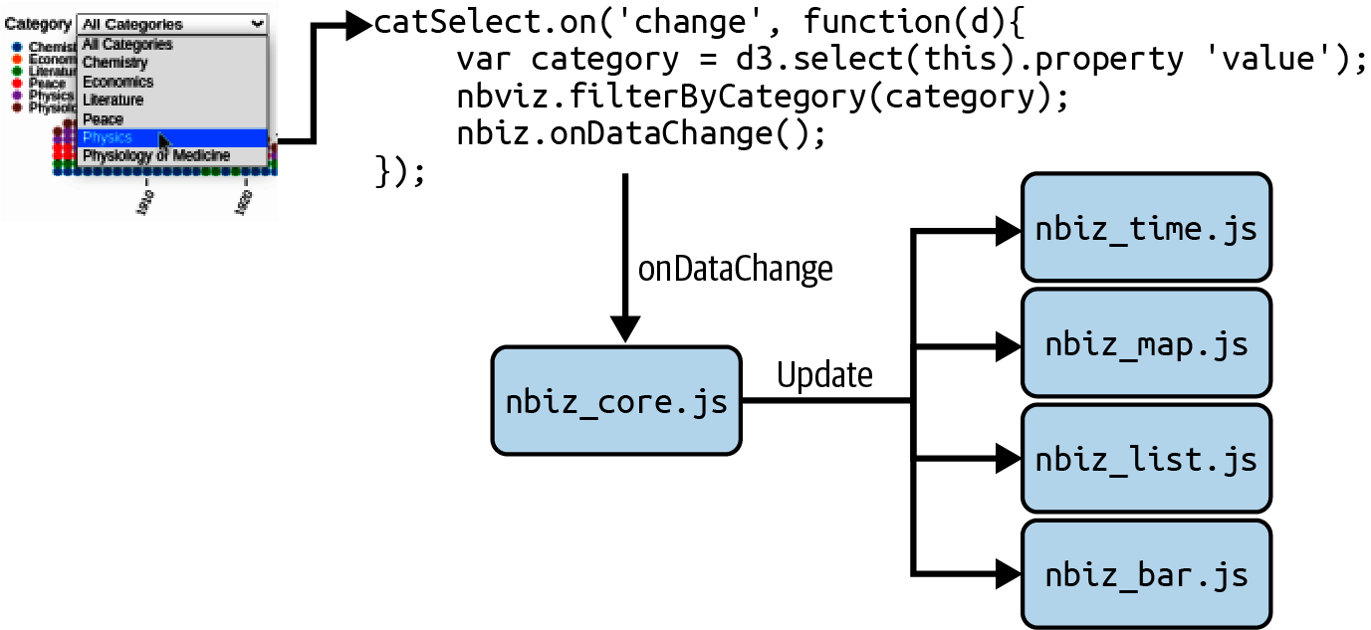

Figure 21-2. The category select callback
Within the category selector’s callback, we first call the filterByCategory method2 to select only the Physics winners and the onDataChange method to trigger an update of all the visual components. Where applicable, these will reflect the changed data. For example, the map’s distribution circular indicators will resize, vanishing in the case of countries with no Nobel Physics winners.

Adding the Gender Selector
We have already added the HTML for our gender selector and its options, in the menu bar’s description in index.html:
<!-- ... -->
<
div
id
=
"gender-select"
>
Gender
<
select
>
<
option
value
=
"All"
>
All
</
option
>
<
option
value
=
"female"
>
Female
</
option
>
<
option
value
=
"male"
>
Male
</
option
>
</
select
>
</
div
>
<!-- ... -->
All we need to do now is select the gender select tag and add a callback function to handle user selections. We can easily achieve this using D3’s on method:
d3
.
select
(
'#gender-select select'
)
.
on
(
'change'
,
function
(
d
)
{
let
gender
=
d3
.
select
(
this
)
.
property
(
'value'
)
;
if
(
gender
===
'All'
)
{
nbviz
.
genderDim
.
filter
(
)
;
}
else
{
nbviz
.
genderDim
.
filter
(
gender
)
;
}
nbviz
.
onDataChange
(
)
;
}
)
;
Calling the gender dimension’s filter without an argument resets it to allow all genders.
First, we select the selector’s option value. We then use this value to filter the current dataset. Finally, we call onDataChange to trigger any changes to the Nobel-viz’s visual components caused by the new dataset.
To place the gender select tag, we use a little CSS, giving it a left margin of 20 pixels:
#gender-select
{
margin-left
:
20px
;}

Adding the Country Selector
Adding the country selector is a little more involved than adding those of category and gender. The distribution of Nobel Prizes by country has a long tail (see Figure 17-1), with lots of countries having one or two prizes. We could include all of these in our selector, but it would make it rather long and cumbersome. A better way is to add groups for the single- and double-winning countries, keeping the number of select options manageable and adding a little narrative to the chart, namely the distributions of small winners over time, which might conceivably say something about changing trends in the Nobel Prize award allocation.3
In order to add our single- and double-country winner groups, we will need the crossfiltered country dimension to get the group sizes by country. This means creating the country selector after our Nobel Prize dataset has loaded. To do this, we put it in an nbviz.initUI method, called in our main nbviz_main.js script after the crossfilter dimensions have been created (see “Filtering Data with Crossfilter”).
The following code creates a selection list. Countries with three or more winners get their own selection slot, below the All Winners selection. Single- and double-country winners are added to their respective lists, which will be used to filter the dataset if the user selects the Single Winning Countries or Double Winning Countries from the selector’s options.
export
let
initMenu
=
function
(
)
{
let
ALL_WINNERS
=
'All Winners'
;
let
SINGLE_WINNERS
=
'Single Winning Countries'
;
let
DOUBLE_WINNERS
=
'Double Winning Countries'
;
let
nats
=
nbviz
.
countrySelectGroups
=
nbviz
.
countryDim
.
group
(
)
.
all
(
)
.
sort
(
function
(
a
,
b
)
{
return
b
.
value
-
a
.
value
;
// descending
}
)
;
let
fewWinners
=
{
1
:
[
]
,
2
:
[
]
}
;
let
selectData
=
[
ALL_WINNERS
]
;
nats
.
forEach
(
function
(
o
)
{
if
(
o
.
value
>
2
)
{
selectData
.
push
(
o
.
key
)
;
}
else
{
fewWinners
[
o
.
value
]
.
push
(
o
.
key
)
;
}
}
)
;
selectData
.
push
(
DOUBLE_WINNERS
,
SINGLE_WINNERS
)
;
//...
}
)
Sorted group array of form ({key:"United States", value:336}, …​) where value is the number of winners from that country.
An object with lists to store single and double winners.
Countries with more than two winners get their own slot in the selectData list.
Single- and double-winning countries are added to their respective lists based on the group size (value) of 1 or 2.
Now that we have our selectData list with corresponding fewWinners arrays, we can use it to create the options for our country selector. We first use D3 to grab the country selector’s select tag and then add the options to it using standard data binding:
let
countrySelect
=
d3
.
select
(
'#country-select select'
);
countrySelect
.
selectAll
(
"option"
)
.
data
(
selectData
)
.
join
(
"option"
)
.
attr
(
"value"
,
(
d
)
=>
d
)
.
html
((
d
)
=>
d
);
With our selectData options appended, the selector looks like Figure 21-3.
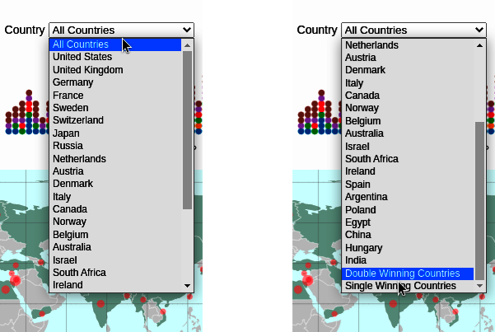

Figure 21-3. Selector for prizes by country
Now all we need is a callback function, triggered when an option is selected, to filter our main dataset by country. The following code shows how it’s done. First, we get the select’s value property (1), a country or one of ALL_WINNERS, DOUBLE_WINNERS, or SINGLE_WINNERS. We then construct a list of countries to send to our national filter method, nbviz.filterByCountries (defined in nbviz_core.js):
countrySelect
.
on
(
'change'
,
function
(
d
)
{
let
countries
;
let
country
=
d3
.
select
(
this
)
.
property
(
'value'
)
;
if
(
country
===
ALL_WINNERS
)
{
countries
=
[
]
;
}
else
if
(
country
===
DOUBLE_WINNERS
)
{
countries
=
fewWinners
[
2
]
;
}
else
if
(
country
===
SINGLE_WINNERS
)
{
countries
=
fewWinners
[
1
]
;
}
else
{
countries
=
[
country
]
;
}
nbviz
.
filterByCountries
(
countries
)
;
nbviz
.
onDataChange
(
)
;
}
)
;
These conditionals make a countries array, depending on the country string. This array is empty, single-valued, or with one of fewWinners arrays.
Calls filterByCountries to filter our main Nobel-winners dataset using the array of countries.
Triggers an update to all the Nobel-viz’s elements.
The filterByCountries function is shown in Example 21-2. An empty countryNames argument resets the filter; otherwise, we filter the country dimension countryDim for all those countries in countryNames .

Example 21-2. Filter by countries function
nbviz
.
filterByCountries
=
function
(
countryNames
)
{
if
(
!
countryNames
.
length
)
{
nbviz
.
countryDim
.
filter
(
)
;
}
else
{
nbviz
.
countryDim
.
filter
(
function
(
name
)
{
return
countryNames
.
indexOf
(
name
)
>
-
1
;
}
)
;
}
if
(
countryNames
.
length
===
1
)
{
nbviz
.
activeCountry
=
countryNames
[
0
]
;
}
else
{
nbviz
.
activeCountry
=
null
;
}
}
;
Resets the filter if the countryNames array is empty (the user chose All Countries).
Here, we create a filter function on our crossfilter country dimension, which returns true if a country is in the countryNames list (containing either a single country or all single or double winners).
Keeps a record of any single selected country in order—for example, to highlight it in the map and bar chart.
Now that we’ve built the filter selectors for our category, gender, and country dimensions, all we need to do is add the callback function to deal with changes to the prize-winning metric radio button.

Wiring Up the Metric Radio Button
The metric radio button has already been built in HTML, consisting of a form with radio inputs:
<
div
id
=
'metric-radio'
>
Number of Winners:
&nbsp;
<
form
>
<
label
>
absolute
<
input
type
=
"radio"
name
=
"mode"
value
=
"0"
checked
>
<
/
label
>
<
label
>
per-capita
<
input
type
=
"radio"
name
=
"mode"
value
=
"1"
>
<
/
label
>
<
/
form
>
<
/
div
>
&nbsp; is used to create a nonbreaking space between the form and its label.
Inputs of type radio sharing the same name (mode, in this case) are grouped together, and activating one deactivates all others. They are differentiated by value (0 and 1 in this case). Here we use the checked attribute to activate value 0 initially.
With the radio button form in place, we need only select all its inputs and add a callback function to deal with any button presses triggering a change:
d3
.
selectAll
(
'#metric-radio input'
)
.
on
(
'change'
,
function
(
)
{
var
val
=
d3
.
select
(
this
)
.
property
(
'value'
)
;
nbviz
.
valuePerCapita
=
parseInt
(
val
)
;
nbviz
.
onDataChange
(
)
;
}
)
;
Update the value of valuePerCapita before calling onDataChange and triggering a redraw of the visual elements.
We are storing the current state of the button with our valuePerCapita integer. When the user selects a radio box, this value is changed and a redraw with the new metric is triggered with onDataChange.
We now have the menu bar elements to our Nobel-viz, allowing users to refine the displayed dataset and drill down to subsets they are most curious about.

Summary
In this chapter, we saw how to add selectors and radio-button elements to our Nobel Prize visualization. There are a number of other user interface HTML tags, such as button groups, groups of checkboxes, time pickers, and plain buttons.4 But implementing these controllers involves the same patterns as shown in this chapter. A list of data is used to append and insert DOM elements, setting properties where appropriate, and callback functions are bound to any change events. This is a very powerful method that plays very well with such D3 (and JS) idioms as method chaining and anonymous functions. It will quickly become a very natural part of your D3 workflow.
1 Remarkably, Marie Curie and her daughter Irène Joliot-Curie hold this distinction.
2 Defined in the nbviz_core.js script.
3 It does show that among single winners, the Nobel Prize for Peace predominates, followed by Literature.
4 There are also native sliders in HTML5, where before one relied on jQuery plug-ins.

Chapter 22. Conclusion
Although this book had a guiding narrative—the transformation of some basic Wikipedia HTML pages into a modern, interactive JavaScript web visualization—it is meant to be dipped into as and when required. The different parts are self-contained, allowing for the existence of the dataset in its various stages, and can be used independently. Let’s have a short recap of what was covered before moving on to a few ideas for future visualization work.

Recap
This book was divided into five parts. The first part introduced a basic Python and JavaScript dataviz toolkit, while the next four showed how to retrieve raw data, clean it, explore it, and finally transform it into a modern web visualization. This process of refinement and transformation used as its backbone a dataviz challenge: to take a fairly basic Wikipedia Nobel Prize list and transform the dataset contained into something more engaging and informative. Let’s summarize the key lessons of each part now.

Part I: Basic Toolkit
Our basic toolkit consisted of:
- A language-learning bridge between Python and JavaScript. This was designed to smooth the transition between the two languages, highlighting their many similarities and setting the scene for the bilingual process of modern dataviz. Python and JavaScript share even more in common, making switching between them that much less stressful.
- Being able to read from and write to the key data formats (e.g., JSON and CSV) and databases (both SQL and NoSQL) with ease is one of Python’s great strengths. We saw how easy it is to pass data around in Python, translating formats and changing databases as we go. This fluid movement of data is the main lubricant of any dataviz toolchain.
- We covered the basic web development (webdev) skills needed to start producing modern, interactive, browser-based dataviz. By focusing on the concept of the single-page application rather than building whole websites, we minimize conventional webdev and place the emphasis on programming your visual creations in JavaScript. An introduction to Scalable Vector Graphics (SVG), the chief building block of D3 visualizations, set the scene for the creation of our Nobel Prize visualization in Part V.

Part II: Getting Your Data
In this part of the book, we looked at how to get data from the web using Python, assuming a nice, clean data file hasn’t been provided to the data visualizer:
- If you’re lucky, a clean file in an easily usable data format (i.e., JSON or CSV) is at an open URL, a simple HTTP request away. Alternatively, there may be a dedicated web API for your dataset, with any luck a RESTful one. As an example, we looked at using the Twitter API (via Python’s Tweepy library). We also saw how to use Google spreadsheets, a widely used data-sharing resource in dataviz.
- Things get more involved when the data of interest is present on the web in human-readable form, often in HTML tables, lists, or hierarchical content blocks. In this case, you have to resort to scraping, getting the raw HTML content and then using a parser to make its embedded content available. We saw how to use Python’s lightweight Beautiful Soup scraping library and the much more featureful and heavyweight Scrapy, the biggest star in the Python scraping firmament.

Part III: Cleaning and Exploring Data with pandas
In this part, we turned the big guns of pandas, Python’s powerful programmatic spreadsheet, on the problem of cleaning and then exploring datasets. We first saw how pandas is part of Python’s NumPy ecosystem, leveraging the power of very fast, powerful low-level array processing libraries but making them accessible. The focus was on using pandas to clean and then explore our Nobel Prize dataset:
- Most data, even that which comes from official web APIs, is dirty. And making it clean and usable will occupy far more of your time as a data visualizer than you probably anticipated. Taking the Nobel dataset as an example, we progressively cleaned it, searching for dodgy dates, anomalous datatypes, missing fields, and all the common grime that needs cleaning before you can start to explore and then transform your data into a visualization.
- With our clean (as we could make it) Nobel Prize dataset in hand, we saw how easy it is to use pandas and Matplotlib to interactively explore data, easily creating inline charts, slicing the data every which way, and generally getting a feel for it, while looking for those interesting nuggets you want to deliver with visualization.

Part IV: Delivering the Data
In this part, we saw how easy it is to create a minimal data API using Flask, to deliver data both statically and dynamically to the web browser.
First, we saw how to use Flask to serve static files and then how to roll your own basic data API, serving data from a local database. Flask’s minimalism allows you to create a very thin data-serving layer between the fruits of your Python data processing and their eventual visualization on the browser. The glory of open source software is that you can often find robust, easy-to-use libraries that solve your problem better than you could. In the second chapter of this part, we saw how easy it is to use best-of-breed Python (Flask) libraries to craft a robust, flexible RESTful API, ready to server your data online. We also covered the easy online deployment of this data server using Heroku, a favorite of Pythonistas.

Part V: Visualizing Your Data with D3 and Plotly
In the first chapter of this part, we saw how to take the fruits of your pandas-driven exploration, in the form of charts or maps, and put them on the web, where they belong. Matplotlib can produce publication-standard static charts, while Plotly brings user controls and dynamic charts to the table. We saw how to take a Plotly chart directly from a Jupyter notebook and put it in a web page.
I think it’s fair to say that taking on D3 was the most ambitious part of this book, but I was determined to demonstrate the construction of a multielement visualization, such as the kind you may well end up being employed to make. One of the joys of D3 is the huge number of examples that can easily be found online, but most of them demonstrate a single technique and there are few showing how to orchestrate multiple visual elements. In these D3 chapters, we saw how to synchronize the update of a timeline (featuring all the Nobel Prizes), a map, a bar chart, and a list as the user filtered the Nobel Prize dataset or changed the prize-winning metric (absolute or per capita).
Mastery of the core themes demonstrated in these chapters should allow you to let loose your imagination and learn by doing. I’d recommend choosing some data close to your heart and designing a D3 creation around it.

Future Progress
As mentioned, the Python and JavaScript data-processing and visualization ecosystems are incredibly active right now and are building from a very solid base.
While the business of acquiring and cleaning datasets learned in Part II and Chapter 9 improves incrementally, getting a lot easier as your craft skills (e.g., your pandas fu) improve, Python is throwing out new and powerful data-processing tools with abandon. There’s a fairly comprehensive list at the Python wiki. Here are a few ideas you might want to use to create some visualizations.

Visualizing Social Media Networks
The advent of social media has provided a huge amount of interesting data, often available from a web API or eminently scrapeable. There are also curated collections of social media data such as Stanford’s Large Network Dataset Collection or the UCIrvine collection. These datasets can provide an easy testing ground for adventures in network visualization, an increasingly popular area.
The two most popular Python libraries for network analysis are graph-tool and NetworkX. While graph-tool is more heavily optimized, NetworkX is arguably more user-friendly. Both libraries produce graphs in the common GraphML and GML formats. D3 cannot read GML files directly, but it’s easy enough to convert them to a JSON format it can read. You’ll find a nice example of that in this blog post, with accompanying code on GitHub. Note that in D3 version 4, the forceSimulation API changed. You can find a gentle introduction to the new API, which uses a forceSimulation object to keep track of things, on Pluralsight.

Machine-Learning Visualizations
Machine learning is more than a little in vogue at the moment, and Python offers a fantastic set of tools to allow you to start analyzing and mining your data with a huge range of algorithms, from the supervised to unsupervised, from basic regression algorithms (such as linear or logistic regression) to more esoteric, cutting-edge stuff like the family of ensemble algorithms such as random forest. See this nice tour of the different flavors of algorithm.
Premier among Python’s machine-learning stable is scikit-learn, which is part of the NumPy ecosystem, also building on SciPy and Matplotlib. scikit-learn provides an amazing resource for efficient data mining and data analysis. Algorithms that only a few years back would have taken days or weeks to craft are available with a single import, well designed, easy to use, and able to get useful results in a few lines of code.
Tools like scikit-learn enable you to discover deep correlations in your data, if they exist. There’s a nice demonstration at R2D3 that both introduces some machine-learning techniques and uses D3 to visualize the process and results. It’s a great example of the creative freedom that mastery of D3 provides and the way in which good web dataviz is pushing the boundaries, making novel visualizations that engage in a way that hasn’t been possible before—and, of course, are available to everybody.
There’s a great collection of IPython (Jupyter) notebooks for statistics, machine learning, and data science at the IPython GitHub repo. Many of these demonstrate visualization techniques that can be adapted and extended in your own works.

Final Thoughts
The suggestions in the previous section just scratch the surface of where you might take your new Python and JavaScript dataviz skills. Hopefully this book has provided a solid bedrock on which to build your web dataviz efforts for the many jobs now opening up in the field or just to scratch a personal itch. The ability to harness Python’s immensely powerful data wrangling and general-purpose abilities to JavaScript’s (D3 being prominent here) increasingly powerful and mature visualization libraries represents the richest dataviz stack I know. Skills in this area are already very bankable, but the pace of change and scale of interest is increasing at a rapid rate. I hope you find this exciting and emergent field as fulfilling as I do.

Appendix A. D3’s enter/exit Pattern
As shown in “Updating the DOM with Data”, D3 now has a more user-friendly join method to replace the old implementation of data-joining using patterns based around the enter, exit, and remove methods. The join method is a great addition to D3, but there are thousands of examples online using the old data-joining patterns. In order to use/convert these it helps to know a little bit more about what’s going on under the hood when D3 joins data.
In order to demonstrate D3’s data joining, let’s look under the hood when D3 joins data. Let’s start with our bar-less chart, with SVG canvas and chart group in place:
...
<
div
id
=
"nobel-bar"
>
<
svg
width
=
"600"
height
=
"400"
>
<
g
class
=
"chart"
transform
=
"translate(40, 20)"
></
g
>
</
svg
>
</
div
>
...
In order to join data with D3, we first need some data in the right form. Generally that will be an array of objects, like our bar chart’s nobelData:
var
nobelData
=
[
{
key
:
'United States'
,
value
:
336
},
{
key
:
'United Kingdom'
,
value
:
98
},
{
key
:
'Germany'
,
value
:
79
},
...
]
A D3 data-join is made in two stages. First, we add the data to be joined using the data method then we perform the join using the join method.
To add our Nobel data to a group of bars, we do the following. First, we select a container for our bars, in this case our SVG group of class chart.
Then we define the container, in this case a CSS selector of class bar:
var
svg
=
d3
.
select
(
'#nobel-bar .chart'
);
var
bars
=
svg
.
selectAll
(
'.bar'
)
.
data
(
nobelData
);
We now come to a slightly counterintuitive aspect of D3’s data method. Our first select returned the chart group in our nobel-bar SVG canvas, but the second selectAll returned all elements with class bars, of which there are none. If there are no bars, what exactly are we binding the data to? The answer is that behind the scenes, D3 is keeping the books and that the bars object returned by data knows which DOM elements have been bound to the nobelData and, just as crucially, which haven’t. We’ll now see how to make use of this fact using the fundamental enter method.

The enter Method
D3’s enter method (and its sibling, exit) is both the basis for D3’s superb power and expressiveness and also the root of much confusion. Although, as mentioned, the newish join method simplifies things, it’s worth coming to grips with enter if you really want your D3 skills to grow. Let’s introduce it now, with a very simple and slow demonstration.
We’ll start with a canonically simple little demonstration, adding a bar rectangle for each member of our Nobel Prize data. We’ll use the first six Nobel Prize–winning countries as our bound data:
var
nobelData
=
[
{
key
:
'United States'
,
value
:
200
},
{
key
:
'United Kingdom'
,
value
:
80
},
{
key
:
'France'
,
value
:
47
},
{
key
:
'Switzerland'
,
value
:
23
},
{
key
:
'Japan'
,
value
:
21
},
{
key
:
'Austria'
,
value
:
12
}
];
With our dataset in hand, let’s first use D3 to grab the chart group, saving it to an svg variable. We’ll use that to make a selection of all elements of class bar (none at the moment):
var
svg
=
d3
.
select
(
'#nobel-bar .chart'
);
var
bars
=
svg
.
selectAll
(
'.bar'
)
.
data
(
nobelData
);
Now although the bars selection is empty, behind the scenes D3 has kept a record of the data we’ve just bound to it. At this point, we can use that fact and the enter method to create a few bars with our data. Calling enter on our bars selection returns a subselection of all the data (nobelData, in this case) that was not bound to a bar. Since there were no bars in the original selection (our chart being empty), all the data is unbound, so enter returns an enter election (essentially placeholder nodes for all the unbound data) of size six:
bars
=
bars
.
enter
();
#
returns
six
placeholder
nodes
We can use the placeholder nodes in bars to create some DOM elements—in our case, a few bars. We won’t bother with trying to put them the right way up (the y-axis being down from the top of the screen by convention), but we will use the data values and indices to set the position and height of the bars:
bars
.
append
(
'rect'
)
.
classed
(
'bar'
,
true
)
.
attr
(
'width'
,
10
)
.
attr
(
'height'
,
function
(
d
)
{
return
d
.
value
;
}
)
.
attr
(
'x'
,
function
(
d
,
i
)
{
return
i
*
12
;
}
)
;
If you provide a callback function to D3’s setter methods (attr, style, etc.), then the first and second arguments provided are the value of the individual data object (e.g., d == {key: 'United States', value: 200}) and its index (i).
Using the callback functions to set height and the x position (allowing a padding of 2 px) of the bars and calling append on our six node selection produces Figure A-1.
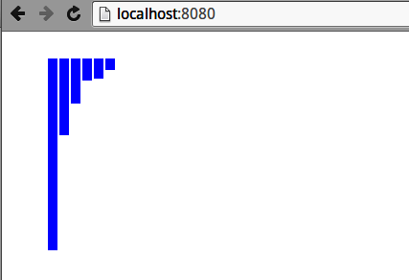

Figure A-1. Producing some bars with D3’s enter method
I’d encourage you generally to use Chrome’s (or equivalent) Elements tab to investigate the HTML your D3 is producing. Investigating our mini–bar chart with Elements shows Figure A-2.
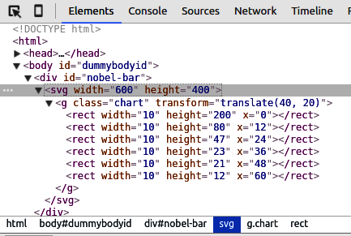

Figure A-2. Using the Elements tab to see the HTML generated by enter and append
So we’ve seen what happens when we call enter on an empty selection. But what happens when we already have a few bars, which we would have in an interactive chart with a user-driven, changing dataset?
Let’s add a couple of bar class rectangles to our starting HTML:
<
div
id
=
"nobel-bar"
>
<
svg
width
=
"600"
height
=
"400"
>
<
g
class
=
"chart"
transform
=
"translate(40, 20)"
>
<
rect
class
=
'bar'
></
rect
>
<
rect
class
=
'bar'
></
rect
>
</
g
>
</
svg
>
</
div
>
If we now perform the same data binding and entering as before, on calling data on our selection, the two placeholder rectangles bind to the first two members of our nobelData array (i.e., [{key: 'United States', value: 200}, {key: 'United Kingdom', value:80}]). This means that enter, which returns only unbound data placeholders, now returns only four placeholders, associated with the last four elements of the nobelData array:
var
svg
=
d3
.
select
(
'#nobel-bar .chart'
);
var
bars
=
svg
.
selectAll
(
'.bar'
)
.
data
(
nobelData
);
bars
=
bars
.
enter
();
#
return
four
placeholder
nodes
If we now call append on the entered bars, as before, we get the result shown in Figure A-3, showing the last four bars (note that they preserve their index i, used to set their x positions) rendered.
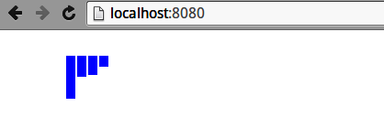

Figure A-3. Calling enter and append with existing bars
Figure A-4 shows the HTML generated for the last four bars. As we’ll see, the data from the first two elements is now bound to the two dummy nodes we added to the initial bar group. We just haven’t used it yet to adjust those rectangles’ attributes. Updating old bars with new data is the one of the key elements of the update pattern we’ll see shortly.
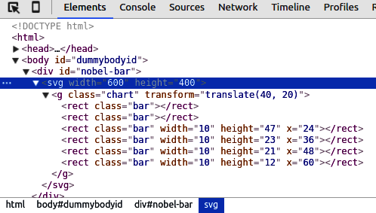

Figure A-4. Using the Elements tab to see the HTML generated by enter and append on a partial selection
To emphasize, coming to grips with enter and exit (and remove) is vital to healthy progress with D3. Play around a bit, inspect the HTML you’re producing, enter a bit of data, and generally get a bit messy, learning the ins and outs. Let’s have a little look at accessing the bound data before moving on to the D3’s nexus, the update pattern.

Accessing the Bound Data
A good way to see what’s happening to the DOM is to use your browser’s HTML inspector and console to track D3’s changes. In Figure A-1, we use Chrome’s console to look at the rect element representing the first bar in Figure A-3, before data has been bound and after the nobelData has been bound to the bars using the data method. As you can see, D3 has added a __data__ object to the rect element with which to store its bound data—in this case, the first member of our nobelData list. The __data__ object is used by D3’s internal bookkeeping and, fundamentally, the data in it is made available to functions supplied to update methods such as attr.
Let’s look at a little example of using the data in an element’s __data__ object to set its name attribute. The name attribute can be useful for making specific D3 selections. For example, if the user selects a particular country, we can now use D3 to get all its named components and adjust their style if needed. We’ll use the bar with bound data in Figure A-5 and set the name using the key property of its bound data:
let
bar
=
d3
.
select
(
'#nobel-bar .bar'
)
;
bar
.
attr
(
'name'
,
function
(
d
,
i
)
{
let
sane_key
=
d
.
key
.
replace
(
/ /g
,
'_'
)
;
console
.
log
(
'__data__ is: '
+
JSON
.
stringify
(
d
)
+
', index is '
+
i
)
return
'bar__'
+
sane_key
;
}
)
;
// console out:
// __data__ is: {"key":"United States","value":336}, index is 0
All D3 setter methods can take a function as their second argument. This function receives the data (d) bound to the selected element and its position in the data array (i).
We use a regular expression (regex) to replace all spaces in the key with underscores (e.g., United States → United_States).
This will set the bar’s name attribute to 'bar__United_States'.
All the setter methods listed in Figure 17-3 (attr, style, text, etc.) can take a function as a second argument, which will receive data bound to the element and the element’s array index. The return of this function is used to set the value of the property. As we’ll see, interactive visualizations’ changes to the visualized dataset will be reflected when we bind the new data and then use these functional setters to adapt attributes, styles, and properties accordingly.
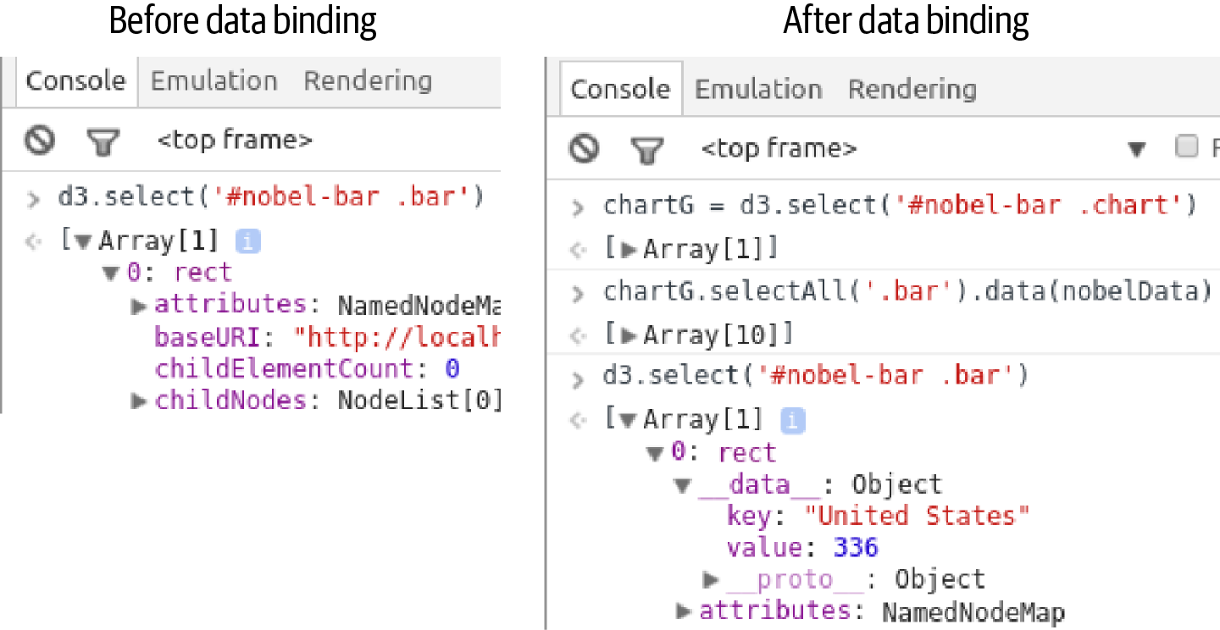

Figure A-5. Using the Chrome console to show the addition of a __data__ object after data binding using D3’s data method
Index

A
- adaptive resampling (in projections), Projections
- age and life expectancy of Nobel Prize winners, exploring with pandas, Age and Life Expectancy of Winners-The Nobel Diaspora
    - age at time of award, Age at Time of Award
    - increasing life expectancies over time, Increasing Life Expectancies over Time
    - life expectancy of winners, Life Expectancy of Winners-Increasing Life Expectancies over Time
- AJAX calls, Delivering Data Files
- aliasing in JavaScript imports, JavaScript Modules
- Anaconda, Python
    - installing free version, Anaconda
    - Requests library, Getting Web Data with the Requests Library
- animated transitions in data visualizations, A Bar Chart Showing Number of Winners by Country
- anonymous functions (JavaScript), Functional Array Methods and List Comprehensions
- append method (D3), Adding DOM Elements, Building the Category Selector, The enter Method
    - calling on existing bars, The enter Method
- apply method (JavaScript), Classes and Prototypes
- arcs (in SVG), Paths
- arcs (TopoJSON), TopoJSON
- arithmetic operators, use with NumPy arrays, A Few Basic Operations
- arrange method (NumPy), Creating Arrays
- arrays
    - functional array methods in JavaScript, Functional Array Methods and List Comprehensions
    - JavaScript
        - Array object, Nesting the Data
        - native functional iterator methods, Iterating: for Loops and Functional Alternatives
    - NumPy, Introduction to NumPy-A Few Basic Operations
        - arithmetic on, The NumPy Array
        - basic operations, A Few Basic Operations-A Few Basic Operations
        - creating, Creating Arrays
        - creating array functions, Creating Array Functions
        - indexing and slicing, Array Indexing and Slicing
        - methods, A Few Basic Operations
        - number of dimensions, shape, and numeric type, The NumPy Array
        - reshaping a one-dimensional array, The NumPy Array
    - of objects in JavaScript, Data Containers: dicts, objects, lists, Arrays
    - Python array slicing in DataFrame, Selecting Multiple Rows
    - of records, storing JSON DataFrame as, JSON
- array_equal method (NumPy), Array Indexing and Slicing
- arrow functions (JavaScript), Updating the Map
- as keyword (Python), Importing Modules, Including Scripts
- astype method, The NumPy Array
- attributes (SVG elements), Applying CSS Styles
- averages, calculating moving average for NumPy array, Calculating a Moving Average
- axes
    - adding in Matplotlib figure, Axes and Subplots
    - in D3 chart, Axes and Labels-Axes and Labels
    - D3 visualization of individual Nobel Prizes, Axes
    - in Matplotlib bar chart, Bar Charts

B
- backend engines for Matplotlib plots, Points, Not Pixels
- bar charts
    - building with D3, Introducing D3—​The Story of a Bar Chart
        - (see also D3 library)
    - Matplotlib, Bar Charts-Scatter Plots
        - grouped bar chart, Bar Charts
        - horizontal bars, Bar Charts
        - stacked bars, Bar Charts
    - showing number of Nobel Prize winners by country, A Bar Chart Showing Number of Winners by Country
    - stacked, Historical Trends
- Beautiful Soup (scraping tool), Beautiful Soup and lxml
    - getting the soup, Getting the Soup
    - selecting tags from parsed soup, Selecting Tags-Scraping the Winners’ Nationalities
- Bézier curves offered by SVG path element, Paths
- binary JSON (see BSON)
- bind method (JavaScript), Classes and Prototypes
- binning data, Historical Trends in Prize Distribution
- bins of data, Age at Time of Award
- bio-box
    - building for D3 visualization of individual Nobel Prize winners, Building the Bio-Box-Updating the Winners List
    - mini bio-box with pictures, A Mini-Biography Box with Picture
- the Black Python code formatter, Style Guidelines, PEP 8, and use strict
- block elements, Marking Up Content
- Boolean expressions
    - constructing for Boolean masks, Selecting Multiple Rows
    - using in Python to query MongoDB, MongoDB
- Boolean masks, Selecting Multiple Rows, Removing Rows
    - filtering rows in DataFrame with, Removing Duplicates
- Boolean operators
    - use in Python versus JavaScript, Booleans
    - use with NumPy arrays, A Few Basic Operations
- Bootstrap library (CSS), Choosing Visual Elements
- borders object, Paths
- box plots, Age at Time of Award
- BSON (binary JSON), MongoDB
- building a visualization, Building a Visualization-Summary
    - HTML skeleton, The HTML Skeleton-The HTML Skeleton
    - JavaScript
        - basic data flow, Basic Data Flow
        - core code, The Core Code-Initializing the Nobel Prize Visualization
        - filtering data with Crossfilter, Filtering Data with Crossfilter-Creating the filter
        - importing the scripts, Importing the Scripts
        - initializing the visualization, Initializing the Nobel Prize Visualization
        - modular JavaScript with imports, Modular JS with Imports
        - visualization app ready to go, Ready to Go
    - preliminaries
        - core components, Preliminaries
        - organizing your files, Organizing Your Files
        - serving the data, Serving the Data
    - running the Nobel Prize visualization app, Running the Nobel Prize Visualization App

C
- caching
    - of web pages being scraped, Caching the Web Pages
    - web page caching using Scrapy, Caching Pages
- call method (JavaScript), Classes and Prototypes
- calling context, reference to (see this keyword)
- CamelCase in variable names, CamelCase Versus Underscore, GeoJSON
- canvas element
    - 2D and 3D graphics contexts, Filling the Placeholders with Content
    - graphics contexts and more complicated graphics, Filling the Placeholders with Content
    - SVG graphics in, Filling the Placeholders with Content
    - WebGL context, Marking Up Content
- Cascading Style Sheets (see CSS)
- categorizing data and measurements, Categorizing Data and Measurements
- category selector (menu bar for D3 visualization), Building the Category Selector
- CDNs (content delivery networks), JavaScript, Importing the Scripts
- center method (D3 projection), Projections
- centroids, Adding Value Indicators
- chained operations, discouraged in pandas, Removing Duplicates
- Chrome
    - accessing the console, JavaScript
    - development tools, Browser with Development Tools
    - downloading, JavaScript
    - web developer kit, Tooling Up
- Chrome DevTools, Chrome DevTools-Other Tools
    - Elements tab, The Elements Tab
    - getting xpath of HTML elements, Targeting HTML with Xpaths
    - other tools, Other Tools
    - Sources tab, The Sources Tab
    - using Elements tab to inspect scraping targets, Establishing the Targets
- circles, creating in SVG, Circles
- classes, comparison to prototypes, Classes and Prototypes-Differences in Practice
- cleaning data, Coming Clean About Dirty Data
    - (see also pandas)
- clean_data function, full version, The Full clean_data Function
- closures
    - in JavaScript, JavaScript Closures and the Module Pattern
    - in Python, JavaScript Closures and the Module Pattern
- code examples from this book, Using Code Examples
- code linters in text editors, A Text-Editing Workhorse
- collections (Python), Collections
- colormaps (Matplotlib), Scatter Plots
- columns
    - adding born_in column to Nobel winners dataset in pandas, Adding the born_in column
    - DataFrame, Rows and Columns
    - Excel worksheet, parsing into DataFrame, Excel Files
    - pandas indexing, Indices and pandas Data Selection
- command prompt, Terminal or Command Prompt
- command-line shell (Scrapy), Testing Xpaths with the Scrapy Shell
- comments
    - comment tag form in HTML web page, The HTML Skeleton
    - syntax differences between Python and JavaScript, Comments and Doc-Strings
- commits (database), Adding Instances with a Session
- concat method (pandas), Finding Duplicates
- conda command
    - combining with pip installer and virtualenv command, Virtual Environments
    - creating and using virtual environments, Virtual Environments
- Conda command-line interface (Anaconda), Anaconda
- conditionals, differences in Python and JavaScript, Conditionals: if, else, elif, switch
- consoles (browser-based), JavaScript
- const keyword (JavaScript), The Core Code
- constants, The Core Code
- content delivery networks (CDNs), JavaScript, Importing the Scripts
- content-type of text/html, Getting Data Files with Requests
- controls, custom, adding to Plotly map, Adding Custom Controls with Plotly-Adding Custom Controls with Plotly
- coordinate reference system (CRS), GeoJSON
- Coordinated Universal Time (UTC), Dealing with Dates, Times, and Complex Data, Starting to Explore
- copies versus views in pandas, Removing Duplicates
- core components of web visualizations, Preliminaries
- CORS (Cross-Origin Resource Sharing), CORS
- Counter type (Python), Collections
- country selector (menu bar in D3 visualization), Adding the Country Selector
- Creative Commons license, Why We Need to Scrape
- Cross-Origin Resource Sharing (CORS), CORS
- Crossfilter, Filtering Data with Crossfilter-Creating the filter
- crossfiltered country dimension in menu bar for D3 visualization, Adding the Country Selector
- crs (coordinate reference system) member, GeoJSON type, GeoJSON
- CRUD (create, retrieve, update, delete), Using Python to Consume Data from a Web API
- CSS, The HTML Skeleton, CSS-CSS
    - adding circle fill color in SVG, Circles
    - adding to HTML document, The HTML Skeleton
    - applying CSS style inline on div tag, Marking Up Content
    - applying styles to HTML elements, CSS
    - Bootstrap library, detecting device size, Choosing Visual Elements
    - centering controls in Plotly chart and adapting font style, User-Driven Plotly with JavaScript and HTML
    - Chrome DevTools Elements tab, The Elements Tab
    - finding tags by CSS classes using Beautiful Soup, Selecting Tags
    - media property, adapting chart style to screen sizes, Adapting to Screen Sizes
    - precedence rules for applying styles, CSS
    - selectors, accessing with Beautiful Soup, Beautiful Soup and lxml
    - setting for DOM elements with D3, Working with Selections
    - setting look and feel for tooltip in D3 map, Building a Simple Tooltip
    - setting SVG visual styles with, Applying CSS Styles
    - sizing, positioning, and styling static chart for the web, Static Charts with Matplotlib
    - styles, applying to SVG elements, Applying CSS Styles
    - stylesheet for Nobel Prize web visualization, The HTML Skeleton
    - styling axes in D3 bar chart, Axes and Labels
    - styling basic map in D3, Putting the Elements Together
    - styling for basic web page, A Basic Page with Placeholders
    - styling for Nobel Prize web visualization, CSS Styling-CSS Styling
    - styling path in SVG, Paths
    - styling selected winners table for D3 visualization, Building the List
    - styling value indicators in D3 map, Adding Value Indicators
    - styling winner infobox for D3 visualization of individual Nobel Prize winners, Building the Bio-Box
    - SVG features which can and can't be set by, Applying CSS Styles
    - text editor for, A Text-Editing Workhorse
- CSV files, Part I: Basic Toolkit
    - creating and saving CSV DataFrame, CSV
    - creating from dictionary in Python, Working with System Files
    - reading in Python, CSV, TSV, and Row-Column Data Formats-CSV, TSV, and Row-Column Data Formats
- csv parameters for parsing CSV files, CSV, TSV, and Row-Column Data Formats
- curly braces ({})
    - delimiting code blocks in JavaScript, Significant Whitespace Versus Curly Brackets
    - enclosing function code block in JavaScript, Functions
    - using in JavaScript imports, JavaScript Modules

D
- d attribute (path element in SVG), Paths
- D3 library, Preface
    - adding DOM elements with, Adding DOM Elements-Adding DOM Elements
    - binding/joining data to DOM elements in D3, Accessing the Bound Data
    - built-in color schemes, The Core Code
    - converting JSON to JavaScript objects, Fetching JSON Files
    - data visualization using D3 and Plotly, Part V: Visualizing Your Data with D3 and Plotly
    - enter/exit pattern, D3’s enter/exit Pattern-The enter Method
        - enter method, The enter Method-The enter Method
    - frameworks and, The Myth of IDEs, Frameworks, and Tools
    - GML files and, Visualizing Social Media Networks
    - importing using script tag, Importing Modules, Including Scripts
    - introduction to, building a bar chart, Introducing D3—​The Story of a Bar Chart-Summary
        - axes and labels, Axes and Labels-Axes and Labels
        - framing the problem, Framing the Problem
        - leveraging D3, Leveraging D3
        - measuring up with D3 scales, Measuring Up with D3’s Scales-Ordinal Scales
        - putting the bar chart together, Putting the Bar Chart Together-Putting the Bar Chart Together
        - transitions, Transitions-Summary
        - unleashing power of D3 with data binding/joining, Unleashing the Power of D3 with Data Binding/Joining
        - updating the DOM with data, Updating the DOM with Data-Updating the DOM with Data
        - working with selections, Working with Selections-Working with Selections
    - mapping with, Mapping with D3-Summary
        - adding value indicators, Adding Value Indicators-Adding Value Indicators
        - available maps, Available Maps
        - building a simple tooltip, Building a Simple Tooltip-Updating the Map
        - completed map, Our Completed Map
        - geo library, projections and paths, D3 Geo, Projections, and Paths-graticules
        - mapping data formats, D3’s Mapping Data Formats-Converting Maps to TopoJSON
        - putting the elements together, Putting the Elements Together-Putting the Elements Together
        - updating the map, Updating the Map-Updating the Map
    - menu bar for Nobel Prize visualization, The Menu Bar-Summary
        - building the menu bar, Building the Menu Bar-Summary
    - programmatic manipulation of the DOM, The DOM
    - rollup method, Fetching JSON Files
    - style component, using to get CSS dimensions for elements and using parseInt function on, Adding DOM Elements
    - SVG graphics, Filling the Placeholders with Content
    - utility methods, using to load data and convert to JavaScript, Initializing the Nobel Prize Visualization
    - visualizing data with, Part V: Visualizing Your Data with D3 and Plotly
    - visualizing individual Nobel Prize winners, Visualizing Individual Winners-Summary
        - building a list of winners, Building the List-Building the List
        - building the bio-box, Building the Bio-Box-Updating the Winners List
    - visualizing individual Nobel Prizes, Visualizing Individual Prizes-Summary
        - adding winners with nested data-join, Adding the Winners with a Nested Data-Join-Adding the Winners with a Nested Data-Join
        - axes, Axes
        - building the framework, Building the Framework
        - category labels, Category Labels
        - improving transitions, A Little Transitional Sparkle
        - nesting the data, Nesting the Data
        - scales, Scales
        - updating the bar chart, Updating the Bar Chart
- data
    - cleaning and exploring with pandas, Part III: Cleaning and Exploring Data with pandas, Part III: Cleaning and Exploring Data with pandas
    - delivering, Part IV: Delivering the Data
    - getting, Part II: Getting Your Data
    - getting from the web using Python, Part II: Getting Your Data
    - for web pages, Data
- data binding in D3, Leveraging D3, Visualizing Individual Winners
    - accessing bound data, Accessing the Bound Data
    - binding mapData to a selection on countries group of class country, Updating the Map
    - binding mapData to the selection of all elements of class centroid, Adding Value Indicators
    - unleashing power of D3 with, Unleashing the Power of D3 with Data Binding/Joining
    - updating the DOM with data, Updating the DOM with Data
- data containers (dicts, objects, lists, arrays), Data Containers: dicts, objects, lists, Arrays
- data directory (MongoDB), Getting MongoDB Up and Running
- data exploration modules, standard, Starting to Explore
- data formats, Part I: Basic Toolkit
    - for web APIs, Using Python to Consume Data from a Web API
- data processing
    - future progress in Python and JavaScript, Future Progress
    - simple data processing example in Python versus JavaScript, Simple Data Processing
- data visualization (see dataviz)
- Data-Driven Documents (see D3 library)
- data-driven updates to a web visualization, Data-Driven Updates-Filtering Data with Crossfilter
- data-joins (in D3), Updating the DOM with Data-Updating the DOM with Data
    - adding winners to Nobel Prizes visualization with nested data-join, Adding the Winners with a Nested Data-Join-Adding the Winners with a Nested Data-Join
    - countries update with mouseenter and mouseout event handlers added, Building a Simple Tooltip
    - getting continuity during transitions, Transitions
    - joining array of categories to label group, Category Labels
- databases, Part I: Basic Toolkit, Databases-Easy MongoDB with Docker, Part I: Basic Toolkit
    - MongoDB
        - getting up and running, Getting MongoDB Up and Running
        - installation instructions, Databases
        - installing using Docker, Easy MongoDB with Docker
    - SQLite, Databases
        - creating for RESTful API, Creating the Database
- DataFrames, The DataFrame-Selecting Groups
    - changing, methods of, Indices and pandas Data Selection
    - column and row indexing, Indices and pandas Data Selection
    - combining Series into, Series into DataFrames-Summary
    - creating and saving, Creating and Saving DataFrames-MongoDB
        - CSV, CSV
        - Excel files, Excel Files
        - JSON, JSON
        - MongoDB document collections, MongoDB
        - SQL, SQL
    - creating from Nobel Prize winners dataset showing regional totals, Basic Charts
    - indices, Indices
    - inspecting data in, Inspecting the Data-Inspecting the Data
    - loading JSON data into, Coming Clean About Dirty Data, Starting to Explore
    - merging, Merging DataFrames
    - methods accessing rows/members, iloc and loc, Indices and pandas Data Selection
    - requirement for FacetGrids, FacetGrids
    - rows and columns, Rows and Columns
    - selecting groups, Selecting Groups-Selecting Groups
    - selecting multiple rows using array slicing, Selecting Multiple Rows
    - sort method, Sorting Data
    - use in Plotly Express charts, Plotly Express
- Dataset module (Python), easier SQL with, Easier SQL with Dataset
- datatypes, mixed, finding in columns using pandas, Finding Mixed Types
- dataviz, Preface
    - basic toolkit, Part I: Basic Toolkit, Part I: Basic Toolkit
    - benefits of pandas for, Why pandas Is Tailor-Made for Dataviz
    - future progress in Python and JavaScript, Future Progress
    - toolchain and transformative pipeline, The Second Edition
- dates and times
    - dealing with in Python and JavaScript, Dealing with Dates, Times, and Complex Data
    - dealing with when reading/writing JSON data in Python, Dealing with Dates and Times
    - dealing with when working with MongoDB in Python, MongoDB
    - handling with pandas, Dealing with Times and Dates-Dealing with Times and Dates
- datetime object (Python)
    - conversion to string and consumption by JavaScript, Dealing with Dates, Times, and Complex Data
    - converting JSON time string into datetime object, Dealing with Dates and Times
    - converting pandas objects to, Starting to Explore
    - creating from CSV file year column, CSV, TSV, and Row-Column Data Formats
- DatetimeIndex, Dealing with Times and Dates
- dateutil module (Python), Dealing with Dates, Times, and Complex Data
- debugging in Python, Integrated Development Environments
- decorators (Python), JavaScript Closures and the Module Pattern
- defaultdict type (Python), Collections
- delay method (D3), Transitions
- DELETE method (HTTP), Using Python to Consume Data from a Web API
- delivering data, Delivering the Data-Summary, Part IV: Delivering the Data
    - data files, Delivering Data Files-Delivering Data Files
        - delivering JSON to the browser, Delivering Data Files
    - serving the data, Serving the Data-Serving Data with Flask
        - organizing Flask files, Organizing Your Flask Files
- describe method (DataFrame), Inspecting the Data
- destructuring capabilities in JavaScript, Tuple Unpacking, Initializing the Nobel Prize Visualization, Nesting the Data
- development environment, Development Setup-Summary
    - databases, Databases-Easy MongoDB with Docker
    - getting source code, The Accompanying Code
    - integrated development environments, Integrated Development Environments
    - JavaScript, JavaScript-Databases
- devices, sizing visualizations for, CSS Styling
- dictionaries (dicts), Data Containers: dicts, objects, lists, Arrays
    - converting CSV rows to dictionaries, CSV, TSV, and Row-Column Data Formats
    - converting MongoDB collection into Python list of dictionaries, MongoDB
    - creating CSV file from dict in Python, Working with System Files
    - iteration by key, not by item, Iterating: for Loops and Functional Alternatives
    - specialized datatypes for handling in Python, Collections
- dictionary comprehension, Adding our RESTful API Routes
- DictReader class (Python), CSV, TSV, and Row-Column Data Formats
- DictWriter class (Python), CSV, TSV, and Row-Column Data Formats
- dimensions (NumPy arrays), The NumPy Array
- dirty data, Coming Clean About Dirty Data
- distribution plots, Age at Time of Award
- doc-strings (documentation strings) in Python, Comments and Doc-Strings
- Docker, installing MongoDB with, Easy MongoDB with Docker
- dollar sign ($) prefixing operators in MongoDB, MongoDB
- DOM (Document Object Model), The Big Picture
    - adding elements using D3, Adding DOM Elements-Adding DOM Elements
    - binding data to elements and changing them in D3, Visualizing Individual Winners
    - binding/joining data to DOM elements in D3, Unleashing the Power of D3 with Data Binding/Joining
    - cat-select DOM element for D3 visualization, Building the Category Selector
    - Chrome DevTools Elements tab, The Elements Tab
    - D3 transitions on existing elements, Transitions
    - manipulating for SVG element layering and transparency, Layering and Transparency
    - selecting and manipulating elements with D3, Working with Selections-Working with Selections
    - updating with data using D3, Updating the DOM with Data-Updating the DOM with Data
- domains
    - changing by data filtering for D3 bar chart axes, Axes and Labels
    - D3 Nobel Prize bar chart, Measuring Up with D3’s Scales
    - D3 visualization of individual Nobel Prizes, Scales
    - mapping from input domain to output range in D3 scales, Measuring Up with D3’s Scales
    - setting domain for D3 bar chart x-scale, Ordinal Scales
- dot notation (.)
    - accessing submodules in large libraries, Importing Modules, Including Scripts
    - in JavaScript method chaining, Method Chaining
    - in namespaces, Keeping Your Namespaces Clean
- dots-per-inch (dpi), Points, Not Pixels
- drop method (pandas DataFrame), Removing Rows, Removing Duplicates
- drop_duplicates method (pandas), Removing Duplicates, Merging DataFrames
- dtype object, Finding Mixed Types
    - specifying for columns in a dataset, Inspecting the Data
- duplicate data
    - finding duplicates using pandas, Finding Duplicates-Finding Duplicates
    - removing duplicates using pandas, Removing Duplicates-Removing Duplicates
- duplicated method (pandas), Finding Duplicates
- dy and dx attributes (SVG), Text

E
- ease method (D3), Transitions
- ECMAScript
    - import and export statements in ECMAScript 6, Importing Modules, Including Scripts
    - strict mode in ECMAScript 5, Style Guidelines, PEP 8, and use strict
- editors
    - JavaScript, JavaScript
    - online, for D3 code, Introducing D3—​The Story of a Bar Chart
- Elements tag (Chrome DevTools), The Elements Tab
- elif statements (Python), Conditionals: if, else, elif, switch
- elliptical arcs in SVG, Paths
    - flags used in, Paths
- else statements, Conditionals: if, else, elif, switch
- empty method, creating NumPy array, Creating Arrays
- enter method (D3), Unleashing the Power of D3 with Data Binding/Joining, Updating the DOM with Data, Adding the Winners with a Nested Data-Join, The enter Method-The enter Method
- entries method (JavaScript), Iterating: for Loops and Functional Alternatives
- enumerate function (Python), Enumerating a List
- equirectangular projection, Projections, Adding Value Indicators
- Excel files
    - loading and saving DataFrame to Excel sheet, Excel Files
    - loading and saving in DataFrames, Excel Files
- exit method (D3), Unleashing the Power of D3 with Data Binding/Joining, Updating the DOM with Data, Updating the Map
- explicit imports (Python), Importing Modules, Including Scripts
- export and import statements in ECMAScript 6, Importing Modules, Including Scripts

F
- FacetGrids, FacetGrids-FacetGrids
- feature method (topojson), D3 Geo, Projections, and Paths
- FeatureCollections (GeoJSON), GeoJSON, D3 Geo, Projections, and Paths
- Fetch API (JavaScript), Delivering Data Files
- fetch method (JavaScript), File Input and Output
- figures (Matplotlib), Figures and Object-Oriented Matplotlib
    - axes and subplots, Axes and Subplots
    - setting size, Starting to Explore
- file formats, Matplotlib plots, Saving Your Charts
- file input and output, File Input and Output
- files, organizing for Nobel Prize visualization project, Organizing Your Files
- FilesPipeline (Scrapy), Scraping Text and Images with a Pipeline
- fill property (SVG), Applying CSS Styles, Paths
- filter method (JavaScript), Functional Array Methods and List Comprehensions
- filter method (Python), Map, Reduce, and Filter with Python’s Lambdas
- filterByCategory method (JavaScript), Building the Category Selector
- filterByCountries function (JavaScript), Adding the Country Selector
- filtering data
    - in D3 bar chart, Axes and Labels
    - filters for database queries in RESTful API, Adding our RESTful API Routes
    - user filtering data in key dimensions, Menu Bar
    - using Crossfilter, Filtering Data with Crossfilter-Creating the filter
- find method (MongoDB), MongoDB
- fixed size for visualizations, Choosing Visual Elements
- Flask, Part IV: Delivering the Data, The Myth of IDEs, Frameworks, and Tools, Serving the Data-Serving Data with Flask
    - creating a RESTful API, RESTful Data with Flask-Summary, Part IV: Delivering the Data
        - deploying API remotely with Heroku, Deploying the API Remotely with Heroku-Consuming the API Using JavaScript
        - extending the API with MethodViews, Extending the API with MethodViews-Extending the API with MethodViews
        - Flask RESTful data server, A Flask RESTful Data Server-Serializing with marshmallow
        - tools for, The Tools for a RESTful Job
    - organizing Flask files, Organizing Your Flask Files
    - serving data with, Serving Data with Flask-Serving Data with Flask, Part IV: Delivering the Data
    - templating with Jinja2, Serving Data with Flask
- Flask-CORS library, CORS
- Flask-Marshmallow, using, Serializing with marshmallow
- Flask-SQLAlchemy, Adding our RESTful API Routes
- flex-boxes, Static Charts with Matplotlib
    - positioning and sizing web page content containers with, Positioning and Sizing Containers with Flex-Filling the Placeholders with Content
    - sizing static charts for different screens, Adapting to Screen Sizes
- float type (Python), Strings and Numbers
- floating-point numbers (JavaScript), Strings and Numbers
- for .. in loops (JavaScript), Iterating: for Loops and Functional Alternatives
- for loops, differences in Python and JavaScript, Iterating: for Loops and Functional Alternatives
- forceSimulation API (D3), Visualizing Social Media Networks
- forEach method (JavaScript), Iterating: for Loops and Functional Alternatives
- from keyword (Python), Importing Modules, Including Scripts
- from method (JavaScript Array), Nesting the Data
- functional methods in modern JavaScript, Iterating: for Loops and Functional Alternatives
- functions
    - array functions in NumPy, A Few Basic Operations
        - creating, Creating Array Functions
    - syntax differences in JavaScript and Python, Functions
- future progress in Python and JavaScript data visualization, Future Progress

G
- g (groups) element in SVG, The <g> Element, Working with Groups
- gcf (get current figure) method (pyplotlib), Configuring Matplotlib
- gender disparities in Nobel Prize winners, exploring, Gender Disparities-Historical Trends
    - historical trends, Historical Trends
- gender selector (menu bar for D3 visualization), Adding the Gender Selector
- geo2topo command-line utility, Converting Maps to TopoJSON
- GeoJSON, D3’s Mapping Data Formats
    - about, GeoJSON
    - conversion of TopoJSON maps to, D3 Geo, Projections, and Paths
    - converting maps to TopoJSON, Converting Maps to TopoJSON
- Geopy library, Mapping with Plotly
- GET method (HTTP), Using Python to Consume Data from a Web API, Consuming a RESTful Web API with Requests
- getting data off the web using Python, Getting Data Off the Web with Python-Summary
    - consuming data from web APIs using Python, Using Python to Consume Data from a Web API-Getting Country Data for the Nobel Dataviz
    - getting data with Requests library, Getting Web Data with the Requests Library-Getting Data Files with Requests
        - data files, Getting Data Files with Requests-Getting Data Files with Requests
    - parsing scraped data into the soup, Getting the Soup
    - scraping data, Scraping Data-Getting the Soup
    - selecting tags from data scraped by Beautiful Soup, Selecting Tags-Scraping the Winners’ Nationalities
    - using libraries to access web APIs, Using Libraries to Access Web APIs-Scraping Data
- GitHub repository for this book, The Accompanying Code
- GML format, Visualizing Social Media Networks
- Google spreadsheets, Using Google Spreadsheets-Using the Twitter API with Tweepy
- graph-objects (Plotly), Plotly Graph-Objects
    - mapping with, Mapping with Plotly
- graph-tool (Python), Visualizing Social Media Networks
- GraphML format, Visualizing Social Media Networks
- GraphQL, Using Python to Consume Data from a Web API
- graticules (d3.geo), Paths, Putting the Elements Together
- group method (D3), Nesting the Data
- groupby method (pandas), Finding Duplicates
- groups
    - g element in SVG, The <g> Element
    - grouped bar charts, Bar Charts
    - selecting in pandas DataFrames, Selecting Groups-Selecting Groups
    - unstacking in pandas bar chart, Unstacking Groups
- gspread library, Using Google Spreadsheets-Using the Twitter API with Tweepy
- GUI session for Matplotlib, Starting an Interactive Session

H
- head method (DataFrame), Inspecting the Data
- headers property (response object), Getting Data Files with Requests
- heatmaps, Historical Trends in Prize Distribution, The Nobel Diaspora
- Heroku, deploying RESTful API remotely via, Deploying the API Remotely with Heroku-Consuming the API Using JavaScript
- historical trends, exploring
    - gender of Nobel Prize winners, Historical Trends-Historical Trends
    - nationality of Nobel Prize winners, Historical Trends in Prize Distribution-Historical Trends in Prize Distribution
- horizontal bar charts, Bar Charts
    - adapting for web presentation, Static Charts with Matplotlib
- HTML
    - chart container for native JavaScript chart in Plotly, Native JavaScript Charts with Plotly
    - Chrome DevTools Elements tab, The Elements Tab
    - conversion into DOM, The DOM
    - creating HTML elements with D3, Creating HTML Elements with D3
    - dropdown (select) for Plotly chart, User-Driven Plotly with JavaScript and HTML
    - embeddable, generating with Plotly for charts, From Notebook to Web with Plotly
    - getting dimensions of bounding box of elements, Adding DOM Elements
    - html method of D3, Working with Selections
    - markup of web page content, Marking Up Content-CSS
    - for metric radio button in D3 visualization menu bar, Wiring Up the Metric Radio Button
    - returned from HTTP request, Getting Data Files with Requests
    - single-page HTML form, The HTML Skeleton
    - skeleton for basic web page, A Basic Page with Placeholders
    - skeleton for bio-box for Nobel Prize winners in D3 visualization, Building the Bio-Box
    - skeleton for menu bar in D3 Nobel Prize visualization, Building the Menu Bar
    - skeleton for Nobel Prize web visualization, The HTML Skeleton-The HTML Skeleton
    - skeleton for web visualizations, The HTML Skeleton
    - starting template, minimal, The HTML Skeleton
    - targeting with xpaths, Targeting HTML with Xpaths-Selecting with Relative Xpaths
    - templating with Jinja2 in Flask, Serving Data with Flask
    - text editor for, A Text-Editing Workhorse
    - for tooltip in D3 map, Building a Simple Tooltip
- HTTP, The Big Picture
    - POST, GET, PUT, and DELETE methods, Using Python to Consume Data from a Web API
    - requests, Getting Web Data with the Requests Library, The Tools for a RESTful Job
        - (see also Requests library)
    - responses, Getting Data Files with Requests
    - serving web pages with, Serving Pages with HTTP
    - status codes, Getting Data Files with Requests
- HTTP methods
    - encapsulation in MethodViews, Extending the API with MethodViews
- http module (Python), JavaScript
    - built-in web server, running locally, Serving Pages with HTTP
- http.server module (Python), Serving the Data

I
- IDEs (Intelligent Development Environments), Integrated Development Environments, The Myth of IDEs, Frameworks, and Tools
- if statements, Conditionals: if, else, elif, switch
- iloc method, Indices and pandas Data Selection
- images
    - remote, using with Matplotlib static charts, Using Remote Images or Assets
    - scraping with a Scrapy pipeline, Scraping Text and Images with a Pipeline-Scraping Text and Images with a Pipeline
- ImagesPipeline (Scrapy), Scrapy Pipelines, Scraping Text and Images with a Pipeline
- imagining a visualization (Nobel Prize dataset), Imagining a Nobel Visualization-Summary
    - bar chart showing winners by country, A Bar Chart Showing Number of Winners by Country
    - complete visualization, The Complete Visualization
    - identifying the audience, Who Is It For?
    - list of selected winners, A List of the Selected Winners-A Mini-Biography Box with Picture
    - map showing selected countries of winners, A Map Showing Selected Nobel Countries
    - menu bar, Menu Bar
    - prizes by year, Prizes by Year
    - visual elements, choosing, Choosing Visual Elements
- import and export statements in ECMAScript 6, Importing Modules, Including Scripts
- imports
    - import keyword in Python, Importing Modules, Including Scripts
    - importing modules, including scripts, Importing Modules, Including Scripts
    - importing NumPy, The NumPy Array
- indentation levels (configurable) for different languages, A Text-Editing Workhorse
- index.html file for Nobel Prize single-page visualization, The HTML Skeleton-The HTML Skeleton
- indexing NumPy arrays, Array Indexing and Slicing
- indices
    - changing rows by numeric index in pandas, Removing Duplicates
    - index in Matplotlib figure used to select axis by row, Axes and Subplots
    - mapping array of indices to a continuous range, to provide bars' x-coordinates, Ordinal Scales
    - and pandas data selection, Indices and pandas Data Selection-Selecting Multiple Rows
    - pandas DataFrames, Indices
    - pandas Series, Series into DataFrames
    - Series full-range index of years for Nobel Prize, Historical Trends
- inheritance
    - class inheritance in Python, Classes and Prototypes
    - prototypes in JavaScript, Classes and Prototypes
- __init__ method (Python), Classes and Prototypes
- inline elements, Marking Up Content
- inline plots (Matplotlib), Starting an Interactive Session
- insert method (D3), Adding DOM Elements
- int type (Python), Strings and Numbers
- integer division operator (//) in Python 3, Prizes by Category
- Intelligent Development Environments (see IDEs)
- interpolate method (D3), Quantitative Scales
- interpreters
    - Python, Python
    - running on terminal or command prompt, Terminal or Command Prompt
- intrapackage references (Python imports), Importing Modules, Including Scripts
- IPython, Python
    - Jupyter notebooks collection, Machine-Learning Visualizations
    - use in Matplotlib interactive session, Starting an Interactive Session
- isin method (pandas), Finding Duplicates
- isnull method, Removing Rows
- ISO (International Standard Organization) 8601 time format, Dealing with Dates, Times, and Complex Data
    - converting JavaScript Date to, Dealing with Dates, Times, and Complex Data
- Item class (Scrapy), A First Scrapy Spider, Yielding Requests
    - declaring Item to hold scraped data, Scraping Text and Images with a Pipeline
- iterating, for loops and functional alternatives in Python and JavaScript, Iterating: for Loops and Functional Alternatives
- iterrows method (pandas), Dealing with Times and Dates

J
- JavaScript, Preface, JavaScript-Databases, A Language-Learning Bridge Between Python and JavaScript, JavaScript
    - adding to HTML document, The HTML Skeleton
    - consuming API deployed remotely with Heroku, Consuming the API Using JavaScript
    - delivering code to browser using a CDN, JavaScript
    - differences from Python, Similarities and Differences
    - differences in practice from Python, Differences in Practice-JavaScript Closures and the Module Pattern
        - closures and the module pattern, JavaScript Closures and the Module Pattern
        - enumerating a list, Enumerating a List
        - functional array methods and list comprehensions, Functional Array Methods and List Comprehensions
        - method chaining, Method Chaining
        - replicating Python collections functionality with Underscore, Underscore
        - tuple unpacking, Tuple Unpacking
    - differences in syntax from Python, Basic Bridge Work-Differences in Practice
        - Booleans, Booleans
        - CamelCase versus underscore, CamelCase Versus Underscore
        - classes and prototypes, Classes and Prototypes-Differences in Practice
        - comments and doc-strings, Comments and Doc-Strings
        - conditionals (if, else, elif, switch), Conditionals: if, else, elif, switch
        - data transformation, simple example, Simple Data Processing
        - declaring variables using let or var in JavaScript, Declaring Variables Using let or var
        - dicts, objects, lists, arrays, Data Containers: dicts, objects, lists, Arrays
        - file input and output, File Input and Output
        - functions, Functions
        - importing modules, including scripts, Importing Modules, Including Scripts
        - iterations, for loops and functional alternatives, Iterating: for Loops and Functional Alternatives
        - keeping namespaces clean, Keeping Your Namespaces Clean
        - modules, JavaScript Modules
        - significant whitespaces versus curly brackets, Significant Whitespace Versus Curly Brackets
        - string construction, String Construction
        - strings and numbers, Strings and Numbers
        - style guidelines, PEP 8 and use strict, Style Guidelines, PEP 8, and use strict
    - embeddable, generating with Plotly to transfer charts to the web, From Notebook to Web with Plotly-From Notebook to Web with Plotly
    - Fetch API delivering Promise, Delivering Data Files
    - frameworks, The Myth of IDEs, Frameworks, and Tools
    - functional alternatives to for loops, Iterating: for Loops and Functional Alternatives
    - future progress in data processing and visualization, Future Progress
    - installing libraries locally, Installing Libraries Locally
    - integrated development environments, Integrated Development Environments
    - interacting with the code, JavaScript-JavaScript
    - JavaScript-based D3 library, Preface
    - native JavaScript charts with Plotly, Native JavaScript Charts with Plotly-Fetching JSON Files
    - native JavaScript controls to manipulate Plotly chart, User-Driven Plotly with JavaScript and HTML-Summary
    - for Nobel Prize web visualization, The HTML Skeleton, The JavaScript Engine-Running the Nobel Prize Visualization App
        - basic data flow, Basic Data Flow
        - core code, The Core Code-Initializing the Nobel Prize Visualization
        - data-driven updates, Data-Driven Updates-Filtering Data with Crossfilter
        - filtering data with Crossfilter, Filtering Data with Crossfilter-Creating the filter
        - importing the scripts, Importing the Scripts
        - initializing the visualization, Initializing the Nobel Prize Visualization
        - modular JavaScript with imports, Modular JS with Imports
        - ready to go, Ready to Go
    - raw data and, Preface
    - similarities to Python, Similarities and Differences
    - Sources tab of Chrome DevTools, The Sources Tab
    - string representation of Python datetime passed to, Dealing with Dates, Times, and Complex Data
    - SVG creation via, JavaScripted SVG
    - text editor for, A Text-Editing Workhorse
    - translating basic operations between Python and JavaScript, cheat sheet for, A Cheat Sheet
- JavaScript Object Notation (see JSON)
- Jinja2 templating language, Serving Data with Flask
- join method (D3), Introducing D3—​The Story of a Bar Chart, Updating the DOM with Data-Updating the DOM with Data, Adding the Winners with a Nested Data-Join
    - (see also data-joins)
- join method (Python), Working with System Files
- joining data in D3, Unleashing the Power of D3 with Data Binding/Joining
- joins, FULL_OUTER_JOIN, Merging DataFrames
- jQuery, Method Chaining
    - programmatic manipulation of the DOM, The DOM
- JSON, Part I: Basic Toolkit
    - conversion of Scrapy items to, A First Scrapy Spider
    - converting dataset to and pasting in JavaScript file, Native JavaScript Charts with Plotly
    - creating and saving JSON DataFrame, JSON
    - data format for web APIs, Using Python to Consume Data from a Web API
    - data format for web visualizations, Data
    - exporting DataFrame to JSON and passing it to JavaScript for processing, Fetching JSON Files
    - JSON-based geometric data formats, D3’s Mapping Data Formats
    - saving cleaned datasets to, Saving the Cleaned Datasets
    - writing and reading using Python json module, JSON-Dealing with Dates and Times
        - dealing with dates and times, Dealing with Dates and Times
- json.dumps method, Dealing with Dates and Times
- JSON.stringify method, Delivering Data Files
- Jupyter notebooks, Preface, Python
    - collection of IPython Jupyter notebooks, Machine-Learning Visualizations
    - showing key elements of pandas DataFrame, The DataFrame
    - starting, Python
    - use as Python dataviz sketchbook, Tooling Up
    - using in interactive Matplotlib session, Starting an Interactive Session

K
- kernel density estimates (KDEs), Age at Time of Award, Life Expectancy of Winners

L
- labels
    - axes labels in D3 chart, Axes and Labels-Axes and Labels
        - format of tick labels changing with chosen metric, Axes and Labels
        - reoriented tick labels on x-axis, Axes and Labels
        - x-axis tick labels in visualization of individual Nobel Prizes, Axes
    - axes labels in Matplotlib plots, Titles and Axes Labels
    - category legend for D3 visualization of individual Nobel Prizes, Category Labels
    - labeling last of shared x-axes in Matplotlib subplot, Axes and Subplots
    - labels and legends in Matplotlib plots, Labels and Legends
    - reducing number of x-axis labels in pandas plot, Historical Trends
- lambdas (Python), map, reduce, and filter with, Map, Reduce, and Filter with Python’s Lambdas
- lattice or trellis plotting (see FacetGrids)
- layering SVG elements, Layering and Transparency
- legends, Labels and Legends
    - (see also labels)
- let keyword (JavaScript)
    - declaring variables with, Declaring Variables Using let or var
    - using in preference to var, Keeping Your Namespaces Clean
- life expectancy of Nobel Prize winners, exploring with pandas, Life Expectancy of Winners-Increasing Life Expectancies over Time
- line chart, creating from DataFrame using Plotly Express, Plotly Express
- linear scale, Quantitative Scales
- lines (in SVG), Lines, Rectangles, and Polygons
- linespace method (NumPy), Creating Arrays
- linters in text editors, A Text-Editing Workhorse
- Linux
    - activating Python virtual environment, Virtual Environments
    - installing Anaconda, Anaconda
    - installing MongoDB, Getting MongoDB Up and Running
- lists, Data Containers: dicts, objects, lists, Arrays
    - building list of Nobel Prize winners for D3 visualization, Building the List-Building the List
    - enumerating, Enumerating a List
    - list comprehensions in JavaScript and Python, Functional Array Methods and List Comprehensions
    - updating Nobel Prize winners list in D3 visualization, Updating the Winners List
- lmplot method, FacetGrids, Increasing Life Expectancies over Time
- loc method, Indices and pandas Data Selection
- logging module (Python), String Construction
- lxml (scraping tool), Beautiful Soup and lxml
    - CSS selectors, Selecting Tags
    - filters for finding tags in Beautiful Soup, Selecting Tags

M
- machine learning visualizations, Machine-Learning Visualizations
- macOS
    - activating Python virtual environment, Virtual Environments
    - installing Anaconda, Anaconda
- magic commands, Starting an Interactive Session
    - %matplotlib, Starting to Explore
- map method (JavaScript), Functional Array Methods and List Comprehensions
- map method (Python), Map, Reduce, and Filter with Python’s Lambdas
- map showing selected Nobel countries, A Map Showing Selected Nobel Countries
- Mapbox, Mapping with Plotly
- mapping style tile-sets (Plotly), Mapping with Plotly
- mapping with D3, Mapping with D3-Summary
    - adding value indicators, Adding Value Indicators-Adding Value Indicators
    - available maps, Available Maps
    - building a simple tooltip, Building a Simple Tooltip-Updating the Map
    - completed map, Our Completed Map
    - d3.geo library, projections and paths, D3 Geo, Projections, and Paths-graticules
        - graticules, graticules
        - paths, Paths
        - projections, Projections-Projections
    - mapping data formats, D3’s Mapping Data Formats-Converting Maps to TopoJSON
        - converting maps to TopoJSON, Converting Maps to TopoJSON
        - GeoJSON, GeoJSON
        - TopoJSON, TopoJSON-TopoJSON
    - putting the elements together, Putting the Elements Together-Putting the Elements Together
    - updating the map, Updating the Map-Updating the Map
- mapping with Plotly, Mapping with Plotly-Mapping with Plotly
    - adding custom controls to the map, Adding Custom Controls with Plotly-Adding Custom Controls with Plotly
- margin object, Adding DOM Elements
- marking up web page content, Marking Up Content-CSS
- marshmallow library, Serializing with marshmallow
- math
    - NumPy array math functions, A Few Basic Operations
    - NumPy array math operations, A Few Basic Operations
- Matplotlib, Preface, Part V: Visualizing Your Data with D3 and Plotly, Visualizing Data with Matplotlib, Machine-Learning Visualizations
    - changing style before plotting charts, Starting to Explore
    - figures and object-oriented Matplotlib, Figures and Object-Oriented Matplotlib
        - axes and subplots, Axes and Subplots
    - interactive plotting with pyplot's global state, Interactive Plotting with pyplot’s Global State-Figures and Object-Oriented Matplotlib
        - configuring Matplotlib, Configuring Matplotlib
        - points, not pixels measuring figure size, Points, Not Pixels
        - saving the charts, Saving Your Charts
        - setting figure size, Setting the Figure’s Size
        - titles and axes labels, Titles and Axes Labels
    - plot types, Plot Types-Adding a regression line
        - bar charts, Bar Charts-Scatter Plots
    - pyplot and object-oriented Matplotlib, pyplot and Object-Oriented Matplotlib
    - seaborn library, seaborn-PairGrids
        - FacetGrids, FacetGrids-FacetGrids
        - PairGrids, PairGrids-PairGrids
    - starting an interactive session, Starting an Interactive Session
    - static charts with, Static Charts with Matplotlib-Charting with Plotly
        - adapting to screen sizes, Adapting to Screen Sizes
        - using remote images or assets, Using Remote Images or Assets
- matrix transform (SVG), Scaling and Rotating
- max method (D3), Quantitative Scales
- measurements, categorical and numerical, Categorizing Data and Measurements
- media property (CSS), Adapting to Screen Sizes
- menu bar, Choosing Visual Elements, Menu Bar
    - creating for D3 Nobel Prize visualization, The Menu Bar-Summary
        - category selector, Building the Category Selector
        - country selector, Adding the Country Selector
        - creating HTML elements with D3, Creating HTML Elements with D3
        - gender selector, Adding the Gender Selector
        - HTML skeleton, Building the Menu Bar
        - wiring up the metric radio button, Wiring Up the Metric Radio Button
- merging DataFrames, Merging DataFrames
- mesh method (topojson), D3 Geo, Projections, and Paths
- method chaining, Method Chaining
- MethodViews, Extending the API with MethodViews-Extending the API with MethodViews
- mini-biography box with pictures (Nobel Prize winners), A Mini-Biography Box with Picture
- missing fields, Inspecting the Data
    - dealing with using pandas, Dealing with Missing Fields-Dealing with Missing Fields
- modules
    - importing in JavaScript and Python, Importing Modules, Including Scripts
    - JavaScript
        - importing and exporting, JavaScript Modules
        - pattern for encapsulated module, Keeping Your Namespaces Clean
    - module pattern in JavaScript, JavaScript Closures and the Module Pattern
- MongoDB, Databases
    - creating utility functions to convert to/from MongoDB and DataFrames, MongoDB
    - getting up and running, Getting MongoDB Up and Running
    - installing using Docker, Easy MongoDB with Docker
    - loading and saving document collection into DataFrames, MongoDB
    - working with in Python, MongoDB-Dealing with Dates, Times, and Complex Data
        - creating database and inserting target dataset, MongoDB
        - creating utility function to access database, MongoDB
        - dealing with dates and times, MongoDB
        - querying the database, MongoDB
        - using constants to access MongoDB, MongoDB
- monkey patching, Caching the Web Pages
- mouseenter callback function, Our Completed Map, Building a Simple Tooltip
- mousein callback function, Building a Simple Tooltip
- mouseout callback function, Our Completed Map, Building a Simple Tooltip
- moving_average function (NumPy), creating, Calculating a Moving Average
- multidimensional arrays (NumPy)
    - indexing and slicing, Array Indexing and Slicing
    - use by other specialized libraries, Introduction to NumPy

N
- namespaces, keeping clean, Keeping Your Namespaces Clean
- NaN
    - replacing empty strings with, using pandas, Replacing Strings
    - replacing missing fields or empty strings in data with, Inspecting the Data
- NaT (not a time), Dealing with Times and Dates
- national trends in Nobel Prize winners, National Trends-Historical Trends in Prize Distribution
    - historical trends, Historical Trends in Prize Distribution-Historical Trends in Prize Distribution
    - movement of prize winners from country of birth to adopted country, The Nobel Diaspora
    - prize winners per capita, Prize Winners Per Capita-Prize Winners Per Capita
    - prizes by category, Prizes by Category-Historical Trends in Prize Distribution
- Navigator GUI (Anaconda), Anaconda
- nesting data in D3, Nesting the Data-Nesting the Data
    - nested data-join, Adding the Winners with a Nested Data-Join-Adding the Winners with a Nested Data-Join
- NetworkX package ( Python), Visualizing Social Media Networks
- new operator (JavaScript), Classes and Prototypes
    - use with this keyword, Classes and Prototypes
- nominal category, Categorizing Data and Measurements
- Nominatim, Mapping with Plotly
- nonlocal keyword (Python), JavaScript Closures and the Module Pattern
- notebook (.ipynb) files, Tooling Up
- null fields, checking for in pandas, Removing Rows
- numbers, differences in Python and JavaScript, Strings and Numbers
- numeric type (NumPy arrays), The NumPy Array
    - 64-bit integer type, The NumPy Array
    - changing with astype method, The NumPy Array
    - dtype (default type), Creating Arrays
- NumPy, Strings and Numbers, Introduction to NumPy
    - about, Introduction to NumPy
    - arrays, Introduction to NumPy-A Few Basic Operations
        - arithmetic on, The NumPy Array
        - basic operations with, A Few Basic Operations-A Few Basic Operations
        - creating, Creating Arrays
        - creating array functions, Creating Array Functions
        - indexing and slicing, Array Indexing and Slicing
        - number of dimensions, shape, and numeric type, The NumPy Array
        - reshaping a one-dimensional array, The NumPy Array
    - merging and importing with pyplot, Starting an Interactive Session
    - pandas and, Why pandas Was Developed
    - polyfit function, Adding a regression line
    - random module, Removing Duplicates
    - use of arrays for homogeneous, numerical number crunching, Categorizing Data and Measurements

O
- object type, Starting to Explore
- object-oriented Matplotlib
    - figures and, Figures and Object-Oriented Matplotlib
    - pyplot and, pyplot and Object-Oriented Matplotlib
- ObjectIds (MongoDB), MongoDB
- objects, Data Containers: dicts, objects, lists, Arrays
    - iterating over key-value pairs in JavaScript, Iterating: for Loops and Functional Alternatives
    - simple JavaScript object, Classes and Prototypes
- objects object (TopoJSON), TopoJSON
- OECD (Organisation for Economic Cooperation and Development) web API, Consuming a RESTful Web API with Requests
- on method (D3), Visualizing Individual Winners, Building the Category Selector
- onDataChange method (JavaScript), Data-Driven Updates, Adding the Winners with a Nested Data-Join, Building the List, Building the Category Selector
- ones method (NumPy), Creating Arrays
- opacity property (CSS), Updating the Map
- opacity property (SVG), Applying CSS Styles, Layering and Transparency
- OpenGL visualizations, Marking Up Content
- openpyxl module (Python), Excel Files
- option tags (HTML), Building the Category Selector
- OrderedDict type (Python), Collections, Easier SQL with Dataset
- ordinal scales, Ordinal Scales, Scales, Adding the Winners with a Nested Data-Join
- OS X, installing MongoDB, Getting MongoDB Up and Running

P
- packages, building in Python, Importing Modules, Including Scripts
- padding method (D3 scales), Ordinal Scales
- pagination, data returns from RESTful API, Paginating the Data Returns-Paginating the Data Returns
- PairGrids, PairGrids-PairGrids
- pandas, Preface, Consuming a RESTful Web API with Requests
    - cleaning and exploring data with, Part III: Cleaning and Exploring Data with pandas, Part III: Cleaning and Exploring Data with pandas
    - cleaning data with, Cleaning Data with pandas-Summary
        - adding born_in column to Nobel winners dataset, Adding the born_in column
        - clean_data function, The Full clean_data Function
        - dates and times, Dealing with Times and Dates-Dealing with Times and Dates
        - finding duplicates, Finding Duplicates-Finding Duplicates
        - finding mixed types, Finding Mixed Types
        - indices and pandas data selection, Indices and pandas Data Selection-Selecting Multiple Rows
        - inspecting data in a DataFrame, Inspecting the Data-Inspecting the Data
        - loading dirty data into a DataFrame, Coming Clean About Dirty Data
        - missing fields, Dealing with Missing Fields-Dealing with Missing Fields
        - removing duplicates, Removing Duplicates-Removing Duplicates
        - removing rows, Removing Rows
        - sorting data, Sorting Data
    - exploring data with, Exploring Data with pandas-Summary
        - age and life expectancy of Nobel Prize winners, Age and Life Expectancy of Winners-The Nobel Diaspora
        - cleaned Nobel Prize dataset, Exploring Data with pandas
        - diaspora of Nobel Prize winners, The Nobel Diaspora
        - gender disparities in Nobel Prize winner dataset, Gender Disparities-Historical Trends
        - national trends in Novel Prize winners, National Trends-Historical Trends in Prize Distribution
        - plotting with pandas, Plotting with pandas
        - starting to explore, Starting to Explore-Starting to Explore
        - stories to investigate in Nobel Prize dataset, Exploring Data with pandas
    - introduction to, Introduction to pandas-Summary
        - benefits of pandas for dataviz, Why pandas Is Tailor-Made for Dataviz
        - categorizing data and measurements, Categorizing Data and Measurements
        - combining Series into DataFrames, Series into DataFrames-Summary
        - creating and saving DataFrames, Creating and Saving DataFrames-MongoDB
        - DataFrames, The DataFrame-Selecting Groups
    - use with Matplotlib, Starting an Interactive Session
    - using with gspread data, Using Google Spreadsheets
- Panel (pandas), to_excel method, Excel Files
- panes (multiple) in text editors, A Text-Editing Workhorse
- parameters, Functions
- parseInt function (D3), Adding DOM Elements
- parsers
    - JSON, JSON
    - reading HTML text returned from HTTP response, Getting Data Files with Requests
- PATCH method (HTTP), Posting Data to the API
- paths (geographic, in D3), Paths, Putting the Elements Together
    - path.centroid method, Adding Value Indicators
- paths, creating in SVG, Paths
- pattern-matching, A First Scrapy Spider
    - (see also regular expressions)
- pattern-matching conditional (Python 3.10), Conditionals: if, else, elif, switch
- PEP (Python Enhancement Proposal), version 8, Style Guidelines, PEP 8, and use strict
- period_range method (pandas), Interactive Plotting with pyplot’s Global State
- permutation method (NumPy random module), Removing Duplicates
- pip installer, Anaconda
    - installing Python libraries to virtual environment, Virtual Environments
    - installing Requests library, Getting Web Data with the Requests Library
    - virtualenv command, Virtual Environments
- Pip Installs Python (see pip installer)
- pipelines (Scrapy)
    - defining, Scrapy Pipelines
    - registering to settings.py module for the project, Scrapy Pipelines
    - scraping images with image pipeline, Scraping Text and Images with a Pipeline
    - scraping text and images with a pipeline, Scraping Text and Images with a Pipeline-Summary
        - specifying pipelines with multiple spiders, Specifying Pipelines with Multiple Spiders
- pixels, sizes and densities on different devices, CSS Styling
- placeholders
    - elements for basic web page, A Basic Page with Placeholders
    - filling with content, Filling the Placeholders with Content-Filling the Placeholders with Content
    - HTML for visual elements in Nobel Prize visualization, The HTML Skeleton
- Plotly charting library, Part V: Visualizing Your Data with D3 and Plotly, Charting with Plotly-Adding Custom Controls with Plotly
    - adding custom controls with, Adding Custom Controls with Plotly-Adding Custom Controls with Plotly
    - basic charts, Basic Charts
    - dynamic/interactive elements in charts, Charting with Plotly
    - graph-objects, Plotly Graph-Objects
    - mapping with, Mapping with Plotly-Mapping with Plotly
    - Plotly Express, Plotly Express
    - producing native JavaScript charts with, Native JavaScript Charts with Plotly-Fetching JSON Files
    - transferring charts from notebook to web, From Notebook to Web with Plotly-From Notebook to Web with Plotly
    - user-driven Plotly with JavaScript and HTML, User-Driven Plotly with JavaScript and HTML-Summary
    - visualizing data with, Part V: Visualizing Your Data with D3 and Plotly
- plotting with pandas, Plotting with pandas
    - (see also Matplotlib)
    - types of plots, Plotting with pandas
- PNG (portable network graphics) format, Saving Your Charts, Static Charts with Matplotlib
- pointer method (D3), Building a Simple Tooltip
- polyfit function (NumPy), Adding a regression line
- polygons in SVG graphics, Lines, Rectangles, and Polygons
- positioning web page elements, A Basic Page with Placeholders
- POST method (HTTP), Using Python to Consume Data from a Web API, Consuming a RESTful Web API with Requests, Posting Data to the API
- posting data to RESTful API, Posting Data to the API
- primary key, Creating the Database
- print function (Python), using logging module instead of, String Construction
- projections (map), Projections-Projections, Adding Value Indicators
    - setting projection for a path, Paths
- projects
    - project directory for web visualization, Organizing Your Files
    - starting using Scrapy, Setting Up Scrapy
- Promise.all method (JavaScript), Ready to Go
- Promises (JavaScript), Delivering Data Files
- properties
    - getting for DOM elements with D3, Working with Selections
    - setting for DOM elements with D3, Working with Selections
- prototypes, comparison to classes, Classes and Prototypes-Differences in Practice
- PUT method (HTTP), Using Python to Consume Data from a Web API
- PyCharm IDE, Integrated Development Environments
- PyDev IDE, Integrated Development Environments
- pyplot module, pyplot and Object-Oriented Matplotlib
    - figure method, Figures and Object-Oriented Matplotlib
    - interactive plotting with pyplot's global state, Interactive Plotting with pyplot’s Global State-Figures and Object-Oriented Matplotlib
        - setting figure size, Setting the Figure’s Size
    - merging and importing with NumPy, Starting an Interactive Session
- Python, Preface, A Language-Learning Bridge Between Python and JavaScript
    - data manipulation with, Delivering the Data
    - data wrangling and data visualization capabilities, skills in, Final Thoughts
    - differences from JavaScript, Similarities and Differences
    - differences in practice from JavaScript, Differences in Practice-JavaScript Closures and the Module Pattern
        - closures, JavaScript Closures and the Module Pattern
        - collections, Collections
        - enumerating a list, Enumerating a List
        - list comprehensions, Functional Array Methods and List Comprehensions
        - map, reduce, and filter with Python lambdas, Map, Reduce, and Filter with Python’s Lambdas
        - method chaining, Method Chaining
        - tuple unpacking, Tuple Unpacking
    - differences in syntax from JavaScript, Basic Bridge Work-Differences in Practice
        - Booleans, Booleans
        - CamelCase versus underscore, CamelCase Versus Underscore
        - classes and prototypes, Classes and Prototypes-Differences in Practice
        - comments and doc-strings, Comments and Doc-Strings
        - conditionals (if, else, elif, switch), Conditionals: if, else, elif, switch
        - data transformation, simple example, Simple Data Processing
        - dicts, objects, lists, arrays, Data Containers: dicts, objects, lists, Arrays
        - file input and output, File Input and Output
        - functions, Functions
        - importing modules, including scripts, Importing Modules, Including Scripts
        - iterations, for loops and functional alternatives, Iterating: for Loops and Functional Alternatives
        - keeping namespaces clean, Keeping Your Namespaces Clean
        - significant whitespaces versus curly brackets, Significant Whitespace Versus Curly Brackets
        - string construction, String Construction
        - strings and numbers, Strings and Numbers
        - style guidelines, PEP 8 and use strict, Style Guidelines, PEP 8, and use strict
    - future progress in data processing and visualization, Future Progress
    - installing libraries, Python-JavaScript
    - integrated development environments, Integrated Development Environments
    - interacting with the code, Interacting with the Code-JavaScript
    - libraries for network analysis, Visualizing Social Media Networks
    - machine learning visualizations libraries, Machine-Learning Visualizations
    - reading and writing data, Reading and Writing Data with Python-Summary
        - CSV, TSV, and row-column data formats, CSV, TSV, and Row-Column Data Formats-CSV, TSV, and Row-Column Data Formats
        - dealing with dates, times, and complex data, Dealing with Dates, Times, and Complex Data-Dealing with Dates, Times, and Complex Data
        - JSON, JSON-Dealing with Dates and Times
        - MongoDB, MongoDB-Dealing with Dates, Times, and Complex Data
        - passing data around key data storage libraries, Passing Data Around
        - SQL, SQL-Easier SQL with Dataset
        - working with system files, Working with System Files
    - reading and writing to key data formats, Part I: Basic Toolkit
    - similarities to JavaScript, Similarities and Differences
    - text editor for, A Text-Editing Workhorse
    - translating basic operations between Python and JavaScript, cheat sheet for, A Cheat Sheet
    - version 3, Python
- Python Enhancement Proposal (PEP), version 8, Style Guidelines, PEP 8, and use strict
- python-js-viz directory, Virtual Environments

Q
- Qt console IPython, Starting an Interactive Session
- quantitative scales, Quantitative Scales
    - linear, Quantitative Scales
    - types of, Quantitative Scales
- querying databases
    - MongoDB, querying in Python, MongoDB
    - querying SQLite file-based database using SQLAlchemy, Querying the Database

R
- radio button, wiring up to menu bar in D3 visualization, Wiring Up the Metric Radio Button
- random method (NumPy), Creating Arrays
- random module (NumPy), Removing Duplicates
- range function (Python), Functional Array Methods and List Comprehensions
- range method (D3), Ordinal Scales
- rangeRound method (D3), Ordinal Scales
- rangeRoundBands method (D3), Scales
- rangeRoundPoints method (D3), Scales
- ranges
    - changing for scales in D3, causing smooth transition in axes, Axes and Labels
    - D3 Nobel Prize bar chart, Measuring Up with D3’s Scales
    - D3 visualization of individual Nobel Prizes, Scales
    - fixed, for D3 bar chart axes, Axes and Labels
    - mapping from input domain to output range in D3 scales, Measuring Up with D3’s Scales
    - ordinal scale in D3, Ordinal Scales
    - setting range for D3 bar chart x-sale, Ordinal Scales
- rcParams variable (pyplotlib), Configuring Matplotlib
- re module (Python), A First Scrapy Spider
- ready function (JavaScript), Ready to Go
- records, array of, storing JSON DataFrame as, JSON
- rectangles in SVG, Lines, Rectangles, and Polygons
- recursive control structures in Python list comprehensions, Functional Array Methods and List Comprehensions
- reduce method (JavaScript), Functional Array Methods and List Comprehensions
- reduce method (Python), Map, Reduce, and Filter with Python’s Lambdas
- regexes (see regular expressions)
- regplots (regression plots), FacetGrids
- regression line in Matplotlib scatter plot, Adding a regression line
- regular expressions, A First Scrapy Spider
    - crafting for replacements in pandas DataFrames, Replacing Strings
    - pattern-matching in web scraping, A First Scrapy Spider
    - using in lxml parser of Beautiful Soup, Selecting Tags
    - using in xpath selector, Scraping Text and Images with a Pipeline
- reindex method (DataFrame), Removing Duplicates
- relative imports (Python), Importing Modules, Including Scripts
- relative xpaths, selecting with, Selecting with Relative Xpaths
- remote images or assets, using with Matplotlib static charts, Using Remote Images or Assets
- remove method (D3), Updating the DOM with Data, Updating the DOM with Data
- render_template method, Serving Data with Flask
- requests (Scrapy), chaining, Yielding Requests-Scrapy Pipelines
- Requests library, Getting Web Data with the Requests Library-Getting Data Files with Requests
    - consuming RESTful APIs with, Consuming a RESTful Web API with Requests-Consuming a RESTful Web API with Requests
        - getting country data from OECD API, Getting Country Data for the Nobel Dataviz
        - getting URL with arguments, OECD API, Consuming a RESTful Web API with Requests
    - getting data files with, Getting Data Files with Requests-Getting Data Files with Requests
    - installing, Getting Web Data with the Requests Library
    - requests-cache plug-in, Caching the Web Pages
- responses (HTTP), Getting Data Files with Requests
    - information from example 200 OK response, Getting Data Files with Requests
- responsive web design (RWD), Choosing Visual Elements
- REST countries, Getting Country Data for the Nobel Dataviz
- RESTful APIs, Using Python to Consume Data from a Web API, RESTful Data with Flask
    - consuming using Requests library, Consuming a RESTful Web API with Requests-Consuming a RESTful Web API with Requests
    - creating with Flask, RESTful Data with Flask-Summary, Part IV: Delivering the Data
        - adding routes, Adding our RESTful API Routes-Posting Data to the API
        - creating the database, Creating the Database
        - deploying API remotely with Heroku, Deploying the API Remotely with Heroku-Consuming the API Using JavaScript
        - extending the API with MethodViews, Extending the API with MethodViews-Extending the API with MethodViews
        - Flask RESTful data server, A Flask RESTful Data Server-Serializing with marshmallow
        - paginating data returns, Paginating the Data Returns-Paginating the Data Returns
        - tools for, The Tools for a RESTful Job
    - creation with Flask, Part IV: Delivering the Data
- rhumb lines, Projections
- rotation
    - applying rotation transforms to SVG text, Text
    - rotate operation in SVG, Scaling and Rotating
- routing
    - adding routes to RESTful API, Adding our RESTful API Routes-Posting Data to the API
    - using MethodViews in RESTful API, Extending the API with MethodViews
- rows
    - DataFrame, Rows and Columns
    - pandas indexing, Indices and pandas Data Selection
    - removing from data using pandas, Removing Rows
    - selecting multiple rows in DataFrame using array slicing, Selecting Multiple Rows
- running visualization app, Running the Nobel Prize Visualization App
- RWD (responsive web design), Choosing Visual Elements

S
- scale method (D3 projections), Projections
- scaleBand (D3), Ordinal Scales
- scales (D3), Measuring Up with D3’s Scales-Ordinal Scales, Scales
    - ordinal, Ordinal Scales
    - quantitative, Quantitative Scales
    - sqrt, Updating the Map
- scaling
    - applying scaling transforms to SVG text, Text
    - scale operation in SVG, Scaling and Rotating
- scatter plots (Matplotlib), Scatter Plots-Adding a regression line
    - adding regression line, Adding a regression line
    - adjusting point size and color, Scatter Plots
    - with FacetGrids, FacetGrids
- scatter-plot matrix, PairGrids
- schemas
    - database
        - creating with SQLAlchemy, Defining the Database Tables
        - MongoDB and, MongoDB
        - schema-less NoSQL databases, Easier SQL with Dataset
    - use in marshmallow, Serializing with marshmallow
- scikit-learn, Machine-Learning Visualizations
- SciPy library (Python), Introduction to NumPy, Machine-Learning Visualizations
- scraping data, Part II: Getting Your Data, Scraping Data-Getting the Soup, Part II: Getting Your Data
    - Beautiful Soup and lxml scraping tools, Beautiful Soup and lxml
    - heavyweight scraping with Scrapy (see Scrapy)
    - reasons for, Why We Need to Scrape
    - scraping foray, getting data on Nobel prize winners, A First Scraping Foray
    - scraping Nobel Prize winners' nationalities, Scraping the Winners’ Nationalities
    - using Beautiful Soup, Getting the Soup
- Scrapy, Heavyweight Scraping with Scrapy-Summary
    - about, Heavyweight Scraping with Scrapy
    - chaining requests and yielding data, Chaining Requests and Yielding Data-Scrapy Pipelines
        - caching web pages, Caching Pages
        - yielding requests, Yielding Requests-Scrapy Pipelines
    - establishing targets, Establishing the Targets-Targeting HTML with Xpaths
    - first Scrapy spider, A First Scrapy Spider-A First Scrapy Spider
    - pipelines, Scrapy Pipelines
    - scraping individual biography pages for Nobel Prize winners, Scraping the Individual Biography Pages-Scraping the Individual Biography Pages
    - scraping text and images with a pipeline, Scraping Text and Images with a Pipeline-Summary
        - specifying pipelines with multiple spiders, Specifying Pipelines with Multiple Spiders
    - setting up, Setting Up Scrapy
    - targeting HTML with xpaths, Targeting HTML with Xpaths-Selecting with Relative Xpaths
        - selecting with relative xpaths, Selecting with Relative Xpaths
        - testing xpaths with Scrapy shell, Testing Xpaths with the Scrapy Shell
- screen sizes, adapting Matplotlib static charts to, Adapting to Screen Sizes
- script tags, Content Delivery Networks
    - importing third-party libraries using, Importing Modules, Including Scripts
- SDMX format, Consuming a RESTful Web API with Requests
- seaborn library, seaborn-PairGrids
    - distplot, Age at Time of Award
    - FacetGrids, FacetGrids-FacetGrids
    - heatmap, Historical Trends in Prize Distribution
    - PairGrids, PairGrids-PairGrids
    - themes for charts, Starting to Explore
    - violin plot, Age at Time of Award
- select method (D3), Working with Selections
- selectAll method (D3), Working with Selections
- selecting tags (Beautiful Soup), Selecting Tags-Scraping the Winners’ Nationalities
    - caching the web pages, Caching the Web Pages
    - creating selection patterns, Crafting Selection Patterns-Crafting Selection Patterns
    - scraping Nobel Prize winners' nationalities, Scraping the Winners’ Nationalities
- selections (D3), Working with Selections-Working with Selections
- selectors (xpath), Selecting with Relative Xpaths
    - crafting for biographical scraping, Scraping Text and Images with a Pipeline
- self (Python), Classes and Prototypes
    - versus this (JavaScript), Classes and Prototypes
- serialization with marshmallow, Serializing with marshmallow
- Series (pandas)
    - changing, methods of, Indices and pandas Data Selection
    - converting to DataFrames, Series into DataFrames-Summary
    - methods accessing rows/members, iloc and loc, Indices and pandas Data Selection
    - sort method, Sorting Data
    - str member and string methods, Replacing Strings
- serving the data, Serving the Data
- sessions (database), Adding Instances with a Session
- shape (NumPy arrays), The NumPy Array
- shapefiles, Available Maps
- shell (Scrapy), testing xpaths with, Testing Xpaths with the Scrapy Shell
- single-line servers, Serving the Data, Delivering Data Files
- single-page applications (SPAs), Single-Page Apps, Serving the Data
- skewing (in SVG), Scaling and Rotating
- slicing arrays, Array Indexing and Slicing
- SOAP APIs, Using Python to Consume Data from a Web API
- social media networks, visualizing, Visualizing Social Media Networks
- soft tabs, Significant Whitespace Versus Curly Brackets
- sort method (JavaScript Array), Nesting the Data
- sorting data, Sorting Data
- Sources tab (Chrome DevTools), The Sources Tab
- SPAs (see single-page applications)
- spiders (Scrapy), A First Scrapy Spider-A First Scrapy Spider
    - specifying pipelines with multiple spiders, Specifying Pipelines with Multiple Spiders
- spread operator (…​) in Java Script, Tuple Unpacking, Fetching JSON Files
- SQL, Part I: Basic Toolkit
    - loading and saving in DataFrames, SQL
    - reading and writing with Python, SQL-Easier SQL with Dataset
    - SQLAlchemy and SQLite, Preface
    - working with databases using Dataset, Easier SQL with Dataset
    - writing DataFrames to SQLite database, SQL
- SQLAlchemy, Databases, SQL-Querying the Database
    - adding instances with a session, Adding Instances with a Session
    - creating a database engine, Creating the Database Engine
    - creating SQLite database for RESTful API, Creating the Database
    - defining database tables, Defining the Database Tables
    - paginating data returns, Paginating the Data Returns
    - querying the database, Querying the Database
- SQLite, Databases
    - file-based database, Creating the Database Engine
    - saving cleaned datasets to, Saving the Cleaned Datasets
- sqrt scale, Updating the Map
- stacked bar charts, Bar Charts
- stacked bars, Historical Trends
- static data, delivering, Delivering Data Files
- static/libs directory, Installing Libraries Locally
- status codes (HTTP), Getting Data Files with Requests
- StreamListener class (Tweepy), Using the Twitter API with Tweepy
- streams (Twitter), Using the Twitter API with Tweepy
- StringIO module (Python), CSV
- strings
    - concatenating with join in Python, Working with System Files
    - constructing in JavaScript versus Python, String Construction
    - converting Python datetimes to, Dealing with Dates, Times, and Complex Data
    - differences in Python and JavaScript, Strings and Numbers
    - empty, replacing with NaN in pandas DataFrame, Replacing Strings
    - str member of Series and its string methods, Replacing Strings
- stroke property (SVG), Applying CSS Styles, Paths
- stroke-width property (SVG), Applying CSS Styles
- strptime method (Python), Dealing with Dates and Times
- style guidelines, Python versus JavaScript, Style Guidelines, PEP 8, and use strict
- style method (D3), Adding DOM Elements
- styles
    - setting as attributes of SVG tags, Applying CSS Styles
    - setting on SVG elements using CSS, Applying CSS Styles
- subplots (Matplotlib), Axes and Subplots, Historical Trends
    - use in bar chart, Bar Charts
- sum statement (Python), Functional Array Methods and List Comprehensions
- SVG (Scalable Vector Graphics), Part I: Basic Toolkit, Filling the Placeholders with Content, Scalable Vector Graphics-Summary
    - applying CSS styles to elements, Applying CSS Styles
    - benefits of use with canvas element, Filling the Placeholders with Content
    - chart group for D3 visualization of individual Nobel Prizes, Building the Framework
    - circles in, Circles
    - element properties and attributes, Applying CSS Styles
    - file format for Matplotlib charts, Saving Your Charts
    - frame for charts created in D3, Adding DOM Elements
    - g (groups) element, The <g> Element
    - getting dimensions of bounding box of elements, Adding DOM Elements
    - groups of visual elements, Working with Groups
    - JavaScripted, JavaScripted SVG
    - joining all existing bars data to SVG rect elements, Updating the DOM with Data
    - layering and transparency, Layering and Transparency
    - lines, rectangles, and polygons, Applying CSS Styles
    - path generator in D3, Paths
    - paths in, Paths
    - scaling and rotating elements, Scaling and Rotating
    - text, Text
- svg canvas element, Adding DOM Elements
- switch statement (JavaScript), Conditionals: if, else, elif, switch
- syntax highlighting, A Text-Editing Workhorse
- sys.path (Python), Importing Modules, Including Scripts

T
- tab-separated values (TSV) files, CSV, TSV, and Row-Column Data Formats
- table tag (HTML), Marking Up Content
- tables (database), defining with SQLAlchemy, Defining the Database Tables
- tabs (multiple) in text editors, A Text-Editing Workhorse
- tail method (DataFrame), Inspecting the Data
- templating with Jinja2, Serving Data with Flask
- terminal, Tooling Up, Terminal or Command Prompt
- text
    - getting for DOM elements with D3, Working with Selections
    - handling in SVG, Text
    - returned from HTTP request, Getting Data Files with Requests
    - setting text content of DOM elements with D3, Working with Selections
    - titles and axes labels in Matplotlib plots, Titles and Axes Labels
- text editors for web development, A Text-Editing Workhorse
- text-anchor property (SVG), Text
- this keyword (JavaScript), Classes and Prototypes, Updating the Map
    - versus self (Python), Classes and Prototypes
- three-dimensional arrays (NumPy), The NumPy Array
- ticks method (D3), Axes and Labels
- tight_layout method (Matplotlib), Titles and Axes Labels
- time
    - formats for, Dealing with Dates, Times, and Complex Data
        - (see also dates and times)
- time zones, Dealing with Dates, Times, and Complex Data
- timeline, Nobel Prize winners by year, Prizes by Year
- tools
    - basic toolkit for data visualization, Part I: Basic Toolkit
    - myth of, in web development, The Myth of IDEs, Frameworks, and Tools
- tooltips
    - for Nobel Prize map, A Map Showing Selected Nobel Countries
    - simple tooltip for D3 map, Building a Simple Tooltip-Updating the Map
- TopoJSON, D3’s Mapping Data Formats
    - about, TopoJSON-TopoJSON
    - converting maps to, Converting Maps to TopoJSON
- topojson client-side library (D3), D3 Geo, Projections, and Paths
- to_datetime method (pandas), Dealing with Times and Dates, Starting to Explore
    - coerce argument, Dealing with Times and Dates
    - raising ValueError, Dealing with Times and Dates
- to_filter method (SQLAlchemy), Adding our RESTful API Routes
- transactions (database), Easier SQL with Dataset
- transitions
    - animated, in data visualizations, A Bar Chart Showing Number of Winners by Country
    - D3, Transitions-Summary
        - improving transition in chart visualizing individual Nobel Prizes, Adding the Winners with a Nested Data-Join
        - updating a map, Updating the Map
- translate method (D3 projections), Projections
- transparency (SVG elements), Layering and Transparency
- trellis plotting (see FacetGrids)
- true or false (Boolean), Booleans
- try-except block (Python), Dealing with Times and Dates
- TSV (tab-separated values) files, CSV, TSV, and Row-Column Data Formats
- tuples, Data Containers: dicts, objects, lists, Arrays
    - tuple unpacking, Tuple Unpacking
- tween method (D3), Transitions
- Tweepy library, using Twitter API with, Using the Twitter API with Tweepy-Scraping Data
- two-dimensional arrays (NumPy), The NumPy Array
- type function, Finding Mixed Types
- type object (GeoJSON), GeoJSON

U
- underscore (_)
    - double underscore in Python special method names, Classes and Prototypes
    - in Python variable names, CamelCase Versus Underscore
- Underscore library (JavaScript), Underscore
- updateList method (D3), Building the List
- updates
    - data-driven updates to Nobel Prize web visualization, Data-Driven Updates-Filtering Data with Crossfilter
    - updating a map in D3, Updating the Map
    - updating D3 bar chart visualizing individual Nobel Prizes, Updating the Bar Chart
    - updating D3 map with tooltip, Updating the Map
    - updating Nobel Prize winners list in D3 visualization, Updating the Winners List
    - updating the bar chart in D3, Updating the Bar Chart
    - updating the DOM with data using D3, Updating the DOM with Data-Updating the DOM with Data
    - updating web page by binding/joining data to DOM elements using D3, Unleashing the Power of D3 with Data Binding/Joining
- URL query strings, Adding our RESTful API Routes
- URL, getting with arguments using Request, Consuming a RESTful Web API with Requests
- User-Agent in request headers, Getting Country Data for the Nobel Dataviz
- UTC (Coordinated Universal Time), Dealing with Dates, Times, and Complex Data, Starting to Explore

V
- value indicators, adding to D3 map, Adding Value Indicators-Adding Value Indicators
- ValueError, Dealing with Times and Dates
- var keyword (JavaScript), Keeping Your Namespaces Clean
    - declaring variables with, Declaring Variables Using let or var
- variable hoisting in JavaScript, Declaring Variables Using let or var
- variables
    - assignments, using Boolean operators, Booleans
    - declaring in JavaScript using let or var, Declaring Variables Using let or var
    - names of in JavaScript and Python, CamelCase Versus Underscore
    - switching in tuple unpacking, Tuple Unpacking
- views versus copies in pandas, Removing Duplicates
- violin plots, Age at Time of Award
    - using Plotly JavaScript, Native JavaScript Charts with Plotly
- virtual environments, Virtual Environments
    - activating, Virtual Environments
- visual elements, choosing, Choosing Visual Elements
- Visual Studio Code (VSCode), Integrated Development Environments, The Myth of IDEs, Frameworks, and Tools
- VSCode (see Visual Studio Code)

W
- web APIs
    - using libraries to access, Using Libraries to Access Web APIs-Scraping Data
        - Google spreadsheets, Using Google Spreadsheets-Using the Twitter API with Tweepy
        - using Twitter API with Tweepy, Using the Twitter API with Tweepy-Scraping Data
    - using Python to consume data from, Using Python to Consume Data from a Web API-Getting Country Data for the Nobel Dataviz
        - consuming RESTful API using Requests, Consuming a RESTful Web API with Requests-Consuming a RESTful Web API with Requests
- web browsers
    - consoles, using to try out JavaScript code, JavaScript
    - development tools, Tooling Up, Browser with Development Tools
    - JavaScript in, Similarities and Differences
- web development (webdev), Webdev 101, Part I: Basic Toolkit
    - building a web page, Building a Web Page-Chrome DevTools
        - CSS, CSS-CSS
        - data, Data
        - HTML skeleton, The HTML Skeleton
        - JavaScript, JavaScript
        - marking up content, Marking Up Content-CSS
        - serving pages with HTTP, Serving Pages with HTTP
    - Chrome DevTools, Chrome DevTools-Other Tools
    - positioning and sizing web page containers with Flex, Positioning and Sizing Containers with Flex-Filling the Placeholders with Content
    - Scalar Vector Graphics, Scalable Vector Graphics-Summary
    - single-page applications, Single-Page Apps
    - tools, Tooling Up-Building a Web Page
        - browser with development tools, Browser with Development Tools
        - myth of IDEs, frameworks, and tools, The Myth of IDEs, Frameworks, and Tools
        - terminal or command prompt, Terminal or Command Prompt
        - text editor, A Text-Editing Workhorse
    - web page (basic) with placeholders, A Basic Page with Placeholders-Positioning and Sizing Containers with Flex
- web page for this book, How to Contact Us
- web pages
    - building (see web development)
    - caching while scraping for data, Caching the Web Pages
- web presentations, Bringing Your Charts to the Web with Matplotlib and Plotly-Summary
    - charting with Plotly, Charting with Plotly-Adding Custom Controls with Plotly
        - adding custom controls, Adding Custom Controls with Plotly-Adding Custom Controls with Plotly
        - basic charts, Basic Charts
        - mapping with Plotly, Mapping with Plotly-Mapping with Plotly
        - Plotly Express, Plotly Express
        - Plotly graph-objects, Plotly Graph-Objects
    - native JavaScript charts with Plotly, Native JavaScript Charts with Plotly-Fetching JSON Files
    - static charts with Matplotlib, Static Charts with Matplotlib-Charting with Plotly
        - adapting to screen sizes, Adapting to Screen Sizes
        - using remote images or assets, Using Remote Images or Assets
    - transferring charts from notebook to web with Plotly, From Notebook to Web with Plotly-From Notebook to Web with Plotly
    - user-driven Plotly with JavaScript and HTML, User-Driven Plotly with JavaScript and HTML-Summary
- WebGL context, Marking Up Content, Filling the Placeholders with Content, Filling the Placeholders with Content
- whitespace in Python versus JavaScript, Significant Whitespace Versus Curly Brackets
- Wikidata, Scraping the Individual Biography Pages
- Wikipedia, using data from, Why We Need to Scrape
- Windows
    - getting MongoDB up and running, Getting MongoDB Up and Running
    - installing Anaconda, Anaconda
    - installing SQLite, Databases
- windows/panes/tabs, multiple, in text editors, A Text-Editing Workhorse
- Wing Python IDE, Integrated Development Environments
- with statement (Python), Working with System Files, Easier SQL with Dataset
- with, as context manager, opening files, File Input and Output
- wrapper libraries, Using Libraries to Access Web APIs

X
- x-scale, setting domain and range for bar chart, Ordinal Scales
- xlrd module (Python), Excel Files
- XML, Using Python to Consume Data from a Web API
- XML-RPC, Using Python to Consume Data from a Web API
- xpath, Beautiful Soup and lxml
    - getting xpath for Wikidata property, Scraping the Individual Biography Pages
    - getting xpaths for scraping targets, Scraping Text and Images with a Pipeline
    - targeting HTML with, Targeting HTML with Xpaths-Selecting with Relative Xpaths
        - selecting with relative xpaths, Selecting with Relative Xpaths
        - testing xpaths with Scrapy shell, Testing Xpaths with the Scrapy Shell

Z
- zeros method (NumPy), Creating Arrays

About the Author
Kyran Dale is a journeyman programmer, ex–research scientist, recreational hacker, independent researcher, occasional entrepreneur, cross-country runner, and improving jazz pianist. During 15-odd years as a research scientist, he hacked a lot of code, learned a lot of libraries, and settled on some favorite tools. These days he finds Python, JavaScript, and a little C++ go a long way to solving most problems out there. He specializes in fast prototyping and feasibility studies with an algorithmic bent but is happy to just build cool things.

Colophon
The animals on the cover of Data Visualization with Python and JavaScript are the blue-banded bee (Amegilla cingulata), the orchid bee (of the Euglossini tribe), and the blue carpenter bee (Xylocopa caerulea). Bees are crucial to agriculture, as they pollinate crops and other flowering plants while they collect pollen and nectar.
The blue-banded bee is native to Australia, in habitats including woodlands, heath, and urban areas. As its name suggests, its distinctive physical feature is the iridescent blue bands on its abdomen: males have five, while females have four. These bees practice what is known as “buzz pollination,” meaning they use vibration to shake pollen loose. This species can vibrate a flower at an astonishing 350 times per second. Many plants, including tomatoes, are pollinated most efficiently in this manner.
The orchid bee is a colorful insect found in the rainforests of Central and South America. They have shiny metallic coloration in vivid shades of green, blue, gold, purple, and red. Their long tongues are almost twice the length of their body. Male orchid bees have specialized legs with small hollows that collect and store fragrant compounds, which are then released at a later time (perhaps in a mating display). Several orchid species hide their pollen in a particular spot marked with a scent the male orchid bee is attracted to, thus relying solely on this species for pollination.
The blue carpenter bee is a large insect (on average, 0.91 inches long) covered in light blue hair. It is widely distributed in Southeast Asia, India, and China. They are so named because nearly all species nest within dead wood, bamboo, or timbers of manmade structures. They bore holes by vibrating their bodies and scraping their mandibles against the wood (however, carpenter bees feed on nectar; the wood they bore through is discarded). They are solitary and so do not form large colonies, but it is possible for several individuals to build nests in the same area.
The cover illustration is by Karen Montgomery, based on an antique line engraving from Insects Abroad. The cover fonts are Gilroy Semibold and Guardian Sans. The text font is Adobe Minion Pro; the heading font is Adobe Myriad Condensed; and the code font is Dalton Maag’s Ubuntu Mono.

