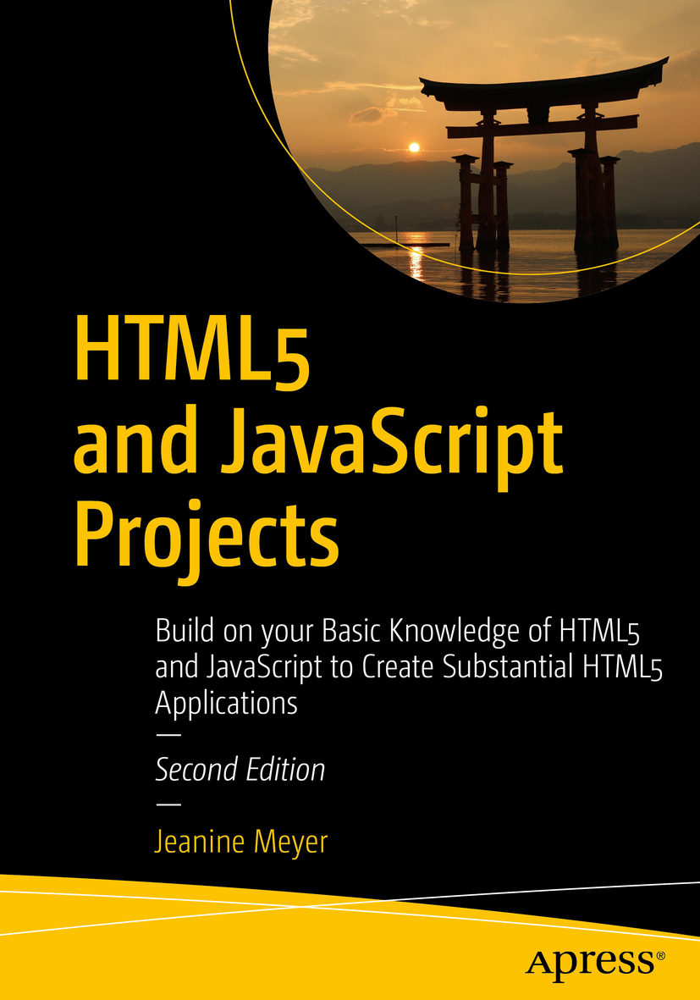

Table of Contents
Front Matter
1. Building the HTML5 Logo: Drawing on Canvas with Scaling and Semantic Tags
2. Family Collage: Manipulating Programmer-Defined Objects on a Canvas
3. Bouncing Video: Animating and Masking HTML5 Video
4. Map Maker: Combining Google Maps and the Canvas
5. Map Portal: Using Google Maps to Access Your Media
6. Add to 15 Game
7. Origami Directions: Using Math-Based Line Drawings, Photographs, and Videos
8. Jigsaw Video
9. US States Game: Building a Multiactivity Game
10. Responsive Design and Accessibility
Back Matter
Jeanine Meyer
HTML5 and JavaScript Projects
Build on your Basic Knowledge of HTML5 and JavaScript to Create Substantial HTML5 Applications
2nd ed.

Jeanine Meyer
New York, USA
Any source code or other supplementary material referenced by the author in this book is available to readers on GitHub via the book's product page, located at www.​apress.​com/​9781484238639 . For more detailed information, please visit http://​www.​apress.​com/​source-code .
ISBN 978-1-4842-3863-9e-ISBN 978-1-4842-3864-6
https://doi.org/10.1007/978-1-4842-3864-6
Library of Congress Control Number: 2018954635
© Jeanine Meyer 2018
This work is subject to copyright. All rights are reserved by the Publisher, whether the whole or part of the material is concerned, specifically the rights of translation, reprinting, reuse of illustrations, recitation, broadcasting, reproduction on microfilms or in any other physical way, and transmission or information storage and retrieval, electronic adaptation, computer software, or by similar or dissimilar methodology now known or hereafter developed.
Trademarked names, logos, and images may appear in this book. Rather than use a trademark symbol with every occurrence of a trademarked name, logo, or image we use the names, logos, and images only in an editorial fashion and to the benefit of the trademark owner, with no intention of infringement of the trademark. The use in this publication of trade names, trademarks, service marks, and similar terms, even if they are not identified as such, is not to be taken as an expression of opinion as to whether or not they are subject to proprietary rights.
While the advice and information in this book are believed to be true and accurate at the date of publication, neither the authors nor the editors nor the publisher can accept any legal responsibility for any errors or omissions that may be made. The publisher makes no warranty, express or implied, with respect to the material contained herein.
Distributed to the book trade worldwide by Springer Science+Business Media New York, 233 Spring Street, 6th Floor, New York, NY 10013. Phone 1-800-SPRINGER, fax (201) 348-4505, e-mail orders-ny@springer-sbm.com, or visit www.springeronline.com. Apress Media, LLC is a California LLC and the sole member (owner) is Springer Science + Business Media Finance Inc (SSBM Finance Inc). SSBM Finance Inc is a Delaware corporation.
To my family, including my parents, who still take care of me
Introduction
This book continues my exploration of HTML5. My approach in developing the projects was to combine features such as canvas and video, attempt more intricate drawing by using mathematics, and use standard programming techniques such as object-oriented programming and separation of content and logic. I was also interested in building applications combining HTML5 and JavaScript with other technologies, including Google Maps.
Each chapter in the book is focused on an application or set of related applications. This is because my experience as a teacher and a learner has shown that concepts and mechanics are best understood in the context of actual use. The applications start off with drawing the HTML5 official logo. As you will find out in Chapter 1 , the way I developed this application prompted use of coordinate transformations.
The project in Chapter 2 , involving a family collage, was inspired by my growing family and the desire to teach about object-oriented programming. It is a good application for you to use as a foundation to create your own, with your own photos and objects of your own invention. Chapter 3 , which shows how to create a bouncing video, was built on other two-dimensional applications I have created, and features two different ways to combine canvas and video.
Chapters 4 and 5 demonstrate use of the Google Maps API (Application Programming Interface), a powerful facility that allows you to incorporate access to Google Maps as part of your own projects. Chapter 4 presents a user interface combining map and canvas and includes a custom-designed cursor and the use of alpha (transparency) in drawing paths. The map quiz in Chapter 5 demonstrates the use of mapping as a portal to media. The application shows you how to separate content and logic so you can scale up to various applications (e.g., a tour of a region or a geography quiz with many locations).
Chapter 6 features a game called Add to 15, which turned out to be an excellent example of arrays. It also demonstrated the necessity to prepare for bad behavior on the part of players.
In Chapter 7 , I use the task of producing directions for origami to show how to combine line drawings, often using mathematical expressions, and video and photographs. You can use this as a model for your own set of directions for a task in which drawings, video, or images would be most appropriate. Or you can let the reading refresh your memory for topics in algebra and geometry. Chapter 8 features a jigsaw puzzle that is transformed into a video when it’s completed. Chapter 9 is an educational game with questions on the states of the USA, and it includes the challenge of a jigsaw puzzle. The jigsaw puzzle includes the feature of saving the puzzle-in-progress using localStorage .
For Chapter 10 , I decided to address challenges of responsive design and accessibility as being more appropriate for an HTML and JavaScript book than what I had before. My examples demonstrate ways to incorporate touch in addition to mouse actions, to respond to different screen dimensions, and to specify tab order to ease the use of screen readers.

Who Is This Book For?
I do believe my explanations are complete, but I am not claiming, as I did for my previous book, The Essential Guide to HTML5 , that this book is for the total beginner. This book is for the developer who has some knowledge of programming and who wants to build (more) substantial applications by combining features of JavaScript and going beyond the basics. It also can serve as an idea book for someone working with programmers to get an understanding of what is possible.

How Is This Book Structured?
This book consists of 10 chapters, each organized around an application or type of application. You can skip around, though there are cross-references between chapters, indicated in the text. Each chapter starts with an introduction to the application, with screenshots of the applications in use. The chapters continue with a discussion of the critical requirements in which concepts are introduced before diving into the technical details. The next sections describe how the requirements are satisfied, with specific constructs in HTML5, JavaScript, and CSS. I then show the application coding line by line with comments. You can decide how to read these tables. You may decide to use them as a reference when writing your own programs. Each chapter ends with instructions and tips for testing and uploading the application to a server, and a summary of what you learned.
The code is included as downloads available from the publisher. Go to https://github.com/Apress/html-js-projs . In addition, the figures are available as full-color TIFF files. Of course, you will want to use your own media for the projects. My media (video, audio, and images) is included with the code and this includes images for the 50 states for the states game in Chapter 9 . You can use the project as a model for a different part of the world or a puzzle based on an image or diagram. There are extras: a program for an origami frog included with the code in Chapter 7 and a version of the jigsaw turning into a video from Chapter 8 adapted for use on devices requiring touch is included with the source code for Chapter 10 .
Let’s get started.
Acknowledgments
Much appreciation to my students and colleagues at Purchase College/State University of New York. In particular, for Chapter 5 , which covers the map portal quiz, I want to thank Jennifer Douglas, Jeremy Martinez, and Nik Dedvukaj, for the maze video clip produced in my Robotics class in 2008, which I retained for the new edition. I want also to thank Takashi Mukoda for his photograph of the Great Torii, in addition to everything else he has contributed to this and other projects. I re-used an audio recording of my mother playing piano. Thanks to all my family members (Aviva Meyer, Daniel Meyer, Annika Meyer, Anne Kellerman, Palmer Agnew, Debbie Torres, and Joshua Torres) for being the subjects of photographs and videos and for making the photos, video, and audio. Thanks to Daniel Davis for his HTML5 logo and his technical assistance with the first edition.
Thanks to the crew at Apress, including Nancy Chen, James Markham, and the technical reviewer Takashi Mukoda, as well as others I do not know by name.

Table of Contents
Chapter 1:​ Building the HTML5 Logo:​ Drawing on Canvas with Scaling and Semantic Tags
Introduction
Project History and Critical Requirements
HTML5, CSS, and JavaScript features
Drawing Paths on Canvas
Placing Text on Canvas and in the Body of a Document
Coordinate Transformations
Using the Range Input Element
Building the Application and Making It Your Own
Testing and Uploading the Application
Summary
Chapter 2 :​ Family Collage:​ Manipulating Programmer-Defined Objects on a Canvas
Introduction
Critical Requirements
Autoplay Policy
HTML5, CSS, and JavaScript Features
JavaScript Objects
User Interface
Saving the Canvas to an Image
Building the Application and Making It Your Own
Testing and Uploading the Application
Summary
Chapter 3:​ Bouncing Video:​ Animating and Masking HTML5 Video
Introduction
Project History and Critical Requirements
HTML5, CSS, and JavaScript Features
Definition of the Body and the Window Dimensions
Animation
Video Drawing Frames on Canvas or As a Movable Element
Traveling Mask
User Interface
Building the Application and Making It Your Own
Making the Application Your Own
Testing and Uploading the Application
Summary
Chapter 4:​ Map Maker:​ Combining Google Maps and the Canvas
Introduction
Latitude and Longitude and Other Critical Requirements
HTML5, CSS, and JavaScript Features
The Google Maps API
Canvas Graphics
Cursor
JavaScript Events
Calculating Distance and Rounding Values for Display
Building the Application and Making It Your Own
Testing and Uploading the Application
Summary
Chapter 5 :​ Map Portal:​ Using Google Maps to Access Your Media
Introduction
Project History and Critical Requirements
HTML5, CSS, and JavaScript Features
Google Maps API for Map Access and Event Handling
Project Content in External File
Distances and Tolerances
Regular Expressions Used to Create the HTML
Dynamic Creation of HTML5 Markup and Positioning
Hint Button
Building the Application and Making It Your Own
The Quiz Application
Testing and Uploading the Application
Summary
Chapter 6:​ Add to 15 Game
Introduction
General Requirements for a Game
HTML5, CSS, and JavaScript
Styling in CSS
JavaScript Arrays
Setting Up the Game
Responding to a Player Move
Generating the Computer Move
Building the Application and Making It Your Own
Testing and Uploading the Application
Summary
Chapter 7:​ Origami Directions:​ Using Math-Based Line Drawings, Photographs, and Videos
Introduction
Critical Requirements
HTML5, CSS, JavaScript Features, and Mathematics
Overall Mechanism for Steps
User Interface
Coordinate Values
Utility Functions for Display
Utility Functions for Calculation
Step Line Drawing Functions
Displaying a Photograph
Presenting and Removing a Video
Building the Application and Making It Your Own
Testing and Uploading the Application
Summary
Chapter 8:​ Jigsaw Video
Introduction
Background and Critical Requirements
HTML5, CSS, JavaScript, and Programming Features
Creating the Base Picture
Dynamically Created Elements
Setting Up the Game
Handling Player Actions
Calculating If the Puzzle Is Complete
Preparing, Positioning, and Playing the Video and Making It Hidden or Visible
Building the Application and Making It Your Own
Testing and Uploading the Application
Summary
Chapter 9:​ US States Game:​ Building a Multiactivity Game
Introduction
Critical Requirements
HTML5, CSS, JavaScript Features, Programming Techniques, and Image Processing
Acquiring the Image Files for the Pieces and Determining Offsets
Creating Elements Dynamically
User Interface Overall
User Interface for Asking the Player to Click a State
User Interface for Asking the Player to Name a State
Spreading Out the Pieces
Setting Up the Jigsaw Puzzle
Saving and Recreating the State of the Jigsaw Game and Restoring the Original Map
Building the Application and Making It Your Own
Testing and Uploading the Application
Summary
Chapter 10:​ Responsive Design and Accessibility
Introduction
Critical Requirements
Screen Size and Dimension
Touch
Screen Reader and Tabs
HTML, CSS, and JavaScript Features
Meta Tags
HTML and CSS Use of Percentages and Auto
CSS @media
The HTML alt Attribute and Semantic Elements
HTML tabIndex
JavaScript Use of Width and Height Properties
Creating Elements Dynamically
Choosing From List
Mouse Events, Touch Events, and Key Events
Building the Reveal Application and Making It Your Own
Testing and Uploading the Reveal Application
Building the Countries/​Capitals Quiz and Making It Your Own
Testing and Uploading the Countries/​Capitals Quiz Application
Testing and Uploading the Jigsaw Turning to Video Application
Summary
Index

About the Author and About the Technical Reviewer

About the Author
Jeanine Meyer

is a full professor at Purchase College/State University of New York. She teaches courses to students majoring in mathematics/computer science and also enjoys the frequent presence of others in her classes, including new media, music, dance, economics, and chemistry majors. She developed and teaches courses satisfying the mathematics general education requirement, including one on math in the news and one on origami. The website for her academic activities is http://faculty.purchase.edu/jeanine.meyer . Before coming to academia, she was a research staff member and manager at IBM Research, focusing on robotics and manufacturing research, and she later worked on the corporate manufacturing staff and as a research consultant at IBM for educational grant programs.
She has enjoyed working with Apress, including updating the HTML5 books. She continues with the practice of building programming examples using media featuring her family and her activities and hopes that inspires readers to create work on topics that are important to them. Her hobbies and interests include studying Spanish and piano, playing computer games, doing origami, and volunteering for progressive candidates and causes. She enjoys her daughter Aviva’s cooking while doing some baking herself and looks forward to travel this year.

About the Technical Reviewer
Takashi Mukoda

is an international student at Purchase College/State University of New York. He is currently taking a semester off and back home in Japan. At Purchase College, he majors in Mathematics/Computer Science and New Media and has worked as a teaching assistant for computing and mathematics courses.
Takashi likes playing the keyboard and going on hikes in the mountains to take pictures. His interest in programming and art motivates him to create multimedia art pieces. Some of them are built with Processing and interact with human motion and sounds.
(See his website at http://www.takashimukoda.com .)

© Jeanine Meyer 2018
Jeanine Meyer
HTML5 and JavaScript Projects
https://doi.org/10.1007/978-1-4842-3864-6_1

1. Building the HTML5 Logo: Drawing on Canvas with Scaling and Semantic Tags
Jeanine Meyer1
(1)
New York, USA

In this chapter, you will learn the following:
Drawing paths on a canvas
Placing text on a canvas
Coordinate transformations
Fonts for text drawn on canvas and fonts for text in other elements
Semantic tags
The range input element

Introduction
The project for this chapter is a presentation of the official HTML5 logo, with accompanying text. The shield and letters of the logo are drawn on a canvas element and the accompanying text demonstrates the use of semantic tags. The viewer can change the size of the logo using a slider input device. It is an appropriate start to this book, a collection of projects making use of HTML5, JavaScript, and other technologies, because of the subject matter and because it serves as a good review of basic event-driven programming and other important features in HTML5. The way I developed the project, building on the work of others, is typical of how most of us work. In particular, the circumstances provide motivation for the use of coordinate transformations.
The approach of this book is to explain HTML5, Cascading Style Sheets (CSS), and JavaScript chapters in the context of specific examples. The projects represent a variety of applications and, hopefully, you will find something in each one that you will learn and adapt for your own purposes.
NoteIf you need an introduction to programming using HTML5 and JavaScript, you can consult my book, The Essential Guide to HTML5 or other books published by Apress or others. There also is considerable material available online, for example, at W3Schools.
Figure 1-1 shows the opening screen for the logo project on the Chrome browser . It is important to realize that browsers can be different. Look ahead to how this appeared using Firefox when I first wrote this example.
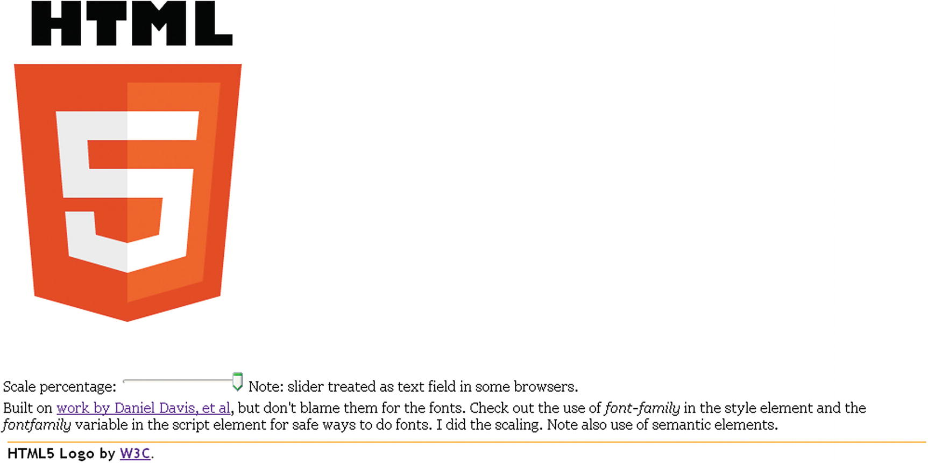
Figure 1-1Opening screen for HTML5 logo
Notice the slider feature, the accompanying text , which contains what appears to be a hyperlink, and the text in a footer below a yellow line. The footer also includes a hyperlink. As I will explain later, the function and the formatting of the footer and any other semantic element is totally up to me, but providing a reference to the owners of the logo , the World Wide Web Consortium would be deemed an appropriate use.
The viewer can use the slider to change the size of the logo. Figure 1-2 shows the application after the slider has been adjusted to show the logo reduced to about a third in width and in height.
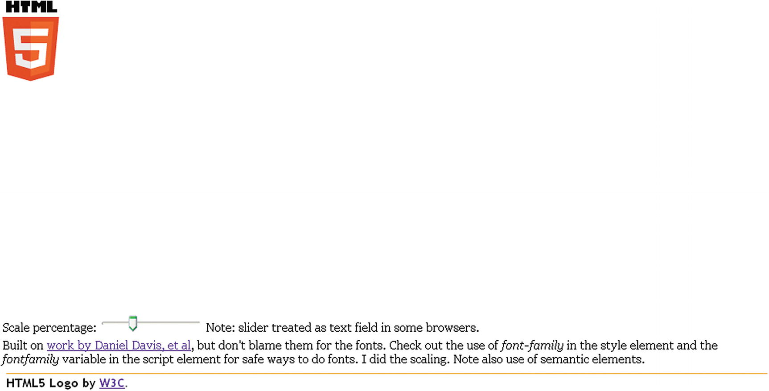
Figure 1-2Logo scaled down
The implementation of HTML5 is complete, or pretty close, in all browsers. However, I want to show you something from the past to illustrate the term graceful degradation . Figure 1-3 shows the opening screen in the older Firefox. The range input is treated as text. Notice the initial value is displayed as 100.
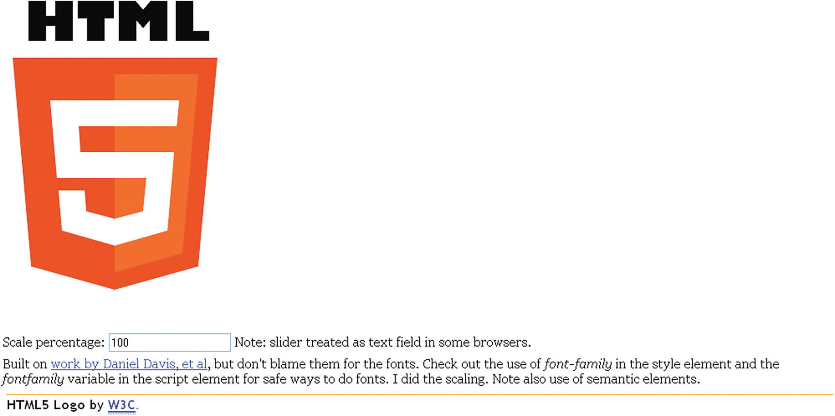
Figure 1-3Application using Firefox
As will be the practice in each chapter, I now explain the critical requirements of the application, more or less independent of the fact that the implementation will be in HTML5, and then describe the features of HTML5, JavaScript, and other technologies as needed that will be used in the implementation. The “Building” section includes a table with comments for each line of code and guidance for building similar applications. The “Testing” section provides details for uploading and testing . This section is more critical in some projects than others. Lastly, there is a “Summary” section that reviews the programming concepts covered and previews what is next in the book.

Project History and Critical Requirements
The critical requirements for this project are somewhat artificial and not easily stated as something separate from HTML. For example, I wanted to draw the logo as opposed to copying an image from the Web. My design objectives always include wanting to practice programming and prepare examples for my students. The shape of the shield part of the logo seemed amenable to drawing on canvas and the HTML letters could be done using the draw text feature. In addition, there are practical advantages to drawing images instead of using image files. Separate files need to be managed, stored, and downloaded. The image shown in Figure 1-4 is 90KB. The file holding the code for the program is only 4KB. Drawing a logo or other graphic means that the scale and other attributes can be changed dynamically using code.

Figure 1-4Image of a logo
I looked online and found an example of just the shield done by Daniel Davis, @ourmaninjapan. This was great because it meant that I did not have to measure a copy of the logo image to get the coordinates. This begs the question of how he determined the coordinates. I don’t know the answer, even though we had a pleasant exchange of emails. One possibility is to download the image and use the grid feature of image processing programs such as Adobe Photoshop or Corel Paint Shop Pro. Another possibility is to use (old-fashioned) transparent graph paper.
However, there was a problem with building on Daniel Davis’s work. His application did not include the HTML letters. The solution to this was to position the letters on the screen and then move down, so to speak, to position the drawing of the shield using the coordinates provided in Daniel’s example. The technical term for “moving down the screen” is performing a coordinate transformation. So the ability to perform coordinate transformations became a critical requirement for this project.
I chose to write something about the logo and, in particular, give credit and references in the form of hyperlinks. I made the decision to reference the official source of the logo as brief text at the bottom of the document below a line. The reference to Daniel Davis was part of the writing in the body. We exchanged notes on font choices and I will discuss that more in the next section.
In order to give the viewer something to do with the logo, I decided to present a means of changing the size. A good device for this is a slider with the minimum and maximum values and steps all specified. So the critical requirements for this application include drawing shapes and letters in a specific font, coordinate transformations, formatting a document with a main section and a footer section, and including hyperlinks .

HTML5, CSS , and JavaScript features
I assume that you, the reader, have some experience with HTML and HTML5 documents. One of the most important new features in HTML5 is the canvas element for drawing. I describe briefly the drawing of filled-in paths of the appropriate color and filled-in text. Next, I describe coordinate transformations, used in this project for the two parts of the logo itself and for scaling, changing the size, of the whole logo. Lastly, I describe the range input element. This produces the slider.

Drawing Paths on Canvas
Canvas is a type of element introduced in HTML5. All canvas elements have a property (aka an attribute) called the 2D context . The context has methods for drawing, which you will see in use. Typically, a variable is set to this property after the document is loaded:
ctx = document.getElementById('canvas').getContext('2d');
It is important to understand that canvas is a good name: code applies color to the pixels of the canvas, just like paint. Code written later can put a different color on the canvas. The old color does not show through. Even though our code causes rectangles and shapes and letters to appear, these distinct entities do not retain their identity as objects to be re-positioned.
The shield is produced by drawing six filled-in paths in succession with the accumulated results, as shown in Figure 1-5. You can refer to this picture when examining the code. Keep in mind that in the coordinates, the first number is the distance from the left edge of the canvas and the second number is the distance from the top edge of the canvas.
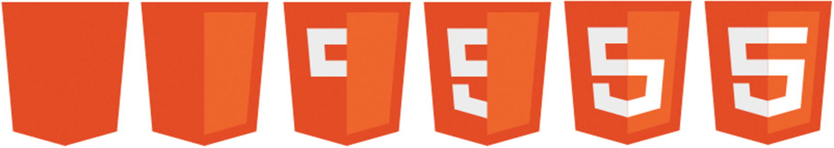
Figure 1-5Sequence of paths for drawing the logo
By the way, I chose to show you the sequence with the accumulated results. If I displayed what is drawn, you would not see the white parts making up the left side of the five. You can see it because it is two white filled-in paths on top of the orange.
All drawing is done using methods and properties of the ctx variable holding the 2D context property of the canvas element. The color for any subsequent fill operation is set by assigning a color to the fillStyle property of the canvas context.
ctx.fillStyle = "#E34C26";
This particular color, given in the hexadecimal format—where the first two hexadecimal (base 16) digits represent red, the second two hexadecimal digits represent green, and the last two represent blue—is provided by the W3C website, along with the other colors, as the particular orange for the background of the shield. It may be counterintuitive, but in this system, white is specified by the value #FFFFFF. Think of this as all colors together make white. The absence of color is black and specified by #000000. The pearly gray used for the right side of the 5 in the logo has the value #EBEBEB. This is a high value, close to white. It is not necessary that you memorize any of these values, but it is useful to know black and white, and that a pure red is #FF0000, a pure green is #00FF00, and a pure blue is #0000FF. You can use the eyedropper/color picker tool in drawing programs such as Adobe Photoshop, Corel Paint Shop Pro, or the online tool http://pixlr.com/ to find out values of colors in images or you can use the official designation, when available, for official images.
All drawing is done using the two-dimensional coordinate systems . Shapes are produced using the path methods. These assume a current location, which you can think of as the position of a pen or paint brush over the canvas. The critical methods are moving to a location and setting up a line from the current location to the indicated location. The following set of statements draws the five-sided orange shape starting at the lower, left corner. The closePath method closes up the path by drawing a line back to the starting point.
ctx.fillStyle = "#E34C26";
ctx.beginPath();
ctx.moveTo(39, 250);
ctx.lineTo(17, 0);
ctx.lineTo(262, 0);
ctx.lineTo(239, 250);
ctx.lineTo(139, 278);
ctx.closePath();
ctx.fill();
If you haven’t done any drawing on canvas, here is the whole HTML script needed to produce the five-sided shape. The onLoad attribute in the <body> tag causes the init function to be invoked when the document is loaded. The init function sets the ctx variable, sets the fillStyle property , and then draws the path.
<!DOCTYPE html>
<html>
<head>
<title>HTML5 Logo</title>
<meta charset="UTF-8">
<script>
function init() {
ctx = document.getElementById('canvas').getContext('2d');
ctx.fillStyle = "#E34C26";
ctx.beginPath();
ctx.moveTo(39, 250);
ctx.lineTo(17, 0);
ctx.lineTo(262, 0);
ctx.lineTo(239, 250);
ctx.lineTo(139, 278);
ctx.closePath();
ctx.fill();
}
</script>
</head>
<body onLoad="init();">
<canvas id="canvas" width="600" height="400">
Your browser does not support the canvas element.
</canvas>
</body>
</html>
Do practice and experiment with drawing on the canvas if you haven’t done so before, but I will go on. The other shapes are produced in a similar manner. By the way, if you see a line down the middle of the shield, this is an optical illusion.

Placing Text on Canvas and in the Body of a Document
Text is drawn on the canvas using methods and attributes of the context. The text can be filled in, using the fillText method or drawn as an outline using the strokeText method . The color is whatever the current fillStyle property or strokeStyle property holds. Another property of the context is the font. This property can contain the size of the text and one or more fonts. The purpose of including more than one font is to provide options to the browser if the first font is unavailable on the computer running the browser. For this project, I use
var fontfamily = "65px 'Gill Sans Ultra Bold', sans-serif";
and in the init function
ctx.font = fontfamily;
This directs the browser to use the Gill Sans Ultra Bold font if it is available and if not, use whatever the default sans serif font on the computer.
I could have put this all in one statement, but chose to make it a variable. You can decide if my choice of font was close enough to the official W3C logo.
NoteThere are at least two other approaches to take for this example. One possibility is not to use text but to draw the letters as filled-in paths. The other is to locate and acquire a font and place it on the server holding the HTML5 document and reference it directly using @font-face.
With the font and color set, the methods for drawing text require a string and a position: x and y coordinates. The statement in this project to draw the letters is
ctx.fillText("HTML", 31,60);
Formatting text in the rest of the HTML document, that is, outside a canvas element, requires the same attention to fonts. In this project, I choose to make use of the semantic elements new to HTML5 and follow the practice of putting formatting in the style element. The body of my HTML script contains two article elements and one footer elements. One article holds the input element with a comment and the other article holds the rest of the explanation. The footer element contains the reference to W3C. Formatting and using these are up to the developer/programmer. This includes making sure the footer is the last thing in the document. If I placed the footer before one or both articles, it would no longer be displayed at the foot, that is, the bottom of the document. The style directives for this project are the following:
footer {display:block; border-top: 1px solid orange; margin: 10px;
font-family: "Trebuchet MS", Arial, Helvetica, sans-serif; font-weight: bold;}
article {display:block; font-family: Georgia, "Times New Roman", Times, serif; margin: 5px;}
The styles each set up all instances of these elements to be displayed as blocks. This puts a line break before and after. The footer has a border on the top, which produces the line above the text. Both styles specify a list of four fonts each. So the browser first sees if Trebuchet MS is available, then checks for Arial, then for Helvetica and then, if still unsuccessful, uses the system default sans serif font for the footer element. Similarly, the browser checks for Georgia, then Times New roman, then Times and then, if unsuccessful, uses the standard serif font. This probably is overkill, but it is the secure way to operate. The footer text is displayed in bold and the articles each have a margin around them of 5 pixels.
Formatting , including fonts, is important. HTML5 provides many features for formatting and for separating formatting from structure and content. You do need to treat the text on the canvas differently than the text in the other elements .

Coordinate Transformations
I have given my motivation for using coordinate transformations, specifically to keep using a set of coordinates. To review, a coordinate system is the way to specify positions on the canvas. Positions are specified as distances from an origin point. For the two-dimensional canvas, two coordinates are necessary: the first coordinate governs the horizontal and is often called the x and the second coordinate governs the vertical and is called the y. A pesky fact is that when drawing to screens, the y axis is flipped so the vertical is measured from the top of the canvas. The horizontal is measured from the left. This means that the point (100,200) is further down the screen than the point (100,100).
In the logo project, I wrote code to display the letters HTML and then moved the origin to draw the rest of the logo. An analogy would be that I know the location of my house from the center of my town and so I can give directions to the center of town and then give directions to my house. The situation in which I draw the letters in the logo and “move down the screen” requires the translate transformation. The translation is done just in the vertical. The amount of the translation is stored in a variable I named offsety:
var offsety = 80;
...
ctx.fillText("HTML", 31, 60);
ctx.translate(0, offsety);
Since I decided to provide a way for the viewer to change the size of the logo, I used the scale transformation. Continuing the analogy of directions, this is equivalent to changing the units. You may give some directions in miles (or kilometers) and other directions in yards or feet or meters or, maybe, blocks. The scaling can be done separately for each dimension. In this application, there is a variable called factorvalue that is set by the function invoked when the input is changed. The statement
ctx.scale(factorvalue, factorvalue);
changes the units for both the horizontal and vertical direction.
HTML5 provides a way to save the current state of the coordinate system and restore what you have saved. This is important if you need your code to get back to a previous state. The saving and restoring is done using what is termed a stack : last in first out. Restoring the coordinate state is termed popping the stack and saving the coordinate state is pushing something onto the stack. My logo project does not use this in its full power, but it is something to remember to investigate if you are doing more complex applications. In the logo project, my code saves the original state when the document is first loaded. Then before drawing the logo, it restores what was saved and then saves it again so it is available the next time. This is overkill for this situation, but it is a good practice just in case I add something in the future. Do your own experiments! The code at the start of the function dologo , which draws the logo, starts as follows:
function dologo() {
var offsety = 80 ;
ctx.restore();
ctx.save();
ctx.clearRect(0,0,600,400);
ctx.scale(factorvalue,factorvalue);
ctx.fillText("HTML", 31,60);
ctx.translate(0,offsety);
// 5 sided orange background
ctx.fillStyle = "#E34C26";
ctx.beginPath();
ctx.moveTo(39, 250);
ctx.lineTo(17, 0);
ctx.lineTo(262, 0);
ctx.lineTo(239, 250);
ctx.lineTo(139, 278);
ctx.closePath();
ctx.fill();
// right hand, lighter orange part of the background
ctx.fillStyle = "#F06529";
ctx.beginPath();
ctx.moveTo(139, 257);
ctx.lineTo(220, 234);
ctx.lineTo(239, 20);
ctx.lineTo(139, 20);
ctx.closePath();
ctx.fill();
...
Note that the canvas is cleared (erased) of anything that was previously drawn .

Using the Range Input Element
The input device, which I call a slider, is the new HTML5 input type range, and is placed in the body of the HTML document. Mine is placed inside an article element. The attributes of this type and other input elements provide ways of specifying the initial value, the minimum and maximum values, the smallest increment adjustment, and the action to take if the viewer changes the slider. The code is
<input id="slide" type="range" min="0" max="100" value="100"
onChange="changescale(this.value)" step="10"/>
The min, max, (initial) value, and step can be set to whatever you like. Since I was using percentage and since I did not want the logo to get bigger than the initial value or deal with negative values, I used 0 and 100.
In the proper implementation of the slider, the viewer does not see the initial value or the maximum or minimum. My code uses the input as a percentage. The expression this.value is interpreted as the value attribute of this element , emphasis given to convey the switch to English! The term this has special meaning in JavaScript and several other programming languages. The changescale function takes the value, specified by the parameter given in the assignment to the onChange attribute , and uses it to set a global variable (a variable declared outside of any function so it persists and is available to any function) named factorvalue.
function changescale(val) {
factorvalue = val / 100;
dologo();
}
It is part of the specification of HTML5 that the browsers will provide form validation , that is, browsers will check that the conditions specified by attributes in the input elements are obeyed. This can be a significant productivity boost in terms of reducing the work programmers need to do and a performance boost since the checking probably would be faster when done by the browser. In the HTML5 logo project, an advantage of the slider is that the viewer does not need to be concerned with values but merely moves the device. There is no way to input an illegal value. Figure 1-6 shows the results of entering a value of 200 in the input field.
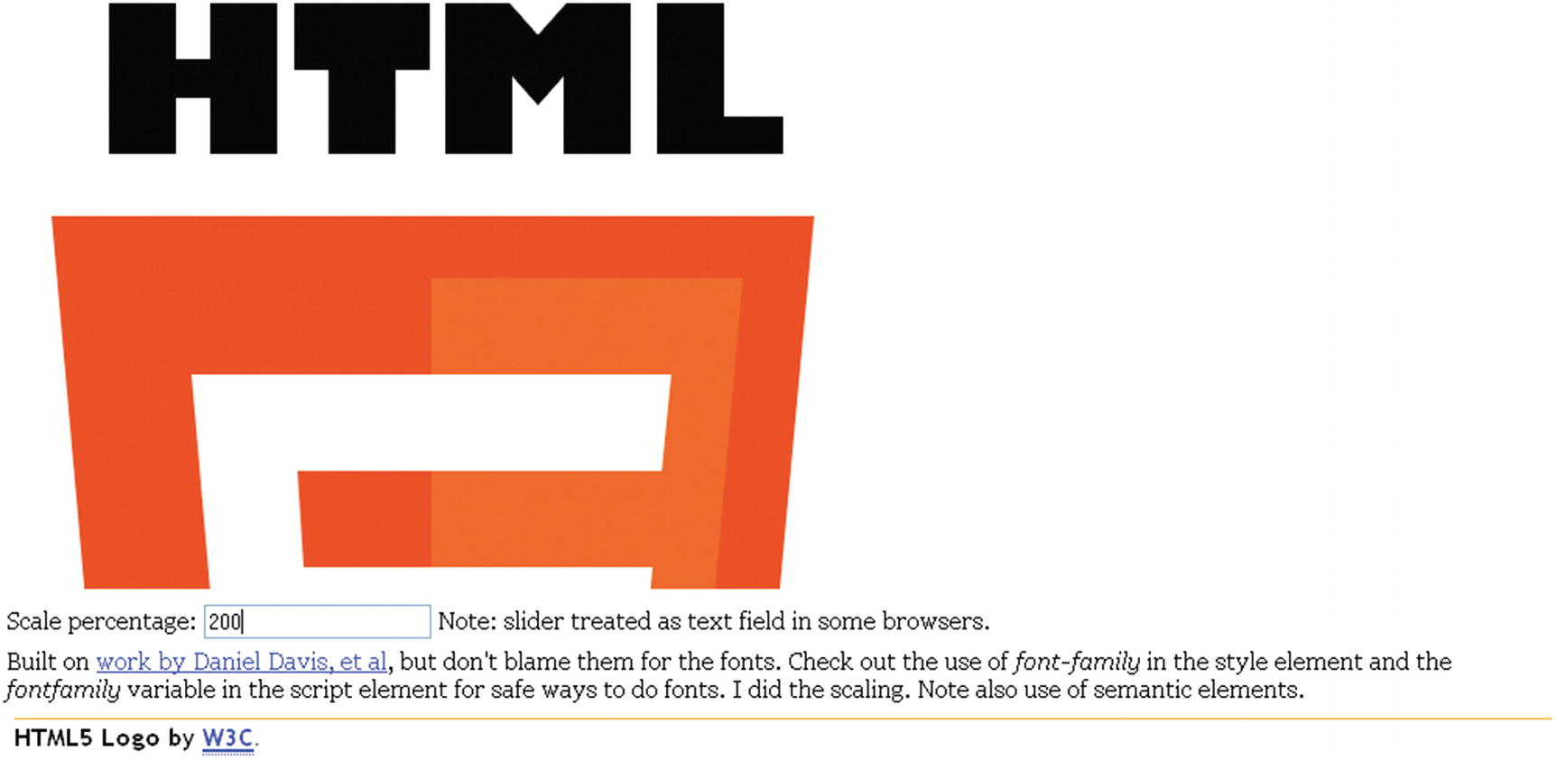
Figure 1-6Display in Firefox of scale of 200
The canvas is of fixed width and height and drawing outside the canvas, which is what is done when the scaling is done to accept numbers and stretch them out to twice the original value, is ignored.

Building the Application and Making It Your Own
The project does one thing, it draws the logo. A function, dologo , is defined for this purpose. Informally, the outline of this program is
1. | init : Initialization
2. | dologo : Draw the logo starting with the HTML letters and then the shield
3. | changescale : Change the scale
Table 1-1 shows the relationship of the functions. The dologo function is invoked when the document is first loaded and then whenever the scale is changed.
Table 1-1 Functions in the HTML5 Logo Project
Function | Invoked/Called By | Calls
init | Invoked by action of the onLoad attribute in the <body> tag | dologo
dologo | Invoked by init and changescale
changescale | Invoked by action of the onChange attribute in the <input type="range"...> tag | dologo
The coding for the dologo function puts together the techniques previously described. In particular, the code brings back the original coordinate system and clears off the canvas.
The global variables in this application are
var ctx;
var factorvalue = 1;
var fontfamily = "65px 'Gill Sans Ultra Bold', sans-serif";
As indicated earlier, it would be possible to not use the fontfamily but use the string directly in the code. It is convenient to make ctx and factorvalue global.
Table 1-2 shows the code for the basic application, with comments for each line.
Table 1-2 Complete Code for the HTML5 Logo Project
Code Line | Description
<!DOCTYPE html> | Header
<html> | Opening html tag
<head> | Opening head tag
<title> HTML5 Logo </title> | Complete title element
<meta charset="UTF-8"> | Meta tag
<style> | Opening style tag
footer {display:block; border-top: 1px solid orange; margin: 10px; font-family: "Trebuchet MS", Arial, Helvetica, sans-serif; font-weight: bold;} | Style for the footer, including the top border and font family
article {display:block; font-family: Georgia, "Times New Roman", Times, serif; margin: 5px;} | Style for the two articles
</style> | Close the style element
<!-- Start of script element --> | HTML comment
<script language="JavaScript"> | Opening script tag. Note: Case doesn’t matter in JavaScript
var ctx ; | Variable to hold the context; used in all drawings
var factorvalue = 1; | Set initial value for scaling
var fontfamily = "65px 'Gill Sans Ultra Bold', sans-serif"; | Set the fonts for the text drawn on the canvas
function init() { | Start of init function
ctx = document.getElementById('canvas').getContext('2d'); | Set ctx
ctx.font = fontfamily; | Set font for text drawn on canvas
ctx.save(); | Save the original coordinate state
dologo(); | Invoke function to draw the logo
} | Close function
/* dologo function definition . This is the main function. It uses factorvalue to change the scale.  */ | Multi-line comment in JavaScript
function dologo() { | Start of dologo function
var offsety = 80 ; | Specify amount to adjust the coordinates to draw the shield part of the logo
ctx.restore(); | Restore original state of coordinates
ctx.save(); | Save it (push onto stack) so it can be restored again
ctx.clearRect(0,0,600,400); | Erase the whole canvas
ctx.scale(factorvalue,factorvalue); | Scale horizontally and vertically using value set by slider
ctx.fillText("HTML", 31,60); | Draw the letters: HTML
ctx.translate(0,offsety); | Move down the screen (canvas)
// 5 sided orange background | Single-line comment
ctx.fillStyle = "#E34C26"; | Set to official bright orange
ctx.beginPath(); | Start a path
ctx.moveTo(39, 250); | Move to indicated position at lower left
ctx.lineTo(17, 0); | Draw line up and more to the left
ctx.lineTo(262, 0); | Draw line straight over to the right
ctx.lineTo(239, 250); | Draw line down and slightly to the left
ctx.lineTo(139, 278); | Draw line to the middle, low point of the shield
ctx.closePath(); | Close the path
ctx.fill(); | Fill in with the indicated color
// right hand, lighter orange part of the background
ctx.fillStyle = "#F06529"; | Set color to the official darker orange
ctx.beginPath(); | Start the path
ctx.moveTo(139, 257); | Move to middle point, close to the top
ctx.lineTo(220, 234); | Draw line to the right and slightly up
ctx.lineTo(239, 20); | Draw line to the right and up
ctx.lineTo(139, 20); | Draw line to the left (point at the middle)
ctx.closePath(); | Close path
ctx.fill(); | Fill in with the indicated color
//light gray, left hand side part of the five
ctx.fillStyle = "#EBEBEB"; | Set color to gray
ctx.beginPath(); | Start path
ctx.moveTo(139, 113); | Move to middle horizontally, midway vertically
ctx.lineTo(98, 113); | Draw line to the left
ctx.lineTo(96, 82); | Draw line up and slightly further left
ctx.lineTo(139, 82); | Draw line to right
ctx.lineTo(139, 51); | Draw line up
ctx.lineTo(62, 51); | Draw line to the left
ctx.lineTo(70, 144); | Draw line to the left and down
ctx.lineTo(139, 144); | Draw line to the right
ctx.closePath(); | Close path
ctx.fill(); | Fill in with indicated color
ctx.beginPath(); | Start a new path
ctx.moveTo(139, 193); | Move to middle point
ctx.lineTo(105, 184); | Draw line to the left and up
ctx.lineTo(103, 159); | Draw line slightly to the left and up
ctx.lineTo(72, 159); | Draw line more to the left
ctx.lineTo(76, 207); | Draw line slightly to the right and down
ctx.lineTo(139, 225); | Draw line to the left and down
ctx.closePath(); | Close path
ctx.fill(); | Fill in the shape in the indicated color
// white, right hand side of the 5
ctx.fillStyle = "#FFFFFF"; | Set color to white
ctx.beginPath(); | Start path
ctx.moveTo(139, 113); | Start at middle pint
ctx.lineTo(139, 144); | Draw line down
ctx.lineTo(177, 144); | Draw line to the right
ctx.lineTo(173, 184); | Draw line slightly left and down
ctx.lineTo(139, 193); | Draw line more left and down
ctx.lineTo(139, 225); | Draw line down
ctx.lineTo(202, 207); | Draw line to the right and up
ctx.lineTo(210, 113); | Draw line slightly right and up
ctx.closePath(); | Close path
ctx.fill(); | Fill in white
ctx.beginPath(); | Start a new path
ctx.moveTo(139, 51); | Move to middle point
ctx.lineTo(139, 82); | Move down
ctx.lineTo(213, 82); | Move to the right
ctx.lineTo(216, 51); | Move slightly to the right and up
ctx.closePath(); | Close path
ctx.fill(); | Fill in white
} | Close dologo function
// The changescale function, response to user input.
function changescale(val) { | Open function changevalue with parameter
factorvalue = val / 100; | Set factorvalue to the input divided by 100
dologo(); | Invoke function to draw logo
} | Close changevalue function
</script> | Close the script element
</head> | Close the head element
The rest of the document is the body element
<body onLoad="init();"> | Body tag with attribute set to invoke init
<canvas id="canvas" width="600" height="400"> | Canvas tag setting dimensions and with ID to be used in code
Your browser does not support the canvas element. | Message to appear if canvas not supported
</canvas> | Close canvas tag
<article> | Article tag
Scale percentage: <input id="slide" type="range" min="0" max="100" value="100" onChange="changescale(this.value)" step="10"/> | The slider (range) input with settings
Note: slider treated as text field in some browsers. | Comment to note that slider may be text field; it is still usable
</article> | Article close tag
<article>Built on <a href=" http://daniemon.com/tech/html5/html5logo/ ">work by Daniel Davis, et al</a>, but don't blame them for the fonts. Check out the use of <em>font-family</em> in the style element and the <em>fontfamily</em> variable in the script element for safe ways to do fonts. I did the scaling. Note also use of semantic elements.</article> | Article tag with some text, including hyperlink
<footer>HTML5 Logo by <a href="http:// www.w3.org /"><abbr title="World Wide Web Consortium">W3C</abbr></a>. | Footer tag and footer content, including abbr element
</footer> | Footer close tag
</body> | Body close
</html> | HTML close
You can make this application your own by using all or parts of it with your own work. You probably want to omit the comments about fonts.

Testing and Uploading the Application
This is a simple application to test and upload (and test) because it is a single file. The variable factorvalue, changed when the range input element is modified and the changescale function is invoked, can be used to adapt to different screens. This program appears to work well on different devices . The challenge of what is termed responsive design will be discussed in Chapter 10.

Summary
In this chapter, you learned how make a specific drawing and learned the steps to take in producing other, similar, applications. The features used in this chapter include
Paths
Text on the canvas and text in semantic elements in the body
The range input element and its associated change event
Coordinate transformations, namely translate and scale
Specification of sets of fonts
Styles for semantic elements, including the border top to make a line to go before the footer
The next chapter describes how to build a utility application for making compositions or collages of photographs and shapes. It combines techniques for drawing on canvas and creating HTML elements with a standard technique in computing, objects. It also uses coordinate transformations.
© Jeanine Meyer 2018
Jeanine Meyer
HTML5 and JavaScript Projects
https://doi.org/10.1007/978-1-4842-3864-6_2

2. Family Collage: Manipulating Programmer-Defined Objects on a Canvas
Jeanine Meyer1
(1)
New York, USA

In this chapter, you will learn the following:
Creating and manipulating object oriented programming for drawing on canvas
Handling mouse events, including double-clicks
Saving the canvas to an image
Using try and catch to trap errors
Browser differences involving the location of the code
Using algebra and geometry to construct shapes and determine when the cursor is over a specific object
Controlling the icon used for the cursor

Introduction
The project for this chapter is a utility for manipulating objects on a canvas to produce a picture. I call it a utility because one person does the programming and gathers photographs and designs and then can offer the program to friends, family members, colleagues, and others to produce the compositions/collages. The result can be anything from an abstract design to a collage of photographs. The objects in my example include one rectangle, two ovals, a heart, two family photographs, and one video (Annika on the monkey bars). It is possible for you, or, perhaps, your end-user/customer/client/player, to make duplicate copies of any of the objects and remove items. The end-user positions the object using drag and drop with the mouse. When the picture is judged to be complete, it is possible to create an image that can be downloaded into a file.
Figure 2-1 shows the opening screen for my program. Notice that you start off with seven objects to arrange.
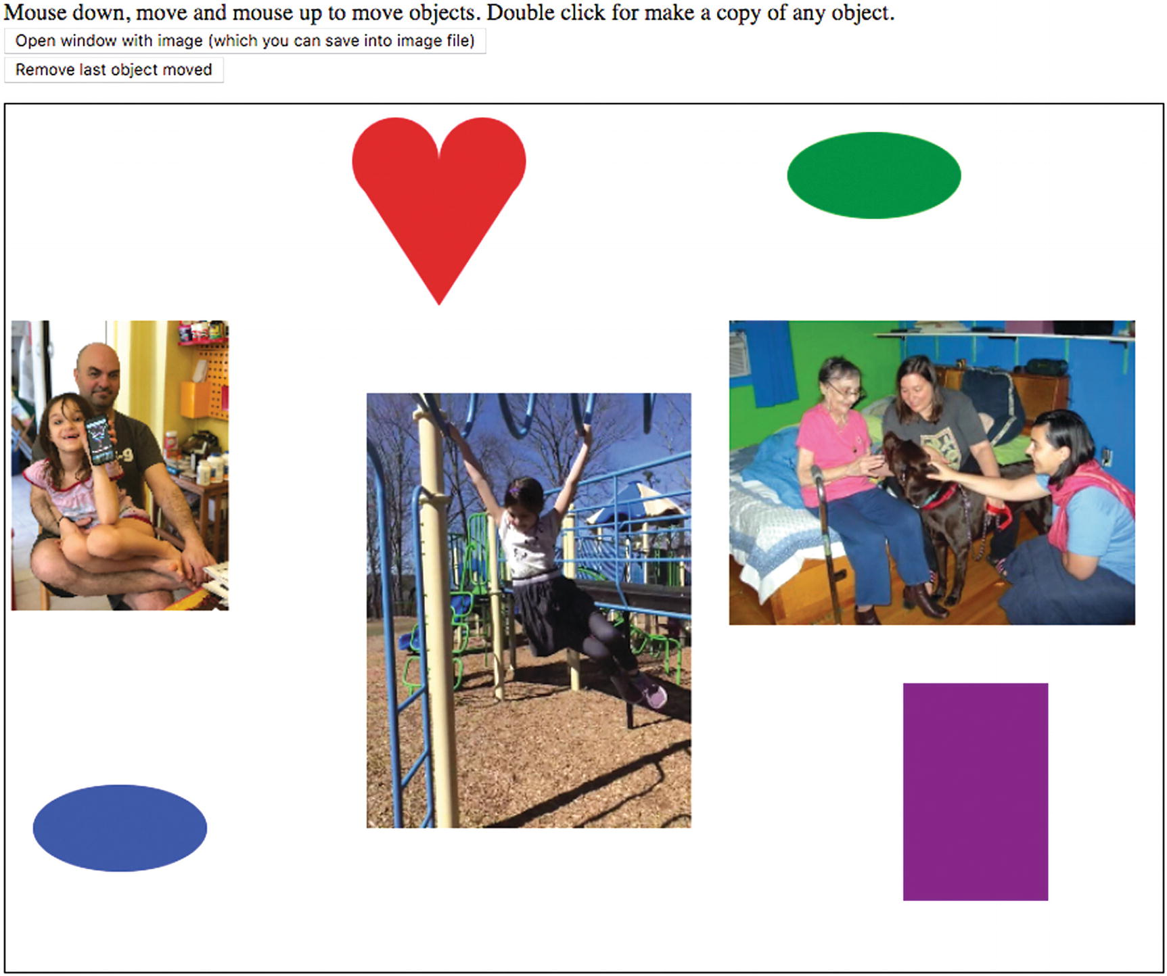
Figure 2-1Opening screen for Family Pictures
Figure 2-2 shows what I, as an end-user, produced as a final product and saved as an image in a new window. I have duplicated (clones) the two photographs and the video, added two more hearts, and removed the rectangle and ovals.
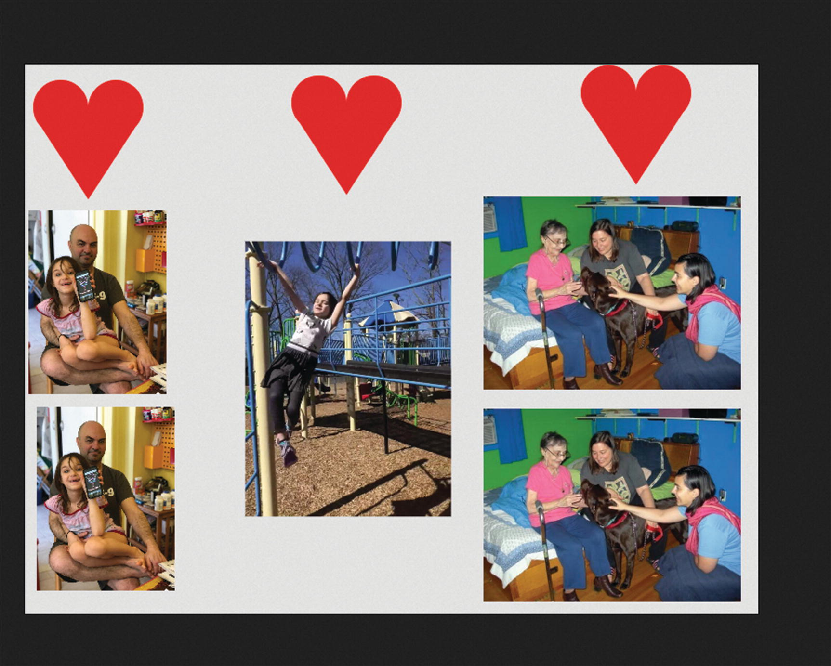
Figure 2-2Sample final product : rearranged objects
I decided on including a heart, not just for sentimental reasons, but because it required me to use algebra and geometry. Don't be afraid of mathematics. It is very useful. I invented, so to speak, a canonical heart. For other shapes, you may be able to find a standard definition in terms of mathematical expressions.
In this situation, I created the set of objects and then I used the program to make a composition. You can plan your application include pictures and videos with some graphics, rectangles, and hearts. When you are finished, you can offer this program to others for them to use. This is analogous to building a game program for players. The end-users for this application may be family members, friends, or colleagues. The list of items is stored in a separate file from the main program so it is easy to change what is included. The technique of separating specification of content from program is a good trick to master.
Of course, it certainly is possible to use a drawing program such as Adobe Photoshop or Corel Paint Shop Pro to create compositions such as these, but this application provides considerable ease-of-use for its specific purpose. The project also serves as a vehicle to learn important programming techniques as well as features of HTML5 and JavaScript. And, as will be a continual refrain, there are differences among the browsers to discuss.

Critical Requirements
The critical requirements for this project include constructing a framework for manipulating objects on the screen, including detecting mouse events on the objects, deleting objects and creating copies of objects, and specifying content in an external file. The current framework provides a way to specify rectangles, ovals, hearts, and images, but the approach can accommodate other shapes, which is an important lesson of the chapter.
The objective is for the drag-and-drop operations to be reasonably precise: not merely moving something from one region of the window to another. I will re-visit this topic in Chapters 8 and 9 on making jigsaw puzzles.
I also made the decision to control the look of the cursor. The cursor when the mouse is not on the canvas is the standard arrow. When on the canvas element, the cursor will be the crosshairs. When the user presses down on the mouse button and drags an object, the cursor changes to a hand with pointer finger.
When the work is complete, it is a natural desire to save it, perhaps as an image file, so this also is a requirement for the project.
When working on this project for the second edition of the book, I discovered a feature of the Chrome browser that I need to discuss: the autoplay policy.

Autoplay Policy
Autoplay refers to a situation in which a video clip is played automatically, without action by the user. In the collage project, the bouncing video to be described in Chapter 3, and in the jigsaw turning into a video program to be described in Chapter 8, my intentions are for the videos to play under program control. I acknowledge that there are arguments against this. Autoplay of video may subject users to data fees and may overload networks. Video ads can be annoying.
As of April 2018, the Chrome browser adopted a policy for autoplay of video (see https://developers.google.com/web/updates/2017/09/autoplay-policy-changes for details) in which autoplay in most cases is not allowed. However, there are exceptions, including muting the audio. For the collage program, I decided to enable videos to play by muting the video. My original program provides a way to have a different volume level for each video. Since this works in Firefox, and perhaps other browsers, at least right now, I have kept the mechanism for specifying volume of video in the program. However, the code does include a muted attribute in the video tag, so you will need to remove it for the audio to be heard. Apple for some time has required the user on iPhones and iPads to start any video and I will describe the implications of this in Chapter 8.
This is a lesson for us that 1) things change and 2) HTML/JavaScript/CSS programs are dependent on browsers.

HTML5, CSS, and JavaScript Features
We now explore the features of HTML5 and JavaScript that are used for the Family Collage project. The idea is to maintain a list of the material on the canvas. This list will be a JavaScript array. The information will include the position of each item, how it is to be drawn on the canvas, and how to determine if the mouse cursor is on the item.

JavaScript Objects
Object oriented programming is a standard of computer science and a critical part of most programming languages. Objects have attributes, also called properties, and methods. A method is a function . Put another way, an object has data and code that may make use of the data. HTML and JavaScript have many built-in objects, such as document and window, and also arrays and strings. For the Family Collage project, I use a basic facility in JavaScript (established before HTML5) for defining my own objects. These sometimes are called user-defined objects, but the term I and others prefer is programmer-defined objects. This is an important distinction for the Family Collage project in which you, the programmer, may create an application, with pictures and other shapes you identify and design, and then offer it to a family member to use.
The objective of this project is to set up a framework for creating and manipulating different shapes on the canvas, keeping in mind that once something is drawn to the canvas, its identity as a rectangle or image is lost. The first step for each shape is to define what is called a constructor function that stores the information that specifies the shape. The next step is to define the methods, code for using the information to do what needs to be done.
My approach gives the appearance of moving things on the canvas. In fact, information kept in internal variables is changed and the canvas is cleared and new drawings made each time something happens to change the look of the canvas.
My strategy is to define new types of objects, each of which will have two methods defined:
draw for drawing the object on the canvas
overcheck for determining if a given position, specifically the mouse position, is on the object
These methods reference the attributes of the object and use these values in mathematical expressions to produce the results. Once the constructor functions are defined, values can be created as new instances of these objects. An array called stuff holds all the object instances.
NoteObject oriented programming in all its glory has a rich and often daunting vocabulary. Classes are what define objects. I have hinted here at what is called an interface. Classes can be subclasses of other classes and this may have been useful for pictures and rectangles. I'm aiming for a more casual tone here. For example, I will speak of objects and object instances.
Let’s move away from generalities and see how this works. There is an expression: what comes first, the chicken or the egg? I have a “chicken and egg” problem on order. I first describe the specification of the content in an external file. Then I will describe the functions I created and named Rect, Oval, Picture, Videoblock, and Heart. These will be what are called the constructor functions for the Rect, Oval, Picture, Videoblock, and Heart object instances. It is a convention to start such functions with capital letters. Then I will describe the createelements function that invokes the constructor function . There is a similar “chicken and the egg” problem regarding drawing the objects.

External File of Specifications
The specification for objects is kept in a separate file. I show the long comment because I need it to remember what the paramters for each object are.
/*
Information on videos, other objects used in collagebase.html
You need to produce 3 video files for each video, type mp4,ogg,webm, with names as indicated in the videoinfo array.
The first element of each subarray indicates the type of object, that is, 'video', 'heart', 'picture', 'oval','rectangle'.
The elements for video objects are
"video", basename of video files, angle in radians, source x, source y, destination on canvas x, destination y, width, height, scale factor (x and y), volume level (0 to 1)
The angle can be used to change the orientation for clips shot on iPhone or iPads.
The source x and y, with the width and height, allows you to use only some of the source video.
The elements for 'picture' are
'picture',x,y,w,h,imagename.
The elements for heart are
'heart',x,y,h,drx,color
The elements for oval are
'oval',x,y,r,horizontal scaling, vertical scaling, color
The elements for rectangle are
'rect',x,y, w,h,color
The element for video
are
'video',videoname, angle, sourcex, sourcey, x, y, width, height, scale, volume, alpha
Note: the width and height are the final (destination) width and height.
*/
var mediainfo=
[
['heart', 300,40,100,30,'red'],
['rect',620,400,100,150,"purple"],
['oval',600,50,30,2,1,'green'],
['oval',80, 500, 30, 2, 1, 'blue'],
['video','monkeyMar18',0,0,0,1000,800,896,1198,.25,1],
['picture',5,150, 150, 200,'danielAndAnnika.jpg'],
['picture',500,150,280,210,'threePlusDog.jpg']
];

Rect
The definition of the Rect constructor function is
function Rect(x,y,w,h,c) {
this.x = x;
this.y = y;
this.w = w;
this.h = h;
this.draw = drawrect;
this.color = c;
this.overcheck = overrect;
}
The function could be called in the following way:
var r1 = new Rect(2,10,50,50,"red");
The variable r1 is declared and set to a new object constructed using the function Rect . The built-in term new does the task of creating a new object. The newly constructed object holds the values 2 and 10 for the initial x and y positions, accessed using the attribute names x and y and the values 50 and 50 for width and height accessed using the attribute names w and h. The term this refers to the object being constructed. The English meaning and the computer jargon meaning of new and this match. The Rect function also stores away values for the attributes draw and overcheck. It is not obvious from what you have seen so far, but these values will be used to invoke functions named drawrect and overrect. This is the way to specify methods for the programmer-defined objects. Lastly, the color attribute is set to "red". Other possibilities exist for specifying color.

Oval
Moving on, the constructor function for Oval is similar.
function Oval(x,y,r,hor,ver,c) {
this.x = x;
this.y = y;
this.r = r;
this.radsq = r*r;
this.hor = hor;
this.ver = ver;
this.draw = drawoval;
this.color = c;
this.overcheck = overoval;
}
The x and y values refer to the center of the oval . The hor and ver attributes will be used to scale the horizontal and vertical axis respectively and, depending on the values, produce an oval that is not a circle. The radsq attribute is calculated and stored to save time in the overoval function.
NoteComputers are very fast and I am showing my age by storing away and then using the square of the radius. Still, making this trade-off of extra storage for savings in computation time may be justified.
A way to set a teal-colored oval would be
var oval1 = new Oval(200,30,20,2.0,1.0, "teal");
The purple circle has the hor and ver values the same and so is a circle. You have every right to ask how or where this information is used to produce an oval or circle. The answer is in the drawoval function that will be shown later. Similarly, the overoval function checks if a given x,y position is on the oval.

Picture
The constructor for Picture objects stores away position, width, and height, as well as the name of an image object.
function Picture(x,y,w,h,imagename) {
this.x = x;
this.y = y;
this.w = w;
this.h = h;
this.imagename = imagename;
this.draw = drawpic;
this.overcheck = overrect;
}
Setting up a picture would require the following coding, setting an Image variable and then the Picture object:
var dad = new Image();
dad.src = "daniel1.jpg";
var pic1 = new Picture(10,100,100,100,dad);

Videoblock
The constructor for Videoblock provides considerable flexibility. The video can be tilted at an angle (though I choose not to do it for the monkey bar video clip). The volume of the audio can be controlled. If you decided to include more than one video and all the videos have audio, you may want to control the volumes. The video can be scaled. The sx and sy (s for source) allows me to specify where in the video to start extracting the video to be displayed. The x and y specify where in the canvas and the w and h specify the final width and height. The alpha parameter can be used to set different transparencies for the video. I stick with a setting of 1, no transparency, for videos, but my code does provide a way for videos to appear lighter over other elements. This should serve as a notice to investigate combining images and properties such as globalAlpha.
function Videoblock(sx,sy,x,y,w,h,scale,videoel,volume,angle,alpha) {
this.sx = sx;
this.sy = sy;
this.x = x;
this.y = y;
this.w = w;
this.h = h;
this.videoelement = videoel;
this.volume = volume;
this.draw = drawvideo;
this.overcheck = overvideo; //need more complex checking because of angle and scale
this.angle = angle;
this.cosine = Math.cos(angle);
this.sine = Math.sin(angle);
this.scale = scale;
this.alpha = alpha;
videoel.volume = 0;
}

Heart
We have one more of the programmer defined objects to cover. The challenge I set myself was to define values that specify a heart shape. I came up with the following: a heart shape is defined by the position—an x,y pair of values that will be the location of the cleft of the heart; the distance from the cleft to the bottom point; and the radius for the two partial circles representing the curved parts of the heart. You can think of this as a canonical heart. The critical pieces of information are shown in Figure 2-3. If and when you add new types of shapes to your application, you will need to invent or discover the data that defines the shape.
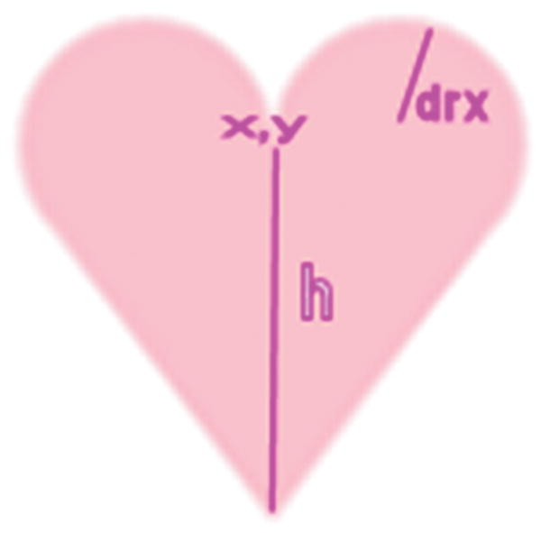
Figure 2-3Data defining a heart
The constructor function saves the indicated values, along with the color, into any newly constructed object. You might be suspecting that the drawing and the overcheck will be somewhat more complicated than the functions for rectangles and you would be correct. The constructor function resembles the other constructor function.
function Heart(x,y,h,drx,color) {
this.x = x;
this.y = y;
this.h = h;
this.drx = drx;
this.radsq = drx*drx;
this.color = color;
this.draw = drawheart;
this.overcheck = overheart;
this.ang = .25*Math.PI;
}
The ang attribute is a case of my hedging my bets. You notice that it is a constant and I could avoid making it an attribute. You will see later when I explain drawheart how my coding uses it to make the heart rounded. I made it an attribute just in case I want to change to allow hearts to have more variability.

Creating the Elements
At this point, I have shown you the specification of the objects and how to create objects, but I have not shown you the code for going from specification to creation. This is done in my createelements function . Notice the switch statement that uses the type of element to determine the action. The most complicated case is video, with picture following. My code needs to create a HTML video element and that is done by inserting the name of the video files in the string my code creates called videomarkup. The videomarkup , in turn, is created by combining three variables: videotext1, videotext2, and videotext3. I could have used just one, but then the statements initializing them would have been very long. The insertion of the name is done using a String method that JavaScript supplies named replace. This is part of a full implementation of what are called regular expressions . The video case also has two calls to addEventListener. One call, for the event loadeddata, is used to wait for all the videos to be fully loaded. The other call, for the event ended, invokes a restart function. This was necessary for browsers that do not support looping. All the cases include a statement that adds the element to an array called stuff.
function createelements() {
var name;
var i;
var type;
var divelement;
var videomarkup;
var velref;
var vb;
var imgdummy;
for (i=0;i<mediainfo.length;i++) {
type = mediainfo[i].shift(); //removes 1st element from array
info = mediainfo[i];
switch(type) {
case 'video':
videocount++;
name = info[0];
divelement= document.createElement("div");
videomarkup = videotext1+videotext2+videotext3;
videomarkup = videomarkup.replace(/XXXX/g,name);
divelement.innerHTML = videomarkup;
document.body.appendChild(divelement);
velref = document.getElementById(name);
velref.addEventListener("ended",restart,false);
velref.addEventListener("loadeddata",videoloaded,false);
vb = new Videoblock(info[2],info[3],info[4],info[5],info[6],info[7],info[8],velref,info[9],info[1],info[10]);
stuff.push(vb);
break;
case 'picture':
imgdummy = new Image();
imgdummy.src = info[4];
images.push(imgdummy);
stuff.push( new Picture(info[0],info[1],info[2],info[3],images[images.length-1]));
break;
case 'heart':
stuff.push(new Heart(info[0],info[1],info[2],info[3],info[4]));
break;
case 'oval':
stuff.push(new Oval(info[0],info[1],info[2],info[3],info[4],info[5]));
break;
case 'rect':
stuff.push(new Rect(info[0],info[1],info[2],info[3],info[4]));
break;
}
}
}

Drawing
I still need to explain the functions that serve to accomplish the draw method for each different type of element, but let’s go to where the drawing is done in order to demonstrate how all of this works together. I define an array, initially empty
var stuff = [];
The createelements function invokes the array push method to add each element to the array.
At appropriate times, namely after any changes, the function drawstuff is invoked. It works by erasing the canvas, drawing a rectangle to make a frame, and then iterating over each element in the stuff array and invoking the draw methods. The function is
function drawstuff() {
ctx.clearRect(0,0,800,600);
ctx.strokeStyle = "black";
ctx.lineWidth = 2;
ctx.strokeRect(0,0,800,600);
for (var i=0;i<stuff.length;i++) {
stuff[i].draw();
}
}
Notice that there is no coding that asks, is this an oval, if so do this, or is it a picture, if so do that.... Instead, the draw method that has been established for each member of the array does its work! The same magic happens when checking if a position (the mouse) is on an object. The benefit of this approach increases as more object types are added.
I did realize that since my code never changes the strokeStyle or the lineWidth, I could move those statements to the init function and just do them one time. However, it occurred to me that I might have a shape that does change these values and so to prepare for that possible change in the application at a later time, I set strokeStyle and lineWidth in drawstuff.
Now I will explain the methods for drawing and the methods for checking if a position is on the object. The drawrect function is pretty straight-forward:
function drawrect() {
ctx.fillStyle = this.color;
ctx.fillRect(this.x, this.y, this.w, this.h);
}
Remember the term this refers to the object for which drawrect serves as a method . The drawrect function is the method for rectangles.
The drawoval function is slightly, but only slightly, more complex. You need to recall how coordinate transformations work. HTML5 JavaScript only allows circular arcs but does allow scaling the coordinates to produce ovals (ellipses) that are not circles. What the coding in the drawoval function does is save the current state of the coordinate system and then perform a translation to the center of the object. Then a scaling transformation is applied, using the hor and ver properties. Now, after setting the fillStyle to be the color specified in the color attribute, I use the coding for drawing a path made up of a circular arc and filling the path. Arcs can be portions of circles, with the starting and the ending angle specified, with true indicating counter-clockwise. The default is false, for clockwise. For a complete circle, which is what is indicated here, I could have omitted the true, since it has the same result as false. See the coding for the heart in which the direction is critical. The last step is to restore the original state of the coordinate system.
function drawoval() {
ctx.save();
ctx.translate(this.x,this.y);
ctx.scale(this.hor,this.ver);
ctx.fillStyle = this.color;
ctx.beginPath();
ctx.arc(0,0,this.r,0,2*Math.PI,true);
ctx.closePath();
ctx.fill();
ctx.restore();
}
This is the way ovals that may or may not be circles are drawn on the canvas. Since my code restored the original state of the coordinate system, this has the effect of undoing the scaling and translation transformations.
Again, the terms starting with this followed by a dot and then the attribute names reference the stored attributes.
NotePlease keep in mind that I didn’t plan and program this whole application all at once. I did the rectangles and ovals and later added the pictures and much later the heart. I also added the duplication operation and the deletion operation much later. Working in stages is the way to go. Planning is important and useful, but you do not have to have all the details complete at the start.
The drawheart function starts by defining variables to be used later. The leftctrx is the x coordinate of the center of the left arc and the rightctrx is the x coordinate of the center of the right arc. The arcs are each more than a half circle. How much more? I decided to make this be .25* Math.PI and to store this value in the ang attribute.
The tricky thing was to determine where the arc stops on the right side. My code uses trig expressions to set the cx and cy values. The cx,cy position is where the arc meets the straight line. Figure 2-4 indicates the meaning of the variables.
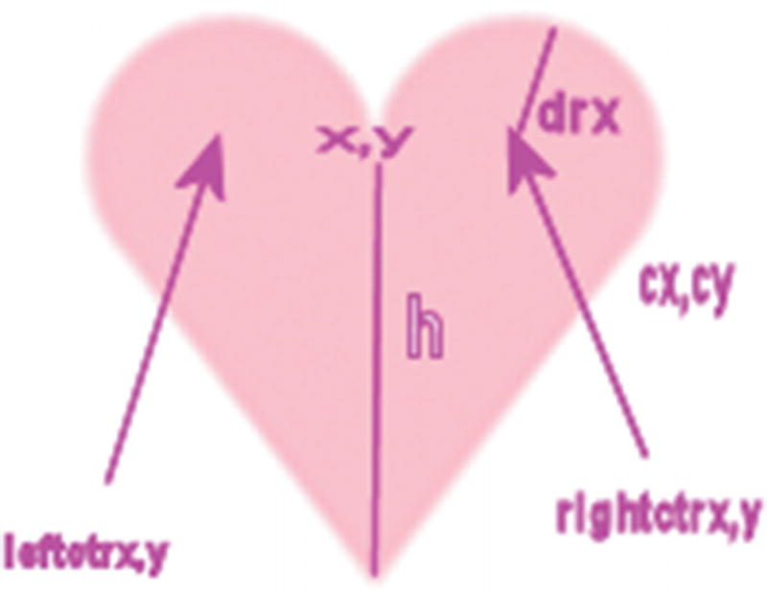
Figure 2-4Added pieces of data used in functions
The path will start at what we are calling the cleft or the cleavage (giggle) and draw the arc on the left. Then it will draw a line to the bottom point, then up to the cx,cy point, and then finish with the arc on the right. The function is the following:
function drawheart() {
var leftctrx = this.x-this.drx;
var rightctrx = this.x+this.drx;
var cx = rightctrx+this.drx*Math.cos(this.ang);
var cy = this.y + this.drx*Math.sin(this.ang);
ctx.fillStyle = this.color;
ctx.beginPath();
ctx.moveTo(this.x,this.y);
ctx.arc(leftctrx,this.y,this.drx,0,Math.PI-this.ang,true);
ctx.lineTo(this.x,this.y+this.h);
ctx.lineTo(cx,cy);
ctx.arc(rightctrx,this.y,this.drx,this.ang,Math.PI,true);
ctx.closePath();
ctx.fill();
}
The drawing of pictures is straight-forward. For both pictures and videos, I provide a way to produce a composite drawing if one object is on top of another.
function drawpic() {
ctx.globalAlpha = 1.0;
ctx.drawImage(this.imagename,this.x,this.y,this.w,this.h);
}
The drawing of the Videoblock is more complex because of the facility to put the video at an angle and scale it. It also is important to understand that what is being drawn is the current frame of the video clip. This is done using the drawimage method of canvas elements.
function drawvideo() {
var savedalpha = ctx.globalAlpha;
ctx.globalCompositeOperation = "lighter";
ctx.globalAlpha = this.alpha;
if (this.angle!=0) {
ctx.save();
ctx.translate(this.x,this.y);
ctx.rotate(this.angle);
ctx.translate(-this.x,-this.y)
if (this.scale!=1) {
ctx.scale(this.scale,this.scale); }
ctx.drawImage(this.videoelement,this.sx,this.sy,this.w,this.h,this.x,this.y, this.w, this.h);
ctx.restore();
}
else {
if (this.scale!=1) {
ctx.save();
ctx.scale(this.scale,this.scale);
ctx.drawImage(this.videoelement,this.sx,this.sy,this.w,this.h,this.x,this.y, this.w, this.h);
ctx.restore();
}
else {
ctx.drawImage(this.videoelement,this.sx,this.sy,this.w,this.h,this.x,this.y, this.w, this.h);
}
}
ctx.globalAlpha = savedalpha;
ctx.globalCompositeOperation = savedgco;
}

Checking for a Mouse Over Object
Before describing the functions for the overcheck method , I will preview why it is needed. HTML5 and JavaScript provide ways to handle (listen for and respond to) mouse events on the canvas and supply the coordinates of where the event took place. However, our code must do the work of determining what object was involved. Remember: there are no objects actually on the canvas, just the remains, think of it as paint, of whatever drawing was done. My code accomplishes this task by looping through the stuff array and invoking the overcheck method for each object. As soon as there is a hit (and I will explain the order in which this is done later), my code proceeds with that object as the one selected. The functions in which this checking occurs are startdragging and makenewitem and are explained in the next section .
There are four functions to explain for the overcheck method since Picture and Rect refer to the same function. Each function takes two parameters. Think of the mx,my as the location of the mouse. The overrect function checks for four conditions each being true. In English, the question is: Is mx greater than or equal to this.x and is mx less than or equal to this.x + this.w and is my greater than or equal to this.y and is my less than or equal to this.y + this.h? The function says this more compactly:
function overrect (mx,my) {
return (
(mx>=this.x)&&(mx<=(this.x+this.w))&&(my>=this.y)&&(my<=(this.y+this.h)));
}
The function defining the overcheck method for ovals is overoval. The overoval function performs the operation of checking if something is within a circle, but in a translated and scaled coordinate system. The check for a point being within a circle could be done by setting the center of the circle to x1,y1 and the point to x2,y2 and see if the distance between the two is less than the radius. I use a variation of this to save time and compare the square of the distance to the radius squared. I define a function called distsq that returns the square of the distance. But now I need to figure out how to do this in a translated and scaled coordinate system. The answer is to set x1,y1 to 0,0. This is the location of the center of the oval in the translated coordinate system. Then my code sets x2 and y2 as indicated in the code to what would be the scaled values.
function overoval(mx,my) {
var x1 = 0;
var y1 = 0;
var x2 = (mx-this.x)/this.hor;
var y2 = (my-this.y)/this.ver;
if (distsq(x1,y1,x2,y2)<=(this.radsq) ){
return true
}
else {return false}
}
This did not come to me instantly. I worked it out trying values for mx and my located in different positions relative to the oval center. The code does represent what the transformations do in terms of the translation and then the scaling.
The overheart function consists of several distinct if statements. This is a case of not trying for a simple expression but thinking about various situations. The function starts off by setting variables to be used later. The first check made by the function is to determine if the mx,my point is outside the rectangle that is the bounding rectangle for the heart. I wrote the outside function to return true if the position specified by the last two parameters was outside the rectangle indicated by the first four parameters. The qx,qy point is the upper-left corner. qwidth is the width at the widest point and qheight is the total height. I thought of this as a quick check that would return false most of the time. The next two if statements determine if the mx,my point is contained in either circle. That is, I again use the comparison of the square of the distance from mx,my to the center of each arc to the stored radsq attribute. At this point in the function, that is, if the mx,my position was not close enough to the center of either circle and if my is above (less than) this.y, then the code returns false. Lastly, the code puts the mx value in the equation for each of the sloping lines and compares the result to my. The equation for a line can be written using the slope m and a point on the line x2,y2 (note: this is mathematics, not programming):
y = m * (x – x2) + y2
The code sets m and x2,y2 for the line on the left and then modifies it to work for the line on the right by changing the sign of m. The check is for x set to mx, is my less than the expression shown. One possible concern here is whether or not the fact that the screen coordinate system has upside down vertical values (vertical values increase going down the screen) causes a problem . I checked out cases and the code works.
function overheart(mx,my) {
var leftctrx = this.x-this.drx;
var rightctrx = this.x+this.drx;
var qx = this.x-2*this.drx;
var qy = this.y-this.drx;
var qwidth = 4*this.drx;
var qheight = this.drx+this.h;
//quick test if it is in bounding rectangle
if (outside(qx,qy,qwidth,qheight,mx,my)) {
return false;}
//compare to two centers
if (distsq(mx,my,leftctrx,this.y)<this.radsq) return true;
if (distsq(mx,my,rightctrx,this.y)<this.radsq) return true;
// if outside of circles AND below (higher in the screen) than this.y, return false
if (my<this.y) return false;
// compare to each slope
var x2 = this.x;
var y2 = this.y + this.h;
var m = (this.h)/(2*this.drx);
// left side
if (mx<=this.x) {
if (my < (m*(mx-x2)+y2)) {return true;}
else { return false;}
}
else {
//right side
m = -m;
if (my < (m*(mx-x2)+y2)) { return true}
else return false;
}
}
The reasoning underlying the outside function is similar to the overrect function. You need to write code comparing the mx,my value to the sides of the rectangle. However, for outside I chose to use the OR operator, ||, and to return its value. This will be true if any of the factors are true and false otherwise.
function outside(x,y,w,h,mx,my) {
return ((mx<x) || (mx > (x+w)) || (my < y) || (my > (y+h)));
}
Actually, what I said was true, but misses what could be an important consideration if performance is an issue. The || evaluates each of the conditions starting from the first (leftmost) one. As soon as one of them is true, it stops evaluating and returns true. The && operator does a similar thing. As soon as one of the conditions is false, it returns false.
The overvideo function must allow for the angle and scaling.
function overvideo (mx,my) {
//need to add code to check in rotation case and scaling
omx = mx;
omy = my;
if (this.angle!=0) {
omx = omx-this.x;
omy = omy - this.y;
mx = omx*this.cosine + omy*this.sine;
my = -omx*this.sine + omy*this.cosine;
mx = this.x +mx;
my = this.y + my;
}
if (this.scale!=1) {
//alert("prescaling mx is "+mx+" prescaling my is "+my);
mx = mx/this.scale;
my = my/this.scale;
//alert("post scaling mx is "+mx+" post scaling my is "+my);
}
return (
(mx>=this.x)&&(mx<=(this.x+this.w))&&(my>=this.y)&&(my<=(this.y+this.h)));
}
This is the basis for the five types of objects I designed for manipulation on the canvas. You can look ahead to examine all the code or continue to see how these objects are put in use in the responses to mouse events.
NoteThis example does not demonstrate the full power of object oriented programming. In a language such as Java (or the variant Processing designed for artists), I could have programmed this in such a way to check that each additional object was defined properly, that is with the x and y attributes for location and methods for drawing and checking.

User Inter face
The application requirements for the user interface include dragging, that is, mouse down, mouse move, and mouse up, for re-positioning items and double-clicking for producing a duplicate copy of an item. I decided to use buttons for the other end-user actions: removing an item from the canvas and creating an image to be saved. The button action is straight-forward. I write two instances of the HTML5 button element with the onClick attributes set to the appropriate function.
<button onClick="saveasimage();">Open window with image (which you can save into image file)
</button></br>
<button onClick="removeobj();">Remove last object moved </button>
The saveasimage function will be explained in the next section. The removeobj function deletes the last moved object from the stuff array because the last moved object has been positioned as the last element in the array. This makes the coding extremely simple:
function removeobj() {
stuff.pop();
drawstuff();
}
A pop for any array deletes the last element. The function then invokes the drawstuff function to display all but the last element. By the way, if the button is clicked at the start of the application, the last element pushed on the stuff array will be deleted. If this is unacceptable, you can add a check to prevent this from happening. The cost is that it needs to be done every time the user clicks on the button.
Fortunately, HTML5 provides the mouse events that we need for this application. In the init function, I include the following lines:
canvas1 = document.getElementById('canvas');
canvas1.onmousedown = function () { return false; };
canvas1.addEventListener('dblclick',makenewitem,false);
canvas1.addEventListener('mousedown',startdragging,false);
The first statement sets the canvas1 variable to reference the canvas element. The second statement is necessary to turn off the default action for the cursor. I also included a style directive for the canvas, which made the positioning absolute and then positioned the canvas 80 pixels from the top. This is ample space for the directions and the buttons.
canvas {position:absolute; top:80px;
cursor:crosshair;
}
The third and fourth statements set up event handling for double-click and mouse button down events. We should appreciate the fact that we as programmers do not have to write code to distinguish mouse down, click, and double-click. However, unfortunately, a double-click will invoke both the makenewitem function and the startdragging function. That is okay in this situation, but do be aware of it for future work.
The makenewitem and the startdragging functions start off the same. The code first determines the mouse cursor coordinates and then loops through the stuff array to determine which, if any, object was clicked on. You probably have seen the mouse cursor coordinate code before, in the Essential Guide to HTML5, for example. The looping through the array is done in reverse order. Calls are made to the overcheck method, defined appropriately for the different types of objects. If there is a hit, then the makenewitem function calls the clone function to make a copy of that item. The code modifies the x and y slightly so the new item is not directly on top of the original. The new item is added to the array and there is a break to leave the for loop.
function makenewitem(ev) {
var mx;
var my;
if (ev.layerX || ev.layerX == 0) {
mx= ev.layerX;
my = ev.layerY;
} else if (ev.offsetX || ev.offsetX == 0) {
mx = ev.offsetX;
my = ev.offsetY;
}
var endpt = stuff.length-1;
var item;
for (var i=endpt;i>=0;i--) { //reverse order
if (stuff[i].overcheck(mx,my)) {
item = clone(stuff[i]);
item.x +=20;
item.y += 20;
stuff.push(item);
break;
}
}
}
As I indicated earlier, the clone function makes a copy of an element in the stuff array. You may ask, why not just write
item = stuff[i];
The answer is that this assignment does not create a new, distinct value. JavaScript merely sets the item variable to point to the same thing as the ith member of stuff. This is called “copy by reference”. We don’t want that. We want a brand new, separate thing that we can change. The way to copy is demonstrated in the clone function. A new object is created and then a for loop is invoked. The for(var info in obj) says: for every attribute of obj, set an equivalently named attribute in item to the value of the attribute.
function clone(obj) {
var item = new Object();
for (var info in obj) {
item[info] = obj[info];
}
return item;
}
So the effect of the two functions is to duplicate whatever element is under the mouse cursor. You or your end-user can then mouse down on the original or the cloned object and move it around.
The startdragged function proceeds as indicated to determine which object was under the mouse. The code then determines what I (and others) call the offsets in x and y of the mouse coordinates versus the x,y position of the object. This is because we want the object to move around, maintaining the same relationship between object and mouse. Some folks call this the flypaper effect . It is as if the mouse cursor came down on the object and stuck like flypaper. The offsetx and offsety are global variables. Note that the coding works for objects for which the x,y values refer to the upper-left corner (pictures and rectangles), to the center (ovals), and to a specific internal point (hearts).
The coding then performs a series of operations that has the effect of moving this object to the end of the array. The first statement is a copy by reference operation to set the variable item. The next step saves the index for the last element of the stuff array to the global variable thingInMotion. This variable will be used by the moveit function. The splice statement removes the original element and the push statement adds it to the array at the end. The statement referencing cursor is the way to specify a cursor. The “pointer” refers to one of the built-in options. The last two statements in the function set up the event handling for moving the mouse and releasing the button on the mouse. This event handling will be removed in the dropit function.
function startdragging(ev) {
var mx;
var my;
if (ev.layerX || ev.layerX == 0) {
mx= ev.layerX;
my = ev.layerY;
} else if (ev.offsetX || ev.offsetX == 0) {
mx = ev.offsetX;
my = ev.offsetY;
}
var endpt = stuff.length-1;
for (var i=endpt;i>=0;i--) { //reverse order
if (stuff[i].overcheck(mx,my)) {
offsetx = mx-stuff[i].x;
offsety = my-stuff[i].y;
var item = stuff[i];
thingInMotion = stuff.length-1;
stuff.splice(i,1);
stuff.push(item);
canvas1.style.cursor = "pointer"; // change to finger
canvas1.addEventListener('mousemove',moveit,false);
canvas1.addEventListener('mouseup',dropit,false);
break;
}
}
}
The moveit function moves the object referenced by thingInMotion and uses the offsetx and offsety variables to move the object. The drawstuff function is invoked to show the modified canvas.
function moveit(ev) {
var mx;
var my;
if ( ev.layerX || ev.layerX == 0) {
mx= ev.layerX;
my = ev.layerY;
} else if (ev.offsetX || ev.offsetX == 0) {
mx = ev.offsetX;
my = ev.offsetY;
}
stuff[thingInMotion].x = mx-offsetx; //adjust for flypaper dragging
stuff[thingInMotion].y = my-offsety;
}
A mousemove event is triggered if the mouse moves a single pixel in any direction. If this seems too much, remember that the computer does it, not you or I. The user gets a smooth response to moving the mouse.
The dropit function is invoked at a mouseup event. The response is to remove, stop the listening for moving and releasing the mouse, and then changing the cursor back to the crosshairs.
function dropit(ev) {
canvas1.removeEventListener('mousemove',moveit,false);
canvas1.removeEventListener('mouseup',dropit,false);
canvas1.style.cursor = "crosshair"; //change back to crosshair
}
To summarize, the user interface for this application involves two buttons and several mouse actions. The drag-and-drop operation is implemented using mouse down, mouse move, and mouse up and cloning an object is done using double-click.

Saving the Canvas to an Image
After creating a composition, I provide a way for the user to save it to an image file. The Firefox browser makes this easy. You can right-click on the canvas when using a PC or do the equivalent operation on a Mac and a pop-up menu will appear with the option to Save Image As... However, Chrome, Safari, and Opera do not provide that facility. If you right-click, the options concern the HTML document. There is, however, an alternative provided in HTML5 that works for Firefox and, perhaps, other browsers. Support for Chrome changed with the most recent update.
A canvas element has a method called to DataURL that will produce an image from the canvas. The method provides a choice of image file types, including PNG and JPG. What I choose to do with the result of this operation is write code to open a new window with the image as the content . The user then can save this image as a file either by the Save File option or the right-click for the image. However, there is one more consideration. Firefox require that this code run from a server, not on the client computer. The client computer is the one running the browser program. The server computer would be the website to which you will upload your finished work. You may or may not have one. Opera and Safari allow the code to run from the client computer. This has an impact on testing, since, generally speaking, we test programs locally and then upload to a server. Because of this situation, this is an appropriate place to use the try/catch facility of JavaScript for catching errors (so to speak) for the programmer to take action. Here is the code for the saveasimage function . The variable canvas1 has been set to the canvas element in the init function invoked when the document is loaded.
function saveasimage() {
try {
window.open(canvas1.toDataURL("image/png"));}
catch(err) {
alert("You need to change browsers AND/OR upload the file to a server.");
}
}

Building the Application and Making It Your Own
You can make this application your own by identifying your own media files, specifying what rectangles, ovals, and hearts you want to include in the collection of objects to be manipulated and, after you have something working, adding new object types. The application has many functions but they each are small and many share attributes with others. An informal summary/outline of the application is
1. | init for initialization, including the createelement function, setting up event handling for double-click, mouse down, mouse move, and mouse up.
2. | object definition methods: constructor functions, draw functions, and overcheck functions.
3. | event handling functions: mouse events and button onClick.
More formally, Table 2-1 lists all the functions and indicates how they are invoked and what functions they invoke. Notice that several functions are invoked as a result of the function being specified as a method of an object type.
Table 2-1 Functions in the HTML5 Family Collage Project
Function | Invoked/Called By | Calls
init | Invoked by action of the onLoad attribute in the <body> tag | Picture, Rect, Oval, Heart, drawstuff
saveasimage | Invoked by action of the onClick attribute in a button tag
removeobj | Invoked by action of the onClick attribute in a button tag | drawstuff
createelements | Invoked by init | Videoblock, Picture, Rect, Oval, Heart
restart | Invoked by action of addEventListener in createelements
videoloaded | Invoked by action of addEventListener in createelements
loading | Invoked by action of setInterval in init
Picture | Invoked in createelements function
Rect | Invoked in createelements function
Oval | Invoked in createelements function
Heart | Invoked in createelements function
Videoblock | INVOKED in createelements function
drawheart | Invoked in drawstuff
drawrect | Invoked in drawstuff
drawoval | Invoked in drawstuff
drawpic | Invoked in drawstuff
drawvideo | Invoked in drawstuff
overheart | Invoked in startdragging and makenewitem | distsq, outside
overrect | Invoked in startdragging and makenewitem
overoval | Invoked in startdragging and makenewitem | distsq
overvideo | Invoked in startdragging and makenewitem
distsq | Invoked by overheart and overoval
drawstuff | Invoked by makenewitem, removeobj, init and the action of setInterval in loading | Draw method of each item in the stuff array
moveit | Invoked by action set by addEventListener for mousemove set in startdragging
dropit | Invoked by action set by addEventListener for mouseup set in startdragging
outside | Invoked by overheart
makenewitem | Invoked by action set by addEventListener for dblclick set in init | clone
clone | Invoked by makenewitem
startdragging | Invoked by action set by addEventListener for mousedown set in init
Table 2-2 shows the code for the basic application, with comments for each line.
Table 2-2 Complete Code for the Family Collage Project
<!DOCTYPE html > | Standard heading for HTML5 documents
<html> | html tag
<head> | head tag
<title>Collage, with video</title> | Complete title
<meta charset="UTF-8"> | meta tag
<style> | Start of style
canvas {position:absolute; top:80px; | Directive for canvas, setting its position as absolute and its location 80 pixels from the top of the document
cursor:crosshair; | Specifying the cursor icon for when the mouse is over the canvas
} | Close directive
video {display:none;} | Initial setting
</style> | Close style
<script type="text/javascript" src="collagedataV2.js"> </script> | External script element link
<script language="Javascript"> | Local script tag
var ctx; | Variable to hold the canvas context
var canvas1; | Variable to hold reference to canvas
var stuff = []; | Array for all the objects on the canvas
var thingInMotion; | Reference to object being dragged
var offsetx; | Horizontal offset for object being dragged
var offsety ; | Vertical offset for object being dragged
var tid; | Hold timing identifier for periodically re-drawing canvas.
var savedgco; | Stores prior composition value
var images = []; | Holds images
var videotext1 = "<video id=\"XXXX\" preload=\"auto\" loop=\"loop\" muted> <source src=\"XXXX.webm\" type=\'video/webm; codec=\"vp8, vorbis\"\'> "; | Template for start of video element html; note muted attribute
var videotext2="<source src=\"XXXX.mp4\" type=\'video/mp4; codecs=\"avc1.42E01E, mp4a.40.2\"\'> <source src=\"XXXX.ogv\" type=\'video/ogg; codecs=\"theora, vorbis\"\'>"; | Template for middle of video element html
var videotext3="Your browser does not accept the video tag.</video>"; | Template for last part of video element html
function restart(ev) { | Restarting video clip
var v = ev.target ; | The video that just ended
v.currentTime=0; | Set current time back to 0
v.play(); | Play the video
} | Close restart
var videocount =0; | Global variable keeping track of videos to be loaded
var okaytogo = false; | Will be changed to true when all videos loaded
function videoloaded(ev) { | Header for videoloaded function; handler for event of data being loaded for a video
ctx.fillText(ev.target.id+" loaded.",400,100*videocount); | Put message onscreen (will not remain on canvas for long)
ev.target.play(); | Start playing the video
videocount--; | Decrement the count of videos still to be loaded
if (videocount==0) { | When no more ...
okaytogo = true; | Set okaytogo to true
} | Close true clause
} | Close videoloaded function
var textmsg = "Loading videos "; | Message while videos still being loaded
function init() { | Header for init
canvas1 = document.getElementById('canvas'); | Set variable to reference to canvas element
canvas1.onmousedown = function () { return false; }; | Prevents change of cursor to default
canvas1.addEventListener('dblclick',makenewitem,false); | Set handling for double-click
canvas1.addEventListener('mousedown',startdragging,false); | Set handling for start of dragging
ctx = canvas1.getContext("2d"); | Set variable to hold the context
savedgco = ctx.globalCompositeOperation; | Save initial gco
createelements(); | Call createlements, which uses the external file contents
drawstuff(); | Draw all the elements in stuff
ctx.fillText(textmsg,100,100); | Write the textmsg indicating waiting for videos
loadid = setInterval(loading,2000); | Set up handling for timing
ctx.strokeStyle = "blue"; | Set border color
} | Close init
function loading() { | Header for loading
if (okaytogo) { | If all video(s) loaded
clearInterval(loadid); | Stop the timing
tid = setInterval(drawstuff,40); | Start new timing event, to draw every 40 millisec
} | Close if okaytogo
else { | Else
textmsg+="."; | Add a dot to the message
ctx.fillText(textmsg,100,100); | Write out the message
} | Close the else
} | Close the loading function
function createelements() { | Header for createelements
var name ; | Will hold name of media
var i; | Used to manipulate array
var type; | Will hold the type
var divelement; | Will hold the divelement
var videomarkup; | Will hold the combined videomarkup template
var velref; | Will hold the ref. to any newly created video element
var vb; | Will hold any newly created videoblock
var imgdummy; | Will hold any newly created image variable
for (i=0;i<mediainfo.length;i++) { | Loop through all the content
type = mediainfo[i].shift(); | Removes first element from array
info = mediainfo[i]; | Holds the first subarray (minus the original 0th element)
switch(type) { | Switch on the type
case 'video ': | Video case
videocount++; | Increment this count, to be used for determining if all videos loaded
name = info[0]; | Base name of the three video files
divelement= document.createElement("div"); | Create a div
videomarkup = videotext1+videotext2+videotext3; | Make the template
videomarkup = videomarkup.replace(/XXXX/g,name); | Swap in the base name
divelement.innerHTML = videomarkup; | Put the result in the div
document.body.appendChild(divelement); | Add to the body so it is now part of document; Note: it isn’t visible yet
velref = document.getElementById(name); | Get the reference
velref.addEventListener("ended",restart,false); | Start the ended event
velref.addEventListener("loadeddata",videoloaded,false); | Start the loadeddata event
vb = new Videoblock(info[2],info[3],info[4],info[5],info[6],info[7],info[8],velref,info[9],info[1], info[10]); | Create the videoblock element
stuff.push(vb); | Add to the stuff array
break ; | Exit the switch
case 'picture': | Picture case
imgdummy = new Image(); | Create an image variable
imgdummy.src = info[4]; | Set its src
images.push(imgdummy); | Add to the array of images
stuff.push( new Picture(info[0],info[1],info[2],info[3],images[images.length-1])); | Add to the stuff array
break; | Exit the switch
case 'heart': | The heart case
stuff.push(new Heart(info[0],info[1],info[2],info[3],info[4])); | Create heart object and add to stuff
break ; | Exit the switch
case 'oval': | The oval case
stuff.push(new Oval(info[0],info[1],info[2],info[3],info[4],info[5])); | Create the oval object and add to stuff
break ; | Exit the switch
case 'rect': | The rect case
stuff.push(new Rect(info[0],info[1],info[2],info[3],info[4])); | Create the rect object and add to stuff
break; | Exit the switch
} | Close the switch
} | Close the for loop
} | Close the createelements function
function distsq (x1,y1,x2,y2) { | Function header for distsq. Takes two points (2x2 values) as parameters
//done to avoid taking square roots
var xd = x1 - x2; | Set difference in x
var yd = y1 - y2; | Set difference in y
return ((xd*xd) + (yd*yd) ); | Returns sum of squares; this is the square of the distance between the two points
} | End distsq function
function Videoblock(sx,sy,x,y,w,h,scale,videoel,volume,angle,alpha) { | Header for videoblock
this.sx = sx; | Save source x
this.sy = sy; | Save source y
this.x = x; | Save x on canvas
this.y = y; | Save y on canvas
this.w = w; | Save the width
this.h = h; | Save the height
this.videoelement = videoel; | Save the ref to the video element
this.volume = volume; | Save the volume
this.draw = drawvideo ; | Set the draw method
this.overcheck = overvideo; | Need more complex checking because of angle and scale
this.angle = angle; | Save the angle
this.cosine = Math.cos(angle); | Calculate in advance the cosine
this.sine = Math.sin(angle); | Calculate in advance the sine
this.scale = scale; | Save the scale
this.alpha = alpha; | Save alpha
videoel.volume = 0; | Save the volume
}
function overvideo (mx,my) { | Header for overvideo
//need to add code to check in rotation case and scaling
omx = mx; | Store the mouse x
omy = my; | Store the mouse y
if (this.angle!=0) { | Is angle not 0...need to do more complex checking
omx = omx-this.x ; | Calculate horizontal distance
omy = omy - this.y; | Calculate vertical difference
mx = omx*this.cosine + omy*this.sine; | Multi-steps for adjustment for angle
my = -omx*this.sine + omy*this.cosine;
mx = this.x +mx;
my = this.y + my;
}
if (this.scale!=1) { | Now do adjustment for scaling
alert("prescaling mx is "+mx+" prescaling my is "+my);
mx = mx/this.scale;
my = my/this.scale;
}
return( (mx>=this.x)&&(mx<=(this.x+this.w))&&(my>=this.y)&&(my<=(this.y+this.h))) ; | Can now do standard rectangle checking
} | Close overvideo
function drawvideo() { | Header for drawvideo
var savedalpha = ctx.globalAlpha; | Save current globalAlpha
ctx.globalCompositeOperation = "lighter"; | Set how to combine
ctx .globalAlpha = this.alpha; | Set new alpha
if (this.angle!=0) { | If angle not = zero...
ctx.save(); | Save current coordinate state
ctx.translate(this.x,this.y); | Translate to position of video
ctx.rotate(this.angle); | Rotate angle
ctx.translate(-this.x,-this.y) | Translate back
if (this.scale!=1) { | If scaling..
ctx.scale(this.scale,this.scale); } | Do the scaling
ctx.drawImage(this.videoelement,this.sx,this.sy,this.w,this.h,this.x,this.y, this.w, this.h); | Draw from the video
ctx .restore(); | Restore previous coordinate state
} | Close if angle
else { | Else
if (this.scale!=1) { | If scaling
ctx.save(); | Save coordinate state
ctx.scale(this.scale,this.scale); | Do the scaling
ctx.drawImage(this.videoelement,this.sx,this.sy,this.w,this.h,this.x,this.y, this.w, this.h); | Draw from the video
ctx.restore(); | Restore coordinate state
} | Close if scaling
else { | Else
ctx .drawImage(this.videoelement,this.sx,this.sy,this.w,this.h,this.x,this.y, this.w, this.h); | Draw from the video
} | Close else
} | Close the else
ctx.globalAlpha = savedalpha; | Restore the globalAlpha
ctx.globalCompositeOperation = savedgco; | Set the savedgco
} | Close drawvideo
function Picture(x,y,w,h,imagename) { | Function header for Picture constructor, positioned at x,y, with width w and height h, and the imagename Image object
this.x = x; | Set attribute
this.y = y; | Set attribute
this.w = w; | Set attribute
this.h = h; | Set attribute
this.imagename = imagename; | Set attribute
this.draw = drawpic ; | Set drawpic function to be the draw method
this .overcheck = overrect; | Set overrect function to be the overcheck method
} | Close function
function Heart(x,y,h,drx,color) { | Function header for Heart constructor, located with the cleavage at x, y, distance from x, y to lower tip h, radius drx, and color
this.x = x; | Set attribute
this.y = y; | Set attribute
this.h = h; | Set attribute
this.drx = drx; | Set attribute
this.radsq = drx*drx; | Set attribute to avoid doing this operation repeated times later
this.color = color; | Set attribute
this.draw = drawheart ; | Set drawheart function to be the draw method
this.overcheck = overheart; | Set overheart function to be the overcheck method
this.ang = .25*Math.PI; | Set attribute to be this constant value; may make more general at a later time
} | Close function
function drawheart() { | Function header for drawheart
var leftctrx = this.x-this.drx; | Calculate and set variable to be x coordinate of center of left curve
var rightctrx = this.x+this.drx; | Calculate and set variable to be x coordinate of center of right curve
var cx = rightctrx+this.drx*Math.cos(this.ang); | Calculate and set variable to be x coordinate of point where curve on the right changes to straight line
var cy = this.y + this.drx*Math.sin(this.ang); | Calculate and set variable to be y coordinate of point where curve on the right changes to straight line
ctx.fillStyle = this.color ; | Set fillStyle
ctx.beginPath(); | Begin path
ctx.moveTo(this.x,this.y); | Move to cleft of heart
ctx.arc(leftctrx,this.y,this.drx,0,Math.PI-this.ang,true); | Draw left curve
ctx.lineTo(this.x,this.y+this.h); | Move to bottom point
ctx .lineTo(cx,cy); | Move to point where straight line meets curve
ctx.arc(rightctrx,this.y,this.drx,this.ang,Math.PI,true); | Draw right curve
ctx.closePath(); | Close path
ctx .fill(); | Fill in path
} | Close function
function overheart(mx,my) { | header for overheart function
var leftctrx = this.x-this.drx; | Set variable to be x coordinate of center of left curve
var rightctrx = this.x+this.drx; | Set variable to be x coordinate of center of right curve
var qx = this.x-2*this.drx; | Calculate and set variable to be x coordinate of left of bounding rectangle
var qy = this.y-this.drx; | Calculate and set variable to be y coordinate of top of bounding rectangle
var qwidth = 4*this.drx ; | Calculate and set variable to be width of bounding rectangle
var qheight = this.drx+this.h; | Calculate and set variable to be height of bounding rectangle
if (outside(qx,qy,qwidth,qheight,mx,my)) { | Quick test if it is in bounding rectangle
return false;}
if (distsq(mx,my,leftctrx,this.y)<this.radsq) return true; | Check if inside left curve
if (distsq(mx,my,rightctrx,this.y)<this.radsq) return true; | or right curve
if (my<=this.y) return false; | Return false if above y on screen (and not previously determined to be within curves)
var x2 = this.x | Start calculations to compare my to slopes. Set x2 and
var y2 = this.y + this.h ; | set y2 to have x2, y2 point on each sloping line
var m = (this.h)/(2*this.drx); | calculate slope of left line
if (mx<=this.x) { | If mx is on the left side...
if (my < (m*(mx-x2)+y2)) { | compare my to the y value corresponding to mx. If my is above (on the screen),
return true;} | then return true
else { | Else
return false;} | Otherwise return false
} | Close if if (mx<=this.x) clause
else { | Else
m = -m; | Change sign of slope to be slope of the right line
if (my < (m*(mx-x2)+y2)) {return true} | Compare my to the value corresponding to mx on the right line and if less than (farther up on the screen) return true
else return false ; | Else return false
} | Close clause
} | Close function
function outside(x,y,w,h,mx,my) { | Header for outside
return ((mx<x) || (mx > (x+w)) || (my < y) || (my > (y+h))); | Return based on calculation with x,y and width and height
} | Close outside
function drawpic() { | Header drawpic
ctx.globalAlpha = 1.0; | Set alpha
ctx.drawImage(this.imagename,this.x,this.y,this.w,this.h); | Draw the image
} | Close drawpic
function Oval(x,y,r,hor,ver,c) { | Function header for Oval constructor, position x, y, horizontal scaling hor, vertical scaling ver, color c
this.x = x; | Set attribute
this.y = y; | Set attribute
this.r = r; | Set attribute
this.radsq = r*r; | Store as attribute to avoid repeated calculations later
this.hor = hor; | Set attribute
this.ver = ver; | Set attribute
this.draw = drawoval; | Set drawoval as the draw method
this.color = c; | Set attribute
this.overcheck = overoval; | Set overoval as the overcheck method
} | Close function
function drawoval() { | Function header for drawoval
ctx .save(); | Save current coordinate state
ctx.translate(this.x,this.y); | Move to center
ctx.scale(this.hor,this.ver); | Scale as indicated by attributes
ctx.fillStyle = this.color; | Set color
ctx.beginPath(); | Start path
ctx.arc(0,0,this.r,0,2*Math.PI,true); | Draw arc (complete circle)
ctx.closePath(); | Close path
ctx.fill(); | Fill in
ctx.restore(); | Restore original coordinate state
} | Close function
function Rect(x,y,w,h,c) { | Function header Rect constructor: position x,y, width w and height h, color c
this.x = x; | Set attribute
this.y = y; | Set attribute
this.w = w; | Set attribute
this.h = h; | Set attribute
this.draw = drawrect; | Set drawrect as the draw method
this.color = c; | Set attribute
this.overcheck = overrect; | Set overrect as the overcheck method
} | Close function
function overoval(mx,my) { | Function header for overoval
Compute positions in the translated and scaled coordinate system
var x1 = 0; | Set variable to be used in call to distsq; this represents x coordinate of point at center of oval
var y1 = 0; | Set variable to be used in call to distsq; this represents y coordinate of point at center of oval
var x2 = (mx-this.x)/this.hor; | Calculate the x2 using input and scaling factor
var y2 = (my-this.y)/this.ver; | Calculate the y2 using input and scaling factor
if (distsq(x1,y1,x2,y2)<=(this.radsq) ){ | If distance squares is less than stored radius squared....
return true | Return true
} | End clause
else {return false} | Else return false
} | Close function
function overrect (mx,my) { | Header for overrect
return ( (mx>=this.x)&&(mx<=(this.x+this.w))&&(my>=this.y)&&(my<=(this.y+this.h))) ; | Standard calculation for rectangles
} | Close overrect
function makenewitem(ev) { | Function header for makenewitem; has as a parameter and event ev set by JavaScript
var mx; | Variable will hold x coordinate of mouse
var my; | Variable will hold y coordinate of mouse
if ( ev.layerX || ev.layerX == 0) { // Firefox, ??? | Does this browser use layer...
mx= ev.layerX; | ... set mx
my = ev.layerY; | ... set my
} else if (ev.offsetX || ev.offsetX == 0) { // Opera, ??? | Does browser use offset...
mx = ev.offsetX; | ... set mx
my = ev.offsetY; | ... set my
} | End clause
var endpt = stuff.length-1; | Store index of last item in stuff array
var item ; | Will hold the new item
for (var i=endpt;i>=0;i--) { //reverse order | Start search from the end
if (stuff[i].overcheck(mx,my)) { | Is the mouse over this member of stuff
item = clone(stuff[i]); | Clone (make copy of)
item.x +=20; | Move over slightly horizontally
item.y += 20; | and vertically
stuff.push(item); | Add newly created item to stuff array
break; | Leave for loop
} | End if clause
} | End for loop
} | Close function
function clone(obj) { | Function header for clone
var item = new Object(); | Create an Object
for (var info in obj) { | Loop over all attributes of the obj passed as parameter
item[info] = obj[info]; | Set an attribute by that name to the attribute value
} | Close for loop
return item; | Return the newly created object
} | Close function
function startdragging(ev) { | Function header for startdragging; has as a parameter an event ev set by JavaScript
var mx; | Variable will hold x coordinate of mouse
var my; | Variable will hold y coordinate of mouse
if ( ev.layerX || ev.layerX == 0) { // Firefox, ??? | Does this browser use layer...
mx= ev.layerX; | ... set mx
my = ev.layerY ; | ... set my
} else if (ev.offsetX || ev.offsetX == 0) { // Opera, ??? | Does browser use offset...
mx = ev.offsetX; | ... set mx
my = ev.offsetY; | ... set my
} | End clause
var endpt = stuff.length-1; | Store index of last item in stuff array
for (var i=endpt;i>=0;i--) { //reverse order | Start search from the end
if (stuff[i].overcheck(mx,my)) { | Is the mouse over this member of stuff
offsetx = mx-stuff[i].x; | Calculate how far the mx was from the x of this object
offsety = my-stuff[i].y; | Calculate how far the my was from the y of this object
var item = stuff[i]; | Will now move this item to the end of the array; set item
thingInMotion = stuff.length-1; | Set global variable to be used in the dragging
stuff.splice(i,1); | Remove this item from its original location
stuff.push(item); | Add item to the end
canvas1.style.cursor = "pointer"; | Change cursor to finger when dragging
canvas1.addEventListener('mousemove',moveit,false); | Set up event handling for moving the mouse
canvas1.addEventListener('mouseup',dropit,false); | Set up event handling for releasing mouse button
break; | Leave the for loop
} | Close if clause
} | Close for loop
} | Close function
function dropit(ev) { | Function header for dropit; has as a parameter and event ev set by JavaScript
canvas1.removeEventListener('mousemove',moveit,false); | Remove (stop) event handling for moving the mouse
canvas1.removeEventListener('mouseup',dropit,false); | Remove (stop) event handling for releasing the mouse button
canvas1 .style.cursor = "crosshair"; | Change cursor back to crosshair
} | close function
function moveit(ev) { | Function header for moveit; has as a parameter and event ev set by JavaScript
var mx; | Variable will hold x coordinate of mouse
var my; | Variable will hold y coordinate of mouse
if ( ev.layerX || ev.layerX == 0) { // Firefox, ??? | Does this browser use layer...
mx= ev.layerX; | ... set mx
my = ev.layerY ; | ... set my
} else if (ev.offsetX || ev.offsetX == 0) { // Opera, ??? | Does browser use offset...
mx = ev.offsetX; | ... set mx
my = ev.offsetY; | ... set my
} | End clause
stuff[thingInMotion].x = mx-offsetx; //adjust for flypaper dragging | Set x for the thingInMotion, adjust for flypaper dragging
stuff[thingInMotion].y = my-offsety ; | Set y for the thingInMotion, adjust for flypaper dragging
} | Close function
function drawstuff() { | Function header for drawstuff
ctx.clearRect (0,0,800,600); | Clear (erase) canvas
ctx.strokeStyle = "black"; | Set color for frame
ctx.lineWidth = 2; | Set lineWidth
ctx.strokeRect(0,0,800,600); | Draw frame
for (var i=0;i<stuff.length;i++) { | Iterate through the stuff array
stuff[i].draw(); | Invoke the draw method for each member of the array
} | Close for
} | Close function
function drawrect() { | Function header drawrect
ctx.fillStyle = this.color; | Set the color
ctx.fillRect(this.x, this.y, this.w, this.h); | Draw a filled rectangle
} | Close function
function saveasimage() { | Function header for saveasimage
try { | Start try clause
window.open(canvas1.toDataURL("image/png"));} | Create the image data and use it as contents of new window
catch(err) { | If that didn’t work, that is, threw an error
alert("You need to change browsers AND/OR upload the file to a server."); | Display alert message
} | Close catch clause
} | Close function
function removeobj() { | Function header for removeobj
stuff.pop(); | Remove the last member of the stuff array
drawstuff(); | Draw everything
} | Close function
</script> | Close script element
</head> | Close head element
<body onLoad="init();"> | Body tag, with onLoad set
Mouse down, move and mouse up to move objects. Double-click for make a copy of any object. | Text giving directions
<br/> | Line break
<canvas id="canvas" width="800" height="600"> | Canvas tag
Your browser doesn't recognize the canvas element | Message for older browsers
</canvas> | Ending canvas tag
<button onClick="saveasimage();">Open window with image (which you can save into image file) </button></br> | Button for saving image
<button onClick="removeobj();">Remove last object moved </button> | Button for removing object
</body> | Close body tag
</html> | Close html tag
It is obvious how to make this application your own using only the techniques demonstrated in my example: gather photos and videos of your own family or acquire other media and use the rect, oval , and heart to create your own set of shapes.
You can define your own objects, using the coding here as a model. For example, the Essential Guide to HTML5 book includes coding for displaying polygons. You can make the overcheck function for the polygon treat the polygon as a circle, perhaps a circle with smaller radius, and your customers will not object.
The next step could be to build an application that allows the end-user to specify the addresses of image files. You would need to set up a form for doing this. Another enhancement is to allow the end-user to enter text, perhaps a greeting, and position it on the canvas. You would create a new object type and write the draw and overcheck methods. The overcheck method could be overrect, that is, the program accepts as being on the text anything in the bounding rectangle.

Testing and Uploading the Application
The application consists of code files, one with an extension of .html and the other with an extension of .js plus all the media files. You need to gather all the media files you want to include in your application and create the .js file that references the media files and specifies how you want them to be treated. To put it another way, you can keep my .html file, and substitute your own .js file , referencing all of your media. The testing procedure depends on what browser you are using. Actually, it is good practice to test with several browsers. If you are using Firefox, you need to upload the application—the .html file and all image files—to a server to test the feature for creating an image. However, the other aspects of the application can be tested on your own (client) computer.

Summary
In this chapter, you learned how to build an application involving creating and positioning specific shapes, namely rectangles, ovals, and hearts, along with pictures such as photographs on the canvas. The programming techniques and HTML5 features included:
Separating content and action
Dynamic creation of HTML5 elements
Programming-defined objects
Mouse events on canvas
Using try and catch for trapping errors
Algebra and geometry for several functions
Consideration of video autoplay policy
The next chapter describes creating an application showing a video clip bouncing around like a ball in a box.
© Jeanine Meyer 2018
Jeanine Meyer
HTML5 and JavaScript Projects
https://doi.org/10.1007/978-1-4842-3864-6_3

3. Bouncing Video: Animating and Masking HTML5 Video
Jeanine Meyer1
(1)
New York, USA

In this chapter, you will learn the following:
Produce a moving video clip by drawing the current frame of the video at different locations on a canvas
Produce a moving video clip by repositioning the video element within the document window
Make the moving video be a circle in the drawing a frame on canvas case by drawing a mask that travels along with the video
Make the moving video be a circle in the moving element situation by using clipPath
Build an application that will adapt to different window sizes

Introduction
The project for this chapter is a display of a video clip in the shape of a ball bouncing in a box. An important feature in HTML5 is the native support of video (and audio). The book The Definitive Guide to HTML5 Video, by Silvia Pfeiffer (Apress, 2010), is an excellent reference. The challenge in this project is making the video clip move on the screen. I will describe two different ways to implement the application. The screenshots do not reveal the differences.
Figure 3-1 shows what the application looks like in the full-window view in Firefox . The video is a standard rectangular video clip. It appears ball-like because of my coding. You can skip ahead to Figure 3-8 and Figure 3-9 to learn about two techniques for producing a ball shaped video. Note: all figures are static screen captures of animations. You need to take my word for it that the video does move and bounce within the box.
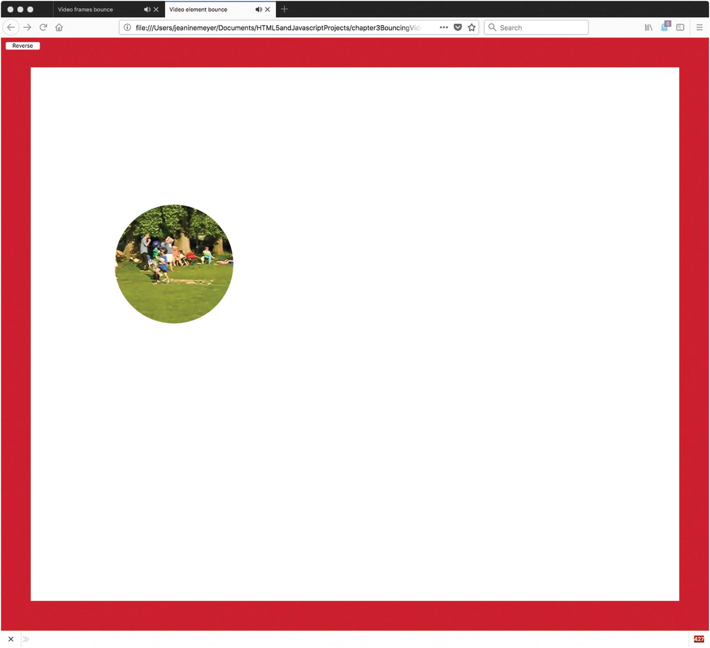
Figure 3-1Screen capture , full window
When the virtual ball hits a wall, it appears to bounce off the wall. If, for example, the virtual ball is moving down the screen and to the right, when it hits the right side of the box, it will head off to the left but still be moving down the screen. When the virtual ball then hits the bottom wall of the box, it will bounce to the left, heading up the screen. The trajectory is shown in Figure 3-2. To produce this image, I changed the virtual ball to be a simple circle and did not write code to erase the canvas at each interval of time. You can think of it as stop-motion photography. Changing the virtual ball was necessary because of its complexity: an image from a video clip and an all-white mask.
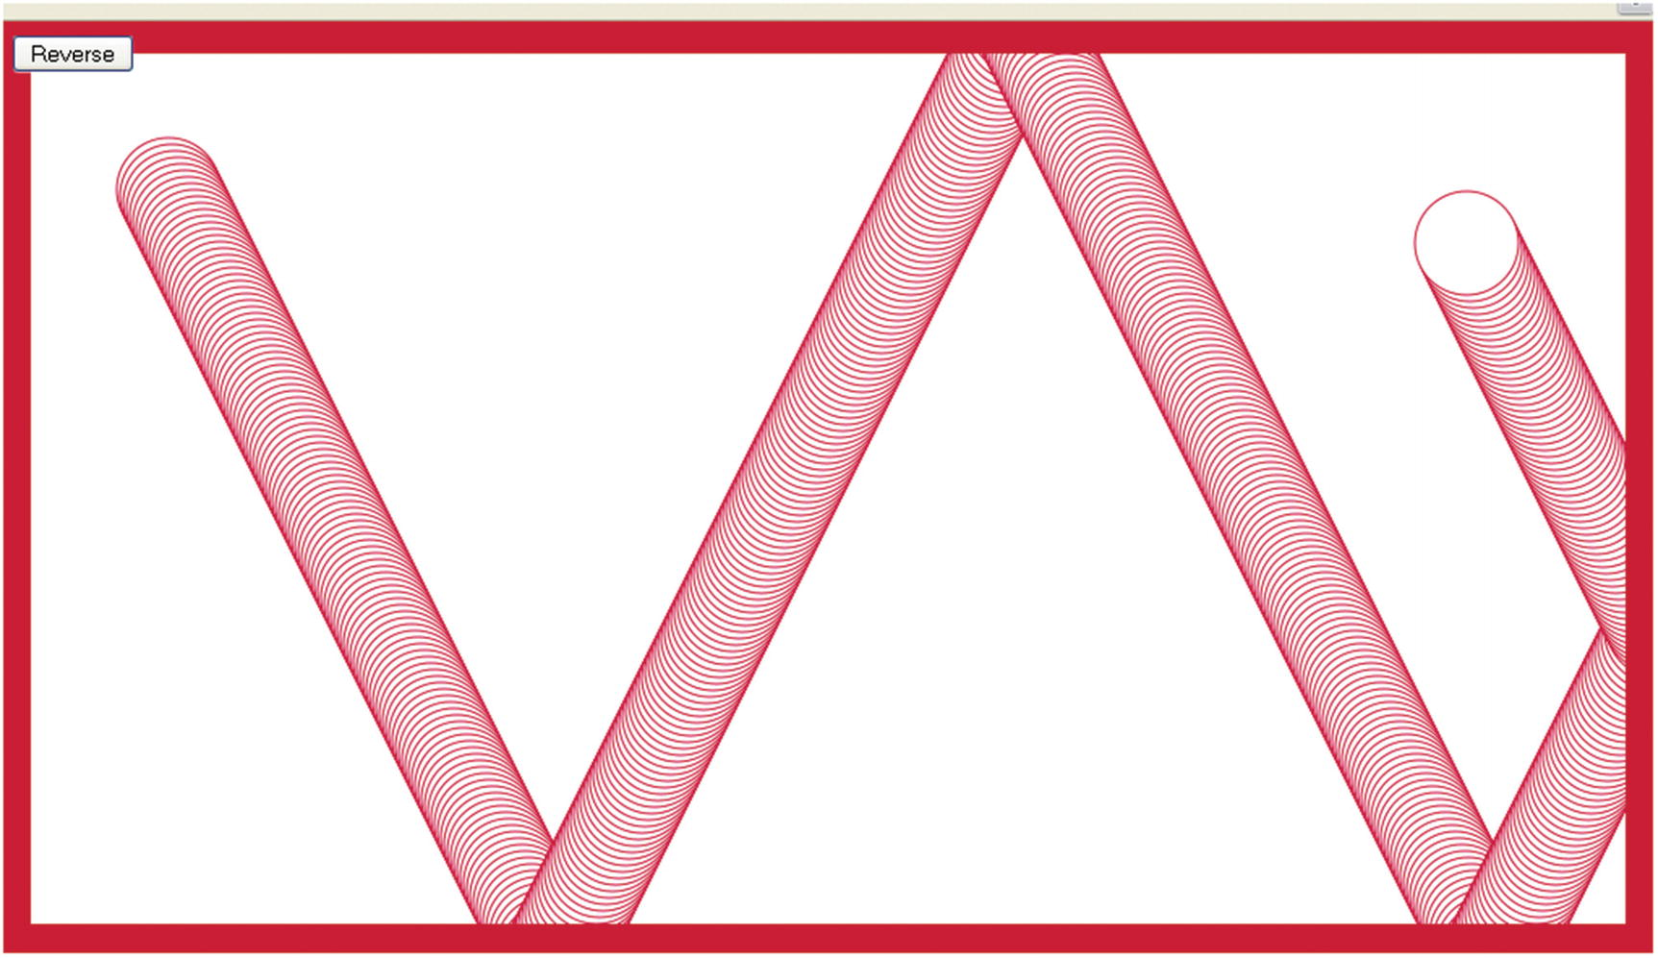
Figure 3-2 Trajectory of virtual ball
If I resize the browser window to be a little bit smaller and reload the application, the code will resize the canvas to produce what is shown in Figure 3-3: a smaller box, but the same size video.
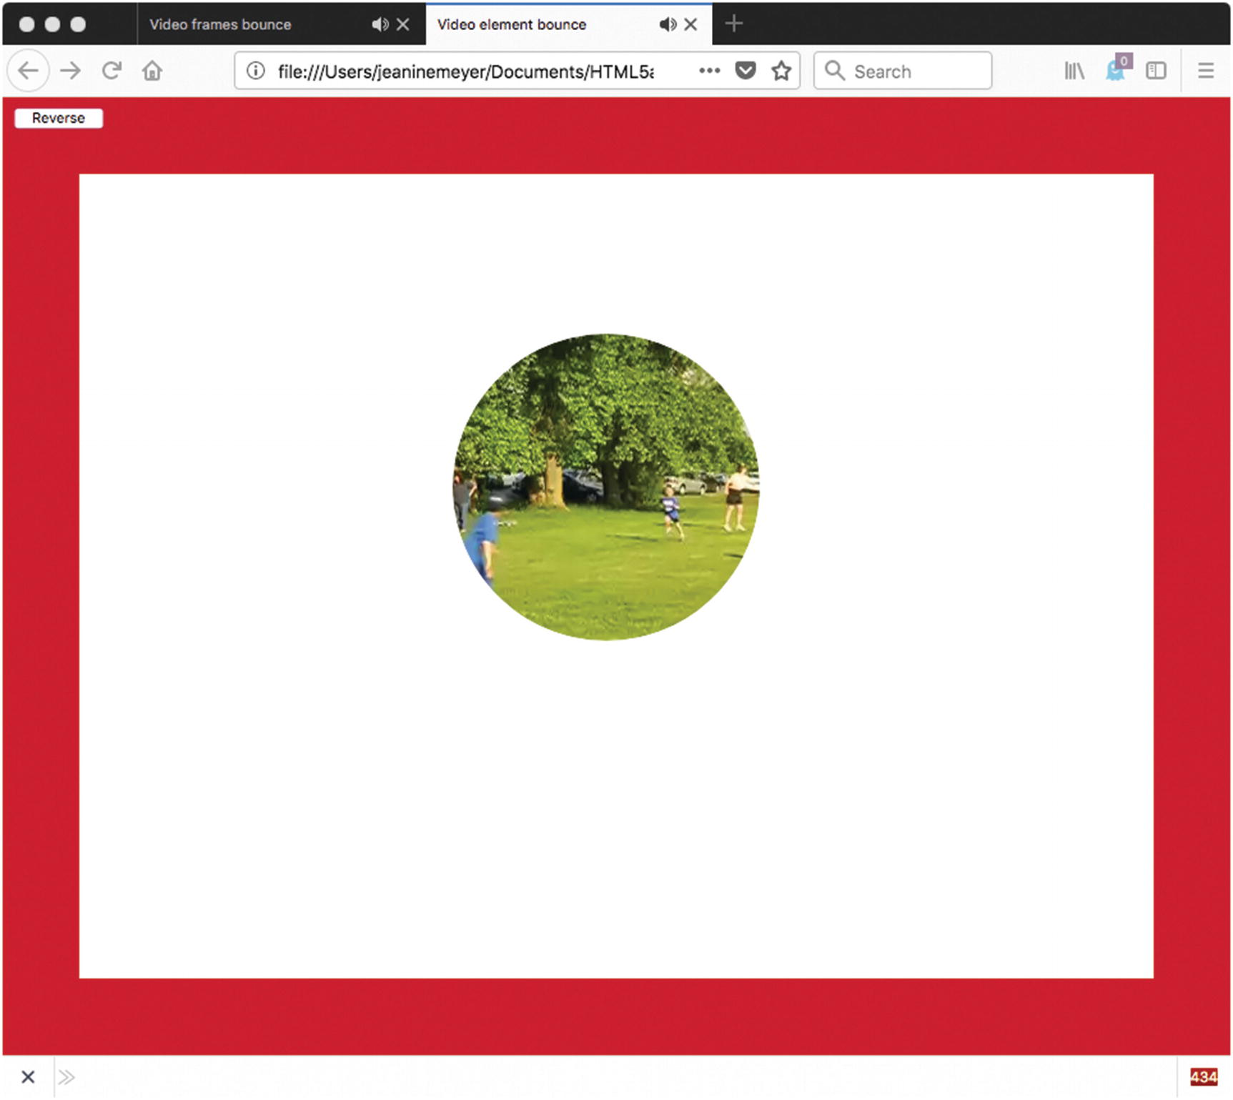
Figure 3-3Application in a smaller window
If the window is made very small, this forces a change in the size of the video clip itself, as well as the canvas and the box, as shown in Figure 3-4.
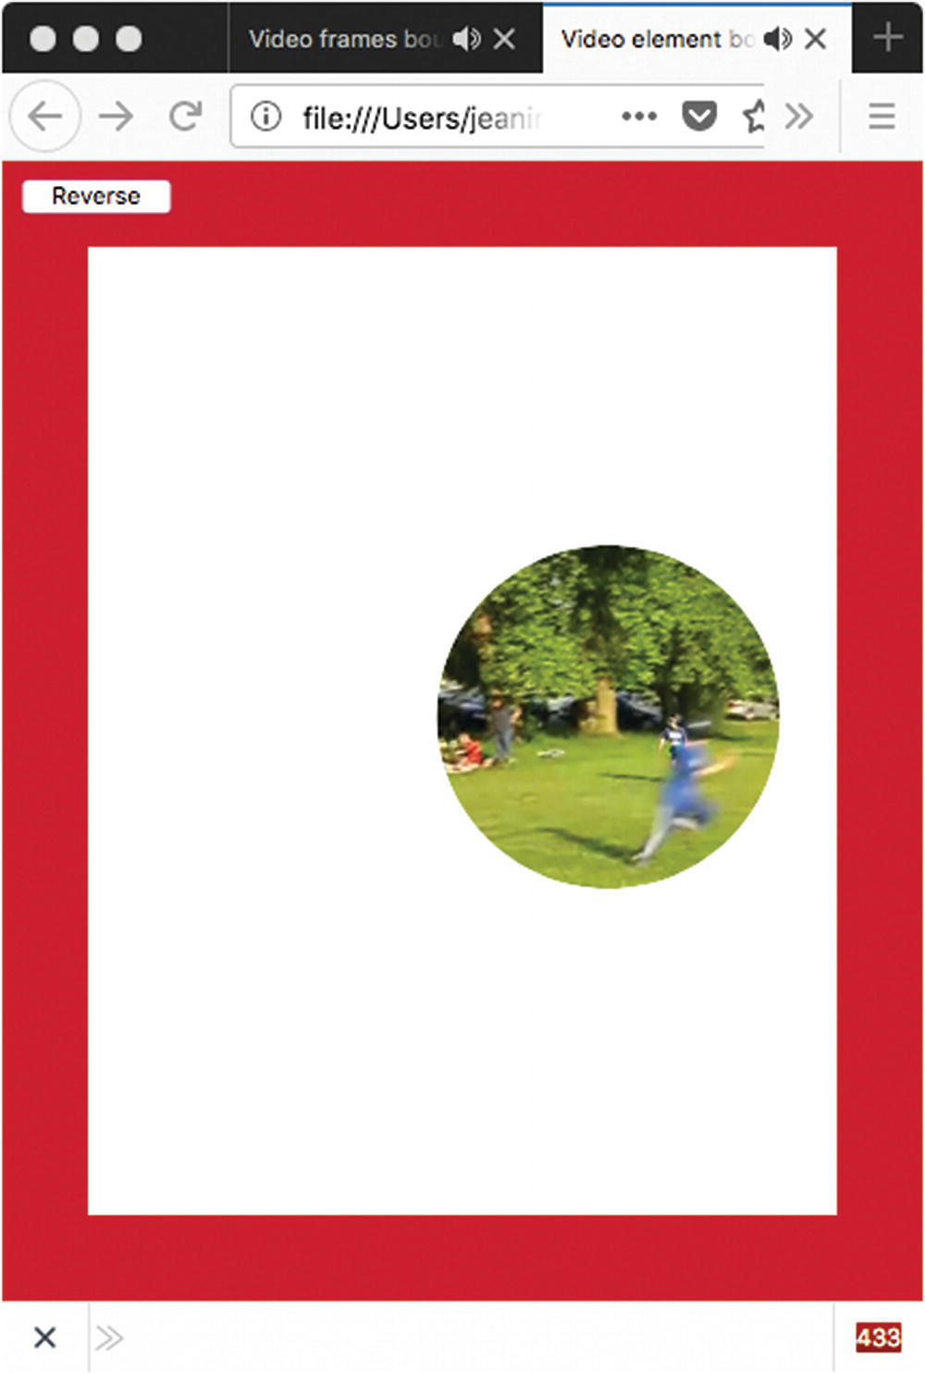
Figure 3-4Window resized to very small
The application adapts the box size, and the virtual video ball size, to the window dimensions at the time that the HTML document is first loaded. If the window is resized by the viewer later, during the running of the application, the canvas and video clip are not resized. In this case, you would see something like Figure 3-5, a small box in a big window.
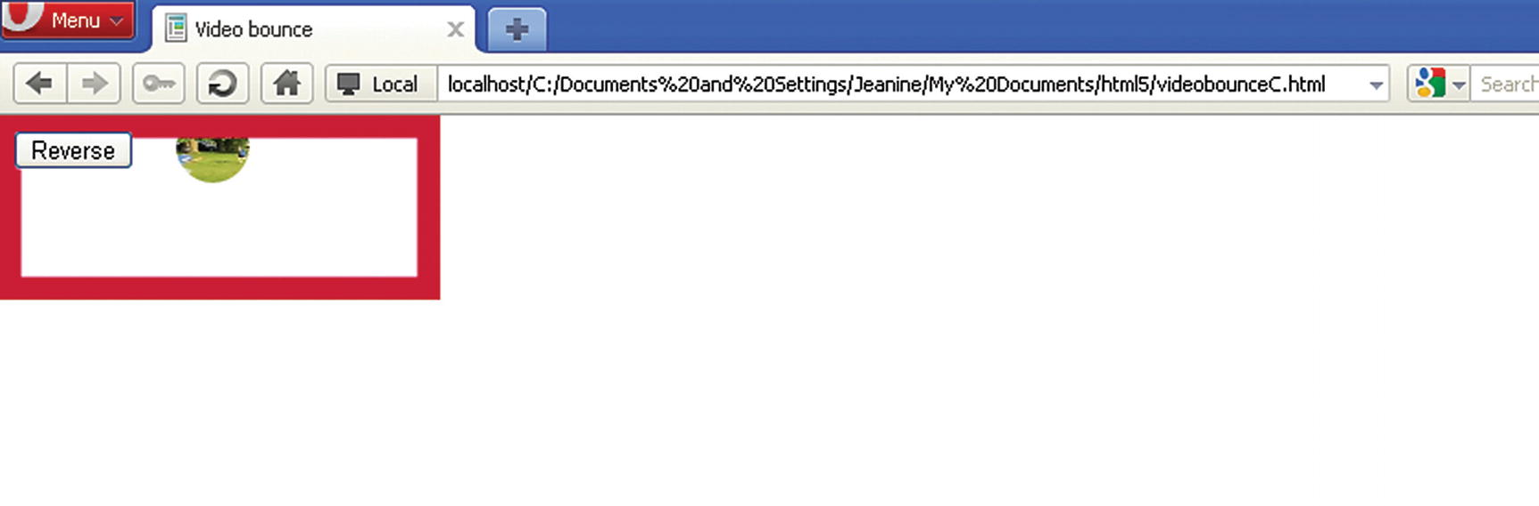
Figure 3-5Window resized during running to be larger
Similarly, if you start the application using a full-size window, or any large window, and resize it to something smaller during the running of the program, you would see something like Figure 3-6, where the scroll bars are displayed by the browser to indicate that the content of the document is wider and longer than the window. The video clip will disappear out of sight periodically for a short period of time before reappearing.
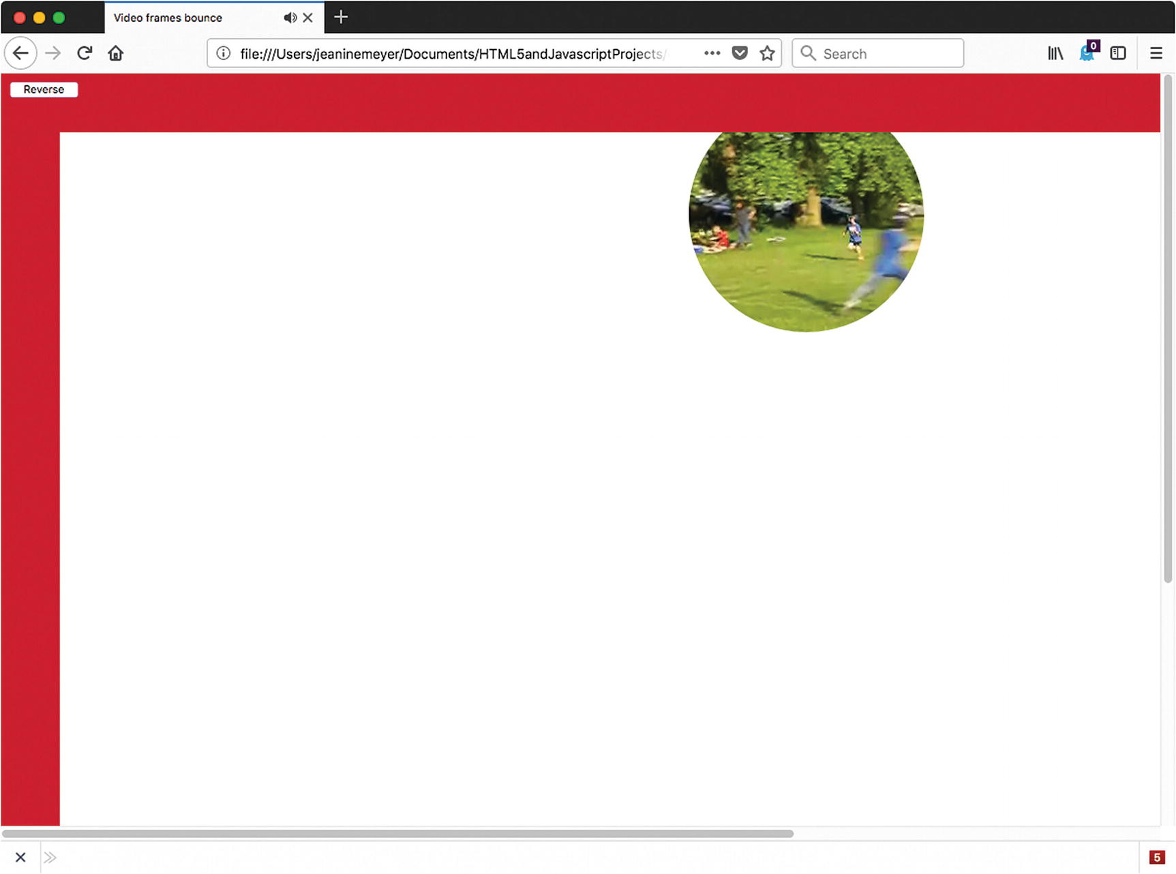
Figure 3-6Large window resized
The two applications (I named them videobounceC for “video frames drawn on canvas” and videobounceEwithClipPath for “video element using clipPath”) have been tested successfully in Firefox and Chrome. Note: look back in Chapter 2 for the discussion of Chrome autoplay policy. I have added the muted attribute to the video tag for this project. The project demonstrates coding techniques using HTML5, JavaScript, and CSS for manipulating video and using video together with the canvas for special effects. The project also explains calculations that are helpful in modifying applications to the dimensions of the browser window. More on adapting to different dimensions is discussed in Chapter 10.

Project History and Critical Requirements
I have always liked the application of simulating a ball bouncing in a box. Chapter 3 in The Essential Guide to HTML5 features projects showing a ball produced by a path drawing and a ball produced by an image, each bouncing in a two-dimensional enclosure. I decided I wanted to make a video clip do the same thing. My explanation of the coding is complete in this chapter. However, if the first book is available to you (shameless plug), you may benefit from seeing what is the same and what is different among the various versions. In the ball and image applications, the canvas was set to fixed dimensions and was located with other material in the document. Because I did not want my video clip to be too small, I decided to use the whole window in this case. This objective produced the challenge of determining the dimensions of the document window. In the ball and image applications described in the other book, I wanted to demonstrate form validation, so the program provided form elements to change the vertical and horizontal speed. For the bouncing ball video clip, the application just provides one action for the user: a button to reverse direction. After studying this chapter, you should be able to add the other interface operations to the video application.
In Chapter 2, you read about including a video with images and drawings. For that application, I used the technique of drawing the current frame as an image on the canvas. The drawing was done periodically and often enough to get the experience of seeing an uninterrupted video. For this chapter, I used that technique and made a mask—think of a rectangular doughnut—travel along to give the video a ball-like shape. In addition, I built another HTML/JavaScript script using the approach of moving the video element directly. One advantage of the element approach is that I can use the clipPath facility to make the rectangular video element appear ball-like. This requires much less coding than drawing the rectangular doughnut mask.
The objective is to simulate a ball-like object bouncing within a box. Therefore, the application must display the walls of the box and perform calculations so that when the video clip appears to collide with any of the walls, the direction of motion changes in the appropriate way. A fancy way to describe the change is that the angle of reflection must equal the angle of incidence. In practical terms, what it means is that when the video clip virtually hits the bottom or top walls, it keeps going in the same direction horizontally (to the left if it was traveling to the left and to the right if it was traveling to the right), but switches direction vertically. When the video clip virtually hits either the left or the right wall, it keeps going in the same direction vertically (traveling up if it was traveling up and traveling down if it was traveling down), but switches direction horizontally. If you are interested in simulating real-life physics, you can slow down the motion at each virtual hit of a wall.
As is my practice, I describe the coding in increasing detail. You can go to the source.

HTML5, CSS, and JavaScript Features
Any order of explanation means something is often discussed before the reason for doing it is clear. In this section, I show how certain variables are set that will be shown in use later on. The general plan is to extract the window dimensions to set variables for the canvas and the video clip that will be referenced in the coding for drawing the video and the mask.

Definition of the Body and the Window Dimensions
The Document Object Model (DOM) provides information about the window in which the HTML document is displayed by the browser. In particular, the attributes window.innerWidth and window.innerHeight indicate the usable dimensions of the window. My code will use these values when it sets up the application.
Recall that the HTML5 video element can contain as child elements any number of source elements referencing different video files. At this time, this is necessary because the browsers that recognize the video element do not accept the same video formats (codecs). The situation may change in the future. If you know the browser used by all your potential customers, you can determine a single video format. If that is not the case, you need to make three versions of the same video clip. The Open Source Miro Video Converter, downloadable from www.mirovideoconverter.com/ , is a good product to convert a video clip into other formats.
With that reminder, I can present the body element for this application. It contains a video element, a button, and a canvas element:
<body onLoad="init();">
<video id="vid" loop="loop" preload="auto" muted>
<source src="joshuahomerun.mp4" type='video/mp4; codecs="avc1.42E01E, mp4a.40.2"'>
<source src="joshuahomerun.webmvp8.webm" type='video/webm; codec="vp8, vorbis"'>
<source src="joshuahomerun.theora.ogg type='video/ogg; codecs="theora, vorbis"'>
Your browser does not accept the video tag.
</video>
<button id="revbtn" onClick="reverse();">Reverse </button><br/>
<canvas id="canvas" >
This browser doesn't support the HTML5 canvas element.
</canvas>
</body>
Style directives will change the location of the three elements: video, canvas, and button. We will discuss the directives later in this chapter.
In the init function that’s invoked when the document is loaded, the following statements set the dimensions of the canvas to match the dimensions of the window:
canvas1 = document.getElementById('canvas');
ctx = canvas1.getContext('2d');
canvas1.width = window.innerWidth;
cwidth = canvas1.width;
canvas1.height = window.innerHeight;
cheight = canvas1.height;
These statements set global variables canvas1, ctx, cwidth, and cheight, which will be used later. So the task of adapting the canvas to the window is accomplished.
Now the next task takes more thought. How much do I want to adapt the video to the window dimensions? I decided that I wanted to maintain the aspect ratio, but not have the video width exceed half of the window width, nor have the video height exceed half of the window height. I did not want to trigger vertical or horizontal scrolling. I was okay, even happy, with the circles going beyond the box walls, because it looked something like the balls flattening. I do think there is room for improvement here.
The Math.min method returns the smallest of its operands, so the statements
v = document.getElementById("vid");
var aspect= v.videoWidth/v.videoHeight;
v.width = Math.min(v.videoWidth,.5*cwidth);
v.height = v.width/aspect;
v.height = Math.min(v.height,.5*cheight);
v.width = aspect*v.height;
var videow = v.width;
var videoh = v.height;
start by setting the variable v to point to the video element, which you can see I have coded in the body to have the id "vid". It then calculates the aspect ratio to be used to maintain the video’s portion. My code first compares the video width to .5 of the canvas width and sets it to be the minimum of the two values and makes the corresponding change to the video height. Then the code performs a similar operation on the newly adjusted height, adjusting the width.
Certain other variables are set in the init function and used for the drawing of the box and for the mask for one example and the box and the clipPath for the other. You can examine this in Table 3-2 and Table 3-4.

Animation
Animation is the trick by which still images are presented in succession fast enough so that our eye and brain interprets what we see as motion. The exact mechanics of how things are drawn are explained in the next two sections. Keep in mind that there are two animations going on: the presentation of the video and the location of the video in the box. In this section, I talk about the location of the video in the box.
One way to get animation in HTML and JavaScript is to use the setInterval function . This function is called with two parameters. The first is the name of a function that we want to call periodically and the second indicates the length of the time interval between each call to the function. The unit of time is milliseconds.
I began by describing the drawing frames example. The moving the element example is similar and I will describe the differences. The following statement, which is in the init function , sets up the animation:
setInterval(drawscene,50);
The parameter drawscene refers to a function that will do the bulk of the work. It draws a frame from the video and draws the mask, what I refer to as the rectangular doughnut. I will describe that operation later. The 50 in the setInterval call stands for 50 milliseconds. This means that every 50 milliseconds (or 20 times per second), the drawscene function will be invoked. Presumably, drawscene will do what needs to be done to display something showing the video clip at a new location. You can experiment with interval duration.
If you want to enhance this application or build another one in which it makes sense to stop the animation, you would declare a local variable for the setInterval call (let’s call it tid) and use the statement
tid = setInterval(drawscene,50);
At the point you wish to stop the animation, or more formally, stop the interval-timing event, you code
clearInterval(tid);
If you have more than one timing event , you would assign the output for each of them to a new variable. Be careful not to call setInterval multiple times with the same function. Doing so has the effect of adding new timing events and invoking the function multiple times. It is not changing the alarm function on your clock, but setting multiple clocks.
Much of the details of the drawscene function will be described in the next sections, but I describe two critical tasks here. One is erasing the canvas and the other is determining the next position of the video clip. The statement for erasing the whole canvas is
ctx.clearRect(0,0,cwidth,cheight);
Notice that it uses the cwidth and cheight values calculated based on the window dimensions.
The simulation of bouncing is performed by a function called checkPosition . The position of the virtual ball is defined by the variables ballx and bally. The (ballx,bally) position is the upper-left corner of the video. The motion, also termed the displacement, is defined by the variables ballvx and ballvy. These two variables are termed the horizontal and vertical displacements, respectively.
NoteWhy did I use two functions, drawscene and checkPosition, when I could have used just one? The checkposition function is just invoked by drawscene. The answer is that the operation of these seemed like distinct operations to me and it is a good practice to make distinct functions for distinct tasks.
The objective of the checkPosition function is to reposition the virtual ball by setting ballx and bally to expressions involving ballvx and ballvy, respectively. When appropriate, my code must change the signs of ballvx and ballvy. The way the code works is to try out new values (see nballx and nbally in the function) and then set ballx and bally. Changing the sign of the displacement values has the effect of making the balls bounce by changing the appropriate horizontal or vertical adjustment for the next interval. If the ball hits at a corner, then both displacement values change sign, but generally, just one changes.
The task now is to determine when to do the bounce. You need to accept that as far as the computer’s concerned, there are no balls, bouncing or otherwise, and no walls. There are just calculations. Moreover, the calculations are done at discrete intervals of time. There is no continuous motion. The virtual ball jumps from position to position. The trajectory appears smooth because the jumps are small enough and our eye-brain interprets the pictures as continuous motion. Since the walls are drawn after the video (that will be explained later), the effect is that the virtual ball touches and goes slightly behind the wall before changing direction.
My approach is to set up trial or stand-in values for ballx and bally and do calculations based on these values. You can think of it logically as asking if the video ball were moved, would it be beyond any of the walls? If so, readjust to just hit that wall and change the appropriate displacement value. The new displacement value is not used immediately, but will be part of the calculation made at the next iteration of time. If the trial value is not at or beyond the wall, keep the trial value as it is and keep the corresponding displacement value as it is. Then change ballx and bally to the possibly adjusted stand-in values.
The function definition for the checkPosition function for the videobounceC program is
function checkPosition() {
var nballx = ballx + ballvx +.5*videow;
var nbally = bally + ballvy +.5*videoh;
if (nballx > cwidth) {
ballvx =-ballvx;
nballx = cwidth;
}
if (nballx < 0) {
nballx = 0;
ballvx = -ballvx;
}
if (nbally > cheight) {
nbally = cheight;
ballvy =-ballvy;
}
if (nbally < 0) {
nbally = 0;
ballvy = -ballvy;
}
ballx = nballx-.5*videow;
bally = nbally-.5*videoh;
}
I decided to change the name of the function drawscene for the video element example. I wanted to emphasize that the video was moving as opposed to being drawn. The counterpart of drawscene is moveVideo. This is the function referenced in the setInterval call.
function moveVideo(){
checkPosition();
v.style.left = String(ballx)+"px";
v.style.top = String(bally)+"px";
}
The checkPosition function does the calculation to determine when bouncing takes place.
function checkPosition() {
var nballx = ballx + ballvx;
var nbally = bally + ballvy;
if ((nballx+v.width) > cwidth) {
ballvx =-ballvx;
nballx = cwidth-v.width;
}
if (nballx < 0) {
nballx = 0;
ballvx = -ballvx;
}
if ((nbally+v.height) > cheight) {
nbally = cheight-v.height;
ballvy =-ballvy;
}
if (nbally < 0) {
nbally = 0;
ballvy = -ballvy;
}
ballx = nballx;
bally = nbally;
}
Notice that the videobounceC version compares ballx + ballvx + .5*videow to cwidth, whereas videobounceEwithClipPath compares ballx + ballvx + videow to cwidth. This means the videobounceE program will force bouncing sooner—that is, turn around sooner—when compared with the right wall. The same holds true for the checking against the bottom wall. I did this to avoid a problem involving automatic scrolling. The video element is not restricted to the canvas, so if it moves out from under the canvas, it is part of the document and is displayed. Because the new display is bigger than the window, this causes scrolling. The scroll bars would appear, and though you would not see anything, I did not like the effect. If you started with a smaller window and made it larger during the program execution, you could see something like what is shown in Figure 3-7. The video element also can move so fast that it escapes the box. This is an amusing exercise left for the reader.
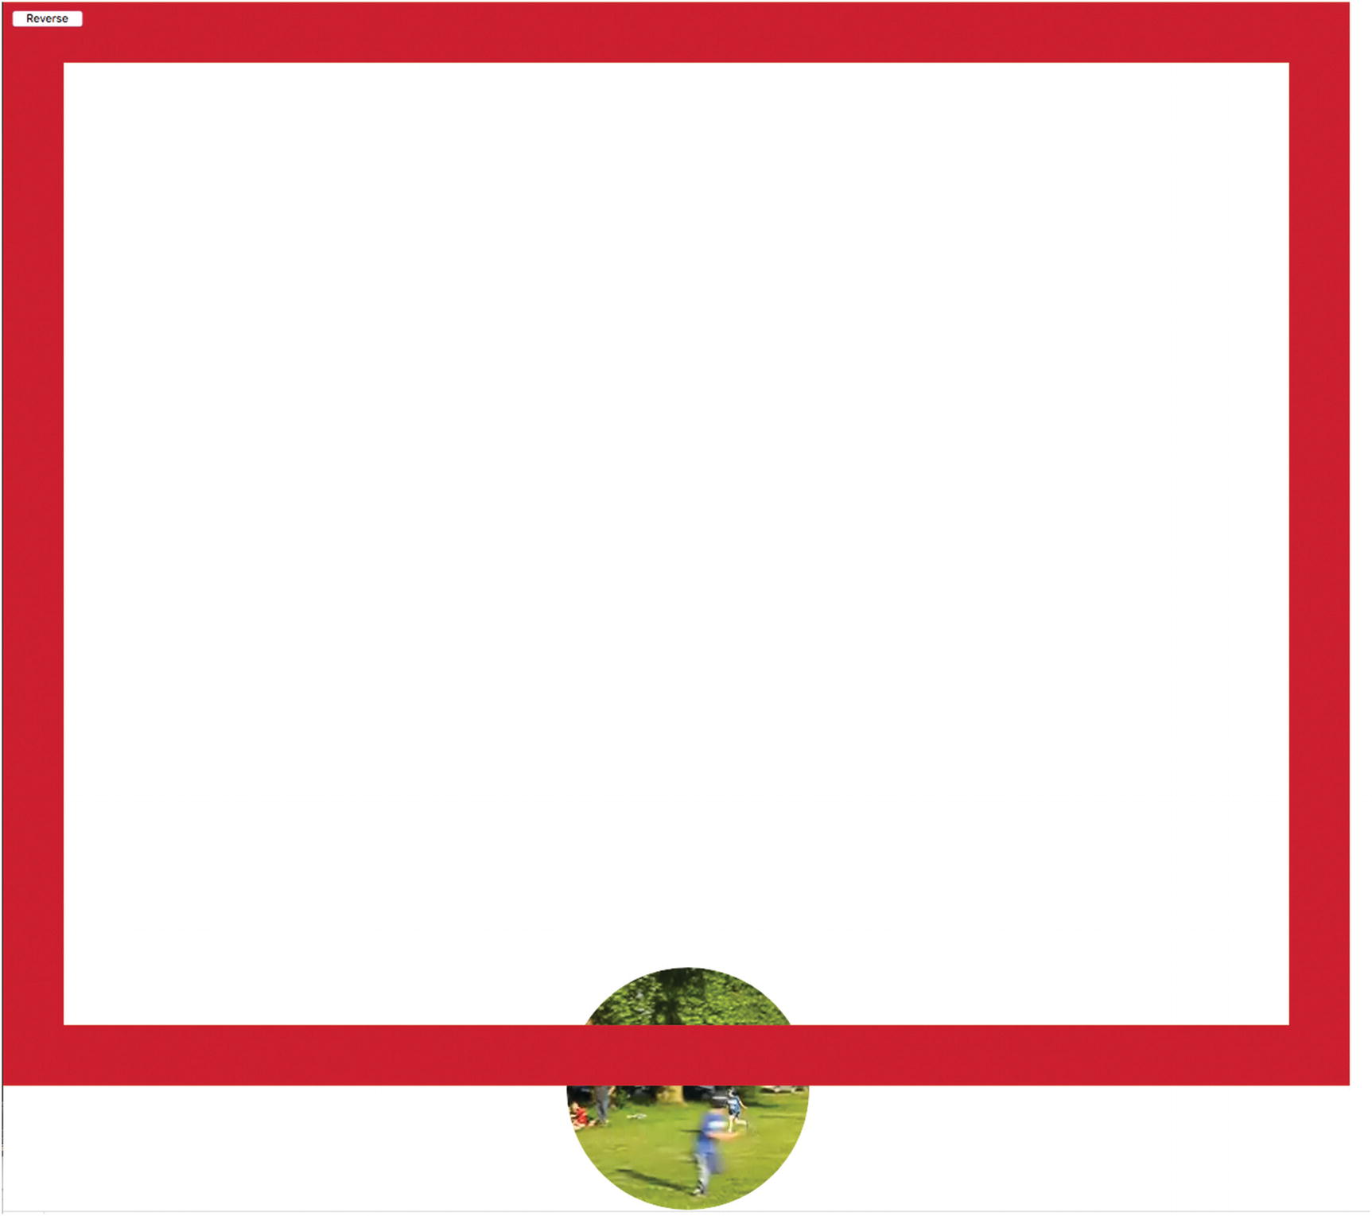
Figure 3-7 Video element bouncing with less restrictive checking
To avoid this, you will see that I changed the checking for the video element application. The downside to doing this is that the video ball barely touches the right and bottom walls.
The reason why these effects do not happen in the video-drawn-on-canvas application, videobounceC, is that drawing on canvas with coordinates outside of the canvas has no visible effect. You can look back to Chapter 1, Figure 1-6, to see an example of drawing “outside the lines” and producing nothing outside the canvas.
NoteThere may be other ways to avoid the scrolling problem. This would not prevent the unsightliness shown in Figure 3-7. It may be possible to prevent scrolling in the browser. It is possible to stop the users from scrolling, but automatic scrolling appears to be more of a challenge.

Video Drawing Frames on Canvas or As a Movable Element
I now describe two different implementations: one with material from the video drawn on the canvas and the other with the video element moved around the document.

Video Drawn on Canvas
As I mentioned previously, HTML5 does provide the facility to draw video on the canvas as one would draw an image. This actually is a misnomer. Video clips are made up of sequences of still images called frames . Frame rates vary but typically are 15 to 32 frames per second, so you can understand that video files tend to be large. Video is stored using different types of encodings, each of which may make different technical trade-offs in terms of quality and storage size. We do not need to be concerned with these technicalities, but can think of the video as a sequence of frames. Playing a video involves presenting the frames in sequence. What happens in the drawImage command is that the current frame of the video clip is the image drawn on the canvas. If this operation is performed through a timed interval event, then the viewer will see a frame at each interval of time. There is no guarantee that the images shown are successive frames from the video clip, but if done fast enough, the frames drawn will be close enough to the actual sequence that our eye and brain experience it as the live action of the video clip.
The command in pseudocode is
ctx.drawImage(video element, x position, y position, width, height);
This command, formally a method of the ctx canvas context, extracts the image corresponding to the current frame of the video and draws it at the x and y values, with the indicated width and height. If the image does not have the specified width and height, the image is scaled. This will not occur for this situation.
The goal is to make the traveling video clip resemble a ball. For this application, this means we want to mask out all but a circle in the center of the rectangular video clip. I accomplish this by creating a traveling mask. The mask is a drawing in the canvas. Since I want to place the video element on the canvas element, and also position a shape created by drawing a path on top of the image drawn from the video clip, I use CSS directives to make both video and canvas be positioned using absolute positioning. I want the Reverse button to be on top of the canvas. These directives do the trick:
#vid {position:absolute; display:none;}
#canvas {position:absolute; z-index:10; top:0px; left:0px;}
#revbtn {position:absolute; z-index:20;}
A way to remember how the layering works is to think of the z-axis as coming out of the screen. Elements set at higher values are on top of elements set at lower values. The top and left properties of the canvas are each set to 0 pixels to position the upper-left corner of the canvas in the upper-left corner of the window.
NoteWhen the z-index is referenced or modified in JavaScript, its name is zIndex . Hopefully, you appreciate why the name z-index would not work: the hyphen (-) would be interpreted as a minus operator.
The video element is set in the style directive to have no display. This is because as an element by itself, it is not supposed to show anything. Instead, the content of the current frame is drawn to the canvas using the following statement:
ctx.drawImage(v, ballx, bally, videow,videoh);
The ballx and bally values are initialized in the init functions and incremented as described in the last section. The width and height of the video clip have been modified to be appropriate for the window size.
One way to understand this is to imagine that the video is being played somewhere offscreen and the browser has access to the information so it can extract the current frame to use in the drawImage method.

Movable Video Element
The videobounceE application moves the actual video element on the document. The video element is not drawn on the canvas, but is a distinct element in the HTML document. To make the video appear as a circle, I use the clip path feature. The style directives are
#vid {position:absolute; display:none; z-index: 1;}
#canvas {position:absolute; z-index:10; top:0px; left:0px;}
#revbtn {position:absolute; z-index:20;}
In the init function, I include code that adjusts the video dimensions to fit the screen.
v = document.getElementById("vid");
aspect= v.videoWidth/v.videoHeight;
v.width = Math.min(v.videoWidth,.5*cwidth);
v.height = v.width/aspect;
v.height = Math.min(v.height,.5*cheight);
v.width = aspect*v.height;
videow = v.width;
videoh = v.height;
Then I calculate the radius of a circle to be the smaller of half the video width and video height. My code uses this number to produce a string ending in "px". This string is used to set the clipPath value.
amt = .5*Math.min(videow,videoh);
amtS = String(amt)+"px";
v.style.clipPath="circle("+amtS+" at center)";
Moving a video element around requires making the video visible and starting the playing of the video. It also requires positioning. The video element is positioned through references to style.left and style.top. Furthermore, the settings for the left and top attributes must be in the form of a character string representing a number followed by the string "px", standing for pixels. The following code
v.style.left = String(ballx)+"px";
v.style.top = String(bally)+"px";
v.play();
v.style.visibility = "visible";
v.style.display = "block";
is executed in the init function. Notice also that the initial position of the video is changed to the initial ballx and bally values. The numeric values need to be converted to strings, and then the "px" needs to be concatenated to the ends of the strings. This is because HTML/JavaScript assumes that style attributes are strings. I write the same code for setting the video element’s top and left properties to the values corresponding to ballx and bally in the movevideo function. The statements that replace the ctx.drawImage statement are
v.style.left = String(ballx)+"px";
v.style.top = String(bally)+"px";
Lastly, the rectangle (the box) is drawn. It does not need to be drawn again. The setInterval function is called to do the movement of the video element.
ctx.strokeRect(0,0,cwidth,cheight); //box
setInterval(moveVideo,50);
This program does not stop the movement, so I do not need to store what is called the timing event identifier. You may consider enhancing the program to provide a way to stop movement . I used it to produce some of the figures. All the code for both videobounceC and videobounceEwithClipPath will be listed with comments in the “Building the Application and Making It Your Own” section.

Traveling Mask
The objective of the mask is to mask out—that is, cover up—all of the video except for a circle in the center. The style directives ensure that I can use the same variables—namely ballx and bally—to refer to the video and mask in both situations: video drawn and video element moved. So now the question is how to make a mask that is a rectangular donut with a round hole.
I accomplish this by writing code to draw two paths and filling them in with white. Since the shape of the mask can be difficult to visualize, I have created two figures to show you what it is. Figure 3-8 shows the outline of the two paths.
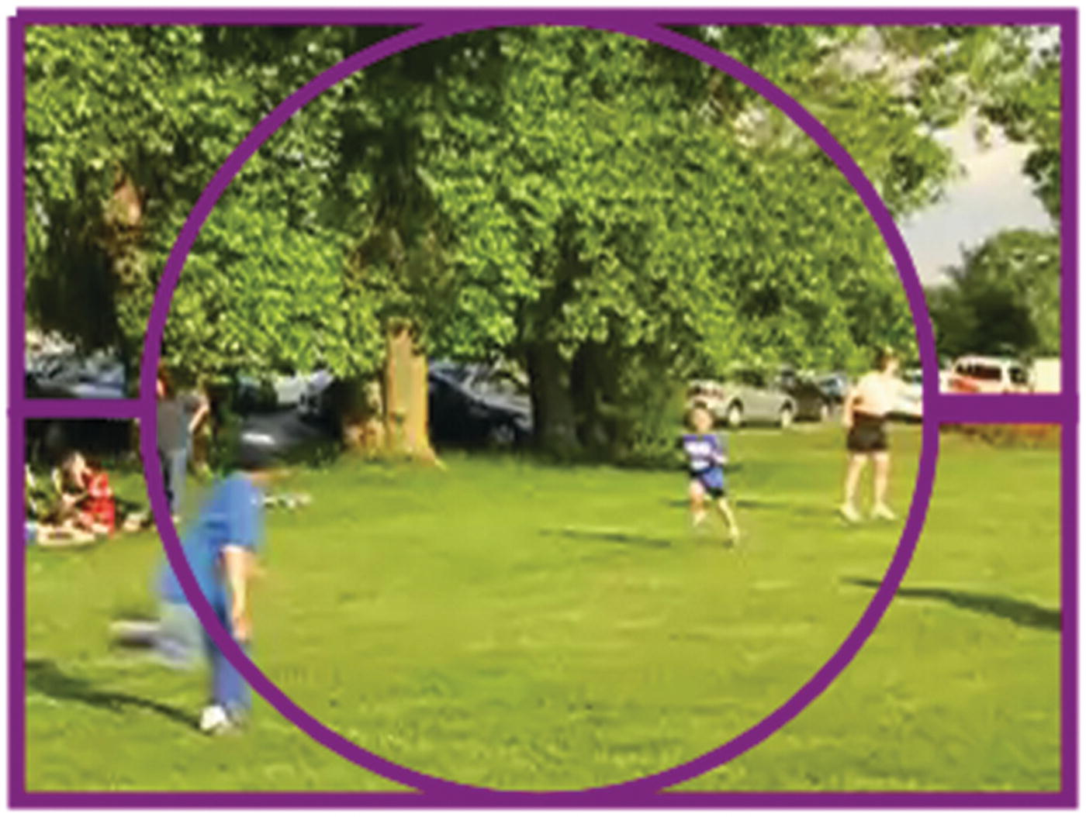
Figure 3-8Outline of paths for the mask
Figure 3-9 shows the outline and the paths filled in. The two small horizontal paths will not be present because there is no stroke in the code .
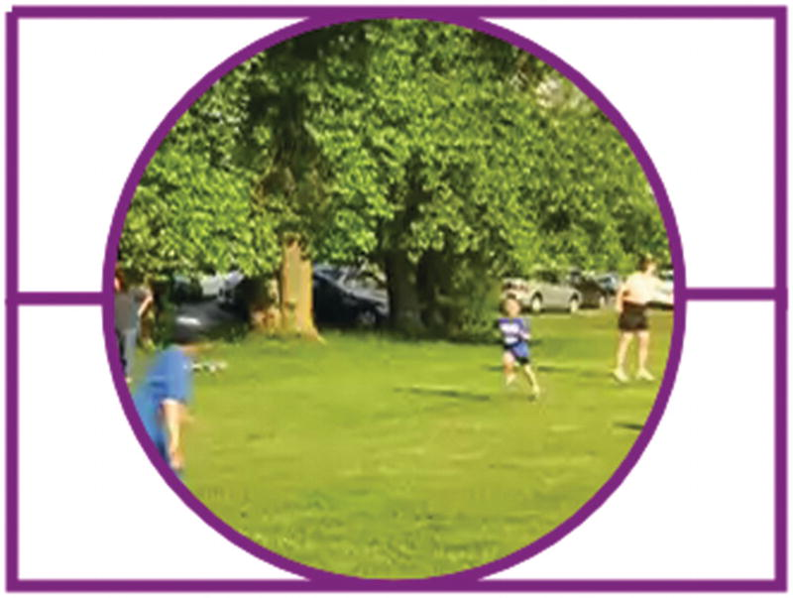
Figure 3-9Paths for the mask after a fill and a stroke
Now, the actual path only has the fill, and the fill color is white. You need to imagine these two white shapes traveling along on top of the video. The effect of the mask is to cover up most of the video clip. The parts of the canvas that have no paint on them, so to speak, are transparent, and the video clip content shows through. Putting it another way, the canvas is on top of the video element, but it is equivalent to a sheet of glass. Each pixel that has nothing drawn in it is transparent.
The first path starts at the upper-left corner , and then goes over to the right, down to the midway point, and finally back left toward the center, but stops. The path then is a semicircular arc. The last parameter indicating the sense of the arc is true for counterclockwise. The path continues with a line to the left edge and then back up to the start. The second path starts in the middle of the left edge, proceeds down to the lower-left corner, goes to the lower-right corner, moves up to the middle of the right side, and then moves to the left. The arc this time has false as the value of the parameter for direction, indicating the arc is clockwise. The path ends where it started. However, I did need to make some adjustments to prevent certain edges of the frame to show. These are indicated by the presence of +2 and -2 in the coding.
ctx.beginPath();
ctx.moveTo(ballx,bally);
ctx.lineTo(ballx+videow+2,bally);
ctx.lineTo(ballx+videow+2,bally+.5*videoh+2);
ctx.lineTo(ballx+.5*videow+ballrad, bally+.5*videoh+2);
ctx.arc(ballx+.5*videow,bally+.5*v.height,ballrad,0,Math.PI,true);
ctx.lineTo(ballx,bally+.5*v.height);
ctx.lineTo(ballx,bally);
ctx.fill();
ctx.closePath();
ctx.beginPath();
ctx.moveTo(ballx,bally+.5*v.height);
ctx.lineTo(ballx,bally+v.height);
ctx.lineTo(ballx+v.width+2,bally+v.height);
ctx.lineTo(ballx+v.width+2,bally+.5*v.height-2);
ctx.lineTo(ballx+.5*v.width+ballrad,bally+.5*v.height-2);
ctx.arc(ballx+.5*v.width,bally+.5*v.height,ballrad,0,Math.PI,false);
ctx.lineTo(ballx,bally+.5*v.height);
ctx.fill();
ctx.closePath();
You can follow along the coding with my “English’” description to see how it works.
By the way, my initial attempt was to draw a path consisting of a four-sided shape representing the outer rectangle and then a circle in the middle. This worked for some browsers, but not others.
For the videobounceC application, the mask is on top of the frames of video drawn on canvas because the two white filled-in paths are drawn after the drawImage statement draws a frame from the video. The next chapter, which demonstrates a spotlight moving on top of a map from Google Maps, will feature changing the z-index using JavaScript. The z-axis is coming out of the screen and can be used to change what is drawn closer to the viewer and what is drawn farther away. I will mention this in the next section.

User Interface
The user interface for both versions of the videobounce project only includes one action for the user: the user can reverse the direction of travel. The button is defined by an element in the body:
<button id="revbtn" onClick="reverse();">Reverse </button><br/>
The effect of the onClick setting is to invoke the function named reverse. This function is defined to change the signs of the horizontal and vertical displacements:
function reverse() {
ballvx = -ballvx;
ballvy = -ballvy;
}
There is one important consideration for any user interface. You need to make sure it is visible. This is accomplished by the following style directive:
#revbtn {position:absolute; z-index:20;}
The z-index places the button on top of the canvas, which in turn is on top of the video.
Having explained the individual HTML5, CSS, and JavaScript features that can be used to satisfy the critical requirements for bouncing video, I’ll now show the code in the two bouncing video applications: the drawing frames with a mask traveling over the frame and a video element masked by a clip path.

Building the Application and Making It Your Own
The two applications for simulating the bouncing of a video clip ball in a two-dimensional box contain similar code, as does the program that produced the picture of the trajectory. The moving the video element is shorter because the clip path style feature effectively produces a mask. The clip path style feature has other possibilities, including a polygon, so it is something to research. A quick summary of the applications follows. The video applications are summarized by the following:
1. | init: initialization, including adapting to fit the window and setting up the timed event for invoking displaying the new scene.
2. | drawscene
  a. | Erase canvas.
  b. | Determine new location of video (virtual ball) using moveandcheck.
  c. | Draw the image from video at a specified location on the canvas.
  d. | Draw paths on canvas to create traveling (rectangular donut) mask.
  e. | Draw the box.
3. | moveVideo
  a. | Determine new location of video using checkPosition.
  b. | checkPosition: Check if the virtual ball will hit any wall. If so, change the appropriate displacement value.
  c. | Position video element at current position.
The table describing the invoked/called by and calling relationships for the drawing frames application is shown in Table 3-1.
Table 3-1Functions in the videobounceC Program
Function | Invoked/Called By | Calls
init | Invoked by action of the onLoad attribute in the <body> tag
drawscene | Invoked by action of the setInterval command issued in init | moveAndCheck
moveAndCheck | Invoked in drawscene
reverse | Invoked by action of onClick in the button
Table 3-2 shows the code for the videobounceC application, which draws the current frame of the video on the canvas at set intervals of time.
Table 3-2Complete Code for the videobounceC Application
Code Line | Description
<!DOCTYPE html> | Header
<html> | Opening html tag
<head> | Opening head tag
<title>Video frames bounce</title> | Complete title
<meta charset="UTF-8"> | Meta element
<style> | Opening style
#vid {position:absolute; display:none;} | Set up positioning of video ; set display to none; video element never appears
#canvas {position:absolute; z-index:10; top:0px; left:0px;} | Set positioning to absolute and position to be upper-left corner; set z-index so it is under the Reverse button
#revbtn {position:absolute; z-index:20;} | Set positioning to absolute and z-index so it is over the canvas
</style> | Close style
<script type="text/javascript"> | Opening script tag
var canvas1;
var ctx; | Used to hold canvas context; used for all drawing
var cwidth; | Used to hold canvas width
var cheight; | Used to hold canvas height
var videow; | Used to hold adjusted video width
var videoh; | Used to hold adjusted video height
var ballrad = 50; | Set ball radius
var ballx = 50; | Initial horizontal coordinate for ball
var bally = 60; | Initial vertical coordinate for ball
var maskrad; | Used for mask radius
var ballvx = 2; | Initial ball horizontal displacement
var ballvy = 4; | Initial ball vertical displacement
var v; | Will hold video element
var videow;
var videoh;
function restart() { | Function header for restart
v.currentTime=0; | Reset place in video to the start
v.play(); | Play video
} | Close restart function
function init(){ | Function header for init
canvas1 = document.getElementById('canvas'); | Set reference for canvas
ctx = canvas1.getContext('2d'); | Set reference for canvas context
canvas1.width = window.innerWidth; | Set canvas width to match current window width
cwidth = canvas1.width; | Set variable
canvas1.height = window.innerHeight; | Set canvas height to match current window height
cheight = canvas1.height; | Set variable
v = document.getElementById("vid"); | Set reference to video element
aspect = v.videoWidth/v.videoHeight; | Compute aspect ratio; the videoWidth and videoHeight values describe the original video and do not change
v.width = Math.min(v.videoWidth,.5*cwidth); | Set video width
v.height = v.width/aspect; | Adjust v.height to maintain proportions
v.height = Math.min(v.height,.5*cheight); | Set video height
v.width = aspect*v.height; | Adjust v.width to maintain proportions
window.onscroll = function () {  window.scrollTo(0,0);  }; | Stops any user action to scroll, if scroll bars do appear
videow = v.width; | Set variable
videoh = v.height; | Set variable
ballrad = Math.min(.5*videow,.5*videoh); | Modify ballrad
ctx.lineWidth = ballrad; | Set line width for drawing the box
ctx.strokeStyle ="rgb(200,0,50)"; | Set color to reddish
ctx.fillStyle="white"; | Set fill style for mask to be white
v.play(); | Start video
setInterval(drawscene,50); | Set up timed event
} | Close init function
function drawscene(){ | Function header for drawscene
ctx.clearRect(0,0,cwidth,cheight); | Erase canvas
checkPosition(); | Check if next move is at a wall, and if so, adjust displacements and position; otherwise, just make the move
ctx.drawImage(v,ballx, bally, videow,videoh); | Draw image from video at indicated position
ctx.beginPath(); | Start the path for the top half of the mask
ctx.moveTo(ballx,bally); | Move to starting point
ctx.lineTo(ballx+videow+2,bally); | Move over horizontally
ctx.lineTo(ballx+videow+2,bally+.5*videoh+2); | Move down to halfway
ctx.lineTo(ballx+.5*videow+ballrad, bally+.5*videoh+2); | Move in to the start of where the opening will be
ctx.arc(ballx+.5*videow,bally+.5*videoh,ballrad,0, Math.PI,true); | Make semicircular arc
ctx.lineTo(ballx,bally+.5*videoh); | Move to the left
ctx.lineTo(ballx,bally); | Move to start
ctx.fill(); | Fill in the white top of the mask
ctx.closePath(); | Close top part of mask
ctx.beginPath(); | Start bottom part of mask
ctx.moveTo(ballx,bally+.5*videoh); | Move to start the bottom of the mask; move to point midway down on the left
ctx.lineTo(ballx,bally+videoh); | Move down to the lower left
ctx.lineTo(ballx+videow+2,bally+videoh); | Move over to the right corner
ctx.lineTo(ballx+videow+2,bally+.5*videoh-2); | Move up to the middle on the right
ctx.lineTo(ballx+.5*videow+ballrad,bally+.5*videoh-2); | Move in to the start of the hole in the mask
ctx.arc(ballx+.5*videow,bally+.5*videoh,ballrad,0,Math.PI,false); | Make semicircular arc
ctx.lineTo(ballx,bally+.5*videoh); | Move to the right
ctx.fill(); | Fill in the white bottom of the mask
ctx.closePath(); | Close the bottom part of mask
ctx.strokeRect(0,0,cwidth,cheight); | Draw the box
} | Close the drawscene function
function checkPosition() { | Header for the checkPosition function
var nballx = ballx + ballvx+.5*videow; | Set up trial values for x
var nbally = bally +ballvy+.5*videoh; | Set up trial values for y
if (nballx > cwidth) { | Compare to right wall, on a hit
ballvx =-ballvx; | Change sign of the horizontal displacement
nballx = cwidth; | Set trial value to be exactly at the right wall
} | Close clause
if (nballx < 0) { | Compare to left wall , on a hit
nballx = 0; | Set trial value to be exactly at the left wall
ballvx = -ballvx; | Change sign of the horizontal displacement
} | Close clause
if (nbally > cheight) { | Compare to bottom wall, on a hit
nbally = cheight; | Set trial value to exact height
ballvy =-ballvy; | Change the sign of the vertical displacement
} | Close clause
if (nbally < 0) { | Compare to top wall on a hit
nbally = 0; | Change trial value to be exactly at the top wall
ballvy = -ballvy; | Change the sign of the vertical displacement
} | Close clause
ballx = nballx-.5*videow; | Set ballx using trial value, and offset to be the upper-left corner , not the center
bally = nbally-.5*videoh; | Set bally using the trial value, and offset to be the upper-left corner, not the center
} | Close checkPosition function
function reverse() { | Function header for the button action
ballvx = -ballvx; | Change sign of horizontal displacement
ballvy = -ballvy; | Change sign of vertical displacement
} | Close reverse function
</script> | Closing script tag
</head> | Closing head tag
<body onLoad="init();"> | Opening body tag; set up call to init
<video id="vid" loop="loop" preload="auto" muted> | Video element header; note muted attribute
<source src="joshuahomerun.mp4" type='video/mp4; codecs="avc1.42E01E, mp4a.40.2"'> | Source for the MP4 video
<source src="joshuahomerun.webmvp8.webm" type='video/webm; codec="vp8, vorbis"'> | Source for the WEBM video
<source src="joshuahomerun.theora.ogg type='video/ogg; codecs="theora, vorbis"'> | Source for the OGG video
Your browser does not accept the video tag. | Message for noncompliant browsers
</video> | Close video tag
<button id="revbtn" onClick="reverse();">Reverse </button><br/> | Button for viewer to reverse direction
<canvas id="canvas"> | Opening canvas tag
This browser doesn't support the HTML5 canvas element. | Message for noncompliant browsers
</canvas> | Closing canvas tag
</body> | Closing body tag
</html> | Closing html tag
The second version of this application moves the video element as opposed to drawing the current frame of the video on the canvas. My research indicates that this may use less computer resources when it is executing. Table 3-3 shows the function relationships.
Table 3-3Function Relationships for the videobounceEwithClipPath Program
Function | Invoked/Called By | Calls
init | Invoked by action of the onLoad attribute in the <body> tag
moveVideo | Invoked by action of the setInterval command issued in init | checkPosition
checkPosition | Invoked in moveVideo
reverse | Invoked by action of onClick in the button
The code for the version of the program that re-positions a video element as opposed to drawing frames from a video is shown in Table 3-4. I have omitted the descriptive comments for when the code statements are the same. Do keep in mind that the differences between the two approaches are mainly that the bouncing video element program does not require the generation of the rectangular donut mask for each iteration nor the erasing and and then re-drawing of the box.
Table 3-4Complete Code for the VideobounceEwithClipPath Program
Code Line | Description
<!DOCTYPE html>
<html>
<head>
<title>Video element bounce</title>
<meta charset="UTF-8">
<style>
#vid {position:absolute; display:none; z-index: 1; | Need to set positioning and z-index because display setting will be changed to make element visible
} | End directive
#canvas {position:absolute; z-index:10; top:0px; left:0px;} | This will be on top of the video and under the button
#revbtn {position:absolute; z-index:20;}
</style>
<script type="text/javascript">
var ctx;
var cwidth;
var cheight;
var ballrad = 50;
var ballx = 80; | Starting point is arbitrary
var bally = 80; | Starting point is arbitrary
var maskrad;
var ballvx = 2;
var ballvy = 4;
var v;
function init(){
canvas1 = document.getElementById('canvas');
ctx = canvas1.getContext('2d');
canvas1.width = window.innerWidth;
cwidth = canvas1.width;
canvas1.height = window.innerHeight;
cheight = canvas1.height ;
window.onscroll = function () {
window.scrollTo(0,0);
};
v = document.getElementById("vid");
aspect = v.videoWidth/v.videoHeight;
v.width = Math.min(v.videoWidth,.5*cwidth);
v.height = v.width/aspect;
v.height = Math.min(v.height,.5*cheight);
v.width = aspect * v.height;
videow = v.width;
videoh = v.height;
amt = .5*Math.min(videow,videoh); | Calculate the radius using the smaller value
amtS = String(amt)+"px"; | Turn into string with "px" at the end
v.style.clipPath="circle("+amtS+" at center)"; | Set the clipPath, effectively masking the video element to be a circle
ballrad = Math.min(50,.5*videow,.5*videoh);
ctx.lineWidth = ballrad;
ctx.strokeStyle ="rgb(200,0,50)";
ctx.fillStyle="white";
v.style.left = String(ballx)+"px";
v.style.top = String(bally)+"px";
v.play();
v.style.display = "block"; | Make video element visible
ctx.strokeRect(0,0,cwidth,cheight); | Draw box; note that this only needs to be drawn once
setInterval(moveVideo,50);
}
function moveVideo(){ | Header for function referenced in setInterval
checkPosition(); | Check on next position; uses global variables
v.style.left = String(ballx)+"px"; | Set horizontal position of element
v.style.top = String(bally)+"px"; | Set vertical position of element
}
function checkPosition() { | Header for checkPosition; calculates new position and checks if there is a bounce on the next iteration
var nballx = ballx + ballvx; | Trial value
var nbally = bally +ballvy; | Trial value
if ((nballx+videow) > cwidth) { | Add total width and compare
ballvx =-ballvx; | Change sign of horizontal displacement
nballx = cwidth-videow; | Set to exact position
}
if (nballx < 0) {
nballx = 0;
ballvx = -ballvx;
}
if ((nbally+videoh) > cheight) { | Compare total length
nbally = cheight-videoh; | Set to exact position
ballvy =-ballvy; | Change sign of vertical displacement
}
if (nbally < 0) {
nbally = 0;
ballvy = -ballvy;
}
ballx = nballx; | Set to trial position , possibly adjusted
bally = nbally; | Set to trial position, possibly adjusted
}
function reverse() {
ballvx = -ballvx;
ballvy = -ballvy;
}
</script>
</head>
<body onLoad="init();" >
<video id="vid" loop="loop" preload="auto" muted>
<source src="joshuahomerun.webmvp8.webm" type='video/webm; codec="vp8, vorbis"'>
<source src="joshuahomerun.mp4" type='video/mp4; codecs="avc1.42E01E, mp4a.40.2"'>
<source src="joshuahomerun.theora.ogg" type='video/ogg; codecs="theora, vorbis"'>
Your browser does not accept the video tag .
</video>
<button id="revbtn" onClick="reverse();">Reverse </button><br/>
<canvas id="canvas" >
This browser doesn't support the HTML5 canvas element.
</canvas>
</body>
</html>
To produce Figure 3-2, I made the trajectory function by modifying the drawscene in videobounceC. Since I wanted the circle to be similar in size to the masked video clip, I added an alert statement temporarily to the videobounceC function after the video width and height were set. Then I ran the program using those values:
v.width = Math.min(v.videoWidth/3,.5*cwidth);
v.height = Math.min(v.videoHeight/3,.5*cheight);
alert("width "+v.width+" height "+v.height);
I then used the values, 106 and 80, to be the videow and videoh values in the trajectory program .

Making the Application Your Own
The first way to make this application your own is to use your own video. You do need to find something that is acceptable when displayed as a small circle. You also can explore uses of the clipPath feature. As mentioned earlier, you need to produce versions using the different video codecs. A next step is adding other user interface actions, including changing the horizontal and vertical speeds, as was done in the bouncing ball projects in The Essential Guide to HTML5. Another set of enhancements would be to add video controls. Video controls can be part of the video element, but I don’t think that would work for a video clip that needs to be small and is moving! However, you could implement your own controls with buttons modeled after the Reverse button. For example, the statement
v.pause();
does pause the video.
The attribute v.currentTime can be referenced or set to control the position within the video clip. You saw how the range input type works in Chapter 1, so consider building a slider input element to adjust the video.
You may decide you want to change my approach to adapting to the window dimensions. One alternative is to change the video clip dimensions to maintain the aspect ratio. Another alternative is to change the video dimensions all the time. This means that the video dimensions and the canvas directions will be in proportion all the time. Yet another alternative, though I think this will be disconcerting, is to make reference to the window dimensions at each time interval and make changes in the canvas, and possibly the video, each time. There is an event that can be inserted into the body tag:
<body onresize="changedims();" ... >
This coding assumes that you have defined a function named changedims that includes some of the statements in the current init function to extract the window.innerWidth and window.innerHeight attributes to set the dimensions of the canvas and the video.
More generally, the objective of this chapter is to show you ways to incorporate video into your projects in a dynamic fashion, both in terms of position on the screen and timing. In particular, it is possible to combine playing of video with drawings on a canvas for exciting effects.
Screen savers exist in which the screen is filled up by a bouncing object similar to the trajectory program. You can change the drawscene function to produce different shapes. Also, as I mentioned before, you can apply the techniques explained in The Essential Guide to HTML5 to provide actions by the viewer. You can refer to Chapter 1 in this book for the use of a range input (slider). Yet another possibility is to provide the viewer a way to change the color of the circle (or other shape you design) using the input type of color. The Opera browser provides a color-picker option.

Testing and Uploading the Application
As has been mentioned, but is worth repeating, you need to acquire a suitable video clip. At the time of writing this book, you then need to use a program such as Miro to produce the WEBM, MP4, and OGG versions because browsers may recognize different video encodings (codecs). This situation may change. Again, if you are content with implementing this for just one browser, you can check which video encoding works for that browser and just prepare one video file. The video files and the HTML file need to be in the same folder on your computer and in the same folder on your server if and when you upload this application to your server account. Alternatively, you can use a complete web address or the correct relative address in the source elements.
Autoplay policies probably will continue to change, so you need to decide what is essential to your application.

Summary
In this chapter, you learned different ways to manipulate video. These included the following:
Drawing the current frame of video as an image onto a canvas
Repositioning of a video element on the screen by changing the left and top style attributes
Using style directives to layer a video, a canvas, and a button
Creating a moving mask on a canvas
Creating the effect of a mask by using the clipPath style attribute
Acquiring information on the dimensions of the window to adapt an application to different situations
The next chapter shows you how to use the Google Maps Application Programming Interface (API) in an HTML5 project. The project involves using a canvas and changing the z-index so that the canvas is alternatively under and over the material produced by Google Maps.
© Jeanine Meyer 2018
Jeanine Meyer
HTML5 and JavaScript Projects
https://doi.org/10.1007/978-1-4842-3864-6_4

4. Map Maker: Combining Google Maps and the Canvas
Jeanine Meyer1
(1)
New York, USA

In this chapter, you will learn the following:
Use the Google Maps API to display a map at a specific location
Draw graphics on a canvas using transparency (also known as the alpha or opacity level) and a customized cursor icon
Provide a graphical user interface (GUI) to your users by combining the use of Google Maps and HTML5 features by managing the events and the z-index levels
Calculate the distance between two geographical locations

Introduction
The project for this chapter is an application involving a geographic map. Many applications today involve the use of an Application Programming Interface (API) provided by another person or organization. This chapter will be an introduction to the use of the Google Maps API, and is the first of two chapters using the Google Maps JavaScript Version 3 API. Figure 4-1 shows the opening screen.
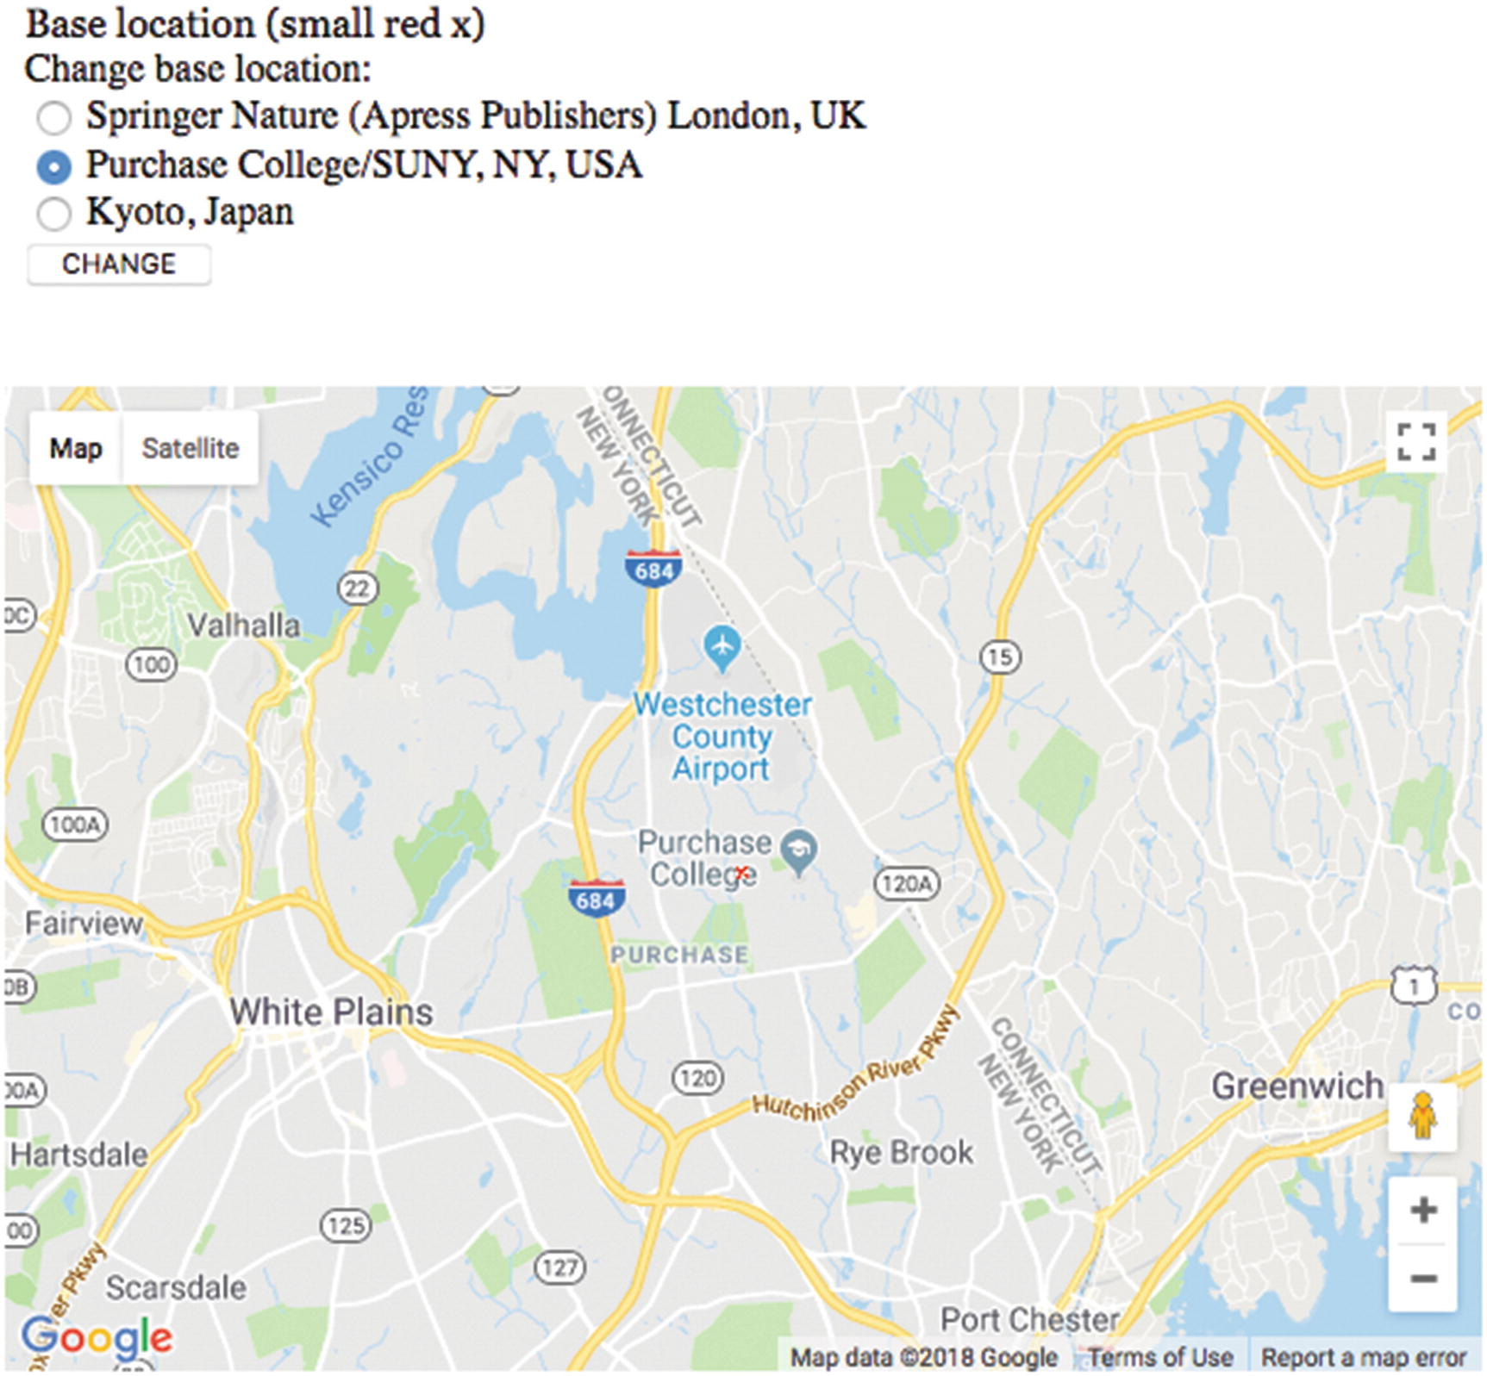
Figure 4-1Opening screen of map spotlight project
Notice the small red (hand-drawn) x located in the middle of the map and on top of the word College. When deciding on map markers, you face a trade-off. A smaller marker is more difficult to see. A larger and/or more intricate marker is easier to see but blocks more of the map or distracts from the map. This map is centered on the Purchase College campus. For this program, it is the initial base location. The base location is used to calculate distances. Notice the radio buttons showing three choices, on three continents. The middle choice is the starting choice.
Moving the mouse over the map is shown in Figure 4-2.
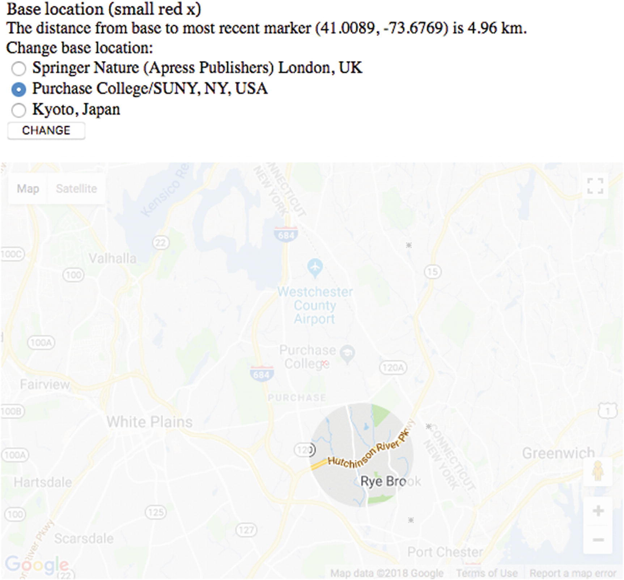
Figure 4-2Shadow/spotlight over map
Notice the shadow and spotlight combination now on the map. Most of the map is covered by a semitransparent shadow. You need to trust me that this screenshot was taken when I had moved the mouse over the map. There is a circle around the mouse position in which the original map shows through. The cursor when moving over the map is not the standard, default cursor but one I created using a small image representing a compact fluorescent light bulb.
The text on the screen shows the distance from the base to the last spot on the map I clicked to be 4.96 kilometers. The marker for all such locations is a hand-drawn x. The latitude and longitude of this location is indicated in parentheses.
The interface for changing locations is a set of radio buttons—only one button can be selected at a time—and a button labeled CHANGE to be clicked when the user/viewer/visitor decides to make a change.
The general GUI features provided by Google Maps are available to the users of this project. This includes the + and – buttons for zooming in and out. Figure 4-3 demonstrates the result of using my radio buttons to switch to Springer Nature/Apress Publishers located in London and the Google Maps + to zoom in. It is possible to zoom in even farther. Notice The Harry Potter Shop.
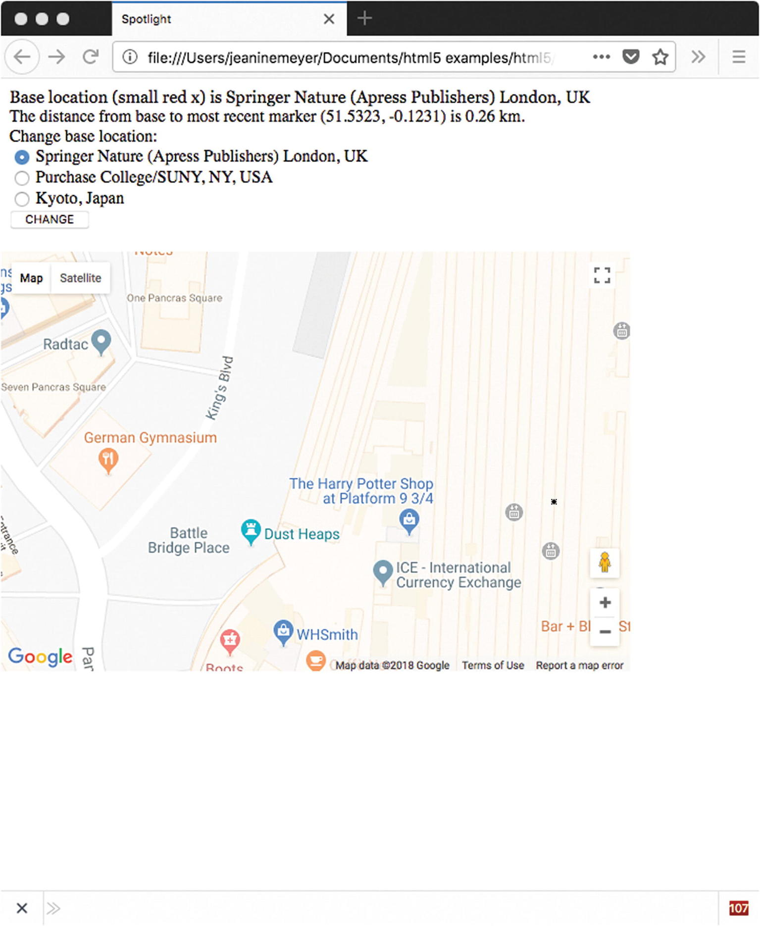
Figure 4-3Zoomed in to London
It also is possible to change the type of map to Satellite and pan the map by clicking the mouse and then pressing down again. Figure 4-4 shows the effects of changing to Satellite and panning.
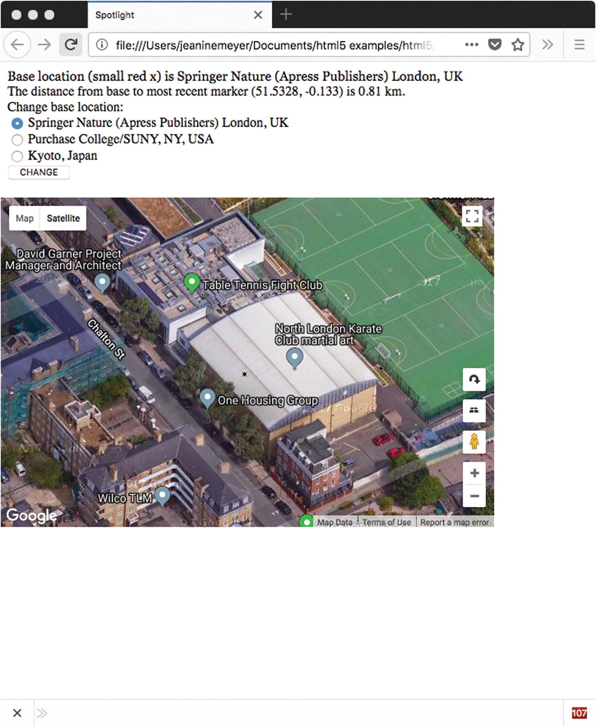
Figure 4-4Zooming out and moving west, satellite view
Let me use the interface to change to the third possibility: Kyoto, Japan. This is shown in Figure 4-5.
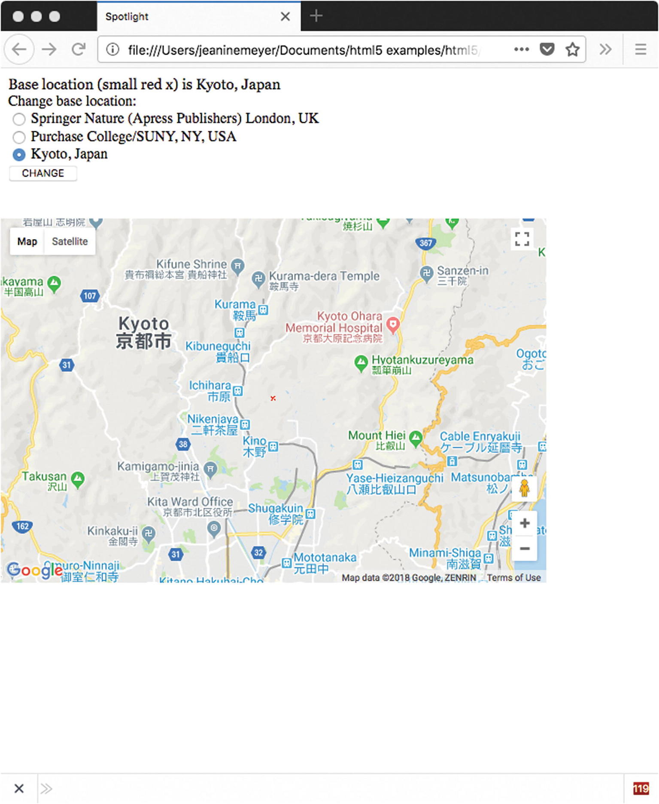
Figure 4-5Kyoto, Japan
Next, I use the Google Maps feature to change to Map/Terrain in Kyoto. The result is shown in Figure 4-6.
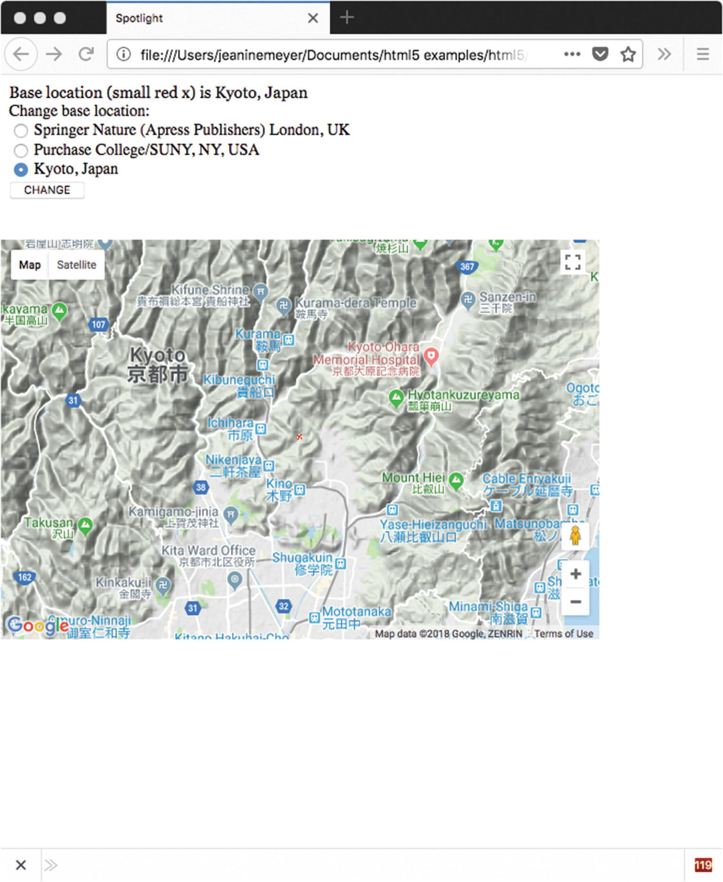
Figure 4-6Base at Kyoto, Japan, Terrain view
Again, notice the small red x indicating the base location and the text at the top of the screen with the name of the new base location.
The location of each base is determined by the latitude and longitude values for each of the three values that I have determined. My code is not “asking” Google Maps to find these locations by name. You may get slightly different results if you type the terms “Purchase College, NY” and the other locations into Google or Google Maps. To make this application your own, you would decide on a set of base locations and look up the latitude and longitude values. I will suggest ways to do this in the next section.
Just in case you are curious, zooming out to the farthest out position on the zoom/scale produces what is shown in Figure 4-7. This projection exhibits what is called the Greenland problem. Greenland is not bigger than Africa, but actually about 1/14 times the size.
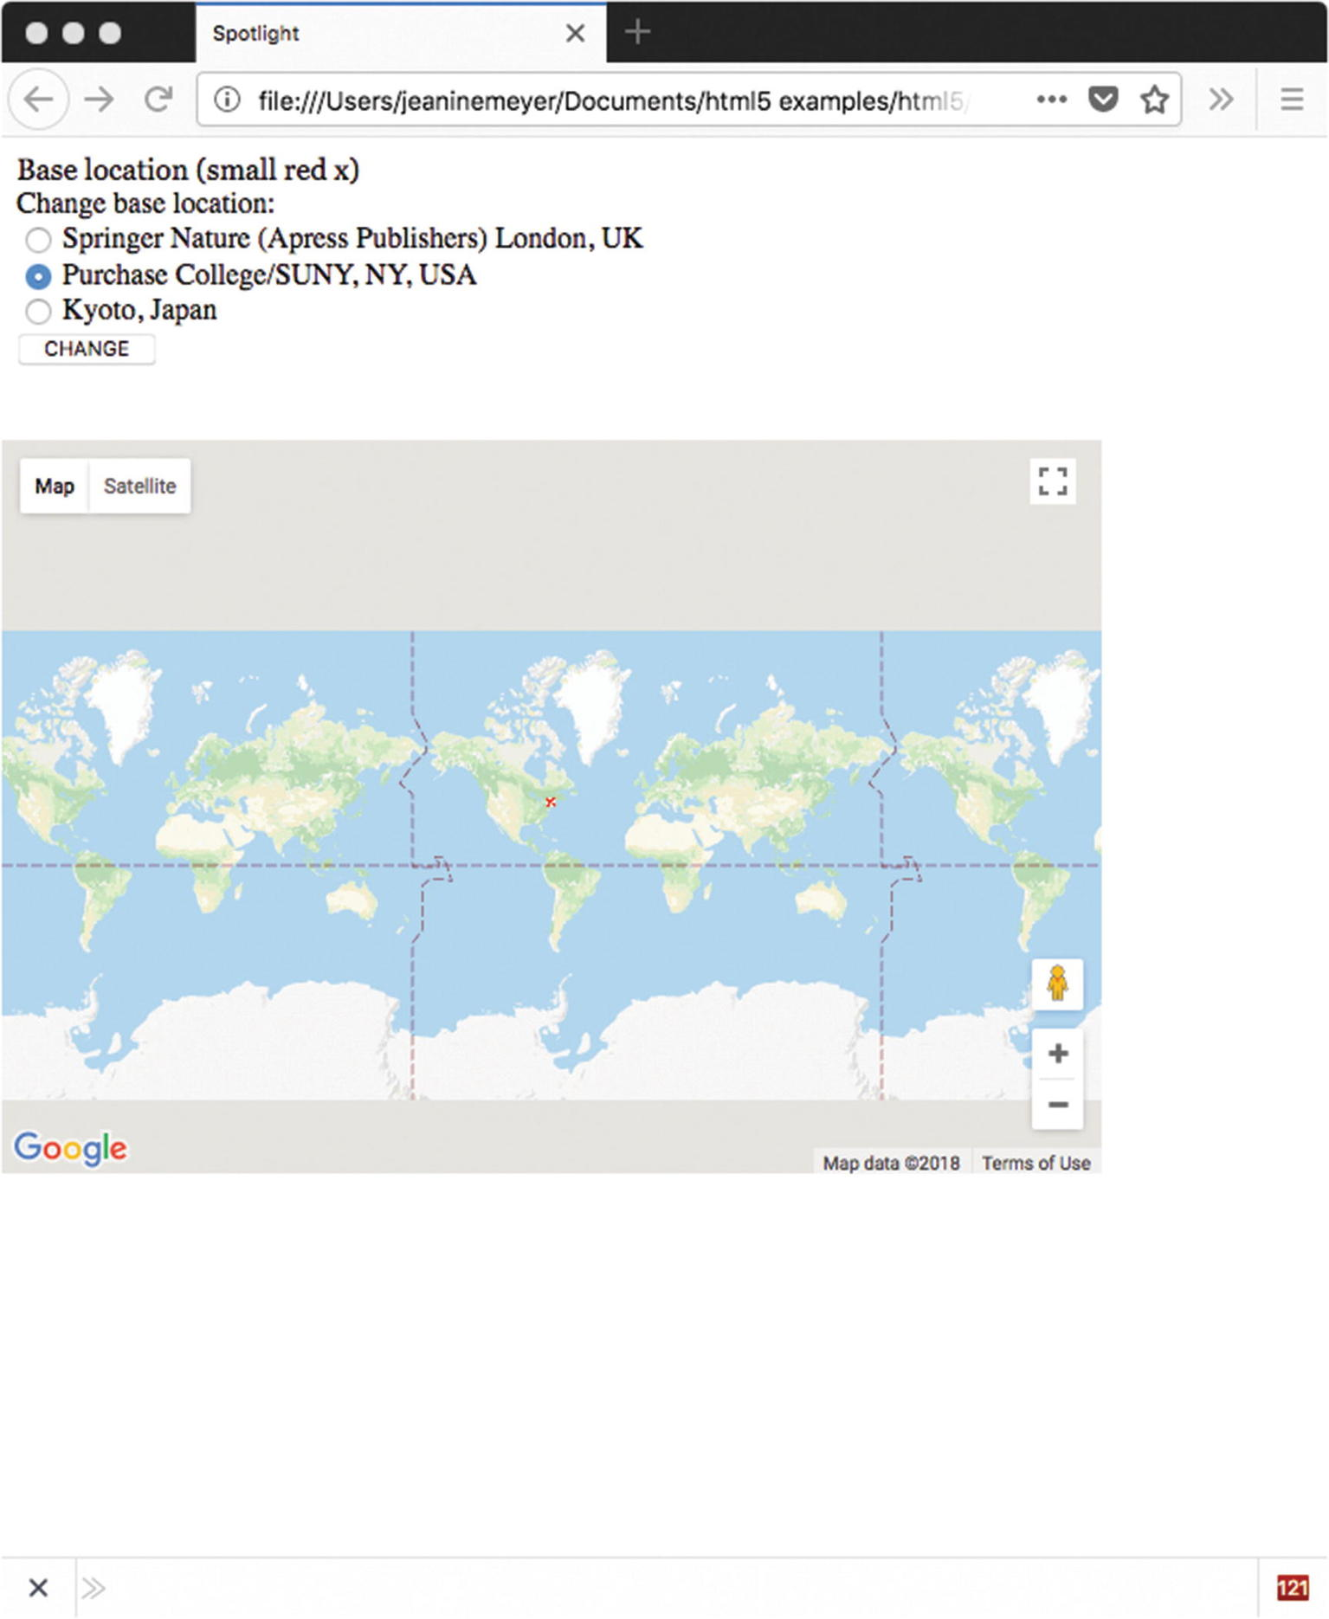
Figure 4-7Farthest-out view of map
Figure 4-8 shows the map at close to the closest-in limit. The map has also been changed to the satellite view using the buttons in the upper-left corner.
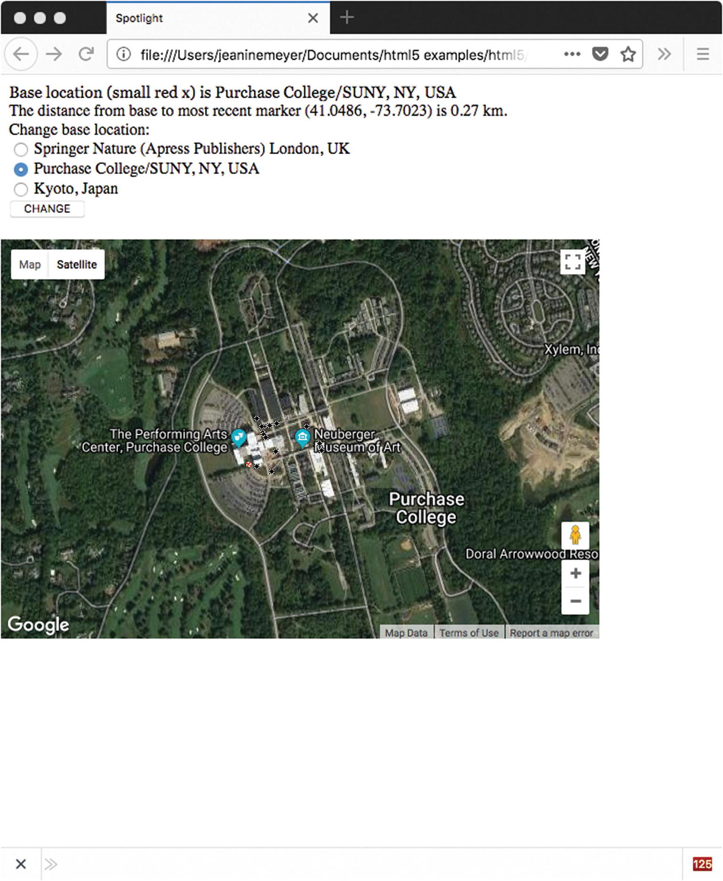
Figure 4-8Zoomed in to where city blocks can be detected, Purchase College base
Lastly, Figure 4-9 shows the map zoomed in to the limit . This is essentially at the building level. The building houses the School of Natural and Social Sciences, which holds my office and my usual computer classroom.
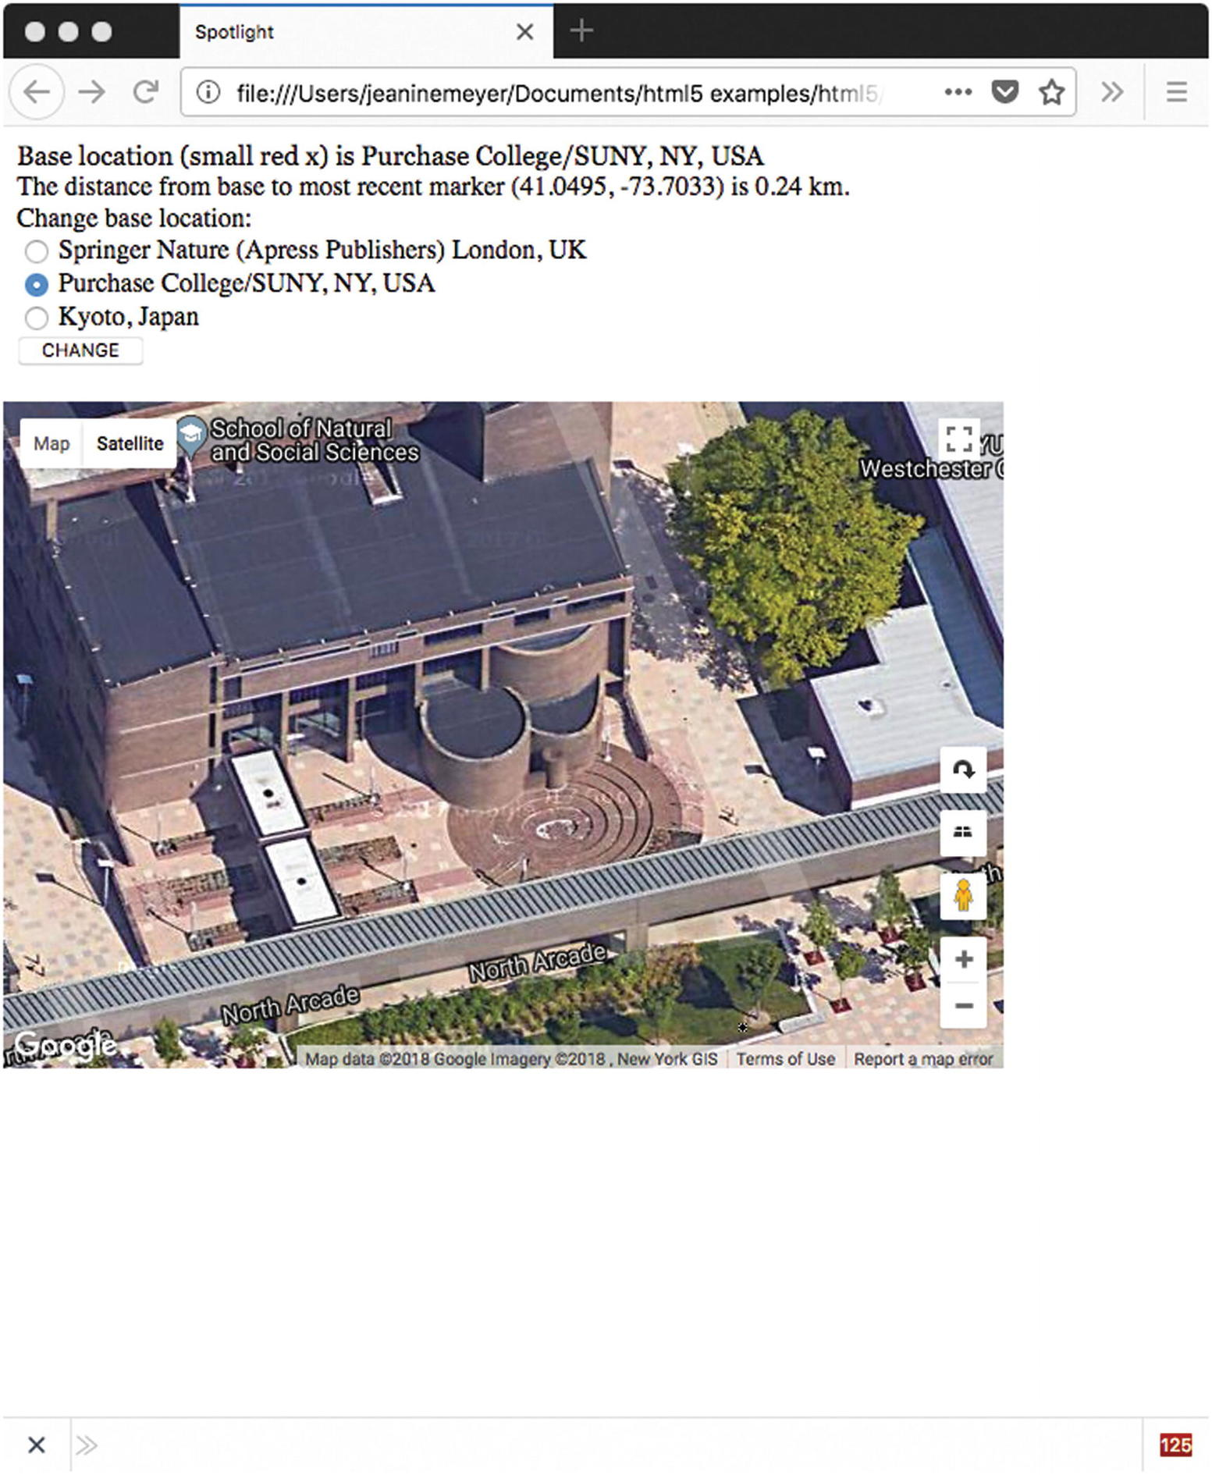
Figure 4-9Zoomed in all the way
By using the interface to zoom out and pan and zoom in again, I can determine the distance from any of the base locations to any other location in the world! I also can use this application to determine latitude and longitude values of any location. You need to know the latitude and longitude for changing or adding to the list of base locations and for determining locations for the project in Chapter 5. I review latitude and longitude in the next section.
Google Maps by itself is an extremely useful application. This chapter and the next demonstrate how to bring that functionality into your own application. That is, we combine the general facilities of Google Maps with anything, or almost anything, we can develop using HTML5 and JavaScript.

Latitude and Longitude and Other Critical Requirements
The most fundamental requirement for this project is an understanding of the coordinate system for geography. Just as a coordinate system is required for specifying points on a canvas or positions on the screen, it is necessary to use a system for places on planet Earth. The latitude and longitude system has been developed and standardized over the last several hundred years. The values are angles, with latitude indicating degrees from the equator and longitude indicating degrees from the Greenwich prime meridian in the United Kingdom. The latter is an arbitrary choice that became standard in the late 1800s.
There is a northern hemisphere bias here: latitude values go from 0 degrees at the equator to 90 degrees at the North Pole and –90 degrees at the South Pole. Similarly, longitude values are positive going east from the Greenwich prime meridian and negative going west. Latitudes are parallel to the equator and longitudes are perpendicular. Latitudes are often called parallels and typically appear as horizontal lines, and longitudes are called meridians and typically appear as verticals. This orientation is arbitrary, but fairly solidly established.
I will use decimal values, which is the default displayed in Google Maps, but you will see combinations of degree, minute (1/60 of a degree), and second (1/60 of a minute). It is not necessary that you memorize latitude-longitude values, but it is beneficial to develop some intuitive sense of the system. You can do this by doing what I call “going both ways.” First, identify and compare latitude-longitude values for places you know, and second, pick values and see what they are. For example, the base values for my version of the project are as follows:
var locations = [
[51.534467,-0.121631, "Springer Nature (Apress Publishers) London, UK"],
[41.04796,-73.70539,"Purchase College/SUNY, NY, USA"],
[35.085136,135.776585,"Kyoto, Japan"]
];
The first thing to notice is that the latitude values are fairly close and the longitude values are negative and not quite so close. Because I decided to choose as the base locations, places on three continents, you will need to experiment to see what small changes in latitude and longitude produce. You can see that all three places are north of the equator. In longitude, the value for London is close to zero, being close to the Greenwich prime meridian. You can notice also the longitude for Kyoto is positive and for the others is negative. This all makes sense, but you need to do your own experiments to become comfortable with these units.
There are many ways to find the latitude and longitude of a specific location. You can use Google Maps as follows:
1. | Invoke Google Maps from the square array of dots in Gmail or go to http://.maps.google.com .
2. | Put a location in the location field. I typed in Statue of Liberty.
3. | Click to get a menu:  Figure 4-10 shows a small window that appears at the bottom of the map.
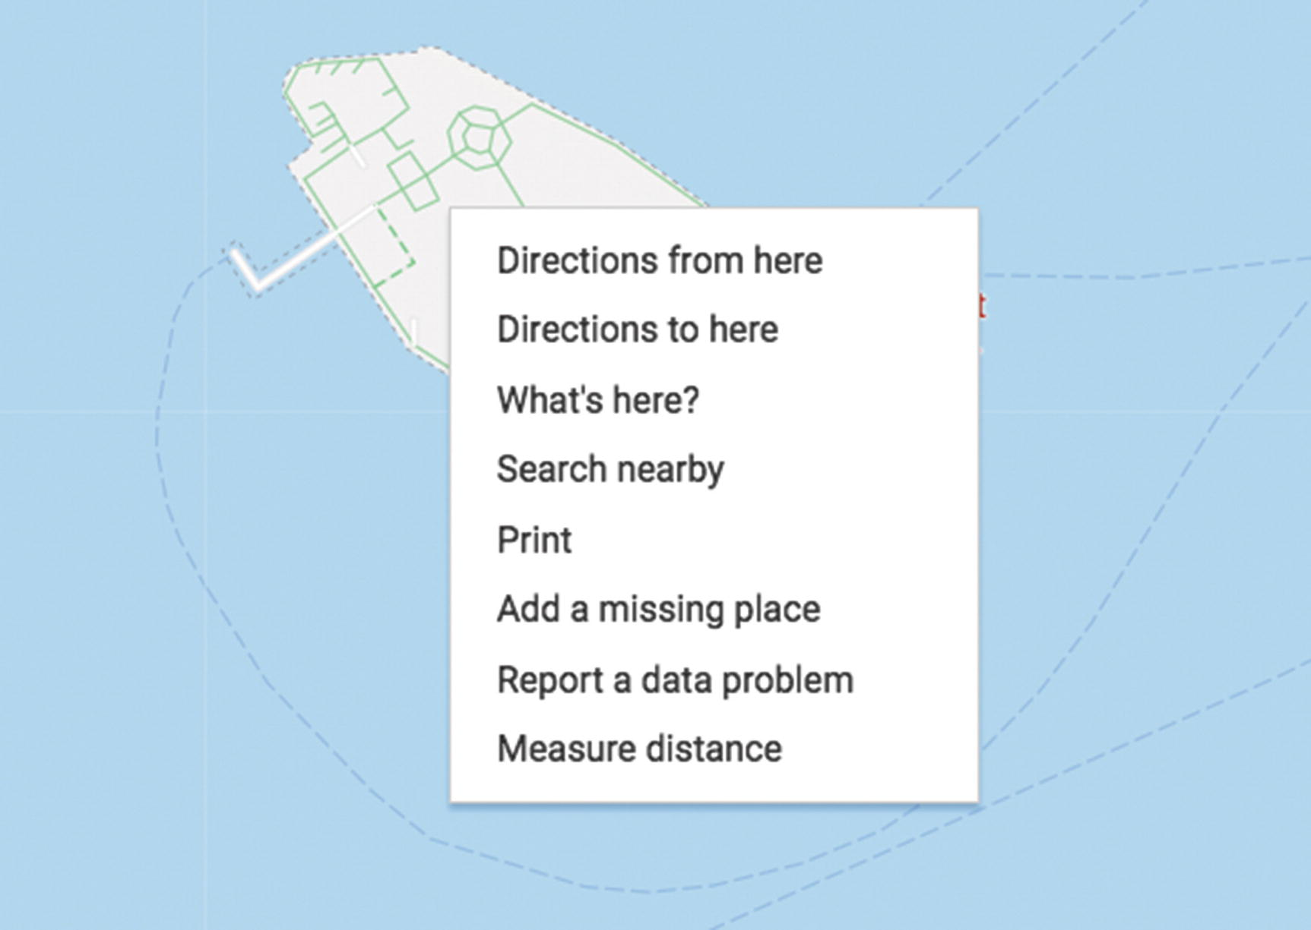
Figure 4-10Getting latitude-longitude values in Google Maps
Click on What’s Here to get a small window with the latitude and longitude.
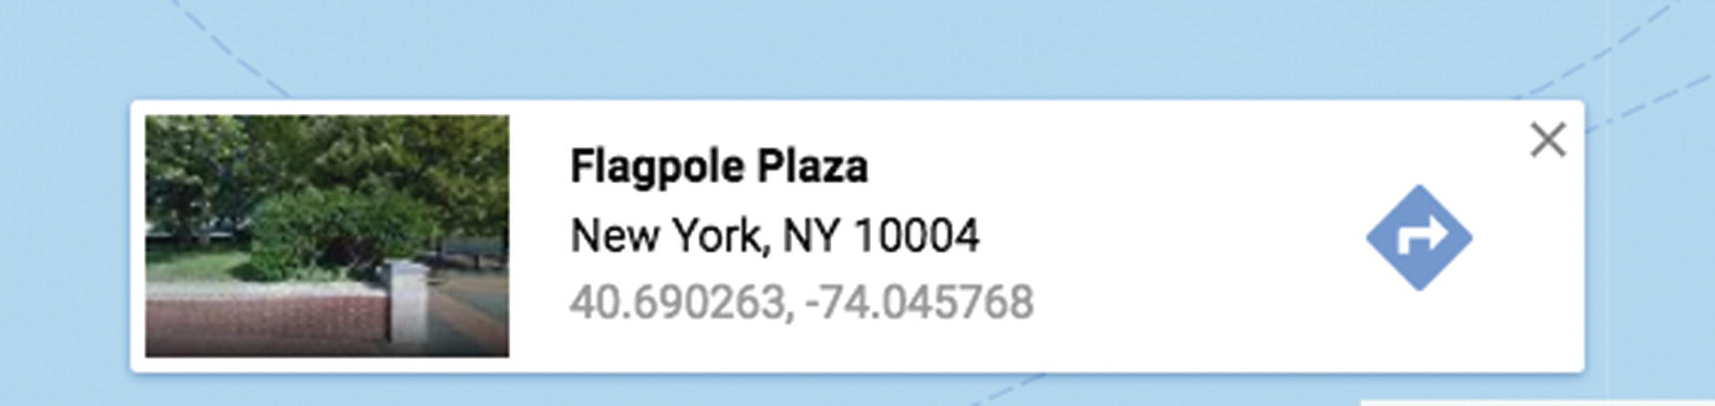
Figure 4-11Box showing latitude and longitude
Another option is to use Wolfram Alpha ( www.wolframalpha.com ), as shown in Figure 4-12, which provides a way to determine latitude and longitude values as well as many other things.
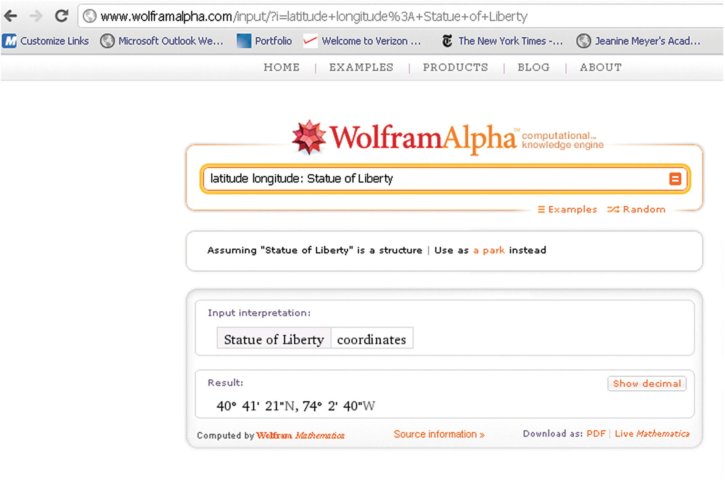
Figure 4-12Results of a query on Wolfram Alpha
Notice the format of the results. This is the degree/minute/second format, with N for north and W for west. When I click the Show Decimal button, the program displays what is shown in Figure 4-13.
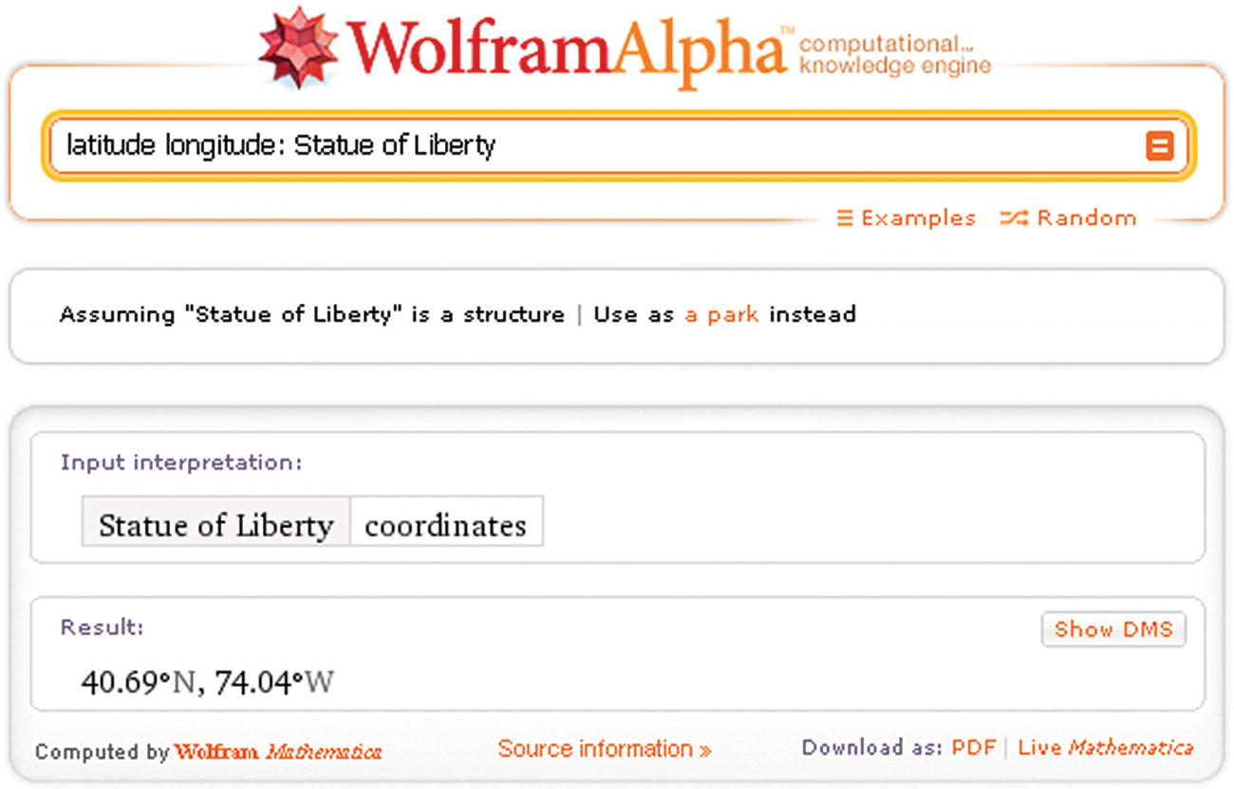
Figure 4-13Decimal results for a query to Wolfram Alpha
Notice that the longitude still appears with W for West as opposed to the negative value given by Google Maps.
Doing what I call “going in the opposite direction,” you can put latitude and longitude values into Google Maps. Figure 4-14 shows the results of putting in 0.0 and 0.0. It is a point in the ocean south of Ghana. This is a point on the equator and on the Greenwich prime meridian.
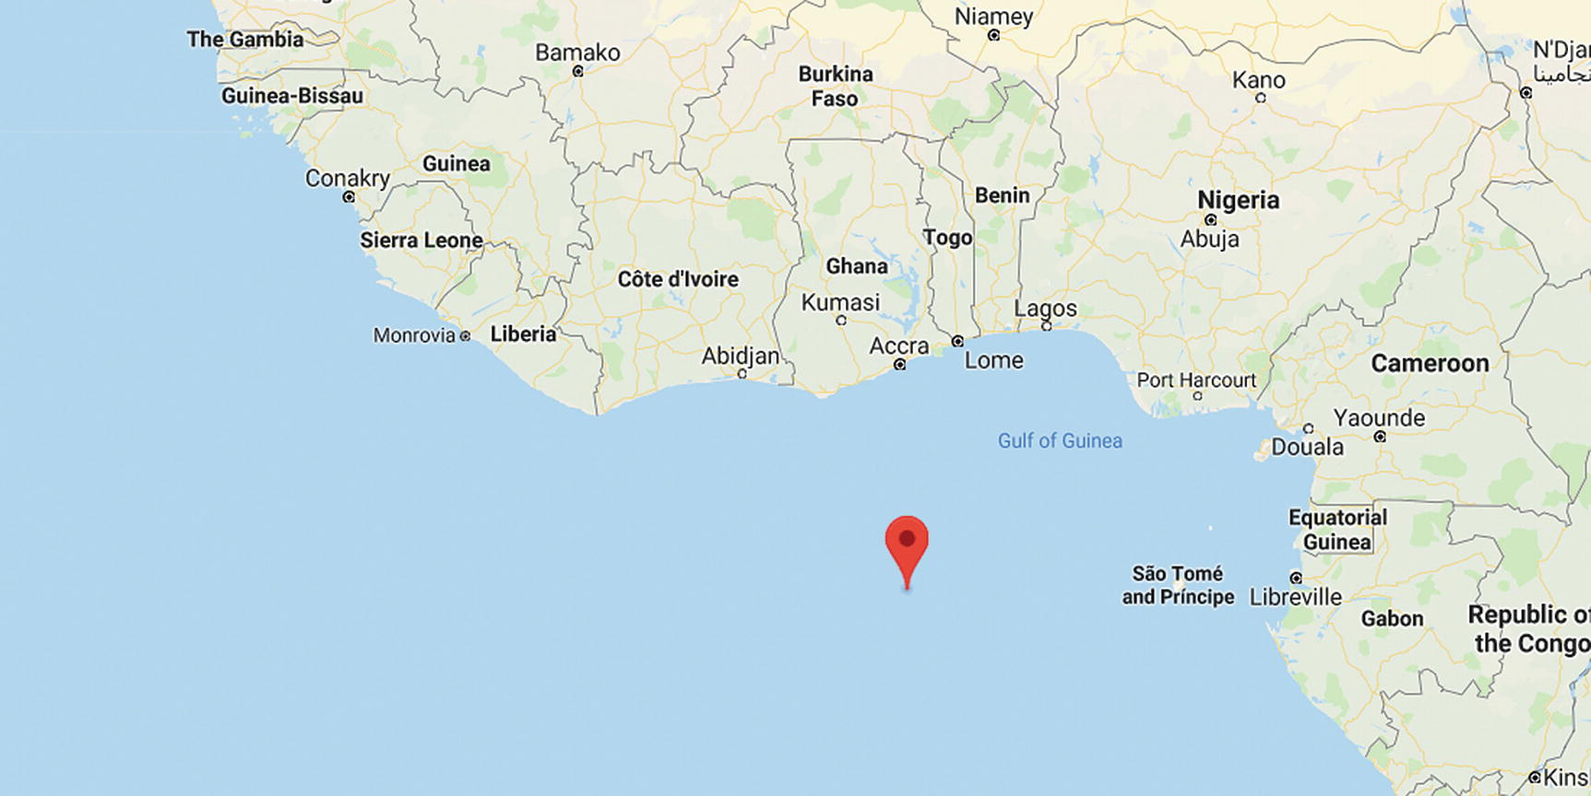
Figure 4-14The equator at the Greenwich prime meridian
I tried to find a place in England on the Greenwich prime meridian and produced the result shown in Figure 4-15 when guessing at the latitude of 52.0 degrees.
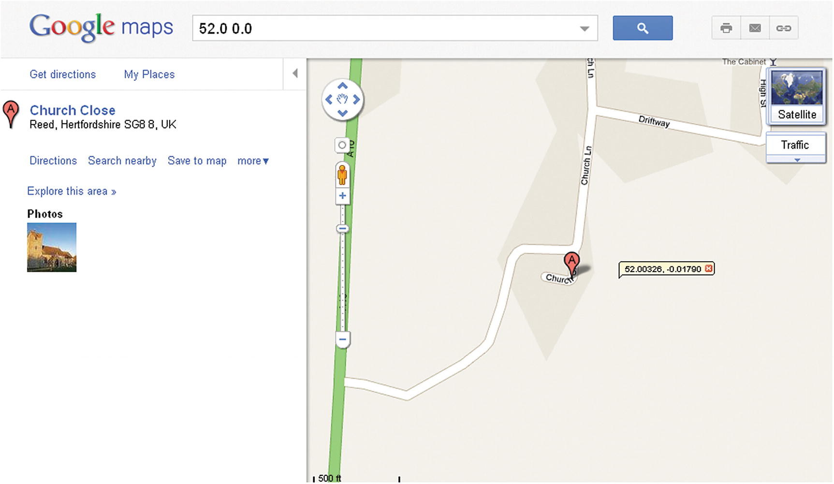
Figure 4-15Results near a place on the Greenwich prime meridian
The A marker indicates the closest place in the Google database to the requested location. I used the Drop LatLng marker option to reveal the exact latitude and longitude values.
The critical requirements for this project start off with the task of bringing Google Maps into a HTML5 application using specified latitude and longitude values. An additional requirement is producing the shadow/spotlight combination on top of the map to track the movements of the mouse. I also require a change from the default cursor for the mouse to something of my own choosing.
Next, I added a requirement to drop markers on the map, but again, with graphical icons that I picked, not the upside-down teardrop that is standard in Google Maps. The teardrop marker is nice enough, but my design objective was to be different to show you how to incorporate your own creativity into an application.
Beyond the graphics, I wanted the users to be able to use the Google Maps devices and any GUI features I built using HTML5. This all required managing events set up by the Google Maps API and events set up using HTML5 JavaScript. The responses to events that I wanted to make the user interface included the following:
Tracking mouse movement with the shadow/spotlight graphic
Responding to a click by placing an x on the map
Retaining the same response to the Google Maps interface (slider, panning buttons, panning by grabbing the map)
Treating the radio buttons and CHANGE button in the appropriate manner
Google Maps provides a way to determine distances between locations. Since I wanted to set up this project to work in terms of the base location, I needed a way to calculate distances directly.
These are the critical requirements for the map spotlight project. Now I will explain the HTML5 features I used to build the project. The objective is to use Google Maps features and JavaScript features, including events, and not let them interfere with each other. You can use what you learn for this and other projects.

HTML5, CSS, and JavaScript Features
The challenges for the map-maker project are bringing in the Google Map and then using the map and canvas and buttons together in terms of appearance and in the operation of the GUI. I’ll describe the basic Google Maps API and then explain how HTML5 features provide the partial masking and the event handling.

The Google Maps API
The Google Maps JavaScript API Version 3 Basics has excellent documentation located at http://code.google.com/apis/maps/documentation/javascript/basics.html . You do not need to refer to it right now, but it will help you if and when you decide to build your own project. It will be especially helpful in producing applications for mobile devices .
Most APIs are presented as a collection of related objects, each object having attributes (also known as properties) and methods. The API also may include events and a method for setting up the event. This is the situation with the Google Maps API. The important objects are Map, LatLng, and Marker . The method to set up an event is addListener , and this can be used to set up a response to clicking a map.
The first step to using the Google Maps API is to go to this site to obtain a key: https://developers.google.com/maps/documentation/javascript/get-api-key .
The code to get access to the API is to modify and then add the following to your HTML document:
<script async defer src="https://maps.googleapis.com/maps/api/js?key=YOUR_API_KEY&callback=initMap"
type="text/javascript"></script>
NoteThe first edition of this text used what is termed a “keyless” API. Though my original code still works on my domain, Google now is stricter. There are quotas in the use of the features, and though the quotas appear very big, you need to study the documentation if you are planning production use.
The next step—and this could be all you need if all you want is to bring in a Google Map—is to set up a call to the Map constructor method . The pseudocode for this is
map = new google.maps.Map(place you are going to put the map, associative array with options);
Note that there is no harm is making the variable have the name map.
Let’s take up the two parameters one at a time. The place to put the map could be a div defined in the body of the HTML document. However, I chose to create the div dynamically. I did this using code in an init function invoked in the usual way, by setting the onLoad attribute in the body statement. I also wrote code to create a canvas element inside the div. The code is
candiv = document.createElement("div");
candiv.innerHTML = ("<canvas id="canvas" width="600" height="400">No canvas
</canvas>");
document.body.appendChild(candiv);
can = document.getElementById("canvas");
pl = document.getElementById("place");
ctx = can.getContext("2d");
The can, pl, and ctx are global variables, each available for use by other functions.
NoteAlthough I try to use the language “bring access to Google Maps into the HTML document,” I am guilty of describing a function that “makes” a map. The Google Maps connection is a dynamic one in which Google Maps creates what are termed “tiles to be displayed.”
The second parameter to the Map method is an associative array. An associative array has named elements, not indexed elements. The array for the Map method can indicate the zoom level, the center of the map, and the map type, among other things. The zoom level can go from 0 to 18. Level 0 is what is shown in Figure 4-7. Level 18 could show buildings. The types of maps are ROADMAP, SATELLITE , HYBRID , and TERRAIN . These are indicated using constants from the Google Maps API. The center is given by a value of type LatLng, constructed, as you may expect, using decimal numbers representing latitude and longitude values. The use of an associative array means that we don’t have to follow a fixed order for parameters, and default settings will be applied to any parameter we omit.
The start of my makemap function follows. The function is called with two numbers indicating the latitude and longitude on which to center the map. My code constructs a LatLng object I name blatlng, sets up the array holding the specification for the map, and then constructs the map—that is, constructs the portal to Google Maps.
function makemap(mylat,mylong) {
var marker;
blatlng = new google.maps.LatLng(mylat,mylong);
myOptions = {
zoom: 12,
center: blatlng,
mapTypeId: google.maps.MapTypeId.ROADMAP
};
map = new google.maps.Map(document.getElementById("place"), myOptions);
The Map method constructs access to Google Maps starting with a map with the indicated options in the div with the ID place. The makemap function continues, placing a marker at the center of the map. This is done by setting up an associative array as the parameter for the Marker method. The icon marker will be an image I created, named rxmarker, using an image of my own design, a drawn red x.
marker = new google.maps.Marker({
position: blatlng,
title: "center",
icon: rxmarker,
map: map });
There is one more statement in the makemap function , but I will explain the rest later.

Canvas Graphics
The graphic that we want to move with the mouse over the map is similar to the mask used in Chapter 3 to turn the rectangular video clip into a circular video clip. Both masks can be described as resembling a rectangular donut: a rectangle with a round hole. We draw the graphics for the shadow/spotlight using two paths, just like the mask for the video in the previous chapter. There are two distinct differences, however, between the two situations:
The exact shape of this mask varies. The outer boundary is the whole canvas, and the location of the hole is aligned with the current position of the mouse. The hole moves around.
The color of the mask is not solid paint, but a transparent gray.
The canvas starts out on top of the Google Map. I accomplish this by writing style directives that set the z-index values :
canvas {position:absolute; top: 165px; left: 0px; z-index:100;}
#place {position:absolute; top: 165px; left: 0px; z-index:1;}
The first directive refers to all canvas elements. There is only one in this HTML document. Recall that the z-axis comes out of the screen toward the viewer, so higher values are on top of lower values. Note also that we use zIndex in the JavaScript code and z-index in the CSS. The JavaScript parser would treat the – sign as a minus operator, so the change to zIndex is necessary. I need to write code that changes the zIndex to get the event handling that I want for this project.
Figure 4-16 shows one example of the shadow mask drawn on the canvas. I have set the base location to Kyoto using the radio buttons. I then used the Google Maps controls to zoom out, pan over to Tokyo, and zoom in. The canvas is over the map in terms of the z-index, and the mask is drawn with a gray color that is transparent so the map underneath is visible.
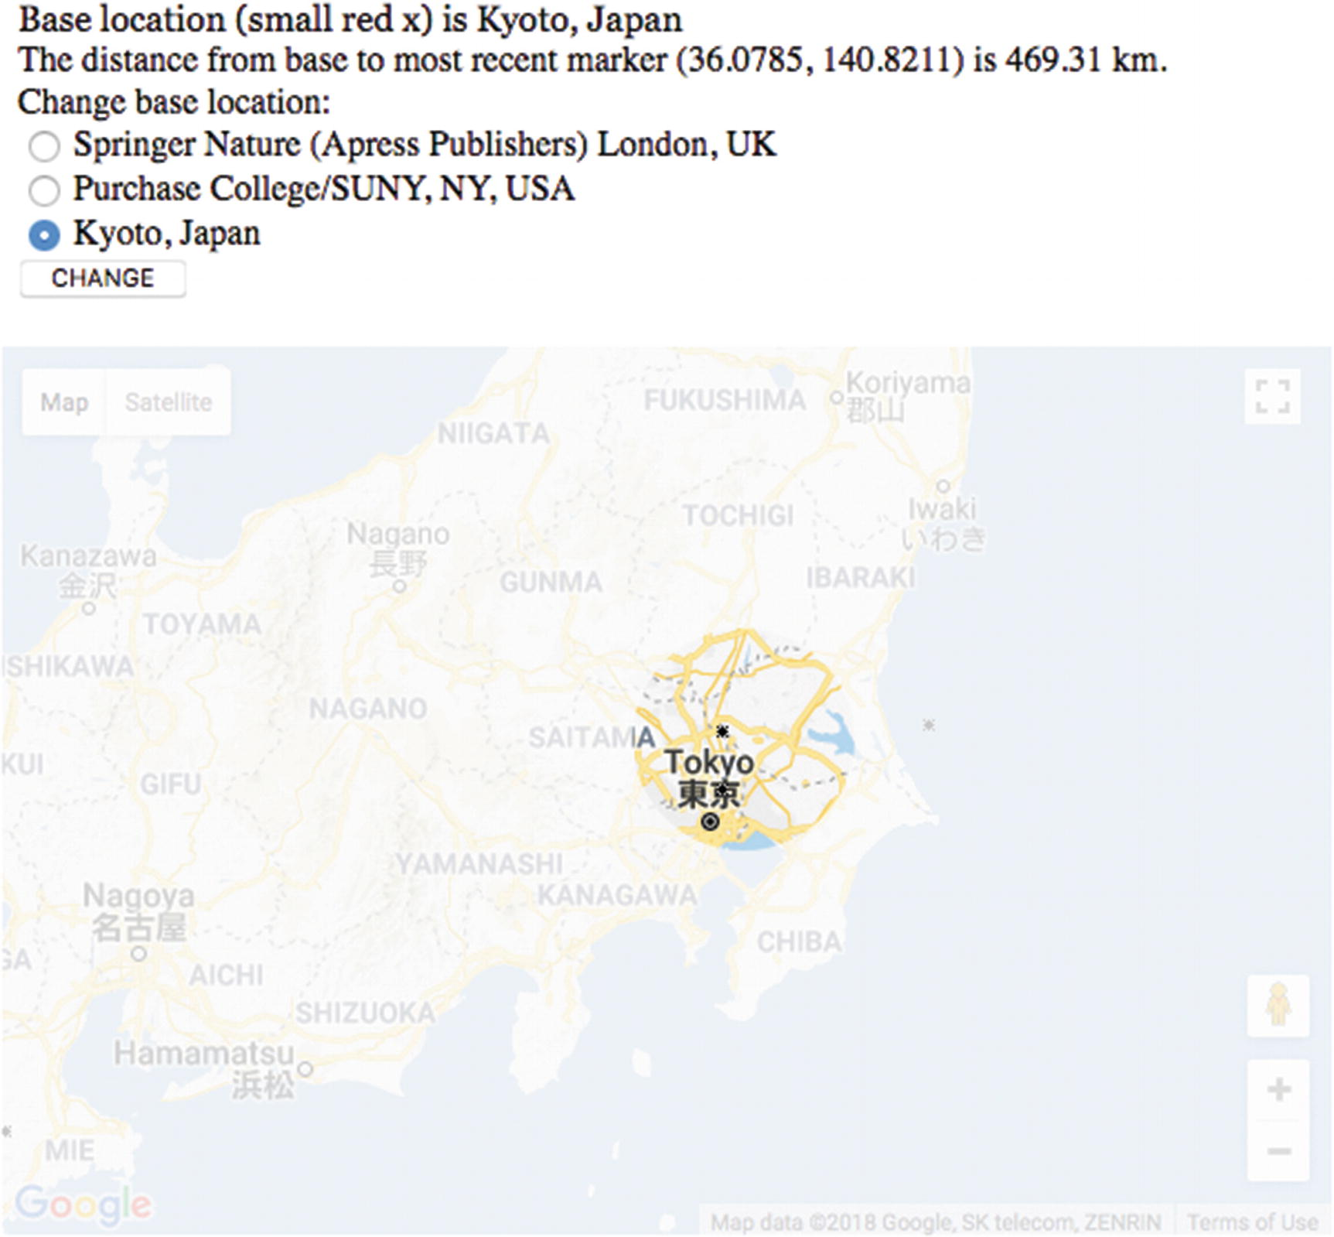
Figure 4-16Shadow/spotlight on one place on the map
Figure 4-17 shows another example of the shadow mask drawn on the same map. This came about because of movement of the mouse by the user handled by Google Maps and then handled by the JavaScript code to restore the shadow.
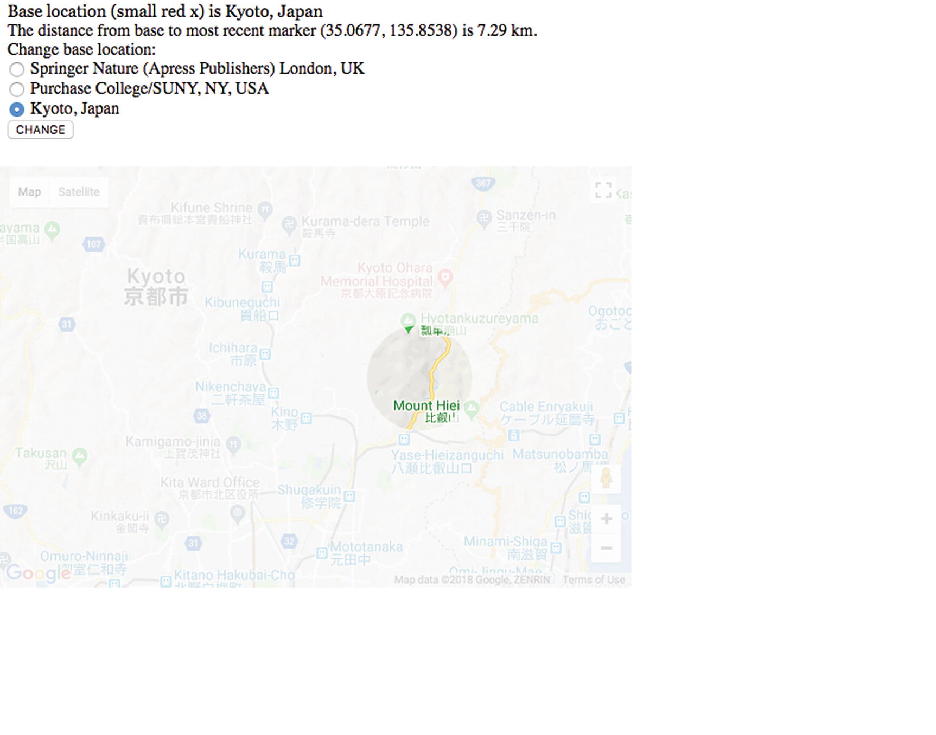
Figure 4-17Shadow mask over another position on the map
Several topics are interlinked here. Let’s assume that the variables mx and my hold the position of the mouse cursor on the canvas. I will explain how later in this chapter. The function drawshadowmask will draw the shadow mask. The transparent gray that is the color of the mask is defined in a variable I named grayshadow and constructed using the built-in function rgba. The rgba stands for red-green-blue-alpha . The alpha refers to the transparency/opacity. A value of 1 for alpha means that the color is fully opaque: solid. A value of 0 means that it is fully transparent—the color is not visible. Recall also that the red, green, and blue values go from 0 to 255, and the combination of 255, 255, and 255 would be white. This is a time for experimentation. I decided on the following setting for the gray/grayish/ghostlike shadow:
var grayshadow = "rgba(250,250,250,.8)";
The function drawshadowmask uses several variables that are constants—they never change. A schematic indicating the values is shown in Figure 4-18.
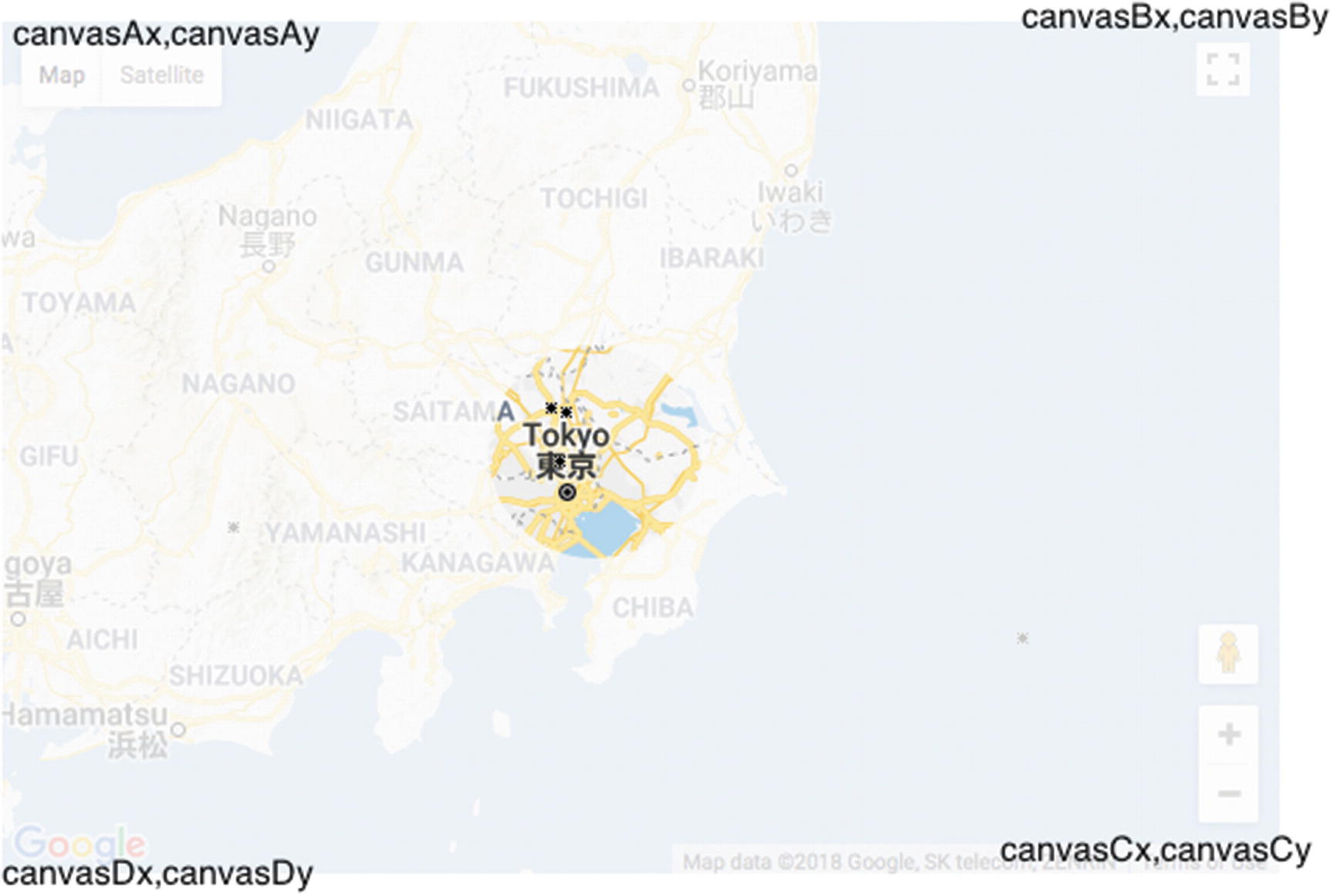
Figure 4-18Schematic with variable values indicated for mask
The mask is drawn in two parts as was done for the mask for the bouncing video. You may look back to Figure 3-8 and Figure 3-9. The coding is similar:
function drawshadowmask(mx,my) {
ctx.clearRect(0,0,600,400);
ctx.fillStyle = grayshadow;
ctx.beginPath();
ctx.moveTo(canvasAx,canvasAy);
ctx.lineTo(canvasBx,canvasBy);
ctx.lineTo(canvasBx,my);
ctx.lineTo(mx+holerad,my);
ctx.arc(mx,my,holerad,0,Math.PI,true);
ctx.lineTo(canvasAx,my);
ctx.lineTo(canvasAx,canvasAy);
ctx.closePath();
ctx.fill();
ctx.beginPath();
ctx.moveTo(canvasAx,my);
ctx.lineTo(canvasDx,canvasDy);
ctx.lineTo(canvasCx,canvasCy);
ctx.lineTo(canvasBx,my);
ctx.lineTo(mx+holerad,my);
ctx.arc(mx,my,holerad,0,Math.PI,false);
ctx.lineTo(canvasAx,my);
ctx.closePath();
ctx.fill();
}
Now we move on to the red light bulb.

Cursor
The cursor—the small graphic that moves on the screen when you move the mouse—can be set in the style element or in JavaScript. There are several built-in choices for the graphic (e.g., crosshair and pointer), and we also can refer to our own designs for a custom-made cursor, which is what I demonstrate in this project. I included the statement
can.onmousedown = function () { return false; } ;
in the init function to prevent a change to the default cursor when pressing down on the mouse. This may not be necessary since the default may not be triggered.
To change the cursor for moving the mouse to something that conveyed a spotlight, I created a picture of a red compact fluorescent light bulb and saved it in the file light.gif. I then used the following statement in the function showshadow. The showshadow function has been set as the event handler for mousemove
can.style.cursor = "url('light.gif'), pointer";
to indicate that JavaScript should use that address for the image for the cursor when on top of the can element. Furthermore, if the light.gif file is not available, the statement directs JavaScript to use the built-in pointer icon. This is similar to the way that fonts can be specified with a priority listing of choices. The variable can has been set to reference the canvas element. The cursor will not be used when the canvas has been pushed under the Google Map, as will be discussed in the next section.

JavaScript Events
The handling of events—namely mouse events, but also events for changing zoom on the Google Map or clicking the radio buttons—seemed the most daunting when I started work on this project. The critical consideration is whether the event is to be handled by Google Maps or by my JavaScript code. However, the actual implementation turned out to be straightforward. In the init function and the makemap function , I write code to set up event handling for movement of the mouse, mouse button down, and mouse button up, all in terms of the canvas element. For example, in the init function, there is
can.addEventListener('mousemove',showshadow);
can.addEventListener('mousedown',pushcanvasunder);
can.addEventListener("mouseout",clearshadow);
The showshadow function , as indicated previously, calls the drawshadowmask function. I could have combined these two functions, but dividing tasks into smaller tasks generally is a good practice. The showshadow function determines the mouse position, makes an adjustment so the light bulb base is at the center of the spotlight, and then makes the call to drawshadowmask :
function showshadow(ev) {
var mx;
var my;
if ( ev.layerX || ev.layerX == 0) {
mx= ev.layerX;
my = ev.layerY;
}
else if (ev.offsetX || ev.offsetX == 0) {
mx = ev.offsetX;
my = ev.offsetY;
}
can.style.cursor = "url('light.gif'), pointer";
mx = mx+10;
my = my + 12;
drawshadowmask(mx,my);
}
The if statement mentioning ev.layerX and ev.layerY is for older Firefox browsers. It probably could be removed.
Now I need to determine what I want to do when the user presses down on the mouse. I decide that I want the shadow to go away and the map to be displayed in its full brightness. In addition to the appearance of things, I also want the Google Maps API to resume control. A critical reason for wanting the Google Maps API to take over is that I want to place a marker on the map, as opposed to the canvas, to mark a location. This is because I want the marker to move with the map, and that would be very difficult to do by drawing on the canvas. I would need to synchronize the marker on the canvas with panning and zooming of the map. Instead, the API does all this for me. In addition, I need the Google Maps API to produce latitude and longitude values for the location.
The way to put Google Maps back in control, so to speak, is to “push the canvas under.” The function is
function pushcanvasunder(ev) {
can.style.zIndex = 1;
pl.style.zIndex = 100;
}
The operation of pushing the canvas under or bringing it back on top is not instantaneous. I am open to suggestions on (1) how to define the interface and (2) how to implement what you have defined. There is room for improvement here.
One more situation to take care of is to decide what I want to occur if and when the user moves the mouse off of the canvas? The mouseout event is available as something to be listened for, so I wrote the code setting up the event (see the can.addEventListener statements shown previously) to be handled by the clearshadow function. The clearshadow function accomplishes just that—it clears the whole canvas, including the shadow:
function clearshadow(ev) {
ctx.clearRect(0,0,600,400);
}
In the function that brings in the Google Map, I set up an event handler for mouseup for maps.
listener = google.maps.event.addListener(map, 'mouseup', function(event) {
checkit(event.latLng);
});
The call to addListener , a method that is part of the Google Maps API as opposed to JavaScript proper, sets up the call to the checkit function. To repeat what has been said in a more informal way: this call to google.maps.event.addListener sets up the Google API to listen for a mouseup event on the map. The following statement causes JavaScript to listen for a mouseout event on can (the canvas).
can.addEventListener("mouseout",clearshadow);
The checkit function is invoked using an attribute of the event object as a parameter. As you can guess, event.latLng is the latitude and longitude values at the position of the mouse when the mouse button was released on the map object. The checkit function will use those values to calculate the distance from the base location and to print out the values along with the distance on the screen. The code invokes a function I wrote that rounds the values. I did this to avoid displaying a value with many significant digits, more than is appropriate for this project. The Google Maps API marker method provides a way to use an image of my choosing for the marker, this time a black, hand-drawn x, and to include a title with the marker. The title is recommended to make applications accessible for people using screen readers, although I cannot claim that this project would satisfy anyone in terms of accessibility. It is possible to produce the screen shown in Figure 4-19. Note the x near Mt. Kisco, where I live. The message at the top indicates the length of my commute in miles. The code can be changed to calculate miles or kilometers.
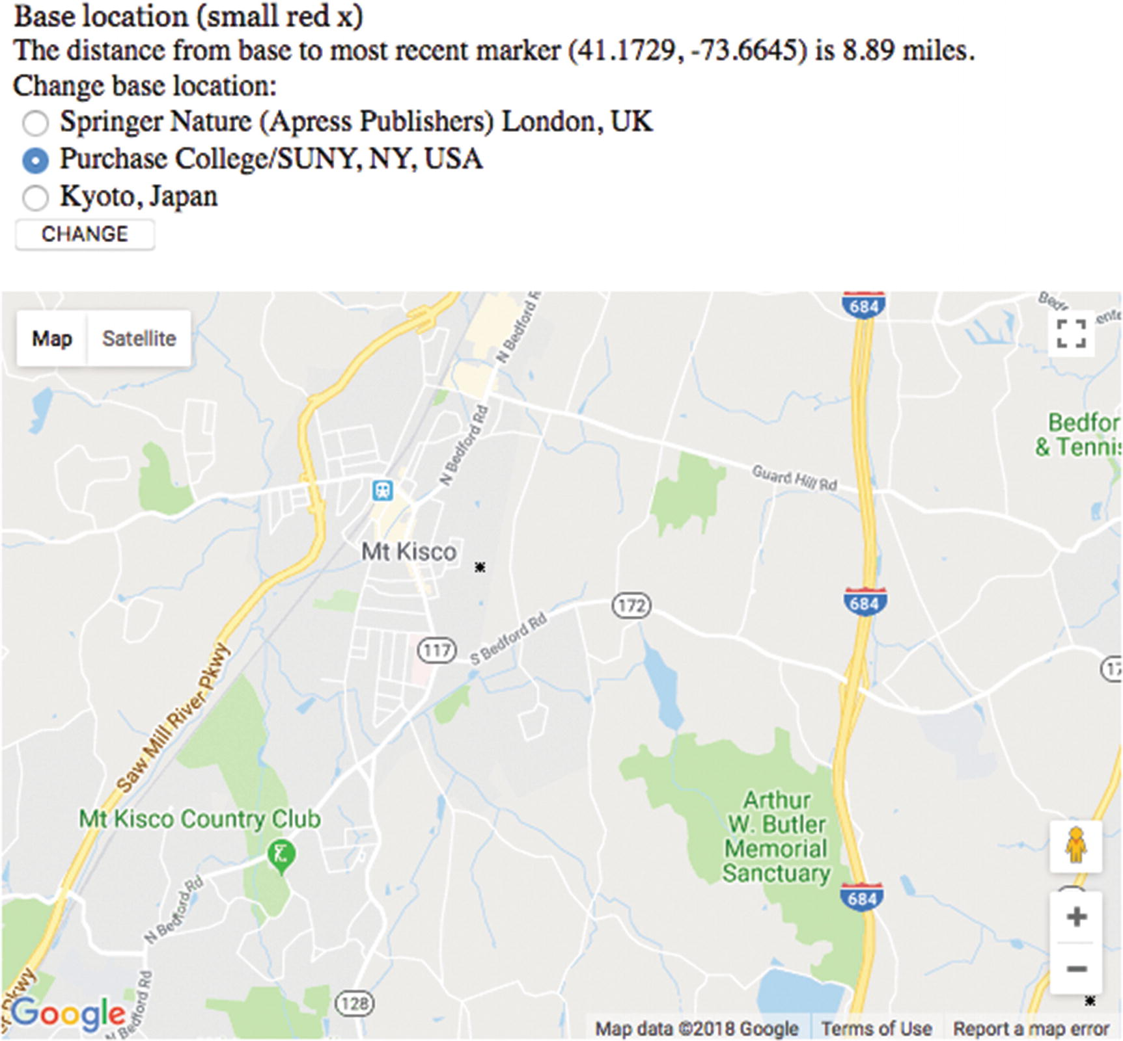
Figure 4-19Title indicating distance shown on map
The checkit function , called with a parameter holding the latitude and longitude value, follows:
function checkit(clatlng) {
var distance = dist(clatlng,blatlng);
distance = round(distance,2);
var distanceString = String(distance)+" km";
marker = new google.maps.Marker({
position: clatlng,
title: distanceString,
icon: bxmarker,
map: map });
var clat = clatlng.lat();
var clng = clatlng.lng();
clat = round(clat,4);
clng = round(clng,4);
document.getElementById("answer").innerHTML =
"The distance from base to most recent marker ("+clat+", "+clng+") is "+String(distance) +" miles.";
//change miles to km depending on value used for R in the dist function
can.style.zIndex = 100;
pl.style.zIndex = 1;
}
Even though I omit most comments in the text, I felt compelled to keep the comments concerning miles versus kilometers. I advise you to do the same for such matters in your work.
Notice that the last thing that the function does is put the canvas back on top of the map.
The CHANGE button and the radio buttons are implemented using standard HTML and JavaScript. The form is produced using the following HTML coding:
<form name="f" onSubmit=" return changebase();">
<input type="radio" name="loc" /> Springer Nature (Apress Publishers) London, UK<br/>
<input id="first" type="radio" name="loc" /> Purchase College/SUNY, NY, USA<br/>
<input type="radio" name="loc" /> Kyoto, Japan<br/>
<input type="submit" value="CHANGE">
</form>
The function changebase is invoked when the submit button, labeled CHANGE, is clicked. The changebase function determines which of the radio buttons was checked and uses the Locations table to pick up the latitude and longitude values. It then makes a call to makemap using these values for parameters. This way of organizing data is called parallel structures : the locations array elements correspond to the radio buttons. The last statement sets the innerHTML of the header element to display text, including the name of the selected base location.
function changebase() {
var mylat;
var mylong;
for(var i=0;i<locations.length;i++) {
if (document.f.loc[i].checked) {
mylat = locations[i][0];
mylong = locations[i][1];
makemap(mylat,mylong);
document.getElementById("header").innerHTML =
"Base location (small red x) is "+locations[i][2];
}
}
return false;
}

Calculating Distance and Rounding Values for Display
Google Maps, as many of us know, provides information on distances and even distinguishes between walking and driving. For this application, I needed more control on specifying the two locations for which I wanted the distance calculated, so I decided to develop a function in JavaScript. Determining the distance between two points, each representing latitude and longitude values, is done using the spherical law of cosines. My source was http://www.movable-type.co.uk/scripts/latlong.html . Here is the code. Notice that to produce a value in kilometers, you use one value for R and for miles the value that is commented. If and when you switch to miles, you need to make sure the message displayed says miles.
function dist(point1, point2) {
var R = 6371; // km Need to make sure this syncs with the message displayed re: distance.
// var R = 3959; // miles
var lat1 = point1.lat()*Math.PI/180;
var lat2 = point2.lat()*Math.PI/180 ;
var lon1 = point1.lng()*Math.PI/180;
var lon2 = point2.lng()*Math.PI/180;
var d = Math.acos(Math.sin(lat1)*Math.sin(lat2) +
Math.cos(lat1)*Math.cos(lat2) *
Math.cos(lon2-lon1)) * R;
return d;
}
CautionI don’t include many comments in the code because I annotate each line in the chapter’s tables. However, comments are important. I strongly recommend leaving the comments on km and miles in the dist function so you can adjust your program as appropriate. Alternatively, you could display both values or give the user a choice.
The last function is for rounding values. When a quantity is dependent on a person moving a mouse, you shouldn’t display a value to a great number of decimal places. However, keep in mind that latitude and longitude represent big units. I decided I wanted the distances to be shown with two decimal places and the latitude and longitude with four.
The function I wrote is quite general. It takes two parameters, one the number num and the other places, indicating how many decimal places to take the value. You can use it in other circumstances. It rounds up or down, as appropriate, by adding the value I call the increment and then calculating the biggest integer not bigger than the value. So
round(9.147,2) will produce 9.15
round(9.143, 2) will produce 9.14
The way the code works is first to determine what I term the factor, 10 raised to the desired number of places. For 2, this will be 100. I then calculate the increment. For two places, this will be 5 / 100 * 10, which is 5 / 1,000, which is .005. My code does the following:
1. | Adds the increment to the original number.
2. | Multiplies the result by the factor.
3. | Calculates the largest whole number not bigger than the result (this is called the floor)—producing a whole number.
4. | Divides the result by the factor.
The code follows:
function round (num,places) {
var factor = Math.pow(10,places);
var increment = 5/(factor*10);
return Math.floor((num+increment)*factor)/factor;
}
I use the round function to round off distances to two decimal places and latitude and longitude to four decimal places.
TipJavaScript has a method called toFixed that essentially performs the task of my round. If num holds a number—say, 51.5621—then num.toFixed() will produce 51 and num.toFixed(2) will produce 51.56. I’ve read that there can be inaccuracies with this method, so I chose to create my own function. You may be happy to go with toFixed() in your own applications, though.
With the explanation of the relevant HTML5 and Google Maps API features, we can now put it all together.

Building the Application and Making It Your Own
The map spotlight application sets up the combination of Google Maps functionality with HTML5 coding. A quick summary of the application is the following:
1. | init: Initialization, including bringing in the map (makemap) and setting up mouse events with handlers: showshadow, pushcanvasunder, and clearshadow
2. | makemap: Brings in a map and sets up event handling, including the call to checkit
3. | showshadow: Invokes drawshadowmask
4. | pushcanvasunder: Enables events on the map
5. | checkit: Calculates distance, adds a custom marker, and displays distance and rounded latitude and longitude
The function table describing the invoked/called by and calling relationships (Table 4-1) is the same for all the applications.
Table 4-1 Functions in the Map Maker Project
Function | Invoked/Called By | Calls
init | Invoked by action of the onLoad attribute in the <body> tag | makemap
pushcanvasunder | Invoked by action of addEventListener called in init
clearshadow | Invoked by action of addEventListener called in init
showshadow | Invoked by action of addEventListener called in init | drawshadowmask
drawshadowmask | Called by showshadow
makemap | Called by init
checkit | Called by action of addEventListener called in makemap | round, dist
round | Called by checkit (three times)
dist | Called by checkit
changebase | Called by action of onSubmit in <form> | makemap
Table 4-2 shows the code for the Map Maker application, named mapspotlight.html.
Table 4-2 Complete Code for the mapspotlight.html Application
Code Line | Description
<!DOCTYPE html> | Header
<html> | Opening html tag
<head> | Opening head tag
<title>Spotlight </title> | Complete title
<meta charset="UTF-8"> | Meta tag
<style> | Opening of style element
header {font-family:Georgia,"Times New Roman",serif; | Set fonts for the heading
font-size:16px; | Font size
display:block;} | Line breaks before and after
canvas {position:absolute; top: 165px; left:0px; | Style directive for the single canvas element; position slightly down the page
z-index:100;} | Initial setting for canvas is on top of map
#place {position:absolute; top: 165px; left: 0px; | Style directive for the div holding the Google Map; position exactly the same as the canvas
z-index:1;} | Initial setting to be under canvas
</style> | Close style element
<script async defer src=" https://maps.googleapis.com/maps/api/js?key=YOUR_API_KEY&callback=initMap "  type="text/javascript"></script> | Bring in the external script element holding the Google Maps API; Note: you need to get your own key to run the program
<script type="text/javascript" charset="UTF-8"> | Opening script tag
var locations = [ | Define set of base locations; Note: you need to coordinate with radio buttons in body
[51.534467,-0.121631, "Springer Nature (Apress Publishers) London, UK"], | Latitude, longitude name publisher office in London
[41.04796,-73.70539,"Purchase College/SUNY, NY, USA"], | . . . Purchase College
[35.085136,135.776585,"Kyoto, Japan"] | . . . Kyoto
]; | Close array of locations
var candiv; | Used to hold div holding the canvas
var can; | Reference canvas element
var ctx; | Reference context of canvas; used for all drawing
var pl; | Reference the div holding the Google Map
function init() { | Function header for init
var mylat; | Will hold latitude value
var mylong; | Will hold longitude value
candiv = document.createElement("div"); | Create a div
candiv.innerHTML = ("<canvas id="canvas" width="600" height="400">No canvas </canvas>"); | Set its contents to be a canvas element
document.body.appendChild(candiv); | Add to the body
can = document.getElementById("canvas"); | Set reference to the canvas
pl = document.getElementById("place"); | Set reference to the div holding the Google Map
ctx = can.getContext("2d"); | Set the context
can.onmousedown = function () { return false; } ; | Prevent change of cursor to default
can.addEventListener('mousemove',showshadow); | Set event handling for mouse moving
can.addEventListener('mousedown',pushcanvasunder); | Set event handling for pushing down on mouse button
can.addEventListener("mouseout",clearshadow); | Set event handling for moving mouse off of the canvas
mylat = locations[1][0]; | Set the latitude to be the latitude of the first (middle) location
mylong = locations[1][1]; | Set the longitude to be the longitude of the first (middle) location
document.getElementById("first").checked="checked"; | Set middle radio button to display as checked
makemap(mylat,mylong); | Invoke function to make a map (bring in Google Maps at specified location)
} | Close init function
function pushcanvasunder(ev) { | Header for pushcanvas function, called with parameter referencing the event
can.style.zIndex = 1; | Push canvas down
pl.style.zIndex = 100; | Set map div up
} | Close pushcanvasunder function
function clearshadow(ev) { | Header for clearshadow function, called with parameter referencing the event
ctx.clearRect(0,0,600,400); | Clear canvas (erase shadow mask)
} | Close clearshadow function
function showshadow(ev) { | Header for showshadow function, called with parameter referencing the event
var mx; | Will be used to hold horizontal position of mouse
var my; | Will be used to hold vertical position of mouse
if ( ev.layerX || ev.layerX == 0) { | Does this browser use layerX? Note: this is for older browsers
mx = ev.layerX; | If so, use it to set mx . . .
my = ev.layerY; | . . . and my
} else if (ev.offsetX || ev.offsetX == 0) { | Try offset. Note: this works on current browsers
mx = ev.offsetX; | If so, use it to set mx . . .
my = ev.offsetY; | . . . and my
} | Close clause
can.style.cursor = "url('light.gif'),pointer"; | Set up cursor to be light.gif if available; otherwise use pointer
mx = mx+10; | Make rough correction to make center of light at base of light bulb horizontally and . . .
my = my + 12; | . . . vertically
drawshadowmask(mx,my); | Invoke drawshadowmask function at the modified (mx,my)
} | Close showshadow function
var canvasAx = 0; | Constant for mask: upper-left x
var canvasAy = 0; | Upper-left y
var canvasBx = 600; | Upper-right x
var canvasBy = 0; | Upper-right y
var canvasCx = 600; | Lower-right x
var canvasCy = 400; | Lower-right y
var canvasDx = 0; | Lower-left x
var canvasDy = 400; | Lower-left y
var holerad = 50; | Constant radius for hole in shadow (radius of spotlight)
var grayshadow = "rgba(250,250,250,.8)"; | Color for faint shadow; note alpha of .8
function drawshadowmask(mx,my) { | Header for drawshadowmask function; parameters hold center of donut hole
ctx.clearRect(0,0,600,400); | Erase whole canvas
ctx.fillStyle = grayshadow; | Set color
ctx.beginPath(); | Start first (top) path
ctx.moveTo(canvasAx,canvasAy); | Move to upper-left corner
ctx.lineTo(canvasBx,canvasBy); | Draw over to upper-right corner
ctx.lineTo(canvasBx,my); | Draw to vertical point specified by my parameter
ctx.lineTo(mx+holerad,my); | Draw over to the left to edge of hole
ctx.arc(mx,my,holerad,0,Math.PI,true); | Draw semicircular arc
ctx.lineTo(canvasAx,my); | Draw to left side
ctx.lineTo(canvasAx,canvasAy); | Draw back to start
ctx.closePath(); | Close path
ctx.fill(); | Fill in
ctx.beginPath(); | Start of second (lower) path
ctx.moveTo(canvasAx,my); | Start at point on left side indicated by my parameter
ctx.lineTo(canvasDx,canvasDy); | Draw to lower-left corner
ctx.lineTo(canvasCx,canvasCy); | Draw to lower-right corner
ctx.lineTo(canvasBx,my); | Draw to point on right edge
ctx.lineTo(mx+holerad,my); | Draw to left to edge of hole
ctx.arc(mx,my,holerad,0,Math.PI,false); | Draw semicircular arc
ctx.lineTo(canvasAx,my); | Draw to left edge
ctx.closePath(); | Close path
ctx.fill(); | Fill in
} | Close drawshadowmask function
var listener; | Variable set by addListener call; not used again
var map; | Holds map
var blatlng; | Holds base latitude-longitude object
var myOptions; | Holds associative array used for map
var rxmarker = "rx1.png"; | Holds filename for red x image
var bxmarker = "bx1.png"; | Holds filename for black x image
function makemap(mylat,mylong) { | Header for makemap function; parameters hold location of center of the map
var marker; | Will hold marker created for center
blatlng = new google.maps.LatLng(mylat,mylong); | Build a LatLng object (special data type for the API)
myOptions = { | Set associative array
zoom: 12, | Zoom setting (can be 0 to 18)
center: blatlng, | Center
mapTypeId: google.maps.MapTypeId.ROADMAP | Type of map
}; | Close myOptions array
map = new google.maps.Map(document.getElementById("place"), myOptions); | Invoke the API to bring in a map at indicated place
marker = new google.maps.Marker( | Place marker in center of map; marker method takes an associative array as its parameter; Note: there is alternative using setMap method of marker object
{ | Start of associative array
position: blatlng, | Set the position
title: "center", | Set the title
icon: rxmarker, | Set the icon
map: map | Set the map named parameter to the variable named map
} | Close the associative array, which is the parameter to the call to Marker
); | Close the call to the Marker method
listener = google.maps.event.addListener( | Set up event handling (the three following parameters); this is a Google Maps event
map, | The object, namely the map
'mouseup', | The specific event
function(event) { | An autonomous function (defined directly as a parameter in addListener)
checkit(event.latLng); | Call checkit with the indicated latitude-longitude object
} | Close the function definition
); | Close the call to addListener
} | Close the makemap function
function checkit(clatlng) { | Function header for checkit; called with the latitude-longitude object
var distance = dist(clatlng,blatlng); | Invoke the dist function to calculate distance between the clicked position and the base
var marker; | Will hold newly created marker
distance = round(distance,2); | Round the value
var distanceString = String(distance)+" km"; | Set distanceString to be the display
marker = new google.maps.Marker( | Invoke the Marker method, which takes an associative array as its parameter
{ | Start of associative array
position: clatlng, | Set position
title: distanceString, | Set title
icon: bxmarker, | Set icon to be black x
map: map | Set map element of associative array to the value of the variable named map
} | Close associative array
); | Close call to Marker method
var clat = clatlng.lat(); | Extract the latitude value
var clng = clatlng.lng(); | Extract the longitude value
clat = round(clat,4); | Round value to four decimal places
clng = round(clng,4); | Round value to four decimal places
document.getElementById("answer").innerHTML = | Set up text onscreen . . .
"The distance from base to most recent marker ("  + clat+", "+clng+") is "+String(distance) +" km."; | . . . to be calculated and formatted information
can.style.zIndex = 100; | Set canvas to be on top
pl.style.zIndex = 1; | Set pl (holding map) to be underneath
} | Close checkit function
function round (num,places) { | Header for function to round values
var factor = Math.pow(10,places); | Determine factor from number of places
var increment = 5/(factor*10); | Determine the increment to round up or down
return Math.floor((num+increment)*factor)/factor; | Do calculation
} | Close round function
function dist(point1, point2) { | Function header for dist (distance) function
// spherical law of cosines,  // from  // http://www.movable-type.co.uk/scripts/latlong.html | Attribution for my source; this is standard mathematics
var R = 6371; // km | Factor used to produce answer in kilometers
// var R = 3959; // miles | Commented out, but keep just in case you want to give answer in miles, which I did in Figure 4-19
var lat1 = point1.lat()*Math.PI/180; | Convert value to radians
var lat2 = point2.lat()*Math.PI/180 ; | Convert value to radians
var lon1 = point1.lng()*Math.PI/180; | Convert value to radians
var lon2 = point2.lng()*Math.PI/180; | Convert value to radians
var d = | Calculation . . .
Math.acos(Math.sin(lat1)*Math.sin(lat2) + Math.cos(lat1)*Math.cos(lat2) * Math.cos(lon2-lon1)) * R; | Use trigonometry to determine distance
return d; | Return result
} | Close dist function
function changebase() { | Header for changebase function
var mylat; | Will hold new base location latitude
var mylong; | Will hold new base location longitude
for(var i=0;i<locations.length;i++) { | for loop to determine which radio button is checked
if (document.f.loc[i].checked) { | Is this one checked?
mylat = locations[i][0]; | If so, set mylat
mylong = locations[i][1]; | Set mylong
makemap(mylat,mylong); | Invoke makemap
document.getElementById("header").  innerHTML = "Base location (small red x) is "+locations[i][2]; | Change text in header to show the name
} | Close if true clause
} | Close for loop
return false; | Return false to present refresh
} | Close function
</script> | Closing script tag
</head> | Closing head tag
<body onLoad="init();"> | Opening body tag; include onLoad to invoke init
<header id="header">Base location (small red x) </header> | Semantic header element
<div id="place" style="width:600px; height:400px"></div> | div to hold Google Maps
<div id="answer"></div> | div to hold information on clicked locations
Change base location: <br/> | Text
<form name="f" onSubmit=" return changebase();"> | Start of form for changing base; Note: you need to coordinate with locations array in the script element
<input type="radio" name="loc" /> Springer Nature (Apress Publishers) London, UK<br/> | Radio button choice
<input id=”first” type="radio" name="loc" /> Purchase College<br/> | Radio button choice; given ID to be set as checked at opening
<input type="radio" name="loc" /> Kyoto, Japan<br/> | Radio button choice
<input type="submit" value="CHANGE"> | The button to make the change
</form> | Closing form tag
</body> | Closing body tag
</html> | Closing html tag
You need to decide on your set of base locations. Again, there is nothing special about three. Your choices may be much closer. If your base list is too large, you may consider using <optgroup> to produce a drop-down list. In any case, you need to define a set of locations. Each location has two numbers—latitude and longitude—and a string of text comprising the name. Some of the text is repeated in the HTML in the form in the body element.

Testing and Uploading the Application
This project consists of the HTML file and three image files. For my version of the project, the image files were the light bulb (light.gif), the red x (rx1.png), and the black x (bx1.png). There is nothing special about these image file types. You can use whatever you like. It could be argued that my x markers are too tiny, so think about your customers when deciding what to do.
This application does require you to be online to test since that is the only way to contact Google Maps.

Summary
In this chapter, you learned how to do the following:
Use the Google Maps API.
Combine the use of the Google Maps API with your own JavaScript coding using canvas graphics. That is, produce a GUI that includes Google Maps events and HTML5 events.
Draw using the alpha setting controlling transparency/opacity.
Change to a custom-made cursor.
Calculate distances between geographic points.
Round off decimal values for suitable display.
The next chapter describes another project using Google Maps. You will learn how to build an application in which you can associate a picture, a video clip, or a picture-and-audio-clip combination with specific geographic locations, and then you’ll see how to display and play the specified media when a user clicks at or near the locations on a map.
© Jeanine Meyer 2018
Jeanine Meyer
HTML5 and JavaScript Projects
https://doi.org/10.1007/978-1-4842-3864-6_5

5. Map Portal: Using Google Maps to Access Your Media
Jeanine Meyer1
(1)
New York, USA

In this chapter, you will learn the following:
Using the Google Maps API to play and display video, audio, and images
Creating HTML5 markup dynamically
Separating the program from descriptions of content
Building a geography game

Introduction
The project in this chapter uses the Google Maps API as a way to play video, display images, or play audio and display an image, all based on geographic locations. You can use this project as a model to build a study of a geographic area or report on a business or vacation trip, or you can develop it into a more elaborate geography quiz. As was the case with Chapter 4, the main lessons concern integrating use of the Google Maps API with your own JavaScript, in particular, presenting images, audio and video. The example for this chapter is a quiz application. I have acquired media, such as video files, audio files, and image files , and I have defined in the code an association between the media and specific geographic locations. To give you an idea of what I mean, for my projects, the associations between a target location (which is given in latitude and longitude coordinates in the code) and media are shown in Table 5-1.
Table 5-1 Outline of Content
Description of Location | Media
Purchase College, NY, USA (Student Services Building) | Starting location: no media
Mount Kisco, NY, USA | Picture of Esther and an audio file of her playing piano
Purchase College/NY, USA (Natural Sciences Building) | Video of LEGO Robotics
Statue of Liberty, New York City, USA | Video of fireworks
Miyajama, Japan | Picture of the Great Torii
The application proceeds smoothly with the different types of media. This is due to the features of HTML5 and, I say modestly, my programming. (In fact, modesty is called for: I needed to make a small modification to the program because of significant differences in image dimensions when I made a change from a smaller picture to a larger one.) The media information along with the questions and locations are stored in a separate file.
It still is recommended that you supply multiple video and audio formats to make sure your application will work in the different browsers. The media types recognized by browsers may change so that fewer types are required, but this is not the case at this time.
The application is a simple quiz. It consists of two files: mapmediaquiz.html and mediaquizcontent.js. The mediaquizcontent.js file contains information connecting the media to the locations and also contains the text for the questions.
Figure 5-1 shows the opening screen for the quiz.
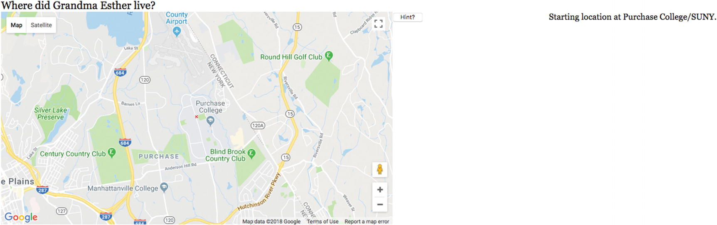
Figure 5-1 Opening screen for quiz
The player now attempts to answer the question by determining the location and clicking on the map. Figure 5-2 shows what happens when I just make a click on the Purchase campus. This is not a good answer, which the program detects.
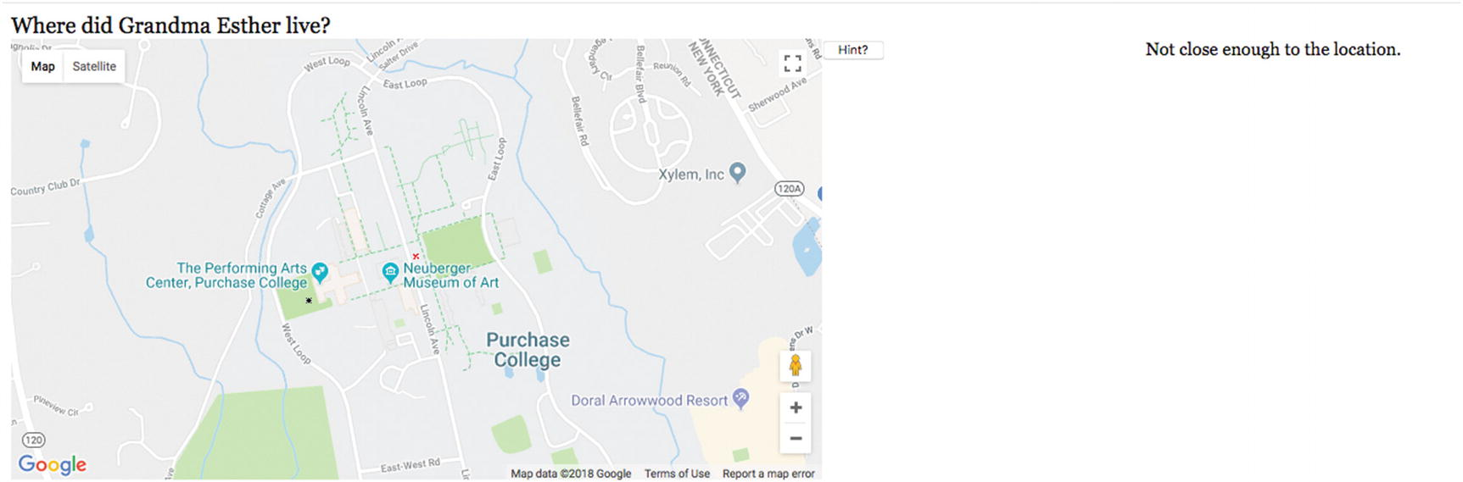
Figure 5-2Result of clicking at Purchase College
Notice that a small x has appeared where I clicked, but it is not sufficiently close to the correct location. I move the map and try again and Figure 5-3 shows the result of clicking the screen, but not sufficiently close to the target location . Notice that I have panned the map, moving it to the north. There is an option for the player to get a hint. When I clicked on the Hint button , Figure 5-3 appeared. This is a very strong hint, and readers are encouraged to devise a way of helping out the player without giving the answer.
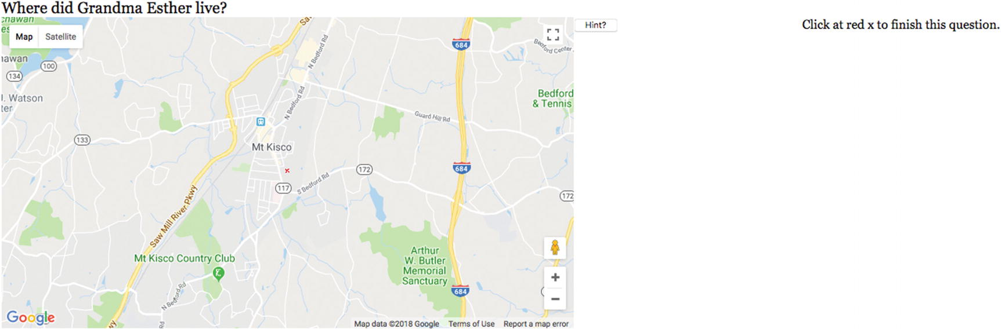
Figure 5-3Result of clicking the Hint button
When I follow the directions to click on the red x, Figure 5-4 shows the result. Notice also the audio control, providing a way to pause and resume playing and also change the speaker volume. The controls for audio (and video) will be different in the different browsers, but the functionality is the same. The audio starts playing immediately. Notice also that the next question appears.
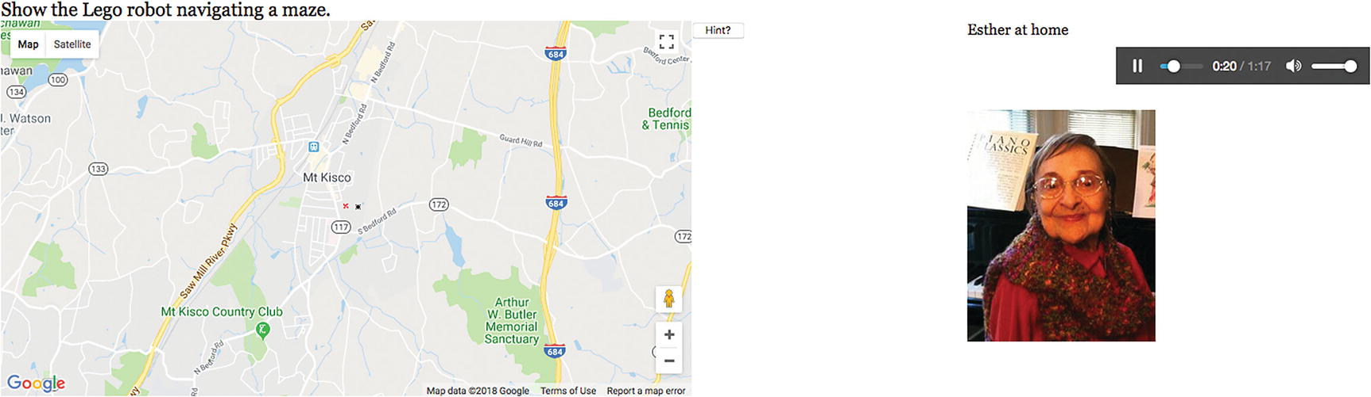
Figure 5-4 Image-and-audio combination
Because I know where the locations are, I know to zoom out to get to the next location. Figure 5-5 shows the results of using the Google Maps interface to accomplish this. The audio track continues playing and I still see the picture.
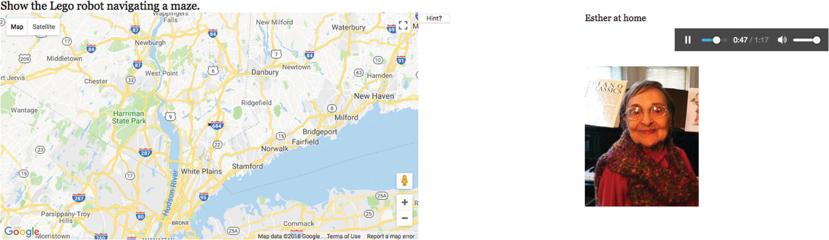
Figure 5-5Zooming out in preparation for a pan south
Figure 5-6 shows the result of moving the map to the south and then zooming in back to the Purchase campus where a video produced by students shows a LEGO Mindstorms robot traversing a maze.
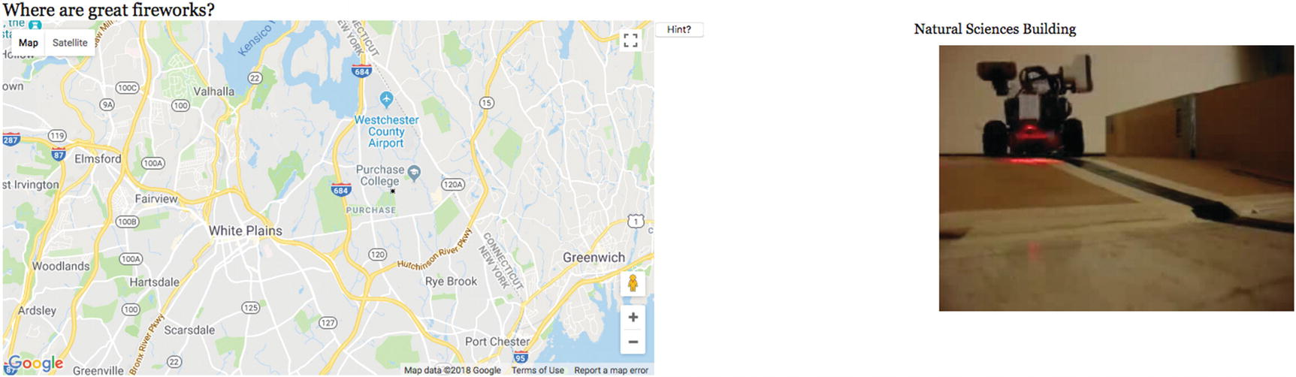
Figure 5-6Correctly locating (close enough) the LEGO robots, so a video plays
The next location is the Statue of Liberty. Notice that when I click close to that location, a pop-up label set by Google appears.
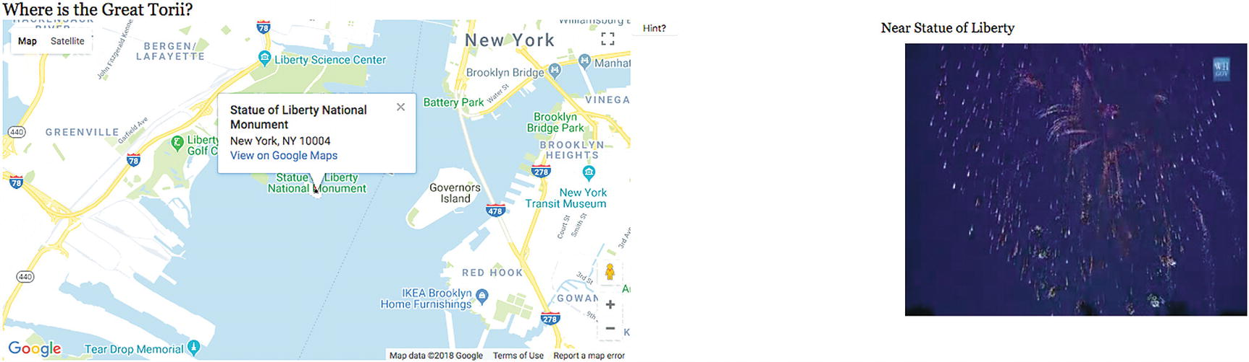
Figure 5-7Zooming out, panning south, and then zooming in to click at the Statue of Liberty
The last question requires going across country and across to the Pacific to locate Miyajama (which I had been told about by Takashi, also the supplier of the photo). Figure 5-8 shows the results of the first steps.
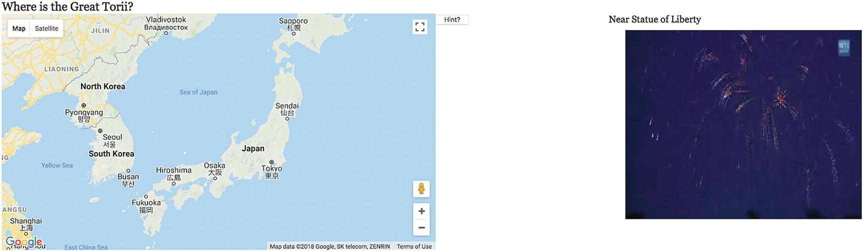
Figure 5-8Zooming out and then in on Japan
Again, the results of the prior question still appear. I press the Hint button and see what is shown in Figure 5-9.
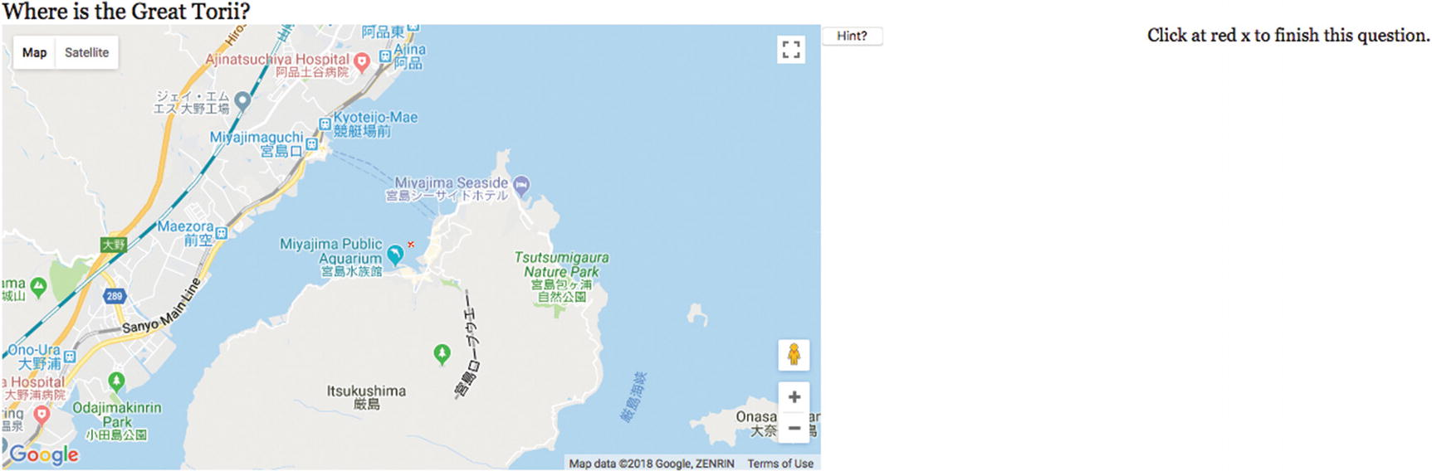
Figure 5-9Result of clicking on the Hint button
When I click on the screen in the place suggested by the hint , Figure 5-10 appears. This is a major local and global tourist attraction in Japan.
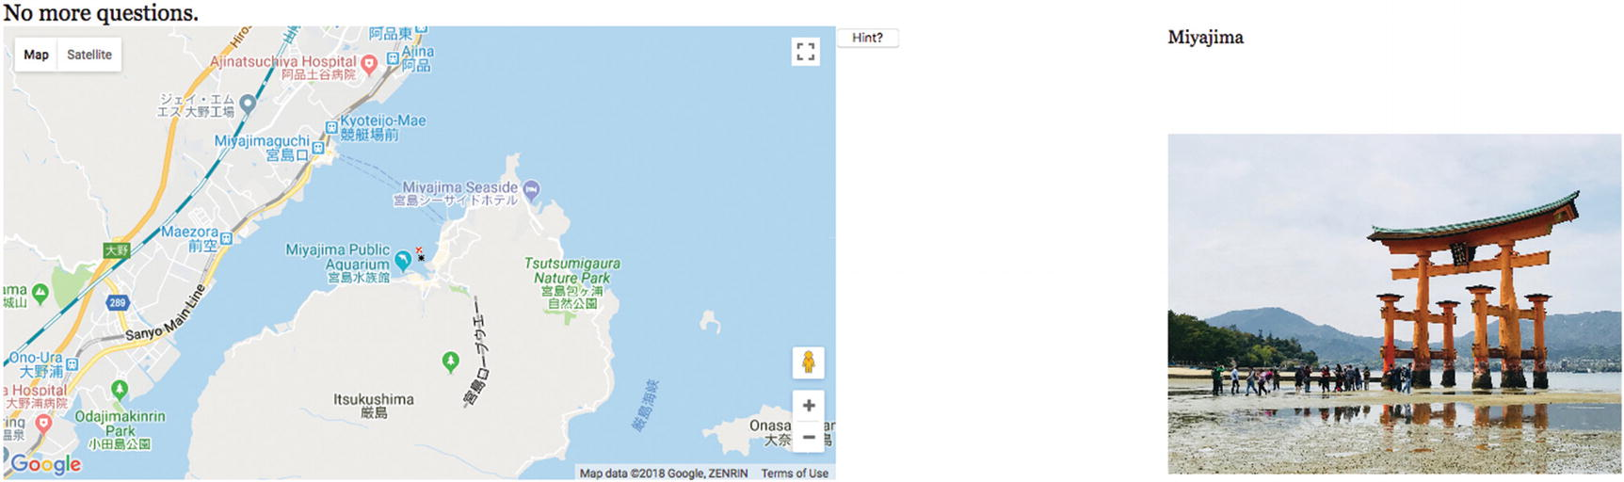
Figure 5-10The Great Torii
At this point, I need to admit that my original code could not handle the very nice and very large image furnished by Takashi. It was too big for the coding I used, which worked well enough with small images. Figure 5-11 shows what happened when I included the Great Torii question and the photo of Miyajama with my original code. This certainly was disappointing. It was only the upper-left corner of the image.
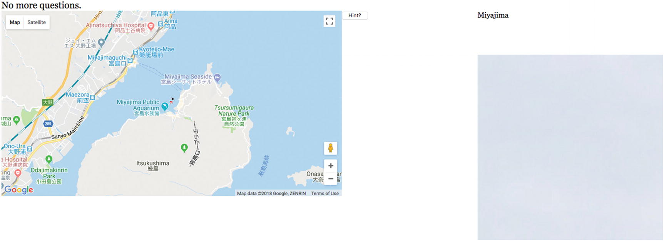
Figure 5-11Result of original coding for showing images
My original statement:
ctx.drawImage(img1,0,0);
drew only the upper corner from the picture onto the canvas. Instead, I needed to write JavaScript that determined how to scale the picture onto the 400x400 canvas, performing scaling while also preserving the aspect ratio. The following does the trick:
var iw = img1.width;
var ih = img1.height;
var aspect = iw/ih;
if (iw>=ih) {
if (iw>400){
tw = 400;
th = 400/aspect;
}
else {
tw = iw;
th = ih;
}
}
else {
if (ih>400){
th = 400;
tw = 400*aspect;
}
else {
th = ih;
tw = iw;
}
}
ctx.drawImage(img1,0,0,iw,ih,0,0,tw,th);
Figure 5-12 indicates the action of the code. An image with original width equal to iw and height equal to ih is scaled down to fit in the 400 by 400 canvas. The final dimensions are indicated by tw and th. This code produced what is shown in Figure 5-10.
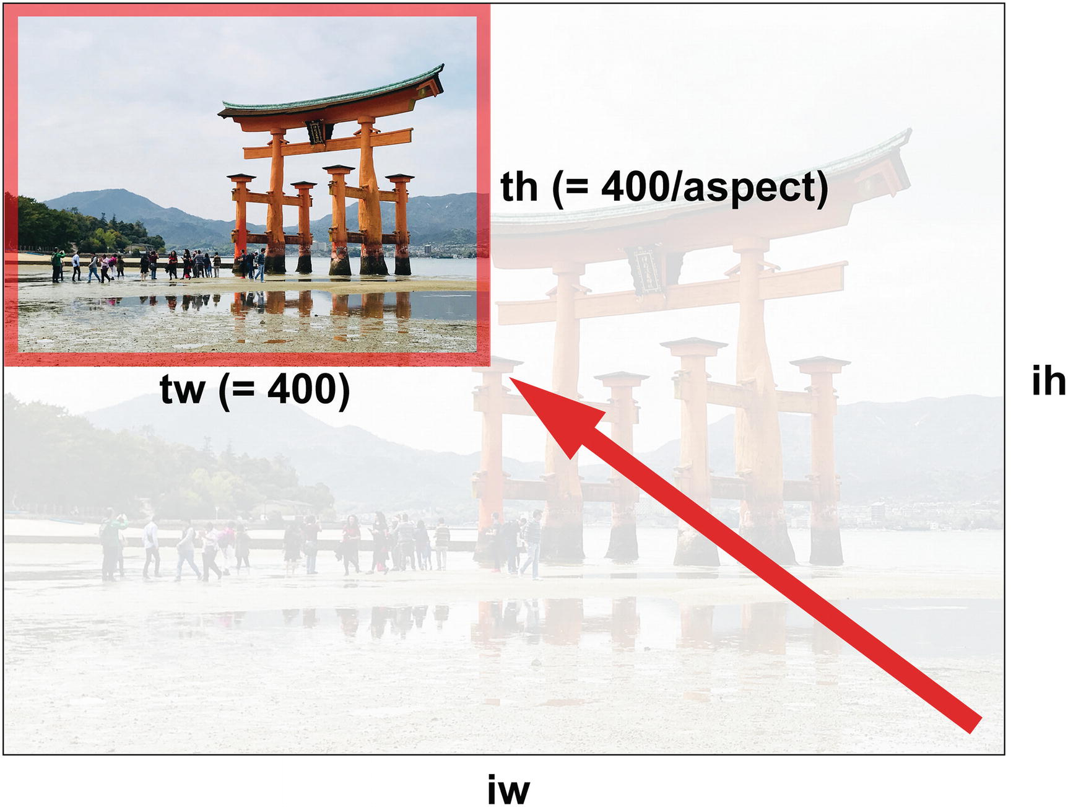
Figure 5-12Diagram showing relationship of source and target width and height values
With this introduction, I’ll go on to discuss the project history and the critical requirements.

Project History and Critical Requirements
A senior at Purchase College had collected and made video clips and photographs about the ethnic neighborhoods of Queens, New York and wanted a way to present the work. The Google Maps API and the new facilities in HTML5 seemed perfect for the task. Keep in mind that the student only needed a way to present the work on a computer she set up at the senior project show, so the issue of noncompliant browsers was not a concern. The critical requirements include what is supplied by the Google Maps API. As you learned in the previous chapter, we can write code to access a map centered at a specified geographic location, set at an initial zoom level, and showing views of roads or satellite or terrain or a hybrid. In addition, the API provides a way to respond to the event of the viewer clicking the map . We need a way to define specific locations to be compared with the location corresponding to the viewer’s click.
My first system for the student just used video and images. I later decided to add the image-and-audio combination. The critical requirement for the application is displaying and playing the designated media at the correct time and stopping and removing the media when appropriate, such as when it is time for the next presentation.
After helping with the student project, I thought of changes. The first one was the addition of the image-and-audio combination. I decided I did not want audio just by itself. The next change was to separate the specific content from the general coding. This, in turn, required a way to create markup for video and audio elements dynamically.
I always like games and lessons, and it seemed like a natural step to build an application with questions or prompts for the viewer—now best described as the player or student. The player gives the answer by finding the right position on the map. Any application like this has a requirement to define a tolerance with respect to the answers. The viewer/player/student cannot be expected to click exactly on the correct spot.
When testing the quiz, I realized I needed some way to help the player get past a particularly difficult question. Because I am a teacher, I decided to show the player the answer, rather than just skipping the question. However, as I indicated earlier, you may be able to devise a better way to produce hints.
Although it is not apparent when playing the game, the separation of the questions, locations (the answers), and the media made it easy to put together a totally different quiz. However, as I indicated, I did need to made some adaption when I decided to incorporate pictures of greatly different sizes and shapes.
Having described the critical requirements, the next section contains an explanation of the specific HTML5 features that can be used to build the projects .

HTML5, CSS, and JavaScript Features
Like the map maker project in Chapter 4, these projects are implemented by combining the use of the Google Maps API with features of HTML5. The combination for this project is not as tricky. The map stays on the left side of the window and the media is presented on the right. I will review quickly how to get access to a map and how to set up the event handling, and then go on to the HTML5, CSS, and JavaScript features for satisfying the rest of the critical requirements.

Google Maps API for Map Access and Event Handling
Access to the Google Maps API requires a script element with reference to an external file . As was mentioned in Chapter 4, the first step to using the Google Maps API is to go to this site to obtain a key: https://developers.google.com/maps/documentation/javascript/get-api-key .
The code to get access to the API is to modify and then add the following to your HTML document:
<script async defer src="https://maps.googleapis.com/maps/api/js?key=YOUR_API_KEY&callback=initMap"
type="text/javascript"></script>
This external script element brings in the definitions of objects, such as map and marker, that you can now use to include functionality from Google Maps into your HTML and JavaScript project.
I set up the connection to mapping using a function I named makemap . It has two parameters: two decimal numbers that represent the latitude and longitude values:
function makemap(mylat, mylong)
The global variables zoomlevel, holding a number from 0 to 18, and bxmarker and rxmarker, holding the address of image files, are set before the function makemap is invoked.
The code to bring in a map is an invocation of the google.maps.Map constructor method. It takes two parameters. The first is the location in the HTML document where the map is to appear. I set up a div with ID place in the body of the document:
<div id="place" style="float: left; width:50%; height:400px"></div>
The second parameter is an associative array. The following three statements set up the location at which the map is centered as a Google Maps latitude-longitude object, create the associative array myOptions, and invoke the Map constructor:
blatlng = new google.maps.LatLng(mylat,mylong);
myOptions = {
zoom: zoomlevel,
center: blatlng,
mapTypeId: google.maps.MapTypeId.ROADMAP
};
map = new google.maps.Map(document.getElementById("place"), myOptions);
For completeness sake, here are screenshots with other settings for the map type. These are TERRAIN, HYBRID, and SATELLITE. The mapTypeId can be set with simple strings, for example, 'roadmap'. Figure 5-13 shows the results of requesting the setting showing the terrain —that is, colors indicating elevations, water, park, and human-constructed areas:
mapTypeId: google.maps.MapTypeId.TERRAIN
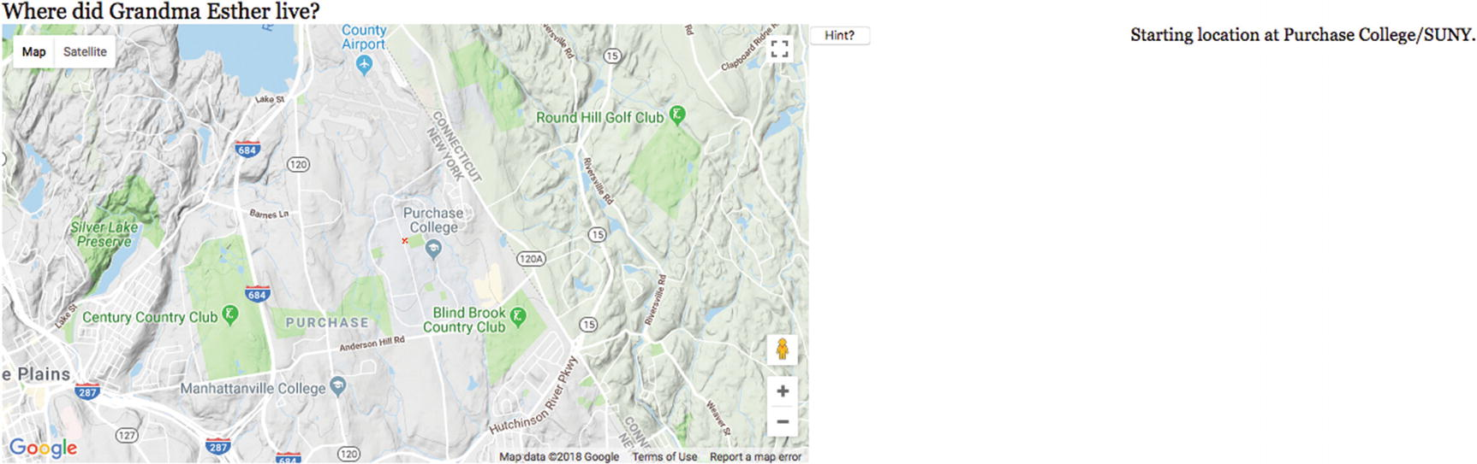
Figure 5-13The TERRAIN map type
Figure 5-14 shows the results of requesting the HYBRID view, combining satellite and road map imagery.
mapTypeId: google.maps.MapTypeId.HYBRID
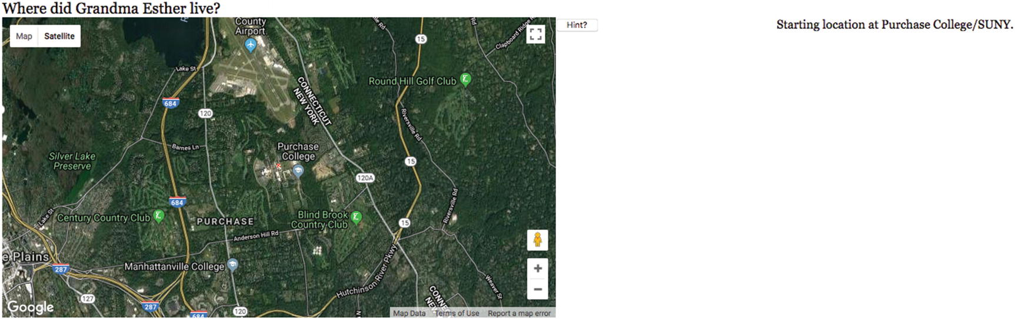
Figure 5-14The HYBRID map type
By the way, the hybrid map is produced by clicking the Satellite option on the interface.
Figure 5-15 shows the results of requesting SATELLITE images. We can think of this as the pure satellite image. Notice that major highways are visible.
mapTypeId: google.maps.MapTypeId.SATELLITE
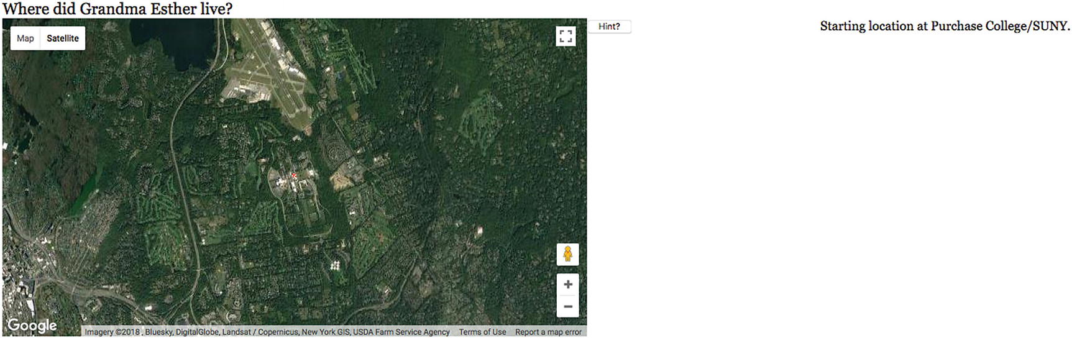
Figure 5-15The SATELLITE map type
Lastly, you may have an application in which you do not want the viewer to change the map directly. You can prevent the user from changing the map by disabling the default interface with the use of an additional option in the myOptions array . I have included the statement I put before disableDefaultUI to communicate that the associative array properties are separated by commas, with no comma after the last one.
mapTypeId: google.maps.MapTypeId.ROADMAP,
disableDefaultUI: true
Figure 5-16 shows the results. The user can still pan over the map, that is, move it, but the + and – zooming controls, and the Map and Satellite buttons have been removed.
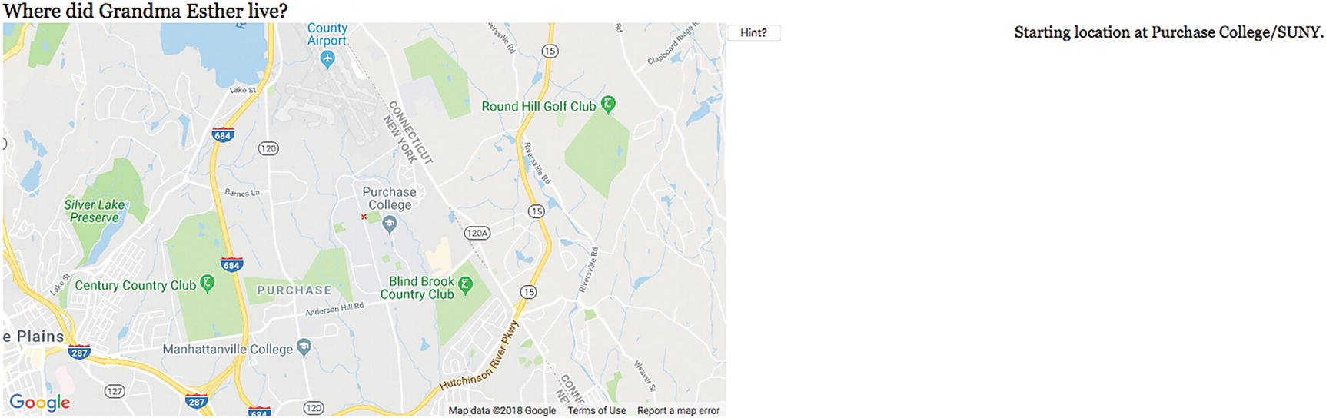
Figure 5-16Map interface removed
There are two more operations for makemap to carry out. A custom marker is placed on the map at the indicated center location and event handling is set up for clicking the map:
marker = new google.maps.Marker({
position: blatlng,
title: "center",
icon: rxmarker,
map: map });
listener = google.maps.event.addListener(map, 'click', function(event) {
checkit(event.latLng);
});
The rxmarker value references an image object that has its src set to an external file named rx1.png . This is what produces the small red x at the center of the map. As a reminder: addListener is a method setting up an event for Google Maps API. The addEventListener is a method setting up an event for JavaScript.

Project Content in External File
The quiz use three types of media: video, picture, and what I term pictureaudio. Note: these are my terms for the three types I have chosen to include in the project. The content of the quiz is specified using two arrays I named precontent and questions. Each element of the precontent array is itself an array of five or six elements. The first four elements are the same for all the types: the latitude, longitude, title, and type. The fifth or the fifth and the sixth point to the specific media elements. The data for the current quiz, that is, the contents of the external file, is:
var base=
[41.04796,-73.70539,"Purchase College/SUNY"];
var zoomlevel = 13;
var precontent = [
[41.19991,-73.72353,"Esther at home","pictureaudio","estherT","esther.jpg"],
[41.05079,-73.70448,"Lego robot","video","maze"],
[40.68992,-74.04460,"Fire works","video","sfire3"],
[34.298846,132.318359,"Miyajima","picture","miyajima0.JPG"]
];
var questions = [
"Where did Grandma Esther live?",
"Show the Lego robot navigating a maze.",
"Where are great fireworks?",
"Where is the Great Torii?"
];
var maxdistance = 10;
The base, zoomlevel, and maxdistance variables are all what they seem. The base is the initial center point for the map. The zoomlevel specifies the initial zoom. I say initial because the user can use the Google Maps controls to pan or zoom in or out. The maxdistance is the number I use to check if the user clicks close enough to one of the locations. You will need to determine the appropriate distance for your application.
The precontent array specifies four locations, starting with a picture/audio combination, followed by two videos, followed by one picture. The element in the array for the picture/audio combination includes, as you would expect, two additional pieces of information. It is not obvious from just this section of code, but esther.jpg refers to an image element and estherT refers to an audio element. Similarly, maze and sfire3 refer to video elements, and miyajima0.JPG refers to another image element. An arrangement using two or more arrays like I use precontent and questions is termed parallel structures. My code produces an array called content, which is referenced by the checkit function (to be described next), and the appropriate media are presented.
The external scripts are brought into the main document using a script element. For the mapmediaquiz, this is
<script type="text/javascript" src="mediaquizcontent.js"> </script>

Distances and Tolerances
The calculation of distance between two latitude-longitude points was described in the previous chapter. The issue to be explained here concerns how to make comparisons of distances. For the quiz application, I need to write code to determine if the position returned by the Google event handler is close enough to the correct location given for the specified question. The variable maxdistance holds the value, sometimes called the tolerance . Here is most of the code for my checkit function. I have left out the switch statement that does something different for each of the question types once it is determined that the player’s guess is close enough.
function checkit(clatlng) {
var marker;
var latlnga =new google.maps.LatLng(content[nextquestion][0],content[nextquestion][1]);
var distance = dist(clatlng,latlnga);
eraseold();
marker = new google.maps.Marker({
position: clatlng,
title: "Your answer",
icon: bxmarker,
map: map });
if (distance<maxdistance) {
switch (content[nextquestion][3]) { ...
} // end switch
asknewquestion();
} // end if (distance<maxdistance)
else {
answer.innerHTML= "Not close enough to the location.";
}
}

Regular Expressions Used to Create the HTML
Regular expressions are a powerful facility for describing patterns of character strings (text) for checking and for manipulation. It is a whole language for specifying patterns. For example, to give you a flavor of this large topic, the pattern
/^5[1-5]\d{2}-?\d{4}-?\d{4}-?\d{4}$/
can be used detect MasterCard numbers. These numbers start with 51 to 55, followed by two more digits, and then three groups of four digits. This pattern accepts the dashes, but does not require them. The ^ symbol means the pattern must be present at the start of the string, and the $ means it must go to the end of the string. The forward slashes (/) are delimiters for the pattern and the backslashes are escape characters . Interpreting this pattern starting at the start goes as follows:
^: Start at the start of the string.
5: Pattern must contain a 5.
[1-5]: Pattern must contain one of the numbers 1, 2, 3, 4, or 5.
\d{2}: Pattern must contain exactly two digits.
-?: Pattern must contain 0 or 1 -.
\d{4}: Pattern must contain exactly four digits.
-?: Pattern must contain 0 or 1 -.
\d{4}: Pattern must contain exactly four digits.
-?: Pattern must contain 0 or 1 -.
\d{4}: Pattern must contain exactly four digits.
$: End of string.
MasterCard numbers must obey other rules as well, and you can do the research to find out how to verify them further. Don’t worry, we’ll be using a much simpler regular expression than that (also known as a regex).
The use of regular expressions predates HTML. Regular expressions can be used in forms to specify the format of the input. For this application, we will use the replace method for strings to find all instances of a specific small piece of text within a long string and replace it with something else. One of the statements I use is
videomarkup = videomarkup.replace(/XXXX/g,name);
What this does is find all occurrences (this is what the g does) of the string XXXX and replace each of them with the value of the variable name.
I could and probably should have made even more use of regular expressions to verify the data defining the content of the applications. Maybe that’s something you want to experiment with in your own applications.
NoteAt some point, the right decision may be to stop using straight JavaScript arrays, including the use of parallel structures, and use XML or a database. I didn’t think it was called for in this application, but I could be wrong. Note that the use of server-side programming using a language such as PHP with or without databases does provide a way to hide the data.

Dynamic Creation of HTML5 Markup and Positioning
The external script statements bring in the information for the quiz application . Now is the time to explain how the information is used. The init function will invoke a function I named loadcontent. This function calls makemap to make a map at the indicated base location.
makemap(base[0],base[1]);
The content array starts off as an empty array.
var content = [];
By the way, this is different from
var content;
Your code needs to make content an array.
It then uses a for loop to iterate over all the elements of precontent. The start of the for loop adds the ith element of precontent to the content array.
for (var i=0;i<precontent.length;i++) {
content.push(precontent[i]);
name = precontent[i][4];
The next line is the header of a switch statement using as the condition the element of the inner arrays that indicates the type.
switch (precontent[i][3]) {
For video and pictureaudio, the code creates a div element and positions it so that it floats to the right. It then places inside the div element the right markup for video or audio. What is that markup? I have what I will describe as dummy strings that have XXXX where the actual names of the video or audio files would go. Think of these as templates. I could have used just one string for video, but it was sufficiently complicated that I decided to use three and two for the audio. These strings are
var videotext1 = "<video id=\"XXXX\" loop=\"loop\" preload=\"auto\" controls=\"controls\" width=\"400\"><source src=\"XXXX.webmpv8.webm\" type=\'video/webm\'>";
var videotext2="<source src=\"XXXX.theora.ogv\" type=\'video/ogg\'> <source src=\"XXXX.mp4\" type=\'video/mp4\'>";
var videotext3="Your browser does not accept the video tag.</video>";
var audiotext1="<audio id=\"XXXX\" controls=\"controls\" preload=\"preload\"><source
src=\"XXXX.ogg\" type=\"audio/ogg\" />";
var audiotext2="<source src=\"XXXX.mp3\" type=\"audio/mpeg\" /><source src=\"XXXX.wav\"
type=\"audio/wav\" /></audio>";
Notice the use of the backslash (\). It tells JavaScript to use the next symbol as is, and not interpret it as a special operator for regular expressions. This is how the quotation marks inside the screen get carried over to be part of the HTML.
My approach required that I make sure that the names of the video and audio files follow this pattern. This meant that the MP4 files all needed to contain just the name and no internal dots.
I write code using the regular expression function replace to take information out of the precontent array and put it in the strings in as many places as necessary. The switch statement in its entirety is
switch (precontent[i][3]) {
case "video":
divelement= document.createElement("div");
divelement.style = "float: right;width:30%;";
videomarkup = videotext1+videotext2+videotext3;
videomarkup = videomarkup.replace(/XXXX/g,name);
divelement.innerHTML = videomarkup;
document.body.appendChild(divelement);
videoreference = document.getElementById(name);
content[i][4] = videoreference;
break;
case "pictureaudio":
divelement = document.createElement("div");
divelement.style = "float: right;width:30%;";
audiomarkup = audiotext1+audiotext2;
audiomarkup = audiomarkup.replace(/XXXX/g,name);
divelement.innerHTML = audiomarkup;
document.body.appendChild(divelement);
audioreference = document.getElementById(name);
savedimagefilename = content[i][5];
content[i][5] = audioreference;
imageobj = new Image();
imageobj.src= savedimagefilename;
content[i][4] = imageobj;
break;
case "picture":
imageobj = new Image();
imageobj.src= precontent[i][4];
content[i][4] = imageobj;
break;
}
Notice that the pictureaudio case does some juggling to create the content element with references to the newly created audio element and the image element.
However, this was not quite enough to ensure that the video and audio end up on the right side for all browsers . That is, it worked for some but not others. I decided to position the audio and video exactly—that is, in absolute terms. This required the following CSS in the style element for all video and audio elements:
video {display:none; position:absolute; top: 60px; right: 20px;}
audio {display:none; position:absolute; top: 60px; right: 20px;}
The position of the audio is for the audio controls.
There is a potential problem with creating these HTML elements dynamically. You may recall that in Chapter 2 on the family collage, there was code to make sure the videos were loaded before doing anything with them. I have not observed any problems with the quiz probably because responding to the questions takes sufficient time. Still, I urge you to keep the issue in mind and refer back to Chapter 2.

Hint Button
You can tell from my coding that I was ambivalent about whether to provide a hint or help a player who had given up. In the body element , I included
<button onClick="giveup();">Hint? </button>
The giveup function creates a new map. That is, it uses the makemap function to construct access to a different Google Map in the same place. It also erases the old media and puts directions into the answer element.
function giveup() {
makemap(content[nextquestion][0],content[nextquestion][1]);
eraseold();
answer.innerHTML="Click at red x to finish this question.";
}

Building the Application and Making It Your Own
The first and critical step in making the application your own is to decide on the content. There are advantages to using a variety of media content and a variety of picture dimensions (and video dimensions), but there is something to be said for having a simpler design.

The Quiz Application
A quick summary of the quiz application follows:
1. | init: Performs initialization, including the call to loadcontent.
2. | loadcontent: Uses the variables, most significantly the precontent array included in the external script element, to create new markup for the media. It also invokes makemap. The questions array does not need any more work.
3. | makemap: Brings in the map and sets up event handling, including the call to checkit.
4. | asknewquestion: Displays the questions.
5. | checkit: Compares the clicked location with the location for this question.
6. | dist: Computes the distance between two locations.
7. | giveup: This is the response to clicking on the Hint button. A new map is brought in. Any media is erased and the player is directed to click near the displayed red x.
8. | eraseold: Removes any currently showing video, audio, or picture.
Table 5-2 outlines the functions in the quiz application. The function table describing the invoked/called by and calling relationships for the mapmediabase.html application is similar for all applications.
Table 5-2 Functions in the Quiz Application
Function | Invoked/Called By | Calls
init | Invoked by action of the onLoad attribute in the <body> tag | loadcontent, asknewquestion
makemap | Invoked by loadcontent and giveup
checkit | Invoked by addListener call in makemap | dist, asknewquestion, eraseold
dist | Invoked by checkit
loadcontent | Invoked by init | makemap
asknewquestion | Invoked by init and checkit
eraseold | Invoked by checkit and giveup
giveup | Invoked by action of button | eraseold, makemap
Table 5-3 shows the code for the quiz application.
Table 5-3 Complete Code for the Map Quiz Program
Code Line | Description
<!DOCTYPE html> | Doctype for HTML5
<html> | html tag
<head> | head tag
<title>Map Quiz </title> | Complete title element
<meta charset="UTF-8"> | Meta tag, standard for HTML5
<style> | style tag
header {font-family:Georgia,"Times New Roman",serif; | Set styling for the header, a semantic element; the font family makes Georgia the first choice, with Times New Roman a fallback, and the default serif the next fallback choice of fonts
font-size:20px; | Fairly big font
display:block; | Set line breaks before and afterward
} | Close style directive
video {display:none; position:absolute; top: 60px;  right: 20px; | Style directive for video; no display initially
} | Close the video directive
audio {display:none; position:absolute; top: 60px;  right: 20px;} | Style directive for audio; note that this is for the controls; no display initially
canvas {position:relative; top:60px} | Style directive for the canvas element
#answer {position:relative; font-family:Georgia,  "Times New Roman", Times, serif; font-size:16px;} | Style directive for the message at the upper right
</style> | Closing style tag
<script async defer src="https://maps.googleapis.com/maps/api/js?key=YOUR_API_KEY&callback=initMap"  type="text/javascript"></script> | Script element bringing in Google Maps API; Note: you need to obtain and use your own API key
<script type="text/javascript" src="mediaquizcontent.js">  </script> | Bring in the content in mediaquizcontent.js
<script type="text/javascript" charset="UTF-8"> | Opening script tag
var listener; | Used to set up the Google Maps event of clicking on a map
var map; | Used to hold a map
var myOptions; | The options array holding map specifications
var ctx; | Context for the canvas
var blatlng; | Base latlng object
var content = []; | An empty array, to be populated by loadcontent
var answer; | Reference to answers, instructions
var v; | Will hold references to video elements
var audioel; | Will hold references to audio elements (this quiz has just one)
var videotext1 = "<video id=\"XXXX\" preload=\"auto\" controls=\"controls\" width=\"400\"><source src=\"XXXX.mp4\" type=\'video/mp4; codecs=\"avc1.42E01E, mp4a.40.2\"\'>"; | Part 1 of template for video
var videotext2="<source src=\"XXXX.theora.ogv\" type=\'video/ogg; codecs=\"theora, vorbis\"\'><source src=\"XXXX.webmvp8.webm\" type=\'video/webm; codec=\"vp8, vorbis\"\'>"; | Part 2 of template for video
var videotext3="Your browser does not accept the video tag.</video>"; | Part 3 of template for video
var audiotext1="<audio id=\"XXXX\" controls=\"controls\" preload=\"preload\"><source src=\"XXXX.ogg\" type=\"audio/ogg\" />"; | Part 1 of template for audio
var audiotext2="<source src=\"XXXX.mp3\" type=\"audio/mpeg\" /><source src=\"XXXX.wav\" type=\"audio/wav\" /></audio>"; | Part 2 of template for audio
var nextquestion = -1; | The question counter needs to start before the 0th one
function init() { | Header for init function
ctx = document.getElementById("canvas").getContext('2d'); | Set reference to canvas
answer = document.getElementById("answer"); | Set reference to answer
header = document.getElementById("header"); | Set reference to header (where question is displayed)
loadcontent(); | Create the content using the precontent array
asknewquestion(); | Invoke function to ask question, thus starting off the quiz
} | Close init function
function asknewquestion() { | Header for asknewquestion function
nextquestion++; | Increment the counter
if (nextquestion<questions.length) { | If still more questions
header.innerHTML=questions[nextquestion]; | Show question
} | Close the if-still-more-questions clause
else { | Else
header.innerHTML="No more questions."; | Display no more questions
} | Close else clause
} | Close asknewquestion function
function loadcontent() { | Header for loadcontent function
var divelement; | Will hold references to newly created div elements
makemap(base[0],base[1]); | Invoke makemap for the base location
var videomarkup; | The complete template for a video element
var videoreference; | Reference to each newly created video element
var audiomarkup; | The complete template for an audio element
var audioreference; | Reference to each newly created audio element
var imageobj; | Image object
var name; | The name obtained from precontent to be used to replace the XXXX in the templates
var savedimagefilename; | Saved image file
for (var i=0;i<precontent.length;i++) { | For loop header, going through precontent
content.push(precontent[i]); | Add to content
name = precontent[i][4]; | Extract the name
switch (precontent[i][3]) { | Do switch based on the type
case "video": | Video case
divelement= document.createElement("div"); | Create a div
divelement.style = "float: right;width:30%;"; | Position media to the right
videomarkup = videotext1+videotext2+videotext3; | Create the complete template
videomarkup = videomarkup.replace(/XXXX/g,name); | Do the replace using name
divelement.innerHTML = videomarkup; | Put result into the div
document.body.appendChild(divelement); | Add the div to the body (so it’s accessible) but note that it will not be visible until it’s made visible
videoreference = document.getElementById(name); | Object a reference
content[i][4] = videoreference; | … and make THAT the fourth element of the subarray
break; | Leave the switch (video case over)
case "pictureaudio": | Pictureaudio case
divelement = document.createElement("div"); | Create a div
divelement.style = "float: right;width:30%;"; | Position media to the right
audiomarkup = audiotext1+audiotext2; | Create the complete template
audiomarkup = audiomarkup.replace(/XXXX/g,name); | Do the replace using name
divelement.innerHTML = audiomarkup; | Put the result in the div
document.body.appendChild(divelement); | Add the div to the body (so it’s accessible) but note that it will not be visible until it’s made visible
audioreference = document.getElementById(name); | Object a reference
savedimagefilename = content[i][5]; | Put the current fifth element into savedimagefilename
content[i][5] = audioreference; | Make the audioreference the fifth element of the subarray
imageobj = new Image(); | Create an image object
imageobj.src= savedimagefilename; | Make its source the savedimagefilename
content[i][4] = imageobj; | Make this the fourth element of the subarray
break; | Leave the switch (pictureaudio done)
case "picture": | Picture case
imageobj = new Image(); | Create an image object
imageobj.src= precontent[i][4]; | Set its src
content[i][4] = imageobj; | Set the fourth element of the subarray to point to the image
break; | Leave the switch (picture case done)
} | Close switch
} | Close for loop
} | Close loadcontent function
var rxmarker = "rx1.png"; | Little red x
var bxmarker = “bx1.png”; | Little black x
function makemap(mylat,mylong) { | Header for makemap function
var marker; | Will hold marker object
blatlng = new google.maps.LatLng(mylat,mylong); | Create latlng object using function parameters
myOptions = { zoom: zoomlevel, center: blatlng, mapTypeId: google.maps.MapTypeId.ROADMAP }; | Set the myOptions array
map = new google.maps.Map(document.getElementById("place"), myOptions); | Bring in the map
marker = new google.maps.Marker({  position: blatlng, title: "center", icon: rxmarker, map: map }); | Create a marker
listener = google.maps.event.addListener(map, 'click', function(event) { | Set up the event for clicking on the map
checkit(event.latLng); | … the event handler is an anonymous function that calls checkit
}); | Lose the function and close the call to addListener
} | Close makemap
function eraseold() { | Header for eraseold function (same code as in previous example, but now in a function)
if (v != undefined) { | Is there an old v defined?
v.pause(); | Pause it
v.style.display = "none"; | Remove from display
} | Close clause
if (audioel != undefined) { | Is there an old audioel defined?
audioel.pause(); | Pause it
audioel.style.display = "none"; | Erase controls for last audio played
} | Close clause
ctx.clearRect(0,0,300,300); | Clear canvas
} | Close eraseold function
function checkit(clatlng) { | Header for checkit
var marker; | Will hold the marker (black x) at the spot set by the player
var latlnga =new google.maps.LatLng(content[nextquestion][0],content[nextquestion][1]); | Build the latitude-longitude object for the answer to this question
var distance = dist(clatlng,latlnga); | Compute distance
eraseold(); | Invoke the function to erase any media now on display
var marker = new google.maps.Marker({  position: clatlng,  title: "Your answer",  icon: bxmarker,  map: map }); | Place the marker
if (distance<maxdistance) { | Was the user’s click close enough?
switch (content[nextquestion][3]) { | Switch on the type associated with this question
case "video": | Video case
answer.innerHTML=content[nextquestion][2]; | Display the answer (title)
ctx.clearRect(0,0,400,400); | Clear the canvas
v = content[nextquestion][4]; | Get reference to the video
v.style.display="block"; | Make it visible
v.currentTime = 0; | Set at the start
v.play(); | Play the video
break; | Leave switch (video case done)
case "picture": | Picture case (will use some of coding for picture audio case)
case "pictureaudio": | Pictureaudio case
answer.innerHTML=content[nextquestion][2]; | Display answer
ctx.clearRect(0,0,400,400); | Clear the canvas
var img1 = content[nextquestion][4]; | Get the image
var iw = img1.width; | Determine width
var ih = img1.height; | Determine height
var aspect = iw/ih; | Calculate aspect
if (iw>=ih) { | If wider than tall, then width will be the factor to fit
if (iw>400){  tw = 400;  th = 400/aspect;  } | If width is bigger than canvas, calculate the target dimensions
else {  tw = iw;  th = ih;  } | If width is not bigger than 400, target is the original
} | Ends if width is bigger
else { | Else (height is critical dimension )
if (ih>400){  th = 400;  tw = 400*aspect;  } | If height is bigger than 400, calculate the target dimensions
else {  th = ih;  tw = iw;  } | Else target dimensions are the original
} | End outer else
ctx.drawImage(img1,0,0,iw,ih,0,0,tw,th); | Draw image from the whole source to the calculated target
if (content[nextquestion][3]=="picture") { | If this is picture…
break;} | Leave switch
else { | Else need to display and play the audio
audioel = content[nextquestion][5]; | Extract the element
audioel.style.display="block"; | Display the controls
audioel.currentTime = 0; | Set at the start
audioel.play(); | Play
break; | Leave the switch
} | Close else not picture
} | Close switch
asknewquestion(); | Ask a new question (only if the user’s guess was close enough)
} | Close within maxdistance
else { | Else
answer.innerHTML= "Not close enough to the answer."; | Display message
} | Close else
} | Close checkit
function dist(point1, point2) { | Header for dist function
var R = 6371; // km | Value used for km
// var R = 3959; // miles | Keep comment in code to easily switch to miles
var lat1 = point1.lat()*Math.PI/180; | Calculate radian
var lat2 = point2.lat()*Math.PI/180 ; | Calculate radians
var lon1 = point1.lng()*Math.PI/180; | Calculate radians
var lon2 = point2.lng()*Math.PI/180; | Calculate radians
var d = Math.acos(Math.sin(lat1)*Math.sin(lat2) +  Math.cos(lat1)*Math.cos(lat2) *  Math.cos(lon2-lon1)) * R; | Standard calculation using law of cosines
return d; | Return distance
} | Close function
function giveup() { | Header for the giveup function (for the hint)
makemap(content[nextquestion][0],content[nextquestion][1]); | Bring in new map centered at the answer
eraseold(); | Erase any old media
answer.innerHTML="Click at red x to finish this question."; | Display instructions since players need to click to proceed; this gives the players a way to indicate they have the new map
} | Close giveup
</script> | Close script element
</head> | Close head element
<body onLoad="init();"> | Body tag; invoke init on loading
<header id="header">Click</header> | Header element
<div id="place" style="float: left;width:50%; height:400px"></div> | The place for the map
<button onClick="giveup();">Hint? </button> | Button indicated need for help
<div style="float: right;width:30%;height:400px"> | Hold rest of elements
<div id="answer">Starting location</div> | Holds answer, that is title of location
<p> </p> | Spacing
<canvas id="canvas" width="400" height="400" > | Canvas
Your browser doesn't recognize canvas | Standard for old browsers
</canvas> | Close canvas element
</div> | Close div
</body> | Close body
</html> | Close html

Testing and Uploading the Application
This chapter had one application, a geography quiz . It is made up of two files, one (mapmediaquiz.html) with HTML, CSS, and the bulk of the coding, and the other (mediaquizcontent.js) with JavaScript representing the content. The coding in the .js file references the media. I include the standard set of video files for each of the two video clips, the standard audio files for the single audio clip, and two image files. I used the image of a small hand-drawn red x and a small hand-drawn black x to mark locations on the map, instead of the default teardrop shape for markers in Google Maps. I repeat: you will not be able to run the source code without acquiring your own API key and changing the script element. You can and should substitute your own questions , answers (the locations), and media, but do be aware of issues of size and shape and review my handling to accommodate any big image files.

Summary
In this chapter, you continued using the Google Maps API. You learned how to do the following:
Manage a geography quiz.
Use specifications of question, location, and media for dynamic creation of HTML elements.
Program Google Maps API event handling to detect if the user was close to locations for which you had video, audio with an image, or image alone.
Separate the definition of media content from the program itself.
Use a regular expression to produce the right markup.
Start and stop the display and playing of media.
In the next chapter, you will read about the implementation of a game called Add to 15. It is mainly an exercise in using arrays and strings.
© Jeanine Meyer 2018
Jeanine Meyer
HTML5 and JavaScript Projects
https://doi.org/10.1007/978-1-4842-3864-6_6

6. Add to 15 Game
Jeanine Meyer1
(1)
New York, USA

In this chapter, you will learn the following:
Implementing a known real-world game as a digital program with “the computer” as one of the players
Developing a strategy for “the computer”
Inserting a pause
Working with arrays and strings

Introduction
The two-player game Add to 15 requires players to take turns choosing from the numbers 1 to 9 with the goal of obtaining a set of three numbers that add up to 15. I first saw this game at the Museum of Mathematics in New York City where it was implemented as an apparatus with the numbers on rods that could be moved from the center to the player’s side. If a player won, there were lights and loud, happy sounds. If no one won, there were shorter and quieter sounds. The game also can be played using a set of 1 to 9 cards from a deck of cards or with paper-and-pencil. The game can be described as one of perfect knowledge: the results of past moves and current possibilities are all visible. The game is equivalent to a well-known children’s game and I leave identifying the game and proving the equivalence to the reader. (You can find an explanation on this with the source code for this chapter.)
For the example for this chapter, I chose to have the program manage the game and take the role of one of the players. This meant that I needed to formulate a strategy for “the computer”. My strategy is pretty good, but it still is possible for the player to win. Sometime later in my work, I decided that I needed to insert a pause before “the computer” moves in order for the human player to experience the program as a game with an opponent.
Figure 6-1 shows the game’s opening window.
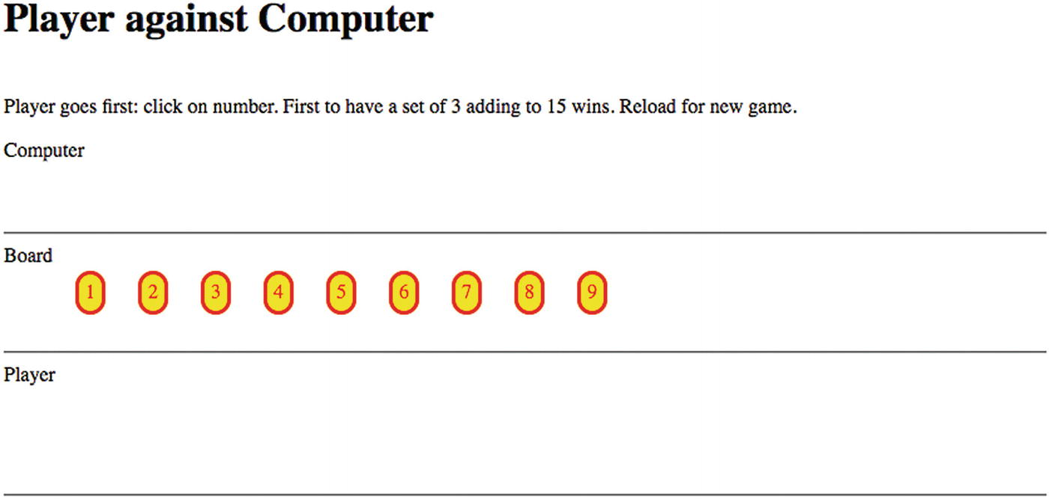
Figure 6-1Opening window
Figure 6-2 shows the results after the player and “the computer” each make a move.
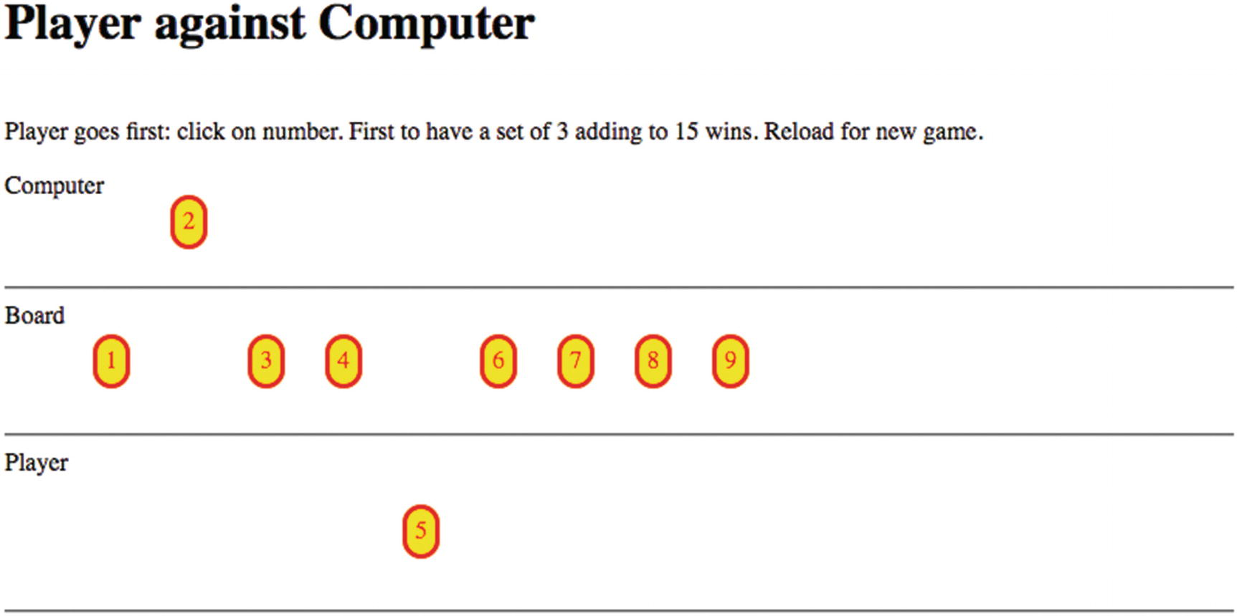
Figure 6-2After moves by player and computer
Lastly, I show a screenshot, Figure 6-3, from what appears to be the most common result: the numbers are exhausted and no one wins. In my family, this was described as “The Cat Wins” so that is the term I used for the message telling the results.
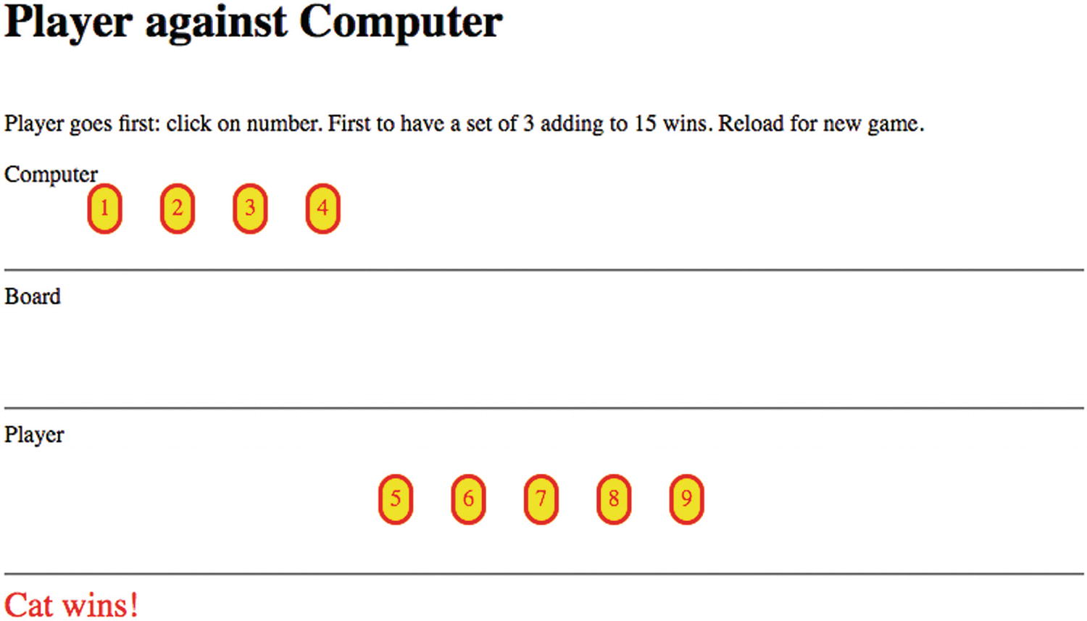
Figure 6-3Game ends in a tie
This chapter is a case study in implementing games, including implementing a user interface and a strategy. The use of arrays with references between arrays is critical.

General Requirements for a Game
The requirement for the Add to 15 program and others like it is to present a reasonably intuitive interface to players. The opposing player, which I name “the computer” even though I do not like anthropomorphizing a machine, needs to have a strategy. The program I describe in this chapter has a fairly tough strategy. I think I have beaten it, but not too often. Possible enhancements for this program are to develop the best possible strategy in which “the computer” never loses, although perhaps does tie, as well as other, less skilled strategies. With a set of options, an enhancement would be to present the human players a choice to pick the skill level for their opponent. This requires formulating a sequence of strategies, including, perhaps, making random moves.
My first version of this program had “the computer” move showing up close to instantaneously with the display of the player’s move. I inserted a pause to give the game what I consider a nicer “touch and feel”. This practice would hold for many games. When we are playing a game in the real world, we do not consciously pause, but implementing the game in the digital world may require explicit attention to time.
The Add to 15 is simple enough so that all possible combinations adding up to 15 can be listed. In fact, there are 8 and so my program has an array whose elements are strings holding the numbers of a valid group, for example “3 5 7”. (Actually, the array has nine elements, with the first an empty placeholder so indexing can be 1-based, not 0-based.) The management of the game and the implementing of “the computer” strategy can be built using the information in this array. You will not see any code that adds up numbers!
My program has another array that has nine elements, each an array with elements pointing to which groups in the list of eight that the number belongs to. My program has an array for the board, which starts out with all nine numbers; an array for the player, initially empty; and an array for “the computer”, also initially empty. There are arrays for player and computer that have nine elements, with the first element not used, that indicate how many elements of each of the eight combinations are present.
The program has two arrays that do not change: groups and occupied. It also has one array, numbers, that is created at the start but does not change after that. There are five arrays that do change: board, computer, player, pgroupcount, and cgroupcount. You will see these in use in the next section. The use of arrays and the pointing back and forth is typical of these types of applications. There is redundancy, but it eases the coding.

HTML5, CSS, and JavaScript
In this section, I explain the features used to accomplish the requirements for the Add to 15 project.

Styling in CSS
The oval-shaped, red border, yellow background elements that hold the nine numbers are created dynamically as span elements. The CSS that sets the appearance is
span {
position:absolute;
top:180px;
border-style: solid;
color: red;
border-radius: 25px;
background-color: yellow;
padding: 5px;
cursor: pointer;
}
Creating these elements dynamically with absolute positioning means that they are easily moved from the board to the player’s or “the computer’s” section. Making the type span as opposed to div means that there is no forced line break and they can be next to each other. By the way, my trick for distinguishing between padding (inside the element) and margin (outside the element) is to think of a padded cell.

JavaScript Arrays
As already discussed, a set of arrays is used for the operation of the game. Some of the arrays have an unused slot at the 0-index position, just to make things easier for the coding. The groups array holds the possible combinations adding up to 15:
var groups = [
" ", //placeholder, not used
"3 4 8",
"1 5 9",
"2 6 7",
"1 6 8",
"3 5 7",
"2 4 9",
"2 5 8",
"4 5 6"
];
The occupied array , which you can view as redundant information, makes certain calculations easier. I did decide to put up with the zero-based indexing. The occupied array is used to indicate which groups each value from 0 to 9 belongs to. To be more specific, values in the Nth subarray correspond to the indices of the groups holding N+1. Here is the occupied array and I will indicate some examples afterwards.
var occupied = [ //indexed subtracting 1
[2, 4],
[3, 6, 7],
[1, 5],
[1, 6, 8],
[2, 5, 7, 8],
[3, 4, 8],
[3, 5],
[1, 4, 7],
[2, 6]
];
So the number 1 is associated with the array [2, 4]. This indicates that 1 belongs to the second group, “1 5 9”, and the fourth group, “1 6 8”. The number 5 belongs to the second, fifth, seventh, and eighth groups. The groups and the occupied arrays do not change.
The board, player and computer array hold the numbers that are on the board, selected by the player, or selected for “the computer”. So the initial declarations are
var player = [];
var computer = [];
var board = [1,2,3,4,5,6,7,8,9];
The last two arrays keep track of how close the player and “the computer” are to completing each of the eight combinations. So the initial declarations are
var pgroupcount = [0,0,0,0,0,0,0,0,0]; //unused first slot
var cgroupcount = [0,0,0,0,0,0,0,0,0]; //unused first slot
At the point in the game shown in Figure 6-2, “the computer” holds a 2. Looking at the occupied array, 2 is present in groups 3, 6, and 7. The cgroupcount would be [0,0,0,1,0,0,1,1,0]. The player chose 5 first, so the pgrounpcount array was [0,0,1,0,0,1,0,1,1].
If the player then chooses 6, the pgroupcount will be [0,0,1,1,1,1,0,1,2]. The presence of a 2 in either group’s count array indicated the chance to win–if the player has 2 members of a group, getting the third means a win–or the need to block–if “the computer” has 2 members of a group, it can win on the next move. My code must determine the identity of the missing number and check if it is still on the board (in the board array).
With what can be described as the infrastructure of these arrays, I can explain responding to a player move, generating “the computer” move, and determining if the game is won or over.

Setting Up the Game
The setUpBoard function creates the nine span elements that represent the nine numbers. References to these nine elements are held in an array called numbers. An extra attribute is set for the elements, named n, to save the specific number. As part of the creation process, implemented using a for loop, the addEventListener method is invoked for the “click” event and is set to invoke the addToPlayer function when the player clicks on the number.
Once created, this array does not change. What does change is the location of each element, indicated by the style.left and style.top attributes.

Responding to a Player Move
The critical function for responding to a player move is addToPlayer. You can think of the addToPlayer function as performing housekeeping types of operations, updating the various arrays. The number selected is added to the player array. The function take is invoked, which removes the element from the board array. The span element corresponding to the number is relocated by changing the style.top attribute. Changing the player and board arrays is required but it does not change where the number element is positioned in the window.
A local variable, holder, is set to hold the groups containing the number. Recall that the occupied array is the array of arrays with that information. I use a for loop to go through holder and update pgroupcount. My code checks if any of the counts are three. This would indicate a win by the player. If that is not true, the addToPlayer function executes a setTimeout statement to put in a pause before invoking computerMove.
The addToPlayer function has a line in which the event of clicking on a piece is stopped:
ev.target.removeEventListener("click",addToPlayer);
This prevents the bad behavior of a player clicking on a piece that has already been taken by the player. I must admit that I did notice this problem originally.

Generating the Computer Move
The computerMove function is invoked after a pause. I split up the tasks between computerMove and smartChoice. The computerMove function invokes the smartChoice function. The computerMove function mainly does the similar housekeeping tasks as performed in the addToPlayer function. I note that although my program has the player playing first, the computerMove code does check if the board is empty.
The smartChoice program uses the arrays to go through the following operations:
1. | Is there any number still on the board (in the board array) that would win the game for the computer?
2. | Assuming that an immediate win is not possible, is there any number on the board that would mean an immediate win by the player? If so, play that number to block the player.
3. | Assuming that an immediate block is not required, is there any group with one element already played by the computer, and neither of the other two played by the player? If so, take one of the two available numbers.
4. | Assuming none of the previous cases apply, and 5 is available, take it.
5. | Assuming none of the previous cases apply, take an even number.
6. | Make a random choice from among the numbers remaining.
So enhancing the program by providing better and/or more strategies would involve changing smartChoice.
Analogous to the action in addToPlayer, the computermove function has a line to remove the event handling for clicking on a piece that has already been played:
numbers[n-1].removeEventListener("click",addToPlayer);
This prevents the bad behavior of a player clicking on a piece that has been played by the computer.
The computerMove function, like the addToPlayer function, can determine if the game is over either with a win for the computer or a tie.

Building the Application and Making It Your Own
You can make this application your own by improving the strategy and/or adding different strategies. You can look ahead to Chapter 9 where the HTML5 facility named localStorage is described and think about how that can be incorporated into game play. The main objective of this chapter is to provide experience in using arrays with cross-references. Another challenge is to provide a way to repeat the game without reloading. You can look ahead to Chapter 8, at the jigsaw puzzle turning into a video, for an example of how to do that. Yet another enhancement is to record the sequence of moves, possibly using localStorage, so you can try different strategies.
Table 6-1 lists all the functions and indicates how they are invoked and what functions they invoke.
Table 6-1 Functions in the Add to 15 Project
Function | Invoked/Called By | Calls
init | Invoked by action of the onLoad attribute in the <body> tag | setUpBoard
setUpBoard | init
computerMove | Invoked by action of setTimeout, called in addToPlayer | smartChoice, take
smartChoice | computerMove
take | addToPlayer, computerMove
addToPlayer | Invoked by action of addEventListener for click events | take
Table 6-2 shows the code for the Add to 15 game, with comments about each line.
Table 6-2 Complete Code for the Add to 15 application
Code Line | Description
<!DOCTYPE html > | Header
<html> | Opening html tag
<head> | Opening head tag
<title>Add to 15</title> | Complete title
<meta charset="UTF-8"> | Meta tag
<style> | Opening of style element
span {position:absolute; top:180px; | Start of span formatting, initial location is on the board
border-style: solid; color: red; border-radius: 25px; background-color: yellow ; | Solid red border, curved; background is yellow
padding: 5px; cursor: pointer; | Padding between border and text; cursor will be pointer
} | Close span style directive
#status { | Styling for status message
color: red; | Red color
font-size: x-large; | Large font
} | Close status style directive
</style> | Close style element
<script language="JavaScript"> | Script tag
var statusref; | Will hold pointer to status
var numbers = []; | Array of pointers to the created span elements
var game = true; | Boolean flag used to control when player can make a move
var player = []; | Will hold all the numbers taken by the player
var computer = []; | Will hold all the numbers taken by the computer
var board = [1,2,3,4,5,6,7,8,9]; | Initial setting for the numbers held on the board
var wedge = 50; | Horizontal space allowed for each number
var startx = 15; | Pieces lined up vertically
var groups = [ | Static array holding the valid combinations
" ", | Placeholder; not used
"3 4 8",
"1 5 9",
"2 6 7",
"1 6 8",
"3 5 7",
"2 4 9",
"2 5 8",
"4 5 6"
]; | Close groups
var occupied = [ | Static array, indexed by subtracting 1 from number N, indicating which groups the number belongs to
[2, 4],
[3, 6, 7],
[1, 5],
[1, 6, 8],
[2, 5, 7, 8],
[3, 4, 8],
[3, 5],
[1, 4, 7],
[2, 6]
]; | Close occupied
var pgroupcount = [0,0,0,0,0,0,0,0,0]; //unused first slot | Initial setting showing progress of filling groups by the player
var cgroupcount = [0,0,0,0,0,0,0,0,0]; //unused first slot | Initial setting showing progress of filling groups by the computer
function init() { | Header init function
setUpBoard(); | Invoke setUpBoard
statusref=document.getElementById("status"); | Get pointer to status area
} | Close init
function smartChoice() { | Header smartChoice (for computer turn)
First check for immediate win
var boardl = board.length; | Store current length of board (number of numbers still on the board)
for (var i=0;i<boardl;i++) { | For loop through those numbers
var possible = board[i]; | Set possible number for a move
for (var j=0;j<occupied[possible-1].length;j++) { | For the groups that possible belongs to…
if (cgroupcount[occupied[possible-1][j]]==2) { | Are there already two numbers in the computer's side?
return (i); | If so, return this number
} | Close if
} | Close inner for loop
} | Close outer for loop
Not returned, now check if need to block
for (var i=0;i<boardl;i++) { | Again, loop through numbers on board
var blocker = board[i]; | Set blocker
for (var j=0;j<occupied[blocker-1].length;j++) { | For those groups that blocker belongs to..
if (pgroupcount[occupied[blocker-1][j]]==2) { | ..does the player already have two numbers?
return(i); | If so, return index for this number
} | Close if
} | Close inner for
} | Close outer for
Try for two in a row
See if there is a possible in a group with one computer played
and 0 player presence
for (var i=0;i<boardl;i++) { | For loop through elements on the board
var possible = board[i]; | Set possible
for (var j=0;j<occupied[possible-1].length;j++) { | For loop for all the groups that possible belongs to
var whatgroup = occupied[possible-1][j]; | Get the group
if ((cgroupcount[whatgroup]==1)&&(pgroupcount[whatgroup]==0 )){ | If computer has one number already and the player does not have any
return (i); | Return index for this number
} | Close if
} | Close inner for
} | Close outer for
If 5 is available, return its position in board
for (var i = 0;i<boardl;i++) { | Loop through board
if (board[i]==5) { | If 5 is present
return (i); | Return its index
} | Close if
} | Close for
If even number available, 2, 4, 6, or 8, return its position in board
Use fact that these numbers are the even ones
for (var i = 0;i<boardl;i++) { | Loop through all the numbers on the board
if (0==board[i]%2) { | Check if the number is even
return (i); | Return index to this number
} | Close if
} | Close for
var ch = Math.floor(Math.random(0,boardl)); | Set up for random move
return (ch); | Return this number
} | Close smartMove
function computerMove() { | Header for computerMove
if (board.length<1) { | If board is exhausted
statusref.innerHTML="Cat wins!"; | Set message
return; | return
} | Close if
var which = smartChoice(); | Get the smartChoice
var n = board[which]; | Get the number for that choice
take(n); | Invoke take (which will remove the number from the board)
numbers[n-1].style.top = "150px"; | Position the number on the computer's side
numbers[n-1].removeEventListener("click",addToPlayer); | Remove event
computer.push(n); | Add to the computer array
var holder = occupied[n-1]; | holder holds groups with n
for (var i=0;i<holder.length;i++) { | Loop through all the groups that holder belongs to
cgroupcount[holder[i]]++; | Increment the count in cgroupcount
if (cgroupcount[holder[i]]==3) { | If any group is now at 3
statusref.innerHTML ="Computer wins "+groups[holder[i]]; | Send out message
game = false; | Turn off play This may not be necessary
return; | return
} | Close if
} | Close for
if (board.length<1) { | Check again for end of game, without a win
statusref.innerHTML="Cat wins!"; | Set message
} | Close if
else { | else continue. Turn game back on
game = true; | Turn game on for player
} | Close else
} | Close computerMove
function setUpBoard() { | Header for setUpBoard
var dv; | Will hold each newly created span element
var xpos; | Used in computation of horizontal position
for (var i=1; i<10; i++) { | For loop, creating and positioning all the numbers
dv = document.createElement("span"); | Create the span elements
dv.addEventListener("click",addToPlayer,false); | Set up event handling for clicking on each number
dv.innerHTML = i.toString(); | Set label
xpos = startx + i*wedge; | Determine horizontal position
dv.style.left=xpos.toString()+"px"; | Set horizontal position
dv.style.top ="240px"; | Set vertical position
document.body.appendChild(dv); | Add the newly created div to the body
dv.n = i; | Set an attribute to hold the number
numbers.push(dv); | Add to the numbers array
} | Close for loop
} | Close function
function take(n) { | Header for take function
var nAt = board.indexOf(n); | Find this number in the array
if (nAt>-1) { | Should always be true
board.splice(nAt,1); | Removes element from board array; movement is done in the calling program
} | Close if
} | Close take function
function addToPlayer(ev) { | Header for addToPlayer, the event handler for clicking on a number
if (game) { | If game is started
var nn = ev.target.n; | Get the number clicked on
ev.target.removeEventListener("click",addToPlayer); | Remove event
player.push(nn); | Add this to the player array
numbers[nn-1].style.top = "350px"; | Reposition the element
take(nn); | Remove from the board array
var holder = occupied[nn-1]; | holder holds groups with this number
for (i=0;i<holder.length;i++) { | Going through all the groups
pgroupcount[holder[i]]++; | Increment pgroupcount since player now has one more in that group
if (pgroupcount[holder[i]]==3) { | If this count is now 3…
statusref.innerHTML="Player wins "+groups[holder[i]]; | The player wins
game = false; | Set game flag to false
return ; | Return (leave loop)
} | Close if true clause
} | Close for loop
game = false; | Temporarily stop player moves
setTimeout(computerMove,1000); | Invoke computermove after a pause
} | Close if(game) true clause
else { | else
statusref.innerHTML="Reload for new game."; | Put out message
} | Close the else
} | Close the function
</script> | Close the script tag
<body onLoad="init();"> | Body tag
<h1>Player against Computer</h1><br> | Header
Player goes first: click on number. First to have a set of 3 adding to 15 wins. Reload for new game. | Instructions
<p> | Spacing
Computer | Computer area
<br><br><br> | Spacing
</p> | Spacing
<hr/> | Horizontal rule
Board | Board area
<br><br><br><br> | Spacing
<hr/> | Horizontal rule
Player | Player area
<br><br><br><br><br> | Spacing
<hr/> | Horizontal rule
<div id="status"> | Div for status
</div> | Close div
</body> | Close body tag
</html> | Close html tag

Testing and Uploading the Application
This source material for this application consists of just one HTML document. The source material contains a Word document on an issue regarding the Add to 15 game.

Summary
In this chapter, you examined how to implement a two-person game, by providing the single player with an opponent and managing the game. You learned about and gained experience with the following:
Defining and manipulating arrays
How to build a user interface for the player, including setting up events for clicking on objects on “the board” and programming a pause
Taking precautions against bad behavior by a player
In the next chapter, we move on to the spatially fascinating world of paper folding. We explore how to produce directions for an origami model of a talking fish using line drawings, video clips, and the drawing of photographs on canvas. The techniques can be applied to different types of directions.
© Jeanine Meyer 2018
Jeanine Meyer
HTML5 and JavaScript Projects
https://doi.org/10.1007/978-1-4842-3864-6_7

7. Origami Directions: Using Math-Based Line Drawings, Photographs, and Videos
Jeanine Meyer1
(1)
New York, USA

In this chapter, you will learn the following:
How to use mathematics to write JavaScript functions to produce precise line drawings
A methodology for combining line drawings, photographs, and videos, along with text for sequential instructions
A methodology that facilitates development by letting you proceed in steps, and even go back and insert or change previous work

Introduction
The project for this chapter is a sequential set of directions for folding an origami model, a talking fish. However, you may read it with any topic in mind in which you want to present to your viewer a sequence of diagrams, including the ability to move forward and back, and with the diagrams consisting of line drawings or images from files or video clips.
NoteOrigami refers to the art of paper folding. It is commonly associated with Japan, but has roots in China and Spain as well. Traditional folds include the water bomb, the crane, and the flapping bird. Lillian Oppenheimer is credited with popularizing origami in the United States and started the organization that became the American national organization OrigamiUSA. She personally taught me the business card frog in 1972. An HTML5 program for the business card frog is included in the downloads for this chapter. Origami is a vibrant art form practiced around the world, as well as a focus of research in mathematics, engineering, and computational complexity.
Figure 7-1 shows the opening screen of the Talking Fish application, origamifish.html . The screen shows the standard conventions for origami diagrams, modified by me to include color. The standard origami paper, called kami, is white on one side and a nonwhite color on the other.
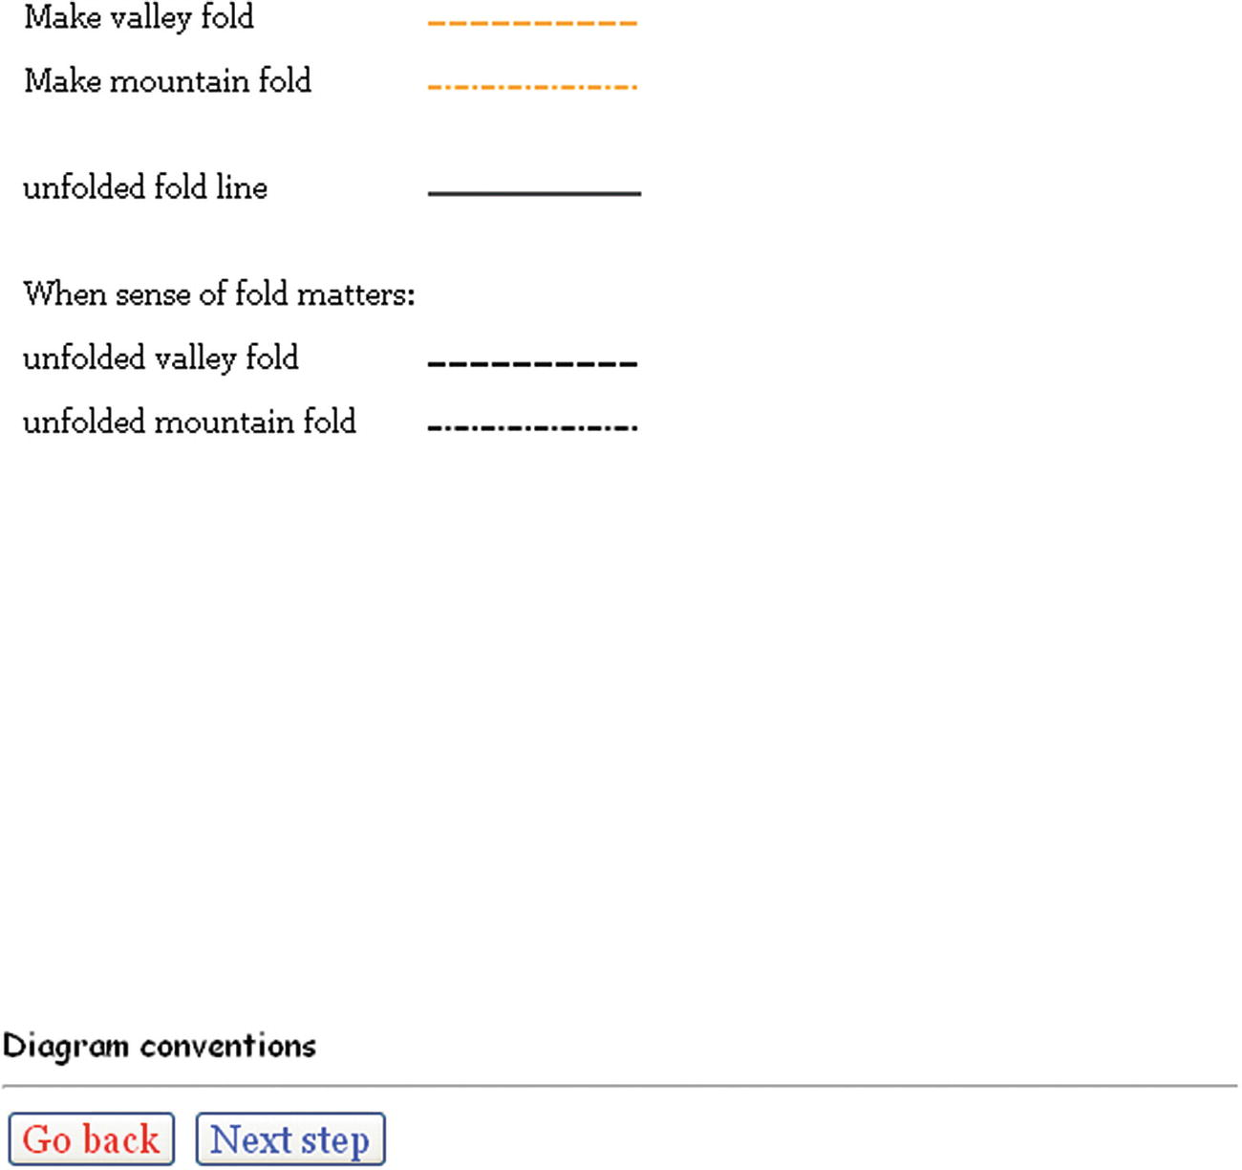
Figure 7-1 Opening screen
NoteI have reduced the set of origami moves. For example, I omitted the representation for a reverse fold, which is used to turn the lips inside out. These folds generally are preceded by what are termed preparation folds, which I describe for the talking fish.
The folder can click Next Step (at this point in the sequence, Go Back does nothing) to get to the first actual step of the instructions , shown in Figure 7-2. Of course, it is possible to add programming to remove the Go Back button at the start and the Next Step button at the end.
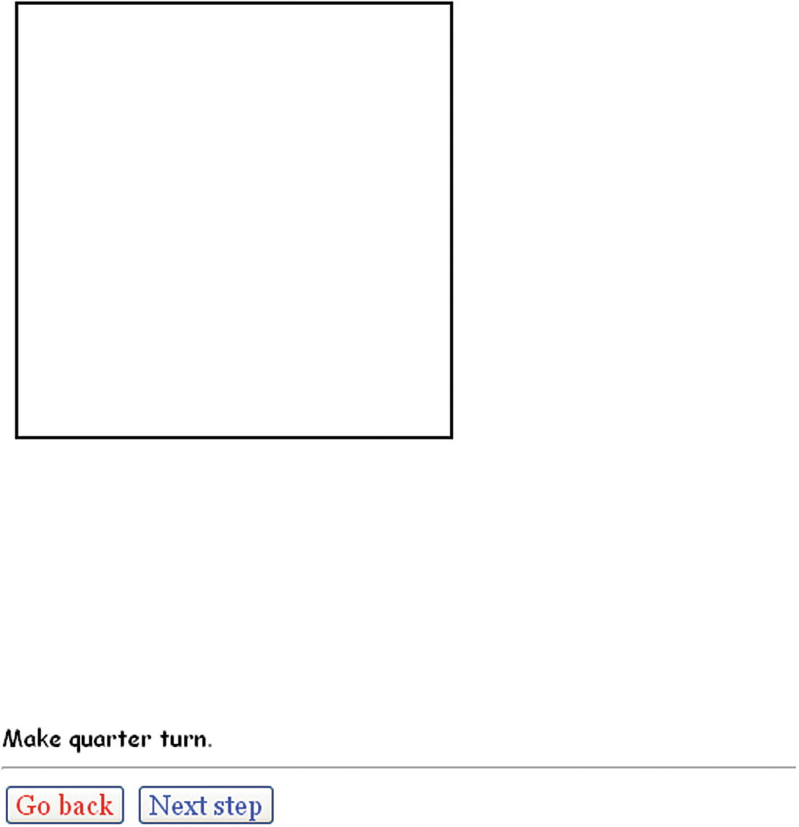
Figure 7-2First step, showing the square of paper. The instructions say to turn the paper.
Skipping ahead, Figure 7-3 shows a later step in the folding. Notice that the colored side of the paper is showing. An unfolded fold line is indicated by the skinny vertical line, and the fold to be made next (folding down the corner) is shown by a colored diagonal of dashes in the upper-right corner.
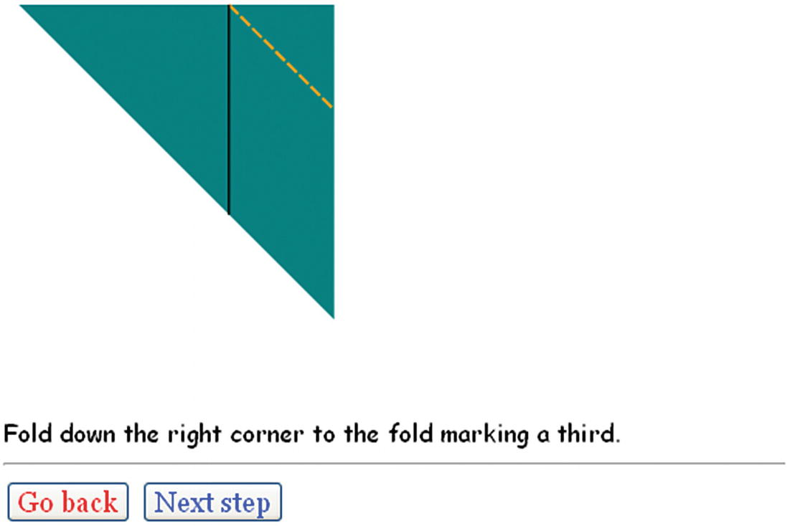
Figure 7-3Folding a corner down to a fold line
Later in the construction of the model, the folder must perform a sink fold. This is considered a difficult move. Figure 7-4 shows what is called the crease pattern prior to the sink: the folds are indicated as mountain folds or valley folds .
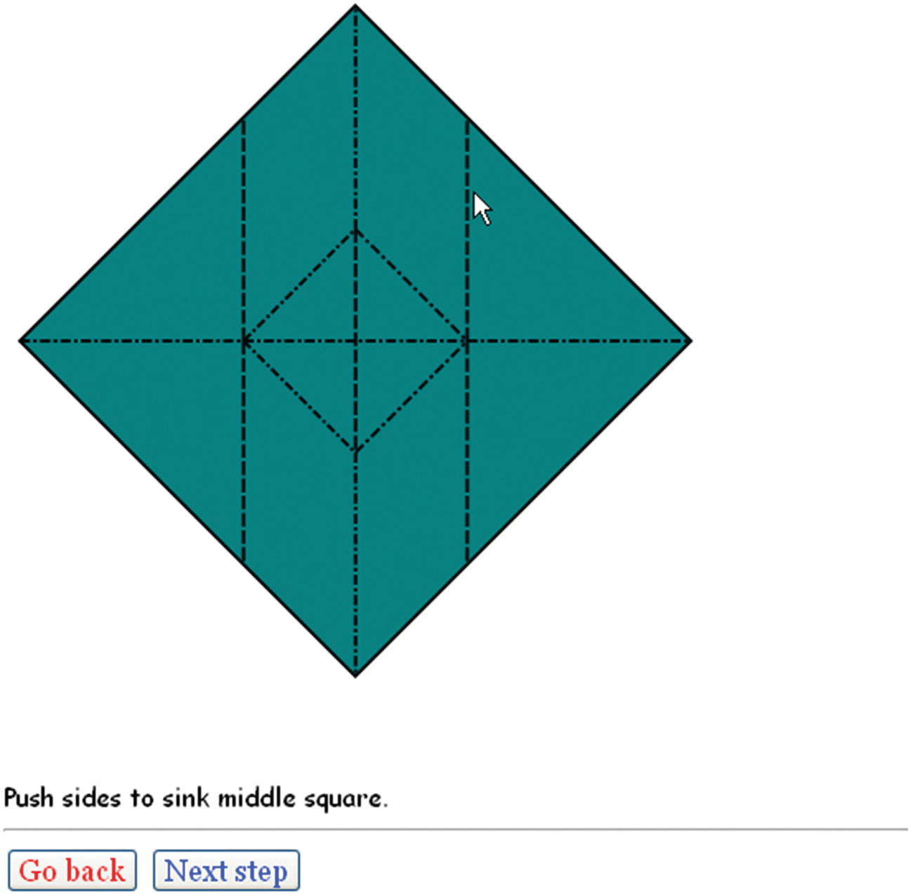
Figure 7-4Step with standard diagram for sink
I decided to supplement the line drawing with a video clip showing the sink step. Figure 7-5 shows a frame from the video. I (the folder) have used the video controls to pause the action. The folder can replay the video clip and go back to the crease pattern repeated times.
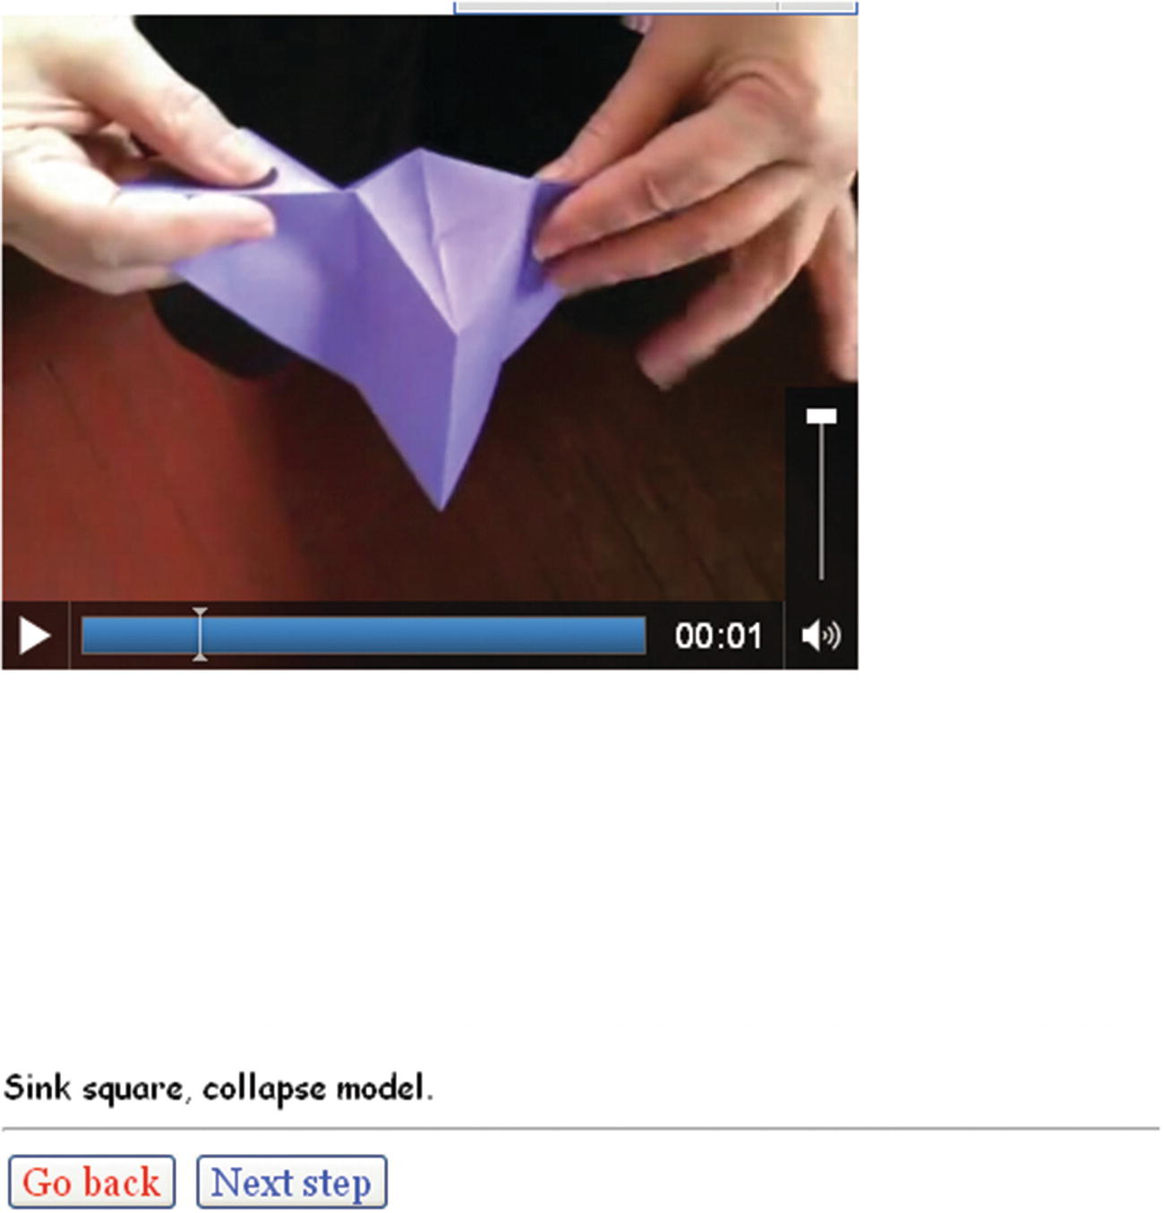
Figure 7-5Paused video showing sink step
Sinking is still a challenge, but viewing the video clip can help. The folder can replay and pause the video clip. Figure 7-6 shows the next step after the sink . Going from line drawing to video clip to line drawing is easy for the user/folder, and it will turn out to be straightforward for the developer as well.
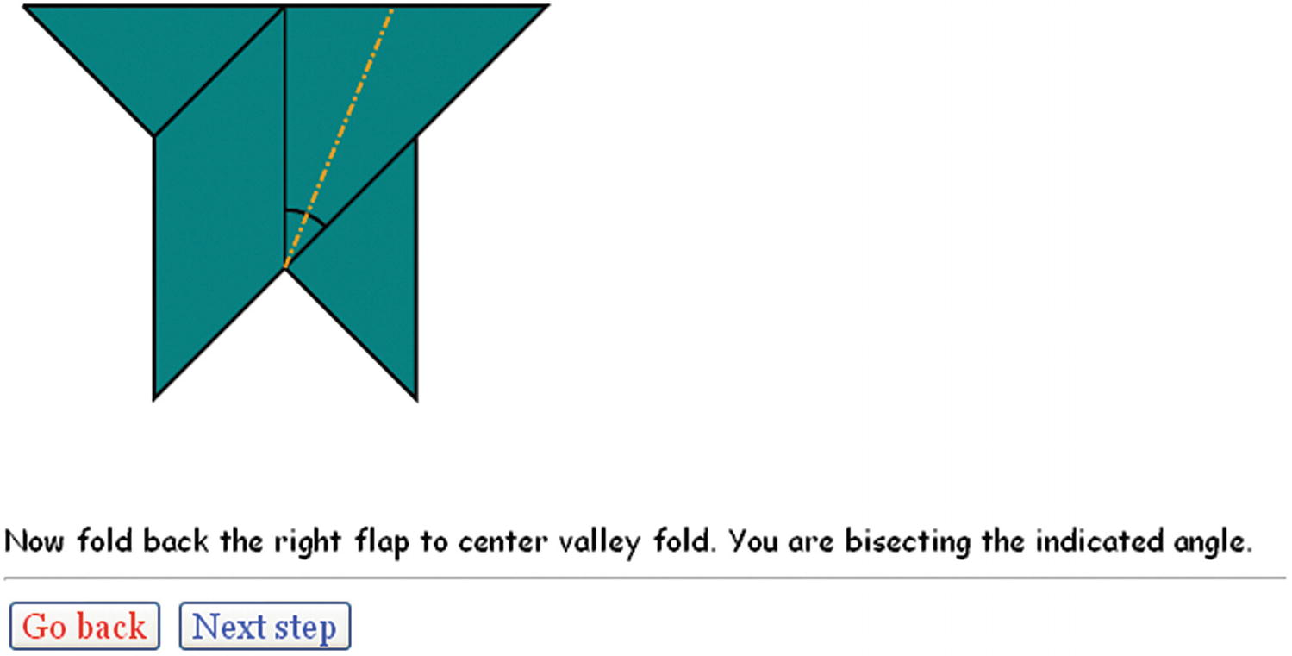
Figure 7-6Step after sink (first video clip)
The next step requires the folder to fold the triangular flap on the right backward, dividing the angle. Notice that the angle is indicated by an arc.
Moving on again in the folding, there is a step for which I decided that a photograph or two was the best way to convey what needs to be done. Figure 7-7 shows a picture of a model in process, viewed from above (looking into the mouth down the throat of the fish).
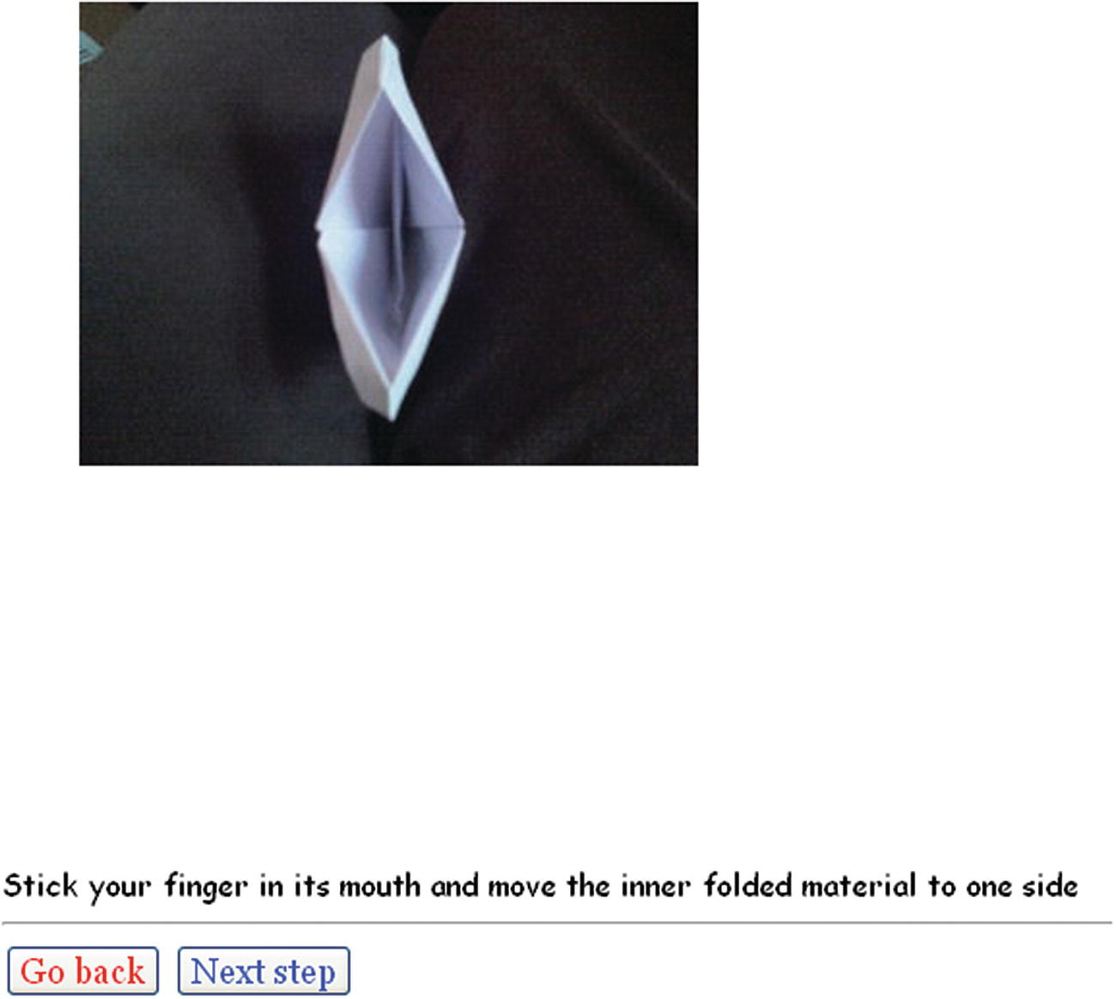
Figure 7-7Photograph showing fish throat
Figure 7-8 shows the result of moving the folded material to one side, as instructed in the directions shown in Figure 7-7.
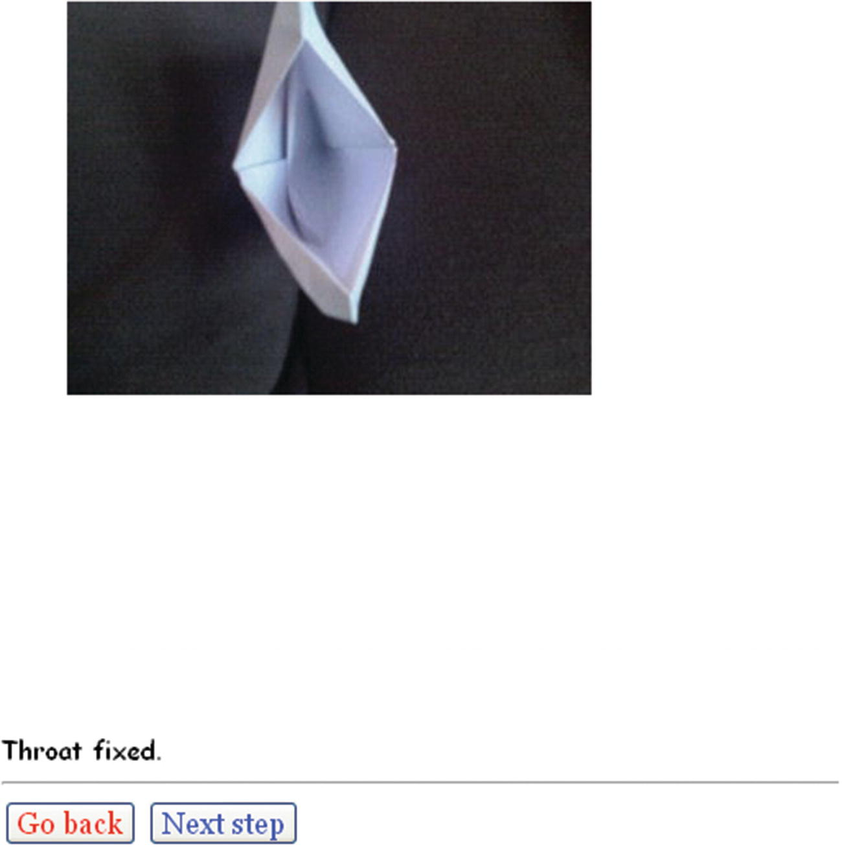
Figure 7-8Photograph of the fish with the throat fixed
The directions end with another video clip, this one showing the fish talking , performed by the folder gently pressing on the top and bottom. Figure 7-9 shows a frame in the video.
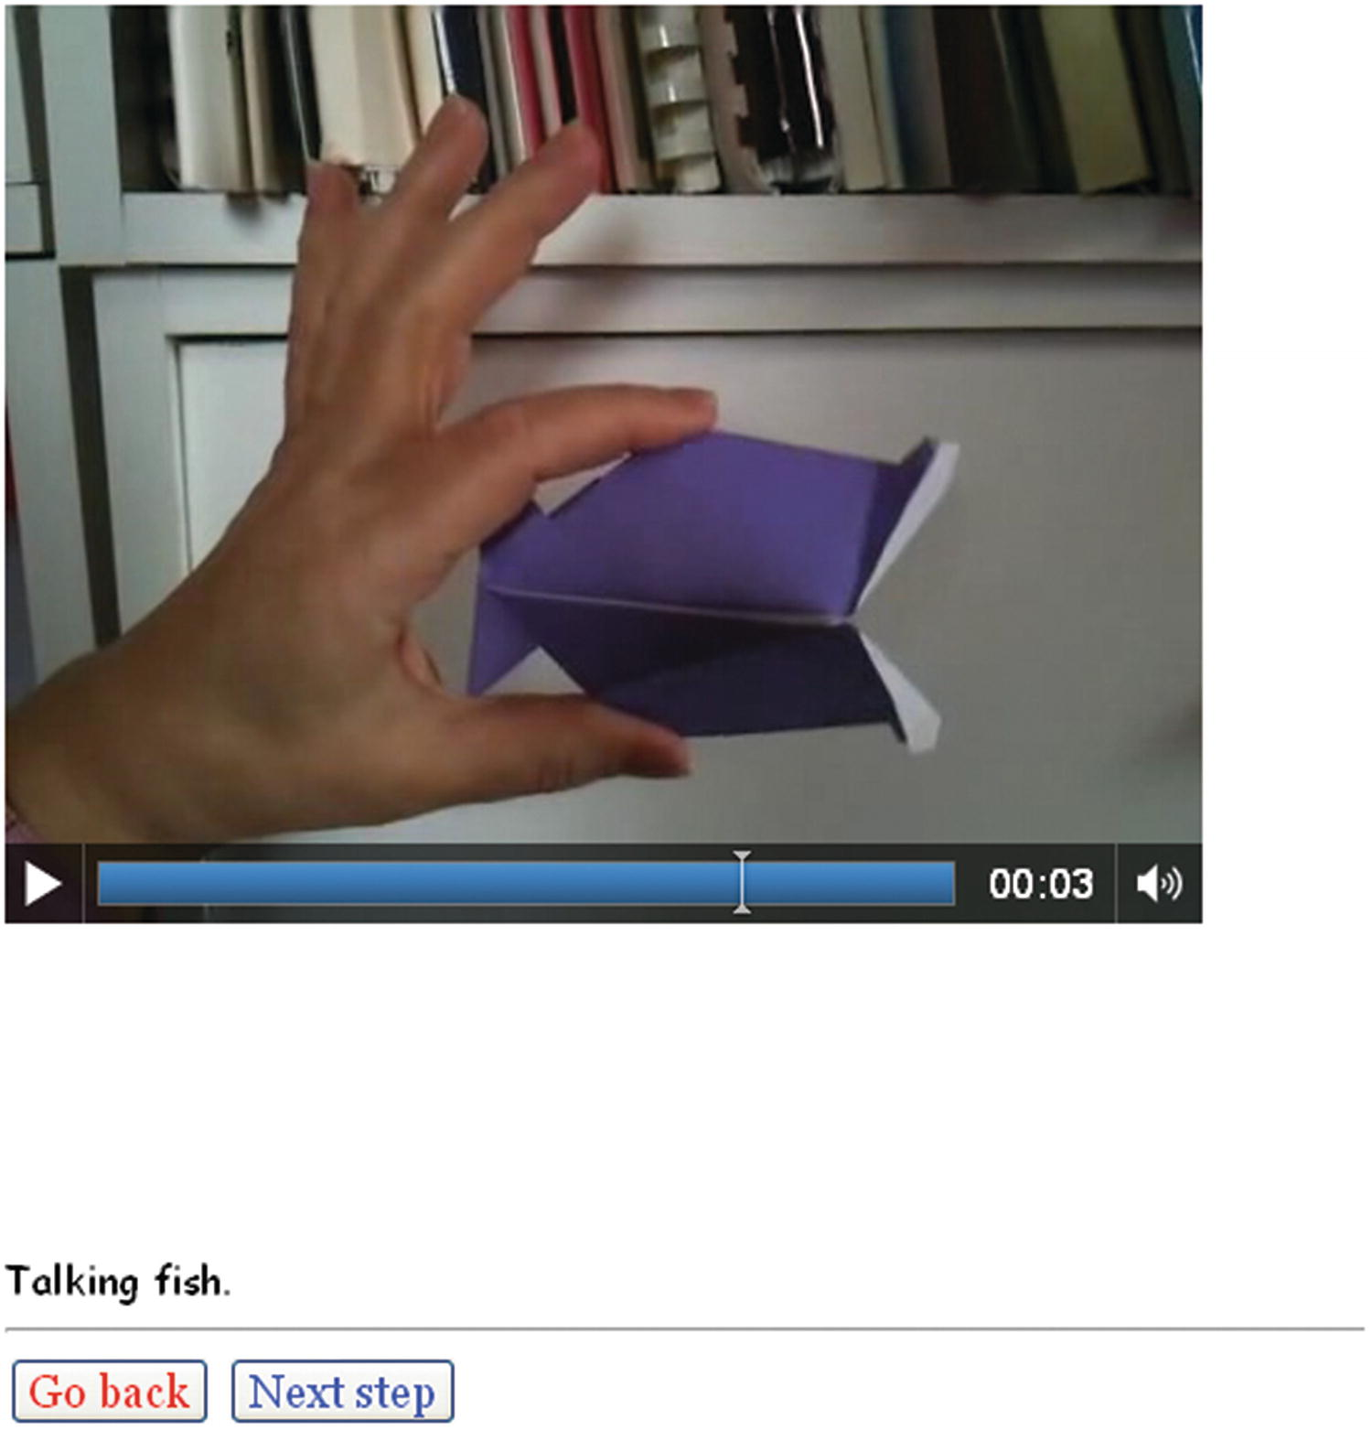
Figure 7-9Video showing talking fish

Critical Requirements
There is a standard format for origami directions, commonly referred to as diagrams, and I built on that standard. In this approach, each step shows the next fold to be made using a set typography. The most basic folds either assume a valley shape when unfolded or a mountain shape, and this is indicated by dashed or dotted and dashed lines. Often, folds are unfolded in the process of making an origami model. Sometimes the places where there were folds are indicated by thin lines and sometimes they are indicated by dashes for valley folds and dots and dashes for mountain folds.
My aim was to produce line drawings, similar to those found in books, with calculations for the coordinate positions of the critical points and lines. I did not want to make drawings by hand and scan them, nor did I want to use a typical engineering CAD program. I did not want to measure and record lengths or angles, but have JavaScript do that task for me. This would work even for folds done “to taste,” as the origami jargon goes, because I could determine the exact positions I chose to use. Using basic algebra, geometry, and trigonometry provides a way to achieve exact positions for the line drawings by calculating the coordinates of endpoints of lines.
Steps for origami typically come with text instructions. Also, arrows are sometimes used. I wanted to follow the standard while still taking advantage of the fact that these instructions would be delivered on a computer, with color and the opportunity for other media.
Thinking about the talking fish and some other folds, I decided to use photographs and videos for operations for which line drawings may not be good enough for you.
NoteThe challenge I set myself for the origami diagrams was to follow the standard but also take advantage of new technology of HTML5. This is typical when moving to a new medium and technology. You do not want to abandon a standard that your audience may feel is essential, but you also want to use what is available if it solves real problems.
A subtler requirement is that I wanted to test the application as I developed it. This meant a flexible but robust way to specify steps.

HTML5, CSS, JavaScript Features, and Mathematics
I will now describe the HTML5 features and the programming techniques used to address the requirements for the origami directions project. The best approach is to start with the overall mechanism for presenting steps, and then explain how I derived the first set of values for the positions. Then I’ll explain the utility functions for drawing the valley, mountain, and arrows, and for calculating intersection points and proportions. Lastly, I will review briefly the display of images and the playing of video.

Overall Mechanism for Steps
The steps for the origami directions are specified by an array called steps. Each element of the array is itself a two-element array holding the name of a function and a piece of text that will appear on the screen. The final value of the steps array in origamifish.html is the following:
var steps= [
[directions,"Diagram conventions"],
[showkami,"Make quarter turn."],
[diamond1,"Fold top point to bottom point."],
[triangleM,"Divide line into thirds and make valley folds and unfold "],
[thirds,"Fold in half to the left."],
[rttriangle,"Fold down the right corner to the fold marking a third. "],
[cornerdown,"Unfold everything."],
[unfolded,"Prepare to sink middle square by reversing folds as indicated ..."],
[changedfolds,"note middle square sides all valley folds, some other folds changed.
Flip over."],
[precollapse,"Push sides to sink middle square."],
[playsink,"Sink square, collapse model."],
[littleguy,"Now fold back the right flap to center valley fold. You are bisecting the
indicated angle."],
[oneflapup,"Do the same thing to the flap on the left"],
[bothflapsup,"Make fins by wrapping top of right flap around 1 layer and left around
back layer"],
[finsp,"Now make lips...make preparation folds"],
[preparelips,"and turn lips inside out. Turn corners in..."],
[showcleftlip,"...making cleft lips."],
[lips,"Pick up fish and look down throat..."],
[showthroat1,"Stick your finger in its mouth and move the inner folded material to one
side"],
[showthroat2,"Throat fixed."],
[rotatefish,"Squeeze & release top and bottom to make fish's mouth close and open"],
[playtalk,"Talking fish."]
];
I did not come up with the steps array when I began building the application. Instead, I added to the steps array as I went along, including inserting new entries and changing the content and/or the names of the functions. I began with the following definition of the steps array:
var steps= [
[showkami,"Make quarter turn"],
[diamond,"Fold top point to bottom point."]
];
It took me some time to get into the rhythm of showing the last stage of folding, with the addition of markings for the next step. The end result is a presentation using a single HTML page that proceeds through 21 steps containing vector drawings, photographs, and video, following a similar format to a PowerPoint presentation—that is, with the ability to go forward or backward.
Going forward and backward are done by the functions donext and goback . But first I need to explain how the whole thing starts. As has been the case for all the projects so far, a function called init is invoked by the action of the onLoad attribute in the <body> tag. The code sets global variables and invokes the function for presenting the next step, donext. The init function is
function init() {
canvas1 = document.getElementById("canvas");
ctx = canvas1.getContext("2d");
cwidth = canvas1.width;
cheight = canvas1.height;
ta = document.getElementById("directions");
nextstep = 0;
ctx.fillStyle = "white";
ctx.lineWidth = origwidth;
origstyle = ctx.strokeStyle;
ctx.font = "15px Georgia, Times, serif";
donext();
}
The variable nextstep is the pointer, so to speak, into the steps array. I start it off at zero.
The donext function has the task of presenting the next step in the progression of steps to produce the origami model. The function starts by checking if it is within range; that is, if it has been incremented to point beyond the end of the steps array, the value of nextstep is set to the last index. Next, the function pauses and removes from display the last video. It restores the canvas to its full height, which my code would have changed when playing a video clip. The function also sets the video variable to undefined, so the removal statements do not have to be executed again for that video. In all cases, donext clears the canvas and resets the linewidth. The donext function then displays the next step. The display includes parts: a graphic part consisting of a line drawing, video or image and a text part consisting of the instructions. The donext function invokes the drawing function indicated by the first (i.e., 0th) element of the inner array:
steps[nextstep][0]();
and displays the text, using the second (i.e., first) element of the inner array:
ta.innerHTML = steps[nextstep][1];
The last statement in the donext function is to increment the pointer. The whole donext function is
function donext() {
if (nextstep>=steps.length) {
nextstep=steps.length-1;
}
if (v) {
v.pause();
v.style.display = "none";
v = undefined;
canvas1.height = 480;
}
ctx.clearRect(0,0,cwidth,cheight);
ctx.lineWidth = origwidth;
steps[nextstep][0]();
ta.innerHTML = steps[nextstep][1];
nextstep++;
}
Coding the goback function took much longer in thinking time than its size would suggest. The nextstep variable holds the index for the next step. This means that going back requires the variable to be decremented by 2. A check must be made that the pointer is not too low—that is, less than zero. Lastly, the goback function invokes donext to display what has been set as nextstep. The code is
function goback() {
nextstep = nextstep -2;
if (nextstep<0) {
nextstep = 0;
}
donext();
}

User Interface
The user, who I refer to as the folder, has two buttons, labeled Next Step and Go Back. They are implemented using the HTML5 button element, and invoke the goback and donext functions, respectively. My choice of two different colors for the buttons—red for Go Back and green for Next Step—can be debated, as can the fact that the wording is not consistent. However, it does give me a chance to remind you of the significance of the word Cascading in the name Cascading Style Sheets. I use a directive in the style element in the head element and then I also use the following markup in the body element: The last style directive is what is controlling and gives the buttons the colors.
<button onClick="goback();" style="color: #F00">Go back </button>
<button onClick="donext();" style="color: #03F">Next step </button>
The color designations, each only three characters, are the equivalent of #FF0000 and #0033FF.
These two sections have described the basic mechanism for sequential directions. It assumes that each step is represented by a function and text. The next section will show how the coordinate values are set.

Coordinate Values
The line drawing is accomplished using HTML5 canvas functions and variables, mostly indicating x and y values. The variables appear in the code as var statements with initializations. I wrote these statements as I worked through making the model step by step, though in terms of JavaScript, they act as constants, and the values are set when the program is loaded. Figure 7-10 shows the third step of the sequence, with annotations for points a, b, c, and d.
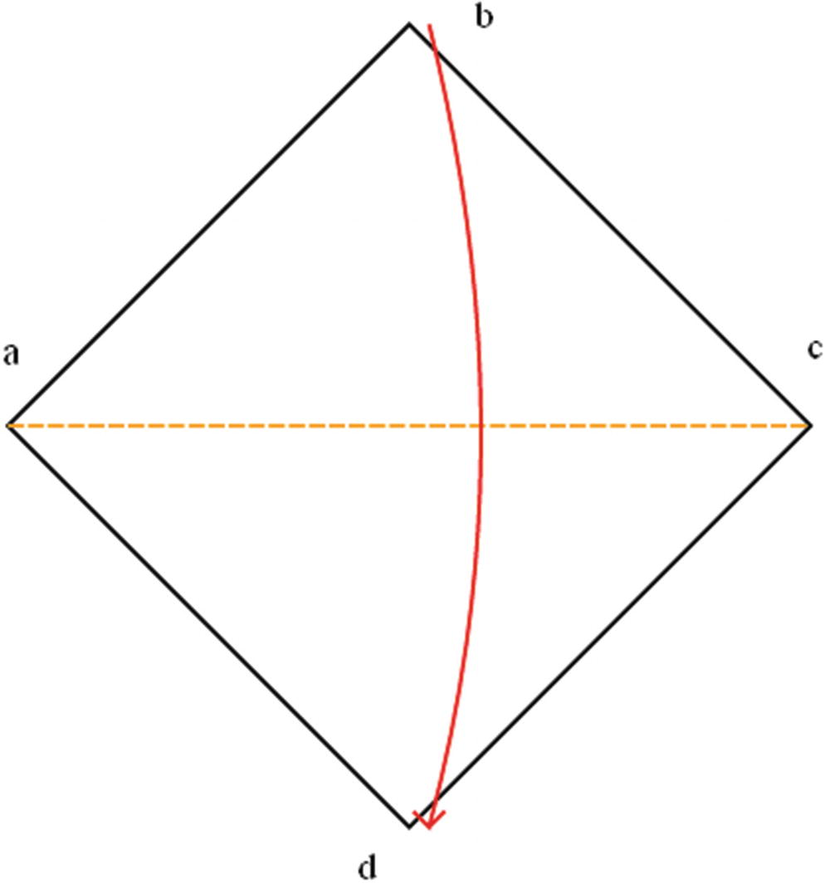
Figure 7-10Labels for corners
How did I determine the coordinates for the four points? As a foundation, I specified the location of point a. I also specified that the width and height of the paper was four inches and the conversion from inches to pixels was 72. The variable declarations are
var kamiw = 4;
var kamih = 4;
var i2p = 72;
var ax = 10;
var ay = 220;
The variable names kamiw and kamih refer to the width and height of the standard square paper for origami. From now on, everything is calculated. The first value required is the size of the diagonal of the paper. For a square, using the Pythagorean theorem, the diagonal is the length of a side times the square root of 2. The following statement setting the variable diag multiples the side (kamiw) by the square root of 2 and by the factor indicating the inches-to-pixels conversion.
var diag = kamiw* Math.sqrt(2.0)*i2p;
Most other programming languages contain built-in code for many standard mathematical functions so programmers do not have to reinvent the wheel. In JavaScript, these generally are supplied as methods of the Math class. You can do online searches to determine the exact names and usage.
With this, the values for the positions b, c, and d are expressions using the existing values.
var bx = ax+ .5*diag;
var by = ay - .5*diag;
var cx = ax + diag;
var cy = ay;
var dx = bx;
var dy = ay + .5*diag;
I developed the expressions for the variables by making the model and determining how new positions were based on old ones. These variables are used by the functions specified in the steps array to draw lines indicating the edges of the model, fold lines, arrows, and angles. Some calculations used general mathematical formulas. The next two sections cover the utility functions: functions used by the step functions.

Utility Functions for Display
As shown in Figure 7-1, a valley fold is indicated by a line made up of dashes. A mountain fold is indicated by a line made up of dots and dashes. This is standard convention for origami directions and makes it possible for folders to follow directions in books in different languages. Either one can be the default color (black) or another color. I need to set up variables for the basics: dash length, dot length, the gap between two dashes, the gap between the dots, and the gap between the last dot and a dash. It is easiest to understand what is needed by looking at the functions first and then defining the necessary values. The valley function is defined as follows:
function valley(x1,y1,x2,y2,color) {
var px=x2-x1;
var py = y2-y1;
var len = dist(x1,y1,x2,y2);
var nd = Math.floor(len/(dashlen+dgap));
var xs = px/nd;
var ys = py/nd;
if (color) ctx.strokeStyle = color;
ctx.beginPath();
for (var n=0;n<nd;n++) {
ctx.moveTo(x1+n*xs,y1+n*ys);
ctx.lineTo(x1+n*xs+dratio*xs,y1+n*ys+dratio*ys);
}
ctx.closePath();
ctx.stroke();
ctx.strokeStyle = origstyle;
}
The valley function determines how many dashes there will be. This is done by dividing the length of the valley line by the total length of a dash and the gap between dashes. If this is not a whole number, the last-and-partial-dash-gap combination is dropped. The Math.floor method accomplished this for us. Math.floor(4.3) returns 4.
The variables xs and ys are the increments in x and y, respectively. The color parameter may or may not be present. The if (color) statement changes the stroke color if the parameter is present. The heart of the function is the for loop that draws each dash.
The mountain function is similar, but more complicated because of the nature of the mountain fold typography: combinations of dashes followed by a gap equal to a dot, then a dot, and then another gap. The mountain function is as follows:
function mountain(x1,y1,x2,y2,color) {
var px=x2-x1;
var py = y2-y1;
var len = dist(x1,y1,x2,y2);
var nd = Math.floor(len/ddtotal);
var xs = px/nd;
var ys = py/nd;
if (color) ctx.strokeStyle = color;
ctx.beginPath();
for (var n=0;n<nd;n++) {
ctx.moveTo(x1+n*xs,y1+n*ys);
ctx.lineTo(x1+n*xs+ddratio1*xs,y1+n*ys+ddratio1*ys);
ctx.moveTo(x1+n*xs+ddratio2*xs,y1+n*ys+ddratio2*ys);
ctx.lineTo(x1+n*xs+ddratio3*xs,y1+n*ys+ddratio3*ys);
}
ctx.closePath();
ctx.stroke();
ctx.strokeStyle = origstyle;
}
With the statements of the functions in mind, here is how I define the variables used by both functions:
var dashlen = 8;
var dgap = 2.0;
var ddashlen = 6.0;
var ddot = 2.0;
var dratio = dashlen/(dashlen+dgap);
var ddtotal = ddashlen+3*ddot;
var ddratio1 = ddashlen/ddtotal;
var ddratio2 = (ddashlen+ddot)/ddtotal;
var ddratio3 = (ddashlen+2*ddot)/ddtotal;
Lines are used to show the edges of the paper. I set the width for these lines to be 2. For places in which the paper has been folded and then unfolded, I use a skinnier line: line width set to 1. I wrote a function to make skinny lines:
function skinnyline(x1,y1,x2,y2) {
ctx.lineWidth = 1;
ctx.beginPath();
ctx.moveTo(x1,y1);
ctx.lineTo(x2,y2);
ctx.closePath();
ctx.stroke();
ctx.lineWidth = origwidth;
}
At one point for the directions for the origami fish, I decided to use short, downward-pointing arrows. I wrote a general function for it, which you can study in the commented code in the “Building the Application and Making It Your Own” section. There were two places when I decided to show a long curved arrow, either horizontal or vertical. This turned out to be the longest function in the project, and I will not go into more detail here. You can study the function in the complete commented code listing. Fortify yourself with the drink of your choice. This is a complex function because of the many cases that need to be handled separately: a vertical arrow going up or down, or a horizontal arrow going left to right or right to left. The arrow is made as an arc of a circle whose center is calculated to be far away from the arc, and two little lines indicating the arrowhead.

Utility Functions for Calculation
You have seen the first mathematical calculation required for this project in previous chapters. It’s called dist, and it calculates the distance between two points:
function dist(x1,y1,x2,y2) {
var x = x2-x1;
var y = y2-y1;
return Math.sqrt(x*x+y*y);
}
The next function to discuss is determining the intersection point between two lines. The intersection is a point that satisfies the equation for both lines. In the origami fish example, look at Figure 7-14. I (in my program) will need to calculate the intersection of the line from k to n and the line from s to q. Look further along in this chapter to Figure 7-17. The xx point is the intersection. The code from the program is
var xxa = intersect(sx,sy,qx,qy,kx,ky,nx,ny);
var xxx = xxa[0];
var xxy = xxa[1];
Lines are defined by two points , and each point is defined by two numbers. This means that the intersect function has 2 × 2 × 2 input parameters. My function is not general; it only works when the lines are not vertical and when there is indeed an intersection. This is acceptable for my use for the origami fish, but if you take this for another application, you may need to do more work.
Let’s now focus on the mathematical representation of lines. There are different equations, but the one I use is called the point slope form. The slope of a line is the change in y divided by the change in x between any two points. Following convention, the slope is named m. The equation for a line with slope m going through the point (x1,y1) is
y – y1 = m * (x – x1)
Note that this line is mathematics, not JavaScript. Returning now to programming, I determined the slopes and equations for each of the lines passed to the intersect function.
The intersect function sets m12 to be the slope of the line going from (x1,y1) to (x2,y2) and m34 to be the slope of the line going from (x3,y3) to (x4,y4). The code essentially sets the two y values:
y = m12 * (x – x1) + y1 and y = m34 * (x – x3) + y3
The next step is to set these two expressions equal to each other and solve for x. What this accomplishes is calculating a value for x that lies on both lines. With that value of x, I use one of the two equations to get the corresponding y. The pair x,y represents a point—in fact, the only point—that is on both lines. This is what is meant by intersection . I write the code for the function to return the array [x,y]. Here is the complete code:
function intersect(x1,y1,x2,y2,x3,y3,x4,y4) {
// only works on line segments that do intersect and
// are not vertical
var m12 = (y2-y1)/(x2-x1);
var m34 = (y4-y3)/(x4-x3);
var m = m34/m12;
var x = (x1-y1/m12-m*x3+y3/m12)/(1-m);
var y = m12*(x-x1)+y1;
return ([x,y]);
}
At this point, you may have had a sudden drop in confidence that whatever you do remember from high school mathematics classes may not apply because the coordinate system for the screen is upside down. The vertical values increase moving down the screen. It turns out that these equations still work (although our interpretation may differ). For example, a line that starts at (0,0) and goes to (100,100) has a calculated slope of positive 1, even though we may think of it as sloping down. In the upside-down world, it has positive slope.
Another calculation required for the origami fish is what I have named proportion . This function takes five input parameters. (x1,y1) and (x2,y2) define a line segment. The fifth parameter is p, indicating proportion. The task of the function is to calculate the (x,y) position on the line segment that is p of the way from (x1,y1) to (x2,y2).
function proportion(x1,y1,x2,y2,p) {
var xs = x2-x1;
var ys = y2-y1;
var x = x1+ p*xs;
var y = y1 + p* ys;
return ([x,y]);
}
This covers what I term the utility functions of the origami project. The three calculation functions would be applicable to other applications.

Step Line Drawing Functions
The functions for producing the diagrams for a step in the sequence use the path-drawing facilities of HTML5 and the variables, which have been set using the calculation utility functions or built-in Math methods . I won’t cover all of them in this section, but will explain a couple. For example, the function triangleM (more on this function following) has the task of producing the diagram for the step shown in Figure 7-11 .
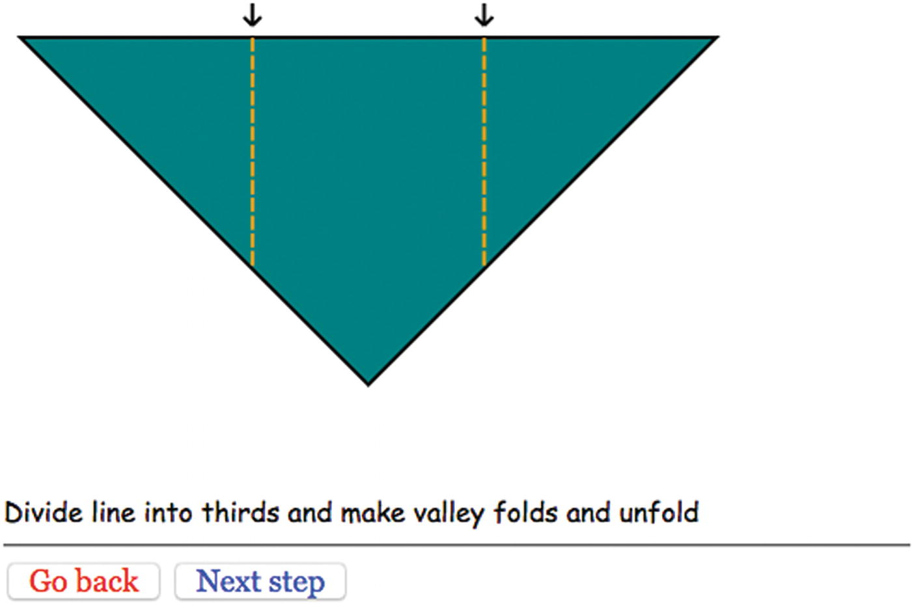
Figure 7-11 Dividing-into-thirds step
NoteMy instructions do not suggest ways to do this. A common way that folders do this is to make a guess for the point one-third of the way from one end—say, the left. Fold the right point to that point and make a tiny pinch. Then fold the left end to the pinch, and repeat until you don’t see a change in the pinch marks. This method demonstrates some nice mathematics, namely limits. Whatever error you make in your initial guess will be reduced to one-quarter of its original size. If you keep doing this, you’ll quickly get to something acceptable.
Figure 7-12 shows the picture annotated with labels for the critical points e, f, g, and h.
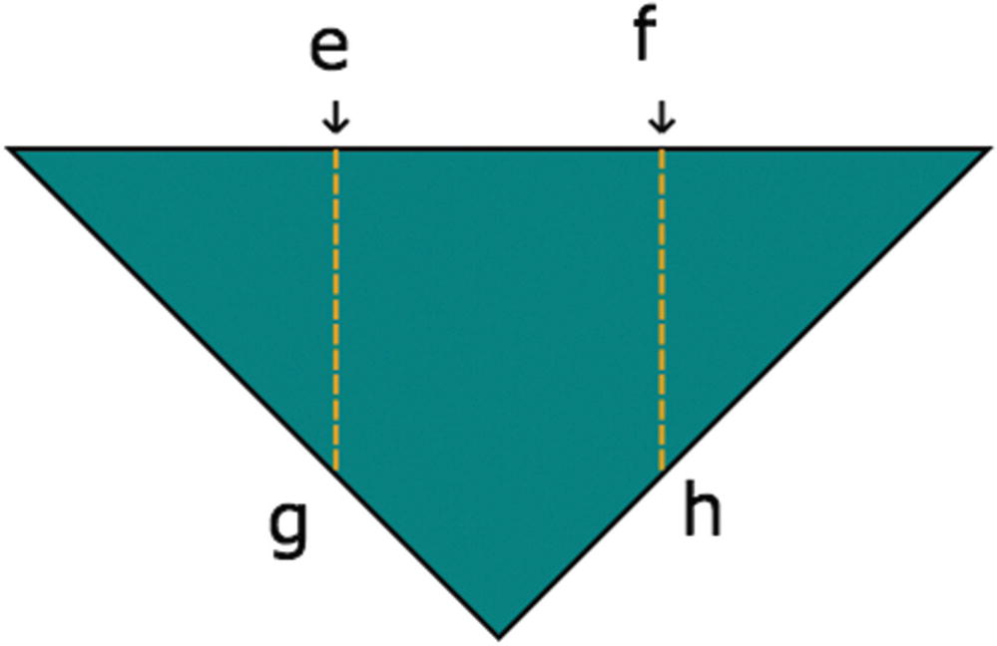
Figure 7-12 Dividing a line into thirds and folding
The variables defining the four points are
var e = proportion(ax,ay,cx,cy,.333333);
var ex = e[0];
var ey = e[1];
var f = proportion(ax,ay,cx,cy,.666666);
var fx = f[0];
var fy = f[1];
var g = proportion(ax,ay,dx,dy,.666666);
var gx = g[0];
var gy = g[1];
var
h
=
proportion
(
cx,cy,dx,dy,
.666666);
var
hx
=
h
[0];
var
hy
=
h
[1];
The function triangleM is defined as follows:
function triangleM() {
triangle();
shortdownarrow(ex,ey);
shortdownarrow(fx,fy);
valley(ex,ey,gx,gy,"orange");
valley(fx,fy,hx,hy,"orange");
}
The function draws a triangle, then draws two short downward arrows above e and f, and then draws two valley lines of color orange.
The triangle function is defined to be
function triangle() {
ctx.fillStyle="teal";
ctx.beginPath();
ctx.moveTo(ax,ay);
ctx.lineTo(cx,cy);
ctx.lineTo(dx,dy);
ctx.lineTo(ax,ay);
ctx.closePath();
ctx.fill();
ctx.stroke();
}
The triangle function is not general, but draws this specific triangle. A general function would be
function generaltriangle(px,py, qx,qy, rx,ry, scolor, fcolor) {
ctx.fillStyle=fcolor;
ctx.strokeStyle = scolor;
ctx.beginPath();
ctx.moveTo(px,py);
ctx.lineTo(qx,qy);
ctx.lineTo(rx,ry);
ctx.lineTo(px,py);
ctx.closePath();
ctx.fill();
ctx.stroke();
}
Also, do not assume that I knew to write this function. I probably put this coding into the first function and then when I got to the next step of the model, realized that I needed a triangle again. I extracted the code I had written and renamed the first function triangleM (for “triangle marked”). I had the triangleM function and the thirds function each invoke the function named triangle.
Figure 7-13 shows a step in the model that I will illustrate with a function I named littleguy , because that is what it looks like to me.
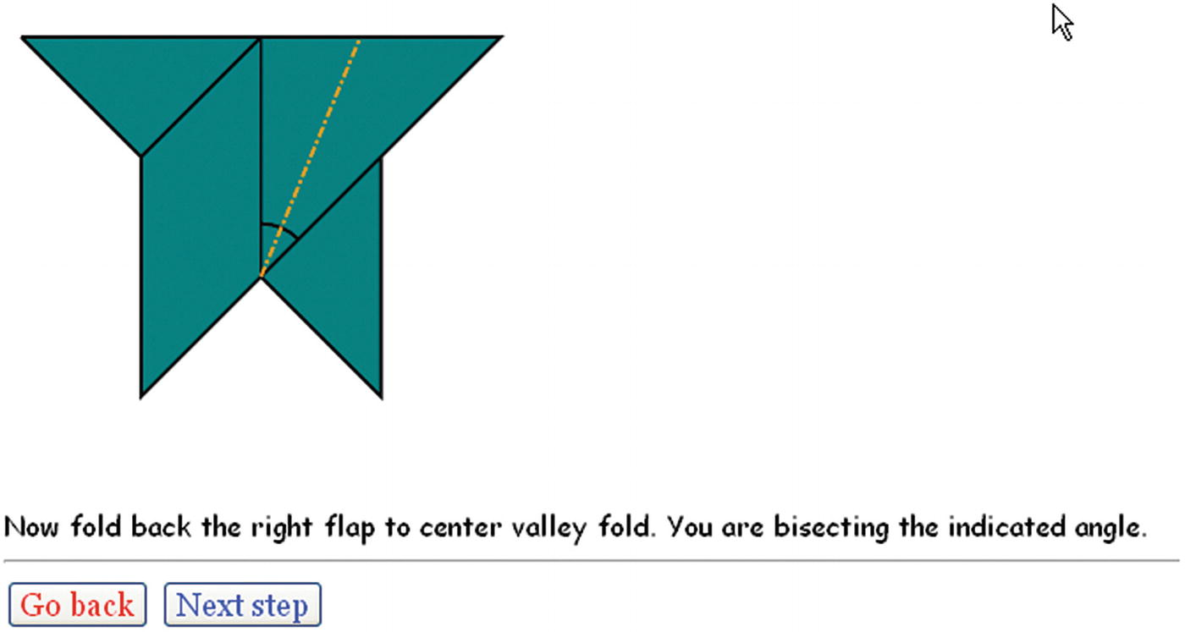
Figure 7-13After sink, what I call littleguy
Figure 7-14 shows the labeling of the critical points.
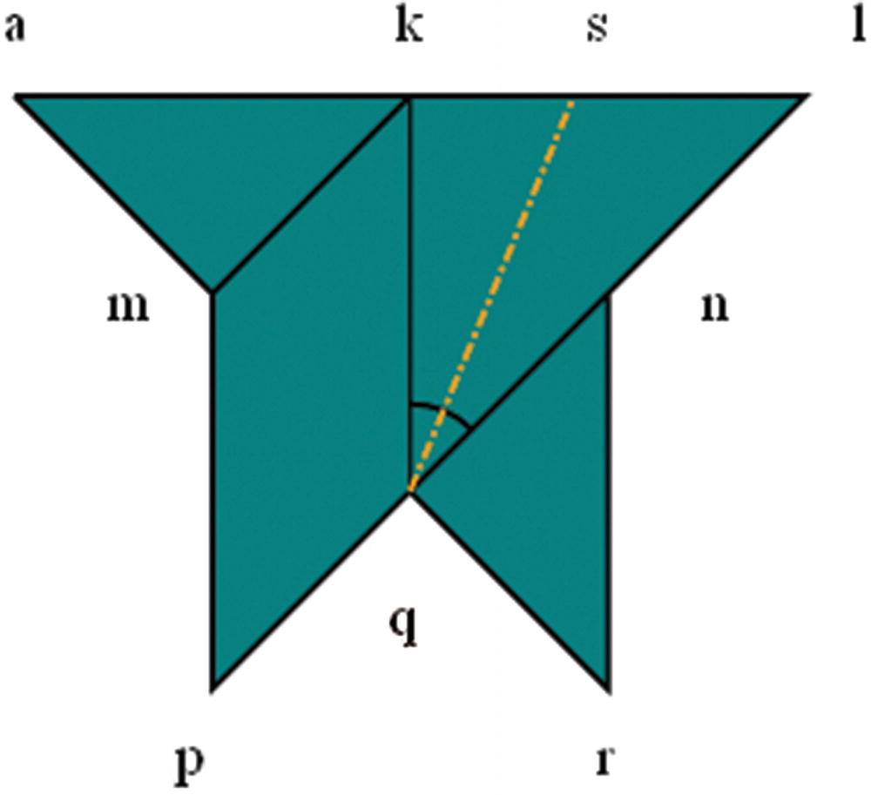
Figure 7-14Labeling of critical points for littleguy
The definitions of the corresponding variables are
var kx = ax+diag/3;
var ky = ay;
var lx = kx + diag/3;
var ly = ay;
var mx = ax + diag/6;
var innersq = Math.sqrt(2)*diag/6;
var my = ay + innersq*Math.sin(Math.PI/4);
var nx = ax+diag/3+diag/6;
var ny = my;
var px = mx;
var py = dy;
var rx = nx;
var ry = py;
var qx = kx;
var qy = hy;
var dkq = qy-ky;
var sx = kx + (dkq/Math.cos(Math.PI/8))*Math.sin(Math.PI/8);
var sy = ay;
Notice that I don’t try to be sparing with variables. Yes, rx is the same value as nx, but it is easier for me to think of them as distinct things.
The code for littleguy follows:
function littleguy() {
ctx.fillStyle="teal";
ctx.beginPath();
ctx.moveTo(ax,ay);
ctx.lineTo(kx,ky);
ctx.lineTo(mx,my);
ctx.lineTo(ax,ay);
ctx.moveTo(kx,ky);
ctx.lineTo(lx,ly);
ctx.lineTo(px,py);
ctx.lineTo(mx,my);
ctx.lineTo(kx,ky);
ctx.moveTo(nx,ny);
ctx.lineTo(rx,ry);
ctx.lineTo(qx,qy);
ctx.lineTo(nx,ny);
ctx.closePath();
ctx.fill();
ctx.stroke();
skinnyline(qx,qy,kx,ky);
ctx.beginPath();
ctx.arc(qx,qy,30,-.5*Math.PI,-.25*Math.PI,false);
ctx.stroke();
mountain(qx,qy,sx,sy,"orange")
}
The description of the arc in degrees is that it goes from –90 degrees to –45 degrees. Note that zero degrees is horizontal and positive degrees go clockwise.
Figures 7-15, 7-16, 7-17, and 7-18 show the locations of the remaining critical positions for the model.
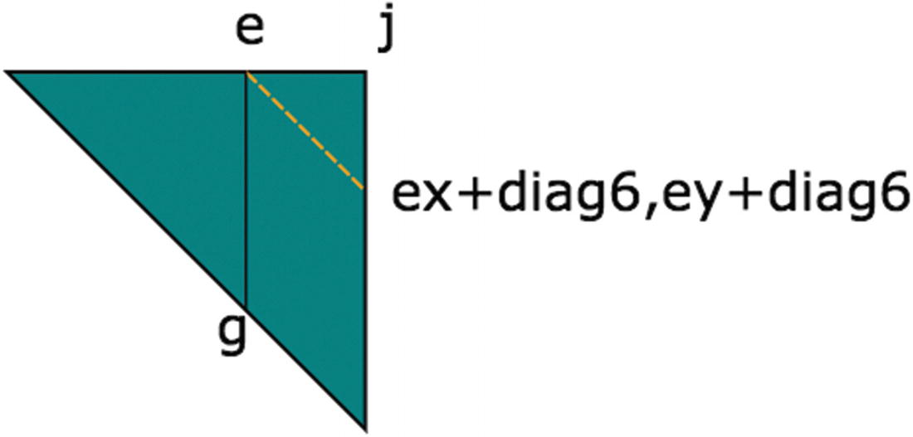
Figure 7-15Labeling at fold in half step
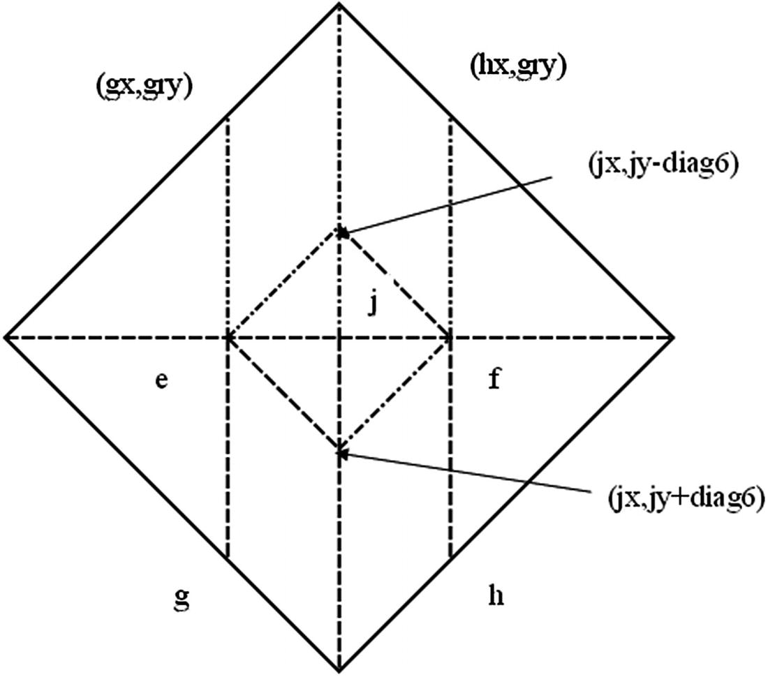
Figure 7-16Preparing to sink center
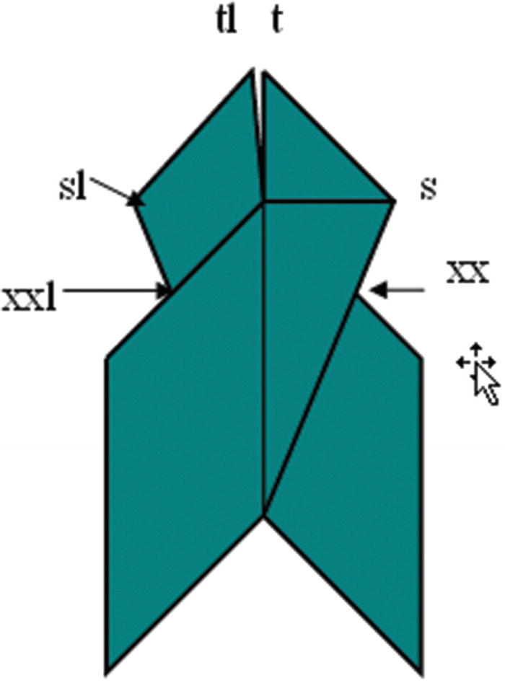
Figure 7-17 After wraparound steps
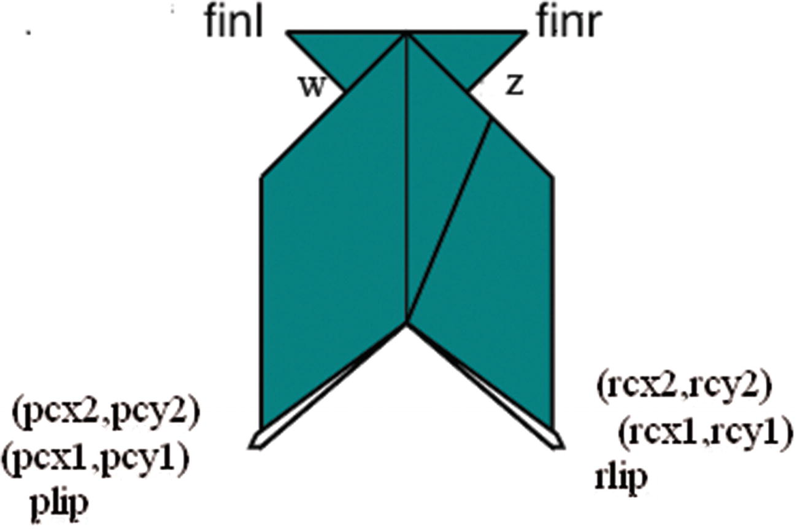
Figure 7-18 After making lips
Use the figures to help understand the code for setting the values of the variables. For example, as I mentioned in describing the intersect function , looking at Figures 7-14 and 7-17, you can see that the point xx, represented by xxx and xxy, is the intersection of the line from s to q and k to n.
One more of the step functions deserves explanation. The directions right before the end had the fish with the head pointed down the screen. I wanted to make the diagram right before the last video clip be oriented horizontally to match the video clip about to be displayed. This is accomplished using the canvas coordinate transformations of HTML5. The previous function is named lips. The rotatefish function saves the current, which is the original, coordinate system. It then translates to a point on the fish, invokes a rotation (90 degrees counterclockwise), and then undoes the translation. The rotatefish function then invokes the lips function, which draws the fish, but now oriented horizontally. Here is the code:
function rotatefish() {
ctx.save();
ctx.translate(kx,my);
ctx.rotate(-Math.PI/2);
ctx.translate(-kx,-my);
lips();
ctx.restore();
}

Displaying a Photograph
The steps that display a photograph have the same structure as the ones that produce a line drawing. For each image required for the application, I need to define an Image object and set the src property to the name of the image file. The following statements relate to the picture shown in Figure 7-7:
var throat1 = new Image();
throat1.src = "throat1.jpg";
function showthroat1() {
ctx.drawImage(throat1,40,40);
}
The techniques shown in Chapter 5 to create a separate file defining the media and generating code (including HTML markup) automatically may be appropriate here. I wrote functions for each photograph and, as I explain in the next section, each video clip.

Presenting and Removing a Video
The origamifish.html file has video elements for each of the two video clips, one with the ID sink and the other with the ID talk. The style element has a directive for all videos to not display:
video {display: none;}
The functions playsink and playtalk each make the video display, set the current time to zero, play the video, and adjust the canvas height. The definition of playsink follows:
function playsink() {
v = document.getElementById("sink");
v.style.display="block";
v.currentTime = 0;
v.play();
canvas1.height = 178;
}
With this discussion of the programming techniques and HTML5 features to use for the origami directions project, we are now ready to look at the application as a whole.

Building the Application and Making It Your Own
The quickest way to build on what you have learned in this chapter is to create directions for another craft project similar to paper folding in the presence of line drawings and the benefits of some photographs and video clips. You can build it step by step, creating the functions you need. It may turn out that some functions are what I call utility functions: functions used by other functions. You may also build up variables indicating positioning as you need them. An informal summary/outline of the origami fish application follows:
init for initialization
donext and goback for moving forward and back through the steps
Utility functions for drawing specific types of lines
Utility functions for calculations
Step functions (functions cited in the steps array)
Table 7-1 lists functions and groups of functions and indicates how they are invoked and what functions they invoke.
Table 7-1 Functions in the Origami Directions Project
Function | Invoked/Called By | Calls
init | Invoked by action of the onLoad attribute in the <body> tag | donext
donext | Invoked by init, goback, and by the onClick attribute in a button tag
goback | Invoked by the onClick attribute in a button tag | donext
Utility functions for drawing (shortdownarrow, valley, mountain, skinnyline, and curvedarrow) | Invoked by the step functions
Utility functions for calculations (dist, intersect, and proportion) | Invoked mainly in var statements to set variables representing critical positions in the model
Step functions | Invoked as elements in the steps array in donext; some (fins, triangle, diamond, rttriangle, diamondc, and lips) are called by other step functions | Utility drawing functions, the other step functions indicated
Table 7-2 shows the code for the basic application, with comments for each line. Much of this code you have seen in previous chapters.
Table 7-2 Complete Code for Origami Directions Project
Code Line | Description
<!DOCTYPE html> | Header
<html> | html tag
<head> | head tag
<title>Origami fish</title> | Complete title
<style> | style tag
button {font-size:large; font-family:Georgia, "Times New Roman", Times, serif;} | Directive for formatting buttons; note that color is specified for each button in the body element
#directions {font-family:"Comic Sans MS", cursive;} | Directive for formatting all directions
video {display:none;} | Turn off display of all video elements until called on
</style> | Closing style tag
<script> | Starting script tag
var ctx; | Will hold canvas context for all drawing
var cwidth; | Width of canvas
var cheight; | Height of canvas
var ta; | Will hold element for text part of each step
var kamiw = 4; | Set width of paper
var kamih = 4; | Set height of paper
var i2p = 72; | Set inches to pixels
var dashlen = 8; | Set length of dash in valley fold
var dgap = 2.0; | Set gap between dashes
var ddashlen = 6.0; | Set dash length in mountain fold
var ddot = 2.0; | Set dot length in mountain fold
var dratio = dashlen/(dashlen+dgap); | Used for mountain line
var ddtotal = ddashlen+3*ddot; | Used for mountain line
var ddratio1 = ddashlen/ddtotal; | Used for mountain line
var ddratio2 = (ddashlen+ddot)/ddtotal; | Used for mountain line
var ddratio3 = (ddashlen+2*ddot)/ddtotal; | Used for mountain line; all values used for calculation of number of dashes and dots and start and extents of dashes and dots
var kamix = 10; | X position of paper in first step
var kamiy = 10; | Y position of paper in first step
var nextstep; | Pointer into steps array
function dist(x1,y1,x2,y2) { | Header for dist function
var x = x2-x1; | Set difference in x
var y = y2-y1; | Set difference in y
return Math.sqrt(x*x+y*y); | Return square root of sum of squares
} | Close dist function
function intersect(x1,y1,x2,y2,x3,y3,x4,y4) { | Header for intersect function between two lines, indicated by 2 × 2 points
// only works on line segments that do intersection and | Good comments to keep in code: assumes there is an intersection . . .
// are not vertical | . . . and assumes lines aren’t vertical; if they were, the code would be dividing by zero, which would produce an error
var m12 = (y2-y1)/(x2-x1); | Compute slope
var m34 = (y4-y3)/(x4-x3); | Compute slope
var m = m34/m12; | Used in calculation
var x = (x1-y1/m12-m*x3+y3/m12)/(1-m); | Solve for x
var y = m12*(x-x1)+y1; | Solve for y
return ([x,y]); | Return pair
} | Close intersect function
function init() { | Header for init function
canvas1 = document.getElementById("canvas"); | Set canvas1
ctx = canvas1.getContext("2d"); | Set context
cwidth = canvas1.width; | Set cwidth
cheight = canvas1.height; | Set cheight
ta = document.getElementById("directions"); | Set ta to hold the element for the text directions
nextstep = 0; | Initialize nextstep
ctx.fillStyle = "white"; | Set fill style; will be used for erasing
ctx.lineWidth = origwidth; | Set line width (set earlier)
origstyle = ctx.strokeStyle; | Save stroke color
ctx.font = "15px Georgia, Times, serif"; | Set font
donext(); | Start with 0th step
} | Close init function
function directions() { | Header for directions, the first “step” shown
ctx.fillStyle = "black"; | Change fill style, for use in text
ctx.font = "15px Georgia, Times, serif"; | Set font
ctx.fillText("Make valley fold", 10,20); | Output explanation
valley(200,18,300,18,"orange"); | Make sample orange valley line
ctx.fillText("Make mountain fold",10,50); | Output explanation
mountain(200,48,300,48,"orange"); | Make sample orange mountain line
ctx.fillText("unfolded fold line",10,100); | Output explanation
skinnyline(200,98,300,98); | Make sample skinny line for unfolded fold line
ctx.fillText("When sense of fold matters:",10,150); | Output explanation
ctx.fillText("unfolded valley fold", 10,180); | Continue
valley(200,178,300,178); | Make sample old valley
ctx.fillText("unfolded mountain fold",10,210); | Output explanation
mountain(200,208,300,208); | Make sample old mountain
ctx.fillStyle = "white"; | Change fill style back
} | Close directions function
function donext() { | Header for donext function
if (nextstep>=steps.length) { | Check if nextstep is too big
nextstep=steps.length-1; | Reset
} | Close clause
if (v) { | Check if v is set
v.pause(); | Pause the video
v.style.display = "none"; | Make it not display
v = undefined; | Set v to undefined
canvas1.height = 480; | Restore height
} | Close clause
ctx.clearRect(0,0,cwidth,cheight); | Clear canvas
ctx.lineWidth = origwidth; | Reset line width
steps[nextstep][0](); | Invoke the appropriate step function
ta.innerHTML = steps[nextstep][1]; | Display the accompanying text
nextstep++; | Increment nextstep
} | Close donext function
function goback() { | Header for goback
nextstep = nextstep -2; | Decrement nextstep by 2 (because it is already one ahead)
if (nextstep<0) { | Check if nextstep is now too low
nextstep = 0; | Reset
} | Close clause
donext(); | Invoke donext
} | Close goback function
function shortdownarrow(x,y) { | Header for short-downward-arrow function
ctx.beginPath(); | Start path
ctx.moveTo(x,y-20) | Move to right above the (x,y) position
ctx.lineTo(x,y-7); | Draw line to just above the (x,y)
ctx.moveTo(x-5,y-12); | Move to the left and up
ctx.lineTo(x,y-7); | Draw diagonal line
ctx.moveTo(x+5,y-12); | Move to the right and up
ctx.lineTo(x,y-7); | Draw diagonal line
ctx.closePath(); | Close path
ctx.stroke(); | Draw the complete path: a short arrow
} | Close shortdownarrow function
function proportion(x1,y1,x2,y2,p) { | Header for proportion function
var xs = x2-x1; | Set difference in x
var ys = y2-y1; | Set difference in y
var x = x1+ p*xs; | Calculate new x
var y = y1 + p* ys; | Calculate new y
return ([x,y]); | Return pair
} | Close proportion function
function skinnyline(x1,y1,x2,y2) { | Header for skinnyline function
ctx.lineWidth = 1; | Set line width
ctx.beginPath(); | Start path
ctx.moveTo(x1,y1); | Move to start
ctx.lineTo(x2,y2); | Line to finish
ctx.closePath(); | Close path
ctx.stroke(); | Make stroke
ctx.lineWidth = origwidth; | Reset line width
} | Close skinnyline
var origstyle; | Will hold original color
var origwidth = 2; | Set to line width for most lines
function valley(x1,y1,x2,y2,color) { | Header for valley function
var px=x2-x1; | Set difference in x
var py = y2-y1; | Set difference in y
var len = dist(x1,y1,x2,y2); | Determine length
var nd = Math.floor(len/(dashlen+dgap)); | How many dashes and gaps
var xs = px/nd; | Call this the x factor
var ys = py/nd; | Call this the y factor
if (color) ctx.strokeStyle = color; | If the color parameter was given, set stroke color to this value
ctx.beginPath(); | Begin path
for (var n=0;n<nd;n++) { | Loop for number of dashes
ctx.moveTo(x1+n*xs,y1+n*ys); | Move to next position
ctx.lineTo(x1+n*xs+dratio*xs,y1+n*ys+dratio*ys); | Draw dash
} | Close for loop
ctx.closePath(); | Close path
ctx.stroke(); | Draw the path
ctx.strokeStyle = origstyle; | Reset stroke style
} | Close valley function
function mountain(x1,y1,x2,y2,color) { | Header for mountain function
var px=x2-x1; | Set difference in x
var py = y2-y1; | Set difference in y
var len = dist(x1,y1,x2,y2); | Determine length
var nd = Math.floor(len/ddtotal); | Determine number of dash and dot combinations
var xs = px/nd; | Set x factor
var ys = py/nd; | Set y factor
if (color) ctx.strokeStyle = color; | If the color parameter was given, set stroke color to this value
ctx.beginPath(); | Begin path
for (var n=0;n<nd;n++) { | Loop for number of combinations
ctx.moveTo(x1+n*xs,y1+n*ys); | Move to next one
ctx.lineTo(x1+n*xs+ddratio1*xs,y1+n*ys+ddratio1*ys); | Draw the dash
ctx.moveTo(x1+n*xs+ddratio2*xs,y1+n*ys+ddratio2*ys); | Move to start of dot
ctx.lineTo(x1+n*xs+ddratio3*xs,y1+n*ys+ ddratio3*ys); | Draw the dot
} | Close loop
ctx.closePath(); | Close path
ctx.stroke(); | Draw the path
ctx.strokeStyle = origstyle; | Reset stroke style
} | Close mountain function
function curvedarrow(x1,y1,x2,y2,px,py){ | Header for curvedarrow from (x1,y1) to (x2,y2) offset by (px,py)
var arrowanglestart; | Start angle
var arrowanglefinish; | Finish angle
var d = dist(x1,y1,x2,y2); | Distance
var rad=Math.sqrt(4.25*d*d); | The value 4.25 arrived at by experimentation to get an attractive curve to the arrow
var ctrx; | X-coordinate of center of arc that is curved arrow
var ctry; | Y-coordinate
var ex; | For the two little lines that make up the head of the arrow
var ey; | For the two little lines that make up the head of the arrow
var angdel = Math.atan2(d/2,2*d); | Angle of the arc
var fromhorizontal; | Angle where arc starts
ctx.strokeStyle = "red"; | Set color
ctx.beginPath(); | Begin path
if (y1==y2) { | Horizontal arrow case
arrowanglestart = 1.5*Math.PI-angdel; | Set starting angle
arrowanglefinish = 1.5*Math.PI+angdel; | Set ending angle
ctrx = .5*(x1+x2) +px; | Calculate center x
ctry = y1+2*d +py; | Calculate center y
if (x1<x2) { | For arrows going left to right
ctx.arc(ctrx,ctry, rad,arrowanglestart,arrowanglefinish, false); | Draw arc
fromhorizontal=2*Math.PI- arrowanglefinish; | Used in calculation
ex = ctrx+rad*Math.cos(fromhorizontal); | Set x increment
ey = ctry - rad*Math.sin(fromhorizontal); | Set y increment
ctx.lineTo(ex-8,ey+8); | Draw first little line
ctx.moveTo(ex,ey); | Move to other end
ctx.lineTo(ex-8,ey-8); | Draw line
} | Close arrows left to right
else { | Right to left
ctx.arc(ctrx,ctry, rad,arrowanglefinish,arrowanglestart,  true); | Draw arc
fromhorizontal=2*Math.PI- arrowanglestart; | Calculate for the lines
ex = ctrx+rad*Math.cos(fromhorizontal); | Set x for little lines
ey = ctry - rad*Math.sin(fromhorizontal); | Set y for little lines
ctx.lineTo(ex+8,ey+8); | Draw first line
ctx.moveTo(ex,ey); | Move to end of other line
ctx.lineTo(ex+8,ey-8); | Draw line
} | End clause
ctx.stroke(); | Do the drawing for either case
} | End horizontal case
else if (x1==x2) { | Vertical line
arrowanglestart = -angdel; | Set starting angle
arrowanglefinish = angdel; | Set finishing angle
ctrx = x1-2*d+px; | Calculate center x
ctry = .5*(y1+y2) + py; | Calculate center y
if (y1<y2) { | If downward arrow
ctx.arc(ctrx,ctry,rad,arrowanglestart,  arrowanglefinish,false); | Draw arc
fromhorizontal=- arrowanglefinish; | For calculation
ex = ctrx+rad*Math.cos(fromhorizontal); | Calculate x for little lines
ey = ctry - rad*Math.sin(fromhorizontal); | Calculate y for little lines
ctx.lineTo(ex-8,ey-8); | Draw first little line
ctx.moveTo(ex,ey); | Move to end
ctx.lineTo(ex+8,ey-8); | Draw second little line
} | End downward clause
else { | Upward clause
ctx.arc(ctrx,ctry, rad,arrowanglefinish,arrowanglestart,  true); | Draw arc
fromhorizontal=- arrowanglestart; | For calculation
ex = ctrx+rad*Math.cos(fromhorizontal); | Calculate x for little lines
ey = ctry - rad*Math.sin(fromhorizontal); | Calculate y for little lines
ctx.lineTo(ex-8,ey+8); | Draw first little line
ctx.moveTo(ex,ey); | Move to end of second line
ctx.lineTo(ex+8,ey+8); | Draw little line
} | End clause
ctx.stroke(); | Draw arc
} | Close vertical case
ctx.strokeStyle = "black"; | Reset color
}
// specific to fish | What follows is specific to the fish model
var steps= [ | Instruction steps: Function name and accompanying text
[directions,"Diagram conventions"],
[showkami,"Make quarter turn."],
[diamond1,"Fold top point to bottom point."],
[triangleM,"Divide line into thirds and make valley folds and unfold "],
[thirds,"Fold in half to the left."],
[rttriangle,"Fold down the right corner to the fold marking a third. "],
[cornerdown,"Unfold everything."],
[unfolded,"Prepare to sink middle square by reversing folds as indicated ..."],
[changedfolds,"note middle square sides all valley folds, some other folds changed. Flip over."],
[precollapse,"Push sides to sink middle square."],
[playsink,"Sink square, collapse model."],
[littleguy,"Now fold back the right flap to center valley fold. You are bisecting the indicated angle."],
[oneflapup,"Do the same thing to the flap on the left"],
[bothflapsup,"Make fins by wrapping top of right flap around 1 layer and left around back layer"],
[finsp,"Now make lips...make preparation folds"],
[preparelips,"and turn lips inside out. Turn corners in..."],
[showcleftlip,"...making cleft lips."],
[lips,"Pick up fish and look down throat..."],
[showthroat1,"Stick your finger in its mouth and move the inner folded material to one side"],
[showthroat2,"Throat fixed."],
[rotatefish,"Squeeze & release top and bottom to make fish's mouth close and open"],
[playtalk,"Talking fish."]
];
var diag = kamiw* Math.sqrt(2.0)*i2p; | Length of diagonal
var ax = 10; | Set x for left corner
var ay = 220; | Set y for left corner
var bx = ax+ .5*diag; | Calculate b (top corner)
var by = ay - .5*diag;
var cx = ax + diag; | Calculate c (right)
var cy = ay;
var dx = bx; | Calculate d (bottom)
var dy = ay + .5*diag;
var e = proportion(ax,ay,cx,cy,.333333); | See Figure 7-12 for e through h
var ex = e[0];
var ey = e[1];
var f = proportion(ax,ay,cx,cy,.666666);
var fx = f[0];
var fy = f[1];
var g = proportion(ax,ay,dx,dy,.666666);
var gx = g[0];
var gy = g[1];
var h = proportion(cx,cy,dx,dy,.666666);
var hx = h[0];
var hy = h[1];
var jx = ax + .5*diag; | See Figures 7-15 and 7-16
var jy = ay;
var diag6 = diag/6;
var gry = ay-(gy-ay);
var kx = ax+diag/3; | See Figure 7-14 for k through s
var ky = ay;
var lx = kx + diag/3;
var ly = ay;
var mx = ax + diag/6;
var innersq = Math.sqrt(2)*diag/6;
var my = ay + innersq*Math.sin(Math.PI/4);
var nx = ax+diag/3+diag/6;
var ny = my;
var px = mx;
var py = dy;
var rx = nx;
var ry = py;
var qx = kx;
var qy = hy;
var dkq = qy-ky;
var sx = kx + (dkq/Math.cos(Math.PI/8))*Math.sin(Math.PI/8);
var sy = ay;
var tx = kx; | See Figure 7-17
var ty = qy-dist(qx,qy,lx,ly);
var xxa = intersect(sx,sy,qx,qy,kx,ky,nx,ny);
var xxx = xxa[0];
var xxy = xxa[1];
var xxlx = kx-(xxx-kx);
var xxly = xxy;
var slx = kx- (sx-kx);
var sly = sy;
var tlx = tx-5;
var tly = ty;
var dkt=ky-ty;
var finlx = kx-dkt; | See Figure 7-18
var finly = ky;
var finrx = kx+dkt;
var finry = ky;
var w = Math.cos(Math.PI/4)*dkt;
var wx = kx-.5*dkt;
var wy = w*Math.sin(Math.PI/4)+ky;
var zx = kx+.5*dkt;
var zy = wy;
var plipx = px;
var plipy = py-10;
var rlipx = rx;
var rlipy = ry-10;
var plipex = px - 10;
var plipey = plipy;
var rlipex = rx + 10;
var rlipey = rlipy;
var rclipcleft1 = proportion(rlipex,rlipey,rlipx,rlipy,.5);
var pclipcleft1 = proportion(plipex,plipey,plipx,plipy,.5);
var rclipcleft2 = proportion(rlipex,rlipey,qx,qy,.1);
var pclipcleft2 = proportion(plipex,plipey,qx,qy,.1);
var rcx1 = rclipcleft1[0];
var rcy1 = rclipcleft1[1];
var rcx2 = rclipcleft2[0];
var rcy2 = rclipcleft2[1];
var pcx1 = pclipcleft1[0];
var pcy1 = pclipcleft1[1];
var pcx2 = pclipcleft2[0];
var pcy2 = pclipcleft2[1];
var v; | Will hold video element
var throat1 = new Image(); | Define Image object
throat1.src = "throat1.jpg"; | Set src
var throat2 = new Image(); | Define Image object
throat2.src = "throat2.jpg" | Set src
var cleft = new Image(); | Define Image object
cleft.src="cleftlip.jpg"; | Set src
function showcleftlip() { | Header for showcleftlip
ctx.drawImage(cleft,40,40); | Draw image
} | Close showcleftlip
function showthroat1() { | Header for showthroat1
ctx.drawImage(throat1,40,40); | Draw image
} | Close showthroat1
function showthroat2() { | Header for showthroat2
ctx.drawImage(throat2,40,40); | Draw image
} | Close showthroat2
function playtalk() { | Header for playtalk
v = document.getElementById("talk"); | Set to the talk video
v.style.display="block"; | Make visible
v.currentTime = 0; | Set at start
v.play(); | Play
canvas1.height = 126; | Adjust for height of video
} | Close playtalk
function playsink() { | Header for playsink
v = document.getElementById("sink"); | Set to the sink video
v.style.display="block"; | Make visible
v.currentTime = 0; | Set at start
v.play(); | Play
canvas1.height = 178; | Adjust for height of video
} | Close playsink
function lips() { | Header for lips
ctx.fillStyle = "teal"; | Set color
ctx.beginPath(); | Begin path
ctx.moveTo(finlx,finly); | Move to left corner of left fin
ctx.lineTo(kx,ky); | Draw to center
ctx.lineTo(wx,wy); | Draw back and down
ctx.lineTo(finlx,finly); | Draw up to start (left corner, left fin)
ctx.moveTo(finrx,finry); | Move to right fin
ctx.lineTo(kx,ky); | Draw to center
ctx.lineTo(zx,zy); | Draw down and right
ctx.lineTo(finrx,finry); | Draw up to right corner, right fin
ctx.moveTo(mx,my); | Move to m
ctx.lineTo(kx,ky); | Draw to k
ctx.lineTo(xxx,xxy); | Draw to xx
ctx.lineTo(qx,qy); | Draw down, center to q
ctx.lineTo(plipx,plipy); | Draw down, right
ctx.lineTo(mx,my); | Draw straight up to m
ctx.moveTo(xxx,xxy); | Move to xx
ctx.lineTo(nx,ny); | Draw right and down
ctx.lineTo(rlipx,rlipy); | Draw down to rlip
ctx.lineTo(qx,qy); | Draw to center q
ctx.lineTo(xxx,xxy); | Draw back to xx
ctx.closePath(); | Close path
ctx.fill(); | Fill in shape
ctx.stroke(); | Outline shape
ctx.fillStyle="white"; | Set to white
ctx.beginPath(); | Begin path
ctx.moveTo(qx,qy); | Start at lower center
ctx.lineTo(pcx2,pcy2); | Draw to left top of lip
ctx.lineTo(pcx1,pcy1); | Draw to left outer lip
ctx.lineTo(plipx,plipy); | Draw over right slightly to bottom-corner plip
ctx.lineTo(qx,qy); | Draw back to center
ctx.lineTo(rcx2,rcy2); | Draw to right top of lip
ctx.lineTo(rcx1,rcy1); | Draw to right outer lip
ctx.lineTo(rlipx,rlipy); | Draw to bottom-corner rlip
ctx.lineTo(qx,qy); | Draw back to center
ctx.closePath(); | Close path
ctx.fill(); | Fill in white shape (two parts)
ctx.stroke(); | Outline shapes
skinnyline(kx,ky,qx,qy); | Draw vertical center line
ctx.fillStyle="teal"; | Reset to color
} | Close lips
function rotatefish() { | Header for rotatefish
ctx.save(); | Save current coordinate system
ctx.translate(kx,my); | Move to a center point
ctx.rotate(-Math.PI/2); | Rotate 90 degrees
ctx.translate(-kx,-my); | Undo translation
lips(); | Draw lips (the model up to this point)
ctx.restore(); | Restore old coordinate system
} | Close rotatefish
function preparelips() { | Header for preparelips
ctx.fillStyle="teal"; | Set color
fins(); | Draw fins
valley(qx,qy,rlipx,rlipy); | Mark valley line
valley(qx,qy,plipx,plipy); | Mark valley line
} | Close preparelips
function finsp() { | Header for finsp
ctx.fillStyle="teal"; | Set color
fins(); | Draw fins
valley(qx,qy,rlipx,rlipy,"orange"); | Draw valley fold
valley(qx,qy,plipx,plipy,"orange"); | Draw valley fold
} | Close finsp
function fins() { | Header for fins
ctx.beginPath(); | Begin path
ctx.moveTo(finlx,finly); | Move to left fin
ctx.lineTo(kx,ky); | Draw line to center
ctx.lineTo(wx,wy); | Draw line left and down
ctx.lineTo(finlx,finly); | Draw to left fin
ctx.moveTo(finrx,finry); | Move to right fin
ctx.lineTo(kx,ky); | Draw to center
ctx.lineTo(zx,zy); | Draw right and down
ctx.lineTo(finrx,finry); | Draw back to right fin
ctx.moveTo(mx,my); | Move to m (left and down)
ctx.lineTo(kx,ky); | Draw to center
ctx.lineTo(xxx,xxy); | Draw to xx
ctx.lineTo(qx,qy); | Draw down to q
ctx.lineTo(px,py); | Draw over to p
ctx.lineTo(mx,my); | Draw left to m
ctx.moveTo(xxx,xxy); | Move to xx
ctx.lineTo(nx,ny); | Draw right to n
ctx.lineTo(rx,ry); | Draw down to r
ctx.lineTo(qx,qy); | Draw up and left to center
ctx.lineTo(xxx,xxy); | Draw to xx
ctx.closePath(); | Close path
ctx.fill(); | Fill in shape
ctx.stroke(); | Draw outline
skinnyline(kx,ky,qx,qy); | Draw skinny line indicated center fold
} | Close fins
function bothflapsup () { | Header for bothflapsup
ctx.fillStyle="teal"; | Set color
ctx.beginPath(); | Begin path
ctx.moveTo(slx,sly); | Move to corner
ctx.lineTo(tlx,tly); | Draw line up to tip
ctx.lineTo(kx,ky); | Draw line to center
ctx.lineTo(xxlx,xxly); | Draw line left and down
ctx.lineTo(slx,sly); | Draw back to tip
ctx.moveTo(mx,my); | Move down (on the left)
ctx.lineTo(kx,ky); | Draw line to center
ctx.lineTo(sx,sy); | Draw to right side
ctx.lineTo(qx,qy); | Draw down, left
ctx.lineTo(px,py); | Draw to bottom, left tip
ctx.lineTo(mx,my); | Draw up
ctx.moveTo(tx,ty); | Draw up
ctx.lineTo(sx,sy); | Draw to right
ctx.lineTo(kx,ky); | Draw to center
ctx.lineTo(tx,ty); | Draw up
ctx.moveTo(xxx,xxy); | Draw to right
ctx.lineTo(nx,ny); | Draw to right
ctx.lineTo(rx,ry); | Draw down to tip
ctx.lineTo(qx,qy); | Draw to center
ctx.lineTo(xxx,xxy); | Draw back to right
ctx.closePath(); | Close path
ctx.fill(); | Fill in shape
ctx.stroke(); | Outline shape
skinnyline(kx,ky,qx,qy); | Add line indicating fold
} | Close bothflapsup
function oneflapup() { | Header for oneflapup
ctx.fillStyle="teal"; | Set color
ctx.beginPath(); | Begin path
ctx.moveTo(ax,ay); | Move to left corner
ctx.lineTo(kx,ky); | Draw to middle
ctx.lineTo(mx,my); | Draw down and left
ctx.lineTo(ax,ay); | Draw back to left corner
ctx.moveTo(kx,ky); | Move to middle
ctx.lineTo(sx,sy); | Draw to right
ctx.lineTo(qx,qy); | Draw down, middle
ctx.lineTo(px,py); | Draw left, down
ctx.lineTo(mx,my); | Draw up
ctx.lineTo(kx,ky); | Draw (back to) middle top
ctx.moveTo(xxx,xxy); | Draw right, down
ctx.lineTo(nx,ny); | Draw down
ctx.lineTo(rx,ry); | Draw down to right tip
ctx.lineTo(qx,qy); | Draw to center
ctx.lineTo(xxx,xxy); | Draw right, up
ctx.moveTo(kx,ky); | Move to middle
ctx.lineTo(tx,ty); | Draw to top
ctx.lineTo(sx,sy); | Draw down, right
ctx.lineTo(kx,ky); | Draw (back to) top
ctx.closePath(); | Close path
ctx.fill(); | Fill in shape
ctx.stroke(); | Outline shape
skinnyline(qx,qy,kx,ky); | Draw fold line
} | Close oneflapup
function littleguy() { | Header for littleguy
ctx.fillStyle="teal"; | Set color
ctx.beginPath(); | Begin path
ctx.moveTo(ax,ay); | Move to left corner
ctx.lineTo(kx,ky); | Draw to center
ctx.lineTo(mx,my); | Draw left, down
ctx.lineTo(ax,ay); | Draw back to corner
ctx.moveTo(kx,ky); | Move to center
ctx.lineTo(lx,ly); | Draw to right corner
ctx.lineTo(px,py); | Draw down and left
ctx.lineTo(mx,my); | Draw up
ctx.lineTo(kx,ky); | Draw back to center
ctx.moveTo(nx,ny); | Move right and down
ctx.lineTo(rx,ry); | Draw down
ctx.lineTo(qx,qy); | Draw to lower center
ctx.lineTo(nx,ny); | Draw back, right
ctx.closePath(); | Close path
ctx.fill(); | Fill in shape
ctx.stroke(); | Outline shape
skinnyline(qx,qy,kx,ky); | Draw fold line
ctx.beginPath(); | Begin path
ctx.arc(qx,qy,30,-.5*Math.PI,  -.25*Math.PI,false); | Draw arc to represent angle
ctx.stroke(); | Draw as stroke
mountain(qx,qy,sx,sy,"orange") | Indicate mountain fold
} | Close littleguy
function unfolded() { | Header for unfolded
diamond(); | Draw diamond shape
valley(ax,ay,cx,cy); | Indicate valley across paper
valley(ex,ey,gx,gy); | Indicate valley, midway, and down on left
valley(fx,fy,hx,hy); | Indicate valley, midway, and down on right
mountain(ex,ey,gx,gry); | Indicate mountain, midway, and up on left
mountain(fx,fy,hx,gry); | Indicate mountain, midway, and up, right
valley(jx,jy,dx,dy); | Valley from inner diamond to bottom
mountain(jx,jy,bx,by); | Mountain from inner diamond to top
valley(ex,ey,jx,jy+diag6); | Valley left, upper side of inner diamond
valley(jx,jy-diag6,fx,fy); | Valley right, lower side of inner diamond
mountain(ex,ey,jx,jy-diag6); | Mountain, left, lower side of inner diamond
mountain(jx,jy+diag6,fx,fy); | Mountain, right, top side of inner diamond
} | Close unfolded
function precollapse() { | Header for precollapse
diamondc(); | Colored diamond
mountain(ax,ay,cx,cy); | Mountain across paper
valley(ex,ey,gx,gy); | Valley center, down on left
valley(fx,fy,hx,hy); | Valley center, down on right
valley(ex,ey,gx,gry); | Valley center, up on left
valley(fx,fy,hx,gry); | Valley center, up on right
valley(jx,jy-diag6,jx,jy+diag6); | Valley in middle of paper, vertical
mountain(jx,jy-diag6,bx,by); | Mountain from inner diamond up
mountain(jx,jy+diag6,dx,dy); | Mountain from inner diamond down
mountain(ex,ey,jx,jy+diag6); | Mountain, bottom, left side of inner diamond
mountain(jx,jy-diag6,fx,fy); | Mountain, top, right side of inner diamond
mountain(ex,ey,jx,jy-diag6); | Mountain, top, left side of inner diamond
mountain(jx,jy+diag6,fx,fy); | Mountain, bottom, right side of inner diamond
} | Close precollapse
function changedfolds() { | Header for changedfolds; note that this is the same as unfolded, except for sense (mountain versus valley) of some folds
diamond(); | Draw diamond
valley(ax,ay,cx,cy); | Valley across paper
mountain(ex,ey,gx,gy); | Mountain, middle of paper, down on left
mountain(fx,fy,hx,hy); | Mountain, middle, down on right
mountain(ex,ey,gx,gry); | Mountain, middle, up on left
mountain(fx,fy,hx,gry); | Mountain, middle, up on right
mountain(jx,jy-diag6,jx,jy+diag6); | Mountain, middle, vertical
valley(jx,jy-diag6,bx,by); | Valley, inner diamond up
valley(jx,jy+diag6,dx,dy); | Valley, inner diamond down
valley(ex,ey,jx,jy+diag6); | Valley, bottom, left side of inner diamond
valley(jx,jy-diag6,fx,fy); | Valley, top, right side of inner diamond
valley(ex,ey,jx,jy-diag6); | Valley, top, left side of inner diamond
valley(jx,jy+diag6,fx,fy); | Valley, bottom, right side of inner diamond
} | Close changefolds
function triangleM() { | Header for triangleM
triangle(); | Draw triangle
shortdownarrow(ex,ey); | Indicate with arrow, one-third point
shortdownarrow(fx,fy); | Indicate with arrow, two-thirds point
valley(ex,ey,gx,gy,"orange"); | Next valley fold
valley(fx,fy,hx,hy,"orange"); | Next valley fold
} | Close triangleM
function thirds() { | Header for thirds
triangle(); | Draw triangle
skinnyline(ex,ey,gx,gy); | Indicate folded line
skinnyline(fx,fy,hx,hy); | Indicate folded line
curvedarrow(cx,cy,ax,ay,0,-20); | Draw curve right to left, offset vertically
valley(jx,jy,dx,dy,"orange"); | Draw (next) valley line
} | Close thirds
function cornerdown() { | Header for cornerdown
rttriangle(); | Draw right triangle
ctx.clearRect(ex,ey, diag6+5,diag6); | Erase rectangle covering corner
ctx.beginPath(); | Begin path
ctx.moveTo(ex,ey); | Move to start
ctx.lineTo(ex+diag6,ey+diag6); | Draw right and down
ctx.lineTo(ex,ey+diag6); | Draw straight down
ctx.lineTo(ex,ey); | Draw back to start
ctx.closePath(); | Close path
ctx.fill(); | Fill in triangle shape
ctx.stroke(); | Outline triangle shape
} | Close cornerdown
function showkami() { | Header for showkami
ctx.strokeRect(kamix,kamiy,kamiw*i2p,kamih*i2p); | Draw a rectangle
} | Close showkami
function diamond1() { | Header for diamond1
diamond(); | Draw diamond
valley(ax,ay,cx,cy,"orange"); | Add orange valley
curvedarrow(bx,by,dx,dy,10,0); | Add vertical curved arrow
} | Close diamond1
function diamondc() { | Header for diamondc
ctx.beginPath(); | Begin path
ctx.moveTo(ax,ay); | Move to left corner
ctx.lineTo(bx,by); | Line up and right
ctx.lineTo(cx,cy); | Line down and right
ctx.lineTo(dx,dy); | Line down and to middle
ctx.lineTo(ax,ay) | Line to start
ctx.closePath(); | Close path
ctx.fillStyle="teal"; | Set color
ctx.fill(); | Fill in diamond
ctx.stroke(); | Draw outline
} | Close diamondc
function diamond() { | Header for diamond
ctx.beginPath(); | Begin path
ctx.moveTo(ax,ay); | Move to left corner
ctx.lineTo(bx,by); | Draw line up and over
ctx.lineTo(cx,cy); | Draw line down and over
ctx.lineTo(dx,dy); | Draw line down to center
ctx.lineTo(ax,ay) | Draw back to start
ctx.closePath(); | Close path
ctx.stroke(); | Draw outline
} | Close diamond
function triangle() { | Header for triangle function
ctx.fillStyle="teal"; | Set to color
ctx.beginPath(); | Begin path
ctx.moveTo(ax,ay); | Move to left corner
ctx.lineTo(cx,cy); | Draw line across
ctx.lineTo(dx,dy); | Draw line down
ctx.lineTo(ax,ay); | Draw line back up
ctx.closePath(); | Close path
ctx.fill(); | Fill in shape
ctx.stroke(); | Draw outline
} | Close triangle
function rttriangle() { | Header for rttriangle
ctx.fillStyle="teal"; | Set color
ctx.beginPath(); | Begin path
ctx.moveTo(ax,ay); | Move to left corner
ctx.lineTo(jx,jy); | Draw line across to middle
ctx.lineTo(dx,dy); | Draw line down
ctx.lineTo(ax,ay); | Draw line back up
ctx.closePath(); | Close path
ctx.fill(); | Fill in right triangle
valley(ex,ey,ex+diag6,ey+diag6,"orange"); | Draw diagonal valley
skinnyline(ex,ey,gx,gy); | Draw a narrower line between ex, ey and gx, gy
} | Close rttriangle
</script> | Closing script tag
</head> | Closing head tag
<body onLoad="init();"> | body, with call to init
<video id="sink" loop="loop" preload="auto" controls="controls" width="400"> | video tag
<source src=" sink.mp4video.mp4 " type='video/mp4; codecs="avc1.42E01E, mp4a.40.2"'> | MP4
<source src=" sink.theora.ogv " type='video/ogg; codecs="theora, vorbis"'> | OGG type; note file extension is what I have
<source src=" sink.webmvp8.webm " type='video/webm; codec="vp8, vorbis"'> | WEBM; note file extension is what I have
Your browser does not accept the video tag. | Message for old browsers
</video> | Closing video tag
<video id="talk" loop="loop" preload="auto" controls="controls"> | video tag
<source src=" talk.mp4video.mp4 " type='video/mp4; codecs="avc1.42E01E, mp4a.40.2"'> | MP4 type
<source src=" talk.theora.ogv " type='video/ogg; codecs="theora, vorbis"'> | OGG type; note the file extension is what I have
<source src=" talk.webmvp8.webm " type='video/webm; codec="vp8, vorbis"'> | WEBM type; note the file extension is what I have
Your browser does not accept the video tag. | Message for old browsers
</video> | Closing video tag
<canvas id="canvas" width="900" height="480"> | Set up canvas
Your browser does not recognize the canvas element | Message for old browsers
</canvas> | Closing canvas tag
<br/> | Break
<div id="directions"> Press buttons to advance or go back </div> | Place to put directions, with closing div tag
<hr/> | Horizontal rule
<button onClick="goback();" style="color: #F00">Go back </button> | Set up Go Back button
<button onClick="donext();" style="color: #03F">Next step </button> | Set up Next Step button
</body> | Closing body tag
</html> | Closing html tag
You can apply this methodology directly to preparing directions for other origami models or similar construction projects. However, do think more broadly about other topics in which line drawings would benefit from mathematical calculations and for which line drawings and images and videos could be used together. You don’t have to know everything at the start. Be prepared to work through the project a step at a time.

Testing and Uploading the Application
The origamifish.html application can be fully tested on your own computer, assuming you download the photographs and the video clips. If and when you upload it or your own application to a server, you’ll need to upload the HTML file, all the image files, and all the video files. Remember, to have an application work on all browsers, you may need multiple formats for each video.

Summary
In this chapter, you learned how to build a substantial application for presenting directions involving line drawings, photographs, and video clips. The programming techniques included the following:
The use of mathematics (algebra, geometry, and trigonometry) to make precise drawings
The use of an array holding text and function names corresponding to each step
The integration of photographs and video clips through the use of functions
In the next chapter, we tackle another project integrating photographs and video clips: the construction of a jigsaw puzzle that turns into a video when the player puts the puzzle together.
© Jeanine Meyer 2018
Jeanine Meyer
HTML5 and JavaScript Projects
https://doi.org/10.1007/978-1-4842-3864-6_8

8. Jigsaw Video
Jeanine Meyer1
(1)
New York, USA

In this chapter, you will learn the following:
Ways to break up an image into pieces to produce pieces for a jigsaw puzzle
How to respond to player moves to move pieces around to solve the puzzle
How to calculate horizontal and vertical coordinates and manipulate left and top style attributes to reposition elements on the screen
About the concept of tolerance or margin so your player does not have to be perfect to solve the puzzle
How to make the completed jigsaw appear to turn into a running video

Introduction
The project for this chapter is a jigsaw puzzle that becomes a video when complete. It has been tested on Chrome, Firefox, Opera, and Safari on computers equipped with a mouse. The jigsaw pieces are positioned randomly on the screen each time the program is loaded or the button is clicked to restart the program. Figure 8-1 shows an opening screen when the program is run on a desktop computer running the Firefox browser.
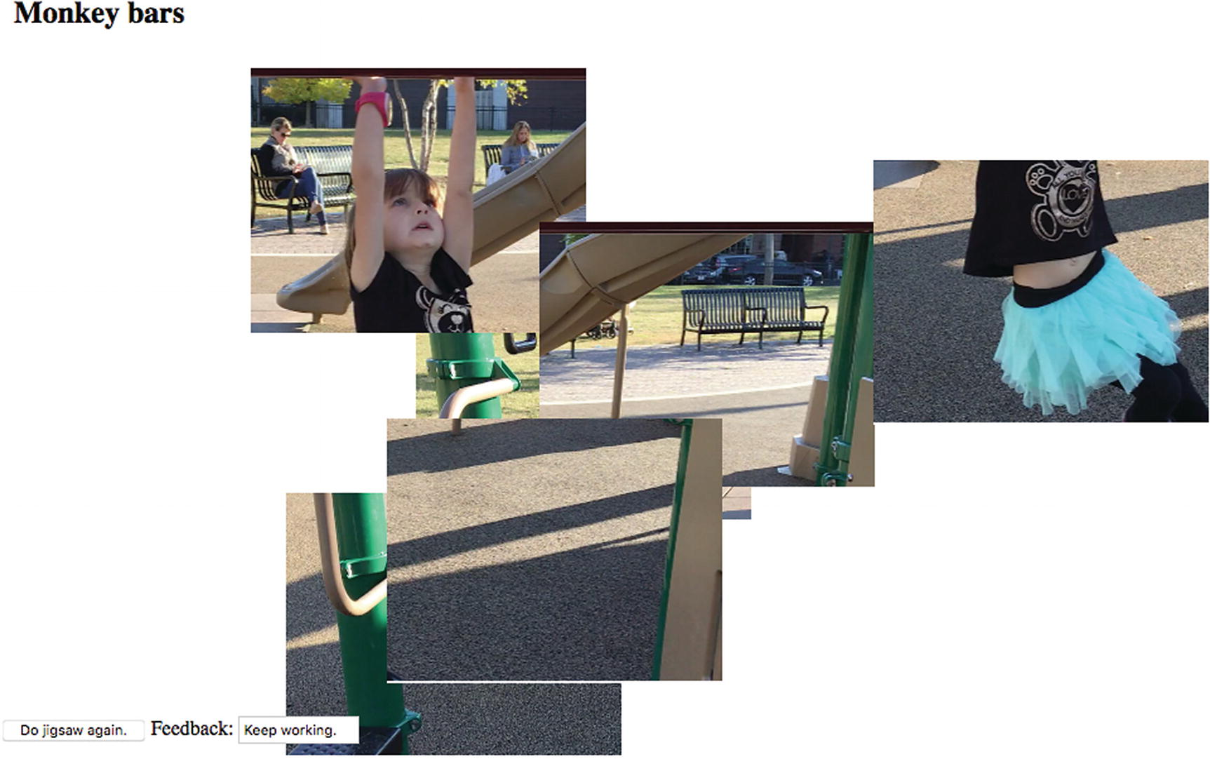
Figure 8-1Opening screen on computer
On a computer, the player uses the mouse to move and reposition pieces. Randomly positioned pieces may end up on top of each other. Figure 8-2 shows the jigsaw pieces spread out. I did this using the mouse. My example has six rectangular-shaped pieces.
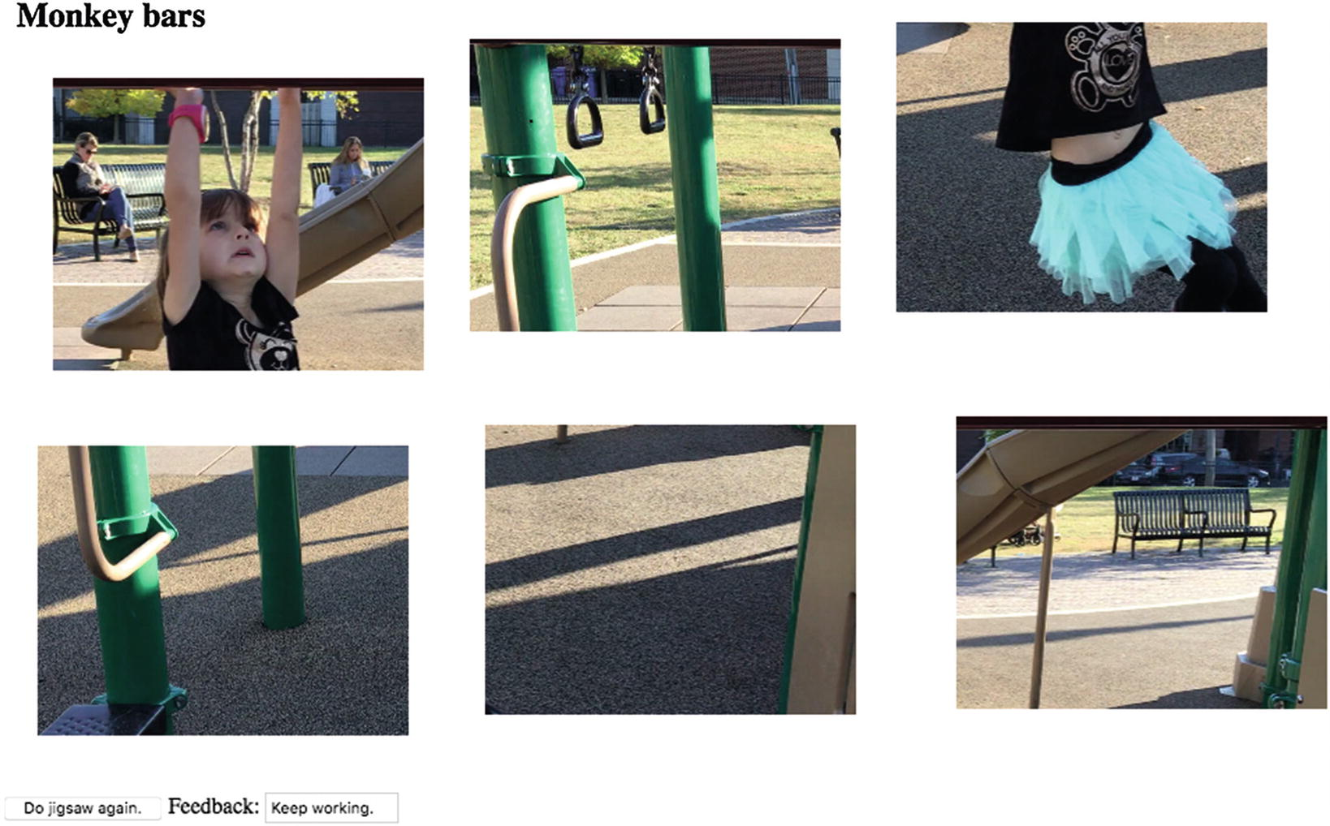
Figure 8-2Pieces spread out
Figure 8-3 shows how I made progress in putting the puzzle together. I can position the puzzle anywhere on the screen. Three pieces of the puzzle have been put together.
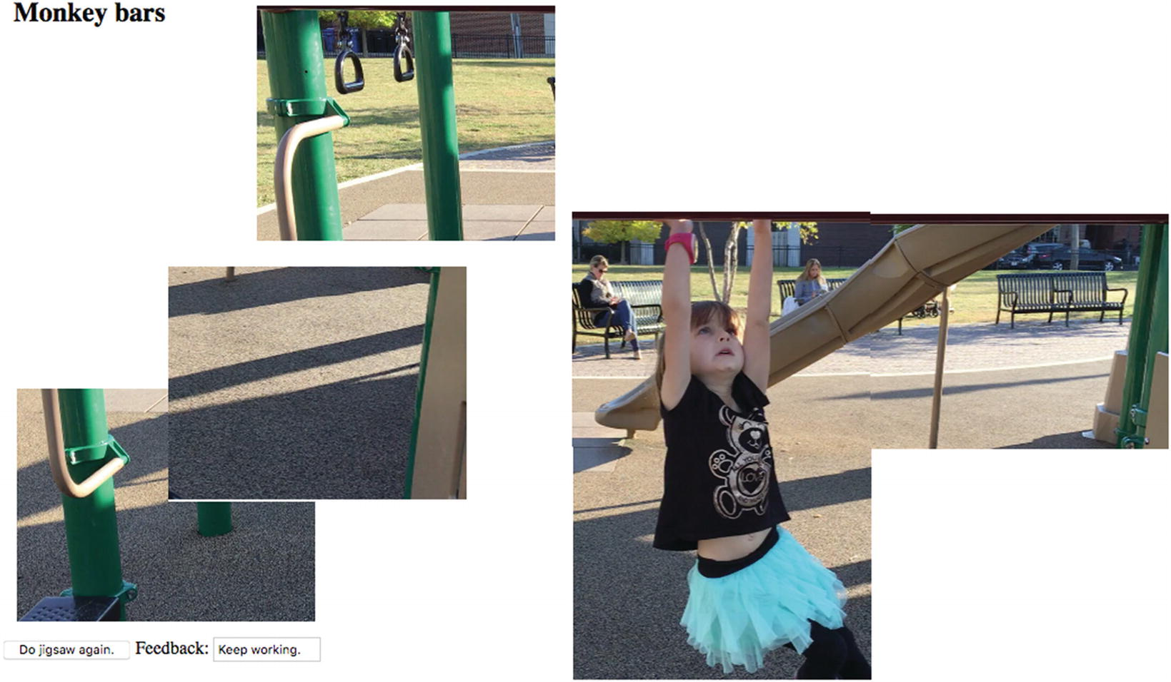
Figure 8-3Progress made on the puzzle
Notice that the box with the label Feedback says to keep working. Figure 8-4 shows the puzzle nearly complete .
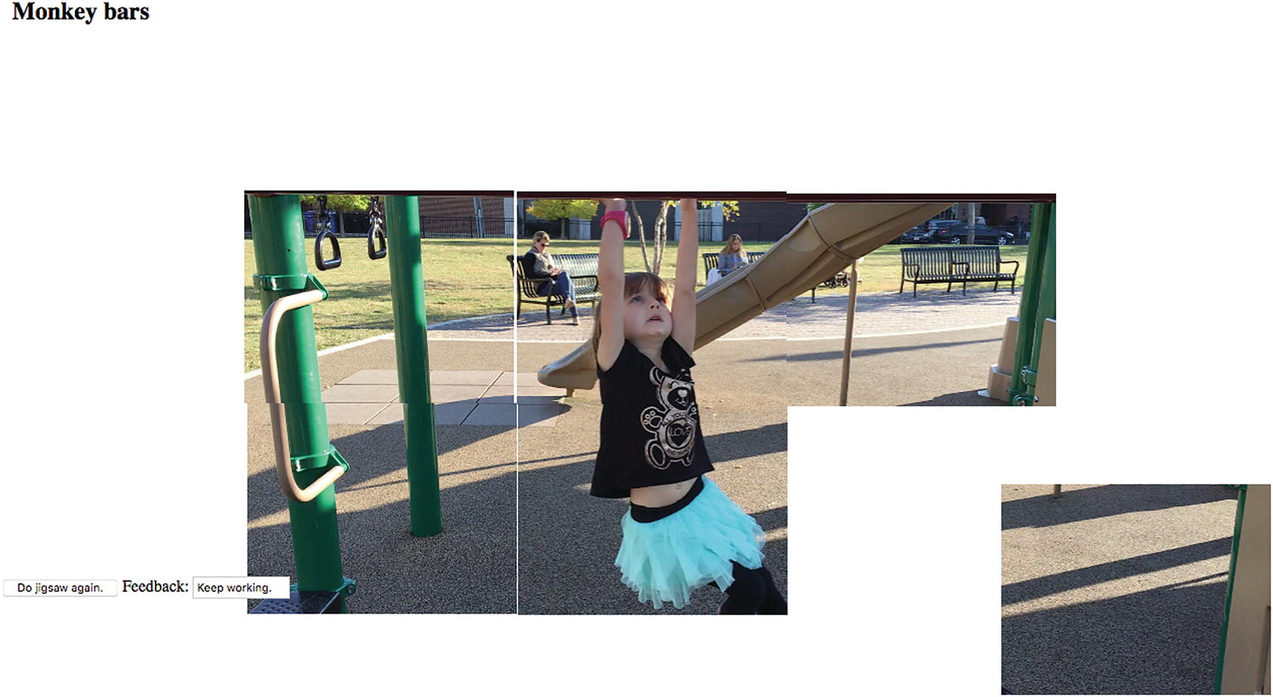
Figure 8-4Just one piece left to fit into the jigsaw puzzle
The program allows for a margin of error, which I term the tolerance , when putting the pieces together. You can see by noticing the white gaps that the puzzle is not perfectly put together. When I move in the last piece, Figure 8-5 shows a screen capture shortly after my last move.
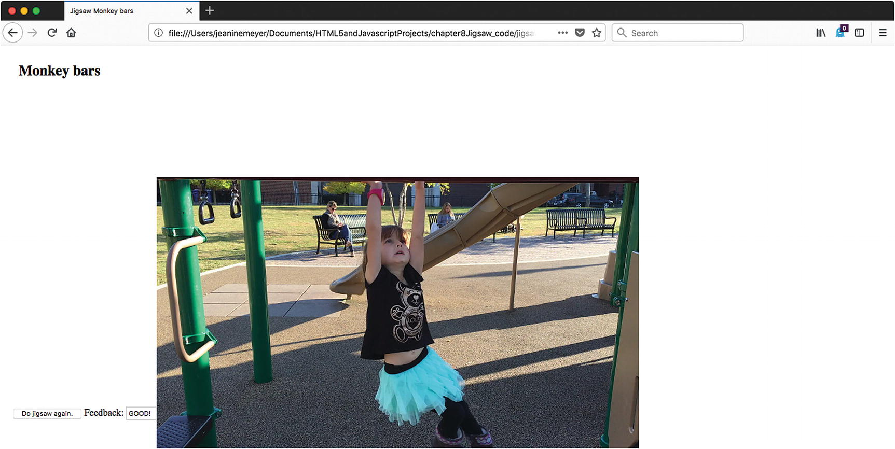
Figure 8-5Pieces replaced by a video
Notice that the feedback now reads “GOOD!” A video has begun to play and I stopped it and reset to the start to obtain this screenshot. The picture appears perfect. In fact, the six jigsaw pieces have been replaced by the video. Figure 8-6 shows the video with controls showing. The controls do not show automatically, but can be seen if the player puts the mouse on top of the lower part of the video. The video controls vary across the different browsers.
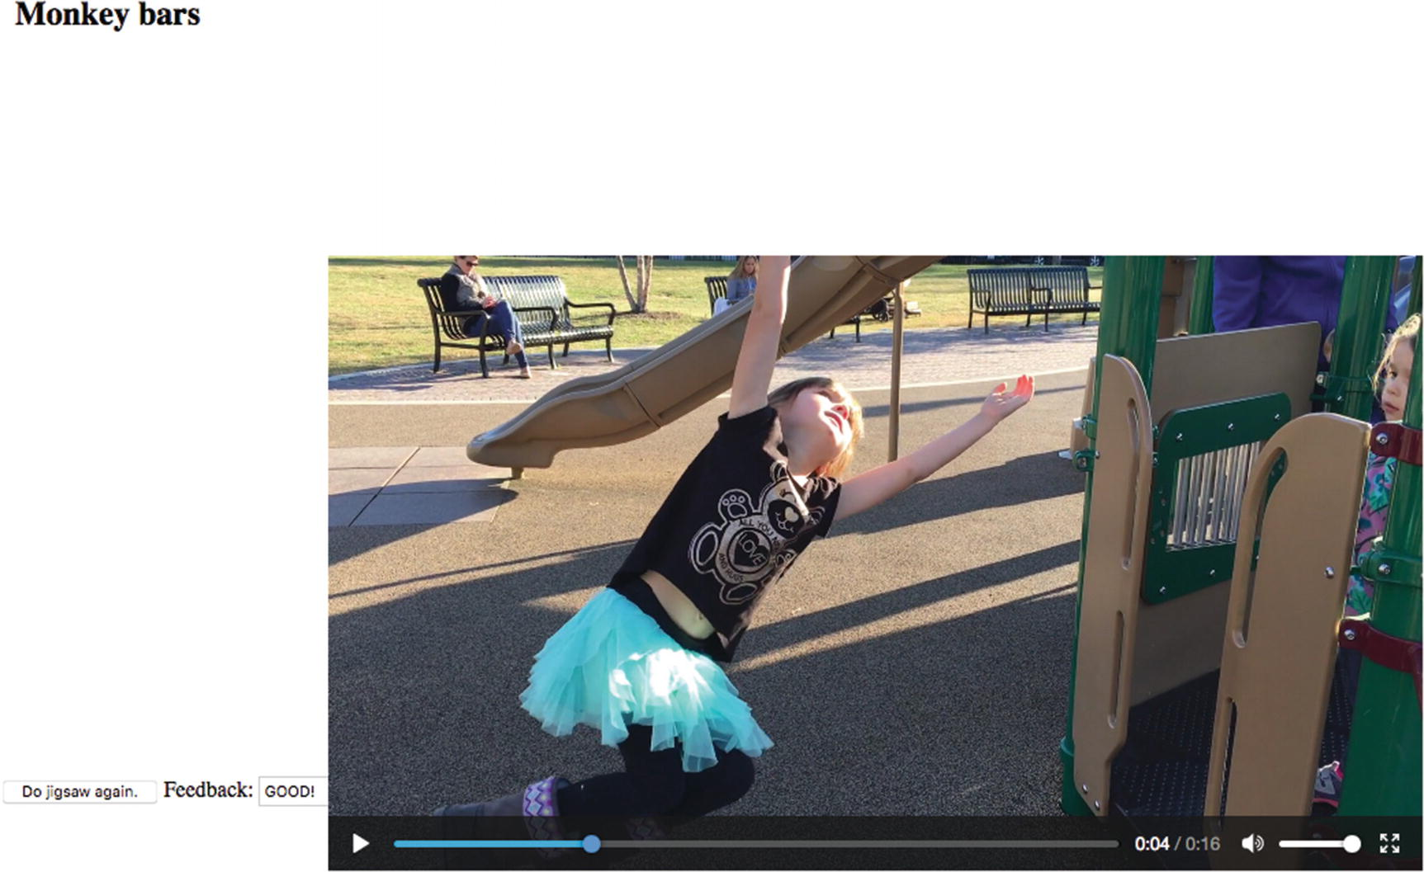
Figure 8-6Video clip with controls
I decided to take the challenge of making the project work for an iPhone, iPad, and Android phone. This meant constructing a user interface that allows the player to use finger touches. To be more precise and demonstrate my ambitions, I wanted to produce one program as a website that would work for both mouse and touch. I will postpone the explanation on how to respond to touch until Chapter 10, “Responsive Design and Accessibility”. In this chapter, I address the issue of modifying the program to work with windows of different dimensions. This can be checked out on a desktop by changing the width and/or height of the window.
Note that the Apple operating systems on mobile devices may require users to click the Play button to start all videos. This is considered a feature, not a bug, by Apple. Requiring a click does give the owners of the devices a chance to prevent downloading of a video, which takes time and battery power and may incur fees. For the jigsaw-to-video project, I would prefer it to be seamless and that is what it is on a desktop or laptop computer. The program does exhibit seamless behavior using Chrome on my Mac desktop, so the autoplay policy discussed in Chapter 2 appears to be satisfied.
With this introduction to what can be called the jigsaw-puzzle-with-video-reward project, we can go on to discuss the requirements for the project and the implementation.

Background and Critical Requirements
Three distinct circumstances inspired me to want to build this particular project. I had built jigsaw puzzles turning into videos in Adobe Flash for a Programming Games course that I taught, and many students were happy to use them as models for their own projects. When I was working on a US states educational game, which is the subject of Chapter 9, I decided a jigsaw activity to put the states together was a good addition to other questions such as asking the player to identify a state by clicking on the state in a map of the whole USA. Lastly, I frequently receive videos of family members and so shameless incorporated them into my teaching examples. These circumstances were the motivation to create the jigsaw turning into video project.
The requirements for this project start with the challenge of creating the jigsaw pieces. One approach is to create—cut up—the base picture outside of this program. If you do this, you must record the relative locations of each jigsaw piece. You can make the pieces more irregular than in this example. See the “How to Build the Application and Make It Your Own” section for ideas. I describe a different approach here. My program cuts up the base picture. The pieces are the same rectangular shape.
After making the adjustments to fit the window, the main technical requirement is to build the user interface. The user interface consists of the mouse or finger touch actions to move individual pieces , along with a button to do the jigsaw again and feedback provided in a text field.
The program presents the pieces randomly positioned on the screen. The player then moves pieces to construct the image. After each release of a piece, the program performs a calculation to see if the puzzle has been solved. This calculation must satisfy two requirements. The puzzle can be put together anywhere on the screen so the calculations must be done in terms of relative positions. Secondly, there needs to be a tolerance in the positioning of the pieces, since we can’t require the positioning to be perfect (i.e., to the pixel).
When the puzzle is deemed complete, it turns into a video. More accurately, a video appears where the pieces were located on the screen.

HTML5, CSS, JavaScript, and Programming Features
The features used for the jigsaw video project are a mixture of HTML5 constructs and general programming techniques.

Creating the Base Picture
The first step is to create an image file from the first frame of the video. How you do this depends on the tools you have and what you feel comfortable using. I used the Grab tool on my Mac. Other possibilities are pressing the PC Print Screen key twice to capture the screen, or pressing Command+Shift+4 to get crosshairs on the Mac. There also is SnagIt. If you have a video editing tool, you can access the first frame using the tool. An alternative is to have the jigsaw picture be independent of the video. This would never have occurred to me, but someone did suggest it.

Dynamically Created Elements
In Chapter 2, you read about the Family Collage project, in which images were repositioned on a canvas. I take a somewhat different approach here. Each piece will be its own canvas element, with the markup created dynamically and sections of the base image drawn on each canvas. The pieces are created in a function called makePieces invoked by the init function . The game is set up using a function called setupGame , also invoked from init. The fact that I have three functions—init, makePieces and setupGame—is partially an artifact of the history of this project. I reused code created for the US states game, in which the jigsaw puzzle was just a part. However, breaking up a function into smaller pieces generally is a good thing to do. The init function does some work, calls makePieces, does some more work, and then calls setupGame. The setupGame function is also invoked from endjigsaw so the player can play the game again. Often, I am too lazy to allow a player to play again because this can be challenging. What needs to be reset and what doesn't? However, I decided to make the effort in this case. The pieces are not re-created but are positioned randomly once again in the window. The way I created this application is not the only way it could be done. In some situations, here and in other chapters, I chose to write a function that is more general than needed, and in others I did not.
The base image (img) and the video elements are each specified in the HTML body. Directives in the style element make each of these invisible. The base img is never made visible, but its contents are used to build the pieces. The init function is invoked by the action of an onload attribute in the body tag. This means that game play will not start until the base image file and the video files are loaded. The init function does some housekeeping tasks of obtaining references to elements and invokes the makePieces and the setupGame functions.
The makePieces does the task of determining the adjustments required to fit the window dimensions. It then virtually cuts up the jigsaw pieces. To adjust the pieces and the video to different windows and preserve the proportions, I need to determine the relationship of the base image and the window. I decided I wanted the base width to be no more than 80% of the window.innerWidth and the base height to be no more than 80% of the window.innerHeight. I also did not want the base to be grow in size if the width and height was less than those amounts. The following statements produce in the variable ratio, the critical factor:
origW = base.width;
origH = base.height;
var ratio =Math.min(1.0,.80*window.innerWidth/origW,.80*window.innerHeight/origH);
You can think it out this way: if the origW value is bigger than .80*window.innerWidth, it means that my code needs to shrink the picture. In this case, the second parameter to the Math.min function will be less than 1. The same can be said regarding height. Whichever factor is the least gets assigned to the ratio variable. If both of these factors are greater than 1, then ratio is set to 1 and the pieces and the video are not increased in size. If one of these factors is less than one, then ratio will be set to less than 1. The following statements use ratio to set the critical variables. The invocation of the drawImage function will use opieceW, opieceH, pieceW, and pieceH to create the jigsaw pieces from the original base. The jigsaw pieces and the video may be changed from the original dimensions.
baseImgW = origW*ratio; //possibly modified
baseImgH = origH*ratio; //possibly modified
v.width = baseImgW; //possibly modified video width
v.height =baseImgH; //possibly modified video height
opieceW = origW/numOfCols; //width of the source for a jigsaw piece
opieceH = origH/numOfRows; //height of the source for a jigsaw piece
pieceW = ratio*opieceW; //jigsaw piece width
pieceH = ratio*opieceH; //jigsaw piece height
The makePieces function invokes drawImage to extract and scale pieces of the base image to be drawn, each into its own newly created canvas element. This operation takes place within nested for loops. The base image is divided into numOfRows and numOfCols. The pieces, that is, references to the canvas elements and the x value and the y values are each stored in the arrays pieces, piecesx and piecesy. Think of the drawImage method as performing the jigsaw operation, although it is more complicated because scaling takes place:
for(i=0.0; i<numOfRows; i++) {
for (j=0.0; j<numOfCols; j++) {
//Some other tasks
sCTX.drawImage(base, j*opieceW, i*opieceH, opieceW, opieceH, 0, 0, pieceW, pieceH);
//Some other tasks
}
}
The base image has not been changed. The sCTX is the context for the canvas created for each piece. The drawImage function extracts—clips—a section of the base image starting at j*opieceW and i*opieceW and opieceW wide and opieceH high. It draws this piece of the image into the sCTX canvas element, scaling it to be pieceW and pieceH. This takes up the whole canvas.
You can examine the complete code in Table 8-2. The canvas pieces are made visible by appending them to the body element and also setting the style attribute visibility to visible. The addEventListener method for each canvas element sets up the response to mousedown for each canvas. The code arranges the pieces so that they resemble the original picture, the first frame of the video clip. However, the setupGame function is invoked soon afterward so the player will not see the puzzle solution. After the nested for loops, another initialization is performed. The firstpkel variable points to the newly created element holding the first piece, the piece in the top-left corner. This is the reference point the code uses to position the video clip. The calculation that positions the pieces correctly in relation to each other is independent of the location of the first piece.

Setting Up the Game
The work of setting up the jigsaw puzzle starts with stopping the video and making it not display. This isn’t necessary the very first time, but it is easier to have the code always perform these operations. The next task is to place the pieces randomly on the screen. The code does this using Math.random and Math.floor . The display attribute is set to inline to make the pieces visible, but not with a line break, which would be the case if the code used block. When the circumstances occur to play the video, all the pieces are made invisible by setting the display to none, so this code is necessary. Note that the variable v has been set in the init function to point to the video element.
function setupGame() {
var i;
var x;
var y;
var thingelem;
v.pause();
v.style.display = "none";
doingjigsaw = true;
for (i=0;i<nums;i++) {
x = 10+Math.floor(Math.random()*baseImgW*.9);
y = 50+Math.floor(Math.random()*baseImgH*.9);
thingelem = pieces[i];
thingelem.style.top = String(y)+"px";
thingelem.style.left = String(x)+"px";
thingelem.style.visibility='visible';
thingelem.style.display="inline";
}
questionfel.feedback.value = " ";
}
NoteIf you notice that a certain amount of complexity occurs in the coding to handle the issue of replaying the jigsaw game, this is typical. Restarting, reinitializing, and so on are more of a challenge than programming something to happen just once.

Handling Player Actions
My approach was to implement the mouse events first and get those working. Then, when my ambitions rose to build an application for certain family members who use iPhones and iPads, I implemented the finger touch by making a touch event simulate a mouse event. I explain the mouse events in this chapter and the coding for touch in Chapter 10.

Using Mouse Events
The tasks for moving the jigsaw pieces are to
Recognize that the mouse button is down and the mouse is on top of a piece
Move the piece when the mouse moves, adjusting the location to make sure that the piece doesn’t jump, but remains as if the cursor were attached to its original position, perhaps in the middle of the element.
Release or drop the element when the player has released the mouse button.
You may recall similar operations in Chapter 2. This reasoning suggests that my code will set up at least three events, and this is what happens. In the makePieces function , the following statement is executed in the nested for loops that create a canvas element for each piece. The variable s holds the reference to the canvas element.
s.addEventListener('mousedown',startdragging);
This sets up event handling for mousedown for each piece. The startdragging function sets a variable named movingobj to be the event target, which is the specific jigsaw piece. The function also sets the global variables oldx and oldy to the position of the mouse. The function sets up event handling for mousemove and mouseup.
movingobj.addEventListener("mousemove",moving);
movingobj.addEventListener("mouseup",release);
Notice that nothing happens if the mouse is not over a piece when the player presses down on the mouse button because the only events “listened to” are events over the canvas elements. The moving function is:
function moving(ev)
{
if((movingobj!=null) &&(mouseDown)){
newx = parseInt(ev.pageX);
newy = parseInt(ev.pageY);
delx = newx-oldx;
dely = newy-oldy;
oldx = newx;
oldy = newy;
curx = parseInt(movingobj.style.left);
cury = parseInt(movingobj.style.top);
movingobj.style.left = String(curx+delx)+"px";
movingobj.style.top = String(cury+dely)+"px";
}
};
Checking that movingobj is not null and mouseDown is true is redundant, but I decided to keep it just in case I want to add something in the future. The moving function performs a relative move of movingobj . The moving jigsaw piece is moved by the same amount horizontally and vertically as the mouse is moved. It does not matter where on the piece canvas the mouse is positioned. Whatever the changes from the last time that the mousemove event has occurred, the piece canvas is adjusted using the same changes.
The release function is invoked when the player releases the mouse button. I handled a failure of release to be invoked when one piece is on top of another by setting up another event:
document.body.onmouseup = release;
There is no problem with invoking release multiple times.
function release(e){
mouseDown = false;
movingobj = e.target;
movingobj.removeEventListener("mousemove",moving);
movingobj.removeEventListener("mouseup",release);
movingobj=null;
checkpositions();
}
Changing the variable mouseDown to false means that nothing will happen if and when the player moves the mouse until the player presses down on the mouse button again, invoking the startdragging function . This completes the mouse event handling. The checkpositions function is explained in the next section.

Calculating If the Puzzle Is Complete
Recall that I set the requirements for calculating if the puzzle is complete to be that the puzzle can be located anywhere on the screen and that the player does not have to be precise. Another more-or-less implicit requirement is that the checking be done automatically. After the player releases the mouse or lifts his or her finger, the release function invokes checkpositions. The checkpositions function is called after each move. Don’t worry, JavaScript is doing the work, not you.
The checkpositions function computes the difference between the piecesx value and the style.left value of each piece element, and the difference between the piecesy value and the style.top value of each piece element. The style.left and style.top values are character strings, not numbers, and include "px". The code needs to remove the "px", which stands for “pixels,” and calculate the numeric value. The differences are stored in the arrays deltax and deltay .
The function calculates the average of these differences (one for x and one for y). If the puzzle were put together exactly according to the values in the piecesx and piecesy arrays , the differences would each be zero, and consequently, the averages for x and for y would each be 0. If the puzzle were put together such that the actual locations were each 100 pixels closer to the left side—that is, more left and 50 pixels further down the page, that is higher value y, then the averages would be 100 and 50. The puzzle would be put together perfectly, but at a location to the left and below the original location. The differences for x for all pieces would be 100 and the differences for y for all pieces would be 50. Each of the differences would have the same value as the corresponding (x or y) average.
The goal is to not require perfection. The tasks of the checkpositions function are to compute the differences in x and y, compute the two averages, and check if each of the differences is close enough to the average.
After computing the difference values, the function performs these tasks by iterating over each piece to compare it with the corresponding average. The check is done using absolute values, because our code doesn’t care if a piece is a few pixels left or right or up or down. The criteria for being close enough is the value held in the variable tolerance . If the gap is bigger than tolerance for any piece, the puzzle is not considered complete. The critical if test is
if ((Math.abs(averagex - deltax[i])>tolerance) || (Math.abs(averagey-deltay[i])>tolerance)) {
break;
}
The doaverage function computes and returns the average value of numbers in an array. This is accomplished in the usual way. The variable sum is called an accumulator . It is initialized to 0. A for loop iterates over the elements in the array, adding each one to the variable sum.
function doaverage(arr) {
var sum;
var i;
var n = arr.length;
sum = 0;
for(i=0;i<n;i++) {
sum += arr[i];
}
return (sum/n);
}
To summarize the action a different way, the checkpositions function uses the first for loop to determine the differences in current horizontal and vertical position of each piece. It then computes two averages: for x and for y. Then the function uses a second for loop to see if the horizontal or vertical difference for any piece is significantly different in absolute value from the relevant average. As soon as this happens, control leaves the for loop and the puzzle is deemed not complete. If the loop has completed, the puzzle is complete and the video is positioned and played. The checkpositions function is shown in Table 8-2. I chose to display a message to the player giving feedback on the puzzle. The form element questionfel holds a reference to the form, and feedback is an input field.
I will describe what happens when the puzzle is deemed complete in the next section.

Preparing, Positioning, and Playing the Video and Making It Hidden or Visible
Preparing the video clip is the same as what you have seen for the other projects involving video. You need to create multiple encodings of the video. Also, as with the other projects, when we do not want the video to appear until a certain situation occurs, the style section contains the directive to make the video initially not visible, set it up to be positioned absolutely, and (when it is displayed) put it in the window at the same location as firstpkel, the upper-left corner piece. The relevant code is
v.style.left = firstpkel.style.left;
v.style.top = firstpkel.style.top;
v.style.display="block";
v.currentTime = 0;
v.play();
The video may demonstrate different behavior in different circumstances. Specifically, on an iPad or iPhone, the player may need to click an arrow to play the video. On my desktop (and I am using an iMac) using Chrome or Firefox and on an Android phone, the video starts automatically, which is what I prefer. In Chapter 2, I discussed the issue of the autoplay policy. I have not muted the monkey bars video. It may be that the calculation performed in Chrome for media engagement index (see https://developers.google.com/web/updates/2017/09/autoplay-policy-changes ) produces these results.
You have seen several HTML5 features to use, as well as programming tricks you can use in other applications. The next section shows you the bulk of the code for the project. The entire program is stored with the source code. I include the program for the same application, but using touch, with the source code for Chapter 10.

Building the Application and Making It Your Own
You can make these projects your own by using your own video clip. You also can make a jigsaw puzzle by itself, though you probably should wait to read the next chapter, which describes a more elaborate jigsaw puzzle and contains pointers on how to cut up more intricate shapes. If the pieces have transparent areas, you still would set up the mousedown event for the whole canvas element. But, you would then code a check if the pixel “under” the mouse is or is not transparent.
Another approach to jigsaw puzzles is to check if a piece is close enough to another piece, using some tolerance or margin calculation, and snap them together. Your code must then move the snapped together pieces together.
You may decide to omit or change the feedback of Keep working or Good. My implementation has the Do Jigsaw Again button and the feedback box on top of pieces but under the video clip. This means that if the player chooses to create the puzzle so that the do over button is hidden, there is no way except re-loading to start again.
Here is an informal summary/outline of the jigsaw-to-video project:
init: For initialization, including invoking calls to setupGame and setupjigsaw.
makePieces: For creating the pieces.
setupGame: For randomly positioning the pieces and setting up event handling.
endjigsaw: For stopping the video and making it not display and then invoking setupGame for a new game.
startdragging, moving, release: For handling events.
checkpositions: For determining if the puzzle is complete.
doaverage: For calculating the average of values in an array.
Table 8-1 lists all the functions and indicates how they are invoked and what functions they invoke.
Table 8-1 Functions in the Jigsaw-to-Video Project
Function | Invoked/Called By | Calls
init | Invoked by action of the onLoad attribute in the <body> tag | makePieces, setupGame
makePieces | Invoked by init
setupGame | Invoked by init and endjigsaw
endjigsaw | Invoked by the onSubmit setting in the form in the body | setupGame
checkpositions | Invoked by release | doaverage
doaverage | Invoked by checkpositions
startdragging | Invoked by event setting in makePieces
moving | Invoked by event setting in startdragging
release | Invoked by event setting in startdragging for individual pieces and makePieces for the body | checkpositions
Table 8-2 shows the code for the basic application, with comments for each line. Much of this code you have seen in the previous chapters.
Table 8-2 Complete Code for the Jigsaw-to-Video Project
<!DOCTYPE html> | Header
<html> | html tag
<meta charset="UTF-8"> | Specific character set
<head> | head tag
<title>Jigsaw Monkey bars | title for tab
</title> | Closing title tag
<style> | Style tag
#base {position:absolute; border:none; visibility: hidden;} | Make base image start out hidden, absolute positioning
form {position: absolute; z-index: 10;} | Put form on top of pieces
body { height:100%; margin: 30px;} | Format for body
video {display:none; position:absolute; z-index: 100;} | Make video start out not displayed; places on top of pieces
</style> | Close style
<script type="text/javascript"> | script tag
var pieces = []; | Will hold pieces
var nums; | Will hold number of pieces
var baseImgW; | Will hold adjusted width of base image
var baseImgH; | Will hold adjusted height of base image
var origW; | Original width of base
var origH; | Original height of base
var opieceW; | Calculated width of a piece in terms of base image
var opieceH; | Calculated height of a piece in terms of base image
var pieceW; | Width of a piece; result of scaling operation
var pieceH; | Height of a piece; result of scaling operation
var numOfRows = 2.0; | Number of rows
var numOfCols = 3.0; | Number of columns
var piecesx = [ ]; | Will hold original x coordinate for all pieces
var piecesy = [ ]; | Will hold original y coordinate for all pieces
var v; | Will hold reference to video element
var base; | Will hold reference to base img
var doingjigsaw = false; | Flag for when jigsaw is in play
var firstpkel; | First piece, located in upper-left corner
var oldx; | Will hold previous x coordinate of moving item
var oldy; | Will hold previous y coordinate of moving item
var questionfel; | Reference to question (status) element
var mouseDown = false; | Flag indicating a piece is being dragged
var movingobj; | Will hold reference to current moving piece
function init(){ | Header for init
v = document.getElementById("bars"); | Get reference to video
base = document.getElementById("base"); | Get reference to base image
makePieces(); | Invoke makePieces
nums = pieces.length; | The pieces array is now set and populated and so can store the length
questionfel = document.getElementById("questionform"); | Reference to place to display form holding do over button and feedback
questionfel.style.left = "20px"; | Location of form
questionfel.style.top = "600px"; | Location of form
questionfel.submitbut.value = "Do jigsaw again."; | Label on the form submit button
setupGame(); | Invoke function to set up puzzle, mainly randomly placing pieces
} | Close init
function makePieces() { | Header for makePieces function
var i; | Indexing variable
var x; | Will hold horizontal coordinate
var y; | Will hold vertical coordinate
var s; | Will hold reference to each dynamically created canvas element for holding a piece
var sCTX ; | Context for canvas elements
origW = base.width; | Width of base image
origH = base.height; | Height of base image
var ratio =Math.min(1.0,.80*window.innerWidth/origW,.80*window.innerHeight/origH); | Computes the required scaling factor
baseImgW = origW*ratio; | Scaled width
baseImgH = origH*ratio; | Scaled height
v.width = baseImgW; | Set width of video after scaling
v.height =baseImgH; | Set height of video after scaling
opieceW = origW/numOfCols; | Compute the width of the portion of the base image to be scaled and drawn on each canvas element
opieceH = origH/numOfRows; | Compute the height
pieceW = ratio*opieceW; | Compute the actual width of each canvas piece
pieceH = ratio*opieceH; | Compute the actual height
for(i=0.0;i<numOfRows;i++) { | for loop going through the rows
for (j=0.0;j<numOfCols;j++) { | for loop, within a row, going through the columns
s = document.createElement('canvas'); | Create a canvas
s.width = pieceW; | Set its width
s.height = pieceH; | Set its height
s.style.position = 'absolute'; | Set position style
sCTX = s.getContext('2d'); | Set context
sCTX.drawImage(base,j*opieceW,i*opieceH,opieceW,opieceH,0,0,pieceW,pieceH); | Cut out of the base image the section to be scaled and drawn to the canvas
document.body.appendChild(s); | Make visible by appending to the body
pieces .push(s); | Add to the pieces array
x = j*pieceW +100; | Set a temporary x value; think of this as the nominal correct x
y = i*pieceH +100; | Set a temporary y value; think of this as the nominal correct y
s.style.top = String(y)+"px"; | Set the top of this canvas element
s.style.left = String(x)+"px"; | Set the left of this canvas element
piecesx.push(x); | Add value to piecesx for later use in checkposition
piecesy.push(y); | Add value to piecesy for later use in checkpositions
s.addEventListener('mousedown',startdragging); | Set up event handling for a mousedown on this element; Note this is never removed
s.style.visibility='visible'; | Make visible
} | Close inner for
} | Close outer for
firstpkel = pieces[0]; | Set reference to the very first piece
document.body.onmouseup = release; | Makes sure release is invoked for situation when pieces are on top of each other
} | Close makePieces
function endjigsaw() { | Header for endjigsaw; this is end and then re-start
if (doingjigsaw) { | If jigsaw is being done
doingjigsaw = false; | Set doingjigsaw to false
v.pause(); | Pause video
v.style.display = "none"; | Make video not display
} | Close if true clause
setupGame(); | Re-start game
return false ; | Prevents page refresh
} | Close endjigsaw
function checkpositions() { | Header checkpositions
var i; | Indexing variables, used in for loop
var x; | Will hold horizontal value
var y; | Will hold vertical value
var tolerance = 10; | Set margin for checking
var deltax = []; | Will hold differences from nominal x position
var deltay = []; | Will hold differences from nominal y position
var delx ; | Used in calculation for x values
var dely; | Used in calculation for y values
for (i=0;i<nums;i++) { | for loop, to determine horizontal and vertical differences
x = pieces[i].style.left; | Get the left style
y = pieces[i].style.top; | Get the top style
x = x.substr(0,x.length-2); | Remove px
y = y.substr(0,y.length-2); | Remove px
x = Number(x); | Convert to number
y = Number(y); | Convert to number
delx = x - piecesx[i]; | Calculate difference
dely = y - piecesy[i]; | Calculate difference
deltax.push(delx); | Add to array
deltay.push(dely); | Add to array
} | End for loop
var averagex = doaverage(deltax); | Calculate average horizontal difference
var averagey = doaverage(deltay); | Calculate average vertical difference
for (i=0;i<nums;i++) { | for loop to check if any delta (x or y) is more than tolerance from average
if ((Math.abs(averagex - deltax[i])>tolerance) || (Math.abs(averagey-deltay[i])>tolerance)) { | Do comparisons (taking absolute values)
break; | If true, leave loop
} | Close if true clause
} | Close for loop
if (i<nums) { | Look at last I; if this is less than nums, then there was a deltax or deltay that was bigger than tolerance
questionfel.feedback.value = "Keep working."; | Display message
} | Close if true
else { | Else
questionfel.feedback.value = "GOOD!"; | Display message
for (i=0;i<nums;i++) { | for loop to make all pieces not be displayed
pieces[i].style.display = "none"; | Make display none
} | Close for loop
v.style.left = firstpkel.style.left; | Position video horizontally
v.style.top = firstpkel.style.top; | … and vertically
v.style.display="block"; | Make video display
v.currentTime = 0; | Set video at start
v.play(); | Play video
} | Close else
} | Close function
function doaverage(arr) { | Header for doaverage
var sum; | Will hold sum
var i; | Indexing variable
var n = arr.length; | Store length
sum = 0; | Initialize sum
for(i=0;i<n;i++) { | for loop going through items in arr
sum += arr[i]; | Add to sum
} | Close for
return (sum/n); | Return calculated average
} | Close doaverage
function setupGame() { | Header for setupGame
v.pause(); | Pause the video; no action or error if video not being played
v.style.display = "none"; | Make video not display
doingjigsaw = true; | Set flag to true
var i; | Indexing variable
var x; | Will hold horizontal value
var y; | Will hold vertical value
var thingelem; | Will hold reference to pieces (canvases for pieces)
for (i=0;i<nums;i++) { | Loop through all the pieces
x = 10+Math.floor(Math.random()*baseImgW*.9); | Set random value for horizontal position
y = 50+Math.floor(Math.random()*baseImgH*.9); | Set random value for vertical position
thingelem = pieces[i]; | Get the ith piece
thingelem.style.top = String(y)+"px"; | Set the top
thingelem.style.left = String(x)+"px"; | Set the left
thingelem.style.visibility='visible'; | Make visible
thingelem.style.display="inline"; | Set display
} | Close for loop
questionfel.feedback.value = " "; | Erase any previous feedback
} | Close setupGame function
function release(e){ | Header for release
movingobj = e.target; | Set to piece released
mouseDown = false; | Set flag to false
movingobj.removeEventListener("mousemove",moving); | Stop listening for mouse move
movingobj.removeEventListener("mouseup",release); | Stop listening for mouse up.
movingobj=null; | Set this variable to null
checkpositions(); | Invoke checkpositions
} | Close release function
function startdragging(e) { | Header for startdragging
movingobj = e.target; | Store the event target; this is the piece being dragged
mouseDown = true; | Set flag to true
oldx = parseInt(e.pageX); | Store current horizontal value of mouse
oldy = parseInt(e.pageY); | Store current vertical value of mouse
movingobj.addEventListener("mousemove",moving); | Set up listening for mousemove
movingobj.addEventListener("mouseup",release); | Set up listening for mouseuup
} | Close startdragging
function moving(ev) { | Header for moving
if((movingobj!=null) &&(mouseDown)){ | Only do anything if movingobj is defined and mouseDown is true; this is redundant, but may ease later enhancements
newx = parseInt(ev.pageX); | Extract horizontal mouse position
newy = parseInt(ev.pageY); | Extract vertical mouse position
delx = newx-oldx ; | Calculate change (delta) from last value stored in oldx
dely = newy-oldy; | Calculate change (delta) from last value stored in oldy
oldx = newx; | Now, store newx in oldx
oldy = newy; | … store newy in oldy
curx = parseInt(movingobj.style.left); | Extract the number from the style.left for this element
cury = parseInt(movingobj.style.top); | Extract the number from the style.top for this element
movingobj.style.left = String(curx+delx)+"px"; | Reset the style.left using the calculated values and concatenate "px"
movingobj.style.top = String(cury+dely)+"px"; | Reset the style.top using the calculated values and concatenate "px"
} | Close if
} | Close moving function
</script> | Ending script tag
</head> | Ending head tag
<body id="body" onLoad="init();"> | Body tag; note onload attribute
<h2> Monkey bars</h2> | Title displayed
<form id="questionform" name="questionform" onSubmit="return endjigsaw();" > | Form for submit button to end and re-start and for feedback
<input name="submitbut" type="submit" value=" " size="30"/> | Submit button
Feedback: <input name="feedback" value=" " size="11" /> | Feedback field
</form> | Close form
<video id="bars" controls="controls" preload="auto" width="800"> | Video element; put in body so it will be loaded before any action taken
<source src="monkeybars.mp4" > | Type of video
<source src="monkeybars.webm" > | Type of video
<source src="monkeybars.ogv" > | Type of video
Your browser does not accept the video tag. | Note for old browsers
</video> | Close video element
<img src="barsbase.png" id="base" width="800px" height="420px"/> | The img for the base image; t is never shown
</body> | Close body
</html> | Close html

Testing and Uploading the Application
Testing the application requires the video files and the image file for the base image to be in the same folder as the HTML document. You can test the adaptability to different window dimensions by changing the window and reloading.

Summary
In this chapter, you learned how to build a jigsaw puzzle that turns into a video clip. The techniques included the following:
Adapting to different screen dimensions while keeping the jigsaw pieces and the video in proportion.
Forming the jigsaw pieces by dynamically creating HTML elements and setting the HTML markup.
Defining event handling for mouse events.
Placing the jigsaw pieces randomly on the screen at the start of a game and then moving the elements in the response to movement of the mouse.
Producing the code to check if the jigsaw puzzle is complete, within a tolerance.
When appropriate, making the video appear and play.
In the next chapter, we tackle another project that includes a jigsaw puzzle, along with other possible moves by the player. Because a jigsaw puzzle such as my set of the 50 states is challenging, I explain a way to store the puzzle as a work-in-progress using the localStorage feature of HTML5.
© Jeanine Meyer 2018
Jeanine Meyer
HTML5 and JavaScript Projects
https://doi.org/10.1007/978-1-4842-3864-6_9

9. US States Game: Building a Multiactivity Game
Jeanine Meyer1
(1)
New York, USA

In this chapter, you will learn the following:
How to build a user interface for a game involving different types of player moves, including putting together a jigsaw puzzle
How to use the mouse to reposition pieces
How to acquire an image, break it up into pieces, and determine the coordinates for those pieces to produce a jigsaw puzzle
How to encode and retrieve the current state of the jigsaw game
How to use localStorage to store and retrieve the information, including using try and catch for situations when localStorage is not allowed

Introduction
The project for this chapter is an educational game in which the player/student clicks a state on a map of the United States in response to a text prompt, names a state that is indicated by a border by typing in the name, or puts the states that have been randomly positioned on the screen all together again. Figure 9-1 shows the opening screen.
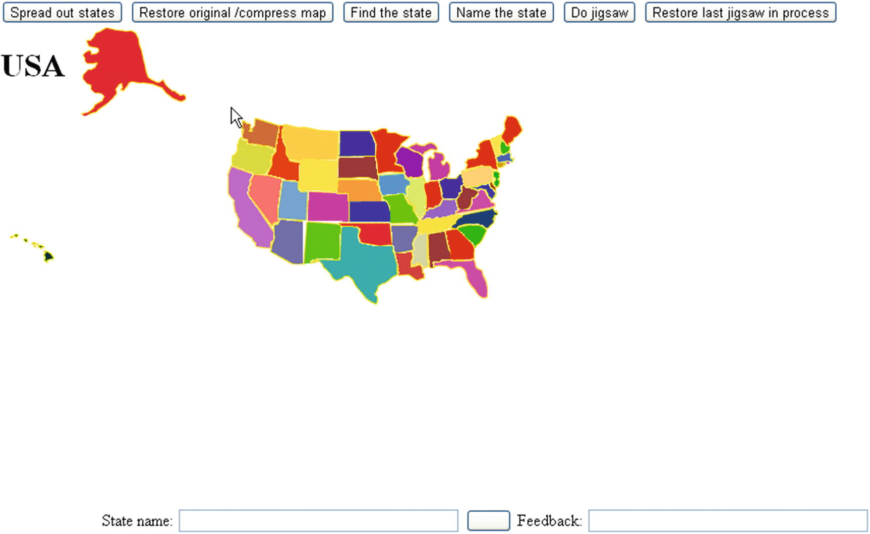
Figure 9-1Opening screen of the US states game
I follow the common practice and present a map with Alaska and Hawaii not in correct position nor proportionally sized. Note also that Rhode Island is bigger than it really is so there’s enough room to click it. The game presents the player with different possibilities. Figure 9-2 shows the result of clicking the Find the State button.
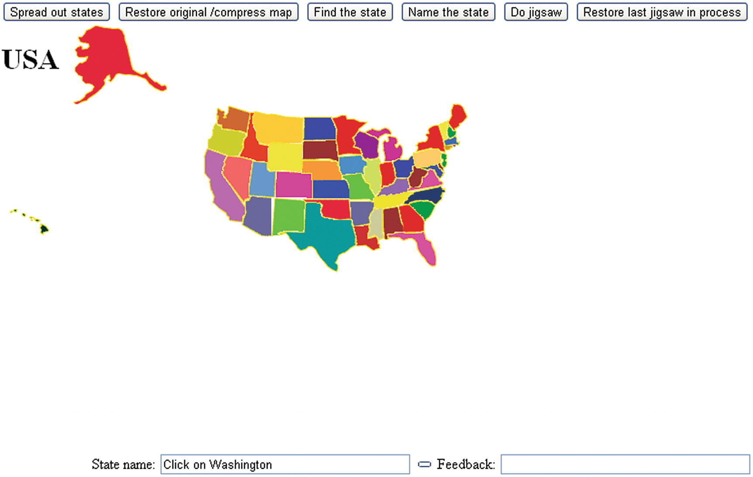
Figure 9-2The prompt is to find Washington
When I clicked Oregon, I saw what is shown in Figure 9-3.
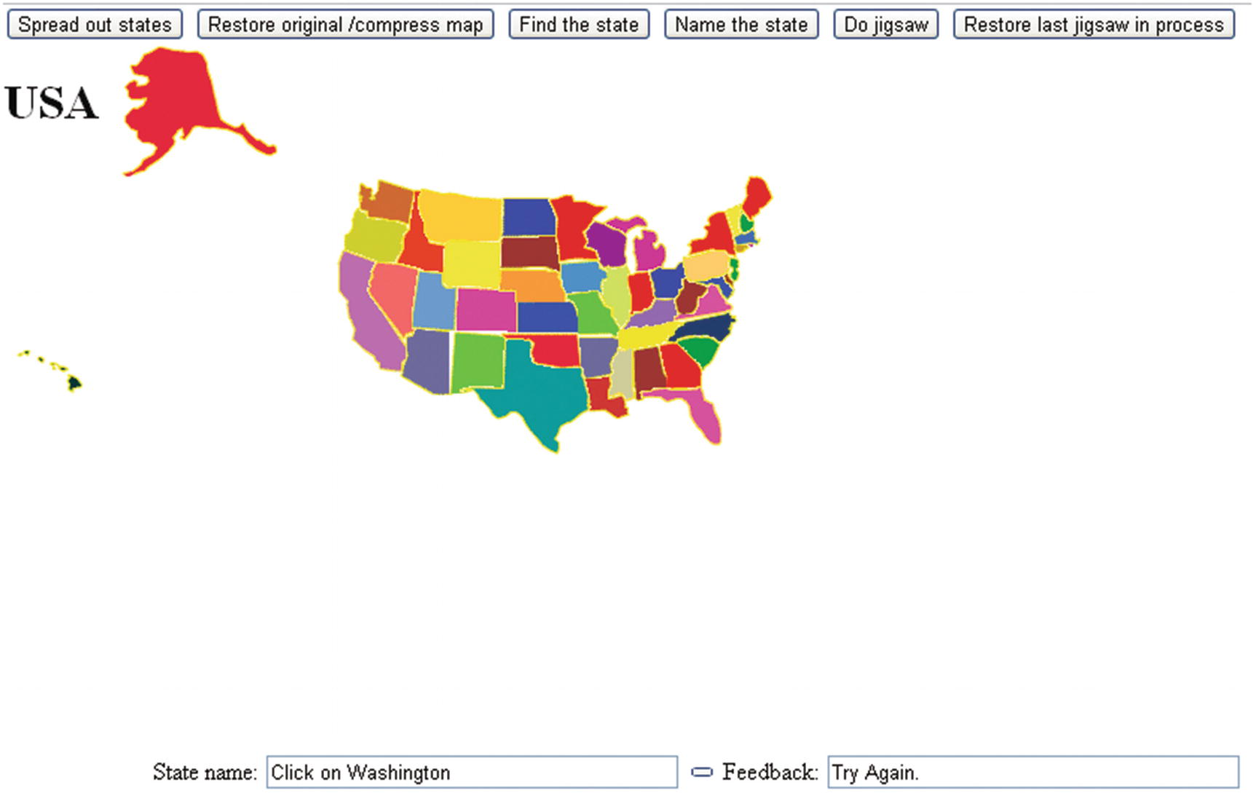
Figure 9-3Response to an incorrect choice
When I clicked the correct choice, the application responded appropriately, as shown in Figure 9-4.
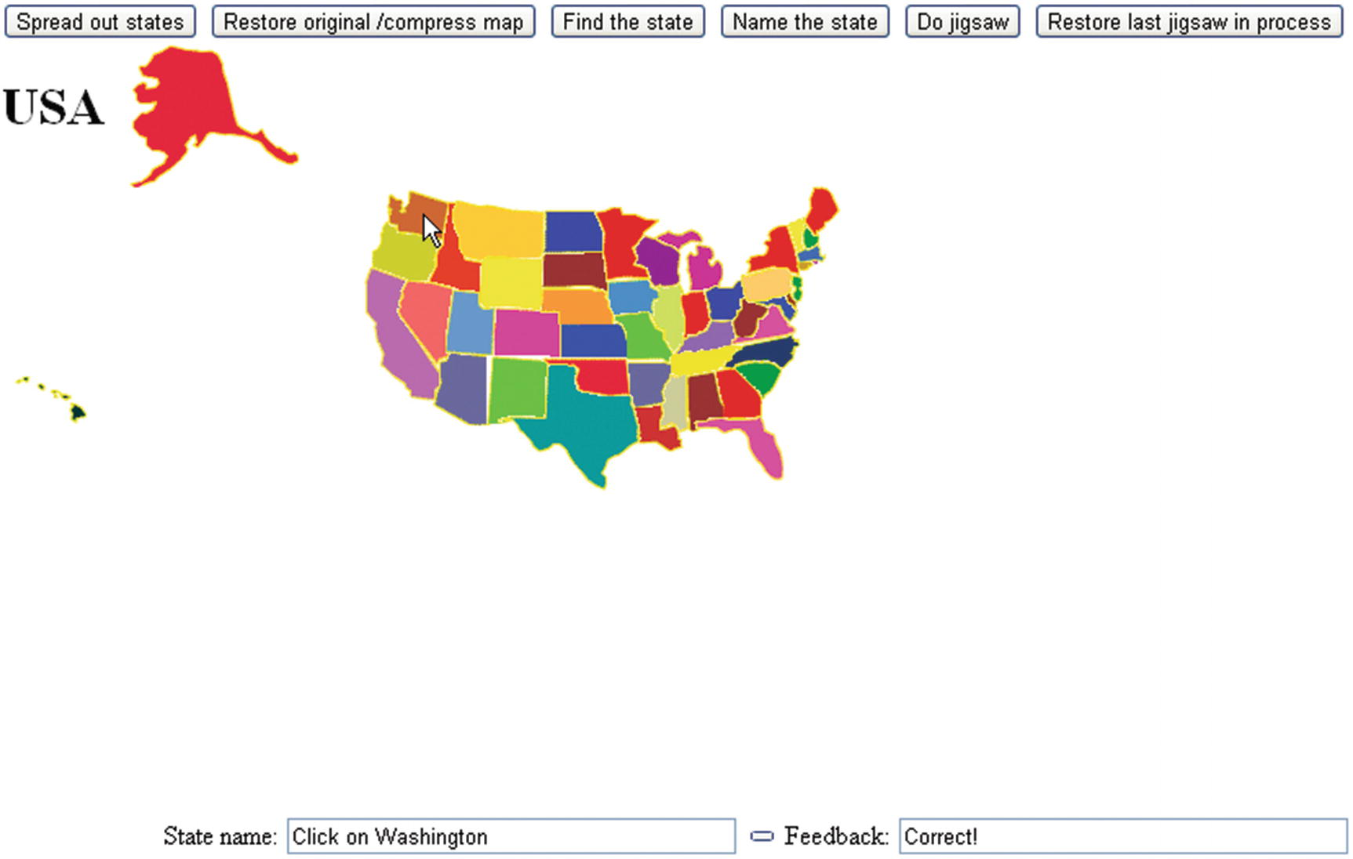
Figure 9-4Response to a correct answer
I decided that it would be helpful to offer the player the option to spread out all the states. After clicking the button labeled Spread Out States, you see what is shown in Figure 9-5.
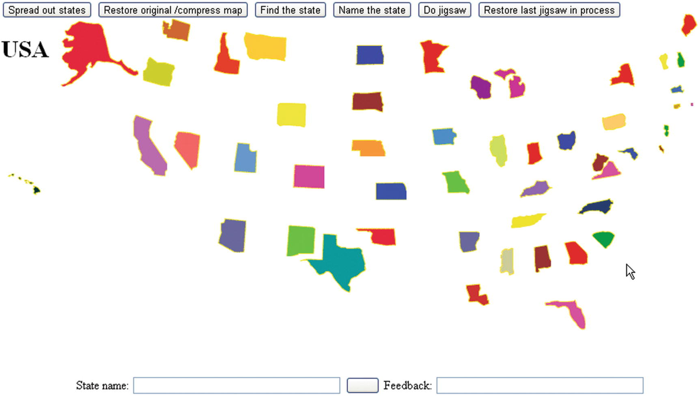
Figure 9-5The states spread out
The player can use the Restore Original/Compress Map button or keep playing with the states spread out. Clicking the Name the State button produces a prompt consisting of one randomly selected state surrounded by a border, as shown in Figure 9-6.
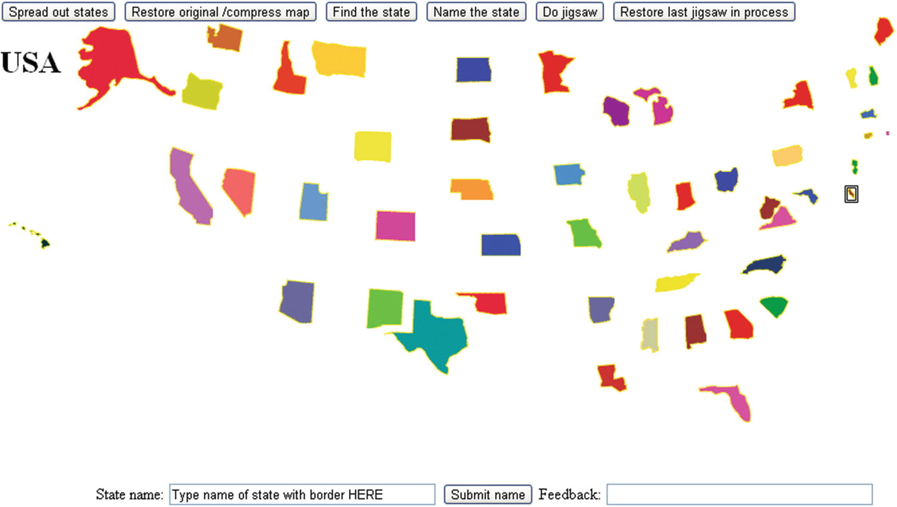
Figure 9-6Border around the state to be named
Notice the double-line border around Delaware, the very small state on the right side (Atlantic coast) in the middle. This demonstrates a case in which the states being spread out would make a real difference for the player. Figure 9-7 shows the response to my typing the correct answer.
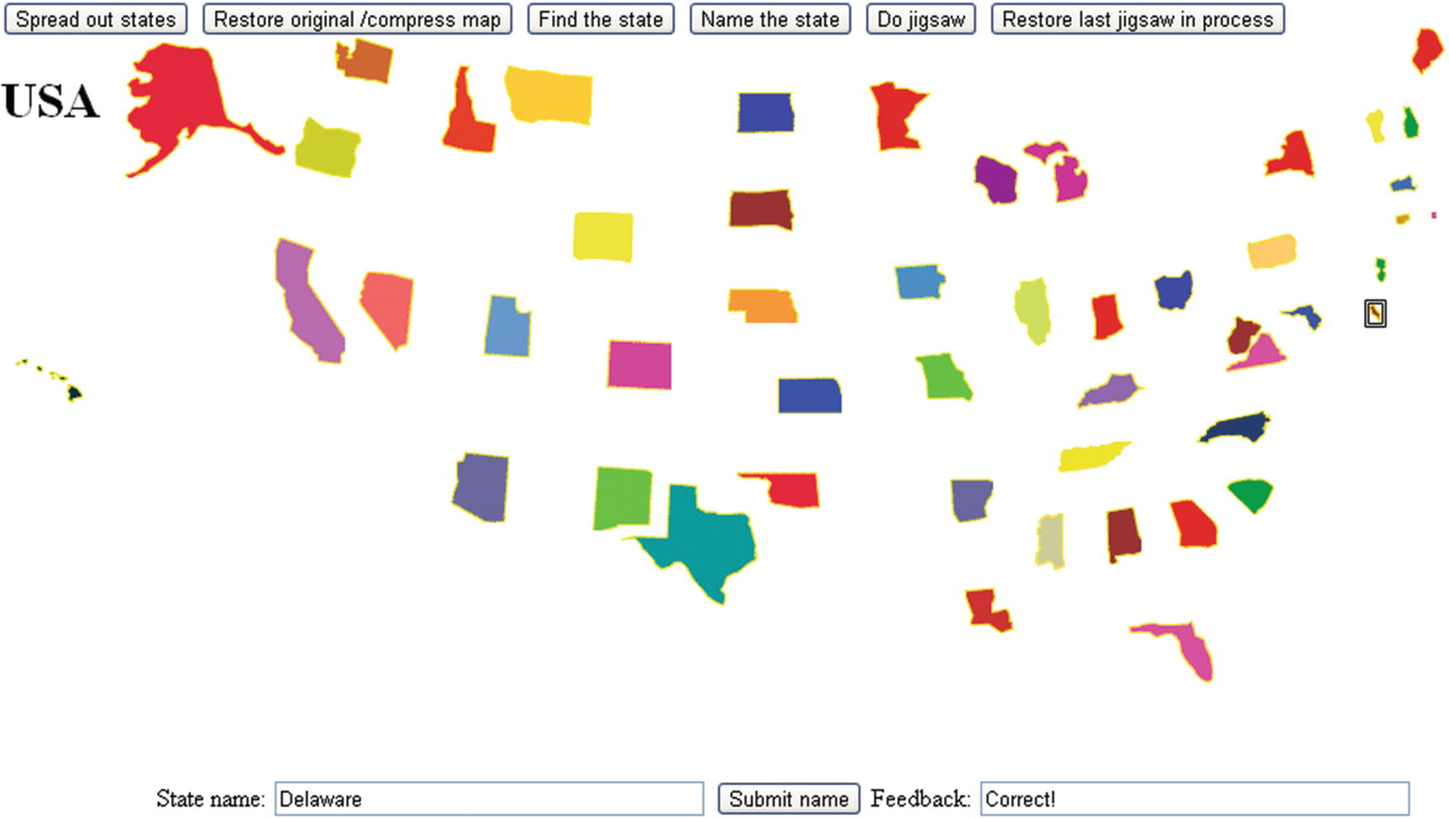
Figure 9-7Response after the correct answer is submitted
The application also provides activity for the player in the form of a jigsaw puzzle. After clicking the Do Jigsaw button, you will see something like Figure 9-8. I say “something like” because the states are arranged using pseudorandom processing, so they’ll appear in different arrangements each time.
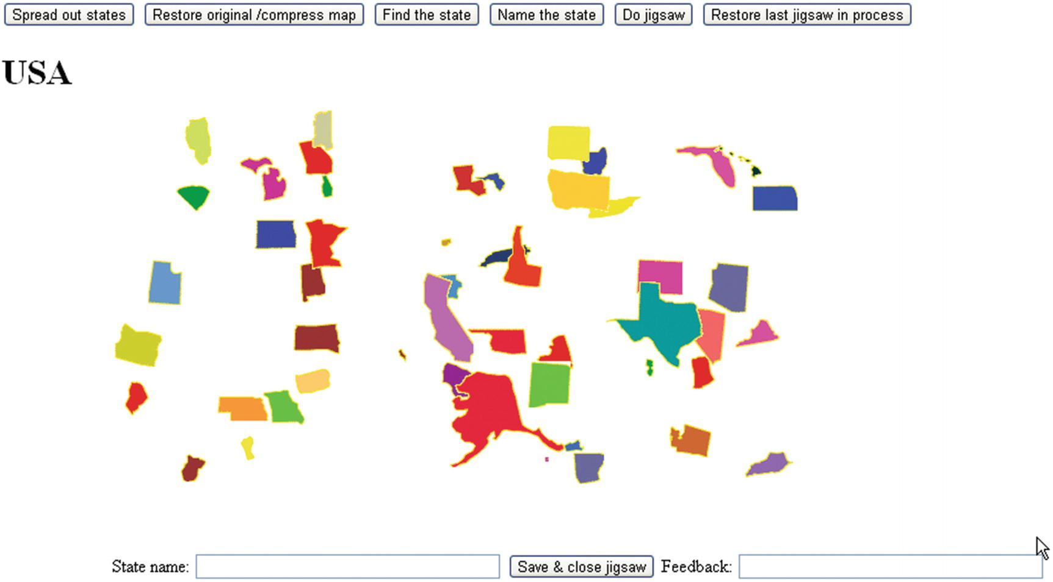
Figure 9-8States jumbled for the jigsaw puzzle
The player can now use the mouse to drag and drop pieces in the same manner (and implemented the same way) as the jigsaw-to-video puzzle described in Chapter 8. Figure 9-9 shows my work in progress.
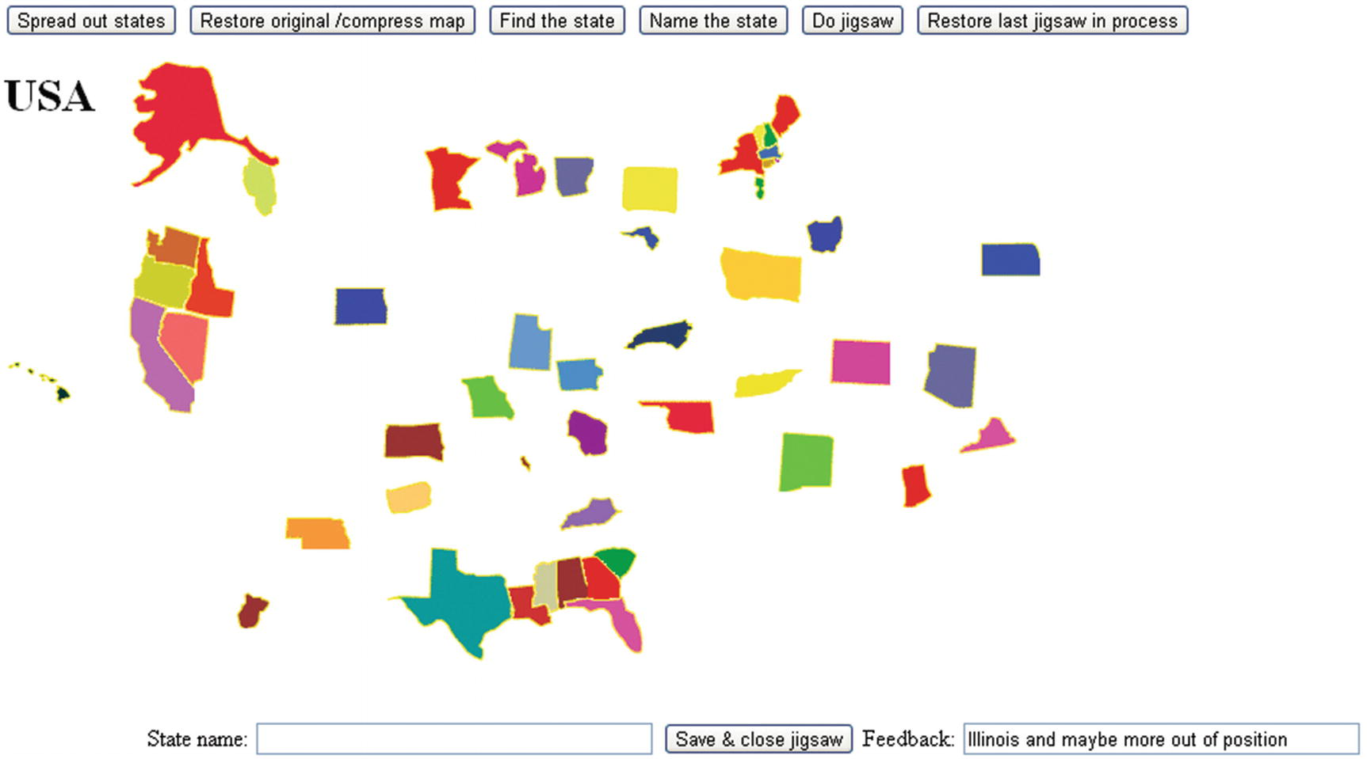
Figure 9-9 Jigsaw puzzle in progress
Observe that I have sorted out Alaska and Hawaii, five states in the West, seven states in the South, all of New England, and New York and New Jersey. The feedback says that Illinois and maybe more are out of position. The feedback could be improved, but it is not strictly programming that is the issue.
This was a challenging puzzle for me. In the interests of full disclosure, and also because it demonstrates a feature of the game, I clicked the Save & Close Jigsaw button, which allowed me to see the states all back in position. I then clicked Restore Last Jigsaw in Process to get back to where I was. With this facility available to me, I was able to get to what is shown in Figure 9-10.
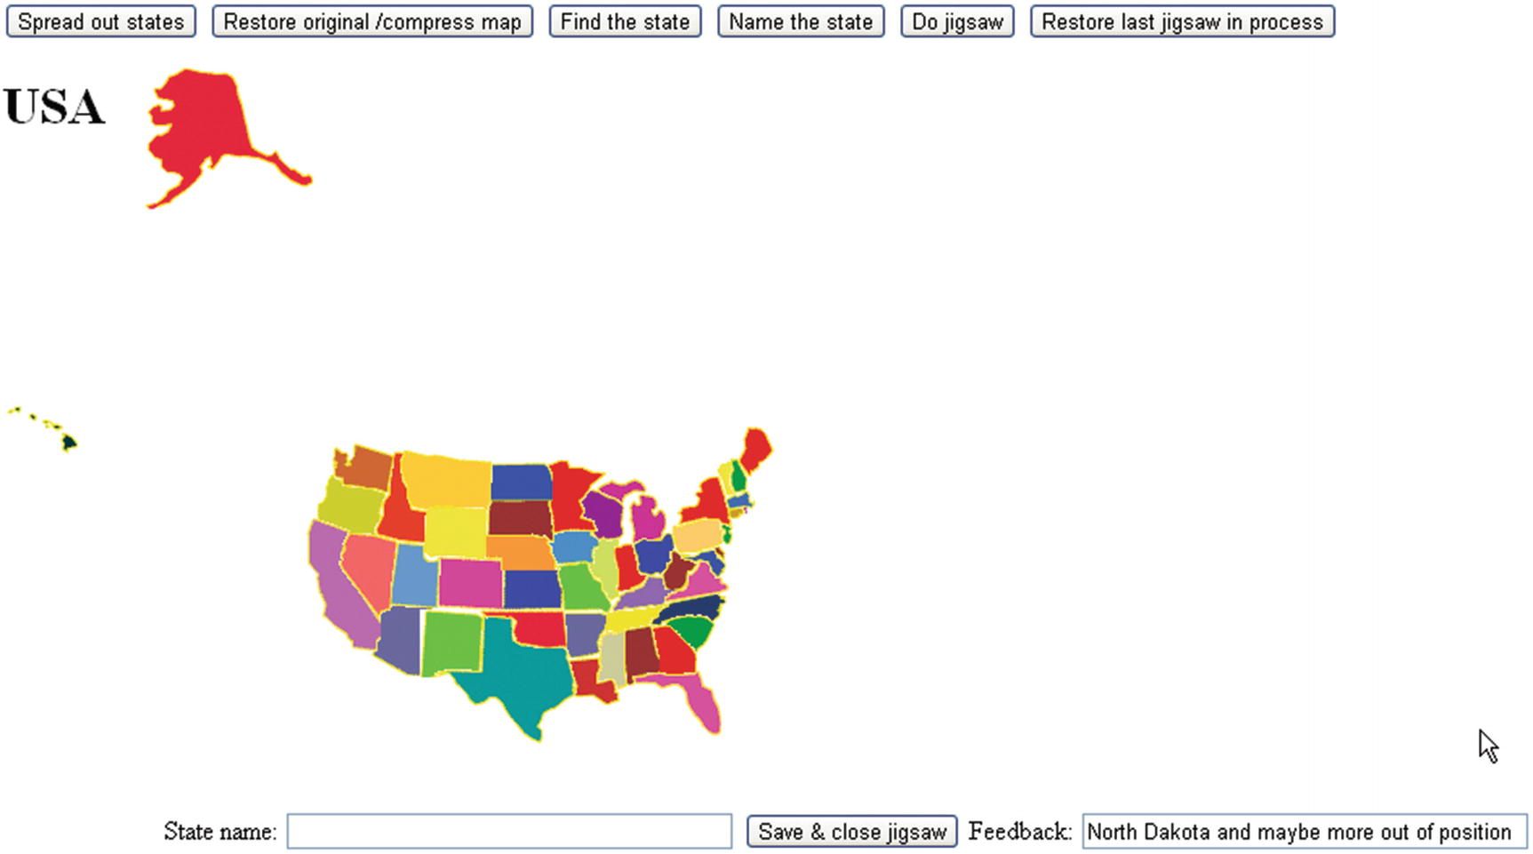
Figure 9-10Not quite correct
The feedback indicates that something is wrong with North Dakota. After cheating—that is, clicking Save & Close Jigsaw and looking at the completed map—I realized that North Dakota and Kansas, two similar rectangular shapes, needed to be swapped. Figure 9-11 shows the correct arrangement.
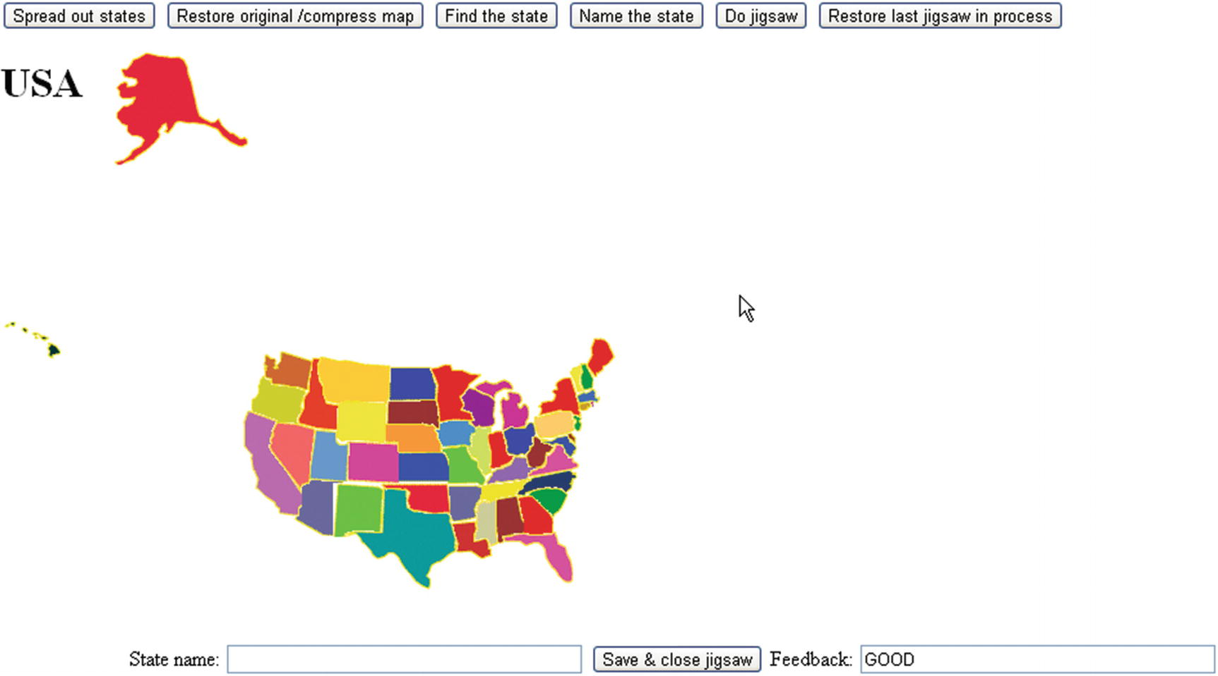
Figure 9-11 Jigsaw puzzle put together correctly
Notice that the positions of Alaska and Hawaii are not closely examined. The puzzle is deemed complete.
After this introduction showing the features of this educational game, I will describe the critical requirements for implementation.

Critical Requirements
The critical requirements for the educational game involve presenting the player with different types of activities. For the jigsaw puzzle activity, the application provides a save-and-restore feature. This feature can be used to take a look at the completed puzzle or to put the puzzle aside for a period of time and do something else. The task for the builder of the game is to provide the features of the user interface and ways for play to go from one type of activity to another.
The application requires the presentation of a complete map of the United States, with the individual states clickable. The first type of activity I described in the “Introduction” section was for the game to display the name of a state and prompt the player to click it. The application must be able to determine if the response was right or wrong and provide feedback.
The next type of activity I demonstrated is the opposite. A state on the map is marked in some way, and the player is prompted to type in the name. There are different ways to single out an individual state. I chose to put a border around the state to be named. The program must read in the player input and determine if the name was correct.
After implementing these two types of activities, it occurred to me that we have some very small states. I then decided to provide the spread-out feature and the capability of undoing it. This could be useful for other maps as well. I also modified the image representing tiny Rhode Island to be bigger.
Lastly, I decided to provide a way to see if people could put the states together. The application presents a jigsaw puzzle in which the states are randomly positioned on the screen, and the player uses the mouse to reposition them. It was at this point that I realized that I needed something different from the drag-and-drop-in-bins feature of HTML5. If you haven’t done so already, you can now read Chapter 8 for how to implement a jigsaw puzzle. The US States game has two additional requirements: I need to build a way to enter jigsaw mode and exit it so that the buttons all work and so the player can click a state. I also need a way to save an incomplete puzzle. This wasn’t necessary for the monkey bar video featured in the jigsaw-to-video project in Chapter 8, but it is necessary for a jigsaw puzzle with 50 pieces. I also view this as an educational game, so it is appropriate to give players a chance to look at the completed map, and also to rest.

HTML5, CSS, JavaScript Features, Programming Techniques, and Image Processing
The features and techniques to implement the educational states game are, for the most part, things you have seen before. However, putting them together can be tricky, so there will be some redundancy between this chapter and the material in previous chapters.

Acquiring the Image Files for the Pieces and Determining Offsets
Image files for each of the 50 states are part of the downloads for this chapter. However, since you may want to make your own map puzzle, I will describe the critical features of the puzzle pieces and the information necessary for checking positioning and for restoring the completed map which must be recorded.
You need to produce image files for each puzzle piece, that is, each individual state of the United States for my game. Since no state is strictly rectangular and image files need to be rectangles, the images will be a bounding box for each state with the areas outside the actual state transparent. There is no special treatment to accommodate the islands of Hawaii or upper and lower Michigan.
The first tasks for making the individual pieces representing the states is to acquire a map of the United States (or the country or region you pick) and to pick your favorite image processing program. I used Adobe Flash, which was popular when I made my first United States game example, but will illustrate the process using pixlr, an online image editing tool. The numbers in the source are from my original implementation and will not be the numbers mentioned here. Figure 9-12 shows the map of the United States . Alaska and Hawaii are not positioned accurately. I finesse this challenge by simply not checking positioning for these two states when my code checks on the job done by the player.
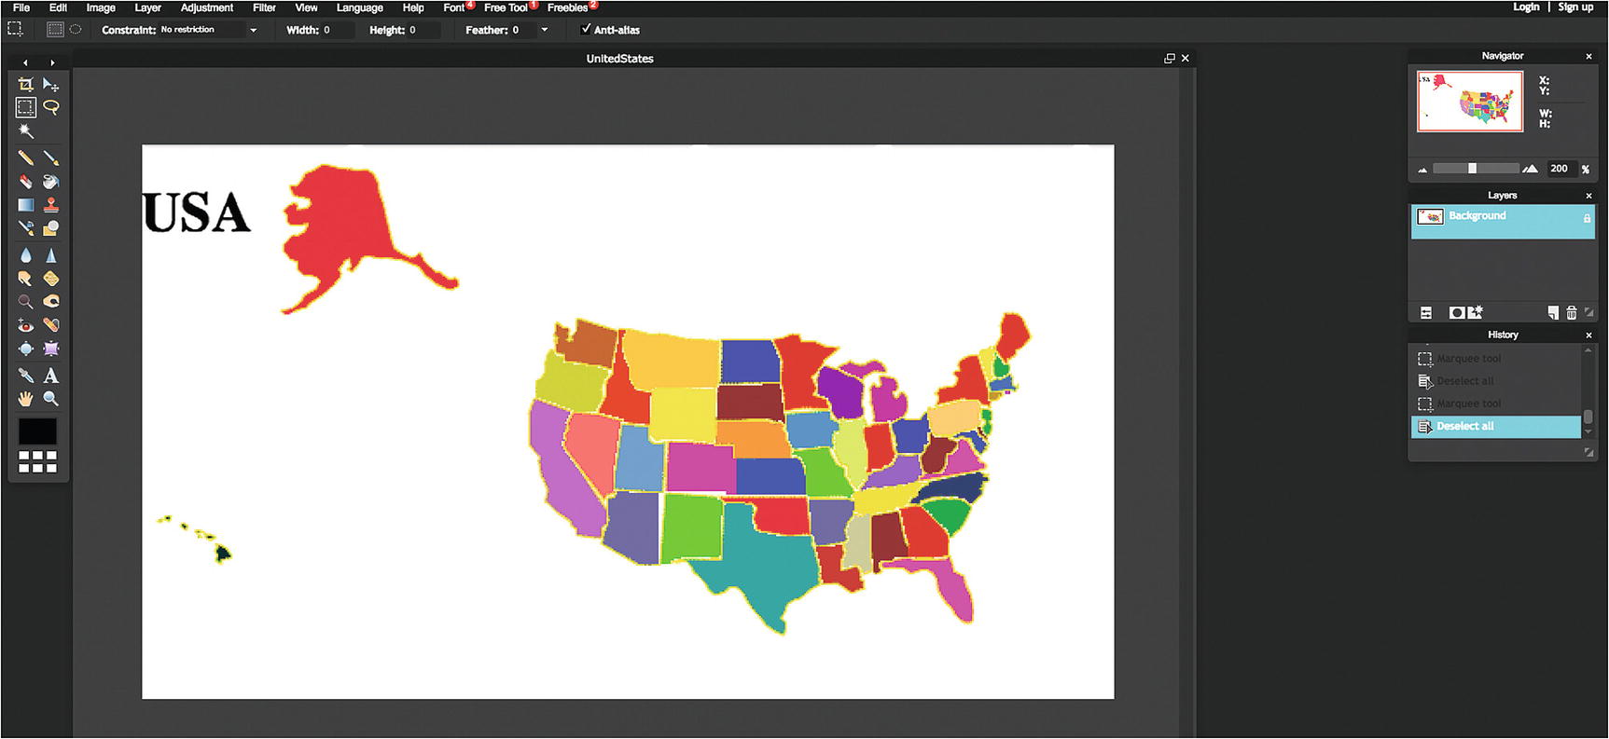
Figure 9-12Original complete map image in pixlr
The next task is to determine the relative location information for each state. The information needed is the relative location of the upper-left corner for a bounding rectangle for each state. This point may not be on the state, but it will determine the correct position. In Figure 9-13, I have used the marquee tool to draw a box around the state of Illinois.
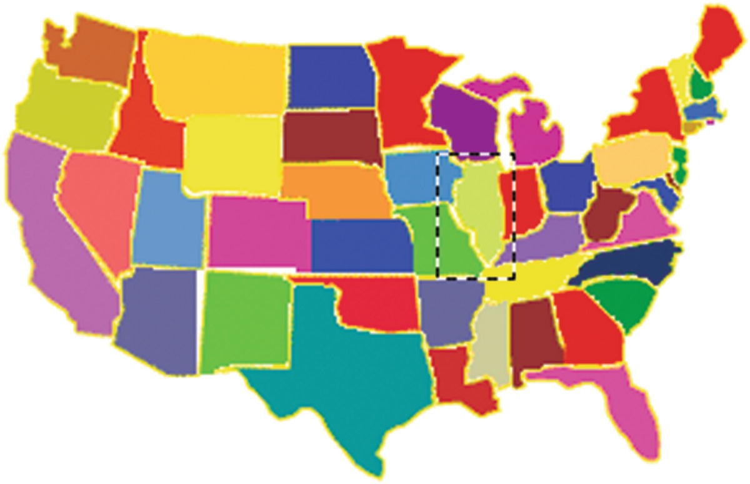
Figure 9-13Box around Illinois
When doing this, I write down the x and y coordinates of the starting position, the upper-left corner of the box, from the Navigator panel, shown in Figure 9-14.
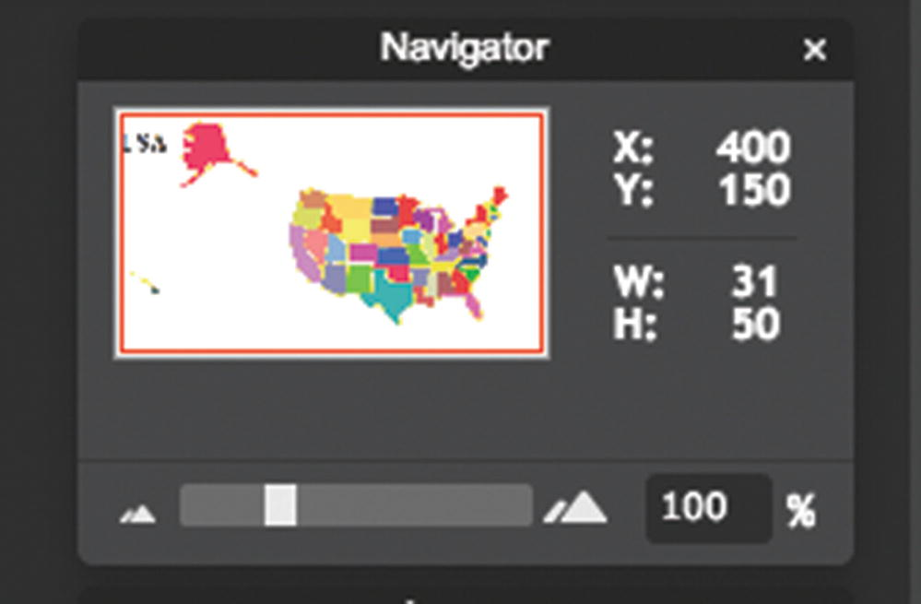
Figure 9-14 Navigator panel
NoteThese are not the coordinates for the upper corner for Illinois, but what was produced during my process for taking screenshots. The Navigator panel shows the position of the mouse.
The next task is to copy the selection into a new image using first Copy on the drop-down menu under Edit on the pixlr toolbar and then New Image under File. Figure 9-15 shows the panel that appears. Notice that I have given the image a name, Illinois, and the instructions to take the image from the clipboard and maintain transparency. I will need to do something to create the transparent regions.
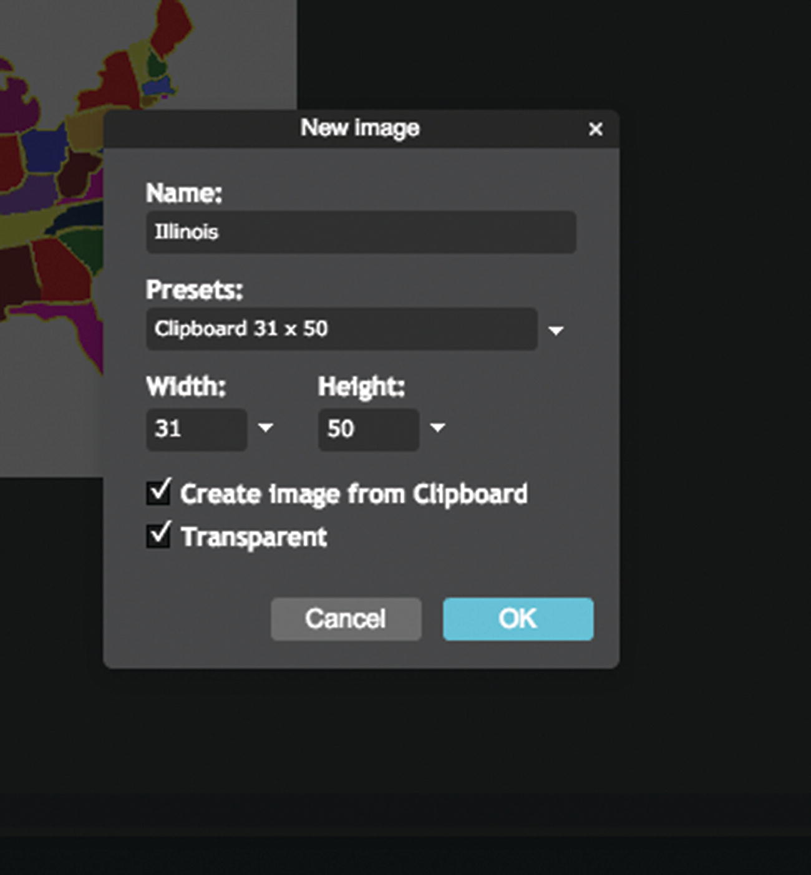
Figure 9-15Panel to create a new image, giving it a name and instructions
The pixlr program now has two images and I needed to move the big map one to get at the new image. I also used the zoom feature under View to make it bigger. It is shown in Figure 9-16.
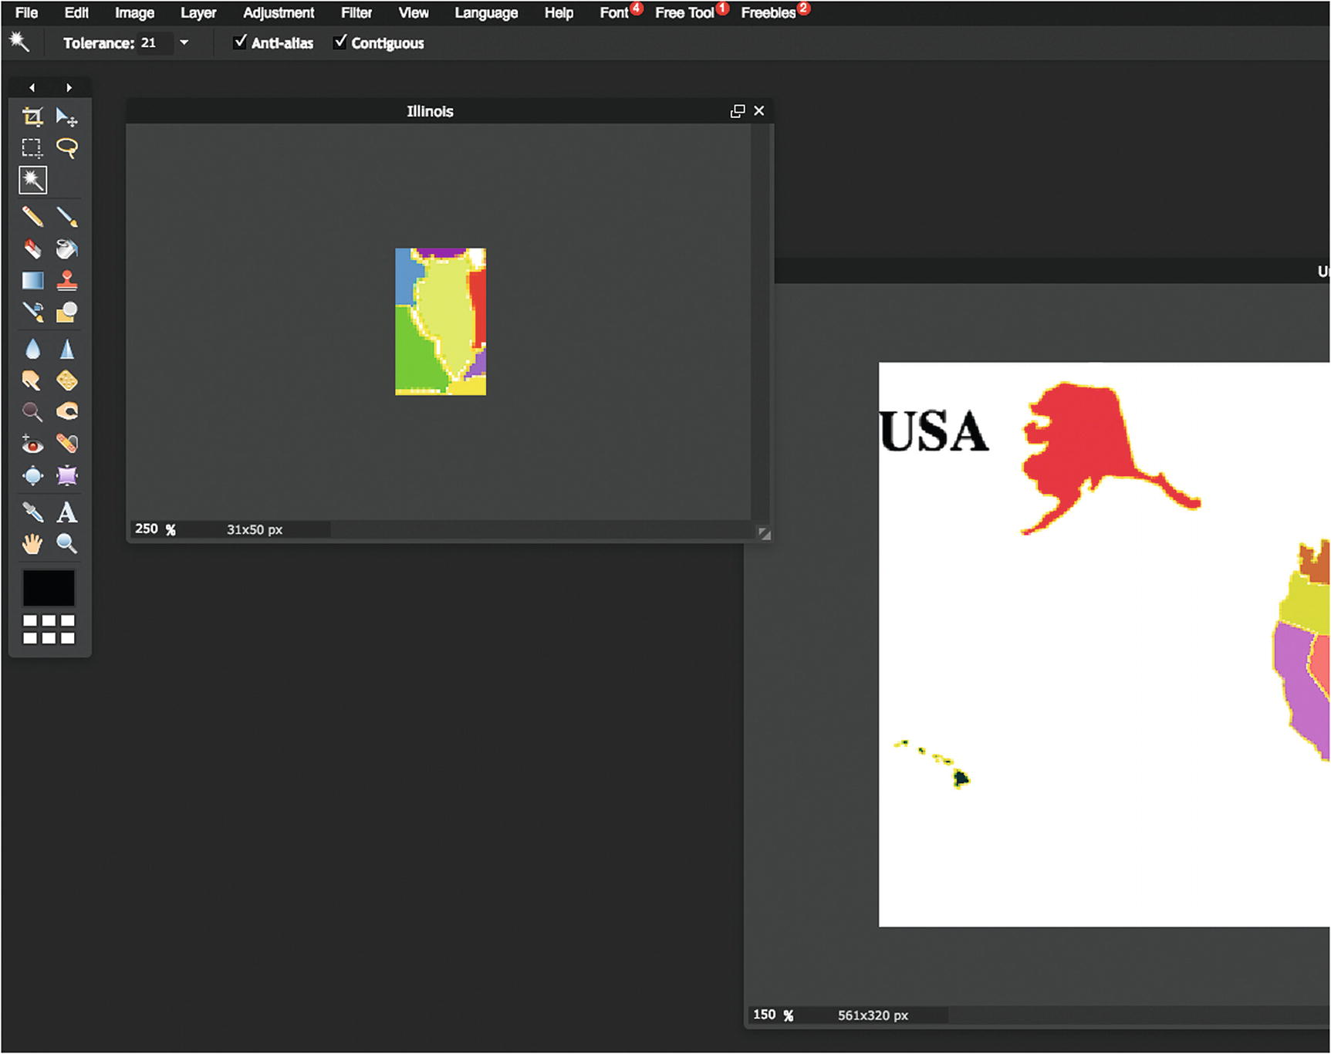
Figure 9-16New image holding Illinois
I now use the wand (also sometimes called magic wand) tool and click on the light green Illinois. This selects just Illinois, as shown in Figure 9-17, using the color. It does not have to be the only light green region on the map but just be different from the adjacent regions.
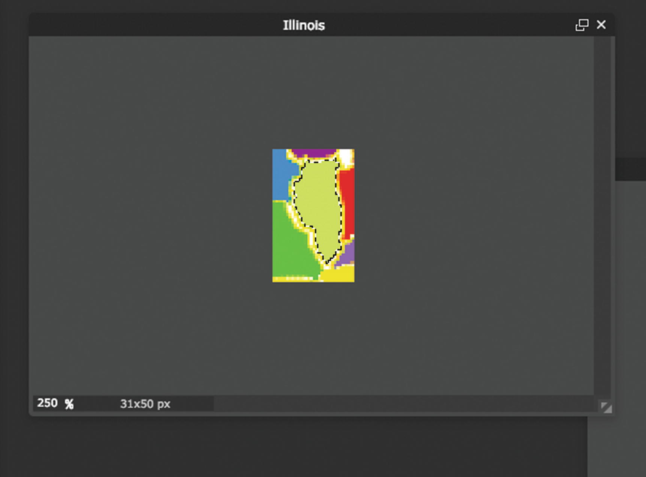
Figure 9-17Selection of Illinois using the wand tool
What I want is to cut out everything except the Illinois shape. This is performed by Edit/Invert Selection. This is shown in Figure 9-18. By the way, I saved this file as a PNG with transparency and named it Illinois1, just to not confuse myself.
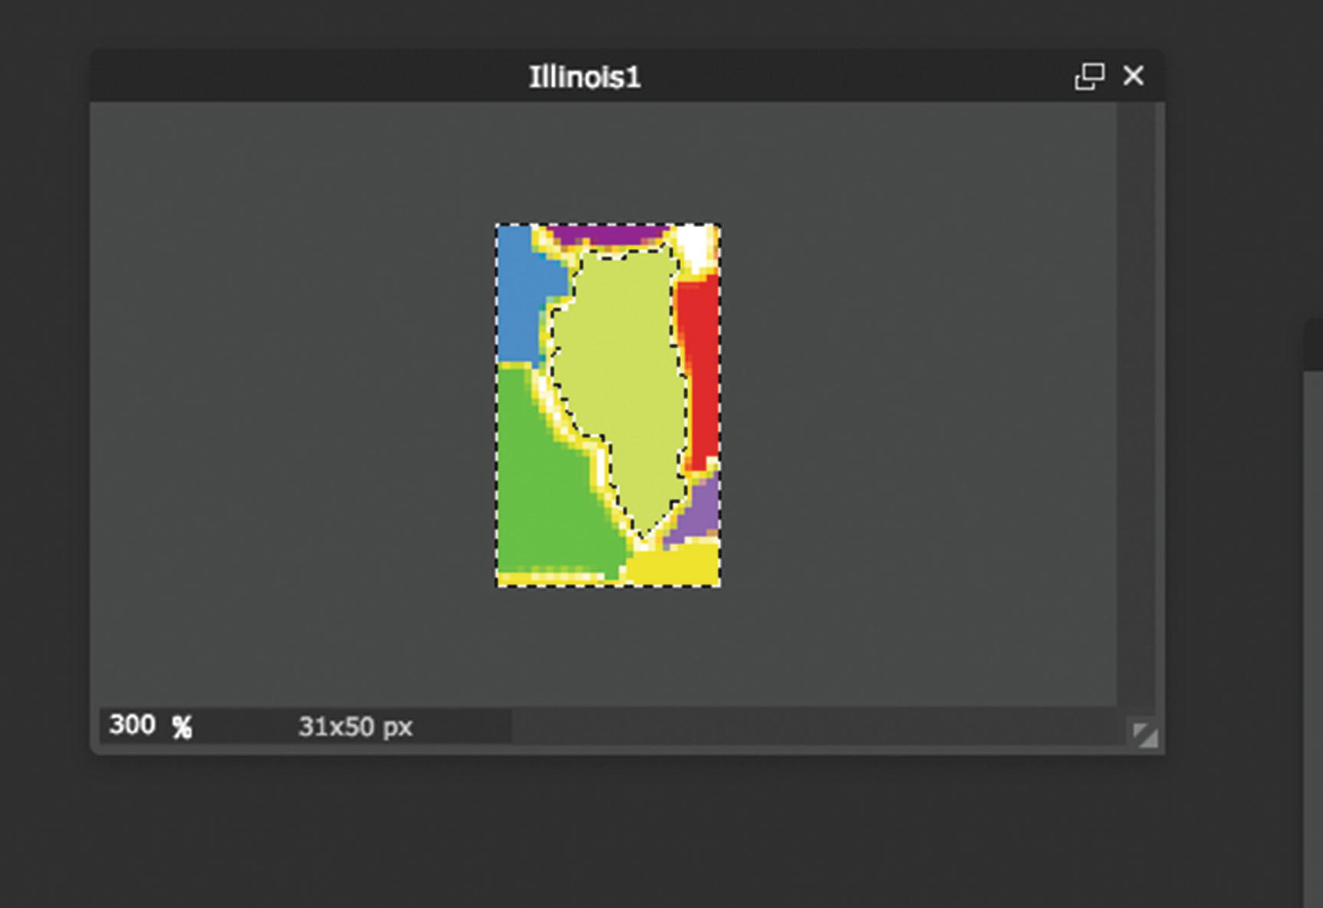
Figure 9-18 Inverted selection: everything except the image of Illinois
Then I Edit/Cut and produce the Illinois shape against a white background, which actually is transparent. Figure 9-19 shows the image that I save.
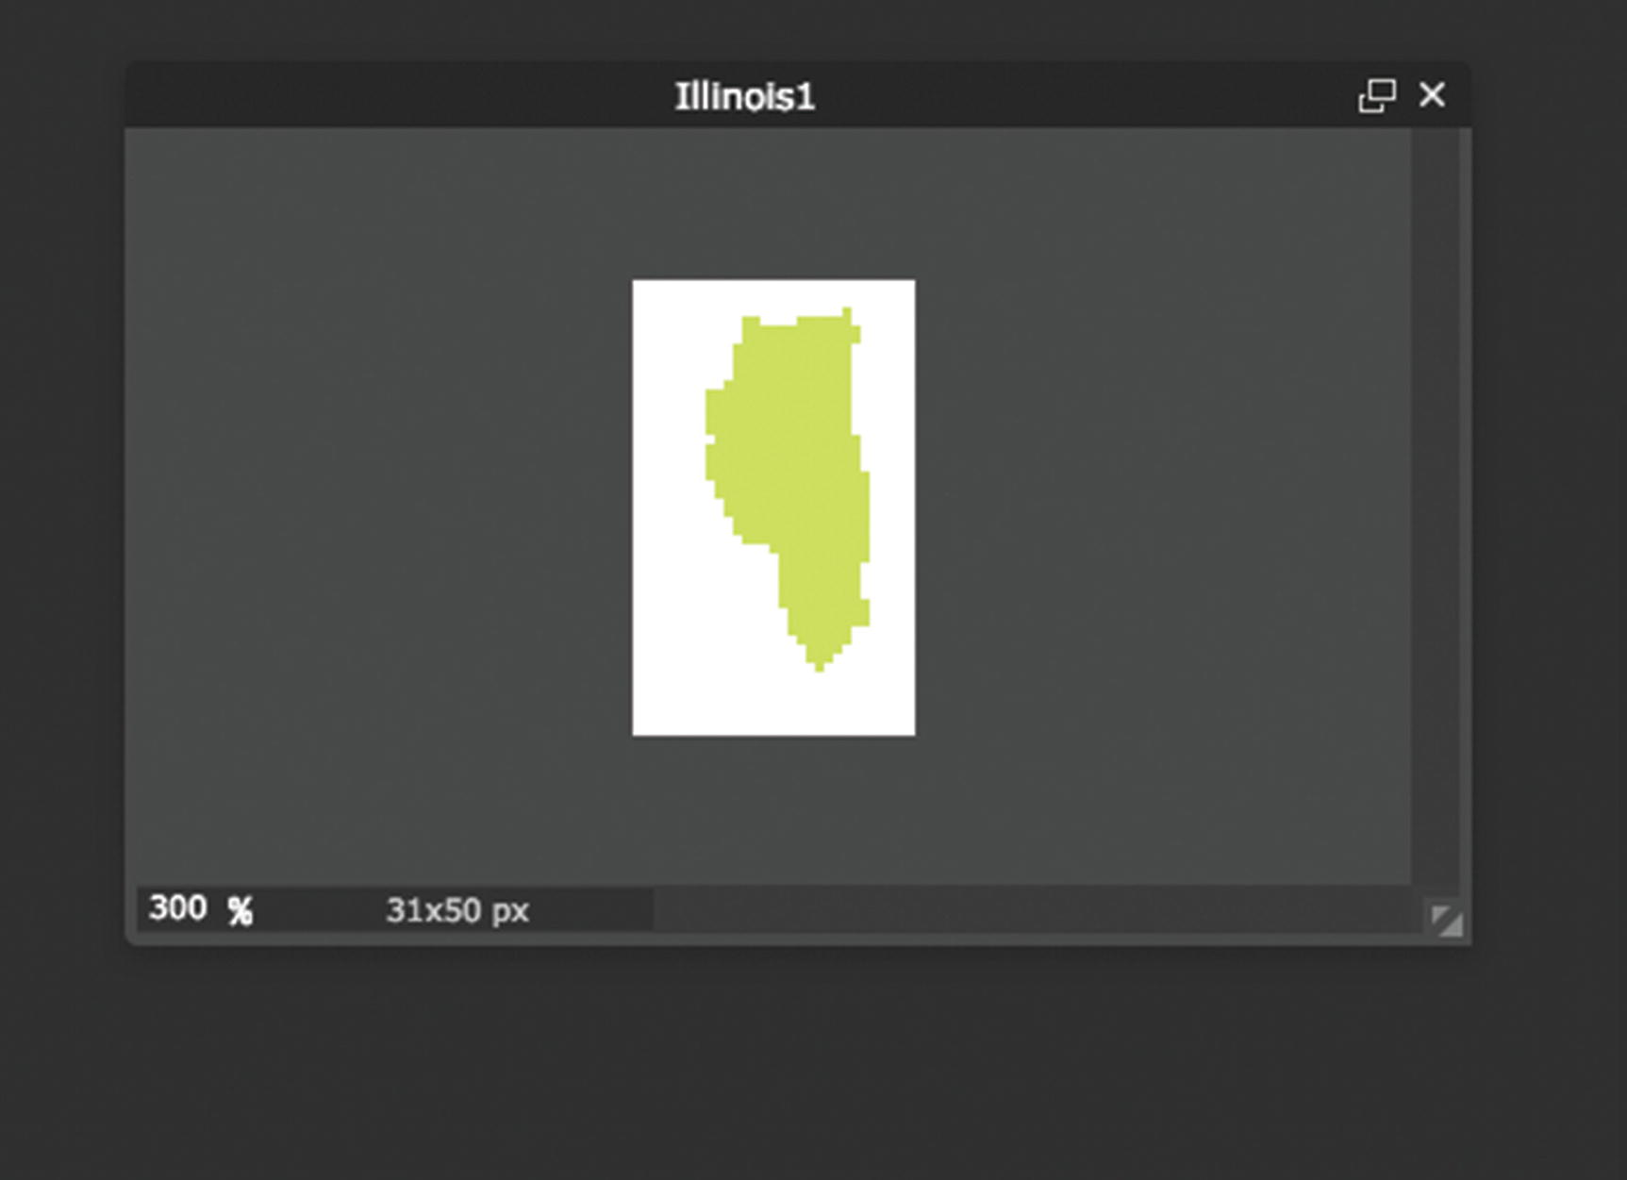
Figure 9-19The Illinois image against a transparent background
These are the necessary steps for each state.
I created arrays holding the names of the image files and the horizontal (x) and vertical (y) offset data. I also created an array listing the full names of the states. These are four parallel arrays. An alternative approach could be to systematically save the files with an underscore for any internal breaks—for example, North_Carolina.gif. I could write code to replace the underscore with a blank both for the game to display and for checking player’s answers. However, I decided to produce the names directly. Having described the creation of the four parallel arrays holding everything the program needs for the states, it now is time to review how to create the elements.

Creating Elements Dynamically
Chapter 6 and Chapter 8 each involved generating HTML markup dynamically—that is, during runtime. The states game and other map games you may create will also feature this technique. The work is done in the function setupgame .
The code determines how many elements—that is, puzzle pieces—from the nums variable have been set to be the length of the states array. If and when you build a puzzle with 10 countries, for example, nums will be set to 10. A for loop is used to construct an element for each state. Each element has a generated unique ID value. The attribute innerHTML of any element is set to be the markup. The code uses the information in the array variables states, statesx, and statesy. As was the case in the last chapter, the code converts numbers to character strings, and then concatenates the string "px" to make the values for setting the style.top and style.left attributes of the element. The code follows:
function setupgame() {
var i;
var x;
var y;
var uniqueid;
var s;
for(i=0;i<nums;i++) {
uniqueid = "a"+String(i);
s = document.createElement('state');
s.innerHTML = (
"<img src='"+states[i]+"' id='"+uniqueid+"'/>");
document.body.appendChild(s);
thingelem = document.getElementById(uniqueid);
x = statesx[i] +310;
y = statesy[i] + 200;
thingelem.style.top = String(y)+"px";
thingelem.style.left = String(x)+"px";
stateelements.push(thingelem);
}
questionfel = document.getElementById("questionform");
questionfel.style.left = "100px";
questionfel.style.top = "500px";
questionfel.question.value = " ";
questionfel.feedback.value = " ";
}
The element is created of a custom defined type 'state' . Its innerHTML is set with the appropriate value. The positioning is done using the offset values in the statesx and statesy arrays (corresponding to the arrays I named piecesx and piecesy in Chapter 8). The second part of the setupgame function positions the form already present in the body element. The form will be used for the identifying and naming activities.

User Interface Overall
It is time to reveal the body element for the application since that will show the buttons for the various operations:
<body id="body" onLoad="init();">
<button onClick="spread();">Spread out states </button>
<button onClick="restore();">Restore original /compress map </button>
<button onClick="setupfindstate();">Find the state </button>
<button onClick="setupidentifystate();">Name the state</button>
<button onClick="setupjigsaw();">Do jigsaw</button>
<button onClick="restorepreviousjigsaw();">Restore last jigsaw in process </button>
<h1>USA</h1>
<form id="questionform" name="questionform" onSubmit="return checkname();">
State name: <input type="text" name="question" value=" " size="40"/>
<input name="submitbut" type="submit" value=" " size="30"/>
Feedback: <input type="text" name="feedback" value=" " size="40" />
</form>
</body>
The HTML markup produces the six buttons at the top of the screen (refer back to Figure 9-1). The buttons on top each invoke a function; more detail on each follows in the next few sections. The form at the bottom is used in distinct ways for each of the three different types of activity. This is a design decision; I am trying to be efficient with screen real estate, avoiding the clutter of multiple forms at the possible cost of confusion to the player.

User Interface for Asking the Player to Click a State
After the player clicks the Find the State button, the application generates a question. Before choosing the state, the program removes any border that may exist around the last chosen state. This situation could arise if the player had just performed the name a state activity. If this is the very first activity by the player, the code would not produce an error, but would merely set the border of the 0th state to empty, which is what it already was. It is a good habit to make the start of any activity do this type of housekeeping. It makes the application easier to change or upgrade in the future. Similarly, if the previous question also was an identifying question, the code would not produce an error. This transition from activity to activity must be attended to for the game to work smoothly. We do not want any state to have a border when the player has moved on to the next activity.
The setupfindstate function makes a random choice among the states. The global variable choice holds a value made for the random choice. The function then sets up event handling for each of the elements corresponding to a state. The prompt for the player is placed in the question field of the form.
function setupfindstate(){
var i;
var thingelem;
stateelements[choice].style.border="";
choice = Math.floor(Math.random()*nums);
for (i=0;i<nums;i++) {
thingelem = stateelements[i];
thingelem.addEventListener('click',pickstate,false);
}
var nameofstate = names[choice];
questionfel.question.value = "Click on "+nameofstate;
questionfel.feedback.value = " ";
questionfel.submitbut.value = "";
}
The appropriate player response for this activity is to click a state on the map. When the player clicks any state, JavaScript event handling is set up to invoke the pickstate function . The task of this function is to determine if the player’s pick was the correct one. To do this, my code uses information in the event information passed to the function and the value in the global variable choice set by setupfindstate. The code for pickstate is
function pickstate(ev) {
var picked = Number(ev.target.id.substr(1));
if (picked == choice) {
questionfel.feedback.value = "Correct!";
}
else {
questionfel.feedback.value = "Try Again.";
}
}
Now I need to remind you of how I set the ID fields for each of the state elements. I used the index values 0 to 49 and added an a at the beginning. This addition of an a was not strictly necessary. I did it when I thought I may be creating other sets of elements. The ev parameter to pickstate has a target attribute referencing the target that received the click event. The ID of that target would be a0, or a1, or a2, and so forth. The String method substr extracts the substring of a string starting at the parameter, so substr(1) returns 0, 1, 2, and so on. My code turns the string into a number. It now can be compared to the value in the global variable choice.
You may decide to limit the number of tries a player can make and/or provide hints.

User Interface for Asking the Player to Name a State
After the player chooses to do the activity of naming a state, the setupidentifystate function is invoked. The task is to place a border around a state on the map and prompt the player to type in the name. For this operation, unlike the last one, my code puts in a value for the submit button. The function also removes the event handling for clicking a state.
function setupidentifystate(){
stateelements[choice].style.border="";
stateelements[choice].style.zIndex = "";
choice = Math.floor(Math.random()*nums);
stateelements[choice].style.border="double";
stateelements[choice].style.zIndex = "20";
questionfel.question.value = "Type name of state with border HERE";
questionfel.submitbut.value = "Submit name";
questionfel.feedback.value = " ";
var thingelem;
for (i=0;i<nums;i++) {
thingelem = stateelements[i];
thingelem.removeEventListener('click',pickstate,false);
}
}
The player’s action is examined by the checkname function . This is already set up as the onsubmit attribute for the form. The function checkname actually does double-duty: if the current activity is doing the jigsaw, checkname ends that activity by restoring the states to their original locations, that is, the original map of the whole United States. If the player is not doing the jigsaw puzzle, checkname checks whether or not the player has typed in the correct name for the chosen state. The code in checkname follows:
function checkname() {
if (doingjigsaw) {
restore();
}
else {
var correctname = names[choice];
var guessedname = document.questionform.question.value;
if (guessedname==correctname) {
questionfel.feedback.value = "Correct!";
}
else {
questionfel.feedback.value = "Try again.";
}
return false;
}
}
Notice that again I do not limit the number of tries, nor do I give any hint or any tolerance for misspellings.

Spreading Out the Pieces
The task of spreading out the states while maintaining their positional relationships is straightforward, although I did some experimentation with the constants to get the effect I wanted. The idea is to use the offset values in a systematic way. The offsets represent distances from a point roughly in the center of the map. My code stretches those offset values for all the states except Alaska and Hawaii. I have positioned Alaska and Hawaii to be the last two states. The code follows:
function spread() {
var i;
var x;
var y;
var thingelem;
for (i=0;i<nums-2;i++) { // don't move alaska or hawaii
x = 2.70*statesx[i] +410;
y = 2.70*statesy[i] + 250;
thingelem = stateelements[i];
thingelem.style.top = String(y)+"px";
thingelem.style.left = String(x)+"px";
}
}
Restoring the states is simply a matter of repositioning them at the values indicated in the statesx and statesy arrays . The restore function will be explained following, in the “Saving and Recreating the State of the Jigsaw Game and Restoring the Original Map” section.

Setting Up the Jigsaw Puzzle
Setting up the jigsaw activity involves randomly positioning the states on the screen and setting up the event handling for the mouse operations. It also means turning off the default drag-and-drop event handling and also turning off the buttons at the top of the screen. The submit button on the question form at the bottom of the screen will be left operational, and this button will perform the operation of saving the state of the jigsaw puzzle, as described in the next section. The only way to stop the jigsaw activity, restore the map, and return to the other activities is to click the button.
The newly created div with ID fullpage, created to prevent the drag-and-drop default action, is set up in the style section to not cover the bottom of the screen containing the form. The CSS is
#fullpage
{
display:block;
position:absolute;
top:0;
left:0;
width:100%;
height:90%;
overflow: hidden;
z-index: 1;
}
Recall that in CSS , the layering is done with the attribute z-index. In JavaScript, the attribute is zIndex . The setupjigsaw function follows:
function setupjigsaw() {
doingjigsaw = true;
stateelements[choice].style.border="";
var i;
var x;
var y;
var thingelem;
for (i=0;i<nums;i++) {
x = 100+Math.floor(Math.random()*600);
y = 100+Math.floor(Math.random()*320);
thingelem = stateelements[i];
thingelem.style.top = String(y)+"px";
thingelem.style.left = String(x)+"px";
thingelem.removeEventListener('click',pickstate,false);
}
d.onmousedown = startdragging;
d.onmousemove = moving;
d.onmouseup = release;
var df = document.createElement('div');
df.id = "fullpage";
bodyel.appendChild(df);
questionfel.question.value = "";
questionfel.submitbut.value = "Save & close jigsaw";
questionfel.feedback.value = " ";
questionfel.style.zIndex = 100;
}
The player does the jigsaw puzzle by using the mouse to reposition the pieces. Go back to Chapter 8 for explanation of the use of the mouse events. The check for completeness is done each time the player lets up on the mouse button. The release function invokes the function I named checkpositions . The checkpositions puzzle computes the average difference in x and the average difference in y of the actual positions of the pieces to the offsets stored in the statesx and statesy arrays . The code then checks if any difference is more than the tolerance amount from the corresponding average. The function stops iterating over the pieces as soon as one is found to be out of place. For the very simple six-piece jigsaw puzzle in Chapter 8, my feedback to the player when this occurs is simply to display “Keep working.” For the US States game, I wanted to do something more. What I decided to do was to report the first state in which either the x or the y difference was greater than the average. When most of the pieces are not in place, this information is not especially helpful, so this is an opportunity for improvement.

Saving and Recreating the State of the Jigsaw Game and Restoring the Original Map
As I noted previously, the only way to end the jigsaw activity is to click the submit button on the form. If the global variable doingjigsaw is true, then the restore function is invoked. The restore function will turn off the event handling for the mouse and remove the fullpage div. I realized that even I could not complete the jigsaw puzzle in a single session and without cheating—that is, looking at the completed puzzle. I am getting better at it, however. This is what motivated me to implement a save-and-restore feature.
The issue of defining application states depends, naturally enough, on the application. Saving the state of a jigsaw game in process requires code to encode the position of each puzzle piece. For the jigsaw puzzle, what needs to be stored are the style.top and style.left attributes of each of the elements. I will be using the localStorage feature of HTML5, which is a version of cookies. I will describe localStorage next. The goal for this program is to have one character string hold all the information. What I do first is combine style.top and style.left into one string by using & to concatenate them. I then put each of these strings into an array using the following line:
xydata.push(thingelem.style.top+"&"+thingelem.style.left);
When all 50 strings have been placed in the array, my code uses the join method to combine everything in one big array, with the delimiter of my choice (;) separating them. This is the string that is stored using localStorage.
In HTML5, localStorage is a variation on cookies. Values are stored on the player’s (client) computer as name/value pairs. A localStorage item is associated with the browser. The state of the jigsaw puzzle stored when using Firefox will not be available when using Chrome. For the name of the localStorage item, I use the name jigsaw, and for the value, the result of the join operation.
The localStorage facility may not work. For example, the player may have used the browser settings to prevent any use of cookies, localStorage or other, similar features. A localStorage item is associated with a specific web domain. Chrome allows setting and retrieving from a program on the local computer. When I originally built this application, Firefox threw an error for retrieving data. My code uses try and catch to present an alert statement if there are problems. Figure 9-20 shows the result of trying to restore a jigsaw puzzle saved using Firefox when using a file on the local computer. This could also happen if the player/user turned off the use of cookies.
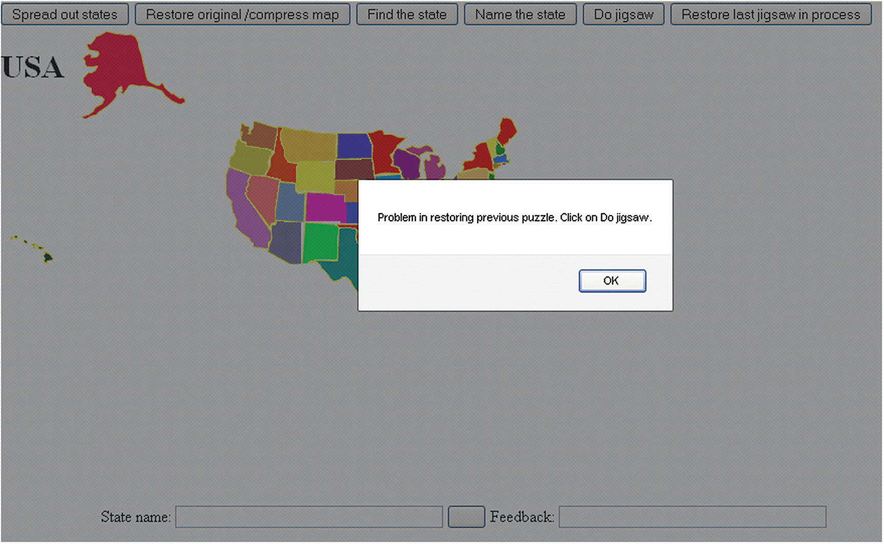
Figure 9-20Alert shown when trying to use localStorage locally with Firefox
Moving on, there are two distinct functions: restore and restorepreviousjigsaw . Remember that the restore function does double-duty: it restores the original map after the pieces are spread out and it restores the original map after the player has done the jigsaw activity.
function restore() {
var i;
var x;
var y;
var thingelem;
var df;
var lsname = "jigsaw";
var xydata = [];
var stringdata;
if (doingjigsaw) {
doingjigsaw = false;
d.onmousedown = "";
d.onmousemove = "";
d.onmouseup = "";
df = document.getElementById("fullpage");
bodyel.removeChild(df);
for (i=0;i<nums;i++) {
thingelem = stateelements[i];
xydata.push(thingelem.style.top+"&"+thingelem.style.left);
}
stringdata = xydata.join(";");
try {
localStorage.setItem(lsname,stringdata);
}
catch(e) {
alert("data not saved, error given: "+e);
}
}
for (i=0;i<nums;i++) {
x = statesx[i] +310;
y = statesy[i] + 200;
thingelem = stateelements[i];
thingelem.style.top = String(y)+"px";
thingelem.style.left = String(x)+"px";
}
}
The restorepreviousjigsaw function attempts to read in the data stored as one long string in localStorage under the name jigsaw; decodes the string to be an array of 50 strings, each one holding the top and left information; and uses that information to position the pieces. The function then sets up event handling for the mouse events and sets up the fullpage div . Finally, the function sets the label of the submit button to indicate that this button saves and closes the puzzle. The code follows:
function restorepreviousjigsaw() {
var i;
var lsname = "jigsaw";
var xydata;
var stringdata;
var ss; // will hold combined top and left for a state
var ssarray;
var thingelem;
try {
stringdata = localStorage.getItem(lsname);
xydata = stringdata.split(";");
for (i=0;i<nums;i++) {
ss = xydata[i];
ssarray = ss.split("&");
thingelem = stateelements[i];
thingelem.style.top = ssarray[0];
thingelem.style.left = ssarray[1];
}
doingjigsaw = true;
stateelements[choice].style.border="";
d.onmousedown = startdragging;
d.onmousemove = moving;
d.onmouseup = release;
var df = document.createElement('div');
df.id = "fullpage";
bodyel.appendChild(df);
questionfel.question.value = "";
questionfel.submitbut.value = "Save & close jigsaw";
questionfel.feedback.value = " ";
questionfel.style.zIndex = 100;
}
catch(e) {
alert("Problem in restoring previous puzzle. Click on Do jigsaw.");}
}

Building the Application and Making It Your Own
You can make the project your own by refining and building on the states application, perhaps giving hints or keeping score, or using the application as a model for a different part of the world. For a different map, do pay attention to the special handling I use for Alaska and Hawaii. You probably will want to remove the nums-2 where it occurs. You can add another parallel array with the names of the capitals and make naming the capital and identifying a state with an indicated capital additional activities. You also can use this as a model for identifying parts of any diagram or picture (e.g., parts of the body). Notice that each activity has a function for setting up and a function for checking the response.
You can use what is described in Chapter 8 to make this project work with finger touches. The US states seemed too much for a phone, but it may be feasible for a tablet. You can use the methods shown in Chapter 5 to extract the content to an external file. If you’re feeling really brave, you may also want to experiment with using SVG (scalable vector graphics) to create a vector version of the map.
The application demonstrated individual features that you can use for other projects. An informal outline/summary of the functions in the states game follows:
init is for initialization, including invoking setupgame.
setupgame builds the state elements and positions the form.
setupfindstate sets up the clicking state function and pickstate checks the player’s response.
setupidentifystate sets up the typing in the name, and checkname checks the response.
setupjigsaw sets up the jigsaw puzzle. The functions startdragging, moving, and release, along with offset and draw, handle the player actions with regard to using the mouse to move pieces. The checkpositions function, along with doaverage, checks if the puzzle is complete.
spread spreads out the pieces and restore restores the pieces to the original map locations. The restore function also saves the state of the jigsaw puzzle using localStorage.
restorepreviousjigsaw extracts the information from localStorage to set up the puzzle as it was left.
More formally, Table 9-1 lists all the functions and indicates how they are invoked and what functions they invoke. Notice that several functions are invoked as a result of the function being specified as a method of an object type.
Table 9-1 Functions in the US States Game Project
Function | Invoked/Called By | Calls
init | Invoked by action of the onLoad attribute in the <body> tag | setupgame
setupgame | Invoked by init
pickstate | Invoked by addEventListener call in setupfindstate
spread | Invoked by button
restore | Invoked by button and checkname
restorepreviousjigsaw | Invoked by button
setupfindstate | Invoked by button
setupidentifystate | Invoked by button
checkname | Invoked as an action of onSubmit in the form | restore
checkpositions | Invoked by release of mouse (mouseup event) | doaverage
doaverage | Invoked by checkpositions
setupjigsaw | Invoked by button
release | Invoked by setting up events in restorepreviousjigsaw and setupjigsaw | checkpositions
startdragging | Invoked by setting up events in restorepreviousjigsaw and setupjigsaw | offset
moving | Invoked by setting up events in restorepreviousjigsaw and setupjigsaw | draw
draw | Invoked by moving the mouse (mousemove event)
offset | Invoked by startdragging
Table 9-2 shows the code for the basic application, with comments for each line.
Table 9-2 Complete Code for the US States Game Project
Code Line | Description
<!DOCTYPE html> | Doctype header
<html> | html tag
<head> | head tag
<title>USA States game</title> | Complete title
<style> | style tag
img {position:absolute;} | All image elements positioned absolutely
form {position: absolute; z-index: 10;} | Form positioned absolutely
body{ height:100%; margin: 0;} | Body styled to take up whole height
#fullpage | Style directive for the created div
{ display:block; position:absolute; top:0; left:0; width:100%; height:90%; overflow: hidden; z-index: 1; } | Take up whole width and nearly whole height; layer underneath
</style> | Closing style tag
<script type="text/javascript"> | script tag
var names = [ | Names of the states; one of many parallel arrays with information on states; order and grouping here not important but order must be the same and Alaska and Hawaii last
"Illinois","Iowa","Missouri","Oregon","Michigan",
"Indiana","Vermont","New Hampshire","Maine","South Dakota","North Dakota",
"Ohio","Wisconsin","Kentucky","Tennessee",
"North Carolina","South Carolina","Georgia","Alabama","Mississippi",
"Virginia","West Virginia","Maryland","Delaware","Pennsylvania","New Jersey","New York",
"Rhode Island", "Connecticut","Massaschusetts","Louisiana","Arkansas","Minnesota",
"Florida","Kansas",
"Arizona","California","Colorado","Idaho","Montana","Nebraska",
"Nevada","New Mexico","Texas","Oklahoma","Utah","Washington","Wyoming","Hawaii","Alaska"
] | End of names array
var states = [ | Array for addresses of image files
"illinois.gif",
"iowa.gif",
"missouri.gif",
"oregon.gif",
"michigan.gif",
"indiana.gif", "vermont.gif","newhampshire.gif","maine.gif","southdakota.gif","northdakota.gif",
"ohio.gif","wisconsin.gif","kentucky.gif","tennessee.gif",
"northcarolina.gif","southcarolina.gif","georgia.gif","alabama.gif","mississippi.gif",
"virginia.gif","westvirginia.gif","maryland.gif","delaware.gif",
"pennsylvania.gif","newjersey.gif","newyork.gif",
"rhodeislandbig.gif","connecticut.gif","massachusetts.gif","louisiana.gif","arkansas.gif","minnesota.gif",
"florida.gif","kansas.gif",
"arizona.gif","california.gif","colorado.gif","idaho.gif","montana.gif","nebraska.gif",
"nevada.gif","newmexico.gif","texas.gif","oklahoma.gif","utah.gif","washington.gif","wyoming.gif","hawaii.gif","alaska.gif"
]; | End of address-of-image-files array
var statesx = [ | Array of horizontal (x) offsets
88.65,60.15,65.40,
-81.70,90.40,
107.40,171.95,181.00,183.00,21.10,22.60,
121.70,78.90,103.65,99.40,
132.20,138.95,125.45,110.45,93.90,
138.95,138.95,151.65,171.95,144.20,174.20,147.95,
187.75,179.35,177.60,77.40,73.65,54.15,
115.70,32.35,
-44.95,-86.85,-8.15,-47.20,-32.15,21.10,
-66.70,-11.15,-4.40,22.60, -36.70,-72.50,-15.65,-300.95,-230.30
]; | End of statesx array
var statesy = [ | Array of vertical (y) offsets
-26.10,-29.85,-8.45,
-64.75,-59.05,
-22.70,-66.00,-67.30,-85.65,-47.15,-70.30,
-27.90,-55.30,-3.60,12.90,
5.20,21.45,26.40,27.90,29.65,
-13.20,-17.10,-19.85,-20.85,-36.40,-31.35,-61.30,
-41.85,-41.85,-50.85,47.10,21.15,-72.70,
55.45,-2.85,
15.15,-35.75,-11.85,-76.70,-76.30,-23.85,
-27.60,18.15,22.65,19.65,-22.35,-83.45,-41.75,31.55,-171.30
]; | End of statesy array
var doingjigsaw = false; | Flag indicating if doing jigsaw
var bodyel; | Used to hold reference to body
var nums = states.length; | Number of states
var stateelements = []; | Will hold the dynamically created elements
var questionfel; | Used to hold reference to form
function init(){ | Header for init function
setupgame(); | Invoke setupgame
bodyel = document.getElementById("body"); | Set reference to use to add fullpage div
} | Close init function
function setupgame() { | Header for setupgame function
var i; | For indexing
var x; | For x value
var y; | For y value
var uniqueid; | For the unique ID created for each element
var s; | Hold each newly created element
for(i=0;i<nums;i++) { | Iterate over the states
uniqueid = "a"+String(i); | Define an ID
s = document.createElement('state'); | Create element
s.innerHTML = (  "<img src='"+states[i]+  "' id='"+uniqueid+"'/>"); | Set the HTML markup contents of the newly created element to be an image with the attributes as indicated
document.body.appendChild(s); | Append to body
thingelem = document.getElementById(uniqueid); | Get the reference
x = statesx[i] +310; | Calculate horizontal coordinate
y = statesy[i] + 200; | Calculate vertical coordinate
thingelem.style.top = String(y)+"px"; | Set style.top to be x
thingelem.style.left= String(x)+"px"; | Set style.left to be y
stateelements.push(thingelem); | Add to stateelements array
} | Close for loop
questionfel = document.getElementById(“questionform”); | Set reference to form
questionfel.style.left = "100px"; | Position form horizontally
questionfel.style.top = "500px"; | Position form vertically
questionfel.question.value = " "; | Clear out question field
questionfel.feedback.value = " "; | Clear out feedback field
} | Close setupgame function
function pickstate(ev) { | Header for pickstate function
var picked = Number(ev.target.id.substr(1)); | Extract and calculate index for the state the player picked
if (picked == choice) { | Compare to choice
questionfel.feedback.value = "Correct!"; | Display feedback as correct
} | Close clause
else { | Else
questionfel.feedback.value = "Try Again."; | Display feedback to try again
} | Close clause
} | Close pickstate function
function spread() { | Header for spread function
var i; | For indexing
var x; | For x value
var y; | For y value
var thingelem; | For element
for (i=0;i<nums-2;i++) { | Iterate over 48 states
x = 2.70*statesx[i] +410; | Stretch out x and add constant
y = 2.70*statesy[i] + 250; | Stretch out y and add constant
thingelem = stateelements[i]; | Get ith element
thingelem.style.top = String(y)+"px"; | Set style.top
thingelem.style.left= String(x)+"px"; | Set style.left
} | Close for loop
} | Close spread function
function restore() { | Header for restore function
var i; | For indexing
var x; | For x
var y; | For y
var thingelem; | For element reference
var df; | Used to remove fullpage
var lsname = "jigsaw"; | Name for localStorage
var xydata = []; | Used for saving
var stringdata; | Used for saving
if (doingjigsaw) { | Check if doingjigsaw is true
doingjigsaw = false; | Set to false
d.onmousedown = ""; | Remove event handling
d.onmousemove = ""; | Remove event handling
d.onmouseup = ""; | Remove event handling
df=  document.getElementById("fullpage"); | Get reference
bodyel.removeChild(df); | Remove df
for (i=0;i<nums;i++) { | Iterate over states
thingelem = stateelements[i]; | Get reference to ith state element
xydata.push(thingelem.style.top+"&"+thingelem.style.left); | Create a string that combines top and left settings and add this to the xydata array
} | Close for loop
stringdata = xydata.join(";"); | Generate a string from the array
try { | Try (since there may be problems with localStorage)
localStorage.setItem(lsname,stringdata); | Set localStorage item
} | End try clause
catch(e) { | catch clause
alert("data not saved, error given: "+e); | Error message
} | Close catch clause
} | Close if doingjigsaw
for (i=0;i<nums;i++) { | Iterate over states
x = statesx[i] +310; | Set x to be original x-coordinate
y = statesy[i] + 200; | Set y to be original y-coordinate
thingelem = stateelements[i]; | Get reference to ith state
thingelem.style.top = String(y)+"px"; | Set style.top
thingelem.style.left= String(x)+"px"; | Set style.left
} | Close for loop
} | Close restore function
function restorepreviousjigsaw() { | Header for restorepreviousjigsaw function
var i; | For indexing
var lsname = "jigsaw"; | Name used for localStorage
var xydata; | Will be used in extracting the data
var stringdata; | Will be used in extracting the data
var ss; | Will hold combined top and left for a state
var ssarray; | Will be used in extracting the data
var thingelem; | Reference of ith state element
try { | Try
stringdata = localStorage.getItem(lsname); | Fetch the data saved in localStorage under the name "jigsaw"
xydata = stringdata.split(";"); | Generate an array from stringdata
for (i=0;i<nums;i++) { | Iterate over states
ss = xydata[i]; | Extract the ith element of xydata
ssarray = ss.split("&"); | Split this string to get two values
thingelem = stateelements[i]; | Get the ith element
thingelem.style.top = ssarray[0]; | Set style.top to be the 0th item
thingelem.style.left = ssarray[1]; | Set style.left to be the first item
} | Close for loop
doingjigsaw = true; | Set for doing the jigsaw
stateelements[choice].style.border=""; | Remove any border
d.onmousedown = startdragging; | Set up event handling
d.onmousemove = moving; | Set up event handling
d.onmouseup = release; | Set up event handling
var df = document.createElement('div'); | Create a div
df.id = "fullpage"; | Give it an ID of fullpage
bodyel.appendChild(df); | Append to body
questionfel.question.value = ""; | Clear out question field
questionfel.submitbut.value = "Save & close jigsaw"; | Set label of the submit button
questionfel.feedback.value = " "; | Clear out feedback field
questionfel.style.zIndex = 100; | Set form to be on top
} | Close try clause
catch(e) { | Catch
alert("Problem in restoring previous puzzle. Click on Do jigsaw.");} | Display alert box
} | Close restorepreviousjigsaw function
var choice = 0; | Global variable holding right answer
function setupfindstate(){ | Header for setupfindstate function
var i; | For indexing
var thingelem; | Reference to element
stateelements[choice].style.border=""; | Remove border of last choice, if there was one
choice = Math.floor(Math.random()*nums); | Make a random choice for the question
for (i=0;i<nums;i++) { | Iterate over the states
thingelem = stateelements[i]; | Set reference to ith element
thingelem.addEventListener('click',pickstate,false); | Set up event handling for this element
} | Close for loop
var nameofstate = names[choice]; | Use choice as index to names array
questionfel.question.value = "Click on "+nameofstate; | Set the prompt
questionfel.feedback.value = " "; | Clear out feedback
questionfel.submitbut.value = ""; | Submit button not used for this task
} | Close setupfindstate function
function setupidentifystate(){ | Header for setupidentifystate function
stateelements[choice].style.border=""; | Remove previous border
stateelements[choice].style.zIndex=""; | Put this state underneath what will be the next choice
choice = Math.floor(Math.random()*nums); | Make random choice
stateelements[choice].style.border="double"; | Set border around the choice state
stateelements[choice].style.zIndex="20"; | Make this element on top of others, so border will be on top
questionfel.question.value = "Type name of state with border HERE"; | Set up prompt indicating where to type in answer
questionfel.submitbut.value = "Submit name"; | Set up label for button
questionfel.feedback.value = " "; | Clear feedback field
var thingelem; | Used for holding references to elements
for (i=0;i<nums;i++) { | Iterate over states
thingelem = stateelements[i]; | Set to be ith element
thingelem.removeEventListener('click',pickstate,false); | Remove event handling
} | Close for loop
} | Close setupidentifystate function
function checkname() { | Header for checkname function
if (doingjigsaw) { | If player was doing jigsaw, then . . .
restore(); | . . . invoke restore
} | End clause
else { | Otherwise
var correctname = names[choice]; | This is the correct name
var guessedname = document.questionform.question.value; | This was what the player typed in
if (guessedname==correctname) { | Was the player correct?
questionfel.feedback.value = "Correct!"; | Display feedback
} | End clause
else { | Else
questionfel.feedback.value = "Try again."; | Display feedback
} | End clause
return false; | Return false to prevent refresh (may not be necessary)
} | End if-not-jigsaw clause
} | Close checkname function
function checkpositions() { | Header for checkpositions function
var i; | Indexing
var x; | For x
var y; | For y
var tolerance = 20; | Margin allowed for positioning
var deltax = []; | Will hold the x differences
var deltay = []; | Will hold the y differences
var delx; | Used in computation
var dely; | Used in computation
for (i=0;i<nums-2;i++) { | Iterate over first 48 states; doesn’t check Alaska or Hawaii
x = stateelements[i].style.left; | x is this state’s left
y = stateelements[i].style.top; | y is this state’s top
x = x.substr(0,x.length-2); | Remove px
y = y.substr(0,y.length-2); | Remove px
x = Number(x); | Convert to number
y = Number(y); | Convert to number
delx = x - statesx[i]; | Calculate difference with the x offset
dely = y - statesy[i]; | Calculate difference with the y offset
deltax.push(delx); | Add to deltax array
deltay.push(dely); | Add to deltay array
} | Close for loop
var averagex = doaverage(deltax); | Calculate average of all x differences
var averagey = doaverage(deltay); | Calculate average of all y differences
for (i=0;i<nums;i++) { | Iterate
if ((Math.abs(averagex - deltax[i])>tolerance) || (Math.abs(averagey-deltay[i])>tolerance)) { | Check if x difference or y difference is bigger than tolerance from the respective average
break; | If so, leave loop
} | Close clause
} | Close for loop
if (i<nums) { | Did the loop break prematurely?
questionfel.feedback.value = names[i]+" and maybe more out of position"; | Set feedback to display the state that was found to be out of position
} | Close clause
else { | Else loop did not end prematurely; could put in check on Hawaii and Alaska here
questionfel.feedback.value = "GOOD"; | Display feedback
} | Close clause
} | Close checkpositions function
function doaverage(arr) { | Header for doaverage function; parameter is an array
var sum; | Used as accumulator in computation
var i; | For indexing
var n = arr.length; | Length of array
sum = 0; | Initialize to zero
for(i=0;i<n;i++) { | Iterate over elements
sum += arr[i]; | Add the ith value
} | Close for loop
return (sum/n); | Return sum divided by number n
} | Close doaverage function
function setupjigsaw() { | Header for setupjigsaw function
doingjigsaw = true; | Set flag to true
stateelements[choice].style.border=""; | Remove any previous border
var i; | For indexing
var x; | For x values
var y; | For y values
var thingelem; | Reference state element
for (i=0;i<nums;i++) { | Iterate over states
x = 100+Math.floor(Math.random()*600); | Choose random value for x
y = 100+Math.floor(Math.random()*320); | Choose random value for y
thingelem = stateelements[i]; | Set ith element
thingelem.style.top = String(y)+"px"; | Position for top
thingelem.style.left =String(x)+"px"; | Position for left
thingelem.removeEventListener('click',pickstate,false); | Remove event handling
} | Close for loop
d.onmousedown = startdragging; | Set up event handling
d.onmousemove = moving; | Set up event handling
d.onmouseup = release; | Set up event handling
var df = document.createElement('div'); | Create div
df.id = "fullpage"; | Give it the ID
bodyel.appendChild(df); | Add to body
questionfel.question.value = ""; | Clear out question field
questionfel.submitbut.value = "Save & close jigsaw"; | Change the label on the submit button
questionfel.feedback.value = " "; | Clear out feedback field
questionfel.style.zIndex = 100; | Set form on top
} | Close setupjigsaw function
var d = document; | Holds document
var ie= d.all; | The Internet Explorer check; note that application has not been checked for latest Internet Explorer version
var mouseDown = false; | Initialize flag to false
var curX; | Current x
var curY; | Current y
var adjustX; | Used for dragging
var adjustY; | Used for dragging
var movingobj; | The object being dragged
function release(e){ | Header for release function
mouseDown = false; | Set flag back to false
checkpositions(); | Invoke check for puzzle being done
}; | Close release function
function startdragging(e) { | Header for startdragging function
var o; | Used to calculate offset
var j; | Used to hold reference to element
var i; | For indexing
curX = ie ? e.clientX+d.body.scrollLeft : e.pageX; | Compute location of cursor in x
curY = ie ? e.clientY+d.body.scrollTop : e.pageY; | Compute location of cursor in y
for (i=0; i<nums;i++) { | Iterate over states
j = stateelements[i]; | Get the ith element
o = offset(j); | Determine offset
if (curX >= o.x && curX <= o.x + j.width && curY >= o.y && curY <= o.y + j.height) | Check if mouse over the ith element
{ break; } | If so, leave for loop
} | End of clause
if (i<nums) { | Was for loop exited prematurely?
movingobj = stateelements[i]; | Set up the ith as the moving object
adjustX = curX- o.x; | Amount in x piece is offset from mouse cursor
adjustY = curY- o.y; | Amount in y piece is offset from mouse cursor
mouseDown = true; | Set flag to true: object in motion
} | Close clause for mouse over an object
} | Close startdragging function
function moving(e) { | Header for moving function
if (!mouseDown) return; | If no object is being moved, return
if (ie) | Check if ie flag set
draw(e.clientX+d.body.scrollLeft, e.clientY+d.body.scrollTop); | Draw using these values
else | Else
draw(e.pageX, e.pageY); | Draw using these values
} | Close moving function
function draw(x, y) { | Header for draw function; this moves/drags the state
var js = movingobj.style; | Extract point to the style
js.left = (x - adjustX) + "px"; | Change the style to new x (left) value
js.top = (y - adjustY) + "px"; | Change the style to new y (top) value
} | Close draw function
function offset(obj) { | Header for offset function; adds in all offsets of obj from ancestors
var left = 0; | Initialize left
var top = 0; | Initialize top
if (obj.offsetParent) | Is there a parent?
do { | Then
left += obj.offsetLeft; | Increment left
top += obj.offsetTop; | Increment top
} while (obj = obj.offsetParent); | Keep going if there is a parent
return {x: left, y: top}; | Return array with the left and top values
} | Close offset function
</script> | Closing script tag
</head> | Closing head tag
<body id="body" onLoad="init();"> | Body tag, with onLoad set to init();
<button onClick="spread();">Spread out states </button> | Button to spread out states
<button onClick="restore();">Restore original /compress map </button> | Button to restore original map
<button onClick="setupfindstate();">Find the state </button> | Button to start Find the state task
<button onClick="setupidentifystate();">Name the state</button> | Button to start Name the state task
<button onClick="setupjigsaw();">Do jigsaw</button> | Button to start jigsaw
<button onClick="restorepreviousjigsaw();">Restore last jigsaw in process </button> | Button to restore saved jigsaw
<h1>USA</h1> | Heading onscreen for the USA puzzle
<form id="questionform" name="questionform" onSubmit="return checkname();"> | form tag, with onSubmit set to checkname call
State name: <input type="text" name="question" value=" " size="40"/> | Label and place for state name
<input name="submitbut" type="submit" value=" " size="30"/> | Submit button; value now empty
Feedback: <input type="text" name="feedback" value=" " size="40" /> | Label and place for feedback
</form> | Closing form tag
</body> | Closing body tag
</html> | Closing html tag

Testing and Uploading the Application
The project can be tested locally (on your home computer) using Chrome and also Firefox, although at one point, as I have mentioned, that was not true. This application requires the 50 files representing the states, so be sure and upload them as well (or whatever files correspond to the parts of the map for your application).

Summary
In this chapter, you learned how to build an educational game that featured different types of questions for the player. The HTML5 features and programming techniques included the following:
Building a user interface involving text or visual prompts. Player responses included clicking elements on the screen and typing text. After entering jigsaw mode, player actions were dragging and repositioning elements on the screen.
Encoding and decoding information using split and join methods.
Saving and restoring works-in-progress, including use of the try...catch construct.
Reusing techniques explained in the last chapter:
- Creating HTML markup dynamically to create the piece elements on the screen
- Placing the jigsaw pieces randomly on the screen
- Determining the coordinate values that indicated how the pieces fit together, and using those values, along with a defined tolerance, to check if the puzzle was put together properly
- Manipulating the positioning of the piece elements to spread out the pieces and restore them to their original locations
In Chapter 10, the final chapter, we explore the requirements for preparing a web document that works on different devices, which is termed responsive design, and initial steps toward making applications more widely accessible.
© Jeanine Meyer 2018
Jeanine Meyer
HTML5 and JavaScript Projects
https://doi.org/10.1007/978-1-4842-3864-6_10

10. Responsive Design and Accessibility
Jeanine Meyer1
(1)
New York, USA

In this chapter, you will:
Learn techniques to make your interactive application usable on a variety of devices
Learn how to make your application accessible to people using only a keyboard and a screen reader
Make random multiple selections and, moreover, combine such tasks
See additional examples of the dynamic creation of HTML markup

Introduction
In the past, people used desktop or laptop computers, to use computer applications! Now, many people want to view and use computer applications, including web pages, on their tablets or smartphones. Moreover, many want to go to a website on all three classes of devices and have similar experiences. They also may choose to modify the dimensions of the window on a desktop or laptop or change the orientation of a mobile device. Preparing a project made using HTML, CSS, and JavaScript to adapt to the device (and the state of the device) is called responsive design . A different, but similar, objective is to prepare a project to be accessible to a variety of users. One critical challenge in this case is to make the application suitable for people with visual disabilities using a screen reader and/or people restricted to using only a keyboard. In this chapter, I describe certain techniques that will be helpful for these objectives, focusing on specific examples.
Figure 10-1 shows the screenshot of an HTML and JavaScript project that adjusts to the dimensions of the device. The program operates by cycling through a sequence of images by making a stroke with a mouse on a desktop or laptop computer or with touch on a tablet or a phone.
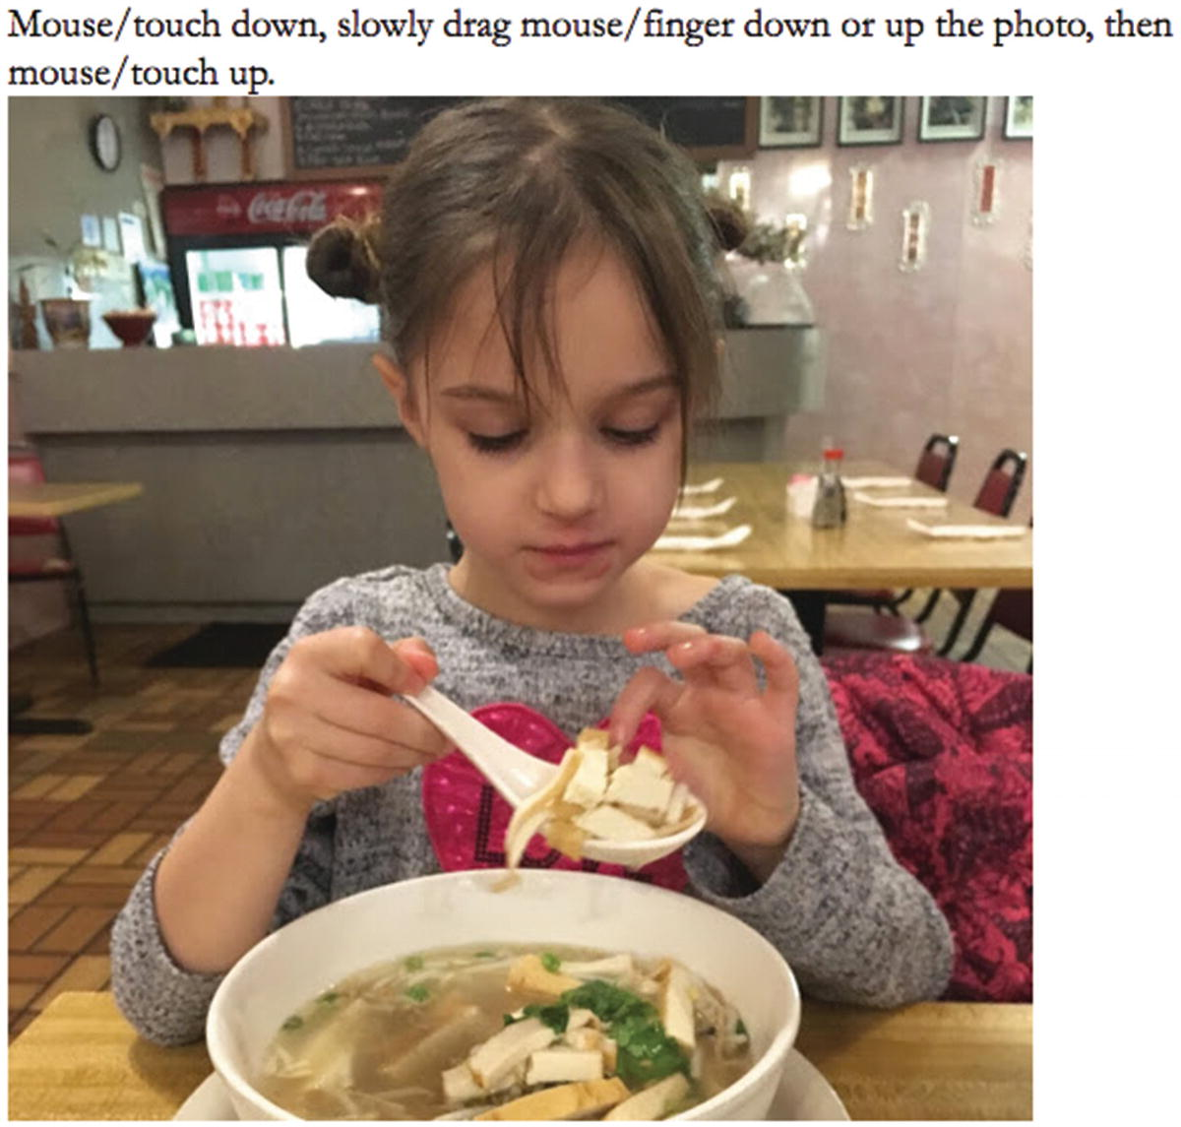
Figure 10-1 Opening screen of reveal program
Pressing down on the mouse button and moving down or touching down with a finger and moving down will cause the next picture to be revealed gradually until close to the bottom. Figure 10-2 shows a picture in the process of being changed.
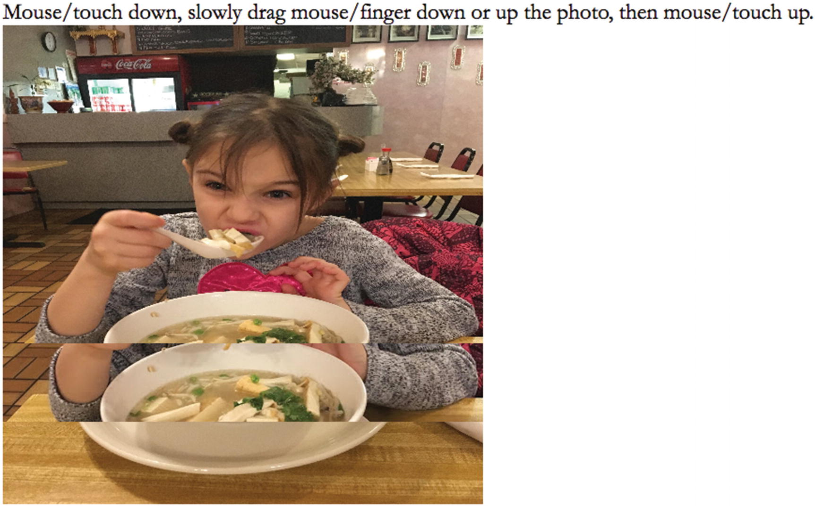
Figure 10-2Change underway from one picture to the next
When the mouse or finger is close enough, the whole next picture appears. Similarly, the user/player can move the mouse or finger up the screen and get the previous picture appearing. I encourage the reader to experiment with the source code.
Figure 10-3 shows a screenshot of a quiz game that can be operated by mouse or touch or the keyboard alone. The set of four countries is selected randomly from the G20 countries and the corresponding capitals are mixed up, so you will see a different set of items each time. The quiz can be taken using just the keyboard and a screen reader program, with the tab key taking the player from item to item, making it suitable for someone with limited or no visual ability and/or someone unable to use a mouse or touch.
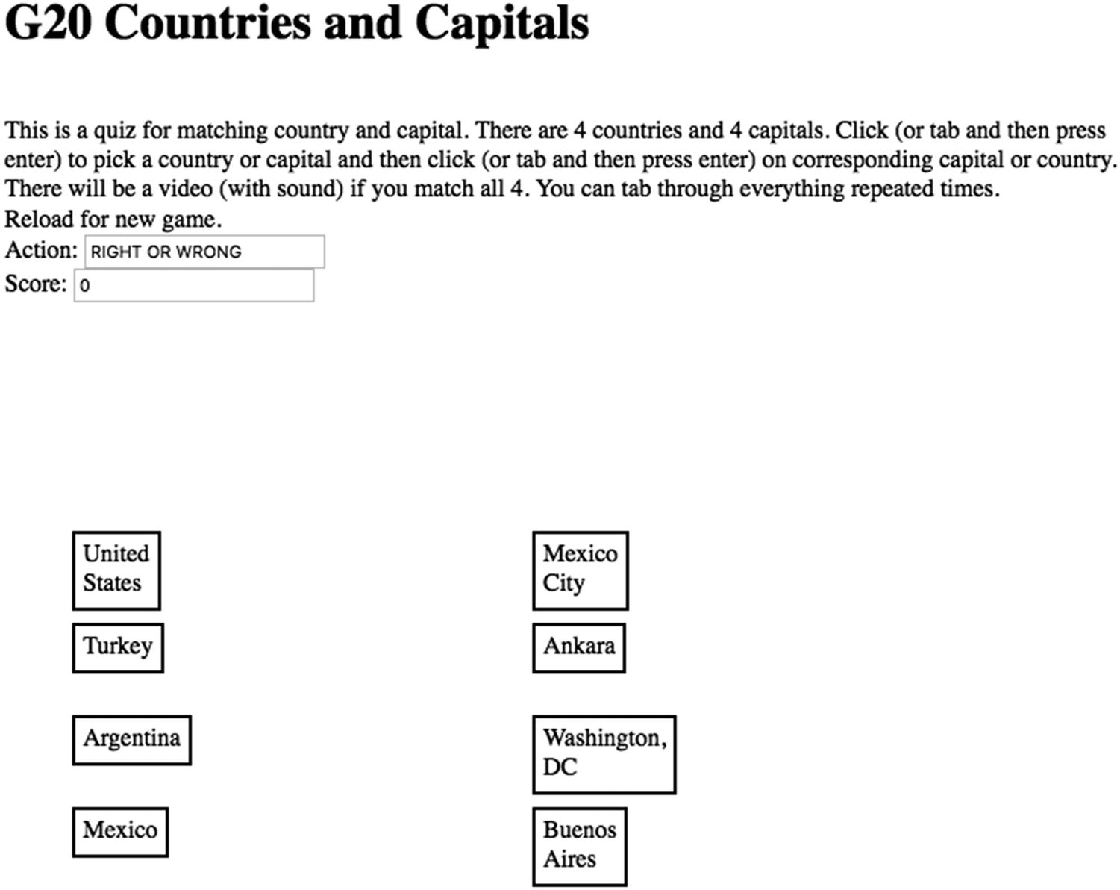
Figure 10-3Opening screen for country/capital quiz
The Action and Score fields indicate the performance so far. The boxes do change color and move to next to the matched box to make it more interesting for the visually able. The yellow/gold color is used when a match is correct. As indicated in the instructions, a video is played when the player correctly makes four matches. Figure 10-4 shows a screenshot.
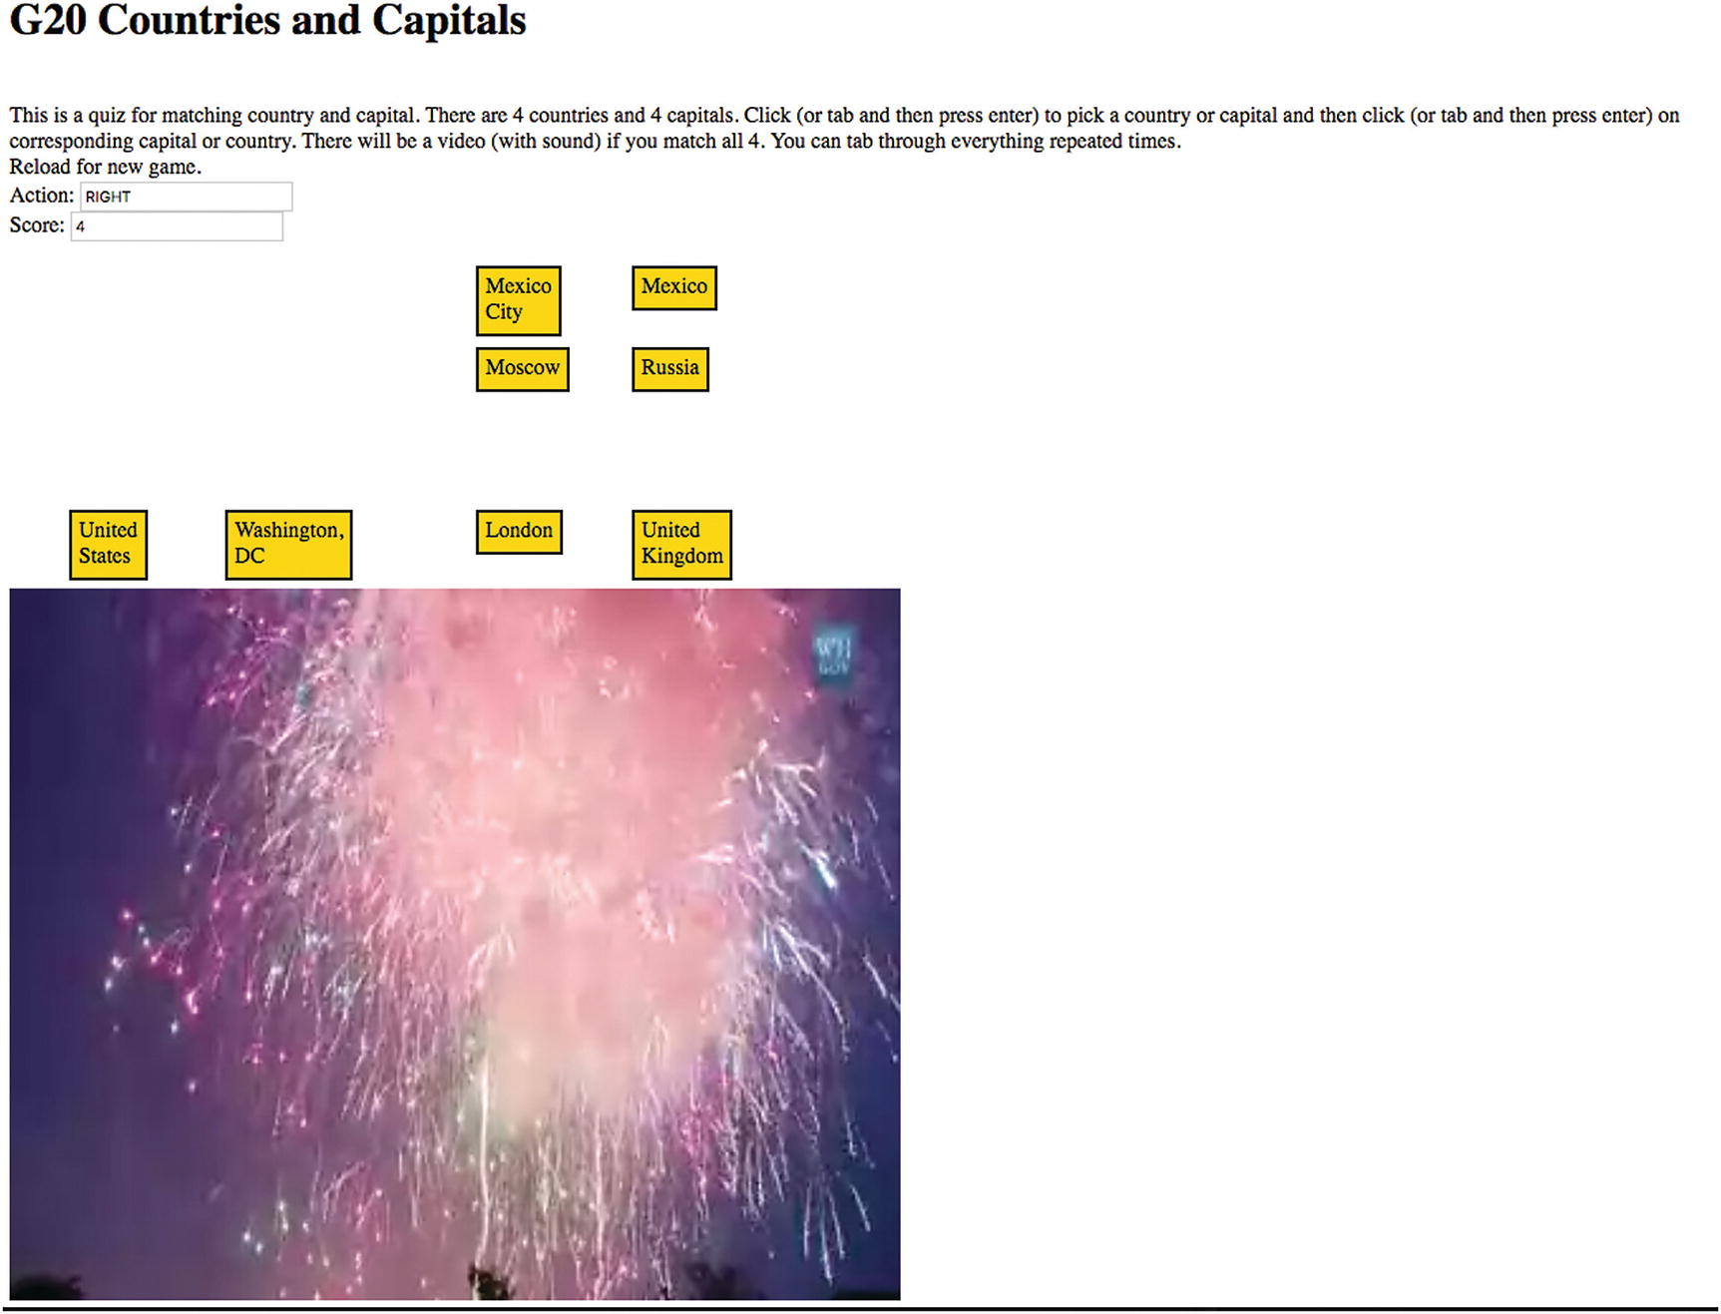
Figure 10-4Screenshot successful completion of quiz
The video has sound so the visually impaired gets the reward as well.
NoteScreen readers are complex and provide options for customizing use. One screen reader I used “spoke” the names of the countries and capitals by themselves but another added the term “group,” which was tiresome. It is possible to use the Tab key with the Shift key to go back and forth hearing the country and capital names. However, screen readers do read the whole screen, including everything on my browser toolbar and this was repeated when clicking on the Tab key past the end of the document. My example shows how to include Tab information in dynamically generated HTML markup. I strongly recommend that when you continue your exploration of the use of screen readers and keyboard operation, study static HTML pages first and then move on to programs with dynamically generated HTML elements.

Critical Requirements
Before going into specific technical features, it is important for developers to consider the most important target audience of a planned application and the feasibility of the application in different situations. There is a notion called mobile first that recommends that the best approach if something is to be available on a mobile device is to design and plan the mobile implementation first as opposed to designing and implementing for a desktop and then making adjustments. Starting with the problem specification, including the most common device and user, and formulating a solution is a good strategy. Teachers and book authors often do something quite different: start with concepts and features we want to explain and design what we believe are interesting programs that use the features.
When you’re designing a web application, it is important to consider that certain programs, such as ones featuring geolocation, are best for mobile. In contrast, a program requiring considerable text entry is best suited for desktops and laptops. A jigsaw puzzle is not for the visually impaired. However, the country/capital quiz , which I originally made for mouse or touch, can be adapted for keyboard operation. Thinking about different screens and different audiences can be a valuable way to determine what is critical for your application and the process of working toward responsive design and improving accessibility can benefit all audiences.
In this chapter, I focus on adapting to screen dimensions, ensuring that touch works in addition to or in place of a mouse, and supporting screen reader and keyboard-only operation for at least some applications. I also wanted to allow the user to resize and resize again the window to arbitrary width and height.
I will mention briefly features that can be useful for a variety of websites, generally having a static design.

Screen Size and Dimension
You may expect to see code that checks for specific devices or device types by name, but that is not the recommended approach for many situations. Instead, if the critical properties to examine include screen width and screen height, then these measurements are checked directly. There are various ways to do that in HTML element properties, CSS rules and directives, and JavaScript code. You can learn, or at least be introduced to, many of the details in the HTML, CSS, and JavaScript features section.

Touch
Mobile devices typically do not have a mouse but instead depend on touch. The interpretation of a touch as a mouse click comes “for free,” that is, no additional coding is required and will be demonstrated in the Quiz example. The Reveal application, which is based on a mouse down, mouse move, and mouse up sequence of operations requires JavaScript code to support touch. The technique is to set up the touch events to simulate the appropriate mouse events.

Screen Reader and Tabs
A variety of screen reader tools exist. I used the built-in VoiceOver feature available on my iMac running MacOS High Sierra to test the quiz program. People with visual impairments and also people unable to operate a mouse need everything to be done through the keyboard. This includes providing the coding to support the use of the Tab key. The general advice for best support of screen reader and keyboard is good overall organization, dividing the text into smaller pieces, and providing labels for what the user cannot see.

HTML, CSS, and JavaScript Features
HTML, together with CSS, provides ways to support responsive design and accessibility. In situations involving more interactive and dynamic behavior, it may be necessary to use JavaScript and I will focus on the JavaScript techniques for the examples.

Meta Tags
The meta tag provides information about the document for the browser, for search engines, and other web programs. Nothing is displayed. The charset meta tag
<meta charset="UTF-8">
specifies what character set is to be used. The UTF-8 designation is the default and indicates the one- to four-byte Unicode standard. The intent in Unicode is to support all the world's languages, and though that may not quite be the case, most languages, including Japanese and Chinese, are supported. Even though Unicode is the default, a warning message may still be displayed on the web console in the absence of this meta tag, so including it will prevent seeing that message if you do go to the web console.
The following meta tag is recommended to set the width to the device width:
<meta name="viewport" content="width=device-width, initial-scale=1.0">
I use the following for the Reveal example to allow the user some ability to scale the window on mobile devices. This is applicable just to mobile devices.
<meta name="viewport"
content="width=device-width, user-scalable=yes, initial-scale=1.0, minimum-scale=1.0, maximum-scale=2.0" />
If image or video elements are not given width or height attribute settings or given fixed amounts, making the window smaller will result in scrolling. Vertical scrolling is considered acceptable, but horizontal scrolling is not. The next section describes techniques to produce the desired effects.

HTML and CSS Use of Percentages and Auto
It is a standard practice to specify the width and the height in pixels for elements such as img. If just one is specified using HTML for the element in the body element, the other is modified to maintain the aspect ratio. In the style section, using CSS, the term auto can be used. This is the default, but I like to mention it explicitly mainly as a reminder to me.
A variation on specifying width or height in pixels is to specify a dimension as a percentage of the containing element. The containing element could be the body element or a div or a semantic tag or something else. The default width dimension for an element with block display, such as a div, is 100% of the screen. It is possible to specify another percentage, say 50% or 80%. An example would be to include in the body
<img id="animal" width="50%" src="monkey.jpg">
This would set the image to have a width taking up 50% of the screen with the height whatever preserves the aspect ratio. In the style section, either of these
#animal {width:50%; height: auto;}
#animal {width:50%;}
would produce the same effect.
If the application window is manipulated (say, on a desktop) to be shorter than the calculated height , then the image would be cut off and a scroll bar would appear for vertical scrolling. If the desired effect is to put a bound on the width (or height), but not stretch the image beyond its original dimension, the max-width or max-height attribute can be used. Generally speaking, vertically scrolling is accepted more than horizontal scrolling so just specifying the width or the max-width is frequently offered as the way to achieve responsiveness. This is the approach I used for the reward video in the countries/capitals quiz.
The percentages can be used with width and/or max-width to set up a grid layout for elements. I encourage you to experiment with these features. The TRY-IT feature of many W3Cschool examples is helpful.
You will see how I use JavaScript to modify the width and the height.

CSS @media
Web developers can set @media queries in the style element. These provide a way to check on attributes of devices and designate style directives for certain conditions. For example, on my Purchase website, I designate certain elements as being in a class I name col. If the screen is wide enough, I want these elements spaced across the window as columns. However, if the screen width is small, I do not want to require horizontal scrolling, but instead have the col elements be displayed vertically with the assumption that users will scroll vertically. The following @media directive produces this effect:
@media all and (max-width: 640px)
{.col {display: block; width: 100%;}}
As was mentioned earlier, this is the technique suggested for testing for a narrow device such as a phone. The @media feature also can be used to specify distinct formatting for screen for computers and devices , the term print for printing out the web page and speech for screen readers.
A @media query can have the modifiers not and only. For example,
@media only screen and (max-width: 600px) {
body {
background-color: lightblue;
}
}
produces a background color of lightblue (this is one of the known color names (see https://www.w3schools.com/Colors/colors_names.asp ) for everything in the body element for use on screens. I refer you to https://www.w3schools.com/CSSref/css3_pr_mediaquery.asp for more examples and explanations.

The HTML alt Attribute and Semantic Elements
The alt attribute for an img element provides information for a screen reader. The value of the alt attribute will be displayed if the file is missing or slow to download. Use of alt elements is recommended in normal cases and programs that check accessibility will indicate any img tags without alt elements. Thinking out what the alt attribute can be an important exercise in developing a web page. Please note that my code for this example does not display the img elements, which are only used as a way to ensure that the images are fully downloaded. Therefore, I did not think it appropriate to include the alt attribute.
Semantic elements can provide information that may be used by screen readers. The terms header, footer, main, section, article, and so on are meaningful when working with other people on large projects. They do not have specific formatting , which must be supplied.

HTML tabIndex
People dependent on a screen reader or unable or uncomfortable using a mouse or touch depend on using the Tab key to go through a document. The tabIndex attribute can be set for any element. Pressing the Tab key takes the user to the next element in tab order (proceeding in numerical order, low to high). Pressing the Tab key and the Shift key reverses direction. The tabindex for an element can be set when preparing the HTML document or produced by coding when creating HTML markup dynamically. In the quizTab application, I included the statement
d.innerHTML = (
"<div tabIndex='"+String(2+i)+"' class="thing" id='"+uniqueid+"'>placeholder</div>");
This code produces successive values for the tabindex for the country names.
The tabindex can be changed during the operation of a web page, although I did not do this in my example. Playing (taking) the quiz does mean going through the items multiple times and this does mean hearing the directions again, and also going up to the address field of the browser again and, in some cases, hearing all the active sites represented by tabs in the browser.

JavaScript Use of Width and Height Properties
The browser for any computer or device will adapt the line width of text to fit the window. However, I also wanted to adapt the font size in the instructions. The instructions are displayed using a font size that my code selects based on a calculation. The fontsz array is set using the statement:
var fontsz = ["14px","16px","18px","20px","24px"];
The size of the font is set in the init function using the cwidth variable that has been assigned the window.innerWidth. The code is
fs = Math.floor (cwidth/200);
fs = Math.min(fs,4);
bodyel.style.fontSize = fontsz[fs];
The challenge I set myself for the Reveal example was for the images to fit within the window without any scrolling, while retaining the proportions. The attributes I used include window.innerWidth and window.innerHeight for the window, and width, naturalWidth, height, and naturalHeight for the images. The “natural” attributes represent the original dimensions of an image. They cannot be changed. For the Reveal example, I had made sure all the images have the same dimension, so I only needed to do one set of calculations. The code checks that the width was less than the screen width and adjusted the height, and then made sure the height was less than the screen height and adjusted the width. You can go back to Chapter 8 for a variation on this involving calculating values for use in the drawImage method.

Creating Elements Dynamically
The sequence of images for the Reveal example is implemented dynamically by drawing each into a canvas element. For any work involving images or other media on the web, it is critical to make sure the files are completed downloaded. I accomplish this by including img elements in the body but setting the visibility to be hidden in the style section. Then, my code invokes a function named init to do all the work of creating the canvas elements, drawing each image into its canvas element, and drawing the first image into the canvas set up in the body.
The countries/capitals quiz also creates elements dynamically. These are rectangular shapes holding the names of the countries and capitals. The HTML markup is created with attributes set for id, class, and tabindex. The id values hold the index into the facts array and is used to determine if the player has correctly matched a country and a capital.

Choosing From List
The Quiz example makes random choices for two situations. It is straight-forward how to make one random choice. However, for this program, I need to make four random choices of country/capital pairs from the facts array on 20 countries, but without allowing repetition. Then, for each country and capital pair, since I do not want each capital name to be opposite its country name, I need code to make random choices for the positioning of each capital from among the four slots representing positions in the second column. This also needs to be done without repetition. Note: It may be the case that a capital does end up opposite its country, but it won’t happen most of the time. See the placement of Mexico City, Ankara, Washington, D.C., and Buenos Aires in Figure 10-3.
My first step toward addressing this problem is to make the facts array hold something to tell me if a fact has been taken. The facts array is an array of arrays and the inner arrays have three elements: country, capital, and true/false. A false setting means the fact has not been selected and true means it has. The slots array will hold indices for the four capital names. I will use an initial setting of -100 to indicate a slot has not been taken. It actually could be any number less than zero. When a slot is chosen, the corresponding value in the slots array is set to the index value of the country/capital in the facts array . Do note that I could use any non-negative number here, because I (my code) does not use the value, but I was thinking about possible future applications.
The coding construct that I use for both situations is a do/while loop . The do/while construct can be used in many situations so try to keep it in mind. Describing it in general terms: the code between brackets is invoked at least one time. Then the condition in the parentheses following the term while is evaluated. If it is true, the code in the brackets is executed again. There can be multiple statements between the brackets. A pseudocode way to think of it is
do { one or more statements }
while (repeat if this condition is true )
The check selecting facts is done by this code:
do {c = Math.floor(Math.random()*facts.length);}
while (facts[c][2]==true)
The assignment to the variable c will be repeated if the fact represented by in the subarray facts[c] has already been chosen.
The analogous check on picking a slot is done by this code.
do {s = Math.floor(Math.random()*nq);}
while (slots[s]>=0)
Values indicating that the position has been taken are indicate by slots[s] being greater than or equal to zero, so the random choice will be repeated if the slot has already been taken.

Mouse Events, Touch Events, and Key Events
There are two main issues to address for responsive design. I have described checking and modifying the elements to fit the window sizes. The second consideration is providing for touch as opposed to mouse events. The handling of touch events is done by simulating mouse events. The mouse events have, presumably, been defined. As I already mentioned, certain touch events are handled without any extra programming. These are simple events such as clicking on an element. However, events such as mousedown, mousemove, and mouseup need to be translated. This is because the exact location of the mouse or touch is needed for calculations to draw from the source canvas to the displayed canvas.
In the init function, the addEventListener method is involved for five events. If this code is executed on a device without some of these events, there is no problem in referencing any event that cannot occur.
canvas.addEventListener("mousedown",startreveal,true);
canvas.addEventListener("touchstart", touchHandler, true);
canvas.addEventListener("touchmove", touchHandler, true);
canvas.addEventListener("touchend", touchHandler, true);
canvas.addEventListener("touchcancel", touchHandler, true);
The touchHandler function performs the task of determining which mouse event is to be simulated (using a switch statement), creating the event (with new MouseEvent), and then dispatching it. The MouseEvent function uses an associative array (also called a dictionary) in which certain attributes are set. There are other attributes that I let assume the default values for this example.
function touchHandler(event)
{
var touches = event.changedTouches;
if (touches.length>1) {
return false;
}
var first = touches[0];
var type = "";
switch(event.type)
{
case "touchstart": type = "mousedown"; break;
case "touchmove": type="mousemove"; break;
case "touchend": type="mouseup"; break;
default: return;
}
var simulatedEvent = new MouseEvent(type,{
screenX: first.screenX,
screenY: first.screenY,
clientX: first.clientX,
clientY: first.clientY
});
first.target.dispatchEvent(simulatedEvent);
event.preventDefault();
}
NoteThe constructor MouseEvent is relatively new and replaces the use of document.createEvent("MouseEvent"), which is now marked as deprecated, meaning its use is discouraged and may not be recognized in the future. Changes in tools are something we need to accept. In fact, the new approach has a significant advantage over the old one: the use of an associative array for the arguments, instead of a long sequence of parameters indicated by position, with most of them taking the default values.
Notice that nothing happens if there is a multi-touch gesture and note also that any default action is prevented. I know of at least one commercial solitaire game—an iPad app—that does not do this and so the whole board may move when moving a card.
Independent of the issue of mouse versus touch: nothing happens if the user in the Reveal program presses down on with mouse or with a finger to the right of the image or below the image (further down the screen). This bad behavior is ignored by use of the following code in the startreveal function:
var startxy = getCoords(ev);
if (startxy[0]>pwidth) return;
if (staryxy[1]>pheight) return;
Similarly, if the player clicks on two country names or two capital names in the Quiz application, the program supplies no special feedback, but does place the second item next to the first. It will not be considered a correct answer because the two id values will not match.
You must decide when building your own application, what feedback, if any, to supply in cases that we can describe as bad behavior.
For the Quiz example, the event handling of a touch (tap) event is interpreted as a mouse click by phone and tablet devices. However, I set myself the challenge of supporting keyboard operation. What I do is set up the keyup event to invoke my pickelement function, but in that function, do a return if the keycode is 9, the keycode for Tab. So, the player using the keyboard would tab to each of the countries and capital items, hear the screen reader say the names, and press Return to pick an item, or tab to the next.

Building the Reveal Application and Making It Your Own
The Reveal program starts with the following sequence of events and actions.
1. | When the document is fully loaded, including the images, the init function is invoked. The init function is invoked following a reload and a resize by the player. Note that the images are not visible because of a directive in the style element.
2. | The init function determines the dimensions of the window and uses that information to choose the size of the font.
3. | The init function invokes the setupimages function.
4. | The setupimages function does calculations to make sure the images fit into the window, maintaining the aspect ratio. It creates a canvas element for each image.
5. | Returning to the init function, the mouseDown and all touch events are set up. The first image is drawn into the canvas element, drawing from a canvas to a canvas. The next and prev variables are set.
The action of revealing the next picture is handled by the functions startreveal, revealing, and stopreveal, with the called and calling relationships indicated in Table 10-1. I made the decision to allow the user to swipe up or down and change direction. I also decided to complete the transition if the vertical level was within a fudge factor of the top or bottom. My intentions are realized by the nested if/else statements in the program.
Table 10-1 Functional Relationships for Reveal
Function | Invoked By | Invokes
init | The onload and onresize attributes in the body tag | setupimages
setupimages | init
touchHandler | Call of addEventListener in init
getCoords | startreveal, revealing
startreveal | Call of addEventListener in init and in stopreveal | getCoords
revealing | Call of addEventListener in startreveal | getCoords
stopreveal | Call of addEventListener in startreveal and direct call in revealing
Table 10-2 shows the code with comments for the reveal program.
Table 10-2 Code for Reveal Program
Code | Description
<!DOCTYPE HTML> | Header
<html> | html tag
<head> | head tag
<title>Reveal next</title> | The complete title element
<meta name="viewport" | Start of viewport
content="width=device-width, user-scalable=yes,  initial-scale=1.0, minimum-scale=1.0,  maximum-scale=2.0" /> | Indicates treatment of user changes
<meta charset="UTF-8"> | Specifies the charset to be Unicode
<style> | Style tag
body { | Directive for body
font-family: Garamond, serif; | Font is Garamond, if available, otherwise serif
font-size: 24px; | Note size may be changed
overflow: hidden; | No overflow and no scrolling if too big
} | Close body directive
div#images {display:none;} | Do not display any images; images used to draw into canvas elements
</style> | Close style element
<script> | Start of script element
var ctx; | Will hold context for canvas elements
var fudge = 40; | Do not require user to go all the way up or all the way down for the next image to appear; this is a “fudge factor,” meaning it is to give the user a small amount of room
var canvas; | Will hold canvas
var pwidth; | Width of the pictures
var pheight; | Height of the pictures
var cwidth; | Window width
var cheight; | Window height
var current = 0; | Start with 0th picture
var prev = 3; | Start with the previous being the picture at index 3
var next = 1; | The next picture is at index 1
var rect; | Used for getting mouse coordinates
var revealflag = false; | Flag
var lastdrawn; | Keeps track of last picture
var lasty; | The last y value
var moving = false; | Set to indicate moving mouse
var canvases = []; | Will hold canvases for all the pictures
var fontsz = ["14px","16px","18px","20px","24px"]; | The possible font sizes
function init() { | Header for init function
var fs; | Used to determine font size
canvas=document.getElementById("canvas"); | Pointer to the canvas element
bodyel = document.getElementById("body"); | Pointer to the body element
ctx = canvas.getContext("2d"); | Context for the canvas
ctx.font = "24px serif"; | Default font and size
cwidth = window.innerWidth; | Width of window
cheight = window.innerHeight; | Height of window
fs = Math.floor (cwidth/200); | Calculate for font size
fs = Math.min(fs,4); | Minimum is 4
bodyel.style.fontSize = fontsz[fs]; | Set font size of instructions in the body to be fs element of fontsz array
canvas.width = cwidth; | Set canvas width
canvas.height= cheight; | Set canvas height
rect = canvas.getBoundingClientRect(); | Used for determining mouse coordinates
var noOfImgs = document.getElementsByTagName('img').length; | Determines the number of img elements in document
setupimages("noodles", noOfImgs); | Invoke function that will set up the image (picture) canvases after performing any scaling
canvas.addEventListener("mousedown",  startreveal,true); | Set mousedown event
canvas.addEventListener("touchstart",  touchHandler, true); | All touch events invoke touchHandler
canvas.addEventListener("touchmove",
touchHandler, true);
canvas.addEventListener("touchend",
touchHandler, true);
canvas.addEventListener("touchcancel",
touchHandler, true);
ctx.drawImage(canvases[0],0,0); | Draw the first (0th index) picture into the canvas
current = 0; | Set current; this and the next two statements are necessary for init being called by onresize
prev = 3; | Set prev
next = 1; | Set next
} | Close init
function setupimages (base, lim){ | Header for setupimages function; the base holds the start of the names of the images and lim indicates the number of images
var dref; | Reference to first image; this one is used to calculate the scaling factor
var can; | Will point to each of the canvases
var canctx; | Will hold the context for each canvas
canvases = []; | Will hold the created canvases, with the images, all scaled to the appropriate size; you can think of these as buffers holding the images
var img; | Will hold each img in turn
dref = document.getElementById("dummy"); | Get reference to the first image
if (dref.naturalWidth) { | This provides the original width of the image
dref.width = dref.naturalWidth; | Set width to this value
pratio = dref.naturalHeight/dref.naturalWidth; | Calculate aspect ratio
} | Close if
else { | Less general when naturalWidth absent, which may be the case with some browsers
pratio = dref.height/dref.width; | Calculate ratio
} | Close else
dref.width = Math.min(dref.width,cwidth-fudge); | Now possibly reset width
dref.height = pratio * dref.width; | Set the height to match the possibly modified width
dref.height = Math.min(dref.height,cheight-fudge); | Now possibly modify height
dref.width = dref.height * (1/pratio); | Set the width to match the possibly modified height
pwidth = dref.width; | Set variable for later use
pheight = dref.height; | Set variable for later use
for(var i=1;i<=lim;i++){ | References the image files by name, by adding 1,2,3,4 to base; this loop scales the images (repeating the operation for the first one); note also the items in the canvases array are at index positions 0,1, 2, 3
img = new Image(); | Create an Image object
img.width = pwidth; | Set the width
img.height = pheight; | Set the height
img.src=base+String(i)+".jpg"; | Set the src using the base and a number
can = document.createElement("canvas"); | Create a canvas
can.width = cwidth; | Set its width
can.height = cheight; | … and height
canctx = can.getContext('2d'); | Set canctx to be the context
canctx.drawImage(img,0,0,pwidth,pheight); | Draw the image into this canvas
canvases.push(can); | Push into the canvases array
} | Close the for loop
} | Close setupimages function
function touchHandler(event) { | Header for touchHandler
var touches = event.changedTouches; | Get array of touches
if (touches.length>1) { | If more than one
return false; | Return; don't do anything for multi-touch gestures
} | Close if
var first = touches[0]; | Take the first (and only) touch
var type = ""; | Initial setting
switch(event.type) { | Switch on type of event
case "touchstart": type = "mousedown"; break; | Set type variable to be the corresponding mouse event
case "touchmove": type="mousemove"; break;
case "touchend": type="mouseup"; break;
default: return; | Do nothing
} | Close switch
var simulatedEvent = new MouseEvent(type,{  screenX: first.screenX,  screenY: first.screenY,  clientX: first.clientX,  clientY: first.clientY  }); | Create the MouseEvent of the calculated type; set the locations from the locations of the touch event
first.target.dispatchEvent(simulatedEvent); | Dispatch event to be treated as actual event
event.preventDefault(); | Stop any default response for the touch event
} | Close touchHandler
function getCoords(ev){ | Header for getCoords to pick up mouse position
var mx; | Will hold horizontal
var my; | Will hold vertical
mx = ev.clientX-rect.left; | The rect variable has been set; calculates mx
my = ev.clientY-rect.top; | Calculate my
return [mx,my]; | Return an array
} | Close getCoords
function startreveal(ev){ | Header for startreveal
var startxy = getCoords(ev); | Get the coordinates of the mouse
if (startxy[0]>pwidth) return; | No action if mouse or touch is to the right of the image
if (startxy[1]>pheight) return; | No action if mouse or touch is below the image
lasty = Math.max(startxy[1],fudge); | Start at least fudge distance from the top
canvas.addEventListener("mousemove",  revealing,true); | Set up mousemove
canvas.addEventListener("mouseup",  stopreveal,true); | Set up mouseup
canvas.removeEventListener("mousedown",  startreveal,true); | Stop listening for mousedown
revealflag = true; | Set flag
} | Close startreveal
function revealing(ev){ | Header for revealing
var slice; | Will indicate how much to be drawn from next picture (vertical amount)
var curxy; | Will hold mouse position
if (!revealflag) return; | If not in the reveal stage, return
curxy = getCoords(ev); | Get mouse coordinates
cury = curxy[1]; | Set cury
if (moving){ | Check moving flag
if (cury>=lasty){ | If it is further down than last
if (cury<(pheight-fudge)){ | If it isn’t in the bottom part
slice = Math.max(1,cury-lasty) | Calculate the height
ctx.drawImage(canvases[next],0,lasty,pwidth,  slice,0,lasty,pwidth,slice); | Draw from the next canvas
lastdrawn = next; | Set up for next move
lasty = cury;
} | Close if
else { | Go immediately to set up for next
lastdrawn = next; | Set lastdrawn
stopreveal(ev); | ev passed to be consist with being eventhandler
} | Close else for cury<(pheight-fudge)
} | Close cury>=lasty
else { | Else cury< lasty, so moving up
if (cury>fudge){ | If still outside of fudge area
slice = Math.max(1,lasty-cury); | Calculate slice
ctx.drawImage(canvases[prev],0,cury,pwidth,  slice,0,cury,pwidth,slice); | Draw from prev image
lastdrawn = prev; | Set lastdrawn to prev
lasty = cury; | Set lasty
} | Close if
else { | Else within fudge area, so complete transition
lastdrawn = prev; | Set lastdrawn
stopreveal(ev); | Invoke stopreveal
} | Closes else for cury>fudge
} | Close else for cury>=lasty
} | Close if moving
else { | First mov
moving = true; | Set moving
if (cury>=lasty){ | Check direction
prev = current; | Moving up, so set prev
if (cury<(pheight-fudge)){ | Check if above fudge
slice = Math.max(1,cury-lasty); | Set the slice
ctx.drawImage(canvases[next],0,lasty,pwidth,  slice,0,lasty,pwidth,slice); | Draw from next
lastdrawn = next; | Set lastdrawn
lasty = cury; | Set lasty
} | Close if above fudge
else { | Else
lastdrawn = next; | Set lastdrawn
stopreveal(ev); | Immediately go to stopreveal; the ev passed to be consist with being an eventhandler
} | Close else for cury<(pheight-fudge)
} | Close cury>=lasty for moving false
else { | Going up the image
next = current; | Set next
if (cury>fudge){ | If greater than fudge
slice = Math.max(1,lasty-cury); | Calculate slice
ctx.drawImage(canvases[prev],0,cury,pwidth,  slice,0,cury,pwidth,slice); | Draw slice
lastdrawn= prev; | Set lastdrawn
lasty = cury; | Set lasty
} | Close if above fudge
else { | Else (in fudge area)
lastdrawn = prev; | Set lastdrawn
stopreveal(ev); | Go immediately to stopreveal
} | Close else for if cury>fudge
} | Close else for cury>=lasty
} | Close else for if moving
} | Close function
function stopreveal(ev) { | Header for stopreveal
revealflag = false; | Reset revealflag
moving = false; | Reset moving
ctx.drawImage(canvases[lastdrawn],0,0); | Draw the complete image
current = lastdrawn; | Set current
next = current+1; | Increment next
if (next==canvases.length) next = 0; | If at the end, set next to 0
prev = current-1; | Set prev
if (prev<0) prev=canvases.length-1; | If prev too low, set to the last index
canvas.removeEventListener("mousemove",  revealing,true); | Stop listening for mousemove
canvas.removeEventListener("mouseup",  stopreveal,true); | Stop listening for mouseup
canvas.addEventListener("mousedown",  startreveal,true); | Set up event for startreveal
} | Close stopreveal
</script> | End script element
<body id="body" onload="init();"  onresize="init();"> | Body tag, with setting for onload and onresize
Mouse/touch down,  slowly drag mouse/finger down or up the photo,  then mouse/touch up. | Instructions
<canvas id="canvas" width="100%"  height="50%" > | Canvas; may be scaled
Your browser doesn't support canvas | Standard message
</canvas> | Canvas end tag
<div id="images"> | The div holding the images
<img src="noodles1.jpg" id="dummy"/> | The first one is used for the scaling calculations
<img src="noodles2.jpg">
<img src="noodles3.jpg">
<img src="noodles4.jpg">
</div> | Close div
</body> | Close body
</html> | Close html

Testing and Uploading the Reveal Application
The Reveal (I also call it uncover) application requires a set of images of the same dimension, though that dimension does not need to be what I have for the girl-eating-noodles. You can have a different number of images than the four that I have. This is supported by the use of the document.getElementsByTagName invocation in the setupimages function. Of course, if you choose to include other images, you will need to do the call for the div holding the img elements in place of document.

Building the Countries/Capitals Quiz and Making It Your Own
The quiz show is set up by selecting four country capital pairs from the facts table using Math.random and checking to be sure not to repeat any pair. Elements are created dynamically for countries and capitals and the order of how the capitals appear in the window is make random. These elements are created with tabIndex set. As each element is created, addEventListener is invoked for the click event and the keyup event. The functions with their relationships are shown in Table 10-3. Notice that there is no touchhandler event because the click using touch events are properly interpreted by browsers on devices. More generally, setting the tabIndex attribute provides the tab functionality without any additional JavaScript coding.
Table 10-3 Functional Relations for Quiz
Function | Invoked By | Invokes
init | Action by the onload attribute in the body tag | setupgame
setupgame | init
pickelement | Action by addEventListener multiple times in setupgame
The code with comments in shown in Table 10-4.
Table 10-4 Code for the Country/Capital Quiz
Code | Description
<!DOCTYPE html> | Standard header
<html> | The html tag
<head> | The head tag
<title>Quiz with Reward!</title> | Complete title
<style> | The style tag
country {position:absolute;left: 0px; top: 0px; border: 2px; border-style: double; background-color: white; margin: 5px; padding: 3px; visibility:hidden;} | Format country blocks
capital {position:absolute;left: 0px; top: 0px; border: 2px; border-style: double; background-color: white; margin: 5px; padding: 3px; visibility:hidden;} | Format capital blocks
#vid {position :absolute; visibility:hidden; z-index: 0; max-width: 50%; height: auto;} | Make video hidden until time to play; set limit on width
main {display:block;} | Force line breaks before and after main
</style> | Closing style tag
<script type="text/javascript"> | Script tag
var facts = [ | Variable holding the information for the quiz; the third place in the inner arrays is used to indicate if the fact has been chosen for this game
["China","Beijing",false],
["India","New Delhi",false],
["European Union","Brussels",false],
["United States","Washington, DC",false],
["Indonesia","Jakarta",false],
["Brazil","Brasilia",false],
["Russia","Moscow",false],
["Japan","Tokyo",false],
["Mexico","Mexico City",false],
["Germany","Berlin",false],
["Turkey","Ankara",false],
["France","Paris",false],
["United Kingdom","London",false],
["Italy","Rome",false],
["South Africa","Pretoria",false], | Note: South Africa has three capitals; I chose to go with Pretoria; it is a matching game, so players will never see the other two city names
["South Korea","Seoul",false],
["Argentina","Buenos Aires",false],
["Canada","Ottawa",false],
["Saudi Arabia","Riyadh",false],
["Australia","Canberra",false]
]; | Close outer array of facts
var thingelem; | Used for each block item
var nq = 4; | Number of questions asked in a game
var elementinmotion; | Used to indicate selected element to be moved next to player’s match
var makingmove = false; | Set to true while player choosing two blocks
var inbetween = 150; | Spacing between columns
var col1 = 0; | Start of first column
var row1; | Set in init; start of first row
var rowsize = 60; | Vertical space allocated for each item
var slots = new Array(nq); | Hold the index into facts array for the capital items
function init(){ | Header for init function
row1= .6* window.innerHeight; | Set row1 as expression in total window height; if height is too small, vertical scrolling will be required
setupgame(); | Invoke setupgame
} | Close init
function setupgame() { | Header for setupgame
var i; | Used in for loops
var c; | Used in calculation of random choice
var s; | Used in calculation of candidate slot for capitals
var mx = col1; | Starting x position
var my = row1; | Starting y position
var d; | Will hold reference to created element for country
var uniqueid; | Used to hold all the generated IDs
for (i=0;i<facts.length;i++) { | Loop over all the facts
facts[i][2] = false; | Set as being unused
} | Close for loop
for (i=0;i<nq;i++) { | Loop over all slots
slots[i] = -100; | Set slot value
} | Close for loop
for(i=0;i<nq;i++) { | Loop until nq distinct facts are chosen
do {c = Math.floor(Math.random()*facts.length);} | Do gets a random value
while (facts[c][2]==true) | If this fact is taken, repeat the do clause
facts[c][2]=true; | Now, having chosen a fact not taken, mark it as taken
uniqueid = "c"+String(c); | Generate an ID
d = document.createElement('country'); | Create an element
d.innerHTML = ( | Set the innerHTML
"<div tabIndex='"+String(2+i)+"' class="thing" id='"+uniqueid+"'>placeholder</div>"); | … to be a div, class 'thing' to respond to the style directive
document.body.appendChild(d); | Append to body (so it will be displayed)
thingelem = document.getElementById(uniqueid); | Set thingelem to reference the newly created element
thingelem.textContent=facts[c][0]; | Make its context the country
thingelem.style.top = String(my)+"px"; | Position it at the my vertical and…
thingelem.style.left = String(mx)+"px"; | … mx horizontal position
thingelem.addEventListener('click',pickelement); | Set up event handling for click
thingelem.addEventListener('keyup',pickelement); | Set up event handling for keyup
thingelem.style.visibility="visible"; | Set the visibility to visible
uniqueid = "p"+String(c); | Now create a new unique ID
d = document.createElement('cap'); | Create an element
d.innerHTML = ( | Set the innerHTML
"<div tabIndex="0" class="thing" id='"+uniqueid+"'>placeholder</div>"); | The div for the items; code will change tabIndex
document.body.appendChild(d); | Append to the body so it will be visible
thingelem = document.getElementById(uniqueid); | Set thingelem to reference this element
thingelem.textContent=facts[c][1]; | Set its content
Put this thing in random choice from empty slots
do {s = Math.floor(Math.random()*nq);} | Do set s to be a random value
while (slots[s]>=0) | If the current value of slots[s] is greater than or equal to zero, it means this slot is taken and so repeat the do clause to get a new value s
slots[s]=c; | This slot has not been taken, so set it to be the value c
thingelem.tabIndex = String(6+s); | Set its tabIndex
thingelem.style.top = String(row1+s*rowsize)+"px"; | Position it vertically, using the position indicated by s
thingelem.style.left = String(col1+inbetween)+"px"; | All capitals have the same horizontal positioning to be the second column
thingelem.addEventListener('click',pickelement); | Set event handling for click
thingelem.addEventListener('keyup',pickelement); | Set event handling for keyup
my +=rowsize; | Increment my to go to the next row
} | Close the for loop
document.f.score.value = "0"; | Set the score to 0
return false; | Return, prevent any refresh of document (may not be needed)
} | Close setupgame
function pickelement(ev) { | Header for pickelement
if (ev.keyCode ===9) {return;} | Return immediately if keycode is tab
var thisx; | Will hold character string indicating horizontal position
var thisxn; | Will hold the new horizontal position with the px removed
var sc; | Score
if (makingmove) { | If makingmove true
if (this==elementinmotion) { | If this is the first item selected—that is, same block clicked twice, treat as not a good move and go back to waiting for a first click
elementinmotion.style.backgroundColor = "white"; | Turn it white
makingmove = false; | Reset makingmove
return; | return
} | Close if
thisx= this.style.left; | The this block is a distinct second item selected; get horizontal position
thisx = thisx.substring(0,thisx.length-2); | Remove the px
thisxn = Number(thisx) + 115; | Convert to number and add some space
elementinmotion.style.left = String(thisxn)+"px"; | Reset the elementinmotion to move element
elementinmotion.style.top = this.style.top; | Set vertical coordinate to save vertical level
makingmove = false; | Reset makingmove
if (this.id.substring(1)  ==elementinmotion.id.substring(1)) { | Now check if this is a good match by comparing the part of the id string after "c" or "p"
elementinmotion.style.backgroundColor = "gold"; | Set to gold
this.style.backgroundColor = "gold"; | Set to gold
document.f.out.value = "RIGHT"; | Output message
sc = 1+Number(document.f.score.value); | Increment score
document.f.score.value = String(sc); | Display score
if (sc==nq) { | Check if this means nq have been matched
v = document.getElementById("vid"); | If so, get the video
v.style.top = String(row1+4*rowsize+20)+"px"; | Locate just under the items; if height is small, video will be off-screen and require vertical scrolling to be visible; it will be heard.
v.style.visibility = "visible"; | Make video visible
v.style.zIndex="10000"; | Put on top of items (this is for any changes putting the video on top; now it is below blocks)
v.play(); | Play video
} | Close if sc==nq
} | Close if IDs match
else { | Else (bad move)
document.f.out.value = "WRONG"; | Display wrong
elementinmotion.style.backgroundColor = "white"; | Set to white
} | Close else
} | Close if second item
else { | Else (first item selected)
makingmove = true; | Set makingmove flag
elementinmotion = this; | Save this reference for later use
elementinmotion.style.backgroundColor="tan"; | Set color
} | Close else
} | Close pickelement function
</script> | Close script section
</head> | Close head section
<body onLoad="init();"> | The body tag; notice call to init upon loading
<main tabIndex="1"> | The main element, tabIndex set
<h1>G20 Countries and Capitals </h1> | Heading
<br/> | Force line break
This is a quiz for matching country and capital.  There are 4 countries and 4 capitals. | Instructions
Click (or tab and then press enter)  to pick a country or capital and  then click (or tab and then press enter)on corresponding capital or country.  There will be a video (with sound) if you match all 4. You can tab through  all the elements repeated times. | Instructions, continued
<p> | A paragraph tag
Reload for new game. </p> | More instructions
</main> | Close main element
<p> | A paragraph tag
<form name="f" > | A form element
Action: <input name="out" type="text"  value="RIGHT OR WRONG"/><br/> | Will indicate results of player moves
Score: <input name="score" type="text"  value="0"/> | Score, starting with 0
</form> | Close form
</p> | Close paragraph
<video id="vid" controls="controls"  preload="auto" width="50%"  alt="Fireworks video"> | Video tag; note alt
<source src="sfire3.webmvp8.webm" type='video/webm; codec="vp8, vorbis"'> | Holds videos in different formats, starting with webm; note: I stayed with the long names for these files
<source src="sfire3.mp4"> | The MP4 format
<source src="sfire3.theora.ogv"  type='video/ogg; codecs="theora, vorbis"'> | The OGV format
Your browser does not accept the video tag. | Standard message for older browsers
</video> | Close video
</body> | Close body
</html> | Close html

Testing and Uploading the Countries/Capitals Quiz Application
You can decide which countries to include in your list or, if you want to change the quiz to something different, you need to formulate and create the pairs of strings defining the content. You also can choose a different video to be the reward for successful completion of the quiz. If you want the quiz to serve the visually impaired as well as others, you will want to choose a video that includes loud, cheerful music.

Testing and Uploading the Jigsaw Turning to Video Application
In Chapter 8, you learned how to create a simple jigsaw puzzle game that turns into a video clip when the jigsaw puzzle is complete. I have added to the jigsaw program the enhancements discussed in this chapter for responding to touch and included it with the source code for this chapter. You will not see anything different if you examine this code on a desktop or laptop. However, if you upload the code to your own website along with a base image and video files, you should see it work on mobile devices.
As I indicated in Chapter 8, be aware that the Apple operating systems on mobile devices may require users to click the Play button for all videos. This is considered a feature, not a bug, by Apple. Requiring a click does give the owners of the devices a chance to prevent downloading of a video, which takes time and battery power and may incur fees. I have discussed the issue of Chrome’s autoplay policy in Chapters 2 and 3. For the jigsaw-to-video project, I would prefer transition from jigsaw to video to be automatic and that is what it is on a desktop or laptop computer . You need to be aware of this issue because there may be changes in the browsers in the future.
You make this game your own by using your own video, with the first frame extracted as an image file to serve as the base.

Summary
In this chapter, you explored issues critical for expanding the audience for your work.
The concerns for responsive design include adapting to the size and shape of different screens as well as providing for touch as well as mouse actions. Certain HTML and CSS features were described that were not used in the examples.
The concerns for accessibility include providing support for keyboard operation when a mouse or touch is not feasible. This includes setting the tab index, which can be done even when elements are created dynamically. Playing a video as the reward for successful completion of a quiz works for the visually impaired if audio from the video is present and appropriate.
The applications described here and the enhanced jigsaw turning into video are built on everything you have learned in this book, including building elements dynamically, working with arrays and images, and setting up events and event handling. I hope you enjoyed the experience and have started building your own projects.

Index

A
Accumulator
addListener function
Add to 15 project
computerMove function
CSS styling
functions
JavaScript arrays
opening window
player move
requirement
setUpBoard function
Alt attribute
Apple operating systems
Application programming interface (API)
Google Maps ( see Google Maps API)
map maker ( see Map maker, Google Maps)
map portal ( see Google Maps API, map portal)
Associative array
Autoplay policy

B
Bouncing video
animation
automatic scrolling
clearInterval(tid)
ctx.clearRect(0,0,cwidth,cheight)
displacement value
init function
moveandcheck function
setInterval(drawscene,50)
tid = setInterval(drawscene,50)
videobounceC program
videobounceE program
video element bouncing with less restrictive checking
application
changedims function
testing and uploading
v.currentTime attribute
videobounceC application code
videobounceE program code
VideobounceTrajectory program code
window.innerWidth and window.innerHeight attributes
body definition and window dimensions
body element
init function
Math.min method
video element
video formats
window.innerWidth and window.innerHeight attributes
HTML5
movable video element
Opera screen capture
project history and critical requirements
smaller window
stop-motion photography
trajectory of virtual ball
traveling mask
user interface
very small window
video drawn on canvas
window resize, running program

C
Canvas graphics
drawshadowmask function
grayshadow
mouse movement, masking
schematic with variable values
shadow mask
z-index values
Cascading Style Sheets (CSS)
changescale function
checkPosition function
clearshadow function
closePath method
computerMove function
Constructor function
Copy by reference
Countries/capitals quiz game
application
code
functional relations for
testing and uploading
creates elements dynamically
critical requirements
do/while loop
facts array
feedback
keyboard operation
opening screen for
random choices
screen size and dimension
Sierra
successful completion of
touch
Crease pattern
Critical methods
CSS @media

D, E
2D context property
distsq function
Document object model (DOM)
dologo function
donext function
Drop LatLng marker option

F
facts array
Family collage
Adobe Photoshop
critical requirements
canvas element
drag and drop operation
CSS, JavaScript features
end-user position
final product, rearranged objects
HTML5
image application
clone(obj)
createelements()
distsq()
drawheart()
drawoval()
drawpic()
drawrect()
drawstuff()
drawvideo()
dropit(ev)
event handling functions
Heart()
HTML5 family collage project
HTML5 Logo project
init()
initialization
loading()
makenewitem()
object definition methods
outside()
Oval()
overheart()
overoval()
overrect()
overvideo function
Picture()
Rect()
removeobj()
restart function
saveasimage()
startdragging(ev)
Videoblock function
videoloaded function
JavaScript object
constructor function
external file
family picture project
method function
types of objects
manipulating object
mouse over object
coordinate system
outside function
overcheck method
overheart function
overoval function
overrect function
overvideo function
startdragging and makenewitem
opening screen, family pictures
save canvas image
DataURL
Firefox browser
saveasimage function
test and upload application
user interface
clone function
drawstuff function
dropit function
flypaper effect
mouse cursor coordinates
moveit function
onClick attributes
removeobj function
fillStyle property
Flypaper effect
Frames

G
Geolocation
application
functions
project code
testing and uploading
goback function
Google Maps API
addListener
associative array
HYBRID map
makemap function
Map constructor method
Map, LatLng, and Marker
map portal
associative array
event handling
HTML document location
HYBRID map type
interface removed
latitude and longitude values
makemap function
myOptions array
SATELLITE map type
TERRAIN map type
x1.png file
mobile devices applications
onLoad attribute
portal construction
pseudocode
ROADMAP
SATELLITE map
TERRAIN map
Graceful degradation

H
Hint button
HTML
Alt attribute
tabIndex
width/height in pixels
HTML5 logo
body of document
canvas element
Chrome browser opening screen
coordinate transformation
dologo function
drawing paths
canvas element
closePath method
2D context
2D coordinate system
hexadecimal format
init function
onLoad attribute
sequence
drawpath, fillStyle property
factorvalue
Firefox opening screen
graceful degradation
image of
project code
project function
project history and critical requirements
range input element
scaled down
semantic tags
slider feature
testing and uploading
text placement
World Wide Web Consortium
HYBRID map

I
innerHTML attribute
intersect function
Intersection

J
JavaScript arrays
JavaScript object
constructor function
createelements function
drawing
heart
Oval
picture
Rect
Videoblock
videomarkup
Jigsaw video puzzle
application
code
jigsaw-to-video project functions
testing and uploading
desktop computer
feedback label
nearly completed puzzle
opening screen
puzzle progress
replaced pieces
spread out pieces
tolerance
video with controls
display attribute
drawImage function
endjigsaw function
finger touches
accumulator
checkpositions function
deltax and deltay arrays
doaverage function
piecesx and piecesy arrays
questionfel element
release function
tolerance
video preparation, positioning, and playing
firstpkel variable
init function
iPhone and iPad
critical requirements
jigsaw-puzzle-with-video-reward project
user interface construction
makePieces function
Math.floor
Math.random
mouse events
checkpositions function
mouseDown variable
moving function
moving jigsaw pieces
setupjigsaw function
startdragging function
sCTX canvas
setupgame function
setupjigsaw function
testing and uploading

K, L
kamih variable
kamiw variable

M, N
Map maker, Google Maps
API ( see Google Maps API)
application
functions
mapspotlight.html application code
testing and uploading
base location
canvas graphics
drawshadowmask function
grayshadow
mouse movement, masking
schematic with variable values
shadow mask
z-index values
closest-in limit
cursor
distance and rounding values
events
addListener
changebase function
CHANGE button
checkit function
clearshadow function
drawshadowmask function
HTML coding
init function
mouseout event
panning and zooming
parallel structures
pushcanvasunder function
radio buttons
showshadow function
title indicating distance
farthest-out view
Greenland problem
latitude and longitude
coordinate system
distances between locations
Drop LatLng marker option
equator at Greenwich prime meridian
Greenwich prime meridian
HTML5 application
location
meridians
parallels
teardrop marker
values
Wolfram Alpha
opening screen
satellite view
semitransparent shadow
shadow/spotlight
slider, zoom
zoomed in to limit
zooming out and moving north
Map portal, Google Maps
API ( see Google Maps API, map portal)
application testing and uploading
click not close to any target
content outline
distances and tolerances
hint button
HTML5 markup and positioning
image-and-audio combination
mapmediaquiz.html file
mediaquizcontent.js file
opening screen
project content
project history and critical requirements
quiz application
code
functions
regular expressions
video, audio, and image files
zooming out
MasterCard numbers
Math.floor method
Math.min method
Meta tag
Mobile first
mountain function

O
Object oriented programming
onChange attribute
Open Source Miro Video Converter
Origami directions
application
functions
project code
testing and uploading
coordinate values
crease pattern
critical requirements
first instructions
fish throat photograph
fish with throat fixed
kami
line drawings/images
mountain/valley folds
opening screen
origami definition
origamifish.html
paused video, sink step
photograph display
sink fold
skinny vertical line
step after sink
step line drawing functions
after making lips
after wraparound steps
canvas coordinate transformations
dividing a line into thirds and folding
dividing-into-thirds step
HTML5 path-drawing facilities
labeling at fold, half step
labeling critical points
littleguy function
built-in Math methods
rotatefish function
sink center preparation
triangle function
triangleM function
variables
steps array
definition
donext function
goback function
init function
nextstep
onLoad attribute
origamifish.html
talking fish
unfolded fold line
user interface
utility functions
calculation
display
video presentation and removal
origamifish.html application
Oval constructor function
Overcheck method

P
Parallel structures
piecesx value
playsink function
playtalk function
Point slope
Popping the stack
Precontent array
Proportion
Pythagorean theorem

Q
Quiz application
API ( see Google Maps API, map portal)
code
content outline
distances and tolerances
functions
hint button
HTML5 markup and positioning
image-and-audio combination
mapmediaquiz.html file
mediaquizcontent.js file
opening screen
project content
project history and critical requirements
regex
testing and uploading
video, audio, and image files
zooming out
Quiz game
countries/capitals ( see Countries/capitals quiz game)

R
Rect constructor function
Red-green-blue-alpha (rgba)
Regular expressions (regex)
Responsive design
restore function
restorepreviousjigsaw function
Reveal program
application
code
functional relationships for
sequence of events and actions
testing and uploading
canvas elements
finger touch
mouse vs. touch
natural attributes
opening screen of
width and height properties
rotatefish function

S
SATELLITE map
setInterval function
Set typography
setupgame function
setupjigsaw function
Stack
statesx and statesy arrays
strokeStyle property
strokeText method
style.left value
style.top value

T
TERRAIN map
THIS element
toFixed method
triangle function

U
User-defined objects
US states game
application
functions
project code
testing and uploading
critical requirements
doingjigsaw variable
educational game
elements creation
find the state button
fullpage div
image files
arrays
Hawaii original symbol
illinois
inverted selection
map image in pixlr
navigator panel
panel creation
pixlr
transparent background
wand tool
jigsaw puzzle
correct arrangement
feedback
pseudorandom processing
restore last jigsaw in process
save and close jigsaw
setting up
work in progress
localStorage
name the state
opening screen
response after correct answer
response to correct answer
response to incorrect choice
restore function
restore original/compress map
restorepreviousjigsaw function
spreading out pieces
spread out states
statesx and statesy arrays
user interface
body element
checkname function
ev parameter
HTML markup
onsubmit attribute
pickstate function
setupfindstate function
setupidentifystate function
String method

V
videobounceE program
Videomarkup

W, X, Y
W3C website
Web application
Wolfram Alpha
World Wide Web Consortium

Z
zIndex

