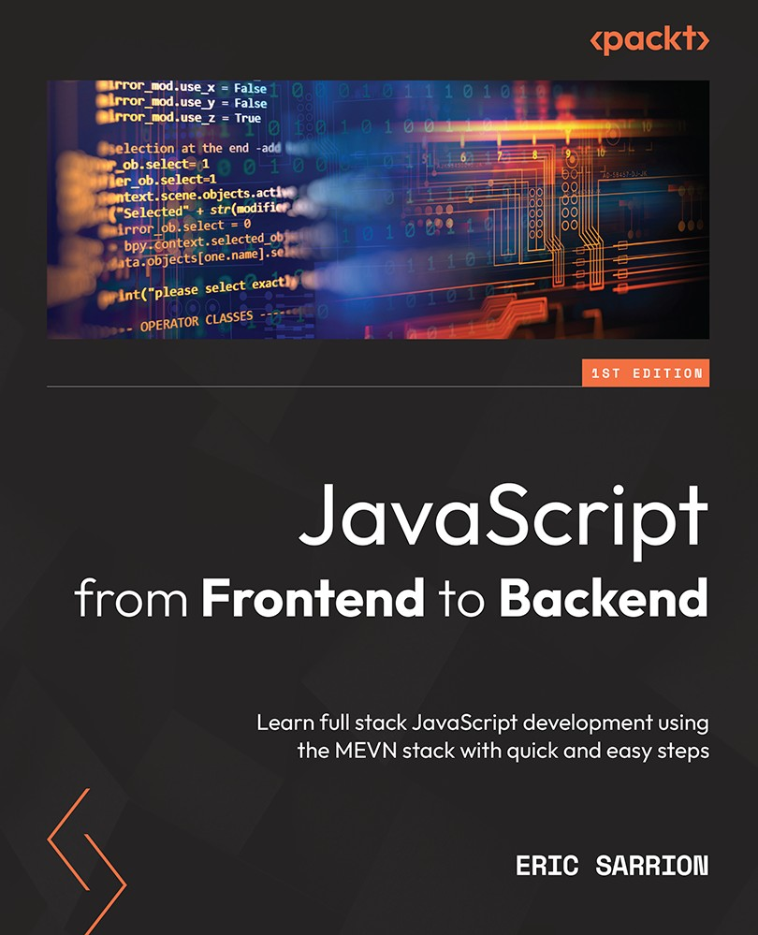

Table of Contents
JavaScript from Frontend to Backend
Contributors
About the author
About the reviewer
Preface
Who this book is for
What this book covers
To get the most out of this book
Download the example code files
Download the color images
Conventions used
Get in touch
Share Your Thoughts
Part 1: JavaScript Syntax
Chapter 1: Exploring the Core Concepts of JavaScript
Technical requirements
Types of variables used in JavaScript
Numerical values
Boolean values
Character strings
Arrays
Objects
Running a JavaScript program
Running a JavaScript program in a browser
Running a JavaScript program on a Node.js server
Differences between JavaScript code written for the browser and the server
Declaring variables in JavaScript
Using the const keyword
Using the var keyword
Using the let keyword
What if we don’t use var or let to define a variable?
What is an uninitialized variable worth?
Writing conditions for conditional tests
Forms of writing instructions
Expressions used to write conditions
Nested test suites
Creating processing loops
Loops with while()
Loops with for()
Using functions
Function displaying the list of the first 10 integers
Function calculating the sum of the first 10 integers
Function calculating the sum of the first N integers
Summary
Chapter 2: Exploring the Advanced Concepts of JavaScript
Technical requirements
Classes and objects
Defining a class
Creating an object by using a class
Creating an object without using a class
Adding properties to a class
Adding methods to a class
Changing an object’s property values
Using the class constructor
Merging one object with another
Arrays
Creating an array
Accessing array elements
Adding items to the array
Deleting array elements
Filtering elements in an array
Character strings
Creating a character string
Accessing characters in a string
Modifying a character string
Using regular expressions
Multitasking in JavaScript
Using the setTimeout() function
Using the setInterval() function
Using the clearInterval() function
Using promises
Part 2: JavaScript on the Client-Side
Chapter 3: Getting Started with Vue.js
Technical requirements
Using Vue.js in an HTML page
Creating our first Vue.js application
Using reactivity
Creating our first component
Inserting a component in the application file
Inserting a component from an external file
Adding methods in components
Defining methods in the methods section
Defining computed properties in the computed section
Using attributes in components
Using directives
The v-if and v-else directives
The v-show directive
The v-for directive
The v-model directive
Summary
Chapter 4: Advanced Concepts of Vue.js
Technical requirements
Managing events
Using the $event parameter
Checking that the entered value is less than 100
Allowing only digits to be entered
Assembling components
Using $emit() to communicate with a parent component
Using props to communicate with children
Using visual effects
When the element appears
When the element disappears
Using a name for the effect
Producing an effect on several elements
Examples of commonly used effects
The shrink effect
The opacity effect
The move-down effect
Summary
Chapter 5: Managing a List with Vue.js
Technical requirements
Displaying application screens
Splitting the application into components
Adding an element to the list
Using the <Element> component
Changing the appearance of the list using CSS code
Removing an element from the list
Modifying an element in the list
Transforming the <span> element into an <input> element
Exiting from the input field
Giving focus to the input field
Summary
Part 3: JavaScript on the Server-Side
Chapter 6: Creating and Using Node.js Modules
Technical requirements
Creating and using our own modules
Creating a module
Using the node_modules directory
Using the package.json file
Adding functionalities to the module
Using internal Node.js modules
Reading the contents of a file
Displaying file contents as strings
Using non-blocking file reading
Using downloaded modules with npm
Using the npm command
Using a downloaded module with npm
Summary
Chapter 7: Using Express with Node.js
Technical requirements
Using the Node.js http module
Installing the Express module
The MVC pattern used by Express
Using routes with Express
The initial content of the app.js file
Different types of routes possible
Analyzing routes defined in the app.js file
Adding a new route in the app.js file
Displaying views with Express
Summary
Chapter 8: Using MongoDB with Node.js
Technical requirements
Installing MongoDB
Using the mongo utility
Installing the mongoose module
Connecting to the MongoDB database
Creating documents in MongoDB
Describing document structure using schemas and models
Creating the document
Searching for documents in MongoDB
Writing search conditions
Retrieving and displaying the results
Updating documents in MongoDB
Deleting documents in MongoDB
Summary
Chapter 9: Integrating Vue.js with Node.js
Technical requirements
Displaying application screens
Building the app with Express
MongoDB database structure
Installing the Axios library
Inserting a new element in the list
Replacing the text and index attributes with the element attribute
Description of the Axios library for communicating between the client and the server
Using Axios with a POST type request (client side)
POST type request processing (server side)
Verifying the correct operation of the insertion in the database
Displaying list elements
Using Axios with a GET type request (client side)
GET type request processing (server side)
Modifying an element in the list
Using Axios with a PUT type request (client side)
PUT type request processing (server side)
Removing an element from the list
Using Axios with a DELETE type request (client side)
DELETE type request processing (server side)
Summary
Thanks
Why subscribe?
Other Books You May Enjoy
Packt is searching for authors like you


BIRMINGHAM—MUMBAI

JavaScript from Frontend to Backend
Copyright © 2022 Packt Publishing
All rights reserved. No part of this book may be reproduced, stored in a retrieval system, or transmitted in any form or by any means, without the prior written permission of the publisher, except in the case of brief quotations embedded in critical articles or reviews.
Every effort has been made in the preparation of this book to ensure the accuracy of the information presented. However, the information contained in this book is sold without warranty, either express or implied. Neither the author, nor Packt Publishing or its dealers and distributors, will be held liable for any damages caused or alleged to have been caused directly or indirectly by this book.
Packt Publishing has endeavored to provide trademark information about all of the companies and products mentioned in this book by the appropriate use of capitals. However, Packt Publishing cannot guarantee the accuracy of this information.
Associate Group Product Manager: Pavan Ramchandani
Publishing Product Manager: Jane D’souza
Senior Editor: Mark D’souza
Content Development Editor: Debolina Acharyya
Technical Editor: Shubham Sharma
Copy Editor: Safis Editing
Proofreader: Safis Editing
Indexer: Rekha Nair
Production Designer: Vijay Kamble
Marketing Coordinater: Marylou De Mello, Anamika Singh
First published: August 2022
Production reference: 2090822
Published by Packt Publishing Ltd.
Livery Place
35 Livery Street
Birmingham
B3 2PB, UK.
ISBN 978-1-80107-031-7
www.packt.com

Contributors

About the author
Eric Sarrion is a trainer, a developer, and an independent consultant. He has been involved in all kinds of IT projects for over 30 years. He is also a long-time author in web development technologies and is renowned for the clarity of his explanations and examples.

About the reviewer
Presently, Kailash Ramanathan works at Uber as a Senior Software Engineer. Since 2009, he has built several lean and powerful web-based applications using contemporary frameworks. Now, he enjoys working with Vue & React. When not at work, he enjoys music & a good-natured banter with friends and family.
First, I thank my parents for their incessant and unconditional support for every enterprise I undertake. Second, I thank God for this life & surrounding it with beautiful people I know - near and dear. Third, I thank my mentors & authors who I have read and learned from. And, to you who are reading these words and have chosen to know more and go beyond.
Gabriel Bieules is an engineer with 18 years of experience in building software applications. He worked in various industries like telecommunication, eDiscovery, and the web. He got exposed to multiple programming languages, but his expertise is mostly around Java and JavaScript.

Table of Contents
Preface

Part 1: JavaScript Syntax

Chapter 1: Exploring the Core Concepts of JavaScript

Technical requirements

Types of variables used in JavaScript

Numerical values

Boolean values

Character strings

Arrays

Objects

Running a JavaScript program

Running a JavaScript program in a browser

Running a JavaScript program on a Node.js server

Differences between JavaScript code written for the browser and the server

Declaring variables in JavaScript

Using the const keyword

Using the var keyword

Using the let keyword

What if we don’t use var or let to define a variable?

What is an uninitialized variable worth?

Writing conditions for conditional tests

Forms of writing instructions

Expressions used to write conditions

Nested test suites

Creating processing loops

Loops with while()

Loops with for()

Using functions

Function displaying the list of the first 10 integers

Function calculating the sum of the first 10 integers

Function calculating the sum of the first N integers

Summary

Chapter 2: Exploring the Advanced Concepts of JavaScript

Technical requirements

Classes and objects

Defining a class

Creating an object by using a class

Creating an object without using a class

Adding properties to a class

Adding methods to a class

Changing an object’s property values

Using the class constructor

Merging one object with another

Arrays

Creating an array

Accessing array elements

Adding items to the array

Deleting array elements

Filtering elements in an array

Character strings

Creating a character string

Accessing characters in a string

Modifying a character string

Using regular expressions

Multitasking in JavaScript

Using the setTimeout() function

Using the setInterval() function

Using the clearInterval() function

Using promises

Part 2: JavaScript on the Client-Side

Chapter 3: Getting Started with Vue.js

Technical requirements

Using Vue.js in an HTML page

Creating our first Vue.js application

Using reactivity

Creating our first component

Inserting a component in the application file

Inserting a component from an external file

Adding methods in components

Defining methods in the methods section

Defining computed properties in the computed section

Using attributes in components

Using directives

The v-if and v-else directives

The v-show directive

The v-for directive

The v-model directive

Summary

Chapter 4: Advanced Concepts of Vue.js

Technical requirements

Managing events

Using the $event parameter

Checking that the entered value is less than 100

Allowing only digits to be entered

Assembling components

Using $emit() to communicate with a parent component

Using props to communicate with children

Using visual effects

When the element appears

When the element disappears

Using a name for the effect

Producing an effect on several elements

Examples of commonly used effects

The shrink effect

The opacity effect

The move-down effect

Summary

Chapter 5: Managing a List with Vue.js

Technical requirements

Displaying application screens

Splitting the application into components

Adding an element to the list

Using the <Element> component

Changing the appearance of the list using CSS code

Removing an element from the list

Modifying an element in the list

Transforming the <span> element into an <input> element

Exiting from the input field

Giving focus to the input field

Summary

Part 3: JavaScript on the Server-Side

Chapter 6: Creating and Using Node.js Modules

Technical requirements

Creating and using our own modules

Creating a module

Using the node_modules directory

Using the package.json file

Adding functionalities to the module

Using internal Node.js modules

Reading the contents of a file

Displaying file contents as strings

Using non-blocking file reading

Using downloaded modules with npm

Using the npm command

Using a downloaded module with npm

Summary

Chapter 7: Using Express with Node.js

Technical requirements

Using the Node.js http module

Installing the Express module

The MVC pattern used by Express

Using routes with Express

The initial content of the app.js file

Different types of routes possible

Analyzing routes defined in the app.js file

Adding a new route in the app.js file

Displaying views with Express

Summary

Chapter 8: Using MongoDB with Node.js

Technical requirements

Installing MongoDB

Using the mongo utility

Installing the mongoose module

Connecting to the MongoDB database

Creating documents in MongoDB

Describing document structure using schemas and models

Creating the document

Searching for documents in MongoDB

Writing search conditions

Retrieving and displaying the results

Updating documents in MongoDB

Deleting documents in MongoDB

Summary

Chapter 9: Integrating Vue.js with Node.js

Technical requirements

Displaying application screens

Building the app with Express

MongoDB database structure

Installing the Axios library

Inserting a new element in the list

Replacing the text and index attributes with the element attribute

Description of the Axios library for communicating between the client and the server

Using Axios with a POST type request (client side)

POST type request processing (server side)

Verifying the correct operation of the insertion in the database

Displaying list elements

Using Axios with a GET type request (client side)

GET type request processing (server side)

Modifying an element in the list

Using Axios with a PUT type request (client side)

PUT type request processing (server side)

Removing an element from the list

Using Axios with a DELETE type request (client side)

DELETE type request processing (server side)

Summary

Thanks
Other Books You May Enjoy

Preface
JavaScript is the most widely used programming language in the world. It has numerous libraries and modules and a dizzying array of need-to-know topics. Picking a starting point can be difficult. This concise, practical guide will get you up to speed in next to no time.

Who this book is for
This book is for JavaScript developers looking to strengthen their core JavaScript concepts and implement them in building full stack apps.

What this book covers
Chapter 1, Exploring the Core Concepts of JavaScript, is where you discover how to use variables, conditions, and loops in JavaScript.
Chapter 2, Exploring the Advanced Concepts of JavaScript, is where you learn how to use object-oriented programming in JavaScript.
Chapter 3, Getting Started withVue.js, is where you learn the basics of Vue.js, with components and directives.
Chapter 4, Advanced Concepts of Vue.js, is where you explore in-depth Vue.js with communication between components and visual effects.
Chapter 5, Managing a List with Vue.js, is where you learn how to build a full project with Vue.js.
Chapter 6, Creating and Using Node.js Modules, is where you learn the basics of Node.js programming with modules.
Chapter 7, Using Express with Node.js, is where you explore the main library used to build Node.js applications.
Chapter 8, Using MongoDB with Node.js, is where you learn how to use the MongoDB database with Node.js using the Mongoose module.
Chapter 9, Integrating Vue.js with Node.js, is where you learn how to build a full project integrating Vue.js and Node.js.

To get the most out of this book
Prior knowledge of HTML and CSS is a must for this book.
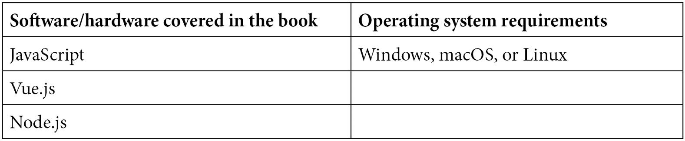
If you are using the digital version of this book, we advise you to type the code yourself or access the code from the book’s GitHub repository (a link is available in the next section). Doing so will help you avoid any potential errors related to the copying and pasting of code.

Download the example code files
You can download the example code files for this book from GitHub at https://github.com/PacktPublishing/JavaScript-from-Frontend-to-Backend. If there’s an update to the code, it will be updated in the GitHub repository.
We also have other code bundles from our rich catalog of books and videos available at https://github.com/PacktPublishing/. Check them out!

Download the color images
We also provide a PDF file that has color images of the screenshots and diagrams used in this book. You can download it here: https://packt.link/xdibe

Conventions used
There are a number of text conventions used throughout this book.
Code in text: Indicates code words in text, database table names, folder names, filenames, file extensions, pathnames, dummy URLs, user input, and Twitter handles. Here is an example: “So { lastname: "Clinton" } can also be written { "lastname": "Clinton" } by surrounding the lastname property with single or double quotes.”
A block of code is set as follows:
var p = { lastname : "Clinton", firstname : "Bill" };
console.log("The person is", p);
When we wish to draw your attention to a particular part of a code block, the relevant lines or items are set in bold:
class Person {
firstname;
lastname;
age;
}
var p = new Person;
console.log(p);
Bold: Indicates a new term, an important word, or words that you see onscreen. For instance, words in menus or dialog boxes appear in bold. Here is an example: “This writing format is also called JavaScript Object Notation (JSON) format.”
Tips or Important Notes
Appear like this.

Get in touch
Feedback from our readers is always welcome.
General feedback: If you have questions about any aspect of this book, email us at customercare@packtpub.com and mention the book title in the subject of your message.
Errata: Although we have taken every care to ensure the accuracy of our content, mistakes do happen. If you have found a mistake in this book, we would be grateful if you would report this to us. Please visit www.packtpub.com/support/errata and fill in the form.
Piracy: If you come across any illegal copies of our works in any form on the internet, we would be grateful if you would provide us with the location address or website name. Please contact us at copyright@packt.com with a link to the material.
If you are interested in becoming an author: If there is a topic that you have expertise in and you are interested in either writing or contributing to a book, please visit authors.packtpub.com.

Share Your Thoughts
Once you’ve read JavaScript from Frontend to Backend, we’d love to hear your thoughts! Please click here to go straight to the Amazon review page for this book and share your feedback.
Your review is important to us and the tech community and will help us make sure we’re delivering excellent quality content.

Part 1: JavaScript Syntax
This part explains the basics you need to know to use JavaScript on the client or on the server. It explains the syntax and the main data types that can be used in JavaScript.
This section comprises the following chapters:
Chapter 1, Exploring the Core Concepts of JavaScript
Chapter 2, Exploring the Advanced Concepts of JavaScript

Chapter 1: Exploring the Core Concepts of JavaScript
The JavaScript language was created (in the mid-1990s) to be executed in internet browsers, in order to make websites more fluid. It was originally used to control what was entered into input forms. For example, it was used to do the following:
Allow the entry of numeric characters in a field – and only numeric ones. Other characters, for example, letters, had to be rejected in this case. This made it possible, thanks to the JavaScript language included in the browser, not to validate the entry of the form and avoid sending data to the server, which would have indicated an entry error in this case.
Check that the mandatory fields of the form were all entered, by checking all the fields before sending the form fields to the server.
These two examples (among many others) show that it is desirable to have a language that checks the validity of the data entered by the user before sending this data to the server. This avoids data transfers from the browser to the server, in the event that the data entered is not correct. For more complex checks, such as checking that two people do not have the same identifier, this can continue to be done on the server because it has access to all existing identifiers.
The goal was, therefore, at the beginning of JavaScript, to have the browser check as many things as possible and then transmit the information entered to the server in order to process it.
For this, an internal browser language was created: the JavaScript language, whose name contained a very popular word at the time – “Java” (even though the two languages Java and JavaScript had nothing to do with each other).
Over the years, developers have had the idea of also associating it with the server side, to use the same language on the client side and on the server side. This allowed the creation of the Node.js server, which is widely used today.
Whether client-side or server-side, the JavaScript language uses a basic syntax that allows you to write your own programs. This is what we are going to discover in this chapter.
In this chapter, we will cover the following topics:
Types of variables used in JavaScript
Running a JavaScript program
Declaring variables in JavaScript
Writing conditions for conditional tests
Creating processing loops
Using functions

Technical requirements
To develop in JavaScript, and write and then run the programs in this book, you will need the following:
A text editor for computer programs, for example, Notepad++, Sublime Text, EditPlus, or Visual Studio.
An internet browser, for example, Chrome, Firefox, Safari, or Edge.
A PHP server, for example, XAMPP or WampServer. The PHP server will be used to execute JavaScript programs containing import statements in HTML pages because these import statements only work on an HTTP server.
A Node.js server: The Node.js server will be created through Node.js installation. We will also install and use the MongoDB database to associate the Node.js server with a database.
You can find the code files for this chapter on GitHub at: https://github.com/PacktPublishing/JavaScript-from-Frontend-to-Backend/blob/main/Chapter%201.zip.
Let’s now begin our discovery of JavaScript, by studying the different types of variables it offers us.

Types of variables used in JavaScript
Like any language, JavaScript allows you to create variables that will be used to manipulate data. JavaScript is a very simple language so, for example, data types are very basic. We will thus have the following as the main data types:
Numerical values
Boolean values
Character strings
Arrays
Objects
Let’s take a quick look at these different types of data.

Numerical values
Numerical values can be positive or negative and even in decimal form (for example, 0, -10, 10.45). All mathematical numbers called real numbers comprise numerical values or data points.

Boolean values
These are of course the two Boolean values—true or false—that are found in most languages. These values are used to express conditions: if the condition is true, then we perform a particular process, otherwise, we perform an alternative one. The result of the condition is therefore a true or false value, which is symbolized by the two values true and false.
We will see how to express conditions in the Writing conditions section, later in this chapter.

Character strings
Character strings refer to values such as "a", "abc", or "Hello, how are you?". An empty character string will be represented by "" (consecutive quotes with nothing inside). Note that you can use double quotes (") or single quotes ('). Thus, the string "abc" can also be written as 'abc' (with single quotes).

Arrays
Arrays, such as [10, "abc", -36], can contain values of any type, like here where we have both numeric values and character strings. An empty array will be represented by [], which means that it contains no value.
The values stored in an array are accessed by means of an index, varying from 0 (to access the first element placed in the array) to the length of the array minus 1 (to access the last element of the array). So, if the array [10, "abc", -36] is represented, for example, by the variable tab, the following occurs:
tab[0] will allow access to the first element of the array: 10.
tab[1] will allow access to the second element of the array: "abc".
tab[2] will allow access to the third and last element of the array: -36.
Note
Note that it is possible to add elements to an array, even if it is empty. So, if we access index 3 of the previous array tab, we can write tab[3] = "def". The array tab will therefore now be [10, "abc", -36, "def"].

Objects
Objects are similar to arrays. They are used to store arbitrary information, for example, the values 43, "Clinton", and "Bill". But unlike arrays that use indexes, you must specify a name to access each of these values. This name is called the key, which thus allows access to the value it represents.
Let’s suppose that the previous value 43 is that of a person’s age, while "Clinton" is their last name, and "Bill" is their first name. We would then write the object in the following form: { age: 43, lastname: "Clinton", firstname: "Bill" }. The definition of the object is done by means of braces, and what is indicated inside is pairs of data of the form key: value separated by commas. This writing format is also called JavaScript Object Notation (JSON) format.
So, if the previous object is associated with the variable person, we can access their age by writing person["age"] (which will therefore be 43 here), but we can also write person.age, which will also be 43. Similarly, we can also write person.lastname or person["lastname"] and person.firstname or person["firstname"] to access the person’s last name and first name, respectively.
The key is also called a property of the object. Thus, the age key is also called the age property. We can choose any name for the key; you just have to indicate the key and then use it under this name. So, if you specify age as a property in the person object, you must use the term age in the expressions person.age or person["age"]; otherwise it will not work.
Note that if you write person[age] instead of person["age"], JavaScript considers age to be a variable with a previously defined value, which it is not here and therefore cannot work in this case. You would have to set the age variable to have the value "age" for this to work.
The elements of an array are ordered according to their index (starting from 0, then 1, and so on), while the elements contained in an object are ordered according to the keys indicated for each element. But even though the lastname key is listed in the person object before the firstname key, this does not differentiate the object { age: 43, lastname: "Clinton", firstname: "Bill" } from the object { firstname: "Bill", lastname: "Clinton", age: 43 } because the order in which keys are written to an object is irrelevant.
Finally, there are empty objects, such as those containing no key (therefore no value). We write an empty object in the form { }, indicating nothing is inside. We can then add one or more keys to an object, even if it is initially empty.
Now that we have seen the main variable types used in JavaScript, let’s see how to use them to define variables in our programs.

Running a JavaScript program
JavaScript is a language that can be executed in a browser (Edge, Chrome, Firefox, Safari, and so on) or on a server with Node.js installed. Let’s see how to write JavaScript programs for these two types of configurations.

Running a JavaScript program in a browser
To run a JavaScript program in a browser, you must insert the JavaScript code into an HTML file. This HTML file will then be displayed in the browser, which will cause the execution of the JavaScript code included in the file.
JavaScript code can be specified in the HTML file in two different ways:
The first way is to write it between the <script> and </script> tags, directly in the HTML file. The <script> tag indicates the beginning of the JavaScript code, while the </script> tag indicates the end of it. Anything written between these two tags is considered JavaScript code.
The second way is to write the JavaScript code in an external file and then include this external file in the HTML file. The external file is included in the HTML file by means of a <script> tag in which the src attribute is indicated, the value of which is the name of the JavaScript file that will be included in the HTML page.
Let’s take a look at these two ways of writing the JavaScript code that will run in the browser.
Writing JavaScript code between the <script> and </script> tags
A file with an .html extension is used; for example, the index.html file. This file is a traditional HTML file, in which we have inserted the <script> and </script> tags, as shown in the following code snippet:
index.html file
<html>
<head>
<meta charset="utf-8" />
<script>
alert("This is a warning message displayed by
JavaScript");
</script>
</head>
<body>
</body>
</html>
We have inserted the <script> tag (and its ending </script>) in the <head> section of the HTML page. The <meta> tag is used to indicate the encoding characters to use. In the preceding code, we have used utf-8 so that accented characters can be displayed correctly.
The JavaScript code inserted here is rudimentary. We use the alert() function, which displays a dialog box on the browser screen, displaying the text of the message indicated in the first parameter of the function.
To run this HTML file, simply move it (by dragging and dropping) from the file manager to any browser; for example, Firefox. The following screen is then displayed:
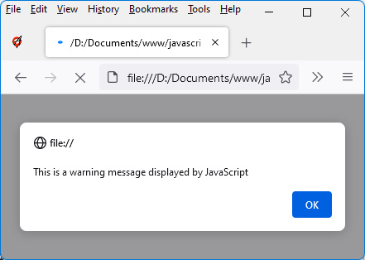
Figure 1.1 – Displaying a message in the browser window
The JavaScript code present in the <script> tag ran when the HTML page was loaded. The message indicated in the alert() function is therefore displayed. A click on the OK button validates the message displayed and continues the execution of the JavaScript code. As we can see, there is nothing more in the program; the program ends immediately by displaying a blank page on the screen (because no HTML code is inserted into the page).
Writing JavaScript code to an external file
Rather than integrating the JavaScript code directly into the HTML file, we can put it in an external file, then insert this file into our HTML file by indicating its name in the src attribute of the <script> tag.
Let’s first write the file that will contain the JavaScript code. This file has the file extension .js and will be named codejs.js, for example, and will be coded as follows:
codejs.js file (in the same directory as index.html)
alert("This is a warning message displayed by JavaScript");
The codejs.js file contains the JavaScript code that we had previously inserted between the <script> and </script> tags.
The index.html file is modified to include the codejs.js file using the src attribute of the <script> tag as follows:
index.html file
<html>
<head>
<meta charset="utf-8" />
<script src="codejs.js"></script>
</head>
<body>
</body>
</html>
Note
Notice the use of the <script> and </script> tags. They are contiguous (that is, they have no spaces or newlines between them), which is necessary for this code to work.
In the rest of our examples, we will mainly use the insertion of the JavaScript code directly in the code of the HTML file, but the use of an external file would produce the same results.
Let’s now explain another way to display messages, without blocking the program as before with the alert(message) function.
Using the console.log() method instead of the alert() function
The alert() function used earlier displays a window on the HTML page, and the JavaScript program hangs waiting for the user to click the OK button in the window. Thus, the function requires the intervention of the user to continue the execution of the program.
An alternative makes it possible to use a display without blocking the execution of the program. This is the display in the console, using the console.log() method.
Note
The console.log() form of writing means that we use the log() method, which is associated with the console object. This will be explained in detail in the following chapter.
Let’s write the program again using the console.log() method instead of the alert() function. The index.html file will be modified as follows:
index.html file using console.log() method
<html>
<head>
<meta charset="utf-8" />
<script>
// display a message in the console
console.log("This is a warning message displayed by
JavaScript");
</script>
</head>
<body>
</body>
</html>
Note
The use of comments in the JavaScript program requires placing // before what needs to be commented out (on the same line). You can also comment out several lines by enclosing them with /* at the beginning and */ at the end.
Let’s run this program by pressing the F5 key on the keyboard to refresh the window. A white screen will appear, with no message.
Indeed, the message is only displayed in the console. The console is only visible if you press the F12 key (and can be removed by pressing F12 again).
Note
You can go to the site https://balsamiq.com/support/faqs/browserconsole/, which explains how to display the console in the event that the F12 key is inoperative.
The following is what you will see when the console is displayed:
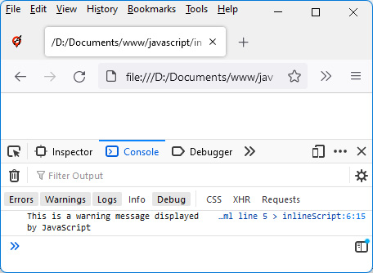
Figure 1.2 – Message displayed in the console
The message is displayed in the lower part of the browser window.
Now that we have learned how to run a JavaScript program in a browser, let’s move on to learning how to run a JavaScript program on a Node.js server.

Running a JavaScript program on a Node.js server
To run a JavaScript program on a Node.js server, you must first install the Node.js server. To install, simply go to https://nodejs.org/ and download and install the server. Note that if you are using macOS, Node.js is already installed.
We can verify the correct installation of Node.js by just opening a shell and typing the command node -h in it. Node.js is correctly installed if the command help appears as follows:
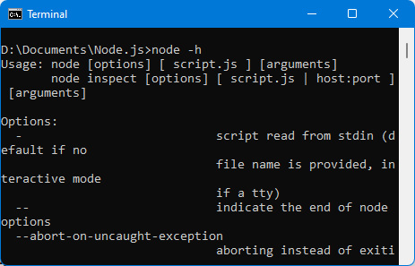
Figure 1.3 – node -h command that displays help
Once Node.js is installed, it can run any JavaScript program you want. All you have to do is create a file containing JavaScript code, for example, testnode.js. The contents of this file will be executed by the server using the node testnode.js command.
Here is a very simple example of a JavaScript file that can be executed by Node.js: It displays a message in the server console. The server console here represents the command interpreter in which you type the command to execute the testnode.js file:
testnode.js file
console.log("This is a warning message displayed by JavaScript");
Let’s type the command node testnode.js in the preceding terminal window.
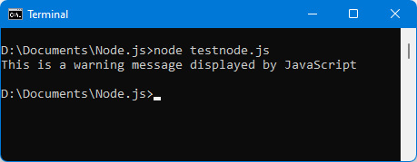
Figure 1.4 – Running a Node.js program
We see that the message is displayed directly in the command interpreter.
In the previous examples, we have written JavaScript code that runs both on the client side (the browser) and on the server side. The question that can be asked is: can the same code run in exactly the same way on the client side and on the server side?

Differences between JavaScript code written for the browser and the server
Although the two pieces of code are similar, we cannot say that they are the same, because the issues to be managed are different in the two cases. Indeed, on the client side, we will mainly want to manage the user interface with JavaScript, while on the server side, we will rather want to manage files or databases. So, the libraries to use in these two cases will not be the same.
On the other hand, we find in both cases the same basic language, which is the JavaScript language that we will be describing now.

Declaring variables in JavaScript
Variables of the types previously described under the Types of variables used in JavaScript section, as we know, consist of numerical values, Boolean values, character strings, arrays, and objects.
JavaScript is a weakly typed language, which means that you can change the type of a variable at any time. For example, a numeric variable can be transformed into a character string, or even become an array.
Of course, it is not advisable to make such voluntary changes in our programs, and it is prudent to maintain the type of a variable throughout the program, for comprehension. However, it is important to know that JavaScript allows changing variable types. A variant of JavaScript called TypeScript provides more security by preventing these type changes for variables.
Now let’s learn how to define a variable. We will do so using one of the following keywords: const, var, or let.

Using the const keyword
The const keyword is used to define a variable whose value will be constant. Any subsequent attempt to change the value will produce an error.
Let’s define the constant variable c1 having the value 12. Let’s try to modify the value by assigning it a new value: an error will be displayed in the console:
Note
To say that we are defining a constant variable is an abuse of language. We should rather say that we are defining a constant value.
Defining a constant value (index.html file)
<html>
<head>
<meta charset="utf-8" />
<script>
const c1 = 12;
console.log(c1);
c1 = 13; // attempt to modify the value of a
// constant: error
console.log(c1); // no display because an error
// occurred above
</script>
</head>
<body>
</body>
</html>
After implementing the preceding code, we will also see the error displayed in the console (if the console is not visible, it can be displayed by pressing the F12 key) of the browser as follows:
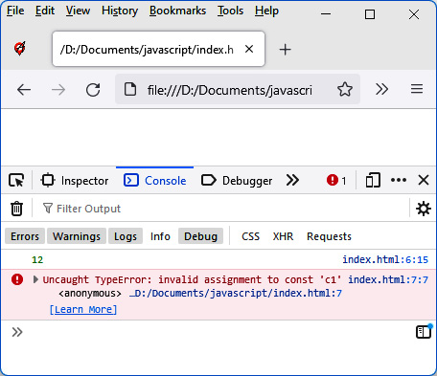
Figure 1.5 – Error when modifying a constant value
As we can see from the preceding figure, the first display of the constant c1 displays the value 12, while the second display does not occur because an error occurred before (while trying to change the value of a constant). Therefore, a value defined by the const keyword should not be modified.

Using the var keyword
Another way to define a variable (whose value can be modified) is to use the var keyword. Let’s see how using the following code example:
Definitions of several variables
<html>
<head>
<meta charset="utf-8" />
<script>
var a = 12;
var b = 56;
var c = a + b;
var s1 = "My name is ";
var firstname = "Bill";
console.log("a + b = " + a + b);
console.log("c = " + c);
console.log(s1 + firstname);
</script>
</head>
<body>
</body>
</html>
We defined the variables a, b, s1, and firstname by preceding them with the keyword var and assigning them a default value. The variable c corresponds to the addition of the variables a and b.
Note
The name of a variable consists of alphanumeric characters but must start with an alphabetic character. Lowercase and uppercase are important in writing the variable name (variables’ names are case sensitive). Thus, the variable a is different from the variable A.
The result of the previous program is displayed in the browser console (if it is not visible, it must be displayed by pressing the F12 key):
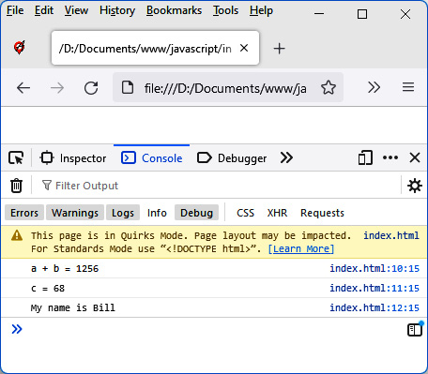
Figure 1.6 – Using the var keyword
In the preceding figure, we can see a result that may seem surprising. Indeed, the direct calculation of a + b produces the display of 1256 the first time, then 68 the second time.
Indeed, when we write console.log("a + b = " + a + b); the fact that we’ve started to display characters by writing "a + b = " means that JavaScript will interpret the rest of the display in the form of a character string; in particular, the values a and b, which follow on the line. So, the values a and b are no longer interpreted as numeric values, but as the character strings 12 and 56. When these character strings are connected by the + operator, this does not correspond to addition but to concatenation.
Conversely, the calculation of the variable c does not involve character strings, so the result of a + b here is equal to the sum of the values of the variables a and b, therefore 68.
Note that the same program can be run on the Node.js server. To do so, we would write it in our testnode.js file as follows:
testnode.js file
var a = 12;
var b = 56;
var c = a + b;
var s1 = "My name is ";
var firstname = "Bill";
console.log("a + b = " + a + b);
console.log("c = " + c);
console.log(s1 + firstname);
We can then execute the preceding code with the node testnode.js command. The result displayed under Node.js is similar to that displayed in the browser console:
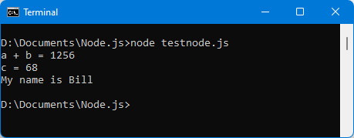
Figure 1.7 – Running the program under Node.js
We learned about the const and var keywords for defining variables; all that remains is for us to learn how to use the let keyword.

Using the let keyword
To understand the use of the let keyword and see the difference from the var keyword, we must use braces in our programs. Braces are used to create program blocks in which instructions are inserted, in particular after the conditional if and else instructions (which we will see in the Writing conditions section).
Let’s write a simple if(true) condition that is always true: the code included in the braces following the condition is therefore always executed:
index.html file including a condition
<html>
<head>
<meta charset="utf-8" />
<script>
var a = 12;
if (true) { // always executed (because always true)
var b = 56;
let c = 89;
console.log("In the brace:");
console.log("a = " + a);
console.log("b = " + b);
console.log("c = " + c);
}
console.log("After the brace:");
console.log("a = " + a);
console.log("b = " + b);
console.log("c = " + c);
</script>
</head>
<body>
</body>
</html>
In the preceding code, we have defined the variable a outside of any braces. This variable will therefore be accessible everywhere (in and out of braces) as soon as it is defined.
The variables b and c are defined within braces following the condition. Variable b is defined using var, while variable c is defined using the let keyword. The difference between the two variables is visible as soon as you exit the block of braces. Indeed, the variable c (defined by let) is no longer known outside the block of braces where it is defined, unlike the variable b (defined by var), which is accessible even outside.
This can be checked by running the program in the browser as follows:
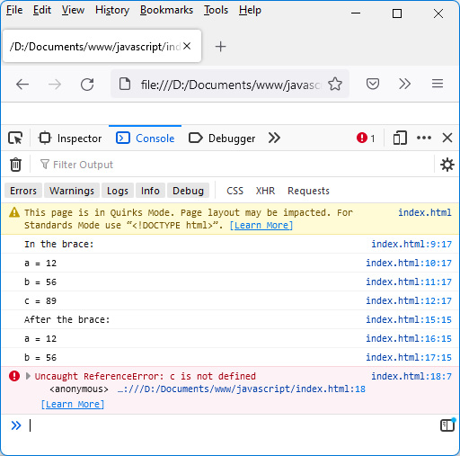
Figure 1.8 – The variable c defined by let is inaccessible outside the block where it is defined
Note that the same program gives a similar result on the Node.js server, as can be seen in the following screen: the variable c defined by let in a block becomes unknown outside the block.
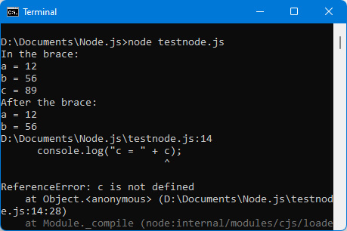
Figure 1.9 – The same results on the Node.js server
As we can see in the preceding screen, the variable c, defined by let in a block, becomes unknown outside the block.

What if we don’t use var or let to define a variable?
It is possible not to use the var or let keywords to define a variable. We can simply write the variable’s name followed by its value (separated by the sign =). Let’s see how using the following example:
Creating variables without specifying var or let
a = 12;
b = 56;
console.log("a = " + a); // displays the value 12
console.log("b = " + b); // displays the value 56
In the preceding example, where the variables are initialized without being preceded by var or let, these variables are global variables. As soon as they are initialized, they become accessible everywhere else in the program. This will become apparent when we study the functions in the Using functions section of this chapter.
Note
It is strongly advised to use as few global variables as possible in the programs, as this complicates the design and debugging of the programs that contain them.

What is an uninitialized variable worth?
Each of the preceding variables was declared by initializing its value, with the = sign, which is the assignment sign. Let’s see what happens if we don’t assign any value to the variable, but just declare it using var or let as follows:
Declaration of variables without initialization
<html>
<head>
<meta charset="utf-8" />
<script>
var a;
let b;
console.log("a = " + a); // displays the value
// undefined
console.log("b = " + b); // displays the value
// undefined
</script>
</head>
<body>
</body>
</html>
In the preceding code, we have defined two variables, a and b – one using var, the other using let. Neither of the two variables has an initial value (that is, they’re not followed by an = sign).
The result displayed in this case for these uninitialized variables is a JavaScript value called undefined. This corresponds to the value of a variable that does not yet have a value. The undefined value is an important keyword in the JavaScript language.
Note
The variables a and b are not initialized, and it is necessary to declare them using var or let. Indeed, you cannot simply write a; or b; as this would cause a runtime error.
Let’s run the preceding program in the browser and observe the results displayed in the console:
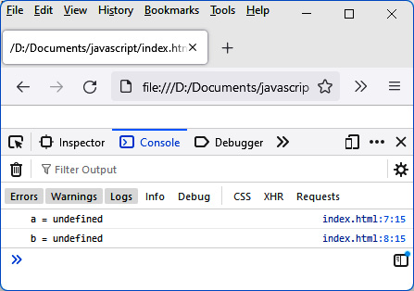
Figure 1.10 – An uninitialized variable is undefined
Note
The undefined value is also associated with an uninitialized variable if using server-side JavaScript with Node.js.
We now know how to define variables in JavaScript. To create useful JavaScript programs, you have to write sequences of instructions. One of the most used instructions allows you to write conditional tests with the if statement, which we will talk about next.

Writing conditions for conditional tests
JavaScript obviously allows you to write conditions in programs. The condition is expressed through the if (condition) statement:
If the condition is true, the statement (or block in braces) that follows is executed.
If the condition is false, the statement (or block) following the else keyword (if present) will be executed.

Forms of writing instructions
We can use the following forms to express the conditions:
Forms of conditional expressions with if (condition)
// condition followed by a statement
if (condition) statement; // statement executed if condition is true
// condition followed by a block
if (condition) {
// block of statements executed if condition is true
statement 1;
statement 2;
statement 3;
}
Forms of conditional expressions with if (condition) … else …
// condition followed by a statement
if (condition) statement 1; // statement 1 executed if
// condition is true
else statement 2; // statement 2 executed if
// condition is false
// condition followed by a block
if (condition) {
// block of statements executed if condition is true
statement 1;
statement 2;
statement 3;
}
else {
// block of statements executed if condition is false
statement 5;
statement 6;
statement 7;
}
Note
If the process to be executed includes several instructions, these instructions are grouped together in a block surrounded by braces. A block can consist of only one statement, even if, as in this case, the block is optional (no need for braces).
Let’s write the following program in the testnode.js file, which we will execute using the node testnode.js command in a command interpreter, as follows:
testnode.js file
var a = 12;
console.log("a = " + a);
if (a == 12) console.log("a is 12");
else console.log("a is not 12");
In the preceding code, the condition is expressed in the form a == 12. Indeed, it is customary to test the equality between two values by means of the sign = repeated twice successively (hence ==).
Note
We use == for equality, != for difference, > or >= to check superiority, and < or <= to check inferiority.
In the preceding code, since the variable a is 12, the following result can be seen:
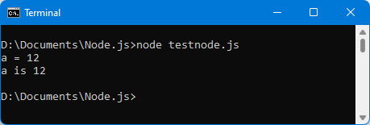
Figure 1.11 – Using conditional tests
If we assign the value 13 to the variable a, the else part of the statement will be executed:
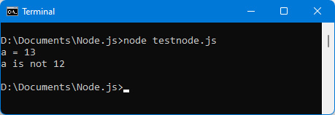
Figure 1.12 – Running the else part of the test
We have seen how to execute one part of the code or another depending on a condition. Let’s now study how to write more complex conditions than those written previously.

Expressions used to write conditions
The condition written previously is a simple test of equality between two values. But the test to write can sometimes be more complex. The goal is to have the final result of the condition, which is true or false, which will then make it possible for the system to decide the next course of action.
The condition is written in Boolean form with the OR keyword (written as ||) or with the AND keyword (written as &&). Parentheses between the different conditions may be necessary to express the final condition as follows:
Condition expressed with “or”
var a = 13;
var b = 56;
console.log("a = " + a);
console.log("b = " + b);
if (a == 12 || b > 50)
console.log("condition a == 12 || b > 50 is true");
else console.log("condition a == 12 || b > 50 is false");
In the preceding code, since the variable b is greater than 50, the condition is true, as seen in Figure 1.13.
Note
In an OR condition, it suffices that one of the conditions is true for the final condition to be true.
In an AND condition, all the conditions must be true for the final condition to be true.
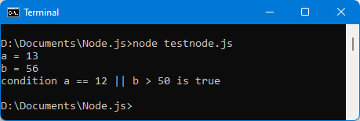
Figure 1.13 – Condition with or
By default, the condition expressed in if(condition) is compared with the value true. We can sometimes prefer to compare with the value false. In this case, it suffices to precede the condition with the sign !, which corresponds to a negation of the following condition.
It is sometimes necessary to chain several tests in a row, depending on the results of the previous tests. We then have a succession of tests, called cascade tests.

Nested test suites
It is possible to chain tests in the processes to be performed. Here is an example:
Test nesting
var a = 13;
var b = 56;
console.log("a = " + a);
console.log("b = " + b);
if (a == 12) console.log("condition a == 12 is true");
else {
console.log("condition a == 12 is false");
if (b > 50) console.log("condition b > 50 is true");
else console.log("condition b > 50 is false");
}
The else part is composed of several statements and is grouped in a block surrounded by braces:
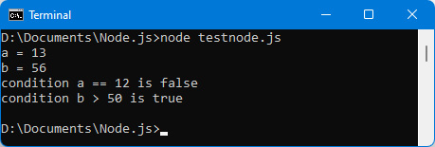
Figure 1.14 – Test nesting
We learned about writing conditions in JavaScript programs. We are now going to learn how to write processing loops, which make it possible to write the instructions in the program only once. These instructions can, however, be executed as many times as necessary.

Creating processing loops
It is sometimes necessary to repeat an instruction (or a block of instructions) several times. Rather than writing it several times in the program, we put it in a processing loop. These instructions will be repeated as many times as necessary.
Two types of processing loops are possible in JavaScript:
Loops with the while() statement
Loops with the for() statement
Let’s take a look at these two types of loops.

Loops with while()
The while(condition) instruction allows you to repeat the instruction (or the block of instructions) that follows. As long as the condition is true, the statement (or block) is executed. It stops when the condition becomes false.
Using this while() statement, let’s display the numbers from 0 to 5:
Displaying numbers from 0 to 5
var i = 0;
while (i <= 5) {
console.log("i = " + i);
i++;
}
The preceding console.log() instruction is written only once in the program, but as it is inserted in a loop (while() instruction), it will be repeated as many times as the condition is true.
The variable i allows you to manage the condition in the loop. The variable i is incremented by 1 (by i++) at each pass through the loop, and we stop when the value 5 is exceeded:
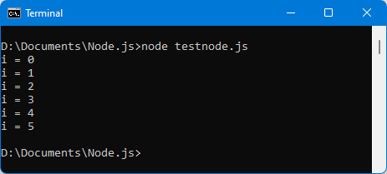
Figure 1.15 – Displaying numbers from 0 to 5
We can verify that this program works in a similar way on the client side, that is to say in a web browser, as follows:
Displaying digits 0–5 in a browser console
<html>
<head>
<meta charset="utf-8" />
<script>
var i = 0;
while (i <= 5) {
console.log("i = " + i);
i++;
}
</script>
</head>
<body>
</body>
</html>
The result is displayed similarly in the browser console:
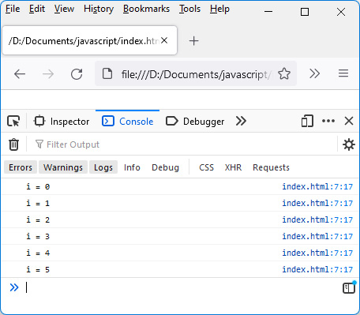
Figure 1.16 – Displaying numbers from 0 to 5 in the browser console

Loops with for()
Another widely used form of loop is one with a for() statement. It simplifies the writing of the previous loop by reducing the number of instructions to write.
Let’s write the same program as before to display the numbers from 0 to 5 using a for() statement instead of the while() statement:
for (var i=0; i <= 5; i++) console.log("i = " + i);
As we can see in the preceding code, a single line replaces several lines as in the previous instance.
The for() statement has three parts, separated by a ;:
The first corresponds to the initialization instruction. Here, it is the declaration of the variable i initialized to 0 (which is the beginning of the loop).
The second corresponds to the condition: as long as this condition is true, the statement (or the block that follows) is executed. Here, the condition corresponds to the fact that the variable i has not exceeded the final value 5.
The third corresponds to an instruction executed after each pass through the loop. Here, we increment the variable i by 1. This ensures that at some point, the condition will be false, in order to exit the loop.
Let’s verify that it works identically to the while() statement:
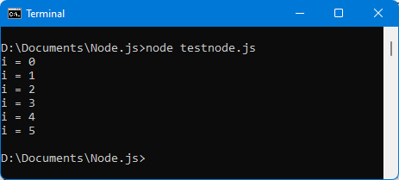
Figure 1.17 – Loop with the for() statement
In this section, we learned how to write sequences of statements that will be executed multiple times, using the while() and for() statements. Now let’s look at how to group statements together, using what are called functions.

Using functions
A function is used to give a name to a block of instructions so that it can be used in different places in the program. In general, in a function, we group a set of instructions that are used to carry out a particular task, for example:
Display the list of the first 10 integers.
Calculate the sum of the first 10 numbers (from 0 to 9).
Calculate the sum of the first N numbers (from 0 to N-1). In this case, N would be a parameter of the function because it can change with each call (or use) of the function.
The functions described above are very simple but show that the role of functions is to encapsulate any process by summarizing in one sentence what is expected of this process. The name given to the function symbolizes the action expected in return, which allows the developer to easily understand the sequence of instructions (including for an external developer who has not participated in the development). Let’s discuss the three functions we listed one by one.

Function displaying the list of the first 10 integers
Let’s write the first function, which displays the list of the first 10 integers. We will call this function display_10_first_integers(). The name must be as explicit as possible because a JavaScript program is composed of many functions whose names must be unique in the program (if two function names are the same, only the last one is taken into account because it overwrites the former).
A function is defined using the keyword function, followed by the name of the function, followed by parentheses. Then, we indicate in the braces that follow the instructions that make up the function. It is this instruction block that will be executed each time the function is called in the program.
Let’s write the function display_10_first_integers(), which displays the first 10 integers:
Display first 10 integers with a function (testnode.js file)
function display_10_first_integers() {
for (var i=0; i <= 10; i++) console.log("i = " + i);
}
The function is defined using the function keyword, followed by the function name and parentheses.
The function statements are grouped in the block that follows between the braces. We find as instructions the previous for() loop, but it could also be the while() loop, which works in the same way.
Let’s run this program assuming it’s included in the testnode.js file:
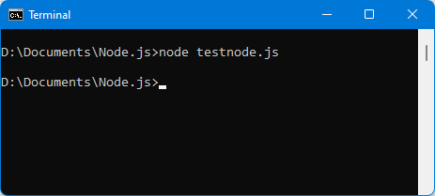
Figure 1.18 – Using a function to display numbers from 1 to 10
As we can see in the preceding figure, the screen remains blank as no display is registered in the console.
Indeed, we have simply defined the function, but we must also use it, that is, call it in our program. You can call it as many times as you want – this is the purpose of functions: we should be able to call (or use) them at any time. But it must be done at least once; otherwise, it is useless, as seen in the preceding figure.
Let’s add the function call following the function definition:
Definition and call of the function
// function definition
function display_10_first_integers() {
for (var i=0; i <= 10; i++) console.log("i = " + i);
}
// function call
display_10_first_integers();
The result of the preceding code can be seen in the following figure:
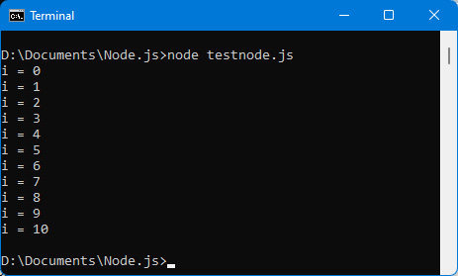
Figure 1.19 – Call of the display_10_first_integers() function
Interestingly, the function can be called in several places of the program. Let’s see how in the following example:
Successive calls to the display_10_first_integers() function
// function definition
function display_10_first_integers() {
for (var i=0; i <= 10; i++) console.log("i = " + i);
}
// function call
console.log("*** 1st call *** ");
display_10_first_integers();
console.log("*** 2nd call *** ");
display_10_first_integers();
console.log("*** 3rd call *** ");
display_10_first_integers();
In the preceding code, the function is called three times in succession, which displays the list of the first 10 integers as many times. The order of the calls is indicated before each list as follows:
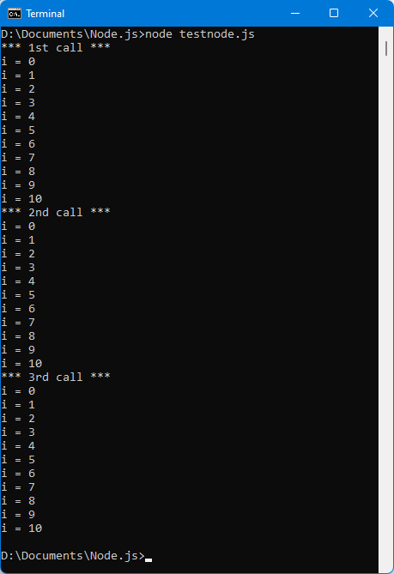
Figure 1.20 – Successive calls to the display_10_first_integers() function

Function calculating the sum of the first 10 integers
We now want to create a function that calculates the sum of the first 10 integers, that is, 1+2+3+4+5+6+7+8+9+10. The result is 55. This will allow us to show how a function can return a result to the outside (that is, to the program that uses it). Here, the function should return 55.
Let’s call the function add_10_first_integers(). This can be written as follows:
Function that adds the first 10 integers
// function definition
function add_10_first_integers() {
var total = 0;
for (var i = 0; i <= 10; i++) total += i;
return total;
}
// function call
var total = add_10_first_integers();
console.log("Total = " + total);
We define the total variable in the function. This variable is a local variable to the function because it is defined using the var or let keyword. This allows this total variable to not be the same as the one defined outside the function, even if the names are the same.
Note
If the total variable in the function was not defined using the var or let keyword, it would create a so-called global variable that would be directly accessible even outside the function. This is not good programming because you want to use global variables as little as possible.
The function uses a for() loop to add the first 10 integers, then returns that total using the return keyword. This keyword makes it possible to make accessible, outside the function, the value of any variable, in our example, the total variable.
Let’s run the previous program. We should see the following output:
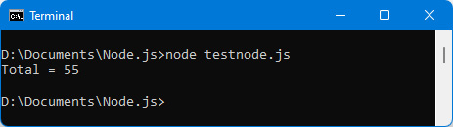
Figure 1.21 – Calculation of the sum of the first 10 integers

Function calculating the sum of the first N integers
The previous function is not very useful because it always returns the same result. A more useful function would be to calculate the sum of the first N integers, knowing that N can be different each time the function is called.
N would in this case be a parameter of the function. Its value is indicated in parentheses when using the function.
Let’s call the add_N_first_integers()function to calculate this sum. The N parameter would be indicated in parentheses following the function name. A function can use several parameters, and it suffices to indicate them in succession, separated by a comma. In our example, a single parameter is enough.
Let’s write the add_N_first_integers(n)function and use that to calculate the sum of the first 10, then 25, then 100 integers. The values 10, 25, and 100 will be used as parameters during successive calls to the function and will replace the parameter n indicated in the definition of the function:
Function that adds the first N integers
// function definition
function add_N_first_integers(n) {
var total = 0;
for (var i = 0; i <= n; i++) total += i;
return total;
}
// calculation of the first 10 integers
var total_10 = add_N_first_integers(10);
console.log("Total of the first 10 integers = " + total_10);
// calculation of the first 25 integers
var total_25 = add_N_first_integers(25);
console.log("Total of the first 25 integers = " + total_25);
// calculation of the first 100 integers
var total_100 = add_N_first_integers(100);
console.log("Total of the first 100 integers = " + total_100);
The add_N_first_integers(n) function is very similar to the add_10_first_integers() function written earlier. It uses the parameter n indicated between the parentheses and does not loop from 0 to 10 as before, but from 0 to n. Depending on the value of n that will be used when calling the function, the loop will thus be different, and the result returned by the function as well.
When calling the function, it passes the parameters 10, 25, then 100 as desired. The result is returned by the function’s total variable, and then used by the total_10, total_25, and total_100 variables outside the function:
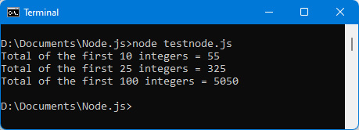
Figure 1.22 – Calculation of the sum of the first 10, then 25, then 100 integers

Summary
The basic features of JavaScript have been covered in this chapter: variables with different types, conditional tests, loops, and functions. They are used on the client side and on the server side.
In the next chapter, we’ll take a look at some more in-depth features of JavaScript, such as object-oriented programming with JavaScript.

Chapter 2: Exploring the Advanced Concepts of JavaScript
In this chapter, we will explore the advanced features of JavaScript, such as object-oriented programming. We will also study two types of objects that are widely used in JavaScript: arrays and strings. Finally, we will see how JavaScript allows you to trigger deferred processing, using so-called callback functions.
In this chapter, we’ll be covering the following topics:
Classes and objects
Arrays
Character strings
Multitasking
Using promises
All these topics are fundamental to building JavaScript applications. Let’s start now!

Technical requirements
You can find the code files for this chapter on GitHub at: https://github.com/PacktPublishing/JavaScript-from-Frontend-to-Backend/blob/main/Chapter%202.zip.

Classes and objects
The notion of classes and objects is fundamental to programming languages. JavaScript allows them to be used as well.
A class is used to represent any type of data. For example, people, customers, cars, and so on. We can define a class to represent each of these types of elements, for example, a Person class to represent people, a Client class to represent customers, and a Car class to represent cars.
Note
Note that the class name traditionally begins with an uppercase letter.
An object, on the other hand, will be a particular element of a class (this element will be also called an instance). For example, among all the people of the class Person, the person identified by his name “Clinton” and his first name “Bill” represents a particular object of the class Person. This object can be associated, for example, with the variable p in the program. We can thus create variables to identify each object associated with the class.

Defining a class
The question to ask yourself when creating a class is what actions you want to perform on the type of data it represents.
For example, if we create the Person class, we should ask what characterizes a person and what action can we perform on this class. We could, for example, say that the Person class is characterized by the last name, first name, and age of the person. You can also add an address, phone number, email, and so on.
As for the possible actions on people, we can imagine, for example, the action of getting married to another person, the action of moving to another city, the action of changing employers, and so on.
Note
Characteristics such as last name, first name, age, and so on are called properties of the class, while actions such as getting married, moving, and so on are called methods of the class. A class will therefore group together a set of properties and a set of methods.
A JavaScript class is created using the keyword class followed by the name of the class, followed by braces describing the content. For example, the Person class will be created as follows:
Person class
class Person {
}
This definition of the Person class will not be very useful for now, because no properties or methods are defined inside it. We will see later how to improve it.

Creating an object by using a class
Once the class is defined, we can create objects associated with this class. For this, we use the keyword new followed by the name of the class. This creates a variable that represents an object of that class:
Creating an object p of class Person
// define the Person class
class Person {
}
// create an object of class Person
var p = new Person; // object p of class Person
console.log(p);
This is what you will see:
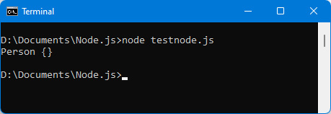
Figure 2.1 – Creating a Person class object
The p object is displayed in the console. We are told that it is a Person class object and that it is empty {}. The representation of an object in the form of braces is traditional in JavaScript, as we saw in the Type of variables used in JavaScript section of the previous chapter.
We can verify that it also works on the client side, in a browser. The HTML file is as follows:
index.html file
<html>
<head>
<meta charset="utf-8" />
<script>
class Person {
}
var p = new Person;
console.log(p);
</script>
</head>
<body>
</body>
</html>
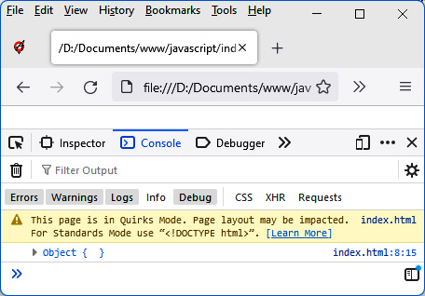
Figure 2.2 – Creating an object in the browser
We find the display of braces, which symbolizes the display of a JavaScript object.

Creating an object without using a class
It is possible to create an object without having created a class first. All you have to do is use the notation with the braces { and }.
For example, we can write the following:
Creating an object using the braces notation
var p = { lastname : "Clinton", firstname : "Bill" };
console.log("The person is", p);
This will create the object p with the lastname and firstname properties. Note that you can indicate the names of the properties by enclosing them in quotation marks, or not. So { lastname: "Clinton" } can also be written { "lastname": "Clinton" } by surrounding the lastname property with single or double quotes.
Now let’s see how to improve the Person class previously created by adding properties and methods to it.

Adding properties to a class
A person has, in our example, a last name, a first name, and an age. We will create these three properties for people of the Person class.
All you have to do is indicate each of these properties, by name, in the body of the Person class. Above all, do not use the var or let keywords to define them:
Adding firstname, lastname, and age properties in Person class
class Person {
firstname;
lastname;
age;
}
var p = new Person;
console.log(p);
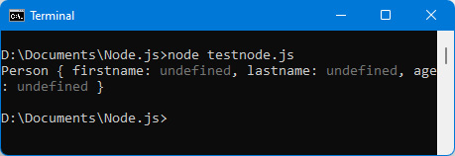
Figure 2.3 – Creation of lastname, firstname, and age properties in the Person class
The Person class object p now has the properties added in the class. Any other object of this class will also have them.
Note that the values of the added properties are undefined. This is normal because no values have been specified for these properties in the p object or the Person class.
Let’s modify the Person class so that the properties have default values, rather than undefined:
Properties with default values
class Person {
firstname = "";
lastname = "";
age = 0;
}
var p = new Person;
console.log(p);
Each property is initialized with its default value. The lastname and firstname properties are initialized with an empty string "", while age is initialized by default to 0.
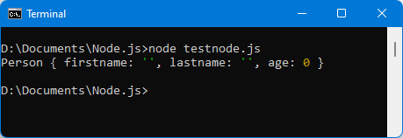
Figure 2.4 – Properties with default values
A class has properties, but also methods. Now let’s see how to add methods to a class.

Adding methods to a class
You can add methods to a class. Objects created from the class (with new) will be able to use these methods directly.
For example, let’s create the display() method, which displays a line of text containing the person’s first and last name. The instruction p.display() (assuming that p is a Person class object) is used to display the last name and first name of the person related to the object p:
Creating the display() method in the Person class
class Person {
// class properties
firstname = "";
lastname = "";
age = 0;
// class methods
display() {
console.log("The person's lastname is = " +
this.lastname +
", firstname = " + this.firstname);
}
}
var p = new Person;
console.log("Variable p = ", p);
p.display();
// use of the display() method on the p object
The properties of the class are accessible in the methods of the class by prefixing them with the keyword this. For example, this.lastname provides access to the lastname property of the class.
The this keyword refers to the object itself that uses the display() method, so here, the p object.
If you omit the this keyword and use the lastname property directly, you will get a syntax error because the property is only accessible with the this keyword.
The output of the preceding code snippet is displayed here:
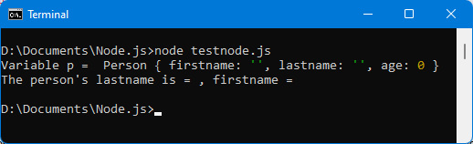
Figure 2.5 – Using the display() method
The display() method displays firstname and lastname of the person associated with the variable p, but since lastname and firstname have been initialized to an empty string, no last name or first name is displayed. Let’s look at how to modify the value of a property.

Changing an object’s property values
You can modify the value of the properties of an object by using these properties directly, for example, p.lastname allows you to read or modify the value of the lastname property for the object p:
Initialization of the lastname and firstname of the person
class Person {
// class properties
lastname = "";
firstname = "";
age = 0;
// class methods
display() {
console.log(" The person's lastname = " + this.lastname +
", firstname = " + this.firstname);
}
}
var p = new Person;
p.lastname = "Clinton"; // initialization of the lastname
// property of the object p
p.firstname = "Bill"; // initialization of the firstname
// property of the object p
console.log("Variable p = ", p);
p.display();
This is what you will see:
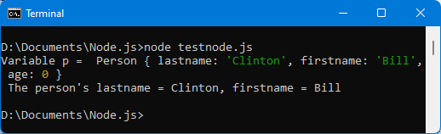
Figure 2.6 – The lastname and firstname properties are initialized
Once the object p has been created by the new operator, we initialize its lastname and firstname properties to the values indicated. The age property is not modified here, and will therefore remain equal to the value 0.
We modified the value of the lastname and firstname properties of the object p created using p.lastname and p.firstname.
This modification of property values is done after the object p is created. It is possible to do this modification during the very creation of the object, in the new instruction. This requires defining a method called constructor(), which allows this initialization.

Using the class constructor
The constructor() method is called the constructor of the class. It is automatically called during each new statement if the constructor() method exists in the class. We define it in a class if we want to perform a specific process each time an object is created in this class.
The constructor() method can have any number of parameters or none at all. The parameters indicated here will be used to initialize the lastname and firstname properties of the person:
Using a constructor for the Person class
class Person {
// class properties
lastname = "";
firstname = "";
age = 0;
// class methods
constructor(lastname, firstname, age) {
this.lastname = lastname;
this.firstname = firstname;
this.age = age;
}
display() {
console.log(" The person's lastname = " + this.lastname +
", firstname = " + this.firstname);
}
}
var p = new Person("Clinton", "Bill");
console.log("Variable p = ", p);
p.display();
The constructor() method is defined by giving it the three parameters lastname, firstname, and age. They are transferred into the properties of the object by means of this.lastname, this.firstname, and this.age.
Finally, the object p is now created by passing as parameters the values of lastname, firstname, and age of the person created with new. Here, age is not specified in parameters in the new instruction; it will therefore be an undefined value that will be transmitted to the constructor.
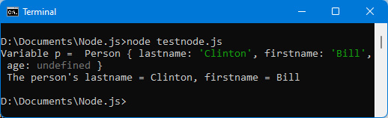
Figure 2.7 – Using a constructor
We find the lastname and firstname properties initialized, but the age property is now initialized to the value undefined instead of 0. To assign it another value, simply pass an additional value when creating the object with new. This additional value will represent the person’s age, for example:
Using age when creating Person class object
class Person {
// class properties
lastname = "";
firstname = "";
age = 0;
// class methods
constructor(lastname, firstname, age) {
this.lastname = lastname;
this.firstname = firstname;
this.age = age;
}
display() {
// the age of the person is also displayed
console.log("The person's lastname = " + this.lastname +
", firstname = " + this.firstname +
", age = " + this.age);
}
}
var p = new Person("Clinton", "Bill", 33);
// age is now
// transmitted
console.log("Variable p = ", p);
p.display();
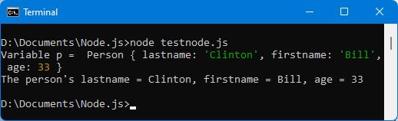
Figure 2.8 – The person’s age is now transmitted
We have seen how to create an object, by directly defining its properties and methods using a class. However, we can also create an object from another object. Let’s see how to do it.

Merging one object with another
There may be cases when you want to create a new object from an old object. Let’s see how to do this.
If the object p contains a value, the statement var p2 = p does not create a new object p2 distinct from the object p, but only a reference p2 that points to the same value as the reference p. So any modification of the properties of the object p will also be visible in the object p2 because both point to the same memory location.
This can be verified using the following example:
Modifying an object in memory
var p = { lastname : "Clinton", firstname : "Bill" };
console.log("p (before modification of p2) =", p);
// p = { lastname : "Clinton", firstname : "Bill" }
var p2 = p;
p2.city = "Washington";
console.log("p (after modification of p2) =", p);
// p = { lastname : "Clinton", firstname : "Bill",
// city : "Washington"}
console.log("p2 =", p2);
// p2 = { lastname : "Clinton", firstname : "Bill",
// city : "Washington"}
Even if only the p2 object is modified, the p object is also modified because they are memory references that point to the same location. If the contents of the memory location are changed, both references see the same change.
To avoid this situation, it would not be necessary to write p2 = p, but rather to copy the properties of the object p into those of the object p2, thus creating a new memory location. For this, JavaScript offers the spread operator, used in the form …, which allows it:
Using the spread operator ...
var p = { lastname : "Clinton", firstname : "Bill" }
console.log("p (before modification of p2) =", p);
var p2 = { ...p}; // copy the properties of object p into
// object p2
p2.city = "Washington";
console.log("p (after modification of p2) =", p);
console.log("p2 =", p2);
The spread operator is used by surrounding the original object with braces { and }, and preceding the object with the spread operator (for example, {...p}).
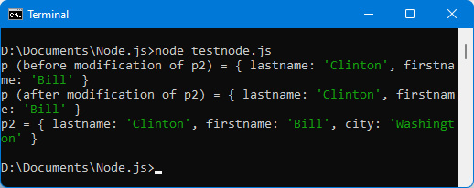
Figure 2.9 – Using the spread operator...
Object p is no longer modified when object p2 is modified.
It is also possible to write it in shortened form:
Creating object p2 from object p, adding the city
// to avoid writing p2.city = "Washington"
var p2 = { ...p, city : "Washington" };
Now that we have looked at classes and objects and how to work with them, let’s take a look at an important class object: the Array class.

Arrays
Arrays store a collection of data, ordered according to their index. The index is also called the index of the array. It starts at 0 and scales up to the total number of elements in the array, minus 1 (0 to n-1).
Let’s learn how to create an array first.

Creating an array
An array corresponds in JavaScript to an Array class object. We therefore create an array using the new Array instruction.
However, since arrays are widely used in JavaScript programs, it is also possible to create them using a bracket notation [ and ]. This is an easier way to use them without going through the Array class.
Let’s take a detailed look at these two ways to create an array (with brackets and with the Array class).
Creating an array using square brackets [ and ]
The easiest and fastest way to create an array is to use the bracket notation:
Creating an array using square brackets
var tab = ["Element 1", "Element 2", "Element 3", "Element 4", "Element 5"];
console.log(tab);
The array begins with an opening square bracket [ and ends with a closing square bracket ]. The elements of the array are separated by a comma. We have inserted elements here as strings, but in fact, any type of element can be inserted into an array.
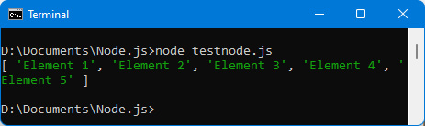
Figure 2.10 – Elements inserted into an array
Note that it is possible to create an empty array (without any elements). We write this as [], without indicating any element inside the square brackets. It will then be possible to add elements to this array.
Creating an array using the Array class
You can also use the Array class to create an array. The Array class includes a constructor in which we indicate the list of array elements, each separated from the next by a comma.
The same array as before can be created by the new Array statement by writing the following:
Creating an array using new Array
var tab = new Array("Element 1", "Element 2", "Element 3", "Element 4", "Element 5");
console.log(tab);
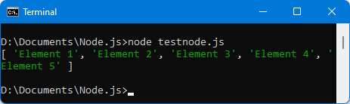
Figure 2.11 – Creation of the array using new Array
The array created is the same as before.
To create an empty array, simply pass no parameters to the constructor by writing the following:
Creating an empty array using new Array()
var tab = new Array(); // or new Array;
console.log(tab);
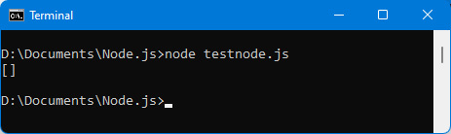
Figure 2.12 – Creating an empty array [ ]
Now that we’ve seen how to create an array, let’s see how to access each of its elements.

Accessing array elements
In previous programs, we displayed the entire array, using the console.log(tab) statement. It is possible to access each element of the array separately. Each element can be accessed as follows:
By its index
With a for() loop
With the forEach() method
Let’s take a look at each of these three ways.
Accessing an element by index
Let’s take the previous array of five elements, that is, tab = ["Element 1", "Element 2", "Element 3", "Element 4", "Element 5"]:
The first element can be accessed by its index 0, that is, tab[0].
The next one, with index 1, will be accessed by tab[1].
The last one, with index 4, will be accessed by tab[4].
This is how you will display each element:
Displaying each element of the array by its index
var tab = ["Element 1", "Element 2", "Element 3", "Element 4", "Element 5"];
console.log("tab =", tab);
console.log("tab[0] =", tab[0]);
console.log("tab[1] =", tab[1]);
console.log("tab[2] =", tab[2]);
console.log("tab[3] =", tab[3]);
console.log("tab[4] =", tab[4]);
console.log("tab[5] =", tab[5]);
The result is displayed in the following figure:
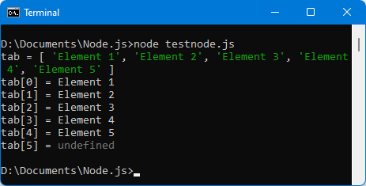
Figure 2.13 – Displaying each element by its index
The array contains five elements, which means the indices go from 0 to 4. However, to do a test, we also access the element with index 5. It is possible to access an index of an element that does not exist in the array. The result in this case is the JavaScript value undefined, which means that the value of this element has not yet been assigned.
Note that it is possible with this access method to modify the value of an array element – just give it a new value:
Modifying the value of the elements in indexes 2 and 3 of the array
var tab = ["Element 1", "Element 2", "Element 3", "Element 4", "Element 5"];
console.log("Array before modification");
console.log("tab =", tab);
// modification of elements, index 2 and 3
tab[2] = "New element 3";
tab[3] = "New element 4";
console.log("Array after modification");
console.log("tab =", tab);
This is the result:
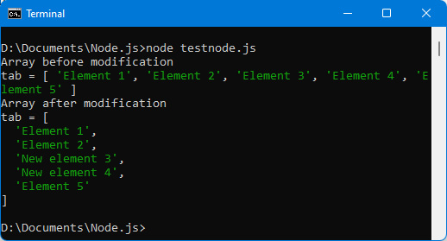
Figure 2.14 – Modifying array elements
Next, we will look at accessing an element with a for() or while() loop.
Accessing an element with a for() or while() loop
The for() and while() loops already studied in the previous chapter allow you to browse all the elements of an array. The index of the loop starts at 0 (to access the first element of the array, the one with index 0) and ends at the last index of the array.
To know this last index, JavaScript provides the length property in the Array class, which allows us to know the total number of elements of an array. The last index will be the one with the value length – 1:
Accessing array elements with a for() loop
var tab = ["Element 1", "Element 2", "Element 3", "Element 4", "Element 5"];
console.log("tab =", tab);
console.log("Access to each element by a for() loop");
for (var i = 0; i < tab.length; i++) console.log("tab[" + i + "]=", tab[i]);
Note that the end of the loop is written by testing the value i < tab.length. This is equivalent to writing i <= tab.length – 1.
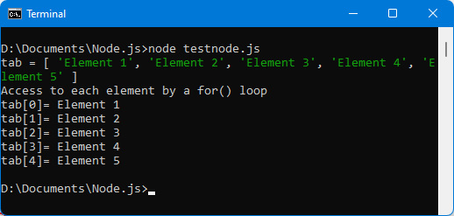
Figure 2.15 – Accessing array elements with a for() loop
Next, we will look at accessing an element with the forEach(callback) method.
Accessing an element with the forEach(callback) method
The forEach(callback) method is a method defined by JavaScript on the Array class. It is used to browse the elements of an array by transmitting each of the elements of the array to a function passed as a parameter. The function indicated as a parameter therefore has access to each element of the array (and to its index if necessary).
Callback Function
The principle of indicating a function in the parameters of a method is very common in JavaScript. The function in the parameters is known as a callback function, which means that the actual processing to be executed is that indicated in the callback function.
We show here how to use a callback function indicated in parameters of the forEach(callback) method.
We use the tab array of five elements seen previously, to which we apply the forEach() method:
Accessing array elements using the forEach() method
var tab = ["Element 1", "Element 2", "Element 3", "Element 4", "Element 5"];
console.log("tab =", tab);
console.log("Access to each element by the forEach() method");
tab.forEach(function(elem, i) {
console.log("tab[" + i + "]=", elem);
});
We indicate a function as a parameter of the forEach() method. This so-called callback function will be called automatically by JavaScript for each element of the tab array (which uses the forEach() method).
The callback function takes as its first parameter the element of the array for which the function is called (parameter elem), and its index (parameter i).
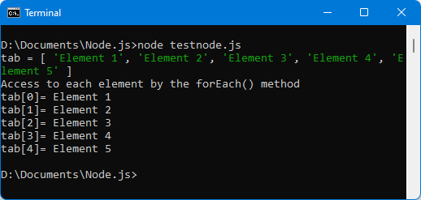
Figure 2.16 – Accessing array elements using the forEach() method
The result is the same as that obtained by the for() loop. However, there is a (small) difference that we discover right away.
The difference between the for() loop and the forEach() method
The previous program did not show any difference between the for() loop and forEach() method results to access array elements.
To show the difference between these two approaches, let’s introduce a new element in the array, at index 10, knowing that the last index used during the creation of the array was 4. We thus create a new element that is much further away than the current last element of the array. How will the array react to this enlargement?
Addition of an element at index 10
// original array
var tab = ["Element 1", "Element 2", "Element 3", "Element 4", "Element 5"];
// adding a new element in the array, at index 10
tab[10] = "Element 9";
console.log("tab =", tab);
// display the array with a for() loop
console.log("Access to each element by a for() loop");
for (var i = 0; i < tab.length; i++) console.log("tab[" + i + "]=", tab[i]);
// display the array by the forEach() method
console.log("Access to each element by the forEach() method");
tab.forEach(function(elem, i) {
console.log("tab[" + i + "]=", elem);
});
We add an element to the array using tab[10] = "Element 9", then display the contents of the array using the for() loop and then the forEach() method.
The result is displayed in the following figure:
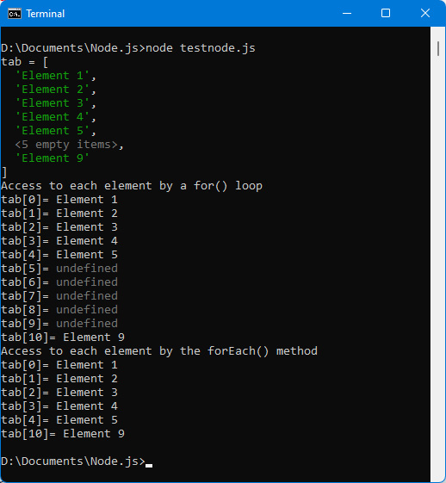
Figure 2.17 – Adding an element at index 10 of the array
The display of the for() loop shows that the elements with indices 5 to 9 exist but are of value undefined, because effectively, no values have been inserted for these indices of the array. However, the indices 5 to 9 with their undefined values are displayed by the for() loop.
Conversely, the forEach() method provides the callback function indicated in parameters with only the array elements that have actually been affected in the array. This therefore avoids the elements at indices 5 to 9, which have not been assigned in the program.
We have seen how to create an array, then how to access each of its elements. Let’s look at how to add new elements to the array.

Adding items to the array
Once the array has been created (empty or not), it is possible to add elements to it. We will mainly use one of the two following techniques:
Adding an element by its index in the array
Adding an item using the push() method
Now let’s take a look at these two techniques.
Adding an element by index
This corresponds to the assignment tab[i] = value. We used it in the previous section by writing tab[10] = "Element 9".
Note simply that if the index used is greater than the current number of elements in the array, this enlarges the array by creating elements initialized to the value undefined. And if the index used is less than the number of elements in the array, it modifies the current value of the targeted element.
Adding an element using the push() method
The push() method is defined in the Array class. It allows you to add a new element to an array without worrying about the insertion index because it automatically inserts the element at the end of the array:
Inserting an element using the push() method
// original array
var tab = ["Element 1", "Element 2", "Element 3", "Element 4", "Element 5"];
// insert an element using the push() method
tab.push("Element 6");
console.log("tab =", tab);
// display the array with a for() loop
console.log("Access to each element by a for() loop");
for (var i = 0; i < tab.length; i++) console.log("tab[" + i + "]=", tab[i]);
// display the array by the forEach() method
console.log("Access to each element by the forEach() method");
tab.forEach(function(elem, i) {
console.log("tab[" + i + "]=", elem);
});
The instruction tab.push("Element 6") inserts this element at the end of the array. The array is then displayed using the various methods seen previously.
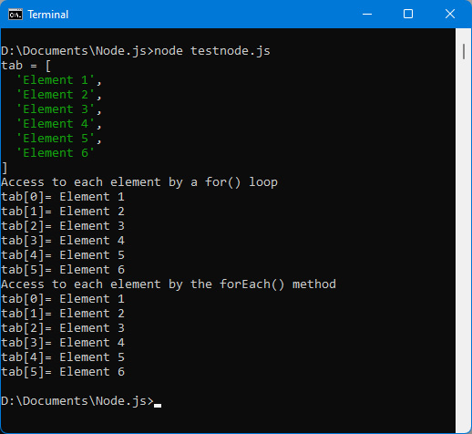
Figure 2.18 – Adding an element using the push() method
We know how to add and modify elements in an array. All that remains is to know how to delete elements from an array.

Deleting array elements
JavaScript allows us to delete array elements in two ways:
Deleting the value of the element in the array, while retaining the element in the array with an undefined value
Removing the element itself from the array
Let’s examine these two possibilities now.
Deleting an element value (without deleting the element from the array)
We use the delete keyword to delete the value of an element in an array. For example, delete tab[0] deletes the value of the element with index 0 in the array tab, by assigning it the value undefined. The element is not removed from the array, which still has the same number of elements as before:
Deleting the value of the element with index 0
// original array
var tab = ["Element 1", "Element 2", "Element 3", "Element 4", "Element 5"];
// delete the value of the element with index 0
delete tab[0];
console.log("tab =", tab);
// display the array with a for() loop
console.log("Access to each element by a for() loop");
for (var i = 0; i < tab.length; i++) console.log("tab[" + i + "]=", tab[i]);
// display the array by the forEach() method
console.log("Access to each element by the forEach() method");
tab.forEach(function(elem, i) {
console.log("tab[" + i + "]=", elem);
});
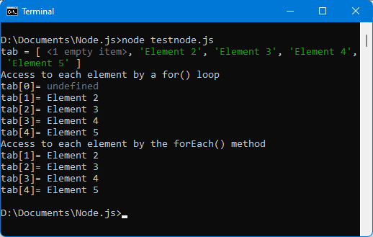
Figure 2.19 – Deleting the value of the element with index 0
We see that the for() loop displays the undefined value of the element, while the forEach() method no longer displays the element because its value has been deleted.
Note
Note that if instead of using delete tab[0], we use tab[0] = undefined, the forEach() method displays the element at index 0 as the first element of the array, because the value of the element has not actually been deleted but rather assigned to a new value, which here is undefined.
Now let’s look at the second method for removing the element from the array.
Deleting an element from an array
Using the delete keyword does not delete the element from the array, which retains the same number of elements.
The splice(begin, count) method defined in the Array class allows you to physically remove the element from the array, which will therefore have at least one element less after its use.
The splice(begin, count) method includes the begin and count parameters, which allow you to indicate from which index you want to delete (begin parameter) the elements and the number of consecutive elements you want to delete (count parameter).
So, to remove the element with index 0 from the array tab, just write tab.splice (0, 1):
Removing element with index 0 in array with splice() method
// original array
var tab = ["Element 1", "Element 2", "Element 3", "Element 4", "Element 5"];
// remove 1 element from index 0
tab.splice(0, 1);
console.log("tab =", tab);
// display the array with a for() loop
console.log("Access to each element by a for() loop");
for (var i = 0; i < tab.length; i++) console.log("tab[" + i + "]=", tab[i]);
// display the array by the forEach() method
console.log("Access to each element by the forEach() method");
tab.forEach(function(elem, i) {
console.log("tab[" + i + "]=", elem);
});
This is what you will see:
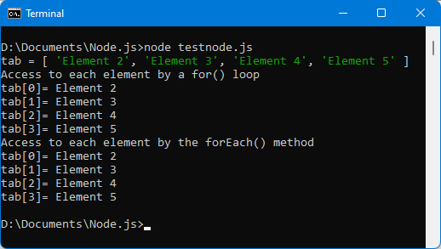

Figure 2.20 – Deletion of element with index 0
We have seen how to add and delete elements in an array. Now let’s see how to extract a new array from the elements present in the current array.

Filtering elements in an array
It is common to filter the elements of an array, for example, to keep only certain elements or to return new ones. The Array class has two methods—filter(callback) and map(callback)—that allow us to return a new array according to our conditions.
Using the filter(callback) method
The tab.filter(callback) method returns a new array while keeping only the desired elements of the tab array.
The callback function of the form callback(element, index) is called for each of the elements of the array tab. It must return true if we decide to keep the element; otherwise, the element is excluded. A new array is returned as a result by the tab.filter() method, but the original tab array is not modified (unless it is assigned in return from the method, as in the following example).
Let’s use the filter() method to keep only the elements of the array whose index is greater than or equal to 2:
Using the filter() method
// original array
var tab = ["Element 1", "Element 2", "Element 3", "Element 4", "Element 5"];
console.log("initial tab =", tab);
// keep only items with index >= 2
tab = tab.filter(function(element, index) {
if (index >= 2) return true; // keep this element
});
console.log("\nfinal tab =", tab);
If the callback function returns true, the element is kept; otherwise, it is excluded. The callback function can also return false, or even return nothing, like here, and in this case, the element is excluded:
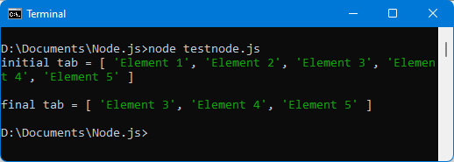
Figure 2.21 – Using the filter() method
This brings us to the end of the filter() method.
Using the map(callback) method
The tab.map(callback) method is used to return a new array from the elements of the initial tab array. Each element of the initial array is passed to the callback function of the form callback(element, index), which must return for each element a new element that will replace the original element.
Let’s use the map(callback) method to return a new array in which all elements have been capitalized:
Using the map() method
// original array
var tab = ["Element 1", "Element 2", "Element 3", "Element 4", "Element 5"];
console.log("initial tab =", tab);
// capitalize all elements
tab = tab.map(function(element, index) {
return element.toUpperCase();
});
console.log("\nfinal tab =", tab);
The toUpperCase() method is a method defined on the String class (following screenshot), allowing you to capitalize the character string that uses the method.
The result is displayed in the following figure:
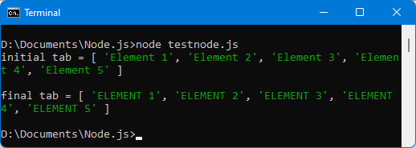
Figure 2.22 – Using the map() method
We have studied in this section the use of objects of the Array class. Another class of objects is also widely used with JavaScript: character strings, which are represented by the String class. Now let’s see how to use objects of the String class.

Character strings
Strings are widely used in programming languages. They are used to represent text entered by a user or text that will be displayed to a user.

Creating a character string
A character string is represented by an object of class String. But since character strings are widely used in JavaScript, the language allows them to be used by surrounding them with double quotes " and " or single quotes ' and '. It is also possible, for certain uses, to use backticks (reverse quotation marks ' and ').
Note
The string literal must in this case begin and end with the same type of quotes.
Now let’s see how to create a string using these various methods.
Creating a string literal using double or single quotes
The easiest way to create a string literal is to use the single or double quote notation:
Creating a string literal with double quotes
var s = "String 1";
console.log("s =", s);
Or, with single quotes:
Creating a string literal with single quotes
var s = 'String 1';
console.log("s =", s);
In both cases, the character string displayed is the same.
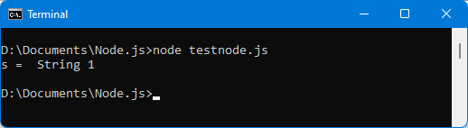
Figure 2.23 – Creating a character string
Advantage of Having the Option to Use Single/Double Quotation Marks
The advantage of having the possibility of using single or double quotes is visible if the string itself contains quotes. For example, if the string is "I'll love JavaScript", using single quotes to create the string will produce an error because the string will be assumed to end with the apostrophe in the word I'll. In this case, you must use double quotes to avoid the error.
Creating a string literal using backticks
You can also use backticks. This is useful in special cases where you want to use the value of variables in character strings in a simpler way.
For example, suppose you want to display a string that uses a person’s first and last name. The last name and first name are in variables named lastname and firstname:
Concatenating strings and variables
var lastname = "Clinton";
var firstname = "Bill";
// old way of concatenating strings and variables
var s1 = "lastname is " + lastname + ", firstname is " + firstname;
// new way of concatenating strings and variables
var s2 = `lastname is ${lastname}, firstname is ${firstname}`;
console.log("s1 =", s1);
console.log("s2 =", s2);
When using reverse quotes, the + symbol is no longer used to concatenate strings and variables. Everything is written in a single string, and the variables are identified by the “symbols” ${variable}.
What is written between the braces { and } can be a simple variable (like here), but also a more complex JavaScript expression that can be calculated (for example, {a+b}).
We can see that the two result strings are identical.
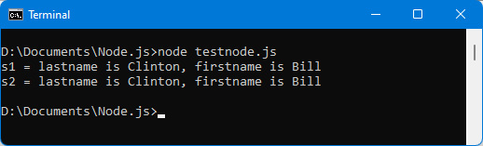
Figure 2.24 – Sequence of character strings and variables creating a string using the String class
Finally, it is possible to use the String class to create the character string. The String class has a constructor in which the string to be constructed is indicated as a parameter:
Using the String class
var s = new String("I'll love JavaScript");
console.log("s =", s);
The following figure displays the result:
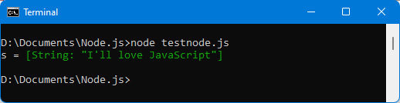
Figure 2.25 – Using the String class
The String class has properties and methods. For example, the length property lets you know the number of characters in the string, and thus lets you compare, for example, the length of two character strings.
Let’s use the length property to display the length of the two strings created using quotes and the String class:
Using the length property of the String class
var s1 = new String("I'll love JavaScript");
var s2 = "I'll love JavaScript";
console.log("s1 =", s1);
console.log("s2 =", s2);
console.log("s1.length =", s1.length);
console.log("s2.length =", s2.length);
This is the result:
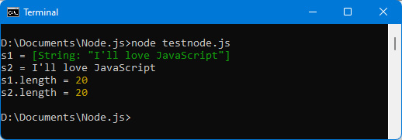
Figure 2.26 – Using the length property of the String class
Regardless of how the string is created, its length is the same (here, 20 characters). We have seen how to create a character string, now let’s see how to access the characters that compose it.

Accessing characters in a string
The String class defines methods for accessing characters in the string. These are, in particular, the charAt(index) and slice(start, end) methods. charAt(index) is used to retrieve the character located at the index indicated in the string, starting from index 0. The maximum index is that associated with the value of the length property, reduced by 1. slice(start, end) breaks the string into a substring, by extracting the characters that go from the start index (included) to the end index (excluded).
Using the charAt(index) method
Let’s use the charAt(index) method to display the characters of a string, one by one:
Displaying characters from a string
var s = "Hello";
console.log("s =", s);
for (var i = 0; i <s.length; i++) console.log(`s.charAt(${i}) = ${s.charAt(i)}`);
Notice the use of reverse quotes to display the result string.
The result is displayed in the following figure:
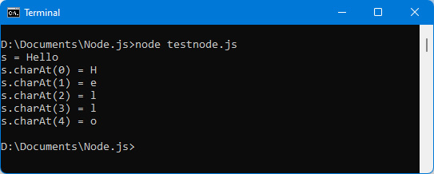
Figure 2.27 – Using the charAt() method
Now, let’s look at the slice(start, end) method.
Using the slice(start, end) method
The preceding charAt(index) method retrieves a single character from the string, while the slice(start, end) method can retrieve several consecutive ones:
Note
Note that the slice(start, end) method does not modify the string on which the method applies, but rather returns a new string. The original string is not modified, allowing it to remain intact.
Using slice() on the “Hello” string
var s = "Hello";
console.log("s =", s);
console.log(`s.slice(0,2) = ${s.slice(0,2)}`);
console.log(`s.slice(0,3) = ${s.slice(0,3)}`);
console.log(`s.slice(1,3) = ${s.slice(1,3)}`);
console.log(`s.slice(0,-1) = ${s.slice(0,-1)}`);
console.log(`s.slice(0,-2) = ${s.slice(0,-2)}`);
console.log(`s.slice(1,-2) = ${s.slice(1,-2)}`);
If the end index (second parameter) of the slice(start, end) method is negative, it means counting starts from the end of the string (instead of the beginning if it is positive).
We then obtain the following result:
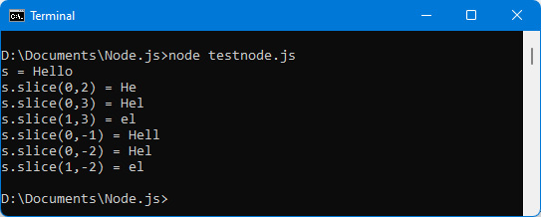
Figure 2.28 – Using the slice() method
Now that we have seen how to get the characters that make up the string, let’s look at how to modify the string.

Modifying a character string
To modify a string, there is only one possibility: you have to construct a new one from it. The original string cannot be changed directly.
For this, we will use the previous slice() and charAt() methods, which will make it possible to extract parts of the original string, in order to build the resulting string.
But to search or modify parts of character strings, it is better to use regular expressions. We study them below.

Using regular expressions
Regular expressions are related to strings. They are used to check whether a string has a certain format (for example, the format of an email, of a telephone number, and so on), or to replace the characters that are in this format with others.
For this, the String class has the match(regexp) method to check whether a character string has a given format and the replace(regexp, str) method to replace the part of the string in this format with the new string str.
In both methods, the regexp parameter corresponds to a regular expression, the meaning of which we will study next.
Checking whether a string has a given format
The match(regexp) method is used to check whether the character string on which the method is used is in the format indicated in regexp. The regexp parameter is called a regular expression.
Regular Expressions
A regular expression is a sequence of characters surrounded by / and /, for example, /abc/. The regular expression /abc/ means that we are looking for the sequence of characters abc in the character string. If the string contains the sequence abc, the match(/abc/) method returns this sequence of characters as a result, otherwise it returns the value null.
A full description of regular expressions can be found at https://developer.mozilla.org/fr/docs/Web/JavaScript/Reference/Global_Objects/RegExp.
Here are some examples of regular expressions with the values returned when using the match() method on the string "Hello":
Using match(regexp)
var s = "Hello";
console.log("s =", s);
// search for "Hel"
console.log(`s.match(/Hel/) = ${s.match(/Hel/)}`);
// search for "hel"
console.log(`s.match(/hel/) = ${s.match(/hel/)}`);
// search for "hel" ignoring upper/lower case
console.log(`s.match(/hel/i) = ${s.match(/hel/i)}`);
// search for H followed by a or b or e followed by l
console.log(`s.match(/H[abe]l/) = ${s.match(/H[abe]l/)}`);
// search for He followed by 0 or 1 a followed by l
console.log(`s.match(/Hea?l/) = ${s.match(/Hea?l/)}`);
// search for He followed by 0 (min) to 1 (max) followed by l
console.log(`s.match(/Hea{0,1}l/) = ${s.match(/Hea{0,1}l/)}`);
// search for He followed 1 (min) to 2 (max) followed by l
console.log(`s.match(/Hea{1,2}l/) = ${s.match(/Hea{1,2}l/)}`);
When the regular expression is found in the "Hello" string, the part of the string found is returned by the match() method, otherwise it returns null.
The i sign at the end of the regular expression indicates that uppercase or lowercase letters must be ignored.
The square brackets [ and ] around a series of letters mean that only one of these letters is required.
The question mark ? means that the preceding character is optional (it can be present or not).
The braces {min,max} mean that the preceding character must be present at least min times and at most max times.
The result of the previous program is as follows:
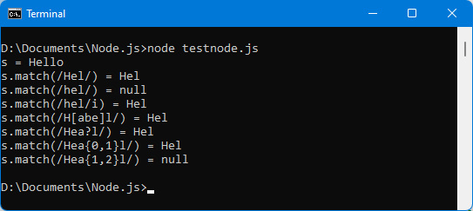
Figure 2.29 – Using regular expressions
Note
Writing a regular expression can sometimes be complex to formulate. The site https://regex101.com/ allows you to test the regular expressions you want.
A regular expression can also modify parts of character strings, using the replace() method.
Replacing a part of a string with a given format
The replace(regexp, str) method is used to replace the part of the string having the format of the regular expression regexp with the string str. It returns a new string, and the original one is not modified. If the format indicated by the regular expression is not found, the original string is returned with no modifications.
Let’s take the regular expressions from the previous example and replace the string found with the string “abc”, thanks to the regular expressions:
Using the replace() method
var s = "Hello";
console.log("s =", s);
// search for "Hel" and replace with "abc"
console.log(`s.replace(/Hel/, "abc") => ${s.replace(/Hel/, "abc")}`);
// search for "hel" and replace with "abc"
console.log(`s.replace(/hel/, "abc") => ${s.replace(/hel/, "abc")}`);
// search for hel ignoring upper/lower case and replacing with
// "abc"
console.log(`s.replace(/hel/i, "abc") => ${s.replace(/hel/i, "abc")}`);
// search for H followed by a or b or e followed by l and
// replace with "abc"
console.log(`s.replace(/H[abe]l/, "abc") => ${s.replace(/H[abe]l/, "abc")}`);
// search for He followed by 0 or 1 a followed by l and
// replaced by "abc"
console.log(`s.replace(/Hea?l/, "abc") => ${s.replace(/Hea?l/,
"abc")}`);
// search for He followed by 0 (min) to 1 (max) followed by l
// and replaced by "abc"
console.log(`s.replace(/Hea{0,1}l/, "abc") => ${s.replace(/Hea{0,1}l/, "abc")}`);
// search for He followed by 1 (min) to 2 (max) followed by l
// and replaced by "abc"
console.log(`s.replace(/Hea{1,2}l/, "abc") => ${s.replace(/Hea{1,2}l/, "abc")}`);
The output is shown here:
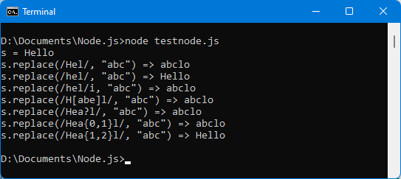
Figure 2.30 – Using the replace() method
All executions of previous programs were executed immediately. We are now going to study how to perform deferred processing over time.

Multitasking in JavaScript
When you start coding in JavaScript, a question often comes up: is it possible to perform several processes simultaneously (what is called multitasking in computing)? This would be useful if a process to be executed will take a long time, so as not to block other equally urgent processes.
JavaScript does not allow several processing operations to be carried out simultaneously. On the other hand, it is possible not to block the program (both on the client side in the browser, and on the server side with Node.js) by using the callback function (which we have already talked about when studying the forEach()method in the Accessing an element with the forEach(callback) method section).
Callback Function
A callback function corresponds to a processing function used as parameters of a JavaScript method or function. The callback function will be executed at the desired time by the method or function that uses it.
Node.js makes extensive use of this feature. For example, when reading a file, the readFile(callback) method calls the callback function as a parameter when the file has been read, which allows the program not to block the pending processing of the file to be read.
JavaScript defines as standard two main functions that use this callback function concept: the setTimeout() and setInterval() functions. Both these use a callback function as a parameter. We’ll describe these two functions next.

Using the setTimeout() function
The setTimeout(callback, timeout) function is used to position a processing function (the callback function) that will be executed when the time period expressed by timeout (in milliseconds) has elapsed.
This allows you, for example, to perform processing after 5 seconds (that is, 5,000 milliseconds). You can execute other instructions while waiting for this delay, so the program is not blocked during this time:
Processing instructions after a delay of 5 seconds
console.log("Before setTimeout()");
setTimeout(function() {
console.log("In the callback function");
}, 5000); // 5000 milliseconds, or 5 seconds
console.log("After setTimeout()");
We display a message ("Before setTimeout()") in the console at the start of the program. We program a delay of 5 seconds, after which a callback function is triggered, which displays another message in the console ("In the callback function"). Finally, we end the program by displaying a new message ("After setTimeout()").
Let’s run this program with the node testnode.js command, for example. To test this program in a browser, simply place the preceding JavaScript code between the <script> and </script> tags of the index.html file.
The following screenshot shows the display after 1 second:
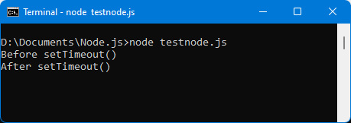
Figure 2.31 – Using setTimeout()
Note that the display message of the start and that of the end follow each other, even though the 5-second time limit has not elapsed. This shows that the program is not blocked, waiting for the timeout to expire.
The following screenshot shows the display after at least 5 seconds (when the delay used in the setTimeout() method has elapsed).
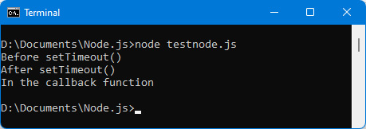
Figure 2.32 – Display when the 5-second delay has elapsed
We see that when the 5-second delay has elapsed, the callback function registered in the setTimeout() function is called automatically by the setTimeout() function.
Let’s improve the program by displaying the time when the messages are displayed. This makes it possible to verify that the 5-second time limit is respected:
Displaying the time when messages are posted
console.log(time(), "Before setTimeout()");
setTimeout(function() {
console.log(time(), "In the callback function");
}, 5000); // 5000 = 5 seconds
console.log(time(), "After setTimeout()");
function time() {
// return time as HH:MM:SS
var date = new Date();
var hour = date.getHours();
var min = date.getMinutes();
var sec = date.getSeconds();
if (hour < 10) hour = "0" + hour;
if (min < 10) min = "0" + min;
if (sec < 10) sec = "0" + sec;
return "" + hour + ":" + min + ":" + sec + " ";
}
The time() function is used to generate a character string that contains the time in the form HH:MM:SS. This time is displayed at the beginning of each message displayed in the console.
The Date class used here is a JavaScript class that allows you to manage dates and to extract hours, minutes, and seconds.
We now get the following:
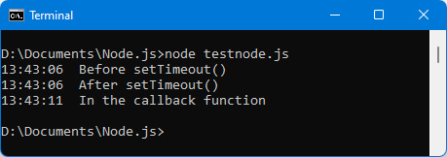
Figure 2.33 – Displaying the time when messages are displayed in the console
We can clearly see that the callback function is executed at the end of the 5-second period indicated in the parameter of the setTimeout() function.

Using the setInterval() function
The setInterval(callback, timeout) function is similar to the setTimeout() function seen previously. But instead of executing the callback function only once at the end of the delay (as the setTimeout() function does), the setInterval() function executes the callback function repeatedly by setting a new delay at the end of it. The callback function is therefore executed at regular intervals. The only way to stop this cycle is to use the clearInterval() function.
The setInterval() function is very useful for running processes at regular intervals.
Let’s use the setInterval() function to display, every second, the value of a counter initialized to 1. The counter is incremented every second:
Incrementing a counter every second
console.log(time(), "Start of timer");
var count = 1;
setInterval(function() {
console.log(time(), `count = ${count}`);
count++;
}, 1000); // 1000 = 1 second
function time() {
// return time as HH:MM:SS
var date = new Date();
var hour = date.getHours();
var min = date.getMinutes();
var sec = date.getSeconds();
if (hour < 10) hour = "0" + hour;
if (min < 10) min = "0" + min;
if (sec < 10) sec = "0" + sec;
return "" + hour + ":" + min + ":" + sec + " ";
}
This is what you will see:
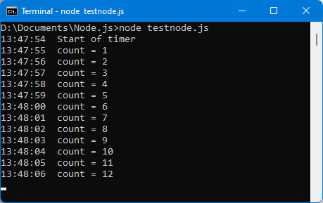
Figure 2.34 – Incrementing a counter every second
The counter increments every second, indefinitely. To stop this endless cycle, you have to use a new JavaScript function, which is clearInterval().

Using the clearInterval() function
The clearInterval(timer) function is used to stop the cycle started during the setInterval() instruction.
Note
Note that multiple timers can be started by multiple calls to the setInterval() function. So the clearInterval(timer) function must specify which timer it wants to stop: the timer parameter is used to tell it.
To do this, the setInterval() function returns the timer parameter that will be used when calling the clearInterval(timer) function.
Let’s use the clearInterval() function to stop the timer when the count counter has reached the value 5:
Using the clearInterval() function to stop the timer
console.log(time(), "Start of timer");
var count = 1;
var timer = setInterval(function() {
console.log(time(), `count = ${count}`);
if (count == 5) {
clearInterval(timer); // timer stop
console.log(time(), "End of timer");
} else count++;
}, 1000);
function time() {
// return time as HH:MM:SS
var date = new Date();
var hour = date.getHours();
var min = date.getMinutes();
var sec = date.getSeconds();
if (hour < 10) hour = "0" + hour;
if (min < 10) min = "0" + min;
if (sec < 10) sec = "0" + sec;
return "" + hour + ":" + min + ":" + sec + " ";
}
The program of the callback function is modified: as soon as the counter reaches 5, the timer is stopped. Otherwise, the counter is incremented by 1.
Check that the count stops after 5 times:
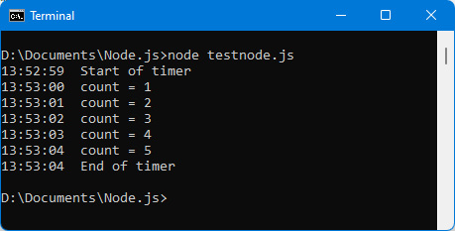
Figure 2.35 – Timer stops after 5 counts
The callback function that is used in the setTimeout() or setInterval() functions is included directly in the parameters of each function. JavaScript makes it easier to write callback functions by using a new type of object called a promise.

Using promises
Promises are another way to use callback functions. Rather than integrating the callback function into the method call (as a parameter), we use it as a parameter of the new then(callback) method. This simplifies the reading of JavaScript code in case it uses callback functions.
For an object to use the then(callback) method, it must be a Promise class object. The Promise class is a class defined in JavaScript language.
The Promise Class
A Promise class object uses a callback function of the form callback(resolve, reject) as a parameter of its constructor.
The resolve and reject parameters are functions, which will be called from the promise’s callback:
When the resolve() function is called, it triggers the then(callback) method.
When the reject() function is called, it triggers the catch(callback) method.
The resolve() function must be called, otherwise the then(callback) method cannot be executed. On the other hand, calling the reject() function is optional, and if it is not used, the catch(callback) method will not be called (and therefore does not have to be present in the program).
Thanks to the resolve and reject parameters, we therefore have the possibility of executing the cases of success (with the then(callback) method) and the cases of failure (with the catch(callback) method). This way of writing ensures more readability of the JavaScript code.
To illustrate this, let’s take the example of the setTimeout(callback, timeout) function seen previously. The callback function is included in the method call here, which we want to avoid with promises. Let’s write the new wait(timeout) method that can be used in the form wait(timeout).then(callback). The callback function is now externalized from the wait() method.
The callback function registered in the then(callback) method will be called when the timeout expires.
This form of writing is more readable than the previous one with setTimeout(), because it thus shows the delay before a process is executed.
To achieve this, the wait(timeout) method must return a Promise object:
Creating the Promise object, then using the then() method
function time() {
// return time as HH:MM:SS
var date = new Date();
var hour = date.getHours();
var min = date.getMinutes();
var sec = date.getSeconds();
if (hour < 10) hour = "0" + hour;
if (min < 10) min = "0" + min;
if (sec < 10) sec = "0" + sec;
return "" + hour + ":" + min + ":" + sec + " ";
}
function wait(sec) {
return new Promise(function(resolve, reject) {
setTimeout(function() {
resolve(sec); // triggers the then() method
}, sec*1000);
});
}
console.log(time(), "Start of timer");
wait(2).then(function(sec) {
console.log(time(), `End of timer of ${sec} seconds`);
});
The wait() method returns a Promise object thanks to the return new Promise() statement. In the callback(resolve, reject) function, we call the resolve() function when we consider that the then() method can execute, here at the end of the timeout.
It is possible to specify arguments for the resolve() and reject() methods. These arguments will be used in the callback functions used in the then(callback) or catch(callback) methods. For example, here, we call the resolve(sec) method, which allows us to use the sec parameter in the callback function of the then() method.
Note
Notice that the reject() function is not used in our example because no error cases can occur here. The resolve() function must, however, be called; otherwise, the then() method will never be executed.
The time() function is used to display the times of each process to check that the execution is correct.
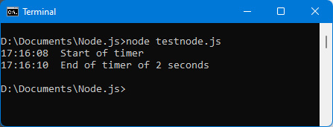
Figure 2.36 – Using the then() method
This brings us to the end of the chapter.
Summary
In this chapter, we went through advanced concepts related to JavaScript.
We learned how to use classes and objects, particularly the Array and String classes. We also saw how to delay the execution of instructions.
In the rest of the book, we will discover the use of the Vue.js JavaScript library associated with the client side of application development.
We will see how the knowledge obtained here will allow us to use this language in aspects of client-side and then server-side programming.

Part 2: JavaScript on the Client-Side
In this part, we discover the use of JavaScript in a browser (so-called client-side). We will learn how to use the Vue.js library to build JavaScript apps on the client-side. We also build a list management application (small but representative of the reality).
This section comprises the following chapters:
Chapter 3, Getting Started with Vue.js
Chapter 4, Advanced concepts of Vue.js
Chapter 5, Managing a list with Vue.js

Chapter 3: Getting Started with Vue.js
The JavaScript world is constantly changing. In recent years, a new concept has emerged: that of developing applications by creating components.
New JavaScript libraries for developing component-based apps have emerged, the main ones being Angular, React, Svelte, and Vue.js. Among all these libraries, which are quite similar to each other, we have chosen to present Vue.js to you because it is widely used and quite simple to implement. The other libraries mentioned operate according to the same principles.
Why Use Vue.js?
The main advantage of Vue.js is the possibility of developing an application using components. We cut the web application into a set of components (actually JavaScript files) and then assemble them to form the final application. Vue.js can test each component independently of the others and can also reuse them in other applications.
In this chapter, we will study how to build our first application with Vue.js, by creating and using our first component.
In this chapter, we will cover the following main topics:
Using Vue.js in an HTML page
Creating our first Vue.js application
Using reactivity
Creating our first component
Adding methods in components
Using attributes in components
Using directives

Technical requirements
You can find the code files for this chapter on GitHub at: https://github.com/PacktPublishing/JavaScript-from-Frontend-to-Backend/blob/main/Chapter%203.zip.

Using Vue.js in an HTML page
To use Vue.js in an HTML page, simply insert the library file into it using the <script> tag.
To check that Vue.js is correctly integrated into the page, let’s display the version number of the library in the Vue.version variable:
Displaying Vue.js version number (index.html file)
<html>
<head>
<meta charset="utf-8" />
<script src="https://unpkg.com/vue@next"></script>
</head>
<body>
</body>
<script>
alert(`Vue.version = ${Vue.version}`);
</script>
</html>
If Vue.js is accessible in the page, the Vue object provides access to the version number in its version property as we can see in the following figure:
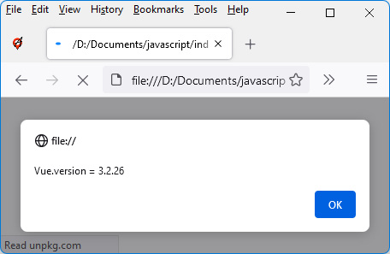
Figure 3.1 – Displaying the Vue.js version number
Now that we have integrated Vue.js into our HTML page, let’s go about creating our first application.

Creating our first Vue.js application
Once Vue.js has been inserted into the HTML page, you must define the HTML elements of the page in which Vue.js will be used.
In general, you want to use Vue.js on the whole HTML page, but it is possible to use it only on certain elements of the page as well. This would allow us, for example, to manage an HTML page with jQuery, except for a particular <div> element, which would be managed with Vue.js.
To illustrate this, let us create an HTML page with two <div> elements, only the first of which will be managed by Vue.js:
Creating an HTML page partially managed by Vue.js
<html>
<head>
<meta charset="utf-8" />
<script src="https://unpkg.com/vue@next"></script>
</head>
<body>
<div id="app">First div</div>
<div>The rest of the page is not managed by
Vue.js</div>
</body>
<script>
var app = Vue.createApp({
template : "This div is managed with Vue.js"
});
// mount the Vue.js application on the <div> having the
// id "app"
var vm = app.mount("div#app");
</script>
</html>
In the preceding code, we have used the Vue.createApp(options) method defined on the Vue object. The options object is used to set options for creating the Vue.js application. One of the options of Vue.createApp(options) is the template option, which allows us to define the view (that is to say the HTML display) that will be displayed on the page, thanks to the call of the app.mount(element) method:
The app object is the one obtained as a result of the Vue.createApp() method call.
The element parameter represents the HTML element on which Vue.js will act.
Let’s run the previous program; we should see the following output:
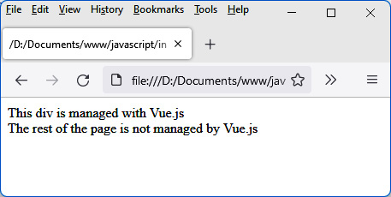
Figure 3.2 – First Vue.js app
On the preceding screen, we can see the result of using Vue.js on the page. The content of the first <div> is replaced by the template written in the options parameter of the Vue.createApp(options) method. The second <div> is not transformed.
Thus, to manage an entire HTML page with Vue.js, just indicate in the <body> part of the page a single <div> element, which will be the one on which Vue.js will be activated.
Now let’s see how to use an important concept of Vue.js, which is the correspondence between the variables defined in the program and their display on the HTML page. This concept is called reactivity.

Using reactivity
One of the objectives of Vue.js is to separate the management of the display (the view) and that of the data (the model). This is the concept that is frequently found in what is called the Model View Controller (MVC) model.
To illustrate, suppose we want to display a counter that increments from 0. A good separation of view and model would be for the view to constantly display the value of the counter, even if that value is changed elsewhere. This concept makes it possible not to link the display with the management of the data displayed. For this, we use the reactivity offered by Vue.js, by creating so-called reactive variables.
Reactive Variables
A variable will be said to be reactive if its modification in memory causes it to be modified automatically wherever the variable is displayed.
Reactive variables are defined in the options object of the Vue.createApp(options) method. For this, we add in the options object, and the definition of the data() method, which will have to return an object containing the so-called reactive variables of the application.
Let’s use a reactive variable named count in our Vue.js application:
Defining a count reactive variable
<html>
<head>
<meta charset="utf-8" />
<script src="https://unpkg.com/vue@next"></script>
</head>
<body>
<div id="app"></div>
</body>
<script>
var app = Vue.createApp({
template : "The counter is: {{count}}",
data() {
// return an object containing the reactive
// variables
return {
count : 0
}
}
});
var vm = app.mount("div#app");
</script>
</html>
In the preceding code, the count reactive variable is defined in the data() method, which returns the { count : 0 } object containing the program’s reactive variable. Other variables can be defined afterward.
This reactive variable can then be used in the template by means of the notation with {{ and }}. This notation is used to indicate a JavaScript expression, such as the value of a variable.
The definition of a so-called reactive variable makes it possible to link the display to the value of the variable. As soon as the variable is modified, the display is also modified. We can see the counter value in the following figure:
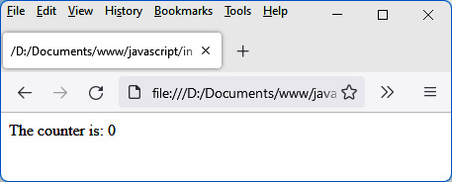
Figure 3.3 – Displaying a reactive variable
The counter remains positioned at its initial value: 0. Reactivity is only visible when the variable is modified. The display will therefore be modified as soon as the count variable is modified.
To do this, let’s increment the value of the variable every second as shown in the following code:
Incrementing count variable every second
<html>
<head>
<meta charset="utf-8" />
<script src="https://unpkg.com/vue@next"></script>
</head>
<body>
<div id="app"></div>
</body>
<script>
var app = Vue.createApp({
template : "The counter is: {{count}}",
data() {
// return an object containing the reactive
// variables
return {
count : 0
}
}
});
var vm = app.mount("div#app");
setInterval(function() {
vm.count += 1;
}, 1000);
</script>
</html>
Using JavaScript’s setInterval() function, we increment the value of the count variable every second. Vue.js provides access to the count variable using vm.count, where vm is the object returned by the app.mount() method. Reactive variables become properties of this vm object. In the preceding code, we can see the separation of view and data processing, as advocated by the MVC pattern. The incrementation of the variable is done outside the view, which would not have been possible with a library such as jQuery.
We can see the incrementation and the automatic update of the display, thanks to the reactivity offered by Vue.js, as evident in the following figure

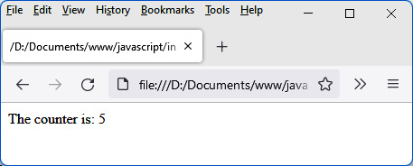
Figure 3.4 – Incrementing a reactive variable
The previous program is very simple, but in reality, applications are of course more complex. As such, it is necessary to break down an application into small pieces, which will then be assembled. Now let’s learn how to write one of the small pieces of an application, called a component.

Creating our first component
Let’s see how to use Vue.js to create our own components.
A Vue.js component will be similar to a new HTML element. It will be used in the form of HTML tags to which new attributes can be associated if necessary. To use the component, all you have to do is use the corresponding tag.
The components are therefore a means of enriching the HTML code by creating our own tags.
How to Discover the Components to Use to Build Our Application
All you have to do is visually cut the HTML page you want to display into the simplest possible elements (which will be the basic components of your application), then group several elements together to form a component that will group them, and so on until you have the main component, which will be your complete application.
For example, if a list of elements is displayed on the HTML page, each element’s line of the list corresponds to a basic component, while the global list that groups these different components will be associated with another component. The set of all components of the HTML page corresponds to the main component, often named <App> or <GlobalApp>. Let’s see how to create and use the <counter> component corresponding to the previous counter by first learning how to insert the component.
You can create the component directly into the HTML page or include it from an external file. Let’s look at these two ways to do it.

Inserting a component in the application file
A component can simply be embedded in the main application Vue.js file. Just use the app.component(name, options) method to create it as follows. The variable app corresponds to the object returned by Vue.createApp():
Creating the <counter> component directly in the application
<html>
<head>
<meta charset="utf-8" />
<script src="https://unpkg.com/vue@next"></script>
</head>
<body>
<div id="app"></div>
</body>
<script>
var app = Vue.createApp({
template : "<counter />"
});
app.component("counter", {
template : "The counter is: {{count}}",
data() {
return {
count : 0
}
}
});
var vm = app.mount("div#app");
</script>
</html>
In the preceding code, the variable app corresponds to the object returned by Vue.createApp().
The app.component(name, options) method works on the same principle as Vue.createApp(options):
The name parameter corresponds to the name of the component, which will then be used as tags in HTML templates.
The options parameter is similar in both cases. There is the template section, data, and so on.
The <counter> component can then be used in other templates, including the one defined for the application. When you run the preceding code, you will see the following screen:
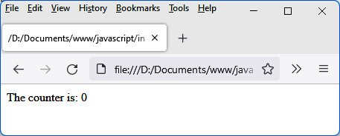
Figure 3.5 – The <counter> component
As we can see in the preceding figure, for the moment, the counter remains at 0. To increment the reactive variable count in the component, it is necessary to be able to write the instruction of incrementation once the component is created. For this, Vue.js provides internal methods allowing access to the life cycle of each component created.
One of the methods of a component’s life cycle is the created() method. It is called when the component is created. You can use this method to write the increment of the variable count every second, using the setInterval() function.
Let’s use the component’s created() method as follows:
Using the component’s created() method
<html>
<head>
<meta charset="utf-8" />
<script src="https://unpkg.com/vue@next"></script>
</head>
<body>
<div id="app"></div>
</body>
<script>
var app = Vue.createApp({
template : "<counter />"
});
app.component("counter", {
template : "The counter is: {{count}}",
data() {
return {
count : 0
}
},
created() {
setInterval(()=>{ // do not use the function()
// form here,
// otherwise the "this" object
// would not be the same
this.count++;
}, 1000);
}
});
var vm = app.mount("div#app");
</script>
</html>
In the preceding code, we have used the notation ()=> instead of function(). This notation (called a lambda function) was introduced in the latest versions of JavaScript in order to allow the value of this to be kept inside callback functions, which is necessary here. If you replace the lambda function ()=> with the function() keyword, the program won’t work, as the this value won’t be the same.
On running the preceding code, you will see the following output:
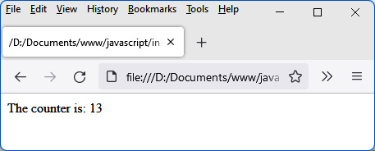
Figure 3.6 – Incrementing the counter in the component

Inserting a component from an external file
Rather than defining the component directly in the HTML page, it is preferable to define it in an external file. The component can be used in the HTML page thanks to the inclusion of the external file in the HTML page. For this, we use the concept of modules provided by JavaScript.
The Advantage of Components Defined in an External File
The advantage of defining the component in an external file is to be able to include this file in several different HTML pages, and therefore to use the component in several different applications.
The <counter> component is defined in an external counter.js file as follows:
<counter> component definition (counter.js file)
const Counter = {
data() {
return {
count: 0
}
},
template : "The counter is: {{count}}",
created() {
setInterval(() => {
this.count += 1;
}, 1000)
}
}
export default Counter;
The <counter> component is defined as an object, having template, data, and created properties. Its definition is similar to the one shown previously in the app.component() method.
The export default Counter instruction makes the component accessible in the other files where this module is imported.
The <counter> component can now be integrated into the main file of our application. We use the JavaScript import statement for this. The code will look as follows:
Importing the component into the program (index.html file)
<html>
<head>
<meta charset="utf-8" />
<script src="https://unpkg.com/vue@next"></script>
</head>
<body>
<div id="app"></div>
</body>
<script type="module">
import Counter from "./counter.js";
var app = Vue.createApp({
components : {
Counter:Counter
},
template : "<counter />" // or "<Counter />"
});
var vm = app.mount("div#app");
</script>
</html>
In the preceding code, to import the counter.js file and use the corresponding component, the following takes place:
The type="module" attribute is indicated in the <script> tag. This allows the use of the import statement in the JavaScript statements of the <script> tag.
We use the import statement to import the corresponding module.
We declare the imported components in the new components section. Components are declared as an object. The names of the properties in this object correspond to the name used by the component in the templates (<counter> or <Counter>), while the values correspond to the name of the imported component (Counter).
Using HTTP Instead of the FILE Protocol
However, as we use the import of JavaScript modules, it is necessary to run our application on an HTTP server, and no longer with a simple drag and drop as before. Hence the use of the URL that begins with http://localhost. If you need to know how to install an HTTP server, you can, for example, use the documentation here: https://developer.mozilla.org/en-US/docs/Learn/Common_questions/set_up_a_local_testing_server.
In the following figure, we can see that creating a component directly in the HTML page or in an external file produces the same result:
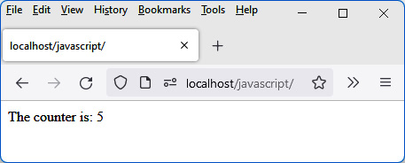
Figure 3.7 – Execution of the HTML file on an HTTP server (here, localhost)
The current component only has a simple reactive variable. It is possible, in a component, to add methods to it that will be used in the component. Now let’s take a look at how to do it.

Adding methods in components
We have seen how to create reactive variables in a component, using the data section of the component. It is also possible to create methods in a component that can be used in the component template.
There are two ways to add methods to a component:
The first is to define the method in the methods section of the component.
The second is to create a so-called computed property that will be defined in the computed section of the component.
Let’s look at these two ways to do it.

Defining methods in the methods section
For each incrementation of the counter, it should be necessary to display the time at which it occurs. A time() function would be very useful in the component, allowing us to display the time in the form HH:MM:SS. This time() function will be defined in the methods section of the component.
The <counter> component is modified to integrate the display of the time at the beginning of the line. We can achieve all this using the following code:
<counter> component displaying time (counter.js file)
const Counter = {
data() {
return {
count: 0
}
},
template : `{{time()}} &nbsp;&nbsp; The counter is:
{{count}}`,
created() {
setInterval(() => {
this.count += 1;
}, 1000)
},
methods : {
time() {
// return time as HH:MM:SS
var date = new Date();
var hour = date.getHours();
var min = date.getMinutes();
var sec = date.getSeconds();
if (hour < 10) hour = "0" + hour;
if (min < 10) min = "0" + min;
if (sec < 10) sec = "0" + sec;
return "" + hour + ":" + min + ":" + sec + " ";
}
}
}
export default Counter;
In the preceding code, the time() method is defined in the methods section and is then directly used in the component template within the double braces {{ and }}.
A method defined in the methods section can use the other methods of this section or the reactive variables of the data section by prefixing them with the this keyword.
The result is displayed in the following figure:
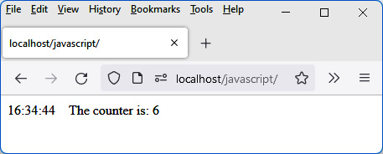
Figure 3.8 – Time display in the component
Vue.js allows you to define, in the form of methods, new variables that will be reactive. They are called computed properties. Let’s see how to create and use them.

Defining computed properties in the computed section
A computed property is similar to a reactive variable. It is the result of the calculation performed on one or more reactive variables, and it will also be reactive. Any modification to one of the reactive variables associated with this computed property will cause it to be modified immediately.
Let’s create a countX2 property that calculates double the count variable as follows:
Defining a computed property countX2 in the component (counter.js file)
const Counter = {
data() {
return {
count: 0
}
},
template : `{{time()}} &nbsp;&nbsp; The counter is:
{{count}}, double is: {{countX2}}`,
created() {
setInterval(() => {
this.count += 1;
}, 1000)
},
methods : {
time() {
// return time as HH:MM:SS
var date = new Date();
var hour = date.getHours();
var min = date.getMinutes();
var sec = date.getSeconds();
if (hour < 10) hour = "0" + hour;
if (min < 10) min = "0" + min;
if (sec < 10) sec = "0" + sec;
return "" + hour + ":" + min + ":" + sec + " ";
}
},
computed : {
countX2() {
return 2 * this.count;
}
}
}
export default Counter;
The output of the preceding code will look as follows:
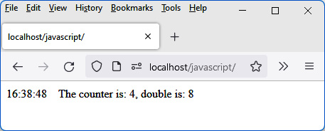
Figure 3.9 – Using a computed property
In the preceding figure, we can see the modification of the count variable. Every second leads to the automatic modification of the countX2 variable thanks to its definition in the computed section.
We have seen how to define methods and reactive variables in a component. Now let’s see how to pass parameters to a component, using the component’s attributes for this.

Using attributes in components
Attributes in a component allow it to pass parameters for its use. For example, we could use in the <counter> component a start attribute indicating at what value we start counting. If this attribute is not indicated, it is considered to be 0 (that is, counting starts at 0 as in the preceding code example).
For a component to be able to employ attributes during its use, it suffices to indicate the name of the attributes in the props section of the component. The component can access the attribute value using the this keyword (for example, this.start to access the start attribute in the component). We can see this in action in the following code:
Using the start attribute in the component (index.html file)
<html>
<head>
<meta charset="utf-8" />
<script src="https://unpkg.com/vue@next"></script>
</head>
<body>
<div id="app"></div>
</body>
<script type="module">
import Counter from "./counter.js";
var app = Vue.createApp({
components : {
Counter:Counter
},
template : "<counter start='10' />"
});
var vm = app.mount("div#app");
</script>
</html>
In the following code, the attribute is passed when using the component, as is traditionally done in HTML. The value of the attribute here will be a character string "10" and not the value 10:
Setting the start attribute in the <counter> component (counter.js file)
const Counter = {
data() {
return {
count : parseInt(this.start), // we initialize the
// count to the value
// of start
}
},
template : `{{time()}} &nbsp;&nbsp; The counter is:
{{count}}, double is: {{countX2}}`,
created() {
var timer = setInterval(() => {
this.count += 1;
}, 1000)
},
methods : {
time() {
// return time as HH:MM:SS
var date = new Date();
var hour = date.getHours();
var min = date.getMinutes();
var sec = date.getSeconds();
if (hour < 10) hour = "0" + hour;
if (min < 10) min = "0" + min;
if (sec < 10) sec = "0" + sec;
return "" + hour + ":" + min + ":" + sec + " ";
}
},
computed : {
countX2() {
return 2 * this.count;
}
},
props : [
"start"
]
}
export default Counter;
In the preceding code, notice the use of the parseInt() function (defined as standard in JavaScript) to retrieve the value of this.start in integer form. Indeed, the attributes are transmitted in the form of character strings, hence the need to transform this.start into an integer value.
It is possible to avoid transforming the attribute value into an integer value. All you have to do is indicate when using the attribute that you want to keep the JavaScript value and not the character string. We prefix the name of the attribute with the character :, for example, :start='10'. In this case, the value 10 will be transmitted and not the string "10".
This makes it possible to be able to transmit in the attributes any types of values: numeric values, character strings, arrays, or objects.
In the following figure we can see the counter has started from the value indicated in the start attribute:
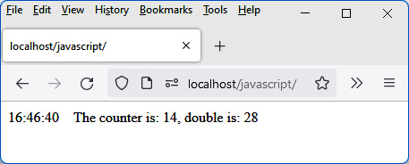
Figure 3.10 – Using the start attribute in the component
We have therefore seen how to create new attributes in a component. Vue.js has specific attributes as standard, which can be used in all components. These specific attributes, created by Vue.js, are called directives. We will study them now.

Using directives
Vue.js improves the writing of HTML code by offering to write its own components, as we have seen in the preceding section. The framework also makes it easier to write basic HTML code by adding new attributes to the HTML elements or to the components created. These new attributes are called directives.
Note
Directives are used exclusively in HTML elements or created components, that is, in the template section of components.
Their name begins with v-, so as not to be confused with other existing HTML attributes. The main directives are v-if, v-else, v-show, v-for, and v-model. They will be explained now.

The v-if and v-else directives
The v-if directive is used to specify a condition. If true, the HTML element (or component) will be inserted into the HTML page. Otherwise, it will not be present.
Let’s use the v-if directive to indicate that we want to display the value of the counter only for values less than or equal to 20. As soon as the value 20 is exceeded, the counter is no longer displayed.
In the following snippet, we have only indicated the code of the template section of the component, knowing that the rest is not modified:
Using the v-if directive
template : `
{{time()}} &nbsp;&nbsp;
<span v-if='count<=20'>The counter is: {{count}}</span>
`,
Using backticks ' and ' to define the template avoids having to manage the concatenation of character strings on several lines.
The <span> element on which the v-if directive is applied will be included in the HTML page only if the following condition is true: if count<=20. Beyond 20, only the time will be displayed without the counter value.
As long as the counter is less than or equal to 20, it is displayed as follows:
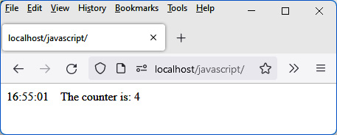
Figure 3.11 – Display of the counter whose value is less than 20
When the counter exceeds the value 20, it is no longer displayed:
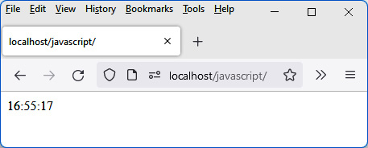
Figure 3.12 – Display as soon as the counter exceeds the value 20
The v-else directive is used to indicate an alternative when the condition expressed in v-if is false. The element on which the v-else directive is used will be inserted into the HTML page if the condition expressed in v-if is false.
Let’s use the v-else directive to display another message when the counter exceeds the value 20:
Using the v-else directive
template : `
{{time()}} &nbsp;&nbsp;
<span v-if='count<=20'>The counter is: {{count}}</span>
<span v-else>The counter has exceeded 20, it is:
{{count}}</span>
`,
When the counter exceeds the value 20, we now get the following:
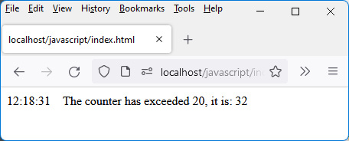
Figure 3.13 – Counter having exceeded the value 20

The v-show directive
The v-show directive is similar to the v-if directive. A condition is given next. If the condition is true, the element that uses the directive is displayed; otherwise, it is not.
The difference from the v-if directive is that the element, if not displayed, is only hidden, but it is still inserted into the page. Whereas with the v-if directive, the element is not inserted (if the condition is false).

The v-for directive
The v-for directive allows you to loop over a set of elements or over the properties of an object. For each iteration of the loop, it inserts the HTML element on which the directive is positioned.
Let us assume the <counter> component is a set of counters associated with the variable counts, which is a JavaScript array. Each counter is, in our example, a character string (for example, "Counter 1"), and we want to display the whole in the form of a list (see the following code snippets).
Let’s look at the two possible forms of the v-for directive.
Using the directive v-for=”count in counts”
Let’s use the first form of the v-for directive. It allows access to each element of the array indicated in the directive (in our example, the JavaScript counts array):
Displaying counters as a list (counter.js file)
const Counter = {
data() {
return {
counts : ["Counter 1", "Counter 2", "Counter 3",
"Counter 4", "Counter 5"]
}
},
template : `
<ul>
<li v-for="count in counts">
<span>{{count}}</span>
</li>
</ul>
`,
}
export default Counter;
In the preceding code, we have positioned the v-for directive on the element that we want to repeat (in this case, the <li> element). The value associated with the v-for directive is a character string of the form "count in counts", knowing that counts is the variable on which we are iterating. The count variable thus corresponds to each of the elements of the counts array:
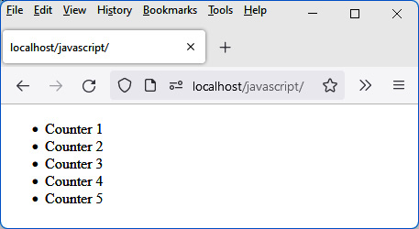
Figure 3.14 – Using the v-for directive
Using the directive v-for=”(count, index) in counts”
A second form of the v-for directive gives access to each element of the array as before, but also to its index (starting from 0):
Displaying counters and their index (counter.js file)
const Counter = {
data() {
return {
counts : ["Counter 1", "Counter 2", "Counter 3",
"Counter 4", "Counter 5"]
}
},
template : `
<ul>
<li v-for="(count, index) in counts">
<span>Index {{index}} : {{count}}</span>
</li>
</ul>
`,
}
export default Counter;
On running the preceding code, the following is displayed:
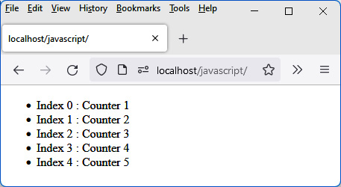
Figure 3.15 – Using index in the v-for directive
Using the key attribute with the v-for directive
The v-for directive can also be used to display large lists, for which reactivity must be maintained. That is, changing the reactive variable specified in the v-for directive should update the corresponding displayed list.
To perform the update as quickly as possible, Vue.js uses a special attribute (to be used only for this specific case) named key. This attribute can be positioned after the v-for directive. Its value must be unique for each item in the list. For example, the value of the index being unique for each list element can be used as a value in the key attribute:
Using the key attribute with the v-for directive
<li v-for="(count, index) in counts"
:key="index"
>
In the preceding code, the value of the attribute is a JavaScript expression (the variable index). We use :key and not just key; otherwise, the attribute would constantly have the string "index" as its value (instead of the value of the variable index).
Of course, adding the key attribute does not produce any display changes, but the performance will be visible on subsequent changes to the displayed list (it helps Vue.js to keep track of the element and prevent unnecessary re-rendering).

The v-model directive
The v-model directive is used to manage form elements during an interaction (input in a field, a click on a checkbox or radio button, the choice of an element in a list).
The v-model directive is used to immediately retrieve the result of input or selection in a reactive variable without having to perform any particular processing. It’s the v-model directive that performs this update (of the reactive variable) for us.
We use the v-model directive in the form v-model="varname", where varname is the name of a reactive variable that will be updated on input or selection.
Let’s use the v-model directive in a form input field. To clearly see what happens with or without its use, we display two input fields: one managed without v-model, the other with:
Using the v-model directive in an input field (counter.js file)
const Counter = {
data() {
return {
count : 10
}
},
template : `
Without v-model:
<input type="text" :value="count" /> &nbsp;&nbsp;
count = {{count}} <br><br>
With v-model:
<input type="text" v-model="count" /> &nbsp;&nbsp;
count = {{count}}
`,
}
export default Counter;
Here are some notes on the preceding program:
The first <input> field does not use v-model, but only uses the value attribute, which will be updated based on the count variable.
The second <input> field uses the v-model directive associated with the same count variable.
The value of the count variable is displayed after the two input fields.
When the program is launched, the value of the reactive variable count is transferred to the value attribute of the first input field, as well as to the second. This produces the initialization of the contents of the two input fields as seen here:
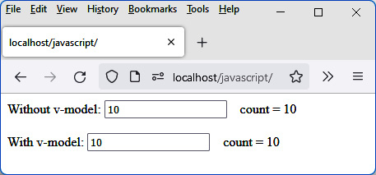
Figure 3.16 – Display when starting the program
If we change the contents of the first input field (which is not used with v-model), we will see something like this:
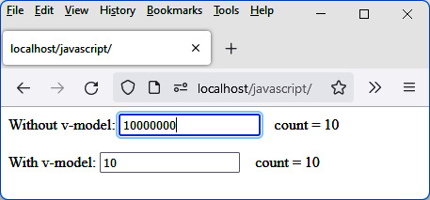
Figure 3.17 – Editing an input field without v-model
Note that modifying the input field (without v-model) has no effect on the reactive variable associated with it.
Now let’s modify the contents of the second input field, managed by v-model:
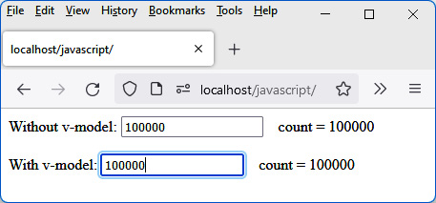
Figure 3.18 – Editing an input field with v-model
We now see that the use of v-model causes the immediate modification of the reactive variable to which it is associated, which then causes the modification of the value attribute of the first input field (because it is linked to the reactive variable).

Summary
In this chapter, we have mainly studied how to create a component and methods or attributes associated with it.
It is now necessary to study how to manage the actions of the user in a component, then how to assemble the components to form an application.

Chapter 4: Advanced Concepts of Vue.js
In this chapter, we look at advanced uses of Vue.js. We will study the handling of events in components, then the assembly of the various components in order to form a whole Vue.js application.
Why is it important to know how to handle events in components?
A Vue.js component is often a set of HTML elements, like building blocks, such as buttons, lists, and input fields. It is therefore essential to know how to manage the interaction of these elements with the possible actions of the user, such as clicking on a button, entering a value in an input field, or selecting an element from a list.
Similarly, why is it important to know how to assemble the components?
A web application brings together many elements, which in the end, will represent the application as a whole. The principle of Vue.js is to break down an application into components, then assemble them to form the complete application. We will have to learn how to divide an application into components, then assemble them by allowing them, for example, to share data.
We end this chapter by showing how we can easily produce visual effects on your pages thanks to Vue.js.
Here are the main topics we explain in the following pages:
Managing events
Assembling components
Using visual effects

Technical requirements
You can find the code files for this chapter on GitHub at: https://github.com/PacktPublishing/JavaScript-from-Frontend-to-Backend/blob/main/Chapter%204.zip.

Managing events
Now let’s see how to handle events with Vue.js. To do this, use the v-on directive, followed by the character : and the name of the event to be handled. For example, if you want to perform a particular process when a button is clicked, we will use the click event on the button and we will write v-on:click to handle the click event. The value of the directive (which follows the = sign) corresponds to the JavaScript expression to be executed (either a statement or a function call).
Tip
Vue.js makes it easier to write v-on:click by writing @click more simply. This rule is valid for all events.
In this example, we will implement a button that increments a reactive variable count on each click. We will also define an incr() method in the methods section of the component that increments the count variable:
Increment counter count (counter.js file)
const Counter = {
data() {
return {
count : 0
}
},
template : `
<button @click="count++">Increment counter by
count++</button>
&nbsp;&nbsp; count = {{count}} <br><br>
<button @click="incr()">Increment counter by
incr()</button>
&nbsp;&nbsp; count = {{count}}
`,
methods : {
incr() {
this.count++;
}
}
}
export default Counter;
We have defined two buttons for which the value of @click is as follows:
@click="count++" (first button)
@click="incr()" (second button)
We thus show the equivalence of these forms of writing.
The counter is incremented by 1 with each click of the buttons.
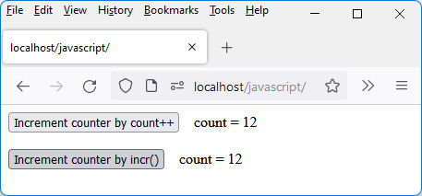
Figure 4.1 – Button click management
It is possible to write several method calls in a row during the processing to be performed (separated by a comma or a semicolon). It is enough that these methods are defined in the methods section of the component.
For example, @click="incr();incr()" allows the incr() method to be executed twice each time the button is clicked.
We have explained here how to catch an event and handle it in a method defined in the methods section of the component. Let’s go further by using the parameters transmitted in the received event, for example, knowing which key on the keyboard was pressed.

Using the $event parameter
Vue.js provides access to the Event object associated with the event. This object can then be used to get additional information about the event. The information is different depending on the type of event:
Mouse coordinates or buttons clicked on the mouse for a mouse-related event
Keyboard key used, or the combination of keys pressed (Ctrl, Shift, Esc, and so on) for a keyboard-related event
The Event object can be accessed from the $event variable. It can be passed as a parameter to a processing method. This parameter will then be retrieved in the event processing function.
Let’s see two examples of how to use this parameter when entering characters in an edit control:
By displaying an error message as soon as the numerical value entered equals or exceeds the value 100
By prohibiting the entry of characters other than numeric characters if the edit control can only contain numbers (this is an improvement of the previous example)

Checking that the entered value is less than 100
Let’s use the $event parameter to check that the content of the counter input field is less than 100. If so, the count variable is updated with the entered value; otherwise, an error message is displayed.
To achieve this, we use the blur event on the input field, and in the processing of the event, we retrieve the value of the input field. A reactive message variable is used to display an error message, if necessary:
Note
The blur event is triggered when leaving the input field, for example, by clicking outside the input field.
Display an error message if the counter is greater than 100 (counter.js file)
const Counter = {
data() {
return {
count : 0,
message : ""
}
},
template : `
count (less than 100): <input type="text"
:value="count" @blur="valid($event)" />
&nbsp;&nbsp; count = {{count}}
<br><br>
<span>{{message}}</span>
`,
methods : {
valid(event) {
this.message = ""; // reset of the error message
// before each check
if (event.target.value < 100) this.count =
event.target.value;
else this.message = "Error: count must be less than 100";
}
}
}
export default Counter;
The $event parameter is passed to the valid(event) processing function. The event.target property provides direct access to the HTML element. Its value property contains the value of the field.
If you type a value less than 100 (here, 45), the counter is updated:
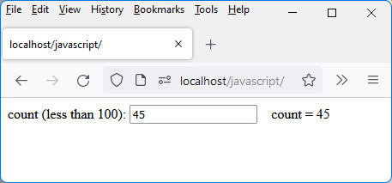
Figure 4.2 – Entering an authorized value
If you type a value greater than 100 (for example, 150), an error is displayed and the old value of the counter (45) is restored.
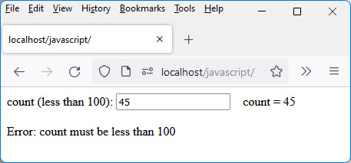
Figure 4.3 – Entering a prohibited value
Then, we’ll look at another use of $event parameter-allowing only digits to be entered.

Allowing only digits to be entered
Another use of the $event parameter can be to only allow numbers to be entered into the field. Other keyboard keys are prohibited (except the Backspace and Delete keys, the right and left arrow keys, and the Tab key).
For this, we use the keydown event, which is triggered each time a key on the keyboard is pressed:
Disallow input of non-numeric characters (counter.js file)
const Counter = {
data() {
return {
count : 0,
message : ""
}
},
template : `
count (less than 100):
<input type="text" :value="count" @blur="valid($event)"
@keydown="verif($event)"
/>
&nbsp;&nbsp; count = {{count}}
<br><br>
<span>{{message}}</span>
`,
methods : {
valid(event) {
this.message = ""; // reset of the error message
// before each check
if (event.target.value < 100) this.count = event.target.
value;
else this.message = "Error: count must be less than 100";
},
verif(event) {
console.log(event.key); // display in the console
// the value of the key
// pressed
if (event.key != "Backspace" && event.key != "Delete"
&&
event.key != "ArrowLeft" && event.key !=
"ArrowRight" &&
event.key != "Tab") {
// forbid the key if it is not numeric
if (event.key < "0" || event.key > "9")
event.preventDefault(); // forbidden key
}
}
}
}
export default Counter;
The event used to filter the keys corresponds to keydown and gets activated when pressing a key on the keyboard. We therefore indicate to process each key press using the verif() method defined in the methods section.
Using event.key and event.preventDefault()
The event.key parameter contains the code of the key pressed. The key code is between “0” and “9” for a numeric value. To prohibit the other keys, we use the event.preventDefault() method (defined in JavaScript), which indicates not to take into account the event, therefore the pressing of the prohibited key.
We learned how to create a component in Chapter 3, Getting Started with Vue.js, and how to manage events in it (at the beginning of this chapter). A full application is composed of several components. Let’s now explain how to proceed to assemble several components to form a complete application.

Assembling components
Vue.js divides an application into a set of components. These components are then assembled to form the final application.
Let’s study an example of how to create components and then assemble the created components. The goal is to use three counters (associated with three input fields) like the one in the previous example, then display the total of these counters. The total updates, as numbers are typed into each of the input fields.
We will create two components for this:
The <counter> component is used to manage a counter.
The <counters> component allows you to manage the three counters together and display the total.
The index.html file will display the <counters> component in its template section:
index.html file
<html>
<head>
<meta charset="utf-8" />
<script src="https://unpkg.com/vue@next"></script>
</head>
<body>
<div id="app"></div>
</body>
<script type="module">
import Counters from "./counters.js";
var app = Vue.createApp({
components : {
Counters:Counters
},
template : `
<counters />
`,
});
var vm = app.mount("div#app");
</script>
</html>
The included counters.js file describes the <counters> component. It partly repeats what has been explained in the previous sections, adding new concepts that we’ll now describe.
These new concepts will explain how a parent component communicates with its child components (thanks to attributes, called props) and how a child component communicates with its parent component (thanks to events and the $emit() method).
These two concepts make it possible to assemble the components between them by allowing them to communicate between a child component and a parent component.

Using $emit() to communicate with a parent component
Let’s first look at the <counter> component file, which describes a counter associated with an input field:
<counter> component (counter.js file)
const Counter = {
data() {
return {
count : 0,
old_value : 0
}
},
template : `
<input type="text" v-model="count"
@keydown="verif($event)"
@input="calcul()"
@focus="focus()"
@blur="blur()" />
`,
methods : {
verif(event) {
if (event.key != "Backspace" && event.key != "Delete" &&
event.key != "ArrowLeft" && event.key !=
"ArrowRight" &&
event.key != "Tab") {
// forbid the key if it is not numeric
if (event.key < "0" || event.key > "9")
event.preventDefault(); // key forbidden
}
this.old_value = event.target.value;
},
calcul() {
this.$emit("sub", this.old_value || 0); // subtract
// old value
this.$emit("add", this.count || 0); // add new value
},
focus() {
if (this.old_value == "0") this.count = "";
},
blur() {
if (!parseInt(this.count)) {
this.old_value = 0;
this.count = 0;
}
}
},
emits : ["sub", "add"] // declare events emitted to
// the parent
}
export default Counter;
The <counter> component has been enriched with new methods, linked to new events to be taken into account during input. Also, a new reactive variable, old_value, has been created:
The old_value variable contains the value that was entered in the field before pressing the key on the keyboard.
The count variable contains the value that was entered in the field after pressing the key on the keyboard.
Why make this distinction? Because to calculate the total of all the counters, it will be necessary, with each typed key, to remove the previous value from the field (before pressing the key) and add the new value (after pressing the key).
Each keypress is handled by the input event, which here calls the calcul() method. As the calculation associated with the total of the three counters is performed at the higher level (in the <counters> component, which is the parent component), you must indicate to this parent component the sum to subtract (old_value) and the sum to add (count). This is done by sending "sub" and "add" events, using the $emit(eventName, value) method.
About the $emit(eventName, value) Method
The $emit(eventName, value) method, executed from a component, sends the eventName event to the parent component, which can process it using the @eventName directive. The value parameter corresponds to the value to be transmitted if necessary.
In addition, we indicate in the emits section of the component the list of events that this component can emit to its parent.
This way of communicating between a child component (here, the <counter> component) and its parent (here, the <counters> component), using events, is the one recommended by Vue.js.
Now let’s see the description of the <counters> component, which encompasses the three counters and the calculation of the total counters as you type in each one:
<counters> component (counters.js file)
import Counter from "./counter.js";
const Counters = {
data() {
return {
total : 0
}
},
components : {
Counter:Counter
},
template : `
Counter 1 : <counter @add="add($event)"
@sub="sub($event)" /> <br>
Counter 2 : <counter @add="add($event)"
@sub="sub($event)" /> <br>
Counter 3 : <counter @add="add($event)"
@sub="sub($event)" /> <br><br>
Total : {{total}} <br>
`,
methods : {
add(value) {
this.total += parseInt(value);
},
sub(value) {
this.total -= parseInt(value);
}
},
}
export default Counters;
The "add" and "sub" events emitted in the <counter> child component are processed in the attributes of the <counter> component when used. The add(value) and sub(value) processing methods are registered in the parent component, which allows the value of the total to be changed each time a numeric key is pressed on the keyboard.
As you type in the fields, Total updates:
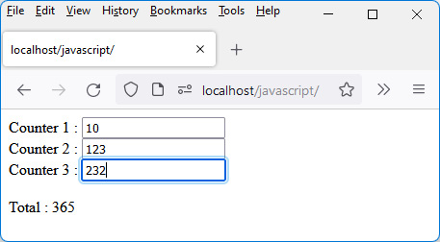
Figure 4.4 – Calculation of the sum of the three counters
We have seen how to communicate from a component to its parent using events. Now let’s look at how to communicate in the other direction, from a component to its child. For this, we use attributes called props here.

Using props to communicate with children
We have seen that the communication of information from a child component to its parent is done with events. Communication in the reverse direction, from parent to child, is done through attributes called props. We have already seen the use of these attributes in the previous chapter, in the Using attributes in components section.
In this example, we will improve the <counters> component so that we tell it the number of counters we want to display. For this, we use the nb attribute in the component. For example, we will write <counters nb="5" /> to display 5 counters on the page. Each counter is displayed as in the previous form, namely Counter followed by its index starting from 1 (see Figure 4.5).
First, we will modify the index.html file to write the <counters> component using the nb attribute. Let’s modify the index.html file previously used:
Using <counters nb=”5” /> (index.html file)
<html>
<head>
<meta charset="utf-8" />
<script src="https://unpkg.com/vue@next"></script>
</head>
<body>
<div id="app"></div>
</body>
<script type="module">
import Counters from "./counters.js";
var app = Vue.createApp({
components : {
Counters:Counters
},
template : `
<counters nb="5" />
`,
});
var vm = app.mount("div#app");
</script>
</html>
Now, we will modify the counters.js file to integrate the new "nb" props into the component:
Integration of the nb props in the <counters> component (counters.js file)
import Counter from "./counter.js";
const Counters = {
data() {
return {
total : 0
}
},
components : {
Counter:Counter
},
props : ["nb"],
computed : {
NB() {
var tab = [];
for(var i = 0; i < this.nb; i++) tab.push(i+1);
return tab;
}
},
template : `
<div v-for="i in NB">
Counter {{i}} : <counter @add="add($event)"
@sub="sub($event)" />
</div>
<br>
Total : {{total}} <br>
`,
methods : {
add(value) {
this.total += parseInt(value);
},
sub(value) {
this.total -= parseInt(value);
}
},
}
export default Counters;
The "nb" props are listed in the component’s props section. To display a list of counters, use the v-for directive on a <div> element.
How to Use the v-for Directive
For the value of the v-for directive, you must specify an array to browse. To do this, we transform the value of the "nb" props into an array [1, 2, 3, …, nb]. This is done using a computed property named NB, which returns the desired array.
The number of counters indicated when using the <counters nb="5"> component is now displayed.
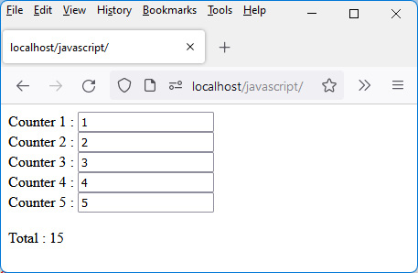
Figure 4.5 – Displaying five counters
We end the study of the Vue.js components here, which come together to form a full application.
Now, let’s examine an aspect of Vue.js that helps you produce visual effects, allowing, for example, making HTML elements displayed on the HTML page appear or disappear using a visual effect.

Using visual effects
Visual effects make it possible to make HTML pages more dynamic by bringing visual animations to them. For example, to delete an item in a list, you can make it gradually disappear using an opacity effect rather than deleting it directly without using a visual effect.
It is possible to use visual effects with Vue.js, in particular, to make elements appear or disappear from the page. Visual effects that do not make HTML elements appear or disappear from the page (for example, making an element move by clicking on it) are also possible with Vue.js. You can refer to https://vuejs.org/guide/extras/animation.html for more details on these types of animations. We do not explain these effects here because the available documentation is clear enough to use them.
Going forward in this chapter, we will learn about the visual effects that are related to the appearance or disappearance of one or more elements on the page.
The element we want to help appear or disappear (using the visual effect) must be inserted in a component named <transition>. This component is used by Vue.js to produce the effect.
Moreover, Vue.js uses the definition of CSS classes in which the CSS properties of the effect are described. Simply define the contents of the CSS classes (described in the following section), and Vue.js uses them at the appropriate times to achieve the effect.
The CSS classes used by Vue.js on an element depend on the state of the element: should it appear or disappear? Depending on its state (visible or not), the CSS classes differ.

When the element appears
When the HTML element should appear, the names of the CSS classes used by Vue.js begin with the character string "v-enter". The class name then contains the suffix "-from" or "-to", which will be used to describe the CSS properties of the element at the start of the effect (with "-from") or at the end of the effect (with "-to").
CSS classes used by Vue.js
So, we will have the following two CSS classes:
v-enter-from: This CSS class describes the CSS properties at the start of the element’s appear effect.
v-enter-to: This CSS class describes the CSS properties at the end of the element’s appear effect.
Note
Note that at the start of the appear effect, the element is not visible, but the CSS properties described in the v-enter-from class are applied to it immediately. If, for example, we enter the CSS opacity property equal to 1 in the CSS properties of the v-enter-from class, the element becomes immediately visible as soon as the appearance effect starts.
Since the v-enter-to class describes the CSS properties of the element at the end of the effect, when the effect completes, Vue.js removes that CSS class from the element.
We thus see that the CSS classes v-enter-from and v-enter-to are used to describe the CSS properties of an element during the effect but are no longer used afterward on the element (i.e., outside the duration of the effect).
The appearance effect progresses the CSS properties described in v-enter-from to those described in v-enter-to. For this, Vue.js uses the v-enter-active class, which describes how each of the CSS properties evolves.
Example content of CSS classes
Let’s look at some sample content from each of the three CSS classes mentioned above, v-enter-from, v-enter-to, and v-enter-active:
v-enter-from class example
.v-enter-from {
opacity: 0;
background-color:#FFCCCC;
}
Here, we indicate that the element will be invisible at the start of the effect (opacity:0) and will have a background color (background-color:#FFCCCC):
v-enter-to class example
.v-enter-to {
opacity: 0.5;
background-color:black;
}
Here, we indicate that the element will be half visible at the end of the effect (opacity:0.5) and will have a black background (background-color:black):
v-enter-active class example
.v-enter-active {
transition: opacity 2s, background-color 2s;
}
Here, we indicate that the CSS opacity and background-color properties must evolve, each for two seconds. As all the specified CSS properties evolve for the same amount of time, we can simplify the code by writing it in shortened form. Here’s how:
v-enter-active class example (simplified form)
.v-enter-active {
transition: all 2s;
}
The all keyword overrides all specified CSS properties.
Using CSS classes
Now let’s show how to use these CSS classes in a program using a button that displays a paragraph with effect. The role of the button will be to hide or display, alternatively, a paragraph on which the effect will occur when the paragraph appears.
This shows how the v-enter-from, v-enter-to, and v-enter-active CSS classes are used by Vue.js to produce an effect when an element appears on the page:
Use a button to produce the appearance effect (index.html file)
<html>
<head>
<meta charset="utf-8" />
<script src="https://unpkg.com/vue@next"></script>
<style type="text/css">
.v-enter-from {
opacity: 0;
background-color:#FFCCCC;
}
.v-enter-to {
opacity: 0.5;
background-color:black;
}
.v-enter-active {
transition: opacity 2s, background-color 2s;
}
</style>
</head>
<body>
<div id="app"></div>
</body>
<script>
var app = Vue.createApp({
data() {
return {
show: false // initially hidden
}
},
template : `
<button @click="show=!show">Produce the
effect</button>
<transition>
<p v-if="show">
Paragraph 1
</p>
</transition>
`,
});
var vm = app.mount("div#app");
</script>
</html>
We have described the contents of the v-enter-from, v-enter-to, and v-enter-active CSS classes, which will be used by Vue.js to produce the effect. Then we inserted the Produce an effect button in the page so that when the button is clicked, the paragraph on which the effect is set to occur will alternately be hidden or displayed. To do this, the paragraph was inserted in an HTML <transition> element, thus allowing Vue.js to know the element on which to apply the effect.
The paragraph is hidden at startup (because the reactive variable show is set to false). Clicking the Produce the effect button changes the value of the show variable to true, which starts the effect.
Note
The effect is started on the paragraph thanks to the <transition> component, which includes the paragraph to be displayed. It is thanks to this <transition> component that Vue.js knows the element on which to produce the effect.
Notice that the effect lasts two seconds as indicated in the CSS transition property, and when the effect is finished, the CSS classes are removed from the <p> element, which then becomes a normal paragraph (without background color and with an opacity of 1). So, you see that the paragraph has an opacity of 0.5 at the end of the effect (the one indicated in v-enter-to), then suddenly changes to an opacity of 1 when the v-enter-to class is removed by Vue.js at the end of the effect.
Note
It is therefore preferable to indicate in the v-enter-to class the CSS values of the element when it no longer produces an effect, in order to make the effect more harmonious.
Let’s run the previous program. When the program is launched, the paragraph is hidden:
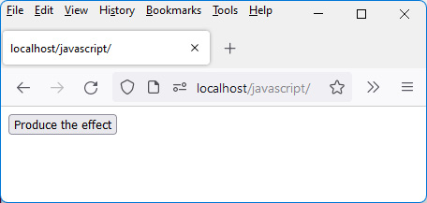
Figure 4.6 – The paragraph is hidden when the program is launched
After clicking the Produce the effect button, the paragraph begins to appear, according to the CSS properties indicated in the v-enter-from, v-enter-to, and v-enter-active classes.
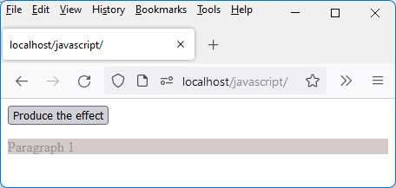
Figure 4.7 – After clicking on the Produce the effect button, the paragraph appears progressively
Just before the effect ends, the paragraph has the CSS properties set in the v-enter-to class, so its background color is black, but with an opacity of 0.5, the background color remains gray, and the paragraph text is not visible.
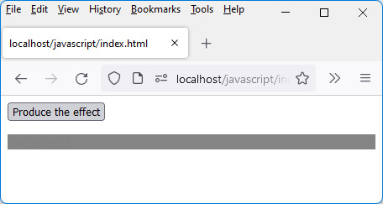
Figure 4.8 – Paragraph just before the end of the effect
At the end of the effect, the CSS classes are removed so that the paragraph appears in a normal way, in black and without a background color.
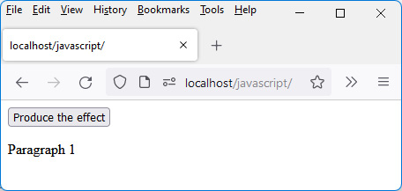
Figure 4.9 – Paragraph at the end of the appear effect
Once the paragraph has appeared, clicking on the Produce the effect button makes it disappear immediately (without producing any effect). This is due to the reactive variable show being set to false when the button is clicked.
We have seen the different classes and stages when an element appears on the page. Now let’s see what happens when an element disappears from the page. We will see that there are many similarities between the appearance and disappearance of the element.

When the element disappears
When the element should disappear, Vue.js uses CSS classes similar to the previous ones, replacing the string "enter" with the string "leave".
CSS classes used by Vue.js
So, we will have the following two CSS classes:
v-leave-from: This CSS class describes the CSS properties at the start of the element’s disappearing effect.
v-leave-to: This CSS class describes the CSS properties at the end of the element’s disappearing effect.
The disappearing effect is going to be to progress the CSS properties described in v-leave-from to those described in v-leave-to. After the effect is complete, the v-leave-to class is removed from the element’s CSS classes.
To progress CSS properties between the values shown in these two classes, Vue.js uses the v-leave-active CSS class, which describes the progression of CSS properties.
Example content of CSS classes
Let’s look at some example content from each of the three CSS classes mentioned above: v-leave-from, v-leave-to, and v-leave-active:
v-leave-from class example
.v-leave-from {
opacity: 1;
background-color:#FFCCCC;
}
Here, we indicate that the element will be fully visible at the start of the effect (opacity:1) and will have a background color (background-color:#FFCCCC):
v-leave-to class example
.v-leave-to {
opacity: 0;
background-color:black;
}
Here, we indicate that the element will be invisible at the end of the effect (opacity:0) and will have a black background color (background-color:black):
v-leave-active class example
.v-leave-active {
transition: opacity 2s, background-color 2s;
}
Here, we indicate that the CSS opacity and background-color properties must evolve, each for two seconds. As all the specified CSS properties evolve for the same amount of time, you can simplify the code by writing it in shortened form:
v-leave-active class example
.v-leave-active {
transition: all 2s;
}
The all keyword overrides all specified CSS properties.
Using CSS classes
Now let’s show how to use these CSS classes in a program, using a button that hides a paragraph with an effect. It’s almost the same program as before, but here we produce an effect when the paragraph disappears:
Using a button to produce the disappearing effect (index.html file)
<html>
<head>
<meta charset="utf-8" />
<script src="https://unpkg.com/vue@next"></script>
<style type="text/css">
.v-leave-from {
opacity: 1;
background-color:#FFCCCC;
}
.v-leave-to {
opacity: 0;
background-color:black;
}
.v-leave-active {
transition: all 2s;
}
</style>
</head>
<body>
<div id="app"></div>
</body>
<script>
var app = Vue.createApp({
data() {
return {
show: true // visible at start
}
},
template : `
<button @click="show=!show">Produce the effect</button>
<transition>
<p v-if="show">
Paragraph 1
</p>
</transition>
`,
});
var vm = app.mount("div#app");
</script>
</html>
The v-leave-from class is applied at the beginning of the effect. It indicates that the element is visible (opacity at 1) and has a background color #FFCCCC (salmon).
The v-leave-to class indicates the values of CSS properties when the effect ends. The paragraph becomes invisible (opacity at 0) and has a black background color. But as the element becomes more and more invisible (opacity tends toward 0), the black background color also becomes less and less visible.
If we write the enter and leave classes in the CSS part in the same program, with each click on the button, we obtain an effect of appearing or disappearing for the paragraph concerned.
The CSS classes used here have fixed names, regardless of the effect used. This does not allow using multiple effects, as the visual effects would all use the same CSS class names.
For this, Vue.js allows you to give a name to each effect, and thus be able to use different CSS class names.

Using a name for the effect
Classes of type "v-enter-xxx" or "v-leave-xxx" can be renamed to symbolize the effect with which they are associated. We just need to replace the character string "v-" with the name of the effect followed by "-".
For example, "v-enter-from" will be replaced by "fade-enter-from" to give the name "fade" to the effect. We then add the name="fade" attribute to the <transition> component, indicating <transition name="fade">.
This allows us to integrate several effects into our application, by defining the CSS classes corresponding to each effect.
The previous program, integrating the effect named "fade" in the paragraph, is then written as follows:
Fade effect (index.html file)
<html>
<head>
<meta charset="utf-8" />
<script src="https://unpkg.com/vue@next"></script>
<style type="text/css">
.fade-leave-from {
opacity: 1;
background-color:#FFCCCC;
}
.fade-leave-to {
opacity: 0;
background-color:black;
}
.fade-leave-active {
transition: all 2s;
}
.fade-enter-from {
opacity: 0;
background-color:#FFCCCC;
}
.fade-enter-to {
opacity: 1;
background-color:black;
}
.fade-enter-active {
transition: opacity 2s, background-color 2s;
}
</style>
</head>
<body>
<div id="app"></div>
</body>
<script>
var app = Vue.createApp({
data() {
return {
show: true
}
},
template : `
<button @click="show=!show">Produce the
effect</button>
<transition name="fade">
<p v-if="show">
Paragraph 1
</p>
</transition>
`,
});
var vm = app.mount("div#app");
</script>
</html>
The <transition> component can only have one element, which will be the one on which the effect will occur. To include multiple elements, you must use the <transition-group> component, which we explain below.

Producing an effect on several elements
The <transition> component can contain only one element. When the effect must be applied to several elements, it is necessary to create several <transition> components or group the elements in a <transition-group> component. In this example, let’s look at using the <transition-group> component:
Using the <transition-group> component
<transition-group name="fade">
<p v-if="show">
Paragraph 1
</p>
<p v-if="show">
Paragraph 2
</p>
</transition-group>
The elements on which the effect occurs (here, the two paragraphs) are grouped in a <transition-group> element instead of the <transition> element that was used previously when there was a single paragraph on which the effect was produced.
Now, we will take a look at how to write the CSS classes associated with some classic effects.

Examples of commonly used effects
Below are some descriptions of effects. With a few lines of CSS code, you can easily produce classic effects such as the shrinking/enlargement of a paragraph (shrink effect), its gradual disappearance/appearance (opacity effect), and its vertical displacement (ymove effect). You are free to choose the names given to these effects and symbolize the effect produced.

The shrink effect
To use the shrink effect (here called "shrink"), we use the CSS font-size property.
At the beginning of the effect, the paragraph is of normal size:
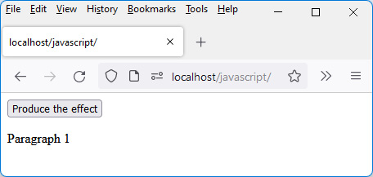
Figure 4.10 – The paragraph is normal size at the beginning of the disappearing effect
Once the effect has started following a click on the button, the paragraph decreases in size until it disappears.
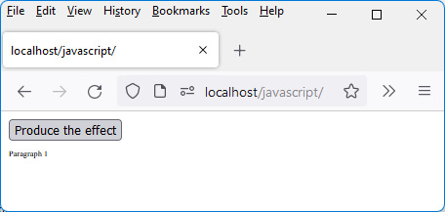
Figure 4.11 – The paragraph decreases in size until it disappears
Once the paragraph has disappeared, it can reappear after another click on the button. The paragraph size will increase until it reaches its normal size:
CSS classes to handle shrink effect
.shrink-leave-from {
}
.shrink-leave-to {
font-size: 0px;
}
.shrink-leave-active {
transition: all 2s;
}
.shrink-enter-from {
font-size: 0px;
}
.shrink-enter-to {
}
.shrink-enter-active {
transition: all 2s;
}
The CSS class shrink-leave-to indicates, for the disappearance effect, to go to a font size of 0px, that is, a reduction to 0 of the font size for the paragraph, which makes the paragraph invisible.
The shrink-enter-from CSS class tells the effect to start with a font size of 0px, gradually growing to the normal paragraph size when visible.
If CSS properties are not indicated in a starting class (for example, the shrink-leave-from class does not contain the font-size property), this means that the current value of this CSS property is used in the element.
Similarly, if CSS properties are not indicated in an arrival class (for example, the shrink-enter-to class does not contain the font-size property), this means that we are progressing toward the value of this CSS property of the element when it will be visible at the end of the effect.

The opacity effect
The effect named "fade" uses the CSS opacity property. This effect consists of varying the CSS opacity property from 0 to 1 (to gradually make an element appear) or from 1 to 0 (to make it disappear).
Here is, for example, the effect of disappearance. The paragraph is disappearing with an opacity that tends toward 0. When the opacity is at 0, the element will be completely invisible on the screen.
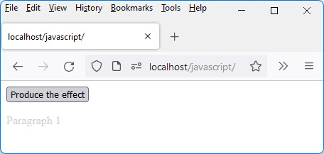
Figure 4.12 – The paragraph has an opacity that decreases toward 0
Once the paragraph is invisible, just click again on the Produce the effect button to make it reappear gradually:
CSS classes to manage opacity
.fade-leave-from {
}
.fade-leave-to {
opacity : 0;
}
.fade-leave-active {
transition: all 0.5s;
}
.fade-enter-from {
opacity : 0;
}
.fade-enter-to {
}
.fade-enter-active {
transition: all 1s;
}
The fade-leave-to CSS class indicates to go to an opacity of 0. The current opacity (of value 1) is the starting one. Since the initial value of the opacity is not defined in fade-leave-from, it will use the value defined by the CSS of the element (i.e., 1).
Similarly, the fade-enter-from class indicates the current opacity at the start of the element’s appearance effect. The destination value of the opacity does not need to be specified as it will use the default value from the element CSS, that is, 1.

The move-down effect
To manage this effect (here, called "ymove"), we use the CSS properties transform (set to translateY(100px)) and opacity (set to 0). This gradually moves the element 100px horizontally downward, gradually decreasing its opacity to 0. The element disappears as it moves down the page.
For example, here is what is displayed when the element has started to slide down by decreasing its opacity, which makes it less visible:
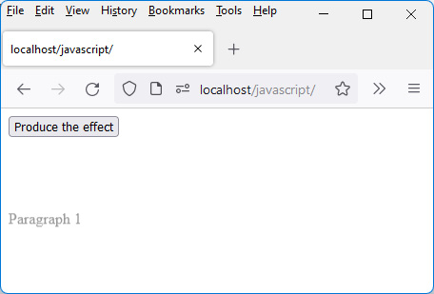
Figure 4.13 – The paragraph moves down the page by decreasing its opacity
As the effect continues, the paragraph moves down the page, until it reaches the distance of 100 pixels specified in the effect. The closer you get to this distance, the more the paragraph decreases in opacity, until it becomes invisible (opacity of 0).
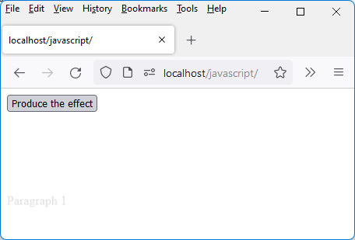
Figure 4.14 – The paragraph becomes almost invisible toward the end of the effect
Once the paragraph has disappeared, clicking on the Produce the effect button makes it reappear gradually from the bottom of the screen:
CSS classes to handle moving down
.ymove-leave-from {
}
.ymove-leave-to {
transform: translateY(100px);
opacity : 0;
}
.ymove-leave-active {
transition: all 0.5s;
}
.ymove-enter-from {
transform: translateY(100px);
opacity : 0;
}
.ymove-enter-to {
}
.ymove-enter-active {
transition: all 0.5s;
}
The ymove-leave-to CSS class indicates the values of the CSS properties toward which we want to vary the indicated CSS properties. The transform property can contain the translateY(100px) value, indicating to perform a vertical translation (Y) of 100 pixels. Adding an opacity of 0 makes the element disappear by moving it vertically.
The ymove-enter-from CSS class allows you to indicate the values of CSS properties at the beginning of the appearance effect. The element is located at 100 pixels vertical distance, with an opacity of 0. The CSS properties will evolve to those specified in the ymove-enter-to class, and if nothing is specified in this class, the CSS properties usually used for an element (opacity of 1 and vertical distance of 0, i.e., the normal location) are those toward which we will evolve during the appearance effect.
The CSS transform property is very useful for producing visual effects, for example, rotation, enlargement, and displacement.
This brings us to the end of the chapter.

Summary
After learning how to handle events and act when an external event (e.g., a click) occurs, we saw in this chapter how components created with Vue.js can be assembled to form complete applications. We learned the following:
To communicate from a component to its parent, we use events.
To communicate from a component to its child, we use the attributes in the component’s props section.
Finally, to produce visual effects, all you have to do is write the CSS classes managed by Vue.js.
In the next chapter, we will see an example of an application that allows us to put into practice the elements studied in the previous chapters.

Chapter 5: Managing a List with Vue.js
After going through the basic and advanced concepts of Vue.js, with this chapter, let’s finish our study of the Vue.js library by building an application to manage a list of elements.
Why make this type of application? Quite simply because it allows you to perform fairly standard operations on the HTML elements of a page, such as inserting an element, modifying it, and deleting it.
These are the basic operations that you need to know how to perform, for example, to manage the elements in a database. In this chapter, we will learn how to perform these operations on the elements displayed on the screen, and in the next part (where we study Node.js and MongoDB), we will see how to simultaneously update a database.
Here are the topics covered in this chapter:
Splitting the application into components
Adding an element to the list
Removing an element from the list
Modifying an element in the list
But let’s start by discovering the screens of the application that we want to create with Vue.js.

Technical requirements
You can find the code files for this chapter on GitHub at: https://github.com/PacktPublishing/JavaScript-from-Frontend-to-Backend/blob/main/Chapter%205.zip.

Displaying application screens
As mentioned earlier, we’ll be building an application to manage a list of elements. Before writing the source code of our application, let’s show the different screens of the application by explaining their sequence.
Initially, the list is empty. The Add Element button allows, on each click, to insert a new element in the list.
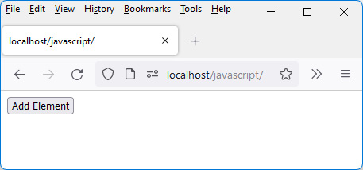
Figure 5.1 – Screen when launching the application
Let’s click the Add Element button several times (here, three times):
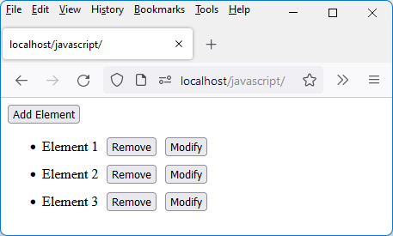
Figure 5.2 – After three clicks on the Add Element button
Each element inserted has the index (starting from 1) of the element in the list. A Remove button and a Modify button are inserted after the item in the list.
Let’s click on the Modify button on the second line. The item text is replaced by an input field, in which the cursor flashes to allow editing.
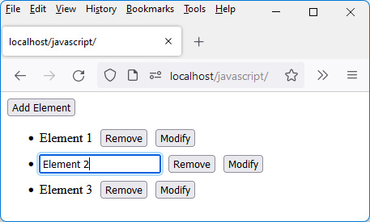
Figure 5.3 – The second item in the list can be changed
Let’s modify the text in the input field, by typing New Element 2.
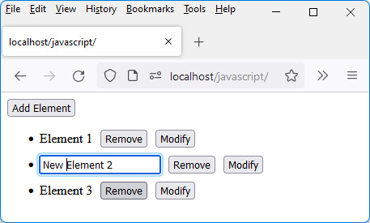
Figure 5.4 – Editing a list item
For the modification of the element to be reflected, you must leave the input field, by clicking elsewhere on the page.
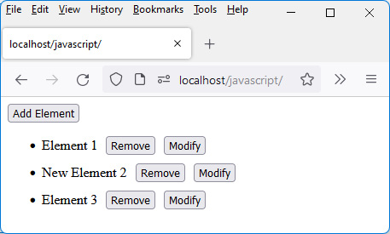
Figure 5.5 – Taking into account the modification of the element
Finally, to remove the first and third elements, click on their corresponding Remove buttons.
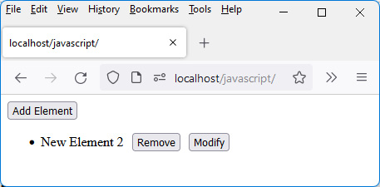
Figure 5.6 – After deleting the first and last element
We have administered here a list of elements on which we have performed basic operations, namely, inserting a new element, modifying the element, and deleting it.
Using HTTP Protocol
This application uses a PHP server to work because the import of JavaScript modules with the JavaScript import statement only works under the HTTP protocol. We will see in the next part (Chapter 9, Integrating Vue.js with Node.js) how to use a Node.js server to also make it work, by coupling it in addition with a MongoDB database.
We have described the operation of the application, and the sequence of the various windows. Now let’s see how to build this application with Vue.js. We first explain how the application can be broken down into different components.

Splitting the application into components
When you create an application with Vue.js, you have to start by asking yourself what components you will need to build it.
In our case, it would be the following:
A <GlobalApp> component that groups the whole application. It is this <GlobalApp> component that will be integrated into our index.html page. It will display the Add Element button as well as the list of elements below.
An <Element> component that displays a list element line, which will include the element’s text, the Remove button, and the Modify button.
The list of elements will be associated with a reactive variable named elements, which will be an array containing, for each element, the displayed text. This reactive variable will be registered in the <GlobalApp> component. It will be modified when adding a new element to the list or when deleting or modifying an element in the list.
So, the core files of our app are as follows:
The index.html file, which is the main file
The global-app.js file, which contains the <GlobalApp> component, and is imported into the index.html file
The element.js file, which describes an element of the displayed list (the <Element> component), namely the text of the element, as well as the Remove and Modify buttons
Here is the content of these files:
index.html file
<html>
<head>
<meta charset="utf-8" />
<script src="https://unpkg.com/vue@next"></script>
</head>
<body>
<div id="app"></div>
</body>
<script type="module">
import GlobalApp from "./global-app.js";
var app = Vue.createApp({
components : {
GlobalApp:GlobalApp
},
template : "<GlobalApp />"
});
var vm = app.mount("div#app");
</script>
</html>
The index.html file displays the <GlobalApp> component, which corresponds to the main component of the application, which we’ll now describe:
<GlobalApp> component (global-app.js file)
import Element from "./element.js";
const GlobalApp = {
data() {
return {
elements : []
}
},
components : {
Element:Element
},
template : `
<button>Add Element</button>
<ul></ul>
`,
}
export default GlobalApp;
We find the reactive variable elements, as well as the Add Element button and the <ul> list of elements, empty for the moment.
The <Element> component is described below. It is empty for the moment and will be enriched in the following sections:
<Element> component (element.js file)
const Element = {
data() {
return {
}
},
template : `
`,
}
export default Element;
Using HTTP Protocol
As the JavaScript code comprises module import instructions, it is necessary to use a web server accessible by HTTP to display the HTML page corresponding to index.html. The file protocol would not work here.
Let’s display the result of this temporary code on the screen:
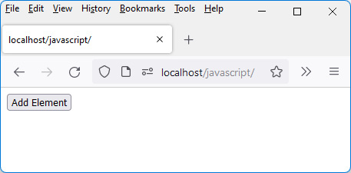
Figure 5.7 – Result displayed with our startup code
In Figure 5.7, we see the rendering of the <GlobalApp> component, which currently only displays the Add Element button. Let’s see how to process a click on this button in order to insert a new element in the list.

Adding an element to the list
We will start with the functionality to add an item to the list. The global-app.js file is modified to process a click on the Add Element button (this button is included in the global-app.js file).
Let’s add the code that should be run when the Add Element button is clicked:
Taking into account the click on the Add Element button (global-app.js file)
import Element from "./element.js";
const GlobalApp = {
data() {
return {
elements : []
}
},
components : {
Element:Element
},
template : `
<button @click="add()">Add Element</button>
<ul>
<li v-for="(element, index) in elements"
:key="index">{{element}}</li>
</ul>
`,
methods : {
add() {
var element = "Element " + (this.elements.length +
1); // "Element X"
this.elements.push(element);
}
}
}
export default GlobalApp;
A click on the Add Element button is handled by the click event, which calls the add() method defined in the methods section. The add() method adds a new element to the reactive variable elements.
The list of elements is updated in the component template. For the moment, we’ll use the <li> tag to define the list element to insert, but below, we will use the <Element> component, which will integrate the Remove and Modify buttons.
Now let’s verify that our modification of the <GlobalApp> component works. To do this, click several times on the Add Element button. List items are inserted with each click, as seen in the following figure.
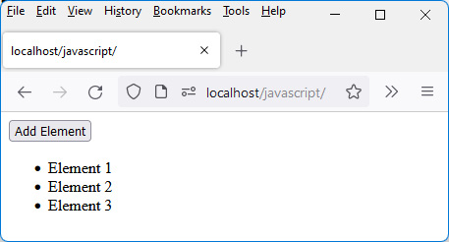
Figure 5.8 – Add Element button clicks
The element inserted here is an HTML <li> element. But it is interesting to replace the element <li> with a Vue.js component because it allows using the philosophy of Vue.js, which is the maximum use of components. Let’s name this new component <Element>, which will replace the <li> element..

Using the <Element> component
Next, let’s use the <Element> component, instead of the previous <li> element.
The <GlobalApp> component is modified to integrate the <Element> component:
Using <Element> component in list (global-app.js file)
import Element from "./element.js";
const GlobalApp = {
data() {
return {
elements : []
}
},
components : {
Element:Element
},
template : `
<button @click="add()">Add Element</button>
<ul>
<Element v-for="(element, index) in elements"
:key="index" :text="element" />
</ul>
`,
methods : {
add() {
var element = "Element " + (this.elements.length +
1);
this.elements.push(element);
}
}
}
export default GlobalApp;
The text to display in the list item is passed as an attribute (via props) to the <Element> component, which will display it in its template. We use the text attribute (or any other attribute name) for this.
The <Element> component is modified to consider the text attribute passed and display the list element. The two buttons Remove and Modify are inserted after the text:
Using the text attribute and buttons (element.js file)
const Element = {
data() {
return {
}
},
template : `
<li>
<span> {{text}} </span>
<button> Remove </button>
<button> Modify </button>
</li>
`,
props : ["text"],
}
export default Element;
Let’s check that the result is equivalent to the previous one (with the addition of the Remove and Modify buttons).
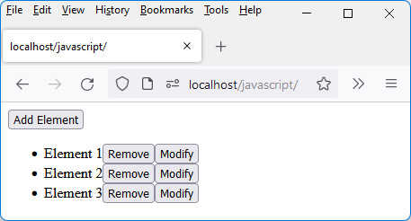
Figure 5.9 – Using the <Element> component in the list
Clicking on the Remove and Modify buttons in the list does not work yet but will soon, in the following sections.
The Remove and Modify buttons are placed side by side, with no spacing. Let’s add some CSS code to better lay them out on the screen.

Changing the appearance of the list using CSS code
Before handling button clicks in the list, let’s use some CSS to display the list items in a nicer way.
The CSS code is indicated directly in the index.html file:
Using CSS code to display the list (index.html file)
<html>
<head>
<meta charset="utf-8" />
<script src="https://unpkg.com/vue@next"></script>
<style type="text/css">
li {
margin-top:10px;
}
ul button {
margin-left:10px;
}
</style>
</head>
<body>
<div id="app"></div>
</body>
<script type="module">
import GlobalApp from "./global-app.js";
var app = Vue.createApp({
components : {
GlobalApp:GlobalApp
},
template : "<GlobalApp />"
});
var vm = app.mount("div#app");
</script>
</html>
We can see that the appearance of the list is now more pleasant.
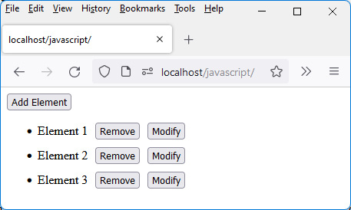
Figure 5.10 – List of elements improved with CSS code
The displayed list now has a look that suits us! We must now manage clicks on the Remove and Modify buttons. Let’s start with the Remove button.

Removing an element from the list
Now let’s deal with a click on the Remove button for a list item. Removing an item from the list will be done by removing the element from the reactive variable elements.
Note
Indeed, the variable elements being reactive, any modification of this variable will lead to the re-display of the list.
To do this, a click on the Remove button is managed by associating it with a process during the click. We therefore call the remove() method defined in the <Element> component on each click:
Taking into account the click on the Remove button (element.js file)
const Element = {
data() {
return {
}
},
template : `
<li>
<span> {{text}} </span>
<button @click="remove()"> Remove </button>
<button> Modify </button>
</li>
`,
props : ["text"],
methods : {
remove() {
// process the click on the Remove button
},
},
}
export default Element;.
The process involved in clicking on the Remove button is discussed later in the chapter.
Note
To process the click on the Remove button, we must update the reactive variable elements, but since this is located in the parent component <GlobalApp>, we must send an event to this parent component to ask it to remove the element in the variable elements.
To indicate the element to be deleted, it must be referenced by its index. For this, we need to indicate the index of the element when creating the <Element> component. We, therefore, create a new attribute (named "index") in this component. Thus the remove() method sends a "remove" event to the <GlobalApp> parent component, indicating in the parameters the index of the element to be removed from the list.
The <Element> component becomes as follows:
Handling the click on the Remove button (element.js file)
const Element = {
data() {
return {
}
},
template : `
<li>
<span> {{text}} </span>
<button @click="remove()"> Remove </button>
<button> Modify </button>
</li>
`,
props : ["text", "index"],
methods : {
remove() {
// process the click on the Remove button
this.$emit("remove", { index : this.index });
},
},
emits : ["remove"]
}
export default Element;
The <GlobalApp> component is modified to process the reception of the "remove" event sent when clicking on the Remove button:
Handling the reception of the “remove” event (global-app.js file)
import Element from "./element.js";
const GlobalApp = {
data() {
return {
elements : []
}
},
components : {
Element:Element
},
template : `
<button @click="add()">Add Element</button>
<ul>
<Element v-for="(element, index) in elements"
:key="index" :text="element"
:index="index"
@remove="remove($event)"
/>
</ul>
`,
methods : {
add() {
var element = "Element " + (this.elements.length +
1);
this.elements.push(element);
},
remove(params) {
var index = params.index;
this.elements.splice(index, 1); // delete element in
// array
}
}
}
export default GlobalApp;
We have indicated in the <Element> component the new attribute index, which will allow knowing the index of the element in the list.
Let’s add three items to the list (see Figure 5.11), then click the Remove button for the item on the second line (see Figure 5.12):
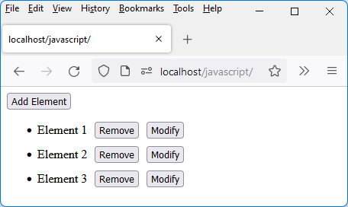
Figure 5.11 – Adding three elements to the list
Here’s what we will see after clicking the Remove button:
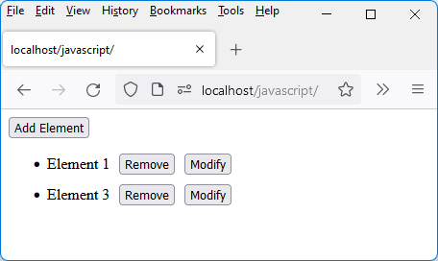
Figure 5.12 – Deleting item Element 2 from the list
By clicking on the Remove button, Element 2 has been removed from the list. Let’s now see how to manage the modification of an element, following a click on the Modify button.

Modifying an element in the list
Modifying a list element is done in several steps:
Following a click on the Modify button, we transform the text of the list element (currently a <span> element) into an HTML <input> element initialized with the text of the element.
Then we manage the exit of the input field, by retrieving the value entered in the field, then by replacing the input field with a <span> element with the new content.
Finally, we improve the input by allowing the input control to automatically have the focus after clicking on the Modify button.
Let’s see these different steps in depth.

Transforming the <span> element into an <input> element
The first step is to transform the <span> element into an <input> element, which will allow the text of the element to be modified. To do this, we will add a new reactive variable (named "input") in the <Element> component. It indicates whether to display a text as a <span> element (if input is false) or whether to display an <input> input field (if input is true). By default, the input variable is set to false (the text is displayed). It will change to true when clicking on the Modify button:
Turning a <span> element into an <input> element (element.js file)
const Element = {
data() {
return {
input : false // display element text by default
}
},
template : `
<li>
<span v-if="!input"> {{text}} </span>
<input v-else type="text" :value="text" />
<button @click="remove()"> Remove </button>
<button @click="input=true"> Modify </button>
</li>
`,
props : ["text", "index"],
methods : {
remove() {
// process the click on the Remove button
this.$emit("remove", { index : this.index });
},
},
emits : ["remove"]
}
export default Element;
Note
The v-if and v-else directives are used to display the text of the element as a <span> element or as an <input> element.
After inserting three items into the list, let’s edit the second item:
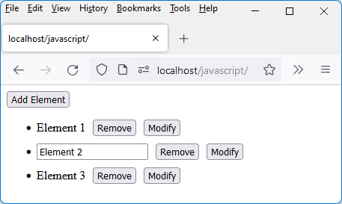
Figure 5.13 – Editing the second item in the list
We now need to show how to leave the input field and redisplay the text as a list element.

Exiting from the input field
Once the edit control has been modified, you must retrieve the value entered to display it instead of the edit control. To do this, in the <Element> component, we use the blur event, which indicates that we have left the input field.
During the processing of this event, the value of the input field is retrieved, which is transmitted to the parent <GlobalApp> component by means of an event named "modify", for example. The <GlobalApp> component modifies the element value in the elements variable when processing the received modify event.
Note
The modification of a reactive variable located in a parent component must be done by sending an event to the parent component, which will have to process it.
Finally, the transformation of the input field into text is done by modifying the reactive variable input defined in the <Element> component by positioning it again to false.
The <Element> component is modified as shown here:
Taking into account the output of the input field (element.js file)
const Element = {
data() {
return {
input : false
}
},
template : `
<li>
<span v-if="!input"> {{text}} </span>
<input v-else type="text" :value="text"
@blur="modify($event)"
/>
<button @click="remove()"> Remove </button>
<button @click="input=true"> Modify </button>
</li>
`,
props : ["text", "index"],
methods : {
remove() {
// process the click on the Remove button
this.$emit("remove", { index : this.index });
},
modify(event) {
var value = event.target.value; // value entered
// in the field
this.input = false; // delete input field
this.$emit("modify", { index : this.index, value :
value }); // update element in list
}
},
emits : ["remove", "modify"]
}
export default Element;
The <GlobalApp> component is also modified to process the reception of the "modify" event and thus modify the list displayed:
Processing the modify event (global-app.js file)
import Element from "./element.js";
const GlobalApp = {
data() {
return {
elements : []
}
},
components : {
Element:Element
},
template : `
<button @click="add()">Add Element</button>
<ul>
<Element v-for="(element, index) in elements"
:key="index" :text="element"
:index="index"
@remove="remove($event)"
@modify="modify($event)"
/>
</ul>
`,
methods : {
add() {
var element = "Element " + (this.elements.length +
1);
this.elements.push(element);
},
remove(params) {
var index = params.index;
this.elements.splice(index, 1);
},
modify(params) {
var index = params.index;
var value = params.value;
this.elements[index] = value; // new element value
}
}
}
export default GlobalApp;
The following figure shows the result after editing the second list item.
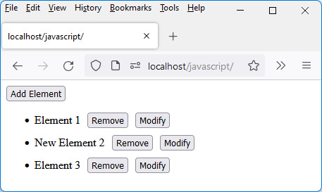
Figure 5.14 – Editing a list item
A final improvement that we can make to our program is to give focus to the input field directly after clicking on the Modify button. Let’s see how to proceed.

Giving focus to the input field
Giving focus to the input field requires using the focus() method, which is defined in the Document Object Model (DOM). The DOM is an internal API (in the JavaScript language) implemented in browsers.
Vue.js makes it possible to make a relationship between the components defined in Vue.js and the HTML elements used by the DOM. For this, we use the ref attribute, which makes it possible to make a correspondence between the two systems.
Note
This ref attribute can be used for each HTML element defined in our component templates. But it should be used only for necessary cases, such as here, to use the focus() method defined in the DOM, which otherwise would be inaccessible.
Once the ref attribute has been positioned (here, on the <input> element allowing input), all that remains is to use it to give focus to the input field. The question then is: in which method of our component should we call the focus() method?
We must use a method in which we are sure that the input field is created. The template written in the component must be transformed into HTML code and integrated into the memory of the browser (in the DOM), which can then display it. So, we see that a transformation process takes place, which takes some time to execute.
Vue.js has defined a number of methods that are called automatically when using components. In the previous chapter, we saw a method called created(). There are other methods, in particular, the mounted() and updated() methods.
Here are the specifics of these three methods:
The created() method is called when creating the component. This is the first method called.
The mounted() method is called when the component is transformed into HTML elements and integrated into the DOM. We can therefore have access, in this method, to HTML elements with the DOM API.
The updated() method is called when a modification is made in the component. For example, when a <span> element is replaced by an <input> element following a click on the Modify button. Or when, conversely, the <input> element turns back into a <span> element (when leaving the input field).
We see that the updated() method is the method in which we can do the processing giving focus to the input field. But as this method is called both when transforming into an input field or simple text, it will be necessary to check that the <input> element associated with the reference indicated in the ref attribute exists. Otherwise, an error visible in the console will occur:
Giving focus to the input field as soon as it appears (element.js file)
const Element = {
data() {
return {
input : false
}
},
template : `
<li>
<span v-if="!input"> {{text}} </span>
<input v-else type="text" :value="text"
@blur="modify($event)"
ref="refInput"
/>
<button @click="remove()"> Remove </button>
<button @click="input=true"> Modify </button>
</li>
`,
props : ["text", "index"],
methods : {
remove() {
// process the click on the Remove button
this.$emit("remove", { index : this.index });
},
modify(event) {
var value = event.target.value;
this.input = false;
this.$emit("modify", { index : this.index, value :
value });
}
},
emits : ["remove", "modify"],
updated() {
// check that the ref="refInput" attribute exists, and
// if so, give focus to the input field
if (this.$refs.refInput) this.$refs.refInput.focus();
}
}
export default Element;
When using the ref attribute in a template, Vue.js stores it in the component’s internal $refs variable. We can therefore access the corresponding HTML element using this.$refs.refInput if we wrote ref="refInput" in the component template.
Let’s check (see the following figure) that the edit control gets the focus directly when clicking on the Modify button.
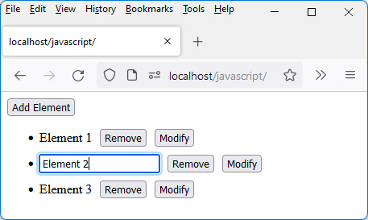
Figure 5.15 – The input field gets the focus directly
This brings us to the end of the chapter.

Summary
This chapter and the example discussed in it shows that it is very easy to manage the elements of an HTML page interactively without leaving the page.
Here, we first decomposed the application into different components, then we assembled them, making them communicate through events and props attributes. We have learned, thanks to this complete example, how to manage a list of elements to carry out the main operations, which are the insertion, the modification, and the deletion of an element.
In the next few chapters, we will see how to use Node.js to connect our application to a MongoDB database and thus be able to store the elements of the list in a database. We will begin by learning how to work with node.js modules in the next chapter.

Part 3: JavaScript on the Server-Side
This part is about using JavaScript in a Node.js server. It explains the use of modules such as Express (to quickly create a Node. js-based web application using the MVC pattern) and the MongoDB database.
We end our study by building an application on a single page (this principle is called Single Page Application) which is written with Vue.js on the client-side, and with Node.js, Express and MongoDB on the server-side. The purpose of this book is to enable you to know how to make this type of application.
This section comprises the following chapters:
Chapter 6, Creating and Using Node.js Modules
Chapter 7, Using Express with Node.js
Chapter 8, Using MongoDB with Node.js
Chapter 9, Integrating Vue.js with Node.js

Chapter 6: Creating and Using Node.js Modules
Modules are at the heart of Node.js. They correspond to JavaScript files and can be used in our applications. A program for the Node.js server will consist of a set of modules, that is, JavaScript files.
There are three kinds of modules:
Modules that we write ourselves for our applications.
Modules internal to Node.js and usable directly.
Modules that can be downloaded from the internet using a utility called npm (npm stands for Node.js package manager). This npm utility is installed with Node.js itself.
In this chapter, we will learn how to create and use these different types of modules.
Regardless of the type of modules used, the require(moduleName) instruction (see below) allows the module called moduleName to be included in the current file. The functionalities of the module will then be accessible.
Here are the topics covered in this chapter:
Using our own modules
Using internal Node.js modules
Using downloaded modules with npm
Let’s first see how to create and use our own modules with Node.js.

Technical requirements
You can find the code files for this chapter on GitHub at: https://github.com/PacktPublishing/JavaScript-from-Frontend-to-Backend/blob/main/Chapter%206.zip.

Creating and using our own modules
In this example, we use two modules, each corresponding to a JavaScript file:
The first module (here named test.js) will be the main file of our application, the one we execute using the node test.js command in a command window.
The second module (here named module1.js) will be the one we want to use in our main test.js module. The module1.js module will then be enriched to show how its functionalities are accessible outside the module (and will therefore be used in the main test.js module).
Let’s go ahead and create these two modules.

Creating a module
Here is the content of the two files, module1.js and test.js:
module1.js file
console.log("module1.js is loaded");
The module currently has a simple console.log() statement. The module will then be enriched. The main module test.js is the following:
test.js file
var mod1 = require("./module1.js");
// or require("./module1") without specifying the .js extension
console.log("mod1 =", mod1);
Here, we use the require(moduleName)instruction, which allows us to load in memory the moduleName module. Any use of the functionalities of the moduleName module requires the require(moduleName)instruction beforehand.
The require(moduleName) instruction returns a reference to the module loaded in memory. This reference is stored in a variable (here, mod1), which will then allow access to the functionalities described in the module (here, none for the moment).
The test.js file is the main file that loads the other modules. It is therefore this test.js file that is executed using the node test.js instruction in a command window.
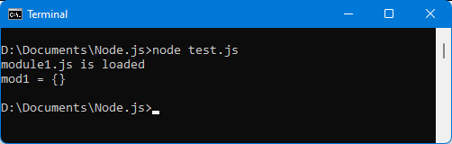
Figure 6.1 – Using a module with require(module)
We can see here that the execution of the main test.js module invokes the call of the require("./module1.js")instruction, which executes the content of the module1.js file, hence the display text specified in the console.log() statement in the module1.js module.
After loading module1.js, the mod1 variable is initialized and we will be able to access functionalities that the module exports later on.
Before adding functionalities to the module1.js module, let’s see how to manage the location of modules using the node_modules directory. The node_modules directory is used by Node.js to locate modules for which it does not have a path. Using this directory simplifies the writing of module names when loading them into memory with the require(moduleName) instruction.

Using the node_modules directory
Note that the previous require(moduleName) statement requires indicating the access path to the module, for example, "./" to indicate the current directory.
However, if the module is in the node_modules directory, it is not necessary to indicate the path because we are sure that the module is inside the node_modules directory (and moreover, it should not be specified). The node_modules directory can be in the main application directory (called the local node_modules directory) or in a dedicated directory created by Node.js (called the global node_modules directory: in this case, it is automatically created during the installation of Node.js).
Note
If the module is not found in the node_modules directory (local or global) and if the access path to the module is not indicated, an error occurs when loading the module with the require(moduleName) instruction.
Now, we will create a node_modules directory in the current directory where the main file, test.js, is located. Let’s transfer the module1.js file to this directory and use the require("module1.js") statement without specifying the path to the module. You can also write require("module1") without indicating the extension of the JavaScript file:
Include module1 located in node_modules directory (test.js file)
var mod1 = require("module1.js"); // or require("module1")
console.log("mod1 =", mod1);
The module1.js file must be in the locally created node_modules directory, while the test.js file remains in the current directory, as described here:
root/
|— node_modules/
│ |— module1.js
|— test.js
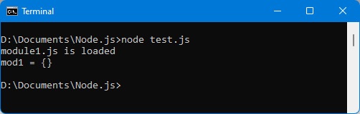
Figure 6.2 – The module is loaded from the node_modules directory
We can see that the module is indeed found by Node.js, because Node.js looks for it in the node_modules directory, which was created in the current directory.
Now let’s see how to allow a module’s files to be grouped in a directory, using the package.json file associated with the module.

Using the package.json file
The node_modules directory (whether located in the application directory or the Node.js installation directory) can contain a lot of files and sometimes a module can consist of many files and directories. It would be easier to associate a module with a directory in the node_modules directory.
Let’s create the module1 directory inside the node_modules directory. The module1 directory contains the module1.js file but may also contain other files and directories related to this module.
The file system is displayed here:
root/
|— node_modules/
| |— module1/
│ |— module1.js
|— test.js
Note
The moduleName indicated in the require(moduleName) statement represents, in this case, the name of the directory that contains the module files.
But as it is necessary to know which file of the directory we must use first when loading the module (as there can be many files in this directory), we indicate this correspondence in the package.json file in the "main" key.
The package.json file is a text file in JSON format, located in the directory of each Node.js module.
Now, we will create the package.json file in the module1 module directory and indicate in this file the "main" key with the value "module1.js".
The file system is as follows:
root/
|— node_modules/
| |— module1/
│ |— module1.js
│ |— package.json
|— test.js
package.json file in the node_modules/module1 directory (package.json file)
{
"main" : "module1.js"
}
We indicate in the "main" key that we must load the module1.js file during the require("module1") instruction:
Including module1 located in node_modules/module1 directory (test.js file)
var mod1 = require("module1");
//"module1" is the directory name
console.log("mod1 =", mod1);
Note
Please note that the module name in the require("module1") statement in this case is the name of the directory that contains the module in the node_modules directory. So, we cannot write the instruction here in the form require("module1.js"), which would cause an error.
We now visualize the execution of the test.js file:
Figure 6.3 – Module loaded with the package.json file
The "main" key in the package.json file is optional if the main module file is named index.js. In all other cases, the "main" key must be indicated in package.json.
We know how to run a module, but for now, the module contains a simple console.log() statement. Let’s see how to add features to the module and then use them.

Adding functionalities to the module
The newly created module1.js module is accessible but does not currently offer any functionality. Let’s see how to add some.
Exporting multiple functions in the module
For example, let’s create the function add(a, b), which returns the sum of a and b:
add(a, b) function defined in module1.js (module1.js file)
console.log("module1 is loaded");
function add(a, b) {
return a+b;
}
module.exports = {
add : add // make the add() function accessible
// outside the module
};
To export a function outside of a module (and make it accessible to users of the module), you can just embed it in the module.exports object defined by Node.js in each module. Each key defined in the module.exports object will be a function accessible outside the module.
We can thus define several functions in the module that will be accessible thanks to the module.exports object.
The usage of the add(a, b) function in the test.js file is as follows:
Using add() function in test.js file (test.js file)
var mod1 = require("module1");
console.log("mod1 =", mod1);
var total = mod1.add(2, 3);
// call of the add() function
// defined in module1
console.log("mod1.add(2, 3) = ", total); // displays 5
The following display is obtained:
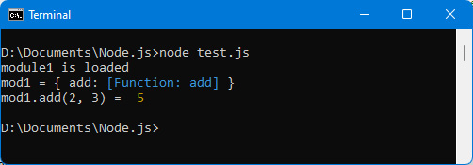
Figure 6.4 – The add() function added to the module
Let’s add a second function in the module. For example, the function mult(a, b), which returns a*b.
If we add the mult(a, b) function in the module, it is written as follows:
Adding the mult(a, b) function to the module (module1.js file)
console.log("module1 is loaded");
function add(a, b) {
return a+b;
}
function mult(a, b) {
return a*b;
}
module.exports = {
add : add,
mult : mult
}
Now, we will use the two functions add() and mult() in the test.js file. This verifies that a module can provide several functionalities to other modules that use it:
Using the module’s add() and mult() functions (test.js file)
var mod1 = require("module1");
console.log("mod1 =", mod1);
var total = mod1.add(2, 3);
console.log("mod1.add(2, 3) = ", total); // 2 + 3 = 5
var total = mod1.mult(2, 3);
console.log("mod1.mult(2, 3) = ", total); // 2 * 3 = 6
The following display is obtained:
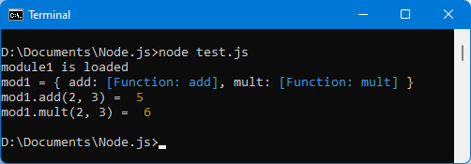
Figure 6.5 – Using the two functions of the module
Now let’s see how to improve the module concept by using a so-called main function in the module.
Allowing a function to be the main function of the module
Often, the module wishes to make a function its main function (the other functions defined in the module are secondary functions). This allows access to this main function in a simplified form.
Suppose (as before) that module1 makes available the add(a, b)function and the mult(a, b)function. We want the add() function to be the main function of the module, which means that we can use it outside the module as mod1(2, 3) instead of mod1.add(2, 3). The mult(a, b) function will remain accessible in the form mod1.mult(2, 3).
Note
Note that only one function can be defined as the main function in a module.
In this case, just specify it in the module.exports object like so:
Making the add() function accessible as a main module function (module1.js file)
console.log("module1 is loaded");
function add(a, b) {
return a+b;
}
function mult(a, b) {
return a*b;
}
// first define the main function
module.exports = add; // the add() function defined outside
// the module, is made main
// then define the secondary functions
module.exports.mult = mult; // and the mult() function
// becomes usable as well
Note
It is important to assign the values in this order in the module.exports object (define the main function first, then the secondary functions). If you make the assignment in the other direction (module.exports.mult first, then module.exports), the assignment of module.exports last will erase the value already positioned in module.exports.mult.
Also, we can no longer assign module.exports as an object, because that would remove the previously assigned value if we wrote module.exports = { mult : mult }.
We now use the module as follows:
Using the module1.js module that has a main function (test.js file)
var mod1 = require("module1");
console.log("mod1 =", mod1);
var total = mod1(2, 3);
// instead of mod1.add(2, 3)
console.log("mod1(2, 3) = ", total);
var total = mod1.mult(2, 3);
console.log("mod1.mult(2, 3) = ", total);
The following display is obtained:
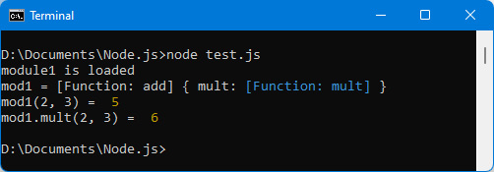
Figure 6.6 – Using the module with the main function
Note
Notice that instead of using the mod1 variable as an object, we now use it as a function. In the call to mod1(a, b) causes the addition of a and b, so it is preferable that the variable be named "add" rather than "mod1" in the instruction require(moduleName).
We saw how to create and use our own module. Now let’s take a look at how to use internal Node.js modules.

Using internal Node.js modules
Node.js already has internal modules. They can also be used with the require(moduleName) instruction seen previously.
Let’s look at an example of an internal module. There is, for example, the "fs" module in the Node.js system. The name "fs" is short for file system. This module allows you to interact with the internal file system of Node.js.
Now, we will use the "fs" module to read the contents of a file.

Reading the contents of a file
Let’s use the "fs" module to read the file named file1.txt located in the current directory (where the test.js file is located). Here are the contents of this file:
file1.txt file (in the directory where test.js is located)
This is the content
of the file file1.txt
located in
the current directory.
The program that uses the "fs" module and displays the contents of the file is as follows:
Reading and displaying the contents of the file (test.js file)
var fs = require("fs");
var data = fs.readFileSync("file1.txt");
console.log("File content:");
console.log(data);
We use the readFileSync() method defined in the "fs" module. It returns the contents of the file in the corresponding variable, which is then displayed.
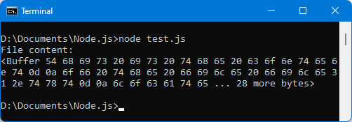
Figure 6.7 – Displaying file contents using the “fs” module
The contents of the file are displayed but as hexadecimal characters. Next, let’s display the contents of the file as strings.

Displaying file contents as strings
The contents of the file are displayed in the form of a buffer of bytes (see Figure 6.7). Node.js makes it easy to manipulate byte streams. It is also possible to view the contents of the file directly as strings by specifying the {encoding: "utf-8"} option in the second parameter (options) of the readFileSync(name, options) method:
Displaying file contents as strings (test.js file)
var fs = require("fs");
var data =
fs.readFileSync("file1.txt", { encoding : "utf-8" });
console.log("File content:");
console.log(data);
The result is now displayed as strings (see the following figure):
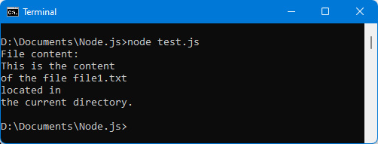
Figure 6.8 – Displaying file contents as strings
The contents of the file are displayed. However, the program waits for the contents of the file to be retrieved in order to display them. By using the readFile() method instead of the readFileSync() method, it is possible to not block the program while waiting for the file.

Using non-blocking file reading
If you observe the previous readFileSync() method, you will see that the contents of the file are rendered in return for the method call. This means that the Node.js program is blocked while the file is being read (even if only for a few milliseconds). Within our small program, this is not noticeable, but in a case where the reading of the file is carried out by thousands of simultaneous users (for example, on a server), this will slow down access to the server.
For this, Node.js has provided, for all blocking features such as this one, a non-blocking version of the method. Rather than returning the return result of the method (as before), we use a callback function indicated as a parameter of the method. In the case of reading the file, we will therefore use the readFile(name, options, callback) method, also defined in the "fs" module. The result of reading the file will be passed as a parameter in the callback function.
Let’s use the non-blocking form of reading the file, using the readFile() method instead of the readFileSync() method:
Using readFile() method to read the file (test.js file)
var fs = require("fs");
console.log("File content:");
fs.readFile("file1.txt", { encoding : "utf-8" }, function(error, data) {
console.log(data);
});
console.log("The readFile() method was called");
Note
The callback function uses the error and data parameters (in that order), which respectively correspond to a possible error message (null if none), and to the contents of the file if the latter has been read. The options parameter indicated as the second parameter of readFile() is similar to that of the readFileSync(name, options) method.
The result is displayed here:
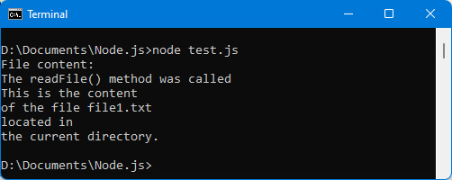
Figure 6.9 – Displaying file contents using the non-blocking readFile() method
We can check in the result displayed above that the readFile() method is really non-blocking. Indeed, the text indicated following the call to the readFile() method is displayed in the console even though the file has not yet been read and displayed, which would have been impossible using the blocking method readFileSync().
Note
We can therefore see that the use of modules internal to Node.js is done very simply by using the require(moduleName) instruction, and then by calling methods on the object returned by this instruction.
We have seen how to create and use your own modules, and how to use internal Node.js modules.
Now let’s see how to use modules available on the internet using the npm command.

Using downloaded modules with npm
In addition to the modules internal to Node.js, it is possible to import modules from the internet using the npm utility provided with Node.js.
For this, the npm command is used (in a command interpreter) by indicating arguments that allow you to perform the corresponding actions on the imported modules.

Using the npm command
Here are some common uses of the npm command:
npm install moduleName: Installs the indicated module in the local node_modules directory. The module will only be accessible for the current application and not for other applications (unless it is installed again).
npm install moduleName -g: Installs the specified module in the global node_modules directory. The -g option allows you to indicate that this module can be accessed by other applications because it is installed in the node_modules directory of Node.js (globally).
npm link moduleName: It is possible that a module installed globally (with the -g option) is inaccessible (you get a module loading error during the require(moduleName) statement). In this case, it is necessary to run the npm link moduleName command.
npm ll: Lists modules already present in the local node_modules directory.
npm ll -g: Lists modules already present in the global node_modules directory.
npm start: Starts the Node.js application according to the command indicated in the "scripts" key, then the "start" key of the package.json file. For example, if you specify "scripts": { "start": "node test.js" } in the package.json file, you can type npm start instead of node test.js to run the test.js file. It is common to use npm start to start a Node.js application. This will be used to start an application under Express (see the next chapter).
Note
If you want to remove an npm-installed module, use the same commands as before, specifying uninstall instead of install.
As an example, let’s create the following package.json file in the directory of the test.js file:
package.json file (in the same directory as test.js)
{
"scripts" : {
"start" : "node test.js"
}
}
Then use the npm start command to start the program:
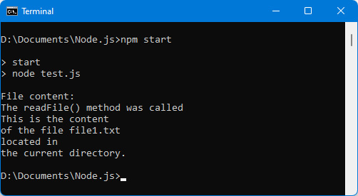
Figure 6.10 – Starting the Node.js application with npm start
We can see that the npm start command thus makes it possible to execute the test.js program. The npm start command is often used to start a Node.js program, thanks to the mechanism explained above.
Now let’s see how to use modules written by other developers by downloading them using npm.

Using a downloaded module with npm
Let’s look at an example of using npm. Here, we will use npm to install the module named colors. It allows you to display colored text in the console.
Installing the colors module in the node_modules local directory
We use the command npm install colors. The result of the installation of the "colors" module is displayed in the following figure.
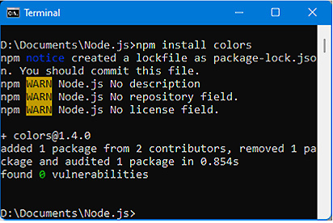
Figure 6.11 – Installing the colors module with npm
Once the module has been installed by npm, you can see that the colors directory of the module has inserted itself into the node_modules local directory of the application.
Using the features of the colors module
One of the ways to have an overview of the functionalities offered by a module is to display the content of the object returned by the require(moduleName) instruction:
Displaying contents of colors object returned by require(“colors”) (test.js file)
var colors = require("colors");
console.log("colors = ", colors);
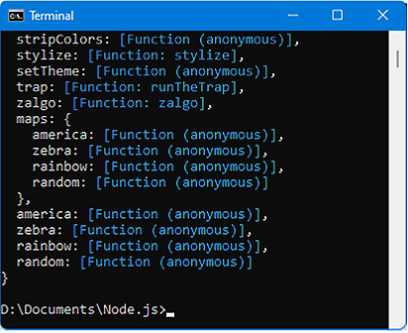
Figure 6.12 – Displaying contents of the colors module
For example, let’s use the last method listed in the module, namely the random() method. It allows you to transform a character string into a string with random colors for each character:
Using the random() method of the colors module (test.js file)
var colors = require("colors");
console.log(colors.random("First text in random colors"));
console.log(colors.random("Second text in random colors"));
Note
The random() method is used by prefixing its name with the name of the variable returned by require("colors"), that is, with the name of the module.
The display of the following figure is obtained, in which each character displayed is a random color:
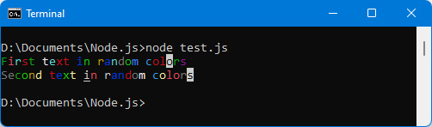
Figure 6.13 – Using the colors module
We have seen here the three types of modules used with Node.js:
Modules written by ourselves, for our own needs
Existing internal modules in Node.js, such as the fs module allowing access to the internal file system of Node.js
Modules downloadable using the npm command, such as the colors module used above
All that remains is to use these different types of modules in our programs. We will discuss that later on.
This brings us to the end of the chapter.

Summary
We have seen in this chapter how to create and use modules with Node.js, which are the essential components of programs created with Node.js.
Whether the module is created by us, is an internal Node.js module, or is a module downloaded with npm, its use is the same in all cases. We use the require(moduleName) instruction and with the value returned in a variable, we access the functionality of the module.
Next, we are going to study the Express module, which is one of the main modules used with Node.js, allowing us to easily structure our applications according to the rules of the MVC model, currently widely used.

Chapter 7: Using Express with Node.js
We saw in the previous chapter that a program for the Node.js server is an assembly of different modules. Many modules have been created by Node.js developers, which can be inserted into our programs using the npm utility (see Chapter 6, Creating and Using Node.js Modules). One of these modules is called Express. It is one of the most used modules with Node.js because it allows you to structure server programs according to the Model View Controller (MVC) model.
In this chapter, we’ll study how to create a Node.js application while respecting the characteristics of the MVC model by using the Express module.
Here are the topics we will cover:
Using the Node.js http module
Installing the Express module
The MVC pattern used by Express
Using routes with Express
Displaying views with Express
Node.js integrates into its internal modules the possibility to create a web server using the http module internal to Node.js. We first explain how to use this http module, and then we will see the contribution that the external Express module makes to more easily create a web application built according to the MVC model.

Technical requirements
You can find the code files for this chapter on GitHub at: https://github.com/PacktPublishing/JavaScript-from-Frontend-to-Backend/blob/main/Chapter%207.zip.

Using the Node.js http module
The http module is an internal Node.js module. It is, therefore, directly accessible in our programs using the require("http") instruction. With this module you can create a web server based on the HTTP protocol and thus display web pages in an internet browser.
For creating a web server based on HTTP, we use the http.createServer(callback) method of the http module. The callback function indicated as a parameter is of the form callback(req, res), in which req corresponds to the request received, and res corresponds to the response to be sent to the browser. Depending on the request received, the corresponding response will be sent.
Note
In the req parameter, there is, among other things, the URL of the request received, thus making it possible to return, via the res parameter, the correct response to the browser according to this request.
Let’s see in the following program how to use the createServer() method:
Creating a web server using the http module (test.js file)
var http = require("http");
var server = http.createServer(function(req, res) {
// display the received request in the console
console.log("Request received:", req.url);
// indicate that the response is HTML in utf-8
res.setHeader("Content-type", "text/html; charset=utf-8");
// we always send the same response, regardless of the
// request received
res.write("<h1>")
res.write("Good morning all");
res.write("</h1>");
res.end();
});
// make the server listen on port 3000 (for example)
server.listen(3000);
console.log("\nThe server was started on port 3000\n");
console.log("You can make a request on:");
console.log("
http://localhost:3000
");
The createServer() method returns an object, here used through the variable named server, on which we indicate to wait for requests coming from port 3000 (the one indicated in the server.listen(port) method). This means that each time URLs of the form http://localhost:3000 are accessed via the browser, the program previously launched (with the node test.js command) will be activated and will display the result in the browser.
Note
The use of the server.listen(port) method is mandatory because it is not enough to create a server with the http.createServer() method. This server must also be listening (with server.listen(port )) to HTTP requests addressed to it by browsers connecting to this server (here using a URL such as http://localhost:3000). Port 3000 is used here, but another port number could be used (provided that this port is not already used by another server, which would cause an access conflict to know to which server the request on the port is addressed).
We send the response to the browser using res.write(string) instructions. You must finish sending the response with the res.end() instruction, which means that the browser has received all the elements to display (the server waits to receive the res.end() instruction to display all the elements sent).
Note
The res.setHeader() method is used to set HTTP header fields. Here, "Content-type" is set to the value "text/html; charset=utf-8".
Let’s launch the previous program by typing the command node test.js. The program displays a message, then waits for HTTP requests on port 3000:
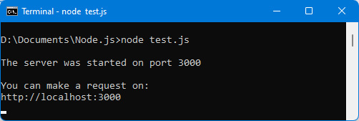
Figure 7.1 – HTTP server waiting on port 3000
To test the program, display the URL beginning with http://localhost:3000 in a browser. When an HTTP request uses port 3000 (the port on which the server is listening), the callback function indicated in the createServer(callback) method is activated and then the response is sent to the browser.
Let’s type the URL http://localhost:3000 in the browser (see the following figure):
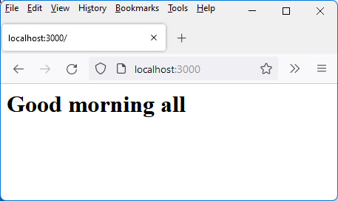
Figure 7.2 – Viewing URL http://localhost:3000 in the browser
Regardless of the URL specified in the browser ( which uses port 3000), the display in the browser remains the same. For the display to be different for different URLs, it must be considered in the callback function by using the value of req.url, which contains the URL typed and returns different strings according to the request received.
Using the Express module makes it easy to manage the different requests received and display different results depending on the URL entered.

Installing the Express module
Since the Express module is installed using npm, we type the npm install express command to install it.
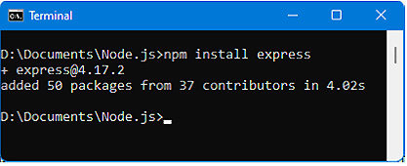
.
Figure 7.3 – Installing the Express module with npm
The Express module is now installed.
Note
A utility related to Express is also useful for creating the architecture of our web applications. This is the "express-generator" module (this module was previously included with Express but is now separate from it, hence it’s uploaded here).
Let’s also install the "express-generator" module using the npm install express-generator -g command. We use the -g option so that the express command defined in this module is accessible from any directory.
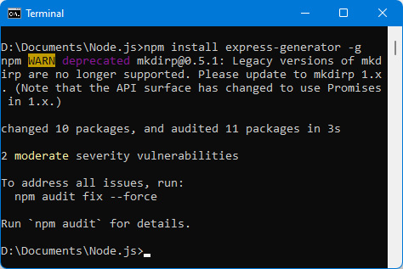
Figure 7.4 – Installing the “express-generator” module with npm
Note
You can verify that the installation is correct by typing the command express -h. If the installation of the module is correct, help for the express command is displayed in the window (otherwise an error is displayed).
Once these two modules are installed, you can create a first web application based on Express.
To do this, type the express apptest command to create the application named apptest. You should see the following result:
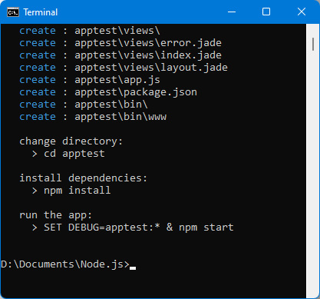
Figure 7.5 – Creating the apptest application with Express
This command creates an apptest directory containing the basic files to run the application. You must then type the three commands indicated at the end of the display: cd apptest, npm install, and npm start.
Once these commands are typed, open a browser and display the URL http://localhost:3000.
This is what you will see:
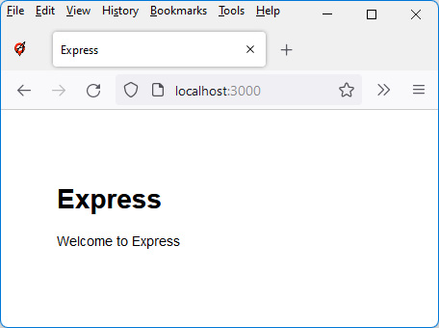
Figure 7.6 – Default app home page created with Express
If we look at the source files of the application created in the apptest directory, we see the app.js and package.json files, as well as the bin, node_modules, public, routes, and views directories. These directories are those that describe the MVC architecture used by Express, which we explain below.

The MVC pattern used by Express
The MVC model is an application architecture model allowing an application to be broken down into different parts: models, views, and the controller:
Models correspond to the data manipulated by the application. In general, this is data from databases. Node.js is closely tied to the MongoDB database, which is explored in the next chapter.
Views correspond to the visualization of data, for example, input forms and displayed lists. Each display corresponds to a view that will be in the views directory of the application.
The controller allows navigation between the different views, depending on the data. For this, we use routes (in fact, URLs) that indicate the processing to be performed. The routes directory describes the routes used by the application (and the processing performed for each of them).
We can therefore see that the MVC model makes it possible to separate the processing, the display, and the data. This split is widely used in web projects and is the one proposed by Express.
Let’s first look at how routing works in Express. This corresponds to the controller part of the MVC model.

Using routes with Express
Routes indicate the processing to be performed based on the requested URL. Compared to what we wrote when using the http module of Node.js with the createServer(callback) method, this consists of writing the content of the callback(req, res) function according to the req request received.
The routes are described in the app.js file, which is the main file created by Express. Let’s examine its content.

The initial content of the app.js file
To understand how routes work in Express, open the app.js file located in the main application directory, and you will see the content of this file, like this:
app.js file
var createError = require('http-errors');
var express = require('express');
var path = require('path');
var cookieParser = require('cookie-parser');
var logger = require('morgan');
var indexRouter = require('./routes/index');
var usersRouter = require('./routes/users');
var app = express();
// view engine setup
app.set('views', path.join(__dirname, 'views'));
app.set('view engine', 'jade');
app.use(logger('dev'));
app.use(express.json());
app.use(express.urlencoded({ extended: false }));
app.use(cookieParser());
app.use(express.static(path.join(__dirname, 'public')));
app.use('/', indexRouter);
app.use('/users', usersRouter);
// catch 404 and forward to error handler
app.use(function(req, res, next) {
next(createError(404));
});
// error handler
app.use(function(err, req, res, next) {
// set locals, only providing error in development
res.locals.message = err.message;
res.locals.error = req.app.get('env') === 'development' ?
err : {};
// render the error page
res.status(err.status || 500);
res.render('error');
});
module.exports = app;
This file describes how the application built with Express works. It uses the app variable, which is the return from the express() function call and symbolizes the application. On this app object, the use() method is used many times, which makes it possible to add processing to be performed for each request received on the server.
For example, app.use(logger("dev")) triggers the logger() function for each request received on the server. This is why the server console displays the URL that was requested in the browser during each request to the server.
By having displayed in the browser the URLs http://localhost:3000 and http://localhost:3000/users, we obtain the following in the server console.
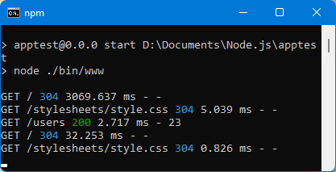
Figure 7.7 – Display of URLs in the server console
Now, let’s look at the meaning of the lines displayed in the server console.

Different types of routes possible
In the previous figure, you’ll notice that the word GET is displayed in front of each URL: GET /, GET /users.
The word GET means that the URL / or /users is accessed by an HTTP request of the GET type. The GET type is the one used when the accessed URL is displayed in the address bar of the browser, for example, when you type it directly or when you click on a link on a page.
Note
Other types of HTTP requests exist. They make it possible not to display the corresponding URL in the address bar of the browser, and thus to hide it from users. For example, if the URL for deleting records from the database was visible in the browser’s address bar, it would suffice to refresh the page to continue deleting records from the database. Hence the interest in other types of HTTP requests that allow the current URL to be hidden.
The other types of HTTP requests (in addition to GET) are mainly PUT, POST, and DELETE type requests. These types of requests are used in programs to signify an action to be performed on one or more pieces of data (called resources):
GET means reading a resource.
POST means creating a resource.
PUT means updating a resource.
DELETE means deleting a resource.
Although multiple types of HTTP requests exist, these are the main ones. They are used to manipulate resources, allowing them to be created (POST), updated (PUT), deleted (DELETE), and read (GET).
Note
A route is the association of an HTTP request with a URL. For example, the GET /users route associates the /users URL with the HTTP GET request, while the DELETE /users route associates the same /users URL with the HTTP DELETE request. Although these routes use the same URL, they are different routes because the HTTP requests are different.
Now that we’ve seen the different types of HTTP requests used, let’s look at how Express uses them internally.

Analyzing routes defined in the app.js file
The app.use() method is also used to define new routes, that is, to define the processing that will be performed for each new URL used (with the associated request type).
The app.use(url, callback) method is used to define the processing to be performed when the specified URL is activated. As the type of request is not indicated here, all types of requests will activate the treatment indicated in the callback function. To indicate the type of request, you must use methods similar to app.use(). These are the app.get(), app.put(), app.post(), and app.delete() methods.
Note
The callback function of the form callback(req, res, next) returns the response to the browser. The next() parameter corresponds to a function to be called at the end of the callback if the processing must continue in the next callback function (if the processing to be performed is handled by multiple callback functions).
The routes already defined in app.js are / and /users, thus making it possible to run the processes associated with these routes. These routes are examples to show how to implement routes in the app.js file. The processing instructions are defined in the indexRouter and usersRouter functions. These functions are the variables used in return for the instructions require('./routes/index') and require('./routes/users'). The processing of routes is therefore done here in the index.js and users.js files defined in the routes directory.
Let’s open these two files and analyze their contents:
index.js file (routes directory)
var express = require('express');
var router = express.Router();
/* GET home page. */
router.get('/', function(req, res, next) {
res.render('index', { title: 'Express' });
});
module.exports = router;
users.js file (routes directory)
var express = require('express');
var router = express.Router();
/* GET users listing. */
router.get('/', function(req, res, next) {
res.send('respond with a resource');
});
module.exports = router;
Each of these files uses the router.get(url, callback) method, meaning that the route is associated with the GET type request. The URL given is / (it will be concatenated with the URL given in the app.js file), followed by the callback function of the form callback(req, res, next). The next parameter corresponds to a function to call if the processing must continue in the callback function that follows (if such a function exists, which is not the case here).
The processing performed in each of the callback functions consists of sending the response, which will be displayed in the browser. Here, we use the res.send() and res.render() methods, which allow the response to be sent:
The res.send() method is similar to res.end() (defined in the "http" module of Node.js), but also allows you to indicate that you are using HTML and utf-8 characters. Only one call to the res.send() method must be made in the processing, otherwise, an error occurs.
The res.render() method allows an external file (called a view) to be displayed. Views are written in a special language that depends on the format of the view. By default, the views used by Express are JADE files, but it is possible to use other formats.
Here, the view displayed by the res.render() method corresponds to the index.jade file located in the views directory. Its contents are as follows:
index.jade file (views directory)
extends layout
block content
h1= title
p Welcome to #{title}
This file is written using a particular syntax, called JADE. The file will be transformed into HTML code by Express before being sent to the browser (which can only interpret HTML).
Note
Express allows files associated with views to be written using a variety of syntaxes. The most common are JADE and EJS.
We will explore the JADE syntax in the Displaying views with Express section in this chapter.
Note that the app.js file allows you to configure the directory associated with the views and the syntax used in the views. Here are the corresponding instructions from the app.js file:
Configuring views (app.js file)
app.set('views', path.join(__dirname, 'views'));
app.set('view engine', 'jade');
We have described the routes already listed in the app.js file. Let’s see how to create new routes in this file.

Adding a new route in the app.js file
Adding a new route in the app.js file can be done either by writing the processing directly in the app.js file or by creating an external file that will be in the routes directory.
Warning
Any modification of the app.js file requires restarting the server by performing the npm start command; otherwise, the modifications are not taken into account.
Let’s look at these two ways to create a new route.
Adding route processing directly in the app.js file
Let’s add the /clients route activated following a GET type request. It displays the list of clients. We use the app.get() method to define the route:
Add the GET /clients route
app.use('/', indexRouter);
app.use('/users', usersRouter);
app.get("/clients", function(req, res, next) {
res.send("<h1>Client list</h1>");
});
The result is displayed in the following figure (Figure 7.8).
Creating an external file to define route processing
We use the same principle as that used for the GET / and GET /users routes defined in the app.js file. We create the clients.js file in the routes directory, which will be included in the app.js file by means of the statement clientsRouter = require("./routes/clients). The route is defined in app.js with the statement app.use("/clients", clientsRouter).
The clients.js file describing the processing performed on the route is as follows:
clients.js file (routes directory)
var express = require('express');
var router = express.Router();
router.get('/', function(req, res, next) {
res.send("<h1>Client list</h1>");
});
module.exports = router;
In both cases, the result is the same, as seen in the following figure.
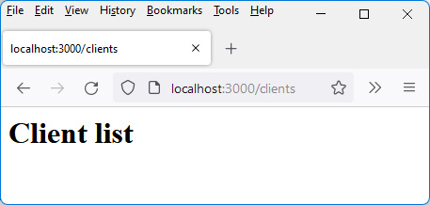
Figure 7.8 – Displaying the GET /clients route
We studied the controller part of the MVC model using the route system defined in Express. Now let’s see how Express allows us to manage the view part of the MVC model.

Displaying views with Express
A view is an external file used to describe the display that you want to view. Specific syntaxes have been created to program the view, for example, JADE or EJS syntaxes.
The res.render(name, obj) method is used to display the name view using any properties provided in the obj object. The view is a file defined in the views directory using JADE syntax or another.
One of the features of Express is to allow you to create views using the desired syntax. The JADE syntax is offered as standard by Express, but other syntax support libraries can be added with npm.
The JADE syntax is, therefore, the one used by default in Express. It makes it possible to replace HTML tags with their tag (for example <h1> simply becomes h1), and the indentation of tags in the code makes it possible to specify their nesting. It is also no longer necessary to close the tag previously opened because the indentation allows you to see the nesting of the tags.
Note
Full JADE documentation can be found at https://jade-lang.com/.
Let’s use JADE to display the previous client list. We create the clients.jade view in the views directory, and we indicate in clients.js that we display this view when accessing the GET /clients route:
clients.js file (routes directory)
var express = require('express');
var router = express.Router();
router.get('/', function(req, res, next) {
res.render("clients"); // display clients.jade view
// (.jade extension is enabled by
// default)
});
module.exports = router;
Note that if you do not indicate the file extension of the view (for example, by writing res.render("clients")), the extension used will be the one indicated in the instruction app.set('view engine' , 'jade') from app.js.
If, on the other hand, you specify an extension to the view file, it will be the one used to display the view even if it is different from the one configured in app.js. The view clients.jade is as follows:
clients.jade file (views directory)
h1 Client list
ul
li Bill Clinton
li Barack Obama
li Joe Biden
Notice the indentation of the tags. The ul tag is at the same level as the h1 tag, otherwise, it would be seen as included in the h1 tag. The li tags are shifted to the right to show their inclusion in the preceding ul tag. The offset must be at least one character. Because of the offsets, we do not use a closing tag as in HTML.
Let’s restart the server with npm start because one of the routing files has been modified.
Note
Editing files associated with views does not require a server restart, unlike the app.js file and files associated with routes (in the routes directory).
Once the server restarts, let’s display the URL http://localhost:3000 again:
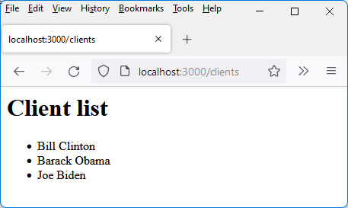
Figure 7.9 – View displayed using JADE syntax
The list of clients is, in this example, entered directly into the JADE view. It is better to pass it as parameters using the second parameter of the res.render(name, obj) method. The clients.js file then becomes the following:
clients.js file (routes directory)
var express = require('express');
var router = express.Router();
router.get('/', function(req, res, next) {
res.render("clients", {
clients : [
{ firstname : "Bill", lastname : "Clinton" },
{ firstname : "Barack", lastname : "Obama" },
{ firstname : "Joe", lastname : "Biden" },
]
});
});
module.exports = router;
The obj parameter of the res.render("clients", obj) method is an object containing the list of clients.
The clients.jade view uses this passed object as follows:
clients.jade file (views directory)
h1 Client list
ul
li #{clients[0].lastname + " " + clients[0].firstname}
li #{clients[1].lastname + " " + clients[1].firstname}
li #{clients[2].lastname + " " + clients[2].firstname}
The obj object passed in parameters is used in the JADE view, by using its clients property here.
JADE Syntax
JavaScript statements can be used in the JADE view by surrounding them with #{ and }. Anything between these two markers will be considered JavaScript code.
You can also use a syntax simplification allowed by JADE, by writing the = sign directly after each li tag. This means that everything following on the line must be interpreted in JavaScript. We can use this simplification of writing here.
Let’s write the clients.jade view as follows:
clients.jade file (views directory)
h1 Client list
ul
li= clients[0].lastname + " " + clients[0].firstname
li= clients[1].lastname + " " + clients[1].firstname
li= clients[2].lastname + " " + clients[2].firstname
Rather than listing each element of the clients array in the view, you can also perform a loop using the each statement of the JADE syntax to iterate over a JavaScript array.
The clients.jade view therefore becomes the following:
clients.jade file (views directory)
h1 Client list
ul
each client in clients
li= client.lastname + " " + client.firstname
The writing of the view is simplified, but you really have to take into account the indentations of the lines otherwise the view will not be displayed.
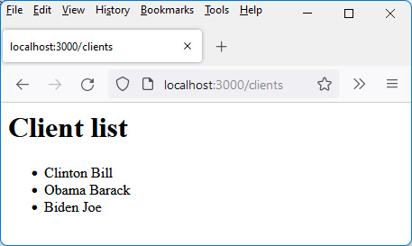
Figure 7.10 – List of clients displayed by the each statement
We see in this example that the JADE syntax makes it easy to display lists of data in the views of the application.
With this, we come to the end of this chapter.

Summary
The Express module makes it possible to structure your application efficiently by allowing (thanks to the MVC model it uses) you to separate the management of routes, the views displayed, and the management of data.
We have explained how to write the views of the application using the JADE syntax provided by default by Express. Other syntaxes, for example, the EJS syntax, are also available by downloading them via npm.
We have also seen the importance of the app.js file created by Express, and the use of HTTP requests such as GET, POST, PUT, and DELETE. We will see in Chapter 9, Integrating Vue.js with Node.js, the importance of these HTTP requests to build a MEVN application (short for MongoDB, Express, Vue.js, Node.js) that manipulates the MongoDB database.
Indeed, data management is often done using the MongoDB database, the use of which we will explore in the next chapter.

Chapter 8: Using MongoDB with Node.js
MongoDB is the database traditionally associated with Node.js. It is a NoSQL type database, which means that SQL will not be used to access the information it contains.
MongoDB is a document-oriented database in which we store so-called documents; that is, a data structure of any type, such as information written on a sheet of paper (which is then equivalent to a document). Several sheets of paper, thus corresponding to several documents, form what is called a collection.
An example of a document is, for example, the first name, the last name, and the address of a customer. Aggregated information from multiple customers would be called a collection.
In this chapter, we’ll study how to use MongoDB in conjunction with Node.js in order to store, read, delete, or update information in the database.
Inserting, searching, updating, or deleting data are the main actions that can be performed in a database. Therefore, in this chapter, we’ll see how to perform these operations with the MongoDB database.
Here are the topics covered in this chapter:
Installing MongoDB and the mongoose module
Connecting to the MongoDB database
Creating documents
Searching documents
Updating documents
Deleting documents
Let’s start by installing MongoDB and the mongoose module, which will allow MongoDB to be used in Node.js programs.

Technical requirements
You can find the code files for this chapter on GitHub at: https://github.com/PacktPublishing/JavaScript-from-Frontend-to-Backend/blob/main/Chapter%208.zip.

Installing MongoDB
The MongoDB database is independent of Node.js, which requires installing it separately. To do this, go to the site https://www.mongodb.com/docs/manual/administration/install-community/. Download the version suitable for your system.
Once MongoDB is installed, verify that the installation is correct by typing the mongo -h command in a command interpreter. The mongo command is located in the Server/x.x/bin directory of MongoDB, where x.x is the version number of MongoDB installed.
Note
At the time of writing, the mongo utility is available directly when installing MongoDB. However, it is possible that this utility will soon be available separately and called mongosh. In this case, download this utility from https://www.mongodb.com/docs/mongodb-shell/install/.
The mongo command will simply be replaced by the equivalent mongosh command. Both commands work identically.
After installing MongoDB, we will look into the mongo (or mongosh) utility. The mongo utility makes it easy to see the contents of database collections, without having to write program lines. It is therefore useful for checking, for example, whether a document has been correctly inserted into a collection, or that its deletion has been successful. Let’s see how to use the mongo utility.

Using the mongo utility
The mongo utility enables you to easily view databases and the collections they contain. The mongo utility is launched by simply typing the mongo command in a command interpreter. The program then waits for database access commands, or the exit command to exit.
Here is the list of the main commands available in the mongo utility:
show dbs: This shows a list of existing databases. A database will be visible here only if it contains at least one collection.
db=connect("mydb_test"): This is to connect to the database mydb_test. The db variable will then be used to access the database collections.
show collections: This shows the collections of the connected database. A collection will be present if it contains at least one document.
db.clients.find(): This shows all documents in the clients collection.
db.clients.find({name:"Clinton"}): This lists documents in the clients collection whose name is Clinton.
db.clients.find().sort({name:1}): This sorts documents in ascending order of the name field. Use {name:-1} for descending sort.
db.clients.count(): This counts the number of documents found in the clients collection.
db.clients.renameCollection("clients2"): This renames the clients collection to clients2.
db.clients.drop(): This drops the clients collection (all documents are dropped).
db.dropDatabase(): This drops the connected database (all collections are removed).
Other commands exist, in particular, for inserting, updating, or deleting documents in a collection. But since these actions are performed through the mongoose module instead, we will describe them using the mongoose module.

Installing the mongoose module
To establish the relationship between MongoDB and Node.js, several npm modules have been created. The most widely used one currently is the mongoose module. It is installed in the node_modules directory of the current directory by typing the npm install mongoose command.
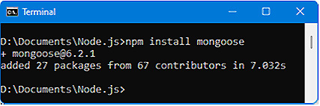
Figure 8.1 – Installing the mongoose module
Once mongoose has been downloaded by npm, we check whether it is accessible for our programs. Let’s display the mongoose version for our programs. We write this snippet in the file test.js:
Displaying mongoose version (test.js file)
var mongoose = require("mongoose");
console.log("mongoose version =", mongoose.version);
Let’s use the node test.js command to run the previous program:
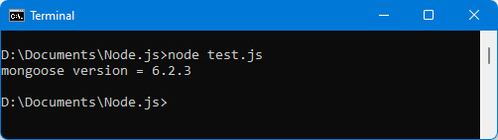
Figure 8.2 – Checking that mongoose is accessible
Warning
If you get an error loading the mongoose module, it’s probably because you installed it globally (with the -g option). In this case, just type the npm link mongoose command in the terminal to get rid of the error.
The mongoose module will allow us to use the MongoDB database to create documents, search them, update them, or destroy them. These are the classic operations that can be performed on a database.
But to be able to perform these operations, it is necessary to first connect to the database.

Connecting to the MongoDB database
All operations to access MongoDB require establishing a connection with it. Now let’s see how to establish a connection with MongoDB.
The mongoose.connect(url) instruction connects the mongoose module to the database specified in the url parameter. The url parameter is of the form "mongodb://localhost/mydb_test" to connect to the mydb_test database on the localhost server.
The database will actually be created (and visible with the execution of the show dbs command of the mongo utility) when the first document is inserted into it:
Connecting to the mydb_test database (test.js file)
var mongoose = require("mongoose");
mongoose.connect("mongodb://localhost/mydb_test");
console.log("Connecting to mydb_test database in progress...");
Let’s run the previous program:
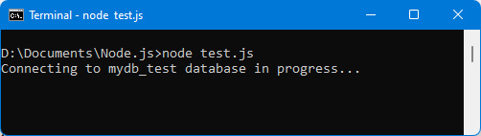
Figure 8.3 – Database connection
To know whether the connection to the database has actually been made, mongoose sends the open event (if the connection was successful) or the error event (if the connection fails) on the mongoose.connection object.
Next, we will take these two events into account and integrate them into the previous program. This is done using the on(event, callback) method defined on the mongoose.connection object:
Note
The on(event, callback) method is used to process the reception of the event and to associate it with the processing described in the callback function.
Using open and error events on database connection (test.js file)
var mongoose = require("mongoose");
mongoose.connect("mongodb://localhost/mydb_test");
mongoose.connection.on("error", function() {
console.log("mydb_test database connection error")
});
mongoose.connection.on("open", function() {
console.log("Successful connection to mydb_test
database");
});
console.log("Connecting to mydb_test database in progress...");
Let’s run the previous program:
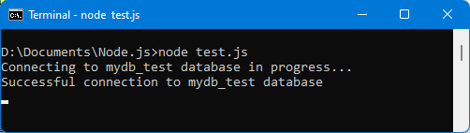
Figure 8.4 – Successful connection to the database
We have seen how to connect to the database. We will therefore be able to create documents in a collection of the database.

Creating documents in MongoDB
Once the database has been accessed, you can create documents in it.
A document will be inserted into a collection. A collection will therefore group together a set of documents. The database will therefore be a set of collections, each containing documents.
In order to be able to insert documents, mongoose asks us to describe the structure of these documents. For this, we will use schemas and models.

Describing document structure using schemas and models
To access the documents in the database, the documents must be described by means of schemas and models.
Definitions
A schema allows you to define the structure of a document that is stored in a collection. The structure is defined according to MongoDB data types.
A model is the representation of a schema as a JavaScript class. It links a schema to a MongoDB collection.
Let’s look at how to create a schema and then a model.
Creating a schema
A schema defines the fields of a document using Node.js internal object classes. These are the following classes:
String: This defines a string of characters.
Number: This defines a numeric field.
Boolean: This defines a Boolean.
Array: This defines an array.
Buffer: This defines a buffer of bytes.
Date: This defines a date.
Object: This defines a JavaScript object.
The mongoose.Schema(format) method is used to define the schema associated with the document. The format parameter is a JavaScript object that associates each field in the document with the type (in the above list) that represents it.
Let’s create the schema defining a client. A client is characterized by its lastname, firstname, and address. All these fields are of type String:
Defining the schema associated with a client (test.js file)
var mongoose = require("mongoose");
mongoose.connect("mongodb://localhost/mydb_test");
var clientSchema = mongoose.Schema({
lastname : String,
firstname : String,
address : String
});
Now let’s explain how to create a model from the schema.
Creating a model
The schema is then used to define the model associated with the document. The model corresponds to a JavaScript class that will be used to create the documents in a collection.
The mongoose.model(collection, schema) method returns a JavaScript class associated with the schema. This class is called a model.
Documents created with this class will be inserted into the specified collection. The collection may not exist before inserting a document. A collection requires at least one document within it.
Summary
A schema specifies the format of a document stored in a collection, while a model is a JavaScript class used to create each such document. We associate a document schema with a collection using the mongoose.model(collection, schema) method call. This returns a JavaScript class that can then be used to generate individual document instances.
Let’s create the Client class, which will create the clients that will be stored in the clients collection. It is traditional to name the collection based on the name of the model, in lowercase and in plural:
Creating the Client model from the schema (test.js file)
var mongoose = require("mongoose");
mongoose.connect("mongodb://localhost/mydb_test");
var clientSchema = mongoose.Schema({
lastname : String,
firstname : String,
address : String
});
// creation of the Client class associated with the clients
// collection
var Client = mongoose.model("clients", clientSchema);
The Client class is now available to create the documents that will be inserted into the clients collection.

Creating the document
There are two methods for creating the documents in a collection. These are the doc.save(callback) instance method and the create(doc, callback) class method. Let’s look at these two ways to create documents in a collection.
Let’s start by using the doc.save(callback) instance method.
Using the doc.save(callback) instance method
The client document is created in memory from the previously created class (by means of var client = new Client()), then saved in the clients collection by means of the client.save() method.
The callback function allows processing when the document has finished being inserted into the collection. This is especially useful if it is necessary to wait for the document to be inserted into the database before continuing processing:
Using the save() instance method to save document (test.js file)
var mongoose = require("mongoose");
mongoose.connect("mongodb://localhost/mydb_test");
var clientSchema = mongoose.Schema({
lastname : String,
firstname : String,
address : String
});
// creation of the Client class associated with the clients
// collection
var Client = mongoose.model("clients", clientSchema);
// create the document in memory
var c = new Client({lastname :"Clinton", firstname:"Bill", address:"Washington"});
console.log("Before the save() statement");
// save the document in the database (clients collection)
c.save(function(err) {
if (!err) console.log("The client is inserted into the
collection");
});
console.log("After the save() statement");
The callback function takes the err parameter, which corresponds to a possible error message (otherwise, it is null).
We get the following result:
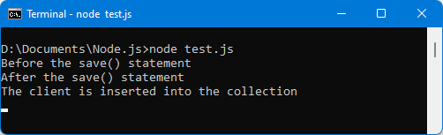
Figure 8.5 – Using the doc.save() instance method
Using the traces displayed in the console, we can see that the message The client is inserted into the collection is displayed after the other messages, which means that inserting a document is not blocking other tasks (i.e., other tasks can be done while waiting for insertion in the database).
The save() method can also be used as a Promise object (see Chapter 2, Exploring the Advanced Concepts of JavaScript). For this, we use the then(callback) method afterward, possibly followed by the catch(callback) method to process the cases of error when calling the save() method.
In this case, we write the following:
Using the save() method as a Promise objet
c.save().then(function(doc) {
console.log(doc);
console.log("The client is inserted into the collection");
}).catch(function(err) {
console.log(err); // display the error
});
Now let’s see the other method of creating a document with the create(doc, callback) class method.
Using the create(doc, callback) class method
A class method means that we can use the method without having instantiated an object, unlike an instance method, which requires that the object of the class be created (with c = new Client()).
To create the document associated with the client identified by {lastname:"Obama", firstname:"Barack", address:"Washington"}, we would write the following:
Using the Client.create(doc, callback) class method to save document (test.js file)
var mongoose = require("mongoose");
mongoose.connect("mongodb://localhost/mydb_test");
var clientSchema = mongoose.Schema({
lastname : String,
firstname : String,
address : String
});
// creation of the Client class associated with the clients
// collection
var Client = mongoose.model("clients", clientSchema);
console.log("Before the create() statement");
// save the document in the database (clients collection)
Client.create({lastname:"Obama", firstname:"Barack", address:"Washington"}, function(err, doc) {
console.log("The client is inserted into the collection",
doc);
});
console.log("After the create() statement");
The create(doc, callback) class method is used by prefixing it with the name of the JavaScript class (here, the Client class).
The document to be saved is written in the form of a JavaScript object (JSON format) but can also be an object instantiated with c = new Client().
The callback function of the form callback(err, doc) is executed at the end of saving the document in the database. This callback function is useful if you want to perform a process while being certain that the document has been saved in the collection.
Note
Note that the callback function callback(err, doc) of the create(doc, callback) method has the two parameters err and doc, which are the possible error and the document saved in the database, respectively.
Let’s run the previous program:
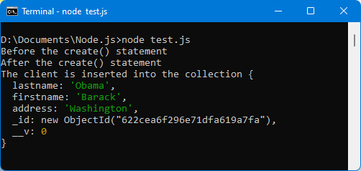
Figure 8.6 – Using the Client.create() class method
The saved document has the fields indicated in the format associated with the model (here, the lastname, firstname, and address fields), but also the _id and __v fields, added automatically by MongoDB:
The _id field is a field used by MongoDB to give a unique identifier to each document in a collection. It plays the role of a primary key.
The __v field is a field added by mongoose, associated with the document version number. We will not use it here.
As with the save() instance method, the create(doc) class method can be used as a Promise object. For this, we do not use the callback parameter in the create(doc) method and instead use the then(callback) and catch(callback) methods following the create(doc) method call.
For example, we could also write the following:
Using create() method as a Promise object
Client.create({lastname:"Obama", firstname:"Barack", address:"Washington"}).then(function(doc) {
console.log("The client is inserted into the collection",
doc);
});
In the previous examples, we have inserted two documents into the clients collection. Let’s use the mongo utility to display the inserted documents and verify the documents that are present in the collection.
Using the mongo utility to view inserted documents
To display the inserted documents, use the mongo utility and type the following commands:
db=connect("mydb_test") to connect to the database
show collections to show the collections already present
db.clients.find() to display documents from the clients collection
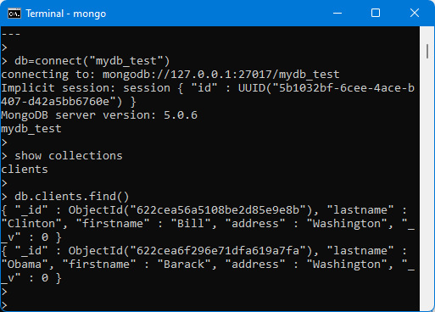
Figure 8.7 – Using the mongo utility to view documents
We thus check that the two documents of the clients collection are indeed present.
Let’s see how to search for them with mongoose module methods.

Searching for documents in MongoDB
Once the documents have been inserted into the collection, they can be searched for using the find() class method.
Note
The find() method is a class method, which means that it is used by prefixing it with the class name associated with the model, for example, Client.find().
The find(conditions, callback) method is used to perform a search in the collection associated with the model, then to retrieve the results of the search in the callback function indicated as a parameter.
Let’s take an in-depth look at the parameters:
The conditions parameter is a JavaScript object used to specify search conditions. If no condition is specified, do not indicate anything (or indicate an empty object {}).
The callback function is of the form callback(err, results) where err is an error message (null otherwise) and results is an array containing the search results (empty [] if none).
There is also the findOne(conditions, callback) class method, which allows you, on the same principle, to find only the first document that satisfies the search. The callback function is of the form callback(err, result) where result is the first document found.
Note
The findOne(conditions, callback) method will be useful if you are looking for a single document, for example, from its identifier _id.
You can also use the find(conditions) and findOne(conditions) methods without specifying the callback function as a parameter. For this, we use the then(callback) and catch(callback) methods to perform the processing on the documents found or in the event of an error. We can also use the exec(callback) method, as explained in the following section.
Let us now examine how to write the conditions parameter used in the two methods find() and findOne().

Writing search conditions
In the conditions parameter, we indicate an object whose properties are the fields of the documents in the collection, and the associated values are the values sought for the field, of the form {field1:value1, field2:value2...}, for example, {lastname:"Clinton", firstname:"Bill"}.
Other properties can be used as keywords to express conditions. They start with the $ sign, such as: $or, $exists, $type, $where, $gt, and $lt.
Note
A list of possible keywords can be found here: https://docs.mongodb.com/manual/reference/operator/query/.
Here are some examples of conditions:
{ }: All documents in the collection. You can also write find(), which is equivalent to find({}).
{ lastname: "Clinton" }: All documents whose lastname is Clinton.
{ lastname: "Clinton", firstname: "Bill" }: All documents whose lastname is Clinton and first name is Bill.
{ $or: [{ lastname: "Clinton"}, { firstname: "Jimmy" }] }: All documents whose lastname is Clinton or first name is Jimmy.
{ lastname: /obama/i }: All documents whose lastname contains the string obama regardless of case (regular expression).
{ address: { $exists: true} }: All documents whose address field exists, regardless of its type (String, Object, etc.).
{ address: { $exists: true, $type: 2 } }: All documents whose address field exists, and which is of type 2 (String).
{"address.city": "Washington" }: All documents containing the address field that itself has a city field whose value is Washington.
{lastname:{$type:2}, $where:"this.lastname.match(/^Clinton|carter$/i)"}: All documents whose lastname is a string (type = 2) and whose lastname begins with Clinton or ends with carter, regardless of case. You must indicate that the lastname is a character string, otherwise you may have an error with names that are not in this form.
{lastname: { $gt: "J", $lt: "S" }}: All documents whose lastname is greater than "J" and less than "S".
{lastname: { $in:["Clinton", "Carter", "Obama"] }} : All documents whose lastname is Clinton, Carter, or Obama.
Once the search conditions have been expressed, the results found must be retrieved and displayed. Let’s see how to do it.

Retrieving and displaying the results
Whatever the condition expressed, the corresponding results can be retrieved in the callback function associated with the find() method, of the form callback(err, results). We will also see that it is possible to use the exec(callback) method to retrieve the results.
Let’s look at these two ways to retrieve search results.
Using the callback parameter of the find(conditions, callback) method
Let’s find all clients whose lastname is Clinton or firstname is Barack. The result will be displayed in the callback function:
Displaying clients whose lastname is “Clinton” or firstname is “Barack” (test.js file)
var mongoose = require("mongoose");
mongoose.connect("mongodb://localhost/mydb_test");
var clientSchema = mongoose.Schema({
lastname : String,
firstname : String,
address : String
});
// creation of the Client class associated with the clients
// collection
var Client = mongoose.model("clients", clientSchema);
Client.find({ $or : [ { lastname : "Clinton" }, { firstname : "Barack"} ] }, function(err, clients) {
console.log(clients);
});
We obtain the result shown in the following figure:
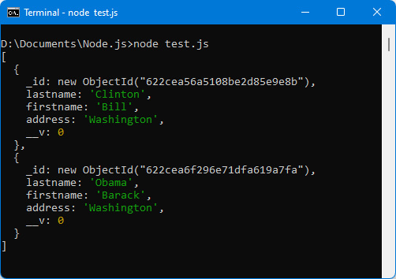
Figure 8.8 – Displaying search results with find(conditions, callback)
The callback function can be expressed in the find() method as before, or be specified in the exec() method used after the find() method. Let us now examine this second possibility.
Using the exec(callback) method
Another way to retrieve results is to use the exec(callback) method following the find(conditions) method. The find(conditions) method is used here without indicating a callback function in its parameters because the callback function is indicated in the exec(callback) method.
The advantage of this is that we can insert new methods between the find() method and the exec() method. For example, if we want to add as additional conditions that the lastname field must be equal to Clinton, we can write the following:
Adding as search conditions that lastname is “Clinton” (test.js file)
var mongoose = require("mongoose");
mongoose.connect("mongodb://localhost/mydb_test");
var clientSchema = mongoose.Schema({
lastname : String,
firstname : String,
address : String
});
// creation of the Client class associated with the clients
// collection
var Client = mongoose.model("clients", clientSchema);
Client.find({ $or : [ { lastname : "Clinton" }, { firstname : "Barack"} ] })
.where("lastname")
.eq("Clinton")
.exec(function(err, clients) {
console.log(clients);
});
Note
Methods such as where(field) and eq(value) can be chained after the find() method. The execution of the search will be effective when calling the exec() method. Other usage possibilities are described here: https://mongoosejs.com/docs/api/query.html#query_Query-where.
You can also use the exec(callback) method without specifying the callback function as a parameter. For this, we use the then(callback) and catch(callback) methods to perform the processing on the documents found or in the event of an error.
We write the following for this:
Using exec() method as a Promise object
Client.find({ $or : [ { lastname : "Clinton" }, { firstname : "Barack"} ] })
.where("lastname")
.eq("Clinton")
.exec()
.then(function(clients) {
console.log(clients); // display the clients
})
.catch(function(err) {
console.log(err); // display the error
});
The result is displayed in the following figure.
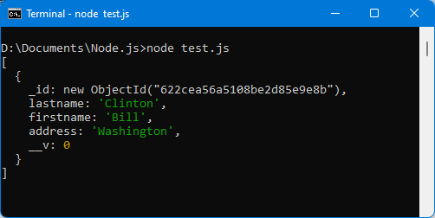
Figure 8.9 – Using the exec(callback) method
We’ve learned how to create documents, then search for them. Now let’s look at how to update them.

Updating documents in MongoDB
It is possible to modify one or more documents of a collection. The updateOne() and updateMany() class methods are used respectively to modify the first document found or all of the documents found.
These two methods have similar parameters:
updateMany(conditions, update, callback) indicates modifying the data indicated in the update object on the documents specified by the indicated conditions. The callback function of the form callback(err, response) is called after the update.
updateOne(conditions, update, callback) indicates modifying the data indicated in the update object on the first document found by the indicated conditions. The callback function of the form callback(err, response) is called after the update.
Only the conditions and update parameters are mandatory in the two methods.
Warning
If the callback is not present in the method, you must use the then() or exec() method afterward, otherwise the update is not done.
Let’s modify the address of Clinton, which will now be New York:
Using updateOne() to modify the address of “Clinton” (test.js file)
var mongoose = require("mongoose");
mongoose.connect("mongodb://localhost/mydb_test");
var clientSchema = mongoose.Schema({
lastname : String,
firstname : String,
address : String
});
// creation of the Client class associated with the clients
// collection
var Client = mongoose.model("clients", clientSchema);
Client.updateOne({ lastname : "Clinton" }, { address : "New York" }, function(err, response) {
console.log("response =", response);
});
Here, we use the callback function to display the content of the response parameter returned by the function. We get the following result:
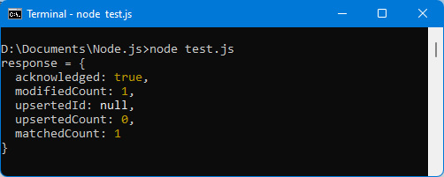
Figure 8.10 – Updating a document
Note
The response.modifiedCount field indicates the number of modified documents.
If you do not want to perform any processing at the end of the update, you can omit the callback function, but in this case, you must use the then() or exec() method afterward, otherwise, the update will not take place.
Let’s use the exec() method to perform the update:
Performing update using exec() method (test.js file)
var mongoose = require("mongoose");
mongoose.connect("mongodb://localhost/mydb_test");
var clientSchema = mongoose.Schema({
lastname : String,
firstname : String,
address : String
});
// creation of the Client class associated with the clients
// collection
var Client = mongoose.model("clients", clientSchema);
Client.updateOne({ lastname : "Clinton" },
{ address : "New York" })
.exec(); // exec() mandatory!
Once you know how to create, search for, and then modify documents, you just have to know how to delete them. Let’s look at how to do it.

Deleting documents in MongoDB
Similar to updateOne() and updateMany(), there are the two class methods, namely deleteOne(conditions, callback) and deleteMany(conditions, callback) that allow you to delete the first document (deleteOne()) or all the documents (deleteMany()) that satisfy the conditions expressed.
In addition, the instance method doc.remove(callback) also makes it possible to delete the doc document when it is in memory.
Let’s remove Clinton from the collection by using the deleteOne() method, then display the new contents of the collection:
Using deleteOne() to delete client “Clinton” (test.js file)
var mongoose = require("mongoose");
mongoose.connect("mongodb://localhost/mydb_test");
var clientSchema = mongoose.Schema({
lastname : String,
firstname : String,
address : String
});
// creation of the Client class associated with the clients
// collection
var Client = mongoose.model("clients", clientSchema);
Client.deleteOne({ lastname : "Clinton" }, function(err, response) {
console.log("After Clinton's removal");
console.log("response = ", response);
Client.find(function(err, clients) {
console.log("clients = ", clients);
});
});
In the same way as for the updateOne() and updateMany() methods, it is the presence of the callback function that triggers the update of the database. If you do not indicate a callback function, you must in this case use the then() or exec() method following the deleteOne() or deleteMany() method.
The result is displayed in the following figure:
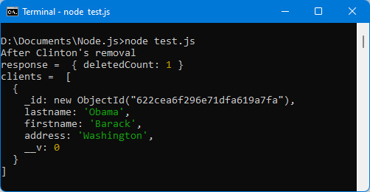
Figure 8.11 – Deleting the “Clinton” client with deleteOne()
The response object returned in the callback of the deleteOne() (or deleteMany()) method indicates the deletedCount field, which contains the number of documents deleted.
We have successively studied the four possible operations on documents in a MongoDB database, namely inserting, searching, modifying, and deleting documents. And with this, we come to the end of this chapter.

Summary
Data management with MongoDB is relatively easy, thanks to the use of external modules such as mongoose. All possible actions on a database are easily achievable.
The mongo utility, available when installing MongoDB, makes it easy to view collections and the documents they contain.
Using the MongoDB database is essential for building client-server applications and maintaining user information.
All that’s left is to see how to interconnect a client side made with Vue.js and a server side made with Node.js. We will see this in the following chapter. We will build a 100% JavaScript application in order to show how simple and efficient it is.

Chapter 9: Integrating Vue.js with Node.js
In this chapter, we will learn how to integrate a Vue.js application into a Node.js server, using Express to structure the server code (according to the MVC model) and MongoDB to store the information.
For this, we will use the example of the list management application built in Chapter 5, Managing a List with Vue.js. But here, the server used will be a Node.js server, and the list items will be stored in the MongoDB database. This will allow them to be redisplayed later, if necessary.
In the end, we will obtain a client-server application entirely made in JavaScript (both on the client side and on the server side).
Here are the topics covered in this chapter:
Displaying application screens
Building the app with Express
MongoDB database structure
Installing the Axios library
Inserting a new element in the list
Displaying list elements
Modifying an element in the list
Removing an element from the list
The application uses the same screens as those already used in Chapter 5, Managing a List with Vue.js. We repeat them below to make them easier for you to understand.

Technical requirements
You can find the code files for this chapter on GitHub at: https://github.com/PacktPublishing/JavaScript-from-Frontend-to-Backend/blob/main/Chapter%209.zip.

Displaying application screens
Here, we visualize the screens of the application, allowing the following:
Displaying the already existing list (empty at first)
Inserting a new element at the end of the list
Modifying an element of the list
Removing an item from the list
Note
The URL to access the list is http://localhost:3000. The server used here is a Node.js server running with the Express module. The database used is MongoDB.
Initially, the list is empty. Only the Add Element button is present on the page (see the following figure):
Figure 9.1 – Empty item list
Clicking the Add Element button multiple times creates multiple rows with the text Element X followed by Remove and Modify buttons (here, we clicked on the Add Element button three times):
Figure 9.2 – Adding three items to the list
Next, let’s modify the second element. An input field appears in place of the item text. Let’s type New Element 2 in place of the text displayed in the input field:
Figure 9.3 – Editing the second item in the list
By clicking outside the input field, the input field disappears, and the text of the element appears modified:
Figure 9.4 – Second list item changed
Finally, let’s remove the first and third items from the list:
Figure 9.5 – First and third list items removed
Now, when we refresh the previous window, we see that the list is re-displayed with New Element 2, thus indicating that the modifications made are indeed stored in a database. This was not the case when we made this application in Chapter 5, Managing a List with Vue.js, with only Vue.js, because the elements of the list were not saved in a database:
Figure 9.6 – New list display: the list is preserved
To create this application, we will, of course, use the Vue.js program that we have already written in Chapter 5, Managing a List with Vue.js. But it will have to be modified so that this application works on a Node.js server with the Express module and that the data displayed is stored in the MongoDB database.
We’ll indicate here the files of the <GlobalApp> and <Element> components, written previously, in Chapter 5, Managing a List with Vue.js, to explain the modifications that will be made to them hereafter.
Here’s the <GlobalApp> component:
<GlobalApp> component (global-app.js file)
import Element from "./element.js";
const GlobalApp = {
data() {
return {
elements : []
}
},
components : {
Element:Element
},
template : `
<button @click="add()">Add Element</button>
<ul>
<Element v-for="(element, index) in elements"
:key="index"
:text="element" :index="index"
@remove="remove($event)" @modify="modify($event)"
/>
</ul>
`,
methods : {
add() {
var element = "Element " + (this.elements.length + 1);
this.elements.push(element);
},
remove(params) {
var index = params.index;
this.elements.splice(index, 1);
},
modify(params) {
var index = params.index;
var value = params.value;
this.elements[index] = value;
}
}
}
export default GlobalApp;
Here’s the <Element> component:
<Element> component (element.js file)
const Element = {
data() {
return {
input : false
}
},
template : `
<li>
<span v-if="!input"> {{text}} </span>
<input v-else type="text" :value="text"
@blur="modify($event)" ref="refInput" />
<button @click="remove()"> Remove </button>
<button @click="input=true"> Modify </button>
</li>
`,
props : ["text", "index"],
methods : {
remove() {
// process the click on the Remove button
this.$emit("remove", { index : this.index });
},
modify(event) {
var value = event.target.value;
this.input = false;
this.$emit("modify", { index : this.index, value :
value });
}
},
emits : ["remove", "modify"],
updated() {
// check that refInput exists, and if so, give focus to
// the input field
if (this.$refs.refInput) this.$refs.refInput.focus();
}
}
export default Element;
The index.html file that allows you to include the <GlobalApp> component is the following:
index.html file
<html>
<head>
<meta charset="utf-8" />
<script src="https://unpkg.com/vue@next"></script>
<style type="text/css">
li {
margin-top:10px;
}
ul button {
margin-left:10px;
}
</style>
</head>
<body>
<div id="app"></div>
</body>
<script type="module">
import GlobalApp from "./global-app.js";
var app = Vue.createApp({
components : {
GlobalApp:GlobalApp
},
template : "<GlobalApp />"
});
var vm = app.mount("div#app");
</script>
</html>
To create this application, we start by creating the Node.js application, which will host the JavaScript code written with Vue.js. To do this, the application is created using the express command. The application will be named list (for example), so we will have to type the express list command to create this application, as is explained in the following section.

Building the app with Express
Let’s start by creating the application with Express. To do this, type the express list command, which creates the application named list. This application will be accessible using the URL http://localhost:3000, as seen in Chapter 7, Using Express with Node.js.
Let’s type the express list command in the current directory:
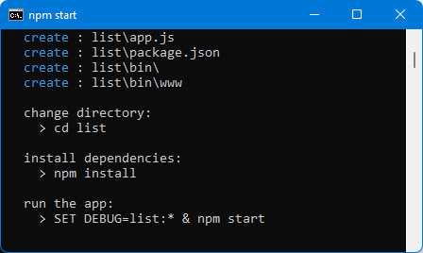
Figure 9.7 – Creating the application list with Express
The server is started by typing the indicated commands, namely: cd list, npm install, followed by npm start.
The application is started by typing the URL http://localhost:3000 in the browser.
We display the basic application created as standard by Express (see Figure 9.8).
If an error occurs while loading the Express modules, you can type the npm link express command in order to locate the Express module within the application. And if an error occurs while loading the mongoose module, you can type the npm link mongoose command.
If all is okay, you obtain the following:
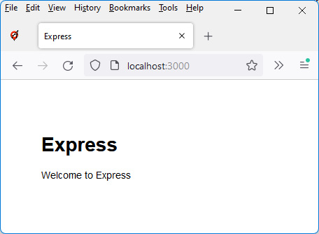
Figure 9.8 – Standard application created with Express
The goal now is to visualize our list management application, created with Vue.js. It consists of three files:
The index.html file, which is the file to view at startup
The global-app.js file, which describes the main <GlobalApp> component of the application
The element.js file, which describes the <Element> component corresponding to a displayed element line
The main directory of the Express application (the list directory) includes a public subdirectory containing the images, javascripts, and stylesheets subdirectories.
Let’s drop the three files index.html, global-app.js, and element.js in the public directory, directly under the root.
Note
Modifying files in the public directory does not require a server restart. On the other hand, modifying the app.js file of the Express application requires restarting the server with npm start.
Let’s view the URL http://localhost:3000 again in the browser. The Vue.js application we built in Chapter 5, Managing a List with Vue.js, will now appear. Button clicks will also start working.
The only difference is that our Vue.js application runs on a Node.js server instead of running on another application server like in Chapter 5, Managing a List with Vue.js.
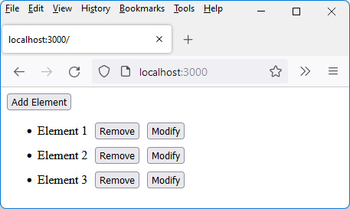
Figure 9.9 – Application running on a Node.js server
However, if the page displayed is refreshed, the list previously displayed is deleted because there is currently no persistence of the information displayed in the database.
We will now see how our application can interact with the Node.js server and the MongoDB database.

MongoDB database structure
To build our application, we will have to perform data reads and updates on the server in the database. For example, each click on the Add Element button should insert a new line into the displayed HTML page but should also insert a new document into MongoDB’s elements collection. Indeed, each document of the elements collection will represent the text of the element displayed in the list on the screen.
Note
To access the MongoDB database, you start by installing the mongoose module (see the previous chapter), which allows you to manipulate database documents in JavaScript.
To do this, type the npm install mongoose command (from the main directory, list, of the Express application).
The elements collection will be the one that will store the list items in MongoDB. A document in the elements collection will consist of its text associated with the text property. Each document will also have the _id property, whose unique value is assigned by MongoDB for each document inserted into the collection.
Note
The structure of the database is described using the listSchema schema, which will be associated with the List model used to create the documents of the elements collection.
Express’s app.js file is modified to include these definitions:
Adding List model to use MongoDB’s elements collection (app.js file)
var createError = require('http-errors');
var express = require('express');
var path = require('path');
var cookieParser = require('cookie-parser');
var logger = require('morgan');
var indexRouter = require('./routes/index');
var usersRouter = require('./routes/users');
var mongoose = require("mongoose");
mongoose.connect("mongodb://localhost/mydb_test"); // we
// connect
// to
// mydb_test
var listSchema = mongoose.Schema({
text : String // text associated with the list item
});
// association of the List model with the elements collection
var List = mongoose.model("elements", listSchema);
var app = express();
// view engine setup
app.set('views', path.join(__dirname, 'views'));
app.set('view engine', 'jade');
app.use(logger('dev'));
app.use(express.json());
app.use(express.urlencoded({ extended: false }));
app.use(cookieParser());
app.use(express.static(path.join(__dirname, 'public')));
app.use('/', indexRouter);
app.use('/users', usersRouter);
// catch 404 and forward to error handler
app.use(function(req, res, next) {
next(createError(404));
});
// error handler
app.use(function(err, req, res, next) {
// set locals, only providing error in development
res.locals.message = err.message;
res.locals.error = req.app.get('env') === 'development' ?
err : {};
// render the error page
res.status(err.status || 500);
res.render('error');
});
module.exports = app;
The app.js file will then be enriched to define the new routes that will update the database. These routes will be created by using the app.use() method (as explained in Chapter 7, Using Express with Node.js). The creation of these routes will be described in the following sections.
Note
Thanks to the List model that we have created, we will have access to the methods List.create(), List.find(), and so on for manipulating documents in the elements collection of the MongoDB database.
To create interactions between the client (here, the browser) and the server (here, the Node.js server) in order to update the database containing the list of elements, we use the Axios JavaScript library here.

Installing the Axios library
We see that, for now, we can manipulate the list items displayed on the HTML page, but we cannot yet update them in the database on the server.
For this, the Vue.js program must be able to communicate with the Node.js server. This is possible using a JavaScript library such as Axios (see https://github.com/axios/axios). All you have to do is include the library in the HTML page (here, it will be in the index.html file) in order to be able to use its features.
Note
The Axios library is a library allowing communication between a browser and a server using Ajax technology. This technology allows a browser and a server to exchange information while remaining on the same HTML page, which is what we want here. This is called a single-page application (SPA) (when the application consists of a single HTML page).
Let’s include the Axios library in the index.html file (using the <script> tag), and display the value of the axios.VERSION variable, which contains the version number of the library. This verifies that the Axios library is accessible:
Including Axios library and displaying version number (index.html file)
<html>
<head>
<meta charset="utf-8" />
<script src="https://unpkg.com/vue@next"></script>
<script src="https://unpkg.com/axios/dist/
axios.min.js"></script>
<style type="text/css">
li {
margin-top:10px;
}
ul button {
margin-left:10px;
}
</style>
</head>
<body>
<div id="app"></div>
</body>
<script type="module">
console.log("axios.VERSION = " + axios.VERSION);
// display Axios version number
import GlobalApp from "./global-app.js";
var app = Vue.createApp({
components : {
GlobalApp:GlobalApp
},
template : "<GlobalApp />"
});
var vm = app.mount("div#app");
</script>
</html>
We simply added in the index.html file the Axios library (using the <script> tag) and the instruction to display the version number of the Axios library in the console, which allows us to check that the Axios library is accessible afterward.
Let’s display the page again in the browser (with the URL http://localhost:3000).
We get a message in the console indicating the version number of Axios used (see the following figure), thus showing that we have access to the functionalities of the Axios library:
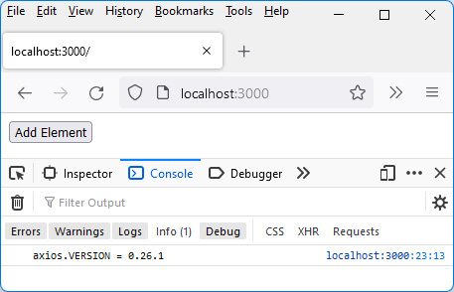
Figure 9.10 – Displaying the Axios version number
Now let’s see how to use Axios to interact with the server and update the database documents.
The goal is, of course, to make maximum use of the Vue.js code that we have already written by modifying it to use the Axios library and thus perform communication with the Node.js server.
Subsequently, we will therefore modify the following files (in addition to the index.html file previously modified to include the Axios library):
The global-app.js file, to make calls to the Axios library
The element.js file, to adapt it to the structure of the database
The app.js file (created by Express), to perform database queries
We have seen how to install and use Axios in our program. Now let’s see how to use it to insert an element into the database.

Inserting a new element in the list
Let’s see how to store a new element in the list, following a click on the Add Element button.
The text associated with this element must be transmitted to the server, which will be of the form Element X. We will see later how to modify this text after clicking on the Modify button.
The add() method defined in the <GlobalApp> component is used to insert a new element into the displayed list. It will be necessary to add instructions that use the Axios library in order to also insert this new element in the MongoDB elements collection.
Before starting to use Axios, it is useful to slightly modify the JavaScript program written with Vue.js. To do this, we will use a new attribute when creating the <Element> component, replacing the text and index attributes with the element attribute.

Replacing the text and index attributes with the element attribute
When creating an element, we currently use the element’s text and index, which are then used in the <Element> component, to display it (with its text) or to modify or delete it (with its index).
The use of the index to identify the element in the list displayed on the screen was relevant before, but this is no longer the case if we want to modify or delete the element in the database. This is because the documents of a MongoDB collection are not identified by their index but rather by their identifier _id.
Rather than passing the text and index parameters in the <Element> component, we simplify by passing only the element parameter, which is a { text, _id } object. The element.text field allows you to retrieve the text to be displayed, while the element._id field allows you to access the unique identifier of the element (such as the index, which was unique for each element).
We modify the global-app.js and element.js files to take this into account.
These files are modified below but will be modified again to take into account the connection with the database:
global-app.js file
import Element from "./element.js";
const GlobalApp = {
data() {
return {
elements : [] // array of object { text, _id }
// (_id = document id in MongoDB)
}
},
components : {
Element:Element
},
template : `
<button @click="add()">Add Element</button>
<ul>
<Element v-for="(element, index) in elements"
:key="index" :element="element"
@remove="remove($event)" @modify="modify($event)"
/>
</ul>
`,
methods : {
add() {
var text = "Element " + (this.elements.length + 1);
this.elements.push({text:text,
_id:this.elements.length});
// to modify to retrieve the real
// _id provided by MongoDB
},
remove(params) {
var id = params.id;
// remove the element with this id from the elements
// array
this.elements = this.elements.filter(
function(element) {
if (element._id == id) return false;
else return true;
});
},
modify(params) {
var id = params.id;
var value = params.value;
// modify the text of the element with this id in the
// elements array
this.elements = this.elements.map(function(element) {
if (element._id == id) {
element.text = value;
return element;
}
else return element;
});
}
}
}
export default GlobalApp;
The following remarks can be made about the preceding code:
The reactive elements variable now becomes an array of { text, _id } objects. To do this, we write in the add() method the instruction this.elements.push({text:text, _id:this.elements.length}) by inserting an object of the form {text, _id} into the elements array.
The value of the _id property is temporary here: in fact, you must then retrieve the identifier provided by MongoDB when the document has been saved in the database.
Each <Element> component is constructed (in the template) by passing it an element attribute that represents a { text, _id } object.
The remove() method must remove from the list the element having the passed identifier. To do this, we use the JavaScript filter() method to keep all the elements except the one with this identifier.
Similarly, the modify() method must modify the value of the element of the list having this identifier. We use the JavaScript map() method to return a new array of elements, for which the element with this identifier has its value modified.
The element.js file becomes the following:
element.js file
const Element = {
data() {
return {
input : false
}
},
template : `
<li>
<span v-if="!input"> {{element.text}} </span>
<input v-else type="text" :value="element.text"
@blur="modify($event)"
ref="refInput" />
<button @click="remove()"> Remove </button>
<button @click="input=true"> Modify </button>
</li>
`,
props : ["element"],
methods : {
remove() {
// process the click on the Remove button
this.$emit("remove", { id : this.element._id });
},
modify(event) {
var value = event.target.value;
this.input = false;
this.$emit("modify", { id : this.element._id, value :
value });
}
},
emits : ["remove", "modify"],
updated() {
// check that refInput exists, and if so, give focus to
// the input field
if (this.$refs.refInput) this.$refs.refInput.focus();
}
}
export default Element;
As the attribute transmitted for the creation of the <Element> component is named element and corresponds to an object { text, _id }, we use element.text and element._id to display the text and use the identifier of the element (instead of the index).
You can check that the program still works, even if the connection with the server for insertion into the database has not yet been made.
Note
We have modified the code of the Vue.js program in order to adapt it to the use of the MongoDB database.
Let’s now explain how the Axios library will allow the client and the server to communicate with each other, in order to update the MongoDB database.

Description of the Axios library for communicating between the client and the server
Now let’s use Axios to insert the element into the database.
Axios offers four main methods for communicating between the browser and the server, with the JavaScript language. The server we are using here is a Node.js server, but Axios allows you to interact with any type of server. The four methods are those related to the types of HTTP requests one can make: GET, POST, PUT, and DELETE:
axios.get(url, options): This allows you to perform a GET type request.
axios.post(url, options): This allows you to perform a POST type request.
axios.put(url, options): This allows you to perform a PUT type request.
axios.delete(url, options): This allows you to perform a DELETE type request.
The options parameter allows you to specify additional parameters that will allow the server to perform its processing. For example, in the case of our application, we will indicate in this parameter the text of the list element that we want to store in the database.
Note
All these methods return a Promise object, which then allows you to continue with the then(callback) method. The callback(response) function is used to retrieve and analyze the server’s response following the request being made.
Promise objects were studied at the end of Chapter 2, Exploring the Advanced Concepts of JavaScript.
In each case, we will have to process the Axios request sent on the client side (in the global-app.js file associated with the <GlobalApp> component), then take it into account on the server side (in the app.js file, which receives the queries issued by Axios).
Now let’s see how the POST request will allow us to insert elements into the database.

Using Axios with a POST type request (client side)
Now let’s see how to use the axios.post() method to insert a new element into the elements collection, following the creation of a new element in the list.
Note
We are using the POST request here to insert the item, but other types of requests would work the same. However, using the POST request makes sense here because it follows the official recommendations for using REpresentational State Transfer (REST) requests.
Although only a few lines are added to each file, the full code is shown below each time, so you can see where the changes are located:
Adding a new element in the database, client side (global-app.js file)
import Element from "./element.js";
const GlobalApp = {
data() {
return {
elements : [] // array of object { text, _id }
// (_id = document id in MongoDB)
}
},
components : {
Element:Element
},
template : `
<button @click="add()">Add Element</button>
<ul>
<Element v-for="(element, index) in elements"
:key="index" :element="element"
@remove="remove($event)" @modify="modify($event)"
/>
</ul>
`,
methods : {
add() {
var text = "Element " + (this.elements.length + 1);
axios.post("/list", {text:text}) // pass object
// {text:text} to
// server
.then((response) => {
this.elements.push({text:text,
_id:response.data.id});
});
},
remove(params) {
var id = params.id;
// remove the element with this id from the elements
// array
this.elements = this.elements.filter(
function(element) {
if (element._id == id) return false;
else return true;
});
},
modify(params) {
var id = params.id;
var value = params.value;
// modify the text of the element with this id in the
// elements array
this.elements = this.elements.map(function(element) {
if (element._id == id) {
element.text = value;
return element;
}
else return element;
});
}
}
}
export default GlobalApp;
The axios.post("/list", {text:text}) method activates the /list URL on the server, using a POST type request. The text parameter is passed to the server so that it stores it in the elements collection.
In return for the call to the server, the latter returns a response object containing in data.id the identifier of the document created in MongoDB. This identifier and the element text are then stored in the elements array. Because the elements array is a reactive variable of Vue.js, its update causes the list to be re-displayed in the browser.
Note
Notice how the callback function is written in the then(callback) method. We use the form with => (that is without using the function keyword) in order to preserve the value of this in the callback function. If you use the function keyword instead, the value of this is undefined and you can no longer access the elements variable through this.elements, which will cause an error.
The POST request was issued by the client (the browser), so it must now be processed by the server to insert a new element into the collection. Let’s study how to proceed.

POST type request processing (server side)
Now let’s see how the server handles the receipt of the POST request. It must create a new document in the elements collection of the database. The server’s app.js file is modified to take into account the POST request on the /list URL:
Adding a new element in the database, server side (app.js file)
var createError = require('http-errors');
var express = require('express');
var path = require('path');
var cookieParser = require('cookie-parser');
var logger = require('morgan');
var indexRouter = require('./routes/index');
var usersRouter = require('./routes/users');
var mongoose = require("mongoose");
mongoose.connect("mongodb://localhost/mydb_test");
var listSchema = mongoose.Schema({
text : String
});
var List = mongoose.model("elements", listSchema);
var app = express();
// view engine setup
app.set('views', path.join(__dirname, 'views'));
app.set('view engine', 'jade');
app.use(logger('dev'));
app.use(express.json());
app.use(express.urlencoded({ extended: false }));
app.use(cookieParser());
app.use(express.static(path.join(__dirname, 'public')));
app.use('/', indexRouter);
app.use('/users', usersRouter);
// creating a new element in the list
app.post("/list", function(req, res) {
var text = req.body.text;
List.create({text:text}, function(err, doc) {
res.json({id:doc._id}); // send the MongoDB identifier
// in the response
});
});
// catch 404 and forward to error handler
app.use(function(req, res, next) {
next(createError(404));
});
// error handler
app.use(function(err, req, res, next) {
// set locals, only providing error in development
res.locals.message = err.message;
res.locals.error = req.app.get('env') === 'development' ?
err : {};
// render the error page
res.status(err.status || 500);
res.render('error');
});
module.exports = app;
The app.post("/list", callback) method is used to receive and process the request to insert the new element into the elements collection.
The text sent in the Axios text parameter is received on the server in the req.body.text variable. The update of the elements collection is performed by the List.create() class method, to which we pass the text parameter. In the callback function associated with the create() method, we retrieve the identifier of the document created in doc._id.
We return this identifier in the response sent to the browser as a JSON object { id : doc._id }. We use the res.json() method for this. This server return is processed in the then(callback) method when calling the axios.post() method previously seen (the global-app.js file).
If you run the preceding program, you’ll see that the lines containing Element X are inserted one under the other on the page. But nothing says that the database has been updated. Let’s verify the correct insertion using the tools available in MongoDB.

Verifying the correct operation of the insertion in the database
To verify the insertion in the database, just use the mongo utility, then type the command db.elements.find() to see the inserted documents displayed (assuming we have already connected the mydb_test database with the db=connect("mydb_test") command).
Assuming that three list items have been inserted, we get the following:
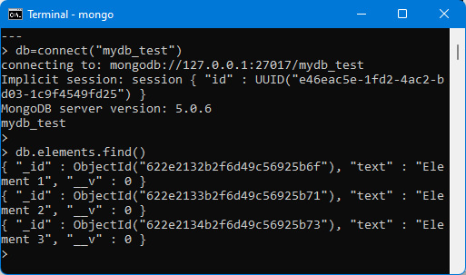
Figure 9.11 – Using the mongo utility to view the contents of the elements collection
The next step is to retrieve the information stored in the database to display the items in the list. The list should be viewed when the page is displayed at the start and will be updated as insertions, modifications, or deletions are made.

Displaying list elements
In this section, we deal with the first display of the page. Insertion has been seen previously, and modification and deletion are covered in the following sections.
Note
To display the list when the application starts, you must use the created() method or the mounted() method of the component, which are called in each Vue.js component when the component is created.
To retrieve the list of elements, we are going to use an HTTP GET request.

Using Axios with a GET type request (client side)
Here, we are going to make a GET type request with the /list URL to the server. The axios.get("/list") instruction is used to perform this request. We can use this instruction in the created() or mounted() method. Here, we choose to use it in the created() method:
Retrieving list of items, client side (global-app.js file)
import Element from "./element.js";
const GlobalApp = {
data() {
return {
elements : [] // array of object { text, _id }
// (_id = document id in MongoDB)
}
},
components : {
Element:Element
},
template : `
<button @click="add()">Add Element</button>
<ul>
<Element v-for="(element, index) in elements"
:key="index" :element="element"
@remove="remove($event)" @modify="modify($event)"
/>
</ul>
`,
methods : {
add() {
var text = "Element " + (this.elements.length + 1);
axios.post("/list", {text:text})
.then((response) => {
console.log(this.elements);
this.elements.push({text:text,
_id:response.data.id});
});
},
remove(params) {
var id = params.id;
// remove the element with this id from the elements
// array
this.elements = this.elements.filter(
function(element) {
if (element._id == id) return false;
else return true;
});
},
modify(params) {
var id = params.id;
var value = params.value;
// modify the text of the element with this id in the
// elements array
this.elements = this.elements.map(function(element) {
if (element._id == id) {
element.text = value;
return element;
}
else return element;
});
}
},
created() {
axios.get("/list")
.then((response) => {
this.elements = response.data.elements.map(
function(element) {
return {_id : element._id, text : element.text }
});
});
}
}
export default GlobalApp;
The axios.get("/list") method makes the request to the server, then processes the response received in the then(callback) method. As before, the received response object contains the data property, which contains the response returned by the server (the elements field – see below).
As the server sends all the document fields of the elements collection, we filter the list received by the map() method in order to keep only the _id and text fields (we thus remove the __v field associated with the version number, which is unnecessary here).
Now let’s see how to process the GET request on the Node.js server side.

GET type request processing (server side)
The GET /list request is received by the Node.js server through the app.get("/list") method defined in the app.js file. The processing will consist of reading the content of the elements collection and returning it in JSON form to the browser in the elements property. Each item in the returned collection has _id, text, and __v (for the version number of the document) fields:
Retrieving list of items, server side (app.js file)
var createError = require('http-errors');
var express = require('express');
var path = require('path');
var cookieParser = require('cookie-parser');
var logger = require('morgan');
var indexRouter = require('./routes/index');
var usersRouter = require('./routes/users');
var mongoose = require("mongoose");
mongoose.connect("mongodb://localhost/mydb_test");
var listSchema = mongoose.Schema({
text : String
});
var List = mongoose.model("elements", listSchema);
var app = express();
// view engine setup
app.set('views', path.join(__dirname, 'views'));
app.set('view engine', 'jade');
app.use(logger('dev'));
app.use(express.json());
app.use(express.urlencoded({ extended: false }));
app.use(cookieParser());
app.use(express.static(path.join(__dirname, 'public')));
app.use('/', indexRouter);
app.use('/users', usersRouter);
// creating a new element in the list
app.post("/list", function(req, res) {
var text = req.body.text;
console.log(text);
List.create({text:text}, function(err, doc) {
res.json({id:doc._id});
});
});
// retrieving list of elements
app.get("/list", function(req, res) {
List.find(function(err, elements) {
res.json({elements:elements});
});
});
// catch 404 and forward to error handler
app.use(function(req, res, next) {
next(createError(404));
});
// error handler
app.use(function(err, req, res, next) {
// set locals, only providing error in development
res.locals.message = err.message;
res.locals.error = req.app.get('env') === 'development' ?
err : {};
// render the error page
res.status(err.status || 500);
res.render('error');
});
module.exports = app;
The elements collection is read using the List.find() class method. We return the { elements : elements } object in response to the browser, the use of which we saw earlier.
The list of items is now displayed each time the application is started. Just restart the server with npm start, then re-display the URL of the page, http://localhost:3000.
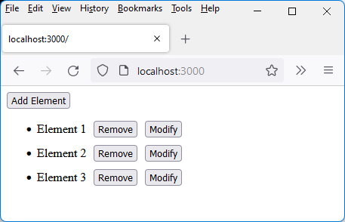
Figure 9.12 – The list of elements is displayed when the application starts
We have seen how to insert an element and retrieve the list of elements. Next, let’s see how to modify an element in the list.

Modifying an element in the list
Here we show how to modify an element of the list, keeping this modification in the database. A PUT type request will be used for this.

Using Axios with a PUT type request (client side)
The axios.put("/list", options) method is used to perform a PUT type request to the server. We transmit to the server in the options parameter the new text of the modified element and its identifier in the database. The identifier and the new text will allow the item to be updated on the server:
Modifying an element, client side (global-app.js file)
import Element from "./element.js";
const GlobalApp = {
data() {
return {
elements : [] // array of object { text, _id }
// (_id = document id in MongoDB)
}
},
components : {
Element:Element
},
template : `
<button @click="add()">Add Element</button>
<ul>
<Element v-for="(element, index) in elements"
:key="index" :element="element"
@remove="remove($event)" @modify="modify($event)"
/>
</ul>
`,
methods : {
add() {
var text = "Element " + (this.elements.length + 1);
axios.post("/list", {text:text})
.then((response) => {
console.log(this.elements);
this.elements.push({text:text,
_id:response.data.id});
});
},
remove(params) {
var id = params.id;
// remove the element with this id from the elements
// array
this.elements = this.elements.filter(
function(element) {
if (element._id == id) return false;
else return true;
});
},
modify(params) {
var id = params.id;
var value = params.value;
// modify the text of the element with this id in the
// elements array
this.elements = this.elements.map(function(element) {
if (element._id == id) {
element.text = value;
return element;
}
else return element;
});
// modify the text of the element having this
// identifier
axios.put("/list", {text:value, id:id});
}
},
created() {
axios.get("/list")
.then((response) => {
this.elements = response.data.elements.map(
function(element) {
return {_id : element._id, text : element.text }
});
});
}
}
export default GlobalApp;
The then(callback) method should not be used here because the server does not return any information for the browser.
Let’s now see the management of the PUT request on the server side.

PUT type request processing (server side)
The server processes the PUT /list request in the app.js file. The processing consists of carrying out an update of the document of the collection having this identifier, with the text received from the browser:
Modifying an element, server side (app.js file)
var createError = require('http-errors');
var express = require('express');
var path = require('path');
var cookieParser = require('cookie-parser');
var logger = require('morgan');
var indexRouter = require('./routes/index');
var usersRouter = require('./routes/users');
var mongoose = require("mongoose");
mongoose.connect("mongodb://localhost/mydb_test");
var listSchema = mongoose.Schema({
text : String
});
var List = mongoose.model("elements", listSchema);
var app = express();
// view engine setup
app.set('views', path.join(__dirname, 'views'));
app.set('view engine', 'jade');
app.use(logger('dev'));
app.use(express.json());
app.use(express.urlencoded({ extended: false }));
app.use(cookieParser());
app.use(express.static(path.join(__dirname, 'public')));
app.use('/', indexRouter);
app.use('/users', usersRouter);
// creating a new element in the list
app.post("/list", function(req, res) {
var text = req.body.text;
console.log(text);
List.create({text:text}, function(err, doc) {
res.json({id:doc._id});
});
});
// retrieving list of elements
app.get("/list", function(req, res) {
List.find(function(err, elements) {
res.json({elements:elements});
});
});
// modifying an element in the list
app.put("/list", function(req, res) {
var id = req.body.id;
var text = req.body.text;
List.updateOne({_id:id}, {text:text}).exec();
// don't forget exec()!
res.send(); // close the connection to the browser
});
// catch 404 and forward to error handler
app.use(function(req, res, next) {
next(createError(404));
});
// error handler
app.use(function(err, req, res, next) {
// set locals, only providing error in development
res.locals.message = err.message;
res.locals.error = req.app.get('env') === 'development' ?
err : {};
// render the error page
res.status(err.status || 500);
res.render('error');
});
module.exports = app;
The text and the identifier are retrieved from the server in the req.body.text and req.body.id variables. The document with this identifier is updated in the database with the new text. The List.updateOne() class method allows this document to be modified, but since it does not use a callback function afterward, the exec() method must be used afterward for the update to be carried out in the database.
Also notice the res.send() instruction at the end of the processing. It closes the connection between the browser and the server. If the connection is not closed, the browser waits for the server’s response, which would never come if the server sends nothing back to the browser.
Let’s finish by explaining how to remove an item from the list.

Removing an element from the list
Finally, we will learn how to remove an element from the list. A DELETE type request will be used for this.

Using Axios with a DELETE type request (client side)
The axios.delete("/list", options) method is used to trigger a DELETE type request on the server. The options parameter must indicate the identifier of the element to be deleted from the collection.
However, unlike the previous axios.get(), axios.put(), and axios.post() calls, the axios.delete("/list", options) call requires that the options parameter be written in the data property (thus written as { data : options }). If you don’t follow this convention, it won’t work.
Here are the instructions for performing a DELETE request with the Axios library:
Deleting an element, client side (global-app.js file)
import Element from "./element.js";
const GlobalApp = {
data() {
return {
elements : [] // array of object { text, _id }
// (_id = document id in MongoDB)
}
},
components : {
Element:Element
},
template : `
<button @click="add()">Add Element</button>
<ul>
<Element v-for="(element, index) in elements"
:key="index" :element="element"
@remove="remove($event)" @modify="modify($event)"
/>
</ul>
`,
methods : {
add() {
var text = "Element " + (this.elements.length + 1);
axios.post("/list", {text:text})
.then((response) => {
console.log(this.elements);
this.elements.push({text:text,
_id:response.data.id});
});
},
remove(params) {
var id = params.id;
// remove the element with this id from the elements
// array
this.elements = this.elements.filter(
function(element) {
if (element._id == id) return false;
else return true;
});
axios.delete("/list", { data : {id:id} });
// the options must be written in the data
// property
},
modify(params) {
var id = params.id;
var value = params.value;
// modify the text of the element with this id in the
// elements array
this.elements = this.elements.map(function(element) {
if (element._id == id) {
element.text = value;
return element;
}
else return element;
});
axios.put("/list", {text:value, id:id});
// modify the text of the element having this
// identifier
}
},
created() {
axios.get("/list")
.then((response) => {
this.elements = response.data.elements.map(
function(element) {
return {_id : element._id, text : element.text }
});
});
}
}
export default GlobalApp;
As mentioned before, we use the options parameter of the axios.delete(/list", options) method in the form { data : options } so that the options are correctly passed by the DELETE method.
Let’s now examine the processing performed by the server when receiving the DELETE request.

DELETE type request processing (server side)
The server receives the DELETE /list request using the app.delete("/list, callback) method. The callback function uses the identifier passed in the request to delete the corresponding document from the elements collection:
Deleting an element, server side (app.js file)
var createError = require('http-errors');
var express = require('express');
var path = require('path');
var cookieParser = require('cookie-parser');
var logger = require('morgan');
var indexRouter = require('./routes/index');
var usersRouter = require('./routes/users');
var mongoose = require("mongoose");
mongoose.connect("mongodb://localhost/mydb_test");
var listSchema = mongoose.Schema({
text : String
});
var List = mongoose.model("elements", listSchema);
var app = express();
// view engine setup
app.set('views', path.join(__dirname, 'views'));
app.set('view engine', 'jade');
app.use(logger('dev'));
app.use(express.json());
app.use(express.urlencoded({ extended: false }));
app.use(cookieParser());
app.use(express.static(path.join(__dirname, 'public')));
app.use('/', indexRouter);
app.use('/users', usersRouter);
// creating a new element in the list
app.post("/list", function(req, res) {
var text = req.body.text;
console.log(text);
List.create({text:text}, function(err, doc) {
res.json({id:doc._id});
});
});
// retrieving list of elements
app.get("/list", function(req, res) {
List.find(function(err, elements) {
res.json({elements:elements});
});
});
// modifying an element in the list
app.put("/list", function(req, res) {
var id = req.body.id;
var text = req.body.text;
List.updateOne({_id:id}, {text:text}).exec();
res.send(); // close the connection to the browser
});
// remove an element from the list
app.delete("/list", function(req, res) {
var id = req.body.id;
console.log(req.body.id);
List.deleteOne({_id:id}).exec(); // don't forget exec()!
res.send(); // close the connection to the browser
});
// catch 404 and forward to error handler
app.use(function(req, res, next) {
next(createError(404));
});
// error handler
app.use(function(err, req, res, next) {
// set locals, only providing error in development
res.locals.message = err.message;
res.locals.error = req.app.get('env') === 'development' ?
err : {};
// render the error page
res.status(err.status || 500);
res.render('error');
});
module.exports = app;
The List.deleteOne({_id:id}) method is used to delete the document having this identifier in the collection. As we do not use a callback function in the List.deleteOne() method, we call the exec() method so that the deletion is performed in the database.
Also, notice the res.send() instruction at the end of the processing. It closes the connection between the browser and the server. If the connection is not closed, the browser waits for the server’s response, which would never come if the server sends nothing back to the browser. In this case, you would see unexpected results by clicking several times on the Delete buttons in the list and reloading the list.
We have seen how to use MongoDB to insert, modify, and delete elements in a list, using a library such as Axios, allowing communication between the JavaScript code of the browser and the JavaScript code written for the server. And now, this brings us to the end of this chapter and the book.

Summary
Through this complete example, we have seen how to use JavaScript on both the client side (here, with Vue.js) and the server side (with Node.js and MongoDB).
The use of a single language to carry out all development simplifies learning and ensures great consistency throughout the application.
In addition, tools such as Vue.js, allowing the creation of reusable components, and modules such as Express and mongoose based on the MVC model, make it possible to properly architect JavaScript code, both on the client side and on the server side.
We also saw how the Axios library made it possible to communicate between the client and the server.
You now have everything you need to create reliable, robust, and well-structured client and server applications entirely in JavaScript.

Thanks
Thank you, dear reader, for purchasing and reading this book. It was written for the sole purpose of helping and guiding you. We hope it has been of great help to you.
If so, we ask you for a very small but extremely important contribution – to make our book knownto others by means at your disposal, in the hope that it can keep helping people like you. Thanks very much!
Packt.com
Subscribe to our online digital library for full access to over 7,000 books and videos, as well as industry leading tools to help you plan your personal development and advance your career. For more information, please visit our website.

Why subscribe?
Spend less time learning and more time coding with practical eBooks and Videos from over 4,000 industry professionals
Improve your learning with Skill Plans built especially for you
Get a free eBook or video every month
Fully searchable for easy access to vital information
Copy and paste, print, and bookmark content
Did you know that Packt offers eBook versions of every book published, with PDF and ePub files available? You can upgrade to the eBook version at packt.com and as a print book customer, you are entitled to a discount on the eBook copy. Get in touch with us at customercare@packtpub.com for more details.
At www.packt.com, you can also read a collection of free technical articles, sign up for a range of free newsletters, and receive exclusive discounts and offers on Packt books and eBooks.

Other Books You May Enjoy
If you enjoyed this book, you may be interested in these other books by Packt:

Real-World Next.js
Michele Riva
ISBN: 978-1-80107-349-3
Get up to speed with Next.js essentials and learn how to build apps quickly
Understand how to create scalable Next.js architectures
Write unit tests and integration tests in your Next.js application
Discover the powerful routing system and Next.js’ built-in components
Design and build modern architectures with Next.js using GraphCMS or any headless CMS

JavaScript from Beginner to Professional
Laurence Svekis , Maaike van Putten , Rob Percival
ISBN: 978-1-80056-252-3
Use logic statements to make decisions within your code
Save time with JavaScript loops by avoiding writing the same code repeatedly
Use JavaScript functions and methods to selectively execute code
Connect to HTML5 elements and bring your own web pages to life with interactive content
Make your search patterns more effective with regular expressions

Packt is searching for authors like you
If you’re interested in becoming an author for Packt, please visit authors.packtpub.com and apply today. We have worked with thousands of developers and tech professionals, just like you, to help them share their insight with the global tech community. You can make a general application, apply for a specific hot topic that we are recruiting an author for, or submit your own idea.
Hi,
I am Eric Sarrion, author of JavaScript from Frontend to Backend. I really hope you enjoyed reading this book and found it useful for increasing your productivity and efficiency in JavaScript.
It would really help me (and other potential readers!) if you could leave a review on Amazon sharing your thoughts on JavaScript from Frontend to Backend.
Go to the link below to leave your review:
https://packt.link/QUTSC
Your review will help us to understand what’s worked well in this book, and what could be improved upon for future editions, so it really is appreciated.
Best Wishes,
Eric Sarrion


