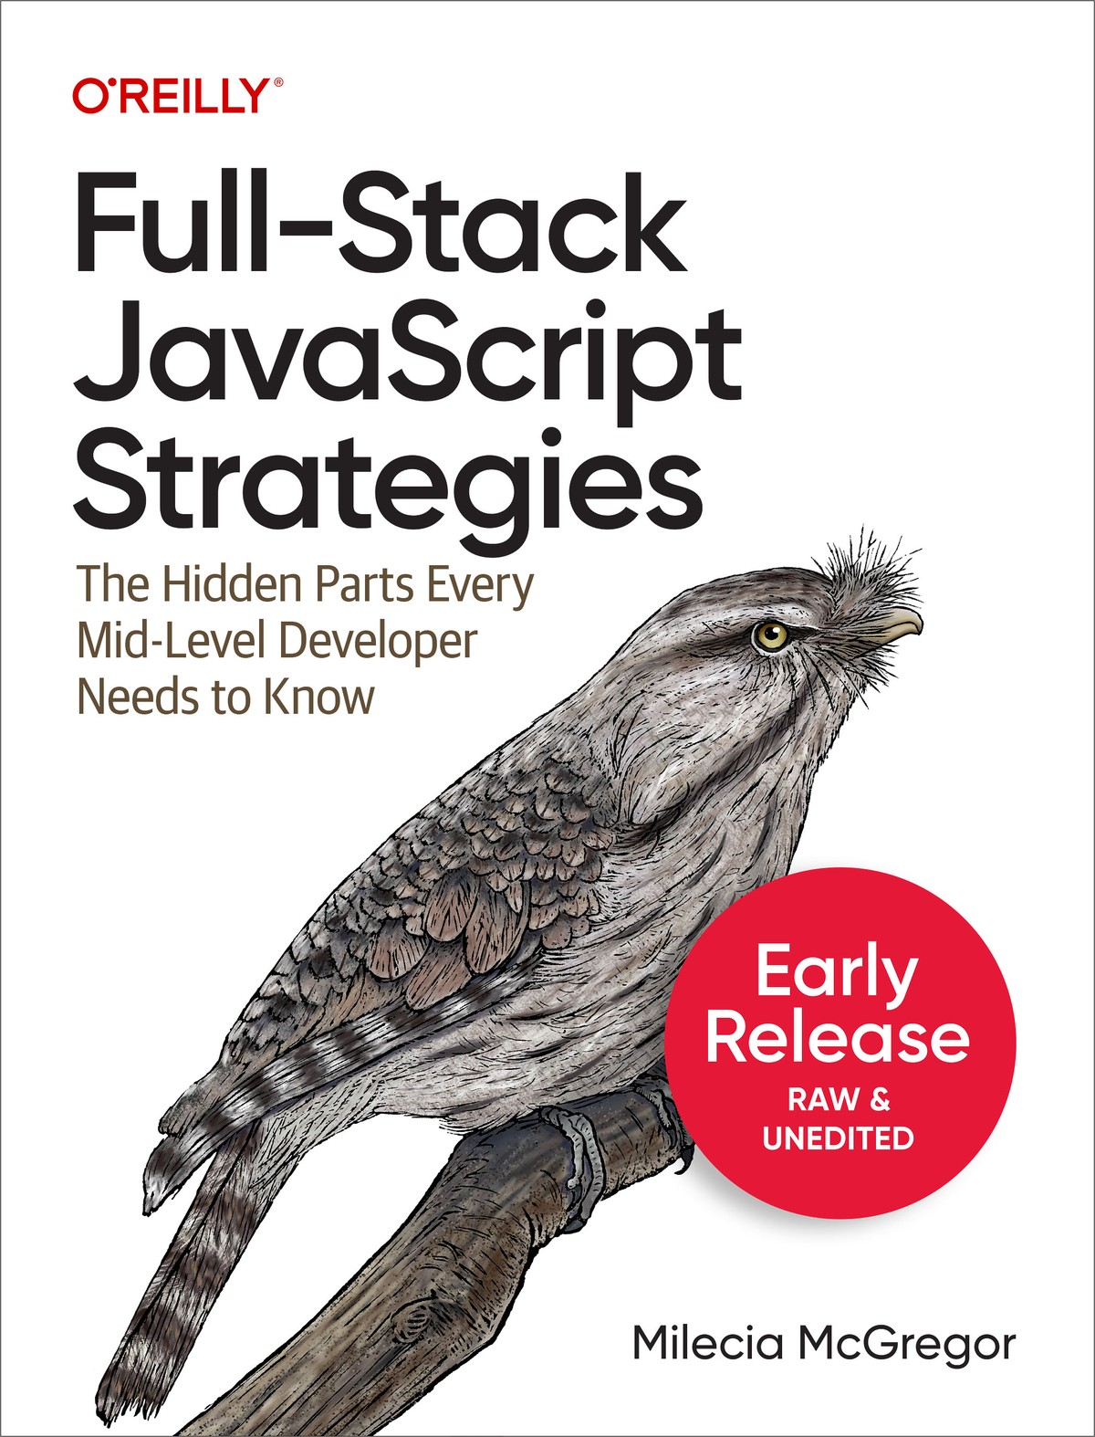

Table of Contents
Preface
Who This Book is For
What You Will Learn
What This Book is Not
How This Book Is Organized
Conventions Used in This Book
Using Code Examples
O’Reilly Online Learning
How to Contact Us
1. Kicking Off the Project
The Project You’ll Build
Project Kick-Off Meeting: Going through the designs
Design Considerations
Data-driven Design
Breaking Down Designs into Tasks
Refining Tasks from Feature Requirements
Discussing Timelines with Product and Other Teams
Talking to Other Development Teams
Coordinating with DevOps
Working with QA
Planning with Support
Bringing It All Together
2. Setting Up the Back-end
Why Nest.js?
Choosing a Project Approach
Setting Up Nest
Testing the Back-end Locally
Updating the README
Adding a CHANGELOG
Monolith and Microservice Architectures
Selecting an API Design Pattern: REST and GraphQL
Conclusion
3. Building the Data Schema
Initial Considerations
Diagramming the Data Schema
Setting Up Postgres
Basic SQL Commands to Know
Deciding What ORM to Use to Work with the Data
Writing Migrations
Seeding the Database
Conclusion
About the Author

Full-Stack JavaScript Strategies

The Hidden Parts Every Mid-Level Developer Needs to Know
With Early Release ebooks, you get books in their earliest form—the author’s raw and unedited content as they write—so you can take advantage of these technologies long before the official release of these titles.
Milecia McGregor

Full-Stack JavaScript Strategies
by Milecia McGregor
Copyright © 2025 Milecia McGregor. All rights reserved.
Printed in the United States of America.
Published by O’Reilly Media, Inc., 1005 Gravenstein Highway North, Sebastopol, CA 95472.
O’Reilly books may be purchased for educational, business, or sales promotional use. Online editions are also available for most titles (http://oreilly.com). For more information, contact our corporate/institutional sales department: 800-998-9938 or corporate@oreilly.com.
- Acquisitions Editor: Amanda Quinn
- Development Editor: Virginia Wilson
- Production Editor: Christopher Faucher

- Cover Designer: Karen Montgomery

- November 2024: First Edition

Revision History for the Early Release
- 2023-09-11: First Release
See http://oreilly.com/catalog/errata.csp?isbn=9781098122256 for release details.
The O’Reilly logo is a registered trademark of O’Reilly Media, Inc. Full-Stack JavaScript Strategies, the cover image, and related trade dress are trademarks of O’Reilly Media, Inc.
The views expressed in this work are those of the author and do not represent the publisher’s views. While the publisher and the author have used good faith efforts to ensure that the information and instructions contained in this work are accurate, the publisher and the author disclaim all responsibility for errors or omissions, including without limitation responsibility for damages resulting from the use of or reliance on this work. Use of the information and instructions contained in this work is at your own risk. If any code samples or other technology this work contains or describes is subject to open source licenses or the intellectual property rights of others, it is your responsibility to ensure that your use thereof complies with such licenses and/or rights.
978-1-098-12219-5

Preface
My goal with this book is to give you a reference, kind of a sanity check, for when you’re working on either greenfield or legacy projects across the front-end and back-end and handling deployments. Some questions are relevant for both types of projects, like how you’ll handle testing, performance, and security. Many applications have core commonalities that you can use, regardless of the industry you work in. When those moments come where you find yourself questioning why you’ve never heard of something, hopefully this book will make you feel more confident asking those “simple” questions.

Who This Book is For
If you are trying to figure out how senior devs seem to magically know how everything works and how they understand complex concepts so quickly, I’m going to show you how. At this point in your career, you’ve probably been working as a software developer for a few years. You know how to complete your tasks with solid code regardless of whether it’s on the front-end or back-end.
While you might have some knowledge across the full-stack, it’s likely you have a focus on one part of the stack over the other. On the front-end, you should be familiar with things like making responsive layouts, fetching data from APIs, and some of the frameworks like React, Astro, or Svelte. On the back-end, you’ve done some database migrations, built some APIs, and handled some basic authentication flows.
You also have skills like using Git with any of the repo hosting services, like GitHub or GitLab, and using different tools to test your changes. You may have worked on one project for years or you might have hopped around, but the scope of your work has typically fallen under some of the concepts mentioned.
Now you’re ready to move to the next level in your career. That means learning how the whole system works and why technical decisions are made. That’s what will be covered in this book.

What You Will Learn
The high level of what you’re going to learn in this book is everything it takes to create a full-stack web application hosted on a cloud platform. You’re going to learn how to find where the business logic for every app comes from. You’re going to gain some intuition on how to decide between different architectures, third-party services, and tools to create a maintainable application.
You are going to learn the subtle, yet deep skills it takes to become a senior developer. This book is going to give you strategies for working with different teams and understanding how product decisions are made. You’ll also deepen your existing skills to cover the full-stack confidently.
Regardless of whether you start on the front-end or back-end, you’re going to learn about design and development principles and when to apply them. You’ll learn all of these things as you go through the software development lifecycle (SDLC) of a project in this book and build a production-like application.
Think of this book as a reference you can pick up at any point in the SDLC and use it as a checklist. You will learn all of the essential parts that need to be considered for app development so that you know exactly what to do when a question comes up. By the time you finish, you’ll know how, why, and when to make technical decisions and how the business requirements evolve.

What This Book is Not
This book is not a deep dive into any specific set of tools and it will not teach you general JavaScript programming. There will be a large range of topics covered in this book with accompanying examples to demonstrate senior-level considerations, but it is expected that you know how to read code, debug issues, and find additional learning resources.
Since there are so many topics covered, there will be strategies discussed along with the code. These strategies are meant to be tools you can bring to any project you work on, although they might not work on every project. There isn’t a single approach that would work for any two projects because everything has its own nuances. So the goal is to give you a number of options you can choose from as needed.
There will be some parts of the book that need a much deeper explanation than a chapter or section can provide and there will be links to other resources. No book can adequately cover all of the topics presented here and I want to make sure you get all of the information you need. So while some topics will be light on the full implementation details, there will always be links to complementary resources.

How This Book Is Organized
The first part of this book, Starting your new project, will be relatively short and cover how you translate designs into tasks and questions that you’ll have to ask the Product team and other teams. This is where you get your first introduction to where business logic comes from.
The second part of the book, Building the back-end, focuses on creating the back-end of this project. You’ll work with Nest.js as we walk through a number of considerations, like security and third-party services, for development.
After you have the back-end ready, you’ll switch over to part 3, Building the front-end where you’ll work with a React project. You’ll build the user interface (UI) for this project and cover concerns associated with front-end apps, like responsiveness and performance.
Finally in part 4, Deploying the full-stack app, you’ll dive into the details of connecting the front-end, back-end, and other systems to build and deploy a full-stack app to production. By the time you finish this book, you should feel comfortable jumping into any part of a project and asking questions that will help clarify tasks as well as provide technical advice.
You’ll notice that each part of the book varies in length. That’s because it’s supposed to help break down where a lot of time really gets spent during development. Some parts of a project take more time than others or have different feedback cycles. This book is trying to reflect real-world conditions as closely as possible.

Conventions Used in This Book
The following typographical conventions are used in this book:
Italic
Indicates new terms, URLs, email addresses, filenames, and file extensions.
Constant width
Used for program listings, as well as within paragraphs to refer to program elements such as variable or function names, databases, data types, environment variables, statements, and keywords.
Constant width bold
Shows commands or other text that should be typed literally by the user.
Constant width italic
Shows text that should be replaced with user-supplied values or by values determined by context.

Tip
This element signifies a tip or suggestion.

Note
This element signifies a general note.
Warning
This element indicates a warning or caution.

Using Code Examples

Supplemental material (code examples, exercises, etc.) is available for download at https://github.com/flippedcoder/dashboard-server.
If you have a technical question or a problem using the code examples, please send email to support@oreilly.com.
This book is here to help you get your job done. In general, if example code is offered with this book, you may use it in your programs and documentation. You do not need to contact us for permission unless you’re reproducing a significant portion of the code. For example, writing a program that uses several chunks of code from this book does not require permission. Selling or distributing examples from O’Reilly books does require permission. Answering a question by citing this book and quoting example code does not require permission. Incorporating a significant amount of example code from this book into your product’s documentation does require permission.
We appreciate, but generally do not require, attribution. An attribution usually includes the title, author, publisher, and ISBN. For example: “Full-Stack JavaScript Strategies by Milecia McGregor (O’Reilly). Copyright 2025 Milecia McGregor, 978-1-098-12225-6.”
If you feel your use of code examples falls outside fair use or the permission given above, feel free to contact us at permissions@oreilly.com.

O’Reilly Online Learning

Note
For more than 40 years, O’Reilly Media has provided technology and business training, knowledge, and insight to help companies succeed.
Our unique network of experts and innovators share their knowledge and expertise through books, articles, and our online learning platform. O’Reilly’s online learning platform gives you on-demand access to live training courses, in-depth learning paths, interactive coding environments, and a vast collection of text and video from O’Reilly and 200+ other publishers. For more information, visit https://oreilly.com.

How to Contact Us
Please address comments and questions concerning this book to the publisher:
O’Reilly Media, Inc.
1005 Gravenstein Highway North
Sebastopol, CA 95472
800-889-8969 (in the United States or Canada)
707-829-7019 (international or local)
707-829-0104 (fax)
support@oreilly.com
https://www.oreilly.com/about/contact.html

For news and information about our books and courses, visit https://oreilly.com.
Find us on LinkedIn: https://linkedin.com/company/oreilly-media
Follow us on Twitter: https://twitter.com/oreillymedia
Watch us on YouTube: https://youtube.com/oreillymedia

Chapter 1. Kicking Off the Project
A Note for Early Release Readers
With Early Release ebooks, you get books in their earliest form—the author’s raw and unedited content as they write—so you can take advantage of these technologies long before the official release of these titles.
This will be the 1st chapter of the final book. Please note that the GitHub repo is available at https://github.com/flippedcoder/dashboard-server.
If you have comments about how we might improve the content and/or examples in this book, or if you notice missing material within this chapter, please reach out to the editor at vwilson@oreilly.com.
Welcome to the team! If you’re like most readers of this book, you’re a front-end or back-end developer, but you would like to be a senior level full-stack developer. Now imagine fast-forwarding to that point in your career—you’re a new senior full-stack JavaScript developer. That means you’re responsible for helping drive the technical direction of the project and helping coordinate efforts across different teams in order to get stuff done. Your task is to start a greenfield app, a project you get to build from scratch with no existing code, based on designs and conversations with a number of teams.
Let’s break down what you’ll learn in this chapter:
- How to work with a Product and a number of other teams to fully define features
- How to take a design and break it into small, actionable tasks
- How to determine the data you’ll need to work with

The Project You’ll Build
Here’s the description of the project you’ll be building as you go throughout the whole book. You work on an e-commerce platform that has access to a lot of user data, including some personal identifiable information (PII), and connects with multiple third-party services. You and your team have been tasked with creating a user dashboard so customers can see information about their order history and other actions they have taken, make purchases, and interact with their digital purchases, like ebooks. They’ll also be able to take different actions based on their permissions within the app
You’re starting with a fresh Product team and possibly a Design team that you’ll work with to make this dashboard a reality. The Product team will be responsible for talking with different stakeholders to decide what features should be built. The Design team will be responsible for making the user interface (UI) for those features and doing the first pass at the user experience.
The first part of the project will likely involve the Product team and the Design team working closely together to make some mock screens for you and possibly some behavioral docs. These mocks will be shown to you and discussed in a project kick-off meeting.

Project Kick-Off Meeting: Going through the designs
This kick-off meeting typically involves the Product team going through the mocks the Design team has made with you. There’s a strong chance that these mocks will change as you go through development, but they should be about 80% of the way there. They’ll take you through the user flow, show you how users interact with the app, and give you an idea of the data you need. At this point in the project, get comfortable asking a lot of questions. There are usually things that come up when you start looking at the designs from a technical perspective that the Product or Design teams haven’t considered.
Remember, this whole process is very collaborative. Asking questions early and often will make things smoother as the project moves forward. Right now there are only two screens that need to be built for a proof of concept, but Product has told you the functionality will expand over time. Let’s take a look at these screens and go through the user flow.
The screenshots are from a commonly used design tool called Figma.
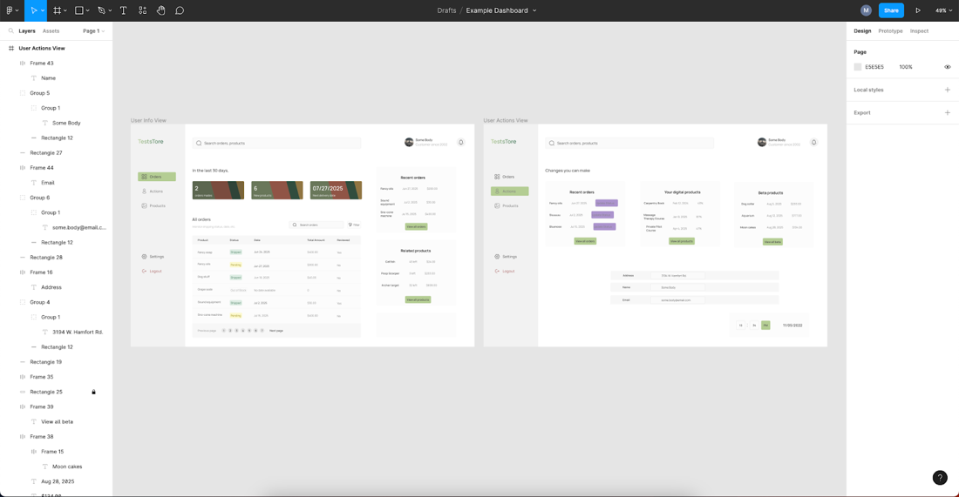
Figure 1-1. : Overall design in Figma
Figure 1-1 shows what all of the views in the application look like. There’s usually a design like this somewhere that visually describes how the app flows. As you move through the engineering process, you’ll focus on one of these views at a time, like the user info screen in Figure 1-2.
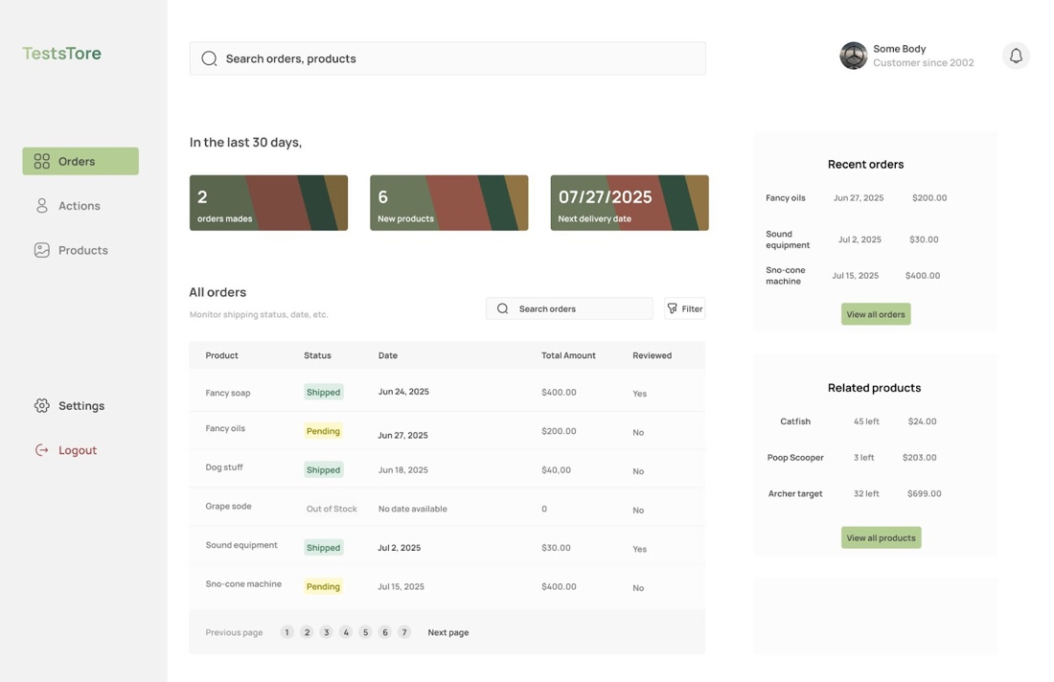
Figure 1-2. : user info screen design in Figma
Figure 1-2 is where users can see their information, like orders, suggested products, and other details.
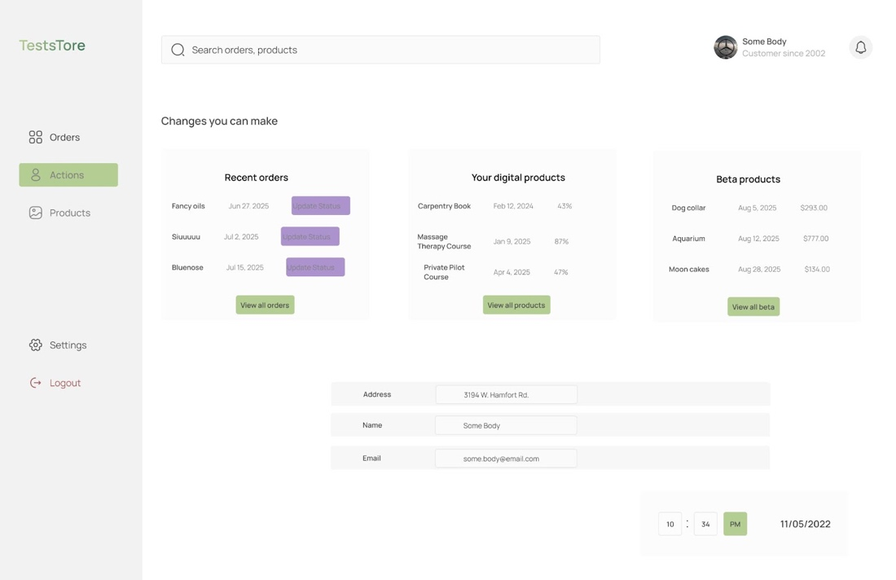
Figure 1-3. : user actions screen design in Figma
In Figure 1-3, users edit their information like address, cancel orders, and see their digital purchases.
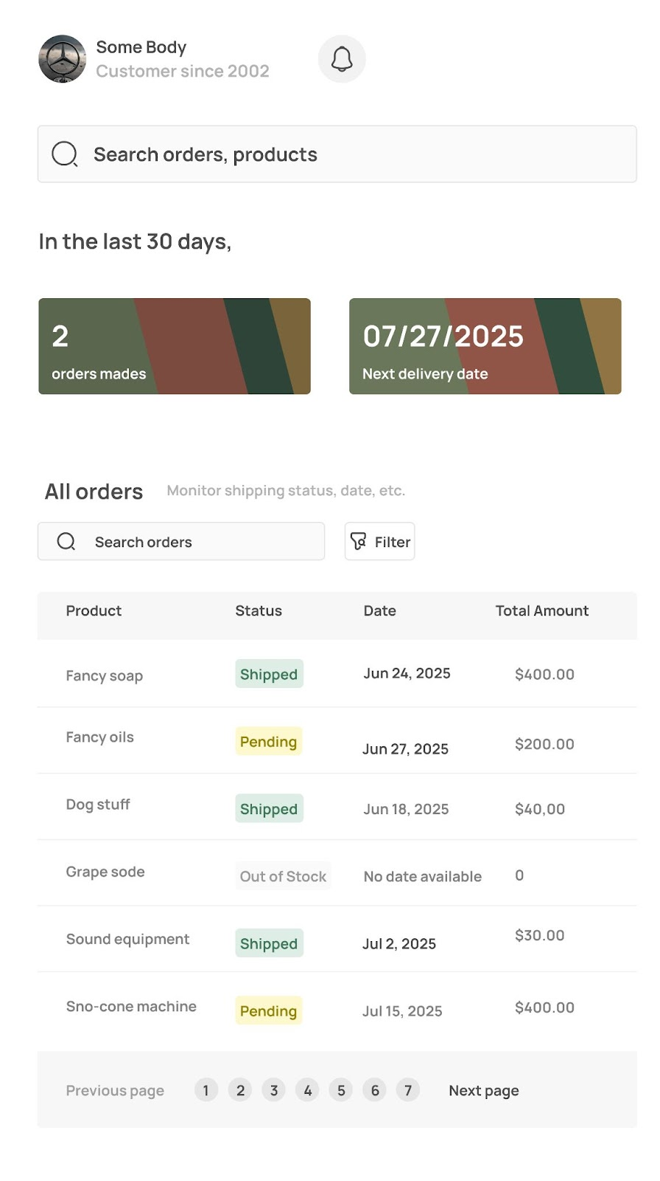
Figure 1-4. : app designs with mobile view in Figma
The design in Figure 1-4 shows how these views should look on mobile devices. The majority of projects that interact with external users will have mobile designs. If you don’t see these designs, make sure you ask about them!
A lot of designers use this tool when they create the mocks for an app or a particular feature. Some other tools you might run into are inVision or the newer alternative, Penpot. These Figma designs also have the HTML and CSS in them, so they can be useful for developers when they want to check dimensions while arranging elements on the page. Although the CSS is there, it’s usually best not to copy it directly into your code. It doesn’t always generate style rules that fit with your existing theming.
By the time you see these mock designs, Product and Design will have had several meetings trying to iron out as much detail as they can. That doesn’t mean they’ll have everything figured out and that’s where you come in. Based on these designs and the explanation of how a user will interact with the app, you have to work with your team to decide the technical approach you want to take.
Let’s walk through these designs, similar to how you will with your Product team.
On the first screen, there’s a navigation bar at the top of the page with links to other areas in the app.
Then, there is a featured products section, along with the users most recent order.
There’s a sortable table that displays all of the user’s orders with several columns.
Finally, there’s a footer that includes links to information about other parts of the e-commerce platform.
On the second screen, there are several sections that have fields the user can interact with. There are a few settings users can toggle, fields that they can update, and actions they can take based on their purchases. This screen has more complexity than the first screen, so you’ll want to take time and really go through this with the team. As the senior developer on the team, Product and Design will often turn to you for the final say on technical decisions.

Note
Never make promises without talking to your team first, no matter how hard you get pushed. The Product team may pull you into a meeting to try and get an idea of how complicated it will be to implement a feature they have in mind. This can lead to them expecting a quick commitment on a timeline. This is something you will have to get comfortable with handling as you move to senior dev level.
You have to firmly state that you can’t give an accurate estimate until you talk to the rest of the team. The other devs will be able to bring up concerns that you might not realize and they’ll be working on the feature eventually anyways. Stand your ground and simply don’t commit if they keep pressing for a date. That way you aren’t the one who put the team on a tight deadline.
With these designs in hand and a few documents on how the screens are supposed to work, it’s time to develop an understanding of the business logic before you go to the team. Having a solid understanding of the business decisions behind the designs is a huge help when you’re trying to explain things to other developers.
As you go through this information, there are a lot of things you’ll need to consider based on the designs you have.

Design Considerations
This is a stage where you will find yourself asking a lot of questions and that’s totally normal. Now is the time to really dive into the details and get nitpicky. One of the ways you can get more experience with evaluating designs for technical purposes is by getting exposure to different design sets. For example, the Design team you’re working with is likely doing design work for other apps in the company.
If you have questions about how a dropdown is supposed to behave, ask if there are other designs you can use as a reference. Many times there are and you should take the time to thoroughly understand how they work. Some of the best questions come from experience with different implementations. Another way to get more exposure to different designs is to start paying close attention to the apps you use! Have you ever really thought about the user flow for your bank app or the flow for an exercise or meditation app? These are all examples of product designs that are in production that you can make comparisons with.

Note
It can be a little tricky getting time to do exploratory work. One way you can do that is by writing a ticket that details what you’ll be looking into, some of the thoughts you’ve had about the issue so far, and some open questions. Go ahead and add points to the ticket too to make it look more official.
Think about how designs look for other products and how interfaces behave when you’re breaking them down into the details. As you think of differences, take notes about the questions they bring up.
Warning
A word of caution for when you’re compiling your list of questions: As you think of a question, look through the documentation you were given. Sometimes the answers are already there and it saves everyone time when you read the docs first. Take about an hour to go through any engineering docs the team has for other projects, go through the docs on third-party services that are being used, and any packages that you’re thinking about using.
You might be wondering what some good questions are and they always depends on your designs and the business logic. Here are some that can get you started as you look at the screens you have available:
- Are there translations to other languages we need account for?
- What are the brand guidelines, like colors, fonts, and responsive sizes, that should be used throughout the app?
- What permissions do users need to see their information?
- What permissions do users need to take actions in the app?
- How many different types of user will there be?
- How long do we expect users to be active, so we know how long an access token should live?
- What is all of the data we expect to handle for users?
- Do we want to show this data for different time ranges?
- Should the table be sortable by each column or only specific columns?
- How do we know which orders should be featured?
- What type of data do the input fields accept?
- When a user saves changes, do we want to redirect them to the previous page?
- When a user saves changes, what should we show them?
- If there’s an API error or client-side, what should the user see or be able to do?
- Does the user need to enter more credentials before taking sensitive actions, like changing PII?
- Should input errors be shown inline with the field or by the submit button?
- Do we need to consider tablet-sized devices?
- Will the back-end of this app be used by any other apps?
- Will the front-end need to be integrated into another app?
- Are there any compliances or regulations this app falls under or will get audited by?
You see, this list of questions can get very long and I’m sure you thought of other questions as well. It’s ok if the list is long. Of course, it’ll be hard to get all of these questions addressed so you should definitely prioritize this list based on the feature. It’s better to ask as many of these things in the beginning compared to half-way to the deadline. If there are small things then you can probably use your experience to make judgement calls, like with form handling.
The questions can be all over the place, but these are questions the Product or Design team can answer. There isn’t anything technical in here yet, although the answers to all of these questions will drive technical decisions. Getting answers to these sorts of questions early is why senior developers tend to deeply understand the business logic.
In order to make the best technical decisions you can, you have to understand the purpose of functionality and how it fits in the overall business. This can give you some foresight on how to build the app in the most maintainable way because you see the direction the business is going. Some of this foresight will come from the data you know you’re going to work with.

Data-driven Design
Data drives design. Everything the designs do is built around how to best deliver data and let users interact with it. Take the table screen for example. The data doesn’t have to be displayed as a table. It could be a collapsable list or a graph. That’s why you have to dig into these questions about the business logic and what you will be working with. It’s one of the reasons that front-end development is usually dependent on back-end development. We’ll talk about this more in the next chapter though.
As you go through the designs, it’s also a good idea to take notes on the data you see you’ll need for each screen. On the settings screen, you can see that you’ll need the user’s name, shipping address, and language preference in one section. Take notes on potential variable names and data types for these that you feel comfortable sharing with the team. It can help spark the initial conversations around how to approach the project. Also confirm with the Product team that these values are correct and what’s expected by the app. Always check with the Product team that you have the correct data and relationships between the data.
They won’t explain it in technical terms, but they’ll walk you through different scenarios so you can paint the big picture. This is like the discovery phase of the project for your development team. Once you’ve gone through these designs and you have your questions and notes, get ready to talk about specific features.

Breaking Down Designs into Tasks
You’ve made it through the first round of refinement for the project! In this next round, you can assume that Product has answered all of your team’s questions and you have updated designs. Now you’ll be working with Product to carve features out of this info. This is when you’ll first come to the a kanban system, like Jira, Trello, ClickUp, or Shortcut.
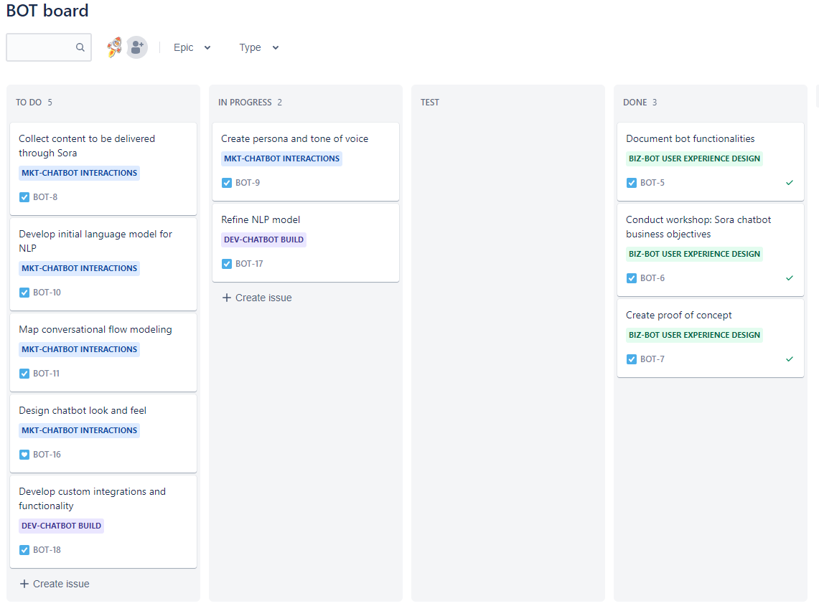
Figure 1-5. : example of a backlog in Jira
The tickets you make here are going to go through refinement once you start bringing in more developers and other teams. The goal at this stage is to make action items for segments of the designs. The user info screen for example has several pieces that can be broken out into features. The featured section and the table are individual features. You’re trying to get people thinking about how the designs will actually work and start bringing in that technical perspective. As a senior full-stack dev, you might try to group features based on data relationships.
This will help make it easier for back-end changes to be made and deployed as the front-end is being built. This is also the point where you can still call out any big issues you run into as you start thinking through the tech stack. Any time you have a thought for a feature or technical requirements, make sure a ticket gets made. If there isn’t a ticket, the work won’t get prioritized.

Refining Tasks from Feature Requirements
You’re at the point in the project where Product should have some user stories written for you to refine with technical details. These user stories are part of the documentation you get that define the features you’re developing. They’re typically written from the perspective of the user to give you some of the hidden context behind how they will interact with the functionality. This doesn’t happen all the time. Many times you’ll be working with Product to fully define features, but they’ll have some details to get started with from the previous round.
You can assume that your team follows a normal agile process with two week sprints and the standard meetings like daily standup, backlog grooming, sprint planning, and retro. At this point, you’ll go to a backlog grooming meeting and start going through the tickets in the Jira backlog. This meeting should include the development team, QA team, and Product team so that everyone can ask questions and bring up concerns. Feature tickets should be broken down into the smallest piece of work a developer can do.
This is one of the parts where you have to use some art vs science. The “smallest” piece could mean having a ticket to write an endpoint with all the tasks associated with it and have a separate ticket for triggering events. One way to think about it is from a QA testing perspective. What is the smallest grouping of work that makes sense to test together? There are entire books and numerous resources written about agile and these kinds of project decisions. One resource you might look at are the Atlassian articles on agile.
In order to keep expectations aligned with what the team can output, estimates are usually made on every ticket for how complex the task is. When you’re going through tickets during backlog grooming, don’t hesitate to slow things down. If you spend the entire time on one ticket, then that shows Product where they need to improve and it can be brought up in the retro meeting.
Make sure every ticket has acceptance criteria that’s agreed on by Product, QA, and your team. If the ticket has UI elements, make sure you have access to the designs for both desktop and mobile. Every ticket should also have background information on how the functionality fits in the overall app so developers have context. All of the developers should be in agreement on estimates for each ticket.
This might seem like a lot of fuss over tickets, but doing all of this upfront saves your team time. Getting everyone on the same page in the very beginning helps keep your team unblocked. With this level of documentation in each ticket, there shouldn’t be ambiguity in the task when anyone on the project gets to it. Here’s an example of info you will find in a well-defined ticket.
[Back-end, QA] Create endpoint for table data on user info screen
Description: As a user, I need to see a table with my purchase info. This info should include the product name, price, estimated arrival date, and quantity in each row on the table. This table should also be sortable by clicking on the column headers. It should have pagination so I can go through my purchase history for the previous 12 months. It should match the designs attached. (See fig 1.1-2 and fig 1.1-4)
Acceptance criteria:
- Update data schema to include purchase history definition: product name, price, estimated arrival date, quantity
- Run migration on database
- Create endpoint that responds with user purchase history for past 12 months
- Ensure authentication is working correctly
- Implement validation on request data
- Write tests for new endpoint
- Write docs for how the endpoint works so front-end can use it
Points: 5
It should be very clear to any engineer what needs to be done, although it shouldn’t tell them how to implement it. That’s something they can decide after the team’s discussed it. Having tickets written out like this will spark deeper technical discussions that will help drive the overall architecture of your project.
This is when you start to take the tasks from Product and refine them even more as a development team. It’s always a good idea to include any highlights that come out of team meetings in the tickets so everyone remembers why things were done that way. You might learn that one of your third-party services only accepts data in a certain format and it leads to you needing to write some hacky code. But you absolutely have to have this because of a product requirement. That’ll be important context to have for a code review and for testing.
It might seem like this is a long process, but usually you can define the tickets in the upcoming sprint in a few days. Then once the sprint starts you can jump in. But before you get to pick your own tickets and start coding, there are a few more conversations you’ll need to have.

Discussing Timelines with Product and Other Teams
At this point in the project, you can assume you have well-defined tickets and the details are as ironed out as possible. Now it’s time for one of the higher level conversations. After all of the tickets have been estimated, Product will be ready to set a launch date.

Note
Sometimes Product will come to you with a launch date before you’ve had a chance to estimate tickets. If you find that their timeline is shorter than engineering needs to adequately get through the tickets, push back. Always speak up when timelines are tight. This will save everyone from unnecessary stress.
This is going to involve more than just your team. You might need to coordinate with developers on other projects, the DevOps team, the Support team, and the QA team. It just depends on how far the reach of your changes goes. Don’t commit to a launch date until you’ve talked with these other teams. You’ll want to see how your goals fit into theirs and what you can do to make the process easier for them.

Talking to Other Development Teams
Your project might depend on another team implementing something in their code that your app consumes. You’ll need to give them plenty of heads-up and details so they can include this in their sprint. Development teams aren’t always aware of when feature releases for one app crosses over into theirs. Talk to them about what you need and keep it as simple as possible. Mention what your target launch date is and see if that’s something they can help you reach.
On the other hand, the new features in your app might cause breaking changes for other teams and you need to let them know what updates they need to make and by when. Don’t hesitate to reach out to any teams you think will be affected just to double check. As you find out which teams are affected, update the team docs to show them as a consumer of your app.
Here are some things you’ll need to have ready before you talk to them:
- Well-defined technical requirements. Give them a task that’s just as defined as if your team were doing it. Also give them time to ask questions if they need more definition.
- A general idea of where in their code the changes need to be made. You don’t have to go in their code and implement the changes, but havinng a clue of where to get started helps.
- Context behind the change you’re requesting. A seemingly small change to you could change the functionality of something important in their app. Make sure they understand why this change is needed.
- A deadline. Of course you’ll ask how long it’ll take them to get to it, but have a flexible date in mind.
- Willingness to do the work. If it would be faster for you to implement the change and the team review it, be open to that as well.
When you know you have everyone across the development teams on the same page, then you can talk to the next set of people. These discussions don’t need to happen in this order, but they do need to happen. Whoever is available to talk first can be the first conversation you have.

Coordinating with DevOps
When it’s time to release to different environments, you’ll need to check in with the DevOps team. That’s assuming there is a DevOps team. Sometimes at smaller companies, you will also be responsible for handling deployments. Throughout this book, you can assume that you’re working with at least one DevOps engineer that handles infrastructure and pipeline changes for you.
Since this will be a completely new app, you’ll need the infrastructure to be set up for QA to do testing, for production, and any other environments. You may be able to help set up the continuous integration and continuous deployment (CI/CD) pipeline using tools like CircleCI, Jenkins, or GitHub Actions. Although when it comes to provisioning resources and handling infrastructure concerns, that will be completely up to the DevOps team.
They’ll give you important information like which cloud provider the app will be hosted on. You’ll give them important information like the programming language and frameworks being used. The goal for these two teams on a new project is to at least have a couple of environments up for testing before prepping for production releases. Getting DevOps involved early is going to make things go smoother as development progresses.
Remember, all of these teams you’re interacting with already have their own priorities. So you have to take into account that they may not get to you right away. That’s why you want to coordinate with DevOps as soon as you have a technical direction. The last thing you want is to put DevOps in a crunched position right before an important deadline. Be ready to jump into a call to go over the project with them so they understand what performance and usage is expected from this app. During your call, there are several things you want to cover:
- Work on developing playbooks, the strategies and steps you implement to resolve issues, for outages and other issues in production. In the moment, it’s hard to think and figure out best steps. That’s why you and DevOps need to think about this ahead of time.
- Determine the right number of environments for the app. Some projects can have three environments while others have an environment for every Git branch in existence. Find the right balance of environments that is maintainable on the infrastructure side and flexible for testing and other uses.
- Figure out the best deployment strategy. It’s important for DevOps to know when they need to trigger scripts to run and how often they will run. Some parts will be automated and other parts will need to be run manually. The best strategy is one that works for these two teams.
- Decide how to handle CI/CD maintenance. Most CI/CD tools use YAML files to define the configurations for a pipeline and these config files live in the project’s repo. Sometimes developers make the changes, DevOps makes the changes, or both feel comfortable making changes. Just get everyone on the same page.
- Agree on the versions of the JavaScript runtime, like Node, Deno, or Bun, that will be supported. Servers aren’t always running the latest version of your runtime and that can cause weird bugs in your app. Know the oldest version of the runtime your project will work with, just in case.
- Find out when credentials are cycled. Some apps are dependent on keys and secrets that are maintained as part of the infrastructure, like NPM tokens. Add a reminder ticket to Jira so you can plan to update them before they expire and cause production issues.
- Choose a location to store assets. For some apps, this will be included as part of the cloud provider and for others a third-party service will be used. Even if you don’t come to an absolute answer right now, make another Jira ticket to come back to this.
- Set up time to test the app together before deploying. You know how the app should behave so DevOps will lean on you to handle some of the environment testing. They can usually get the app running, but you have to verify it’s in the correct state.
- Reserve some time for after the initial app deployment. Things always come up with the first few deploys that need to be fixed. Go ahead and put that meeting on the calendar. If nothing happens, you just reserved celebration time for everyone.
One thing to remember while you’re talking to DevOps is that you won’t understand everything they’re talking about and you don’t need to. You’ll start to pick up on things as you work with them and it wouldn’t hurt to pair with them a few times to see what they do. But even if you don’t want to dive into DevOps world, that’s fine. They’ll handle everything on their side from here.
Now you need to talk with the QA team.

Working with QA
While developers, especially seniors, are expected to thoroughly check their work, sometimes bugs slip through. That’s why QA teams exist: to make sure those bugs don’t reach production. Weird integration issues happen, PRs overwrite functionality, a number of things cause bugs that developers don’t catch. Getting new features and bug fixes to QA in a timely manner is important to staying on time for releases. You need to get the new code to them, give them time to test and report back defects, then give you time to fix the defects, and send it back to QA.

Note
There is a chance that you might not work with a QA team at all. It really depends on the company. Usually in early-stage startups, you won’t have a dedicated QA team. It’ll just be you and the other developers, maybe even the CEO. In other companies, you might see the Product team do some manual QA on features. Regardless of whether there’s a QA team or not, you can use the steps in this section to help do your own QA more thoroughly.
You see this loop can take quite a while. So to shorten that time and make sure the highest priority tickets are tested first, include QA in many of your development calls. There will be questions they have about features and bugs from a QA perspective that need to be understood. All of the test cases they write are basically like the history of the app. Many features will have test coverage, whether it’s automated or manual. These tests will exist even when the feature doesn’t, so QA keeps record of changes in a different way than other teams.
Set up a call between the QA team and your dev team and make sure you’ve talked about:
- Automated integration tests. This is a responsibility that’s usually owned by QA, but since the tests live in the project’s repo in many cases, developers can write these tests as well. Also, make the distinction between integration tests and unit tests. Developers should always be the ones writing unit tests.
- Level of detail in reproduction steps. There’s a balance between not enough detail and way too much. Discuss what works best for developers and QA engineers so that everyone knows what to expect. You’ll end up working with a QA engineer to hone in on the issue anyways, but it helps to have a starting point.
- Include them in relevant calls like backlog grooming and stand ups. This way they’ll be up to date with any upcoming deadlines, shifted priorities, or releases and they can give updates if they’re running into issues. Try to put any updates for them at the beginning of these calls, like tickets they can test, so they can use their time the best.
- Make it clear that QA should feel comfortable reaching out to the developer that worked on a ticket they’re testing. Developers should be willing to pair with QA to help them determine if an issue is a bug or something else like an environment difference.
QA is everybody’s best friend because they find a lot of bugs that would have caused issues on production. It’s not good for anyone when there are issues on production. They aren’t there to tell the developer they’re wrong or that their code is bad. They just want to make sure absolutely nothing makes us bring out those playbooks for production fires. Be patient with them as they report defects because they’re just doing their job.
You’ll interact with a number of teams once you’re ready to deploy changes and that will really depend on the company. You might interact with the sales team so they understand what the product is capable of and they can set realistic customer expectations.
There’s also the integration or customer success team. These teams usually work with customers 1-1 to help them integrate the product into their systems. They definitely need to be aware of any breaking changes or new features.
Some companies have a dedicated security team as well, especially if the product is in the FinTech, healthcare, e-commerce, or manufacturing. This team may come in right after QA and run security tests and there might also be continuous security scans happening on the app throughout your development pipeline.
One team that will be around in some form or another is the Support team. They are the next and probably last team you need to talk with.

Planning with Support
These are the people who are in direct contact with users who are experiencing problems. Some of the bugs you will fix come directly from Support. They might even link their support ticket to your bug ticket so they can keep users updated. The Support team is also a source of inspiration for new features. If they keep getting the same requests from different users, it’s worth looking into a solution.
Support does a difficult job of dealing with upset customers. You want to make sure that happens as little as possible. When you’re talking with Support about an upcoming feature release, they need to know how it affects users. Product should have already talked to them and discussed timelines. You’re trying to see what they need from the development team.
Keep in mind that the Support team usually doesn’t have highly technical backgrounds. They understand how the app works from a user perspective and as an app admin, but they won’t necessarily understand the weeds of the technical details. Understanding where they are coming from will help your communications exponentially. Your job with Support is to translate the technical stuff into the information they need.
Here are some common things that will help:
- Have documentation Support can refer to in order to use the new feature. Describe anything that has changed compared to existing functionality. Highlight values users will need to enter since user input causes many of the issues they receive.
- Listen when they bring up complaints with the app. Take in the feedback they give you from bugs or other requests and work with Product to prioritize it. That doesn’t mean you implement everything they ask for, but it does mean you do a little research into why they’re asking about it and how hard it would be to fix.
- Always sync up on release dates and times. Support will sometimes set aside special time around releases because there are going to be user questions. They need to know exactly when changes are going out so they aren’t blindsided with an increase in issues.
- Do a demo of the finished feature right before release. After the changes have been approved for release, do a quick live demo with Support (and really everybody else). That way they can see how it’s supposed to work and ask any questions.
- Dedicate extra developer time to Support around release days. If they start getting overwhelmed with issues, you might need to rollback the changes. Just be ready to pay close attention to them.
Discussing these things with Support is another way to bring up issues that can be addressed early in the process. It’s also a great way to build a relationship between Engineering and Support because you work closer together than it seems. This is the last team you need to coordinate with. Now it’s time to bring back all of your findings and notes to make a cohesive plan.

Bringing It All Together
You’ve made it to the final step of project kick-off. You have all of your notes from the different team meetings and it’s time to distill it all and give the highlights to Product. All of these conversations will help you come up with a reasonable deadline. This is where some negotiation will start. One thing to keep in mind with deadlines is that something in development will go wrong.
Give yourself and your team room to breathe and possibly over-deliver. Remember, under-promise and over-deliver. Unless the feature you need to implement is time-sensitive, like a third-party service being updated, add a few days of padding to account for weird happenings. After you’ve settled on a date with Product taking all of the other teams’ concerns in mind, summon everyone together for one final, short call.

Note
It’s important to understand that setting deadlines is extremely tricky in software development. Any number of things can pop up at any time and derail everything. If someone gets sick or a natural disater takes out someone’s electricity for a week, some tickets aren’t going to get done. You might get deep into development and realize that a tool you’re trying to integrate with is way more complex on the back-end than you accounted for. There might be work your waiting to receive from another dev team and they fall off schedule, putting you behind as well.
All of that is ok. The best thing you can do is communicate these things with everyone as soon as you find out about them. Then you can start making plans for what to do next. Life happens and you have to try your best to not let this stress you out every time it happens. Because it will happen a lot!
This call will have someone from all of the teams you’ve talked to. The only things you want to confirm at this point are everyone’s action items and deadlines. Having this call is about establishing accountability and triple-checking that everyone is on the same page. As prep for this meeting, take all of this info out of your notes and make a short doc that everyone can reference leading up to the release.
At this point, you have many of the Jira tickets you’ll be working on and they’re well-defined. You’ve documented the cross-team connections. Project kick-off is complete. You have everything you need to finally get started writing code. In the next part of this book, you’ll build a scalable back-end in TypeScript using the Nest.js framework.

Chapter 2. Setting Up the Back-end
A Note for Early Release Readers
With Early Release ebooks, you get books in their earliest form—the author’s raw and unedited content as they write—so you can take advantage of these technologies long before the official release of these titles.
This will be the 2nd chapter of the final book. Please note that the GitHub repo is available at https://github.com/flippedcoder/dashboard-server.
If you have comments about how we might improve the content and/or examples in this book, or if you notice missing material within this chapter, please reach out to the editor at vwilson@oreilly.com.
You’ve got all of your tickets ready to go and you can assume you’ve been tasked with building the bones of the back-end. The framework of choice at your company is Nest.js. It’s ok if you’ve never seen Nest.js or even heard of it before. The docs for it are pretty good and you’ll have other code you can reference. Reach out to other developers to see why certain architecture and design decisions have been made on existing back-ends.
In this chapter, you’ll learn more about:
- How to make architecture decisions for the back-end
- Checking the app to make sure it runs after initial setup
- Writing initial documentation
These are all crucial to ensuring that development is able to run smoothly as both the product and the team grow and change over time. Everything that you build on the back-end will start from the foundation you set here, so take your time to thoroughly discuss options with your team.

Why Nest.js?
Before we dive too deep into the weeds, let’s discuss why Nest.js is a solid choice. It’s basically like a back-end architecture in a box. As soon as you initialize the app, you immediately have access to things like validation, authentication, routing, controllers, data schema, and a lot of other functionality. Instead of piecing everything together, Nest.js gives you everything you need to make a scalable back-end from the beginning. That does mean it’s a little less flexible in what you can do with it, but it’s the trade-off for all of the up-front scaffolding.
This is when you get to have some fun as a senior dev as you set up the initial repo for the back-end. The decisions you make here drive the direction for the future of this project. As you come to questions that have options, ask your team for their technical input. They might be aware of something you don’t know about. This not only helps you build a better app, it also helps everyone on the team learn.
There are so many considerations for building a back-end that having other input will help you make decisions faster and more confidently. It will also help to keep architectural decision records (ADRs). These help keep track of why and when important architectural decisions were made and you can see some examples in this GitHub repo.
It can be a little overwhelming being the one to open the empty terminal and bootstrap a completely new project. There’s nothing to build on except examples and boilerplate code. It will go whatever direction you and your team decide to take it. This is a fun time because you can really set up the code base to be in a position that’s clean to update, test, and expand.

Choosing a Project Approach
This project will be a monolithic back-end with a couple of serverless functions. This will allow you to build and deploy quickly and you’ll get to work with a hybrid back-end architecture. You could have also decided to take a microservice approach. Then all of your APIs could be serverless functions, for example. Your choice of back-end architecture is dependent on how the app is going to grow over time. Microservices can take more resources and more engineers to maintain compared to monoliths. Although monoliths can make it more difficult to make larger changes as quickly as you can with microservices.
You’ll also be using TypeScript. The reason you’re starting the project off with TypeScript is to help prevent debugging because it’s harder to write incorrect code. By strictly enforcing typing, you’ll catch some errors before you even run the code. It also helps make it easier to see what fields and data types you’re working with and where they come from, which is wonderful for keeping types consistent across the front-end and back-end. Having some typing in place is like having documentation for how things are connected and it lets you see all of the fields you have available.

Setting Up Nest
You’ll walk through all of the steps to bootstrap this whole project. To start, there are a few environment things you need to have in place. You can follow along with the demo repo here: https://github.com/flippedcoder/dashboard-server

Note
Keeping track of these types of version concerns is something a senior dev might silently do. As we go through building this app, you’ll be introduced to some leadership best practices, like keeping docs updated and making sure everyone’s local environment is running correctly. You’ll also have to consider things like linting with something like ESLint and formatting rules with a common tool like Prettier for the repo and any number of environment configs to keep everything consistent in the code for everyone.
You’ll need to install the Nest CLI. The current version of Nest as of this writing is 9.2.0. Open a terminal and run the following command:
[source, bash]
npm i -g @nestjs/cli
You can create a new Nest project with the command:
[source, bash]
nest new <your-project-name>
For this project though, you’ll use this command:
[source, bash]
nest new dashboard-server
It will ask you which package manager you want to use. Select npm and hit ENTER.
[source, bash]
? Which package manager would you ❤️ to use? (Use arrow keys)
❯ npm
yarn
pnpm
After that the installation will start and it might take a few minutes. This process is installing all of the project dependencies, scaffolding the entire architecture, adding boilerplate code, and more. It even comes with TypeScript preconfigured. Take some time to go through this repo before you start making changes. Whether you’re working on a brand new app like this or a legacy project, always take some time in the beginning to get a high-level understanding of how everything works.
Key things to look at are:
- The package.json so you can see which packages are used in the project.
- All of the config files so you know how things work under the hood.
- The test files because these give you a good idea of the major functionality of the app.
- Some of the actual code to see how developers are expected to write things and if anything can be improved.
After you’ve poked around a bit, go ahead and run the app with these commands:
[source, bash]
cd dashboard-server
npm start
You’ll see an output in the terminal like this that will let you know the app is running successfully:
[source, bash]
> dashboard-server@0.0.1 start
> nest start
[Nest] 20891 - 03/03/2023, 8:18:46 PM LOG [NestFactory] Starting Nest application...
[Nest] 20891 - 03/03/2023, 8:18:46 PM LOG [InstanceLoader] AppModule dependencies initialized +11ms
[Nest] 20891 - 03/03/2023, 8:18:46 PM LOG [RoutesResolver] AppController {/}: +5ms
[Nest] 20891 - 03/03/2023, 8:18:46 PM LOG [RouterExplorer] Mapped {/, GET} route +3ms
[Nest] 20891 - 03/03/2023, 8:18:46 PM LOG [NestApplication] Nest application successfully started +1ms
This is where one of your first senior decisions comes up. How exactly are you going to test this back-end? Having a consistent environment for development will change how quickly you can test code and how much frustration the team experiences as the product grows and the team grows too.

Note
A standard choice is to use Docker because you can setup everything from a Postgres database instance to the server that the app will run on in a container (or two).These containers can hold the exact same data and versions and be setup on any local environment, regardless of the operating system (OS). Another option would be using some functionality in VS Code called Dev Containers. This can be a good choice depending on the team and the project.

Testing the Back-end Locally
Some popular tools you’ll see include Postman and Paw. You’ll work with Postman in this book (and many times in real life) because it has a free version. This is how you’ll be able to make requests to your endpoints with different headers, body values, and other values and see what response you get. That’s typically how you test the back-end before there is a UI available.
Remember, tools like this are here to help you move faster. Don’t get caught up in all of the tool options. At the end of the day, it doesn’t matter what you use for your local development as long as you’re able to make meaningful progress. Now that you have Postman available, make a GET request to +http://localhost:3000+. You should see +Hello world!+ as the response.
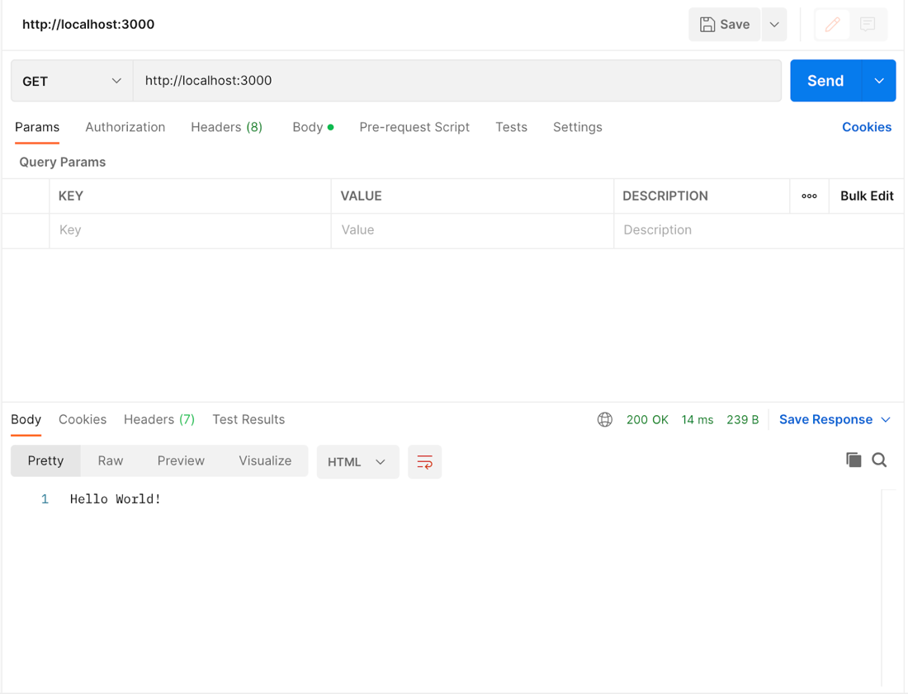
Figure 2-1. : GET request and response in Postman
Everyone will have a different preference for the tools they like to use for back-end testing and it typically doesn’t matter. However, it’s easier to troubleshoot when all of the devs on the team are in agreement on this particular tool. You can share your endpoint tests with other devs and that helps everyone find issues faster and more consistently. Eventually your back-end tests can serve as the documentation for the front-end. This will be something worth making a Jira ticket for so you can get it included in a sprint.
Now that you know the app is working, you can start making changes to get it ready for the team.

Updating the README
Start by updating the +README.md+ with specific instructions on how to set up and run the app. There’s already a lot of good stuff in there, so you can trim it up a bit and add a few things. A basic update can look like:
[source, markdown]
# Dashboard Server
## Description
Back-end to support customers built on [Nest](https://github.com/nestjs/nest) framework TypeScript starter repository.
## Installation
```bash
$ npm install
```
## Running the app
```bash
# development
$ npm run start
# watch mode
$ npm run start:dev
# production mode
$ npm run start:prod
```
## Test
```bash
# unit tests
$ npm run test
# e2e tests
$ npm run test:e2e
# test coverage
$ npm run test:cov
```
It doesn’t have to be a huge doc that expands on your philosophical thoughts about code and the project. Give enough guidance that any dev could clone this repo and get it running. Other docs for the project will be stored somewhere else. As the repo grows, adding more details to the README will be helpful. This is a living doc that everyone should feel comfortable updating as part of their PRs when it’s needed.

Adding a CHANGELOG
As a best practice, it’s good to include a +CHANGELOG.md+ file in your repo. This will help you keep a close record of everything in each release over time. Having this record will help you determine which version of the app contains which updates and that comes in handy when there are issues with production. Here’s what the beginnings of this file can look like:
[source, markdown]
# CHANGELOG
## Guide
- Major releases include breaking changes and the version number will be incremented like, `x.0.0`
- Minor releases include new features, but no breaking changes and the version number will be incremented like, `0.x.0`
- Patch releases include bug fixes and performance enhancements and the version number will be incremented like, `0.0.x`
### 0.0.1
- Initial release
You might also consider setting specific rules on commit messages. If there’s a certain format you prefer, set up a tool like commitlint to enforce it early. This means you commit messages can include details like whether this is a fix or a chore. It can include ticket numbers if needed. You can also make it enforce things like the message starting with a verb to state what the change does.
That commit message might look like:
[souce, bash]
fix: update modal to send API call once
As a senior dev, you might be responsible for preparing the release PRs so it’s important to make sure updating this file gets included in that process. A good way to remember it is when you update the app version in +package.json+, update this file too.
In many projects, you may need to set up ESLint, Prettier, and TypeScript config files. This app comes with a lot of configs set by default, so you should go through them and add or remove values as needed. That’s all for the initial app setup. Now you can turn your attention to building the data schema.

Monolith and Microservice Architectures
This is a crucial point in the project because you’re setting the foundation for how everything will be built for the foreseeable future. You’ll need to think about the future of the project and how it might grow and what blockers that growth might run into. Take some time to make an architecture diagram. It doesn’t have to be fancy, but it does need to represent how the back-end interacts with different pieces of the entire application.
This includes everything the app touches ranging from the front-end to cron jobs. Cron jobs are tasks that run in the background of your system on a schedule. They can be written in TypeScript as well. The back-end is like your control center. It drives the development of everything else because it interacts with a number of systems. That’s why it’s so important to take your time and make this calculated decision.
The two based architectures you’ll run into are monoliths and microservices and I’ll cover the differences here. You can think of this as a guide to help you choose one or the other.
A monolith is when all of your back-end functionality is contained in a single codebase. You’ll see this a lot with enterprise apps. There’s one database and one server for the application. It gets deployed as a single unit that is connected to all of the services that you work with. All of the endpoints, maybe some cron jobs, and some third-party integrations will be handled here.
With a monolith, you get the benefit of all the code being in one place. That way you can get exposure to how the entirety of the system works and where changes need to be made. Setting up the infrastructure is straight-forward because you’ll only be deploying one app. Debugging is also easy because you can check the back-end holistically.
Building a monolith is a simpler approach, but it comes with drawbacks. For example, if some bug gets released to production and it causes errors at runtime that didn’t happen locally, the whole app is down for users. It can also be hard to appropriately scale the app. You might only have one endpoint that gets a large amount of traffic, but with a monolith, you have to scale the whole back-end which can cost a lot.
Figure 2-2 shows an example of what a monolithic back-end can look like:
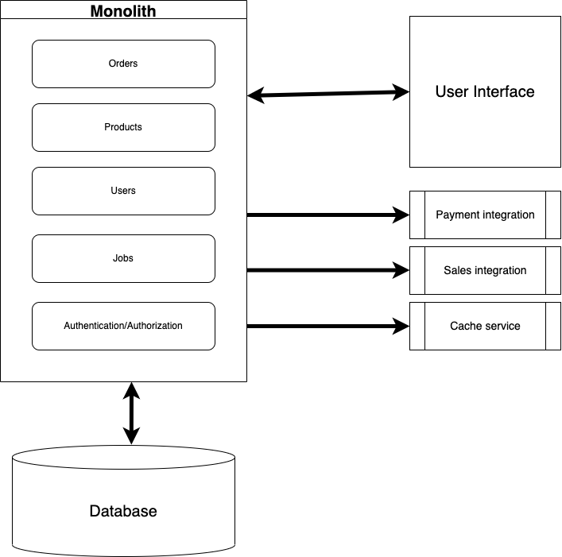
Figure 2-2. : Architecture diagram for simple monolith
On the other hand, a microservice is the complete opposite of a monolith. If you have a directory or set of files dedicated to one piece of business logic in your monolith, it becomes its own API in the form of a microservice. With microservices, all of the back-end business logic is split into different chunks based on functionality. Each microservice has its own codebase, database, and server.
One of the biggest benefits of microservices is scaling. Since all of the business logic is separated into specific entities, you can ramp up resources for one endpoint while keeping the others the same. A really unique thing you can do is use different programming languages for different microservices. You might have a microservice written in Rust for concurrency handling, a microservice written in Python to serve a machine learning model, and a microservice written in TypeScript because that’s the dominant language used on the team.
Microservices give you more flexibility throughout development and deployment. There are a few drawbacks though. Debugging microservices can get tricky. It may be hard to figure out the source of an issue when you have to sift through all of the microservices you have running. The issue of data integrity may also come up if you have references to the same data across multiple microservices.
Figure 2-3 shows an example of what a microservices back-end can look like:
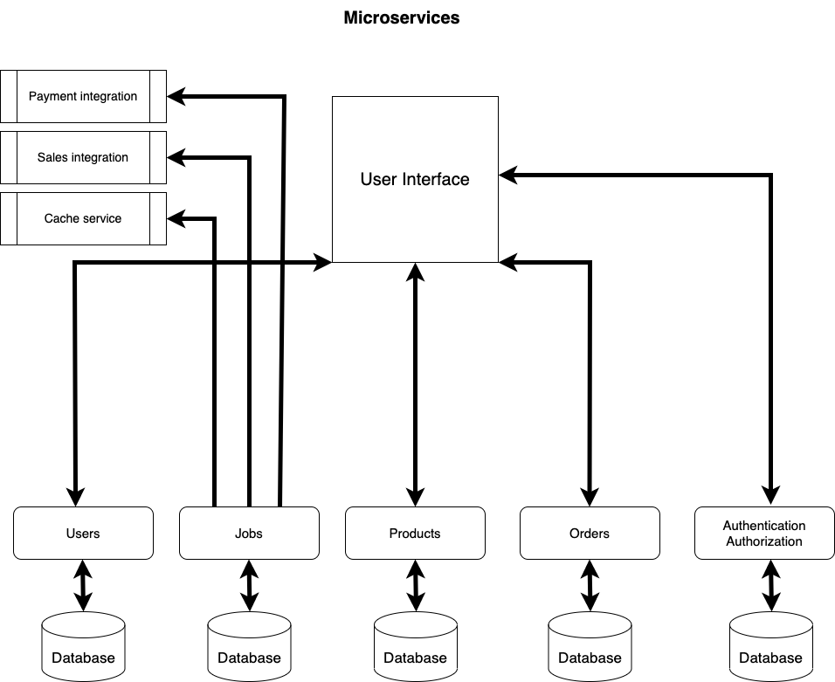
Figure 2-3. : Architecture diagram for simple microservices
Another architecture you’ll hear about is serverless. These can be used to handle all of the back-end functionality, you just have to be aware of their differences because it can make a huge difference in your cloud provider bills. But if you need a few lambda functions, for example, to handle very specific behavior, this could be a good addition to your back-end design. You might see serverless and monolithic architectures used together as the product grows.
Before microservices became a thing, there was service-oriented architecture (SOA). The main difference is that with SOA, all of the separate services are sharing the same database. This can still be a good approach if you’re app gets complex enough that it still might be a good idea to break out functionality into smaller chunks code-wise to keep things maintainable. I’m not going to dive into the details of SOA, but that you can consider if they should be used as part of your architecture.
The beautiful thing about architecture is that you can take the bits and pieces that work for your use case and put them together. As you work with microservices, you might hear about service meshes too. I encourage you to learn more about service meshes and how they are implemented, but I won’t cover them here.
Remember, as you go through the process of designing a back-end, it will take time. This isn’t something that should be rushed through and you should seek out as much feedback as possible from the other developers and teams you work with. Selecting any combination of these approaches cements the future development of the project because it’s not an easy task to switch the entire architecture to something else.

Selecting an API Design Pattern: REST and GraphQL
There’s something else you need to decide on at this phase of setting up the project. Are you going to go with Representational State Transfer (REST) APIs, GraphQL, or something else? This will determine how the front-end and other services are able to interface with your back-end and it will also determine how you extend your code as new roles, permissions, and other features are added over time.
REST is the standard in back-end development at the moment and GraphQL has grown to be a close second. There are other options, like Simple Object Access Protocol (SOAP) APIs, but hopefully you won’t have to work with those.
The main difference between REST and GraphQL is that GraphQL uses a single endpoint to handle all requests while REST uses multiple endpoints for requests. You might hear people talk about these paradigms like they’re super different, but they really aren’t. It’s more in the difference of the way you can build the APIs and consume them. One thing to call out is that GraphQL does come with subscriptions built in. The only way to handle that with REST is with WebSockets or a similar technology.
With REST APIs, you typically have one type of resource per endpoint. Take the `orders` endpoint in your project for example. You have `GET`, `POST`, and `PUT` requests for the different ways you need to interact with your order data. If this were a GraphQL API, the endpoints would become your GraphQL schema like this:
[source, javascript]
type Order {
id: ID
name: String
total: Number
products: Product[]
createdAt: Date
updatedAt: Date
}
type CreateOrderInput {
name: String
total: Number
products: Product[]
}
type UpdateOrderInput {
name: String
total: Number
products: Product[]
}
type Query {
order(id: ID!): Order
orders: Order[]
}
type Mutation {
create(input: CreateOrderInput): Order
update(input: UpdateOrderInput): Order
}
With GraphQL, you can specify the operation you want with the +query+ or +mutation+ keyword instead of an HTTP method. There’s no difference in the data that you’ll receive compared to your HTTP requests. The GraphQL response will still be in JSON format with the same values as an HTTP response. The difference is in how you manage the code.
When you write HTTP requests in JavaScript, you specify an endpoint path, a method, and any data you need to send in the request. With GraphQL, you have more flexibility with your requests. Using queries and mutations, you can write resolver functions instead of endpoint paths. Here’s an example of what resolvers might look like for your orders functionality:
[source, javascript]
{
Query: {
order: (root, { id }) => find(orders, { id: id }),
},
Order: {
products: (order) => filter(products, { orderId: order.id }),
},
}
So when you're ready to make a request, the query would look like this:
[source, javascript]
query {
order(id: 'fejiw-f4wt301-4tfw2g-g4t24') {
name
products {
name
price
}
}
}
This is where some of the power of GraphQL starts coming in. You can query for the exact data you want without returning values you don’t need. When you make HTTP requests, you can’t ask for one or two values to be returned. You get all of the data from that endpoint every time. GraphQL can save on response times for systems that handle massive amounts of data that are interrelated because you can ask for exactly what you need.
This book isn’t going to do a deep dive into GraphQL, but I wanted to make sure that you know this option is available and it’s widely used across the tech industry. You can think of GraphQL as the next evolution after REST. It’s like when TypeScript came along to become the standard over JavaScript. It’s worth taking some time to learn more about it. You can check out some resources directly at https://graphql.org/. You’ll find all kinds of communities, classes, tools, and docs based around GraphQL.

Conclusion
In this chapter, you’ve learned about the Nest.js app you’ll be setting up to handle your back-end. You’ve learned about a few different architectures and API paradigms and their trade-offs. Now that you’ve done the initial setup for the Nest.js back-end and you know why each decision was made and some of the trade-offs, it’s time to turn your attention to the data schema.

Chapter 3. Building the Data Schema
A Note for Early Release Readers
With Early Release ebooks, you get books in their earliest form—the author’s raw and unedited content as they write—so you can take advantage of these technologies long before the official release of these titles.
This will be the 3rd chapter of the final book. Please note that the GitHub repo is available at https://github.com/flippedcoder/dashboard-server.
If you have comments about how we might improve the content and/or examples in this book, or if you notice missing material within this chapter, please reach out to the editor at vwilson@oreilly.com.
The data layer covers a lot. That’s why it’s awesome we have so many good tools to work with. Regardless of the tools you choose, you do need to understand a bit about what’s going on beneath the surface. When you start building your data schema, take your time and really write it out. The data schema drives everything for the app and any of its dependencies. Over time, it can really hard to update the schema without breaking everything.
Since you’ve already decided what kind of back-end architecture to go with, you probably already have an idea of how data will be related and what that data looks like. That’s why this chapter is going to cover:
- Initial considerations for setting up the data schema
- Setting up a database
- Using object relational mapping (ORM) tools
- Data migrations in your database
You want to be as detailed as you can and document as much of the business logic as possible. By the time you finish this chapter, you’ll have a good foundation of where to start building out your data schema.

Initial Considerations
To build out your data layer, you’ll go through these basic steps:
Make a diagram for a data schema. This should include the entities, their columns and data types, and their relationships.
Set up the database connection in the app. This example will use Prisma to connect to a PostgreSQL database, but there are other popular tools like Knex or Drizzle you can use. Some of the reasons you’re using Postgres is because it is open-source and has a long history of reliability. You’ll find it behind huge, complex apps that have been in production for decades and newer apps that have just been released.
Write the data schema in the app. Take your diagram and translate it into code.
Add seed data. This is to ensure that your database has the essential data it needs from the beginning. It’s also a great tool for adding data for testing in different environments.
Run migrations. After the connection is established and the schema and seed data are ready, you need to run a migration to get these changes to the database.
Test the database with simple SQL queries. Check that the tables are creating, updating and storing data as expected. Double-check the relations between tables by looking at foreign keys.
Some apps will have a more complex scenario than this, but you’ll see a process similar to this across all projects. You already know what data you’re expecting based on your conversations with Product, so now it’s time to make a good diagram for the dev team.

Note
We’re not going to discuss non-relational databases in this book because we’re going to work with relational databases. Relational databases enforce strict rules between data whereas non-relational databases don’t. Choosing between the two depends on the type of project you’re working on. If you want somewhere to store any format of data that comes in, like with events that might have constantly changing information for example, non-relational databases can give you more flexibility. Non-relational databases have specific use cases, but many apps are fine with a normal relational database.

Diagramming the Data Schema
A diagram is a great visual reference for developers and QA to understand what values to expect and why. It’s a great tool to spark discussions between the front-end and back-end, and to document relations between data in a non-code way. Again, they don’t have to be anything fancy. Something developers tend to get hung up on are little details in places that don’t matter. As a senior dev, you have to be self-aware enough to notice when you start diving too deep on a task that doesn’t need that much attention.
These tables, for example, can be just like the ones below. When possible, you want to use a tool that connects directly to the database to create the visualization, like DBeaver. That way you can see the exact relationships you’ve defined. The important part is that it’s in a format that everyone can understand.
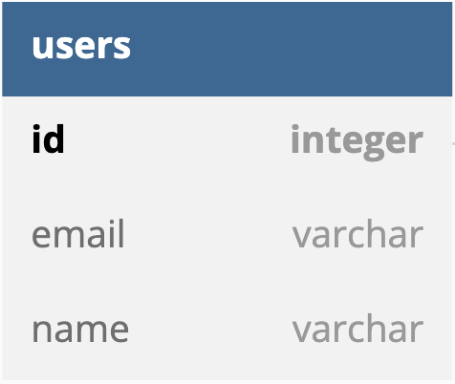
Figure 3-1. : This table shows the columns you can expect in the user table.
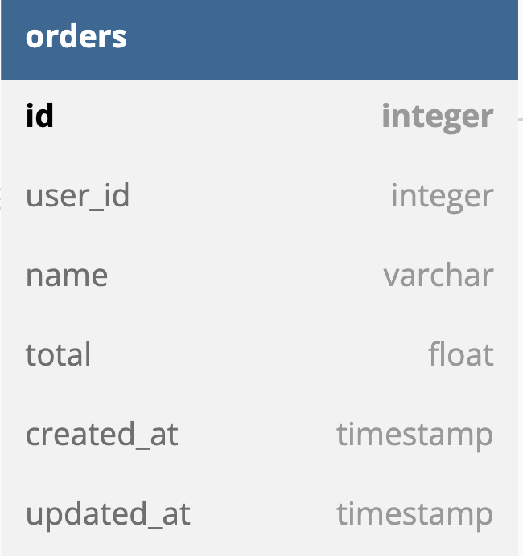
Figure 3-2. : This table has the columns for the orders information.
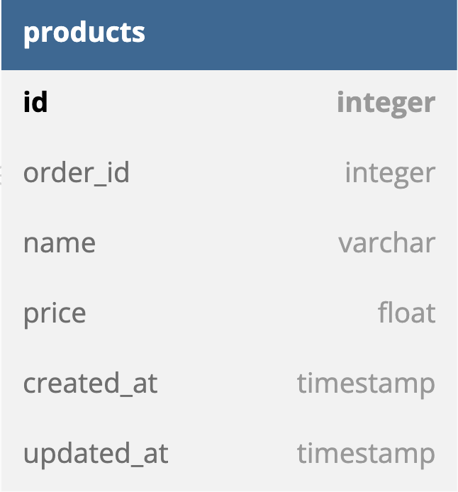
Figure 3-3. : In this table, there are the columns associated with a product.
Figure 3-4: A visual of how Figures 3-1, 3-2, and 3-3 are related.
Finally, in Figure 3-4, you can see how all of the tables are related to each other.
Now that you have the data schema documented. You’ll take this to the team and walk through what your thoughts are and ask for feedback. The front-end devs might have specific data format requests based on how they have to render elements. When it comes to the front-end, you typically shouldn’t plan the schema around it. It’s important to make sure that the queries they typically make, like searches and sorts, are thought of in the schema design though. Other devs might bring up security considerations.
By opening this up for everyone to think about, you end up with a stronger schema than if one person handled it alone. As a senior dev, you’ll learn how to be more confident with sharing your ideas and getting others to open up with theirs. Don’t be afraid to be wrong during these discussions because it might spark an idea for someone else.
It can be an uncomfortable place to be for a while because it feels like everyone is heavily scrutinizing your code and your technical prowess. They aren’t. You have to get used to receiving constructive feedback and that’s what will help you and the team build better code. The more you present your code and thoughts to the team, the quicker you’ll be able to improve things for everyone.
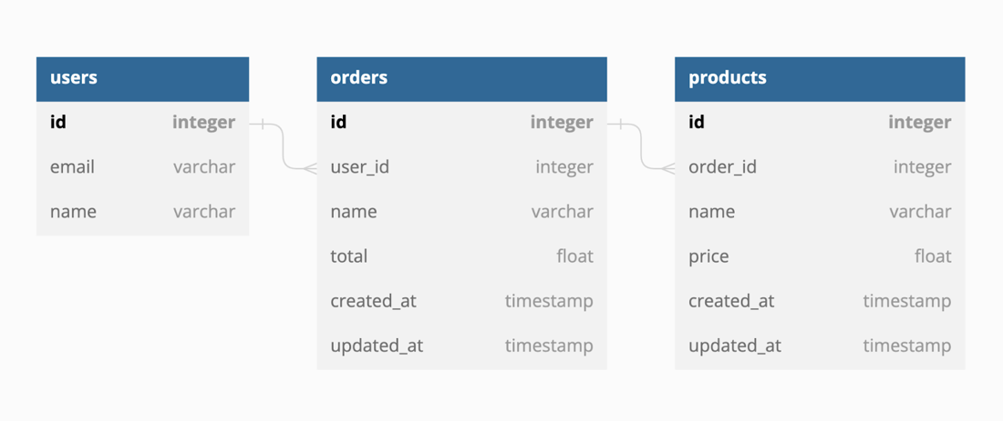

With the data schema diagramed and agreed upon by the front-end and back-end devs, you can start work on connecting the back-end to the database to create these tables. You’ll be working with a Postgres instance locally, but this can also be hosted on a server in the cloud.

Setting Up Postgres
You need to set up Postgres so you can get the connection information for your app. This will normally be handled by the team that manages the infrastructure for your production and non-production environments. You’ll still need your own local instance to make sure the changes you and the team are making work as expected. This is something you’d include in a Docker container if that’s how you wanted to keep the local environments consistent. As a senior dev, something else you’re responsible for thinking of is how to make onboarding smooth for new devs. Getting the local environment setup is one of the biggest hurdles for anyone joining a new team, so doing this will really pay off as the team and the product grows.
You can also download Postgres for free here. Follow their documentation to get everything up and running. You should set a master password or a password on the database you create. Doing some basic database security locally can help reveal potential issues early on.
If you do choose to create a database password, make sure you remember it. You’ll need it to connect your app to the database. You’ll also need the database name, port number, and database username. This project will name the database, dashboard. Unless you chose something other than the default values, the other credentials will be the following:
- Database username: postgres
- Database port number: 5432
The password depends on what you decided to do when you initially set up Postgres. If you installed via the linked download, then you can create your database in pgAdmin. It will look similar to this:
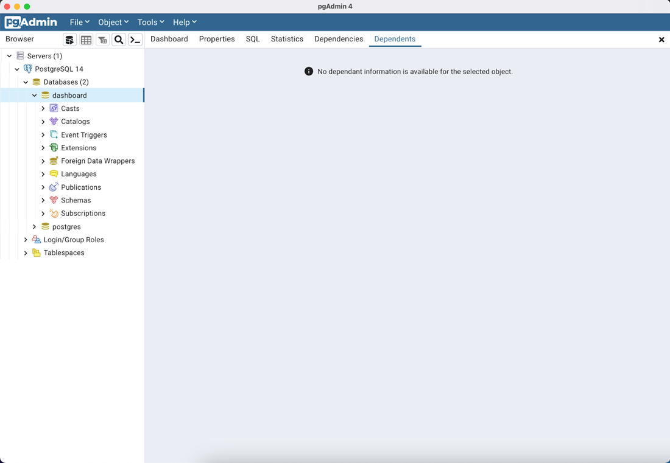
Figure 3-4. : Dashboard database in local Postgres
When you’re at this point, you’re ready to start creating the tables you diagramed earlier. We’re going to look at a couple of different approaches to create these tables: SQL statements and using an object-relational mapping (ORM) tool.

Basic SQL Commands to Know
Let’s start with using SQL statements. As a senior full-stack developer, it’s good to know some basic SQL commands. You don’t have to get super in-depth with things like views and indexing, but knowing enough to do create-read-update-delete (CRUD) operations goes a long way. One way to get started is by writing a statement to insert a new row into a table. You can do that with the following SQL:
[source, sql]
INSERT INTO table_name (column1, column2, column3 ) VALUES (value1, value2, value3);
You can change table_name to the table you want to insert the data into. The column1, column2, column3 fields represent the column name you want to put the data into. Finally, value1, value2, value3 are the values you want to add to the respective columns. For testing purposes, you can add new row entries like this:
[source, sql]
INSERT INTO Orders (id,name,total)
VALUES (4, 'Mark', 25.99)
RETURNING id;
To check that your data is stored like you expect it to be, you can query the data like this:
[source, sql]
SELECT * FROM Orders;
And to round things out, you may need to delete some data to clean up an example you’ve been working on. You can do that with something like this:
[source, sql]
DELETE FROM Orders
WHERE id = 4
RETURNING *;
If you can confidently use commands like these, you have enough SQL knowledge to double-check values directly in the database. Of course you can dive deeper into SQL and database management, but you don’t need to in order to be a good senior full-stack dev. With these little SQL commands in your background knowledge, let’s move on to the real tool you’ll likely be using for database operations from your app.

Deciding What ORM to Use to Work with the Data
Aside from choosing the framework for your back-end, the ORM tool is one of the big choices you’ll make for the lifetime of your project. It’s not an easy task to switch to a different ORM tool once you’ve started building. Nest.js comes with TypeORM, Sequelize, and Mongoose built in if you don’t have a preference. There are other commonly used ORM tools like Knex and Prisma, which you’ll be using.
All of these tools essentially do the same thing, but with a different flavor. The one you use will come down to the comfort level of the team and any limitations they may have. For this project, you’ve decided to go with Prisma because it’s the tool everyone on the team has used before, the documentation is well maintained, and it’s a tool used by a lot of tech teams across different projects in the industry. There’s a built-in ORM, but Prisma has more support, a bigger community, and it works really well with Postgres. Reasons like these make it a strong candidate and that’s why you and the team have selected it.
Now you’ll need to install it as a dev dependency in your project with the following command:
[source, bash]
npm install prisma @prisma/client --save-dev

Note
As a senior dev, there are some finer details you need to be aware of, especially concerning dependencies. When you are adding a dependency to your project, make sure you understand what type of dependency it needs to be. There are 3 types of dependencies: dependencies (regular), development (dev) dependencies, and peer dependencies.
Dependencies are the packages your app needs to run correctly. Dev dependencies are the packages that you need to do development work, like interfacing with the database. You’ll learn more about peer dependencies if you work on a project that needs to be published as its own package, but peer dependencies are the packages that your package expects to be installed in the container app.
With Prisma installed in your project, you need to set up some configs to connect the app to your Postgres database. Like any ORM, you have to initialize it in your project. With Prisma, you can run this command to do that:
[source, bash]
npx prisma init --datasource-provider postgresql
✔ Your Prisma schema was created at prisma/schema.prisma
You can now open it in your favorite editor.
warn You already have a .gitignore file. Don't forget to add `.env` in it to not commit any private information.
Next steps:
1. Set the DATABASE_URL in the .env file to point to your existing database. If your database has no tables yet, read https://pris.ly/d/getting-started
2. Run prisma db pull to turn your database schema into a Prisma schema.
3. Run prisma generate to generate the Prisma Client. You can then start querying your database.
More information in our documentation:
https://pris.ly/d/getting-started

Note
Always read the console output after you run commands. They usually give you useful advice!
This will create the prisma directory and a .env file in your project. Make sure the .env file is in your .gitignore first. Then inside the prisma directory, you’ll find the schema.prisma and this is where you’ll set up your database connection and the models for the app. The .env file has a URL to your database and this is the connection string that will contain the database credentials. Update the value for DATABASE_URL in the .env file with your local credentials. It might look something like this:
[source, bash]
DATABASE_URL="postgresql://username:password@localhost:5432/dashboard"
Any values in your .env should be handled in your CI/CD pipeline. Work with the DevOps team to get this in place depending on the infrastructure setup. Now you can move over to the schema.prisma file and start writing your model. You’ve already done the hard part of thinking out how everything relates, so now you can confidently start coding. You’ll notice this is where you can see one of the biggest differences between the ORM tools. Prisma has its own flavor that you’ll have to get used to and it’s ok to refer to the docs often.
In your schema.prisma, you can start adding pieces of your model. Add the following code to the end of the file:
[source, javascript]
// schema.prisma
...
model User {
id Int @id @default(autoincrement())
email String @unique
name String
products Product[]
}
model Product {
id Int @id @default(autoincrement())
name String
imageUrl String
price Float
quantity Int
User User? @relation(fields: [userId], references: [id])
userId Int?
}
Building models with Prisma is similar to writing objects or type definitions if you’re familiar with TypeScript. These models use special Prisma syntax for the types, but they match closely to the common types you work with. The most important thing to note is how relationships are defined between tables. On the Product table, you see we have an associated user id. On the User table, we have an array of products.
This is how Prisma defines relationships between tables and I highly encourage you to look through their documentation to learn about building more complex relationships. You might also want to look into the Prisma VS Code plugin to help make development smoother. For this app though, these few models will get you moving.
This completes the data schema for your app so far. Now it’s time to get this schema onto the database with a migration.

Writing Migrations
Migrations are the SQL queries statements by the ORM based on your schema definition. When you connect to the database to run a migration, you’re essentially executing SQL statements. That’s what makes ORM tools so useful. Instead of having to manually write the SQL for multiple tables, like you did earlier, you can write the query in JavaScript and the ORM will translate it to SQL. That’s why JavaScript developers use these tools so they don’t have to learn all of the details of SQL and database quirks.
To run a migration with Prisma, you’ll open your console and navigate to the root of the project and run this command:
[source, bash]
npx prisma migrate dev --name initialize_dashboard_db
Environment variables loaded from .env
Prisma schema loaded from prisma/schema.prisma
Datasource "db": PostgreSQL database "dashboard", schema "public" at "localhost:5432"
Applying migration `20230318132006_initialize_dashboard_db`
The following migration(s) have been created and applied from new schema changes:
migrations/
└─ 20230318132006_initialize_dashboard_db/
└─ migration.sql
Your database is now in sync with your schema.
Anytime you update your schema you’ll need to make a new migration to update the database. Make sure to give it a descriptive name so you can quickly understand what happened in the database history. This is super helpful if you run into data issues on the back-end because it’s easier to see what changes have been made and when. Every migration will automatically generate the timestamp at the beginning of the folder name in Prisma. The timestamp is important so the database knows what order to run the migrations.
Other tools will handle migrations a little differently. Knex, for example, lets you write migrations in pure SQL if you want and it generates migration files instead of folders. If you look in your project’s prisma directory, you should see a migrations folder with an subfolder. This is where the generated SQL for your migration is. That’s the beauty of an ORM. You can write in syntax you’re familiar with and it will generate the SQL for you. Take a look at the migration.sql file in the migration folder. You’ll see something like this:
[source, sql]
-- CreateTable
CREATE TABLE "User" (
"id" SERIAL NOT NULL,
"email" TEXT NOT NULL,
"name" TEXT NOT NULL,
CONSTRAINT "User_pkey" PRIMARY KEY ("id")
);
…
This is just the initial set up migration for the database and you’ll be adding more tables and columns and changing names as the app grows. When you run into issues with a migration, you can roll it back and you’ll learn how to do that in the debugging section of this chapter. For now, you have what you need to add some seed data to the database so you can start working on the rest of the app.

Seeding the Database
Since this is your local database, you’ll eventually want some test data to play with. You can add that as part of the dev env setup or have it as part of the setup for the real database. To start, create a new seed.ts file in the prisma directory. This is where you’ll use the Prisma Client to create some records. In your seed.ts file, add the following code:
[source, javascript]
// seed.ts
const { PrismaClient } = require('@prisma/client');
const db = new PrismaClient();
async function main() {
const orderData = [
{
name: 'inv_924',
quantity: 2,
total: 92.42,
createdAt: new Date('2023/02/21'),
updatedAt: new Date('2023/02/24'),
},
{
name: 'inv_925',
quantity: 7,
total: 24.56,
createdAt: new Date('2023/02/21'),
updatedAt: new Date('2023/02/24'),
},
…
You can find the complete seed.ts file here: https://github.com/flippedcoder/dashboard-server/blob/main/prisma/seed.ts
This code allows you to connect to the database and insert these new rows into their respective tables. Then it disconnects from the database. In order to run this with Prisma, you need to add the seed config to your package.json like this:
[source, json]
...
"collectCoverageFrom": [
"**/*.(t|j)s"
],
"coverageDirectory": "../coverage",
"testEnvironment": "node"
},
"prisma": {
"seed": "ts-node prisma/seed.ts"
}
}
This tells Prisma where to look for your seed file and how to execute it. With the configs and some data ready, you can run this command to actually insert the data into your Postrgres instance:
[source, bash]
npx prisma db seed
Environment variables loaded from .env
Running seed command `ts-node prisma/seed.ts` ..
ߌႠ The seed command has been executed.
Now if you look in your Postgres tables, you should see the values you wrote in seed.ts. This should be everything you need for your data concerns right now. Just to double-check, here’s a quick checklist you can go through when you think you’re finished setting everything up:
- Does the schema match the designs and functionality explained in the behavioral doc?
- Have you had at least one other dev look at it?
- Have you checked to make sure the schema works for all of the apps consuming data from this database?
There are more advanced things to consider as well that are out of scope for this book. Here’s a list of some of those things and links to more resources:
- Does your schema give room for the app to grow? https://www.oreilly.com/library/view/software-architecture-the/9781492086888/
- Is there a way to audit actions and the users who triggered them? https://www.auditboard.com/blog/what-is-an-audit-trail/
- Have you considered different user role levels for table operation access? https://www.imperva.com/learn/data-security/role-based-access-control-rbac/
These advanced topics could have their own chapters or even books. There are a wide range of questions you can ask here, but to keep things moving forward at this stage, don’t get too deep into the details. If you can answer these questions, explain the schema decisions to another dev, and you can demo it to the Product team, you’re good to go for now.
Take notes and make Jira tickets for any optimizations you see along the way. That way you can come back and actually work on the details because it’s documented in a way that Product considers. You’ve decided that the schema is in a good place and the tickets regarding different endpoints can be unblocked. This is when you’ll start working on the API that different apps will interact with to get data from the database you just set up.

Conclusion
In this chapter, you went through the process of drawing diagrams for your data, setting up a Postgres instance, and handling some initial setup with your ORM. You should feel pretty good about expanding your data schema from here because you’ve already asked a lot of questions about the future of the app.

About the Author
Melecia McGregor is a senior software engineer that’s worked with JavaScript, Angular, React, Node, PHP, Python, .NET, SQL, AWS, Heroku, Azure, and many other tools to build web apps. She also has a master’s degree in mechanical and aerospace engineering and has published research in machine learning and robotics. She started Flipped Coding in 2017 to help people learn web development with real-world projects and she publishes articles covering all aspects of software on several publications, including freeCodeCamp. In her free time, she spends time with her husband and dogs while learning to play the harmonica and trying to create her own mad scientist lab.

