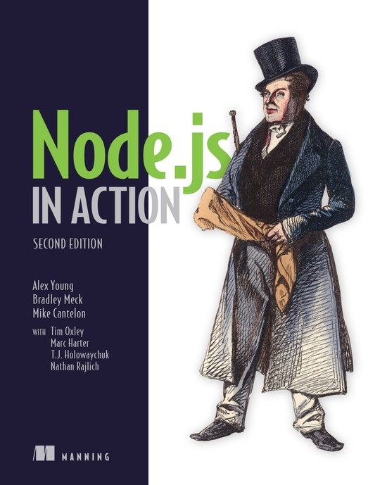

Table of Contents
Copyright
Brief Table of Contents
Table of Contents
Praise for the First Edition
Preface
Acknowledgments
About this Book
About the Author
About the Cover Illustration
Part 1. Welcome to Node
Chapter 1. Welcome to Node.js
Chapter 2. Node programming fundamentals
Chapter 3. What is a Node web application?
Part 2. Web development with Node
Chapter 4. Front-end build systems
Chapter 5. Server-side frameworks
Chapter 6. Connect and Express in depth
Chapter 7. Web application templating
Chapter 8. Storing application data
Chapter 9. Testing Node applications
Chapter 10. Deploying Node applications and maintaining uptime
Part 3. Beyond web development
Chapter 11. Writing command-line applications
Chapter 12. Conquering the desktop with Electron
Appendix A. Installing Node
Appendix B. Automating the web with scraping
Appendix C. Connect’s officially supported middleware
Glossary
Index
List of Figures
List of Tables
List of Listings

Node.js in Action, Second Edition
Alex Young, Bradley Meck, and Mike Cantelon

Copyright
For online information and ordering of this and other Manning books, please visit www.manning.com. The publisher offers discounts on this book when ordered in quantity. For more information, please contact
Special Sales Department
Manning Publications Co.
20 Baldwin Road
PO Box 761
Shelter Island, NY 11964
Email:
orders@manning.com
©2017 by Manning Publications Co. All rights reserved.
No part of this publication may be reproduced, stored in a retrieval system, or transmitted, in any form or by means electronic, mechanical, photocopying, or otherwise, without prior written permission of the publisher.
Many of the designations used by manufacturers and sellers to distinguish their products are claimed as trademarks. Where those designations appear in the book, and Manning Publications was aware of a trademark claim, the designations have been printed in initial caps or all caps.
Recognizing the importance of preserving what has been written, it is Manning’s policy to have the books we publish printed on acid-free paper, and we exert our best efforts to that end. Recognizing also our responsibility to conserve the resources of our planet, Manning books are printed on paper that is at least 15 percent recycled and processed without the use of elemental chlorine.
 | Manning Publications Co.  20 Baldwin Road  PO Box 761  Shelter Island, NY 11964
Development editor: Cynthia Kane
Review editor: Aleksandar Dragosavljević
Technical development editor: Stan Bice
Project editors: Kevin Sullivan, David Novak
Copyeditor: Sharon Wilkey
Proofreader: Melody Dolab
Technical proofreader: Doug Warren
Typesetter and cover design: Marija Tudor
ISBN 9781617292576
Printed in the United States of America
1 2 3 4 5 6 7 8 9 10 – EBM – 22 21 20 19 18 17

Brief Table of Contents
Copyright
Brief Table of Contents
Table of Contents
Praise for the First Edition
Preface
Acknowledgments
About this Book
About the Author
About the Cover Illustration
1. Welcome to Node
Chapter 1. Welcome to Node.js
Chapter 2. Node programming fundamentals
Chapter 3. What is a Node web application?
2. Web development with Node
Chapter 4. Front-end build systems
Chapter 5. Server-side frameworks
Chapter 6. Connect and Express in depth
Chapter 7. Web application templating
Chapter 8. Storing application data
Chapter 9. Testing Node applications
Chapter 10. Deploying Node applications and maintaining uptime
3. Beyond web development
Chapter 11. Writing command-line applications
Chapter 12. Conquering the desktop with Electron
Appendix A. Installing Node
Appendix B. Automating the web with scraping
Appendix C. Connect’s officially supported middleware
Glossary
Index
List of Figures
List of Tables
List of Listings

Table of Contents
Copyright
Brief Table of Contents
Table of Contents
Praise for the First Edition
Preface
Acknowledgments
About this Book
About the Author
About the Cover Illustration
1. Welcome to Node
Chapter 1. Welcome to Node.js
1.1. A typical Node web application
1.1.1. Nonblocking I/O
1.1.2. The event loop
1.2. ES2015, Node, and V8
1.2.1. Node and V8
1.2.2. Working with feature groups
1.2.3. Understanding Node’s release schedule
1.3. Installing Node
1.4. Node’s built-in tools
1.4.1. npm
1.4.2. The core modules
1.4.3. The debugger
1.5. The three main types of Node program
1.5.1. Web applications
1.5.2. Command-line tools and daemons
1.5.3. Desktop applications
1.5.4. Applications suited to Node
1.6. Summary
Chapter 2. Node programming fundamentals
2.1. Organizing and reusing Node functionality
2.2. Starting a new Node project
2.2.1. Creating modules
2.3. Fine-tuning module creation by using module.exports
2.4. Reusing modules by using the node_modules folder
2.5. Exploring caveats
2.6. Using asynchronous programming techniques
2.7. Handling one-off events with callbacks
2.8. Handling repeating events with event emitters
2.8.1. An example event emitter
2.8.2. Responding to an event that should occur only once
2.8.3. Creating event emitters: a publish/subscribe example
2.8.4. Extending the event emitter: a file watcher example
2.9. Challenges with asynchronous development
2.10. Sequencing asynchronous logic
2.11. When to use serial flow control
2.12. Implementing serial flow control
2.13. Implementing parallel flow control
2.14. Using community tools
2.15. Summary
Chapter 3. What is a Node web application?
3.1. Understanding a Node web application’s structure
3.1.1. Starting a new web app
3.1.2. Comparing other platforms
3.1.3. What’s next?
3.2. Building a RESTful web service
3.3. Adding a database
3.3.1. Making your own model API
3.3.2. Making articles readable and saving them for later
3.4. Adding a user interface
3.4.1. Supporting multiple formats
3.4.2. Rendering templates
3.4.3. Using npm for client-side dependencies
3.5. Summary
2. Web development with Node
Chapter 4. Front-end build systems
4.1. Understanding front-end development with Node
4.2. Using npm to run scripts
4.2.1. Creating custom npm scripts
4.2.2. Configuring front-end build tools
4.3. Providing automation with Gulp
4.3.1. Adding Gulp to a project
4.3.2. Creating and running Gulp tasks
4.3.3. Watching for changes
4.3.4. Using separate files for larger projects
4.4. Building web apps with webpack
4.4.1. Using bundles and plugins
4.4.2. Configuring and running webpack
4.4.3. Using webpack development server
4.4.4. Loading CommonJS modules and assets
4.5. Summary
Chapter 5. Server-side frameworks
5.1. Personas
5.1.1. Phil: agency developer
5.1.2. Nadine: open source developer
5.1.3. Alice: product developer
5.2. What is a framework?
5.3. Koa
5.3.1. Setting up
5.3.2. Defining routes
5.3.3. REST APIs
5.3.4. Strengths
5.3.5. Weaknesses
5.4. Kraken
5.4.1. Setting up
5.4.2. Defining routes
5.4.3. REST APIs
5.4.4. Strengths
5.4.5. Weaknesses
5.5. hapi
5.5.1. Setting up
5.5.2. Defining routes
5.5.3. Plugins
5.5.4. REST APIs
5.5.5. Strengths
5.5.6. Weaknesses
5.6. Sails.js
5.6.1. Setting up
5.6.2. Defining routes
5.6.3. REST APIs
5.6.4. Strengths
5.6.5. Weaknesses
5.7. DerbyJS
5.7.1. Setting up
5.7.2. Defining routes
5.7.3. REST APIs
5.7.4. Strengths
5.7.5. Weaknesses
5.8. Flatiron.js
5.8.1. Setting up
5.8.2. Defining routes
5.8.3. REST APIs
5.8.4. Strengths
5.8.5. Weaknesses
5.9. LoopBack
5.9.1. Setting up
5.9.2. Defining routes
5.9.3. REST APIs
5.9.4. Strengths
5.9.5. Weaknesses
5.10. Comparison
5.10.1. HTTP servers and routes
5.11. Writing modular code
5.12. Persona choices
5.13. Summary
Chapter 6. Connect and Express in depth
6.1. Connect
6.1.1. Setting up a Connect application
6.1.2. Understanding how Connect middleware works
6.1.3. Combining middleware
6.1.4. Ordering middleware
6.1.5. Creating configurable middleware
6.1.6. Using error-handling middleware
6.2. Express
6.2.1. Generating the application skeleton
6.2.2. Configuring Express and your application
6.2.3. Rendering views
6.2.4. Express routing 101
6.2.5. Authenticating users
6.2.6. Registering new users
6.2.7. Logging in registered users
6.2.8. Working with user-loading middleware
6.2.9. Creating a public REST API
6.2.10. Enabling content negotiation
6.3. Summary
Chapter 7. Web application templating
7.1. Using templating to keep code clean
7.1.1. Templating in action
7.1.2. Rendering HTML without a template
7.2. Templating with Embedded JavaScript
7.2.1. Creating a template
7.2.2. Integrating EJS into your application
7.2.3. Using EJS for client-side applications
7.3. Using the Mustache templating language with Hogan
7.3.1. Creating a template
7.3.2. Using Mustache tags
7.3.3. Fine-tuning Hogan
7.4. Templating with Pug
7.4.1. Pug basics
7.4.2. Logic in Pug templates
7.4.3. Organizing Pug templates
7.5. Summary
Chapter 8. Storing application data
8.1. Relational databases
8.2. PostgreSQL
8.2.1. Performing installation and setup
8.2.2. Creating the database
8.2.3. Connecting to Postgres from Node
8.2.4. Defining tables
8.2.5. Inserting data
8.2.6. Updating data
8.2.7. Querying data
8.3. Knex
8.3.1. jQuery for databases
8.3.2. Connecting and running queries with Knex
8.3.3. Swapping the database back end
8.3.4. Beware of leaky abstractions
8.4. MySQL vs. PostgreSQL
8.5. ACID guarantees
8.5.1. Atomicity: transactions either succeed or fail in entirety
8.5.2. Consistency: constraints are always enforced
8.5.3. Isolation: concurrent transactions don’t interfere
8.5.4. Durability: transactions are permanent
8.6. NoSQL
8.7. Distributed databases
8.8. MongoDB
8.8.1. Performing installation and setup
8.8.2. Connecting to MongoDB
8.8.3. Inserting documents
8.8.4. Querying
8.8.5. Using MongoDB identifiers
8.8.6. Using replica sets
8.8.7. Understanding write concerns
8.9. Key/value stores
8.10. Redis
8.10.1. Performing installation and setup
8.10.2. Performing initialization
8.10.3. Working with key/value pairs
8.10.4. Working with keys
8.10.5. Encoding and data types
8.10.6. Using hashes
8.10.7. Using lists
8.10.8. Using sets
8.10.9. Providing pub/sub with channels
8.10.10. Improving Redis performance
8.11. Embedded databases
8.12. LevelDB
8.12.1. LevelUP and LevelDOWN
8.12.2. Installation
8.12.3. API overview
8.12.4. Initialization
8.12.5. Key/value encodings
8.12.6. Reading and writing key/value pairs
8.12.7. Pluggable back ends
8.12.8. The modular database
8.13. Serialization and deserialization are expensive
8.14. In-browser storage
8.14.1. Web storage: localStorage and sessionStorage
8.14.2. Reading and writing values
8.14.3. localForage
8.14.4. Reading and writing
8.15. Hosted storage
8.15.1. Simple Storage Service
8.16. Which database?
8.17. Summary
Chapter 9. Testing Node applications
9.1. Unit testing
9.1.1. The assert module
9.1.2. Mocha
9.1.3. Vows
9.1.4. Chai
9.1.5. Should.js
9.1.6. Spies and stubs with Sinon.JS
9.2. Functional testing
9.2.1. Selenium
9.3. Dealing with failing tests
9.3.1. Getting more-detailed logs
9.3.2. Getting better stack traces
9.4. Summary
Chapter 10. Deploying Node applications and maintaining uptime
10.1. Hosting Node applications
10.1.1. Platform as a service
10.1.2. Servers
10.1.3. Containers
10.2. Understanding deployment basics
10.2.1. Deploying from a Git repository
10.2.2. Keeping Node running
10.3. Maximizing uptime and performance
10.3.1. Maintaining uptime with Upstart
10.3.2. The cluster API: taking advantage of multiple cores
10.3.3. Hosting static files and proxying
10.4. Summary
3. Beyond web development
Chapter 11. Writing command-line applications
11.1. Understanding conventions and philosophy
11.2. Introducing parse-json
11.3. Using command-line arguments
11.3.1. Parsing command-line arguments
11.3.2. Validating arguments
11.3.3. Passing stdin as a file
11.4. Sharing command-line tools with npm
11.5. Connecting scripts with pipes
11.5.1. Piping data into parse-json
11.5.2. Working with errors and exit codes
11.5.3. Using pipes in Node
11.5.4. Pipes and command execution order
11.6. Interpreting real-world scripts
11.7. Summary
Chapter 12. Conquering the desktop with Electron
12.1. Introducing Electron
12.1.1. Electron’s stack
12.1.2. Interface design
12.2. Creating an Electron app
12.3. Building a full desktop application
12.3.1. Bootstrapping React and Babel
12.3.2. Installing the dependencies
12.3.3. Setting up webpack
12.4. The React app
12.4.1. Defining the Request component
12.4.2. Defining the Response component
12.4.3. Communicating between React components
12.5. Builds and distribution
12.5.1. Building with Electron Packager
12.5.2. Packaging
12.6. Summary
Appendix A. Installing Node
A.1. Installing Node by using an installer
A.1.1. The macOS installer
A.1.2. The Windows installer
A.2. Using other ways to install Node
A.2.1. Installing Node from source
A.2.2. Installing Node with a package manager
Appendix B. Automating the web with scraping
B.1. Understanding web scraping
B.1.1. Uses of web scraping
B.1.2. Required tools
B.2. Performing basic web scraping with cheerio
B.3. Handling dynamic content with jsdom
B.4. Making sense of raw data
B.5. Summary
Appendix C. Connect’s officially supported middleware
C.1. Parsing cookies, request bodies, and query strings
C.1.1. cookie-parser: parse HTTP cookies
C.1.2. Parsing query strings
C.1.3. body-parser: parse request bodies
C.1.4. compression: compressing outgoing responses
C.2. Implementing core web application functions
C.2.1. morgan: log requests
C.2.2. serve-favicon: address bar and bookmark icons
C.2.3. method-override: fake HTTP methods
C.2.4. vhost: virtual hosting
C.2.5. express-session: session management
C.3. Handling web application security
C.3.1. basic-auth: HTTP Basic authentication
C.3.2. csurf: cross-site request forgery protection
C.3.3. errorhandler: displaying errors during development
C.4. Serving static files
C.4.1. serve-static: automatically serving files to the browser
C.4.2. serve-index: generating directory listings
Glossary
Chapter 1
Chapter 2
Chapter 3
Chapter 4
Chapter 5
Chapter 6
Chapter 7
Chapter 8
Chapter 9
Chapter 10
Chapter 11
Chapter 12
Appendix A
Index
List of Figures
List of Tables
List of Listings

Praise for the First Edition
From the first edition of Node.js in Action by Mike Cantelon, Marc Harter, T.J. Holowaychuk, and Nathan Rajlich.
“The content ramps up nicely from basic to advanced.”
From the Foreword by Isaac Z. Schlueter, Node.js Project Lead
“The definitive guide to Node and the Node.js ecosystem.”
Kevin Baister, 1KB Software Solutions
“Superbly written with practical (and even funny) real-world examples.”
Àlex Madurell, Polymedia SpA
“Thoroughly enjoyable...will get you up and running very quickly.”
Gary Ewan Park, Honeywell
“An excellent resource written by the people behind the code.”
Brian Falk, NodeLingo, GoChime

Preface
Since the first edition of Node.js in Action, Node has merged with io.js and has dramatically changed its governance model. Node’s package manager has been spun off into a successful new company, npm, and technologies such as Babel and Electron have transformed the development landscape.
And yet, not much has changed in Node’s core libraries. JavaScript itself has changed: most developers now use features from ES2015, so all of the original listings have been rewritten to take advantage of arrow functions, constants, and destructuring. Node’s libraries and built-in tools still look broadly similar to Node pre 4.x, though, so we’ve looked to the community for updates to this edition.
To reflect the realities a Node developer now faces, we’ve restructured the book. There is less focus on Express and Connect, and more focus on a broader range of technologies. Everything you need to be a full-stack developer is here, including front-end build systems, choosing a web framework, working with databases in Node, writing tests, and deploying web apps.
In addition to web development, we’ve included chapters on writing command-line applications and Electron desktop apps. This lets you take full advantage of your Node and JavaScript skills.
Understanding Node and its ecosystem isn’t the only thing this book is about. Where possible, I’ve tried to add background details on what has influenced Node. Ideas such as Unix philosophy and using databases correctly and safely are covered alongside the usual Node and JavaScript topics. Hopefully, this gives you a broad enough picture of Node and JavaScript to seek out your own solutions to unique problems.
—ALEX YOUNG

Acknowledgments
This book was built on the work of the previous authors and owes a great debt to their efforts: Mike Cantelon, Marc Harter, T.J. Holowaychuk, and Nathan Rajlich. This edition wouldn’t have been possible without the encouragement of the team at Manning. Cynthia Kane, my development editor, kept me focused during the long process of updating the original content. Without Doug Warren’s detailed technical proofread, this book and the sample code wouldn’t be half as good as it is. Finally, thanks to the many reviewers who provided feedback during the writing and development process: Austin King, Carl Hope, Chris Salch, Christopher Reed, Dale Francis, Hafiz Waheed ud din, Harinath Mallepally, Jeff Smith, Marc-Philippe Huget, Matthew Bertoni, Philippe Charrière, Randy Kamradt, Sander Rossel, Scott Dierbeck, and William Wheeler.
—ALEX YOUNG

About this Book
The first edition of Node.js in Action was about web development with a particular focus on the Connect and Express web frameworks. Node.js in Action, Second Edition has been updated to suit the changing requirements of Node development. You’ll learn about front-end build systems, popular Node web frameworks, and how to build a web application with Express from scratch. You’ll also learn how to create automated tests and deploy Node web applications.
Node is being increasingly used for command-line developer tools and desktop applications with Electron, so you’ll find chapters dedicated to both of these areas.
This book assumes you’re familiar with basic programming concepts. The first chapter provides an overview of JavaScript and ES2015 for those of you who haven’t yet discovered the joys of modern JavaScript.

Roadmap
This book is organized into three parts.
Part 1 provides an introduction to Node.js, teaching the fundamental techniques needed to develop with it. Chapter 1 explains the characteristics of JavaScript and Node and steps through example code. Chapter 2 guides you through fundamental Node.js programming concepts. Chapter 3 is a full tutorial on how to build a web application from scratch.
Part 2, the largest section of the book, focuses on web application development. Chapter 4 dispels some of the mystery around front-end build systems: if you’ve ever had to use webpack or Gulp in a project but didn’t really understand it, this is the chapter for you. Chapter 5 reviews some of the most popular server-side frameworks available for Node, and chapter 6 goes into Connect and Express in more depth. Chapter 7 is dedicated to templating languages, which can improve your productivity when writing server-side code. Most web applications need a database, so chapter 8 covers the many types of databases that you can use with Node, from relational to NoSQL. Chapters 9 and 10 deal with testing and deployment, and this includes cloud deployment.
Part 3 goes beyond web application development. Chapter 11 is about building command-line applications with Node so you can create developer-friendly text interfaces. If you’re excited about the prospect of building desktop apps such as Atom with Node, then take a look at chapter 12, which is all about Electron.
We’ve also included three detailed appendixes. Appendix A has instructions on how to install Node for macOS and Windows. Appendix B is a detailed tutorial on web scraping, and appendix C reviews each of the officially supported middleware components for the Connect web framework.

Code conventions and downloads
The code in this book follows common JavaScript conventions. Spaces, rather than tabs, are used for indentation. Lines longer than 80 characters are avoided. In many listings, the code is annotated to point out key concepts.
A single statement per line is used and semicolons are added at the end of simple statements. For blocks of code, where one or more statements are enclosed in curly braces, the left curly brace is placed at the end of the opening line of the block. The right curly brace is indented so it’s vertically aligned with the opening line of the block.
Source code for the examples in this book is available for download from the publisher’s website at www.manning.com/books/node-js-in-action-second-edition.

Book Forum
Purchase of Node.js in Action, Second Edition includes free access to a private web forum run by Manning Publications where you can make comments about the book, ask technical questions, and receive help from the author and from other users. To access the forum, go to https://forums.manning.com/forums/node-js-in-action-second-edition. You can also learn more about Manning’s forums and the rules of conduct at https://forums.manning.com/forums/about.
Manning’s commitment to our readers is to provide a venue where a meaningful dialogue between individual readers and between readers and the author can take place. It is not a commitment to any specific amount of participation on the part of the author, whose contribution to the forum remains voluntary (and unpaid). We suggest you try asking the author some challenging questions lest his interest stray! The forum and the archives of previous discussions will be accessible from the publisher’s website as long as the book is in print.

About the Author

Alex Young
Alex is a web developer based in London, England, and is the author of Node.js in Practice (Manning, 2014). Alex created the popular JavaScript blog DailyJS, and is currently employed by Sky as a senior developer for NOW TV. You can find him on GitHub (https://github.com/alexyoung) and Twitter as @alex_young.

Bradley Meck
Bradley is a member of TC39 and part of the Node.js Foundation. When not working his time is spent working on tooling solutions for Javascript, gardening, and mentoring students. His work at GoDaddy comes after a long resume of using Node.js for other companies like NodeSource and Nodejitsu. While always eager to teach and explain, he tries to keep people motivated because learning is hard for him as well as for many others.

About the Cover Illustration
The figure on the cover of Node.js in Action, Second Edition is captioned “Man about Town.” The illustration is taken from a 19th-century edition of Sylvain Maréchal’s four-volume compendium of regional dress customs published in France. Each illustration is finely drawn and colored by hand. The rich variety of Maréchal’s collection reminds us vividly of how culturally apart the world’s towns and regions were just 200 years ago. Isolated from each other, people spoke different dialects and languages. Whether on city streets, in small towns, or in the countryside, it was easy to identify where they lived and what their trade or station in life was just by their dress.
Dress codes have changed since then, and the diversity by region and class, so rich at the time, has faded away. It is now hard to tell apart the inhabitants of different continents, let alone different towns or regions. Perhaps we have traded cultural diversity for a more varied personal life—certainly for a more varied and fast-paced technological life.
At a time when it is hard to tell one computer book from another, Manning celebrates the inventiveness and initiative of the computer business with book covers based on the rich diversity of regional life of two centuries ago, brought back to life by Maréchal’s pictures.

Part 1. Welcome to Node
Node is now a mature web development platform. In chapters 1 to 3, you’ll learn about Node’s main features, including how to use the core modules and npm. You’ll also see how Node uses modern JavaScript, and how to build a web application from scratch. After reading these chapters, you’ll have a solid understanding of what Node can do and of how to create your own projects.

Chapter 1. Welcome to Node.js
This chapter covers

What is Node.js?
Defining Node applications
The advantages of using Node
Asynchronous and nonblocking I/O
Node.js is an asynchronous, event-driven JavaScript runtime that offers a powerful but concise standard library. It’s managed and supported by the Node.js Foundation, an industry consortium with an open governance model. Two actively supported versions of Node are available: Long-Term Support (LTS) and Current. If you want to learn more about how Node is managed, the official website has plenty of documentation (https://nodejs.org/).
Since Node.js appeared in 2009, JavaScript has gone from a barely tolerated browser-centric language to one of the most important languages for all kinds of software development. This is partly due to the arrival of ECMAScript 2015, which solved several critical problems in previous versions of the language. Node uses Google’s V8 JavaScript engine that’s based on the sixth edition of the ECMAScript standard, which is sometimes called ES6 and abbreviated as ES2015. It’s also due to innovative technologies such as Node, React, and Electron, which allow Java-Script to be used everywhere: from the server to the browser, and in native mobile applications. Even big companies such as Microsoft are embracing JavaScript, and Microsoft has even contributed to the success of Node.
In this chapter, you’ll learn more about Node, its event-driven nonblocking model, and some of the reasons that JavaScript has become a great general-purpose programming language. First, let’s look at a typical Node web application.

1.1. A typical Node web application
One of the strengths of Node and JavaScript in general is their single-threaded programming model. Threads are a common source of bugs, and although some recent programming languages, including Go and Rust, have attempted to offer safer concurrency tools, Node retains the model used in the browser. In browser-based code, we write sequences of instructions that execute one at a time; code doesn’t execute in parallel. This doesn’t make sense for user interfaces, however: users don’t want to wait around for slow operations such as network or file access to finish. To get around this, browsers use events: when you click a button, an event fires, and a function runs that has previously been defined but not yet executed. This avoids some of the issues found in threaded programming, including resource deadlocks and race conditions.

1.1.1. Nonblocking I/O
What does this mean in the context of server-side programming? The situation is similar: I/O requests such as disk and network access are also comparatively slow, so we don’t want the runtime to block business logic from executing while reading files or sending messages over the network. To solve this, Node uses three techniques: events, asynchronous APIs, and nonblocking I/O. Nonblocking I/O is a low-level term from a Node programmer’s perspective. It means your program can make a request for a network resource while doing something else, and then, when the network operation has finished, a callback will run that handles the result.
Figure 1.1 shows a typical Node web application that uses the web application library Express to handle the order flow for a shop. Browsers make requests to buy a product, and then the application checks the current stock inventory, creates an account for the user, emails the receipt, and sends back a JSON HTTP response. Concurrently, other things happen as well: an email receipt is sent, and a database is updated with the user’s details and order. The code itself is straightforward, imperative JavaScript, but the runtime behaves concurrently because it uses nonblocking I/O.

Figure 1.1. Asynchronous and nonblocking components in a Node application
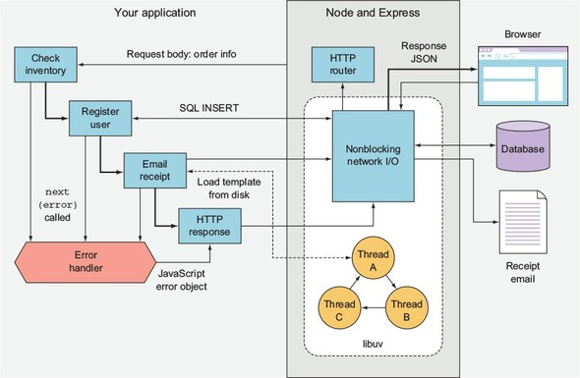
In figure 1.1 the database is accessed over the network. In Node, that network access is nonblocking, because Node uses a library called libuv (http://libuv.org/) to provide access to the operating system’s nonblocking network calls. This is implemented differently in Linux, macOS, and Windows, but all you have to worry about is your friendly Java-Script database library. While you’re writing code such as db.insert(query, err => {}), Node is doing highly optimized, nonblocking networking underneath.
Disk access is similar, but intriguingly not the same. When the email receipt is generated and the email template is read from the disk, libuv uses a thread pool to provide the illusion that a nonblocking call is being used. Managing a thread pool is no fun at all, but writing email.send('template.ejs', (err, html) => {}) is definitely much easier to understand.
The real benefit to using asynchronous APIs with nonblocking I/O is that Node can do other things while these comparatively slow processes happen. Even though you have only a single-threaded, single-process Node web app running, it can handle more than one connection from potentially thousands of website visitors at any one time. To understand this, you need to look at the event loop.

1.1.2. The event loop
Now let’s zoom into a specific aspect of figure 1.1: responding to browser requests. In this application, Node’s built-in HTTP server library, which is a core module called http.Server, handles the request by using a combination of streams, events, and Node’s HTTP request parser, which is native code. This triggers a callback in your application to run, which has been added using the Express (https://expressjs.com/) web application library. The callback that runs causes a database query to run, and eventually the application responds with JSON using HTTP. This whole process uses a minimum of three nonblocking network calls: one for the request, one for the database, and another for the response. How does Node schedule all these nonblocking network operations? The answer is the event loop. Figure 1.2 shows how the event loop is used for these three network operations.

Figure 1.2. The event loop
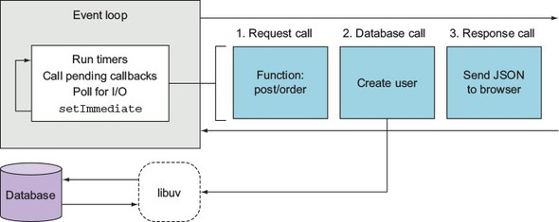
The event loop runs one way (it’s a first-in, first-out queue) and goes through several phases. Figure 1.2 shows a simplified set of the important phases that run on each iteration of the loop. First, the timers execute, which are the timers scheduled with the JavaScript functions setTimeout and setInterval. Next, I/O callbacks run, so if any I/O has returned from one of the nonblocking network calls, this is where your callback is triggered. The poll phase is where new I/O events are retrieved, and then callbacks scheduled with setImmediate run at the end. This is a special case because it allows you to schedule a callback to run immediately after the current I/O callbacks already in the queue. This might sound abstract at this stage, but what you should take away is the idea that although Node is single-threaded, it does give you tools to write efficient and scalable code.
Over the last few pages, you might have noticed that the examples have been written using ES2015 arrow functions. Node supports many new JavaScript features, so before moving on, let’s look at what new language features you can use to write better code.

1.2. ES2015, Node, and V8
If you’ve ever used JavaScript and been disheartened by the lack of classes and strange scoping rules, you’re in luck: Node has fixed most of these problems! You can now make classes, and using const and let (instead of var) fixes scoping issues. As of Node 6, you can use default function parameters, rest parameters, the spread operator, for...of loops, template strings, destructuring, generators, and more. A great summary of Node’s ES2015 support can be found at http://node.green.
First, let’s look at classes. ES5 and earlier versions required the use of prototype objects to create class-like constructs:
function User() {
// constructor
}
User.prototype.method = function() {
// Method
};
With Node 6 and ES2015, you can now write the same code by using classes:
class User {
constructor() {}
method() {}
}
This uses less code and is a little easier to read. But there’s more: Node also supports subclassing, super, and static methods. For those versed in other languages, the adoption of class syntax makes Node more accessible than when we were stuck with ES5.
Another important feature in Node 4 and above is the addition of const and let. In ES5, all variables were created with var. The problem with var is it defines variables in function or global scope, so you couldn’t define a block-level variable in an if statement, for loop, or other block.
Should I use const or let?
When deciding whether to use const or let, you almost always want const. Because most of your code will use instances of your own classes, object literals, or values that don’t change, you can use const most of the time. Even instances of objects that have properties that change can be declared with const, because const means only that the reference is read-only, not that the value is immutable.
Node also has native promises and generators. Promises are supported by lots of libraries, allowing you to write asynchronous code with a fluent interface style. You’re probably familiar with fluent interfaces already: if you’ve ever used an API such as jQuery or even JavaScript arrays, you’ll have seen it. The following short example shows you how to chain calls to manipulate an array in JavaScript:
[1, 2, 3]
.map(n => n * 2)
.filter(n => n > 3);
Generators are used to give a synchronous programming style to asynchronous I/O. If you want to see a practical example of generators in Node, take a look at the Koa web application library (http://koajs.com/). If you use promises or other generators with Koa, you can yield on values rather than nesting callbacks.
One other useful ES2015 feature in Node is template strings. In ES5, string literals didn’t support interpolation or multiple lines. Now by using the backtick symbol (`), you can insert values and span strings over several lines. This is useful when stubbing quick bits of HTML for web apps:
this.body = `
<div>
<h1>Hello from Node</h1>
<p>Welcome, ${user.name}!</p>
</div>
`;
In ES5, the previous example would have to be written like this:
this.body = '\n';
this.body += '<div>\n';
this.body += ' <h1>Hello from Node</h1>\n';
this.body += ' <p>Welcome, ' + user.name + '</p>\n';
this.body += '<div>\n';
The older style not only used more code but also made introducing bugs easy. The final big feature, which is of particular importance to Node programmers, is arrow functions. Arrow functions let you streamline syntax. For example, if you’re writing a callback that has a single argument and returns a value, you can write it with hardly any syntax at all:
[1, 2, 3].map(v => v * 2);
In Node we typically need two arguments, because the first argument to a callback is often an error object. In that case, you need to use parentheses around the arguments:
const fs = require('fs');
fs.readFile('package.json',
(err, text) => console.log('Length:', text.length)
);
If you need to use more than one line in the function body, you need to use curly brackets. The value of arrow functions isn’t just in the streamlined syntax; it has to do with JavaScript scopes. In ES5 and before, defining functions inside other functions makes the this reference become the global object. Here’s an ES5-style class that suffers from a bug due to this issue:
function User(id) {
// constructor
this.id = id;
}
User.prototype.load = function() {
var self = this;
var query = 'SELECT * FROM users WHERE id = ?';
sql.query(query, this.id, function(err, users) {
self.name = users[0].name;
});
};
The line that assigns self.name can’t be written as this.name, because the function’s this will be the global object. A workaround used to be to assign a variable to this at the entry point to the parent function or method. But arrow functions are bound correctly. In ES2015, the previous example can be rewritten to be much more intuitive:
class User {
constructor(id) {
this.id = id;
}
load() {
const query = 'SELECT * FROM users WHERE id = ?';
sql.query(query, this.id, (err, users) => {
this.name = users[0].name;
});
}
}
Not only can you use const to better model the database query, but there’s also no need for the clumsy self variable. ES2015 has many other great features that make Node code more readable, but let’s look at what powers this in Node and how it relates to the nonblocking I/O features that you’ve already looked at.

1.2.1. Node and V8
Node is powered by the V8 JavaScript engine, which is developed by the Chromium project for Google Chrome. The notable feature of V8 is that it compiles directly to machine code, and it includes code-optimization features that help keep Node fast. In section 1.1.1, we talked about the other main native part of Node, libuv. That part handles I/O; V8 handles interpreting and running your JavaScript code. To use libuv with V8, you use a C++ binding layer. Figure 1.3 shows all of the separate software components that make up Node.

Figure 1.3. Node’s software stack
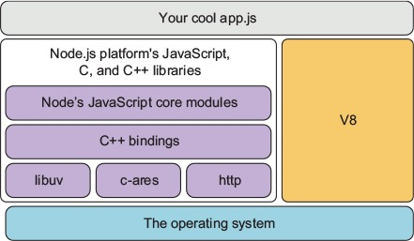
The specific JavaScript features that are available to Node therefore come down to what V8 supports. This support is managed through feature groups.

1.2.2. Working with feature groups
Node includes ES2015 features based on what V8 provides. Features are grouped under shipping, staged, and in progress. The shipping features are turned on by default, but staged and in progress can be enabled using command-line flags. If you want to use staged features, which are almost complete but not considered complete by the V8 team, then you can run Node with the --harmony flag. In-progress features, however, are less stable and are enabled with specific feature flags. Node’s documentation recommends querying the currently available in-progress features by grepping for in progress:
node --v8-options | grep "in progress"
The list will vary between Node releases. Node itself also has a versioning schedule that defines which APIs are available.

1.2.3. Understanding Node’s release schedule
Node releases are grouped into Long-Term Support (LTS), Current, and Nightly. LTS releases get 18 months of support and then 12 months of maintenance support. Releases are made according to semantic versioning (SemVer). SemVer gives releases a major, minor, and patch version number. For example, 6.9.1 has a major version of 6, minor of 9, and patch of 1. Whenever you see a major version change for Node, it means some of the APIs may be incompatible with your projects, and you’ll need to retest them against this version of Node. Also, in Node release terminology, a major version increment means a new Current release has been cut. Nightly builds are automatically generated every 24 hours with the latest changes, but are typically used only for testing Node’s latest features.
Which version you use depends on your project and organization. Some may prefer LTS because updates are less frequent: this might work well in larger enterprises that find it harder to manage frequent updates. But if you want the latest performance and feature improvements, Current is a better choice.

1.3. Installing Node
The easiest way to install Node is to use the installer from https://nodejs.org. Install the latest Current version (version 6.5 at the time of this writing) by using the Mac or Windows installer. You can download the source yourself, or install it by using your operating system’s package manager. Debian, Ubuntu, Arch, Fedora, FreeBSD, Gentoo, and SUSE all have packages. There are also packages for Homebrew and Smart-OS. If your operating system doesn’t have a package, you can build from source.

Note
Appendix A provides more details on installing Node.
The full list of packages is on Node’s website (https://nodejs.org/en/download/package-manager/), and the source is on GitHub (https://github.com/nodejs/node). Bookmarking the GitHub source is worthwhile in case you want to poke around in the source without downloading it.
Once you’ve installed Node, you can try it out straight away by typing node -v in the terminal. This should print out the version of Node that you just downloaded and installed. Next, create a file called hello.js that looks like this:
console.log("hello from Node");
Save the file and run it by typing node hello.js. Congratulations—you’re now ready to start writing applications with Node!
Getting started quickly in Windows, Linux, and macOS
If you’re fairly new to programming in general and you don’t yet have a preferred text editor, then a solid choice for Node is Visual Studio Code (https://code.visualstudio.com/). It’s made by Microsoft, but it’s open source and a free download, and supports Windows, Linux, and macOS.
Some of the beginner-friendly features in Visual Studio Code include JavaScript syntax highlighting and Node core module completion, so your JavaScript will look clearer and you’ll be able to see lists of supported methods and objects as you type. You can also open a command-line interface where Node can be invoked just by typing Node. This is useful for running Node and npm commands. Windows users might prefer this to using cmd.exe. We tested the listings with Windows and Visual Studio Code, so you shouldn’t need anything special to run the examples.
To get started, you can follow a Visual Studio Code Node.js tutorial (https://code.visualstudio.com/docs/runtimes/nodejs).
When you install Node, you also get some built-in tools. Node isn’t just the interpreter: it’s a whole suite of tools that form the Node platform. Let’s look in more detail at the tools that are bundled with Node.

1.4. Node’s built-in tools
Node comes with a built-in package manager, the core JavaScript modules that support everything from file and network I/O to zlib compression, and a debugger. The npm package manager is a critical piece of this infrastructure, so let’s look at it in more detail.
If you want to verify that Node has been installed correctly, you can run node -v and npm -v on the command-line. These commands show the version of Node and npm that you have installed.

1.4.1. npm
The npm command-line tool can be invoked by typing npm. You can use it to install packages from the central npm registry, but you can also use it to find and share your own open and closed source projects. Every npm package in the registry has a website that shows the readme file, author, and statistics about downloads.
That doesn’t cover everything, though. npm is also npm, Inc.—the company that runs the npm service and that provides services used by commercial enterprises. This includes hosting private npm packages: you can pay a monthly fee to host your company’s source code so your JavaScript developers can easily install it with npm.
When installing packages with the npm install command, you have to decide whether you’re adding them to your current project or installing them globally. Globally installed packages are usually used for tools, typically programs you run on the command line. A good example of this is the gulp-cli package.
To use npm, create a package.json file in a directory that will contain your Node project. The easiest way to create a package.json file is to use npm to do it for you. Type the following on the command line:
mkdir example-project
cd example-project
npm init -y
If you open package.json, you’ll see a simple JSON file that describes your project. If you now install a module from www.npmjs.com and use the --save option, npm will automatically update your package.json file. Try it out by typing npm install, or npm i for short:
npm i --save express
If you open your package.json file, you should see express added under the dependencies property. Also, if you look inside the node_modules folder, you’ll see an express directory. This contains the version of Express that you just installed. You can also install modules globally by using the --global option. You should use local modules as much as possible, but global modules can be useful for command-line tools that you want to use outside Node JavaScript code. An example of a command-line tool that’s installable with npm is ESLint (http://eslint.org/).
When you’re starting out with Node, you’ll often use packages from npm. Node comes with lots of useful built-in libraries, which are known as the core modules. Let’s look at these in more detail.

1.4.2. The core modules
Node’s core modules are similar to other languages’ standard libraries; these are the tools you need to write server-side JavaScript. The JavaScript standards themselves don’t include anything for working with the network, or even file I/O as most server-side developers know it. Node has to add features for files and TCP/IP networking at a minimum to be a viable server-side language.

Filesystem
Node ships with a filesystem library (fs, path), TCP clients and servers (net), HTTP (http and https), and domain name resolution (dns). There’s a useful assertion library that’s used mostly to write tests (assert), and an operating system library for querying information about the platform (os).
Node also has libraries that are unique to Node. The events module is a small library for working with events, and it’s used as a basis for much of Node’s APIs. For example, the stream module uses the events module to provide abstract interfaces for working with streams of data. Because all data streams in Node use the same APIs, you can easily compose software components; if you have a file-stream reader, you can pipe it through a zlib transform that compresses the data, and then pipe it through a file-stream writer to write the data out to a file.
The following listing shows how to use Node’s fs module to create read- and write-streams that can be piped through another stream (gzip) to transform the data—in this case, by compressing it.

Listing 1.1. Using core modules and streams
const fs = require('fs');
const zlib = require('zlib');
const gzip = zlib.createGzip();
const outStream = fs.createWriteStream('output.js.gz');
fs.createReadStream('./node-stream.js')
.pipe(gzip)
.pipe(outStream);

Networking
For a while, we used to say that creating a simple HTTP server was Node’s true Hello World example. To build a server in Node, you just need to load the http module and give it a function. The function accepts two arguments: the incoming request and the outgoing response. The next listing shows an example you can run in your terminal.

Listing 1.2. Hello World with Node’s http module
const http = require('http');
const port = 8080;
const server = http.createServer((req, res) => {
res.end('Hello, world.');
});
server.listen(port, () => {
console.log('Server listening on: http://localhost:%s', port);
});
Save listing 1.2 as hello.js and run it with node hello.js. If you visit http://localhost:8080, you should see the message from line 4.
Node’s core modules are minimal but also powerful. You can often achieve a lot just by using these modules, without even installing anything from npm. For more on the core modules, refer to https://nodejs.org/api/.
The final built-in tool is the debugger. The next section introduces Node’s debugger with an example.

1.4.3. The debugger
Node includes a debugger that supports single-stepping and a REPL (read-eval-print loop). The debugger works by talking to your program with a network protocol. To run your program with a debugger, use the debug argument at the command line. Let’s say you’re debugging listing 1.2:
node
debug
hello.js
Then you should see the following output:
< Debugger listening on [::]:5858
connecting to 127.0.0.1:5858 ... ok
break in node-http.js:1
> 1 const http = require('http');
2 const port = 8080;
3
Node has invoked your program and is debugging it by connecting on port 5858. At this point, you can type help to see the list of available commands, and then c to continue program execution. Node always starts the program in a break state, so you always need to continue execution before you can do anything else.
You can make the debugger break by adding a debugger statement anywhere in your code. When the debugger statement is encountered, the debugger will halt, allowing you to issue commands. Imagine you’ve written a REST API that creates accounts for new users, and your user creation code doesn’t seem to be persisting the new user’s password hash to the database. You could add debugger to the save method in the User class, and then step over each instruction to see what happens.
Interactive debugging
Node supports the Chrome Debugging Protocol. To debug a script using Chrome’s Developer Tools, use the --inspect flag when running a program:
node --inspect --debug-brk
This will make Node launch the debugger and break on the first line. It’ll print a URL to the console that you can open in Chrome so you can use Chrome’s built-in debugger. Chrome’s debugger lets you step through code line by line, and it shows the value in each variable and object. It’s a much better alternative to typing console.log.
Debugging is covered in more detail in chapter 9. If you want to try it right now, the best place to start is the Node manual page on the debugger (https://nodejs.org/api/debugger.html).
So far in this chapter, we’ve talked about how Node works and what it provides to developers. You’re probably also itching to hear about the kinds of things that people are using Node for in production. The next section looks at the types of programs you can make with Node.

1.5. The three main types of Node program
Node programs can be divided into three typical types: web applications, command-line tools and daemons, and desktop applications. Web applications include simple apps that serve up single-page applications, REST microservices, and full-stack web apps. You may have already used command-line tools written with Node—for example, npm, Gulp, and webpack. Daemons are background services. A good example is the PM2 (www.npmjs.com/package/pm2) process manager. Desktop applications tend to be software written with the Electron framework (http://electron.atom.io/), which uses Node as the back end for web-based desktop apps. Examples include the Atom (https://atom.io/) and Visual Studio Code (https://code.visualstudio.com/) text editors.

1.5.1. Web applications
Node is server-side JavaScript, so it makes sense as a platform for building web applications. By running JavaScript on both the client and server, opportunities exist for code reuse between each environment. Node web apps tend to be written with frameworks such as Express (http://expressjs.com/). Chapter 6 reviews the major server-side frameworks available for Node. Chapter 7 is specifically about Express and Connect, and chapter 8 is about web application templating.
You can create a quick Express web application by creating a new directory and then installing the Express module:
mkdir hello_express
cd hello_express
npm init -y
npm i express --save
Next, add the following JavaScript code to a file called server.js.

Listing 1.3. A Node web application
const express = require('express');
const app = express();
app.get('/', (req, res) => {
res.send('Hello World!');
});
app.listen(3000, () => {
console.log('Express web app on localhost:3000');
});
Now type npm start and you’ll have a Node web server running on port 3000. If you open http://localhost:3000 in a browser you’ll be able to see the text from the res.send line.
Node is also a big part of the front-end development world, because it’s the main tool used when transpiling other languages such as TypeScript to JavaScript. Transpilers compile languages from one high-level language to another; this contrasts with traditional compilers, which compile from high-level to low-level languages. Chapter 4 is dedicated to front-end build systems, where we look at using npm scripts, Gulp, and webpack.
Not all web development involves building web apps. Sometimes you need to do things such as extract data from a legacy website to use when rebuilding it. We’ve included appendix B, which is all about web scraping, as a way of showing how Node’s JavaScript runtime can be used to work with the Document Object Model (DOM), as well as showing how to use Node outside the comfort zone of typical Express web apps. If you just want to quickly make a basic web app, chapter 3 provides a self-contained tutorial on building Node web applications.

1.5.2. Command-line tools and daemons
Node is used to write command-line tools such as process managers and JavaScript transpilers that are used by JavaScript developers. But it’s also used as a convenient way to write handy command-line tools that do other things, including image conversion, and scripts for controlling media playback.
Here’s a quick command-line example that you can try. Create a new file called cli.js and add the following lines:
const [nodePath, scriptPath, name] = process.argv;
console.log('Hello', name);
Run the script with node cli.js yourName and you’ll see Hello yourName. This works by using ES2015 destructuring to pull out the third argument from process.argv. The process object is available to every Node program and forms the basis for accepting arguments when users run your programs.
You can do a few other things with Node command-line programs. If you add a line to the start of the program that starts with #!, and grant it execute permissions (chmod +x cli.js), then you can make the shell use Node when it invokes the program. Now you can run your Node programs just like any other shell script. Just use a line like this for Unix-like systems:
#!/usr/bin/env node
By using Node this way, you can replace your shell scripts with Node. This means Node can be used with any other command-line tools, including background programs. Node programs can be invoked by cron, or run in the background as daemons.
If all of this is new to you, don’t worry: chapter 11 introduces writing command-line utilities, and shows how this type of program plays into Node’s strengths. For example, command-line tools make heavy use of streams as a universal API, and streams are one of Node’s most powerful features.

1.5.3. Desktop applications
If you’ve been using the Atom or Visual Studio Code text editors, then you’ve been using Node all along. The Electron framework uses Node as the back end, so whenever I/O such as disk or network access is required, Electron uses Node. Electron also uses Node for managing dependencies, which means you can add packages from npm to Electron projects.
If you want to quickly try Electron now, you can clone the Electron repository and start up an application:
git clone https://github.com/electron/electron-quick-start
cd electron-quick-start
npm install && npm start
curl localhost:8081
To learn how to write an app with Electron, flip ahead to chapter 12.

1.5.4. Applications suited to Node
We’ve walked through some of the types of applications you can build with Node, but there are certain types of applications that Node excels at. Node is commonly used to create real-time web applications, which can mean anything from user-facing applications such as chat servers to back ends for collecting analytics. Because functions are first-class objects in JavaScript, and Node has a built-in event model, writing asynchronous real-time programs feels more natural than other scripting languages.
If you’re building traditional Model-View-Controller (MVC) web applications, Node can do this well. Popular blogging engines are built with Node, such as Ghost (https://ghost.org/); Node is now a proven platform for building these types of web applications. The style of development is different from WordPress, which is built with PHP, but Ghost supports similar features, including templates and a multiuser administration area.
Node can also do things that are much harder in other languages. It’s based on JavaScript, and it’s possible to run browser JavaScript in Node. Complex client-side applications can be adapted to run on a Node server, allowing servers to pre-render web applications, which speeds up page rendering time in the browser and also facilitates search engines.
Finally, if you’re considering building a desktop or mobile app, you should try Electron, which is powered by Node. Now that web user interfaces are as rich as desktop experiences, Electron desktop apps can rival native web applications and cut down development time. Electron also supports three major platforms, so you can reuse your code across Windows, Linux, and macOS.

1.6. Summary

Node is an evented and nonblocking platform for building JavaScript applications.
V8 is used as the JavaScript runtime.
libuv is the native library that provides fast, cross-platform, nonblocking I/O.
Node has a small standard library known as the core modules that add network and disk I/O to JavaScript.
Node comes with a debugger and a dependency manager (npm).
Node is used for building web applications, command-line tools, and even desktop applications.

Chapter 2. Node programming fundamentals
This chapter covers

Organizing your code into modules
Handling one-off events with callbacks
Handling repeating events with event emitters
Implementing serial and parallel flow control
Using flow-control tools
Node, unlike many open source platforms, is easy to set up and doesn’t require much in terms of memory and disk space. No complex integrated development environments or build systems are required. Some fundamental knowledge will, however, help you a lot when starting out. In this chapter, we address two challenges that new Node developers face:

How to organize your code
How asynchronous programming works
In this chapter, you’ll learn important asynchronous programming techniques that will allow you to keep a tight rein on how your application executes. You’ll learn

How to respond to one-time events
How to handle repeating events
How to sequence asynchronous logic
We’ll start, however, with how you can tackle the problem of code organization through the use of modules, which are Node’s way of keeping code organized and packaged for easy reuse.

2.1. Organizing and reusing Node functionality
When creating an application, Node or otherwise, you often reach a point where putting all your code in a single file becomes unwieldy. When this happens, the conventional approach, as represented in figure 2.1, is to take a file containing a lot of code and try to organize it by grouping related logic and moving it into separate files.

Figure 2.1. Navigating your code is easier if you organize it into directories and separate files rather than keeping your application in one long file.
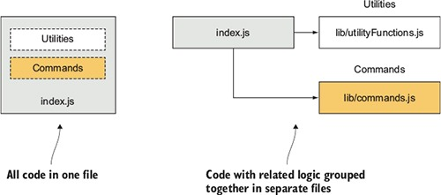
In some language implementations, such as PHP and Ruby, incorporating the logic from another file (we call this the included file) can mean that all the logic executed in that file affects the global scope. Any variables created and functions declared in the included file risk overwriting those created and declared by the application.
Say you’re programming in PHP; your application might contain the following logic:
function uppercase_trim($text) {
return trim(strtoupper($text));
}
include('string_handlers.php');
If your string_handlers.php file also attempted to define an uppercase_trim function, you’d receive the following error:
Fatal error: Cannot redeclare uppercase_trim()
In PHP you can avoid this by using namespaces, and Ruby offers similar functionality through modules. Node, however, avoids this potential problem by not offering an easy way to accidentally pollute the global namespace.

PHP namespaces, Ruby modules
PHP namespaces are discussed in the PHP language manual at http://php.net/manual/en/language.namespaces.php. Ruby modules are explained in the Ruby documentation: http://ruby-doc.org/core-2.3.1/Module.html.
Node modules bundle up code for reuse, but they don’t alter global scope. Suppose, for example, you’re developing an open source content management system (CMS) application by using PHP, and you want to use a third-party API library that doesn’t use namespaces. This library could contain a class with the same name as one in your application, which would break your application unless you changed the class name either in your application or the library. Changing the class name in your application, however, could cause problems for other developers using your CMS as the basis of their own projects. Changing the class name in the library would require you to remember to repeat this hack each time you update the library in your application’s source tree. Naming collisions are a problem best avoided altogether.
Node modules allow you to select which functions and variables from the included file are exposed to the application. If the module is returning more than one function or variable, the module can specify these by setting the properties of an object called exports. If the module is returning a single function or variable, the property module.exports can instead be set. Figure 2.2 shows how this works.

Figure 2.2. The population of the module.exports property or the exports object allows a module to select what should be shared with the application.
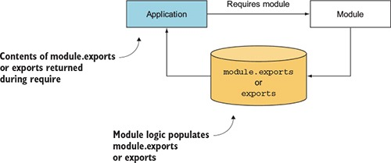
If this seems a bit confusing, don’t worry; we run through several examples in this chapter. By avoiding pollution of the global scope, Node’s module system avoids naming conflicts and simplifies code reuse. Modules can then be published to the npm (package manager) registry, an online collection of ready-to-use Node modules, and shared with the Node community without those using the modules having to worry about one module overwriting the variables and functions of another.
To help you organize your logic into modules, we cover the following topics:

How you can create modules
Where modules are stored in the filesystem
Things to be aware of when creating and using modules
Let’s dive into learning the Node module system by starting a new Node project and then creating a simple module.

2.2. Starting a new Node project
Creating a new Node project is easy: create a folder and then run npm init. That’s it! The npm command will ask you a few questions, and you can answer yes to all of them. Here’s a full example:
mkdir my_module
cd my_module
npm init -y
The -y flag means yes. That means npm will create a package.json file with default values. If you want more control, leave off the -y flag, and npm will run you through a set of questions about the project’s license, author name, and so on. After you’ve done this, look at the contents of package.json. You can manually edit it, but remember, it has to be valid JSON.
Now that you have an empty project, you can create your own module.

2.2.1. Creating modules
Modules can be either single files or directories containing one or more files, as you can see in figure 2.3. If a module is a directory, the file in the module directory that will be evaluated is typically named index.js (although this can be overridden: see section 2.5).

Figure 2.3. Node modules can be created by using either files (example 1) or directories (example 2).
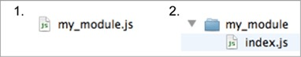
To create a typical module, you create a file that defines properties on the exports object with any kind of data, such as strings, objects, and functions.
To show how a basic module is created, let’s see how to add some currency conversion functionality to a file named currency.js. This file, shown in the following listing, will contain two functions that convert Canadian dollars to U.S. dollars, and vice versa.

Listing 2.1. Defining a Node module (currency.js)
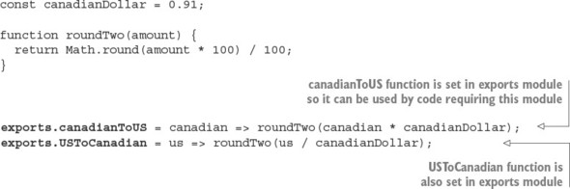
Note that only two properties of the exports object are set. Therefore, only the two functions, canadianToUS and USToCanadian, can be accessed by the application including the module. The variable canadianDollar acts as a private variable that affects the logic in canadianToUS and USToCanadian but can’t be directly accessed by the application.
To use your new module, use Node’s require function, which takes a path to the module you wish to use as an argument. Node performs a synchronous lookup to locate the module and loads the file’s contents. The order in which Node looks for files is first core modules, then the current directory, and finally node_modules.
A note about require and synchronous I/O
require is one of the few synchronous I/O operations available in Node. Because modules are used often and are typically included at the top of a file, having require be synchronous helps keep code clean, ordered, and readable.
Avoid using require in I/O-intensive parts of your application. Any synchronous call will block Node from doing anything until the call has finished. For example, if you’re running an HTTP server, you’d take a performance hit if you used require on each incoming request. This is typically why require and other synchronous operations are used only when the application initially loads.
In the next listing, which shows test-currency.js, you require the currency.js module.

Listing 2.2. Requiring a module (test_currency.js)
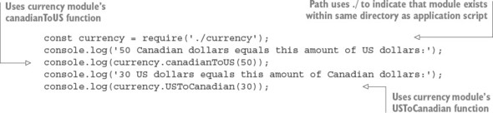
Requiring a module that begins with ./ means that if you were to create your application script named test-currency.js in a directory named currency_app, then your currency.js module file, as represented in figure 2.4, would also need to exist in the currency_app directory. When requiring, the .js extension is assumed, so you can omit it if desired. If you don’t include .js, Node will also check for a .json file. JSON files are loaded as JavaScript objects.

Figure 2.4. When you put ./ at the beginning of a module require, Node will look in the same directory as the program file being executed.
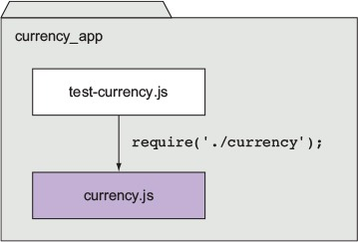
After Node has located and evaluated your module, the require function returns the contents of the exports object defined in the module. You’re then able to use the two functions returned by the module to perform currency conversion.
If you want to organize related modules, you can put modules into subdirectories. If, for example, you want to put the currency module in a folder called lib/, you can do so by changing the line with require to the following:
const currency = require('./lib/currency');
Populating the exports object of a module gives you a simple way to group reusable code in separate files.

2.3. Fine-tuning module creation by using module.exports
Although populating the exports object with functions and variables is suitable for most module-creation needs, at times you’ll want a module to deviate from this model.
The currency converter module created in the previous section, for example, could be redone to return a single Currency constructor function rather than an object containing functions. An object-oriented implementation could behave something like the following:
const Currency = require('./currency');
const canadianDollar = 0.91;
const currency = new Currency(canadianDollar);
console.log(currency.canadianToUS(50));
Returning a function from require, rather than an object, will make your code more elegant if it’s the only thing you need from the module.
To create a module that returns a single variable or function, you might guess that you need to set exports to whatever you want to return. But this won’t work, because Node expects exports to not be reassigned to any other object, function, or variable. The module code in the next listing attempts to set exports to a function.

Listing 2.3. Module won’t work as expected
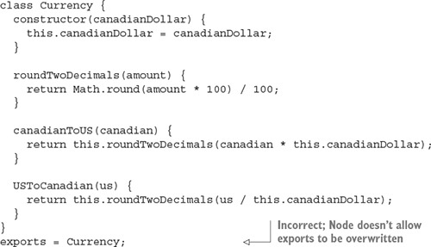
To get the previous module code to work as expected, you’d need to replace exports with module.exports. The module.exports mechanism enables you to export a single variable, function, or object. If you create a module that populates both exports and module.exports, module.exports will be returned, and exports will be ignored.
What really gets exported
What ultimately gets exported in your application is module.exports. exports is set up as a global reference to module.exports, which initially is defined as an empty object that you can add properties to. exports.myFunc is shorthand for module.exports.myFunc.
As a result, if exports is set to anything else, it breaks the reference between module.exports and exports. Because module.exports is what gets exported, exports will no longer work as expected—it doesn’t reference module.exports anymore. If you want to maintain that link, you can make module.exports reference exports again as follows:
module.exports = exports = Currency;
By using either exports or module.exports, depending on your needs, you can organize functionality into modules and avoid the pitfall of ever-growing application scripts.

2.4. Reusing modules by using the node_modules folder
Requiring modules in the filesystem to exist relative to an application is useful for organizing application-specific code, but isn’t as useful for code you’d like to reuse between applications or share with others. Node includes a unique mechanism for code reuse that allows modules to be required without knowing their location in the filesystem. This mechanism is the use of node_modules directories.
In the earlier module example, you required ./currency. If you omit the ./ and simply require currency, Node will follow certain rules, as specified in figure 2.5, to search for this module.

Figure 2.5. Steps to finding a module
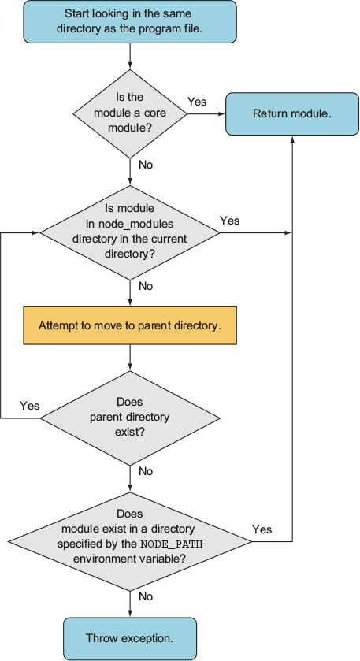
The NODE_PATH environmental variable provides a way to specify alternative locations for Node modules. If used, NODE_PATH should be set to a list of directories separated by semicolons in Windows, or colons in other operating systems.

2.5. Exploring caveats
Although the essence of Node’s module system is straightforward, you should be aware of two points.
First, if a module is a directory, the file in the module directory that will be evaluated must be named index.js, unless specified otherwise by a file in the module directory named package.json. To specify an alternative to index.js, the package.json file must contain JavaScript Object Notation (JSON) data defining an object with a key named main that specifies the path, within the module directory, to the main file. Figure 2.6 shows a flowchart summarizing these rules.

Figure 2.6. The package.json file, when placed in a module directory, allows you to define your module by using a file other than index.js.
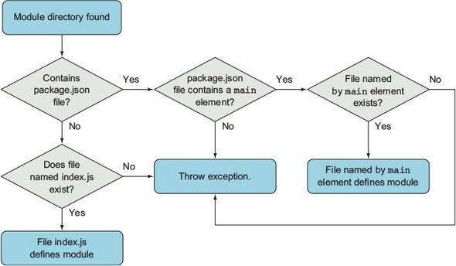
Here’s an example of a package.json file specifying that currency.js is the main file:
{
"main": "currency.js"
}
The other thing to be aware of is Node’s capability to cache modules as objects. If two files in an application require the same module, the first require will store the data returned in application memory so the second require won’t need to access and evaluate the module’s source files. This means loading a module with require in the same process returns the same object. Imagine you’ve built an MVC web application that has a main app object. You can set up that app object, export it, and then require it from anywhere within the project. If you’ve added useful configuration values to the app object, you can then access those values from other files, given a directory structure as follows:
project
app.js
models
post.js
Figure 2.7 shows how this works.

Figure 2.7. Shared app object in a web app
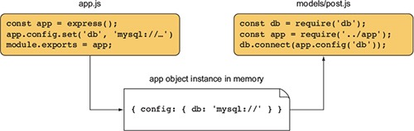
The best way to get comfortable with Node’s module system is to play with it, verifying the behavior described in this section yourself. Now that you have a basic understanding of how modules work, let’s move on to asynchronous programming techniques.

2.6. Using asynchronous programming techniques
If you’ve done front-end web programming in which interface events (such as mouse clicks) trigger logic, you’ve done asynchronous programming. Server-side asynchronous programming is no different: events occur that trigger response logic. Two popular models are used in the Node world for managing response logic: callbacks and event listeners.
Callbacks generally define logic for one-off responses. If you perform a database query, for example, you can specify a callback to determine what to do with the query results. The callback may display the database results, perform a calculation based on the results, or execute another callback by using the query results as an argument.
Event listeners, on the other hand, are callbacks associated with a conceptual entity (an event). For comparison, a mouse click is an event you would handle in the browser when someone clicks the mouse. As an example, in Node an HTTP server emits a request event when an HTTP request is made. You can listen for that request event to occur and add response logic. In the following example, the function handle-Request will be called whenever a request event is emitted, by using the Event-Emitter.prototype.on method to bind an event listener to the server:
server.on('request', handleRequest)
A Node HTTP server instance is an example of an event emitter, a class (Event-Emitter) that can be inherited and that adds the ability to emit and handle events. Many aspects of Node’s core functionality inherit from EventEmitter, and you can also create your own event emitter.
Now that we’ve established that response logic is generally organized in one of two ways in Node, you’re ready to jump into how it all works by learning about the following:

How to handle one-off events with callbacks
How to respond to repeating events by using event listeners
How to handle some of the challenges of asynchronous programming
Let’s look first at one of the most common ways asynchronous code is handled: the use of callbacks.

2.7. Handling one-off events with callbacks
A callback is a function, passed as an argument to an asynchronous function, that describes what to do after the asynchronous operation has completed. Callbacks are used frequently in Node development, more so than event emitters, and they’re simple to use.
To demonstrate the use of callbacks in an application, let’s see how to make a simple HTTP server that does the following:

Pulls the titles of recent posts stored as a JSON file asynchronously
Pulls a basic HTML template asynchronously
Assembles an HTML page containing the titles
Sends the HTML page to the user
The results will be similar to figure 2.8.

Figure 2.8. An HTML response from a web server that pulls titles from a JSON file and returns results as a web page
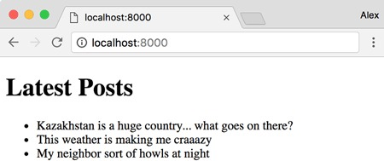
The JSON file (titles.json), shown in the following listing, is formatted as an array of strings containing titles of posts.

Listing 2.4. A list of post titles
[
"Kazakhstan is a huge country... what goes on there?",
"This weather is making me craaazy",
"My neighbor sort of howls at night"
]
The HTML template file (template.html), shown next, includes just a basic structure to insert the titles of the blog posts.

Listing 2.5. A basic HTML template to render the blog titles
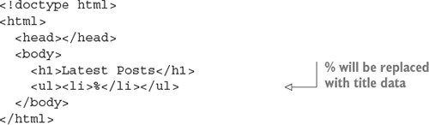
The code that pulls in the JSON file and renders the web page is shown next (blog_recent.js).

Listing 2.6. Using callbacks in a simple application
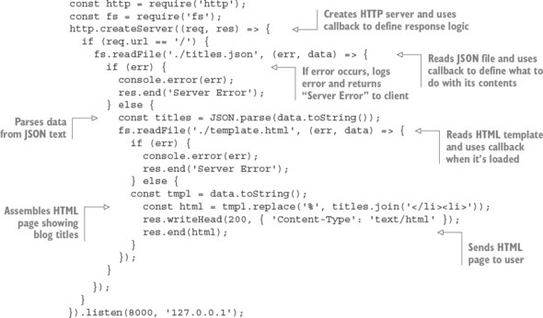
This example nests three levels of callbacks:
http.createServer((req, res) => { ...
fs.readFile('./titles.json', (err, data) => { ...
fs.readFile('./template.html', (err, data) => { ...
Using three levels isn’t bad, but the more levels of callbacks you use, the more cluttered your code looks, and the harder it is to refactor and test, so it’s good to limit callback nesting. By creating named functions that handle the individual levels of callback nesting, you can express the same logic in a way that requires more lines of code, but that could be easier to maintain, test, and refactor. The following listing is functionally equivalent to listing 2.6.

Listing 2.7. Reducing nesting by creating intermediary functions
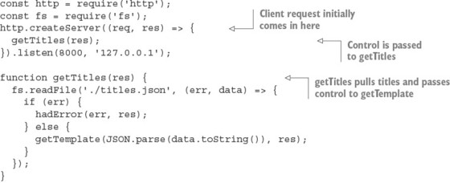
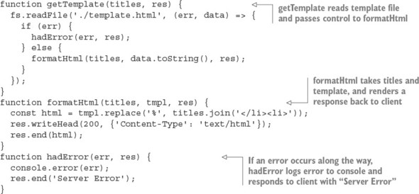
You can also reduce the nesting caused by if/else blocks with another common idiom in Node development: returning early from a function. The following listing is functionally the same but avoids further nesting by returning early. It also explicitly indicates that the function shouldn’t continue executing.

Listing 2.8. Reducing nesting by returning early
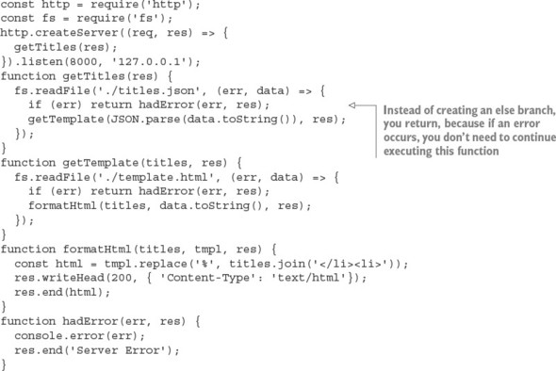
Now that you’ve learned how to use callbacks to handle one-off events for such tasks as defining responses when reading files and web server requests, let’s move on to organizing events by using event emitters.
The Node convention for asynchronous callbacks
Most Node built-in modules use callbacks with two arguments: the first argument is for an error, should one occur, and the second argument is for the results. The error argument is often abbreviated as err.
Here’s a typical example of this common function signature:
const fs = require('fs');
fs.readFile('./titles.json', (err, data) => {
if (err) throw err;
// do something with data if no error has occurred
});

2.8. Handling repeating events with event emitters
Event emitters fire events and include the ability to handle those events when triggered. Some important Node API components, such as HTTP servers, TCP servers, and streams, are implemented as event emitters. You can also create your own.
As we mentioned earlier, events are handled through the use of listeners. A listener is the association of an event with a callback function that gets triggered each time the event occurs. For example, a TCP socket in Node has an event called data that’s triggered whenever new data is available on the socket:
socket.on('data', handleData);
Let’s look at using data events to create an echo server.

2.8.1. An example event emitter
A simple example of repeated events occurs in an echo server. When you send data to an echo server, it echoes the data back, as shown in figure 2.9.

Figure 2.9. An echo server repeating the data sent to it
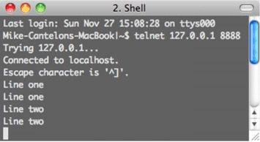
Listing 2.9 shows the code needed to implement an echo server. Whenever a client connects, a socket is created. The socket is an event emitter to which you can then add a listener, using the on method, to respond to data events. These data events are emitted whenever new data is available on the socket.

Listing 2.9. Using the on method to respond to events
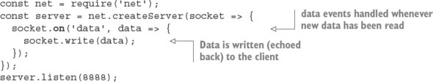
You run this echo server by entering the following command:
node echo_server.js
After the echo server is running, you can connect to it by entering the following command:
telnet 127.0.0.1 8888
Every time data is sent from your connected telnet session to the server, it will be echoed back into the telnet session.

Telnet on Windows
If you’re using the Microsoft Windows operating system, telnet may not be installed by default, and you’ll have to install it yourself. TechNet has instructions for the various versions of Windows: http://mng.bz/egzr.

2.8.2. Responding to an event that should occur only once
Listeners can be defined to repeatedly respond to events, as the previous example shows, or listeners can be defined to respond only once. The following listing, using the once method, modifies the previous echo server example to echo only the first chunk of data sent to it.

Listing 2.10. Using the once method to respond to a single event


2.8.3. Creating event emitters: a publish/subscribe example
In the previous example, you used a built-in Node API that uses event emitters. Node’s built-in events module, however, allows you to create your own event emitters.
The following code defines a channel event emitter with a single listener that responds to someone joining the channel. Note that you use on (or, alternatively, the longer form addListener) to add a listener to an event emitter:
const EventEmitter = require('events').EventEmitter;
const channel = new EventEmitter();
channel.on('join', () => {
console.log('Welcome!');
});
This join callback, however, won’t ever be called, because you haven’t emitted any events yet. You could add a line to the listing that would trigger an event using the emit function:
channel.emit('join');

Event names
Events are keys that can have any string value: data, join, or some crazy long event name. Only one event, called error, is special, and you’ll look at it soon.
Let’s look at how you could implement your own publish/subscribe logic by using EventEmitter to make a communication channel. If you run the script in listing 2.11, you’ll have a simple chat server. A chat server channel is implemented as an event emitter that responds to join events emitted by clients. When a client joins the channel, the join listener logic, in turn, adds an additional client-specific listener to the channel for the broadcast event that will write any message broadcast to the client socket. The names of the event types, such as join and broadcast, are completely arbitrary. You could use other names for these event types if you wished.

Listing 2.11. A simple publish/subscribe system using an event emitter
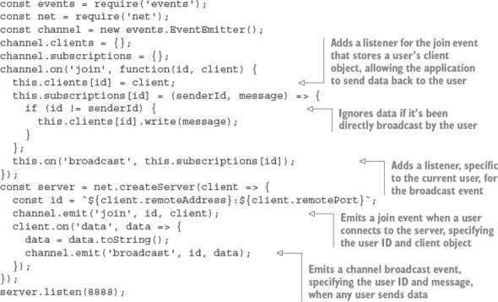
After you have the chat server running, open a new command line and enter the following code to enter the chat:
telnet 127.0.0.1 8888
If you open up a few command lines, you’ll see that anything typed in one command line is echoed to the others.
The problem with this chat server is that when users close their connections and leave the chat room, they leave behind a listener that will attempt to write to a client that’s no longer connected. This will, of course, generate an error. To fix this issue, you need to add the listener in the following listing to the channel event emitter, and add logic to the server’s close event listener to emit the channel’s leave event. The leave event removes the broadcast listener originally added for the client.

Listing 2.12. Creating a listener to clean up when clients disconnect
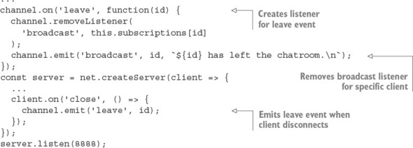
If you want to prevent a chat for some reason but don’t want to shut down the server, you can use the removeAllListeners event emitter method to remove all listeners of a given type. The following code shows how this is implemented for our chat server example:
channel.on('shutdown', () => {
channel.emit('broadcast', '', 'The server has shut down.\n');
channel.removeAllListeners('broadcast');
});
You can then add support for a chat command that triggers the shutdown. To do so, change the listener for the data event to the following code:
client.on('data', data => {
data = data.toString();
if (data === 'shutdown\r\n') {
channel.emit('shutdown');
}
channel.emit('broadcast', id, data);
});
Now when any chat participant enters shutdown into the chat, it’ll cause all participants to be kicked off.
Error handling
A convention you can use when creating event emitters is to emit an error type event instead of directly throwing an error. This allows you to define custom event response logic by setting one or more listeners for this event type.
The following code shows how an error listener handles an emitted error by logging on the console:
const events = require('events');
const myEmitter = new events.EventEmitter();
myEmitter.on('error', err => {
console.log(`ERROR: ${err.message}`);
});
myEmitter.emit('error', new Error('Something is wrong.'));
If no listener for this event type is defined when the error event type is emitted, the event emitter will output a stack trace (a list of program instructions that executed up to the point when the error occurred) and halt execution. The stack trace indicates an error of the type specified by the emit call’s second argument. This behavior is unique to error type events; when other event types are emitted, and they have no listeners, nothing happens.
If an error type event is emitted without an error object supplied as the second argument, a stack trace will indicate an Uncaught, unspecified 'error' event error, and your application will halt. There is a deprecated method you can use to deal with this error—you can define your own response by defining a global handler via the following code:
process.on('uncaughtException', err => {
console.error(err.stack);
process.exit(1);
});
Alternatives to this, such as domains (http://nodejs.org/api/domain.html), are being developed, but they’re not considered production-ready.
If you want to provide users connecting to chat with a count of currently connected users, you can use the following listeners method, which returns an array of listeners for a given event type:
channel.on('join', function(id, client) {
const welcome = `
Welcome!
Guests online: ${this.listeners('broadcast').length}
`;
client.write(`${welcome}\n`);
...
To increase the number of listeners that an event emitter has, and to avoid the warnings Node displays when there are more than 10 listeners, you can use the setMaxListeners method. Using your channel event emitter as an example, you use the following code to increase the number of allowed listeners:
channel.setMaxListeners(50);

2.8.4. Extending the event emitter: a file watcher example
If you want to build upon the event emitter’s behavior, you can create a new JavaScript class that inherits from the event emitter. For example, you can create a class called Watcher that processes files placed in a specified filesystem directory. You then use this class to create a utility that watches a directory (renaming any files placed in it to lowercase and then copying the files into a separate directory).
After setting up the Watcher object, you need to extend the methods inherited from EventEmitter with two new methods, as shown in the following listing.

Listing 2.13. Extending the event emitter’s functionality
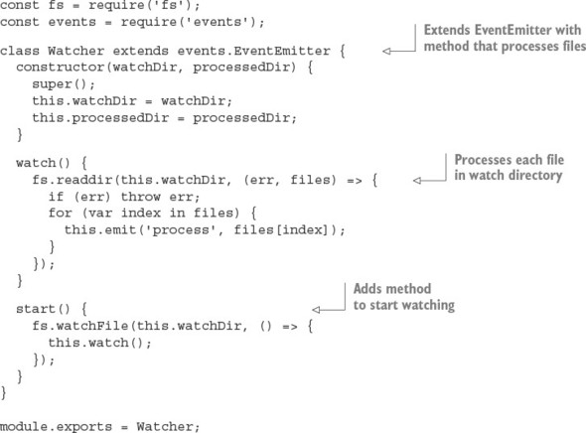
The watch method cycles through the directory, processing any files found. The start method starts the directory monitoring. The monitoring uses Node’s fs.watchFile function, so when something happens in the watched directory, the watch method is triggered, cycling through the watched directory and emitting a process event for each file found.
Now that you’ve defined the Watcher class, you can put it to work by creating a Watcher object with the following code:
const watcher = new Watcher(watchDir, processedDir);
With your newly created Watcher object, you can use the on method, inherited from the event emitter class, to set the logic used to process each file, as shown in this snippet:
watcher.on('process', (file) => {
const watchFile = `${watchDir}/${file}`;
const processedFile = `${processedDir}/${file.toLowerCase()}`;
fs.rename(watchFile, processedFile, err => {
if (err) throw err;
});
});
Now that all the necessary logic is in place, you can start the directory monitor by using the following code:
watcher.start();
After putting the Watcher code into a script and creating watch and done directories, you should be able to run the script by using Node, drop files into the watch directory, and see the files pop up, renamed to lowercase, in the done directory. This is an example of how the event emitter can be a useful class from which to create new classes.
By learning how to use callbacks to define one-off asynchronous logic and how to use event emitters to dispatch asynchronous logic repeatedly, you’re one step closer to mastering control of a Node application’s behavior. In a single callback or event emitter listener, however, you may want to include logic that performs additional asynchronous tasks. If the order in which these tasks are performed is important, you may be faced with a new challenge: how to control exactly when each task, in a series of asynchronous tasks, executes.
Before we get to controlling when tasks execute—coming up in section 2.10—let’s take a look at some of the challenges you’ll likely encounter as you write asynchronous code.

2.9. Challenges with asynchronous development
When creating asynchronous applications, you have to pay close attention to the way your application flows and keep a watchful eye on application state: the conditions of the event loop, application variables, and any other resources that change as program logic executes.
Node’s event loop, for example, keeps track of asynchronous logic that hasn’t completed processing. As long as there’s uncompleted asynchronous logic, the Node process won’t exit. A continually running Node process is desirable behavior for something like a web server, but it isn’t desirable to continue running processes that are expected to end after a period of time, such as command-line tools. The event loop keeps track of any database connections until they’re closed, preventing Node from exiting.
Application variables can also change unexpectedly if you’re not careful. Listing 2.14 shows an example of how the order in which asynchronous code executes can lead to confusion. If the example code was executing synchronously, you’d expect the output to be “The color is blue.” Because the example is asynchronous, however, the value of the color variable changes before console.log executes, and the output is “The color is green.”

Listing 2.14. How scope behavior can lead to bugs
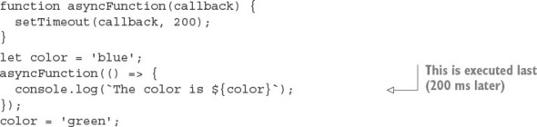
To “freeze” the contents of the color variable, you can modify your logic and use a JavaScript closure. In listing 2.15, you wrap the call to asyncFunction in an anonymous function that takes a color argument. You then execute the anonymous function immediately, sending it the current contents of color. By making color an argument for the anonymous function, it becomes local to the scope of that function, and when the value of color is changed outside the anonymous function, the local version is unaffected.

Listing 2.15. Using an anonymous function to preserve a global variable’s value
function asyncFunction(callback) {
setTimeout(callback, 200);
}
let color = 'blue';
(color => {
asyncFunction(() => {
console.log('The color is', color);
});
})(color);
color = 'green';
This is but one of many JavaScript programming tricks you’ll come across in your Node development.

Closures
For more information on closures, see the Mozilla JavaScript documentation: https://developer.mozilla.org/en-US/docs/JavaScript/Guide/Closures.
Now that you understand how to use closures to control your application state, let’s look at sequencing asynchronous logic in order to keep the flow of your application under control.

2.10. Sequencing asynchronous logic
During the execution of an asynchronous program, some tasks can happen anytime, independent of what the rest of the program is doing, without causing problems. But some tasks should happen only before or after certain other tasks.
The concept of sequencing groups of asynchronous tasks is called flow control by the Node community. There are two types of flow control: serial and parallel, as figure 2.10 shows.

Figure 2.10. Serial execution of asynchronous tasks is similar, conceptually, to synchronous logic: tasks are executed in sequence. Parallel tasks, however, don’t have to execute one after another.
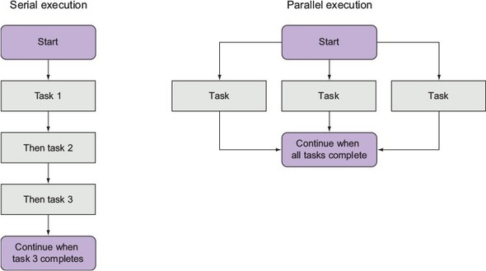
Tasks that need to happen one after the other are called serial. A simple example is the task of creating a directory and the task of storing a file in it. You can’t store the file before creating the directory.
Tasks that don’t need to happen one after the other are called parallel. It isn’t necessarily important when these tasks start and stop relative to one another, but they should all be completed before further logic executes. One example is downloading numerous files that will later be compressed into a zip archive. The files can be downloaded simultaneously, but all of the downloads should be completed before creating the archive.
Keeping track of serial and parallel flow control requires programmatic bookkeeping. When you implement serial flow control, you need to keep track of the task currently executing or maintain a queue of unexecuted tasks. When you implement parallel flow control, you need to keep track of how many tasks have executed to completion.
Flow-control tools handle the bookkeeping for you, which makes grouping asynchronous serial or parallel tasks easy. Although plenty of community-created add-ons deal with sequencing asynchronous logic, implementing flow control yourself demystifies it and helps you gain a deeper understanding of how to deal with the challenges of asynchronous programming.
In the following sections we show you

When to use serial flow control
How to implement serial flow control
How to implement parallel flow control
How to use third-party modules for flow control
Let’s start by looking at when and how you handle serial flow control in an asynchronous world.

2.11. When to use serial flow control
To execute numerous asynchronous tasks in sequence, you could use callbacks, but if you have a significant number of tasks, you’ll have to organize them. If you don’t, you’ll end up with messy code due to excessive callback nesting.
The following code is an example of executing tasks in sequence by using callbacks. The example uses setTimeout to simulate tasks that take time to execute: the first task takes one second, the next takes half of a second, and the last takes one-tenth of a second. setTimeout is only an artificial simulation; in real code you could be reading files, making HTTP requests, and so on. Although this example code is short, it’s arguably a bit messy, and there’s no easy way to programmatically add another task.
setTimeout(() => {
console.log('I execute first.');
setTimeout(() => {
console.log('I execute next.');
setTimeout(() => {
console.log('I execute last.');
}, 100);
}, 500);
}, 1000);
Alternatively, you can use a flow-control tool such as Async (http://caolan.github.io/async/) to execute these tasks. Async is straightforward to use and benefits from having a small codebase (a mere 837 bytes, minified and compressed). You can install Async with the following command:
npm install async
Now, use the code in the next listing to re-implement the previous code snippet with serial flow control.

Listing 2.16. Serial control using a community-created add-on
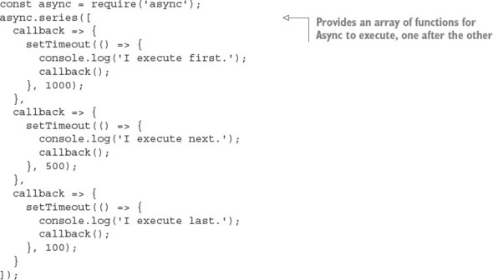
Although the implementation using flow control means more lines of code, it’s generally easier to read and maintain. You’re likely not going to use flow control all the time, but if you run into a situation where you want to avoid callback nesting, it’s a handy tool for improving code legibility.
Now that you’ve seen an example of the use of serial flow control with a specialized tool, let’s look at how to implement it from scratch.

2.12. Implementing serial flow control
To execute numerous asynchronous tasks in sequence by using serial flow control, you first need to put the tasks in an array, in the desired order of execution. This array, as figure 2.11 shows, acts as a queue: when you finish one task, you extract the next task in sequence from the array.

Figure 2.11. How serial flow control works
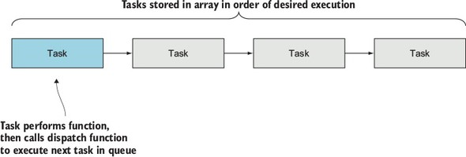
Each task exists in the array as a function. When a task has completed, the task should call a handler function to indicate error status and results. The handler function in this implementation will halt execution if there’s an error. If there isn’t an error, the handler will pull the next task from the queue and execute it.
To demonstrate an implementation of serial flow control, you’ll make a simple application that displays a single article’s title and URL from a randomly chosen RSS feed. The list of possible RSS feeds is specified in a text file. The application’s output will look something like the following text:
Of Course ML Has Monads!
http://lambda-the-ultimate.org/node/4306
Our example requires the use of two helper modules from the npm registry. First, open a command-line prompt, and then enter the following commands to create a directory for the example and install the helper modules:
mkdir listing_217
cd listing_217
npm init -y
npm install --save request@2.60.0
npm install --save htmlparser@1.7.7
The request module is a simplified HTTP client that you can use to fetch RSS data. The htmlparser module has functionality that allows you to turn raw RSS data into JavaScript data structures.
Next, create a file named index.js inside your new directory that contains the code shown here.

Listing 2.17. Serial flow control implemented in a simple application
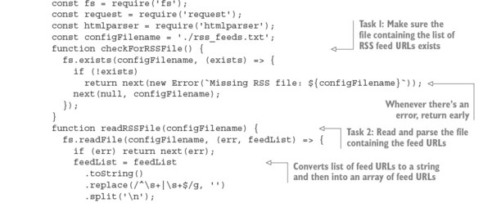
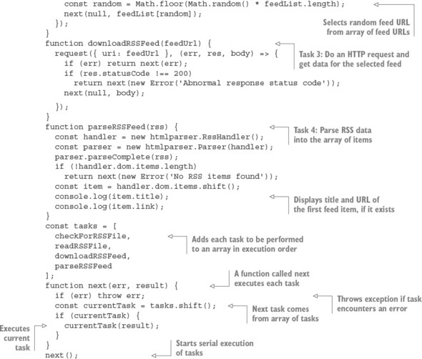
Before trying out the application, create the file rss_feeds.txt in the same directory as the application script. If you don’t have any feeds at hand, you can try the Node blog’s feed, which is http://blog.nodejs.org/feed/. Put the URLs of RSS feeds into the text file, one on each line of the file. After you’ve created this file, open a command line and enter the following commands to change to the application directory and execute the script:
cd listing_217
node index.js
Serial flow control, as this example implementation shows, is a way of putting callbacks into play when they’re needed, rather than simply nesting them.
Now that you know how to implement serial flow control, let’s look at how to execute asynchronous tasks in parallel.

2.13. Implementing parallel flow control
To execute numerous asynchronous tasks in parallel, you again need to put the tasks in an array, but this time the order of the tasks is unimportant. Each task should call a handler function that will increment the number of completed tasks. When all tasks are complete, the handler function should perform some subsequent logic.
For a parallel flow-control example, you’ll make a simple application that reads the contents of text files and outputs the frequency of word use throughout the files. Reading the contents of the text files will be done using the asynchronous readFile function, so numerous file reads can be done in parallel. Figure 2.12 shows how this application works.

Figure 2.12. Using parallel flow control to implement a frequency count of word use in numerous files
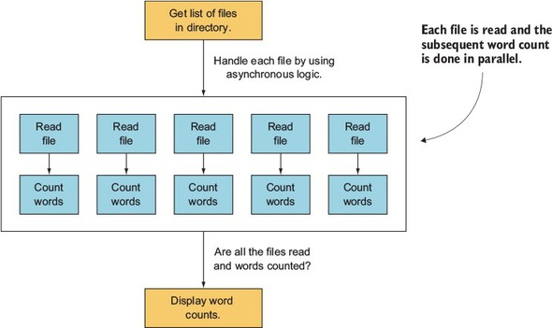
The output looks something like the following text (although it’ll likely be much longer):
would: 2
wrench: 3
writeable: 1
you: 24
Open a command-line prompt and enter the following commands to create two directories—one for the example, and another within that to contain the text files you want to analyze:
mkdir listing_218
cd listing_218
mkdir text
Next, create a file named word_count.js inside the listing_218 directory that contains the code that follows.

Listing 2.18. Parallel flow control implemented in a simple application
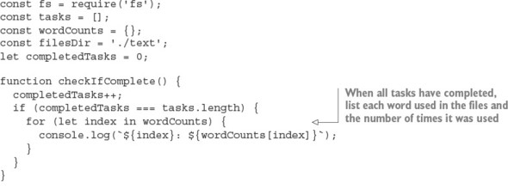
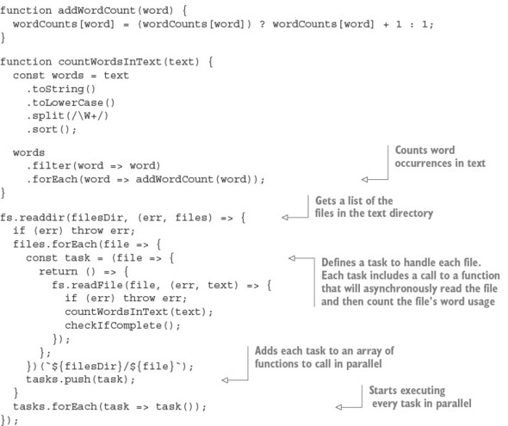
Before trying out the application, create some text files in the text directory you created earlier. Then open a command line and enter the following commands to change to the application directory and execute the script:
cd word_count
node word_count.js
Now that you’ve learned how serial and parallel flow control work under the hood, let’s look at how to use community-created tools that allow you to easily benefit from flow control in your applications, without having to implement it yourself.

2.14. Using community tools
Many community add-ons provide convenient flow-control tools. Some popular add-ons include Async, Step, and Seq. Although each of these is worth checking out, we’ll use Async again for another example.

Community add-ons for flow control
For more information about community add-ons for flow control, see the article “Virtual Panel: How to Survive Asynchronous Programming in JavaScript” by Werner Schuster and Dio Synodinos on InfoQ: http://mng.bz/wKnV.
Listing 2.19 is an example of using Async to sequence tasks in a script that uses parallel flow control to download two files simultaneously and then archive them.

The following example won’t work in Microsoft Windows
Because the Windows operating system doesn’t come with the tar and curl commands, the following example won’t work in this operating system.
In this example, we use serial control to make sure that the downloading is done before proceeding to archiving.

Listing 2.19. Using a community add-on flow-control tool in a simple application
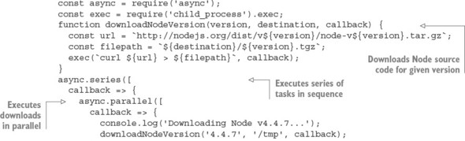
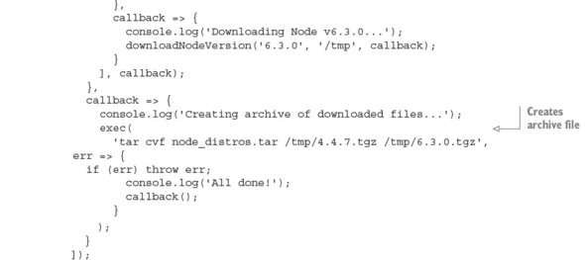
The script defines a helper function that downloads any specified release version of the Node source code. Two tasks are then executed in series: the parallel downloading of two versions of Node and the bundling of the downloaded versions into a new archive file.

2.15. Summary

Node modules can be organized into reusable modules.
The require function is used to load modules.
The module.exports and exports objects are used to share functions and variables from within a module.
The package.json file is used to specify dependencies and which file is exported as the main file.
Asynchronous logic can be controlled with nested callbacks, event emitters, and flow-control utilities.

Chapter 3. What is a Node web application?
This chapter covers

Creating a new web application
Building RESTful services
Persisting data
Working with templates
This chapter is all about Node web applications. After reading this chapter, you’ll understand what Node web applications look like and how to start building them. You’ll do everything a modern web developer does when building an application.
You’re going to build a web application called later that’s inspired by popular read-it-later websites such as Instapaper (www.instapaper.com) and Pocket (getpocket.com). This involves starting a new Node project, managing dependencies, creating a RESTful API, saving data to a database, and making an interface with templates. That might sound like a lot, but you’ll explore each of the ideas in this chapter again in subsequent chapters.
Figure 3.1 shows what the result should look like.

Figure 3.1. A read-it-later web application

The read-it-later page on the left has stripped away all of the navigation from the target website, preserving the main content and title. More significantly, the article is permanently saved to a database, which means you can read it at a future date when the original article may no longer be retrievable.
Before building a web application, you should create a fresh project. The next section shows how to create Node projects from scratch.

3.1. Understanding a Node web application’s structure
A typical Node web application has the following components:

package.json—A file that contains a list of dependencies, and the command that runs the application
public/—A folder of static assets, such as CSS and client-side JavaScript
node_modules/—The place where the project’s dependencies get installed
One or more JavaScript files that contains your application code
The application code is often further subdivided as follows:

app.js or index.js—The code that sets up the application
models/—Database models
views/—The templates that are used to render the pages in the application
controllers/ or routes/—HTTP request handlers
middleware/—Middleware components
There are no rules that dictate how your application should be structured: most web frameworks are flexible and require configuration. But this template is the general outline that you’ll find in most projects.
It’s much easier to learn how to do this if you practice, so let’s see how to create a skeleton web application the way a seasoned Node programmer would.

3.1.1. Starting a new web app
To create a new web app, you need to make a new Node project. Refer to chapter 2 if you want to refresh your memory, but to recap, you need to create a directory and run npm init with defaults:
mkdir later
cd later
npm init -fy
Now you have a fresh project; what’s next? Most people would add a module from npm that makes web development easier. Node has a built-in http module that has a server, but it’s easier to use something that reduces the boilerplate required for command web development tasks. Let’s see how to install Express.

Adding a dependency
To add a dependency to a project, use npm install. The following command installs Express:
npm install --save express
Now if you look at package.json, you should see that Express has been added. The following snippet shows the section in question:
"dependencies": {
"express": "^4.14.0"
}
The Express module is in the project’s node_modules/ folder. If you wanted to uninstall Express from the project, you would run npm rm express --save. This removes it from node_modules/ and updates the package.json file.

A simple server
Express is focused on modeling your application in terms of HTTP requests and responses, and it’s built using Node’s built-in http module. To make a basic application, you need to make an application instance by using express(), add a route handler, and then bind the application to a TCP port. Here’s a full example:
const express = require('express');
const app = express();
const port = process.env.PORT || 3000;
app.get('/', (req, res) => {
res.send('Hello World');
});
app.listen(port, () =>
console.log(`Express web app available at localhost: ${port}`);
};
It’s not as complicated as it sounds! Save this code to a file called index.js, and run it by typing node index.js. Then visit http://localhost:3000 to view the result. To avoid having to remember exactly how to run each application, most people use npm scripts to simplify the process.

npm scripts
To save your server start command (node index.js) as an npm script, open package.json and add a new property under scripts called start:
"scripts": {
"start": "node index.js",
"test": "echo \"Error: no test specified\" && exit 1"
},
Now you can run your application by typing npm start. If you see an error because port 3000 is already being used on your machine, you can use a different port by running PORT=3001 npm start. People use npm scripts for all kinds of things: building client-side bundles, running tests, and generating documentation. You can put anything you like in there; it’s basically a mini-script invocation tool.

3.1.2. Comparing other platforms
For comparison, the equivalent PHP Hello World application is shown here:
<?php echo '<p>Hello World</p>'; ?>
It fits on one line and is easy to understand, so what benefits does the more complex Node example have? The difference is in terms of programming paradigm: with PHP, your application is a page; in Node, it’s a server. The Node example has complete control over the request and response, so you can do all kinds of things without configuring a server. If you want to use HTTP compression or URL redirection, you can implement these features as part of your application logic. You don’t need to separate HTTP and application logic; they become part of your application.
Instead of having a separate HTTP server configuration, you can keep it in the same place, and that means the same directory. This makes Node applications easy to deploy and manage.
Another feature that makes Node applications easy to deploy is npm. Because dependencies are installed per project, you don’t get clashes between projects on the same system.

3.1.3. What’s next?
Now that you have the hang of creating projects with npm init and installing dependencies with npm install --save, you can create new projects quickly. This is great, because it means you can try out ideas without messing up other projects. If there’s a hot new web framework you want to try, then create a new directory, run npm init, and install the module from npm.
With all of this in place, you’re ready to start writing code. At this stage, you can add JavaScript files to your project and load modules that you’ve installed with npm --save by using require. Let’s focus on what most web developers would do next: add some RESTful routes. This will help you define your application’s API and determine what database models are needed.

3.2. Building a RESTful web service
Your application will be a RESTful web service that allows articles to be created and saved in a similar way to Instapaper or Pocket. It’ll use a module that was inspired by the original Readability service (www.readability.com) to turn messy web pages into elegant articles that you can read later.
When designing a RESTful service, you need to think about which operations you need and map them to routes in Express. In this case, you need to be able to save articles, fetch them so they can be read, fetch a list of all of them, and delete articles you no longer want. That maps to these routes:

POST /articles—Create a new article
GET /articles/:id—Get a single article
GET /articles—Get all articles
DELETE /articles/:id—Delete an article
Before getting into issues such as databases and web interfaces, let’s focus on creating RESTful resources with Express. You can use cURL to make requests to a sample application to get the hang of it, and then move on to more complicated operations such as storing data to make it like a real web application.
The following listing is a simple Express app that implements these routes by using a JavaScript array to store the articles.

Listing 3.1. RESTful routes example
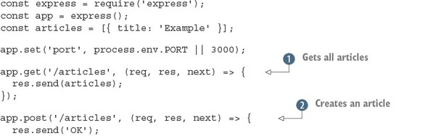
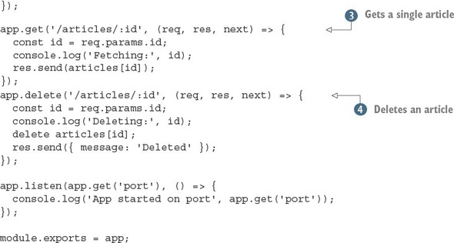
Save this listing as index.js and you should be able to run it with node index.js. To use this example, follow these steps:
mkdir listing3_1
cd listing3_1
npm init -fy
run npm install --save express@4.12.4
Creating new Node projects is explored in more detail in chapter 2.
Running the examples and making changes
To run these examples, make sure you restart the server after editing the code each time. You can do this by pressing Ctrl-C to end the Node process and then type node index.js to start it again.
The examples are presented in snippets, so you should be able to combine them sequentially to produce a working app. If you can’t get it running, try downloading the book’s source code from https://github.com/alexyoung/nodejsinaction.
Listing 3.1 has a built-in array of sample data that’s used to respond with JSON for all articles by using the Express res.send method. Express will automatically convert the array to a valid JSON response, so it’s perfect for making quick REST APIs.
This example can also respond with a single article by using the same principle . You can even delete an article by using the standard JavaScript delete keyword and a numerical ID specified in the URL. You can get values from the URL by putting them in the route string (/articles/:id) and then getting the value with req.params.id.
Listing 3.1 can’t create articles , because for that it needs a request body parser; you’ll look at this in the next section. First, let’s look at how you can use this example with cURL (http://curl.haxx.se).
After the example is running with node index.js, you can make requests to it with a browser or cURL. To fetch one article, run the following snippet:
curl http://localhost:3000/articles/0
To fetch all articles, you need to make a request to /articles:
curl http://localhost:3000/articles
And you can even delete an article:
curl -X DELETE http://localhost:3000/articles/0
But why did we say you couldn’t create articles? The main reason is that implementing a POST request requires body parsing. Express used to come with a built-in body parser, but there are so many ways to implement it that the developers opted to make it a separate dependency.
A body parser knows how to accept MIME-encoded (Multipurpose Internet Mail Extensions) POST request bodies and turn them into data you can use in your code. Usually, you get JSON data that’s easy to work with. Whenever you’ve submitted a form on a website, a body parser has been involved somewhere in the server-side software.
To add the officially supported body parser, run the following npm command:
npm install --save body-parser
Now load the body parser in your application, near the top of the file, as shown in the following listing. If you’re following along, you can save this to the same folder as listing 3.1 (listing3_1), but we’ve also saved it in its own folder in the book’s source code (ch03-what-is-a-node-web-app/listing3_2).

Listing 3.2. Adding a body parser
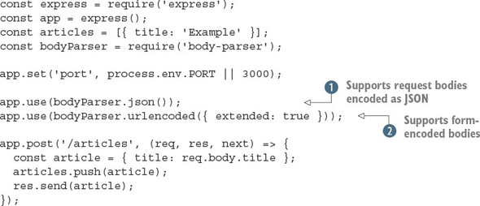
This adds two useful features: JSON body parsing and form-encoded bodies . It also adds a basic implementation for creating articles: if you make a POST request with a field called title, a new article will be added to the articles array! Here’s the cURL command:
curl --data "title=Example 2" http://localhost:3000/articles
Now you’re not too far away from building a real web application. You need just two more things: a way to save data permanently in a database, and a way to generate the readable version of articles found on the web.

3.3. Adding a database
There’s no predefined way to add a database to a Node application, but the process usually involves the following steps:

Decide on the database you want to use.
Look at the popular modules on npm that implement a driver or object--relational mapping (ORM).
Add the module to your project with npm -save.
Create models that wrap database access with a JavaScript API.
Add the models to your Express routes.
Before adding a database, let’s continue focusing on Express by designing the route-handling code from step 5. The HTTP route handlers in the Express part of the application will make simple calls to the database models. Here’s an example:
app.get('/articles', (req, res, err) => {
Article.all(err, articles) => {
if (err) return next(err);
res.send(articles);
});
});
Here the HTTP route is for getting all articles, so the model method could be something like Article.all. This will vary depending on your database API; typical examples are Article.find({}, cb),[1] and Article.fetchAll().then(cb).[2] Note that in these examples, cb is an abbreviation of callback.
1
Mongoose: http://mongoosejs.com

2
Bookshelf.js http://bookshelfjs.org

Given the amazing number of databases out there, how do you decide which one to use? Read on for the reasons that we’re going with SQLite for this example.
Which database?
For our project, we’re going to use SQLite (www.sqlite.org), with the popular sqlite3 module (http://npmjs.com/package/sqlite3). SQLite is convenient because it’s an in-process database: you don’t need to install a server that runs in the background on your system. Any data that you add is written to a file that’s kept after your application is stopped and started again, so it’s a good way to get started with databases.

3.3.1. Making your own model API
Articles should be created, retrieved, and deleted. Therefore, you need the following methods for an Article model class:

Article.all(cb)—Return all articles.
Article.find(id, cb)—Given an ID, find the corresponding article.
Article.create({ title, content }, cb)—Create an article with a title and content.
Article.delete(id, cb)—Delete an article by ID.
You can implement all of this with the sqlite3 module. This module allows you to fetch multiple rows of results with db.all, and single rows with db.get. First you need a database connection.
The following listing shows how to do each of these things with SQLite in Node. This code should be saved as db.js in the same folder as the code from listing 3.1.

Listing 3.3. An Article model
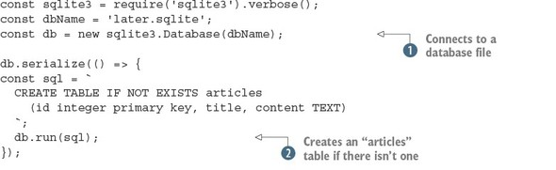
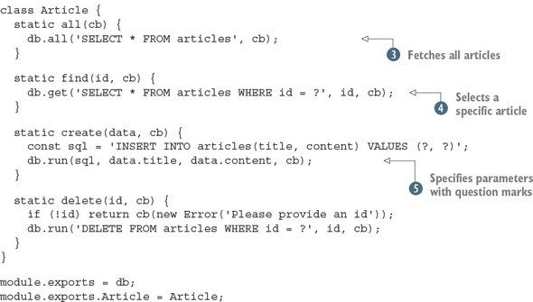
In this example, an object is created called Article that can create, fetch, and delete data by using standard SQL and the sqlite3 module. First, a database file is opened by using sqlite3.Database , and then an articles table is created . The IF NOT EXISTS SQL syntax is useful here because it means you can rerun the code without accidentally deleting and re-creating the articles table.
When the database and tables are ready, the application is ready to make queries. To fetch all articles, you use the sqlite3 all method . To fetch a specific article, use the question mark query syntax with a value ; the sqlite3 module will insert the ID into the query. Finally, you can insert and delete data by using the run method .
For this example to work, you need to have installed the sqlite3 module with npm install --save sqlite3. It’s version 3.1.8 at the time of writing.
Now that the basic database functionality is ready, you need to add it to the HTTP routes from listing 3.2.
The next listing shows how to add each method except for POST. (You’ll deal with that separately, because it needs to use the readability module, which you haven’t yet set up.)

Listing 3.4. Adding the Article model to the HTTP routes
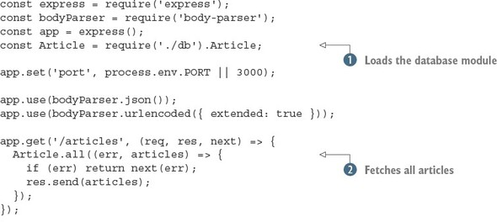
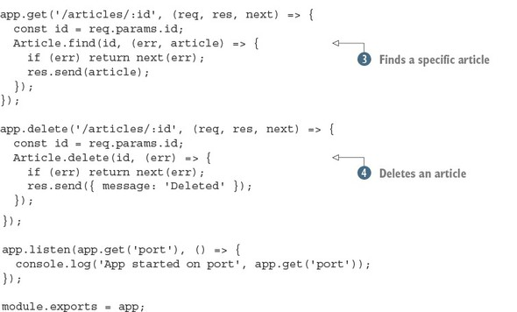
Listing 3.4 is written assuming that you’ve saved listing 3.3 as db.js in the same directory. Node will load that module and then use it to fetch each article , find a specific article , and delete an article .
The final thing to do is add support for creating articles. To do this, you need to be able to download articles and process them with the magic readability algorithm. What you need is a module from npm.

3.3.2. Making articles readable and saving them for later
Now that you’ve built a RESTful API and data can be persisted to a database, you should add code that converts web pages into simplified “reader view” versions. You won’t implement this yourself; instead, you can use a module from npm.
If you search npm for readability, you’ll find quite a few modules. Let’s try using node-readability (which is at version 1.0.1 at the time of this writing). Install it with npm install node-readability --save. The module provides an asynchronous function that downloads a URL and turns the HTML into a simplified representation. The following snippet shows how node-readability is used; if you want to try it, add the snippet to index.js in addition to listing 3.5:
const read = require('node-readability');
const url = 'http://www.manning.com/cantelon2/';
read(url, (err, result)=> {
// result has .title and .content
});
The node-readability module can be used with your database class to save articles with the Article.create method:
read(url, (err, result) => {
Article.create(
{ title: result.title, content: result.content },
(err, article) => {
// Article saved to the database
}
);
});
To use this in the application, open the index.js file and add a new app.post route handler that downloads and saves articles. Combining this with everything you learned about HTTP POST in Express and the body parser gives the example in the following listing.

Listing 3.5. Generating readable articles and saving them
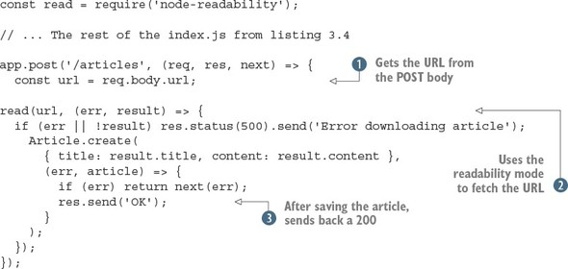
Here you first get the URL from the POST body and then use the node-readability module to get the URL . You save the article by using your Article model class. If an error occurs, you pass handling along the Express middleware stack ; otherwise, a JSON representation of the article is sent back to the client.
You can make a POST request that will work with this example by using the --data option:
curl --data "url=http://manning.com/cantelon2/" http://localhost:3000/articles
Over the course of the preceding section, you added a database module, created a JavaScript API that wraps around it, and tied it in to the RESTful HTTP API. That’s a lot of work, and it will form the bulk of your efforts as a server-side developer. You’ll learn more about databases later in this book as you look at MongoDB and Redis.
Now that you can save articles and programmatically fetch them, you’ll add a web interface so you can read articles as well.

3.4. Adding a user interface
Adding an interface to an Express project involves several things. The first is the use of a template engine; we’ll show you how to install one and render templates shortly. Your application should also serve static files, such as CSS. Before rendering templates and writing any CSS, you need to know how to make the router handlers from the previous examples respond with both JSON and HTML when necessary.

3.4.1. Supporting multiple formats
So far you’ve used res.send() to send JavaScript objects back to the client. You used cURL to make requests, and in this case JSON is convenient because it’s easy to read in the console. But to really use the application, it needs to support HTML as well. How can you support both?
The basic technique is to use the res.format method provided by Express. It allows your application to respond with the right format based on the request. To use it, provide a list of formats with functions that respond the desired way:
res.format({
html: () => {
res.render('articles.ejs', { articles: articles });
},
json: () => {
res.send(articles);
}
});
In this snippet, res.render will render the articles.ejs template in the views folder. But for this to work, you need to install a template engine and create some templates.

3.4.2. Rendering templates
Many template engines are available, and a simple one that’s easy to learn is EJS (Embedded JavaScript). Install the EJS module from npm (EJS is at version 2.3.1 at the time of writing):
npm install ejs --save
Now res.render can render HTML files formatted with EJS. If you replace res.send (articles) in the app.get('/articles') route handler from listing 3.4, visiting http://localhost:3000/articles in a browser should attempt to render articles.ejs.
Next you need to create the articles.ejs template in a views folder. The next listing shows a full template that you can use.

Listing 3.6. Article list template
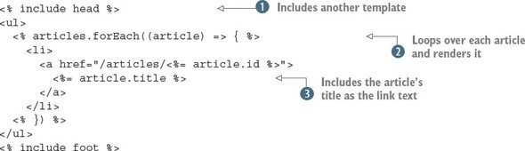
The article list template uses a header and footer template that are included as snippets in the following code examples. This is to avoid duplicating the header and footer in every template. The article list is iterated over by using a standard Java-Script forEach loop, and then the article IDs and titles are injected into the template by using the EJS <%= value %> syntax .
Here’s an example header template, saved as views/head.ejs:
<html>
<head>
<title>Later</title>
</head>
<body>
<div class="container">
And this is a corresponding footer (saved as views/foot.ejs):
</div>
</body>
</html>
The res.format method can be used for displaying specific articles as well. This is where things start to get interesting, because for this application to make sense, articles should look clean and easy to read.

3.4.3. Using npm for client-side dependencies
With the templates in place, the next step is to add some style. Rather than creating a style sheet, it’s easier to reuse existing styles, and you can even do this with npm! The popular Bootstrap (http://getbootstrap.com/) client-side framework is available on npm (www.npmjs.com/package/bootstrap), so add it to this project:
npm install bootstrap --save
If you look at node_modules/bootstrap/, you’ll see the source for the Bootstrap project. Then, in the dist/css folder, you’ll find the CSS files that come with Bootstrap. To use this in your project, you need to be able to serve static files.

Serving static files
When you need to send client-side JavaScript, images, and CSS back to the browser, Express has some built-in middleware called express.static. To use it, you point it at a directory that contains static files, and those files will then be available to the browser.
Near the top of the main Express app file (index.js), there are some lines that load the middleware required by the project:
app.use(bodyParser.json());
app.use(bodyParser.urlencoded({ extended: true }));
To load Bootstrap’s CSS, use express.static to register the file at the right URL:
app.use(
'/css/bootstrap.css',
express.static('node_modules/bootstrap/dist/css/bootstrap.css')
);
Now you can add /css/bootstrap.css to your templates to get some cool Bootstrap styles. Here’s what views/head.ejs should look like:
<html>
<head>
<title>later;</title>
<link rel="stylesheet" href="/css/bootstrap.css">
</head>
<body>
<div class="container">
This is only Bootstrap’s CSS; Bootstrap also comes with other files, including icons, fonts, and jQuery plugins. You could add more of these files to your project, or use a tool to bundle them all up so loading them is easier.

Doing more with npm and client-side development
The previous example is a simple use of a library intended for browsers through npm. Web developers typically download Bootstrap’s files and then add them to their project manually, particularly web designers who work on simpler static sites.
But modern front-end developers use npm for both downloading libraries and loading them in client-side JavaScript. With tools such as Browserify (http://browserify.org/) and webpack (http://webpack.github.io/), you get all the power of npm installation and require for loading dependencies. Imagine being able to type const React = require('react') in not just Node code, but code for front-end development as well! This is beyond the scope of this chapter, but it gives you a hint of the power you can unlock by combining techniques from Node programming with front-end development.

3.5. Summary

You can quickly build a Node web application from scratch with npm init and Express.
The command to install a dependency is npm install.
Express allows you to make web applications with RESTful APIs.
Selecting the right database and database module requires some up-front investigation and depends on your requirements.
SQLite is handy for small projects.
EJS is an easy way to render templates in Express.
Express supports lots of template engines, including Pug and Mustache.

Part 2. Web development with Node
Now you’re ready to learn about server-side development in more depth. Node has found an important niche outside server-side code: front-end build systems. In this part, you’ll learn how to start projects with webpack and Gulp. We’ll also introduce the most popular web frameworks and compare them from multiple developers’ perspectives to help you decide on the perfect framework for your projects.
If you want to learn in detail about Connect and Express, chapter 6 is entirely dedicated to building web applications with these modules. There’s also a chapter dedicated to templating and using databases with Node.
To complete the journey of full-stack web development with Node, we’ve included chapters on testing and deployment, so you can prepare your first Node application.

Chapter 4. Front-end build systems
This chapter covers

Simplifying complex commands with npm scripts
Using Gulp to manage repetitive tasks
Bundling client-side web apps with webpack
In modern web development, Node is increasingly used to run tools and services depended on by front-end engineers. As a Node programmer, you may be responsible for setting up and maintaining these tools. As a full-stack developer, you’ll want to use these tools to create faster and more reliable web applications. In this chapter, you’ll learn how to use npm scripts, Gulp, and webpack to build maintainable projects.
The benefits of using front-end build systems can be huge. They can help you to write more readable and future-proof code. There’s no need to worry about ES2015 browser support when you can transpile it with Babel. Also, because you can generate source maps, browser-based debugging is still possible.
The next section provides a brief introduction to front-end development with Node. After that, you’ll see some examples of modern front-end technologies such as React that you can use with your own projects.

4.1. Understanding front-end development with Node
Recently, front-end and server-side developers have converged on using npm for distributing JavaScript. That means npm is used for front-end modules, such as React, and server-side code, such as Express. But some modules don’t neatly fall into either side: lodash is an example of a general-purpose library that can be used in Node and browsers. By packing lodash carefully, the same module can be consumed by Node and browsers, and the dependency within a project can be managed with npm.
You may have seen other module systems dedicated to client-side development, such as Bower (http://bower.io/). You can still use these tools, but as a Node developer, you should consider using npm.
Package distribution isn’t the only thing Node gets used for, however. Front-end developers are also increasingly dependent on tools for generating portable, backward-compatible JavaScript. Transpilers such as Babel (https://babeljs.io/) are used to convert modern ES2015 into more widely supported ES5 code. Other tools include minifiers (for example, UglifyJS; https://github.com/mishoo/UglifyJS) and linters (for example, ESLint, http://eslint.org/) for verifying the correctness of your code before shipping it.
Test runners are also often driven by Node. You can run the tests for UI code in a Node process, or use a Node script to drive tests that run in a browser.
It’s also typical to use these tools together. When you start juggling a transpiler, minifier, linter, and test runner, you’ll need a way to record how the build process works. Some projects use npm scripts; others use Gulp or webpack. You’ll look at all of these approaches in this chapter and see some related best practices.

4.2. Using npm to run scripts
Node comes with npm, and npm has built-in features for running scripts. Therefore, you can rely on your collaborators or users being able to invoke commands such as npm start and npm test. To add your own command for npm start, you add it to the scripts property of your project’s package.json file:
{
...
"scripts": {
"start": "node server.js"
},
...
}
Even if you don’t define start, node server.js is the default, so technically you can leave this blank if that’s all you need—just remember to create a file called server.js. Defining the test property is useful because you can include your test framework as a dependency and run it by typing npm test. Let’s say you’re using Mocha (www.npmjs.com/package/mocha) for tests, and you’ve installed it with npm install --save-dev. To avoid having to install Mocha globally, you can add the following statement to your package.json file:
{
...
"scripts": {
"test": "./node_modules/.bin/mocha test/*.js"
},
...
}
Notice that in the previous example, arguments were passed to Mocha. You can also pass arguments when running npm scripts by using two hyphens:
npm test -- test/*.js
Table 4.1 shows a breakdown of some of the available npm commands.

Table 4.1. npm commands
Command | package.json property | Example uses
start | scripts.start | Start a web application server or an Electron app.
stop | scripts.stop | Stop a web server.
restart |  | Run stop and then restart.
install, postinstall | scripts.install, scripts.postinstall | Run native build commands after a package is installed. Note that postinstall can be run only with npm run postinstall.
More commands are available, including some for cleaning up packages before publishing them, and pre/post version commands for migrating between package versions. But for most web development tasks, start and test are the commands you want.
Plenty of tasks that you may want to define won’t fit into the supported command names. For example, let’s say you’re working on a simple project that’s written in ES2015 but you want to transpile it to ES5. You can do this with npm run. In the next section, you’ll run through a tutorial that sets up a new project that can build ES2015 files.

4.2.1. Creating custom npm scripts
The npm run command, aliased from npm run-script, is used to define arbitrary scripts that are invoked with npm run script-name. Let’s see how to make one for building a client-side script with Babel.
Start by setting up a new project and installing the necessary dependencies:
mkdir es2015-example
cd es2015-example
npm init -y
npm install --save-dev babel-cli babel-preset-es2015
echo '{ "presets": ["es2015"] }' > .babelrc
Now you should have a new Node project with the basic Babel ES2015 tools and plugins. Next, open the package.json file and add a babel property under scripts. It should run the script that has been installed into the project’s node_modules/.bin folder:
"babel": "./node_modules/.bin/babel browser.js -d build/"
Here’s a sample file with ES2015 syntax that you can use; save it to browser.js:
class Example {
render() {
return '<h1>Example</h1>';
}
}
const example = new Example();
console.log(example.render());
You’ll be able to test this by running npm run babel. If everything is configured correctly, you should now have a build folder with browser.js. Open browser.js to confirm that it’s indeed an ES5 file. It’s too long to print, so look for something like var_createClass near the top of the file.
If this is all your project ever does when it builds, you could name it build instead of babel in the package.json file. But you can go a little further by adding UglifyJS as well:
npm i --save-dev uglify-es
UglifyJS can be invoked by using node_modules/.bin/uglifyjs, so add it to the package.json under scripts with the name uglify:
./node_modules/.bin/uglifyjs build/browser.js -o build/browser.min.js
Now you should be able to invoke npm run uglify. You can tie all of this together by combining both of these scripts. Add another script property called build that invokes both tasks:
"build": "npm run babel && npm run uglify"
Both scripts are run by typing npm run build. People on your team can now combine multiple front-end packaging tools by invoking this simple command. The reason this works is that Babel and UglifyJS can be run as command-line scripts, and both accept command-line arguments, so it’s easy to add them as one-liners to a package.json file. In the case of Babel, you can manage complex behavior by defining a .babelrc file, which you did earlier in this chapter.

4.2.2. Configuring front-end build tools
In general, you can configure front-end build tools in three ways when used with npm scripts:

Specifying command-line arguments. For example, ./node_modules/.bin/uglify --source-map.
Creating a project-specific configuration file with options. This is often done for Babel and ESLint.
Adding configuration options to package.json. Babel supports this as well.
What if your build requirements have more steps, and include things like copying, concatenating, or moving files? You could create a shell script and invoke it with an npm script, but it may help your JavaScript-savvy collaborators if you use Java-Script. Many build systems provide JavaScript APIs for automating builds. In the next section, you’ll learn all about one such solution: Gulp.

4.3. Providing automation with Gulp
Gulp (http://gulpjs.com/) is a build system based on streams. You can route streams together to create build processes that do more than just transpile or minify code. Imagine you have a project with an administration area that’s built with Angular, but you have a React-based public area; both subprojects share certain build requirements. With Gulp, you can reuse parts of the build process for each stage. Figure 4.1 shows an example of these two build processes that share functionality.

Figure 4.1. Two build processes that share functionality
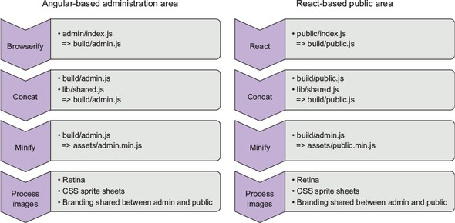
Gulp helps you achieve a high level of reuse through two techniques: using plugins and defining your own build tasks. As the figure suggests, the build process is a stream, so you can pipe tasks and plugins through each other. For example, you can handle the React part of the previous example with Gulp Babel (www.npmjs.com/package/gulp-babel/) and the built-in gulp.src file globbing method:
gulp.src('public/index.jsx')
.pipe(babel({
presets: ['es2015', 'react']
}))
.pipe(minify())
.pipe(gulp.dest('build/public.js'));
You can even add the concat stage to this chain quite easily. Before looking more closely at this syntax, let’s see how to set up a small Gulp project.

4.3.1. Adding Gulp to a project
To add Gulp to a project, you need to install both the gulp-cli and gulp packages with npm. Most people install gulp-cli globally, so Gulp recipes can be run simply by typing gulp. Note that you should run npm rm --global gulp if you had previously installed the gulp package globally. In the next snippet, you install gulp-cli globally and create a new Node project that has a Gulp development dependency:
npm i --global gulp-cli
mkdir gulp-example
cd gulp-example
npm init -y
npm i –save-dev gulp
Next create a file called gulpfile.js:
touch gulpfile.js
Open the gulpfile. Now you’ll use Gulp to build a small React project. It’ll use gulp-babel (www.npmjs.com/package/gulp-babel), gulp-sourcemaps, and gulp-concat:
npm i --save-dev gulp-sourcemaps gulp-babel babel-preset-es2015
npm i --save-dev gulp-concat react react-dom babel-preset-react
Remember to use npm with --save-dev when you want to add Gulp plugins to a project. If you’re experimenting with new plugins and decide to remove them, you can use npm uninstall --save-dev to remove them from ./node_modules and update the project’s package.json file.

4.3.2. Creating and running Gulp tasks
Creating Gulp tasks involves writing Node code with Gulp’s API in a file called gulpfile.js. Gulp’s API has methods for things like finding files and piping them through plugins that transform them in some way.
To try this for yourself: Open gulpfile.js and set up a build task that uses gulp.src to find JSX files, Babel to process ES2015 and React, and then concat to join each file together, as shown in the following listing.

Listing 4.1. A gulpfile for ES2015 and React with Babel
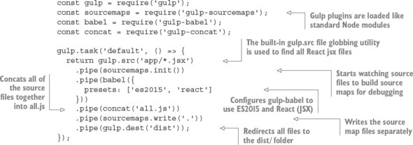
Listing 4.1 uses several Gulp plugins to capture, process, and write files. First you find all of the input files by using file globbing, and then you use the gulp-sourcemaps plugin to collect source-map metrics for client-side debugging. Notice that source maps require two stages: one to state that you want to use source maps, and another to write the source-map files. Meanwhile, gulp-babel is configured to process files with ES2015 and React.
This Gulp task can be run by typing gulp in a terminal.
In this example, all of the files are transformed by using a single plugin. It just so happens that Babel is transpiling React JSX code and converting ES2015 to ES5. Once that’s done, the files are concatenated using the gulp-concat plugin. Now that all of the transpiling is done, it’s safe to write the source maps, and the final build can be placed in the dist folder.
You can try this gulpfile out by creating a JSX file named app/index.jsx. Here’s a simple JSX file that you can use to test Gulp:
import React from 'react';
import ReactDOM from 'react-dom';
ReactDOM.render(
<h1>Hello, world!</h1>,
document.getElementById('example')
);
Gulp makes it easy to express build stages in JavaScript, and by using gulp.task(), you can add your own tasks to this file. Tasks usually follow the same pattern:

Source— Gather input files
Transpile— Pipe them through a plugin that transforms them
Concat— Pipe the files together to create a monolithic build
Output— Set a file destination or move the output files
In the previous example, sourcemaps is a special case because it requires two pipes: one for configuration and a final one to output the files. That makes sense because source maps depend on mapping the original line numbers to the transpiled build’s line numbers.

4.3.3. Watching for changes
The last thing front-end developers want is a build/refresh cycle. The simplest way to streamline builds is to use a Gulp plugin to watch the filesystem for changes. But alternatives exist. Some libraries work well with hot reloading, and more-generic DOM and CSS-based projects can work well with the LiveReload (http://livereload.com/) project.
As an example, you can add gulp-watch (www.npmjs.com/package/gulp-watch) to the previous project in listing 4.1. Add the package to the project:
npm i --save-dev gulp-watch
Now remember to load the package in gulpfile.js:
const watch = require('gulp-watch');
And add a watch task that calls the default task from the previous example:
gulp.task('watch', () => {
watch('app/**.jsx', () => gulp.start('default'));
});
This defines a task called watch, and then uses watch() to watch React JSX files for changes. Whenever a file changes, the default build task will run. With minor modifications, this recipe could be used to build Syntactically Awesome Style Sheets (SASS) files, optimize images, or pretty much anything else you might need for front-end projects.

4.3.4. Using separate files for larger projects
As projects grow, they tend to need more Gulp tasks. Eventually, you’ll end up with a long file that’s hard to understand. You can fix this, however: break up your code into separate modules.
As you’ve seen, Gulp uses Node’s module system for loading plugins. There’s no special plugin-loading system; it just uses standard modules. You can also use Node’s module system to split up long gulpfiles, to make your files more maintainable. To use separate files, you need to follow these steps:

Create a folder called gulp, and a subfolder called tasks.
Define your tasks by using the usual gulp.task() syntax in separate files. One file per task is a good rule of thumb.
Create a file called gulp/index.js to require each Gulp task file.
Require the gulp/index.js file in gulpfile.js.
The file tree should look like the following snippet:
gulpfile.js
gulp/
gulp/index.js
gulp/tasks/development-build.js
gulp/tasks/production-build.js
This technique can help you organize projects with complex build tasks, but it can also be paired with the gulp-help (www.npmjs.com/package/gulp-help) module. This module allows you to document Gulp tasks; running gulp help shows information about each task. This helps when you’re working in a team, or if you switch between lots of projects that use Gulp. Figure 4.2 shows what the output looks like.

Figure 4.2. Sample gulp-help output
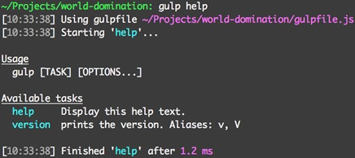
Gulp is a general-purpose project-automation tool. It’s good when adding cross--platform housekeeping scripts to projects—for example, running complex client-side tests or bringing up fixtures for a database. Although it can be used for building client-side assets, there are also tools specifically designed to do that, which means they typically require less code and configuration than Gulp. One such tool is webpack, which focuses on bundling JavaScript and CSS modules. The next section demonstrates how to use webpack for a React project.

4.4. Building web apps with webpack
webpack is specifically designed to build web applications. Imagine that you’re working with a designer who has already created a static site for a single-page web app, and you want to adapt it to build more-efficient CSS and ES2015 JavaScript. With Gulp, you write JavaScript code to drive the build system, so this would involve writing a gulpfile and several build tasks. With webpack, you write a configuration file and then bring in new functionality by using plugins and loaders. In some cases, no extra configuration is required: you type webpack on the command-line with an argument for the source-file path, and it’ll build your project. Skip to section 4.4.4 to see what this looks like.
One of the advantages of webpack is that it’s easier to quickly set up a build system that supports incremental builds. If you set it up to automatically build when files change, it won’t need to rebuild the entire project when a single file changes. As a result, builds can be faster and easier to understand.
This section shows you how to use webpack for a small React project. First, let’s define the terminology webpack uses.

4.4.1. Using bundles and plugins
Before setting up a webpack project, some terminology should be clarified. webpack plugins are used to change the behavior of the build process. This can include things like automatically uploading assets to Amazon S3 (https://github.com/MikaAK/s3-plugin-webpack) or removing duplicated files from the output.
In contrast to plugins, loaders are transformations that are applied to resource files. If you need to convert SASS to CSS, or ES2015 to ES5, you need a loader. Loaders are functions that transform input source text into output. They can be asynchronous or synchronous. Plugins are instances of classes that can hook into webpack’s more low-level APIs.
If you need to convert React code, CoffeeScript, SASS, or any other transpiled languages, you’re looking for a loader. If you need to instrument your JavaScript, or manipulate sets of files in some way, you’ll need a plugin.
In the next section you’ll see how to use the Babel loader to convert a React ES2015 project to a browser-friendly bundle.

4.4.2. Configuring and running webpack
You’re going to re-create the React example from listing 4.1 by using webpack. To get started, install React in a new project:
mkdir webpack-example
npm init -y
npm install --save react react-dom
npm install --save-dev webpack babel-loader babel-core
npm install --save-dev babel-preset-es2015 babel-preset-react
The last line installs Babel’s ES2015 plugin and the React transformer for Babel. Now you need to make a file called webpack.config.js that instructs webpack on where to find the input file, where to write the output, and what loaders to use. You’re going to use babel-loader with some extra settings for React, as shown in the next listing.

Listing 4.2. A webpack.config.js file
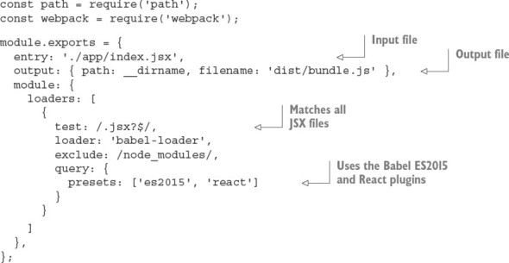
This configuration file encapsulates everything you need to successfully build a React app with ES2015. The settings are easy to follow: define an entry, which is the main file that loads the application. Then specify the directory where the output should be written; this directory will be created if it doesn’t yet exist. Next, define a loader and associate it with a file glob search by using the test property. Finally, make sure to set any options for the loader. In this example, these options load the ES2015 and React Babel plugins.
You need to include a sample React JSX file in app/index.jsx; use the snippet from section 4.3.2. Now running ./node_modules/.bin/webpack will compile an ES5 version of the file with the React dependencies.

4.4.3. Using webpack development server
If you want to avoid having to rebuild the project whenever a React file changes, you can use the webpack development server (http://webpack.github.io/docs/webpack-dev-server.html). In the book’s source code, this can be found under webpack--hotload-example (ch04-front-end/webpack-hotload-example). This small Express server will run webpack with your webpack configuration file when files change, and then serve the changed assets to the browser. You should run it on a different port to your main web server, and this means your script tags will have to include different URLs during development. The server builds assets and stores them in memory rather than in your webpack output folder. You can also use webpack-dev-server for hot module loading, in a similar way to LiveReload servers.
To add webpack-dev-server to a project, follow these steps:

Install webpack-dev-server with npm i --save-dev webpack-dev-server@ 1.14.1.
Add a publicPath option to the output property in webpack.config.js.
Add an index.html file to your build directory to act as a harness to load your JavaScript and CSS bundles. Ensure that the port is the port specified in the next step.
Run the server with the options you want. For example, webpack-dev-server --hot --inline --content-base dist/ --port 3001.
Visit http://localhost:3001/ and load the app.
Open webpack.config.js from listing 4.2 and change the output property to include a publicPath:
output: {
path: path.resolve(__dirname, 'dist'),
filename: 'bundle.js',
publicPath: '/assets/'
},
Create a new file called dist/index.html, as shown in the next listing.

Listing 4.3. An example HTML template for a React web app
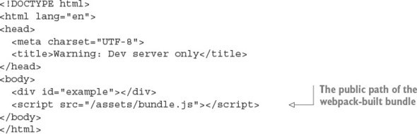
Next open package.json and add the command that runs the webpack server under the scripts property:
"scripts": {
"server:dev": "webpack-dev-server --hot –inline
--content-base dist/ --port 3001"
},
The --hot option makes the dev server use hot module reloading. If you edit the example React file in app/index.jsx, you should see the browser refresh. The refresh mechanism is specified with the --inline option. Inline refresh means the dev server will inject code to manage refreshing the bundle. There’s also an iframe version that wraps the entire page in an iframe.
Now run the dev server:
npm run server:dev
Running the webpack development server will trigger the build and start a server listening on port 3001. You can test everything by going to http://localhost:3001 in a browser.
Hot reloading
Because of React and other frameworks including AngularJS, there are framework-specific hot module reloading projects. Some take into account data-flow frameworks such as Redux and Relay, which means code can be refreshed while the current state is maintained. This is the ideal way to perform code reloading, because you don’t have to keep running through steps to re-create the UI state that you’re working on.
The example we’ve given you here, however, is less React-specific and is a good way to get you started with webpack dev servers. Be sure to experiment to find the best option for your project.

4.4.4. Loading CommonJS modules and assets
We’ve been using React and Babel in this chapter, but if you’re using webpack with a more vanilla, CommonJS project, then webpack can provide everything you need without a CommonJS browser shim. It’s even capable of loading CSS files.

webpack and CommonJS
To use CommonJS module syntax with webpack, you don’t need to set anything up. Let’s say you have a file that uses require:
const hello = require('./hello');
hello();
And another that defines the hello function:
module.exports = function() {
return 'hello';
};
Then you need only a small webpack config file to define the entry point (the first snippet), and the build destination path:
const path = require('path');
const webpack = require('webpack');
module.exports = {
entry: './app/index.js',
output: { path: __dirname, filename: 'dist/bundle.js' },
};
This example clarifies how different Gulp and webpack are. webpack is entirely focused on building bundles, and as part of that, is capable of generating bundles with CommonJS shims. If you open dist/bundle.js, you’ll see the webpackBootstrap shim at the top of the file, and then each file from the original source tree is wrapped in closures to simulate the module system. The following snippet is part of the bundle:
function(module, exports, __webpack_require__) {
const hello = __webpack_require__(1);
hello();
/***/ },
/* 1 */
/***/ function(module, exports) {
module.exports = function() {
return 'hello';
};
The code comments show where the modules are defined, and the files have access to module and exports objects as arguments to their closures to simulate the CommonJS module API.

Using npm packages with webpack
You can take this a step further by including modules downloaded from npm. Let’s say you want to use jQuery. Rather than making it a script tag on the page, you can install it with npm i --save-dev jquery, and then load it just like a Node module:
const jquery = require('jquery');
That means webpack gives you CommonJS modules and access to modules from npm out of the box without any additional configuration!
Finding loaders and plugins
The webpack website has a list of loaders (https://webpack.github.io/docs/list-of-loaders.html) and plugins (https://webpack.github.io/docs/list-of-plugins.html). You can also find webpack tools on npm; the webpack keyword is a good place to start (www.npmjs.com/browse/keyword/webpack).

4.5. Summary

If you need to automate simple tasks or invoke scripts, npm scripts are perfect.
Gulp can be used to write more-complex tasks with JavaScript and is cross--platform.
When gulpfiles get too long, you can divide the code into separate files.
webpack can be used to generate client-side bundles.
If you just need to build a client-side bundle, using webpack might be less work than setting up the equivalent script with Gulp.
webpack supports hot module reloading, which means you’ll see code changes without refreshing your browser.

Chapter 5. Server-side frameworks
This chapter covers

Working with popular Node web frameworks
Choosing the right framework
Building web apps with web frameworks
This chapter is all about server-side web development. It answers questions including how do I choose the perfect framework for a given project, and what are the advantages and disadvantages of each framework?
Deciding on the right framework is difficult because it’s hard to compare them on a level playing field. Most people don’t have time to learn all of them, so we tend to make superficial decisions about the frameworks we have experience with. In some cases, you might use different frameworks together. Express, for instance, could be used for larger applications, whereas microservices that support larger applications could be written in hapi.
Imagine you’re building a content management system (CMS). It’s used to manage legal documents collected by a research firm. It can output PDFs and has an e-commerce component. Such a system could be built with separate frameworks as follows:

Document upload, download, and reading— Express
PDF generator microservice—hapi
E-commerce component— Sails.js
The perfect framework for a given project is dependent on the needs of the project and the team working on it. In this chapter, we use personas—hypothetical people—as a way of exploring which framework is right for a specific type of project. You’ll learn about Koa, hapi, Sails.js, DerbyJS, Flatiron, and LoopBack through these imaginary programmers. The personas are defined in the next section.

5.1. Personas
We want to avoid selling a single framework that you’ll use for every project. It’s much better to be eclectic and use a mix of tools that suit each problem. Using personas to think about design is a widespread practice, in part because it helps designers to empathize with users.
In this chapter, personas are used to help you to think about frameworks in the third person, to see how different classes of projects suit different solutions. The personas are defined in terms of professional situation and development tools. You should be able to identify with at least one of the three people we’ve invented here.

5.1.1. Phil: agency developer
Phil has been working for three years as a full-stack web developer. He’s done a little Ruby, Python, and client-side JavaScript:

Job situation— Employee, full-stack developer
Work type— Front-end engineering, server-side development
Computer— MacBook Pro
Tools— Sublime Text, Dash, xScope, Pixelmator, Sketch, GitHub
Background— High school education; started as a hobbyist programmer
A typical day for Phil involves working with designers and user-experience experts in agile-style meetings to develop or review new features, as well as maintenance and bug fixes.

5.1.2. Nadine: open source developer
Nadine moved to contracting after a successful early career working as a corporate web developer:

Job situation— Contractor, JavaScript specialist
Work type— Server-side programming, occasional high-performance programming in Go and Erlang. Also writes a popular open source, web-based movie catalog app
Computer— High-end PC, Linux
Tools— Vim, tmux, Mercurial, anything in the shell
Background—Computer science degree
Nadine’s day usually involves balancing clocking enough hours for her two major clients with working on her open source projects. Her client work is test-driven, but her open source projects are more feature-driven.

5.1.3. Alice: product developer
Alice works on a successful iOS app but also helps with her company’s web APIs:

Job situation— Employee, programmer
Work type— iOS development; also responsible for web apps and web services
Computer— MacBook Pro, iPad Pro
Tools— Xcode, Atom, Babel, Perforce
Background— Science degree; one of the first five employees at her current startup
Alice grudgingly works with Xcode, Objective-C, and Swift, but secretly prefers Java-Script and is excited by ES2015 and Babel. She relishes developing new web services to support her company’s iOS and desktop apps, and wants to work on React-based web apps more often.
Now that the personas have been defined, let’s define the term framework.

5.2. What is a framework?
Some of the server-side frameworks discussed in this chapter are technically not frameworks at all. The term framework is unfortunately overloaded and means different things to different programmers. In the Node community, it’s more accurate to call most of these projects modules, but a more nuanced definition is useful when directly comparing this family of libraries.
The LoopBack project (http://loopback.io/resources/#compare) uses the following definitions:

API framework— A library for building web APIs, backed by a framework that helps to structure the application. LoopBack itself is defined as this type of framework.
HTTP server library— Anything based on Express falls into this category, including Koa and Kraken.js. These libraries help you build applications that are based around HTTP verbs and routes.
HTTP server framework— A framework for building modular servers that speak HTTP. hapi is an example of this type of framework.
Web MVC framework— Model-View-Controller frameworks including Sails.js fall into this category.
Full-stack framework— These frameworks use JavaScript on the server and browser, and are able to share code between both ends. This is known as isomorphic code. DerbyJS is a full-stack MVC framework.
Most Node developers understand framework to mean the second term: HTTP server library. The next section introduces Koa, a server library that uses the innovative ES2015 syntax known as generators to offer a unique way to handle HTTP middleware.

5.3. Koa
Koa (http://koajs.com/)is based on Express, but uses the ES2015 generator syntax to define middleware. That means you can write middleware in an almost synchronous fashion. This partly solves the problem of middleware that depends highly on callbacks. With Koa, you can use the yield keyword to exit and then reenter middleware. Table 5.1 is an overview of Koa’s main features.

Table 5.1. Koa’s main features
Library type | HTTP server library
Features | Generator-based middleware, request/response model
Suggested uses | Lightweight web apps, nonstrict HTTP APIs, serving single-page web app
Plugin architecture | Middleware
Documentation | http://koajs.com/
Popularity | 10,000 GitHub stars
License | MIT
The following listing shows how to use Koa to benchmark requests by yielding to the next middleware component and then continuing execution in the callee when it’s finished.

Listing 5.1. Koa’s middleware ordering
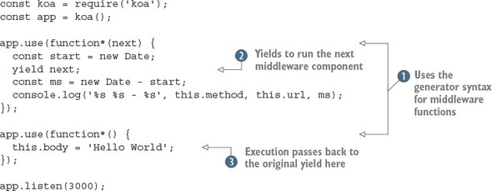
Listing 5.1 uses generators to switch context between two middleware components. Notice that we use the keyword function*—it’s not possible to use an arrow function here. By using the yield keyword , execution steps down the middleware stack, then back again when the next middleware component returns . An added benefit of using generator functions is you can just set this.body. In contrast, Express uses a function to send responses: res.send(response). In Koa middleware, this is known as a context. A context is created for every request, and it’s used to encapsulate Node’s HTTP request and response objects (https://nodejs.org/api/http.html). Whenever you need to access something from the request, such as the GET parameters or cookies, you can use the context. The same is true for the response: as you saw in listing 5.1, you can control what gets sent to the browser by setting values on this.body.
If you’ve used both Express middleware and generator syntax before, Koa should be easy to learn. If either of these things is new to you, Koa might be hard to follow—or at least it might be hard to see why this style is beneficial. Figure 5.1 shows in more detail how yield hands off execution between middleware components.

Figure 5.1. Koa middleware execution order
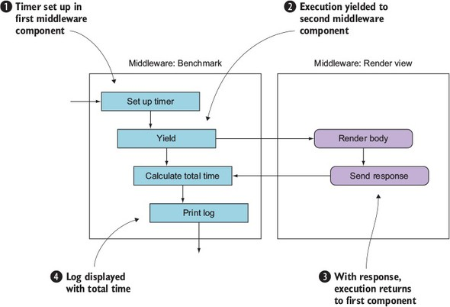
Each of the stages in figure 5.1 corresponds to the numbers in listing 5.1. First, the timer is set up in the first middleware component , and then execution is yielded to the second middleware component that renders the body . After the response has been sent, execution returns to the first middleware component, and the time is calculated . This is displayed in the terminal with console.log, and the request is then finished . Note that stage isn’t visible in listing 5.1; it’s handled by Koa and Node’s HTTP server.

5.3.1. Setting up
Setting up a project with Koa requires installing the module and then defining middleware. If you want more functionality, such as a routing API that makes it easier to define and respond to various types of HTTP request, then you’ll need to install router middleware. That means a typical workflow requires planning the middleware your project will use beforehand, so you need to research popular modules first.
Persona thoughts
Alice: “As a product developer, I like Koa’s minimal feature set—because our project has unique requirements, and we really want to shape the entire stack according to our needs.”
Phil: “As an agency developer, I find dealing with the middleware research stage too much trouble. I’d prefer this to be handled for me, because many of my projects have similar requirements, and I don’t want to keep installing the same modules to do basic things.”
The next section demonstrates a third-party module that implements a powerful routing library for Koa.

5.3.2. Defining routes
A popular router middleware component is koa-router (https://www.npmjs.com/package/koa-router). Like Express, it’s based on HTTP verbs, but unlike Express, it has a chainable API. The next snippet shows how groups of routes are defined:
router
.post('/pages', function*(next) {
// Create a page
})
.get('/pages/:id', function*(next) {
// Render the page
})
.put('pages-update', '/pages/:id', function*(next) {
// Update a page
});
Routes can be named by using an additional argument. This is great because you can generate URLs, which not all Node web frameworks support. Here’s an example:
router.url('pages-update', '99');
This module has a unique blend of features from Express and other web frameworks.

Persona thoughts
Phil: “This routing library reminds me of some of the things I liked about Ruby on Rails, so Koa could win me over after all!”
Nadine: “I can see opportunities for modularizing my existing projects with Koa, and then sharing this code with the community.”

5.3.3. REST APIs
Koa doesn’t come with the tools necessary to make RESTful APIs without implementing some kind of route-handling middleware. The previous example can be extended to implement a RESTful API in Koa.

5.3.4. Strengths
It would be easy to say that Koa’s strengths come from its early adoption of generator syntax, but now that ES2015 is widespread in the Node community, this is no longer as unique as it once was. Currently, Koa’s main advantage is that it’s streamlined yet has some excellent third-party modules; check out the Koa wiki for more information (https://github.com/koajs/koa/wiki#middleware). Product developers love it, because it has elegant syntax and can be tailored for projects with specific requirements.

5.3.5. Weaknesses
Koa’s level of configurability alienates some developers. Creating many small projects with Koa can lead to low levels of code reuse, unless you already have code-sharing strategies in place.

5.4. Kraken
Kraken is based on Express, but adds new functionality through custom modules developed by PayPal. One useful module in particular is Lusca (https://github.com/krakenjs/lusca), which provides an application security layer. Although it’s possible to use Lusca without Kraken, one of Kraken’s benefits is its predefined project structure. Express and Koa applications don’t require any specific project structure, so if you’re looking for help with starting new projects, Kraken can help get things going. Table 5.2 shows an overview of Kraken’s main features.

Table 5.2. Kraken’s main features
Library type | HTTP server library
Features | Strict project structure, models, templates (Dust), security hardening (Lusca), configuration management, internationalization
Suggested uses | Corporate web apps
Plugin architecture | Express middleware
Documentation | https://www.kraken.com/help/api
Popularity | 4,000 GitHub stars
License | Apache 2.0

5.4.1. Setting up
If you already have an Express project, you can add Kraken as a middleware component:
const express = require('express'),
const kraken = require('kraken-js');
const app = express();
app.use(kraken());
app.listen(3000);
But if you want to start a new project, you should try Kraken’s Yeoman generator. Yeoman is a tool that helps you to generate new projects. By using Yeoman generators, you can create bootstrapped projects for a variety of frameworks. Here are the steps to create a tailored Kraken project using Yeoman, with Kraken’s preferred filesystem layout:
$ npm install -g yo generator-kraken bower grunt-cli
$ yo kraken
,'""`.
hh / _ _ \
|(@)(@)| Release the Kraken!
) __ (
/,'))((`.\
(( (( )) ))
`\ `)(' /'
Tell me a bit about your application:
[?] Name: kraken-test
[?] Description: A Kraken application
[?] Author: Alex R. Young
...
The generator creates a new directory, so you don’t need to do this yourself. After the generator finishes, you should be able to start a server and visit http://localhost:8000 to try it out.

5.4.2. Defining routes
In Kraken, routes are defined alongside the controller. Rather than separating out route definitions and route handlers as Express does, Kraken uses an MVC-inspired approach, which is lightweight thanks to the use of ES6 arrow functions:
module.exports = (router) => {
router.get('/', (req, res) => {
res.render('index');
});
};
Routes can include parameters in the URL:
module.exports = (router) => {
router.get('/people/:id', (req, res) => {
const people = { alex: { name: 'Alex' } };
res.render('people/edit', people[req.param.id]);
});
};
Kraken’s routing API is express-enrouten (https://github.com/krakenjs/express-enrouten), and it partly infers the route from the directory the file is in. Say you have a file layout like this:
controllers
|-user
|-create.js
|-list.js
Then Kraken will generate routes such as /user/create and /user/list.

5.4.3. REST APIs
Kraken can be used to make REST APIs but doesn’t provide specific support for them. The capabilities of express-enrouten combined with middleware for parsing JSON means you can use Kraken to implement REST APIs.
Kraken’s router has HTTP verbs for DELETE, GET, POST, PUT, and so on, which makes implementing REST similar to Express.

5.4.4. Strengths
Because Kraken comes with a generator, Kraken projects look similar from a high level. Although Express projects can vary wildly in their layout, Kraken projects typically put files and directories in the same places.
Because Kraken provides both a templating library (Dust) and internationalization (Makara), the two are seamlessly integrated. To write Dust templates with internationalization, you need to specify a key:
<h1>{@pre type="content" key="greeting"/}</h1>
Then add a .properties file to locales/language-code/view-name.properties. These properties files are simple key/value pairs, so if the previous example was in a view file called public/templates/profile.dust, the .profile file would be locales/US/en/profile.properties.

Persona thoughts
Phil: “The fact that Kraken has a filesystem layout and uses controllers for routes appeals to me a lot. Some of my team know Django and Ruby on Rails, so this will be an easy transition for them. Kraken’s documentation also seems really good; there’s lots of useful stuff on the blog.”
Alice: “I like the idea of getting better application security with Lusca, but Kraken provides things I don’t really need. I’m going to try just using Lusca by itself.”

5.4.5. Weaknesses
It takes more effort to learn Kraken than Koa or Express. Some tasks that are done programmatically in Express are done through JSON configuration files, and it’s sometimes hard to figure out exactly what JSON properties are needed to get things to work the desired way.

5.5. hapi
hapi (http://hapijs.com/) is a server framework that focuses on web API development. It has its own hapi plugin API, and doesn’t come with any client-side support or database model layer. It comes with a routing API and has its own HTTP server wrapper. In hapi, you design APIs by thinking about the server as the main abstraction. The built-in server features for connections and logging make hapi good at scaling and management from a DevOps point of view. Table 5.3 contains an overview of hapi’s main features.

Table 5.3. hapi’s main features
Library type | HTTP server framework
Features | High-level server container abstraction, security headers
Suggested uses | Single-page web apps, HTTP APIs
Plugin architecture | hapi plugins
Documentation | http://hapijs.com/api
Popularity | 6,000 GitHub stars
License | BSD 3 Clause

5.5.1. Setting up
First, create a new Node project and install hapi:
mkdir listing5_2
cd listing5_2
npm init –y
npm install --save hapi
Then create a new file called server.js. Add the code from the following listing.

Listing 5.2. Basic hapi server
const Hapi = require('hapi');
const server = new Hapi.Server();
server.connection({
host: 'localhost',
port: 8000
});
server.start((err) => {
if (err) {
throw err;
}
console.log('Server running at:', server.info.uri);
});
You could run this example as it is, but it won’t do much without any routes. Read on to learn about how hapi handles routes.

5.5.2. Defining routes
hapi has a built-in API for creating routes. You must provide an object that includes properties for the request method, a URL, and a callback to run, which is known as a handler. The next listing shows how to define a route with a handler method.

Listing 5.3. hapi hello world server
const Hapi = require('hapi');
const server = new Hapi.Server();
server.connection({
host: 'localhost',
port: 8000
});
server.route({
method: 'GET',
path:'/hello',
handler: (request, reply) => {
return reply('hello world');
}
});
server.start((err) => {
if (err) {
throw err;
}
console.log('Server running at:', server.info.uri);
});
Add this code to the previous listing to define a route and handler that will respond with the text hello world. You can run this example by typing npm start. Open http://localhost:8000/hello to see the response.
hapi doesn’t come with a predefined folder structure or any MVC features; it’s entirely based around servers. In this regard, it’s similar to Express. Notice, however, a key difference: the request, reply route handler signature is different from Express’s req, res. hapi’s request and reply objects are different from Express’s equivalents as well: you must call reply rather than manipulate Express’s res object. Express is more similar to Node’s built-in HTTP server.
To go beyond this simple example and get more functionality, such as serving static files, you need plugins.

5.5.3. Plugins
hapi has its own plugin architecture, and most projects require several plugins to provide features such as authentication and user input validation. A simple plugin that most projects need is inert (https://github.com/hapijs/inert), which adds static file and directory handlers.
To add inert to a hapi project, you need to first register the plugin with the server.register method. This adds the reply.file method for sending single files, and a built-in directory handler. Let’s look at the directory handler.
Make sure you have a project set up based on listing 5.2. Next, install inert:
npm install --save inert
Now the plugin can be loaded and registered. Open the server.js file and add the following lines.

Listing 5.4. Adding a plugin with hapi
const Inert = require('inert');
server.register(Inert, () => {});
server.route({
method: 'GET',
path: '/{param*}',
handler: {
directory: {
path: '.',
redirectToSlash: true,
index: true
}
}
});
Instead of accepting only functions, hapi routes can also accept configuration objects for plugins. In this listing, the directory object includes the inert settings to serve files in the current path and show an index of the files in that directory. This is different from Express middleware, and shows how plugins extend the server’s behavior in hapi applications.

5.5.4. REST APIs
hapi supports HTTP verbs and URL parameterization, allowing REST APIs to be implemented by using the standard hapi route API. The following snippet is the route required for a generalized delete method:
server.route({
method: 'DELETE',
path: '/items/{id}',
handler: (req, reply) => {
// Delete "item" here, based on req.params.id
reply(true);
}
});
In addition, plugins make creating RESTful APIs easier. For example, hapi-sequelize-crud (https://www.npmjs.com/package/hapi-sequelize-crud) automatically generates a RESTful API based on Sequelize models (http://docs.sequelizejs.com/en/latest/).
Persona thoughts
Phil: “I would definitely like to try hapi-sequelize-crud because we already have apps that use PostgreSQL and MySQL, so Sequelize might be a good fit. But, because hapi doesn’t come with features like this out of the box, I’m worried that this plugin might become unsupported, so I’m not sure if hapi will work well in an agency scenario.”
Alice: “As a product developer, I think hapi is interesting because like Express, it’s minimal, yet the plugin API is more formal and expressive.”
Nadine: “I can see several opportunities for making open source plugins for hapi, and the existing plugins mostly seem well written. hapi seems to have a technically competent audience, which appeals to me.”

5.5.5. Strengths
hapi’s plugin API is one of the biggest advantages of using hapi. Plugins can extend hapi’s server but also add all kinds of other behavior, from data validation to templating. Also, because hapi is based around HTTP servers, it suits certain types of deployment scenarios. If you’re deploying many servers that need to be connected together or load balanced, you might prefer hapi’s server-based API to Express or Koa.

5.5.6. Weaknesses
hapi has similar weaknesses to Express: it’s minimal, so there’s no guidance on project structure. You can never be sure whether development on a plugin might cease, so relying on lots of plugins could cause maintenance issues in the future.

5.6. Sails.js
The frameworks you’ve seen so far have been minimal server libraries. Sails (http://sailsjs.org/) is a Model-View-Controller (MVC) framework, which is fundamentally different from a server library. It comes with an object-relational mapping (ORM) library for working with databases, and it can automatically generate REST APIs. It has modern features as well, including built-in WebSocket support. And if you’re a fan of React or Angular, you’ll be glad to know it’s front-end agnostic: it’s not a full-stack framework, so you can use it with practically any front-end library or framework. Table 5.4 shows the main features of Sails.

Table 5.4. The main features of Sails
Library type | MVC framework
Features | Database support with an ORM, REST API generation, WebSocket
Suggested uses | Rails-style MVC apps
Plugin architecture | Express middleware
Documentation | http://sailsjs.org/documentation/concepts/
Popularity | 6,000 GitHub stars
License | BSD 3 Clause
Persona thoughts
Phil: “This sounds exactly what I’m looking for—what’s the catch?!”
Alice: “I thought this wouldn’t be for me because we’ve already invested development time in a React app, but because it’s focused on the server, it may work for our product.”

5.6.1. Setting up
Sails comes with a project generator, so it’s best if you install it globally to make creating new projects easier. Install it with npm and then use sails new to make a project:
npm install -g sails
sails new example-project
This creates a new directory with a package.json for the basic Sails dependencies. The new project includes Sails itself, EJS, and Grunt. You can run npm start to start the server, or type sails lift. When the server is running, you’ll be able to see the built-in Getting Started page by visiting http://localhost:1337.

5.6.2. Defining routes
To add routes, known as custom routes in Sails, open config/routes.js and add a property to the exported routes. This property is the HTTP verb and partial URL. For example, these are some valid Sails routes:
module.exports.routes = {
'get /example': { view: 'example' },
'post /items': 'ItemController.create
};
The first route expects a file called views/example.ejs. The second route expects a file called api/controllers/ItemController with a method called create. You can generate this controller with a method called create by running sails generate controller item create. A similar command can be used to quickly create RESTful APIs.

5.6.3. REST APIs
Sails combines database models and controllers into APIs, so to quickly stub RESTful APIs, use sails generate api resource-name. To use a database, you first need to install a database adapter. Adding MySQL involves finding the name of the Waterline MySQL package (https://github.com/balderdashy/waterline) and then adding it to the project:
npm install --save waterline sails-mysql
Next, open config/connections.js and fill out the connection details for your MySQL server. Sails model files allow you to specify the database connection, so you can use different models with different databases. That allows situations like a user session database in Redis and other, more permanent resources in a relational database such as MySQL.
Waterline is the database library for Sails, and it has its own documentation repository (https://github.com/balderdashy/waterline-docs). Other than supporting multiple databases, Waterline has useful features: you can define table and column names to support legacy schemas, and the query API supports promises so queries look like modern JavaScript.
Persona thoughts
Phil: “The ease of creating APIs and the fact that Waterline models can support existing database schemas means Sails sounds ideal for us. We have clients that we want to slowly move from MySQL to PostgreSQL, so we may be able to do this with Waterline. Some of our developers and designers have already worked with Ruby on Rails, so I think they’ll pick up Sails with Node’s modern ES2015 syntax in no time.”
Alice: “This framework provides things that I don’t need for our product. I feel like Koa or hapi would be a better fit.”

5.6.4. Strengths
The built-in project creation and API generation means that setting up projects and adding typical REST APIs is fast. It works well for quickly creating new projects and collaborating, because Sails projects have the same filesystem layout. The creators of Sails, Mike McNeil and Irl Nathan, have written a book called Sails.js in Action (Manning Publications, 2017), which shows how Sails welcomes to Node beginners as well.

5.6.5. Weaknesses
Sails has some of the weaknesses shared by other server-side MVC frameworks: the routing API means you have to design your application with the Sails routing features in mind, and you may find it hard to adapt your schema to suit the Waterline way of handling things.

5.7. DerbyJS
DerbyJS is a full-stack framework that supports data synchronization and server rendering of views. It depends on MongoDB and Redis. The data synchronization layer is provided by ShareJS, and it supports automatic conflict resolution. Table 5.5 summarizes DerbyJS’ main features.

Table 5.5. DerbyJS features
Library type | Full-stack framework
Features | Database support with an ORM (Racer), isomorphic
Suggested uses | Single-page web apps with server-side support
Plugin architecture | DerbyJS plugins
Documentation | http://derbyjs.com/docs/derby-0.6
Popularity | 4,000 GitHub stars
License | MIT

5.7.1. Setting up
If you don’t have MongoDB or Redis, you need to install both of them to run the DerbyJS examples. The DerbyJS documentation explains how to do this for Mac OS, Linux, and Windows (http://derbyjs.com/started#environment).
To create a new DerbyJS project quickly, install derby and derby-starter. The derby-starter package is used to bootstrap a Derby application:
mkdir example-derby-app
cd example-derby-app
npm init -f
npm install --save derby derby-starter derby-debug
Derby applications are split into several smaller applications, so create a new app directory with three files: index.js, server.js, and index.html. The following listing shows a simple Derby app that renders a template.

Listing 5.5. Derby app/index.js file
const app = module.exports = require('derby')
.createApp('hello', __filename);
app.loadViews(__dirname);
app.get('/', (page, model) => {
const message = model.at('hello.message');
message.subscribe(err => {
if (err) return next(err);
message.createNull('');
page.render();
});
});
The server file needs to load only the derby-starter module, as shown in the following snippet. Save this as app/server.js:
require('derby-starter').run(__dirname, { port: 8005 });
The app/index.html file renders an input field and the message that the user types:
<Body:>
Holler: <input value="{{hello.message}}">
<h2>{{hello.message}}</h2>
You should be able to run the application from the example-derby-app directory by typing node derby/server.js. Once it’s running, editing the app/index.html file will cause the application to restart; you automatically get real-time updates when editing code and templates.

5.7.2. Defining routes
DerbyJS uses derby-router for routing. Because DerbyJS is powered by Express, the routing API is similar for server-side routes, and the same routing module is used in the browser. When clicking a link in a DerbyJS app, it’ll attempt to render the response in the client.
DerbyJS is a full-stack framework, so adding routes isn’t quite the same as with the other libraries that you’ve looked at in this chapter. The most idiomatic way to add a basic route is by adding a view. Open apps/app/index.js and add a route by using app.get:
app.get('hello', '/hello');
Next, open apps/app/views/hello.pug and add a simple Pug template:
index:
h2 Hello
p Hello world
Now open apps/app/views/index.pug and import the template:
import:(src="./hello")
The project should constantly update if you’ve run npm start, so opening http://localhost:3000/hello will now show the new view.
The line that reads index: is the namespace for the view. In DerbyJS, view names have colon-separated namespaces, so you just created hello:index. The idea behind this is to encapsulate views so they don’t clash in larger projects.

5.7.3. REST APIs
In DerbyJS projects, you need to create RESTful APIs by adding routes and route handlers with Express. Your DerbyJS project will have a server.js file that uses Express to create a server. If you open server/routes.js, you’ll find an example route, defined by using the standard Express routing API.
In the server routes file, you could use app.use to mount another Express application, so you could model a REST API as a completely separate Express app that the main DerbyJS app mounts.

5.7.4. Strengths
DerbyJS has a database model API and a data synchronization API. You can use it to build single-page web apps, and modern real-time applications. Because it comes with WebSocket and synchronization built in, you don’t have to worry about which WebSocket library to use, or how to sync data between the client and server.
Persona thoughts
Phil: “We had a client asking about building a data visualization project based on real-time data, so I think DerbyJS could be good for that. But the learning curve seems steep, so I’m not sure I can convince our developers to use it.”
Alice: “As a product developer, I find it hard to see how to fit our product’s needs to DerbyJS’ architecture, so I don’t think it’s a good fit for my project.”

5.7.5. Weaknesses
It’s hard to convince people who are already experienced with either server-side or client-side libraries to use DerbyJS. Client-side developers who love React, for example, don’t typically want to use DerbyJS. Server-side developers who love making REST APIs or MVC projects and who are comfortable with WebSocket also fail to be motivated to learn DerbyJS.

5.8. Flatiron.js
Flatiron is a web framework that includes features for URL routing, data management, middleware, plugins, and logging. Unlike most web frameworks, Flatiron’s modules are designed to be decoupled, so you don’t have to use all of them. You could even use one or more in your own projects—if you like the logging module, for example, you could drop it into an Express project. Unlike many Node frameworks, Flatiron’s URL routing and middleware layers aren’t written using Express or Connect, although the middleware is backward-compatible with Connect. Table 5.6 summarizes Flatiron’s features.

Table 5.6. Flatiron’s features
Library type | Modular MVC framework
Features | Database management layer (Resourceful), decoupled reusable modules
Suggested uses | Lightweight MVC apps, use Flatiron modules in other frameworks
Plugin architecture | Broadway plugin API
Documentation | https://github.com/flatiron
Popularity | 1,500 GitHub stars
License | MIT

5.8.1. Setting up
Installing Flatiron requires globally installing the command-line tool to create new Flatiron projects:
npm install -g flatiron
flatiron create example-flatiron-app
After running these commands, you’ll find a new directory that contains a package.json file with the necessary dependencies. Run npm install to install the dependencies, and then npm start to run the app.
The main app.js file looks a lot like a typical Express app:
const flatiron = require('flatiron');
const path = require('path');
const app = flatiron.app;
app.config.file({ file: path.join(__dirname, 'config', 'config.json') });
app.use(flatiron.plugins.http);
app.router.get('/', () => {
this.res.json({ 'hello': 'world' })
});
app.start(3000);
Notice, however, that the router is different from both Express and Koa. Responses are returned by using this.res, instead of an argument to the responder callback. Let’s look at Flatiron’s routes in more detail.

5.8.2. Defining routes
Flatiron’s routing library is called Director. Although it can be used for server routes, it also supports routes in browsers, so it can be used to make single-page apps as well. Director calls Express-style HTTP verb routes ad hoc:
router.get('/example', example);
router.post('/example', examplePost);
Routes can have parameters, and parameters can be defined with a regular expression:
router.param('id', /([
\\
w
\\
-]+)/);
router.on('/pages/:id', pageId => {});
To generate a response, use res.writeHead to send headers, and res.end to send the response body:
router.get('/', () => {
this.res.writeHead(200, { 'content-type': 'text/plain' });
this.res.end('Hello, World');
});
The routing API can also be used as a class, with a routing table object. To use it, instantiate a new router and then use the dispatch method when HTTP requests arrive:
const http = require('http');
const director = require('director');
const router = new director.http.Router({
'/example': {
get: () => {
this.res.writeHead(200, { 'Content-Type': 'text/plain' })
this.res.end('hello world');
}
}
});
const server = http.createServer((req, res) =>
router.dispatch(req, res);
});
Using the routing API as a class also means you can hook into the streaming API. This makes dealing with large requests possible in a quick and easy way, which is good for doing things such as parsing uploaded data and exiting early:
const director = require('director');
const router = new director.http.Router();
router.get('/', { stream: true }, () => {
this.req.on('data', (chunk) => {
console.log(chunk);
});
});
Director has a scoped routing API, which can be useful for creating REST APIs.

5.8.3. REST APIs
REST APIs can be created with the standard Express HTTP verb style methods, or Director’s scoped routing feature. This allows routes to be grouped together based on URL fragments and URL parameters:
router.path(/\/users\/(\w+)/, () => {
this.get((id) => {});
this.delete((id) => {});
this.put((id) => {});
});
Flatiron also provides a high-level REST wrapper called Resourceful (https://github.com/flatiron/resourceful), which supports CouchDB, MongoDB, Socket.IO, and data validation.

5.8.4. Strengths
It’s hard for frameworks to gain traction, which is why Flatiron’s decoupled design is a major strength. You can use some of its modules without using the entire framework. For example, the Winston logging module (https://github.com/winstonjs/winston) is used by many projects that don’t use the rest of Flatiron. This means some parts of Flatiron receive a good level of open source contributions.
The Director URL-routing API is isomorphic, so you can use it as a solution for both client- and server-side development. Director’s API differs from the Express-style routing APIs as well: Director has a simplified streaming API, and the routing object emits events before and after routes are executed.
Unlike most Node web frameworks, Flatiron has a plugin manager. Therefore, it's easier to extend Flatiron projects with community-supported plugins.
Persona thoughts
Nadine: “I love Flatiron’s modular design, and the plugin manager is great. I can already think of some plugins that I’d like to make.”
Alice: “I don't like the sound of all of Flatiron’s modules, so I’d like to try it with a different ORM and template library.”

5.8.5. Weaknesses
Flatiron isn’t as easy to use for larger MVC-style projects as some other frameworks. For example, Sails is easier to set up. If you’re creating several medium-sized traditional web apps, Flatiron may work well. The ability to configure Flatiron is an added bonus, but make sure you evaluate it next to other options first.
One strong competitor is LoopBack, which is the last framework that features in this chapter.

5.9. LoopBack
LoopBack was created by StrongLoop, a company offering several commercial services that support the development of Node web apps. It’s billed as an API framework, but has features that make it work well with databases and for MVC apps. It even comes with a web interface for exploring and managing REST APIs. If you’re looking for something that will help create web APIs for mobile and desktop clients, LoopBack’s features are ideal. See table 5.7 for details about LoopBack.

Table 5.7. LoopBack’s features
Library type | API framework
Features | ORM, API user interface, WebSocket, client SDKs (including iOS)
Suggested uses | APIs that support multiple clients (mobile, desktop, web)
Plugin architecture | Express middleware
Documentation | http://loopback.io/doc/
Popularity | 6,500 GitHub stars
License | Dual license: MIT and StrongLoop Subscription Agreement
LoopBack is open source, and since StrongLoop’s acquisition by IBM, the framework now has major commercial endorsement. That makes it a unique offering in the Node community. It comes with Yeoman generators for quickly setting up application scaffolds. In the next section, you’ll see how to create a fresh LoopBack application.

5.9.1. Setting up
To set up a new LoopBack project, you need to use the StrongLoop command-line tools (www.npmjs.com/package/strongloop). Globally installing the strongloop package makes the command-line tools available through the slc command. This package includes features for process management, but what we’re interested in is the LoopBack project generator:
npm install -g strongloop
slc loopback
The StrongLoop command-line tool walks you through the steps necessary to set up a new project. Type in a name for the project and then select the api-server application skeleton. When the generator has finished installing the project’s dependencies, it will display some handy tips for working with the new project. Figure 5.2 shows what this should look like.

Figure 5.2. LoopBack’s project generator
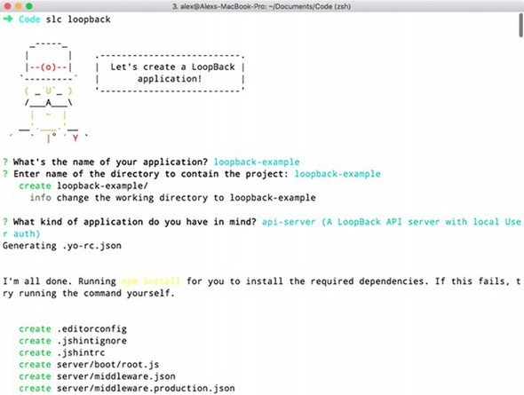
To run the project, type node ., and to create a model, use slc loopback:model. You’ll use the slc command regularly as you set up a new LoopBack project.
When the project is running, you should be able to access the API explorer at http://0.0.0.0:3000/explorer/. Click User to expand the User endpoint. You should see a large list of available API methods, including standard RESTful routes such as PUT /Users and DELETE /Users/{id}. Figure 5.3 shows the API explorer.

Figure 5.3. The StrongLoop API explorer showing User routes
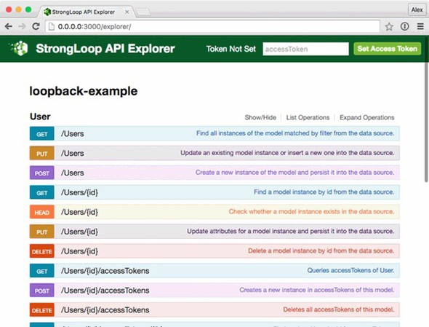

5.9.2. Defining routes
In LoopBack, you can add routes at the Express level. Add a new file called server/boot/routes.js, and add a route by accessing the LoopBack Router instance:
module.exports = (app) => {
const router = app.loopback.Router();
router.get('/hello', (req, res) => {
res.send('Hello, world');
});
app.use(router);
};
Visiting http://localhost:3000/hello will now respond with Hello, world. Adding routes this way, however, isn’t typical in a LoopBack project. It may be required for certain unusual API endpoints, but in general, routes are added automatically when models are generated.

5.9.3. REST APIs
The easiest way to create REST APIs in a LoopBack project is by using the model generator. This is part of the slc command’s features. If you want to add a new model called product, for example, run slc loopback:model:
slc loopback:model product
The slc command walks you through the steps to create a model, allowing you to select whether the model is server-only, and set up some properties and validators. After you add a model, take a look at the corresponding JSON file—it should be in common/models/product.json. This JSON file is a lightweight way of defining how models behave, including all of the properties you specified in the previous step.
If you want to add more properties, type slc loopback:property. You can add properties to models at any time.
Persona thoughts
Phil: “Our teams love the sound of LoopBack, mainly because of the ability to quickly add RESTful resources and browse them with the API explorer. But I like it because it looks like it’s flexible enough to support our legacy MVC web apps. We could hook into the older database and move these projects over to Node.”
Alice: “This is the only framework that really targets iOS and Android, as well as rich web clients. LoopBack has client libraries for iOS and Android, so this is a big deal for us as product developers who depend on mobile apps.”

5.9.4. Strengths
Even from this short introduction, it should be clear that one of the strengths of LoopBack is it removes the need to write boilerplate code. The command-line tool generates almost everything you need for lightweight RESTful web APIs, even database models and validation. At the same time, LoopBack doesn’t dictate too much about the front-end code. It also enables you to think about which models should be accessible to the browser and which are server-side only. Some frameworks get this wrong and push everything to the browser.
If you have mobile apps that need to talk to your web APIs, take a look at LoopBack’s client SDKs (http://loopback.io/doc/en/lb2/Client-SDKs.html). LoopBack supports API integration and push messages for both iOS and Android.

5.9.5. Weaknesses
LoopBack’s JSON-based model API is different from most JavaScript database APIs. It can take a while to learn how to map it to an existing project’s database schema. And because the HTTP layer is based on Express, it’s partly limited to what Express supports. Although Express is a solid HTTP server library, newer libraries are available for Node with more-modern APIs. LoopBack doesn’t have a specific plugin API. You can use Express middleware, but this isn’t as convenient as Flatiron or hapi’s plugin APIs.
This concludes the frameworks that are covered in this chapter. Before moving on to the next chapter, let’s compare the frameworks to help you decide which is the right choice for your next project.

5.10. Comparison
If you’ve been following the persona thoughts throughout this chapter, you may already have decided which framework to use. If not, the rest of this chapter compares the benefits of each framework. And, if you’re still lost, figure 5.4 will help you pick the right framework by answering some questions.

Figure 5.4. Choosing a Node framework
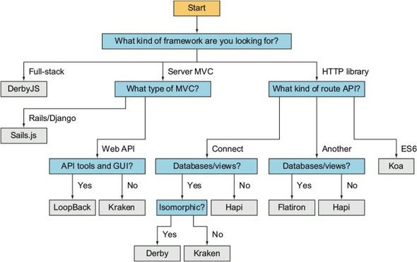
If you glance through Node’s popular server-side frameworks, they all sound similar. They offer lightweight HTTP APIs, and they use the server model instead of PHP’s page model. But the differences in their design have big implications for projects made with them, so to compare these frameworks, we’ll start at the HTTP level.

5.10.1. HTTP servers and routes
The majority of Node frameworks are based on Connect or Express. In this chapter, you’ve seen three that aren’t based on Express at all, and have their own solutions to HTTP APIs: Koa, hapi, and Flatiron.
Koa was created by the same author as Express, but offers a fresh approach by using more-modern JavaScript features. If you like Express but want to use ES2015 generator syntax, Koa may work for you.
hapi’s server and routing APIs are highly modular and feel different from those of Express. If you find Express’s syntax awkward, you should give hapi a try. hapi makes it easier to reason about HTTP servers, so if you need to do things such as connect servers or cluster them, you may prefer hapi to Express descendants.
Flatiron’s router is backward-compatible with Express but has extra features. The router emits events and uses a routing table. That’s different from the Express-style stack of middleware components. You can pass an object literal to Flatiron’s router. The router also works in browsers, so if you have server-side developers trying to tackle modern client-side development, they might be more at home with Flatiron than going all out with something like React Router.

5.11. Writing modular code
Not all of the frameworks covered here directly support plugins, but they’re all extensible in some way. The Express-based frameworks can use Connect middleware, but hapi and Flatiron have their own plugin APIs. Well-defined plugin APIs are useful because they make it easier for new users of a framework to extend it.
If you’re using a larger MVC framework such as Sails.js or LoopBack, a plugin API makes it much easier to set up a new project. LoopBack partly sidesteps needing a plugin API by providing a highly capable project management tool. If you look at StrongLoop’s npm account (www.npmjs.com/~strongloop), you’ll see lots of loopback-related projects that add support for things like Angular and several databases.

5.12. Persona choices
The personas in this chapter now have enough background to make the right choice for their next project:
Phil: “In the end I decided to go with LoopBack. It was a difficult choice because Sails and Kraken both have excellent features that my team liked, but we felt like LoopBack has stronger long-term support and reduces so much effort on server-side development.”
Nadine: “As an open source developer, I’ve opted for Flatiron. It’ll adapt to the various projects that I’m working on. For example, some projects will just use Winston and Director, but others will use the whole stack.”
Alice: “I’ve chosen hapi for my next project. It’s minimal, so I can adapt it to the project’s unique requirements. Most of the code will be Node and not rely on any specific framework, so I feel this works well with hapi.”

5.13. Summary

Koa is lightweight, minimal, and uses ES2015 generator syntax for middleware. It’s good for hosting single-page web apps that depend on external web APIs.
hapi is focused on HTTP servers and routes. It’s good for lightweight back ends composed of lots of small services.
Flatiron is a set of decoupled modules that can be used like either a web MVC framework or a more lightweight Express library. Flatiron is compatible with Connect middleware.
Kraken is based on Express, with added security features. It can be used for MVC.
Sails.js is a Rails/Django-inspired MVC framework. It has an ORM and a template system.
DerbyJS is an isomorphic framework that’s good for real-time applications.
LoopBack removes the need to write boilerplate code for quickly generating REST APIs complete with database support and an API explorer.

Chapter 6. Connect and Express in depth
This chapter covers

Understanding what Connect and Express are for
Using and creating middleware
Creating and configuring an Express application
Using key Express techniques for error handling, rendering views, and forms
Using Express architectural techniques for routes, REST APIs, and authentication
In chapter 3, you saw how to build a simple Express application. This chapter provides a more in-depth study of Express and Connect. These two popular Node modules are used by many web developers. This chapter shows you how to build web apps and REST APIs with the most commonly used patterns.
Connect and Express
The concepts discussed in the following section are directly applicable to the higher-level framework Express because it extends and builds upon Connect with additional higher-level sugar. After reading this section, you’ll have a firm understanding of how Connect middleware works and how to compose components together to create an application. Other Node web frameworks work in a similar way, so learning Connect will give you a head start when learning new frameworks.
To start, let’s see how to create a basic Connect application. Later in the chapter, you’ll see how to build a more complex Express application by using popular Express techniques.

6.1. Connect
In this section, you’ll learn about Connect. You’ll see how its middleware can be used to build simple web applications, and how middleware ordering matters. This will help you to build more-modular Express applications later.

6.1.1. Setting up a Connect application
Express is built with Connect, but do you know you can make a fully functionally web app with Connect alone? You can download and install Connect from the npm registry by using the command shown here:
$ npm install connect@3.4.0
Here’s what a minimal Connect application looks like:
const app = require('connect')();
app.use((req, res, next) => {
res.end('Hello, world!');
});
app.listen(3000);
This simple application (found under ch06-connect-and-express/hello-world in the sample code) will respond with Hello, world! The function passed to app.use is a middleware component that ends the request by sending back the Hello, world! text as a response. Middleware components form the basis of all Connect and Express apps. Let’s look at them in more detail.

6.1.2. Understanding how Connect middleware works
In Connect, a middleware component is a JavaScript function that by convention accepts three arguments: a request object, a response object, and an argument commonly named next, which is a callback function indicating that the component is done and the subsequent middleware component can be executed.
Before your middleware runs, Connect uses a dispatcher that takes in requests and then hands them off to the first middleware component that you’ve added to your application. Figure 6.1 shows a typical Connect application, which is composed of the dispatcher as well as an arrangement of middleware including a logger, a body parser, a static file server, and custom middleware.

Figure 6.1. The life cycle of two HTTP requests making their way through a Connect server
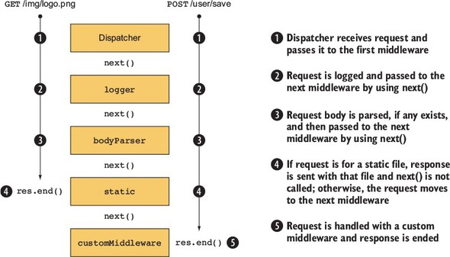
As you can see, the design of the middleware API means that more-complex behavior can be composed of smaller building blocks. In the next section, you’ll see how to do this by combining components.

6.1.3. Combining middleware
Connect provides a method called use for combining middleware components. Let’s define two middleware functions and add them both to the application. One is the simple Hello World function from earlier, and the other is a logger.

Listing 6.1. Using multiple Connect middleware components
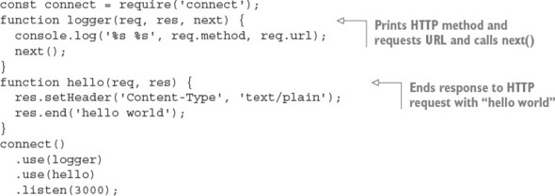
This middleware has two signatures: one with next, and one without. That’s because this component finishes the HTTP response and never needs to give control back to the dispatcher.
The use() function returns an instance of a Connect application to support method chaining, as shown previously. Note that chaining the .use() calls isn’t required, as shown in the following snippet:
const app = connect();
app.use(logger);
app.use(hello);
app.listen(3000);
Now that you have a simple Hello World application working, we’ll look at why the ordering of middleware .use() calls is important, and how to strategically use that ordering to alter the way your application works.

6.1.4. Ordering middleware
The ordering of middleware in your application can dramatically affect the way it behaves. Execution can be stopped by omitting next(), and middleware can be combined to implement features such as authentication.
What happens when middleware components don’t call next? Consider the previous Hello World example, where the logger middleware component is used first, followed by the hello component. In that example, Connect logs to stdout and then responds to the HTTP request. But consider what would happen if the ordering were switched, as follows.

Listing 6.2. Wrong: hello middleware component before logger component
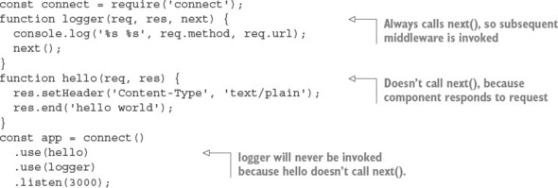
In this example, the hello middleware component is called first and responds to the HTTP request as expected. But logger is never called because hello never calls next(), so control is never passed back to the dispatcher to invoke the next middleware component. The moral here is that when a component doesn’t call next(), no remaining middleware in the chain of command will be invoked.
Figure 6.2 shows how this example would skip the logger, and how to correct it.

Figure 6.2. Middleware ordering is important.
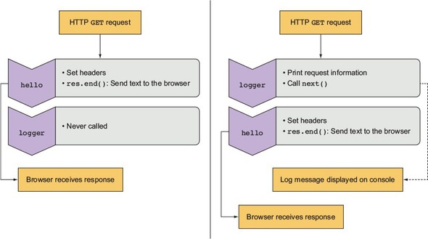
As you can see, placing hello in front of logger is rather useless, but when used properly, ordering can be to your benefit.

6.1.5. Creating configurable middleware
You’ve learned some middleware basics; now we’ll go into detail and look at how to create more-generic and reusable middleware.
Middleware commonly follows a simple convention in order to provide configuration capabilities to developers: using a function that returns another function (a closure). The basic structure for configurable middleware of this kind looks like this:
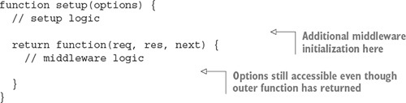
This type of middleware is used as follows:
app.use(setup({ some: 'options' }));
Notice that the setup function is invoked in the app.use line, whereas in previous examples you were just passing a reference to the function.
In this section, you’ll apply this technique to build three reusable, configurable middleware components:

A logger component with a configurable printing format
A router component that invokes functions based on the requested URL
A URL rewriter component that converts URL slugs to IDs
You’ll start by expanding your logger component to make it more configurable. The logger middleware component you created earlier in this chapter wasn’t configurable. It was hardcoded to print out the request’s req.method and req.url when invoked. But what if you want to change what the logger displays at some point in the future?
In practice, using configurable middleware is just like using any of the middleware you’ve created so far, except that you can pass additional arguments to the middleware component to alter its behavior. Using the configurable component in your application might look a little like the following example, where logger can accept a string that describes the format that it should print out:
const app = connect()
.use(logger(':method :url'))
.use(hello);
To implement the configurable logger component, you first need to define a setup function that accepts a single string argument (in this example, you’ll name it format). When setup is invoked, a function is returned, and it’s the middleware component Connect will use. The returned component retains access to the format variable, even after the setup function has returned, because it’s defined within the same JavaScript closure. The logger then replaces the tokens in the format string with the associated request properties on the req object, logs to stdout, and calls next(), as shown in the following listing.

Listing 6.3. A configurable logger middleware component for Connect
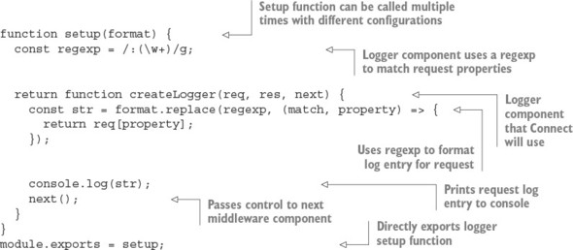
Because you’ve created this logger middleware component as configurable middleware, you can .use() the logger multiple times in a single application with different configurations or reuse this logger code in any number of future applications you might develop. This simple concept of configurable middleware is used throughout the Connect community, and it’s used for all core Connect middleware to maintain consistency.
To use the logger middleware in listing 6.3, you need to pass it a string that includes some of the properties found on the request object. For example, .use(setup(':method :url')) prints the HTTP method (GET, POST, and so forth) and URL of each request.
Before moving on to Express, let’s look at how Connect supports error handling.

6.1.6. Using error-handling middleware
All applications have errors, whether at the system level or the user level, and being well prepared for error situations—even ones you aren’t anticipating—is a smart thing to do. Connect implements an error-handling variant of middleware that follows the same rules as regular middleware but accepts an error object along with the request and response objects.
Connect’s error handling is intentionally minimal, allowing the developer to specify the way errors should be handled. For example, you could pass only system and application errors through the middleware (for example, foo is undefined) or user errors (password is invalid) or a combination of both. Connect lets you choose which is best for your application.
In this section, you’ll use both types, and you’ll learn how error-handling middleware works. You’ll also learn some useful patterns that can be applied while we look at the following:

Using Connect’s default error handler
Handing application errors yourself
Using multiple error-handling middleware components
Let’s jump in with a look at how Connect handles errors without any configuration.

Using Connect’s default error handler
Consider the following middleware component, which will throw a ReferenceError error because the function foo() isn’t defined by the application:
const connect = require('connect')
connect()
.use((req, res) => {
foo();
res.setHeader('Content-Type', 'text/plain');
res.end('hello world');
})
.listen(3000)
By default, Connect will respond with a 500 status code, a response body containing the text Internal Server Error, and more information about the error itself. This is fine, but in any kind of real application, you’d probably want to do more-specialized things with those errors, such as send them off to a logging daemon.

Handling application errors yourself
Connect also offers a way for you to handle application errors yourself, using error-handling middleware. For instance, in development you might want to respond to the client with a JSON representation of the error for quick and easy reporting, whereas in production you’d want to respond with a simple Server error, so as not to expose sensitive internal information (such as stack traces, filenames, and line numbers) to a potential attacker.
An error-handling middleware function must be defined to accept four arguments—err, req, res, and next—as shown in listing 6.4, whereas regular middleware takes the arguments req, res, and next. The following listing shows an example error middleware. For a full example with a server, look at ch06-connect-and-express/listing6_4 in the book’s source code.

Listing 6.4. Error-handling middleware in Connect
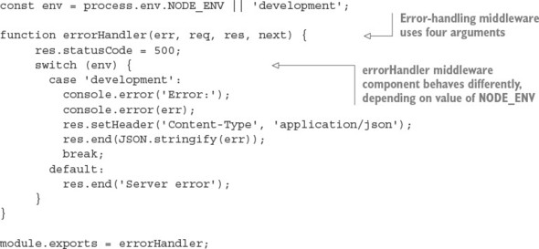

Use NODE_ENV to set the application’s mode
A common Connect convention is to use the NODE_ENV environment variable (process.env.NODE_ENV) to toggle the behavior between server environments, such as production and development.
When Connect encounters an error, it’ll switch to invoking only error-handling middleware, as you can see in figure 6.3.

Figure 6.3. The life cycle of an HTTP request causing an error in a Connect server
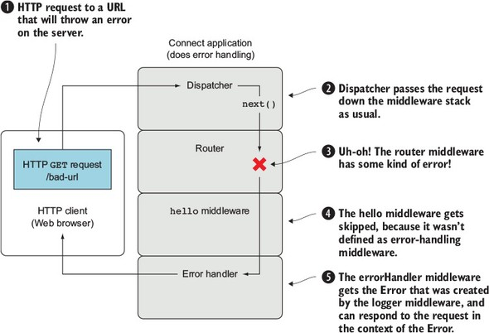
Imagine you have an application that allows people to authenticate to an administration area for a blog. If the routing middleware component for the user routes causes an error, both the blog and admin middleware components will be skipped, because they don’t act as error-handling middleware—they only define three arguments. Connect will then see that errorHandler accepts the error argument and will invoke it. The middleware components could look something like this:
connect()
.use(router(require('./routes/user')))
.use(router(require('./routes/blog'))) // Skipped
.use(router(require('./routes/admin'))) // Skipped
.use(errorHandler);
Short-circuiting functionality based on middleware execution is a fundamental concept used to organize Express applications. Now that you’ve learned the basics of Connect, it’s time to go into more detail about Express.

6.2. Express
Express is a popular web framework formerly built on Connect but still compatible with Connect middleware. Although Express comes with basic functionality, such as serving static files, URL routing, and application configuration, it’s still minimal. It provides enough structure so you can compose reusable chunks without being too restrictive of your development practices.
Over the next few sections, you’ll implement a new Express application by using the Express skeleton app generator. This process is more detailed than the brief overview in chapter 3, so by the end of this chapter you should have enough knowledge of Express to build your own Express web apps and RESTful APIs. As the chapter continues, you’ll keep adding functionality to the skeleton to produce a full app by the end.

6.2.1. Generating the application skeleton
Express doesn’t force application structure on the developer. You can place routes in as many files as you want, public assets in any directory you want, and so on. A minimal Express application can be as small as the following listing, which implements a fully functional HTTP server.

Listing 6.5. A minimal Express application
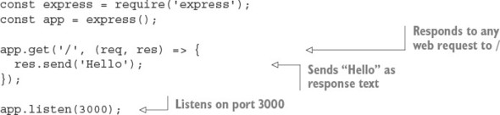
The express(1) command-line tool available in the express-generator package (www.npmjs.com/package/express-generator) can set up an application skeleton for you. Using the generated application is a good way to get started if you’re new to Express, as it sets up an application complete with templates, public assets, configuration, and more.
The default application skeleton that express(1) generates consists of only a few directories and files, as shown in figure 6.4. This structure is designed to get developers up and running with Express in seconds, but the application’s structure is entirely up to you and your team to create.

Figure 6.4. Default application skeleton structure using EJS templates
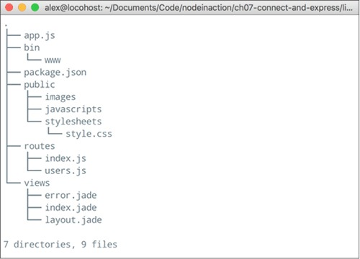
This chapter’s example uses Embedded JavaScript (EJS) templates, which are similar in structure to HTML. EJS is similar to PHP, JSP (for Java), and ERB (for Ruby), because server-side JavaScript is embedded in an HTML document and executed prior to being sent to the client. You’ll look at EJS more closely in chapter 7.
In this section, you’ll do the following:

Install Express globally with npm
Generate the application
Explore the application and install dependencies
Let’s get started.

Installing the Express executable
First, install express-generator globally with npm:
$ npm install -g express-generator
Next, you can use the --help flag to see the options available, as shown in figure 6.5.

Figure 6.5. Express help
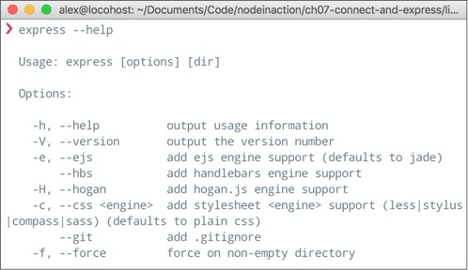
Some of these options will generate small portions of the application for you. For example, you can specify a template engine to generate a dummy template file for the chosen template engine. Similarly, if you specify a CSS preprocessor by using the --css option, a dummy template file will be generated for it.
Now that the executable is installed, let’s see how to generate what will become the photo application.

Generating the application
For this application, you use the -e (or --ejs) flag to use the EJS templating engine. Execute express -e shoutbox. If you want to duplicate the code samples in our GitHub repository, use express -e listing6_6.
A fully functional application is created in the shoutbox directory. It contains a package.json file to describe the project and dependencies, the application file itself, the public file directories, and a directory for route handlers.

Exploring the application
Let’s take a closer look at what was generated. Open the package.json file in your editor to see the application’s dependencies, as shown in figure 6.6. Express can’t guess which version of the dependencies you’ll want, so it’s good practice to supply the major, minor, and patch levels of the module so you don’t introduce any surprise bugs. For example, "express": "~4.13.1" is explicit and will provide you with identical code on each installation.

Figure 6.6. Generated package.json contents
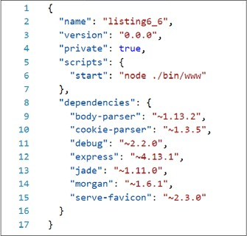
Now look at the application file generated by express(1), shown in the following listing. For now, you’ll leave this file as is. You should be familiar with these middleware components from the Connect sections earlier in this chapter, but it’s worth taking a look at how the default middleware configuration is set up.

Listing 6.6. Generated Express application skeleton
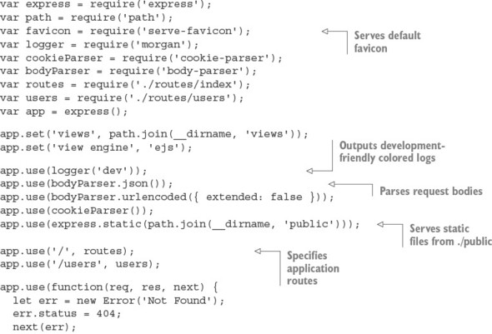
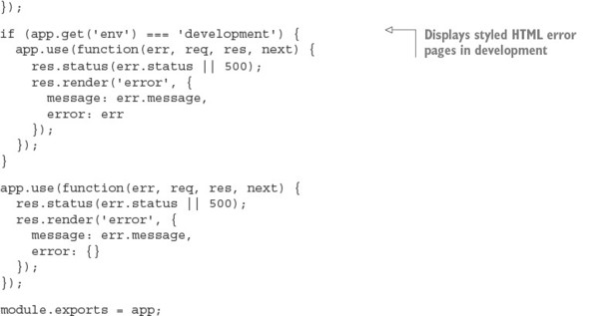
You have the package.json and app.js files, but the application won’t run yet because the dependencies haven’t been installed. Whenever you generate a package.json file from express(1), you need to install the dependencies. Execute npm install to do this, and then execute npm start to run the application.
Check out the application by visiting http://localhost:3000 in your browser. The default application looks like the one in figure 6.7.

Figure 6.7. Default Express application
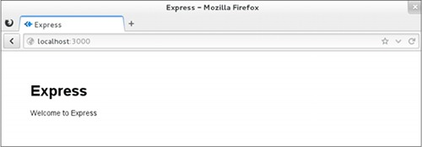
Now that you’ve seen the generated skeleton, you can start building a real Express application. The application will be a shoutbox that allows people to post messages. When building applications like this, most seasoned Express developers start by planning their API and hence the required routes and resources that will be required.

Planning the shoutbox application
Here are the requirements for the shoutbox application:

It should allow users to register accounts, sign in, and sign out.
Users should be able to post messages (entries).
Site visitors should be able to paginate through entries.
There should be a simple REST API that supports authentication.
You need to store data and handle authentication. You also need to validate user input. The necessary routes look something like this:

API routes
GET /api/entries: Get a list of entries
GET /api/entries/page: Get a single page of entries
POST /api/entry: Create a new shoutbox entry
Web UI routes
GET /post: The form for a new entry
POST /post: Post a new entry
GET /register: Show the registration form
POST /register: Create a new account
GET /login: Show the sign-in form
POST /login: Sign in
GET /logout: Sign out
This layout is similar to that of most web applications. Hopefully, you’ll be able to use the example from this chapter as a template for your own applications in the future.
In the previous listing, you may have noticed some calls to app.set:
app.set('views', path.join(__dirname, 'views'));
app.set('view engine', 'ejs');
This is how Express applications are configured. The next section explains Express configuration in more detail.

6.2.2. Configuring Express and your application
Your application’s requirements will depend on the environment in which it’s running. For example, you may want verbose logging when your product is in development, but a leaner set of logs and gzip compression when it’s in production. In addition to configuring environment-specific functionality, you may want to define some application-level settings so Express knows what template engine you’re using and where it can find the templates. Express also lets you define custom configuration key/value pairs.
Setting environment variables
To set an environment variable in UNIX systems, you can use this command:
$ NODE_ENV=production node app
In Windows, you can use this code:
$ set NODE_ENV=production
$ node app
These environment variables will be available in your application on the process.env object.
Express has a minimal environment-driven configuration system, consisting of several methods, all driven by the NODE_ENV environment variable:

app.set()
app.get()
app.enable()
app.disable()
app.enabled()
app.disabled()
In this section, you’ll see how to use the configuration system to customize the way Express behaves, as well as how to use this system for your own purposes throughout development.
Let’s take a closer look at what environment-based configuration means. Although the NODE_ENV environment variable originated in Express, many other Node frameworks have adopted it as a means to notify the Node application which environment it’s operating within, defaulting to development.
The app.configure() method accepts optional strings representing the environment, and a function. When the environment matches the string passed, the callback is immediately invoked; when only a function is given, it’s invoked for all environments. These environment names are completely arbitrary. For example, you may have development, stage, test, and production, or prod for short:
if (app.get('env') === 'development') {
app.use(express.errorHandler());
}
Express uses the configuration system internally, allowing you to customize the way Express behaves, but it’s also available for your own use.
Express also provides Boolean variants of app.set() and app.get(). For example, app.enable(setting) is equivalent to app.set(setting, true), and app.enabled (setting) can be used to check whether the value was enabled. The methods app.disable (setting) and app.disabled(setting) complement the truthful variants.
A useful setting for developing APIs with Express is the json spaces option. If you add it to your app.js file, your JSON will be printed in a more readable format:
app.set('json spaces', 2);
Now that you’ve seen how to take advantage of the configuration system for your own use, let’s look at rendering views in Express.

6.2.3. Rendering views
In this chapter’s application, you’ll use EJS templates, though as previously mentioned, almost any template engine in the Node community can be used. If you’re not familiar with EJS, don’t worry. It’s similar to templating languages found in other web development platforms (PHP, JSP, ERB). We cover some basics of EJS in this chapter, but we discuss EJS and several other template engines in greater detail in chapter 7.
Whether it’s rendering an entire HTML page, an HTML fragment, or an RSS feed, rendering views is crucial for nearly every application. The concept is simple: you pass data to a view, and that data is transformed, typically to HTML for web applications. You’re likely familiar with the idea of views, because most frameworks provide similar functionality; figure 6.8 illustrates how a view forms a new representation for the data.

Figure 6.8. HTML template plus data = HTML view of data
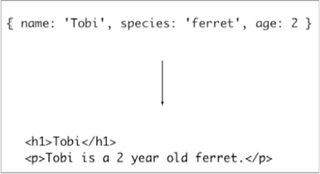
The template that generates template 6.8 can be found in the following snippet:
<h1><%= name %></h1>
<p><%= name %> is a 2 year old <%= species %>.</p>
Express provides two ways to render views: at the application level with app.render(), and at the response with res.render(), which uses the former internally. In this chapter, you’ll use only res.render(). If you look in ./routes/index.js, a function is defined that invokes res.render('index') in order to render the ./views/index.ejs template, as shown in the following code (found in listing6_8):
router.get('/', (req, res, next) => {
res.render('index', { title: 'Express' });
});
Before looking at res.render() more closely, let’s see how to configure the view system.

Configuring the view system
Configuring the Express view system is simple. But even though express(1) generated the configuration for you, it’s still useful to know what’s going on behind the scenes so you can make changes. We’ll focus on three areas:

Adjusting the view lookup
Configuring the default template engine
Enabling view caching to reduce file I/O
First up is the views setting.

Changing the lookup directory
The following snippet shows the views setting that the Express executable created:
app.set('views', __dirname + '/views');
This specifies the directory that Express will use during view lookup. It’s a good idea to use __dirname so that your application isn’t dependent on the current working directory being the application’s root.
__dirname
__dirname (with two leading underscores) is a global variable in Node that identifies the directory in which the currently running file exists. Often in development this directory will be the same as your current working directory (CWD), but in production the Node executable may run from another directory. Using __dirname helps keep paths consistent across environments.
The next setting is view engine.

Using the default template engine
When express(1) generated the application, the view engine setting was assigned ejs because EJS was the template engine selected by the -e command-line option. This setting enables you to render index rather than index.ejs. Otherwise, Express requires the extension in order to determine which template engine is to be used.
You might be wondering why Express even considers extensions. The use of extensions allows you to use multiple template engines within a single Express application, while providing a clean API for common use cases, because most applications will use one template engine.
Suppose, for example, you find writing RSS feeds easier with another template engine, or perhaps you’re migrating from one template engine to another. You might use Pug as the default, and EJS for the /feed route, as indicated in the following code by the .ejs extension:
app.set('view engine', 'pug');
app.get('/', function(){
res.render('index');
});
app.get('/feed', function(){
res.render('rss.ejs')
;
});

Keeping package.json in sync
Keep in mind that any additional template engines you wish to use should be added to your package.json dependencies object. Try to remember to install packages with npm install --save package-name. Remove them with npm uninstall --save package-name to delete them from node_modules and package.json. This makes experimenting with different template engines easier when you’re still trying to figure out which one you want to use.

View caching
The view cache setting is enabled by default in the production environment and prevents subsequent render() calls from performing disk I/O. The contents of the templates are saved in memory, greatly improving performance. The side effect of enabling this setting is that you can no longer edit the template files without restarting the server, which is why it’s disabled in development. If you’re running a staging environment, you’ll likely want to enable this option.
As illustrated in figure 6.9, when view cache is disabled, the template is read from disk on every request. This is what allows you to make changes to a template without restarting the application. When view cache is enabled, the disk is hit only once per template.

Figure 6.9. The view cache setting
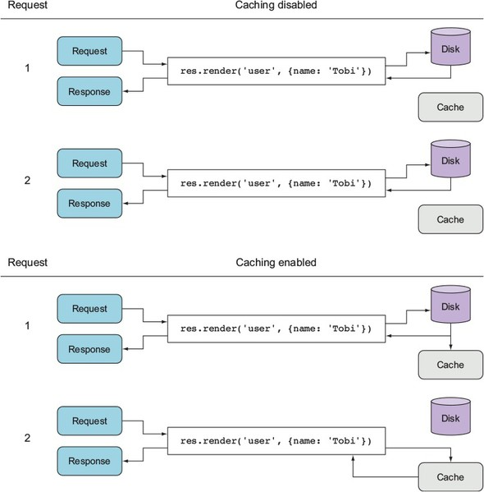
You’ve seen how the view-caching mechanism helps improve performance in a nondevelopment environment. Now let’s see how Express locates views in order to render them.

View lookup
The process of looking up a view is similar to the way Node’s require() works. When res.render() or app.render() is invoked, Express first checks whether a file exists at an absolute path. Next, Express looks relative to the views directory. Finally, Express tries an index file. This process is represented as a flowchart in figure 6.10.

Figure 6.10. Express view lookup process
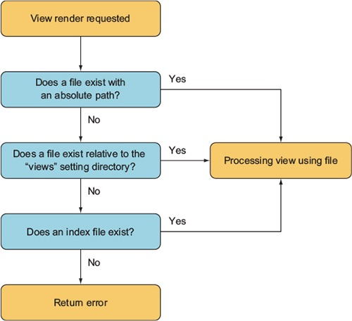
Because ejs is set as the default engine, the render call omits the .ejs extension, and the template file will still be resolved correctly.
As the application evolves, you’ll need more views, and sometimes several for a single resource. Using view lookup can help with organization—for example, you can use subdirectories related to the resource and create views within them.
Adding subdirectories allows you to eliminate redundant parts of names (such as edit-entry.ejs and show-entry.ejs). Express then adds the view engine extension and resolves res.render('entries/edit') to ./views/entries/edit.ejs.
Express checks to see whether a file named index resides in subdirectories of the view directory. When files are named with a pluralized resource, such as entries, this typically implies a resource listing. This means you can use res.render('entries') to render the file in views/entries/index.ejs.

Methods of exposing data to views
You’ve seen how to pass local variables directly to res.render() calls, but you can also use a few other mechanisms for this. For example, you can use app.locals for application-level variables, and res.locals for request-level local variables that are typically set by middleware components prior to the final route-handling method where views are rendered.
The values passed directly to res.render() take precedence over values set in res.locals and app.locals, as figure 6.11 shows.

Figure 6.11. Values passed directly to the render function take precedence when rendering a template.
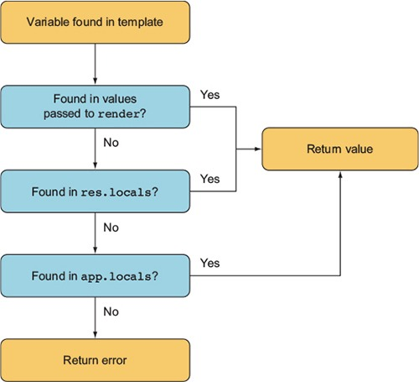
By default, Express exposes only one application-level variable, settings, to views, which is the object containing all of the values set with app.set(). For example, using app.set('title', 'My Application') would expose settings.title in the template, as shown in the following EJS snippet:
<html>
<head>
<title><%= settings.title %></title>
</head>
<body>
<h1><%= settings.title %></h1>
<p>Welcome to <%= settings.title %>.</p>
</body>
Internally, Express exposes this object with the following JavaScript:
app.locals.settings = app.settings;
That’s all there is to it! Now that you’ve seen how to render views and send data to them, let’s look at how routes are defined and see how to write route handlers that can render views for the shoutbox application. You’ll also set up database models to persist data.

6.2.4. Express routing 101
The primary function of Express routes is to pair a URL pattern with response logic. But routes also can pair a URL pattern with middleware. This allows you to use middleware to provide reusable functionality to certain routes.
In this section, you’ll do the following:

Validate user-submitted content by using route-specific middleware
Implement route-specific validation
Implement pagination
Let’s explore some of the ways to use route-specific middleware.

Validating user content submission
To give you something to apply validation to, you’re going to finally add the ability to post to the shoutbox application. To add the ability to post, you need to do a few things:

Create an entry model
Add entry-related routes
Create an entry form
Add logic to create entries using submitted form data
You’ll start by creating an entry model.

Creating an entry model
Before moving on, you need to install the Node redis module into the project. Install it with npm install --save redis. If you don’t have Redis installed, go to http://redis.io/ to learn how to install it; if you’re using macOS, you can easily install it with Homebrew (http://brew.sh/), and Windows has a Redis Chocolatey package (https://chocolatey.org/).
We’re using Redis to cheat a little bit: the features of Redis and ES6 make creating lightweight models without a complex database library easy. If you’re feeling ambitious, you could use another database library (see chapter 8 for more about databases in Node).
Let’s see how to create a lightweight model to store your shoutbox entries. Create a file to contain the entry model definition at models/entry.js. Add the code contained in the following listing to this file. The entry model will be a simple ES6 class that saves data in a Redis list.

Listing 6.7. A model for entries
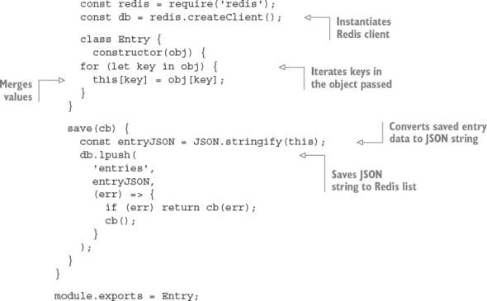
With the basic model fleshed out, you now need to add a function called getRange, using the contents of the following listing. This function will allow you to retrieve entries.

Listing 6.8. Logic to retrieve a range of entries
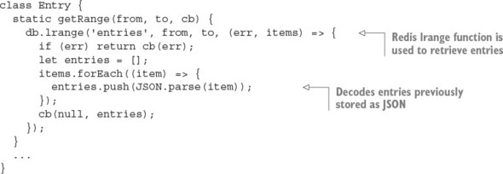
With a model created, you can now add routes to create and list entries.

Creating an entry form
The app has the ability to list entries, but no way to add them. You’ll add this capability next, starting by adding the following lines to the routing section of app.js:
app.get('/post', entries.form);
app.post('/post', entries.submit);
Next, add the following route to routes/entries.js. This route logic will render a template containing a form:
exports.form = (req, res) => {
res.render('post', { title: 'Post' });
};
Next, use the EJS template in the following listing to create a template for the form and save it to views/post.ejs.

Listing 6.9. A form for entering post data
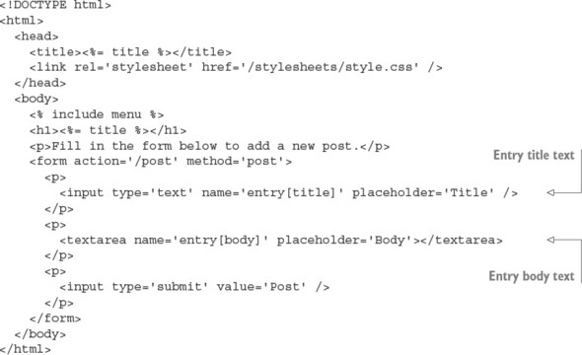
This form uses input names such as entry[title], so extended body parsing is required. To change the body parser, open app.js, and move to the line that reads
app.use(bodyParser.urlencoded({ extended: false }));
Change this to use extended parsing:
app.use(bodyParser.urlencoded({ extended: true }));
With form display taken care of, let’s move on to creating entries from the submitted form data.

Implementing entry creation
To add the capability to create entries from submitted form data, add the logic in the next listing to the file routes/entries.js. This logic will add entries when form data is submitted.

Listing 6.10. Add an entry using submitted form data
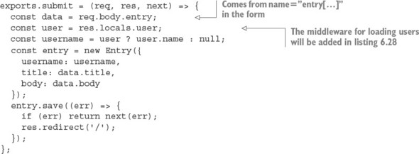
Now when you use a browser to access /post on your application, you’ll be able to add entries. You’ll take care of forcing the user to sign in first in listing 6.21.
With posting content taken care of, it’s time to render lists of entries.

Adding front-page display of entries
Start by creating the file routes/entries.js. Then add the code in the following listing to require the entry model and export a function for rendering a list of entries.

Listing 6.11. Listing entries
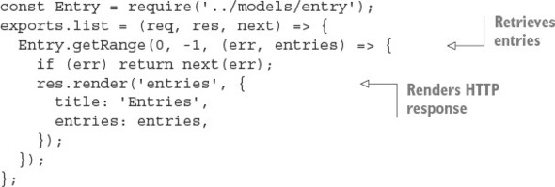
With route logic defined for listing entries, you now need to add an EJS template to display them. In the views directory, create a file named entries.ejs and put the following EJS in it.

Listing 6.12. The entries.ejs view
<!DOCTYPE html>
<html>
<head>
<title><%= title %></title>
<link rel='stylesheet' href='/stylesheets/style.css' />
</head>
<body>
<% include menu %>
<% entries.forEach((entry) => { %>
<div class='entry'>
<h3><%= entry.title %></h3>
<p><%= entry.body %></p>
<p>Posted by <%= entry.username %></p>
</div>
<% }) %>
</body>
</html>
Before running the application, run touch views/menu.ejs to create a temporary file that will hold the menu at a later stage. When the views and routes are ready, you need to tell the application where to find the routes.

Adding entry-related routes
Before you add entry-related routes to the application, you need to make modifications to app.js. First, add the following require statement to the top of your app.js file:
const entries = require('./routes/entries');
Next, also in app.js, change the line containing the text app.get('/' to the following to make any requests to the path / to return the entry listing:
app.get('/', entries.list);
When you run the application, the front page will display a list of entries. Now that entries can be created and listed, let’s move on to using route-specific middleware to validate form data.

Using route-specific middleware
Suppose you want the entry text field in the post entry form to be required. The first way you might think of to address this problem is to add it straight in your route callback, as shown in the following snippet. This approach isn’t ideal, however, because it tightly ties the validation logic to this particular form. In many cases, validation logic can be abstracted into reusable components, making development easier, faster, and more declarative:
...
exports.submit = (req, res, next) => {
let data = req.body.entry;
if (!data.title) {
res.error('Title is required.');
res.redirect('back');
return;
}
if (data.title.length < 4) {
res.error('Title must be longer than 4 characters.');
res.redirect('back');
return;
}
...
Express routes can optionally accept middleware of their own, applied only when that route is matched, before the final route callback. The route callbacks themselves that you’ve been using throughout the chapter aren’t treated specially. These are the same as any other middleware, even the ones you’re about to create for validation!
Let’s get started with route-specific middleware by looking at a simple, but inflexible, way to implement validation as route-specific middleware.

Performing form validation with route-specific middleware
The first possibility is to write a few simple, yet specific, middleware components to perform validation. Extending the POST /post route with this middleware might look something like the following:
app.post('/post',
requireEntryTitle,
requireEntryTitleLengthAbove(4),
entries.submit
);
Note that this route definition, which normally has only a path and routing logic as arguments, has two additional arguments specifying validation middleware.
The two example middleware components in the following listing illustrate how the original validations can be abstracted out. But they’re still not modular and work only for the single field entry[title].

Listing 6.13. Two more potential, but imperfect, attempts at validation middleware
function requireEntryTitle(req, res, next) {
const title = req.body.entry.title;
if (title) {
next();
} else {
res.error('Title is required.');
res.redirect('back');
}
}
function requireEntryTitleLengthAbove(len) {
return (req, res, next) => {
const title = req.body.entry.title;
if (title.length > len) {
next();
} else {
res.error(`Title must be longer than ${len}.`);
res.redirect('back');
}
};
}
A more viable solution is to abstract the validators and pass the target field name. Let’s take a look at approaching it this way.

Building flexible validation middleware
You can pass the field name, as shown in the following snippet. This allows you to reuse validation logic, lessening the amount of code you need to write:
app.post('/post',
validate.required('entry[title]'),
validate.lengthAbove('entry[title]', 4),
entries.submit);
Swap the line app.post('/post', entries.submit); in the routing section of app.js with this snippet. It’s worth noting that the Express community has created many similar libraries for public consumption, but understanding how validation middleware works, and how to author your own, is invaluable.
Let’s get on with it. Create a file named ./middleware/validate.js by using the program code in listing 6.14. In validate.js, you’ll export several middleware components—in this case, validate.required() and validate.lengthAbove(). The implementation details aren’t important; the point of this example is that a small amount of effort can go a long way if the code is common within the application.

Listing 6.14. Validation middleware implementation
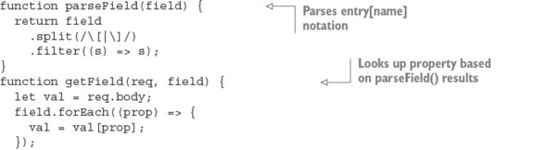
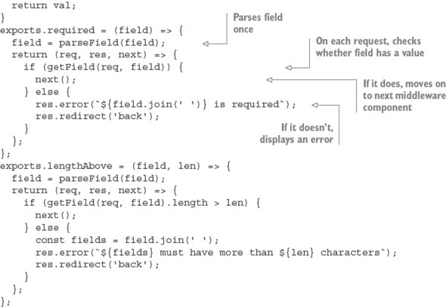
To make this middleware available to your application, add the following line at the top of app.js:
const validate = require('./middleware/validate');
If you try the application now, you’ll find that the validation will be in effect. This validation API could be made even more fluent, but we’ll leave that for you to investigate.

6.2.5. Authenticating users
In this section, you’ll create an authentication system for the application from scratch. You’ll go through the following steps:

Implement logic to store and authenticate registered users
Add account registration functionality
Allow people to sign in
Create and use middleware to load users
You’ll continue using Redis to implement user accounts. Now let’s see how to create a user model to make working with Redis easier in our Node code.

Saving and loading user records
In this section, you’ll implement user loading, saving, and authentication. You’ll do the following:

Define application dependencies by using a package.json file
Create a user model
Add logic to load and save user data by using Redis
Secure user passwords by using bcrypt
Add logic to authenticate attempts to log in
Bcrypt is a salted hashing function that’s available as a third-party module designed specifically for hashing passwords. Bcrypt is great for passwords because it incorporates an iteration count argument to make it slower over time.
Before continuing, add bcrypt to your shoutbox project:
npm install --save redis bcrypt

Creating a user model
You now need to create a user model. Add a file named user.js to the models/ directory.
Listing 6.15 is the user model. In this code, the redis and bcrypt dependencies are required, and then a Redis connection is opened with redis.createClient(). The User function accepts an object and merges this object’s properties into its own. For example, new User({ name: 'tobi' }) creates an object and sets the object’s name property to Tobi.

Listing 6.15. Starting to create a user model
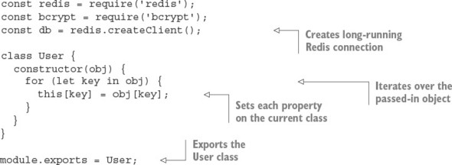
At the moment, the user mode is just a stub. You’ll need to add methods for creating and updating user records as well.

Saving a user into Redis
The next functionality you need is the ability to save a user, storing the user’s data with Redis. The save method shown in listing 6.16 checks whether the user already has an ID, and if so, save invokes the update method, indexing the user ID by name, and populating a Redis hash with the object’s properties. Otherwise, a user who doesn’t have an ID is considered a new user; the user:ids value is then incremented, which gives the user a unique ID, and the password is hashed before saving into Redis with the same update method.
Add the code in the following listing to models/user.js.

Listing 6.16. Updating user records
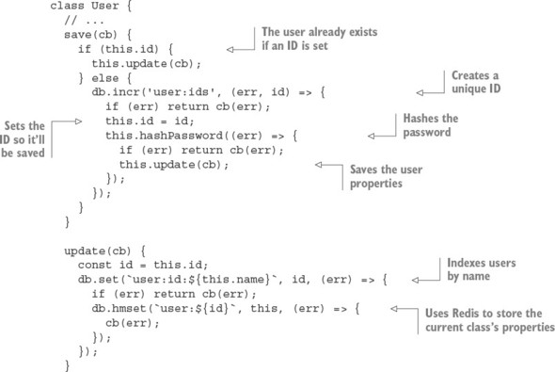

Securing user passwords
When the user is first created, you need to set a .pass property to the user’s password. The user-saving logic then replaces the .pass property with a hash generated by using the password.
The hash is salted. Per-user salting helps to protect against rainbow table attacks: the salt acts as a private key for the hashing mechanism. You can use bcrypt to generate a 12-character salt for the hash with genSalt().

Rainbow table attacks
Rainbow table attacks use precomputed tables to break hashed passwords. You can read more about this topic in Wikipedia: http://en.wikipedia.org/wiki/Rainbow_table.
After the salt is generated, bcrypt.hash() is called, which hashes the.pass property and the salt. This final hash value then replaces the .pass property before .update() stores it in Redis, ensuring that plain-text passwords aren’t saved, only the hash.
The following listing, which you’ll add to models/user.js, defines a function that creates the salted hash and stores it in the user’s .pass property.

Listing 6.17. Adding bcrypt encryption to the user model
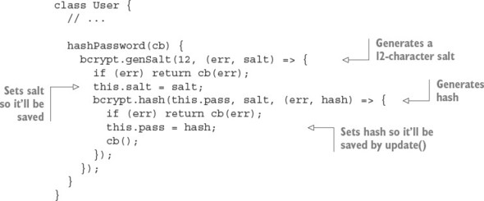
That’s all there is to it.

Testing the user-saving logic
To try out saving users, start the Redis server by entering redis-server on the command line. Then add the code in the following listing, which creates an example user, to the bottom of models/user.js. You can then run node models/user.js on the command line to execute the creation of the example user.

Listing 6.18. Testing the user model
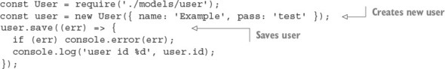
You should see output indicating that the user has been created: user id 1, for example. After testing the user model, remove the code in listing 6.18 from models/user.js.
When you use the redis-cli tool that comes with Redis, you can use the HGETALL command to fetch each key and value of the hash, as the following command-line session demonstrates.

Listing 6.19. Querying with the Redis command-line tool
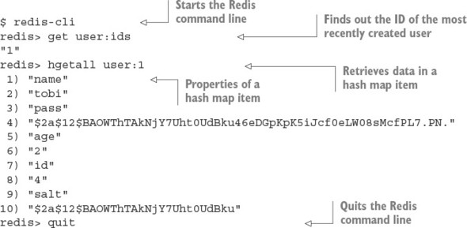
Having defined logic to save a user, you now need to add logic to retrieve user information.

Other Redis commands you can run in the redis-cli tool
For more information about Redis commands, see the Redis command reference at http://redis.io/commands.

Retrieving user data
When a user attempts to log in to a web application, the user usually enters a username and password into a form, and this data is then submitted to the application for authentication. Once the login form is submitted, you need a method for fetching the user via name.
This logic is defined in the following listing as User.getByName(). The function first performs an ID lookup with User.getId() and then passes the ID that it finds to User.get(), which gets the Redis hash data for that user. Add the following methods to models/user.js.

Listing 6.20. Fetching a user from Redis
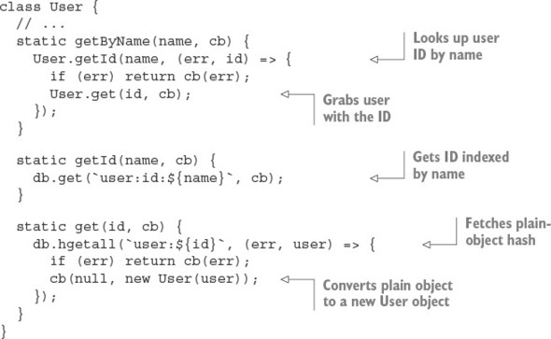
If you want to try fetching a user, you can try code like this:
User.getByName('tobi', (err, user) => {
console.log(user);
});
Having retrieved the hashed password, you can now proceed with authenticating the user.

Authenticating user logins
The final component needed for user authentication is a method, defined in the following listing, that takes advantage of the functions defined earlier for user data retrieval. Add this logic to models/user.js.

Listing 6.21. Authenticating a user’s name and password
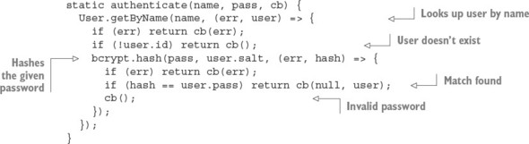
The authentication logic begins by fetching the user by name. If the user isn’t found, the callback function is immediately invoked. Otherwise, the user’s stored salt and the password submitted are hashed to produce what should be identical to the stored user.pass hash. If the submitted and stored hashes don’t match, the user has entered invalid credentials. When looking up a key that doesn’t exist, Redis will give you an empty hash, which is why the check for !user.id is used instead of !user.
Now that you’re able to authenticate users, you need a way for users to register.

6.2.6. Registering new users
To allow users to create new accounts and then sign in, you need both registration and login capabilities.
In this section, you’ll do the following to implement registration:

Map registration and login routes to URL paths
Add route logic to display a registration form
Add logic to store user data submitted from the form
The form will look like figure 6.12.

Figure 6.12. User registration form

This form is displayed when a user visits /register with a web browser. Later you’ll create a similar form that allows users to log in.

Adding registration routes
To get the registration form to show up, you first want to create a route to render the form and return it to the user’s browser for display.
Listing 6.22 shows how you should alter app.js, using Node’s module system to import a module defining registration route behavior from the routes directory, and associating HTTP methods and URL paths to route functions. This forms a sort of “front controller.” As you can see, there are both GET and POST register routes.

Listing 6.22. Adding registration routes
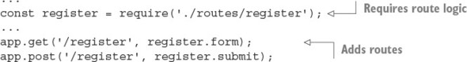
Next, to define the route logic, create an empty file in the routes directory called register.js. Start defining registration route behavior by exporting the following function from routes/register.js—a route that renders the registration template:
exports.form = (req, res) => {
res.render('register', { title: 'Register' });
};
This route uses an EJS template, which you’ll create next, to define the registration form’s HTML.

Creating a registration form
To define the registration form’s HTML, create a file in the views directory called register.ejs. You can define this form by using the HTML/EJS detailed in the following listing.

Listing 6.23. A view template that provides a registration form
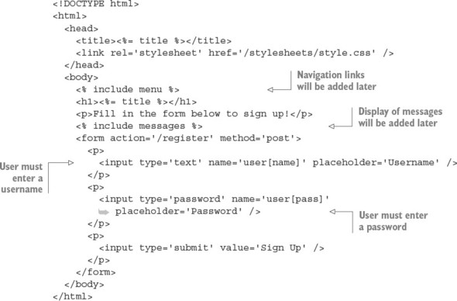
Note the use of include messages, which includes another template: messages.ejs. This template, which you’ll define next, is used to communicate with the user.

Relaying feedback to users
During user registration, and in many other parts of a typical application, it can be necessary to relay feedback to the user. A user, for example, may attempt to register with a username that someone else is already using. In this case, you need to tell the user to choose another name.
In your application, the messages.ejs template will be used to display errors. Numerous templates throughout the application will include the messages.ejs template.
To create the messages template, create a file in the views directory called messages.ejs and put the logic in the following snippet into that file. The template logic checks whether the locals.messages variable is set. If so, the template cycles through the variable, displaying message objects. Each message object has a type property (allowing you to use messages for nonerror notifications if need be) and a string property (the message text). Application logic can queue an error for display by adding to the res.locals.messages array. After messages are displayed, removeMessages is called to empty the messages queue:
<% if (locals.messages) { %>
<% messages.forEach((message) => { %>
<p class='<%= message.type %>'><%= message.string %></p>
<% }) %>
<% removeMessages() %>
<% } %>
Figure 6.13 shows the registration form when displaying an error message.

Figure 6.13. Registration form error reporting

Adding a message to res.locals.messages is a simple way to communicate with the user, but because res.locals doesn’t persist across redirects, you need to make it more robust by using sessions to store messages between requests.

Storing transient messages in sessions
A common web application design pattern is the Post/Redirect/Get (PRG) pattern. In this pattern, a user requests a form, the form data is submitted as an HTTP POST request, and the user is then redirected to another web page. Where the user is redirected to depends on whether the form data was considered valid by the application. If the form data isn’t considered valid, the application redirects the user back to the form page. If the form data is valid, the user is redirected to a new web page. The PRG pattern is primarily used to prevent duplicate form submissions.
In Express, when a user is redirected, the content of res.locals is reset. If you’re storing messages to the user in res.locals, the messages are lost before they can be displayed. By storing messages in a session variable, however, you can work around this. Messages can then be displayed on the final redirect page.
To accommodate the ability to queue messages to the user in a session variable, you need to add a module to your application. Create a file named ./middleware/messages.js, and add the following code:
const express = require('express');
function message(req) {
return (msg, type) => {
type = type || 'info';
let sess = req.session;
sess.messages = sess.messages || [];
sess.messages.push({ type: type, string: msg });
};
};
The res.message function provides a way to add messages to a session variable from any Express request. The express.response object is the prototype that Express uses for the response objects. Adding properties to this object means they’ll then be available to all middleware and routes alike. In the preceding snippet, express.response is assigned to a variable named res to make it easier to add properties on the object and to improve readability.
This feature requires session support. To add support for sessions, you need an Express-compatible middleware module. There’s an officially supported package called express-session. Install it with npm install --save express-session, and then add the middleware to app.js, like this:
const session = require('express-session');
...
app.use(session({
secret: 'secret',
resave: false, saveUninitialized: true
}));
It’s best to place the middleware after the cookie middleware is inserted (it should be around line 26).
To make it even easier to add messages, add the code in the following snippet. The res.error function allows you to easily add a message of type error to the message queue. Use the res.message function you previously defined in the module:
res.error = msg => this.message(msg, 'error');
The last step is to expose these messages to the templates for output. If you don’t do this, you have to pass req.session.messages to every res.render() call in the application, which isn’t exactly ideal.
To address this, you’ll create middleware that populates res.locals.messages with the contents of res.session.messages on each request, effectively exposing the messages to any templates that are rendered. So far, ./middleware/messages.js extends the response prototype, but it doesn’t export anything. But adding the following snippet to this file exports the middleware you need:
module.exports = (req, res, next) => {
res.message = message(req);
res.error = (msg) => {
return res.message(msg, 'error');
};
res.locals.messages = req.session.messages || [];
res.locals.removeMessages = () => {
req.session.messages = [];
};
next();
};
First, a messages template variable is defined to store the session’s messages; it’s an array that may or may not exist from the previous request (remember that these are session-persisted messages). Next, you need a way to remove the messages from the session; otherwise, they’ll build up, because nothing is clearing them.
Now, all you need to do to integrate this new feature is to require() the file in app.js. You should mount this middleware below the session middleware because it depends on req.session being defined. Note that because this middleware was designed not to accept options and doesn’t return a second function, you can call app.use(messages) instead of app.use(messages()). For future-proofing, it’s typically best for third-party middleware to use app.use(messages()), regardless of whether it accepts options:
...
const register = require('./routes/register');
const messages = require('./middleware/messages');
...
app.use(express.methodOverride());
app.use(express.cookieParser());
app.use(session({
secret: 'secret',
resave: false,
saveUninitialized: true
}));
app.use(messages);
...
Now you’re able to access messages and removeMessages() within any view, so messages.ejs should work perfectly when included in any template.
With the display of the registration form completed and a way to relay any necessary feedback to the user worked out, let’s move on to handling registration submissions.

Implementing user registration
You need to create the route function to handle HTTP POST requests to /register. This function is called submit.
When form data is submitted, the bodyParser() middleware populates req.body with the submitted data. The registration form uses the object notation user[name], which translates to req.body.user.name after parsing by the body parser. Likewise, req.body.user.pass is used for the password field.
You need only a small amount of code in the submission route to handle validation, such as ensuring that the username isn’t already taken, and to save the new user, as listing 6.24 shows.
Once registration is complete, the user.id is assigned to the user’s session, which you’ll later check to verify that the user is authenticated. If validation fails, a message is exposed to templates as the messages variable, via res.locals.messages, and the user is redirected back to the registration form.
To add this functionality, add the contents of the following listing to routes/register.js.

Listing 6.24. Creating a user with submitted data
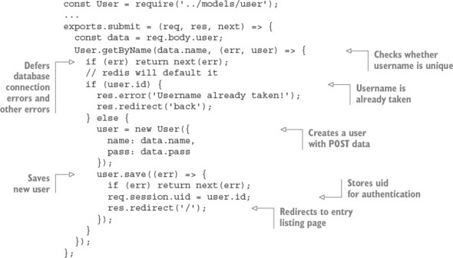
You can now fire up the application, visit /register, and register a user. The next thing you need is a way for returning registered users to authenticate, via the /login form.

6.2.7. Logging in registered users
Adding login functionality is even simpler than registration, because the bulk of the necessary logic is already in User.authenticate(), the general-purpose authentication method defined earlier. In this section, you’ll add the following:

Route logic to display a login form
Logic to authenticate user data submitted from the form
The form will look like figure 6.14.

Figure 6.14. User login form
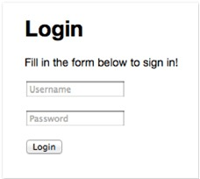
You’ll start by modifying app.js so login routes are required and the route paths are established:
...
const login = require('./routes/login');
...
app.get('/login', login.form);
app.post('/login', login.submit);
app.get('/logout', login.logout);
...
Next, you’ll add functionality to display a login form.

Displaying a login form
The first step in implementing a login form is creating a file for login- and logout-related routes: routes/login.js. The route logic you need to add to display the login form is nearly identical to the logic used earlier to display the registration form; the only differences are the name of the template displayed and the page title:
exports.form = (req, res) => {
res.render('login', { title: 'Login' });
};
The EJS login form that you’ll define in ./views/login.ejs, shown in the following listing, is extremely similar to register.ejs as well; the only differences are the instruction text and the route that data is submitted to.

Listing 6.25. A view template for a login form
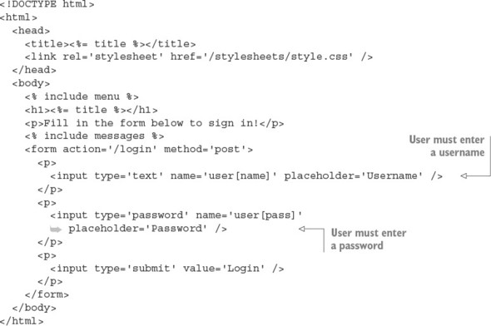
Now that you’ve added the route and template needed to display the login form, the next step is to add logic to handle login attempts.

Authenticating logins
To handle login attempts, you need to add route logic that will check the submitted username and password and, if they’re correct, set a session variable to the user’s ID and redirect the user to the home page. The following listing contains this logic, which you should add to routes/login.js.

Listing 6.26. A route to handle logins
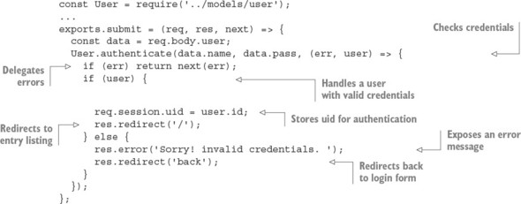
Here, if the user is authenticated by using User.authenticate(), req.session.uid is assigned in the same way as in the POST /register route: the session will persist this value, which you can use later to retrieve the User or other associated user data. If a match isn’t found, an error is set and the form is redisplayed.
Users may also prefer to explicitly log out, so you should provide a link for this somewhere in the application. In app.js, set up the route with this:
const login = require('./routes/login');
...
app.get('/logout', login.logout);
Then in ./routes/login.js, the following function will remove the session, which is detected by the session() middleware, causing the session to be assigned for subsequent requests:
exports.logout = (req, res) => {
req.session.destroy((err) => {
if (err) throw err;
res.redirect('/');
})
};
Now that the registration and login pages have been created, the next thing you need to add is a menu so users can reach them. Let’s see how to create one.

Creating a menu for authenticated and anonymous users
In this section, you’ll create a menu for both anonymous and authenticated users, allowing them to sign in, register, submit entries, and log out. Figure 6.15 shows the menu for an anonymous user.

Figure 6.15. User login and registration menu used to access the forms you created
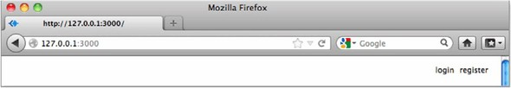
When the user is authenticated, you’ll display a different menu showing that user’s username, as well as a link to a page for posting messages to the shoutbox and a link allowing the user to log out. Figure 6.16 shows this menu.

Figure 6.16. Menu when the user is authenticated
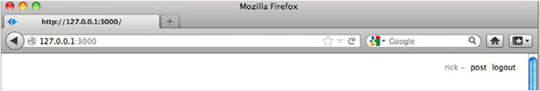
Each EJS template you’ve created, representing an application page, has contained the code <% include menu %> after the <body> tag. This includes the ./views/menu.ejs template, which you’ll create next with the contents of the following listing.

Listing 6.27. Anonymous and authenticated user menu template
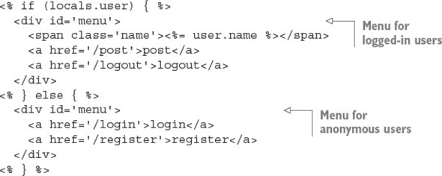
In this application, you can assume that if a user variable is exposed to the template, a user is authenticated, because you won’t be exposing the variable otherwise; you’ll see this next. When this variable is present, you can display the username along with the entry submission and logout links. When an anonymous user is visiting, the site login and register links are displayed.
You may be wondering where this user local variable comes from—you haven’t written it yet. Next you’ll write some code to load the logged-in user’s data for each request and make this data available to templates.

6.2.8. Working with user-loading middleware
A common task when you work with a web application is loading user information from a database, typically represented as a JavaScript object. Having this data readily available makes interacting with the user simpler. For this chapter’s application, you’ll load the user data on every request, using middleware.
You’ll place this middleware script in ./middleware/user.js, requiring the User model from the directory above (../models). The middleware function is first exported, and then it checks the session for the user ID. When the user ID is present, a user is authenticated, so it’s safe to fetch the user data from Redis.
Because Node is single-threaded, there’s no thread-local storage. In the case of an HTTP server, the request and response variables are the only contextual objects available. High-level frameworks could build upon Node to provide additional objects to store the authenticated user, but Express made the choice to stick with the original objects that Node provides. As a result, contextual data is typically stored on the request object, as shown in listing 6.28, where the user is stored as req.user; subsequent middleware and routes can access the user object by using the same property.
You may wonder what the assignment to res.locals.user is for. res.locals is the request-level object that Express provides to expose data to templates, much like app.locals. It’s also a function that can be used to merge existing objects into itself.

Listing 6.28. Middleware that loads a logged-in user’s data
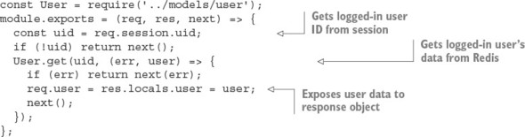
To use this new middleware, first delete all lines in app.js containing the text user. You can then require the module as usual and pass it to app.use(). In this application, user is used above the router, so only the routes and middleware following user have access to req.user. If you’re using middleware that loads data, as this middleware does, you may want to move the express.static middleware above it; otherwise, each time a static file is served, a needless round-trip to the database takes place to fetch the user.
The following listing shows how to enable this middleware in app.js.

Listing 6.29. Enabling user-loading middleware
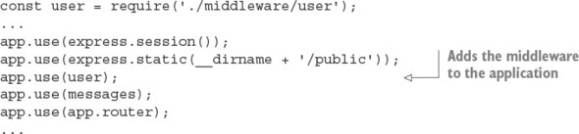
If you fire up the application again and visit either the /login or /register pages in your browser, you should see the menu. If you want to style the menu, add the following lines of CSS to public/stylesheets/style.css.

Listing 6.30. CSS that can be added to style.css to style application menus
#menu {
position: absolute;
top: 15px;
right: 20px;
font-size: 12px;
color: #888;
}
#menu .name:after {
content: ' -';
}
#menu a {
text-decoration: none;
margin-left: 5px;
color: black;
}
With the menu in place, you should be able to register yourself as a user. Then you should see the authenticated user menu with the Post link.
In the next section, you’ll learn how to create a public REST API for the application.

6.2.9. Creating a public REST API
In this section, you’ll implement a RESTful public API for the shoutbox application, so that third-party applications can access and add to publication data. REST enables application data to be queried and changed using verbs and nouns, represented by HTTP methods and URLs, respectively. A REST request typically returns data in a machine-readable form, such as JSON or XML.
To implement an API, you’ll do the following:

Design an API that allows users to show, list, remove, and post entries
Add Basic authentication
Implement routing
Provide JSON and XML responses
Various techniques can be used to authenticate and sign API requests, but implementing the more complex solutions are beyond the scope of this book. To illustrate how to integrate authentication, you’ll use the basic-auth package.

Designing the API
Before proceeding with the implementation, it’s a good idea to rough out the routes involved. For this application, you’ll prefix the RESTful API with the /api path, but this is a design choice you can alter. For example, you may wish to use a subdomain such as http://api.myapplication.com.
The following snippet illustrates why it can be a good choice to move the callback functions into separate Node modules, versus defining them inline with the app.VERB() calls. A single list of routes gives you a clear picture of what you and the rest of your team have implemented, and where the implementation callback lives:
app.get('/api/user/:id', api.user);
app.get('/api/entries/:page?', api.entries);
app.post('/api/entry', api.add);

Adding Basic authentication
As previously mentioned, there are many ways to approach API security and restrictions that fall outside the scope of this book. But it’s worth illustrating the process with Basic authentication.
The api.auth middleware will abstract this process, because the implementation will live in the soon-to-be-created ./routes/api.js module. The app.use() method can be passed a pathname, which is known in Express as a mount point. With this mount point, pathnames beginning with /api and any HTTP verb will cause this middleware to be invoked.
The line app.use('/api', api.auth), as shown in the following snippet, should be placed before the middleware that loads user data. This is so that you can later modify the user-loading middleware to load data for authenticated API users:
...
const api = require('./routes/api');
...
app.use('/api', api.auth);
app.use(user);
...
To perform Basic authentication, install the basic-auth module: npm install --save basic-auth. Next, create the ./routes/api.js file, and require both Express and the user model, as shown in the following snippet. The basic-auth package accepts a function to perform the authentication, taking the function signature (username, password, callback). Your User.authenticate method is a perfect fit:
const auth = require('basic-auth');
const express = require('express');
const User = require('../models/user');
exports.auth = (req, res, next) => {
const { name, pass } = auth(req);
User.authenticate(name, pass, (err, user) => {
if (user) req.remoteUser = user;
next(err);
});
};
Authentication is ready to roll. Let’s move on to implementing the API routes.

Implementing routing
The first route you’ll implement is GET /api/user/:id. The logic for this route has to first fetch the user by ID, responding with a 404 Not Found code if the user doesn’t exist. If the user exists, the user data will be passed to res.send() to be serialized, and the application will respond with a JSON representation of this data. Add the logic in the following snippet to routes/api.js:
exports.user = (req, res, next) => {
User.get(req.params.id, (err, user) => {
if (err) return next(err);
if (!user.id) return res.sendStatus(404);
res.json(user);
});
};
Next, add the following route path to app.js:
app.get('/api/user/:id', api.user);
You’re now ready to test it.

Testing user data retrieval
Fire up the application and test it with the cURL command-line tool. The following snippet shows how to test the application’s REST authentication. Credentials are provided in the URL tobi:ferret, which cURL uses to produce the Authorization header field:
$ curl http://tobi:ferret@127.0.0.1:3000/api/user/1 -v
The following listing shows the result of a successful test. To perform a similar test, you need to make sure you know the ID of a user. Try using redis-cli and GET user:ids if 1 doesn’t work and you’ve registered a user.

Listing 6.31. Test output
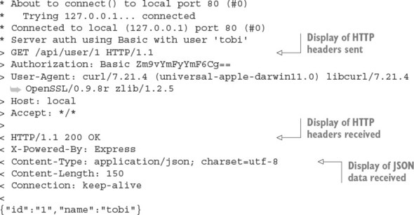

Removing sensitive user data
As you can see by the JSON response, both the user’s password and salt are provided in the response. To alter this, you can implement.toJSON() on the User in models/user.js:
class User {
// ...
toJSON() {
return {
id: this.id,
name: this.name
};
}
If .toJSON exists on an object, it will be used by JSON.stringify calls to get the JSON format. If the cURL request shown earlier was to be issued again, you’d now receive only the ID and name properties:
{
"id": "1",
"name": "tobi"
}
The next thing you’ll add to the API is the ability to create entries.

Adding entries
The processes for adding an entry via the HTML form and through an API are nearly identical, so you’ll likely want to reuse the previously implemented entries.submit() route logic.
When adding entries, however, the route logic stores the name of the user, adding the entry in addition to the other details. For this reason, you need to modify the user-loading middleware to populate res.locals.user with the user data loaded by the basic-auth middleware. The basic-auth middleware returns this data, and you set it to req.remoteUser. Adding a check for this in the user-loading middleware is straightforward; change the module.exports definition in middleware/user.js as follows to make the user-loading middleware work with the API:
...
module.exports = (req, res, next) => {
if (req.remoteUser) {
res.locals.user = req.remoteUser;
}
const uid = req.session.uid;
if (!uid) return next();
User.get(uid, (err, user) => {
if (err) return next(err);
req.user = res.locals.user = user;
next();
});
};
With this change made, you’re now able to add entries via the API.
One more change to implement, however, is an API-friendly response, rather than redirection to the application’s home page. To add this functionality, change the entry.save call in routes/entries.js to the following:
...
entry.save(err => {
if (err) return next(err);
if (req.remoteUser) {
res.json({ message: 'Entry added.' });
} else {
res.redirect('/');
}
});
...
Finally, to activate the entry-adding API in your application, add the contents of the following snippet to the routing section of app.js:
app.post('/api/entry', entries.submit);
By using the following cURL command, you can test adding an entry via the API. Here the title and body data is sent using the same field names that are in the HTML form:
$ curl -X POST -d "entry[title]='Ho ho ho'&entry[body]='Santa loves you'"
http://tobi:ferret@127.0.0.1:3000/api/entry
Now that you’ve added the ability to create entries, you need to add the ability to retrieve entry data.

Adding entry listing support
The next API route to implement is GET /api/entries/:page?. The route implementation is nearly identical to the existing entry list route in ./routes/entries.js. You also need to add pagination middleware, which is page() in the following snippets. You’ll add page() shortly.
Because the routing logic will be accessing entries, you require the Entry model at the top of routes/api.js by using the following line:
const Entry = require('../models/entry');
Next, add the lines in the following snippet to app.js:
const Entry = require('./models/entry');
...
app.get('/api/entries/:page?', page(Entry.count), api.entries);
Now add the routing logic in the following snippet to routes/api.js. The difference between this route logic and the similar logic in routes/entries.js reflects the fact that you’re no longer rendering a template, but JSON instead:
exports.entries = (req, res, next) => {
const page = req.page;
Entry.getRange(page.from, page.to, (err, entries) => {
if (err) return next(err);
res.json(entries);
});
};

Implementing pagination middleware
For pagination, you use the query-string ?page=N value to determine the current page. Add the following middleware function to ./middleware/page.js.

Listing 6.32. Pagination middleware
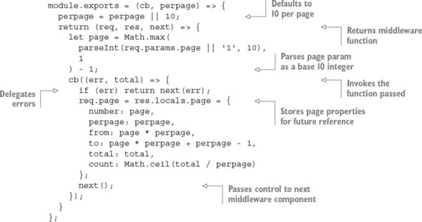
This middleware grabs the value assigned to ?page=N; for example, ?page=1. It then fetches the total number of results and exposes the page object with precomputed values to any views that may later be rendered. These values are computed outside the template to allow for a cleaner template containing less logic.

Testing the entries route
The following cURL command requests entry data from the API:
$ curl http://tobi:ferret@127.0.0.1:3000/api/entries
This cURL command should result in output similar to the following JSON:
[
{
"username": "rick",
"title": "Cats can't read minds",
"body": "I think you're wrong about the cat thing."
},
{
"username": "mike",
"title": "I think my cat can read my mind",
"body": "I think cat can hear my thoughts."
},
...
With basic API implementation covered, let’s move on to how APIs can support multiple response formats.

6.2.10. Enabling content negotiation
Content negotiation enables a client to specify the formats that it’s willing to accept, and which it prefers. In this section, you’ll provide JSON and XML representations of the API content so that the API consumers can decide what they want.
HTTP provides the content negotiation mechanism via the Accept header field. For example, a client who prefers HTML but is willing to accept plain text could set the following request header:
Accept: text/plain; q=0.5, text/html
The qvalue, or quality value (q=0.5 in this example), indicates that even though text/html is specified second, it’s favored by 50% over text/plain. Express parses this information and provides a normalized req.accepted array:
[{ value: 'text/html', quality: 1 },
{ value: 'text/plain', quality: 0.5 }]
Express also provides the res.format() method, which accepts an array of MIME types and callbacks. Express will determine what the client is willing to accept and what you’re willing to provide, and it’ll invoke the appropriate callback.

Implementing content negotiation
Implementing content negotiation for the GET /api/entries route, in routes/api.js, might look something like listing 6.33. JSON is supported as it was before—you serialize the entries as JSON with res.send(). The XML callback iterates the entries and writes to the socket as it does so. Note that there’s no need to set the Content-Type explicitly; res.format() sets it to the associated type automatically.

Listing 6.33. Implementing content negotiation
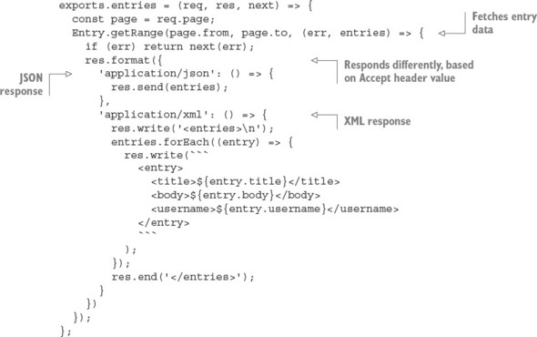
If you set a default response format callback, this will execute if a user hasn’t requested a format you’ve explicitly handled.
The res.format() method also accepts an extension name that maps to an associated MIME type. For example, json and xml can be used in place of application/json and application/xml, as the following snippet shows:
...
res.format({
json: () => {
res.send(entries);
},
xml: () => {
res.write('<entries>\n');
entries.forEach((entry) => {
res.write(```
<entry>
<title>${entry.title}</title>
<body>${entry.body}</body>
<username>${entry.username}</username>
</entry>
```
);
});
res.end('</entries>');
}
})
...

Responding with XML
Writing a bunch of custom logic in the route in order to respond with XML may not be the cleanest way to go, so let’s see how to use the view system to clean this up.
Create a template named ./views/entries/xml.ejs with the following EJS iterating the entries to generate <entry> tags.

Listing 6.34. Using an EJS template to generate XML
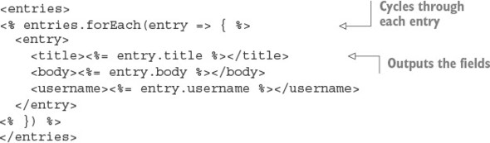
The XML callback can now be replaced with a single res.render() call, passing the entries array, as shown in the following code:
...
xml: () => {
res.render('entries/xml', { entries: entries });
}
})
...
You’re now ready to test the XML version of the API. Enter the following in the command line to see the XML output:
curl -i -H 'Accept: application/xml'
http://tobi:ferret@127.0.0.1:3000/api/entries

6.3. Summary

Connect is an HTTP framework that lets you stack middleware components before and after requests are processed.
Connect middleware components are functions that accept Node’s request and response objects, as well as a function that calls the next middleware and an optional error object.
Express web applications are also built with middleware components.
You can build REST APIs with Express by using HTTP verbs to define routes.
Express routes can respond with JSON, HTML, or other data formats.
Express has a simple template engine API that supports many engines.

Chapter 7. Web application templating
This chapter covers

Organizing applications with templating
Creating templates by using Embedded JavaScript
Learning minimalist templating with Hogan
Using Pug to create templates
In chapters 3 and 6, you learned some basics about templates in Express applications in order to create views. In this chapter, you’ll focus exclusively on templating, learning how to use three popular template engines, and how to use templating to keep any web application’s code clean by separating logic from presentation markup.
If you’re familiar with templating and the Model-View-Controller (MVC) pattern, you can skim through to section 7.2, where you’ll start learning about the template engines detailed in this chapter, which include Embedded JavaScript, Hogan, and Pug. If you’re not familiar with templating, keep reading—you’ll explore it conceptually in the next few sections.

7.1. Using templating to keep code clean
You can use the MVC pattern to develop conventional web applications in Node as well as in nearly every other web technology. One of the key concepts in MVC is the separation of logic, data, and presentation. In MVC web applications, the user typically requests a resource from the server, which causes the controller to request application data from the model and then pass the data to the view, which finally formats the data for the end user. This view portion of the MVC pattern is often implemented by using one of various templating languages. When an application uses templating, the view relays selected values, returned by the model, to a template engine, and specifies the template file that defines how to display the provided values.
Figure 7.1 shows how templating logic fits into the overall architecture of an MVC application. Template files typically contain placeholders for application values as well as HTML, CSS, and sometimes small bits of client-side JavaScript to implement dynamic behavior, including displaying third-party widgets such as Facebook’s Like button, or to trigger interface behavior, such as hiding or revealing parts of the page. Because template files focus on presentation rather than logic, front-end developers and server-side developers can work on them, which can help with a project’s division of labor.

Figure 7.1. The flow of an MVC application and its interaction with the template layer
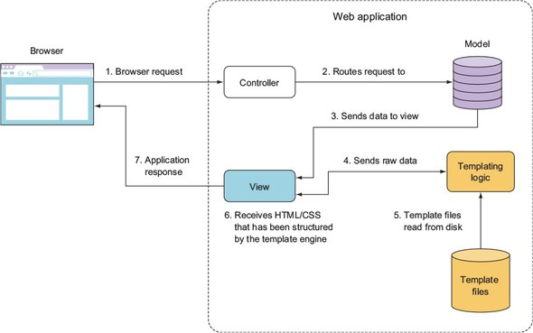
In this section, we’ll render HTML with, and without, a template to show you the difference. But first, let’s start with an example of templating in action.

7.1.1. Templating in action
As a quick illustration of applying templating, let’s look at the problem of elegantly outputting HTML from a simple blogging application. Each blog entry has a title, date of entry, and body text. The blog looks similar to figure 7.2 in a web browser.

Figure 7.2. Example blog application browser output
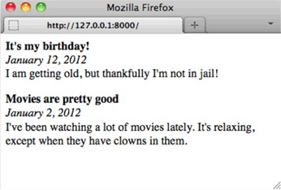
Blog entries are read from a text file formatted like the following snippet from entries.txt. The --- in the following listing indicates where one entry stops and another begins.

Listing 7.1. Blog entries text file
title: It's my birthday!
date: January 12, 2016
I am getting old, but thankfully I'm not in jail!
---
title: Movies are pretty good
date: January 2, 2016
I've been watching a lot of movies lately. It's relaxing,
except when they have clowns in them.
The blog application code in blog.js starts by requiring necessary modules and reading in the blog entries, as shown in the following listing.

Listing 7.2. Blog entry file-parsing logic for a simple blogging application
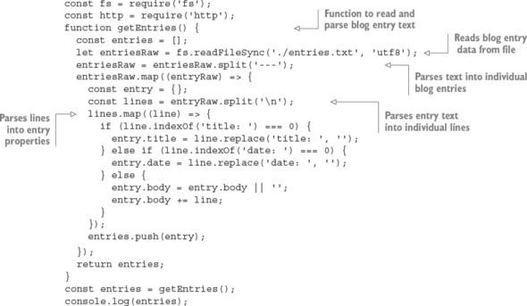
The following code, when added to the blog application, defines an HTTP server. When the server receives an HTTP request, it returns a page containing all blog entries. This page is rendered using a function called blogPage, which you’ll define next:
const server = http.createServer((req, res) => {
const output = blogPage(entries);
res.writeHead(200, {'Content-Type': 'text/html'});
res.end(output);
});
server.listen(8000);
Now you need to define the blogPage function, which renders the blog entries into a page of HTML that can be sent to the user’s browser. You’ll implement this by trying two approaches:

Rendering HTML without a template
Rendering HTML using a template
Let’s look at rendering without a template first.

7.1.2. Rendering HTML without a template
The blog application could output the HTML directly, but including the HTML with the application logic would result in clutter. In the following listing, the blogPage function illustrates a nontemplated approach to displaying blog entries.

Listing 7.3. Template engines separate presentation details from application logic
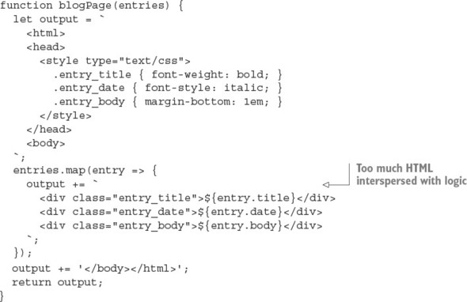
Note that all of this presentation-related content, CSS definitions, and HTML adds many lines to the application.

Rendering HTML by using a template
Rendering HTML by using templating allows you to remove the HTML from the application logic, cleaning up the code considerably.
To try the demos in this section, you need to install the Embedded JavaScript (EJS) module into your application directory. You can do this by entering the following on the command line:
npm install ejs
The following snippet loads a template from a file and then defines a new version of the blogPage function, this time using the EJS template engine, which we’ll show you how to use in section 7.2:
const fs = require('fs');
const ejs = require('ejs');
const template = fs.readFileSync('./templatess/blog_page.ejs', 'utf8');
function blogPage(entries) {
const values = { entries };
return ejs.render(template, values);
}
The full listing can be found in this book’s listings under ch07-templates/listing7_4/. The EJS template file contains HTML markup (keeping it out of the application logic) and placeholders that indicate where data passed to the template engine should be put. The EJS template file that shows the blog entries contains the HTML and placeholders shown in the following listing.

Listing 7.4. An EJS template for displaying blog entries
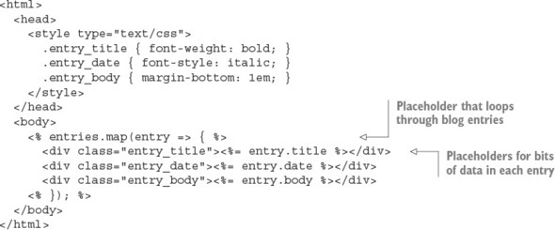
Community-contributed Node modules also provide template engines, and a wide variety of them exist. If you consider HTML and/or CSS inelegant, because HTML requires closing tags and CSS requires opening and closing braces, take a closer look at template engines. They allow template files to use special languages (such as the Pug language, which we cover later in this chapter) that provide a shorthand way of specifying HTML, CSS, or both.
These template engines can make your templates cleaner, but you may not want to take the time to learn an alternative way of specifying HTML and CSS. Ultimately, what you decide to use comes down to a matter of personal preference.
In the rest of this chapter, you’ll learn how to incorporate templating in your Node applications through the lens of three popular template engines:

The Embedded JavaScript (EJS) engine
The minimalist Hogan engine
The Pug template engine
Each engine allows you to write HTML in an alternative way. Let’s start with EJS.

7.2. Templating with Embedded JavaScript
Embedded JavaScript (https://github.com/visionmedia/ejs) takes a fairly straightforward approach to templating, and it will be familiar territory for folks who’ve used template engines in other languages, such as Java Server Pages (JSP), Smarty (PHP), Embedded Ruby (ERB), and so on. EJS allows you to embed EJS tags as placeholders for data within HTML. EJS also lets you execute raw JavaScript logic in your templates for tasks such as conditional branching and iteration, much as PHP does.
In this section, you’ll learn how to do the following:

Create EJS templates
Use EJS filters to provide commonly needed, presentation-related functionality, such as text manipulation, sorting, and iteration
Integrate EJS with your Node applications
Use EJS for client-side applications
Let’s dive deeper into the world of EJS templating.

7.2.1. Creating a template
In the world of templating, the data sent to the template engine for rendering is sometimes called the context. The following is a bare-bones example of Node using EJS to render a simple template in a context:
const ejs = require('ejs');
const template = '<%= message %>';
const context = { message: 'Hello template!' };
console.log(ejs.render(template, context));
Note the use of locals in the second argument sent to render. The second argument can include rendering options as well as context data, which means the use of locals ensures that individual bits of context data aren’t interpreted as EJS options. But it’s possible in most cases to pass the context itself as the second option, as the following render call illustrates:
console.log(ejs.render(template, context));
If you pass a context to EJS directly as the second argument to render, make sure you don’t name context values by using any of the following terms: cache, client, close, compileDebug, debug, filename, open, or scope. These values are reserved to allow the changing of template engine settings.

Character escaping
When rendering, EJS escapes any special characters in context values, replacing them with HTML entity codes. This is intended to prevent cross-site scripting (XSS) attacks, in which malicious web application users attempt to submit JavaScript as data in the hopes that when displayed, it’ll execute in some other user’s browser. The following code shows EJS’s escaping at work:
const ejs = require('ejs');
const template = '<%= message %>';
const context = {message: "<script>alert('XSS attack!');</script>"};
console.log(ejs.render(template, context));
The previous code displays the following output:
&lt;script&gt;alert('XSS attack!');&lt;/script&gt;
If you trust the data being used in your template and don’t want to escape a context value in an EJS template, you can use <%- instead of <%= in your template tag, as the following code demonstrates:
const ejs = require('ejs');
const template = '<%- message %>';
const context = {
message: "<script>alert('Trusted JavaScript!');</script>"
};
console.log(ejs.render(template, context));
Note that if you don’t like the characters used by EJS to specify tags, you can customize them, like so:
const ejs = require('ejs');
ejs.delimiter = '$'
const template = '<$= message $>';
const context = { message: 'Hello template!' };
console.log(ejs.render(template, context));
Now that you know the basics of EJS, let’s look at some more detailed examples.

7.2.2. Integrating EJS into your application
Because it’s awkward to store templates in files along with application code, and doing so clutters up your code, we’ll show you how to use Node’s filesystem API to read them from separate files.
Move to a working directory and create a file named app.js containing the code in the following listing.

Listing 7.5. Storing template code in files
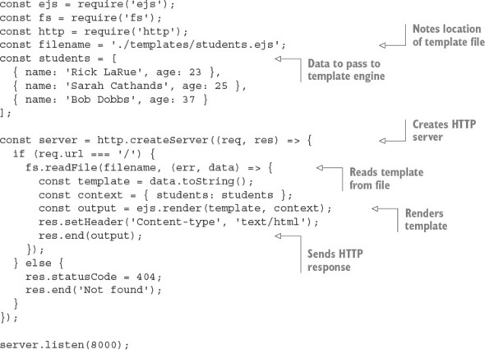
Next, create a child directory called templates. You’ll keep your templates in this directory. Create a file named students.ejs in the templates directory. Enter the code in the following listing into templates/students.ejs.

Listing 7.6. EJS template that renders an array of students
<% if (students.length) { %>
<ul>
<% students.forEach((student) => { %>
<li><%= student.name %> (<%= student.age %>)</li>
<% }) %>
</ul>
<% } %>

Caching EJS templates
EJS supports optional, in-memory caching of template functions: after parsing your template file once, EJS will store the function that’s created by the parsing. Rendering a cached template will be faster because the parsing step can be skipped.
If you’re doing initial development of a Node web application, and you want to see any changes you make to your template files reflected immediately, don’t enable caching. But if you’re deploying an application to production, enabling caching is a quick, easy win. Caching is conditionally enabled via the NODE_ENV environment variable.
To try out caching, change the call to EJS’s render function in the previous example to the following:
const cache = process.env.NODE_ENV === 'production';
const output = ejs.render(
template,
{ students, cache, filename }
);
Note that the filename option doesn’t necessarily have to be a file; you can use a unique value that identifies whichever template you’re rendering.
Now that you’ve learned how to integrate EJS with your Node applications, let’s look at how EJS can be used in a different way: in web browsers.

7.2.3. Using EJS for client-side applications
To use EJS on the client side, you first need to download the EJS engine to your working directory, as shown by the following commands:
cd /your/working/directory
curl -O https://raw.githubusercontent.com/tj/ejs/master/lib/ejs.js
After you download the ejs.js file, you can use EJS in your client-side code. The following listing shows a simple client-side application of EJS. If you save this file as index.html, you should be able to open it in a browser to see the results.

Listing 7.7. Using EJS to add templating capabilities to the client side
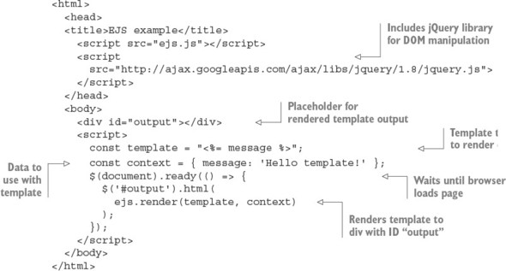
You’ve now learned how to use a fully featured Node template engine, so it’s time to look at the Hogan template engine, which deliberately limits the functionality available to templating code.

7.3. Using the Mustache templating language with Hogan
Hogan.js (https://github.com/twitter/hogan.js) is a template engine that was created by Twitter for its templating needs. Hogan is an implementation of the popular Mustache (http://mustache.github.com/) template language standard, which was created by GitHub’s Chris Wanstrath.
Mustache takes a minimalist approach to templating. Unlike EJS, the Mustache standard deliberately doesn’t include conditional logic, or any built-in content-filtering capabilities other than escaping content to prevent XSS attacks. Mustache advocates that template code should be kept as simple as possible.
In this section you’ll learn

How to create and implement Mustache templates in your application
How to use the various template tags in the Mustache standard
How to organize your templates by using partials
How to fine-tune Hogan with your own delimiters and other options
Let’s look at the alternative approach Hogan provides for templating.

7.3.1. Creating a template
To use Hogan in an application, or to try the demos in this section, you need to install Hogan in your application directory (ch07-templates/hogan-snippet). You can do this by entering the following command on the command line:
npm i --save hogan.js
The following is a bare-bones example of Node using Hogan to render a simple template in a context. Running it outputs the text Hello template!
const hogan = require('hogan.js');
const templateSource = '{{message}}';
const context = { message: 'Hello template!' };
const template = hogan.compile(templateSource);
console.log(template.render(context));
Now that you know how to process Mustache templates with Hogan, let’s look at what tags Mustache supports.

7.3.2. Using Mustache tags
Mustache tags are conceptually similar to EJS’s tags. Mustache tags serve as placeholders for variable values, indicate where iteration is needed, and allow you to augment Mustache’s functionality and add comments to your templates.

Displaying simple values
To display a context value in a Mustache template, include the name of the value in double braces. Braces, in the Mustache community, are known as mustaches. If you want to display the value for context item name, for example, you use the Hogan tag {{name}}.
Like most template engines, Hogan escapes content by default to prevent XSS attacks. But to display an unescaped value in Hogan, you can either add a third mustache or prepend the name of the context item with an ampersand. Using the previous name example, you could display the context value unescaped by either using the {{{name}}} or {{&name}} tag formats.
If you want to add a comment in a Mustache template, you can use this format: {{! This is a comment }}.

Sections: iterating through multiple values
Although Hogan doesn’t allow the inclusion of logic in templates, it does include an elegant way to iterate through multiple values in a context item by using Mustache sections. The following context, for example, contains an item with an array of values:
const context = {
students: [
{ name: 'Jane Narwhal', age: 21 },
{ name: 'Rick LaRue', age: 26 }
]
};
If you want to create a template that displays each student in a separate HTML paragraph, with output similar to the following, it’s a straightforward task using a Hogan template:
<p>Name: Jane Narwhal, Age: 21 years old</p>
<p>Name: Rick LaRue, Age: 26 years old</p>
The following template produces the desired HTML:
{{#students}}
<p>Name: {{name}}, Age: {{age}} years old</p>
{{/students}}

Inverted sections: default HTML when values don’t exist
What if the value of the students item in the context data isn’t an array? If the value is a single object, for example, the template will display it. But sections won’t display if the corresponding item’s value is undefined or false, or is an empty array.
If you want your template to output a message indicating that values don’t exist for a section, Hogan supports what Mustache calls inverted sections. The following template code, if added to the previous student display template, would display a message when no student data exists in the context:
{{^students}}
<p>No students found.</p>
{{/students}}

Section lambdas: custom functionality in section blocks
In order to allow developers to augment Mustache’s functionality, the Mustache standard lets you define section tags that process template content through a function call, rather than iterating through arrays. This is called a section lambda.
Listing 7.8 shows an example of using a section lambda to add Markdown support when rendering a template. Note that the example uses the github-flavored-markdown module, which you install by entering npm install github-flavored-markdown --dev on your command line. If you’re using the book’s source code, run npm install from ch07-templates/listing7_8 to run the example.
In the following listing, the **Name** in the template gets rendered to <strong>Name</strong> when passing through the Markdown parser called by the section lambda logic.

Listing 7.8. Using a lambda in Hogan
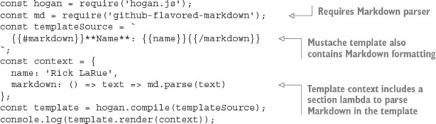
Section lambdas allow you to easily implement features such as caching and translation mechanisms in your templates.

Partials: reusing templates within other templates
When writing templates, you want to avoid unnecessarily repeating the same code in multiple templates. One way to avoid this is to create partials. Partials are templates used as building blocks that are included in other templates. Another use of partials is to break up complicated templates into simpler templates.
The following listing, for example, uses a partial to separate the template code used to display student data from the main template.

Listing 7.9. Using partials in Hogan
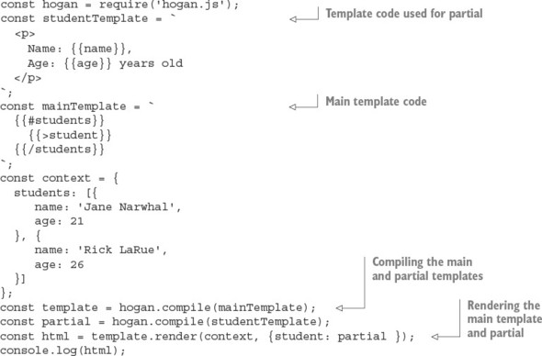

7.3.3. Fine-tuning Hogan
Hogan is fairly simple to use—after you’ve learned its vocabulary of tags, you should be off and running. You may need to tweak only a couple of options as you use it.
If you don’t like Mustache-style braces, you can change the delimiters Hogan uses by passing the compile method an option to override them. The following example shows compiling in Hogan using EJS-style delimiters:
hogan.compile(text, { delimiters: '<% %>' });
In addition to Mustache, other template languages are available. One that attempts to eliminate as much of HTML’s noise as possible is Pug.

7.4. Templating with Pug
Pug (http://pugjs.org), formerly known as Jade, offers an alternative way to specify HTML. It’s the default template engine in Express. The key difference between Pug and the majority of other templating systems is the use of meaningful whitespace. When creating a template in Pug, you use indentation to indicate HTML tag nesting. HTML tags also don’t have to be explicitly closed, which eliminates the problem of accidentally closing tags prematurely or not at all. Using indentation also results in templates that are less visually dense and easier to maintain.
For a quick example of this at work, let’s look at how you’d represent this snippet of HTML:
<html>
<head>
<title>Welcome</title>
</head>
<body>
<div id="main" class="content">
<strong>"Hello world!"</strong>
</div>
</body>
</html>
This HTML could be represented using the following Pug template:
html
head
title Welcome
body
div.content#main
strong "Hello world!"
Pug, like EJS, allows you to embed JavaScript, and you can use it on the server or client side. But Pug offers additional features, such as support for template inheritance and mixins. Mixins allow you to define easily reusable mini-templates to represent the HTML used for commonly occurring visual elements, such as item lists and boxes. Mixins are similar in concept to the Hogan.js partials, which you learned about in the previous section. Template inheritance makes it easy to organize the Pug templates needed to render a single HTML page into multiple files. You’ll learn about these features in detail later in this section.
To install Pug in a Node application directory, enter the following on the command line:
npm install pug --save
In this section, you’ll learn

Pug basics, such as specifying class names, attributes, and block expansion
How to add logic to your Pug templates by using built-in keywords
How to organize your templates by using inheritance, blocks, and mixins
To get started, let’s look at the basics of Pug usage and syntax.

7.4.1. Pug basics
Pug uses the same tag names as HTML, but it lets you lose the opening and closing < and > characters and instead uses indentation to express tag nesting. A tag can have one or more CSS classes associated with it by adding .<classname>. A div element with the content and sidebar classes applied to it would be represented like this:
div.content.sidebar
CSS IDs are assigned by adding #<ID> to the tag. You add a CSS ID of featured_content to the previous example by using the following Pug representation:
div.content.sidebar#featured_content

Using div tag shorthand
Because the div tag is commonly used in HTML, Pug offers a shorthand way of specifying it. The following example renders to the same HTML as the previous example:
.content.sidebar#featured_content
Now that you know how to specify HTML tags and their CSS classes and IDs, let’s look at how to specify HTML tag attributes.

Specifying tag attributes
You can specify tag attributes by enclosing the attributes in parentheses, separating the specification of each attribute from the next with a comma. You can specify a hyperlink that’ll open in a different tab by using the following Pug representation:
a(href='http://nodejs.org', target='_blank')
Because the specification of tag attributes can lead to long lines of Pug, the template engine provides you with some flexibility. The following Pug is valid and equivalent to the previous example:
a(href='http://nodejs.org',
target='_blank')
You can also specify attributes that don’t require a value. The next Pug example shows the specification of an HTML form that includes a select element with an option preselected:
strong Select your favorite food:
form
select
option(value='Cheese') Cheese
option(value='Tofu', selected) Tofu
Specifying tag content
In the previous code snippet, you can also see examples of tag content: Select your favorite food: after the strong tag; Cheese after the first option tag; and Tofu after the second option tag.
This is the normal way to specify tag content in Pug, but it’s not the only way. Although this style is great for short bits of content, it can result in Pug templates with overly long lines if a tag’s content is lengthy. Luckily, as the following example shows, Pug allows you to specify tag content by using the | character:
textarea
| This is some default text
| that the user should be
| provided with.
If the HTML tag, such as the style and script tags, accepts only text (meaning it doesn’t allow nested HTML elements), then the | characters can be left out entirely, as the following example shows:
style
h1 {
font-size: 6em;
color: #9DFF0C;
}
Having two separate ways to express long tag content and short tag content helps you keep your Pug templates looking elegant. Pug also supports an alternative way to express nesting, called block expansion.

Keeping it organized with block expansion
Pug normally expresses nesting through indentation, but sometimes indentation can lead to excess whitespace. For example, here’s a Pug template that uses indentation to define a simple list of links:
ul
li
a(href='http://nodejs.org/') Node.js homepage
li
a(href='http://npmjs.org/') NPM homepage
li
a(href='http://nodebits.org/') Nodebits blog
A more compact way to express the previous example is by using Pug block expansion. With block expansion, you add a colon after your tag to indicate nesting. The following code generates the same output as the previous listing, but in four lines instead of seven:
ul
li: a(href='http://nodejs.org/') Node.js homepage
li: a(href='http://npmjs.org/') NPM homepage
li: a(href='http://nodebits.org/') Nodebits blog
Now that you’ve had a good look at how to represent markup using Pug, let’s look at how to integrate Pug with your web application.

Incorporating data in Pug templates
Data is relayed to the Pug engine in the same basic way as in EJS. The template is first compiled into a function that’s then called with a context in order to render the HTML output. The following is an example of this:
const pug = require('pug');
const template = 'strong #{message}';
const context = { message: 'Hello template!' };
const fn = pug.compile(template);
console.log(fn(context));
Here, the #{message} in the template specifies a placeholder to be replaced by a context value.
Context values can also be used to supply values for attributes. The next example renders <a href="http://google.com"></a>:
const pug = require('pug');
const template = 'a(href = url)';
const context = { url: 'http://google.com' };
const fn = pug.compile(template);
console.log(fn(context));
Now that you’ve learned how HTML is represented using Pug, and how to provide Pug templates with application data, let’s look at how to incorporate logic in Pug.

7.4.2. Logic in Pug templates
After you supply Pug templates with application data, you need logic to deal with that data. Pug allows you to directly embed lines of JavaScript code into your templates, which is how you define logic in your templates. Code such as if statements, for loops, and var declarations are common. Before we dive into the details, here’s an example for template rendering a contact list, to give you a practical feel for how you might use Pug logic in an application:
h3.contacts-header My Contacts
if contacts.length
each contact in contacts
- var fullName = contact.firstName + ' ' + contact.lastName
.contact-box
p fullName
if contact.isEditable
p: a(href='/edit/+contact.id) Edit Record
p
case contact.status
when 'Active'
strong User is active in the system
when 'Inactive'
em User is inactive
when 'Pending'
| User has a pending invitation
else
p You currently do not have any contacts
Let’s first look at the various ways Pug handles output when embedding JavaScript code.

Using JavaScript in Pug templates
Prefixing a line of JavaScript logic with - will execute the JavaScript without including any value returned from the code in the template’s output. Prefixing JavaScript logic with = will include a value returned from the code, escaped to prevent XSS attacks. But if your JavaScript generates code that shouldn’t be escaped, you can prefix it with !=. Table 7.1 summarizes the output resulting from these prefixes.

Table 7.1. Prefixes used to embed JavaScript in Pug
Prefix | Output
= | Escaped output (for untrusted or unpredictable values, XSS safe)
!= | Output without escaping (for trusted or predictable values)
- | No output
Pug includes commonly used conditional and iterative statements that can be written without prefixes: if, else, case, when, default, until, while, each, and unless.
Pug also allows you to define variables. The following shows two ways to assign values that are equivalent in Pug:
- count = 0
count = 0
The unprefixed statements have no output, just like the - prefix discussed previously.

Iterating through objects and arrays
Values passed in a context are accessible to JavaScript in Pug. In the next example, you’ll read a Pug template from a file and pass the Pug template a context containing a couple of messages that you intend to display in an array:
const pug = require('pug');
const fs = require('fs');
const template = fs.readFileSync('./template.pug');
const context = { messages: [
'You have logged in successfully.',
'Welcome back!'
]};
const fn = pug.compile(template);
console.log(fn(context));
The Pug template contains the following:
- messages.forEach(message => {
p= message
- })
The final HTML output looks like this:
<p>You have logged in successfully.</p><p>Welcome back!</p>
Pug also supports a non-JavaScript form of iteration: the each statement, which allows you to cycle through arrays and object properties with ease.
The following is equivalent to the previous example, but using each instead:
each message in messages
p= message
You can cycle through object properties by using a slight variation, like this:
each value, key in post
div
strong #{key}
p value

Conditionally rendering template code
Sometimes templates need to make decisions about how data is displayed, depending on the value of the data. The next example illustrates a conditional in which, roughly half the time, the script tag is outputted as HTML:
- n = Math.round(Math.random() * 1) + 1
- if (n == 1) {
script
alert('You win!');
- }
Conditionals can also be written in Pug by using a cleaner, alternative form:
- n = Math.round(Math.random() * 1) + 1
if n == 1
script
alert('You win!');
If you’re writing a negated conditional, such as if (n != 1), you can use Pug’s unless keyword:
- n = Math.round(Math.random() * 1) + 1
unless n == 1
script
alert('You win!');

Using case statements in Pug
Pug also supports a non-JavaScript form of conditional similar to a switch: the case statement, which allows you to specify an outcome based on various template scenarios.
The following example template shows how the case statement can be used to display results from the search of a blog in three ways. If the search finds nothing, a message is shown indicating that. If a single blog post is found, it’s displayed in detail. If multiple blog posts are found, an each statement is used to iterate through the posts, displaying their titles:
case results.length
when 0
p No results found.
when 1
p= results[0].content
default
each result in results
p= result.title

7.4.3. Organizing Pug templates
With your templates defined, you next need to know how to organize them. As with application logic, you don’t want to make your template files overly large. A single template file should correspond to a conceptual building block: a page, a sidebar, or blog post content, for example.
In this section, you’ll learn a few mechanisms that allow template files to work together to render content:

Structuring multiple templates with template inheritance
Implementing layouts by using block prepending/appending
Template including
Reusing template logic with mixins
Let’s begin by looking at template inheritance in Pug.

Structuring multiple templates with template inheritance
Template inheritance is one means of structuring multiple templates. The concept treats templates, conceptually, like classes in the object-oriented programming paradigm. One template can extend another, which can in turn extend another. You can use as many levels of inheritance as makes sense.
As a simple example, let’s look at using template inheritance to provide a basic HTML wrapper that you can use to wrap page content. In a working directory, create a folder called templates in which you’ll put the example’s Pug file. For a page template, you’ll create a file called layout.pug containing the following Pug:
html
head
block title
body
block content
The layout.pug template contains the bare-bones definition of an HTML page as well as two blocks. Blocks are used in template inheritance to define where a descendant template can provide content. In layout.pug, there’s a title block, allowing a descendent template to set the title, and a content block, allowing a descendant template to set what's to be displayed on the page.
Next, in your working directory’s templates directory, create a file named page.pug. This template file will populate the title and content blocks:
extends layout
block title
title Messages
block content
each message in messages
p= message
Finally, add the logic in the following listing (a modification of an earlier example in this section), which will display the template results, showing inheritance in action.

Listing 7.10. Template inheritance in action
const pug = require('pug');
const fs = require('fs');
const templateFile = './templates/page.pug';
const iterTemplate = fs.readFileSync(templateFile);
const context = { messages: [
'You have logged in successfully.',
'Welcome back!'
]};
const iterFn = pug.compile(
iterTemplate,
{ filename: templateFile }
);
console.log(iterFn(context));
Now let’s look at another template inheritance feature: block prepending and appending.

Implementing layouts by using block prepending/appending
In the previous example, the blocks in layout.pug contain no content, which makes setting the content in the page.pug template straightforward. But if a block in an inherited template does contain content, this content can be built upon, rather than replaced, by descendant templates using block prepending and appending. This allows you to define common content and add to it, rather than replace it.
The following layout.pug template contains an additional block, scripts, which contains content—a script tag that loads the jQuery JavaScript library:
html
head
- const baseUrl = "http://ajax.googleapis.com/ajax/libs/jqueryui/1.8/"
block title
block style
block scripts
body
block content
If you want the page.pug template to additionally load the jQuery UI library, you can do this by using the template in the following listing.

Listing 7.11. Using block appending to load an additional JavaScript file
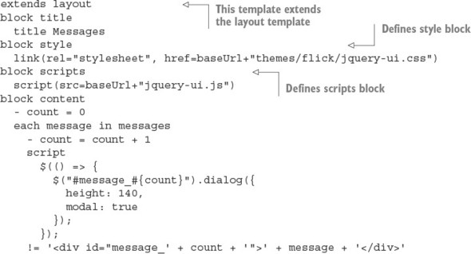
Template inheritance isn’t the only way to integrate multiple templates. You also can use the include Pug command.

Template including
Another tool for organizing templates is Pug’s include command. This command incorporates the contents of another template. If you add the line include footer to the layout.pug template from the earlier example, you end up with the following template:
html
head
block title
block style
block scripts
script(src='//ajax.googleapis.com/ajax/libs/jquery/1.8/jquery.js')
body
block content
include footer
This template includes the contents of a template named footer.pug in the rendered output of layout.pug, as illustrated in figure 7.3.

Figure 7.3. Pug’s include mechanism provides a simple way to include the contents of one template in another template during rendering.
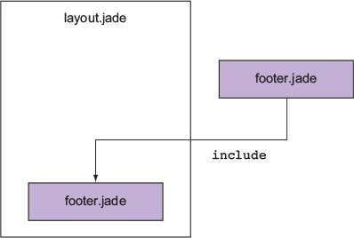
This can be used, for example, to add information about the site or design elements to layout.pug. You can also include non-Pug files by specifying the file extension (for example, include twitter_widget.html).

Reusing template logic with mixins
Although Pug’s include command is useful for bringing in previously created chunks of code, it’s not ideal for creating a library of reusable functionality that you can share between pages and applications. For this, Pug provides the mixin command, which lets you define reusable Pug snippets.
A Pug mixin is analogous to a JavaScript function. A mixin can, like a function, take arguments, and these arguments can be used to generate Pug code.
Let’s say, for example, your application handles a data structure similar to the following:
const students = [
{ name: 'Rick LaRue', age: 23 },
{ name: 'Sarah Cathands', age: 25 },
{ name: 'Bob Dobbs', age: 37 }
];
If you want to define a way to output an HTML list derived from a given property of each object, you could define a mixin like the following one to accomplish this:
mixin list_object_property(objects, property)
ul
each object in objects
li= object[property]
You could then use the mixin to display the data using this line of Pug:
mixin list_object_property(students, 'name')
By using template inheritance, include statements, and mixins, you can easily reuse presentation markup and can prevent your template files from becoming larger than they need to be.

7.5. Summary

Templating engines help keep application logic and presentation organized.
Node has several popular template engines, including EJS, Hogan.js, and Pug.
EJS supports simple control flow and escape or unescaped interpolation.
Hogan.js is a simple template engine that doesn't support control flow, but does support the Mustache standard.
Pug is a more complex template language that can output HTML, but doesn’t use angled brackets.
Pug relies on whitespace for embedding tags.

Chapter 8. Storing application data
This chapter covers

Relational databases: PostgreSQL
NoSQL databases: MongoDB
ACID categories
Hosted cloud databases and storage services
Node.js serves an incredibly diverse set of developers with equally diverse needs. No single database or storage solution solves the number of use cases tackled by Node. This chapter provides a broad overview of the data storage possibilities, along with some important high-level concepts and terminology.

8.1. Relational databases
For most of the history of the web, relational databases have been the dominant choice for application data storage. This topic has been covered at length in many other texts and university programs, so we don’t spend too much time elaborating on this topic in this chapter.
Relational databases, built upon the mathematical ideas of relational algebra and set theory, have been around since the 1970s. A schema specifies the format of various data types and the relationships that exist among those types. For example, if you’re building a social network, you may have User and Post data types, and define a one-to-many relationship between User and Post. Then using Structured Query Language (SQL), you can issue queries on this data, such as, “Give me all posts belonging to a user with ID 123,” or in SQL: SELECT * FROM post WHERE user_id=123.

8.2. PostgreSQL
Both MySQL and PostgreSQL (Postgres) are popular relational database choices for Node applications. The differences between relational databases are mostly aesthetic, so for the most part, this section also applies to using other relational databases such as MySQL in Node. First, let’s look at how to install Postgres on your development machine.

8.2.1. Performing installation and setup
Postgres needs to be installed on your system. You can’t simply npm install it. Installation instructions vary from platform to platform. On macOS, installation is as simple as this:
brew update
brew install postgres
You may run into upgrade issues if you already have a Postgres installation. Follow the instructions for your platform to migrate your existing databases, or wipe the database directory:
# WARNING: will delete existing postgres configuration & data
rm –rf /usr/local/var/postgres
Then initialize and start Postgres:
initdb -D /usr/local/var/postgres
pg_ctl -D /usr/local/var/postgres -l logfile start
This starts a Postgres daemon. This daemon needs to be started every time you boot your computer. You may want to automatically boot the Postgres daemon on startup, and many online guides detail this process for your particular operating system.
Similarly, most Linux systems have a package for installing Postgres. With Windows, you should download the installer from postgresql.org (www.postgresql.org/download/windows/).
Several command-line administration utilities are installed with Postgres. You may want to familiarize yourself with some of them by reading their man pages.

8.2.2. Creating the database
After the Postgres daemon is running, you need to create a database to use. This needs to be done only once. The simplest way is to use createdb from the command line. Here you create a database named articles:
createdb articles
There is no output if this succeeds. If a database with this name already exists, this command does nothing and reports a failure.
Most applications connect to only a single database at a time, though multiple databases may be configured, depending on the environment the database is running in. Many applications have at least two environments: development and production.
To drop all the data from an existing database, you can run the dropdb command from a terminal, passing the database name as an argument:
dropdb articles
You need to run createdb before using this database again.

8.2.3. Connecting to Postgres from Node
The most popular package for interfacing with Postgres from node is pg. You can install pg by using npm:
npm install pg --save
With the Postgres server running, a database created, and the pg package installed, you’re ready to start using the database from Node. Before you can issue any commands against the server, you need to establish a connection to it, as shown in the next listing.

Listing 8.1. Connecting to the database
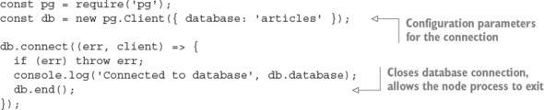
Comprehensive documentation for pg.Client and other methods can be found on the pg package’s wiki page on GitHub: https://github.com/brianc/node-postgres/wiki.

8.2.4. Defining tables
In order to store data in PostgreSQL, you first need to define some tables and the shape of the data to be stored within them, as shown in the following listing (ch08-databases/listing8_3 in the book’s source code).

Listing 8.2. Defining a schema
db.query(`
CREATE TABLE IF NOT EXISTS snippets (
id SERIAL,
PRIMARY KEY(id),
body text
);
`, (err, result) => {
if (err) throw err;
console.log('Created table "snippets"');
db.end();
});

8.2.5. Inserting data
After your table is defined, you can insert data into it by using INSERT queries, as shown in the next listing. If you don’t specify the id value, PostgreSQL will select an ID for you. To learn which ID was chosen for a particular row, you append RETURNING id to your query, and it appears in the rows of the result passed to the callback.

Listing 8.3. Inserting data
const body = 'hello world';
db.query(`
INSERT INTO snippets (body) VALUES (
'${body}'
)
RETURNING id
`, (err, result) => {
if (err) throw err;
const id = result.rows[0].id;
console.log('Inserted row with id %s', id);
db.query(`
INSERT INTO snippets (body) VALUES (
'${body}'
)
RETURNING id
`, () => {
if (err) throw err;
const id = result.rows[0].id;
console.log('Inserted row with id %s', id);
});
});

8.2.6. Updating data
After data is inserted, you can update the data by using an UPDATE query, as shown in the next listing. The number of affected rows will be available in the rowCount property of the query result. You can find the full example for this listing in ch08-databases/listing8_4.

Listing 8.4. Updating data
const id = 1;
const body = 'greetings, world';
db.query(`
UPDATE snippets SET (body) = (
'${body}'
) WHERE id=${id};
`, (err, result) => {
if (err) throw err;
console.log('Updated %s rows.', result.rowCount);
});

8.2.7. Querying data
One of the most powerful features of a relational database is the ability to perform complex ad hoc queries on your data. Querying is performed by using SELECT statements, and the simplest example of this is shown in the following listing.

Listing 8.5. Querying data
db.query(`
SELECT * FROM snippets ORDER BY id
`, (err, result) => {
if (err) throw err;
console.log(result.rows);
});

8.3. Knex
Many developers prefer to not work with SQL statements directly in their applications, instead using an abstraction over the top. This is understandable, given that concatenating strings into SQL statements can be a clunky process and that queries can grow hard to understand and maintain. This has been particularly true for JavaScript, which didn’t have a syntax for representing multiline strings until ES2015 introduced template literals (see https://developer.mozilla.org/en/docs/Web/JavaScript/Reference/Template_literals). Figure 8.1 shows Knex’s statistics, including the number of downloads, which demonstrates its popularity.

Figure 8.1. Knex’s usage statistics

Knex is a Node package implementing a type of lightweight abstraction over SQL, known as a query builder. A query builder constructs SQL strings though a declarative API that closely resembles the generated SQL. The Knex API is intuitive and unsurprising:
knex({ client: 'mysql' })
.select()
.from('users')
.where({ id: '123' })
.toSQL();
This produces a parameterized SQL query in the MySQL dialect of SQL:
select * from `users` where `id` = ?

8.3.1. jQuery for databases
Despite ANSI and ISO SQL standards existing since the mid-1980s, most databases still speak their own SQL dialects. PostgreSQL is a notable exception; it prides itself on adhering to the SQL:2008 standard. A query builder can normalize differences across SQL dialects, providing a single, unified interface for SQL generation for multiple technologies. This has clear benefits for teams that regularly context-switch between various database technologies.
Knex.js currently supports the following databases:

PostgreSQL
MSSQL
MySQL
MariaDB
SQLite3
Oracle
Table 8.1 compares the ways Knex generates an insert statement, depending on which database is selected.

Table 8.1. Comparing Knex-generated SQL for various databases
Database | SQL
PostgreSQL, SQLite, and Oracle | insert into "users" ("name", "age") values (?, ?)
MySQL and MariaDB | insert into `users` (`name`, `age`) values (?, ?)
Microsoft SQL Server | insert into [users] ([name], [age]) values (?, ?)
Knex supports promises and Node-style callbacks.

8.3.2. Connecting and running queries with Knex
Unlike many other query builders, Knex can also connect and execute queries for you against the selected database driver:
db('articles')
.select('title')
.where({ title: 'Today's News' })
.then(articles => {
console.log(articles);
});
Knex queries return promises by default, but can also support Node’s callback convention with .asCallback:
db('articles')
.select('title')
.where({ title: 'Today's News' })
.asCallback((err, articles) => {
if (err) throw err;
console.log(articles);
});
In chapter 3, you interacted with a SQLite database by using the sqlite3 package directly. This API can be rewritten using Knex. To run this example, first ensure that both the knex and sqlite3 packages are installed from npm:
npm install knex@~0.12.0 sqlite3@~3.1.0 --save
The next listing uses sqlite3 to implement a simple Article model. Save this file as db.js; you’ll use it in listing 8.7 to interact with the database.

Listing 8.6. Using Knex to connect and query sqlite3
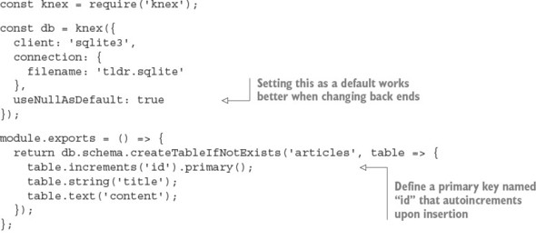
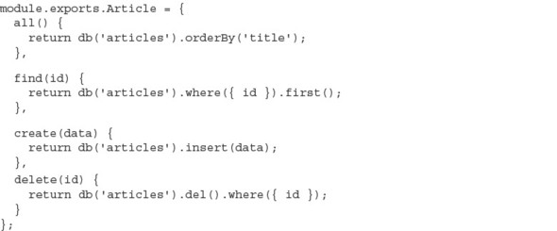
Now Article entries can be added by using db.Article. The following listing can be used with the previous one to create articles and then print them. See ch08-databases/listing8_7/index.js for the full example.

Listing 8.7. Interacting with the Knex-powered API
db().then(() => {
db.Article.create({
title: 'my article',
content: 'article content'
}).then(() => {
db.Article.all().then(articles => {
console.log(articles);
process.exit();
});
});
})
.catch(err => { throw err });
SQLite requires minimal configuration: you don’t need to boot up a server daemon or create databases from outside the application. SQLite writes everything into a single file. If you run the preceding code, you’ll find an articles.sqlite file in your current directory. Wiping a SQLite database is as simple as deleting this one file:
rm articles.sqlite
SQLite also has an in-memory mode, which avoids writing to disk entirely. This mode is commonly used to decrease the running time of automated tests. You can configure in-memory mode by using the special :memory: filename. Opening multiple connections to the :memory: file gives each connection its own private database:
const db = knex({
client: 'sqlite3',
connection: {
filename: ':memory:'
},
useNullAsDefault: true
});

8.3.3. Swapping the database back end
Because you’re using Knex, it’s trivial to change listings 8.6 and 8.7 to use PostgreSQL over sqlite3. Knex needs the pg package installed to talk to the PostgreSQL server, which you’ll need to have installed and running. Install the pg package into the folder with listing 8.7 (ch08-databases/listing8_7 in the book’s code) and remember to create the appropriate database by using PostgreSQL’s createdb command-line utility:
npm install pg --save
createdb articles
The only code changes required to use this new database are in the Knex configuration; otherwise, the consumer API and usage are identical:
const db = knex({
client: 'pg',
connection: {
database: 'articles'
}
})
Note that in a real-world scenario, you’d also need to migrate any existing data.

8.3.4. Beware of leaky abstractions
Query builders can normalize SQL syntax, but can do little to normalize behavior. Some features are supported in only particular databases, and some databases may exhibit entirely different behavior given identical queries. For example, the following are two methods of defining a primary key when using Knex:

table.increments('id').primary();
table.integer('id').primary();
Both options work as expected in SQLite3, but the second option will cause an error in PostgreSQL when inserting a new record:
"null value in column "id" violates not-null constraint"
Values inserted into SQLite with a null primary key will be assigned an automatically incremented ID, regardless of whether the primary-key column was explicitly configured to autoincrement. PostgreSQL, on the other hand, requires autoincrement columns to be defined explicitly. Many such behavioral differences exist between databases, and some differences may be subtle without visible errors. Thorough testing needs to be applied if you do choose to transition to a different database.

8.4. MySQL vs. PostgreSQL
Both MySQL and PostgreSQL are mature and powerful databases, and for many projects, there will be minimal differences when selecting one over the other. Many distinctions, which won’t be significant until the project needs to scale, exist below or at the edge of the interface exposed to the application developer.
An exhaustive comparison between relational databases is mostly beyond the scope of this book, as the topic is complicated. Some notable distinctions are listed here:

PostgreSQL supports more-expressive data types, including arrays, JSON, and user-defined types.
PostgreSQL has built-in full-text search.
PostgreSQL supports the full ANSI SQL:2008 standard.
PostgreSQL’s replication support isn’t as powerful or battle-tested as MySQL’s.
MySQL is older and has a bigger community. More compatible tools and resources are available for MySQL.
The MySQL community has more fragmentation through subtly different forks (for example, MariaDB and WebScaleSQL from Facebook, Google, Twitter, and so forth).
MySQL’s pluggable storage engine can make it more complicated to understand, administer, and tune. On the other hand, this can be seen as an opportunity for more fine-grained control over performance.
MySQL and PostgreSQL express different performance characteristics at scale, depending on the type of workload. The subtleties of your workload may not become obvious until the project matures.
Many online resources provide far more in-depth comparisons between relational databases:

www.digitalocean.com/community/tutorials/sqlite-vs-mysql-vs-postgresql-a-comparison-of-relational-database-management-systems
https://blog.udemy.com/mysql-vs-postgresql/
https://eng.uber.com/mysql-migration/
Which relational database you initially choose is unlikely to be a significant factor in the success of your project, so don’t worry about this decision too much. You can migrate to another database later, but Postgres should be powerful enough to provide most of the features and scalability that you’ll ever need. But if you’re in a position to evaluate several databases, you should familiarize yourself with the idea of ACID guarantees.

8.5. ACID guarantees
ACID describes a set of desirable properties for database transactions: atomicity, consistency, isolation, and durability. The exact definitions of these terms can vary. As a general rule, the more strictly a system guarantees ACID properties, the greater the performance compromise. This ACID categorization is a common way for developers to quickly communicate the trade-offs of a particular solution, such as those found in NoSQL systems.

8.5.1. Atomicity: transactions either succeed or fail in entirety
An atomic transaction can’t be partially executed: either the entire operation completes, or the database is left unchanged. For example, if a transaction is to delete all comments by a particular user, either all comments will be deleted, or none of them will be deleted. There is no way to end up with some comments deleted and some not. Atomicity should apply even in the case of system error or power failure. Atomic is used here with its original meaning of indivisible.

8.5.2. Consistency: constraints are always enforced
The completion of a successful transaction must maintain all data-integrity constraints defined in the system. Some example constraints are that primary keys must be unique, data conforms to a particular schema, or foreign keys must reference entities that exist. Transactions that would lead to inconsistent state typically result in transaction failures, though minor issues may be resolved automatically; for example, coercing data into the correct shape. This isn’t to be confused with the C of consistency in the CAP theorem, which refers to guaranteeing a single view of the data being presented to all readers of a distributed store.

8.5.3. Isolation: concurrent transactions don’t interfere
Isolated transactions should produce the same result, whether the same transactions are executed concurrently or sequentially. The level of isolation a system provides directly affects its ability to perform concurrent operations. A naïve isolation scheme is the use of a global lock, whereby the entire database is locked for the duration of a transaction, thus effectively processing all transactions in series. This gives a strong isolation guarantee but it’s also pathologically inefficient: transactions operating on entirely disjointed datasets are needlessly blocked (for example, a user adding a comment ideally doesn’t block another user updating their profile). In practice, systems provide various levels of isolation using more fine-grained and selective locking schemes (for example, by table, row, or field). More-sophisticated systems may even optimistically attempt all transactions concurrently with minimal locking, only to retry transactions by using increasingly coarse-grained locks in cases where conflicts are detected.

8.5.4. Durability: transactions are permanent
The durability of a transaction is the degree to which its effects are guaranteed to persist, even after restarts, power failures, system errors, or even hardware failures. For example, an application using the SQLite in-memory mode has no transaction durability; all data is lost when the process exits. On the other hand, SQLite persisting to disk will have good transaction durability, because data persists even after the machine is restarted.
This may seem like a no-brainer: just write the data to disk—and voila, you have durable transactions. But disk I/O is one of the slowest operations your application can perform and can quickly become a significant bottleneck in your application, even at moderate levels of scale. Some databases offer different durability trade-offs that can be employed to maintain acceptable system performance.

8.6. NoSQL
The umbrella term for data stores that don’t fit in the relational model is NoSQL. Today, because some NoSQL databases do speak SQL, the term NoSQL has a meaning closer to nonrelational or as the backronym not only SQL.
Here’s a subset of paradigms and example databases that can be considered NoSQL:

Key-value/tuple— DynamoDB, LevelDB, Redis, etcd, Riak, Aerospike, Berkeley DB
Graph— Neo4J, OrientDB
Document— CouchDB, MongoDB, Elastic (formerly Elasticsearch)
Column— Cassandra, HBase
Time series— Graphite, InfluxDB, RRDtool
Multiparadigm— Couchbase (document database, key/value store, distributed cache)
For a more comprehensive list of NoSQL databases, see http://nosql-database.org/.
NoSQL concepts can be difficult to digest if you’ve worked only with relational databases, because NoSQL usage often goes directly against well-established best practices: No defined schemas. Duplicate data. Loosely enforced constraints. NoSQL systems take responsibilities normally assigned to the database and place them in the realm of the application. It can all seem dirty.
Usually, only a small set of access patterns create the bulk of the workload for the database, such as the queries that generate the landing screen of your application, where multiple domain objects need to be fetched. A common technique for improving read performance in a relational database is denormalization, whereby domain queries are preprocessed and shaped into a form that reduces the number of reads required for consumption by the client.
NoSQL data is more frequently denormalized by default. The domain modeling step may be entirely skipped. This can discourage overengineering of the data model, allow changes to be executed more quickly, and lead to an overall simpler, better-performing design.

8.7. Distributed databases
An application can scale vertically by increasing the capacity of the machines running it, or horizontally by adding more machines. Vertical scaling is usually the less complicated option, but constraints borne by the hardware limit how far one machine can scale. Vertical scaling also tends to get expensive quickly. Horizontal scaling, on the other hand, has a far higher capacity for growth as you add capacity by adding more processes and more machines. This comes at the cost of complexity in orchestrating many more moving parts. All growing systems eventually reach a point where they must scale horizontally.
Distributed databases are designed from the outset with horizontal scaling as the premise. Data stored across multiple machines improves the durability of the data by removing any single point of failure. Many relational systems have some capacity to perform horizontal scaling in the form of sharding, master/slave, master/master replication, though even with these capacities, relational systems aren’t designed to scale beyond a few hundred nodes. For example, the upper limit for a MySQL cluster is 255 nodes. Distributed databases, on the other hand, can scale into the thousands of nodes by design.

8.8. MongoDB
MongoDB is a document-oriented, distributed database that’s hugely popular among Node developers. It’s the M in the fashionable MEAN stack (MongoDB, Express, Angular, Node) and is often one of the first databases people encounter when they start working with Node. Figure 8.2 shows how popular the mongodb module is on npm.

Figure 8.2. MongoDB’s usage statistics

MongoDB attracts more than its fair share of criticism and controversy; despite this, it remains a staple data store for many developers. MongoDB has known deployments in prominent companies including Adobe, LinkedIn, and eBay and is even used in a component of the Large Hadron Collider at the European Organization for Nuclear Research (CERN).
A MongoDB database stores documents in schemaless collections. Documents don’t need to have a predefined schema, and documents in a single collection needn’t share the same schema. This grants a lot of flexibility to MongoDB, though the burden is now upon the application to ensure that documents maintain a predictable structure (guaranteeing consistency—the C in ACID).

8.8.1. Performing installation and setup
MongoDB needs to be installed on your system. Installation varies between platforms. On macOS, installation is as simple as this:
brew install mongodb
The MongoDB server is started by using the mongod executable:
mongod --config /usr/local/etc/mongod.conf
The most popular MongoDB driver is the official mongodb package by Christian Amor Kvalheim:
npm install mongodb@^2.1.0 --save
Windows users should note that driver installation requires msbuild.exe, which is installed by Microsoft Visual Studio.

8.8.2. Connecting to MongoDB
After installing the mongodb package and starting the mongod server, you can connect as a client from Node, as shown in the following listing.

Listing 8.8. Connecting to MongoDB
const { MongoClient } = require('mongodb');
MongoClient.connect('mongodb://localhost:27017/articles')
.then(db => {
console.log('Client ready');
db.close();
}, console.error);
The connection’s success handler is passed a database client instance, from which all database commands are executed.
Most interactions with the database are via the collection API:

collection.insert(doc)—Insert one or more documents
collection.find(query)—Find documents matching the query
collection.remove(query)—Remove documents matching the query
collection.drop()—Remove the entire collection
collection.update(query)—Update documents matching the query
collection.count(query)—Count documents matching the query
Operations such as find, insert, and delete come in a few flavors, depending on whether you’re operating on one or many values. For example:

collection.insertOne(doc)—Insert a single document
collection.insertMany([doc1, doc2])—Insert many documents
collection.findOne(query)—Find a single document matching the query
collection.updateMany(query)—Update all documents matching the query

8.8.3. Inserting documents
collection.insertOne places a single object into the collection as a document, as shown in the next listing. The success handler is passed an object containing metadata about the state of the operation.

Listing 8.9. Inserting a document
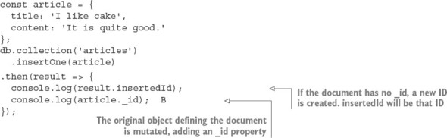
The insertMany call is similar, except it takes an array of multiple documents. The insertMany response will contain an array of insertedIds, in the order the documents were supplied, instead of a singular insertedId.

8.8.4. Querying
Methods that read documents from the collection (such as find, update, and remove) take a query argument that’s used to match documents. The simplest form of a query is an object with which MongoDB will match documents with the same structure and same values. For example, this finds all articles with the title “I like cake”:
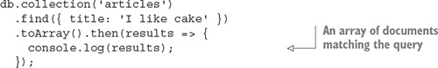
Queries can be used to match objects by their unique _id:
collection.findOne({ _id: someID })
Or match based on a query operator:
Many query operators exist in the MongoDB query language—for example:

$eq—Equal to a particular value
$neq—Not equal to a particular value
$in—In array
$nin—Not in array
$lt, $lte, $gt, $gte—Greater/less than or equal to comparison
$near—Geospatial value is near a certain coordinate
$not, $and, $or, $nor—Logical operators
These can be combined to match almost any condition and create a highly readable, sophisticated, and expressive query language. See https://docs.mongodb.com/-manual/reference/operator/query/ for more information on queries and query operators.
The next listing shows an example that the previous Articles API implemented by using MongoDB, while maintaining a nearly identical external interface. Save this file as db.js (it’s listing8_10/db.js in the book’s sample code).

Listing 8.10. Implementing the Article API with MongoDB
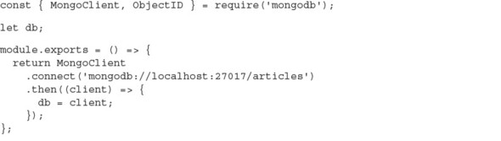
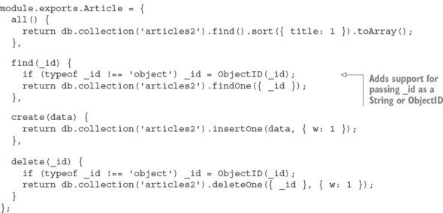
The following snippet shows how to use listing 8.10 (listing 8_10/index.js in the sample code):
const db = require('./db');
db().then(() => {
db.Article.create({ title: 'An article!' }).then(() => {
db.Article.all().then(articles => {
console.log(articles);
process.exit();
});
});
});
This uses a promise from listing 8.10 to connect to the database, then creates an article using Article’s create method. After that, it loads all articles and logs them out.

8.8.5. Using MongoDB identifiers
Identifiers from MongoDB are encoded in Binary JSON (BSON) format. The _id property on a document is a JavaScript Object that wraps a BSON-formatted ObjectID value. MongoDB uses BSON to represent documents internally and as a transmission format. BSON is more space-efficient than JSON and can be parsed more quickly, which means faster database interactions using less bandwidth.
A BSON ObjectID isn’t just a random sequence of bytes; it encodes metadata about where and when the ID was generated. For example, the first four bytes of an ObjectID are a timestamp. This removes the need to have to store a createdAt timestamp property in your documents:
See https://docs.mongodb.com/manual/reference/method/ObjectId/ for more information about the ObjectID format.
ObjectIDs may superficially appear to be strings because of the way they’re printed in the terminal, but they’re objects. ObjectIDs suffer from classic object comparison gotchas: seemingly totally equivalent values are reported as inequivalent because they reference different objects.
In the following snippet, we extract the same value twice. Using the node’s built-in assert module, we try to assert that the objects or the IDs are equivalent, but both result in failure:
const Articles = db.collection('articles');
Articles.find().then(articles => {
const article1 = articles[0];
return Articles
.findOne({_id: article1._id})
.then(article2 => {
assert.equal(article2._id, article1._id);
});
});
These assertions produce error messages that at first seem confusing, as the actual values appear to match the expected values:
operator: equal
expected: 577f6b45549a3b991e1c3c18
actual: 577f6b45549a3b991e1c3c18
operator: equal
expected:
{ _id: 577f6b45549a3b991e1c3c18, title: 'attractive-money' ... }
actual:
{ _id: 577f6b45549a3b991e1c3c18, title: 'attractive-money' ... }
Equivalence can be detected correctly by using the ObjectID’s equal method that’s available on every _id. Alternatively, you can coerce the identifiers and compare them as strings, or use a deepEquals method such as that found on Node’s built-in assert module:
Identifiers passed to the Node mongodb driver must be a BSON-formatted ObjectID. A string can be converted into an ObjectID by using the ObjectID constructor:
const { ObjectID } = require('mongodb');
const stringID = '577f6b45549a3b991e1c3c18';
const bsonID = new ObjectID(stringID);
Where possible, the BSON form should be maintained; the cost of marshalling to and from strings works against the potential performance gains MongoDB hopes to achieve by serving client identifiers as BSON. See http://bsonspec.org/ for detailed information about the BSON format.

8.8.6. Using replica sets
The distributed features of MongoDB are mostly beyond the scope of this book, but in this section we quickly cover the basics of replica sets. Many mongod processes can be run as nodes/members of a replica set. A replica set consists of a single primary node and numerous secondary nodes. Each member of a replica set needs to be allocated a unique port and directory to store its data. Instances can’t share ports or directories, and the directories must already exist before startup.
In the following listing, you create a unique directory for each member and start them on a sequential port number starting from 27017. You may want to run each of the mongod commands in a new terminal tab without backgrounding them (without the trailing &).

Listing 8.11. Starting a replica set
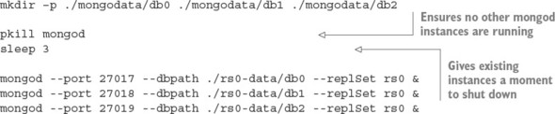
After the replica set is running, MongoDB needs to perform some initiation. You need to connect to the port of the instance that you want to become the first primary node (27017 by default) and call rs.initiate(), as shown in the following listing. Then you need to add each instance as a member of the replica set. Note that you need to supply the hostname of the machine you’re connecting to.

Listing 8.12. Initiating a replica set

MongoDB clients need to know about all the possible replica set members when they connect, though not all members need to currently be online. After connecting, you may use the MongoDB client as usual. Listing 8.13 shows how to create a replica set with three members.

Listing 8.13. Connecting to a replica set
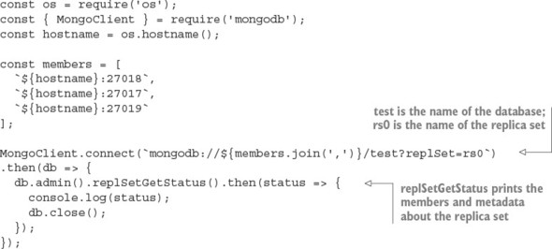
If any of the mongod nodes crash, the system will continue working, as long as at least two instances are running. If the primary node crashes, a secondary node will automatically be elected to be promoted into the primary.

8.8.7. Understanding write concerns
MongoDB gives the developer fine-grained control over which performance and safety trade-offs are acceptable for various areas of your application. It’s important to understand the concepts of both write and read concerns in order to use MongoDB without surprises, especially as the number of nodes in your replica set increases. In this section, we touch only on write concerns, as they’re the most important.
Write concerns dictate the number of mongod instances that the data needs to be successfully written to before the overall operation responds with a success. If not explicitly specified, the default write concern is 1, which ensures that the data has been written to at least one node. It may not provide an adequate level of assurance for critical data; data may be lost if the node goes down before replicating to other nodes.
It’s possible and often desirable to set a zero write concern, whereby the application doesn’t wait for any response:
db.collection('data').insertOne(data, { w: 0 });
A zero write concern grants the highest performance but provides the least durability assurances, and is typically used for only temporary or unimportant data (such as the writing of logs or caches).
If you’re connected to a replica set, you can indicate a write concern greater than 1. Replicating to more nodes decreases the likelihood of data loss, at the expense of more latency when performing operations:
db.collection('data').insertOne(data, { w: 2 });
db.collection('data').insertOne(data, { w: 5 });
You may want to scale the write concern as the number of nodes in the cluster changes. This can be done dynamically by MongoDB itself if you set the write concern to majority. This ensures that data is written to more than 50% of the available nodes:
db.collection('data').insertOne(data, { w: 'majority' });
The default write concern of 1 may not provide an adequate level of assurance for critical data. Data may be lost if the node goes down before replicating to other nodes.
Setting a write concern higher than 1 ensures that the data exists across multiple mongod instances before continuing. Running multiple instances on the same machine adds protection but doesn’t help in the case of systemwide failures such as running out of disk space or RAM. You can protect against machine failure by running instances across multiple machines and ensuring that writes propagate to these nodes, but this again will be slower and doesn’t protect against datacenter-wide failure. Running nodes across different datacenters protects against datacenter outage, but ensuring that data is replicated across datacenters will greatly impact performance.
As always, the more assurances you add, the slower and more complicated the system becomes. This isn’t an issue specific to MongoDB; it’s an issue with any and all data storage. No perfect solution exists, and you’ll need to decide the acceptable level of risk for the various parts of your application.
For more information about how MongoDB replication works, see the following resources:

https://docs.mongodb.com/manual/faq/replica-sets/
https://docs.mongodb.com/manual/faq/concurrency/

8.9. Key/value stores
Each record in a key/value store comprises a single key and a single value. In many key/value systems, values can be of any data type, of any length or structure. From the perspective of the database, values are opaque atoms: the database doesn’t know or care about the type of the data and can’t be subdivided or accessed other than in its entirety. Contrast this with value storage in a relational database: data is stored in a series of tables, which contain rows of data separated into predefined columns. In a key/value store, the responsibility of managing the format of the data is handed to the application.
Key/value stores can often be found in performance-critical paths of an application. Ideally, values are laid out in a manner such that the absolute minimum number of reads is required to fulfill a task. Key/value stores come with simpler querying capabilities than other database types. Ideally, complex queries are precalculated; otherwise, they need to be performed within the application rather than the database. This constraint can lead to easily understood and predictable performance characteristics.
The most popular key/value stores, such as Redis and Memcached, are often used for volatile storage (if the process exits, the data is lost). Avoiding writing to disk is one of the best ways to improve performance. This can be an acceptable trade-off for features when data can be regenerated or loss is of little concern; for example, caches and user sessions.
Key/value stores may carry a stigma that they can’t be used for primary storage, but this isn’t always true. Many key/value stores provide just as much durability as a “real” database.

8.10. Redis
Redis is a popular in-memory, data-structure store. Although many consider Redis to be a key/value store, keys and values represent only a subset of the features Redis supports across a variety of useful, basic data structures. Figure 8.3 shows the usage statistics for the redis package on npm.

Figure 8.3. The redis package’s statistics on npm

The data structures built into Redis include the following:

Strings
Hashes
List
Set
Sorted set
Redis also comes with many other useful features out of the box:

Bitmap data— Direct bit manipulation in values.
Geospatial indexes— Storing geospatial data with radius queries.
Channels— A publish/subscribe data-delivery mechanism.
TTLs— Values can be configured with an expiry time, after which they’re automatically removed.
LRU eviction— Optionally removes values that haven’t been recently used in order to maintain maximum memory usage.
HyperLogLog— High-performing approximation of set cardinality, while maintaining a low-memory footprint (doesn’t need to store every member).
Replication, clustering, and partitioning— Horizontal scaling and data durability.
Lua scripting— Extend Redis with custom commands.
In this section, you’ll find several bulleted lists of Redis commands. They’re not intended to be a reference, but rather to give some insight into what’s possible with Redis. It’s an incredibly powerful and versatile tool. See http://redis.io/commands for more details.

8.10.1. Performing installation and setup
Redis can be installed through your system’s package management tool. On macOS, you can easily install it with Homebrew:
brew install redis
Starting the server is done using the redis-server executable:
redis-server /usr/local/etc/redis.conf
The server listens on port 6379 by default.

8.10.2. Performing initialization
A Redis client instance is created with the createClient function from the redis npm package:
const redis = require('redis');
const db = redis.createClient(6379, '127.0.0.1');
This function takes the port and a host as arguments. But if you’re running the Redis server on the default port on your local machine, you don’t need to supply any arguments at all:
const db = redis.createClient();
The Redis client instance is an EventEmitter, so you can attach listeners for various Redis status events, as shown in the next listing. You can immediately start issuing commands to the client, and they’ll be buffered until the connection is ready.

Listing 8.14. Connecting to Redis and listening for status events
const redis = require('redis');
const db = redis.createClient();
db.on('connect', () => console.log('Redis client connected to server.'));
db.on('ready', () => console.log('Redis server is ready.'));
db.on('error', err => console.error('Redis error', err));
The error handler will fire if a connection or client problem occurs. If an error event is fired and no error handler is attached, the application process will throw the error and crash; this is a feature of all EventEmitters in Node. If the connection fails and an error handler is supplied, the Redis client will attempt to retry the connection.

8.10.3. Working with key/value pairs
Redis can be used as a generic key/value store for strings and arbitrary binary data. Reading and writing a key/value pair can be done using the set and get methods, respectively:
db.set('color', 'red', err => {
if (err) throw err;
});
db.get('color', (err, value) => {
if (err) throw err;
console.log('Got:', value);
});
If you set an existing key, the value will be overwritten. If you try to get a key that doesn’t exist, the value will be null; it’s not considered an error.
The following commands can be used to retrieve and manipulate values:

append
decr
decrby
get
getrange
getset
incr
incrby
incrbyfloat
mget
mset
msetnx
psetex
set
setex
setnx
setrange
strlen

8.10.4. Working with keys
You can check whether a key exists by using exists. This works with any data type:
db.exists('users', (err, doesExist) => {
if (err) throw err; console.log('users exists:', doesExist);
});
Along with exists, the following commands can all be used with any key, regardless of the type of the value (these commands work with strings, sets, lists, and so forth):

del
exists
rename
renamenx
sort
scan
type

8.10.5. Encoding and data types
The Redis server stores keys and values as binary objects; it’s not dependent on the encoding of the value passed to the client. Any valid JavaScript string (UCS2/UTF16) can be used as a valid key or value:
db.set('greeting', '你好', redis.print);
db.get('greeting', redis.print);
db.set('icon', '?', redis.print);
db.get('icon', redis.print);
By default, keys and values are coerced to strings as they’re written. For example, if you set a key with a number, it will be a string when you try to get that same key:
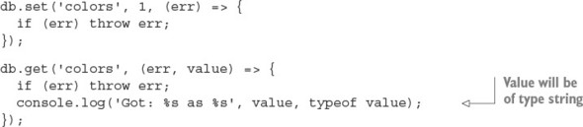
The Redis client silently coerces numbers, Booleans, and dates into strings, and it also happily accepts buffer objects. Trying to set any other JavaScript type as a value (for example, Object, Array, RegExp) prints a warning that should be heeded:
db.set('users', {}, redis.print);
Deprecated: The SET command contains a argument of type Object.
This is converted to "[object Object]" by using .toString() now
and will return an error from v.3.0 on.
Please handle this in your code to make sure everything works
as you intended it to.
In the future, this will be an error, so the calling application must be responsible for ensuring that the correct types are passed to the Redis client.

Gotcha: single vs. multiple value arrays
The client produces a cryptic error, “ReplyError: ERR syntax error,” if you try to set an array of values:
db.set('users', ['Alice', 'Bob'], redis.print);
But note that no error occurs when the array contains only a single value:
db.set('user', ['Alice'], redis.print);
db.get('user', redis.print);
This type of bug may show symptoms only when you’re running it in production, as it can easily elude detection if the test suite happens to produce only single-valued arrays, which is common for stripped-down test data. Be aware!

Binary data with buffers
Redis is capable of storing arbitrary byte data, which means you can store any type of data in it. The Node client supports this feature with special handling for Node’s Buffer type. When a buffer is passed to the Redis client as a key or value, the bytes are sent unmodified to the Redis server. This avoids accidental data corruption and performance penalties of unnecessary marshalling between strings and buffers. For example, if you want to write data from disk or network directly into Redis, it’s more efficient to write the buffers directly to Redis than to convert them into strings first.
Buffers
Buffers are what you receive from Node’s core file and network APIs by default. They’re a container around contiguous blocks of binary data, and were introduced in Node before JavaScript had its own native binary data types (Uint8Array, Float32Array, and so forth). Today, buffers are implemented in Node as a specialized subclass of Uint8Array. The Buffer API is available globally in Node; you don’t need to require anything to use it.
See https://github.com/nodejs/node/blob/master/lib/buffer.js
Redis has recently added commands for manipulating individual bits of string values, which can be of use when working with buffers:

bitcount
bitfield
bitop
setbit
bitpos

8.10.6. Using hashes
A hash is a collection of key/value pairs. The hmset command takes a key and an object representing the key/value pairs of the hash. You can get the key/value pairs back as an object by using hmget, as shown in the next listing.

Listing 8.15. Storing data in elements of Redis hashes
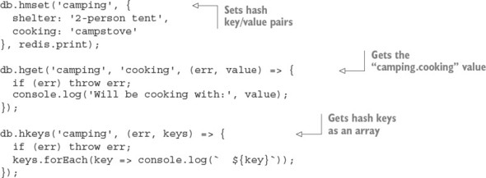
You can’t store nested objects in a Redis hash. It provides only a single level of keys and values.
The following commands operate on hashes:

hdel
hexists
hget
hgetall
hincrby
hincrbyfloat
hkeys
hlen
hmget
hmset
hset
hsetnx
hstrlen
hvals
hscan

8.10.7. Using lists
A list is an ordered collection of string values. A list can contain multiple copies of the same value. Lists are conceptually similar to arrays. Lists are best used for their ability to behave as a stack (LIFO: last in, first out) or queue (FIFO: first in, first out) data structures.
The following code shows the storage and retrieval of values in a list. The lpush command adds a value to a list. The lrange command retrieves a range of values, using start and end indices. The -1 argument in the following code signifies the last item of the list, so this use of lrange retrieves all list items:
client.lpush('tasks', 'Paint the bikeshed red.', redis.print);
client.lpush('tasks', 'Paint the bikeshed green.', redis.print);
client.lrange('tasks', 0, -1, (err, items) => {
if (err) throw err;
items.forEach(item => console.log(` ${item}`));
});
Lists don’t contain any built-in means to determine whether a value is in the list, or any means of discovering the index of a particular value in the list. You can manually iterate over the list to obtain this information, but this is a highly inefficient approach that should be avoided. If you need these types of features, you should consider a different data structure, such as a set, perhaps even used in addition to a list. Duplicating data across multiple data structures is often desirable in order to take advantage of various performance characteristics.
The following commands operate on lists:

blpop
brpop
lindex
linsert
llen
lpop
lpush
lpushx
lrange
lrem
lset
ltrim
rpop
rpush
rpushx

8.10.8. Using sets
A set is an unordered collection of unique values. Testing membership, and adding and removing items from a set can be performed in O(1) time, making it a high-performing structure suitable for many tasks:
db.sadd('admins', 'Alice', redis.print);
db.sadd('admins', 'Bob', redis.print);
db.sadd('admins', 'Alice', redis.print);
db.smembers('admins', (err, members) => {
if (err) throw err;
console.log(members);
});
The following commands operate on Redis sets:

sadd
scard
sdiff
sdiffstore
sinter
sinterstore
sismember
smembers
spop
srandmember
srem
sunion
sunionstore
sscan

8.10.9. Providing pub/sub with channels
Redis goes beyond the traditional role of a data store by providing channels. Channels are a data-delivery mechanism that provides publish/subscribe functionality, as shown conceptually in figure 8.4. They can be useful for real-time applications such as chat and gaming.

Figure 8.4. Redis channels provide an easy solution to a common data-delivery scenario.
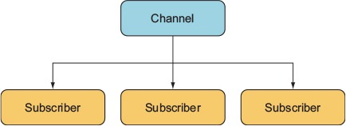
A Redis client can subscribe or publish to a channel. A message published to a channel will be delivered to all subscribers. A publisher doesn’t need to know about the subscribers, nor the subscribers about the publishers. This decoupling of publishers and subscribers is what makes this a powerful and clean pattern.
The following listing shows an example of how Redis’s publish/subscribe functionality can be used to implement a TCP/IP chat server.

Listing 8.16. A simple chat server implemented with Redis pub/sub functionality
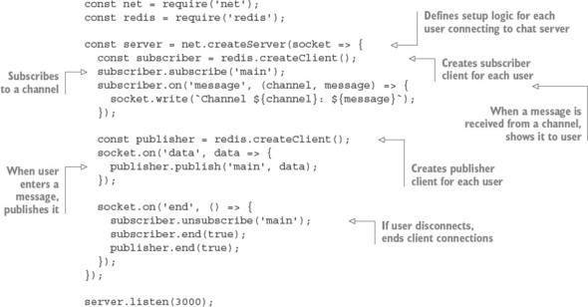

8.10.10. Improving Redis performance
The hiredis npm package is a native binding from JavaScript to the protocol parser in the official Hiredis C library. Hiredis can significantly improve the performance of Node Redis applications, particularly if you’re using sunion, sinter, lrange, and zrange operations with large datasets.
To use hiredis, simply install it alongside the redis package in your application, and the Node redis package will detect it and use it automatically the next time it starts:
npm install hiredis --save
There are few downsides to using hiredis, but because it’s compiled from C code, some complications or limitations may arise when building hiredis for some platforms. As with all native add-ons, you may need to rebuild hiredis with npm rebuild after updating Node.

8.11. Embedded databases
An embedded database doesn’t require the installation or administration of an external server. It runs embedded within your application process itself. Communication with an embedded database usually occurs via direct procedure calls in your application, rather than across an interprocess communication (IPC) channel or a network.
In many situations, an application needs to be self-contained, so an embeddable database is the only option (for example, mobile or desktop applications). Embedded databases can also be used on web servers, often found powering high-throughput features such as user sessions or caching, and sometimes even as the primary storage.
Some embeddable databases commonly used in Node and Electron apps are as follows:

SQLite
LevelDB
RocksDB
Aerospike
EJDB
NeDB
LokiJS
Lowdb
NeDB, LokiJS, and Lowdb are all written in pure JavaScript, which by nature makes them embeddable into Node/Electron applications. Most embedded databases are simple key/value or document stores, though SQLite is a notable exception as an embeddable relational store.

8.12. LevelDB
LevelDB is an embeddable, persistent key/value store developed in early 2011 by Google, initially for use as the backing store for the IndexedDB implementation in Chrome. LevelDB’s design is built on concepts from Google’s Bigtable database. LevelDB is comparable to databases such as Berkley DB, Tokyo/Kyoto Cabinet, and Aerospike, but in the context of this book, you can think of LevelDB as an embeddable Redis with only the bare minimum of features. Like many embedded databases, LevelDB isn’t multithreaded and doesn’t support multiple instances using the same underlying file storage, so it doesn’t work in a distributed setting without a wrapping application.
LevelDB stores arbitrary byte arrays, sorted lexicographically by key. Values are compressed by using Google’s Snappy compression algorithm. Data is always persisted to disk; the total data capacity isn’t constrained by the amount of RAM on the machine, unlike an in-memory store such as Redis.
Only a small set of self-explanatory operations are provided with LevelDB: Get, Put, Del, and Batch. LevelDB can also capture snapshots of the current database state and create bidirectional iterators for moving forward or backward through the dataset. Creating an iterator creates an implicit snapshot; the data an iterator can see can’t be changed by subsequent writes.
LevelDB forms the foundation for other databases, in the form of LevelDB forks. The number of significant LevelDB offshoots could be attributed to the simplicity of LevelDB itself:

RocksDB by Facebook
HyperLevelDB by Hyperdex
Riak by Basho
leveldb-mcpe by Mojang (creators of Minecraft)
bitcoin/leveldb for the bitcoind project
For more information about LevelDB, see http://leveldb.org/.

8.12.1. LevelUP and LevelDOWN
LevelDB support in Node is provided by the LevelUP and LevelDOWN packages written by Node foundation chair and prolific Australian developer Rod Vagg. LevelDOWN is a simple, sugar-free C++ binding to LevelDB for Node, and it’s unlikely you’ll interface with it directly. LevelUP wraps the LevelDOWN API with a more convenient, idiomatic node interface, adding support for key/value encodings, JSON, buffering writes until the database is open, and wrapping the LevelDB iterator interface in a Node stream. Figure 8.5 shows levelup’s popularity on npm.

Figure 8.5. The levelup package’s statistics on npm


8.12.2. Installation
A major convenience of using LevelDB in your Node application is that it’s embedded: you can install everything you need solely with npm. You don’t need to install any additional software; just issue the following command and you’re ready to start using LevelDB:
npm install level --save
The level package is a simple convenience wrapper around the LevelUP and LevelDOWN packages, providing a LevelUP API preconfigured to use a LevelDown back end. Documentation for the LevelUP API exposed by the level package can be found on the LevelUP readme:

www.npmjs.com/package/levelup
www.npmjs.com/package/leveldown

8.12.3. API overview
The LevelDB client’s main methods for storing and retrieving values are as follows:

db.put(key, value, callback—Store a value under key
db.get(key, callback)—Get the value under key
db.del(key, callback)—Remove the value under key
db.batch().write()—Perform batch operations
db.createKeyStream(options)—Stream of keys in database
db.createValueStream(options)—Stream of values in database

8.12.4. Initialization
When you initialize level, you need to provide a path to the directory that will store the data, as shown in the following listing; the directory will be created if it doesn’t already exist. There’s a loose community convention of giving this directory a .db extension (for example, ./app.db).

Listing 8.17. Initializing a level database
const level = require('level');
const db = level('./app.db', {
valueEncoding: 'json'
});
After level() is called, the returned LevelUP instance is immediately ready to start accepting commands, synchronously. Commands issued before the LevelDB store is open will be buffered until the store is open.

8.12.5. Key/value encodings
Because LevelDB can store arbitrary data of any type for both keys and values, it’s up to the calling application to handle data serialization and deserialization. LevelUp can be configured to encode keys and values by using the following data types out of the box:

utf8
json
binary
id
hex
ascii
base64
ucs2
utf16le
By default, both keys and values are encoded as UTF-8 strings. In listing 8.17, keys will remain as UTF-8 strings, but values are encoded/decoded as JSON. JSON encoding permits storage and retrieval of structured values such as objects or arrays in a somewhat similar fashion to that of a document store such as MongoDB. But note that unlike a real document store, there’s no way to access keys within values with vanilla LevelDB; values are opaque. Users can also supply their own custom encodings—for example, to support a different structured data format such as MessagePack.

8.12.6. Reading and writing key/value pairs
The core API is simple: use put(key, value) to write a value, get(key) to read a value, and del(key) to delete a value, as shown in the next listing. The code in listing 8.18 should be appended to the code in listing 8.17; for a full example, see ch08-databases/listing8_18/index.js in the book’s sample code.

Listing 8.18. Reading and writing values
const key = 'user';
const value = {
name: 'Alice'
};
db.put(key, value, err => {
if (err) throw err;
db.get(key, (err, result) => {
if (err) throw err;
console.log('got value:', result);
db.del(key, (err) => {
if (err) throw err;
console.log('value was deleted');
});
});
});
If you put a value on a key that already exists, the old value will be overwritten. Trying to get a key that doesn’t exist will result in an error. This error object will be of a particular type, NotFoundError, and has a special property, err.notFound, that can be used to differentiate it from other types of errors. This may seem unusual, but because LevelDB doesn’t have a built-in method to check for existence, LevelUp needs to be able to disambiguate nonexistent values and values that are undefined. Unlike with get, trying to del a nonexistent key will not cause an error.

Listing 8.19. Getting keys that don’t exist
db.get('this-key-does-not-exist', (err, value) => {
if (err && !err.notFound) throw err;
if (err && err.notFound) return console.log('Value was not found.');
console.log('Value was found:', value);
});
All data reading and writing operations take an optional options argument for overriding the encoding options of the current operation, as shown in the next listing.

Listing 8.20. Overriding encoding for specific operations
const options = {
keyEncoding: 'binary',
valueEncoding: 'hex'
};
db.put(new Uint8Array([1, 2, 3]), '0xFF0099', options, (err) => {
if (err) throw err;
db.get(new Uint8Array([1, 2, 3]), options, (err, value) => {
if (err) throw err;
console.log(value);
});
});

8.12.7. Pluggable back ends
A happy side effect of the separation of LevelUP/LevelDOWN is that LevelUP isn’t restricted to using LevelDB as the storage back end. Anything you can wrap with the MemDown API can be used as a storage back end for LevelUP, allowing you to use the exact same API to interface with many data stores.
Some examples of alternative back ends are as follows:

MySQL
Redis
MongoDB
JSON files
Google spreadsheets
AWS DynamoDB
Windows Azure table storage
Browser web storage (IndexedDB/localStorage)
This ability to easily swap out the storage medium or even write your own custom back end means you can use a single, consistent set of database APIs and tooling across many situations and environments. One database API to rule them all!
A commonly used alternative back end is memdown, which stores values entirely in memory rather than disk, akin to using SQLite in-memory mode. This can be particularly useful in a test environment to reduce the cost of test setup and teardown.
To run the following listing, make sure you have the LevelUP and memdown packages installed:
npm install --save levelup memdown

Listing 8.21. Using memdown with LevelUP
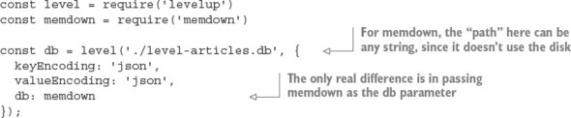
In this sample, you could’ve used the same level package you used before, because it’s just a wrapper for LevelUP. But if you’re not using the LevelDB-backed LevelDOWN that comes bundled with level, you can just use LevelUP and avoid the binary dependency on LevelDB via LevelDOWN.

8.12.8. The modular database
LevelDB’s performance and minimalism resonate with many Node developers, and it has fostered a modular database movement within the Node community. The concept is to be able to pick and choose exactly which features your application needs and tailor a database for your specific use case.
Here are just a few examples of modular LevelDB functionality available through npm packages:

Atomic updates
Autoincrementing keys
Geospatial queries
Live update streams
LRU eviction
Map/reduce jobs
Master/master replication
Master/slave replication
SQL queries
Secondary indexes
Triggers
Versioned data
The LevelUP wiki maintains a fairly comprehensive overview of the LevelDB ecosystem: https://github.com/Level/levelup/wiki/Modules, or you can search for leveldb on npm, for which there are 898 packages at the time of this writing. Figure 8.6 shows how popular LevelDB is on npm.

Figure 8.6. Examples of third-party LevelDB packages on npm
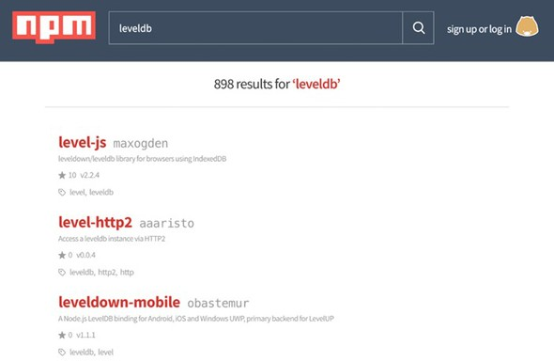

8.13. Serialization and deserialization are expensive
It’s important to remember that the built-in JSON operations are both expensive and blocking; your process can’t do anything else while it’s marshalling data to and from JSON. The same goes for most other serialization formats. It’s common for serialization to be a key bottleneck on a web server. The best way to reduce its impact is to minimize how often it’s performed and how much data it needs to handle.
You may experience some speed improvement by using a different serialization format (for example, MessagePack or Protocol Buffers), but alternative formats should be considered only after you've squeezed the possible gains out of reducing the payload sizes and unnecessary serialization/deserialization steps.
JSON.stringify and JSON.parse are native functions and have been thoroughly optimized, but they can easily be overwhelmed when needing to handle megabytes of data. To demonstrate, the following listing benchmarks serializing and deserializing about 10 MB of data.

Listing 8.22. Serialization benchmarking
const bytes = require('pretty-bytes');
const obj = {};
for (let i = 0; i < 200000; i++) {
obj[i] = {
[Math.random()]: Math.random()
};
}
console.time('serialise');
const jsonString = JSON.stringify(obj);
console.timeEnd('serialise');
console.log('Serialised Size', bytes(Buffer.byteLength(jsonString)));
console.time('deserialise');
const obj2 = JSON.parse(jsonString);
console.timeEnd('deserialise');
On a 2015 3.1 GHz Intel Core i7 MacBook Pro running Node 6.2.2, it takes roughly 140 ms to serialize, and 335 ms to deserialize, the approximately 10 MB of data. This would be a disaster if such a load were to occur on a web server, because these steps are totally blocking and have to be processed in series. Such a server would be able to handle only about a dismal seven requests a second when serializing, and about three requests a second when deserializing.

8.14. In-browser storage
The asynchronous programming model used in Node works well for many use cases because the assumption holds that I/O is the single biggest bottleneck for most web applications. The single most significant thing you can do to simultaneously reduce server workload and improve user experience is to take advantage of client-side data storage. A happy user is one who doesn’t have to wait for a full network round-trip to get results. Client-side storage can also facilitate improved application availability by allowing your application to remain at least semifunctional while the user or your service is offline.

8.14.1. Web storage: localStorage and sessionStorage
Web storage defines a simple key/value store and has great support across both desktop and mobile browsers. Using web storage, a domain can persist a moderate amount of data in the browser and retrieve it at a later time, even after the website has been refreshed, the tab closed, or the browser shut down. Web storage is your first resort for client-side persistence. Its winning feature is its bare simplicity.
There are two web storage APIs: localStorage and sessionStorage. sessionStorage implements an identical API to localStorage, though it differs in its persistence behavior. Like localStorage, data stored in sessionStorage is persisted across page reloads, but unlike localStorage, all sessionStorage data expires when the page session ends (when the tab or browser is closed). sessionStorage data can’t be accessed from different browser windows.
The web storage APIs were developed to overcome limitations with browser cookies. Specifically, cookies aren’t well suited for sharing data between multiple active tabs on the same domain. If a user is performing an activity across multiple tabs, sessionStorage can be used for sharing state between those tabs, without requiring the use of the network.
Cookies are also ill-suited for handling more long-term data that should live across multiple sessions, tabs, and windows; for example, user-authored documents or email. This is the use case that localStorage was designed to handle. Depending on the particular browser, varying upper limits exist for the amount of data that can be stored in web storage. Mobile browsers are limited to just 5 MB of storage.

API overview
The localStorage API provides the following methods for working with keys and values:

localStorage.setItem(key, value)—Store a value under key
localStorage.getItem(key)—Get the value under key
localStorage.removeItem(key)—Remove the value under key
localStorage.clear()—Remove all keys and values
localStorage.key(index)—Get value at index
localStorage.length—Total number of keys in localStorage

8.14.2. Reading and writing values
Both keys and values must be strings. If you pass a value that isn’t a string, it’ll be coerced into a string for you. This conversion doesn’t produce JSON strings; instead, it’s a naïve conversion using .toString. Objects will end up serialized as the string [object Object]. The application must serialize values to and from strings in order to store more-complicated data types in web storage. The next listing shows how to store JSON in localStorage.

Listing 8.23. Storing JSON in web storage
const examplePreferences = {
temperature: 'Celcius'
};
// serialize on write
localStorage.setItem('preferences', JSON.stringify(examplePreferences));
// deserialize on read
const preferences = JSON.parse(localStorage.getItem('preferences'));
console.log('Loaded preferences:', preferences);
Access to web storage data is reasonably fast, though it’s also synchronous. Web storage blocks the UI thread while performing read and write operations. For small workloads, this overhead will be unnoticeable, but care should be taken to avoid excessive reads or writes, especially with large quantities of data. Unfortunately, web storage is also unavailable from web workers, so all reads and writes must happen on the main UI thread. For a detailed analysis of the performance impact of various client-side storage technologies, see this post by Nolan Lawson, author of PouchDB: http://nolanlawson.com/2015/09/29/indexeddb-websql-localstorage-what-blocks-the-dom/.
Web storage APIs provide no built-in facilities to perform queries, select keys by range, or search through values. You’re limited to accessing items key by key. To perform searches, you can set up and maintain your own indexes; or if your dataset is small enough, you can iterate over it in its entirety. The following listing iterates over all the keys in localStorage.

Listing 8.24. Iterating over entire dataset in localStorage
function getAllKeys() {
return Object.keys(localStorage);
}
function getAllKeysAndValues() {
return getAllKeys()
.reduce((obj, str) => {
obj[str] = localStorage.getItem(str);
return obj;
}, {});
}
// Get all values
const allValues = getAllKeys().map(key => localStorage.getItem(key));
// As an object
console.log(getAllKeysAndValues());
As in most key/value stores, there’s only a single namespace for keys. For example, if you have posts and comments, there’s no way to create separate stores for posts and comments. It’s easy enough to create your own “namespace” by using a prefix on each key to delineate namespaces, as shown in the next listing.

Listing 8.25. Namespacing keys
localStorage.setItem(`/posts/${post.id}`, post);
localStorage.setItem(`/comments/${comment.id}`, comment);
To get all items within a namespace, you can filter through all items using the preceding getAllKeys function, as shown in the next listing.

Listing 8.26. Getting all items in a namespace
function getNamespaceItems(namespace) {
return getAllKeys().filter(key => key.startsWith(namespace));
}
console.log(getNamespaceItems('/exampleNamespace'));
Note that this loops over every single key in localStorage, so be wary of performance when iterating over many items.
As a result of the localStorage API being synchronous, a few restrictions exist on when and where it can be used. For example, you could use localStorage to permanently memoize the result of any function that takes and returns JSON-serializable data, as shown in the following listing.

Listing 8.27. Using localStorage for persistent memoization
// subsequent calls with the same argument will fetch the memoized result
function memoizedExpensiveOperation(data) {
const key = `/memoized/${JSON.stringify(data)}`;
const memoizedResult = localStorage.getItem(key);
if (memoizedResult != null) return memoizedResult;
// do expensive work
const result = expensiveWork(data);
// save result to localStorage, never calculate again
localStorage.setItem(key, result);
return result;
}
Note that an operation would need to be particularly slow in order for the memoization benefits to outweigh the overhead of the serialization/deserialization process (for example, a cryptographic algorithm). As such, localStorage works best when it’s saving time spent moving data across a network.
Web storage does have limitations, but for the right tasks, it can be a powerful and simple tool. Other in-browser storage topics to investigate are as follows:

IndexedDB
Service workers
Offline-first

8.14.3. localForage
Web storage’s main drawbacks are its blocking, synchronous API and limited storage capacity in some browsers. In addition to web storage, most modern browsers also support one or both of WebSQL and IndexedDB. Both data stores are nonblocking and can reliably hold far more data than web storage.
But using either of these databases directly, as we did with the web storage APIs, is inadvisable. WebSQL is deprecated, and its successor, IndexedDB, has a particularly unfriendly and verbose API, not to mention patchier browser support. To conveniently and reliably store data in the browser without blocking, we’re relegated to using a nonstandard tool to “normalize” the landscape. The localForage library from Mozilla (http://mozilla.github.io/localForage/) is one such normalizing tool.

API overview
Conveniently, the localForage interface closely mirrors that of web storage, though in an asynchronous, nonblocking form:

localforage.setItem(key, value, callback)—Store a value under key
localforage.getItem(key, callback)—Get the value under key
localforage.removeItem(key, callback)—Remove the value under key
localforage.clear(callback)—Remove all keys and values
localforage.key(index, callback)—Get value at index
localforage.length(callback)—Number of keys in localForage
The localForage API also includes useful additions with no web storage equivalent:

localforage.keys(callback)—Remove all keys and values
localforage.iterate(iterator, callback)—Iterate over keys and values

8.14.4. Reading and writing
The localForage API supports both promises and Node’s error-first callback convention.

Listing 8.28. Comparison of getting data with localStorage vs. localForage
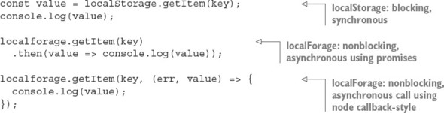
Under the hood, localForage utilizes the best storage mechanism available in the current browser environment. If IndexedDB is available, localForage will use that. Otherwise, it’ll try to fall back to WebSQL or even using web storage if required. You can configure the order in which the stores will be tried and even blacklist certain options:
Unlike localStorage, localForage isn’t limited to storing just strings. It supports most JavaScript primitives such as arrays and objects, as well as binary data types: Typed-Arrays, ArrayBuffers, and Blobs. Note that IndexedDB is the only back end that can store binary data natively: the WebSQL and localStorage back ends will incur marshalling overheads:
Promise.all([
localforage.setItem('number', 3),
localforage.setItem('object', { key: 'value' }),
localforage.setItem('typedarray', new Uint32Array([1,2,3]))
]);
Mirroring the web storage APIs makes localForage intuitive to use, while also overcoming many of the shortcomings and compatibility issues when trying to store data in the browser.

8.15. Hosted storage
Hosted storage is another tactic you can use to avoid managing your own server-side storage. Hosted infrastructure services such as those provided by Amazon Web Services (AWS) are often considered as only a scaling and performance optimization, but smart usage of hosted services early on can save a lot of time implementing unnecessary infrastructure poorly.
Many, if not all, of the databases listed in this chapter have a hosted offering. Hosted services allow you to try tools quickly and even deploy publicly accessible production applications without the hassles of setting up your own database hosting. But hosting your own is becoming increasingly easy. Many cloud services provide prebuilt server images, loaded with all the right software and configurations needed to run a machine hosting the database of your choosing.

8.15.1. Simple Storage Service
Amazon Simple Storage Service (S3) is a remote file-hosting service provided as a part of the popular AWS suite. S3 is a cost-effective means of storing and hosting network-accessible files. It’s a filesystem in the cloud. Using RESTful HTTP calls, files can be uploaded into buckets, along with up to 2 KB of metadata. Bucket contents can then be accessed via HTTP GET or the BitTorrent protocol.
Buckets and their contents can be configured with various permissions, including time-based access. You can also specify a time to live (TTL) on bucket contents themselves, after which they’ll become inaccessible and be removed from your bucket. It’s easy to promote your S3 data up to a content delivery network (CDN). AWS provides the CloudFront CDN, which can be easily connected to your files and will be accessible with low latency from around the world.
Not all data needs to be or should be stored in a database. Are there components of your data that could be treated as files? After you’ve generated the results of an expensive calculation for a user, perhaps you can push those results up to S3 then forever step out of the way.
A common and obvious use for S3 is the hosting of user-uploaded assets such as images. Uploaded assets live in a temporary directory on the application machine, processed by using a tool such as ImageMagick to reduce the file size, and then uploaded to S3 for hosting to web browsers. This process can be simplified even further by streaming uploads directly to S3, where they can trigger further processing. The client-side applications can also upload to S3 directly. Some more developer-centric services even opt for providing absolutely zero storage, requiring users to provide access tokens so the application can use their S3 buckets.

S3 isn’t limited to the storage of images
S3 can be used to store any type of file, up to 5 terabytes in size, of any format. S3 works best for large blobs of data that change infrequently and need to be accessed as a single atom.
Storing data in S3 steps around the complications and complexity of setting up and maintaining a server for the hosting and storage of files. It’s great for instances where writes are infrequent, large chunks of data need to be accessed as a single atom, and there are many reads and potentially many read locations.

8.16. Which database?
In this chapter, we’ve covered just a few of the many databases commonly used in Node applications. Successful applications can be and have been built using any of these databases. Within a single application, there’s not always one ideal data storage solution; there’s no silver bullet. Each database presents its own unique set of trade-offs, and it’s up to the developer to evaluate which trade-offs make sense for the current state of the project. A hybrid of technologies is frequently the most appropriate.
Rather than asking, “What database should I use?” you could be asking, “How far can I go without using a database at all?” How much of your project can you build with the fewest long-lasting decisions? It’s often best to defer decisions; you’ll always be able to make a better decision later, when you have more information.

8.17. Summary

Both relational and NoSQL databases can be used with Node.
The simple pg Node module is great for working with the SQL language.
The Knex module allows you to use several databases with Node.
ACID is a set of properties for database transactions and ensures safety.
MongoDB is a NoSQL database that uses JavaScript.
Redis is a data-structure store that can be used as a database and cache.
LevelDB is a fast key/value store by Google that maps from strings to values.
LevelDB is a modular database.
Web-based storage, including localForage and localStorage, can be used to save data in browsers.
Storage services, such as Amazon S3, can be used to persist data to cloud providers.

Chapter 9. Testing Node applications
This chapter covers

Testing logic with Node’s assert module
Using other assertion libraries
Using Node unit-testing frameworks
Simulating and controlling web browsers using Node
Getting more details when tests fail
As features are added to your application, the risk of introducing bugs is increased. An application isn’t complete if it’s not tested, and because manual testing is tedious and prone to human error, automated testing has become increasingly popular with developers. Automated testing involves writing logic to test your code, rather than running through application functionality by hand.
If the idea of automated testing is new to you, think of it as a robot doing all of the boring stuff while you focus on the interesting work. Every time you make a change to the code, the robot ensures that bugs haven’t crept in. Although you may not have completed or started your first Node application yet, it’s good to get a handle on how to implement automated testing because you’ll be able to write tests as you develop.
In this chapter, you’ll look at two types of automated testing: unit testing and acceptance testing. Unit testing is used to verify logic, typically at a function or method level, and it’s applicable to all types of applications. Unit-testing methodologies can be divided into two major forms: test-driven development (TDD) and behavior-driven development (BDD). Practically speaking, TDD and BDD are largely the same thing, but they differ stylistically. This can be important, depending on who needs to read your tests. Other differences between TDD and BDD exist, but they’re beyond the scope of this book. Acceptance testing is an additional layer of testing most commonly used for web applications. Acceptance testing involves scripting control of a browser and attempting to trigger web application functionality with it.
This chapter covers established solutions for both unit and acceptance testing. For unit testing, we cover Node’s assert module; the Mocha, Vows, and Should.js frameworks; and Chai. For acceptance testing, we look at using Selenium with Node. Figure 9.1 places the tools alongside their respective testing methodologies and flavors.

Figure 9.1. Test framework overview
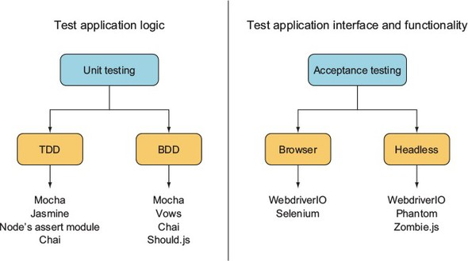
Let’s start with unit testing.

9.1. Unit testing
Unit testing is a type of automated testing in which you write logic to test discrete parts of your application. Writing tests helps you think more critically about your application design choices and helps you avoid pitfalls early on. The tests also give you confidence that your recent changes haven’t introduced errors. Although unit tests take a bit of work up front to write, they can save you time by lessening the need to manually retest every time you make a change to an application.
Unit testing can be tricky, and testing asynchronous logic can present its own challenges. Asynchronous unit tests can run in parallel, so you have to be careful to ensure that tests don’t interfere with each other. For example, if your tests create temporary files on disk, you have to be careful that when you delete the files after a test, you don’t delete the working files of another test that hasn’t yet finished. For this reason, many unit-testing frameworks include flow control to sequence the running of tests.
In this section, we show you how to use the following:

Node’s built-in assert module— A good building block for TDD-style automated testing
Mocha— A relatively new testing framework that can be used for TDD- or BDD-style testing
Vows— A widely used BDD-style testing framework
Should.js— A module that builds on Node’s assert module to provide BDD-style assertions
The next section demonstrates how to test business logic with the assert module, which is included with Node.

9.1.1. The assert module
The basis for most Node unit testing is the built-in assert module, which tests a condition and, if the condition isn’t met, throws an error. Node’s assert module is used by many third-party testing frameworks. Even without a testing framework, you can do useful testing with it. If you’re trying out a quick idea, you can use the assert module by itself to write a quick test.

A simple example
Suppose you have a simple to-do application that stores items in memory, and you want to assert that it’s doing what you think it’s doing.
The following listing defines a module containing the core application functionality. Module logic supports creating, retrieving, and deleting to-do items. It also includes a simple doAsync method, so you can look at testing asynchronous methods too. Save this file as todo.js.

Listing 9.1. A model for a to-do list
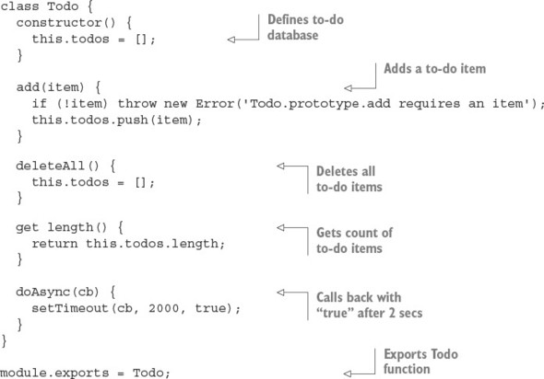
Now you can use Node’s assert module to test the code. In a file called test.js, enter the following code to load the necessary modules, set up a new to-do list, and set a variable that tracks the number of completed tests.

Listing 9.2. Set up necessary modules
const assert = require('assert');
const Todo = require('./todo');
const todo = new Todo();
let testsCompleted = 0;

Using equal to test the contents of a variable
Next, you can add a test of the to-do application’s delete functionality. Add the function in the following listing to the end of test.js.

Listing 9.3. Test to make sure that no to-do items remain after deletion
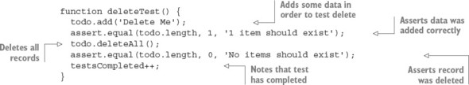
This test adds a todo item and then deletes it. Because there should be no to-dos at the end of this test, the value of todo.length should be 0 if the application logic is working properly. If a problem occurs, an exception is thrown. If the value returned by todo.length isn’t set to 0, the assertion will result in a stack trace showing an error message, “No items should exist,” outputted to the console. After the assertion, testsCompleted is incremented to note that a test has completed.

Using notEqual to find problems in logic
Next, add the code in the following listing to test.js. This code is a test of the to-do application’s add functionality.

Listing 9.4. Test to make sure adding a to-do works
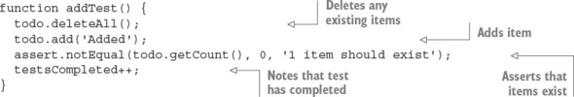
The assert module also allows notEqual assertions. This type of assertion is useful when the generation of a certain value by application code indicates a problem in logic. Listing 9.4 shows the use of a notEqual assertion. All to-do items are deleted, an item is added, and the application logic then gets all items. If the number of items is 0, the assertion will fail and an exception will be thrown.

Using additional functionality: strictEqual, notStrictEqual, deep- pEqual, notDeepEqual
In addition to equal and notEqual functionality, the assert module offers strict versions of assertions called strictEqual and notStrictEqual. These use the strict equality operator (===) rather than the more permissive version (==).
To compare objects, the assert module offers deepEqual and notDeepEqual. The deep in the names of these assertions indicates that they recursively compare two objects, comparing two object’s properties, and if the properties are themselves objects, comparing these as well.

Using ok to test for an asynchronous value being true
Now it’s time to add a test of the to-do application’s doAsync method, as shown in listing 9.5. Because this is an asynchronous test, you’re providing a callback function (cb) to signal to the test runner when the test has completed; you can’t rely on the function returning to tell you, as you can with synchronous tests. To see whether the result of doAsync is the value true, use the ok assertion. The ok assertion provides an easy way to test a value for being true.

Listing 9.5. Test whether the doAsync callback is passed true
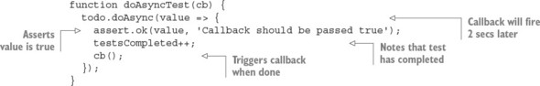

Testing that thrown errors are correct
You can also use the assert module to check that thrown error messages are correct, as the following listing shows. The second argument in the throws call is a regular expression that looks for the text requires in the error message.

Listing 9.6. Test whether add throws when missing a parameter
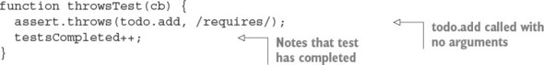

Adding logic to run your tests
Now that you’ve defined the tests, you can add logic to the file to run each of the tests. The logic in the following listing runs each test, and then prints the number of tests that were run and completed.

Listing 9.7. Running the tests and reporting test completion
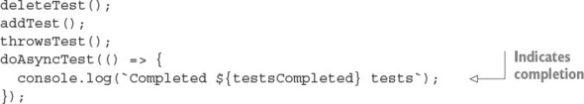
You can run the tests with the following command:
$ node chapter09-testing/listing_09_1-7/test.js
If the tests don’t fail, the script informs you of the number of tests completed. It also can be smart to keep track of when tests start execution as well as when they complete, to protect against flaws in individual tests. For example, a test may execute without reaching the assertion.
In order to use Node’s built-in functionality, each test case has to include a lot of boilerplate to set up the test (such as deleting all items) and to keep track of progress (the completed counter). All this boilerplate shifts the focus away from the primary concern of writing test cases, and it’s better left to a dedicated framework that can do the heavy lifting while you focus on testing business logic. Let’s look at making things easier by using Mocha, a third-party unit-testing framework.

9.1.2. Mocha
Mocha, a popular testing framework, is easy to grasp. Although it defaults to a BDD style, you can also use it in a TDD style. Mocha has a wide variety of features, including global variable leak detection and client-side testing.

Global variable leak detection
You should have little need for global variables that are readable application-wide, and it’s considered a programming best practice to minimize your use of them. But in ES5, it’s easy to inadvertently create global variables by forgetting to include the var keyword when declaring a variable. Mocha helps detect accidental global variable leaks by throwing an error when you create a global variable during testing.
If you want to disable global leak detection, run mocha with the --ignored-leaks command-line option. Alternatively, if you want to allow a select number of globals to be used, you can specify them by using the --globals command-line option followed by a comma-delimited list of allowable global variables.
By default, Mocha tests are defined and their logic is set up by using BDD-flavored functions called describe, it, before, after, beforeEach, and afterEach. Alternatively, you can use Mocha’s TDD interface, which replaces the use of describe with suite, it with test, before with setup, and after with teardown. For our example, you’ll stick with the default BDD interface.

Testing Node applications with Mocha
Let’s dive right in and see how to create a small project called memdb—a small in-memory database—and use Mocha to test it. First, you need to create the directories and files for the project:
$ mkdir -p memdb/test
$ cd memdb
$ touch index.js
$ touch test/memdb.js
$ npm init -y
$ npm install --save-dev mocha
Open package.json and add a scripts property that defines how the tests are run:
"scripts": {
"test": "mocha"
},
The test directory is where the tests will live. By default, Mocha uses the BDD interface. The following listing shows what it looks like (chapter09-testing/memdb in the book’s sample code).

Listing 9.8. Basic structure for a Mocha test
const memdb = require('..');
describe('memdb', () => {
describe('.saveSync(doc)', () => {
it('should save the document', () => {
});
});
});
Mocha also supports TDD and qunit, and exports style interfaces, which are detailed on the project’s site (https://mochajs.org/). To illustrate the concept of interfaces, here’s the exports interface:
module.exports = {
'memdb': {
'.saveSync(doc)': {
'should save the document': () => {
}
}
}
}
All of these interfaces provide the same functionality, but for now you’ll stick to the BDD interface and write the first test, shown in the following listing, in test/memdb.js. This test uses Node’s assert module to perform the assertions.

Listing 9.9. Describing the memdb .save functionality
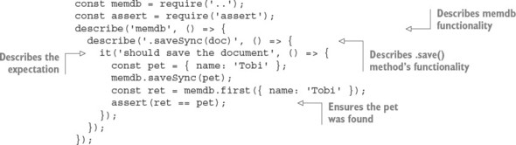
To run the tests, all you need to do is execute npm test. Mocha looks in the ./test directory by default for JavaScript files to execute. Because you haven’t implemented the .saveSync() method yet, you’ll see that the single defined test fails, as shown in figure 9.2.

Figure 9.2. Failing test in Mocha
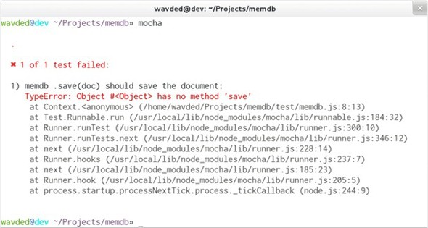
Let’s make it pass! Add the code in the following listing to index.js.

Listing 9.10. Added save functionality
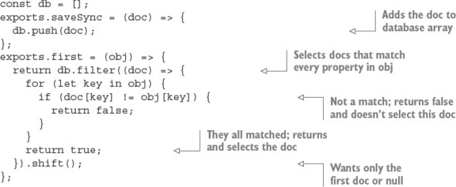
Run the tests again with npm, and the results should be similar to figure 9.3.

Figure 9.3. Successful test in Mocha
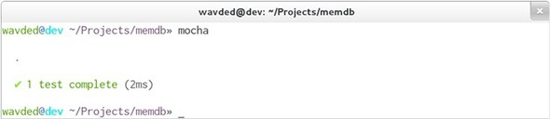

Defining setup and cleanup logic by using Mocha hooks
The test case in listing 9.10 makes the assumption that memdb.first() works correctly, so you’ll want to add a few test cases for that as well. The revised test file, listing 9.11, includes a new concept—the concept of Mocha hooks. The BDD interface exposes beforeEach(), afterEach(), before(), and after(), which take callbacks for defining setup and cleanup logic.

Listing 9.11. Adding a beforeEach hook
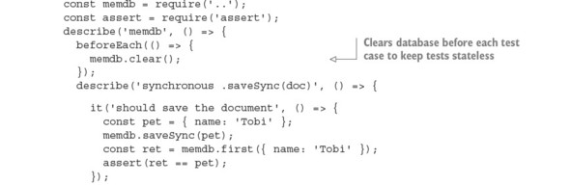
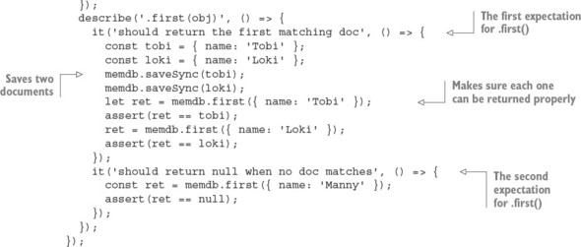
Ideally, test cases share no state whatsoever. To achieve this with memdb, you need to remove all the documents by implementing the .clear() method in index.js:
exports.clear = () => {
db.length = 0;
};
Running Mocha again should show you that three tests have passed.

Testing asynchronous logic
One thing we haven’t yet looked at in Mocha is testing asynchronous logic. To see how this is done, you’ll make a small change to one of the functions defined earlier in index.js. By changing the save function to the following, a callback can be optionally provided that will execute after a small delay (meant to simulate some sort of asynchronous operation):
exports.save = (doc, cb) => {
db.push(doc);
if (cb) {
setTimeout(() => {
cb();
}, 1000);
}
};
Mocha test cases can be defined as asynchronous by adding an argument to a function defining testing logic. The argument is commonly named done. The following listing shows how to write a test for the asynchronous save method.

Listing 9.12. Testing asynchronous logic
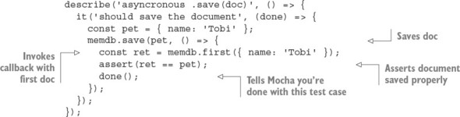
This same rule applies to all of the hooks. For example, the beforeEach() hook to clear the database could add a callback, and Mocha could wait until it’s called in order to move on. If done() is invoked with an error as the first argument, Mocha will report the error and mark the hook or test case as a failure:
beforeEach((done) => {
memdb.clear(done);
});
For more about Mocha, check out its full online documentation: http://mochajs.org. Mocha also works for client-side JavaScript.
Mocha’s use of nonparallel testing
Mocha executes tests one after another rather than in parallel, which makes test suites execute more slowly but makes writing tests easier. But Mocha won’t let any test run for an inordinately long time. Mocha, by default, allows any given test to run for only 2,000 milliseconds before failing it. If you have tests that take longer, you can run Mocha with the --timeout command-line option and then specify a larger number.
For most testing, running tests serially is fine. If you find this problematic, other frameworks, such as Vows, execute in parallel, and are covered in the next section.

9.1.3. Vows
The tests you can write using the Vows unit-testing framework are more structured than those of many other frameworks, with the structure intended to make the tests easy to read and maintain.
Vows uses its own BDD-flavored terminology to define test structure. In the realm of Vows, a test suite contains one or more batches. A batch can be thought of as a group of related contexts, or conceptual areas of concern that you want to test. The batches and contexts run in parallel. A context may contain a topic, one or more vows, and/or one or more related contexts (inner contexts also run in parallel). A topic is testing logic that’s related to a context. A vow is a test of the result of a topic. Figure 9.4 shows how Vows structures tests.

Figure 9.4. Vows can structure tests in a suite using batches, contexts, topics, and vows.
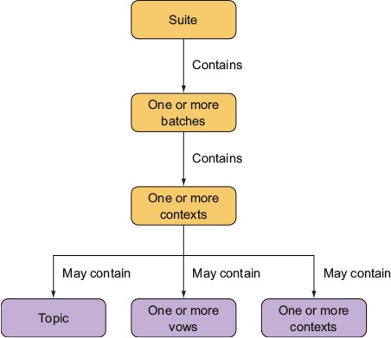
Vows, like Mocha, is geared toward automated application testing. The difference is primarily in flavor and parallelism, with Vows tests requiring a specific structure and terminology. In this section, we run through an example application test and explain how to use a Vows test to run multiple tests at the same time.
Add Vows to the to-do project by installing it using npm:
mkdir -p vows-todo/test
cd vows-todo
touch todo.js
touch test/todo-test.js
npm init -y
npm install --save-dev –g vows
You need to add Vows to the test property in package.json so you can run the tests by typing npm test:
"scripts": {
"test": "vows test/*.js"
},

Testing application logic with Vows
You can trigger testing in Vows either by running a script containing test logic or by using the vows command-line test runner. The following example of a standalone test script (which can be run like any other Node script) uses one of the tests of the to-do application’s core logic.
Listing 9.13 creates a batch. Within the batch, you define a context. Within the context, you define a topic and a vow. Note how the code uses the callback to deal with asynchronous logic in the topic. If a topic isn’t asynchronous, a value can be returned rather than being sent via a callback. Save the file as test/todo-test.js.

Listing 9.13. Using Vows to test the to-do application
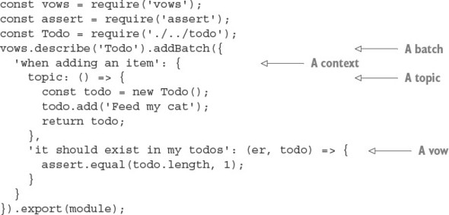
You should be able to run this test by typing npm test. If you install Vows globally with npm i -g vows, you can also run all tests in a folder named test by entering the following command:
$ vows test/*
For more about Vows, check out the project’s online documentation (http://vowsjs.org/), as shown in figure 9.5.

Figure 9.5. Vows combines full-featured BDD testing with macros and flow control.
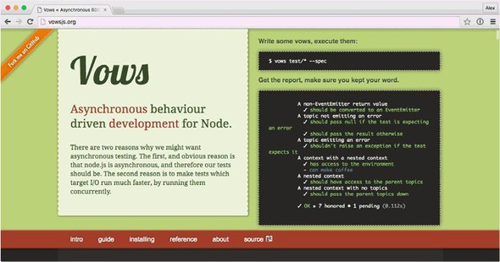
Vows offers a comprehensive testing solution, but you can mix and match test library features by using a different assertion library. Perhaps you like Mocha but don’t like Node’s assertion library. The next section introduces Chai, an assertion library that you can use in place of Node’s assert module.

9.1.4. Chai
Chai (http://chaijs.com/) is a popular assertion library that comes with three interfaces: should, expect, and assert. The assert interface, shown in the following listing, looks like Node’s built-in assertion module, but it comes with useful tools for comparing objects, arrays, and their properties. For example, typeOf can be used to compare types, and property checks that an object has the desired property.

Listing 9.14. Chai’s assert interface
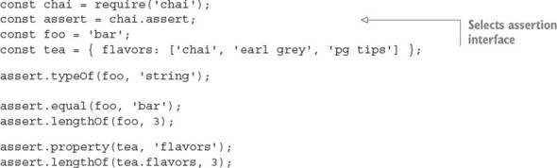
The main reason you might want to try Chai is the should and expect interfaces. They provide fluent APIs that are more like BDD-style libraries. Here’s the expect interface:
const chai = require('chai');
const expect
=
chai.expect;
const foo = 'bar';
expect(foo).to.be.a('string');
expect(foo).to.equal('bar');
This API reads more like an English sentence—the declarative style is more verbose but easier to read aloud. The should interface switches this around: objects are decorated to have extra properties, so you don’t need to wrap assertions in a call as with expect:
const chai = require('chai');
chai.should();
const foo = 'bar';
foo.should.be.a('string');
foo.should.equal('bar');
Deciding which interface to use depends on the project. If you’re writing tests first and using them to document the project, the verbose expect and should interfaces will work well. JavaScript purists prefer expect because it doesn’t change prototypes, but those with Ruby experience may be familiar with APIs such as should.
The main advantage of using Chai is the range of plugins. This includes handy things such as chai-as-promised (http://chaijs.com/plugins/chai-as-promised/), which helps test code that uses promises, and chai-stats (http://chaijs.com/plugins/chai-stats/), a library for comparing numbers according to statistical methods. Note that Chai is an assertion library, so you should use it alongside a test runner like Mocha.
Another BDD assertion library like Chai is Should.js. The next section introduces Should.js and demonstrates how to write tests with it.

9.1.5. Should.js
Should.js is an assertion library that can help make your tests easier to read by allowing you to express assertions in a BDD-like style. It’s designed to be used in conjunction with other testing frameworks, which lets you continue to use your own preferred framework. In this section, you’ll learn how to write assertions with Should.js and, as an example, you’ll write a test for a custom module.
Should.js is easy to use with other frameworks because it augments Object. --proto-type with a single property: should. This allows you to write expressive assertions such as user.role.should.equal('admin'), or users.should.include ('rick').
Let’s say you’re writing a Node command-line tip calculator that you want to use to figure out who should pay what amount when you split a bill with friends. You’d like to write tests for your calculation logic in a way that’s easily understood by your nonprogrammer friends, because then they won’t think you’re cheating them.
To set up your tip calculator application, enter the following commands, which set up a folder for the application, and then install Should.js for testing:
mkdir -p tips/test
cd tips
touch index.js
touch test/tips.js
Now you can install Should.js by running the following commands:
npm init -y
npm install --save-dev should
Next, edit the index.js file, which will contain the logic defining the application’s core functionality. Specifically, the tip calculator logic includes four helper functions:

addPercentageToEach—Increases each number in an array by a given percentage
sum—Calculates the sum of each element in an array
percentFormat—Formats a percentage for display
dollarFormat—Formats a dollar value for display
Add this logic by populating index.js with the contents of the following listing.

Listing 9.15. Logic for calculating tips when splitting a bill
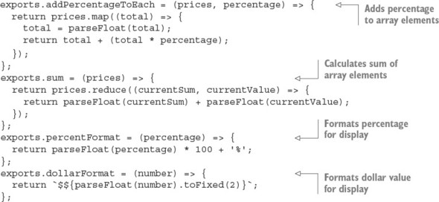
Now edit the test script in test/tips.js, as shown in the following listing. The script loads the tip logic module; defines a tax, tip percentage, and the bill items to test; tests the addition of a percentage to each array element; and tests the bill total.

Listing 9.16. Logic that calculates tips when splitting a bill
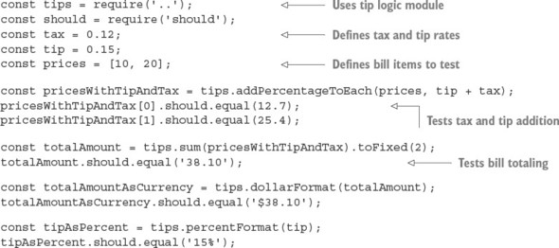
Run the script by using the following command. If all is well, the script should generate no output, because no assertions have been thrown, and your friends will be reassured of your honesty:
$ node test/tips.js
To make this easier to run, add it as the test property under scripts in package.json:
"scripts": {
"test": "node test/tips.js"
}
Should.js supports many types of assertions—everything from assertions that use regular expressions to assertions that check object properties—allowing comprehensive testing of data and objects generated by your application. The project’s GitHub page (https://github.com/shouldjs/should.js) provides comprehensive documentation of Should.js’s functionality.
Spies, stubs, and mocks are often used in addition to assertion libraries to control the way that code under tests is executed. The next section demonstrates how to do these with Sinon.JS.

9.1.6. Spies and stubs with Sinon.JS
The final tool for your testing toolbox is a mock and stub library. The reason we write unit tests is to isolate parts of a system to test, but sometimes this is difficult. For example, imagine you’re testing code that resizes images. You don’t want to write to real image files, so how do you write tests? The code shouldn’t have special test branches that avoid touching the filesystem, because then you wouldn’t be truly testing the code. In cases like this, you need to stub the filesystem functionality. The practice of writing stubs also helps you do true TDD, because you can stub dependencies that aren’t ready yet.
In this section, you’ll learn how to use Sinon.JS (http://sinonjs.org/) to write test spies, stubs, and mocks. Before you get started, create a new project and install Sinon:
mkdir sinon-js-examples
cd sinon-js-examples
npm init -y
mkdir test
npm i --save-dev sinon
Next create a sample file to test. The example we use is a simple JSON key/value database. Our goal is to be able to stub the filesystem API so it doesn’t create real files on the filesystem. This will allow us to test only our database code rather than the file-handling code, as shown in the next listing.

Listing 9.17. Database class
const fs = require('fs');
class Database {
constructor(filename) {
this.filename = filename;
this.data = {};
}
save(cb) {
fs.writeFile(this.filename, JSON.stringify(this.data), cb);
}
insert(key, value) {
this.data[key] = value;
}
}
module.exports = Database;
Save the listing as db.js. Now you’ll try testing it with Sinon’s spies.

Spies
Sometimes you just want to see whether a method has been called. Spies are perfect for this. The API lets you replace a method with something you can use to make assertions on. To mock the fs.writeFile call in db.js, use Sinon’s method replacement, spy:
sinon.spy(fs, 'writeFile');
When the test is finished, you can get the original method back with restore:
fs.writeFile.restore();
In a test library like Mocha, you’d place these calls in the beforeEach and afterEach blocks. The following listing shows a full example of using spies. Save this file as spies.js.

Listing 9.18. Using spies
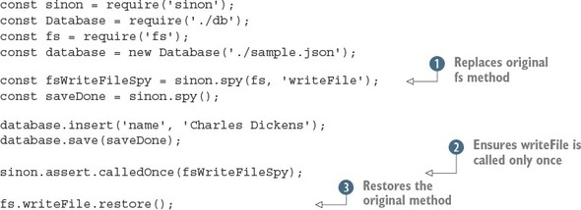
After setting up the spy , the code under test is run. Then you ensure that the expected method was called with sinon.assert . The original method is then restored . In this test, restoring it isn’t strictly necessary, but it’s best practice to always restore methods that you’ve changed.

Stubs
Sometimes you need to control code flow. For example, you might want to force an error branch to be executed so you can test error handling in your code. The preceding example could be rewritten to use a stub instead of a spy to cause writeFile to execute its callback. Note that you still want to avoid calling the original method, but instead force the code under test to run the supplied callback. The next listing shows how to use stubs to replace functions. Save it as stub.js.

Listing 9.19. Using stubs
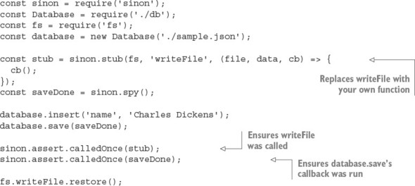
Using a combination of stubs and spies is ideal for testing Node code that makes heavy use of user-supplied functions, callbacks, and promises. Now that you’ve looked at tools designed for unit testing, let’s move on to an altogether different style of testing: functional testing.

9.2. Functional testing
In most web development projects, functional tests work by driving the browser and then checking for various DOM transformations against a list of user-specific requirements. Imagine you’re building a content management system. A functional test for the image library upload feature would upload an image, check that it gets added, and then check that it’s added to a corresponding list of images.
The choice of tools to implement functional testing in Node is bewildering. From a high level, however, they fall into two broad groups: headless and browser-based tests. Headless tests typically use something like PhantomJS to provide a terminal-friendly browser environment, but lighter solutions use libraries such as Cheerio and JSDOM. Browser-based tests use a browser automation tool such as Selenium (www.seleniumhq.org) so you can write scripts that drive a real browser. Both approaches can use the same underlying Node test tools, so you could use Mocha, Jasmine, or even Cucumber to drive Selenium against your application. Figure 9.6 shows an example test environment.

Figure 9.6. Testing with browser automation
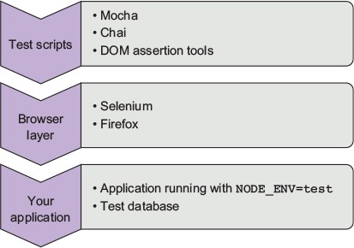
In this section, you’ll learn about functional testing solutions for Node, so you can set up test environments based on your own requirements.

9.2.1. Selenium
Selenium is a popular Java-based browser automation library. With the aid of a language-specific driver, you can connect to a Selenium server and run tests against a real browser. In this section, you’ll learn how to use WebdriverIO (http://webdriver.io/), a Node Selenium driver.
Getting Selenium running is trickier than pure Node test libraries, because you need to install Java and download the Selenium JAR file. Download Java for your operating system, and then go to the Selenium download site (http://docs.seleniumhq.org/download/) to download the JAR file. You can then run a Selenium server like this:
java -jar selenium-server-standalone-2.53.0.jar
Note that your exact Selenium version may be different. You may also have to supply a path to the browser binary. For example, in Windows 10 with Firefox set as the browserName, you can specify Firefox’s full path like this:
java -jar -Dwebdriver.firefox.driver="C:\path\to\firefox.exe" selenium-server-standalone-3.0.1.jar
The exact path will depend on how Firefox is installed on your machine. For more about the Firefox driver, read the SeleniumHQ documentation (https://github.com/SeleniumHQ/selenium/wiki/FirefoxDriver). Drivers for Chrome and Microsoft Edge are configured in similar ways.
Now create a new Node project and install WebdriverIO:
mkdir -p selenium/test/specs
cd selenium
npm init -y
npm install --save-dev webdriverio
npm install --save express
WebdriverIO comes with a friendly config file generator. To run it, run wdio config:
./node_modules/.bin/wdio config
Follow the questions and accept the defaults. Figure 9.7 shows my session.

Figure 9.7. Using wdio to configure Selenium tests
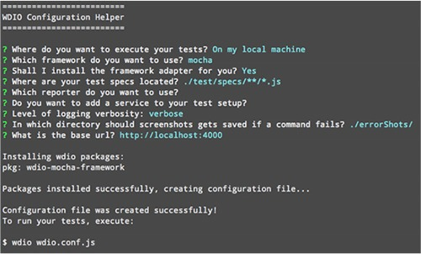
Update the package.json file with the wdio command so tests can be run with npm test:
"scripts": {
"test": "wdio wdio.conf.js"
},
Now add something to the test. A basic Express server will suffice. The example in the following listing will be used in the subsequent listing for testing. Save this listing as index.js (it’s c09-testing/selenium/index.js in the book’s sample code).

Listing 9.20. Sample Express project
const express = require('express');
const app = express();
const port = process.env.PORT || 4000;
app.get('/', (req, res) => {
res.send(`
<html>
<head>
<title>My to-do list</title>
</head>
<body>
<h1>Welcome to my awesome to-do list</h1>
</body>
</html>
`);
});
app.listen(port, () => {
console.log('Running on port', port);
});
The good thing about WebdriverIO is it provides a simple, fluent API for writing Selenium tests. The syntax is clear and easy to learn—you can even write tests with CSS selectors. The next listing (found in test/specs/todo-test.js in the book’s sample code) shows a simple test that sets up a WebdriverIO client and then checks the title on the page.

Listing 9.21. A WebdriverIO test
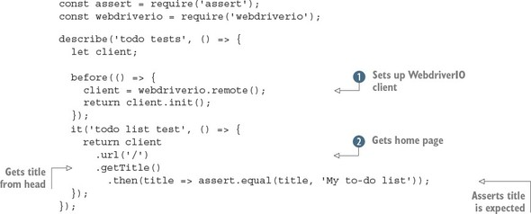
After WebdriverIO is connected , you can use an instance of the client to fetch pages from your app . Then you can query the current state of the document in the browser—this example uses getTitle to get the title element from the document’s head. If you want to query the document for CSS elements, you can use .elements instead (http://webdriver.io/api/protocol/elements.html). There are all kinds of methods for manipulating the document, forms, and even cookies.
This test, which looks like the other Mocha tests in this chapter, is capable of running a real browser against a Node web app. To run it, start the server on port 4000:
PORT=4000 node index.js
Then type npm test. You should see Firefox open and the tests run in the command line. If you want to use Chrome, open wdio.conf.js and change the browserName property.
More-advanced testing with Selenium
If you use WebdriverIO and Selenium to test a more complex web app that uses something like React or Angular, you’ll want to check out the utility methods. Some of the methods will pause the test until certain elements are available, which is great for React apps that may asynchronously render the document, updating it several times based on when remote data is available.
Take a look at the waitFor* methods, such as waitForVisible (http://webdriver.io/api/utility/waitForVisible.html) to learn more.

9.3. Dealing with failing tests
When you’re working on an established project, there will come a point when tests begin to fail. Node provides several tools for getting more detail on failed tests, and in this section you’ll learn about how to enrich the output generated when debugging failing tests.
The first thing to do when tests fail is to generate more-verbose logging output. The next section demonstrates how to do that with NODE_DEBUG.

9.3.1. Getting more-detailed logs
When tests fail, it’s useful to get information on what the program is doing. Node has two ways to do this: one for Node’s internals, and another for npm modules. To debug Node’s core modules, use NODE_DEBUG.

Using NODE_DEBUG
To see how NODE_DEBUG works, imagine you have a deeply nested filesystem call where you’ve forgotten to use a callback. For example, the following example will throw an exception:
const fs = require('fs');
function deeplyNested() {
fs.readFile('/');
}
deeplyNested();
The stack trace shows only a limited amount of detail about the exception, and in particular doesn’t include full information on the call site where the exception originated:
fs.js:60
throw err; // Forgot a callback but don't know where? Use NODE_DEBUG=fs
^
Error: EISDIR: illegal operation on a directory, read
at Error (native)
Without the helpful comment, many programmers see a trace like this and blame Node for the unhelpful error. But, as the comment points out, NODE_DEBUG=fs can be used to get more information on the fs module. Run the script like this instead:
NODE_DEBUG=fs node node-debug-example.js
Now you’ll see a more detailed trace that helps debug the issue:
fs.js:53
throw backtrace;
^
Error: EISDIR: illegal operation on a directory, read
at rethrow (fs.js:48:21)
at maybeCallback (fs.js:66:42)
at Object.fs.readFile (fs.js:227:18)
at deeplyNested (node-debug-example.js:4:6)
at Object.<anonymous> (node-debug-example.js:7:1)
at Module._compile (module.js:435:26)
at Object.Module._extensions..js (module.js:442:10)
at Module.load (module.js:356:32)
at Function.Module._load (module.js:311:12)
at Function.Module.runMain (module.js:467:10)
It’s clear from this trace that the problem lies in our file, inside a function on line 4 that was originally called from line 7. This makes debugging any code that uses core modules much easier, and that includes not only the filesystem, but also network libraries such as Node’s HTTP client and server modules.

Using DEBUG
The public alternative to NODE_DEBUG is DEBUG. Many packages on npm look for the DEBUG environment variable. It mimics the parameter style used by NODE_DEBUG, so you can specify a list of modules to debug or see all of them with DEBUG='*'. Figure 9.8 shows the project from chapter 4 running with DEBUG='*'.

Figure 9.8. Running an Express application with DEBUG='*'
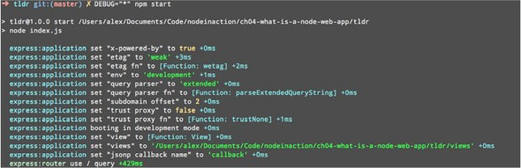
If you want to incorporate the NODE_DEBUG functionality into your own projects, use the built-in util.debuglog method:
const debuglog = require('util').debuglog('example');
debuglog('You can only see these messages by setting NODE_DEBUG=example!');
To make custom debug loggers that are configured with DEBUG, you need to use the debug package from npm (www.npmjs.com/package/debug). You can create as many loggers as you want. Imagine you’re building an MVC web application. You could create separate loggers for models, views, and controllers. Then, when tests fail, you’ll be able to specify the debug logs that are necessary to debug the specific part of the application. The following listing (found in ch09-testing/debug-example/index.js) demonstrates how to use the debug module.

Listing 9.22. Using the debug package
const debugViews = require('debug')('debug-example:views');
const debugModels = require('debug')('debug-example:models');
debugViews('Example view message');
debugModels('Example model message');
To run this example and see the view logs, set DEBUG to debug-example:views:
DEBUG=debug-example:views node index.js
One final feature of debug logging is that you can prefix a debug section with a hyphen to remove it from logs:
DEBUG='* -debug-example:views' node index.js
Hiding certain modules means you can still use the wildcard, but omit unneeded or noisy sections from the output.

9.3.2. Getting better stack traces
If you’re using asynchronous operations, and that includes anything you’ve written using asynchronous callbacks or promises, then you may run into problems when stack traces aren’t detailed enough. Packages on npm can help you in such cases. For example, when callbacks run asynchronously, Node won’t keep the call stack from when the operation was queued. To test this, create two files, one called async.js that defines an asynchronous function, and another called index.js that requires async.js. This snippet is aync.js (found in ch09-testing/debug-stacktraces/async.js in the book’s sample code):
module.exports = () => {
setTimeout(() => {
throw new Error();
})
};
And index.js just needs to require async.js:
require('./async.js')();
Now if you run index.js with node index.js, you’ll get a short stack trace that doesn’t show the caller of the failed function, only the location of the thrown exception:
throw new Error();
^
Error
at null._onTimeout (async.js:3:11)
at Timer.listOnTimeout (timers.js:92:15)
To improve this reporting, install the trace package (www.npmjs.com/package/trace) and run it with node -r trace index.js. The -r flag tells Node to require the trace module before loading anything else.
Another problem with stack traces is they can be too detailed. This happens when the trace includes too much detail about Node’s internals. To clear up your stack traces, use clarify (www.npmjs.com/package/clarify). Again, you can run it with the -r flag:
$ node -r clarify index.js
throw new Error();
^
Error
at null._onTimeout (async.js:3:11)
clarify is particularly useful if you want to include stack traces in error alert emails for a web application.
If you’re running code intended for browsers in Node, perhaps as part of an isomorphic web application, then you can get better stack traces by using source-map-support (www.npmjs.com/package/source-map-support). This can be run with -r, but it also works with some test frameworks:
$ node -r source-map-support/register index.js
$ mocha --require source-map-support/register index.js
The next time you’re struggling with a stack trace generated by asynchronous code, look for tools such as trace and clarify to make sure you’re getting the best out of what V8 and Node can offer.

9.4. Summary

Writing unit tests requires a test runner such as Mocha.
Node has a built-in assertion library called assert.
There are other assertion libraries, including Chai and Should.js.
If you don’t want to run certain code, such as network requests, you can use Sinon.JS.
Sinon.JS also allows you to spy on code and verify that certain functions or methods were run.
Selenium can be used to write browser tests by scripting real browsers.

Chapter 10. Deploying Node applications and maintaining uptime
This chapter covers

Choosing where to host your Node application
Deploying a typical application
Maintaining uptime and maximizing performance
Developing a web application is one thing, but putting it into production is another. For every web technology, tips and tricks are available that can increase stability and maximize performance, and Node is no different. In this chapter, you’ll get an overview of how to choose the right deployment environment for your application, and you’ll also learn about how to maintain uptime.
The following section outlines the main types of environments you’ll deploy to. Then you’ll look at ways to maintain high uptimes.

10.1. Hosting Node applications
The web applications you’ve developed in this book use a Node-based HTTP server. A browser can talk to your application without a dedicated HTTP server such as Apache or Nginx. It’s possible to sit a server such as Nginx in front of your application, however, so Node can often be hosted anywhere you’ve previously been able to run a web server.
Cloud providers, including Heroku and Amazon, also support Node. As a result, you have three ways to run your application in a reliable and scalable way:

Platform as a service— Run your application on Amazon, Azure, or Heroku
Server or virtual machine— Run your application on a UNIX or Windows server in the cloud, a private hosting company, or internally at your place of business
Container— Run your application and any other associated services by using a software container such as Docker
Choosing which of these three approaches to use can be difficult, particularly because trying them out first isn’t always easy. Note that each option isn’t tied to a particular vendor: Amazon and Azure are both capable of providing all of these deployment strategies, for example. To understand which option is right for you, this section explains their requirements as well as their advantages and disadvantages. Fortunately, every option has free or affordable options, so they should all be accessible to hobbyists and professionals alike.

10.1.1. Platform as a service
With platform as a service (PaaS), you typically prepare an application for deployment by signing up for the service, creating a new app, and then adding a Git remote to your project. Pushing to that remote deploys your application. By default, it’ll run on a single container—the exact definition of container varies among vendors—and the service will attempt to restart the application if it crashes. You’ll get limited access to logs, and web and command-line interfaces for managing your app. To scale, you’ll run more instances of your application, which carries an additional fee. Table 10.1 contains an overview of the features of a typical PaaS offering.

Table 10.1. PaaS features
Ease of use | High
Features | Git push to deploy, simple horizontal scalability
Infrastructure | Abstracted/black box
Commercial suitability | Good: applications are typically network isolated
Pricing[1] | Low traffic: $$; Popular site: $$$$
Vendors | Heroku, Azure, AWS Elastic Beanstalk
1
$: Cheap, $$$$$: Expensive

PaaS providers support their own preferred database and third-party databases. For Heroku, this is PostgreSQL; and for Azure, it’s SQL Database. The database connection details will be in environment variables, so you can connect without adding database credentials to your project’s source code. PaaS is great for hobbyists, because it can be cheap or even sometimes free to run small projects with low traffic.
Some vendors are easier to use than others: Heroku is extremely easy for programmers familiar with Git, even with little or no sysadmin or DevOps knowledge. PaaS systems typically know how to run projects made with popular tools such as Node, Rails, and Django, so they’re almost plug-and-play.

Example: Node on Heroku in 10 minutes
In this section, you'll deploy an application to Heroku. Using Heroku’s default settings, you'll deploy the application to a single lightweight Linux container-, known as a dyno in Heroku’s terminology, to serve your application. To deploy a basic Node app to Heroku, you need the following prerequisites:

An app to deploy
An account with Heroku: https://signup.heroku.com/
The Heroku CLI: https://devcenter.heroku.com/articles/heroku-cli
After you have these elements, sign in to Heroku on the command-line:
heroku login
Heroku then prompts you to enter your email address and Heroku password. Next, make a simple Express app:
mkdir heroku-example
npm i -g express-generator
express
npm i
You can run npm start and visit http://localhost:3000 to ensure that everything is running correctly. The next step is to make a Git repository and create a Heroku application:
git init
git add .
git commit –m 'Initial commit'
heroku create
git push heroku master
This displays a randomly generated URL for your application, and a Git remote. Whenever you want to deploy, commit your changes with Git and push to heroku master. You can change the URL and the name of the application with heroku rename.
Now visit the herokuapp.com URL from the previous step to see your basic Express app. To see the application logs, run heroku logs, and to get a shell in the application’s dyno, run heroku run bash.
Heroku is a quick and easy way to run a Node application. Notice that you don’t have to do any Node-specific tailoring—Heroku runs basic Node apps out of the box without extra configuration. Sometimes you need more control over the environment, however, so in the next section we introduce using servers for hosting Node apps.

10.1.2. Servers
Getting your own server has some advantages over PaaS. Instead of worrying about where to run the database, you can install PostgreSQL, MySQL, or even Redis on the same server if you want. You can install anything you like: custom logging software, HTTP servers, caching layers—it’s up to you. Table 10.2 summarizes the main characteristics of running your own servers.

Table 10.2. Server features
Ease of use | Low
Features | Complete control over the whole stack, run your own database and caching layer
Infrastructure | Open to the developer (or sysadmin/DevOps)
Commercial suitability | Good if you have staff capable of maintaining the server
Pricing | Small VM: $; Large hosted server: $$$$$
Vendors | Azure, Amazon, hosting companies
You can obtain and maintain a server in various ways. You can get a cheap virtual machine from a company such as Linode or Digital Ocean; this will be a full server that you can configure however you like, but it’ll share resources with other virtual machines on the same hardware. You can also buy your own hardware or rent a server. Some hosting companies offer managed hosting, whereby they’ll help maintain the server’s operating system.
You have to decide which operating system you want to use. Debian has several flavors, and Node also works well in Windows and Solaris, so the choice is more difficult than it seems.
Another critical decision is how to expose your app to the world: traffic can be redirected from port 80 and 443 to your app, but you could also sit Nginx in front of it to proxy requests and potentially handle static files.
You have various ways to move your code from your repository to the server as well. You can manually copy files with scp, sftp, or rsync, or you can use Chef to control multiple servers and manage releases. Some people set up a Heroku-like Git hook that will automatically update the app on the server, based on pushes to a certain Git branch.
The important thing to realize is that managing your own server is difficult. Configuration takes a lot of work, and the server also has to be maintained with the latest OS bug fixes and security updates. If you’re a hobbyist, this may put you off—but you’ll learn a lot and may discover an interest in DevOps.
Running Node apps on a virtual machine or full server doesn’t require anything special. If you want to see some of the techniques used to run a Node app on a server and keep it running for long periods of time, skip forward to section 10.2, Understanding deployment basics. Otherwise, continue reading to learn about Node and Docker.

10.1.3. Containers
Using software containers is a kind of OS virtualization that automates the deployment of applications. The most well-known project is Docker, which is open source but also has commercial services that help you deploy production applications. Table 10.3 shows the main features of containers.

Table 10.3. Server features
Ease of use | Medium
Features | Complete control over the whole stack, run your own database and caching layer, redeploy to various providers and local machines
Infrastructure | Open to the developer (or sysadmin/DevOps)
Commercial suitability | Great: deploy to a managed host, Docker host, or your own datacenter
Pricing | $$$
Vendors | Azure, Amazon, Docker Cloud, Google Cloud Platform (with Kubernetes), hosting companies that allow you to run Docker containers
Docker allows you to define your application in terms of images. If you’ve built a typical content management system that has a microservice for image processing, a main service for storing application data, and then a back-end database, you could deploy it with four separate Docker images:

Image 1— Microservice for resizing images that are uploaded to the CMS
Image 2— PostgreSQL
Image 3— Your main CMS web application with the administration interface
Image 4— The public front-end web application
Because Docker is open source, you’re not limited to a single vendor for deploying Dockerized applications. You can use Amazon’s Elastic Beanstalk to deploy your images, Docker Cloud, or even Microsoft’s Azure. Amazon also offers EC2 Container Service (ECS), and AWS CodeCommit for cloud Git repositories, which can be deployed to Elastic Beanstalk in a similar fashion to Heroku.
The amazing thing about using containers is that after you’ve containerized your app, you can bring up a fresh instance of it with a single command. If you get a new computer, you just need to check out your app’s repository, install Docker locally, and then run the script to start your app. Because your application has a well-defined recipe for deployment, it’s easier for you and your collaborators to understand how your application is supposed to run outside the local development environment.

Example: Running Node apps with Docker
Example: https://nodejs.org/en/docs/guides/nodejs-docker-webapp/
To run a Node app with Docker, you need to do a few things first:

Install Docker: https://docs.docker.com/engine/installation/.
Create a Node app. Refer to section 10.1.1, Platform as a service, for details on how to quickly make an example Express app.
Add a new file to the project called Dockerfile.
The Dockerfile tells Docker how to build your application’s image, and how to install the app and run it. You’ll use the official Node Docker image (https://hub.docker.com/_/node/) by specifying FROM node:boron in the Dockerfile, and then run npm install and npm start with the RUN and CMD instructions. The following snippet is a full Dockerfile that works for simple Node apps:
FROM node:argon
RUN mkdir -p /usr/src/app
WORKDIR /usr/src/app
COPY package.json /usr/src/app/
RUN npm install
COPY . /usr/src/app
EXPOSE 3000
CMD ["npm", "start"]
After you’ve created the Dockerfile, run the docker build (https://docs.docker.com/engine/reference/commandline/build/) command in the terminal to create an application image. You need to specify only the directory to build, so if you’re in the example Express app, you should be able to type docker build . to build the image and send it to the Docker daemon.
Run docker images to see a list of images. Get the image ID, and then run docker run -p 8080:3000 -d <image ID> to run the app. We’ve bound the internal port (3000) to 8080 on localhost, so to access the app, we used http://localhost:8080 in a browser.

10.2. Understanding deployment basics
Suppose you’ve created a web application that you want to show off, or maybe you’ve created a commercial application and need to test it before putting it into full production. You’ll likely start with a simple deployment, and then do some work later to maximize uptime and performance. In this section, we walk you through a simple, temporary Git deployment, as well as details on how to keep the application up and running with Forever. Temporary deployments don’t persist beyond reboots, but they have the advantage of being quick to set up.

10.2.1. Deploying from a Git repository
Let’s quickly go through a basic deployment using a Git repository to give you a feel for the fundamental steps. Deployment is most commonly done by following these steps:

Connect to a server by using SSH.
Install Node and version-control tools (such as Git or Subversion) on the server if needed.
Download application files, including Node scripts, images, and CSS style sheets, from a version-control repository to the server.
Start the application.
Here’s an example of an application starting after downloading the application files using Git:
git clone https://github.com/Marak/hellonode.git
cd hellonode
node server.js
Like PHP, Node doesn’t run as a background task. Because of this, the basic deployment we've outlined requires keeping the SSH connection open. As soon as the SSH connection closes, the application will terminate. Luckily, it’s fairly easy to keep your application running by using a simple tool.
Automating deployment
You can automate deployment of your Node application in various ways. One is to use a tool such as Fleet (https://github.com/substack/fleet), which allows you to deploy to one or more servers by using git push. A more traditional approach is to use Capistrano, as detailed in the “Deploying node.js applications with Capistrano” post on Evan Tahler’s Bricolage blog (https://blog.evantahler.com/deploying-node-js-applications-with-capistrano-af675cdaa7c6#.8r9v0kz3l).

10.2.2. Keeping Node running
Let’s say you’ve created a personal blog by using the Ghost blogging application (https://ghost.org/), and you want to deploy it, making sure that it stays running even if you disconnect from SSH.
The most popular tool in the Node community for dealing with this is Nodejitsu’s Forever (https://github.com/foreverjs/forever). It keeps your application running after you disconnect from SSH and, additionally, restarts it if it crashes. Figure 10.1 shows, conceptually, how Forever works.

Figure 10.1. The Forever tool helps you keep your application running, even if it crashes.
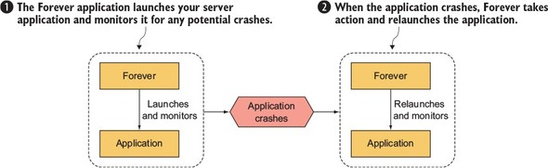
You can install Forever globally by using the sudo command.

The sudo command
Sometimes when installing an npm module globally (with the -g flag), you need to prefix the npm command with the sudo command (www.sudo.ws) in order to run npm with superuser privileges. The first time you use the sudo command, you’ll be prompted to enter your password. Then the command specified after it will be run.
If you’re following along, install Forever now by using this command:
npm install -g forever
After you’ve installed Forever, you can use it to start your blog and keep it running with the following command:
forever start server.js
If you want to stop your blog for some reason, you can use Forever’s stop command:
forever stop server.js
When using Forever, you can get a list of applications that the tool is managing by using its list command:
forever list
Another useful capability of Forever is that it can optionally restart your application when any source files have changed. This frees you from having to manually restart each time you add a feature or fix a bug.
To start Forever in this mode, use the -w flag:
forever -w start server.js
Although Forever is an extremely useful tool for deploying applications, you may want to use something more full-featured for long-term deployments. In the next section, you’ll look at some industrial-strength monitoring solutions and see how to maximize application performance.

10.3. Maximizing uptime and performance
When a Node application is release-worthy, you’ll want to make sure it starts and stops when the server starts and stops, and that it automatically restarts when the server crashes. It’s easy to forget to stop an application before a reboot or to forget to restart an application afterward.
You’ll also want to make sure you’re taking steps to maximize performance. For example, it makes sense when you’re running your application on a server with a quad-core CPU to not use only a single core. If you’re using only a single core and your web application’s traffic increases significantly, a single core may not have the processing capability to handle the traffic, and your web application won’t be able to consistently respond.
In addition to using all CPU cores, you’ll want to avoid using Node to host static files for high-volume production sites. Node is geared toward interactive applications, such as web applications and TCP/IP protocols, and it can’t serve static files as efficiently as software optimized to do only that. For serving static files, you should use technologies such as Nginx (http://nginx.org/en/), which specializes in serving static files. Alternatively, you could upload all your static files to a content delivery network (CDN), such as Amazon S3 (http://aws.amazon.com/s3/), and reference those files in your application.
This section covers some server uptime and performance tips:

Using Upstart to keep your application up and running through restarts and crashes
Using Node’s cluster API for multicore processors
Serving Node application static files using Nginx
Let’s start by looking at a powerful and easy-to-use tool for maintaining uptime: Upstart.

10.3.1. Maintaining uptime with Upstart
Let’s say you’re happy with an application and want to market it to the world. You want to make dead sure that if you restart a server, you don’t then forget to restart your application. You also want to make sure that if your application crashes, it’s not only automatically restarted, but the crash is logged and you’re notified, which allows you to diagnose any underlying issues.
Upstart (http://upstart.ubuntu.com) is a project that provides an elegant way to manage the starting and stopping of any Linux application, including Node applications. Modern versions of Ubuntu and CentOS support the use of Upstart. An alternative for macOS is to create launchd files (node-launchd on npm can do this), and the Windows equivalent is to use Windows Services, which is supported by the node-windows package on npm.
You can install Upstart on Ubuntu, if it’s not already installed, with this command:
sudo apt-get install upstart
You can install Upstart on CentOS, if it’s not already installed, with this command:
sudo yum install upstart
After you install Upstart, you need to add an Upstart configuration file for each of your applications. These files are created in the /etc/init directory and are named something like my_application_name.conf. The configuration files don't need to be marked as executable.
The following creates an empty Upstart configuration file for this chapter’s example application:
sudo touch /etc/init/hellonode.conf
Now add the contents of the following listing to your config file. This setup will run the application when the server starts and will stop the application upon shutdown. The exec section gets executed by Upstart.

Listing 10.1. A typical Upstart configuration file
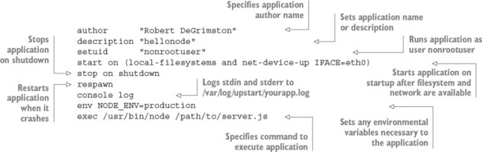
This configuration will keep your process up and running after the server restarts and even after it crashes unexpectedly. All the application-generated output will be sent to /var/log/upstart/hellonode.log, and Upstart will manage the log rotation for you.
Now that you’ve created an Upstart configuration file, you can start your application by using the following command:
sudo service hellonode
If your application was started successfully, you’ll see a line like this:
hellonode start/running, process 6770
Upstart is highly configurable. Check out the online cookbook (http://upstart.ubuntu.com/cookbook/) for all the available options.

Upstart and respawning
When the respawn option is used, Upstart will by default continually reload your application on crashes unless the application is restarted 10 times within 5 seconds. You can change this limit by using the respawn limit COUNT INTERVAL option, where COUNT is the number of times within the INTERVAL, which is specified in seconds. For example, you set a limit of 20 times in 5 seconds like this:
respawn
respawn limit 20 5
If your application is reloaded 10 times within 5 seconds (the default limit), typically there’s something wrong in the code or configuration, and it will never start successfully. Upstart won’t try to restart after reaching the limit, in order to save resources for other processes.
It’s a good idea to do health checks outside Upstart that provide alerts to the development team through email or some other means of quick communication. A health check, for a web application, can simply involve hitting the website and seeing whether you get a valid response. You could roll your own methods or use tools such as Monit (http://mmonit.com/monit/) or Zabbix (www.zabbix.com) for this.
Now that you know how to keep your application running regardless of crashes and server reboots, the next logical concern is performance. Node’s cluster API can help with this.

10.3.2. The cluster API: taking advantage of multiple cores
Most modern computer CPUs have multiple cores, but a Node process uses only one of them when running. If you're hosting a Node application on a server and want to maximize the server’s usage, you can manually start multiple instances of your application on different TCP/IP ports and use a load balancer to distribute web traffic to these instances, but that’s laborious to set up.
To make it easier to use multiple cores for a single application, the cluster API was added to Node. This API makes it easy for your application to simultaneously run multiple workers on different cores that each do the same thing and respond to the same TCP/IP port. Figure 10.2 shows how an application’s processing would be organized using the cluster API on a four-core processor.

Figure 10.2. A master spawning three workers on a four-core processor
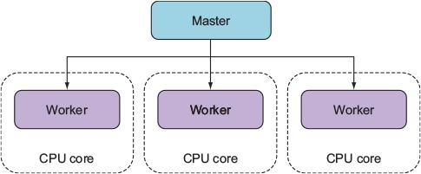
The following listing automatically spawns a master process and a worker for each additional core.

Listing 10.2. A demonstration of Node’s cluster API
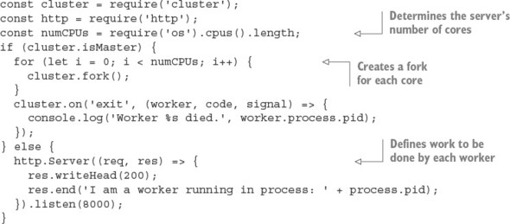
Because masters and workers run in separate operating system processes, which is necessary if they’re to run on separate cores, they can’t share state through global variables. But the cluster API does provide a means for the master and workers to communicate.
The following listing shows an example in which messages are passed between the master and the workers. A count of all requests is kept by the master, and whenever a worker reports handling a request, it’s relayed to each worker.

Listing 10.3. A demonstration of Node’s cluster API
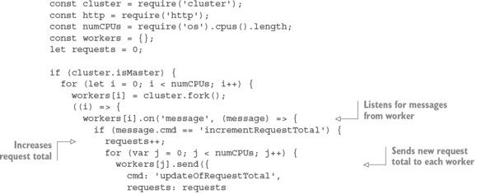
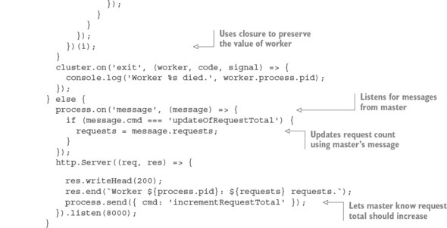
Using Node’s cluster API is a simple way of creating applications that take advantage of modern hardware.

10.3.3. Hosting static files and proxying
Although Node is an effective solution for serving dynamic web content, it’s not the most efficient way to serve static files such as images, CSS style sheets, or client-side JavaScript. Serving static files over HTTP is a specific task for which specific software projects are optimized, because they’ve focused primarily on this task for many years.
Fortunately, Nginx (http://nginx.org/en/), an open source web server optimized for serving static files, is easy to set up alongside Node to serve those files. In a typical Nginx/Node configuration, Nginx initially handles each web request, relaying requests that aren’t for static files back to Node. Figure 10.3 illustrates this configuration.

Figure 10.3. You can use Nginx as a proxy to relay static assets quickly back to web clients.
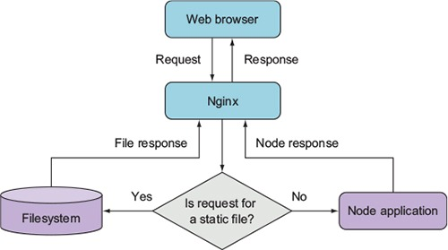
The configuration in the following listing, which would be put in the Nginx configuration file’s http section, implements this setup. The configuration file is conventionally stored in a Unix server’s /etc directory at /etc/nginx/nginx.conf.

Listing 10.4. A configuration file that uses Nginx to proxy Node.js and serve static files
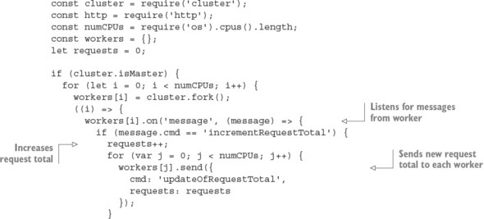
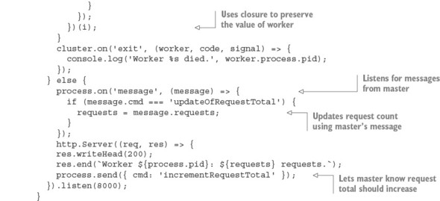
By using Nginx to handle your static web assets, you ensure that Node is dedicated to doing what it does best.

10.4. Summary

Node applications can be hosted by PaaS providers, dedicated services, virtual private servers, and cloud hosting.
You can quickly deploy Node applications to Linux servers by using Forever and Upstart.
To make your application perform better, Node’s cluster module lets you run multiple processes.

Part 3. Beyond web development
Millions of people depend on apps that are built with Node. If you’ve ever used Slack or Visual Studio Node, you’ve used applications that are powered by Node. This part introduces both Electron and modules for writing command-line tools with Node. If you’ve ever wanted to make an app for Linux, macOS, or Windows, now you can.

Chapter 11. Writing command-line applications
This chapter covers

Designing command-line applications by using common conventions
Communicating with pipes
Using exit codes
Node command-line utilities are used everywhere, from project automation tools, such as Gulp and Yeoman, to XML and JSON parsers. If you’ve ever wondered how to build command-line tools with Node, this chapter will show you everything you need to know to get started. You’ll learn how Node programs accept command-line arguments and how to handle I/O with pipes. We’ve also included shell tips that will help you use the command line more effectively.
Although writing command-line tools with Node isn’t hard, it’s important to follow community conventions. This chapter includes many of these conventions so you’ll be able to write tools that other people can use, without too much documentation.

11.1. Understanding conventions and philosophy
A big part of command-line development is understanding the conventions used by established programs. As a real-world example, take a look at Babel:
Usage: babel [options] <files ...>
Options:
-h, --help output usage information
-f, --filename [filename] filename to use when reading from stdin
[ ... ]
-q, --quiet Don't log anything
-V, --version output the version number
Several points are worth noting here. The first is the use of both -h and --help for printing help: this is a flag that many programs use. The second flag is -f for filename—this is an easy mnemonic to learn. Lots of flags are based on mnemonics. Using -q for quiet output is also a popular convention, and so is -v for showing the program’s version. Your applications should include these flags.
This user interface isn’t merely a convention, however. The use of the hyphen and double hyphen (--) is recognized by the Open Group’s Utility Conventions.[1] This document even specifies how they should be used:
1
The Open Group Base Specifications Issue 7,” http://pubs.opengroup.org/onlinepubs/9699919799/basedefs/V1_chap11.html.

Guideline 4— All options should be preceded by the - delimiter character.
Guideline 10— The first -- argument that’s not an option-argument should be accepted as a delimiter indicating the end of options. Any following arguments should be treated as operands, even if they begin with the - character.
Another aspect of command-line application design is philosophy. This dates back to the creators of UNIX, who wanted to design “small, sharp tools” that could be used together with a simple, text-based interface.
This is the UNIX philosophy: Write programs that do one thing and do it well. Write programs to work together. Write programs to handle text streams, because that is a universal interface.
Doug McIlroy[2]
2
Basics of the Unix Philosophy”, www.catb.org/~esr/writings/taoup/html/ch01s06.html.

In this chapter, we provide a broad overview of shell techniques and UNIX conventions so you can design command-line tools that other people can use. We offer guidance for Windows-specific usage as well, but for the most part, your Node tools should be cross-platform by default.

Shell tips: getting help
If you get stuck when using the shell, try typing man <cmd>. This loads the manual page for the command.
If you can’t remember the command’s name, you can use apropos <cmd> to search the database of system commands.

11.2. Introducing parse-json
For JavaScript programmers, one of the simplest useful applications reads JSON and prints it if it’s valid. By following this chapter, you’ll re-create this tool.
Let’s start with what a command line for this application should look like. The following snippet shows how to invoke such a program:
node parse-json.js -f my.json
The first thing you need to do is figure out how to grab -f my.json from the command line; these are the program’s arguments. You also need to read input from stdin. Read on to learn how to do both of these things.

11.3. Using command-line arguments
Most—but not all—command-line programs accept arguments. Node has a built-in way to handle these arguments, but third-party modules on npm offer extra features. You need these features in order to implement some widely used conventions. Read on to learn more.

11.3.1. Parsing command-line arguments
Command-line arguments can be accessed by using the process.argv array. The items in the array are the strings passed to the shell when running a command. So if you split up the command, you can figure out what each item in the array is. The item at process.argv[0] is node, the item at process.argv[1] is parse-json.js, [2] is -f, and so forth.
If you’ve ever used command-line applications before, you may have seen arguments with - or --. These prefixes are special conventions for passing options to applications: -- denotes a full string for an option name, and - denotes a single character for an option name. The npm command-line binary is a great example of this with -h and --help.
Argument conventions
Other argument conventions are as follows:

--version to print the version of your application
-y or --yes to use default values for any missing options
Adding aliases for arguments, such as -h and –-help, makes parsing awkward after you add support for several options, but luckily there’s a module for parsing arguments called yargs. The following snippet shows how yargs works in the simplest case. All you need to do is require yargs, and then access the argv property to inspect the arguments that were passed to the script:
const argv = require('yargs').argv;
console.log({ f: argv.f });
Figure 11.1 shows how Node’s built-in version of the command-line arguments differs from the object generated by yargs.

Figure 11.1. Node’s argv compared to yargs
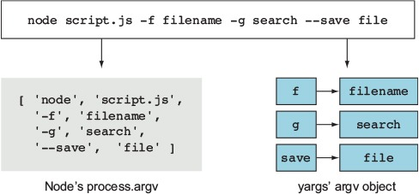
Although an options object is useful, it doesn’t provide much structure for validating arguments and generating usage text. The next section shows how to describe and validate arguments.

11.3.2. Validating arguments
The yargs module includes methods for validating the arguments. The following listing shows how to use yargs to parse the -f argument that your JSON parser will need, and it uses the describe and nargs methods to enforce the expected argument format.

Listing 11.1. Using yargs to parse command-line arguments
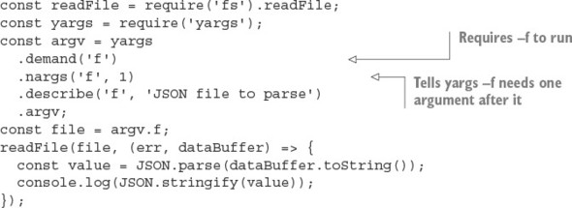
Using yargs is easier than manipulating the process.argv array, and it’s better because rules can be enforced. Listing 11.1 uses demand to force an argument, and then declares that it requires a single parameter, which will be the JSON file to parse. To make the program easier to use, you can provide usage text with yargs as well. The convention here is to print the usage text when -h or --help is passed. You can add these with the help of yargs, as shown in this snippet:
yargs
// ...
.usage('parse-json [options]')
.help('h')
.alias('h', 'help')
// ...
Now your JSON parser can accept a file argument and process the file. File handling isn’t yet finished for this project, however, because it also needs to accept stdin. Read on to learn how to do that with a common UNIX convention.
Shell tips: history
Your shell stores a log of the commands you’ve typed previously. Type history to view the log; this is often aliased to h.

11.3.3. Passing stdin as a file
If a file parameter is given as a hyphen (-f -), it means grab the data from stdin. This is another common command-line convention. You can use the mississippi package to do this easily. You have to concatenate all the data piped to your application prior to calling JSON.parse, though, because it expects a full JSON string to parse. With the mississippi module, the example now looks like the following listing.

Listing 11.2. Reading a file from stdin
#!/usr/bin/env node
const concat = require('mississippi').concat;
const readFile = require('fs').readFile;
const yargs = require('yargs');
const argv = yargs
.usage('parse-json [options]')
.help('h')
.alias('h', 'help')
.demand('f') // require -f to run
.nargs('f', 1) // tell yargs -f needs 1 argument after it
.describe('f', 'JSON file to parse')
.argv;
const file = argv.f;
function parse(str) {
const value = JSON.parse(str);
console.log(JSON.stringify(value));
}
if (file === '-') {
process.stdin.pipe(concat(parse));
} else {
readFile(file, (err, dataBuffer) => {
if (err) {
throw err;
} else {
parse(dataBuffer.toString());
}
});
}
This code loads mississippi and calls it concat. It then uses concat with the stdin stream. Because mississippi accepts a function that receives the final full set of data, the original parse function from listing 11.1 can still be used. This is done only when the filename is -.

11.4. Sharing command-line tools with npm
Any application that you want others to be able to use should be easily installed with npm. The simplest way to make npm see a command-line application is to use the bin field in package.json. This field makes npm install an executable available to any scripts in the current project. The bin field also tells npm to install the executable globally if you use npm install --global. This isn’t useful only for Node developers, but also for anyone else who might want to use your scripts.
This snippet and the #!/usr/bin/env node line in listing 11.2 are all you need for the JSON parser example in this chapter:
...
"name": "parse-json",
"bin": {
"parse-json": "index.js"
},
...
If you install this package with npm install –global, it will make the parse-json command available systemwide. To try it, open a terminal (or command prompt in Windows) and type parse-json. Note that this works even in Windows, because npm will automatically install a wrapper enabling it to work in Windows transparently.

11.5. Connecting scripts with pipes
The parse-json program is simple—it accepts text and validates it. What if you have other command-line tools that you want to use it with? Imagine you have a program that can add syntax highlighting to JSON files. It would be great if the JSON could be parsed first and then highlighted. In this section, you’ll learn about pipes, which can do all of this and more.
You’ll be using parse-json and other programs to perform fancy workflows with pipes. Windows and Unix shells differ, but the important bits are (luckily) the same in both shells. A few differences arise during debugging, but they shouldn’t affect you when you’re writing command-line applications.

11.5.1. Piping data into parse-json
The main way to connect command-line applications is called piping. Piping is taking an application’s stdout and attaching it to a different process’s stdin stream. It’s the central component of interprocess communication: enabling programs to talk to each other. You can access stdin in Node with process.stdin because it’s a readable stream. Look at the following code to parse JSON coming in from stdin:
echo "[1,2,3]" | parse-json -f –
Notice the | character. This tells the shell that echo '{}' should send its output to parse-json’s stdin.
Shell tips: keyboard shortcuts
Now that you’ve seen how pipes work, you can search the command history by combining history with grep:
history | grep node
An even better way to access previous commands is by using the up and down arrows on the keyboard. People do this all the time—but there’s an even better way! Type Ctrl-R to recursively search through the command history. This lets you fish out lengthy commands based on a partial text match.
Here are more shortcuts: Ctrl-S does a forward search, and Ctrl-G aborts the search. You can also edit text more efficiently with these shortcuts: Ctrl-W deletes words, ALT-F/B moves forward or backward one word, and Ctrl-A/E moves to the start or end of the line.

11.5.2. Working with errors and exit codes
Right now the program doesn’t output anything. But if you give it incorrect data, how do you know that it was able to complete successfully, even if you don’t know the expected output of an executable? The answer is the exit code. You can see the exit code of the last command you ran, but note that the echo and node commands are treated as a single command unit because of piping.
On Windows, you can inspect the exit code with the following:
echo %errorlevel%
On UNIX, you can see the exit code by using this command:
echo $?
If a command is successful, it has an exit code of 0 (zero). So if you feed incorrect JSON to the script, it should exit with a nonzero value:
parse-json -f invalid.json
If you run this, the application will exit with a nonzero status and print a message indicating the reason. This is because when an error is thrown but not caught, Node automatically exits and prints the error message.

error streams
Although printing your output to the console can be useful, saving it to a file to read is even better, because you can keep it for debugging purposes. Luckily, you can do this with the shell by redirecting the stdout stream:
echo 'you can overwrite files!' > out.log
echo 'you can even append to files!' >> out.log
When you try this with invalid JSON, it would make sense for parse-json to save the error message:
parse-json -f invalid.json >out.log
But doing this won’t log any errors. This is the expected behavior once you understand the difference between stderr and stdout:

stdout is for other command-line applications to consume.
stderr is for developers to consume.
Node logs to stderr when console.error is called or an error is thrown. This is different from echo, which logs to stdout, just like console.log. With that knowledge, you may want to redirect stderr to a file instead of to stdout. Luckily, that’s a simple change.
The stdin, stdout, and stderr streams all have associated numbers, from 0 to 2, respectively. stderr has a stream number of 2. You can redirect it by using 2> out.log, which tells the shell the stream number you want to redirect and the file in which to place the output:
parse-json -f invalid.json 2> out.log
Redirecting output is what piping does, but with processes instead of files. Take the following snippet:
node -e "console.log(null)" | parse-json
You’re logging null and piping it to parse-json. null won’t be logged to the console here because it’s being piped to only the next command. Say you do something similar, but use console.error:
node -e "console.error(null)" | parse-json
You’ll see an error because no text is being sent over to parse-json to consume. null was logged to stderr and will be printed to the console. The data should be piped to stdout and not stderr.
Figure 11.2 shows how pipes and numbered output streams can be used to connect programs and then route the output into separate files.

Figure 11.2. Combining pipes and output streams
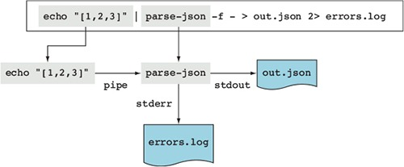
Node also has an API for working with pipes. It’s based on Node streams, so you can use it with anything that implements Node’s stream classes. Read on to learn more about pipes in Node.
Shell tips: clearing a line
Some of these commands are pretty long; what do you do when you need to delete a long command and don’t want to run it? One useful shortcut is Ctrl-U, which deletes the current line. If you type Ctrl-Y, you’ll get the line back, so you can use these keyboard commands as you’d use copy and paste.

11.5.3. Using pipes in Node
You’re now going to learn how pipes work by using Node’s API. To do this, you’ll write a short script that displays how long it takes a program to run, without interrupting piping.
A program can monitor a pipe without interrupting it by waiting for stdin to close and then piping the results to stdout. Because Node programs end when there’s no more input to consume, you can print a message when the program is exiting. Here’s an example, which you can save as time.js to try it out:
process.stdin.pipe(process.stdout);
const start = Date.now();
process.on('exit', () => {
const timeTaken = Date.now() - start;
console.error(`Time (s): ${timeTaken / 1000}`);
});
By piping to stdout again, you can put time.js in the middle of commands you pipe together and still have them work! In fact, both parse-json and time.js can easily be used together with pipes. For example, this shows how long it takes to parse JSON and send the data:
parse-json -f test.json | node time.js
Now that you have a basic idea of what to output and how to get input from other applications, you can start making applications that are much more complex. But first, we should talk about timing while processes are piping to each other.
Shell tips: completion
In addition to providing command history, most shells are capable of matching commands or files when the Tab key is pressed. Some even allow you to see the completions with Alt-?.

11.5.4. Pipes and command execution order
When you pipe commands, each command starts immediately. The commands don’t wait for each other in any way. This means piping data won’t wait for any command to exit, and you can consume only the data it gives you. Because the commands don’t wait, you can’t know how the previous command exited.
Imagine you want to log a message only when JSON is successfully parsed. To do this, you need new operators. The && and || operators act similarly in a shell to the way they do in JavaScript when used on numbers. Using && executes the next command if the previous exit code is zero, and || executes the next command if the exit code is a nonzero number.
Let’s see how to make a little script that logs a message when a process is exiting over stderr. It’s important to note that this is different from echo, because it’s printing to stderr—it’s meant for developers to use rather than other programs. All you need to do is listen for the process exit event, and then write the arguments to stderr:
process.stdin.pipe(process.stdout);
process.on('exit', () => {
const args = process.argv.slice(2);
console.error(args.join(' '));
});
Using &&, you can call exit-message.js if the JSON parsed successfully:
parse-json -f test.json && node exit-message.js "parsed JSON successfully"
But exit-message.js won’t get the output of parse-json. The && operator must wait for parse-json.js to finish, to see whether it should execute the next command. While using &&, there’s no automatic redirection as there is when piping.

Redirecting input
You’ve already seen how to redirect output, but you can also redirect input in a similar fashion. This is a rare need, but can be a valuable asset if an executable doesn’t accept a filename as an argument. If you want a command to read a file into stdin, use <filename to do so:
parse-json -f - <invalid.json
By combining both forms of redirection, you can use a temporary file to recover the output of parse-json:
parse-json -f test.json >tmp.out &&
node exit-message.js "parsed JSON successfully" <tmp.out
Now that you’ve learned how to handle streams, exit codes, and command order, you should be able to write scripts with Node commands for your own packages. The next section demonstrates how to use Browserify and UglifyJS together using pipes.
Shell tips: clearing the display
You may sometimes cat binary data to the terminal and basically break it. Like a scene from The Matrix, garbled characters will appear everywhere. In cases like this, you can either press Ctrl-L to refresh the display or type reset to reset the terminal.

11.6. Interpreting real-world scripts
You’re ready to start writing your own scripts fields in package.json files. As an example, let’s look at how to combine the browserify and uglifyjs packages from npm. Browserify (http://browserify.org/) is an application that takes Node modules and bundles them up for use in the browser. UglifyJS (https://github.com/mishoo/UglifyJS2) is an application that minifies a JavaScript file so that it takes up less bandwidth and time to send to a browser. Your script will take a file called main.js (found in the book’s listings under ch11-command-line/snippets/uglify-example), concatenate it for use in a browser, and then minify the concatenated script:
{
"devDependencies": {
"browserify": "13.3.0",
"uglify-js": "2.7.5"
},
"scripts": {
"build": "browserify -e main.js > bundle.js && uglifyjs bundle.js > bundle.min.js"
}
}
You can run the build script by typing npm run build. The build script in this example makes bundle.js. Then, if creating bundle.js is successful, the script creates bundle.min.js. By using the && operator, you can ensure that the second stage runs only if the first stage succeeds.
Using the techniques demonstrated in this chapter, you can create and use command-line applications. Remember, you can always use the command lines to combine scripts from other languages together—if you have a useful Python, Ruby, or Haskell command-line program, you can easily use it with your Node programs.

11.7. Summary

Command-line arguments can be read from process.argv.
Modules such as yargs make it easier to parse and validate arguments.
A handy way to add scripts to your Node projects is by defining npm scripts in the package.json file.
Data is read and written to command-line programs by using standard I/O pipes.
Standard input, output, and errors can be redirected to different processes and files.
Programs emit exit codes that are used to determine whether they ran successfully.
Command-line programs adhere to established conventions that other users will expect.

Chapter 12. Conquering the desktop with Electron
This chapter covers

Building desktop apps with Electron
Showing desktop menus
Sending desktop notifications
Creating cross-platform builds
In the preceding chapter, you learned about building command-line tools with Node. Node is starting to become prominent in another area, however: desktop software. Programmers are increasingly harnessing web technology to solve the problems of cross-platform development. In this chapter, you’ll learn how to make a desktop web application based on native desktop features, Node, and client-side web technology. You can develop and run this application in Linux, macOS, and Windows. You’ll also use Node modules in a model that isn’t too far removed from client-server web application development.

12.1. Introducing Electron
Electron, originally known as Atom Shell, enables you to build desktop applications with web technology. The application and user interface are left up to you to create with HTML, CSS, and JavaScript, but some of the “hard parts” of desktop software are provided for you. These include the following:

Automatic updates
Crash reporting
Installers for Microsoft Windows
Debugging
Native menus and notifications
Some famous applications have been made with Electron. The first was Atom, GitHub’s text editor, but more recent applications include Slack, the popular chat service, and Visual Studio Code by Microsoft, shown in figure 12.1.

Figure 12.1. Visual Studio Code’s application window and a native context menu
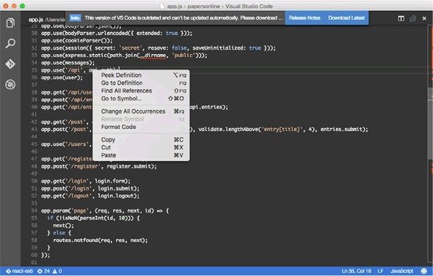
You should try out some of these applications to see the kinds of things that are possible with Electron. It’s exciting to think that armed with Node and JavaScript skills, you can build compelling desktop software.

12.1.1. Electron’s stack
Before getting started with Electron, you should familiarize yourself with the way Electron fits in with Node, HTML, and CSS. An Electron app has the following components:

The main process— A Node script that boots the application and provides access to native Node modules
The render process— A web page managed by Chromium
A real application, however, has several other dependencies. The previous list can be fleshed out as follows:

Includes the main process
Connects to a native database (for example, SQLite)
Communicates with web APIs
Reads and writes any local files (for example, configuration files)
Provides access to native features (for example, context menus)
Includes the render process
Shows a modern rich web application using your preferred client-side technology (for example, React or Angular)
Triggers native features (for example, context menus and notifications)
Provides build scripts
Generates the front-end JavaScript by using your preferred build system (Grunt, Gulp, npm scripts)
Prepares releases for distribution
Figure 12.2 shows an overview of the three main parts of a typical Electron app. As you can see, Node is used to run the main process and to communicate with the operating system for services including opening files, reading and writing to a database, and communicating with web services. Although a large part of the focus is on the UI in the rendering process, Node is still used for a critical part of the application’s architecture.

Figure 12.2. The main parts of a typical Electron application
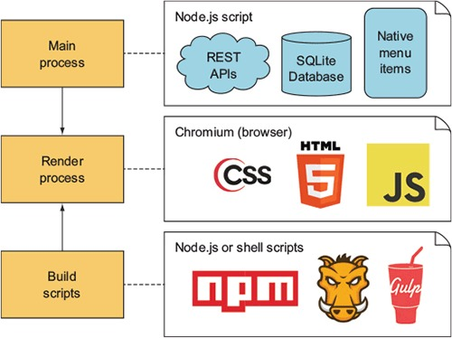

12.1.2. Interface design
Now that you’ve seen the main components of an Electron app, let’s look at how to design suitable interfaces. Electron applications are based on HTML, CSS, and Java-Script, so you can’t pull in native widgets. Imagine that you want to make a native Mac-style interface. You can fake the macOS toolbar by using CSS gradients. Using native fonts provided by macOS and Windows is possible through CSS, and you can even tweak the antialiasing to look like a native application. You can also remove text selection for certain UI components, and make the UI work with drag-and-drop. Currently, most Electron apps use CSS that uses the same colors, border styles, icons, and gradients as macOS and Windows.
Some applications go the extra mile in terms of duplicating the native experience; one example is the N1 email application (https://github.com/nylas/N1). Other applications, such as Slack (https://slack.com/), have their own unique branding and identity that’s clean enough to work well without too much modification on each platform.
When you build your own Electron apps, you’ll have to decide which approach is right for your project. If you want to make an app that looks like it uses native desktop widgets, you have to create styles that suit each platform. That requires more time designing each target UI. Your customers may prefer it, but it may also result in more overhead when deploying new features.
In the next section, you’ll use a skeleton Electron application to create a new one. This is the standard way to build new projects with Electron.

12.2. Creating an Electron app
The easiest way to get started with Electron is to use the electron-quick-start project, available on GitHub (https://github.com/atom/electron-quick-start). This small repository contains the dependencies necessary to run a basic Electron application.
To use it, check out the repository and install the dependencies with npm:
git clone https://github.com/atom/electron-quick-start
cd electron-quick-start
npm install
After everything has finished downloading, you can start the main process with npm start. It’s safe to use this project as the basis for the rest of your Electron application; you shouldn’t need to create your own project from scratch.
When the application starts, you should see a window with a web page and the Chromium Developer Tools. If you’re a web developer who uses Chrome, this might not seem that exciting: the app looks like a web page with no CSS rendering in Chrome. But a lot more is going on under the hood to make this work. Figure 12.3 shows what this looks like in macOS.

Figure 12.3. The electron-quick-start project running in macOS
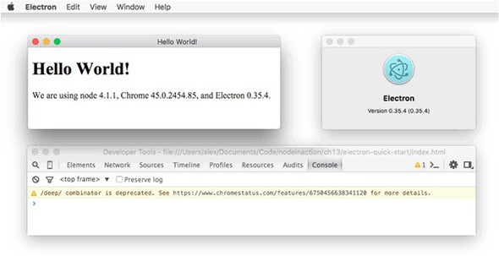
This is a self-contained macOS application bundle: it includes a version of Node that’s different from the one running on my system, and it has its own menu items and About window.
At this point, you can start to build your web application in index.html by using HTML, JavaScript, and CSS. But as a Node programmer, you’re probably eager to use Node for something, so let’s see how to do that first.
Electron comes with a module called remote that uses interprocess communication (IPC) between the rendering process and the main Node process. The remote module can even provide access to Node modules. To try it, add a file called readfile.js to your Electron project, and add the code in the following listing.

Listing 12.1. A simple Node module
const fs = require('fs');
module.exports = (cb) => {
fs.readFile('./main.js', { encoding: 'utf8' }, cb);
};
Now open index.html and change it to add an element with an ID of source, and a script that loads readfile.js, as shown in the next listing.

Listing 12.2. Loading Node modules from the rendering process
<!DOCTYPE html>
<html>
<head>
<meta charset="UTF-8">
<title>Hello World!</title>
</head>
<body>
<h1>Hello World!</h1>
<pre id="source"></pre>
<script>
var readfile = require('remote').require('./readfile');
readfile(function(err, text) {
console.log('readfile:', err, text);
document.getElementById('source').innerHTML = text;
});
</script>
</body>
</html>
Listing 12.2 uses the remote module to load readfile.js and then run it on the main process. The interaction between the two processes is seamless, so it doesn’t seem that much different from using standard Node modules. The only real difference is the use of require('remote').require(file).

12.3. Building a full desktop application
Now that you’ve seen how to create a basic Electron app and how to use Node modules, let’s go a step further and see how to build a fully fledged desktop app with native features. The application you’ll create is intended to be a developer tool for making and viewing HTTP requests. Think of it as a GUI for the request module (www.npmjs.com/package/request).
Although you can build Electron apps with pure HTML, JavaScript, CSS, and Node, for this example you’ll use modern front-end development tools to make the app more maintainable and extensible. Here’s a list of what you’ll use:

electron-quick-start as the basis for the project
request module for making HTTP requests
React for the user-interface code
Babel for converting modern ES6 into browser-friendly ES5
webpack for building the client-side app
Figure 12.4 shows what the finished application should look like.

Figure 12.4. The HTTP Master Electron application
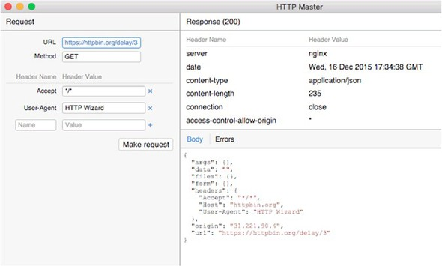
Next you’ll learn how to set up a React-based project with webpack and Babel.

12.3.1. Bootstrapping React and Babel
The biggest challenge in building a new app with a sophisticated front end is setting up libraries such as React and Babel with a maintainable build system. You have many choices, including Grunt, Gulp, and webpack. And what makes things even more difficult is that these libraries change over time, so books and tutorials quickly become out-of-date.
To mitigate the fast-paced world of front-end development, we specify the exact versions of each dependency, so you should be able to follow the tutorial and obtain similar results. If you get lost, you can use tools such as Yeoman (http://yeoman.io/) to generate a skeleton app. Then you can modify it to work like the app outlined in this chapter.

12.3.2. Installing the dependencies
Create a new electron-quick-start project. To recap, you must clone the project from GitHub:
git clone https://github.com/atom/electron-quick-start
cd electron-quick-start
npm install
Now install react, react-dom, and babel-core:
npm install --save-dev react@0.14.3 react-dom@0.14.3 babel-core@6.3.17
Next, you need to install Babel plugins. The main one is babel-preset-es2015, which may be overkill for a project limited to Chromium, but including it makes it easier for you to experiment with ES2015 features that Chromium doesn’t yet support. Use these commands for installation:
npm install --save-dev babel-preset-es2015@6.3.13
npm install --save-dev babel-plugin-transform-class-properties@6.3.13
This plugin adds JSX support to Babel:
npm install --save-dev babel-plugin-transform-react-jsx@6.3.13
Then install webpack:
npm install --save-dev webpack@1.12.9
You also need babel-loader for webpack to work with Babel:
npm install --save-dev babel-loader@6.2.0
Now that most of the dependencies are ready, add a .babelrc file to your project. It tells Babel to use the ES2015 and React plugins:
{
"plugins": [
"transform-react-jsx"
],
"presets": ["es2015"]
}
Finally, open package.json and update the scripts property to include a webpack invocation:
"scripts": {
"start": "electron main.js",
"build": "node_modules/.bin/webpack --progress --colors"
},
This allows the application to be built with npm run build. Webpack plugins are available for React hot-loading, but we don’t cover that here. If you want to automatically build your client-side code when files change, you could use something like fswatch or nodemon.

12.3.3. Setting up webpack
To use webpack, you need a webpack.config.js file. Add it to the root of your project. The basic format is JavaScript, using a Node-style CommonJS module:
const webpack = require('webpack');
module.exports = {
setting: 'value'
};
Our project requires settings for finding React files (.jsx), loading the entry point (/app/index.jsx), and then placing the output in a place where the Electron UI can find it (js/app.js). The React files also have to be processed with Babel. Putting those requirements together produces the file in the following listing.

Listing 12.3. webpack.config.js
const webpack = require('webpack');
module.exports = {
module: {
loaders: [
{ test: /\.jsx?$/, loaders: ['babel-loader'] }
]
},
entry: [
'./app/index.jsx'
],
resolve: {
extensions: ['', '.js', '.jsx']
},
output: {
path: __dirname + '/js',
filename: 'app.js'
}
};
In this listing, webpack is told to transform .jsx (React) files with Babel through the module.loaders property. Babel has already been set up to handle React files with transform-react-jsx in .babelrc. Next, the entry property is used to define the main entry point for the React code. This works well because React components are based on HTML elements. Because HTML elements must have one parent node, a single entry point can encompass the entire application.
The resolve.extensions property tells webpack that .jsx files must be treated as modules. If you use a statement such as import {Class} from 'class', it’ll check class.js and class.jsx.
Finally, the output property tells webpack where to write the output file. Here I’ve used js/, but you could use any path that’s accessible to the Electron UI.
This is a good time to start fleshing out the React app. Let’s start by looking at the main entry point and how it’ll pull in the request and response UI elements.

12.4. The React app
In figure 12.4, you saw a preview of what this app should look like. It has two main groups of UI components that can be divided into seven items:

Request
URL: String
Method: String
Headers: Object of string pairs
Response
HTTP status code
Headers: Object of string pairs
Body: String
Errors: String
But in React, you can’t render two things side by side: they need to be contained by a single parent. You need a top-level app object, which contains the UI elements for the request and response.
Given classes for Request and Response, which you’ll implement later, the App class itself should look like the following listing.

Listing 12.4. The App class
import React from 'react';
import ReactDOM from 'react-dom';
import Request from './request';
import Response from './response';
class App extends React.Component {
render() {
return (
<div className="container">
<Request />
<Response />
</div>
);
}
}
ReactDOM.render(<App />, document.getElementById('app'));
Save this file as app/index.jsx. It first loads the Request and Response classes, and then renders them in a div. The last line uses ReactDOM to render the DOM nodes for the App class. React allows you to refer to the App class with <App />.
To make this work, you also need to define the Request and Response components.

12.4.1. Defining the Request component
The Request class takes input for the URL and HTTP method, and then generates a request that’s posted with the Node request module. It renders the interface by using JSX, but unlike the previous example, it doesn’t render the element directly with ReactDOM; this happens when it’s included into the main app class in app/index.jsx.
The following listing (app/request.js) contains the code for the full class. We’ve removed the header-editing capability to reduce the length of the example; for an example with more features, including header editing, see our HTTP Wizard GitHub repository (https://github.com/alexyoung/http-wizard).

Listing 12.5. The Request class
import React from 'react';
import Events from './events';
const request = remote.require('request');
class Request extends React.Component {
constructor(props) {
super(props);
this.state = { url: null, method: 'GET' };
}
handleChange = (e) => {
const state = {};
state[e.target.name] = e.target.value;
this.setState(state);
}
makeRequest = () => {
request(this.state, (err, res, body) => {
const statusCode = res ? res.statusCode : 'No response';
const result = {
response: `(${statusCode})`,
raw: body ? body : '',
headers: res ? res.headers : [],
error: err ? JSON.stringify(err, null, 2) : ''
};
Events.emit('result', result);
new Notification(`HTTP response finished: ${statusCode}`)
});
}
render() {
return (
<div className="request">
<h1>Request</h1>
<div className="request-options">
<div className="form-row">
<label>URL</label>
<input
name="url"
type="url"
value={this.state.url}
onChange={this.handleChange} />
</div>
<div className="form-row">
<label>Method</label>
<input
name="method"
type="text"
value={this.state.method}
placeholder="GET, POST, PATCH, PUT, DELETE"
onChange={this.handleChange} />
</div>
<div className="form-row">
<a className="btn" onClick={this.makeRequest}>Make request</a>
</div>
</div>
</div>
);
}
}
export default Request;
The bulk of the listing is taken up by the render method’s HTML. Let’s focus on the rest before going over how the UI is built up. First, we’ve used a descendent of Node’s EventEmitter in app/events.jsx to communicate between this component and the response component. The following snippet is app/events.jsx:
import { EventEmitter } from 'events';
const Events = new EventEmitter();
export default Events;
Notice that Request is a React.Component descendant class. It defines a constructor that sets up a default state: the state property is special in React and can be set this way only in a constructor. Elsewhere, you must use this.setState.
The handleChange method sets state based on the HTML element’s name attribute. To understand how this works, skip ahead to the URL <input> element in the render method:
<input
name="url"
type="url"
value={this.state.url}
onChange={this.handleChange} />
The name specified here is used to set the URL when it’s edited. Setting the state also causes render to run, and React will update the value attribute with the updated state. Let’s move on to look at how the request module is used by this class.
This class is client-side code that runs in a web view, so you need a way of accessing the request module to make HTTP requests. Electron provides a way of loading remote modules without any unnecessary boilerplate. Near the top of the class, you use the global remote object to require the Node request module:
const request = remote.require('request');
Then later in makeRequest, the HTTP request can be made with a simple call to request(). The arguments for the request have been set in the class’s state, so all you need to do is handle the callback that runs when the request is complete. Here that’s very little imperative code: the class’s state is set based on the outcome of the request, and then the result is emitted so the Response component can use it. A desktop notification is also displayed; if the request is slow, the user will be notified visually by using the operating system’s notification pop-up:
new Notification(`HTTP response finished: ${statusCode}`)
Figure 12.5 shows a typical notification.

Figure 12.5. A desktop notification
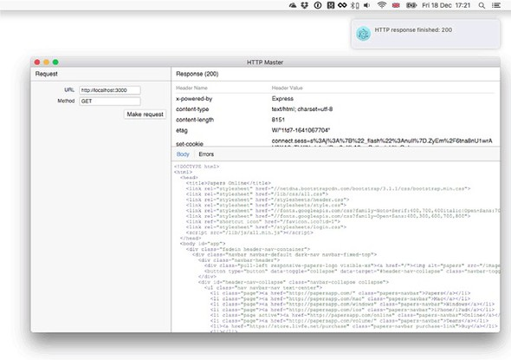
Now let’s look at how the Response component displays the HTTP response.

12.4.2. Defining the Response component
The Response component listens for result events and then sets its state to contain the results of the last request. It displays the results by using a table for headers, and divs for the request body and any errors.
The following listing has the whole Response component. This file is app/response.jsx.

Listing 12.6. The Response component
import React from 'react';
import Events from './events';
import Headers from './headers';
class Response extends React.Component {
constructor(props) {
super(props);
this.state = { result: {}, tab: 'body' };
}
componentWillUnmount() {
Events.removeListener('result', this.handleResult.bind(this));
}
componentDidMount() {
Events.addListener('result', this.handleResult.bind(this));
}
handleResult(result) {
this.setState({ result: result });
}
handleSelectTab = (e) => {
const tab = e.target.dataset.tab;
this.setState({ tab: tab });
}
render() {
const result = this.state.result;
const tabClasses = {
body: this.state.tab === 'body' ? 'active' : null,
errors: this.state.tab === 'errors' ? 'active' : null,
};
const rawStyle = this.state.tab === 'body'
? null
: { display: 'none' }
const errorsStyle = this.state.tab === 'errors'
? null
: { display: 'none' };
return (
<div className="response">
<h1>Response <span id="response">{result.response}</span></h1>
<div className="content-container">
<div className="content">
<div id="headers">
<table className="headers">
<thead>
<tr>
<th className="name">Header Name</th>
<th className="value">Header Value</th>
</tr>
</thead>
<Headers headers={result.headers} />
</table>
</div>
<div className="results">
<ul className="nav">
<li className={tabClasses.body}>
<a data-tab='body' onClick={this.handleSelectTab}>Body</a>
</li>
<li className={tabClasses.errors}>
<a data-tab='errors' href="#" onClick={this.handleSelectTab}>Errors</a>
</li>
</ul>
<div
className="raw"
id="raw"
style={rawStyle}>{result.raw}</div>
<div
className="raw"
id="error"
style={errorsStyle}>{result.error}</div>
</div>
</div>
</div>
</div>
);
}
}
export default Response;
The Response component doesn’t have any code specific to handling HTTP responses; it displays its state in various HTML elements. It’s able to switch tabs by binding an onclick event to the handleSelectTab method that switches between the body and errors by using an attribute (data-tab).
The Response component uses another component, Headers, to render the HTTP response headers. Breaking components into ever smaller components is standard practice in React. The values of each header are passed to the subcomponent by using an attribute; in React, these are known as props, or properties:
<Headers headers={result.headers} />
The following listing shows the Headers component. This is in the app/headers.jsx file.

Listing 12.7. The Headers component
import React from 'react';
class Headers extends React.Component {
render() {
const headers = this.props.headers || {};
const headerRows = Object.keys(headers).map((key, i) => {
return (
<tr key={i}>
<td className="name">{key}</td>
<td className="value">{headers[key]}</td>
</tr>
);
});
return (
<tbody className="header-body">
{headerRows}
</tbody>
);
}
}
export default Headers;
Notice how the props are accessed near the top of the render() method, at this.props.headers.

12.4.3. Communicating between React components
The Request and Response classes are fairly well isolated; they’re focused on solving their particular tasks without directly calling each other. React has other, more sophisticated state-management approaches, but they’re beyond the scope of this chapter. This example application doesn’t need a sophisticated communication mechanism, because it has only two main components, so instead it uses EventEmitter from Node to communicate.
To use EventEmitter this way, instantiate it inside its own file and then export the instance. This file is app/events.jsx in the example project for this chapter:
import { EventEmitter } from 'events';
const Events = new EventEmitter();
export default Events;
Now components can require events and either emit events or attach listeners to communicate. The Request component does this in the makeRequest method, with the result of the HTTP request:
Events.emit('result', result);
Then in the Response class, you can capture results by setting up a listener early in the component’s life cycle:
componentWillUnmount() {
Events.removeListener('result', this.handleResult.bind(this));
}
As an application grows, this pattern becomes harder to maintain. One particular problem is tracking the names of events. Because they’re strings, it’s easy to forget them or write them incorrectly. An extension of this pattern is to use a list of constants for event names. If you extend this pattern again to split the responsibility of dispatching events and storing data, you end up with something similar to Facebook’s Redux state container (http://redux.js.org/), which is why many React programmers use it to design and build larger applications.

12.5. Builds and distribution
Now that you have a usable desktop application, you can bundle it for macOS, Linux, and Windows. App distribution with Electron has three stages:

Rebrand the Electron app with your application’s name and icon
Package your app into a file
Create a binary for each platform
The electron-quick-start project is already almost suitable for distribution. You just need to copy your code into Electron’s Contents/Resources/app folder in macOS, or electron/resources/app in Windows and Linux.
But manually copying files isn’t the best way to build a redistributable binary. A more foolproof method is to use electron-packager (www.npmjs.com/package/electron-packager) by Max Ogden. This package provides a command-line tool for building executables for Windows, Linux, and macOS.

12.5.1. Building with Electron Packager
To install electron-packager, install it globally. This will allow you to build any project that you want to create platform-specific binaries for:
npm install electron-packager –g
After it’s installed, you can run it from your application’s directory. You must invoke it with the path to your application, the application name, platform, architecture (32- or 64-bit), and the Electron version:
electron-packager . HttpWizard --version=1.4.5
This downloads Electron version 1.4.5 and generates binaries for all supported platforms and architectures. This may take some time (Electron is about 40 MB), but when it’s done, you’ll have binaries that can be run on all major operating systems.

Hiding the developer tools
Before sharing builds, you should remove or change the line in main.js that opens the Chromium development tools:
mainWindow.webContents.openDevTools();
Alternatively, you could wrap this with a flag to hide it when working on the app:
if (process.env.NODE_ENV === 'debug') {
mainWindow.webContents.openDevTools();
}

12.5.2. Packaging
To further improve your application’s performance, you can package the client-side and Node JavaScript file by using Atom Shell archives (https://github.com/atom/asar). These archives are known as asar files, and they work like the UNIX tar command. They hide your JavaScript but don’t obscure it enough to stop people from decoding the packages, so you can’t use it to truly obfuscate code. But they solve the issue of long filenames breaking in Windows, which you might run into if you have deeply nested dependencies.
In Electron, Chromium can read asar files as well as Node, so you don’t have to do anything special to support it. Also, electron-packager can create asar packages for you with the --asar command-line option.
Figure 12.6 shows what an application packaged without asar looks like.

Figure 12.6. A typical Electron application bundle’s contents
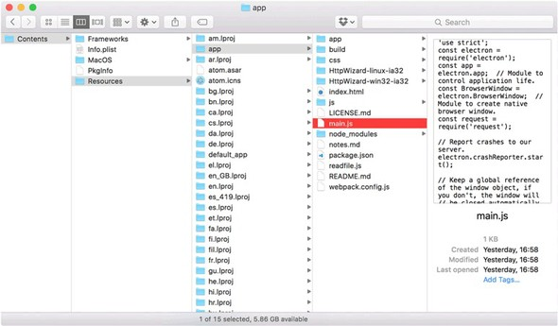
Notice that you can open the JavaScript files to view the source. The only binary files in an Electron application are resources such as images, or binary Node modules.
To generate a build with asar files, you can use electron-packager with the --asar flag:
electron-packager . HttpWizard --version=0.36.0 --asar=true
This is the easiest way to do it, because electron-packager runs all the necessary commands. To do it manually, you need to install asar, and then you need to invoke the command-line tool to create a package:
npm install -g asar
asar pack path-to-your-app/ app.asar
After you have the asar archive, download an Electron binary (https://github.com/atom/electron/releases) for the platform you want to support, and add the archive to the resources directory, as shown in figure 12.6. Running the application executable or bundle should cause your application to run.
Editing the vendor-supplied binaries is also how Electron applications are branded. You can change the application’s name and icons this way. If you run an Electron binary with no modifications, it provides a window that allows you to run Electron apps made with the electron-quick-start repository.

12.6. Summary

Using Electron, you can make desktop applications with Node, JavaScript, HTML, and CSS.
You can generate native menus and notifications without using C++, C#, or Objective-C.
If you have useful Node modules, you can use them from the client-side Java-Script within the Electron application’s UI.
Electron uses a fully fledged browser, so you can build UIs with the latest Java-Script technology, such as React or Angular.

Appendix A. Installing Node
This appendix provides more details on installing Node.js. If you’re fairly new to Node, we recommend installing it with a prebuilt package. We explain this for each major operating system.
Depending on your requirements, you can install Node in other ways instead. If you’re more experienced with Node or have specific DevOps requirements, skip ahead to review other ways you can install Node.

A.1. Installing Node by using an installer
Node has two installers and several prebuilt binary packages. If you use macOS or Windows, you can use either binaries or installers. The binary packages contain executable files, but the installers have installation wizards that help you put Node on your system in a place that’s easy to find when you’re running commands such as node or npm in the terminal.
If you’re new to Node, use an installer. All of the versions can be found on Node’s website under Downloads (https://nodejs.org/en/download/).

A.1.1. The macOS installer
For macOS, download the 64-bit .pkg file from Node’s website (https://nodejs.org/en/download/). You can use either the LTS or Current release. You should see a package file, as shown in figure A.1.

Figure A.1. The installer .pkg file
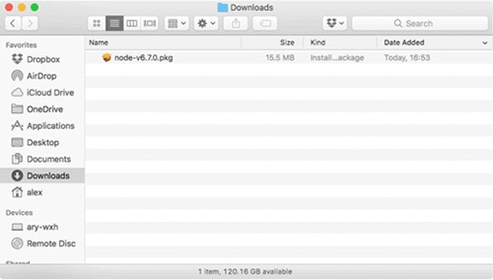
After you’ve downloaded the installer, double-click it to open the installation wizard (Figure A.2).

Figure A.2. The installation wizard
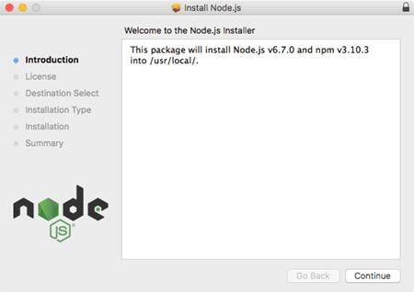
Click the Continue button and follow the instructions; the default options will install Node correctly. After the installation process has finished, you should be able to open a terminal and type node to run the Node REPL. Figure A.3 shows what this should look like.

Figure A.3. Node’s REPL
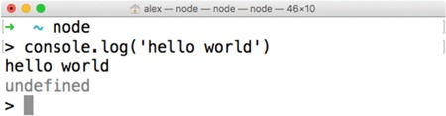
The next section includes the same instructions for Windows users.

A.1.2. The Windows installer
On the Node Downloads page (https://nodejs.org/en/download/), click the Windows Installer icon, or click the Windows Installer .msi link. There are 32- and 64-bit options, but you probably want 64-bit. After the file has downloaded, double-click it to run the installation wizard, shown in figure A.4.

Figure A.4. The Windows .msi installer
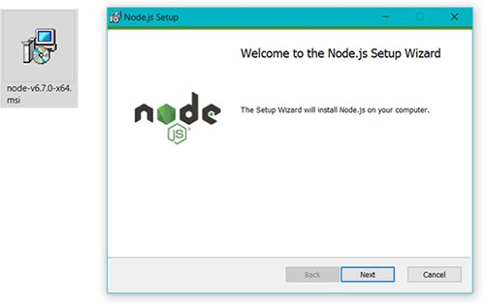
Accept all of the default options, and then open cmd.exe to try out the Node REPL. Figure A.5 shows Node’s REPL in Windows.

Figure A.5. Node’s REPL in Windows
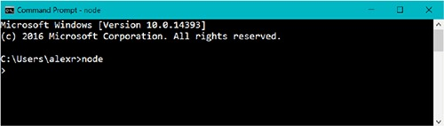
If you don’t usually install software this way or don’t want to install Node systemwide, continue reading to see how else Node can be installed.

A.2. Using other ways to install Node
You can install Node from source, through your operating system’s package manager, or by using a Node version manager. If you install it from source, you’ll need a working build system and Python installed.

A.2.1. Installing Node from source
You can download Node’s source from the nodejs.org downloads page, but it’s also available via Git on GitHub (https://github.com/nodejs/node). The full build guide is also on GitHub under node/Building.md (https://github.com/nodejs/node/blob/master/BUILDING.md). You’ll need the following prerequisites to build Node:

Linux— Python 2.6 or 2.7, gcc and g++ 4.8 or newer, or clang and clang++ 3.4 or newer. The easiest way to get this is with the build-essentials package in Debian-like distributions, or its equivalent for other distributions.
macOS— Xcode and the command-line tools, which can be installed with Xcode.
Windows— Python 2.6 or 2.7, Visual C++ Build Tools, Visual Studio 2015 Update 3.
When your build tools are ready, you can run ./configure and make in UNIX-like operating systems. In Windows, you can run .\vcbuild nosign.

A.2.2. Installing Node with a package manager
If you use Linux or macOS, you may want to install Node with a package manager. This can make it easier to update Node. For example, if you’re using a Linux web server, you might want to install Node so that it gets automatic security updates.
Node’s website has a large list of installation instructions for operating systems that provide Node as a package (https://nodejs.org/en/download/package-manager/). In Debian and Ubuntu-based systems, for example, you can get Node from the NodeSource binary distribution repository. This has its own repository on GitHub with more details (https://github.com/nodesource/distributions).
In macOS, you can install Node with Homebrew (http://brew.sh/). If you have Homebrew installed, you just need to run brew install node.
Node is also available from Docker Hub. If you add FROM node:argon to your Dockerfile, you’ll get the LTS version of Node installed into your image.

Appendix B. Automating the web with scraping
This appendix covers

Creating structured data from web pages
Performing basic web scraping with cheerio
Handling dynamic content with jsdom
Parsing and outputting structured data
In the preceding chapter, you learned some general Node programming techniques, but now we’re going to start focusing on web development. Scraping the web is an ideal way to do this, because it requires a combination of server and client-side programming skills. Scraping is all about using programming techniques to make sense of web pages and transform them into structured data. Imagine you’re tasked with creating a new version of a book publisher’s website that’s currently just a set of old-fashioned, static HTML pages. You want to download the pages and analyze them to extract the titles, descriptions, authors, and prices for all the books. You don’t want to do this by hand, so you write a Node program to do it. This is web scraping.
Node is great at scraping because it strikes a perfect balance between browser-based technology and the power of general-purpose scripting languages. In this chapter, you’ll learn how to use HTML parsing libraries to extract useful data based on CSS selectors, and even to run dynamic web pages in a Node process.

B.1. Understanding web scraping
Web scraping is the process of extracting useful information from websites. This usually involves downloading the required pages, parsing them, and then querying the raw HTML by using CSS or XPath selectors. The results of the queries are then exported as CSV files or saved to a database. Figure B.1 shows how scraping works from start to finish.

Figure B.1. Steps for scraping and storing content
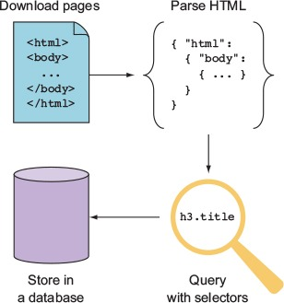
Web scraping may be against the terms of use of some websites, because of its cost or because of resource limitations. If thousands of scrapers hit a single site that runs on an old and slow server, the server could be knocked offline. Before you scrape any content, you should ensure that you have permission to access and duplicate the content. You can technically check the site’s robots.txt (www.robotstxt.org) file for this information, but you should contact the site’s owners first. In some cases, the site’s owners may have invited you to index its information—perhaps as part of a larger web development contract.
In this section, you’ll learn how people use scrapers for real sites, and then you’ll look at the required tools that allow Node to become a web-scraping powerhouse.

B.1.1. Uses of web scraping
A great example of web scraping is the vertical search engine Octopart (https://octopart.com/). Octopart, shown in figure B.2, indexes electronics distributors and manufacturers to make it easier for people to find electronics. For example, you can search for resistors based on resistance, tolerance, power rating, and case type. A site like this uses web crawlers to download content, scrapers to make sense of the content and extract interesting values (for example, the tolerance of a resistor), and an internal database to store the processed information.

Figure B.2. Octopart allows users to search for electronic parts.
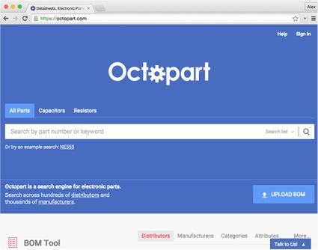
Web scraping isn’t used for only search engines, however. It’s also used in the growing fields of data science and data journalism. Data journalists use databases to produce stories, but because there’s so much data that isn’t stored in easily accessible formats, they may use tools such as web scraping to automate the collection and processing of data. This allows journalists to present information in new ways, through data--visualization techniques including infographics and interactive graphics.

B.1.2. Required tools
To get down to business, you need a couple of easily accessible tools: a web browser and Node. Browsers are one of the most useful scraping tools—if you can right-click and select Inspect Element, you’re already partway to making sense of websites and converting them into raw data. The next step is to parse the pages with Node. In this chapter, you’ll learn about two types of parser:

Lightweight and forgiving: cheerio
A web-standards-aware, Document Object Model (DOM) simulator: jsdom
Both of these libraries are installed with npm. You may need to parse loosely structured human-readable data formats such as dates as well. We’ll briefly look at Java-Script’s Date.parse and Moment.js.
The first example uses cheerio, which is a fast way to parse most static web pages.

B.2. Performing basic web scraping with cheerio
The cheerio library (www.npmjs.com/package/cheerio), by Felix Böhm, is perfect for scraping because it combines two key features: fast HTML parsing, and a jQuery-like API for querying and manipulating the HTML.
Imagine you need to extract information about books from a publisher’s website. The publisher doesn’t yet have an API that exposes book details, so you need to download pages from its website and turn them into usable JSON output that includes the author name and book title. Figure B.3 shows how scraping with cheerio works.

Figure B.3. Scraping with cheerio
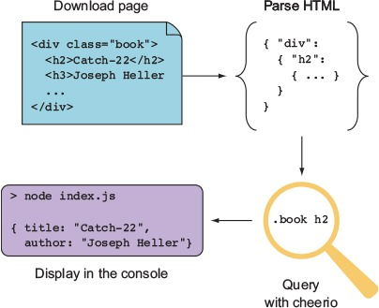
The following listing contains a small scraper that uses cheerio. Sample HTML has been included, so you don’t need to worry about how to download the page itself yet.

Listing B.1. Extracting a book’s details
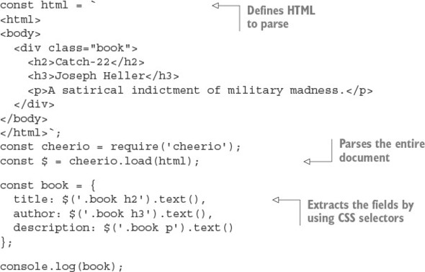
Listing B.1 uses cheerio to parse a hardcoded HTML document by using the cheerio.load() method and CSS selectors. In a simple example like this, the CSS selectors are simple and clear, but often real-world HTML is far messier. Unfortunately, poorly structured HTML is unavoidable, and your skill as a web scraper is defined by coming up with clever ways to pull out the values you need.
Making sense of bad HTML requires two steps. The first is to visualize the document, and the second is to define the selectors that target the elements you’re interested in. You use cheerio’s features to define the selector in just the right way.
Fortunately, modern browsers offer a point-and-click solution for finding selectors: if your browser has development tools, you can usually right-click and select Inspect Element. Not only will you see the underlying HTML, but the browser should also show a representation of the selector that targets the element.
Let’s say you’re trying to extract book information from a quirky site that uses tables without any handy CSS classes. The HTML might look like this:
<html>
<body>
<h1>Alex's Dated Book Website</h1>
<table>
<tr>
<td><a href="/book1">Catch-22</a></td>
<td>Joseph Heller</td>
</tr>
</table>
</body>
</html>
If you open that in Chrome and right-click the title, you’ll see something like figure B.4.

Figure B.4. Viewing HTML in Chrome
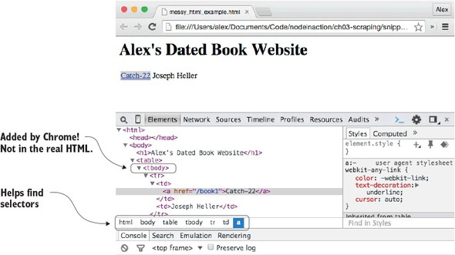
The white bar under the HTML shows “html body table tbody tr td a”—this is close to the selector that you need. But it’s not quite right, because the real HTML doesn’t have a tbody. Chrome has inserted this element. When you’re using browsers to visualize documents, you should be prepared to adjust what you discover based on the true underlying HTML. This example shows that you need to search for a link inside a table cell to get the title, and the next table cell is the corresponding author.
Assuming the preceding HTML is in a file called messy_html_example.html, the following listing will extract the title, link, and author.

Listing B.2. Dealing with messy HTML
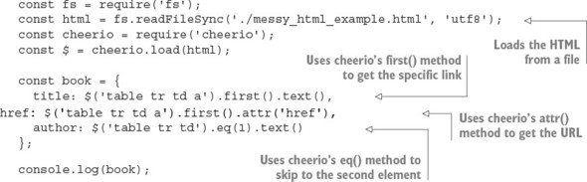
You use the fs module to load the HTML; that’s so you don’t have to keep printing HTML in the example. In reality, your data source might be a live website, but the data could also be from a file or a database. After the document has been parsed, you use first() to get the first table cell with an anchor. To get the anchor’s URL, you use cheerio’s attr() method; it returns a specific attribute from an element, just like jQuery. The eq() method is also useful; in this listing, it’s used to skip the first td, because the second contains the author’s text.
Web-parsing dangers
Using a module such as cheerio is a quick and dirty way of interpreting web documents. But be careful of the type of content that you attempt to parse with it. It may throw an exception with binary data, for example, so using it in a web application could crash the Node process. This would be dangerous if your scraper is embedded in the same process that serves your web application.
It’s best to check the content type before passing it through a parser, and you may want to consider running your web scrapers in their own Node processes to reduce the impact of any serious crashes.
One of cheerio’s limitations is that it allows you to work only with a static version of a document; it’s used for working with pure HTML documents rather than dynamic pages that use client-side JavaScript. In the next section, you’ll learn how to use jsdom to create a browser-like environment in your Node applications, so client-side Java-Script will be executed.

B.3. Handling dynamic content with jsdom
jsdom is the web scraper’s dream tool: it downloads HTML, interprets it according to the DOM as found in a typical browser, and runs client-side JavaScript. You can specify the client-side JavaScript that you want to run, which typically means including jQuery. That means you can inject jQuery (or your own custom debugging scripts) into any pages. Figure B.5 shows how jsdom combines HTML and JavaScript to make otherwise unscrapeable content accessible.

Figure B.5. Scraping with jsdom
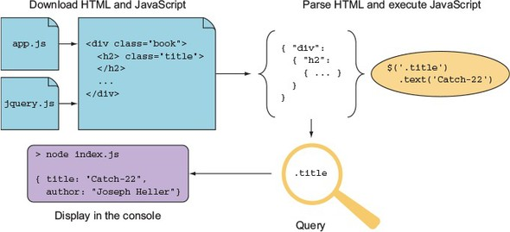
jsdom does have a downside. It’s not a perfect simulation of a browser, it’s slower than cheerio, and the HTML parser is strict, so it may fail for pages with poorly written markup. Some sites don’t make sense without client-side JavaScript support, however, so it’s an indispensible tool for some scraping tasks.
The basic usage of jsdom is through the jsdom.env method. The following listing shows how jsdom can be used to scrape a page by injecting jQuery and pulling out useful values.

Listing B.3. Scraping with jsdom
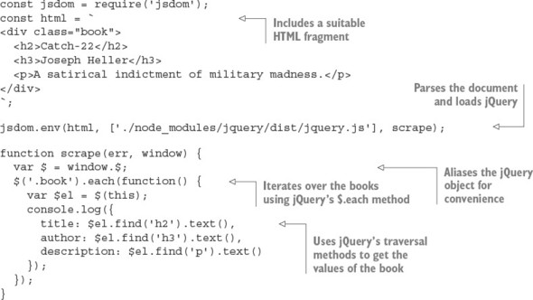
To run listing B.3, you need to save jQuery locally and install jsdom.[1] You can install both with npm. The modules are called jsdom (www.npmjs.com/package/jsdom) and jQuery (www.npmjs.com/package/jquery), respectively. After everything is set up, this code should print out the title, author, and description of the HTML fragment.
1
jsdom 6.3.0 is the current version at the time of writing.

The jsdom.env method is used to parse the document and inject jQuery. jQuery is injected by downloading it from npm, but you could supply the URL to jQuery on a content delivery network (CDN) or your filesystem; jsdom will know what to do. The jsdom.env method is asynchronous and requires a callback to work. The callback receives error and window objects; the window object is how you access the document. Here the window’s jQuery object has been aliased so it can be easily accessed with $.
A selector is used with jQuery’s .each method to iterate over each book. This example has only one book, but it demonstrates that jQuery’s traversal methods are indeed available. Each value from the book is accessed by using jQuery’s traversal methods as well.
Listing B.3 is similar to the earlier cheerio example in listing B.1, but the main difference is that jQuery has been parsed and run by Node, within the current process. Listing B.1 used cheerio to provide similar functionality, but cheerio provides its own jQuery-like layer. Here you’re running code intended for a browser as if it’s really running in a browser.
The jsdom.env method is useful only for working with static pages. To parse pages that use client-side JavaScript, you need to use jsdom.jsdom instead. This synchronous method returns a window object that you can manipulate with other jsdom utilities. The following listing uses jsdom to parse a document with a script tag, and jsdom.jQueryify to make scraping it easier.

Listing B.4. Parsing dynamic HTML with jsdom
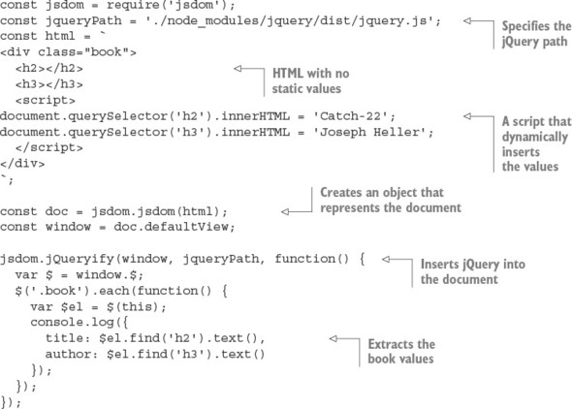
Listing B.4 requires jQuery to be installed, so if you’re creating this listing by hand, you need to set up a new project with npm init and npm install --save jquery jsdom. It uses a simple HTML document in which the useful values that you’re looking for are dynamically inserted. They’re inserted using client-side JavaScript found in a script tag.
This time, jsdom.jsdom is used instead of jsdom.env. It’s synchronous because the document object is created in memory, but won’t do much until you attempt to query or manipulate it. To do this, you use jsdom.jQueryify to insert your specific version of jQuery into the document. After jQuery has been loaded and run, the callback is run, which queries the document for the values you’re interested in and prints them to the console. The output is shown here:
{ title: 'Catch-22', author: 'Joseph Heller' }
This proves that jsdom has invoked the necessary client-side JavaScript. Now imagine this is a real web page and you’ll see why jsdom is so powerful: even websites made with very little static HTML and dynamic technologies such as Angular and React can be scraped.

B.4. Making sense of raw data
After you finally get useful data from a page, you need to process it so it’s suitable for saving to a database or for an export format such as CSV. Your scraped data will either be unstructured plain text or encoded using microformats.
Microformats are lightweight, markup-based data formats that are used for things like addresses, calendars and events, and tags or keywords. You can find established microformats at microformats.org. Here’s an example of a name represented as a microformat:
<a class="h-card" href="http://example.com">Joseph Heller</a>
Microformats are relatively easy to parse; with cheerio or jsdom, a simple expression such as $('.h-card').text() is sufficient to extract Joseph Heller. But plain text requires more work. In this section, you’ll see how to parse dates and then convert them into more database-friendly formats.
Most web pages don’t use microformats. One area where this is problematic but potentially manageable is date values. Dates can appear in many formats, but they’re usually consistent on a given website. After you’ve identified the format, you can parse and then format the date.
JavaScript has a built-in date parser: if you run new Date('2016 01 01'), an instance of Date will be returned that corresponds to the first of January, 2016. The supported input formats are determined by Date.parse, which is based on RFC 2822 (http://tools.ietf.org/html/rfc2822#page-14) or ISO 8601 (www.w3.org/TR/NOTE-datetime). Other formats may work and are often worth trying out with your source data to see what happens.
The other approach is to match values in the source data with a regular expression, and then use Date’s constructor to make new Date objects. The signature for the constructor is as follows:
new Date(year, month[,day[,hour[,minutes[,seconds[,millis]]]]]);
Date parsing in JavaScript is usually good enough to handle many cases, but it falls down in reformatting dates. A great solution to this is Moment.js (http://momentjs.com), a date-parsing, validation, and formatting library. It has a fluent API, so calls can be chained like this:
moment().format("MMM Do YY"); // Sep 7th 15
This is convenient for turning scraped data into CSV files that work well with programs such as Microsoft Excel. Imagine you have a web page with books that include title and published date. You want to save the values to a database, but your database requires dates to be formatted as YYYY-MM-DD. The following listing shows how to use Moment with cheerio to do this.

Listing B.5. Parsing dates and generating CSV
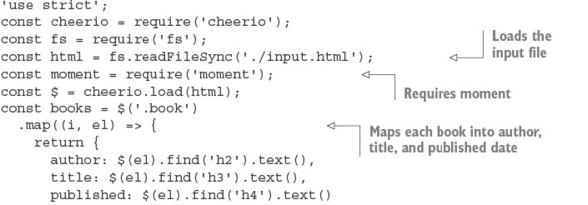
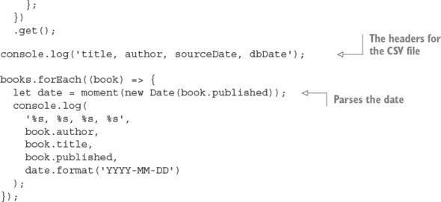
Listing B.5 requires that you install cheerio, Moment, and books. It takes as input HTML (from input.html) and then outputs CSV. The HTML should have dates in h4 elements, like this:
<div>
<div class="book">
<h2>Catch-22</h2>
<h3>Joseph Heller</h3>
<h4>11 November 1961</h4>
</div>
<div class="book">
<h2>A Handful of Dust</h2>
<h3>Evelyn Waugh</h3>
<h4>1934</h4>
</div>
</div>
After the scraper has loaded the input file, it loads up Moment, and then maps each book to a simple JavaScript object by using cheerio’s .map and .get methods. The .map method iterates over each book, and the callback extracts each element that you’re interested in by using the .find selector traversal method. To get the resulting text values as an array, .get is used.
Listing B.5 outputs CSV by using console.log. The header is printed, and then each row is logged in a loop that iterates over each book. The dates are converted to a format compatible with MySQL by using Moment; first the date is parsed using new Date, and then it’s formatted using Moment.
After you’ve become used to parsing and formatting dates, you can apply similar techniques to other data formats. For example, currency and distance measurements can be captured with regular expressions, and then formatted by using a more generic number-formatting library such as Numeral (www.npmjs.com/package/numeral).

B.5. Summary

Web scraping is the automated transformation of sometimes badly structured web pages into computer-friendly formats such as CSV or databases.
Web scraping is used for vertical search engines but also for data journalism.
If you're going to scrape a site, you should get permission first. You can do this by checking the site’s robots.txt file and contacting the site’s owner.
The main tools are static HTML parsers (cheerio) and parsers capable of running JavaScript (jsdom), but also browser developer tools for finding the right CSS selector for the elements you’re interested in.
Sometimes the data itself is not well formatted, so you may need to parse things such as dates or currencies to make them work with databases.

Appendix C. Connect’s officially supported middleware
Connect is a minimal wrapper around Node’s built-in HTTP client and server modules. The Connect authors and contributors have also produced officially supported middleware components that implement low-level features used by most web frameworks, including things like cookie handling, body parsing, sessions, basic auth, and cross-site request forgery (CSRF). This appendix demonstrates all of the officially supported modules so you can use them to build lightweight web applications without a larger framework.

C.1. Parsing cookies, request bodies, and query strings
Node’s core doesn’t provide modules for higher-level web application concepts such as parsing cookies, buffering request bodies, or parsing complex query strings, so Connect modules implement these features. This section covers four modules that parse request data:

cookie-parser— Parses cookies from web browsers into req.cookies
qs— Parses the request URL query string into req.query
body-parser— Consumes and parses the request body into req.body
The first module we’ll look at is cookie-parser. This makes it easy to retrieve data stored by a website visitor’s browser so you can read things such as authorization status, website settings, and so on.

C.1.1. cookie-parser: parse HTTP cookies
The cookie-parser module supports regular cookies, signed cookies, and special JSON cookies (www.npmjs.com/package/cookie-parser). By default, regular unsigned cookies are used, populating the req.cookies object. If you want signed cookie support, which helps prevent cookies from being tampered with, you’ll want to pass a secret string when creating the cookie-parser instance.

Setting cookies on the server side
The cookie-parser module doesn’t provide any helpers for setting outgoing cookies. For this, you should use the res.setHeader() function with Set-Cookie as the header name. Connect patches Node’s default res.setHeader() function to special-case the Set-Cookie headers so that it just works, as you’d expect it to.

Regular cookies
To read cookies, you need to load the module, add it to the middleware stack, and then read the cookies in a request. The following listing illustrates each of these steps.

Listing C.1. Reading cookies sent in a request
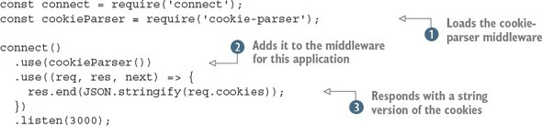
This example loads the middleware component . Remember that you need to install the middleware with npm install cookie-parser for this to work. Next it adds an instance of the cookie parser to the middleware stack for this application . The final step is to send back the cookies to the browser as a string , so you can see it working.
If you run this example, you’ll need to set cookies with the request. If you go to http://localhost:3000 in a browser, you probably won’t see much; it should return an empty object ({}). You can use cURL to set a cookie like this:
curl http://localhost:3000/ -H "Cookie: foo=bar, bar=baz"

Signed cookies
Signed cookies are better suited for sensitive data, as the integrity of the cookie data can be verified, helping to prevent man-in-the-middle attacks. Signed cookies are placed in the req.signedCookies object when valid. The reasoning behind having two separate objects is that it shows the developer’s intention. If you were to place both signed and unsigned cookies in the same object, a regular cookie could be crafted to contain data to mimic a signed cookie.
A signed cookie looks something like s:tobi.DDm3AcVxE9oneYnbmpqxoy[...],[1] where the content to the left of the period (.) is the cookie’s value, and the content to the right is the secret hash generated on the server with SHA-256 HMAC (hash-based message authentication code). When Connect attempts to unsign the cookie, it will fail if either the value or HMAC has been altered.
1
The signed values have been shortened.

Suppose, for example, you set a signed cookie with a key of name and a value of luna. cookieParser would encode the cookie to s:luna.PQLM0wNvqOQEObZX[...]. The hash portion is checked on each request, and when the cookie is sent intact, it will be available as req.signedCookies.name:
$ curl http://localhost:3000/ -H "Cookie:
name=s:luna.PQLM0wNvqOQEObZXU[...]"
{}
{ name: 'luna' }
GET / 200 4ms
If the cookie’s value were to change, as shown in the next curl command, the name cookie would be available as req.cookies.name because it wasn’t valid. It might still be of use for debugging or application-specific purposes:
$ curl http://localhost:3000/ -H "Cookie:
name=manny.PQLM0wNvqOQEOb[...]"
{ name: 'manny.PQLM0wNvqOQEOb[...]' }
{}
GET / 200 1ms
The first argument to cookieParser is the secret to be used for signing cookies. In the following listing, the secret is tobi is a cool ferret.

Listing C.2. Parsing signed cookies
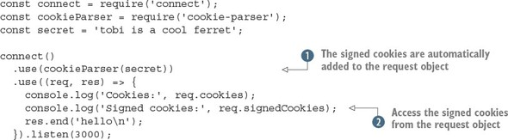
In this example, the signed cookies are parsed automatically because the secret argument was passed to the cookieParser middleware component . The values can be accessed on the request object . The cookie-parser module also makes the cookie parsing functionality available through the signedCookie and signedCookies methods.
Before moving on, let’s look at how to use this example. As with listing C.1, you can use curl with the -H option to send a cookie. But for it to be considered a signed cookie, it needs to be encoded in a certain way.
Node’s crypto module is used to unsign cookies in the signedCookie method. If you want to sign a cookie to test listing C.2, you need to install cookie-signature and then sign a string with the same secret:
const signature = require('cookie-signature');
const message = 'luna';
const secret = 'tobi is a cool ferret';
console.log(signature.sign(message, secret);
Now if the signature or message were modified, the server would be able to tell. In addition to signed cookies, this module supports JSON-encoded cookies. The next section shows how these work.

JSON cookies
The special JSON cookie is prefixed with j:, which informs Connect that it’s intended to be serialized JSON. JSON cookies can be either signed or unsigned.
Frameworks such as Express can use this functionality to provide developers with a more intuitive cookie interface, instead of requiring them to manually serialize and parse JSON cookie values. Here’s an example of how Connect parses JSON cookies:
$ curl http://localhost:3000/ -H 'Cookie: foo=bar,
bar=j:{"foo":"bar"}'
{ foo: 'bar', bar: { foo: 'bar' } }
{}
GET / 200 1ms
As mentioned, JSON cookies can also be signed, as illustrated in the following request:
$ curl http://localhost:3000/ -H "Cookie:
cart=j:{\"items\":[1]}.sD5p6xFFBO/4ketA1OP43bcjS3Y"
{}
{ cart: { items: [ 1 ] } }
GET / 200 1ms

Setting outgoing cookies
As noted earlier, the cookie-parser module doesn’t provide any functionality for writing outgoing headers to the HTTP client via the Set-Cookie header. Connect, however, provides explicit support for multiple Set-Cookie headers via the res.setHeader() function.
Say you want to set a cookie named foo with the string value bar. Connect enables you to do this in one line of code by calling res.setHeader(). You can also set the various options of a cookie, such as its expiration date, as shown in the second setHeader() call here:
var connect = require('connect');
connect()
.use((req, res) => {
res.setHeader('Set-Cookie', 'foo=bar');
res.setHeader('Set-Cookie',
'tobi=ferret; Expires=Tue, 08 Jun 2021 10:18:14 GMT'
);
res.end();
})
.listen(3000);
If you check out the headers that this server sends back to the HTTP request by using the --head flag of curl, you can see the Set-Cookie headers set as you would expect:
$ curl http://localhost:3000/ --head
HTTP/1.1 200 OK
Set-Cookie: foo=bar
Set-Cookie: tobi=ferret; Expires=Tue, 08 Jun 2021 10:18:14 GMT
Connection: keep-alive
That’s all there is to sending cookies with your HTTP response. You can store any kind of text data in cookies, but it has become usual to store a single session cookie on the client side so that you can have full user state on the server. This session technique is encapsulated in the express-session module, which you’ll learn about later in this appendix.
Now that you can handle cookies, you’re probably eager to handle the other usual methods for accepting user input. The next two sections cover parsing query strings and request bodies, and you’ll discover that even though Connect is relatively low-level, you can still get the same features as more complicated web frameworks without writing lots of code.

C.1.2. Parsing query strings
One method for accepting input is to use GET parameters. You place a question mark after a URL, with a list of arguments separated by ampersands:
http://localhost:3000/page?name=tobi&species=ferret
This type of URL can be presented to your application by a form that’s set to use the GET method, or by anchor elements within your application’s templates. You’ve probably seen this used for pagination.
The request object that’s passed to each middleware component in Connect applications includes a url property, but what you want is the last part of the URL: just the portion after the question mark. Node comes with a URL-parsing module, so you could technically use url.parse to get the query string. But Connect also has to parse the URL, so it sets an internal property with a parsed version.
The recommended module for parsing query strings is qs (www.npmjs.com/package/qs). This module isn’t officially supported by Connect, and alternatives are available through npm. To use qs and similar modules, you need to call its .parse() method from your own middleware component.

Basic usage
The following listing uses the qs.parse method to create an object that’s stored on the req.query property for subsequent middleware components to use.

Listing C.3. Parsing query strings
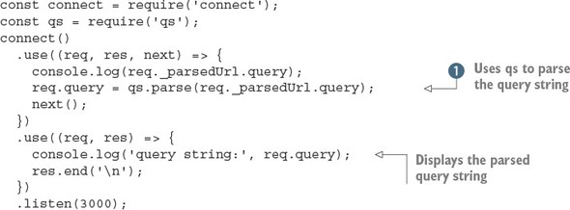
This example uses a custom middleware component to obtain the parsed URL, parse it using qs.parse , and then display it in a subsequent component.
Suppose you’re designing a music library app. You could offer a search engine and use the query string to build up the search parameters, like this:
/songSearch?artist=Bob%20Marley&track=Jammin.
This example query produces a res.query object like this:
{ artist: 'Bob Marley', track: 'Jammin' }
The qs.parse method supports nested arrays, so complex query strings such as ?images[]=foo.png&images[]=bar.png produce objects like this one:
{ images: [ 'foo.png', 'bar.png' ] }
When no query-string parameters are given in the HTTP request, such as /songSearch, req.query will default to an empty object:
{}
Higher-level frameworks such as Express tend to have query-string parsing built in, because it’s such a common requirement for web development. Another common feature of web frameworks is parsing request bodies, so you can accept data posted in forms. The next section explains how to parse request bodies, handle forms and file uploads, and validate these requests to ensure they’re safe.

C.1.3. body-parser: parse request bodies
Most web applications have to accept and process user input. This can be from forms or even other programs in the case of RESTful APIs. HTTP requests and responses are collectively known as HTTP messages. The format of a message consists of a list of headers and then a message body. In Node web applications, the body is usually a stream, and it can be encoded in various ways: a POST from a form will usually be application/x-www-form-urlencoded, and a RESTful JSON request could be application/json.
That means your Connect applications need middleware that’s capable of decoding streams of form-encoded data, JSON, or even compressed data using gzip or deflate. In this section, we’ll show how to do the following:

Handle input from forms
Parse JSON requests
Validate bodies based on content and size
Accept file uploads

Forms
Suppose you want to accept registration information for your application though a form. All you have to do is add the body-parser component (www.npmjs.com/package/body-parser) before any other middleware that will access the req.body object. Figure C.1 shows how this works.

Figure C.1. How a form is processed by body-parser
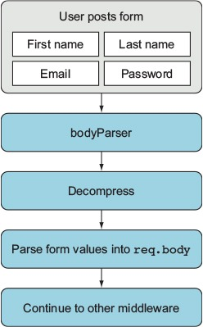
The following listing shows how to use the body-parser module with HTTP POSTs from forms.

Listing C.4. Parsing form requests
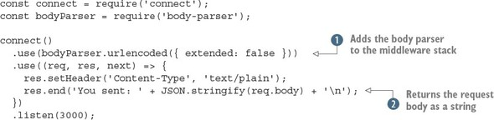
To use this example, you need to install the body-parser module,[2] and then you need a way to make a simple HTTP request with a URL-encoded body. The easiest way is to use curl with the -d option:
2
We used version 1.11.0.

curl -d name=tobi http://localhost:3000
This should cause the server to display You sent: {"name":"tobi"}. To make this work, the body parser is added to the middleware stack , and then the parsed body in req.body is converted to a string so it can be displayed more easily. The urlencoded body parser accepts a UTF-8 encoded string, and it’ll automatically decompress request bodies encoded with gzip or deflate.
In this example, the options passed to the body parser are extended: false. When set to true, this option causes the body parser to use another library to parse the query-string format. This allows you to use more complex, nested, JSON-like objects in forms. The other options are presented in the next section, where you’ll look at validating requests.

Validating requests
Each parser that comes with the body-parser module supports two options for validating requests: limit and verify. The limit option allows you to block requests over a certain size: the default is 100 KB, so you can increase it if you want to accept larger forms. If you’re making something like a content management system or blog, where people can potentially enter valid but lengthy fields, this would be useful.
The verify option allows you to use a function to validate requests. It’s useful if you want to get the raw request body and check that it’s in the correct format. For example, you could use this to ensure that API methods that accept XML always start with the correct XML header. The following listing shows how to use both of these options.

Listing C.5. Validating form requests
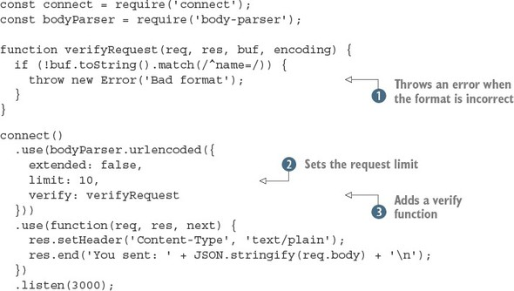
Notice that an Error object should be thrown by using the throw keyword . The body-parser module is set up to catch these before parsing the request, so it’ll pass the error back to Connect. After a request validation function has been created, you need to pass it to the body-parser middleware component by using the verify option .
The body size limit is in bytes; here it’s quite small, at 10 bytes . You can easily see what happens when the request is too large by using the previous curl command with a larger name value. Also, if you want to see what happens when the validation error is thrown, use curl to send another value instead of name.

Why is limit needed?
Let’s take a look at how a malicious user can render a vulnerable server useless. First, create the following small Connect application named server.js, which does nothing other than parse request bodies by using the bodyParser() middleware component:
const connect = require('connect');
const bodyParser = require('body-parser');
connect()
.use(bodyParser.json({ limit: 99999999, extended: false }))
.use((req, res, next) => {
res.end('OK\n');
})
.listen(3000);
Now create a file named dos.js, as shown in the following listing. You can see how a malicious user could use Node’s HTTP client to attack the preceding Connect application, simply by writing several megabytes of JSON data:
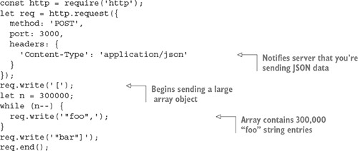
Fire up the server and run the attack script:
$ node server.js &
$ node dos.js
If you watch the node process in top(1), you should see that it starts to use more CPU and RAM as dos.js runs. This is bad, but thankfully it’s exactly why all the body parsing middleware components accept a limit option.

Parsing JSON data
If you’re making web applications with Node, you’re going to be dealing with a lot of JSON. The body-parser module’s JSON parser has a few handy options that you’ve seen in the previous examples. The following listing shows how parsing JSON and using the resulting values works.

Listing C.6. Validating form requests
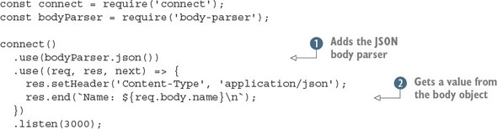
After the JSON parser has been loaded , your request handlers can treat the req.body value as a JavaScript object rather than a string. This example assumes that a JSON object with a name property has been sent, and it’ll send the value back in the response . That means your request has to have a Content-Type of application/json, and you need to send valid JSON. By default, the json middleware component uses strict parsing, but you can relax encoding requirements by setting this to false.
Setting the JSON Content-Type option
One option that you need to be aware of is type. This allows you to change the Content-Type that’ll be parsed as JSON. In the following example, we use the default, which is application/json. But in some cases your application might have to interact with HTTP clients that don’t send this header, so be warned.
The following curl request could be used to submit data to your application, and will send a JSON object with the username property set to tobi:
curl -d '{"name":"tobi"}' -H "Content-Type: application/json"
http://localhost:3000
Name: tobi

Parsing multipart <form> data
The body-parser module doesn’t handle multipart request bodies. You need to handle multipart messages to support file uploads, so anything such as uploading a user’s avatar needs multipart support.
There’s no officially supported multipart parser for Connect, but some popular ones are well maintained. Two examples are busboy (www.npmjs.com/package/busboy) and multiparty (www.npmjs.com/package/multiparty). Both of these modules have associated connect modules: connect-busboy and connect-multiparty. The reason for this is that the multipart parsers themselves are dependent on Node’s lower-level HTTP modules, so a wide range of frameworks can use them. They’re not specifically tied into Connect.
The following listing is based on multiparty, and will print out the details of an uploaded file in the console.

Listing C.7. Handling uploaded files
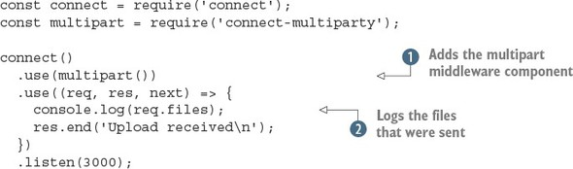
This short example adds the multiparty middleware component and then logs the received files . The files will be uploaded to a temporary location, so you have to use the fs module to delete the files when your application is finished with them.
To use this example, make sure you’ve installed connect-multiparty.[3] Then start the server and send it a file with curl’s -F option:
3
We used version 1.2.5 to test this example.

curl -F file=@index.js http://localhost:3000
The filename is placed after the @ symbol, and it’s prefixed with a field name. The field name will be available in the req.files object, so you can distinguish between separate uploaded files.
If you take a look at the output of the application, you’ll see something similar to the following example output. As you can see, req.files.file.path would be available to your application, and you could rename the file on disk, transfer the data to a worker for processing, upload to a content delivery network, or do anything else your app requires:
{ fieldName: 'file',
originalFilename: 'index.js',
path: '/var/folders/d0/_jqj3lf96g37s5wrf79v_g4c0000gn/T/60201-p4pohc.js',
headers:
{ 'content-disposition': 'form-data; name="file"; filename="index.js"',
'content-type': 'application/octet-stream' },
Although body-parser copes with compression, you may be wondering about compressing outgoing responses. Read on to learn about the compression middleware component that can reduce your bandwidth bills and make your web applications feel faster.

C.1.4. compression: compressing outgoing responses
In the preceding section, you may have noticed that the body parsers are capable of decompressing requests that used gzip or deflate. Node comes with a core module for handling compression called zlib, and this is used to implement both compression and decompression methods. The compression middleware component (www.npmjs.com/package/compression) can be used to compress outgoing responses, which means the data your server sends can be compressed.
Google’s PageSpeed Insights tool recommends enabling gzip compression,[4] and if you look at requests made by your browser in the developer tools, you should see that many sites send gzipped responses. Compression adds CPU overhead, but because formats such as plain text and HTML compress well, it can improve your site’s performance and reduce bandwidth usage.
4
See https://developers.google.com/speed/docs/insights/EnableCompression for more information.

Deflate or gzip?
Having two compression options can be confusing. You’re probably wondering which is best, and why two exist at all. Well, according to the standards (RFC 1950 and RFC 2616), both use the same compression algorithm, but they differ in the way the header and checksum are handled.
Unfortunately, some browsers don’t correctly handle deflate, so the general advice is to use gzip. In the case of body parsing, it’s best to be able to support both, but if you’re compressing your server’s output, use gzip to be on the safe side.
The compression module detects the accepted encodings from the Accept-Encoding header field. If this field isn’t present, the identity encoding is used, meaning the response is untouched. Otherwise, if the field contains gzip, deflate, or both, the response will be compressed.

Basic usage
You should generally add compression high in the Connect stack, because it wraps the res.write() and res.end() methods.
In the following example, the content will be compressed:
const connect = require('connect');
const compression = require('compression');
connect()
.use(compression({ threshold: 0 }))
.use((req, res) => {
res.setHeader('Content-Type', 'text/plain');
res.end('This response is compressed!\n');
})
.listen(3000);
To run this example, you need to install the compression module from npm. Then, start the server and try making a request with curl that sets Accept-Encoding to gzip:
$ curl http://localhost:3000 -i -H "Accept-Encoding: gzip"
The -i argument makes cURL show you the headers, so you should see the Content-Encoding set to gzip. The output should be garbled, because the compressed data won’t be standard characters. Try piping it through gunzip without the -i option to see the output:
$ curl http://localhost:3000 -H "Accept-Encoding: gzip" | gunzip
This is powerful and relatively simple to set up, but you won’t always want to compress everything your server sends. To skip compression, you can use custom filter functions.

Using a custom filter function
By default, compression includes the MIME types text/*, */json, and */java-script in the default filter function to avoid compressing these data types:
exports.filter = function(req, res){
const type = res.getHeader('Content-Type') || '';
return type.match(/json|text|javascript/);
};
To alter this behavior, you can pass a filter in the options object, as shown in the following snippet, which will compress only plain text:
function filter(req) {
const type = req.getHeader('Content-Type') || '';
return 0 === type.indexOf('text/plain');
}
connect()
.use(compression({ filter: filter }));

Specifying compression and memory levels
Node’s zlib bindings provide options for tweaking performance and compression characteristics, and they can also be passed to the compression function.
In the following example, the compression level is set to 3 for less but faster compression, and memLevel is set to 8 for faster compression by using more memory. These values depend entirely on your application and the resources available to it. Consult Node’s zlib documentation for details:
connect()
.use(compression({ level: 3, memLevel: 8 }));
That’s all there is to it. Next we’ll look at middleware that covers core web application needs, such as logging and sessions.

C.2. Implementing core web application functions
Connect aims to implement and provide built-in middleware for the most common web application needs so that they don’t need to be reimplemented over and over by every developer. Core web application functions such as logging, sessions, and virtual hosting are all provided by Connect out of the box.
In this section, you’ll learn about five useful middleware components that you’ll likely use in your applications:

morgan— Provides flexible request logging
serve-favicon— Takes care of the /favicon.ico request without you having to think about it
method-override— Enables incapable clients to transparently overwrite req.method
vhost— Sets up multiple websites on a single server (virtual hosting)
express-session— Manages session data
Up until now, you’ve created your own custom logging middleware, but the Connect maintainers provide a flexible solution named morgan, so let’s explore that first.

C.2.1. morgan: log requests
The morgan module (www.npmjs.com/package/morgan) is a flexible request-logging middleware component with customizable log formats. It also has options for buffering log output to decrease disk writes, and for specifying a log stream if you want to log to something other than the console, such as a file or socket.

Basic usage
To use morgan in your own application, invoke it as a function to return a middleware function, as shown in the following listing.

Listing C.8. Using the morgan module for logging
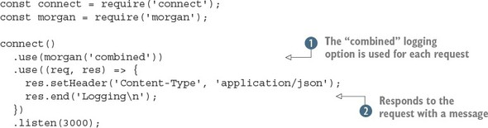
To use this example, you need to install the morgan module from npm.[5] It adds the module at the top of the middleware stack and then outputs a simple text response . By using the combined logging format argument , this Connect application will output the Apache log format. This is a flexible format that many command-line utilities can parse, so you can run your logs through log-processing applications that can generate useful statistics. If you try making requests from different clients, such as curl, wget, and a browser, you should see the user agent string in the logs.
5
We used version 1.5.1.

The combined logging format is defined like this:
:remote-addr - :remote-user [:date[clf]] ":method :url
HTTP/:http-version" :status :res[content-length] ":referrer" ":user-agent"
Each of the :something pieces are tokens, and in a log entry they’d contain real values from the HTTP request that’s being logged. For example, a simple curl(1) request would generate a log line similar to the following:
127.0.0.1 - - [Thu, 05 Feb 2015 04:27:07 GMT]
"GET / HTTP/1.1" 200 - "-"
"curl/7.37.1"

Customizing log formats
You can also create your own log formats. To do this, pass a custom string of tokens. For example, the following format would output something like GET /users 15 ms:
connect()
.use(morgan(':method :url :response-time ms'))
.use(hello)
.listen(3000);
By default, the following tokens are available for use (note that the header names aren’t case-sensitive):

:req[header] example: :req[Accept]
:res[header] example: :res[Content-Length]
:http-version
:response-time
:remote-addr
:date
:method
:url
:referrer
:user-agent
:status
You can even define custom tokens. All you have to do is provide a token name and callback function to the connect.logger.token function. For example, say you want to log each request’s query string. You might define it like this:
var url = require('url');
morgan.token('query-string', function(req, res){
return url.parse(req.url).query;
});
The morgan module comes with predefined formats other than the default one, such as short and tiny. Another predefined format is dev, which produces concise output for development, for situations when you’re usually the only user on the site and you don’t care about the details of the HTTP requests. This format also color-codes the response status codes by type: responses with a status code in the 200s are green, 300s are blue, 400s are yellow, and 500s are red. This color scheme makes it great for development.
To use a predefined format, you provide the name to logger():
connect()
.use(morgan('dev'))
.use(hello);
.listen(3000);
Now that you know how to format the logger’s output, let’s look at the options you can provide to it.

Logger options: stream, immediate, and buffer
As mentioned previously, you can use options to tweak how morgan behaves.
One such option is stream, which allows you to pass a Node Stream instance that the logger will write to instead of stdout. This allows you to direct the logger output to its own log file, independent of your server’s own output, by using a Stream instance created from fs.createWriteStream.
When you use these options, it's generally recommended to also include the format property. The following example uses a custom format and logs to /var/log/myapp.log with the append flag, so that the file isn’t truncated when the application boots:
const fs = require('fs');
const morgan = require('morgan');
const log = fs.createWriteStream('/var/log/myapp.log', { flags: 'a' })
connect()
.use(morgan({ format: ':method :url', stream: log }))
.use('/error', error)
.use(hello)
.listen(3000);
Another useful option is immediate, which writes the log line when the request is first received, rather than waiting for the response. You might use this option if you’re writing a server that keeps its requests open for a long time, and you want to know when the connection begins. Or you might use it for debugging a critical section of your app. Tokens such as :status and :response-time can’t be used, because they’re related to the response. To enable immediate mode, pass true for the immediate value, as shown here:
const app = connect()
.use(connect.logger({ immediate: true }))
.use('/error', error)
.use(hello);
That’s it for logging! Next we’ll look at the favicon-serving middleware component.

C.2.2. serve-favicon: address bar and bookmark icons
A favicon is that tiny website icon your browser displays in the address bar and bookmarks. To get this icon, the browser makes a request for a file at /favicon.ico. It’s usually best to serve favicon files as soon as possible, so the rest of your application can simply ignore them. The serve-favicon module (www.npmjs.com/package/serve-favicon) causes Connect’s icon to be displayed by default. This can be configured by passing arguments for other icons. This favicon is shown in figure C.2.

Figure C.2. A favicon
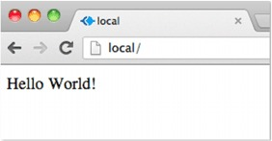

Basic usage
The serve-favicon middleware component can be placed at the top of the stack, which causes favicon requests to be ignored by any subsequent logging components. The icon is cached in memory for fast responses.
The following example shows serve-favicon sending an .ico file by passing the file path as the only argument:
const connect = require('connect');
const favicon = require('serve-favicon');
connect()
.use(favicon(__dirname + '/favicon.ico'))
.use((req, res) => {
res.end('Hello World!\n');
});
Note that you need a file called favicon.ico to test this out. Optionally, you can pass in a maxAge argument to specify how long browsers should cache the favicon in memory.
Next we have another small but helpful middleware component: method-override. It provides the means to fake the HTTP request method when client capabilities are limited.

C.2.3. method-override: fake HTTP methods
Sometimes it’s useful to use HTTP verbs beyond the common GET and POST methods. Imagine that you’re building a blog, and you want to allow people to create, update, and delete articles. It feels more natural to say DELETE /article rather than GET or POST. Unfortunately, not every browser understands the DELETE method.
A common workaround is to allow the server to get a hint about which HTTP method to use from the query parameters, form values, and sometimes even the HTTP headers. One way this is done is by adding <input type=hidden> with the value set to the method name you want to use. The server can then check the value and pretend it’s the request method.
Most web frameworks support this technique, and the method-override module (www.npmjs.com/package/method-override) is the recommended way to do it with Connect.

Basic usage
By default, the HTML input name is _method, but you can pass a custom value to methodOverride, as shown in the following snippet:
connect()
const connect = require('connect');
const methodOverride = require('method-override');
connect()
.use(methodOverride('__method__'))
.listen(3000)
To demonstrate how methodOverride() is implemented, let’s see how to create a tiny application to update user information. The application consists of a single form that will respond with a simple success message when the form is submitted by the browser and processed by the server, as illustrated in figure C.3.

Figure C.3. Using methodoverride to simulate a PUT request to update a form in the browser
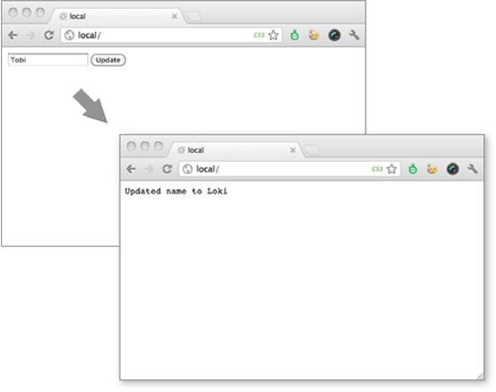
The application updates the user data through the use of two separate middleware components. In the update function, next() is called when the request method isn’t PUT. As mentioned previously, most browsers don’t respect the form attribute method="put", so the application in the following listing won’t function properly.

Listing C.9. A broken user-update application
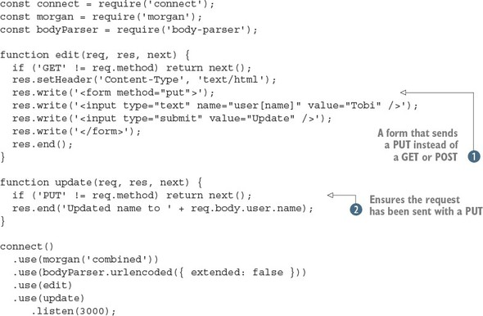
In this example, a form has been set up that sends a PUT to the server . The form should send data to the update function, but only if it’s sent with a PUT . You can try this with different browsers and HTTP clients; you can send a PUT with curl by using the -X option.
To improve browser support, you’ll add the method-override module. Here an additional input with the name _method has been added to the form, and methodOverride() has been added below the bodyParser() method because it references req.body to access the form data.

Listing C.10. Using method-override to support HTTP PUT
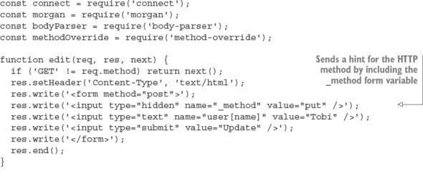
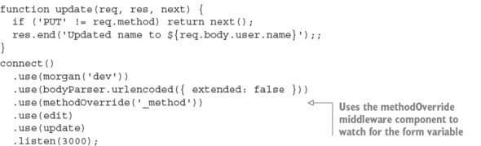
If you run this example, you should see that you can now send PUT requests from almost any browser.

Accessing the original req.method
methodOverride() alters the original req.method property, but Connect copies over the original method, which you can always access with req.originalMethod. The previous form would output values like these:
console.log(req.method);
// "PUT"
console.log(req.originalMethod);
// "POST"
To avoid including extra form variables, HTTP headers are supported as well. Different vendors use different headers, so you can create servers that support several header field names. This will help if you want to support client tools and libraries that assume a specific header. In the following example, the three header field names are supported:
Routing based on headers is a common task. One good example of this is supporting virtual hosts. You may have seen Apache servers that do this when you want to host multiple websites on a smaller number of IP addresses. Apache and Nginx can determine which website should be served based on the Host header.
Connect can do this too, and it’s easier than you might think. Read on to learn about virtual hosts and the vhost module.

C.2.4. vhost: virtual hosting
The vhost (virtual host) module (www.npmjs.com/package/vhost) is a simple, lightweight middleware component that routes requests via the Host request header. This task is commonly performed by a reverse proxy, which then forwards the request to a web server running locally on a different port. The vhost component does this in the same Node process by passing control to a Node HTTP server associated with the vhost instance.

Basic usage
Like most middleware, a single line is all it takes to get up and running with the vhost component. It takes two arguments: The first is the hostname string that this vhost instance will match against. The second is the http.Server instance that’ll be used when an HTTP request with a matching hostname is made (all Connect apps are subclasses of http.Server, so an application instance will work as well):
const connect = require('connect');
const server = connect();
const vhost = require('vhost');
const app = require('./sites/expressjs.dev');
server.use(vhost('expressjs.dev', app));
server.listen(3000);
In order to use the preceding ./sites/expressjs.dev module, it should assign the HTTP server to module.exports, as in the following example:
const http = require('http')
module.exports = http.createServer((req, res) => {
res.end('hello from expressjs.com\n');
});

Using multiple vhost instances
As with any other middleware, you can use vhost more than once in an application to map several hosts to their associated applications:
const app = require('./sites/expressjs.dev');
server.use(vhost('expressjs.dev', app));
const app = require('./sites/learnboost.dev');
server.use(vhost('learnboost.dev', app));
Rather than setting up the vhost middleware manually like this, you could generate a list of hosts from the filesystem. That’s shown in the following example, with the fs.readdirSync() method returning an array of directory entries:
const connect = require('connect')
const fs = require('fs');
cons app = connect()
const sites = fs.readdirSync('source/sites');
sites.forEach((site) => {
console.log(' ... %s', site);
app.use(vhost(site, require('./sites/' + site)));
});
app.listen(3000);
The benefit of using vhost instead of a reverse proxy is simplicity. It allows you to manage all your applications as a single unit. This is ideal for serving several smaller sites, or for serving sites that are largely composed of static content, but it also has the downside that if one site causes a crash, all your sites will be taken down (because they all run in the same process).
Next we’ll take a look at one of the most fundamental middleware components that Connect provides: the session management component, appropriately named express-session.

C.2.5. express-session: session management
The way web applications handle sessions is dependent on varying requirements. For example, one important choice is the storage back end: some applications benefit from high-performance databases such as Redis; others require simplicity and use the same database as the main application. The express-session module (www.npmjs.com/package/express-session) provides an API that can be extended to suit different databases. It’s robust and easy to extend, so it has many community-supported extensions. In this section, you’ll learn how to use the memory-backed version and Redis.
First, let’s see how to set up the middleware and explore the options available.

Basic usage
Listing C.11 implements a small application that counts the number of times a given user has accessed the page. The data is stored in the user’s session. By default, the cookie name is connect.sid, and it’s set to be httpOnly, meaning client-side scripts can’t access its value. The data in the session itself is stored in-memory on the server. The listing shows the basic usage for express-session in Connect.[6]
6
This was tested with express-session 1.10.2.

Listing C.11. Using sessions in Connect
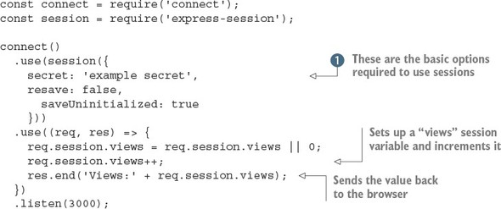
This short example sets up sessions and then manipulates a single session variable called views. First, the session middleware component is initialized with the required options: secret, resave, and saveUninitialized . The secret option is required and determines whether the cookie used to identify the session is signed. The resave option is used to force the session to be saved on each request, even if it hasn’t changed. Some session storage back ends require this, so you need to check before enabling it. The last option, saveUninitialized, causes a session to be created even if no values were saved. You can turn this off if you want to comply with laws that require consent before saving cookies.

Setting the session expiration date
Suppose you want sessions to expire in 24 hours, to send the session cookie only when HTTPS is used, and to configure the cookie name. You can control how long the session lasts by setting the expires or maxAge properties on the expression object:
const hour = 3600000
req.session.cookie.expires = new Date(Date.now() + hour * 24);
req.session.cookie.maxAge = hour * 24;
When using Connect, you’ll often set maxAge, specifying a number of milliseconds from that point in time. This method of expressing future dates is often written more intuitively, expanding to new Date(Date.now() + maxAge).
Now that sessions are set up, let’s look at the methods and properties available when working with session data.

Working with session data
The express-session data management API is simple. The basic principle is that any properties assigned to the req.session object are saved when the request is complete; then they’re loaded on subsequent requests from the same user (browser). For example, saving shopping cart information is as simple as assigning an object to the cart property, as shown here:
req.session.cart = { items: [1,2,3] };
When you access req.session.cart on subsequent requests, the .items array will be available. Because this is a regular JavaScript object, you can call methods on the nested objects in subsequent requests, as in the following example, and they’ll be saved as you expect:
req.session.cart.items.push(4);
One important thing to keep in mind is that this session object gets serialized as JSON between requests, so the req.session object has the same restrictions as JSON: cyclic properties aren’t allowed, function objects can’t be used, Date objects can’t be serialized correctly, and so on. Keep those restrictions in mind when using the session object.
Connect will save session data for you automatically, but internally it’s calling the Session#save([callback]) method, which is also available as a public API. Two additional helpful methods are Session#destroy() and Session#regenerate(), which are often used when authenticating a user to prevent session fixation attacks. When you build applications with Express, you’ll use these methods for authentication.
Now let’s move on to manipulating session cookies.

Manipulating session cookies
Connect allows you to provide global cookie settings for sessions, but it’s also possible to manipulate a specific cookie via the Session#cookie object, which defaults to the global settings.
Before you start tweaking properties, let’s see how to extend the previous session application to inspect the session cookie properties by writing each property into individual <p> tags in the response HTML, as shown here:
...
res.write('<p>views: ' + sess.views + '</p>');
res.write('<p>expires in: ' + (sess.cookie.maxAge / 1000) + 's</p>');
res.write('<p>httpOnly: ' + sess.cookie.httpOnly + '</p>');
res.write('<p>path: ' + sess.cookie.path + '</p>');
res.write('<p>domain: ' + sess.cookie.domain + '</p>');
res.write('<p>secure: ' + sess.cookie.secure + '</p>');
...
Express-session allows all the cookie properties (such as expires, httpOnly, secure, path, and domain) to be altered programmatically on a per-session basis. For example, you could expire an active session in 5 seconds like this:
req.session.cookie.expires = new Date(Date.now() + 5000);
An alternative, more intuitive API for expiry is the .maxAge accessor, which allows you to get and set the value in milliseconds relative to the current time. The following also expires the session in 5 seconds:
req.session.cookie.maxAge = 5000;
The remaining properties, domain, path, and secure, limit the cookie scope, restricting it by domain, path, or to secure connections, whereas httpOnly prevents client-side scripts from accessing the cookie data. These properties can be manipulated in the same manner:
req.session.cookie.path = '/admin';
req.session.cookie.httpOnly = false;
So far you’ve been using the default memory store to store session data, so let’s take a look at how to plug in alternative data stores.

Session stores
In the previous examples, we’ve been using the built-in MemoryStore session storage. It’s a simple, in-memory data store, which is ideal for running application tests because no other dependencies are necessary. But during development and in production, it’s best to have a persistent, scalable database backing your session data; otherwise, you’ll keep losing your session when you restart the server.
Just about any database can act as a session store, but low-latency key/value stores work best for such volatile data. The Connect community has created several session stores for databases, including CouchDB, MongoDB, Redis, Memcached, PostgreSQL, and others.
Here you’ll use Redis with the connect-redis module (https://www.npmjs.com/package/connect-redis). Redis is a good backing store because it supports key expiration, provides great performance, and is easy to install.
Invoke redis-server to make sure you’ve got Redis installed:
$ redis-server
[11790] 16 Oct 16:11:54 * Server started, Redis version 2.0.4
[11790] 16 Oct 16:11:54 * DB loaded from disk: 0 seconds
[11790] 16 Oct 16:11:54 * The server is now ready to accept
connections on port 6379
[11790] 16 Oct 16:11:55 - DB 0: 522 keys (0 volatile) in 1536 slots HT.
Next, you need to install connect-redis by adding it to your package.json file and running npm install, or by executing npm install --save connect-redis directly.[7] The connect-redis module exports a function that should be passed connect, as shown in the following listing.
7
We used version 2.2.0 when writing this book.

Listing C.12. Using Redis as a session store
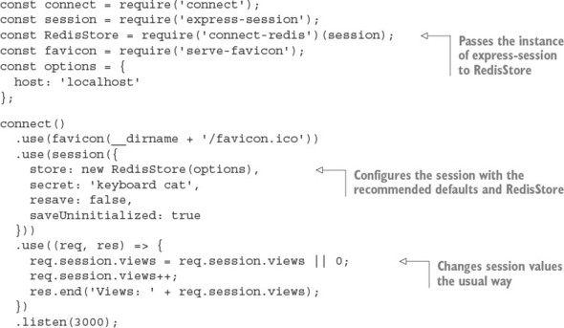
This example sets up a session store that uses Redis. Passing the connect reference to connect-redis allows it to inherit from connect.session.Store.prototype. This is important because in Node a single process may use multiple versions of a module simultaneously; by passing your specific version of Connect, you can be sure that connect-redis uses the proper copy.
The instance of RedisStore is passed to session() as the store value, and any options you want to use, such as a key prefix for your sessions, can be passed to the RedisStore constructor. After both of these steps are done, you can access session variables the same way as with MemoryStore. One small detail about this example is that we included the favicon middleware component to prevent the session variable from being incremented twice; otherwise, the views value will appear to be increased by 2 on each request as the browser fetches the page and /favicon.ico.
Whew! session was a lot to cover, but that finishes up all the core concept middleware. Next we’ll go over the built-in middleware that handles web application security. This is an important subject for applications that need to secure their data.

C.3. Handling web application security
As we’ve stated many times, Node’s core API is intentionally low-level. This means it provides no built-in security or best practices when it comes to building web applications. Fortunately, Connect middleware components implement these security practices.
This section will teach you about three security-related modules that you can install from npm:

basic-auth— Provides HTTP Basic authentication for protecting data
csurf— Implements protection against cross-site request forgery (CSRF) attacks
errorhandler— Helps you debug during development
First, let’s see how to set up an application that uses basic-auth to provide HTTP Basic authentication.

C.3.1. basic-auth: HTTP Basic authentication
In chapter 4, you created a crude Basic authentication middleware component. Well, it turns out that several Connect modules can do this for you. As previously mentioned, Basic authentication is a simple HTTP authentication mechanism, and it should be used with caution because user credentials can be trivial for an attacker to intercept unless Basic authentication is served over HTTPS. That being said, it can be useful for adding quick and dirty authentication to a small or personal application.
When your application has the basic-auth module in use, web browsers will prompt for credentials the first time the user attempts to connect to your application, as shown in figure C.4.

Figure C.4. Basic authentication prompt
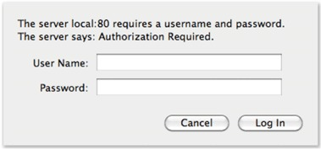

Basic usage
The basic-auth module (www.npmjs.com/package/basic-auth) allows you to get the credentials from the HTTP Authorization header field. The following listing shows how to use it with your own password verification function.

Listing C.13. Using the basic-auth module
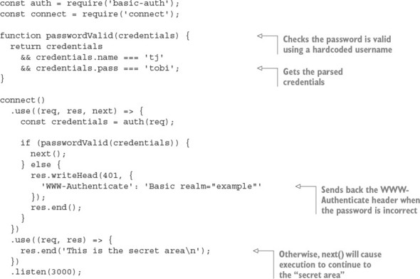
The basic-auth module provides only the Authorization header field parsing part of the authentication process. You have to check the password yourself by calling it in a middleware component and then the basic-auth module sends back the right headers when authentication fails. This example calls next() when authentication has succeeded so execution will continue to the protected parts of the application.

An example with curl
Now try issuing an HTTP request to the server with curl, and you’ll see that you’re unauthorized:
$ curl http://localhost:3000 -i
HTTP/1.1 401 Unauthorized
WWW-Authenticate: Basic realm="Authorization Required"
Connection: keep-alive
Transfer-Encoding: chunked
Unauthorized
Issuing the same request with HTTP Basic authorization credentials (notice the beginning of the URL) will provide access:
$ curl --user tj:tobi http://localhost:3000 -i
HTTP/1.1 200 OK
Date: Sun, 16 Oct 2011 22:42:06 GMT
Cache-Control: public, max-age=0
Last-Modified: Sun, 16 Oct 2011 22:41:02 GMT
ETag: "13-1318804862000"
Content-Type: text/plain; charset=UTF-8
Accept-Ranges: bytes
Content-Length: 13
Connection: keep-alive
I'm a secret
Continuing on with the security theme of this section, let’s look at the csurf module, which is designed to help protect against cross-site request forgery attacks.

C.3.2. csurf: cross-site request forgery protection
Cross-site request forgery (CSRF) is a form of attack that exploits the trust that a web browser has in a site. The attack works by having an authenticated user on your application visit a different site that an attacker has either created or compromised, and then making requests on the user’s behalf without them knowing about it.
It’s easier to understand this process with an example. Suppose that in your application the request DELETE /account will trigger a user’s account to be destroyed (though only while the user is logged in). Now suppose that user visits a forum that happens to be vulnerable to CSRF. An attacker could post a script that issues the DELETE /account request, thus destroying the user’s account. This is a bad situation for your application to be in, and the csurf module can help protect against such an attack.
The csurf module (https://www.npmjs.com/package/csurf) works by generating a 24-character unique ID, the authenticity token, and assigning it to the user’s session as req.session._csrf. This token can then be included as a hidden form input named _csrf, and the CSRF component can validate the token on submission. This process is repeated for each interaction.

Basic usage
To ensure that csurf can access req.body._csrf (the hidden input value) and req.session._csrf, you need to make sure that you add the module’s middleware function below body-parser and express-session, as shown in the following listing.[8]
8
We tested this example with csurf 1.6.6.

Listing C.14. CSRF protection
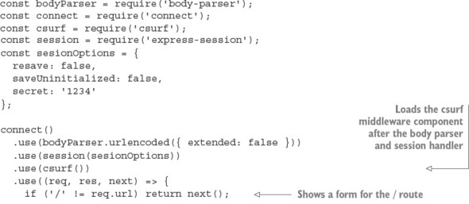
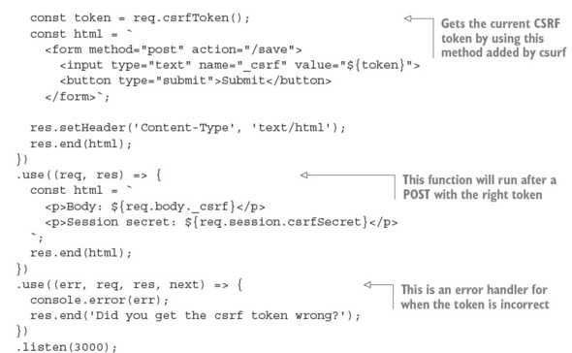
To use csurf, you have to first load the body-parser and session middleware components. This example then shows a form, which includes a text field with the current CSRF token. This token will cause all requests of certain method types to be checked based on the secret in the session. You can get the current token with req.csrf-Token, which is a method added by csurf. Posts with invalid tokens will automatically be flagged by csurf, so we’ve included a “token successful” handler and an error handler. This example uses a text field so you can see what happens if you change it.
This example shows that csurf automatically kicks in for certain kinds of requests. This is defined by the ignoreMethods option that you can pass to csurf. By default, HTTP GET, HEAD, and OPTIONS are ignored, but you could add others if required.
Another aspect of web development is ensuring that verbose logs and detailed error reporting are available both in production and development environments. Let’s look at the errorhandler module, which is designed to do exactly that.

C.3.3. errorhandler: displaying errors during development
The errorhandler module (www.npmjs.com/package/errorhandler) is ideal for development, providing verbose HTML, JSON, and plain-text error responses based on the Accept header field. It’s meant for use during development and shouldn’t be part of the production configuration.

Basic usage
Typically, this component should be the last used so it can catch all errors:
connect()
.use((req, res, next) => {
setTimeout(function () {
next(new Error('something broke!'));
}, 500);
})
.use(errorhandler());

Receiving an HTML error response
If you view any page in your browser with the setup shown here, you’ll see a Connect error page like the one shown in figure C.5, displaying the error message, the response status, and the entire stack trace.

Figure C.5. The default errorhandler HTML as displayed in a web browser
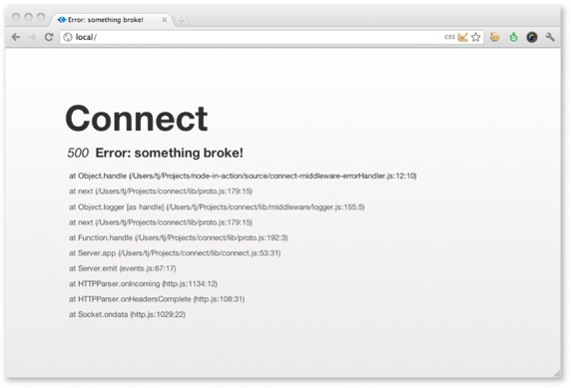

Receiving a plain-text error response
Now suppose you’re testing an API built with Connect. It’s far from ideal to respond with a large chunk of HTML, so by default errorHandler() will respond with text/plain, which is ideal for command-line HTTP clients such as curl(1). This is illustrated in the following stdout:
$ curl localhost:3000 -H "Accept: text/plain"
Error: something broke!
at Object.handle (/Users/tj/Projects/node-in-action/source
/connect-middleware-errorHandler.js:12:10)
at next (/Users/tj/Projects/connect/lib/proto.js:179:15)
at Object.logger [as handle] (/Users/tj/Projects/connect
/lib/middleware/logger.js:155:5)
at next (/Users/tj/Projects/connect/lib/proto.js:179:15)
at Function.handle (/Users/tj/Projects/connect/lib/proto.js:192:3)
at Server.app (/Users/tj/Projects/connect/lib/connect.js:53:31)
at Server.emit (events.js:67:17)
at HTTPParser.onIncoming (http.js:1134:12)
at HTTPParser.onHeadersComplete (http.js:108:31)
at Socket.ondata (http.js:1029:22)

Receiving a JSON error response
If you send an HTTP request that has the Accept: application/json HTTP header, you’ll get the following JSON response:
$ curl http://localhost:3000 -H "Accept: application/json"
{"error":{"stack":"Error: something broke!\n
at Object.handle (/Users/tj/Projects/node-in-action
/source/connect-middleware-errorHandler.js:12:10)\n
at next (/Users/tj/Projects/connect/lib/proto.js:179:15)\n
at Object.logger [as handle] (/Users/tj/Projects
/connect/lib/middleware/logger.js:155:5)\n
at next (/Users/tj/Projects/connect/lib/proto.js:179:15)\n
at Function.handle (/Users/tj/Projects/connect/lib/proto.js:192:3)\n
at Server.app (/Users/tj/Projects/connect/lib/connect.js:53:31)\n
at Server.emit (events.js:67:17)\n
at HTTPParser.onIncoming (http.js:1134:12)\n
at HTTPParser.onHeadersComplete (http.js:108:31)\n
at Socket.ondata (http.js:1029:22)","message":"something broke!"}}
We’ve added additional formatting to the JSON response, so it’s easier to read on the page, but when Connect sends the JSON response, it gets compacted nicely by JSON.stringify().
Are you feeling like a Connect security guru now? Maybe not yet, but you should have enough of the basics down to make your applications secure. Now let’s move on to a common web application function: serving static files.

C.4. Serving static files
Serving static files is another requirement common to many web applications that’s not provided by Node’s core. Fortunately, with some simple modules, Connect has you covered here as well.
In this section, you’ll learn about two more of Connect’s officially supported modules—this time focusing on serving files from the filesystem. These types of features are provided by HTTP servers such as Apache and Nginx, but with a little bit of configuration you can add them to your Connect projects:

serve-static— Serves files from the filesystem from a given root directory
serve-index— Serves pretty directory listings when a directory is requested
First we’ll show you how to serve static files with a single line of code by using the server-static module.

C.4.1. serve-static: automatically serving files to the browser
The serve-static module (www.npmjs.com/package/serve-static) implements a high-performance, flexible, feature-rich static file server supporting HTTP cache mechanisms, Range requests, and more. It also includes security checks for malicious paths, disallows access to hidden files (beginning with a period) by default, and rejects poison null bytes. In essence, serve-static is a secure and compliant static file-serving middleware component, ensuring compatibility with the various HTTP clients out there.

Basic usage
Suppose your application follows the typical scenario of serving static assets from a directory named ./public. This can be achieved with a single line of code:
app.use(serveStatic('public'));
With this configuration, serve-static will check for regular files that exist in ./public/ based on the request URL. If a file exists, the response’s Content-Type field value will be defaulted based on the file’s extension, and the data will be transferred. If the requested path doesn’t represent a file, the next() callback will be invoked, allowing subsequent middleware (if any) to handle the request.
To test it out, create a file named ./public/foo.js with console.log('tobi'), and issue a request to the server by using curl(1) with the -i flag, telling it to print the HTTP headers. You’ll see that the HTTP cache-related header fields are set appropriately, the Content-Type reflects the .js extension, and the content is transferred:
$ curl http://localhost/foo.js -i
HTTP/1.1 200 OK
Date: Thu, 06 Oct 2011 03:06:33 GMT
Cache-Control: public, max-age=0
Last-Modified: Thu, 06 Oct 2011 03:05:51 GMT
ETag: "21-1317870351000"
Content-Type: application/javascript
Accept-Ranges: bytes
Content-Length: 21
Connection: keep-alive
console.log('tobi');
Because the request path is used as is, files nested within directories are served as you’d expect. For example, you might have a GET /javascripts/jquery.js request and a GET /stylesheets/app.css request on your server, which would serve the files ./public/javascripts/jquery.js and ./public/stylesheets/app.css, respectively.

Using serve-static with mounting
Sometimes applications prefix pathnames with /public, /assets, /static, and so on. With the mounting concept that Connect implements, serving static files from multiple directories is simple. Just mount the app at the location you want. As mentioned in chapter 5, the middleware itself has no knowledge that it’s mounted, because the prefix is removed.
For example, a request to GET /app/files/js/jquery.js with serve-static mounted at /app/files will appear to the middleware as GET /js/jquery. This works out well for the prefixing functionality because /app/files won’t be part of the file resolution:
app.use('/app/files', connect.static('public'));
The original request of GET /foo.js won’t work anymore, because the middleware isn’t invoked unless the mount point is present, but the prefixed version GET /app/files/foo.js will transfer the file:
$ curl http://localhost/foo.js
Cannot get /foo.js
$ curl http://localhost/app/files/foo.js
console.log('tobi');

Absolute vs. relative directory paths
Keep in mind that the path passed to serve-static is relative to the current working directory. Passing in "public" as your path will essentially resolve to process.cwd() + "public".
Sometimes, though, you may want to use absolute paths when specifying the base directory, and the __dirname variable helps with that:
app.use('/app/files', connect.static(__dirname + '/public'));

Serving index.html when a directory is requested
Another useful feature of serve-static is its ability to serve index.html files. When a request for a directory is made and an index.html file lives in that directory, it will be served.
Serving static files is useful for web application assets, such as CSS, JavaScript, and images. But what if you want to allow people to download a list of arbitrary files from a list of directories? That’s where serve-index comes in.

C.4.2. serve-index: generating directory listings
The serve-index module (www.npmjs.com/package/serve-index) is a small directory-listing component that provides a way for users to browse remote files. Figure C.6 illustrates the interface provided by this component, complete with a search input field, file icons, and clickable breadcrumbs.

Figure C.6. Serving directory listings with Connect’s directory() middleware component
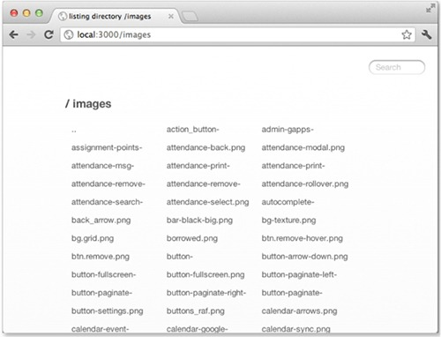

Basic usage
This component is designed to work with serve-static, which will perform the file serving; serve-index simply serves the listings. The setup can be as simple as the following snippet, where the request GET / serves the ./public directory:
const connect = require('connect');
const serveStatic = require('serve-static');
const serveIndex = require('serve-index');
connect()
.use(serveIndex('public'))
.use(serveStatic('public'))
.listen(3000);

Using directory() with mounting
Through the use of middleware mounting, you can prefix both the server-static and serve-index modules to any path you like, such as GET /files in the following example. Here the icons option is used to enable icons, and hidden is enabled for both components to allow the viewing and serving of hidden files:
connect()
.use('/files', serveIndex('public', { icons: true, hidden: true }))
.use('/files', serveStatic('public', { hidden: true }))
.listen(3000);
It’s now possible to navigate through files and directories with ease.

Glossary

Chapter 1

abstract interface
A programmatic description of an API that doesn’t include an implementation. In Node.js, a good example is the Streams API.

arrow function
A function written in a shorthand syntax. Instead of writing function () {}, write () => {} when passing functions as arguments to other functions. If the function accepts only one argument, the parentheses can be omitted.

asynchronous
Describes code that doesn’t necessarily run in the order in which it appears. In Node.js, this term is used to distinguish APIs that accept callbacks that will be run at a point in the future. For example, fs.readFile accepts a callback that receives the file’s contents after it has been read.

core modules
The libraries that are built into Node.

destructuring
ECMAScript 2015 introduced destructuring, which allows objects and arrays to be broken into variables and constants. For example, const { name } = { name: 'Alex' } creates a constant called name with the value alex.

ECMAScript standard
ECMAScript is a scripting language specification standardized by Ecma International. There are several ECMAScript standards; this book focuses on ECMAScript 2015 (ECMAScript 6th Edition). JavaScript implementers use the ECMAScript standard to make sure their interpreter is compatible with JavaScript written for other implementations.

event
A string that causes a function to be called. The function is known as an object listener. An emitter sends the named event. The basic class for creating emitters in Node is EventEmitter.

event loop
Node’s event loop waits for external events and converts them into callback invocations. Other systems use similar things-—message dispatchers and run loops—to quickly route events to the corresponding event handler.

JSON (JavaScript Object Notation)
JSON is a lightweight data-interchange format, intended to be easy to read and write, and based on a subset of JavaScript.

libuv
A multiplatform library for asynchronous I/O. It’s used in Node, but also other libraries and languages such as Julia.

nonblocking I/O
Blocking operations halt execution until the operation completes. Node uses nonblocking I/O, which means reads from a network or file resource won’t block execution.

npm
Node’s package manager. It allows you to install Node packages from a large central repository and to manage dependencies in Node projects.

Promise
The Promise object is a standardized ECMAScript 2015 API for representing values that may be available now, in the future, or never.

REPL (read-eval-print loop)
A command-line interface enabling you to evaluate code and see the results.

rest parameters
The rest parameter syntax in ECMAScript 2015 allows an unknown number of arguments in a function to be represented as an array. To name two arguments but put the rest in an array, use function (a, b, ...rest). It can also be used with destructuring to copy objects: const newObject = { ...oldObject }.

semantic versioning
A convention for specifying library compatibility using three numbers: major, minor, and patch, written as 1.0.2 (major: 1, minor: 0, patch: 2). An application that depends on version 1.0.2 should be compatible with 1.1.1, but not 2.0.0.

Chapter 2

callback
A function that has been passed to a function and may run later.

closure
JavaScript functions capture the variables defined in their enclosing scope. If you define function B inside function A, B will have access to all of A’s values.

CommonJS module specification
A module format for defining which values should be exported from the current JavaScript file. See module.

content management system (CMS)
Web application used to edit text and images that will be displayed on a public-facing website.

flow control (or control flow)
The order in which statements will be executed. Because Node is asynchronous, control flow is of interest, as JavaScript offers many ways of dealing with control flow, including callbacks, promises, generators, basic looping primitives, and iterators. In Node, flow control refers to the way we group sequences of asynchronous tasks.

global scope
Scope means the parts of the program that can access a value, so global scope means a value is accessible everywhere within a program.

module
Node modules are single files that contain JavaScript. Values (typically, functions and constants) can be exported so they can be used in other files.

nested callback
A callback within a callback; when a callback has been passed to a function, it’s sometimes necessary to define another callback inside the first callback.

package.json
A file that defines a Node project’s name, author, license, and dependencies. Every Node program and library you create should have a package.json file.

property
JavaScript objects are collections of keys and values, and keys and values are known as the object’s properties.

stack trace
A list of program instructions that had executed up to the point when an error occurred.

state
The value of all the variables in a program at a given time.

Chapter 3

boilerplate
Code that’s frequently duplicated and that could be automated.

client-side bundle
Preprocessed JavaScript code from several source files that’s usually minified and compressed, and then served to clients.

cURL
A command-line tool and programmer library for making HTTP requests. It’s often used as a debugging tool for quickly checking how web servers respond to requests.

database model
A programmer-friendly data model that makes it easier to interact with database tables or documents than using the database’s native language.

form encoding
When an HTTP POST is made to a web server, including a simple form POST, the form’s contents are encoded into the request body. The most common format, application/x-www-form-urlencoded, is similar to URL encoding, which replaces unsafe ASCII characters with percent signs.

MIME (Multipurpose Internet Mail Extensions)
An internet standard for adding nontextual data to emails and multipart message bodies. This allows email clients to show HTML, images, and text in non-ASCII character sets.

object-relational mapping (ORM)
A library that maps between programmer-friendly data structures (for example, JavaScript objects) and database data structures (for example, tables and foreign keys).

REST (Representational State Transfer), RESTful API
Stateless web API using a set of predefined operations in HTTP. The operations are based on HTTP verbs; the most common are GET, POST, PUT, and DELETE.

route
The URL fragment and HTTP verb that a given route handler should process.

route handler
A user-defined callback that runs when an HTTP request is made to a web application. The route handler usually generates content, perhaps from a database, or modifies a database, and then generates the response by using a template or format such as JSON.

static asset
A file that’s served by a web server without any additional processing. Typically, images, CSS files, and client-side JavaScript files are static assets.

template
Plain-text format that can include embedded data or JavaScript code and be used to generate HTML to streamline HTML’s syntax.

Chapter 4

build system
A set of tools and configuration files for generating JavaScript that will run efficiently in a browser.

linter
A program that checks the correctness of a source file’s format. Linters can be used to enforce a given programming style on a project by checking against a set of linting rules.

method chain
Running a method on the return value of a previously called method.

pipe
Connecting a data output to an input. In UNIX, processes are pipelined by using the vertical bar character (|); in Node, streams are connected by using method chaining.

source map
A file that allows browser debuggers to map from a line in a transpiled source file to the original code.

stream
An efficient data input and/or output channel that may be text or binary data. Node supports readable, writable, and other stream types, and these streams can be linked together by using pipes.

test runner
A program that runs and collates the results of unit tests found in one or more files.

transpile
Also known as source-to-source compilers, JavaScript transpilers convert one type of ECMAScript to another. The most common use is to convert modern ES2015 to backward-compatible ECMAScript 5, which can run in more browsers. Another example is TypeScript, which is a superset of JavaScript that gets transpiled into ES5 or ES2015.

webpack loader
Transforms or transpiles source code.

webpack plugin
Changes the behavior of the build process itself, rather than the output files.

Chapter 5

database adapter
Some database libraries are written in a generic fashion and can be extended with specific adapters that implement functionality for the desired database.

decoupled
If a function, class, or module can easily be changed in a project, or reused in another project, then it is loosely coupled.

full-stack framework
A framework that includes features for working with both client-side and server-side code. That usually means it has libraries for dealing with HTTP requests, request routing, database modeling, and communication with code running in a browser.

GET parameters
URL parameters that appear after a question mark and are separated by ampersands.

HTTP verb
The HTTP method (GET, POST, PUT, PATCH, DELETE) representing the action that should be performed on a remote resource.

isomorphic
JavaScript applications that run both client-side and server-side by sharing the same code.

middleware
Functions that can be called in sequence to modify an HTTP request and response.

Model-View-Controller (MVC)
Design pattern for separating software into components; the model manages data and logic, the view transforms the data into a user interface, and the controller converts interactions into operations for the model or view.

relational database
A database structure based around relations between the stored entities.

single-page web app
An application that’s served to the browser once and doesn’t require a full-page reload. If the application needs to change the URL in the browser for any reason, the HTML5 History API is used to give the impression that the URL has changed and the browser has loaded a new page from the server.

web framework
A set of libraries for developing a web application with support for extensibility through plugins or middleware.

Chapter 6

bcrypt
A password-hashing function. This function maps arbitrary amounts of data to a string of fixed size that can be stored safely in a database, so the user’s plain-text password isn’t stored.

content negotiation
Part of the HTTP standard that deals with serving different versions of a document at the same URI. User agents (browsers) can request a different data format if the server supports it.

CSS preprocessor
Programs that convert supersets of CSS to CSS that a browser can interpret. The Sass and LESS stylesheet languages both include CSS preprocessors, and these languages add features such as variables, nesting, and mixins.

password salt
Random data used in addition to the input of a hash function, making dictionary attacks harder.

Redis database
An in-memory database that’s also used as a cache and message broker. It’s useful for storing user sessions and dealing with push messages in web applications.

Redis hash
A map from a string field and a value, used to represent objects in a Redis database.

response object
An object that determines how your server will respond to a given HTTP request. It includes the response body, which is usually a web page, and the headers.

single-threaded
A running program (process) can be made up of threads that execute concurrently. JavaScript’s model is to use a single thread, but allow the thread to switch context and run different code when events happen. The events in a browser are interactions such as the user clicking a button; in Node, they’re typically I/O events, such as network operations or data being read from a disk.

template language
Lightweight markup languages that are converted to HTML and add features that make it easier to inject values from code, and iterate over arrays or objects.

third-party middleware
Middleware components that aren’t distributed by the authors of the original web library or framework.

Chapter 7

lexical scope
The visibility of a variable is determined by its scope. In JavaScript, adding a function adds a new level of scope. Any variables defined in that function are visible by any functions defined within that function.

mixin
This usually means a class that contains methods for use in other classes. In Sass, mixins are groups of CSS declarations that can be reused in multiple places; in Pug, mixins are used to define reusable template fragments.

partial
Small, reusable template.

section lambda
A lambda is an anonymous function, so a section lambda in Hogan is a way of associating a function with a tag in a template.

significant whitespace
In JavaScript, curly brackets, semicolons, and newlines are used to separate statements. If a new lexical block is required, a function or control statement is used. In languages with significant whitespace, such as Pug, lines of code are grouped together by the number of spaces used to indent each line.

XSS (cross-site scripting) attack
If a web application accepts user input from forms or URL parameters, and those values are redisplayed in templates, then it may be possible to inject malicious code. Values must be escaped first to be safe from this type of attack.

Chapter 8

ACID (atomicity, consistency, isolation, durability)
For a database to be ACID-compliant, it must support operations that are atomic (the operation succeeds, or the operation fails and the database is left unchanged), consistent (the data changes only in the allowed ways), isolated (ensuring concurrent execution), and durable (after a change has been made, it will remain, even if the system crashes or is rebooted).

BSON
A binary format used by MongoDB for representing objects. Objects consist of an ordered set of elements; the elements are made up of a field name, a type, and a value. The types supported by BSON include string, integer, date, and JavaScript code.

daemon
A program that runs in the background, usually starting automatically when the system boots.

database schema
A formal definition of the data and relationships between items in a database. It’s the design of the database.

database transaction
One or more database operations that are grouped together and run according to the ACID properties.

distributed database
A database stored on multiple computers, potentially but not necessarily in different geographical locations.

leaky abstraction
An attempt to hide complexity that exposes too many details and issues of the underlying implementation.

document-oriented database
A database that stores semistructured data without a predefined schema, sometimes in JSON or XML. Examples include MongoDB and CouchDB.

memoize
An optimization technique that stores the result of a function so it doesn’t have to be called again.

NoSQL
A database that doesn’t use tabular relations as found in relational databases.

primary key
A column in a database table that’s used to uniquely identify each row.

publish-subscribe
A pattern in which messages can be sent to multiple receivers.

query builder
An API that’s more convenient for programmers than writing SQL queries by hand.

relational algebra
Used as the theoretical basis for relational databases to model the stored data and queries that can be performed on it.

replica set
A group of MongoDB processes that maintain the same dataset.

web worker
A way of allowing JavaScript to run on background threads in browsers.

Chapter 9

assert, assertion
Ensure that an expression matches an expectation. This can be a simple Boolean statement, equality, or practically anything else. In Node, assertions throw exceptions when they fail. A test runner can catch and collate these exceptions to produce test reports.

BDD (behavior-driven development)
An extension of TDD that uses a different API style to encourage a focus on where in the process the test occurs, what to test and what not to test, and how much to test in one go. It also tries to improve understanding of test failures, and the naming of test units.

functional testing
Testing a slice of functionality through the whole system. In web development, that means full-stack testing: the browser and server are tested at the same time.

mocks
Objects or values that behave like real counterparts, but are usually a simple veneer that provides just enough behavior to allow a test to run. Rather than accessing real files or networks in tests, which could be slow or dangerous if destructive operations occur, mocks can be used to safely simulate their behavior.

test-driven development (TDD)
Writing tests before the code under test.

test runner
A program that manages loading tests, running them, and then collecting the results so they can be displayed. Mocha is a test runner.

typeof
A JavaScript operator that returns a string for a given object or value.

unit testing
Small parts of a module, such as functions or methods of a class, are tested in isolation against assertions in small test cases (units).

Chapter 10

Amazon EC2 (Amazon Elastic Compute Cloud)
Amazon’s virtual computer service.

container
A type of virtualization, containers are isolated user-space instances of an operating system, running on top of a host operating system. Containers offer additional control over resource usage and security benefits, and they can be quickly started up and destroyed.

Content delivery network (CDN)
Distributed servers that deliver static content.

Docker image
An image of the filesystem that Docker will use to create a container.

dyno
Heroku’s term for a container; this is used to run both servers and arbitrary commands in an isolated environment on Heroku’s servers.

Elastic Beanstalk
An orchestration service run by Amazon for scripting deployments to Amazon’s other services, such as EC2.

log rotation
A command that runs periodically and renames log files based on the date, and then optionally compresses them to use less storage space.

SSH (Secure Shell)
Provides an encrypted command-line (or X11) interface to a remote computer for running commands. It can form the workflow of a web developer when initially configuring a new server, or connecting to servers to run maintenance or debugging commands.

sudo
A program for running programs with other user privileges. It’s usually used to run commands that need special privileges, such as editing system configuration files.

Chapter 11

arguments
Program arguments are the flags provided on the command line that enable or disable certain features.

exit status
Value returned by a program when it completes. Nonzero values indicate an error.

interprocess communication
The methods an operating system provides to allow running programs to communicate. An example is pipes, which use the output of one program as the input of another, but even files can be considered a form of interprocess communication.

Open Group
A consortium that publishes the Single UNIX Specification, a family of standards that qualifies producers of operating systems to use the UNIX trademark.

shell
Command-line user interface enabling commands to be entered and the results viewed. It’s called a shell because it’s a layer around the operating system.

redirection
Capturing the output from a program and sending it as input to another program or file.

stderr
The error stream for outputting error messages from a running program.

stdin
The input stream for a running program.

stdout
The output stream for messages printed by a program.

Chapter 12

Chromium
An open source browser from which Google’s Chrome browser derives its code.

Electron main process
A Node process that manages the Electron app and access to files and the network.

Electron render process
The Chromium web view.

JSX
React applications use a mix of HTML fragments alongside JavaScript. This is preprocessed into pure JavaScript before it runs in a browser. This language is called JSX.

native
A program or library that’s written using the operating system’s built-in APIs.

React
A library by Facebook for building data-driven web and mobile user interfaces.

Appendix A

constructor
A function that creates and initializes a JavaScript object.

CSV (comma-separated values)
A text format for tabular data that’s typically used with databases or spreadsheet programs. The values are split into columns by using commas, and rows by using new lines.

DOM (Document Object Model)
The standards that define the API for JavaScript working with HTML. The DOM is a language-independent interface working with HTML.

microformats
A way of including structured data in HTML that’s readable by both humans and software. Because HTML doesn’t always represent structured data clearly, microformats can be used to embed data such as addresses, geographical locations, and calendar entries in HTML without any special tags.

regular expression
An expression that matches patterns in a string.

robots.txt
A standard used by websites to tell web crawlers and scrapers what content can be scanned or excluded from scraping.

vertical search engine
Search engine that focuses on a niche.

web scraping
Converting HTML into structured data that can be stored in files or a database.

XPath
A query language for selecting nodes from an XML document.

Index
[SYMBOL][A][B][C][D][E][F][G][H][I][J][K][L][M][N][O][P][Q][R][S][T][U][V][W][X][Y][Z]

SYMBOL
- prefix
-- (double hyphen)
!= prefix
' (backtick) symbol
{} (curly brackets)
@ symbol
&& operator
= prefix
=== operator
|| operator
404 Not Found code
500 status code

A
absolute directory path
abstract interface
Accept-Encoding header
acceptance testing
ACID (atomicity, consistency, isolation, durability)
ACID guarantees
atomicity
consistency
durability
isolation
addListener function
addPercentageToEach function
after function
afterEach function
Amazon EC2 (Amazon Elastic Compute Cloud)
Amazon S3
App class
app.configure() method
app.get() method
app.post route handler
app.render() method
app.set() method
app.use() method, 2nd
append command
application data, storing
distributed databases, MongoDB
embedded databases, LevelDB
expense of serialization and deserialization
hosted storage
in-browser storage
localForage API
localStorage and sessionStorage APIs
reading and writing
reading and writing values
key/value stores, Redis
relational databases
ACID guarantees
Knex
NoSQL
PostgreSQL, 2nd
selecting database type
applications
building with webpack
bundles and plugins
CommonJS
configuring and running
development server
npm packages
comparing other platforms to Node
database
making articles readable and saving them for later
making model API
dependency
deploying
from Git repository
keeping Node running
hosting
containers
platform as service
servers
npm scripts
RESTful web service
server start command
starting new
structure of
user interface
multiple format support
npm for client-side dependencies
templates
argument conventions
arguments
ArrayBuffers
arrow functions, 2nd
Article class, 2nd
Article.create method
articles
articles.sqlite file
asar option
assert interface
assert module
adding logic to run tests
deepEqual assertion
equal assertion
example using
notDeepEqual assertion
notEqual assertion
notStrictEqual assertion
ok assertion
strictEqual assertion
testing that thrown errors are correct
assert, assertion
Async
asyncFunction
asynchronous programming
challenges with
one-off events with callbacks
parallel flow control, implementing
repeating events with event emitters
creating event emitters
example of
extending event emitters
responding to events that should occur once
sequencing asynchronous logic
serial flow control
implementing
when to use
atomicity, consistency, isolation, durability.
See ACID.
attr() method
autoincrement
automating deployment
automation, using Gulp
adding to projects
creating and running tasks
using separate files for larger projects
watching filesystem for changes

B
babel property
backtick symbol
basic-auth security module
basic usage
example with curl
bcrypt, 2nd
bcrypt.hash() function
BDD (behavior-driven development), 2nd
before function
beforeEach function
bitcount command
bitfield command
bitop command
bitpos command
Blobs
block expansion, Pug
block prepending/appending, Pug
blogPage function
blpop command
body-parser
forms
JSON data
limit option
multipart data
validating requests
bodyParser() method, 2nd, 3rd
boilerplate
break state
brew install node command
broadcast event
browser-based tests
brpop command
BSON
buffer logger option
build system

C
cache value
callbacks, 2nd
case statements, Pug
cb (callback function)
CDN (content delivery network), 2nd, 3rd, 4th
Chai
channel event emitter
character escaping, Embedded JavaScript
cheerio, scraping with
cheerio.load() method
Chocolatey package, Redis
Chromium, 2nd
.clear() method
client value
client-side bundle
close event
close value
closures, 2nd
cluster API
CMS (content management system), 2nd, 3rd
collections
color variable
comma-separated values.
See CSV.
command-line applications
command-line arguments
parsing
reading files from stdin
validating
conventions and philosophy of
example of
interpreting real-world scripts
pipes
command execution order and
errors and exit codes
piping data
using in Node
sharing via npm
command-line arguments
parsing
reading files from stdin
validating
command-line tools and daemons
CommonJS
loading modules and assets
module specification
webpack and
CommonJS shims
compileDebug value
completed counter
compression middleware component
basic usage
custom filter function
specifying compression and memory levels
compression options
Connect middleware, 2nd
body-parser
forms
JSON data
limit option
multipart data
validating requests
combining components
compression component
basic usage
custom filter function
specifying compression and memory levels
cookie-parser
JSON cookies
regular cookies
setting outgoing cookies
signed cookies
creating configurable
error-handling
default error handler
handling errors yourself
express-session module
basic usage
manipulating session cookies
session stores
setting session expiration date
working with session data
function of
method-override module
accessing req.method property
basic usage
morgan module
basic usage
customizing log formats
logger options
ordering of
qs parse method
serve-favicon module
serve-index module
basic usage
using directory() with mounting
serve-static module
absolute vs. relative directory paths
basic usage
serving index.html when directory is requested
using serve-static with mounting
setting up
vhost module
basic usage
using multiple vhost instances
web application security
basic-auth module
csurf module
errorhandler module
connect.session.Store.prototype
const vs. let
constructor
container
content block
content delivery network.
See CDN.
content management system.
See CMS.
content negotiation, shoutbox app
implementing
responding with XML
Content-Type option
context
control flow
controller, 2nd
cookie-parser
JSON cookies
regular cookies
setting outgoing cookies
signed cookies
core modules
create method
createdAt property
createdb command
CSRF (cross-site request forgery), 2nd, 3rd
_csrf property
--css option
CSS preprocessor
csurf security module
CSV (comma-separated values)
cURL
curl command
curly brackets
custom filter function
custom routes
CWD (current working directory)

D
daemons, 2nd
data events
database adapter
database model
database schema
database transaction
databases
ACID guarantees
atomicity
consistency
durability
isolation
adding to web applications
making articles readable and saving for later
making model API
Knex
connecting and running queries
jQuery for databases
leaky abstractions
swapping database back end
MongoDB
connecting to
identifiers
inserting documents
installation and setup
querying
replica sets
write concerns
NoSQL
PostgreSQL
connecting to from Node
creating database
defining tables
inserting data
MySQL vs.
performing installation and setup
querying data
updating data
DEBUG
debug value
debugger
decoupled
decr command
decrby command
deepEqual assertion
deepEquals method
del command
delete keyword
DELETE method
dependencies property
dependency, adding to web applications
deploying applications
from Git repository
keeping Node running
DerbyJS
RESTful APIs
route definition
setting up
strengths of
weaknesses of
describe method, 2nd
desktop apps, building with Electron
bootstrapping libraries
communicating between components
defining Request component
defining Response component
installing dependencies
setting up webpack
destructuring
developer tools
directory object
__dirname variable, 2nd
distributed databases, MongoDB
connecting to
identifiers
inserting documents
installation and setup
querying
replica sets
write concerns
div tag, shorthand for in Pug
doAsync method, 2nd
Docker, 2nd
document-oriented database
dollarFormat function
DOM (Document Object Model), 2nd, 3rd
domain property
double hyphen
dropdb command
Dust
dyno, 2nd

E
echo command
ECMAScript, 2nd
ECS (EC2 Container Service)
EJS (Embedded JavaScript)
integrating in application
web application templating with
caching templates
character escaping
client-side applications
creating templates
integrating into application
Elastic Beanstalk
Electron
builds and distribution
electron-packager
packaging
creating apps
creating full desktop apps
bootstrapping libraries
communicating between components
defining Request component
defining Response component
installing dependencies
setting up webpack
interface design
main process
render process
stack
electron-packager
embedded databases, LevelDB
API overview
installation
key/value encodings
LevelUP and LevelDOWN packages
modular database
pluggable back ends
reading and writing key/value pairs
Embedded JavaScript.
See EJS.
entries.submit() method
entry property
environment variables
environment-based configuration
eq() method
equal assertion
equality operator
err argument
err.notFound property
error event
error handling, Connect middleware
default error handler
handling errors yourself
error streams
errorhandler security module
basic usage
HTML error response
JSON error response
plain-text error response
errorHandler() function
event emitters
creating
events that should occur only once
example of
extending
event handling
one-off events with callbacks
repeating events with event emitters
creating event emitters
events that should occur only once
example of
extending event emitters
event listeners
event loop, 2nd
EventEmitter class, 2nd, 3rd
events, defined
exists command
exit codes
exit status
expect interface
expires property
exports object
Express
application skeleton
generating application
installing Express executable
overview of application
planning application
configuring
content negotiation
implementing
responding with XML
RESTful API
adding basic authentication
adding entries
adding entry listing support
designing
implementing routing
pagination middleware
removing sensitive user data
testing entries route
testing user data retrieval
user authentication
authenticating user logins
creating user model
retrieving user data
saving and loading user records
saving user into Redis
securing user passwords
testing user-saving logic
user login
authenticating
creating menu for users
displaying form
user registration
adding registration routes
creating registration form
implementing
relaying feedback to users
storing transient messages in sessions
user-loading middleware
user-submitted content
adding entry-related routes
adding front-page display of entries
creating entry form
creating entry model
flexible validation middleware
implementing entry creation
performing form validation
route-specific middleware
validating user content submission
view rendering
changing lookup directory
configuring view system
default template engine
methods of exposing data to
view caching
view lookup
express-enrouten API
express-session module
basic usage
manipulating session cookies
session stores
setting session expiration date
working with session data
express.response object
express.static

F
FIFO (first in, first out)
file watcher utility, event emitters
filename value
filesystem (fs) module)
filter function
Flatiron.js
RESTful APIs
route definition
setting up
strengths of
weaknesses of
Float32Array
flow control
parallel
serial
flow control, community tools for
foo() function
for loops
forEach loop
form encoding
form requests, parsing
format property
format variable
frameworks, server-side
comparison of
defined
DerbyJS
RESTful APIs
route definition
setting up
strengths of
weaknesses of
Flatiron.js
RESTful APIs
route definition
setting up
strengths of
weaknesses of
hapi
plugins
RESTful APIs
route definition
setting up
strengths of
weaknesses of
Koa
RESTful APIs
route definition
setting up
strengths of
weaknesses of
Kraken
RESTful APIs
route definition
setting up
strengths of
weaknesses of
LoopBack
RESTful APIs
route definition
setting up
strengths of
weaknesses of
Sails.js
RESTful APIs
route definition
setting up
strengths of
weaknesses of
typical users of, 2nd
agency developer
open source developer
product developer
writing modular code
front-end build systems
Gulp
adding to projects
creating and running tasks
using separate files for larger projects
watching filesystem for changes
npm scripts
configuring front-end build tools
creating custom
overview
webpack
bundles and plugins
CommonJS
configuring and running
development server
npm packages
fs module
fs.createWriteStream
fs.watchFile function
full-stack framework
functional testing, 2nd

G
generators
geospatial indexes
get command
GET method
GET parameters
getAllKeys function
getrange command
getRange function
getset command
Git repository, deploying applications from
global leak detection
global lock
--global option
global scope
global variables
Gulp
adding to projects
creating and running tasks
using separate files for larger projects
watching filesystem for changes
gulp-concat plugin
gulp-sourcemaps plugin
gulp.task() method

H
handleChange method
handleRequest function
handleSelectTab method
hapi
plugins
RESTful APIs
route definition
setting up
strengths of
weaknesses of
--harmony flag
hashed password
hdel command
Headers component
headless tests
--help flag
Heroku
hexists command
hget command
HGETALL command
hgetall command
hidden option
hincrby command
hincrbyfloat command
hkeys command
hlen command
hmget command
hmset command
Hogan
creating templates
fine-tuning
Mustache tags
displaying simple values
inverted sections
partials
section lambdas
sections
hosted storage
hosting applications
containers
platform as service
servers
hot reloading
hscan command
hset command
hsetnx command
hstrlen command
HTML error response
htmlparser module
HTTP Authorization header field
HTTP messages
HTTP verb
:http-version token
httpOnly property
hvals command
HyperLogLog
hyphen

I
-i option
icons option
_id property
if statements
if/else blocks
ignoreMethods
ImageMagick
immediate logger option
immediate option
in progress features
in-browser storage
localForage API
localStorage and sessionStorage APIs
reading and writing
reading and writing values
include command, Pug
included file
incr command
incrby command
incrbyfloat command
index.html files, serving when directory is requested
--inline option
install command
installing Node
from source
with MacOS installer
with package manager
with Windows Installer
interactive debugging
interprocess communication
IPC (interprocess communication), 2nd
isomorphic, defined
it function

J
JavaScript, in Pug templates
join callback
jQuery
jsdom, scraping with
jsdom.env method
JSON (JavaScript Object Notation), 2nd, 3rd, 4th
json spaces option
JSON.parse function
JSON.stringify() function, 2nd
JSX

K
key/value stores, Redis
encoding and data types
hashes
initialization
installation and setup
key/value pairs
keys
lists
performance improvement
pub/sub with channels
sets
keyboard shortcuts
Knex
connecting and running queries
jQuery for databases
leaky abstractions
swapping database back end
Koa
RESTful APIs
route definition
setting up
strengths of
weaknesses of
Kraken
RESTful APIs
route definition
setting up
strengths of
weaknesses of

L
leaky abstraction
let vs. const
level option
LevelDB
API overview
installation
key/value encodings
LevelUP and LevelDOWN packages
modular database
pluggable back ends
reading and writing key/value pairs
LevelDOWN package
LevelUp package
lexical scope
libraries, bootstrapping
libuv
LIFO (last in, first out)
limit option
lindex command
linsert command
linter
listener
listeners method
llen command
loaders
localForage API
locals.messages variable
localStorage API
log formats, customizing
log rotation
logger options
LoopBack
RESTful APIs
route definition
setting up
strengths of
weaknesses of
lpop command
lpush command
lpushx command
lrange command
lrem command
LRU eviction
lset command
ltrim command
LTS (Long-Term Support)
Lua scripting

M
MacOS installer, installing Node with
maintenance
cluster API
hosting static files and proxying
with Upstart
Makara
map method
maxAge argument, 2nd
MEAN stack (MongoDB, Express, Angular, Node)
memdb project
memdown
memLevel option
memoize
memory levels, specifying compression and
MemoryStore, 2nd
messages variable
messages.ejs template
method chain
method property
:method token
method-override module
accessing req.method property
basic usage
methodOverride() function
mget command
microformats, 2nd
middleware
MIME (Multipurpose Internet Mail Extensions), 2nd, 3rd
mixin
mixin command, Pug
Mocha
hooks
testing asynchronous logic
testing Node applications
mocks
module.exports mechanism, fine-tuning module creation using
module.exports property
module.loaders property
modules
caveats regarding
core
creation of
organizing and reusing functionality
reusing
MongoDB
connecting to
identifiers
inserting documents
installation and setup
querying
replica sets
write concerns
mongodb module
MongoDB, Express, Angular, Node.
See MEAN stack.
Monit
morgan module
basic usage
customizing log formats
logger options
mount point
mounting middleware
using directory() with
using serve-static module with
mset command
msetnx command
.msi installer, Windows
multipart data
Mustache templating language
creating templates
tags
displaying simple values
inverted sections
partials
section lambdas
sections
MVC (Model-View-Controller), 2nd
MySQL, PostgreSQL vs.

N
namespaces
nargs method
native
nested callback
networking (http) module
next argument
next() method, 2nd
Nginx, 2nd
node command
NODE_DEBUG
NODE_ENV variable, 2nd, 3rd
node_modules folder, reusing modules
NODE_PATH variable
Node, using pipes in
Node.js
asynchronous programming
challenges with
community tools for flow control
one-off events with callbacks
parallel flow control
repeating events with event emitters
sequencing asynchronous logic
serial flow control
built-in tools
core modules
debugger
npm command-line tool
ECMAScript 2015 support
event loop
example of typical web application
feature groups
installing
modules
caveats regarding
creating
fine-tuning creation of
reusing
nonblocking I/O
organizing and reusing functionality
release schedule
starting new projects
types of Node program
applications suited to Node
command-line tools and daemons
desktop applications
web applications
V8 JavaScript engine
nonblocking I/O, 2nd
nonparallel testing
NoSQL, 2nd
notDeepEqual assertion
notEqual assertion
NotFoundError
notStrictEqual assertion
npm command-line tool
for client-side dependencies
npm packages with webpack
npm scripts
configuring front-end build tools
creating custom
npm install cookie-parser
npm run build command
npm start command
npm test command

O
ObjectIDs
Octopart
ok assertion
once method
Open Group
open value
option tag
originalMethod property
ORM (object-relational mapping), 2nd
outgoing cookies, setting
output property

P
PaaS (platform as service)
package manager, installing Node with
package.json
page() method
parallel flow control, implementing
parse() method
partial
.pass property
password salt
path property
percentFormat function
performance maintenance
cluster API
hosting static files and proxying
with Upstart
pg package
pipes
command execution order and
errors and exit codes
piping data
using in Node
plain-text error response
plugins, jQuery
POST request, 2nd, 3rd
PostgreSQL
connecting to from Node
creating database
defining tables
inserting data
MySQL vs.
performing installation and setup
querying data
updating data
postinstall command
prefixes
PRG (Post/Redirect/Get) pattern
primary key
process.argv array
programming
challenges with
one-off events with callbacks
parallel flow control, implementing
repeating events with event emitters
creating event emitters
example of
extending event emitters
responding to events that should occur once
sequencing asynchronous logic
serial flow control
implementing
when to use
Promise object
promises
property
proxying
psetex command
publicPath option
publish-subscribe
publish/subscribe logic
event emitters
Redis
Pug
block expansion
div tag shorthand
incorporating data
logic
case statements
conditionally rendering code
iterating through objects and arrays
JavaScript
organizing templates
block prepending/appending
include command
mixin command
template inheritance
specifying tag attributes
specifying tag content

Q
qs parse method, query strings
query builder
query operators
query property
query strings

R
rainbow table attacks
React
React.Component class
readability
readdirSync method
readFile function
redirection
Redis
encoding and data types
hashes
initialization
installation and setup
key/value pairs
keys
lists
performance improvement
pub/sub with channels
saving users into
sets
redis-server command
redis.createClient() function
ReferenceError error
:referrer token
regular cookies
regular expressions
relational algebra
relational databases, 2nd
ACID guarantees
atomicity
consistency
durability
isolation
Knex
connecting and running queries
jQuery for databases
leaky abstractions
swapping database back end
NoSQL
PostgreSQL
connecting to from Node
creating database
defining tables
inserting data
MySQL vs.
performing installation and setup
querying data
updating data
relative directory path
:remote-addr token
removeAllListeners method
removeMessages() method, 2nd
rename command
renamenx command
render() method, 2nd
REPL (read-eval-print loop)
replica set
reply.file method
req argument
:req token
req.accepted array
req.body object
req.cookies object
req.files object
req.files.file.path
req.method property, accessing
req.query property
req.remoteUser function
req.session object
req.session._csrf
req.session.cart
req.session.messages function
req.session.uid function
Request component
request module
request() method
require() method, 2nd, 3rd
res argument
:res token
res.end() method
res.error function
res.format() method, 2nd
res.locals.messages function
res.locals.user function
res.message function
res.render() method
res.send() method, 2nd, 3rd, 4th
res.setHeader() function, 2nd
res.write() method
resolve.extensions property
Response component
response object
:response-time token
REST (Representational State Transfer)
rest parameters
restart command
RESTful APIs
DerbyJS
Flatiron.js
hapi
Koa
Kraken
LoopBack
Sails.js
shoutbox app
adding basic authentication
adding entries
adding entry listing support
designing
implementing routing
pagination middleware
removing sensitive user data
testing entries route
testing user data retrieval
RESTful web service, building
robots.txt
route
route definition
DerbyJS
Flatiron.js
hapi
Koa
Kraken
LoopBack
Sails.js
route handler
rowCount property
rpop command
rpush command
rpushx command
rs.initiate() method

S
S3 (Simple Storage Service)
sadd command
Sails.js
RESTful APIs
route definition
setting up
strengths of
weaknesses of
salted hash
SASS (Syntactically Awesome Style Sheets) files
save method
--save option
.saveSync() method
saveUninitialized
scan command
scard command
scope value
scope, for cookies
scraping
defined
processing raw data
required tools for
uses of
with cheerio
with jsdom
script tag, 2nd, 3rd, 4th
scripts property, 2nd
sdiff command
sdiffstore command
section lambda
secure property
Secure Shell.
See SSH.
select element
SELECT statements
Selenium
semantic versioning
SemVer
serial flow control
implementing
when to use
serve-favicon module
serve-index module
basic usage
using directory() with mounting
serve-static module
absolute versus relative directory paths
basic usage
serving index.html when directory is requested
using with mounting middleware
server-side frameworks
comparison of
defined
DerbyJS
RESTful APIs
route definition
setting up
strengths of
weaknesses of
Flatiron.js
RESTful APIs
route definition
setting up
strengths of
weaknesses of
hapi
plugins
RESTful APIs
route definition
setting up
strengths of
weaknesses of
Koa
RESTful APIs
route definition
setting up
strengths of
weaknesses of
Kraken
RESTful APIs
route definition
setting up
strengths of
weaknesses of
LoopBack
RESTful APIs
route definition
setting up
strengths of
weaknesses of
Sails.js
RESTful APIs
route definition
setting up
strengths of
weaknesses of
typical users of, 2nd
agency developer
open source developer
product developer
writing modular code
server.register method
session() function
sessionStorage API
set command
Set-Cookie header, 2nd
setbit command
setex command
setHeader method
setImmediate function
setInterval function
setMaxListeners method
setnx command
setrange command
setTimeout function, 2nd
shell
shipping features
should interface
Should.js
signed cookies
significant whitespace
Simple Storage Service.
See S3.
single-page web app
single-threaded
Sinon.JS
spies
stubs
sinter command
sinterstore command
sismember command
slc command, 2nd
smembers command
sort command
source map
source, installing Node from
spop command
spread operator
SQL (Structured Query Language)
SQLite
srandmember command
srem command
sscan command
SSH (Secure Shell)
stack trace
stack, Electron
staged features
start method
state
static asset
:status token
stderr stream, 2nd
stdin, reading files from
stdout stream, 2nd
storing application data
distributed databases
embedded databases
expense of serialization and deserialization
hosted storage
in-browser storage
localForage API
localStorage and sessionStorage APIs
reading and writing
reading and writing values
key/value stores, Redis
relational databases
ACID guarantees
Knex
NoSQL
PostgreSQL, 2nd
selecting database type
stream option, 2nd
strictEqual assertion
string property
strlen command
StrongLoop
style tag
sudo command, 2nd
sum function
sunion command
sunionstore command
synchronous I/O operations
Syntactically Awesome Style Sheets files.
See SASS.

T
tar command, 2nd
TDD (test-driven development), 2nd
template engine
template language
template strings
templates, for web applications
clean code
EJS, integrating in application
example of
rendering HTML using templates
rendering HTML without templates
Express default view template engine
user interface
with Embedded JavaScript
caching templates
character escaping
client-side applications
creating templates
integrating into application
with Hogan and Mustache templating language
creating templates
fine-tuning Hogan
Mustache tags
with Pug
block expansion
div tag shorthand
incorporating data
logic
organizing templates
specifying tag attributes
specifying tag content
test property, 2nd
test runner, 2nd
testing
failed tests
better stack traces
more-detailed logs
functional testing
unit testing
assert module
Chai
Mocha
Should.js
Sinon.JS
Vows
testsCompleted
third-party middleware
--timeout command
title block
token function
tokens
transpilers
TTL (time to live)
type command
type property
TypedArrays
typeof operator
TypeScript

U
Uint8Array
unit testing, 2nd
assert module
adding logic to run tests
deepEqual assertion
equal assertion
example using
notDeepEqual assertion
notEqual assertion
notStrictEqual assertion
ok assertion
strictEqual assertion
testing that thrown errors are correct
Chai
Mocha
hooks
testing asynchronous logic
testing Node applications
Should.js
Sinon.JS
spies
stubs
Vows
update method
UPDATE query
uppercase_trim function
Upstart
uptime and performance maintenance
cluster API
hosting static files and proxying
with Upstart
url property
:url token
urlencoded body parser
use() function
user authentication, shoutbox app
authenticating user logins
creating user model
retrieving user data
saving and loading user records
saving user into Redis
securing user passwords
testing user-saving logic
user interface, adding to web applications
multiple format support
npm for client-side dependencies
templates
user login, shoutbox app
authenticating
creating menu for authenticated and anonymous users
displaying form
user registration, shoutbox app
adding registration routes
creating registration form
implementing
relaying feedback to users
storing transient messages in sessions
:user-agent token
user-submitted content, shoutbox app
adding entry-related routes
adding front-page display of entries
creating entry form
creating entry model
flexible validation middleware
implementing entry creation
performing form validation
validating submission
user:ids value
User.authenticate() method, 2nd, 3rd
User.get() function
User.getByName() function
User.getId() function
user.pass hash
utility method

V
V8 JavaScript engine
validate.lengthAbove() function
validate.required() function
validating requests
var declarations
verify option
vertical search engine
vhost module
basic usage
using multiple vhost instances
view rendering, shoutbox app
changing lookup directory
configuring view system
default template engine
methods of exposing data to
view caching
view lookup
Vows

W
waitForVisible method
Wanstrath, Chris
watch() method, 2nd
Watcher object
web application security
basic-auth module
basic usage
example with curl
csurf module
errorhandler module
basic usage
HTML error response
JSON error response
plain-text error response
web application templating
clean code
example of
rendering HTML using templates
rendering HTML without templates
with Embedded JavaScript
caching templates
character escaping
client-side applications
creating templates
integrating into application
with Hogan and Mustache templating language
creating templates
fine-tuning Hogan
Mustache tags
with Pug
block expansion
div tag shorthand
incorporating data
logic
organizing templates
specifying tag attributes
specifying tag content
web applications, 2nd
building with webpack
bundles and plugins
CommonJS
configuring and running
development server
npm packages
comparing other platforms to Node
database
making articles readable and saving them for later
making model API
dependency
example of typical
npm scripts
RESTful web service
server start command
starting new
structure of
user interface
multiple format support
npm for client-side dependencies
templates
web framework
web scraping
web worker
web-parsing
WebdriverIO test
webpack
bundles and plugins
CommonJS
configuring and running
development server
npm packages
setting up
webpack loader
webpack plugin
webpackBootstrap shim
Windows Installer, installing Node with

X
XML, content negotiation
XPath
XSS (cross-site scripting) attacks
XSS attack

Y
-y flag
yargs
Yeoman, 2nd
yield keyword

Z
Zabbix

List of Figures
Chapter 1. Welcome to Node.js
Figure 1.1. Asynchronous and nonblocking components in a Node application
Figure 1.2. The event loop
Figure 1.3. Node’s software stack
Chapter 2. Node programming fundamentals
Figure 2.1. Navigating your code is easier if you organize it into directories and separate files rather than keeping your application in one long file.
Figure 2.2. The population of the module.exports property or the exports object allows a module to select what should be shared with the application.
Figure 2.3. Node modules can be created by using either files (example 1) or directories (example 2).
Figure 2.4. When you put ./ at the beginning of a module require, Node will look in the same directory as the program file being executed.
Figure 2.5. Steps to finding a module
Figure 2.6. The package.json file, when placed in a module directory, allows you to define your module by using a file other than index.js.
Figure 2.7. Shared app object in a web app
Figure 2.8. An HTML response from a web server that pulls titles from a JSON file and returns results as a web page
Figure 2.9. An echo server repeating the data sent to it
Figure 2.10. Serial execution of asynchronous tasks is similar, conceptually, to synchronous logic: tasks are executed in sequence. Parallel tasks, however, don’t have to execute one after another.
Figure 2.11. How serial flow control works
Figure 2.12. Using parallel flow control to implement a frequency count of word use in numerous files
Chapter 3. What is a Node web application?
Figure 3.1. A read-it-later web application
Chapter 4. Front-end build systems
Figure 4.1. Two build processes that share functionality
Figure 4.2. Sample gulp-help output
Chapter 5. Server-side frameworks
Figure 5.1. Koa middleware execution order
Figure 5.2. LoopBack’s project generator
Figure 5.3. The StrongLoop API explorer showing User routes
Figure 5.4. Choosing a Node framework
Chapter 6. Connect and Express in depth
Figure 6.1. The life cycle of two HTTP requests making their way through a Connect server
Figure 6.2. Middleware ordering is important.
Figure 6.3. The life cycle of an HTTP request causing an error in a Connect server
Figure 6.4. Default application skeleton structure using EJS templates
Figure 6.5. Express help
Figure 6.6. Generated package.json contents
Figure 6.7. Default Express application
Figure 6.8. HTML template plus data = HTML view of data
Figure 6.9. The view cache setting
Figure 6.10. Express view lookup process
Figure 6.11. Values passed directly to the render function take precedence when rendering a template.
Figure 6.12. User registration form
Figure 6.13. Registration form error reporting
Figure 6.14. User login form
Figure 6.15. User login and registration menu used to access the forms you created
Figure 6.16. Menu when the user is authenticated
Chapter 7. Web application templating
Figure 7.1. The flow of an MVC application and its interaction with the template layer
Figure 7.2. Example blog application browser output
Figure 7.3. Pug’s include mechanism provides a simple way to include the contents of one template in another template during rendering.
Chapter 8. Storing application data
Figure 8.1. Knex’s usage statistics
Figure 8.2. MongoDB’s usage statistics
Figure 8.3. The redis package’s statistics on npm
Figure 8.4. Redis channels provide an easy solution to a common data-delivery scenario.
Figure 8.5. The levelup package’s statistics on npm
Figure 8.6. Examples of third-party LevelDB packages on npm
Chapter 9. Testing Node applications
Figure 9.1. Test framework overview
Figure 9.2. Failing test in Mocha
Figure 9.3. Successful test in Mocha
Figure 9.4. Vows can structure tests in a suite using batches, contexts, topics, and vows.
Figure 9.5. Vows combines full-featured BDD testing with macros and flow control.
Figure 9.6. Testing with browser automation
Figure 9.7. Using wdio to configure Selenium tests
Figure 9.8. Running an Express application with DEBUG='*'
Chapter 10. Deploying Node applications and maintaining uptime
Figure 10.1. The Forever tool helps you keep your application running, even if it crashes.
Figure 10.2. A master spawning three workers on a four-core processor
Figure 10.3. You can use Nginx as a proxy to relay static assets quickly back to web clients.
Chapter 11. Writing command-line applications
Figure 11.1. Node’s argv compared to yargs
Figure 11.2. Combining pipes and output streams
Chapter 12. Conquering the desktop with Electron
Figure 12.1. Visual Studio Code’s application window and a native context menu
Figure 12.2. The main parts of a typical Electron application
Figure 12.3. The electron-quick-start project running in macOS
Figure 12.4. The HTTP Master Electron application
Figure 12.5. A desktop notification
Figure 12.6. A typical Electron application bundle’s contents
Appendix A. Installing Node
Figure A.1. The installer .pkg file
Figure A.2. The installation wizard
Figure A.3. Node’s REPL
Figure A.4. The Windows .msi installer
Figure A.5. Node’s REPL in Windows
Appendix B. Automating the web with scraping
Figure B.1. Steps for scraping and storing content
Figure B.2. Octopart allows users to search for electronic parts.
Figure B.3. Scraping with cheerio
Figure B.4. Viewing HTML in Chrome
Figure B.5. Scraping with jsdom
Appendix C. Connect’s officially supported middleware
Figure C.1. How a form is processed by body-parser
Figure C.2. A favicon
Figure C.3. Using methodoverride to simulate a PUT request to update a form in the browser
Figure C.4. Basic authentication prompt
Figure C.5. The default errorhandler HTML as displayed in a web browser
Figure C.6. Serving directory listings with Connect’s directory() middleware component

List of Tables
Chapter 4. Front-end build systems
Table 4.1. npm commands
Chapter 5. Server-side frameworks
Table 5.1. Koa’s main features
Table 5.2. Kraken’s main features
Table 5.3. hapi’s main features
Table 5.4. The main features of Sails
Table 5.5. DerbyJS features
Table 5.6. Flatiron’s features
Table 5.7. LoopBack’s features
Chapter 7. Web application templating
Table 7.1. Prefixes used to embed JavaScript in Pug
Chapter 8. Storing application data
Table 8.1. Comparing Knex-generated SQL for various databases
Chapter 10. Deploying Node applications and maintaining uptime
Table 10.1. PaaS features
Table 10.2. Server features
Table 10.3. Server features

List of Listings
Chapter 1. Welcome to Node.js
Listing 1.1. Using core modules and streams
Listing 1.2. Hello World with Node’s http module
Listing 1.3. A Node web application
Chapter 2. Node programming fundamentals
Listing 2.1. Defining a Node module (currency.js)
Listing 2.2. Requiring a module (test_currency.js)
Listing 2.3. Module won’t work as expected
Listing 2.4. A list of post titles
Listing 2.5. A basic HTML template to render the blog titles
Listing 2.6. Using callbacks in a simple application
Listing 2.7. Reducing nesting by creating intermediary functions
Listing 2.8. Reducing nesting by returning early
Listing 2.9. Using the on method to respond to events
Listing 2.10. Using the once method to respond to a single event
Listing 2.11. A simple publish/subscribe system using an event emitter
Listing 2.12. Creating a listener to clean up when clients disconnect
Listing 2.13. Extending the event emitter’s functionality
Listing 2.14. How scope behavior can lead to bugs
Listing 2.15. Using an anonymous function to preserve a global variable’s value
Listing 2.16. Serial control using a community-created add-on
Listing 2.17. Serial flow control implemented in a simple application
Listing 2.18. Parallel flow control implemented in a simple application
Listing 2.19. Using a community add-on flow-control tool in a simple application
Chapter 3. What is a Node web application?
Listing 3.1. RESTful routes example
Listing 3.2. Adding a body parser
Listing 3.3. An Article model
Listing 3.4. Adding the Article model to the HTTP routes
Listing 3.5. Generating readable articles and saving them
Listing 3.6. Article list template
Chapter 4. Front-end build systems
Listing 4.1. A gulpfile for ES2015 and React with Babel
Listing 4.2. A webpack.config.js file
Listing 4.3. An example HTML template for a React web app
Chapter 5. Server-side frameworks
Listing 5.1. Koa’s middleware ordering
Listing 5.2. Basic hapi server
Listing 5.3. hapi hello world server
Listing 5.4. Adding a plugin with hapi
Listing 5.5. Derby app/index.js file
Chapter 6. Connect and Express in depth
Listing 6.1. Using multiple Connect middleware components
Listing 6.2. Wrong: hello middleware component before logger component
Listing 6.3. A configurable logger middleware component for Connect
Listing 6.4. Error-handling middleware in Connect
Listing 6.5. A minimal Express application
Listing 6.6. Generated Express application skeleton
Listing 6.7. A model for entries
Listing 6.8. Logic to retrieve a range of entries
Listing 6.9. A form for entering post data
Listing 6.10. Add an entry using submitted form data
Listing 6.11. Listing entries
Listing 6.12. The entries.ejs view
Listing 6.13. Two more potential, but imperfect, attempts at validation middleware
Listing 6.14. Validation middleware implementation
Listing 6.15. Starting to create a user model
Listing 6.16. Updating user records
Listing 6.17. Adding bcrypt encryption to the user model
Listing 6.18. Testing the user model
Listing 6.19. Querying with the Redis command-line tool
Listing 6.20. Fetching a user from Redis
Listing 6.21. Authenticating a user’s name and password
Listing 6.22. Adding registration routes
Listing 6.23. A view template that provides a registration form
Listing 6.24. Creating a user with submitted data
Listing 6.25. A view template for a login form
Listing 6.26. A route to handle logins
Listing 6.27. Anonymous and authenticated user menu template
Listing 6.28. Middleware that loads a logged-in user’s data
Listing 6.29. Enabling user-loading middleware
Listing 6.30. CSS that can be added to style.css to style application menus
Listing 6.31. Test output
Listing 6.32. Pagination middleware
Listing 6.33. Implementing content negotiation
Listing 6.34. Using an EJS template to generate XML
Chapter 7. Web application templating
Listing 7.1. Blog entries text file
Listing 7.2. Blog entry file-parsing logic for a simple blogging application
Listing 7.3. Template engines separate presentation details from application logic
Listing 7.4. An EJS template for displaying blog entries
Listing 7.5. Storing template code in files
Listing 7.6. EJS template that renders an array of students
Listing 7.7. Using EJS to add templating capabilities to the client side
Listing 7.8. Using a lambda in Hogan
Listing 7.9. Using partials in Hogan
Listing 7.10. Template inheritance in action
Listing 7.11. Using block appending to load an additional JavaScript file
Chapter 8. Storing application data
Listing 8.1. Connecting to the database
Listing 8.2. Defining a schema
Listing 8.3. Inserting data
Listing 8.4. Updating data
Listing 8.5. Querying data
Listing 8.6. Using Knex to connect and query sqlite3
Listing 8.7. Interacting with the Knex-powered API
Listing 8.8. Connecting to MongoDB
Listing 8.9. Inserting a document
Listing 8.10. Implementing the Article API with MongoDB
Listing 8.11. Starting a replica set
Listing 8.12. Initiating a replica set
Listing 8.13. Connecting to a replica set
Listing 8.14. Connecting to Redis and listening for status events
Listing 8.15. Storing data in elements of Redis hashes
Listing 8.16. A simple chat server implemented with Redis pub/sub functionality
Listing 8.17. Initializing a level database
Listing 8.18. Reading and writing values
Listing 8.19. Getting keys that don’t exist
Listing 8.20. Overriding encoding for specific operations
Listing 8.21. Using memdown with LevelUP
Listing 8.22. Serialization benchmarking
Listing 8.23. Storing JSON in web storage
Listing 8.24. Iterating over entire dataset in localStorage
Listing 8.25. Namespacing keys
Listing 8.26. Getting all items in a namespace
Listing 8.27. Using localStorage for persistent memoization
Listing 8.28. Comparison of getting data with localStorage vs. localForage
Chapter 9. Testing Node applications
Listing 9.1. A model for a to-do list
Listing 9.2. Set up necessary modules
Listing 9.3. Test to make sure that no to-do items remain after deletion
Listing 9.4. Test to make sure adding a to-do works
Listing 9.5. Test whether the doAsync callback is passed true
Listing 9.6. Test whether add throws when missing a parameter
Listing 9.7. Running the tests and reporting test completion
Listing 9.8. Basic structure for a Mocha test
Listing 9.9. Describing the memdb .save functionality
Listing 9.10. Added save functionality
Listing 9.11. Adding a beforeEach hook
Listing 9.12. Testing asynchronous logic
Listing 9.13. Using Vows to test the to-do application
Listing 9.14. Chai’s assert interface
Listing 9.15. Logic for calculating tips when splitting a bill
Listing 9.16. Logic that calculates tips when splitting a bill
Listing 9.17. Database class
Listing 9.18. Using spies
Listing 9.19. Using stubs
Listing 9.20. Sample Express project
Listing 9.21. A WebdriverIO test
Listing 9.22. Using the debug package
Chapter 10. Deploying Node applications and maintaining uptime
Listing 10.1. A typical Upstart configuration file
Listing 10.2. A demonstration of Node’s cluster API
Listing 10.3. A demonstration of Node’s cluster API
Listing 10.4. A configuration file that uses Nginx to proxy Node.js and serve static files
Chapter 11. Writing command-line applications
Listing 11.1. Using yargs to parse command-line arguments
Listing 11.2. Reading a file from stdin
Chapter 12. Conquering the desktop with Electron
Listing 12.1. A simple Node module
Listing 12.2. Loading Node modules from the rendering process
Listing 12.3. webpack.config.js
Listing 12.4. The App class
Listing 12.5. The Request class
Listing 12.6. The Response component
Listing 12.7. The Headers component
Appendix B. Automating the web with scraping
Listing B.1. Extracting a book’s details
Listing B.2. Dealing with messy HTML
Listing B.3. Scraping with jsdom
Listing B.4. Parsing dynamic HTML with jsdom
Listing B.5. Parsing dates and generating CSV
Appendix C. Connect’s officially supported middleware
Listing C.1. Reading cookies sent in a request
Listing C.2. Parsing signed cookies
Listing C.3. Parsing query strings
Listing C.4. Parsing form requests
Listing C.5. Validating form requests
Listing C.6. Validating form requests
Listing C.7. Handling uploaded files
Listing C.8. Using the morgan module for logging
Listing C.9. A broken user-update application
Listing C.10. Using method-override to support HTTP PUT
Listing C.11. Using sessions in Connect
Listing C.12. Using Redis as a session store
Listing C.13. Using the basic-auth module
Listing C.14. CSRF protection

