

Table of Contents
Node.js: Novice to Ninja
Notice of Rights
Notice of Liability
Trademark Notice
About SitePoint
About the Author
Preface
Prerequisites
Conventions Used
Code Samples
Tips, Notes, and Warnings
Where to Find Help
The SitePoint Forums
The Code Archive
Your Feedback
Let’s Go
Chapter 1: What is Node.js
Skip Ahead?
JavaScript, JScript, ECMAScript, ES6, ES2015?
Why Learn Node.js?
It’s JavaScript
JavaScript Alternatives
It’s Fast
It’s Real-time
It’s Lightweight
It’s Modular
It’s Extendible
It’s Open Source
It’s Everywhere
What About Deno?
Summary
Quiz
Chapter 2: Install Node.js
Node Version Manager
Choosing a Node.js Version
How to Install Node.js on Linux (or Windows WSL2)
Configuring npm Global Permissions on Linux
How to Install Node.js on macOS
How to Install Node.js on Windows
How to Install Node.js on Other Devices
Run JavaScript Commands in the Node.js REPL
Summary
Quiz
Chapter 3: Your First Node.js Application
Your First Console App
#!/What?
Your First Web Server App
Port 3000?
Restarting Node.js Applications with Nodemon
Executing Scripts from Windows Powershell
Web Application Considerations
Complexity Ahead
Write Stateless Applications
Summary
Quiz
Chapter 4: How to Debug Node.js Scripts
Skip Ahead?
What is Debugging?
How to Avoid Bugs
Use a Good Code Editor
Use a Code Linter
Use Source Control
Adopt an Issue-tracking System
Use Test-driven Development
Node.js Debugging Environment Variables
Node.js Debugging Command-line Options
Console Debugging
Never Use console.log()?!
Node.js util.debuglog
Debugging with Logging Modules
Node.js V8 Inspector
Debugging Node.js Apps with Chrome
Not Using Chrome?
Remote Target
Debugger Statement
Debugging Node.js Apps with VS Code
Advanced Debugging Configuration
Other Node.js Debugging Tools
Exercise: Debugging webhello.js
Summary
Debugging Terminology
Quiz
Chapter 5: Getting Started with Express
Why use Express?
Express Version
Create a New Node.js Project
Create a New Git Repository
Semantic Versioning
Switch to ES6 Modules
Install Express
Runtime Dependencies and Development Dependencies
Create the Express Entry Script
What Is Routing?
Should You Switch to HTTPS?
Serve Static Files
Efficient Static Assets
Express Middleware Functions
Define Working Directories
Compressing HTTP Responses
Disable Express Identification
Handle 404 Not Found Errors
Add an HTML Template Engine
Template Performance
Advanced Routing
Routing Path Expressions
Routing Path Parameters
HTTP Route Methods
Creating a Route Handler
Exercises
Summary
Quiz
Chapter 6: Processing Form Data with Express
Code Examples
Sanitize User Input
Processing HTTP GET Query Strings
Processing HTTP Post Body Data
The body-parser Module
Processing Uploaded Files
Callback Functions
Exercises
Summary
Quiz
Chapter 7: How to Use the npm Node Package Manager
npm Alternatives
Global vs Local Packages
npm link
npm Help
npm Configuration
Project Initialization
Semantic Versioning
Project Dependencies
Development Dependencies
Searching for Packages
Development Dependency Limits?
Installing Packages
.gitignore node_modules
Shortcut Aliases
Semantic Constraints
“No-install” Execution
npx Local Execution
Listing Packages
Finding Outdated Packages
Update npm with npm
Removing Packages
Using npm Scripts
Special Scripts
Pre and Post Scripts
Life Cycle Scripts
Sophisticated Scripting
Publishing Packages
Publication Preparation
Two-factor Authentication
Publishing Tips
Exercises
Summary
Quiz
Chapter 8: Using ES2015 and CommonJS Modules
Skip Ahead?
CommonJS
ES2015 Modules (ESM)
Importing External URLs
Comparison of CommonJS and ES2015 Modules
Importing CommonJS Modules in ES2015
Requiring ES2015 Modules in CommonJS
Using ES2015 Modules in Browsers
Summary
Quiz
Chapter 9: Asynchronous Programming in Node.js
Single-threaded Non-blocking I/O Event-looping What?
Callbacks in Action
The Event Loop
Avoid Blocking the Event Loop
Callback Conundrums
A Function Must be 100% Synchronous or 100% Asynchronous
process.nextTick()
Callback Hell
Promises
util.promisify()
then() Functions Are Promisified
Parallel Promises
Promising Problems
async/await
Promise.all() is Still Necessary
try/catch is Ugly
Asynchronous Awaits in Synchronous Loops
Exercises
HTTP Requests
Summary
Quiz
Chapter 10: Using Database Storage
Skip Ahead?
A Database-driven Web Application Example
Installing and Configuring Database Software
MongoDB
Start the MongoDB Application
Your Own MongoDB Installation?
MongoDB Functionality
What Is a Database Index?
Stop the MongoDB Application
MySQL
Start the MySQL Application
Your Own MySQL Installation?
MySQL Functionality
No Time?
UNHEX? INET_ANON?
Never Build SQL Strings!
Stop the MySQL Application
Sequelize ORM
Start the Sequelize ORM Application
Your Own MySQL Installation?
Sequelize ORM Functionality
How to Choose the Right Database
Native vs ORM Drivers
Exercises
Summary
Quiz
Chapter 11: Using WebSockets
Skip Ahead?
What Are WebSockets?
Example WebSocket Chat Application
WebSocket Walkthrough
Advanced WebSockets Considerations
Multiple WebSocket Servers
What is Pub–sub?
Exercise
Summary
Quiz
Chapter 12: Useful Node.js APIs
Module node: URL Imports
Process
exit Events
OS
Util
URL
File System
fs and path
Events
Events in Client-side JavaScript
Streams
Worker Threads
Asynchronous Calculations
Workers and Event Loops
Child Processes
A Real-world Example
Clusters
Write Stateless Applications
Exercises
Summary
Quiz
Chapter 13: Example Real-time Multiplayer Quiz: Overview
Source Code
Quizzing Quick Start
What is Docker?
Summary
Chapter 14: Example Real-time Multiplayer Quiz: Architecture
Why Develop Using Multiple Servers?
1. One PostgreSQL Database Server
2. Two Express HTTP Web Servers
3. Three WebSocket Servers
4. One Traefic Load Balancer
5. Adminer Database Client
Docker Development Environment
Docker Production Environment
Is Docker Compose Suited to Production?
Summary
Chapter 15: Example Real-time Multiplayer Quiz: Express Code
Database Library
Question Database Initialization
Initializing Data on Application Start?
Why Does the Number of Imported Questions Vary?
Native Node.js Fetch()
Sequential Database INSERTs
Starting a New Game
Joining a Game
Quiz Page
Summary
Chapter 16: Example Real-time Multiplayer Quiz: WebSocket Code
Initiating a WebSocket Connection
WebSocket Message Format
PostgreSQL Pub–sub
Game Logic
Joining a Game
Why Run a create() Method?
Starting a Game
Answering a Question
Leaving a Game
Exercises
Summary
Chapter 17: Node.js Tools and Resources
Perfect Package Pursuit
Development Tools
Testing
Logging
Full-stack Frameworks
Server-side Frameworks
Node.js in Client-side Frameworks
Web Publishing, Content Management Systems, and Blogging
Headless Content Management Systems
Static Site Generators
Database Drivers
Templating
Command Line
File System
Network
WebSockets
Images
Email
Security and Authentication
Summary
Chapter 18: Node.js Application Deployment
Pages vs Applications
Node.js Application Preparation
Dedicated Server Hosting
sudo-not
HTTP and HTTPS Considerations
Process Management
PM2 Port Clashes
Use a Reverse Proxy
Static Site Hosting (Jamstack)
Build PHP-powered Static Sites with Node.js
Serverless/Lambda Functions
AWS Everywhere
Container Hosting
Summary
Chapter 19: Epilogue
Is Node.js for You?
Is Deno Better?
Thank You for Reading!
Appendix: Quiz Answers
Chapter 1
Chapter 2
Chapter 3
Chapter 4
Chapter 5
Chapter 6
Chapter 7
Chapter 8
Chapter 9
Chapter 10
Chapter 11
Chapter 12

Node.js: Novice to Ninja
Copyright © 2022 SitePoint Pty. Ltd.
Ebook ISBN: ISBN 978-1-925836-53-0
Product Manager: Simon Mackie
Technical Editor: Ivaylo Gerchev
English Editor: Ralph Mason
Cover Designer: Alex Walker

Notice of Rights
All rights reserved. No part of this book may be reproduced, stored in a retrieval system or transmitted in any form or by any means, without the prior written permission of the publisher, except in the case of brief quotations embodied in critical articles or reviews.

Notice of Liability
The author and publisher have made every effort to ensure the accuracy of the information herein. However, the information contained in this book is sold without warranty, either express or implied. Neither the authors and SitePoint Pty. Ltd., nor its dealers or distributors will be held liable for any damages to be caused either directly or indirectly by the instructions contained in this book, or by the software or hardware products described herein.

Trademark Notice
Rather than indicating every occurrence of a trademarked name as such, this book uses the names only in an editorial fashion and to the benefit of the trademark owner with no intention of infringement of the trademark.

Published by SitePoint Pty. Ltd.
10-12 Gwynne St, Cremorne, VIC, 3121
Australia
Web: www.sitepoint.com
Email: books@sitepoint.com

About SitePoint
SitePoint specializes in publishing fun, practical, and easy-to-understand content for web professionals. Visit http://www.sitepoint.com/ to access our blogs, books, newsletters, articles, and community forums. You’ll find a stack of information on JavaScript, PHP, design, and more.

About the Author
Craig is a UK-based freelance full-stack web developer, writer, and speaker who’s passionate about standards and performance.
He began coding in the 1980s and started client-side JavaScript development on its release in 1995 when DHTML, spacer GIFs, and marquees were considered sophisticated. You may have encountered his work at SitePoint, where he’s written more than 1,200 tutorials, and books including Jump Start Web Performance, Browser DevTool Secrets, and Docker for Web Developers.
Craig used Node.js from the start and hopes this book is a great first step on your server-side JavaScript journey. Contact him on Twitter @craigbuckler or at craigbuckler.com.

Preface
This book will help you get started with Node.js in the shortest possible time. Within a day or two you should have enough knowledge to write simple applications.

Prerequisites
This book is for web developers taking their first steps with Nodes.js. Ideally, you should understand web development concepts and technologies:
web browsers (client-side HTML, CSS, and JavaScript)
web servers (code to serve web pages and APIs)
It will help if you already know some JavaScript—perhaps from writing client-side scripts. This book explains some aspects of JavaScript in relation to Node.js, but you won’t find deep dives into variables, loops, functions, objects, and so on.
A little knowledge of the command line, Git, and code editors such as VS Code will also be useful.

Conventions Used

Code Samples
Code in this book is displayed using a fixed-width font, like so:
<h1>A Perfect Summer's Day</h1>
<p>It was a lovely day for a walk in the park.
The birds were singing and the kids were all back at school.</p>
Some lines of code should be entered on one line, but we’ve had to wrap them because of page constraints. An ➥ indicates a line break that exists for formatting purposes only, and should be ignored:
URL.open("https://www.sitepoint.com/responsive-web-
➥design-real-user-testing/?responsive1");
You’ll notice that we’ve used certain layout styles throughout this book to signify different types of information. Look out for the following items.

Tips, Notes, and Warnings

Hey, You!
Tips provide helpful little pointers.

Ahem, Excuse Me ...
Notes are useful asides that are related—but not critical—to the topic at hand. Think of them as extra tidbits of information.

Make Sure You Always ...
... pay attention to these important points.

Watch Out!
Warnings highlight any gotchas that are likely to trip you up along the way.

Where to Find Help
PHP and MySQL are moving targets, so chances are good that, by the time you read this, some minor detail or other of these technologies has changed from what’s described in this book. Thankfully, SitePoint has a thriving community of PHP developers ready and waiting to help you out if you run into trouble, and we also maintain a list of known errata for this book you can consult for the latest updates.

The SitePoint Forums
The SitePoint Forums are discussion forums where you can ask questions about anything related to web development. You may, of course, answer questions, too. That’s how a discussion forum site works—some people ask, some people answer, and most people do a bit of both. Sharing your knowledge benefits others and strengthens the community. A lot of fun and experienced web designers and developers hang out there. It’s a good way to learn new stuff, have questions answered in a hurry, and just have fun.
The SitePoint Forums include separate forums for PHP and MySQL:
PHP
Databases & MySQL

The Code Archive
As you progress through this book, you’ll note a number of references to the code archive. This is a GitHub repository that contains each and every line of example source code that’s printed in this book. If you want to cheat (or save yourself from carpal tunnel syndrome), go ahead and download the archive. Select the example from the dropdown that says Branch, then choose Clone or Download, and you can download a .zip file for that example.
Alternatively, if you’re familiar with Git, you can clone the repository.

Your Feedback
If you’re unable to find an answer through the forums, or if you wish to contact us for any other reason, the best place to write is books@sitepoint.com. We have a well-staffed email support system set up to track your inquiries, and if our support team members are unable to answer your question, they’ll send it straight to us. Suggestions for improvements, as well as notices of any mistakes you may find, are especially welcome. You can also report and discuss issues in the book’s GitHub repository.

Let’s Go
Now that I’ve introduced myself, given you some broad tips, and shown you where to find help, it’s time to get started! You’ll begin by setting up a development environment, and you’ll be writing your first lines of code very shortly.

Chapter 1: What is Node.js
Node.js is a JavaScript runtime, which means it runs programs written in JavaScript. Most developers use it to create command-line tools or web server applications.

Skip Ahead?
That’s everything you need know about Node.js. If you’re eager to start programming, skip ahead to Chapter 2. That said, it’s worth revisiting this chapter later to learn about Node’s advantages and core features.

JavaScript, JScript, ECMAScript, ES6, ES2015?
To make learning more confusing for beginners, JavaScript has many names. It started life as “Live Script” in 1994. Netscape rebranded it as “JavaScript” following a hasty deal with Sun Microsystems, despite it bearing little resemblance to Java or lightweight scripting. Microsoft couldn’t use that name, so it became JScript in Internet Explorer.
In 2005, Mozilla (which grew out of Netscape) joined ECMA International and standardized the language as “ECMAScript”. Versions 1 to 3 documented the evolution of JavaScript up until 1999. Version 4 was abandoned, but ECMAScript 5 became the standard supported by most browsers in 2009.
Work then started on ECMAScript 6—or “ES6”. The final specification was approved in 2015, which led to yet another name: “ES2015”. New specifications now arrive every year.
Rightly or wrongly, this course refers to “JavaScript” throughout. References to specific versions (such as ES9/ES2018) are only made if they affect the version of Node.js you need to use.
Node.js was initially developed by Ryan Dahl. He took the V8 JavaScript engine from Google’s Chrome browser, added some APIs, wrapped it in an event loop, and launched it as an open-source product on Linux and macOS in 2009. The Windows edition arrived in 2011.
The Node Package Manager (npm) was introduced in 2010. It allowed developers to use code modules published by others in their own projects. There was no official ECMAScript module standard at the time, so Node.js and npm adopted CommonJS.
The first (non-beta) release of Node.js arrived in 2015, with updates promised every six months.
Node.js wasn’t the first JavaScript runtime, but unlike other options—such as Rhino and SpiderMonkey—its popularity grew exponentially. Even those writing PHP, Python, Ruby or other languages often use Node.js tools to supplement their development processes.

Why Learn Node.js?
JavaScript is the most-used language on GitHub, and it’s ranked highly by developers. Companies including Netflix, Uber, Trello, PayPal, LinkedIn, eBay, NASA and Medium have adopted Node.js, and most professional developers will have encountered Node.js tools.
Below, we’ll look at some of the reasons you should consider using Node.js.

It’s JavaScript
JavaScript is used on trillions of web pages, where it has a browser monopoly. Every professional web developer requires JavaScript knowledge to program client-side applications.
Server-side languages are more diverse. Historically, developers could opt for PHP, Ruby, Python, C# (ASP.NET), Perl, or Java, but these have different syntaxes and concepts. It can be difficult to switch contexts, so larger project teams often split into frontend and backend developers.
Node.js allows a developer with frontend JavaScript knowledge to leverage their skills on the backend. It won’t make you a full-stack developer overnight, but the concepts are similar, and there’s less rigmarole when formatting JSON, handling character sets, using WebSockets, and so on.

JavaScript Alternatives
Some developers prefer languages such as TypeScript, PureScript, CoffeeScript, Reason, and Dart, which can transpile to JavaScript and run in a browser or Node.js. Ultimately, it still results in JavaScript code.

It’s Fast
Most server-side languages are fast enough, but few match the speed of Node.js. The V8 engine is quick, and it evolves rapidly, having the weight of Google and Chrome behind its development. Node.js also has a non-blocking, event-driven I/O.
Let’s go through that again with less jargon. Most languages use synchronous blocking execution. When you issue a command—such as fetching information from a database—that command will halt further processing and complete before the runtime progresses to the next statement. To ensure that multiple users can have access at the same time, web servers such as Apache create a new processing thread for every request. This is an expensive operation, and Apache has a default limit of 150 concurrent connections. Busy servers can become overloaded.
Node.js code (and browser JavaScript) runs on a single processing thread. Long-running tasks such as a database query are processed asynchronously, which doesn’t halt execution. The task runs in the background, and Node.js continues to the next command. When the task is complete, the returned data is passed to a callback function. A Node.js program can have many hundreds of ongoing operations that are completed whenever they’re finished, meaning that the processor is free to tackle other tasks.
Asynchronous programming has challenges, but it’s possible to create fast Node.js applications that scale well.

It’s Real-time
Web platform features such as WebSockets and server-sent events permit real-time functionality—such as instant data updates, live chat, multiplayer games, and more. These can be difficult to implement in traditional server-side languages, where they often require third-party services. Real-time functionality in Node.js is significantly easier.

It’s Lightweight
The Node.js runtime is small and cross-platform. As well as catering for Linux, macOS, and Windows, you find editions for embedded systems, the Raspberry Pi, and even SpaceX rockets.

It’s Modular
Node offers a minimal standard library with good documentation. It contains basic functions for error handling, file system access, network operations, and logging.
For everything else …

It’s Extendible
Node.js has the largest package registry in the world, with more than one million modules. You’ll find pre-written code for task runners, loggers, database connectors, image processors, code compilers, web servers, API managers, and even client-side libraries.
The npm command-line tool is provided with Node.js and makes it easy to install, update, and remove modules. You can also use it to install global modules so Node.js scripts can run as commands from anywhere on your system.

It’s Open Source
Node.js is an open-source project. The runtime is free to use without any commercial restrictions. The majority of modules are also free, because they’re submitted by the community for the benefit of other developers.

It’s Everywhere
This course concentrates on web applications, but you can use Node.js to create serverless functions, deployment scripts, cross-platform command-line tools, and even complex graphical apps such as VS Code, Slack, and Skype—all of which use the Electron framework.
As a web developer, you’ll almost certainly encounter Node.js, even if it’s not a core part of your technology stack. Knowing a little Node.js could help your projects and career. You’ll have a better insight into the possibilities available to modern web applications.

What About Deno?
Node.js is a cross-platform, V8-based JavaScript runtime released by Ryan Dahl in 2009.
Deno is a cross-platform, V8-based JavaScript runtime released by Ryan Dahl in 2020.
Deno smooths over some cracks and inconsistencies of Node.js, with the benefit of a decade’s worth of hindsight. It directly supports TypeScript without a compiler, uses ES6 modules rather than CommonJS, replicates many browser APIs (window, addEventListener, Fetch, Web Workers, etc.), and provides built-in tools for linting, testing, and bundling.
Deno is great—but it’s new, and yet to achieve a fraction of Node’s popularity. The frameworks are similar: if you know one, it’s easy to switch to the other.

Summary
In this chapter, you’ve learned that Node.js is a popular JavaScript runtime that’s uniquely suited to web development. I’ve summarized it in this chapter’s video. Chapter 2 describes how to install Node.js on your platform of choice.

Quiz
Many chapters in this course end with a quick quiz to ensure you’ve grasped the concepts. Beware! Some questions are designed to catch you out, so make sure you’ve been paying attention! Answers can be found in Appendix A, at the back of the book.
1. What is Node.js?
a. A JavaScript runtime.
b. A tool for creating command-line, GUI, and web applications.
c. A cross-platform programming framework.
d. All of the above.
2. What is JavaScript’s relationship to Java?
a. JavaScript is a cut-down version of Java.
b. JavaScript is a cross-platform version of Java.
c. JavaScript is Java that runs in a web browser.
d. JavaScript is a marketing name.
3. What is not another name for JavaScript?
a. ECMAScript
b. TypeScript
c. JScript
d. ES2015
4. What best describes the Node.js non-blocking, event-driven I/O?
a. Code that runs in separate processing threads.
b. Code that runs synchronously; the next command runs after the current command has completed.
c. Code that runs asynchronously; the next command could run before the current command has completed.
d. Code that runs in parallel with other processes.
5. What is npm short for?
a. Node Package Manager
b. Node Program Maintenance
c. Node Parsing Methods
d. Node.js Perfect Manual

Chapter 2: Install Node.js
You won’t get far on your Node.js journey without installing the runtime first! You have three primary options:
Install Node.js on your local development machine running Linux, macOS, or Windows.
This is the easiest choice, and the best way to get started—and it’s the option we’ll be taking here.
Install Node.js via a virtual machine (typically Linux) running on Hypervisor software such as VMware, VirtualBox, Parallels, or Hyper-V.
This won’t affect your main OS, so you can experiment without risk.
Windows users should also consider the Windows Subsystem for Linux 2 (WSL2), which offers a highly integrated Linux environment. Follow the Linux instructions accordingly (found below in the “How to Install Node.js on Linux (or Windows WSL2)” section).
Containerization software such as Docker.
Docker provides a wrapper around applications known as a container. You’ll use Docker in later chapters to install software such as databases, but you can also develop, debug, and deploy Node.js apps in a similar way.
A configured container runs identically on every OS, so it’s ideal when working in teams where members have different devices.
Node.js apps will work cross-platform, but there are differences in file systems and supported software. Web applications are typically deployed to a Linux server, so developing on a Linux OS, virtual machine, or Docker container can help to avoid compatibility issues.

Node Version Manager
Node Version Manager (nvm) is a tool that allows multiple editions of Node.js to be installed on the same Linux, macOS, or Windows WSL system. This can be practical if you’re working on two or more projects using different versions of Node.js.

Choosing a Node.js Version
Install a recent release of Node.js unless you’re supporting a legacy application with specific requirements.
Even-numbered Node.js versions—such as 16, 18, and 20—focus on stability and security with long-term support (LTS). Updates are provided for at least two years, so I recommend them for live production servers. You should install an identical version on your development machine.
Odd-numbered versions—such as 15, 17, 19—are under active development and may have experimental features. They’re fine for development if you’re learning, experimenting, or upgrading frequently.
Node.js 16 was used to develop the example code in this course. However, Node.js generally has good backward compatibility, and applications written in earlier editions of the framework usually run in later versions.

How to Install Node.js on Linux (or Windows WSL2)
Open the nodejs.org home page in your browser and you’ll be directed to download an installation package appropriate for your OS. However, it’s most practical to use the package manager built into your OS. Ubuntu and Debian binaries are available from NodeSource and, using version 16.x as an example, you can install Node.js from an Ubuntu bash terminal like so:
curl -fsSL https://deb.nodesource.com/setup_16.x | sudo -E bash -
sudo apt-get install -y nodejs
Verify that Node.js and npm are installed correctly by running the following commands in the terminal to view their version numbers:
node -v
npm -v
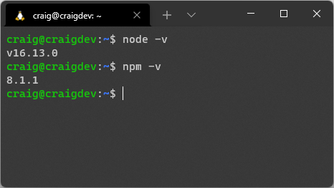

Configuring npm Global Permissions on Linux
The Node Package Manager command-line tool is provided with Node.js and makes it easy to install, update, and remove modules. Where practical, Node.js apps can be installed globally and run from anywhere—such as the Rollup bundler for optimizing client-side JavaScript:
npm install rollup --global
This command results in a EACCES permission error, because you’re not running as a superuser or using sudo. However, sudo grants unlimited permissions to global scripts. I’d rather not run my own code that way, let alone someone else’s!
A better option is to change the default npm directory to one owned by you. Create a new directory for global modules, then configure npm, like so:
mkdir ~/.npm-global
npm config set prefix '~/.npm-global'
Then, open ~/.bashrc or ~/.profile in an editor such as nano:
nano ~/.bashrc
Next, add the following lines to the end of the file:
export NPM_GLOBAL="$HOME/.npm-global"
export PATH="$NPM_GLOBAL/bin:$PATH"
Restart the Bash terminal or update the system manually with source ~/.bashrc.
You can now install global modules without sudo—including updates to npm itself:
npm install npm --global

How to Install Node.js on macOS
Open the nodejs.org home page in your browser and you’ll be directed to download the Node.js .pkg installer for macOS. Launch the file, agree to the terms, and continue the installation.
Verify that Node.js and npm are installed correctly by running the following commands in the terminal to view their version numbers:
node -v
npm -v

How to Install Node.js on Windows
You can perform a Windows installation of Node.js in three ways:
on Windows directly
on a Linux distro installed in WSL2 (refer to the “How to Install Node.js on Linux (or Windows WSL2)” section above)
on both Windows and Linux!
To install on Windows, open the nodejs.org home page in your browser and you’ll be directed to download the Node.js .msi installer. Launch the file, agree to the terms, and continue the installation.
Verify that Node.js and npm are installed correctly by running the following commands in the terminal to view their version numbers:
node -v
npm -v

How to Install Node.js on Other Devices
If you’re using another device, chances are you’ll find a Node.js distribution somewhere. It may not be on the standard nodejs.org website, so try Googling “install Node.js on [my-device’s-name]”.
For example, searching for “Install Node.js on Raspberry Pi” provides many resources for installing Node.js on different editions of the hardware.

Run JavaScript Commands in the Node.js REPL
Node.js provides a read-evaluate-print loop (REPL) language environment. It will be familiar if you’ve ever opened a browser’s developer tools console, and it’s useful for testing snippets of code.
Start the REPL from your terminal by entering node. You’ll see a prompt such as this:
Welcome to Node.js v16.12.0.
Type ".help" for more information.
>
Enter a JavaScript command or expression at the > prompt. For example:
> const myname = 'World';
(Replace “World” with your own name in quotes.)
You’ll see undefined returned, because the expression doesn’t output anything. Now enter the following, to see “Hello World” (or whatever name you used):
> console.log(`Hello ${ myname }`);
Again, undefined is shown because console.log() outputs a string and doesn’t return a value.
You can enter any JavaScript expression. It’s not necessary to wrap it in a console.log(). For example:
$ node
Welcome to Node.js v16.12.0.
Type ".help" for more information.
> 2+2
4
> const myname = 'World'
undefined
> `Hello ${ myname }`
'Hello World'
>
Finally, press Ctrl | Cmd + D to exit the REPL console.
You’re unlikely to use the REPL environment on a daily basis, but it can be useful for evaluating simple expressions before adding them to a script.

Summary
In this chapter, you’ve learned how to install Node.js on a variety of devices and run JavaScript commands in the REPL console. I've summarized it in this chapter's video. In the next chapter, you’ll write your first JavaScript-powered console and web applications.

Quiz
1. Versions of Node.js are available for:
a. most Linux distributions
b. macOS
c. Microsoft Windows
d. all of the above
2. What is nvm used for?
a. It’s an alternative to the standard npm.
b. It can install and manage different versions of Node.js on one device.
c. It’s a module search system.
d. It’s a text editor specifically designed for JavaScript applications.
3. What is REPL short for?
a. read-evaluate-print loop
b. read-execute-print loop
c. run-evaluate-print loop
d. read-execute-primary loop

Chapter 3: Your First Node.js Application
In this chapter, you’ll write, run, and debug your first Node.js programs. To keep it simple, these won’t use any third-party modules or npm. They’re self-contained scripts that use the standard library provided in Node.js.

Your First Console App
Command-line console applications can be useful for automating tasks, formatting data, manipulating files, or any other laborious job that’s best handled by a computer.
Create a directory for your project, such as console:
mkdir console
cd console
Then add a file named hello.js with the following content:
#!/usr/bin/env node
// output message
console.log('Hello World!');
Save and run it from the command line:
node hello.js
You should now see Hello World!.
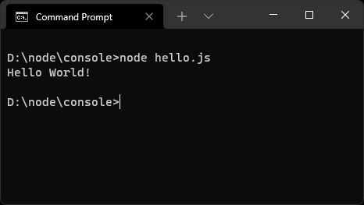

#!/What?
The first line in hello.js—#!/usr/bin/env node—is known as a shebang or hashbang. It’s entirely optional and ignored when you run node hello.js, because you’re passing the script to the Node.js runtime which executes the code.
However, the shebang can be useful in Linux and macOS because it specifies which runtime to use—in this case, node. You can run the script using ./hello.js alone but, before you can do that, you must permit direct execution by entering the following OS command in your terminal:
chmod +x ./hello.js
From then on you can run the script from the command line using this:
./hello.js
The OS analyses the shebang and runs the code using Node.js. It’s not necessary to enter the full node hello.js command, although that will continue to work.
This is beyond the scope of Node.js and we won’t use it again, because npm provides some cross-platform options. It’s there should you need it.
To make the script more useful, you could pass a name on the command line. The process.argv property in the standard library returns an array containing the command-line arguments:
the first (element 0) is the node command itself
the second (element 1) is the script you’re running (hello.js)
the third (element 2) is the first argument passed
Edit your hello.js script to extract the second argument and output it in the console.log() statement:
#!/usr/bin/env node
// fetch name from command or fallback
const nameArg = (process.argv[2] || 'world');
// output message
console.log(`Hello ${ nameArg }!`);
Save this, then run node hello.js Craig to see Hello Craig!.
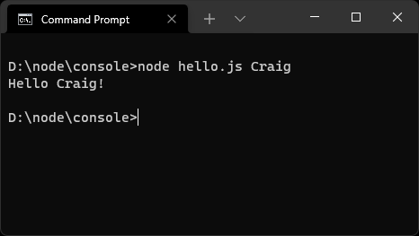
If you omit the parameter (node hello.js), the app falls back to Hello world.
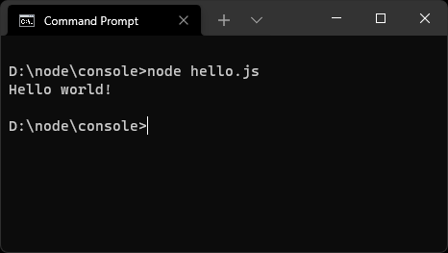
The fallback text of “world” is a little boring, so you could fetch the user’s name stored in the OS’s environment variables. The process.env property returns an object containing environment variable name/value pairs. Try entering process.env in the REPL. (See the section “Run JavaScript Commands in the Node.js REPL” in Chapter 2 for more on this.)
Linux and macOS devices define a USER variable, while Windows sets USERNAME. Ensure your script is cross-platform by examining both when declaring nameArg:
// fetch name from command argument, environment, or fallback
const nameArg = (process.argv[2] || process.env.USER || process.env.USERNAME ||
➥ 'world');
Run the script with node hello.js and you’ll see Hello <yourname>. You can still override your OS name by passing a parameter such as node hello.js Craig.
You can add a finishing touch to your console app by capitalizing the initial letter of any name. Here’s the final script:
#!/usr/bin/env node
// fetch name from command argument, environment, or fallback
const nameArg = capitalize(process.argv[2] || process.env.USER ||
➥process.env.USERNAME || 'world');
// output message
console.log(`Hello ${ nameArg }!`);
// capitalize the first letter of all words
function capitalize(str) {
return str
.trim()
.toLowerCase()
.split(' ')
.map(word => word.charAt(0).toUpperCase() + word.slice(1))
.join(' ');
}
Run the script with this:
node hello.js "from my node.js script"
You’ll now see Hello From My Node.js Script!.
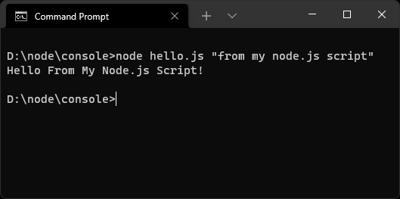
You can see a video demonstration of this in action here.

Your First Web Server App
Web applications require a web server to return HTML web pages when they’re requested by a browser. The browser may then request other assets such as CSS stylesheets, client-side JavaScript, images, and Ajax-powered APIs.
Dedicated web servers such as Apache and NGINX are often used for this task. If Apache receives a request for a PHP file, it passes the content to the PHP interpreter, which runs the code. Apache receives the resulting output and returns it to the user’s browser. PHP developers often access Apache server variables or tweak permissions to enhance their code.
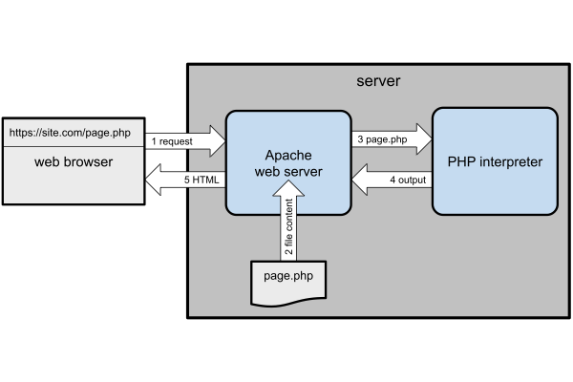
Node.js takes a different approach: your JavaScript application is a web server. This sounds as though it’s complex to code, but the HTTP and HTTPS standard libraries do much of the work for you.
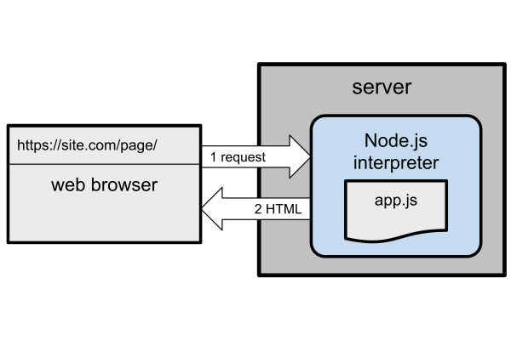
Create a directory for your project, such as server:
mkdir server
cd server
Then add a file named webhello.js with the following content:
#!/usr/bin/env node
const
port = (process.argv[2] || process.env.PORT || 3000),
http = require('http');
http.createServer((req, res) => {
console.log(req.url);
res.statusCode = 200;
res.setHeader('Content-Type', 'text/html');
res.end(`<p>Hello World!</p>`);
}).listen(port);
console.log(`Server running at http://localhost:${ port }/`);
Run it with node webhello.js and you’ll see Server running at http://localhost:3000/ or similar. Open that address in your web browser to view a web page with a “Hello World!” paragraph.
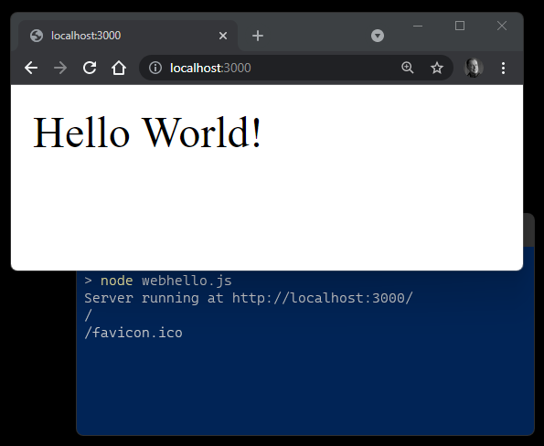
The code does the following:
It defines a variable for the server’s port. This can be passed on the command line, a PORT environment variable, or it falls back to 3000.
It uses the HTTP createServer library to create a web server which listens on that port. When its callback function receives a request, it can examine the details in the req object and return a response using the res object.
This is a simple example, and the server returns the same “Hello World!” response regardless of the URL. Try accessing http://localhost:3000/, http://localhost:3000/abc/, or http://localhost:3000/abc/123/: every page is the same.

Port 3000?
Web servers listen for HTTP requests on port 80 and HTTPS requests on port 443. You can set a different port, but you must specify it on the URL.
Using the standard ports has drawbacks:
They may be in use by other software, such as other web servers or Skype.
Linux and macOS block apps listening on ports below 1000 unless they’re launched by a superuser. This grants your script unlimited rights, where it could do anything such as wiping your OS or posting passwords to Twitter. Remember, you’re running your code as well as hidden code inside Node.js and any modules you’ve installed.
It’s safer to run web applications with standard permissions on a higher port. Live production servers can use a web server such as NGINX to forward requests to Node.js.
Let’s improve the application by saying “hello” to a string passed on the URL. The URL is available in req.url, so you can strip any non-word characters and capitalize as before. Update the script to this:
#!/usr/bin/env node
const
port = (process.argv[2] || process.env.PORT || 3000),
http = require('http');
http.createServer((req, res) => {
console.log(req.url);
const nameArg = capitalize( req.url.replace(/[^\w.,-]/g, ' ').replace
➥(/\s+/g, ' ').trim() || 'world' );
res.statusCode = 200;
res.setHeader('Content-Type', 'text/html');
res.end(`<p>Hello ${ nameArg }!</p>`);
}).listen(port);
console.log(`Server running at http://localhost:${ port }/`);
// capitalize the first letter of all words
function capitalize(str) {
return str
.trim()
.toLowerCase()
.split(' ')
.map(word => word.charAt(0).toUpperCase() + word.slice(1))
.join(' ');
}
Now open http://localhost:3000/from/Node.js in your browser. Chances are that you’ll see “Hello World!”, because your previous application instance is still running!
Switch to the terminal and press Ctrl | Cmd + C to stop the application. Restart it with node webhello.js, return to your browser, and refresh the page to see “Hello From Node.js!”
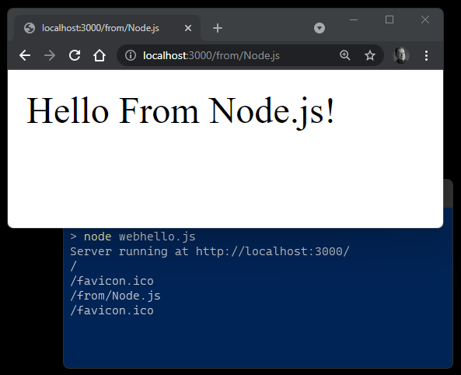
Experiment with different URL paths and analyze the nameArg declaration to understand how it works.
Switch back to the Node.js terminal after you’ve tried a few URLs. It’s logging each request, and you’ll see something like this:
$ node webhello.js
Server running at http://localhost:3000/
/from/Node.js
/favicon.ico
/craig
/favicon.ico
What are those unexpected /favicon.ico requests? You’ll investigate further and debug in the next chapter.

Restarting Node.js Applications with Nodemon
You must restart a running Node.js application every time you make a change. Pressing Ctrl | Cmd + C and launching again will quickly become tiresome.
Nodemon is a utility that monitors your source files for changes and automatically restarts the application. Install it globally with npm:
npm install -g nodemon
You can now use nodemon in place of node to launch any Node.js application. For example:
nodemon webhello.js
(You can pass any arguments as before.)
When you save a code change, Nodemon restarts the application and you’ll see a log entry in the terminal:
[nodemon] restarting due to changes...
[nodemon] starting `node webhello.js`
If it doesn’t work, try running nodemon with the --legacy-watch / -L argument:
nodemon -L webhello.js
Refer to the Nodemon documentation for more options.

Executing Scripts from Windows Powershell
By default, Windows Powershell won’t let you execute third-party scripts such as nodemon. Enter this command in a Powershell window to permit script execution:
Set-ExecutionPolicy RemoteSigned -Scope CurrentUser
You can find a video demonstration of the web application in action here.

Web Application Considerations
Complexity Ahead
This section covers some advanced topics. Don’t worry if it doesn’t make sense now. We’ll revisit the information later.
It’s astonishing that this lightweight script implements a functional web server. The app is permanently on, and it can retain its own state regardless of the number of users. For example, it could establish a database connection once at start-up, then reuse that same connection on every request. Apache/PHP environments are usually stateless, so every page request must load configuration parameters and connect to a database before running a query.
However, Node.js applications run on a single processing thread:
If your app fails, it fails for everyone and won’t restart unless you have appropriate monitoring in place. Options including PM2 and forever can help.
If a single user triggers a long-running JavaScript function that takes ten seconds to complete, every user accessing at that time will be waiting at least ten seconds for a response. Asynchronous code solves the problem, but it takes time to understand the concepts.
Scaling an application can be difficult. Throwing more RAM or CPUs onto an Apache/PHP server will improve response times. Node.js still runs on a single CPU core even when that CPU has 15 more at its disposal. Solutions such as clustering, PM2, and Docker containers can help by launching multiple instances of the same application.
In addition, Node.js web servers are not efficient at serving static files such as images, stylesheets, and client-side JavaScript. Production sites often use a front-end NGINX web server to serve static files or direct the request to the Node.js application when appropriate. This is known as a reverse proxy and it has benefits, such as:
Static assets are served without any Node.js interaction. This avoids unnecessary processing and improves performance.
Settings such as HTTPS certificates can be handled by NGINX rather than Node.js. This is especially practical when you have more than one instance of the same Node.js application running.
A Node.js app can run on a port above 1000, so it doesn’t need elevated superuser permissions.
Write Stateless Applications
Suppose your single Node.js app kept count of the number of logged-in users in single global variable named userCount.
What would happen if you wanted to improve performance by launching two or more instances of the same app—perhaps on other servers? Any instance could handle a user login. The userCount value would be different—and wrong—on each running instance of the app.
During development, you’ll often work on a single running instance. However, I recommend you make it stateless to ensure it can scale and be more resilient. Always presume:
multiple instances could be running anywhere, possibly on different ports or servers
an instance can be started or stopped at any time
a frontend web server will direct a single user’s request to any instance—regardless of which instance handled a previous request
In essence, avoid storing application or user state in variables or local files that could differ across instances. Use a database to retain state so every instance of the application can be synchronized.

Summary
In this chapter, you’ve learned how to write simple console and web server applications using Node.js libraries alone. You’ve also seen how nodemon can automatically restart your app after updating code.
In the next chapter, you’ll discover options for debugging and fixing problems in your Node.js code.

Quiz
1. Which of the following statements is true:
a. Node.js can only run web apps.
b. Node.js web apps require web server software such as NGINX to run.
c. Node.js web apps don’t require web server software, but NGINX or similar can be beneficial on production sites.
d. Node.js isn’t suitable for running production web applications.
2. Which steps are necessary after modifying a Node.js app?
a. Use a tool such as nodemon to monitor for changes and restart the application.
b. If it’s already running, stop the application with Ctrl | Cmd + C and restart it.
c. Close the terminal, open a new one, and start the application again.
d. Any of the above.
3. Which Node.js object property returns command line arguments?
a. process.arg
b. process.argv
c. process.argument
d. process.env
4. Which Node.js object property returns environment variables?
a. process.env
b. process.envv
c. process.environment
d. process.arg
5. Can you launch multiple instances of the same Node.js app to improve resilience and performance?
No. Only a single instance of a Node.js app can be launched at a time.
Yes, but each instance must be on a separate real or virtual server.
Yes, but containerization software such as Docker is essential.
Yes, but the application should be stateless and receive requests via a load balancer or web server.

Chapter 4: How to Debug Node.js Scripts
Tutorials often describe debugging in the final chapters. This can be frustrating if you encounter a problem at the start of your coding journey—which you will. Software development is complex.
If you’re lucky, your code will crash with an obvious error message. If you’re unlucky, your application will carry on regardless but not generate the results you expect. If you’re really unlucky, everything will work fine until the first user to arrive discovers a catastrophic, disk-wiping bug.

Skip Ahead?
This is a long chapter that describes several debugging options. You can skip ahead to the “Exercise: Debugging webhello.js” section (near the end of the chapter) if you’d like to get going. That said, a little learning now could save hours of effort later!

What is Debugging?
Debugging is the black art of fixing software defects. Fixing a bug is often easy; a corrected character or additional line of code solves the problem. Finding that bug is another matter, and developers can spend many frustrating hours locating the source of an issue. Fortunately, Node.js has some great tools to help trace problems.

How to Avoid Bugs
You can often prevent bugs before you test your application. Let’s look at some ways.

Use a Good Code Editor
A good code editor offers features such as:
line numbering to locate where an error occurred
type checking—for example, to ensure a number variable can’t have a string assigned
color-coding to catch syntax issues, such as invalid statements or missing quotes
auto-completion of variable names, function names, properties, etc.
bracket matching to highlight problems in nested structures
auto-indentation that uses the correct tab or space characters
variable renaming across files and projects
snippet saving and reuse
parameter prompts for functions, properties, and methods
function navigation to jump to a declaration
unreachable code detection
refactoring tools to rearrange messy code
Node.js developers are spoiled for choice, with editors such as VS Code, Atom, and Sublime Text.

Use a Code Linter
A linter reports faults such as syntax errors, poor indentation, undeclared variables, mismatching brackets, and your own preferences (semicolons, quote usage, etc.) before you save and test your code. Popular options for JavaScript and Node.js include ESLint, JSLint, and JSHint.
These can be installed as global Node.js modules. For example, here’s how to install ESLint globally using npm:
npm install eslint -g
You can then check files from the command line:
eslint myscript.js
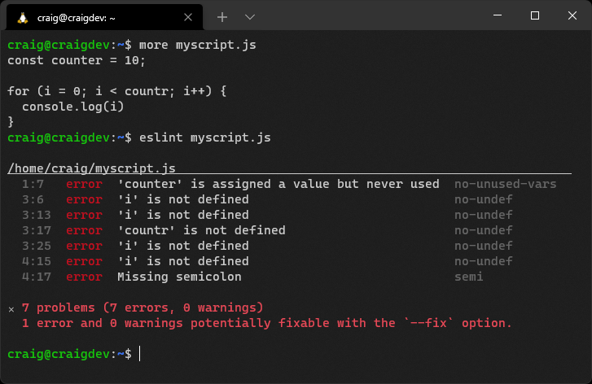
However, most linters have code editor plugins, such as ESLint for VS Code and linter-eslint for Atom, which check your code as you type.
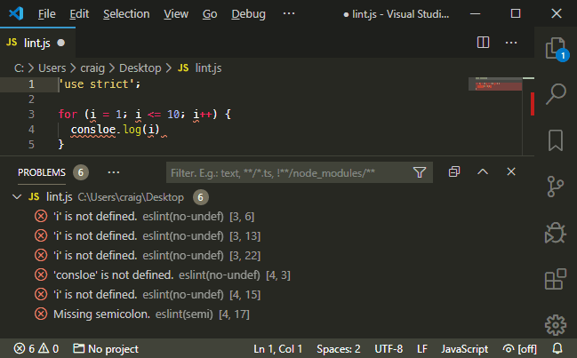

Use Source Control
A source control system such as Git can help safeguard your code and manage revisions. It becomes easier to discover where and when a bug was introduced and who should receive the blame! Online repositories such as GitHub and Bitbucket offer free space and management tools.

Adopt an Issue-tracking System
Does a bug exist if no one knows about it? An issue-tracking system is used to report bugs, find duplicates, document reproduction steps, determine severity, calculate priorities, assign developers, record discussions, and track progress of fixes.
Online source code repositories often offer basic issue tracking, but dedicated solutions such as Jira, FogBugz, or Bugzilla may be appropriate for larger teams and projects.

Use Test-driven Development
Test-driven development (TDD) is a development process that encourages developers to write code to test the operation of a function before that function is written—as in is X returned when function Y is passed input Z?
Tests are run as you develop code to prove the resulting function works as expected. The same test can be rerun to spot issues as further changes are made. Of course, your tests could have bugs too!
Further resources:
TDD overview at Wikipedia
“What is Test Driven Development”
“Master Test-driven Development in Node.js”

Node.js Debugging Environment Variables
Environment variables set within the host operating system control Node.js application settings. The most common is NODE_ENV, which is typically set to development when debugging or production on a live server.
Environment variables can be set on Linux/macOS:
NODE_ENV=development
This is the Windows Command Prompt:
set NODE_ENV=development
This is for Windows Powershell:
$env:NODE_ENV="development"
Internally, your own application can detect the setting and enable debugging messages when necessary. For example:
// running in development mode?
const DEVMODE = (process.env.NODE_ENV !== 'production');
if (DEVMODE) {
console.log('application started in development mode');
}
NODE_DEBUG enables debugging messages using the Node.js util.debuglog. (See the “Node.js util.debuglog” section below.) You should also consult the documentation of your primary modules and frameworks to discover further logging options.

Node.js Debugging Command-line Options
Various command-line options can be passed to the node or nodemon runtime when launching an application. One of the most useful is --trace-warnings, which outputs stack traces when promises don’t resolve or reject as expected:
node --trace-warnings index.js
Other options include:
--enable-source-maps: enable source maps when using a transpiler such as TypeScript
--throw-deprecation: throw errors when deprecated features are used
--inspect: activate the V8 inspector (see the “Node.js V8 Inspector” section below)

Console Debugging
One of the easiest ways to debug an application is to output values to the console during execution:
console.log( myVariable );

Never Use console.log()?!
Some developers claim you should never use console.log(), because you’re changing code and there are better debugging options. This is true—but everyone does it!
Use whatever tool makes you productive. Console logging can be a quick and practical option. Finding a bug is more important than the method you used to find it.
Few developers delve beyond the standard console.log() command, but they’re missing out on many more possibilities:
console method | Description
.log(msg) | output a message to the console
.log('%j', obj) | output an object as a compact JSON string
.dir(obj,opt) | uses util.inspect to pretty-print objects and properties
.table(obj) | outputs arrays of objects in tabular format
.error(msg) | output an error message
.count(label) | a named counter reporting the number of times the line has been executed
.countReset[label] | resets a named counter
.group(label) | indents a group of log messages
.groupEnd(label) | ends the indented group
.time(label) | starts a timer to calculate the duration of an operation
.timeLog([label] | reports the elapsed time since the timer started
.timeEnd(label) | stops the timer and reports the total duration
.trace() | outputs a stack trace (a list of all calling functions)
.clear() | clear the console
console.log() accepts a list of comma-separated values. For example:
let x = 123;
console.log('x:', x);
// x: 123
However, ES6 destructuring offers similar output with less typing effort:
console.log({ x });
// { x: 123 }
util.inspect can format objects for easier reading, but console.dir() does the hard work for you:
console.dir(obj, { depth: null, color: true });

Node.js util.debuglog
The Node.js util module offers a built-in debuglog method that conditionally writes log messages to STDERR:
const util = require('util');
const debuglog = util.debuglog('myapp');
debuglog('myapp debug message [%d]', 123);
When the NODE_DEBUG environment variable is set to myapp (or a wildcard such as * or my*), debugging messages are displayed in the console:
MYAPP 9876: myapp debug message [123]
(9876 is the Node.js process ID.)

Debugging with Logging Modules
Third-party logging modules are available should you require more sophisticated options for messaging levels, verbosity, sorting, file output, profiling, reporting, and more. Popular solutions include:
cabin
loglevel
morgan (Express middleware)
pino
signale
storyboard
tracer
winston

Node.js V8 Inspector
The following sections use the webhello.js script developed in the previous chapter to illustrate debugging concepts.
Node.js is a wrapper around the V8 JavaScript engine. V8 includes its own inspector and debugging client. Use the inspect argument to start an application (not to be confused with the --inspect flag—which is covered below in the “Debugging Node.js Apps with Chrome” section):
node inspect webhello.js
The debugger pauses at the first line and displays a debug prompt:
$ node inspect webhello.js
< Debugger listening on ws://127.0.0.1:9229/8bf7669c-b3b4-43e6-9f96-3b40abbcb479
< For help, see: https://nodejs.org/en/docs/inspector
<
connecting to 127.0.0.1:9229 ... ok
< Debugger attached.
<
Break on start in webhello.js:4
2
3 const
> 4 port = (process.argv[2] || process.env.PORT || 3000),
5 http = require('http');
6
Enter help to view a list of commands. You can step through the application with these options:
cont or c: continue execution
next or n: run the next command
step or s: step into a function being called
out or o: step out of a function and return to the calling command
pause: pause running code
Other options include:
watching variable values with watch('myvar')
setting breakpoints with the setBreakpoint()/sb() command (although it’s easier to insert a debugger; statement in your code)
restart a script
.exit the debugger (the initial . is required)
If this sounds horribly clunky, it is. Only use the built-in debugging client when there’s absolutely no other option or you’re feeling masochistic.

Debugging Node.js Apps with Chrome
Start the Node.js V8 inspector with the --inspect flag:
node --inspect webhello.js
(nodemon can be run instead of node if necessary.)
This starts the debugger listening on 127.0.0.1:9229, which any local debugging client can attach to:
Debugger listening on ws://127.0.0.1:9229/20ac75ae-90c5-4db6-af6b-d9d74592572f
If you’re running the Node.js application on another device or Docker container, ensure port 9229 is accessible and grant remote access using this:
node --inspect=0.0.0.0:9229 webhello.js
Alternatively, use --inspect-brk to halt processing the first statement so you can step through the application line by line.
Open the Chrome browser and enter chrome://inspect in the address bar.
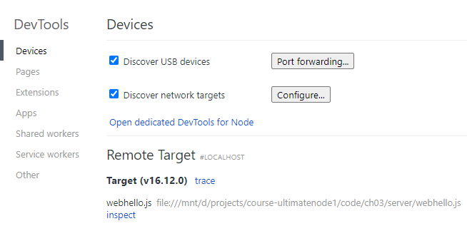

Not Using Chrome?
Chromium, Edge, Opera, Vivaldi, and Brave all have the same debugger as Chrome. The chrome://inspect address should work identically.

Remote Target
If the Node.js application doesn’t appear as a Remote Target, ensure Discover network targets is checked, then click Configure to add the IP address and port of the device where the application is running.
Click the Target’s inspect link to launch DevTools. This will be immediately familiar to anyone who’s used browser developer tools.
In the Sources pane, click + Add folder to workspace, select where your Node.js files are located, and hit Agree. Open webhello.js in the left-hand pane or by pressing Ctrl | Cmd + P.
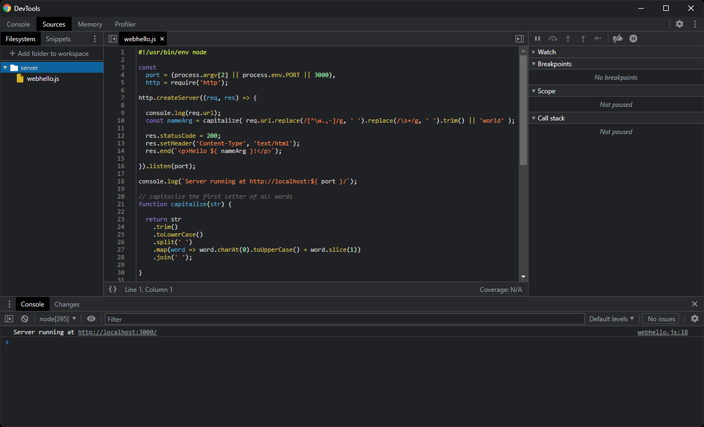
Click any line number to set a breakpoint denoted by a blue marker. A breakpoint specifies where the debugger should pause processing so you can inspect the state of the program. You can define any number of breakpoints.

Debugger Statement
Processing also halts at any debugger statement in your code when it runs using the V8 inspector. This may be practical when sharing code or debugging across multiple devices, although you may want to remove those commands before committing the code to source control or releasing on a live server.
Refresh/open http://localhost:3000/ in your browser and code execution stops when that breakpoint is reached.
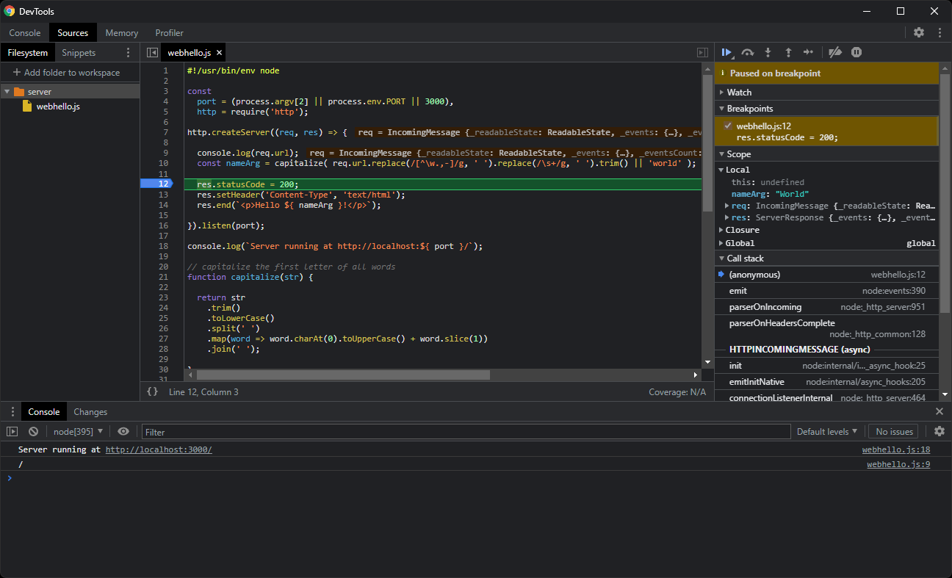
The right-hand panels include:
a Watch pane, which allows you to monitor variables by clicking the + icon and entering their name
a Breakpoints pane, which shows a list of all breakpoints and allows them to be enabled or disabled
a Scope pane, which shows the state of all available local and global variables
a Call Stack pane, which shows the functions that were called to reach this point
The row of icons above the Paused on breakpoint message is pictured below.
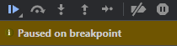
These options perform the following actions (from left to right):
resume execution: continue processing until the next breakpoint
step over: execute the next command but stay within the current function; don’t jump into any function it calls
step into: execute the next command and jump into any function it calls
step out: continue processing to the end of the function and return to the calling command
step: similar to step into, except it won’t jump into async functions
deactivate all breakpoints
pause on exceptions: halt processing whenever an error occurs
You can find a video demonstration of debugging with Chrome here.

Debugging Node.js Apps with VS Code
Node.js debugging in VS Code requires no configuration when you run a Node.js application on your local system. Open the starting file (use webhello.js here), activate the Run and Debug pane, click the Run and Debug Node.js button, and choose the Node.js environment.
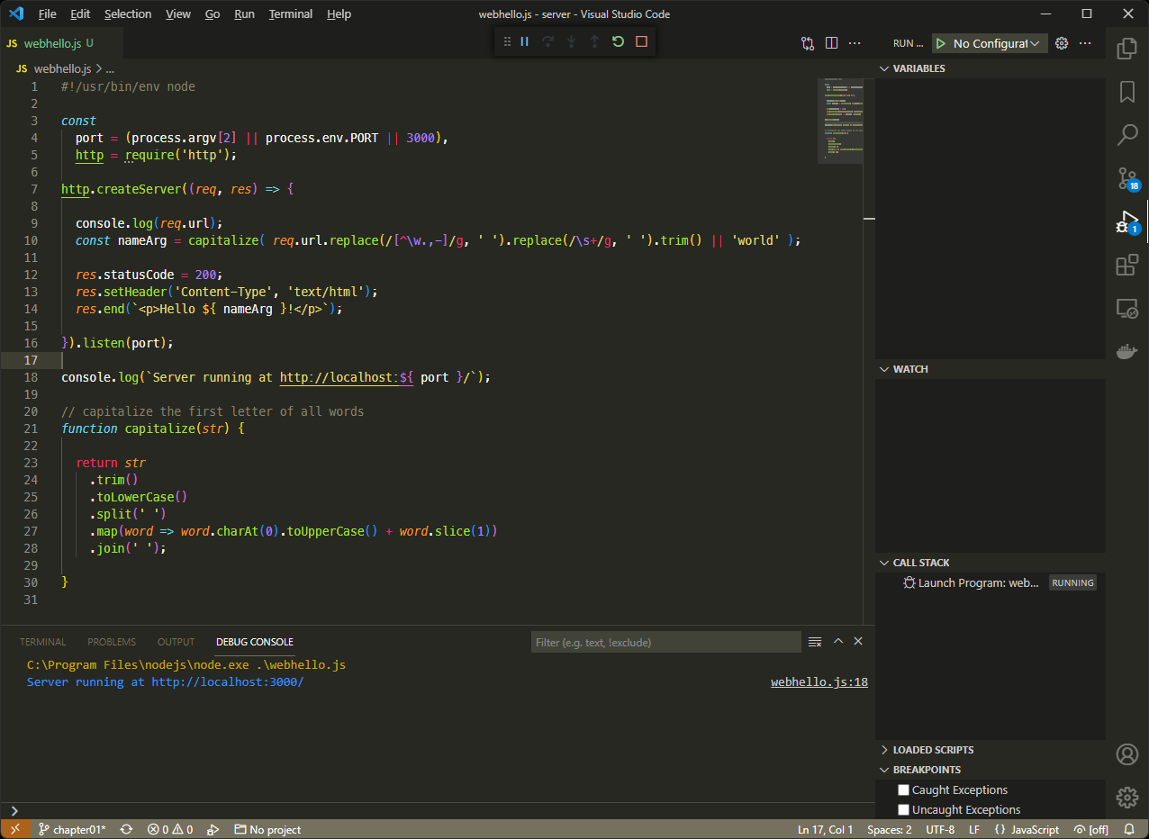
The debugging screen is similar to the DevTools screen, with a Variables, Watch, Call stack, Loaded scripts, and Breakpoints list. Set a breakpoint by clicking the left-hand gutter next to the line number. A red dot icon appears. Refresh http://localhost:3000/ in your browser and execution will halt on the breakpoint line so you can examine the program state.
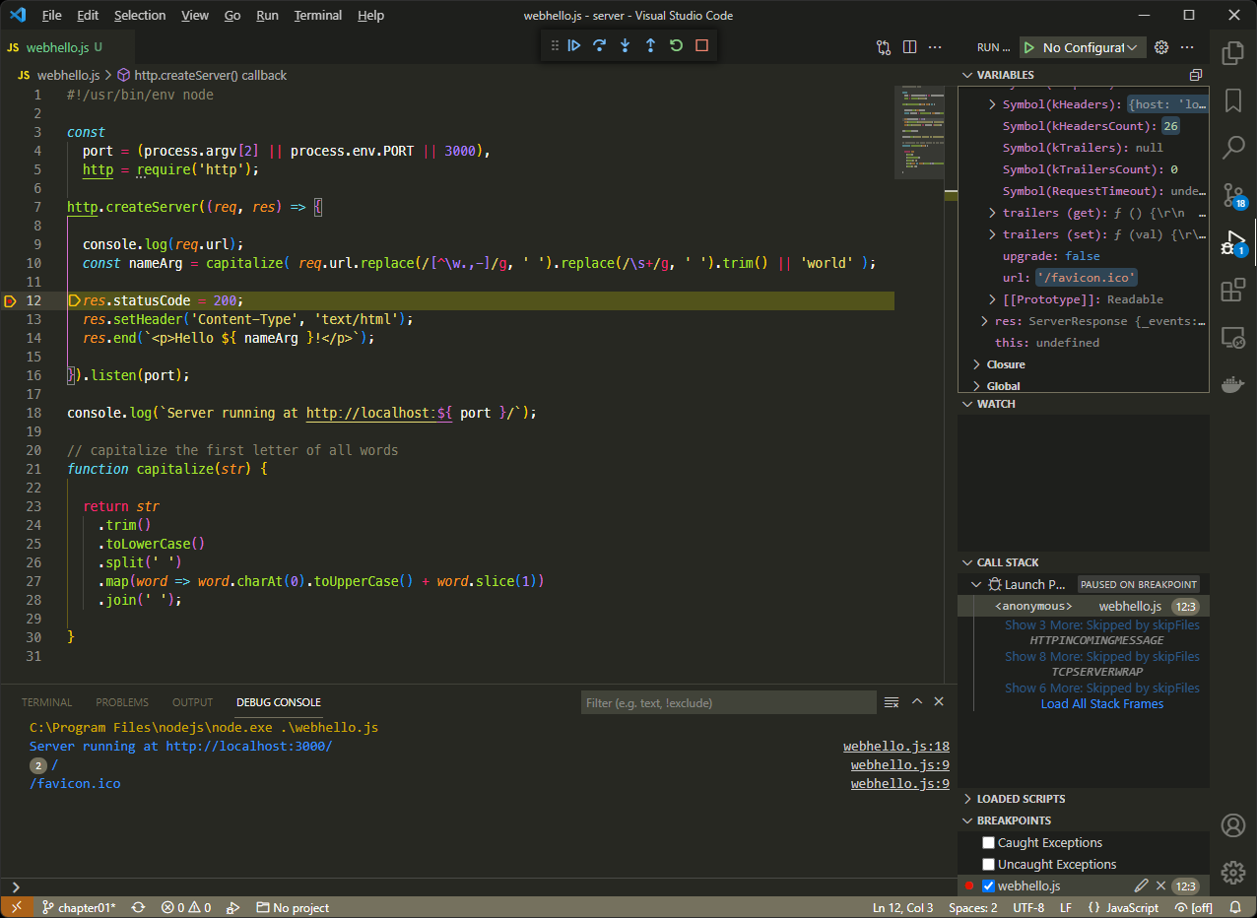
The icons in the debugging toolbar at the top are used to resume execution, step over, step into, step out, restart, or stop the application. Identical options are available from the Run menu.
You can also right-click a line number.
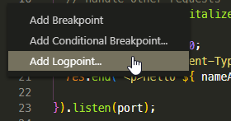
Once you’ve done that, you can set the following:
A standard breakpoint.
A conditional breakpoint that halts the program when criteria are met—such as count > 3.
A logpoint. This is effectively console.log() without code! Enter any string with evaluated expressions in curly braces. For example, URL: { req.url } outputs the value of the req.url property.
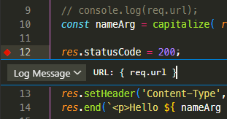
The DEBUG CONSOLE displays the logpoint value when the web page is refreshed.
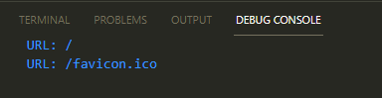
For more information, refer to “Debugging in Visual Studio Code”.

Advanced Debugging Configuration
VS Code configuration is necessary when you’re debugging code on another device, a virtual machine, or you want to use different launch options. VS Code stores launch configurations in a launch.json file inside a .vscode folder in your project. To generate the file, click the create a launch.json file link at the top of the Run and Debug pane and choose the Node.js environment.
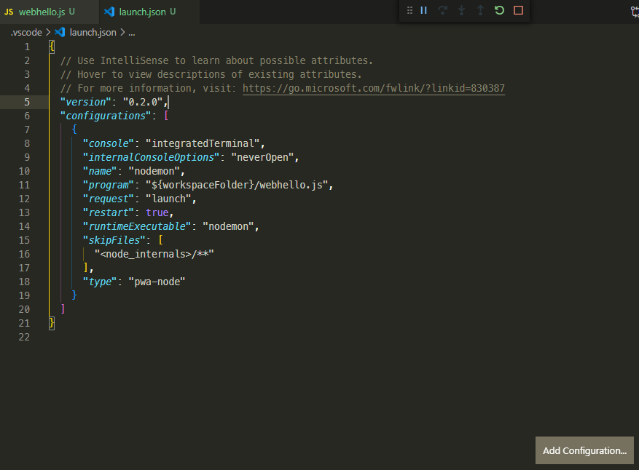
You can add any number of configuration setting objects to the "configurations": [] array. Click the Add Configuration button to add an appropriate option. VS Code can either:
Launch a process using Node.js itself
Attach to a Node.js inspector process, perhaps running on a remote machine or Docker container
The screenshot above shows a nodemon launch configuration. The Add Configuration button provides a nodemon option; it’s only necessary to edit the "program" property to point at ${workspaceFolder}/webhello.js.
Save launch.json, then select nodemon from the drop-down list at the top of the Run and Debug pane, and click the green run icon.
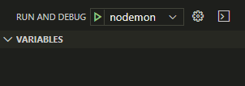
nodemon will launch your application. You can edit the code and set breakpoints or logpoints as before.
For further information, refer to the VS Code launch configurations.
VS Code can debug any Node.js application, but the following extensions can make life easier:
Remote - Containers: connect to apps running in Docker containers
Remote - WSL: connect to apps running on Linux in WSL on Windows

Other Node.js Debugging Tools
The Node.js Debugging Guide provides advice for other IDEs and editors including Visual Studio, JetBrains, WebStorm, Gitpod, and Eclipse. Atom also has a node-debug extension.
ndb offers an improved debugging experience with powerful features such as attaching to child processes and script blackboxing so that only code in specific folders is shown.
The IBM report-toolkit for Node.js works by analyzing data output when node runs with an --experimental-report option.
Finally, commercial services such as LogRocket and Sentry.io integrate with your live web application on both the client and the server to record errors as they’re encountered by real users.

Exercise: Debugging webhello.js
The webhello.js code has a strange bug where an unexpected /favicon.ico request is logged. To examine what’s happening, launch VS Code and open the folder containing webhello.js. Then:
Switch to the Run and Debug pane.
Click create a launch.json file and choose the Node.js environment.
Click the Add Configuration button and choose Node.js: Nodemon setup. (You’ll now have two objects inside the "configurations" array. You can delete the second one.)
Change the "program" value to "${workspaceFolder}/webhello.js".
Save the file and open webhello.js.
Click the + icon in the Watch pane and add the expression req.url.
Click the + icon in the Watch pane and add the expression nameArg.
Add a breakpoint to the line starting res.end by clicking to the left of the line number. A red circle icon will appear.
Click the nodemon green start icon at the top of the Run and Debug pane.
The web application will start.
Now open http://localhost:3000/ in your browser and processing will halt at the breakpoint. Assuming you haven’t used a different path on the URL, the Watch pane will show:
req.url: `/`
nameArg: `World`
Click the Continue icon or press F5 to resume processing. At this point, the browser will show “Hello World!”—but the breakpoint will trigger again.
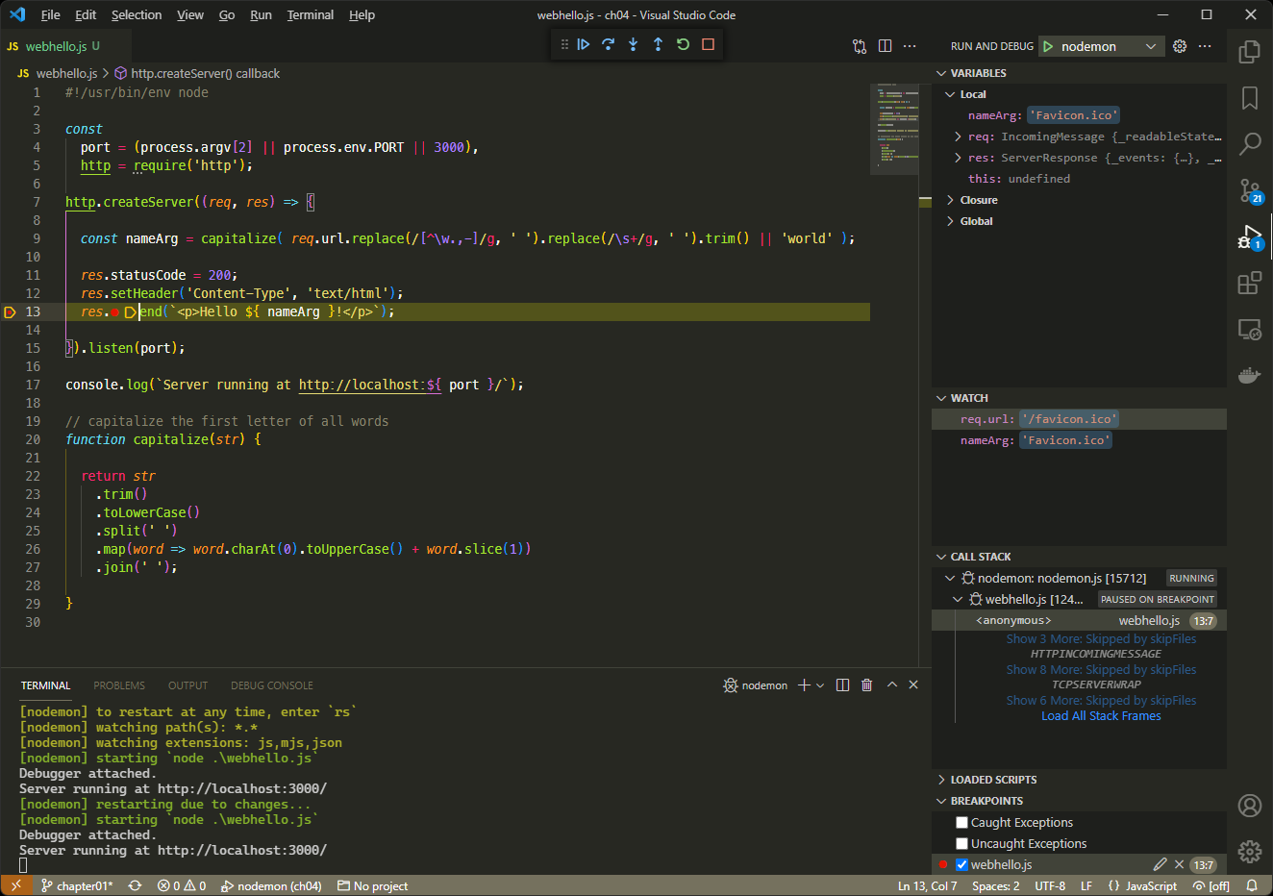
The Watch pane shows:
req.url: `/favicon.ico`
nameArg: `Favicon.ico`
(If this doesn’t happen, try a hard refresh in your browser—usually Ctrl + F5 on Windows and Linux or Cmd + R on macOS.)
When a browser makes its first request for a web page, it also requests a favicon.ico image. This is the icon shown to the left of the page’s title in the browser tab.
A web server would normally send an appropriate image or return an HTTP 404 Not found error. However, your Node.js application treats it like any other request and returns the HTML text "Hello Favicon.ico", which the browser can’t use.
It’s not a catastrophic bug, but both the browser and server are doing unnecessary work. Fix it by adding a check at the top of the createServer callback function, which returns a 404 error:
http.createServer((req, res) => {
// abort favicon.ico request
if (req.url.includes('favicon.ico')) {
res.statusCode = 404;
res.end('Not found');
return;
}
Save webhello.js, and nodemon will restart the application. Try refreshing your browser again and the breakpoint triggers just once.
To finish debugging, click the red square Stop icon in the debugging toolbar.
You can find a video demonstration of debugging with VS Code here.

Summary
This chapter has illustrated options for debugging Node.js applications. Use whatever makes you productive, but I generally use console logging for quick and dirty bug hunting and VS Code when things get complicated.
In the next chapter, you’ll start to write more complex Node.js code using npm and third-party modules.

Debugging Terminology
Debugging has its own selection of obscure jargon. We’ve covered most aspects throughout this chapter, but you could encounter terms like the ones shown below.
Term | Explanation
breakpoint | a line at which a debugger halts a program so its state can be inspected
breakpoint (conditional) | a breakpoint triggered by a certain condition, such as a value reaching 100. Also known as a watchpoint
debugger | a tool that offers debugging facilities such as running code line by line to inspect internal variable states
duplication | a reported bug that has already been reported—perhaps in a different way
feature | as in the claim: “it’s not a bug, it’s a feature”. You’ll find yourself saying this at some point
frequency | how often a bug occurs
it doesn’t work | the most-often made but least useful bug report
logpoint | a debugger instruction that shows the value of an expression during execution
logging | output of runtime information to the console or a file
logic error | the program works but doesn’t act as intended
priority | where a bug is allocated on a list of planned updates
race condition | hard-to-trace bugs dependent the sequence or timing of uncontrollable events
refactoring | rewriting code to help readability and maintenance
regression | re-emergence of a previously fixed bug perhaps owing to other updates
related | a bug that’s similar or related to another
reproduce | the steps required to cause the error
RTFM error | user incompetence disguised as a bug report, typically followed by a developer’s response that they should “Read The Friendly Manual”
step into | when running code line by line in a debugger, step into the function being called
step out | when running line by line, complete execution of the current function and return to the calling code
step over | when running line by line, complete execution of a command without stepping into a function it calls
severity | the impact of a bug on system. For example, data loss would normally be considered more problematic than a one-pixel UI alignment issue unless the frequency of occurrence is very low
stack trace | the historical list of all functions called before the error occurred
syntax error | typographical errors, such as console.lug()
user error | an error caused by a user rather than the application. This may still incur an update, depending on the seniority of the person who caused it!
watch | a variable or expression output during debugger execution

Quiz
1. You can debug Node.js apps by:
a. using the command-line V8 inspector
b. attaching to the process using Chrome DevTools
c. using a suitable editor such as VS Code
d. all of the above
2. What command would be suitable for outputting the values contained in a JavaScript object?
a. console.log('%j', obj)
b. console.table(obj)
c. console.dir(obj, { depth: null, color: true })
d. any of the above
3. A breakpoint is:
a. triggered by console.log()
b. a point at which processing halts during execution
c. a statement to stop the program, such as exit
d. the moment a developer chooses to stop work
4. A logpoint is:
a. used to show the value of an expression during execution
b. an alternative name for a breakpoint
c. a reference to a console.log() statement
d. a specific line in an output log
5. console.log():
a. should never be used
b. should only be used when there’s no other option
c. should be used if it’ll help locate a bug
d. is impractical for debugging

Chapter 5: Getting Started with Express
In this chapter, you’ll create a web server application that constructs and returns simple web pages. It will help you become more familiar with:
npm (Node Package Manager)
ES6 modules
the Express framework
URL routing
HTML template engines

Why use Express?
You created a small web server application in Chapter 3. It’s fast, and it works well, but a complex web application requires features such as URL routing, query string parsing, posted data decoding, HTML templates, image serving, and more. You could write this yourself, but much of that effort is already implemented in Express.
Express is a Node.js web server framework that promotes itself as “fast, unopinionated, and minimalist”. It allows you to concentrate on your application’s business logic without having to worry too much about web server technicalities such as URL routing, parsing data, setting HTTP headers, and so on.
Various web server frameworks are available in the Node.js ecosystem, including Fastify, Koa, and Hapi. These may be more recent, more regularly maintained, faster, and a better fit for your application. However, Express was one of the first web frameworks and influenced all that followed. It’s stable, easy to use, and remains popular, with 18 million downloads per week. You’re more likely to encounter Express than another framework.

Express Version
At the time of writing, Express 4 is the active recommended release and Express 5 is in alpha. All the examples below should work in either, but switch to version 4 if you have problems.

Create a New Node.js Project
Create and access a project directory for your new application. A name such as express is fine:
mkdir express
cd express

Create a New Git Repository
For real projects, I recommend creating a new Git repository and cloning it accordingly. This is easier than attempting to Git-ify a partially written project later.
Run npm init to initialize a new Node.js project. npm will prompt you for values, but you can hit Enter to accept the defaults.
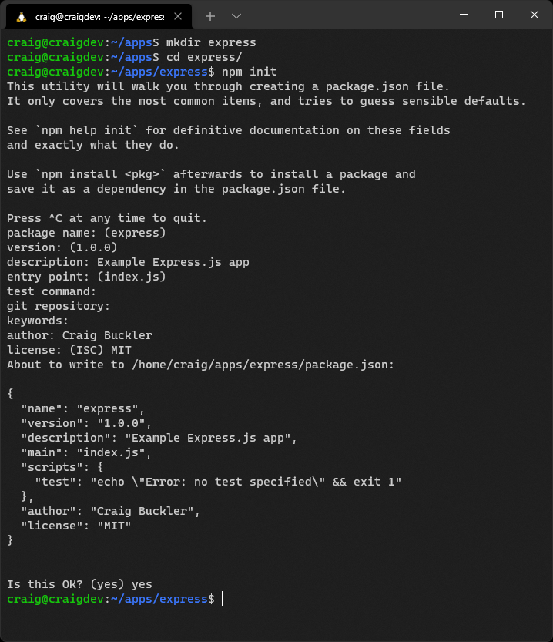
npm saves the settings to a new package.json file in your project’s root directory:
{
"name": "express",
"version": "1.0.0",
"description": "Example Express app",
"main": "index.js",
"scripts": {
"test": "echo \"Error: no test specified\" && exit 1"
},
"author": "Craig Buckler",
"license": "MIT"
}
package.json provides a single place to configure your application. It contains the name, the version, the main entry/starting script, useful application scripts, configuration data, and module dependencies.

Semantic Versioning
Most Node.js projects use semantic versioning, with three MAJOR.MINOR.PATCH numbers such as 1.2.33. When a change occurs, you increment the appropriate number and zero those that follow:
MAJOR for major updates with incompatible API changes
MINOR for new functionality that doesn’t affect backwards compatibility
PATCH for bug fixes

Switch to ES6 Modules
Ensure your project uses standard ES6 modules by adding "type": "module", to package.json in your editor (it can go anywhere in the root object, but is placed above "main" here):
{
"name": "express",
"version": "1.0.0",
"description": "Example Express app",
"type": "module",
"main": "index.js",
"scripts": {
"test": "echo \"Error: no test specified\" && exit 1"
},
"author": "Craig Buckler",
"license": "MIT"
}
ES6 modules are identical to those used in web browsers. Node.js uses CommonJS by default, but ES6 support arrived in version 13. ES6 modules will become predominant over time, so we’ll use ES6 throughout this course.
Node can import CommonJS modules using ES6 syntax. It will also make suggestions if there’s a potential issue or conflict. However, you may encounter problems with some modules written in CommonJS syntax, especially if they haven’t been updated for a few years.

Install Express
Install Express from your project directory using npm:
npm install express
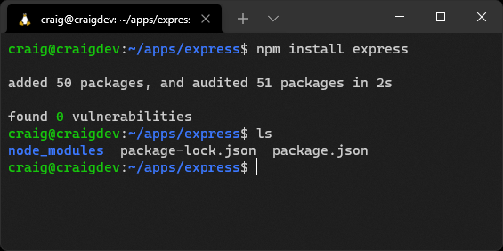
After completion, your package.json file will have a new "dependencies" object, which lists the modules required when your project runs. It contains a reference to "express" and its latest version number (the leading ^ means Express can upgrade to a compatible version such as 4.17.2 or 4.18.0 but not 5.0.0):
{
"name": "express",
"version": "1.0.0",
"description": "Example Express app",
"type": "module",
"main": "index.js",
"scripts": {
"test": "echo \"Error: no test specified\" && exit 1"
},
"author": "Craig Buckler",
"license": "MIT",
"dependencies": {
"express": "^4.17.1"
}
}
You’ll also find the following:
a new package-lock.json file for npm internal use, which lists all the installed modules
a new node_modules folder, which contains the Express module and all submodules code (around 2MB of files)

Runtime Dependencies and Development Dependencies
A module such as Express is required for your application to run. It’s a dependency.
You can also install development dependencies, which are typically build tools that are only required on your development PC. Examples include JavaScript bundlers such as Rollup, CSS preprocessors such as Sass, and live reload systems such as Browsersync.
npm presumes a module is a runtime dependency unless you add the --save-dev switch during installation. For example:
npm install browser-sync --save-dev
This installs Browsersync, but references it in a "devDependencies" object in package.json. Running npm install on a production server where the NODE_ENV environment variable is set to production would not install Browsersync.
The distinction between a dependency and a development dependency is not always straightforward. For example, you could run Rollup on a production server to create minified JavaScript files.

Create the Express Entry Script
You can now write code that uses Express to create a web application. Add a new index.js file in the project directory with the following code:
// Express application
import express from 'express';
// configuration
const
cfg = {
port: process.env.PORT || 3000
};
// Express initiation
const app = express();
// home page route
app.get('/', (req, res) => {
res.send('Hello World!');
});
// start server
app.listen(cfg.port, () => {
console.log(`Example app listening at http://localhost:${ cfg.port }`);
});
To make starting this app a little easier, edit package.json and change the "scripts" object to this:
"scripts": {
"start": "nodemon index.js"
},
If you don’t have nodemon installed, you can install it globally with npm install nodemon -g. If you’d rather use node directly, use "node index.js" as your "start" script (but you’ll need to stop and restart your app every time you want to test a change).
Start the application with npm start and browse to http://localhost:3000.
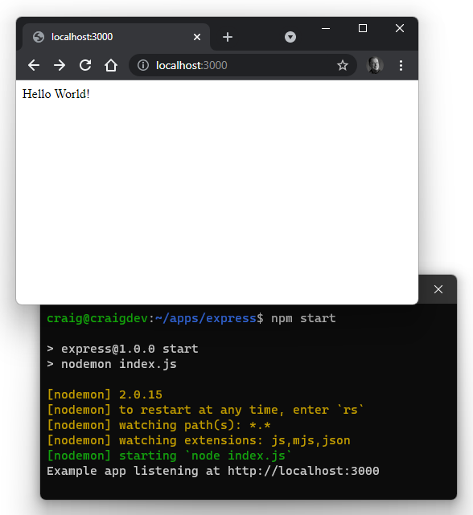
The script imports the express module and creates an instance named app.
A single routing function is defined to handle HTTP GET requests to the root / path:
// home page route
app.get('/', (req, res) => {
res.send('Hello World!');
});
What Is Routing?
Routing determines which functions Express executes when it receives a request for a specific URL, such as / or /another/path/.
Ultimately, one function will return an HTTP response and terminate further processing. The order of your routing functions is therefore critical: a function won’t run if an earlier function completes the request.
A routing function is passed these two objects:
An Express HTTP Request object (req), which contains details about the browser’s request.
An Express HTTP Response object (res), which provides methods used to return a response to the browser. It sends “Hello, World!” text.
Try adding another routing function below the / handler to handle HTTP GET requests to /hello/:
// another route
app.get('/hello/', (req, res) => {
res.send('Hello again!');
});
Once the application has restarted, open http://localhost:3000/hello/ in your browser to see a “Hello again!” message.
No other URL routes are defined. Entering a different URL path in the browser—such as http://localhost:3000/abc—returns Cannot GET /abc. Routing is a central part of Express, and the framework provides options for parsing and responding to different URLs.
The end of the script has an app.listen() call to start the Express server listening on the defined port.
See the course code/ch05/express01 directory and associated video to run the code created so far.

Should You Switch to HTTPS?
Probably not.
All the Node.js examples in this course respond to HTTP requests on port 3000 by default:
// start server
app.listen(cfg.port, () => {
console.log(`Example app listening at http://localhost:${ cfg.port }`);
});
HTTPS requires a Secure Socket Layer (SSL) certificate. These are issued by certificate authorities for use on a specific domain to encrypt tamper-proof data between the browser and server.
For local testing, developers often create their own self-signed certificates using the command line or online tools.
If you have a private key file named server.key, and a site certificate named server.crt, an Express app can read the SSL files, create an HTTPS server, and pass the Express app object as a listener:
// start HTTPS server
import { createServer } from 'https';
import { readFileSync } from 'fs';
createServer(
{
key: fs.readFileSync('./server.key'),
cert: fs.readFileSync('./server.crt')
},
app
).listen(cfg.port);
(This replaces the HTTP app.listen() code above.)
Your application will now accept requests to https://localhost:3000/—although your browser will warn that the certificate has not been issued by a recognized Authority.
Problems with this approach include the following:
You must manage different sets of certificates for production, staging, and every development PC.
You still need an HTTP server to forward invalid HTTP requests to HTTPS.
There are subtle differences when using real and self-signed certificates. For example, browsers don’t cache data from a self-signed server. Applications could run fine locally but experience cache-related issues in production.
The Node.js app must listen on port 443 when deployed to a production server. It must be launched by a superuser (sudo node index.js), but this grants the app permission to do anything. It could accidentally wipe all system files!
A better approach is to use a web server such as NGINX as a reverse proxy. It can handle SSL, HTTP requests, and static files, but forward all requests to the Node.js app (over HTTP) when necessary. (See chapter 18 for deployment options.)

Serve Static Files
Most web applications contain static files that return the same response to all users. These could include images, favicons, CSS stylesheets, client-side JavaScript, pre-rendered HTML pages, or any other asset.
It would be painful to programmatically assign routes for every file. Express allows you to define a single directory that contains static assets and returns any file that matches the URL path.
Create a directory named static in your project folder and add a file named page.html with the following content:
<!DOCTYPE html>
<html lang="en">
<head>
<meta charset="UTF-8">
<title>Static page</title>
<meta name="viewport" content="width=device-width,initial-scale=1" />
</head>
<body>
<h1>This is a static page</h1>
</body>
</html>
Edit your index.js file and add the following code after the final app.get() route:
// serve static assets
app.use(express.static( 'static' ));
(The following “Express Middleware Functions” section explains this code.)
Save and restart the application, then open http://localhost:3000/page.html in your browser.
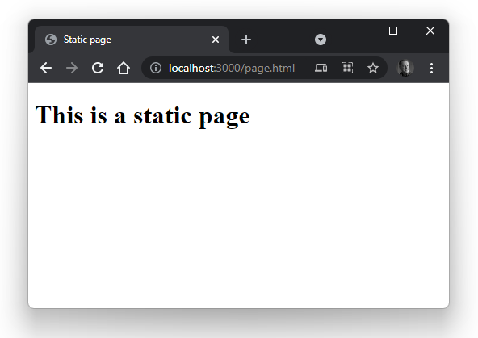
Try adding pages, images, or other assets to the static directory or a subdirectory within it. For example, an image at /static/images/myimage.png can be viewed in the browser at http://localhost:3000/images/myimage.png.

Efficient Static Assets
In this example, Express only checks the file system for a matching static asset when it can’t be handled by a routing function. However, you could check for assets first if your application mostly consists of static files.
On production servers, it’s more efficient to use a frontend web server such as NGINX to serve static assets and bypass Node.js processing entirely.

Express Middleware Functions
The app.use() method used above to define the static directory introduces the concept of Express middleware. Middleware functions run in the sequence defined in the code, and can typically:
run code on every request
manipulate or change the request and response objects
terminate a response—perhaps if the user isn’t logged in
call the next middleware function
In this case, express.static( 'static' ) returns a middleware function that handles static directory processing.
All middleware functions receive three arguments:
req: the Express HTTP Request object.
res: the Express HTTP Response object.
next: a callback that passes control to the next middleware function. Middleware functions must always call next() unless they complete or terminate the current request.
The following middleware function logs every URL request to the terminal:
// log every request to the terminal
app.use((req, res, next) => {
console.log(req.url);
next();
});
You should place this function before any others that could end processing. No logging would occur if you placed it after URL routing or static asset middleware that succeeded in returning a response.

Define Working Directories
A hard-coded static directory is used above. That’s fine for Express, but what if another module needed to locate the same directory to read or write a file?
We can define a fully qualified reference to all working directories in the cfg configuration object. This used to be easy in CommonJS (see Chapter 8 for more on this topic) because Node provided a __dirname constant with the full directory of the current module. The situation is more complex in ES6 modules, because they’re referenced by URL—not by file. The URL of the current module is available in import.meta.url, so it can be parsed to a file path using the standard Node.js library:
import { fileURLToPath } from 'url';
import { dirname, sep } from 'path';
const __dirname = dirname(fileURLToPath( import.meta.url )) + sep;
The url module provides a fileURLtoPath() function, which converts a file:// URL to a fully qualified file path.
The path module provides a dirname() function to extract the directory from a path and a sep constant with the platform-specific path separator (/ on POSIX, \ on Windows).
Update the top of index.js accordingly:
// Express application
import express from 'express';
import { fileURLToPath } from 'url';
import { dirname, sep } from 'path';
// configuration
const
__dirname = dirname(fileURLToPath( import.meta.url )) + sep,
cfg = {
port: process.env.PORT || 3000,
dir: {
root: __dirname,
static: __dirname + 'static' + sep
}
};
console.dir(cfg, { depth: null, color: true });
// Express initiation
// ...rest of code
Then change the reference to the hard-coded static directory:
// serve static assets
app.use(express.static( cfg.dir.static ));
The application shows the configuration settings when starting, but the static page at http://localhost:3000/page.html should work as before.
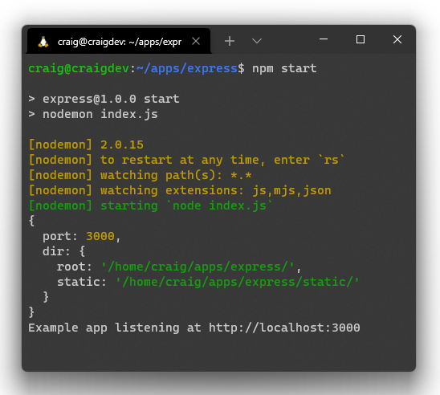
Other modules can’t access the cfg object unless you export it. The active app object can also be useful, so add the following code at the end of index.js:
// export defaults
export { cfg, app };

Compressing HTTP Responses
To improve web application performance, you should compress assets before they’re returned to the browser over the network. The compression middleware module can handle this for you. Stop your app, then install the module:
npm install compression
The dependencies section of your package.json file updates accordingly:
"dependencies": {
"compression": "^1.7.4",
"express": "^4.17.1"
}
Load the module at the top of index.js:
// Express application
import express from 'express';
import compression from 'compression';
Then add it as one of the first middleware functions (before routers and static file handlers):
// HTTP compression
app.use( compression() );
It won’t make a noticeable difference to performance here, but addressing performance at the start of a project puts you one step ahead of most teams!

Disable Express Identification
By default, Express sets the following HTTP response header:
X-Powered-By: Express
It doesn’t do any harm, but you can disable it with app.disable() in index.js:
// Express initiation
const app = express();
// do not identify Express
app.disable('x-powered-by');
It will save a few bytes on every HTTP request, and will also give malicious hackers less information about your Node.js technology stack.

Handle 404 Not Found Errors
Add the following code as the last middleware function to gracefully handle errors when a page or asset can’t be found:
// 404 error
app.use((req, res) => {
res.status(404).send('Not found');
});
This returns a “Not Found” message with a 404 HTTP header code, but you could also do one of the following options:
redirect to an appropriate page
show suggested pages to the user
log bad requests to a file for further analysis
See the course code/ch05/express02 directory and associated video to run the code created so far.

Add an HTML Template Engine
Node.js has a wide range of HTML template engines that create HTML pages or snippets for output. A typical engine will take an HTML template and:
substitute variables with actual values
allow the inclusion of partials such as headers, footers, menus, and so on
permit basic programming functionality, such as conditions and loops

Template Performance
Ideally, your HTML templates should do as little as possible at runtime. You may be able to pre-render some parts of a template, such as including other files (partials) so your app has less work to do when rendering a page.
Popular templating options include Pug, Nunjucks, and EJS, which we’ll use here, because it’s one of the simplest, fastest, and most popular options. Many HTML template engines work with Express, but most provide instructions in situations where there’s no direct support.
In this example, you’ll create a simple message.ejs template that’s used to display single messages such as “Hello World!” in an <h1> tag. Stop your server and install EJS with npm install ejs.
The dependencies section of your package.json file updates accordingly:
"dependencies": {
"compression": "^1.7.4",
"ejs": "^3.1.6",
"express": "^4.17.1"
}
Now create a views subdirectory in your project. Add a file to it named message.ejs with the code to output a title variable:
<%- include('partials/_htmlhead'); -%>
<h1><%= title %></h1>
<%- include('partials/_htmlfoot'); -%>
This template includes other partials, so create a partials subdirectory in views with a _htmlhead.ejs file:
<!DOCTYPE html>
<html lang="en">
<head>
<meta charset="UTF-8">
<title><%= title %></title>
<meta name="viewport" content="width=device-width,initial-scale=1" />
</head>
<body>
Also create an _htmlfoot.ejs file:
</body>
</html>
Open the Express entry index.js file and add a new cfg.dir.views property that points at the views directory:
// configuration
const
__dirname = dirname(fileURLToPath( import.meta.url )) + sep,
cfg = {
port: process.env.PORT || 3000,
dir: {
root: __dirname,
static: __dirname + 'static' + sep,
views: __dirname + 'views' + sep
}
};
Add this code before any routes and middleware:
// use EJS templates
app.set('view engine', 'ejs');
app.set('views', cfg.dir.views);
This sets EJS as the Express view engine with files contained in the views directory.
EJS is invoked using the Express Response render() method in a routing function. Update the functions /, /hello/, and the 404 handler:
// home page route
app.get('/', (req, res) => {
res.render('message', { title: 'Hello World!' });
});
// another route
app.get('/hello/', (req, res) => {
res.render('message', { title: 'Hello again!' });
});
// serve static assets
app.use(express.static( cfg.dir.static ));
// 404 errors
app.use((req, res) => {
res.status(404).render('message', { title: 'Not found' });
});
The render method is passed the name of the template ('message'—the .ejs extension can be omitted) and an object containing name/value pairs. A title is set in this example.
Start your Express server with npm start, then open http://localhost:3000/ in a browser.
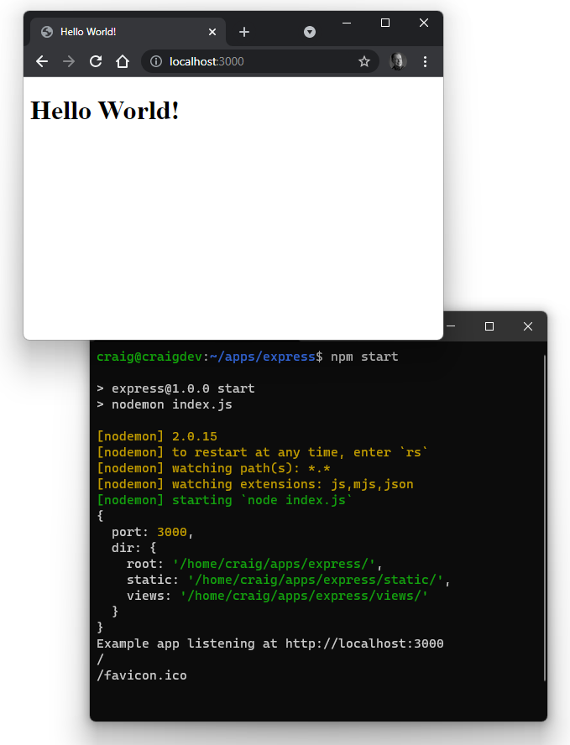
The result may not be significantly different, but it’s a fully rendered HTML page with an <h1> title. (View the source, Luke.)

Advanced Routing
URL routing is at the heart of Express processing. You’ve developed simple routes that run functions for specific matching URLs, but there are more options:
path expressions: handling many routes with one function
path parameters: parsing routes to extract values
HTTP methods: using GET, POST, DELETE, PUT and so on
route handlers: grouping related route handler functions into one file

Routing Path Expressions
Simple URL routes are defined in the examples above. For example:
// another route
app.get('/hello/', (req, res) => {
res.send('Hello again!');
});
The route handles HTTP GET requests to /hello/, although Express will do the following:
Ignore casing. The paths /Hello/ and /HELLO/ will match the /hello/ route unless you add app.set('case sensitive routing', true) to index.js.
Ignore closing slashes. The paths /hello/ and /hello match the same route unless you add app.set('strict routing', true) to index.js.
As well as exact routes, you can define regular expression patterns to match a range of URLs. For example:
? denotes that the preceding character is optional. A route of /ab?cd/ matches the URL paths /abcd/ and /acd/.
+ denotes that the preceding character must appear one or more times. A route of /ab+cd/ matches the URL paths /abcd/, /abbcd/, /abbbbbcd/ and so on.
* denotes any number of characters. A route of /ab*cd/ matches the URL paths /abcd/, /ab123cd/, /ab-node.js-cd/ and so on.
A more complex route of /.+Script$/ matches the URL paths /JavaScript/ and /ECMAScipt/, but not /Scripting/.
Express uses the Path-to-RegExp module to parse paths. The Express Route Tester tool can help you build and debug more complex URLs.

Routing Path Parameters
Route parameters are named path segments preceded by a colon (:) to identify a variable in the URL. For example, the route /user/:id matches any URL path starting /user/ that has a single segment—such as /user/123 or /user/abc.
Captured values are available in the Request params object, so req.params.id would be set to 123 or abc in the examples above.
Any number of URL parameters can be defined. The following route function would run for the path /author/Craig-Buckler/book/Node.js:
// return a value for a user
app.get('/author/:name/book/:bookName', (req, res, next) => {
console.log(`author: ${ req.params.name }`); // "Craig-Buckler"
console.log(` book: ${ req.params.bookName }`); // "Node.js"
next();
});

HTTP Route Methods
The examples above handle HTTP GET requests by defining an app.get() function. Express supports all the other HTTP methods, including:
HTTP POST with app.post()
HTTP PUT with app.put()
HTTP DELETE with app.delete()
app.all() handles all HTTP methods to a specific route. The function can examine the req.method property to determine which HTTP method was used.

Creating a Route Handler
Defining all route handler functions in the entry index.js script becomes impractical as your application grows in complexity. A better option is to create route handling middleware in separate files with related functionality.
The following example updates the Express code so that requests to any URL starting /hello/ are handled in a single router file. Two GET requests are implemented:
/hello/:name returns a page saying hello to someone by name. For example, /hello/craig displays “Hello Craig!”
/hello/:lang/:name returns a page saying hello to someone by name in a specific language. For example, /hello/fr/craig switches to French and displays “Bonjour Craig!”
Before doing this, create a lib subdirectory in your project folder for generic library modules. Add a new file at lib/locale.js with the following code:
// localisation
// international greetings
export const hello = {
au: 'G\'day',
cn: 'Nǐ hǎo',
en: 'Hello',
de: 'Hallo',
es: 'Hola',
fr: 'Bonjour',
jp: 'Kon\'nichiwa'
};
Then add lib/string.js with the following code:
// string functions
// capitalize the first letter of all words
export function capitalize(str) {
return str
.trim()
.toLowerCase()
.split(' ')
.map(word => word.charAt(0).toUpperCase() + word.slice(1))
.join(' ');
}
Next, create a new routes subdirectory in your project folder for routing middleware. Add a new file at routes/hello.js with code to define the two routing functions:
// /hello/ route
import { Router } from 'express';
import { hello } from '../lib/locale.js';
import { capitalize } from '../lib/string.js';
export const helloRouter = Router();
// say hello in English
helloRouter.get('/:name', (req, res, next) => {
res.render(
'message',
{ title: `${ hello.en } ${ capitalize( req.params.name ) }!` }
);
});
// say hello in a specific language
helloRouter.get('/:lang/:name', (req, res, next) => {
res.render(
'message',
{ title: `${ hello[req.params.lang] || hello.en } ${ capitalize( req.params.
➥name ) }!` }
);
});
This defines an Express Router object named helloRouter. Routers are mini applications that can perform routing and middleware functions.
The first route defines a function for the parametrized path /:name. (You should not specify the full /hello/:name route, because this router file will become the handler for all /hello/ paths.) The function renders the message template with a title that says “Hello” (in English) to the :name value passed on the URL (req.params.name).
The second route defines a function for the parametrized path /:lang/:name. Again, this renders the message template with a title that uses a localized version of “Hello” as defined in lib/locale.js.
To use your Router file, open index.js then remove these lines:
// another route
app.get('/hello/', (req, res) => {
res.send('Hello again!');
});
Replace them with this code:
// /hello/ route
import { helloRouter } from './routes/hello.js';
app.use('/hello', helloRouter);
app.use() defines the helloRouter middleware rather than a single app.get() route.
If necessary, restart your Express app with npm start and open a URL in your browser, such as http://localhost:3000/hello/craig to see “Hello Craig!”
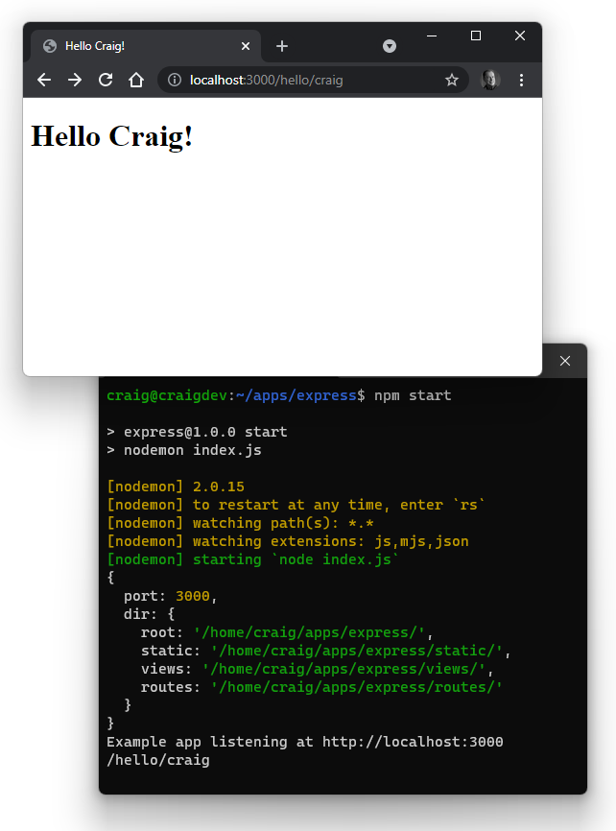
Switch to an Australian greeting with the URL http://localhost:3000/hello/au/craig.
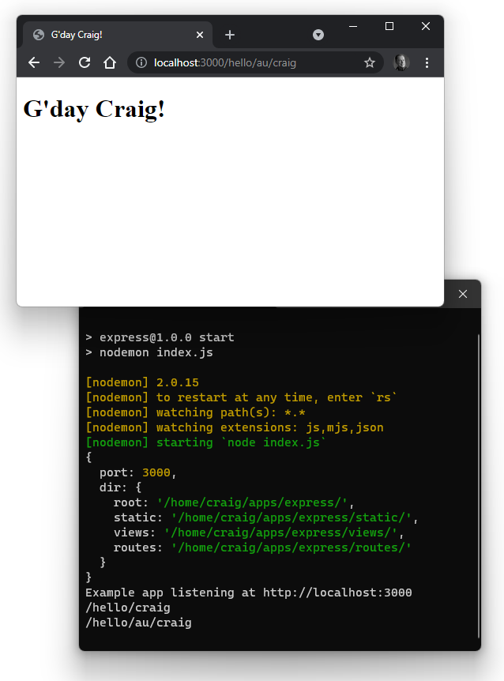
See the course code/ch05/express02 directory and associated video to run the code created so far.

Exercises
Attempt the following updates to improve your Express coding experience:
Improve the message template to add a stylesheet. (Hint: the CSS could be a static file.)
Create and use a new template that also outputs the current URL to the page. (Hint: the Express Request object passed as req can help.)
Create a new router to say “Goodbye” in a similar way to the “Hello” example.

Summary
This chapter introduced the Express framework for server-side web applications. Other Node.js server frameworks follow similar conventions and some are compatible with Express middleware.
This is just the start of the possibilities. In the following chapters, we’ll look at ways to process form data, implement REST APIs, and manipulate databases in your Express applications.

Quiz
1. Express is:
a. similar to Apache or NGINX but programmable with Node.js code
b. a Node.js server-side application framework
c. one of several Node.js web server frameworks
d. all of the above
2. Express is typically installed in a project as:
a. a global module
b. a development dependency
c. a dependency
d. a single static JavaScript file
3. A package.json file is used to:
a. store configuration information about a Node.js application
b. store application runtime data
c. configure npm
d. all of the above
4. An Express middleware function:
a. is an internal Express module
b. runs when an Express app starts
c. can handle or manipulate the HTTP request and response
d. runs when an Express app shuts down
5. Middleware functions are passed the following parameters in order:
a. the next function, the Request object, the Response object
b. the Request object, the Response object, the next function
c. the next function, the Response object, the Request object
d. the Response object, the Request object, the next function

Chapter 6: Processing Form Data with Express
Unless you’re creating a static website, processing user data posted from an HTML form is at the heart of all web applications. In this chapter, you’ll learn how Express can:
parse query string data typically sent in an HTTP GET request (see the “Processing HTTP GET Query Strings” section)
parse posted body data typically sent in an HTTP POST request (see the “Processing HTTP Post Body Data” section)
receive uploaded files typically sent in a multipart/form-data HTTP POST (see the “Processing Uploaded Files” section)

Code Examples
The Express examples provided below purposely omit some of the options recommended in the previous chapter. Dropping features such as compression, router middleware, and 404 pages makes for more concise code—but be sure not to forget them in your projects!
Sanitize User Input
The rules of data processing club:
Never trust user data.
See #1.
User data must always be sanitized on the server. You may have robust HTML and JavaScript validation, but there’s no guarantee the request came from a browser or worked as you expected. Always check data before it’s used elsewhere—especially if it’s output to an HTML page. (Note that the EJS <%= escapes HTML.)
Incoming field data will be a string, so you can check for specific formats using regular expressions and parse to types such as numbers, dates, or objects to check for errors. The express-validator module provides a range of validation and sanitization functions.
For brevity, the examples below don’t check any incoming data, so please don’t use them on a live server!

Processing HTTP GET Query Strings
Data can be passed on the URL query string denoted by a ? and a series of name=value pairs separated by &—such as http://localhost:3000/?a=1&b=2&c=3. Query strings are usually added to HTTP GET requests, although they can be used by any method.
Express automatically parses query strings and returns a name/value object in the Request .query property. The example URL above returns an object:
{
a: 1,
b: 2,
c: 3
}
The example code in code/ch06/express-get provides a simple example. The template views/form.ejs implements an HTML <form>, which posts to itself with its method set to "get". A table at the top shows all name/value pairs passed in a data object:
<%- include('partials/_htmlhead'); -%>
<h1><%= title %></h1>
<% if (data) { %>
<p>Data received in last request:</p>
<table>
<% for (const name in data) { %>
<tr>
<th>
<%= name %>:</th>
<td>
<%= data[name] %>
</td>
</tr> <% } %>
</table>
<% } %>
<p>Submission form:</p>
<form action="/" method="get">
<div>
<label for="name">name</label>
<input type="text" id="name" name="name" value="<%= data.name %>" />
</div>
<div>
<label for="job">job</label>
<input type="text" id="job" name="job" value="<%= data.job %>" />
</div>
<div>
<label for="nodejs">like Node.js?</label>
<input type="checkbox" id="nodejs" name="nodejs" value="yes"<% if
➥(data.nodejs) { %> checked<% } %> />
</div>
<input type="hidden" name="date" value="<%= new Date(); %>" />
<button>submit</button>
</form>
<%- include('partials/_htmlfoot'); -%>
(Note that views/partials/_htmlhead.ejs provides a little inline CSS styling.)
The index.js entry script sets the EJS template engine and renders the form template when a GET request is made to the root / URL. The template is passed an object containing:
the page title
a data property set to req.query
// Express application
import express from 'express';
// configuration
const cfg = { port: process.env.PORT || 3000
};
// Express initiation
const app = express();
// use EJS templates
app.set('view engine', 'ejs');
app.set('views', 'views');
// render form
app.get('/', (req, res) => {
res.render('form', {
title: 'Parse HTTP GET data',
data: req.query
});
});
// start server
app.listen(cfg.port, () => {
console.log(`Example app listening at http://localhost:${ cfg.port }`);
});
Following an npm install to install the Express and EJS dependencies, start the server running with npm start and navigate to http://localhost:3000/ in a browser.
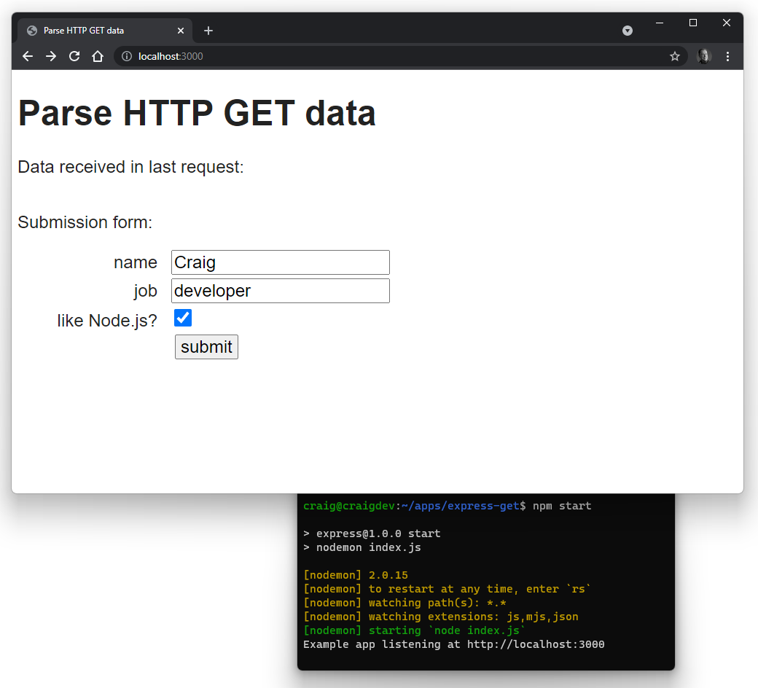
Enter some data and hit submit. The URL query string changes, and all name/value pairs are displayed. (Note that the date is passed as a hidden input value.)
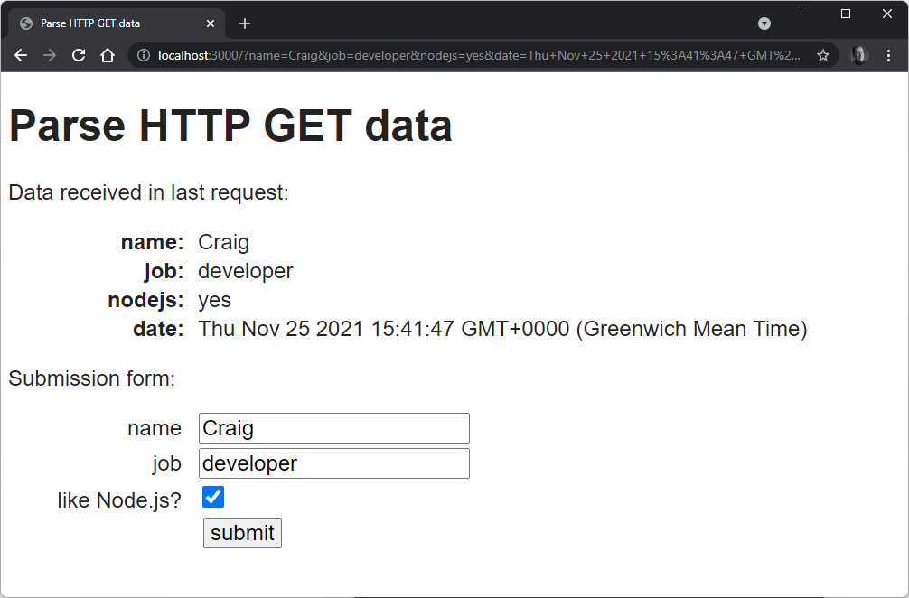
See the course code/ch06/express-get directory and associated video to run this code.

Processing HTTP Post Body Data
An HTTP POST sent via an HTML <form> with its method set to "post" places all data in the body of the request. Express doesn’t parse this data by default and requires an express.urlencoded() middleware function to populate a Request .body property with an object containing name/value pairs.

The body-parser Module
Older editions of Express didn’t include a body parsing function, so you may see references to a body-parser module in other tutorials.
The code in code/ch06/express-post provides a simple example. The template views/form.ejs is identical to that shown in the GET example above (in the “Processing HTTP GET Query Strings” section), except the <form> method is set to "post".
The index.js entry script sets the EJS template engine and then defines the body parsing middleware like so:
// body parsing
app.use(express.urlencoded({ extended: true }));
The extended syntax option uses the qs module to create a richer Request body object with nested properties and arrays if you’ve defined form fields appropriately.
The initial page load for the root / URL is an HTTP GET request, while the form submission is an HTTP POST request. Rather than define these as separate routes, the index.js entry script uses app.all() so a single function processes all HTTP methods. It renders the form template and passes an object where the data property is set to req.body:
// Express application
import express from 'express';
// configuration
const cfg = { port: process.env.PORT || 3000
};
// Express initiation
const app = express();
// use EJS templates
app.set('view engine', 'ejs');
app.set('views', 'views');
// body parsing
app.use(express.urlencoded({ extended: true }));
// render form
// use .all to handle initial GET and POST
app.all('/', (req, res, next) => {
if (req.method === 'GET' || req.method === 'POST') {
res.render('form', {
title: 'Parse HTTP POST data',
data: req.body
});
}
else {
next();
}
});
// start server
app.listen(cfg.port, () => { console.log(`Example app listening at
➥http://localhost:${ cfg.port }`);
});
Following an npm install to install the Express and EJS dependencies, start the server running with npm start and navigate to http://localhost:3000/ in a browser.
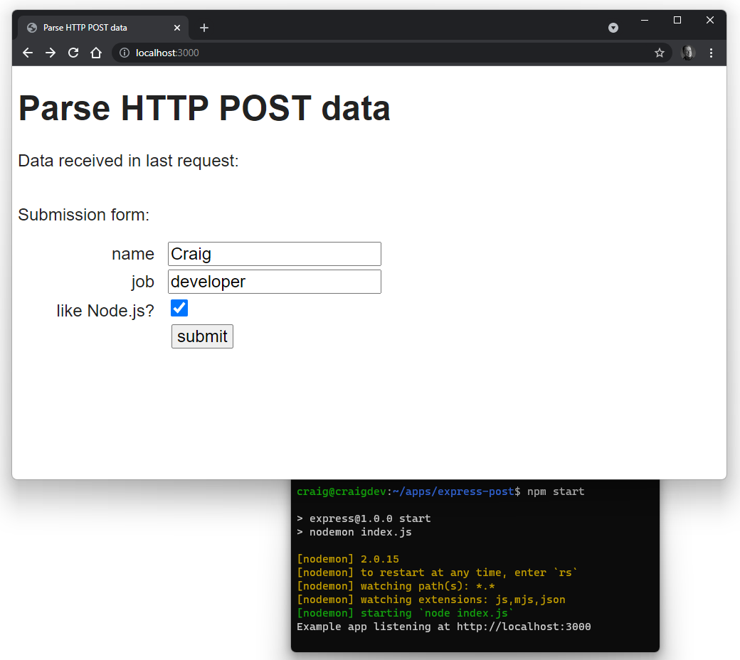
Enter some data and hit submit. The data is posted and all name/value pairs are displayed. (Note the date is passed as a hidden input value.)
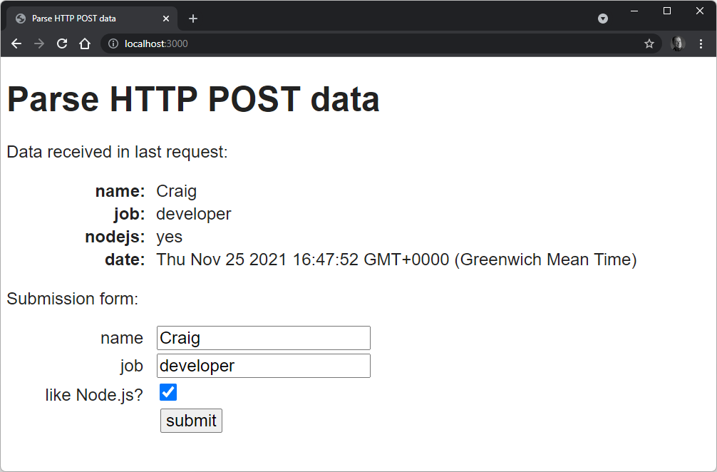
See the course code/ch06/express-post directory and associated video to run this code.

Processing Uploaded Files
Receiving file uploads in Express is gloriously simple compared to some languages. However, it requires a third-party module such as formidable to parse incoming streamed data to one or more files.
The example code in code/ch06/express-file has a package.json file where Express, EJS, and Formidable are declared as project dependencies:
"dependencies": {
"ejs": "^3.1.6",
"express": "^4.17.1",
"formidable": "^2.0.1"
}
The template views/form.ejs defines a <form> with its method set to "post" and enctype set to "multipart/form-data". A field that allows images to be uploaded is also added:
<input type="file" id="image" name="image" accept="image/*" />
The received data <table> also checks for an imageurl property in the data object and displays it using an <img> tag when found:
<table>
<% for (const name in data) { %>
<tr>
<th><%= name %>:</th>
<td>
<%= data[name] %>
<% if (name === 'imageurl') { %>
<img src="<%- data[name] %>" alt="uploaded image" />
<% } %>
</td>
</tr>
<% } %>
</table>
The index.js entry script defines an uploads subdirectory, where uploaded files are stored:
// Express application
import express from 'express';
import formidable from 'formidable';
import { fileURLToPath } from 'url';
import { dirname, parse, sep } from 'path';
// configuration
const
__dirname = dirname(fileURLToPath( import.meta.url )) + sep,
cfg = {
port: process.env.PORT || 3000,
dir: {
root: __dirname,
uploads: __dirname + 'uploads' + sep
}
};
(Create this uploads subdirectory in your project. A project is somewhere within your home directory should already have write permissions, but run chmod 666 uploads if necessary.)
The script then initializes Express and sets uploads as a static directory. This makes it easy to display an uploaded image for the purposes of this example, but you’d normally move a valid file to a safer location—perhaps outside the project directory—to ensure that it can’t be accidentally deleted or overwritten. (See the “Exercises” section below for pointers.)
// Express initiation
const app = express();
// use EJS templates
app.set('view engine', 'ejs');
app.set('views', 'views');
// static assets
app.use(express.static( cfg.dir.uploads ));
Note that the express.urlencoded() middleware is no longer required, because formidable will also parse the form fields.
The app.all() route uses a single function for all HTTP methods. When this routing function runs:
It initializes a new formidable object with the upload directory and a setting to keep the file extension.
The .parse() method is called with the Express Request object (req) and a callback function that runs once the upload has completed. The callback is passed an error message (err), the (non-file) data fields, and a files object.
If a single, non-empty image property exists in files, the data object is supplemented with information about the image. Formidable places it in the uploads directory with a unique GUID filename to ensure it can’t clash with previous uploads.
The data.imageurl property is defined by extracting the filename from the file path and prepending a slash / to define a URL that resolves to the static directory.
// render form
// use .all to handle initial GET and POST
app.all('/', (req, res, next) => {
if (req.method === 'GET' || req.method === 'POST') {
// parse uploaded file data
const form = formidable({
uploadDir: cfg.dir.uploads,
keepExtensions: true
});
form.parse(req, (err, data, files) => {
if (err) {
next(err);
return;
}
if (files && files.image && files.image.size > 0) {
data.filename = files.image.originalFilename;
data.filetype = files.image.mimetype;
data.filesize = Math.ceil(files.image.size / 1024) + ' KB';
data.uploadto = files.image.filepath;
data.imageurl = '/' + parse(files.image.filepath).base;
}
res.render('form', { title: 'Parse HTTP POST file data', data });
});
}
else {
next();
}
});
// start server
app.listen(cfg.port, () => {
console.log(`Example app listening at http://localhost:${ cfg.port }`);
});
Callback Functions
The callback function passed to form.parse() is the first callback example we’ve used. This function is called asynchronously: the Node.js runtime can perform other tasks while the callback waits for data.
Understanding JavaScript callbacks, promises, and async/await is essential for Node.js development. They’re discussed further in Chapter 9.
Following an npm install to install the Express, EJS, and Formidable dependencies, start the server running with npm start and navigate to http://localhost:3000/ in a browser.
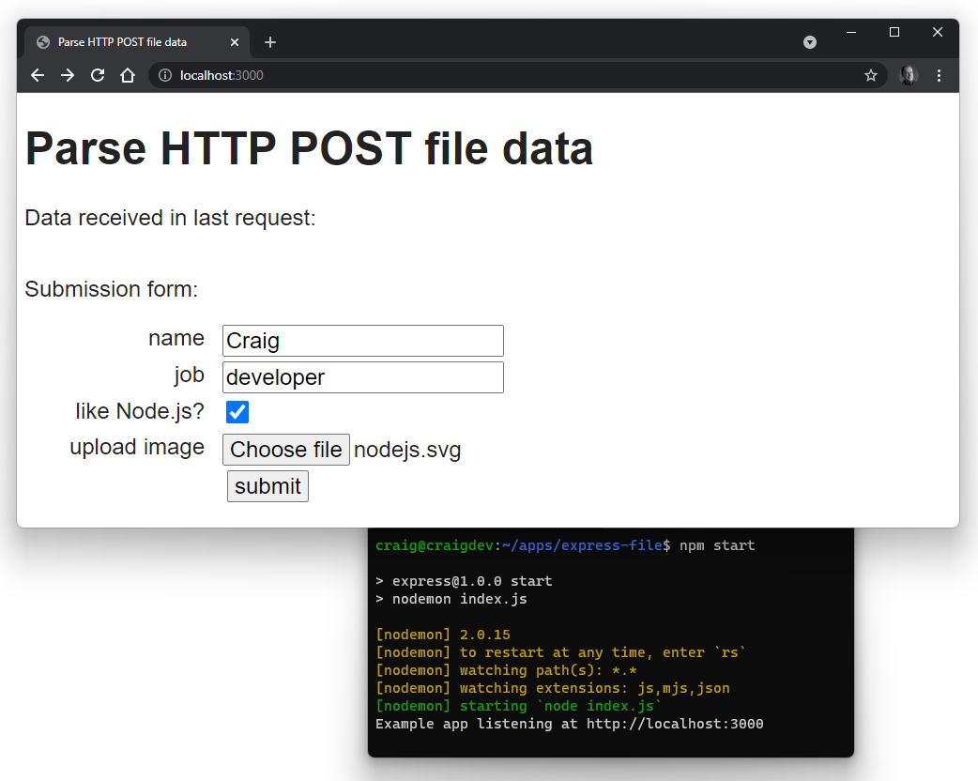
Enter some data, choose an image file, and hit submit. The data is posted and all name/value pairs are displayed with the image URL displayed in an <img> tag.
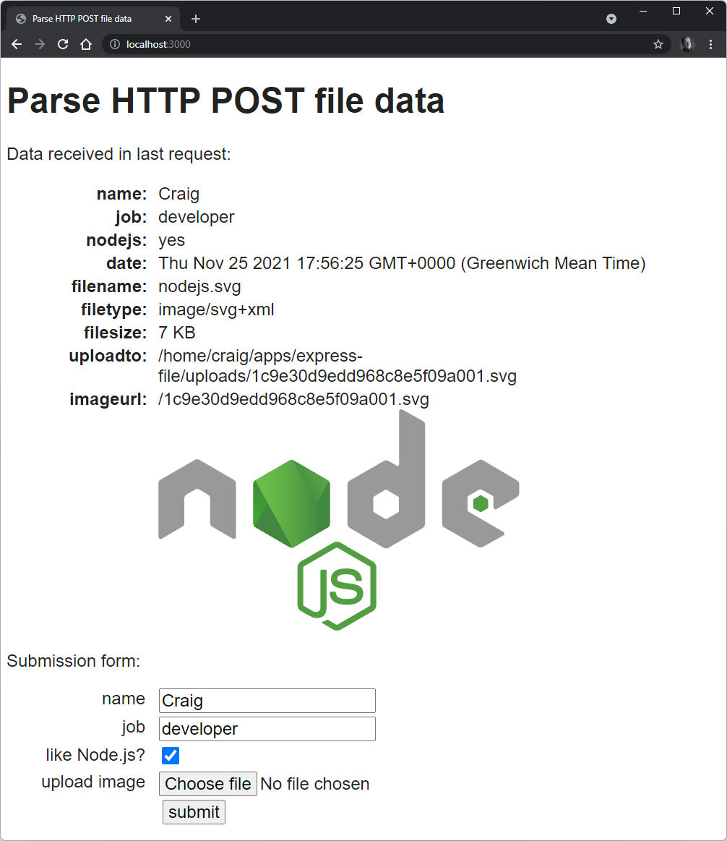
See the course code/ch06/express-file directory and associated video to run this code.

Exercises
Modify any of the examples so that:
a new email field is added to the HTML form
the receiving route only permits data expected in the HTML form—but nothing else
the user values are validated—especially the email address (a basic regular expression is fine)
adapt the EJS template to show errors as necessary
For some big bonus points, write code to delete files from the uploads directory—perhaps those uploaded more than 24 hours ago. You’ll require Node.js file system methods such as readdir() to read a directory, stat() to fetch file information, and unlink() to delete a file.

Summary
This chapter has built on your Express knowledge to illustrate how you can receive and process data uploaded to the server. This is essential for any web application and Express makes life a little easier for developers.

Quiz
1. Data passed on the URL query string:
a. is not parsed in Express by default
b. is available in an object returned by the Request .query property
c. is available in an object returned by the Request .querystring property
d. is available in an object returned by the Request .body property
2. Body data in an HTTP POST request:
a. is not parsed in Express by default
b. is available in an object returned by the Request .query property
c. is available in an object returned by the Request .querystring property
d. is available in an object returned by the Request .body property
3. File upload data in an HTTP POST request:
a. is not parsed in Express by default
b. requires a third-party module to process the incoming data
c. should be handled asynchronously in Node.js
d. all of the above

Chapter 7: How to Use the npm Node Package Manager
You can attribute much of Node’s success—and frustration—to npm. Node Package Manager provides ways to find, install, update, manage, publish, and remove Node.js packages. A package could be anything from a simple, one-line JavaScript module to a full application.
npm is the world’s largest software registry. Almost 1.5 million packages have been published at registry.npmjs.org and the majority are free to include in your own projects. You can publish your own package with a single command, and almost 1,000 developers do that every day.
Earlier chapters in this course introduced some npm concepts, but the following sections explain options you’ll use daily (plus a few you’ll use less frequently). The information is important, although you can skim it and use this chapter for reference later.

npm Alternatives
npm isn’t the only Node.js package manager, and you can try alternatives such as Yarn and pnpm. However, npm is installed with Node.js and it’s good enough for most developers.

Global vs Local Packages
By default, npm installs packages in the local project directory so it can be used in an application.
You can also install packages globally so that they’re available across your whole system. This is most practical for command-line applications and utilities that could be used at any time from any directory.
For example, to install the ESLint JavaScript validator globally, run npm install eslint --global.
You can then run eslint <file.js> from any directory to validate a JavaScript file.
However, you could install eslint in a project directory if you wanted to guarantee all team members had the module and fixed their errors before committing code to a project.

npm link
npm link symlinks the current project directory so it acts like a global package. A script can then be run from any other directory. This can be useful when developing a package you intend to use globally. There’s no need to publish and install it as a global package every time you make a change.
npm uninstall <name> --global removes the symlink.
Don’t worry if this isn’t clear now. You’re unlikely to use this feature until you start sharing modules with other developers.

npm Help
npm documentation is available at docs.npmjs.com, but help is also available from the command line: npm help. For further details, enter npm help npm, or request help about a specific npm command. For example:
npm help install
npm help list
npm help config
npm help package.json

npm Configuration
You’ll rarely need to change npm configurations, but you can view your defaults with npm config list, or you can view a complete list of settings with npm config list -l.
An individual setting can be viewed. For example, show the default author name:
npm config get init-author-name
A setting can also be changed:
npm config set init-author-name="Craig Buckler"
From this point forward, npm won’t prompt for the author name when initializing any project.
A setting can be unset (or deleted) with npm config delete init-author-name.

Project Initialization
To start a new project, you should create a new directory, navigate to it, and run npm init.
This prompts for information about the project—such as it name, description, Git repository, and so on. Use npm init --yes to accept all defaults without prompting.
npm init creates a configuration file named package.json. You can adapt this from another project or edit it manually if you prefer. The file contains information about your project and its dependencies. For example:
{
"name": "express",
"version": "1.0.0",
"description": "Example Express app",
"type": "module",
"main": "index.js",
"scripts": {
"start": "nodemon index.js"
},
"author": "Craig Buckler",
"license": "MIT",
"dependencies": {
"compression": "^1.7.4",
"ejs": "^3.1.6",
"express": "^4.17.1"
}
}
Your project can then be installed on another device using npm install, which downloads all the required dependencies for the application.
Common package.json values include:
name | description
name | the project name—which must be unique if you want to publish on the npm registry (see the “Publishing Packages” section below)
version | the semantic version number (see the “Semantic Versioning” section below)
description | a short description of the project
type | either "module" for ES6 modules or "commonjs" (the default)
keywords | an array of strings to help others discover the project
repository | the code repository, often on GitHub
homepage | the project home page URL (often the GitHub README.md file)
bugs | the project issue tracker URL (often the GitHub Issues panel)
licence | a license for usage restrictions (if any)—set "private" if you’re not sharing the project
main | the main entry/starting script
scripts | script commands (see the “Using npm Scripts” section below) which typically build, test, launch, or deploy a project
dependencies | project dependencies (see the “Project Dependencies” section below) required at runtime
devDependencies | development dependencies (see the “Development Dependencies” section below) required during development
Lesser-used values include:
name | description
config | application runtime configuration parameters such as ports
publishConfig | configuration parameters used at publish time
engines | the Node.js version required—such as"node": ">=14.0.0"
os | an array of compatible operating systems—such as ["linux", "darwin", "win32"]
cpu | an array of compatible CPU architectures—such as ["x64"]
browser | the main entry/starting script for client-side JavaScript packages installed with npm (used instead of main)
funding | a funding page URL
files | an array of file patterns that specifies the files included when the package is installed as a dependency
bin | a list of one or more executable files to install in the PATH
man | one or more manual page files
peerDependencies | compatibility of your package with another
bundledDependencies | other packages bundled with the package
optionalDependencies | an optional dependency; the package should run without it
private | set "true" and npm will never publish the package to the npm registry
See the online help documentation or run npm help package.json for a full description.

Semantic Versioning
Always use a semantic version for your project with MAJOR.MINOR.PATCH numbers separated by a period (.).
When a change occurs, you should increment the appropriate number and zero those that follow. Assuming a current version of 1.2.33:
a new bug fix would update the PATCH number to version 1.2.34
new functionality that didn’t break backward compatibility would update the MINOR number to version 1.3.0
a major update with incompatible API changes would update the MAJOR number to version 2.0.0
Not all developers follow this convention, so read the documentation carefully!

Project Dependencies
A package such as Express is (usually) required at runtime. It’s a dependency for your application; the app would fail to run without it.
Project dependencies are listed in the dependencies section of package.json. When your project is deployed to another machine (such as a live production server), running npm install installs all dependencies.

Development Dependencies
Packages such as the Browsersync live reload server or the ESLint JavaScript validator are (usually) used during development. They aren’t required by your application when it runs, so they aren’t required on a live production server.
Development dependencies are listed in the devDependencies section of package.json. They aren’t installed if you run npm install when the NODE_ENV environment variable is set to production. This can be set on Linux or macOS:
NODE_ENV=production
This is the Windows cmd prompt:
set NODE_ENV=production
And this for Windows Powershell:
$env:NODE_ENV="production"

Searching for Packages
You’ll need to install and use a third-party dependency for your application at some point. Always consider whether you really need it. npm is often criticized for reasons such as:
There may be dozens of packages that perform a similar function. How long will it take to evaluate the best option?
Installation can cause an avalanche of further installations, as each package requires others that have further dependences. You can even end up with multiple versions of the same package in the same project.
Every third-party package and subpackage raises security implications. npm has a registry of known vulnerabilities, but information won’t be available for new or less popular packages.
Is it more practical to write the code yourself?
A small module specific to your application is a good candidate. You’ll learn more and be able to write fully customizable code that’s fast and lean. Over the long term, it may even take less time and effort than maintaining a regularly updated third-party package.
Larger or more generic modules such as frameworks (Express), database drivers, or image compressors are full projects in their own right. It makes sense to leverage the many hours of development and real-world testing.
There’s an infinite array of situations between these extremes. Only you can make a judgement, but you may find yourself using fewer packages as your Node.js and JavaScript knowledge increases.

Development Dependency Limits?
Development tools (in devDependencies) have no direct effect on your application. That said, using a large number will increase installation times, require ongoing maintenance, and may confuse new team members.
Perhaps start by browsing a list of curated Node.js packages:
github.com/sindresorhus/awesome-nodejs
nodejs.libhunt.com
Alternatively, you can search for packages from the command line using npm search <term>. For example, to find a MongoDB database driver, enter npm search mongodb.
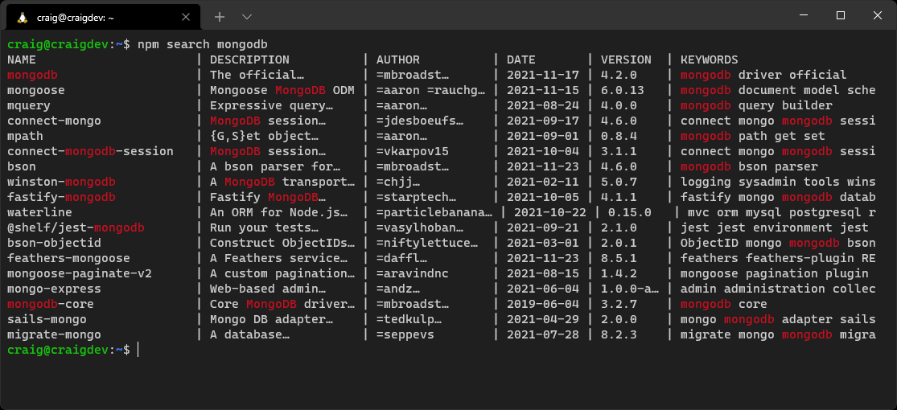
More practically, it’s best to use an online search engine:
npmjs.com: the official repository
npms: a fast search that ranks packages by quality
snyk.io/advisor/: ranks packages with a health percentage
There are tools for comparing two or more packages:
npmcompare.com
moiva.io
Or tools to extract package information:
anvaka.com: dependency visualization
npm-stat.com: download and usage statistics
Hardcore coders can even examine the JSON data used by npm at registry.npmjs.org! Add the package name to the URL—for example, registry.npmjs.org/express.
If you’re struggling to choose, opt for a package that’s popular with a non-restrictive usage license, recent and regular updates, a small size, the fewest dependencies, and no major outstanding issues.

Installing Packages
To install a development dependency, run npm install, followed by one or more space-separated package names. For example:
npm install express mongodb
To install a package as a development dependency, add --save-dev to the command:
npm install browser-sync --save-dev
These options install the latest package into the node_modules directory and update package.json with the name and current version number.

.gitignore node_modules
There’s no need to add the node_modules directory to your Git (or other) repository, because npm install can re-create the dependency tree.
If you require a specific or earlier package, add @ and the version number to the package name. For example:
npm install ejs@2.7.4
To install a package globally so it’s available in any directory, add --global to the command:
npm install eslint --global

Shortcut Aliases
Most npm commands and switches have shorter aliases. Either i or add can be used in place of install, and -g can be used instead of --global. For example:
npm i eslint -g

Semantic Constraints
package.json uses special codes to indicate which version of a package can be installed on a clean machine using MAJOR.MINOR.PATCH semantic versioning (see the “Semantic Versioning” section above):
1.2.33: install an exact version
>1.2.33: install a version greater than 1.2.33 (2.0.0 is permitted)
>=1.2.33: install a version greater than or equal to 1.2.33
<1.2.33: install a version less than 1.2.33
<=1.2.33: install a version less than or equal to 1.2.33
^1.2.33: install any greater or equal compatible version with the same MAJOR number—such as 1.3.0 but not 2.0.0 (this is the default)
~1.2.33: similar to ^ but won’t go beyond the next MINOR number—that is, a maximum of 1.3.0
* (or an empty string): install any version
Versions can be combined—for example, <2.0.0 || >=3.0.0, to skip version 2.x.x.
The installation of each package (and subpackage) is recorded in package-lock.json. This ensures subsequent installs are identical regardless of available updates. The file can be added to your code repository, although you can run into problems if the application is installed on different operating systems. Personally, I prefer to set the exact version in package.json, omit package-lock.json from the Git repo, and then update and test manually whenever new packages are available. (See the “Finding Outdated Packages” section below.)

“No-install” Execution
The npx command allows you run a package command without installing it locally. For example, try running the cowsay talking cow package:
npx cowsay "I love Node.js!"
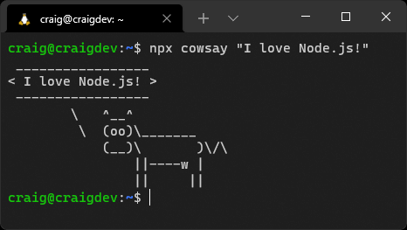
You’ll be prompted to agree to the download the first time this command is run. From then on, the version in the npm cache is used.

npx Local Execution
A package such as eslint or rollup can’t be run directly from the command line when it’s installed locally. The following command fails if ESLint is installed locally:
eslint file.js
Rather than installing it globally, you can run a local package by defining an npm script (see the “Using npm Scripts” section below) or using npx. This command works:
npx eslint file.js

Listing Packages
To list all the packages installed in your project, enter npm list (or use the aliases ls, la, or ll in place of list).
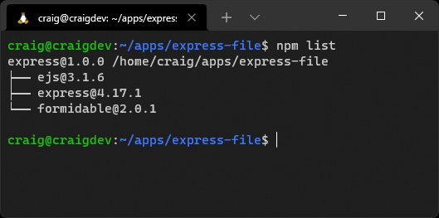
Older versions of npm show all packages and child packages. Add --depth=0 to view the top-level installations only:
npm list --depth=0
The --depth argument can be used to view the package dependency tree to a specific level. For example, npm list --depth=1 shows your installed packages and their immediate dependencies but doesn’t go any deeper.
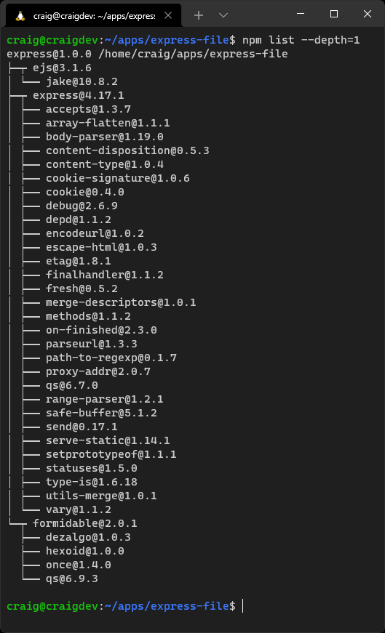
You can list globally installed packages using npm list --global.
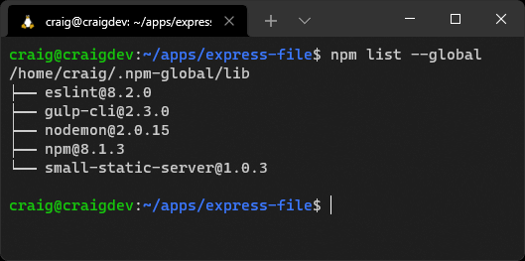

Finding Outdated Packages
Find local packages that have received updates using npm outdated or global packages with updates using npm outdated --global.
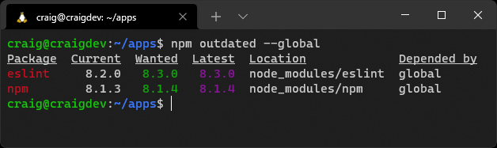
Older packages are listed with their current and latest version. The wanted column indicates which version will be installed if you run npm update.
To update a local package, you can do one of the following:
run npm update to update all packages according to semantic constraints (see the “Semantic Constraints” section above)
run npm update <package> to update one or more space-separated packages according to semantic constraints (see the “Semantic Constraints” section above)
edit package.json, change any necessary version numbers, and rerun npm install
To update global packages, run npm install <package> --global. Again, any number of space-separated packages can be listed.

Update npm with npm
npm itself is a global package that you can update with npm install npm --global or the shorter npm i npm -g.

Removing Packages
You should always remove unused packages. They increase installation times, use disk space, could have vulnerabilities, and are likely to confuse other developers working on the project. Remove packages with npm uninstall <package>, (or use the aliases remove, rm, r, un, or unlink in place of uninstall).
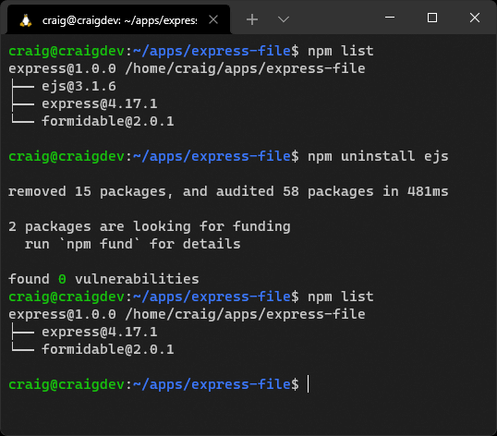
package.json is updated and the package is removed from the dependencies or devDependencies section. There’s no need to specify the type.
Global packages can be removed with the --global switch. For example:
npm uninstall eslint --global

Using npm Scripts
The "scripts" section of package.json lists useful script aliases you can run during development, testing, building, deployment, and so on. A script is useful when you find yourself repeatedly retyping the same command.
Consider the JavaScript bundler Rollup, which can build a single optimized client-side JavaScript file from multiple source files. The command to compile a development build is long. For example:
npx rollup --config --environment NODE_ENV:development --sourcemap --watch
➥--no-watch.clearScreen
It can therefore be defined as a script in package.json. For example:
"scripts": {
"rollup": "rollup --config --environment NODE_ENV:development --sourcemap
➥--watch --no-watch.clearScreen"
}
Note that npx isn’t required in the command, because npm can execute locally installed packages.
You can now start the rollup command with npm run rollup.
Any number of scripts can be added to package.json, but each must have a unique name.

Special Scripts
The following script names can be defined when appropriate:
"start": starts your application. You used it in previous chapters to launch "nodemon index.js".
"test": runs tests on your application code using a test runner such as Mocha, Jest, or AVA.
"stop": stops your application. This may only be necessary if your application starts in the background. I’ve never used it!
The run command isn’t required, so you can launch these scripts with npm start, npm test, and npm stop.

Pre and Post Scripts
Any script can have one or both of these:
a "pre<name>" script, which automatically runs before "<name>"
a "post<name>" script, which automatically runs after "<name>"
For example:
"scripts": {
"prebuild": "rm -rf build",
"build": "rollup --config",
"postbuild: "echo build complete"
}
Running npm run build runs all three scripts in the order shown above.

Life Cycle Scripts
npm permits life cycle scripts that automatically execute at certain points during package publication (see the “Publishing Packages” section below) or installation. The reserved script names are prepare, prepublish, prepublishOnly, prepack, and postpack.
You’re unlikely to use these in your own projects, but avoid using these names for other purposes.

Sophisticated Scripting
npm scripts are simple but powerful. Developers often use them instead of dedicated JavaScript task runners such as Grunt and Gulp.
Consider the following scripts to clean a build directory then generate HTML, CSS, and JavaScript using (imaginary) Node.js tools:
"scripts": {
"clean" : "rm -rf build",
"build:html" : "sitegen ./src/content/ ./build/ --compress",
"build:css" : "cssgen ./src/css/main.css --out ./build/css/",
"build:js" : "jsgen ./src/js/main.js ./build/js/main.js --minify"
}
A single build script could run the clean script followed by all build tools in parallel:
"build" : "clean && (build:html & build:css & build:js)"
Executing npm run build performs all tasks in a bash shell. However, it won’t work in Windows or other shells that don’t support & and && command chaining.
Cross-platform scripts can be created using task packages such as yall-scripts, concurrently, or npm-run-all. The rimraf package can also replace the rm command.
You can install cross-platform modules:
npm install yall-scripts rimraf --save-dev
Then update package.json to use them:
"scripts": {
"clean" : "rimraf build",
"build:html" : "sitegen ./src/content/ ./build/ --compress",
"build:css" : "cssgen ./src/css/main.css --out ./build/css/",
"build:js" : "jsgen ./src/js/main.js ./build/js/main.js --minify",
"buildcode" : "yall --parallel build:*",
"build" : "yall --sequential clean buildcode"
}
npm run build will now work on any platform that can run Node.js.

Publishing Packages
Your own packages can be published to the npm repository. This may be practical when you want to share code with others or create your own libraries for use in several projects. Skip down to the “Exercises” section if you’d rather think about this later!
Publication Preparation
Publishing code to the npm repository makes it public. Always ensure it doesn’t contain private information such as Git or database credentials.
Authors of popular packages receive regular requests for support or feature updates. Add a disclaimer to the README.md file in the root of your project if you’d rather not offer a free consultancy service! That said, you can request funding and watch the cash roll in as your package becomes an essential part of every Node.js project.
To publish a package, you must sign up for an account at npmjs.com. A valid email address is required, and it will be publicly added to the metadata of any package you publish.

Two-factor Authentication
Accounts are secured with 2FA, so you’ll need an app such as Google Authenticator, Microsoft Authenticator, Authy, or andOTP.
Before publishing, update your package package.json file:
Use a unique "name".
All npm projects must have a unique name. Naming is difficult. You have 1.5 million competitors, so use a tool such as the npm-package-name-checker to check availability. If you can’t find a decent name, prefix the name with your account ID—such as @username/my-package.
Set the next semantic "version" number (See the “Semantic Versioning” section above).
You can’t overwrite an existing package with the same version number. The next unique version must be set every time you publish.
Add an optional array of "files" glob patterns.
You can define which files are included in the package. The following example includes all files and subdirectories in the dist and doc directories. All other files except package.json are omitted:
"files": [
"dist/**/*",
"doc/**/*"
],
Add optional "bin" command(s) aliases.
To run your package by its package.json "name", define a relative path to its script as a "bin" value. For example:
"name": "myapp",
"bin": "./dist/myapp.js"
The myapp command can be run from the command line when the package is installed globally. (npx myapp can be used for local installations.)
"bin" can also be set to an array if you have more than one script or require aliases. For example:
"name": "myapp",
"bin": [
"myapp": "./dist/myapp.js",
"ma": "./dist/myapp.js",
"myapp2": "./dist/myapp2.js"
]
To publish, navigate to your project directory, then log in at the terminal with npm login. Publish your package with npm publish.
Assuming there are no errors, npm will publish your package so it can be installed from anywhere. At this point, it’s best to commit the code to your repository to ensure the codebases are the same.

Publishing Tips
You’re unlikely to publish many packages at the start of your Node.js journey, but the following tips may help as you develop more complex projects:
Create packages that meet your needs to solve a specific problem.
Create small, focused packages that do one thing well and can be reused across many projects.
It may be better to create a new package than complicate an existing one.
In summary: keep it simple.

Exercises
Attempt the following exercise to improve your npm knowledge:
Initialize a new Node.js project, ideally using a name that’s not already taken in the npm registry.
Search for packages that can output colors to the terminal.
Install your chosen package into the project.
Create a small command-line application that’s passed a string and color argument. Output the string in that color.
Optionally, publish the code to npm, then install it as a global package so you can run it from anywhere.
The video for this chapter describes a solution that’s available in the example code, the npm registry, and GitHub.

Summary
This chapter has expanded on your npm knowledge so you can find, install, update, manage, publish, and remove Node.js packages in any project.
The next chapter looks at the options for using these packages and your own modules in Node.js applications.

Quiz
1. npm help is available from:
a. online documentation
b. the npm help command
c. using npm help <command>
d. any of the above
2. A Node.js package.json file can be initialized with:
a. npm new
b. npm init
c. npm start
d. any of the above
3. Your project’s package.json "version" is currently "1.2.33" and you are adding a new feature (it won’t break backward compatibility). The new version number should be:
a. 2.0.0
b. 1.3.0
c. 1.3.1
d. 1.2.34
4. How do you install a package for use in your project?
a. npm add <name> --local
b. npm require <name>
c. npm install <name>
d. any of the above
5. How do you list all the packages installed in your project without viewing any child dependencies?
a. npm list
b. npm ll
c. npm ls --depth=0
d. any of the above
6. How can you find packages that have newer updates in the local project?
a. npm outdated
b. npm old
c. npm newer
d. npm update

Chapter 8: Using ES2015 and CommonJS Modules
The previous chapter explained how npm can be used to find and install packages containing multiple JavaScript files, or modules. In this chapter, we’ll examine how modules are used in Node.js.

Skip Ahead?
The information in this chapter is important, since you’ll encounter issues with older Node.js packages. However, all the packages referenced in this course have been tested for compatibility, so you can skip ahead and return when you eventually run into a problem!
Modules provide a way to define functionality in one file and use it in another. Developers often create encapsulated code libraries responsible for handling related tasks. The benefits include:
code can be split into smaller files with self-contained functionality
the same modules can be shared and reused across any number of applications
modules need never be examined or updated by others once they’ve been proven to work
code referencing a module understands it’s a required dependency
modules prevent naming conflicts: function x() in module1.js can’t clash with function x() in module2.js
Bizarrely, there was no concept of modules in JavaScript during its first twenty years. You couldn’t directly reference or include one JavaScript file in another. Client-side developers would either:
add multiple <script> tags to an HTML page
concatenate scripts into a single file, perhaps using a bundler such as webpack or task runners such as Grunt and Gulp
use a module loading library such as RequireJS or SystemJS—all of which adopted syntaxes such as CommonJS, AMD, or UMD
It would have been inconceivable for Node.js not to support modules when it was released in 2009. CommonJS syntax was chosen as the Node.js module standard, and support was added to npm.

CommonJS
A CommonJS module makes a function or value publicly available using module.exports. For example:
// lib.js
const PI = 3.1415926;
// add values
function sum(...args) {
log('sum', args);
return args.reduce((num, tot) => tot + num);
}
// multiply values
function mult(...args) {
log('mult', args);
return args.reduce((num, tot) => tot * num);
}
// private logging function
function log(...msg) {
console.log(...msg);
}
module.exports = { PI, sum, mult };
A require statement includes a module by referencing either:
its relative file path (./lib.js, ../lib.js)
a fully qualified file path (/path/lib.js)
its npm name following installation (express, chalk, etc.)
The module is included at the point it’s referenced during execution of the script.
You can require specific named exported items:
const { sum, mult } = require('./lib.js');
console.log( sum(1,2,3,4) ); // 10
console.log( mult(1,2,3,4) ); // 24
Or you can require all exported items using a (namespaced) variable:
const lib = require('./lib.js');
console.log( lib.PI ); // 3.1415926
console.log( lib.add(1,2,3,4) ); // 10
console.log( lib.mult(1,2,3,4) ); // 24
A module with a single exported item can be defined as a default. For example:
// myclass.js
class MyClass {}
module.exports = MyClass;
And it can be defined using any name:
const
MyNewClass = require('myclass.js'),
myObj = new MyNewClass();
CommonJS dynamically imports file names by default, and can also import JSON data as a JavaScript object. For example:
const
file = `data${ Math.round(Math.random() * 3) }.json`,
data = require(file);
console.log( data.propertyOne || 'propertyOne not set' );
However, top-level await isn’t supported. Asynchronous calls must be wrapped in an immediately invoked function expression (IIFE)—a function that runs as soon as it’s defined. For example:
function waitOneSec() {
return new Promise(
(resolve) => setTimeout(resolve, 1000)
);
}
(async () => {
await waitOneSec();
})();
CommonJS was the Node.js module standard until the arrival of ES2015 modules.

ES2015 Modules (ESM)
A native JavaScript module standard was proposed in ES2015 (ES6).
Everything inside an ES2015 module is private by default and runs in strict mode (there’s no need for 'use strict'). Public properties, functions, and classes are exposed using export. For example:
// lib.js
export const PI = 3.1415926;
// add values
export function sum(...args) {
log('sum', args);
return args.reduce((num, tot) => tot + num);
}
// multiply values
export function mult(...args) {
log('mult', args);
return args.reduce((num, tot) => tot * num);
}
// private logging function
function log(...msg) {
console.log(...msg);
}
Alternatively, a single export statement can declare one or more public items. For example:
// lib.js
const PI = 3.1415926;
// add values
function sum(...args) {
log('sum', args);
return args.reduce((num, tot) => tot + num);
}
// multiply values
function mult(...args) {
log('mult', args);
return args.reduce((num, tot) => tot * num);
}
// private logging function
function log(...msg) {
console.log(...msg);
}
export { PI, sum, mult };
An import statement includes ES modules using either:
a relative URL (starting ./ or ../)
a fully qualified URL (such as file:///home/path/lib.js)
its npm name following installation (express, chalk, etc.)
Importing External URLs
Deno and browser JavaScript can import URLs from other domains:
import { someFunction } from 'https://example.com/lib.js';
This isn’t supported in Node.js but will arrive in a future release. You can use an HTTPS loader, although it’s slower than disk access, the module isn’t cached, and there are security implications.
All ES modules and their submodules are resolved and imported once before your script executes. It doesn’t matter where they’re declared in your script.
You can import specific named items:
import { sum, mult } from './lib.js';
console.log( sum(1,2,3,4) ); // 10
console.log( mult(1,2,3,4) ); // 24
Or imports can be aliased to resolve naming conflicts:
import { sum as addAll, mult as multiplyAll } from './lib.js';
console.log( addAll(1,2,3,4) ); // 10
console.log( multiplyAll(1,2,3,4) ); // 24
Alternatively, all public items can be imported into a namespaced variable:
import * as lib from './lib.js';
console.log( lib.PI ); // 3.1415926
console.log( lib.add(1,2,3,4) ); // 10
console.log( lib.mult(1,2,3,4) ); // 24
A module with a single item to export can set a default. For example:
// moduleWithDefault.js
export default function() { ... };
Or:
// moduleWithDefault.js
function x() { ... };
export default x;
The default is imported without curly braces and can use any name. For example:
import myDefault from './moduleWithDefault.js';
This is effectively the same as this:
import { default as myDefault } from './moduleWithDefault.js';
Dynamic module loading—perhaps from a generated value—is possible using the import() function, which returns a promise. For example:
const
script = `./script${ Math.round(Math.random() * 3) }.js`
randomImport = await import(script);
This affects performance and makes code validation difficult. Only use the import() function when there’s no other option—for example, an imported script is created after the application starts.
Node.js version 17 and above also support JSON loading and parsing using the import() function:
import data from './data.json' assert { type: 'json' };
Finally, ESM supports top-level await. For example:
function waitOneSec() {
return new Promise(
(resolve) => setTimeout(resolve, 1000)
);
}
await waitOneSec();

Comparison of CommonJS and ES2015 Modules
CommonJS and ES2015 module syntaxes are superficially similar, but they work in different ways:
Each CommonJS require references a file that’s dynamically loaded on demand during execution.
Each ESM import references a URL that’s hoisted and pre-parsed to resolve further imports. This occurs before your code is executed. Dynamic importing of modules isn’t directly supported or recommended.
Consider this ES2015 module:
// ESM two.mjs
console.log('running two');
export const hello = 'Hello from two';
It's imported by this script:
// ESM one.mjs
console.log('running one');
import { hello } from './two.mjs';
console.log(hello);
This is the output when running node one.mjs:
running two
running one
hello from two
Now consider this CommonJS module:
// CommonJS two.cjs
console.log('running two');
module.exports = 'Hello from two';
It's required by this script:
// CommonJS one.cjs
console.log('running one');
const hello = require('./two.cjs');
console.log(hello);
This is the output when running node one.cjs:
running one
running two
hello from two
Execution order is critical in some applications—and what would happen if ES2015 and CommonJS modules were mixed in the same file?
It took several years for ESM support to arrive in Node.js. The following approach was adopted to resolve potential compatibility problems:
CommonJS is the default (or set "type": "commonjs" in package.json).
Any file with a .cjs extension is parsed as CommonJS.
Any file with a .mjs extension is parsed as ESM.
Running node --input-type=module index.js parses the entry script as ESM.
Setting "type": "module" in package.json parses the entry script as ESM.

Importing CommonJS Modules in ES2015
Node.js can import a CommonJS module into an ESM file. For example:
import lib from './lib.cjs';
This usually works well, and Node.js makes syntax suggestions when problems occur.

Requiring ES2015 Modules in CommonJS
You can’t require an ES module in a CommonJS file. ESM modules load asynchronously, so they aren’t compatible with synchronous loading and execution in CommonJS.
One way around this is the dynamic import() function, which loads a module on demand:
// CommonJS script
(async () => {
const lib = await import('./lib.mjs');
// ... use lib ...
})();
Alternatively, the esm package provides a way to import ESM code in CommonJS.
This chapter’s video demonstrates how CommonJS and ESM modules can be used interchangeably.

Using ES2015 Modules in Browsers
This section isn’t specific to Node.js, but it may be useful if you’re developing a cross-platform JavaScript library that works both client-side and server-side (it’s isomorphic).
Browsers load ES modules asynchronously and defer execution until the DOM is ready. They run in the order specified by each <script> tag:
<script type="module" src="./runsfirst.js"></script>
<script type="module" src="./runssecond.js"></script>
Or as specified by an inline import:
<script type="module">
import { something } from './somewhere.js';
// ...
</script>
Browsers without ESM support don’t load scripts with a type="module" attribute. Browsers with ESM support don’t load scripts with a nomodule attribute:
<script type="module" src="runs-when-ESM-supported.js"></script>
<script nomodule src="runs-when-ESM-is-not-supported.js"></script>
Modules must be served with the MIME type application/javascript or text/javascript. A CORS header such as Access-Control-Allow-Origin: * must also be set if a module can be imported from another domain.

Summary
The module situation in Node.js can be confusing. It has reached a point where:
some libraries are CommonJS
some libraries are ESM
some libraries provide builds for both CommonJS and ESM
CommonJS was the only option for several years. There’s little benefit converting a large project to ESM, especially where it uses older modules with compatibly issues.
Moving forward, ES2015 module syntax is the JavaScript standard implemented in browsers and the Deno runtime. Personally, I like CommonJS, but I recommend ES modules for new Node.js projects. All the examples in this course use ESM. Importing CommonJS modules into ESM is usually possible, but you may need to consider alternative packages if problems occur.
For more information, refer to:
JavaScript modules on MDN
CommonJS modules on nodejs.org
ECMAScript modules on nodejs.org

Quiz
1. Node.js natively supports the following module syntaxes:
a. CommonJS and ECMAScript modules
b. CommonJS and AMD
c. ECMAScript modules and UMD
d. AMD and UMD
2. Which syntax does CommonJS use to declare and use public module functions?
a. export and import
b. module.exports and import
c. module.exports and require
d. export and require
3. Which syntax do ES modules use to declare and use public functions?
a. export and import
b. module.exports and import
c. module.exports and require
d. export and require
4. Which of the following is true?
a. CommonJS and ESM operate identically
b. you can usually import a CommonJS modules in ESM
c. you can usually require an ES module in CommonJS
d. all of the above
5. The import() function:
a. can import an ES module into CommonJS
b. can dynamically load an ES module after the application starts
c. returns a promise
d. all of the above

Chapter 9: Asynchronous Programming in Node.js
This chapter discusses the benefits and challenges of asynchronous programming in JavaScript. Asynchronous concepts are rarely evident in other languages, but it’s impossible to avoid them in Node.js.
You may have written asynchronous event handling functions in client-side JavaScript. These should run quickly, and pages don’t remain open for long; a bug could cause problems for an individual user, but a browser restart or page reload would fix it. However, your Node.js app is the central point of access for all users and must remain active without a restart. A small asynchronous bug can generate memory leaks that eventually crash the application.
This is one of the biggest causes of confusion when developers migrate from other languages, so please don’t skip this chapter! Asynchronous programming can seem complex, but a few pointers will help you avoid common pitfalls.

Single-threaded Non-blocking I/O Event-looping What?
Imagine you’re running a pizza restaurant on your own. You take all the orders and prepare all the pizzas but can only manage one task at a time. You receive your first order, then prepare the dough (20 minutes), add the toppings (20 minutes), pop it in the oven, watch while it cooks (20 minutes), and serve to the customer. The process takes one hour; you’re then free to take another order.
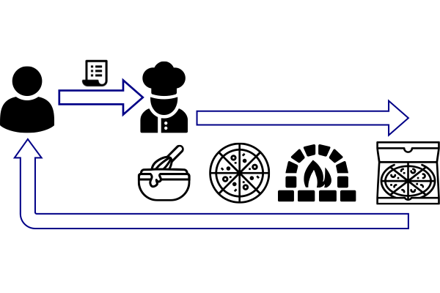
To make your restaurant more efficient, you hire three chefs: one to make dough, one to add toppings, and one to bake. The chefs are in different kitchens and can’t talk to each other, but they’ll report back to you when their specific task is complete.
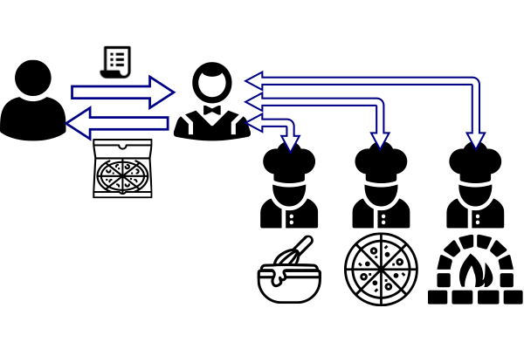
It still takes an hour to create one pizza (although the three chefs together can prepare three pizzas every hour). What’s important is that you’re no longer involved in the cooking process. You’re passing instructions to chefs and receiving an alert when they’ve completed their job. You’re free to take customer orders whenever they arrive.
Both JavaScript and Node.js are single-threaded: the runtime can only do one thing at a time. It would be like a restaurant with a single chef, except JavaScript offloads input and output operations to the operating system kernel (other “chefs” who operate in parallel). A Node.js app may start a file write, database read, or HTTP request, but it won’t wait for that operation to finish. Instead, it asks for a callback function to be run when it’s complete and success or error data is available.
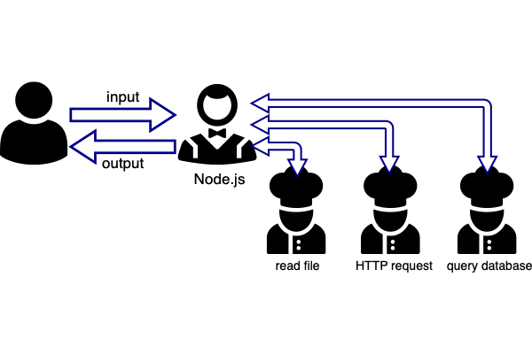

Callbacks in Action
Consider this PHP code to write text to a file:
<?php
echo 'saving file';
$err = file_put_contents('file.txt', 'Hello from PHP');
if ($err !== false) echo 'file saved';
echo 'processing complete';
?>
The program outputs this:
saving file
file saved
processing complete
The PHP interpreter processes the file_put_contents() statement and waits until the file is fully written before progressing to the next command.
This is the equivalent code in Node.js:
import { writeFile } from 'fs';
console.log('saving file');
writeFile('file.txt', 'Hello Node.js', 'utf8', err => {
if (!err) console.log('file saved');
});
console.log('processing complete');
The program outputs this:
saving file
processing complete
file saved
Processing completes before the file saves!
The fourth argument passed to writeFile() is an anonymous ES6 callback function with a single err parameter. The callback runs when the file has saved (or fails to save and raises an error passed in err). File saving may only take a few milliseconds, but it runs in the background, so the 'processing complete' command executes immediately.
Asynchronous callbacks are at the heart of all client-side and server-side JavaScript applications.
It’s standard practice to handle errors and return an error object or string message as the first argument to a callback function (like err above). When no error occurs, the callback’s first parameter should be null, undefined or any other falsy value.

The Event Loop
Why does the Node.js program above continue to run after the last line has executed?
All Node.js applications initialize an event loop. Once the last statement completes execution, Node.js loops back and checks for any outstanding:
timers (such as setTimeout)
pending callbacks
polling data connections
These are run in the order they’re received (know as “first in, first out”, or FIFO).
A seemingly idle application won’t end if it’s waiting for something to complete or if something could occur at a future point (such as a server listen on a specific port).
Avoid Blocking the Event Loop
Long-running JavaScript calculations or processes block the event loop and delay the processing of incoming requests. Process-intensive tasks should either be:
split into smaller sub-tasks with timers
run in the background using a worker thread or a child process (options that are discussed in Chapter 12).

Callback Conundrums
Using callbacks in asynchronous functions isn’t always easy. Your code can look correct and run without errors, but it eventually causes the Node.js runtime to crash.
Two severe issues are:
failing to terminate an asynchronous function after a callback
accidentally making an asynchronous function synchronous
These are best explained with examples. Consider this simple asynchronous function which waits for ms milliseconds:
// wait for ms milliseconds
function wait(ms, callback) {
setTimeout(callback, ms);
}
// wait for one second
wait(1000, () => {
console.log('waited 1000ms');
});
Let’s improve the function by returning the following arguments to the callback:
an error when ms is not a number, less than 1, or more than 3000
the value of ms waited
Our initial implementation:
// wait for ms milliseconds
function wait(ms, callback) {
ms = parseFloat(ms);
// invalid ms value?
if (!ms || ms < 1 || ms > 3000) {
const err = new RangeError('Invalid ms value');
callback( err, ms );
}
// wait ms before callback
setTimeout( callback, ms, null, ms );
}
// call wait
wait(500, (err, ms) => {
if (err) console.log(err);
else console.log(`waited ${ ms }ms`);
});
Execution returns the expected waited 500ms result.
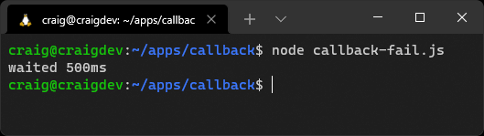
However, what happens when we pass an invalid ms value such as 0?
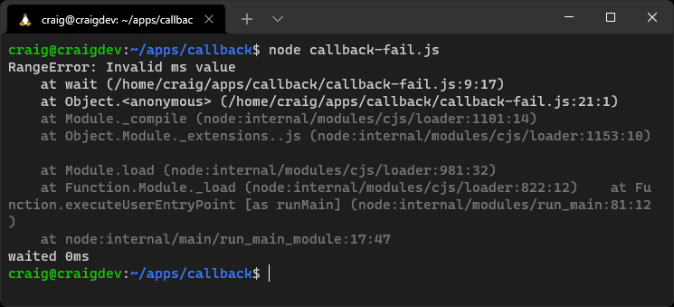
We get the error we expected, but the setTimeout also runs and we see waited 0ms. The callback function executes twice, because the function didn’t terminate when the error occurred. We can solve this by putting the setTimeout in an else statement or adding a return in the error condition:
// wait for ms milliseconds
function wait(ms, callback) {
ms = parseFloat(ms);
// invalid ms value?
if (!ms || ms < 1 || ms > 3000) {
const err = new RangeError('Invalid ms value');
callback( err, ms );
return; // terminate function
}
// wait ms before callback
setTimeout( callback, ms, null, ms );
}
There’s another, subtler issue: the callback runs immediately when an error is raised. At that point, the function is no longer asynchronous—it’s synchronous. It won’t cause an obvious problem here, but it can lead to memory leaks in larger, long-running Node.js applications. Your app will eventually crash with an obscure “memory overflow” error message.
A Function Must be 100% Synchronous or 100% Asynchronous
No path through an asynchronous function should ever lead to a callback being run immediately.
A simple way to solve this is the setImmediate() timer. This calls a function during the next iteration of the event loop:
// wait for ms milliseconds
function wait(ms, callback) {
ms = parseFloat(ms);
// invalid ms value?
if (!ms || ms < 1 || ms > 3000) {
const err = new RangeError('Invalid ms value');
setImmediate( callback, err, ms );
return;
}
// wait ms before callback
setTimeout( callback, ms, null, ms );
}

process.nextTick()
You may see process.nextTick(callback) used in some applications. This works similarly to setImmediate(), except that the callback runs before the end of the current iteration of the event loop. This can cause the event loop to never restart if nextTick() is recursively called.

Callback Hell
In complex Node.js applications, you’ll often make a series of asynchronous function calls—such as when fetching something from a database, making an API call, loading a file, and so on. A callback may be used in one place only, so it makes sense to declare an inline anonymous function. This can quickly descend into deeply nested callback hell:
wait(100, (err) => {
console.log('wait 1');
wait(200, (err) => {
console.log('wait 2');
wait(300, (err) => {
console.log('wait 3');
});
});
});
There are syntactical ways to flatten this structure, typically by naming each function and ensuring each calls others in turn. Fortunately, the JavaScript gods addressed the problem with promises.

Promises
A Promise object represents the eventual completion or failure of an asynchronous operation with its resulting value. Promises provide a clearer syntax that makes it easier to chain asynchronous calls that run in series. Developers can also avoid the callback issues raised in the previous sections.
Promises were introduced in ES6/2015 and are syntactical sugar; callbacks are still used under the hood. To make a function asynchronous, a Promise object must be returned immediately. The Promise constructor is passed two callback functions as parameters:
resolve: the function that’s run when processing successfully completes
reject: the function that’s run when an error occurs
In the case of our wait() function, it can be rewritten to return a promise that calls resolve(ms) after the timeout or reject(error) when an invalid ms parameter is passed:
// wait for ms milliseconds
function pWait(ms) {
ms = parseFloat(ms);
return new Promise((resolve, reject) => {
if (!ms || ms < 1 || ms > 3000) {
reject( new RangeError('Invalid ms value') );
}
else {
setTimeout( resolve, ms, ms );
}
});
}

util.promisify()
util.promisify() converts any callback-based function with an error as the first argument into a promise. Rather than re-writing wait(), you could create a promisified alternative named pWait():
import { promisify } from 'util';
const pWait = promisify(wait);
Anything that returns a promise can have:
a then() method, which is passed a function that takes the result from the previous resolve()
a catch() method, which is passed a function that runs when an error is returned from any reject()
a finally() method, which is called at the end regardless
pWait(100)
.then(ms => console.log(`waited ${ ms }ms`) );
.catch(err => console.log( err ) )
.finally(() => console.log('all done') )
Each .then() function can return a value or another promise so that sequential asynchronous function calls can be chained. For example:
pWait(100)
.then(ms => {
console.log(`waited ${ ms }ms`);
return pWait(ms + 100);
})
.then(ms => {
console.log(`waited ${ ms }ms`);
return pWait(ms + 100);
})
.then(ms => {
console.log(`waited ${ ms }ms`);
})
.catch(err => {
console.log( err );
});
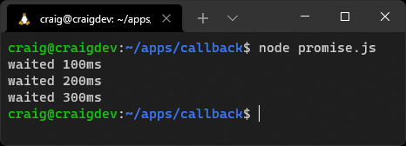

then() Functions Are Promisified
The final then() in the code above runs a synchronous function, but JavaScript automatically converts it into a promise-based asynchronous function so you can append further then() methods when necessary.

Parallel Promises
The example above executes each asynchronous function call one after the other. This is only necessary if the result from one function is required as input for the next.
You’ll often encounter situations when several asynchronous functions are required but they aren’t related to each other. For example, given a book ID, such as an ISBN, you want to:
retrieve book information such as the title, author, etc. from a local database (getBook(ID))
call a stock control system API to determine how may of those books are available (getStock(ID))
get the latest recommended retail price from the publisher (getPrice(ID))
Assume each function returns a promise where resolve() returns an information object.
The following promise chain works but is inefficient, because each call occurs one after the other:
// book data object
const bookData = { id: 123 };
getBook( bookData.id )
.then(book => {
bookData.title = book.title;
bookData.author = book.author;
bookData.description = book.description;
getStock( bookData.id );
})
.then(stock => {
bookData.stock = stock;
getPrice( bookData.id );
})
.then(price => {
bookData.price = price;
})
.catch(err => {
console.log( err );
})
A better option is Promise.all(), which takes an array of promises, runs each in parallel, and returns a new outer promise where resolve() returns an array of output values in the same order. This code is as fast as the slowest function:
// book data object
const bookData = { id: 123 };
Promise.all([
getBook( bookData.id ),
getStock( bookData.id ),
getPrice( bookData.id )
])
.then(result => {
bookData.title = result[0].title;
bookData.author = result[0].author;
bookData.description = result[0].description;
bookData.stock = result[1];
bookData.price = result[2];
})
.catch(err => {
console.log( err );
})
The .catch() is triggered whenever a single promise reject() runs, so any pending promises are aborted.
Similar options include:
Promise.allSettled()
Runs all promises in the array and waits until every one has resolved or rejected. Each item in the returned array is an object with a .status property (either 'fulfilled' or 'rejected') and a .value property with the returned value.
Promise.any()
Runs all promises in the array but resolves as soon as the first promise resolves. A single value is returned.
Promise.race()
Runs all promises in the array but resolves or rejects as soon as the first promise resolves or rejects. A single value is returned.

Promising Problems
Promises help prevent callback hell, but I found them confusing at first, and it’s easy to mangle the .then()/.catch() chain syntax. You should also note that the whole promise chain is asynchronous, so any function using a series of promises should return its own promise (or it could run a callback to confuse other developers!)
async/await
ES2017 introduced the async and await keywords, which enable asynchronous, promise-based behavior to be written in a cleaner and clearer syntax. Again, they’re more syntactical sugar, but they make promises sweeter.
A promise chain to make three successive pWait() calls is long and difficult to read:
pWait(100)
.then(ms => {
console.log(`waited ${ ms }ms`);
return pWait(ms + 100);
})
.then(ms => {
console.log(`waited ${ ms }ms`);
return pWait(ms + 100);
})
.then(ms => {
console.log(`waited ${ ms }ms`);
})
.catch(err => {
console.log( err );
});
This is the equivalent code using await:
try {
const p1 = await pWait(100);
console.log(`waited ${ p1 }ms`);
const p2 = await pWait(p1 + 100);
console.log(`waited ${ p2 }ms`);
const p3 = await pWait(p2 + 100);
console.log(`waited ${ p3 }ms`);
}
catch(err) {
console.log(err);
}
Put the await keyword before any promise-based asynchronous function and the JavaScript interpreter will appear to wait until it’s resolved or rejected. The syntax is cleaner and looks much like a series of synchronous function calls.
The code above is a top-level await because it’s not contained in a function. This works in ES2015 modules, but not in CommonJS, where you must wrap it in an asynchronous immediately invoked function expression (IIFE):
(async () => {
try {
const p1 = await pWait(100);
console.log(`waited ${ p1 }ms`);
const p2 = await pWait(p1 + 100);
console.log(`waited ${ p2 }ms`);
const p3 = await pWait(p2 + 100);
console.log(`waited ${ p3 }ms`);
}
catch(err) {
console.log(err);
}
})();
Any function that contains one or more await statements must have async prepended to indicate it’s asynchronous. In effect, this turns it into a promise-based function:
// async function
async function waitSeries(ms) {
try {
const p1 = await pWait(ms);
console.log(`waited ${ p1 }ms`);
const p2 = await pWait(p1 + 100);
console.log(`waited ${ p2 }ms`);
const p3 = await pWait(p2 + 100);
console.log(`waited ${ p3 }ms`);
}
catch(err) {
console.log(err);
}
}
// top-level await to run the async function
await waitSeries(100);

Promise.all() is Still Necessary
There’s no async/await equivalent for Promise.all() and similar functions. However, async functions return a promise, so they can be passed in the processing array.

try/catch is Ugly
async functions silently exit if you omit try/catch and the current await is rejected. Unless you can examine the error type, it’s not possible to know which await triggered the problem, so multiple try/catch blocks may be necessary.
You could consider using a higher-order function to catch errors when they can be processed in the same way. For example:
// async function
async function waitSeries(ms) {
const p1 = await pWait(ms);
console.log(`waited ${ p1 }ms`);
const p2 = await pWait(p1 + 100);
console.log(`waited ${ p2 }ms`);
const p3 = await pWait(p2 + 100);
console.log(`waited ${ p3 }ms`);
}
// higher-order function handle errors
function catchErrors(fn) {
return function(...args) {
return fn(...args).catch(err => {
console.log('ERROR', err);
});
}
}
// top-level await
await catchErrors(waitSeries)(100);
Whether this results in more readable code is another matter.

Asynchronous Awaits in Synchronous Loops
Be wary about using await in looping methods such as forEach(), which are passed a function. Loops are synchronous and continue to run even when the function they call is asynchronous. Consider this example:
const ms = [100, 200, 300];
let totalWait = 0;
ms.forEach(async i => {
console.log(i);
const w = await pWait(i);
console.log(`waited ${ w }ms`);
totalWait += w;
});
console.log(`total wait time: ${ totalWait }ms`);
You might expect to see the following output:
100
waited 100ms
200
waited 200ms
300
waited 300ms
total wait time: 600ms
The actual result is surprising, as pictured below.
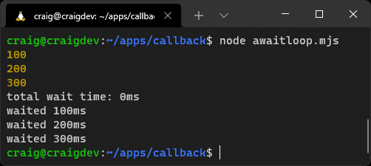
Each iteration of the loop won’t await until it’s complete. This will be a problem if the result of one await is required in the next call.
Standard for(), while() and async iterator loops may be necessary. The code above can be fixed with this:
const ms = [100, 200, 300];
let totalWait = 0;
for (let i = 0; i < ms.length; i++) {
console.log( ms[i] );
const w = await pWait( ms[i] );
console.log(`waited ${ w }ms`);
totalWait += w;
}
console.log(`total wait time: ${ totalWait }ms`);
The result is pictured below.
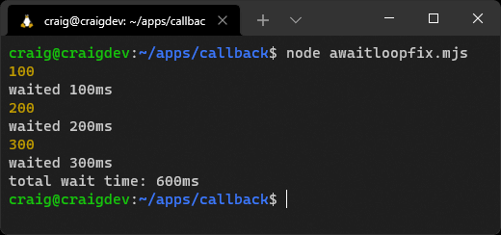

Exercises
Write a small application that fetches three random questions from the Open Trivia Database using the following REST URL requests:
General knowledge:
https://opentdb.com/api.php?type=multiple&amount=1&category=9
Computers:
https://opentdb.com/api.php?type=multiple&amount=1&category=18
Gadgets:
https://opentdb.com/api.php?type=multiple&amount=1&category=30

HTTP Requests
Unless you’re using Node.js 18 or above, which offers a native Fetch() API, you’ll need use a third-party HTTP request module such as node-fetch.
Format the question data into a single array and output it in JSON format into a file named questions.json.
For bonus points, make your application more efficient by running all URL requests in parallel.
This chapter’s video demonstrates a solution.

Summary
Asynchronous programming takes some time to understand and will catch you out. The following tips will help you write more robust Node.js applications.
Ensure JavaScript functions run quickly and don’t block the event loop.
Pass callback functions to an asynchronous function so they can be called when an operation is complete.
The first argument of the callback function must be an error object or string message.
Always ensure a function return occurs after a callback runs.
An asynchronous function must be 100% asynchronous: no path should lead to an immediate callback. Pass a callback to setImmediate() to run it during the next iteration of the event loop if necessary.
Learn how to create your own promise functions or create them from a callback-based function using util.promisify().
You can await for a promise to complete inside an async function.
Where possible, run promises in parallel using options such as Promise.all() or Promise.allSettled().
Useful links:
The Node.js event loop
Don’t block the event loop (or the worker pool)
MDN promise documentation
MDN async and await
The “Promises” and “Async functions” sections of Chapter 11, JavaScript: Novice to Ninja
Chapters 8 and 9 of JavaScript: The New Toys

Quiz
1. A callback function:
a. runs before an operation starts
b. calls an asynchronous function
c. is called when an asynchronous operation completes
d. all of the above
2. An asynchronous function:
a. completes at a later time
b. allows subsequent JavaScript commands to be executed
c. can be implemented with callbacks, promises, or async
d. all of the above
3. The Node.js event loop:
a. reruns when there are outstanding timers or callbacks
b. runs asynchronous functions
c. is another name for callbacks
d. none of the above
4. A Promise object completes by running:
a. a resolve or reject function
b. a fulfilled or error function
c. a resolve or error function
d. a fulfilled or reject function
5. An async function:
a. can call promise-based functions using await
b. returns a promise
c. uses try/catch blocks to handle errors
d. all of the above

Chapter 10: Using Database Storage
The previous chapters explained programming practices that affect all Node.js applications. This chapter applies these fundamentals to the specific challenge of data storage using database solutions such as MongoDB and MySQL.
Web applications often require data that persists between page loads and application restarts. Consider a content management system such as WordPress: it stores articles, metadata, media, user profiles, comments, settings, plugin configurations, and more. Multiple users can log in at any time to view and update content.
The most common solution to data persistence is a database such as MongoDB, MySQL, or PostgreSQL. All database systems have the same purpose: to provide the ability to store and query data fast and frequently. They differ in how they achieve those goals.

Skip Ahead?
Databases may not be the most exciting topic, but it’s one of the most significant differences between frontend and backend engineering. You can skip sections about specific systems, but the following chapters will be more difficult to understand without some database knowledge.

A Database-driven Web Application Example
The sections below explain how to create a web page hit counter service. Your grandparents will tell you how popular they were in the 1990s.
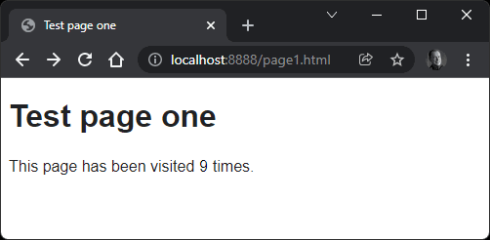
A page using this service includes an image:
<img src="http://localhost:8001/hit.svg" alt="hits" referrerpolicy="unsafe-url" />
(Note that the referrerpolicy is required in modern browsers so they send referral information in the HTTP header.)
The image is returned from a Node.js Express application, which:
Extracts the page URL from the request’s referer HTTP header.
Cleans and transforms the URL to a 32-character hash using the MD5 algorithm. All URLs therefore resolve to a 32-character string no matter how long they are. (In theory, two different URLs could generate the same hash, but it’s unlikely to occur for a few billion years.)
Stores the hash in a new database record with the user’s IP address, user agent string, and current date/time.
Counts all references to the hash in the database.
Generates and returns an SVG image with that count.
Three applications are provided in the code directory:
A MongoDB version (see the “MongoDB” section below) using the native mongodb driver.
A MySQL version (see the “MySQL” section below) using the native mysql2 driver.
A Sequelize ORM version (see the “Sequelize ORM” section below). This also connects to a MySQL database using mysql2, but you don’t use it directly.
All three use the same Node.js code except for a lib/pagehit.js file, which communicates with a specific database to add and query records.
It’s impossible to describe every option in every database, but this example code provides a head start when developing your own applications.

Installing and Configuring Database Software
You can download, install, and configure MySQL, MongoDB, or any other database on Linux, macOS, and Windows. That’s beyond the scope of this course, so prepare yourself for several hours of effort.
An easier option is Docker. This is often shrouded in mystery, but Docker provides a way to download, install, and configure pre-built applications in minutes. Install Docker on your system, then follow the steps below to run MySQL, MongoDB, and the Adminer database client. The page hit service runs as a Node.js application on your device that connects to this database.

MongoDB
MongoDB is a popular NoSQL database that became associated with Node.js in the same way MySQL is often paired with PHP. MongoDB groups JSON-like documents into one or more collections (analogous to tables) and implements querying with JavaScript-like objects.
NoSQL has become a catch-all term for any database that doesn’t follow SQL conventions (see the “MySQL” section below). In general, NoSQL databases implement fewer rules. Repeated (denormalized) data is encouraged, and there’s no need to define data structures, defaults, constraints, or relationships.
NoSQL software and storage mechanisms vary. Some offer basic key–value pairs. Some use JSON documents. Others are use-case specific, such as Redis for in-memory caching, and Elasticsearch for search-engine indexing.
A NoSQL database can be practical when data is more organic and relationships are looser. Consider an address book storing telephone numbers for individual contacts:
You could allocate a single telephone field in an SQL database, but it’s too restrictive: contacts may have home, work, and mobile numbers. Allocating three telephone fields would be wasteful for some contacts, but not enough for others. A separate telephone table is the most flexible option, but this increases complexity.
In a NoSQL database, telephone numbers can be defined as an unlimited array of objects associated with a contact. For example:
{
"firstName": "Contact",
"lastName": "One",
"telephone": [
{ "home": "1-01234567890" },
{ "work": "2-01234567890" },
{ "iPhone": "3-01234567890" },
{ "Android phone": "4-01234567890" },
{ "Test phone": "5-01234567890" }
]
}

Start the MongoDB Application
To use the MongoDB-based application, navigate to the pagehit-mongodb directory and start MongoDB and the Adminer client with docker-compose up.

Your Own MongoDB Installation?
Database configuration parameters are defined in the project’s .env file. It configures Docker, and the Node.js application reads it using the dotenv module.
If you’re using your own installation of MongoDB, edit the .env file and change the configuration parameters accordingly. In most cases, only the root user’s password need be changed (MONGO_INITDB_ROOT_PASSWORD).
In another terminal, install the Node.js express, mongodb, and dotenv dependencies referenced in package.json:
npm install
Then start the page hit application:
npm start
Finally, start a web server in another terminal so you can load test pages:
npx small-static-server 8888 ./test
You now have four services running:
the MongoDB database at http://localhost:27017
the Adminer database client at http://localhost:8080/
the page hit service at http://localhost:8001/
a test page web server at http://localhost:8888/
Different ports can be defined in the .env file if you have clashes.
Visit http://localhost:8888/page1.html or http://localhost:8888/page2.html to view page counters. Refresh and watch the counter increase.
You can examine the database data using the Adminer panels at http://localhost:8080/. Log on with the credentials specified in .env:
System: MongoDB
Server: host.docker.internal (or your network IP address if not using Docker Desktop)
Username: root
Password: rootuserpw
Database: pagehitmongo
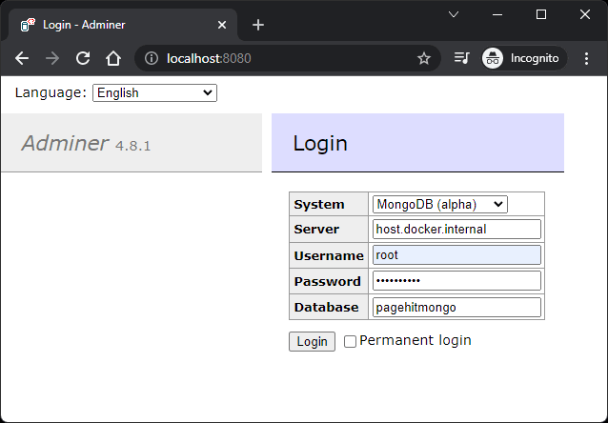
Click the hit collection followed by Select data.
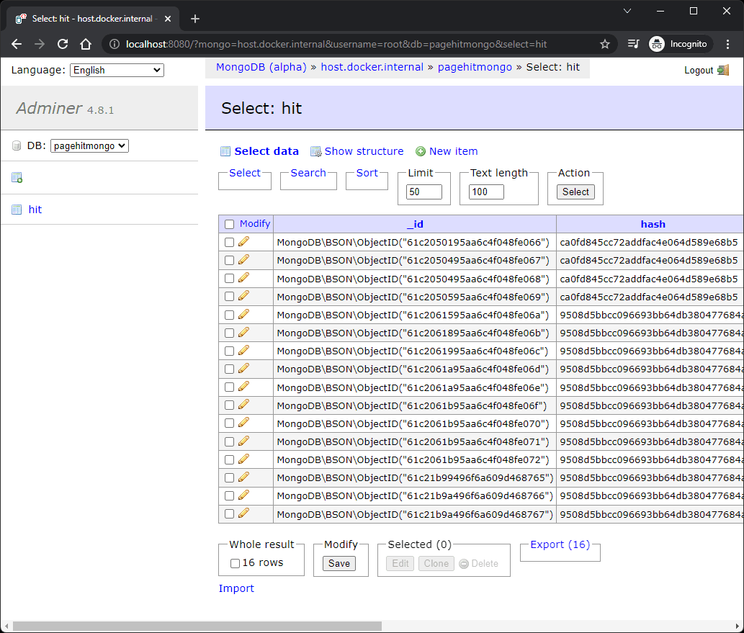
View this chapter’s video to see the code in action.

MongoDB Functionality
The lib/pagehit.js file handles all MongoDB functionality. It loads the required modules and extracts the configuration parameters from the .env file using the dotenv module:
import dotenv from 'dotenv';
import { MongoClient } from 'mongodb';
import httpReferrer from './httpreferrer.js';
// load .env configuration
dotenv.config();
You require a Node.js package to communicate with a database. These are often referred to as database clients, connectors, or drivers, and the MongoDB native driver is used here. It provides low-level methods to construct and execute any MongoDB command.
A connection string is passed to the MongoClient driver constructor, which sets the database user’s name, password, host, and port. The asynchronous .connect() method is called to establish a connection:
// connect to MongoDB
const client = new MongoClient(
`mongodb://${ process.env.MONGO_INITDB_ROOT_USERNAME }:${ process.env.MONGO_
➥INITDB_ROOT_PASSWORD }@${ process.env.MONGO_INITDB_HOST }:${ process.env.
➥MONGO_INITDB_PORT }/`,
{ useNewUrlParser: true, useUnifiedTopology: true }
);
await client.connect();
The code then connects to a specific database (pagehitmongo) and references a hit collection for later use (a collection is a group of similar JSON-like documents):
const
db = client.db(process.env.MONGO_INITDB_DATABASE),
hit = db.collection('hit');
MongoDB allows you to arbitrarily add data to a document in a collection without describing that data up front (although it’s possible to define a schema so you can benefit from data validation). However, you should index regularly queried values to make searches faster and more efficient.
What Is a Database Index?
An index is a list of the data in one or more fields in a specific order—much like the index in a book. For example, you could have a number of user records created as each person registers. When someone logs in, you must locate a user’s record by their email address:
Without an index, the database must search through every user record one by one until the correct email is found.
With an index on the email field in ascending alphabetical order, the database can locate a matching record far faster.
Indexes should be used on fields that you frequently query. It’s tempting to create indexes on every field, but the more you add, the longer it takes to write new records and update all indexes.
The hit collection has an index created on the URL hash and time. This runs every time the application starts, but is ignored after the first attempt:
// add collection index
await hit.createIndex({ hash: 1, time: 1 });
lib/pagehit.js exports a single default asynchronous function. It generates a hash from the referring page’s URL, but returns null when no referrer is found:
// count handler
export default async function(req) {
// hash of referring URL
const hash = httpReferrer(req);
// no referrer?
if (!hash) return null;
The browser’s IP address (ip), user agent (ua), and access time (time) are then determined:
// fetch browser IP address and user agent
const
ipRe = req.ip.match(/(?:\d{1,3}\.){3}\d{1,3}/),
ip = ipRe?.[0] || null,
ua = req.get('User-Agent') || null,
time = new Date();
This data is added as a new document into the hit collection using the insertOne() method. By default, all MongoDB documents also have a unique _id added to every document:
try {
// store page hit
await hit.insertOne({ hash, ip, ua, time });
A count of all documents with the same hash is then returned:
// fetch page hit count
return await hit.countDocuments({ hash });
An error is thrown if any database operation fails:
}
catch (err) {
throw new Error('DB error', { cause: err });
}
}
The main index.js script loads this module:
import pagehit from './lib/pagehit.js';
It uses it within a middleware function that sets req.count to the returned page count. This is available to subsequent (next()) middleware functions, but any error terminates the request immediately:
// page hit count middleware
app.use(async (req, res, next) => {
try {
req.count = await pagehit(req);
if (req.count) {
next();
}
else {
res.status(400).send('No referrer');
}
}
catch(err) {
res.status(503).send('Pagehit service down');
}
});
A single /hit.svg route is defined, which returns an SVG image containing the req.count value:
// SVG counter response
app.get('/hit.svg', (req, res) => {
res
.set('Content-Type', 'image/svg+xml')
.send(`<svg xmlns="http://www.w3.org/2000/svg" width="${ String( req.count ).
➥length * 0.6 }em" height="1em"><text x="50%" y="75%" font-family=
➥"sans-serif" font-size="1em" text-anchor="middle" dominant-baseline=
➥"middle">${ req.count }</text></svg>`);
});
The response ends once the SVG is returned to the calling browser.

Stop the MongoDB Application
Stop both the Node.js page hit application and test page server by pressing Ctrl | Cmd + C in their terminals. From the same project directory, stop the MongoDB database and Adminer client with docker-compose down.

MySQL
MySQL is a popular SQL database. SQL (Structured Query Language) is a standard for managing data in a relational database management system (RDBMS). Data is stored in tables and should ideally be defined in one place without duplication (known as normalization).
Consider a book store inventory. Each book has an ID, title, author, and publisher, and is added as a new row (record) to a book table:
id | title | author | publisher
1 | Introduction to Node.js | Craig Buckler | SitePoint
2 | Jump Start Web Performance | Craig Buckler | SitePoint
3 | DevTool Secrets | Craig Buckler | SitePoint
4 | Learn to Code with JavaScript | Darren Jones | SitePoint
An author and publisher can have more than one book. Rather than repeat the same values, it’s more practical to create author and publisher tables where each record has a unique ID.
Here’s the author table:
id | name | country
2 | Craig Buckler | UK
3 | Darren Jones | UK
Here’s the publisher table:
id | name | country
1 | SitePoint | AU
You can reference those IDs in the book table:
id | title | author_id | publisher_id
1 | Introduction to Node.js | 2 | 1
2 | Jump Start Web Performance | 2 | 1
3 | DevTool Secrets | 2 | 1
4 | Learn to Code with JavaScript | 3 | 1
If a publisher changes their name or address, you can update the data in the publisher table without affecting related book records.
A brief overview of SQL:
Database table structures must be defined before data can be stored.
SQL offers simple declarative CRUD operations such as INSERT, SELECT, UPDATE, and DELETE, but is powerful enough for complex operations.
Queries can JOIN tables to examine related data in a single command.
Data integrity and relationships can be enforced. For example, it becomes impossible to delete an author if they have one or more books.
Most systems can wrap multiple updates into a single transaction. If one operation fails, the data rolls back to the state before the first update.
SQL is a fairly loose standard. Similar syntaxes are implemented across relational database management systems, but features and syntax can differ.
SQL was initially devised in the early 1970s, so software, tools, documentation, and resources are plentiful.
Other popular SQL databases include MariaDB, PostgreSQL, SQLite, Microsoft SQL Server, and Oracle.

Start the MySQL Application
To use the MySQL-based application, navigate to the pagehit-mysql directory and start MySQL and the Adminer client with docker-compose up.

Your Own MySQL Installation?
As before, database configuration parameters are defined in the project .env file, which you can edit if you’re using your own MySQL installation.
Docker automatically runs the mysql/init.sql script to initialize the database tables and indexes. You must run this manually before starting the Node.js application, either by running it in a MySQL client or using the terminal command:
mysql -h localhost -u pagehituser pagehitmysql < mysql/init.sql
(Change the host, user, or database names as necessary.)
In another terminal, install the Node.js express, mysql2, and dotenv dependencies referenced in package.json:
npm install
Then start the page hit application:
npm start
Finally, start a web server in another terminal so you can load test pages:
npx small-static-server 8888 ./test
You now have four services running:
the MySQL database at http://localhost:3306
the Adminer database client at http://localhost:8080/
the page hit service at http://localhost:8001/
a test page web server at http://localhost:8888/
Different ports can be defined in the .env file if you have clashes.
Visit http://localhost:8888/page1.html or http://localhost:8888/page2.html to view page counters. Refresh and watch the counter increase.
You can examine the database data using the Adminer panels at http://localhost:8080/. Log on with the credentials specified in .env:
System: MySQL
Server: host.docker.internal (or your network IP address if not using Docker Desktop)
Username: pagehituser
Password: pagehitpw
Database: pagehitmysql
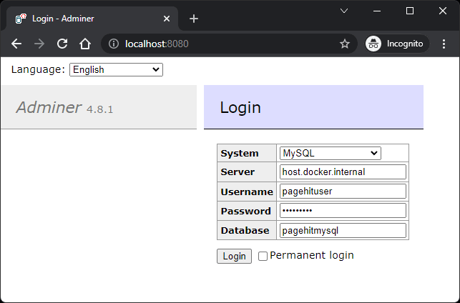
Then click select next to the hit table.
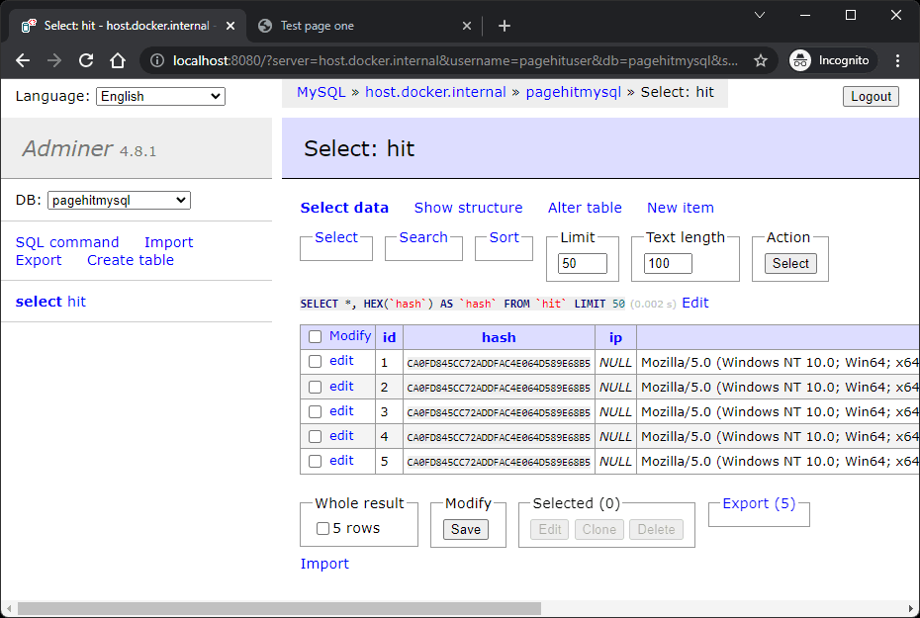

MySQL Functionality
You can’t store data in an SQL RDBMS until the data structure (its schema) is defined. The MySQL database schema is defined in mysql/init.sql, which runs automatically when using Docker:
-- MySQL database initialization
USE pagehitmysql;
CREATE TABLE IF NOT EXISTS hit (
id bigint unsigned NOT NULL AUTO_INCREMENT COMMENT 'record ID',
hash binary(16) NOT NULL COMMENT 'URL hash',
ip int(4) unsigned DEFAULT NULL COMMENT 'client IP address',
ua varchar(200) DEFAULT NULL COMMENT 'client useragent string',
time timestamp NOT NULL DEFAULT CURRENT_TIMESTAMP COMMENT 'hit time',
PRIMARY KEY (id),
KEY hash_time (hash, time)
) ENGINE=InnoDB DEFAULT CHARSET=utf8 COMMENT='page hits';
The lib/pagehit.js file handles all MySQL functionality. It loads the required modules and extracts the configuration parameters from the .env file using the dotenv module:
import dotenv from 'dotenv';
import mysqlPromise from 'mysql2/promise';
import httpReferrer from './httpreferrer.js';
// load .env configuration
dotenv.config();
The mysql2 driver has been chosen for MySQL communication. It provides promise-based, low-level methods to construct and execute any SQL command.
A MySQL connection pool is configured using defaults from the .env file. Connection pools reduce the time spent connecting to a MySQL server by reusing previous connections:
// connect to MySQL
const db = await mysqlPromise.createPool({
host: process.env.MYSQL_HOST,
port: process.env.MYSQL_PORT,
database: process.env.MYSQL_DATABASE,
user: process.env.MYSQL_USER,
password: process.env.MYSQL_PASSWORD,
waitForConnections: true,
connectionLimit: 10,
queueLimit: 0
});
Like before, lib/pagehit.js exports a single default asynchronous function. It generates a hash from the referring page’s URL, returns when no referrer is found, and determines the browser’s IP address (ip), and user agent (ua):
// count handler
export default async function(req) {
// hash of referring URL
const hash = httpReferrer(req);
// no referrer?
if (!hash) return null;
// fetch browser IP address and user agent
const
ipRe = req.ip.match(/(?:\d{1,3}\.){3}\d{1,3}/),
ip = ipRe?.[0] || null,
ua = req.get('User-Agent') || null;

No Time?
The time of record insertion is automatically handled by MySQL, which sets the CURRENT_TIMESTAMP by default.
The data is added as a new record into the hit table by executing an SQL INSERT statement:
try {
// store page hit
await db.execute(
'INSERT INTO `hit` (hash, ip, ua) VALUES (UNHEX(?), INET_ATON(?), ?);',
[ hash, ip, ua ]
);
This is an example of a prepared statement, where each ? character is substituted by an associated (and escaped) value in the array.

UNHEX? INET_ANON?
A couple of MySQL-specific functions are used in the SQL statement above to make smaller, more efficient numeric fields that use less space and are quicker to search:
UNHEX() converts the 32-character hash string to a binary value.
INET_ATON() converts a dotted-quad IPv4 network address string to an integer.
Never Build SQL Strings!
Never programmatically build SQL strings. This is the biggest cause of SQL injection attacks:
b.execute(`SELECT * FROM user WHERE email='${ email }' AND
➥password='${ password }';`);
A user could enter the email address: boss@company.com'; --. This comments out the password check, so anyone can log in as the boss!
A more dangerous example would wipe the user table:
boss@company.com'; DROP TABLE user; --
You should validate all incoming user data, but a prepared statement makes SQL injection attacks far more difficult.
A count of all records with the same hash is then returned:
// fetch page hit count
const [res] = await db.query(
'SELECT COUNT(1) AS `count` FROM `hit` WHERE hash = UNHEX(?);',
[ hash ]
);
return res?.[0]?.count;
An error is thrown if any database operation fails:
}
catch (err) {
throw new Error('DB error', { cause: err });
}
}
As before, the main index.js script loads the lib/pagehit.js module, sets req.count in a middleware function, and outputs it in a generated SVG in the /hit.svg route.

Stop the MySQL Application
Stop both the Node.js page hit application and test page server by pressing Ctrl | Cmd + C in their terminals. From the same project directory, stop the MongoDB database and Adminer client with docker-compose down.

Sequelize ORM
The MySQL and MongoDB examples in their respective sections above use native drivers to communicate directly with a database using its SQL or NoSQL command syntax. This has some disadvantages:
Your application is tied to a specific database.
You must learn and implement the language used by that database.
You must track your own data and schema updates to ensure database changes are pushed to all installations of the application.
An object-relational mapping (ORM) module can make development easier by providing an abstract layer between your code and the database. Rather than running SQL/NoSQL commands directly, your code manipulates data objects that are saved and restored from a representation in a database.
sequelize is a popular Node.js ORM that supports MySQL, MariaDB, PostgreSQL, SQLite, SQL Server, and other SQL databases. It still requires a native database driver such as mysql2, but there’s no need to write SQL statements.

Start the Sequelize ORM Application
To use the ORM-based application, navigate to the pagehit-orm directory and start MySQL and the Adminer client with docker-compose up.

Your Own MySQL Installation?
As before, database configuration parameters are defined in the project .env file, which you can edit if you’re using your own MySQL installation. In this case, there’s no initialization script, because it’s handled by Node.js code.
In another terminal, install the Node.js express, sequelize, mysql2, and dotenv dependencies referenced in package.json:
npm install
Then start the page hit application:
npm start
Finally, start a web server in another terminal so you can load test pages:
npx small-static-server 8888 ./test
You now have four services running:
the MySQL database at http://localhost:3306
the Adminer database client at http://localhost:8080/
the page hit service at http://localhost:8001/
a test page web server at http://localhost:8888/
Different ports can be defined in the .env file if you have clashes.
Visit http://localhost:8888/page1.html or http://localhost:8888/page2.html to view page counters. Refresh and watch the counter increase.
You can examine the database data using the Adminer panels at http://localhost:8080/. Log on with the credentials specified in .env:
System: MySQL
Server: host.docker.internal (or your network IP address if not using Docker Desktop)
Username: pagehituser
Password: pagehitpw
Database: pagehitorm
Then click select next to the hits table.

Sequelize ORM Functionality
The lib/pagehit.js file handles all Sequelize functionality. It loads the required modules and extracts the configuration parameters from the .env file using the dotenv module:
import dotenv from 'dotenv';
import Sequelize from 'sequelize';
import httpReferrer from './httpreferrer.js';
// load .env configuration
dotenv.config();
(There’s no need to import the mysql2 module, as Sequelize loads it.)
The database name, user, and password connection parameters are passed to the Sequelize object constructor. A fourth options object defines the database type, host, and port:
// initialize ORM connection
const sequelize = new Sequelize(
process.env.MYSQL_DATABASE,
process.env.MYSQL_USER,
process.env.MYSQL_PASSWORD,
{
host: process.env.MYSQL_HOST,
port: process.env.MYSQL_PORT,
dialect: 'mysql'
}
);
Rather than defining a table, you create a JavaScript class from a Sequelize.Model class. The static init() method defines the property data types and indexes (note that each model has a default id, createdAt, and updatedAt date):
// define Hit class
class Hit extends Sequelize.Model {}
Hit.init(
{
hash: {
type: Sequelize.STRING(32),
allowNull: false
},
ip: {
type: Sequelize.STRING(15),
allowNull: true
},
ua: {
type: Sequelize.STRING(200),
allowNull: true
}
},
{
indexes: [
{ fields: [ 'hash', 'createdAt' ] }
],
sequelize,
modelName: 'hit'
}
);
The asynchronous sync() method synchronizes all data models with the database. In this case, a hits table is defined from the Hit model:
// synchronize model with database
await sequelize.sync();
Like before, lib/pagehit.js exports a single default asynchronous function. It generates a hash from the referring page’s URL, returns when no referrer is found, and determines the browser’s IP address (ip), and user agent (ua):
// count handler
export default async function(req) {
// hash of referring URL
const hash = httpReferrer(req);
// no referrer?
if (!hash) return null;
// fetch browser IP address and user agent
const
ipRe = req.ip.match(/(?:\d{1,3}\.){3}\d{1,3}/),
ip = ipRe?.[0] || null,
ua = req.get('User-Agent') || null;
A new Hit record is created with the data:
try {
// store page hit
await Hit.create(
{ hash, ip, ua }
);
A count of all items with the same hash is then returned:
// fetch page hit count
const res = await Hit.findAndCountAll({
where: { hash }
});
return res?.count;
An error is thrown if any operation fails:
}
catch (err) {
throw new Error('DB error', { cause: err });
}
}
As before, the main index.js script loads the lib/pagehit.js module, sets req.count in a middleware function, and outputs it in a generated SVG in the /hit.svg route.

How to Choose the Right Database
An SQL database such as MySQL is the best option when requirements are clearly defined and data integrity is essential—such as for banking, ecommerce, stock control, and so on. A money transfer requires an amount to be debited from one account and credited to another: transactions guarantee that both or neither update is successful.
A NoSQL database such as MongoDB could be ideal for projects where organic data flexibility is important—such as content management, social networks, web analytics, and so on.
In general:
A NoSQL database can be easier to use at the start of a project, but may become more difficult as you identify data relationships.
An SQL database requires more careful data planning up front, but this can return dividends toward the end of a project—(unless requirements change radically!)
Complex projects could benefit from using two or more databases. For example, a blog stored in MySQL could use Elasticsearch for Google-like search queries. However, maintaining data integrity between two or more databases is complex and cumbersome. It may also be unnecessary, because the distinction between SQL and NoSQL has blurred:
some SQL databases have adopted NoSQL features, such as JSON and XML fields
some NoSQL databases have adopted SQL features, such as JOINs and transactions
Research the options, browse usage reports, and consult others to make sure a database has the features and support you need. Try to abstract your data manipulation code so it becomes easier to switch to another system if that becomes necessary.

Native vs ORM Drivers
Think of an ORM as an abstract database framework. The benefits include:
They can be easier to learn than specific SQL or NoSQL dialects.
Development time is reduced, because a good ORM will manage security and data integrity.
You can create data models in the application code. There’s no need to directly create or alter tables.
ORMs track changes and can migrate schemas as necessary.
ORMs support multiple databases, which could be important if you’re distributing web software for others to install.
The downsides of an ORM:
They can still be difficult to learn. The Sequelize manual is daunting, and that knowledge won’t be applicable elsewhere.
An ORM won’t save you from poor data decisions.
More complex queries can be difficult to express.
ORMs are slower, and queries won’t necessarily be optimized.
You’ll be unable to use advanced options provided in a specific database.
Database-related bugs may be more difficult to debug.
An ORM can be ideal for prototypes and smaller projects. Native drivers with optimized, hand-crafted queries are better for larger projects where data requirements are more critical.
If I could offer one piece of advice: learn SQL.
Unlike most development technologies, SQL has persisted for half a century, and the skills are transferable to other databases. You’ll become more adept at modeling data and creating efficient applications that require less code. You’ll have fewer reasons to consider an ORM.

Exercises
Adapt any of the page hit counter projects so different routes can return:
Page hits during the past 24 hours.
Page hits from the current IP address.
Page hits from the same browser (Chrome, Edge, Safari, Firefox, etc.). This is tricky! Browser user agent strings purposely obfuscate the application! You may also need to parse and output another field to make searches more efficient.

Summary
Databases are a core web application technology. If your database functions well, it won’t necessarily matter whether you write the business logic using Node.js, PHP, Python, Ruby, or .NET.
You need to start somewhere, so pick a database and create example projects. Choosing an SQL database with a native driver will have a steep learning curve, but persevere! It will make you a better web developer.
SQL and NoSQL resources:
Simply SQL
“SQL vs NoSQL: The Differences”
“SQL vs NoSQL: How to Choose”
MongoDB resources:
MongoDB website, documentation, downloads, and Docker image
“An Introduction to MongoDB”
mongo-express (Docker image), Mongoku (Docker image), and Robo 3T MongoDB clients
mongodb and mongoose Node.js database drivers
MySQL resources:
MySQL website, documentation, downloads and Docker image
“How to Install MySQL”
Adminer (Docker image) and phpMyAdmin (Docker image) MySQL clients
mysql, mysql2, and sequelize ORM Node.js database drivers
“Using MySQL with Node.js and the mysql JavaScript Client”
You could also consider the MySQL-compatible MariaDB database system: documentation, downloads, Docker image, and mariadb Node.js module.
PostgreSQL resources:
PostgreSQL website, documentation, downloads, and Docker image
Adminer (Docker image) and other PostgreSQL clients
node-postgres, postgres, and Sequelize ORM Node.js database drivers
SQLite is a small, free, file-based SQL database engine. It’s not recommended for busy websites, but it can be ideal for demonstration projects, embedded systems, desktop, and mobile applications.
SQLite website, documentation, and downloads
better-sqlite3, sqlite3, sqlite, and Sequelize ORM Node.js database drivers

Quiz
1. SQL is short for:
a. Simple Query Language
b. Structured Query Language
c. Statistical Query Language
d. Small & Quick Language
2. A MySQL database table can store:
a. table data
b. JSON data
c. XML data
d. all of the above
3. A MongoDB database can:
a. be used without a data schema
b. be used with a data schema
c. join data in two collections
d. all of the above
4. ORM is short for:
a. object-relational mapping
b. object-reference model
c. ordered-reference map
d. ordered-results management
5. A database index:
a. defines data in a specific order
b. is automatically used when required
c. should make queries faster
d. all of the above

Chapter 11: Using WebSockets
This chapter demonstrates how to use WebSockets—a technology that makes it possible to open a two-way, interactive communication channel between a browser and a server. In the past, this was difficult to achieve on most platforms, and often required a third-party service. Node.js makes it easy, although we’ll delve into some deeper challenges.

Skip Ahead?
It’s possible to become a respected senior developer without touching WebSockets! You can skip this chapter, but the technology opens a world of opportunities you may not have considered before.

What Are WebSockets?
The web is a request–response communication platform. Your browser requests a web page and receives HTML as the response from a web server. The page may reference assets such as images, fonts, CSS, and JavaScript; the browser makes an additional request for each.
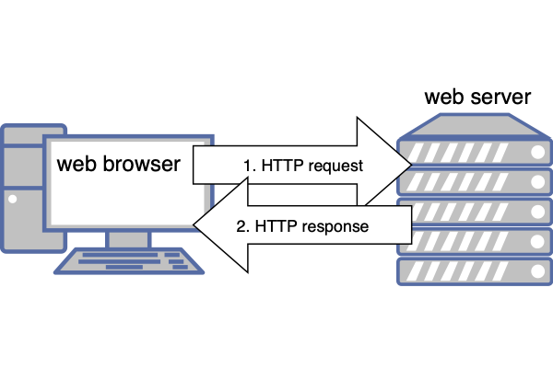
The browser initiates every request. A web server can’t arbitrarily push data to a user. It must be requested first.
Ajax techniques can be used to make web apps look as though they update in real time by initiating a polling request every few seconds. This can check for new data from a web server and update the DOM as necessary.
Few apps need go beyond this request–response model, because data changes infrequently in a typical web application. However, it’s not ideal for true real-time applications such as stock price dashboards, chat apps, and multiplayer games. Polling every second would be inefficient at certain times, and too slow at others. It’s also difficult for a server to determine what changed between two polling intervals: every browser could be asking for different data.
WebSockets provide a solution for real-time apps. The browser makes an initial WebSocket request, which opens a communication channel. At that point, either the browser or server can send a message that raises an event on the other device.
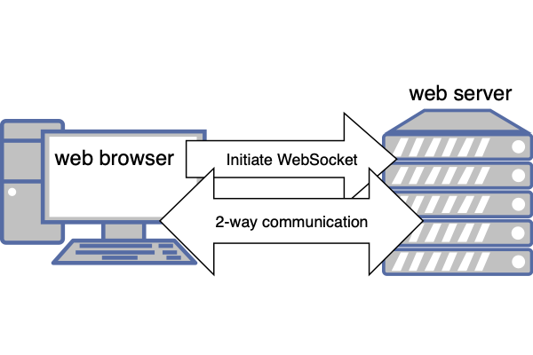
Two things to be aware of:
A browser can only send a message to the WebSocket server.
The WebSocket server can send a message to any of its connected clients.
One browser can’t directly message another. It can only send a message to the central WebSocket server and hope it gets forwarded as necessary.

Example WebSocket Chat Application
The sections below explain how to create a simple real-time chat app using WebSockets. Chat apps are the “Hello, World!” of WebSocket demonstrations, so I apologize for being unoriginal—but they show the concepts without too much code.
To get started, navigate to the wschat code directory in your terminal and install the Node.js dependencies with npm install.
Run the application with npm start.
Open http://localhost:3000/ in a number of browser tabs (you can also define your chat name on the query string—such as http://localhost:3000/?Craig). Type something in one window, then press SEND or hit Enter, and you’ll see it appear in every window.
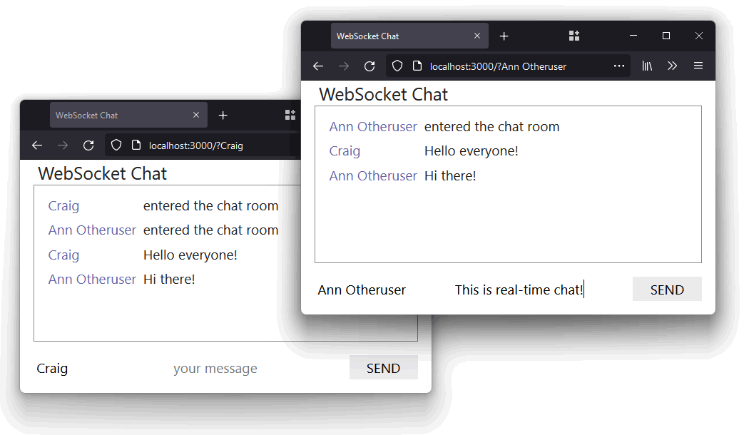
View the video to see the chat application in action.

WebSocket Walkthrough
The application works by starting two server processes in the index.js file:
An Express app with an EJS template to serve a single page with client-side HTML, CSS, and JavaScript. This runs at http://localhost:3000/ and uses the browser WebSocket API to send and receive messages.
A WebSocket server, which listens for incoming client connections, receives messages, sends messages, and monitors disconnections. This runs at ws://localhost:3001/ and uses the Node.js ws library.
- A "connection" event is raised when a connection is received from a browser. The handler function receives a socket object used to communicate with that individual device.
- A socket "message" event is raised when a client sends a message. The chat application’s handler function broadcasts that message to every connected client.
- A socket "close" event is raised when the client disconnects (typically when the browser tab is closed or refreshed).
Here’s the full server JavaScript code:
// WebSocket server
import WebSocket, { WebSocketServer } from 'ws';
const ws = new WebSocketServer({ port: cfg.wsPort });
// client connection
ws.on('connection', (socket, req) => {
console.log(`connection from ${ req.socket.remoteAddress }`);
// received message
socket.on('message', (msg, binary) => {
// broadcast to all clients
ws.clients.forEach(client => {
client.readyState === WebSocket.OPEN && client.send(msg, { binary });
});
});
// closed
socket.on('close', () => {
console.log(`disconnection from ${ req.socket.remoteAddress }`);
});
});
The client-side browser JavaScript:
caches HTML dom nodes for later use
sets a default username from the query string or a random string
determines the ws:// WebSocket connection address using the page’s domain plus the port defined in the HTML page template
// get page DOM nodes
const dom = { form: 0, chat: 0, name: 0, message: 0 };
for (let n in dom) dom[n] = document.getElementById(n);
// set user's name
dom.name.value = decodeURIComponent(location.search.trim().slice(1,1 + window.
➥cfg.nameLen)) || 'Anonymous' + Math.floor(Math.random() * 99999);
wsInit(`ws://${ location.hostname }:${ window.cfg.wsPort }`);
A wsInit() function is called with the WebSocket server address to initiate the connection. An open event is triggered when a connection is established. At this point, the handler function sends an “entered the chat room” message by calling sendMessage():
// handle WebSocket communication
function wsInit(wsServer) {
const ws = new WebSocket(wsServer);
// connect to server
ws.addEventListener('open', () => {
sendMessage('entered the chat room');
});
The sendMessage() function fetches the user’s name and message from the HTML form, although the message can be overridden by any passed setMsg argument. The values are converted to a JSON object that’s sent over the WebSocket channel using its ws.send() method:
// send message
function sendMessage(setMsg) {
let
name = dom.name.value.trim(),
msg = setMsg || dom.message.value.trim();
name && msg && ws.send( JSON.stringify({ name, msg }) );
}
The message is received by the server’s "message" handler and broadcast to every connected client—including the client that sent the message. This triggers a "message" event on each client, with the event’s data property set to the original JSON. The handler function parses this back to a JavaScript object and updates the chat window:
// receive message
ws.addEventListener('message', e => {
try {
const
chat = JSON.parse(e.data),
name = document.createElement('div'),
msg = document.createElement('div');
name.className = 'name';
name.textContent = (chat.name || 'unknown');
dom.chat.appendChild(name);
msg.className = 'msg';
msg.textContent = (chat.msg || 'said nothing');
dom.chat.appendChild(msg).scrollIntoView({ behavior: 'smooth' });
}
catch(err) {
console.log('invalid JSON', err);
}
});
Finally, new messages are sent using sendMessage() whenever the form’s "submit" handler is triggered:
// form submit
dom.form.addEventListener('submit', e => {
e.preventDefault();
sendMessage();
dom.message.value = '';
dom.message.focus();
}, false);
This chapter’s second video also explains the basics of the chat application’s functionality.

Advanced WebSockets Considerations
WebSocket technology is easy in Node.js: one device sends a message using a send() method, which triggers a "message" event on the other. How each device creates and responds to messages is more challenging.
Consider an online multiplayer game. The game could have many universes playing separate instances of the game—such as universeA, universeB, and universeC. Each player can connect to a single universe:
universeA: joined by player1, player2, and player3
universeB: joined by player99
You could do one of the following:
Use a separate WebSocket server for each game universe.
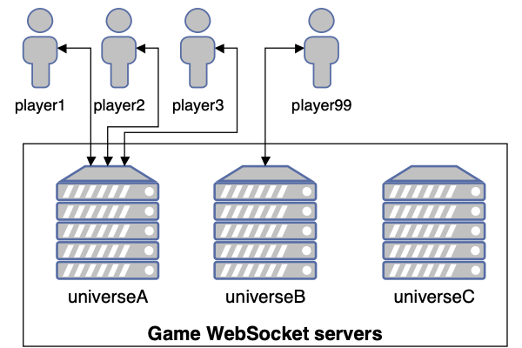
This would make user management easy: a player action in universeA would never be seen by those in universeB. However, launching and managing separate server instances could be difficult. Would you stop universeC because it has no players, or continue to pay for that resource?
Use a single WebSocket server for all game universes.
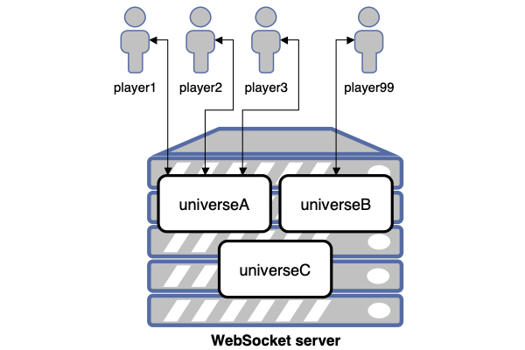
This would use fewer resources and be easier to manage, but the WebSocket server must record which universe each player joins. When player1 performs an action, it should only be broadcast to player2 and player3—not player99.
You must then consider game mechanics and messaging efficiency. For example:
How do you synchronize a player’s actions across all client devices?
If player1 can’t currently be seen by player2 (because they’re in another room), is it necessary for player2 to receive a message about their actions?
How do you cope with network latency—or communication lag? Would someone with a faster machine and connection have an unfair advantage?
Fast action games have to make compromises. In essence, you’re playing the game on your local device but some objects are influenced by the activities of other people. Rather than sending the exact position of every object at all times, games can send simpler, less frequent messages. For example:
objectX has appeared at pointX
objectY has a new direction and velocity
objectZ has been destroyed
… and so on.
Each client game fills in the gaps. When objectZ explodes, it rarely matters whether the explosion looks the same on every device.
This all explains why you were unfairly beaten in your favorite game by a seemingly invisible player!

Multiple WebSocket Servers
The example chat application can cope with dozens of concurrent users, but at some point, it’ll crash as popularity rises. More RAM can help, but there are limits. You’ll eventually require another server.
Each WebSocket server can only manage its own connected clients. A message sent from a user to serverA wouldn’t be broadcast to those connected to serverB. It may be necessary to implement backend, pub–sub messaging systems such as Kafka, Redis, or RabbitMQ.

What is Pub–sub?
Publisher–subscriber services provide asynchronous communication services. An application can send (publish) a message to the pub–sub system. Applications can subscribe to those messages and be instantly alerted when a new one arrives.
Therefore:
WebSocket serverA wants to send a message to all clients. It publishes the message on the pub–sub system.
All WebSocket servers subscribed to the pub–sub system receive a new message event (including serverA). Each can handle the message and broadcast it to their connected clients as necessary.
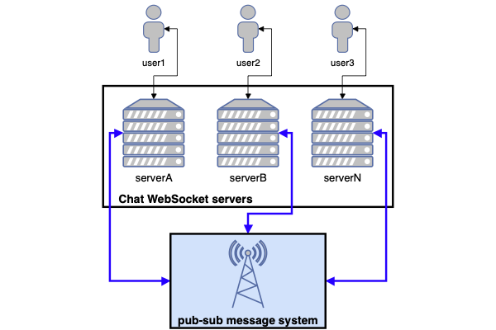
The example real-time quiz at the end of this course uses PostgreSQL to provide pub–sub functionality.

Exercise
Adapt the chat application to store the most recent 30 messages and send them to any new user entering the chat room. For big bonus points, store message data in a database so it persists between application restarts.
You could also experiment with sending different types of messages. For example, allow private messages to be sent to a single user.

Summary
Node.js makes it easy to handle WebSockets. It won’t make real-time applications easier to design or code, but the technology won’t hold you back.
Note that ws isn’t the only Node.js option. Almost 1,000 other WebSocket packages are available. Some provide their own browser client libraries or integrate with JavaScript frameworks to make usage easier.
You could also consider server-sent events if your app only needs to receive updates from a central server.

Quiz
1. WebSockets offer:
a. two-way browser/server communication
b. real-time messaging
c. an event-driven API
d. all of the above
2. A WebSocket server:
a. responds to connections and messages from clients
b. passes connection requests to and from a web server
c. initiates the WebSocket connection
d. all of the above
3. A message sent on a WebSocket connection must be:
a. a string
b. JSON
c. binary data
d. any text or binary data
4. A browser WebSocket client can message another user’s browser by:
a. sending a direct peer-to-peer message that bypasses the server
b. sending a message to the WebSocket server that forwards as necessary
c. adding the other user’s IP address to the message
d. all of the above
5. Which best describes WebSocket code as used in the ws library?
a. a message() call that triggers a "sent" event on the other device
b. a send() call that triggers a "message" event on the other device
c. a transmit() call that triggers a "received" event on the other device
d. a send() call that triggers a "receive" event on the other device

Chapter 12: Useful Node.js APIs
This chapter demonstrates a selection of regularly used APIs that are built in to the standard Node.js runtime. You’ve seen some in previous chapters of this book, but I hope the following sections will pique your interest and encourage you to browse the Node.js API documentation.

Module node: URL Imports
Node.js 14 and above support node: imports for both ESM and CommonJS modules. Rather than using the API’s module name:
import path from 'path';
… you can reference it using an absolute node: URL:
import path from 'node:path';
This might be practical if you had another module named path or want to distinguish built-in APIs in your code.

Process
The process object provides information about your Node.js application as well as control methods. process is available globally: you can use it without import, although the Node.js documentation recommends you explicitly reference it:
import process from 'process';
We’ve used process.argv in other scripts to fetch commmand-line arguments:
const firstArg = process.argv[2];
process.argv returns an array where the first two items are the Node.js executable path and the script name. The item at index 2 is the first argument passed.
Other useful properties and methods include:
process.env: returns an object containing environment name/value pairs—such as process.env.NODE_ENV.
process.cwd(): returns the current working directory.
process.platform: returns a string identifying the operating system: 'aix', 'darwin' (macOS), 'freebsd', 'linux', 'openbsd', 'sunos', or 'win32' (Windows).
process.uptime(): returns the number of seconds the Node.js process has been running.
process.cpuUsage(): returns the user and system CPU time usage of the current process—such as { user: 12345, system: 9876 }. Pass the object back to the method to get a relative reading.
process.memoryUsage(): returns an object describing memory usage in bytes.
process.version: returns the Node.js version string—such as 18.0.0.
process.report: generates a diagnostic report.
process.exit(code): exits the current application. Use an exit code of 0 to indicate success or an appropriate error code where necessary.
process is also an event emitter (see the “Events” section): you can attach event handler functions to events such as 'beforeExit' to clean up before the process terminates. For example:
// clean up when the Node.js process terminates
process.on('beforeExit', code => {
// ...
});
exit Events
You can also define an exit handler function. However, this can’t run asynchronous functions such as disconnecting from a database or outputting a log file, because the Node.js event loop will end on the current iteration and the program will terminate.

OS
The os API has similarities to process (see the “Process” section above), but it can also return the following:
os.cpus(): returns an array of objects with information about each logical CPU core. The “Clusters” section below references os.cpus() to fork the process. On a 16-core CPU, you’d have 16 instances of your Node.js application running to improve performance.
os.hostname(): the OS host name.
os.version(): a string identifying the OS kernel version.
os.homedir(): the full path of the user’s home directory.
os.tmpdir(): the full path of the operating system’s default temporary file directory.
os.uptime(): the number of seconds the OS has been running.

Util
The util module provides an assortment of useful JavaScript methods. One of the most useful is util.promisify(function), which takes an error-first callback style function and returns a promise-based function. (See the code in Chapter 9 for a demonstration.)
Further methods include:
util.callbackify(function): takes a function that returns a promise and returns a callback-based function.
util.isDeepStrictEqual(object1, object2): returns true when there’s a deep equality between two objects (all child properties must match).
util.format(format, [args]): returns a string using a printf-like format.
util.inspect(object, options): returns a string representation of an object for debugging. This is similar to using console.dir(object, { depth: null, color: true });.
util.stripVTControlCharacters(str): strips ANSI escape codes from a string.
util.types provides type checking for common JavaScript and Node.js values. For example:
import util from 'util';
util.types.isDate( new Date() ); // true
util.types.isMap( new Map() ); // true
util.types.isRegExp( /abc/ ); // true
util.types.isAsyncFunction( async () => {} ); // true

URL
URL is another global object that lets you safely create, parse, and modify web URLs. For example:
const myURL = new URL('https://example.org:8000/path/?abc=123#target');
console.dir(myURL, { depth: null, color: true });
The code above outputs this:
{
href: 'https://example.org:8000/path/?abc=123#target',
origin: 'https://example.org:8000',
protocol: 'https:',
username: '',
password: '',
host: 'example.org:8000',
hostname: 'example.org',
port: '8000',
pathname: '/path/',
search: '?abc=123',
searchParams: URLSearchParams { 'abc' => '123' },
hash: '#target'
}
You can view and change any property. For example:
myURL.port = 8001;
console.log( myURL.href );
// https://example.org:8001/path/?abc=123#target
You can then use the URLSearchParams API to modify query string values. For example:
myURL.searchParams.delete('abc');
myURL.searchParams.append('xyz', 987);
console.log( myURL.search );
// ?xyz=987
There are also methods for converting file system paths to URLs and back again.
The dns module provides name resolution functions so you can look up the IP address, name server, TXT records, and other domain information.

File System
The fs API can create, read, update, and delete files, directories, and permissions. Recent releases of the Node.js runtime provide promise-based functions in fs/promises, which make it easier to manage asynchronous file operations.

fs and path
You’ll often use fs in conjunction with path to resolve file names on different operating systems.
The example code has a filecompress project, which compresses a text file (typically HTML, CSS, or JS) by removing whitespace and comments. (It’s a demonstration—so please don’t use it on real files! The compression process is simplistic and will mangle some files.)
The project has a lib/fileinfo.js module that returns information about a file system object using the stat and access methods:
// fetch file information
import { constants as fsConstants } from 'fs';
import { access, stat } from 'fs/promises';
export async function getFileInfo(file) {
const fileInfo = {};
try {
const info = await stat(file);
fileInfo.isFile = info.isFile();
fileInfo.isDir = info.isDirectory();
}
catch (e) {
return { new: true };
}
try {
await access(file, fsConstants.R_OK);
fileInfo.canRead = true;
}
catch (e) {}
try {
await access(file, fsConstants.W_OK);
fileInfo.canWrite = true;
}
catch (e) {}
return fileInfo;
}
When passed a filename, the function returns an object with information about that file. For example:
{
isFile: true,
isDir: false,
canRead: true,
canWrite: true
}
The main filecompress.js script uses path.resolve() to resolve input and output filenames passed on the command line into absolute file paths, then fetches information using getFileInfo() above:
#!/usr/bin/env node
import path from 'path';
import { readFile, writeFile } from 'fs/promises';
import { getFileInfo } from './lib/fileinfo.js';
// check files
let
input = path.resolve(process.argv[2] || ''),
output = path.resolve(process.argv[3] || ''),
[ inputInfo, outputInfo ] = await Promise.all([ getFileInfo(input),
➥getFileInfo(output) ]),
error = [];
The code validates the paths and terminates with error messages if necessary:
// use input file name when output is a directory
if (outputInfo.isDir && outputInfo.canWrite && inputInfo.isFile) {
output = path.resolve(output, path.basename(input));
}
// check for errors
if (!inputInfo.isFile || !inputInfo.canRead) error.push(`cannot read input file
➥${ input }`);
if (input === output) error.push('input and output files cannot be the same');
if (error.length) {
console.log('Usage: ./filecompress.js [input file] [output file|dir]');
console.error('\n ' + error.join('\n '));
process.exit(1);
}
The whole file is then read into a string named content using readFile():
// read file
console.log(`processing ${ input }`);
let content;
try {
content = await readFile(input, { encoding: 'utf8' });
}
catch (e) {
console.log(e);
process.exit(1);
}
let lengthOrig = content.length;
console.log(`file size ${ lengthOrig }`);
JavaScript regular expressions then remove comments and whitespace:
// compress content
content = content
.replace(/\n\s+/g, '\n') // trim leading space from lines
.replace(/\/\/.*?\n/g, '') // remove inline // comments
.replace(/\s+/g, ' ') // remove whitespace
.replace(/\/\*.*?\*\//g, '') // remove /* comments */
.replace(/<!--.*?-->/g, '') // remove <!-- comments -->
.replace(/\s*([<>(){}}[\]])\s*/g, '$1') // remove space around brackets
.trim();
let lengthNew = content.length;
The resulting string is output to a file using writeFile(), and a status message shows the saving:
let lengthNew = content.length;
// write file
console.log(`outputting ${output}`);
console.log(`file size ${ lengthNew } - saved ${ Math.round((lengthOrig -
➥lengthNew) / lengthOrig * 100) }%`);
try {
content = await writeFile(output, content);
}
catch (e) {
console.log(e);
process.exit(1);
}
Run the project code with an example HTML file:
node filecompress.js ./test/example.html ./test/output.html
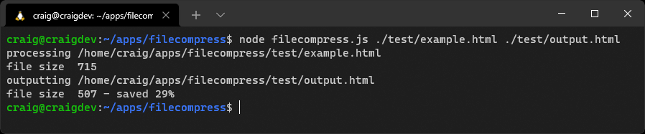
View the demonstration video to see the code in action.

Events
You often need to execute multiple functions when something occurs. For example, a user registers on your app, so the code must add their details to a database, start a new logged-in session, and send a welcome email:
// example pseudo code
async function userRegister(name, email, password) {
try {
await dbAddUser(name, email, password);
await new UserSession(email);
await emailRegister(name, email);
}
catch (e) {
// handle error
}
}
This series of function calls is tightly coupled to user registration. Further activities incur further function calls. For example:
// updated pseudo code
try {
await dbAddUser(name, email, password);
await new UserSession(email);
await emailRegister(name, email);
await crmRegister(name, email); // register on customer system
await emailSales(name, email); // alert sales team
}
You could have dozens of calls managed in this single, ever-growing code block.
The Node.js Events API provides an alternative way to structure the code using a publish–subscribe pattern. The userRegister() function can emit an event—perhaps named newuser—after the user’s database record is created.
Any number of event handler functions can subscribe and react to newuser events; there’s no need to change the userRegister() function. Each handler runs independently of the others, so they could execute in any order.

Events in Client-side JavaScript
Events and handler functions are frequently used in client-side JavaScript—for example, to run a function when the user clicks an element:
// client-side JS click handler
document.getElementById('myelement').addEventListener('click', e => {
// output information about the event
console.dir(e);
});
In most situations, you’re attaching handlers for user or browser events, although you can raise your own custom events. Event handling in Node.js is conceptually similar, but the API is different.
Objects that emit events must be instances of the Node.js EventEmitter class. These have an emit() method to raise new events and an on() method for attaching handlers.
The event example project provides a class that triggers a tick event on predefined intervals. The ./lib/ticker.js module exports a default class that extends EventEmitter:
// emits a 'tick' event every interval
import EventEmitter from 'events';
import { setInterval, clearInterval } from 'timers';
export default class extends EventEmitter {
Its constructor must call the parent constructor. It then passes the delay argument to a start() method:
constructor(delay) {
super();
this.start(delay);
}
The start() method checks delay is valid, resets the current timer if necessary, and sets the new delay property:
start(delay) {
if (!delay || delay == this.delay) return;
if (this.interval) {
clearInterval(this.interval);
}
this.delay = delay;
It then starts a new interval timer that runs the emit() method with the event name "tick". Subscribers to this event receive an object with the delay value and number of seconds since the Node.js application started:
// start timer
this.interval = setInterval(() => {
// raise event
this.emit('tick', {
delay: this.delay,
time: performance.now()
});
}, this.delay);
}
}
The main event.js entry script imports the module and sets a delay period of one second (1000 milliseconds):
// create a ticker
import Ticker from './lib/ticker.js';
// trigger a new event every second
const ticker = new Ticker(1000);
It attaches handler functions triggered every time a tick event occurs:
// add handler
ticker.on('tick', e => {
console.log('handler 1 tick!', e);
});
// add handler
ticker.on('tick', e => {
console.log('handler 2 tick!', e);
});
A third handler triggers on the first tick event only using the once() method:
// add handler
ticker.once('tick', e => {
console.log('handler 3 tick!', e);
});
Finally, the current number of listeners is output:
// show number of listeners
console.log(`listeners: ${ ticker.listenerCount('tick') }`);
Run the project code with node event.js.
The output shows handler 3 triggering once, while handler 1 and 2 run on every tick until the app is terminated.
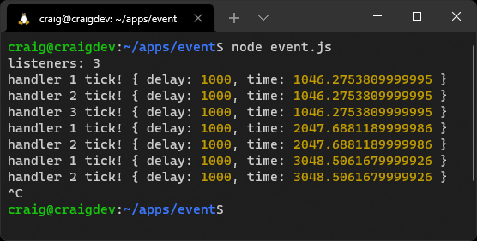
Press Ctrl | Cmd + C to terminate the application.
View the demonstration video to see the code in action.

Streams
The file system example code above (in the “File System” section) reads a whole file into memory before outputting the minified result. What if the file was larger than the RAM available? The Node.js application would fail with an “out of memory” error.
The solution is streaming. This processes incoming data in smaller, more manageable chunks. A stream can be:
readable: from a file, a HTTP request, a TCP socket, stdin, etc.
writable: to a file, a HTTP response, TCP socket, stdout, etc.
duplex: a stream that’s both readable and writable
transform: a duplex stream that transforms data
Each chunk of data is returned as a Buffer object, which represents a fixed-length sequence of bytes. You may need to convert this to a string or another appropriate type for processing.
The example code has a filestream project which uses a transform stream to address the file size problem in the filecompress project. As before, it accepts and validates input and output filenames before declaring a Compress class, which extends Transform:
import { createReadStream, createWriteStream } from 'fs';
import { Transform } from 'stream';
// compression Transform
class Compress extends Transform {
constructor(opts) {
super(opts);
this.chunks = 0;
this.lengthOrig = 0;
this.lengthNew = 0;
}
_transform(chunk, encoding, callback) {
const
data = chunk.toString(), // buffer to string
content = data
.replace(/\n\s+/g, '\n') // trim leading spaces
.replace(/\/\/.*?\n/g, '') // remove // comments
.replace(/\s+/g, ' ') // remove whitespace
.replace(/\/\*.*?\*\//g, '') // remove /* comments */
.replace(/<!--.*?-->/g, '') // remove <!-- comments -->
.replace(/\s*([<>(){}}[\]])\s*/g, '$1') // remove bracket spaces
.trim();
this.chunks++;
this.lengthOrig += data.length;
this.lengthNew += content.length;
this.push( content );
callback();
}
}
The _transform method is called when a new chunk of data is ready. It’s received as a Buffer object that’s converted to a string, minified, and output using the push() method. A callback() function is called once chunk processing is complete.
The application initiates file read and write streams and instantiates a new compress object:
// process stream
const
readStream = createReadStream(input),
writeStream = createWriteStream(output),
compress = new Compress();
console.log(`processing ${ input }`);
The incoming file read stream has .pipe() methods defined, which feed the incoming data through a series of functions that may (or may not) alter the contents. The data is piped through the compress transform before that output is piped to the writeable file. A final on('finish') event handler function executes once the stream has ended:
readStream.pipe(compress).pipe(writeStream).on('finish', () => {
console.log(`file size ${ compress.lengthOrig }`);
console.log(`output ${ output }`);
console.log(`chunks ${ compress.chunks }`);
console.log(`file size ${ compress.lengthNew } - saved ${ Math.round((
➥compress.lengthOrig - compress.lengthNew) / compress.lengthOrig * 100) }%`);
});
Run the project code with an example HTML file of any size:
node filestream.js ./test/example.html ./test/output.html
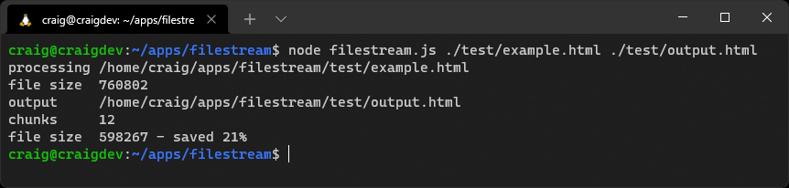
View the demonstration video to see the code in action.
This is a small demonstration of Node.js streams. Stream handling is a complex topic, and you may not use them often. In some cases, a module such as Express uses streaming under the hood but abstracts the complexity from you.
You should also be aware of data chunking challenges. A chunk could be any size and split the incoming data in inconvenient ways. Consider minifying this code:
<script type="module">
// example script
console.log('loaded');
</script>
Two chunks could arrive in sequence:
<script type="module">
// example
And:
script
console.log('loaded');
</script>
Processing each chunk independently results in the following invalid minified script:
<script type="module">script console.log('loaded');</script>
The solution is to pre-parse each chunk and split it into whole sections that can be processed. In some cases, chunks (or parts of chunks) will be added to the start of the next chunk.
Minification is best applied to whole lines, although an extra complication occurs because <!-- --> and /* */ comments can span more than one line. Here’s a possible algorithm for each incoming chunk:
Append any data saved from the previous chunk to the start of the new chunk.
Remove any whole <!-- to --> and /* to */ sections from the chunk.
Split the remaining chunk into two parts, where part2 starts with the first <!-- or /* found. If either exists, remove further content from part2 except for that symbol.
If neither is found, split at the last carriage return character. If none is found, set part1 to an empty string and part2 to the whole chunk.
If part2 becomes significantly large—perhaps more than 100,000 characters because there are no carriage returns—append part2 to part1 and set part2 to an empty string. This will ensure saved parts can’t grow indefinitely.
Minify and output part1.
Save part2 (which is added to the start of the next chunk).
The process runs again for each incoming chunk.
That’s your next coding challenge—if you’re willing to accept it!

Worker Threads
Chapter 9 discussed how Node.js applications run on a single thread. Assume a user could trigger a complex, ten-second JavaScript calculation in your Express application. The calculation would become a bottleneck that halted processing for all users. Your application can’t handle any requests or run other functions until it completes.

Asynchronous Calculations
Complex calculations that process data from a file or database may be less problematic, because each stage runs asynchronously as it waits for data to arrive. Processing occurs on separate iterations of the event loop.
However, long-running calculations written in JavaScript alone—such as image processing or machine-learning algorithms—will hog the current iteration of the event loop.
One solution is worker threads. These are similar to browser web workers and launch a JavaScript process on a separate thread. The main and worker thread can exchange messages to trigger or terminate processing.
Workers and Event Loops
Workers are useful for CPU-intensive JavaScript operations, although the main Node.js event loop should still be used for asynchronous I/O activities.
The example code has a worker project that exports a diceRun() function in lib/dice.js. This throws any number of N-sided dice a number of times and records a count of the total score (which should result in a Normal distribution curve):
// dice throwing
export function diceRun(runs = 1, dice = 2, sides = 6) {
const stat = [];
while (runs > 0) {
let sum = 0;
for (let d = dice; d > 0; d--) {
sum += Math.floor( Math.random() * sides ) + 1;
}
stat[sum] = (stat[sum] || 0) + 1;
runs--;
}
return stat;
}
The code in index.js starts a process that runs every second and outputs a message:
// run process every second
const timer = setInterval(() => {
console.log(' another process');
}, 1000);
Two dice are then thrown one billion times using a standard call to the diceRun() function:
import { diceRun } from './lib/dice.js';
// throw 2 dice 1 billion times
const
numberOfDice = 2,
runs = 999_999_999;
const stat1 = diceRun(runs, numberOfDice);
This halts the timer, because the Node.js event loop can’t continue to the next iteration until the calculation completes.
The code then tries the same calculation in a new Worker. This loads a script named worker.js and passes the calculation parameters in the workerData property of an options object:
import { Worker } from 'worker_threads';
const worker = new Worker('./worker.js', { workerData: { runs, numberOfDice } });
Event handlers are attached to the worker object running the worker.js script so it can receive incoming results:
// result returned
worker.on('message', result => {
console.table(result);
});
… and handle errors:
// worker error
worker.on('error', e => {
console.log(e);
});
… and tidy up once processing has completed:
// worker complete
worker.on('exit', code => {
// tidy up
});
The worker.js script starts the diceRun() calculation and posts a message to the parent when it’s complete—which is received by the "message" handler above:
// worker thread
import { workerData, parentPort } from 'worker_threads';
import { diceRun } from './lib/dice.js';
// start calculation
const stat = diceRun( workerData.runs, workerData.numberOfDice );
// post message to parent script
parentPort.postMessage( stat );
The timer isn’t paused while the worker runs, because it executes on another CPU thread. In other words, the Node.js event loop continues to iterate without long delays.
Run the project code with node index.js.
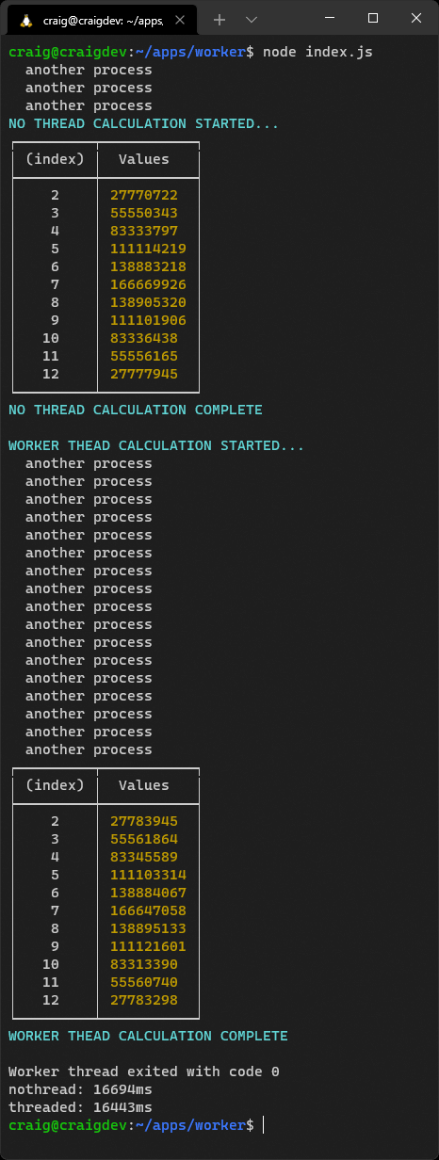
You should note that the worker-based calculation runs slightly faster because the thread is fully dedicated to that process. Consider using workers if you encounter performance bottlenecks in your application.
View the demonstration video to see the code in action.

Child Processes
It’s sometimes necessary to call applications that are either not written in Node.js or have a risk of failure.

A Real-world Example
I worked on an Express application that generated a fuzzy image hash used to identify similar graphics. It ran asynchronously and worked well—until someone uploaded a malformed GIF containing a circular reference (animation frameA referenced frameB which referenced frameA).
The hash calculation never ended. The user gave up and tried uploading again. And again. And again. The whole application eventually crashed with memory errors.
The problem was fixed by running the hashing algorithm in a child process. The Express application remained stable because it launched, monitored, and terminated the calculation when it took too long.
The child process API allows you to run sub-processes that you can monitor and terminate as necessary. There are three options:
spawn: spawns a child process.
fork: a special type of spawn that launches a new Node.js process.
exec: spawns a shell and runs a command. The result is buffered and returned to a callback function when the process ends.
Unlike worker threads, child processes are independent from the main Node.js script and can’t access the same memory.

Clusters
Is your 64-core server CPU under-utilized when your Node.js application runs on a single core? Clusters allow you to fork any number of identical processes to handle the load more efficiently.
The initial primary process can fork itself—perhaps once for each CPU returned by os.cpus(). It can also handle restarts when a process fails, and broker communication messages between forked processes.
Clusters work amazingly well, but your code can become complex. Simpler and more robust options include:
process managers such as PM2, which offer an automated Cluster Mode
a container management system such as Docker or Kubernetes
Both can start, monitor, and restart multiple isolated instances of the same Node.js application. The application will remain active even when one fails.
Write Stateless Applications
This was mentioned in Chapter 3, but it’s worth reiterating: make your application stateless to ensure it can scale and be more resilient. It should be possible to start any number of instances and share the processing load.

Exercises
Browse the Readline API documentation and write a small console application that prompts the user for their name before displaying a “Hello <name>” greeting.
Examine the Performance hooks API documentation to discover how you can monitor and improve code efficiency. The worker threads code (from the “Worker Threads” section above) illustrates basic use of performance marks and measurements.
For big bonus points, improve the stream example (from the “Streams” section) to parse incoming data chunks, as discussed above.

Summary
This chapter has provided a sample of the more useful Node.js APIs, but I encourage you to browse the documentation and discover them for yourself. The documentation is generally good and shows simple examples, but it can be terse in places. Where necessary, search for more thorough tutorials on SitePoint.
The next chapter will build on your Node.js knowledge to develop a real-time, multiuser quiz application.

Quiz
1. The process object provides:
a. a way to launch a new thread
b. information about your application and environment
c. tools to manage application execution
d. all of the above
2. The File System API is named:
a. filesystem
b. file-system
c. fsystem
d. fs
3. Objects that emit events:
a. are instances of the EventEmitter class
b. run an emit() method
c. provide on() event handlers
d. all of the above
4. A Node.js stream provides:
a. data processing on smaller more manageable chunks
b. custom event management
c. processing threads management
d. asynchronous function management
5. Worker threads are best used to run:
a. asynchronous I/O activities
b. CPU-intensive JavaScript operations
c. non-Node.js applications
d. child processes

Chapter 13: Example Real-time Multiplayer Quiz: Overview
This chapter demonstrates a real-time multiplayer quiz written in Node.js. The application is a step up from the simpler, self-contained examples shown in previous chapters. It has a more complex architecture, but it isn’t using any modules or techniques you haven’t seen before. I recommend that you progress through the explanations at your own pace and examine the code in an editor so you can follow what’s happening.
The game allows any player to start a new quiz using their own configuration options—such as the number of questions, scoring, time limits, and so on. Any number of other players can join that quiz using a unique code.
Any number of quiz games can be running concurrently. Players may be connected to different HTTP and WebSocket servers, which must keep themselves synchronized as events occur.
This chapter describes how to run and play the game. The following chapters will cover these topics:
the application’s architecture (Chapter 14)
the Express code (Chapter 15)
the WebSocket code (Chapter 16)

Source Code
The source code is provided in the code/ch13/nodequiz/ directory, although you may find it more practical to pull the repository from github.com/craigbuckler/nodequiz using the following Git command:
git clone https://github.com/craigbuckler/nodequiz

Quizzing Quick Start
The application uses Docker and Docker Compose to download and run Node.js and database servers.

What is Docker?
Docker provides a way to quickly install, configure, and run applications such as databases. Each application launches in an isolated environment known as a container. It behaves a little like a Linux virtual machine, but it’s lightweight and requires no ongoing maintenance.
Docker Compose can run any number of containerized applications from a single command. This makes it ideal for managing web application dependencies, and it behaves identically on all platforms—whether you’re using Windows, macOS, or Linux. A similar environment can also be deployed to a production server.
The Docker for Web Developers book and a video course are available from SitePoint if you want to learn more.
Once you’ve installed Docker, navigate to the project root directory (nodequiz) and start the application in development mode with docker-compose up.
All software dependencies download and initialize, so the first run can take several minutes. The terminal shows a log of database and server activities.
Once started, access the quiz in a browser at http://quiz.localhost/.
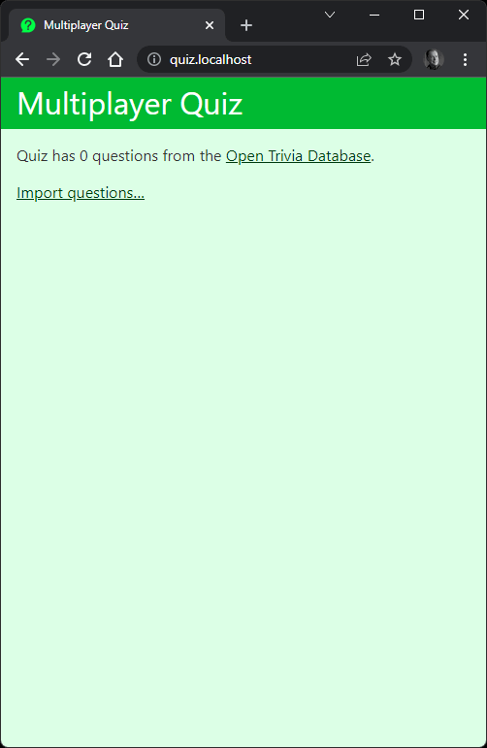
You must import some questions before starting a quiz, so click Import questions... to retrieve a selection from the Open Trivia Database—which is a free-to-use, user-contributed trivia question database. You’re then prompted to JOIN an existing game.
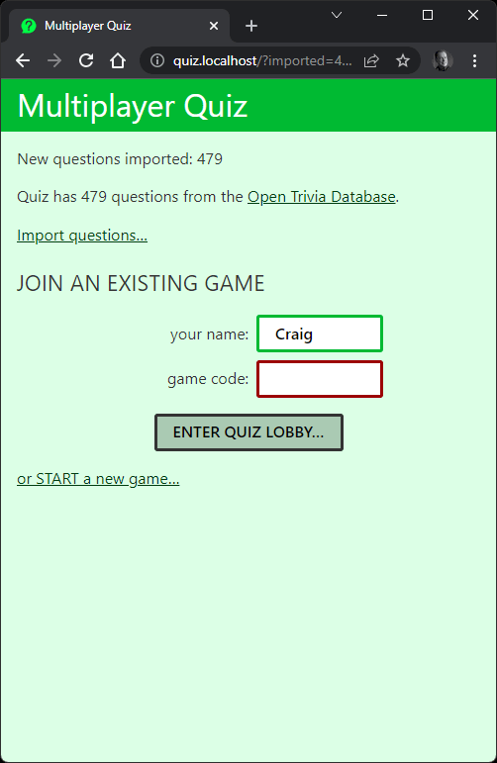
Or you can START a new game.
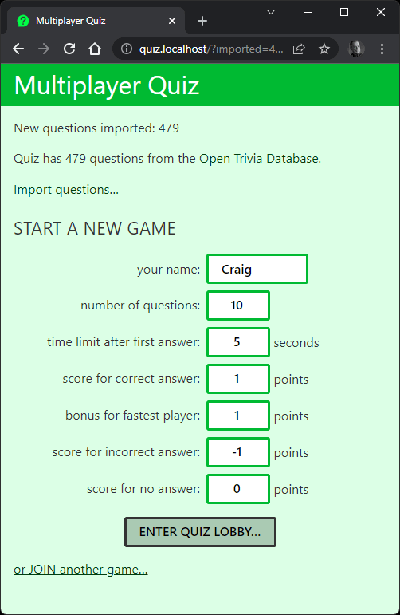
Any number of games can be running concurrently with different configurations, leading to different strategies based on time limits and whether you guess or decline to answer a question.
Once started, a game is assigned a unique code—such as a23, as shown below. Others can join this game by entering the code on the JOIN screen and entering the lobby.
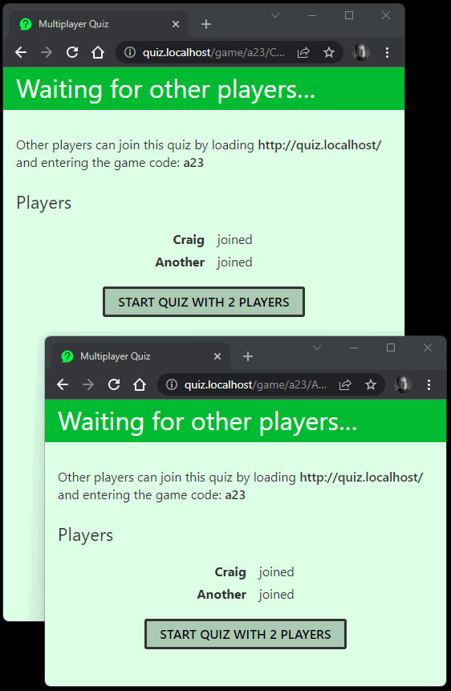
Any player can start the game, which progresses to the first question. A countdown timer starts after the first person has answered so everyone else must respond within the allotted time.
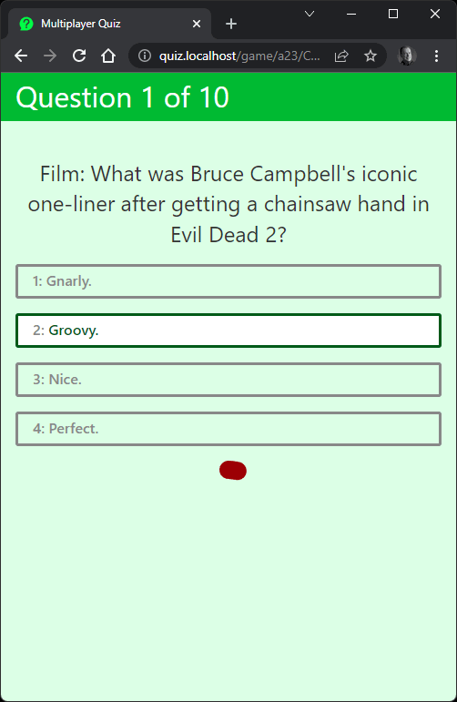
The score is displayed between questions and at the end of the game. A timer indicates that the next question is coming.
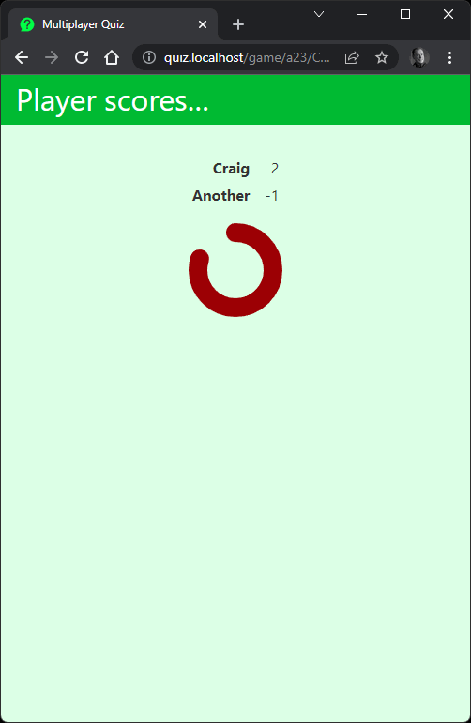
To shut down the quiz, navigate to the project root directory (nodequiz) in another terminal and run docker-compose down.
View the demonstration video to see the game running.

Summary
The quiz is developed in Node.js using a few third-party modules, vanilla ES6, and less than 60KB of code. It’s also scalable: you can add more Node.js HTTP and WebSocket servers as traffic increases. This leads to some considerable software engineering challenges, which we’ll discuss in the next chapter.

Chapter 14: Example Real-time Multiplayer Quiz: Architecture
This chapter describes the quiz application’s architecture and dependencies. It does get complex, so you can skip it if you’d rather concentrate on the Node.js and Express parts (Chapter 15) and WebSocket code (Chapter 16). That said, technical decisions described in those chapters are based on the architecture, so it’s good to understand the basics.

Why Develop Using Multiple Servers?
You could develop and run the quiz on a single server running a database and a single Node.js application that launches both the HTTP and WebSocket servers. It would be easier to develop, and it would support dozens of concurrent users. However, problems will arise as traffic grows. If your application crashes, it fails for everyone, and it’s difficult to scale the quiz:
Node.js applications run on a single CPU core.
Using a multi-core CPU has negligible benefit: Node.js will use one. You could use clustering (see Chapter 12), but it’s a considerable coding effort, and you’re still limited to the number of physical CPUs.
You can’t launch multiple application instances.
A process manager such as PM2 can launch multiple isolated instances of your application on different domains and/or HTTP ports. Two players wanting to join the same quiz would have to ensure they’re connected to the same instance.
The quiz therefore uses a multi-server architecture running at least seven individual stateless applications. New Node.js application instances can be started on the same server—or even different servers—and the they’ll start to handle incoming traffic. A server can fail and restart without noticeable downtime.
The only reliable way to develop this application is to use an appropriate architecture from the start.
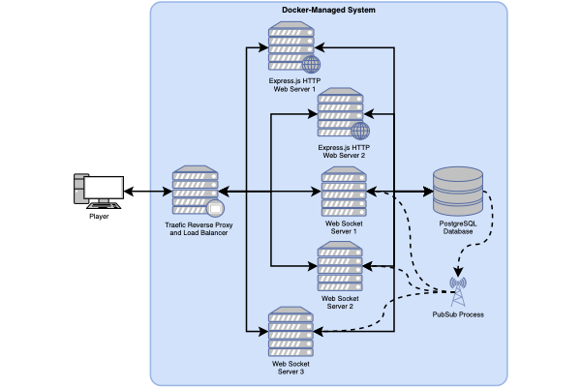
The video for this chapter and the following sections describe the setup.

1. One PostgreSQL Database Server
A single PostgreSQL database server implements a quiz database with the following data tables:
question: question text
answer: answer text with correct/incorrect flags
game: individual game instances and configurations
player: players connected to each game
pubsub: data shared to all WebSocket servers when specific events occur
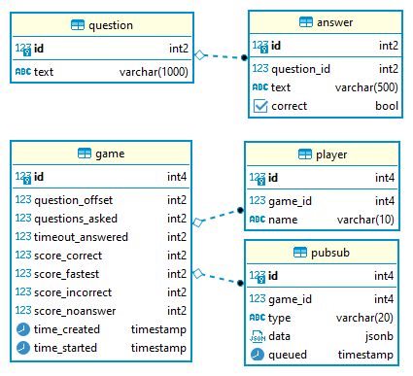
The database guarantees data integrity using constraints defined in the schema. For example:
it’s impossible to add two questions with the same text
changing the id of a question automatically updates the question_id for associated answer records
deleting a game record automatically deletes player and pubsub records associated with that game
PostgreSQL was chosen for the project because it offers a publisher–pubscriber (or pub–sub) service. It’s possible to trigger events when an application changes database data (publishes), which can notify all subscribers. This means we don’t require a dedicated pub–sub solution as another dependency.
The .env file in the project root configures the database connectivity credentials. The /db/001-quiz.sql file creates the table schema when PostgreSQL is first launched.
Note that Express and WebSocket applications use the same Node.js module defined at libshared/quizdb.js for all database activities.

2. Two Express HTTP Web Servers
An Express application handles:
importing questions from the Open Trivia Database
allowing a player to start a new game with specific defaults
allowing other players to join that game
It serves all the client-side HTML, CSS, and JavaScript files. Eventually, all users on the same game end up at the URL /game/<gameCode>/<playerName> where:
<gameCode> is a unique code for a specific quiz game
<playerName> is the player’s name
At this point, each user connects to a WebSocket server that controls further interaction—such as starting and answering questions.
The system starts two isolated instances of the web server. This offers improved performance and redundancy: if one web server fails, the other remains active while the first restarts. An incoming HTTP request from any user can be handled by either server.
The code is defined in the web directory. The .env configuration file and libshared directory also provide code shared across all components.

3. Three WebSocket Servers
A WebSocket server uses the ws library to handle:
the initial connection from a player joining a game
starting the game for all connected players
sending questions and answers to all players
responding to player choices and keeping score
disconnecting users when they leave or the game completes
The system starts three isolated instances of the WebSocket server. This offers improved performance and some redundancy. If a server fails, a game should continue for those connected to a different server.
When a player connects, they remain connected to the same WebSocket server throughout the duration of their session. However, two players on the same quiz game could connect to different WebSocket servers!
Games are kept in sync using the pub–sub functionality in PostgreSQL:
When an event occurs on one WebSocket server, such as the user answering a question, that server inserts a new record into the pubsub table.
PostgreSQL activates a trigger, which sends an event containing the new data to all WebSocket servers (the subscribers) running the same instance of a specific game.
Each WebSocket server (including the one that originally received the request) runs a handler that acts on the incoming event data.
The code is defined in the ws directory. The .env configuration file and libshared directory also provide code shared across all components.

4. One Traefic Load Balancer
Traefic is a reverse proxy and load balancer that directs all incoming HTTP and WebSocket requests to the appropriate (and least-busy) server.
When the application is running, the Traefic dashboard can be accessed and monitored at http://localhost:8080/.

5. Adminer Database Client
An (optional) Adminer database client is launched in development mode so you can examine PostgreSQL table data. Access it at http://adminer.localhost/ with the following credentials:
System: PostgreSQL
Server: dbserver (or host.docker.internal or your PC’s IP address)
Username: quizuser
Password: quizpass
Database: quiz
If you’d rather use your preferred client application to access the database, enter localhost as the Server name. Popular options including Beekeeper Studio, DBeaver, and Postbird should be compatible.

Docker Development Environment
Installing, configuring, and launching all seven applications (eight with Adminer) on a single server wouldn’t leave much time for development! Fortunately, the whole environment can be managed with Docker so it starts in a few seconds and still supports live Node.js restarts using nodemon.
For this reason, Docker is the only software dependency you need to install. Even the Node.js runtime is managed by Docker.
A full Docker tutorial is beyond the scope of this book, but the web and ws directories have Dockerfile configurations (web.Dockerfile and ws.Dockerfile), which tell Docker how to build and run the Express and WebSocket applications from a lightweight Node.js 16 Alpine Linux base.
Both create a Docker image. You can think of it like a disk image containing all the files, libraries, and executables required to run an application.
You can start any number of Docker image instances. A running instance is known as a container. Think of it as an isolated Linux Virtual Machine that’s running a single executable such as a database or Node.js application.
Launching a container requires a single docker run command. Fortunately, Docker Compose can manage and run all containers using a development environment configuration defined in docker-compose.yml. This does the following:
Declares all containers, replicas, and restart policies.
Defines all environment variables from the .env file.
Attaches disk storage volumes so there’s no need to re-initialize the database on every launch. It also mounts the libshared modules directory in both the web and ws projects.
Overrides some Dockerfile settings to use nodemon and launch Node.js debugging servers.
Connects all containers to the same internal Docker network.
Configures the Traefic load balancer.
Start the whole environment in development mode from the project’s root directory:
docker-compose up
The terminal shows a live activity log and any errors. nodemon restarts the web and ws applications whenever a JavaScript file is changed.
To gracefully shut down all applications, run the following command in another terminal from the project root:
docker-compose down

Docker Production Environment
docker-compose-production.yml defines production-level settings, so the quiz application can be run on a live server. The configuration is simpler, because there’s no need to override Dockerfile settings or launch Adminer.
Start the application in production mode with:
docker-compose -f ./docker-compose-production.yml up
Is Docker Compose Suited to Production?
Probably not. It’s not efficient to run PostgreSQL in a container, and there are better options such as Docker Swarm and Kubernetes to manage containers across multiple servers. But that’s beyond the scope of this and most Docker books!

Summary
Setting up a development environment is complex, but the choices you make at the start can affect the long-term success of your project. We’re now in a good position to create a (mostly) stateless application, starting with the Express server in the next chapter.

Chapter 15: Example Real-time Multiplayer Quiz: Express Code
The Express part of the quiz application:
imports questions from the Open Trivia Database
allows a player to create and start a new game with specific defaults
allows other players to join that game
It serves all the client-side HTML, CSS, and JavaScript files. Eventually, users on the same game end up at the URL /game/<gameCode>/<playerName>, where the WebSocket server (see Chapter 16) takes over and controls the gameplay.
Docker starts two isolated HTTP servers and a single request could be directed to either by the Traefic load balancer. Even two requests from the same user on the same page—such as a CSS and JavaScript file—could be delivered by different servers. This is rarely an issue, because the web is stateless by default: the application avoids storing state on one server that wouldn’t be available on the other.
Before we delve into the Express code, we’ll take a look at the database code.

Database Library
PostgreSQL database connectivity is handled by the Node.js pg library (see the documentation). This is loaded in the libshared/quizdb.js module, which provides a selection of functions to INSERT, UPDATE, SELECT, and DELETE records in the quiz database. The same module is used by both the web and ws servers.
The code initially imports the pg library and defines integer type parsers. By default, pg returns all record fields as strings, so a parser can convert it to the correct type:
import pg from 'pg';
// data type parsers
pg.types.setTypeParser(pg.types.builtins.INT2, v => parseInt(v, 10));
pg.types.setTypeParser(pg.types.builtins.INT4, v => parseInt(v, 10));
pg.types.setTypeParser(pg.types.builtins.INT8, v => parseFloat(v));
The code then defines a “connection pool” using the environment variable defaults:
const pool = new pg.Pool({
host: process.env.POSTGRES_SERVER,
port: process.env.POSTGRES_PORT,
database: process.env.POSTGRES_DB,
user: process.env.POSTGRES_QUIZUSER,
password: process.env.POSTGRES_QUIZPASS
});
A pool provides a reusable set of database connection clients you can check out, use, release, and reuse. This has benefits including:
There’s no initial handshake delay when a client is reused.
Each client is a separate connection to the database. Unlike a single connection, they can make simultaneous requests.
Here’s a basic parameterized SQL query example that returns all records from the question table with an id between 1 and 10 using one of the pool connections:
// DB connection
const client = await pool.connect();
try {
// fetch all questions with ids between 1 and 10
const result = await client.query(
'SELECT * FROM question WHERE id >= $1 AND id <= $2;',
[1, 10]
);
}
catch(err) {
console.log(err);
}
finally {
// release client
client.release();
}
The SQL SELECT string references $1 and $2, which are substituted with values in the first and second elements in the array. An array of row objects is returned when the query executes successfully.
Creating individual SQL commands can be cumbersome, and it’s easy to miss or transpose array parameters. The libshared/quizdb.js module has private dbSelect(), dbInsert(), dbUpdate(), and dbDelete() functions, which make development easier. For example, the public playerCreate() function is used when adding a new player record for a specific game:
// create a new player
export async function playerCreate( game_id, name ) {
return await dbInsert({
table: 'player',
values: { game_id, name },
return: 'id'
});
}
This calls the private dbInsert() function with a table name, a values object containing name/value pairs, and a return to fetch the id of the added record. The dbInsert() function returns the added id or false when an error occurs:
// database INSERT
// pass object: { table: <tablename>, values: <{ n1: v1,... }>, return: <field> }
async function dbInsert(ins) {
const
ret = ins.return ? ` RETURNING ${ ins.return }` : '',
key = Object.keys( ins.values ),
sym = key.map( (v,i) => `$${i + 1}` ),
sql = `INSERT INTO ${ ins.table } (${ key.join() }) VALUES(${ sym.join() })
➥${ ret };`,
client = ins.client || await pool.connect();
let success = false;
try {
// run insert
const i = await client.query(sql, Object.values( ins.values ));
// successful?
success = i.rowCount === 1;
// return value?
if (success && ins.return) {
success = i.rows[0][ ins.return ];
}
}
catch(err) {
}
finally {
if (!ins.client) client.release();
}
return success;
}
The const values at the top are responsible for creating the SQL string:
INSERT INTO player (game_id, name) VALUES ($1, $2) RETURNING id;
There are four things to note here:
key defines an array of property names extracted from the values object.
sym defines an array of $1 to $N strings, which match the number of items in the key array.
The property values from values are passed to the SQL query using Object.values( ins.values ).
The calling function can pass its own pool.connect() object. This is necessary when it’s running a series of updates in a database transaction.
The private dbUpdate() method is similar, although it also receives a where object with name/value pairs to create an SQL string, such as:
UPDATE game SET time_started=$1 WHERE game_id=$2;
The function ensures the names and values resolve correctly:
// database UPDATE
// pass object: { table: <tablename>, values: <{ n1: v1,... }>,
// where: <{ n1: v1,... }> }
async function dbUpdate(upd) {
const
sym = [...Object.values( upd.values ), ...Object.values( upd.where )],
vkey = Object.keys( upd.values ),
val = vkey.map( (k, i) => `${ k }=$${ i + 1 }` ),
ckey = Object.keys( upd.where ),
cond = ckey.map( (k, i) => `${ k }=$${ i + val.length + 1 }` ),
sql = `UPDATE ${ upd.table } SET ${ val.join() } WHERE ${ cond.join() };`,
client = upd.client || await pool.connect();
let updated = 0;
try {
// run update
const u = await client.query(sql, sym);
// successful?
updated = u.rowCount;
}
catch(err) {
}
finally {
if (!upd.client) client.release();
}
return updated;
}
Record deletion SQL is simpler. For example:
DELETE FROM game WHERE id=$1;
Therefore, so is the dbDelete() function:
// database delete
// pass object: { table: <tablename>, where: <{ n1: v1,... }> }
// logical AND is used for all where name/value pairs
async function dbDelete(del) {
const
key = Object.keys( del.values ).map((v, i) => `${ v }=$${ i+1 }`),
sql = `DELETE FROM ${ del.table } WHERE ${ key.join(' AND ') };`,
client = del.client || await pool.connect();
let deleted = false;
try {
// run delete
const d = await client.query(sql, Object.values( del.values ));
deleted = d.rowCount;
}
catch(err) {
}
finally {
if (!del.client) client.release();
}
return deleted;
}
Finally, dbSelect() is the simplest function of all, since you must specify your own sql string and array of arguments:
// database SELECT
// pass SQL string and array of parameters
async function dbSelect(sql, arg = []) {
const client = await pool.connect();
try {
const result = await client.query(sql, arg);
return result && result.rows;
}
catch(err) {
console.log(err);
}
finally {
client.release();
}
}
The reason is that SQL SELECT queries can be varied and complex. Some database libraries provide object–relational mapping (ORM) methods to build SQL query strings, but this would have been overkill for this project!

Question Database Initialization
Data is downloaded from the Open Trivia Database—a free-to-use repository of user-contributed questions and answers with a REST API. Questions and their associated answers are stored in the question and answer database tables. This action can be initiated by a user when the quiz home page is accessed for the first time.

Initializing Data on Application Start?
The application could initialize the questions when the web server starts. However, any number of application instances can be launched and each would attempt to load questions. Making it into a user request ensures only one server will load questions at a time.
The .env file defines environment variables—including database credentials and QUIZ_QUESTIONS_MAX=500—to limit the number of imported questions. The web/index.js entry script loads modules and configures the Express server:
// Express
import express from 'express';
import compression from 'compression';
// modules
import { questionCount, gameCreate, gameFetch } from './libshared/quizdb.js';
import { questionsImport } from './lib/questionsimport.js';
import * as libId from './libshared/libid.js';
// configuration
const cfg = {
dev: ((process.env.NODE_ENV).trim().toLowerCase() !== 'production'),
port: process.env.NODE_PORT || 8000,
domain: process.env.QUIZ_WEB_DOMAIN,
wsDomain: process.env.QUIZ_WS_DOMAIN,
title: process.env.QUIZ_TITLE,
questionsMax: parseInt(process.env.QUIZ_QUESTIONS_MAX, 10)
};
// Express initiation
const app = express();
// use EJS templates
app.set('view engine', 'ejs');
app.set('views', 'views');
// GZIP
app.use(compression());
// body parsing
app.use(express.urlencoded({ extended: true }));
By default, the home page / route fetches the number of questions in the database using the questionCount() function in libshared/quizdb.js (see the else block):
// home page
app.get('/', async (req, res) => {
if (typeof req.query.import !== 'undefined') {
// import new questions and redirect back
res.redirect(`/?imported=${ await questionsImport() }`);
}
else {
// home page template
res.render('home', {
title: cfg.title,
questions: await questionCount(),
questionsMax: cfg.questionsMax,
imported: req.query?.imported || null
});
}
});
This count and questionsMax is passed to an HTML view at web/views/home.ejs. It shows a link to the home page with an /?import query string when further questions can be loaded:
<% if (questions < questionsMax) { %>
<p><a href="/?import">Import questions&hellip;</a></p>
<% } %>
When clicked, it reloads the home page with an ?import query string, which triggers the if block above. This executes questionsImport() in web/lib/questionsimport.js and returns the number of questions imported.
The code then redirects back to the home page with an ?imported=N query string, which shows the number of imported questions. Assuming there’s at least one question in the database, the web/views/home.ejs view displays the START and JOIN game options:
<% if (questions) { %>
<section class="tabs">
<article id="new">
<h2>START A NEW GAME</h2>
<!-- more code -->
<% } %>

Why Does the Number of Imported Questions Vary?
The Open Trivia Database API returns a random set of questions. Some may be duplicates of previously imported questions, but the database’s question.text field has a UNIQUE flag to ensure a question can only be added once.
The questionsImport() function is a little long, so examine web/lib/questionsimport.js in an editor. It uses a series of promise-based functions to make up to ten concurrent calls to the Open Trivia API at https://opentdb.com/api.php with Promise.allSettled(). Data is fetched using the node-fetch module.

Native Node.js Fetch()
Deno usefully implements the browser Fetch API, so you can use it in a server application. A similar Fetch API arrived in Node.js version 18, but it’s experimental. A third-party module is used here for backward compatibility.
The Open Trivia API returns JSON data such as:
{
"response_code": 0,
"results": [
{
"category": "History",
"type": "multiple",
"difficulty": "medium",
"question": "The crown of the Empire State Building was originally built
➥for what purpose?",
"correct_answer": "Airship Dock",
"incorrect_answers": [
"Lightning Rod",
"Antennae",
"Flag Pole"
]
},
{
"category": "Entertainment: Cartoon & Animations",
"type": "multiple",
"difficulty": "easy",
"question": "Which of these is NOT a Disney cartoon character?",
"correct_answer": "Daffy Duck",
"incorrect_answers": [
"Donald Duck",
"Daisy Duck",
"Scrooge McDuck"
]
},
{
"category": "History",
"type": "multiple",
"difficulty": "hard",
"question": "What was the original name of New York City?",
"correct_answer": "New Amsterdam",
"incorrect_answers": [
"New London",
"New Paris",
"New Rome"
]
}
]
}
This is converted to JavaScript values, formatted, and each question/answer set is added to the database using a call to the questionAdd(question, answer) function in libshared/quizdb.js. Each question and answer set is inserted within a database transaction so that, if any SQL INSERT operation fails, they all fail:
// add a new question and answer set
export async function questionAdd(question, answer) {
const client = await pool.connect();
let commit = false;
try {
// new transaction
await client.query('BEGIN');
// add question
const qId = await dbInsert({
client,
table: 'question',
values: {
text: question
},
return: 'id'
})
if (qId) {
// insert answers in sequence
let inserted = 0;
for (let item of answer) {
const a = await dbInsert({
client,
table: 'answer',
values: {
question_id: qId,
text: item.text,
correct: item.correct
}
});
if (a) inserted++;
}
// answers added?
commit = inserted === answer.length;
}
}
catch(err) {
}
finally {
// commit or rollback transaction
if (commit) {
await client.query('COMMIT');
}
else {
await client.query('ROLLBACK');
}
client.release();
}
return commit;
}

Sequential Database INSERTs
The code could run multiple database INSERT commands in a short period. This is faster, but question and answer IDs would appear in a seemingly random order in the database tables. For example, the question record with an id of 1 could have associated answer records with the ids 17, 22, 52, and 54.
This isn’t a problem for an indexed database, but it can make the tables more difficult to read during development! For this reason, questions and answers are inserted sequentially, one at a time. It also means that ordering by answer.id returns an alphabetically ordered list without requiring an additional answer.order field.

Starting a New Game
The web/views/home.ejs template defines an HTML form to configure and start new games:
<form action="/newgame/" method="post">
<div class="formgrid">
<label for="namenew">your name:</label>
<div><input type="text" name="name" id="namenew" value="" minlength="1"
maxlength="10" pattern="[A-Za-z0-9]{1,10}" required /></div>
<label for="questions_asked">number of questions:</label>
<div><input type="number" name="questions_asked" id="questions_asked"
value="10" min="1" max="50" required /></div>
<label for="timeout_answered">time limit after first answer:</label>
<div><input type="number" name="timeout_answered" id="timeout_answered"
value="5" min="5" max="60" required /> seconds</div>
<label for="score_correct">score for correct answer:</label>
<div><input type="number" name="score_correct" id="score_correct" value="1"
min="-100" max="100" required /> points</div>
<label for="score_fastest">bonus for fastest player:</label>
<div><input type="number" name="score_fastest" id="score_fastest" value="1"
min="-100" max="100" required /> points</div>
<label for="score_incorrect">score for incorrect answer:</label>
<div><input type="number" name="score_incorrect" id="score_incorrect"
value="-1" min="-100" max="100" required /> points</div>
<label for="score_noanswer">score for no answer:</label>
<div><input type="number" name="score_noanswer" id="score_noanswer" value="0"
min="-100" max="100" required /> points</div>
</div>
<button>ENTER QUIZ LOBBY&hellip;</button>
</form>
The form HTTP POSTs data to the /newgame/ URL, which is handled by the route defined in web/index.js:
// create a new game
app.post('/newgame', async (req, res) => {
const
gameId = await(gameCreate( req.body )),
playerName = libId.clean( req.body.name );
if (gameId === null) {
// game creation error?
res.status(500).render('error', {
title: cfg.title,
error: 'Game could not be started?'
});
}
else {
// redirect to game page using slug and user name
res.redirect(`/game/${ libId.encode( gameId ) }/${ playerName }`);
}
});
The code calls the gameCreate() function in libshared/quizdb.js and passes the req.body object containing the form data. This inserts a new record into the database game table and returns its id—by calling the private dbInsert() function (shown above in the “Database Library” section):
// create a new game
export async function gameCreate(data) {
const qCount = await questionCount();
return await dbInsert({
table: 'game',
values: {
question_offset : Math.floor( Math.random() * qCount ), // random start q
questions_asked : clamp(1, data.questions_asked, 50),
timeout_answered: clamp(5, data.timeout_answered, 60),
score_correct : clamp(-100, data.score_correct, 100),
score_fastest : clamp(-100, data.score_fastest, 100),
score_incorrect : clamp(-100, data.score_incorrect, 100),
score_noanswer : clamp(-100, data.score_noanswer, 100)
},
return: 'id'
});
}
Note the following:
Each game record has a unique id integer which identifies the game.
The number can become long and is easy to guess. If you’re currently playing game 99, you could try joining game 100 or 101 and have a high success rate.
For this reason, game IDs are encrypted into a string using encode() and decode() in libshared/libid.js. This string also avoids using similar-looking characters such as zero and uppercase “o” or one and uppercase “i”.
A player can then tell others to join game a23 rather than game 1.
clamp() is a private function that ensures a value is between a lower and upper limit:
// return integer between low and high values
function clamp(min = 0, value = 0, max = 0) {
return Math.max(min, Math.min(parseInt(value || '0', 10) || 0,
➥max));
}
game.question_offset defines the starting question. It’s set to a random number between 0 and the number of database questions.
game.time_created is automatically set to the date/time the game was created by the database (time_created timestamp NOT NULL DEFAULT NOW()).
game.time_started is initially NULL, but is eventually set to the date/time the game is started. This value is checked when you join a game to ensure players can’t jump in mid-way through a quiz.
Assuming a game record is created, the browser redirects the user to the URL /game/<gameCode>/<playerName>—such as /game/a23/Craig. A failure shows a message using the view at web/views/error.ejs.

Joining a Game
The web/views/home.ejs template also defines an HTML form for joining a game that HTTP POSTs the user’s name and game code to the /joingame/ route:
<form action="/joingame/" method="post">
<div class="formgrid">
<label for="namejoin">your name:</label>
<div><input type="text" name="name" id="namejoin" value="" minlength="1"
maxlength="10" pattern="[A-Za-z0-9]{1,10}" required /></div>
<label for="slug">game code:</label>
<div><input type="text" name="slug" id="slug" value="" minlength="3"
maxlength="8" autocomplete="off" required /></div>
</div>
<button>ENTER QUIZ LOBBY&hellip;</button>
</form>
The form HTTP POSTs data to the /joingame/ URL, which is handled by the route defined in web/index.js:
// join an existing game
app.post('/joingame', (req, res) => {
// redirect to game page using slug and user name
res.redirect(`/game/${ libId.clean( req.body.slug ).toLowerCase() || 'x' }/${
➥ libId.clean( req.body.name ) }`);
});
This receives the data, cleans the strings, and redirects the user to the URL /game/<gameCode>/<playerName>—such as /game/a23/Craig.

Quiz Page
All players starting or joining a game reach the URL /game/<gameCode>/<playerName>, where:
<gameCode> is the unique code for a specific quiz game
<playerName> is a player’s name
This is handled by the Express routing function at web/index.js:
// game page
app.get('/game/:slug/:name', async (req, res) => {
// get game ID and player name
const
slug = req.params.slug,
gameId = libId.decode( slug ),
game = gameId === null ? null : await gameFetch( gameId ),
gameValid = game && gameId === game.id,
playerName = libId.clean( req.params.name ) || 'Player';
if (gameValid && game.time_started === null) {
// game open for players
res.render('game', {
domain: cfg.domain,
wsDomain: cfg.wsDomain,
slug,
title: cfg.title,
game,
playerName
});
}
else {
// game has been started or is invalid
const url = `${ cfg.domain }/game/${ slug }`;
res.status(gameValid ? 403 : 404).render('error', {
title: cfg.title,
error: gameValid ? `You were too late to join the game at ${ url }` : `The
➥game at ${ url } is not valid. Did you enter it correctly?`
});
}
});
The function decodes the game code to an integer and fetches the game information from the database by calling gameFetch() in libshared/quizdb.js:
// fetch game data
export async function gameFetch( gameId ) {
const game = await dbSelect('SELECT * FROM game WHERE id=$1;', [ gameId ]);
return game?.[0];
}
Assuming the game ID is valid and the game’s time_started value is NULL, the code renders the template at web/views/game.ejs. Configuration variables are passed to a client-side script in the template:
<script type="module">
window.cfg = {
wsDomain: '<%= wsDomain %>',
gameId: <%= game.id %>,
playerName: '<%= playerName %>'
};
</script>
<script type="module" src="/js/main.js"></script>
This configures values used in the client-side script at web/static/js/main.js.
When necessary, errors are shown using the template at web/views/error.ejs:
An invalid game ID returns an HTTP 404 Not found error.
A started game (where time_started is not NULL) returns an HTTP 403 Forbidden error.

Summary
The Express part of the application illustrates how URL routes can be resolved to trigger server-side functionality.
At this point, all players joining a game have loaded the web/views/game.ejs template. All further quiz game processing is now handled using client-side JavaScript and WebSocket server messaging (see Chapter 16). Express has completed its job!

Chapter 16: Example Real-time Multiplayer Quiz: WebSocket Code
Chapter 11 introduced WebSockets, which establish a two-way interactive communication channel between a client browser and server.
Our quiz application starts three WebSocket servers, and there’s no limit to the number of servers that could be started. However:
A user will connect to a single server and remain connected to it throughout their session.
Two users on the same game could be connected to different WebSocket servers.
Messages sent to and from the WebSocket server are typically simple strings, but we have the added challenge of coordinating messages across all servers!

Initiating a WebSocket Connection
The client-side JavaScript at web/static/js/main.js initiates a connection to the WebSocket server’s address and sends a gameInit message when it’s established. Note that window.cfg.wsDomain, window.cfg.gameId, and window.cfg.playerName are values passed by Express to the web/views/game.ejs template:
// client-side code
// handle WebSocket communication
const ws = new WebSocket( window.cfg.wsDomain );
// connect to server and send game ID and initial player name
ws.addEventListener('open', () => {
sendMessage( 'gameInit', { gameId: window.cfg.gameId, playerName: window.cfg.
➥playerName } );
});
// send message
function sendMessage(type, data = null) {
ws.send( `${ type }:${ JSON.stringify( data ) }` );
}
An event handler function can now receive incoming messages from the WebSocket server:
// receive message
ws.addEventListener('message', e => {
// process...
});
The server-side script at ws/index.js initializes a ws library WebSocketServer object and listens for new client connections and incoming messages:
// server
ws = new WebSocketServer({ port: cfg.wsPort, perMessageDeflate: false });
// client connected
ws.on('connection', (socket, req) => {
console.log(`connection from ${ req.socket.remoteAddress }`);
// message received from client
socket.on('message', async (msg) => {
// process...
});
}

WebSocket Message Format
The quiz application uses the same format for all WebSocket messages sent by the client or server. An identifying type string is followed by a colon character and payload data in JSON format:
messageType:{ jsondata }
For example, the gameInit message shown above passes the game ID and player name to the server shortly after initiating the WebSocket connection:
gameInit:{ "gameId": "a23", "playerName": "Craig" }
When receiving a message from a player, the WebSocket server may perform some actions immediately. However, most messages are forwarded to all WebSocket servers where users are connected to the same game. Each WebSocket server (including the one that originally received the message) then process the message and, in most cases, transmits it back to its connected clients where DOM and game state updates occur.
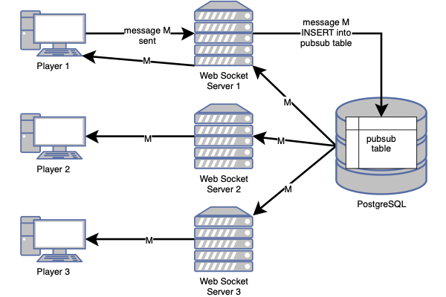

PostgreSQL Pub–sub
Messages are broadcast to all WebSocket servers using PostgreSQL’s pub–sub functionality. The pubsub table has the following fields:
id: an auto-incrementing integer
game_id: the (non-encoded) game ID integer (a foreign key for the game.id)
type: the type of message
data: the message payload in fast JSONB binary format
queued: the current timestamp
When a single WebSocket server wants to share an event, it inserts a new record into the pubsub table using a broadcast() function in libshared/quizdb.js:
// broadcast an event
export async function broadcast( game_id, type, data ) {
return await dbInsert({
table: 'pubsub',
values: { game_id, type, data },
return: 'id'
});
}
A database trigger named pubsub_insert_trigger calls a sub_insert_notify() function whenever a record is inserted into the pubsub table. This executes a PostgreSQL pg_notify() command, which sends the record to all subscribers:
CREATE OR REPLACE FUNCTION pubsub_insert_notify()
RETURNS trigger AS
$BODY$
BEGIN
PERFORM pg_notify('pubsub_insert', row_to_json(NEW)::text);
RETURN NULL;
END;
$BODY$
LANGUAGE plpgsql VOLATILE
COST 100;
CREATE TRIGGER "pubsub_insert_trigger"
AFTER INSERT ON public.pubsub FOR EACH ROW
EXECUTE FUNCTION pubsub_insert_notify();
A PubSub object, which extends the Node.js EventEmitter class, is defined in libshared/quizdb.js:
// pubsub event emitter
class PubSub extends EventEmitter {
constructor(delay) {
super();
}
async listen() {
if (this.listening) return;
this.listening = true;
const client = await pool.connect();
client.on('notification', event => {
try {
const payload = JSON.parse( event.payload );
if ( payload ) {
this.emit(
`event:${ payload.game_id }`,
{
gameId: payload.game_id,
type: payload.type,
data: payload.data
}
);
}
}
catch (e) {
}
});
client.query('LISTEN pubsub_insert;');
}
}
A single object instance named pubsub is instantiated and exported. The listen() method is called, which connects to the database and defines a handler function when a notification event occurs. This emits a Node.js event named event:<gameId> with a payload object containing the gameId, type string, and JSON-parsed data object:
export const pubsub = new PubSub();
await pubsub.listen();
Game instances on each server then subscribe to event:<gameId> event using the pubsub.on method:
import * as db from '../libshared/quizdb.js';
// abbreviated code
class Game {
#handlerFunction = async e => await this.#eventHandler(e);
// initialize game
async create( gameId ) {
this.gameId = gameId;
// monitor incoming events
db.pubsub.on(`event:${ this.gameId }`, this.#handlerFunction);
}
}
The private #eventHandler() function is called when an event occurs. It receives the incoming data and can react accordingly:
// incoming event sent to all game servers
async #eventHandler({ gameId, type, data }) {
console.log('Shared server event', type, data);
// ...
// handle server event (on all servers)
switch (type) {
//...
}
}

Game Logic
This section provides an overview of the game logic as it progresses from joining, to starting, playing, and finishing a quiz. Note the following:
The client-side JavaScript at web/static/js/main.js sends messages from a client to the WebSocket server when an event occurs—such as answering a question.
The WebSocket server-side JavaScript at ws/index.js receives a message from a client and executes appropriate functionality. In most cases, messages are broadcast to all WebSocket servers running the same game. They receive the data and transmit it back to all connected clients on that game.
The client-side JavaScript at web/static/js/main.js receives incoming messages and updates the DOM or game state accordingly.
The HTML <body> class is set to the incoming message type. This can trigger CSS to show or hide specific elements according to the game state.
In some cases, an action occurring on a client does nothing until it has been received back from the server after it has been transmitted to all WebSocket servers and their connected clients!

Joining a Game
When a player accesses a valid game at the URL /game/<gameCode>/<playerName>—such as /game/a23/Craig—the client establishes a WebSocket connection with a single server and sends a gameInit message. For example:
gameInit:{ "gameId": "a23", "playerName": "Craig" }
This triggers the message event handler function on a WebSocket Server, which initiates the game (the if block):
// message received from client
socket.on('message', async (msg) => {
// parse message
msg = parseMessage(msg);
// initialize player and game
if (!player && msg.type === 'gameInit' && msg.data) {
player = new Player();
const pId = await player.create( msg.data.gameId, msg.data.playerName,
➥socket );
if (!pId) player = null;
}
else {
// pass message to game object
msg.data = msg.data || {};
msg.data.playerId = player.id;
await player.game.clientMessage( msg );
}
});
A new Player object is created using the class defined in ws/lib/player.js. Its create( gameId, playerName, socket ) method is run:
// initialize new player
async create( gameId, playerName, socket ) {
// player properties
this.name = playerName;
this.#socket = socket;
// initialize game
this.gameId = gameId;
this.game = await GameFactory( gameId );
if ( !this.game ) return null;
// send existing players to new player
this.send('player', this.game.playerAll())
// create this player
this.id = await db.playerCreate( this.gameId, playerName );
if ( !this.id ) return null;
// add player to game
this.game.playerAdd( this );
return this.id;
}

Why Run a create() Method?
The Player class has a constructor function that runs when an instance of an object is created. Unfortunately, constructor functions can’t be asynchronous, so it’s necessary to run another method to handle initialization.
Player objects keep track of the user’s ID, game ID, name, score, and the WebSocket connection is used by the send() method to send a message to an individual player:
// send message to player
send( type = 'ws', data = {} ) {
if (this.#socket) {
this.#socket.send( `${ type }:${ JSON.stringify(data) }` );
}
}
Player create() passes the gameId to a GameFactory() function defined in ws/lib/game.js:
// active games
const gameActive = new Map();
// create and manage active game objects
export async function GameFactory( gameId ) {
// game instance not exists?
if ( !gameActive.has( gameId ) ) {
// create new game instance
const game = new Game();
if ( await game.create( gameId ) ) {
gameActive.set( gameId, game );
}
console.log(`Game ${ gameId } added - active games on this server: ${
➥gameActive.size }`);
}
return gameActive.get( gameId ) || null;
}
Game objects keep track of the game state and connected players. They’re responsible for receiving a message from a single client, broadcasting that message to all WebSocket servers, and receiving the message back again, and sending it to all connected clients on the same game.
The GameFactory() function creates and returns a new Game object when the first player joins a specific game on each WebSocket server. This object is referenced in a gameActive JavaScript Map using the game ID integer as the reference. All subsequent players to join the same game on the same WebSocket server receive the same Game object.
Next, the joining client is sent a player message with an array of all existing player IDs and names (from the Game object’s playerAll() method). When received, an init() function in the client-side web/static/js/player.js script adds each player to an HTML <table> and stores DOM references in a Map named player:
// CLIENT-SIDE CODE
const
pList = document.getElementById('player'),
pNum = document.getElementById('pnum'),
player = new Map();
// add new players
export function init(pAll, showScore = false) {
clear(pList);
player.clear();
pAll.forEach(p => add(p, showScore));
}
// add a new player
export function add( p, showScore = false ) {
if (!p.id || player.has(p.id)) return;
const item = document.createElement('tr');
(item.appendChild(document.createElement('th'))).textContent = p.name;
const info = item.appendChild(document.createElement('td'));
info.textContent = showScore ? p.score || 0 : 'joined';
const pObj = {
name: p.name,
node: pList.appendChild(item)
};
pObj.info = pObj.node.getElementsByTagName('td')[0];
player.set(p.id, pObj);
pNum.textContent = player.size;
}
The player is now added to the player table in the database by calling the playerCreate() function in libshared/quizdb.js:
// create a new player
export async function playerCreate( game_id, name ) {
return await dbInsert({
table: 'player',
values: { game_id, name },
return: 'id'
});
}
Assuming the player can be inserted into the database, the Player object (this) is passed to the Game object’s playerAdd() method:
// add player to game
async playerAdd( player, broadcast = true ) {
// add player to this server
this.player.set( player.id, player );
// broadcast event
if (broadcast) {
await db.broadcast(
this.gameId,
'playerAdd',
{ id: player.id, game_id: this.gameId, name: player.name }
);
}
}
This broadcasts a playerAdd message with the new player’s ID, game ID, and name to all WebSocket servers. These send it to all connected clients on the same game (including the joining player). When received, the add() function in the client-side web/static/js/player.js script (shown above) adds the new player to the same HTML <table>.

Starting a Game
After joining, any player can hit the START QUIZ button. This sends a start message to one WebSocket server, which broadcasts it to all servers and back to all clients. Each client calls a start() function in the client-side web/static/js/player.js script that shows which player started the game and initializes a five-second countdown timer using the startTimer() function in web/static/js/timer.js:
// CLIENT-SIDE JAVASCRIPT
// started
export function start(pId) {
if (!player.has(pId)) return;
player.get(pId).info.textContent = 'started game';
startTimer();
}
The Game object on the WebSocket server (ws/lib/game.js) receives the start message and calls the private #questionNext() method:
// incoming client event
async clientMessage({ type, data }) {
console.log('Data from client', type, data);
// handle client event (on single server)
switch (type) {
case 'start':
// fetch first question
this.#state.current = type;
// no question found?
if (!await this.#questionNext( timerDefault )) {
await db.broadcast( this.gameId, 'gameover' );
};
break;
The #questionNext() method determines whether more questions can be asked, fetches the next question from the database, and broadcasts it using a questionactive message type to all WebSocket servers after a five-second delay:
// fetch and broadcast next question
async #questionNext( delay ) {
// can ask next question?
if (this.#state.question >= this.cfg.questions_asked) return;
// fetch next question and answer set
const qSet = await db.questionFetch( this.#state.question + this.cfg.
➥question_offset );
if (!qSet) return;
qSet.num = this.#state.question + 1;
this.#setTimer(async () => {
await db.broadcast( this.gameId, 'questionactive', qSet );
}, delay || 1);
return qSet.num;
}
The questionFetch() function defined in libshared/quizdb.js returns an object containing the question text and an array of answer objects where one has a correct property set to true:
// fetch next question and answer set
export async function questionFetch( qNum ) {
// fetch question
const
qCount = await questionCount(),
question = await dbSelect('SELECT * FROM question ORDER BY id LIMIT 1
➥OFFSET $1', [ qNum % qCount ]);
if (question.length !== 1) return null;
// fetch answers
const answer = await dbSelect('SELECT * FROM answer WHERE question_id=$1 ORDER
➥BY id;', [ question[0].id ]);
if (!answer.length) return null;
return {
text: question[0].text,
answer: answer.map( a => { return { text: a.text, correct: a.correct }})
};
}
Note that the PostgreSQL OFFSET clause fetches the next question according to the random question_offset defined for the current game.

Answering a Question
When each client receives the questionactive message it runs the show() function in the client-side web/static/js/question.js script to display the question and possible answer buttons:
// CLIENT-SIDE JAVASCRIPT
// show question
export function show( q ) {
currentQuestion = q;
currentQuestion.answered = null;
clear(question);
clear(answers);
answers.classList.remove( answeredClass );
qNum.textContent = q.num;
question.innerHTML = q.text;
currentQuestion.answerNode = [];
q.answer.forEach((ans, idx) => {
const button = document.createElement('button');
button.value = idx;
button.innerHTML = `<span>${ idx+1 }:</span> ${ ans }`;
currentQuestion.answerNode[idx] = answers.appendChild(button);
});
}
When the player answers a question—by clicking a button or pressing an associated number (1 to 4) on the keyboard—the questionAnswered() function in the client-side web/static/js/question.js script verifies it’s valid, highlights the button, and raises a custom event named answered:
// CLIENT-SIDE JAVASCRIPT
// answer event handlers
answers.addEventListener('click', questionAnswered);
window.addEventListener('keydown', questionAnswered);
// user answers a question
function questionAnswered( e ) {
// already answered?
if ( !currentQuestion || currentQuestion.answered !== null ) return;
let ans = null;
if (e.type == 'click') {
// button click
ans = e.target && e.target.nodeName === 'BUTTON' ? parseInt(e.target.value,
➥ 10) : null;
if (ans > currentQuestion.answer.length) ans = null;
}
else {
// keypress
ans = e.key >= '1' && e.key <= String(currentQuestion.answer.length) ?
➥parseInt(e.key, 10) - 1 : null;
}
if (ans === null) return;
// highlight answer
currentQuestion.answered = ans;
answers.classList.add( answeredClass );
currentQuestion.answerNode[ans].classList.add( answeredClass );
// raise custom event
document.dispatchEvent( new CustomEvent('answered', { detail: ans }) );
}
This triggers a handler function in the client-side web/static/js/main.js script, which sends a questionanswered message to the connected WebSocket server:
// CLIENT-SIDE JAVASCRIPT
// question answered event
document.addEventListener('answered', e => {
if (state.current === 'questionactive') sendMessage('questionanswered', {
➥answer: e.detail });
});
This triggers the Game object's clientMessage() function in ws/lib/game.js:
// incoming client event
async clientMessage({ type, data }) {
console.log('Data from client', type, data);
// handle client event (on single server)
switch (type) {
// ...
case 'questionanswered':
// player answers question
if (this.#state.current !== 'questionactive') return;
// calculate player score
const correct = this.#state.activeQuestion.answer[ data.answer ].correct;
data = {
playerId: data.playerId,
score: correct ? this.cfg.score_correct : this.cfg.score_incorrect,
fastest: correct && !this.#state.correctGiven
};
// fastest correct bonus?
if (data.fastest) data.score += this.cfg.score_fastest;
// first answer controls flow
if (!this.#state.playersAnswered) {
let timeout = 100;
// first response?
if (!this.#state.playersAnswered && this.player.size > 1) {
// send question timeout warning
timeout =this.cfg.timeout_answered * 1000;
await db.broadcast( this.gameId, 'questiontimeout', { timeout });
}
// complete question
if (timeout) {
this.#setTimer(async () => {
// broadcast correct answer
await db.broadcast( this.gameId, 'questioncomplete', {
correct: this.#state.activeQuestion.answer.findIndex(a => a.
➥correct)
});
// show scoreboard
this.#setTimer(async () => {
await db.broadcast( this.gameId, 'scoreboard' );
// next question or game over?
if (!(await this.#questionNext( timerDefault ))) {
await db.broadcast( this.gameId, 'gameover' );
};
});
}, timeout);
}
}
break;
}
// broadcast message to all servers
if (type) await db.broadcast( this.gameId, type, data );
}
It calculates the player’s score if they’re correct, incorrect, or the fastest to respond based on the game settings. This is broadcast to all servers, which update their player scores when they’re received by the #eventHandler() method (they aren’t broadcast to their clients):
// incoming event sent to all game servers
async #eventHandler({ gameId, type, data }) {
console.log('Shared server event', type, data);
if (gameId !== this.gameId || !type) return;
// handle server event (on all servers)
switch (type) {
// ...
// player answers question
case 'questionanswered':
if (this.#state.current !== 'questionactive') return;
const p = this.player.get( data.playerId );
if (p) {
p.scoreQuestion = data.score;
this.#state.correctGiven = data.fastest;
this.#state.playersAnswered++;
}
// ...
}
// send to all clients
if (type) this.#clientSend( type, data );
// clean up completed game
if (this.#state.current === 'gameover') {
db.pubsub.off(`event:${ this.gameId }`, this.#handlerFunction);
await gameComplete( this.gameId );
}
}
A chain of events then commences on the WebSocket server that received the first answer response:
It broadcasts a questiontimeout to all servers and clients. When received, each client starts a timer of game.timeout_answered seconds, which indicates how long users have to respond (see web/static/js/main.js):
// CLIENT-SIDE JAVASCRIPT
// receive message
ws.addEventListener('message', e => {
const { type, data } = parseMessage( e.data );
if (!type || !data) return;
console.log('Data from server:', type, data);
switch (type) {
case 'questiontimeout':
startTimer( data.timeout );
break;
An identical timer is started on the server. After it has elapsed, it broadcasts a questioncomplete message with the correct answer. On receipt, each client runs the correctAnswer() function in the client-side web/static/js/question.js script to highlight the appropriate button:
// CLIENT-SIDE JAVASCRIPT
// receive message
ws.addEventListener('message', e => {
const { type, data } = parseMessage( e.data );
if (!type || !data) return;
console.log('Data from server:', type, data);
switch (type) {
case 'questioncomplete':
question.correctAnswer( data.correct );
break;
After another five seconds have elapsed, the server broadcasts a scoreboard message to each server. When received, each server appends the calculated player total scores to the message and sends it to its connected clients in the Game #eventHandler() method (ws/lib/game.js):
// incoming event sent to all game servers
async #eventHandler({ gameId, type, data }) {
console.log('Shared server event', type, data);
if (gameId !== this.gameId || !type) return;
// handle server event (on all servers)
switch (type) {
// show scoreboard
case 'scoreboard':
if (this.#state.current !== 'questioncomplete') return;
this.#state.current = type;
this.player.forEach(p => p.scoreTotal += p.scoreQuestion);
data = this.playerAll();
break;
}
// send to all clients
if (type) this.#clientSend( type, data );
On receipt, each client executes the score() function in web/static/js/player.js to update the player totals. This regenerates the player table with the updated scores with the highest scoring player at the top:
// CLIENT-SIDE JAVASCRIPT
// update scores
export function score(pAll) {
init( pAll.sort((a, b) => b.score - a.score), true );
}
The server calls the Game object’s #questionNext() method to fetch the next question. This is sent as a new questionactive message after another five seconds, and the process restarts.
The method returns undefined when the number of questions reaches the game.questions_asked. When this occurs, the server broadcasts a gameover message to all servers, which is handled by the #eventHandler() method in (ws/lib/game.js):
// incoming event sent to all game servers
async #eventHandler({ gameId, type, data }) {
console.log('Shared server event', type, data);
if (gameId !== this.gameId || !type) return;
// handle server event (on all servers)
switch (type) {
// game over
case 'gameover':
this.#state.current = type;
data = {};
break;
}
// send to all clients
if (type) this.#clientSend( type, data );
// clean up completed game
if (this.#state.current === 'gameover') {
db.pubsub.off(`event:${ this.gameId }`, this.#handlerFunction);
await gameComplete( this.gameId );
}
}
Each server runs a gameComplete() function to delete the Game object and the associated record in the database game table (only the first will succeed). This causes a cascade of deletions from the player and pubsub tables for that game:
// remove active game
async function gameComplete( gameId ) {
if ( !gameActive.has( gameId ) ) return;
await db.gameRemove( gameId );
gameActive.delete( gameId );
console.log(`Game ${ gameId } removed - active games on this server:
➥${ gameActive.size }`);
}
The same gameover message is sent to all connected clients. When received, each client shows the Game over messages with links to start or join a new game.

Leaving a Game
If the user closes or refreshes their browser, a WebSocket close event handler is triggered on the server in ws/index.js:
// client connection closed
socket.on('close', async () => {
// remove player
if (player) {
await player.game.playerRemove( player );
}
console.log(`disconnection from ${ req.socket.remoteAddress }`);
});
It calls the Game object's playerRemove() method in ws/lib/game.js:
// remove player from game
async playerRemove( player ) {
// delete from database
await db.playerRemove( player.id );
// broadcast event
await db.broadcast(
this.gameId,
'playerRemove',
{ id: player.id }
);
}
This deletes the player from the database player table using the playerRemove() function in libshared/quizdb.js:
// remove a player
export async function playerRemove( playerId ) {
return await dbDelete({
table: 'player',
values: { id: playerId }
});
}
It then broadcasts a playerRemove message to all WebSocket servers. This is received by their Game #eventHandler(), which deletes the player reference:
// incoming event sent to all game servers
async #eventHandler({ gameId, type, data }) {
console.log('Shared server event', type, data);
if (gameId !== this.gameId || !type) return;
// handle server event (on all servers)
switch (type) {
// remove player
case 'playerRemove':
if (this.player.has(data.id)) {
this.player.delete( data.id );
}
break;
Finally, the same playerRemove message is sent to all clients. On receipt, each client executes the remove() function in web/static/js/player.js to delete the player from memory and the DOM:
// remove existing player
export function remove(p) {
if (!p.id || !player.has(p.id)) return;
pList.removeChild( player.get(p.id).node );
player.delete(p.id);
}

Exercises
Try debugging the quiz application using the instructions provided in Chapter 4. It’s not as straightforward as before, because a single user could be communicating with any of the HTTP or WebSocket servers.
Fortunately, each player can only connect to one WebSocket server at a time. Examine the Docker log when you start or join a game:
ws_1 | connection from ::ffff:172.18.0.3
In this case, the user is connecting to the first WebSocket server ws_1. Run the following command in another terminal to list the active Docker containers:
docker container ls
Note the NAMES and PORTS mappings:
PORTS NAMES
0.0.0.0:59961->8001/tcp, 0.0.0.0:59962->9229/tcp nodequiz_ws_1
0.0.0.0:59956->8001/tcp, 0.0.0.0:59957->9229/tcp nodequiz_ws_2
0.0.0.0:59958->8001/tcp, 0.0.0.0:59959->9229/tcp nodequiz_ws_3
0.0.0.0:59952->8000/tcp, 0.0.0.0:59953->9229/tcp nodequiz_web_1
0.0.0.0:59954->8000/tcp, 0.0.0.0:59955->9229/tcp nodequiz_web_2
0.0.0.0:5432->5432/tcp dbserver
0.0.0.0:59951->8080/tcp nodequiz_adminer_1
0.0.0.0:80->80/tcp, 0.0.0.0:8080->8080/tcp nodequiz_reverse-proxy_1
In this example, the following ports are exposed on nodequiz_ws_1:
localhost:59961 maps to the ws_1 WebSocket service running on port 8001
localhost:59962 maps to the ws_1 WebSocket server’s debugger running on port 9229
Open chrome://inspect/#devices in Google Chrome, hit Configure, and add localhost:59962 as a target.
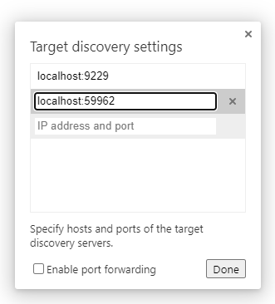
An inspect link to the Remote Target should appear within a few seconds. Click it to open the WebSocket server’s debugger.
Next, consider how you could improve the quiz app. For example:
limit imported questions to specific categories, difficulties, or types
create administrative screens to add, edit, or remove questions
allow the user to refresh the page but remain active
display which players have already answered
show which choice each player made on the answer screen
provide “restart game” functionality, which enrolls all current players on a new quiz
make a game fully recoverable if one or more WebSocket servers fail

Summary
This quiz illustrates how a scalable, multi-server, multi-user, real-time web application can be developed in Node.js using a few third-party modules, vanilla ES6, and less than 60KB of code. Admittedly, negotiating messages between all servers and clients is complex, but that’s the nature of multi-player games rather than WebSocket technologies.
In the final chapters, we’ll look at a selection of popular Node.js development and deployment tools that you may find useful.

Chapter 17: Node.js Tools and Resources
I hope you now feel confident enough to write your own Node.js programs and find appropriate packages when necessary. The success of the runtime has one downside: you’re spoiled for choice! There are 1.5 million packages available, ranging from full application development suites to simple, one-function modules. This can lead to choice paralysis, and the moment you settle on one package, a better option will inevitably arrive.
This chapter provides a list of popular and proven npm packages for use in various situations. They provide a head start, but please don’t think you have to use them. Only you can judge whether a package is or isn’t useful for your project.
I’ll also reiterate a point made throughout this book: only use third-party modules that are absolutely necessary. It makes sense to leverage the years of development and real-world testing received by frameworks, database drivers, image optimizers, and so on. You can write smaller modules yourself—such as string or date manipulation functions. It may take longer initially, but should save you time over the long term, because there’s no need to search for appropriate packages, manage updates, assess security issues, or switch to alternatives.

Perfect Package Pursuit
The following sites provide curated lists of npm packages:
github.com/sindresorhus/awesome-nodejs
nodejs.libhunt.com
You can search for npm packages from the command line. For example:
$ npm search mysql
NAME | DESCRIPTION | AUTHOR | DATE | VERSION
mysql | A node.js dri… | =felixge… | 2020-01-23 | 2.18.1
knex | A… | =tgriesser… | 2022-03-13 | 1.0.4
sequelize | Sequelize i… | =janaameier… | 2022-02-25 | 6.17.0
mysql2 | fast mysql driv… | =sidorares… | 2021-11-14 | 2.3.3
sails-mysql | MySQL adapter … | =particlebanan… | 2021-10-15 | 2.0.0
waterline | An ORM for Node… | =particlebanan… | 2021-10-22 | 0.15.0
egg-mysql | MySQL plugin fo… | =jtyjty99999… | 2022-02-11 | 3.1.0
tunnel-ssh | Easy extendable … | =agebrock | 2021-10-03 | 4.1.6
@mysql/xdevapi | MySQL… | =ltangvald… | 2022-01-18 | 8.0.28
hapi-plugin-mysql | Hapi plugin … | =adrivanhoudt | 2022-01-03 | 7.2.6
mysql-abstraction | Abstraction la… | =rwky | 2022-02-22 | 5.1.4
mysqlconnector | MySQL connector | =pteyssedre | 2021-10-26 | 1.0.21
anytv-node-mysql | Our version… | =freedom_sherw… | 2022-01-19 | 1.0.0
sql-template-strings | ES6 tagged templ… | =felixfbecker | 2016-09-17 | 2.2.2
@keyv/mysql | MySQL/Mari… | =jaredwray… | 2022-01-25 | 1.3.0
aws-xray-sdk-mysql | AWS X-Ray Patc… | =aws-sdk-team… | 2021-11-11 | 3.3.4
winston-mysql | MySQL transp… | =charles-zh | 2021-09-22 | 1.1.1
data-elevator-mysql | Flexible util… | =kaasdude… | 2021-09-29 | 4.0.0
An online search engine offers a better interface:
npmjs.com: the official repository
npms: a fast search, which ranks packages by a quality
snyk.io/advisor/: ranks packages with a health percentage based on their popularity, maintenance, security issues, and contributor community
There are tools for comparing two or more packages:
npmcompare.com
moiva.io
Or tools to extract package information:
anvaka.com: dependency visualization
npm-stat.com: download and usage statistics
If you’re struggling to choose, opt for a package that:
is popular
has a non-restrictive usage license
receives recent and regular updates
has a small size
has the fewest dependencies
has no major outstanding issues
Most of the packages discussed below satisfy these criteria.

Development Tools
The following packages are tools that aid development rather than form part of your Node.js project. You’ll normally install them globally with npm install <package> -g or add them as a devDependency in the project folder with npm install <package> --save-dev:
nvm (Node Version Manager): manages multiple installations of Node.js
ESLint: finds and fixes JavaScript code problems
TypeScript: adds variable types and other features to the language and compiles to standard JavaScript
Rollup: a JavaScript module bundler (tutorial here)
esbuild: a fast module bundler written in Go
PostCSS: CSS transformer and optimizer (tutorial here)
JSDoc: generates API documentation from JavaScript comments
small-static-server: a tiny static file web server
nodemon: restarts Node.js applications when source files change
Browsersync: browser live reloads when client-side HTML, CSS, or JavaScript updates
nodemon has been used throughout this book. Use it in place of node when running a script during development to restart the application if a script or any of its modules is changed:
nodemon index.js
Browsersync is effectively a client-side version of nodemon with a few superpowers. The following command starts a web server that can serve HTML files and other assets. Client-side scripts are dynamically reloaded if any .js file changes:
browser-sync start --server --files "js/*.js"
Finally, you’ll need a good Node.js-compatible editor such as VS Code, Atom, or Sublime Text. Most offer extensions for linting, debugging, and source-code management.

Testing
Writing tests for your application’s internal functions helps ensure updates are robust and won’t break existing functionality. Node.js doesn’t provide a built-in test runner, but the following packages are popular:
Testing Library
Jest
Mocha
AVA
uvu
Tap
The main difference between these packages is the download size and syntax. Most allow you to write English-like assertions, so choose whichever appeals to you or your team.
All suites provide unit testing facilities to verify the result of a function given known inputs. This example uses uvu to test the Math.sqrt() method:
import { test } from 'uvu';
import * as assert from 'uvu/assert';
test('Math.sqrt()', () => {
assert.is( Math.sqrt(4), 2 );
assert.is( Math.sqrt(144), 12 );
assert.is( Math.sqrt(2), Math.SQRT2 );
});
test.run();
The following packages provide headless browser automation tools used for integration testing—that is, testing routes through an application by programmatically clicking buttons and filling in forms to observe an expected result:
Puppeteer: Chrome automation
Playwright: supports all mainstream browsers
Cypress: commercial option with remote testing

Logging
If you outgrow console.log(), third-party logging modules provide more sophisticated logging with messaging levels, verbosity, sorting, file output, profiling, reporting, and more. Popular options include:
cabin: Node.js, middleware, and browser logging
loglevel: a lightweight Node.js equivalent to the browser console API
signale: a highly configurable logger
pino: a fast and popular Node.js and middleware logger
winston: a comprehensive and configurable logger
morgan: Express middleware logging
storyboard: a logging library that can output to a Chrome DevTools extension
tracer: simple log formatting

Full-stack Frameworks
The following frameworks can be used to create full web applications and typically allow rendering on the server, the client, or a mixture, as appropriate. They may offer hydration techniques where initial content is generated on the server in HTML before client-side components take over for full interactivity.
Next.js: based on React components
Nuxt.js: based on Vue components
SvelteKit: based on Svelte components
Sails: the Node.js equivalent to Ruby on Rails

Server-side Frameworks
If you’d rather have full control over client and server development, the following frameworks primarily handle server-side rendering of HTML content and/or Ajax responses in JSON or any other format:
Express: one of the first and most popular frameworks
Koa: a modern framework designed by the Express team
Fastify: claims to be one of the fastest options
Hapi: focuses on simplicity, security, and scalability
NestJS: offers concepts similar to the Angular client-side framework
Adonis: the Node.js equivalent to PHP Laravel
Feathers: a lightweight framework for real-time applications and REST APIs
restify: optimized for REST web services

Node.js in Client-side Frameworks
Client-side JavaScript (and CSS) frameworks that run in the browser don’t generally require Node.js. However, they often use the runtime to provide build tools to scaffold project folders, bundle modules, implement testing, run development servers, or optimize assets at build time.

Web Publishing, Content Management Systems, and Blogging
The following platforms provide administration panels where content editors can write content that’s pulled into a site template theme when visitors access the site. These are effectively Node.js alternatives to the PHP-based WordPress.
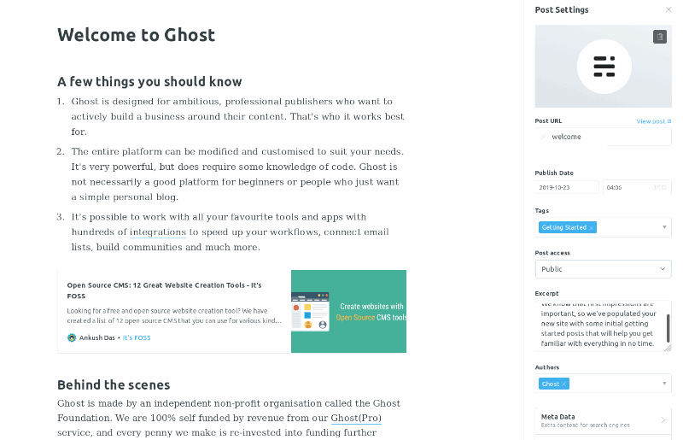
Ghost: a commercial, hosted service is also available at ghost.org
Hexo: closer to an SSG (see the “Static Site Generators” section below), but administration panels can be added via a plugin

Headless Content Management Systems
The following packages provide editing panels and make content available via an API. Articles and other data can be pulled into your application or a static site generator for output to a web page, app, ebook, PDF, or elsewhere:
Strapi
Keystone
Apostrophe

Static Site Generators
Static site generators (SSGs) pull content—typically from Markdown files or a headless CMS—and place it into templates at build time. The result is a full site pre-rendered as HTML files that can be hosted on any web server without language runtimes, databases, security, or performance implications. You may see this referred to as Jamstack, which originally meant JavaScript, APIs, and Markup, but is now used in a wider context:
Eleventy: Markdown to HTML, with support for many template engines
MetalSmith: a simple pluggable SSG
Gatsby: based on React components
VuePress: based on Vue components
Gridsome: based on Vue components

Database Drivers
Database drivers—also known as connectors or clients—provide APIs that allow you to connect, query, and update database data. The following packages are native drivers: they support a single system, replicate standard commands, and often have official support from the database developers:
mysql: for MySQL
mysql2: a faster MySQL alternative
mariadb: for MariaDB
pg: for PostgreSQL
mongodb: for MongoDB
mssql: for Microsoft SQL Server
oracledb: for Oracle
couchbase: for Couchbase
redis: for Redis
sqlite: for SQLite
sqlite3: an asynchronous SQLite alternative
sqlite-async: a promise-based version of sqlite3
An object-relational mapping (ORM) module can make development easier by providing an abstract layer between your code and the database. Rather than running commands directly, your code manipulates data objects that are saved and restored from a representation in a database. This allows you to switch between systems, but you’ll also need to install a native driver, and the full database feature set may not be available. Examples include:
mongoose: for MongoDB
sequelize: for MySQL, MariaDB, PostgreSQL, SQLite, DB2, and Microsoft SQL Server
typeorm: for MySQL, MariaDB, PostgreSQL, SQLite, Oracle, and Microsoft SQL Server
Refer to Chapter 10 for database usage examples.

Templating
Most templating systems generate HTML by inserting values into appropriate blocks. Some provide programming constructs such as file includes, loops, and conditions to optimize development. Popular options include:
EJS
Nunjucks
Handlebars
Pug
Pug differs from others in that you use a concise, indented-style document rather than HTML tags. For example, assume a title value is set to “My Site” in the following Pug template:
doctype html
html
head
title #{title}
body
h1 #{title}
p#intro Welcome to my site.
The resulting HTML is this:
<!DOCTYPE html>
<html>
<head>
<title>My Site</title>
</head>
<body>
<h1>My Site</h1>
<p id="intro">Welcome to my site</p>
</body>
</html>
You’ll typically use a template system in server-side frameworks such as Express. Chapter 5, Chapter 6 and Chapter 15 of this book use EJS. For example, render an <h1> title between a header and footer defined in partials:
<%- include('partials/_htmlhead'); -%>
<h1><%= title %></h1>
<%- include('partials/_htmlfoot'); -%>

Command Line
The following packages can be useful when creating command-line applications using Node.js:
commander: parse command-line arguments
cliffy: implement interactive CLIs
chalk: output color console messages
terminal-link: output clickable hyperlinks
boxen: output boxes
progress: a simple progress bar
progress [===== ] 29%

File System
The standard Node.js library provides an extensive file system API for creating, altering, reading, and deleting files and directories. These are fairly low-level functions, so the following packages provide easier file manipulation options:
fs-extra: provides a range of file system methods
globby: file name string (glob) matching
chokidar: cross-platform file watching
del and rimraf: file and directory deletion

Network
The following packages provide a number of network APIs.
Note that a native version of the HTTP Fetch API arrived in Node.js 18. It should become less necessary to use a third-party module as developers and hosts update their installations.
node-fetch: HTTP Fetch
axios: HTTP Fetch
got: HTTP Fetch
get-port: get an available TCP port
ssh2: SSH client and server methods

WebSockets
WebSockets establish a two-way interactive communication channel between a browser and server, which permits real-time updates and applications. The following packages provide server-side APIs that can send messages to and from the browser WebSocket API:
ws: fast lightweight server
socket.io: full client and server library
See Chapter 11 and Chapter 16 for WebSocket examples using the ws library.

Images
Node.js applications can create, examine, and modify images in most popular formats (JPG, GIF, PNG, etc.) Packages typically provide options to resize, crop, flip, and rotate, or apply filters such as sharpening, blurring, greyscale, and opacity. Popular options include:
jimp: scaling, flipping, filters, and pixel analysis
image-js: Node.js and browser image manipulation
sharp: fast image conversion
imagemin: image minification
The following example uses jimp to load an image, convert it to greyscale, reduce the width and height by 50%, and output the modified version:
import Jimp from 'jimp';
Jimp.read('one.png').then(image => {
image
.greyscale()
.scale(0.5)
.write('one-bw-small.png');
});

Email

The most popular Node.js package for sending email is Nodemailer. The following code sends a single email via an SMTP account:
const nodemailer = require('nodemailer');
const transport = nodemailer.createTransport({
host: 'smtp.example.com',
port: 587,
secure: false,
auth: {
user: 'username',
pass: 'password',
},
});
await transport.sendMail({
from: '"Sender" <me@sender.com>',
to: 'you@recipient.com',
subject: 'new email',
text: 'Hello world!', // plain text body
html: '<p>Hello world!</p>', // HTML body
});
An alternative is node-email, which provides a wrapper around the open-source Sendmail application. Either option is fine for sending ad-hoc emails such as user registration or password reset confirmations.
Bulk email messaging—such as newsletters—is better handled using a dedicated service such as Mailgun, SendGrid, MailerSend, or Mailchimp. These often offer their own Node.js APIs to efficiently manage email transmission.
Finally, imap-simple provides a way to connect to and read from an IMAP inbox if you need to provide automated email responses.

Security and Authentication
Passport is one of the most popular Express-compatible authentication packages for Node.js. It supports more than 500 strategies (plugins) ranging from basic usernames and passwords to passwordless and single-sign-on OAuth options for Google, GitHub, Facebook, Twitter, and LinkedIn.
An alternative option is grant, which supports more than 200 OAuth providers.

Summary
The Node.js ecosystem is enormous and growing exponentially. Third-party packages are generally designed to handle a single, specific task, so you’ll find a range of appropriate options for every situation. The downsides:
It’s easy to become overwhelmed and suffer choice paralysis as you expend time and energy evaluating packages.
You can become increasingly dependent on third-party solutions. Your development career may descend into writing tedious code to glue packages together.
The more third-party packages you use, the more time you require to maintain and update that software. You’ll often need to update your code as APIs evolve.
There’s no such thing as a perfect Node.js package, and I make no apology for repeating my mantra: only use third-party modules that are absolutely necessary. Spend most of your time writing code, not choosing tools and resources!
I hope you now have a few simple web projects ready to reveal to the world. The next chapter delves into deployment.

Chapter 18: Node.js Application Deployment
You’ll eventually want to release your Node.js web app to the world. Deployment options have grown exponentially since the runtime was released in 2009. This chapter describes general types of production hosting, with links to appropriate companies, but the range of services and prices changes daily.

Pages vs Applications
Many readers of this book will be familiar with PHP—the world’s most-used web programming language. WordPress alone runs almost half of all websites. A PHP application consists of .php files that are interpreted by the PHP runtime when they’re accessed via a server such as Apache. HTML or data is then returned to the user’s browser.
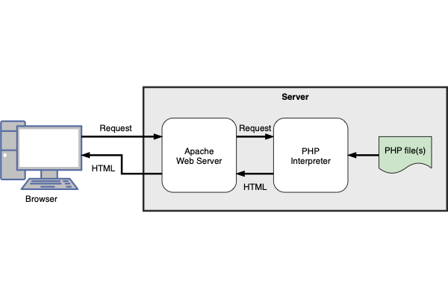
The following points are important to note:
Each page load is stateless. It knows nothing about the application’s state, so if a user is logged in, their state must be retrieved from a token or database record during every page request.
Changing a .php file instantly updates the application, because the code is executed when a user requests that resource.
A .php file that causes an error is less likely to cause problems on other pages. Of course, that .php file may provide functions shared across multiple pages, but the server and other parts of the application will usually remain active.
A Node.js web project is a full application that handles web requests. It doesn’t (necessarily) require a server such as Apache and runs continuously after the code is loaded from .js files.
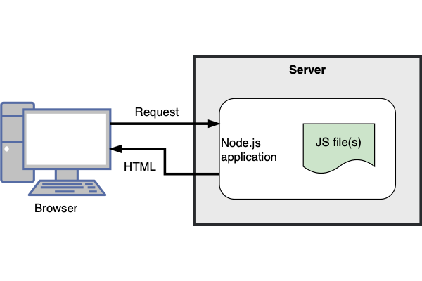
Therefore:
State can be retained. If necessary, a server application could store a JavaScript object for every logged-in user. (I recommend you write stateless apps, but it’s not enforced!)
Changing a .js file has no impact on the running application. It will only be loaded after the node process has been stopped and restarted.
If any part of your application causes a crash, it goes down for everyone forever! No user will be able to access any part of the system and it will lose any state retained in memory.
The Node.js model has advantages and disadvantages over PHP, but deploying an application to a production server is more challenging.
Most budget shared server hosts support PHP because it can be run by uploading a .php file to a server directory. Far fewer offer Node.js, because you require OS-level access to launch an application, which could hog resources as it runs continuously.
Some offer Node.js facilities via systems such as cPanel, where you can define an application’s start-up command and configuration. However, these often impose restrictions such as CPU limits or no access to npm.
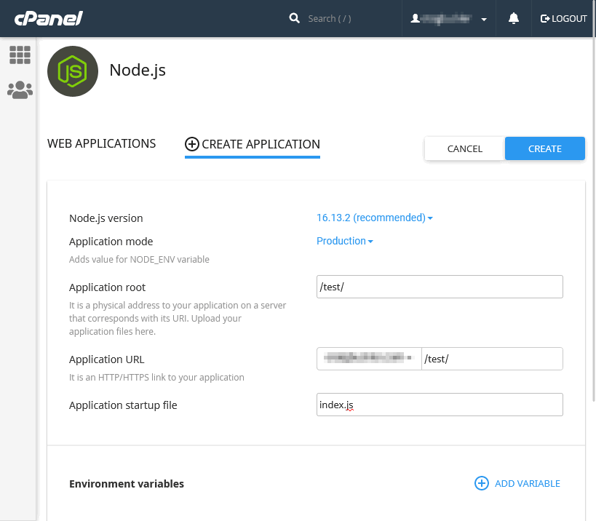

Node.js Application Preparation
Your development and deployment environments will differ. As a bare minimum, live servers should set the NODE_ENV environment variable to production:
NODE_ENV=production
When set, the Express framework disables verbose logging and enables template caching to improve performance. Other modules may offer similar optimizations, but check their README files and documentation.
Internally, your application can detect the NODE_ENV value and disable terminal debugging messages, or make other changes such as logging to a file. For example:
// running in development mode?
const DEVMODE = (process.env.NODE_ENV !== 'production');
if (DEVMODE) {
console.log('application started in development mode');
}
else {
writeToLog('application started in production mode');
}
Other environment variables may be required to define application configurations or database connections.
Finally, production servers should normally launch the application with the node runtime command rather than nodemon or similar. Command-line options such as --inspect and --enable-source-maps shouldn’t be used.

Dedicated Server Hosting
In Node’s early days, there was little choice but to spin up a real or virtual Linux server. It probably remains the most-used method of application deployment and requires DevOps personnel to:
provision appropriate CPUs, RAM, and disk space
install an appropriate version of the Node.js runtime
pull the application from a repository
npm install all project and global dependencies
launch the application with node app.js as appropriate
Steps 3 to 5 are repeated for every update, although continuous integration and/or continuous deployment solutions can automate the process.
Many hosts offer virtual servers, including DigitalOcean Droplets, Amazon EC2, Google Compute Engine, and Azure Virtual Machines.
sudo-not
Avoid using sudo to run your Node.js application with administrator privileges. The application or any of its modules would have rights to do anything—such as wiping OS files.

HTTP and HTTPS Considerations
Chapter 5 showed how to configure SSL certificates in Express. This isn’t recommended on production servers, because the application must be launched using sudo to permit use of HTTP ports below 1,000 (port 80 for HTTP or port 443 for HTTPS).
A better option is to launch the application on a non-standard port—such as 3000—then use a reverse proxy (see the “Use a Reverse Proxy” section below) to forward incoming traffic.
The examples in this book launch development servers on an insecure HTTP connection. This is fine for testing, although care must be taken when referring to internal URLs throughout the frontend and backend code.
Some developers create a fake self-signed certificate for their development server, which makes it more difficult to introduce inconsistent HTTP/HTTPS URLs. The browser will throw an “invalid certificate” error, but you can choose to ignore it. I don’t recommend this practice: it has burned me in the past! Browsers often behave differently when they encounter fake certificates. For example, they disable caching, which can lead to strange bugs on live servers.
I recommend you do either of the following:
Use HTTP during development but be wary when referring to internal URLs that could be HTTPS on production servers.
Generate a real, locally trusted SSL certificate using mkcert. These can be used on your own development PC, although you can’t share them with other team members (so they’ll need to generate their own certificates).

Process Management
Node.js applications run on a single processing thread. In other words, 63 cores in your 64-core server CPU are sitting idle.
You can implement your own clustering code to run an application on all available CPU cores, but this can be difficult (see Chapter 12, as well as the Node.js documentation). A better solution is to use a process manager, which makes your live application more efficient by:
running multiple instances across different CPU cores
restarting an instance if (when) it crashes
For this to work, your application must be stateless. Avoid storing application or user state in variables or local files that could differ across instances.

PM2 is the primary contender for Node.js process management. After installing globally, you can start a Node.js application in cluster mode across all available CPU cores:
pm2 start app.js -i max

PM2 Port Clashes
PM2 magically manages ports. If sixteen instances of your Express application all listen on port 3000, PM2 ensures they won’t clash. A single request sent to port 3000 gets forwarded to one application instance. The next request may go to another.
Note that PM2 port management can fail if you launch your application using an npm script.
Running processes can be monitored with pm2 status.

Use a Reverse Proxy
A reverse proxy passes an incoming request to your Node.js web application. Most web servers can be configured as reverse proxies—including NGINX.
This has several advantages:
Any number of domains and applications can be configured on the same server.
Your Node.js application can be clustered and launched without using sudo.
SSL certificates for HTTPS can be managed by the web server.
The web server can be configured to serve static assets—such as client-side images, CSS, and JavaScript. This is more efficient than passing the request to Express, because most web servers are multi-threaded.
An NGINX configuration file at /etc/nginx/sites-available/default can define the incoming ports, set the SSL certificates, look for static files, and resolve requests to the Node.js application when a static file isn’t found:
server {
listen 80;
listen 443 ssl;
# live domain
server_name myapp.com;
# HTTPS certificates
ssl_certificate /etc/nginx/ssl/server.crt;
ssl_certificate_key /etc/nginx/ssl/server.key;
# static file?
location / {
root /home/node/myapp/static/;
index index.html;
try_files $uri $uri/ @nodejs;
}
# Node.js reverse proxy
location @nodejs {
proxy_pass http://localhost:3000;
proxy_http_version 1.1;
proxy_set_header Upgrade $http_upgrade;
proxy_set_header Connection 'upgrade';
proxy_set_header Host $host;
proxy_cache_bypass $http_upgrade;
}
}
The NGINXConfig configuration tool can help create a setup suitable for your requirements.

Static Site Hosting (Jamstack)
If your application primarily uses client-side HTML, CSS, and JavaScript, it may not be necessary to deploy a Node.js application or use any server-side runtime. A static site generator (SSG) builds directory-based HTML files using content (typically in Markdown format) and templates. There are numerous SSGs, but Eleventy is one of the more popular Node.js options.
The resulting build files can be uploaded to any web server. The pages offer:
excellent performance: they’re just files with no server-side processing
robust security: there’s no database or runtime to exploit
portability: you can host anywhere with no vendor lock-in
minimum-cost deployments: often for free
This simpler approach to web development has become increasingly popular over the past few years. Facilities such as Amazon S3 hosting have been overtaken by platform-as-a-service (PaaS) hosts such as GitHub Pages, CloudFlare Pages, Heroku, Vercel, and Netlify.
Some services offer a simple command-line deployment tool, while others require you to push a branch to a Git repository.

Build PHP-powered Static Sites with Node.js
I often use Node.js SSGs for smaller websites. These sometimes require basic server-side functionality such as forwarding old URLs or parsing contact forms. Rather than deploy a Node.js server, I output a few .php files so the site can be deployed to any PHP host.

Serverless/Lambda Functions
If your app requires more comprehensive server-side processing such as database storage, you could consider serverless functions. Despite the name, serverless functions run on a server but there’s no need for you to manage the OS, runtime, or even use a framework such as Express.
Serverless functions usually respond on a network endpoint. For example, data posted to https://myapp.com/store-contact/ passes the HTTP request to a function defined in store-contact.js, which stores the information and returns a result. The following Netlify serverless function at functions/hello.js returns a message when requesting the /hello/ endpoint:
exports.handler = async (event, context) => {
return {
statusCode: 200,
body: 'Hello World'
};
};
You could therefore choose to write a monolithic web application as a series of small stateless functions. These are started on demand, but they usually remain active on busy servers and can scale according to rises in traffic. If a serverless function fails, it’s restarted on the next request and won’t usually affect or conflict with other functions.
Most cloud hosts offer Node.js serverless functions including AWS, Azure, Google, Cloudflare, Heroku, Vercel, and Netlify.

AWS Everywhere
Many serverless hosts, including Netlify and Vercel, deploy serverless functions to AWS Lambda but offer a simpler or improved developer experience.
Serverless functions can be ideal for many applications. They can simplify DevOps and reduce costs on smaller services, but there are downsides:
Usage limitations: not all npm packages can be used, especially if they depend on other OS utilities.
Start-up delay: the first request can take some time as the function is initialized.
Shut-down timeout: functions may have processing limits, so long-running activities such as WebSocket servers may not be possible.
Vendor lock-in: you must adhere to the host’s APIs, rules, and updates. It may be difficult to switch to another service.
Incalculable costs: serverless functions are often priced according to compute time. You may have heard anecdotes from developers who deployed a non-terminating recursive function that led to an eye-watering bill.

Container Hosting
You may require more robust hosting as your Node.js service increases in popularity. The multiplayer quiz in Chapter 12 uses Docker containers to launch multiple load-balanced instances of the HTTP and WebSocket applications. The same concept can be applied on production servers. Solutions such as Kubernetes and Docker Swarm can launch, manage, update, and restart containers across any number of servers in any number of locations throughout the world.
At this point, you’ll require a dedicated DevOps team to manage deployments costing millions every year. That’s unlikely to be a problem: if your app is successful, venture capitalists can’t give you enough money, and Google/Microsoft/Apple/Facebook are circling for a potential takeover.

Summary
Node.js hosting options are varied, with extensive ecosystems and prices ranging from free to exorbitant. Personally, I like to write apps that are service agnostic and could be hosted anywhere, but that has become more challenging over recent years. We’ve reached a weird point where you should probably choose a host before you write any code. We have numerous hosting solutions, but many companies still select AWS because … many companies select AWS!
Whichever hosting route you choose, you can’t go wrong writing stateless web apps. I may have mentioned that a few times before …

Chapter 19: Epilogue
Congratulations! You’ve reached the end of the beginning of your Node.js journey. You’ve learned a lot, and I hope this course jump-starts your development while helping you avoid some of the pitfalls.
We’ve covered many topics, from command-line tools, debugging, web applications, and modules, through to real-time, database-driven, multi-player games. No one will fully grasp every topic on their first read, but knowing that a solution exists is half the battle.
I hope you enjoy Node.js development. It has a lot of advantages, such as:
It’s quick to learn the basics and be productive.
Node.js exposes possibilities you may never have encountered in other runtimes.
It allows web developers to leverage their client-side JavaScript skills to create useful libraries, frameworks, command-line tools, and even desktop apps.
Node.js programming can be fun.

Is Node.js for You?
Node.js blossomed from being a niche engine to an indispensable developer runtime within a matter of years. Even those using other languages often have Node.js installed, because it offers a range of tools you won’t necessarily find elsewhere.
The reason: JavaScript. Web development has become the primary vehicle for platforming applications, so it’s difficult to avoid browser-based coding. Using the same language on the frontend and backend lowers the cognitive overhead. Node.js won’t make you a full-stack developer overnight, but there’s less context switching, and you’ll avoid simple errors such as using the wrong quote character, forgetting a semicolon, or making the wrong method call.
Of course, Node.js isn’t without its criticisms:
Some programmers detest JavaScript.
No language is perfect, but JavaScript was developed in ten days, and it’s unlikely Brendan Eich, its inventor, ever considered it might be used for full-scale enterprise level applications. Some issues have been addressed with ES6 and types in JavaScript compilers such as TypeScript.
Personally, I love JavaScript—warts and all. Those who complain loudest are usually comparing it to their favorite language and have been bitten by JavaScript’s oddities, such as prototypal inheritance. If it’s not to your taste, either persevere or consider one of the many server-side alternatives.
npm is cumbersome.
npm is partly responsible for the success of Node.js. It’s easy to install, update, and remove any of the 1.5 million packages. Understandably, not every package is good, and some have been downright dangerous—laced with malware and crypto-mining code. npm has addressed many issues, but others will occur.
Your node_modules directory will also grow to many megabytes and, despite recent optimizations, npm can still recursively download the same packages across different projects. Package maintenance can become increasingly laborious over the long term.
Remember, npm is just a tool. Only install the packages you need and you’ll minimize the impact of third-party code.
CommonJS vs ES6 module mess.
Node.js is migrating toward ES6 modules, but the process has been painful and some legacy packages may never support it. The situation is improving, though, and I was pleasantly surprised by how few problems I encountered while writing this book.
Asynchronous programming is a challenge.
You won’t necessarily encounter asynchronous programming in other languages, and it’s easy to make mistakes that lead to application instability. I devoted the whole of Chapter 9 to this topic, because it’s so important in Node.js programs.
Understanding callbacks can be tricky for novice JavaScript coders, but it’s impossible to avoid event handling either on the client or server. Promises and async/await help, although I initially struggled to understand the concepts.
That said, asynchronous programming makes real-time web applications possible. Instantly updated dashboards, live chat, and multi-player games are far easier in Node.js.
Node.js isn’t as good/fast/popular/stable/secure as runtimeX.
There will always be alternatives that handle some aspect of application programming in a better way. But Node.js is good enough in most respects for web application and command-line utility development.
To quote C++ designer Bjarne Stroustrup: “There are only two kinds of languages: the ones people complain about and the ones nobody uses.”

Is Deno Better?
Ryan Dahl released Deno in 2020 and it addresses many of his Node.js regrets. Deno offers:
Better security. An application must be granted specific rights when it needs access to environment variables, the file system, the network, and other resources.
Native TypeScript support. You can write applications in JavaScript or TypeScript without an additional third-party compiler.
ES6 modules only. Modules are loaded from a URL: there’s no npm equivalent, and packages can be cached so there’s one instance on your system across all projects.
Built-in tools. Linting, formatting, testing, benchmarking, bundling, documentation generation, task running, and more are available from the deno runtime.
Replicated browser APIs. Features such as window, addEventListener, Fetch, and web workers all work in Deno.
Replicated Node.js APIs. Deno supports features such as fs, events, http, os, process, stream, url, util, and CommonJS when running in Node.js compatibility mode.
Deno is a great option, but it’s new and not as fast, as popular, or well supported as Node.js. Perhaps we’ll all be using Deno in a decade’s time, and Node.js will be consigned to the history books. But it’s too early to tell. There’s no harm writing a few small utilities or example apps in Deno … but should you adopt it for a long-term, mission-critical application when it’s difficult to find programmers with more than a couple of months’ experience?
Deno is similar enough to Node.js that it’s easy to switch between the runtimes. Learn Node.js today, then consider Deno tomorrow.

Thank You for Reading!
I hope you enjoyed this book and are ready to embark on the next stage of your programming career. Check out some tips in the final video for this course.
If you have any feedback or suggestions, please contact me directly on Twitter @craigbuckler or send your message to SitePoint.
Best of luck!

Appendix: Quiz Answers
Here are the solutions to the quizzes.

Chapter 1
d.
d. Other than some superficial syntactical similarities, JavaScript has no technical relationship to Java whatsoever!
b. TypeScript can compile to JavaScript, but it’s a superset of the JavaScript syntax so isn’t JavaScript itself!
c.
a.

Chapter 2
d.
b.
a.

Chapter 3
c.
d. … although c. is somewhat extreme!
b.
a.
d. Bonus points if you knew that Docker isn’t essential, although it could make Node.js deployments easier!

Chapter 4
d.
d.
b.
a.
Well, I’m going to say c. It’s heavily opinionated, but I don’t believe any developer who says they never use console.log()! It’s not always the best option and it’s too easy to go down a deep console logging rabbit hole, but finding the cause of a bug is more important than the technique you used to get there

Chapter 5
d.
c.
a.
c.
b.

Chapter 6
b.
a. But d. could be correct if you defined a parsing middleware function!
d.

Chapter 7
d.
b.
b.
c.
d. Bonus points if you realized that a. and b. would list all dependencies in older versions of npm.
a.

Chapter 8
a.
c.
a.
b.
d.

Chapter 9
c.
d.
a.
a.
d.

Chapter 10
b.
d.
d.
a.
d.

Chapter 11
d.
a.
d.
b.
b.

Chapter 12
b.
d.
d.
a.
b.

