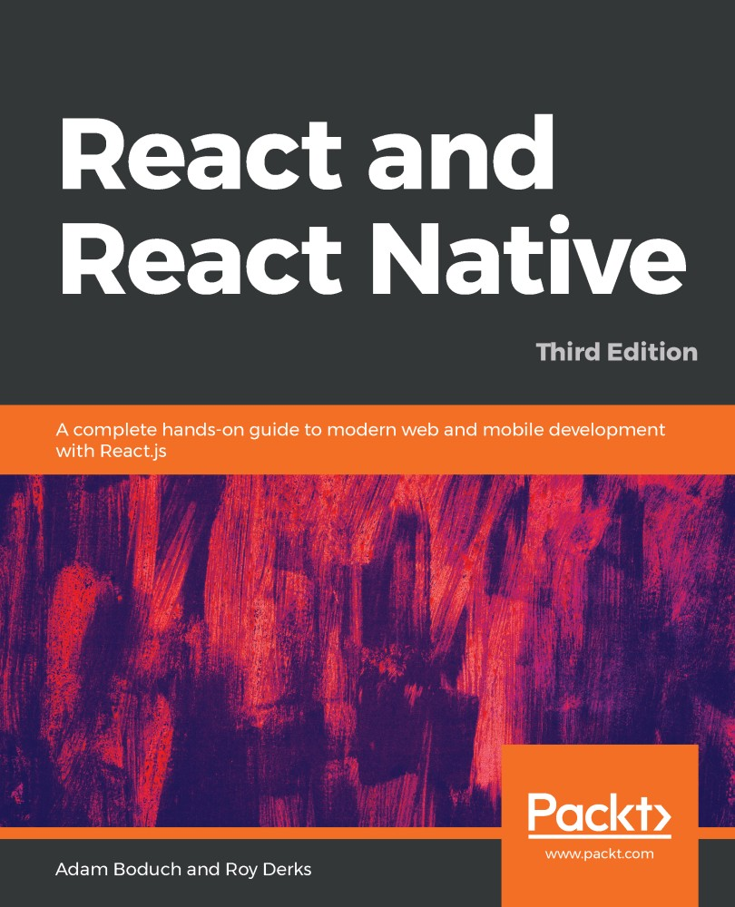

Table of Contents
Title Page
Copyright and Credits
React and React Native Third Edition
About Packt
Why subscribe?
Contributors
About the authors
About the reviewers
Packt is searching for authors like you
Preface
Who this book is for
What this book covers
Section 1 – React
Section 2 – React Native
Section 3 – React Architecture
To get the most out of this book
Download the example code files
Conventions used
Get in touch
Reviews
Section 1: React
Why React?
What is React?
React is just the view layer
Simplicity is good
Declarative UI structures
Time and data
Performance matters
The right level of abstraction
React Features
Revamped core architecture
Lifecycle methods
The Context API
Rendering fragments
Portals
Rendering lists and strings
Handling errors
Server-side rendering
What's new in React?
Memoizing functional components
Code splitting and loading
Hooks
Summary
Further reading
Rendering with JSX
Technical requirements
Your first JSX content
Hello JSX
Declarative UI structures
Rendering HTML
Built-in HTML tags
HTML tag conventions
Describing UI structures
Creating your own JSX elements
Encapsulating HTML
Nested elements
Namespaced components
Using JavaScript expressions
Dynamic property values and text
Mapping collections to elements
Fragments of JSX
Using wrapper elements
Using fragments
Summary
Further reading
Component Properties, State, and Context
Technical requirements
What is component state?
What are component properties?
Setting a component state
Setting an initial component state
Creating a component state
Merging the component state
Passing property values
Default property values
Setting property values
Stateless components
Pure functional components
Defaults in functional components
Container components
Providing and consuming context
Summary
Further reading
Getting Started with Hooks
Technical requirements
Maintaining state using Hooks
Initial state values
Updating state values
Performing initialization and cleanup actions
Fetching component data
Canceling requests and resetting state
Optimizing side-effect actions
Sharing data using context Hooks
Sharing fetched data
Updating stateful context data
Using reducer Hooks to scale state management
Using reducer actions
Handling state dependencies
Summary
Event Handling - The React Way
Technical requirements
Declaring event handlers
Declaring handler functions
Multiple event handlers
Importing generic handlers
Using event handler context and parameters
Getting component data
Higher-order event handlers
Declaring inline event handlers
Binding handlers to elements
Using synthetic event objects
Understanding event pooling
Summary
Further reading
Crafting Reusable Components
Technical requirements
Reusable HTML elements
The difficulty with monolithic components
The JSX markup
Initial state
Event handler implementation
Refactoring component structures
Starting with the JSX
Implementing an article list component
Implementing an article item component
Implementing an add article component
Making components functional
Render props
Refactoring class components using Hooks
Rendering component trees
Feature components and utility components
Summary
Further reading
The React Component Life Cycle
Technical requirements
Why components need a life cycle
Initializing properties and state
Fetching component data
Initializing state with properties
Updating state with properties
Optimizing rendering efficiency
To render or not to render
Using metadata to optimize rendering
Rendering imperative components
Rendering jQuery UI widgets
Cleaning up after components
Cleaning up asynchronous calls
Containing errors with error boundaries
Summary
Further reading
Validating Component Properties
Technical requirements
Knowing what to expect
Promoting portable components
Simple property validators
Basic type validation
Requiring values
Any property value
Type and value validators
Things that can be rendered
Requiring specific types
Requiring specific values
Writing custom property validators
Summary
Further reading
Handling Navigation with Routes
Technical requirements
Declaring routes
Hello route
Decoupling route declarations
Parent and child routes
Handling route parameters
Resource IDs in routes
Optional parameters
Using link components
Basic linking
URL and query parameters
Summary
Further reading
Code Splitting Using Lazy Components and Suspense
Technical requirements
Using the lazy API
Dynamic imports and bundles
Making components lazy
Using the Suspense component
Top-level Suspense components
Simulating latency
Working with spinner fallbacks
When to avoid lazy components
Lazy pages and routes
Summary
Server-Side React Components
Technical requirements
What is isomorphic JavaScript?
The server is a render target
Initial load performance
Sharing code between the server and the browser
Rendering to strings
Backend routing
Frontend reconciliation
Fetching data
Summary
Further reading
User Interface Framework Components
Technical requirements
Layout and organization
Using containers
Building responsive grid layouts
Using navigation components
Navigating with drawers
Navigating with tabs
Collecting user input
Checkboxes and radio buttons
Text inputs and select inputs
Working with buttons
Working with styles and themes
Making styles
Customizing themes
Summary
Section 2: React Native
Why React Native?
Technical requirements
What is React Native?
React and JSX are familar
The mobile browser experience
Android and iOS – different yet the same
The case for mobile web apps
Summary
Further reading
Kick-Starting React Native Projects
Technical requirements
Installing and using the Expo command-line tool
Viewing your app on your phone
Viewing your app on Expo Snack
Summary
Building Responsive Layouts with Flexbox
Technical requirements
Flexbox is the new layout standard
Introducing React Native styles
Building Flexbox layouts
Simple three-column layout
Improved three-column layout
Flexible rows
Flexible grids
Flexible rows and columns
Summary
Further reading
Navigating Between Screens
Technical requirements
Navigation basics
Route parameters
The navigation header
Tab and drawer navigation
Handling state
Summary
Further reading
Rendering Item Lists
Technical requirements
Rendering data collections
Sorting and filtering lists
Fetching list data
Lazy list loading
Summary
Further reading
Showing Progress
Technical requirements
Progress and usability
Indicating progress
Measuring progress
Navigation indicators
Step progress
Summary
Further reading
Geolocation and Maps
Technical requirements
Where am I?
What's around me?
Annotating points of interest
Plotting points
Plotting overlays
Summary
Further reading
Collecting User Input
Technical requirements
Collecting text input
Selecting from a list of options
Toggling between on and off
Collecting date/time input
Summary
Further reading
Displaying Modal Screens
Technical requirements
Important information
Getting user confirmation
Displaying a success confirmation
Error confirmation
Passive notifications
Activity modals
Summary
Further reading
Responding to User Gestures
Technical requirements
Scrolling with your fingers
Giving touch feedback
Swipeable and cancellable
Summary
Further reading
Controlling Image Display
Technical requirements
Loading images
Resizing images
Lazy image loading
Rendering icons
Summary
Further reading
Going Offline
Technical requirements
Detecting the state of the network
Storing application data
Synchronizing application data
Summary
Further reading
Section 3: React Architecture
Native UI Components Using NativeBase
Technical requirements
Application containers
Headers, footers, and navigation
Using layout components
Collecting input using form components
Displaying data using lists
Showing user notifications
Summary
Handling Application State
Technical requirements
Information architecture and Flux
Unidirectionality
Synchronous update rounds
Predictable state transformations
Unified information architecture
Implementing Redux
Initial application state
Creating the store
Store provider and routes
The App component
The Home component
State in mobile apps
Scaling the architecture
Summary
Further reading
Why Apollo?
Yet another approach?
Verbose vernacular
Declarative data fetching
Mutating application state
Summary
Further reading
Building an Apollo React App
Technical requirements
Todo and Apollo Client
The GraphQL schema
Bootstrapping Apollo Client
Adding todo items
Rendering todo items
Completing todo items
Summary
Other Books You May Enjoy
Leave a review - let other readers know what you think
React and React Native
Third Edition

A complete hands-on guide to modern web and mobile development with React.js

Adam Boduch
Roy Derks


BIRMINGHAM - MUMBAI
React and React Native
Third Edition

Copyright © 2020 Packt Publishing

All rights reserved. No part of this book may be reproduced, stored in a retrieval system, or transmitted in any form or by any means, without the prior written permission of the publisher, except in the case of brief quotations embedded in critical articles or reviews.
Every effort has been made in the preparation of this book to ensure the accuracy of the information presented. However, the information contained in this book is sold without warranty, either express or implied. Neither the authors, nor Packt Publishing or its dealers and distributors, will be held liable for any damages caused or alleged to have been caused directly or indirectly by this book.
Packt Publishing has endeavored to provide trademark information about all of the companies and products mentioned in this book by the appropriate use of capitals. However, Packt Publishing cannot guarantee the accuracy of this information.

Commissioning Editor: Ashwin Nair
Acquisition Editor: Ashitosh Gupta
Content Development Editor: Divya Vijayan
Senior Editor: Hayden Edwards
Technical Editor: Shubham Sharma
Copy Editor: Safis Editing
Project Coordinator: Kinjal Bari
Proofreader: Safis Editing
Indexer: Tejal Daruwale Soni
Production Designer: Nilesh Mohite
First published: March 2017
Second edition: September 2018
Third edition: April 2020
Production reference: 1290420
Published by Packt Publishing Ltd.
Livery Place
35 Livery Street
Birmingham
B3 2PB, UK.
ISBN 978-1-83921-114-0
www.packt.com

Packt.com
Subscribe to our online digital library for full access to over 7,000 books and videos, as well as industry leading tools to help you plan your personal development and advance your career. For more information, please visit our website.

Why subscribe?
Spend less time learning and more time coding with practical eBooks and Videos from over 4,000 industry professionals
Improve your learning with Skill Plans built especially for you
Get a free eBook or video every month
Fully searchable for easy access to vital information
Copy and paste, print, and bookmark content
Did you know that Packt offers eBook versions of every book published, with PDF and ePub files available? You can upgrade to the eBook version at www.packt.com and as a print book customer, you are entitled to a discount on the eBook copy. Get in touch with us at customercare@packtpub.com for more details.
At www.packt.com, you can also read a collection of free technical articles, sign up for a range of free newsletters, and receive exclusive discounts and offers on Packt books and eBooks.
Contributors

About the authors
Adam Boduch has been involved in large-scale JavaScript development for nearly 10 years. Before moving to the frontend, he worked on several large-scale cloud computing products using Python and Linux. No stranger to complexity, Adam has practical experience with real-world software systems and the scaling challenges they pose. He is the author of several JavaScript and React books and is passionate about innovative user experiences and high performance.

Roy Derks is a serial start-up CTO, conference speaker, and developer from Amsterdam. He has been actively programming since he was a teenager, starting as a self-taught programmer using online tutorials and books. At the age of 14, he founded his first start-up, a peer-to-peer platform where users could trade DVDs with other users for free. This marked the start of his career in web development, which back then primarily consisted of creating web applications using an MVC architecture with the LAMP stack. In 2015, he was introduced to React and GraphQL at a hackathon in Berlin, and after winning a prize for his project, he started to use these technologies professionally. Over the next few years, he helped multiple start-ups create cross-platform applications using React and React Native, including a start-up that he co-founded. He also started giving workshops and talks at conferences around the globe. In 2019, he gave over 20 conference talks about React, React Native, and GraphQL, inspiring over 10,000 developers worldwide.

About the reviewers

Emmanuel Demey works with the JavaScript ecosystem on a daily basis. He spends his time sharing his knowledge with anyone and everyone. His first goal at work is to help the people he works with. He has spoken at numerous French conferences (including Devfest Nantes, Devfest Toulouse, Sunny Tech, and Devoxx France) about topics related to the web platform, such as JavaScript frameworks (Angular, React.js, and Vue.js), accessibility, and Nest.js. He has been a trainer for 10 years at Worldline and Zenika (two French consulting companies). He is also the co-leader of the Google Developer Group de Lille and the co-organizer of the Devfest Lille conference.
Atul Sandilya Tiwari is working as Mobile Application Development Engineer since 2014. He has worked as a Software Engineer in several Silicon Valley startups. He has also been working as a React Native Development Engineer since 2017.

Packt is searching for authors like you
If you're interested in becoming an author for Packt, please visit authors.packtpub.com and apply today. We have worked with thousands of developers and tech professionals, just like you, to help them share their insight with the global tech community. You can make a general application, apply for a specific hot topic that we are recruiting an author for, or submit your own idea.

Table of Contents
Title Page
Copyright and Credits
React and React Native Third Edition
About Packt
Why subscribe?
Contributors
About the authors
About the reviewers
Packt is searching for authors like you
Preface
Who this book is for
What this book covers
Section 1 – React
Section 2 – React Native
Section 3 – React Architecture
To get the most out of this book
Download the example code files
Conventions used
Get in touch
Reviews
Section 1: React
Why React?
What is React?
React is just the view layer
Simplicity is good
Declarative UI structures
Time and data
Performance matters
The right level of abstraction
React Features
Revamped core architecture
Lifecycle methods
The Context API
Rendering fragments
Portals
Rendering lists and strings
Handling errors
Server-side rendering
What's new in React?
Memoizing functional components
Code splitting and loading
Hooks
Summary
Further reading
Rendering with JSX
Technical requirements
Your first JSX content
Hello JSX
Declarative UI structures
Rendering HTML
Built-in HTML tags
HTML tag conventions
Describing UI structures
Creating your own JSX elements
Encapsulating HTML
Nested elements
Namespaced components
Using JavaScript expressions
Dynamic property values and text
Mapping collections to elements
Fragments of JSX
Using wrapper elements
Using fragments
Summary
Further reading
Component Properties, State, and Context
Technical requirements
What is component state?
What are component properties?
Setting a component state
Setting an initial component state
Creating a component state
Merging the component state
Passing property values
Default property values
Setting property values
Stateless components
Pure functional components
Defaults in functional components
Container components
Providing and consuming context
Summary
Further reading
Getting Started with Hooks
Technical requirements
Maintaining state using Hooks
Initial state values
Updating state values
Performing initialization and cleanup actions
Fetching component data
Canceling requests and resetting state
Optimizing side-effect actions
Sharing data using context Hooks
Sharing fetched data
Updating stateful context data
Using reducer Hooks to scale state management
Using reducer actions
Handling state dependencies
Summary
Event Handling - The React Way
Technical requirements
Declaring event handlers
Declaring handler functions
Multiple event handlers
Importing generic handlers
Using event handler context and parameters
Getting component data
Higher-order event handlers
Declaring inline event handlers
Binding handlers to elements
Using synthetic event objects
Understanding event pooling
Summary
Further reading
Crafting Reusable Components
Technical requirements
Reusable HTML elements
The difficulty with monolithic components
The JSX markup
Initial state
Event handler implementation
Refactoring component structures
Starting with the JSX
Implementing an article list component
Implementing an article item component
Implementing an add article component
Making components functional
Render props
Refactoring class components using Hooks
Rendering component trees
Feature components and utility components
Summary
Further reading
The React Component Life Cycle
Technical requirements
Why components need a life cycle
Initializing properties and state
Fetching component data
Initializing state with properties
Updating state with properties
Optimizing rendering efficiency
To render or not to render
Using metadata to optimize rendering
Rendering imperative components
Rendering jQuery UI widgets
Cleaning up after components
Cleaning up asynchronous calls
Containing errors with error boundaries
Summary
Further reading
Validating Component Properties
Technical requirements
Knowing what to expect
Promoting portable components
Simple property validators
Basic type validation
Requiring values
Any property value
Type and value validators
Things that can be rendered
Requiring specific types
Requiring specific values
Writing custom property validators
Summary
Further reading
Handling Navigation with Routes
Technical requirements
Declaring routes
Hello route
Decoupling route declarations
Parent and child routes
Handling route parameters
Resource IDs in routes
Optional parameters
Using link components
Basic linking
URL and query parameters
Summary
Further reading
Code Splitting Using Lazy Components and Suspense
Technical requirements
Using the lazy API
Dynamic imports and bundles
Making components lazy
Using the Suspense component
Top-level Suspense components
Simulating latency
Working with spinner fallbacks
When to avoid lazy components
Lazy pages and routes
Summary
Server-Side React Components
Technical requirements
What is isomorphic JavaScript?
The server is a render target
Initial load performance
Sharing code between the server and the browser
Rendering to strings
Backend routing
Frontend reconciliation
Fetching data
Summary
Further reading
User Interface Framework Components
Technical requirements
Layout and organization
Using containers
Building responsive grid layouts
Using navigation components
Navigating with drawers
Navigating with tabs
Collecting user input
Checkboxes and radio buttons
Text inputs and select inputs
Working with buttons
Working with styles and themes
Making styles
Customizing themes
Summary
Section 2: React Native
Why React Native?
Technical requirements
What is React Native?
React and JSX are familar
The mobile browser experience
Android and iOS – different yet the same
The case for mobile web apps
Summary
Further reading
Kick-Starting React Native Projects
Technical requirements
Installing and using the Expo command-line tool
Viewing your app on your phone
Viewing your app on Expo Snack
Summary
Building Responsive Layouts with Flexbox
Technical requirements
Flexbox is the new layout standard
Introducing React Native styles
Building Flexbox layouts
Simple three-column layout
Improved three-column layout
Flexible rows
Flexible grids
Flexible rows and columns
Summary
Further reading
Navigating Between Screens
Technical requirements
Navigation basics
Route parameters
The navigation header
Tab and drawer navigation
Handling state
Summary
Further reading
Rendering Item Lists
Technical requirements
Rendering data collections
Sorting and filtering lists
Fetching list data
Lazy list loading
Summary
Further reading
Showing Progress
Technical requirements
Progress and usability
Indicating progress
Measuring progress
Navigation indicators
Step progress
Summary
Further reading
Geolocation and Maps
Technical requirements
Where am I?
What's around me?
Annotating points of interest
Plotting points
Plotting overlays
Summary
Further reading
Collecting User Input
Technical requirements
Collecting text input
Selecting from a list of options
Toggling between on and off
Collecting date/time input
Summary
Further reading
Displaying Modal Screens
Technical requirements
Important information
Getting user confirmation
Displaying a success confirmation
Error confirmation
Passive notifications
Activity modals
Summary
Further reading
Responding to User Gestures
Technical requirements
Scrolling with your fingers
Giving touch feedback
Swipeable and cancellable
Summary
Further reading
Controlling Image Display
Technical requirements
Loading images
Resizing images
Lazy image loading
Rendering icons
Summary
Further reading
Going Offline
Technical requirements
Detecting the state of the network
Storing application data
Synchronizing application data
Summary
Further reading
Section 3: React Architecture
Native UI Components Using NativeBase
Technical requirements
Application containers
Headers, footers, and navigation
Using layout components
Collecting input using form components
Displaying data using lists
Showing user notifications
Summary
Handling Application State
Technical requirements
Information architecture and Flux
Unidirectionality
Synchronous update rounds
Predictable state transformations
Unified information architecture
Implementing Redux
Initial application state
Creating the store
Store provider and routes
The App component
The Home component
State in mobile apps
Scaling the architecture
Summary
Further reading
Why Apollo?
Yet another approach?
Verbose vernacular
Declarative data fetching
Mutating application state
Summary
Further reading
Building an Apollo React App
Technical requirements
Todo and Apollo Client
The GraphQL schema
Bootstrapping Apollo Client
Adding todo items
Rendering todo items
Completing todo items
Summary
Other Books You May Enjoy
Leave a review - let other readers know what you think

Preface
I never had any interest in developing mobile apps. I used to believe strongly that it was the web, or nothing; that there was no need for yet more applications to install on devices already overflowing with apps. Then, React Native came along. I was already writing React code for web applications and loving it. It turns out that I wasn't the only developer that balked at the idea of maintaining several versions of the same app using different tooling, environments, and programming languages. React Native was created out of a natural desire to take what works well from a web development experience standpoint (React), and apply it to native app development. Native mobile apps offer better user experiences than web browsers. It turns out I was wrong; we do need mobile apps for the time being. But that's okay, because React Native is a fantastic tool. This book is essentially my experience as a React developer for the web and as a less experienced mobile app developer. React Native is meant to be an easy transition for developers who already understand React for the web. With this book, you'll learn the subtleties of doing React development in both mobile and web environments. You'll also learn the conceptual theme of React, a simple rendering abstraction that can target anything. Today, it's web browsers and mobile devices. Tomorrow, it could be anything.
The second edition of this book was written to address the rapidly evolving React project-including state-of-the-art best practices for implementing React components as well as the ecosystem surrounding React. I think it's important for React developers to appreciate how React works and how the implementation of React changes to better support the people who rely on it. I've done my best to capture the essence of React as it is today and the direction in which it's moving, in this edition of React and React Native.

Who this book is for
This book is written for any JavaScript developer—beginner or expert—who wants to start learning how to put both of Facebook's UI libraries to work. No knowledge of React is required, although a working knowledge of ECMAScript (ES) will help you follow along better.

What this book covers
This book covers the following three sections:
React: Chapters 1 to 12
React Native: Chapters 13 to 24
React Architecture: Chapters 25 to 28

Section 1 – React
Chapter 1, Why React?, covers the basics of what React really is, and why you want to use it.
Chapter 2, Rendering with JSX, explains that JSX is the syntax used by React to render content. HTML is the most common output, but JSX can be used to render many things, such as native UI components.
Chapter 3, Component Properties, State, and Context, shows how properties are passed to components, how state re-renders components when it changes, and the role of context in components.
Chapter 4, Getting Started with Hooks, gets you moving with the new Hooks React API that replaces many legacy React APIs.
Chapter 5, Event Handling – The React Way, explains that events in React are specified in JSX. There are subtleties associated with how React processes events, and how your code should respond to them.
Chapter 6, Crafting Reusable Components, shows that components are often composed using smaller components. This means that you have to properly pass data and behavior to child components.
Chapter 7, The React Component Life Cycle, explains how React components are created and destroyed all the time. There are several other life cycle events that take place in between, where you do things such as fetch data from the network.
Chapter 8, Validating Component Properties, shows that React has a mechanism that allows you to validate the types of properties that are passed to components. This ensures that there are no unexpected values passed to your component.
Chapter 9, Handling Navigation with Routes, explains that navigation is an essential part of any web application. React handles routes declaratively using the react-router package.
Chapter 10, Code Splitting Using Lazy Components and Suspense, shows you how to structure your components so that only code that's needed is loaded into the browser.
Chapter 11, Server-Side React Components, discusses how React renders components to the DOM when rendered in the browser. It can also render components to strings, which is useful for rendering pages on the server and sending static content to the browser.
Chapter 12, User Interface Framework Components, introduces you to the popular Material-UI React framework for building responsive UIs.

Section 2 – React Native
Chapter 13, Why React Native?, shows that React Native is React for mobile apps. If you've already invested in React for web applications, then why not leverage the same technology to provide a better mobile experience?
Chapter 14, Kick-Starting React Native Projects, discusses how nobody likes writing boilerplate code or setting up project directories. React Native has tools to automate these mundane tasks.
Chapter 15, Building Responsive Layouts with Flexbox, explains why the Flexbox layout model is popular with web UI layouts using CSS. React Native uses the same mechanism to lay out screens.
Chapter 16, Navigating Between Screens, discusses the fact that while navigation is an important part of web applications, mobile applications also need tools to handle how a user moves from one screen to the next.
Chapter 17, Rendering Item Lists, demonstrates that React Native has a list view component that's perfect for rendering lists of items. You simply provide it with a data source, and it handles the rest.
Chapter 18, Showing Progress, explains that progress bars are great for showing a specified amount of progress. When you don't know how long something will take, you use a progress indicator. React Native has both of these components.
Chapter 19, Geolocation and Maps, shows that the react-native-maps package provides React Native with mapping capabilities. The Geolocation API that's used in web applications is provided directly by React Native.
Chapter 20, Collecting User Input, shows that most applications need to collect input from the user. Mobile applications are no different, and React Native provides a variety of controls that are not unlike HTML form elements.
Chapter 21, Displaying Modal Screens, explains that alerts are designed to interrupt the user to let them know something important has happened, while notifications are unobtrusive updates, and confirmation is used to get an immediate answer.
Chapter 22, Responding to User Gestures, discusses how gestures on mobile devices are something that's difficult to get right in the browser. Native apps, on the other hand, provide a much better experience for swiping, touching, and so on. React Native handles a lot of the details for you.
Chapter 23, Controlling Image Display, shows how images play a big role in most applications, either as icons, logos, or photographs of things. React Native has tools for loading images, scaling them, and placing them appropriately.
Chapter 24, Going Offline, explains that mobile devices tend to have volatile network connectivity. Therefore, mobile apps need to be able to handle temporary offline conditions. For this, React Native has local storage APIs.

Section 3 – React Architecture
Chapter 25, Native UI Components Using NativeBase, shows you how to build native user interfaces using pre-built, platform-agnostic UI components.
Chapter 26, Handling Application State, discusses how application state is important for any React application, web or mobile. This is why understanding libraries such as Redux and Immutable.js is important.
Chapter 27, Why Apollo?, explains that Apollo and GraphQL, used together, represent a novel approach to handling state at scale. It is a query and mutation language, plus a library for wrapping React components.
Chapter 28, Building an Apollo React App, shows that the real advantage of Apollo and GraphQL lies in the fact that your state schema is shared between web and native versions of your application.

To get the most out of this book
As you go through the book, you will uncover how all the concepts come together when building web and mobile applications with React.
All code examples have been tested using React 16.13, React Native 0.62, Node.js 14.
Before you start, you will need the following things set up:
A code editor
A modern web browser
Node.js
If you are using the digital version of this book, we advise you to type the code yourself or access the code via the GitHub repository (link available in the next section). Doing so will help you avoid any potential errors related to the copying and pasting of code.

Download the example code files
You can download the example code files for this book from your account at www.packt.com. If you purchased this book elsewhere, you can visit www.packtpub.com/support and register to have the files emailed directly to you.
You can download the code files by following these steps:
Log in or register at www.packt.com.
Select the SUPPORT tab.
Click on Code Downloads.
Enter the name of the book in the Search box and follow the onscreen instructions.
Once the file is downloaded, please make sure that you unzip or extract the folder using the latest version of:
WinRAR/7-Zip for Windows
Zipeg/iZip/UnRarX for Mac
7-Zip/PeaZip for Linux
The code bundle for the book is also hosted on GitHub at https://github.com/PacktPublishing/React-and-React-Native---Third-Edition. In case there's an update to the code, it will be updated on the existing GitHub repository.
We also have other code bundles from our rich catalog of books and videos available at https://github.com/PacktPublishing/. Check them out!

Conventions used
There are a number of text conventions used throughout this book.
CodeInText: Indicates code words in text, database table names, folder names, filenames, file extensions, path names, dummy URLs, user input, and Twitter handles. Here is an example: "The Query component takes a GraphQL query as a prop and returns an object with the state variables, loading, error, and data."
A block of code is set as follows:
import React, { Component } from 'react';
// Renders a "<button>" element, using
// "this.props.children" as the text.
export default class MyButton extends Component {
render() {
return <button>{this.props.children}</button>;
}
}
Any command-line input or output is written as follows:
$
npm install -g create-react-native-app
$
create-react-native-app my-project
Bold: Indicates a new term, an important word, or words that you see on screen. For example, words in menus or dialog boxes appear in the text like this. Here is an example: "Select System info from the Administration panel."
Warnings or important notes appear like this.
Tips and tricks appear like this.

Get in touch
Feedback from our readers is always welcome.
General feedback: If you have questions about any aspect of this book, mention the book title in the subject of your message and email us at customercare@packtpub.com.
Errata: Although we have taken every care to ensure the accuracy of our content, mistakes do happen. If you have found a mistake in this book, we would be grateful if you would report this to us. Please visit www.packtpub.com/support/errata, selecting your book, clicking on the Errata Submission Form link, and entering the details.
Piracy: If you come across any illegal copies of our works in any form on the internet, we would be grateful if you would provide us with the location address or website name. Please contact us at copyright@packt.com with a link to the material.
If you are interested in becoming an author: If there is a topic that you have expertise in, and you are interested in either writing or contributing to a book, please visit authors.packtpub.com.

Reviews
Please leave a review. Once you have read and used this book, why not leave a review on the site that you purchased it from? Potential readers can then see and use your unbiased opinion to make purchase decisions, we at Packt can understand what you think about our products, and our authors can see your feedback on their book. Thank you!
For more information about Packt, please visit packt.com.
Section 1: React
In this section, we will cover the following chapters:
Chapter 1, Why React?
Chapter 2, Rendering with JSX
Chapter 3, Component Properties, State, and Context
Chapter 4, Getting Started with Hooks
Chapter 5, Event Handling – the React Way
Chapter 6, Crafting Reusable Components
Chapter 7, The React Component Life Cycle
Chapter 8, Validating Component Properties
Chapter 9, Handling Navigation with Routes
Chapter 10, Code Splitting Using Lazy Components and Suspense
Chapter 11, Server-Side React Components
Chapter 12, User Interface Framework Components
Why React?
If you're reading this book, you probably know what React is. If not, don't worry. I'll do my best to keep philosophical definitions to a minimum. However, this is a long book with a lot of content, so I feel that setting the tone is an appropriate first step. Yes, the goal is to learn React and React Native. But it's also to put together a lasting architecture that can handle everything we want to build with React today and in the future.
This chapter starts with a brief explanation of why React exists. Then, we'll think about the simplicity of React and how React is able to handle many of the typical performance issues faced by web developers. Next, we'll go over the declarative philosophy of React and the level of abstraction that React programmers can expect to work with. Finally, we'll touch on some of the major features of React.
Once you have a conceptual understanding of React and how it solves problems with UI development, you'll be better equipped to tackle the remainder of the book.
This chapter will cover the following topics:
What is React?
React Features
What's new in React?

What is React?
I think the one-line description of React on its home page (https://facebook.github.io/react) is concise and accurate:
"A JavaScript library for building user interfaces."
It's a library for building user interfaces (UIs). This is perfect because, as it turns out, this is all we want most of the time. I think the best part about this description is everything that it leaves out. It's not a mega framework. It's not a full-stack solution that's going to handle everything from the database to real-time updates over WebSocket connections. We might not actually want most of these prepackaged solutions.
If React isn't a framework, then what is it exactly?

React is just the view layer
React is generally thought of as the view layer in an application. You might have used a library such as Handlebars or jQuery in the past. Just like jQuery manipulates UI elements and Handlebars templates are inserted into the page, React components change what the user sees. The following diagram illustrates where React fits in our frontend code:
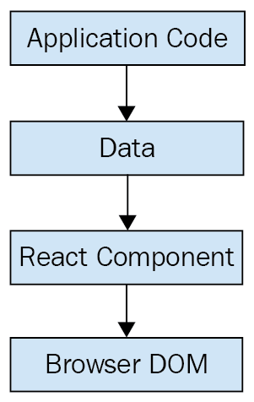
This is all there is to React—the core concept. Of course, there will be subtle variations to this theme as we make our way through the book, but the flow is more or less the same. We have some application logic that generates some Data. We want to render this Data to the UI, so we pass it to a React Component, which handles the job of getting the HTML into the page.
You may wonder what the big deal is; React appears to be yet another rendering technology. We'll touch on some of the key areas where React can simplify application development in the remaining sections of the chapter.

Simplicity is good
React doesn't have many moving parts to learn about and understand. Internally, there's a lot going on, and we'll touch on these things throughout the book. The advantage of having a small API to work with is that you can spend more time familiarizing yourself with it, experimenting with it, and so on. The opposite is true of large frameworks, where all of your time is devoted to figuring out how everything works. The following diagram gives you a rough idea of the APIs that we have to think about when programming with React:
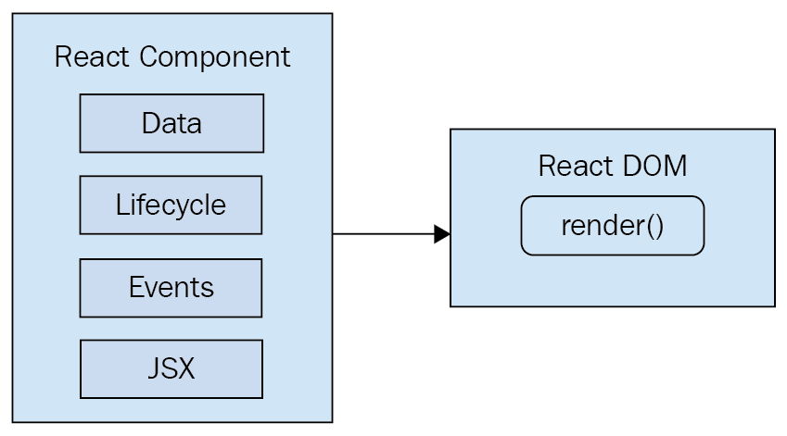
React is divided into two major APIs:
The React Component API: These are the parts of the page that are actually rendered by React DOM.
React DOM: This is the API that's used to perform the actual rendering on a web page.
Within a React component, we have the following areas to think about:
Data: This is data that comes from somewhere (the component doesn't care where), and is rendered by the component.
Lifecycle: This consists of methods or Hooks that we implement to respond to the component's entering and exiting phases of the React rendering process as they happen over time. For example, one phase of the lifecycle is when the component is about to be rendered.
Events: These are the code that we write for responding to user interactions.
JSX: This is the syntax of React components used to describe UI structures.
Don't fixate on what these different areas of the React API represent just yet. The takeaway here is that React, by nature, is simple. Just look at how little there is to figure out! This means that we don't have to spend a ton of time going through API details here. Instead, once you pick up on the basics, we can spend more time on nuanced React usage patterns that fit in nicely with declarative UI structures.

Declarative UI structures
React newcomers have a hard time coming to grips with the idea that components mix markup in with their JavaScript in order to declare UI structures. If you've looked at React examples and had the same adverse reaction, don't worry. Initially, we're all skeptical of this approach, and I think the reason is that we've been conditioned for decades by the separation of concerns principle. This principle states that different concerns, such as logic and presentation, should be separate from one another. Now, whenever we see things mixed together, we automatically assume that this is bad and shouldn't happen.
The syntax used by React components is called JSX (JavaScript XML). A component renders content by returning some JSX. The JSX itself is usually HTML markup, mixed with custom tags for React components. The specifics don't matter at this point; we'll go into detail in the coming chapters. What's groundbreaking about the declarative JSX approach is that we don't have to perform little micro-operations to change the content of a component.
Although I won't be following the convention in this book, some React developers prefer the .jsx extension instead of .js for their components.
For example, think about using something like jQuery to build your application. You have a page with some content on it, and you want to add a class to a paragraph when a button is clicked. Performing these steps is easy enough. This is called imperative programming, and it's problematic for UI development. While this example of changing the class of an element is simple, real applications tend to involve more than three or four steps to make something happen.
React components don't require executing steps in an imperative way. This is why JSX is central to React components. The XML-style syntax makes it easy to describe what the UI should look like. That is, what are the HTML elements that this component is going to render? This is called declarative programming and is very well suited for UI development. Once you've declared your UI structure, you need to specify how it changes over time.

Time and data
Another area that's difficult for React newcomers to grasp is the idea that JSX is like a static string, representing a chunk of rendered output. This is where time and data come into play. React components rely on data being passed into them. This data represents the dynamic parts of the UI. For example, a UI element that's rendered based on a Boolean value could change the next time the component is rendered. Here's a diagram of the idea:
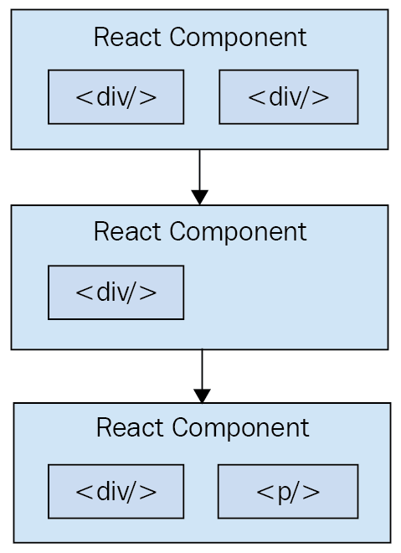
Each time the React component is rendered, it's like taking a snapshot of the JSX at that exact moment in time. As your application moves forward through time, you have an ordered collection of rendered UI components. In addition to declaratively describing what a UI should be, re-rendering the same JSX content makes things much easier for developers. The challenge is making sure that React can handle the performance demands of this approach.

Performance matters
Using React to build UIs means that we can declare the structure of the UI with JSX. This is less error-prone than the imperative approach of assembling the UI piece by piece. However, the declarative approach does present a challenge: performance.
For example, having a declarative UI structure is fine for the initial rendering, because there's nothing on the page yet. So, the React renderer can look at the structure declared in JSX and render it in the DOM browser.
The Document Object Model (DOM) represents HTML in the browser after it has been rendered. The DOM API is how JavaScript is able to change content on the page.
This concept is illustrated in the following diagram:
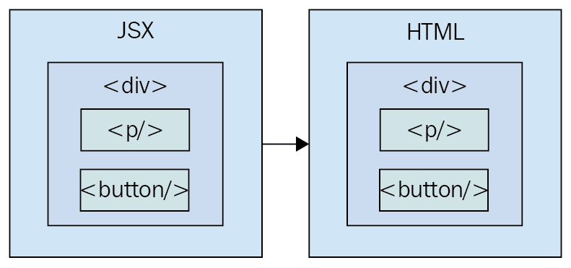
On the initial render, React components and their JSX are no different from other template libraries. For instance, Handlebars will render a template to HTML markup as a string, which is then inserted into the browser DOM. Where React is different from libraries such as Handlebars is when data changes and we need to re-render the component. Handlebars will just rebuild the entire HTML string, the same way it did on the initial render. Since this is problematic for performance, we often end up implementing imperative workarounds that manually update tiny bits of the DOM. We end up with a tangled mess of declarative templates and imperative code to handle the dynamic aspects of the UI.
We don't do this in React. This is what sets React apart from other view libraries. Components are declarative for the initial render, and they stay this way even as they're re-rendered. It's what React does under the hood that makes re-rendering declarative UI structures possible.
React has something called the virtual DOM, which is used to keep a representation of the real DOM elements in memory. It does this so that each time we re-render a component, it can compare the new content to the content that's already displayed on the page. Based on the difference, the virtual DOM can execute the imperative steps necessary to make the changes. So, not only do we get to keep our declarative code when we need to update the UI, but React will also make sure that it's done in a performant way. Here's what this process looks like:
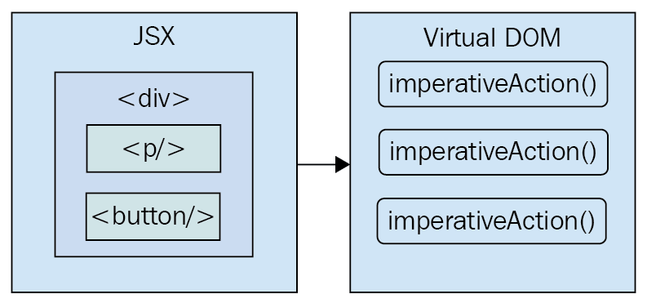
When you read about React, you'll often see words such as diffing and patching. Diffing means comparing old content with new content to figure out what's changed. Patching means executing the necessary DOM operations to render the new content.
Like any other JavaScript library, React is constrained by the run-to-completion nature of the main thread. For example, if the React internals are busy diffing content and patching the DOM, the browser can't respond to user input. As you'll see in the last section of this chapter, changes were made to the internal rendering algorithms in React 16 to mitigate these performance pitfalls.
With performance concerns addressed, we need to make sure that we're confident that React is flexible enough to adapt to different platforms that we might want to deploy our apps to in the future.

The right level of abstraction
Another topic I want to cover at a high level before we dive into React code is abstraction.
In the preceding section, you saw how JSX syntax translates to low-level operations that update our UI. A better way to look at how React translates our declarative UI components is via the fact that we don't necessarily care what the render target is. The render target happens to be the browser DOM with React, but it isn't restricted to the browser DOM.
React has the potential to be used for any UI we want to create, on any conceivable device. We're only just starting to see this with React Native, but the possibilities are endless. I personally will not be surprised when React Toast becomes a thing, targeting toasters that can singe the rendered output of JSX onto bread. The abstraction level with React is at the right level, and it's in the right place.
The following diagram gives you an idea of how React can target more than just the browser:
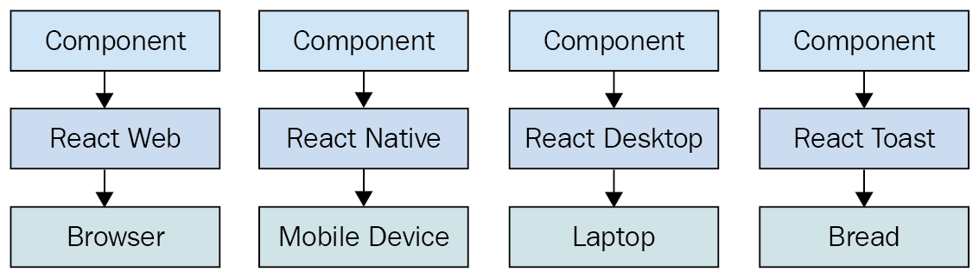
From left to right, we have React Web (just plain React), React Native, React Desktop, and React Toast. As you can see, to target something new, the same pattern applies:
Implement components specific to the target.
Implement a React renderer that can perform the platform-specific operations under the hood.
This is, obviously, an oversimplification of what's actually implemented for any given React environment. But the details aren't so important to us. What's important is that we can use our React knowledge to focus on describing the structure of our UI on any platform.
React Toast will probably never be a thing, unfortunately.
Now that you understand the role of abstractions in React, let's see what's new in React 16.

React Features
The second edition of this book covers the major changes in React 16. I'm leaving this section intact for the third edition because I think the changes that were introduced in React 16 are still new and important enough to be relevant to learning React.
The features of React 16 include the following:
Revamped core architecture
Lifecycle methods
Context API
Rendering fragments
Portals
Rendering lists and strings
Handling errors
Server-side rendering
Let's look at each new feature in detail.

Revamped core architecture
Perhaps the biggest change in React 16 is the change made to the internal reconciliation code. These changes don't impact the way that you interact with the React API. Instead, these changes were made to address some pain points that were preventing React from scaling up in certain situations. For example, one of the main concepts of this new architecture is that of fibers. Instead of rendering every component on the page in a run-to-compilation way, React renders fibers—smaller chunks of the page that can be prioritized and rendered asynchronously.
For a more in-depth look at this new architecture, these resources should be helpful:
https://github.com/acdlite/react-fiber-architecture
https://reactjs.org/blog/2017/09/26/react-v16.0.html

Lifecycle methods
React 16 had to revamp some of the lifecycle methods that are available to class components. Some lifecycle methods are deprecated and will eventually be removed because they will be problematic for future async rendering functionality in React. For example, a common way to initialize state in a React component is to use the componentWillMount() lifecycle method. Once this method is removed from React, you can just set the initial state directly as an instance value.
For more information on these lifecycle methods, visit https://reactjs.org/blog/2018/03/27/update-on-async-rendering.html.

The Context API
React has always provided a Context API for developers, but it was always considered experimental. Context is an alternative approach to passing data from one component to the next. For example, using properties, you can passing data through a tree of components that is several layers deep. The components in the middle of this tree don't actually use any of these properties—they're just acting as intermediaries. This becomes problematic as your application grows because you have lots of properties in your source that add to the complexity.
The new Context API in React 16.3 is more stable than previous versions and provides a way for you to supply your components with data at any tree level. You can read more about the new Context API here: https://reactjs.org/docs/context.html.

Rendering fragments
If your React component renders several sibling elements, say three <p> elements, for instance, you would have to wrap them in <div> because React would only allow components to return a single element. The only problem with this approach is that it leads to a lot of unnecessary DOM structure. Wrapping your elements with <Fragment> is the same as wrapping them with <div>, except there won't be any superfluous DOM elements.
You can read more about fragments here: https://reactjs.org/docs/fragments.html.

Portals
When a React component returns content, it gets rendered into its parent component. Then, that parent's content gets rendered into its parent component and so on, all the way to the tree root. There are times when you want to render something that specifically targets a DOM element. For example, a component that should be rendered as a dialog probably doesn't need to be mounted at the parent. Using a portal, you can control precisely where your component's content is rendered.
You can read more about portals here: https://reactjs.org/docs/portals.html.

Rendering lists and strings
Prior to React 16, components had to return either an HTML element or another React component as its content. This can restrict how you compose your application. For example, you might have a component that is responsible for generating an error message. You used to have to wrap strings in HTML tags or map list items to HTML tags in order to be considered a valid React component output. Now you can just return the string. Similarly, you can just return a list of strings or a list of elements.
This blog post introducing React 16 has more details on this new functionality: https://reactjs.org/blog/2017/09/26/react-v16.0.html.

Handling errors
Error handling in React can be difficult. Where exactly do you handle errors? If a component handles a JavaScript exception and sets an error state on the component to true, how do you reset this state? In React 16, there are error boundaries. Error boundaries are created by implementing the componentDidCatch() lifecycle method in a component. This component can then serve as the error boundary by wrapping other components. If any of the wrapped components throw an exception, the error boundary component can render alternative content.
Having error boundaries in place like this allows you to structure your components in a way that best suits your application. You can read more about error boundaries here: https://reactjs.org/docs/error-boundaries.html.

Server-side rendering
Server-side rendering (SSR) in React can be difficult to wrap your head around. You're rendering on the server, then rendering on the client too? Since the SSR pattern has become more prevalent, the React team has made it easier to work within React 16. In addition, there are a number of internal performance gains as well as efficiency gains by enabling streaming rendered content to the client.
If you want to read more about SSR in React 16, I recommend the following resources:
https://hackernoon.com/whats-new-with-server-side-rendering-in-react-16-9b0d78585d67
https://reactjs.org/docs/react-dom-server.html
However, in this book, the focus will be on using Next.js for SSR since it's so much easier than using a manual setup. Next.js is a simple framework for building React applications that handles many gory details related to routing and SSR.
Now that you're familiar with the big changes that came with React 16, it's time to take a look at the cutting edge features available in the latest React release.

What's new in React?
The third edition of this book includes React features that were introduced after version 16.6.0. In the following sections, I'll give you a brief introduction to the new functionality. Each feature will be covered in greater detail as you make your way through the book.
For now, we will briefly look at the following:
Memoizing functional components
Cook splitting and loading
Hooks
Let's start exploring them.

Memoizing functional components
The React.memo() function is the modern equivalent of the PureComponent class. Memoized components avoid re-rendering if the component data hasn't changed. In the past, you would extend your class component with PureComponent. This would automatically handle checking whether the component data has changed or not and whether or not the component should re-render.
The challenge with this approach is that it is now common for large React applications to have a lot of functional components. Before React.memo(), there was no way to memorize components so that they could avoid re-rendering if no data changes happened. Now, you can pass your functional components to React.memo() and they'll behave like PureComponent.
You can read more about React.memo() here: https://reactjs.org/docs/react-api.html#reactmemo.

Code splitting and loading
Prior to the React.lazy() function, code splitting in large React applications was cumbersome. Code splitting is important for large applications because it reduces the size of the code bundles that are sent to the browser, which can dramatically improve the user experience. Some features of an application might never be used, which means that the code that implements those features is never delivered to the browser. This is a huge efficiency gain.
With the addition of React.lazy(), React acknowledges that code splitting and the user experience of waiting for pieces of the application to load are integral parts of the application, not an afterthought. By combining React.lazy() and the Suspense component, we get fine-grained control over how our app is split up and what happens while the user waits for it to load.
You can read more about code splitting here: https://reactjs.org/docs/code-splitting.html.

Hooks
One of the most consequential new features of React is Hooks—functions that extend the behavior of functional React components. Hooks are used to "hook into" the React component machinery from your React components. Instead of relying on classes to build components that have state or that rely on executing side effects when the component is mounted, you can use the React Hooks API to pass functions that handle these cases.
The end result is having more flexibility with how you're able to compose React components since functions are more easily shared between modules than component class methods are. Hooks are the future of how React components are assembled, which will have a big impact on the third edition of this book, where there's a new chapter devoted to Hooks, as well as updated code in all chapters from the second edition.
You can read more about Hooks here: https://reactjs.org/docs/Hooks-intro.html.

Summary
In this chapter, you were introduced to React at a high level. React is a library, with a small API, used to build UIs. Next, you were introduced to some of the key concepts of React. We discussed the fact that React is simple because it doesn't have a lot of moving parts. Next, we looked at the declarative nature of React components and JSX. Then, you learned that React takes performance seriously and that this is how we're able to write declarative code that can be re-rendered over and over. Next, you learned about the idea of render targets and how React can easily become the UI tool of choice for all of them. Lastly, I gave you a rough overview of what's new in React 16.x.
That's enough introductory and conceptual stuff for now. As we make our way toward the end of the book, we'll revisit these ideas. For now, let's take a step back and nail down the basics, starting with JSX.

Further reading
Take a look at the following links for more information:
React: https://facebook.github.io/react
Introducing Hooks: https://reactjs.org/docs/hooks-intro.html
React Fiber Architecture: https://github.com/acdlite/react-fiber-architecture
React v16.0: https://reactjs.org/blog/2017/09/26/react-v16.0.html
Update on Async Rendering: https://reactjs.org/blog/2018/03/27/update-on-async-rendering.html
Context: https://reactjs.org/docs/context.html
Fragments: https://reactjs.org/docs/fragments.html
Portals: https://reactjs.org/docs/portals.html
Error Boundaries: https://reactjs.org/docs/error-boundaries.html
What’s New With Server-Side Rendering in React 16: https://hackernoon.com/whats-new-with-server-side-rendering-in-react-16-9b0d78585d67
ReactDOMServer: https://reactjs.org/docs/react-dom-server.html
Rendering with JSX
This chapter will introduce you to JSX. JSX is the XML/HTML markup syntax that's embedded in your JavaScript code and used to declare your React components. At the lowest level, you'll use HTML markup to describe the pieces of your UI. Building React applications involves organizing these pieces of HTML markup into components. When you create a component, you add new vocabulary to JSX beyond basic HTML markup. This is where React gets interesting; when you have your own JSX tags that can use JavaScript expressions to bring your components to life. JSX is the language used to describe UIs built using React.
In this chapter, we'll cover the following:
Your first JSX content
Rendering HTML
Describing UI structures
Creating your own JSX elements
Using JavaScript expressions
Fragments of JSX

Technical requirements
The code present in this chapter can be found at https://github.com/PacktPublishing/React-and-React-Native---Third-Edition/tree/master/Chapter02.

Your first JSX content
In this section, we'll implement the obligatory "hello world" JSX application. At this point, we're just dipping our toes in the water; more in-depth examples will follow. We'll also discuss what makes this syntax work well for declarative UI structures.

Hello JSX
Without further ado, here's your first JSX application:
import React from 'react';
import { render } from 'react-dom';
render(
<p>
Hello, <strong>JSX</strong>
</p>,
document.getElementById('root')
);
Let's walk through what's happening here. First, we need to import the relevant pieces. The render() function takes JSX as the first argument and renders it to the DOM node passed as the second argument.
The actual JSX content in this example renders a paragraph with some bold text inside. There's nothing fancy going on here, so we could have just inserted this markup into the DOM directly as a plain string. However, the aim of this example is to show the basic steps involved in getting JSX rendered onto the page. Now, let's talk a little bit about the declarative UI structure.
JSX is transpiled into JavaScript statements; browsers have no idea what JSX is. I would highly recommend downloading the companion code for this book from https://github.com/PacktPublishing/React-and-React-Native-Third-Edition, and running it as you read along. Everything transpiles automatically for you; you just need to follow the simple installation steps.

Declarative UI structures
Before we move forward with more in-depth code examples, let's take a moment to reflect on our "hello world" example. The JSX content was short and simple. It was also declarative because it described what to render, not how to render it. Specifically, by looking at the JSX, you can see that this component will render a paragraph, and some bold text within it. If this were done imperatively, there would probably be some more steps involved, and they would probably need to be performed in a specific order.
I find it helpful to think of declarative as structured and imperative as ordered. It's much easier to get things right with a structure than to perform steps in a specific order.
The example we just implemented should give you a feel for what declarative React is all about. As we move forward in this chapter and throughout the book, the JSX markup will grow more elaborate. However, it's always going to describe what is in the UI.
The render() function tells React to take your JSX markup and transform it into JavaScript statements that update the UI in the most efficient way possible. This is how React enables you to declare the structure of your UI without having to think about carrying out ordered steps to update elements on the screen; an approach that often leads to bugs. Out of the box, React supports the standard HTML tags that you would find on any HTML page. Unlike static HTML, React has unique conventions that should be followed when using HTML tags.

Rendering HTML
At the end of the day, the job of a React component is to render HTML into the DOM browser. This is why JSX has support for HTML tags out of the box. In this section, we'll look at some code that renders a few of the available HTML tags. Then, we'll cover some of the conventions that are typically followed in React projects when HTML tags are used.

Built-in HTML tags
When we render JSX, element tags reference React components. Since it would be tedious to have to create components for HTML elements, React comes with HTML components. We can render any HTML tag in our JSX, and the output will be just as we'd expect. Now, let's try rendering some of these tags:
import React from 'react';
import { render } from 'react-dom';
render(
<div>
<button />
<code />
<input />
<label />
<p />
<pre />
<select />
<table />
<ul />
</div>,
document.getElementById('root')
);
Don't worry about the formatting of the rendered output for this example. We're making sure that we can render arbitrary HTML tags, and they render as expected, without any special definitions and imports.
You may have noticed the surrounding <div> tag, grouping together all of the other tags as its children. This is because React needs a root component to render. Later in the chapter, you'll learn how to render adjacent elements without wrapping them in a parent element.
HTML elements rendered using JSX closely follow regular HTML element syntax with a few subtle differences regarding case sensitivity and attributes.

HTML tag conventions
When you render HTML tags in JSX markup, the expectation is that you'll use lowercase for the tag name. In fact, capitalizing the name of an HTML tag will fail. Tag names are case-sensitive and non-HTML elements are capitalized. This way, it's easy to scan the markup and spot the built-in HTML elements versus everything else.
You can also pass HTML elements any of their standard properties. When you pass them something unexpected, a warning about the unknown property is logged. Here's an example that illustrates these ideas:
import React from 'react';
import { render } from 'react-dom';
render(
<button title="My Button" foo="bar">
My Button
</button>,
document.getElementById('root')
);
render(<Button />, document.getElementById('root'));
When you run this example, it will fail to compile because React doesn't know about the <Button> element; it only knows about <button>.
Later on in the book, I'll cover property validation for the components that you make. This avoids silent misbehavior, as seen with the foo property in this example.
You can use any valid HTML tags as JSX tags, as long as you remember that they're case-sensitive and that you need to pass the correct attribute names. In addition to simple HTML tags that only have attribute values, you can use HTML tags to describe the structure of your page content.

Describing UI structures
JSX is capable of describing screen elements in a way that ties them together to form a complete UI structure. Let's look at some JSX markup that declares a more elaborate structure than a single paragraph:
import React from 'react';
import { render } from 'react-dom';
render(
<section>
<header>
<h1>A Header</h1>
</header>
<nav>
<a href="item">Nav Item</a>
</nav>
<main>
<p>The main content...</p>
</main>
<footer>
<small>&copy; 2019</small>
</footer>
</section>,
document.getElementById('root')
);
This JSX markup describes some fairly sophisticated UI structure. Yet, it's easier to read than imperative code because it's XML, and XML is good for concisely expressing a hierarchical structure. This is how we want to think of our UI when it needs to change, not as an individual element or property.
Here is what the rendered content looks like:
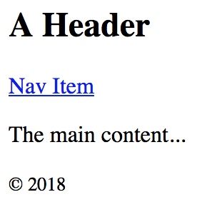
There are a lot of semantic elements in this markup describing the structure of the UI. For example, the <header> element describes the top part of the page where the title is, and the <main> element describes where the main page content goes. This type of complex structure makes it clearer for developers to reason about. But before we start implementing dynamic JSX markup, let's create some of our own JSX components.

Creating your own JSX elements
Components are the fundamental building blocks of React. In fact, components are the vocabulary of JSX markup. In this section, we'll see how to encapsulate HTML markup within a component. We'll build examples that nest custom JSX elements and learn how to namespace your components.

Encapsulating HTML
We create new JSX elements so that we can encapsulate larger structures. This means that instead of having to type out complex markup, you can use your custom tag. The React component returns the JSX that goes where the tag is used. Let's look at the following example:
import React, { Component } from 'react';
import { render } from 'react-dom';
class MyComponent extends Component {
render() {
return (
<section>
<h1>My Component</h1>
<p>Content in my component...</p>
</section>
);
}
}
render(<MyComponent />, document.getElementById('root'));
Here's what the rendered output looks like:
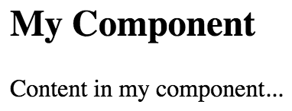
This is the first React component that we've implemented, so let's take a moment to dissect what's going on here. We created a class called MyComponent, which extends the Component class from React. This is how we create a new JSX element. As you can see in the call to render(), you're rendering a <MyComponent> element.
The HTML that this component encapsulates is returned by the render() method. In this case, when the JSX <MyComponent> is rendered by react-dom, it's replaced by a <section> element, and everything within it.
When React renders JSX, any custom elements that you use must have their corresponding React component within the same scope. In the preceding example, the MyComponent class was declared in the same scope as the call to render(), so everything worked as expected. Usually, you'll import components, adding them to the appropriate scope. You'll see more of this as you progress through the book.
HTML elements such as <div> often take nested child elements. Let's see whether we can do the same with JSX elements, which we create by implementing components.

Nested elements
Using JSX markup is useful for describing UI structures that have parent-child relationships. Child elements are created by nesting them within another component: the parent. For example, a <li> tag is only useful as the child of a <ul> tag or a <ol> tag—you're probably going to make similar nested structures with your own React components. For this, you need to use the children property. Let's see how this works. Here's the JSX markup:
import React from 'react';
import { render } from 'react-dom';
import MySection from './MySection';
import MyButton from './MyButton';
render(
<MySection>
<MyButton>My Button Text</MyButton>
</MySection>,
document.getElementById('root')
);
You're importing two of your own React components: MySection and MyButton. Now, if you look at the JSX markup, you'll notice that <MyButton> is a child of <MySection>. You'll also notice that the MyButton component accepts text as its child, instead of more JSX elements. Let's see how these components work, starting with MySection:
import React, { Component } from 'react';
export default class MySection extends Component {
render() {
return (
<section>
<h2>My Section</h2>
{this.props.children}
</section>
);
}
}
This component renders a standard <section> HTML element, a heading, and then {this.props.children}. It's this last piece that allows components to access nested elements or text, and to render them.
The two braces used in the preceding example are used for JavaScript expressions. I'll touch on more details of the JavaScript expression syntax found in JSX markup in the following section.
Now, let's look at the MyButton component:
import React, { Component } from 'react';
export default class MyButton extends Component {
render() {
return <button>{this.props.children}</button>;
}
}
This component uses the exact same pattern as MySection; take the {this.props.children} value and surround it with markup. React handles the details for you. In this example, the button text is a child of MyButton, which is, in turn, a child of MySection. However, the button text is transparently passed through MySection. In other words, we didn't have to write any code in MySection to make sure that MyButton got its text. Pretty cool, right? Here's what the rendered output looks like:
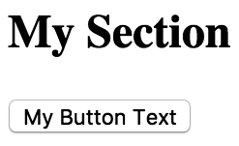
We can further organize our components by placing them within a namespace.

Namespaced components
The custom elements that you've created so far have used simple names. A namespace provides an organizational unit for your components so that related components can share the same namespace prefix. Instead of writing <MyComponent> in your JSX markup, you would write <MyNamespace.MyComponent>. This makes it clear that MyComponent is part of MyNamespace.
Typically, MyNamespace would also be a component. The idea of namespacing is to have a namespace component render its child components using the namespace syntax. Let's take a look at an example:
import React from 'react';
import { render } from 'react-dom';
import MyComponent from './MyComponent';
render(
<MyComponent>
<MyComponent.First />
<MyComponent.Second />
</MyComponent>,
document.getElementById('root')
);
This markup renders a <MyComponent> element with two children. Instead of writing <First>, we write <MyComponent.First>, and the same with <MyComponent.Second>. We want to explicitly show that First and Second belong to MyComponent within the markup.
I personally don't depend on namespaced components like these, because I'd rather see which components are in use by looking at the import statements at the top of the module. Others would rather import one component and explicitly mark the relationship within the markup. There is no one correct way to do this; it's a matter of personal taste.
Now, let's take a look at the MyComponent module:
import React, { Component } from 'react';
class First extends Component {
render() {
return <p>First...</p>;
}
}
class Second extends Component {
render() {
return <p>Second...</p>;
}
}
class MyComponent extends Component {
render() {
return <section>{this.props.children}</section>;
}
}
MyComponent.First = First;
MyComponent.Second = Second;
export default MyComponent;
export { First, Second };
This module declares MyComponent as well as the other components that fall under this namespace (First and Second). It assigns the components to the namespace component (MyComponent) as class properties. There are a number of things that you could change in this module. For example, you don't have to directly export First and Second since they're accessible through MyComponent. You also don't need to define everything in the same module; you could import First and Second and assign them as class properties. Using namespaces is completely optional, and, if you use them, you should use them consistently.
You now know how to build your own React components that introduce new JSX tags in your markup. You can also control the HTML content that a given component renders and provide components with a namespace to avoid confusion. The components that we've looked at so far in this chapter have been static. That is, once we rendered them, they were never updated. JavaScript expressions are the dynamic pieces of JSX and are what cause React to update components.

Using JavaScript expressions
As you saw in the preceding section, JSX has a special syntax that allows you to embed JavaScript expressions. Any time React renders JSX content, expressions in the markup are evaluated. This is the dynamic aspect of JSX, and in this section, you'll learn how to use expressions to set property values and element text content. You'll also learn how to map collections of data to JSX elements.

Dynamic property values and text
Some HTML property or text values are static, meaning that they don't change as JSX markup is re-rendered. Other values, the values of properties or text, are based on data that is found elsewhere in the application. Remember, React is just the view layer. Let's look at an example so that you can get a feel for what the JavaScript expression syntax looks like in JSX markup:
import React from 'react';
import { render } from 'react-dom';
const enabled = false;
const text = 'A Button';
const placeholder = 'input value...';
const size = 50;
render(
<section>
<button disabled={!enabled}>{text}</button>
<input placeholder={placeholder} size={size} />
</section>,
document.getElementById('root')
);
Anything that is a valid JavaScript expression, including nested JSX, can go in between the braces: {}. For properties and text, this is often a variable name or object property. Notice, in this example, that the !enabled expression computes a Boolean value. Here's what the rendered output looks like:
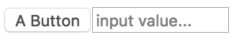
If you're following along with the downloadable companion code, which I strongly recommend doing, try playing with these values and seeing how the rendered HTML changes.
Primitive JavaScript values are straightforward to use in JSX syntax. But what if you have an object or array that you need to transform into JSX elements?

Mapping collections to elements
Sometimes, you need to write JavaScript expressions that change the structure of your markup. In the preceding section, you learned how to use JavaScript expression syntax to dynamically change the property values of JSX elements. What about when you need to add or remove elements based on JavaScript collections?
Throughout the book, when I refer to a JavaScript collection, I'm referring to both plain objects and arrays. Or, more generally, anything that's iterable.
The best way to dynamically control JSX elements is to map them from a collection. Let's look at an example of how this is done:
import React from 'react';
import { render } from 'react-dom';
const array = ['First', 'Second', 'Third'];
const object = {
first: 1,
second: 2,
third: 3
};
render(
<section>
<h1>Array</h1>
<ul>
{array.map(i => (
<li key={i}>{i}</li>
))}
</ul>
<h1>Object</h1>
<ul>
{Object.keys(object).map(i => (
<li key={i}>
<strong>{i}: </strong>
{object[i]}
</li>
))}
</ul>
</section>,
document.getElementById('root')
);
The first collection is an array called array, populated with string values. Moving down to the JSX markup, you can see the call to array.map(), which returns a new array. The mapping function is actually returning a JSX element (<li>), meaning that each item in the array is now represented in the markup.
The result of evaluating this expression is an array. Don't worry– JSX knows how to render arrays of elements.
The object collection uses the same technique, except you have to call Object.keys() and then map this array. What's nice about mapping collections to JSX elements on the page is that you can control the structure of React components based on the collected data. This means that you don't have to rely on imperative logic to control the UI.
Here's what the rendered output looks like:
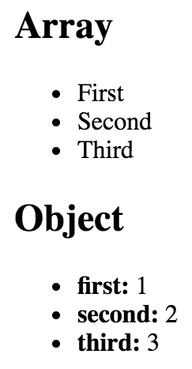
JavaScript expressions bring JSX content to life. React evaluates expressions and updates the HTML content based on what has already been rendered and what has changed. Understanding how to utilize these expressions is important because they're one of the most common day-to-day activities of any React developer. Now it's time to learn how to group together JSX markup without relying on HTML tags to do so.

Fragments of JSX
React 16 introduces the concept of JSX fragments. Fragments are a way to group together chunks of markup without having to add unnecessary structure to your page. For example, a common approach is to have a React component return content wrapped in a <div> element. This element serves no real purpose and adds clutter to the DOM.
Let's look at an example. Here are two versions of a component. One uses a wrapper element and one uses the new fragment feature:
import React from 'react';
import { render } from 'react-dom';
import WithoutFragments from './WithoutFragments';
import WithFragments from './WithFragments';
render(
<div>
<WithoutFragments />
<WithFragments />
</div>,
document.getElementById('root')
);
The two elements rendered are <WithoutFragments> and <WithFragments>. Here's what they look like when rendered:
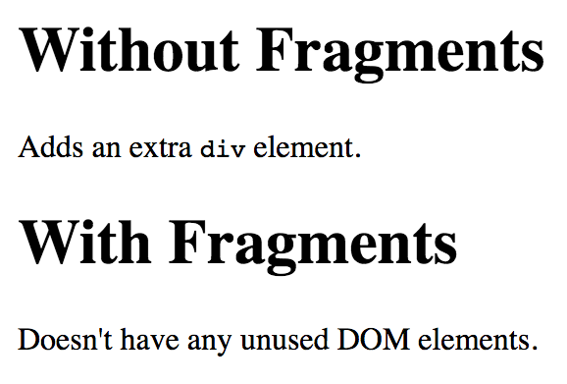
Let's compare the two approaches now.

Using wrapper elements
The first approach is to wrap sibling elements in <div>. Here's what the source looks like:
import React, { Component } from 'react';
class WithoutFragments extends Component {
render() {
return (
<div>
<h1>Without Fragments</h1>
<p>
Adds an extra <code>div</code> element.
</p>
</div>
);
}
}
export default WithoutFragments;
The essence of this component is the <h1> and <p> tags. Yet, in order to return them from render(), you have to wrap them with <div>. Indeed, inspecting the DOM using your browser dev tools reveals that <div> does nothing but add another level of structure:
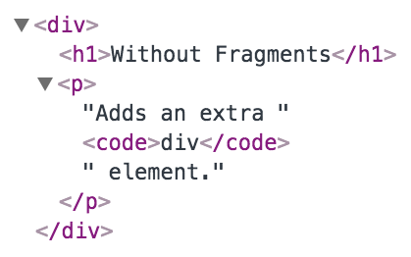
Now, imagine an app with lots of these components—that's a lot of pointless elements! Let's see how to use fragments to avoid unnecessary tags.

Using fragments
Now, let's take a look at the WithFragments component, where we have avoided using unnecessary tags:
import React, { Component, Fragment } from 'react';
class WithFragments extends Component {
render() {
return (
<Fragment>
<h1>With Fragments</h1>
<p>Doesn't have any unused DOM elements.</p>
</Fragment>
);
}
}
export default WithFragments;
Instead of wrapping the component content in <div>, the <Fragment> element is used. This is a special type of element that indicates that only its children need to be rendered. You can see the difference compared to the WithoutFragments component if you inspect the DOM:
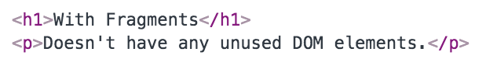
Notice how you had to import Fragment from React in the previous example? This is because not all transpilers such as Babel understand the Fragment element yet. In future versions, there will actually be a shorthand way to express fragments in JSX: <>My Content</>. But, for now, React.Fragment should work with all React tooling. Personally, I find the <Fragment> syntax easier to read.
With the advent of fragments in JSX markup, we have less HTML rendered on the page because we don't have to use tags such as <div> for the sole purpose of grouping elements together. Instead, when a component renders a fragment, React knows to render the event's child element wherever the component is used.

Summary
In this chapter, you learned about the basics of JSX, including its declarative structure, which leads to more maintainable code. Then, you wrote some code to render some basic HTML and learned about describing complex structures using JSX; every React application has at least some structure.
Next, you spent some time learning about extending the vocabulary of JSX markup by implementing your own React components, which is how you design your UI as a series of smaller pieces and glue them together to form the whole. Then, you learned how to bring dynamic content into JSX element properties, and how to map JavaScript collections to JSX elements, eliminating the need for imperative logic to control the UI display. Finally, you learned how to render fragments of JSX content using new React 16 functionality, which prevents unnecessary HTML elements from being used.
Now that you have a feel for what it's like to render UIs by embedding declarative XML in your JavaScript modules, it's time to move on to the next chapter, where we'll take a deeper look at component properties and state.

Further reading
Refer to the following links for more information:
Introducing JSX: https://reactjs.org/docs/introducing-jsx.html
Fragments: https://reactjs.org/docs/fragments.html
Component Properties, State, and Context
React components rely on JSX syntax, which is used to describe the structure of the UI. JSX will only get you so far—you need data to fill in the structure of your React components. The focus of this chapter is on component data, which comes in two main varieties: properties and state. Another option for passing data to components is via a context.
I'll start things off by defining what is meant by properties and state. Then, I'll walk through some examples that show you the mechanics of setting component state and passing component properties. Toward the end of this chapter, we'll build on your newfound knowledge of properties and state and introduce functional components and the container pattern. Finally, you'll learn about context and when it makes a better choice than a property for passing data to components.
In this chapter, we'll cover the following topics:
What is component state?
What are component properties?
Setting a component state
Passing property values
Stateless components
Container components
Providing and consuming context

Technical requirements
The code present in this chapter can be found at https://github.com/PacktPublishing/React-and-React-Native---Third-Edition/tree/master/Chapter03.

What is component state?
React components declare the structure of UI elements using JSX. However, components need data if they are to be useful. For example, your component JSX might declare <ul> that maps a JavaScript collection to <li> elements. Where does this collection come from?
State is the dynamic part of a React component. You can declare the initial state of a component, which changes over time.
Imagine that you're rendering a component where a piece of its state is initialized to an empty array. Later on, this array is populated with data using setState(). This is called a change in state, and whenever you tell a React component to change its state, the component will automatically re-render itself, calling render(). The process is visualized here:
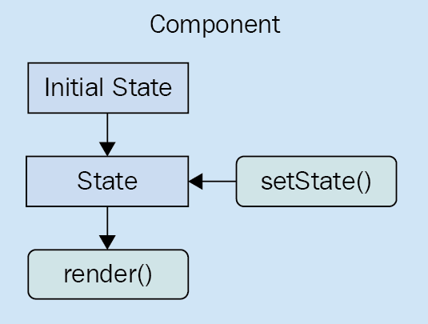
The state of a component is something that either the component itself can set, or other pieces of code, outside of the component. Now we'll look at component properties and explain how they differ from component state.

What are component properties?
Properties are used to pass data into your React components. Instead of calling a method with a new state as the argument, properties are passed only when the component is rendered. That is, you pass property values to JSX elements.
In the context of JSX, properties are called attributes, probably because that's what they're called in XML parlance. In this book, properties and attributes are synonymous with one another.
Properties are different than state because they don't change after the initial render of the component. If a property value has changed, and you want to re-render the component, then we have to re-render the JSX that was used to render it in the first place. The React internals take care of making sure this is done efficiently. Here's a diagram of rendering and re-rendering a component using properties:
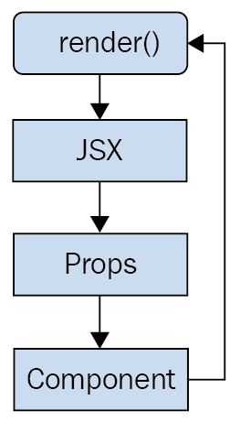
This looks a lot different than a stateful component. The real difference is that with properties, it's often a parent component that decides when to render the JSX. The component doesn't actually know how to re-render itself. As you'll see throughout this book, this type of top-down flow is easier to predict than state that changes all over the place.
Let's make sense of state and properties by writing some code, starting with setting the state of your components.

Setting a component state
In this section, you're going to write some React code that sets the state of components. First, you'll learn about the initial state—that is, the default state of a component. Next, you'll learn how to change the state of a component, causing it to re-render itself. Finally, you'll see how a new state is merged with an existing state.

Setting an initial component state
The initial state of a component isn't actually required, but if your component uses state, it should be set. This is because if the component expects certain state properties to be there and they aren't, then the component will either fail or render something unexpected. Thankfully, it's easy to set the initial component state.
The initial state of a component should always be an object with one or more properties. For example, you might have a component that uses a single array as its state. This is fine, but just make sure that you set the initial array as a property of the state object. Don't use an array as the state. The reason for this is simple: consistency. Every React component uses a plain object as its state.
Let's turn our attention to some code now. Here's a component that sets an initial state object:
import React, { Component } from 'react';
export default class MyComponent extends Component {
state = {
first: false,
second: true
};
render() {
const { first, second } = this.state;
return (
<main>
<section>
<button disabled={first}>First</button>
</section>
<section>
<button disabled={second}>Second</button>
</section>
</main>
);
}
}
If you look at the JSX that's returned by render(), you can actually see the state values that this component depends on—first and second. Since you've set these properties up in the initial state, you're safe to render the component, and there won't be any surprises. For example, you could render this component only once, and it would render as expected thanks to the initial state set in MyComponent in the preceding code listing:
import React from 'react';
import { render } from 'react-dom';
import MyComponent from './MyComponent';
render(<MyComponent />, document.getElementById('root'));
Here's what the rendered output looks like:
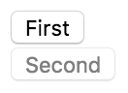
Setting the initial state isn't very exciting, but it's important nonetheless. Let's make the component re-render itself when the state is changed.

Creating a component state
Let's create a component that has some initial state. You'll then render this component and update its state. This means that the component will be rendered twice. Let's take a look at the component:
import React, { Component } from 'react';
export default class MyComponent extends Component {
state = {
heading: 'React Awesomesauce (Busy)',
content: 'Loading...'
};
render() {
const { heading, content } = this.state;
return (
<main>
<h1>{heading}</h1>
<p>{content}</p>
</main>
);
}
}
The JSX of this component depends on two state values—heading and content. The component also sets the initial values of these two state values, which means that it can be rendered without any unexpected "gotchas." Now, let's look at some code that renders the component and then re-renders it by changing the state:
import React from 'react';
import { render } from 'react-dom';
import MyComponent from './MyComponent';
const myComponent = render(<MyComponent />, document.getElementById('root'));
setTimeout(() => {
myComponent.setState({
heading: 'React Awesomesauce',
content: 'Done!'
});
}, 3000);
The component is first rendered with its default state. However, the interesting spot in this code is the setTimeout() call. After 3 seconds, it uses setState() to change the two state property values. Sure enough, this change is reflected in the UI. Here's what the initial state looks like when rendered:
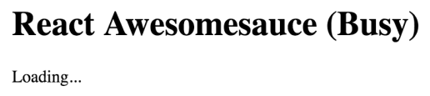
Here's what the rendered output looks like after the state change:
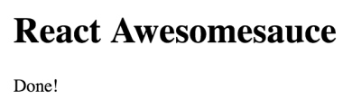
This example highlights the power of having declarative JSX syntax to describe the structure of the UI component. You declare it once and update the state of the component over time to reflect changes in the application as they happen. All the DOM interactions are optimized and hidden from view.
In this example, you replaced the entire component state. That is, the call to setState() passed in the same object properties found in the initial state. But what if you only want to update part of the component state?

Merging the component state
When you set the state of a React component, you're actually merging the state of the component with the object that you pass to setState(). This is useful because it means that you can set part of the component state while leaving the rest of the state as it is. Let's look at an example now. First, let's implement a component that has some initial state set on it:
import React, { Component } from 'react';
export default class MyComponent extends Component {
state = {
first: 'loading...',
second: 'loading...',
third: 'loading...',
fourth: 'loading...',
doneMessage: 'finished!'
};
render() {
const { state } = this;
return (
<ul>
{Object.keys(state)
.filter(key => key !== 'doneMessage')
.map(key => (
<li key={key}>
<strong>{key}: </strong>
{state[key]}
</li>
))}
</ul>
);
}
}
This component renders the keys and values of its state—except for doneMessage. Each value defaults to loading.... To iterate over objects, we have to use Object.keys(), which returns an array of the object keys. Next, filter() is used to return a new array of object keys but without the doneMessage value. Finally, we can call map() to map each object key to an <li> element. The value that corresponds to the key is looked up on the state object, like so: state[key].
Let's write some code that sets the state of each state property individually:
import React from 'react';
import { render } from 'react-dom';
import MyComponent from './MyComponent';
const myComponent = render(<MyComponent />, document.getElementById('root'));
setTimeout(() => {
myComponent.setState({ first: 'done!' });
}, 1000);
setTimeout(() => {
myComponent.setState({ second: 'done!' });
}, 2000);
setTimeout(() => {
myComponent.setState({ third: 'done!' });
}, 3000);
setTimeout(() => {
myComponent.setState(state => ({
...state,
fourth: state.doneMessage
}));
}, 4000);
The takeaway from this example is that you can set individual state properties on components. It will efficiently re-render itself. Here's what the rendered output looks like for the initial component state:
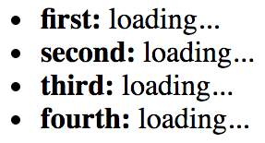
Here's what the output looks like after three of the setTimeout() callbacks have run:
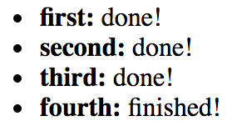
The fourth call to setState() looks different from the first three. Instead of passing a new object to merge into the existing state, you can pass a function. This function takes a state argument—the current state of the component. This is useful when you need to base state changes on current state values. In this example, the doneMessage value is used to set the value of fourth. The function then returns the new state of the component. It's up to you to merge existing state values into the new state. You can use the spread operator to do this (...state).
Components with state usually have an initial state. You can then change the initial values by calling setState(). If you only need to change part of the state, you can pass an object with only the values that you want to change and React will take care of merging the values into the overall state of the component. Now that we've looked at the state of a component that changes over time, it's time to learn about properties that never change.

Passing property values
Properties are like state data that gets passed into components. However, properties are different from state in that they're only set once, which is when the component is rendered. In this section, you'll learn about default property values. Then, we'll look at setting property values. After this section, you should be able to grasp the differences between component state and properties.

Default property values
Default property values work a little differently than default state values. They're set as a class attribute called defaultProps. Let's take a look at a component that declares default property values:
import React, { Component } from 'react';
export default class MyButton extends Component {
static defaultProps = {
disabled: false,
text: 'My Button'
};
render() {
const { disabled, text } = this.props;
return <button disabled={disabled}>{text}</button>;
}
}
Why not just set the default property values as an instance property, like you would with default state? The reason is that properties are immutable, and there's no need for them to be kept as an instance property value. State, on the other hand, changes all the time, so the component needs an instance-level reference to it. You can see that this component sets default property values for disabled and text. These values are only used if they're not passed in through the JSX markup used to render the component.
Let's go ahead and render this component without any properties, to make sure that the defaultProps values are used:
import React from 'react';
import { render } from 'react-dom';
import MyButton from './MyButton';
render(<MyButton />, document.getElementById('root'));
The same principle of always having default state applies to properties too. We want to be able to render components without having to know in advance what the dynamic values of the component are. In this example, the MyButton component renders a <button> element using the default disabled and text property values. Now, let's write some code that passes new property values to components that will override any default value for a given property.

Setting property values
React component properties are set by passing JSX attributes to the component when it is rendered. In Chapter 8, Validating Component Properties, I'll go into more detail about how to validate the property values that are passed to components. Now let's create a couple of components that expect different types of property values:
import React, { Component } from 'react';
export default class MyButton extends Component {
render() {
const { disabled, text } = this.props;
return <button disabled={disabled}>{text}</button>;
}
}
This simple button component expects a Boolean disabled property and a string text property. Let's create one more component that expects an array property value:
import React, { Component } from 'react';
export default class MyList extends Component {
render() {
const { items } = this.props;
return (
<ul>
{items.map(i => (
<li key={i}>{i}</li>
))}
</ul>
);
}
}
You can pass just about anything you want as a property value via JSX, just as long as it's a valid JavaScript expression. The MyList component accepts an items property, an array that is mapped to <li> elements. Now, let's write some code to set these property values:
import React from 'react';
import { render as renderJSX } from 'react-dom';
import MyButton from './MyButton';
import MyList from './MyList';
const appState = {
text: 'My Button',
disabled: true,
items: ['First', 'Second', 'Third']
};
function render(props) {
renderJSX(
<main>
<MyButton text={props.text} disabled={props.disabled} />
<MyList items={props.items} />
</main>,
document.getElementById('root')
);
}
render(appState);
setTimeout(() => {
appState.disabled = false;
appState.items.push('Fourth');
render(appState);
}, 1000);
The render() function looks like it's creating new React component instances every time it's called. React is smart enough to figure out that these components already exist, and that it only needs to figure out what the difference in output will be with the new property values. In this example, the call to setTimeout() causes a delay of 1 second. Then, the appState.disabled value is changed to false and the appState.items array has a new value added to the end of it. The call to render() will re-render the <MyButton> and <MyList> components with new property values.
Another takeaway from this example is that you have an appState object that holds on to the state of the application. Pieces of this state are then passed into components as properties when the components are rendered. State has to live somewhere, and, in this case, it's outside of the component. I'll build on this topic in the next section, where you will learn how to implement stateless functional components.

Stateless components
The components you've seen so far in this book have been classes that extend the base Component class. It's time to learn about functional components in React. In this section, you'll learn what a functional component is by implementing one. Then, you'll learn how to set default property values for stateless functional components.

Pure functional components
A functional React component is just what its name suggests—a function. Picture the render() method of any React component that you've seen. This method, in essence, is the component. The job of a functional React component is to return JSX, just like a class-based React component. The difference is that this is all a functional component can do. It has no state and no lifecycle methods.
Why would you want to use functional components? It's a matter of simplicity more than anything else. If your component renders some JSX and does nothing else, then why bother with a class when a function is simpler?
A pure function is a function without side effects. That is to say, called with a given set of arguments, the function always produces the same output. This is relevant for React components because, given a set of properties, it's easier to predict what the rendered content will be. Functions that always return the same value with a given argument values are easier to test as well.
Let's look at a functional component now:
import React from 'react';
export default ({ disabled, text }) => (
<button disabled={disabled}>{text}</button>
);
Concise, isn't it? This function returns a <button> element, using the properties passed in as arguments (instead of accessing them through this.props). This function is pure because the same content is rendered if the same disabled and text property values are passed. Now, let's see how to render this component:
import React from 'react';
import { render as renderJSX } from 'react-dom';
import MyButton from './MyButton';
function render({ first, second }) {
renderJSX(
<main>
<MyButton text={first.text} disabled={first.disabled} />
<MyButton text={second.text} disabled={second.disabled} />
</main>,
document.getElementById('root')
);
}
render({
first: {
text: 'First Button',
disabled: false
},
second: {
text: 'Second Button',
disabled: true
}
});
There's zero difference between the class-based and function-based React components, from a JSX point of view. The JSX looks exactly the same whether the component was declared using the class or function syntax.
The convention is to use the arrow function syntax to declare functional React components. However, it's perfectly valid to declare them using a traditional JavaScript function syntax, if that's better suited to your style.
Here's what the rendered HTML looks like:
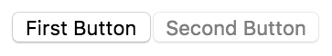
Functional components rely on property values being passed to them for anything dynamic. For example, if a component renders a functional component, it usually passes in property values and these can change each time it is rendered. But what about default property values for functional components?

Defaults in functional components
Functional components are lightweight; they don't have any state or lifecycle. They do, however, support some metadata options. For example, you can specify the default property values of functional components the same way you would with a class component. Here's an example of what this looks like:
import React from 'react';
const MyButton = ({ disabled, text }) => (
<button disabled={disabled}>{text}</button>
);
MyButton.defaultProps = {
text: 'My Button',
disabled: false
};
export default MyButton;
The defaultProps property is defined on a function instead of a class. When React encounters a functional component with this property, it knows to pass in the default properties if they're not provided via JSX.
Functional components are an important part of React applications because they're highly focused on taking property values and rendering markup that uses these values. The term "pure function" is used to indicate that a function, in our case, a React component, doesn't have any side effects. As long as you give it the same property values, the same output is rendered. Functional components can also have default property values, just as their class-based counterparts can.
You might have noticed a pattern at this point: some components have state that changes over time. These components then pass state values to other components as properties. These stateful components are called container components.

Container components
In this section, you're going to learn about the concept of container components. This is a common React pattern, and it brings together many of the concepts that you've learned about state and properties.
The basic premise of container components is simple: don't couple data fetching with the component that renders the data. The container is responsible for fetching the data and passing it to its child component. It contains the component responsible for rendering the data.
The idea is that you should be able to achieve some level of substitutability with this pattern. For example, a container could substitute its child component. Or, a child component could be used in a different container. Let's look at the container pattern in action, starting with the container itself:
import React, { Component } from 'react';
import MyList from './MyList';
function fetchData() {
return new Promise(resolve => {
setTimeout(() => {
resolve(['First', 'Second', 'Third']);
}, 2000);
});
}
export default class MyContainer extends Component {
state = { items: [] };
componentDidMount() {
fetchData().then(items => this.setState({ items }));
}
render() {
return <MyList {...this.state} />;
}
}
The job of this component is to fetch data and to set its state. Any time the state is set, render() is called. This is where the child component comes in. The state of the container is passed to the MyList component as properties. Let's take a look at the MyList component next:
import React from 'react';
export default ({ items }) => (
<ul>
{items.map(i => (
<li key={i}>{i}</li>
))}
</ul>
);
MyList is a functional component that expects an items property. Let's see how the container component is actually used:
import React from 'react';
import { render } from 'react-dom';
import MyContainer from './MyContainer';
render(<MyContainer />, document.getElementById('root'));
Container component design will be covered in more depth in Chapter 6, Crafting Reusable Components. The idea of this example is to give you a feel for the interplay between state and properties in React components.
When you load the page, you'll see the following content rendered after the 3 seconds it takes to simulate an HTTP request:
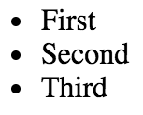
Containers are an important concept in React applications, as they help to separate the work of getting data and using data to render markup. You'll encounter many variations of this pattern in any given React code base. The basic idea is that the container does the work to get the data, and then passes it as properties to the component responsible for rendering visual elements.
Over time, you might end up with a lot of container components in your app that all share similar state that needs to be passed to child components. This amounts to lots of code to pass property values around. For data that is truly global in your application, we can use context to access it.

Providing and consuming context
As your React application grows, it will use more components. Not only will it have more components, but the structure of your application will change so that the components are nested more deeply. The components that are nested at the deepest level still need to have data passed to them. Passing data from a parent component to a child component isn't a big deal. The challenge is when you have to start using components as indirection for passing data around your app.
For data that needs to make its way to any component in your app, you can create and use a context. There are two key concepts to remember when using contexts in React—providers and consumers. A context provider creates data and makes sure that it's available to any React components. A context consumer is a component that uses this data within the context.
You might be wondering whether or not context is just another way of saying global data in a React application. Essentially, this is exactly what contexts are used for. Using the React approach to wrap components with a context works better than creating global data because you have better control of how your data flows down through your components. For example, you can have nested contexts and a number of other advanced use cases. But, for now, let's just focus on simple usage.
Let's say that you have some application data that determines permissions for given application features. This data could be fetched from an API or it could be hardcoded. In either case, the requirement is that you don't want to have to pass all of this permission data through the component tree. It would be nice if the permission data were just there, for any component that needs it.
Starting at the very top of the component tree, let's look at index.js:
import React from 'react';
import { render } from 'react-dom';
import { PermissionProvider } from './PermissionContext';
import App from './App';
render(
<PermissionProvider>
<App />
</PermissionProvider>,
document.getElementById('root')
);
The <App> component is the child of the <PermissionProvider> component. This means that the permission context has been provided to the <App> component and any of its children, all the way down the tree. Let's take a look at the PermissionContext.js module where the permission context is defined:
import React, { Component, createContext } from 'react';
const { Provider, Consumer } = createContext('permissions');
export class PermissionProvider extends Component {
state = {
first: true,
second: false,
third: true
};
render() {
return (
<Provider value={this.state}>{this.props.children}</Provider>
);
}
}
const PermissionConsumer = ({ name, children }) => (
<Consumer>{value => value[name] && children}</Consumer>
);
export { PermissionConsumer };
The createContext() function is used to create the actual context. The return value is an object containing two components—Provider and Consumer. Next, there's a simple abstraction for the permission provider that's to be used all throughout the app. The state contains the actual data that components might want to use. In this example, if the value is true, the feature should be displayed as normal. If it's false, then the feature doesn't have permission to render. Here, the state is only set once; however, since this is a regular React component, you could set the state in the same way you would set the state on any other component. The value that's rendered is the <Provider> component. This provides any children with context data, set via the value property.
Next, there's a small abstraction for permission consumers. Instead of having every component that needs to test for permissions implement the same logic over and over, the PermissionConsumer component can do it. The child of the <Consumer> component is always a function that takes the context data as an argument. In this example, the PermissionConsumer component has a name property, for the name of the feature. This is compared with the value from the context and, if it's false, nothing is rendered.
Now let's look at the App component:
import React, { Fragment } from 'react';
import First from './First';
import Second from './Second';
import Third from './Third';
export default () => (
<Fragment>
<First />
<Second />
<Third />
</Fragment>
);
This component renders three components that are features and each needs to check for permissions. Without the context functionality of React, you would have to pass this data as a series of properties to each of these components through this component. If <First> had children or grandchildren that needed to check permissions, the same property-passing mechanism can get quite messy.
Now let's take a look at the <First> component (<Second> and <Third> components are almost exactly the same):
import React from 'react';
import { PermissionConsumer } from './PermissionContext';
export default () => (
<PermissionConsumer name="first">
<div>
<button>First</button>
</div>
</PermissionConsumer>
);
This is where the PermissionConsumer component is put to use. You just need to supply it with a name property, and the child component is the component that is rendered if the permission check passes. The <PermissionConsumer> component can be used anywhere, and there's no need to pass data in order to use it. Here's what the rendered output of these three components looks like:
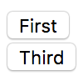
The second component isn't rendered because its permission in the PermissionProvider component is set to false. Context should be used sparingly, because it can lead to confusion about where data comes from and which components throughout your application rely on it. Often, you'll start out using state to manage data and then, later on, discover that you're passing this state to every component in your app. To avoid this, you can refactor data that's shared by every component from state into context. Remember, context should be used sparingly. If you rely on context for accessing data too much, it's a good indication that your app has too much global data and should be revised. For the data that must be global, context is a good way to avoid too much property-passing code.

Summary
In this chapter, you learned about state and properties in React components. We started off by defining and comparing the two concepts. Then, we implemented several React components and manipulated their state, allowing you to dynamically update what the user sees on the screen. Next, you learned about properties by implementing code that passed property values from JSX to the component, in cases where the component only needs to display values instead of changing them. Next, you were introduced to the concept of a container component, which is used to decouple data fetching from rendering content, leading to a clear separation of concerns. Finally, you learned about the new context API in React 16 and how to use it to avoid too many repetitive properties when you have global application data.
In the following chapter, you'll learn about the new React Hooks API and how it supports using functional components for everything, including state and lifecycle management.

Further reading
Visit the following links for more information:
Instance Properties: https://reactjs.org/docs/react-component.html#instance-properties-1
Setting the Initial State: https://reactjs.org/docs/react-without-es6.html#setting-the-initial-state
Context: https://reactjs.org/docs/context.html
Spread syntax: https://developer.mozilla.org/en-US/docs/Web/JavaScript/Reference/Operators/Spread_syntax
Getting Started with Hooks
One of the most anticipated new features of React is Hooks, an API that allows your functional components to "Hook" into React functionality. The overarching motivation for this feature is to simplify your components. For example, forcing React developers to use classes to define their components leads to the overuse of wrapper components to pass state around their apps. With Hooks, you can stick with simple functions to implement your components and have a clear picture of how everything fits together.
In this chapter, we'll cover the following topics:
Maintaining state using Hooks
Performing initialization and cleanup actions
Sharing data using context Hooks
Using reducer Hooks to scale state management

Technical requirements
The code present in this chapter can be found at https://github.com/PacktPublishing/React-and-React-Native---Third-Edition/tree/master/Chapter04.

Maintaining state using Hooks
The first React Hook API that we'll look at is called useState(), which enables your functional React components to be stateful. Before Hooks were introduced to React, our only option for creating stateful components was to use a class so that we could access the setState() method. In this section, you'll learn how to initialize state values, and how to change the state of a component using Hooks.

Initial state values
When our components are first rendered, they probably expect some state values to be set. This is called the initial state of the component, and we can use the useState() Hook to set the initial state. Let's take a look at an example:
import React, { Fragment, useState } from 'react';
export default function App() {
const [name] = useState('Adam');
const [age] = useState(35);
return (
<Fragment>
<p>My name is {name}</p>
<p>My age is {age}</p>
</Fragment>
);
}
The App component is a functional React component, a function that returns JSX markup. But it's also now a stateful component, thanks to the useState() Hook. This example initializes two pieces of state, name and age. This is why there are two calls to useState(), one for each state value.
You can have as many pieces of state in your component as you need. The best practice is to have one call to useState() per state value. You could always define an object as the state of your component using only one call to useState(), but this complicates things because you have to access state values through an object instead of directly. Updating state values is also more complicated using this approach. When in doubt, use one useState() Hook per state value.
When we call useState(), we get an array returned to us. The first value of this array is the state value itself. Since we've used array destructuring syntax here, we can call the value whatever we want; in this case, it is name and age. Both of these constants have values when the component is first rendered because we passed the initial state values for each of them to useState(). Here's what the page looks like when it's rendered:
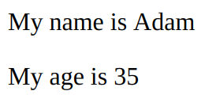
Now that you've seen how to set the initial state values of your components, let's learn about updating these values.

Updating state values
React components use state for values that change over time. The state values used by components start off in one state, as we saw in the previous section, and then change in response to some event. For example, the server responds to an API request with new data or the user has clicked a button or changed a form field.
With functional components that use the useState() Hook, state values are updated differently to class components that rely on the setState() method. Instead of using setState() to update every piece of component state, you have individual functions to set each state value. The useState() Hook returns an array. The first item is the state value and the second is the function used to update the value. Let's take a look at an example:
import React, { Fragment, useState } from 'react';
export default function App() {
const [name, setName] = useState('Adam');
const [age, setAge] = useState(35);
return (
<Fragment>
<section>
<input value={name} onChange={e => setName(e.target.value)} />
<p>My name is {name}</p>
</section>
<section>
<input
type="number"
value={age}
onChange={e => setAge(e.target.value)}
/>
<p>My age is {age}</p>
</section>
</Fragment>
);
}
Just like the example from the Initial state values section, the App component in this example has two pieces of state: name and age. Unlike the previous example, this component uses two functions to update each piece of state. These are returned from the call to useState(). Let's take a closer look:
const [name, setName] = useState('Adam');
const [age, setAge] = useState(35);
Now we have two functions – setName() and setAge() – that can be used to update the state of our component. Let's take a look at the text input field that updates the name state:
<section>
<input value={name} onChange={e => setName(e.target.value)} />
<p>My name is {name}</p>
</section>
Whenever the user changes the text in the <input> field, the onChange event is triggered. The handler for this event calls setName(), passing it e.target.value as an argument. The argument passed to setName() is the new state value of name. The succeeding paragraph shows that the text input is also updated with the new name value every time the user changes the text input.
Next, let's look at the age number input field and how this value is passed to setAge():
<section>
<input
type="number"
value={age}
onChange={e => setAge(e.target.value)}
/>
<p>My age is {age}</p>
</section>
The age field follows the exact same pattern as the name field. The only difference is that we've made the input a number type. Any time the number changes, setAge() is called with the updated value in response to the onChange event. The following paragraph shows that the number input is also updated with every change that is made to the age state.
Here is what the two inputs and their two corresponding paragraphs look like when they're rendered on the screen:
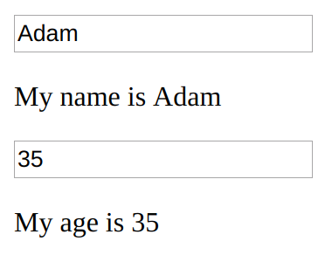
In this section, you learned about the useState() Hook, which is used to add state to functional React components. Each piece of state uses its own Hook and has its own value variable and its own setter function. This greatly simplifies accessing and updating state in your components. Any given state value should have an initial value so that the component can render correctly the first time. To re-render functional components that use state Hooks, you can use the setter functions that useState() returns to update your state values as needed.
The next Hook that you'll learn about is used to perform initialization and cleanup actions.

Performing initialization and cleanup actions
Often, our React components need to perform actions when the component is created. For example, a common initialization action is to fetch API data that the component needs. Another common action is to make sure that any pending API requests are canceled when the component is removed. In this section, you'll learn about the useEffect() Hook and how it can help you with these two scenarios. You'll also learn how to make sure that the initialization code doesn't run too often.

Fetching component data
The useEffect() Hook is used to run "side-effects" in your component. Another way to think about side effect code is that functional components have only one job: return JSX content to render. If the component needs to do something else, such as fetching API data, this should be done in a useEffect() Hook. For example, if you were to just make the API call as part of your component function, you would likely introduce race conditions and other difficult-to-fix buggy behavior.
Let's take a look at an example that fetches API data using Hooks:
import React, { Fragment, useEffect, useState } from 'react';
function fetchUser() {
return new Promise(resolve => {
setTimeout(() => {
resolve({ id: 1, name: 'Adam' });
}, 1000);
});
}
export default function App() {
const [id, setId] = useState('loading...');
const [name, setName] = useState('loading...');
useEffect(() => {
fetchUser().then(user => {
setId(user.id);
setName(user.name);
});
});
return (
<Fragment>
<p>ID: {id}</p>
<p>Name: {name}</p>
</Fragment>
);
}
The useEffect() Hook expects a function as an argument. This function is called after the component finishes rendering, in a safe way that doesn't interfere with anything else that React is doing with the component under the covers. Let's look at the pieces of this example more closely, starting with the mock API function:
function fetchUser() {
return new Promise(resolve => {
setTimeout(() => {
resolve({ id: 1, name: "Adam" });
}, 1000);
});
}
The fetchUser() function returns a promise. The promise resolves a simple object with two properties, id and name. The setTimeout() function delays the promise resolution for 1 second, so this function is asynchronous just like a normal fetch() call would be.
Next, let's look at the Hooks used by the App component:
const [id, setId] = useState("loading...");
const [name, setName] = useState("loading...");
useEffect(() => {
fetchUser().then(user => {
setId(user.id);
setName(user.name);
});
});
As you can see, we're using two Hooks in this component: useState() and useEffect(). Combining Hook functionality like this is powerful and encouraged. First, we set up the id and name states of the component. Then, useEffect() is used to set up a function that calls fetchUser() and sets the state of our component when the promise resolves.
Here is what the App component looks like when it's first rendered, using the initial state of id and name:
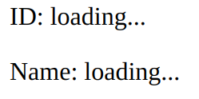
After 1 second, the promise returned from fetchUser() is resolved with data from the API, which is then used to update the id and name states. This results in App being re-rendered:
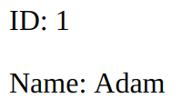
There is a good chance that your users will navigate around your application while an API request is still pending. The useEffect() Hook can be used to deal with canceling these requests.

Canceling requests and resetting state
There's a good chance that at some point, your users will navigate around your app and cause components to unmount before responses to their API requests arrive. When this happens, an error occurs because the component will attempt to update the state values of a component that has been removed.
Thankfully, the useEffect() Hook has a mechanism to clean up things such as pending API requests when the component is removed. Let's take a look at an example of this in action:
import React, { Fragment, useEffect, useState } from "react";
import { Promise } from "bluebird";
Promise.config({ cancellation: true });
function fetchUser() {
return new Promise(resolve => {
setTimeout(() => {
resolve({ id: 1, name: "Adam" });
}, 1000);
});
}
export default function User() {
const [id, setId] = useState("loading...");
const [name, setName] = useState("loading...");
useEffect(() => {
const promise = fetchUser().then(user => {
setId(user.id);
setName(user.name);
});
return () => {
promise.cancel();
};
});
return (
<Fragment>
<p>ID: {id}</p>
<p>Name: {name}</p>
</Fragment>
);
}
This looks a lot like the component from the fetching component data example. It has the same state, it fetches data inside useEffect(), and it renders the same output. There are a couple of important differences though. Let's start by taking a closer look at the useEffect() Hook:
useEffect(() => {
const promise = fetchUser().then(user => {
setId(user.id);
setName(user.name);
});
return () => {
promise.cancel();
};
});
Just like in the fetching component data example, this effect creates a promise by calling the fetchUser() API function. It also returns a function, which React runs when the component is removed. In this example, the promise that is created by calling fetchUser() is canceled by calling promise.cancel(). This prevents the component from trying to update its state after it has been removed.
Another important difference compared with the preceding example is that here, we're using the Bluebird library for promises since they support cancellation. There are many other ways that you can "cancel" asynchronous operations in the function returned by the useEffect() Hook, but I found Bluebird to be well worth the added dependency for this added capability.
Now, let's look at the App component, which renders and removes the User component:
import React, { Fragment, useState } from 'react';
import User from './User';
const ShowHideUser = ({ show }) => (show ? <User /> : null);
export default function App() {
const [show, setShow] = useState(false);
return (
<Fragment>
<button onClick={() => setShow(!show)}>
{show ? 'Hide User' : 'Show User'}
</button>
<ShowHideUser show={show} />
</Fragment>
);
}
The App component renders a button that is used to toggle the show state. This state value determines whether or not the User component is rendered, but by using the ShowHideUser convenience component. If show is true, <User> is rendered, otherwise, User is removed, triggering our useEffect() cleanup behavior.
Here's what the screen looks like when it first loads:
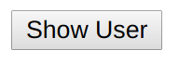
The User component isn't rendered because the show state of the App component is false. Try clicking on the show button. This will change the show state and render the User component:
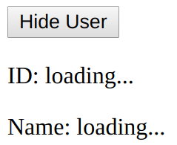
The "loading..." strings are the two initial state values for the id and name states. These will be updated when the API promise resolves after 1 second:
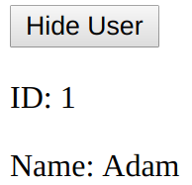
You can click on the Hide User button once more to remove the User component. Now, click on the Show User button, and then click on Hide User before it finishes loading. Without the cleanup code that we added to useEffect(), this would trigger an error. In fact, you can test this by commenting out the call to promise.cancel().
Effects are run by React after every render. This might not be what you want, especially if your effect is something that is relatively slow, such as an asynchronous network request. Instead, we want to call the API after the first render, and that's it. We'll take a look at how to do this next.

Optimizing side-effect actions
By default, React assumes that every effect that is run needs to be cleaned up. This typically isn't the case. For example, you might have specific property or state values that require cleanup when they change. You can pass an array of values to watch as the second argument to useEffect(). For example, if you have a resolved state that requires cleanup when it changes, you would write your effect code like this:
const [resolved, setResolved] = useState(false);
useEffect(() => {
// ...the effect code...
return () => {
// ...the cleanup code that depends on "resolved"
}
}, [resolved]);
In this code, the cleanup function will only ever run if the resolved state value changes. If the effect runs and the resolved state hasn't changed, then the cleanup code will not run. Another common case is to never run the cleanup code, except for when the component is removed. In fact, this is what we want to happen in the example from the previous section. Right now, the cleanup code runs after every render. This means that we're repeatedly fetching the user API data when all we really want is to fetch it once when the component is first mounted.
Let's make some modifications to the User component from the canceling requests example:
import React, { Fragment, useEffect, useState } from 'react';
import { Promise } from 'bluebird';
Promise.config({ cancellation: true });
function fetchUser() {
console.count('fetching user');
return new Promise(resolve => {
setTimeout(() => {
resolve({ id: 1, name: 'Adam' });
}, 1000);
});
}
export default function User() {
const [id, setId] = useState('loading...');
const [name, setName] = useState('loading...');
useEffect(() => {
const promise = fetchUser().then(user => {
setId(user.id);
setName(user.name);
});
return () => {
promise.cancel();
};
}, []);
return (
<Fragment>
<p>ID: {id}</p>
<p>Name: {name}</p>
</Fragment>
);
}
We've added a second argument to useEffect(), an empty array. This tells React that there are no values to watch and that we only want to run the cleanup code when the component is removed. We've also added console.count('fetching user') to the fetchUser() function. This makes it easier to look at the browser dev tools console and make sure that our component data is only fetched once. If you remove the [] argument that is passed to useEffect(), you'll notice that fetchUser() is called several times.
In this section, you learned about the side effects in React components. Effects are an important concept, as they are the bridge between your React components and the outside world. One of the most common use cases for effects is to fetch data that the component needs, when it is first created, and then clean up after the component when it is removed.
Now, we're going to look at another way to share data with React components: context.

Sharing data using context Hooks
React applications often have a few pieces of data that are global in nature. This means that several components, possibly every component in the app, share this data. For example, information about the currently logged-in user might be used in several places. In cases like this, it makes sense to provide a context where this data can be easily accessed by components that are rendered in this context.
In this section, you'll learn how to consume context data and how to consume it using Hooks.

Sharing fetched data
Most of our components will directly fetch the data that they and their children need. In other cases, our app has some API endpoint with data that is used by several components throughout the application. To share global data like this, you can use the React context API. As the name suggests, components that are rendered within a context are able to access the data provided by the context.
Let's build an example to help clarify what this means and how it relates to Hooks. Here is the UserContext context and the UserProvider component:
import React, { createContext, useState, useEffect } from "react";
export const UserContext = createContext();
function fetchUser() {
return new Promise(resolve => {
setTimeout(() => {
resolve({ id: 1, name: "Adam" });
}, 1000);
});
}
export function UserProvider({ children }) {
const [user, setUser] = useState({ name: "..." });
useEffect(() => {
fetchUser().then(user => {
setUser(user);
});
}, []);
return <UserContext.Provider value={user}>{children}</UserContext.Provider>;
}
First, we have the UserContext object, created by calling the createContext() React API. Next, we have the mock API function, fetchUser(). Finally, we have the UserProvider component. The job of this component is to call the fetchUser() API and set the user state as the response from the API when it arrives. To do this, we're using the useState() and useEffect() Hooks.
This component renders the <UserContext.Provider> component, passing in any children it receives. The value property is then made available to any child components of UserProvider. In this case, the value is the state that is set by calling the fetchUser() API. We've set ourselves up to be able to pass the user value to any components of our application. Let's see how this is done by creating a simple App component with three pages on it:
import React, { useState } from 'react';
import { UserProvider } from './UserContext';
import { Page1, Page2, Page3 } from './Pages';
function ChoosePage({ page }) {
const Page = [Page1, Page2, Page3][page];
return <Page />;
}
function App() {
const [page, setPage] = useState(0);
return (
<UserProvider>
<button onClick={() => setPage(0)} disabled={page === 0}>
Page 1
</button>
<button onClick={() => setPage(1)} disabled={page === 1}>
Page 2
</button>
<button onClick={() => setPage(2)} disabled={page === 2}>
Page 3
</button>
<ChoosePage page={page} />
</UserProvider>
);
}
export default App;
The App component renders three buttons that, when clicked, render their corresponding page component. The page state is used to control the page that is displayed and defaults to 0. When App is first rendered, the Page1 component is rendered. This happens with the help of ChoosePage, which renders the correct page based on the page state that is passed to it. Here's what you'll see when the page state first loads:
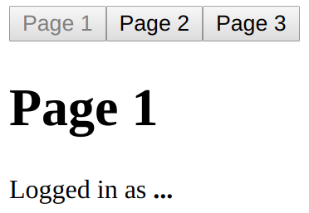
The Page 1 button is disabled because it is the currently active page. There's an ellipsis following the Logged in as message at the bottom of the page. This is because the UserProvider component is waiting for the fetchUser() API call to respond. When the response arrives and the context data is updated, the Page1 component is updated:
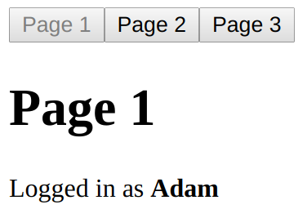
Last but not least, let's take a look at the page components that use context Hooks:
import React, { Fragment, useContext } from 'react';
import { UserContext } from './UserContext';
function Username() {
const user = useContext(UserContext);
return (
<p>
Logged in as <strong>{user.name}</strong>
</p>
);
}
export function Page1() {
return (
<Fragment>
<h1>Page 1</h1>
<Username />
</Fragment>
);
}
export function Page2() {
return (
<Fragment>
<h1>Page 2</h1>
<Username />
</Fragment>
);
}
export function Page3() {
return (
<Fragment>
<h1>Page 3</h1>
<Username />
</Fragment>
);
}
All three page components look pretty much the same, except for the <h1> text used in each. Let's focus in on the Username component that is used by each page:
function Username() {
const user = useContext(UserContext);
return (
<p>
Logged in as <strong>{user.name}</strong>
</p>
);
}
This is where the useContext() Hook is used. The user context value is actually the state that is set by the UserProvider component when the API call responds. This means that the user context value is updated by the useContext() Hook whenever the user value changes.
Another important idea from this example is that the page components (Page1, Page2, and Page3) have no knowledge of this global user data. Instead of having to pass data down from the top-level component as property values, we can rely on useContext() when we need access to global data, no matter how deeply nested the component is in our JSX markup. Components that have nothing to do with the data, like the page components in this example, there's no need to touch it.

Updating stateful context data
Global data that is shared throughout your application isn't limited to read-only API response data. Sometimes, components themselves need to update global state values. To enable this capability, we need to pass not only data from context producers, but also a mechanism to update the data. Since the data stored in a context provider is a state created with useState(), we can just pass along the setter function, along with the state value.
Let's illustrate these ideas by extending the sharing fetched data example. Instead of a user context, we'll add a status context. This way, components that are rendered within this context will have access to the status state value, and the status state setter function. Here's what the StatusProvider component looks like:
import React, { createContext, useState } from "react";
export const StatusContext = createContext();
export function StatusProvider({ children }) {
const value = useState("set a status");
return (
<StatusContext.Provider value={value}>{children}</StatusContext.Provider>
);
}
The StatusProvider component has a status state with a default string value. Recall that useState() returns an array of state value, and a state setter function. This array is then passed to the value property of <StatusContext.Provider>. Now, let's take a look at the page components that display and update the status context data:
import React, { Fragment, useContext } from 'react';
import { StatusContext } from './StatusContext';
function SetStatus() {
const [status, setStatus] = useContext(StatusContext);
return <input value={status} onChange={e => setStatus(e.target.value)} />;
}
export function Status() {
const [status] = useContext(StatusContext);
return <p>{status}</p>;
}
export function Page1() {
return (
<Fragment>
<h1>Page 1</h1>
<SetStatus />
</Fragment>
);
}
export function Page2() {
return (
<Fragment>
<h1>Page 2</h1>
</Fragment>
);
}
export function Page3() {
return (
<Fragment>
<h1>Page 3</h1>
<SetStatus />
</Fragment>
);
}
Let's take a closer look at the two utility components that consume context data with useContext():
function SetStatus() {
const [status, setStatus] = useContext(StatusContext);
return <input value={status} onChange={e => setStatus(e.target.value)} />;
}
export function Status() {
const [status] = useContext(StatusContext);
return <p>{status}</p>;
}
The SetStatus component is used to render an input so that the user can provide new values for the status context. When they do, the setStatus() function that comes from the context data array is used to update the context state. The Status component only renders status, so it doesn't need the setStatus() function that comes from useContext(). The Page2 component doesn't render the SetStatus component, but Page1 and Page2 do.
The Status component is used by the App component to display status on every page, including Page2. Let's see these pages in action now. Here is what the first page looks like when it first loads, using the default status context:
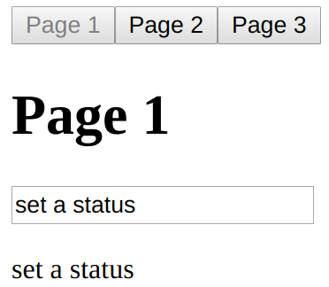
The text input that sets the status is part of the Page1 component. The succeeding status label shows that the text input that displays the status is part of the App component and will be rendered on every page. Let's try changing the status:
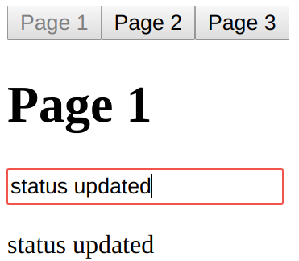
The setStatus() function that was passed in context data is used to update the status state in the StatusProvider component. The new context data is propagated throughout the application components that use it, any time it changes. Let's see what the second page looks like after we've updated the status:
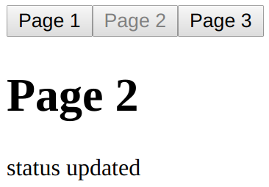
The Page2 component doesn't use the SetStatus component, which is why there's no input shown here. But the status label that is rendered by the App component hasn't changed. Lastly, let's take a look at the third page:
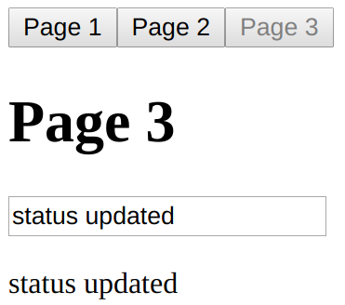
As expected, the updated status context data is reflected here as well. In fact, since Page3 uses the SetStatus component, you can update the status again and navigate around the pages again. The result will be the same since the same mechanics are in place.
This section showed you how to create a context for global data that various components in your application need to share. One common scenario is an API endpoint with data that most components in the application need access to. You can implement a context provider component that performs this API data fetch and then shares it with other components. The components that require this global data can use the useContext() Hook, which feels a lot like using the useState() Hook.
You also learned that context data can be changed by different components. This involves passing a state setting function as part of the context data so that components can use it to update the context value. In the next section, we'll look at using reducer Hooks to help simplify complex state management.

Using reducer Hooks to scale state management
The useState() Hook is a great way to manage the state of your component. It can become a challenge to use this Hook when your component has a lot of related pieces of state. You end up with a lot of setter functions that you need to call individually, once you've figured out how a change in one state value affects another state value. With reducers, you have one dispatch() function that's used to update the state of your component.
In this section, you'll learn about the basics of reducer actions and how they update the state of your component. Then, we'll look at a more in-depth example that shows you how to handle updating state values that depend on other state values.

Using reducer actions
A reducer function in a React application is a function that takes the current state, an action, and any other arguments that are needed to update the state. It returns the new state of the component. The action argument tells the reducer function what new state to return and is often used in a switch statement. Let's look at an example now:
import React, { Fragment, useReducer } from 'react';
function reducer(state, action) {
switch (action.type) {
case 'changeName':
return { ...state, name: action.value };
case 'changeAge':
return { ...state, age: action.value };
default:
throw new Error(`${action.type} is not a valid action`);
}
}
export default function App() {
const [{ name, age }, dispatch] = useReducer(reducer, {});
return (
<Fragment>
<input
placeholder="Name"
value={name}
onChange={e => dispatch({ type: 'changeName', value: e.target.value })}
/>
<p>Name: {name}</p>
<input
placeholder="Age"
type="number"
value={age}
onChange={e => dispatch({ type: 'changeAge', value: e.target.value })}
/>
<p>Age: {age}</p>
</Fragment>
);
}
Here, we have an App component that renders two fields and two labels. When the text value changes, it should update the corresponding label value. This is done by using two pieces of state, one for each field. Let's take a closer look at how state is set up with the useReducer() Hook:
const [{ name, age }, dispatch] = useReducer(reducer, {});
The useReducer() function takes two arguments: the reducer function that updates the state, and the initial state of the component. The return value of useReducer() is an array with the state as the first element and the dispatcher function as the second. When we use reducers, we only have one object as the state of the component, instead of several smaller, unrelated state values. This is why we're destructuring the state object into name and age constants. Now, let's take a look at the reducer function itself:
function reducer(state, action) {
switch (action.type) {
case "changeName":
return { ...state, name: action.value };
case "changeAge":
return { ...state, age: action.value };
default:
throw new Error(`${action.type} is not a valid action`);
}
}
The state argument is the current state of the component. The action argument is the argument that's passed to dispatch(). The action.type value is used to determine what to do. This reducer only has two possible actions: changeName and changeAge. Based on this, we use the object spread operator to return a new state object, made from the existing state and the updated state object values. In this case, based on the action.type value, either the name or age state values will be updated.
It's also important to have a default handler in place that throws an error when an unexpected action is passed to the reducer. It's highly likely that you will get this wrong at some point and it's better to have the reducer complain loudly about the invalid action than to have to figure out why your component has the wrong state set on it.
Here is what the screen looks like when App is first rendered:
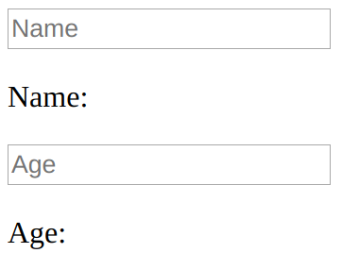
Here's what you'll see when you enter some text into these two inputs:
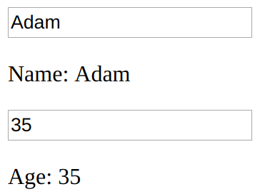
This example used a reducer function to update two unrelated pieces of state. In other words, you probably could have used the useState() Hook just as easily. However, now that you have an idea of what reducers are is and how they handle different actions that are dispatched to them, you're ready to look at a more complex example that involves state values that depend on other state values.

Handling state dependencies
When our components have one piece of state that depends on another, it's difficult to use the useState() Hook. This Hook comes with the assumption that when a state needs to be updated, it's one piece at a time. In real applications, there are often scenarios where updating one piece of state means that another piece of state needs to be updated as well, based on this new value.
Let's look at an example that allows the user to select an item and the quantity of that item. It then shows the cost. This means that whenever the quantity or item fields change, the total must also change. Here's the reducer code:
import React, { Fragment, useReducer, useEffect } from 'react';
const initialState = {
options: [
{ id: 1, name: 'First', value: 10 },
{ id: 2, name: 'Second', value: 50 },
{ id: 3, name: 'Third', value: 200 }
],
quantity: 1,
selected: 1
};
function reduceButtonStates(state) {
return {
...state,
decrementDisabled: state.quantity === 0,
incrementDisabled: state.quantity === 10
};
}
function reduceTotal(state) {
const option = state.options.find(option => option.id === state.selected);
return { ...state, total: state.quantity * option.value };
}
function reducer(state, action) {
let newState;
switch (action.type) {
case 'init':
newState = reduceTotal(state);
return reduceButtonStates(newState);
case 'decrementQuantity':
newState = { ...state, quantity: state.quantity - 1 };
newState = reduceTotal(newState);
return reduceButtonStates(newState);
case 'incrementQuantity':
newState = { ...state, quantity: state.quantity + 1 };
newState = reduceTotal(newState);
return reduceButtonStates(newState);
case 'selectItem':
newState = { ...state, selected: Number(action.id) };
return reduceTotal(newState);
default:
throw new Error(`${action.type} is not a valid action`);
}
}
Here's the App component that uses the reducer:
export default function App() {
const [
{
options,
selected,
quantity,
total,
decrementDisabled,
incrementDisabled
},
dispatch
] = useReducer(reducer, initialState);
useEffect(() => {
dispatch({ type: 'init' });
}, []);
return (
<Fragment>
<section>
<button
disabled={decrementDisabled}
onClick={() => dispatch({ type: 'decrementQuantity' })}
>
-
</button>
<button
disabled={incrementDisabled}
onClick={() => dispatch({ type: 'incrementQuantity' })}
>
+
</button>
<input readOnly value={quantity} />
</section>
<section>
<select
value={selected}
onChange={e => dispatch({ type: 'selectItem', id: e.target.value })}
>
{options.map(o => (
<option key={o.id} value={o.id}>
{o.name}
</option>
))}
</select>
</section>
<section>
<strong>{total}</strong>
</section>
</Fragment>
);
}
Before jumping into code explanations, let's see what this code actually does. Here's what you'll see when the screen first loads:
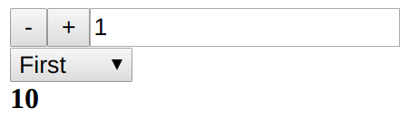
By default, the quantity is set to 1 and the First item is selected. The total cost is displayed beneath the two fields. When the page first loads, the total is 10 since the cost of the First item is 10 and the quantity is set to 1. Let's try changing the quantity value, using the increment and decrement buttons beside it:
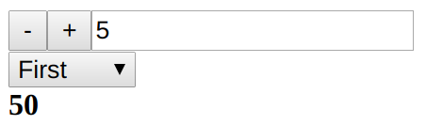
Here, we've changed the quantity to 5. As you can see, the total reflects this quantity by changing to 50. The quantity state has minimum (0) and maximum (10) restrictions, so if you bring the quantity value up to 10, the increment button is disabled:
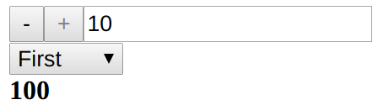
If you change the selected item, the total is reflected based on the current quantity value:
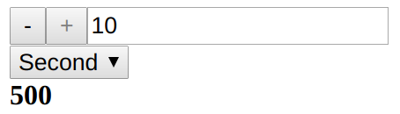
This example has several pieces of state that depend on one another in moderately complex ways. This is a perfect opportunity to put the useReducer() Hook into action. Let's break down what's going on in the code. We'll start by looking at the initial state:
const initialState = {
options: [
{ id: 1, name: 'First', value: 10 },
{ id: 2, name: 'Second', value: 50 },
{ id: 3, name: 'Third', value: 200 }
],
quantity: 1,
selected: 1
};
The options array is the items that the user can select from; initial quantity is 1, and the selected value represents which item is selected. Later on, this component will set several other state values, but these are all that are needed for the initial render. Next, let's take a closer look at the reducer functions that maintain the state of this component:
function reduceButtonStates(state) {
return {
...state,
decrementDisabled: state.quantity === 0,
incrementDisabled: state.quantity === 10
};
}
function reduceTotal(state) {
const option = state.options.find(option => option.id === state.selected);
return { ...state, total: state.quantity * option.value };
}
function reducer(state, action) {
let newState;
switch (action.type) {
case 'init':
newState = reduceTotal(state);
return reduceButtonStates(newState);
case 'decrementQuantity':
newState = { ...state, quantity: state.quantity - 1 };
newState = reduceTotal(newState);
return reduceButtonStates(newState);
case 'incrementQuantity':
newState = { ...state, quantity: state.quantity + 1 };
newState = reduceTotal(newState);
return reduceButtonStates(newState);
case 'selectItem':
newState = { ...state, selected: Number(action.id) };
return reduceTotal(newState);
default:
throw new Error(`${action.type} is not a valid action`);
}
}
The reducer() function is passed to useReducer() and is responsible for handling different action paths. This particular reducer handles the following actions:
init: When the component first mounts.
decrementQuantity: The decrement quantity button was pressed.
incrementQuantity: The increment quantity button was pressed.
selectItem: The selected item was changed.
Every one of these actions has the potential to change the total state, which is why the code to compute the total was moved into its own function: reduceTotal(). For example, if the quantity changes or the item changes, we need to compute a new total. When the component first mounts, we also need to compute total, because we don't want to have a default state for something that's derived from other state values. Instead, we introduced the init action and use the useEffect() Hook to call it once when the component is first mounted.
The state of the increment and decrement buttons is dependent on the quantity value. So, the incrementDisabled and decrementDisabled state values are computed in the reduceButtonStates() function, which is used by the init, decrementQuantity, and incrementQuantity actions.
At first glance, it might seem like there's a lot going on in the reducer() function, and you'd be right, there is. But in this example, the goal is to keep related state operations close to one another since they're related. The perfect place to do this is in a reducer function. Developers look at our code and follow the action flow without much trouble. We also managed to factor out common reducer behavior into their own functions. All of this results in a functional component that doesn't have to directly perform any complex state updates. Instead, it just needs to make dispatch() calls, keeping the component itself focused on markup and event handling.
In this section, you learned that the useReducer() Hook is similar to the useState() Hook in that they are both React state management APIs. Using a reducer function is helpful when you want to keep your component state together as a single object so that you can update it more easily when the updates are complex due to dependencies.

Summary
This chapter introduced you to the new React Hooks API. You started out by using the useState() Hook, which is fundamental for using state in functional React components. Then, you learned about useEffect(), which enables life cycle management in functional React components, such as fetching API data when the component is mounted and cleaning up any pending async operations when it is removed. Then, you learned how to use the useContext() Hook in order to access global application data. Lastly, you learned about the useReducer() Hook: an effective replacement for useState() when your component state grows too big or too complex for useState().
In the following chapter, you'll learn about event handling in React components.
Event Handling - The React Way
The focus of this chapter is event handling. React has a unique approach to handling events: declaring event handlers in JSX. I'll get things going by looking at how event handlers for particular elements are declared in JSX. Then, you'll learn about binding handler context and parameter values. Next, we'll implement inline and higher-order event handler functions.
Then, you'll learn how React actually maps event handlers to DOM elements under the hood. Finally, you'll learn about the synthetic events that React passes to event handler functions, and how they're pooled for performance purposes. Once you've completed this chapter, you'll be comfortable implementing event handlers in your React components. At that point, your applications come to life for your users because they are then able to interact with them.
The following topics are covered in this chapter:
Declaring event handlers
Using event handler context and parameters
Declaring inline event handlers
Binding handlers to elements
Using synthetic event objects
Understanding event pooling

Technical requirements
The code present in this chapter can be found at https://github.com/PacktPublishing/React-and-React-Native---Third-Edition/tree/master/Chapter05.

Declaring event handlers
The differentiating factor with event handling in React components is that it's declarative. Contrast this with something like jQuery, where you have to write imperative code that selects the relevant DOM elements and attaches event handler functions to them.
The advantage of the declarative approach to event handlers in JSX markup is that they're part of the UI structure. Not having to track down code that assigns event handlers is mentally liberating.
In this section, you'll write a basic event handler, so you can get a feel for the declarative event handling syntax found in React applications. Then, you'll learn how to use generic event handler functions.

Declaring handler functions
Let's take a look at a basic component that declares an event handler for the click event of an element:
import React, { Component } from "react";
export default class MyButton extends Component {
onClick() {
console.log("clicked");
}
render() {
return <button onClick={this.onClick}>{this.props.children}</button>;
}
}
The event handler function, this.onClick(), is passed to the onClick property of the <button> element. By looking at this markup, you can see exactly which code will run when the button is clicked.
View the official React documentation for the full list of supported event property names at https://facebook.github.io/react/docs/.
Next, let's take a look at how to respond to more than one type of event using different event handlers with the same element.

Multiple event handlers
What I really like about the declarative event handler syntax is that it's easy to read when there's more than one handler assigned to an element. Sometimes, for example, there are two or three handlers for an element. Imperative code is difficult to work with for a single event handler, let alone several of them. When an element needs more handlers, it's just another JSX attribute. This scales well from a code-maintainability perspective, as this example shows:
import React, { Component } from "react";
export default class MyInput extends Component {
onChange() {
console.log("changed");
}
onBlur() {
console.log("blured");
}
render() {
return <input onChange={this.onChange} onBlur={this.onBlur} />;
}
}
This <input> element could have several more event handlers, and the code would be just as readable.
As you keep adding more event handlers to your components, you'll notice that a lot of them do the same thing. Next, you'll learn how to share generic handler functions across components.

Importing generic handlers
Any React application is likely going to share the same event handling logic for different components. For example, in response to a button click, the component should sort a list of items. It's these types of generic behaviors that belong in their own modules so that several components can share them. Let's implement a component that uses a generic event handler function:
import React, { Component } from "react";
import reverse from "./reverse";
export default class MyList extends Component {
state = {
items: ["Angular", "Ember", "React"]
};
onReverseClick = reverse.bind(this);
render() {
const {
state: { items },
onReverseClick
} = this;
return (
<section>
<button onClick={onReverseClick}>Reverse</button>
<ul>
{items.map((v, i) => (
<li key={i}>{v}</li>
))}
</ul>
</section>
);
}
}
Let's walk through what's going on here, starting with the imports. You're importing a function called reverse(). This is the generic event handler function that you're using with your <button> element. When it's clicked, the list should reverse its order.
The onReverseClick method actually calls the generic reverse() function. It is created using bind() to bind the context of the generic function to this component instance.
Finally, looking at the JSX markup, you can see that the onReverseClick() function is used as the handler for the button click.
So, how does this work exactly? You have a generic function that somehow changes the state of this component because you bound context to it? Well, pretty much, yes—that's it. Let's look at the generic function implementation now:
export default function reverse() {
this.setState(this.state.items.reverse());
}
This function depends on a this.state property and an items array within the state. The key is that the state is generic; an application could have many components with an items array in its state.
Here's what our rendered list looks like:
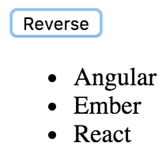
As expected, clicking on the button causes the list to sort, using your generic reverse() event handler:
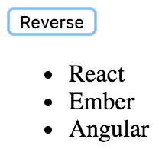
In this section, you learned how to declare event handler functions for your JSX elements. You then learned how to assign more than one event handler to an element and how to import and use generic handler functions. Next, you'll learn how to bind the context and the argument values of event handler functions.

Using event handler context and parameters
In this section, you'll learn about React components that bind their event handler contexts and how you can pass data into event handlers. Having the right context is important for React event handler functions, because they usually need access to component properties or state. Being able to parameterize event handlers is also important, because they don't pull data out of DOM elements.

Getting component data
In this section, you'll learn about scenarios where the handler needs access to component properties, along with argument values. You'll render a custom list component that has a click event handler for each item in the list. The component is passed an array of values as follows:
import React from "react";
import { render } from "react-dom";
import MyList from "./MyList";
const items = [
{ id: 0, name: "First" },
{ id: 1, name: "Second" },
{ id: 2, name: "Third" }
];
render(<MyList items={items} />, document.getElementById("root"));
Each item in the list has an id property, which is used to identify the item. You'll need to be able to access this ID when the item is clicked on in the UI so that the event handler can work with the item. Here's what the MyList component implementation looks like:
import React, { Component } from "react";
export default class MyList extends Component {
constructor() {
super();
this.onClick = this.onClick.bind(this);
}
onClick(id) {
const { name } = this.props.items.find(i => i.id === id);
console.log("clicked", `"${name}"`);
}
render() {
return (
<ul>
{this.props.items.map(({ id, name }) => (
<li key={id} onClick={this.onClick.bind(null, id)}>
{name}
</li>
))}
</ul>
);
}
}
Here is what the rendered list looks like:
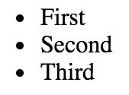
You have to bind the event handler context, which is done in the constructor. If you look at the onClick() event handler, you can see that it needs access to the component so that it can look up the clicked item in this.props.items. Also, the onClick() handler is expecting an id parameter. If you take a look at the JSX content of this component, you can see that calling bind() supplies the argument value for each item in the list. This means that when the handler is called in response to a click event, the id of item is already provided.
This approach to parameterized event handling is quite different from prior approaches. For example, I used to rely on getting parameter data from the DOM element itself. This works well when you only need one event handler, and it can extract the data it needs from the event argument. This approach also doesn't require setting up several new functions by iterating over a collection and calling bind().
And therein lies the trade-off. React applications avoid touching the DOM, because the DOM is really just a render target for React components. If you can write code that doesn't introduce explicit dependencies to DOM elements, your code will be portable. This is what you've accomplished with the event handler in this example.
If you're concerned about the performance implications of creating a new function for every item in a collection, don't be. You're not going to render thousands of items on the page at a time. Benchmark your code, and if it turns out that bind() is the slowest part, then you probably have a really fast application.
In the next section, you'll learn how to build event handler functions on the fly using higher-order functions.

Higher-order event handlers
A higher-order function is a function that returns a new function. Sometimes, higher-order functions take functions as arguments too. In the Getting component data example, you used bind() to bind the context and argument values of your event handler functions. Higher-order functions that return event handler functions are another technique. The main advantage of this technique is that you don't have to call bind() several times. Instead, you just call the function where you want to bind parameters to the function. Let's look at an example component:
import React, { Fragment, Component } from "react";
export default class App extends Component {
state = {
first: 0,
second: 0,
third: 0
};
onClick = name => () => {
this.setState(state => ({
...state,
[name]: state[name] + 1
}));
};
render() {
const { first, second, third } = this.state;
return (
<Fragment>
<button onClick={this.onClick("first")}>First {first}</button>
<button onClick={this.onClick("second")}>Second {second}</button>
<button onClick={this.onClick("third")}>Third {third}</button>
</Fragment>
);
}
}
This component renders three buttons and has three pieces of state—a counter for each button. The onClick() function is automatically bound to the component context because it's defined as an arrow function. It takes a name argument and returns a new function. The function that is returned uses this name value when called. It uses computed property syntax (variables inside []) to increment the state value for the given name. Here's what that component content looks like after each button has been clicked a few times:
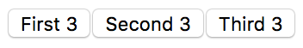
In this section, you learned how to make your event handler functions interact with your component data. If you have a class-based component, you can bind your function context to the component class so that you have direct access to the component state and properties. You also learned that higher-order functions are another option for generating distinct callback functions by passing an argument to the higher-order function. In the next section, you'll learn about inline event handler functions.

Declaring inline event handlers
The typical approach to assigning handler functions to JSX properties is to use a named function. However, sometimes, you might want to use an inline function, where the function is defined as part of the markup. This is done by assigning an arrow function directly to the event property in the JSX markup:
import React, { Component } from "react";
export default class MyButton extends Component {
render() {
return (
<button onClick={e => console.log("clicked", e)}>
{this.props.children}
</button>
);
}
}
The main use of inlining event handlers like this is when you have a static parameter value that you want to pass to another function. In this example, you're calling console.log() with the clicked string. You could have set up a special function for this purpose outside of the JSX markup by creating a new function using bind(), or by using a higher-order function. But then you would have to think of yet another name for yet another function. Inlining is just easier sometimes. Next, you'll learn about how React binds handler functions to the underlying DOM elements in the browser.

Binding handlers to elements
When you assign an event handler function to an element in JSX, React doesn't actually attach an event listener to the underlying DOM element. Instead, it adds the function to an internal mapping of functions. There's a single event listener on the document for the page. As events bubble up through the DOM tree to the document, the React handler checks to see whether any components have matching handlers. The process is illustrated here:
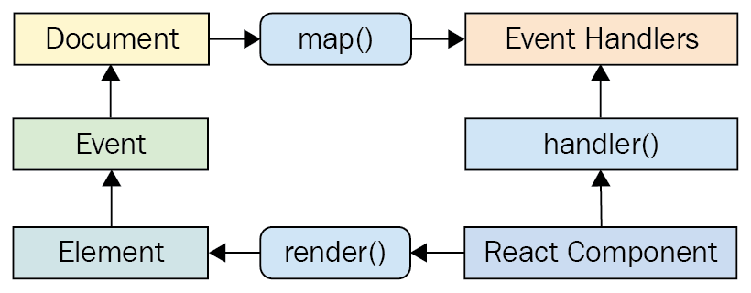
Why does React go to all of this trouble, you might ask? It's the same principle that I've been covering in the last few chapters: keep the declarative UI structures separated from the DOM as much as possible.
For example, when a new component is rendered, its event handler functions are simply added to the internal mapping maintained by React. When an event is triggered and it hits the document object, React maps the event to the handlers. If a match is found, it calls the handler. Finally, when the React component is removed, the handler is simply removed from the list of handlers.
None of these DOM operations actually touch the DOM. It's all abstracted by a single event listener. This is good for performance and the overall architecture (keep the render target separate from the application code).
In the following section, you'll learn about the synthetic event implementation used by React to ensure good performance and safe asynchronous behavior.

Using synthetic event objects
When you attach an event handler function to a DOM element using the native addEventListener() function, the callback will get an event argument passed to it. Event handler functions in React are also passed an event argument, but it's not the standard Event instance. It's called SyntheticEvent, and it's a simple wrapper for native event instances.
Synthetic events serve two purposes in React:
They provide a consistent event interface, normalizing browser inconsistencies.
Synthetic events contain information that's necessary for propagation to work.
Here's a diagram of the synthetic event in the context of a React component:
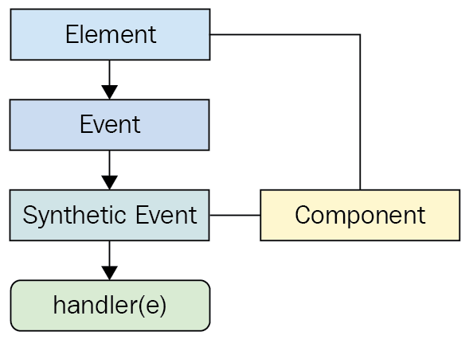
When a DOM element that is part of a React component dispatches an event, React will handle the event because it sets up its own listeners for them. Then, it will either create a new synthetic event or will reuse one from the pool depending on availability. If there are any event handlers declared for the component that match the DOM event that was dispatched, they will run with the synthetic event passed to them.
In the next section, you'll see how these synthetic events are pooled for performance reasons and the implications of this on asynchronous code.

Understanding event pooling
One challenge of wrapping native event instances is that it can cause performance issues. Every synthetic event wrapper that's created will also need to be garbage collected at some point, which can be expensive in terms of CPU time.
When the garbage collector is running, none of your JavaScript code is able to run. This is why it's important to be memory efficient; frequent garbage collection means less CPU time for code that responds to user interactions.
For example, if your application only handles a few events, this wouldn't matter much. But even by modest standards, applications respond to many events, even if the handlers don't actually do anything with them. This is problematic if React constantly has to allocate new synthetic event instances.
React deals with this problem by allocating a synthetic instance pool. Whenever an event is triggered, it takes an instance from the pool and populates its properties. When the event handler has finished running, the synthetic event instance is released back into the pool, as shown here:
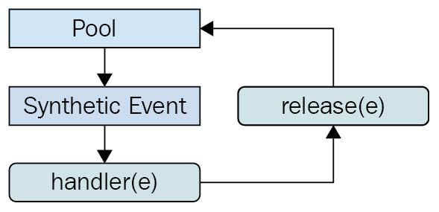
This prevents the garbage collector from running frequently when a lot of events are triggered. The pool keeps a reference to the synthetic event instances, so they're never eligible for garbage collection. React never has to allocate new instances either.
However, there is one gotcha that you need to be aware of. It involves accessing the synthetic event instances from asynchronous code in your event handlers. This is an issue because, as soon as the handler has finished running, the instance goes back into the pool. When it goes back into the pool, all of its properties are cleared. Here's an example that shows how this can go wrong:
import React, { Component } from "react";
function fetchData() {
return new Promise(resolve => {
setTimeout(() => {
resolve();
}, 1000);
});
}
export default class MyButton extends Component {
onClick(e) {
console.log("clicked", e.currentTarget.style);
fetchData().then(() => {
console.log("callback", e.currentTarget.style);
});
}
render() {
return <button onClick={this.onClick}>{this.props.children}</button>;
}
}
The second call to console.log() is attempting to access a synthetic event property from an asynchronous callback that doesn't run until the event handler completes, which causes the event to empty its properties. This results in a warning and an undefined value.
The aim of this example is to illustrate how things can break when you write asynchronous code that interacts with events. Just don't do it!
In this section, you learned that events are pooled for performance reasons, which means that you should never access event objects in an asynchronous way.

Summary
This chapter introduced you to event handling in React. The key differentiator between React and other approaches to event handling is that handlers are declared in JSX markup. This makes tracking down which elements handle which events much simpler.
You learned that having multiple event handlers on a single element is a matter of adding new JSX properties. Next, you learned that it's a good idea to share event handling functions that handle generic behavior. Context can be important for event handler functions if they need access to component properties or state. You learned about the various ways to bind event handler function context and parameter values. These include calling bind() and using higher-order event handler functions.
Then, you learned about inline event handler functions and their potential use, as well as how React actually binds a single DOM event handler to the document object. Synthetic events are abstractions that wrap native events; you learned why they're necessary and how they're pooled for efficient memory consumption.
In the next chapter, you'll learn how to create components that are reusable for a variety of purposes. Instead of writing new components for each use case that you encounter, you'll learn the skills necessary to refactor existing components so that they can be used in more than one context.

Further reading
Visit the following link for more information:
Handling Events: https://reactjs.org/docs/handling-events.html
Crafting Reusable Components
The focus of this chapter is to show you how to implement React components that serve more than just one purpose. After reading this chapter, you'll feel confident about how to compose application features.
The chapter starts with a brief look at HTML elements and how they work in terms of helping to implement features versus having a high level of utility. Then, you'll see the implementation of a monolithic component and discover the issues that it will cause down the road. The next section is devoted to re-implementing the monolithic component in such a way that the feature is composed of smaller components.
Finally, the chapter ends with a discussion of rendering trees of React components and gives you some tips on how to avoid introducing too much complexity as a result of decomposing components. I'll close this final section by reiterating the concept of high-level feature components versus utility components.
The following topics will be covered in this chapter:
Reusable HTML elements
The difficulty with monolithic components
Refactoring component structures
Render props
Refactoring class components using Hooks
Rendering component trees
Feature components and utility components

Technical requirements
You can find the code files for this chapter on GitHub at https://github.com/PacktPublishing/React-and-React-Native---Third-Edition/tree/master/Chapter06.

Reusable HTML elements
Let's think about HTML elements for a moment. Depending on the type of HTML element, it's either feature-centric or utility-centric. Utility-centric HTML elements are more reusable than feature-centric HTML elements. For example, consider the <section> element. This is a generic element that can be used just about anywhere, but its primary purpose is to compose the structural aspects of a feature—the outer shell of the feature and the inner sections of the feature. This is where the <section> element is most useful.
On the other side of the fence, you have elements such as <p>, <span>, and <button>. These elements provide a high level of utility because they're generic by design. You're supposed to use <button> elements whenever you have something that's clickable by the user, resulting in an action. This is a level lower than the concept of a feature.
While it's easy to talk about HTML elements that have a high level of utility versus those that are geared toward specific features, the discussion is more detailed when data is involved. HTML is static markup—React components combine static markup with data. The question is, how do you make sure that you're creating the right feature-centric and utility-centric components?
The aim of this chapter is to find out how to go from a monolithic React component that defines a feature to a smaller feature-centric component combined with utility components.

The difficulty with monolithic components
If you could implement just one component for any given feature, it would simplify your job. At the very least, there wouldn't be many components to maintain, and there wouldn't be many communication paths for data to flow through, because everything would be internal to the component.
However, this idea doesn't work for a number of reasons. Having monolithic feature components makes it difficult to coordinate any kind of team development effort. The bigger monolithic components become, the more difficult they are to refactor into something better later on.
There's also the problem of feature overlap and feature communication. Overlap happens because of similarities between features—it's unlikely that an application will have a set of features that are completely unique to one another. That would make the application very difficult to learn and use. Component communication essentially means that the state of something in one feature will impact the state of something in another feature. State is difficult to deal with, and even more so when there is a lot of state packaged up in a monolithic component.
The best way to learn how to avoid monolithic components is to experience one first hand. You'll spend the remainder of this section implementing a monolithic component. In the following section, you'll see how this component can be refactored into something a little more sustainable.

The JSX markup
The monolithic component we're going to implement is a feature that lists articles. It's just for illustrative purposes, so we don't want to go overboard on the size of the component. It'll be simple, yet monolithic. The user can add new items to the list, toggle the summary of items in the list, and remove items from the list. Here is the render method of the component:
render() {
const { articles, title, summary } = this.state;
return (
<section>
<header>
<h1>Articles</h1>
<input
placeholder="Title"
value={title}
onChange={this.onChangeTitle}
/>
<input
placeholder="Summary"
value={summary}
onChange={this.onChangeSummary}
/>
<button onClick={this.onClickAdd}>Add</button>
</header>
<article>
<ul>
{articles.map(i => (
<li key={i.id}>
<a
href={`#${i.id}`}
title="Toggle Summary"
onClick={this.onClickToggle.bind(null, i.id)}
>
{i.title}
</a>
&nbsp;
<a
href={`#${i.id}`}
title="Remove"
onClick={this.onClickRemove.bind(null, i.id)}
>
✗
</a>
<p style={{ display: i.display }}>{i.summary}</p>
</li>
))}
</ul>
</article>
</section>
);
}
This is definitely more JSX than is necessary in one place. We'll improve on this in the following section, but for now, let's implement the initial state for this component.
I strongly encourage you to download the companion code for this book from https://github.com/PacktPublishing/React-and-React-Native---Third-Edition. I can break apart the component code so that I can explain it on these pages. However, it's an easier learning experience if you can see the code modules in their entirety, in addition to running them.

Initial state
Now, let's look at the initial state of this component:
state = {
articles: [
{
id: id.next(),
title: "Article 1",
summary: "Article 1 Summary",
display: "none"
},
{
id: id.next(),
title: "Article 2",
summary: "Article 2 Summary",
display: "none"
},
{
id: id.next(),
title: "Article 3",
summary: "Article 3 Summary",
display: "none"
},
{
id: id.next(),
title: "Article 4",
summary: "Article 4 Summary",
display: "none"
}
],
title: "",
summary: ""
};
The state consists of an array of articles, a title string, and a summary string. Each article object in the articles array has several string fields to help render the article and an id field, which is a number. The number is generated by id.next(). Let's take a look at how this works:
const id = (function*() {
let i = 1;
while (true) {
yield i;
i += 1;
}
})();
The id constant is a generator. It is created by defining an inline generator function and calling it right away. This generator will yield numbers infinitely. So calling id.next() the first time returns 1, the next is 2, and so on. This simple utility will come in handy when it's time to add new articles and we need a new unique ID.

Event handler implementation
At this point, you have the initial state and the JSX of the component. Now it's time to implement the event handlers:
onChangeTitle = e => {
this.setState({ title: e.target.value });
};
onChangeSummary = e => {
this.setState({ summary: e.target.value });
};
The onChangeTitle() and onChangeSummary() methods use setState() to update the title and summary state values, respectively. The new values come from the target.value property of the event argument, which is the value that the user types into the text input:
onClickAdd = () => {
this.setState(state => ({
articles: [
...state.articles,
{
id: id.next(),
title: state.title,
summary: state.summary,
display: "none"
}
],
title: "",
summary: ""
}));
};
The onClickAdd() method adds a new article to the articles state. This state value is an array. We use the spread operator to build a new array from the existing array ([...state.articles]), and the new object gets added to the end of the new array. The reason we're building a new array and passing it to setState() is so that there are no surprises. In other words, we're treating state values as immutable so that other code that updates the same state doesn't accidentally cause problems:
onClickRemove = id => {
this.setState(state => ({
...state,
articles: state.articles.filter(article => article.id !== id)
}));
};
The onClickRemove() method removes the article with the given ID from the articles state. It does this by calling filter() on the array, which returns a new array so the operation is immutable. The filter removes the object with the given ID:
onClickToggle = id => {
this.setState(state => {
const articles = [...state.articles];
const index = articles.findIndex(article => article.id === id);
articles[index] = {
...articles[index],
display: articles[index].display ? "" : "none"
};
return { ...state, articles };
});
};
The onClickToggle() method toggles the visibility of the article with the given ID. We carry out two immutable operations in this method. First, we build a new articles array from state.articles. Then, based on the index of the given ID, we replace the article object at the index with a new object. We use the object spread operator to fill in the properties ({...articles[index]}), and then the display property value is toggled based on the existing display value.
Here's a screenshot of the output rendered:
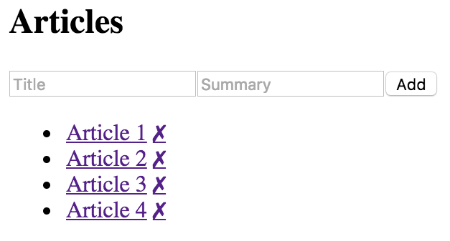
At this point, we have a component that does everything that we need our feature to do. However, it's monolithic and difficult to maintain. Imagine if we had other places in our app that use the same pieces of MyFeature? They have to re-invent them because they cannot be shared. In the following section, we'll work on breaking down MyFeature into smaller reusable components.

Refactoring component structures
You have a monolithic feature component—now what? Let's make it better.
In this section, you'll learn how to take the feature component that you just implemented in the preceding section and split it into more maintainable components. You'll start with the JSX, as this is probably the best refactor starting point. Then, you'll implement new components for the feature.
Next, you'll make these new components functional, instead of class-based. Finally, you'll learn how to use render props to reduce the number of direct component dependencies in your application and how to remove classes entirely by using Hooks to manage state within functional components.

Starting with the JSX
The JSX of any monolithic component is the best starting point for figuring out how to refactor it into smaller components. Let's visualize the structure of the component that we're currently refactoring:
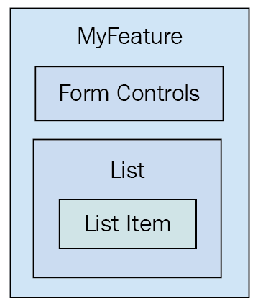
The top part of the JSX is the form controls, so this could easily become its own component:
<header>
<h1>Articles</h1>
<input
placeholder="Title"
value={title}
onChange={this.onChangeTitle}
/>
<input
placeholder="Summary"
value={summary}
onChange={this.onChangeSummary}
/>
<button onClick={this.onClickAdd}>Add</button>
</header>
Next, you have the list of articles:
<ul>
{articles.map(i => (
<li key={i.id}>
<a
href="#"
onClick={
this.onClickToggle.bind(null, i.id)
}
>
{i.title}
</a>
&nbsp;
<a
href="#"
onClick={this.onClickRemove.bind(null, i.id)}
>
✗
</a>
<p style={{ display: i.display }}>
{i.summary}
</p>
</li>
))}
</ul>
Within this list, there's potential for an article component, which would be everything in the <li> tag. Let's try building this next.

Implementing an article list component
Here's what the article list component implementation looks like:
import React, { Component } from "react";
export default class ArticleList extends Component {
render() {
const { articles, onClickToggle, onClickRemove } = this.props;
return (
<ul>
{articles.map(article => (
<li key={article.id}>
<a
href={`#${article.id}`}
title="Toggle Summary"
onClick={onClickToggle.bind(null, article.id)}
>
{article.title}
</a>
&nbsp;
<a
href={`#${article.id}`}
title="Remove"
onClick={onClickRemove.bind(null, article.id)}
>
✗
</a>
<p style={{ display: article.display }}>{article.summary}</p>
</li>
))}
</ul>
);
}
}
We're taking the relevant JSX out of the monolithic component and putting it here. Now, let's see what the feature component of JSX looks like:
render() {
const { articles, title, summary } = this.state;
return (
<section>
<header>
<h1>Articles</h1>
<input
placeholder="Title"
value={title}
onChange={this.onChangeTitle}
/>
<input
placeholder="Summary"
value={summary}
onChange={this.onChangeSummary}
/>
<button onClick={this.onClickAdd}>Add</button>
</header>
<ArticleList
articles={articles}
onClickToggle={this.onClickToggle}
onClickRemove={this.onClickRemove}
/>
</section>
);
}
The list of articles is now rendered by the <ArticleList> component. The list of articles to render is passed to this component as a property along with two of the event handlers.
Wait. Why are we passing event handlers to a child component? The reason is so that the ArticleList component doesn't have to worry about state or how the state changes. All it cares about is rendering content, and making sure the appropriate event callbacks are hooked up to the appropriate DOM elements. This is a container component concept that I'll expand upon later in this chapter.
Now that we have an ArticleList component, let's see whether we can further break it down into smaller reusable components.

Implementing an article item component
After implementing the article list component, you might decide that it's a good idea to break this component.
Another way to look at it is this—if it turns out that we don't actually need the item as its own component, this new component doesn't introduce much indirection or complexity. Without further ado, here's the article item component:
import React, { Component } from "react";
export default class ArticleItem extends Component {
render() {
const { article, onClickToggle, onClickRemove } = this.props;
return (
<li>
<a
href={`#{article.id}`}
title="Toggle Summary"
onClick={onClickToggle.bind(null, article.id)}
>
{article.title}
</a>
&nbsp;
<a
href={`#{article.id}`}
title="Remove"
onClick={onClickRemove.bind(null, article.id)}
>
✗
</a>
<p style={{ display: article.display }}>{article.summary}</p>
</li>
);
}
}
Here's the new ArticleItem component being rendered by the ArticleList component:
import React, { Component } from "react";
import ArticleItem from "./ArticleItem";
export default class ArticleList extends Component {
render() {
const { articles, onClickToggle, onClickRemove } = this.props;
return (
<ul>
{articles.map(i => (
<ArticleItem
key={i.id}
article={i}
onClickToggle={onClickToggle}
onClickRemove={onClickRemove}
/>
))}
</ul>
);
}
}
Do you see how this list just maps the list of articles? What if you wanted to implement another article list that does some filtering too? If so, it's beneficial to have a reusable ArticleItem component. Next, we'll move the add article markup into its own component.

Implementing an add article component
Now that we're done with the article list, it's time to think about the form controls used to add a new article. Let's implement a component for this aspect of the feature:
import React, { Component } from "react";
export default class AddArticle extends Component {
render() {
const {
name,
title,
summary,
onChangeTitle,
onChangeSummary,
onClickAdd
} = this.props;
return (
<section>
<h1>{name}</h1>
<input placeholder="Title" value={title} onChange={onChangeTitle}
/>
<input
placeholder="Summary"
value={summary}
onChange={onChangeSummary}
/>
<button onClick={onClickAdd}>Add</button>
</section>
);
}
}
Now, our feature component only needs to render <AddArticle> and <ArticleList> components:
render() {
const { articles, title, summary } = this.state;
return (
<section>
<AddArticle
name="Articles"
title={title}
summary={summary}
onChangeTitle={this.onChangeTitle}
onChangeSummary={this.onChangeSummary}
onClickAdd={this.onClickAdd}
/>
<ArticleList
articles={articles}
onClickToggle={this.onClickToggle}
onClickRemove={this.onClickRemove}
/>
</section>
);
}
The focus of this component is on the feature data, while it defers to other components for rendering UI elements. Several components that we've created while refactoring MyFeature are classes and they don't need to be. Let's make them simple functions instead.

Making components functional
While implementing these new components, you may have noticed that they don't have any responsibilities other than rendering JSX using property values. These components are good candidates for pure function components. Whenever you come across components that only use property values, it's a good idea to make them functional. For one thing, it makes it explicit that the component doesn't rely on any state or life cycle methods. It's also more efficient because React doesn't perform as much work when it detects that a component is a function.
Here is the functional version of the ArticleList component:
import React from "react";
import ArticleItem from "./ArticleItem";
export default function ArticleList({
articles,
onClickToggle,
onClickRemove
}) {
return (
<ul>
{articles.map(i => (
<ArticleItem
key={i.id}
article={i}
onClickToggle={onClickToggle}
onClickRemove={onClickRemove}
/>
))}
</ul>
);
}
Here is the functional version of the ArticleItem component:
import React from "react";
export default function ArticleItem({ article, onClickToggle, onClickRemove }) {
return (
<li>
<a
href={`#${article.id}`}
title="Toggle Summary"
onClick={onClickToggle.bind(null, article.id)}
>
{article.title}
</a>
&nbsp;
<a
href={`#${article.id}`}
title="Remove"
onClick={onClickRemove.bind(null, article.id)}
>
✗
</a>
<p style={{ display: article.display }}>{article.summary}</p>
</li>
);
}
Here is the functional version of the AddArticle component:
import React from "react";
export default function AddArticle({
name,
title,
summary,
onChangeTitle,
onChangeSummary,
onClickAdd
}) {
return (
<section>
<h1>{name}</h1>
<input placeholder="Title" value={title} onChange={onChangeTitle} />
<input placeholder="Summary" value={summary}
onChange={onChangeSummary} />
<button onClick={onClickAdd}>Add</button>
</section>
);
}
Another added benefit of making components functional is that there's less opportunity to introduce unnecessary methods or other data.
In this section, you learned about using JSX as the basis for refactoring larger components into smaller more reusable ones. This leads to more components, but they're smaller, more focused, and are reusable. In the next section, we'll look at how render props makes it possible to pass components around as properties instead of directly importing them as dependencies.

Render props
Imagine implementing a feature that is composed of several smaller components – like what you've been working on in this chapter. The MyFeature component depends on ArticleList and AddArticle. Now imagine using MyFeature in different parts of your application where it makes sense to use a different implementation of ArticleList or AddArticle. The fundamental challenge is substituting one component for another.
Render props are a nice way to address this challenge. The idea is that you pass a property to your component whose value is a function that returns a component to render. This way, instead of having the feature component directly depend on its child components, you can configure them as you like; they pass them in as render prop values.
Render props aren't a React 16 feature. They're a technique whose popularity increase coincided with the release of React 16. It's an officially recognized way to deal with dependency and substitution problems. You can read more about render props at https://reactjs.org/docs/render-props.html.
Let's look at an example. Instead of having MyFeature directly depend on AddArticle and ArticleList, you can pass them as render props. Here's what the render() method of MyFeature looks like when it's using render props to fill in the holes where <AddArticle> and <ArticleList> used to be:
render() {
const { articles, title, summary } = this.state;
const {
props: { addArticle, articleList },
onClickAdd,
onClickToggle,
onClickRemove,
onChangeTitle,
onChangeSummary
} = this;
return (
<section>
{addArticle({
title,
summary,
onChangeTitle,
onChangeSummary,
onClickAdd
})}
{articleList({ articles, onClickToggle, onClickRemove })}
</section>
);
}
The addArticle() and articleList() functions are called with the same property values that would have been passed to <AddArticle> and <ArticleList>, respectively. The difference now is that this module no longer imports AddArticle or ArticleList as dependencies.
Now, let's take a look at the index.js file where <MyFeature> is rendered:
render(
<MyFeature
addArticle={({
title,
summary,
onChangeTitle,
onChangeSummary,
onClickAdd
}) => (
<AddArticle
name="Articles"
title={title}
summary={summary}
onChangeTitle={onChangeTitle}
onChangeSummary={onChangeSummary}
onClickAdd={onClickAdd}
/>
)}
articleList={({ articles, onClickToggle, onClickRemove }) => (
<ArticleList
articles={articles}
onClickToggle={onClickToggle}
onClickRemove={onClickRemove}
/>
)}
/>,
document.getElementById("root")
);
There's a lot more going on here now than there was when it was just <MyFeature> being rendered. Let's break down why that is. Here is where you pass the addArticle and articleList render props. These prop values are functions that accept argument values from MyComponent. For example, the onClickToggle() function comes from MyFeature and is used to change the state of that component. You can use the render prop function to pass this to the component that will be rendered, along with any other values. The return value of these functions is what is ultimately rendered.
In this section, you learned that by passing render property values – functions that render JSX markup – you can avoid hardcoding dependencies in places where you might want to share functionality. Passing a different property value to a component is usually easier than changing which dependencies are used by a given module. In the final section of this chapter, we'll refactor the MyFeature component into a functional component that uses Hooks for state management.

Refactoring class components using Hooks
Prior to the addition of Hooks to React, we would often end up using class-based components just because the component had state data to maintain. Hooks exist so that you can implement React components using regular functions and still have access to the React APIs that you used to access through class attributes and methods. In this section, we'll rewrite the MyFeature component so that it's a function and it uses the useState() hook.
First, let's take a look at the functional version of MyFeature:
import React, { useState } from "react";
const id = (function*() {
let i = 1;
while (true) {
yield i;
i += 1;
}
})();
export default function MyFeature({ addArticle, articleList }) {
const [articles, setArticles] = useState([
{
id: id.next(),
title: "Article 1",
summary: "Article 1 Summary",
display: "none"
},
...
]);
const [title, setTitle] = useState("");
const [summary, setSummary] = useState("");
function onChangeTitle(e) {
setTitle(e.target.value);
}
function onChangeSummary(e) {
setSummary(e.target.value);
}
function onClickAdd() {
setArticles([
...articles,
{
id: id.next(),
title: title,
summary: summary,
display: "none"
}
]);
setTitle("");
setSummary("");
}
function onClickRemove(id) {
setArticles(articles.filter(article => article.id !== id));
}
function onClickToggle(id) {
const index = articles.findIndex(article => article.id === id);
const updatedArticles = [...articles];
updatedArticles[index] = {
...articles[index],
display: articles[index].display ? "" : "none"
};
setArticles(updatedArticles);
}
return (
<section>
{addArticle({
title,
summary,
onChangeTitle,
onChangeSummary,
onClickAdd
})}
{articleList({ articles, onClickToggle, onClickRemove })}
</section>
);
}
Even though we've completely changed the implementation of MyFeature, none of the other utility components, such as AddArticle or ArticleList, require any changes. Now, let's take a closer look at what was changed, starting with the component declaration:
export default function MyFeature({ addArticle, articleList }) {
...
}
Now, MyFeature is a function that takes two properties (addArticle and articleList) as arguments. Next, let's look at how state is initialized in this function:
const [articles, setArticles] = useState([
{
id: id.next(),
title: "Article 1",
summary: "Article 1 Summary",
display: "none"
},
{
id: id.next(),
title: "Article 2",
summary: "Article 2 Summary",
display: "none"
},
{
id: id.next(),
title: "Article 3",
summary: "Article 3 Summary",
display: "none"
},
{
id: id.next(),
title: "Article 4",
summary: "Article 4 Summary",
display: "none"
}
]);
const [title, setTitle] = useState("");
const [summary, setSummary] = useState("");
Now, instead of assigning the pieces of state that our component needs to a state property on a class, we're using the useState() hook to initialize our state values and state setter functions. One immediate benefit of this approach is that the state values are now accessible throughout the function scope. We no longer need to access state values via this.state.
Next, let's look at the event handler implementations:
function onChangeTitle(e) {
setTitle(e.target.value);
}
function onChangeSummary(e) {
setSummary(e.target.value);
}
function onClickAdd() {
setArticles([
...articles,
{
id: id.next(),
title: title,
summary: summary,
display: "none"
}
]);
setTitle("");
setSummary("");
}
function onClickRemove(id) {
setArticles(articles.filter(article => article.id !== id));
}
function onClickToggle(id) {
const index = articles.findIndex(article => article.id === id);
const updatedArticles = [...articles];
updatedArticles[index] = {
...articles[index],
display: articles[index].display ? "" : "none"
};
setArticles(updatedArticles);
}
Now, instead of using this.setState() to update any values, we can just use the setter functions. For example, setArticles() updates the articles state. In cases where updating the state depends on the previous state value, we can simply access the previous value directly. For example, in the onClickToggle() handler, we need access to the articles array before we can update it. The articles constant is available to us to read the current state value, which leads to simpler code; we no longer need to pass a callback function to setState().
The callbacks are now functions nested inside the MyFeature function, instead of class methods. The functions are named, so no readability is lost. Also, there's no scope to worry about since everything, including state values, is within the larger component function scope.
This section showed you how to take an existing class component that has state and refactor it into a functional component with state. The useState() hook leads to simplified state management code. In the following section, we'll look at the concept of component trees.

Rendering component trees
Let's take a moment and reflect on what we've accomplished so far in this chapter. The feature component that was once monolithic ended up focusing almost entirely on the state data. It handled the initial state and handled transforming the state, and it would handle network requests that fetch state, if there were any. This is a typical container component in a React application, and it's the starting point for data.
The new components that you implemented, to better compose the feature, were the recipients of this data. The difference between these components and their container is that they only care about the properties that are passed into them at the time they're rendered. In other words, they only care about data snapshots at a particular point in time. From here, these components might pass the property data into their own child components as properties. The generic pattern for composing React components is as follows:
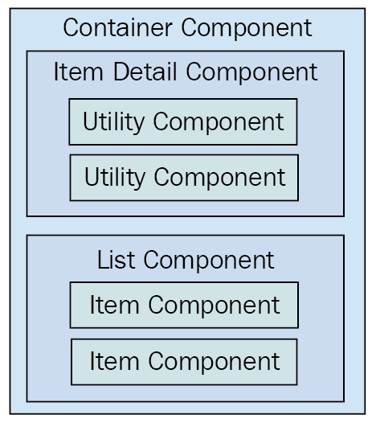
The Container Component will typically contain one direct child. In this diagram, you can see that the container has either an Item Detail Component or a List Component. Of course, there will be variations in these two categories, as every application is different. This generic pattern has three levels of component composition. Data flows in one direction from the container all the way down to the utility components.
Once you add more than three layers, the application architecture becomes difficult to comprehend. There will be the odd case where you'll need to add four layers of React components but, as a rule of thumb, you should avoid this.

Feature components and utility components
In the monolithic component example, you started off with a single component that was entirely focused on a feature. This means that the component has very little utility elsewhere in the application.
The reason for this is because top-level components deal with application state. Stateful components are difficult to use in any other context. As you refactored the monolithic feature component, you created new components that moved further away from the data. The general rule is that the further your components move from stateful data, the more utility they have, because their property values could be passed in from anywhere in the application.

Summary
This chapter was about avoiding a monolithic component design. However, monoliths are often a necessary starting point in the design of any React component.
You began by learning about how the different HTML elements have varying degrees of utility. Next, you learned about the issues with monolithic React components and walked through the implementation of a monolithic component.
Then, you spent several sections learning how to refactor the monolithic component into a more sustainable design. From this exercise, you learned that container components should only have to think in terms of handling state, while smaller components have more utility because their property values can be passed from anywhere. You also learned that you can use render props for better control over component dependencies and substitution.
In the next chapter, you'll learn about the React component life cycle. This is an especially relevant topic for implementing container components.

Further reading
Visit the following links for more information:
Render Props: https://reactjs.org/docs/render-props.html
Components and Props: https://reactjs.org/docs/components-and-props.html#functional-and-class-components
The React Component Life Cycle
The goal of this chapter is for you to learn about the life cycle of React components and how to write code that responds to life cycle events. You'll learn why components need a life cycle in the first place. Then, you'll implement several components that initialize their properties and state using these methods.
Next, you'll learn about how to optimize the rendering efficiency of your components by avoiding rendering when it isn't necessary. Then, you'll see how to encapsulate the imperative code in React components and how to clean up when components are unmounted. Finally, you'll learn how to capture and handle errors using new React 16 life cycle methods.
Here are the sections we'll cover in this chapter:
Why components need a life cycle
Initializing properties and state
Optimizing rendering efficiency
Rendering imperative components
Cleaning up after components
Containing errors with error boundaries

Technical requirements
You can find the code files for this chapter on GitHub at https://github.com/PacktPublishing/React-and-React-Native---Third-Edition/tree/master/Chapter07.

Why components need a life cycle
React components go through a life cycle. In fact, the render() method that you've implemented in your components so far in this book is actually a life cycle method. Rendering is just one life cycle event in a React component.
For example, there are life cycle events for when the component is mounted to the DOM, when the component is updated, and so on. Life cycle events are yet another moving part, so you'll want to keep them to a minimum. As you'll learn in this chapter, some components do need to respond to life cycle events to perform initialization, render heuristics, clean up after the component when it's unmounted from the DOM, or to handle errors thrown by the component.
The following diagram gives you an idea of how a component flows through its life cycle, calling the corresponding methods in turn:
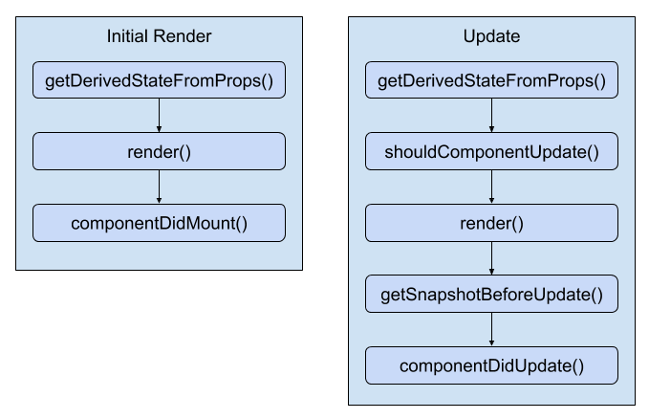
These are the two main life cycle flows of a React component. The first happens when the component is initially rendered. The second happens whenever the component is updated. Here's a rough overview of each of the methods:
getDerivedStateFromProps(): This method allows you to update the state of the component based on the property values of the component. This method is called when the component is initially rendered and when it receives new property values.
render(): Returns the content to be rendered by the component. This is called when the component is first mounted to the DOM, when it receives new property values, and when setState() is called.
componentDidMount(): This is called after the component is mounted to the DOM. This is where you can perform component initialization work, such as fetching data.
shouldComponentUpdate(): You can use this method to compare new states or props with current states or props. Then, you can return false if there's no need to re-render the component. This method is used to make your components more efficient.
getSnapshotBeforeUpdate(): This method lets you perform operations directly on the DOM elements of your component before they're actually committed to the DOM. The difference between this method and render() is that getSnapshotBeforeUpdate() isn't asynchronous. With render(), there's a good chance that the DOM structure could change between when it's called and when the changes are actually made in the DOM.
componentDidUpdate(): This is called when the component is updated. It's rare that you'll have to use this method.
The other life cycle method that isn't included in this diagram is componentWillUnmount(). This is the only life cycle method that's called when a component is about to be removed. We'll see an example of how to use this method at the end of this chapter. On that note, let's get coding.

Initializing properties and state
In this section, you'll see how to implement the initialization code in React components. This involves using life cycle methods that are called when the component is first created. First, you'll implement a basic example that sets the component up with data from the API. Then, you'll see how the state can be initialized from properties, and also how the state can be updated as properties change.

Fetching component data
When your components are initialized, you'll want to populate their state or properties. Otherwise, the component won't have anything to render other than its skeleton markup. For instance, let's say you want to render the following user list component:
import React from "react";
const ErrorMessage = ({ error }) => (error ? <strong>{error}</strong> : null);
const LoadingMessage = ({ loading }) => (loading ? <em>{loading}</em> : null);
export default ({ error, loading, users }) => (
<section>
<ErrorMessage error={error} />
<LoadingMessage loading={loading} />
<ul>
{users.map(user => (
<li key={user.id}>{user.name}</li>
))}
</ul>
</section>
);
There are three pieces of data that this JSX relies on, as follows:
loading: This message is displayed while fetching API data.
error: This message is displayed if something goes wrong.
users: Data that's fetched from the API.
There are two helper components being used here: ErrorMessage and LoadingMessage. They're used to format the error and the loading states, respectively. If error or loading is null, nothing is rendered. Otherwise, an error or loading message is rendered by the respective component.
How should we go about making the API call and using the response to populate the users collection? The answer is to use a container component that makes the API call and then renders the UserList component:
import React, { Component } from "react";
import { users } from "./api";
import UserList from "./UserList";
export default class UserListContainer extends Component {
state = {
error: null,
loading: "loading...",
users: []
};
componentDidMount() {
users().then(
result => {
this.setState({ loading: null, error: null, users: result.users });
},
error => {
this.setState({ loading: null, error });
}
);
}
render() {
return <UserList {...this.state} />;
}
}
Let's take a look at the render() method. Its job is to render the <UserList> component, passing in this.state as properties. The actual API call happens in the componentDidMount() method. This method is called after the component is mounted into the DOM.
Due to the naming of componentDidMount(), React newcomers think that it's bad to wait until the component is mounted to the DOM before issuing requests for component data. In other words, the user experience might suffer if React has to perform a lot of work before the request is even sent. In reality, fetching data is an asynchronous task and initiating it before or after render() makes no real difference as far as your application is concerned. You can read more about this at https://reactjs.org/blog/2018/03/27/update-on-async-rendering.html.
Once the API call returns with data, the users collection is populated, causing the UserList to re-render itself, only this time, it has the data it needs. Let's take a look at the users() mock API function call being used here:
export function users(fail) {
return new Promise((resolve, reject) => {
setTimeout(() => {
if (fail) {
reject("epic fail");
} else {
resolve({
users: [
{ id: 0, name: "First" },
{ id: 1, name: "Second" },
{ id: 2, name: "Third" }
]
});
}
}, 2000);
});
}
It returns a promise that's resolved with an array after 2 seconds. Promises are a good tool for mocking things such as API calls because they enable you to use more than HTTP calls as a data source in your React components. For example, you might be reading from a local file or using a library that returns promises that resolve data from various sources.
Here's what the UserList component renders when the loading state is a string, and the users state is an empty array:
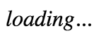
Here's what it renders when loading is null and users is non-empty:
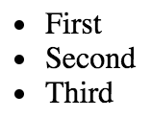
I want to reiterate the separation of responsibilities between the UserListContainer and UserList components. Because the container component handles the life cycle management and the actual API communication, you can create a generic user list component. In fact, it's a functional component that doesn't require any state, which means you can reuse it in other container components throughout your application.
Now that we've seen how to set the state of a component using fetched API data, let's figure out how to set the state of a component using property values that are passed to it.

Initializing state with properties
The preceding example showed you how to initialize the state of a container component by making an API call in the componentDidMount() life cycle method. However, the only populated part of the component state was the users collection. You might want to populate other pieces of state that don't come from API endpoints.
For example, the error and loading state messages have default values set when the state is initialized. This is great, but what if the code that is rendering UserListContainer wants to use a different loading message? You can achieve this by allowing properties to override the default state. Let's build on the UserListContainer component:
import React, { Component } from "react";
import { users } from "./api";
import UserList from "./UserList";
export default class UserListContainer extends Component {
state = {
error: null,
users: []
};
componentDidMount() {
users().then(
result => {
this.setState({ error: null, users: result.users });
},
error => {
this.setState({ loading: null, error });
}
);
}
render() {
return <UserList {...this.state} />;
}
static getDerivedStateFromProps(props, state) {
return {
...state,
loading: state.users.length === 0 ? props.loading : null
};
}
}
UserListContainer.defaultProps = {
loading: "loading..."
};
The loading property no longer has a default string value. Instead, defaultProps provides default values for properties. The new life cycle method is getDerivedStateFromProps(). It uses the loading property to set the loading state. Since the loading property has a default value, it's safe to just change the state. The method is called before the component mounts and on subsequent re-renders of the component.
This method is static because of internal changes in React 16. The expectation is that this method behaves like a pure function and has no side effects. If this method were an instance method, you would have access to the component context and side effects would be commonplace.
The challenge with this new React 16 method is that it's called on initial render and on subsequent re-renders. Prior to React 16, you could use the componentWillMount() method for code that you only wanted to run prior to the initial render. In this example, you have to check whether there are values in the users collection before setting the loading state to null – you don't know if this is the initial render or the 40th render.
Let's see how we can pass state data to UserListContainer now:
import React from "react";
import { render } from "react-dom";
import UserListContainer from "./UserListContainer";
render(
<UserListContainer loading="playing the waiting game..." />,
document.getElementById("root")
);
Here's what the initial loading message looks like when UserList is first rendered:
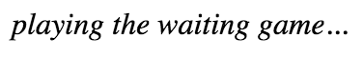
Just because the component has state doesn't mean that you can't allow for customization. Next, you'll learn a variation of this concept—updating the component state with properties.

Updating state with properties
You've seen how the componentDidMount() and getDerivedStateFromProps() life cycle methods help get your components the data they need. There's one more scenario that you need to consider—re-rendering the component container.
Let's take a look at a simple button component that tracks the number of times it's been clicked:
import React from "react";
export default ({ clicks, disabled, text, onClick }) => (
<section>
<p>{clicks} clicks</p>
<button disabled={disabled} onClick={onClick}>
{text}
</button>
</section>
);
Now, let's implement a container component for this feature:
import React, { Component } from "react";
import MyButton from "./MyButton";
export default class MyFeature extends Component {
state = {
clicks: 0,
disabled: false,
text: ""
};
onClick = () => {
this.setState(state => ({ ...state, clicks: state.clicks + 1 }));
};
render() {
return <MyButton onClick={this.onClick} {...this.state} />;
}
static getDerivedStateFromProps({ disabled, text }, state) {
return { ...state, disabled, text };
}
}
MyFeature.defaultProps = {
text: "A Button"
};
The same approach that we used for initializing the state with properties is being used here. The getDerivedStateFromProps() method is called before every render and is where you can use prop values to figure out if and how the component state should be updated. Let's see how to re-render this component and whether or not the state behaves as expected:
import React from "react";
import { render as renderJSX } from "react-dom";
import MyFeature from "./MyFeature";
let disabled = true;
function render() {
disabled = !disabled;
renderJSX(<MyFeature {...{ disabled }} />, document.getElementById("root"));
}
setInterval(render, 3000);
render();
Sure enough, everything goes as planned. Whenever the button is clicked, the click counter is updated. <MyFeature> is re-rendered every 3 seconds, toggling the disabled state of the button. When the button is re-enabled and clicking resumes, the counter continues from where it left off.
Here is what the MyButton component looks like when it's first rendered:
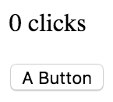
Here's what it looks like after it has been clicked a few times and the button has moved into a disabled state:
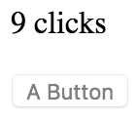
In this section, you learned about initializing property and state values in your components by using different life cycle methods. Without these methods, you would have a hard time ensuring that your components have the data that they need when they need it. In the next section, we'll consider different ways to optimize the efficiency of our components using life cycle methods.

Optimizing rendering efficiency
The next life cycle method you're going to learn about is used to implement heuristics that improve component rendering performance. You'll see that if the state of a component hasn't changed, then there's no need to render. Then, you'll implement a component that uses specific metadata from the API to determine whether or not the component needs to be re-rendered.

To render or not to render
The shouldComponentUpdate() life cycle method is used to determine whether or not the component will render when asked to. For example, if this method were implemented and returned false, the entire life cycle of the component would short-circuit, and no render would happen. This can be an important check to have in place if the component is rendering a lot of data and is re-rendered frequently. The trick is knowing whether or not the component state has changed.
Let's take a look at a simple list component:
import React, { Component } from "react";
function referenceEquality(arr1, arr2) {
return arr1 === arr2;
}
function valueEquality(arr1, arr2) {
for (let i = 0; i < arr1.length; i++) {
if (arr1[i] !== arr2[i]) {
return false;
}
}
return true;
}
export default class MyList extends Component {
state = {
items: new Array(5000).fill(null).map((v, i) => i)
};
shouldComponentUpdate(props, state) {
if (!referenceEquality(this.state.items, state.items)) {
return !valueEquality(this.state.items, state.items);
}
return false;
}
render() {
return (
<ul>
{this.state.items.map(item => (
<li key={item}>{item}</li>
))}
</ul>
);
}
}
The items state is initialized to an array with 5000 items in it. This is a fairly large collection, so you don't want the virtual DOM inside React to constantly diff this list. The virtual DOM is efficient at what it does, but not nearly as efficient as code, which can perform a simple should or shouldn't render check. The shouldComponentRender() method that you've implemented here does exactly that. It compares the new state with the current state with the help of two utility functions:
referenceEquality(): Returns true if two arguments are the same reference. This is an extremely fast check to perform.
valueEqulity(): Returns true if the two array values are the same. This isn't quite as fast because it needs to iterate over the whole array, but it's still faster than the virtual DOM.
The idea for having these two functions separated like this is to handle the fast common case, which is that setState() wasn't even called and we have the same array reference, so there's no need to do anything else. If it's not the same object, then we can check for value changes. Even if the values are all the same, and it's a new array reference, this method still pays off because it's relatively fast to run and often avoids a trip to the virtual DOM.
Now, let's put this component to work and see what kind of efficiency gains you get:
import React from "react";
import { render as renderJSX } from "react-dom";
import MyList from "./MyList";
function render() {
const myList = renderJSX(<MyList />, document.getElementById("root"));
myList.data = myList.setState(state => ({
items: [0, ...state.items.slice(1)]
}));
}
for (let i = 0; i < 100; i++) {
render();
}
You're rendering <MyList>, over and over, in a loop. Each iteration has 5,000 list items to render. Since the state doesn't change, the call to shouldComponentUpdate() returns false on every one of these iterations. This is important for performance reasons because there are a lot of them. You're not going to have code that re-renders a component in a tight loop, in a real application. This code is meant to stress the rendering capabilities of React. If you were to comment out the shouldComponentUpdate() method, you'd see what I mean. Here's what the performance profile looks like for this component:
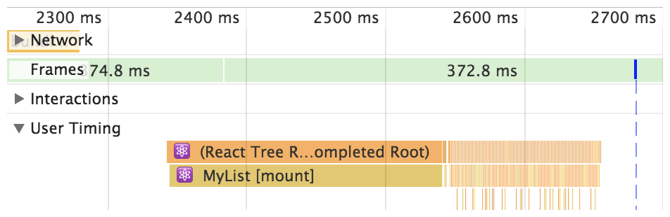
The initial render takes the longest—a few hundred milliseconds. But then you have all of these tiny time slices that are completely imperceptible to the user experience. These are the result of shouldComponentUpdate() returning false. Let's comment out this method now and see how this profile changes:
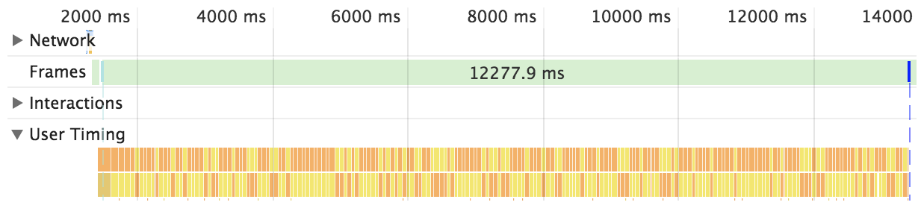
Without shouldComponentUpdate(), the end result is much larger time slices with a drastically negative impact on user experience. In the next section, we'll try a different approach to optimizing our component rendering in shouldComponentUpdate().

Using metadata to optimize rendering
In this section, you'll learn how to use metadata that's part of the API response to determine whether or not the component should re-render itself. Here's a simple user details component:
import React, { Component } from "react";
export default class MyUser extends Component {
state = {
modified: new Date(),
first: "First",
last: "Last"
};
shouldComponentUpdate(props, state) {
return Number(state.modified) > Number(this.state.modified);
}
render() {
const { modified, first, last } = this.state;
return (
<section>
<p>{modified.toLocaleString()}</p>
<p>{first}</p>
<p>{last}</p>
</section>
);
}
}
The shouldComponentUpdate() method is comparing the new modified state with the old modified state. This code makes the assumption that the modified value is a date that reflects when the data that was returned by the API was actually modified. The main downside to this approach is that the shouldComponentUpdate() method is now tightly coupled with the API data. The advantage is that you get a performance boost in the same way that you would with immutable data.
Here's how this heuristic looks in action:
import React from "react";
import { render } from "react-dom";
import MyUser from "./MyUser";
const myUser = render(<MyUser />, document.getElementById("root"));
myUser.setState({
modified: new Date(),
first: "First1",
last: "Last1"
});
myUser.setState({
first: "First2",
last: "Last2"
});
The MyUser component is now entirely dependent on the modified state. If it's not greater than the previous modified value, no render happens.
Here's what the component looks like after it's been rendered twice:
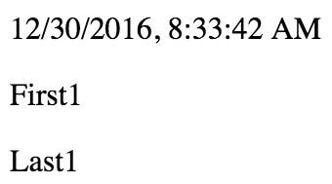
In this section, you learned how to improve the efficiency of your components by using the shouldComponentUpdate() life cycle method. Even if your component data hasn't changed, frequently diffing the virtual DOM can cause performance issues. This method exists so that we can build heuristics into our components using an approach that makes sense for our app. In the next section, we'll attempt to render components from other libraries that use an imperative approach.

Rendering imperative components
Everything you've rendered so far in this book has been straightforward declarative HTML. Life is never so simple: sometimes, your React components need to implement some imperative code under the covers.
This is the key – hiding the imperative operations so that the code that renders your component doesn't have to touch it. In this section, you'll implement a simple jQuery UI button React component so that you can see how the relevant life cycle methods help you to encapsulate the imperative code.

Rendering jQuery UI widgets
The jQuery UI widget library implements several widgets on top of standard HTML. It uses a progressive enhancement technique whereby the basic HTML is enhanced in browsers that support newer features. To make these widgets work, you first need to render HTML into the DOM somehow; then, you need to make imperative function calls to create and interact with the widgets.
In this example, you'll create a React button component that acts as a wrapper around the jQuery UI widget. Anyone using the React component shouldn't need to know that, behind the scenes, it's making imperative calls to control the widget. Let's see what the button component looks like:
import React, { Component } from "react";
import $ from "jquery";
import "jquery-ui/ui/widgets/button";
import "jquery-ui/themes/base/all.css";
export default class MyButton extends Component {
componentDidMount() {
$(this.button).button(this.props);
}
componentDidUpdate() {
$(this.button).button("option", this.props);
}
render() {
return (
<button
onClick={this.props.onClick}
ref={button => {
this.button = button;
}}
/>
);
}
}
The jQuery UI button widget expects a <button> element, so this is what's rendered by the component. An onClick() handler from the component props is assigned as well. There's also a ref property being used here, which assigns the button argument to this.button. The reason this is done is so that the component has direct access to the underlying DOM element of the component. Generally, components don't need access to any DOM elements, but here, you need to issue imperative commands to the element.
For example, in the componentDidMount() method, the button() function is called and passes its properties from the component. The componentDidUpdate() method does something similar and is called when property values change. Now, let's take a look at the button container component:
import React, { Component } from "react";
import MyButton from "./MyButton";
export default class MyButtonContainer extends Component {
componentDidMount() {
this.setState({ ...this.props, onClick: this.props.onClick.bind(this) });
}
render() {
return <MyButton {...this.state} />;
}
}
MyButtonContainer.defaultProps = {
onClick: () => {}
};
You have a container component that controls the state, which is then passed to <MyButton> as properties.
The {...data} syntax is called JSX spread attributes. This allows you to pass objects to elements as attributes. Instead of writing <User first={data.first} last={data.last} age={data.age} />, you could shorten it to <User {...data} /> to get the exact same result.
The component has a default onClick() handler function. However, you can pass a different click handler in as a property. Additionally, it's automatically bound to the component context, which is useful if the handler needs to change the button state. Let's look at an example of this:
import React from "react";
import { render } from "react-dom";
import MyButtonContainer from "./MyButtonContainer";
function onClick() {
this.setState({ disabled: true });
}
render(
<section>
<MyButtonContainer label="Text" />
<MyButtonContainer
label="My Button"
icon="ui-icon-person"
showLabel={false}
/>
<MyButtonContainer label="Disable Me" onClick={onClick} />
</section>,
document.getElementById("root")
);
Here, you have three jQuery UI button widgets, each controlled by a React component with no imperative code in sight. Here's how the buttons look:
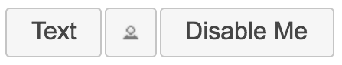
In this section, you learned that React components can be used to render imperative components. In order to do so, we need life cycle methods so that we can perform the necessary setup and cleanup operations. In the next section, we'll dig deeper into cleaning up after our components when they're removed.

Cleaning up after components
In this section, you'll learn how to clean up after components. You don't have to explicitly unmount components from the DOM – React handles that for you. There are some things that React doesn't know about and therefore cannot clean up for you after the component is removed.
It's for these types of cleanup tasks that the componentWillUnmount() life cycle method exists. One use case for cleaning up after React components is asynchronous code.
For example, imagine a component that issues an API call to fetch some data when the component is first mounted. Now, imagine that this component is removed from the DOM before the API response arrives.

Cleaning up asynchronous calls
If your asynchronous code tries to set the state of a component that has been unmounted, nothing will happen. A warning will be logged, and the state won't be set. It's actually very important that this warning is logged; otherwise, you would have a hard time trying to solve subtle race condition bugs.
The correct approach is to create cancellable asynchronous actions. Here's a modified version of the users() API function that you implemented in the fetching component data example:
import { Promise } from "bluebird";
Promise.config({ cancellation: true });
export function users(fail) {
return new Promise((resolve, reject) => {
setTimeout(() => {
if (fail) {
reject(fail);
} else {
resolve({
users: [
{ id: 0, name: "First" },
{ id: 1, name: "Second" },
{ id: 2, name: "Third" }
]
});
}
}, 4000);
});
}
Instead of returning a native promise, users() returns a promise from the Bluebird library that's been configured to have cancellable behavior. Now, let's take a look at a container component, which has the ability to cancel asynchronous behavior:
import React, { Component } from "react";
import { render } from "react-dom";
import { users } from "./api";
import UserList from "./UserList";
const onClickCancel = e => {
e.preventDefault();
render(<p>Cancelled</p>, document.getElementById("root"));
};
export default class UserListContainer extends Component {
state = {
error: null,
loading: "loading...",
users: []
};
componentDidMount() {
this.job = users();
this.job.then(
result => {
this.setState({ loading: null, error: null, users: result.users });
},
error => {
this.setState({ loading: null, error: error.message });
}
);
}
componentWillUnmount() {
this.job.cancel();
}
render() {
return <UserList onClickCancel={onClickCancel} {...this.state} />;
}
}
The onClickCancel() handler actually replaces the user list. This calls the componentWillUnmount() method, where you can cancel this.job. It's also worth noting that when the API call is made in componentDidMount(), a reference to the promise is stored in the component. This is necessary; otherwise, you would have no way to cancel the async call.
Here's what the component looks like when rendered during a pending API call:
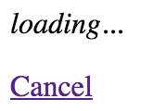
Clicking the Cancel button causes the onClickCancel() function to run, which completely removes UserListContainer from the DOM. This, in turn, causes the componentWillUnmount() method to run, which will make sure that any pending promises are canceled. Now, we can feel confident that our components can be safely removed, even when they have pending API requests. In the next section, we'll look at life cycle methods to help us control errors in our components.

Containing errors with error boundaries
A new feature of React 16 – error boundaries – lets you handle unexpected component failures. Rather than have every component of your application know how to deal with any errors that it might encounter, error boundaries are a mechanism that you can use to wrap components with error-handling behavior. The best way to think of error boundaries is as try/catch syntax for JSX.
Let's revisit the first example from this chapter, where you fetched component data using an API function. The users() function accepts a Boolean argument, which, when true, causes the promise to reject. This is something that you'll want to handle, but not necessarily in the component that made the API call. In fact, the UserListContainer and UserList components are already set up to handle API errors like this. The challenge is that if you have lots of components, this is a lot of error-handling code. Furthermore, the error handling is specific to that one API call – what if something else goes wrong?
Here's the modified source for UserListContainer that you can use for this example:
import React, { Component } from "react";
import { users } from "./api";
import UserList from "./UserList";
export default class UserListContainer extends Component {
state = {
error: null,
loading: "loading...",
users: []
};
componentDidMount() {
users(false).then(
result => {
this.setState({ loading: null, error: null, users: result.users });
},
error => {
this.setState({ loading: null, error });
}
);
}
render() {
if (this.state.error !== null) {
throw new Error(this.state.error);
}
return <UserList {...this.state} />;
}
}
This component is mostly the same as it was in the first example. The first difference is the call to users(), where it's now passing true:
componentDidMount() {
users(true).then(
...
This call will fail, resulting in the error state being set. The second difference is in the render() method:
if (this.state.error !== null) {
throw new Error(this.state.error);
}
Instead of forwarding the error state onto the UserList component, it's passing the error back to the component tree by throwing an error instead of attempting to render more components. The key design change here is that this component is now making the assumption that there is some sort of error boundary in place further up in the component tree that will handle these errors accordingly.
You might be wondering why the error is thrown in render instead of being thrown when the promise is rejected in componentDidMount(). The problem is that fetching data asynchronously like this means that there's no way for the React internals to actually catch exceptions that are thrown from within async promise handlers. The easiest solution for asynchronous actions that could cause a component to fail is to store the error in the component state but to throw the error before actually rendering anything if it's there.
Now, let's create the error boundary itself:
import React, { Component } from "react";
export default class ErrorBoundary extends Component {
state = {
error: null
};
componentDidCatch(error) {
this.setState({ error });
}
render() {
if (this.state.error === null) {
return this.props.children;
} else {
return <strong>{this.state.error.toString()}</strong>;
}
}
}
This is where the componentDidCatch() life cycle method is utilized by setting the error state of this component when it catches an error. When it's rendered, an error message is rendered if the error state is set. Otherwise, it renders the child components as usual.
Here's how you can use this ErrorBoundary component:
import React from "react";
import { render } from "react-dom";
import ErrorBoundary from "./ErrorBoundary";
import UserListContainer from "./UserListContainer";
render(
<ErrorBoundary>
<UserListContainer />
</ErrorBoundary>,
document.getElementById("root")
);
Any errors that are thrown by UserListContainer or any of its children will be caught and handled by ErrorBoundary:
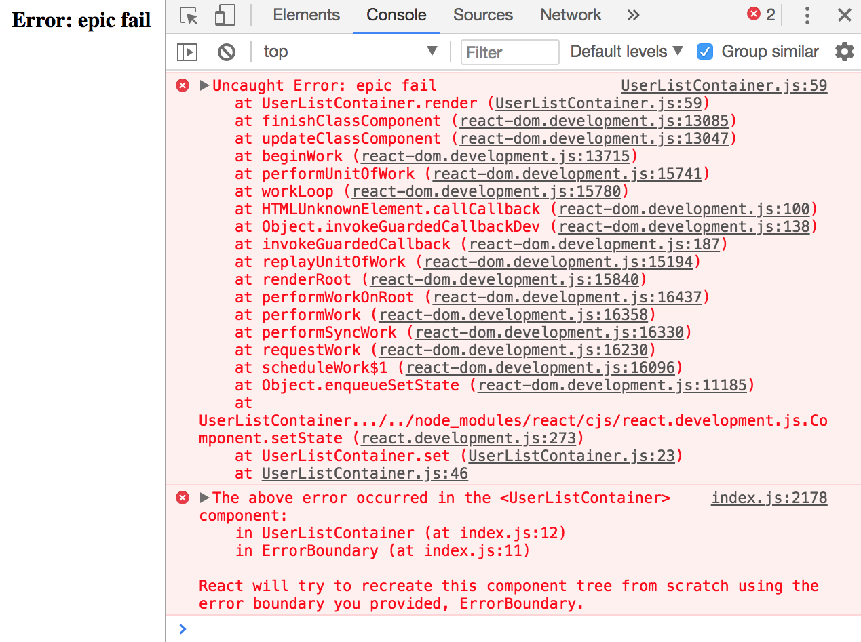
Now, you can remove the argument that's passed to users() in UserListContainer to stop it from failing. In the UserList component, let's say that you have an error that tries to call toUpperCase() on a number:
import React from "react";
const LoadingMessage = ({ loading }) => (loading ? <em>{loading}</em> : null);
export default ({ error, loading, users }) => (
<section>
<LoadingMessage loading={loading} />
<ul>
{users.map(user => (
<li key={user.id.toUpperCase()}>{user.name}</li>
))}
</ul>
</section>
);
You'll get a different error thrown, but since it's under the same boundary as the previous error, it'll be handled the same way:
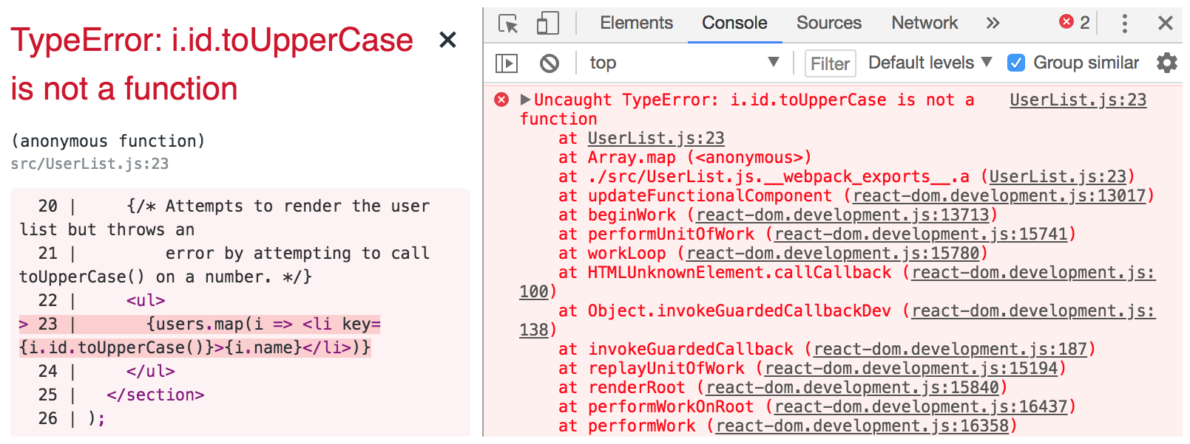
If you're running your project with create-react-app and react-scripts, you might notice an error overlay for every error in your application, even those that are handled by error boundaries. If you close the overlay using the x in the top right, you will be able to see how your component handles the error in your app.
In this section, you learned about the componentDidCatch() life cycle method and how it can be used to handle errors in a way that prevents your entire app from crashing. By introducing error boundaries into your application, you have total control over what happens when any piece of your application fails.

Summary
In this chapter, you learned a lot about the life cycle of React components. We started things off with a discussion on why React components need a life cycle in the first place. It turns out that React can't do everything automatically for us, so we need to write some code that's run at the appropriate time during the components' life cycles.
Next, you implemented several components that were able to fetch their initial data and initialize their state from JSX properties. Then, you learned how to implement more efficient React components by providing a shouldComponentRender() method.
After that, you learned how to hide the imperative code that some components need to implement and how to clean up after asynchronous behavior. Finally, you learned how to use the new error boundary functionality from React 16.
In the next chapter, you'll learn techniques that help to ensure that your components are being passed the right properties.

Further reading
You can visit the following links for more information:
React.Component: https://reactjs.org/docs/react-component.html
State and Lifecycle: https://reactjs.org/docs/state-and-lifecycle.html
Validating Component Properties
In this chapter, you'll learn about property validation in React components. This might seem simple at first glance, but it's an important topic because it leads to bug-free components. I'll start things off with a discussion about predictable outcomes and how this leads to components that are portable throughout the application.
Next, you'll walk through examples of some of the type-checking property validators that come with React. Then, you'll walk through some more complex property-validation scenarios. Finally, I'll wrap this chapter up with an example of how to implement your own custom validators.
The following topics will be covered in this chapter:
Knowing what to expect
Promoting portable components
Simple property validators
Type and value validators
Writing custom property validators

Technical requirements
The code files for this chapter can be found on GitHub at https://github.com/PacktPublishing/React-and-React-Native---Third-Edition/tree/master/Chapter08.

Knowing what to expect
Property validation in React components is like field validation in HTML forms. The basic premise of validating form fields is letting the user know that they've provided a value that's not acceptable. Ideally, the validation error message is clear enough that the user can easily fix the situation. With React component property validation, you're doing the same thing – making it easy to fix a situation where an unexpected value was provided. Property validation enhances the developer experience, rather than the user experience.
The key aspect of property validation is knowing what's passed into the component as a property value. For example, if you're expecting an array and a Boolean is passed instead, something will probably go wrong. If you validate the property values using the prop-types React validation package, then you know that something unexpected was passed. If the component is expecting an array so that it can call the map() method, it'll fail if a Boolean value is passed because it has no map() method. However, before this failure happens, you'll see the property validation warning.
The idea isn't to fail fast with property validation. It's to provide information to the developer. When property validation fails, you know that something was provided as a component property that shouldn't have been. It's a matter of finding where the value is passed in the code and fixing it.
Fail fast is an architectural property of software in which the system will crash completely rather than continue running in an inconsistent state.
Next, you'll learn how property validation is used to promote portability. These are components that can be used in many places throughout your app.

Promoting portable components
When you know what to expect from your component properties, the context in which the component is used becomes less important. This means that as long as the component is able to validate its property values, it really shouldn't matter where the component is used; it could easily be used by any feature.
If you want a generic component that's portable across application features, you can either write component validation code or you can write defensive code that runs at render time. The challenge with programming defensively is that it dilutes the value of declarative React components. Using React-style property validation, you can avoid writing defensive code. Instead, the property validation mechanism emits a warning when something doesn't pass, informing you that you need to fix something.
Defensive code is code that needs to account for a number of edge cases during runtime, in a production environment. Coding defensively is necessary when potential problems cannot be detected during development, such as with React component property validation.
Now that you have a better understanding of how property validation assists with writing defensive code and portable components, it's time to implement some property validators.

Simple property validators
In this section, you'll learn how to use the simple property type validators available in the prop-types package. Then, you'll learn how to accept any property value as well as make a property required instead of optional.

Basic type validation
Let's take a look at validators that handle the most primitive types of JavaScript values. You will use these validators frequently, as you'll want to know whether a property is a string or a function, for example. This example will also introduce you to the mechanisms involved with setting up validation of a component. Here's the component; it just renders some properties using basic markup:
import React from "react";
import PropTypes from "prop-types";
export default function MyComponent({
myString,
myNumber,
myBool,
myFunc,
myArray,
myObject
}) {
return (
<section>
<p>{myString}</p>
<p>{myNumber}</p>
<p>
<input type="checkbox" defaultChecked={myBool} />
</p>
<p>{myFunc()}</p>
<ul>
{myArray.map(i => (
<li key={i}>{i}</li>
))}
</ul>
<p>{myObject.myProp}</p>
</section>
);
}
MyComponent.propTypes = {
myString: PropTypes.string,
myNumber: PropTypes.number,
myBool: PropTypes.bool,
myFunc: PropTypes.func,
myArray: PropTypes.array,
myObject: PropTypes.object
};
There are two key pieces to the property validation mechanism:
You have the static propTypes property. This is a class-level property, not an instance property. When React finds propTypes, it uses this object as the property specification of the component.
You have the PropTypes object from the prop-types package, which has several built-in validator functions.
The PropTypes object used to be built into React. It was split from React core and moved into the prop-types package so that it became opt-in to use – a request by React developers that do not use property validation.
In this example, MyComponent has six properties, each with its own type. When you look at the propTypes specification, you will see what type of values this component will accept. Let's render this component with some property values:
import React from "react";
import { render as renderJSX } from "react-dom";
import MyComponent from "./MyComponent";
const validProps = {
myString: "My String",
myNumber: 100,
myBool: true,
myFunc: () => "My Return Value",
myArray: ["One", "Two", "Three"],
myObject: { myProp: "My Prop" }
};
const invalidProps = {
myString: 100,
myNumber: "My String",
myBool: () => "My Reaturn Value",
myFunc: true,
myArray: { myProp: "My Prop" },
myObject: ["One", "Two", "Three"]
};
function render(props) {
renderJSX(<MyComponent {...props} />, document.getElementById("root"));
}
render(validProps);
render(invalidProps);
The first time <MyComponent> is rendered, it uses the validProps properties. These values all meet the component property specification, so no warnings are logged in the console. The second time around, the invalidProps properties are used, and this fails the property validation because the wrong type is used in every property. The console output should look something like the following:
Invalid prop `myString` of type `number` supplied to `MyComponent`, expected `string`
Invalid prop `myNumber` of type `string` supplied to `MyComponent`, expected `number`
Invalid prop `myBool` of type `function` supplied to `MyComponent`, expected `boolean`
Invalid prop `myFunc` of type `boolean` supplied to `MyComponent`, expected `function`
Invalid prop `myArray` of type `object` supplied to `MyComponent`, expected `array`
Invalid prop `myObject` of type `array` supplied to `MyComponent`, expected `object`
TypeError: myFunc is not a function
This last error is interesting. We can see that the property validation is complaining about the invalid property types. This includes the invalid function that was passed to myFunc. So, despite the type checking that happens on the property, the component will still try to call the value as though it were a function.
Here's what the rendered output looks like:
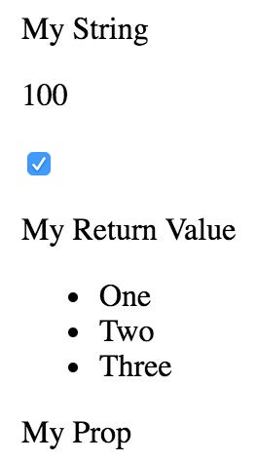
Once again, the aim of property validation in React components is to help you discover bugs during development. When React is in production mode, property validation is turned off completely. This means that you don't have to concern yourself with writing expensive property validation code; it'll never run in production. However, the error will still occur, so fix it.
When you validate the type of a given property, nothing is validated if the property isn't passed to the component at all. In the following section, we'll look at how to specify that a property is required and should always be passed.

Requiring values
Let's make some adjustments to the preceding example. The component property specification requires specific types for values, but these are only checked if the property is passed to the component as a JSX attribute. For example, you could have completely omitted the myFunc property and it would have been validated. Thankfully, the PropTypes functions have a tool that lets you specify that a property must be provided, and it must have a specific type. Here's the modified component:
import React from "react";
import PropTypes from "prop-types";
export default function MyComponent({
myString,
myNumber,
myBool,
myFunc,
myArray,
myObject
}) {
return (
<section>
<p>{myString}</p>
<p>{myNumber}</p>
<p>
<input type="checkbox" defaultChecked={myBool} />
</p>
<p>{myFunc()}</p>
<ul>
{myArray.map(i => (
<li key={i}>{i}</li>
))}
</ul>
<p>{myObject.myProp}</p>
</section>
);
}
MyComponent.propTypes = {
myString: PropTypes.string.isRequired,
myNumber: PropTypes.number.isRequired,
myBool: PropTypes.bool.isRequired,
myFunc: PropTypes.func.isRequired,
myArray: PropTypes.array.isRequired,
myObject: PropTypes.object.isRequired
};
Not much has changed between this component and the one that you implemented in the preceding section. The main difference is in regards to the specs in propTypes. The isRequired value is appended to each of the type validators used. So, for instance, string.isRequired means that the property value must be a string and that the property cannot be missing. Let's put this component to the test:
import React from "react";
import { render as renderJSX } from "react-dom";
import MyComponent from "./MyComponent";
const validProps = {
myString: "My String",
myNumber: 100,
myBool: true,
myFunc: () => "My Return Value",
myArray: ["One", "Two", "Three"],
myObject: { myProp: "My Prop" }
};
const missingProp = {
myString: "My String",
myNumber: 100,
myBool: true,
myFunc: () => "My Return Value",
myArray: ["One", "Two", "Three"]
};
function render(props) {
renderJSX(<MyComponent {...props} />, document.getElementById("root"));
}
render(validProps);
render(missingProp);
The first time around, the component is rendered with all of the correct property types. The second time around, the component is rendered without the myObject property. The console errors should be as follows:
Required prop `myObject` was not specified in `MyComponent`.
Cannot read property 'myProp' of undefined
Thanks to the property specification and subsequent error message for myObject, it's clear that an object value needs to be provided to the myObject property. The last error is because the component assumes that there is an object with myProp as a property.
Ideally, you would validate for the myProp object property in this example since it's directly used in the JSX. The specific properties that are used in the JSX markup for the shape of an object can be validated, as you'll see later in this chapter.
What if you're not exactly sure about the specific type of a given property quite yet? In the next section, we'll look at allowing any value to be passed to a property value while we're still adding a validator for it.

Any property value
The final topic of this section is the any property validator. That is, it doesn't actually care what value it gets – anything is valid, including not passing a value at all. In fact, the isRequired validator can be combined with the any validator. For example, if you're working on a component and you just want to make sure that something is passed, but not sure exactly which type you're going to need yet, you could do something like myProp: PropTypes.any.isRequired.
Another reason to have the any property validator is for the sake of consistency. Every component should have property specifications. The any validator is useful in the beginning when you're not exactly sure what the property type will be. You can at least begin the property spec and then refine it later as things unfold.
Let's take a look at some code:
import React from "react";
import PropTypes from "prop-types";
export default function MyComponent({ label, value, max }) {
return (
<section>
<h5>{label}</h5>
<progress {...{ max, value }} />
</section>
);
}
MyComponent.propTypes = {
label: PropTypes.any,
value: PropTypes.any,
max: PropTypes.any
};
This component doesn't actually validate anything because the three properties in its property spec will accept anything. However, it's a good starting point, because, at a glance, we can see the names of the three properties that this component uses. So, later on, when we decide exactly which types these properties should have, the change is simple. Let's see this component in action:
import React from "react";
import { render } from "react-dom";
import MyComponent from "./MyComponent";
render(
<section>
<MyComponent label="Regular Values" max={20} value={10} />
<MyComponent label="String Values" max="20" value="10" />
<MyComponent label={Number.MAX_SAFE_INTEGER} max={new Date()}
value="10" />
</section>,
document.getElementById("root")
);
Strings and numbers are interchangeable in several places. Allowing just one or the other seems overly restrictive. As you'll see in the next section, React has other property validators that allow you to further restrict the property values that are allowed by your component.
Here's what our component looks like when rendered:
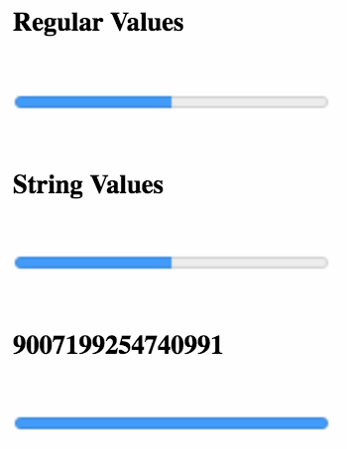
In this section, you learned the basics of property validation for your React components. You can make sure that a property value follows a specific type, that a value is indeed required, and how to allow any value to be passed. In the following section, we'll get into the more specific type and value property validations.

Type and value validators
In this section, you'll learn about the more advanced validator functionality available in the React prop-types package. First, you'll learn about the element and node validators that check for values that can be rendered inside HTML markup. Then, you'll see how to check for specific types, beyond the primitive type checking that you just learned about. Finally, you'll implement validation that looks for specific values.

Things that can be rendered
Sometimes, you just want to make sure that a property value is something that can be rendered by JSX markup. For example, if a property value is an array of plain objects, this can't be rendered by putting it in {}. You have to map the array items to JSX elements.
This sort of checking is especially useful if your component passes property values to other elements as children. Let's look at an example of what this looks like:
import React from "react";
import PropTypes from "prop-types";
export default function MyComponent({ myHeader, myContent }) {
return (
<section>
<header>{myHeader}</header>
<main>{myContent}</main>
</section>
);
}
MyComponent.propTypes = {
myHeader: PropTypes.element.isRequired,
myContent: PropTypes.node.isRequired
};
This component has two properties that require values that can be rendered. The myHeader property wants element; this can be any JSX element. The myContent property wants node; this can be any JSX element or any string value. Let's pass this component some values and render it:
import React from "react";
import { render } from "react-dom";
import MyComponent from "./MyComponent";
const myHeader = <h1>My Header</h1>;
const myContent = <p>My Content</p>;
render(
<section>
<MyComponent {...{ myHeader, myContent }} />
<MyComponent myHeader="My Header" {...{ myContent }} />
<MyComponent {...{ myHeader }} myContent="My Content" />
<MyComponent
{...{ myHeader }}
myContent={[myContent, myContent, myContent]}
/>
</section>,
document.getElementById("root")
);
The myHeader property is more restrictive about the values it will accept. The myContent property will accept a string, an element, or an array of elements. These two validators are important when passing in child data from properties, as this component does. For example, trying to pass a plain object or a function as a child will not work, and it's best if you check for this situation using a validator.
Here's what this component looks like when rendered:
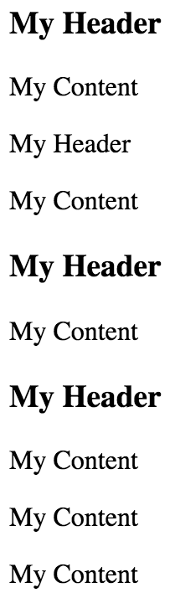
In the following section, you'll learn how to apply more specific type checking to your property validators.

Requiring specific types
Sometimes, you need a property validator that checks for a type defined by your application. For example, let's say you have the following user class:
const id = (function*() {
let i = 1;
while (true) {
yield i;
i += 1;
}
})();
export default class MyUser {
constructor(first, last) {
this.id = id.next().value;
this.first = first;
this.last = last;
}
get name() {
return `${this.first} ${this.last}`;
}
}
Now, suppose that you have a component that wants to use an instance of this class as a property value. You would need a validator that checks that the property value is an instance of MyUser. Let's implement a component that does just that:
import React from "react";
import PropTypes from "prop-types";
import MyUser from "./MyUser";
export default function MyComponent({ myDate, myCount, myUsers }) {
return (
<section>
<p>{myDate.toLocaleString()}</p>
<p>{myCount}</p>
<ul>
{myUsers.map(user => (
<li key={user.id}>{user.name}</li>
))}
</ul>
</section>
);
}
MyComponent.propTypes = {
myDate: PropTypes.instanceOf(Date),
myCount: PropTypes.oneOfType([PropTypes.string, PropTypes.number]),
myUsers: PropTypes.arrayOf(PropTypes.instanceOf(MyUser))
};
This component has three properties that require specific types, each going beyond the basic type validators that you've seen so far in this chapter. Let's walk through these now:
myDate requires an instance of Date. It uses the instanceOf() function to build a validator function that ensures the value is a Date instance.
myCount requires that the value either be a number or a string. This validator function is created by combining oneOfType, PropTypes.number(), and PropTypes.string().
myUsers requires an array of MyUser instances. This validator is built by combining arrayOf() and instanceOf().
This example illustrates the number of scenarios that you can handle by combining the property validators provided by React. Here's what the rendered output looks like:
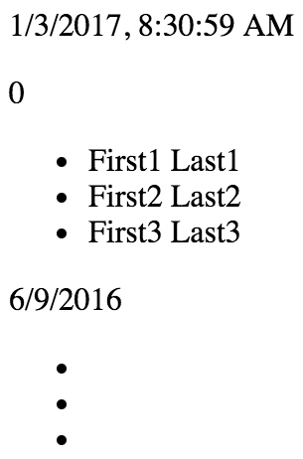
In the next section, we'll look at validating the actual values that are passed to component properties.

Requiring specific values
I've focused on validating the type of property values so far, but that's not always what you'll want to check for. Sometimes, specific values matter. Let's see how we can validate specific property values:
import React from "react";
import PropTypes from "prop-types";
const levels = new Array(10).fill(null).map((v, i) => i + 1);
const userShape = {
name: PropTypes.string,
age: PropTypes.number
};
export default function MyComponent({ level, user }) {
return (
<section>
<p>{level}</p>
<p>{user.name}</p>
<p>{user.age}</p>
</section>
);
}
MyComponent.propTypes = {
level: PropTypes.oneOf(levels),
user: PropTypes.shape(userShape)
};
The level property is expected to be a number from the levels array. This is easy to validate using the oneOf() function. The user property is expecting a specific shape. A shape is the expected properties and types of an object. The userShape defined in this example requires a name string and an age number. The key difference between shape() and instanceOf() is that you don't necessarily care about the type. You might only care about the values that are used in the JSX of the component.
Let's take a look at how this component is used:
import React from "react";
import { render } from "react-dom";
import MyComponent from "./MyComponent";
render(
<section>
<MyComponent level={10} user={{ name: "Name", age: 32 }} />
<MyComponent user={{ name: "Name", age: 32, online: false }} />
<MyComponent level={11} user={{ name: "Name", age: "32" }} />
</section>,
document.getElementById("root")
);
Here's what the component looks like when it's rendered:
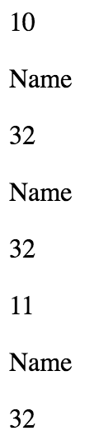
In this section, you learned about the property validation tools that are available to validate very precise requirements regarding the property types and property values. In the following section, you'll learn how to build your own property validators.

Writing custom property validators
In this final section, you'll learn how to build your own custom property validation functions and apply them in the property specification. Generally speaking, you should only implement your own property validator if you absolutely have to. The default validators available in prop-types cover a wide range of scenarios.
However, sometimes, you need to make sure that very specific property values are passed to the component. Remember, these will not be run in production mode, so it's perfectly acceptable for a validator function to iterate over collections. Let's implement some custom validator functions:
import React from "react";
export default function MyComponent({ myArray, myNumber }) {
return (
<section>
<ul>
{myArray.map(i => (
<li key={i}>{i}</li>
))}
</ul>
<p>{myNumber}</p>
</section>
);
}
MyComponent.propTypes = {
myArray: (props, name, component) =>
Array.isArray(props[name]) && props[name].length
? null
: new Error(`${component}.${name}: expecting non-empty array`),
myNumber: (props, name, component) =>
Number.isFinite(props[name]) && props[name] > 0 && props[name] < 100
? null
: new Error(`${component}.${name}: expecting number between 1 and
99`)
};
The myArray property expects a non-empty array, and the myNumber property expects a number that's greater than 0 and less than 100. Let's try passing these validators some data:
import React from "react";
import { render } from "react-dom";
import MyComponent from "./MyComponent";
render(
<section>
<MyComponent myArray={["first", "second", "third"]} myNumber={99} />
<MyComponent myArray={[]} myNumber={100} />
</section>,
document.getElementById("root")
);
The first element renders just fine, as both of the validators return null. However, the empty array and the number 100 cause both validators to return errors, like so:
MyComponent.myArray: expecting non-empty array
MyComponent.myNumber: expecting number between 1 and 99
Here's what the rendered output looks like:
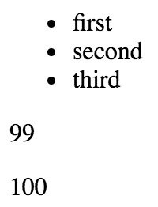
In this section, you learned how to construct your own functions that are given a number of arguments so that you can validate the property value. As long as the function returns true when the property value is considered valid, you can do almost any kind of validation that you can imagine. These functions can then be passed to the propTypes object, just like any of the built-in property validators.

Summary
The focus of this chapter has been React component property validation. When you implement property validation, you know what to expect; this promotes portability. The component doesn't care how the property values are passed to it, just as long as they're valid.
Then, you worked on several examples that used the basic React validators to check primitive JavaScript types. You also learned that if a property is required, it must be made explicit. Next, you learned how to validate more complex property values by combining the built-in validators that come with React.
Finally, you implemented your own custom validator functions to perform validation that goes beyond what's possible with the prop-types validators. In the next chapter, you'll learn how to handle navigation using React routes.

Further reading
To find out more about type checking with PropTypes, you can refer to https://reactjs.org/docs/typechecking-with-proptypes.html.
Handling Navigation with Routes
Almost every web application requires routing: the process of responding to a URL, based on a set of route handler declarations. In other words, this is a mapping from the URL to rendered content. However, this task is more involved than it seems at first. This is why you're going to leverage the react-router package in this chapter, the de facto routing tool for React.
First, you'll learn the basics of declaring routes using JSX syntax. Then, you'll learn about the dynamic aspects of routing, such as dynamic path segments and query parameters. Next, you'll implement links using components from react-router.
Here are the high-level topics that we'll cover in this chapter:
Declaring routes
Handling route parameters
Using link components

Technical requirements
You can find the code files for this chapter on GitHub at https://github.com/PacktPublishing/React-and-React-Native---Third-Edition/tree/master/Chapter09.

Declaring routes
With react-router, you can collocate routes with the content that they render. In this section, you'll see that this is done using JSX syntax that defines routes.
You'll create a basic hello world example route so that you can see what routes look like in React applications. Then, you'll learn how you can organize your route declarations by feature instead of in a monolithic module. Finally, you'll implement a common parent-child routing pattern.

Hello route
Let's create a simple route that renders a simple component. First, we have a small React component that we want to render when the route is activated:
import React from "react";
export default function MyComponent() {
return <p>Hello Route!</p>;
}
Next, let's look at the route definition:
import React from "react";
import { render } from "react-dom";
import { BrowserRouter as Router, Route } from "react-router-dom";
import MyComponent from "./MyComponent";
render(
<Router>
<Route exact path="/" component={MyComponent} />
</Router>,
document.getElementById("root")
);
The Router component is the top-level component of the application. Let's break it down to find out what's happening within the router.
You have the actual routes declared as <Route> elements. There are two key properties of any route: path and component. When the path is matched against the active URL, the component is rendered. But where is it rendered, exactly? The Router component doesn't actually render anything itself; it's responsible for managing how other components are rendered based on the current URL. Sure enough, when you look at this example in a browser, <MyComponent> is rendered as expected:
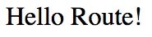
When the path property matches the current URL, <Route> is replaced by the component property value. In this example, the route is replaced with <MyComponent>. If a given route doesn't match, nothing is rendered.

Decoupling route declarations
The difficulty with routing happens when your application has dozens of routes declared within a single module since it's more difficult to mentally map routes to features.
To help with this, each top-level feature of the application can define its own routes. This way, it's clear which routes belong to which feature. So, let's start with the App component:
import React, { Fragment } from "react";
import { BrowserRouter as Router, Route, Redirect } from "react-router-dom";
import One from "./one";
import Two from "./two";
export default () => (
<Router>
<Fragment>
<Route exact path="/" render={() => <Redirect to="one" />} />
<One />
<Two />
</Fragment>
</Router>
);
In this example, the application has two features: one and two. These are imported as components and rendered inside <Router>. You have to include the <Fragment> element because <Router> doesn't like having multiple children. By using a fragment, you're passing one child without having to use an unnecessary DOM element. The first child in this router is actually a redirect. This means that when the app first loads the URL, /, the <Redirect> component will send the user to /one. The render property is an alternative to the component property when you need to call a function to render content. You're using it here because you need to pass the property to <Redirect>.
This module will only get as big as the number of application features, instead of the number of routes, which could be substantially larger. Let's take a look at one of the feature routes:
import React, { Fragment } from "react";
import { Route, Redirect } from "react-router";
import First from "./First";
import Second from "./Second";
export default function One() {
return (
<Fragment>
<Route exact path="/one" render={() => <Redirect to="/one/1" />} />
<Route exact path="/one/1" component={First} />
<Route exact path="/one/2" component={Second} />
</Fragment>
);
}
This module, one/index.js, exports a component that renders a fragment with three routes:
When the /one path is matched, redirect to /one/1.
When the /one/1 path is matched, render the First component.
When the /one/2 path is matched, render the Second component.
This follows the same pattern as the App component for the / path. Often, your application doesn't actually have content to render at the root of a feature or at the root of the application itself. This pattern allows you to send the user to the appropriate route and the appropriate content. Here's what you'll see when you first load the app:
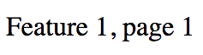
The second feature follows the exact same pattern as the first. Here's what the First component looks like:
import React from "react";
export default function First() {
return <p>Feature 1, page 1</p>;
}
Each feature in this example uses the same minimal rendered content. These components are ultimately what the user needs to see when they navigate to a given route. By organizing routes this way, you've made your features self-contained with regard to routing. In the following section, you'll learn how to further organize your routes into parent-child relationships.

Parent and child routes
The App component in the preceding example was the main component of the application. This is because it defined the root URL: /. However, once the user navigated to a specific feature URL, the App component was no longer relevant.
In versions of react-router prior to version 4, you could nest your <Route> elements so that as long as the path continued to match the current URL, the relevant component was rendered. For example, the /users/8462 path would have nested <Route> elements. In version 4 and above, react-router no longer uses nested routes to handle child content. Instead, you have your App component as you normally would. Then, <Route> elements are used to match paths against the current URL in order to render specific content in App.
Let's take a look at a parent App component that uses <Route> elements to render child components:
import React from "react";
import { BrowserRouter as Router, Route, NavLink } from "react-router-dom";
import UsersHeader from "./users/UsersHeader";
import UsersMain from "./users/UsersMain";
import GroupsHeader from "./groups/GroupsHeader";
import GroupsMain from "./groups/GroupsMain";
export default function App() {
return (
<Router>
<section>
<nav>
<NavLink
exact
to="/"
style={{ padding: "0 10px" }}
activeStyle={{ fontWeight: "bold" }}
>
Home
</NavLink>
...
</nav>
<header>
<Route exact path="/" render={() => <h1>Home</h1>} />
<Route exact path="/users" component={UsersHeader} />
<Route exact path="/groups" component={GroupsHeader} />
</header>
<main>
<Route exact path="/users" component={UsersMain} />
<Route exact path="/groups" component={GroupsMain} />
</main>
</section>
</Router>
);
}
First, the App component renders some navigation links. These will always be visible. Since these links point to pages in your app, you can use the NavLink component instead of the Link component. The only difference is that you can use the activeStyle property to change the look of the link when its URL matches the current URL.
Next, you have the header and main sections. This is where you use the Route component to determine what is rendered in this part of the App component. For example, the first route in <header> uses the render property to render the title when the user is at the root of the app. The next two Route components use the component property to render other header content. The same pattern is used in <main>.
Nested routes can get messy fast. With this flat structure of declaring routes, it's easier to scan the routes in your code to figure out what's happening.
This application has two features – users and groups. Each of them has its own App components defined. For example, UsersHeader is used in <header> and UsersMain is used in <main>.
Here's what the UsersHeader component looks like:
import React from "react";
export default function UsersHeader() {
return <h1>Users Header</h1>;
}
And here's what the UsersMain component looks like:
import React from "react";
export default function UsersMain() {
return <p>Users content...</p>;
}
The components being used in the groups feature look almost exactly the same as these. If you run this example and navigate to /users, here's what you can expect to see:
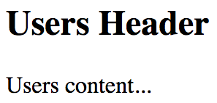
This section taught you how to declare routes in your app. We started off simple by mapping paths to components. Then, we decoupled unrelated route declarations from one another. Lastly, we broke our route declarations down into parent-child relationships as this helps keep things organized as our apps become more complex. In the next section, we'll look at parameters in routes.

Handling route parameters
The URLs that you've seen so far in this chapter have all been static. Most applications will use both static and dynamic routes. In this section, you'll learn how to pass dynamic URL segments into your components, how to make these segments optional, and how to get query string parameters.

Resource IDs in routes
One common use case is to make the ID of a resource part of the URL. This makes it easy for your code to get the ID, then make an API call that fetches the relevant resource data. Let's implement a route that renders a user detail page. This will require a route that includes the user ID, which then needs to somehow be passed to the component so that it can fetch the user.
Let's start with the App component that declares the routes:
import React, { Fragment } from "react";
import { BrowserRouter as Router, Route } from "react-router-dom";
import UsersContainer from "./UsersContainer";
import UserContainer from "./UserContainer";
export default function App() {
return (
<Router>
<Fragment>
<Route exact path="/" component={UsersContainer} />
<Route path="/users/:id" component={UserContainer} />
</Fragment>
</Router>
);
}
The : syntax marks the beginning of a URL variable. The id variable will be passed to the UserContainer component – here's how it's implemented:
import React, { useState, useEffect } from "react";
import PropTypes from "prop-types";
import User from "./User";
import { fetchUser } from "./api";
export default function UserContainer({
match: {
params: { id }
}
}) {
const [error, setError] = useState();
const [first, setFirst] = useState();
const [last, setLast] = useState();
const [age, setAge] = useState();
useEffect(() => {
fetchUser(+id).then(
user => {
setError(null);
setFirst(user.first);
setLast(user.last);
setAge(user.age);
},
error => {
setError(error);
setFirst(null);
setLast(null);
setAge(null);
}
);
}, [id]);
return <User {...{ error, first, last, age }} />;
}
UserContainer.propTypes = {
match: PropTypes.object.isRequired
};
The match.params property contains any dynamic parts of the URL. In this case, you're interested in the id parameter. Then, you pass the number version of this value to the fetchUser() API call. If the URL is missing the segment completely, then this code won't run at all; the router will revert back to the / route. However, no type checking this one at the route level, which means it's up to you to handle non-numbers being passed where numbers are expected, and so on.
In this example, the type cast operation will result in a 500 error if the user navigates to, for example, /users/one. You could write a function that type checks parameters and, instead of failing with an exception, responds with a 404: Not found error. In any case, it's up to the application, not the react-router library, to provide a meaningful failure mode.
Now, let's take a look at the API functions that were used in this example:
const users = [
{ first: "First 1", last: "Last 1", age: 1 },
{ first: "First 2", last: "Last 2", age: 2 }
];
export function fetchUsers() {
return new Promise((resolve, reject) => {
resolve(users);
});
}
export function fetchUser(id) {
return new Promise((resolve, reject) => {
const user = users[id];
if (user === undefined) {
reject(`User ${id} not found`);
} else {
resolve(user);
}
});
}
The fetchUsers() function is used by the UsersContainer component to populate the list of user links. The fetchUser() function will find and resolve a value from the users array of the mock data if the promise is rejected. If rejected, the error handling behavior of the UserContainer component is invoked.
Here is the User component, which is responsible for rendering the user details:
import React from "react";
import PropTypes from "prop-types";
const Error = ({ error }) =>
error ? (
<p>
<strong>{error}</strong>
</p>
) : null;
const Text = ({ children }) => (children ? <p>{children}</p> : null);
export default function User({ error, first, last, age }) {
return (
<section>
<Error error={error} />
<Text>{first}</Text>
<Text>{last}</Text>
<Text>{age}</Text>
</section>
);
}
User.propTypes = {
error: PropTypes.string,
first: PropTypes.string,
last: PropTypes.string,
age: PropTypes.number
};
When you run this app and navigate to /, you should see a list of users that looks like this:
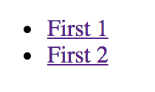
Clicking on the first link should take you to /users/0, which looks like this:
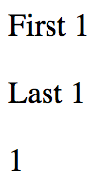
If you navigate to a user that doesn't exist, /users/2, here's what you'll see:
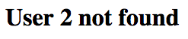
The reason that you can this error message instead of a 500 error is because the API endpoint knows how to deal with missing resources:
if (user === undefined) {
reject(`User ${id} not found`);
}
This results in the UserContainer setting its error state:
fetchUser(+id).then(
user => {
setError(null);
setFirst(user.first);
setLast(user.last);
setAge(user.age);
},
error => {
setError(error);
setFirst(null);
setLast(null);
setAge(null);
}
);
This then results in the User component rendering the error message:
const Error = ({ error }) =>
error ? (
<p>
<strong>{error}</strong>
</p>
) : null;
export default function User({ error, first, last, age }) {
return (
<section>
<Error error={error} />
...
</section>
);
}
Since the error property value is a string, the Error component will render the error message. In the next section, we'll look at defining route parameters that are optional.

Optional parameters
Sometimes, we need optional URL path values and query parameters. URLs work best for simple options, and query parameters work best if there are many values that the component can use.
Let's implement a user list component that renders a list of users. Optionally, you want to be able to sort the list in descending order. Let's make this an optional path segment in the route definition for this page:
import React from "react";
import { render } from "react-dom";
import { BrowserRouter as Router, Route } from "react-router-dom";
import UsersContainer from "./UsersContainer";
render(
<Router>
<Route path="/users/:desc?" component={UsersContainer} />
</Router>,
document.getElementById("root")
);
The : syntax marks a variable, while the ? suffix marks the variable as optional. This means that the user can provide anything they want after /users/. This also means that the component needs to make sure that the desc string is provided and that everything else is ignored.
It's also up to the component to handle any query strings provided to it. So, while the route declaration doesn't provide a mechanism to define accepted query strings, the router will still pass the raw query string to the component. Let's take a look at the user list container component:
import React, { useState, useEffect } from "react";
import PropTypes from "prop-types";
import Users from "./Users";
import { fetchUsers } from "./api";
export default function UsersContainer({
match: { params },
location: { search }
}) {
const [users, setUsers] = useState([]);
useEffect(() => {
const desc =
params.desc === "desc" || !!new URLSearchParams(search).get("desc");
fetchUsers(desc).then(users => {
setUsers(users);
});
}, [params, search]);
return <Users users={users} />;
}
UsersContainer.propTypes = {
match: PropTypes.object.isRequired,
location: PropTypes.object.isRequired
};
In the componentDidMount() method, this component looks for either params.desc or search.desc. It uses this as an argument to the fetchUsers() API, in order to determine the sort order.
Here's what the Users component looks like:
import React from "react";
import PropTypes from "prop-types";
export default function Users({ users }) {
return (
<ul>
{users.map(user => (
<li key={user}>{user}</li>
))}
</ul>
);
}
Users.propTypes = {
users: PropTypes.array.isRequired
};
Here's what's rendered when you navigate to /users:
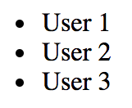
If you include the descending parameter by navigating to /users/desc, here's what you get:
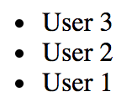
In this section, you learned about parameters in routes. Perhaps the most common pattern is to have the ID of a resource in your app as part of the URL, which means that components need to be able to parse out this information in order to interact with the API. You also learned about optional parameters in routes – these aren't always required because the component will use default values when they're not provided. In the next section, you'll learn about link components.

Using link components
In this section, you'll learn how to create links. You might be tempted to use the standard <a> elements to link to pages controlled by react-router. The problem with this approach is that these links will try to locate the page on the backend by sending a GET request. This isn't what you want, because the route configuration is already in the browser.
First, you'll see an example that illustrates how <Link> elements are just like <a> elements in most ways. Then, you'll see how to build links that use URL parameters and query parameters.

Basic linking
The idea of links in React apps is that they point to routes that point to components that render new content. The Link component also takes care of the browser history API and looking up route/component mappings. Here's an application component that renders two links:
import React from "react";
import { BrowserRouter as Router, Route, Link } from "react-router-dom";
import First from "./First";
import Second from "./Second";
export default function App() {
return (
<Router>
<section>
<nav>
<p>
<Link to="first">First</Link>
</p>
<p>
<Link to="second">Second</Link>
</p>
</nav>
<section>
<Route path="/first" component={First} />
<Route path="/second" component={Second} />
</section>
</section>
</Router>
);
}
The to property specifies the route to activate when clicked. In this case, the application has two routes – /first and /second. Here is what the rendered links look like:
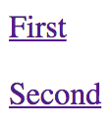
When you click the first link, the page content changes to look like this:

Now that you can use Link components to render links to basic paths, it's time to learn about building dynamic links with parameters.

URL and query parameters
Constructing the dynamic segments of a path that is passed to <Link> involves string manipulation. Everything that's part of the path goes in the to property. This means that you have to write more code to construct the string, but it also means less behind-the-scenes magic happening in the router.
Let's create a simple component that will echo back whatever is passed to the echo URL segment or the echo query parameter:
import React from "react";
import { withRouter } from "react-router";
export default withRouter(function Echo({
match: { params },
location: { search }
}) {
return <h1>{params.msg || new URLSearchParams(search).get("msg")}</h1>;
});
The withRouter() utility function is a higher-order function that returns a new component. This new component will have router-related properties passed to it, which you need if you want to work with path segment variables or the query string. The two properties used by your Echo component are match.params for the URL path variables and location.search for the query string.
Prior to react-router version 4, the query string was parsed and passed in as an object. Now, this has to be handled in your code. In this example, URLSearchParams is used.
Now, let's take a look at the App component that renders two links. The first will build a string that uses a dynamic value as a URL parameter. The second will use URLSearchParams to build the query string portion of the URL:
import React from "react";
import PropTypes from "prop-types";
import { Link } from "react-router-dom";
export default function App({ children }) {
return <section>{children}</section>;
}
App.propTypes = {
children: PropTypes.node.isRequired
};
const param = "From Param";
const query = new URLSearchParams({ msg: "From Query" });
App.defaultProps = {
children: (
<section>
<p>
<Link to={`echo/${param}`}>Echo param</Link>
</p>
<p>
<Link to={`echo?${query.toString()}`} query={query}>
Echo query
</Link>
</p>
</section>
)
};
Here's what the two links look like when they're rendered:

The param link takes you to /echo/From Param, which looks like this:
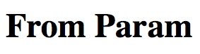
The query link takes you to /echo?echo=From+Query, which looks like this:

In this section, you learned about using the Link component to render links in your application. You also learned how to build dynamic links that pass parameters to URLs.

Summary
In this chapter, you learned about routing in React applications. The job of a router is to render content that corresponds to a URL. The react-router package is the standard tool for this job. You learned how routes are JSX elements, just like the components they render. Sometimes, you need to split routes into feature-based modules. A common pattern for structuring page content is to have a parent component that renders the dynamic parts as the URL changes.
Then, you learned how to handle the dynamic parts of URL segments and query strings. You also learned how to build links throughout your application using the <Link> element. In the next chapter, you'll learn how split your code into smaller chunks using Lazy components.

Further reading
Refer to the following links for more information:
React Router: https://reacttraining.com/react-router/
URLSearchParams: https://developer.mozilla.org/en-US/docs/Web/API/URLSearchParams
Code Splitting Using Lazy Components and Suspense
Code splitting has been happening in React applications for some time now, long before there was any official support in the React API. With the latest version of React, there are new APIs that we can use that directly support code-splitting scenarios. Code splitting is necessary when you have larger applications with a lot of JavaScript code that must be delivered to the browser.
Big monolithic JavaScript bundles that house the entire application can create usability issues on initial page loads due to longer load times. With code splitting, we have more fine-grained control over how code makes its way from the server to the browser. This means more opportunities for us to properly handle load-time User Experience (UX). You'll learn how to do this in your React applications by using the lazy() API and the Suspense components, two recent additions to React. Once you understand how these two pieces work, you'll be able to completely integrate code splitting into your applications.
We'll cover the following topics in this chapter:
Using the lazy() API
Using the Suspense component
When to avoid lazy components
Lazy pages and routes

Technical requirements
You can find the code files of this chapter on GitHub at https://github.com/PacktPublishing/React-and-React-Native---Third-Edition/tree/master/Chapter10.

Using the lazy API
There are two pieces involved with using the new lazy() API in React. First, there's bundling components into their own separate files so that they can be downloaded by the browser separately from other parts of the application. Secondly, once you have created the bundles, you can build React components that are lazy—they don't download anything until the first time they're rendered.

Dynamic imports and bundles
The code examples in this book are using the create-react-app tooling for creating bundles. The nice thing about this approach is that you don't have to maintain any sort of bundle configuration. Instead, bundles are created for you automatically, based on how you import your modules. If you're using the import statement everywhere, your app will be downloaded all at once in one bundle. When your app gets bigger, there are likely going to be features that some users never use or don't use as frequently as others. You can use the import() function to import modules on demand. By using this function, you're telling webpack to create a separate bundle for the code that you're importing dynamically.
Let's take a look at a simple component that we might want to bundle separately from the rest of the application:
import React from "react";
export default function MyComponent() {
return <p>My Component</p>;
}
Now let's take a look at how we would import this module dynamically using the import() function, resulting in a separate bundle:
import React, { useState, useEffect } from "react";
export default function App() {
const [MyComponent, setMyComponent] = useState(() => () => null);
useEffect(() => {
import("./MyComponent").then(module => {
setMyComponent(() => module.default);
});
}, []);
return <MyComponent />;
}
When you run this example, you'll see the <p> text rendered right away. If you open the browser dev tools and look at the network requests, you'll notice that a separate call is made to fetch the bundle containing MyComponent code. This happens because of the call to import("./MyComponent"). The import() function returns a promise that resolves with the module object. Since we need the default export to access MyComponent, we reference module.default when we call setMyComponent().
The reason why we're setting a component as the MyComponent state is that the first time the App renders, we don't have the MyComponent code loaded yet. Once it loads, MyComponent will reference the proper value, which results in the correct text being rendered.
Now that you have an idea of how bundles get created and are fetched by the app, it's time to see how the lazy() API greatly simplifies this process for us.

Making components lazy
Instead of manually handling the promise returned by import() by returning the default export and setting state, you can lean on the lazy() API. This function takes a function that returns an import() promise. The return value is a lazy component that you can just render. Let's modify the App component to use this API:
import React, { Suspense, lazy } from "react";
const MyComponent = lazy(() => import("./MyComponent"));
export default function App() {
return (
<Suspense fallback={"loading..."}>
<MyComponent />
</Suspense>
);
}
The MyComponent value is created by calling lazy(), passing in the dynamic module import as an argument. Now, you have a separate bundle for your component and a lazy component that loads the bundle when it's first rendered. There's one other thing that we need here. The Suspense component compliments lazy components by providing a fallback to display while the code bundle is being fetched. In this example, the string "loading..." will be rendered in place of <MyComponent> while it is being fetched. In fact, the Suspense component is required if you plan on using lazy components.
In this section, you learned how code splitting works. You learned that the import() function handles bundle creation for you. You also learned that the lazy() API makes your components lazy, and handles all of the gritty work of importing components for you. The Suspense component is used to render fallback content while bundles are downloaded to the browser. In the following section, we'll look at the Suspense component in more depth.

Using the Suspense component
In this section, we'll explore some of the more common usage scenarios of the Suspense component. We'll look at where to place Suspense components in your component tree, how to simulate latency when fetching bundles, and some of the options available to us to use as the fallback content.

Top-level Suspense components
Lazy components need to be rendered inside of a Suspense component. They do not have to be direct children of Suspense though, which is important because this means that you can have one Suspense component handle every lazy component in your app. Let's illustrate this concept with an example. Here's a component that we would like to bundle separately and use lazily:
import React from "react";
export default function MyFeature() {
return <p>My Feature</p>;
}
Next, let's make the MyFeature component lazy and render it inside of a MyPage component:
import React, { Fragment, lazy } from "react";
const MyFeature = lazy(() => import("./MyFeature"));
export default function MyPage() {
return (
<Fragment>
<h1>My Page</h1>
<MyFeature />
</Fragment>
);
}
Here, we're using the lazy() API to make the MyFeature component lazy. This means that when the MyPage component is rendered, the code bundle that contains MyFeature will be downloaded because MyFeature was also rendered. What's important to note with the MyPage component is that it is rendering a lazy component (MyFeature) but it isn't rendering a Suspense component. This is because our hypothetical app has many page components each with its own lazy components. Having each of these components render its own Suspense component would be redundant. Instead, we can render one Suspense component inside of our App component like so:
import React, { Suspense } from "react";
import MyPage from "./MyPage";
export default function App() {
return (
<Suspense fallback={"loading..."}>
<MyPage />
</Suspense>
);
}
While the MyFeature code bundle is being downloaded, the <MyPage> is replaced with the fallback text passed to Suspense. So even though MyPage isn't lazy itself, it renders a lazy component that Suspense knows about and will replace its children with the fallback content while this happens.
So far, we haven't really been able to see the fallback content that displays while our lazy components load their code bundles. This is because when developing locally, these bundles load almost instantly. In the next section, we'll look at an approach to simulate latency when loading code bundles.

Simulating latency
The whole idea with the lazy() and Suspense APIs is to provide a better user experience for both of the following:
The initial load, by splitting code into bundles so that the whole app doesn't have to be downloaded upfront
Providing consistent fallback content while code bundles load
Unless we can experience latency similar to what your users are likely to experience, we have no idea how effective our use of these APIs is. One way to address this issue is to simulate latency in the same way that you might simulate latency in a mock API call. In the mock function that returns a promise, you use a setTimeout() call that resolves the promise after some time, say, 3 seconds for example. Because the import() function returns a promise, we can use this to our advantage.
Here's an updated version of the MyPage component from the top-level suspense component example:
import React, { Fragment, lazy } from "react";
const MyFeature = lazy(() =>
Promise.all([
import("./MyFeature"),
new Promise(resolve => {
setTimeout(() => {
resolve();
}, 3000);
})
]).then(([m]) => m)
);
export default function MyPage() {
return (
<Fragment>
<h1>My Page</h1>
<MyFeature />
</Fragment>
);
}
Now when you load the example, you'll actually get to see the loading text for about three seconds before it's replaced with MyPage content. Instead of just returning the promise from import(), we're building a new promise using Promise.all(). This method returns a promise that resolves when all of the promises that are passed to it have resolved. In this example, we're passing two promises to Promise.all(). The first is the promise returned by import(), which eventually resolves the module object from the code bundle once it's downloaded. The problem is that this resolves immediately when doing local development. The second promise that's passed to Promise.all() is how we simulate latency, by not resolving the promise for three seconds.
The last thing we need to do is make sure that it's the module that's resolved since this is what lazy() is expecting. When Promise.all() resolves, all of the resolved values are passed as an array to .then(). To address this, we add our own .then() that returns the first array argument, which is the module that lazy() needs.
Now that we have the ability to actually see our loading fallback content in action, let's work on making this content a little bit more visually appealing.

Working with spinner fallbacks
The simplest fallback that you can use with the Suspense component is some text that indicates to the user that something is happening. The fallback property can be any valid React element, which means that we can enhance the fallback to be something more visually appealing. For example, the react-spinners package has a selection of spinner components, all of which can be used as a fallback with Suspense.
Let's modify the App component from the Simulating latency section to include a spinner from the react-spinners package as the Suspense fallback:
import React, { Suspense } from "react";
import { FadeLoader } from "react-spinners";
import MyPage from "./MyPage";
export default function App() {
return (
<Suspense fallback={<FadeLoader color={"lightblue"} size={150} />}>
<MyPage />
</Suspense>
);
}
The FadeLoader component will render a spinner that we've configured with a color of lightblue and a size of 150 pixels. The rendered element of the FadeLoader component is passed to the fallback property. Since we're simulating latency, you should be able to see the spinner when you first load the app:

Now, instead of text, we're showing an animated spinner. This likely provides a user experience that your users are more accustomed to. The react-spinners package has several spinners for you to choose from, each of which has a number of configuration options. There are other spinner libraries that you can use or you can implement your own.
In this section, you learned that you can use a single Suspense component that will display its fallback content for any lazy components that are lower in the tree. You learned how to simulate latency during local development so that you can experience what your users will experience with your Suspense fallback content. Finally, you learned how to use components from other libraries as the fallback content to provide something that looks better than plain text.
In the next section, you'll learn about why it doesn't make sense to make every component in your app a lazy component.

When to avoid lazy components
It might be tempting to make most of your React components lazy components that live in their own bundle. After all, there isn't much extra work that needs to happen in order to set up separate bundles and to make lazy components. There are some downsides to this though. If you have too many lazy components, your app is going to end up making several HTTP requests to fetch them – at the same time. There's no benefit to having separate bundles for components that are used on the same part of the app. You're better off trying to bundle components together in a way that one HTTP request is made to load what is needed on the current page.
A helpful way to think of this is to associate "pages" with bundles. If you have lazy page components, then everything on that page will also be lazy, yet bundled together with other components on the page. Let's build an example that demonstrates how to organize our lazy components. Let's say that your app has a couple of pages and a few features on each page. We don't necessarily want to make these features lazy if they're all going to be needed when the page loads. Here's the App component that shows the user a selector to pick which page to load:
import React, { Fragment, Suspense, lazy, useState } from "react";
const First = lazy(() => import("./First"));
const Second = lazy(() => import("./Second"));
function ShowComponent({ name }) {
switch (name) {
case "first":
return <First />;
case "second":
return <Second />;
default:
return null;
}
}
export default function App() {
const [component, setComponent] = useState("");
return (
<Fragment>
<label>
Load Component:{" "}
<select value={component} onChange={e =>
setComponent(e.target.value)}>
<option value="">None</option>
<option value="first">First</option>
<option value="second">Second</option>
</select>
</label>
<Suspense fallback="loading...">
<ShowComponent name={component} />
</Suspense>
</Fragment>
);
}
The First and Second components are the pages that make up our app, so we want them to be lazy components that load their bundles on demand. The ShowComponent component renders the appropriate page when the user changes the selector. Next, let's look at the First page and see how it's composed, starting with the First component:
import React, { Fragment } from "react";
import One from "./One";
import Two from "./Two";
import Three from "./Three";
export default function First() {
return (
<Fragment>
<One />
<Two />
<Three />
</Fragment>
);
}
The First component pulls in three components and renders them: One, Two, and Three. These three components will be part of the same bundle. While we could make them lazy, there would be no point as all we would be doing is making three HTTP requests for bundles at the same time instead of one.
Now that you have a better understanding of how to map page structures of your application to bundles, let's look at another use case where we use a router component to navigate around our app.

Lazy pages and routes
In the When to avoid lazy components section, you saw where to avoid making components lazy when there is no benefit in doing so. The same pattern can be applied when you're using react-router as the mechanism to navigate around your application. Let's take a look at an example. Here are the imports we'll need:
import React, { Suspense, lazy } from "react";
import { BrowserRouter as Router, Route, Link } from "react-router-dom";
import { FadeLoader } from "react-spinners";
Next, we'll create our lazy components:
const First = lazy(() =>
Promise.all([
import("./First"),
new Promise(resolve => {
setTimeout(() => {
resolve();
}, 3000);
})
]).then(([m]) => m)
);
const Second = lazy(() =>
Promise.all([
import("./Second"),
new Promise(resolve => {
setTimeout(() => {
resolve();
}, 3000);
})
]).then(([m]) => m)
);
Finally, we have the application component that uses the two lazy components that we just declared:
export default function App() {
return (
<Router>
<section>
<nav>
<p>
<Link to="first">First</Link>
</p>
<p>
<Link to="second">Second</Link>
</p>
</nav>
<section>
<Suspense fallback={<FadeLoader color={"lightblue"} size={150}
/>}>
<Route path="/first" component={First} />
<Route path="/second" component={Second} />
</Suspense>
</section>
</section>
</Router>
);
}
In the preceding code, we have two lazy page components that will be bundled separately from the rest of the app. They're using the same latency simulation technique that was introduced in the Simulating latency section so that we can see the fallback content as we navigate through pages by clicking on links. The fallback content in this example uses the same FadeLoader spinner component that was introduced in the Working with spinner fallbacks section.
You'll notice that the Suspense component is placed beneath the navigation links. This means that the fallback content will be rendered in the spot where the page content will eventually show when it loads. The children of the Suspense component are the Route components that will render our lazy page components. For example, when the /first route is activated, the First component is rendered for the first time, triggering the bundle download.

Summary
This chapter was all about code splitting and bundling, which are important concepts for larger React applications. We started by looking at how code is split into bundles in your React applications, by using the import() function. Then, we looked at the lazy() React API and how it helps to simplify loading bundles when components are rendered for the first time. Next, we looked more deeply at the Suspense component, which is used to manage content while component bundles are being fetched. The fallback property is how we specify the content to be shown while bundles are being loaded. You typically don't need more than one Suspense component in your app, as long as you follow a consistent pattern for bundling pages of your app.
In the next chapter, you'll learn how to use the Next.js framework to handle rendering React components on the server. The Next.js framework allows you to create pages that act as React components and can be rendered on the server and in the browser. This is an important capability for applications that need good initial page load performance, that is, all applications.
Server-Side React Components
Everything that you've learned so far in this book has been React code that runs in web browsers. React isn't just confined to the browser for rendering, and in this chapter, you'll learn how to render components from a Node.js server.
The first section of this chapter briefly touches upon high-level server rendering concepts. The next four sections go in-depth, teaching you how to implement the most crucial aspects of server-side rendering with React and Next.js.
In this chapter, we'll cover the following topics:
What is isomorphic JavaScript?
Rendering to strings
Backend routing
Frontend reconciliation
Fetching data

Technical requirements
You can find the code files present in this chapter on GitHub at https://github.com/PacktPublishing/React-and-React-Native---Third-Edition/tree/master/Chapter11.

What is isomorphic JavaScript?
Another term for server-side rendering is isomorphic JavaScript. This is a fancy way of saying JavaScript code that can run in the browser and in Node.js without modification. In this section, you'll learn the basic concepts of isomorphic JavaScript before diving into the code.

The server is a render target
The beauty of React is that it's a small abstraction layer that sits on top of a rendering target. So far, the target has been the browser, but it can also be the server. The render target can be anything, just as long as the correct translation calls are implemented behind the scenes.
In the case of rendering on the server, components are rendered to strings. The server can't actually display rendered HTML; all it can do is send the rendered markup to the browser. The idea is shown in the following diagram:
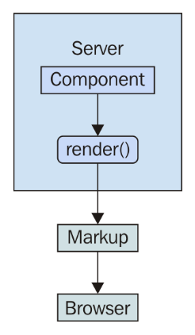
It's possible to render a React component on the server and send the rendered output to the browser. The question is, why would you want to do this on the server instead of in the browser?

Initial load performance
The main motivation behind server-side rendering, for me personally, is improved performance. In particular, the initial rendering just feels faster for the user and this translates to an overall better user experience. It doesn't matter how fast your application is once it's loaded and ready to go; it's the initial load time that leaves a lasting impression on your users.
There are three ways in which this approach results in better performance for the initial load:
The rendering that takes place on the server is generating a string; there's no need to compute a difference or to interact with the DOM in any way. Producing a string of rendered markup is inherently faster than rendering components in the browser.
The rendered HTML is displayed as soon as it arrives. Any JavaScript code that needs to run on the initial load is run after the user is already looking at the content.
There are fewer network requests to fetch data from the API because these have already happened on the server, and the server, typically, has far more resources than a single client.
The following diagram illustrates these performance ideas:
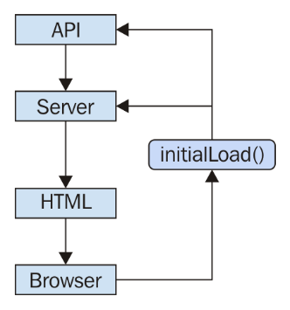
Beyond just performance enhancements, we can share the same code between the client and the server in some cases. We'll cover this next.

Sharing code between the server and the browser
There's a good chance that your application will need to talk to API endpoints that are out of your control, for example, an application that is composed of many different microservice endpoints. It's rare that you can use data from these services without modification. Rather, you have to write code that transforms data so that it's usable by your React components.
If you're rendering your components on a Node.js server, then this data transformation code will be used by both the client and the server. This is because, on the initial load, the server will need to talk to the API and, later on, the component in the browser will need to talk to the API.
It's not just about transforming the data that's returned from these services either. For example, you have to think about providing input to them as well, such as when creating or modifying resources.
The fundamental adjustment that you'll need to make as a React programmer is to assume that any given component that you implement will need to be rendered on the server. This may seem like a minor adjustment, but the devil is in the detail.
In this section, we covered the important concepts related to rendering React components on the server. You learned that React treats the server as a target to render content on, just like the browser is a target. You learned that the performance of your initial application page load can be greatly improved when the server sends content that's already been rendered. Finally, you learned that once the browser has the initial content to display, it can then use those same components that were used on the server to perform the initial render.
In the next section, we'll look at how React is able to render components to static HTML strings instead of DOM manipulation calls.

Rendering to strings
Rendering components in Node.js means rendering to strings, instead of trying to figure out the best way to insert them into the DOM. The string content is then returned to the browser, which displays this to the user immediately. Let's look at an example:
Here is the component to render:
import React from "react";
import PropTypes from "prop-types";
export default function App({ items }) {
return (
<ul>
{items.map(item => (
<li key={item}>{item}</li>
))}
</ul>
);
}
App.propTypes = {
items: PropTypes.arrayOf(PropTypes.string).isRequired
};
Next, let's implement the server that will render this component when the browser asks for it:
import React from "react";
import { renderToString } from "react-dom/server";
import express from "express";
import App from "./App";
const doc = content =>
`
<!doctype html>
<html>
<head>
<title>Rendering to strings</title>
</head>
<body>
<div id="app">${content}</div>
</body>
</html>
`;
const app = express();
app.get("/", (req, res) => {
const props = { items: ["One", "Two", "Three"] };
const rendered = renderToString(<App {...props} />);
res.send(doc(rendered));
});
app.listen(8080, () => {
console.log("Listening on 127.0.0.1:8080");
});
Now if you visit http://127.0.0.1:8080 in your browser, you'll see the rendered component content:
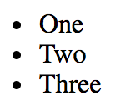
There are two things to pay attention to in this example. First, there's the doc() function. This creates the basic HTML document template with a placeholder for rendered React content. The second is the call to renderToString(), which is just like the render() call that you're used to. This is called in the server request handler and the rendered string is sent to the browser.
This section showed you that it's possible for React to act similar to a template engine, by building strings as its output and using this content to serve as HTML content from the server. In the following section, we'll look at how routing works in a React application that runs on the server.

Backend routing
In the Rendering to strings section, you implemented a single request handler in the server that responded to requests for the root URL (/). Your application is going to need to handle more than a single route. You learned how to use the react-router package for routing in Chapter 9, Handling Navigation with Routes. Now, you're going to see how to use the same package in Node.js.
First, let's take a look at the main App component:
import React from "react";
import { Route, Link } from "react-router-dom";
import FirstHeader from "./first/FirstHeader";
import FirstContent from "./first/FirstContent";
import SecondHeader from "./second/SecondHeader";
import SecondContent from "./second/SecondContent";
export default function App() {
return (
<section>
<header>
<Route exact path="/" render={() => <h1>App</h1>} />
<Route exact path="/first" component={FirstHeader} />
<Route exact path="/second" component={SecondHeader} />
</header>
<main>
<Route
exact
path="/"
render={() => (
<ul>
<li>
<Link to="first">First</Link>
</li>
<li>
<Link to="second">Second</Link>
</li>
</ul>
)}
/>
<Route exact path="/first" component={FirstContent} />
<Route exact path="/second" component={SecondContent} />
</main>
</section>
);
}
There are three routes that this application handles:
/: The home page
/first: The first page of content
/second: The second page of content
The App content is divided into <header> and <main> elements. In each of these sections, there is a <Route> component that handles the appropriate content. For example, the main content for the / route is handled by a render() function that renders links to /first and /second.
This component will work fine on the client, but will it work on the server? Let's implement that now:
import React from "react";
import { renderToString } from "react-dom/server";
import { StaticRouter } from "react-router";
import express from "express";
import App from "./App";
const app = express();
app.get("/*", (req, res) => {
const context = {};
const html = renderToString(
<StaticRouter location={req.url} context={context}>
<App />
</StaticRouter>
);
if (context.url) {
res.writeHead(301, {
Location: context.url
});
res.end();
} else {
res.write(`
<!doctype html>
<div id="app">${html}</div>
`);
res.end();
}
});
app.listen(8080, () => {
console.log("Listening on 127.0.0.1:8080");
});
Now you have both frontend and backend routing! How does this work exactly? Let's start with the request handler path. This has changed so that it's now a wildcard (/*). Now, this handler is called for every request.
On the server, the <StaticRouter> component is used instead of the <BrowserRouter> component. The <App> component is the child, which means that the <Route> components within it will be passed data from <StaticRouter>. This is how <App> knows to render the correct content based on the URL. The resulting html value that results from calling renderToString() can then be used as part of the document that's sent to the browser as a response.
Now your application is starting to look like a real end-to-end React rendering solution. This is what the server renders if you hit the root URL /:
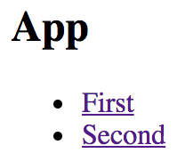
If you hit the /second URL, the Node.js server will render the correct component:
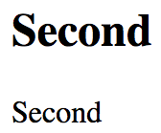
If you navigate from the main page to the first page, the request goes back to the server. We need to figure out how to get the frontend code to the browser so that it can take over after the initial render.
In this section, you learned that react-router routes work similarly to how they would work in a browser-based React app. In the next section, we'll make sure that your components can work both on the server and in the browser.

Frontend reconciliation
The only thing that was missing from the last example was the client JavaScript code. The user wants to use the application and the server needs to deliver the client's code bundle. How would this work? Routing has to work in the browser and on the server, without modifying the routes. In other words, the server handles routing in the initial request, then the browser takes over as the user starts clicking on things and moving around in the application.
Let's create the index.js module for this example:
import React from "react";
import { hydrate } from "react-dom";
import App from "./App";
hydrate(<App />, document.getElementById("root"));
This looks like most other index.js files that you've seen so far in this book. You render the <App> component in the root element in the HTML document. In this case, you're using the hydrate() function instead of the render() function. The two functions have the same end result—rendered JSX content in the browser window. The hydrate() function is different because it expects rendered component content to already be in place. This means that it will perform less work because it will assume that the markup is correct and doesn't need to be updated on the initial render.
Only in development mode will React examine the entire DOM tree of the server-rendered content to make sure that the correct content is displayed. If there's a mismatch between the existing content and the output of the React components, you'll see warnings that show you where these mismatches happened so that you can go and fix them.
Here is the App component that your app will render in the browser and on the Node.js server:
import React, { useState } from "react";
export default function App() {
const [clicks, setClicks] = useState(0);
return (
<section>
<header>
<h1>Hydrating The Client</h1>
</header>
<main>
<p>Clicks {clicks}</p>
<button onClick={() => setClicks(clicks + 1)}>Click Me</button>
</main>
</section>
);
}
The component renders a button that, when clicked, will update the clicks state. This state is rendered in a label above the button. When this component is rendered on the server, the default clicks value of 0 is used, and the onClick handler is ignored since it's just rendering static markup. Let's take a look at the server code next:
import fs from "fs";
import React from "react";
import { renderToString } from "react-dom/server";
import express from "express";
import App from "./App";
const app = express();
const doc = fs.readFileSync("./build/index.html");
app.use(express.static("./build", { index: false }));
app.get("/*", (req, res) => {
const context = {};
const html = renderToString(<App />);
if (context.url) {
res.writeHead(301, {
Location: context.url
});
res.end();
} else {
res.write(
doc.toString().replace('<div id="root">', `<div id="root">${html}`)
);
res.end();
}
});
app.listen(8080, () => {
console.log("Listening on 127.0.0.1:8080");
});
Let's walk through this source and code and see what's going on:

const doc = fs.readFileSync("./build/index.html");
This reads the index.html file that's created by your React build tool, such as create-react-app/react-scripts, and stores it in doc:
app.use(express.static("./build", { index: false }));
This tells the Express server to serve files under ./build as static files, except for index.html. Instead, you're going to write a handler that responds to requests for the root of the site:
app.get("/*", (req, res) => {
const context = {};
const html = renderToString(<App />);
if (context.url) {
res.writeHead(301, {
Location: context.url
});
res.end();
} else {
res.write(
doc
.toString()
.replace('<div id="root">', `<div id="root">${html}`)
);
res.end();
}
});
This is where the html constant is populated with the rendered React content. Then, it gets interpolated into the HTML string using replace() and is sent as the response. Because you've used the index.html file based on your build, it contains a link to the bundled React app that will run when loaded in the browser.
In this section, you learned how to share the same components that render content on the server with your application that runs in the browser. In the next section, you'll learn how to leverage Next.js to fetch data that React components on the server need.

Fetching data
What if one of your components needs to fetch API data before it can fully render its content? This presents a challenge for rendering on the server because there's no easy way to define a component that knows when to fetch data on the server and in the browser.
This is where a minimal framework such as Next.js comes into play. Next.js treats server rendering and browser rendering as equals. This means that the headache of fetching data for your components is abstracted—you can use the same code in the browser and on the server.
The previous edition of this book didn't use any frameworks for fetching React component data on the server. I think that if you're going to go down this road, not using a framework is a mistake. There are simply too many things that can go wrong and, without a framework, you're ultimately responsible for them.
To handle routing, Next.js uses the concept of pages. A page is a JavaScript module that exports a React component. The rendered content of the component turns into the page content. Here's what the pages directory looks like:
└── pages
├── first.js
├── index.js
└── second.js
The index.js module is the root page of the app; Next.js knows this based on the filename. Here's what the source looks like:
import Layout from "../components/MyLayout.js";
export default function Index() {
return (
<Layout>
<p>Fetching component data on the server and on the client...</p>
</Layout>
);
}
This page uses a <Layout> component to ensure that common components are rendered without the need to duplicate code. Here's what the page looks like when rendered:
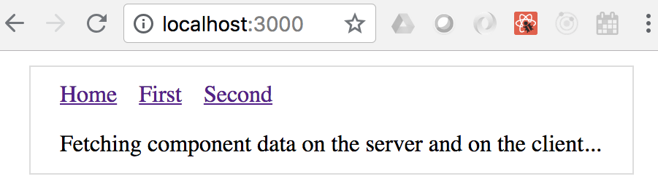
In addition to the paragraph, you have the overall application layout including the navigation links to other pages. Here's what the Layout source looks like:
import Header from "./Header";
const layoutStyle = {
margin: 20,
padding: 20,
border: "1px solid #DDD"
};
export default function Layout(props) {
return (
<div style={layoutStyle}>
<Header />
{props.children}
</div>
);
}
The Layout component renders a Header component and props.children. The children property is the value that you pass to the Layout component in your pages. Let's take a look at the Header component now:
import Link from "next/link";
const linkStyle = {
marginRight: 15
};
export default function Header() {
return (
<div>
<Link href="/">
<a style={linkStyle}>Home</a>
</Link>
<Link href="/first">
<a style={linkStyle}>First</a>
</Link>
<Link href="/second">
<a style={linkStyle}>Second</a>
</Link>
</div>
);
}
The Link component used here comes from Next.js. This is so that the links work as expected with the routing that Next.js sets up automatically. Now, let's look at a page that has data-fetching requirements—pages/first.js:
import Layout from "../components/MyLayout.js";
import { fetchFirstItems } from "../api";
export default function First({ items }) {
return (
<Layout>
{items.map(item => (
<li key={item}>{item}</li>
))}
</Layout>
);
}
First.getInitialProps = async () => {
const res = await fetchFirstItems();
const items = await res.json();
return { items };
};
The fetch() function that's used to fetch data comes from the isomorphic-unfetch package. This version of fetch() works on the server and in the browser. There's no need for you to check anything. Once again, the Layout component is used to wrap the page content for consistency with other pages.
The getInitialProps() function is how Next.js fetches data—in the browser and on the server. This is an async function, meaning that you can take as long as you need to fetch data for the component properties and Next.js will make sure not to render any markup until the data is ready. Let's take a look at the fetchFirstItems() API function:
export default function fetchFirstItems() {
return new Promise(resolve =>
setTimeout(() => {
resolve({
json: () => Promise.resolve(["One", "Two", "Three"])
});
}, 1000)
);
}
This function is mimicking API behavior by returning a promise that's resolved after 1 second with data for the component. If you navigate to /first, you'll see the following after 1 second:
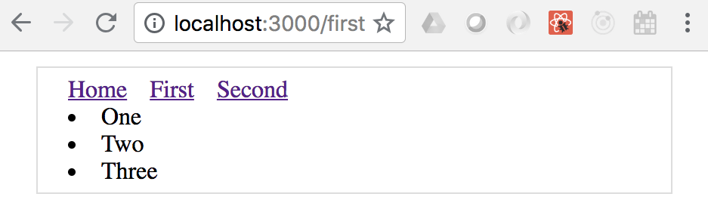
By clicking on the first link, you caused the getInitialProps() function to be called in the browser since the app has already been delivered. If you reload the page while at /first, you'll trigger getInitialProps() to be called on the server since this is the page that Next.js is handling on the server.

Summary
In this chapter, you learned that React can be rendered on the server, in addition to the client. There are a number of reasons for doing this, such as sharing common code between the frontend and the backend. The main advantage of server-side rendering is the performance boost that you get on the initial page load. This translates to a better user experience and, therefore, a better product.
Then, you progressively improved a server-side React application, starting with a single-page render. You were also introduced to routing, client-side reconciliation, and component data fetching to produce a complete backend rendering solution using Next.js.
In the next chapter, you'll learn how to implement React Bootstrap components to implement a mobile-first design.

Further reading
View the following links for more information:
ReactDOMServer: https://reactjs.org/docs/react-dom-server.html
<StaticRouter>: https://reacttraining.com/react-router/core/api/StaticRouter
Next.js: https://nextjs.org/learn/
User Interface Framework Components
If you're using React to build a user interface (UI) for your application, you probably aren't planning on creating your own UI library too. There are lots of React UI component libraries available to choose from and there's no wrong choice, as long as the components make your life simpler.
This chapter will introduce you to the Material-UI React library. Here are the specific topics that we'll cover:
Layout and organization
Using navigation components
Collection user input
Working with styles and themes

Technical requirements
You can find the code files present in this chapter on GitHub at https://github.com/PacktPublishing/React-and-React-Native---Third-Edition/tree/master/Chapter12.

Layout and organization
Material-UI provides us with a number of components that help us to control the overall layout of our applications and to organize the other UI components without each layout. This section will demonstrate that you have to use containers and grids.

Using containers
Often, when you're trying to lay out components on your page, the horizontal layout is the most difficult part to get right. The Container component from Material-UI is a simple, but powerful, layout tool. It helps to control the horizontal width of its children. Let's take a look at an example to see what's possible:
import "typeface-roboto";
import React, { Fragment } from "react";
import Typography from "@material-ui/core/Typography";
import Container from "@material-ui/core/Container";
export default function App() {
const textStyle = {
backgroundColor: "#cfe8fc",
margin: 5,
textAlign: "center"
};
return (
<Fragment>
<Container maxWidth="sm">
<Typography style={textStyle}>sm</Typography>
</Container>
<Container maxWidth="md">
<Typography style={textStyle}>md</Typography>
</Container>
<Container maxWidth="lg">
<Typography style={textStyle}>lg</Typography>
</Container>
</Fragment>
);
}
This example has three Container components, each of which wraps a Typography component. The Typography component is used to render text in Material-UI applications. Each Container component used in this example takes a maxWidth property. It accepts a breakpoint string value. These breakpoints represent common screen sizes; this example uses small (sm), medium (md), and large (lg). When the screen reaches these breakpoint sizes, the container width will stop growing. Here's what the page looks like when the width is smaller than the sm breakpoint:
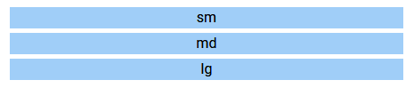
Now, if we were to resize the screen so that it was larger than the md breakpoint but smaller than the lg breakpoint, here is what it would look like:
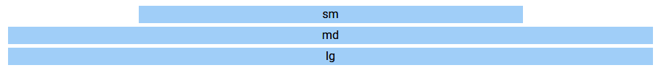
Notice how the first container stays at a fixed width now that we've exceeded its maxWidth breakpoint. The md and lg containers just keep growing along with the screen until their breakpoints have been passed. Let's see what these Container components look like when the screen width surpasses all breakpoints:
The Container component gives you control over how your page elements grow horizontally. They're also responsive, so your layouts will be updated as the screen dimensions change. While it is helpful, we can only do so much with horizontal layouts. In the next section, we'll look at using Material-UI components to build more complex and responsive layouts.

Building responsive grid layouts
Material-UI has a Grid component that we can use to compose complex layouts that are responsive. At a high level, a Grid component can be either a container or an item within a container. By combining these two roles, we can achieve any type of layout for our app. To get familiar with Material-UI grid layouts, let's put together an example that uses a fairly common layout pattern that we'll find in many web applications. Here is what the end result looks like:
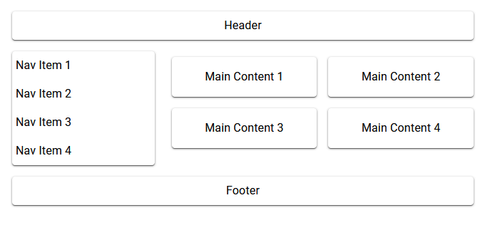
As you can see, this layout has the familiar sections that are typical in many web apps. This is just an example layout; you can use the Grid component to build any type of layout you can imagine. Let's take a look at the code that created this layout:
import "typeface-roboto";
import React from "react";
import Paper from "@material-ui/core/Paper";
import Grid from "@material-ui/core/Grid";
import Typography from "@material-ui/core/Typography";
const headerFooterStyle = {
padding: 8,
textAlign: "center"
};
const mainStyle = {
padding: 16,
textAlign: "center"
};
const navStyle = { marginLeft: 5 };
export default function App() {
return (
<div style={{ flexGrow: 1 }}>
<Grid container spacing={3}>
<Grid item xs={12}>
<Paper style={headerFooterStyle}>
<Typography>Header</Typography>
</Paper>
</Grid>
<Grid item xs={4}>
<Paper>
<Grid container spacing={2} direction="column">
<Grid item xs={12}>
<Typography style={navStyle}>Nav Item 1</Typography>
</Grid>
...
</Grid>
</Paper>
</Grid>
<Grid item xs={8}>
<Grid container spacing={2}>
<Grid item xs={6}>
<Paper style={mainStyle}>
<Typography>Main Content 1</Typography>
</Paper>
</Grid>
...
</Grid>
</Grid>
<Grid item xs={12}>
<Paper style={headerFooterStyle}>
<Typography>Footer</Typography>
</Paper>
</Grid>
</Grid>
</div>
);
}
There are a couple of places where I've replaced repetitive code with .... In these cases, the code that was removed was just a repeat of the Grid component that came before it. Now, let's break down how the sections in this layout are created. We'll start with the header section:
<Grid item xs={12}>
<Paper style={headerFooterStyle}>
<Typography>Header</Typography>
</Paper>
</Grid>
The xs breakpoint property value of 12 means that the header will always span the entire width of the screen since 12 is the highest value you can use here. Next, let's look at the navigation items:
<Grid item xs={4}>
<Paper>
<Grid container spacing={2} direction="column">
<Grid item xs={12}>
<Typography style={navStyle}>Nav Item 1</Typography>
</Grid>
<Grid item xs={12}>
<Typography style={navStyle}>Nav Item 2</Typography>
</Grid>
<Grid item xs={12}>
<Typography style={navStyle}>Nav Item 3</Typography>
</Grid>
<Grid item xs={12}>
<Typography style={navStyle}>Nav Item 4</Typography>
</Grid>
</Grid>
</Paper>
</Grid>
In the navigation section, we have a grid container nested inside of a grid item. It's common to nest grids like this, and the more complex the layout, the more levels of nested grids that you'll require. You'll notice that the direction property value of column used in the navigation section makes the navigation items flow vertically instead of the horizontal default. Next, we'll look at the main content section:
<Grid item xs={8}>
<Grid container spacing={2}>
<Grid item xs={6}>
<Paper style={mainStyle}>
<Typography>Main Content 1</Typography>
</Paper>
</Grid>
<Grid item xs={6}>
<Paper style={mainStyle}>
<Typography>Main Content 2</Typography>
</Paper>
</Grid>
<Grid item xs={6}>
<Paper style={mainStyle}>
<Typography>Main Content 3</Typography>
</Paper>
</Grid>
<Grid item xs={6}>
<Paper style={mainStyle}>
<Typography>Main Content 4</Typography>
</Paper>
</Grid>
</Grid>
</Grid>
The main content section follows the same approach as the navigation section—it uses a nested grid container for subsections. The xs breakpoint value of 6 used by each of the Grid subsection components determines how wide each of them are and how they flow on the page. Since the value is 6, they take up half of the available space in the main section. Also, you can see that the xs breakpoint value for the main section is 8. The xs value for the navigation section is 4; these two numbers add up to 12 meaning that, together, they use the full width of the screen.
In this section, you were introduced to what Material-UI has to offer in the way of layouts. You can use the Container component to control the width of sections and how they change in response to screen dimension changes. You then learned that the Grid component is used to put together more complex grid layouts. In the following section, we'll look at some of the navigational components found in Material-UI.

Using navigation components
Once we have an idea of how the layout of our application is going to look and work, we can start to think about the navigation. This is an important piece of our UI because it's how the user gets around the application and it will be used frequently. In this section, we'll learn about two of the navigational components offered by Material-UI.

Navigating with drawers
The Drawer component, just like a physical drawer, slides open to reveal contents that are easily accessed. When we're finished, the drawer closes again. This works well for navigation because it stays out of the way, allowing more space on the screen for the active task that the user is engaged with. Let's take a look at an example, starting with the App component:
import "typeface-roboto";
import React, { useState } from "react";
import Drawer from "@material-ui/core/Drawer";
...
import { BrowserRouter as Router, Route, Switch, Link } from "react-router-dom";
import First from "./First";
import Second from "./Second";
import Third from "./Third";
export default function App({ links }) {
const [open, setOpen] = useState(false);
function toggleDrawer({ type, key }) {
if (type === "keydown" && (key === "Tab" || key === "Shift")) {
return;
}
setOpen(!open);
}
return (
<Router>
<Button onClick={toggleDrawer}>Open Nav</Button>
<section>
<Route path="/first" component={First} />
<Route path="/second" component={Second} />
<Route path="/third" component={Third} />
</section>
<Drawer open={open} onClose={toggleDrawer}>
<div
style={{ width: 250 }}
role="presentation"
onClick={toggleDrawer}
onKeyDown={toggleDrawer}
>
<List>
{links.map(link => (
<ListItem button key={link.url} component={Link}
to={link.url}>
<Switch>
<Route
exact
path={link.url}
render={() => (
<ListItemText
primary={link.name}
primaryTypographyProps={{ color: "primary" }}
/>
)}
/>
<Route
path="/"
render={() => <ListItemText primary={link.name} />}
/>
</Switch>
</ListItem>
))}
</List>
</div>
</Drawer>
</Router>
);
}
Let's take a look at what's happening here. Everything that this component renders is within the Router component because the items in the drawer are links to routes:
<section>
<Route path="/first" component={First} />
<Route path="/second" component={Second} />
<Route path="/third" component={Third} />
</section>
The First, Second, and Third components are used to render the main application content when the user clicks on a link in the drawer. The drawer itself is opened when the Open Nav button is clicked. Let's take a closer look at the state that's used to control this:
const [open, setOpen] = useState(false);
function toggleDrawer({ type, key }) {
if (type === "keydown" && (key === "Tab" || key === "Shift")) {
return;
}
setOpen(!open);
}
The open state controls the visibility of the drawer. The onClose property of the Drawer component calls this function too so that the drawer closes when any of the links within it are activated. Next, let's look at how the links within the drawer are generated:
<List>
{links.map(link => (
<ListItem button key={link.url} component={Link} to={link.url}>
<Switch>
<Route
exact
path={link.url}
render={() => (
<ListItemText
primary={link.name}
primaryTypographyProps={{ color: "primary" }}
/>
)}
/>
<Route
path="/"
render={() => <ListItemText primary={link.name} />}
/>
</Switch>
</ListItem>
))}
</List>
The items that are displayed in a Drawer component are actually list items, as you can see here. The links property that is passed to App has all of the link objects with the url and name properties. Each item in the items array is mapped to the ListItem component, which uses the Link component. Within ListItem, we have the Route component that generates the link text, by rendering a ListItemText component. There are actually two Route components within a Switch component. The reason is so that we can style the list item differently if it matches the current path. Finally, let's take a look at the default value for the links property:
App.defaultProps = {
links: [
{ url: "/first", name: "First Page" },
{ url: "/second", name: "Second Page" },
{ url: "/third", name: "Third Page" }
]
};
Here's what the drawer looks like when it's opened after the screen first loads:
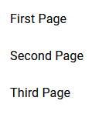
Try clicking on the First Page link. The drawer closes and renders the content of the /first route. Then, when you open the drawer again, you'll notice that the First Page link is rendered as the active link:
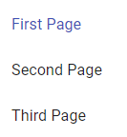
In this section, you learned how to use the Drawer component as the main navigation for your application. In the following section, we'll take a look at the Tabs component.

Navigating with tabs
Tabs are another common navigation pattern found in modern web apps. The Material-UI Tabs component lets us use tabs as links and hook them up to a router. Let's take a look at an example of how to do this. Here is the App component:
import "typeface-roboto";
import React, { Fragment } from "react";
import { BrowserRouter as Router, Route, Link } from "react-router-dom";
import AppBar from "@material-ui/core/AppBar";
import Tabs from "@material-ui/core/Tabs";
import Tab from "@material-ui/core/Tab";
import Typography from "@material-ui/core/Typography";
const tabContentStyle = {
padding: 16
};
function TabContainer({ value }) {
return (
<AppBar position="static">
<Tabs value={value}>
<Tab label="Item One" component={Link} to="/" />
<Tab label="Item Two" component={Link} to="/page2" />
<Tab label="Item Three" component={Link} to="/page3" />
</Tabs>
</AppBar>
);
}
export default function App() {
return (
<Router>
<Route
exact
path="/"
render={() => (
<Fragment>
<TabContainer value={0} />
<Typography component="div" style={tabContentStyle}>
Item One
</Typography>
</Fragment>
)}
/>
<Route
exact
path="/page2"
render={() => (
<Fragment>
<TabContainer value={1} />
<Typography component="div" style={tabContentStyle}>
Item Two
</Typography>
</Fragment>
)}
/>
...
</Router>
);
}
In the interest of space, I've left out the Route component for /page3; it follows the exact same pattern as /page2. The Tabs and Tab components from Material-UI don't actually render any content underneath the selected tab. It's up to us to provide the content as the Tabs component only looks after showing the tabs and marking one of them as selected. The aim of this example is to have the Tab components use Link components that link to content rendered by routes. Let's take a closer look at the TabContainer component:
function TabContainer({ value }) {
return (
<AppBar position="static">
<Tabs value={value}>
<Tab label="Item One" component={Link} to="/" />
<Tab label="Item Two" component={Link} to="/page2" />
<Tab label="Item Three" component={Link} to="/page3" />
</Tabs>
</AppBar>
);
}
Here, we're wrapping the Tabs component with the AppBar component so that the tabs appear like they're part of the bar across the top of the UI. Each Tab component uses the Link component so that, when it is clicked, the router is activated with the route specified in the to property. The TabContainer component is then used as a child component inside our Route components. This way, the route knows which value property to pass—this determines the active tab.
Here's what the page looks like when it first loads:
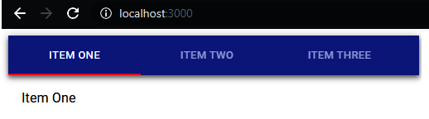
If you click on the ITEM TWO tab, the URL will update, the active tab will change, and the page content below the tabs will change:
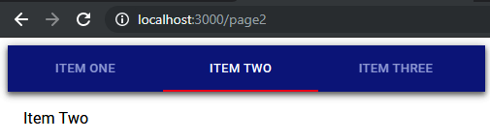
In this section, you learned about two of the navigation approaches that you can use in your Material-UI application. The first is to use a drawer that is only displayed when the user needs to access navigational links. The second is to use tabs that are always visible. In the following section, you'll learn about collecting input from users.

Collecting user input
Collecting input from users can be difficult. There are many nuanced things about every field that we need to consider if we plan on getting the user experience right. Thankfully, the form components available in Material-UI take care of a lot of usability concerns for us. In this section, you'll get a brief sampling of the input controls that you can use.

Checkboxes and radio buttons
Checkboxes are useful for collecting true/false answers from users, while radio buttons are useful for getting the user to select an option from a short number of choices. Let's take a look at an example of these components in Material-UI:
import "typeface-roboto";
import React, { useState } from "react";
import Checkbox from "@material-ui/core/Checkbox";
import Radio from "@material-ui/core/Radio";
import RadioGroup from "@material-ui/core/RadioGroup";
import FormControlLabel from "@material-ui/core/FormControlLabel";
import FormControl from "@material-ui/core/FormControl";
import FormLabel from "@material-ui/core/FormLabel";
export default function Checkboxes() {
const [checkbox, setCheckbox] = useState(false);
const [radio, setRadio] = useState("First");
return (
<div>
<FormControlLabel
label={`Checkbox ${checkbox ? "(checked)" : ""}`}
control={
<Checkbox
checked={checkbox}
onChange={() => setCheckbox(!checkbox)}
/>
}
/>
<FormControl component="fieldset">
<FormLabel component="legend">{radio}</FormLabel>
<RadioGroup value={radio} onChange={e => setRadio(e.target.value)}>
<FormControlLabel value="First" label="First" control={<Radio />}
/>
<FormControlLabel value="Second" label="Second" control={<Radio
/>} />
<FormControlLabel value="Third" label="Third" control={<Radio />}
/>
</RadioGroup>
</FormControl>
</div>
);
}
This example has two pieces of state. The checkbox state controls the value of the Checkbox component, while the radio value controls the state of the RadioGroup component. The checkbox state is passed to the checked property of the Checkbox component, while the radio state is passed to the value property of the RadioGroup component. Both components have onChange handlers that call their respective state setter functions: setCheckbox() and setRadio(). You'll notice that many other Material-UI components are involved in the display of these controls. For example, the label for the checkbox is displayed using the FormControlLabel component and the radio control uses a FormControl component and a FormLabel component.
Here is what the two input controls look like:
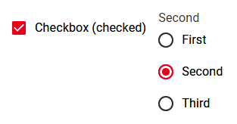
The labels for both of these controls are updated to reflect the state of the component as they change. The checkbox labels show whether or not the checkbox is checked, and the radio labels show the currently selected value. In the next section, we'll look at text inputs and select components.

Text inputs and select inputs
Text fields allow our users to enter text, while selects allow them to choose from a number of options. The difference between selects and radio buttons is that selects require less space on the screen since the options are only displayed when the user opens the option menu. Let's take a look at a Select component now:
import React, { useState } from "react";
import InputLabel from "@material-ui/core/InputLabel";
import MenuItem from "@material-ui/core/MenuItem";
import FormControl from "@material-ui/core/FormControl";
import Select from "@material-ui/core/Select";
export default function MySelect() {
const [value, setValue] = useState("first");
return (
<FormControl>
<InputLabel htmlFor="my-select">My Select</InputLabel>
<Select
value={value}
onChange={e => setValue(e.target.value)}
inputProps={{ id: "my-select" }}
>
<MenuItem value="first">First</MenuItem>
<MenuItem value="second">Second</MenuItem>
<MenuItem value="third">Third</MenuItem>
</Select>
</FormControl>
);
}
The value state used in this example controls the selected value in the Select component. When the user changes their selection, the setValue() function changes the value. The MenuItem component is used to specify the available options in the select field; the value property is set as the value state when a given item is selected. Here's what the select looks like when the menu is displayed:
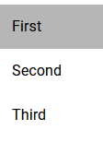
Next, let's take a look at a TextField component example:
import React, { useState } from "react";
import TextField from "@material-ui/core/TextField";
export default function MyTextInput() {
const [value, setValue] = useState("");
return (
<TextField
label="Name"
value={value}
onChange={e => setValue(e.target.value)}
margin="normal"
/>
);
}
The value state controls the value of the text input and changes as the user types. Here's what the text field looks like:
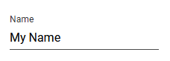
Unlike other form control components, the TextField component doesn't require several other supporting components. Everything that we need can be specified via properties. In the next section, we'll look at the Button component.

Working with buttons
Material-UI buttons are very similar to HTML button elements. The difference is that they're React components that work well with other aspects of Material-UI such as theming and layout. Let's take a look at an example that renders different styles of buttons:
import "typeface-roboto";
import React, { useState } from "react";
import Button from "@material-ui/core/Button";
import Grid from "@material-ui/core/Grid";
import IconButton from "@material-ui/core/IconButton";
import AndroidIcon from "@material-ui/icons/Android";
const buttonStyle = { margin: 10 };
function toggleColor(setter, value) {
setter(value === "default" ? "primary" : "default");
}
export default function App() {
const [contained, setContained] = useState("default");
const [text, setText] = useState("default");
const [outlined, setOutlined] = useState("default");
const [icon, setIcon] = useState("default");
return (
<Grid container>
<Grid
item
component={Button}
variant="contained"
style={buttonStyle}
color={contained}
onClick={() => toggleColor(setContained, contained)}
>
Contained
</Grid>
<Grid
item
component={Button}
style={buttonStyle}
color={text}
onClick={() => toggleColor(setText, text)}
>
Text
</Grid>
<Grid
item
component={Button}
variant="outlined"
style={buttonStyle}
color={outlined}
onClick={() => toggleColor(setOutlined, outlined)}
>
Outlined
</Grid>
<Grid
item
component={IconButton}
style={buttonStyle}
color={icon}
onClick={() => toggleColor(setIcon, icon)}
>
<AndroidIcon />
</Grid>
</Grid>
);
}
This example renders four different buttons styles. We're using the Grid component to render the row of buttons. Instead of rendering buttons as children of the Grid item components, we're setting the component property value to Button and IconButton. This way, we can pass button properties directly to Grid. Each button has its own color state, initially set to default. When the buttons are clicked on, the state toggles to primary. Here's what the buttons look like when they're first rendered:
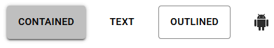
And here's what the buttons look like when they've each been clicked on:

In this section, you learned about some of the user input controls available in Material-UI. Checkboxes and radio buttons are useful when the user needs to turn something on or off or choose an option. Text inputs are necessary when the user needs to type in the text, while selects are useful when you have a list of options to choose from but limited space to display those options. Finally, you learned that Material-UI has several styles of buttons that can be used when the user needs to initiate an action. In the following section, we'll look at how styles and themes work in Material-UI.

Working with styles and themes
Included with Material-UI are systems for extending the styles of UI components, and extending theme styles that are applied to all components. In this section, you'll learn about using both of these systems.

Making styles
Material-UI comes with a makeStyles() function that can be used to create styles based on JavaScript objects. The return value of this function is a Hook function, which, when used in a component, returns an object with the different style names as properties. There are two ways to use this style object with your Material-UI components:
The first is to pass the style name to the className property of the component:
const classes = makeStyles({ myStyle: { ... }});
...
<Button className={classes.myStyle} />
This will apply whatever CSS properties that you've defined in myStyle to the Button component. The challenge with this approach is that every Material-UI component has several styles applied to it and it's very easy to mess these up.
The other approach is to use the classes property. This allows us to structure our styles in a way that follows the style API that's available for each Material-UI component. Let's take a closer look at this approach:
import "typeface-roboto";
import React, { Fragment } from "react";
import { makeStyles } from "@material-ui/core/styles";
import Button from "@material-ui/core/Button";
const useButtonStyles = makeStyles(theme => ({
root: { margin: theme.spacing(1) },
contained: { borderRadius: theme.shape.borderRadius + 2 },
sizeSmall: { fontWeight: theme.typography.fontWeightLight }
}));
export default function App() {
const buttonClasses = useButtonStyles();
return (
<Fragment>
<Button classes={buttonClasses}>First</Button>
<Button classes={buttonClasses} variant="contained">
Second
</Button>
<Button classes={buttonClasses} size="small"
variant="outlined">
Third
</Button>
</Fragment>
);
}
Here, the makeStyles() function results in a Hook function that we can use in our component: useButtonStyles(). We're passing a function to makeStyles() instead of an object because our custom styles need access to some theme values. This function then returns an object. The names used in this style (root, contained, and sizeSmall) aren't something that we came up with. These are part of the Button CSS API. The root style is applied to all buttons, so, in this example, all three buttons will have the margin value that we've applied here. The contained style is applied to buttons that use the contained variant. The sizeSmall style is applied to buttons that have a small value for the size property.
By using this approach, we can just pass classes={buttonClasses} to every one of our button components and let the Material-UI style system figure out which styles get applied based on other properties that we've set.
Here's what the custom button styles look like:
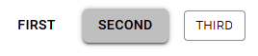
Now that you know how to change the look and feel of individual components, it's time to think about customizing the look and feel of the application as a whole.

Customizing themes
Material-UI comes with a default theme. We can use this as the starting point to create our own theme. There are two main steps to creating a new theme in Material-UI:
Use the createMuiTheme() function to customize the default theme settings and return a new theme object.
Use the ThemeProvider component to wrap our application so that the appropriate theme is applied.
Let's take a look at how this process works in action:
import "typeface-roboto";
import React from "react";
import { createMuiTheme } from "@material-ui/core/styles";
import { ThemeProvider } from "@material-ui/styles";
import Menu from "@material-ui/core/Menu";
import MenuItem from "@material-ui/core/MenuItem";
const theme = createMuiTheme({
typography: {
fontSize: 11
},
overrides: {
MuiMenuItem: {
root: {
marginLeft: 15,
marginRight: 15
}
}
}
});
export default function App() {
return (
<ThemeProvider theme={theme}>
<Menu anchorEl={document} open={true}>
<MenuItem>First Item</MenuItem>
<MenuItem>Second Item</MenuItem>
<MenuItem>Third Item</MenuItem>
</Menu>
</ThemeProvider>
);
}
The custom theme that we've created here does two things:
It changes the default font size for all components to 11.
It updates the left and right margin values for the MenuItem components.
There are many values that can be set in a Material-UI theme; refer to the customization documentation for more. The overrides section is used for component-specific customizations. This is useful when you need to style for every instance of a component in your application.

Summary
This chapter was a very brief introduction to Material-UI, the most popular React UI framework. We started by looking at the components used to assist with the layout of our pages. We then looked at components that can help the user navigate around in your application. Next, you learned how to collect user input using Material-UI form components. Finally, you learned how to style your Material-UI using styles and modifying themes.
In the next chapter, we'll go over what makes React Native a good choice for native application development.
Section 2: React Native
In this section, we will cover the following chapters:
Chapter 13, Why React Native?
Chapter 14, Kick-starting React Native Projects
Chapter 15, Building Responsive Layouts with Flexbox
Chapter 16, Navigating between Screens
Chapter 17, Rendering Item Lists
Chapter 18, Showing Progress
Chapter 19, Geolocation and Maps
Chapter 20, Collecting User Input
Chapter 21, Displaying Modal Screens
Chapter 22, Responding to User Gestures
Chapter 23, Controlling Image Display
Chapter 24, Going Offline
Why React Native?
Facebook created React Native to build its mobile applications. The motivation to do so originated from the fact that React for the web was so successful. So, if React is such a good tool for UI development, and you need a native application, then why fight it? Just make React work with native mobile OS UI elements!
In this chapter, you'll learn about the motivations for using React Native to build native mobile web applications. Here are the topics that we'll cover in this chapter:
What is React Native?
React and JSX are familiar
The mobile browser experience
Android and iOS—different yet the same
The case for mobile web apps

Technical requirements
There aren't any technical requirements for this chapter since it is a brief conceptual introduction to React Native.

What is React Native?
Earlier in this book, I introduced the notion of a render target—the thing that React components render to. The render target is abstract as far as the React programmer is concerned. For example, in React, the render target can be a string or it could be the Document Object Model (DOM). This is why your components never directly interface with the render target, because you can never make assumptions about where the rendering is taking place.
A mobile platform has UI widget libraries that developers can leverage to build apps for that platform. On Android, developers implement Java apps, while, on iOS, developers implement Swift apps. If you want a functional mobile app, you're going to have to pick one. However, you'll need to learn both languages, as supporting only one of two major platforms isn't realistic for success.
For React developers, this isn't a problem. The same React components that you build work all over the place, even on mobile browsers! Having to learn two more programming languages to build and ship a mobile application is cost and time-intensive prohibitive. The solution to this is to introduce a new React platform that supports a new render target—native mobile UI widgets.
React Native uses a technique that makes asynchronous calls to the underlying mobile OS, which calls the native widget APIs. There's a JavaScript engine, and the React API is mostly the same as React for the web. The difference is with the target; instead of a DOM, there are asynchronous API calls. The concept is visualized here:
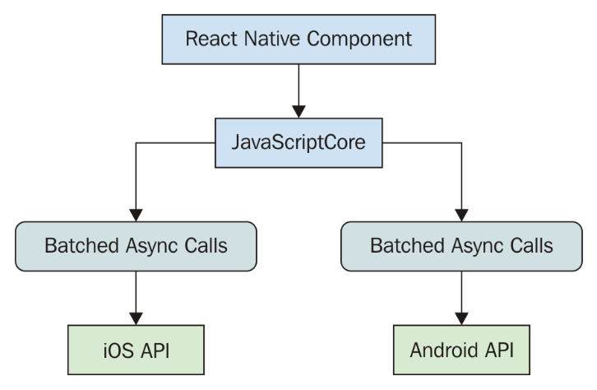
This oversimplifies everything that's happening under the covers, but the basic ideas are as follows:
The same React library that's used on the web is used by React Native and runs in JavaScriptCore.
Messages that are sent to native platform APIs are asynchronous and batched for performance purposes.
React Native ships with components implemented for mobile platforms, instead of components that are HTML elements.
Much more on the history and mechanics of React Native can be found at https://code.facebook.com/posts/1014532261909640.
Now that you know what React Native is, it's time to look at what attracts React developers to React Native.

React and JSX are familar
Implementing a new render target for React is not straightforward. It's essentially the same thing as inventing a new DOM that runs on iOS and Android. So, why go through all the trouble?
First, there's a huge demand for mobile apps. The reason is that the mobile web browser user experience isn't as good as the native app experience. Second, JSX is a fantastic tool for building UIs. Rather than having to learn new technology, it's much easier to use what you know.
It's the latter point that's the most relevant to you. If you're reading this book, you're probably interested in using React for both web applications and native mobile applications. I can't put into words how valuable React is from a development-resource perspective. Instead of having a team that does web UIs, a team that does iOS, a team that does Android, and so on, there's just the UI team that understands React.
In the following section, you'll learn about the challenges of delivering good user experiences on mobile web browsers.

The mobile browser experience
Mobile browsers lack many capabilities of mobile applications. This is due to the fact that browsers cannot replicate the same native platform widgets as HTML elements. You can try to do this, but it's often better to just use the native widget, rather than try to replicate it. This is partly because this requires less maintenance effort on your part, and partly because using widgets that are native to the platform means that they're consistent with the rest of the platform. For example, if a date picker in your application looks different from all the date pickers the user interacts with on their phone, this isn't a good thing. Familiarity is key, and using native platform widgets makes familiarity possible.
User interactions on mobile devices are fundamentally different from the interactions that you typically design for the web. Web applications assume the presence of a mouse, for example, and that the click event on a button is just one phase. However, things become more complicated when the user uses their fingers to interact with the screen. Mobile platforms have what's called a gesture system to deal with this. React Native is a much better candidate for handling gestures than React for the web because it handles these types of things that you don't have to think about much in a web app.
As the mobile platform is updated, you want the components of your app to stay updated too. This isn't a problem with React Native because they're using actual components from the platform. Once again, consistency and familiarity are important for good user experience. So, when the buttons in your app look and behave in exactly the same way as the buttons in every other app on the device, your app feels like part of the device.
Now that you understand what makes developing UIs for mobile browsers difficult, it's time to look at how React Native is able to bridge the gap between the different native platforms.

Android and iOS – different yet the same
When I first heard about React Native, I automatically thought that it would be some cross-platform solution that lets you write a single React application that will run natively on any device. Do yourself a favor and get out of this mindset before you start working with React Native. iOS and Android are different on many fundamental levels. Even their user experience philosophies are different, so trying to write a single app that runs on both platforms is categorically misguided.
Besides, this is not the goal of React Native. The goal is React components everywhere, not write once, run anywhere. In some cases, you'll want your app to take advantage of an iOS-specific widget or an Android-specific widget. This provides a better user experience for that particular platform and should trump the portability of a component library.
There are several areas that overlap between iOS and Android where the differences are trivial. The two widgets aim to accomplish the same thing for the user, in roughly the same way. In these cases, React Native will handle the difference for you and provide a unified component. In the next section, we'll look at the case where mobile web apps that run in the browser might be a better fit for your users.

The case for mobile web apps
Not every one of your users is going to be willing to install an app, especially if you don't yet have a high download count and rating. The barrier to entry is much lower with web applications—the user only needs a browser.
Despite not being able to replicate everything that native platform UIs have to offer, you can still implement awesome things in a mobile web UI. Maybe having a good web UI is the first step toward getting those download counts and ratings up for your mobile app.
Ideally, what you should aim for is the following:
Standard web (laptop/desktop browsers)
Mobile web (phone/tablet browsers)
Mobile apps (phone-/tablet-native platform)
Putting an equal amount of effort into all three of these spaces probably doesn't make much sense, as your users probably favor one area over another. Once you know, for example, that there's a really high demand for your mobile app compared to the web versions, that's when you allocate more effort there.

Summary
In this chapter, you learned that React Native is an effort by Facebook to reuse React to create native mobile applications. React and JSX are really good at declaring UI components, and since there's now a huge demand for mobile applications, it makes sense to use what you already know for the web.
The reason there's such a demand for mobile applications over mobile browsers is that they just feel better. Web applications lack the ability to handle mobile gestures the same way apps can, and they generally don't feel like part of the mobile experience from a look and feel perspective.
React Native isn't trying to implement a component library that lets you build a single React app that runs on any mobile platform. iOS and Android are fundamentally different in many important ways. Where there's overlap, React Native does try to implement common components. Will you do away with mobile web apps now that we can build natively using React? This will probably never happen because the user can only install so many apps.
Now that you know what React Native is and what its strengths are, you'll learn how to get started with new React Native projects in the following chapter.

Further reading
You can find more information on React Native at https://facebook.github.io/react-native/
Kick-Starting React Native Projects
In this chapter, you'll get up and running with React Native. Thankfully, much of the boilerplate involved with the creation of a new project is handled for you by the Expo command-line tool.
In this chapter, we'll cover the following topics:
Installing and using the Expo command-line tool
Viewing your app on your phone
Viewing your app on Expo Snack

Technical requirements
You can find the code files of this chapter on GitHub at https://github.com/PacktPublishing/React-and-React-Native---Third-Edition/tree/master/Chapter14/my-project.

Installing and using the Expo command-line tool
The Expo command-line tool is the preferred way to get started with your React Native project. When you use this tool to kick-start your project, it handles the creation of all of the scaffolding that your project needs to run a basic React Native application. Additionally, Expo has a couple of other tools that make running our app during development nice and straightforward. But, first, we need to install the Expo command-line tool:
In your command-line terminal, type in the following command:
npm install -g expo-cli
Once this installation is complete, you'll have a new expo command available on your system. To start a new project, we can run the expo init command, as follows:
expo init my-project
In this case, the name of the project that will be created is my-project. Next, the process will ask you about your project. You should see something like this in your terminal:
? Choose a template: (Use arrow keys)
----- Managed workflow -----
> blank a minimal app as clean as an empty canvas
blank (TypeScript) same as blank but with TypeScript configuration
tabs several example screens and tabs using react-navigation
----- Bare workflow -----
minimal bare and minimal, just the essentials to get you started
minimal (TypeScript) same as minimal but with TypeScript configuration
We'll choose the blank Managed workflow (the default). Managed means that, later on, we can use Expo tools and services during development that will enable us to focus more on the application than on the complexities of developing for different mobile devices.
Next, Expo will ask you for a human-friendly name for your app:
? Please enter a few initial configuration values.
Read more: https://docs.expo.io/versions/latest/workflow/configuration/ » 50% completed
{
"expo": {
"name": "<The name of your app visible on the home screen>",
"slug": "my-project"
}
}
If you start typing in a name, it will replace the <The name of your app visible on the home screen> placeholder and update the project configuration. Try entering My Project and hit Enter. Expo will finish creating your project for you:
Extracting project files...
Customizing project...
Installing dependencies...
Your project is ready at /path/to/my-project
Now that we have a blank React Native project created, you'll learn how to launch the Expo development server on your computer and view the app on one of your devices.

Viewing your app on your phone
In order to view your React Native project on your device during development, we need to start the Expo development server:
In the command-line terminal, make sure that you're in the project directory:
cd path/to/my-project
Once you're in my-project, you can run the following command to start the development server:
npm start
This will show you some information about the developer server in the terminal:
Starting project at C:\Users\adamb\React-and-React-Native---Third-Edition\Chapter13\my-project
Expo DevTools is running at http://localhost:19002
Opening DevTools in the browser... (press shift-d to disable)
Starting Metro Bundler on port 19001.
Tunnel ready.
It will also open a browser tab with a UI for managing where the application is run, viewing logs, and other miscellaneous activities. Here is what the Expo app looks like:
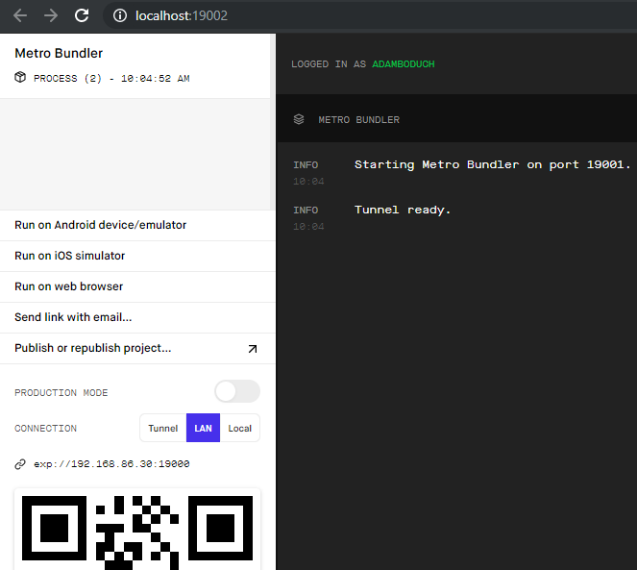
On the right side of the screen is where you'll find logs that come from the bundler, the process that bundles your React Native code and sends it to an emulator or a physical device. At the bottom left of the page is a QR code that you can scan with the camera on your device. This is how we deliver bundled React Native code to physical devices. If your device doesn't have a camera, you can click on the Send link with email... button.
In order to view our app on our devices, we need to install the Expo app. You can find it in the Play Store app on Android devices or in the App Store on iOS devices. Once you have Expo installed, you can click on the Scan QR Code button:

This will open the camera app on your device.
Point it at the QR code that is displayed in the Expo UI on your computer. Once the code is scanned, you'll notice new logs and a new connected device in the Expo UI:
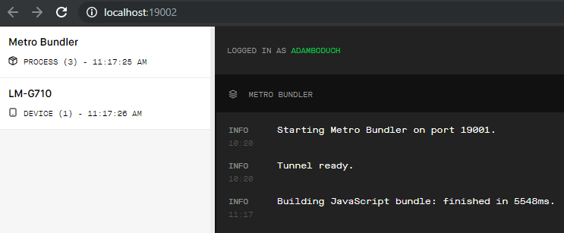
If you see your device listed on the left side of this screen and the logs on the right side indicate that a JavaScript bundle has finished building, you can return to your device and you should see your app running:
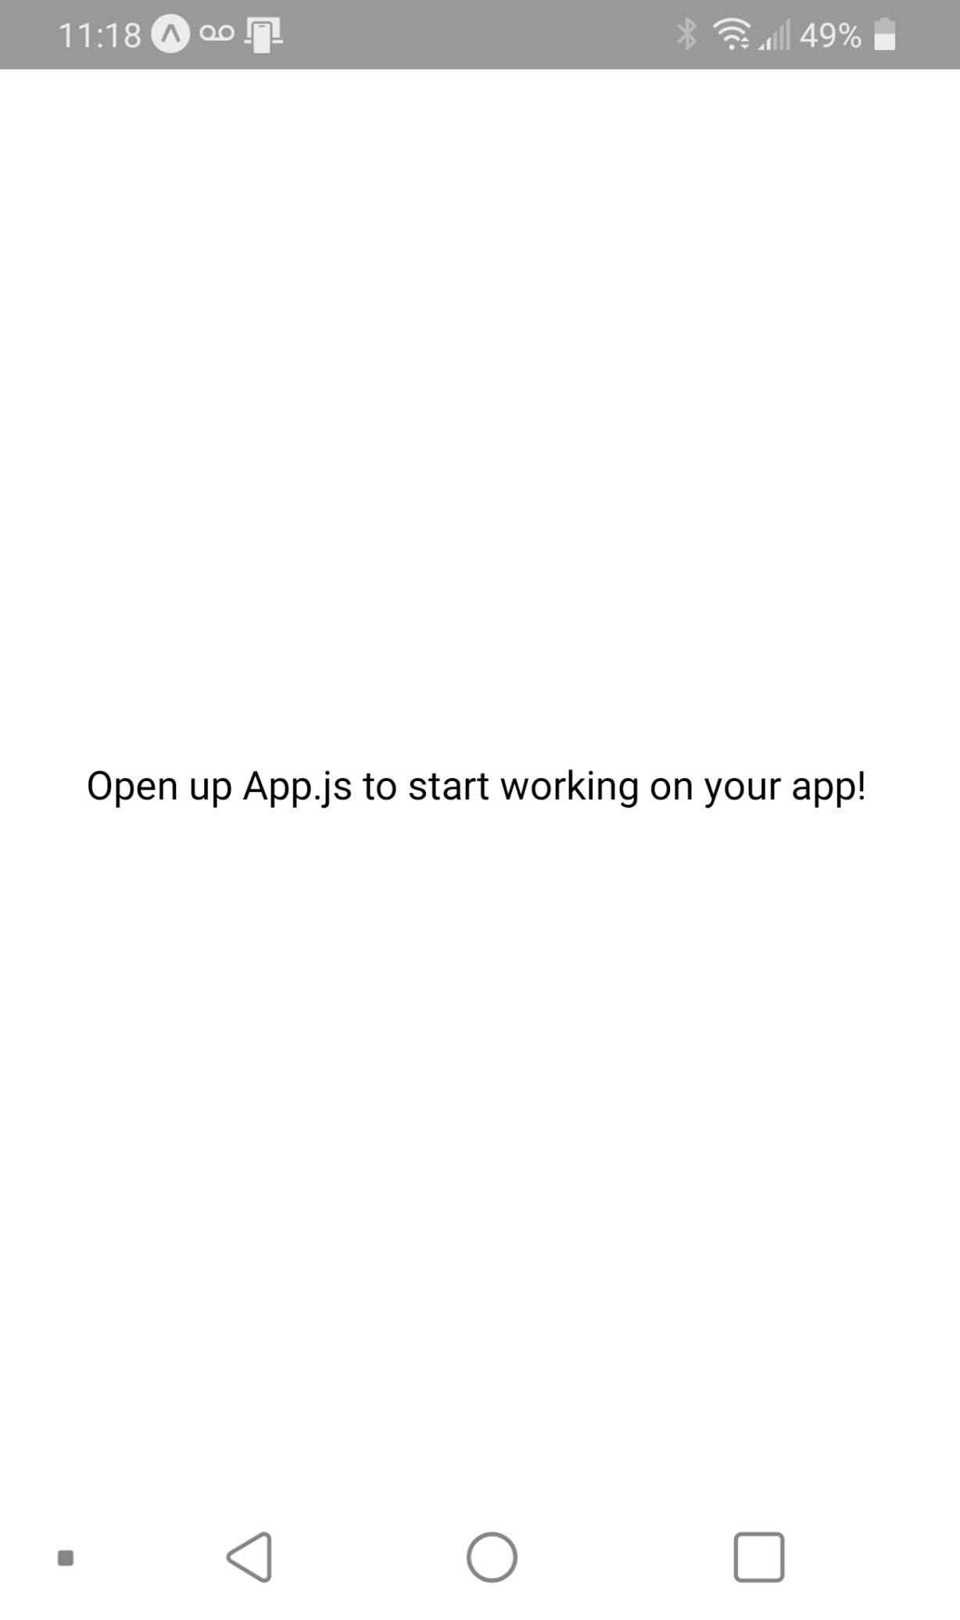
At this point, you're ready to start developing your app. In fact, you can repeat this same process if you have several physical devices that you want to work with at the same time. The best part of this Expo setup is that we get live reloading for free on our physical devices as we make code updates on our computer. Let's try this now to make sure that everything works as expected:
Let's open up the App.js file inside the my-project folder:
import React from "react";
import { StyleSheet, Text, View } from "react-native";
export default function App() {
return (
<View style={styles.container}>
<Text>Open up App.js to start working on your app!</Text>
</View>
);
}
const styles = StyleSheet.create({
container: {
flex: 1,
backgroundColor: "#fff",
alignItems: "center",
justifyContent: "center"
}
});
Let's make a small style change to make the font bold:
import React from "react";
import { StyleSheet, Text, View } from "react-native";
export default function App() {
return (
<View style={styles.container}>
<Text style={styles.text}>
Open up App.js to start working on your app!
</Text>
</View>
);
}
const styles = StyleSheet.create({
container: {
flex: 1,
backgroundColor: "#fff",
alignItems: "center",
justifyContent: "center"
},
text: {
fontWeight: "bold"
}
});
We've added a new style called text and applied it to the Text component. If you save the file and return to your device, you'll immediately see the change applied:
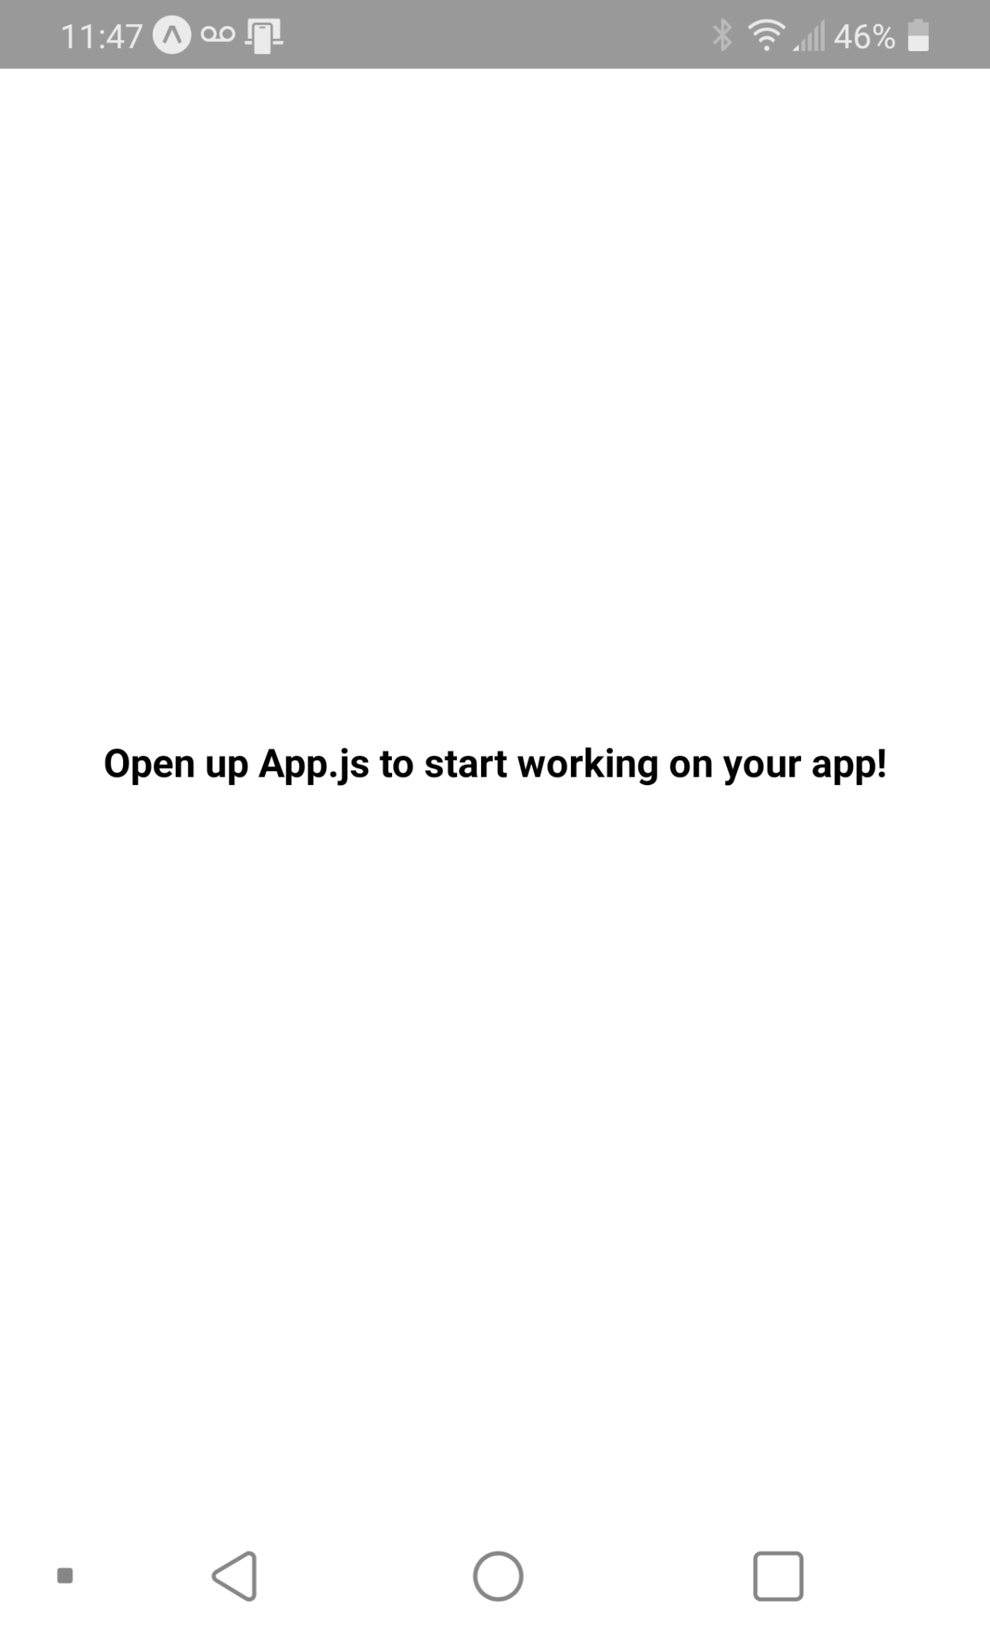
Now that you're able to run your apps locally on your physical devices, it's time to look at running your React Native apps on a variety of virtual device emulators using the Expo Snack service.

Viewing your app on Expo Snack
The Snack service provided by Expo is a playground for your React Native code. It lets you organize your React Native project files just like you would locally on your computer. If you end up putting something together that is worth building on, you can export your Snack. You can also create an Expo account and save your Snacks to keep working on them or to share them with others.
We can also import code that is stored locally into a Snack or we can import a Git repository. The nice thing about importing a repository is that when you push changes to Git, your Snack is also updated. The Git URL for the example that we've worked on in this chapter looks like this: https://github.com/PacktPublishing/React-and-React-
Native---Third-Edition/tree/master/Chapter13/my-project. I can click on the import Git repository button in the Snack menu (https://Snack.expo.io) and paste in this URL. Once the repository is imported and the Snack is saved, you'll get an updated Snack URL that reflects the Git repository location. For example, the Snack URL from this chapter looks like this: https://Snack.expo.io/@git/github.com/
PacktPublishing/React-and-React-Native---Third-Edition:Chapter13/my-project.
If you open this URL, the Snack interface will load and you can make changes to the code to test things out before running them. The pièce de résistance of Snack is the ability to easily run them on virtualized devices. The controls to run your app on a virtual device can be found on the right side of the UI and look like this:
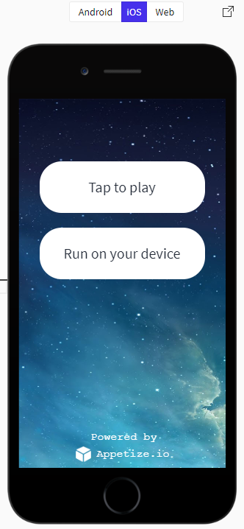
The top control above the image of the phone controls which device type to emulate: Android, iOS, or Web. The Tap to play button will launch the selected virtual device. Here's what our app looks like on a virtual iOS device:
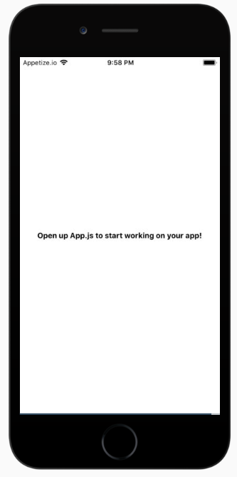
And here's what our app looks like on a virtual Android device:
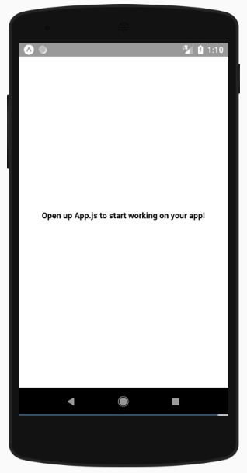
This app only displays text and applies some styles to it, so it looks pretty much identical on different platforms. As we make our way through the React Native chapters in this book, you'll see how useful having a tool like Snack is for making comparisons between the two platforms to understand the difference between them.

Summary
In this chapter, you learned how to kick-start a React Native project using the Expo command-line tool. First, you learned how to install the Expo tool. Then, you learned how to initialize a new React Native project. Next, you started the Expo development server and learned about the various parts of the development server UI. In particular, you learned how to connect the development server with the Expo app on any devices that you want to test your app on.
Expo also has the Snack service, which lets us experiment with snippets of code or entire Git repositories. You learned how to import a repository and run it on virtual iOS and Android devices. In the next chapter, we'll look at how to build responsive layouts in our React Native apps.
Building Responsive Layouts with Flexbox
In this chapter, you'll get a feel for what it's like to lay components out on the screen of mobile devices. Thankfully, React Native polyfills many CSS properties that you might have used in the past to implement page layouts in web applications. You'll learn how to use the Flexbox model to lay out our React Native screens.
Before you dive into implementing layouts, you'll get a brief introduction to Flexbox and using CSS style properties in React Native apps—it's not quite what you're used to with regular CSS style sheets. Then, you'll implement several React Native layouts using Flexbox.
Here's the list of topics that we'll cover in this chapter:
Flexbox is the new layout standard
Introducing React Native styles
Building Flexbox layouts

Technical requirements
You can find the code files present in this chapter on GitHub at https://github.com/PacktPublishing/React-and-React-Native---Third-Edition/tree/master/Chapter15.

Flexbox is the new layout standard
Before the flexible box layout model was introduced to CSS, the various approaches used to build layouts felt hacky and were prone to errors. Flexbox fixes this by abstracting many of the properties that you would normally have to provide in order to make the layout work.
In essence, the Flexbox model is exactly what it sounds like—a box model that's flexible. That's the beauty of Flexbox—its simplicity. You have a box that acts as a container, and you have child elements within that box. Both the container and the child elements are flexible in how they're rendered on the screen, as illustrated here:
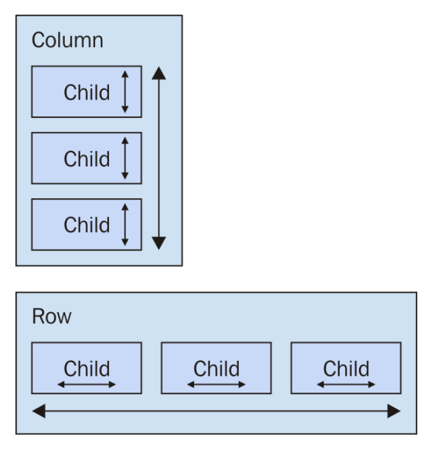
Flexbox containers have a direction, either Column (up/down) or Row (left/right). This actually confused me when I was first learning Flexbox; my brain refused to believe that rows move from left to right. Rows stack on top of one another! The key thing to remember is that it's the direction that the box flexes, not the direction that boxes are placed on the screen.
For a more in-depth treatment of Flexbox concepts, refer to https://css-tricks.com/snippets/css/a-guide-to-Flexbox/.
Now that we've covered the basics of Flexbox layouts at a high level, it's time to learn how styles in React Native applications work.

Introducing React Native styles
It's time to implement your first React Native app, beyond the boilerplate that's generated by create-react-native-app. I want to make sure that you feel comfortable using React Native style sheets before you start implementing Flexbox layouts in the next section. Here's what a React Native style sheet looks like:
import { Platform, StyleSheet, StatusBar } from "react-native";
export default StyleSheet.create({
container: {
flex: 1,
justifyContent: "center",
alignItems: "center",
backgroundColor: "ghostwhite",
...Platform.select({
ios: { paddingTop: 20 },
android: { paddingTop: StatusBar.currentHeight }
})
},
box: {
width: 100,
height: 100,
justifyContent: "center",
alignItems: "center",
backgroundColor: "lightgray"
},
boxText: {
color: "darkslategray",
fontWeight: "bold"
}
});
This is a JavaScript module, not a CSS module. If you want to declare React Native styles, you need to use plain objects. Then, you call StyleSheet.create() and export this from the style module.
As you can see, this style sheet has three styles: container, box, and boxText. Within the container style, there's a call to Platform.select():
...Platform.select({
ios: { paddingTop: 20 },
android: { paddingTop: StatusBar.currentHeight }
})
This function will return different styles based on the platform of the mobile device. Here, you're handling the top padding of the top-level container view. You'll probably use this code in most of your apps to make sure that your React components don't render underneath the status bar of the device. Depending on the platform, the padding will require different values. If it's iOS, paddingTop is 20. If it's Android, paddingTop will be the value of StatusBar.currentHeight.
The preceding Platform.select() code is an example of a case where you need to implement a workaround for differences in the platform. For example, if StatusBar.currentHeight was available on iOS and Android, you wouldn't need to call Platform.select().
Let's see how these styles are imported and applied to React Native components:
import React from "react";
import { Text, View } from "react-native";
import styles from "./styles";
export default function App() {
return (
<View style={styles.container}>
<View style={styles.box}>
<Text style={styles.boxText}>I'm in a box</Text>
</View>
</View>
);
}
The styles are assigned to each component via the style property. You're trying to render a box with some text in the middle of the screen. Let's make sure that this looks as we expect it to:
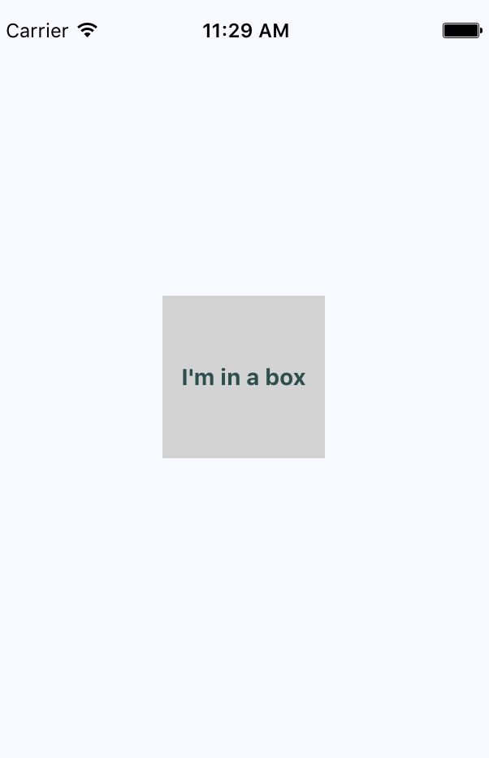
Perfect! Now that you have an idea of how to set styles on React Native elements, it's time to start creating some screen layouts.

Building Flexbox layouts
In this section, you'll learn about several potential layouts that you can use in your React Native applications. I want to stay away from the idea that one layout is better than another. Instead, I'll show you how powerful the Flexbox layout model is for mobile screens so that you can design the layout that best suits your application.

Simple three-column layout
To start things off, let's implement a simple layout with three sections that flex in the direction of the column (top to bottom). Let's start by taking a look at the resulting screen:
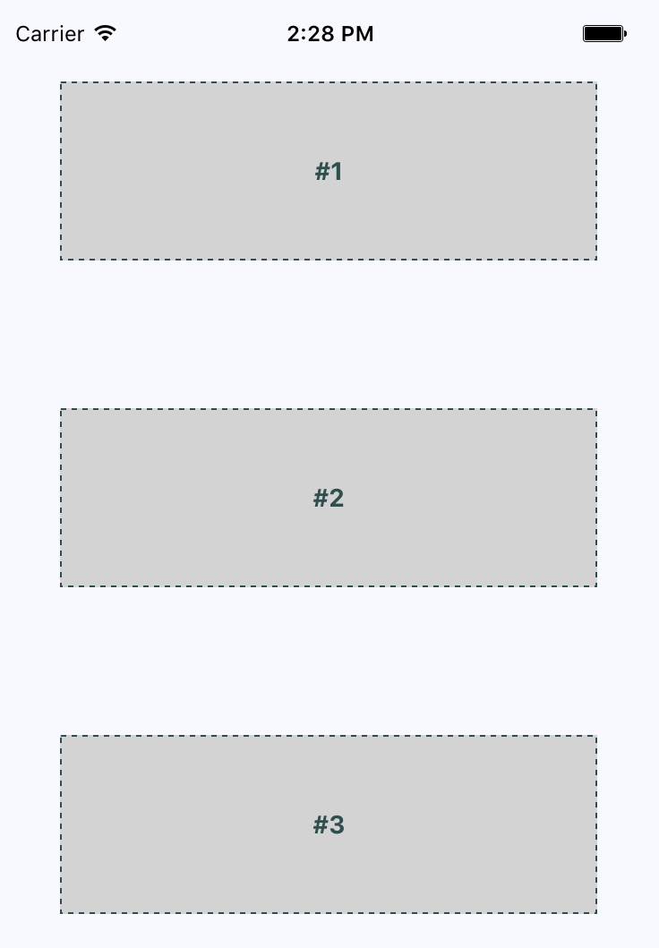
The idea, in this example, is that you've styled and labeled the three screen sections so that they stand out. In other words, these components wouldn't necessarily have any styling in a real application since they're used to arrange other components on the screen.
Let's take a look at the components used to create this screen layout:
import React from "react";
import { Text, View } from "react-native";
import styles from "./styles";
export default function App() {
return (
<View style={styles.container}>
<View style={styles.box}>
<Text style={styles.boxText}>#1</Text>
</View>
<View style={styles.box}>
<Text style={styles.boxText}>#2</Text>
</View>
<View style={styles.box}>
<Text style={styles.boxText}>#3</Text>
</View>
</View>
);
}
The container view (the outermost <View> component) is the column and the child views are the rows. The <Text> component is used to label each row. In terms of HTML elements, <View> is similar to a <div> element while <Text> is similar to a <p> element.
Maybe this example could have been called a three-row layout, since it has three rows. But, at the same time, the three layout sections are flexing in the direction of the column that they're in. Use the naming convention that makes the most conceptual sense to you.
Now, let's take a look at the styles used to create this layout:
import { Platform, StyleSheet, StatusBar } from "react-native";
export default StyleSheet.create({
container: {
flex: 1,
flexDirection: "column",
alignItems: "center",
justifyContent: "space-around",
backgroundColor: "ghostwhite",
...Platform.select({
ios: { paddingTop: 20 },
android: { paddingTop: StatusBar.currentHeight }
})
},
box: {
width: 300,
height: 100,
justifyContent: "center",
alignItems: "center",
backgroundColor: "lightgray",
borderWidth: 1,
borderStyle: "dashed",
borderColor: "darkslategray"
},
boxText: {
color: "darkslategray",
fontWeight: "bold"
}
});
The flex and flexDirection properties of container enable the layout of the rows to flow from top to bottom. The alignItems and justifyContent properties align the child elements to the center of the container and add space around them, respectively.
Let's see how this layout looks when you rotate the device from a portrait orientation to a landscape orientation:
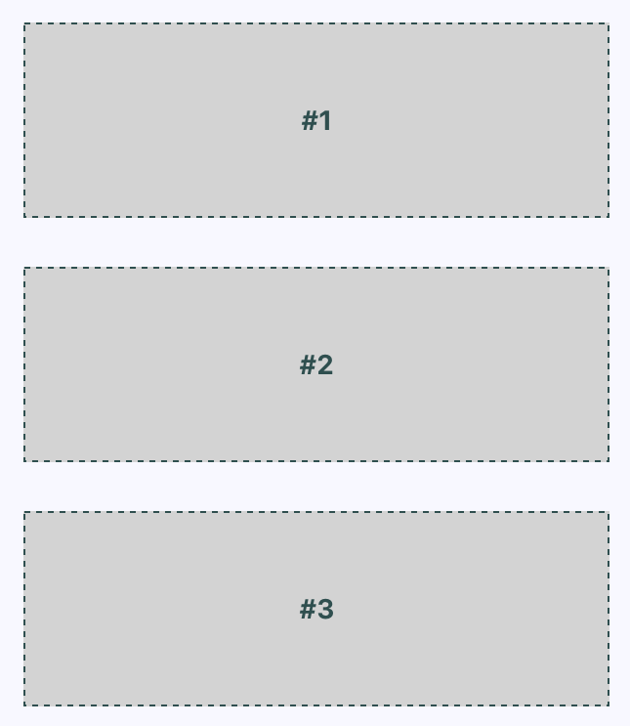
The Flexbox automatically figured out how to preserve the layout for you. However, you can improve on this a little bit. For example, the landscape orientation has a lot of wasted space to the left and right now. You could create your own abstraction for the boxes that you're rendering. In the following section, we'll improve on this layout.

Improved three-column layout
There are a few things that I think you can improve on from the last example. Let's fix the styles so that the children of the Flexbox stretch to take advantage of the available space. Remember, in the last example, when you rotated the device from a portrait orientation to a landscape orientation? There was a lot of wasted space. It would be nice to have the components automatically adjust themselves. Here's what the new style module looks like:
import { Platform, StyleSheet, StatusBar } from "react-native";
export default StyleSheet.create({
container: {
flex: 1,
flexDirection: "column",
backgroundColor: "ghostwhite",
alignItems: "center",
justifyContent: "space-around",
...Platform.select({
ios: { paddingTop: 20 },
android: { paddingTop: StatusBar.currentHeight }
})
},
box: {
height: 100,
justifyContent: "center",
alignSelf: "stretch",
alignItems: "center",
backgroundColor: "lightgray",
borderWidth: 1,
borderStyle: "dashed",
borderColor: "darkslategray"
},
boxText: {
color: "darkslategray",
fontWeight: "bold"
}
});
The key change here is the alignSelf property. This tells elements with the box style to change their width or height (depending on flexDirection of their container) to fill space. Also, the box style no longer defines a width property because this will be computed on the fly now. Here's what the sections look like in portrait mode:
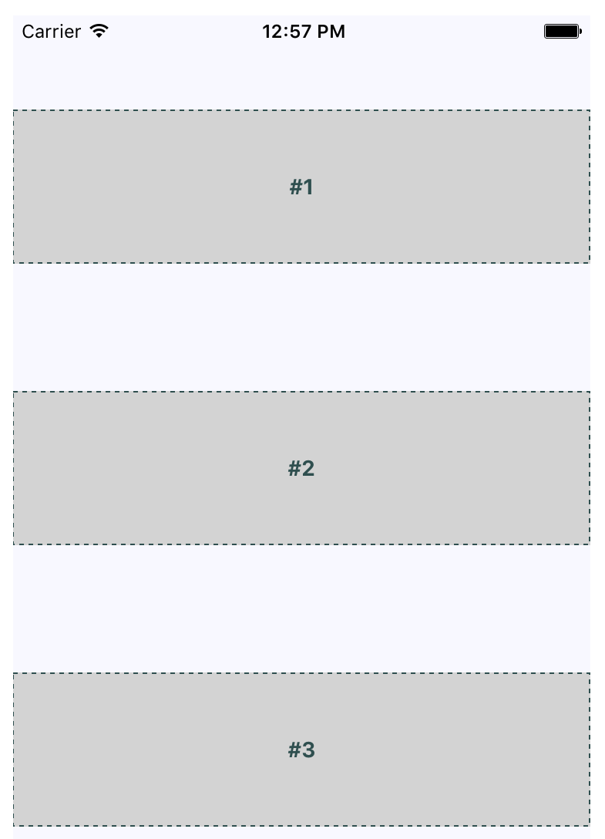
Now, each section takes the full width of the screen, which is exactly what you want to happen. The issue of wasted space was actually more prevalent in landscape orientation, so let's rotate the device and see what happens to these sections now:
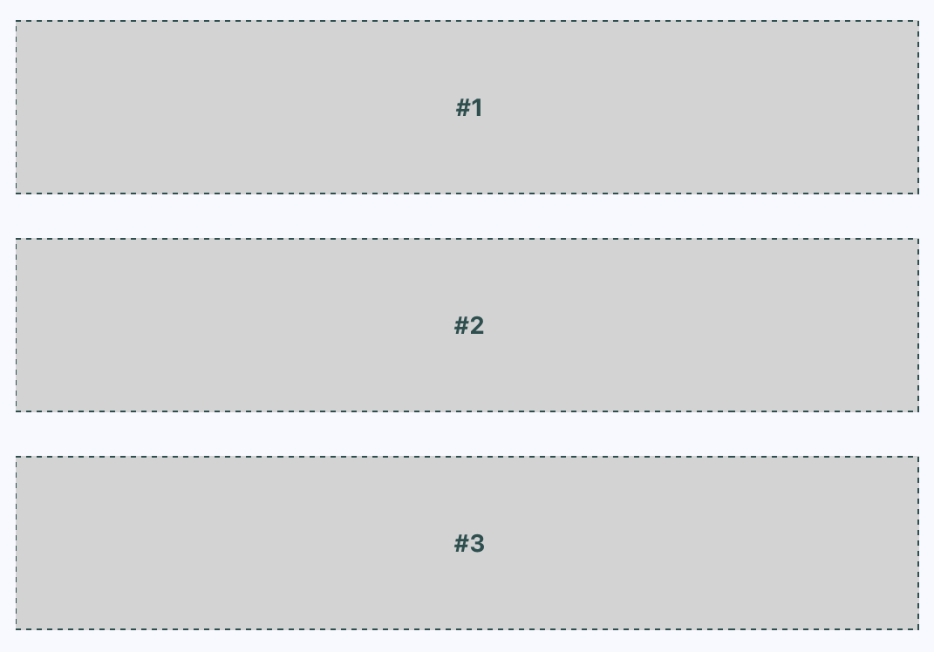
Now your layout is utilizing the entire width of the screen, regardless of orientation. Lastly, let's implement a proper Box component that can be used by App.js instead of having repetitive style properties in place. Here's what the Box component looks like:
import React from "react";
import { PropTypes } from "prop-types";
import { View, Text } from "react-native";
import styles from "./styles";
export default function Box({ children }) {
return (
<View style={styles.box}>
<Text style={styles.boxText}>{children}</Text>
</View>
);
}
Box.propTypes = {
children: PropTypes.node.isRequired
};
You now have the beginnings of a nice layout. Next, you'll learn about flexing in the other direction—left to right.

Flexible rows
In this section, you'll learn how to make screen layout sections stretch from top to bottom. To do this, you need a flexible row. Here is what the styles for this screen look like:
import { Platform, StyleSheet, StatusBar } from "react-native";
export default StyleSheet.create({
container: {
flex: 1,
flexDirection: "row",
backgroundColor: "ghostwhite",
alignItems: "center",
justifyContent: "space-around",
...Platform.select({
ios: { paddingTop: 20 },
android: { paddingTop: StatusBar.currentHeight }
})
},
box: {
width: 100,
justifyContent: "center",
alignSelf: "stretch",
alignItems: "center",
backgroundColor: "lightgray",
borderWidth: 1,
borderStyle: "dashed",
borderColor: "darkslategray"
},
boxText: {
color: "darkslategray",
fontWeight: "bold"
}
});
Here's the App component, using the same Box component that you implemented in the previous section:
import React from "react";
import { Text, View, StatusBar } from "react-native";
import styles from "./styles";
import Box from "./Box";
export default function App() {
return (
<View style={styles.container}>
<Box>#1</Box>
<Box>#2</Box>
</View>
);
}
Here's what the resulting screen looks like in portrait mode:
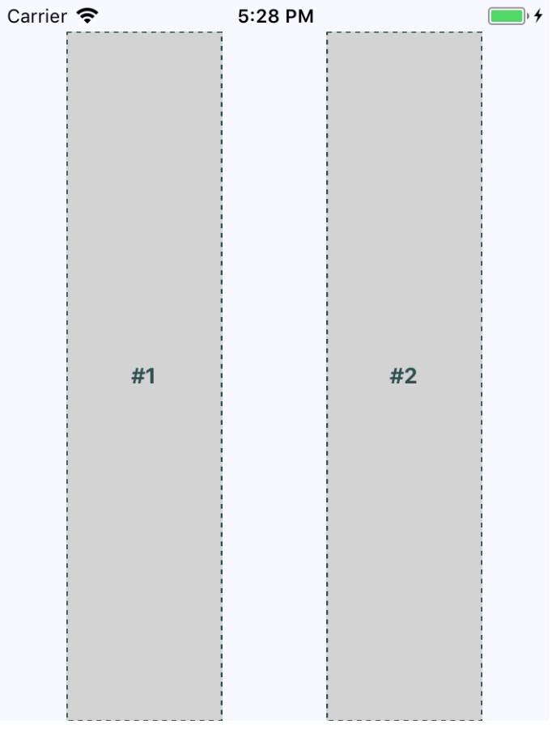
The two columns stretch all the way from the top of the screen to the bottom of the screen because of the alignSelf property, which doesn't actually specify which direction to stretch in. The two Box components stretch from top to bottom because they're displayed in a flex row. Note how the spacing between these two sections goes from left to right? This is because of the container's flexDirection property, which has a value of row.
Now, let's see how this flex direction impacts the layout when the screen is rotated to a landscape orientation:
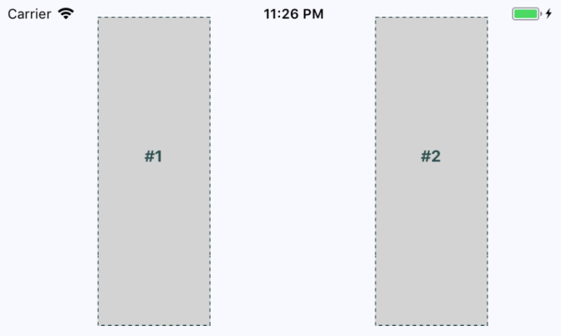
Since the Flexbox has a justifyContent style property value of space-around, space is proportionally added to the left, the right, and in between the sections. In the following section, you'll learn about flexible grids.

Flexible grids
Sometimes, you need a screen layout that flows like a grid. For example, what if you have several sections that are the same width and height, but you're not sure how many of these sections will be rendered? The Flexbox makes it easy to build a row that flows from left to right until the end of the screen is reached. Then, it automatically continues rendering elements from left to right on the next row.
Here's an example layout in portrait mode:
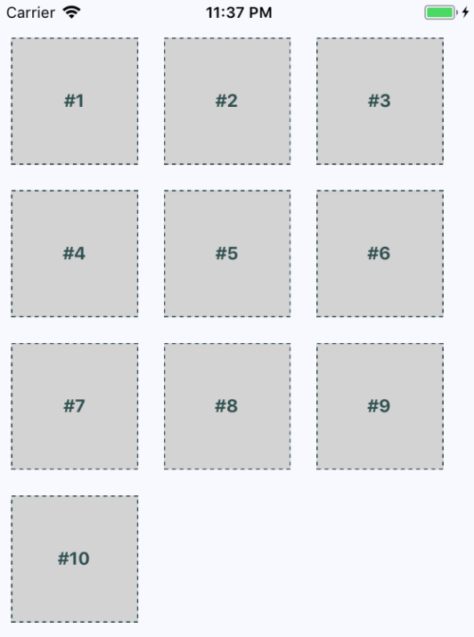
The beauty of this approach is that you don't need to know in advance how many columns are in a given row. The dimensions of each child determine what will fit in a given row. Let's take a look at the styles used to create this layout:
import { Platform, StyleSheet, StatusBar } from 'react-native';
export default StyleSheet.create({
container: {
flex: 1,
flexDirection: 'row',
flexWrap: 'wrap',
backgroundColor: 'ghostwhite',
alignItems: 'center',
...Platform.select({
ios: { paddingTop: 20 },
android: { paddingTop: StatusBar.currentHeight }
})
},
box: {
height: 100,
width: 100,
justifyContent: 'center',
alignItems: 'center',
backgroundColor: 'lightgray',
borderWidth: 1,
borderStyle: 'dashed',
borderColor: 'darkslategray',
margin: 10
},
boxText: {
color: 'darkslategray',
fontWeight: 'bold'
}
});
Here's the App component that renders each section:
import React from "react";
import { View, StatusBar } from "react-native";
import styles from "./styles";
import Box from "./Box";
const boxes = new Array(10).fill(null).map((v, i) => i + 1);
export default function App() {
return (
<View style={styles.container}>
<StatusBar hidden={false} />
{boxes.map(i => (
<Box key={i}>#{i}</Box>
))}
</View>
);
}
Lastly, let's make sure that the landscape orientation works with this layout:
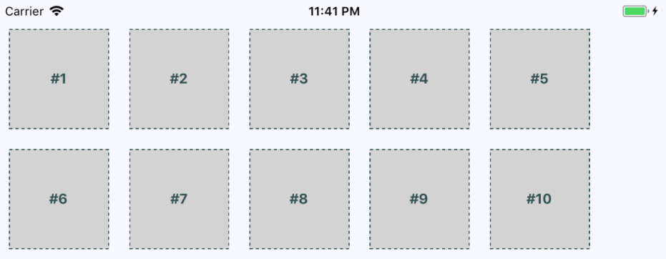
You might have noticed that there's some superfluous space on the right side. Remember, these sections are only visible in this book because we want them to be visible. In a real app, they're just grouping other React Native components. However, if the space to the right of the screen becomes an issue, play around with the margin and the width of the child components.
Now that you have an understanding of how flexible grids work, we'll look at flexible rows and columns next.

Flexible rows and columns
In this final section of the chapter, you'll learn how to combine rows and columns to create a sophisticated layout for your app. For example, sometimes, you need the ability to nest columns within rows or rows within columns. Let's take a look at the App component of an application that nests columns within rows:
import React from "react";
import { View, StatusBar } from "react-native";
import styles from "./styles";
import Row from "./Row";
import Column from "./Column";
import Box from "./Box";
export default function App() {
return (
<View style={styles.container}>
<StatusBar hidden={false} />
<Row>
<Column>
<Box>#1</Box>
<Box>#2</Box>
</Column>
<Column>
<Box>#3</Box>
<Box>#4</Box>
</Column>
</Row>
<Row>
<Column>
<Box>#5</Box>
<Box>#6</Box>
</Column>
<Column>
<Box>#7</Box>
<Box>#8</Box>
</Column>
</Row>
<Row>
<Column>
<Box>#9</Box>
<Box>#10</Box>
</Column>
<Column>
<Box>#11</Box>
<Box>#12</Box>
</Column>
</Row>
</View>
);
}
You've created abstractions for the layout pieces (<Row> and <Column>) and the content piece (<Box>). Let's see what this screen looks like:
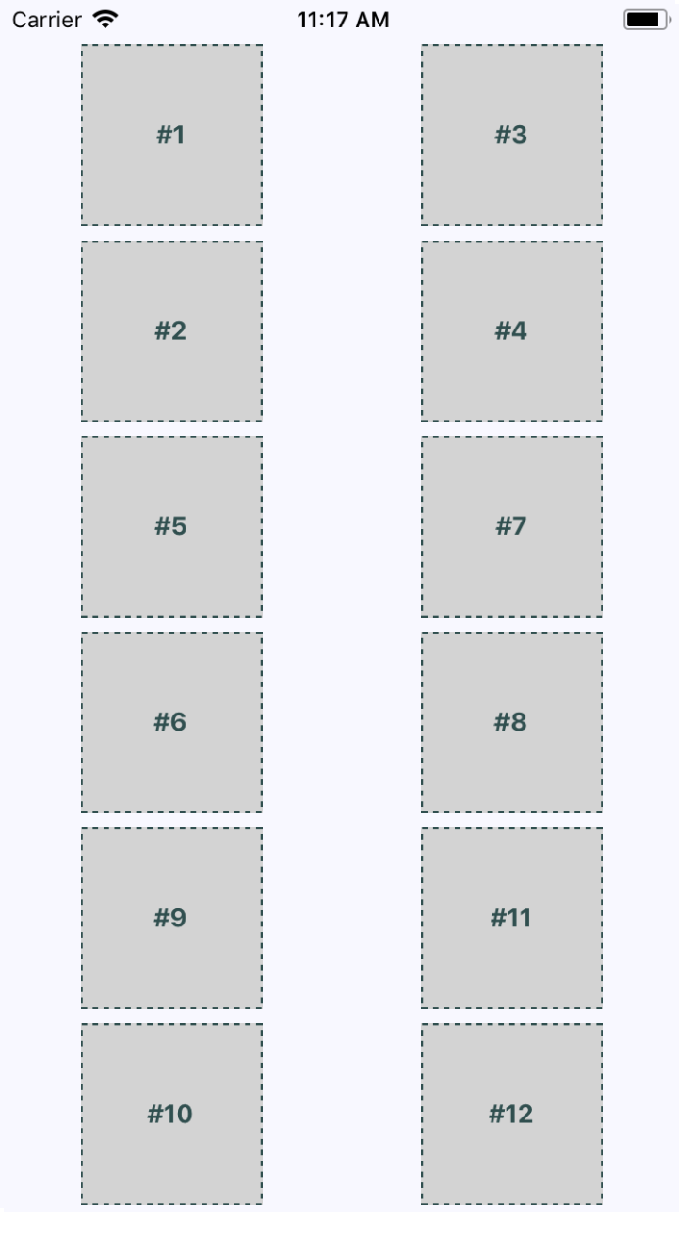
This layout probably looks familiar because you've done it already in this chapter. The key difference is in how these content sections are ordered. For example, #2 doesn't go to the left of #1, it goes below it. This is because we've placed #1 and #2 in <Column>. The same happens with #3 and #4. These two columns are placed in a row. Then, the next row begins, and so on.
This is just one of many possible layouts that you can achieve by nesting row Flexboxes and column Flexboxes. Let's take a look at the Row component now:
import React from "react";
import PropTypes from "prop-types";
import { View } from "react-native";
import styles from "./styles";
export default function Row({ children }) {
return <View style={styles.row}>{children}</View>;
}
Row.propTypes = {
children: PropTypes.node.isRequired
};
This component applies the row style to the <View> component. The end result is cleaner JSX markup in the App component when creating a complex layout. Finally, let's look at the Column component:
import React from "react";
import PropTypes from "prop-types";
import { View } from "react-native";
import styles from "./styles";
export default function Column({ children }) {
return <View style={styles.column}>{children}</View>;
}
Column.propTypes = {
children: PropTypes.node.isRequired
};
This looks just like the Row component, only with a different style applied to it. It also serves the same purpose as Row—to enable simpler JSX markup for layouts in other components.

Summary
This chapter introduced you to styles in React Native. Though you can use many of the same CSS style properties that you're used to, the CSS style sheets used in web applications look very different. Namely, they're composed of plain JavaScript objects.
Then, you learned how to work with the main React Native layout mechanism—the Flexbox. This is the preferred way to lay out most web applications these days, so it makes sense to be able to reuse this approach in a Native app. You created several different layouts, and you saw how they looked in portrait and landscape orientation.
In the next chapter, you'll start implementing navigation for your app.

Further reading
Refer to the following links for more information:
Layout with Flexbox: https://facebook.github.io/react-native/docs/Flexbox
StatusBar: https://facebook.github.io/react-native/docs/statusbar
StyleSheet: https://facebook.github.io/react-native/docs/stylesheet
Navigating Between Screens
The focus of this chapter is on navigating between the screens that make up your React Native application. Navigation in Native apps is slightly different than navigation in web apps—mainly because there isn't any notion of a URL that the user is aware of. In prior versions of React Native, there were primitive navigator components that you could use to control the navigation between screens. There were a number of challenges with these components that resulted in more code to accomplish basic navigation tasks.
More recent versions of React Native encourage you to use the react-navigation package, which will be the focus of this chapter, even though there are several other options. You'll learn about navigation basics, passing parameters to screens, changing the header content, using tab and drawer navigation, and handling state with navigation.
We'll cover the following topics in this chapter:
Navigation basics
Route parameters
The navigation header
Tab and drawer navigation
Handling state

Technical requirements
You can find the code files for this chapter on GitHub at: https://github.com/PacktPublishing/React-and-React-Native---Third-Edition/tree/master/Chapter16.

Navigation basics
Let's start off with the basics of moving from one page to another using react-navigation. Here's what the App component looks like:
import { createAppContainer } from "react-navigation";
import { createStackNavigator } from "react-navigation-stack";
import Home from "./Home";
import Settings from "./Settings";
export default createAppContainer(
createStackNavigator({ Home, Settings }, { initialRouteName: "Home" })
);
The createStackNavigator() function sets up your navigation. The first argument to this function maps to the screen components that can be navigated. The second argument is for more general navigation options—in this case, you're telling the navigator that Home should be the default screen component that's rendered. The createAppContainer() function is necessary so that the screen components get all of the navigation properties that they need.
Here's what the Home component looks like:
import React from "react";
import { View, Text, Button } from "react-native";
import styles from "./styles";
export default function Home({ navigation }) {
return (
<View style={styles.container}>
<Text>Home Screen</Text>
<Button
title="Settings"
onPress={() => navigation.navigate("Settings")}
/>
</View>
);
}
This is your typical functional React component. You could use a class-based component here, but there's no need since there are no life cycle methods or state. It renders a View component where the container style is applied. This is followed by a Text component that labels the screen followed by a Button component. A screen can be anything you want—it's just a regular React Native component. The navigator component handles the routing and the transitions between screens for you.
The onPress handler for this button navigates to the Settings screen when clicked. This is done by calling navigation.navigate('Settings'). The navigation property is passed to your screen component by react-navigation and contains all of the routing functionality you need. In contrast to working with URLs in React web apps, here you call navigator API functions and pass them the names of screens.
Let's take a look at the Settings component:
import React from "react";
import { View, Text, Button } from "react-native";
import styles from "./styles";
export default function Settings({ navigation }) {
return (
<View style={styles.container}>
<Text>Settings Screen</Text>
<Button title="Home" onPress={() => navigation.navigate("Home")} />
</View>
);
}
This component is just like the Home component, except with different text, and when the button is clicked on, you're taken back to the Home screen.
Here's what the Home screen looks like:
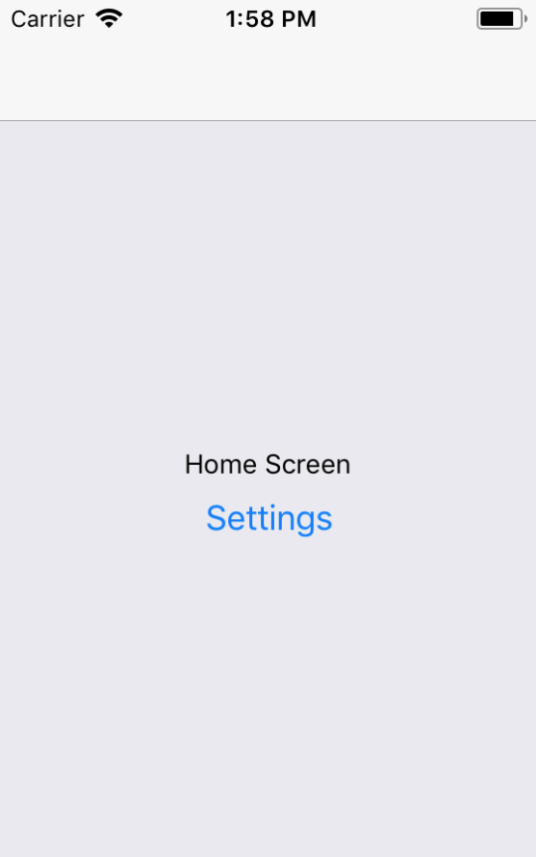
You can click the Settings button and you'll be taken to the Settings screen, which looks like this:
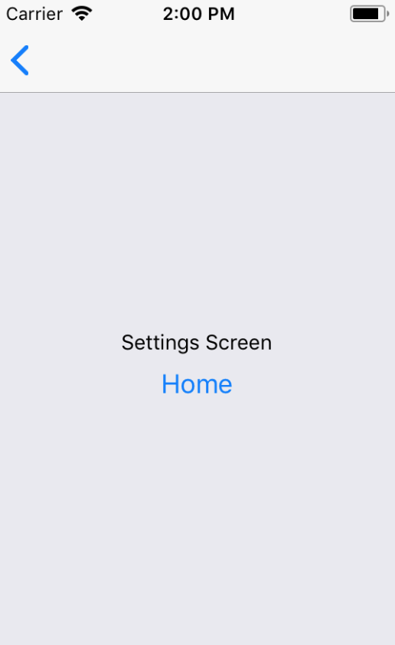
This screen looks almost identical to the Home screen. It has different text and a different button that will take you back to the Home screen when clicked. However, there's another way to get back to the Home screen. Take a look at the top of the screen, and you'll notice a white navigation bar. On the left side of the navigation bar, there's a back arrow. This works just like the back button in a web browser and will take you back to the previous screen. What's nice about react-navigation is that it takes care of rendering this navigation bar for you.
With this navigation bar in place, you don't have to worry about how your layout styles impact the status bar. You only need to worry about the layout within each of your screens.
If you run this app in Android, you'll see the same back button in the navigation bar. But you can also use the standard back button found outside of the app on most Android devices. In the next section, you'll learn how to pass parameters to your routes.

Route parameters
When you develop React web applications, some of your routes have dynamic data in them. For example, you can link to a details page and, within that URL, you'll have some sort of identifier. The component then has what it needs to render specific detailed information. The same concept exists within react-navigation. Instead of just specifying the name of the screen that you want to navigate to, you can pass along additional data.
Let's take a look at route parameters in action:
We'll start with the App component:
import { createAppContainer } from "react-navigation";
import { createStackNavigator } from "react-navigation-stack";
import Home from "./Home";
import Details from "./Details";
export default createAppContainer(
createStackNavigator({ Home, Details }, { initialRouteName: "Home" })
);
This looks just like the navigation basics example, except instead of a Settings page there's a Details page. This is the page that you want to pass data to dynamically so it can render the appropriate information.
Next, let's take a look at the Home screen component:
import React from "react";
import { View, Text, Button } from "react-native";
import styles from "./styles";
export default function Home({ navigation }) {
return (
<View style={styles.container}>
<Text>Home Screen</Text>
<Button
title="First Item"
onPress={() => navigation.navigate("Details", { title:
"First Item" })}
/>
<Button
title="Second Item"
onPress={() => navigation.navigate("Details", { title:
"Second Item" })}
/>
<Button
title="Third Item"
onPress={() => navigation.navigate("Details", { title:
"Third Item" })}
/>
</View>
);
}
The Home screen has three Button components and each navigates to the Details screen. You'll notice that, in the navigation.navigate() calls, in addition to the screen name, they each have a second argument. These arguments are objects that contain specific data that is passed to the Details screen.
Next, let's take a look at the Details screen and see how it consumes these route parameters:
import React from "react";
import { View, Text, Button } from "react-native";
import styles from "./styles";
export default function({ navigation }) {
return (
<View style={styles.container}>
<Text>{navigation.getParam("title")}</Text>
</View>
);
}
Although this example is only passing one parameter—title—you can pass as many parameters to the screen as you need to. You can access these parameters using the navigator.getParam() function to look up the value.
Here's what the Home Screen looks like when rendered:
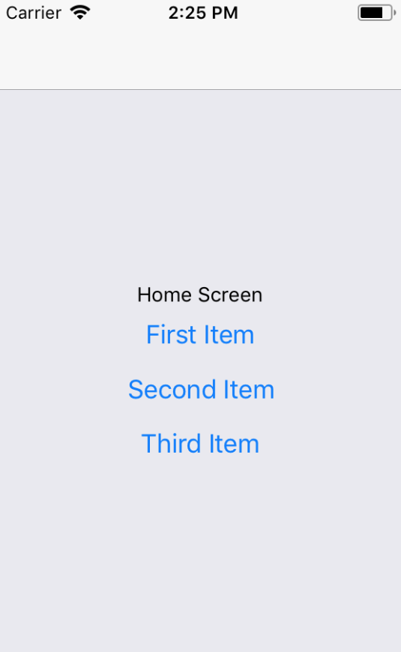
If you click on the First Item button, you'll be taken to the Details screen that is rendered using route parameter data:
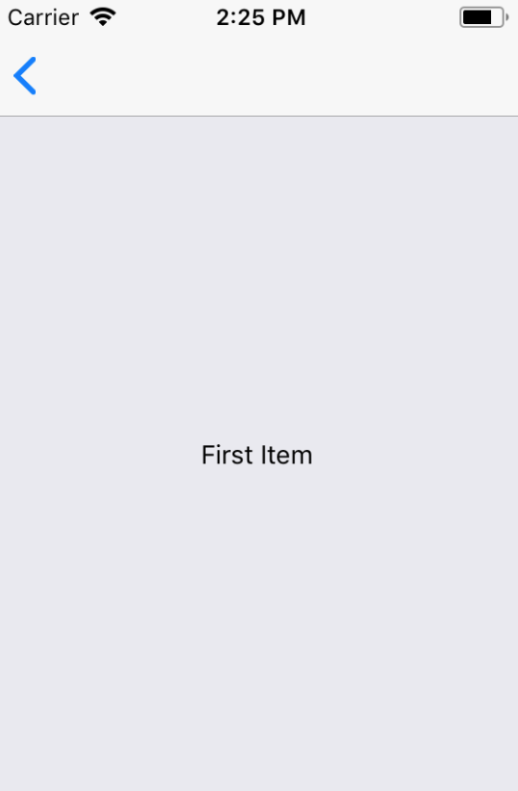
You can click the back button in the navigation bar to get back to the Home screen. If you click on any of the other buttons on the Home screen, you'll be taken back to the Details screen with updated data. Route parameters are necessary to avoid having to write duplicate components. You can think of passing parameters to navigator.navigate() as passing props to a React component. In the following section, you'll learn how to populate navigation section headers with content.

The navigation header
The navigation bars that you've created so far in this chapter have been sort of plain. That's because you haven't configured them to do anything, so react-navigation will just render a plain bar with a back button. Each screen component that you create can configure specific navigation header content.
Let's build on the previous example, which used buttons to navigate to a details page:
The App component stays the same, so let's take a look at the Home component first:
import React from "react";
import { View, Button } from "react-native";
import styles from "./styles";
export default function Home({ navigation }) {
return (
<View style={styles.container}>
<Button
title="First Item"
onPress={() =>
navigation.navigate("Details", {
title: "First Item",
content: "First Item Content",
stock: 1
})
}
/>
<Button
title="Second Item"
onPress={() =>
navigation.navigate("Details", {
title: "Second Item",
content: "Second Item Content",
stock: 0
})
}
/>
<Button
title="Third Item"
onPress={() =>
navigation.navigate("Details", {
title: "Third Item",
content: "Third Item Content",
stock: 200
})
}
/>
</View>
);
}
Home.navigationOptions = {
title: "Home"
};
The first thing you'll notice is that each button is passing more route parameters to the Details component: content and stock. You'll see why in a moment. It's the Home.navigationOptions value that configures the navigation header for you. In this case, the Home screen is setting the title.
The Home screen is a functional component, so you can just set navigationOptions as a property on the function. If your component is class-based because it has the state of lifecycle methods, you can define it as a static class property:
class MyScreen extends Component { static navigationOptions = {...} ... }
Next, let's take a look at the Details component:
import React from "react";
import { View, Text, Button } from "react-native";
import styles from "./styles";
export default function Details({ navigation }) {
return (
<View style={styles.container}>
<Text>{navigation.getParam("content")}</Text>
</View>
);
}
Details.navigationOptions = ({ navigation }) => ({
title: navigation.getParam("title"),
headerRight: (
<Button
title="Buy"
onPress={() => {}}
disabled={navigation.getParam("stock") === 0}
/>
)
});
This time, the Details component renders the content route parameter. Like the Home component, it also has a navigationOptions property. In this case, it's a function instead of an object. This is because you're dynamically changing navigation header content based on the parameters that are passed to the screen. The function is passed a navigation property – this is the same value that's passed to the Details component. You can call navigation.getParam() to get the title to change the navigation header based on a route parameter.
Next, the headerRight option is used to add a Button component to the right side of the navigation bar. This is where the stock parameter comes into play. If this value is 0 because there isn't anything in stock, you want to disable the Buy button.
Let's see how all of this works now, starting with the Home screen:
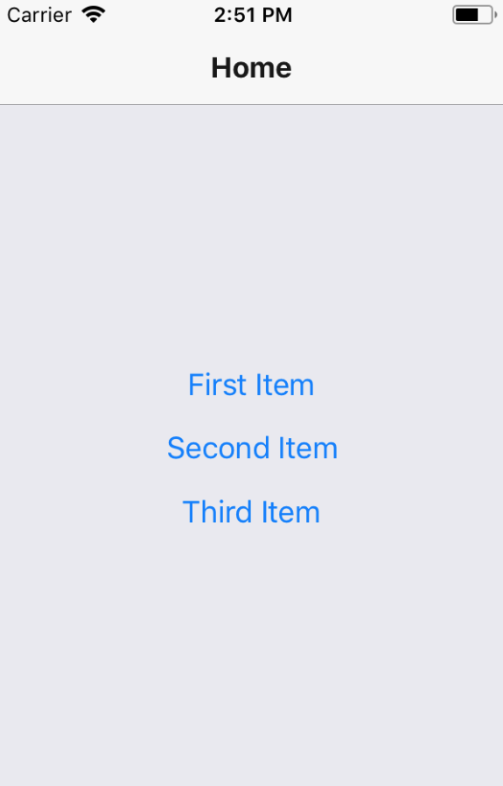
There is now header text in the navigation bar, which is set by the Home screen component.
Next, try clicking on the First Item button:
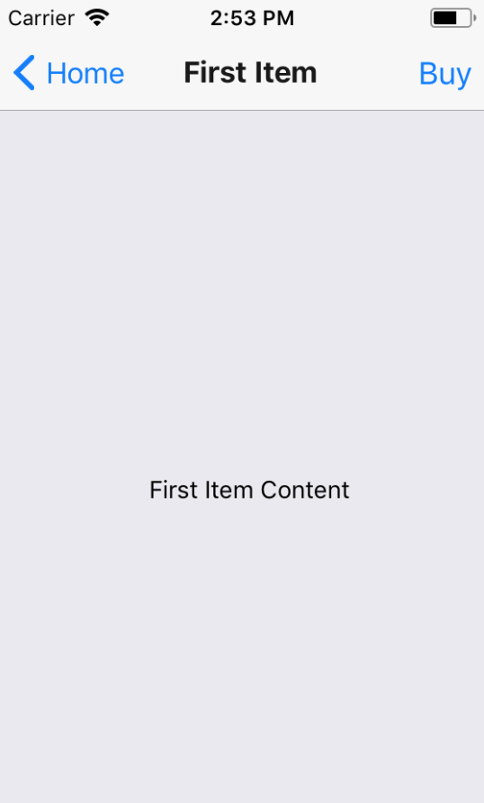
The title in the navigation bar is set based on the title parameter that's passed to the Details component. The Buy button that's rendered on the right side of the navigation bar is rendered by the Details component as well. It's enabled because the stock parameter value is 1. Now try returning to the Home screen and clicking on the Second Item button:
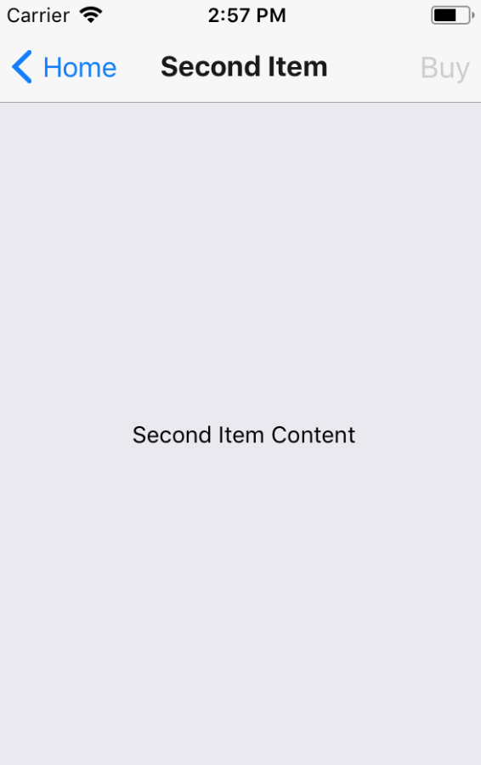
The title and the page content both reflect the new parameter values passed to Details. But so does the Buy button. It is in a disabled state because the stock parameter value was 0, meaning that it can't be bought. Now that you've learned how to use navigation headers, in the next section, you'll learn about tab and drawer navigation.

Tab and drawer navigation
So far in this chapter, each example has used Button components to link to other screens in the app. You can use functions from react-navigation that will create tab or drawer navigation for you automatically based on the screen components that you give it.
Let's create an example that uses bottom tab navigation on iOS and drawer navigation on Android.
You aren't limited to using tab navigation on iOS or drawer navigation on Android. I'm just picking these two to demonstrate how to use different modes of navigation based on the platform. You can use the exact same navigation mode on both platforms if you prefer.
Here's what the App component looks like:
import { createAppContainer } from "react-navigation";
import { createBottomTabNavigator } from "react-navigation-tabs";
import { createDrawerNavigator } from "react-navigation-drawer";
import { Platform } from "react-native";
import Home from "./Home";
import News from "./News";
import Settings from "./Settings";
const { createNavigator } = Platform.select({
ios: { createNavigator: createBottomTabNavigator },
android: { createNavigator: createDrawerNavigator }
});
export default createAppContainer(
createNavigator({ Home, News, Settings }, { initialRouteName: "Home" })
);
Instead of using the createStackNavigator() function to create your navigator, you're importing the createBottomTabNavigator() and createDrawerNavigator() functions:
import { createBottomTabNavigator } from "react-navigation-tabs";
import { createDrawerNavigator } from "react-navigation-drawer";
Then you're using the Platform utility from react-native to decide which of these two functions to use. The result, depending on the platform, is assigned to createNavigator():
const { createNavigator } = Platform.select({
ios: { createNavigator: createBottomTabNavigator },
android: { createNavigator: createDrawerNavigator }
});
Now you can call createNavigator() and pass it to your screens. The resulting tab or drawer navigation will be created and rendered for you:
createNavigator({ Home, News, Settings }, { initialRouteName: "Home" })
Next, let's take a look at the Home screen component:
import React from "react";
import { View, Text } from "react-native";
import styles from "./styles";
export default function Home({ navigation }) {
return (
<View style={styles.container}>
<Text>Home Content</Text>
</View>
);
}
Home.navigationOptions = {
title: "Home"
};
It sets the title in the navigation bar and renders some basic content. The News and Settings components are essentially the same as Home.
Here's what the bottom tab navigation looks like on iOS:
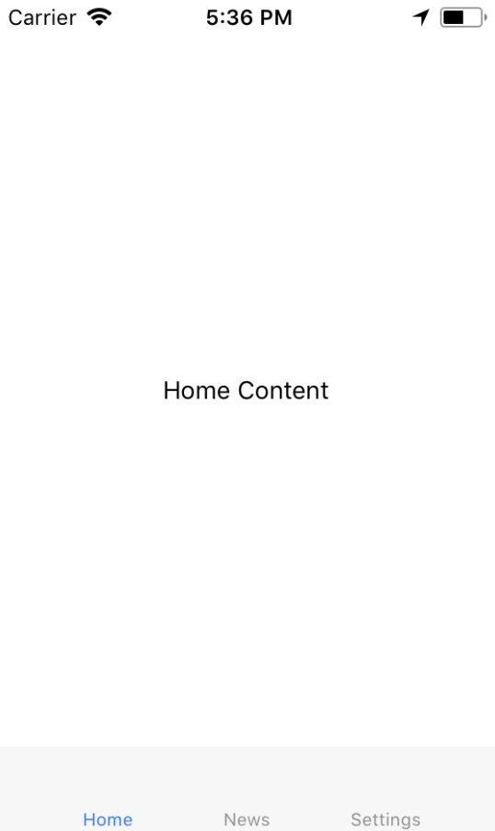
The three screens that make up your app are listed at the bottom. The current screen is marked as active, and you can click on the other tabs to move around.
Now, let's see what the drawer layout looks like on Android:
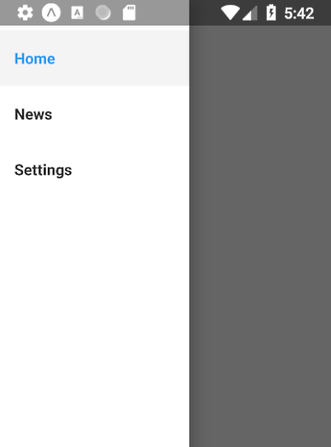
To open the drawer, you need to swipe from the left side of the screen. Once it's open, you'll see buttons that will take you to the various screens of your app.
Swiping the drawer open from the left side of the screen is the default mode. You can configure the drawer to swipe open from any direction.
Now that you've learned how to use tab and drawer navigation, you're ready to learn how to handle the application state that is shared across more than one screen in your application.

Handling state
React applications have state that gets passed down to components that render features and require state data. For example, imagine that you're designing an app that uses react-navigation and different screens depend on the same state data. How do you get state data into these screen components? How do they update the application state?
To start with, let's think about where to put your application state. The most natural place to put it would be the App component. So far in this chapter, the examples have directly exported calls to createStackNavigator(). This function is a higher-order function—it returns a new React component. This means that you can wrap your own stateful component around the navigation component that's returned by createStackNavigator().
To illustrate this idea, let's revisit the example from earlier in which you have a Home screen that lists item buttons that navigate to a Details screen. Here's what the new App component looks like:
import React, { useState } from "react";
import { createAppContainer } from "react-navigation";
import { createStackNavigator } from "react-navigation-stack";
import Home from "./Home";
import Details from "./Details";
const Nav = createAppContainer(
createStackNavigator({ Home, Details }, { initialRouteName: "Home" })
);
export default function App() {
const [stock, setStock] = useState({
first: 1,
second: 0,
third: 200
});
function updateStock(id) {
setStock({ ...stock, [id]: stock[id] === 0 ? 0 : stock[id] - 1 });
}
return <Nav screenProps={{ stock, updateStock }} />;
}
You use the createStackNavigator() and createAppContainer() functions to create your navigator component:
const Nav = createAppContainer(
createStackNavigator({ Home, Details }, { initialRouteName: "Home" })
);
Now you have a Nav component that you can render.
Next, you can create a regular React component with state:
export default function App() {
const [stock, setStock] = useState({
first: 1,
second: 0,
third: 200
});
...
return <Nav screenProps={{ stock, updateStock }} />;
}
The state used in this component represents the number quantity of each item that is available to buy.
Next, you have the updateStock() function, which is used to update the stock state for a given item ID:
function updateStock(id) {
setStock({ ...stock, [id]: stock[id] === 0 ? 0 : stock[id] - 1 });
}
The ID that's passed to this function has its stock state decremented by 1, unless it's already at 0. This function can be used when the Buy button is clicked for an item to check its stuck quantity by 1.
Finally, we can render the Nav component:
return <Nav screenProps={{ stock, updateStock }} />;
The state of App is passed to Nav as props. The updateStock() function is also passed as a prop so that it can be used by the screen components.
Now let's take a look at the Home screen:
import React from "react";
import { View, Button } from "react-native";
import styles from "./styles";
export default function Home({ navigation, screenProps: { stock } }) {
return (
<View style={styles.container}>
<Button
title={`First Item (${stock.first})`}
onPress={() =>
navigation.navigate("Details", {
id: "first",
title: "First Item",
content: "First Item Content"
})
}
/>
<Button
title={`Second Item (${stock.second})`}
onPress={() =>
navigation.navigate("Details", {
id: "second",
title: "Second Item",
content: "Second Item Content"
})
}
/>
<Button
title={`Third Item (${stock.third})`}
onPress={() =>
navigation.navigate("Details", {
id: "third",
title: "Third Item",
content: "Third Item Content"
})
}
/>
</View>
);
}
Home.navigationOptions = {
title: "Home"
};
Once again, you have the three Button components that navigate to the Details screen and pass route parameters. There's a new parameter added in this version: id. The title of each button reflects the stock count of the given item. This value is part of the application state and is passed to the screen component via properties. However, these properties are all accessed through the screenProps property.
Rule of thumb: If a prop is passed to the navigation component, it's accessible via the screenProps property. If a value is passed to the screen via navigator.navigate(), it's accessible by calling navigator.getParam().
Let's take a look at the Details component next:
import React from "react";
import { View, Text, Button } from "react-native";
import styles from "./styles";
export default function Details({ navigation }) {
return (
<View style={styles.container}>
<Text>{navigation.getParam("content")}</Text>
</View>
);
}
Details.navigationOptions = ({
navigation,
screenProps: { stock, updateStock }
}) => {
const id = navigation.getParam("id");
const title = navigation.getParam("title");
return {
title,
headerRight: (
<Button
title="Buy"
onPress={() => updateStock(id)}
disabled={stock[id] === 0}
/>
)
};
};
The id and the title route parameters are used to manipulate content in the navigation bar. The title parameter sets the title. The id is used by the onPress handler of the Buy button that passes it to updateStock(), and the appropriate item stock count is updated when the button is pressed. The disabled property also relies on the id parameter to look up the stock quantity. Just like the Home screen, the stock and updateStock() props that are passed down from the App component are accessible through the screenProps property.
Here's what the Home screen looks like when it's first rendered:
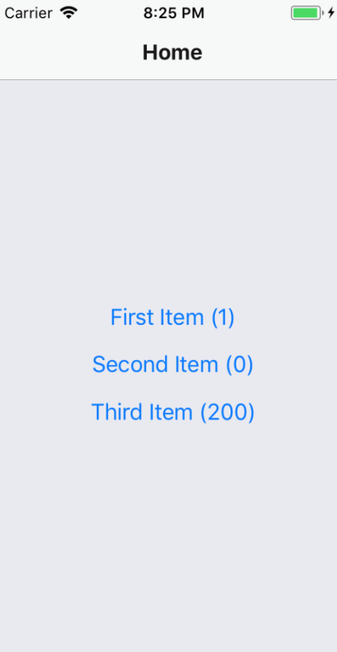
The stock quantity is reflected in each item button as a number. Let's press the First Item button and navigate to the Details page:
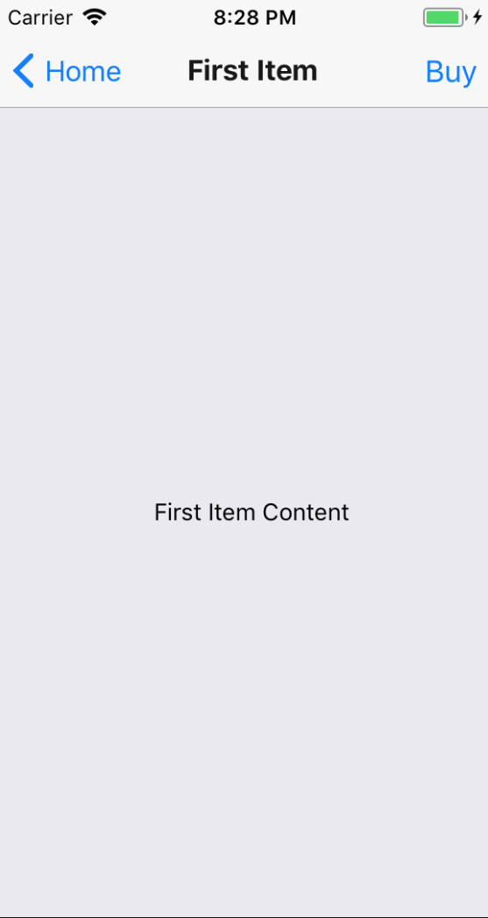
The Buy button in the navigation bar is enabled because the stock quantity is 1. Let's go ahead and press the Buy button and see what happens:
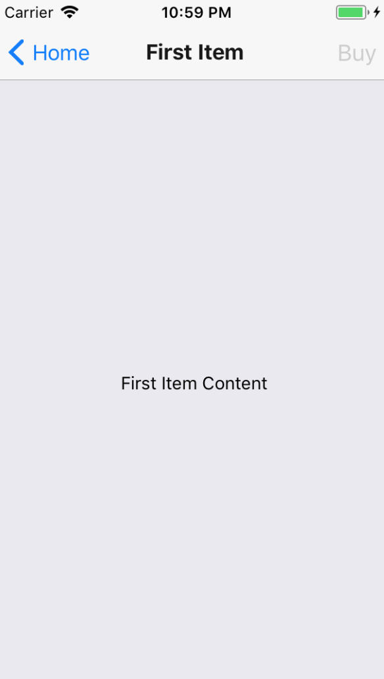
After pressing the Buy button, it becomes disabled. This is because the stock value for this item was 1. By pressing Buy, you caused the updateStock() function to be called, which updated this value to 0. As a result of the state change, the App component re-rendered the Nav component, which in turn, re-rendered your Details screen component with new prop values.
Let's go back to the Home screen and see what's changed there as a result of the state update:
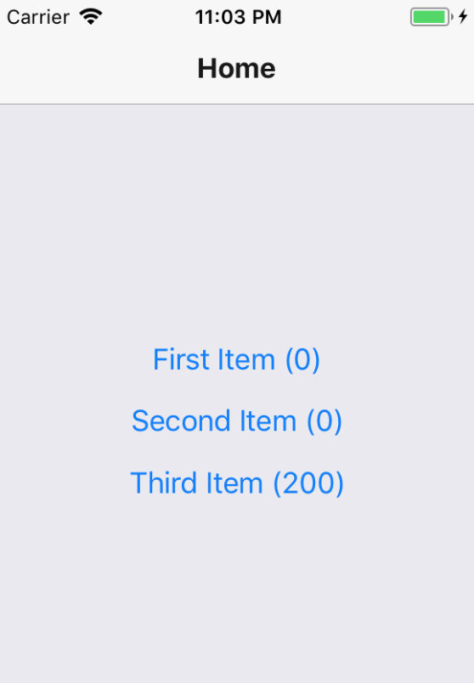
As expected, the stock quantity that is rendered beside the First Item button text is 0, reflective of the state change that just happened.
This example shows that you can have a top-level App component handle the application state while passing it down to the individual app screens, along with the functions that issue state updates.

Summary
In this chapter, you learned that mobile web applications require navigation just like web applications do. Although different, web application and mobile application navigation have enough conceptual similarities that mobile app routing and navigation doesn't have to be a nuisance.
Older versions of React Native made attempts to provide components to help manage navigation within mobile apps, but these never really took hold. Instead, the React Native community has dominated this area. One example of this is the react-navigation library, the focus of this chapter.
You learned how basic navigation works with react-navigation. You then learned how to control header components within the navigation bar. Next, you learned about tab and drawer navigation. These two navigation components can automatically render the navigation buttons for your app based on the screen components. Finally, you learned how to maintain navigation while still being able to pass state data down to screen components from the top level app.
In the next chapter, you'll learn how to render lists of data.

Further reading
Check out the following link for more information on React Navigation: https://reactnavigation.org/.
Rendering Item Lists
In this chapter, you'll learn how to work with item lists. Lists are a common web application component. While it's relatively straightforward to build lists using the <ul> and <li> elements, doing something similar on native mobile platforms is much more involved.
Thankfully, React Native provides an item list interface that hides all of the complexity. First, you'll get a feel for how item lists work by walking through an example. Then, you'll learn how to build controls that change the data displayed in lists. Lastly, you'll see a couple of examples that fetch items from the network. The following are the sections you'll find in this chapter:
Rendering data collections
Sorting and filtering lists
Fetching list data
Lazy list loading

Technical requirements
You can find the code files for this chapter on GitHub at https://github.com/PacktPublishing/React-and-React-Native---Third-Edition/tree/master/Chapter17.

Rendering data collections
Let's start with an example. The React Native component you'll use to render lists is FlatList, which works the same way on iOS and Android. List views accept a data property, which is an array of objects. These objects can have any properties you like, but they do require a key property. This is similar to the key property requirement for rendering <li> elements inside of a <ul> element. This helps the list to efficiently render when changes are made to the list data.
Let's implement a basic list now. Here's the code to render a basic 100-item list:
import React from "react";
import { Text, View, FlatList } from "react-native";
import styles from "./styles";
const data = new Array(100)
.fill(null)
.map((v, i) => ({ key: i.toString(), value: `Item ${i}` }));
export default function App() {
return (
<View style={styles.container}>
<FlatList
data={data}
renderItem={({ item }) => <Text style={styles.item}>{item.value}</Text>}
/>
</View>
);
}
Let's walk through what's going on here, starting with the data constant. This has an array of 100 items in it. It is created by filling a new array with 100 null values and then mapping this to a new array with the objects that you want to pass to <FlatList>. Each object has a key property because this is a requirement. Anything else is optional. In this case, you've decided to add a value property that will be used later on when the list is rendered.
Next, you render the <FlatList> component. It's within a <View> container because list views need height in order to make scrolling work correctly. The data and renderItem properties are passed to <FlatList>, which ultimately determines the rendered content.
At first glance, it would seem that the FlatList component doesn't do too much. Do you have to figure out how the items look? Well, yes, the FlatList component is supposed to be generic. It's supposed to excel at handling updates and embeds scrolling capabilities into lists for us. Here are the styles that were used to render the list:
import { StyleSheet } from "react-native";
export default StyleSheet.create({
container: {
flex: 1,
flexDirection: "column",
paddingTop: 20
},
item: {
margin: 5,
padding: 5,
color: "slategrey",
backgroundColor: "ghostwhite",
textAlign: "center"
}
});
Here, you're styling each item in your list. Otherwise, each item would be text-only and it would be difficult to differentiate between other list items. The container style gives the list height by setting flexDirection to column. Without height, you won't be able to scroll properly.
Let's see what this thing looks like now:
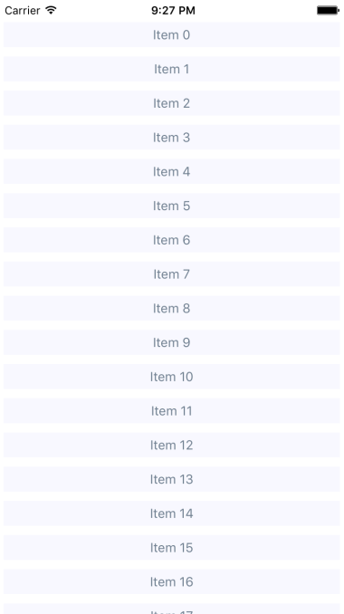
If you're running this example in a simulator, you can click and hold down the mouse button anywhere on the screen, like a finger, then scroll up or down through the items.
In the following section, you'll learn how to add controls for sorting and filtering lists.

Sorting and filtering lists
Now that you have learned the basics of FlatList components, including how to pass data, let's add some controls to the list that you just implemented in the Rendering data collections section. The FlatList component helps you render fixed-position content for list controls. You'll also see how to manipulate the data source, which ultimately drives what's rendered on the screen.
Before implementing list control components, it might be helpful to review the high-level structure of these components so that the code has more context. Here's an illustration of the component structure that you're going to implement:
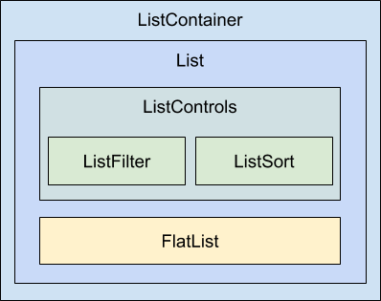
Here's what each of these components is responsible for:
ListContainer: The overall container for the list; it follows the familiar React container pattern
List: A stateless component that passes the relevant pieces of state intoListControls and the React Native ListView component
ListControls: A component that holds the various controls that change the state of the list
ListFilter: A control for filtering the item list
ListSort: A control for changing the sort order of the list
FlatList: The actual React Native component that renders items
In some cases, splitting apart the implementation of a list like this is overkill. However, I think that, if your list needs controls in the first place, you're probably implementing something that will stand to benefit from having a well-thought-out component architecture.
Now, let's drill down into the implementation of this list, starting with the ListContainer component:
import React, { useState, useEffect } from "react";
import List from "./List";
function mapItems(items) {
return items.map((value, i) => ({ key: i.toString(), value }));
}
function filterAndSort(data, text, asc) {
return data
.
filter((i)
=> text.length === 0 || i.includes(text))
.sort(
asc
? (a, b) => (b > a ? -1 : a === b ? 0 : 1)
: (a, b) => (a > b ? -1 : a === b ? 0 : 1)
);
}
export default function ListContainer() {
const [asc, setAsc] = useState(true);
const [filter, setFilter] = useState("");
const [data, setData] = useState(
filterAndSort(new Array(100).fill(null).map((v, i) => `Item ${i}`),
""
)
);
return (
<List
data={mapItems(data)}
asc={asc}
onFilter={text => {
setFilter(text);
setData(filterAndSort(data, text, asc));
}}
onSort={() => {
setAsc(!asc);
setData(filterAndSort(data, filter, asc));
}}
/>
);
}
If this seems like a bit much, it's because it is. This container component has a lot of state to handle. It also has some nontrivial behavior that it needs to make available to its children. If you look at it from the perspective of an encapsulating state, it will be more approachable. Its job is to populate the list with state data and provide functions that operate on this state.
In an ideal world, the child components of this container should be nice and simple since they don't have to directly interface with the state. Let's take a look at the List component next:
import React from "react";
import PropTypes from "prop-types";
import { Text, FlatList } from "react-native";
import styles from "./styles";
import ListControls from "./ListControls";
export default function List({ Controls, data, onFilter, onSort, asc }) {
return (
<FlatList
data={data}
ListHeaderComponent={<Controls {...{ onFilter, onSort, asc }} />}
renderItem={({ item }) => <Text
style={styles.item}>{item.value}</Text>}
/>
);
}
List.propTypes = {
Controls: PropTypes.func.isRequired,
data: PropTypes.array.isRequired,
onFilter: PropTypes.func.isRequired,
onSort: PropTypes.func.isRequired,
asc: PropTypes.bool.isRequired
};
List.defaultProps = {
Controls: ListControls
};
This component takes the state from the ListContainer component as properties and renders a FlatList component. The main difference here, relative to the previous example, is the ListHeaderComponent property. This renders the controls for your List. What's especially useful about this property is that it renders the controls outside the scrollable list content, ensuring that the controls are always visible.
Also, notice that you're specifying your own ListControls component as a default value for the controls property. This makes it easy for others to pass in their own list controls. Let's take a look at the ListControls component next:
import React from "react";
import PropTypes from "prop-types";
import { View } from "react-native";
import styles from "./styles";
import ListFilter from "./ListFilter";
import ListSort from "./ListSort";
export default function ListControls({ onFilter, onSort, asc }) {
return (
<View style={styles.controls}>
<ListFilter onFilter={onFilter} />
<ListSort onSort={onSort} asc={asc} />
</View>
);
}
ListControls.propTypes = {
onFilter: PropTypes.func.isRequired,
onSort: PropTypes.func.isRequired,
asc: PropTypes.bool.isRequired
};
This component brings together the ListFilter and ListSort controls. So, if you were to add another list control, you would add it here. Let's take a look at the ListFilter implementation now:
import React from "react";
import PropTypes from "prop-types";
import { View, TextInput } from "react-native";
import styles from "./styles";
export default function ListFilter({ onFilter }) {
return (
<View>
<TextInput
autoFocus
placeholder="Search"
style={styles.filter}
onChangeText={onFilter}
/>
</View>
);
}
ListFilter.propTypes = {
onFilter: PropTypes.func.isRequired
};
The filter control is a simple text input that filters the list of items by user type. The onChange function that handles this comes from the ListContainer component.
Let's look at the ListSort component next:
import React from "react";
import PropTypes from "prop-types";
import { Text } from "react-native";
const arrows = new Map([[true, "▼"], [false, "▲"]]);
export default function ListSort({ onSort, asc }) {
return <Text onPress={onSort}>{arrows.get(asc)}</Text>;
}
ListSort.propTypes = {
onSort: PropTypes.func.isRequired,
asc: PropTypes.bool.isRequired
};
Here's a look at the resulting list:
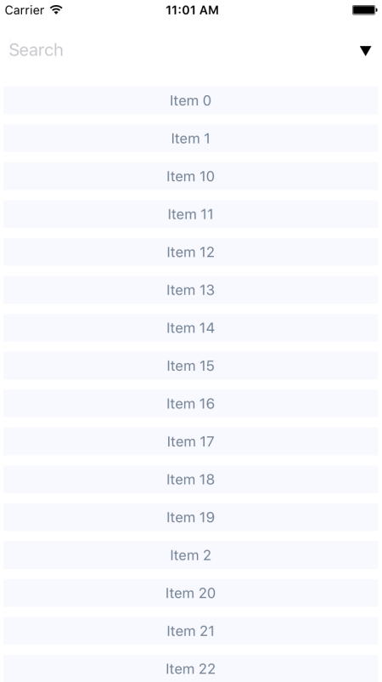
By default, the entire list is rendered in ascending order. You can see the placeholder text Search when the user hasn't provided anything yet. Let's see how this looks when you enter a filter and change the sort order:
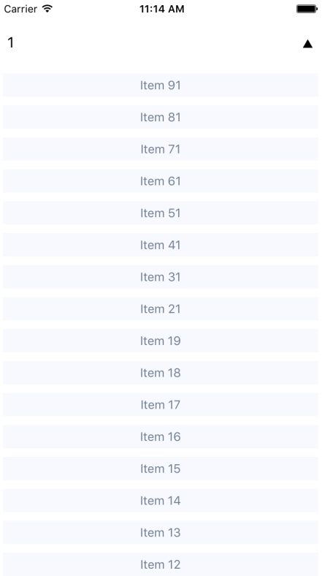
This search includes items with a 1 and sorts the results in descending order. Note that you can either change the order first or enter the filter first. Both the filter and the sort order are part of the ListContainer state.
In the next section, you'll learn how to fetch list data from an API endpoint.

Fetching list data
Often, you'll fetch your list data from some API endpoint. In this section, you'll learn about making API requests from React Native components. The good news is that the fetch() API is polyfilled by React Native, so the networking code in your mobile applications should look and feel a lot like it does in your web applications.
To start things off, let's build a mock API for our list items using functions that return promises just like fetch() does:
const items = new Array(100).fill(null).map((v, i) => `Item ${i}`);
function filterAndSort(data, text, asc) {
return data
.filter(i => text.length === 0 || i.includes(text))
.sort(
asc
? (a, b) => (b > a ? -1 : a === b ? 0 : 1)
: (a, b) => (a > b ? -1 : a === b ? 0 : 1)
);
}
export function fetchItems(filter, asc) {
return new Promise(resolve => {
resolve({
json: () =>
Promise.resolve({
items: filterAndSort(items, filter, asc)
})
});
});
}
With the mock API function in place, let's make some changes to the list container component. Instead of using local data sources, you can now use the fetchItems() function to load data from the API mock:
import React, { useState, useEffect } from "react";
import { fetchItems } from "./api";
import List from "./List";
function mapItems(items) {
return items.map((value, i) => ({ key: i.toString(), value }));
}
export default function ListContainer() {
const [asc, setAsc] = useState(true);
const [filter, setFilter] = useState("");
const [data, setData] = useState([]);
useEffect(() => {
fetchItems(filter, asc)
.then(resp => resp.json())
.then(({ items }) => {
setData(mapItems(items));
});
}, []);
return (
<List
data={data}
asc={asc}
onFilter={text => {
fetchItems(text, asc)
.then(resp => resp.json())
.then(({ items }) => {
setFilter(text);
setData(mapItems(items));
});
}}
onSort={() => {
fetchItems(filter, !asc)
.then(resp => resp.json())
.then(({ items }) => {
setAsc(!asc);
setData(mapItems(items));
});
}}
/>
);
}
Any action that modifies the state of the list needs to call fetchItems() and set the appropriate state once the promise resolves. In the following section, you'll learn how list data can be loaded lazily.

Lazy list loading
In this section, you'll implement a different kind of list—one that scrolls infinitely. Sometimes, users don't actually know what they're looking for, so filtering or sorting isn't going to help. Think about the Facebook news feed you see when you log into your account; it's the main feature of the application and rarely are you looking for something specific. You need to see what's going on by scrolling through the list.
To do this using a FlatList component, you need to be able to fetch more API data when the user scrolls to the end of the list. To get an idea of how this works, you need a lot of API data to work with. Generators are great at this! So let's modify the mock that you created in the Fetching list data example so that it just keeps responding with new data:
function* genItems() {
let cnt = 0;
while (true) {
yield `Item ${cnt++}`;
}
}
const items = genItems();
export function fetchItems() {
return Promise.resolve({
json: () =>
Promise.resolve({
items: new Array(20).fill(null).map(() => items.next().value)
})
});
}
With this in place, you can now make an API request for new data every time the end of the list is reached. Well, eventually this will fail when you run out of memory, but I'm just trying to show you in general terms the approach you can take to implement infinite scrolling in React Native. Here's what the ListContainer component looks like:
import React, { useState, useEffect } from "react";
import * as api from "./api";
import List from "./List";
export default function ListContainer() {
function fetchItems() {
return api
.fetchItems()
.then(resp => resp.json())
.then(({ items }) => {
setData(
items.map((value, i) => ({
key: i.toString(),
value
}))
);
});
}
const [data, setData] = useState([]);
const [asc, setAsc] = useState(true);
const [filter, setFilter] = useState("");
useEffect(() => {
fetchItems();
}, []);
return <List data={data} fetchItems={fetchItems} />;
}
Each time fetchItems() is called, the response is concatenated with the data array. This becomes the new list data source, instead of replacing it as you did in earlier examples. Now, let's take a look at the List component to see how to respond to the end of the list having been reached:
import React from "react";
import PropTypes from "prop-types";
import { Text, FlatList } from "react-native";
import styles from "./styles";
export default function List({ data, fetchItems }) {
return (
<FlatList
data={data}
renderItem={({ item }) => <Text style={styles.item}>{item.value}</Text>}
onEndReached={fetchItems}
/>
);
}
List.propTypes = {
data: PropTypes.array.isRequired,
fetchItems: PropTypes.func.isRequired
};
If you run this example, you'll see that, as you approach the bottom of the screen while scrolling, the list just keeps growing.

Summary
In this chapter, you learned about the FlatList component in React Native. This component is general-purpose in that it doesn't impose any specific look for items that get rendered. Instead, the appearance of the list is up to you, while the FlatList component helps with efficiently rendering a data source. The FlatList component also provides a scrollable region for the items it renders.
You implemented an example that took advantage of section headers in list views. This is a good place to render static content such as list controls. You then learned about making network calls in React Native; it's just like using fetch() in any other web application. Finally, you implemented lazy lists that scroll infinitely by only loading new items after they've scrolled to the bottom of what's already been rendered.
In the next chapter, you'll learn how to show the progress of things such as network calls.

Further reading
Take a look at the following link for more information on FlatList: https://facebook.github.io/react-native/docs/flatlist
Showing Progress
This chapter is all about communicating progress to the user. React Native has different components that are used to handle the different types of progress that you want to communicate. First, you'll learn why you need to communicate progress like this in the first place. Then, you'll learn how to implement progress indicators and progress bars. After that, you'll see specific examples that show you how to use progress indicators with navigation while data loads, and how to use progress bars to communicate the current position in a series of steps.
The following sections are covered in this chapter:
Progress and usability
Indicating progress
Measuring progress
Navigation indicators
Step progress

Technical requirements
You can find the code files for this chapter on GitHub at https://github.com/PacktPublishing/React-and-React-Native---Third-Edition/tree/master/Chapter18.

Progress and usability
Imagine that you have a microwave oven that has no window and makes no sound. The only way to interact with it is by pressing a button labeled Cook. As absurd as this device sounds, it's what many software users are faced with – there's no indication of progress. Is the microwave cooking anything? If so, how do we know when it will be done?
One way to improve the microwave situation is to add sound. This way, the user gets feedback after pressing the Cook button. You've overcome one hurdle, but the user is still left guessing, "where's my food?". Before you go out of business, you had better add some sort of progress measurement display, such as a timer.
It's not that UI programmers don't understand the basic principles of this usability concern; it's just that we have stuff to do and this sort of thing simply slips through the cracks in terms of priority. In React Native, there are components for giving the user indeterminate progress feedback, and for giving precise progress measurements. It's always a good idea to make these things a top priority if you want a good user experience.
Now that you understand the role of progress in usability, it's time to learn how to indicate progress in your React Native UIs.

Indicating progress
In this section, you'll learn how to use the ActivityIndicator component. As its name suggests, you render this component when you need to indicate to the user that something is happening. The actual progress may be indeterminate, but at least you have a standardized way to show that something is happening, despite there being no results to display yet.
Let's create an example so that you can see what this component looks like. Here's the App component:
import React from "react";
import { View, ActivityIndicator } from "react-native";
import styles from "./styles";
export default function App() {
return (
<View style={styles.container}>
<ActivityIndicator size="large" />
</View>
);
}
The <ActivityIndicator> component is platform agnostic. Here's how it looks on iOS:

It renders an animated spinner in the middle of the screen. This is the large spinner, as specified in the size property. The ActivityIndicator spinner can also be small, which makes more sense if you're rendering it inside another smaller element. Now, let's take a look at how this looks on an Android device:
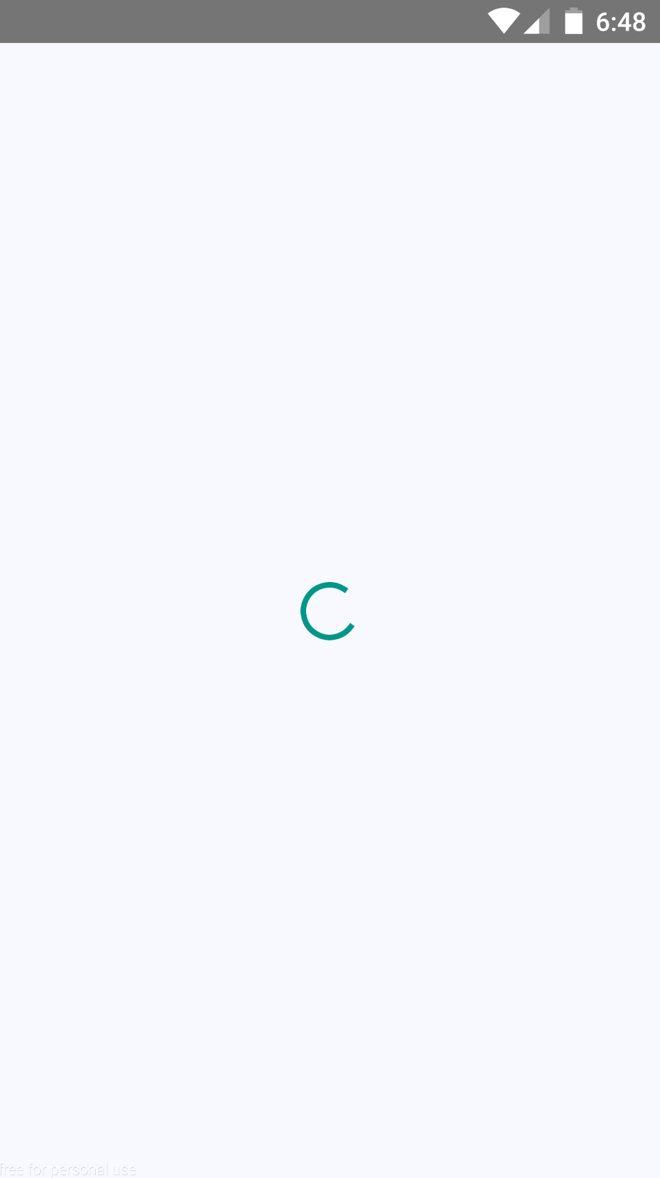
The spinner looks different, as it should, but your app conveys the same thing on both platforms – you're waiting for something.
This example just spins forever. Don't worry – there's a more realistic progress indicator example coming up that shows you how to work with navigation and loading API data.

Measuring progress
The downside of indicating that progress is being made is that there's no end in sight for the user. This leads to a feeling of unease, like when you're waiting for food in a microwave with no timer. When you know how much progress has been made, and how much is left to go, you feel better. This is why it's always better to use a deterministic progress bar whenever possible.
Unlike the ActivityIndicator component, there's no platform-agnostic component in React Native for progress bars. So, we'll have to make one ourselves. We'll create a component that uses ProgressViewIOS on iOS and ProgressBarAndroid on Android:
Let's handle the cross-platform issues first. React Native knows to import the correct module based on its file extension. Here's what the ProgressBarComponent.ios.js module looks like:
export { ProgressViewIOS as ProgressBarComponent } from "react-native";
export const progressProps = {};
You're directly exporting the ProgressViewIOS component from React Native. You're also exporting properties for the component that are specific to the platform. In this case, it's an empty object because there are no properties that are specific to <ProgressViewIOS>.
Now, let's take a look at the ProgressBarComponent.android.js module:
export { ProgressBarAndroid as ProgressBarComponent } from "react-native";
export const progressProps = {
styleAttr: "Horizontal",
indeterminate: false
};
This module uses the exact same approach as the ProgressBarComponent.ios.js module. It exports the Android-specific component, as well as the Android-specific properties to pass to it.
Now, let's build the ProgressBar component that the application will use:
import React from "react";
import PropTypes from "prop-types";
import { View, Text } from "react-native";
import styles from "./styles";
import { ProgressBarComponent, progressProps } from "./ProgressBarComponent";
function ProgressLabel({ show, progress }) {
return (
show && (
<Text style={styles.progressText}>{Math.round(progress *
100)}%</Text>
)
);
}
export default function ProgressBar({ progress, label }) {
return (
<View style={styles.progress}>
<ProgressLabel show={label} progress={progress} />
<ProgressBarComponent
{...progressProps}
style={styles.progress}
progress={progress}
/>
</View>
);
}
ProgressBar.propTypes = {
progress: PropTypes.number.isRequired,
label: PropTypes.bool.isRequired
};
ProgressBar.defaultProps = {
progress: 0,
label: true
};
Let's walk through what's going on in this module, starting with the imports. The ProgressBarComponent and progressProps values are imported from our ProgressBarComponent module. React Native determines which module to import these from.
Next, you have the ProgressLabel utility component. It figures out what label is rendered for the progress bar based on the show property. If it's false, nothing is rendered. If it's true, it renders a <Text> component that displays the progress as a percentage.
Lastly, you have the ProgressBar component itself, which our application will import and use. This renders the label and the appropriate progress bar component. It takes a progress property, which is a value between 0 and 1. Now, let's put this component to use in the App component:
import React, { useState, useEffect } from "react";
import { View } from "react-native";
import styles from "./styles";
import ProgressBar from "./ProgressBar";
export default function MeasuringProgress() {
const [progress, setProgress] = useState(0);
useEffect(() => {
function updateProgress() {
setProgress(currentProgress => {
if (currentProgress < 1) {
setTimeout(updateProgress, 300);
}
return currentProgress + 0.01;
});
}
updateProgress();
}, []);
return (
<View style={styles.container}>
<ProgressBar progress={progress} />
</View>
);
}
Initially, the <ProgressBar> component is rendered at 0%. In the useEffect() hook, the updateProgress() function uses a timer to simulate a real process that you want to show progress for. Here's what the iOS screen looks like:
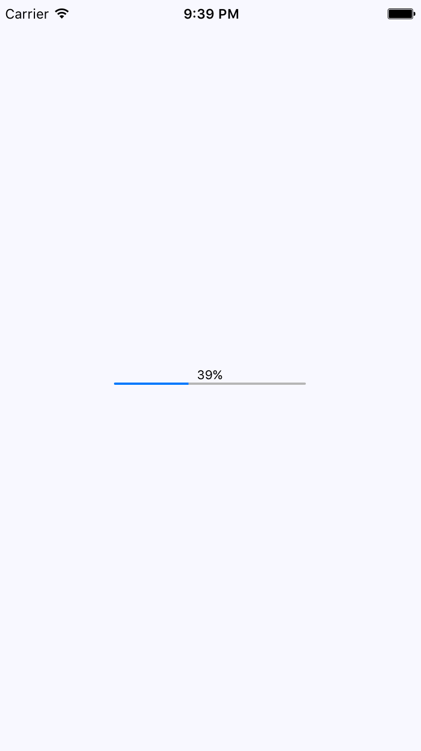
Here's what the same progress bar looks like on Android:
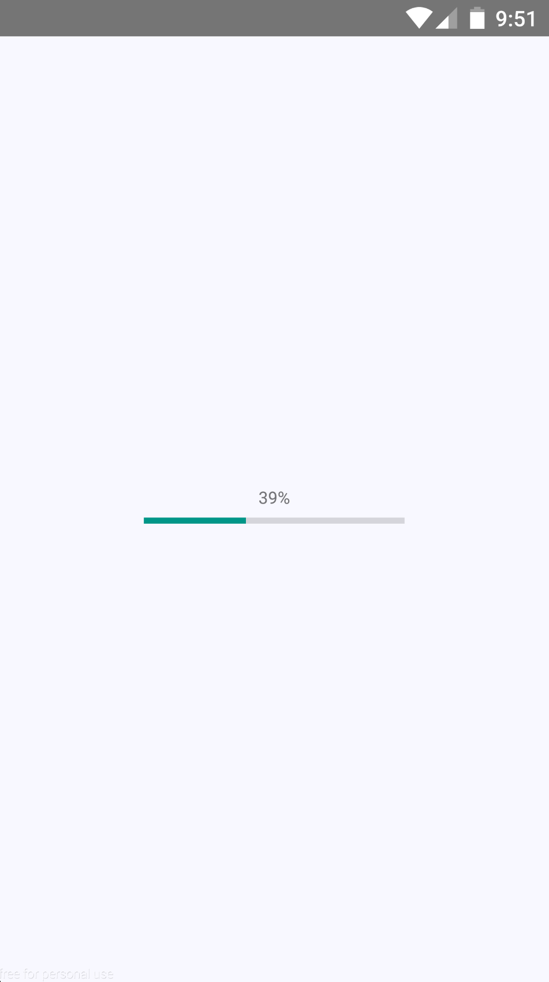
Showing a quantitative measure of progress is important so that users can gauge how long something will take. In the next section, you'll learn how to use progress indicators to show the user where they are in terms of navigating screens.

Navigation indicators
Earlier in this chapter, you were introduced to the ActivityIndicator component. In this section, you'll learn how it can be used when navigating an application that loads data. For example, the user navigates from page (screen) one to page two. However, page two needs to fetch data from the API that it can display to the user. So, while this network call is happening, it makes more sense to display a progress indicator instead of a screen devoid of useful information.
Doing this is actually kind of tricky because you have to make sure that the data that's required by the screen is fetched from the API each time the user navigates to the screen. Your goals should be as follows:
Have the Navigator component automatically fetch API data for the scene that's about to be rendered.
Use the promise that's returned by the API call as a means to display the spinner and hide it once the promise has been resolved.
Since your components probably don't care about whether or not a spinner is displayed, let's implement this as a generic higher-order component:
import React, { useState, useEffect } from "react";
import { View, ActivityIndicator } from "react-native";
import styles from "./styles";
export default function loading(Wrapped) {
return function LoadingWrapper(props) {
const [loading, setLoading] = useState(true);
useEffect(() => {
props.promise.then(() => setLoading(false), () => setLoading(false));
}, []);
if (loading) {
return (
<View style={styles.container}>
<ActivityIndicator size="large" />
</View>
);
} else {
return <Wrapped {...props} />;
}
};
}
This loading() function takes a component – the Wrapped argument – and returns a LoadingWrapper component. The returned wrapper accepts a promise property, and when it resolves or rejects, it changes the loading state to false. As you can see in the render() method, the loading state determines whether the spinner or the Wrapped component is rendered.
With the loading() higher-order function in place, let's take a look at the first screen component that you'll use with react-navigation:
import React from "react";
import { View, Text } from "react-native";
import styles from "./styles";
import loading from "./loading";
const First = loading(({ navigation }) => (
<View style={styles.container}>
<Text style={styles.item} onPress={() =>
navigation.navigate("Second")}>
Second
</Text>
<Text style={styles.item} onPress={() => navigation.navigate("Third")}>
Third
</Text>
</View>
));
export default First;
This module exports a component that's wrapped with the loading() function we created earlier. It wraps the First component so that a spinner is displayed while the promise property is pending. The last step is getting that promise into the component whenever the user navigates to a given page. This happens in the route configuration in the App component:
import React from "react";
import { createAppContainer } from "react-navigation";
import { createStackNavigator } from "react-navigation-stack";
import First from "./First";
import Second from "./Second";
import Third from "./Third";
export default createAppContainer(
createStackNavigator(
{
First: {
screen: props => (
<First
promise={new Promise(resolve => setTimeout(resolve, 1000))}
{...props}
/>
)
},
Second: {
screen: props => (
<Second
promise={new Promise(resolve => setTimeout(resolve, 1000))}
{...props}
/>
)
},
Third: {
screen: props => (
<Third
promise={new Promise(resolve => setTimeout(resolve, 1000))}
{...props}
/>
)
}
},
{ initialRouteName: "First" }
)
);
Instead of just passing the screen components directly to the router config argument of createStackNavigator(), you're passing an object for each screen. The screen property allows you to provide the actual screen component to render. In this case, you're passing it a promise property by calling an API function that resolves data needed by the component. This is how the loading() function is able to display a spinner while waiting for the promise to resolve. The first screen doesn't have to worry about displaying a loading screen.

Step progress
In this final example, you'll build an app that displays the user's progress through a predefined number of steps. For example, it might make sense to split a form into several logical sections and organize them in such a way that, as the user completes one section, they move to the next step. A progress bar would be helpful feedback for the user.
You'll insert a progress bar into the navigation bar, just below the title, so that the user knows how far they've gone and how far is left to go. You'll also reuse the ProgressBar component that you implemented earlier in this chapter.
Let's take a look at the result first. There are four screens in this app that the user can navigate to. Here's what the first page (scene) looks like:

The progress bar under the title reflects the fact that the user is 25% through the navigation. Let's see what the third screen looks like:

The progress is updated to reflect where the user is in the route stack. Let's take a look at the App component:
import React from "react";
import { createAppContainer } from "react-navigation";
import { createStackNavigator } from "react-navigation-stack";
import First from "./First";
import Second from "./Second";
import Third from "./Third";
import Fourth from "./Fourth";
const routes = [First, Second, Third, Fourth];
export default createAppContainer(
createStackNavigator(
routes.reduce(
(result, route) => ({
...result,
[route.name]: route
}),
{}
),
{
initialRouteName: "First",
initialRouteParams: {
progress: route =>
(routes.map(r => r.name).indexOf(route) + 1) / routes.length
}
}
)
);
This app has four screens. The components that render each of these screens are stored in the routes constant, which is then used to configure the stack navigator using createStackNavigator(). The reason for creating the routes array is so that it can be used by the progress() function that is passed to the initial route (First) as a route parameter. This function takes the current route name as an argument and looks up its index position in routes. For example, Second is in the number 2 position (index of 1 + 1) and the length of the array is 4. This will set the progress bar to 50%.
Let's see how the progress function is used by the First component:
import React from "react";
import { View, Text } from "react-native";
import styles from "./styles";
import ProgressBar from "./ProgressBar";
export default function First() {
return (
<View style={styles.container}>
<Text style={styles.content}>First Content</Text>
</View>
);
}
First.navigationOptions = ({ navigation }) => ({
headerTitle: (
<View style={styles.progress}>
<Text style={styles.title}>First</Text>
<ProgressBar
label={false}
progress={navigation.state.params.progress(
navigation.state.routeName)}
/>
</View>
),
headerLeft: (
<Text
onPress={() => navigation.navigate("Fourth",
navigation.state.params)}
>
Fourth
</Text>
),
headerRight: (
<Text
onPress={() => navigation.navigate("Second",
navigation.state.params)}
>
Second
</Text>
)
});
The function is accessed as navigation.state.params.progress(). It's passed the value of navigation.state.routeName to get the progress value for the current page. Also, the calls to navigation.navigate() have to pass navigation.state.params so that the progress() function is available to the screen. If you don't do this, then progress() will only be available to the first screen because it's set using the initialRouteParams option within the App component.

Summary
In this chapter, you learned how to show your users that something is happening behind the scenes. First, we discussed why showing progress is important for the usability of an application. Then, we implemented a basic screen that indicated progress was being made. After that, we implemented a ProgressBar component, which is used to measure specific progress amounts.
Indicators are good for indeterminate progress. We implemented navigation that showed progress indicators while network calls were pending. In the final section, we implemented a progress bar that showed the user where they were in a predefined number of steps.
In the next chapter, we'll look at React Native maps and geolocation data in action.

Further reading
Check out the following links for more information:
ActivityIndicator: https://facebook.github.io/react-native/docs/activityindicator
ProgressViewIOS: https://facebook.github.io/react-native/docs/progressviewios
ProgressBarAndroid: https://facebook.github.io/react-native/docs/progressbarandroid
Geolocation and Maps
In this chapter, you'll learn about the geolocation and mapping capabilities of React Native. You'll start learning by how to use the geolocation API; then you'll move on to using the MapView component to plot points of interest and regions.
You'll use the react-native-maps package to implement maps. The goal of this chapter is to go over what's available in React Native for geolocation and in React Native Maps for maps. You'll find the following section headings in this chapter:
Where am I?
What's around me?
Annotating points of interest

Technical requirements
You can find the code file for this chapter on GitHub at https://github.com/PacktPublishing/React-and-React-Native---Third-Edition/tree/master/Chapter19.

Where am I?
The geolocation API that web applications use to figure out where the user is located can also be used by React Native applications because the same API has been polyfilled. Outside of maps, this API is useful for getting precise coordinates from the GPS on mobile devices. You can then use this information to display meaningful location data to the user.
Unfortunately, the data that's returned by the geolocation API is of little use on its own; your code has to do the legwork to transform it into something useful. For example, latitude and longitude don't mean anything to the user, but you can use this data to look up something that is of use to the user. This might be as simple as displaying where the user is currently located.
Let's implement an example that uses the geolocation API of React Native to look up coordinates and then use those coordinates to look up human-readable location information from the Google Maps API:
import React, { useState, useEffect } from "react";
import { Text, View } from "react-native";
import styles from "./styles";
const
API_KEY
=
""
;
const URL = "https://maps.google.com/maps/api/geocode/json?latlng=";
export default function WhereAmI() {
const [address, setAddress] = useState("loading...");
const [longitude, setLongitude] = useState();
const [latitude, setLatitude] = useState();
useEffect(() => {
function setPosition({ coords: { latitude, longitude } }) {
setLongitude(longitude);
setLatitude(latitude);
fetch(`${URL}${latitude},${longitude}`)
.then(resp => resp.json(), e => console.error(e))
.then(({ results: [{ formatted_address }] }) => {
setAddress(formatted_address);
});
}
navigator.geolocation.getCurrentPosition(setPosition);
let watcher = navigator.geolocation.watchPosition(
setPosition,
err => console.error(err),
{ enableHighAccuracy: true }
);
return () => {
navigator.geolocation.clearWatch(watcher);
};
});
return (
<View style={styles.container}>
<Text style={styles.label}>Address: {address}</Text>
<Text style={styles.label}>Latitude: {latitude}</Text>
<Text style={styles.label}>Longitude: {longitude}</Text>
</View>
);
}
The goal of this component is to render the properties returned by the geolocation API on the screen, as well as look up the user's specific location, and display it. The setPosition() function is used as a callback in a couple of places. Its job is to set the state of your component.
First, setPosition() sets the lat-long coordinates. Normally, you wouldn't display this data directly, but this is an example that's showing the data that's available as part of the geolocation API. Second, it uses the latitude and longitude values to look up the name of where the user is currently, using the Google Maps API.
The setPosition() callback is used with getCurrentPosition(), which is only called once when the component is mounted. You're also using setPosition() with watchPosition(), which calls the callback any time the user's position changes.
The iOS emulator and Android Studio let you change locations via menu options. You don't have to install your app on a physical device every time you want to test changing locations.
Let's see what this screen looks like once the location data has loaded:

The address information that was fetched is probably more useful in an application than latitude and longitude data. Even better than physical address text is visualizing the user's physical location on a map; you'll learn how to do this in the next section.

What's around me?
The MapView component from react-native-maps is the main tool you'll use to render maps in your React Native applications.
Let's implement a basic MapView component to see what you get out of the box:
import React from "react";
import { View } from "react-native";
import MapView from "react-native-maps";
import styles from "./styles";
export default () => (
<View style={styles.container}>
<MapView style={styles.mapView} showsUserLocation followUserLocation />
</View>
);
The two Boolean properties that you've passed to MapView do a lot of work for you. The showsUserLocation property will activate the marker on the map, which denotes the physical location of the device running this application. The followUserLocation property tells the map to update the location marker as the device moves around. Let's see the resulting map:
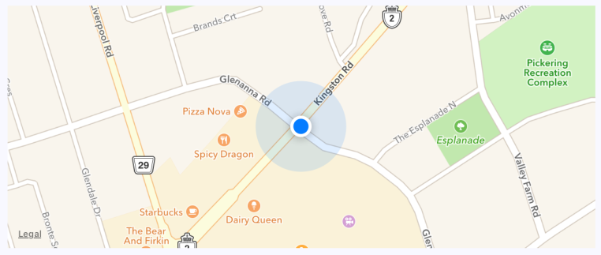
The current location of the device is clearly marked on the map. By default, points of interest are also rendered on the map. These are things in close proximity to the user so that they can see what's around them.
It's generally a good idea to use the followUserLocation property whenever using showsUserLocation. This makes the map zoom to the region where the user is located.
In the following section, you'll learn how to annotate points of interest on your maps.

Annotating points of interest
Annotations are exactly what they sound like; additional information rendered on top of the basic map geography. In fact, you get annotations by default when you render MapView components. The MapView component can render the user's current location and points of interest around the user. The challenge here is that you probably want to show points of interest that are relevant to your application, instead of the points of interest that are rendered by default.
In this section, you'll learn how to render markers for specific locations on the map, as well as render regions on the map.

Plotting points
Let's plot some local breweries! Here's how you pass annotations to the MapView component:
import React from "react";
import { View } from "react-native";
import MapView from "react-native-maps";
import styles from "./styles";
export default function App() {
return (
<View style={styles.container}>
<MapView
style={styles.mapView}
showsPointsOfInterest={false}
showsUserLocation
followUserLocation
>
<MapView.Marker
title="Duff Brewery"
description="Duff beer for me, Duff beer for you"
coordinate={{
latitude: 43.8418728,
longitude: -79.086082
}}
/>
<MapView.Marker
title="Pawtucket Brewery"
description="New! Patriot Light!"
coordinate={{
latitude: 43.8401328,
longitude: -79.085407
}}
/>
</MapView>
</View>
);
}
In this example, you've opted out of this capability by setting the showsPointsOfInterest property to false. Let's see where these breweries are located:
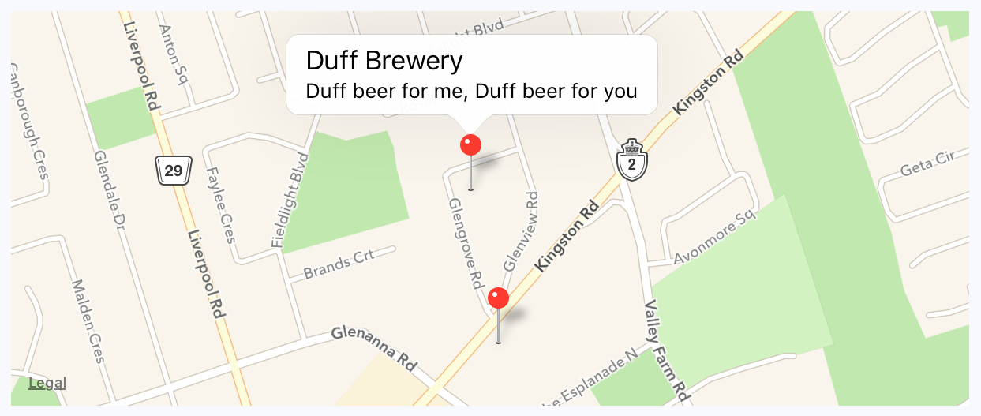
The callout is displayed when you press the marker that shows the location of the brewery on the map. The title and the description property values that you give to <MapView.Marker> are used to render this text.

Plotting overlays
In this last section of this chapter, you'll learn how to render region overlays. A point is a single latitude/longitude coordinate. Think of a region as a connect-the-dots drawing of several coordinates. Regions can serve many purposes, such as showing where we're more likely to find IPA drinkers versus stout drinkers. Here's what the code looks like:
import React, { useState } from "react";
import { View, Text } from "react-native";
import MapView from "react-native-maps";
import styles from "./styles";
const ipaRegion = {
coordinates: [
{ latitude: 43.8486744, longitude: -79.0695283 },
{ latitude: 43.8537168, longitude: -79.0700046 },
{ latitude: 43.8518394, longitude: -79.0725697 },
{ latitude: 43.8481651, longitude: -79.0716377 },
{ latitude: 43.8486744, longitude: -79.0695283 }
],
strokeColor: "coral",
strokeWidth: 4
};
const stoutRegion = {
coordinates: [
{ latitude: 43.8486744, longitude: -79.0693283 },
...
],
strokeColor: "firebrick",
strokeWidth: 4
};
export default function PlottingOverlays() {
const [ipaStyles, setIpaStyles] = useState([styles.ipaText, styles.boldText]);
const [stoutStyles, setStoutStyles] = useState([styles.stoutText]);
const [overlays, setOverlays] = useState([ipaRegion]);
function onClickIpa() {
setIpaStyles([...ipaStyles, styles.boldText]);
setStoutStyles([stoutStyles[0]]);
setOverlays([ipaRegion]);
}
function onClickStout() {
setStoutStyles([...stoutStyles, styles.boldText]);
setIpaStyles([ipaStyles[0]]);
setOverlays([stoutRegion]);
}
return (
<View style={styles.container}>
<View>
<Text style={ipaStyles} onPress={onClickIpa}>
IPA Fans
</Text>
<Text style={stoutStyles} onPress={onClickStout}>
Stout Fans
</Text>
</View>
<MapView
style={styles.mapView}
showsPointsOfInterest={false}
showsUserLocation
followUserLocation
>
{overlays.map((v, i) => (
<MapView.Polygon
key={i}
coordinates={v.coordinates}
strokeColor={v.strokeColor}
strokeWidth={v.strokeWidth}
/>
))}
</MapView>
</View>
);
}
The region data consists of several latitude/longitude coordinates that define the shape and location of the region. The rest of this code is mostly about handling state when the two text links are pressed. By default, the IPA region is rendered, as follows:
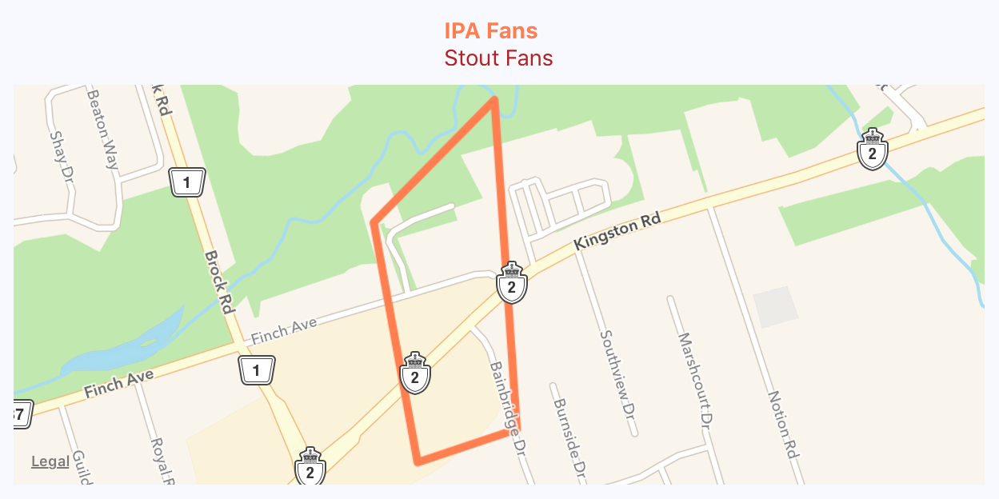
When the stout text is pressed, the IPA overlay is removed from the map and the stout region is added:
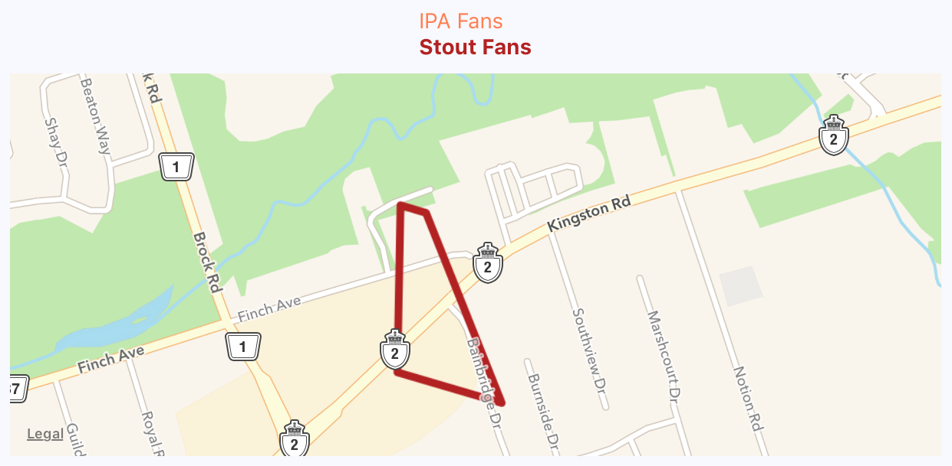
Overlays are useful when you need to highlight an area instead of a latitude/longitude point or an address.

Summary
In this chapter, you learned about geolocation and mapping in React Native. The geolocation API works the same as its web counterpart. The only reliable way to use maps in React Native applications is to install the third-party react-native-maps package.
You saw the basic configuration MapView components, and how they can track the user's location and show relevant points of interest. Then, you saw how to plot your own points of interest and regions of interest.
In the next chapter, you'll learn how to collect user input using React Native components that resemble HTML form controls.

Further reading
Take a look at the following URLs to get more information:
Geolocation: https://facebook.github.io/react-native/docs/geolocation
React Native maps: https://github.com/react-community/react-native-maps
Collecting User Input
In web applications, you can collect user input from standard HTML form elements that look and behave similarly on all browsers. With native UI platforms, collecting user input is more nuanced.
In this chapter, you'll learn how to work with the various React Native components that are used to collect user input. These include text input, selecting from a list of options, checkboxes, and date/time selectors. You'll learn the differences between iOS and Android, and how to implement the appropriate abstractions for your app.
The following topics will be covered in this chapter:
Collecting text input
Selecting from a list of options
Toggling between on and off
Collecting date/time input

Technical requirements
You can find the code files for this chapter on GitHub at https://github.com/PacktPublishing/React-and-React-Native---Third-Edition/tree/master/Chapter20.

Collecting text input
It turns out that there's a lot to think about when it comes to implementing text inputs. For example, should it have placeholder text? Is this sensitive data that shouldn't be displayed on the screen? Should you process text as it's entered, or when the user moves to another field?
The noticeable difference between mobile text input and traditional web text input is that the former has its own built-in virtual keyboard that you can configure and respond to. Let's build an example that renders several instances of the <TextInput> component:
import React, { useState } from "react";
import PropTypes from "prop-types";
import { Text, TextInput, View } from "react-native";
import styles from "./styles";
function Input(props) {
return (
<View style={styles.textInputContainer}>
<Text style={styles.textInputLabel}>{props.label}</Text>
<TextInput style={styles.textInput} {...props} />
</View>
);
}
Input.propTypes = {
label: PropTypes.string
};
export default function CollectingTextInput() {
const [changedText, setChangedText] = useState("");
const [submittedText, setSubmittedText] = useState("");
return (
<View style={styles.container}>
<Input label="Basic Text Input:" />
<Input label="Password Input:" secureTextEntry />
<Input label="Return Key:" returnKeyType="search" />
<Input label="Placeholder Text:" placeholder="Search" />
<Input
label="Input Events:"
onChangeText={e => {
setChangedText(e);
}}
onSubmitEditing={e => {
setSubmittedText(e.nativeEvent.text);
}}
onFocus={() => {
setChangedText("");
setSubmittedText("");
}}
/>
<Text>Changed: {changedText}</Text>
<Text>Submitted: {submittedText}</Text>
</View>
);
}
I won't go into depth about what each of these <TextInput> components is doing – there are comments in the code that explain this. Let's see what these components look like on the screen:
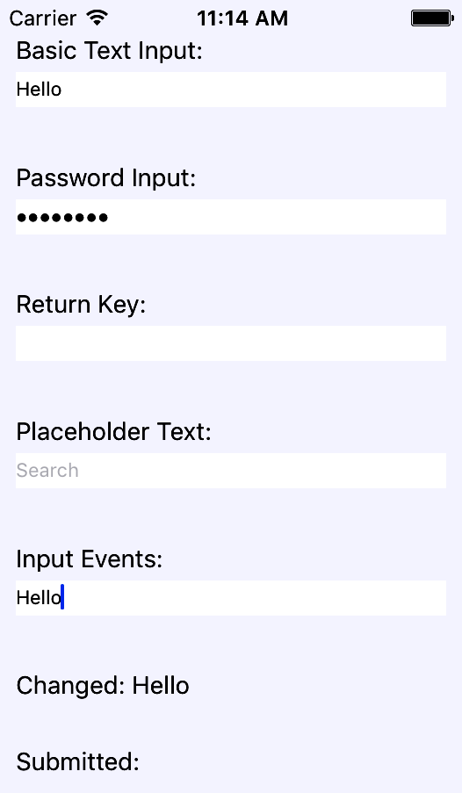
The plain text input shows the text that's been entered. The Password Input field doesn't reveal any characters. Placeholder Text is displayed when the input is empty. The Changed text state is also displayed. You can't see the Submitted text state because I didn't press the Submitted button on the virtual keyboard before I took the screenshot.
Let's take a look at the virtual keyboard for the input element where you changed the Return key text via the returnKeyType prop:
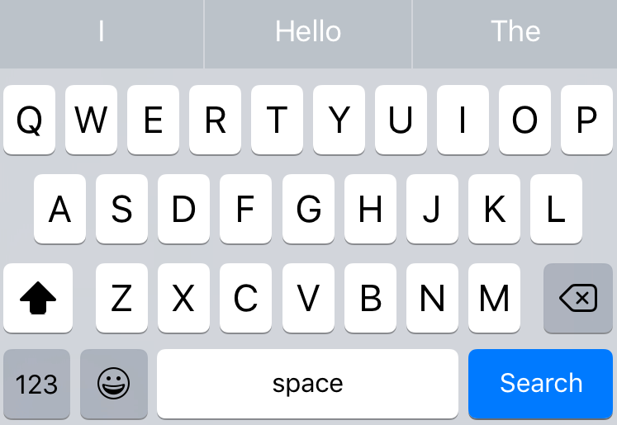
When the keyboard Return key reflects what's going to happen when the user presses it, the user feels more in tune with the application. Now that you're familiar with collecting text input, it's time to learn how to select a value from a list of options.

Selecting from a list of options
In web applications, you typically use the <select> element to let the user choose from a list of options. React Native comes with a <Picker> component, which works on both iOS and Android. There is some trickery involved with styling this component based on which platform the user is on, so let's hide all of this inside of a generic Select component. Here's the Select.ios.js module:
import React from "react";
import PropTypes from "prop-types";
import { View, Picker, Text } from "react-native";
import styles from "./styles";
export default function Select(props) {
return (
<View style={styles.pickerHeight}>
<View style={styles.pickerContainer}>
<Text style={styles.pickerLabel}>{props.label}</Text>
<Picker style={styles.picker} {...props}>
{props.items.map(i => (
<Picker.Item key={i.label} {...i} />
))}
</Picker>
</View>
</View>
);
}
Select.propTypes = {
items: PropTypes.array,
label: PropTypes.string
};
That's a lot of overhead for a simple Select component. Well, it turns out that it's actually quite hard to style the React Native <Picker> component. Here's the Select.android.js module:
import React from "react";
import PropTypes from "prop-types";
import { View, Picker, Text } from "react-native";
import styles from "./styles";
export default function Select(props) {
return (
<View>
<Text style={styles.pickerLabel}>{props.label}</Text>
<Picker {...props}>
{props.items.map(i => (
<Picker.Item key={i.label} {...i} />
))}
</Picker>
</View>
);
}
Select.propTypes = {
items: PropTypes.array,
label: PropTypes.string
};
This is what the styles look like:
import { StyleSheet } from "react-native";
export default StyleSheet.create({
container: {
flex: 1,
flexDirection: "row",
flexWrap: "wrap",
justifyContent: "space-around",
alignItems: "center",
backgroundColor: "ghostwhite"
},
pickerHeight: {
height: 300
},
pickerContainer: {
flex: 1,
flexDirection: "column",
alignItems: "center",
marginTop: 40,
backgroundColor: "white",
padding: 6,
height: 240
},
pickerLabel: {
fontSize: 14,
fontWeight: "bold"
},
picker: {
width: 100,
backgroundColor: "white"
},
selection: {
width: 200,
marginTop: 230,
textAlign: "center"
}
});
Now, you can render your <Select> component:
import React, { useState } from "react";
import { View, Text } from "react-native";
import styles from "./styles";
import Select from "./Select";
export default function SelectingOptions() {
const [sizes, setSizes] = useState([
{ label: "", value: null },
{ label: "S", value: "S" },
{ label: "M", value: "M" },
{ label: "L", value: "L" },
{ label: "XL", value: "XL" }
]);
const [garments, setGarments] = useState([
{ label: "", value: null, sizes: ["S", "M", "L", "XL"] },
{ label: "Socks", value: 1, sizes: ["S", "L"] },
{ label: "Shirt", value: 2, sizes: ["M", "XL"] },
{ label: "Pants", value: 3, sizes: ["S", "L"] },
{ label: "Hat", value: 4, sizes: ["M", "XL"] }
]);
const [availableGarments, setAvailableGarments] = useState([]);
const [selectedSize, setSelectedSize] = useState(null);
const [selectedGarment, setSelectedGarment] = useState(null);
const [selection, setSelection] = useState("");
return (
<View style={styles.container}>
<Select
label="Size"
items={sizes}
selectedValue={selectedSize}
onValueChange={size => {
setSelectedSize(size);
setSelectedGarment(null);
setAvailableGarments(garments.filter(i =>
i.sizes.includes(size)));
}}
/>
<Select
label="Garment"
items={availableGarments}
selectedValue={selectedGarment}
onValueChange={garment => {
setSelectedGarment(garment);
setSelection(
`${selectedSize} ${garments.find(i => i.value ===
garment).label}`
);
}}
/>
<Text style={styles.selection}>{selection}</Text>
</View>
);
}
The basic idea of this example is that the selected option in the first selector changes the available options in the second selector. When the second selector changes, the label shows selectedSize and selectedGarment as a string. Here's how the screen looks:
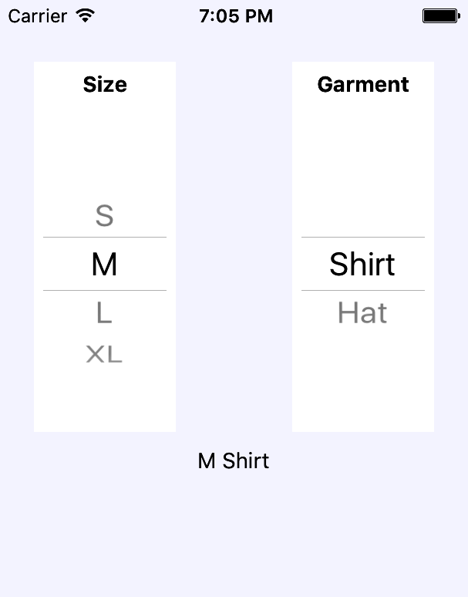
The size selector is shown on the left-hand side of the screen. When the size value changes, the available values in the garment selector on the right-hand side of the screen change to reflect size availability. The current selection is displayed as a string, after the two selectors. In the following section, you'll learn about the buttons that toggle between on and off states.

Toggling between on and off
Another common element you'll see in web forms is checkboxes. React Native has a Switch component that works on both iOS and Android. Thankfully, this component is a little easier to style than the Picker component. Let's look at a simple abstraction you can implement to provide labels for your switches:
import React from "react";
import PropTypes from "prop-types";
import { View, Text, Switch } from "react-native";
import styles from "./styles";
export default function CustomSwitch(props) {
return (
<View style={styles.customSwitch}>
<Text>{props.label}</Text>
<Switch {...props} />
</View>
);
}
CustomSwitch.propTypes = {
label: PropTypes.string
};
Now, let's learn how we can use a couple of switches to control application state:
import React, { useState } from "react";
import { View } from "react-native";
import styles from "./styles";
import Switch from "./Switch";
export default function TogglingOnAndOff() {
const [first, setFirst] = useState(false);
const [second, setSecond] = useState(false);
return (
<View style={styles.container}>
<Switch
label="Disable Next Switch"
value={first}
disabled={second}
onValueChange={setFirst}
/>
<Switch
label="Disable Previous Switch"
value={second}
disabled={first}
onValueChange={setSecond}
/>
</View>
);
}
These two switches toggle the disabled property of one another. When the first switch is toggled, the setFirst() function is called, which will update the value of the first state. Depending on the current value of first, it will either be set to true or false. The second switch works the same way except it uses setSecond() and the second state value. Turning on one switch will disable the other because we've set the disabled property value for each switch to the state of the other switch. For example, the second switch has disabled={first}, which means that it is disabled whenever the first switch is turned on. Here's what the screen looks like on iOS:
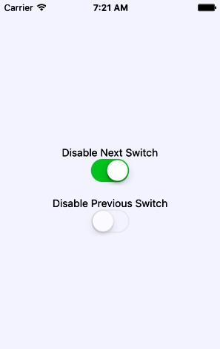
Here's what the same screen looks like on Android:
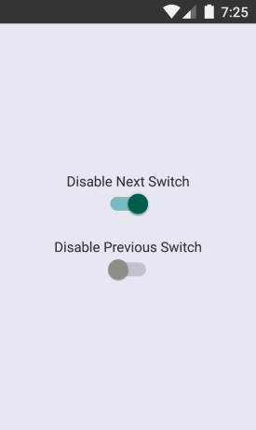
As you can see, our CustomSwitch component enables the same functionality on Android and iOS while using one component for both platforms. In the following section, you'll learn how to collect date/time input.

Collecting date/time input
In this final section of this chapter, you'll learn how to implement date/time pickers. React Native has independent date/time picker components for iOS and Android, which means that it is up to you to handle the cross-platform differences between the components.
So, let's start with a date picker component for iOS:
import React from "react";
import PropTypes from "prop-types";
import { Text, View, DatePickerIOS } from "react-native";
import styles from "./styles";
export default function DatePicker(props) {
return (
<View style={styles.datePickerContainer}>
<Text style={styles.datePickerLabel}>{props.label}</Text>
<DatePickerIOS mode="date" {...props} />
</View>
);
}
DatePicker.propTypes = {
label: PropTypes.string
};
There's not a lot to this component; it simply adds a label to the DatePickerIOS component. The Android version of the date picker needs a little more work. Let's take a look at the implementation:
import React from "react";
import PropTypes from "prop-types";
import { Text, View, DatePickerAndroid } from "react-native";
import styles from "./styles";
function pickDate(options, onDateChange) {
DatePickerAndroid.open(options).then(date =>
onDateChange(new Date(date.year, date.month, date.day))
);
}
export default function DatePicker({ label, date, onDateChange }) {
return (
<View style={styles.datePickerContainer}>
<Text style={styles.datePickerLabel}>{label}</Text>
<Text onPress={() => pickDate({ date }, onDateChange)}>
{date.toLocaleDateString()}
</Text>
</View>
);
}
DatePicker.propTypes = {
label: PropTypes.string,
date: PropTypes.instanceOf(Date),
onDateChange: PropTypes.func.isRequired
};
The key difference between the two date pickers is that the Android version doesn't use a React Native component, such as DatePickerIOS. Instead, we have to use the imperative DatePickerAndroid.open() API. This is triggered when the user presses the date text that our component renders and opens a date picker dialog. The good news is that this component of ours hides this API behind a declarative component.
I've also implemented a time picker component that follows this exact pattern. So, rather than listing that code here, I suggest that you download the code for this book from https://github.com/PacktPublishing/React-and-React-Native---Third-Edition so that you can see the subtle differences and run the example.
Now, let's learn how to use our date and time picker components:
import React, { useState } from "react";
import { View } from "react-native";
import DatePicker from "./DatePicker";
import TimePicker from "./TimePicker";
import styles from "./styles";
export default function CollectingDateTimeInput() {
const [date, setDate] = useState(new Date());
const [time, setTime] = useState(new Date());
return (
<View style={styles.container}>
<DatePicker
label="Pick a date, any date:"
date={date}
onDateChange={setDate}
/>
<TimePicker
label="Pick a time, any time:"
date={time}
onTimeChange={setTime}
/>
</View>
);
}
Awesome! Now, we have two simple components that work on iOS and Android. Let's see how the pickers look on iOS:
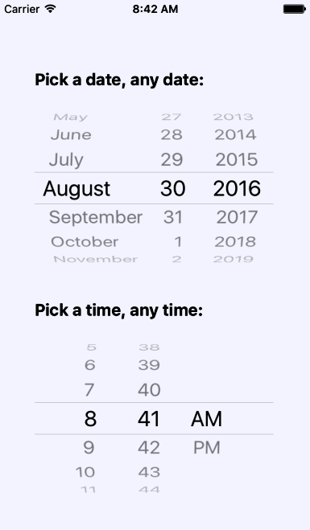
As you can see, the iOS date and time pickers use the Picker component that you learned about earlier in this chapter. The Android picker looks a lot different – let's look at it now:
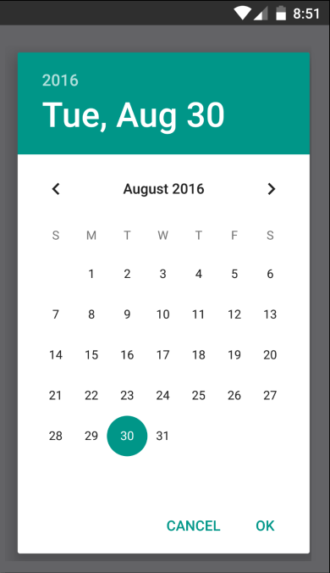
The Android version follows a completely different approach from the iOS date/time picker, yet we can use the same DatePicker component that we've created on both platforms.

Summary
In this chapter, we learned about the various React Native components that resemble the form elements from the web that we're used to. We started off by learning about text input and how each text input has its own virtual keyboard to take into consideration. Next, we learned about Picker components, which allow the user to select an item from a list of options. Then, we learned about the Switch component, which is kind of like a checkbox.
In the final section, we learned how to implement generic date/time pickers that work on both iOS and Android. In the next chapter, we'll learn about modal dialogs in React Native.

Further reading
Visit the following links for more information:
Handling text input: https://facebook.github.io/react-native/docs/handling-text-input
Switch: https://facebook.github.io/react-native/docs/switch
Picker: https://facebook.github.io/react-native/docs/picker
DatePickerIOS: https://facebook.github.io/react-native/docs/datepickerios
DatePickerAndroid: https://facebook.github.io/react-native/docs/datepickerandroid.html
Displaying Modal Screens
The goal of this chapter is to show you how to present information to the user in ways that don't disrupt the current page. Pages use a View component and render it directly on the screen. There are times, however, when there's important information that the user needs to see, but you don't necessarily want to kick them off the current page.
You'll start by learning how to display important information. Knowing what information is important and when to use it, you'll learn how to get user acknowledgment – both for error and success scenarios. Then, you'll implement passive notifications that show the user that something has happened. Finally, you'll implement modal views that show the user that something is happening in the background.
The following topics will be covered in this chapter:
Important information
Getting user confirmation
Passive notifications
Activity modals

Technical requirements
You can find the code files for this chapter on GitHub at https://github.com/PacktPublishing/React-and-React-Native---Third-Edition/tree/master/Chapter21.

Important information
Before you dive into implementing alerts, notifications, and confirmations, let's take a few minutes and think about what each of these items means. I think this is important because if you end up passively notifying the user about an error, it can easily get missed. Here are my definitions of the types of information that you'll want to display:
Alert: Something important just happened and you need to ensure that the user sees what's going on. Possibly, the user needs to acknowledge the alert.
Notification: Something happened but it's not important enough to completely block what the user is doing. These typically go away on their own.
Confirmation is actually part of an alert. For example, if the user has just performed an action, and then wants to make sure that it was successful before carrying on, they would have to confirm that they've seen the information in order to close the modal. A confirmation could also exist within an alert, warning the user about an action that they're about to perform.
The trick is to try to use notifications where the information is good to know, but not critical. Use confirmations only when the workflow of the feature cannot continue without the user acknowledging what's going on. In the following sections, you'll see examples of alerts and notifications that are used for different purposes.

Getting user confirmation
In this section, you'll learn how to show modal views in order to get confirmation from the user. First, you'll learn how to implement a successful scenario, where an action generates a successful outcome that you want the user to be aware of. Then, you'll learn how to implement an error scenario, where something went wrong and you don't want the user to move forward without acknowledging the issue.

Displaying a success confirmation
Let's start by implementing a modal view that's displayed as the result of the user successfully performing an action. Here's the Modal component, which is used to show the user a success confirmation:
import React from "react";
import PropTypes from "prop-types";
import { View, Text, Modal } from "react-native";
import styles from "./styles";
export default function ConfirmationModal(props) {
return (
<Modal {...props}>
<View style={styles.modalContainer}>
<View style={styles.modalInner}>
<Text style={styles.modalText}>Dude, srsly?</Text>
<Text style={styles.modalButton} onPress={props.onPressConfirm}>
Yep
</Text>
<Text style={styles.modalButton} onPress={props.onPressCancel}>
Nope
</Text>
</View>
</View>
</Modal>
);
}
ConfirmationModal.propTypes = {
visible: PropTypes.bool.isRequired,
onPressConfirm: PropTypes.func.isRequired,
onPressCancel: PropTypes.func.isRequired
};
ConfirmationModal.defaultProps = {
transparent: true,
onRequestClose: () => {}
};
The properties that are passed to ConfirmationModal are forwarded to the React Native Modal component. You'll see why in a moment. First, let's see what this confirmation modal looks like:
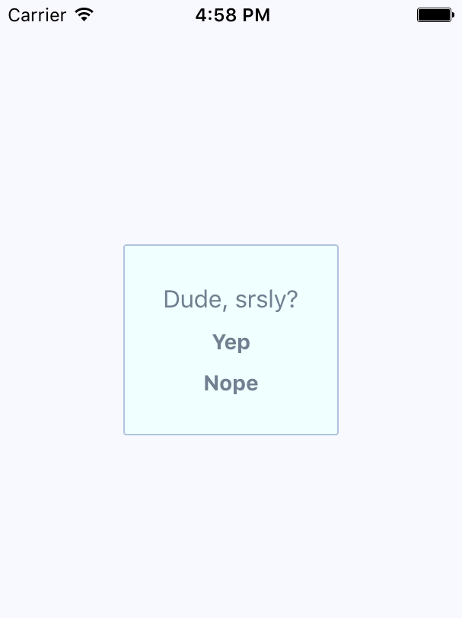
The modal that's displayed once the user completes an action uses our own styling and confirmation message. It also has two actions, but it may only need one, depending on whether this confirmation is pre-action or post-action. Here are the styles that are being used for this modal:
modalContainer: {
flex: 1,
justifyContent: "center",
alignItems: "center"
},
modalInner: {
backgroundColor: "azure",
padding: 20,
borderWidth: 1,
borderColor: "lightsteelblue",
borderRadius: 2,
alignItems: "center"
},
modalText: {
fontSize: 16,
margin: 5,
color: "slategrey"
},
modalButton: {
fontWeight: "bold",
margin: 5,
color: "slategrey"
}
With the React Native Modal component, it's pretty much up to you how you want your confirmation modal view to look. Think of them as regular views, with the only difference being that they're rendered on top of other views.
A lot of the time, you might not care to style your own modal views. For example, in web browsers, you can simply call the alert() function, which shows text in a window that's styled by the browser. React Native has something similar: Alert.alert(). The tricky part here is that this is an imperative API, and you don't necessarily want to expose it directly to your application.
Instead, let's implement an alert confirmation component that hides the details of this particular React Native API so that your app can just treat this like any other component:
import React, { useEffect } from "react";
import PropTypes from "prop-types";
import { Alert } from "react-native";
export default function ConfirmationAlert(props) {
useEffect(() => {
if (props.visible) {
Alert.alert(props.title, props.message, props.buttons);
}
});
return null;
}
ConfirmationAlert.propTypes = {
visible: PropTypes.bool.isRequired,
title: PropTypes.string,
message: PropTypes.string,
buttons: PropTypes.array
};
This component doesn't need to render anything since it deals exclusively with imperative React Native calls. However, it feels like something is being rendered to the person that's using ConfirmationAlert.
Here's what the alert looks like on iOS:
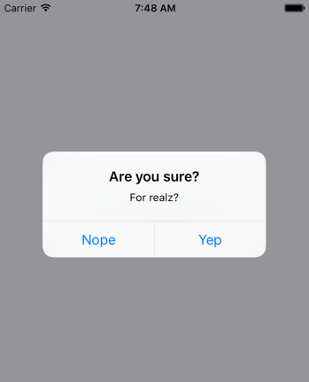
In terms of functionality, there's nothing really different here. There are a title and text beneath it, but that's something that could easily be added to a modal view if you wanted. The real difference is that this modal looks like an iOS modal, instead of something that's styled by the app. Let's see how this alert appears on Android:

This modal looks like an Android modal, and you didn't have to style it. I think using alerts over modals is a better choice most of the time. It makes sense to have something styled to look like it's part of iOS or part of Android. However, there are times when you need more control over how the modal looks, such as when displaying error confirmations. Here's the code that's used to display both the modal and the alert confirmation dialogs:
import React, { useState } from "react";
import { View, Text } from "react-native";
import ConfirmationModal from "./ConfirmationModal";
import ConfirmationAlert from "./ConfirmationAlert";
import styles from "./styles";
export default function App() {
const [modalVisible, setModalVisible] = useState(false);
const [alertVisible, setAlertVisible] = useState(false);
function toggleModal() {
setModalVisible(!modalVisible);
}
function toggleAlert() {
setAlertVisible(!alertVisible);
}
return (
<View style={styles.container}>
<ConfirmationModal
animationType="fade"
visible={modalVisible}
onPressConfirm={toggleModal}
onPressCancel={toggleModal}
/>
<ConfirmationAlert
title="Are you sure?"
message="For realz?"
visible={alertVisible}
buttons={[
{ text: "Nope", onPress: toggleAlert },
{ text: "Yep", onPress: toggleAlert }
]}
/>
<Text style={styles.text} onPress={toggleModal}>
Show Confirmation Modal
</Text>
<Text style={styles.text} onPress={toggleAlert}>
Show Confimation Alert
</Text>
</View>
);
}
The approach to rendering modals is different from the approach to rendering alerts. However, they're both still declarative components that change based on the changing property values.

Error confirmation
All of the principles you learned about in the Displaying a success confirmation section are applicable when you need the user to acknowledge an error. If you need more control of the display, use a modal. For example, you might want the modal to be red and scary looking:
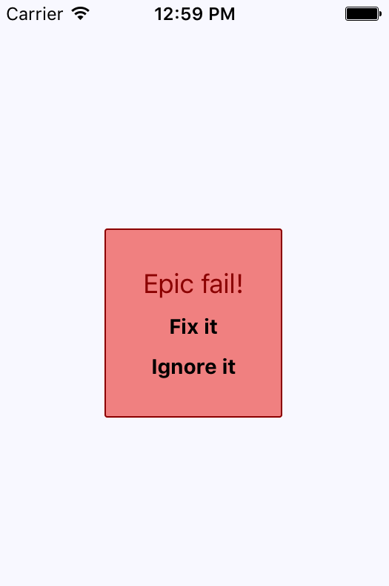
Here are the styles that were used to create this look. Maybe you want something a little more subtle, but the point is that you can make this look however you want:
import { StyleSheet } from "react-native";
export default StyleSheet.create({
container: {
flex: 1,
justifyContent: "center",
alignItems: "center",
backgroundColor: "ghostwhite"
},
text: {
color: "slategrey"
},
modalContainer: {
flex: 1,
justifyContent: "center",
alignItems: "center"
},
modalInner: {
backgroundColor: "azure",
padding: 20,
borderWidth: 1,
borderColor: "lightsteelblue",
borderRadius: 2,
alignItems: "center"
},
modalInnerError: {
backgroundColor: "lightcoral",
borderColor: "darkred"
},
modalText: {
fontSize: 16,
margin: 5,
color: "slategrey"
},
modalTextError: {
fontSize: 18,
color: "darkred"
},
modalButton: {
fontWeight: "bold",
margin: 5,
color: "slategrey"
},
modalButtonError: {
color: "black"
}
});
The same styles modal that you used for the success confirmations are still here. That's because the error confirmation modal needs many of the same styles. Here's how you apply both to the Modal component:
import React from "react";
import PropTypes from "prop-types";
import { View, Text, Modal } from "react-native";
import styles from "./styles";
const innerViewStyle = [styles.modalInner, styles.modalInnerError];
const textStyle = [styles.modalText, styles.modalTextError];
const buttonStyle = [styles.modalButton, styles.modalButtonError];
export default function ErrorModal(props) {
return (
<Modal {...props}>
<View style={styles.modalContainer}>
<View style={innerViewStyle}>
<Text style={textStyle}>Epic fail!</Text>
<Text style={buttonStyle} onPress={props.onPressConfirm}>
Fix it
</Text>
<Text style={buttonStyle} onPress={props.onPressCancel}>
Ignore it
</Text>
</View>
</View>
</Modal>
);
}
ErrorModal.propTypes = {
visible: PropTypes.bool.isRequired,
onPressConfirm: PropTypes.func.isRequired,
onPressCancel: PropTypes.func.isRequired
};
ErrorModal.defaultProps = {
transparent: true,
onRequestClose: () => {}
};
The styles are combined as arrays before they're passed to the style property. The styles error always comes last since conflicting style properties, such as backgroundColor, will be overridden by whatever comes later in the array.
In addition to styles in error confirmations, you can include whatever advanced controls you want. It really depends on how your application lets users cope with errors; for example, maybe there are several courses of action that can be taken.
However, the more common case is that something went wrong and there's nothing you can do about it, besides making sure that the user is aware of the situation. In these cases, you can probably get away with just displaying an alert:
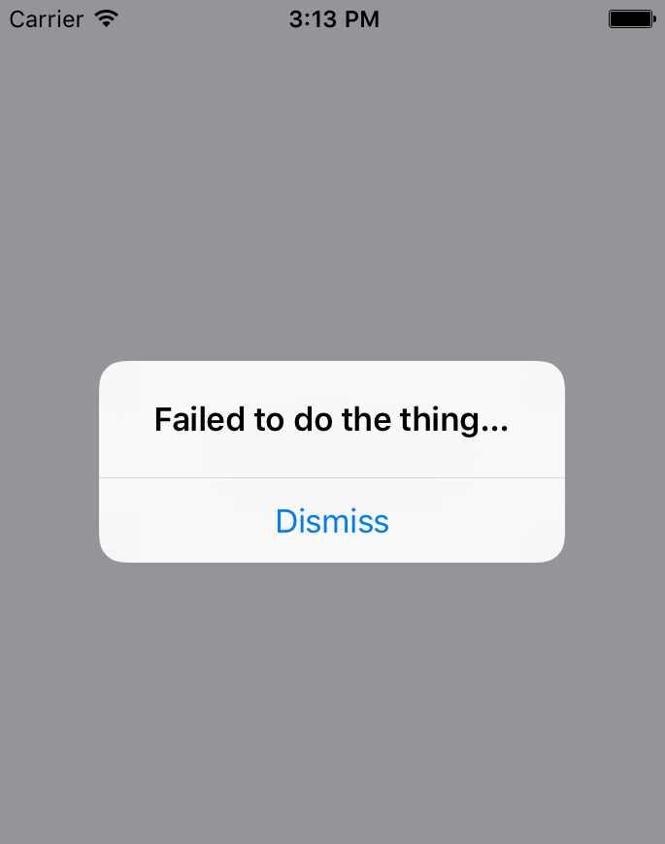
Now that you're able to display error notifications that require user engagement, it's time to learn about less aggressive notifications that don't disrupt what the user is currently doing.

Passive notifications
The notifications you've examined so far in this chapter all have required input from the user. This is by design because it's important information that you're forcing the user to look at. However, you don't want to overdo this. For notifications that are important but not life-altering if ignored, you can use passive notifications. These are displayed in a less obtrusive way than modals and don't require any user action to dismiss them.
In this section, you'll create a Notification component that uses the Toast API for Android and creates a custom modal for iOS. It's called the Toast API because the information that's displayed looks like a piece of toast popping up. Here's what the Android component looks like:
import React from "react";
import PropTypes from "prop-types";
import { ToastAndroid } from "react-native";
export default function Notification({ message, duration }) {
if (message) {
ToastAndroid.show(message, duration);
}
return null;
}
Notification.propTypes = {
message: PropTypes.string,
duration: PropTypes.number.isRequired
};
Notification.defaultProps = {
duration: ToastAndroid.LONG
};
Once again, you're dealing with an imperative React Native API that you don't want to expose to the rest of your app. Instead, this component hides the imperative ToastAndroid.show() function behind a declarative React component. No matter what, this component returns null, because it doesn't actually render anything. Here's what the ToastAndroid notification looks like:
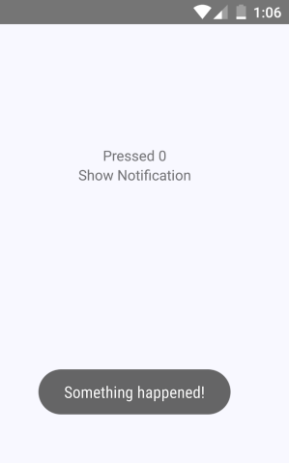
A notification stating Something happened! is displayed at the bottom of the screen and is removed after a short delay. The key is that the notification is unobtrusive.
The iOS notification component is a little more involved because it needs state and life cycle events to make a modal view behave like a transient notification. Here's what the code for it looks like:
import React, { useState, useEffect } from "react";
import PropTypes from "prop-types";
import { View, Modal, Text } from "react-native";
import styles from "./styles";
export default function Notification(props) {
const [message, setMessage] = useState(props.message);
useEffect(() => {
if (!message) {
setMessage(props.message);
const timer = setTimeout(() => {
setMessage(null);
}, props.duration);
return () => {
clearTimeout(timer);
};
}
}, [props.message]);
const modalProps = {
animationType: "fade",
transparent: true,
visible: Boolean(message)
};
return (
<Modal {...modalProps}>
<View style={styles.notificationContainer}>
<View style={styles.notificationInner}>
<Text>{message}</Text>
</View>
</View>
</Modal>
);
}
Notification.propTypes = {
message: PropTypes.string,
duration: PropTypes.number.isRequired
};
Notification.defaultProps = {
duration: 1500
};
You have to style the modal to display the notification text, as well as the state that's used to hide the notification after a delay. Here's what the end result looks like for iOS:
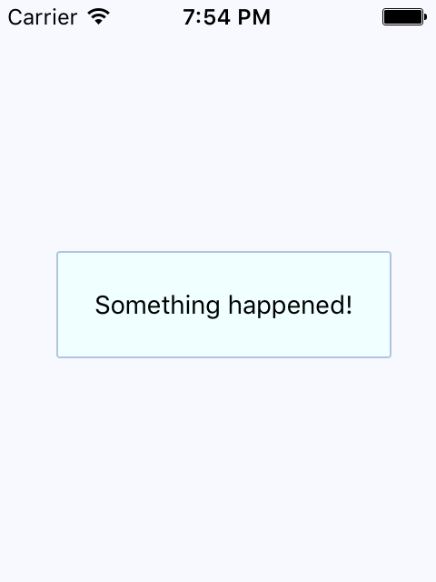
The same principle for the ToastAndroid API applies here. You might have noticed that there's another button in addition to the Show Notification button. This is a simple counter that re-renders the view. There's actually a reason for demonstrating this seemingly obtuse feature, as you'll see momentarily. Here's the code for the main application view:
import React, { useState } from "react";
import { Text, View } from "react-native";
import Notification from "./Notification";
import styles from "./styles";
export default function PassiveNotifications() {
const [count, setCount] = useState(0);
const [message, setMessage] = useState(null);
return (
<View style={styles.container}>
<Notification message={message} />
<Text
onPress={() => {
setCount(count + 1);
setMessage(null);
}}
>
Pressed {count}
</Text>
<Text
onPress={() => {
setMessage("Something happened!");
}}
>
Show Notification
</Text>
</View>
);
}
The whole point of the press counter is to demonstrate that, even though the Notification component is declarative and accepts new property values when the state changes, you still have to set the message state to null when changing other state values. The reason for this is that if you re-render the component and the message state still has a string in it, it will display the same notification, over and over.
In the next section, you'll learn about activity modals, which show the user that something is happening.

Activity modals
In this final section of this chapter, you'll implement a modal that shows a progress indicator. The idea is to display the modal, and then hide it when the promise resolves. Here's the code for the generic Activity component, which shows a modal with an ActivityIndicator:
import React from "react";
import PropTypes from "prop-types";
import { View, Modal, ActivityIndicator } from "react-native";
import styles from "./styles";
export default function Activity(props) {
return (
<Modal visible={props.visible} transparent>
<View style={styles.modalContainer}>
<ActivityIndicator size={props.size} />
</View>
</Modal>
);
}
Activity.propTypes = {
visible: PropTypes.bool.isRequired,
size: PropTypes.string.isRequired
};
Activity.defaultProps = {
visible: false,
size: "large"
};
You might be tempted to pass the promise to the component so that it automatically hides when the promise resolves. I don't think this is a good idea, because then you would have to introduce the state into this component. Furthermore, it would depend on a promise in order to function. With the way you've implemented this component, you can show or hide the modal based on the visible property alone. Here's what the activity modal looks like on iOS:

There's a semi-transparent background on the modal that's placed over the main view with the Fetch Stuff... link. Here's how this effect is created in styles.js:
modalContainer: {
flex: 1,
justifyContent: "center",
alignItems: "center",
backgroundColor: "rgba(0, 0, 0, 0.2)"
}
Instead of setting the actual Modal component to transparent, you can set the transparency in backgroundColor, which gives the look of an overlay. Now, let's take a look at the code that controls this component:
import React, { useState } from "react";
import { Text, View } from "react-native";
import styles from "./styles";
import Activity from "./Activity";
export default function App() {
const [fetching, setFetching] = useState(false);
const [promise, setPromise] = useState(Promise.resolve());
function onPress() {
setPromise(
new Promise(resolve => setTimeout(resolve, 3000)).then(() => {
setFetching(false);
})
);
setFetching(true);
}
return (
<View style={styles.container}>
<Activity visible={fetching} />
<Text onPress={onPress}>Fetch Stuff...</Text>
</View>
);
}
When the fetch link is pressed, a new promise is created that simulates async network activity. Then, when the promise resolves, you can change the fetching state back to false so that the activity dialog is hidden.

Summary
In this chapter, we learned about the need to show mobile users important information. This sometimes involves explicit feedback from the user, even if that just means acknowledging the message. In other cases, passive notifications work better, since they're less obtrusive than confirmation modals.
There are two tools that we can use to display messages to users: modals and alerts. Modals are more flexible because they're just like regular views. Alerts are good for displaying plain text and they take care of styling concerns for us. On Android, we have the ToastAndroid interface as well. We saw that it's also possible to do this on iOS, but it just requires more work.
In the next chapter, we'll dig deeper into the gesture response system inside React Native, which makes for a better mobile experience than browsers are able to provide.

Further reading
Check out the following links for more information:
Modal: https://facebook.github.io/react-native/docs/modal
Alert: https://facebook.github.io/react-native/docs/alert
ToastAndroid: https://facebook.github.io/react-native/docs/toastandroid
Responding to User Gestures
All of the examples that you've implemented so far in this book have relied on user gestures. In traditional web applications, you mostly deal with mouse events. However, touchscreens rely on the user manipulating elements with their fingers, which is fundamentally different from the mouse.
First, you'll learn about scrolling. This is probably the most common gesture, besides touch. Then, you'll learn about giving the user the appropriate level of feedback when they interact with your components. Finally, you'll implement components that can be swiped.
The goal of this chapter is to show you how the gesture response system inside React Native works and some of the ways this system is exposed via components.
In this chapter, we'll cover the following topics:
Scrolling with your fingers
Giving touch feedback
Swipeable and cancellable

Technical requirements
You can find the code files for this chapter on Github at https://github.com/PacktPublishing/React-and-React-Native---Third-Edition/tree/master/Chapter22.

Scrolling with your fingers
Scrolling in web applications is done by using the mouse pointer to drag the scrollbar back and forth or up and down, or by spinning the mouse wheel. This doesn't work on mobile devices because there's no mouse. Everything is controlled by gestures on the screen. For example, if you want to scroll down, you use your thumb or index finger to pull the content up by physically moving your finger over the screen.
Scrolling like this is difficult to implement, but it gets more complicated. When you scroll on a mobile screen, the velocity of the dragging motion is taken into consideration. You drag the screen fast, then let go, and the screen continues to scroll based on how fast you moved your finger. You can also touch the screen while this is happening to stop it from scrolling.
Thankfully, you don't have to handle most of this stuff. The ScrollView component handles much of the scrolling complexity for you. In fact, you've already used the ScrollView component, back in Chapter 17, Rendering Item Lists. The ListView component has ScrollView baked into it.
You can hack the low-level parts of user interactions by implementing gesture life cycle methods. You'll probably never need to do this, but if you're interested, you can read about it at https://reactnative.dev/docs/gesture-responder-system.
You can use ScrollView outside of ListView. For example, if you're just rendering arbitrary content such as text and other widgets – not a list, in other words – you can just wrap it in a <ScrollView>. Here's an example:
import React from "react";
import {
Text,
ScrollView,
ActivityIndicator,
Switch,
View
} from "react-native";
import styles from "./styles";
export default function App() {
return (
<View style={styles.container}>
<ScrollView style={styles.scroll}>
{new Array(6).fill(null).map((v, i) => (
<View key={i}>
<Text style={[styles.scrollItem, styles.text]}>Some text</Text>
<ActivityIndicator style={styles.scrollItem} size="large" />
<Switch style={styles.scrollItem} />
</View>
))}
</ScrollView>
</View>
);
}
The ScrollView component isn't of much use on its own – it's there to wrap other components. It needs height in order to function correctly. Here's what the scroll style looks like:
scroll: {
height: 1,
alignSelf: "stretch",
},
height is set to 1, but the stretch value of alignSelf allows the items to display properly. Here's what the end result looks like:
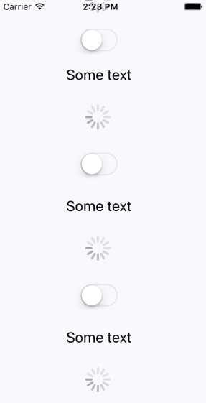
There's a vertical scrollbar on the right-hand side of the screen as you drag the content down. If you run this example, you can play around with making various gestures, such as making content scroll on its own and then making it stop.
When the user scrolls through content on the screen, they receive visual feedback. Users should also receive visual feedback when they touch certain elements on the screen.

Giving touch feedback
The React Native examples you've worked with so far in this book have used plain text to act as buttons or links. In web applications, to make text look like something that can be clicked, you just wrap it with the appropriate link. There's no such thing as mobile links, so you can style your text to look like a button.
The problem with trying to style text as links on mobile devices is that they're too hard to press. Buttons provide a bigger target for fingers, and they're easier to apply touch feedback on.
Let's style some text as a button. This is a great first step as it makes the text look touchable. But you also want to give visual feedback to the user when they start interacting with the button. React Native provides two components to help with this: TouchableOpacity and TouchableHighlight. But before diving into the code, let's take a look at what these components look like visually when users interact with them, starting with TouchableOpacity:
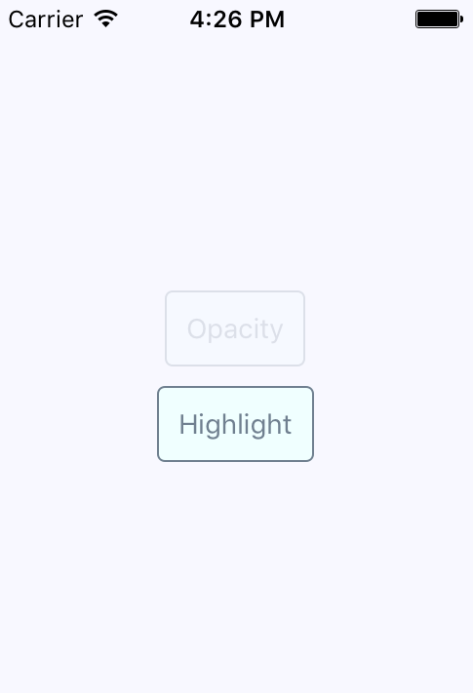
There are two buttons being rendered here. The top one, labeled Opacity, is currently being pressed by the user. The opacity of the button is dimmed when pressed, which provides important visual feedback for the user. Let's see what the Highlight button looks like when pressed:
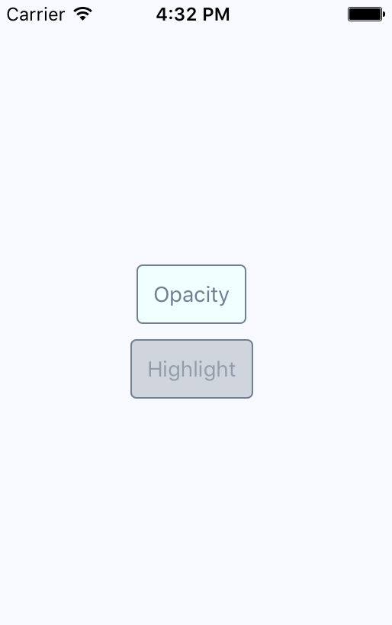
Instead of changing the opacity when pressed, the TouchableHighlight component adds a highlight layer over the button. In this case, it's highlighted using a more transparent version of the slate gray that's being used in the font and border colors.
It doesn't really matter which approach you use. The important thing is that you provide the appropriate touch feedback for your users as they interact with your buttons. In fact, you might want to use the two approaches in the same app, but for different things. Let's create a Button component, which makes it easy to use either approach:
import React from "react";
import PropTypes from "prop-types";
import { Text, TouchableOpacity, TouchableHighlight } from "react-native";
import styles from "./styles";
const touchables = new Map([
["opacity", TouchableOpacity],
["highlight", TouchableHighlight],
[undefined, TouchableOpacity]
]);
export default function Button({ label, onPress, touchable }) {
const Touchable = touchables.get(touchable);
const touchableProps = {
style: styles.button,
underlayColor: "rgba(112,128,144,0.3)",
onPress
};
return (
<Touchable {...touchableProps}>
<Text style={styles.buttonText}> {label} </Text>
</Touchable>
);
}
Button.propTypes = {
onPress: PropTypes.func.isRequired,
label: PropTypes.string.isRequired,
touchable: PropTypes.oneOf(["opacity", "highlight"])
};
The touchables map is used to determine which React Native touchable component wraps the text, based on the touchable property value. Here are the styles that were used to create this button:
button: {
padding: 10,
margin: 5,
backgroundColor: "azure",
borderWidth: 1,
borderRadius: 4,
borderColor: "slategrey"
},
buttonText: {
color: "slategrey"
}
Here's how you can put those buttons into the main app module:
import React from "react";
import { View } from "react-native";
import styles from "./styles";
import Button from "./Button";
export default function App() {
return (
<View style={styles.container}>
<Button onPress={() => {}} label="Opacity" />
<Button onPress={() => {}} label="Highlight" touchable="highlight" />
</View>
);
}
Note that the onPress callbacks don't actually do anything – we're passing them because they're a required property.
In the following section, you'll learn about providing feedback when the user swipes elements across the screen.

Swipeable and cancellable
Part of what makes native mobile applications easier to use than mobile web applications is that they feel more intuitive. Using gestures, you can quickly get a handle of how things work. For example, swiping an element across the screen with your finger is a common gesture, but the gesture has to be discoverable.
Let's say that you're using an app, and you're not exactly sure what something on the screen does. So, you press down with your finger and try dragging the element. It starts to move. Unsure of what will happen, you lift your finger up, and the element moves back into place. You've just discovered how part of this application works.
You'll use the Scrollable component to implement swipeable and cancellable behaviors like this. You can create a somewhat generic component that allows the user to swipe text off the screen and, when that happens, call a callback function. Let's look at the code that will render the swipeables before we look at the generic component itself:
import React, { useState } from "react";
import { View } from "react-native";
import styles from "./styles";
import Swipeable from "./Swipeable";
export default function SwipableAndCancellable() {
const [items, setItems] = useState(
new Array(8).fill(null).map((v, id) => ({ id, name: "Swipe Me" }))
);
function onSwipe(id) {
return () => {
setItems(items.filter(item => item.id !== id));
};
}
return (
<View style={styles.container}>
{items.map(item => (
<Swipeable key={item.id} onSwipe={onSwipe(item.id)}
name={item.name} />
))}
</View>
);
}
This will render eight <Swipeable> components on the screen. Let's see what this looks like:
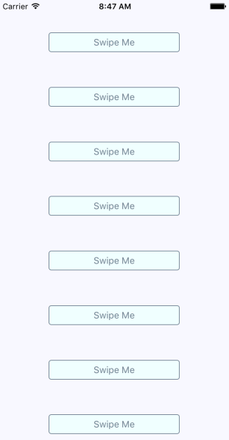
Now, if you start to swipe one of these items to the left, it will move. Here's what this looks like:
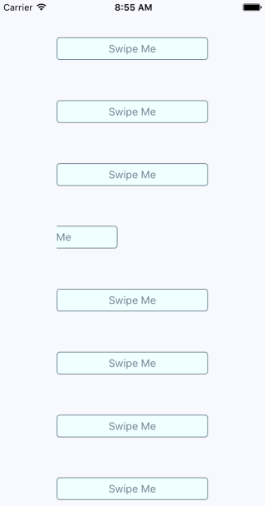
If you don't swipe far enough, the gesture will be canceled and the item will move back into place, as expected. If you swipe it all the way, the item will be removed from the list completely and the items on the screen will fill the empty space, like this:
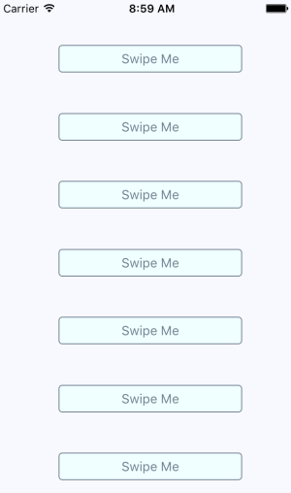
Now, let's take a look at the Swipeable component itself:
import React from "react";
import PropTypes from "prop-types";
import { View, ScrollView, Text, TouchableOpacity } from "react-native";
import styles from "./styles";
export default function Swipeable({ onSwipe, name }) {
function onScroll(e) {
e.nativeEvent.contentOffset.x === 200 && onSwipe();
}
const scrollProps = {
horizontal: true,
pagingEnabled: true,
showsHorizontalScrollIndicator: false,
scrollEventThrottle: 10,
onScroll
};
return (
<View style={styles.swipeContainer}>
<ScrollView {...scrollProps}>
<TouchableOpacity>
<View style={styles.swipeItem}>
<Text style={styles.swipeItemText}>{name}</Text>
</View>
</TouchableOpacity>
<View style={styles.swipeBlank} />
</ScrollView>
</View>
);
}
Swipeable.propTypes = {
onSwipe: PropTypes.func.isRequired,
name: PropTypes.string.isRequired
};
Note that the <ScrollView> component is set to horizontal and that pagingEnabled is true. It's the paging behavior that snaps the components into place and provides cancellable behavior. This is why there's a blank component beside the component with text in it. Here are the styles that are used for this component:
swipeContainer: {
flex: 1,
flexDirection: "row",
width: 200,
height: 30,
marginTop: 50
},
swipeItem: {
width: 200,
height: 30,
backgroundColor: "azure",
justifyContent: "center",
borderWidth: 1,
borderRadius: 4,
borderColor: "slategrey"
},
swipeItemText: {
textAlign: "center",
color: "slategrey"
},
swipeBlank: {
width: 200,
height: 30
}
The swipeBlank style has the same dimensions as swipeItem, but nothing else. It's invisible.

Summary
In this chapter, we were introduced to the idea that gestures on native platforms make a significant difference compared to mobile web platforms. We started off by looking at the ScrollView component, and how it makes life much simpler by providing native scrolling behavior for wrapped components.
Next, we spent some time implementing buttons with touch feedback. This is another area that's tricky to get right on the mobile web. We learned how to use the TouchableOpacity and TouchableHighlight components to do this.
Finally, we implemented a generic Swipeable component. Swiping is a common mobile pattern, and it allows for the user to discover how things work without feeling intimidated. In the next chapter, we'll learn how to control the image display using React Native.

Further reading
Take a look at the following links for more information:
ScrollView: https://facebook.github.io/react-native/docs/scrollview
TouchableHighlight: https://facebook.github.io/react-native/docs/touchablehighlight
TouchableOpacity: https://facebook.github.io/react-native/docs/touchableopacity
Controlling Image Display
So far, the examples in this book haven't rendered any images on mobile screens. This doesn't reflect the reality of mobile applications. Web applications display lots of images. If anything, native mobile applications rely on images even more than web applications because images are a powerful tool when you have a limited amount of space.
In this chapter, you'll learn how to use the React Native Image component, starting with loading images from different sources. Then, you'll learn how you can use the Image component to resize images, and how you can set placeholders for lazily loaded images. Finally, you'll learn how to implement icons using the react-native-vector-icons package.
We'll cover the following topics in this chapter:
Loading images
Resizing images
Lazy image loading
Rendering icons

Technical requirements
You can find the code files for this chapter on GitHub at https://github.com/PacktPublishing/React-and-React-Native---Third-Edition/tree/master/Chapter23.

Loading images
Let's get started by figuring out how to load images. You can render the <Image> component and pass it properties just like any other React component. But this particular component needs image blob data to be of any use. Let's look at some code:
import React from "react";
import PropTypes from "prop-types";
import { View, Image } from "react-native";
import styles from "./styles";
export default function App({ reactSource, relaySource }) {
return (
<View style={styles.container}>
<Image style={styles.image} source={reactSource} />
<Image style={styles.image} source={relaySource} />
</View>
);
}
const sourceProp = PropTypes.oneOfType([
PropTypes.shape({
uri: PropTypes.string.isRequired
}),
PropTypes.number
]).isRequired;
App.propTypes = {
reactSource: sourceProp,
relaySource: sourceProp
};
App.defaultProps = {
reactSource: {
uri: "https://facebook.github.io/react-native/docs/assets/favicon.png"
},
relaySource: require("./images/relay.png")
};
There are two ways to load the blob data into an <Image> component. The first approach loads the image data from the network. This is done by passing an object with a uri property to source. The second <Image> component in this example is using a local image file. It does this by calling require() and passing the result to source.
Take a look at the sourceProp property type validator. This gives you an idea of what can be passed to the source property. It's either an object with a uri string property or a number. It expects a number because require() returns a number.
Now, let's see what the rendered result looks like:

Here's the style that was used with these images:
image: {
width: 100,
height: 100,
margin: 20,
},
Note that without the width and height style properties, images will not render. In the next section, you'll learn how image resizing works when the width and height values are set.

Resizing images
The width and height style properties of Image components determine the size of what's rendered on the screen. For example, you'll probably have to work with images at some point that have a larger resolution than you want to be displayed in your React Native application. Simply setting the width and height style properties on the Image is enough to properly scale the image.
Let's look at some code that lets you dynamically adjust the dimensions of an image using controls:
import React, { useState } from "react";
import { View, Text, Image, Slider } from "react-native";
import styles from "./styles";
export default function App() {
const source = require("./images/flux.png");
const [width, setWidth] = useState(100);
const [height, setHeight] = useState(100);
return (
<View style={styles.container}>
<Image source={source} style={{ width, height }} />
<Text>Width: {width}</Text>
<Text>Height: {height}</Text>
<Slider
style={styles.slider}
minimumValue={50}
maximumValue={150}
value={width}
onValueChange={value => {
setWidth(value);
setHeight(value);
}}
/>
</View>
);
}
Here's what the image looks like if you're using the default 100 x 100 dimensions:
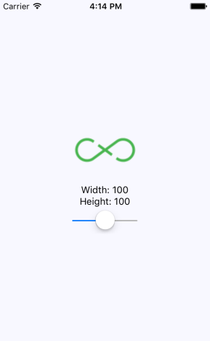
Here's a scaled-down version of the image:
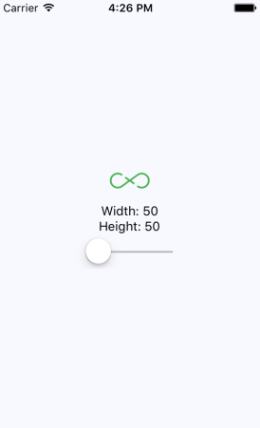
Lastly, here's a scaled-up version of the image:
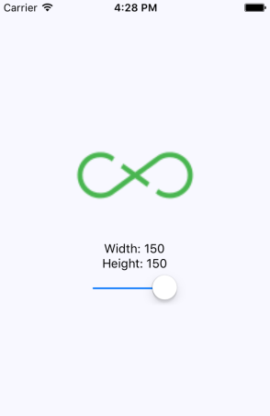
There's a resizeMode property that you can pass to Image components. This determines how the scaled image fits within the dimensions of the actual component. You'll see this property in action in the Rendering icons section of this chapter.
As you can see, the dimensions of the images are controlled by the width and height style properties. Images can even be resized while the app is running by changing these values. In the next section, you'll learn how to lazily load images.

Lazy image loading
Sometimes, you don't necessarily want an image to load at the exact moment that it's rendered; for example, you might be rendering something that's not visible on the screen yet. Most of the time, it's perfectly fine to fetch the image source from the network before it's actually visible. But if you're fine-tuning your application and discover that loading lots of images over the network causes performance issues, you can lazily load the source.
I think the more common use case in a mobile context is handling a scenario where you've rendered one or more images where they're visible, but the network is slow to respond. In this case, you will probably want to render a placeholder image so that the user sees something right away, rather than empty space.
To do this, you can implement an abstraction that wraps the actual image that you want to show once it's loaded. Here's the code for this:
import React, { useState } from "react";
import PropTypes from "prop-types";
import { View, Image } from "react-native";
const placeholder = require("./assets/placeholder.png");
function Placeholder(props) {
if (props.loaded) {
return null;
} else {
return <Image style={props.style} source={placeholder} />;
}
}
export default function LazyImage(props) {
const [loaded, setLoaded] = useState(false);
return (
<View style={props.style}>
<Placeholder loaded={loaded} {...props} />
<Image
{...props}
onLoad={() => {
setLoaded(true);
}}
/>
</View>
);
}
LazyImage.propTypes = {
style: PropTypes.shape({
width: PropTypes.number.isRequired,
height: PropTypes.number.isRequired
})
};
This component renders a View with two Image components inside it. It also has a loaded state, which is initially false. When loaded is false, the placeholder image is rendered. The loaded state is set to true when the onLoad() handler is called. This means that the placeholder image is removed and the main image is displayed.
Now, let's use the LazyImage component that we've just implemented. You'll render the image without a source, and the placeholder image should be displayed. Let's add a button that gives the lazy image a source. When it loads, the placeholder image should be replaced. Here's what the main app module looks like:
import React, { useState } from "react";
import { View } from "react-native";
import styles from "./styles";
import LazyImage from "./LazyImage";
import Button from "./Button";
const remote =
"https://facebook.github.io/react-native/docs/assets/favicon.png";
export default function LazyLoading() {
const [source, setSource] = useState(null);
return (
<View style={styles.container}>
<LazyImage
style={{ width: 200, height: 100 }}
resizeMode="contain"
source={source}
/>
<Button
label="Load Remote"
onPress={() => {
setSource({ uri: remote });
}}
/>
</View>
);
}
This is what the screen looks like initially:
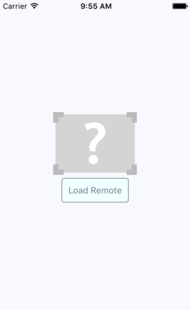
Then, if you click the Load Remote button, you'll eventually see the image that we actually want:
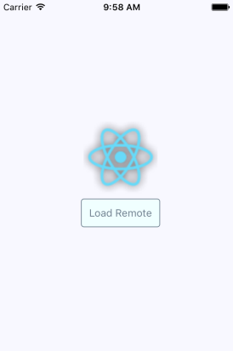
You might notice that, depending on your network speed, the placeholder image remains visible, even after you click the Load Remote button. This is by design because you don't want to remove the placeholder image until you know for sure that the actual image is ready to be displayed. Now, let's render some icons in our React Native application.

Rendering icons
In the final section of this chapter, you'll learn how to render icons in React Native components. Using icons to indicate meaning makes web applications more usable. So, why should native mobile applications be any different?
You'll want to use the react-native-vector-icons package to pull in various vector font packages into your React Native project, as follows:
npm install --save @expo/vector-icons
Now, you can import the Icon components and render them. Let's implement an example that renders several FontAwesome icons based on a selected icon category:
import React, { useState, useEffect } from "react";
import { View, Picker, FlatList, Text } from "react-native";
import Icon from "react-native-vector-icons/FontAwesome";
import styles from "./styles";
import iconNames from "./icon-names.json";
export default function RenderingIcons() {
const [selected, setSelected] = useState("Web Application Icons");
const [listSource, setListSource] = useState([]);
const categories = Object.keys(iconNames);
function updateListSource(selected) {
setListSource(iconNames[selected]);
setSelected(selected);
}
useEffect(() => {
updateListSource(selected);
}, []);
return (
<View style={styles.container}>
<View style={styles.picker}>
<Picker selectedValue={selected} onValueChange={updateListSource}>
{categories.map(category => (
<Picker.Item key={category} label={category} value={category}
/>
))}
</Picker>
</View>
<FlatList
style={styles.icons}
data={listSource.map((value, key) => ({ key: key.toString(), value
}))}
renderItem={({ item }) => (
<View style={styles.item}>
<Icon name={item.value} style={styles.itemIcon} />
<Text style={styles.itemText}>{item.value}</Text>
</View>
)}
/>
</View>
);
}
When you run this example, you should see something that looks like the following:
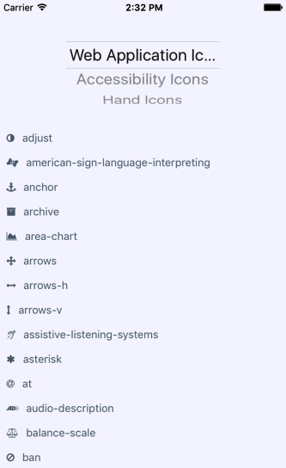
The color of each icon is specified in the same way you would specify the color of text: via styles.

Summary
In this chapter, we learned about handling images in our React Native applications. Images in a native application are just as important in a native mobile context as they are in a web context – they improve the user experience.
We learned about the different approaches to loading images, as well as how to resize them. We also learned how to implement a lazy image, which displays a placeholder image while the actual image is being loading in. Finally, we learned how to use icons in a React Native app.
In the next chapter, we'll learn about local storage in React Native, which is handy when our app goes offline.

Further reading
Check out the following links for more information:
Image: https://facebook.github.io/react-native/docs/image
React Native vector icons: https://github.com/oblador/react-native-vector-icons
Going Offline
Users expect applications to operate seamlessly with unreliable network connections. If your mobile application can't cope with transient network issues, then your users will use a different app. When there's no network, you have to persist data locally on the device. Or, perhaps your app doesn't even require network access, in which case you'll still need to store data locally.
In this chapter, you'll learn how to do the three things with React Native. First, you'll learn how to detect the state of the network connection. Second, you'll learn how to store data locally. Lastly, you'll learn how to synchronize local data that's been stored due to network problems, once it comes back online.
In this chapter, we'll cover the following topics:
Detecting the state of the network
Storing application data
Synchronizing application data

Technical requirements
You can find the code files for this chapter on GitHub at https://github.com/PacktPublishing/React-and-React-Native---Third-Edition/tree/master/Chapter24.

Detecting the state of the network
If your code tries to make a request over the network while disconnected – using fetch(), for example – an error will occur. You probably have error handling code in place for these scenarios already, since the server could return some other type of error. However, in the case of connectivity trouble, you might want to detect this issue before the user attempts to make network requests.
There are two potential reasons for proactively detecting the network state. You might display a friendly message to the user stating that, since the network is disconnected, they can't do anything. You would then prevent the user from performing any network requests until you've detected that it's back online. The other possible benefit of early network state detection is that you can prepare to perform actions offline and sync the app state when the network is connected again.
Let's look at some code that uses the NetInfo utility from the @react-native-community/netinfo package to handle changes in network state:
import React, { useState, useEffect } from "react";
import { Text, View } from "react-native";
import NetInfo from "@react-native-community/netinfo";
import styles from "./styles";
const connectedMap = {
none: "Disconnected",
unknown: "Disconnected",
wifi: "Connected",
cell: "Connected",
mobile: "Connected"
};
export default function App() {
const [connected, setConnected] = useState("");
useEffect(() => {
function onNetworkChange(connection) {
setConnected(connectedMap[connection.type]);
}
const unsubscribe = NetInfo.addEventListener(onNetworkChange);
return () => {
unsubscribe();
};
}, []);
return (
<View style={styles.container}>
<Text>{connected}</Text>
</View>
);
}
This component will render the state of the network, based on the string values in connectedMap. The connectionChange event of the NetInfo object will cause the connected state to change. For example, when you run this app for the first time, the screen might look like this:
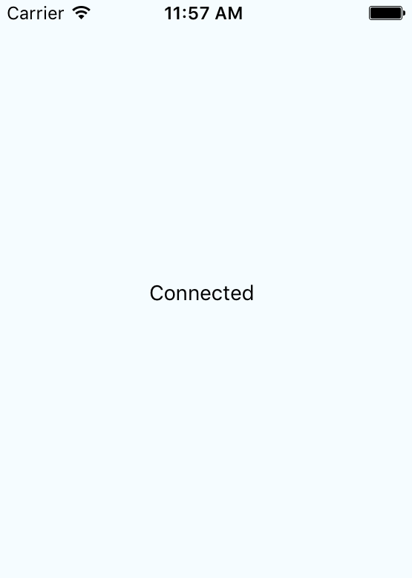
Then, if you turn off networking on your host machine, the network state will change on the emulated device as well, causing the state of our application to change, as follows:

In the next section, you'll learn how to store application data locally on the device where the application is running.

Storing application data
The AsyncStorage API works the same on both the iOS and Android platforms. You would use this API for applications that don't require any network connectivity in the first place or to store data that will eventually be synchronized using an API endpoint once a network becomes available.
Let's look at some code that allows the user to enter a key and a value, and then stores them:
import React, { useState, useEffect } from "react";
import { Text, TextInput, View, FlatList, AsyncStorage } from "react-native";
import styles from "./styles";
import Button from "./Button";
export default function App() {
const [key, setKey] = useState(null);
const [value, setValue] = useState(null);
const [source, setSource] = useState([]);
function setItem() {
return AsyncStorage.setItem(key, value)
.then(() => {
setKey(null);
setValue(null);
})
.then(loadItems);
}
function clearItems() {
return AsyncStorage.clear().then(loadItems);
}
async function loadItems() {
const keys = await AsyncStorage.getAllKeys();
const values = await AsyncStorage.multiGet(keys);
setValues(values);
}
useEffect(() => {
loadItems();
}, []);
Here's the markup that's rendered by the App component:
return (
<View style={styles.container}>
<Text>Key:</Text>
<TextInput
style={styles.input}
value={key}
onChangeText={v => {
this.data = this.data.set("key", v);
}}
/>
<Text>Value:</Text>
<TextInput
style={styles.input}
value={value}
onChangeText={v => {
this.data = this.data.set("value", v);
}}
/>
<View style={styles.controls}>
<Button label="Add" onPress={setItem} />
<Button label="Clear" onPress={clearItems} />
</View>
<View style={styles.list}>
<FlatList
data={source.map(([key, value]) => ({
key: key.toString(),
value
}))}
renderItem={({ item: { value, key } }) => (
<Text>
{value} ({key})
</Text>
)}
/>
</View>
</View>
);
}
Before we walk through what this code is doing, let's take a look at the following screen since it'll explain most of what we're going to cover:
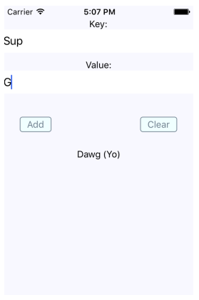
As you can see, there are two input fields and two buttons. The fields allow the user to enter a new key and value. The Add button allows the user to store this key-value pair locally on their device, while the Clear button clears any existing items that have been stored previously.
The AsyncStorage API works the same for both iOS and Android. Under the hood, AsyncStorage works very differently, depending on which platform it's running on. The reason React Native is able to expose the same storage API on both platforms is due to its simplicity – it's just key-value pairs. Anything more complex than that is left up to the application developer.
The abstractions that you've created around AsyncStorage in this example are minimal. The idea is to set and get items. However, even straightforward actions like this deserve an abstraction layer. For example, the setItem() method you've implemented here will make the asynchronous call to AsyncStorage and update the items state once that has completed. Loading items is even more complicated because you need to get the keys and values as two separate asynchronous operations.
The reason we do this is to keep the UI responsive. If there are pending screen repaints that need to happen while data is being written to disk, preventing those from happening by blocking them would lead to a suboptimal user experience.
In the next section, you'll learn how to synchronize data that's been stored locally while the device is offline, with remote services once the device comes back online.

Synchronizing application data
So far in this chapter, you've learned how to detect the state of a network connection, and how to store data locally in a React Native application. Now, it's time to combine these two concepts and implement an app that can detect network outages and continue to function.
The basic idea is to only make network requests when you know for sure that the device is online. If you know that it isn't, you can store any changes in the state locally. Then, when you're back online, you can synchronize those stored changes with the remote API.
Let's implement a simplified React Native app that does this. The first step is implementing an abstraction that sits between the React components and the network calls that store data. We'll call this module store.js:
import { AsyncStorage } from "react-native";
import NetInfo from "@react-native-community/netinfo";
const fakeNetworkData = {
first: false,
second: false,
third: false
};
let connected = false;
const unsynced = [];
export function set(key, value) {
return new Promise((resolve, reject) => {
if (connected) {
fakeNetworkData[key] = value;
resolve(true);
} else {
AsyncStorage.setItem(key, value.toString()).then(
() => {
unsynced.push(key);
resolve(false);
},
err => reject(err)
);
}
});
}
export function get(key) {
return new Promise((resolve, reject) => {
if (connected) {
resolve(key ? fakeNetworkData[key] : fakeNetworkData);
} else if (key) {
AsyncStorage.getItem(key).then(
item => resolve(item),
err => reject(err)
);
} else {
AsyncStorage.getAllKeys().then(
keys =>
AsyncStorage.multiGet(keys).then(
items => resolve(Object.fromEntries(items)),
err => reject(err)
),
err => reject(err)
);
}
});
}
NetInfo.fetch().then(
connection => {
connected = ["wifi", "unknown"].includes(connection.type);
},
() => {
connected = false;
}
);
NetInfo.addEventListener(connection => {
connected = ["wifi", "unknown"].includes(connection.type);
if (connected && unsynced.length) {
AsyncStorage.multiGet(unsynced).then(items => {
items.forEach(([key, val]) => set(key, val));
unsynced.length = 0;
});
}
});
This module exports two functions – set() and get(). Their jobs are to set and get data, respectively. Since this is just a demonstration of how to sync between local storage and network endpoints, this module just mocks the actual network with the fakeNetworkData object.
Let's start by looking at the set() function. It's an asynchronous function that will always return a promise that resolves to a Boolean value. If it's true, it means that you're online and that the call over the network was successful. If it's false, it means that you're offline and AsyncStorage was used to save the data.
The same approach is used with the get() function. It returns a promise that resolves a Boolean value that indicates the state of the network. If a key argument is provided, then the value for that key is looked up. Otherwise, all the values are returned, either from the network or from AsyncStorage.
In addition to these two functions, this module does two other things. It uses NetInfo.fetch() to set the connected state. Then, it adds a listener to listen for changes in the network state. This is how items that were saved locally when you were offline become synced with the network when it's connected again.
Now, let's check out the main application that uses these functions:
import React, { useState, useEffect } from "react";
import { Text, View, Switch } from "react-native";
import NetInfo from "@react-native-community/netinfo";
import styles from "./styles";
import { set, get } from "./store";
const boolMap = {
true: true,
false: false
};
export default function App() {
const [message, setMessage] = useState(null);
const [first, setFirst] = useState(false);
const [second, setSecond] = useState(false);
const [third, setThird] = useState(false);
const setters = new Map([
["first", setFirst],
["second", setSecond],
["third", setThird]
]);
function save(key) {
return value => {
set(key, value).then(
connected => {
setters.get(key)(value);
setMessage(connected ? null : "Saved Offline");
},
err => {
setMessage(err);
}
);
};
}
useEffect(() => {
NetInfo.fetch().then(() =>
get().then(
items => {
for (let [key, value] of Object.entries(items)) {
setters.get(key)(value);
}
},
err => {
setMessage(err);
}
)
);
}, []);
Here's the markup that's rendered by the App component:
return (
<View style={styles.container}>
<Text>{message}</Text>
<View>
<Text>First</Text>
<Switch
value={boolMap[first.toString()]}
onValueChange={save("first")}
/>
</View>
<View>
<Text>Second</Text>
<Switch
value={boolMap[second.toString()]}
onValueChange={save("second")}
/>
</View>
<View>
<Text>Third</Text>
<Switch
value={boolMap[third.toString()]}
onValueChange={save("third")}
/>
</View>
</View>
);
}
The job of the App component is to save the state of three checkboxes, which is difficult when you're providing the user with a seamless transition between online and offline modes. Thankfully, your set() and get() abstractions, which are implemented in another module, hide most of the details from the application functionality.
You will notice, however, that you need to check the state of the network in this module before you attempt to load any items. If you don't do this, then the get() function will assume that you're offline, even if the connection is fine. Here's what the app looks like:
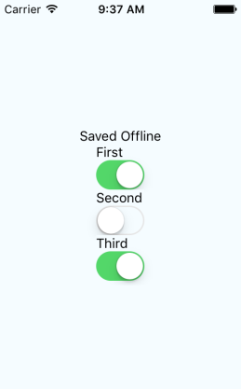
Note that you won't actually see the Saved Offline message until you change something in the UI.

Summary
This chapter introduced us to storing data offline in React Native applications. The main reason we would want to store data locally is when the device goes offline and our app can't communicate with a remote API. However, not all applications require API calls and AsyncStorage can be used as a general-purpose storage mechanism. We just need to implement the appropriate abstractions around it.
We also learned how to detect changes in the network state of React Native apps. It's important to know when the device has gone offline so that our storage layer doesn't make pointless attempts at network calls. Instead, we can let the user know that the device is offline, and then synchronize the application state when a connection is available.
In the next chapter, we'll learn how to import and use UI components from the NativeBase library.

Further reading
You can find more information on AsyncStorage at https://facebook.github.io/react-native/docs/asyncstorage
Section 3: React Architecture
In this section, we will cover the following chapters:
Chapter 25, Native UI Components using NativeBase
Chapter 26, Handling Application State
Chapter 27, Why Apollo?
Chapter 28, Building an Apollo React App
Native UI Components Using NativeBase
Right out of the box, React Native gives us most of the tools we need to build a fully functional native application that runs on both Android and iOS. However, taking your application to the next level and delivering a consistent and polished UX across both platforms requires help. NativeBase can provide us with additional tools that can facilitate quality UI designs for React Native apps. It is possible to build a quality native UI without a tool such as NativeBase, but this would require a lot more coding on our part. If you want to deliver applications that address specific challenges faced by your users, rather than maintaining your own UI library, NativeBase might be what you're looking for.
We'll cover the following topics in this chapter:
Application containers
Headers, footers, and navigation
Using layout components
Collecting input using form components
Displaying data using lists
Showing user notifications

Technical requirements
You can find the code files used in this chapter on GitHub at https://github.com/PacktPublishing/React-and-React-Native---Third-Edition/tree/master/Chapter25.

Application containers
Before we can pull out the NativeBase UI components and render them on our application screens, there are a couple of initialization tasks we have to perform. NativeBase requires you to load font files in order to work. Additionally, we want to set up the same general screen structure for every screen using top-level NativeBase components. To accomplish both of these goals, we can implement a Container component, which can then be used by our screens. We'll start by importing everything that we need:
import React, { useState, useEffect } from "react";
import {
Container as NativeBaseContainer,
Header,
Content,
Body,
Title
} from "native-base";
import { AppLoading } from "expo";
import * as Font from "expo-font";
import { Ionicons } from "@expo/vector-icons";
import { getStatusBarHeight } from "react-native-status-bar-height";
Now, we can implement the Container component:
export default function Container({ title, children }) {
const [ready, setReady] = useState(false);
useEffect(() => {
Font.loadAsync({
Roboto: require("native-base/Fonts/Roboto.ttf"),
Roboto_medium: require("native-base/Fonts/Roboto_medium.ttf"),
...Ionicons.font
}).then(() => setReady(true));
}, []);
if (ready) {
return (
<NativeBaseContainer>
<Header
noLeft
style={{
paddingTop: getStatusBarHeight(),
height: 54 + getStatusBarHeight()
}}
>
<Body>
<Title>{title}</Title>
</Body>
</Header>
<Content>{children}</Content>
</NativeBaseContainer>
);
} else {
return <AppLoading />;
}
}
Let's take a look at what this code is doing. The Container component accepts two properties: title and children. title is a string that sets the title for each screen in the app, while children is the contents for each page in the app. The ready state is used to determine whether the fonts that we need to load have finished loading or not. The call to the useEffect() hook uses the Font.loadAsync() function to load the fonts that NativeBase requires. Without these fonts, the NativeBase components will not work. This is why we check the ready state. If it's false, we render the AppLoading component while the fonts load. When they finish loading, we set the ready state to true and render the NativeBaseContainer component.
NativeBase has a Container component, which we're importing here as NativeBaseContainer since the component we're defining is also called Container. Inside Container, we have a Header component, which uses functions from the react-native-status-bar-height package to make sure the header is visible in the app. The header is also where we set the title. The contents of a given page are passed in via the children property and this value is rendered in Content.
Let's see how the Container component is used by the App component:
import React from "react";
import { Text } from "native-base";
import Container from "./Container";
export default function App() {
return (
<Container title="Application Container">
<Text>Application content goes here...</Text>
</Container>
);
}
The title property is passed a value of "Application Container" and the application content is written in simple text, for now, set using the Text component. Here's what the result looks like on iOS:
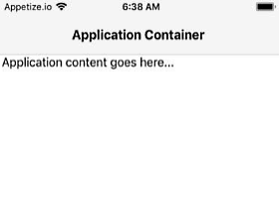
Here's what the result looks like on Android:
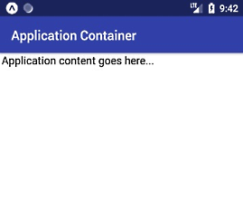
Now that we have a Container component that we can use on every page of the app, let's add in some navigation capabilities and footer navigation links.

Headers, footers, and navigation
To implement navigation in our app, we'll use the react-navigation package. Here's what our App component looks like:
import { createAppContainer } from "react-navigation";
import { createStackNavigator } from "react-navigation-stack";
import Home from "./Home";
import Settings from "./Settings";
import Help from "./Help";
import Contact from "./Contact";
const AppNavigator = createStackNavigator(
{
Home,
Settings,
Help,
Contact
},
{
defaultNavigationOptions: {
headerShown: false
}
}
);
export default createAppContainer(AppNavigator);
The AppNavigator component is created with four screen components from our app: Home, Settings, Help, and Contact. The other thing to note here is that we're setting the headerShown option to false because each of our screen components includes the header as part of the Container component. Next, let's take a look at the Home screen component:
import React from "react";
import { Text } from "native-base";
import Container from "./Container";
export default function Home({ navigation }) {
return (
<Container navigation={navigation}>
<Text>Home content goes here...</Text>
</Container>
);
}
We're passing the Container component the navigation object that allows us to perform navigation actions, such as checking the current route name and navigating to new routes. The footer links are going to go in the Container component because they're going to be on every page. This is why we need to pass in the navigation property – so that we can navigate to another screen when a link is activated and so that we can display the active links differently from the others. Let's take a look at the updated Container component, starting with the new imports:
import {
Container as NativeBaseContainer,
Header,
Footer,
FooterTab,
Content,
Body,
Button,
Icon,
Title,
Text
} from "native-base";
We're now importing several new NativeBase components, mostly to help build the footer navigation. Let's take a look at this now:
export default function Container({ children, navigation }) {
const [ready, setReady] = useState(false);
useEffect(() => {
...
}, []);
if (ready) {
return (
<NativeBaseContainer>
<Header
noLeft
style={{
paddingTop: getStatusBarHeight(),
height: 54 + getStatusBarHeight()
}}
>
<Body>
<Title>{navigation.state.routeName}</Title>
</Body>
</Header>
<Content>{children}</Content>
<Footer>
<FooterTab>
<Button
vertical
active={navigation.state.routeName === "Home"}
onPress={() => {
navigation.navigate("Home", {});
}}
>
<Icon name="home" />
<Text>Home</Text>
</Button>
...
</FooterTab>
</Footer>
</NativeBaseContainer>
);
} else {
return <AppLoading />;
}
}
The first change is in the Header component, where the title is now navigation.state.routeName. This is made possible by the navigation property, which is passed to the Container component from pages that are managed by a navigator. The next addition is the Footer component, where we want to display navigation links on every screen in the app. The FooterTab component groups the Button components together for this purpose. This example only shows the Home navigation link but the other buttons all follow the same pattern.
The button displays as active if the current route name is Home. When the button is pressed, the navigation.navigate() function activates the "Home" route. Here's what the result looks like on iOS:
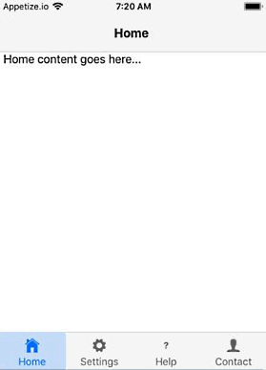
Here's what the result looks like on Android:

In the next section, you'll learn how to use layout components to organize the content on your screens.

Using layout components
NativeBase provides layout components that simplify the layout code for your screens. You can use these components to build your own grid layouts for the UI components on your screens. Let's take a look at an example. Here are the imports for our App component:
import React from "react";
import { Card, CardItem, Body, Text } from "native-base";
import { Col, Row, Grid } from "react-native-easy-grid";
import Container from "./Container";
The Card, CardItem, Body, and Text components are what we'll use to create some screen content that we need a layout for. The Grid, Row, and Col components are used to build layouts in NativeBase apps. You'll notice that these components come from the react-native-easy-grid package instead of native-base. This is so that projects that aren't using NativeBase can still use this package. Now, let's look at our layout:
export default function App() {
return (
<Container title="Using Layout Components">
<Grid>
<Row>
<Col>
<Card>
<CardItem>
<Body>
<Text>Card 1</Text>
</Body>
</CardItem>
</Card>
</Col>
<Col>
<Card>
<CardItem>
<Body>
<Text>Card 2</Text>
</Body>
</CardItem>
</Card>
</Col>
</Row>
<Row>
...
</Row>
</Grid>
</Container>
);
}
This example creates two rows with two columns each; the second row is truncated here because it looks just like the first row. Here's what it looks like on iOS:
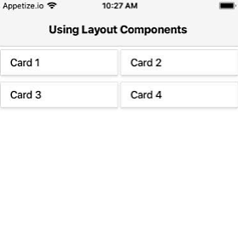
Here's what it looks like on Android:
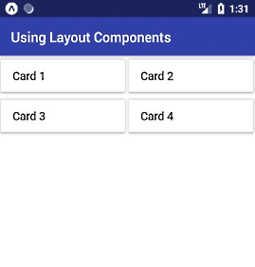
Now that you're able to build screen layouts, it's time to use the NativeBase layout components to align form input components.

Collecting input using form components
NativeBase has form components for every type of input imaginable, including the common inputs that you're most likely to use. Form input controls are notoriously difficult for native application developers to use because even with cross-platform tools, such as React Native, the native input controls on the two platforms are so different that you have to write different code for different platforms. With the NativeBase input components, you can usually write your code once. Let's take a look at an example. Here's everything that you need to import:
import React, { useState } from "react";
import {
Text,
Form,
Input,
Item,
Picker,
Icon,
CheckBox,
ListItem,
Body,
Grid,
Row,
Col,
Left,
Right,
Radio
} from "native-base";
import Container from "./Container";
Next, let's look at the state that's used by the various input components to store values collected from the user:
const [text, setText] = useState("");
const [picker, setPicker] = useState();
const [checkbox, setCheckbox] = useState(false);
const [radio, setRadio] = useState();
const options = ["First", "Second", "Third"];
The text state defaults to an empty string, the picker state defaults to undefined, the checkbox state is false by default, and the radio state defaults to undefined. The options array is values used to define the options for the picker input and the radio control. Let's look at how the text input component is used:
<Input
placeholder="Textbox"
value={text}
onChangeText={setText}
/>
The value property uses the value state from our App component. The onChangeText handler uses setText() to update the text state any time the user changes the text input. Next, let's look at the Picker component:
<Picker
mode="dropdown"
iosIcon={<Icon name="arrow-down" />}
style={{ width: undefined }}
placeholder="Picker"
placeholderStyle={{ color: "#bfc6ea" }}
placeholderIconColor="#007aff"
selectedValue={picker}
onValueChange={value => setPicker(value)}
>
{options.map((name, index) => (
<Picker.Item label={name} key={index} value={index} />
))}
</Picker>
The Picker component requires several properties that control the appearance of the dropdown. The selectedValue property controls the value of picker and is set in the picker state. When the picker value changes, the setPicker() function updates this state. The options available in the dropdown for the user to choose from are mapped from values in the options array to the Picker.Item components. Let's look at the CheckBox component next:
<ListItem>
<CheckBox
checked={checkbox}
onPress={() => setCheckbox(!checkbox)}
/>
<Body>
<Text>Checkbox</Text>
</Body>
</ListItem>
The checked visual is controlled by the checkbox state, while the onPress handler uses the setCheckbox() function to toggle the state of the checkbox. We're using ListItem and a Body component here to align both the checkbox itself and the text that tells the user what they're checking. Lastly, let's look at the Radio form input control:
{options.map((name, index) => (
<ListItem>
<Left>
<Text>{name}</Text>
</Left>
<Right>
<Radio
selected={index === radio}
onPress={() => setRadio(index)}
/>
</Right>
</ListItem>
))}
Each value in the options array is mapped to a ListItem component, which is used to render the text label to the left of the radio button. The selected property controls the selected appearance of the radio and is true if the radio state matches the index state of the current radio control. The index state comes from the options.map() call. When the user presses one of the radio controls, the setRadio() function is called to set the radio state to the index of the radio state that was pressed.
Here's what these controls look like on iOS:
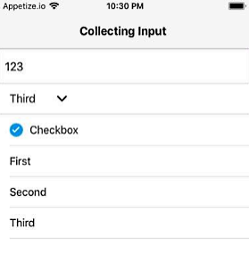
Here's what these controls look like on Android:
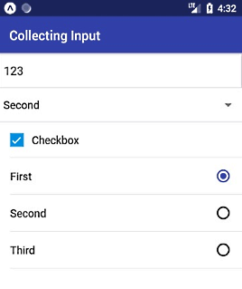
In the next section, you'll learn how to display data using lists.

Displaying data using lists
The NativeBase List component is useful when you have a large array of objects that you want to render. The ListItem components can also be selected by the user. Let's look at an example. First, we'll add some states for items that we want to render as a list on the screen:
const [items, setItems] = useState(
new Array(100)
.fill(null)
.map((value, index) => ({ name: `Item ${index + 1}`, selected: false }))
);
The items state is an array of objects with a name to display, and a selected Boolean property that defaults to false. Next, we'll define a helper function that returns an event handler for the list item at a given index, which toggles the selected value:
function toggleSelected(index) {
return () => {
const newItems = [...items];
const item = { ...items[index], selected: !items[index].selected };
newItems[index] = item;
setItems(newItems);
};
}
Once the selected property is updated, we can use the setItems() function to update the items state, which in turn will update the rendered list. Now, let's look at how the List component is rendered:
<Container title="Displaying Data Using Lists">
<List>
{items.map((item, index) => (
<ListItem selected={item.selected} onPress={toggleSelected(index)}>
<Left>
<Text>{item.name}</Text>
</Left>
<Right>{item.selected ? <Icon name="checkmark" /> : null}</Right>
</ListItem>
))}
</List>
</Container>
The items array maps to the ListItem components. The selected property is set to item.selected, which also determines whether the checkmark icon component is displayed or not. Here's what the result looks like on iOS:
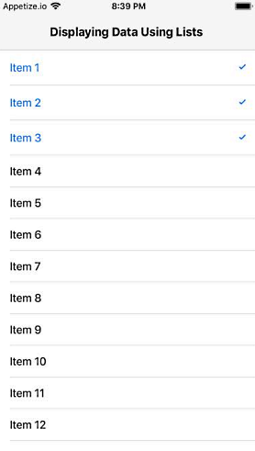
Here's what the result looks like on Android:
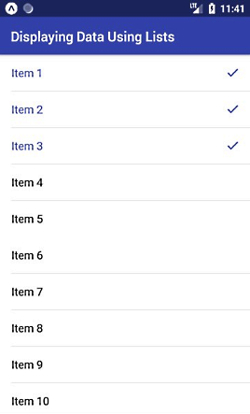
In the final section of this chapter, you'll learn how to display notifications for your users.

Showing user notifications
The NativeBase Toast API works the same way on iOS and Android. Notifications are difficult to handle in a cross-platform way, but thankfully, this API makes this possible. Let's look at an example now:
import React from "react";
import { Button, Text, Toast } from "native-base";
import Container from "./Container";
export default function App() {
return (
<Container title="Showing User Notifications">
<Button
onPress={() =>
Toast.show({
text: "Something happened!",
buttonText: "dismiss",
duration: 3000
})
}
>
<Text>Show Notification</Text>
</Button>
</Container>
);
}
This app renders a button that, when clicked, calls Toast.show() to display a notification to the user. This function takes an object with several message configuration values, such as the text to display and how long the message should be visible before disappearing automatically. Here's what the result looks like on iOS:
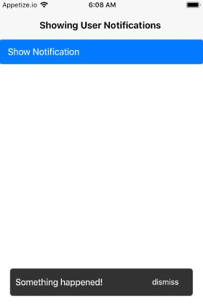
Here's what the result looks like on Android:
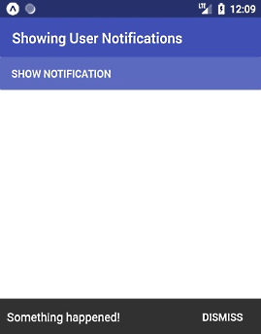
By using the NativeBase Toast API, you can have consistent notifications displayed on either platform.

Summary
Although we barely scratched the surface of the components available in NativeBase, you now have a sense of what's possible with this library and how it greatly reduces the amount of cross-platform code we need to write. We started by looking at application container components that take care of loading NativeBase fonts and establishing the overall structure for every screen in the app. We then learned about adding navigation and navigation links to our NativeBase app. Then, we organized components on the screen using the NativeBase layout components.
Next, we used form input components to collect different kinds of input from the user. Finally, we learned how to render data as lists and show notifications. In the next chapter, we'll look at scaling application states in React applications.
Handling Application State
From early on in this book, you've been using state to control your React components. State is an important concept in any React application because it controls what the user can see and interact with. Without state, you just have a bunch of empty React components.
In this chapter, you'll learn about Flux and how it can serve as the basis of your information architecture. Then, you'll learn how to build an architecture that best serves web and mobile architectures. You'll also be introduced to the Redux library, followed by a discussion on the limitations of React architectures and how you might overcome them.
This chapter has the following sections:
Information architecture and Flux
Unified information architecture
Implementing Redux
Scaling the architecture

Technical requirements
You can find the code files present in this chapter on GitHub at https://github.com/PacktPublishing/React-and-React-Native---Third-Edition/tree/master/Chapter26/implementing-redux.

Information architecture and Flux
It can be difficult to think of UIs as information architectures. More often, you get a rough idea of how the UI should look and behave, and then you implement it. I do this all the time, and it's a great way to get the ball rolling, to discover issues with your approach early, and so on. But then I like to take a step back and picture what's happening without any widgets. Inevitably, what I've built is flawed in terms of how state flows through the various components. This is fine; at least I have something to work with now. I just have to make sure that I address the information architecture before building too much.
Flux is a set of patterns created by Facebook that helps developers think about their information architecture in a way that fits in naturally with their apps. I'll go over the key concepts of Flux next so that you can apply these ideas to a unified React architecture.

Unidirectionality
In Chapter 6, Crafting Reusable Components, I introduced the container pattern for React components. The container component has state but it doesn't actually render any UI elements. Instead, it renders other React components and passes in its state as properties. Whenever the container state changes, the child components are re-rendered with new property values. This is unidirectional data flow.
Flux takes this idea and applies it to something called a store. A store is an abstract concept that holds application state. As far as I'm concerned, a React container is a perfectly valid Flux store. I'll have more to say about stores in a moment. First, I want you to understand why unidirectional data flows are advantageous.
There's a good chance that you've implemented a UI component that changes state, but you're not always sure how it happens. Was it the result of some event in another component? Was it a side-effect from some network call completing? When that happens, you spend lots of time chasing down where the update came from. The effect is often a cascading game of whack-a-mole. When changes can only come from one direction, you can eliminate a number of other possibilities, thus making the architecture as a whole more predictable.

Synchronous update rounds
When you change the state of a React container, it will re-render its children, who re-render their children, and so on. In Flux terminology, this is called an update round. From the time state changes to the time that the UI elements reflect this change, this is the boundary of the round. It's nice to be able to group the dynamic parts of application behavior into larger chunks like this because it's easier to reason about cause and effect.
A potential problem with React container components is that they can interweave with one another and render in a non-deterministic order. For example, what if some API call completes and causes a state update to happen before the rendering has completed in another update round? The side effects of asynchronicity can accumulate and morph into unsustainable architectures if not taken seriously.
The solution in Flux architectures is to enforce synchronous update rounds and to treat attempts to sidestep the update round order as an error. JavaScript is a single-threaded, run-to-completion environment that should be embraced by working with it rather than against it. Update the whole UI, and then update the whole UI again. It turns out that React is a really good tool for this job.

Predictable state transformations
In a Flux architecture, you have a store used to hold application state. You know that when state changes, it happens synchronously and unidirectionally, making the system as a whole more predictable and easy to reason about. However, there's still one more thing you can do to ensure that side-effects aren't introduced.
You're keeping all your application state in a store, which is great, but you can still break things by mutating data in other places. These mutations might seem innocent at first glance, but they're toxic to your architecture. For example, the callback function that handles a fetch() call might manipulate the data before passing it to the store. An event handler might generate some structure and pass it to the store. There are limitless possibilities.
The problem with performing these state transformations outside the store is that you don't necessarily know that they're happening. Think of mutating data as a butterfly effect: one small change has far-reaching consequences that aren't obvious at first. The solution is to only mutate state in the store, without exception. It's predictable and easy to trace the cause and effect of your React architecture this way.

Unified information architecture
Let's take a moment to recap the ingredients of our application architecture so far:
React Web: Applications that run in web browsers
React Native: Applications that run natively on mobile platforms
Flux: Patterns for scalable data in React applications
Remember, React is just an abstraction that sits on top of a render target. The two main render targets are browsers and native mobile. This list will likely grow, so it's up to you to design your architecture in a way that doesn't exclude future possibilities. The challenge is that you're not porting a web application to a native mobile application; they're different applications, but they serve the same purpose.
Having said that, is there a way that you can still have some kind of unified information architecture based on ideas from Flux that can be used by these different applications? The best answer I can come up with, unfortunately, is sort of. You don't want to let the different web and mobile user experiences lead to drastically different approaches in handling state. If the goals of the applications are the same, then there has to be some common information that you can share, using the same Flux concepts.
The difficult part is the fact that web and native mobile are different experiences, which means that the shape of your application state will be different. It has to be different; otherwise, you would just be porting from one platform to the other, which defeats the purpose of using React Native to leverage capabilities that don't exist in browsers.

Implementing Redux
You'll use a library called Redux to implement a basic application that demonstrates the Flux architecture. Redux doesn't strictly follow the patterns set out by Flux. Instead, it borrows key ideas from Flux and implements a small API to make it easy to implement Flux.
The application itself will be a newsreader, a specialized reader for hipsters that you probably haven't heard of. It's a simple app, but I want to highlight the architectural challenges as I walk through the implementation. Even simple apps get complex when you're paying attention to what's going on with the data.
You're going to implement two versions of this app. You'll start with the web version, and then you'll implement mobile-native apps for iOS and Android. You'll see how you can share architectural concepts between your apps. This lowers the conceptual overhead when you need to implement the same application on several platforms. You're implementing two apps right now, but this will likely be more in the future as React expands its rendering capabilities.
Once again, I urge you to download the code samples for this book from https://github.com/PacktPublishing/React-and-React-Native---Third-Edition. There are a lot of little details that I simply do not have room to cover in this book, especially for the example apps we're about to look at.

Initial application state
Let's start by looking at the initial state of the Flux store. In Redux, the entire state of the application is represented by a single store. Here's what it looks like:
export default {
App: {
title: "Neckbeard News",
links: [
{ name: "All", url: "/" },
{ name: "Local", url: "/local" },
{ name: "Global", url: "/global" },
{ name: "Tech", url: "/tech" },
{ name: "Sports", url: "/sports" }
]
},
Home: {
articles: []
},
Article: {
full: ""
}
};
This module exports a plain object. In Redux, you divide up the application state into slices. In this case, it's a simple application, so the store only has three slices of state. Each slice of the state is mapped to a major application feature.
For example, the Home key represents a state that's used by the Home component of your app. It's important to initialize any state, even if it's an empty object or array, so that your components have initial properties. Now let's use some Redux functions to create a store that's used to get data to your React components.

Creating the store
The initial state is useful when the application first starts. This is enough to render components, but that's about it. Once the user starts interacting with the UI, you need a way to change the state of the store. In Redux, you assign a reducer function to each slice of state in your store. So, for example, your app would have a Home reducer, an App reducer, and an Article reducer.
The key concept of a reducer in Redux is that it's pure and side-effect free. This is where having Immutable.js structures as state comes in handy. Let's see how to tie your initial state to the reducer functions that will eventually change the state of our store:
import { createStore, combineReducers } from "redux";
import initialState from "./initialState";
import App from "./App";
import Home from "./Home";
import Article from "./Article";
export default createStore(
combineReducers({
App,
Home,
Article
}),
initialState
);
The App, Home, and Article functions are named in exactly the same way as the slice of state that they manipulate. This makes it easier to add new states and reducer functions as the application grows.
You now have a Redux store that's ready to go. But you still haven't hooked it up to the React components that actually render state. Let's take a look at how to do this now.

Store provider and routes
Redux has a Provider component (technically, it's the react-redux package that provides it), which is used to wrap the top-level components of your application. This will ensure that Redux store data is available to every component in your application.
In the hipster newsreader app you're developing, you'll wrap the Router component with a Provider component. Then, as you build your components, you know that store data will be available. Here's what the Root component looks like:
import React from "react";
import { Provider } from "react-redux";
import store from "../store";
import App from "./App";
export default function Root() {
return (
<Provider store={store}>
<App />
</Provider>
);
}
The store that you created by taking the initial state and combining it with reducer functions is passed to <Provider>. This means that, when your reducers cause the Redux store to change, the store data is automatically passed to each application component. We'll take a look at the App component next.

The App component
The App component includes the page heading and a list of links to various article categories. When the user moves around the user interface, the App component is always rendered, but each <Route> element renders different content based on the current route. Let's take a look at the component, and then we'll break down how it works:
import React from "react";
import { BrowserRouter as Router, Route, NavLink } from "react-router-dom";
import { connect } from "react-redux";
import Home from "./Home";
import Article from "./Article";
function articleList(filter) {
return props => <Home {...props} filter={filter} />;
}
const categoryListStyle = {
listStyle: "none",
margin: 0,
padding: 0,
display: "flex"
};
const categoryItemStyle = {
padding: "5px"
};
const Local = articleList("local");
const Global = articleList("global");
const Tech = articleList("tech");
const Sports = articleList("sports");
export default connect(state => state.App)(({ title, links }) => (
<Router>
<main>
<h1>{title}</h1>
<ul style={categoryListStyle}>
{/* Renders a link for each article category.
The key thing to note is that the "links"
value comes from a Redux store. */}
{links.map(l => (
<li key={l.url} style={categoryItemStyle}>
<NavLink exact to={l.url} activeStyle={{ fontWeight: "bold" }}>
{l.name}
</NavLink>
</li>
))}
</ul>
<section>
<Route exact path="/" component={Home} />
<Route exact path="/local" component={Local} />
<Route exact path="/global" component={Global} />
<Route exact path="/tech" component={Tech} />
<Route exact path="/sports" component={Sports} />
<Route exact path="/articles/:id" component={Article} />
</section>
</main>
</Router>
));
This component requires a title property and a links property. Both of these values are actually states that come from the Redux store. Note that it's exporting a higher-order component, created using the connect() function. This function accepts a callback function that transforms the store state into properties that the component needs.
In this example, you need the App state. This is how Redux state is passed to components. Here's what the rendered content of the App component looks like:
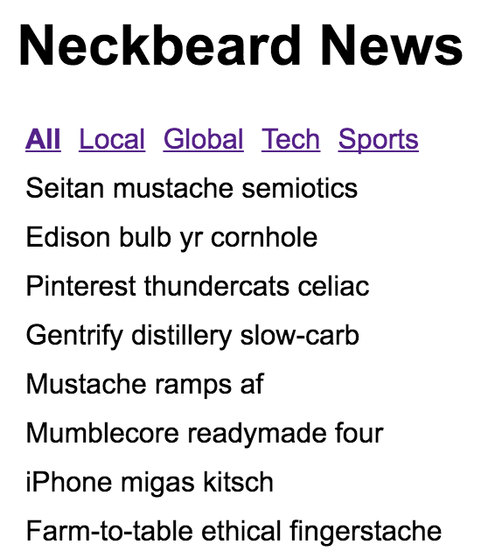
Ignore the amazing article titles for a moment; we'll return to these briefly. The title and the category links are rendered by the App component. The article titles are rendered by one of the <Route> elements.
Notice how the All category is bold? This is because it's the currently selected category. If the Local category is selected, the All text will go back to regular font, and the Local text will be emboldened. This is all controlled through the Redux state. Let's take a look at the reducer function of the App component now:
import initialState from "./initialState";
const title = initialState.App.title;
const articleLinks = [
{
name: "Home",
url: "/"
}
];
const homeLinks = initialState.App.links;
const typeMap = {
FETCHING_ARTICLE: state => ({ ...state, title: "...", articleLinks }),
FETCH_ARTICLE: (state, payload) => ({ ...state, title: payload.title }),
FETCHING_ARTICLES: state => ({ ...state, title, links: homeLinks }),
FETCH_ARTICLES: state => ({ ...state, title })
};
export default function App(state = initialState, { type, payload }) {
const reducer = typeMap[type];
return reducer ? reducer(state, payload) : state;
}
There are two points I'd like to make about this reducer logic. First, you can now see how having immutable data structures in place makes this code concise and easy to follow. Second, a lot of state handling happens here in response to simple actions. Take the FETCHING_ARTICLE and FETCHING_ARTICLES actions, for example. You want to change the UI before actually issuing a network request. I think this type of explicitness is the real value of Flux and Redux. You know exactly why something changes. It's explicit, but not verbose.

The Home component
The last major piece of the Redux architecture that's missing from this picture is the action creator functions. These are called by components in order to dispatch payloads to the Redux store. The end result of dispatching any action is a change in state. However, some actions need to go and fetch state before they can be dispatched to the store as a payload.
Let's look at the Home component of the Neckbeard News app. It'll show you how you can pass along action creator functions when wiring up components to the Redux store. Here's the code:
import React, { Component } from "react";
import PropTypes from "prop-types";
import { connect } from "react-redux";
import { Link } from "react-router-dom";
const listStyle = {
listStyle: "none",
margin: 0,
padding: 0
};
const listItemStyle = {
margin: "0 5px"
};
const titleStyle = {
background: "transparent",
border: "none",
font: "inherit",
cursor: "pointer",
padding: "5px 0"
};
With the imports and styles in place, here is the Home component:
class Home extends Component {
static propTypes = {
articles: PropTypes.arrayOf(PropTypes.object).isRequired,
fetchingArticles: PropTypes.func.isRequired,
fetchArticles: PropTypes.func.isRequired,
toggleArticle: PropTypes.func.isRequired,
filter: PropTypes.string.isRequired
};
static defaultProps = {
filter: ""
};
componentDidMount() {
this.props.fetchingArticles();
this.props.fetchArticles(this.props.filter);
}
onTitleClick = id => () => this.props.toggleArticle(id);
render() {
const { onTitleClick } = this;
const { articles } = this.props;
return (
<ul style={listStyle}>
{articles.length === 0 ? <li style={listItemStyle}>...</li> : null}
{articles.map(a => (
<li key={a.id} style={listItemStyle}>
<button onClick={onTitleClick(a.id)} style={titleStyle}>
{a.title}
</button>
<p style={{ display: a.display }}>
<small>
<span>{a.summary} </span>
<Link to={`articles/${a.id}`}>More...</Link>
</small>
</p>
</li>
))}
</ul>
);
}
}
export default connect(
(state, ownProps) => ({ ...state.Home, ...ownProps }),
dispatch => ({
fetchingArticles: () =>
dispatch({
type: "FETCHING_ARTICLES"
}),
fetchArticles: filter => {
const headers = new Headers();
headers.append("Accept", "application/json");
fetch(`/api/articles/${filter}`, { headers })
.then(resp => resp.json())
.then(json =>
dispatch({
type: "FETCH_ARTICLES",
payload: json
})
);
},
toggleArticle: payload =>
dispatch({
type: "TOGGLE_ARTICLE",
payload
})
})
)(Home);
Let's focus on the connect() function, which is used to connect the Home component to the store. The first argument is a function that takes relevant state from the store and returns it as props for this component. It's using ownProps so that you can pass props directly to the component and override anything from the store. The filter property is why we need this capability.
The second argument is a function that returns action creator functions as props. The dispatch() function is how these action creator functions are able to deliver payloads to the store. For example, the toggleArticle() function is a call directly to dispatch() and is called in response to the user clicking the article title. However, the fetchingArticles() call involves asynchronous behavior. This means that dispatch() isn't called until the fetch() promise resolves. It's up to you to make sure that nothing unexpected happens in between.
Let's wrap things up by looking at the reducer function used with the Home component:
import initialState from "./initialState";
const typeMap = {
FETCHING_ARTICLES: state => ({ ...state, articles: [] }),
FETCH_ARTICLES: (state, payload) => ({
...state,
articles: payload.map(a => ({ ...a, display: "none" }))
}),
TOGGLE_ARTICLE: (state, id) => {
const articles = [...state.articles];
const index = articles.findIndex(a => a.id === id);
articles[index] = {
...articles[index],
display: articles[index].display === "none" ? "block" : "none"
};
return { ...state, articles };
}
};
export default function Home(state = initialState, { type, payload }) {
const reducer = typeMap[type];
return reducer ? reducer(state, payload) : state;
}
The same technique of using a type map to change state based on the action type is used here. Once again, this code is easy to reason about, yet everything that can change in the system is explicit.

State in mobile apps
What about using Redux in React Native mobile apps? Of course, you should if you're developing the same application for the web and for native platforms. In fact, I've implemented Neckbeard News in React Native for both iOS and Android. I encourage you to download the code for this book and get this application running for both web and native mobile.
There really is no difference from how you actually use Redux in a mobile app. The only difference is in the shape of the state that's used. In other words, don't think that you can use the exact same Redux store and reducer functions in the web and native versions of your app. Think about React Native components. There's no one-size-fits-all component for many things. You have some components that are optimized for the iOS platform, while others are optimized for the Android platform. It's the same idea with Redux state. Here's what the initial state looks like for Neckbeard News for mobile:
export default {
Main: {
title: "All",
component: "articles"
},
Categories: {
items: [
{
title: "All",
filter: "",
selected: true
},
{
title: "Local",
filter: "local",
selected: false
},
{
title: "Global",
filter: "global",
selected: false
},
{
title: "Tech",
filter: "tech",
selected: false
},
{
title: "Sports",
filter: "sports",
selected: false
}
]
},
Articles: {
filter: "",
items: []
},
Article: {
full: ""
}
};
As you can see, the same principles that apply in the web context apply here in the mobile context. It's just the state itself that differs, in order to support the given components we're using and the unique ways that you're using them to implement your application.

Scaling the architecture
By now, you probably have a pretty good grip of Flux concepts, the mechanisms of Redux, and how they're used to implement sound information architectures for React applications. The question then becomes, how sustainable is this approach, and can it handle arbitrarily large and complex applications?
I think Redux is a great way to implement large-scale React applications. You can predict what's going to happen as the result of any given action because everything is explicit. It's declarative, it's unidirectional, and without side effects. But it isn't without challenges.
The limiting factor with Redux is also its bread and butter; because everything is explicit, applications that need to scale up, in terms of feature count and complexity, ultimately end up with more moving parts. There's nothing wrong with this; it's just the nature of the game. The unavoidable consequence of scaling up is slowing down. You simply cannot grasp enough of the big picture in order to implement things quickly.
In the final two chapters of this book, we're going to look at a related but different approach to Flux: Apollo/GraphQL. I think this technology can scale in ways that Redux cannot.

Summary
In this chapter, you learned about Flux, a set of architectural patterns that aid in building information architecture for your React application. The key ideas with Flux involve unidirectional data flow, synchronous update rounds, and predictable state transformations.
Next, I walked through a detailed implementation of a Redux/React application. Redux provides a simplified implementation of Flux ideas. The benefit is predictability everywhere.
Then, you learned whether or not Redux has what it takes to build scalable architectures for our React applications. The answer is yes, for the most part. For the remainder of this book, however, you're going to explore Apollo and GraphQL to see whether these technologies can scale your applications to the next level.

Further reading
For more information, check out the following links:
Redux: https://redux.js.org/
Flux: https://facebook.github.io/flux/

Why Apollo?
In the preceding chapter, you learned about the architectural principles of Flux. In particular, you used the Redux library to implement concrete Flux concepts in a React application. Having a framework of patterns such as Flux in place to help you reason how state changes and flows through your application is a good thing. At the end of the chapter, you learned about the potential limitations in terms of scale.
In this chapter, we are going to walk you through yet another approach to handling state in a React application. Like Redux, Apollo Client can be used with both web and mobile React applications. Apollo Client is a React implementation of Apollo and relies on a query language called GraphQL, which is used to fetch resources and mutate them.
Unlike Redux, you don't have to write reducers and actions to deal with state management. Instead, Apollo provides a more declarative way of handling data fetching and the state of that data in your application afterward. For this, Apollo provides you with components and hooks to fetch and mutate data from any GraphQL server.
In the final chapter of this book, you'll work on a React Native implementation of the ever-popular Todo MVC application using Apollo.
In this chapter, you'll learn about the following:
The need for another approach to handle data in React apps
The high-level vocabulary of GraphQL
Declarative data fetching
Mutations as a means to update data

Yet another approach?
This was the exact question I had when I learned of Apollo and GraphQL. Then, I reminded myself that the beauty of React is that it's just the view abstraction of the UI. Of course, there are going to be many approaches to handling data. So, the real question is, what makes using Apollo and GraphQL better or worse than using something such as Redux?
At a high level, you can think of Apollo as an implementation of Flux architecture patterns and you can think of GraphQL as the interface that describes how the Flux stores within Apollo Client work. At a more practical level, the value of Apollo Client is its ease of implementation. For example, with Redux, you have a lot of implementation work to do just to populate the stores with data. This gets verbose over time as it's difficult to scale Redux beyond a certain point if you've got to write that much code for every new feature you want to implement.
It's not the individual data points that are difficult to scale. It's the aggregate effect of having lots of fetch requests that end up building very complicated stores. Apollo Client changes this by allowing you to declare the data that a given component needs and letting Apollo Client figure out the best way to fetch this data and synchronize it with the local store. Under the hood, it will use a similar logic to what you've written by yourself in the previous chapters.
Is the Apollo and GraphQL approach better than Redux and other approaches for handling data in React applications? In some respects, yes, it is. Is it perfect? Far from it. There is a learning curve involved and not everyone is able to deal with it. It's immutable and parts of it are difficult to use. However, just knowing the premise of how GraphQL and Apollo work and seeing it in action is worth your while, even if you decide against it.
Now, let's pick apart some vocabulary.

Verbose vernacular
Before I start going into more depth on data dependencies and mutations, I think it makes sense for me to throw some general Relay and GraphQL terminology definitions out there:
Apollo: The complete industry-standard solution to implement GraphQL in any application.
Apollo Client: A library that manages application data fetching and data mutations and provides higher-order components that feed data to our application components. Also, it comes with React Hooks support and caching out of the box.
GraphQL: A query language used to specify data requirements and data mutations.
Query: A part of a data dependency, expressed in GraphQL syntax and executed by an encapsulated Relay mechanism.
Fragment: A part of a larger GraphQL query.
Mutation: A special type of GraphQL query that changes the state of some remote resource. Apollo Client has to figure out how to reflect this change in the frontend once it completes.
Subscription: A GraphQL type used for real-time events between the server and the client application; for example, for notifications or chat messages.
Let's quickly talk about data dependencies and mutations so that we can look at some application code.

Declarative data fetching
As mentioned before, GraphQL is a query language that lets you define what the response of an API looks like by how you structure your query. Not only is it a query language, but it also provides a runtime to fulfill those queries based on your existing data. Not only can you use GraphQL to fetch data with queries, but you can also send mutate data by using mutations.
When you want to use GraphQL, the API that you're using for data fetching should support GraphQL. This means the server should have a schema that describes which operations (queries, mutations, or subscriptions) are allowed and which data fields can be requested. Every operation that is described in the schema for a GraphQL server can be executed by sending a document containing these operations. Other than with REST APIs, you have complete control over the shape of your data as you define what structure the response should have in your operation.
Let's get a taste of how GraphQL queries work. If you want to display the first and last name of a user, you need to tell the GraphQL server that you want to retrieve these fields. Then, you can rest assured that the data will always be there. Here's an example of what a query looks like:
query getUser {
user {
firstName
lastName
}
}
In this query, you have described that you want to retrieve the firstName and lastName fields for a user. When you send this query in a document to a GraphQL server, it will respond with a JSON object containing these fields (and these fields only):
"data": {
"user": {
"firstName": "John",
"lastName": "Doe"
}
}
This request is similar to how a REST API would handle a request, for example, a call to a /users endpoint. What differs is the shape of the data that is returned by the GraphQL server and that you can use Apollo Client to retrieve this data.
Apollo Client can be used for data fetching in different ways, using React concepts that you've already explored in this book. One of those ways is by using higher-order components to execute GraphQL operations, such as sending a query. For this, you can use the Query component from Apollo Client, which not only sends the query but also handles state management for you.
Let's see how to use a Query component to retrieve data:
const GET_USER = gql`
user {
firstName
lastName
}
}`
return (
<Query query={GET_USER}>
{({ loading, error, data }) => {
if (loading) return 'Loading...'
if (error) return `Error: ${error.message}`
const { firstName, lastName } = data.user
return (
<p>`Hi there, ${firstName} ${lastName}`</p>
)
}}
</Query>
)
The Query component takes a GraphQL query as a prop and returns an object with the loading, error, and data state variables. When there is no data fetched yet, the loading variable will be true. As soon as the data is loaded, the error or data variables will be resolved with information from the GraphQL server.
As well as using higher-order components to use GraphQL operations, you can also use React Apollo hooks for this. These work very similar to how React hooks are used to control your application state. The example to fetch users can be rewritten using a useQuery hook instead:
const GET_USER = gql`
user {
firstName
lastName
}
}`
const { loading, error, data } = useQuery(GET_USER)
if (loading) return 'Loading...'
if (error) return `Error: ${error.message}`
const { firstName, lastName } = data.user
return (
<p>`Hi there, ${firstName} ${lastName}`</p>
)
The useQuery hook returns the response from the GraphQL server in the same manner as the Query component does. Rather than with the Query component, you can control the state of the application with Hooks instead.
Depending on the schema of the GraphQL server, you can add more fields to the query or even query nested relationships for this user. If the GraphQL schema allows for nested relationships, you can define these in your query like this:
query getUser {
user {
firstName
lastName
todos {
title
status
}
}
}
The preceding query will also retrieve todos for this user, as well as firstName and lastName. This query would return the following data:
"data": {
"user": {
"firstName": "John",
"lastName": "Doe",
"todos": [
{
"title": "Do dishes",
"status" "complete"
},
{
"title": "Walk the dog",
"status": "open"
}
}
}
}
You can see how the todos object is not only shaped exactly like how it was defined in the query, but also as a list. If you have a REST API, you would need to send two different requests to two different endpoints to retrieve this. For example, one request to the /users endpoint, and another request to the endpoint that returns the list of todos for a user.
Once again, don't dwell on the Apollo/GraphQL specifics just yet. The idea here is to simply illustrate that this is what you need to write to get data from a GraphQL server. The rest is just bootstrapping Apollo React for data fetching and state-management, which you'll see in the next chapter.

Mutating application state
GraphQL mutations are the actions that cause side effects in your systems because they change the state of some resource that your UI cares about. What's interesting about mutations is that they care about side effects that happen to your data as a result of a change in the state of something. For example, if you change the information of a user, this will certainly impact the screen that displays the user information. But it could also impact a listing screen that shows the information of several users.
Let's see what a mutation looks like:
mutation changeTodoStatus($input: ChangeTodoStatusInput!) {
changeTodoStatus(input: $input) {
todo {
title
status
}
user {
todos {
title
status
}
}
}
}
`;
This mutation will change the status of a todo item and return the updated information of that todo. But that's not all this mutation does, as it also returns the user information containing all the todos of that user. When the status of a todo item changes, a screen that shows the todos for this user might also change. This is how Apollo and GraphQL can determine what might be affected as a side effect of performing this mutation, as the updated information for the user will also be returned.
Similar to how you used Apollo Client to retrieve user information, this information can also be mutated using Apollo Client. Again, there are multiple approaches to using GraphQL mutations with Apollo Client. We'll first see how this works with a higher-order component called Mutation:
const CHANGE_TODO = gql`
// Mutation goes here
`
return (
<Mutation mutation={GET_USER}>
{(changeTodo, { data }) => (
<div>
<form onSubmit={e => {
e.preventDefault()
changeTodo({ variables: { input: input.value } })}
input.value = ''
}>
<input ref={node => {
input = node
}}/>
<button type="submit">Change todo</button>
</form>
{data.todos && 'Completed'}
</div>
}}
</Mutation>
)
The Mutation component takes the mutation as a prop and returns an object to execute the mutation and an object with the data that will be returned. With a simple form element, the mutation function can be called when this form gets submitted. When it returns the data for the user, a Completed! message will be shown on the screen.
You'll see more mutations in action in the following chapter, where you'll implement Apollo Client in a React Native application.

Summary
The goal of this chapter was to quickly introduce you to the concepts of GraphQL and Apollo Client prior to the final chapter of this book, where you're going to implement some Apollo/GraphQL code.
Apollo Client is yet another approach to the state management problem in React applications. It's different in the sense that it reduces the complexities associated with the data fetching code that we have to write with other approaches to Flux, such as Redux.
The two key aspects of Apollo Client are declarative data fetching and explicit mutation side-effect handling. All of this is expressed through GraphQL syntax. In order to have an Apollo Client application, you need a GraphQL backend where the data can be retrieved from. Now, on to the final chapter, where you'll examine Apollo/GraphQL concepts in more detail by creating a React application with Apollo Client.

Further reading
You can find more information on Relay at https://facebook.github.io/relay/.
Building an Apollo React App
In the previous chapter, you got an extensive introduction to Apollo and GraphQL and learned why and how you should use this approach for your React application. Now you can build your Todo React Native application using Apollo Client. By the end of this chapter, you should be comfortable with knowing how data moves around in a GraphQL-centric application.
In this chapter, we'll cover the following topics:
Todo and Apollo Client
The GraphQL schema
Bootstrapping Apollo Client
Adding todo items
Rendering todo items
Completing todo items

Technical requirements
You can find the code files used in this chapter on GitHub at https://github.com/PacktPublishing/React-and-React-Native---Third-Edition/tree/master/Chapter28.

Todo and Apollo Client
Originally, it was my plan to extend the Neckbeard News app that we worked on earlier in this chapter. Instead, I decided that the Todo example for React (https://github.com/tastejs/todomvc/tree/gh-pages/examples/react) is a robust, yet concise, example that would be a better starting point for creating an application for this chapter.
I'm going to walk you through an example React Native implementation of a Todo app. The key is that it will use the same GraphQL backend as the web UI. I think this is a win for React developers that want to build both web and native versions of their apps; they can share the same schema!
I've included the web version of the Todo app in the code that ships with this book, but I won't dwell on the details of how it works. If you've worked on web development in the past 5 years, you've probably come across a sample Todo app. Here's what the web version looks like:
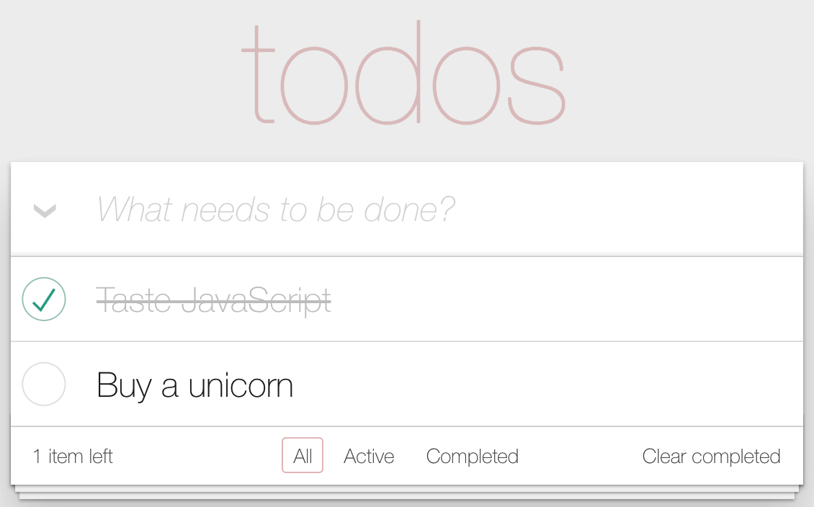
Even if you haven't used any of the Todo apps before, I would recommend playing with this one before trying to implement the native version, which is what we'll be doing for the remainder of this chapter.
The goal of the native version that you're about to implement isn't functional parity. In fact, you're shooting for a very minimal subset of todo functionality. The aim is to show you that Apollo Client works mostly the same on native platforms as it does on web platforms and that the GraphQL backend can be shared between web and native apps.

The GraphQL schema
The schema is the vocabulary used by the GraphQL backend server and the Apollo components in the frontend. The GraphQL type system enables the schema to describe the data that's available and how to put it all together when a query request comes in. This is what makes the whole approach so scalable—the fact that the GraphQL runtime figures out how to put data together. All you need to supply are functions that tell GraphQL where the data is; for example, in a database or in a remote service endpoint.
Let's take a look at some of the types used in the GraphQL schema for the Todo app:
We'll start with Todo itself:
type Todo {
id: ID!
text: String!
complete: Boolean
}
This type describes the Todo objects used throughout the application, including all the optional and required fields for this type. In the example code, you can see that the types followed with an exclamation mark are required (id and text), and the ones without an exclamation mark are optional (complete). Everything else in the GraphQL schema is based on this type, either directly or indirectly.
Next, let's look at the types that tie the Todo type to the user who is interacting with the app:
type User {
id: ID!
totalCount: Int!
completedCount: Int!
todos: [Todo]!
}
By implementing these types, the end result is a User type with a list of todos, including the total number of todos and the total number of completed todos. This type can be accessed from our components, which we'll see shortly. Our schema also needs to declare how data changes.
Let's look at some of the mutation types used with this app:
type Mutation {
addTodo(text: String): [Todo]
changeTodoStatus(id: Int!, complete: Boolean): [Todo]
markAllTodos: [Todo]
removeCompletedTodos: [Todo]
removeTodo(id: Int!): [Todo]
renameTodo(id: Int!, text: String): [Todo]
}
Each mutation type describes what it takes as input and what the resulting payload looks like once the operation is complete. The mutation type ties all of this together and provides an interface for everything that changes in the application. In this schema, there are mutations to add new todos, change the name or status of a todo, or to delete todos. These mutations will be used when creating the application later on.
Now that there's a GraphQL schema in place, we're ready to put it into our application using Apollo and React in the next section.

Bootstrapping Apollo Client
At this point, you have the GraphQL backend up and running. Now, you can focus on your React components in the frontend. In particular, you're going to look at Apollo Client in a React Native context, which really only has minor differences. For example, in web apps, it's usually react-router that bootstraps Apollo Client. In React Native, it's a little different. Let's look at the App.js file that serves as the entry point for your native app:
import
React
from
'react'
;
import
{
View
,
Text
}
from
'react-native'
;
import
{
ApolloClient
,
InMemoryCache
}
from
'@apollo/client'
;
import
{
ApolloProvider
,
Query
}
from
'@apollo/react-components'
;
import
styles
from
'./styles'
;
import
TodoInput
from
'./TodoInput'
;
import
TodoList
from
'./TodoList'
;
import
{
GET_USER
}
from
'../constants'
;
// Replace this value with the network IP address of your machine
const
NETWORK_IP
=
''
;
const
client
=
new
ApolloClient
({
cache
:
new
InMemoryCache
(),
uri
:
`http://
${
NETWORK_IP
}
:3000/graphql`
,
});
export
default
()
=>
(
<
ApolloProvider
client
=
{
client
}
>
<
Query
query
=
{
GET_USER
}
variables
=
{
{
// Mock authenticated ID that matches database
userId
:
'me'
,
}
}
>
{
({
loading
,
error
,
data
})
=>
{
if
(
loading
) {
return
<
Text
>
Loading
</
Text
>
;
}
if
(
error
) {
return
<
Text
>
{
error
.
message
}
</
Text
>
;
}
return
(
<
View
style
=
{
styles
.
container
}
>
<
TodoInput
/>
<
TodoList
user
=
{
data
.
user
}
/>
</
View>
);
}
}
</
Query
>
</
ApolloProvider
>
);
Let's break down what's happening here, starting with adding the network IP address of your machine:
// Replace this value with the local IP address of your machine
const
LOCAL_IP
=
''
;
The GraphQL backend is running on your local machine. But as we're using Expo with a tunnel to run the React Native application, you'll need to use the network IP address (or IPv4 address) of your local machine to access the GraphQL backend.
Getting the network IP address involves the following steps, depending on your operating system:
For Windows: Open the terminal (or Command Prompt) and run this command:
ipconfig
This will return a list, as follows, with data from your local machine. In this list, you need to look for the IPv4 Address field:
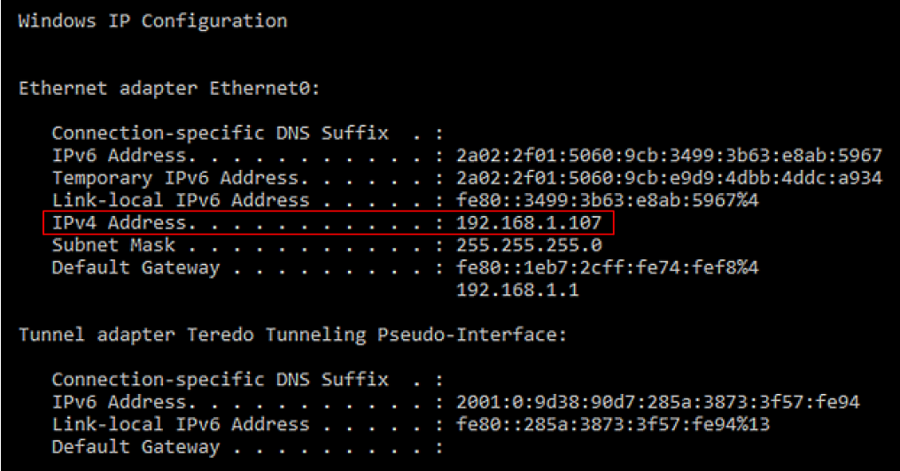
For macOS: Open Terminal and run this command:
ipconfig getifaddr en0
After running this command, the IPv4 address of your machine gets returned, which looks like this:
192.168.1.107
After getting the network IP address, you can use this address to set up an Apollo Client instance for the React Native application:
const
client
=
new
ApolloClient
({
cache
:
new
InMemoryCache
(),
uri
:
`http://
${
NETWORK_IP
}
:3000/graphql`
,
});
This is how you communicate with the GraphQL backend: by configuring a client. In this example, you're using the network IP address that you retrieved previously, which means all requests to the GraphQL backend are being made on your machine. This is really handy for when you're getting started, especially when building a React Native app. Also, InMemoryCache from @apollo/client is used to get caching for your application data out of the box.
Next, there's the Query component from @apollo/react-components. This Apollo component is used to render other components that depend on GraphQL queries. It expects a query property, which is used to get the data:
<
Query
query
=
{
GET_USER
}
variables={{
userId: 'me',
}}
>
The value for query can be found in the constants.js file, which hosts all the queries and mutations for this application:
export
const
GET_USER
=
gql
`
query
GetUser
(
$userId
:
String
) {
user
(
id
:
$userId
) {
id
totalCount
completedCount
todos
{
id
text
complete
}
}
}
`
;
As you can see, this query requires the userId parameter. You can pass variables to the query from the Query component:
<
Query
query
=
{
GET_USER
}
variables={{
userId: 'me',
}}
>
Then, the Query component will return a loading value, once the query is transferred to the GraphQL backend, and the error and data values when the GraphQL data is ready:
{
({
loading
,
error
,
data
})
=>
{
if
(
loading
) {
return
<
Text
>
Loading
</
Text
>
;
}
if
(
error
) {
return
<
Text
>
{
error
.
message
}
</
Text
>
;
}
return
(
<
View
style
=
{
styles
.
container
}
>
<
TodoInput
/>
<
TodoList
user
=
{
data
.
user
}
/>
</
View>
);
}
}
If something went wrong, error will contain information about the error and you can return a message to the user. Otherwise, you can return the components that need the data value. If there's no error and no props, it's safe to assume that the GraphQL data is still loading.
Next, we'll have a look at using mutations to add new todo items to the application.

Adding todo items
In the TodoInput component, there's a text input that allows the user to enter new todo items. When they're done entering the todo item, Apollo Client will need to send a mutation to the backend GraphQL server. Here's what the component code looks like:
import
React
, {
Component
}
from
'react'
;
import
{
TextInput
}
from
'react-native'
;
import
{
Mutation
}
from
'@apollo/react-components'
import
styles
from
'./styles'
;
import
{
GET_USER
,
ADD_TODO
}
from
'../constants'
;
export
default
class
App
extends
Component
{
render
() {
return
(
<
Mutation
mutation
=
{
ADD_TODO
}
refetchQueries
=
{
[
{
query
:
GET_USER
,
variables
:
{
userId
:
'me'
}
}
]
}
>
{
addTodo
=>
(
<
TextInput
style
=
{
styles
.
textInput
}
placeholder
=
'What needs to be done?'
onSubmitEditing
=
{
({
nativeEvent
: {
text
} })
=>
addTodo
({
variables
:
{
text
} })
}
/>
)
}
</
Mutation
>
);
}
}
It doesn't look that different from your typical React Native component. The piece that stands out is the Mutation component, which is how you tell the GraphQL backend that you want a new todo item created. This component looks very similar to the Query component that you saw in the previous section:
<
Mutation
mutation
=
{
ADD_TODO
}
refetchQueries
=
{
[
{
query
:
GET_USER
,
variables
:
{
userId
:
'me'
}
}
]
}
>
The Mutation component needs a mutation, which is the ADD_TODO mutation that you can find in the constants.js file:
export
const
ADD_TODO
=
gql
`
mutation
AddTodo
(
$text
:
String
) {
addTodo
(
text
:
$text
) {
id
}
}
`
;
This mutation takes just one variable, which you can pass to the mutation by using the addTodo callback function that was returned by the Mutation component. You can call this function when the user submits something in the input field in the TodoInput component:
{
addTodo
=>
(
<
TextInput
style
=
{
styles
.
textInput
}
placeholder
=
'What needs to be done?'
onSubmitEditing
=
{
({
nativeEvent
: {
text
} })
=>
addTodo
({
variables
:
{
text
} })
}
/>
)
}
When the mutation has been sent to the GraphQL backend, this same component can be used to refetch any queries that are defined in your application. If a new todo is added using the mutation, you want your user to see the new list of todos by refetching the GET_USER query from the App component. To refetch a query, you can pass a value for refetchQueries to the Mutation component:
<
Mutation
mutation
=
{
ADD_TODO
}
refetchQueries
=
{
[
{
query
:
GET_USER
,
variables
:
{
userId
:
'me'
}
}
]
}
>
Let's see what the application looks like so far:
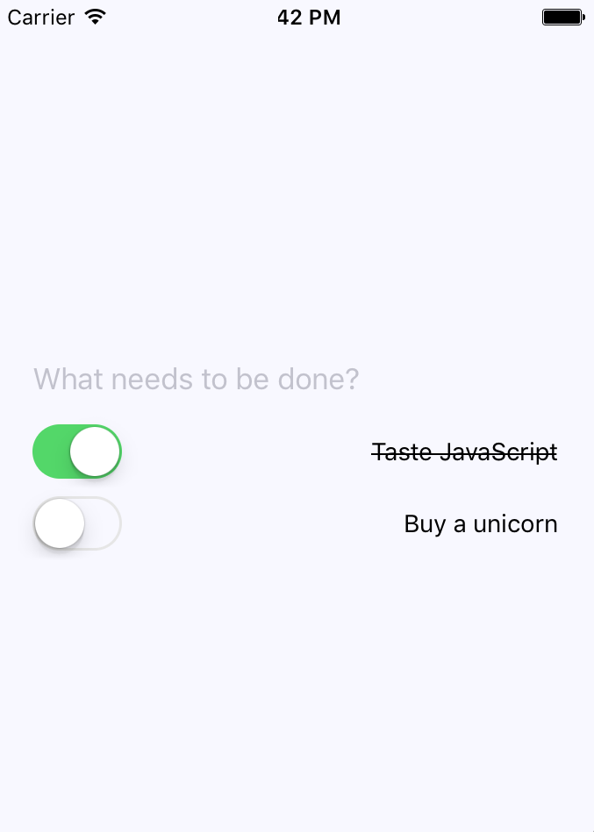
The input field for adding new todo items is just above the list of todo items. Now, let's look at the TodoList component, which is responsible for rendering the todo item list.

Rendering todo items
It's the job of the TodoList component to render the todo list items. When the GET_USER query takes place, the TodoList component needs to be able to render all the todo items. Here's a look at the item list again, with several more todos added:
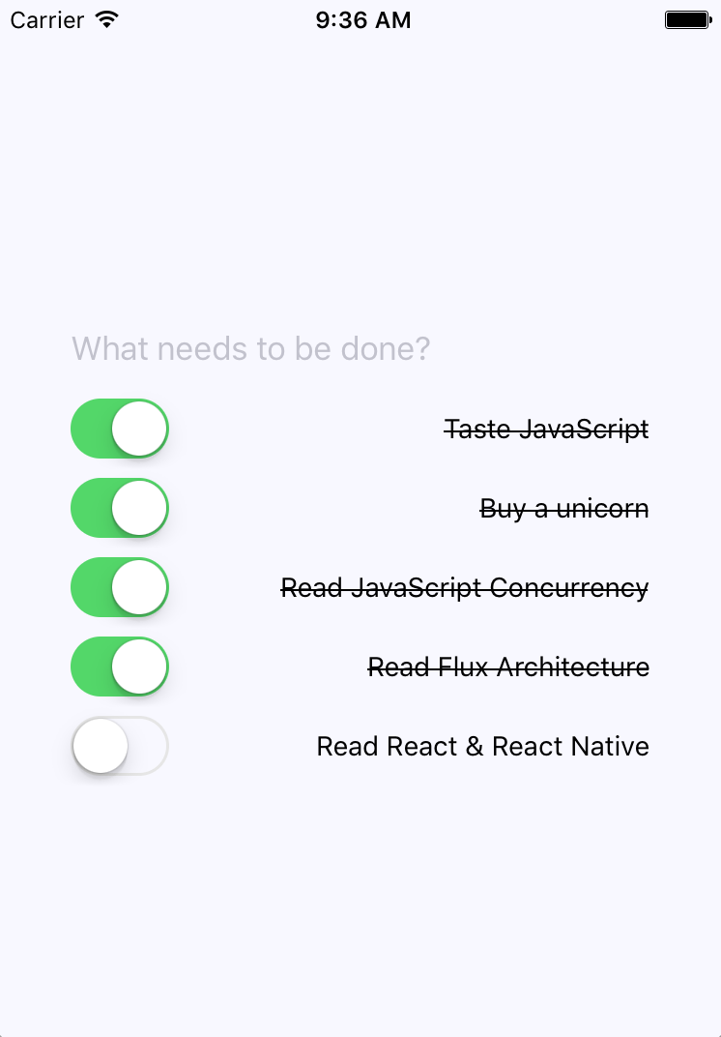
Here's the TodoList component itself:
import
React
, {
Component
}
from
'react'
;
import
{
View
}
from
'react-native'
;
import
Todo
from
'./Todo'
;
class
TodoList
extends
Component
{
render
() {
const
{
user
} =
this
.
props
;
return
(
<
View
>
{
user
.
todos
.
map
(
todo
=>
(
<
Todo
key
=
{
todo
.
id
}
todo
=
{
todo
}
/>
))
}
</
View
>
);
}
}
export
default
TodoList
The relevant GraphQL query to get the data you need for this component is already executed in the App component. This component, therefore, doesn't need to send a query to the GraphQL backend itself and can render the todos that were passed to it. When you render the <Todo> component, you're passing it the todo data. Now, let's see what the Todo component looks like.

Completing todo items
The last piece of this application is rendering each todo item and providing the ability to change the status of the todo in the Todo component. Let's take a look at this code:
import
React
, {
Component
}
from
'react'
;
import
{
Text
,
View
,
Switch
}
from
'react-native'
;
import
{
Mutation
}
from
'@apollo/react-components'
;
import
styles
from
'./styles';
import
{
CHANGE_TODO_STATUS
,
GET_USER
}
from
'../constants'
;
const
completeStyleMap
=
new
Map
([
[
true
, {
textDecorationLine
:
'line-through'
}],
[
false
, {}],
]);
class
Todo
extends
Component
{
render
() {
const
{
todo
: {
id
,
text
,
complete
},
} =
this
.
props
;
return
(
<
Mutation
mutation
=
{
CHANGE_TODO_STATUS
}
refetchQueries
=
{
[
{
query
:
GET_USER
,
variables
:
{
userId
:
'me'
}
}
]
}
>
{
changeTodoStatus
=>
(
<
View
style
=
{
styles
.
todoItem
}
>
<
Switch
value
=
{
complete
}
onValueChange
=
{
value
=>
changeTodoStatus
({
variables
:
{
id
,
complete
:
value
} })
}
/>
<
Text
style
=
{
completeStyleMap
.
get
(
complete
)
}
>
{
text
}
</
Text
>
</
View
>
)
}
</
Mutation
>
);
}
}
export
default
Todo
;
The actual component that's rendered by the Todo component is a switch control and the item text. When the user marks the todo as complete, the item text is styled as crossed off. The user can also uncheck items. These components are wrapped in a Mutation component, which is using the CHANGE_TODO_STATUS mutation from the constants.js file:
export
const
CHANGE_TODO_STATUS
=
gql
`
mutation
ChangeTodoStatus
(
$id
:
Int
!,
$complete
:
Boolean
) {
changeTodoStatus
(
id
:
$id
,
complete
:
$complete
) {
id
complete
}
}
`
;
Based on the id component of the todo item, this mutation sends the request to the GraphQL backend to change the todo state. The GraphQL backend then talks to any services that are needed to make this happen. Then, it will refetch the GET_USER query to get the new list of todos, including the one you've just updated.
That's all for the React Native implementation of the Todo app, but if you head over to the web example, you can find even more code examples. In the native application, we've only used a number of queries and mutations, but the web version features more.

Summary
In this chapter, you implemented some specific Apollo Client and GraphQL ideas. Starting with the GraphQL schema, you learned how to declare the data that's used by the application and how these data types resolve to specific data sources, such as microservice endpoints. Then, you learned about bootstrapping GraphQL queries with Apollo Client in your React Native app. Next, you walked through the specifics of adding, changing, and listing todo items. The application itself uses the same schema as the web version of the Todo application, which makes things much easier when you're developing web and native React applications.
Well, that's a wrap for this book. We've gone over a lot of material together and I hope that you've learned as much from reading it as I have from writing it. If there is one theme from this book that you should walk away with, it's that React is simply a rendering abstraction. As new rendering targets emerge, new React libraries will emerge as well. As developers think of novel ways to deal with state at scale, you'll see new techniques and libraries released. My hope is that you're now well prepared to work in this rapidly evolving React ecosystem.
Other Books You May Enjoy
If you enjoyed this book, you may be interested in these other books by Packt:

ASP.NET Core 3 and React
Carl Rippon
ISBN: 978-1-78995-022-9
Build RESTful APIs with .NET Core using API controllers
Create strongly typed, interactive, and function-based React components using Hooks
Build forms efficiently using reusable React components
Perform client-side state management with Redux and the React Context API
Secure REST APIs with ASP.NET identity and authorization policies
Run a range of automated tests on the frontend and backend
Implement continuous integration (CI) and continuous delivery (CD) processes into Azure using Azure DevOps

React Projects
Roy Derks
ISBN: 978-1-78995-493-7
Create a wide range of applications using various modern React tools and frameworks
Discover how React Hooks modernize state management for React apps
Develop progressive web applications using React components
Build test-driven React applications using the Jest and Enzyme frameworks
Understand full stack development using React, Apollo, and GraphQL
Perform server-side rendering using React and React Router
Design gestures and animations for a cross-platform game using React Native

Leave a review - let other readers know what you think
Please share your thoughts on this book with others by leaving a review on the site that you bought it from. If you purchased the book from Amazon, please leave us an honest review on this book's Amazon page. This is vital so that other potential readers can see and use your unbiased opinion to make purchasing decisions, we can understand what our customers think about our products, and our authors can see your feedback on the title that they have worked with Packt to create. It will only take a few minutes of your time, but is valuable to other potential customers, our authors, and Packt. Thank you!

