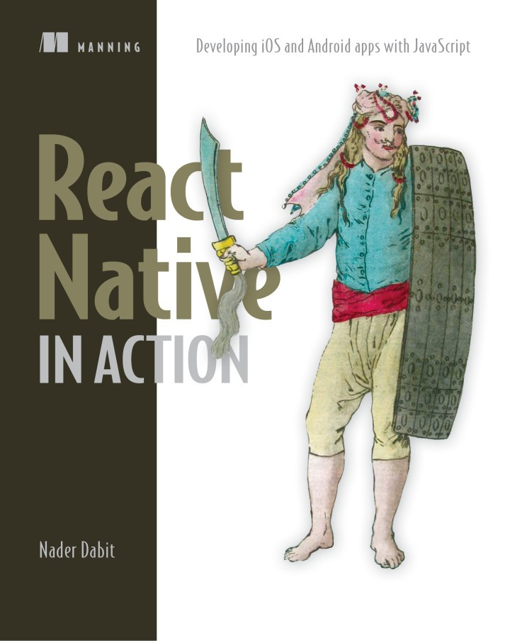

Table of Contents
Titlepage
Copyright
contents in brief
contents
preface
acknowledgments
about this book
Source code
Book forum
about the author
about the cover illustration
Part 1: Getting started with React Native
Chapter 1: Getting started with React Native
1.1 Introducing React and React Native
1.1.1 A basic React class
1.1.2 React lifecycle
1.2 What you’ll learn
1.3 What you should know
1.4 Understanding how React Native works
1.4.1 JSX
1.4.2 Threading
1.4.3 React
1.4.4 Unidirectional data flow
1.4.5 Diffing
1.4.6 Thinking in components
1.5 Acknowledging React Native’s strengths
1.5.1 Developer availability
1.5.2 Developer productivity
1.5.3 Performance
1.5.4 One-way data flow
1.5.5 Developer experience
1.5.6 Transpilation
1.5.7 Productivity and efficiency
1.5.8 Community
1.5.9 Open source
Immediate updates
Other solutions for building cross-platform mobile applications
1.6 React Native’s drawbacks
1.7 Creating and using basic components
1.7.1 An overview of components
1.7.2 Native components
1.7.3 Component composition
1.7.4 Exportable components
1.7.5 Combining components
1.8 Creating a starter project
1.8.1 Create React Native App CLI
1.8.2 React Native CLI
Summary
Chapter 2: Understanding React
2.1 Managing component data using state
2.1.1 Correctly manipulating component state
2.2 Managing component data using props
2.3 React component specifications
2.3.1 Using the render method to create a UI
2.3.2 Using property initializers and constructors
2.4 React lifecycle methods
2.4.1 The static getDerivedStateFromProps method
2.4.2 The componentDidMount lifecycle method
2.4.3 The shouldComponentUpdate lifecycle method
2.4.4 The componentDidUpdate lifecycle method
2.4.5 The componentWillUnmount lifecycle method
Summary
Chapter 3: Building your first React Native app
3.1 Laying out the todo app
3.2 Coding the todo app
3.3 Opening the developer menu
3.3.1 Opening the developer menu in the iOS simulator
3.3.2 Opening the developer menu in the Android emulator
3.3.3 Using the developer menu
3.4 Continuing building the todo app
Summary
Part 2: Developing applications in React Native
Chapter 4: Introduction to styling
4.1 Applying and organizing styles in React Native
4.1.1 Applying styles in applications
4.1.2 Organizing styles
4.1.3 Styles are code
4.2 Styling view components
4.2.1 Setting the background color
4.2.2 Setting border properties
4.2.3 Specifying margins and padding
4.2.4 Using position to place components
4.2.5 Profile Card positioning
4.3 Styling Text components
4.3.1 Text components vs. View components
4.3.2 Font styles
4.3.3 Using decorative text styles
Summary
Chapter 5: Styling in depth
5.1 Platform-specific sizes and styles
5.1.1 Pixels, points, and DPs
5.1.2 Creating drop shadows with ShadowPropTypesIOS and Elevation
5.1.3 Putting it into practice: drop shadows in the ProfileCard
5.2 Using transformations to move, rotate, scale, and skew components
5.2.1 3D effects with perspective
5.2.2 Moving elements along the x- and y-axes with translateX and translateY
5.2.3 Rotating elements with rotateX, rotateY, and rotateZ (rotate)
5.2.4 Setting visibility when rotating an element more than 90°
5.2.5 Scaling objects on the screen with scale, scaleX, and scaleY
5.2.6 Using the scale transform to create a thumbnail of the ProfileCard
5.2.7 Skewing elements along the x- and y-axes with skewX and skewY
5.2.8 Transformation key points
5.3 Using flexbox to lay out components
5.3.1 Altering a component’s dimensions with flex
5.3.2 Specifying the direction of the flex with flexDirection
5.3.3 Defining how space is used around a component with justifyContent
5.3.4 Aligning children in a container with alignItems
5.3.5 Overriding the parent container’s alignment with alignSelf
5.3.6 Preventing clipped items with flexWrap
Summary
Chapter 6: Navigation
6.1 React Native navigation vs. web navigation
6.2 Building a navigation-based app
6.3 Persisting data
6.4 Using DrawerNavigator to create drawer-based navigation
Summary
Chapter 7: Animations
7.1 Introducing the Animated API
7.2 Animating a form input to expand on focus
7.3 Creating a custom loading animation using interpolation
7.4 Creating multiple parallel animations
7.5 Creating an animated sequence
7.6 Using Animated.stagger to stagger animation start times
7.7 Other useful tips for using the Animated library
7.7.1 Resetting an animated value
7.7.2 Invoking a callback
7.7.3 Offloading animations to the native thread
7.7.4 Creating a custom animatable component using createAnimatedComponent
Summary
Chapter 8: Using the Redux data architecture library
8.1 What is Redux?
8.2 Using context to create and manage global state in a React application
8.3 Implementing Redux with a React Native app
8.4 Creating Redux reducers to hold Redux state
8.5 Adding the provider and creating the store
8.6 Accessing data using the connect function
8.7 Adding actions
8.8 Deleting items from a Redux store in a reducer
Summary
Part 3: API reference
Chapter 9: Implementing cross-platform APIs
9.1 Using the Alert API to create cross-platform notifications
9.1.1 Use cases for alerts
9.1.2 Example of using alerts
9.2 Using the AppState API to detect the current application state
9.2.1 Use cases for AppState
9.2.2 Example of using AppState
9.3 Using the AsyncStorage API to persist data
9.3.1 Use cases for AsyncStorage
9.3.2 Example of using AsyncStorage
9.4 Using the Clipboard API to copy text into the user’s clipboard
9.4.1 Use cases for Clipboard
9.4.2 Example of using Clipboard
9.5 Using the Dimensions API to get the user’s screen information
9.5.1 Use cases for the Dimensions API
9.5.2 Example of using the Dimensions API
9.6 Using the Geolocation API to get the user’s current location information
9.6.1 Use cases for the Geolocation API
9.6.2 Example of using Geolocation
9.7 Using the Keyboard API to control the location and functionality of the native keyboard
9.7.1 Use cases for the Keyboard API
9.7.2 Example of using the Keyboard API
9.8 Using NetInfo to get the user’s current online/offline status
9.8.1 Use cases for NetInfo
9.8.2 Example of using NetInfo
9.9 Getting information about touch and gesture events with PanResponder
9.9.1 Use cases for the PanResponder API
9.9.2 Example of using PanResponder
Summary
Chapter 10: Implementing iOS-specific components and APIs
10.1 Targeting platform-specific code
10.1.1 iOS and Android file extensions
10.1.2 Detecting the platform using the Platform API
10.2 DatePickerIOS
10.2.1 Example of using DatePickerIOS
10.3 Using PickerIOS to work with lists of values
10.3.1 Example of using PickerIOS
10.4 Using ProgressViewIOS to show loading indicators
10.4.1 Use cases for ProgressViewIOS
10.4.2 Example of using ProgressViewIOS
10.5 Using SegmentedControlIOS to create horizontal tab bars
10.5.1 Use cases for SegmentedControlIOS
10.5.2 Example of using SegmentedControlIOS
10.6 Using TabBarIOS to render tabs at the bottom of the UI
10.6.1 Use cases for TabBarIOS
10.6.2 Example of using TabBarIOS
10.7 Using ActionSheetIOS to show action or share sheets
10.7.1 Use cases for ActionSheetIOS
10.7.2 Example of using ActionSheetIOS
Summary
Chapter 11: Implementing Android-specific components and APIs
11.1 Creating a menu using DrawerLayoutAndroid
11.2 Creating a toolbar with ToolbarAndroid
11.3 Implementing scrollable paging with ViewPagerAndroid
11.4 Using the DatePickerAndroid API to show a native date picker
11.5 Creating a time picker with TimePickerAndroid
11.6 Implementing Android toasts using ToastAndroid
Summary
Part 4: Bringing it all together
Chapter 12: Building a Star Wars app using cross-platform components
12.1 Creating the app and installing dependencies
12.1.1 Importing the People component and creating the Container component
12.1.2 Creating the navigation component and registering routes
12.1.3 Creating the main class for the initial view
12.2 Creating the People component using FlatList, Modal, and Picker
12.2.1 Creating the state and setting up a fetch call to retrieve data
12.2.2 Adding the remaining class methods
12.2.3 Implementing the render method
12.3 Creating the HomeWorld component
12.3.1 Creating the HomeWorld class and initializing state
12.3.2 Fetching data from the API using the url prop
12.3.3 Wrapping up the HomeWorld component
Summary
appendix: Installing and running React Native
Developing for iOS devices
Getting started
Testing the installation on iOS
Developing for Android devices
Mac and Android
Windows and Android
Linux and Android
Creating a new project (Mac/Windows/Linux)
Running a project (Mac/Windows/Linux)
Index
List of Figures
List of Tables
List of Listings
React Native in Action
Developing iOS and Android apps with JavaScript
Nader Dabit

Manning
Shelter Island
For online information and ordering of this and other Manning books, please visit www.manning.com. The publisher offers discounts on this book when ordered in quantity.

For more information, please contact

Special Sales Department
Manning Publications Co.
20 Baldwin Road
PO Box 761
Shelter Island, NY 11964
Email: orders@manning.com

©2018 by Manning Publications Co. All rights reserved.

No part of this publication may be reproduced, stored in a retrieval system, or transmitted, in any form or by means electronic, mechanical, photocopying, or otherwise, without prior written permission of the publisher.

Many of the designations used by manufacturers and sellers to distinguish their products are claimed as trademarks. Where those designations appear in the book, and Manning Publications was aware of a trademark claim, the designations have been printed in initial caps or all caps.

Recognizing the importance of preserving what has been written, it is Manning’s policy to have the books we publish printed on acid-free paper, and we exert our best efforts to that end. Recognizing also our responsibility to conserve the resources of our planet, Manning books are printed on paper that is at least 15 percent recycled and processed without the use of elemental chlorine.

Manning Publications Co.
20 Baldwin Road
PO Box 761
Shelter Island, NY 11964

Development editor: Marina Michaels
Project editor: Tiffany Taylor
Copy editor: Tiffany Taylor
Proofreader: Melody Dolab
Typesetter: Happenstance Type-O-Rama
Cover designer: Marija Tudor

ISBN: 9781617294051
Printed in the United States of America
1 2 3 4 5 6 7 8 9 10 – SP – 24 23 22 21 20 19
contents in brief
Part 1: Getting started with React Native
- Chapter 1: Getting started with React Native
- Chapter 2: Understanding React
- Chapter 3: Building your first React Native app
Part 2: Developing applications in React Native
- Chapter 4: Introduction to styling
- Chapter 5: Styling in depth
- Chapter 6: Navigation
- Chapter 7: Animations
- Chapter 8: Using the Redux data architecture library
Part 3: API reference
- Chapter 9: Implementing cross-platform APIs
- Chapter 10: Implementing iOS-specific components and APIs
- Chapter 11: Implementing Android-specific components and APIs
Part 4: Bringing it all together
- Chapter 12: Building a Star Wars app using cross-platform components
- appendix: Installing and running React Native
contents
Titlepage
Copyright
contents in brief
contents
preface
acknowledgments
about this book
- Source code
- Book forum
about the author
about the cover illustration
Part 1: Getting started with React Native
- Chapter 1: Getting started with React Native
  - 1.1 Introducing React and React Native
    - 1.1.1 A basic React class
    - 1.1.2 React lifecycle
  - 1.2 What you’ll learn
  - 1.3 What you should know
  - 1.4 Understanding how React Native works
    - 1.4.1 JSX
    - 1.4.2 Threading
    - 1.4.3 React
    - 1.4.4 Unidirectional data flow
    - 1.4.5 Diffing
    - 1.4.6 Thinking in components
  - 1.5 Acknowledging React Native’s strengths
    - 1.5.1 Developer availability
    - 1.5.2 Developer productivity
    - 1.5.3 Performance
    - 1.5.4 One-way data flow
    - 1.5.5 Developer experience
    - 1.5.6 Transpilation
    - 1.5.7 Productivity and efficiency
    - 1.5.8 Community
    - 1.5.9 Open source
    - Immediate updates
    - Other solutions for building cross-platform mobile applications
  - 1.6 React Native’s drawbacks
  - 1.7 Creating and using basic components
    - 1.7.1 An overview of components
    - 1.7.2 Native components
    - 1.7.3 Component composition
    - 1.7.4 Exportable components
    - 1.7.5 Combining components
  - 1.8 Creating a starter project
    - 1.8.1 Create React Native App CLI
    - 1.8.2 React Native CLI
  - Summary
- Chapter 2: Understanding React
  - 2.1 Managing component data using state
    - 2.1.1 Correctly manipulating component state
  - 2.2 Managing component data using props
  - 2.3 React component specifications
    - 2.3.1 Using the render method to create a UI
    - 2.3.2 Using property initializers and constructors
  - 2.4 React lifecycle methods
    - 2.4.1 The static getDerivedStateFromProps method
    - 2.4.2 The componentDidMount lifecycle method
    - 2.4.3 The shouldComponentUpdate lifecycle method
    - 2.4.4 The componentDidUpdate lifecycle method
    - 2.4.5 The componentWillUnmount lifecycle method
  - Summary
- Chapter 3: Building your first React Native app
  - 3.1 Laying out the todo app
  - 3.2 Coding the todo app
  - 3.3 Opening the developer menu
    - 3.3.1 Opening the developer menu in the iOS simulator
    - 3.3.2 Opening the developer menu in the Android emulator
    - 3.3.3 Using the developer menu
  - 3.4 Continuing building the todo app
  - Summary
Part 2: Developing applications in React Native
- Chapter 4: Introduction to styling
  - 4.1 Applying and organizing styles in React Native
    - 4.1.1 Applying styles in applications
    - 4.1.2 Organizing styles
    - 4.1.3 Styles are code
  - 4.2 Styling view components
    - 4.2.1 Setting the background color
    - 4.2.2 Setting border properties
    - 4.2.3 Specifying margins and padding
    - 4.2.4 Using position to place components
    - 4.2.5 Profile Card positioning
  - 4.3 Styling Text components
    - 4.3.1 Text components vs. View components
    - 4.3.2 Font styles
    - 4.3.3 Using decorative text styles
  - Summary
- Chapter 5: Styling in depth
  - 5.1 Platform-specific sizes and styles
    - 5.1.1 Pixels, points, and DPs
    - 5.1.2 Creating drop shadows with ShadowPropTypesIOS and Elevation
    - 5.1.3 Putting it into practice: drop shadows in the ProfileCard
  - 5.2 Using transformations to move, rotate, scale, and skew components
    - 5.2.1 3D effects with perspective
    - 5.2.2 Moving elements along the x- and y-axes with translateX and translateY
    - 5.2.3 Rotating elements with rotateX, rotateY, and rotateZ (rotate)
    - 5.2.4 Setting visibility when rotating an element more than 90°
    - 5.2.5 Scaling objects on the screen with scale, scaleX, and scaleY
    - 5.2.6 Using the scale transform to create a thumbnail of the ProfileCard
    - 5.2.7 Skewing elements along the x- and y-axes with skewX and skewY
    - 5.2.8 Transformation key points
  - 5.3 Using flexbox to lay out components
    - 5.3.1 Altering a component’s dimensions with flex
    - 5.3.2 Specifying the direction of the flex with flexDirection
    - 5.3.3 Defining how space is used around a component with justifyContent
    - 5.3.4 Aligning children in a container with alignItems
    - 5.3.5 Overriding the parent container’s alignment with alignSelf
    - 5.3.6 Preventing clipped items with flexWrap
  - Summary
- Chapter 6: Navigation
  - 6.1 React Native navigation vs. web navigation
  - 6.2 Building a navigation-based app
  - 6.3 Persisting data
  - 6.4 Using DrawerNavigator to create drawer-based navigation
  - Summary
- Chapter 7: Animations
  - 7.1 Introducing the Animated API
  - 7.2 Animating a form input to expand on focus
  - 7.3 Creating a custom loading animation using interpolation
  - 7.4 Creating multiple parallel animations
  - 7.5 Creating an animated sequence
  - 7.6 Using Animated.stagger to stagger animation start times
  - 7.7 Other useful tips for using the Animated library
    - 7.7.1 Resetting an animated value
    - 7.7.2 Invoking a callback
    - 7.7.3 Offloading animations to the native thread
    - 7.7.4 Creating a custom animatable component using createAnimatedComponent
  - Summary
- Chapter 8: Using the Redux data architecture library
  - 8.1 What is Redux?
  - 8.2 Using context to create and manage global state in a React application
  - 8.3 Implementing Redux with a React Native app
  - 8.4 Creating Redux reducers to hold Redux state
  - 8.5 Adding the provider and creating the store
  - 8.6 Accessing data using the connect function
  - 8.7 Adding actions
  - 8.8 Deleting items from a Redux store in a reducer
  - Summary
Part 3: API reference
- Chapter 9: Implementing cross-platform APIs
  - 9.1 Using the Alert API to create cross-platform notifications
    - 9.1.1 Use cases for alerts
    - 9.1.2 Example of using alerts
  - 9.2 Using the AppState API to detect the current application state
    - 9.2.1 Use cases for AppState
    - 9.2.2 Example of using AppState
  - 9.3 Using the AsyncStorage API to persist data
    - 9.3.1 Use cases for AsyncStorage
    - 9.3.2 Example of using AsyncStorage
  - 9.4 Using the Clipboard API to copy text into the user’s clipboard
    - 9.4.1 Use cases for Clipboard
    - 9.4.2 Example of using Clipboard
  - 9.5 Using the Dimensions API to get the user’s screen information
    - 9.5.1 Use cases for the Dimensions API
    - 9.5.2 Example of using the Dimensions API
  - 9.6 Using the Geolocation API to get the user’s current location information
    - 9.6.1 Use cases for the Geolocation API
    - 9.6.2 Example of using Geolocation
  - 9.7 Using the Keyboard API to control the location and functionality of the native keyboard
    - 9.7.1 Use cases for the Keyboard API
    - 9.7.2 Example of using the Keyboard API
  - 9.8 Using NetInfo to get the user’s current online/offline status
    - 9.8.1 Use cases for NetInfo
    - 9.8.2 Example of using NetInfo
  - 9.9 Getting information about touch and gesture events with PanResponder
    - 9.9.1 Use cases for the PanResponder API
    - 9.9.2 Example of using PanResponder
  - Summary
- Chapter 10: Implementing iOS-specific components and APIs
  - 10.1 Targeting platform-specific code
    - 10.1.1 iOS and Android file extensions
    - 10.1.2 Detecting the platform using the Platform API
  - 10.2 DatePickerIOS
    - 10.2.1 Example of using DatePickerIOS
  - 10.3 Using PickerIOS to work with lists of values
    - 10.3.1 Example of using PickerIOS
  - 10.4 Using ProgressViewIOS to show loading indicators
    - 10.4.1 Use cases for ProgressViewIOS
    - 10.4.2 Example of using ProgressViewIOS
  - 10.5 Using SegmentedControlIOS to create horizontal tab bars
    - 10.5.1 Use cases for SegmentedControlIOS
    - 10.5.2 Example of using SegmentedControlIOS
  - 10.6 Using TabBarIOS to render tabs at the bottom of the UI
    - 10.6.1 Use cases for TabBarIOS
    - 10.6.2 Example of using TabBarIOS
  - 10.7 Using ActionSheetIOS to show action or share sheets
    - 10.7.1 Use cases for ActionSheetIOS
    - 10.7.2 Example of using ActionSheetIOS
  - Summary
- Chapter 11: Implementing Android-specific components and APIs
  - 11.1 Creating a menu using DrawerLayoutAndroid
  - 11.2 Creating a toolbar with ToolbarAndroid
  - 11.3 Implementing scrollable paging with ViewPagerAndroid
  - 11.4 Using the DatePickerAndroid API to show a native date picker
  - 11.5 Creating a time picker with TimePickerAndroid
  - 11.6 Implementing Android toasts using ToastAndroid
  - Summary
Part 4: Bringing it all together
- Chapter 12: Building a Star Wars app using cross-platform components
  - 12.1 Creating the app and installing dependencies
    - 12.1.1 Importing the People component and creating the Container component
    - 12.1.2 Creating the navigation component and registering routes
    - 12.1.3 Creating the main class for the initial view
  - 12.2 Creating the People component using FlatList, Modal, and Picker
    - 12.2.1 Creating the state and setting up a fetch call to retrieve data
    - 12.2.2 Adding the remaining class methods
    - 12.2.3 Implementing the render method
  - 12.3 Creating the HomeWorld component
    - 12.3.1 Creating the HomeWorld class and initializing state
    - 12.3.2 Fetching data from the API using the url prop
    - 12.3.3 Wrapping up the HomeWorld component
  - Summary
appendix: Installing and running React Native
- Developing for iOS devices
  - Getting started
  - Testing the installation on iOS
- Developing for Android devices
  - Mac and Android
  - Windows and Android
  - Linux and Android
  - Creating a new project (Mac/Windows/Linux)
  - Running a project (Mac/Windows/Linux)
Index
List of Figures
List of Tables
List of Listings

preface
I’ve always been fascinated with the idea of mobile application development. Building mobile apps was one of the reasons I wanted to learn how to code. This fascination has lead me down many paths, from Objective-C to jQuery mobile to Cordova and now to React Native.
Because my career has centered around writing JavaScript, I’ve also always been drawn to technologies that increase my efficiency by using my existing skillset, allowing me to do more than just web development. Finding ways to be more efficient has been core to my career when choosing paths to follow and rabbit holes to dive into.
When React Native first landed, I knew that it was going to be something significant. There were already thousands of React and JavaScript developers in the world. React Native gave these developers a way to extend their existing skillset into the realm of mobile application development in a way that Cordova and other options didn’t, and also appealed heavily to React developers who were at the time the most rapidly growing segment of all frontend developers. The framework also delivered a substantial increase in quality of applications that could be built versus other options available in the same space.
After writing my first application and shipping it to the app store, I had learned quite a bit and decided to start answering questions on Stack Overflow. I quickly realized that I had valuable knowledge I could share, while helping the community as well my career, so I began hanging out there more and more, answering questions.
I learned a lot while answering these questions, and eventually I made a conscious decision to specialize 100% in the React Native framework. I heard from many successful developers and consultants that specializing had helped them in their careers: they were more productive, got more business, and could demand a higher rate. So, I decided to try being a specialist for the first time in my career. This decision turned out to be great for me; I quickly began getting leads for consulting and, later, training.
I’ve watched the React Native framework grow from its infancy to what it is today and have seen many developers and companies rapidly increase their efficiency and productivity by taking advantage of what the framework has to offer. I think we’re at an exciting time for React Native: many Fortune 500 companies and enterprises are picking it up, finally solidifying it as a first-class choice in their developer toolkits and giving more confidence to people who are considering betting their companies and applications on the framework. It will be exciting to watch the framework evolve and to see the new apps that will be shipped using React Native!
acknowledgments
This is the first time I’ve written a book. It has been a good learning experience, and also much more work than I anticipated. While I’ve been writing, my career has changed a couple of times and my obligations along with it, affecting the amount of time I could commit to the book. Nickie Buckner and Marina Michaels are the reason this book is complete. If it wasn’t for them, it would have been in editing indefinitely; I was unable to rewrite a couple of chapters in a reasonable amount of time, and Nickie stepped up in a huge way to finish the book. Marina also did more than what was called for in helping the book make it the last 20% of the way as my time became increasingly constrained.
Thank you to my wife, Lilly, who worked overtime in addition to her already exceedingly high normal duties as I worked late nights in the office and sometimes at home to write this book. Thank you to my kids, Victor and Eli, who are awesome; I love them very much. And thank you to my parents for putting me in a position to be able to learn things and get second, third, and fourth chances at life.
My thanks go to many groups and individuals: to the React Native community and the React Native team (Jordan Walke, Christopher Chedeau, Adam Wolff, and everyone at Facebook over the years whom I didn’t mention); to Monte Thakkar, who took over React Native Elements’ open source while I was writing (and to all React Native Training open source contributors); to Eric Vicenti and Brent Vatne and all the people who have worked on Navigation and many other projects I use day to day; to Charlie Cheever, who has, with Expo, pushed the development of many React Native projects and, by extension, of Expo, and who has helped many open source projects; to Parasharum N, who has been committed to building things around React Native for years, now works on React Native at Facebook, and has always been a great asset to the community and ecosystem; to Peter Piekarczyk, Kevin Old, Lee Johnson, Gant Laborde, and Spencer Carli, who have consistently helped with the “React Native Radio” podcast; to Russ Davis and SchoolStatus, for the opportunity to learn React Native on the job, which is how I got started with it in the first place; to Orta Therox and the people at Artsy, for their commitment to the React Native community with their amazing blog and open source; to Leland Richardson, Devin Abbott, and the team at Airbnb, who gave React Native a fair shot and contributed extensively to the ecosystem even though the framework didn’t work out for Airbnb in the long run; to the Wix team, who have contributed many amazing projects to the React Native open source ecosystem; to Mike Grabowski and Anna Lankauf, of Callstack, for being in charge of releasing React Native open source, for many contributions to the React Native open source ecosystem, and for collaborating with me on things over the years; and to Jason Brown for pushing amazing blog posts and teaching me about animations early on. I’m sure I left out many people, and if that person is you, I apologize and thank you for your contribution, as well.
Finally, I want to thank the people at Manning who made this book possible: publisher Marjan Bace and everyone behind the scenes on the editorial and production teams. My thanks also to the technical peer reviewers led by Aleksandar Dragosavljevic´: Alessandro Campeis, Andriy Kharchuk, Francesco Strazzullo, Gonzalo Barba López, Ian Lovell, Jason Rogers, Jose San Leandro, Joseph Tingsanchali, Markus Matzker, Matej Strašek, Mattias Lundell, Nickie Buckner, Olaoluwa Oluro, Owen Morris, Roger Sperberg, Stuart Rivero, Thomas Overby Hansen, Ubaldo Pescatore, and Zhuo Hong Wei. On the technical side, my thanks to Michiel Trimpe, who served as the book’s technical editor; and Jason Rogers, who served as the book’s technical proofreader.
about this book
React Native in Action was written to get you up and running with the React Native framework as quickly and seamlessly as possible. It uses a combination of real-world examples, discussions around APIs and development techniques, and a focus on learning things that will translate into real-world scenarios.
The book begins with an overview of React Native in chapter 1, following by a look at how React works in chapter 2. From chapter 3 through the end of the book, you build applications containing functionality you’ll use to build applications in the real world. The book dives deep into topics such as data architecture, navigation, and animations, giving you a well-rounded understanding of how to build mobile apps using React Native.
The book is divided into 4 parts and 12 chapters:
Part 1, “Getting Started with React Native”:
Chapter 1 gets you up and running with React Native by going over what React Native is, how it works, its relationship with React, and when you might want to use React Native (and when you might not). This chapter includes an overview of React Native’s components, which are at the core of React Native. It concludes with creating a small React Native project.
Chapter 2 covers state and props: what they are, how they work, and why they’re important in React Native application development. It also covers the React Component specification and React lifecycle methods.
In chapter 3, you build your first React Native app—a todo app—from the ground up, and you’ll learn about using the developer menu in iOS and Android to, among other things, debug your app.
Part 2, “Developing Applications in React Native.” With the basics covered, you can start adding features to your React Native app. The chapters in this part cover styling, navigation, animations, and elegant ways to handle data using data architectures (with a focus on Redux):
Chapters 4 and 5 teach you how to apply styles: either in line, with components, or in stylesheets that components can reference. Because React Native components are the main buildings blocks of your app’s UI, chapter 4 spends some time teaching useful things you can do with the View component. Chapter 5 builds on the skills taught in chapter 4; it covers aspects of styling that are platform-specific, as well as some advanced techniques, including using flexbox to make it easier to lay out applications.
Chapter 6 shows how to use the two most-recommended and most-used navigation libraries: React Navigation and React Native Navigation. We’ll walk through creating the three main types of navigators—tabs, stack, and drawer—and discuss how to control the navigation state.
Chapter 7 covers the four things you need to do to create animations, the four types of animatable components that ship with the Animated API, how to create custom animatable components, and several other useful skills.
In chapter 8, we explore handling data with data architectures. Because Redux is the most widely adopted method of handling data in the React ecosystem, you’ll use it to build an app. Through doing so, you’ll learn the skills needed to handle data. You’ll see how to use the Context API and how to implement Redux with a React Native app by using reducers to hold the Redux state and delete items from the example app. You’ll also learn how to use providers to pass global state to the rest of the app, how to use the connect function to access the example app from a child component, and how to use actions to add functionality.
Part 3, “API Reference.” React Native offers a wealth of APIs. The chapters in this part cover cross-platform APIs as well as APIs that are specific to the iOS and Android platforms:
Chapter 9 explores using React Native’s cross-platform APIs: APIs that can be used on either iOS or Android to create alerts; detect whether the app is in the foreground, in the background, or inactive; persist, retrieve, and remove data; store and update text to the device clipboard; and perform a number of other useful features.
Chapters 10 and 11 look at React Native’s APIs that are specific to either the iOS platform or the Android platform.
Part 4, “Bringing It All Together.” This part pulls together everything covered in the previous chapters—styling, navigation, animations, and some of the cross-platform components—into a single app:
Chapter 12 starts by looking at the final design and walking through a basic overview of what the app will do. Then, you’ll create a new React Native application and install the React Navigation library, dive deep into styling both the components as well as the navigation UI, work with data from external network resources by using the fetch API, and ultimately build out an application that allows users to view information about their favorite Star Wars characters.

Source code
This book contains many examples of source code, both in numbered listings and inline with normal text. In both cases, source code is formatted in a fixed-width font like this to separate it from ordinary text.
In many cases, the original source code has been reformatted; we’ve added line breaks and reworked indentation to accommodate the available page space in the book. In rare cases, even this was not enough, and listings include line-continuation markers (➥).
Additionally, comments in the source code have often been removed from the listings when the code is described in the text. Code annotations accompany many of the listings, highlighting important concepts.
Source code for the book’s examples is available from the publisher’s website at www.manning.com/books/react-native-in-action and on GitHub at https://github.com/dabit3/react-native-in-action.

Book forum
Purchase of React Native in Action includes free access to a private web forum run by Manning Publications where you can make comments about the book, ask technical questions, and receive help from the author and from other users. To access the forum, go to https://livebook.manning.com/#!/book/react-native-in-action/discussion. You can also learn more about Manning’s forums and the rules of conduct at https://livebook.manning.com/#!/discussion.
Manning’s commitment to our readers is to provide a venue where a meaningful dialogue between individual readers and between readers and the author can take place. It is not a commitment to any specific amount of participation on the part of the author, whose contribution to the forum remains voluntary (and unpaid). We suggest you try asking the author some challenging questions lest his interest stray! The forum and the archives of previous discussions will be accessible from the publisher’s website as long as the book is in print.
about the author
Nader Dabit is a developer advocate at AWS Mobile, where he works on tools and services to allow developers to build full-stack web and mobile applications using their existing skillset. He is also the founder of React Native Training and the host of the “React Native Radio” podcast.
about the cover illustration
The figure on the cover of React Native in Action is captioned “Insulaire D’Amboine” or “Islander of Amboine.” The illustration is taken from a nineteenth-century edition of Sylvain Maréchal’s four-volume compendium of regional dress customs published in France. Each illustration is finely drawn and colored by hand. The rich variety of Maréchal’s collection reminds us vividly of how culturally apart the world’s towns and regions were just 200 years ago. Isolated from each other, people spoke different dialects and languages. Whether on city streets, in small towns, or in the countryside, it was easy to identify where they lived and what their trade or station in life was just by their dress.
Dress codes have changed since then and the diversity by region and class, so rich at the time, has faded away. It is now hard to tell apart the inhabitants of different continents, let alone different towns or regions. Perhaps we have traded cultural diversity for a more varied personal life—certainly for a more varied and fast-paced technological life.
At a time when it is hard to tell one computer book from another, Manning celebrates the inventiveness and initiative of the computer business with book covers based on the rich diversity of regional life of two centuries ago, brought back to life by Maréchal’s pictures.

Part 1
Getting started with React Native
C
hapter 1 will get you up and running by going over what React Native is, how it works, what its relationship with React is, and when you might want to use React Native (and when you might not). This chapter provides an overview of React Native’s components, which are at the core of React Native. It concludes with creating a small React Native project.
Chapter 2 covers state and properties: what they are, how they work, and why they’re important in React Native application development. It also covers the React Component specification and React lifecycle methods.
In chapter 3, you’ll build your first React Native app—a Todo app—from the ground up. You’ll also learn about using the developer menu in iOS and Android for, among other things, debugging apps.

1
Getting started with React Native
This chapter covers
Introducing React Native
The strengths of React Native
Creating components
Creating a starter project
Native mobile application development can be complex. With the complicated environments, verbose frameworks, and long compilation times developers face, developing a quality native mobile application is no easy task. It’s no wonder the market has seen its share of solutions come onto the scene that attempt to solve the problems that go along with native mobile application development and try to make it easier.
At the core of this complexity is the obstacle of cross-platform development. The various platforms are fundamentally different and don’t share much of their development environments, APIs, or code. Because of this, we must have separate teams working on each platform, which is both expensive and inefficient.
But this is an exciting time in mobile application development. We’re witnessing a new paradigm in the mobile development landscape, and React Native is on the forefront of this shift in how we build and engineer mobile applications. It’s now possible to build native performing cross-platform apps as well as web applications with a single language and a single team. With the rise of mobile devices and the subsequent increase in demand for talent driving developer salaries higher and higher, React Native brings to the table the ability to deliver quality applications across all platforms at a fraction of the time and cost, while still delivering a high-quality user experience and a delightful developer experience.

1.1 Introducing React and React Native
React Native is a framework for building native mobile apps in JavaScript using the React JavaScript library; React Native code compiles to real native components. If you’re not sure what React is, it’s a JavaScript library open sourced by and used within Facebook. It was originally used to build user interfaces for web applications. It has since evolved and can now also be used to build server-side and mobile applications (using React Native).
React Native has a lot going for it. In addition to being backed and open sourced by Facebook, it also has a tremendous community of motivated people behind it. Facebook groups, with their millions of users, are powered by React Native as well as Facebook Ads Manager. Airbnb, Bloomberg, Tesla, Instagram, Ticketmaster, SoundCloud, Uber, Walmart, Amazon, and Microsoft are some of the other companies either investing in or using React Native in production.
With React Native, developers can build native views and access native platform-specific components using JavaScript. This sets React Native apart from other hybrid app frameworks like Cordova and Ionic, which package web views built using HTML and CSS into a native application. Instead, React Native takes JavaScript and compiles it into a true native application that can use platform-specific APIs and components. Alternatives like Xamarin take the same approach, but Xamarin apps are built using C#, not JavaScript. Many web developers have JavaScript experience, which helps ease the transition from web to mobile app development.
There are many benefits to choosing React Native as a mobile application framework. Because the application renders native components and APIs directly, speed and performance are much better than with hybrid frameworks such as Cordova and Ionic. With React Native, we’re writing entire applications using a single programming language: JavaScript. We can reuse a lot of code, thereby reducing the time it takes to ship a cross-platform application. And hiring and finding quality JavaScript developers is much easier and cheaper than hiring Java, Objective C, or Swift developers, leading to an overall less-expensive process.

Note React Native applications are built using JavaScript and JSX. We’ll discuss JSX in depth in this book, but for now think of it as a JavaScript syntax extension that looks like HTML or XML.

We’ll dive much deeper into React in chapter 2. Until then, let’s touch on a few core concepts as an introduction.

1.1.1 A basic React class
Components are the building blocks of a React or React Native application. The entry point of an application is a component that requires and is made of other components. These components may also require other components, and so on.
There are two main types of React Native components: stateful and stateless. Here’s an example of a stateful component using an ES6 class:
class HelloWorld extends React.Component {
constructor() {
super()
this.state = { name: 'Chris' }
}
render () {
return (
<SomeComponent />
)
}
}
And here’s an example of a stateless component:
const HelloWorld = () => (
<SomeComponent />
)
The main difference is that stateless components don’t hook into any lifecycle methods and hold no state of their own, so any data to be rendered must be received as properties (props). We’ll go through the lifecycle methods in depth in chapter 2, but for now let’s take a first look at them and look at a class.
Listing 1.1 Creating a basic React Native class
import React from 'react'
import { View, Text, StyleSheet } from 'react-native'
class HelloWorld extends React.Component {
constructor () {
①
super()
this.state = {
name: 'React Native in Action'
}
}
componentDidMount () {
②
console.log('mounted..')
}
render () {
③
return (
<View style={styles.container}>
<Text>{this.state.name}</Text>
</View>
)
}
}
const styles = StyleSheet.create({
container: {
marginTop: 100,
flex: 1
}
})
①
Constructor sets a state object with a name property
②
Final lifecycle method
③
Calls render()

Note Something to keep in mind when we discuss the following methods is the concept of mounting. When a component is created, the React component lifecycle is instantiated, triggering the methods used in listing 1.1.

At the top of the file, you require React from 'react', as well as View, Text, and StyleSheet from 'react-native'. View is the most fundamental building block for creating React Native components and the UI in general and can be thought of like a div in HTML. Text allows you to create text elements and is comparable to a span tag in HTML. StyleSheet lets you create style objects to use in an application. These two packages (react and react-native) are available as npm modules.
When the component first loads, you set a state object with the property name in the constructor. For data in a React Native application to be dynamic, it needs to be either set in the state or passed down as props. Here, you set the state in the constructor and can therefore change it if desired by calling
this.setState({
name: 'Some Other Name'
})
which rerenders the component. Setting the variable in state allows you to update the value elsewhere in the component.
render is then called: it examines the props and state and then must return a single React Native element, null, or false. If you have multiple child elements, they must be wrapped in a parent element. Here, the components, styles, and data are combined to create what will be rendered to the UI.
The final method in the lifecycle is componentDidMount. If you need to do any API calls or AJAX requests to reset the state, this is usually the best place to do so. Finally, the UI is rendered to the device, and you can see the result.

1.1.2 React lifecycle
When a React Native class is created, methods are instantiated that you can hook into. These methods are called lifecycle methods, and we’ll cover them in depth in chapter 2. The methods in listing 1.1 are constructor, componentDidMount, and render, but there are a few more, and they all have their own use cases.
Lifecycle methods happen in sync and help manage the state of components as well as execute code at each step of the way, if you wish. The only required lifecycle method is render; all the others are optional. When working with React Native, you’re fundamentally working with the same lifecycle methods and specifications you’d use with React.

1.2 What you’ll learn
In this book, we’ll cover everything you need to know to build robust mobile applications for iOS and Android using the React Native framework. Because React Native is built using the React library, we’ll begin in chapter 2 by covering and thoroughly explaining how React works.
We’ll then cover styling, touching on most of the styling properties available in the framework. Because React Native uses flexbox for laying out the UI, we’ll dive deep into how flexbox works and discuss all the flexbox properties. If you’ve used flexbox in CSS for layout on the web, all of this will be familiar to you, but keep in mind that the flexbox implementation used by React Native isn’t 100% the same.
We’ll then go through many of the native components that come with the framework out of the box and walk through how each of them works. In React Native, a component is basically a chunk of code that provides a specific functionality or UI element and can easily be used in the application. Components are covered extensively throughout this book because they’re the building blocks of a React Native application.
There are many ways to implement navigation, each with its own nuances, pros, and cons. We’ll discuss navigation in depth and cover how to build robust navigation using the most important of the navigation APIs. We’ll cover not only the native navigation APIs that come out of the box with React Native, but also a couple of community projects available through npm.
Next, we’ll discuss in depth both cross-platform and platform-specific APIs available in React Native and how they work. It will then be time for you to start working with data using network requests, AsyncStorage (a form of local storage), Firebase, and WebSocket. Then we’ll dive into the different data architectures and how each of them works to handle the state of the application. Finally, we’ll look at testing and a few different ways to test in React Native.

1.3 What you should know
To get the most out of this book, you should have beginner to intermediate knowledge of JavaScript. Much of your work will be done with the command line, so a basic understanding of how to use the command line is also needed. You should also understand what npm is and how it works on at least a fundamental level. If you’ll be building in iOS, a basic understanding of Xcode is beneficial and will speed things along but isn’t required. Similarly, if you’re building for Android, a basic understanding of Android Studio will be beneficial but not required.
Fundamental knowledge of newer JavaScript features implemented in the ES2015 release of the JavaScript programming language is beneficial but not necessary. Some conceptual knowledge of MVC frameworks and single-page architecture is also good but not required.

1.4 Understanding how React Native works
Let’s look at how React Native works by discussing JSX, the threading model, React, unidirectional data flow, and more.

1.4.1 JSX
React and React Native both encourage the use of JSX. JSX is basically a syntax extension to JavaScript that looks similar to XML. You can build React Native components without JSX, but JSX makes React and React Native a lot more readable and easier to maintain. JSX may seem strange at first, but it’s extremely powerful, and most people grow to love it.

1.4.2 Threading
All JavaScript operations, when interacting with the native platform, are done in a separate thread, allowing the user interface as well as any animations to perform smoothly. This thread is where the React application lives, and where all API calls, touch events, and interactions are processed. When there’s a change to a native-backed component, updates are batched and sent to the native side. This happens at the end of each iteration of the event loop. For most React Native applications, the business logic runs on the JavaScript thread.

1.4.3 React
A great feature of React Native is that it uses React. React is an open source JavaScript library that’s also backed by Facebook. It was originally designed to build applications and solve problems on the web. This framework has become extremely popular since its release, with many established companies taking advantage of its quick rendering, maintainability, and declarative UI, among other things.
Traditional DOM manipulation is slow and expensive in terms of performance and should be minimized. React bypasses the traditional DOM with something called the virtual DOM: basically, a copy of the actual DOM in memory that only changes when comparing new versions of the virtual DOM to old versions of the virtual DOM. This minimizes the number of DOM operations required to achieve the new state.

1.4.4 Unidirectional data flow
React and React Native emphasize unidirectional, or one-way, data flow. Because of how React Native applications are built, this one-way data flow is easy to achieve.

1.4.5 Diffing
React takes the idea of diffing and applies it to native components. It takes your UI and sends the smallest amount of data to the main thread to render it with native components. The UI is declaratively rendered based on the state, and React uses diffing to send the necessary changes over the bridge.

1.4.6 Thinking in components
When building a UI in React Native, it’s useful to think of your application as being composed of a collection of components. Thinking about how a page is set up, you already do this conceptually, but using concepts, names, or class names like header, footer, body, sidebar, and so on. With React Native, you can give these components names that make sense to you and other developers who may be using your code, making it easy to bring new people into a project or hand a project off to someone else.
Suppose a designer has handed you the example mockup shown in figure 1.1. Let’s think of how to conceptualize this into components.
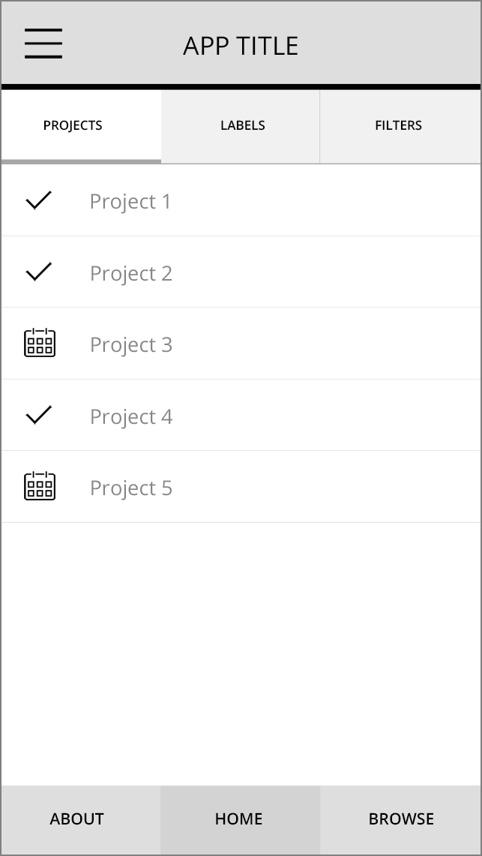
Figure 1.1 Example app design
The first thing to do is to mentally break the UI elements into what they represent. The example mockup has a header bar, and within the header bar are a title and a menu button. Below the header is a tab bar, and within the tab bar are three individual tabs. Go through the rest of the mockup and think of what the other items are. These items you’re identifying will be translated into components. This is the way you should think about composing a UI when working with React Native: break down common elements in the UI into reusable components, and define their interface accordingly. When you need an element in the future, it will be available for reuse.
Breaking UI elements into reusable components is good for code reuse and also makes your code declarative and understandable. For instance, instead of 12 lines of code implementing a footer, the element could be called footer. Looking at code built this way, it’s much easier to reason about and know exactly what’s going on.
Figure 1.2 shows how the design in figure 1.1 could be broken up as I just described. The names can be whatever makes sense to you. Some of the items are grouped together—I logically separated the items individually and grouped components conceptually.
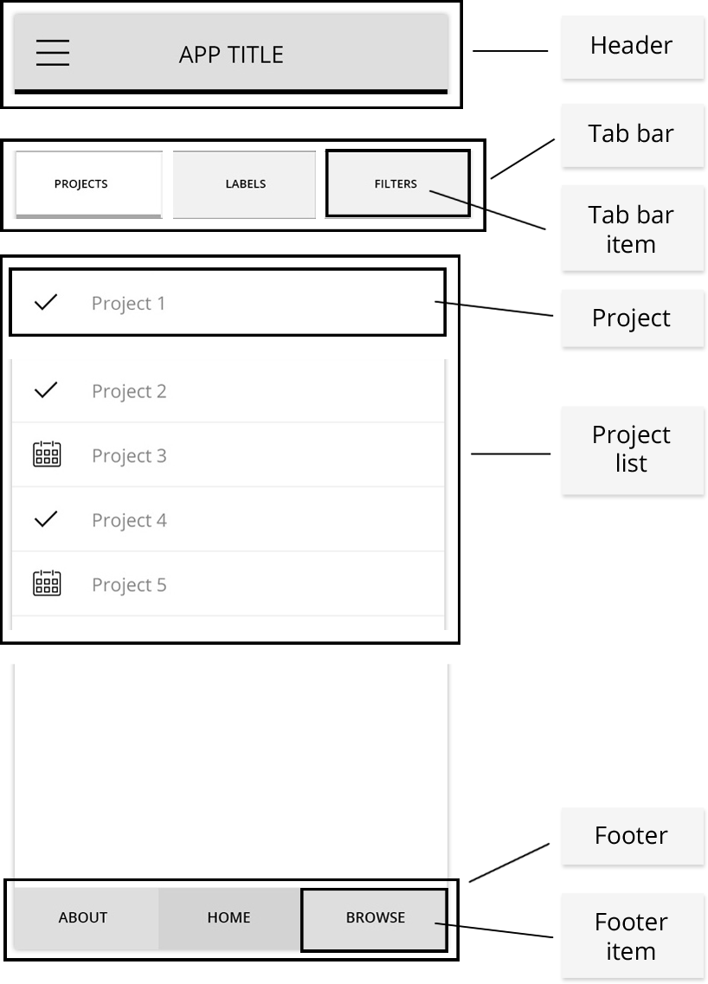
Figure 1.2 App structure broken down into separate components
Next, let’s see how this would look using actual React Native code. First, let’s look at how the main UI elements appear on the page:
<Header />
<TabBar />
<ProjectList />
<Footer />
Next, let’s see how the child elements look:
TabBar:
<TabBarItem />
<TabBarItem />
<TabBarItem />
ProjectList:
// Add a Project component for each project in the list:
<Project />
I’ve used the names declared in figure 1.2, but they could be whatever makes sense to you.

1.5 Acknowledging React Native’s strengths
As discussed earlier, one of the main strengths React Native has going for it is that it uses React. React, like React Native, is an open source project backed by Facebook. As of the time of this writing, React has over 100,000 stars and more than 1,100 contributors on GitHub—that’s a lot of interest and community involvement in the project, making it easier to bet on as a developer or as a project manager. Because React is developed, maintained, and used by Facebook, it has some of the most talented engineers in the world overseeing it, pushing it forward, and adding new features, and it probably won’t be going away anytime soon.

1.5.1 Developer availability
With the rising cost and decreasing availability of native mobile developers, React Native enters the market with a key advantage over native development: it takes advantage of the wealth of existing talented web and JavaScript developers and gives them another platform on which to build without having to learn a new language.

1.5.2 Developer productivity
Traditionally, to build a cross-platform mobile application, you needed both an Android team and an iOS team. React Native allows you to build Android, iOS, and (soon) Windows applications using a single programming language, JavaScript, and possibly even a single team, dramatically decreasing development time and development cost while increasing productivity. As a native developer, the great thing about coming to a platform like this is the fact that you’re no longer tied down to being only an Android or iOS developer, opening the door for a lot of opportunity. This is great news for JavaScript developers as well, allowing them to spend all their time in one state of mind when switching between web and mobile projects. It’s also a win for teams who were traditionally split between Android and iOS, because they can now work together on a single codebase. To underscore these points, you can share your data architecture not only cross platform, but also on the web, if you’re using something like Redux (discussed in chapter 12).

1.5.3 Performance
If you follow other cross-platform solutions, you’re probably aware of solutions such as PhoneGap, Cordova, and Ionic. Although these are also viable solutions, the consensus is that performance hasn’t yet caught up to the experience a native app delivers. This is where React Native also shines, because the performance is usually not noticeably different from that of a native mobile app built using Objective-C/Swift or Java.

1.5.4 One-way data flow
One-way data flow separates React and React Native from most other JavaScript frameworks and also any MVC framework. React incorporates a one-way data flow from top-level components all the way down (see figure 1.3). This makes applications much easier to reason about, because there’s one source of truth for the data layer as opposed to having it scattered about the application. We’ll look at this in more detail later in the book.
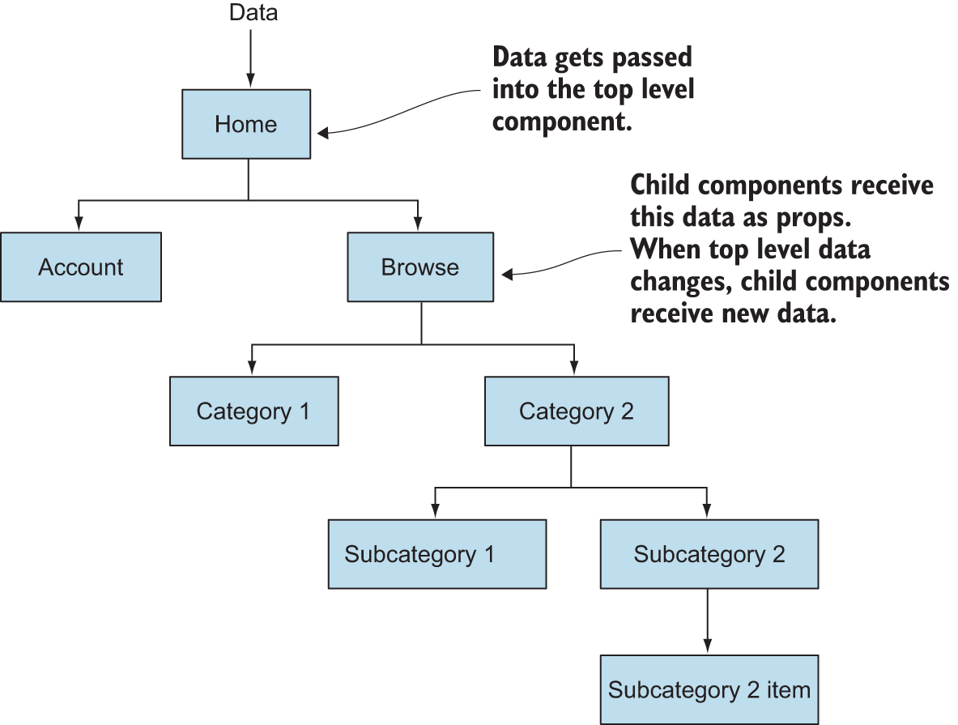
Figure 1.3 How one-way data flow works

1.5.5 Developer experience
The developer experience is a major win for React Native. If you’ve ever developed for the web, you’re aware of the browser’s snappy reload times. Web development has no compilation step: just refresh the screen, and your changes are there. This is a far cry from the long compile times of native development. One of the reasons Facebook decided to develop React Native was to overcome the lengthy compile times of the Facebook application when using native iOS and Android build tools. To make a small UI change or any other change, Facebook developers had to wait a long time while the program compiled to see the results. Long compilation times result in decreased productivity and increased developer cost. React Native solves this issue by giving you the quick reload times of the web, as well as Chrome and Safari debugging tools, making the debugging experience feel a lot like the web.
React Native also has something called hot reloading built in. What does this mean? Well, while developing an application, imagine having to click a few times into your app to get to the place you’re developing. While using hot reloading, when you make a code change, you don’t have to reload and click back through the app to get to the current state. Using this feature, you save the file, and the application reloads only the component you’ve changed, instantly giving you feedback and updating the current state of the UI.

1.5.6 Transpilation
Transpilation is typically when something known as a transpiler takes source code written in one programming language and produces the equivalent code in another language. With the rise of new ECMAScript features and standards, transpilation has spilled over to also include taking newer versions and yet-to-be-implemented features of certain languages, in this case JavaScript, and producing transpiled standard JavaScript, making the code usable by platforms that can only process older versions of the language.
React Native uses Babel to do this transpilation step, and it’s built in by default. Babel is an open source tool that transpiles the most bleeding-edge JavaScript language features into code that can be used today. You don’t have to wait for the bureaucratic process of language features being proposed, approved, and then implemented before you can use them. You can start using a feature as soon as it makes it into Babel, which is usually very quickly. JavaScript classes, arrow functions, and object destructuring are all examples of powerful ES2015 features that haven’t made it into all browsers and runtimes yet; but with Babel and React Native, you can use them today with no worries about whether they will work. If you like using the latest language features, you can use the same transpilation process to develop web applications.

1.5.7 Productivity and efficiency
Native mobile development is becoming more and more expensive, so engineers who can deliver applications across platforms and stacks will become increasingly valuable and in demand. Once React Native—or something similar, if it comes along—makes developing desktop and web as well as mobile applications using a single framework mainstream, there will be a restructuring and rethinking of how engineering teams are organized. Instead of a developer being specialized in a certain platform, such as iOS or web, they’ll oversee features across platforms. In this new era of cross-platform and cross-stack engineering teams, developers delivering native mobile, web, and desktop applications will be more productive and efficient and will therefore be able to demand a higher wage than a traditional web developer who can only deliver web applications.
Companies that are hiring developers for mobile development stand to benefit the most from using React Native. Having everything written in one language makes hiring a lot easier and less expensive. Productivity also soars when a team is all on the same page, working within a single technology, which simplifies collaboration and knowledge sharing.

1.5.8 Community
The React community, and by extension the React Native community, is one of the most open and helpful groups I’ve ever interacted with. When I’ve run into issues I couldn’t resolve on my own by searching online or on Stack Overflow, I’ve reached out directly to either a team member or someone in the community and have had nothing but positive feedback and help.

1.5.9 Open source
React Native is open source. This offers a wealth of benefits. First, in addition to the Facebook team, hundreds of developers contribute to React Native. Bugs are pointed out much faster than in proprietary software, which has only the employees on a specific team working on bug fixes and improvements. Open source usually gets closer to what users want because the users can have a hand in making the software what they want it to be. Given the cost of purchasing proprietary software, licensing fees, and support costs, open source also wins when measuring price.

Immediate updates
Traditionally, when publishing new versions of an app, you’re at the mercy of the app store approval process and schedule. This long, tedious process can take up to two weeks. Making a change, even if it’s extremely small, is painful and requires releasing a new version of the application.
React Native, as well as hybrid application frameworks, allow you to deploy mobile app updates directly to the user’s device, without going through an app store approval process. If you’re used to the web and the rapid release cycle it offers, you can now do the same thing with React Native and other hybrid application frameworks.

Other solutions for building cross-platform mobile applications
React Native isn’t the only option for building a cross-platform mobile application. Multiple other options are available, with the main ones being Cordova, Xamarin, and Flutter:
Cordova is basically a native shell around a web application that allows the developer to access native APIs within the application. Unlike traditional web applications, Cordova apps can be deployed to the App Store and Google Play Store. The benefit of using something like Cordova is that there isn’t much more to learn if you’re already a web developer: you can use HTML, JavaScript, CSS, and your JavaScript framework of choice. The main drawback of Cordova is that you’ll have a hard time matching the performance and smooth UI that React Native offers: you’re relying on the DOM, because you’re mainly working with webtechnologies.
Xamarin is a framework that allows developers to build iOS, Android, Windows, and macOS applications using a single codebase written in C#. Xamarin compiles to a native app in different ways depending on the platform being targeted. Xamarin has a free tier that lets developers build and deploy mobile applications and a paid tier for larger or enterprise companies. Xamarin will probably appeal more to native developers because it doesn’t have similarities to web technologies like React Native and Cordova.
Flutter is a framework open sourced by Google that uses the Dart programming language to build applications that run on iOS and Android platforms.

1.6 React Native’s drawbacks
Now that we’ve gone over the benefits of using React Native, let’s look at a few reasons and circumstances where you may not want to choose the framework. First, React Native is still immature when compared to other platforms such as native iOS, Android, and Cordova. Feature parity isn’t there yet with either native iOS or Cordova. Most functionality is now built in, but there may be times when you need functionality that isn’t yet available, and this means you must dig into the native code to build it yourself, hire someone to do it, or not implement the feature.
Another thing to think about is the fact that you and/or your team must learn a completely new technology if you aren’t familiar with React. Most people agree that React is easy to pick up; but if you’re already proficient with Angular and Ionic, for example, and you have an application deadline coming up, it may be wise to go with what you already know instead of spending the time it takes to learn and train your team on a new tech. In addition to learning React and React Native, you must also become familiar with Xcode and the Android development environments, which can take some getting used to.
Finally, React Native is an abstraction built on top of existing platform APIs. When newer versions of iOS, Android, and other future platforms are released, there may be a time when React Native will be behind on new features, forcing you to either build custom implementations to interact with these new APIs or wait until React Native regains feature parity with the new release.

1.7 Creating and using basic components
Components are the fundamental building blocks of React Native, and they can vary in functionality and type. Examples of components in popular use cases include buttons, headers, footers, and navigation components. They can vary in type from an entire view, complete with its own state and functionality, to a single stateless component that receives all its props from its parent.

1.7.1 An overview of components
As I’ve said, the core of React Native is the concept of components. Components are collections of data and UI elements that make up views and, ultimately, applications. React Native has built-in components that are described as native components in this book, but you can also build custom components using the framework. We’ll go into depth on how to build, create, and use components.
As mentioned earlier, React Native components are built using JSX. Table 1.1 shows a few basic examples of what JSX in React Native looks like versus HTML. As you can see, JSX looks similar to HTML or XML.
Table 1.1 JSX components vs. HTML elements
Component type | HTML | React Native JSX
Text | <span>Hello World</span> | <Text>Hello World</Text>
View | <div>  <span>Hello World 2</span>  </div> | <View>  <Text>Hello World 2</Text>  </View>
Touchable highlight | <button>  <span>Hello World 2</span>  </button > | <TouchableHighlight>  <Text>Hello World 2</Text>  </TouchableHighlight>

1.7.2 Native components
The framework offers native components out of the box, such as View, Text, and Image, among others. You can create components using these Native components as building blocks. For example, you can use the following markup to create a Button component using React Native TouchableHighlight and Text components.
Listing 1.4 Creating a Button component
import { Text, TouchableHighlight } from 'react-native'
const Button = () => (
<TouchableHighlight>
<Text>Hello World</Text>
</TouchableHighlight>
)
export default Button
You can then import and use the new button.
Listing 1.5 Importing and using the Button component
import React from 'react'
import { Text, View } from 'react-native'
import Button from './components/Button'
const Home = () => (
<View>
<Text>Welcome to the Hello World Button!</Text>
<Button />
</View>
)
Next, we’ll go through the fundamentals of what a component is, how components fit into the workflow, and common use cases and design patterns for building them.

1.7.3 Component composition
Components are usually composed using JSX, but they can also be composed using JavaScript. In this section, you’ll create a component several different ways to see all the options. You’ll be creating this component:
<MyComponent />
This component outputs “Hello World” to the screen. Now, let’s see how to build this basic component. The only out-of-the-box components you’ll use to build this custom component are the View and Text elements discussed earlier. Remember, a View component is similar to an HTML <div>, and a Text component is similar to an HTML <span>.
Let’s look at a few ways to create a component. The entire application doesn’t have to be consistent in its component definitions, but it’s usually recommended that you stay consistent and follow the same pattern for defining classes throughout your application.

createClass syntax (ES5, JSX)
This is the way to create a React Native component using ES5 syntax. You’ll probably still see this syntax in use in some older documentation and examples, but it isn’t being used in newer documentation and is now deprecated. We’ll focus on the ES2015 class syntax for the rest of the book but will review the createClass syntax here in case you come across it in older code:
const React = require('react')
const ReactNative = require('react-native')
const { View, Text } = ReactNative
const MyComponent = React.createClass({
render() {
return (
<View>
<Text>Hello World</Text>
</View>)
}
})

Class syntax (ES2015, JSX)
The main way to create stateful React Native components is using ES2015 classes. This is the way you’ll create stateful components for the rest of the book and is now the approach recommended by the community and creators of React Native:
import React from 'react'
import { View, Text } from ‘react-native’
class MyComponent extends React.Component {
render() {
return (
<View>
<Text>Hello World</Text>
</View>)
}
}

Stateless (reusable) component (JSX)
Since the release of React 0.14, we’ve had the ability to create stateless components. We haven’t yet dived into state, but just remember that stateless components are basically pure functions that can’t mutate their own data and don’t contain their own state. This syntax is much cleaner than the class or createClass syntax:
import React from 'react'
import { View, Text } from 'react-native'
const MyComponent = () => (
<View>
<Text>Hello World</Text>
</View>
)
or
import React from 'react'
import { View, Text } from 'react-native'
function MyComponent () {
return <View><Text>HELLO FROM STATELESS</Text></View>
}

createElement (JavaScript)
React.createElement is rarely used, and you’ll probably never need to create a React Native element using this syntax. But it may come in handy if you ever need more control over how you’re creating a component, or if you’re reading someone else’s code. It will also give you a look at how JavaScript compiles JSX. React.createElement takes a few arguments:
React.createElement(type, props, children) {}
Let’s walk through them:
type—The element you want to render
props—Any properties you want the component to have
children—Child components or text
In the following example, you pass in a view as the first argument to the first instance of React.createElement, an empty object as the second argument, and another element as the last argument. In the second instance, you pass in text as the first argument, an empty object as the second argument, and “Hello” as the final argument:
class MyComponent extends React.Component {
render() {
return (
React.createElement(View, {},
React.createElement(Text, {}, "Hello")
)
)
}
}
This is the same as declaring the component as follows:
class MyComponent extends React.Component {
render () {
return (
<View>
<Text>Hello</Text>
</View>
)
}
}

1.7.4 Exportable components
Next, let’s look at another, more in-depth implementation of a React Native component. You’ll create an entire component that you can export and use in another file:
import React, { Component } from 'react'
import {
Text,
View
} from 'react-native'
class Home extends Component {
render() {
return (
<View>
<Text>Hello from Home</Text>
</View>)
}
}
export default Home
Let’s go over all the pieces that make up this component and discuss what’s going on.

Importing
The following code imports React Native variable declarations:
import React, { Component } from 'react'
import {
Text,
View
} from 'react-native'
Here, you’re importing React directly from the React library using a default import and importing Component from the React library using a named import. You’re also using named imports to pull Text and View into your file.
The import statement using ES5 would look like this:
var React = require('react')
This statement without using named imports would look like this:
import React = from 'react'
const Component = React.Component
import ReactNative from 'react-native'
const Text = ReactNative.Text
const View = ReactNative.View
The import statement is used to import functions, objects, or variables that have been exported from another module, file, or script.

Component declaration
The following code declares the component:
class Home extends Component { }
Here you’re creating a new instance of a React Native Component class by extending it and naming it Home. Before, you declared React.Component; now you’re just declaring Component, because you imported the Component element in the object destructuring statement, giving you access to Component as opposed to having to call React.Component.

The render method
Next, look at the render method:
render() {
return (
<View>
<Text>Hello from Home</Text>
</View>)
}
The code for the component is executed in the render method, and the content after the return statement returns what’s rendered on the screen. When the render method is called, it should return a single child element. Any variables or functions declared outside of the render function can be executed here. If you need to do any calculations, declare any variables using state or props, or run any functions that don’t manipulate the state of the component, you can do so between the render method and the return statement.

Exports
Now, you export the component to be used elsewhere in the application:
export default Home
If you want to use the component in the same file, you don’t need to export it. After it’s declared, you can use it in the file or export it to be used in another file. You may also use module.exports = 'Home', which is ES5 syntax.

1.7.5 Combining components
Let’s look at how to combine components. First, create Home, Header, and Footer components in a single file. Begin by creating the Home component:
import React, { Component } from 'react'
import {
Text,
View
} from 'react-native'
class Home extends Component {
render() {
return (
<View>
</View>)
}
}
In the same file, below the Home class declaration, build out a Header component:
class Header extends Component {
render() {
return <View>
<Text>HEADER</Text>
</View>
}
}
This looks nice, but let’s see how to rewrite Header into a stateless component. We’ll discuss when and why it’s good to use a stateless component versus a regular React Native class in depth later in the book. As you’ll begin to see, the syntax and code are much cleaner when you use stateless components:
const Header = () => (
<View>
<Text>HEADER</Text>
</View>
)
Now, insert Header into the Home component:
class Home extends Component {
render() {
return (
<View>
<Header />
</View>
)
}
}
Create a Footer and a Main view, as well:
const Footer = () => (
<View>
<Text>Footer</Text>
</View>
)
const Main = () => (
<View>
<Text> Main </Text>
</View>
)
Now, drop those into your application:
class Home extends Component {
render() {
return (
<View>
<Header />
<Main />
<Footer />
</View>
)
}
}
The code you just wrote is extremely declarative, meaning it’s written in such a way that it describes what you want to do and is easy to understand in isolation. This is a high-level overview of how you’ll create components and views in React Native, but should give you a good idea of how the basics work.

1.8 Creating a starter project
Now that we’ve gone over a lot of details about React Native, let’s dig into some more code. We’ll focus on building apps using the React Native CLI, but you can also use the Create React Native App CLI to create a new project.

1.8.1 Create React Native App CLI
You can create React Native projects using the Create React Native App CLI, a project generator that’s maintained in the React Community GitHub repository, mainly by the Expo team. Expo created the React Native App project as a way to allow developers to get up and running with React Native without having to worry about installing all the native SDKs involved with running a React Native project using the CLI.
To create a new project using Create React Native App, first install the CLI:
npm install -g create-react-native-app
Here’s how to create a new project using create-react-native-app from the command line:
create-react-native-app myProject

1.8.2 React Native CLI
Before we go any further, check this book’s appendix to verify that you have the necessary tools installed on your machine. If you don’t have the required SDKs installed, you won’t be able to continue building your first project using the React Native CLI.
To get started with the React Native starter project and the React Native CLI, open the command line and then create and navigate to an empty directory. Once you’re there, install the react-native CLI globally by typing the following:
npm install -g react-native-cli
After React Native is installed on your machine, you can initialize a new project by typing react-native init followed by the project name:
react-native init myProject
myProject can be any name you choose. The CLI will then spin up a new project in whatever directory you’re in. Open the project in a text editor.
First, let’s look at the main files and folders this process has generated for you:
android —This folder contains all the Android platform-specific code and dependencies. You won’t need to go into this folder unless you’re implementing a custom bridge into Android or you install a plugin that calls for some type of deep configuration.
ios —This folder contains all the iOS platform-specific code and dependencies. You won’t need to go into this folder unless you’re implementing a custom bridge into iOS or you install a plugin that calls for some type of deep configuration.
node_modules —React Native uses npm (node package manager) to manage dependencies. These dependencies are identified and versioned in the .package.json file and stored in the node_modules folder. When you install any new packages from the npm/node ecosystem, they’ll go here. These can be installed using either npm or yarn.
.flowconfig —Flow (also open sourced by Facebook) offers type checking for JavaScript. Flow is like Typescript, if you’re familiar with that. This file is the configuration for flow, if you choose to use it.
.gitignore —This is the place to store any file paths you don’t want in version control.
.watchmanconfig —Watchman is a file watcher that React Native uses to watch files and record when they change. This is the configuration for Watchman. No changes to this will be needed except in rare use cases.
index.js —This is the entry point of the application. In this file, App.js is imported and AppRegistry.registerComponent is called, initializing the app.
App.js —This is the default main import used in index.js containing the base project. You can change it by deleting this file and replacing the main import in index.js.
package.json —This file holds your npm configuration. When you npm install files, you can save them here as dependencies. You can also set up scripts to run different tasks.
The following listing shows App.js.
Listing 1.6 App.js
/**
* Sample React Native App
* https://github.com/facebook/react-native
* @flow
*/
import React, { Component } from 'react';
import {
Platform,
StyleSheet,
Text,
View
} from 'react-native';
const instructions = Platform.select({
ios: 'Press Cmd+R to reload,\n' +
'Cmd+D or shake for dev menu',
android: 'Double tap R on your keyboard to reload,\n' +
'Shake or press menu button for dev menu',
});
export default class App extends Component<{}> {
render() {
return (
<View style={styles.container}>
<Text style={styles.welcome}>
Welcome to React Native!
</Text>
<Text style={styles.instructions}>
To get started, edit App.js
</Text>
<Text style={styles.instructions}>
{instructions}
</Text>
</View>
);
}
}
const styles = StyleSheet.create({
container: {
flex: 1,
justifyContent: 'center',
alignItems: 'center',
backgroundColor: '#F5FCFF',
},
welcome: {
fontSize: 20,
textAlign: 'center',
margin: 10,
},
instructions: {
textAlign: 'center',
color: '#333333',
marginBottom: 5,
},
});
This code looks much like what we went over in the last section. There are a couple of new items you haven’t yet seen:
StyleSheet
Platform
Platform is an API that allows you to detect the current type of operating system you’re running on: web, iOS, or Android.
StyleSheet is an abstraction like CSS stylesheets. In React Native, you can declare styles either inline or using stylesheets. As you can see in the first view, a container style is declared:
<View style={styles.container}>
This corresponds directly to
container: {
flex: 1,
justifyContent: 'center',
alignItems: 'center',
backgroundColor: '#F5FCFF',
}
At the bottom of the index.js file, you see
AppRegistry.registerComponent('myProject', () => App);
This is the JavaScript entry point to running all React Native apps. In the index file is the only place you’ll call this function. The root component of the app should register itself with AppRegistry.registerComponent. The native system can then load the bundle for the app and run the app when it’s ready.
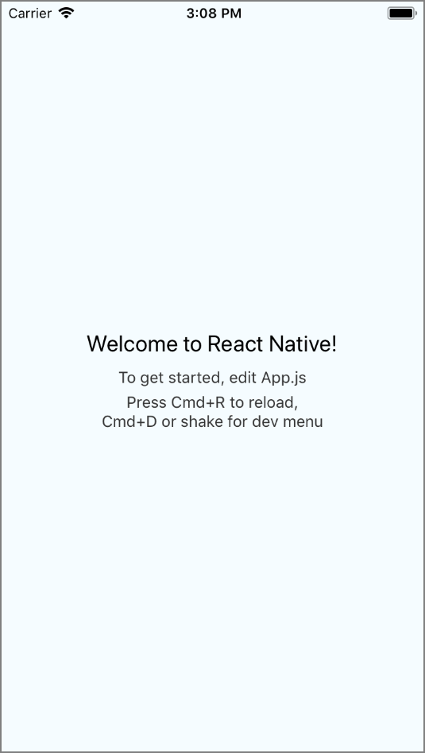
Figure 1.4 React Native starter project: what you should see after running the starter project on the emulator
Now that we’ve gone over what’s in the file, run the project in either your iOS simulator or your Android emulator (see figure 1.4). In the text element that contains “Welcome to React Native,” enter “Welcome to Hello World!” or other text of your choice. Refresh the screen, and you should see your changes.

Summary
React Native is a framework for building native mobile apps in JavaScript using the React JavaScript library.
Some of React Native’s strengths are its performance, developer experience, ability to build cross platform with a single language, one-way data flow, and community. You may consider React Native over a hybrid mainly because of its performance, and over Native mainly because of the developer experience and cross-platform ability with a single language.
JSX is a preprocessor step that adds an XML-like syntax to JavaScript. You can use JSX to create a UI in React Native.
Components are the fundamental building blocks in React Native. They can vary in functionality and type. You can create custom components to implement common design elements.
Components that require state or lifecycle methods need to be created using a JavaScript class by extending the React.Component class.
Stateless components can be created with less boilerplate for components that don’t need to keep up with their own state.
Larger components can be created by combining smaller subcomponents.

2
Understanding React
This chapter covers
How state works and why it’s important
How properties work and why they’re important
Understanding the React component specification
Implementing React lifecycle methods
Now that we’ve gone over the basics, it’s time to dive into some other fundamental pieces that make up React and React Native. We’ll discuss how to manage state and data, and how data is passed through an application. We’ll also dive deeper by demonstrating how to pass properties (props) between components and how to manipulate these props from the top down.
After you’re equipped with knowledge about state and props, we’ll go deeper into how to use the built-in React lifecycle methods. These methods allow you to perform certain actions when a component is created or destroyed. Understanding them is key to understanding how React and React Native work and how to take full advantage of the framework. The lifecycle methods are also conceptually the biggest part of React and React Native.

Note You’ll see both React and React Native referenced in this chapter. Keep in mind that when I mention React, I’m talking not about things that are specific to React Native, but concepts that are related to both React and React Native. For example, state and props work the same in both React and React Native, as do the React lifecycle and the React component specifications.

2.1 Managing component data using state
One of the ways data is created and managed in a React or React Native component is by using state. Component state is declared when the component is created, and its structure is a plain JavaScript object. State can be updated within the component using a function called setState that we’ll look at in depth shortly.
The other way data can be handled is by using props. Props are passed down as parameters when the component is created; unlike state, they can’t be updated within the component.

2.1.1 Correctly manipulating component state
State is a collection of values that a component manages. React thinks of UIs as simple state machines. When the state of a component changes using the setState function, React rerenders the component. If any child components are inheriting this state as props, then all of the child components are rerendered as well.
When building an application using React Native, understanding how state works is fundamental because state determines how stateful components render and behave. Component state is what allows you to create components that are dynamic and interactive. The main point to understand when differentiating between state and props is that state is mutable, whereas props are immutable.
Setting Initial State
State is initialized when a component is created either in the constructor or with a property initializer. Once the state is initialized, it’s available in the component as this.state. The following listing shows an example.
Listing 2.1 Setting state with a property initializer
import React from 'react'
class MyComponent extends React.Component {
state = {
year: 2016,
name: 'Nader Dabit',
colors: ['blue']
}
render() {
return (
<View>
<Text>My name is: { this.state.name }</Text>
<Text>The year is: { this.state.year }</Text>
<Text>My colors are { this.state.colors[0] }</Text>
</View>
)
}
}
The constructor function is called the moment a JavaScript class is instantiated, as shown in the next listing. This isn’t a React lifecycle method, but a regular JavaScript class method.
Listing 2.2 Setting state with a constructor
import React {Component} from 'react'
class MyComponent extends Component {
constructor(){
super()
this.state = {
year: 2016,
name: 'Nader Dabit',
colors: ['blue']
}
}
render() {
return (
<View>
<Text>My name is: { this.state.name }</Text>
<Text>The year is: { this.state.year }</Text>
<Text>My colors are { this.state.colors[0] }</Text>
</View>
)
}
}
The constructor and property initializer both work exactly the same, and which approach you use is based on preference.

Updating state
State can be updated by calling this.setState(object), passing in an object with the new state you want to use. setState merges the previous state with the current state, so if you only pass in a single item (key-value pair), the rest of the state will remain the same, while the new item in the state will be overwritten.
Let’s look at how to use setState (see listing 2.3). To do so, we’ll introduce a new method, a touch handler called onPress. onPress can be called on a few types of “tappable” React Native components, but here you’ll attach it to a Text component to get started with this basic example. You’ll call a function called updateYear when the text is pressed, to update the state with setState. This function will be defined before the render function, because it’s usually best practice to define any custom methods before the render method, but keep in mind that the order of the definition of the functions doesn’t affect the actual functionality.
Listing 2.3 Updating state
import React {Component} from 'react'
class MyComponent extends Component {
constructor(){
super()
this.state = {
year: 2016,
}
}
updateYear() {
this.setState({
year: 2017
})
}
render() {
return (
<View>
<Text
onPress={() => this.updateYear()}>
The year is: { this.state.year }
</Text>
</View>
)
}
}
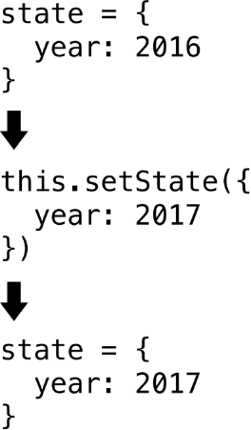
Figure 2.1 The flow of setState, with arrows indicating when the text element is pressed. The state year property is initialized to 2016 in the constructor. Each time the text is pressed, the state year property is set to 2017.
Figure 2.1 shows how the state is updated each time the text element in listing 2.3 is pressed. Every time setState is called, React will rerender the component (calling the render method again) and any child components. Calling this.setState is the way to change a state variable and trigger the render method again, because changing the state variable directly won’t trigger a rerender of the component and therefore no changes will be visible in the UI. A common mistake for beginners is updating the state variable directly. For example, something like the following doesn’t work when trying to update state—the state object is updated, but the UI isn’t updated because setState isn’t called and the component isn’t rerendered:
class MyComponent extends Component {
constructor(){
super()
this.state = {
year: 2016,
}
}
updateYear() {
this.state.year = 2017
}
render() {
return (
<View>
<Text
onPress={() => this.updateYear()}>
The year is: { this.state.year }
</Text>
</View>
)
}
}
But a method is available in React that can force an update once a state variable has been changed as in the previous snippet. This method is called forceUpdate; see listing 2.4. Calling forceUpdate causes render to be called on the component, triggering a rerendering of the UI. Using forceUpdate isn’t usually necessary or recommended, but it’s good to know about in case you run into it in examples or documentation. Most of the time, this rerendering can be handled using other methods such as calling setState or passing in new props.
Listing 2.4 Forcing rerender with forceUpdate
class MyComponent extends Component {
constructor(){
super()
this.state = {
year: 2016
}
}
updateYear() {
this.state.year = 2017
}
update() {
this.forceUpdate()
}
render() {
return (
<View>
<Text onPress={ () => this.updateYear() }>
The year is: { this.state.year }
</Text>
<Text
onPress={ () => this. update () }>Force Update
</Text>
</View>
)
}
}
Now that we’ve gone over how to work with state using a basic string, let’s look at a few other data types. You’ll attach a Boolean, an array, and an object to the state and use it in the component. You’ll also conditionally show a component based on a Boolean in the state.
Listing 2.5 State with other data types
class MyComponent extends Component {
constructor(){
super()
this.state = {
year: 2016,
leapYear: true,
topics: ['React', 'React Native', 'JavaScript'],
info: {
paperback: true,
length: '335 pages',
type: 'programming'
}
}
}
render() {
let leapyear = <Text>This is not a leapyear!</Text>
if (this.state.leapYear) {
leapyear = <Text>This is a leapyear!</Text>
}
return (
<View>
<Text>{ this.state.year }</Text>
<Text>Length: { this.state.info.length }</Text>
<Text>Type: { this.state.info.type }</Text>
{ leapyear }
</View>
)
}
}

2.2 Managing component data using props
Props (short for properties) are a component’s inherited values or properties that have been passed down from a parent component. Props can be either static or dynamic values when they’re declared, but when they’re inherited they’re immutable; they can only be altered by changing the initial values at the top level where they’re declared and passed down. React’s “Thinking in React” documentation says that props are best explained as “a way of passing data from parent to child.” Table 2.1 highlights some of the differences and similarities between props and state.
Table 2.1 Props vs. state
Props | State
External data | Internal data
Immutable | Mutable
Inherited from a parent | Created in the component
Can be changed by a parent component | Can only be updated in the component
Can be passed down as props | Can be passed down as props
Can’t change inside the component | Can change inside the component
A good way to explain how props work is to show an example. The following listing declares a book value and passes it down to a child component as a static prop.
Listing 2.6 Static props
class MyComponent extends Component {
render() {
return (
<BookDisplay book="React Native in Action" />
)
}
}
class BookDisplay extends Component {
render() {
return (
<View>
<Text>{ this.props.book }</Text>
</View>
)
}
}
This code creates two components: <MyComponent /> and <BookDisplay />. When you create <BookDisplay />, you pass in a property called book and set it to the string “React Native in Action”. Anything passed as a property in this way is available on the child component as this.props.
You can also pass down literals as you would variables, by using curly braces and a string value as shown next.
Listing 2.7 Displaying static props
class MyComponent extends Component {
render() {
return (
<BookDisplay book={"React Native in Action"} />
)
}
}
class BookDisplay extends Component {
render() {
return (
<View>
<Text>{ this.props.book }</Text>
</View>
)
}
}

Dynamic props
Next, pass a dynamic property to the component. In the render method, before the return statement, declare a variable book and pass it in as a prop.
Listing 2.8 Dynamic props
class MyComponent extends Component {
render() {
let book = 'React Native in Action'
return (
<BookDisplay book={ book } />
)
}
}
class BookDisplay extends Component {
render() {
return (
<View>
<Text>{ this.props.book }</Text>
</View>
)
}
}
Now, pass a dynamic property to the component using state.
Listing 2.9 Dynamic props using state
class MyComponent extends Component {
constructor() {
super()
this.state = {
book: 'React Native in Action'
}
}
render() {
return (
<BookDisplay book={this.state.book} />
)
}
}
class BookDisplay extends Component {
render() {
return (
<View>
<Text>{ this.props.book }</Text>
</View>
)
}
}
Next, let’s look at how to update the state and, consequently, the value passed down as the prop to BookDisplay. Remember, props are immutable, so you’ll change the state of the parent component (MyComponent), which will supply a new value to the BookDisplay book prop and trigger a rerender of both the component and the child component. Breaking this idea into individual parts, here’s what needs to be done:
Declare the state variable:
this.state = {
book: 'React Native in Action'
}
Write a function that will update the state variable:
updateBook() {
this.setState({
book: 'Express in Action'
})
}
Pass the function and the state down to the child component as props:
<BookDisplay
updateBook={ () => this.updateBook() }
book={ this.state.book } />
Attach the function to the touch handler in the child component:
<Text onPress={ this.props.updateBook }>
Now that you know the pieces you need, you can write the code to put this into action. You’ll use the components from the previous examples and add the new functionality.
Listing 2.10 Updating dynamic props
class MyComponent extends Component {
constructor(){
super()
this.state = {
book: 'React Native in Action'
}
}
updateBook() {
this.setState({
book: 'Express in Action'
})
}
render() {
return (
<BookDisplay
updateBook={ () => this.updateBook() }
book={ this.state.book } />
)
}
}
class BookDisplay extends Component {
render() {
return (
<View>
<Text
onPress={ this.props.updateBook }>
{ this.props.book }
</Text>
</View>
)
}
}

Destructuring props and state
Constantly referring to state and props as this.state and this.props can get repetitive, violating the DRY (don’t repeat yourself) principle that many of us try to follow. To fix this, you can try using destructuring. Destructuring is a new JavaScript feature that was added as part of the ES2015 spec and is available in React Native applications. The basic idea is that you can take properties from an object and use them as variables in an app:
const person = { name: 'Jeff', age: 22 }
const { age } = person
console.log(age) #22
Write a component using destructuring, as shown next.
Listing 2.11 Destructuring state and props
class MyComponent extends Component {
constructor(){
super()
this.state = {
book: 'React Native in Action'
}
}
updateBook() {
this.setState({ book: 'Express in Action' })
}
render() {
const { book } = this.state
return (
<BookDisplay
updateBook={ () => this.updateBook() }
book={ book } />
)
}
}
class BookDisplay extends Component {
render() {
const { book, updateBook } = this.props
return (
<View>
<Text
onPress={ updateBook }>
{ book }
</Text>
</View>
)
}
}
You no longer have to refer to this.state or this.props in the component when referencing the book; instead, you’ve taken the book variable out of the state and the props and can reference the variable itself. This starts to make more sense and will keep your code cleaner as your state and props become larger and more complex.

Props with stateless components
Because stateless components only have to worry about props and don’t have their own state, they can be extremely useful when creating reusable components. Let’s see how props are used in a stateless component.
To access props using a stateless component, pass in props as the first argument to the function.
Listing 2.12 Props with stateless components
const BookDisplay = (props) => {
const { book, updateBook } = props
return (
<View>
<Text
onPress={ updateBook }>
{ book }
</Text>
</View>
)
}
You can also destructure props in the function argument.
Listing 2.13 Destructuring props in a stateless component
const BookDisplay = ({ updateBook, book }) => {
return (
<View>
<Text
onPress={ updateBook }>
{ book }
</Text>
</View>
)
}
That looks much nicer and cleans up a lot of unnecessary code! You should use stateless components wherever you can, simplifying your codebase and logic.

Note Stateless components are often referred to as functional components, because they can be written as functions in JavaScript.

Passing arrays and objects as props
Other data types work exactly as you might expect. For example, to pass an array, you pass in the array as a prop. To pass an object, you pass in the object as a prop. Let’s look at a basic example.
Listing 2.14 Passing other data types as props
class MyComponent extends Component {
constructor(){
super()
this.state = {
leapYear: true,
info: {
type: 'programming'
}
}
}
render() {
return (
<BookDisplay
leapYear={ this.state.leapYear }
info={ this.state.info }
topics={['React', 'React Native', 'JavaScript']} />
)
}
}
const BookDisplay = (props) => {
let leapyear
let { topics } = props
const { info } = props
topics = topics.map((topic, i) => {
return <Text>{ topic }</Text>
})
if (props.leapYear) {
leapyear = <Text>This is a leapyear!</Text>
}
return (
<View>
{ leapyear }
<Text>Book type: { info.type }</Text>
{ topics }
</View>
)
}

2.3 React component specifications
When creating React and React Native components, you can hook into several specifications and lifecycle methods to control what’s going on in your component. In this section, we’ll discuss them and give you a good understanding of what each one does and when you should use them.
First we’ll go over the basics of the component specifications. A component specification basically lays out how a component should react to different things happening in the lifecycle of the component. The specifications are as follows:
render method
constructor method
statics object, used to define static methods available to a class

2.3.1 Using the render method to create a UI
The render method is the only method in the component specification that’s required when creating a component. It must return either a single child element, null, or false. This child element can be a component you declared (such as a View or Text component), or another component you defined (maybe a Button component you created and imported into the file):
render() {
return (
<View>
<Text>Hello</Text>
</View>
)
}
You can use the render method with or without parentheses. If you don’t use parentheses, then the returned element must of course be on the same line as the return statement:
render() {
return <View><Text>Hello</Text></View>
}
The render method can also return another component that was defined elsewhere:
render() {
return <SomeComponent />
}
#or
render() {
return (
<SomeComponent />
)
}
You can also check for conditionals in the render method, perform logic, and return components based on their value:
render() {
if(something === true) {
return <SomeComponent />
} else return <SomeOtherComponent />
}

2.3.2 Using property initializers and constructors
State can be created in a constructor or using a property initializer. Property initializers are an ES7 specification to the JavaScript language, but they work out of the box with React Native. They provide a concise way to declare state in a React class:
class MyComponent extends React.Component {
state = {
someNumber: 1,
someBoolean: false
}
You can also use a constructor method to set the initial state when using classes. The concept of classes, as well as the constructor function, isn’t specific to React or React Native; it’s an ES2015 specification and is just syntactic sugar on top of JavaScript’s existing prototype-based inheritance for creating and initializing an object created with a class. Other properties can also be set for a component class in the constructor by declaring them with the syntax this.property (property being the name of the property). The keyword this refers to the current class instance you’re in:
constructor(){
super()
this.state = {
someOtherNumber: 19,
someOtherBoolean: true
}
this.name = 'Hello World'
this.type = 'class'
this.loaded = false
}
When using a constructor to create a React class, you must use the super keyword before you can use the this keyword, because you’re extending another class. Also, if you need access to any props in the constructor, they must be passed as an argument to the constructor and the super call.
Setting the state based on props usually isn’t good practice unless you’re intentionally setting some type of seed data for the component’s internal functionality, because the data will no longer be consistent across components if it’s changed. State is only created when the component is first mounted or created. If you rerender the same component using different prop values, then any instances of that component that have already been mounted won’t use the new prop values to update state.
The following example shows props being used to set state values within the constructor. Let’s say you pass in “Nader Dabit” as the props to the component initially: the fullName property in the state will be “Nader Dabit”. If the component is then rerendered with “Another Name”, the constructor won’t be called a second time, so the state value for fullName will remain “Nader Dabit”:
constructor(props){
super(props)
this.state = {
fullName: props.first + ' ' + props.last,
}
}

2.4 React lifecycle methods
Various methods are executed at specific points in a component’s lifecycle: these are called the lifecycle methods. Understanding how they work is important because they allow you to perform specific actions at different points in the creation and destruction of a component. For example, suppose you wanted to make an API call that returned some data. You’d probably want to make sure the component was ready to render this data, so you’d make the API call once the component was mounted in a method called componentDidMount. In this section, we’ll go over the lifecycle methods and explain how they work.
The life of a React component has three stages: creation (mounting), updating, and deletion (unmounting). During these three stages, you can hook into three sets of lifecycle methods:
Mounting (creation) —When a component is created, a series of lifecycle methods are triggered and you have the option to hook into any or all of them: constructor, getDerivedStateFromProps, render, and componentDidMount. The one such method you’ve used so far is render, which renders and returns a UI.
Updating —When a component updates, the update lifecycle methods are triggered: getDerivedStateFromProps (when props change), shouldComponentUpdate, render, getSnapshotBeforeUpdate, and componentDidUpdate. An update can happen in one of two ways:
When setState or forceUpdate is called within a component
When new props are passed down into the component
Unmounting —When the component is unmounted (destroyed), a final lifecycle method is triggered: componentWillUnmount.

2.4.1 The static getDerivedStateFromProps method
getDerivedStateFromProps is a static class method that is called both when the component is created and when it receives new props. This method receives the new props and most up-to-date state as arguments and returns an object. The data in the object is updated to the state. The following listing shows an example.
Listing 2.15 staticgetDerivedStateFromProps
export default class App extends Component {
state = {
userLoggedIn: false
}
static getDerivedStateFromProps(nextProps, nextState) {
if (nextProps.user.authenticated) {
return {
userLoggedIn: true
}
}
return null
}
render() {
return (
<View style={styles.container}>
{
this.state.userLoggedIn && (
<AuthenticatedComponent />>
)
}
</View>
);
}
}

2.4.2 The componentDidMount lifecycle method
componentDidMount is called exactly once, just after the component has been loaded. This method is a good place to fetch data with AJAX calls, perform setTimeout functions, and integrate with other JavaScript frameworks.
Listing 2.16 componentDidMount
class MainComponent extends Component {
constructor() {
super()
this.state = { loading: true, data: {} }
}
componentDidMount() {
#simulate ajax call
setTimeout(() => {
this.setState({
loading: false,
data: {name: 'Nader Dabit', age: 35}
})
}, 2000)
}
render() {
if(this.state.loading) {
return <Text>Loading</Text>
}
const { name, age } = this.state.data
return (
<View>
<Text>Name: {name}</Text>
<Text>Age: {age}</Text>
</View>
)
}
}

2.4.3 The shouldComponentUpdate lifecycle method
shouldComponentUpdate returns a Boolean and lets you decide when a component renders. If you know the new state or props won’t require the component or any of its children to render, you can return false. If you want the component to rerender, return true.
Listing 2.17 shouldComponentUpdate
class MainComponent extends Component {
shouldComponentUpdate(nextProps, nextState) {
if(nextProps.name !== this.props.name) {
return true
}
return false
}
render() {
return <SomeComponent />
}
}

2.4.4 The componentDidUpdate lifecycle method
componentDidUpdate is invoked immediately after the component has been updated and rerendered. You get the previous state and previous props as arguments.
Listing 2.18 componentDidUpdate
class MainComponent extends Component {
componentDidUpdate(prevProps, prevState) {
if(prevState.showToggled === this.state.showToggled) {
this.setState({
showToggled: !showToggled
})
}
}
render() {
return <SomeComponent />
}
}

2.4.5 The componentWillUnmount lifecycle method
componentWillUnmount is called before the component is removed from the application. Here, you can perform any necessary cleanup, remove listeners, and remove timers that were set up in componentDidMount.
Listing 2.19 componentWillUnmount
class MainComponent extends Component {
handleClick() {
this._timeout = setTimeout(() => {
this.openWidget();
}, 2000);
}
componentWillUnmount() {
clearTimeout(this._timeout);
}
render() {
return <SomeComponent
handleClick={() => this.handleClick()} />
}
}

Summary
State is a way to handle data in React components. Updating state rerenders the UI of the component and any child component relying on this data as props.
Properties (props) are how data is passed down through a React Native application to child components. Updating props automatically updates any components receiving the same props.
A React component specification is a group of methods and properties in a React component that specifies the declaration of the component. render is the only required method when creating a React component; all other methods and properties are optional.
There are three main stages in a React component’s lifecycle: creation (mounting), updating, and deletion (unmounting). Each has its own set of lifecycle methods.
React lifecycle methods are available in a React component and are executed at specific points in the component’s lifecycle. They control how the component functions and updates.

3
Building your first React Native app
This chapter covers
Building a todo app from the ground up
Light debugging
When learning a new framework, technology, language, or concept, diving directly into the process by building a real app is a great way to jump-start the learning process. Now that you understand the basics of how React and React Native work, let’s put these pieces together to make your first app: a todo app. Going through the process of building a small app and using the information we’ve gone over so far will be a good way to reinforce your understanding of how to use React Native.
You’ll use some functionality in the app that we haven’t yet covered in depth, and some styling nuances we’ve yet to discuss, but don’t worry. Instead of going over these new ideas one by one now, you’ll build the basic app and then learn about these concepts in detail in later chapters. Take this opportunity to play around with the app as you build it to learn as much as possible in the process: feel free to break and fix styles and components to see what happens.

3.1 Laying out the todo app
Let’s get started building the todo app. It will be similar in style and functionality to the apps on the TodoMVC site (http://todomvc.com). Figure 3.1 shows how the app will look when you’re finished, so you can conceptualize what components you need and how to structure them. As in chapter 1, figure 3.2 breaks the app into components and container components. Let’s see how this will look in the app using a basic implementation of React Native components.
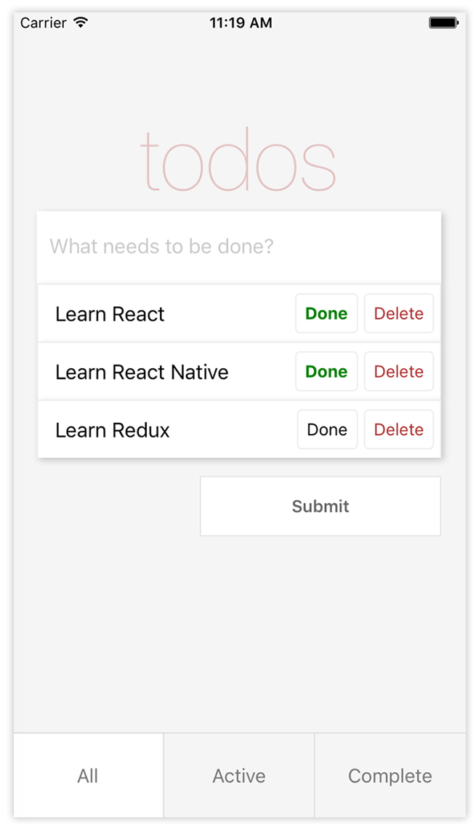
Figure 3.1 Todo app design
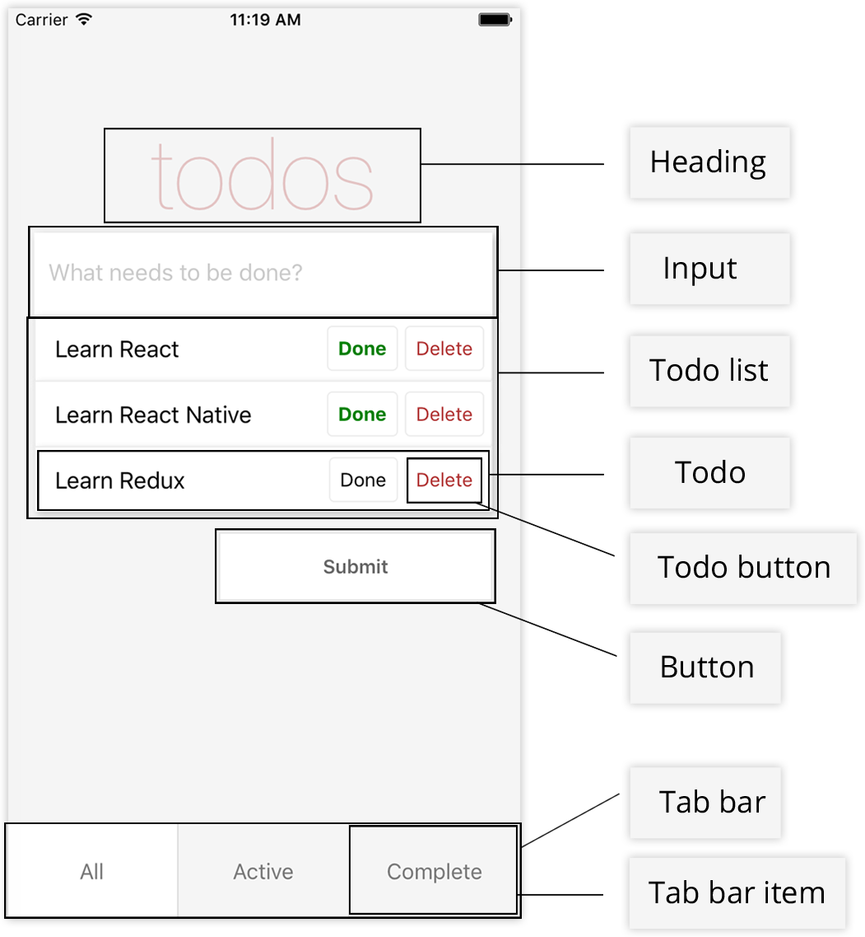
Figure 3.2 Todo app with descriptions
Listing 3.1 Basic todo app implementation
<View>
<Heading />
<Input />
<TodoList />
<Button />
<TabBar />
</View>
The app will display a heading, a text input, a button, and a tab bar. When you add a todo, the app will add it to the array of todos and display the new todo beneath the input. Each todo will have two buttons: Done and Delete. The Done button will mark it as complete, and the Delete button will remove it from the array of todos. At the bottom of the screen, the tab bar will filter the todos based on whether they’re complete or still active.

3.2 Coding the todo app
Let’s get started coding the app. Create a new React Native project by typing react-native init TodoApp in your terminal (see figure 3.3). Now, go into your index file: if you’re developing for iOS, open index.iOS.js; and if you’re developing for Android, open index.Android.js. The code for both platforms will be the same.
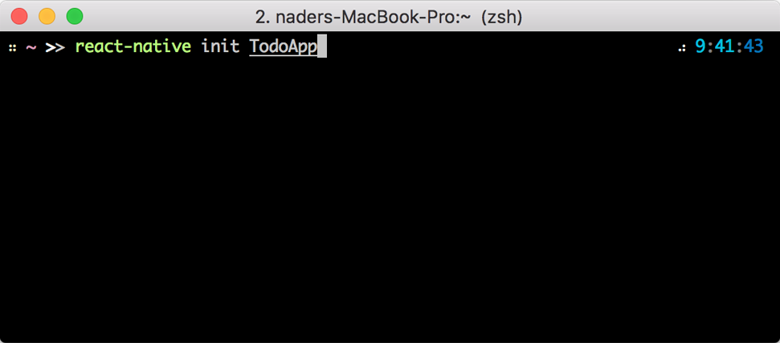
Figure 3.3 Initializing a new React Native app

Note I’m using React Native version 0.51.0 for this example. Newer versions may have API changes, but nothing should be broken for building the todo app. You’re welcome to use the most recent version of React Native, but if you run into issues, use the exact version I’m using here.

In the index file, import an App component (which you’ll create soon), and delete the styling along with any extra components you’re no longer using.
Listing 3.2 index.js
import React from 'react'
import { AppRegistry } from 'react-native'
import App from './app/App'
const TodoApp = () => <App />
AppRegistry.registerComponent('TodoApp', () => TodoApp)
Here, you bring in AppRegistry from react-native. You also bring in the main App component, which you’ll create next.
In the AppRegistry method, you initiate the application. AppRegistry is the JS entry point to running all React Native apps. It takes two arguments: the appKey, or the name of the application you defined when you initialized the app; and a function that returns the React Native component you want to use as the entry point of the app. In this case, you’re returning the TodoApp component declared in listing 3.2.
Now, create a folder called app in the root of the application. In the app folder, create a file called App.js and add the basic code shown in the next listing.
Listing 3.3 Creating the App component
import React, { Component } from 'react'
import { View, ScrollView, StyleSheet } from 'react-native'
class App extends Component {
render() {
return (
<View style={styles.container}>
<ScrollView keyboardShouldPersistTaps='always'
style={styles.content}>
<View/>
</ScrollView>
</View>
)
}
}
const styles = StyleSheet.create({
container: {
flex: 1,
backgroundColor: '#f5f5f5'
},
content: {
flex: 1,
paddingTop: 60
}
})
export default App
You import a new component called ScrollView, which wraps the platform ScrollView and is basically a scrollable View component. A keyboardShouldPersistTaps prop of always is added: this prop will dismiss the keyboard if it’s open and allow the UI to process any onPress events. You make sure both the ScrollView and the parent View of the ScrollView have a flex:1 value. flex:1 is a style value that makes the component fill the entire space of its parent container.
Now, set up an initial state for some of the values you’ll need later. You need an array to keep your todos, which you’ll name todos; a value to hold the current state of the TextInput that will add the todos, named inputValue; and a value to store the type of todo that you’re currently viewing (All, Current, or Active), named type.
In App.js, before the render function, add a constructor and an initial state to the class, and initialize these values in the state.
Listing 3.4 Setting the initial state
...
class App extends Component {
constructor() {
super()
this.state = {
inputValue: '',
todos: [],
type: 'All'
}
}
render() {
...
}
}
...
Next, create the Heading component and give it some styling. In the app folder, create a file called Heading.js. This will be a stateless component.
Listing 3.5 Creating the Heading component
import React from 'react'
import { View, Text, StyleSheet } from 'react-native'
const Heading = () => (
<View style={styles.header}>
<Text style={styles.headerText}>
todos
</Text>
</View>
)
const styles = StyleSheet.create({
header: {
marginTop: 80
},
headerText: {
textAlign: 'center',
fontSize: 72,
color: 'rgba(175, 47, 47, 0.25)',
fontWeight: '100'
}
})
export default Heading
Note that in the styling of headerText, you pass an rgba value to color. If you aren’t familiar with RGBA, the first three values make up the RGB color values, and the last value represents the alpha or opacity (red, blue, green, alpha). You pass in an alpha value of 0.25, or 25%. You also set the font weight to 100, which will give the text a thinner weight and look.
Go back into App.js, bring in the Heading component, and place it in the ScrollView, replacing the empty View you originally placed there.
Run the app to see the new heading and app layout: see figure 3.4. To run the app in iOS, use react-native run-ios. To run in Android, use react-native run-android in your terminal from the root of your React Native application.

Figure 3.4 Running the app
Listing 3.6 Importing and using the Heading component
import React, { Component } from 'react'
import {View, ScrollView, StyleSheet} from 'react-native'
import Heading from './Heading'
class App extends Component {
...
render() {
return (
<View style={styles.container}>
<ScrollView
keyboardShouldPersistTaps='always'
style={styles.content}>
<Heading />
</ScrollView>
</View>
)
}
}
...
Next, create the TextInput component and give it some styling. In the app folder, create a file called Input.js.
Listing 3.7 Creating the TextInput component
import React from 'react'
import { View, TextInput, StyleSheet } from 'react-native'
const Input = () => (
<View style={styles.inputContainer}>
<TextInput
style={styles.input}
placeholder='What needs to be done?'
placeholderTextColor='#CACACA'
selectionColor='#666666' />
</View>
)
const styles = StyleSheet.create({
inputContainer: {
marginLeft: 20,
marginRight: 20,
shadowOpacity: 0.2,
shadowRadius: 3,
shadowColor: '#000000',
shadowOffset: { width: 2, height: 2 }
},
input: {
height: 60,
backgroundColor: '#ffffff',
paddingLeft: 10,
paddingRight: 10
}
})
export default Input
You’re using a new React Native component called TextInput here. If you’re familiar with web development, this is similar to an HTML input. You also give both the TextInput and the outer View their own styling.
TextInput takes a few other props. Here, you specify a placeholder to show text before the user starts to type, a placeholderTextColor that styles the placeholder text, and a selectionColor that styles the cursor for the TextInput.
The next step, in section 3.4, will be to wire up a function to get the value of the TextInput and save it to the state of the App component. You’ll also go into App.js and add a new function called inputChange below the constructor and above the render function. This function will update the state value of inputValue with the value passed in, and for now will also log out the value of inputValue for you to make sure the function is working by using console.log(). But to view console.log() statements in React Native, you first need to open the developer menu. Let’s see how it works.

3.3 Opening the developer menu
The developer menu is a built-in menu available as a part of React Native; it gives you access to the main debugging tools you’ll use. You can open it in the iOS simulator or in the Android emulator. In this section, I’ll show you how to open and use the developer menu on both platforms.

Note If you aren’t interested in the developer menu or want to skip this section for now, go to section 3.4 to continue building the todo app.

3.3.1 Opening the developer menu in the iOS simulator
While the project is running in the iOS simulator, you can open the developer menu in one of three ways:
Press Cmd-D on the keyboard.
Press Cmd-Ctrl-Z on the keyboard.
Open the Hardware > Shake Gesture menu in the simulator options (see figure 3.5).
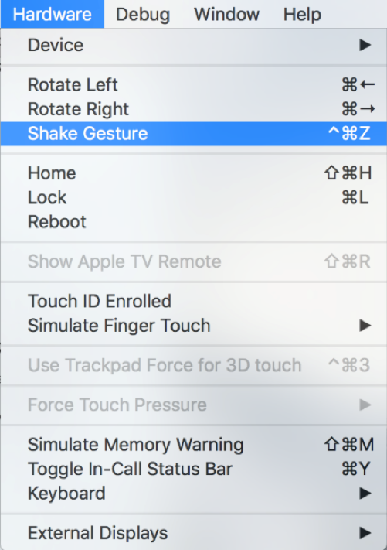
Figure 3.5 Manually opening the developer menu (iOS simulator)
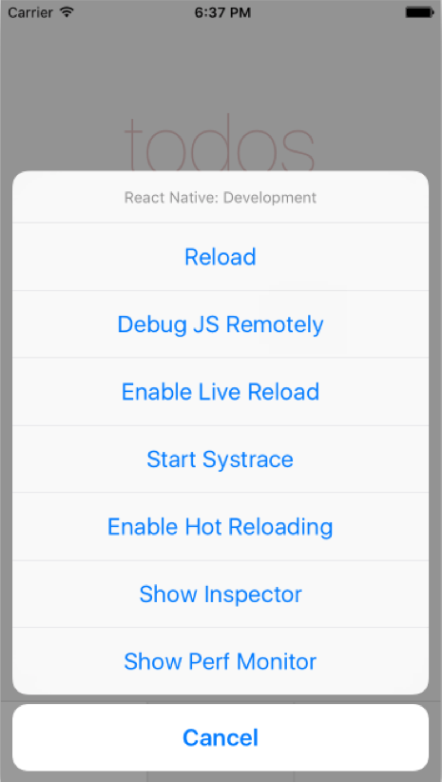
Figure 3.6 React Native developer menu (iOS simulator)
When you do, you should see the developer menu, shown in figure 3.6.

Note If Cmd-D or Cmd-Ctrl-Z doesn’t open the menu, you may need to connect your hardware to the keyboard. To do this, go to Hardware > Keyboard > Connect Hardware Keyboard in your simulator menu.

3.3.2 Opening the developer menu in the Android emulator
With the project open and running in the Android emulator, the developer menu can be opened in one of three ways:
Press F2 on the keyboard.
Press Cmd-M on the keyboard.
Press the Hardware button (see figure 3.7).
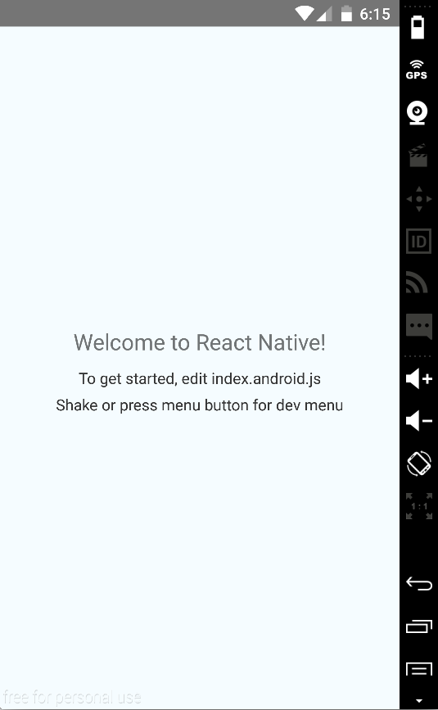
Figure 3.7 Manually opening the hardware menu (Android emulator)
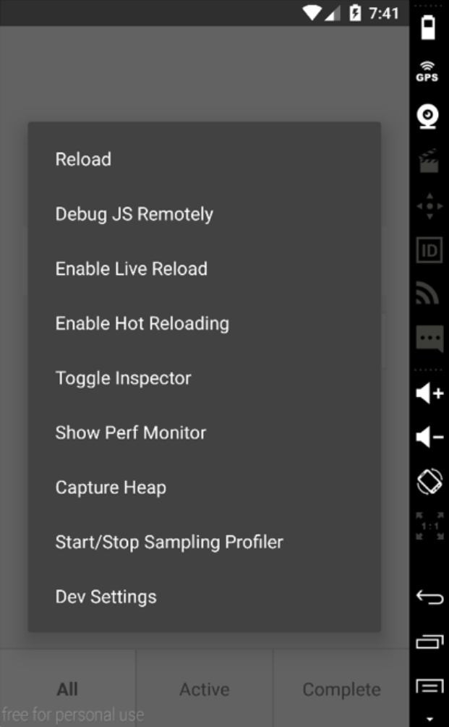
Figure 3.8 React Native developer menu (Android emulator)
When you do, you should see the developer menu shown in figure 3.8.

3.3.3 Using the developer menu
When the developer menu opens, you should see the following options:
Reload (iOS and Android) —Reloads the app. This can also be done by pressing Cmd-R on the keyboard (iOS) or pressing R twice (Android).
Debug JS Remotely (iOS and Android) —Opens the Chrome dev tools and gives you full debugging support through the browser (figure 3.9). Here, you have access not only to logging statements in your code, but also to breakpoints and whatever you’re used to while debugging web apps (with the exception of the DOM). If you need to log any information or data in your app, this is usually the place to do so.
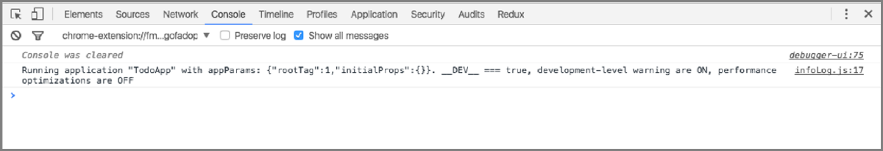
Figure 3.9 Debugging in Chrome
Enable Live Reload (iOS and Android)—Enables live reload. When you make changes in your code, the entire app will reload and refresh in the simulator.
Start Systrace (iOS only)—Systrace is a profiling tool. This will give you a good idea of where your time is being spent during each 16 ms frame while your app is running. Profiled code blocks are surrounded by start/end markers that are then visualized in a colorful chart format. Systrace can also be enabled manually from the command line in Android. If you want to learn more, check out the docs for a very comprehensive overview.
Enable Hot Reloading (iOS and Android)—A great feature added in version .22 of React Native. It offers an amazing developer experience, giving you the ability to see your changes immediately as files are changed without losing the current state of the app. This is especially useful for making UI changes deep in your app without losing state. It’s different than live reloading because it retains the current state of your app, only updating the components and state that have been changed (live reloading reloads the entire app, therefore losing the current state).
Toggle Inspector (iOS and Android)—Brings up a property inspector similar to what you see in the Chrome dev tools. You can click an element and see where it is in the hierarchy of components, as well as any styling applied to the element (figure 3.10).
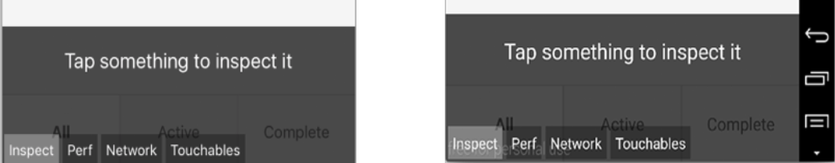
Figure 3.10 Using the inspector (left: iOS, right: Android)
Show Perf Monitor (iOS and Android)—Brings up a small box in the upper-left corner of the app, giving some information about the app’s performance. Here you’ll see the amount of RAM being used and the number of frames per second at which the app is currently running. If you click the box, it will expand to show even more information (figure 3.11).
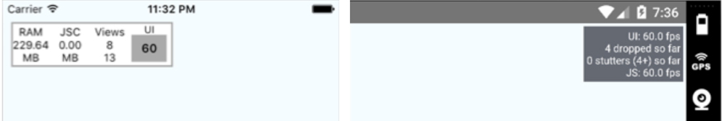
Figure 3.11 Perf Monitor (left: iOS, right: Android)

Figure 3.12 Dev Settings (Android emulator)
Dev Settings (Android emulator only)—Brings up additional debugging options, including an easy way to toggle between the __DEV__ environment variable being true or false (figure 3.12).

3.4 Continuing building the todo app
Now that you know how the developer menu works, open it and press Debug JS Remotely to open the Chrome dev tools. You’re ready to start logging information to the JavaScript console.
You’ll import the Input component into app/App.js and attach a method to TextInput, which you’ll give as a prop to the Input. You’ll also pass the inputValue stored on the state to Input as a prop.
Listing 3.8 Creating the inputChange function
...
import Heading from './Heading'
import Input from './Input'
class App extends Component {
constructor() {
…
}
inputChange(inputValue) {
①
console.log(' Input Value: ' , inputValue)
②
this.setState({ inputValue })
③
}
render() {
const { inputValue } = this.state
return (
<View style={styles.container}>
<ScrollView
keyboardShouldPersistTaps='always'
style={styles.content}>
<Heading />
<Input
inputValue={inputValue}
④
inputChange={(text) => this.inputChange(text)} />
⑤
</ScrollView>
</View>
)
}}
①
Creates the inputChange method, which takes inputValue as an argument
②
Logs out the inputValue value to make sure the method is working
③
Sets the state with the new value—same as this.setState({inputValue: inputValue})
④
Passes inputValue as a property to the Input component
⑤
Passes inputChange as a property to the Input component
inputChange takes one argument, the value of the TextInput, and updates the inputValue in the state with the returned value from the TextInput.
Now, you need to wire up the function with the TextInput in the Input component. Open app/Input.js, and update the TextInput component with the new inputChange function and the inputValue property.
Listing 3.9 Adding inputChange and inputValue to the TextInput
...
const Input = ({ inputValue, inputChange }) => (
①
<View style={styles.inputContainer}>
<TextInput
value={inputValue}
style={styles.input}
placeholder='What needs to be done?'
placeholderTextColor='#CACACA'
selectionColor='#666666'
onChangeText={inputChange} />
②
</View>
)
...
①
Destructures the inputValue and inputChange props
②
Sets the onChangeText method to inputChange
You destructure the props inputValue and inputChange in the creation of the stateless component. When the value of the TextInput changes, the inputChange function is called, and the value is passed to the parent component to set the state of inputValue. You also set the value of the TextInput to be inputValue, so you can later control and reset the TextInput. onChangeText is a method that will be called every time the value of the TextInput component is changed and will be passed the value of the TextInput.
Run the project again and see how it looks (figure 3.13). You’re logging the value of the input, so as you type you should see the value being logged out to the console (figure 3.14).
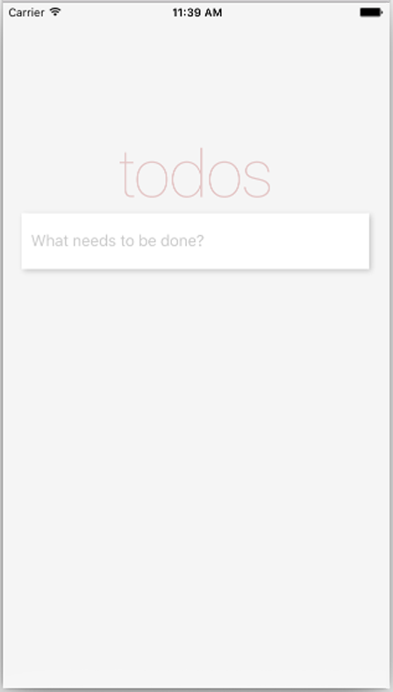
Figure 3.13 Updated view after adding the TextInput
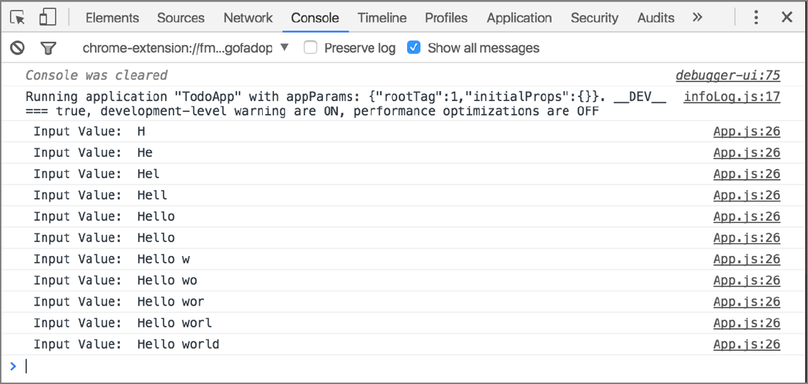
Figure 3.14 Logging out the TextInput value with the inputChange method
Now that the value of the inputValue is being stored in the state, you need to create a button to add the items to a list of todos. Before you do, create a function that you’ll bind to the button to add the new todo to the array of todos defined in the constructor. Call this function submitTodo, and place it after the inputChange function and before the render function.
Listing 3.10 Adding the submitTodo function
...
submitTodo () {
①
if (this.state.inputValue.match(/^\s*$/)) {
①
return
①
}
①
const todo = {
②
title: this.state.inputValue,
②
todoIndex,
②
complete: false
②
}
②
todoIndex++
③
const todos = [...this.state.todos, todo]
④
this.setState({ todos, inputValue: '' }, () => {
⑤
console.log('State: ', this.state)
⑥
})
}
...
①
Checks whether inputValue is empty or only contains whitespace. If it’s empty, returns without doing anything else.
②
If inputValue isn’t empty, creates and assigns a todo variable an object with a title, a todoIndex, and a complete Boolean (you’ll create the todoIndex shortly).
③
Increments the todoIndex
④
Pushes the new todo to the existing array of todos
⑤
Sets the state of the todos to match the updated array of this.state.todos, and resets inputValue to an empty string
⑥
Once the state is set, you have the option to pass a callback function. Here, a callback function from setState logs out the state to make sure everything is working.
Next, create the todoIndex at the top of the App.js file, below the last import statement.
Listing 3.11 Creating the todoIndex variable
...
import Input from './Input'
let todoIndex = 0
class App extends Component {
...
Now that the submitTodo function has been created, create a file called Button.js and wire up the function to work with the button.
Listing 3.12 Creating the Button component
import React from 'react'
import { View, Text, StyleSheet, TouchableHighlight } from 'react-native'
const Button = ({ submitTodo }) => (
①
<View style={styles.buttonContainer}>
<TouchableHighlight
underlayColor='#efefef'
style={styles.button}
onPress={submitTodo}>
②
<Text style={styles.submit}>
Submit
</Text>
</TouchableHighlight>
</View>
)
const styles = StyleSheet.create({
buttonContainer: {
alignItems: 'flex-end'
},
button: {
height: 50,
paddingLeft: 20,
paddingRight: 20,
backgroundColor: '#ffffff',
width: 200,
marginRight: 20,
marginTop: 15,
borderWidth: 1,
borderColor: 'rgba(0,0,0,.1)',
justifyContent: 'center',
alignItems: 'center'
},
submit: {
color: '#666666',
fontWeight: '600'
}
})
export default Button
①
Destructures the submitTodo function, which was passed as a prop to the component
②
Attaches submitTodo to the onPress function available to the TouchableHighlight component. This function will be called when the TouchableHighlight is touched or pressed.
In this component, you use TouchableHighlight for the first time. TouchableHighlight is one of the ways you can create buttons in React Native and is fundamentally comparable to the HTML button element.
With TouchableHighlight, you can wrap views and make them respond properly to touch events. On press down, the default backgroundColor is replaced with a specified underlayColor property that you’ll provide as a prop. Here you specify an underlayColor of '#efefef', which is a light gray; the background color is white. This will give the user a good sense of whether the touch event has registered. If no underlayColor is defined, it defaults to black.
TouchableHighlight supports only one main child component. Here, you pass in a Text component. If you want multiple components in a TouchableHighlight, wrap them in a single View, and pass this View as the child of the TouchableHighlight.

Note There’s also quite a bit of styling going on in listing 3.12. Don’t worry about styling specifics in this chapter: we cover them in depth in chapters 4 and 5. But do look at them, to get an idea how styling works in each component. This will help a lot in the in-depth later chapters, because you’ll already have been exposed to some styling properties and how they work.

You’ve created the Button component and wired it up with the function defined in App.js. Now bring this component into the app (app/App.js) and see if it works!
Listing 3.13 Importing the Button component
...
import Button from './Button'
①
let todoIndex = 0
...
constructor() {
super()
this.state = {
inputValue: '',
todos: [],
type: 'All'
}
this.submitTodo = this.submitTodo.bind(this)
②
}
...
render () {
let { inputValue } = this.state
return (
<View style={styles.container}>
<ScrollView
keyboardShouldPersistTaps='always'
style={styles.content}>
<Heading />
<Input
inputValue={inputValue}
inputChange={(text) => this.inputChange(text)} />
<Button submitTodo={this.submitTodo} />
③
</ScrollView>
</View>
)
}
①
Imports the new Button component
②
Binds the method to the class in the constructor. Because you’re using classes, functions won’t be auto-bound to the class.
③
Place the Button below the Input component, and pass in submitTodo as a prop.
You import the Button component and place it under the Input component in the render function. submitTodo is passed in to the Button as a property called this.submitTodo.
Now, refresh the app. It should look like figure 3.15. When you add a todo, the TextInput should clear, and the app state should log to the console, showing an array of todos with the new todo in the array (figure 3.16).
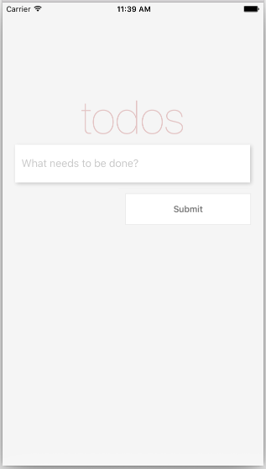
Figure 3.15 Updated app with the Button component
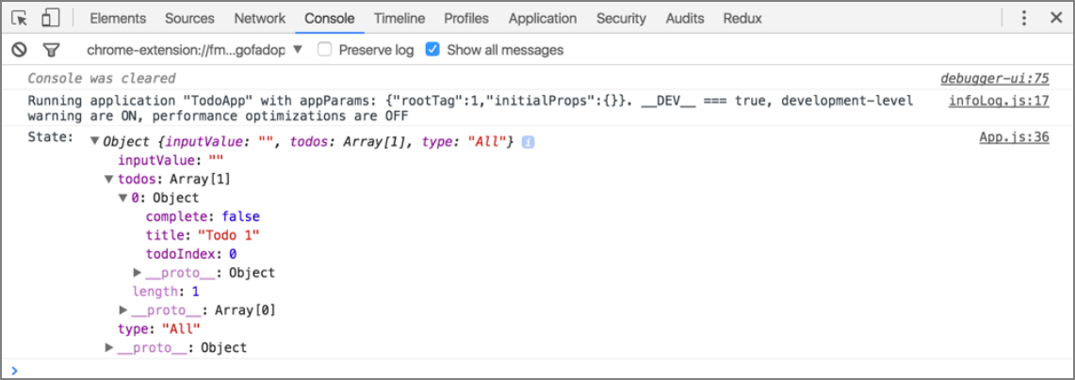
Figure 3.16 Logging the state
Now that you’re adding todos to the array of todos, you need to render them to the screen. To get started with this, you need to create two new components: TodoList and Todo. TodoList will render the list of Todos and will use the Todo component for each individual todo. Begin by creating a file named Todo.js in the app folder.
Listing 3.14 Creating the Todo component
import React from 'react'
import { View, Text, StyleSheet } from 'react-native'
const Todo = ({ todo }) => (
<View style={styles.todoContainer}>
<Text style={styles.todoText}>
{todo.title}
</Text>
</View>
)
const styles = StyleSheet.create({
todoContainer: {
marginLeft: 20,
marginRight: 20,
backgroundColor: '#ffffff',
borderTopWidth: 1,
borderRightWidth: 1,
borderLeftWidth: 1,
borderColor: '#ededed',
paddingLeft: 14,
paddingTop: 7,
paddingBottom: 7,
shadowOpacity: 0.2,
shadowRadius: 3,
shadowColor: '#000000',
shadowOffset: { width: 2, height: 2 },
flexDirection: 'row',
alignItems: 'center'
},
todoText: {
fontSize: 17
}
})
export default Todo
The Todo component takes one property for now—a todo—and renders the title in a Text component. You also add styling to the View and Text components.
Next, create the TodoList component (app/TodoList.js).
Listing 3.15 Creating the TodoList component
import React from 'react'
import { View } from 'react-native'
import Todo from './Todo'
const TodoList = ({ todos }) => {
todos = todos.map((todo, i) => {
return (
<Todo
key={todo.todoIndex}
todo={todo} />
)
})
return (
<View>
{todos}
</View>
)
}
export default TodoList
The TodoList component takes one property for now: an array of todos. You then map over these todos and create a new Todo component (imported at the top of the file) for each todo, passing in the todo as a property to the Todo component. You also specify a key and pass in the index of the todo item as a key to each component. The key property helps React identify the items that have changed when the diff with the virtual DOM is computed. React will give you a warning if you leave this out.
The last thing you need to do is import the TodoList component into the App.js file and pass in the todos as a property.
Listing 3.16 Importing the TodoList component
...
import TodoList from './TodoList'
...
render () {
const { inputValue, todos } = this.state
return (
<View style={styles.container}>
<ScrollView
keyboardShouldPersistTaps='always'
style={styles.content}>
<Heading />
<Input inputValue={inputValue} inputChange={(text) => this.inputChange(text)} />
<TodoList todos={todos} />
<Button submitTodo={this.submitTodo} />
</ScrollView>
</View>
)
}
...
Run the app. When you add a todo, you should see it pop up in the list of todos (figure 3.17).
The next steps are to mark a todo as complete, and to delete a todo. Open App.js, and create toggleComplete and deleteTodo functions below the submitTodo function. toggleComplete will toggle whether the todo is complete, and deleteTodo will delete the todo.
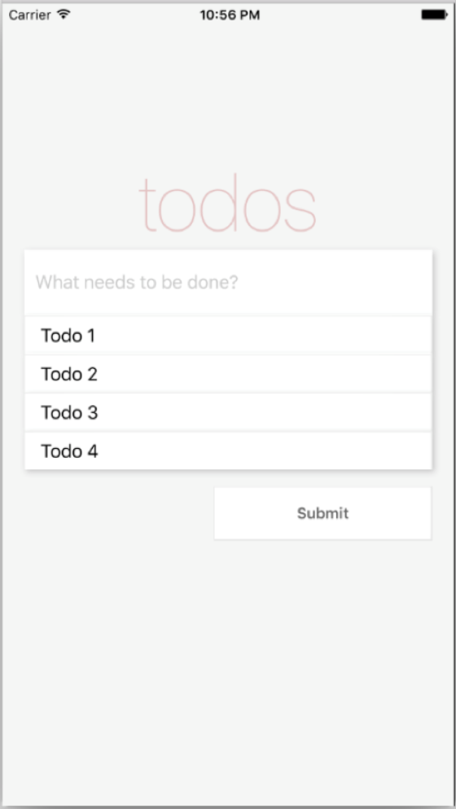
Figure 3.17 Updated app with the TodoList component
Listing 3.17 Adding toggleComplete and deleteTodo functions
constructor () {
...
this.toggleComplete = this.toggleComplete.bind(this)
①
this.deleteTodo = this.deleteTodo.bind(this)
②
}
...
deleteTodo (todoIndex) {
③
let { todos } = this.state
todos = todos.filter((todo) => todo.todoIndex !== todoIndex)
this.setState({ todos })
}
toggleComplete (todoIndex) {
④
let todos = this.state.todos
todos.forEach((todo) => {
if (todo.todoIndex === todoIndex) {
todo.complete = !todo.complete
}
})
this.setState({ todos })
}
...
①
Binds the toggleComplete method to the class in the constructor
②
Binds the deleteTodo method to the class in the constructor
③
deleteTodo takes the todoIndex as an argument, filters the todos to return all but the todo with the index that was passed in, and then resets the state to the remaining todos.
④
toggleComplete also takes the todoIndex as an argument, and loops through the todos until it finds the todo with the given index. It changes the complete Boolean to the opposite of complete’s current setting, and then resets the state of the todos.
To hook in these functions, you need to create a button component to pass in to the todo. In the app folder, create a new file called TodoButton.js.
Listing 3.18 Creating TodoButton.js
import React from 'react'
import { Text, TouchableHighlight, StyleSheet } from 'react-native'
const TodoButton = ({ onPress, complete, name }) => (
①
<TouchableHighlight
onPress={onPress}
underlayColor='#efefef'
style={styles.button}>
<Text style={[
styles.text,
complete ? styles.complete : null,
②
name === 'Delete' ? styles.deleteButton : null ]}
③
>
{name}
</Text>
</TouchableHighlight>
)
const styles = StyleSheet.create({
button: {
alignSelf: 'flex-end',
padding: 7,
borderColor: '#ededed',
borderWidth: 1,
borderRadius: 4,
marginRight: 5
},
text: {
color: '#666666'
},
complete: {
color: 'green',
fontWeight: 'bold'
},
deleteButton: {
color: 'rgba(175, 47, 47, 1)'
}
})
export default TodoButtton
①
Takes onPress, complete, and name as props
②
Checks whether complete is true, and applies a style
③
Checks whether the name property equals “Delete” and, if so, applies a style
Now, pass the new functions as props to the TodoList component.
Listing 3.19 Passing toggleComplete and deleteTodo as props to TodoList
render () {
...
<TodoList
toggleComplete={this.toggleComplete}
deleteTodo={this.deleteTodo}
todos={todos} />
<Button submitTodo={this.submitTodo} />
...
}
Next, pass toggleComplete and deleteTodo as props to the Todo component.
Listing 3.20 Passing toggleComplete and deleteTodo as props to ToDo
...
const TodoList = ({ todos, deleteTodo, toggleComplete }) => {
todos = todos.map((todo, i) => {
return (
<Todo
deleteTodo={deleteTodo}
toggleComplete={toggleComplete}
key={i}
todo={todo} />
)
})
...
Finally, open Todo.js and update the Todo component to bring in the new TodoButton component and some styling for the button container.
Listing 3.21 Updating Todo.js to bring in TodoButton and functionality
import TodoButton from './TodoButton'
...
const Todo = ({ todo, toggleComplete, deleteTodo }) => (
<View style={styles.todoContainer}>
<Text style={styles.todoText}>
{todo.title}
</Text>
<View style={styles.buttons}>
<TodoButton
name='Done'
complete={todo.complete}
onPress={() => toggleComplete(todo.todoIndex)} />
<TodoButton
name='Delete'
onPress={() => deleteTodo(todo.todoIndex)} />
</View>
</View>
)
const styles = StyleSheet.create({
...
buttons: {
flex: 1,
flexDirection: 'row',
justifyContent: 'flex-end',
alignItems: 'center'
},
...
)}
You add two TodoButtons: one named Done, and one named Delete. You also pass toggleComplete and deleteTodo as functions to be called as the onPress you defined in TodoButton.js. If you refresh the app and add a todo, you should now see the new buttons (figure 3.18).
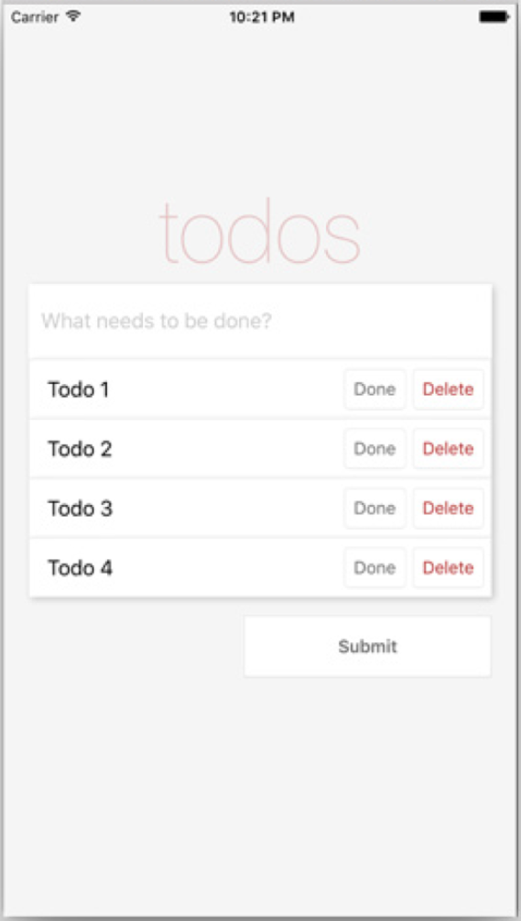
Figure 3.18 App with TodoButtons displayed
If you click Done, the button text should be bold and green. If you click Delete, the todo should disappear from the list of todos.
You’re now almost done with the app. The final step is to build a tab bar filter that will show either all the todos, only the complete todos, or only the incomplete todos. To get this started, you’ll create a new function that will set the type of todos to show.
In the constructor, you set a state type variable to 'All' when you first created the app. You’ll now create a function named setType that will take a type as an argument and update the type in the state. Place this function below the toggleComplete function in App.js.
Listing 3.22 Adding the setType function
constructor () {
...
this.setType = this.setType.bind(this)
}
...
setType (type) {
this.setState({ type })
}
...
Next, you need to create the TabBar and TabBarItem components. First, create the TabBar component: add a file in the app folder named TabBar.js.
Listing 3.23 Creating the TabBar component
import React from 'react'
import { View, StyleSheet } from 'react-native'
import TabBarItem from './TabBarItem'
const TabBar = ({ setType, type }) => (
<View style={styles.container}>
<TabBarItem type={type} title='All'
setType={() => setType('All')} />
<TabBarItem type={type} border title='Active'
setType={() => setType('Active')} />
<TabBarItem type={type} border title='Complete'
setType={() => setType('Complete')} />
</View>
)
const styles = StyleSheet.create({
container: {
height: 70,
flexDirection: 'row',
borderTopWidth: 1,
borderTopColor: '#dddddd'
}
})
export default TabBar
This component takes two props: setType and type. Both are passed down from the main App component.
You’re importing the yet-to-be-defined TabBarItem component. Each TabBarItem component takes three props: title, type, and setType. Two of the components also take a border prop (Boolean), which if set will add a left border style.
Next, create a file in the app folder named TabBarItem.js.
Listing 3.24 Creating the TabBarItem component
import React from 'react'
import { Text, TouchableHighlight, StyleSheet } from 'react-native'
const TabBarItem = ({ border, title, selected, setType, type }) => (
<TouchableHighlight
underlayColor='#efefef'
onPress={setType}
style={[
styles.item, selected ? styles.selected : null,
border ? styles.border : null,
type === title ? styles.selected : null ]}>
<Text style={[ styles.itemText, type === title ? styles.bold : null ]}>
{title}
</Text>
</TouchableHighlight>
)
const styles = StyleSheet.create({
item: {
flex: 1,
justifyContent: 'center',
alignItems: 'center'
},
border: {
borderLeftWidth: 1,
borderLeftColor: '#dddddd'
},
itemText: {
color: '#777777',
fontSize: 16
},
selected: {
backgroundColor: '#ffffff'
},
bold: {
fontWeight: 'bold'
}
})
export default TabBarItem
In the TouchableHighlight component, you check a few props and set styles based on the prop. If selected is true, you give it the style styles.selected. If border is true, you give it the style styles.border. If type is equal to the title, you give it styles.selected.
In the Text component, you also check to see whether type is equal to title. If so, add a bold style to it.
To implement the TabBar, open app/App.js, bring in the TabBar component, and set it up. You’ll also bring in type to the render function as part of destructuring this.state.
Listing 3.25 Implementing the TabBar component
...
import TabBar from './TabBar'
class App extends Component {
...
render () {
const { todos, inputValue, type } = this.state
return (
<View style={styles.container}>
<ScrollView
keyboardShouldPersistTaps='always'
style={styles.content}>
<Heading />
<Input inputValue={inputValue}
inputChange={(text) => this.inputChange(text)} />
<TodoList
type={type}
toggleComplete={this.toggleComplete}
deleteTodo={this.deleteTodo}
todos={todos} />
<Button submitTodo={this.submitTodo} />
</ScrollView>
<TabBar type={type} setType={this.setType} />
</View>
)
}
...
Here, you bring in the TabBar component. You then destructure type from the state and pass it not only to the new TabBar component, but also to the TodoList component; you’ll use this type variable in just a second when filtering the todos based on this type. You also pass the setType function as a prop to the TabBar component.
The last thing you need to do is open the TodoList component and add a filter to return only the todos of the type you currently want back, based on the tab that’s selected. Open TodoList.js, destructure the type out of the props, and add the following getVisibleTodos function before the return statement.
Listing 3.26 Updating the TodoList component
...
const TodoList = ({ todos, deleteTodo, toggleComplete, type }) => {
const getVisibleTodos = (todos, type) => {
switch (type) {
case 'All':
return todos
case 'Complete':
return todos.filter((t) => t.complete)
case 'Active':
return todos.filter((t) => !t.complete)
}
}
todos = getVisibleTodos(todos, type)
todos = todos.map((todo, i) => {
...
You use a switch statement to check which type is currently set. If 'All' is set, you return the entire list of todos. If 'Complete' is set, you filter the todos and only return the complete todos. If 'Active' is set, you filter the todos and only return the incomplete todos.
You then set the todos variable as the returned value of getVisibleTodos. Now you should be able to run the app and see the new TabBar (figure 3.19). The TabBar will filter based on which type is selected.
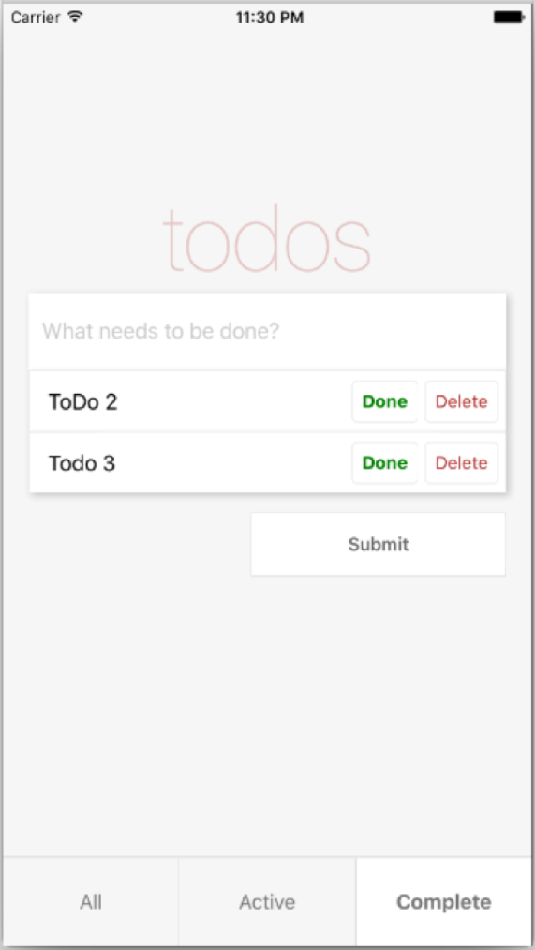
Figure 3.19 Final todo app

Summary
AppRegistry is the JavaScript entry point to running all React Native apps.
The React Native component TextInput is similar to an HTML input. You can specify several props, including a placeholder to show text before the user starts to type, a placeholderTextColor that styles the placeholder text, and a selectionColor that styles the cursor for the TextInput.
TouchableHighlight is one way to create buttons in React Native; it’s comparable to the HTML button element. You can use TouchableHighlight to wrap views and make them respond properly to touch events.
You learned how to enable the developer tools in both iOS and Android emulators.
Using the JavaScript console (available from the developer menu) is a good way to debug your app and log useful information.

Part 2
Developing applications in React Native
W
ith the basics covered, you can start adding features to your React Native app. The chapters in this part cover styling, navigation, animations, and elegant ways to handle data using data architectures (with a focus on Redux).
Chapters 4 and 5 teach how to apply styles either inline with components or in stylesheets that components can reference. And because React Native components are the main building blocks of your app’s UI, chapter 4 spends some time teaching useful things you can do with the View component. Chapter 5 builds on the skills taught in chapter 4. It covers aspects of styling that are platform specific, as well as some advanced techniques, including using flexbox to make it easier to lay out an application.
Chapter 6 shows how to use the two most-recommended and most-used navigation libraries, React Navigation and React Native Navigation. We walk through creating the three main types of navigators—tabs, stack, and drawer—and how to control the navigation state.
Chapter 7 covers the four things you need to do to create animations, the four types of animatable components that ship with the Animated API, how to create custom animatable components, and several other useful skills.
In chapter 8, we explore handling data with data architectures. Because Redux is the most widely adopted method of handling data in the React ecosystem, you use it to build an app, meanwhile learning data-handling skills. We show how to use the Context API and how to implement Redux with a React Native app by using reducers to hold the Redux state and delete items from the example app. We also cover how to use providers to pass global state to the rest of the app, how to use the connect function to access the example app from a child component, and how to use actions to add functionality.

4
Introduction to styling
This chapter covers
Styling using JavaScript
Applying and organizing styles
Applying styles to View components
Applying styles to Text components
It takes talent to build mobile applications, but it takes style to make them great. If you’re a graphic designer, you know this intuitively, deep in your bones. If you’re a developer, you’re probably groaning and rolling your eyes. In either case, understanding the fundamentals of styling Reactive Native components is critical to making an engaging application that others want to use.
In all likelihood, you have some experience with CSS, even if it’s nothing more than seeing the syntax. You can easily understand what a CSS rule like background-color: 'red' is meant to do. As you begin reading this chapter, it may appear as though styling components in React Native is as simple as using camelCase names for CSS rules. For instance, setting the background color on a React Native component uses almost the same syntax, backgroundColor: 'red'—but be forewarned, this is where the similarities end.
Try not to hang on to how you did things in CSS. Embrace the React Native way, and you’ll find that learning how to style components is a much more pleasant experience—even for a developer.
The first section of this chapter provides an overview of styling components. We’ll make sure you understand the various ways to apply styles to components and discuss how to organize styles in an application. Forming good organizational habits now will make things easier to manage and will facilitate the use of more advanced techniques down the road.
Because React Native is styled using JavaScript, we’ll talk about how to start thinking of styles as code and how to take advantage of JavaScript features like variables and functions. The final two sections explore styling View components and Text components. In some cases, we’ll use short examples to explain a topic, but for the most part, we’ll walk through styling something real. You’ll take what you learn and apply it to the construction of a Profile Card.
For all the example code in this chapter, you can start with the default generated app and replace the contents of App.js with the code from the individual listings. Complete source files can be found at www.manning.com/books/react-native-in-action and in the book’s Git repository at https://github.com/dabit3/react-native-in-action under chapter-4.

4.1 Applying and organizing styles in React Native
React Native comes with many built-in components, and the community has built many more you can include with your projects. Components support a specific set of styles. Those styles may or may not be applicable to other types of components. For example, the Text component supports the fontWeight property (fontWeight refers to the thickness of the font), but the View component doesn’t. Conversely, the View component supports the flex property (flex refers to the layout of components within a view), but the Text component doesn’t.
Some styling elements are similar between components but not the same. For example, the View component supports the shadowColor property, whereas the Text component supports the textShadowColor property. Some styles, like ShadowPropTypesIOS, only apply to a specific platform (in this case, to iOS).
Learning the various styles and how to manipulate them takes time. That’s why it’s important to start with fundamentals like how to apply and organize styles. This section will focus on teaching those styling fundamentals, so you’ll have a good foundation from which to start exploring styles and building the example Profile Card component.

Tip For a solid reference on how to make mobile apps usable, see Matt Lacey’s Usability Matters (Manning, 2018; www.manning.com/books/usability-matters).

4.1.1 Applying styles in applications
To compete in the marketplace, mobile applications must have a sense of style. You can develop a fully functional app, but if it looks terrible and isn’t engaging, people aren’t going to be interested. You don’t have to build the hottest-looking app in the world, but you do have to commit to creating a polished product. A polished, sharp-looking app greatly influences people’s perception of the app’s quality.
You can apply styles to elements in React Native in a number of ways. In chapters 1 and 3, we went over inline styling (shown in the next listing) and styling using a StyleSheet (listing 4.2).
Listing 4.1 Using inline styles
import React, { Component } from 'react'
import { Text, View } from 'react-native'
export default class App extends Component {
render () {
return (
<View style={{marginLeft: 20, marginTop: 20}}>
①
<Text style={{fontSize: 18,color: 'red'}}>Some Text</Text>
②
</View>
)
}
}
①
Applies an inline style to a React Native component
②
Applies multiple inline styles at once
As you can see, it’s possible to specify multiple styles at once by supplying an object to the styles property.
Listing 4.2 Referencing styles defined in a StyleSheet
import React, { Component } from 'react'
import { StyleSheet, Text, View } from 'react-native'
export default class App extends Component {
render () {
return (
<View style={styles.container}>
①
<Text style={[styles.message,styles.warning]}>Some Text</Text>
②
</View>
)
}
}
const styles = StyleSheet.create({
container: {
③
marginLeft: 20,
marginTop: 20
},
message: {
③
fontSize: 18
},
warning: {
③
color: 'red'
}
});
①
References the container style defined in the styles stylesheet
②
Uses an array to reference both the message and warning styles from the stylesheet
③
Defines the styles using StyleSheet.create
Functionally, there’s no difference between using an inline style versus referencing a style defined in a StyleSheet. With StyleSheet, you create a style object and refer to each style individually. Separating the styles from the render method makes the code easier to understand and promotes reuse of styles across components.
When using a style name like warning, it’s easy to recognize the intent of the message. But the inline style color: 'red' offers no insight into why the message is red. Having styles specified in one place rather than inline on many components makes it easier to apply changes across the entire application. Imagine you wanted to change warning messages to yellow. All you have to do is change the style definition once in the stylesheet, color: 'yellow'.
Listing 4.2 also shows how to specify multiple styles by supplying an array of style properties. Remember when doing this that the last style passed in will override the previous style if there’s a duplicate property. For example, if an array of styles like this is supplied, the last value for color will override all the previous values:
style={[{color: 'black'},{color: 'yellow'},{color: 'red'}]}
In this example, the color will be red.
It’s also possible to combine the two methodologies by specifying an array of styling properties using inline styles and references to stylesheets:
style={[{color: 'black'}, styles.message]}
React Native is very flexible in this regard, which can be both good and bad. Specifying inline styles when you’re quickly trying to prototype something is extremely easy, but in the long haul, you’ll want to be careful how you organize your styles; otherwise your application can quickly become a mess and difficult to manage. By organizing your styles, you’ll make it easier to do the following:
Maintain your application’s codebase
Reuse styles across components
Experiment with styling changes during development

4.1.2 Organizing styles
As you might suspect from the previous section, using inline styles isn’t the recommended way to go: stylesheets are a much more effective way to manage styles. But what does that mean in practice?
When styling websites, we use stylesheets all the time. Often we use tools like Sass, Less, and PostCSS to create monolithic stylesheets for the entire application. In the world of the web, styles are in essence global, but that isn’t the React Native way.
React Native focuses on the component. The goal is to make components as reusable and standalone as possible. Having a component dependent on an application’s stylesheet is the antithesis of modularity. In React Native, styles are scoped to the component—not to the application.
How to accomplish this encapsulation depends entirely on your team’s preference. There’s no right or wrong way, but in the React Native community, you’ll find two common approaches:
Declaring stylesheets in the same file as the component
Declaring stylesheets in a separate file, outside of the component

Declaring stylesheets in the same file as the component
As you’ve done so far in this book, a popular way to declare styles is within the component that will be using them. The major benefit of this approach is that the component and its styles are completely encapsulated in a single file. This component can then be moved or used anywhere in the app. This is a common approach to component design, one you’ll see often in the React Native community.
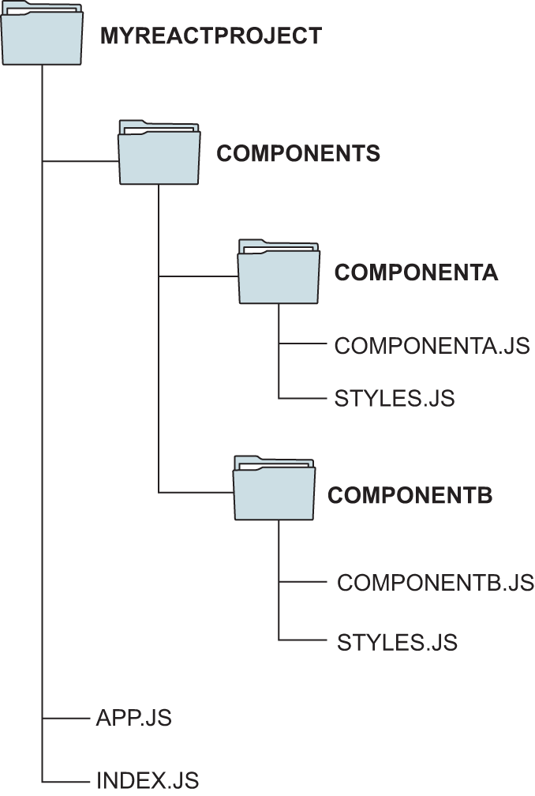
Figure 4.1 An example file structure with styles separated from components in a single folder instead of a single file
When including the stylesheet definitions with the component, the typical convention is to specify the styles after the component. All the listings in this book have, so far, followed this convention.

Declaring stylesheets in a separate file
If you’re used to writing CSS, putting your styles into a separate file might seem like a better approach and feel more familiar. The stylesheet definitions are created in a separate file. You can name it whatever you want (styles.js is typical), but be sure the extension is .js; it’s JavaScript, after all. The stylesheet file and component file are saved in the same folder.
A file structure like that shown in figure 4.1 retains the close relationship between components and styles and affords a bit of clarity by not mixing style definitions with the functional aspects of the components. Listing 4.3 corresponds to a styles.js file that would be used to style a component like ComponentA and ComponentB in the figure. Use meaningful names when defining your stylesheets, so it’s clear what part of a component is being styled.
Listing 4.3 Externalizing a component’s stylesheets
import { StyleSheet } from 'react-native'
const styles = StyleSheet.create({
①
container: {
②
marginTop: 150,
backgroundColor: '#ededed',
flexWrap: 'wrap'
}
})
const buttons = StyleSheet.create({
③
primary: {
④
flex: 1,
height: 70,
backgroundColor: 'red',
justifyContent: 'center',
alignItems: 'center',
marginLeft: 20,
marginRight: 20
}
})
export { styles, buttons }
⑤
①
Creates a stylesheet, and saves it in the styles constant
②
Defines a style for the container. It can be referenced by the component as styles.container.
③
Creates a second stylesheet, and saves it in the buttons constant
④
Defines a style for the primary button. It can be referenced by the component as buttons.primary.
⑤
Exports both the styles and buttons stylesheets so the component will have access to the constants
The component imports the external stylesheets and can reference any styles defined within them.
Listing 4.4 Importing external stylesheets
import { styles, buttons } from './component/styles'
①
<View style={styles.container}>
②
<TouchableHighlight style={buttons.primary} />
③
...
</TouchableHighlight>
</View>
①
Imports multiple stylesheets exported from styles.js
②
Reference to the styles.container style created in styles.js
③
Reference to the buttons.primary style created in styles.js

4.1.3 Styles are code
You’ve already seen how JavaScript is used to define styles in React Native. Despite having a full scripting language with variables and functions, your styles have been rather static, but they certainly don’t have to be!
Web developers have fought with CSS for years. New technologies like Sass, Less, and PostCSS were created to work around the many limitations of cascading stylesheets. Even a simple thing like defining a variable to store the primary color of a site was impossible without CSS preprocessors. The CSS Custom Properties for Cascading Variables Module Level 1 candidate recommendation in December 2015 introduced the concept of custom properties, which are akin to variables; but at the time of writing, fewer than 80% of browsers in use support this functionality.
Let’s take advantage of the fact that we’re using JavaScript and start thinking of styles as code. You’ll build a simple application that gives the user a button to change the theme from light to dark. But before you start coding, let’s walk through what you’re trying to build.
The application has a single button on the screen. That button is enclosed by a small square box. When the button is pressed, the themes will toggle. When the light theme is selected, the button label will say White, the background will be white, and the box around the button will be black. When the dark theme is selected, the button label will say Black, the background will be black, and the box around the button will be white. Figure 4.2 shows what the screen should look like when the themes are selected.
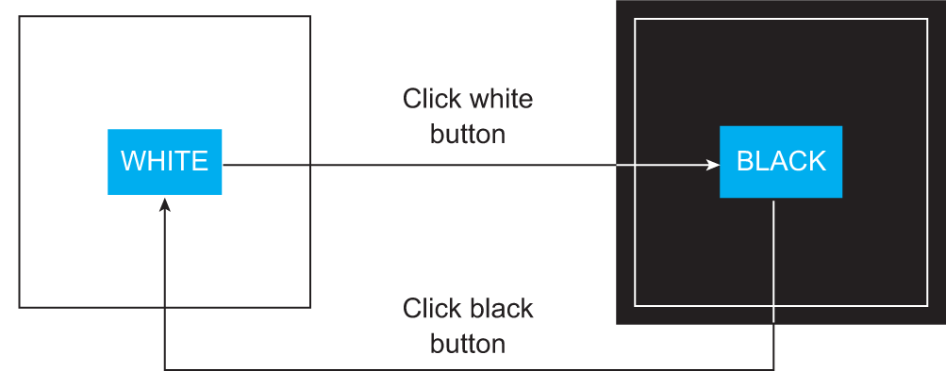
Figure 4.2 A simple application that supports two themes, white and black. Users can press the button to toggle between a white background and a black background.
For this example, organize the styles in a separate file, styles.js. Then, create some constants to hold the color values, and create two stylesheets for the light and dark themes.
Listing 4.5 Dynamic stylesheets extracted from the main component file
import {StyleSheet} from 'react-native';
export const Colors = {
①
dark: 'black',
light: 'white'
};
const baseContainerStyles = {
②
flex: 1,
justifyContent: 'center',
alignItems: 'center'
};
const baseBoxStyles = {
③
justifyContent: 'center',
alignItems: 'center',
borderWidth: 2,
height: 150,
width: 150
};
const lightStyleSheet = StyleSheet.create({
④
container: {
...baseContainerStyles,
backgroundColor: Colors.light
},
box: {
...baseBoxStyles,
borderColor: Colors.dark
}
});
const darkStyleSheet = StyleSheet.create({
⑤
container: {
...baseContainerStyles,
backgroundColor: Colors.dark
},
box: {
...baseBoxStyles,
borderColor: Colors.light
}
});
export default function getStyleSheet(useDarkTheme){
⑥
return useDarkTheme ? darkStyleSheet : lightStyleSheet;
⑦
}
①
Constant defining the colors that will correspond to the light and dark themes
②
JavaScript object to hold the base container styles
③
JavaScript object to hold the base box styles
④
Creates the stylesheet for the light theme
⑤
Creates the stylesheet for the dark theme
⑥
Function that will return the appropriate theme based on a Boolean value
⑦
Returns the dark theme if useDarkTheme is true; otherwise returns the light theme
Once the styles have been configured, you can start building the component app in App.js. Because you only have light and dark themes, create a utility function, getStyleSheet, which takes a Boolean value. If true is supplied, the dark theme will be returned; otherwise the light theme will be returned.
Listing 4.6 Application that toggles between light and dark themes
import React, { Component } from 'react';
import { Button, StyleSheet, View } from 'react-native';
import getStyleSheet from './styles';
①
export default class App extends Component {
constructor(props) {
super(props);
this.state = {
darkTheme: false
②
};
this.toggleTheme = this.toggleTheme.bind(this);
③
}
toggleTheme() {
this.setState({darkTheme: !this.state.darkTheme})
④
};
render() {
const styles = getStyleSheet(this.state.darkTheme);
⑤
const backgroundColor =
StyleSheet.flatten(styles.container).backgroundColor;
⑥
return (
<View style={styles.container}>
⑦
<View style={styles.box}>
⑧
<Button title={backgroundColor}
⑨
onPress={this.toggleTheme}/>
⑩
</View>
</View>
);
}
}
①
Imports the getStyleSheet function from the externalized styles
②
Initializes the component’s state to show the light theme by default
③
To avoid exceptions, the toggleTheme function must be bound to the component.
④
Toggles the theme value in state whenever the function is called
⑤
Uses the imported getStyleSheet function to get the appropriate stylesheet for whichever theme should be displayed
⑥
The React Native StyleSheet.flatten utility function converts the StyleSheet object into a JavaScript object, which makes It much easier to get the backgroundColor.
⑦
References the theme’s container style
⑧
References the theme’s box style (the box border around the button)
⑨
String representation of the color being used by the theme
⑩
When the button is pressed, calls the toggleTheme function to alternate from one theme to another
The application toggles themes: feel free to experiment and take it a bit further. Try changing the light theme to a different color. Notice how easy it is, because the colors are defined as constants in one place. Try changing the button label in the dark theme to be the same color as the background instead of always white. Try creating an entirely new theme, or modify the code to support many different themes instead of just two—have fun!

4.2 Styling view components
Now that you’ve had a proper overview of styling in React Native, let’s talk more about individual styles. This chapter covers many of the basic properties you’ll use all the time. In chapter 5, we’ll go into more depth and introduce styles you won’t see every day and styles that are platform specific. But for now, let’s focus on the basics: in this section, that’s the View components. The View component is the main building block of a UI and is one of the most important components to understand to get your styling right. Remember, a View element is similar to an HTML div tag in the sense that you can use it to wrap other elements and build blocks of UI code in it.
As you progress through the chapter, you’ll use what you’ve learned to build a real component: a Profile Card. Building the Profile Card will show how to put everything together. Figure 4.3 shows what the component will look like at the end of this section. In the process of creating this component, you’ll learn how to do the following:
Create a border around the profile container using borderWidth
Round the corners of that border with borderRadius
Create a border that looks like a circle by using a borderRadius half the size of the component’s width
Position everything using margin and padding properties
The next few sections will teach the styling techniques you’ll need to know to create the Profile Card component. We’ll start easy by talking about how to set a component’s background color. You’ll be able to use that same technique to set the background color of the Profile Card.
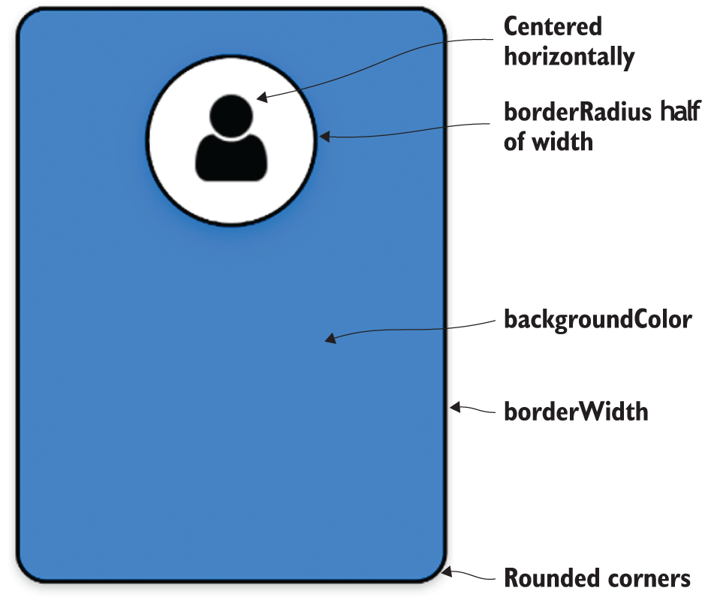
Figure 4.3 The Profile Card component after the structural View components have been styled. The Profile Card is a rectangle with rounded corners and a circular section for a profile image.

4.2.1 Setting the background color
Without a splash of color, a user interface (UI) looks boring and dull. You don’t need an explosion of color to make things look interesting, but you do need a bit. The backgroundColor property sets the background color of an element. This property takes a string of one of the properties shown in table 4.1. The same colors are available when rendering text to the screen as well.
Table 4.1 Supported color formats
Supported color format | Example
#rgb | '#06f'
#rgba | '#06fc'
#rrggbb | '#0066ff'
#rrggbbaa | '#ff00ff00'
rgb(number, number, number) | 'rgb(0, 102, 255)'
rgb(number, number, number, alpha) | 'rgba(0, 102, 255, .5)'
hsl(hue, saturation, lightness) | 'hsl(216, 100%, 50%)'
hsla(hue, saturation, lightness, alpha) | 'hsla(216, 100%, 50%, .5)'
Transparent background | 'transparent'
Any CSS3-specified named color (black, red, blue, and so on) | 'dodgerblue'
Fortunately, the supported color formats are the same ones supported by CSS. We won’t go into great detail, but because this may be the first time you’ve seen some of these formats, here’s a quick explanation:
rgb stands for red, green, and blue. You can specify the values for red, green, and blue using a scale from 0–255 (or in hexadecimal 00–ff). Higher numbers mean more of each color.
alpha is similar to opacity (0 is transparent, 1 is solid).
hue represents 1 degree on a 360-degree color wheel, where 0 is red, 120 is green, and 240 is blue.
saturation is the intensity of the color from a 0% shade of gray to 100% full color.
lightness is a percentage between 0% and 100%. 0% is darker (closer to black), and 100% is light (closer to white).
You’ve seen backgroundColor applied in previous examples, so let’s take things a step further in the next example. To use your new skills to create something real, let’s start building the Profile Card. Right now, it won’t look like much, as you can see in figure 4.4—it’s just a 300 × 400 colored rectangle.
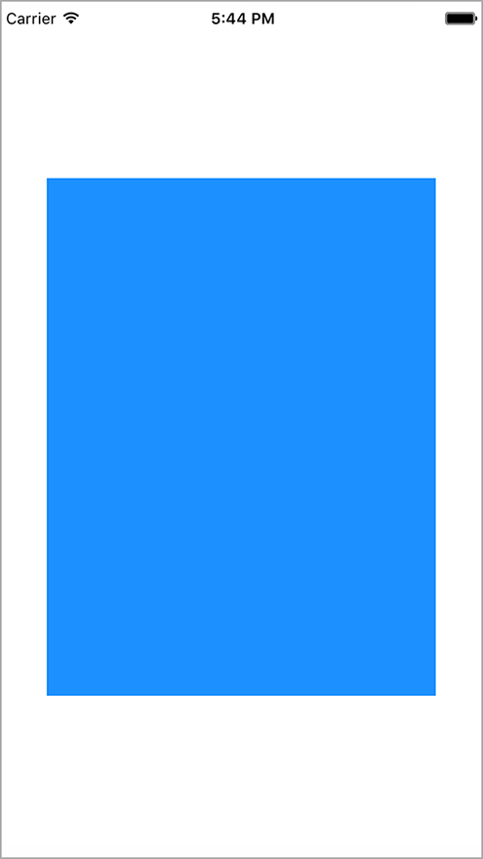
Figure 4.4 A simple 300 × 400 colored rectangle that forms the base of the Profile Card component
The following listing shows the initial code. Don’t worry about the fact that most of it has nothing to do with styling. We’ll walk through each piece, but you need a foundation from which to start.
Listing 4.7 Initial framework for the Profile Card component
import React, { Component } from 'react';
import { StyleSheet, View} from 'react-native';
export default class App extends Component<{}> {
render() {
return (
<View style={styles.container}>
①
<View style={styles.cardContainer}/>
②
</View>
);
}
}
const profileCardColor = 'dodgerblue';
③
const styles = StyleSheet.create({
container: {
④
flex: 1,
justifyContent: 'center',
alignItems: 'center'
},
cardContainer: {
⑤
backgroundColor: profileCardColor,
⑥
width: 300,
height: 400
}
});
①
The outermost View element references the container style that centers the child View component.
②
The inner View element will become the Profile Card component.
③
Defines the color for the Profile Card in a variable in case you need to use it in more than one place
④
Style definition for the outermost container
⑤
Style definition for the Profile Card container
⑥
Sets the Profile Card backgroundColor to the constant set earlier
The first View component is the outermost element. It acts as a container around everything else. Its sole purpose is to center child components on the device’s display. The second View component will be the container for the Profile Card. For now, it’s a 300 × 400 colored rectangle.

4.2.2 Setting border properties
Applying a background color to a component definitely makes it stand out, but without a crisp border line delineating the edge of the component, it looks like the component is floating in space. A clear delineation between components will help users understand how to interact with your mobile application.
Adding a border around a component is the best way to give screen elements a concrete, real feeling. There are quite a few border properties, but conceptually there are only four: borderColor, borderRadius, borderStyle, and borderWidth. These properties apply to the component as a whole.
For the color and width, there are individual properties for each side of the border: borderTopColor, borderRightColor, borderBottomColor, borderLeftColor, borderTopWidth, borderRightWidth, borderBottomWidth, and borderLeftWidth. For the border radius, there are properties for each corner: borderTopRightRadius, borderBottomRightRadius, borderBottomLeftRadius, and borderTopLeftRadius. But there’s only one borderStyle.

Creating borders with the color, width and style properties
To set a border, you must first set borderWidth. borderWidth is the size of the border, and it’s always a number. You can either set a borderWidth that applies to the entire component or choose which borderWidth you want to set specifically (top, right, bottom, or left). You can combine these properties in many different ways to get the effect you like. See figure 4.5 for some examples.
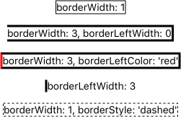
Figure 4.5 Examples of various combinations of border style settings
As you can see, you can combine border styles to create combinations of border effects. The next listing shows how easy this is to do.
Listing 4.8 Setting various border combinations
import React, { Component } from 'react';
import { StyleSheet, Text, View} from 'react-native';
export default class App extends Component<{}> {
render() {
return (
<View style={styles.container}>
<Example style={{borderWidth: 1}}>
①
<Text>borderWidth: 1</Text>
</Example>
<Example style={{borderWidth: 3, borderLeftWidth: 0}}>
②
<Text>borderWidth: 3, borderLeftWidth: 0</Text>
</Example>
<Example style={{borderWidth: 3, borderLeftColor: 'red'}}>
③
<Text>borderWidth: 3, borderLeftColor: 'red'</Text>
</Example>
<Example style={{borderLeftWidth: 3}}>
④
<Text>borderLeftWidth: 3</Text>
</Example>
<Example style={{borderWidth: 1, borderStyle: 'dashed'}}>
⑤
<Text>borderWidth: 1, borderStyle: 'dashed'</Text>
</Example>
</View>
);
}
}
const Example = (props) => (
⑥
<View style={[styles.example,props.style]}>
{props.children}
</View>
);
const styles = StyleSheet.create({
container: {
flex: 1,
justifyContent: 'center',
alignItems: 'center'
},
example: {
marginBottom: 15
}
});
①
Sets borderWidth to 1
②
Increases borderWidth to 3, removes the left border, and sets borderLeftWidth to 0
③
Sets borderWidth to 3, adds back the left border, and sets the color to red
④
Sets only a left border, with borderLeftWidth set to 3
⑤
Changes borderStyle from the default solid to dashed
⑥
Reusable Example component with a default set of styles that can easily be overridden by passing in style properties
When only borderWidth is specified, borderColor defaults to 'black' and borderStyle defaults to 'solid'. If borderWidth or borderColor is set at the component level, those properties can be overridden by using a more specific property like borderWidthLeft; specificity takes precedence over generality.

Note borderStyle is a bit buggy, and I suggest sticking with the default, solid border. If you try to change the border width of any side and have borderStyle set to 'dotted' or 'dashed', you’ll get an error. This will probably be fixed at some point, but for now don’t spend too much time scratching your head if borderStyle doesn’t work the way you expect. File that away in your brain, and let’s move along.

Using border radius to create shapes
Another border property that can be used to great effect is borderRadius. A lot of objects in the real world have straight edges, but seldom does a straight line convey any sense of style. You wouldn’t buy an automobile that looked like a box. You want your car to have nice curved lines that look sleek. Using the borderRadius style gives you the ability to add a bit of style to your applications. You can make many different, interesting shapes by adding curves in the right spots.
With borderRadius, you can define how rounded border corners appear on elements. As you may suspect, borderRadius applies to the entire component. If you set borderRadius and don’t set one of the more specific values, like borderTopLeftRadius, all four corners will be rounded. Look at figure 4.6 to see how to round different borders to create cool effects.
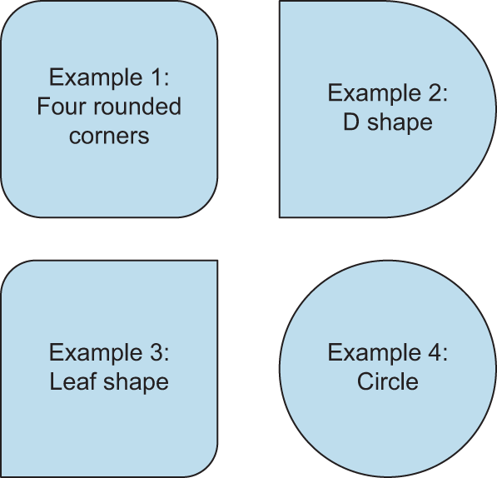
Figure 4.6 Examples of various border radius combinations. Example 1: a square with four rounded corners. Example 2: a square with the right two corners rounded, making a D shape. Example 3: a square with the opposite corners rounded, which looks like a leaf. Example 4: a square with a border radius equal to half the length of a side, which results in a circle.
Creating the shapes in figure 4.6 is relatively simple, as shown in listing 4.9. Honestly, the trickiest part about this code is making sure you don’t make the text too big or too long. I’ll show you what I mean shortly, in listing 4.10.
Listing 4.9 Setting various border radius combinations
import React, { Component } from 'react';
import { StyleSheet, Text, View} from 'react-native';
export default class App extends Component<{}> {
render() {
return (
<View style={styles.container}>
<Example style={{borderRadius: 20}}>
①
<CenteredText>
Example 1:{"\n"}4 Rounded Corners
②
</CenteredText>
</Example>
<Example style={{borderTopRightRadius: 60,
borderBottomRightRadius: 60}}>
③
<CenteredText>
Example 2:{"\n"}D Shape
</CenteredText>
</Example>
<Example style={{borderTopLeftRadius: 30,
borderBottomRightRadius: 30}}>
④
<CenteredText>
Example 3:{"\n"}Leaf Shape
</CenteredText>
</Example>
<Example style={{borderRadius: 60}}>
⑤
<CenteredText>
Example 4:{"\n"}Circle
</CenteredText>
</Example>
</View>
);
}
}
const Example = (props) => (
<View style={[styles.example,props.style]}>
{props.children}
</View>
);
const CenteredText = (props) => (
⑥
<Text style={[styles.centeredText, props.style]}>
{props.children}
</Text>
);
const styles = StyleSheet.create({
container: {
⑦
flex: 1,
flexDirection: 'row',
flexWrap: 'wrap',
marginTop: 75
},
example: {
width: 120,
height: 120,
marginLeft: 20,
marginBottom: 20,
backgroundColor: 'grey',
borderWidth: 2,
justifyContent: 'center'
},
centeredText: {
⑧
textAlign: 'center',
margin: 10
}
});
①
Example 1: a square with four rounded corners
②
This is JavaScript, so you can specify a hard return inline with the text by using {"\n"}.
③
Example 2: a square with the right two corners rounded
④
Example 3: a square with the opposite corners rounded
⑤
Example 4: a square with a border radius equal to half the length of a side
⑥
Reusable component for rendering the centered text elements
⑦
React Native uses flexbox to control layout.
⑧
Style that centers the text within the text components
Pay particular attention to the style that centers the text. You got lucky by using margin: 10. If you used padding: 10, the background of the text component would occlude the underlying border stroke of the View component (see figure 4.7).
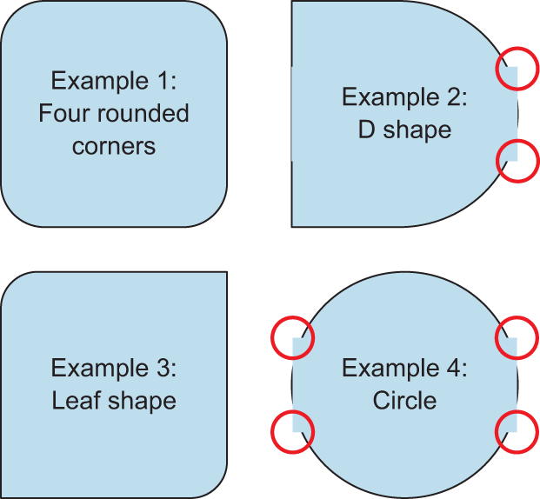
Figure 4.7 This is what figure 4.6 would look like if the centeredText style used padding: 10 instead of margin: 10 to position the text. The small circles highlight the points at which the bounding box of the Text component overlaps the border of the View component.
By default, a Text component inherits the background color of its parent component. Because the bounding box of the Text component is a rectangle, the background overlaps the nice rounded corners. Obviously, using the margin property solves the problem, but it’s also possible to remedy the situation another way. You could add backgroundColor: 'transparent' to the centeredText style. Making the text component’s background transparent allows the underlying border to show through and look normal again, as in figure 4.6.
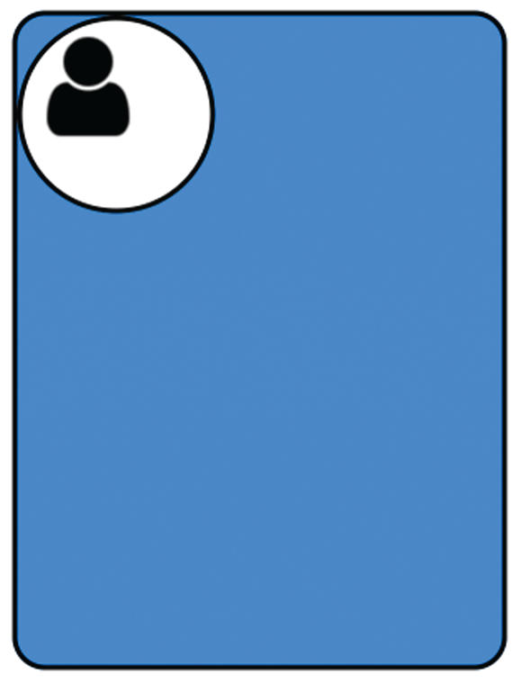
Figure 4.8 Incorporating border properties into the Profile Card component transforms the 300 × 400 colored rectangle into something more akin to what you want for the final Profile Card component.

Adding borders to your Profile Card component
With your newfound knowledge of border properties, you can almost complete the initial layout of the Profile Card component. Using only the border properties from the last section, you can transform the 300 × 400 colored rectangle into something that more closely resembles what you want. Figure 4.8 shows how far you can get with an image and the techniques you’ve learned so far. It includes an image to use as a placeholder for a person’s photo; you’ll find it in the source code. But the circle is created by manipulating the border radius as described in the previous examples.
Clearly there are some layout issues with the Profile Card, but you’re almost there. We’ll discuss how to use the margin and padding styles in the next section to get everything aligned correctly.
Listing 4.10 Incorporating border properties into the Profile Card
import React, { Component } from 'react';
import {
Image
, StyleSheet, View} from 'react-native';
①
export default class App extends Component<{}> {
render() {
return (
<View style={styles.container}>
<View style={styles.cardContainer}>
<View style={styles.cardImageContainer}>
<Image style={styles.cardImage}
source={require('./user.png')}/>
②
</View>
</View>
</View>
);
}
}
const profileCardColor = 'dodgerblue';
const styles = StyleSheet.create({
container: {
flex: 1,
justifyContent: 'center',
alignItems: 'center'
},
cardContainer: {
borderColor: 'black',
③
borderWidth: 3,
borderStyle: 'solid',
borderRadius: 20,
backgroundColor: profileCardColor,
width: 300,
height: 400
},
cardImageContainer: {
④
backgroundColor: 'white',
borderWidth: 3,
borderColor: 'black',
width: 120,
height: 120,
borderRadius: 60,
},
cardImage: {
⑤
width: 80,
height: 80
}
});
①
Imports the Image component from react-native
②
user.png is located in the same directory as the application code.
③
Adds the border properties to the Profile Card
④
The image container is a 120 × 120 square with a borderRadius of 60 (half of 120), which results in a circle.
⑤
Styles for the actual image
The differences between listing 4.10 and the previous Profile Card code (listing 4.7) have been bolded to highlight the incremental changes.

4.2.3 Specifying margins and padding
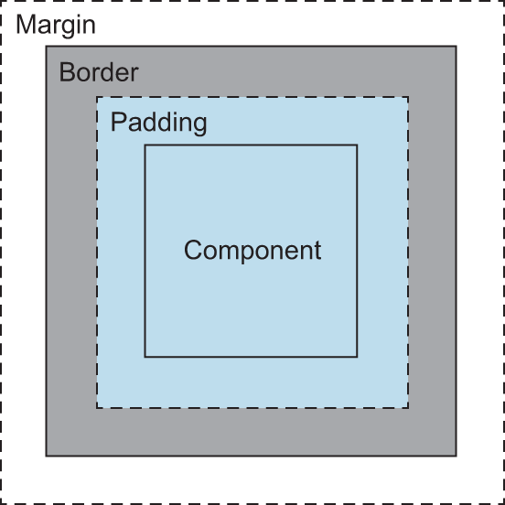
Figure 4.9 A common depiction of how margins, padding, and borders interrelate
You could explicitly position every component on the screen and lay it out exactly like you want, but that would be extremely tedious if the layout needed to be responsive to user actions. It makes more sense to position items relative to one another, so if you move one component, the other components can move in response based on their relative positions.
The margin style allows you to define this relationship between components. The padding style lets you define the relative position of a component to its border. Using these properties together provides a great deal of flexibility when laying out components. You’ll use these properties every day, so it’s important to understand what they mean and do.
Conceptually, margins and padding work exactly the same as they do in CSS. The customary depiction of how margins and padding relate to borders and the content area still applies (see figure 4.9).
Functionally, you’re likely to run into bugs when dealing with margins and padding. You might be tempted to call them “quirks,” but either way they’re a pain. For the most part, margins on View components behave reasonably well and work across iOS and Android. Padding tends to work a little differently between OSs. At the time of writing, padding text components in an Android environment doesn’t work at all; I suspect that will change in an upcoming release.

Using the margin property
When laying out components, one of the first problems to solve is how far the components are from one another. To avoid specifying a distance for each component, you need a way to specify a relative position. The margin property allows you to define the perimeter of the component, which determines how far an element is from the previous or parent component. Articulating the layout this way allows the container to figure out where the components should be positioned with respect to one another rather than you having to calculate the position of every single component.
The available margin properties are margin, marginTop, marginRight, marginBottom, and marginLeft. If only the general margin property is set, without another, more-specific value such as marginLeft or marginTop, then that value applies to all sides of the component (top, right, bottom, and left). If both margin and a more-specific margin property are specified (for example, marginLeft), then the more-specific margin property takes precedence. It works exactly the same as the border properties. Let’s apply some of these styles: see figure 4.10.
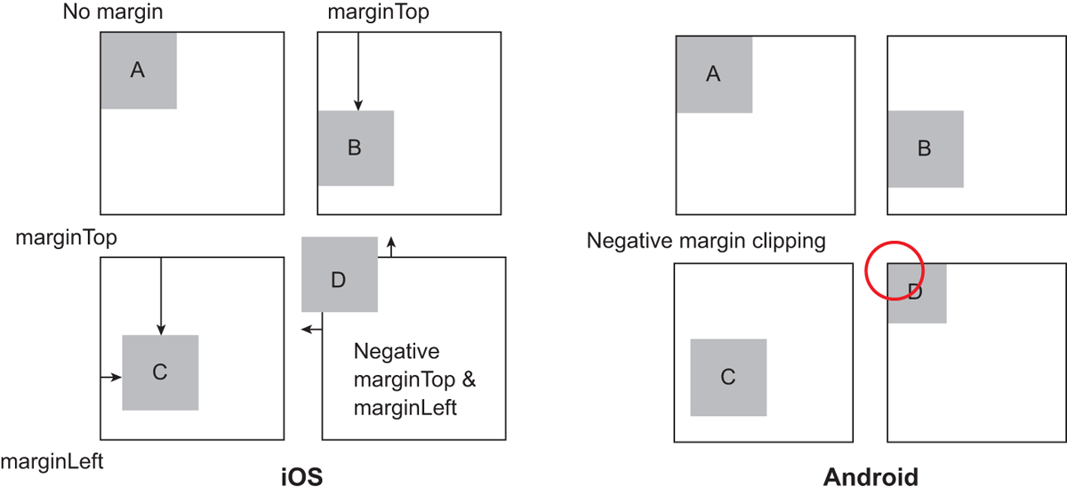
Figure 4.10 Examples of applying margins to components. In iOS, example A has no margins applied. Example B has a top margin applied. Example C has top and left margins. Example D has both negative top and negative left margins. In Android, negative margins behave a bit differently: the component is clipped by the parent container.
The margins all position the components as expected, but notice how the Android device clips the component when negative margins are applied. If you plan to support both iOS and Android, test on each device from the beginning of your project. Don’t develop on iOS and think everything you styled will behave the same on Android. Listing 4.11 shows the code for the examples in figure 4.10.
Listing 4.11 Applying various margins to components
import React, { Component } from 'react';
import { StyleSheet, Text, View} from 'react-native';
export default class App extends Component<{}> {
render() {
return (
<View style={styles.container}>
<View style={styles.exampleContainer}>
<Example>
①
<CenteredText>A</CenteredText>
</Example>
</View>
<View style={styles.exampleContainer}>
<Example style={{marginTop: 50}}>
②
<CenteredText>B</CenteredText>
</Example>
</View>
<View style={styles.exampleContainer}>
<Example style={{marginTop: 50, marginLeft: 10}}>
③
<CenteredText>C</CenteredText>
</Example>
</View>
<View style={styles.exampleContainer}>
<Example style={{marginLeft: -10, marginTop: -10}}>
④
<CenteredText>D</CenteredText>
</Example>
</View>
</View>
);
}
}
const Example = (props) => (
<View style={[styles.example,props.style]}>
{props.children}
</View>
);
const CenteredText = (props) => (
<Text style={[styles.centeredText, props.style]}>
{props.children}
</Text>
);
const styles = StyleSheet.create({
container: {
alignItems: 'center',
flex: 1,
flexDirection: 'row',
flexWrap: 'wrap',
justifyContent: 'center',
marginTop: 75
},
exampleContainer: {
borderWidth: 1,
width: 120,
height: 120,
marginLeft: 20,
marginBottom: 20,
},
example: {
width: 50,
height: 50,
backgroundColor: 'grey',
borderWidth: 1,
justifyContent: 'center'
},
centeredText: {
textAlign: 'center',
margin: 10
}
});
①
Base example with no margins applied
②
marginTop of 50
③
marginTop of 50 and marginLeft of 10
④
Applies negative margins to marginTop and marginLeft

Using the padding property
You can think of margins as the distance between elements, but padding represents the space between the content of the element and the border of the same element. When padding is specified, it allows the content of the component to not be flush against the border. In figure 4.9, the backgroundColor property bleeds through the component’s edges up to the border, which is the space defined by padding. The available properties available for padding are padding, paddingLeft, paddingRight, paddingTop, and paddingBottom. If only the main padding property is set without another, more-specific value such as paddingLeft or paddingTop, then that value is passed to all sides of the component (top, right, bottom, and left). If both padding and a more-specific padding property are specified, such as paddingLeft, then the more-specific padding property takes precedence. This behavior is exactly like borders and margins.
Rather than create a new example to show how padding is different than margins, let’s reuse the code from listing 4.11 and make a few tweaks. Change the margin styles on the example components to padding styles, and add a border around the Text components and change their background color. Figure 4.11 shows what you’ll end up with.
Listing 4.12 Modifying listing 4.11 to replace margins with padding
import React, { Component } from 'react';
...
<View style={styles.container}>
<View style={styles.exampleContainer}>
<Example style={{}}>
①
<CenteredText>A</CenteredText>
</Example>
</View>
<View style={styles.exampleContainer}>
<Example style={{
paddingTop
: 50}}>
②
<CenteredText>B</CenteredText>
</Example>
</View>
<View style={styles.exampleContainer}>
<Example style={{
paddingTop
: 50,
paddingLeft
: 10}}>
③
<CenteredText>C</CenteredText>
</Example>
</View>
<View style={styles.exampleContainer}>
<Example style={{
paddingLeft
: -10,
paddingTop
: -10}}>
④
<CenteredText>D</CenteredText>
</Example>
</View>
</View>
...
},
centeredText: {
textAlign: 'center',
margin: 10,
borderWidth: 1,
⑤
backgroundColor: 'lightgrey'
}
});
①
Example A: unchanged, with no margins or padding
②
Example B: marginTop changed to paddingTop
③
Example C: marginTop and marginLeft changed to paddingTop and paddingLeft, respectively
④
Example D: marginLeft and marginTop changed to paddingLeft and marginTop, respectively. The negative values remain.
⑤
Adds a border and background color to the Text component
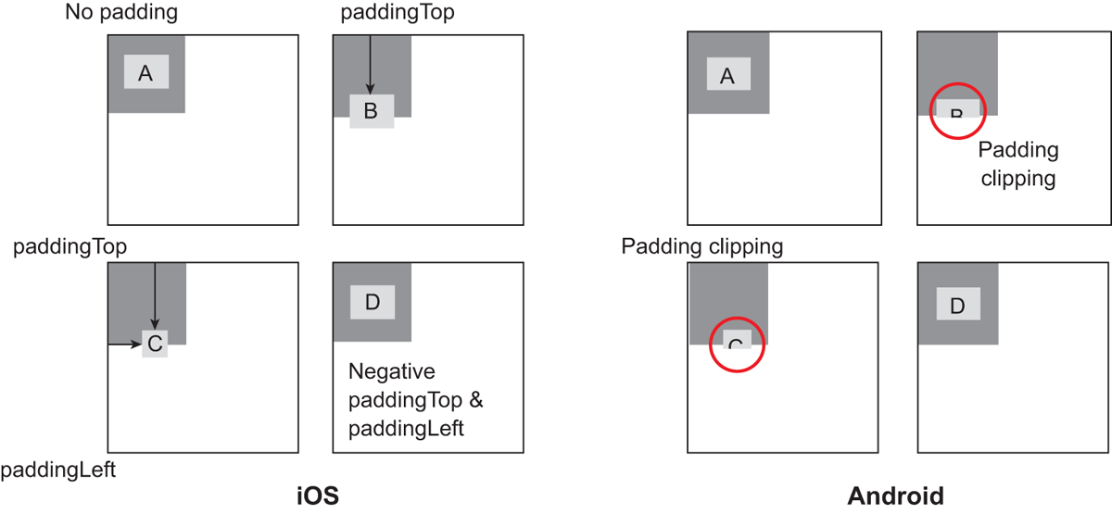
Figure 4.11 Changing the margin styles from the previous example to padding styles. Example A, with no padding, looks the same as when no margins are applied. Example B shows the component with paddingTop applied. Example C is the same, but it also applies paddingLeft. Example D applies negative padding values to paddingTop and paddingLeft, which are ignored.
Unlike margins, which specify the space between the component and its parent component, padding applies from the border of the component to its children. In example B, padding is calculated from the top border, which pushes the Text component B down from the top border. Example C adds a paddingLeft value, which also pushes the Text component C inward from the left border. Example D applies negative padding values to paddingTop and paddingLeft.
A few interesting observations can be made. Example B and example C are both clipped on the Android device. Example C’s Text component’s width is compressed, and the negative values for padding are ignored in example D.

4.2.4 Using position to place components
So far, everything we’ve looked at has been positioned relative to another component, which is the default layout position. Sometimes it’s beneficial to take advantage of absolute positioning and place a component exactly where you want it. The implementation of the position style in React Native is similar to CSS, but there aren’t as many options. By default, all elements are laid out relative to one another. If position is set to absolute, then the element is laid out relative to its parent. The available properties for position are relative (the default position) and absolute.
CSS has other values, but those are the only two in React Native. When using absolute positioning, the following properties are also available: top, right, bottom, and left.
Let’s look at a simple example to demonstrate the difference between relative and absolute positioning. In CSS, positioning can get much more confusing, but in React Native the “everything has relative positioning by default” makes it much easier to position items. In figure 4.12, blocks A, B, and C are laid out relative to one another in a row. Without any margin or padding, they’re lined up one after another. Block D is a sibling to the ABC row of blocks, meaning the main container is the parent container for the ABC row and block D.
Block D is set to {position: 'absolute', right: 0, bottom: 0}, so it’s positioned in the lower-right corner of its container. Block E is also set to {position: 'absolute', right: 0, bottom: 0}, but its parent container is block B, which means block E is positioned absolutely but with respect to block B. Block E appears in the lower-right corner of block B, instead. Listing 4.13 shows the code for this example.
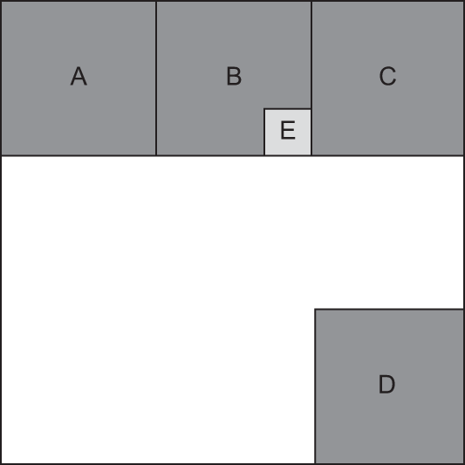
Figure 4.12 An example showing blocks A, B, and C laid out relative to one another. Block D has an absolute position of right: 0 and bottom: 0. Block E also has an absolute position of right: 0 and bottom: 0, but its parent is block B and not the main container, whereas D’s parent was the main container.
Listing 4.13 Relative and absolute positioning comparison
import React, { Component } from 'react';
import { StyleSheet, Text, View} from 'react-native';
export default class App extends Component<{}> {
render() {
return (
<View style={styles.container}>
<View style={styles.row}>
①
<Example>
<CenteredText>A</CenteredText>
</Example>
<Example>
<CenteredText>B</CenteredText>
<View style={[styles.tinyExample,
②
{position: 'absolute',
right: 0,
bottom: 0}]}>
<CenteredText>E</CenteredText>
</View>
</Example>
<Example>
<CenteredText>C</CenteredText>
</Example>
</View>
<Example style={{position: 'absolute',
③
right: 0, bottom: 0}}>
<CenteredText>D</CenteredText>
</Example>
</View>
);
}
}
const Example = (props) => (
<View style={[styles.example,props.style]}>
{props.children}
</View>
);
const CenteredText = (props) => (
<Text style={[styles.centeredText, props.style]}>
{props.children}
</Text>
);
const styles = StyleSheet.create({
container: {
width: 300,
height: 300,
margin: 40,
marginTop: 100,
borderWidth: 1
},
row: {
④
flex: 1,
flexDirection: 'row'
},
example: {
width: 100,
height: 100,
backgroundColor: 'grey',
borderWidth: 1,
justifyContent: 'center'
},
tinyExample: {
width: 30,
height: 30,
borderWidth: 1,
justifyContent: 'center',
backgroundColor: 'lightgrey'
},
centeredText: {
textAlign: 'center',
margin: 10
}
});
①
Row containing blocks A, B, and C
②
Block E is absolutely positioned in the lower-right corner of its parent container, block B.
③
Block D is absolutely positioned in the lower-right corner of its parent container.
④
The flexbox direction is specified as row, so the blocks are in a row across the screen.

Note In listing 4.13, the flexDirection property is specified as 'row', so the blocks are in a row across the screen. React Native uses an open source, cross-platform layout library called Yoga (https://yogalayout.com). Yoga implements the flexbox layout mode, which you often see in CSS and is used frequently in React Native. We’ll spend a lot of time in the next chapter talking about flexbox. Margins, padding, and position are all great layout tools, but flexbox is the tool you’ll use most often.

We’re finished with the fundamentals of styling View components. You’ve learned about some layout techniques: margins, padding, and position. Let’s revisit the Profile Card component and fix the pieces that aren’t yet laid out properly.

4.2.5 Profile Card positioning
The following listing has the code changes that need to be made to listing 4.10 to space the circle and user image properly and center everything. Figure 4.13 shows the result.
Listing 4.14 Modifying Profile Card styles to fix the layout
...
cardContainer: {
alignItems: 'center',
①
borderColor: 'black',
borderWidth: 3,
borderStyle: 'solid',
borderRadius: 20,
backgroundColor: profileCardColor,
width: 300,
height: 400
},
cardImageContainer: {
alignItems: 'center',
②
backgroundColor: 'white',
borderWidth: 3,
borderColor: 'black',
width: 120,
height: 120,
borderRadius: 60,
marginTop: 30,
③
paddingTop: 15
④
},
...
①
Aligns the circle in the horizontal center of the Profile Card
②
Aligns the user image in the horizontal center of the circle
③
Provides space between the top of the circle and the top of the Profile Card
④
Provides padding between the inner part of the circle and the contained image
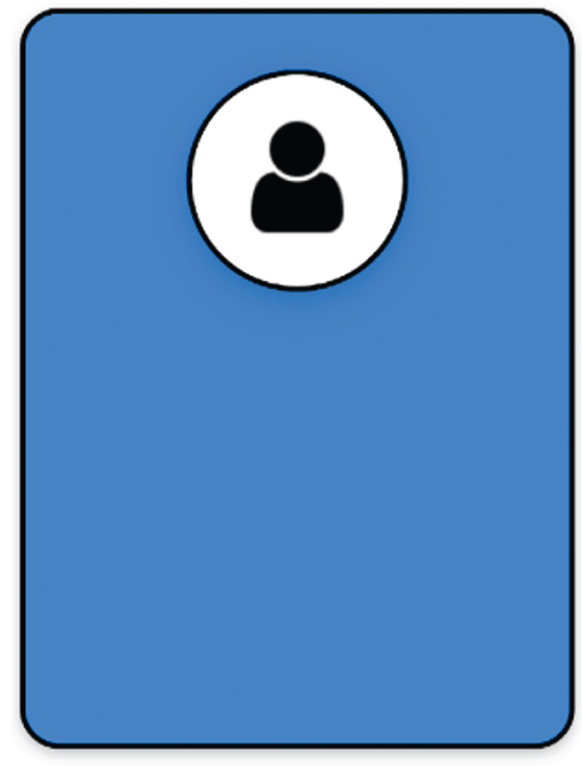
Figure 4.13 The Profile Card component after all the View components have been lined up properly
Now, the major View components for the Profile Card are in place. By using the techniques discussed so far, you’ve built a nice-looking foundation for the component, but you’re not finished. You need to add information about the person: name, occupation, and a brief profile description. All that information is text based, so the next thing you’ll learn is how to style Text components.

4.3 Styling Text components
In this section, we’ll discuss how to style Text components. After you have a working knowledge of how to make text look great, we’ll take another look at the Profile Card and add some information about the user. Figure 4.14 is the finished Profile Card component with the user’s name and occupation and a brief profile description. But before we revisit the Profile Card, let’s look at the styling techniques that will enable you to finish building it.
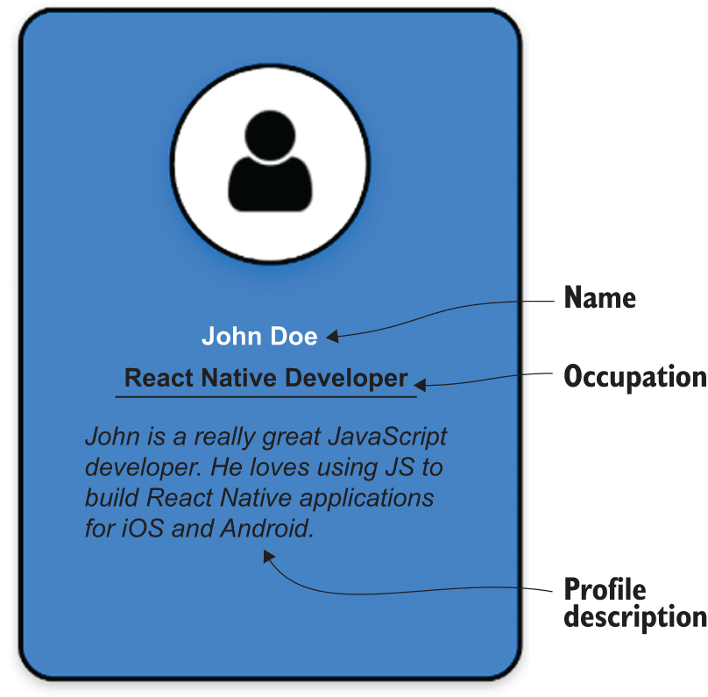
Figure 4.14 The completed Profile Card with the user’s name and occupation and a brief profile description

4.3.1 Text components vs. View components
With the exception of flex properties, which we have yet to cover, most of the styles applicable to View elements will also work as expected with Text elements. Text elements can have borders and backgrounds and are affected by layout properties like margin, padding, and position.
The reverse can’t be said. Most of the styles Text elements can use won’t work for View elements, which makes perfect sense. If you’ve ever used a word processor, you know you can use different fonts for text and change the font color; that you can resize, bold, and italicize the text; and that you can apply decorations like underlines.
Before we get into text-specific styling, let’s talk about color, a style common to both Text and View components. Then you’ll use color along with everything you’ve learned thus far to start adding text to the Profile Card.

Coloring text
The color property applies to Text components in exactly the same way as it does to View components. As expected, this property specifies the color of the text in a Text element. All the color formats listed in table 4.1 still apply—even transparent, although I can’t imagine how that’s of benefit. By default, the text color is black.
Figure 4.14 showed three Text elements in the Profile Card:
Name
Occupation
Profile description
Using what you’ve already learned, you can center and position the text, change the color of the name from black to white, and add a simple border to separate the occupation from the description. Figure 4.15 shows what you’ll end up with by applying techniques in your arsenal.
By this point, you should be able to follow along with listing 4.15 and understand everything that’s going on. Don’t feel bad if you don’t—if necessary, go back and re-read the appropriate sections.
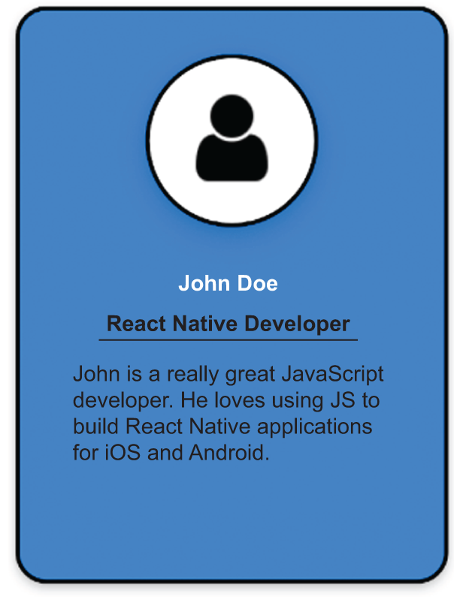
Figure 4.15 The Profile Card with Text elements added using text styling defaults and the color property for the name set to white
Listing 4.15 Adding text to the Profile Card
import React, { Component } from 'react';
import { Image, StyleSheet,
Text
, View} from 'react-native';
①
export default class App extends Component<{}> {
render() {
return (
<View style={styles.container}>
<View style={styles.cardContainer}>
<View style={styles.cardImageContainer}>
<Image style={styles.cardImage}
source={require('./user.png')}/>
</View>
<View>
<Text style={styles.cardName}>
②
John Doe
</Text>
</View>
<View style={styles.cardOccupationContainer}>
③
<Text style={styles.cardOccupation}>
④
React Native Developer
</Text>
</View>
<View>
<Text style={styles.cardDescription}>
⑤
John is a really great JavaScript developer. He
loves using JS to build React Native applications
for iOS and Android.
</Text>
</View>
</View>
</View>
);
}
}
const profileCardColor = 'dodgerblue';
const styles = StyleSheet.create({
container: {
flex: 1,
justifyContent: 'center',
alignItems: 'center'
},
cardContainer: {
alignItems: 'center',
borderColor: 'black',
borderWidth: 3,
borderStyle: 'solid',
borderRadius: 20,
backgroundColor: profileCardColor,
width: 300,
height: 400
},
cardImageContainer: {
alignItems: 'center',
backgroundColor: 'white',
borderWidth: 3,
borderColor: 'black',
width: 120,
height: 120,
borderRadius: 60,
marginTop: 30,
paddingTop: 15
},
cardImage: {
width: 80,
height: 80
},
cardName: {
⑥
color: 'white',
marginTop: 30,
},
cardOccupationContainer: {
⑦
borderColor: 'black',
borderBottomWidth: 3
},
cardOccupation: {
⑧
marginTop: 10,
marginBottom: 10,
},
cardDescription: {
⑨
marginTop: 10,
marginRight: 40,
marginLeft: 40,
marginBottom: 10
}
});
①
Imports the Text component from react-native
②
Text component that renders the person’s name
③
Container around the occupation text that sets a bottom border separating the occupation from the description
④
Text component that renders the occupation
⑤
Text component that renders the profile description
⑥
Styles for the name Text component; the color is 'white'.
⑦
Styles for the occupation container
⑧
Styles for the occupation text (currently only positional styling)
⑨
Styles for the profile description
At this point, you have all the content for the Profile Card, but it’s pretty plain. In the next couple of sections, we’ll talk about how to set font properties and add decorative styles to text.

4.3.2 Font styles
If you’ve ever used a word processor or written an email with rich text capabilities, you’ve been able to change fonts, increase or decrease the font size, bold or italicize the text, and so on. These are the same styles you’ll learn how to change in this section. By adjusting these styles, you can make text more compelling and attractive to the end user. We’ll discuss these properties: fontFamily, fontSize, fontStyle, and fontWeight.

Specifying a font family
The fontFamily property is deceptively simple. If you stick with the defaults, it’s easy; but if you want to use a specific font, you can run into trouble quickly. Both iOS and Android come with a default set of fonts. For iOS, a large number of available fonts can be implemented out of the box. For Android, there’s Roboto, a monospace font, and some simple serif and sans serif variants. For a full list of Android and iOS fonts available out of the box in React Native, go to https://github.com/dabit3/react-native-fonts.
If you wanted to use a monospaced font in an application, you couldn’t specify either of the following:
fontFamily: 'monospace'—The 'monospace' option isn’t supported on iOS, so on that platform you’ll get the error “Unrecognized font family 'monospace'.” But on Android, the font will render correctly without any problems. Unlike CSS, you can’t supply multiple fonts to the fontFamily property.
fontFamily: 'American Typewriter, monospace'—You’ll again get an error on iOS, “Unrecognized font family 'American Typewriter, monospace'.” But on Android, when you supply a font it doesn’t support, it falls back to the default. That might not be true in every version of Android, but suffice it to say neither approach will work.
If you want to use different fonts, you’ll have to use React Native’s Platform component. Well discuss Platform in more detail in chapter 10, but I want to introduce it, so you can see how to work around this dilemma. Figure 4.16 shows the American Typewriter font rendered on iOS and the generic monospace font used on Android.
The following listing shows the code that produced this example. Pay attention to how the fontFamily is set using Platform.select.

Figure 4.16 An example of rendering monospaced fonts on both iOS and Android
Listing 4.16 Displaying monospaced fonts on iOS and Android
import React, { Component } from 'react';
import { Platform, StyleSheet, Text, View} from 'react-native';
①
export default class App extends Component<{}> {
render() {
return (
<View style={styles.container}>
<View style={styles.row}>
<CenteredText>
I am a monospaced font on both platforms
</CenteredText>
<BottomText>
{Platform.OS}
②
</BottomText>
</View>
</View>
);
}
}
const CenteredText = (props) => (
<Text style={[styles.centeredText, props.style]}>
{props.children}
</Text>
);
const BottomText = (props) => (
<CenteredText style={[{position: 'absolute', bottom: 0},
③
props.style]}>
{props.children}
</CenteredText>
);
const styles = StyleSheet.create({
container: {
width: 300,
height: 300,
margin: 40,
marginTop: 100,
borderWidth: 1
},
row: {
alignItems: 'center',
flex: 1,
flexDirection: 'row',
justifyContent: 'center'
},
centeredText: {
textAlign: 'center',
margin: 10,
fontSize: 24,
...Platform.select({
④
ios: {
fontFamily: 'American Typewriter'
},
android: {
fontFamily: 'monospace'
}
})
}
});
①
Imports the Platform component from react-native
②
Platform.OS can also tell you what OS the code is running on.
③
Takes advantage of your absolute positioning knowledge
④
Uses Platform.select to pick the styles for the appropriate platform
This example shows how to select fonts based on the OS, but the set of fonts at your disposal is still limited to what comes with React Native out of the box. You can add custom fonts to a project using font files (TTF, OTF, and so on) and linking them to your application as assets. In theory the process is simple, but success varies greatly depending on the OS and the font files being used. I want you to know it’s possible to do, but if you want to give it try, break out your search engine of choice and look into react-native link.

Adjusting text size with fontSize
fontSize is pretty simple: it adjusts the size of the text in a Text element. You’ve used this quite a bit already, so we won’t go into much detail other than the fact that the default fontSize is 14.

Changing font styles
You can use fontStyle to change the font style to italic. The default is 'normal'. The only two options at this moment are 'normal' and 'italic'.

Specifying font weights
fontWeight refers to the thickness of the font. The default is 'normal' or '400'. The options for fontWeight are 'normal', 'bold', '100', '200', '300', '400', '500', '600', '700', '800', and '900'. The smaller the value, the lighter/thinner the text. The larger the value, the thicker/bolder the text.
Now that you know how to change the font styles, you can almost finish the Profile Card component. Let’s change some font styles and see how close you can get to the final product, as shown in figure 4.17. The next listing shows how to change the styles from listing 4.16 to achieve this look.
Listing 4.17 Setting font styles for Text elements in the Profile Card
…
cardName: {
color: 'white',
fontWeight: 'bold',
①
fontSize: 24,
②
marginTop: 30,
},
…
cardOccupation: {
fontWeight: 'bold',
③
marginTop: 10,
marginBottom: 10,
},
cardDescription: {
fontStyle: 'italic',
④
marginTop: 10,
marginRight: 40,
marginLeft: 40,
marginBottom: 10
}
…
①
Changes the font weight of the name text to bold
②
Changes the font size of the name text to 24
③
Bolds the occupation text
④
Italicizes the description text
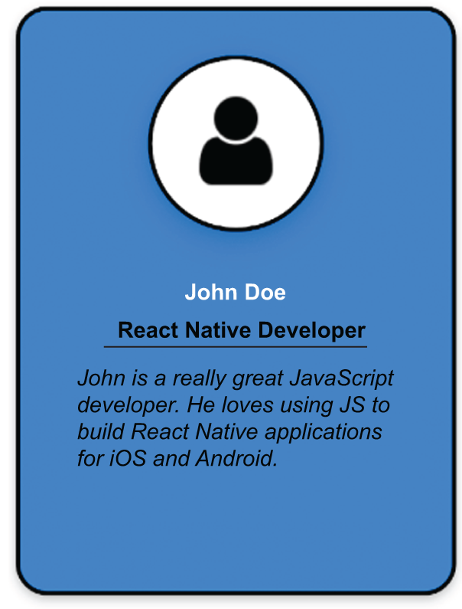
Figure 4.17 The Profile Card with font styles applied to the Name, Occupation, and Description texts
Modifying the font styles for the name, occupation, and description text helps differentiate each of the sections, but the name still doesn’t stand out much. The next section covers some decorative ways to style text and how to use those techniques to make the name stand out in the Profile Card.

4.3.3 Using decorative text styles
In this section, you’ll go beyond the basics of changing font styles and start applying decorative styles to text. I’ll show you how to do things like underline and strikethrough text and add drop shadows. These techniques can add a lot of visual variety to applications and help text elements stand out from one another.
Here are the properties we’ll cover in this section:
iOS and Android —lineHeight, textAlign, textDecorationLine, textShadowColor, textShadowOffset, and textShadowRadius
Android only —textAlignVertical
iOS only —letterSpacing, textDecorationColor, textDecorationStyle, and writingDirection.
Notice that some of the properties only apply to one OS or another. Some values that can be assigned to the properties are also OS-specific. It’s important to keep this in mind, especially if you’re relying on a specific style to highlight a particular element of text on the screen.

Specifying height of text elements
lineHeight specifies the height of the Text element. Figure 4.18 and listing 4.18 show an example of how this behaves differently on iOS versus Android. A lineHeight of 100 is applied to the Text B element: the height of that line is significantly greater than the others. Also notice how iOS and Android position the text within the line differently. On Android, the text is positioned at the bottom of the line.
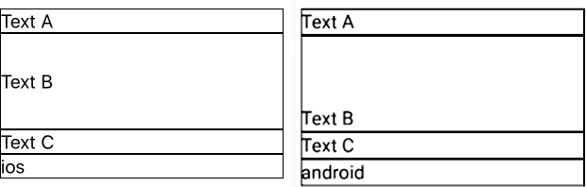
Figure 4.18 Example of using lineHeight on iOS and Android.
Listing 4.18 Applying lineHeight to a Text element in iOS and Android
import React, { Component } from 'react';
import { Platform, StyleSheet, Text, View} from 'react-native';
export default class App extends Component<{}> {
render() {
return (
<View style={styles.container}>
<TextContainer>
<LeftText>Text A</LeftText>
</TextContainer>
<TextContainer>
<LeftText style={{lineHeight: 100}}>
①
Text B
</LeftText>
</TextContainer>
<TextContainer>
<LeftText>Text C</LeftText>
</TextContainer>
<TextContainer>
<LeftText>{Platform.OS}</LeftText>
</TextContainer>
</View>
);
}
}
const LeftText = (props) => (
<Text style={[styles.leftText, props.style]}>
{props.children}
</Text>
);
const TextContainer = (props) => (
<View style={[styles.textContainer, props.style]}>
{props.children}
</View>
);
const styles = StyleSheet.create({
container: {
width: 300,
height: 300,
margin: 40,
marginTop: 100
},
textContainer: {
borderWidth: 1
②
},
leftText: {
fontSize: 20
}
});
①
Sets lineHeight to 100
②
Setting a border lets you easily see the height of the line.

Aligning text horizontally
textAlign refers to how the text in the element will be horizontally aligned. The options for textAlign are 'auto', 'center', 'right', 'left', and 'justify' ('justify' is iOS only).

Underlining text or adding lines through text
Use the textDecorationLine property to add either an underline or a line through the given text. The options for textDecorationLine are 'none', 'underline', 'line-through', and 'underline line-through'. The default value is 'none'. When you specify 'underline line-through', a single space separates the values in quotes.

Text-decoration styles (iOS only)
iOS supports several text-decoration styles that Android doesn’t. The first is textDecorationColor, which allows you to set a color for textDecorationLine. iOS also supports styling the line itself. On Android, the line is always solid, but on iOS textDecorationStyle lets you specify 'solid', 'double', 'dotted', and 'dashed'. Android will ignore these additional styles.
To use the additional iOS decoration styles, specify them in conjunction with the primary textDecorationLine style. For example:
{
textDecorationLine: 'underline',
textDecorationColor: 'red',
textDecorationStyle: 'double'
}

Adding shadows to text
You can use the textShadowColor, textShadowOffset, and textShadowRadius properties to add a shadow to a Text element. To create a shadow, you need to specify three things:
The color
The offset
The radius
The offset specifies the position of the shadow relative to the component casting the shadow. The radius basically defines how blurry the shadow appears. You can specify a text shadow like this:
{
textShadowColor: 'red',
textShadowOffset: {width: -2, height: -2},
textShadowRadius: 4
}

Controlling letter spacing (iOS only)
letterSpacing specifies the spacing between text characters. It’s not something you’ll use every day, but it can produce some interesting visual effects. Keep in mind that it’s iOS only, so use it if you need it.

Examples of text styles
We’ve gone through a lot of different styles in this section. Figure 4.19 shows various styles applied to Text components.
Here’s a quick rundown of the styles being used for each example in figure 4.19:
A is italic text using {fontStyle: 'italic'}.
B shows text decoration with an underline and a line through the text. The style for this is {textDecorationLine: 'underline line-through'}.
C expands on example B by also applying some iOS-only text styles, {textDecorationColor: 'red', textDecorationStyle: 'dotted'}. Notice how these styles have no effect in Android.
D applies a shadow using {textShadowColor: 'red', textShadowOffset: {width: -2, height: -2}, textShadowRadius: 4}.
E uses the iOS-only {letterSpacing: 5}, which doesn’t affect Android.
The text ios and android is styled using {textAlign: 'center', fontWeight: 'bold'}.
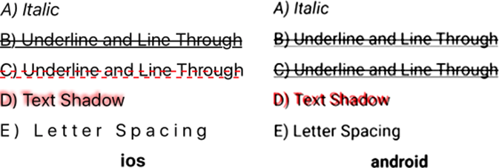
Figure 4.19 Various examples of styling text components
Use listing 4.19 as a starting point, and see how modifying the styles affects the result.
Listing 4.19 Examples of styling Text components
import React, { Component } from 'react';
import { Platform, StyleSheet, Text, View} from 'react-native';
export default class App extends Component<{}> {
render() {
return (
<View style={styles.container}>
<LeftText style={{fontStyle: 'italic'}}>
A) Italic
</LeftText>
<LeftText style={{textDecorationLine: 'underline line-through'}}>
B) Underline and Line Through
</LeftText>
<LeftText style={{textDecorationLine: 'underline line-through',
textDecorationColor: 'red',
textDecorationStyle: 'dotted'}}>
C) Underline and Line Through
</LeftText>
<LeftText style={{textShadowColor: 'red',
textShadowOffset: {width: -2, height: -2},
textShadowRadius: 4}}>
D) Text Shadow
</LeftText>
<LeftText style={{letterSpacing: 5}}>
E) Letter Spacing
</LeftText>
<LeftText style={{textAlign: 'center', fontWeight: 'bold'}}>
{Platform.OS}
</LeftText>
</View>
);
}
}
const LeftText = (props) => (
<Text style={[styles.leftText, props.style]}>
{props.children}
</Text>
);
const styles = StyleSheet.create({
container: {
width: 300,
height: 300,
margin: 40,
marginTop: 100
},
leftText: {
fontSize: 20,
paddingBottom: 10
}
});
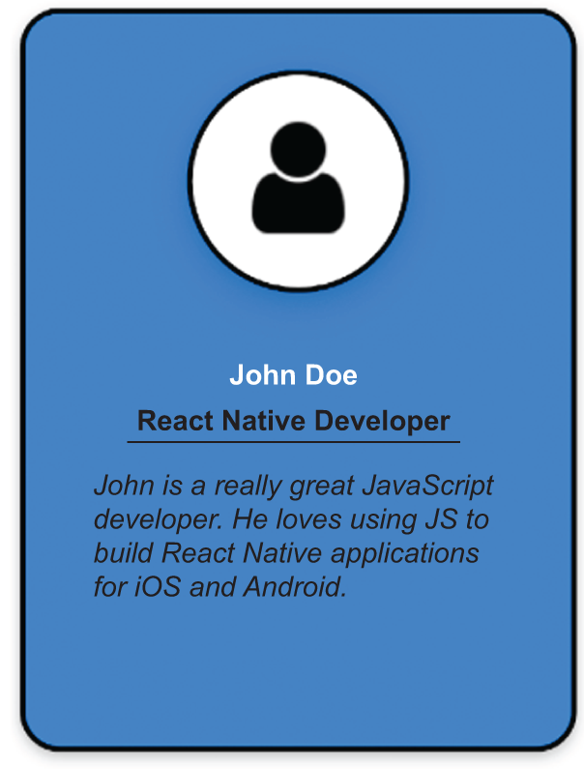
Figure 4.20 The completed Profile Card example. Textual information has been added about the person using the text styling techniques covered in this section.
Now that you know how to create a shadow effect, let’s add a shadow to the person’s name so it stands out from the other text. Figure 4.20 shows the desired result.
The completed code for the Profile Card is provided next. You only have to add a tiny snippet to set the text shadow for the name.
Listing 4.20 Completed Profile Card example
import React, { Component } from 'react';
import { Image, StyleSheet, Text, View} from 'react-native';
export default class App extends Component<{}> {
render() {
return (
<View style={styles.container}>
<View style={styles.cardContainer}>
<View style={styles.cardImageContainer}>
<Image style={styles.cardImage}
source={require('./user.png')}/>
</View>
<View>
<Text style={styles.cardName}>
John Doe
</Text>
</View>
<View style={styles.cardOccupationContainer}>
<Text style={styles.cardOccupation}>
React Native Developer
</Text>
</View>
<View>
<Text style={styles.cardDescription}>
John is a really great JavaScript developer.
He loves using JS to build React Native
applications for iOS and Android.
</Text>
</View>
</View>
</View>
);
}
}
const profileCardColor = 'dodgerblue';
const styles = StyleSheet.create({
container: {
flex: 1,
justifyContent: 'center',
alignItems: 'center'
},
cardContainer: {
alignItems: 'center',
borderColor: 'black',
borderWidth: 3,
borderStyle: 'solid',
borderRadius: 20,
backgroundColor: profileCardColor,
width: 300,
height: 400
},
cardImageContainer: {
alignItems: 'center',
backgroundColor: 'white',
borderWidth: 3,
borderColor: 'black',
width: 120,
height: 120,
borderRadius: 60,
marginTop: 30,
paddingTop: 15
},
cardImage: {
width: 80,
height: 80
},
cardName: {
color: 'white',
fontWeight: 'bold',
fontSize: 24,
marginTop: 30,
textShadowColor: 'black',
①
textShadowOffset: {
②
height: 2,
width: 2
},
textShadowRadius: 3
③
},
cardOccupationContainer: {
borderColor: 'black',
borderBottomWidth: 3
},
cardOccupation: {
fontWeight: 'bold',
marginTop: 10,
marginBottom: 10,
},
cardDescription: {
fontStyle: 'italic',
marginTop: 10,
marginRight: 40,
marginLeft: 40,
marginBottom: 10
}
});
①
Sets the shadow color to black on the Title text component
②
Sets the shadow offset to be down and to the right
③
Sets the shadow radius
There’s a lot you could do to this basic example to make it even better, but the goal was to show how beneficial it is to understand styling concepts. You don’t have to be a fantastic graphic designer to make a nice-looking component—a few simple techniques can make your application look great.
We covered a lot of ground in this chapter, but believe it or not, this has been a short introduction! We’ll explore some additional advanced topics in chapter 5.

Summary
Styles can be applied inline with components or by creating stylesheets that can be referenced by components.
Styles should be organized in the same file as the component after the component definition or externalized into a separate styles.js file.
Styles are code. The fact that JavaScript is a complete language with variables and functions affords many advantages over traditional CSS.
View components are the main building blocks of a UI, and they have many styling properties.
You can use borders in many ways to enhance the look of components. You can even use borders to create shapes, such as circles.
You can use margins and padding to position components relative to one another.
Absolute positioning lets you place a component anywhere within the parent container.
Clipping can occur on Android devices, depending on how you set borders, margins, and padding.
Specifying fonts other than the defaults can be tricky. Use the Platform component to select the appropriate font for the OS.
Use general font styles like color, size, and weight to change the size and appearance of Text components.
There are rendering differences between OSs, such as how the line height behaves differently between iOS and Android.
Text-decorating styles can add underlines or drop shadows to text. The set of available styles differs from one OS to another.

5
Styling in depth
This chapter covers
Platform-specific sizes and styles
Adding drop shadows to components
Moving and rotating components on the x- and y-axes
Scaling and skewing components
Using flexbox for layout
Chapter 4 introduced styling React Native components. It showed how to style View and Text components, styles you’ll likely use every day and that mostly affect the look of a component. This chapter continues the discussion and goes into more depth with platform-specific styles; drop shadows; manipulating components with transformations such as translation, rotation, scaling, and skewing; and dynamically laying out components with flexbox.
Some of these topics may feel familiar. You used platform-specific styles and flexbox in several of the examples in chapter 4. We didn’t cover them in detail, but you saw them in a few code listings.
This chapter expands on those topics. Transformations give you the power to manipulate components in two or three dimensions. You can translate components from one position to another, rotate components, scale components to different sizes, and skew components. Transforms are useful in their own right, but they will play a much bigger role in chapter 7, which discusses animation in detail.
We’ll continue talking about some of the differences between platforms and look more deeply at flexbox. Because flexbox is a fundamental concept, it’s important to properly understand it so you can create layouts and UIs in React Native. You’ll probably use flexbox in every application you create. You’ll use some of your new styling techniques to continue building new features into the ProfileCard example from the previous chapter.

5.1 Platform-specific sizes and styles
You’ve seen how to use the Platform.select utility function to choose fonts available only on iOS or Android. You used Platform.select to choose a monospaced font supported by each platform. You might not have thought much of that at the time, but it’s important to keep in mind that you’re developing for two different platforms. The styles you apply to a component may look or behave differently between the two OSs or even between different versions of iOS and Android.
You aren’t coding for a single device; you’re not even coding for a single OS. The beauty of React Native is that you’re using JavaScript to create applications that can run on both iOS and Android. If you look through the React Native documentation, you’ll see many components suffixed with IOS or Android, such as ProgressBarAndroid, ProgressViewIOS, and ToolbarAndroid, so it should come as no surprise that styles can be platform specific too.
You may not have noticed that you’ve never specified a size in pixels for anything, like width: 300 vs width: '300px'. That’s because even the concept of size is different between the iOS and Android operating systems.

5.1.1 Pixels, points, and DPs
Size can be a confusing topic, but it’s important to keep in mind if you need to be absolutely precise when positioning components on the screen. Even if you’re not trying to produce a high-fidelity layout, it will be useful to understand the concepts in case you encounter small discrepancies in your layouts from one device to another.
Let’s start from the beginning and define a pixel. A pixel is the smallest unit of programmable color on a display. A pixel is typically made up of red, green, and blue (RGB) color components. By manipulating the intensity of each RGB value, the pixel emits a color you see. A pixel doesn’t tell you anything until you start looking at the physical properties of the display: screen size, resolution, and dots per inch.
The screen size is the diagonal measurement of the screen, from one corner to another. For example, the original screen size of the iPhone was 3.5 inches, while the screen size of the iPhone X is 5.8 inches. Although the iPhone X is considerably bigger, the size doesn’t mean anything until you understand how many pixels fit within that screen size.
Resolution is the number of pixels in the display, which is most typically expressed as the number of pixels along the width and height of the device. The original iPhone was 320 × 480, while the iPhone X is 1125 × 2436.
Screen size and resolution can then be used to calculate the pixel density: pixels per inch (PPI). You’ll often see this expressed as dots per inch (DPI), which is a holdover term from the printing world, where a dot of color was printed on the page. PPI and DPI are often used interchangeably even though that’s not exactly correct, so if you see DPI used in reference to a screen, know that PPI is what’s truly being discussed.
The PPI gives you a measure of image sharpness. Imagine if two screens had the same resolution, 320 × 480 (half VGA). What would the same image look like on the 3.5-inch iPhone display versus a 17-inch HVGA monitor display? The same image would look much sharper on the iPhone, because it has 163 PPI versus the CRT monitor, which has 34 PPI. You can fit nearly five times as much information in the same physical space on the original iPhone. Table 5.1 compares the diagonal size, resolution, and PPI of the two devices.
Table 5.1 Comparison of a 17-inch HVGA monitor’s PPI vs. the original iPhone’s PPI
 | HVGA monitor | Original iPhone
Diagonal size | 17 inches | 3.5 inches
Resolution | 320 × 480 | 320 × 480
PPI | 34 | 163
Why does this matter? Because neither iOS nor Android uses the actual physical measurements to render content to a device’s screen. iOS uses an abstract measurement of points, and Android uses a similar abstract measurement of density-independent pixels.
When the iPhone 4 came on the scene, it had the same physical size as its predecessors; but it had a fancy new Retina screen with a resolution of 640 × 960, quadrupling the resolution of the original device. If the iPhone had rendered images from existing apps at a 1:1 scale, everything would be drawn at a quarter size on the new Retina display. It would have been an insane proposition for Apple to make such a change and break all the existing apps.
Instead, Apple introduced the logical concept of a point. A point is a unit of distance that can be scaled independently of a device’s resolution, so a 320 × 480 image that took up the entire screen on an original iPhone could be scaled up 2x to fully fit within the Retina display. Figure 5.1 provides a visualization of pixel density for several iPhone models.
The original iPhone’s 163 PPI is the basis for the iOS point. An iOS point is 1/163 of an inch. Without going into more detail, Android uses a similar measure called a device-independent pixel (DIP, often abbreviated DP). An Android DP is 1/160 of an inch.
When defining styles in React Native, you use the logical concept of a pixel, a point on iOS, and a DP on Android. When working at the native level, you occasionally may need to work with device pixels by multiplying the logical pixels by the screen scale (for example, 2x, 3x).
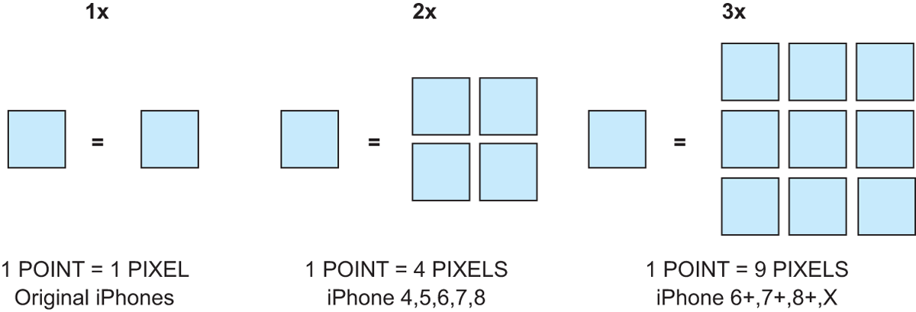
Figure 5.1 A visualization of points compared to pixel density for iPhones. The original iPhone had a resolution of 320 × 480. The iPhone 4 had a resolution of 640 × 960, quadruple the resolution of the original device. The iPhone 4 has twice the PPI (326 vs. 163), so images are said to be scaled up 2x.

5.1.2 Creating drop shadows with ShadowPropTypesIOS and Elevation
In chapter 4, you used the text shadow properties to add a drop shadow to the ProfileCard title. Both iOS and Android support adding a drop shadow to a Text component. It would be nice to spruce up more of the ProfileCard by adding drop shadows to the card and circular image container, but there isn’t a common style property for View components to use between the two platforms.
That doesn’t mean all is lost. The ShadowPropTypesIOS style can be used to add a drop shadow on iOS devices; it doesn’t affect the z-order of the component. On Android, you can use the Elevation style to simulate a drop shadow, but it does affect the z-order of the component.

Creating drop shadows in iOS with ShadowPropTypesIOS
Let’s look at how to use ShadowPropTypesIOS styles to add drop shadows to a few view components. Figure 5.2 shows various shadow effects that can be achieved. Table 5.2 lists the specific settings used to achieve each shadow effect. The important takeaways are as follows:
If you don’t supply a value for shadowOpacity, you won’t see a shadow.
Shadows offsets are expressed in terms of width and height, but you can think of this as moving the shadow in the x and y directions. You can even specify negative values for width and height.
A shadowOpacity of 1 is completely solid, whereas a value of 0.2 is more transparent.
A value for shadowRadiuseffectively blurs the edges of the shadow. The shadow is more diffuse.
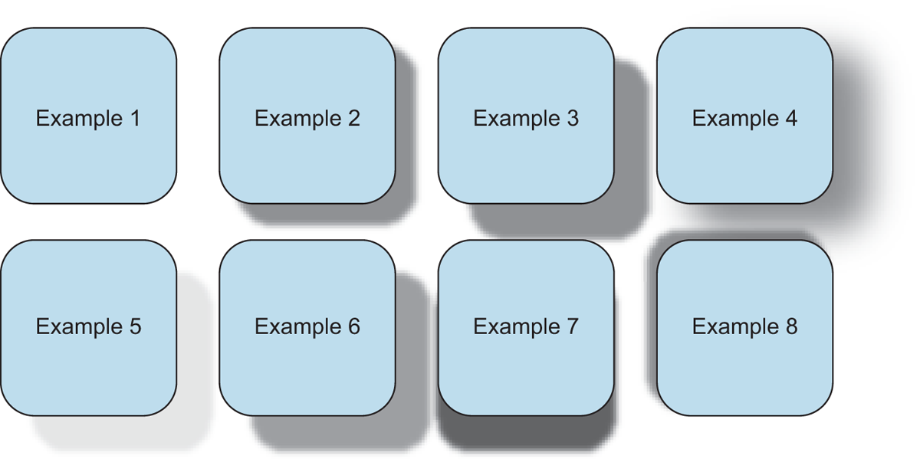
Figure 5.2 iOS-specific examples of how to apply ShadowPropTypesIOS styles to View components. Example 1 has a shadow applied but no opacity set, which causes the drop shadow to not be displayed. Example 2 has the same shadow effect but with opacity set to 1. Example 3 has a slightly larger shadow, and example 4 has the same size shadow with a shadow radius. Example 5 has the same shadow size, but opacity is changed from 1 to 0.2. Example 6 changes the color of the shadow. Example 7 shows the shadow applied in only one direction, and example 8 shows the shadow applied in the opposite direction.
Table 5.2 Shadow properties used to create the examples in figure 5.2
shadowOffset
Example | shadowColor | width (x) | height (y) | shadowOpacity | shadowRadius
1 | Black | 10 | 10
2 | Black | 10 | 10 | 1
3 | Black | 20 | 20 | 1
4 | Black | 20 | 20 | 1 | 20
5 | Black | 20 | 20 | 0.2
6 | Red | 20 | 20 | 1
7 | Black |  | 20 | 1
8 | Black | -5 | -5 | 1
The code for this figure can be found in the git repository under chapter5/figures/Figure-5.2-ShadowPropTypesIOS. If you run the code for this example, remember to run it in the iOS simulator. On an Android device, you’ll just see eight boring squares with rounded corners. ShadowPropTypesIOS styles are ignored on Android.

Approximating drop shadows on Android devices with elevation
How do you get the same effect on Android devices? The truth is, you can’t. You can use Android’s elevation style to affect the z-order of components. If two or more components occupy the same space, you can decide which one should be in front by giving it the larger elevation and therefore the larger z-index, which will create a small drop shadow, but it isn’t nearly as striking as the shadow effects you can achieve on iOS. Note that this only applies to Android, because iOS doesn’t support the elevation style and will gladly ignore it if it’s specified.
Nevertheless, let’s see elevation in action. To do so, you’ll create a View component with three boxes, each of which is positioned absolutely. You’ll give them three different elevations—1, 2, and 3—and then you’ll reverse the assignment of the elevations and see how that affects the layout. Figure 5.3 shows the results of these elevation adjustments.
Table 5.3 shows the absolute positions and elevations used for each group of boxes. Notice that nothing has changed except the elevation assigned to each of the boxes. iOS ignores the style and always renders box C on top of box B, and box B on top of box A. But Android respects the style and flips the order in which it renders the boxes, so box A is now on top of box B, and box B is on top of box C.
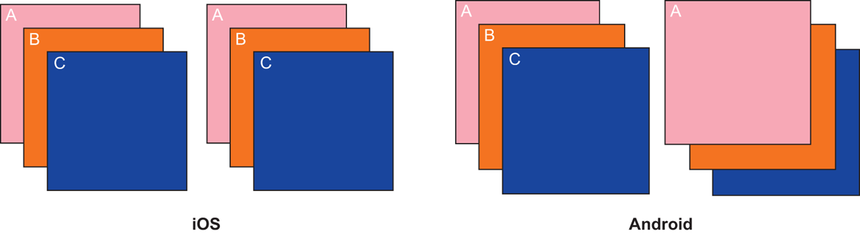
Figure 5.3 Examples of using the elevation style on iOS and Android. On iOS, elevation is ignored; all components retain the same z-order, so whatever component is last in the layout is on top. On Android, elevation is used, and the z-order is changed; in the second example, where the elevation assignments are reversed, A is on top.
Table 5.3 Elevation settings for figure 5.3
Example | color | top | left | elevation
A | Red | 0 | 0 | 1
B | Orange | 20 | 20 | 2
C | Blue | 40 | 40 | 3
A | Red | 0 | 0 | 3
B | Orange | 20 | 20 | 2
C | Blue | 40 | 40 | 1

5.1.3 Putting it into practice: drop shadows in the ProfileCard
Let’s go back to the ProfileCard example from the last chapter and add some drop shadows that will look great on iOS and not so great on Android. You’ll add a drop shadow to the entire ProfileCard container and to the circular image container. Figure 5.4 shows what you’re shooting for on iOS and what you’ll get on Android.
Notice that even with elevation applied on Android, you don’t see much of a shadow. The reality is, on Android you’ll never get close to the shadow effects that can be produced on iOS with React Native out of the box. If you really must have drop shadows on Android, then I suggest looking for a component on npm or yarn that does what you need. Experiment with different components, and see if you can get the Android version looking as sharp as the iOS version. I don’t have any recommendations; I stay away from drop shadows or accept the differences.
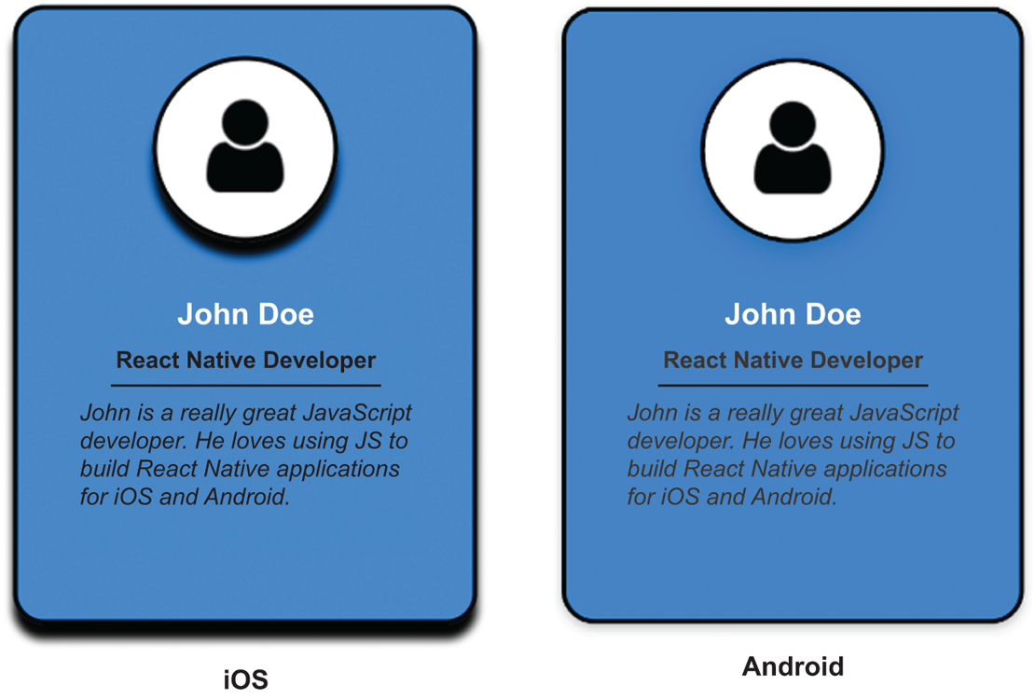
Figure 5.4 The ProfileCard on iOS and Android after drop shadows have been added to the card container and the circular image container. The drop shadows on iOS are created using the iOS-specific shadow properties: shadowColor, shadowOffset, and shadowOpacity. On Android, the elevation property is used to try to create depth. It produces only a minor shadow effect, far inferior to the shadows produced on iOS.
The code in this chapter begins with listing 4.20: the completed ProfileCard example from chapter 4. Listing 5.1 only shows the changes needed to apply the drop shadows to the component. You don’t need to add a lot of code to get the drop shadows on iOS. Look at the listing on an Android device, and see how the elevation setting causes the faintest of shadows.
Listing 5.1 Adding drop shadows to the ProfileCard
import React, { Component } from 'react';
import { Image,
Platform
, StyleSheet, Text, View} from 'react-native';
①
...
cardContainer: {
...
height: 400,
...Platform.select({
②
ios: {
shadowColor: 'black',
shadowOffset: {
height: 10
},
shadowOpacity: 1
},
android: {
elevation: 15
}
})
},
cardImageContainer: {
...
paddingTop: 15,
...Platform.select({
③
ios: {
shadowColor: 'black',
shadowOffset: {
height: 10,
},
shadowOpacity: 1
},
android: {
borderWidth: 3,
borderColor: 'black',
elevation: 15
}
})
},
...
①
Imports the Platform utility component to programmatically select styles based on the platform
②
Adds a drop shadow to the card container based on the platform
③
Adds a drop shadow to the circular image container
Just as with font selection in chapter 4, you use the Platform.select function to apply different styles to components based on the platform: iOS or Android. In some cases, like the drop shadow, one platform may perform much better than the other; but in most cases the styles will behave the same on both platforms, which is an amazing benefit of React Native.

5.2 Using transformations to move, rotate, scale, and skew components
Up to this point, the styles we’ve discussed have mostly affected the appearance of components. You learned how to set properties like the style, weight, size, and color of borders and fonts. You applied background colors and shadow effects, and you saw how to manipulate the appearance of components relative to one another by using margins and padding. But we haven’t explored how to manipulate a component’s position or orientation on the screen independent of everything else. How do you move a component on the screen, or rotate a component in a circle?
The answer is transformations. React Native provides a number of useful transforms that allow you to modify the shape and position of a component in 3D space. You can move components from one position to another, rotate components about all three axes, and scale and skew components in the x and y directions. Alone, transformations can produce some interesting effects, but their true power comes from sequencing them together to form animations.
This section will give you a firm understanding of transforms and how they affect the components to which they’re applied. If you clearly understand what they do, you’ll be better able to link them together to create meaningful animations later.
The transform style takes an array of transform properties that define how to apply a transformation to a component. For example, to rotate a component 90 degrees and shrink it by 50%, apply this transform to the component:
transform: [{rotate: '90deg', scale: .5}]
The transform style supports the following properties:
perspective
translateX and translateY
rotateX, rotateY, and rotateZ (rotate)
scale, scaleX, and scaleY
skewX and skewY

5.2.1 3D effects with perspective
perspective gives an element 3D space by affecting the distance between the z plane and the user. This is used with other properties to give a 3D effect. The larger the perspective value, the greater the z-index of a component, which makes it appear closer to the user. If the z-index is negative, the farther away the component appears.

5.2.2 Moving elements along the x- and y-axes with translateX and translateY
The translation properties move an element along the x (translateX) or y (translateY) axis from the current position. This isn’t very useful in normal development because you already have margin, padding, and other position properties available. But this becomes useful for animations, to move a component across the screen from one position to another.
Let’s look at how to move a square using the translateX and translateY style properties. In figure 5.5, a square is placed in the center of the display and then moved in each of the four cardinal and four ordinal directions: NW (upper left), N (top), NE (upper right), W (left), E (right), SW (bottom left), S (bottom), and SE (bottom right). In each case, the center of the square is moved by 1.5 times the square’s size in the x or y direction or in both directions.
When studying geometry, you typically see the positive y-axis drawn going up instead of down. But on mobile devices, the convention is to have the positive y-axis go down the screen, which reflects the most common interaction of scrolling down the screen to view more content. Coupled with that bit of knowledge, it’s pretty easy to see how moving the center square in figure 5.5 in the positive x direction and in the positive y direction results in the square ending up in the bottom right corner. By combining translateX and translateY, you can move components in any direction in the Cartesian plane (x-y plane).
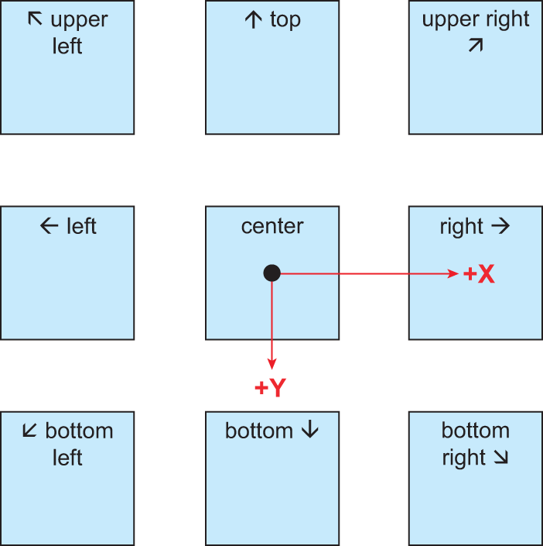
Figure 5.5 A depiction of a center square being moved in each of the four cardinal and four ordinal directions: NW (upper left), N (top), NE (upper right), W (left), E (right), SW (bottom left), S (bottom), and SE (bottom right)
There’s no corresponding translation for movement in the z plane. The z-axis is perpendicular to the face of the device, which means you’re looking straight at it. Moving a component forward or backward would be imperceptible without some corresponding size change. The perspective transform is intended to handle this type of visual effect.
In the next section, we’ll use the same example and focus on the center row, where the center square was translated to the left and to the right. You’ll see what happens when you rotate components along each of the three axes.

5.2.3 Rotating elements with rotateX, rotateY, and rotateZ (rotate)
The rotation properties do exactly what it sounds like they would: they rotate elements. Rotation occurs along an axis: x, y, or z. The origin of the rotation is the center point of the element before any transformations are applied, so if you use translateX or translateY, keep in mind that the rotation will be around the axis at the original location. The amount of rotation can be specified in either degrees (deg) or radians (rad). The examples use degrees:
transform: [{ rotate: '45deg' }]
transform: [{ rotate: '0.785398rad' }]
Figure 5.6 shows the positive and negative direction of rotation for each axis. The rotate transform does the same thing as the rotateZ transform.
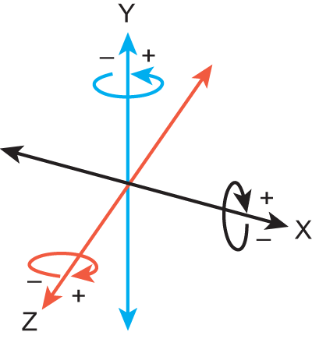
Figure 5.6 The positive and negative direction of rotation for each axis
Let’s rotate a 100 × 100 square about the x-axis in increments of 35°, as shown in figure 5.7. A center line is drawn through each square, so it’s easier to see how the squares are rotating. You can visualize rotation about the x-axis in the positive direction as the square rotating from the top into the page. The bottom is coming closer to you as the top moves further away.
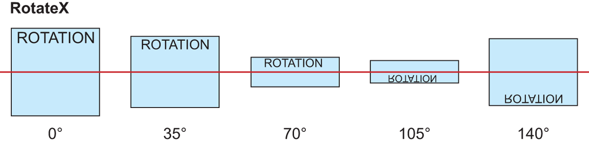
Figure 5.7 Rotating a 100 × 100 square about the x-axis in increments of 35°. After 90°, the “ROTATION” label can be seen through the element, upside down.
At 90°, you’re looking at the square on its edge (because it doesn’t have any thickness, you don’t see a thing). After the square has rotated past the 90° mark, you start to see the back of the square. If you look closely in figure 5.7, you can see the “ROTATION” label is upside down, because you’re looking through what was the back of the square.
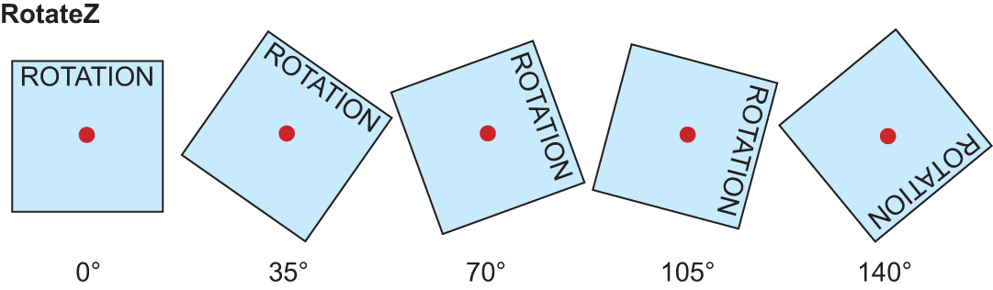
Figure 5.9 Rotating a 100 × 100 square about the z-axis in increments of 35°. The positive rotation is clockwise, and the negative rotation is counterclockwise.
The next example will rotate the same 100 × 100 square about the y-axis, instead continuing to use increments of 35° to demonstrate the rotation (see figure 5.8). Picture the right side of the square moving away from you, into the page. After the square has rotated beyond the 90° mark, you can see the “ROTATION” label through the component. Because you’re looking through the back of the component, the text appears backward.
Compare figure 5.8 to figure 5.7. Fundamentally, rotation about the y-axis is no different than rotation about the x-axis. I aligned the squares in figure 5.8 vertically so you can easily see the axis of rotation. I like to visualize rotation in the y-axis by picturing a book opening and closing: if you’re opening a book, the cover is rotating in the negative direction. If you’re closing the book, then you’re rotating the cover in the positive direction.
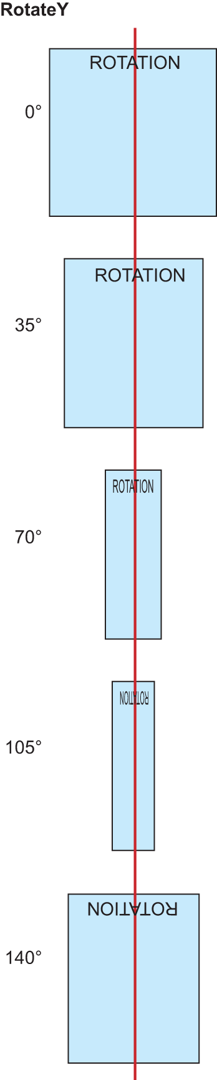
Figure 5.8 Rotating a 100 × 100 square about the y-axis in increments of 35°. After 90°, the “ROTATION” label can be seen through the element, backward.
Rotation about the z-axis is the easiest to visualize. Rotation in the positive direction spins the object in a clockwise fashion, and rotation in the negative direction spins the square in a counterclockwise fashion. For this example, shown in figure 5.9, the axis of rotation is represented as a dot in the center of the square, because the z-axis is, basically, your line of sight; it goes straight into the screen.
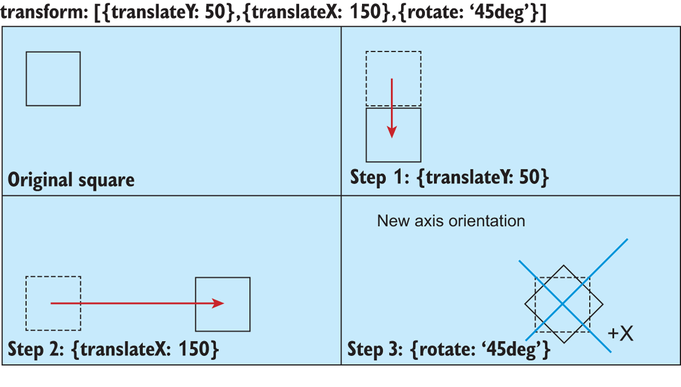
Figure 5.10 Applying transform: [{translateY: 50},{translateX: 150},{rotate: '45deg'}] to the original square
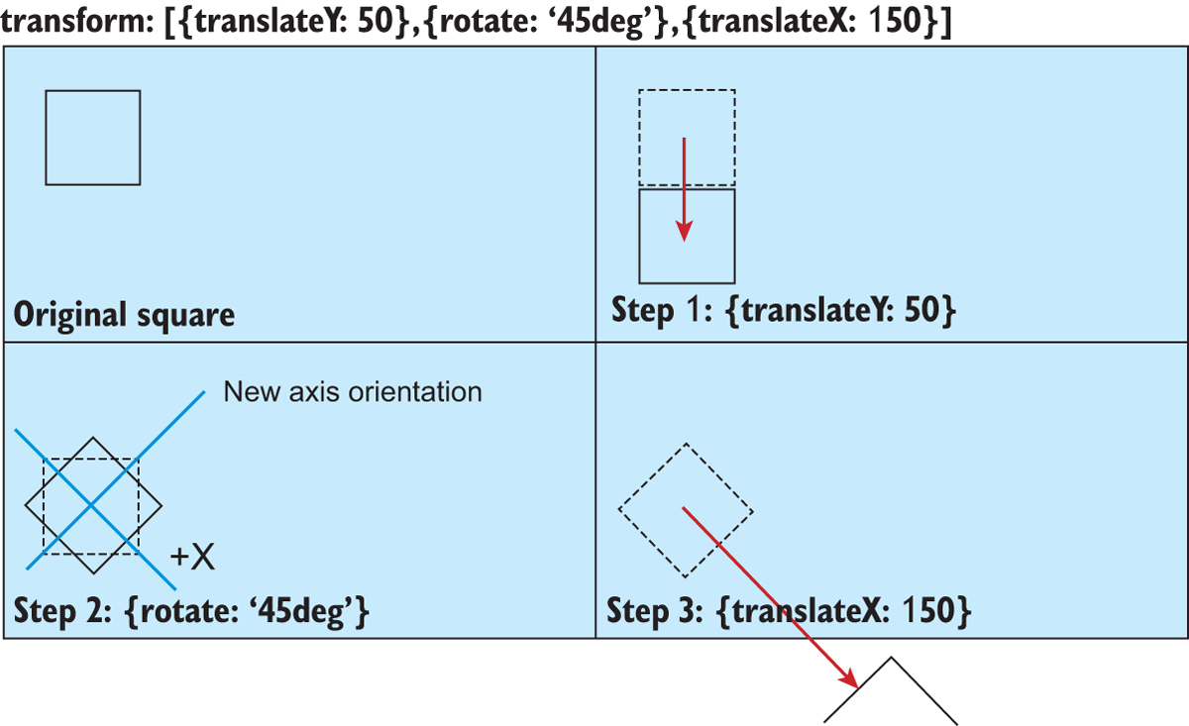
Figure 5.11 Applying transform: [{translateY: 50},{rotate: '45deg'},{translateX: 150}] to the original square. Rotating the square changes the orientation of the x- and y-axes, so when the square is translated 150 points in the +x direction, it’s moved diagonally down and out of the viewport.
Hopefully, it’s fairly obvious now how the rotation transforms work. Understanding the direction in which positive and negative rotations affect an object is probably the most complex part. But when you start combining other transforms in conjunction with rotation, you may be surprised by the results. Remember that the transform property is an array of transforms, so multiple transforms can be supplied at once, and order matters! Specifying a transform and switching the order of the elements in the array will yield different results.
Let’s investigate how altering the order in which the transforms are specified affects the final layout. Let’s apply three different transforms to a square: translate in the y direction 50 points, translate in the x direction 150 points, and rotate the square 45°. Figure 5.10 specifies the transform in the order just described. The original/previous position of the square has a dotted border and the new position of the square has a solid outline, so you can see how the transformation affects the position and orientation of the original square.
The result in figure 5.10 is pretty much as expected, but what will happen if you apply the rotation after moving the square in the y direction? Look at figure 5.11 and find out.
Whoa, what happened? The square is completely off the screen after the transformations are applied! It might not be immediately obvious what happened, which is why figure 5.11 is annotated with the new axis orientation.
After the rotation, the +x- and +y-axes are no longer oriented vertically and horizontally on the screen: they’re rotated by 45°. When the translateX transform is applied, the square is moved 150 points in the +x direction, but the +x direction is now at a 45° angle from the original x-axis.
The next section shows another interesting aspect of rotational transforms.

5.2.4 Setting visibility when rotating an element more than 90°
If you look back at figures 5.7 and 5.8, when you rotate the square about the x- or y-axis and go beyond the 90° point, you can still see the text that was on the front face of the square. ThebackfaceVisibilityproperty dictates whether an element is visible when the element is rotated more than 90°.This property can be set to either 'visible'or'hidden'. This property isn’t a transform, but it gives you the ability to hide or show elements when viewing the back face of an object.
The backfaceVisibility property defaults to 'visible', but if you changed backfaceVisibility to 'hidden', you wouldn’t see the element at all once the component rotated more than 90° in either the x or y direction. In figures 5.7 and 5.8, the squares corresponding to the 105° and 140° rotations would disappear. If that sounds confusing, look at figure 5.12.
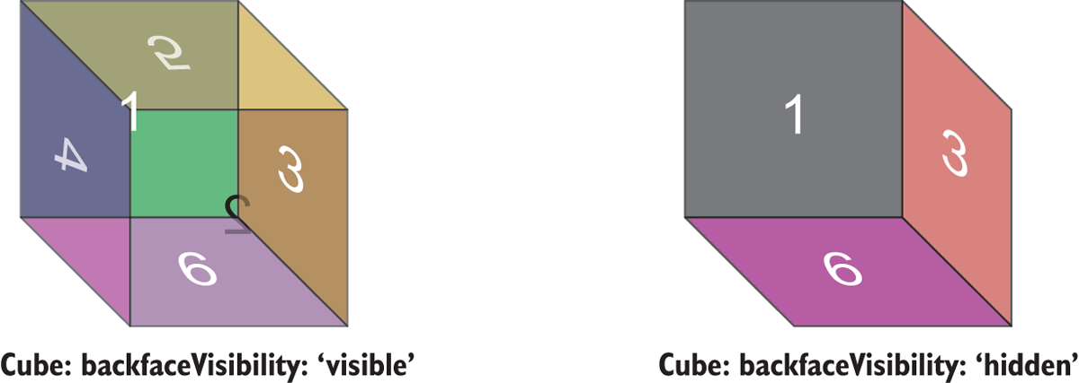
Figure 5.12 A demonstration of how setting the backfaceVisibility property to 'hidden' hides elements that have rotated beyond 90°. The cube on the left shows faces 2, 4, and 5, all of which have rotated 180°. The cube on the right has hidden those faces.
In the figure, you can easily see the effect of setting backfaceVisibility to 'hidden'. It’s also easy to see how this behavior might be beneficial during animations. When the faces of the cube rotate out of sight, you want them to be hidden.

5.2.5 Scaling objects on the screen with scale, scaleX, and scaleY
This section talks about scaling objects on the screen. There are many practical uses for scaling and many patterns that take advantage of its capabilities. For instance, scaling can be used to create thumbnails of objects. You’ve seen this in many applications; the user taps a thumbnail, and an animation gradually scales the object back up to full size. It’s a common transition technique that provides a nice visual effect.
You’ll learn the basics of scaling objects and then use those skills to create a thumbnail of the ProfileCard that opens to full size when pressed. Later, this chapter discusses flexbox and how it can be used to manage a bunch of ProfileCard thumbnails in a gallery interface, from which you can press profiles to view them in more detail.
scale multiplies the size of the element by the number passed to it, the default being 1. To make an element appear larger, pass a value larger than 1; to make it appear smaller, pass a value smaller than 1.
The element can also be scaled along a single axis using scaleX or scaleY. scaleX stretches the element horizontally along the x-axis, and scaleY stretches the element vertically along the y-axis. Let’s create a few squares to show the effects of scaling: see figure 5.13.
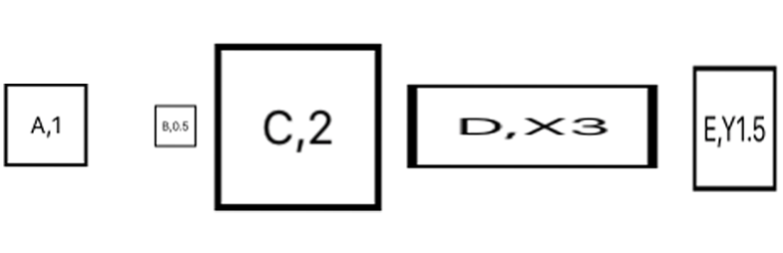
Figure 5.13 Examples of how scaling transforms the original square. All the squares start the same size and shape as A, which has the default scale of 1. B scales the square by 0.5, shrinking it. C scales the square by 2, enlarging it. D uses scaleX, transforming the square along the x-axis by 3x. E uses scaleY, transforming the square along the y-axis by 1.5x.
Nothing unusual happens; scaling an object is pretty straightforward. Listing 5.2 shows how simple it is.
Listing 5.2 Scaling squares using scale, scaleX, and scaleY
import React, { Component } from 'react';
import { StyleSheet, Text, View} from 'react-native';
export default class App extends Component<{}> {
render() {
return (
<View style={styles.container}>
<Example style={{}}>A,1</Example>
①
<Example style={{transform: [{scale: 0.5}]}}>B,0.5</Example>
②
<Example style={{transform: [{scale: 2}]}}>C,2</Example>
③
<Example style={{transform: [{scaleX: 3}]}}>D,X3</Example>
④
<Example style={{transform: [{scaleY: 1.5}]}}>E,Y1.5</Example>
⑤
</View>
);
}
}
const Example = (props) => (
<View style={[styles.example,props.style]}>
<Text>
{props.children}
</Text>
</View>
);
const styles = StyleSheet.create({
container: {
marginTop: 75,
alignItems: 'center',
flex: 1
},
example: {
width: 50,
height: 50,
borderWidth: 2,
margin: 15,
alignItems: 'center',
justifyContent: 'center'
},
});
①
Default 50 × 50 square with no scaling applied
②
Scales the default square by 0.5, shrinking it
③
Scales the default square by 2, making it larger
④
Scales the default square only in the x direction, stretching it horizontally
⑤
Scales the default square only in the y direction, stretching it vertically

5.2.6 Using the scale transform to create a thumbnail of the ProfileCard
Now that you’ve seen scaling in action, let’s use this technique to create a thumbnail of the ProfileCard. Normally you’d animate what I’m about to show you, to avoid flickering, but let’s see how to use scaling in a practical way. Figure 5.14 shows a small, scaled-down version of the ProfileCard component—a thumbnail. If you press the thumbnail, the component will return to full size. If you press the full-size component, it will collapse back down into a thumbnail view.
Begin with the code from listing 5.1. As far as styles go, you only need to add one new style to do the scaling transform from full size to thumbnail. The remainder of the code reorganizes the component’s pieces into a more reusable structure and provides the touch capabilities to handle the onPress events.
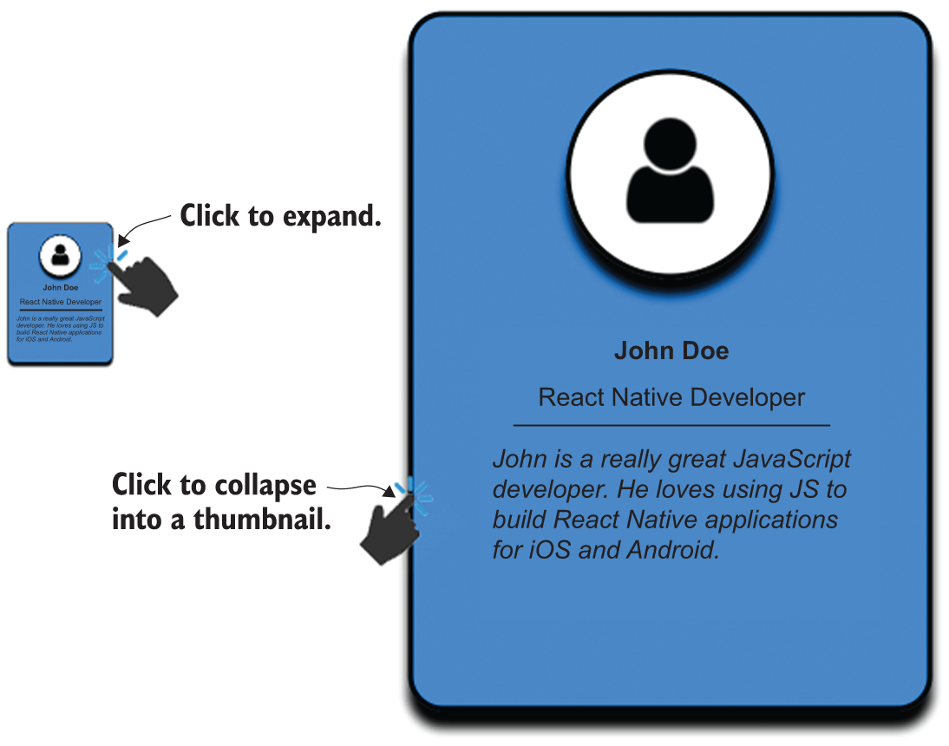
Figure 5.14 Scaling the full-sized ProfileCard down 80% into a thumbnail image. Pressing the thumbnail restores the ProfileCard to its original size, and pressing the full-sized component collapses the component into a thumbnail.
Listing 5.3 Scaling ProfileCard from full size to thumbnail
import React, { Component } from 'react';
import PropTypes from 'prop-types';
①
import update from 'immutability-helper';
②
import { Image, Platform, StyleSheet, Text,
TouchableHighlight, View} from 'react-native';
③
const userImage = require('./user.png');
const
data = [{
④
image: userImage,
name: 'John Doe',
occupation: 'React Native Developer',
description: 'John is a really great Javascript developer. ' +
'He loves using JS to build React Native applications ' +
'for iOS and Android',
showThumbnail: true
}
];
const ProfileCard = (props) => {
⑤
const { image, name, occupation,
description, onPress, showThumbnail } = props;
let containerStyles = [styles.cardContainer];
if (showThumbnail) {
⑥
containerStyles.push(styles.cardThumbnail);
}
return (
<TouchableHighlight onPress={onPress}>
⑦
<View style={[containerStyles]}>
<View style={styles.cardImageContainer}>
<Image style={styles.cardImage} source={image}/>
</View>
<View>
<Text style={styles.cardName}>
{name}
</Text>
</View>
<View style={styles.cardOccupationContainer}>
<Text style={styles.cardOccupation}>
{occupation}
</Text>
</View>
<View>
<Text style={styles.cardDescription}>
{description}
</Text>
</View>
</View>
</TouchableHighlight>
)
};
ProfileCard.propTypes = {
image: PropTypes.number.isRequired,
name: PropTypes.string.isRequired,
occupation: PropTypes.string.isRequired,
description: PropTypes.string.isRequired,
showThumbnail: PropTypes.bool.isRequired,
onPress: PropTypes.func.isRequired
};
export default class App extends Component<{}> {
constructor(props, context) {
super(props, context);
this.state = {
⑧
data: data
}
}
handleProfileCardPress = (index) => {
⑨
const showThumbnail = !this.state.data[index].showThumbnail;
this.setState({
data: update(this.state.data,
{[index]: {showThumbnail: {$set: showThumbnail}}})
});
};
render() {
const list = this.state.data.map(function(item, index) {
⑩
const { image, name, occupation, description, showThumbnail } = item;
return <ProfileCard key={'card-' + index}
image={image}
name={name}
occupation={occupation}
description={description}
onPress={this.handleProfileCardPress.bind(this, index)}
showThumbnail={showThumbnail}/>
}, this);
return (
<View style={styles.container}>
{list}
⑪
</View>
);
}
}
...
cardThumbnail: {
⑫
transform: [{scale: 0.2}]
},
...
①
PropTypes lets you specify what properties the ProfileCard component can accept.
②
The immutability helper function update lets you update a specific piece of the component’s state.
③
The TouchableHighlight component enables touch processing.
④
Data elements have been extracted to generalize the component.
⑤
The ProfileCard component is now separated from the App code.
⑥
If showThumbnail is true, the component is scaled down by 80%.
⑦
Processes presses to minimize and maximize the component
⑧
Component state is maintained in the higher-order App component.
⑨
Handler function to process onPress events
⑩
List (array) of ProfileCard components
⑪
Renders the list in the overall container
⑫
The cardThumbnail style reduces the component’s size by 80%.
By reorganizing the structure of the component, you can better handle adding more ProfileCard components to the application. In section 5.3, you’ll add more ProfileCards and see how to organize them into a gallery layout.

5.2.7 Skewing elements along the x- and y-axes with skewX and skewY
Before we leave transforms and talk about layout, let’s look at the skewX and skewY transformations. In the source code that produced the cubes for the backfaceVisibility example shown in figure 5.12 (github chapter5/figures/Figure-5.12-BackfaceVisibility), you can see that skewing the squares was essential to producing the three-dimensional affect for the cube faces. Let’s discuss what skewX and skewY do, so when you explore the source code in detail, you’ll understand what you’re seeing.
The skewX property skews an element along the x-axis. Similarly, the skewY property skews an element along the y-axis. Figure 5.15 shows the results of skewing a square as follows:
Square A has no transformation applied to it.
Square B is skewed along the x-axis by 45°.
Square C is skewed along the x-axis by –45°.
Square D is skewed along the y-axis by 45°.
Square E is skewed along the y-axis by –45°.
As with scaling, skewing an element is relatively simple: provide an angle, and specify the axis. The next listing gives all the details.

Note At the time of writing, the skewX transform doesn’t work correctly on Android.

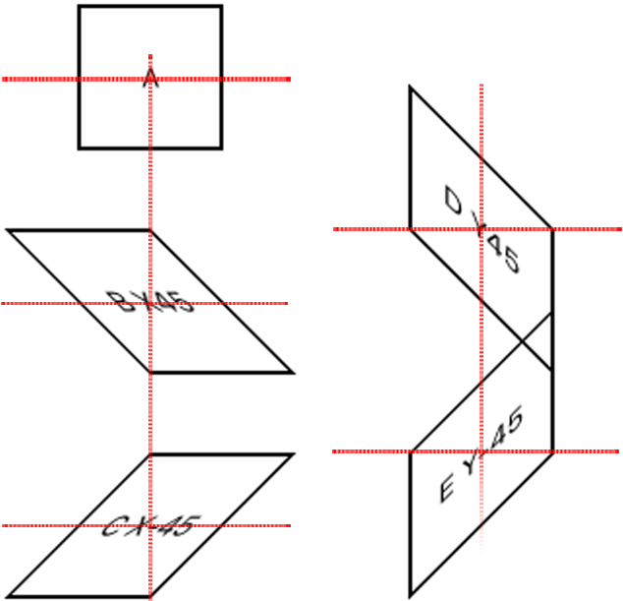
Figure 5.15 Examples of skewing a square along the x- and y-axes on iOS. Square A has no transformation applied. Square B is skewed along the x-axis by 45°. Square C is skewed along the x-axis by –45°. Square D is skewed along the y-axis by 45°, and square E is skewed along the y-axis by –45°.
Listing 5.4 Examples showing how skewing transforms a square
import React, { Component } from 'react';
import { StyleSheet, Text, View} from 'react-native';
export default class App extends Component<{}> {
render() {
return (
<View style={styles.container}>
<Example style={{}}>A</Example>
<Example style={{transform: [{skewX: '45deg'}]}}>
①
B X45
</Example>
<Example style={{transform: [{skewX: '-45deg'}]}}>
②
C X-45
</Example>
<Example style={{transform: [{skewY: '45deg'}]}}>
③
D Y45
</Example>
<Example style={{transform: [{skewY: '-45deg'}]}}>
④
E Y-45
</Example>
</View>
);
}
}
const Example = (props) => (
<View style={[styles.example,props.style]}>
<Text>
{props.children}
</Text>
</View>
);
const styles = StyleSheet.create({
container: {
marginTop: 50,
alignItems: 'center',
flex: 1
},
example: {
width: 75,
height: 75,
borderWidth: 2,
margin: 20,
alignItems: 'center',
justifyContent: 'center'
},
});
①
Skews the square 45° along the x-axis
②
Skews the square –45° along the x-axis
③
Skews the square 45° along the y-axis
④
Skews the square –45° along the y-axis

5.2.8 Transformation key points
We’ve covered a lot of transformative ideas in this section! Some of them were relatively simple, while others may have been hard to visualize at first. I didn’t show many examples that combine transforms, so you could focus on what individual transforms do. I encourage you to take any of the examples and include additional transformations, to experiment and see what happens.
In chapter 7, when we discuss animation, you’ll see how transformations can make things come alive. For now, take away these key points:
The origin of the x- and y-axes is at upper left, meaning the positive direction for y is down the screen. You saw this with absolute positioning in the previous chapter, but it’s likely the opposite of what you’re used to, which can make it hard to reason about what a transformation will do.
The origin for rotations and translations is always at the element’s original location. You can’t translate an object in the x or y direction and then rotate it about a new center point.
Transformations are a great way to move components around the screen, but you won’t use them on an everyday basis. Most often, you’ll use Yoga, a layout engine that implements much of the W3C’s flexbox web specification. In the next section, we’ll discuss Yoga’s flexbox implementation in detail.

5.3 Using flexbox to lay out components
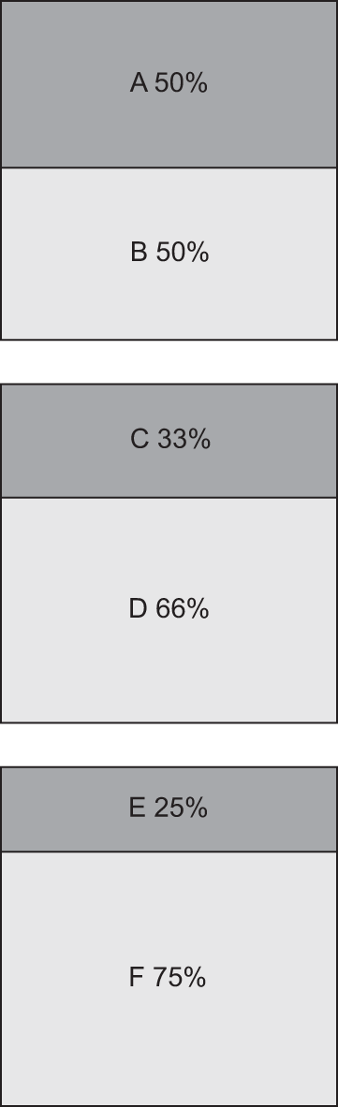
Figure 5.16 Three examples of layouts using the flex property. The top example is 1:1, with A = {flex: 1} and B = {flex: 1}, resulting in each taking up 50% of the space. The middle example is 1:2, with C = {flex: 1} and D = {flex: 2}, resulting in C taking up 33% of the space and D taking up 66%. The bottom example is 1:3, with E = {flex: 1} and F = {flex: 3}, resulting in E taking up 25% of the space and F taking up 75% of the space.
Flexbox is a layout implementation that React Native uses to provide an efficient way for users to create UIs and control positioning. The React Native flexbox implementation is based on the W3C flexbox web specification but doesn’t share 100% of the API. It aims to give you an easy way to reason about, align, and distribute space among items in a layout, even when their size isn’t known or is dynamic.

Note Flexbox layout is only available for use on View components.

You’ve already seen flexbox used in many of the examples. It’s powerful and makes laying out items so much easier than alternative methods that it’s difficult not to use it. You’ll benefit greatly by taking time to understand the material in this section. Here are the alignment properties used to control the flexbox layout: flex, flexDirection, justifyContent, alignItems, alignSelf, and flexWrap.

5.3.1 Altering a component’s dimensions with flex
The flex property specifies the ability of a component to alter its dimensions to fill the space of the container it’s in. This value is relative to the flex properties specified for the rest of the items in the same container.
If you have a View element with a height of 300 and a width of 300, and a child View element with a property of flex: 1, then the child view will completely fill the parent view. If you decide to add another child element with a flex property of flex: 1, each view will take up equal space in the parent container. The flex number is only important relative to the other flex items occupying the same space.
Another way to look at this is to think of the flex properties as being percentages. For example, if you want the child components to take up 66.6% and 33.3%, respectively, you can use flex:66 and flex:33. Rather than flex:66 and flex:33, you can specify flex:2 and flex:1 and achieve the same layout effect.
To better understand how this works, let’s look at a few examples shown in figure 5.16. These are easily achieved by setting the appropriate flex value on the individual elements. The following listing shows the steps necessary to create such a layout.
Listing 5.5 Flex views with 1:1 ratio, 1:2, and 1:3 ratios
…
render() {
return (
<View style={styles.container}>
<View style={[styles.flexContainer]}>
<Example style={[{flex: 1},styles.darkgrey]}>A 50%</Example>
①
<Example style={[{flex: 1}]}>B 50%</Example>
</View>
<View style={[styles.flexContainer]}>
②
<Example style={[{flex: 1},styles.darkgrey]}>C 33%</Example>
<Example style={{flex: 2}}>D 66%</Example>
</View>
<View style={[styles.flexContainer]}>
③
<Example style={[{flex: 1},styles.darkgrey]}>E 25%</Example>
<Example style={{flex: 3}}>F 75%</Example>
</View>
</View>
);
}
…
①
The items have the same flex value, so they take up the same amount of space in their parent container.
②
C takes up 1/3 of the total space, and D takes up 2/3 of the total space.
③
E takes up 1/4 of the total space, and F takes up 3/4 of the total space.

5.3.2 Specifying the direction of the flex with flexDirection
In the previous examples, the items in flex containers are laid out in a column (y-axis), meaning top to bottom. A is stacked on B, C is stacked on D, and E is stacked on F. Using the flexDirection property, you can change the primary axis of the layout, and therefore change the direction of the layout. flexDirection is applied to the parent view that contains
All that’s needed to achieve the layout in figure 5.17 is to add a single line of code to the flexContainer style, which is the parent container for each of the example components. Changing flexDirection on this container affects the layout of all its flex children. Add flexDirection: 'row' to the style, and see how it changes the layout.
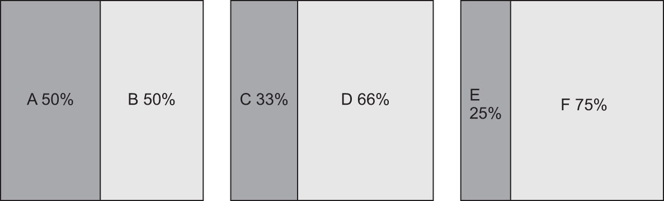
Figure 5.17 The same example as in figure 5.16, but with flexDirection set to 'row'. Now the items take up space horizontally within the row rather than vertically within the column.
Listing 5.6 Adding flexDirection: 'row' to the parent container
flexContainer: {
①
width: 150,
height: 150,
borderWidth: 1,
margin: 10,
flexDirection: 'row'
②
},
①
flexContainer is the parent container of each example.
②
Causes the children to be laid out horizontally
The child elements now appear left to right. There are two options for flexDirection: 'row' and 'column'. The default setting is 'column'. If you don’t specify a flexDirection property, content will be laid out in a column. This property is something you’ll use a lot when developing apps in React Native, so it’s important to grasp it and understand how it works.

5.3.3 Defining how space is used around a component with justifyContent
Using the flex property, you can specify how much space each component takes up in its parent container; but what if you’re not trying to take up the entire space? How can you use flexbox to lay out components using their original size?
justifyContent defines how space is distributed between and around flex items along the primary axis of the container (the flex direction). justifyContent is declared on the parent container. Five options are available:
center causes the children to be centered within the parent container. The free space is distributed on both sides of the clustered group of children.
flex-start groups the components at the beginning of the flex column or row, depending on what value is assigned to flexDirection. flex-start is the default value for justifyContent.
flex-end acts in the opposite manner: it groups items together at the end of the container.
space-around attempts to evenly distribute space around each element. Don’t confuse this with distributing the elements evenly in the container; the space is distributed around the elements. If it were based on the elements, you’d expect
space – element – space – element – space
Instead, flexbox allocates the same amount of space on each side of the element, yielding
space – element – space – space – element – space
In both cases, the amount of whitespace is the same; but in the latter, the space between elements is greater.
space-between doesn’t apply spacing at the start or end of the container. The space between any two consecutive elements is the same as the space between any other two consecutive elements.
Figure 5.18 demonstrates how each of the justifyContent properties distributes space between and around the flex elements. Every example uses two elements to help depict what is happening.
Listing 5.7 shows the code used to generate figure 5.18. Look at it carefully, to understand how it works, and then try to do the following: add more elements to each example to see what happens as the number of items increases; and set flexDirection to row to see what happens when the items are laid out horizontally instead of vertically.
Listing 5.7 Examples showing the justifyContent options
...
render() {
return (
<View style={styles.container}>
<FlexContainer style={[
{justifyContent: 'center'}
]}>
①
<Example>center</Example>
<Example>center</Example>
</FlexContainer>
<FlexContainer style={[
{justifyContent: 'flex-start'}
]}>
②
<Example>flex-start</Example>
<Example>flex-start</Example>
</FlexContainer>
<FlexContainer style={[
{justifyContent: 'flex-end'}
]}>
③
<Example>flex-end</Example>
<Example>flex-end</Example>
</FlexContainer>
<FlexContainer style={[
{justifyContent: 'space-around'}
]}>
④
<Example>space-around</Example>
<Example>space-around</Example>
</FlexContainer>
<FlexContainer style={[
{justifyContent: 'space-between'}
]}>
⑤
<Example>space-between</Example>
<Example>space-between</Example>
</FlexContainer>
</View>
);
}
...
①
Uses the justifyContent: 'center' option
②
Uses the justifyContent: 'flex-start' option
③
Uses the justifyContent: 'flex-end' option
④
Uses the justifyContent: 'space-around' option
⑤
Uses the justifyContent: 'space-between' option
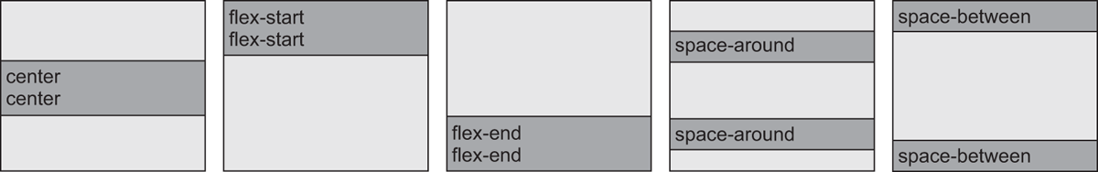
Figure 5.18 Examples of how justifyContent affects the distribution of space between flexible child elements for each of the supported options: center, flex-start, flex-end, space-around, and space-between.
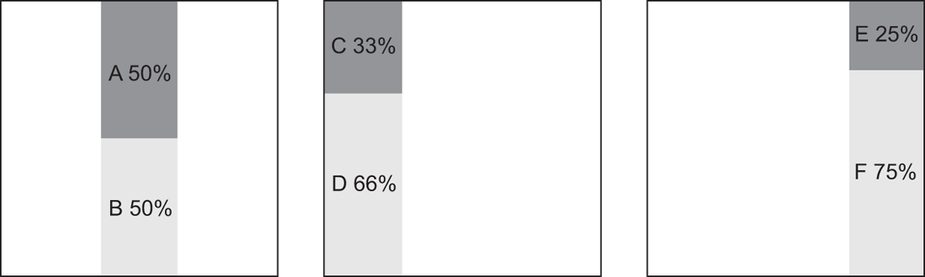
Figure 5.19 Modified examples from figure 5.16, using the non-default alignItems properties: center, flex-start, and flex-end

5.3.4 Aligning children in a container with alignItems
alignItems defines how to align children along the secondary axis of their container. This property is declared on the parent view and affects its flex children just as flexDirection did. There are four possible values for alignItems: stretch, center, flex-start, and flex-end.
stretch is the default, used in figures 5.17 and 5.18. Each example component is stretched to fill its parent container. Figure 5.19 revisits figure 5.16 and shows what happens with the other options: center, flex-start, and flex-end. Because a precise width isn’t specified for the example components, they only take up as much space horizontally as is necessary to render their contents rather than stretching to fill the space. In the first case, alignItems is set to 'center'. In the second case, alignItems is set to 'flex-start'. And last alignItems is set to 'flex-end'. Use listing 5.8 to change the alignments on each of the examples from listing 5.5.
Listing 5.8 Using non-default alignItems properties
render() {
return (
<View style={styles.container}>
<View style={[styles.flexContainer,
{alignItems: 'center'}
]}>
①
<Example style={[styles.darkgrey]}>A 50%</Example>
<Example>B 50%</Example>
</View>
<View style={[styles.flexContainer,
{alignItems: 'flex-start'}
]}>
②
<Example style={[styles.darkgrey]}>C 33%</Example>
<Example style={{flex: 2}}>D 66%</Example>
</View>
<View style={[styles.flexContainer,
{alignItems: 'flex-end'}
]}>
③
<Example style={[styles.darkgrey]}>E 25%</Example>
<Example style={{flex: 3}}>F 75%</Example>
</View>
</View>
);
}
①
Changes the alignItems property to center
②
Changes alignItems to flex-start
③
Changes alignItems to flex-end
Now that you’ve seen how to use the other alignItems properties and their effects on the default column layout, why don’t you set flexDirection to 'row' and see what happens?

5.3.5 Overriding the parent container’s alignment with alignSelf
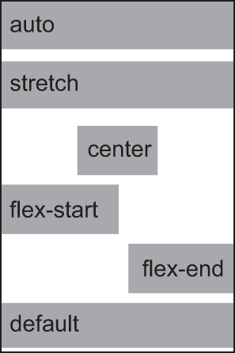
Figure 5.20 How each alignSelf property affects the layout when its parent container’s alignItems property is set to the default value of stretch
So far, all the flex properties have been applied to the parent container. alignSelf is applied directly to an individual flex child.
With alignSelf, you can access the alignItems property for individual elements within the container. In essence, alignSelf gives you the ability to override whatever alignment was set on the parent container, so a child object can be aligned independently of its peers. The available options are auto, stretch, center, flex-start, and flex-end. The default value is auto, which takes the value from the parent container’s alignItems setting. The remaining properties affect the layout in the same way as their corresponding properties on alignItems.
In figure 5.20, the parent container doesn’t have alignItems set, so it defaults to stretch. In the first example, the auto value inherits stretch from its parent container. The next four examples lay out exactly as you’d expect. The final example has no alignSelf property set, so it defaults to auto and is laid out the same as the first example.
Listing 5.9 does something a little different. Rather than supply the style directly to theExample element, you create a new component property: align. It’s passed down to the Example component and used to set alignSelf. Otherwise, the example is the same as many others in this chapter; it explores the effects of each value applied to the style.
Listing 5.9 Using alignSelf to override the parent’s alignItems
import React, { Component } from 'react';
import { StyleSheet, Text, View} from 'react-native';
export default class App extends Component<{}> {
render() {
return (
<View style={styles.container}>
<FlexContainer style={[]}>
<Example
align='auto'
>auto</Example>
①
<Example
align='stretch'
>stretch</Example>
②
<Example
align='center'
>center</Example>
③
<Example
align='flex-start'
>flex-start</Example>
④
<Example
align='flex-end'
>flex-end</Example>
⑤
<Example>default</Example>
⑥
</FlexContainer>
</View>
);
}
}
const FlexContainer = (props) => (
<View style={[styles.flexContainer,props.style]}>
{props.children}
</View>
);
const Example = (props) => (
<View style={[styles.example,
styles.lightgrey,
{alignSelf: props.align || 'auto'}
,
⑦
props.style
]}>
<Text>
{props.children}
</Text>
</View>
);
const styles = StyleSheet.create({
container: {
marginTop: 50,
alignItems: 'center',
flex: 1
},
flexContainer: {
backgroundColor: '#ededed',
width: 120,
height: 180,
borderWidth: 1,
margin: 10
},
example: {
height: 25,
marginBottom: 5,
backgroundColor: '#666666'
},
});
①
Sets alignSelf to auto, which picks up the parent container’s value of stretch
②
Sets alignSelf explicitly to stretch
③
Sets alignSelf to center
④
Sets alignSelf to flex-start
⑤
Sets alignSelf to flex-end
⑥
The default value for alignSelf is auto.
⑦
Uses the align property to set the Example component’s alignItems style

5.3.6 Preventing clipped items with flexWrap
You learned earlier in this section that the flexDirection property takes two values: column (the default) and row. column lays out items vertically, and row lays out items horizontally. What you haven’t seen is a situation in which items flow off the screen because they don’t fit.
flexWrap takes two values: nowrap and wrap. The default value is nowrap, meaning items will flow off the screen if they don’t fit. The items are clipped, and the user can’t see them. To work around this problem, use the wrap value.
In figure 5.21, the first example uses nowrap, and the squares flow off the screen. The row of squares is chopped off at the right edge. The second example uses wrap, and the squares wrap around and start a new row. Listing 5.10 shows the code.
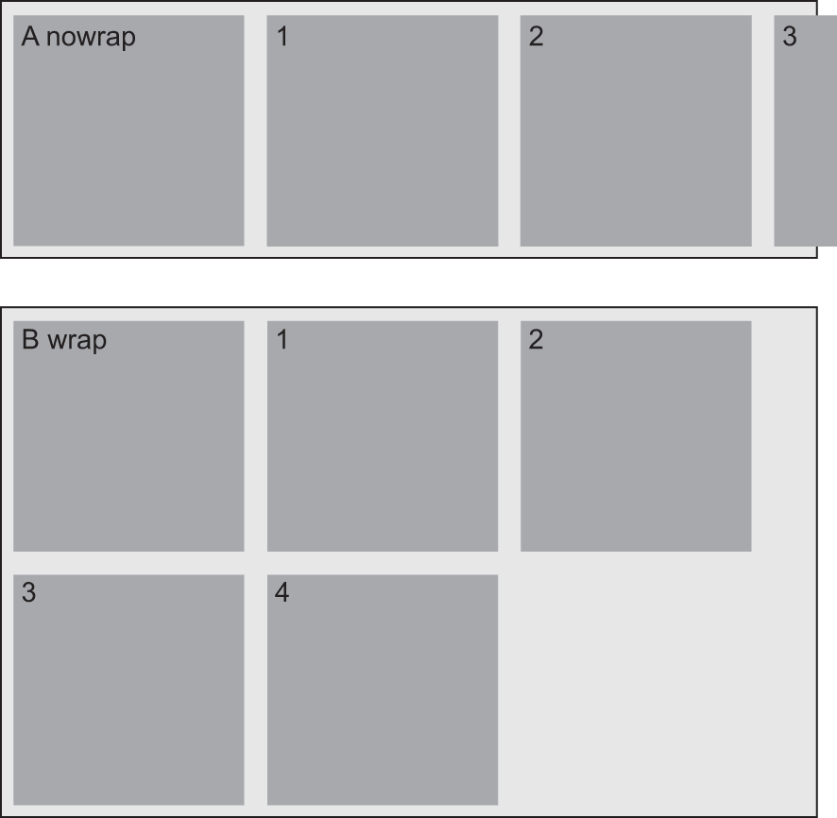
Figure 5.21 An example of two overflowing containers: one with flexWrap set to nowrap and the other with flexWrap set to wrap
Listing 5.10 Example of how flexWrap values affect layout
import React, { Component } from 'react';
import { StyleSheet, Text, View} from 'react-native';
export default class App extends Component<{}> {
render() {
return (
<View style={styles.container}>
<NoWrapContainer>
①
<Example>A nowrap</Example>
<Example>1</Example>
<Example>2</Example>
<Example>3</Example>
<Example>4</Example>
</NoWrapContainer>
<WrapContainer>
②
<Example>B wrap</Example>
<Example>1</Example>
<Example>2</Example>
<Example>3</Example>
<Example>4</Example>
</WrapContainer>
</View>
);
}
}
const NoWrapContainer = (props) => (
<View style={[
styles.noWrapContainer
,props.style]}>
③
{props.children}
</View>
);
const WrapContainer = (props) => (
<View style={[
styles.wrapContainer
,props.style]}>
④
{props.children}
</View>
);
const Example = (props) => (
<View style={[styles.example,props.style]}>
<Text>
{props.children}
</Text>
</View>
);
const styles = StyleSheet.create({
container: {
marginTop: 150,
flex: 1
},
noWrapContainer: {
backgroundColor: '#ededed',
flexDirection: 'row',
⑤
flexWrap: 'nowrap',
borderWidth: 1,
margin: 10
},
wrapContainer: {
backgroundColor: '#ededed',
flexDirection: 'row',
⑥
flexWrap: 'wrap',
borderWidth: 1,
margin: 10
},
example: {
width: 100,
height: 100,
margin: 5,
backgroundColor: '#666666'
},
});
①
flexWrap is set to nowrap: the squares overflow off the screen.
②
flexWrap is set to wrap: the row of squares wraps around to start a new line.
③
Uses the noWrapContainer style for the first example
④
Uses the wrapContainer style for the second example
⑤
Sets flexDirection to row and flexWrap to nowrap
⑥
Sets flexDirection to row and flexWrap to wrap
It’s easy to see which behavior is preferable when laying out tiles, but you may come across a situation in which nowrap will serve you better. Either way, you should now have a clear understanding of flexbox and the many ways it can help you build responsive layouts in React Native.

Summary
When sizing items for display, iOS uses points and Android uses density-independent pixels. The systems of measurement are different but should have little impact on development unless you need pixel-perfect graphics.
Some styles are only available on one platform or another. ShadowPropTypeIOS is only available on iOS, and elevation is only recognized on Android.
Components can be moved in the x and y directions using the translateX and translateY transforms.
Components can be rotated about the x-, y-, and z-axes using rotateX, rotateY, and rotateZ. The point of rotation is the original location of the object before any transforms have been applied.
Components can be scaled in the x and y directions to make the components grow or shrink.
Components can also be skewed in the x and y directions.
Several transformations can be applied at the same time, but the order in which they’re specified matters. Rotating a component changes the orientation of the component for subsequent transformations.
The flexDirection property defines the primary axis, the default being column (y-axis).
The justifyContent property defines how items should be laid out along the primary axis.
The alignItems property defines how items should be laid out along the secondary axis.
The alignSelf property can be used to override the alignItems property specified by a parent container.
The flexWrap property tells flexbox how to handle items that would typically overflow off the screen.

6
Navigation
This chapter covers
Navigation in React Native vs. the web
Navigating using tabs, stacks, and drawers
Managing nested navigators
Passing data and methods between routes
One of the core pieces of functionality in any mobile application is navigation. Before building an application, I recommend that you spend some time strategizing how you want the app to handle navigation and routing. This chapter covers the three main types of navigation typical to mobile applications: tab-based, stack-based, and drawer-based navigation.
Tab-based navigation typically has tabs either at the top or bottom of the screen; pressing a tab takes you to the screen that correlates with the tab. Many popular apps like Twitter, Instagram, and Facebook implement this type of navigation on their main screens.
Stack-based navigation transitions from one screen to another, replacing the current screen, and usually implements some sort of animated transition. You can then go backward or continue moving forward in the stack. You can think of stack-based navigation like an array of components: pushing a new component into the array takes you to the screen of the new component. To go back, you pop the last screen from the stack and are navigated to the previous screen. Most navigation libraries handle this popping and pushing for you.
Drawer-based navigation is typically a side menu that pops out from either the left or right side of the screen and shows a list of options. When you press an option, the drawer closes, and you’re taken to the new screen.
The React Native framework doesn’t include a navigation library. When building navigation in a React Native app, you have to go with a third-party navigation library. A few good navigation libraries are available, but in this chapter, I use React Navigation as the navigation library of choice to build out the demo app. The React Navigation library is recommended by the React Native team and is maintained by many people in the React and React Native community.
React Navigation is a JavaScript-based navigation implementation. All the transitions and controls are handled by JavaScript. Some teams prefer a native solution for many reasons: for instance, they may be adding React Native to an existing native app and want navigation to be consistent throughout the app. If you’re interested in a native navigation solution, check out React Native Navigation, an open source React Native navigation library built and maintained by the engineers at Wix.

6.1 React Native navigation vs. web navigation
Because the paradigm of navigation on the web is much different than that of React Native, navigation is a stumbling block for many developers new to React Native. On the web, we’re used to working with URLs. There are many ways to navigate to a new route, depending on the framework or environment, but typically you want to send the user to a new URL and maybe add some URL parameters if needed.
In React Native, routes are based around components. You load or show a component using the navigator you’re working with. Depending on whether it’s tab based, stack based, drawer based, or a combination of these, the routing will also differ. We’ll walk through all this when you build the demo app in the next section.
You also need to keep up with the data and state throughout the routes and possibly access methods defined elsewhere in the app, so having a strategy around data and method sharing is important. You can manage data and methods either at the top level, where the navigation is defined, or using a state-management library such as Redux or MobX. In the example, you’ll manage data and methods in the class at the top level of the app.

6.2 Building a navigation-based app
In this chapter, you’ll learn how to implement navigation by building out an app that uses both tab-based and stack-based navigation. The app you’ll create is called Cities; it’s shown in figure 6.1. It’s a travel app that lets you keep up with all the cities you visit or want to visit. You can also add locations in each city you want to visit.
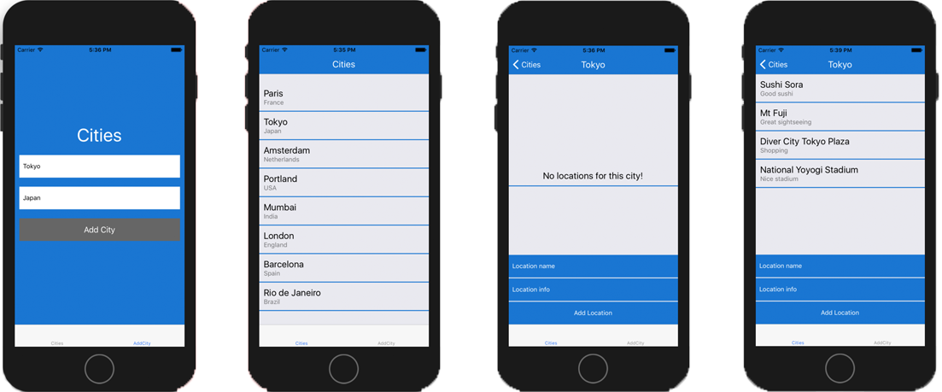
Figure 6.1 Completed Cities app with screens for adding a city, listing cities, viewing city details, and viewing locations within the city
The main navigation is tab based, and one of the tabs includes a stack-based navigation. The left tab shows the list of cities you’ve created, and the right tab contains a form to create new cities. On the left tab, you can press an individual city to view it as well as view and create locations in the city.
To get started, create a new React Native application. In your terminal, navigate to an empty directory, and install the new React Native application using the React Native CLI:
react-native init CitiesApp
Next, navigate into the new directory, and install two dependencies: React Navigation and uuid. React Navigation is the navigation library, and uuid will be used to create unique IDs for cities in order to identify them uniquely:
cd CitiesApp
npm install react-navigation uuid
Now, let’s get to work creating components! Create a new main directory called src in the root of the application. This directory will hold most of the new code for the app. In this new directory, add three main subdirectories: Cities, AddCity, and components.
Because the main navigation is tab based, you’ll separate the main application into two main components (Cities and AddCity), each having its own tab. The AddCity folder will only contain a single component, AddCity.js. The Cities folder will contain two components: Cities.js to view the list of cities, and City.js to view an individual city. The components folder will hold any reusable components; in this case, it will hold a single component.
You’ll also have src/index.js and src/theme.js files. src/index.js will hold all the navigation configuration, and theme.js will be where you keep themeable configuration—in this case, a primary color configuration. Figure 6.2 shows the project’s complete folder structure.
Now that you’ve created the folder structure and installed the necessary dependencies, let’s write some code. The first file you’ll work with is src/theme.js. Here, you’ll set the primary color and make it exportable for use in the app. The theme color I’ve chosen for the app is blue, but feel free to use any color you want; the app will work the same if you change the color value in this file.
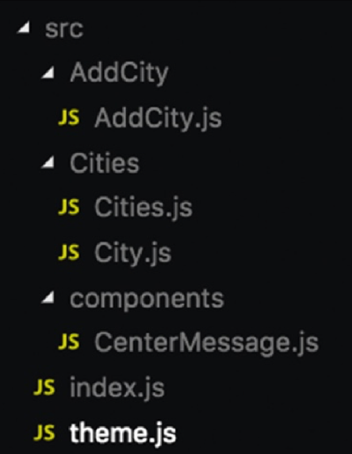
Figure 6.2 The complete src folder structure
Listing 6.1 Creating a theme file with a primary color
const colors = {
primary: '#1976D2'
}
export {
colors
}
You can import this primary color throughout the application if you wish, and change it in one place if you choose to do so.
Next, edit src/index.js to create the main navigation configuration. You’ll create both navigation instances here: the tab-based navigation and the stack-based navigation.
Listing 6.2 Creating the navigation configuration
import React from 'react'
import Cities from './Cities/Cities'
①
import City from './Cities/City'
①
import AddCity from './AddCity/AddCity'
①
import { colors } from './theme'
②
import { createBottomTabNavigator,
createStackNavigator } from 'react-navigation'
③
const options = {
④
navigationOptions: {
headerStyle: {
backgroundColor: colors.primary
},
headerTintColor: '#fff'
}
}
const CitiesNav = createStackNavigator({
⑤
Cities: { screen: Cities },
City: { screen: City }
}, options)
const Tabs = createBottomTabNavigator({
⑥
Cities: { screen: CitiesNav },
AddCity: { screen: AddCity }
})
export default Tabs
①
Imports the three components to have in the scope of the file
②
Imports colors from the theme
③
Imports the two navigators to access from React Navigation
④
Creates an options object to hold configuration for the stack navigator
⑤
Creates the first navigation instance
⑥
Creates the tab navigator using the CitiesNav stack navigator for one tab and the AddCity component for the second tab
When you create the options object, the stack navigator automatically places a header at the top of each route. The header is usually where you’ll have the title of the current route as well as buttons like a Back button. The options object also defines the background color and the tint color of the header.
For the first navigation instance, createStackNavigator takes two arguments: the route configuration and any configuration regarding things like styling to apply to the navigation. You pass in two routes as the first argument, and the options object as the second argument.
Next, update App.js to include the new navigation and render it as the main entry point. In addition to rendering the navigation component, App.js will contain and control any methods and data to be made available to the application.
Listing 6.3 Updating App.js to use the navigation configuration
import React, { Component } from 'react';
import {
Platform,
StyleSheet,
Text,
View
} from 'react-native';
import Tabs from './src'
①
export default class App extends Component {
state = {
②
cities: []
}
addCity = (city) => {
③
const cities = this.state.cities
cities.push(city)
this.setState({ cities })
}
addLocation = (location, city) => {
④
const index = this.state.cities.findIndex(item => {
return item.id === city.id
})
const chosenCity = this.state.cities[index]
chosenCity.locations.push(location)
const cities = [
...this.state.cities.slice(0, index),
chosenCity,
...this.state.cities.slice(index + 1)
]
this.setState({
cities
})
}
render() {
return (
<Tabs
⑤
screenProps={{
cities: this.state.cities,
addCity: this.addCity,
addLocation: this.addLocation
}}
/>
)
}
}
①
Imports the navigation from src/index.js
②
Creates an initial state of cities, an empty array
③
Adds a new city to the existing list of cities stored in the state
④
Adds a location to the array of locations in a chosen city
⑤
Returns the Tabs component and passes in a screenProps object containing the cities array, the addCity method, and the addLocation method
App.js has three main pieces of functionality. It creates the initial state of the app: an empty array called cities. Each city will be an object and will have a name, country, ID, and array of locations. The addCity method lets you add new cities to the cities array stored in the state. The addLocation method identifies the city you want to add a location to, updates the city, and resets the state with the new data.
React Navigation has a way to pass these methods and the state down to all the routes being used by the navigator. To do this, pass a prop called screenProps containing whatever you want access to. Then, from within any route, this.props.screenProps gives access to the data or methods.
Next, you’ll create a reusable component called CenterMessage, which is used in Cities.js and City.js (src/components/CenterMessage.js). It displays a message when the array is empty. For example, when the app first starts, it won’t have any cities to list; you can display a message as shown in figure 6.3, instead of just showing a blank screen.
Listing 6.4 CenterMessage component
import React from 'react'
import {
Text,
View,
StyleSheet
} from 'react-native'
import { colors } from '../theme'
const CenterMessage = ({ message }) => (
<View style={styles.emptyContainer}>
<Text style={styles.message}>{message}</Text>
</View>
)
const styles = StyleSheet.create({
emptyContainer: {
padding: 10,
borderBottomWidth: 2,
borderBottomColor: colors.primary
},
message: {
alignSelf: 'center',
fontSize: 20
}
})
export default CenterMessage
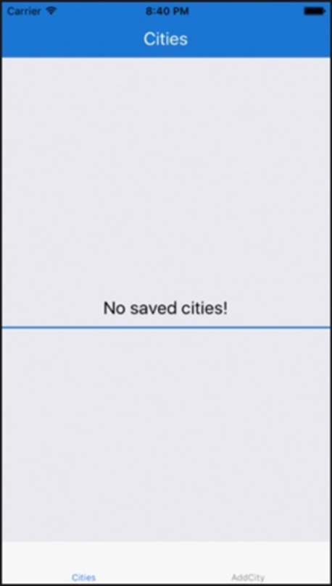
Figure 6.3 The reusable CenterMessage component displays a message centered within the display.
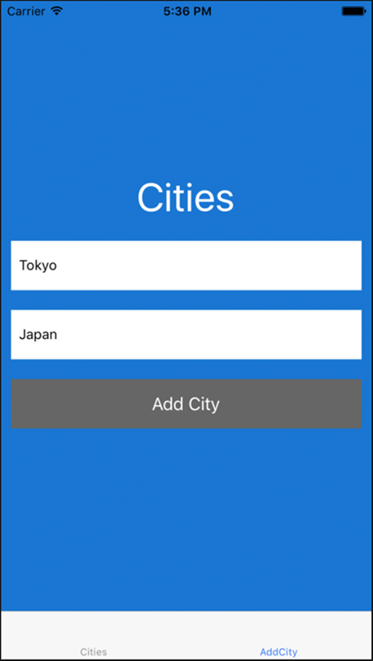
Figure 6.4 AddCity tab allows the user to enter a new city name and the country name.
This component is straightforward. It’s a stateless component that receives only a message as a prop and displays the message along with some styling.
Next, in src/AddCity/AddCity.js, create the AddCity component that will allow you to add new cities to the cities array (see figure 6.4). This component will contain a form with two text inputs: one to hold the city name and one to hold the country name. In addition, a button will call the addCity method from App.js.
Listing 6.5 AddCity tab (functionality)
import React from 'react'
import {
View,
Text,
StyleSheet,
TextInput,
TouchableOpacity
} from 'react-native'
import uuidV4 from 'uuid/v4'
import { colors } from '../theme'
export default class AddCity extends React.Component {
state = {
①
city: '',
country: '',
}
onChangeText = (key, value) => {
②
this.setState({ [key]: value })
}
submit = () => {
③
if (this.state.city === '' || this.state.country === '') {
alert('please complete form')
}
const city = {
city: this.state.city,
country: this.state.country,
id: uuidV4(),
locations: []
}
this.props.screenProps.addCity(city)
this.setState({
city: '',
country: ''
}, () => {
this.props.navigation.navigate('Cities')
})
}
render() {
return (
<View style={styles.container}>
<Text style={styles.heading}>Cities</Text>
<TextInput
placeholder='City name'
onChangeText={val => this.onChangeText('city', val)}
style={styles.input}
value={this.state.city}
/>
<TextInput
placeholder='Country name'
onChangeText={val => this.onChangeText('country', val)}
style={styles.input}
value={this.state.country}
/>
<TouchableOpacity onPress={this.submit}>
<View style={styles.button}>
<Text style={styles.buttonText}>Add City</Text>
</View>
</TouchableOpacity>
</View>
)
}
}
①
The initial state holds a city name and a country name, both initially set as empty strings.
②
Updates the state with either the city or name value. This will be attached to the TextInput and will fire whenever the input value changes.
③
Holds much of the functionality for this component
First, you check to make sure neither the city nor the country is an empty string. If either or both are empty, you return, because you don’t want to store the data unless both fields are filled out. Next, you create an object to hold the city being adding to the cities array. Take the existing city and country values stored on the state, and add an ID value using the uuidV4 method and an empty locations array. Call this.props.screenProps.addCity, passing in the new city. Next, reset the state to clear out any values stored in the state. Finally, navigate the user to the Cities tab to show them their list of cities with the new city added, by calling this.props.navigation.navigate and passing in the string of the route to navigate to—in this case, 'Cities'.
Every component that’s a screen in a navigator automatically has access to two props: screenProps and navigation. In listing 6.3, when you created the navigation component, you passed in three screenProps. In the submit method, you called this.props.screenProps.addCity, accessing and invoking this screenProps method. You also access the navigation prop by calling this.props.navigation.navigate. navigate is what you use to navigate between routes in React Navigation.
Next, add the styles for this component. This code goes below the class definition in src/AddCity/AddCity.js.
Listing 6.6 AddCity tab (styling)
const styles = StyleSheet.create({
button: {
height: 50,
backgroundColor: '#666',
justifyContent: 'center',
alignItems: 'center',
margin: 10
},
buttonText: {
color: 'white',
fontSize: 18
},
heading: {
color: 'white',
fontSize: 40,
marginBottom: 10,
alignSelf: 'center'
},
container: {
backgroundColor: colors.primary,
flex: 1,
justifyContent: 'center'
},
input: {
margin: 10,
backgroundColor: 'white',
paddingHorizontal: 8,
height: 50
}
})
Now, create src/Cities/Cities.js to list all the cities the app is storing and allow the user to navigate to an individual city (see figure 6.5). The functionality is shown in the following listing, and the styling is in listing 6.8.
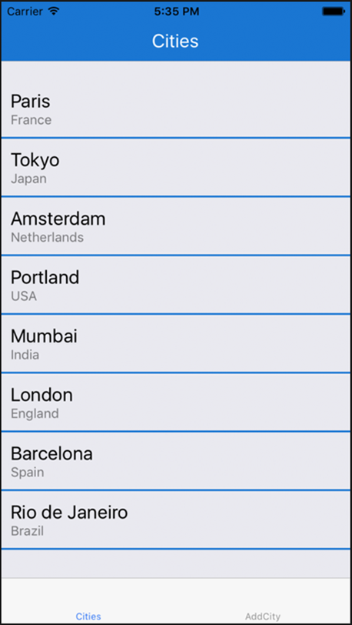
Figure 6.5 Cities.js displays a list of cities that have been added to the application.
Listing 6.7 Cities route (functionality)
import React from 'react'
import {
View,
Text,
StyleSheet,
TouchableWithoutFeedback,
ScrollView
} from 'react-native'
import CenterMessage from '../components/CenterMessage'
①
import { colors } from '../theme'
export default class Cities extends React.Component {
static navigationOptions = {
②
title: 'Cities',
headerTitleStyle: {
color: 'white',
fontSize: 20,
fontWeight: '400'
}
}
navigate = (item) => {
this.props.navigation.navigate('City', { city: item })
③
}
render() {
const { screenProps: { cities } } = this.props
④
return (
<ScrollView contentContainerStyle={[!cities.length && { flex: 1 }]}>
<View style={[!cities.length &&
{ justifyContent: 'center', flex: 1 }]}>
{
!cities.length && <CenterMessage message='No saved cities!'/>
⑤
}
{
cities.map((item, index) => (
⑥
<TouchableWithoutFeedback
onPress={() => this.navigate(item)} key={index} >
<View style={styles.cityContainer}>
<Text style={styles.city}>{item.city}</Text>
<Text style={styles.country}>{item.country}</Text>
</View>
</TouchableWithoutFeedback>
))
}
</View>
</ScrollView>
)
}
}
①
Imports the CenterMessage component created in listing 6.4
②
Declares a static navigationOptions property on the class and declares the configuration for this route
③
Passes in the city as the second argument to this.props.navigation.navigate
④
Accesses and destructures the cities array from the screenProps prop available in the component
⑤
Checks if the cities array is empty. If so, shows the user a message that there are no cities currently in the app.
⑥
Maps over all the cities in the array, displaying the city name and country name. Also attaches the navigate method to the TouchableWithoutFeedback component.
In this listing, you first import the CenterMessage component. React Navigation has a way to control certain options around the navigation within a route. To do so, you can declare a static navigationOptions property on the class and declare the configuration for a route. In this case, you want to set a title and style the title, so give the configuration a title and headerTitleStyle property.
The navigate method calls this.props.navigation.navigate and passes in the route name as well as the city to access to in the City route. Pass in the city as the second argument; in the City route, you’ll have access to this property in props.navigation.state.params. The render method accesses and destructures the cities array. It also includes logic to check whether the cities array is empty; if it is, show the user an appropriate message. You map over all the cities in the array, displaying the city name and country name. Attaching the navigate method to the TouchableWithoutFeedback component lets users navigate to the city by pressing anywhere on the city.
Listing 6.8 Cities route (styling)
const styles = StyleSheet.create({
cityContainer: {
padding: 10,
borderBottomWidth: 2,
borderBottomColor: colors.primary
},
city: {
fontSize: 20,
},
country: {
color: 'rgba(0, 0, 0, .5)'
},
})
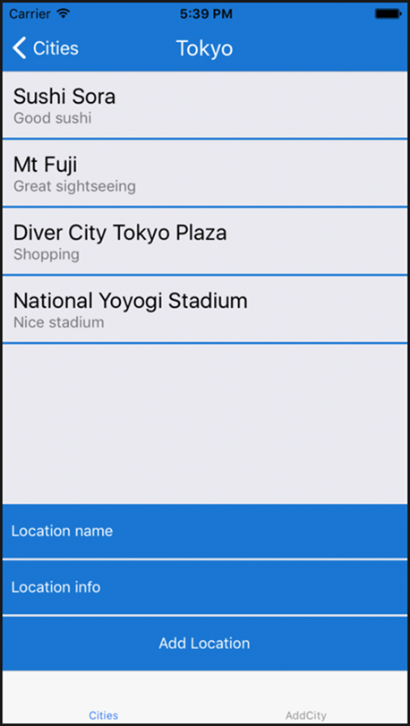
Figure 6.6 City.js shows locations within the city.
Next, create the City component (src/Cities/City.js) to hold the locations for each city as well as a form that lets users create a new location in a city; see figure 6.6. This component will access the cities from screenProps and will also use the addLocation method from screenProps to add a location to the city.
Listing 6.9 City route (functionality)
import React from 'react'
import {
View,
Text,
StyleSheet,
ScrollView,
TouchableWithoutFeedback,
TextInput,
TouchableOpacity
} from 'react-native'
import CenterMessage from '../components/CenterMessage'
import { colors } from '../theme'
class City extends React.Component {
static navigationOptions = (props) => {
①
const { city } = props.navigation.state.params
return {
title: city.city,
headerTitleStyle: {
color: 'white',
fontSize: 20,
fontWeight: '400'
}
}
}
state = {
name: '',
info: ''
}
onChangeText = (key, value) => {
this.setState({
[key]: value
})
}
addLocation = () => {
②
if (this.state.name === '' || this.state.info === '') return
const { city } = this.props.navigation.state.params
const location = {
name: this.state.name,
info: this.state.info
}
this.props.screenProps.addLocation(location, city)
this.setState({ name: '', info: '' })
}
render() {
const { city } = this.props.navigation.state.params
③
return (
<View style={{ flex: 1 }}>
<ScrollView
contentContainerStyle={
[!city.locations.length && { flex: 1 }]
}>
<View style={[
styles.locationsContainer,
!city.locations.length && { flex: 1,
justifyContent: 'center' }
]}>
{
!city.locations.length &&
<CenterMessage message='No locations for this city!' />
}
{
city.locations.map((location, index) => (
④
<View key={index} style={styles.locationContainer}>
<Text style={styles.locationName}>{location.name}</Text>
<Text style={styles.locationInfo}>{location.info}</Text>
</View>
))
}
</View>
</ScrollView>
<TextInput
⑤
onChangeText={val => this.onChangeText('name', val)}
placeholder='Location name'
value={this.state.name}
style={styles.input}
placeholderTextColor='white'
/>
<TextInput
onChangeText={val => this.onChangeText('info', val)}
placeholder='Location info'
value={this.state.info}
style={[styles.input, styles.input2]}
placeholderTextColor='white'
/>
<View style={styles.buttonContainer}>
<TouchableOpacity onPress={this.addLocation}>
<View style={styles.button}>
<Text style={styles.buttonText}>Add Location</Text>
</View>
</TouchableOpacity>
</View>
</View>
)
}
}
①
Creates the static navigationOptions property as in Cities.js
②
Destructures the city object, creates a location object, and calls this.props.screenProps.addLocation to add the location and reset the state
③
Destructures city
④
Maps over the cities in the cities array, and returns a component that displays the city’s name and information
⑤
Creates the form
This code first creates the navigationOptions property. You use a callback function to return an object instead of just declaring an object, because you need access to the props in order to have access to the city information passed down by the navigation. You need to know the city title for use as the route title instead of a hard-coded string.
The addLocation method destructures the city object available from this.props.navigation.state.params for use later in the function. You then create a location object holding the location name and info. Calling this.props.screenProps.addLocation adds the location to the city you’re currently viewing and then resets the state. Again, destructure city from the navigation state. You need city in order to map over the locations in the city and also to use as an argument when creating a new location, to identify the city you’re referencing. Finally, you map over the cities, returning a component that displays both the city name and city information, and create the form with two text inputs and a button.

6.3 Persisting data
You’re finished and should be able to run the app. Play around with the app, add cities and locations, and then refresh it. Notice that all the cities disappear when you refresh. This is because you’re only storing the data in memory. Let’s use AsyncStorage to persist the state, so if the user closes or refreshes the app, their data remains available.
To do so, you’ll work in the App component in App.js and do the following:
Store the cities array in AsyncStorage every time a new city is added.
Store the cities array in AsyncStorage every time a new location is added to a city.
When the user opens the app, check AsyncStorage to see whether any cities are stored there. If so, update the state with those cities.
AsyncStorage only accepts strings for stored values. So, when storing a value, call JSON.stringify on the value if it isn’t already a string, and JSON.parse if you want to parse the stored value before using it.
Open App.js and make the changes:
Import AsyncStorage, and create a key variable.
import {
#omitting previous imports
AsyncStorage
} from 'react-native';
const key = 'state'
export default class App extends Component {
#omitting class definition
Create a componentDidMount function that will check for AsyncStorage and get any item stored there with the key value you set:
async componentDidMount() {
try {
let cities = await AsyncStorage.getItem(key)
cities = JSON.parse(cities)
this.setState({ cities })
} catch (e) {
console.log('error from AsyncStorage: ', e)
}
}
In the addCity method, store the cities array in AsyncStorage after the new cities array has been created:
addCity = (city) => {
const cities = this.state.cities
cities.push(city)
this.setState({ cities })
AsyncStorage.setItem(key, JSON.stringify(cities))
.then(() => console.log('storage updated!'))
.catch(e => console.log('e: ', e))
}
Update the addLocation method to store the city array after setState has been called.
addLocation = (location, city) => {
#previous code omitted
this.setState({
cities
}, () => {
AsyncStorage.setItem(key, JSON.stringify(cities))
.then(() => console.log('storage updated!'))
.catch(e => console.log('e: ', e))
})
}
Now, when the user opens the app after closing it, their data will still be available.

6.4 Using DrawerNavigator to create drawer-based navigation
We’ve gone over how to create stack-based and tab-based navigation. Let’s look at the API for creating drawer-based navigation.
The drawer navigator has an API very similar to that of the stack and tab navigators. You’ll use the createDrawerNavigator function from React Navigation to create a drawer-based navigation. First define the routes to use:
import Page1 from './routeToPage1'
import Page2 from './routeToPoage2'
Next, define the screens you want used in the navigator:
const screens = {
Page1: { screen: Page1 },
Page2: { screen: Page2 }
}
Now you can define the navigator using the screen configuration and use it in the app:
const DrawerNav = createDrawerNavigator(screens)
// somewhere in our app
<DrawerNav />

Summary
Before building an application, spend time strategizing how you want it to handle navigation and routing.
Many navigation libraries are available for React Native, but the two most recommended are React Navigation and React Native Navigation. React Navigation is a JavaScript-based navigation library, and React Native Navigation is a native implementation.
There are three main types of navigators:
Tab-based navigation typically has tabs either at the top or bottom of the screen. When you press a tab, you’re taken to the screen that correlates with that tab. For example, createBottomTabNavigator creates tabs at the bottom of the screen.
Stack-based navigation transitions from one screen to another, replacing the current screen. You can go backward or continue moving forward in the stack. Stack-based navigation usually implements some sort of animated transition. You create stack-based navigation using the createStackNavigator function.
Drawer-based navigation is typically a menu that pops out from either the left or right side of the screen and shows a list of options. When you press an option, the drawer closes and you’re taken to the new screen. You create drawer-based navigation using the createDrawerNavigator function.
Depending on which kind of navigation you use—tab-based, stack-based, drawer-based, or a combination of these—the routing will also differ. Every route or screen managed by the React Navigation library has a navigation prop you can use to control the navigation state.
Use AsyncStorage to persist state so if the user closes or refreshes the app, their data is still available.

7
Animations
This chapter covers
Creating basic animations using Animated.timing
Using interpolation with animated values
Creating animations and in parallel
Staggering animations using Animated.stagger
Using the native driver to offload animations to the native UI thread
One of the great things about React Native is the ability to easily create animations using the Animated API. This is one of the more stable and easy to use React Native APIs, and it’s one of the few places in the React Native ecosystem where, unlike areas such as navigation and state management, there’s almost 100% agreement on how a problem should be solved.
Animations are usually used to enhance the UI of an application and bring more life to the existing design. Sometimes, the difference between an average and above-average user experience can be attributed to using the right animations at the right time, thus setting an app apart from other, similar apps.
Real-world use cases that we cover in this chapter include the following:
Expanding user inputs that animate when focused
Animated welcome screens that have more life than a basic static welcome screen
A custom animated loading indicator
In this chapter, we dive deeply into how to create animations. We’ll cover everything you need to know to take full advantage of the Animated API.
7.1 Introducing the Animated API
The Animated API ships with React Native, so to use it, all you have to do is import it as you would any other React Native API or component. When creating an animation, you always need to do the following four things:
Import Animated from React Native.
Create an animatable value using the Animated API.
Attach the value to a component as a style.
Animate the animatable value using a function.
Out of the box, four types of animatable components ship with the Animated API:
View
ScrollView
Text
Image
The examples in this chapter work exactly the same across any of these components. In section 7.5, we also cover how to create a custom animated component using any element or component with createAnimatedComponent.
Let’s take a quick look at what a basic animation might look like using Animated. In the example, you’ll animate the top margin of a box (see figure 7.1).
Listing 7.1 Using Animated and updating the marginTop property
import React, { Component } from 'react';
import {
StyleSheet,
View,
Animated,
①
Button
} from 'react-native';
export default class RNAnimations extends Component {
marginTop = new Animated.Value(20);
②
animate = () => {
③
Animated.timing(
this.marginTop,
{
toValue: 200,
duration: 500,
}
).start();
}
render() {
return (
<View style={styles.container}>
<Button
④
title='Animate Box'
onPress={this.animate}
/>
<Animated.View
style={[styles.box, { marginTop: this.marginTop } ]} />
⑤
</View>
);
}
}
const styles = StyleSheet.create({
container: {
flex: 1,
padding: 10,
paddingTop: 50,
},
box: {
width: 150,
height: 150,
backgroundColor: 'red'
}
});
①
Imports the Animated API from React Native
②
Creates a class property called marginTop and assigns it to an animated value, passing in the starting value (20 in this case)
③
Creates a function that will animate the value
④
Attach the animate method to an onPress handler so you can call it
⑤
Use the Animated.View component instead of the regular View component
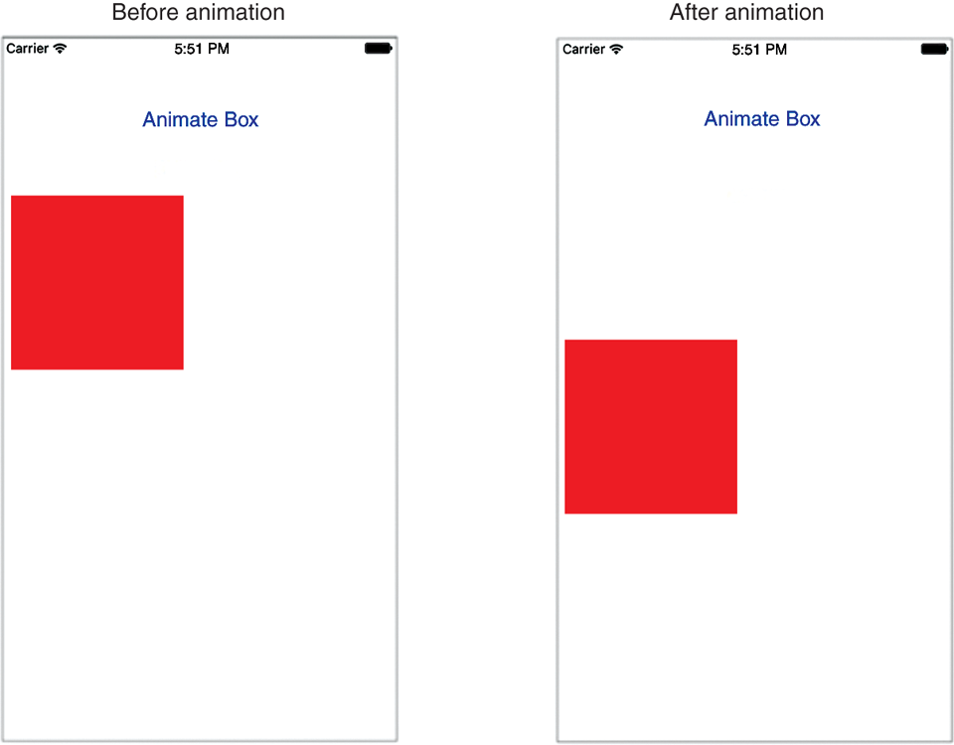
Figure 7.1 Animating the top margin of a square box using Animated
This example uses the timing function to animate a value. The timing function takes two arguments: a starting value and a configuration object. The configuration object is passed a toValue to set the value the animation should animate to, and a duration in milliseconds to set the length of the animation.
Rather than a View component, you use an Animated.View. Animated has four components that can be animated out of the box: View, Image, ScrollView, and Text. In the styling of the Animated.View, you pass in an array of styles consisting of a base style (styles.box) and an animated style (marginTop).
Now that you’ve created a basic animated component, you’ll create a few more animations using real-world use cases that may come in handy.

7.2 Animating a form input to expand on focus
In this example, you’ll create a basic form input that expands when the user focuses it, and contracts when the input is blurred. This is a popular UI pattern.
Along with the props that you’ve used with the TextInput component so far in this book, such as value, placeholder, and onChangeText, you can also use onFocus and onBlur to call functions when the inputs are focused and blurred. That’s how you’ll achieve this animation (shown in figure 7.2).
Listing 7.2 Animating a TextInput to expand when the input is focused
import React, { Component } from 'react';
import {
StyleSheet,
View,
Animated,
Button,
TextInput,
Text,
} from 'react-native';
export default class RNAnimations extends Component {
animatedWidth = new Animated.Value(200);
①
animate = (value) => {
②
Animated.timing(
this.animatedWidth,
{
toValue: value,
duration: 750,
}
).start()
}
render() {
return (
<View style={styles.container}>
<Animated.View style={{ width: this.animatedWidth }}>
③
<TextInput
④
style={[styles.input]}
onBlur={() => this.animate(200)}
onFocus={() => this.animate(325)}
ref={input => this.input = input}
/>
</Animated.View>
<Button
title='Submit'
onPress={() => this.input.blur()}
/>
</View>
);
}
}
const styles = StyleSheet.create({
container: {
flex: 1,
padding: 10,
paddingTop: 50,
},
input: {
height: 50,
marginHorizontal: 15,
backgroundColor: '#ededed',
marginTop: 10,
paddingHorizontal: 9,
},
});
①
Creates an initial value for the animation, calling it animatedWidth
②
Creates an animate function that will animate the animated value of animatedWidth
③
Attach the animatedWidth value to the style of the container View holding the Input component.
④
Attach the animate method to the onBlur and onFocus handlers, passing in the desired width for when each event is fired.
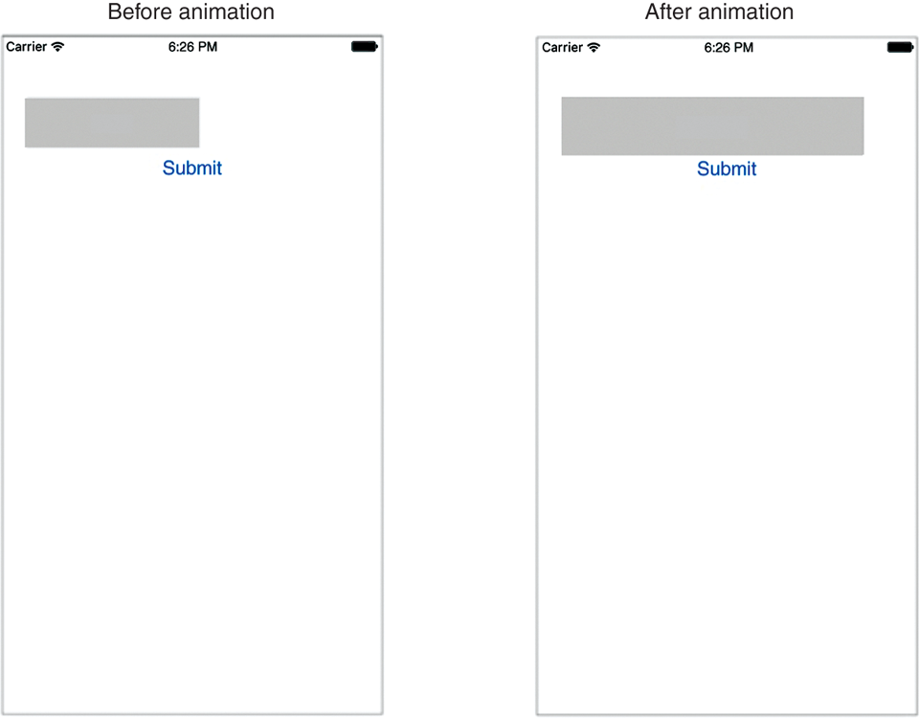
Figure 7.2 Animating a TextInput component when the input is focused

7.3 Creating a custom loading animation using interpolation
Many times, you need to create animations that are infinite loops, such as loading indicators and activity indicators. One easy way to create such animations is to use the Animated.loop function. In this section, you use Animated.loop along with the Easing module to create a loading indicator, spinning an image in an infinite loop!
So far, we’ve only looked at calling an animation using Animated.timing. In this example, you want the animation to run continuously without stopping. To do this, you’ll use a new static method called loop. Animated.loop runs a given animation continuously: each time it reaches the end, it resets to the beginning and starts again.
You’ll also deal with styling a little differently than in the past. In listings 7.1 and 7.2, you used the animated value directly in the style prop of the component. In subsequent examples, you’ll store these animation values in variables and interpolate the values before using the new interpolated variables in the style prop. Because you’re creating a spinning effect, you’ll use strings instead of numbers: for example, you’ll reference a value such as 360deg for style.
Animated has a class method called interpolate that you can use to manipulate animated values, changing them into other values that you can also use. The interpolate method takes a configuration object with two keys: inputRange (array) and outputRange (also an array). inputRange is the original animated values you work with in a class, and outputRange specifies the values the original values should be changed to.
Finally, you’ll change the easing value of the animation. Easing basically allows you to control the animation’s motion. In this example, you want a smooth, even motion for the spin effect, so you’ll use a linear easing function.
React Native has a built-in way to implement common easing functions. Just as you’ve imported other APIs and components, you can import the Easing module and use it along with Animated. Easing can be configured in the configuration object where you set values like toValue and duration, in the second argument of Animated.timing. Let’s look at an example with an animated value called animatedMargin. Setting animatedMargin to 0 and animating the value to 200 would normally achieve the easing effect by directly animating the value between 0 and 200 in the timing function. Using interpolation, you can instead animate a value between 0 and 1 in the timing function and later interpolate the value by using the Animated interpolate class method, saving the value into another variable, and then referencing that variable in the style, usually in the render method:
const marginTop = animatedMargin.interpolate({
inputRange: [0, 1],
outputRange: [0, 200],
});
Now, use interpolation to create the loading indicator. You’ll show the indicator when the application loads; in componentDidMount, you’ll call setTimeout, which cancels the loading state after 2,000 milliseconds (see figure 7.3). The icon used here is located at https://github.com/dabit3/react-native-in-action/blob/chapter7/assets/35633-200.png; feel free to use it or any other image you want.
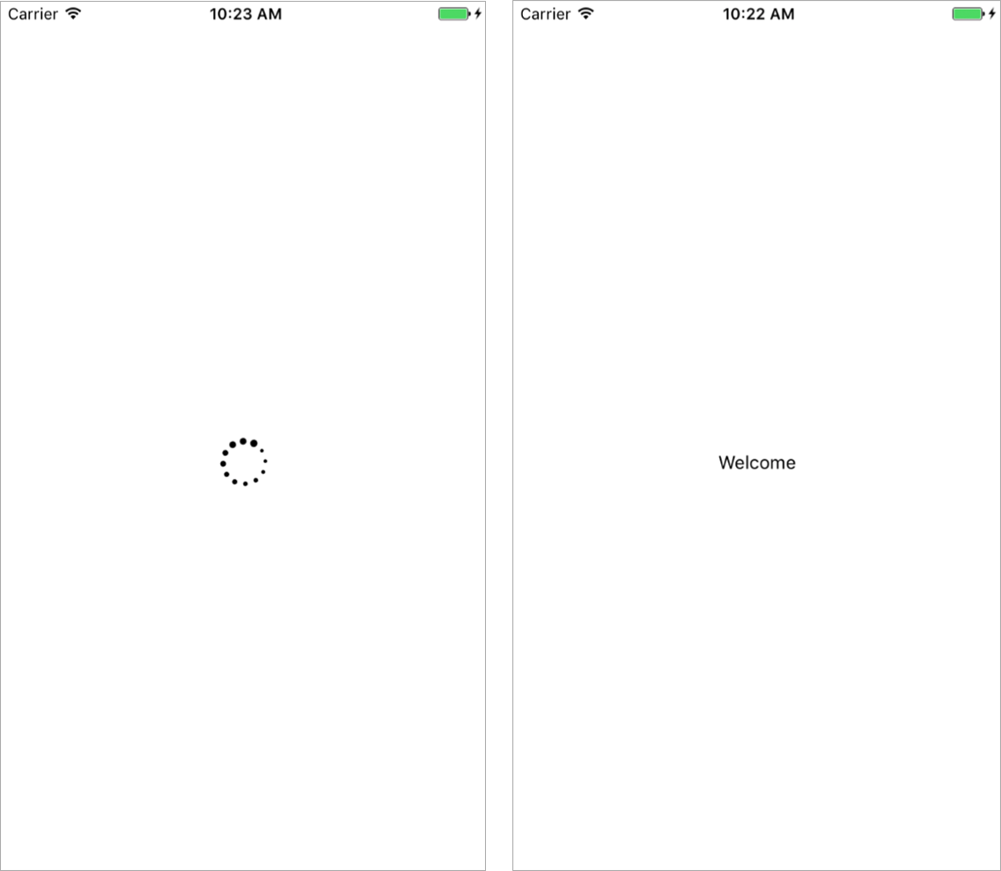
Figure 7.3 Creating a spinning loading indicator using interpolation and an animated loop
Listing 7.3 Creating an infinitely spinning loading animation
import React, { Component } from 'react';
import {
Easing,
StyleSheet,
View,
Animated,
Button,
Text,
} from 'react-native';
export default class RNAnimations extends Component {
state = {
loading: true,
①
}
componentDidMount() {
②
this.animate();
setTimeout(() => this.setState({ loading: false }), 2000)
}
animatedRotation = new Animated.Value(0);
③
animate = () => {
④
Animated.loop(
Animated.timing(
this.animatedRotation,
{
toValue: 1,
duration: 1800,
easing: Easing.linear,
}
)
).start()
}
render() {
const rotation = this.animatedRotation.interpolate({
⑤
inputRange: [0, 1],
⑥
outputRange: ['0deg', '360deg'],
⑦
});
const { loading } = this.state;
return (
<View style={styles.container}>
{
loading ? (
⑧
<Animated.Image
source={require('./pathtoyourimage.png')}
style={{ width: 40,
height: 40,
transform: [{ rotate: rotation }] }}
/>
) : (
<Text>Welcome</Text>
)
}
</View>
);
}
}
const styles = StyleSheet.create({
container: {
flex: 1,
justifyContent: 'center',
alignItems: 'center',
padding: 10,
paddingTop: 50,
},
input: {
height: 50,
marginHorizontal: 15,
backgroundColor: '#ededed',
marginTop: 10,
paddingHorizontal: 9,
},
});
①
Initializes the state with a Boolean loading value of true
②
Triggers the animation by calling this.animate, and invokes a setTimeout function to set loading to false in the state after 2 seconds
③
Sets an initial animatedRotation value of 0
④
Creates an animate class method that passes Animated.timing into a call to Animated.loop
⑤
Uses the animatedRotation value to create a new rotation value using the interpolate method
⑥
Passes in the animation’s beginning and end values (0 and 1)
⑦
Passes in the values for inputRange to map to
⑧
Checks whether loading is true, and responds accordingly
The animate class method passes Animated.timing into a call to Animated.loop. In the configuration, you set toValue to 1, duration to 1800, and easing to Easing.linear, to create a smooth spinning movement.
The animatedRotation value creates a new value called rotation, using the interpolate method. inputRange gives the animation’s beginning and end values, and outputRange gives the values inputRange should map to: a beginning value of 0 degrees and a final value of 360 degrees, creating a full 360-degree rotation.
In the return statement, first check to see whether loading is true. If it is, show the animated loading indicator (update this path to that of the image in your application); if it’s false, show a welcome message. Attach the rotation variable to the transform rotate value in the styling of Animated.Image.

7.4 Creating multiple parallel animations
Sometimes you need to create multiple animations at once and have them run simultaneously. The Animated library has a class method called parallel you can use to do this. parallel starts an array of animations at the same time.
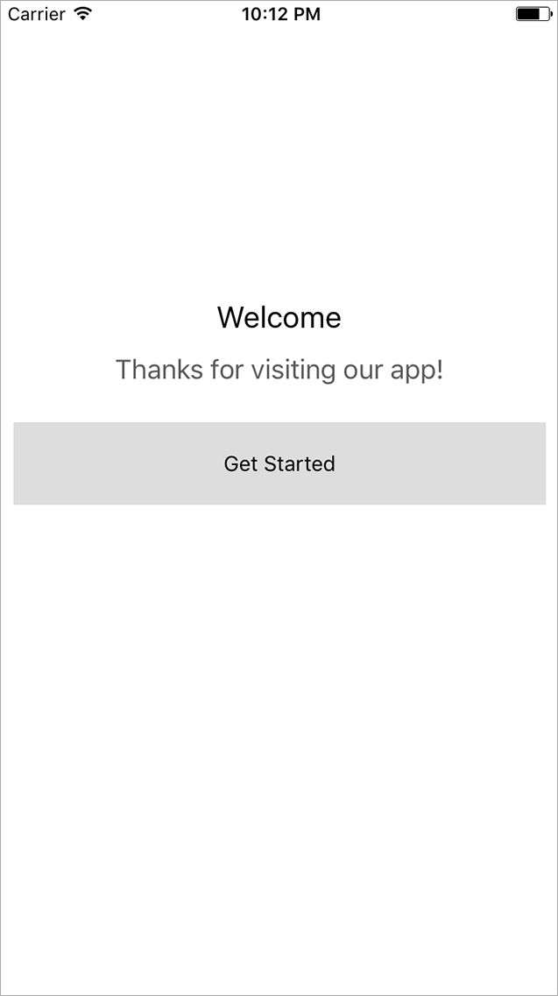
Figure 7.4 Welcome screen using parallel animations (shown after the animations are complete)
For example, to make a welcome screen with two messages and a button all appear to move into the screen at once, you could create three separate animations and call .start() on each of them. But a more efficient way would be to use the Animated.parallel function and pass in the array of animations to run at the same time.
In this example, you’ll create a welcome screen that animates in two messages and a button when the component mounts (see figure 7.4). Because you’re using Animated.parallel, all three animations will begin at exactly the same time. You’ll add a delay property to the configuration to control the start time of two of the animations.
Listing 7.4 Creating an animated welcome screen
import React, { Component } from 'react';
import {
Easing,
StyleSheet,
View,
Animated,
Text,
TouchableHighlight,
} from 'react-native';
export default class RNAnimations extends Component {
animatedTitle = new Animated.Value(-200);
①
animatedSubtitle = new Animated.Value(600);
①
animatedButton = new Animated.Value(800);
①
componentDidMount() {
this.animate();
②
}
animate = () => {
③
Animated.parallel([
③
Animated.timing(
③
this.animatedTitle,
{
toValue: 200,
duration: 800,
}
),
Animated.timing(
③
this.animatedSubtitle,
{
toValue: 0,
duration: 1400,
delay: 800,
}
),
Animated.timing(
③
this.animatedButton,
{
toValue: 0,
duration: 1000,
delay: 2200,
}
)
]).start();
}
render() {
return (
<View style={styles.container}>
<Animated.Text style={[styles.title,
{ marginTop: this.animatedTitle}]}>
Welcome
</Animated.Text>
④
<Animated.Text style={[styles.subTitle,
{ marginLeft: this.animatedSubtitle }]}>
Thanks for visiting our app!
</Animated.Text>
④
<Animated.View style={{ marginTop: this.animatedButton }}>
④
<TouchableHighlight style={styles.button}>
<Text>Get Started</Text>
</TouchableHighlight>
</Animated.View>
</View>
);
}
}
const styles = StyleSheet.create({
container: {
flex: 1,
},
title: {
textAlign: 'center',
fontSize: 20,
marginBottom: 12,
},
subTitle: {
width: '100%',
textAlign: 'center',
fontSize: 18,
opacity: .8,
},
button: {
marginTop: 25,
backgroundColor: '#ddd',
height: 55,
justifyContent: 'center',
alignItems: 'center',
marginHorizontal: 10,
}
});
①
When you create the class, also create three new animated values.
②
Calls the animate() method on componentDidMount
③
Calls Animated.parallel and passes in three Animated.timing animations to trigger all three animations to start at once
④
Attach the animated values to each component you’re animating.

7.5 Creating an animated sequence
An animated sequence is a series of animations that occur one after another, with each animation waiting for the previous animation to complete before it begins. You can create an animated sequence with sequence. Like parallel, sequence takes an array of animations:
Animated.sequence([
animationOne,
animationTwo,
animationThree
]).start()
In this example, you’ll create a sequence that drops the numbers 1, 2, and 3 into the screen, 500 milliseconds apart (figure 7.5).
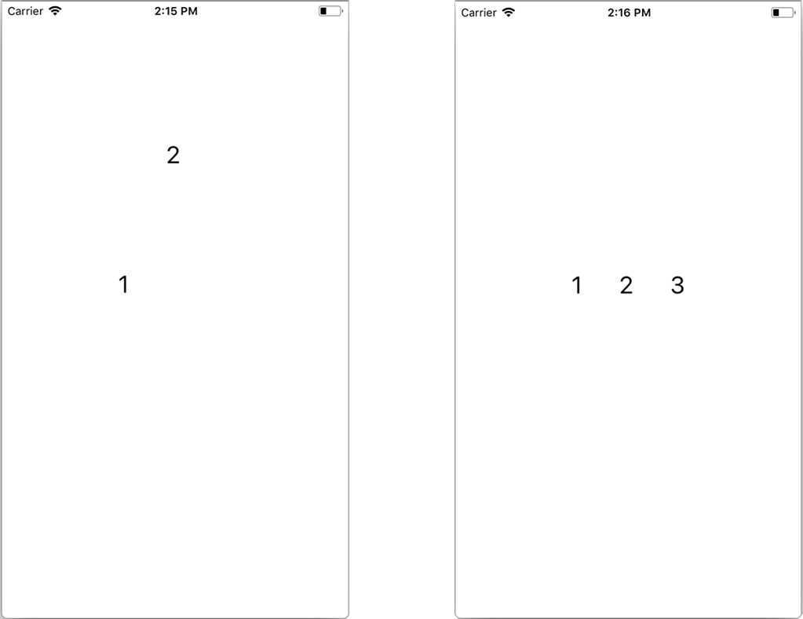
Figure 7.5 Creating an animated sequence of numbers
Listing 7.5 Creating a sequence of animations
import React, { Component } from 'react';
import {
StyleSheet,
View,
Animated
①
} from 'react-native';
export default class RNAnimations extends Component {
componentDidMount() {
this.animate();
②
}
AnimatedValue1 = new Animated.Value(-30);
③
AnimatedValue2 = new Animated.Value(-30);
③
AnimatedValue3 = new Animated.Value(-30);
③
animate = () => {
const createAnimation = (value) => {
④
return Animated.timing(
value, {
toValue: 290,
duration: 500
})
}
Animated.sequence([
⑤
createAnimation(this.AnimatedValue1),
⑤
createAnimation(this.AnimatedValue2),
⑤
createAnimation(this.AnimatedValue3)
⑤
]).start()
⑤
}
render() {
return (
<View style={styles.container}>
<Animated.Text style={[styles.text,
{ marginTop: this.AnimatedValue1}]}>
⑥
1
</Animated.Text>
<Animated.Text style={[styles.text,
{ marginTop: this.AnimatedValue2}]}>
⑥
2
</Animated.Text>
<Animated.Text style={[styles.text,
{ marginTop: this.AnimatedValue3}]}>
⑥
3
</Animated.Text>
</View>
);
}
}
const styles = StyleSheet.create({
container: {
flex: 1,
justifyContent: 'center',
flexDirection: 'row',
},
text: {
marginHorizontal: 20,
fontSize: 26
}
});
①
Imports Animated from React Native
②
Calls the animate function when the component mounts
③
Creates three animated values, passing in -30 for the beginning value
④
Creates a createAnimation function as a helper for making a new timing animation
⑤
Starts the sequence, calling createAnimation once for each animated value
⑥
Passes the animated values to the three Animated.Text components
This example uses beginning animated values of -30 because they’re the marginTop values for the text elements: the text is pulled off the top of the screen and hidden before the animation begins. The createAnimation function also receives an animated value as its argument.

7.6 Using Animated.stagger to stagger animation start times
The last type of animation we’ll go over is Animated.stagger. Like parallel and sequence, stagger takes an array of animations. The array of animations starts in parallel, but the start time is staggered equally across all the animations. Unlike parallel and sequence, the first argument to stagger is the stagger time, and the second argument is the array of animations:
Animated.stagger(
100,
[
Animation1,
Animation2,
Animation3
]
).start()
In this example, you’ll dynamically create a large number of animations that are used to stagger a series of red boxes onto the screen (figure 7.6).
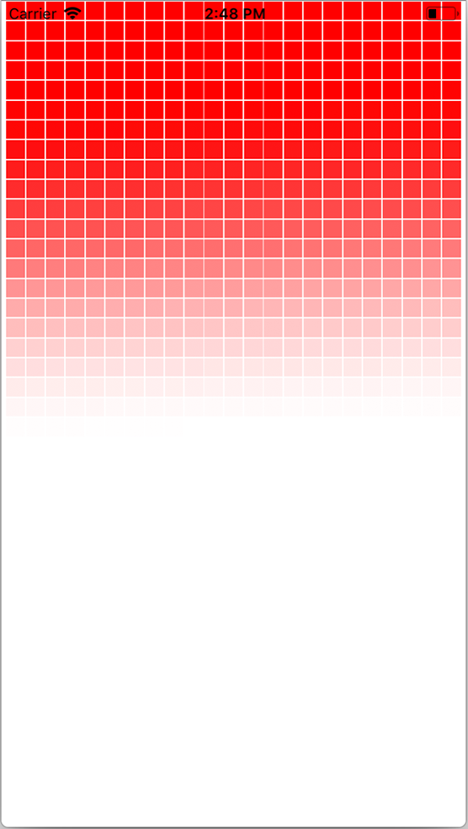
Figure 7.6 Using Animated.stagger to create an array of staggered animations
Listing 7.6 Using Animated.stagger to stagger a series of animations
import React, { Component } from 'react'
import {
StyleSheet,
View,
Animated
①
} from 'react-native'
export default class RNAnimations extends Component {
constructor () {
super()
this.animatedValues = []
②
for (let i = 0; i < 1000; i++) {
②
this.animatedValues[i] = new Animated.Value(0)
②
}
②
this.animations = this.animatedValues.map(value => {
③
return Animated.timing(
③
value,
③
{
③
toValue: 1,
③
duration: 6000
③
}
③
)
③
})
}
componentDidMount() {
this.animate()
④
}
animate = () => {
Animated.stagger(15, this.animations).start()
⑤
}
render() {
return (
<View style={styles.container}>
{
this.animatedValues.map((value, index) => (
⑥
<Animated.View key={index}
style={[{opacity: value},
styles.box]} />
⑥
))
⑥
}
</View>
);
}
}
const styles = StyleSheet.create({
container: {
flex: 1,
justifyContent: 'center',
flexDirection: 'row',
flexWrap: 'wrap'
},
box: {
width: 15,
height: 15,
margin: .5,
backgroundColor: 'red'
}
})
①
Imports Animated from React Native
②
Creates an array that will contain 1,000 animated values of 0
③
Creates an array of Animated.timing animations referencing the animated values created in the animatedValues array
④
Calls the animate method
⑤
Calls Animated.stagger().start(), passing in the timing of 15 ms and array of animations
⑥
Maps over the animations, creating an Animated.View for each item in the array

7.7 Other useful tips for using the Animated library
In addition to the parts of the Animated API we’ve already covered, a few more techniques are useful to know about: resetting an animated value, invoking callbacks, offloading animations to the native thread, and creating custom animatable components. This section takes a quick look at each of these.

7.7.1 Resetting an animated value
If you’re calling an animation, you can reset the value to whatever you want by using setValue(value). This is useful if you’ve already called an animation on a value and need to call the animation again, and you want to reset the value to either the original value or a new value:
animate = () => {
this.animatedValue.setValue(300);
#continue here with the new animated value
}

7.7.2 Invoking a callback
When an animation is completed, an optional callback function can be fired, as shown here:
Animated.timing(
this.animatedValue,
{
toValue: 1,
duration: 1000
}
).start(() => console.log('animation is complete!'))

7.7.3 Offloading animations to the native thread
Out of the box, the Animated library performs animations using the JavaScript thread. In most cases, this works fine, and you shouldn’t have many performance problems. But if anything is blocking the JavaScript thread, you may see issues like frames being skipped, causing laggy or jumpy animations.
There’s a way around using the JavaScript thread: you can use a configuration Boolean called useNativeDriver. useNativeDriver offloads the animation to the native UI thread, and the native code can then update the views directly on the UI thread, as shown here:
Animated.timing(
this.animatedValue,
{
toValue: 100,
duration: 1000,
useNativeDriver: true
}
).start();
Not every animation can be offloaded using useNativeDriver, so be sure to check the Animated API documentation when you use it. As of this writing, only non-layout properties can be animated using this method; flexbox properties as well as properties like margins and padding can’t be animated.

7.7.4 Creating a custom animatable component using createAnimatedComponent
We mentioned in section 7.1 that the only animatable components out of the box are View, Text, Image, and ScrollView. There’s also a way to create an animated component from any existing or custom React Native element or component. You can do this by wrapping the component in a call to createAnimatedComponent. Here’s an example:
const Button = Animated.createAnimatedComponent(TouchableHighlight)
<Button onPress={somemethod} style={styles.button}>
<Text>Hello World</Text>
</Button>
Now you can use the button just like a regular React Native component.

Summary
The built-in Animated API is the recommended way to create animations in React Native.
Animated.timing is the main method to use to create animations using the Animated library.
The only components that are animatable out of the box are View, Text, ScrollView, and Image, but you can create custom animatable components using createAnimatedComponent.
To interpolate and reuse animated values, use the Animated interpolate method.
To create and trigger an array of animations at the same time, use Animated.parallel.
To create an infinitely looping animation, use Animated.loop.
Use Animated.sequence to create a sequence of animations that execute one after another.
Use Animated.stagger to create an array of animations that happen in parallel, but whose start times are staggered based on the time passed in.

8
Using the Redux data architecture library
This chapter covers
How the React context API works
Creating a Redux store
How to use Redux actions and reducers to manage global state
Reducer composition using combineReducers
When building React and React Native applications in the real world, you’ll quickly learn that the data layer can become complex and unmanageable if it isn’t handled very precisely and deliberately. One way to handle data is to keep it in component state and pass it around as props, as we’ve done throughout this book. Another way is to use a data architecture pattern or library. This chapter covers the Redux library: it’s the most widely adopted method of handling data in the React ecosystem, and it’s maintained by Facebook, the same team that maintains both React and React Native.

8.1 What is Redux?
In the Redux documentation, the library is described as “a predictable state container for JavaScript apps.” Redux is basically a global state object that’s the single source of truth in an application. This global state object is received as props into React Native components. Any time a piece of data is changed in the Redux state, the entire application receives this new data as props.
Redux simplifies application state by moving it all into one place called a store; this makes it much easier to reason about and understand. When you need the value of something, you’ll know exactly where to look in a Redux application and can expect the same value to be available and up-to-date elsewhere in the application, too.
So how does Redux work? It takes advantage of a React feature called context, a mechanism for creating and managing global state.

8.2 Using context to create and manage global state in a React application
Context is a React API that creates global variables that can be accessed anywhere in the application, as long as the component receiving the context is a child of the component that created it. Normally you’d have to do this by passing props down each level of the component structure. With context, you don’t need to use props. You can use the context anywhere in the app and access it without passing it down to each level.

Note Although context is good to understand and is used in numerous open source libraries, you probably won’t need to use it in apps unless you’re building an open source library or can’t find another way around a problem. We’re discussing it in order for you to fully understand how Redux works under the hood.

Let’s look at how to create context in a basic component structure of three components: Parent, Child1, and Child2. This example shows how to apply application-wide theming from a parent level, which could make it possible to control the styling of an entire application if needed.
Listing 8.1 Creating context
const ThemeContext = React.createContext()
①
class Parent extends Component {
state = { themeValue: 'light' }
②
toggleThemeValue = () => {
③
const value = this.state.themeValue === 'dark' ? 'light' : 'dark'
③
this.setState({ themeValue: value })
③
}
③
render() {
return (
<ThemeContext.Provider
④
value={{
themeValue: this.state.themeValue,
toggleThemeValue: this.toggleThemeValue
}}
>
<View style={styles.container}>
<Text>Hello World</Text>
</View>
<Child1 />
</ThemeContext.Provider>
);
}
}
const Child1 = () => <Child2 />
⑤
const Child2 = () => (
⑥
<ThemeContext.Consumer>
{(val) => (
<View style={[styles.container,
val.themeValue === 'dark' &&
{ backgroundColor: 'black' }]}>
<Text style={styles.text}>Hello from Component2</Text>
<Text style={styles.text}
onPress={val.toggleThemeValue}>
Toggle Theme Value
</Text>
</View>
)}
</ThemeContext.Consumer>
)
const styles = StyleSheet.create({
container: {
flex: 1,
justifyContent: 'center',
alignItems: 'center',
backgroundColor: '#F5FCFF',
},
text: {
fontSize: 22,
color: '#666'
}
})
①
Creates a new variable called ThemeContext
②
Creates a themeValue state variable with the value ‘light’
③
Checks the current theme value and toggles it to ‘light’ or ‘dark’
④
Provides the context to child components. Anything wrapped in a Provider is available to children of a component in a Consumer.
⑤
Stateless function that returns a component, demonstrating that you aren’t passing props between Parent and Child2
⑥
Stateless function that returns a component wrapped in a ThemeContext.Consumer
The Child2 stateless function returns a component that’s wrapped in a ThemeContext.Consumer. ThemeContext.Consumer requires a function as its child. The function receives an argument containing whatever context is available (in this case, the val object containing two properties). You can now use the context values in the component.
When you use Redux with React, you’ll take advantage of a function called connect, which basically takes pieces of context and makes them available as props in the component. Understanding context should make learning Redux much easier!

8.3 Implementing Redux with a React Native app
Now that you’ve know the fundamentals of what Redux is and have seen what’s going on under the hood with context, let’s create a new React Native app and start adding Redux. You’ll be creating a basic list app you can use to keep up with books you’ve read (see figure 8.1). Follow these steps:
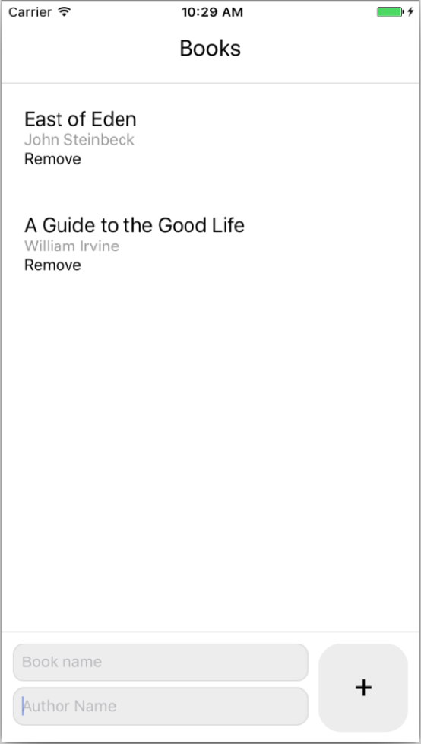
Figure 8.1 Completed book list application
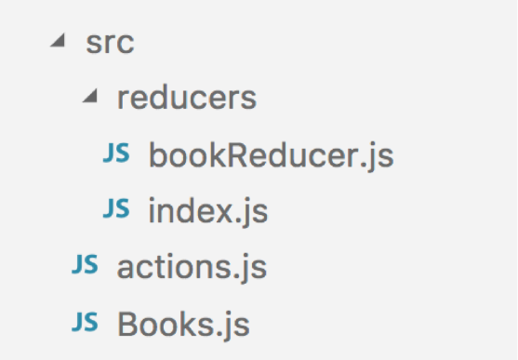
Figure 8.2 RNRedux src folder structure
Create a new React Native application, and call it RNRedux:
react-native init RNRedux
Change into the new directory:
cd RNRedux
Install the Redux-specific dependencies you’ll need:
npm i redux react-redux –-save
In the root of the directory, create a folder called src, and add to it the following files: Books.js and actions.js. Also, in src, create a folder called reducers, containing two files: bookReducer.js and index.js. The src folder structure should now look like figure 8.2.
The next thing to do is create the first piece of Redux state. You’ll do this in bookReducer.js. In section 8.1, I described Redux as a global object. To create this global object, you’ll piece together smaller objects using what are known as reducers.

8.4 Creating Redux reducers to hold Redux state
A reducer is a function that returns an object; when combined with other reducers, they create the global state. Reducers can be more easily thought of as data stores. Each store contains a piece of data, which is exactly what reducers do in the Redux architecture.
In the reducers folder are two files: bookReducer.js and index.js. In index.js, you’ll combine all the reducers in the app to create the global state. The app will have only one reducer to start with (bookReducer), so the global state object will look something like this:
{
bookReducer: {}
}
You’ve yet to decide what to put in bookReducer. An array in which to store a list of books will be a good start. This reducer will create and return a piece of state that you’ll access later from the Redux store. In reducers/bookReducer.js, create your first reducer. This code creates a function whose only purpose (for now) is to return the state.
Listing 8.2 Creating a reducer
const initialState = {
①
books: [{ name: 'East of Eden', author: 'John Steinbeck' }]
①
}
①
①
Creates the initialState object
const bookReducer = (state = initialState) => {
②
return state
③
}
export default bookReducer
②
Takes a state argument and sets the default to the initial state
③
Returns the state
The initialState object will hold the beginning state. In this case, that’s an array of books that you’ll populate with objects containing name and author props. You create a function that takes an argument, state, and sets the default value to the initial state. When this function is first called, state will be undefined and will return the initialState object. At this time, the function’s only purpose is to return the state.
Now that you’ve created the first reducer, go into rootReducer (reducers/index.js) and create what will be the global state. The root reducer gathers all the reducers in the application and allows you to make a global store (state object) by combining them.
Listing 8.3 Creating a root reducer
import { combineReducers } from 'redux'
①
import bookReducer from './bookReducer'
②
const rootReducer = combineReducers({
③
bookReducer
})
export default rootReducer
①
Imports the combineReducers function from Redux
②
Imports the bookReducer reducer
③
Creates a root reducer containing all the reducers; in this case it contains the single property bookReducer
Next, to hook this all together, you’ll go into App.js, create the Redux store, and make the store available to all child components using a couple of Redux and React-Redux helpers.

8.5 Adding the provider and creating the store
In this section, you’ll add a provider to the app. A provider is usually a parent component that passes data of some kind along to all child components. In Redux, the provider passes the global state/store to the rest of the application. In App.js, update the code as follows.
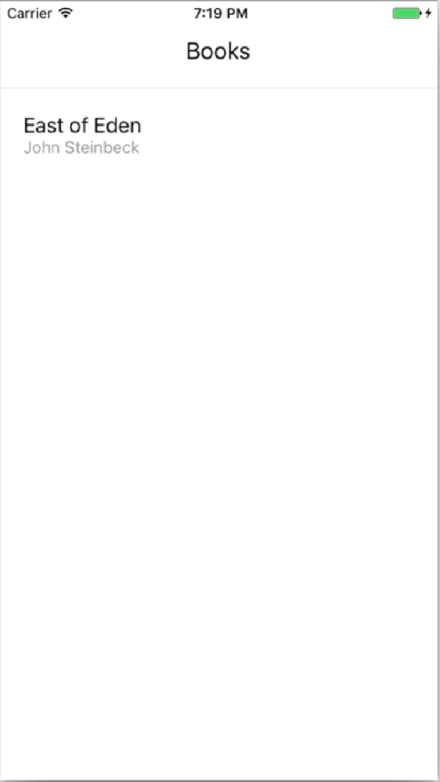
Figure 8.3 Rendering the list of books from the Redux store
Listing 8.4 Adding the provider and store
import React from 'react'
import Books from './src/Books'
①
import rootReducer from './src/reducers'
②
import { Provider } from 'react-redux'
③
import { createStore } from 'redux'
④
const store = createStore(rootReducer)
⑤
export default class App extends React.Component {
render() {
return (
<Provider store={store} >
⑥
<Books />
⑥
</Provider>
⑥
)
}
}
①
Imports the Books component (created in listing 8.5)
②
Imports rootReducer
③
Imports the Provider wrapper from react-redux
④
Imports createStore
⑤
Creates a store, passing in the rootReducer
⑥
Returns the Books component wrapped in a Provider component, passing in the store as a prop to the Provider
The Provider wrapper is used to wrap the main component. Any child of Provider will have access to the Redux store. createStore is a utility from Redux that you use to create the Redux store by passing in the rootReducer. You’re finished with the basic Redux setup, and you can now access the Redux store in the app.
In the Books component, you’ll hook into the Redux store, pull out the books array, and map over the books, displaying them in the UI (figure 8.3). Because Books is a child of Provider, it can access anything in the Redux store.

8.6 Accessing data using the connect function
You access the Redux store from a child component by using the connect function from react-redux. The first argument to connect is a function that gives you access to the entire Redux state. You can then return an object with whatever pieces of the store you want access to.
connect is a curried function, meaning in the most basic sense a function that returns another function. You’ll have two sets of arguments, and a blueprint that looks something like this: connect(args)(args). The properties in the object returned from the first argument to connect are then made available to the component as props.
Let’s see what this means by looking at the connect function you’ll use in the Books.js component.
Listing 8.5 connect function in Books.js
connect(
(state) => {
①
return {
②
books: state.bookReducer.books
}
}
)(Books)
③
①
Function that gives the global Redux state object
②
Returns an object from this function
③
Passes in Books
The first argument to connect is a function that gives the global Redux state object as an argument. You can then reference this state object and have access to anything in the Redux state. You return an object from this function. Whatever keys are returned in the object become available as props in the component you’re wrapping: in this case, Books. You pass in Books as the only argument to the connect function’s second function call.
Often, you’ll separate this function and store it in a variable to make this easier to read:
const mapStateToProps = state => ({
books: state.bookReducer.books
})
In this connected component is a new property called this.props.books, which is the books array from bookReducer. Tie all this together, access the books array, and map over the books to display them in the UI, as shown in the following listing (Books.js).
Listing 8.6 Accessing the Redux store and bookReducer data
import React from 'react'
import {
Text,
View,
ScrollView,
StyleSheet
} from 'react-native'
import { connect } from 'react-redux'
①
class Books extends React.Component<{}> {
render() {
const { books } = this.props
②
return (
<View style={styles.container}>
<Text style={styles.title}>Books</Text>
<ScrollView
keyboardShouldPersistTaps='always'
style={styles.booksContainer}
>
{
books.map((book, index) => (
③
<View style={styles.book} key={index}>
③
<Text style={styles.name}>{book.name}</Text>
③
<Text style={styles.author}>{book.author}</Text>
③
</View>
③
))
③
}
</ScrollView>
</View>
)
}
}
const styles = StyleSheet.create({
container: {
flex: 1
},
booksContainer: {
borderTopWidth: 1,
borderTopColor: '#ddd',
flex: 1
},
title: {
paddingTop: 30,
paddingBottom: 20,
fontSize: 20,
textAlign: 'center'
},
book: {
padding: 20
},
name: {
fontSize: 18
},
author: {
fontSize: 14,
color: '#999'
}
})
const mapStateToProps = (state) => ({
④
books: state.bookReducer.books
④
})
④
export default connect(mapStateToProps)(Books)
⑤
①
Imports connect from react-redux
②
Because the books array was returned from the connect function (at the bottom of the code listing), you have access to it as props.
③
Maps over the array, displaying the name and author of each book
④
Takes the Redux state, and returns an object with a key containing the books array
⑤
Exports the connect function
You begin by importing connect from react-redux. In listing 8.5, you wrote the function returning the props inline. This listing separates it and names it mapStateToProps, following the convention of the Redux ecosystem. This naming convention makes a lot of sense, because you’re essentially mapping Redux state to component props. This function takes the Redux state as an argument and returns an object with one key containing the books array from bookReducer. Finally, you export the connect function, passing in mapStateToProps as the first argument to connect and Books as the only argument in the second set of arguments to connect.
After launching the application, you should see a basic list of books, as shown earlier in figure 8.3.

8.7 Adding actions
Now that you have access to the Redux state, a logical next step is to add some functionality that will allow you to add books to the books array Redux store. To do this, you’ll use actions. Actions are basically functions that return objects that send data to the store and update reducers; they’re the only way to change the store. Each action should contain a type property in order for reducers to be able to use them. Here are a couple of examples of actions:
function fetchBooks() {
return {
type: 'FETCH_BOOKS'
}
}
function addBook(book) {
return {
type: 'Add_BOOK',
book: book
}
}
Actions, when called using a Redux dispatch function, are sent to all reducers in the application as the second argument to the reducer. (We’ll cover how to attach the Redux dispatch function later in this chapter.) When the reducer receives the action, you check the action’s type property and update what the reducer returns based on whether the action is one that it’s listening for.
In this case, the only action you need for the next step is addBook, to add additional books to the array of books. In actions.js, create the following action.
Listing 8.7 Creating the first action
export const ADD_BOOK = 'ADD_BOOK'
①
export function addBook (book) {
②
return {
type: ADD_BOOK,
book
}
}
①
Creates and exports an ADD_BOOK constant for reuse in reducers
②
Creates the addBook function, which takes a single book object and returns an object containing a type and the passed-in book
Next, wire up bookReducer to use the addBook action.
Listing 8.8 Updating bookReducer to use the addBook action
import { ADD_BOOK } from '../actions'
①
const initialState = {
books: [{ name: 'East of Eden', author: 'John Steinbeck' }]
}
const bookReducer = (state = initialState, action) => {
②
switch(action.type) {
③
case ADD_BOOK:
return {
books: [
④
...state.books,
action.book
]
}
default:
⑤
return state
}
}
export default bookReducer
①
Imports the ADD_BOOK constant from the actions file
②
Adds a second argument to bookReducer: the action
③
Creates a switch statement that will switch on the action type
④
If the action type equals ADD_BOOK, returns a new books array
⑤
If the switch statement doesn’t hit, returns the existing state
In the listing, if the action type is equal to ADD_BOOK, you return a new books array containing all the previous items in the array. You do so by creating a new array, using the spread operator to add the contents of the existing books array to the new array, and adding to the array a new item that’s the book property of the action.
That’s all you need to do in the Redux configuration to get this working. The last step is to go into the UI and wire it all together. To get the user’s book info, you need to create a form. Figure 8.4 shows what the UI will look like.
This form has two inputs: one for the book name and one for the author name. It also has a submit button. When the user types into the form, you need to keep up with the values in the local state. You can then pass those values on to the action when the user clicks the submit button.
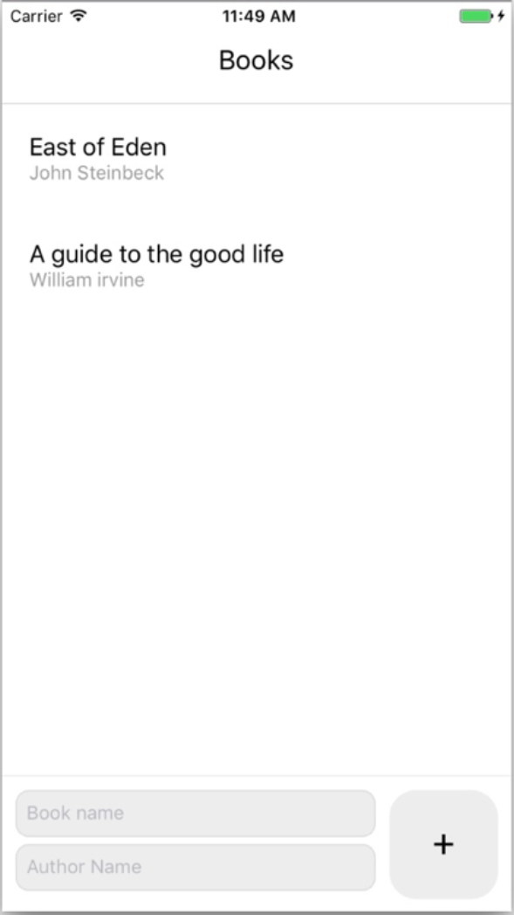
Figure 8.4 UI with added text inputs to capture the book and the author name
Open Books.js, and import the additional components needed for this functionality, as well as the addBook function from the actions. You’ll also create an initialState variable to use as the local component state.
Listing 8.9 Additional imports in Books.js
import React from 'react'
import {
Text,
View,
ScrollView,
StyleSheet,
TextInput,
①
TouchableOpacity
①
} from 'react-native'
import { addBook } from './actions'
②
import { connect } from 'react-redux'
const initialState = {
③
name: '',
③
author: ''
③
}
...
①
Imports TextInput and TouchableOpacity
②
Imports the addBook function from the actions file
③
Creates an initialState object containing name and author fields
Next, in the body of the class, you need to create three things: the component state, a method that keeps up with the component state when the textInput values change, and a method that will send the action to Redux containing the book values (name and author) when the submit button is pressed. Before the render method, add the following code.
Listing 8.10 Adding state and class methods to Books.js
class Books extends React.Component {
state = initialState
①
updateInput = (key, value) => {
②
this.setState({
...this.state,
[key]: value
})
}
addBook = () => {
③
this.props.dispatchAddBook(this.state)
this.setState(initialState)
}
...
①
Gives the component state the value of the initialState variable
②
Creates an updateInput method that takes two arguments: key and value. You’ll update the state by using the spread operators to add the existing state key-value pairs to the new state and then adding the new key-value pair.
③
Calls dispatchAddBook, accessible as props from the connect function
The addBook method calls a function that you have access to as props from the connect function: dispatchAddBook. This function accepts the entire state as an argument, which is an object with name and author properties. After the dispatch action has been called, you then clear the component state by resetting it to the initialState value.
With the functionality in place, you can create the UI and hook these methods up to it. Under the closing tag of the ScrollView in Books.js, add the form UI.
Listing 8.11 Adding the UI for the form
class Books extends React.Component {
...
render() {
...
</ScrollView>
<View style={styles.inputContainer}>
<View style={styles.inputWrapper}>
<TextInput
①
value={this.state.name}
onChangeText={value => this.updateInput('name', value)}
style={styles.input}
placeholder='Book name'
/>
<TextInput
①
value={this.state.author}
onChangeText={value => this.updateInput('author', value)}
style={styles.input}
placeholder='Author Name'
/>
</View>
<TouchableOpacity onPress={this.addBook}>
②
<View style={styles.addButtonContainer}>
<Text style={styles.addButton}>+</Text>
</View>
</TouchableOpacity>
</View>
</View>
}
}
const styles = StyleSheet.create({
inputContainer: {
③
padding: 10,
backgroundColor: '#ffffff',
borderTopColor: '#ededed',
borderTopWidth: 1,
flexDirection: 'row',
height: 100
},
inputWrapper: {
flex: 1
},
input: {
height: 44,
padding: 7,
backgroundColor: '#ededed',
borderColor: '#ddd',
borderWidth: 1,
borderRadius: 10,
flex: 1,
marginBottom: 5
},
addButton: {
fontSize: 28,
lineHeight: 28
},
addButtonContainer: {
width: 80,
height: 80,
backgroundColor: '#ededed',
marginLeft: 10,
justifyContent: 'center',
alignItems: 'center',
borderRadius: 20
},
...
}
const mapDispatchToProps = {
④
dispatchAddBook: (book) => addBook(book)
}
export default connect(mapStateToProps, mapDispatchToProps)(Books)
⑤
}
①
Receives the updateInput method as the property of onChangeText, passing ‘name’ or ‘author’ as the first argument and the value of TextInput as the second argument
②
Calls the addBook method. TouchableOpacity wraps the View component, allowing it to respond properly to touches.
③
Adds new styles
④
Creates a mapDispatchToProps object
⑤
Passes in mapDispatchToProps as the second argument to connect
In the mapDispatchToProps object, you can declare functions you want access to as props in the component. You create a new function called dispatchAddBook and have it call the addBook action, passing in book as an argument. Similar to how mapStateToProps maps state to component props, mapDispatchToProps maps actions (that need to be dispatched to reducers) to component props. In order for an action to be recognized by the Redux reducers, it must be declared in this mapDispatchToProps object. You pass in mapDispatchToProps as the second argument to the connect function.
Now you should be able to easily add books to the book list.

8.8 Deleting items from a Redux store in a reducer
The next logical step is to add a way to remove books you’ve already read. Given everything you’ve put together, this won’t require too much more work (figure 8.5).
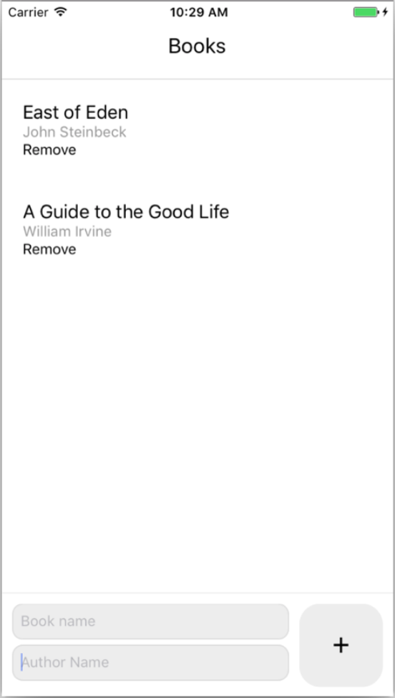
Figure 8.5 Adding the Remove button to the Books.js UI
The first thing to think about when removing an item from an array such as this is how to identify a book as being unique. Right now, a user could have multiple books with the same author or multiple books with the same name, so using the existing properties won’t work. Instead, you can use a library such as uuid to create unique identifiers on the fly. To begin setting this up, from the command line, install the uuid library into node_modules:
npm i uuid --save
Next, you’ll implement a unique identifier in the reducer for the items in the initialState books array. In reducers/bookReducer.js, update the imports and initialState to look like the next listing.
Listing 8.12 Importing and using uuid
import uuidV4 from 'uuid/v4'
①
import { ADD_BOOK } from '../actions'
const initialState = {
②
books: [{ name: 'East of Eden', author: 'John Steinbeck', id: uuidV4() }]
}
①
Imports the v4 algorithm
②
Adds an id property to initialState and generates a new unique identifier
The uuid library has a few algorithms to choose from. Here, you import only the v4 algorithm, which creates a random 32-character string. Then you add a new property to the initialState books array, id, and generate a new unique identifier by calling uuidV4().
Now that you have a way to uniquely identify the items in the books array, you’re ready to move forward with the rest of the functionality. The next step is to create a new action in actions.js; you’ll call it when you want to remove a book. You also need to update the addBook action to add an ID to newly created books.
Listing 8.13 Creating the removeBook action
export const ADD_BOOK = 'ADD_BOOK'
export const REMOVE_BOOK = 'REMOVE_BOOK'
①
import uuidV4 from 'uuid/v4'
②
export function addBook (book) {
return {
type: ADD_BOOK,
book: {
...book,
id: uuidV4()
③
}
}
}
export function removeBook (book) {
④
return {
type: REMOVE_BOOK,
book
}
}
①
Creates a reusable constant, REMOVE_BOOK, used here and in the reducer
②
Imports the uuid library
③
Adds a new key to the book, assigning id a property of a newly created unique identifier using the uuidV4 function
④
Creates a new removeBook function that returns an object with a type and the book parameter that’s passed in
Next, the reducer needs to be aware of the new action. In reducers/bookReducer.js, create a new type listener, this one for REMOVE_BOOK, and add the necessary functionality to remove a book from the array of books stored in the Redux state.
Listing 8.14 Removing an item from an array in a Redux reducer
import uuidV4 from 'uuid/v4'
import { ADD_BOOK, REMOVE_BOOK } from '../actions'
①
const initialState = {
books: [{ name: 'East of Eden', author: 'John Steinbeck', id: uuidV4() }]
}
const bookReducer = (state = initialState, action) => {
switch(action.type) {
...
case REMOVE_BOOK:
②
const index = state.books.findIndex(
book => book.id === action.book.id)
③
return {
books: [
④
...state.books.slice(0, index),
...state.books.slice(index + 1)
]
}
...
}
}
export default bookReducer
①
Imports the new REMOVE_BOOK constant from the actions folder
②
Adds a new case to the switch statement that listens for the REMOVE_BOOK action type
③
Finds the index of the book to be deleted
④
Returns a new array containing the first and second half of the existing books array, leaving out the index of the book to be removed
The last thing to do is implement this new removeBook functionality in the UI of the Books component (Books.js). You’ll import the removeBook action, add a remove button to each rendered item, and wire the remove button up to the removeBook action.
Listing 8.15 Adding removeBook functionality
...
import { addBook, removeBook } from './actions'
①
...
removeBook = (book) => {
②
this.props.dispatchRemoveBook(book)
②
}
...
{
books.map((book, index) => (
③
<View style={styles.book} key={index}>
③
<Text style={styles.name}>{book.name}</Text>
③
<Text style={styles.author}>{book.author}</Text>
③
<Text onPress={() => this.removeBook(book)}>
③
Remove
③
</Text>
③
</View>
③
))
}
...
const mapDispatchToProps = {
dispatchAddBook: (book) => addBook(book),
dispatchRemoveBook: (book) => removeBook(book)
④
}
...
①
Adds removeBook as an import from the actions file
②
Creates a new class method removeBook, calling this.props.dispatchRemoveBook as a new key in mapDispatchToProps
③
Returns a new Text component and attaches removeBook to its onPress event
④
Adds the new dispatchAddBook function to mapDispatchToProps

Summary
With context, you can pass properties and data to children in a React Native application without explicitly passing the properties to each individual child.
Reducers are similar to a traditional data store in the sense that they keep up with and return data, but also allow you to update data in the store.
You can create and use actions to update a Redux store.
With the connect function, you can access data from the Redux state as props and also create dispatch functions that interact with reducers using actions.
Any time data needs to be changed in a reducer, it must be done by using an action.

Part 3
API reference
R
eact Native offers a wealth of APIs. The chapters in this part cover cross-platform APIs as well as APIs that are specific to the iOS and Android platforms.
In chapter 9, we explore using React Native’s cross-platform APIs: APIs that can be used on either iOS or Android to create alerts; detect whether the app is in the foreground, is in the background, or is inactive; persist, retrieve, and remove data; store and update text to the device clipboard; and perform a number of other useful tasks. In chapters 10 and 11, we’ll look at React Native’s APIs that are specific to either the iOS platform or the Android platform.

9
Implementing cross-platform APIs
This chapter covers
Creating native application alert dialogs
Detecting whether the app is in the foreground, background, or inactive
Storing and updating text to the device clipboard
Using geolocation to retrieve and use latitude, longitude, speed, and altitude of the user’s device
Detecting device attributes such as the height and width of the screen and the connection type
One of the key benefits of using React Native is the ease with which native APIs can be accessed and used with JavaScript. In this chapter, we’ll cover most of the cross-platform APIs available in the framework. When accessing these APIs, you’ll be able to use a single codebase to implement platform-specific behavior on both iOS and Android.
The main difference between the native APIs discussed in this chapter and native components is that native components usually have something to do with the UI, such as showing a specific UI element. APIs, on the other hand, are more about accessing native features and hardware in the phone, such as interacting with or accessing data held in the device (geolocation, application state, and so on).
This chapter covers the following cross-platform APIs:
Alert
AppState
AsyncStorage
Clipboard
Dimensions
Geolocation
Keyboard
NetInfo
PanResponder
Although React Native offers other cross-platform APIs, you’ll find these to be the most useful.
In addition to its cross-platform APIs, React Native also offers platform-specific APIs (that is, APIs that work only on either iOS or Android). We’ll cover iOS-specific APIs in chapter 10 and Android-specific APIs in chapter 11.

Note You can find the code for this chapter at www.manning.com/books/react-native-in-action and also at https://github.com/dabit3/react-native-in-action/tree/chapter9.

9.1 Using the Alert API to create cross-platform notifications
Alert launches a platform-specific alert dialog with a title, a message, and optional methods that can be called when an alert button is pressed. Alert can be triggered by calling the alert method (Alert.alert), which takes four arguments (see table 9.1):
Alert.alert(title, message, buttons, options)
Table 9.1 Alert.alert method arguments
Argument | Type | Description
title | String | Main message of the alert button
message | String | Secondary message of the alert button
buttons | Array | Array of buttons, each of which is an object with two keys: title (string) and onPress (function)
options | Object | Object containing a cancelable Boolean (options: { cancelable: true } )

9.1.1 Use cases for alerts
An alert is a common UI pattern across both the web and mobile devices, and it’s an easy way to let the user know about something happening in the application such as an error or success. Many times, an alert is used if a download has finished, an error has occurred, or an asynchronous process (such as logging in) has completed.

9.1.2 Example of using alerts
You can trigger an alert by calling the Alert.alert() method and passing in one or more arguments. In this example, you’ll create an alert with two options: Cancel and Show Message (see figure 9.1). If cancel is pressed, you’ll dismiss the alert; if Show Message is pressed, you’ll update the state to show the message.
Listing 9.1 Binding an alert to a touch event
import React, { Component } from 'react'
import { TouchableHighlight, View, Text, StyleSheet, Alert }
from 'react-native'
①
let styles = {}
export default class App extends Component {
constructor () {
super()
this.state = {
②
showMessage: false
②
}
this.showAlert = this.showAlert.bind(this)
}
showAlert () {
③
Alert.alert(
'Title',
'Message!',
[
{
text: 'Cancel',
onPress: () => console.log('Dismiss called...'),
style: 'destructive'
},
{
text: 'Show Message',
④
onPress: () => this.setState({ showMessage: true })
④
}
]
)
}
render () {
const { showMessage } = this.state
return (
<View style={styles.container}>
<TouchableHighlight onPress={this.showAlert} style={styles.button}>
<Text>SHOW ALERT</Text>
</TouchableHighlight>
{
⑤
showMessage && <Text>Showing message - success</Text>
⑤
}
⑤
</View>
)
}
}
styles = StyleSheet.create({
container: {
justifyContent: 'center',
flex: 1
},
button: {
height: 70,
justifyContent: 'center',
alignItems: 'center',
backgroundColor: '#ededed'
}
})
①
Imports alert from React Native
②
Instantiates the state with showMessage set to false
③
Defines the showAlert method, passing in a title of ‘Title’, a message of ‘Message!’, and two buttons
④
If Show Message is pressed, updates the state to showMessage being true
⑤
Hides the message unless showMessage is set to true
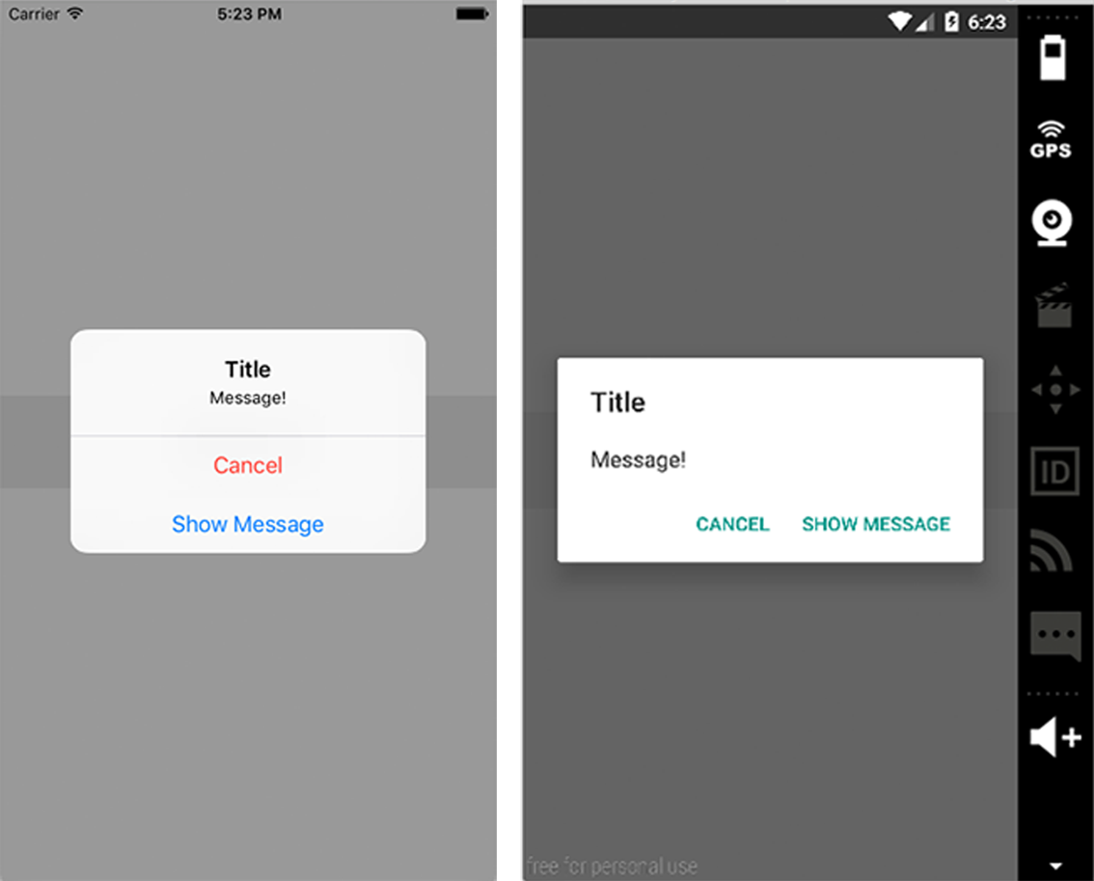
Figure 9.1 onPress alert with two options: Cancel and Show Message (left: iOS, right: Android)

9.2 Using the AppState API to detect the current application state
AppState will tell you whether the app is active, inactive, or in the background. It basically calls a method whenever the app state changes, allowing you to perform actions or call other methods based on the state of the app.
AppState triggers whenever the app state changes and then returns active, inactive, or background. To respond to app state changes, add an event listener and call a method when the event is fired. The events that AppState uses to respond are change and memorywarning. This section’s example uses change because it’s what you’ll primarily use in a real-world scenario.

9.2.1 Use cases for AppState
AppState is a useful API, and frequently comes in handy. Many times, when the app is pulled into the foreground, you may want to do things such as fetch fresh data from your API—and that’s a great use case for AppState.
Another use case is authentication. When the app is set into the foreground, you may want to add another layer of security, such as a PIN or fingerprint.
If you’re doing polling, such as hitting a database every 15 seconds or so to check for new data, you may want to disable the polling when the user pushes the app into the background. AppState is a great use case for this as well.

9.2.2 Example of using AppState
In this example, you’ll add an event listener that listens for the change event in componentDidMount and then displays the current state in the console.
Listing 9.2 Using AppState to log out the current app state
import React, { Component } from 'react'
import { AppState, View, Text, StyleSheet } from 'react-native'
①
let styles = {}
class App extends Component {
componentDidMount () {
②
AppState.addEventListener('change', this.handleAppStateChange)
②
}
handleAppStateChange (currentAppState) {
③
console.log('currentAppState:', currentAppState)
}
render () {
return (
<View style={styles.container}>
<Text>Testing App State</Text>
</View>
)
}
}
styles = StyleSheet.create({
container: {
justifyContent: 'center',
flex: 1
}
})
export default App
①
Imports the AppState API from React Native
②
Calls AppState.addEventListener, passing in the type of event to listen for (change) and a callback function (handleAppStateChange)
③
Logs the currentAppState
Run the project, and test it by either pressing CMD-Shift-H in iOS Simulator or pressing the home button in the Android emulator. The console should log the current app state (active, inactive, or background).

9.3 Using the AsyncStorage API to persist data
Next up is AsyncStorage. AsyncStorage is a great way to persist and store data: it’s asynchronous, meaning you can retrieve data using a promise or async await, and it uses a key-value system to store and retrieve data.
When you use an application and then close it, its state will be reset the next time you open it. One of the main benefits of AsyncStorage is that it lets you store the data directly to the user’s device and retrieve it whenever you need it!
AsyncStorage’s methods and arguments are listed in table 9.2.
Table 9.2 AsyncStorage methods and arguments
Method | Arguments | Description
setItem | key, value, callback | Stores an item in AsyncStorage
getItem | key, callback | Retrieves an item from AsyncStorage
removeItem | key, callback | Removes an item from AsyncStorage
mergeItem | key, value, callback | Merges an existing value with another existing value (both values must be stringified JSON)
clear | callback | Erases all values in AsyncStorage
getAllKeys | callback | Gets all keys stored in your app
flushGetRequests | None | Flushes any pending requests
multiGet | [keys], callback | Allows you to get multiple values using an array of keys
multiSet | [keyValuePairs], callback | Allows you to set multiple key-value pairs at once
multiRemove | [keys], callback | Allows you to delete multiple values using an array of keys
multiMerge | [keyValuePairs], callback | Allows you to merge multiple key-value pairs into one method

9.3.1 Use cases for AsyncStorage
AsyncStorage is often used for authentication purposes, persisting user data and information that you don’t want lost when the application is closed. For example, when a user logs in and you get their name, user ID, avatar, and so on from the API, you don’t want to force that user to log in every time they open the app. You can save their information to AsyncStorage when they log in the first time, and from then on, use the original information and only update it when necessary.
Another use case is when you’re working with large data sets or slow APIs and don’t want to wait for them more than once. For example, if a data set takes a few seconds to retrieve, you may want to cache that data in AsyncStorage, show it to the user when they open the app, and refresh the data in a background process so the user doesn’t have to wait to begin interacting with the data or the UI.

9.3.2 Example of using AsyncStorage
In this example, you’ll take a user object and store it into the AsyncStorage in componentDidMount. You’ll then use a button to extract the data from AsyncStorage, populate the state with the data, and render it to the view.
Listing 9.3 Persisting and retrieving data using AsyncStorage
import React, { Component } from 'react'
import { TouchableHighlight, AsyncStorage, View,
Text, StyleSheet } from 'react-native'
①
let styles = {}
const person = {
②
name: 'James Garfield',
age: 50,
occupation: 'President of the United States'
}
const key = 'president'
③
export default class App extends Component {
constructor () {
super()
this.state = {
person: {}
④
}
this.getPerson= this.getPerson.bind(this)
}
componentDidMount () {
AsyncStorage.setItem(key, JSON.stringify(person))
⑤
.then(() => console.log('item stored...'))
.catch((err) => console.log('err: ', err))
}
getPerson () {
⑥
AsyncStorage.getItem(key)
⑦
.then((res) => this.setState({ person: JSON.parse(res) }))
⑧
.catch((err) => console.log('err: ', err))
}
render () {
const { person } = this.state
return (
<View style={styles.container}>
<Text style={{textAlign: 'center'}}>Testing AsyncStorage</Text>
<TouchableHighlight onPress={this.getPerson}
style={styles.button}>
⑨
<Text>Get President</Text>
</TouchableHighlight>
<Text>{person.name}</Text>
<Text>{person.age}</Text>
<Text>{person.occupation}</Text>
</View>
)
}
}
styles = StyleSheet.create({
container: {
justifyContent: 'center',
flex: 1,
margin: 20
},
button: {
justifyContent: 'center',
marginTop: 20,
marginBottom: 20,
alignItems: 'center',
height: 55,
backgroundColor: '#dddddd'
}
})
①
Imports AsyncStorage from React Native
②
Creates a person object and stores the information in it
③
Creates a key you’ll use to add and remove data from AsyncStorage
④
Creates a person object in the state
⑤
Calls AsyncStorage.setItem, passing in the key as well as the person. Calls JSON.stringify because the value stored in AsyncStorage needs to be a string; JSON.stringify turns objects and arrays into strings.
⑥
Creates the getPerson method
⑦
Calls AsyncStorage.getItem, passing in the key created earlier. You receive a callback function with the data retrieved from AsyncStorage.
⑧
Calls JSON.parse, which turns the returned data back into a JavaScript object; and populates the state
⑨
Wires up getPerson to a TouchableHighlight in the view. When the TouchableHighlight is pressed, the data from AsyncStorage is rendered to the View.
As you can see, promises are used to set and return the values from AsyncStorage. There’s also another way to do this: let’s look at async await.
Listing 9.4 Using async await to fetch data asynchronously
async componentDidMount () {
try {
await AsyncStorage.setItem(key, JSON.stringify(person))
console.log('item stored')
} catch (err) {
console.log('err:', err)
}
}
async getPerson () {
try {
var data = await AsyncStorage.getItem(key)
var person = await data
this.setState({ person: JSON.parse(person) })
} catch (err) {
console.log('err: ', err)
}
}
async await first requires you to mark the function as async by adding the async keyword before the function name. You’re then able to use the await keyword to wait for the returned value of a function, allowing you to write promise-based code as if it were synchronous. When you await a promise, the function waits until the promise settles, but it does so in a nonblocking way; it then assigns the value to the variable.

9.4 Using the Clipboard API to copy text into the user’s clipboard
Clipboard lets you save and retrieve content from the clipboard on both iOS and Android. Clipboard has two methods: getString() and setString() (see table 9.3).
Table 9.3 Clipboard methods
Method | Arguments | Description
getString | None | Gets the contents of the clipboard
setString | content | Sets the contents of the clipboard

9.4.1 Use cases for Clipboard
The most common use case for Clipboard is when a user needs to copy a string of text. Rather than have to remember it, the user can copy it to the clipboard using Clipboard and then paste it anywhere they want to use the information!

9.4.2 Example of using Clipboard
In this example, you’ll set an initial clipboard value of “Hello World” in componentDidMount and then use a method attached to a TextInput to update the clipboard. You’ll add a button that pushes the current ClipboardValue to an array and renders it to the View.
Listing 9.5 Saving and replacing clipboard content
import React, { Component } from 'react'
import { TextInput, Clipboard, TouchableHighlight, View,
Text, StyleSheet } from 'react-native'
①
let styles = {}
export default class App extends Component {
constructor() {
super()
this.state = {
clipboardData: []
②
}
this.pushClipboardToArray = this.pushClipboardToArray.bind(this)
}
componentDidMount () {
Clipboard.setString('Hello World! ');
③
}
updateClipboard (string) {
Clipboard.setString(string);
④
}
async pushClipboardToArray() {
⑤
const { clipboardData } = this.state
var content = await Clipboard.getString();
⑥
clipboardData.push(content)
⑦
this.setState({clipboardData})
⑧
}
render () {
const { clipboardData } = this.state
return (
<View style={styles.container}>
<Text style={{textAlign: 'center'}}>Testing Clipboard</Text>
<TextInput style={styles.input}
onChangeText={
(text) => this.updateClipboard(text)
} />
⑨
<TouchableHighlight onPress={this.pushClipboardToArray}
style={styles.button}>
⑩
<Text>Click to Add to Array</Text>
</TouchableHighlight>
{
clipboardData.map((d, i) => {
⑪
return <Text key={i}>{d}</Text>
})
}
</View>
)
}
}
styles = StyleSheet.create({
container: {
justifyContent: 'center',
flex: 1,
margin: 20
},
input: {
padding: 10,
marginTop: 15,
height: 60,
backgroundColor: '#dddddd'
},
button: {
backgroundColor: '#dddddd',
justifyContent: 'center',
alignItems: 'center',
height: 60,
marginTop: 15,
}
})
①
Imports Clipboard from React Native
②
Sets an empty array called clipboardData in the state
③
Updates the Clipboard value to “Hello World”
④
Adds an updateClipboard method that will replace the existing slipboard value
⑤
Adds an async method pushClipboardToArray, using the async await syntax from listing 9.4
⑥
Stores the clipboard value in a variable named content
⑦
Pushes to the clipboardData array
⑧
Resets the array’s state
⑨
Attaches the TextInput with the updateClipboard method
⑩
Attaches the pushClipboardToArray method to be called when the TouchableHighlight is pressed
⑪
Maps through the items in the clipboardData array and renders them to the screen

9.5 Using the Dimensions API to get the user’s screen information
Dimensions gives you a way to get the device screen’s height and width. This is a good way to perform calculations based on the screen’s dimensions.

9.5.1 Use cases for the Dimensions API
Many times, you want to know the exact dimensions of the user’s device, in order to create the perfect UI. When creating a global theme, having the width and the height to set global variables (such as font sizes) is a great way to provide consistent styling across your app, regardless of device size. Using the width of the device to make consistent grid elements is another easy way to create a consistent experience. Bottom line: whenever you need the device screen’s height and width, use Dimensions.

9.5.2 Example of using the Dimensions API
To use Dimensions, import the API from React Native, and then call the get() method, passing in either window or screen as a parameter. Return width, height, or both.
Listing 9.6 Using Dimensions to retrieve the width and height of the device
import React, { Component } from 'react'
import { View, Text, Dimensions, StyleSheet } from 'react-native'
①
let styles = {}
const { width, height } = Dimensions.get('window')
②
const windowWidth = Dimensions.get('window').width
③
const App = () => (
<View style={styles.container}>
④
<Text>{width}</Text>
<Text>{height}</Text>
<Text>{windowWidth}</Text>
</View>
)
styles = StyleSheet.create({
container: {
flex: 1,
justifyContent: 'center',
alignItems: 'center'
}
})
①
Imports Dimensions from React Native
②
Destructures the width and height
③
Accesses the width object property directly
④
In the View, render the dimensions that were stored in the variables you retrieved off the Dimensions.get method.
One way to access the dimensions is to destructure what’s returned from calling Dimensions.get on the window, in this case width and height. You can also get the scale of the window. Another way is to call Dimensions.get and access the object property directly, calling .width on Dimensions.get.

9.6 Using the Geolocation API to get the user’s current location information
Geolocation is achieved in React Native using the same API used in the browser, with the navigator.geolocation global variable available anywhere in the app. You don’t need to import anything to begin using this, because it’s again available as a global.

9.6.1 Use cases for the Geolocation API
If you’re building an application that requires the user’s latitude and longitude, then you’ll need to use geolocation. react-native-maps, the map component that was created and open sourced by Airbnb, is a great use case for geolocation. Many times you’ll want to have the map load to the user’s current location; to do that, you have to pass in the correct coordinates. Use Geolocation to get those coordinates.

9.6.2 Example of using Geolocation
To get started with Geolocation, you must enable it to be used in the app if you’re developing for Android (iOS is enabled by default):
<uses-permission android:name="android.permission.ACCESS_FINE_LOCATION" />
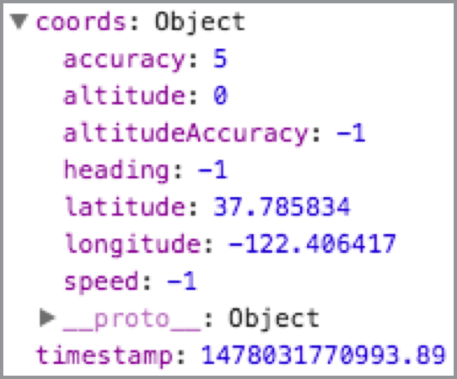
Figure 9.2 Coordinates object returned from Geolocation
Table 9.4 lists the available methods.
Table 9.4 Geolocation methods
Method | Arguments | Description
getCurrentPosition | successcallback, errcallback, optionsobject{enableHighAccuracy: Boolean, timeout: number, maximumAge: number} | Gets the current position. Success returns an object with a coords object and a timestamp.
watchPosition | successcallback, errcallback, optionsobject{enableHighAccuracy: Boolean, timeout: number, maximumAge: number} | Gets the current position and is automatically called when the device position changes.
clearWatch | watchId | Cancels a watch. Store the watchPosition method in a variable when created to have access to the watchId.
stopObserving | None | Cancels all geolocation watches that have been set up.
getCurrentPosition and watchPosition return coordinates as an object with information about the current user’s location (see figure 9.2). The information returned contains not only the latitude and longitude, but also the speed and altitude as well as a few other data points.
To see this in action, you’ll set up an instance of Geolocation getCurrentPosition and watchPosition. You’ll also have a button to call clearWatch, which will clear the watch position functionality enabled by the call to watchPosition.
watchPosition will only change if you physically change the coordinates. For example, if you run this on a device and walk around, you should see the coordinates update. This watch can be cancelled at any time by calling navigator.geolocation.clearWatch(id), passing in the ID of the watch you want to cancel. You’ll then display both the original coordinates as well as the updated coordinates (latitude and longitude).
Listing 9.7 Retrieving user coordinates using the Geolocation API
import React, { Component } from 'react'
import { TouchableHighlight, View, Text, StyleSheet } from 'react-native'
let styles = {}
export default class App extends Component {
constructor () {
super()
this.state = {
①
originalCoords: {},
①
updatedCoords: {},
①
id: ''
①
}
this.clearWatch = this.clearWatch.bind(this)
}
componentDidMount() {
navigator.geolocation.getCurrentPosition(
②
(success) => {
this.setState({originalCoords: success.coords})
③
},
(err) => console.log('err:', err)
)
let id = navigator.geolocation.watchPosition(
④
(success) => {
this.setState({
⑤
id,
⑤
updatedCoords: success.coords
})
},
(err) => console.log('err:', err)
)
}
clearWatch () {
⑥
navigator.geolocation.clearWatch(this.state.id)
}
render () {
const { originalCoords, updatedCoords } = this.state
return (
<View style={styles.container}>
⑦
<Text>Original Coordinates</Text>
⑦
<Text>Latitude: {originalCoords.latitude}</Text>
⑦
<Text>Longitude: {originalCoords.longitude}</Text>
⑦
<Text>Updated Coordinates</Text>
⑦
<Text>Latitude: {updatedCoords.latitude}</Text>
⑦
<Text>Longitude: {updatedCoords.longitude}</Text>
⑦
<TouchableHighlight
onPress={this.clearWatch}
style={styles.button}>
<Text>Clear Watch</Text>
</TouchableHighlight>
</View>
)
}
}
styles = StyleSheet.create({
container: {
flex: 1,
justifyContent: 'center',
padding: 20,
},
button: {
height: 60,
marginTop: 15,
backgroundColor: '#ededed',
justifyContent: 'center',
alignItems: 'center'
}
})
①
Creates an initial state with originalCoords and updatedCoords set as an empty object and id set as an empty string
②
Calls getCurrentPosition on navigator.geolocation
③
Sets the state of originalCoords to success.coords
④
Calls watchPosition, and stores the result of the function in a variable named id that you’ll use later to clear the watch
⑤
Resets the state with the id
⑥
Creates a clearWatch method to clear the watch
⑦
Displays the latitude and longitude from both the original coordinates as well as the updated coordinates

9.7 Using the Keyboard API to control the location and functionality of the native keyboard
The Keyboard API gives you access to the native keyboard. You can use this to either listen to keyboard events (and call methods based on these events) or dismiss the keyboard. The Keyboard methods are listed in table 9.5.
Table 9.5 Keyboard methods
Method | Arguments | Description
addListener | event, callback | Connects a method to be called based on native keyboard events such as keyboardWillShow, keyboardDidShow, keyboardWillHide, keyboardDidHide, keyboardWillChangeFrame, and keyboardDidChangeFrame
removeAllListeners | eventType | Removes all listeners of the type specified
dismiss | None | Dismisses the keyboard

9.7.1 Use cases for the Keyboard API
Many times, the default behavior of text inputs and the keyboard is exactly what you want, but not always. If you simulate a text input using some other type of component, the keyboard won’t slide up. In this case, you can import Keyboard and get manual and granular control over when the keyboard is shown and hidden.
In some cases, you may want to manually dismiss the keyboard even when the text input is in focus. For example, if a PIN number input accepts four numbers and automatically checks to see if the input value is correct on the last input value, you may want to provide a UI that fetches or checks after the last value is typed in. Hiding the keyboard may make sense, and you can achieve this using the Keyboard API.

9.7.2 Example of using the Keyboard API
In this example, you’ll set up a text input and have listeners for all available events. When the event is fired, you’ll log the event to the console. You’ll also have two buttons: one to dismiss the keyboard and another to remove all event listeners set up in componentWillMount.
Listing 9.8 Controlling the device keyboard using the Keyboard API
import React, { Component } from 'react'
import { TouchableHighlight, Keyboard, TextInput, View,
Text, StyleSheet } from 'react-native'
①
let styles = {}
export default class App extends Component {
componentWillMount () {
②
this.keyboardWillShowListener =
Keyboard.addListener('keyboardWillShow',
() => this.logEvent('keyboardWillShow'))
②
this.keyboardDidShowListener =
Keyboard.addListener('keyboardDidShow',
() => this.logEvent('keyboardDidShow'))
②
this.keyboardWillHideListener =
Keyboard.addListener('keyboardWillHide',
() => this.logEvent('keyboardWillHide'))
②
this.keyboardDidHideListener =
Keyboard.addListener('keyboardDidHide',
() => this.logEvent('keyboardDidHide'))
②
this.keyboardWillChangeFrameListener =
Keyboard.addListener('keyboardWillChangeFrame',
() => this.logEvent('keyboardWillChangeFrame'))
②
this.keyboardDidChangeFrameListener =
Keyboard.addListener('keyboardDidChangeFrame',
() => this.logEvent('keyboardDidChangeFrame'))
②
}
logEvent(event) {
③
console.log('event: ', event)
③
}
dismissKeyboard () {
④
Keyboard.dismiss()
④
}
removeListeners () {
⑤
Keyboard.removeAllListeners('keyboardWillShow')
⑤
Keyboard.removeAllListeners('keyboardDidShow')
⑤
Keyboard.removeAllListeners('keyboardWillHide')
⑤
Keyboard.removeAllListeners('keyboardDidHide')
⑤
Keyboard.removeAllListeners('keyboardWillChangeFrame')
⑤
Keyboard.removeAllListeners('keyboardDidChangeFrame')
⑤
}
render () {
return (
<View style={styles.container}>
<TextInput style={styles.input} />
<TouchableHighlight
⑥
onPress={this.dismissKeyboard}
⑥
style={styles.button}>
⑥
<Text>Dismiss Keyboard</Text>
⑥
</TouchableHighlight>
⑥
<TouchableHighlight
⑦
onPress={this.removeListeners}
⑦
style={styles.button}>
⑦
<Text>Remove Listeners</Text>
⑦
</TouchableHighlight>
⑦
</View>
)
}
}
styles = StyleSheet.create({
container: {
flex: 1,
marginTop: 150,
},
input: {
margin: 10,
backgroundColor: '#ededed',
height: 50,
padding: 10
},
button: {
height: 50,
backgroundColor: '#dddddd',
margin: 10,
justifyContent: 'center',
alignItems: 'center'
}
})
①
Imports the Keyboard API from React Native
②
Sets up event listeners for all available keyboard events, and then calls the logEvent method to log out the event name
③
Takes in the event name, and logs out the name of the event
④
Dismisses the keyboard if it’s in view
⑤
Calls Keyboard.removeAllListeners, passing in each of the listeners declared in componentWillMount
⑥
Wires up the dismissKeyboard method to a button in the UI
⑦
Wires up the removeListeners method to a button in the UI

9.8 Using NetInfo to get the user’s current online/offline status
NetInfo is an API that allows you to access data describing whether the device is online or offline. In order to use the NetInfo API on Android, you need to add the required permission to AndroidManifest.xml:
<uses-permission android:name="android.permission.ACCESS_NETWORK_STATE"/>
iOS and Android have different connectivity types, listed in table 9.6. Access to them depends on the actual connectivity type of the user’s connection. To determine the connection, you can use the methods in table 9.7.
Table 9.6 Cross platform and Android specific connectivity types
Cross platform (iOS and Android) | Android
none | bluetooth
wifi | ethernet
cellular | wimax
unknown
Table 9.7 NetInfo methods
Method | Arguments | Description
isConnectionExpensive | None | Returns a promise that returns a Boolean specifying whether the connection is or isn’t expensive
isConnected | None | Returns a promise that returns a Boolean specifying whether the device is or isn’t connected
addEventListener | eventName, callback | Adds an event listener for the specified event
removeEventListener | eventName, callback | Removes an event listener for the specified event
getConnectionInfo | None | Returns a promise that returns an object with type and effectiveType.

9.8.1 Use cases for NetInfo
NetInfo is often used to prevent other API calls from happening, or to provide an offline UI that provides some but not all features of an online application. For example, suppose you have a feed of items that, when pressed, shows a new view with fetched information about that item. You can show some indication of the application being offline and not navigate to the item detail when the device is offline. NetInfo will give you this type of device information, allowing you to interact with the user in a useful way.
Another use case is to set different API configurations based on the type of connection. For example, on Wi-Fi you may want to be more generous about the amount of data you allow to be requested and sent: if the user is on a cellular network, you may fetch only 10 items at a time; but on Wi-Fi, you’ll bump that to 20. With NetInfo, you can determine what type of connection the user has, if any.

9.8.2 Example of using NetInfo
Let’s set up a NetInfo.getConnectionInfo method to get the initial connection information. Then you’ll set up a listener to log out the current NetInfo if and when it changes.
Listing 9.9 Fetching and displaying the user connection type using NetInfo
import React, { Component } from 'react'
import { NetInfo, View, Text, StyleSheet } from 'react-native'
①
class App extends Component {
constructor () {
super()
this.state = {
②
connectionInfo: {}
②
}
this.handleConnectivityChange =
this.handleConnectivityChange.bind(this)
}
componentDidMount () {
NetInfo.getConnectionInfo().then((connectionInfo) => {
③
console.log('type: ' + connectionInfo.type +
', effectiveType: ' + connectionInfo.effectiveType)
③
this.setState({connectionInfo})
③
})
NetInfo.addEventListener('connectionChange',
this.handleConnectivityChange)
④
}
handleConnectivityChange (connectionInfo) {
⑤
console.log('new connection:', connectionInfo)
⑤
this.setState({connectionInfo})
⑤
}
render () {
return (
<View style={styles.container}>
<Text>{this.state.connectionInfo.type}</Text>
⑥
</View>
)
}
}
const styles = StyleSheet.create({
container: {
flex: 1,
justifyContent: 'center',
alignItems: 'center'
}
})
①
Imports NetInfo from React Native
②
Sets the initial state of connectionInfo to an empty object
③
Gets the initial connection type, and sets the state
④
Creates an event listener to call handleConnectivityChange when the connection changes
⑤
Updates the state with the new connection information
⑥
Renders the connection information to the view

9.9 Getting information about touch and gesture events with PanResponder
The PanResponder API offers a way to use data from touch events. With it, you can granularly respond to and manipulate the application state based on single and multiple touch events, such as swiping, tapping, pinching, scrolling, and more.

9.9.1 Use cases for the PanResponder API
Because the fundamental functionality of PanResponder is to determine the current touches happening on the user’s device, the use cases are unlimited. In my experience, I’ve used this API often to do things like the following:
Create a swipeable stack of cards where an item is removed from the stack when swiped out of view (think Tinder)
Create an animatable overlay that the user can close by clicking a button or move out of view by swiping down
Give the user the ability to rearrange items in a list by pressing part of a list item and moving to the desired location
The use cases for PanResponder are many, but the most apparent and frequently used let the user move items around in the UI based on their press/swipe position.
Let’s look at a basic gesture event using onPanResponderMove(event, gestureState), which gives you data about the current position of the touch event, including current position, accumulated difference between current position and original position, and more:
onPanResponderMove(evt, gestureState) {
console.log(evt.nativeEvent)
console.log(gestureState)
}
To use this API, you first create an instance of PanResponder in the componentWillMount method. In this instance, you can then set all the configuration and callback methods for the PanResponder, using the methods to manipulate the state and View.
Let’s look at the create method, which is the only available method for PanResponder. It creates the configuration for the PanResponder instance. Table 9.8 shows the configuration options available to the create method.
Table 9.8 Configuration arguments for the PanResponder create method
Configuration property | Description
onStartShouldSetPanResponder | Determines whether to enable the PanResponder. Gets called after the element is touched.
onMoveShouldSetPanResponder | Determines whether to enable the PanResponder. Gets called after the initial touch has first move.
onPanResponderReject | Gets called if the PanResponder does not register.
onPanResponderGrant | Gets called if the PanResponder does register.
onPanResponderStart | Gets called after the PanResponder registers.
onPanResponderEnd | Gets called after the PanResponder has finished.
onPanResponderMove | Gets called when the PanResponder moves.
onPanResponderTerminationRequest | Gets called when something else wants to become responder.
onPanResponderRelease | Gets called when the touch has been released.
onPanResponderTerminate | This responder has been taken by another one.
Each configuration option is supplied with the Native Event and Gesture State. Table 9.9 describes all the available properties of both evt.nativeEvent and gestureState.
Table 9.9 evt and gestureState properties
evt.nativeEvent properties | Description
changedTouches | Array of all touch events that have changed since the last event
identifier | ID of the touch
locationX | X position of the touch, relative to the element
locationY | Y position of the touch, relative to the element
pageX | X position of the touch, relative to the root element
pageY | Y position of the touch, relative to the root element
target | Node ID of the element receiving the touch event
timestamp | Time identifier for the touch; useful for velocity calculations
touches | Array of all current touches on the screen
gestureState properties | Description
stateID | ID of the gestureState, persisted as long as there is at least one touch on the screen
moveX | Latest screen coordinates of the recently moved touch
moveY | Latest screen coordinates of the recently moved touch
x0 | Screen coordinates of the responder
y0 | Screen coordinates of the responder
dx | Accumulated distance of the gesture since the touch started
dy | Accumulated distance of the gesture since the touch started
vx | Current velocity of the gesture
vy | Current velocity of the gesture
numberActiveTouches | Number of touches currently on screen

9.9.2 Example of using PanResponder
For this example, you’ll create a draggable square and display its x and y coordinates in the view. The result is shown in figure 9.3.
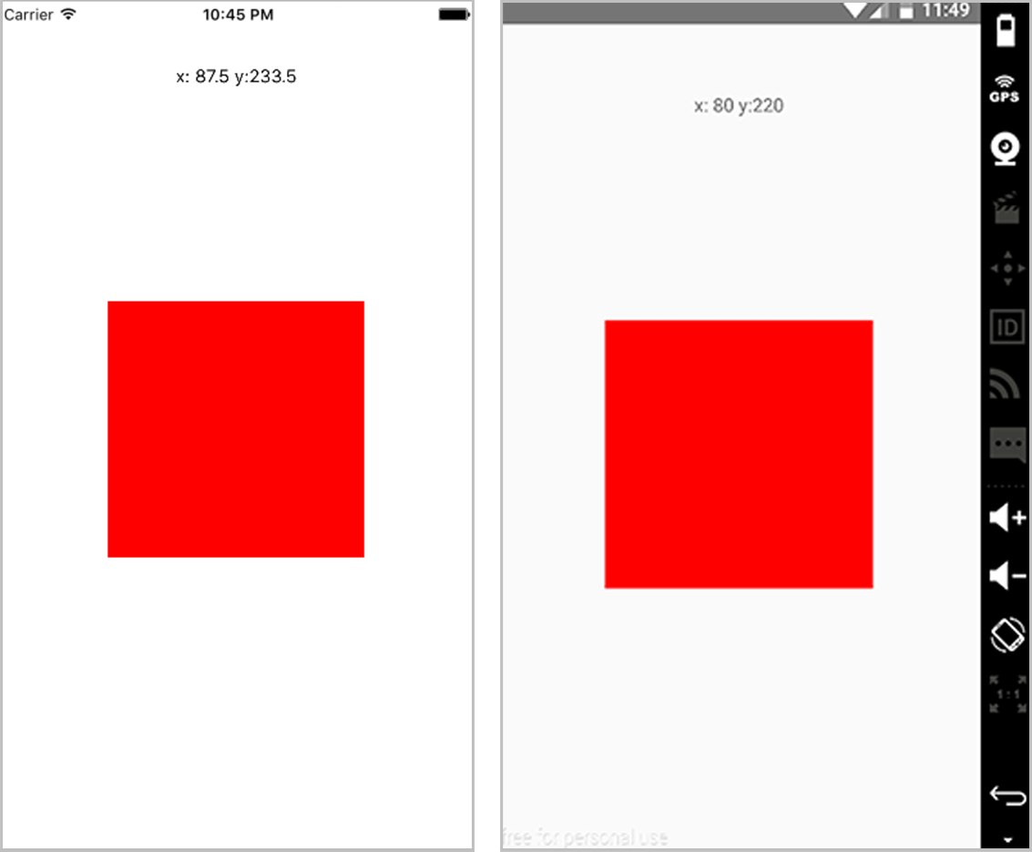
Figure 9.3 PanResponder used to make the square draggable
Listing 9.10 Using PanResponder to create a draggable element
import React, { Component } from 'react'
import { Dimensions, TouchableHighlight, PanResponder, TextInput,
View, Text, StyleSheet } from 'react-native'
①
const { width, height } = Dimensions.get('window')
②
let styles = {}
class App extends Component {
constructor () {
super()
this.state = {
oPosition: {
③
x: (width / 2) - 100,
y: (height / 2) - 100,
},
position: {
④
x: (width / 2) - 100,
y: (height / 2) - 100,
},
}
this._handlePanResponderMove = this._handlePanResponderMove.bind(this)
this._handlePanResponderRelease =
this._handlePanResponderRelease.bind(this)
}
componentWillMount () {
this._panResponder = PanResponder.create({
⑤
onStartShouldSetPanResponder: () => true,
⑤
onPanResponderMove: this._handlePanResponderMove,
⑤
onPanResponderRelease: this._handlePanResponderRelease
⑤
})
}
_handlePanResponderMove (evt, gestureState) {
⑥
let ydiff = gestureState.y0 - gestureState.moveY
⑥
let xdiff = gestureState.x0 - gestureState.moveX
⑥
this.setState({
⑥
position: {
⑥
y: this.state.oPosition.y - ydiff,
⑥
x: this.state.oPosition.x - xdiff
⑥
}
})
}
_handlePanResponderRelease () {
⑦
this.setState({
⑦
oPosition: this.state.position
⑦
})
}
render () {
return (
<View style={styles.container}>
<Text style={styles.positionDisplay}>
x: {this.state.position.x} y:{this.state.position.y}
</Text>
⑧
<View
{...this._panResponder.panHandlers}
⑨
style={[styles.box,
{ marginLeft: this.state.position.x,
marginTop: this.state.position.y } ]}
/>
⑩
</View>
)
}
}
styles = StyleSheet.create({
container: {
flex: 1,
},
positionDisplay: {
textAlign: 'center',
marginTop: 50,
zIndex: 1,
position: 'absolute',
width
},
box: {
position: 'absolute',
width: 200,
height: 200,
backgroundColor: 'red'
}
})
①
Imports Dimensions, PanResponder, and everything else needed for this component
②
Stores the window width and height in variables for later use
③
Creates an object called oPosition to store the original square position x and y axes to center the square, and stores it into the state
④
Creates an object called position to store the actual square position x and y axes to center the square, and stores it into the state
⑤
Creates a new PanResponder, returning true for onStartShouldSetPanResponder, and setting up onPanResponderMove and onPanResponderRelease methods
⑥
Finds the total movement of x and y by calculating the difference between the location that the pan started and the current total of movement since the pan started. Updates the state position with these values.
⑦
Sets the state of oPosition with the updated position in the view
⑧
Displays the current position values in the view
⑨
Attaches the PanResponder to the view by passing in {...this._panResponder.panHandlers} as props
⑩
Attaches the position x and y values to the view to update the margins, making the item draggable

Summary
Alert gives you the ability to prompt or alert the user to important information or events in the app.
AppState provides information about whether the current app is in use. You can then use this information in the app in a useful way.
AsyncStorage lets you persist data to the user’s device, so that if the user closes the app, you can still access the data.
Clipboard copies information to the user’s device clipboard so they can access it later.
Dimensions provides useful information about the user’s device, most importantly the screen width and height.
Geolocation provides the location as well as other important information about the user’s device, and allows you to check the location data when the user moves.
NetInfo provides the user’s current connection information, including the type of connection and whether they’re currently connected.
PanResponder provides the current touch location(s) happening on the user’s device. You can use this information to enhance the UX and UI.

10
Implementing iOS-specific components and APIs
This chapter covers
Strategies for effectively targeting platform-specific code
Using the picker components, DatePickerIOS, and PickerIOS
Showing loading progress using ProgressViewIOS
Choosing views using SegmentedControlIOS and TabBarIOS
Calling and choosing items in an action sheet using ActionSheetIOS
One of the end goals of the React Native project is to have a minimal amount of platform-specific logic and code. Most APIs can be built so the platform-specific code is abstracted away by the framework, giving you a single way to interact with them and easily create cross-platform functionality.
Unfortunately, there will always be platform-specific APIs that can’t be completely abstracted away using an approach that makes sense cross-platform. Therefore, you’ll need to use at least a handful of platform-specific APIs and components. In this chapter, we cover iOS-specific APIs and components, discuss their props and methods, and create examples that mimic functionality and logic that will get you up to speed quickly.

10.1 Targeting platform-specific code
The main idea of platform-specific code is writing components and files in a way that renders iOS- or Android-specific code based on the platform you’re on. There are a few techniques that can be implemented to show components based on what platform the app is running, and we cover the two most useful of those techniques here: using the correct file extension, and using the Platform API.

10.1.1 iOS and Android file extensions
The first way to target platform-specific code is to name the file with the correct file extension, depending on the platform you wish to target. For example, one component that differs quite a bit between iOS and Android is DatePicker. If you want specific styling around DatePicker, writing all the code in the main component may become verbose and difficult to maintain. Instead, you create two files—DatePicker.ios.js and DatePicker.android.js—and import them into the main component. When you run the project, React Native will automatically choose the correct file and render it based on the platform you’re using. Let’s look at a basic example in listings 10.1, 10.2, and 10.3. (Note that this example will throw an error as is—DatePicker requires both props and methods to function correctly.)
Listing 10.1 iOS platform-specific code
import React from 'react'
import { View, Text, DatePickerIOS } from 'react-native'
export default () => (
<View>
<Text>This is an iOS specific component</Text>
<DatePickerIOS />
</View>
)
Listing 10.2 Android platform-specific code
import React from 'react'
import { View, Text, DatePickerAndroid } from 'react-native'
export default () => (
<View>
<Text>This is an Android specific component</Text>
<DatePickerAndroid />
</View>
)
Listing 10.3 Rendering the cross-platform component
import React from 'react'
import DatePicker from './DatePicker'
const MainComponent = () => (
<View>
...
<DatePicker />
...
</View>
)
You import the date picker without giving a specific file extension. React Native knows which component to import depending on the platform. From there, you can use it in the application without having to worry about which platform you’re on.

10.1.2 Detecting the platform using the Platform API
Another way to detect and perform logic based on the platform is to use the Platform API. Platform has two properties. The first is an OS key that reads either ios or android, depending on the platform.
Listing 10.4 Platform module detecting using Platform.OS property
import React from 'react'
import { View, Text, Platform } from 'react-native'
const PlatformExample = () => (
<Text
style={{ marginTop: 100, color: Platform.OS === 'ios' ? 'blue' : 'green' }}
>
Hello { Platform.OS }
</Text>
)
Here, you check whether the value of Platform.OS is equal to the string 'ios' and, if it is, return a color of 'blue'. If it isn’t, you return 'green'.
The second property of Platform is a method called select. select takes in an object containing the Platform.OS strings as keys (either ios or android) and returns the value for the platform you’re running.
Listing 10.5 Using Platform.select to render components based on Platform
import React from 'react'
import { View, Text, Platform } from 'react-native'
const ComponentIOS = () => (
<Text>Hello from IOS</Text>
)
const ComponentAndroid = () => (
<Text>Hello from Android</Text>
)
const Component = Platform.select({
ios: () => ComponentIOS,
android: () => ComponentAndroid,
})();
const PlatformExample = () => (
<View style={{ marginTop: 100 }}>
<Text>Hello from my App</Text>
<Component />
</View>
)
You can also use the ES2015 spread syntax to return objects and use those objects to apply styling. You may recall seeing the Platform.select function used in a couple of examples in chapter 4.
Listing 10.6 Using Platform.select to apply styles based on Platform
import React from 'react'
import { View, Text, Platform } from 'react-native'
let styles = {}
const PlatformExample = () => (
<View style={styles.container}>
<Text>
Hello { Platform.OS }
</Text>
</View>
)
styles = {
container: {
marginTop: 100,
...Platform.select({
ios: {
backgroundColor: 'red'
}
})
}
}

10.2 DatePickerIOS
DatePickerIOS provides an easy way to implement a native date picker component on iOS. It has three modes that come in handy when working with dates and times: date, time, and dateTime, shown in figure 10.1.
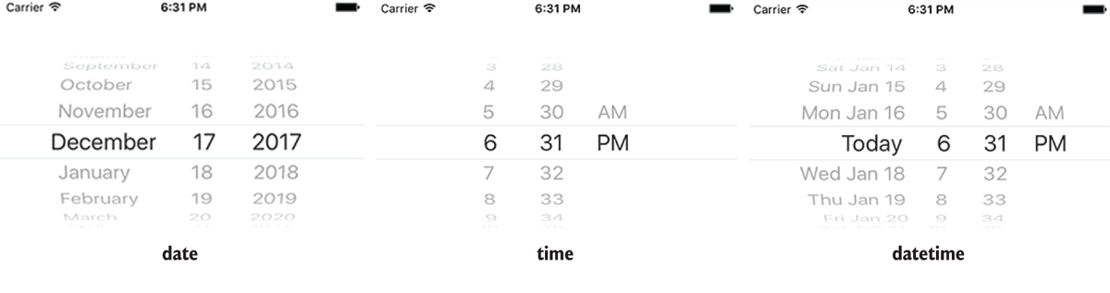
Figure 10.1 DatePickerIOS with date mode, time mode, and datetime mode
DatePickerIOS has the props listed in table 10.1. The minimum props that need to be passed are date (the date that’s the beginning or current date choice) and an onDateChange method. When any of the date values are changed, onDateChange is called, passing the function the new date value.
Table 10.1 DatePickerIOS props and method
Prop | Type | Description
date | Date | Currently selected date
maximumDate | Date | Maximum allowed date
minimumDate | Date | Minimum allowed date
minuteInterval | Enum | Interval at which minutes can be selected
mode | String: date, time, or datetime | Date picker mode
onDateChange | Function: onDateChange(date) { } | Function called when the date changes
timeZoneOffsetInMinutes | Number | Time zone offset in minutes; overrides the default (the device time zone)

10.2.1 Example of using DatePickerIOS
In the following example, you’ll set up a DatePickerIOS component and display the time in the view. You won’t pass in a mode prop, because the mode defaults to datetime. Figure 10.2 shows the result.
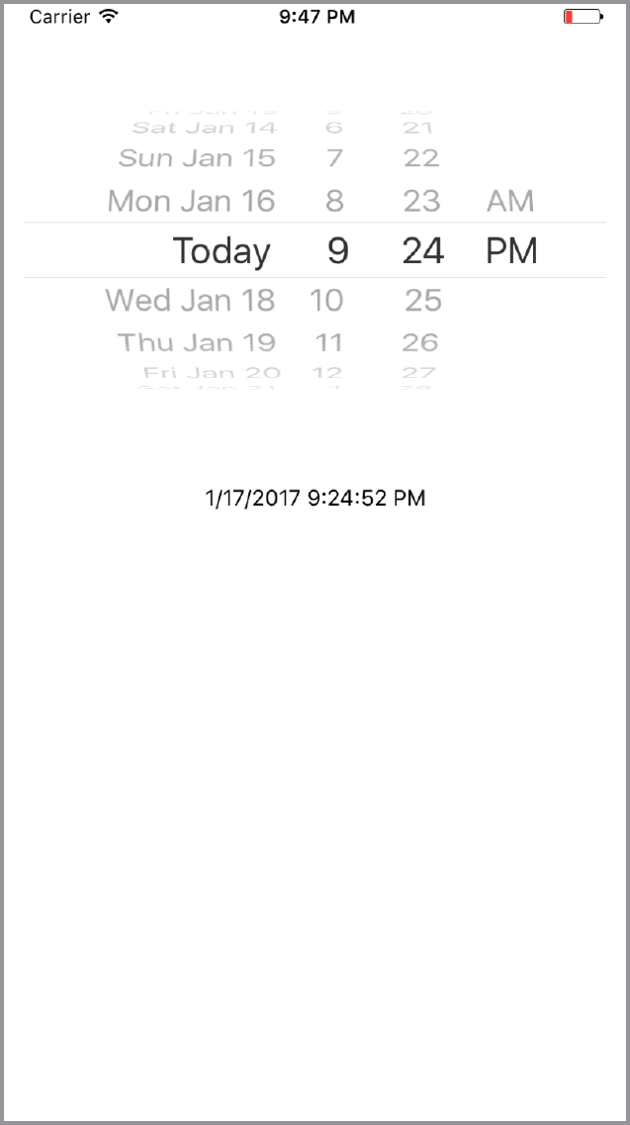
Figure 10.2 DatePickerIOS rendering chosen date and time
Listing 10.7 Using DatePicker to show and update time values
import React, { Component } from 'react'
import { Text, View, DatePickerIOS } from 'react-native'
①
class App extends Component {
constructor() {
super()
this.state = {
②
date: new Date(),
②
}
this.onDateChange = this.onDateChange.bind(this)
}
onDateChange(date) {
③
this.setState({date: date});
③
};
render() {
return (
<View style={{ marginTop: 50 }}>
<DatePickerIOS
④
date={this.state.date}
④
onDateChange={this.onDateChange}
④
/>
<Text style={{ marginTop: 40, textAlign: 'center' }}>
{ this.state.date.toLocaleDateString() } { this.state.date.toLocaleTimeString() }
⑤
</Text>
</View>)
}
}
①
Imports DatePickerIOS from React Native
②
Creates a date value, and stores it in the state
③
Creates a method called onDateChange that updates the state with the new date value
④
Returns the DatePickerIOS component, and passes in the date and onDateChange as props
⑤
Renders the date value as text

10.3 Using PickerIOS to work with lists of values
Using PickerIOS, you can access the native iOS Picker component. This component basically allows you to scroll through and choose from a list of values using the native UI (see figure 10.3). PickerIOS has the methods and props listed in table 10.2.
Table 10.2 PickerIOS methods and props
Prop | Type | Description
itemStyle | Object (style) | The text style for items within the container
onValueChange | Function (value) | Called when the PickerIOS value changes
selectedValue | Number or string | Currently selected PickerIOS value
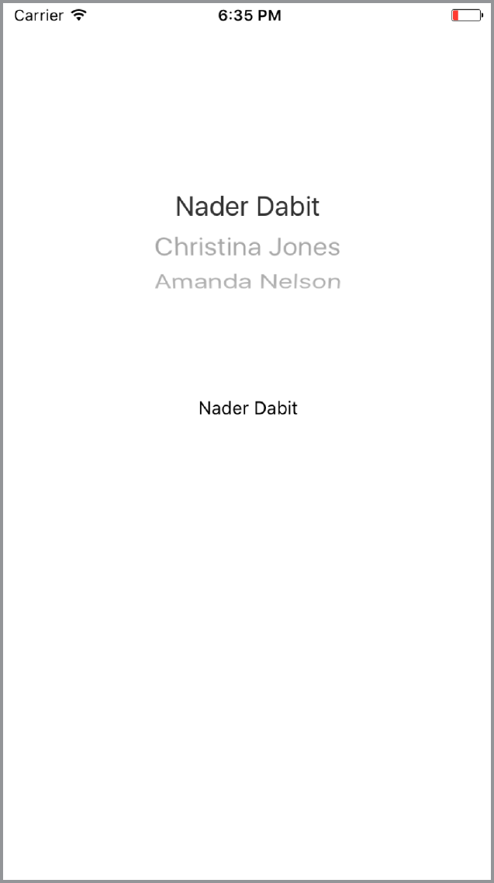
Figure 10.3 PickerIOS rendering a list of people
PickerIOS wraps a list of items to be rendered as children. Each child item must be a PickerIOS.Item:
import { PickerIOS } from 'react-native'
const PickerItem = PickerIOS.Item
<PickerIOS>
<PickerItem />
<PickerItem />
<PickerItem />
</PickerIOS>
It’s possible to declare each PickerIOS.Item individually as done here, but most of the time you’ll be mapping over elements in an array and returning a PickerIOS.Item for each item in the array. The following listing shows an example.
Listing 10.8 Using PickerIOS with an array of PickerIOS.Items
const people = [ #an array of people ];
render() {
<PickerIOS>
{
people.map((p, i) =>(
<PickerItem key={i} value={p} label={p}/>
))
}
<PickerIOS>
}
PickerIOS and PickerIOS.Item receive their own props. For PickerIOS, the main props are onValueChange and selectedValue. The onValueChange method is called whenever the picker is changed. The selectedValue is the value the picker shows as selected in the UI.
For PickerIOS.Item, the main props are key, value, and label. key is a unique identifier, value is what will be passed to the onValueChange method of the PickerIOS component, and label is what is displayed in the UI as the label for the PickerIOS.Item.

10.3.1 Example of using PickerIOS
In this example, you’ll render an array of people in the PickerIOS. When the value changes, you’ll update the UI to show the new value.
Listing 10.9 Using PickerIOS to render an array of people
import React, { Component } from 'react'
import { Text, View, PickerIOS } from 'react-native'
①
const people = [
②
{
name: 'Nader Dabit',
age: 36
},
{
name: 'Christina Jones',
age: 39
},
{
name: 'Amanda Nelson',
age: 22
}
];
const PickerItem = PickerIOS.Item
class App extends Component {
constructor() {
super()
this.state = {
③
value: 'Christina Jones'
③
}
③
this.onValueChange = this.onValueChange.bind(this)
③
}
onValueChange(value) {
④
this.setState({ value });
④
};
render() {
return (
<View style={{ marginTop: 50 }}>
<PickerIOS
⑤
onValueChange={this.onValueChange}
⑤
selectedValue={this.state.value}
⑤
>
⑤
{
people.map((p, i) => {
⑥
return (
<PickerItem
key={i}
value={p.name}
label={p.name}
/>
)
})
}
</PickerIOS>
<Text style={{ marginTop: 40, textAlign: 'center' }}>
{this.state.value}
⑦
</Text>
</View>)
}
}
①
Imports PickerIOS from React Native
②
Creates an array of people that’s used to populate the PickerItem values
③
Creates an initial value in the state to hold the chosen picker value
④
Creates an onValueChange method to update the state value with the new value from the PickerIOS
⑤
Renders the PickerIOS, passing onValueChange and selectedValue as props
⑥
Renders a PickerIOS.Item for every person in the people array
⑦
Renders the value of this.state.value in the UI

10.4 Using ProgressViewIOS to show loading indicators
ProgressViewIOS lets you render the native UIProgressView in the UI. Basically, it’s a native way to show a loading-percentage indication, download-percentage indication, or any indication of a task that’s being completed (see figure 10.4). It has the props shown in table 10.3.
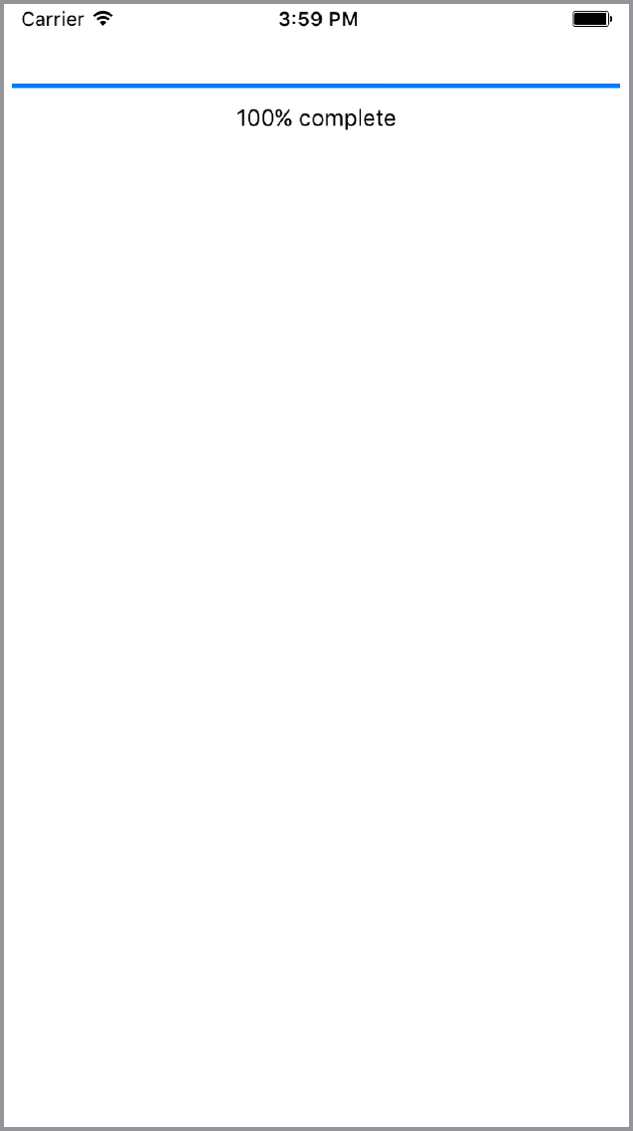
Figure 10.4 Rendering ProgressViewIOS in the UI
Table 10.3 ProgressViewIOS methods and props
Prop | Type | Description
progress | Number | Progress value (between 0 and 1)
progressImage | Image source | Stretchable image to display as the progress bar
progressTintColor | String (color) | Tint color of the progress bar
progressViewStyle | Enum (default or bar) | Progress bar style
trackImage | Image source | Stretchable image to display behind the progress bar
trackTintColor | String | Tint color of the progress bar track

10.4.1 Use cases for ProgressViewIOS
The most common use case for ProgressViewIOS is working with an external API that tells you how much information has been passed across the wire when you’re fetching or posting data or working with a local API that does the same. For example, if you’re saving a video to the user’s camera roll, you can use ProgressViewIOS to show the user how much longer the download will take and how much has been completed.

10.4.2 Example of using ProgressViewIOS
The main prop you need to know about to create this functionality is progress. progress takes a number between 0 and 1 and fills the ProgressViewIOS with a percentage fill between 0% and 100%.
In this example, you’ll simulate some data loading by setting a setInterval method that’s called in componentDidMount. You’ll increment the state value by 0.01 every 0.01 seconds until you’re at 1, starting with the initial value 0.
Listing 10.10 Using ProgressViewIOS to increment progress bar from 0% to 100%
import React, { Component } from 'react'
import { Text, View, ProgressViewIOS } from 'react-native'
①
class App extends Component {
constructor() {
super()
this.state = {
②
progress: 0,
②
}
}
componentDidMount() {
this.interval = setInterval(() => {
③
if (this.state.progress >= 1) {
③
return clearInterval(this.interval)
③
}
③
this.setState({
③
progress: this.state.progress + .01
③
})
③
}, 10)
③
}
render() {
return (
<View style={{ marginTop: 50 }}>
<ProgressViewIOS
④
progress={this.state.progress}
④
/>
<Text style={{ marginTop: 10, textAlign: 'center' }}>
{Math.floor(this.state.progress * 100)}% complete
⑤
</Text>
</View>)
}
}
①
Imports ProgressVIewIOS from React Native
②
Creates an initial state value of progress, set to 0
③
Stores a setInterval method in a variable, and increments the state value of progress every 1/100 of a second by .01. If this.state.progress is greater than or equal to 1, you clear and cancel the interval by calling clearInterval and return.
④
Renders the ProgressViewIOS, passing in this.state.progress as the progress prop
⑤
Rounds and renders the value of this.state.progress in the UI

10.5 Using SegmentedControlIOS to create horizontal tab bars
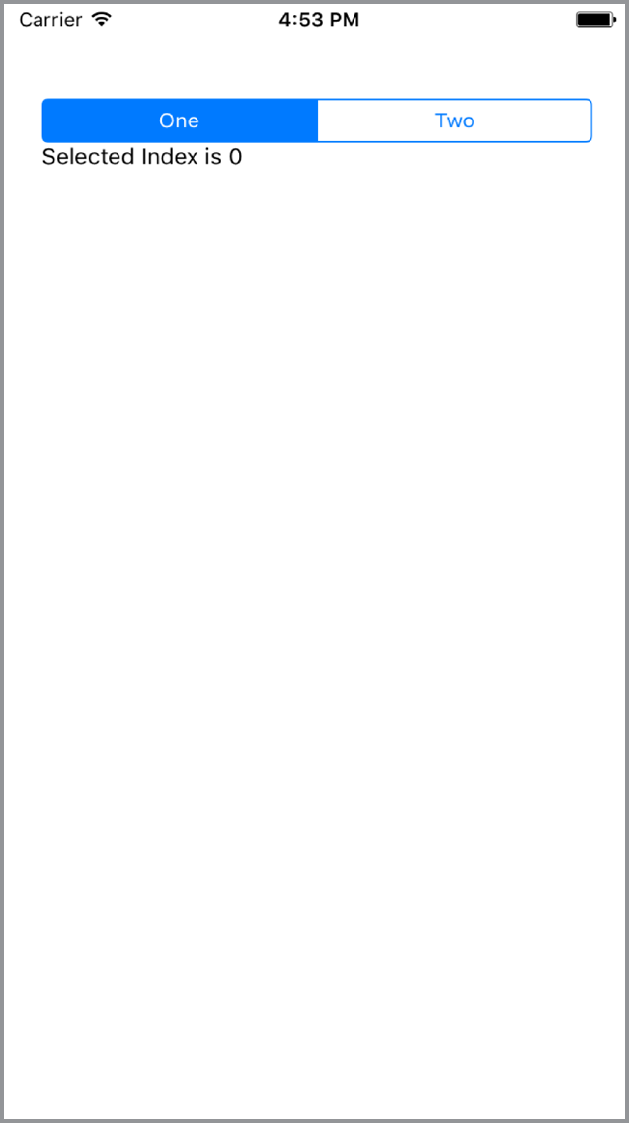
Figure 10.5 Basic SegmentedControlIOS implementation with two values (one and two)
SegmentedControlIOS allows you to access the native iOS UISegmentedControl component. It’s a horizontal tab bar made up of individual buttons, as shown in figure 10.5.
SegmentedControlIOS has the methods and props in table 10.4. At a minimum, it takes an array of values to render the control values, a selectedIndex as the index of the control selected, and an onChange method that will be called when a control is pressed.
Table 10.4 SegmentedControlIOS methods and props
Prop | Type | Description
enabled | Boolean | If false, the user can’t interact with the control. Default value is true.
momentary | Boolean | If true, selecting a segment won’t persist visually.onValueChange will still work as expected.
onChange | Function (event) | Callback called when the user taps a segment; passes the event as an argument.
onValueChange | Function (value) | Callback called when the user taps a segment; passes the segment’s value as an argument.
selectedIndex | Number | Index in props.values of the segment to be (pre)selected.
tintColor | String (color) | Accent color of the control.
values | Array of strings | Labels for the control’s segment buttons, in order.

10.5.1 Use cases for SegmentedControlIOS
SegmentedControlIOS is a good place to separate and display certain filterable/sortable data in the UI. For example, if an app had information listed and viewable by week, you could use SegmentedControlIOS to separate that data even further by day of the week, with a separate view for each day.

10.5.2 Example of using SegmentedControlIOS
In this example, you’ll render an array of three items as a SegmentedControlIOS. You’ll also show a value in the UI based on which item is selected.
Listing 10.11 SegmentedControlIOS rendering three values
import React, { Component } from 'react'
import { Text, View, SegmentedControlIOS } from 'react-native'
①
const values = ['One', 'Two', 'Three']
②
class App extends Component {
constructor() {
super()
this.state = {
selectedIndex: 0,
③
}
}
render() {
const { selectedIndex } = this.state
let selectedItem = values[selectedIndex]
④
return (
<View style={{ marginTop: 40, padding: 20 }}>
<SegmentedControlIOS
⑤
values={values}
⑤
selectedIndex={this.state.selectedIndex}
⑤
onChange={(event) => {
⑤
this.setState({selectedIndex:
event.nativeEvent.selectedSegmentIndex});
⑤
}}
/>
<Text>{selectedItem}</Text>
⑥
</View>)
}
}
①
Imports SegmentedControlIOS from React Native
②
Creates an array of values to use in the SegmentedControlIOS
③
Creates a state value of selectedIndex set to 0
④
Creates a variable called selectedItem, set to the value of the selectedIndex of the values array
⑤
Renders the SegmentedControlIOS component, passing in the values array as the values prop, this.state.selectedIndex as the selectedIndex, and an onChange method that updates the selectedIndex state value with the index of the pressed item
⑥
Renders the value of selectedItem in the UI

10.6 Using TabBarIOS to render tabs at the bottom of the UI
TabBarIOS allows you to access the native iOS tab bar. It renders tabs at the bottom of the UI, as shown in figure 10.6, giving you a nice, easy way to separate an application into sections. Its methods and props are listed in table 10.5.
Table 10.5 TabBarIOS props
Prop | Type | Description
barTintColor | String (color) | Background color of the tab bar.
itemPositioning | Enum ("fill", "center", "auto") | Tab bar item positioning. fill distributes items across the entire width of the tab bar. center centers items in the available tab bar space. auto (default) distributes items dynamically according to the UI idiom; in a horizontally compact environment, defaults to fill; otherwise defaults to center.
style | Object (style) | Style of the TabBarIOS.
tintColor | String (color) | Color of the currently selected tab icon.
translucent | Boolean | Indicates whether the tab bar is translucent.
unselectedItemTintColor | String (color) | Color of unselected tab icons (available since iOS 10).
unselectedTintColor | String (color) | Color of the text on unselected tabs.
TabBarIOS takes a list of TabBarIOS.Item components as children:
const Item = TabBarIOS.Item
<TabBarIOS>
<Item>
<View> #some content here </View>
</Item>
<Item>
<View> #some other content here </View>
</Item>
</TabBarIOS>
To show the content in the TabBarIOS.Item, the selected prop of the TabBarIOS.Item must be true:
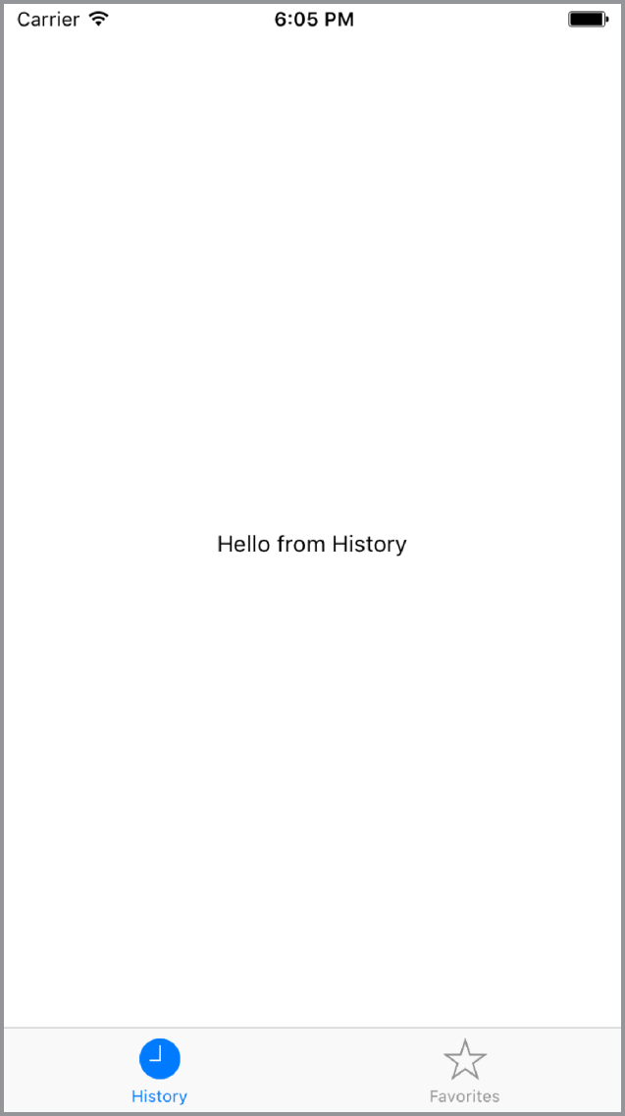
Figure 10.6 TabBarIOS with two tabs: History and Favorites
<Item
selected={this.state.selectedComponent === 'home'}
>
#your content here
</Item>

10.6.1 Use cases for TabBarIOS
The main use case for TabBarIOS is for navigation. Many times, on mobile, the best type of navigation is a tab bar. Separating the UI and displaying content in sections separated by tabs is a common pattern and is encouraged because it delivers a good user experience.

10.6.2 Example of using TabBarIOS
In this example, you’ll create an app with two views: History and Favorites. When the TabBarIOS.Item is pressed, you’ll switch between views by calling an onPress method to update the state.
Listing 10.12 Rendering tabs using TabBarIOS
import React, { Component } from 'react'
import { Text, View, TabBarIOS } from 'react-native'
①
const Item = TabBarIOS.Item
②
class App extends Component {
constructor() {
super()
this.state = {
selectedTab: 'history',
③
}
this.renderView = this.renderView.bind(this)
}
renderView(tab) {
④
return (
<View style={{ flex: 1, justifyContent: 'center',
alignItems: 'center' }}>
<Text>Hello from {tab}</Text>
</View>
)
}
render() {
return (
<TabBarIOS>
⑤
<Item
systemIcon="history"
⑥
onPress={() => this.setState({ selectedTab: 'history' })}
⑦
selected={this.state.selectedTab === 'history'}
⑦
>
{this.renderView('History')}
⑧
</Item>
<Item
systemIcon='favorites'
onPress={() => this.setState({ selectedTab: 'favorites' })}
selected={this.state.selectedTab === 'favorites'}
>
{this.renderView('Favorites')}
</Item>
</TabBarIOS>
)
}
①
Imports TabBarIOS from React Native
②
Creates a variable called Item to hold the TabBarIOS.Item component
③
Creates an initial state value of selectedTab, and sets it to history
④
Creates a reusable renderView method that takes in tab as an argument
⑤
Renders a TabBarIOS in the UI, passing in two Item components as children
⑥
Sets the systemIcon prop to history
⑦
Attaches an onPress method to the item, updating the selectedTab value in the state with the value passed in to this.setState({})
⑧
Renders the view by calling this.renderView
You can set icons either with a system icon or by passing in an icon prop and requiring a local image. For a list of all system icons, see http://mng.bz/rYNJ.

10.7 Using ActionSheetIOS to show action or share sheets
ActionSheetIOS allows you to access the native iOS UIAlertController to show a native iOS action sheet or share sheet (see figure 10.7).
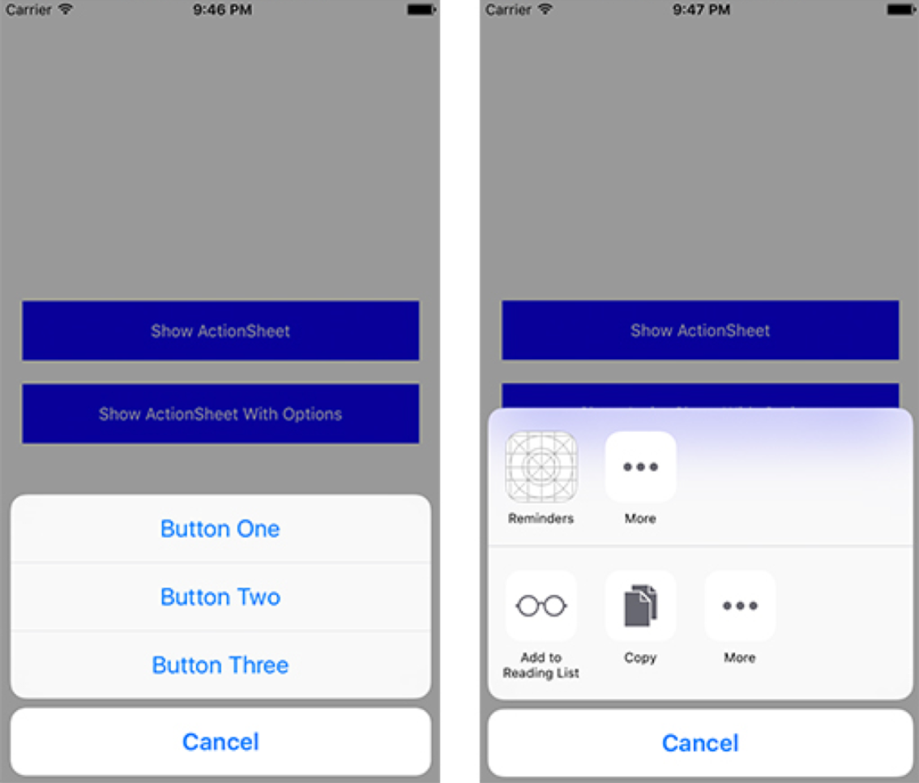
Figure 10.7 ActionSheetIOS rendering an action sheet (left) and a share sheet (right)
The two main methods that you can call on ActionSheetIOS are showActionSheetWithOptions and showShareActionSheetWithOptions; these methods have the options listed in tables 10.6 and 10.7, respectively. showActionSheetWithOptions lets you pass an array of buttons and attach methods to each of the buttons. It’s called with two arguments: an options object and a callback function. showShareActionSheetWithOptions displays the native iOS share sheet, passing in a URL, message, and subject to share. It’s called with three arguments: an options object, a failure callback function, and a success callback function.
Table 10.6 ActionSheetIOSshowActionSheetWithOptions options
Option | Type | Description
options | Array of strings | List of button titles (required)
cancelButtonIndex | Integer | Index of the Cancel button in options
destructiveButtonIndex | Integer | Index of the Destructive button in options
title | String | Title to show above the action sheet
message | String | Message to show below the title
Table 10.7 ActionSheetIOSshowShareActionSheetWithOptions options
Option | Type | Description
url | String | URL to share
message | String | Message to share
subject | String | Subject for the message
excludedActivityTypes | Array | Activities to exclude from the action sheet

10.7.1 Use cases for ActionSheetIOS
The main use case for ActionSheetIOS is to give the user a set of options to choose from and then call a function based on their selection. For example, in the Twitter app, the action sheet is used when the Retweet button is pressed, giving the user a few options including retweet, quote retweet, and cancel. This is a common use case, displaying an action sheet after a user presses a button and giving the user a set of options to choose from.

10.7.2 Example of using ActionSheetIOS
In this example, you’ll create a view with two buttons. One button will call showActionSheetWithOptions, and the other will call showShareActionSheetWithOptions.
Listing 10.13 Using ActionSheetIOS to create action sheets and share sheets
import React, { Component } from 'react'
import { Text, View, ActionSheetIOS,
TouchableHighlight } from 'react-native'
①
const BUTTONS = ['Cancel', 'Button One', 'Button Two', 'Button Three']
②
class App extends Component {
constructor() {
super()
this.state = {
③
clicked: null
③
}
this.showActionSheet = this.showActionSheet.bind(this)
this.showShareActionSheetWithOptions =
this.showShareActionSheetWithOptions.bind(this)
}
showActionSheet() {
④
ActionSheetIOS.showActionSheetWithOptions({
options: BUTTONS,
cancelButtonIndex: 0,
},
(buttonIndex) => {
if (buttonIndex > 0) {
this.setState({ clicked: BUTTONS[buttonIndex] });
}
});
}
showShareActionSheetWithOptions() {
⑤
ActionSheetIOS.showShareActionSheetWithOptions({
url: 'http://www.reactnative.training',
message: 'React Native Training',
},
(error) => console.log('error:', error),
(success, method) => {
⑥
if (success) {
console.log('successfully shared!', success)
}
});
};
render() {
return (
<View style={styles.container}>
⑦
<TouchableHighlight onPress={this.showActionSheet}
style={styles.button}>
⑦
<Text style={styles.buttonText}>
⑦
Show ActionSheet
⑦
</Text>
⑦
</TouchableHighlight>
⑦
<TouchableHighlight onPress={this.showShareActionSheetWithOptions}
style={styles.button}>
⑦
<Text style={styles.buttonText}>
⑦
Show ActionSheet With Options
⑦
</Text>
⑦
</TouchableHighlight>
<Text>
{this.state.clicked}
</Text>
</View>
)
}
}
styles = {
container: {
flex: 1,
justifyContent: 'center',
padding: 20,
},
button: {
height: 50,
marginBottom: 20,
justifyContent: 'center',
alignItems: 'center',
backgroundColor: 'blue'
},
buttonText: {
color: 'white'
}
}
①
Imports ActionSheetIOS from React Native
②
Creates an array of buttons to use in the action sheet
③
Creates a variable clicked and sets it to null
④
Creates a showActionSheet method
⑤
Creates a showShareActionSheetWithOptions method
⑥
The success callback takes a Boolean signifying success or failure, and a string that indicates the method of sharing.
⑦
Creates two buttons in the view, and attaches the showActionSheet and showShareActionSheetWithOptions to them
In the showActionSheet method, you pass in the buttons as the options. Setting cancelButtonIndex to zero positions Cancel at the bottom of the action sheet. The callback method takes the button index as an argument; if the button index is greater than 0, the clicked state value is set to the new button value. When you create the showShareActionSheetWithOptions method, you pass in url and a message to share. The first callback function checks to see if there’s an error, and the second checks whether success is true.

Summary
To import cross-platform files, use platform-specific android.js and ios.jsfile extensions.
To render platform-specific code, use the Platform API.
Use DatePickerIOS to choose and save dates in your app.
Use PickerIOS to render and save values from a list.
Use ProgressViewIOS to show loading progress.
Use SegmentedControlIOS to choose from an array of options.
Use TabBarIOS to create and switch between tabs in your app.
With ActionSheetIOS, you can call a native iOS action sheet or share sheet in an app.

11
Implementing Android-specific components and APIs
This chapter covers
Using DrawerLayoutAndroid to create a side menu
Creating a native toolbar with ToolbarAndroid
Create paging views using ViewPagerAndroid
Create date/time pickers using DatePickerAndroid and TimePickerAndroid
Creating toasts using ToastAndroid
In this chapter, we’ll implement the most used Android-specific APIs and components, discuss their props and methods, and create examples that will mimic functionality and logic that will get you up to speed quickly. To see how these work, you’ll create a demo app with a menu, a toolbar, scrollable paging, a date picker, and a time picker. The app will also implement Android toasts. As you implement each of these features, you’ll learn the capabilities of the most commonly used Android-specific APIs and components.

Note Section 10.1 covered how to target platform-specific code. If you skipped that chapter on iOS-specific components and APIs and don’t already know how to target platform-specific code, you should read that section before continuing.

11.1 Creating a menu using DrawerLayoutAndroid
To get started, you’ll first create a slide-out menu (see figure 11.1). This menu will link to each of the app’s pieces of functionality. It will basically serve as a way to navigate between components. You’ll create this menu using the DrawerLayoutAndroid component.
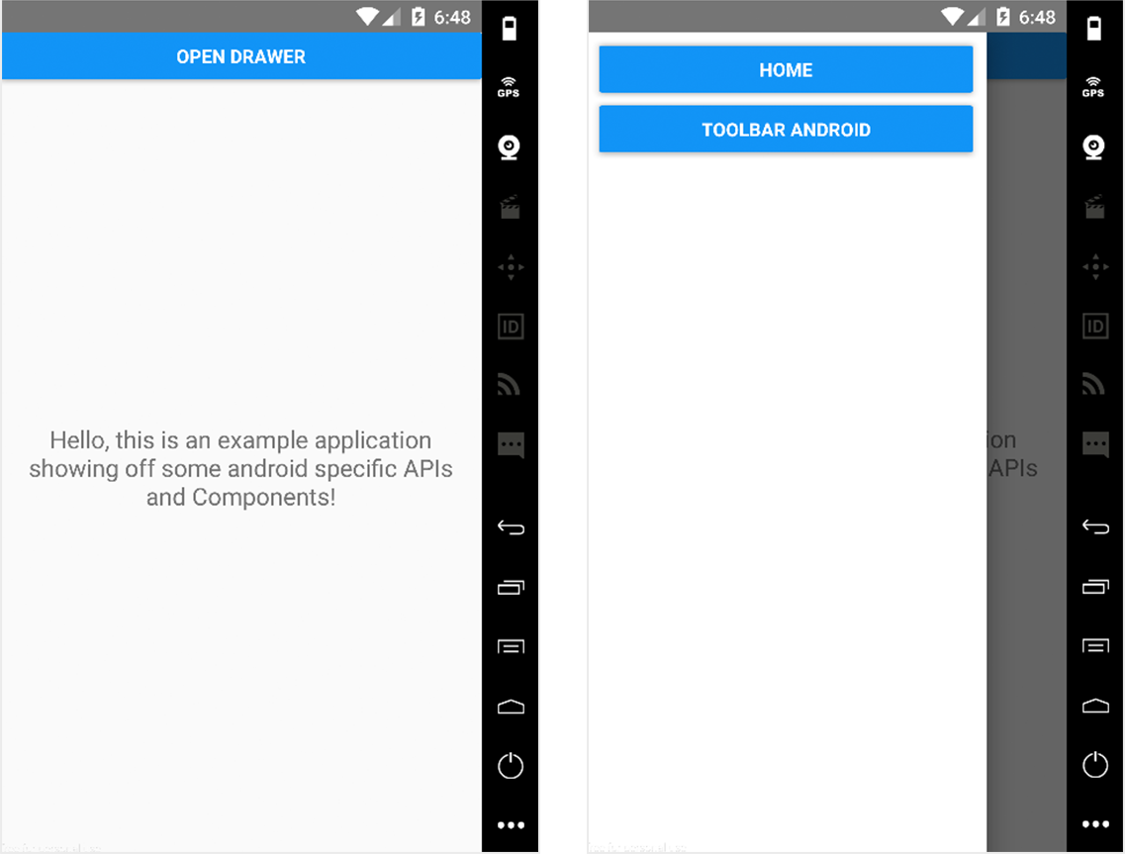
Figure 11.1 Initial layout of the application using DrawerLayoutAndroid. The button at the top in the first screen, Open Drawer, will call a method that opens the drawer. The second screen is the opened drawer.
The first thing to do is create a new Android application. From the command line in the folder you’ll be working in, create a new application, replacing YourApplication in the following command with whatever application name you choose:
react-native init YourApplication
Next, create the files you’ll use to create all this functionality. In the root of the application, add a folder named app and four files: App.js, Home.js, Menu.js, and Toolbar.js.
Now you need to update index.android.js to use your first Android-specific component, DrawerLayoutAndroid, which is a sliding toolbar from the left side of the screen. Edit index.android.js to include and implement this component.
Listing 11.1 Implementing the DrawerLayoutAndroid component
import React from 'react'
import {
AppRegistry,
DrawerLayoutAndroid,
①
Button,
View
} from 'react-native'
import Menu from './app/Menu'
②
import App from './app/App'
③
class mycomponent extends React.Component {
constructor () {
super()
this.state = {
scene: 'Home'
④
}
this.jump = this.jump.bind(this)
this.openDrawer = this.openDrawer.bind(this)
}
openDrawer () {
this.drawer.openDrawer()
⑤
}
jump (scene) {
⑥
this.setState({
⑥
scene
⑥
})
⑥
this.drawer.closeDrawer()
⑥
}
render () {
return (
<DrawerLayoutAndroid
⑦
ref={drawer => this.drawer = drawer}
⑧
drawerWidth={300}
⑨
drawerPosition={DrawerLayoutAndroid.positions.Left}
⑩
renderNavigationView={() => <Menu onPress={this.jump} />}>
⑪
<View style={{ margin: 15 }}>
⑫
<Button onPress={() => this.openDrawer()} title='Open Drawer' />
</View>
<App
⑬
openDrawer={this.openDrawer}
jump={this.jump}
scene={this.state.scene} />
</DrawerLayoutAndroid>
)
}
}
AppRegistry.registerComponent('mycomponent', () => mycomponent)
①
Imports DrawerLayoutAndroid from React Native
②
Imports the Menu component (not yet created)
③
Imports the App component (not yet created)
④
Creates a component state setting scene to ‘Home’
⑤
Creates a method to open the Drawer
⑥
Creates a method to update the scene state, and then calls closeDrawer()
⑦
Implements the DrawerLayoutAndroid component
⑧
Creates a reference to the drawer to call methods on the component
⑨
Gives the drawer a width of 300
⑩
Positions the drawer to the left
⑪
Renders the navigation view, which is the Menu component
⑫
Attaches the jump method to the menu and creates a button that will be used to open the drawer
⑬
Also passes in the App component as a child, giving the openDrawer, jump, and scene as props
Next, create the menu you’ll use in the drawer, in app/Menu.js.
Listing 11.2 Creating the DrawerLayoutAndroid menu component
import React from 'react'
import { View, StyleSheet, Button } from 'react-native'
let styles
const Menu = ({onPress }) => {
const {
button
} = styles
return (
<View style={{ flex: 1 }}>
<View style={button} >
<Button onPress={() => onPress('Home')} title='Home' />
</View>
<View style={button} >
<Button onPress={() => onPress('Toolbar')} title='Toolbar Android' />
</View>
</View>
)
}
styles = StyleSheet.create({
button: {
margin: 10,
marginBottom: 0
}
})
export default Menu
Now, in app/App.js, create the following component, which basically takes in a scene as a prop and returns a component based on the prop.
Listing 11.3 Creating the DrawerLayoutAndroid App component
import React from 'react'
import Home from './Home'
①
import Toolbar from './Toolbar'
②
function getScene (scene) {
③
switch (scene) {
case 'Home':
return Home
case 'Toolbar':
return Toolbar
default:
return Home
}
}
const App = (props) => {
const Scene = getScene(props.scene)
④
return (
<Scene openDrawer={props.openDrawer} jump={props.jump} />
⑤
)
}
export default App
①
Imports the Home component (not yet created)
②
Imports the Toolbar component (not yet created)
③
Creates a getScene method that checks the scene and returns the correct component
④
Creates a component based on the current scene prop
⑤
Renders the component, passing in openDrawer and jump as props
Now you can start creating components to interact with the menu. For the current setup to work, you need to create a Home component and a Toolbar component. Although you’ve seen the imports, you haven’t actually created those components yet. In app/Home.js, create the following component, which is a basic introduction page.
Listing 11.4 Creating the DrawerLayoutAndroid Home component
import React, { Component } from 'react'
import {
View,
Text,
StyleSheet
} from 'react-native'
let styles
class Home extends Component {
render () {
return (
<View style={styles.container}>
<Text style={styles.text}>
Hello, this is an example application showing off some
android-specific APIs and Components!
</Text>
</View>
)
}
}
styles = StyleSheet.create({
container: {
flex: 1,
justifyContent: 'center',
alignItems: 'center'
},
text: {
margin: 20,
textAlign: 'center',
fontSize: 18
}
})
export default Home
In app/Toolbar.js, create the following component, which will show that you’re in the toolbar by displaying a “Hello from Toolbar” message.
Listing 11.5 Creating the DrawerLayoutAndroid Toolbar component
import React from 'react'
import {
View,
Text
} from 'react-native'
class ToolBar extends React.Component {
render () {
return (
<View style={{ flex: 1 }}>
<Text>Hello from Toolbar</Text>
</View>
)
}
}
export default ToolBar
Start the application, and you should see the menu shown in figure 11.1.

11.2 Creating a toolbar with ToolbarAndroid
With everything set up, let’s add a new component, ToolbarAndroid. ToolbarAndroid is a React Native component that wraps the native Android toolbar. This component can display a variety of things, including a title, a subtitle, a log, a navigation icon, and action buttons.
In this example, you’ll implement ToolbarAndroid with a title, a subtitle, and two actions (Options and Menu; see figure 11.2). When Menu is clicked, you’ll trigger the openDrawer method, which will open the menu.
In app/Toolbar.js, update the code as follows to implement the toolbar.
Listing 11.6 Implementing ToolbarAndroid
import React from 'react'
import {
ToolbarAndroid,
①
View
} from 'react-native'
class Toolbar extends React.Component {
render () {
const onActionSelected = (index) => {
②
if (index === 1) {
②
this.props.openDrawer()
②
}
}
return (
<View style={{ flex: 1 }}>
<ToolbarAndroid
③
subtitleColor='white'
titleColor='white'
style={{ height: 56, backgroundColor: '#52998c' }}
title='React Native in Action'
subtitle='ToolbarAndroid'
actions={[ { title: 'Options', show: 'always' },
{ title: 'Menu', show: 'always' } ]}
④
onActionSelected={onActionSelected}
⑤
/>
</View>
)
}
}
export default Toolbar
①
Imports the ToolbarAndroid component
②
Creates an onActionSelected method. This method takes in an index and calls this.props.openDrawer if index is 1. You’ll have an array of actions, each of which will call this method when clicked, passing in its own index.
③
Returns ToolbarAndroid
④
Passes in an array of actions. Pressing these actions calls them with their array index as an argument.
⑤
Passes in the onActionSelected function to the onActionSelected property
When you refresh your device, you should not only see the ToolbarAndroid but also be able to open the DrawerLayoutAndroid menu by pressing the button labeled Menu.
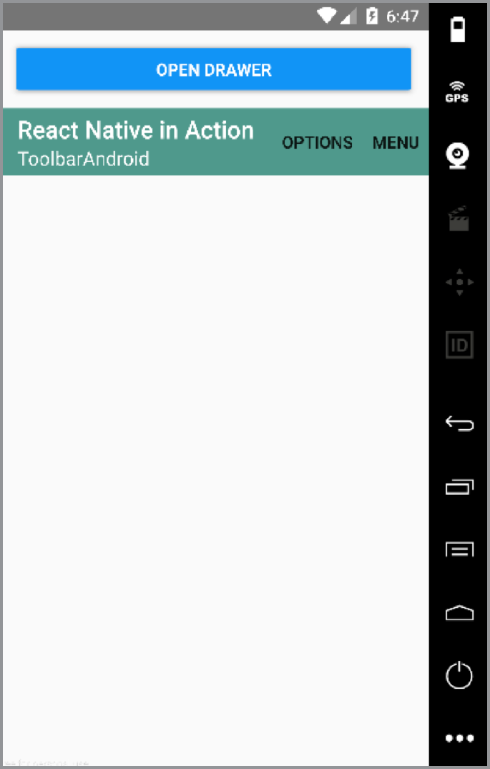
Figure 11.2 ToolbarAndroid with title, subtitle, and two actions. This menu is configurable, but you’re only working with the default settings in this example.

11.3 Implementing scrollable paging with ViewPagerAndroid
Next, you’ll create a new example page and component using ViewPagerAndroid. This component allows you to easily swipe left and right between views. Every child of ViewPagerAndroid is treated as its own separate, swipeable view (see figure 11.3).
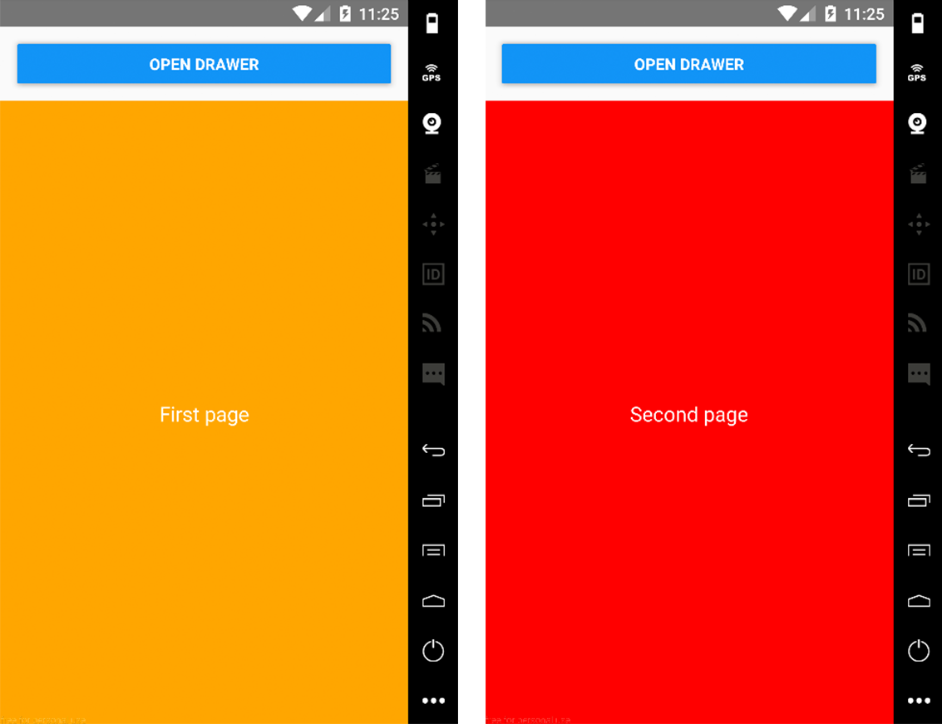
Figure 11.3 ViewPagerAndroid with two child views. When you swipe the pages, they scroll left and right to show the next page.
To get started, create an app/ViewPager.js file and add the code in listing 11.7 to implement the ViewPagerAndroid component.
Listing 11.7 Using ViewPagerAndroid to enable a scrollable paging view
import React, { Component } from 'react'
import {
ViewPagerAndroid,
①
View,
Text
} from 'react-native'
let styles
class ViewPager extends Component {
render () {
const {
pageStyle,
page1Style,
page2Style,
textStyle
} = styles
return (
<ViewPagerAndroid
②
style={{ flex: 1 }}
initialPage={0}>
<View style={[ pageStyle, page1Style ]}>
<Text style={textStyle}>First page</Text>
</View>
<View style={[ pageStyle, page2Style ]}>
<Text style={textStyle}>Second page</Text>
</View>
</ViewPagerAndroid>
)
}
}
styles = {
pageStyle: {
justifyContent: 'center',
alignItems: 'center',
padding: 20,
flex: 1,
},
page1Style: {
backgroundColor: 'orange'
},
page2Style: {
backgroundColor: 'red'
},
textStyle: {
fontSize: 18,
color: 'white'
}
}
export default ViewPager
①
Imports ViewPagerAndroid from React Native
②
Returns ViewPagerAndroid with two child views, one with an orange background and one with a red background
Next, update Menu.js to add the button to view the new component. In Menu.js, add this button below the Toolbar Android button:
<View style={button} >
<Button onPress={() => onPress('ViewPager')} title='ViewPager Android' />
</View>
Finally, import the new component and update the switch statement in App.js to render the component.
Listing 11.8 App.js with the new ViewPager component
import React from 'react'
import Home from './Home'
import Toolbar from './Toolbar'
import ViewPager from './ViewPager'
function getScene (scene) {
switch (scene) {
case 'Home':
return Home
case 'Toolbar':
return Toolbar
case 'ViewPager':
return ViewPager
default:
return Home
}
}
const App = (props) => {
const Scene = getScene(props.scene)
return (
<Scene openDrawer={props.openDrawer} jump={props.jump} />
)
}
export default App
Run the app. You should see the new ViewPager Android button in the side menu, and you can view and interact with the new component.

11.4 Using the DatePickerAndroid API to show a native date picker
DatePickerAndroid lets you open and interact with the native Android date-picker dialog as shown in figure 11.4. To open and use the DatePickerAndroid component, import DatePickerAndroid and call DatePickerAndroid.open(). To get started, create app/DatePicker.js and then the DatePicker component in it (listing 11.9).
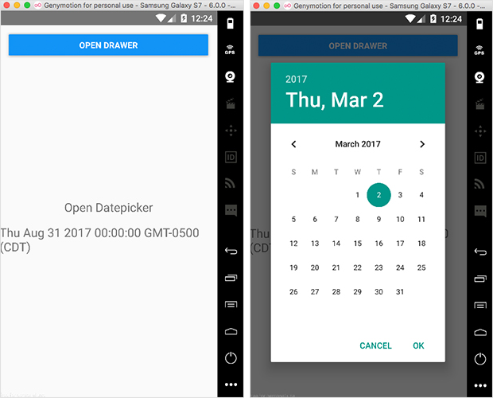
Figure 11.4 DatePickerAndroid with a button that opens the date picker and then shows the selected date in the view
Listing 11.9 Implementing a DatePicker component
import React, { Component } from 'react'
import { DatePickerAndroid, View, Text } from 'react-native'
①
let styles
class DatePicker extends Component {
constructor() {
super()
this.state = {
②
date: new Date()
}
this.openDatePicker = this.openDatePicker.bind(this)
}
openDatePicker () {
③
DatePickerAndroid.open({
date: this.state.date
})
.then((date) => {
const { year, month, day, action } = date
④
if (action === 'dateSetAction') {
⑤
this.setState({ date: new Date(year, month, day) })
}
}) }
render() {
const {
container,
text
} = styles
return (
<View style={container}>
⑥
<Text onPress={this.openDatePicker} style={text}>
Open Datepicker
</Text>
⑥
<Text style={text}>{this.state.date.toString()}</Text>
⑥
</View>
⑥
)
}
}
styles = {
container: {
flex: 1,
justifyContent: 'center',
alignItems: 'center'
},
text: {
marginBottom: 15,
fontSize: 20
}
}
export default DatePicker
①
Imports DatePickerAndroid from React Native
②
Creates the state, setting the date as a new Date()
③
Creates the openDatePicker method that will be used when the button is pressed
④
DatePickerAndroid.open returns a promise, giving you an object with the selected day, month, year, and the action that was chosen.
⑤
If you choose a date, then the action is dateSetAction. If the modal is dismissed, then the action is dismissedAction.
⑥
Creates a button that calls the openDatePicker method and displays the date in the view.
Now that you have the component, update app/App.js to include it.
Listing 11.10 app/App.js with the new DatePicker component
import React from 'react'
import Home from './Home'
import Toolbar from './Toolbar'
import ViewPager from './ViewPager'
import DatePicker from './DatePicker'
function getScene (scene) {
switch (scene) {
case 'Home':
return Home
case 'Toolbar':
return Toolbar
case 'ViewPager':
return ViewPager
case 'DatePicker':
return DatePicker
default:
return Home
}
}
const App = (props) => {
const Scene = getScene(props.scene)
return (
<Scene openDrawer={props.openDrawer} jump={props.jump} />
)
}
export default App
Finally, update the menu to add the new button that will open the DatePicker component. In app/Menu.js, add the following button below the ViewPager Android button:
<View style={button} >
<Button onPress={() => onPress('DatePicker')} title='DatePicker Android' />
</View>

11.5 Creating a time picker with TimePickerAndroid
Next up is TimePickerAndroid. It’s like DatePickerAndroid in that you import it and call the open method to interact with it. This component brings up a time picker dialog that allows you to choose a time and use it in your application (figure 11.5).
To standardize the time formats, you’ll use a third party library called moment.js. To get started with this library, you must first install it. In the root directory of the project, install moment using either npm or yarn (your preference—both npm and yarn will work exactly the same here):
npm install moment –save
or
yarn add moment
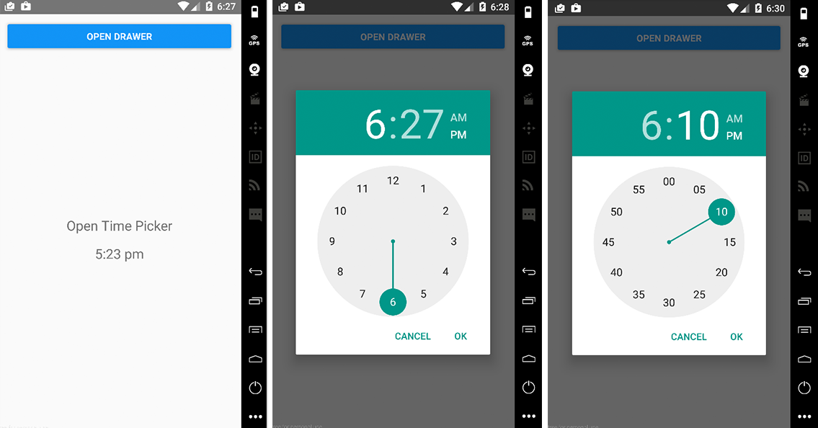
Figure 11.5 TimePickerAndroid with both hour and minute views
Next, in app/TimePicker.js, create the following TimePicker component.
Listing 11.11 TimePickerAndroid using moment.js
import React, { Component } from 'react'
import { TimePickerAndroid, View, Text } from 'react-native'
①
import moment from 'moment'
②
let styles
class TimePicker extends Component {
constructor () {
super()
this.state = {
time: moment().format('h:mm a')
③
}
this.openTimePicker = this.openTimePicker.bind(this)
}
openTimePicker () {
④
TimePickerAndroid.open({
⑤
time: this.state.time
})
.then((time) => {
const { hour, minute, action } = time
⑥
if (action === 'timeSetAction') {
const time = moment().minute(minute).hour(hour).format('h:mm a')
this.setState({ time })
}
})
}
render () {
const {
container,
text
} = styles
return (
<View style={container}>
⑦
<Text onPress={this.openTimePicker} style={text}>Open Time Picker</Text>
<Text style={text}>{this.state.time.toString()}</Text>
</View>
)
}
}
styles = {
container: {
flex: 1,
justifyContent: 'center',
alignItems: 'center'
},
text: {
marginBottom: 15,
fontSize: 20
}
}
export default TimePicker
①
Imports TimePickerAndroid from React Native
②
Imports moment from moment.js
③
Creates an initial time and stores it in the state with a format 'h:mm a', hour:minutes a.m. or p.m.
④
Creates the openTimePicker method
⑤
The TimePickerAndroid.open method returns a promise, with a time object that contains hour, minute, and action.
⑥
Check to see if the action is timeSetAction, and if so, update the state to reflect the new time.
⑦
Creates a button to call openTimePicker and display the time in the view
Next, update app/App.js to include the new component.
Listing 11.12 app/App.js with the added TimePicker component
import React from 'react'
import Home from './Home'
import Toolbar from './Toolbar'
import ViewPager from './ViewPager'
import DatePicker from './DatePicker'
import TimePicker from './TimePicker'
function getScene (scene) {
switch (scene) {
case 'Home':
return Home
case 'Toolbar':
return Toolbar
case 'ViewPager':
return ViewPager
case 'DatePicker':
return DatePicker
case 'TimePicker':
return TimePicker
default:
return Home
}
}
const App = (props) => {
const Scene = getScene(props.scene)
return (
<Scene openDrawer={props.openDrawer} jump={props.jump} />
)
}
export default App
Finally, update the menu to add the button that will open the new TimePicker component. In app/Menu.js, add the following below the DatePicker Android button:
<View style={button} >
<Button onPress={() => onPress('TimePicker')} title='TimePicker Android' />
</View>

11.6 Implementing Android toasts using ToastAndroid
ToastAndroid allows you to easily call native Android toasts from a React Native application. An Android toast is a popup with a message that goes away after a given period of time (see figure 11.6). To get started building out this component, create app/Toast.js, as shown in the next listing.
Listing 11.13 Implementing ToastAndroid
import React from 'react'
import { View, Text, ToastAndroid } from 'react-native'
①
let styles
const Toast = () => {
let {
container,
button
} = styles
const basicToast = () => {
②
ToastAndroid.show('Hello World!', ToastAndroid.LONG)
②
}
const gravityToast = () => {
③
ToastAndroid.showWithGravity('Toast with Gravity!',
ToastAndroid.LONG, ToastAndroid.CENTER)
}
return (
<View style={container}>
④
<Text style={button} onPress={basicToast}>
⑤
Open basic toast
</Text>
<Text style={button} onPress={gravityToast}>
⑥
Open gravity toast
</Text>
</View>
)
}
styles = {
container: {
flex: 1,
justifyContent: 'center',
alignItems: 'center'
},
button: {
marginBottom: 10,
color: 'blue'
}
}
export default Toast
①
Imports ToastAndroid from React Native
②
Creates a basicToast method that will call ToastAndroid.show()
③
Creates a gravityToast method that will call ToastAndroid.showWithGravity()
④
Creates two buttons in the view: Open basic toast and Open gravity toast
⑤
Opens the basicToast popup when the button is pressed
⑥
Opens the gravityToast popup when the button is pressed
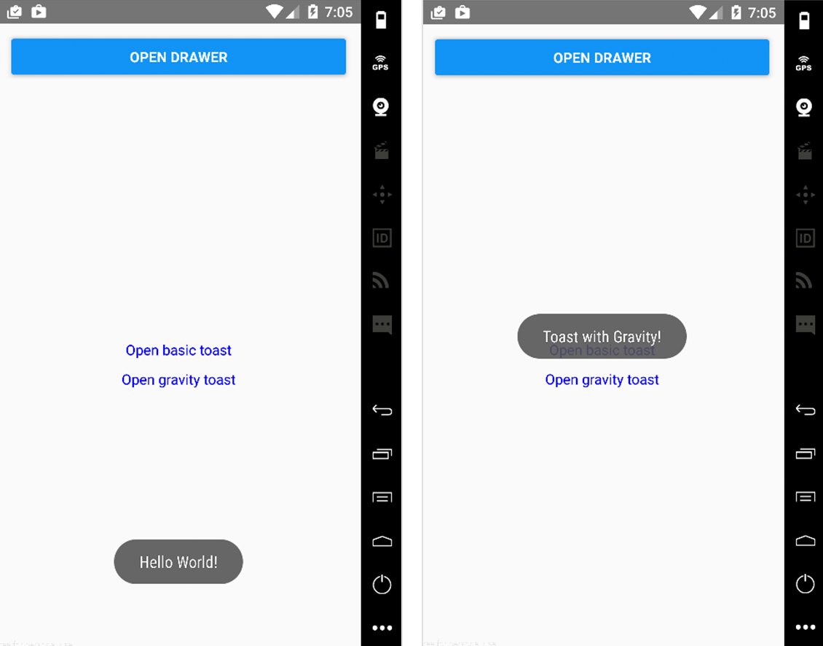
Figure 11.6 ToastAndroid with toasts in the default and middle positions
The ToastAndroid.show() takes two arguments: a message and a length of time to show the toast. The time can be either SHORT (about 2 seconds) or LONG (about 4 seconds); this example uses LONG. The ToastAndroid.showWithGravity() method is like ToastAndroid.show(), but you can pass it a third argument to position the toast at the top, bottom, or center of the view. In this case, you’re positioning the toast in the middle of the screen with ToastAndroid.CENTER as the third argument.
Now, update app/App.js to include the new component.
Listing 11.14 Adding the toast component to the app
import React from 'react'
import Home from './Home'
import Toolbar from './Toolbar'
import ViewPager from './ViewPager'
import DatePicker from './DatePicker'
import TimePicker from './TimePicker'
import Toast from './Toast'
function getScene (scene) {
switch (scene) {
case 'Home':
return Home
case 'Toolbar':
return Toolbar
case 'ViewPager':
return ViewPager
case 'DatePicker':
return DatePicker
case 'TimePicker':
return TimePicker
case 'Toast':
return Toast
default:
return Home
}
}
const App = (props) => {
const Scene = getScene(props.scene)
return (
<Scene openDrawer={props.openDrawer} jump={props.jump} />
)
}
export default App
Finally, update the menu to add the new button that will open the toast component. In app/Menu.js, add the following button below the TimePicker Android button:
<View style={button} >
<Button onPress={() => onPress('Toast')} title='Toast Android' />
</View>

Summary
You can use DrawerLayoutAndroid to create the main menu of an application.
You can use ToolbarAndroid to create an interactive app toolbar.
You can use ViewPagerAndroid to create swipeable views.
With DatePickerAndroid, you can access the native date picker, allowing you to create and manipulate dates in the application.
TimePickerAndroid lets you access the native time picker, making it possible to create and manipulate time in the application.
You can easily create native Android toast notifications withToastAndroid.

Part 4
Bringing it all together
T
his part of the book pulls together everything covered in the previous chapters—styling, navigation, animations, and some of the cross-platform components—into a single app. We’ll start by looking at the final design and walking through a basic overview of what the app will do.
You’ll create a new React Native application and install the React Navigation library, dive deep into styling both the components as well as the navigation UI, work with data from external network resources by using the Fetch API, and ultimately build out an application that allows users to view information about their favorite Star Wars characters.

12
Building a Star Wars app using cross-platform components
This chapter covers
The basics of fetching data using the Fetch API
Using a Modal component to show and hide views
Creating a list using the FlatList component
Using the ActivityIndicator to show loading state
Using React Navigation in a real-world project to handle navigation
React Native ships with many components that are ready to use in your apps. Some of these components work cross-platform: that is, they work regardless of whether you’re running an app on iOS or Android. Other components are platform-specific: for example, ActionSheetIOS only runs on iOS, and ToolbarAndroid only runs on the Android platform (cross-platform components were covered in Chapters 10 and 11).
This chapter covers some of the most-used cross-platform components and how to implement each one as you build a demo application. For this purpose, you’ll implement the following cross-platform components and APIs by building a cross-platform Star Wars information app:
Fetch API
Modal
ActivityIndicator
FlatList
Picker
React-Navigation
This app will access SWAPI, the Star Wars API (https://swapi.co), and return information about Star Wars characters, starships, home planets, and more, as shown in figure 12.1. When a user clicks People, the app fetches the movie’s main cast from https://swapi.co/api/people and displays their information. In the process, the app uses several React Native cross-platform components. In this chapter, you’ll learn how to use these components as you do the following:
Set up a new React Native application and install dependencies
Import the People component and create the Container component
Create the Navigation component and register routes
Create the main class for the view
Create the People component
Use the cross-platform components FlatList, Modal, and Picker to create the state and set up a fetch call to retrieve data
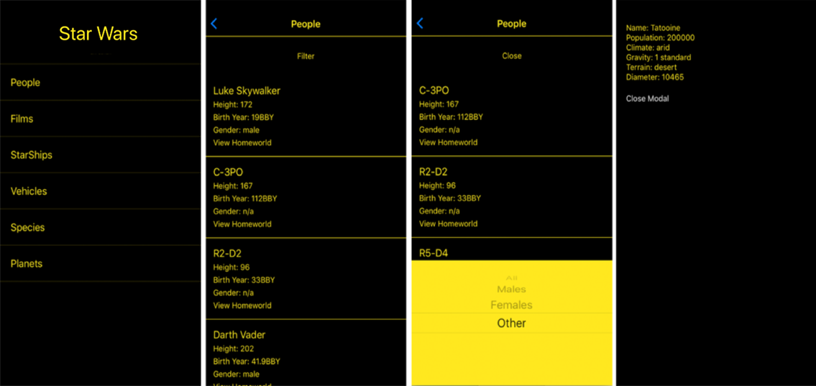
Figure 12.1 The completed Star Wars app that you’ll build with React Native cross-platform components. You’ll focus on the first link: People.

Note You can download this chapter’s code from the book’s website (www.manning.com/books/react-native-in-action) and also from GitHub (https://github.com/dabit3/react-native-in-action/tree/chapter12/StarWars).

12.1 Creating the app and installing dependencies
The first thing you need to do is set up a new React Native application and install any dependencies required to build this app. Go to the command line, and create a React Native app by typing in the following:
react-native init StarWarsApp
Next, change into the newly created StarWarsApp directory:
cd StarWarsApp
The only thing you’ll need to install for this app is react-navigation, so install it using either npm or yarn:
Using npm: npm i react-navigation
Using yarn: yarn add react-navigation
Now that the project is created, open App.js and create the components needed for the screen shown in figure 12.2. At the top of the file, import the components shown next.
Listing 12.1 Importing the initial components
import React, { Component } from 'react';
import {
StyleSheet,
Text,
FlatList,
TouchableHighlight
} from 'react-native';
import { createStackNavigator } from 'react-navigation';
In this listing you import the required React Native components, as well as createStackNavigator from react-navigation. FlatList is a component that will allow you to render performant lists in an app using any array of data. createStackNavigator is a navigator from react-navigation that provides an easy way to navigate between scenes; each scene is pushed on top of a route stack. All the animations are configured for you and give the default iOS and Android feel and transitions.

12.1.1 Importing the People component and creating the Container component
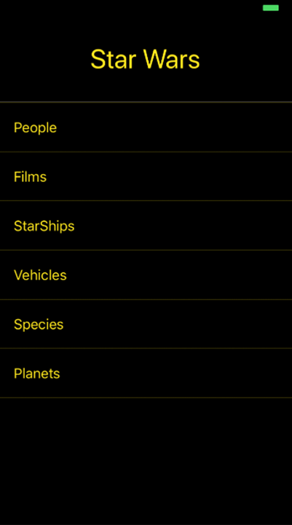
Figure 12.2 The initial view of the app
Next, you need to import the two views you’ll use in this app. Take another look at the first screen in figure 12.2. As you can see, there are links for People, Films, and so on. When the user clicks People, the app should navigate to a component that lists the people (main characters) in the Star Wars films. To do this, you’ll create a People component in section 12.2—you’ll import the component now and create it later. Below the last import in listing 12.1, import the yet-to-be-created People component:
import People from './People'
Because the design uses a black color background and you don’t want to repeat styling code across components, let’s create a Container component that you’ll use as a wrapper for your views. This Container component will be strictly used for styling. In the root of the app, create a new file called Container.js, and enter the following code.
Listing 12.2 Creating a reusable Container component
import React from 'react'
import { StyleSheet, View } from 'react-native'
const styles = StyleSheet.create({
①
container: {
flex: 1,
backgroundColor: 'black',
},
})
const Container = ({ children }) => (
②
<View style={styles.container}>
③
{children}
③
</View>
③
)
export default Container
①
Stylesheet, covered in chapter 4, lets you create a set of reusable styles.
②
Container takes a single property, children—in this case, the component wrapped in the Container.
③
Wraps the children component in a View and assigns it a style of container, which will give the component a black background and a flex property of 1
Import the Container into the App.js file, below the last import of the People component:
import Container from './Container'
Below the Container import, create an array of data that you’ll use for the links. The items in the array will be passed to the FlatList component to create the list of links. This array should contain objects, and each object should contain a title key. You need the title key to display the name of the link:
const links = [
{ title: 'People' },
{ title: 'Films' },
{ title: 'StarShips' },
{ title: 'Vehicles' },
{ title: 'Species' },
{ title: 'Planets' }
]

12.1.2 Creating the navigation component and registering routes
At the bottom of the App.js file, you’ll next create the main navigation component and pass it to the AppRegistry. You’re using createStackNavigator as the navigation component, and you need to register the routes you’ll use in the application.
Initialize createStackNavigator and pass the navigator to the AppRegistry method, replacing the default StarWars component with the navigation component as shown in the following listing. createStackNavigator provides a way for the app to transition between screens: each new screen is placed on top of a stack and is a cross-platform component.
Listing 12.3 Using createStackNavigator
const App =
createStackNavigator
({
①
StarWars: {
screen: StarWars
②
},
People: {
screen: People
③
}
})
export default App
①
The first argument to createStackNavigator is the route configuration: an object with the routes you want to define. The route name is defined by the key, and the value passed to the key defines the component you want to use for the named route.
②
The first key is automatically rendered as the initial route. In this case, you pass in the StarWars component (created in listing 12.4) as the initial route.
③
The other route in the app is People: you pass in the People component (created in listing 12.5).

12.1.3 Creating the main class for the initial view
In App.js, below the links array you created in section 12.1.1, add the main class for the view (listing 12.4). This class returns a list that will render all the movie characters who come back from the API. You’ll also set the header title using the navigationOptions static property and set the logo in the header. You’ll render this list using FlatList from React Native. It’s a built-in interface for rendering simple lists in a React Native app.
Listing 12.4 Creating the main StarWars component
class StarWars extends Component {
static navigationOptions = {
①
①
headerTitle: <Text
①
style={{
①
fontSize: 34, color: 'rgb(255,232,31)'
①
}}
①
>Star Wars</Text>,
①
headerStyle: { backgroundColor: "black", height: 110 }
①
}
navigate = (link) => {
②
const { navigate } = this.props.navigation
navigate(link)
}
renderItem = ({ item, index }) => {
③
return (
<TouchableHighlight
onPress={() => this.navigate(item.title)}
style={[ styles.item, { borderTopWidth: index === 0 ? 1 : null} ]}>
<Text style={styles.text}>{item.title}</Text>
</TouchableHighlight>
)
}
render() {
④
return (
④
<Container>
④
<FlatList
④
data={links}
④
keyExtractor={(item) => item.title}
④
renderItem={this.renderItem}
④
/>
④
</Container>
④
)
}
}
const styles = StyleSheet.create({
item: {
padding: 20,
justifyContent: 'center',
borderColor: 'rgba(255,232,31, .2)',
borderBottomWidth: 1
},
text: {
color: '#ffe81f',
fontSize: 18
}
});
①
Creates a static navigationOptions object, and passes in a headerTitle component and a headerStyle object
②
Creates a navigate method that takes a link as an argument
③
Loops through the data array and returns an item and an index for each item
④
Returns the Container, wraps the FlatList component in it, and passes in links, renderItem, and a keyExtractor method
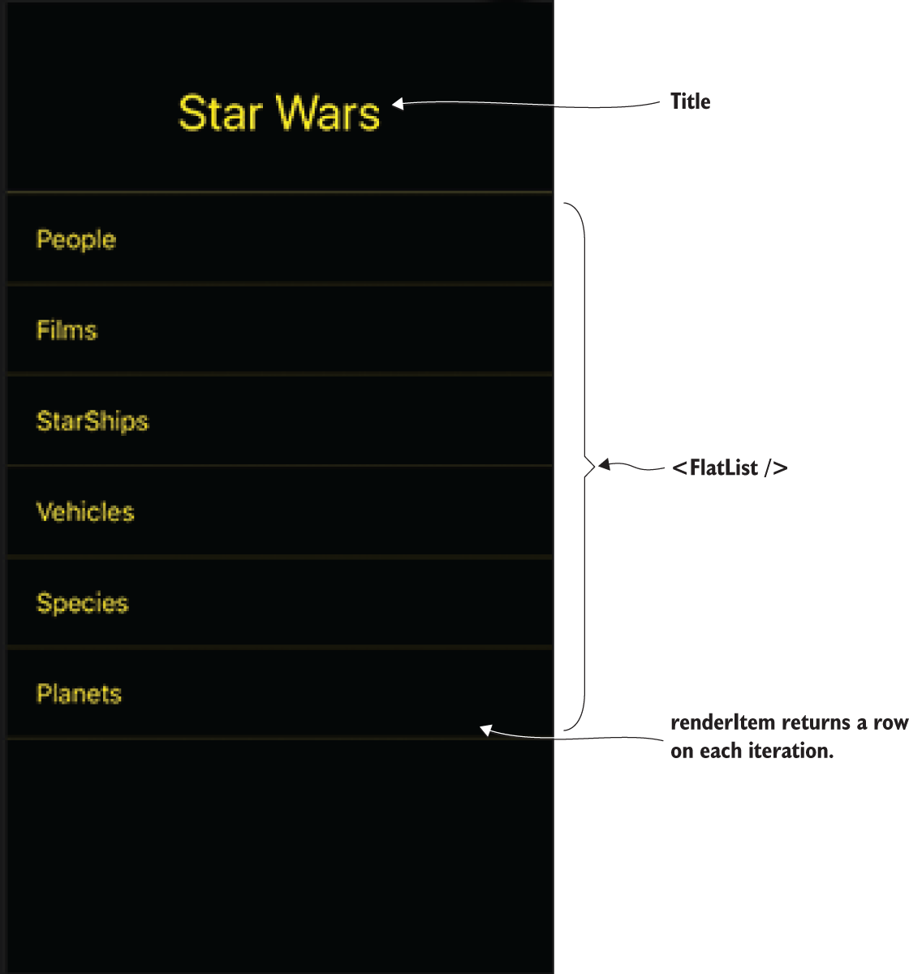
Figure 12.3 Components and title for the StarWars component
Because you’re using createStackNavigator from react-navigation, you can pass in configuration for each route. In this route, you want to change the default header configuration and styling. To do so, you create a static navigationOptions object, and in it you pass in a headerTitle component containing a title and a headerStyle object containing some specific styling. The headerTitle is the text you’ll use as the logo, and headerStyle sets the background color to black and gives a set height to fit the text.
The navigate method takes a link as an argument. Any component rendered by StackNavigation receives the navigation object as a prop. You use this prop to destructure the navigate method and then navigate to the link passed in. The link, in this case the title property in the links array, correlates with the keys passed in to createStackNavigator.
FlatList takes a renderItem method that loops through the array of data passed in as the data property and returns an object with an item and an index for each item in the array. The item is the actual item with all its properties, and the index is the index of the item. You destructure these as arguments, pass item as an argument to navigate to display the title, and use index to apply a borderTop style if it’s the first array item.
render() returns the Container, and in it you wrap the FlatList passing in links as the data and the renderItem method you created earlier. You also pass in a keyExtractor method. If there’s no item labeled key in the array, you have to tell the FlatList which item to use as its key; otherwise it will throw an error. Figure 12.3 shows the initial application view with its components. The final code for App.js is at www.manning.com/books/react-native-in-action and on GitHub at https://github.com/dabit3/react-native-in-action/blob/chapter12/StarWars/App.js.

12.2 Creating the People component using FlatList, Modal, and Picker
Next you’ll create a People component to fetch and display information about the Star Wars cast that you get from the Star Wars API (figure 12.4). As part of this component, you’ll use the React Native cross-platform components Modal and Picker. Modal lets you display an element on top of whatever view you’re currently working in. Picker displays a scrollable list of options or values; this component provides a convenient means of capturing input from a user and making their selection available to the rest of the application.
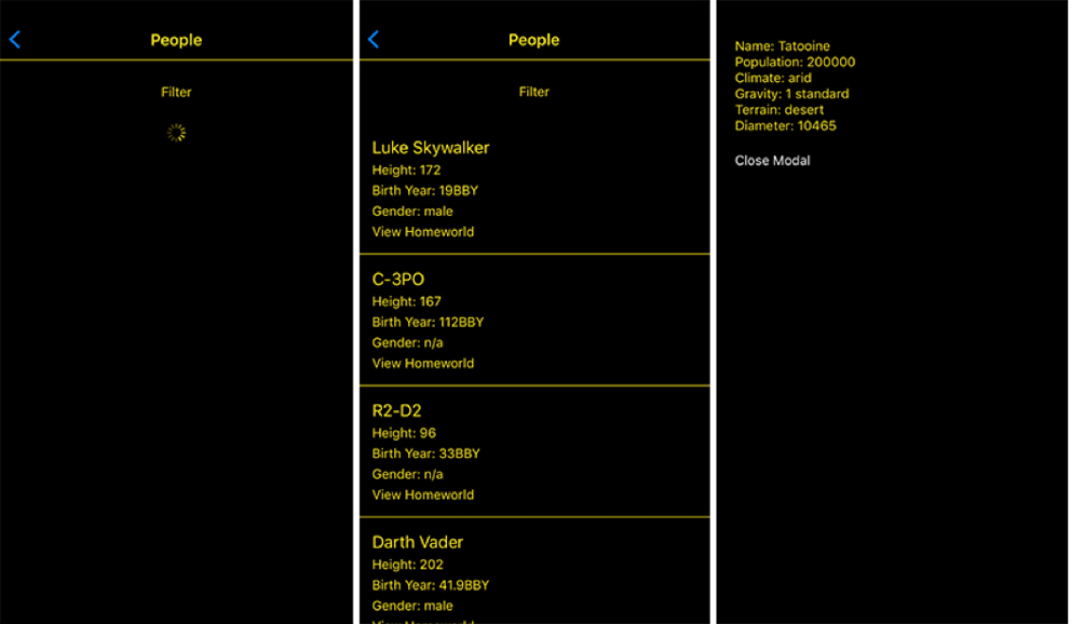
Figure 12.4 This component will display the Loading (left) and Loaded (middle) state of the People.js screen. It will also allow you to view each character’s home world information (right).
When the People component loads, it will start with an empty data array, a loading state of true, and with a few other pieces of state:
state = {
data: [],
loading: true,
modalVisible: false,
gender: 'all',
pickerVisible: false
}
When the component mounts, you’ll fetch the data you need from the Star Wars API at https://swapi.co/api/people; and when this data returns, you’ll populate the data array with the returned data, and set the loading Boolean to false.
You’ll use the modalVisble Boolean to show and hide the Modal component that will fetch information about the character’s home world. You’ll use pickerVisible to show and hide a Picker component that will let you choose the gender of the person you want to view, and will pass the result to a filter that will filter the results accordingly.
Creating a new file, People.js, and begin coding.
Listing 12.5 People.js imports
import React, { Component } from 'react'
import {
①
StyleSheet,
Text,
View,
Image,
TouchableHighlight,
ActivityIndicator,
FlatList,
Modal,
Picker
} from 'react-native'
import _ from 'lodash'
②
import Container from './Container'
③
import HomeWorld from './HomeWorld'
④
①
Imports components from React Native
②
Imports the lodash utility library
③
Imports the Container component used in App.js, because you’ll need the same styling here
④
Imports the HomeWorld component (not yet created) that will populate with a character’s information when you click View Homeworld
The Lodash utility library provides many convenience functions. You’ll need to install it via npm or yarn prior to importing it here.
The next step is to create the main class for the component and set up the navigationOptions to give the header a title as well as some styling. Under the last import in People.js, create the following People class.
Listing 12.6 Creating the People class and setting up the page title
export default class People extends Component {
static navigationOptions = {
①
headerTitle: 'People',
headerStyle: {
②
borderBottomWidth: 1,
borderBottomColor: '#ffe81f',
backgroundColor: 'black'
},
headerTintColor: '#ffe81f',
pressColorAndroid: 'white'
③
}
}
①
Creates the static navigationOptions property
②
headerStyle is the style object for the title header.
③
Sets the color to use the “material ripple” animation used when the button is pressed (Android >= 5.0 only)
The static navigationOptions property is created here, as in the App.js file, but instead of passing in a component as the headerTitle, you pass in the string “People”. You also add some styling.

12.2.1 Creating the state and setting up a fetch call to retrieve data
Now you’ll create the state and set up a fetch call on componentDidMount. Fetch is a cross-platform API for fetching network resources that’s supplanting XMLHttpRequest. Fetch isn’t yet 100% compatible with all internet browsers, but React Native provides a polyfill (an API that mimics the behavior of the original API, in this case Fetch). The Fetch API is an easy-to-use-out-of-the-box way to work with network requests, including GET, POST, PUT, and DELETE. fetch returns a promise, which makes it easy to work with asynchronously.
A fetch request usually looks something like this:
fetch('https://swapi.co/api/people/')
.then(response => response.json())
.then(json => {
#do something with the returned data / json
})
.catch(err => {
#handle error here
})
In the example, the fetch call will hit the Star Wars API at https://swapi.co/api/people and return an object containing a results array. This results array will contain the characters to display on this page. To view this dataset, open the URL in a browser to check out the data structure.
The data set looks like the following, with results being the array of movie characters you’re interested in using:
{
"count": 87,
"next": "http://swapi.co/api/people/?page=2",
"previous": null,
"results": [
{ "name": "Luke Skywalker",
"height": "172",
"mass": "77",
...
},
...
}
Once the data is returned from the API, you update the data array in the state with the results.
Below the navigationOptions object in People.js, create the state and the componentDidMount fetch call.
Listing 12.7 Setting up the initial state and fetching data
state = {
data: [],
loading: true,
modalVisible: false,
gender: 'all',
pickerVisible: false
}
componentDidMount() {
fetch('https://swapi.co/api/people/')
.then(res => res.json())
.then(json => this.setState({ data: json.results, loading: false }))
.catch((err) => console.log('err:', err))
}
In componentDidMount, you fetch the data from the API using fetch(). fetch returns a promise. You then take the returned data and call the .json() method to read the response and transform the data. .json() returns a promise containing the JSON data. Finally, you set the state again, updating the data and loading variables.

12.2.2 Adding the remaining class methods
At this point in the app, if you load this page, the data should be loaded into the state and ready to use. Next up, you need to create the rest of the functionality to display this data, as well as a render method to display the data. To create the rest of the methods used in this component, add the following code after componentDidMount in People.js.
Listing 12.8 Remaining methods for component functionality
renderItem = ({ item }) => {
①
return (
<View style={styles.itemContainer}>
<Text style={styles.name}>{item.name}</Text>
<Text style={styles.info}>Height: {item.height}</Text>
<Text style={styles.info}>Birth Year: {item.birth_year}</Text>
<Text style={styles.info}>Gender: {item.gender}</Text>
<TouchableHighlight
style={styles.button}
onPress={() => this.openHomeWorld(item.homeworld)}
>
<Text style={styles.info}>View Homeworld</Text>
</TouchableHighlight>
</View>
)
}
openHomeWorld = (url) => {
②
this.setState({
url,
modalVisible: true
})
}
closeModal = () => {
③
this.setState({ modalVisible: false })
}
togglePicker = () => {
④
this.setState({ pickerVisible: !this.state.pickerVisible })
}
filter = (gender) => {
⑤
this.setState({ gender })
}
①
renderItem method that will be passed to the FlatList
②
Updates the URL and the modalVisible Boolean in the state, opening the HomeWorld modal
③
Closes the modal by setting modalVisible in the state to false
④
Toggles the pickerVisible Boolean
⑤
Updates the filter value in the state to the passed-in value used to filter the data in the render method
The renderItem method is what you’ll pass to FlatList to render the data in the state. Every time an item is passed through this method, you get an object with two keys: item and key. You destructure the item when the method is called and use the item properties to display the data for the user (item.name, item.height, and so on). Note the onPress method passed to the TouchableHighlight component: this method passes the item.homeworld property to the openHomeWorld method. item.homeworld is a URL you’ll use to fetch the movie character’s home planet information.
The togglePicker method toggles the pickerVisible Boolean. This Boolean shows and hides a picker from which you can choose a filter to view characters by gender: all, female, male, or other (robots and so on).

12.2.3 Implementing the render method
With all the methods set up, the last thing to do is implement the UI in the render method. In People.js, you’ll introduce a new component called the ActivityIndicator: a cross-platform circular loading indicator that will indicate the loading state (you can see a list of properties in table 12.1). After the filter method, add the render method as shown next.
Listing 12.9 render method
render() {
let { data } = this.state
①
if (this.state.gender !== 'all') {
②
data = data.filter(f => f.gender === this.state.gender)
②
}
return (
<Container>
<TouchableHighlight style={styles.pickerToggleContainer}
onPress={this.togglePicker}>
③
<Text style={styles.pickerToggle}>
{this.state.pickerVisible ? 'Close Filter' : 'Open Filter'}
</Text>
③
</TouchableHighlight>
{
④
this.state.loading ? <ActivityIndicator color='#ffe81f' /> : (
④
<FlatList
④
data={data}
④
keyExtractor={(item) => item.name}
④
renderItem={this.renderItem}
④
/>
④
)
④
}
<Modal
⑤
onRequestClose={() => console.log('onrequest close called')}
⑥
animationType="slide"
⑦
visible={this.state.modalVisible}>
⑤
<HomeWorld closeModal={this.closeModal}
url={this.state.url} />
</Modal>
⑤
{
this.state.pickerVisible && (
⑧
<View style={styles.pickerContainer}>
<Picker
⑨
style={{ backgroundColor: '#ffe81f' }}
⑨
selectedValue={this.state.gender}
⑨
onValueChange={(item) => this.filter(item)}>
⑨
<Picker.Item itemStyle={{ color: 'yellow' }}
label="All"
value="all" />
<Picker.Item label="Males" value="male" />
<Picker.Item label="Females" value="female" />
<Picker.Item label="Other" value="n/a" />
</Picker>
</View>
)
}
</Container>
);
}
①
Destructures the data array from the state for easier access
②
Checks whether the filter is set to all: if so, skips this function; if not, performs a filter based on the gender of the character vs. the gender set in the state
③
Creates a button: Close Filter or Open Filter, based on the value of this.state.pickerVisible
④
Checks whether the data is loading by evaluating this.state.loading: if so, shows an ActivityIndicator to indicate loading is taking place; if not, renders the FlatList, passing in the data, this.renderItem, and keyExtractor
⑤
The Modal component stays hidden until modalVisible is set to true and then slides up into view.
⑥
onRequestClose is a required property. You don’t need to do anything, so just logs to the console when called.
⑦
Animation type of the Modal; could also be none or fade
⑧
If this.state.pickerVisible is set to true, renders the Picker component
⑨
Renders the Picker, passing in a value, a style, and an onValueChange method
When the Close Filter / Open Filter button is clicked, the togglePicker method is called and the picker is shown or hidden. The onValueChange method fires every time the picker value is updated, which then updates the state, triggering a rerender of the component, and updating the filtered list of items in the view.
Table 12.1 ActivityIndicator properties
Property | Type | Description (some from docs)
animating | Boolean | Animates the ActivityIndicator icon
color | Color | Color of the ActivityIndicator
size | String (small or large) | Size of the ActivityIndicator
The last thing you need is the styling for this component. This code goes below the class definition in People.js.
Listing 12.10 People component styling
const styles = StyleSheet.create({
pickerToggleContainer: {
padding: 25,
justifyContent: 'center',
alignItems: 'center'
},
pickerToggle: {
color: '#ffe81f'
},
pickerContainer: {
position: 'absolute',
bottom: 0,
right: 0,
left: 0
},
itemContainer: {
padding: 15,
borderBottomWidth: 1, borderBottomColor: '#ffe81f'
},
name: {
color: '#ffe81f',
fontSize: 18
},
info: {
color: '#ffe81f',
fontSize: 14,
marginTop: 5
}
});
You can find the final code for this component at www.manning.com/books/react-native-in-action and also on GitHub at https://github.com/dabit3/react-native-in-action/blob/chapter12/StarWars/People.js.

12.3 Creating the HomeWorld component
To finish the app, you’ll create the final component: HomeWorld. In People.js, you created a Modal, and this HomeWorld component was the Modal’s content:
<Modal
onRequestClose={() => console.log('onrequest close called')}
animationType="slide"
visible={this.state.modalVisible}>
<HomeWorld closeModal={this.closeModal} url={this.state.url} />
</Modal>
You’ll use the HomeWorld component to fetch data about a character’s home planet and display this information to the user in the modal, as shown in figure 12.5.
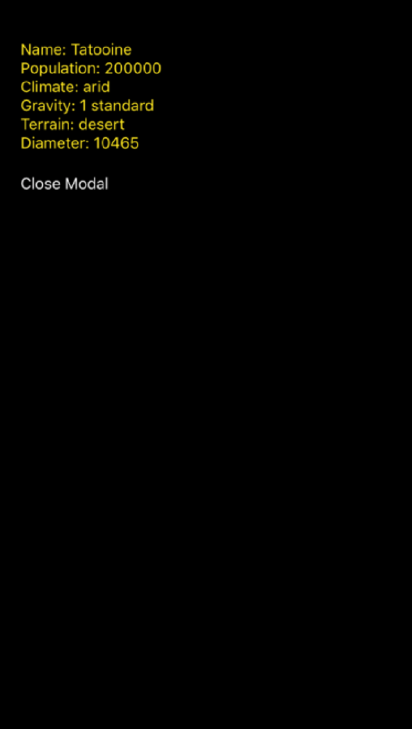
Figure 12.5 HomeWorld component displaying data after fetching from the API. The Close Modal button calls the closeModal function passed in as a prop.
This component will fetch the url prop that’s passed in when the modal opens in a fetch call placed in componentDidMount. This happens because componentDidMount is called every time the visible property of the modal is set to true: it’s basically reloading the component when the modal is shown.

12.3.1 Creating the HomeWorld class and initializing state
Create a new file: HomeWorld.js. Then, import the components you’ll need, create the class definition, and create the initial state, as shown next.
Listing 12.11 HomeWorld component class, imports, and initial state
import React from 'react'
import {
View,
Text,
ActivityIndicator,
StyleSheet,
} from 'react-native'
export default class HomeWorld extends React.Component {
state = {
①
data: {},
loading: true
}
}
①
Initial state
The initial state holds only two things: an empty data object and a loading Boolean set to true. When the component loads, you’ll show a loading indicator while you wait for the data to come back from the API. Once the data loads, you’ll update the loading Boolean to false and render the data that came back from the API.

12.3.2 Fetching data from the API using the url prop
You’ll call the API using the url property in componentDidMount, which will be called once the component loads. Below the state declaration in HomeWorld.js, create the following componentDidMount method.
Listing 12.12 Fetching data and uploading state in componentDidMount
componentDidMount() {
if (!this.props.url) return
①
const url = this.props.url.replace(/^http:\/\//i, 'https://')
②
fetch(url)
③
.then(res => res.json())
.then(json => {
this.setState({ data: json, loading: false })
})
.catch((err) => console.log('err:', err))
}
①
Makes sure there’s a URL; if not, returns out of the function to not cause an error
②
Updates the API URL to use HTTPS
③
Calls fetch on the URL passed in as a prop
You update the API URL to use HTTPS because React Native doesn’t allow unsecure HTTP requests out of the box (although it can be configured to work if necessary). You call fetch on the URL and, when the response comes back, transform the data into JSON, update the state to set loading to false, and add the data to the state by updating the data value of state with the returned JSON.
Finally, you need to create the render method and the styling. In the render method, you’ll display some properties relating to the character’s home world, such as its name, population, climate, and so on. These styles will be repetitive. In React and React Native, it’s best to create and reuse a component rather than creating and reusing styling, if it’s something you’ll be doing more than a handful of times.
In this case, it makes sense to create a custom TextContainer component to use in the render method to display data. Above the class declaration in HomeWorld.js, create the following TextContainer component.
Listing 12.13 Creating a reusable TextContainer component
const TextContainer = ({ label, info }) => (
<Text style={styles.text}>{label}: {info}</Text>
)
In this component, you return a basic Text component and receive two props that you’ll use: label and info. The static label is the description of the field, and info is the information you get when the API returns the home world data.

12.3.3 Wrapping up the HomeWorld component
Now that the TextContainer is ready to go, finish the component by creating the render method and the styling in HomeWorld.js.
Listing 12.14 render method and styling
export default class HomeWorld extends React.Component {
...
render() {
const { data } = this.state
①
return (
<View style={styles.container}>
{
this.state.loading ? (
②
<ActivityIndicator color='#ffe81f' />
) : (
<View style={styles.HomeworldInfoContainer}>
③
<TextContainer label="Name" info={data.name} />
<TextContainer label="Population" info={data.population} />
<TextContainer label="Climate" info={data.climate} />
<TextContainer label="Gravity" info={data.gravity} />
<TextContainer label="Terrain" info={data.terrain} />
<TextContainer label="Diameter" info={data.diameter} />
<Text
④
style={styles.closeButton}
④
onPress={this.props.closeModal}>
④
Close Modal
④
</Text>
④
</View>
)
}
</View>
)
}
}
const styles = StyleSheet.create({
container: {
flex: 1,
backgroundColor: '#000000',
paddingTop: 20
},
HomeworldInfoContainer: {
padding: 20
},
text: {
color: '#ffe81f',
},
closeButton: {
paddingTop: 20,
color: 'white',
fontSize: 14
}
})
①
Destructures the data object from the state
②
Check whether loading is true; if so, shows an ActivityIndicator to indicate loading
③
If loading isn’t true, returns the main View component that wraps the TextContainers and displays the data returned from the API, now stored as the data object in the state
④
Creates a button that calls this.props.closeModal to let the user close the modal

Summary
React Native ships with cross-platform components: components that work on both the iOS and Android platforms.
Use the Modal component to show overlays by setting the visible prop to true or false.
Use the Picker component to easily allow user selections. The selectedValue prop defines which value is selected.
Use the Fetch API to work with network requests and use the response data. fetch will return a promise with data you can use in the app.
The FlatList component lets you easily and efficiently render lists of data by passing in a renderItem method as well as a data array as props.
ActivityIndicator is a great, easy way to indicate a loading state in your app. An indicator is shown or hidden based on the loading state.
Create reusable containers by wrapping the children prop in two React Native View components.

appendix
Installing and running React Native

Developing for iOS devices
At the time of this this writing, if you want to develop for iOS you must have a Mac, because Linux and Windows aren’t supported for developing for the iOS platform.

Getting started
To get started, you must have a Mac, and you need the following installed on it:
Xcode
Node.js
Watchman
React Native command-line interface
Follow these steps:
Install Xcode, which is available through the App Store.
The React Native docs and I recommend installing Node and Watchman via Homebrew. If you don’t already have Homebrew installed, go to http://brew.sh and install it on your machine.
Open a command line, and install Node and Watchman using Homebrew: brew install node
brew install watchman
Once Node.js is installed, install the React Native command-line tools by running the following from the command line:
npm install –g react-native-cli
If you get a permission error, try again with sudo:
sudo npm install -g react-native-cli

Testing the installation on iOS
Check to see if React Native is properly installed by creating a new project. In the terminal or on your command line of choice, run the following commands, replacing MyProjectName with the project name:
react-native init MyProjectName
cd MyProjectName
Now that you’ve created the project and changed into the new directory, you can run the project a couple of different ways:
From within the MyProjectName directory, run the command react-native run-ios.
Open the project in Xcode by opening the MyProjectName.xcodeproj file located at MyProjectName/ios/MyProjectName.xcodeproj.

Developing for Android devices
You can develop React Native for Android with a Mac, Linux, or Windows environment.

Mac and Android
To get started on a Mac, you need the following installed on your machine:
Node.js
React Native command-line tools
Watchman
Android Studio
Follow these steps:
The React Native docs and I recommend installing Node and Watchman via Homebrew. If you don’t already have Homebrew installed, go to http://brew.sh and install it on your machine.
Open a command line, and install Node and Watchman using Homebrew:
brew install node
brew install watchman
Once Node.js is installed, install the React Native command-line tools by running the following from the command line:
npm install -g react-native-cli
Install Android Studio at https://developer.android.com/studio/install.html.
When everything is installed, go to section A.2.4 to create your first project.

Windows and Android
The following must be installed on your machine:
Node.js
Python2
React Native command-line tools
Watchman
Android Studio
Follow these steps:
Watchman is in the alpha stage for Windows, but it’s working fine so far in my experience. To install Watchman, go to https://github.com/facebook/watchman/issues/19 and download the alpha build via the link in the first comment.
React Native recommends installing Node.js and Python2 via Chocolatey, a package manager for Windows. To do so, install Chocolatey (https://chocolatey.org), open a command line as admin, and then run these commands:
choco install nodejs.install
choco install python2
Install the React Native command-line interface:
npm install –g react-native-cli
Download and install Android Studio from .
When everything is installed, go to section A.2.4 to create your first project.

Linux and Android
The following must be installed on your machine:
Node.js
React Native command-line tools
Watchman
Android Studio
Follow these steps:
If you don’t already have Node.js installed, go to https://nodejs.org/en/download/package-manager and follow the instructions for your Linux distribution.
Run the following command to install the React Native command-line tools:
npm install -g react-native-cli
Download and install Android Studio from https://developer.android.com/studio/install.html.
Download and install Watchman from .
Once everything is installed, continue to the next section to create your first project.

Creating a new project (Mac/Windows/Linux)
Once your development environment is set up and react-native-cli is installed, you create new React Native projects from the command line. Navigate to the folder in which you want to create a project, and issue the following command, replacing MyProjectName with the project name:
react-native init
MyProjectName

Running a project (Mac/Windows/Linux)
To run a React Native project, change directories into the project from the command line, and run this command for Android:
react-native run-android
Index
3D effects 123–123
actions
adding 187–192
actions, showing with ActionSheetIOS 238–241
ActionSheetIOS 238–241
ActivityIndicator component 274, 275
addBook function 188, 189, 190
addCity method 150, 151
addEventListener method 215
addListener method 212
addLocation method 150, 156, 158, 160
Alert.alert() method 201
Alert API 200–201
alerts
examples of 201–201
use cases for 200–200
aligning
children in containers 139–140
text, horizontally 109–109
alignItems property 135, 139–140
alignSelf property 135, 140–140
Android operating system
APIs for 242–259
components for 242–259
creating drop shadows with Elevation 118–119–120, 120
file extensions 223–224
React Native with 282–284
Animated.loop function 167, 169
Animated.parallel function 170
Animated.stagger 175–175
Animated.timing function 167, 169
Animated.View 165
Animated API 162–163–165, 178
animatedMargin 167
animatedRotation value 170
animations
jumpy 177
laggy 177
loading 167–170
parallel 170–171
APIs (application programming interfaces) 278–278
App.js 24
appKey argument 47
AppRegistry.registerComponent 24, 25
AppRegistry method 47, 267
AppState API 202–203
arrays 38–38
async keyword 206
AsyncStorage API 159, 204–206
await keyword 206
Babel tool 13
backfaceVisibility property 127, 127, 132
backgroundColor property 59, 84, 85, 95
background colors 84–86
barTintColor 235
BookDisplay component 35
bookReducer 183, 183
borderBottomColor property 86
borderBottomLeftRadius property 86
borderBottomRightRadius property 86
borderBottomWidth property 86
borderColor property 86
borderLeftColor property 86
borderLeftWidth property 86, 87
border properties 86–92
borderRadius property 83, 86
borderRightColor property 86
borderRightWidth property 86
borderStyle property 86, 88
borderTopColor property 86
borderTopLeftRadius property 86
borderTopRightRadius property 86
borderTopWidth property 86
borderWidth property 83, 86
Button component 16, 39, 60, 60
cancelButtonIndex 238, 240
Cartesian plane 123
CenterMessage component 150
center option 137
Child2 function 181
children in containers 139–140
Chocolatey package manager 283
classes
creating 277–277
in React 5–6
main classes for initial view 267–269
class methods 273–274
Class syntax 18–18
clear method 204
clearWatch method 210
Clipboard API 207–207
clipboards 207–207
clipped items 142–144
closeModal function 276
colors
background colors 84–86
coloring text 101–103
combining components 21–22
Component class 20
componentDidMount method 6, 41, 42–42, 44, 167, 203, 205, 272, 278
componentDidUpdate method 43–43
components 5, 9–11–15, 22
componentWillMount method 213, 217
componentWillUnmount method 41, 44–44
connect function 73, 181, 185–187
console.log() function 51
constructor function 29, 40
constructors 40–41
Container components 266–267
containers
children, aligning in 139–140
parents 140–140
context 180–181
Context API 180–181
copying text 207–207
Cordova 14–14
createAnimatedComponent 163, 178
createAnimation function 174
createClass syntax 17–17
createDrawerNavigator API 160
createElement 18–19
create-react-native-app command 23
createStackNavigator 149, 265, 267, 269
cross-platform APIs 199–221
cross-platform notifications 200–201
curried function 185
data
accessing with connect function 185–187
creating states to retrieve 271–272
fetching from APIs with url property 278–278
managing using props 32–38
managing using state 28–32
persisting with AsyncStorage API 204–206
retrieving 271–272
unidirectional data flow 8–8–12, 12
DatePickerAndroid.open() function 251
DatePickerAndroid API 251–253
DatePickerIOS 226–226
date pickers 251–253
Debug JS Remotely option 53
declarations 20–20
deleteTodo function 63
dependencies 265–269
designing apps 46–46
destructiveButtonIndex 238
destructuring
props 36–37
state 36–37
developer menu
opening 52–55
overview of 53–55
Dev Settings option 55
diffing 8–8
Dimensions.get 209
Dimensions API 208–209
DIP (device-independent pixel) 117
direction of flex 136–137
dismiss method 212
dispatchAddBook function 190, 191
dispatch function 187
don't repeat yourself (DRY) principle 36
DPI (dots per inch) 117
DPs (device-independent pixels) 116–117
drawer-based navigation 146
DrawerLayoutAndroid 243–247
DrawerNavigator 160–161
drop shadows
with Elevation 118–119–120, 120
with ShadowPropTypesIOS 118–118–119, 120
DRY (don't repeat yourself) principle 36
dx property 218
dynamic props 34–35
dy property 218
easing 167
Easing.linear 169
ECMAScript 2015 18–18
ECMAScript 5 17–17
elements, moving along axis 123–124
Elevation, creating drop shadows with 118–119–120, 120
emulators 53–53
Enable Hot Reloading option 54
Enable Live Reload option 54
entry point of components 5
ES2015 (ECMAScript 2015) 18–18
ES5 (ECMAScript 5) 17–17
excludedActivityTypes 239
exportable components 19–21
exports 21–21
false element 39
fetch calls 271–272
filter method 274
FlatList 270–276
flex
altering component dimensions with 135–136
specifying direction with flexDirection 136–137
flexbox 135–144
flexDirection property 99, 135, 136–137
flex-end option 137
flex-start option 137
flexWrap property 135, 142–144
Flow 23
flushGetRequests method 204
Flutter 15
font styles 104–107
fontWeight property 76
font weights 106–107
forceUpdate method 31
form inputs 165–165
fullName property 41
functional components 38
Geolocation API 209–210
gesture events 216–221
get() method 209
getAllKeys method 204
getConnectionInfo method 215
getCurrentPosition method 210, 210
getDerivedStateFromProps method 41
getItem method 204
getSnapshotBeforeUpdate method 41
getString() method 207
getStyleSheet function 82
getVisibleTodos function 70
.gitignore 23
global state 180–181
headerTitle component 269
headerTitleStyle property 155
height of text elements 108–108
Homebrew 281, 282
Home class 21, 246
horizontal tab bars 233–234
hot reloading 13, 54
importing 20–20
index.js 24
initializing
properties 40–41
states 277–277
initialState variable 183, 189
initial view 267–269
inputChange function 51, 56, 57
Input component 55
inputRange 167
inputValue property 48, 56
installing dependencies 265–269
interpolation 167–170
iOS operating system
components for 222–241
controlling letter spacing in 110–110
file extensions 223–224
React Native with 281–282
ShadowPropTypesIOS 118–118–119, 120
text decoration styles 109–109
isConnected method 215
isConnectionExpensive method 215
item.homeworld property 273
itemPositioning 235
items
deleting from Redux stores in reducer 192–195
itemStyle 228
JavaScript programming language 4, 18–19
json() method 272
JSX extension 8–8
jumpy animations 177
justifyContent property 135, 137–138
Keyboard API 212–213
keyboards 212–213
keyboardShouldPersistTaps prop 48
keyExtractor method 269
laggy animations 177
laying out apps 46–46
lifecycle methods 41–44
lineHeight property 108
Linux operating systems 283–283
lists of values 228–230
loading animations 167–170
loading indicators 231–232
location of users 209–210
Lodash utility library 271
main classes for initial view 267–269
mapDispatchToProps object 191
mapStateToProps 187, 187
marginBottom property 93
marginLeft property 93
marginRight property 93
margins 92–99
marginTop property 93, 174
menus 243–247
mergeItem method 204
Modal 270–276
modalVisible Boolean 270
moment.js 253
monospace option 104
mounting 6, 41
moveX property 218
moveY property 218
multiGet method 204
multiMerge method 204
multiRemove method 204
multiSet method 204
name property 6
native components 16–17
native date pickers 251–253
native threads 177–178
navigate method 269
navigation 145–161
navigation components 267–267
navigationOptions property 155, 158, 267, 271, 271
navigator.geolocation variable 209
NetInfo.getConnectionInfo method 216
NetInfo API 214–216
Node.js 283
notifications 200–201
nowrap value 142
npm (node package manager) 23
null element 39
numberActiveTouches property 218
objects, passing as props 38–38
onBlur 165
onDateChange method 226, 226
onFocus 165
onMoveShouldSetPanResponder property 217
onPanResponderEnd property 217
onPanResponderGrant property 217
onPanResponderMove property 217
onPanResponderReject property 217
onPanResponderRelease property 217
onPanResponderStart property 217
onPanResponderTerminate property 217
onPanResponderTerminationRequest property 217
onPress method 29, 67, 129, 237, 273
onStartShouldSetPanResponder property 217
onValueChange method 228, 229, 275
openDrawer method 247
options object 149
organizing styles 76–83
outputRange 167
package.json file 24
padding 92–99
paddingBottom property 95
paddingLeft property 95
paddingRight property 95
paddingTop property 95
paging, scrollable 248–251
PanResponder API 216–221
parallel animations 170–171
parent containers 140–140
People components 266–267
persisting data 204–206
perspective 123–123, 124
Picker 270–276
Picker. Modal 270
PickerIOS 228–230
pickerVisible Boolean 274
pixel density 117
pixels 116–117
pixels per inch (PPI) 117
placeholderTextColor 51
Platform.OS property 224
Platform.select function 116, 122, 225
Platform API 25, 224–225
Platform component 104
platforms, detecting 224–225
platform-specific code 223–225
platform-specific sizes and styles 116–122
points 116–117
position style 97–99
PPI (pixels per inch) 117
ProgressBarAndroid 116
progressImage 232
progressTintColor 232
ProgressViewIOS
examples of 232–232
overview of 116
use cases for 232–232
progressViewStyle 232
property initializers 40–41
props
destructuring 36–37
dynamic 34–35
managing component data using 32–38
passing arrays as 38–38
passing objects as 38–38
with stateless components 37–38
props.navigation.state.params 156
providers 184–185
Provider wrapper 184
React
classes 5–6
lifecycle of 6–6
overview of 27–44
React.createElement 18
React Native
advantages of 11–15
disadvantages of 15–15
overview of 4–6–8, 11
React Native App CLI 22–23
React Native apps
creating 45–72, 265–269
designing 46–46
detecting state of with AppState API 202–203
developing for Android devices 282–284
developing for iOS devices 281–282
implementing Redux with 181–182
navigation-based 146–160
React Native CLI 23–26
react-native-maps 210
react-native package 6
react-native run-android 49
react-native run-ios 49
react-navigation 269
react package 6
red, green, and blue (RGB) 116
reducers
creating to hold Redux state 183–183
deleting items from Redux store in 192–195
Redux data architecture library 179–195
registering routes 267–267
Reload option 53
removeAllListeners 212
removeBook function 194
removeEventListener method 215
removeItem method 204
rendering tabs 235–237
renderItem method 269, 273
render methods
creating UI with 39–40
implementing 274–276
overview of 6, 30
resolution 116
reusable components 18–18
RGB (red, green, and blue) 116
RNRedux application 182
rootReducer 183
rotate 124–127
rotating elements 124–127
ROTATION label 125
rotation variable 170
routes 267–267
scale 128–128
scale transform 129–132
scaling objects onscreen 128–128
screen information of users 208–209
scrollable paging 248–251
ScrollView component 48
SegmentedControlIOS 233–234
selectedIndex 233
selectedValue method 228, 229
selectionColor 51
sequences, animated 172–174
setInterval method 232
setItem method 204
setState function 28, 29, 30
setString() method 207
setTimeout function 42, 167
setType function 67, 70
shadowColor property 76, 121
shadowOffset property 121
shadowOpacity property 118, 121
ShadowPropTypesIOS 76, 118–118–119, 120
shadowRadius 118
shadows 109–109
sheets, sharing 238–241
shouldComponentUpdate lifecycle method 43–43
shouldComponentUpdate method 41
showActionSheet method 240
showActionSheetWithOptions method 238, 239
Show Perf Monitor option 54
showShareActionSheetWithOptions method 238, 239, 240
simulators 52–52
size of text, adjusting 106–106
skewing elements along axis 132–132
space-around option 137
space-between option 138
spacing
around components 137–138
of letters 110–110
span tag 6
src directory 147
stack-based navigation 146–160
StackNavigation 269
staggering start times 175–175
Start Systrace option 54
state
creating Redux reducers to hold 183–183
creating to retrieve data 271–272
destructuring 36–37
global 180–181
initial, setting 28–29
initializing 277–277
managing component data using 28–32
manipulating component state 28–32
of applications, detecting 202–203
updating 29–32
stateful components 5
stateID property 218
stateless components 5, 18–18, 37–38
state object 6
static getDerivedStateFromProps method 42–42
static prop 33
stopObserving method 210
stores
creating 184–185
deleting items from in reducer 192–195
strikethrough 109–109
style prop 167
styles.border 69
styles.selected 69
stylesheets
declaring in same file as components 79–79
declaring in separate files 79–80
styles property 77
styling 75–114, 115–144
submit method 153
submitTodo function 57, 60, 63
switch statement 250
Systrace 54
TabBar component 68, 68, 70
TabBarIOS 235–237
TabBarItem component 68, 68
tab bars 233–234
tab-based navigation 146–160
tabs 235–237
testing React Native installation 282–282
textAlign property 109
Text components
styling 100–114
View components vs. 101–103
TextContainer component 278
textDecorationColor property 109
textDecorationLine property 109
textDecorationStyle property 109
TextInput component 48, 50, 51, 56, 165
textInput values 189
textShadowColor property 76, 109
textShadowOffset property 109
textShadowRadius property 109
text styles
adding lines through 109–109
adding shadows to text 109–109
aligning text horizontally 109–109
coloring 101–103
controlling letter spacing (iOS only) 110–110
examples of 110–114
in iOS 109–109
specifying height of text elements 108–108
underlining text 109–109
ThemeContext.Consumer 181
theming 146–160
this.props.books 185
this.props.navigation.navigate 153
this.props.navigation.state.params 158
this.props.screenProps 150
this.props.screenProps.addCity 153, 153
this.props.screenProps.addLocation 158
this.props component 33
this.state component 28
this.submitTodo 60
this keyword 40
threading 8–8, 177–178
thumbnails 129–132
TimePickerAndroid 253–256
time pickers 253–256
timeZoneOffsetInMinutes 226
timing function 164
tintColor 235
title key 267
ToastAndroid 256–259
ToastAndroid.show() function 257
ToastAndroid.showWithGravity() method 257
toasts 256–259
todo app, creating 45–72
TodoButton component 66
Todo component 61, 63, 66
todoIndex function 58
TodoList component 61, 63, 70
TodoMVC site 46
todos variable 71
toggleComplete function 63, 67
Toggle Inspector option 54
togglePicker method 274, 275
ToolbarAndroid 116, 247–248
Toolbar component 246
toolbars 247–248
TouchableHighlight component 16, 59, 59, 69, 273
TouchableWithoutFeedback 156
touch events 216–221
trackImage 232
trackTintColor 232
transformations 122–134
translate 123–124
transpilation 13–13
type argument 19
type property 187
UI (user interface) 39–40
UIAlertController 238
UIProgressView 231
UISegmentedControl component 233
underlayColor property 59
underlining text 109–109
unidirectional data flow 8–8–12, 12
unmounting (deletion) stage 41
unselectedItemTintColor 235
unselectedTintColor 235
updateYear function 29
updating
immediate updates 14–14
state 29–32
url property 278–278
useNativeDriver 177
user status 214–216
uuid library 147, 192
uuidV4 method 153
values, lists of with PickerIOS 228–230
View components
overview of 17, 39, 76
styling 83–100
Text components vs. 101–103
ViewPagerAndroid 248–251
virtual DOM 8
visibility, setting 127–127
visible property 277
vx property 218
vy property 218
Watchman 23, 283
watchPosition method 210, 210
web navigation 146–160
weights of fonts 106–107
Windows operating systems 283–283
wrap value 142
x0 property 218
Xamarin 15
XMLHttpRequest 271
y0 property 218
Yoga library 99
Lists of Figures, Tables and Listings

List of Illustrations
Figure 1.1: Example app design
Figure 1.2: App structure broken down into separate components
Figure 1.3: How one-way data flow works
Figure 1.4: React Native starter project: what you should see after running the starter project on the emulator
Figure 2.1: The flow of setState, with arrows indicating when the text element is pressed. The state year property is initialized to 2016 in the constructor. Each time the text is pressed, the state year property is set to 2017.
Figure 3.1: Todo app design
Figure 3.2: Todo app with descriptions
Figure 3.3: Initializing a new React Native app
Figure 3.4: Running the app
Figure 3.5: Manually opening the developer menu (iOS simulator)
Figure 3.7: Manually opening the hardware menu (Android emulator)
Figure 3.9: Debugging in Chrome
Figure 3.10: Using the inspector (left: iOS, right: Android)
Figure 3.11: Perf Monitor (left: iOS, right: Android)
Figure 3.13: Updated view after adding the TextInput
Figure 3.14: Logging out the TextInput value with the inputChange method
Figure 3.15: Updated app with the Button component
Figure 3.16: Logging the state
Figure 3.17: Updated app with the TodoList component
Figure 3.18: App with TodoButtons displayed
Figure 3.19: Final todo app
Figure 4.1: An example file structure with styles separated from components in a single folder instead of a single file
Figure 4.8: Incorporating border properties into the Profile Card component transforms the 300 × 400 colored rectangle into something more akin to what you want for the final Profile Card component.
Figure 4.9: A common depiction of how margins, padding, and borders interrelate
Figure 4.14: The completed Profile Card with the user’s name and occupation and a brief profile description
Figure 4.20: The completed Profile Card example. Textual information has been added about the person using the text styling techniques covered in this section.
Figure 5.4: The ProfileCard on iOS and Android after drop shadows have been added to the card container and the circular image container. The drop shadows on iOS are created using the iOS-specific shadow properties: shadowColor, shadowOffset, and shadowOpacity. On Android, the elevation property is used to try to create depth. It produces only a minor shadow effect, far inferior to the shadows produced on iOS.
Figure 5.6: The positive and negative direction of rotation for each axis
Figure 5.7: Rotating a 100 × 100 square about the x-axis in increments of 35°. After 90°, the “ROTATION” label can be seen through the element, upside down.
Figure 5.9: Rotating a 100 × 100 square about the z-axis in increments of 35°. The positive rotation is clockwise, and the negative rotation is counterclockwise.
Figure 5.8: Rotating a 100 × 100 square about the y-axis in increments of 35°. After 90°, the “ROTATION” label can be seen through the element, backward.
Figure 5.10: Applying transform: [{translateY: 50},{translateX: 150},{rotate: '45deg'}] to the original square
Figure 5.11: Applying transform: [{translateY: 50},{rotate: '45deg'},{translateX: 150}] to the original square. Rotating the square changes the orientation of the x- and y-axes, so when the square is translated 150 points in the +x direction, it’s moved diagonally down and out of the viewport.
Figure 5.16: Three examples of layouts using the flex property. The top example is 1:1, with A = {flex: 1} and B = {flex: 1}, resulting in each taking up 50% of the space. The middle example is 1:2, with C = {flex: 1} and D = {flex: 2}, resulting in C taking up 33% of the space and D taking up 66%. The bottom example is 1:3, with E = {flex: 1} and F = {flex: 3}, resulting in E taking up 25% of the space and F taking up 75% of the space.
Figure 5.19: Modified examples from figure 5.16, using the non-default alignItems properties: center, flex-start, and flex-end
Figure 5.20: How each alignSelf property affects the layout when its parent container’s alignItems property is set to the default value of stretch
Figure 6.4: AddCity tab allows the user to enter a new city name and the country name.
Figure 6.6: City.js shows locations within the city.
Figure 7.1: Animating the top margin of a square box using Animated
Figure 7.4: Welcome screen using parallel animations (shown after the animations are complete)
Figure 7.5: Creating an animated sequence of numbers
Figure 7.6: Using Animated.stagger to create an array of staggered animations
Figure 8.2: RNRedux src folder structure
Figure 8.3: Rendering the list of books from the Redux store
Figure 8.5: Adding the Remove button to the Books.js UI
Figure 9.2: Coordinates object returned from Geolocation
Figure 9.3: PanResponder used to make the square draggable
Figure 10.1: DatePickerIOS with date mode, time mode, and datetime mode
Figure 10.2: DatePickerIOS rendering chosen date and time
Figure 10.3: PickerIOS rendering a list of people
Figure 10.4: Rendering ProgressViewIOS in the UI
Figure 10.5: Basic SegmentedControlIOS implementation with two values (one and two)
Figure 10.6: TabBarIOS with two tabs: History and Favorites
Figure 10.7: ActionSheetIOS rendering an action sheet (left) and a share sheet (right)
Figure 11.1: Initial layout of the application using DrawerLayoutAndroid. The button at the top in the first screen, Open Drawer, will call a method that opens the drawer. The second screen is the opened drawer.
Figure 11.2: ToolbarAndroid with title, subtitle, and two actions. This menu is configurable, but you’re only working with the default settings in this example.
Figure 11.3: ViewPagerAndroid with two child views. When you swipe the pages, they scroll left and right to show the next page.
Figure 11.4: DatePickerAndroid with a button that opens the date picker and then shows the selected date in the view
Figure 11.5: TimePickerAndroid with both hour and minute views
Figure 11.6: ToastAndroid with toasts in the default and middle positions
Figure 12.1: The completed Star Wars app that you’ll build with React Native cross-platform components. You’ll focus on the first link: People.
Figure 12.2: The initial view of the app
Figure 12.3: Components and title for the StarWars component
Figure 12.4: This component will display the Loading (left) and Loaded (middle) state of the People.js screen. It will also allow you to view each character’s home world information (right).
Figure 12.5: HomeWorld component displaying data after fetching from the API. The Close Modal button calls the closeModal function passed in as a prop.

List of Tables
Table 1.1 JSX components vs. HTML elements
Table 2.1 Props vs. state
Table 4.1 Supported color formats
Table 5.1 Comparison of a 17-inch HVGA monitor’s PPI vs. the original iPhone’s PPI
Table 5.2 Shadow properties used to create the examples in figure 5.2
Table 5.3 Elevation settings for figure 5.3
Table 9.1 Alert.alert method arguments
Table 9.2 AsyncStorage methods and arguments
Table 9.3 Clipboard methods
Table 9.4 Geolocation methods
Table 9.5 Keyboard methods
Table 9.6 Cross platform and Android specific connectivity types
Table 9.7 NetInfo methods
Table 9.8 Configuration arguments for the PanResponder create method
Table 9.9 evt and gestureState properties
Table 10.1 DatePickerIOS props and method
Table 10.2 PickerIOS methods and props
Table 10.3 ProgressViewIOS methods and props
Table 10.4 SegmentedControlIOS methods and props
Table 10.5 TabBarIOS props
Table 10.6 ActionSheetIOSshowActionSheetWithOptions options
Table 10.7 ActionSheetIOSshowShareActionSheetWithOptions options
Table 12.1 ActivityIndicator properties

List of Listings
Listing 1.1: Creating a basic React Native class
Listing 1.4: Creating a Button component
Listing 1.5: Importing and using the Button component
Listing 1.6: App.js
Listing 2.1: Setting state with a property initializer
Listing 2.2: Setting state with a constructor
Listing 2.3: Updating state
Listing 2.4: Forcing rerender with forceUpdate
Listing 2.5: State with other data types
Listing 2.6: Static props
Listing 2.7: Displaying static props
Listing 2.8: Dynamic props
Listing 2.9: Dynamic props using state
Listing 2.10: Updating dynamic props
Listing 2.11: Destructuring state and props
Listing 2.12: Props with stateless components
Listing 2.13: Destructuring props in a stateless component
Listing 2.14: Passing other data types as props
Listing 2.15: staticgetDerivedStateFromProps
Listing 2.16: componentDidMount
Listing 2.17: shouldComponentUpdate
Listing 2.18: componentDidUpdate
Listing 2.19: componentWillUnmount
Listing 3.1: Basic todo app implementation
Listing 3.2: index.js
Listing 3.3: Creating the App component
Listing 3.4: Setting the initial state
Listing 3.5: Creating the Heading component
Listing 3.6: Importing and using the Heading component
Listing 3.7: Creating the TextInput component
Listing 3.8: Creating the inputChange function
Listing 3.9: Adding inputChange and inputValue to the TextInput
Listing 3.10: Adding the submitTodo function
Listing 3.11: Creating the todoIndex variable
Listing 3.12: Creating the Button component
Listing 3.13: Importing the Button component
Listing 3.14: Creating the Todo component
Listing 3.15: Creating the TodoList component
Listing 3.16: Importing the TodoList component
Listing 3.17: Adding toggleComplete and deleteTodo functions
Listing 3.18: Creating TodoButton.js
Listing 3.19: Passing toggleComplete and deleteTodo as props to TodoList
Listing 3.20: Passing toggleComplete and deleteTodo as props to ToDo
Listing 3.21: Updating Todo.js to bring in TodoButton and functionality
Listing 3.22: Adding the setType function
Listing 3.23: Creating the TabBar component
Listing 3.24: Creating the TabBarItem component
Listing 3.25: Implementing the TabBar component
Listing 3.26: Updating the TodoList component
Listing 4.1: Using inline styles
Listing 4.2: Referencing styles defined in a StyleSheet
Listing 4.3: Externalizing a component’s stylesheets
Listing 4.4: Importing external stylesheets
Listing 4.5: Dynamic stylesheets extracted from the main component file
Listing 4.6: Application that toggles between light and dark themes
Listing 4.7: Initial framework for the Profile Card component
Listing 4.8: Setting various border combinations
Listing 4.9: Setting various border radius combinations
Listing 4.10: Incorporating border properties into the Profile Card
Listing 4.11: Applying various margins to components
Listing 4.12: Modifying listing 4.11 to replace margins with padding
Listing 4.13: Relative and absolute positioning comparison
Listing 4.14: Modifying Profile Card styles to fix the layout
Listing 4.15: Adding text to the Profile Card
Listing 4.16: Displaying monospaced fonts on iOS and Android
Listing 4.17: Setting font styles for Text elements in the Profile Card
Listing 4.18: Applying lineHeight to a Text element in iOS and Android
Listing 4.19: Examples of styling Text components
Listing 4.20: Completed Profile Card example
Listing 5.1: Adding drop shadows to the ProfileCard
Listing 5.2: Scaling squares using scale, scaleX, and scaleY
Listing 5.3: Scaling ProfileCard from full size to thumbnail
Listing 5.4: Examples showing how skewing transforms a square
Listing 5.5: Flex views with 1:1 ratio, 1:2, and 1:3 ratios
Listing 5.6: Adding flexDirection: 'row' to the parent container
Listing 5.7: Examples showing the justifyContent options
Listing 5.8: Using non-default alignItems properties
Listing 5.9: Using alignSelf to override the parent’s alignItems
Listing 5.10: Example of how flexWrap values affect layout
Listing 6.1: Creating a theme file with a primary color
Listing 6.2: Creating the navigation configuration
Listing 6.3: Updating App.js to use the navigation configuration
Listing 6.4: CenterMessage component
Listing 6.5: AddCity tab (functionality)
Listing 6.6: AddCity tab (styling)
Listing 6.7: Cities route (functionality)
Listing 6.8: Cities route (styling)
Listing 6.9: City route (functionality)
Listing 7.1: Using Animated and updating the marginTop property
Listing 7.2: Animating a TextInput to expand when the input is focused
Listing 7.3: Creating an infinitely spinning loading animation
Listing 7.4: Creating an animated welcome screen
Listing 7.5: Creating a sequence of animations
Listing 7.6: Using Animated.stagger to stagger a series of animations
Listing 8.1: Creating context
Listing 8.2: Creating a reducer
Listing 8.3: Creating a root reducer
Listing 8.4: Adding the provider and store
Listing 8.5: connect function in Books.js
Listing 8.6: Accessing the Redux store and bookReducer data
Listing 8.7: Creating the first action
Listing 8.8: Updating bookReducer to use the addBook action
Listing 8.9: Additional imports in Books.js
Listing 8.10: Adding state and class methods to Books.js
Listing 8.11: Adding the UI for the form
Listing 8.12: Importing and using uuid
Listing 8.13: Creating the removeBook action
Listing 8.14: Removing an item from an array in a Redux reducer
Listing 8.15: Adding removeBook functionality
Listing 9.1: Binding an alert to a touch event
Listing 9.2: Using AppState to log out the current app state
Listing 9.3: Persisting and retrieving data using AsyncStorage
Listing 9.4: Using async await to fetch data asynchronously
Listing 9.5: Saving and replacing clipboard content
Listing 9.6: Using Dimensions to retrieve the width and height of the device
Listing 9.7: Retrieving user coordinates using the Geolocation API
Listing 9.8: Controlling the device keyboard using the Keyboard API
Listing 9.9: Fetching and displaying the user connection type using NetInfo
Listing 9.10: Using PanResponder to create a draggable element
Listing 10.1: iOS platform-specific code
Listing 10.2: Android platform-specific code
Listing 10.3: Rendering the cross-platform component
Listing 10.4: Platform module detecting using Platform.OS property
Listing 10.5: Using Platform.select to render components based on Platform
Listing 10.6: Using Platform.select to apply styles based on Platform
Listing 10.7: Using DatePicker to show and update time values
Listing 10.8: Using PickerIOS with an array of PickerIOS.Items
Listing 10.9: Using PickerIOS to render an array of people
Listing 10.10: Using ProgressViewIOS to increment progress bar from 0% to 100%
Listing 10.11: SegmentedControlIOS rendering three values
Listing 10.12: Rendering tabs using TabBarIOS
Listing 10.13: Using ActionSheetIOS to create action sheets and share sheets
Listing 11.1: Implementing the DrawerLayoutAndroid component
Listing 11.2: Creating the DrawerLayoutAndroid menu component
Listing 11.3: Creating the DrawerLayoutAndroid App component
Listing 11.4: Creating the DrawerLayoutAndroid Home component
Listing 11.5: Creating the DrawerLayoutAndroid Toolbar component
Listing 11.6: Implementing ToolbarAndroid
Listing 11.7: Using ViewPagerAndroid to enable a scrollable paging view
Listing 11.8: App.js with the new ViewPager component
Listing 11.9: Implementing a DatePicker component
Listing 11.10: app/App.js with the new DatePicker component
Listing 11.11: TimePickerAndroid using moment.js
Listing 11.12: app/App.js with the added TimePicker component
Listing 11.13: Implementing ToastAndroid
Listing 11.14: Adding the toast component to the app
Listing 12.1: Importing the initial components
Listing 12.2: Creating a reusable Container component
Listing 12.3: Using createStackNavigator
Listing 12.4: Creating the main StarWars component
Listing 12.5: People.js imports
Listing 12.6: Creating the People class and setting up the page title
Listing 12.7: Setting up the initial state and fetching data
Listing 12.8: Remaining methods for component functionality
Listing 12.9: render method
Listing 12.10: People component styling
Listing 12.11: HomeWorld component class, imports, and initial state
Listing 12.12: Fetching data and uploading state in componentDidMount
Listing 12.13: Creating a reusable TextContainer component
Listing 12.14: render method and styling

