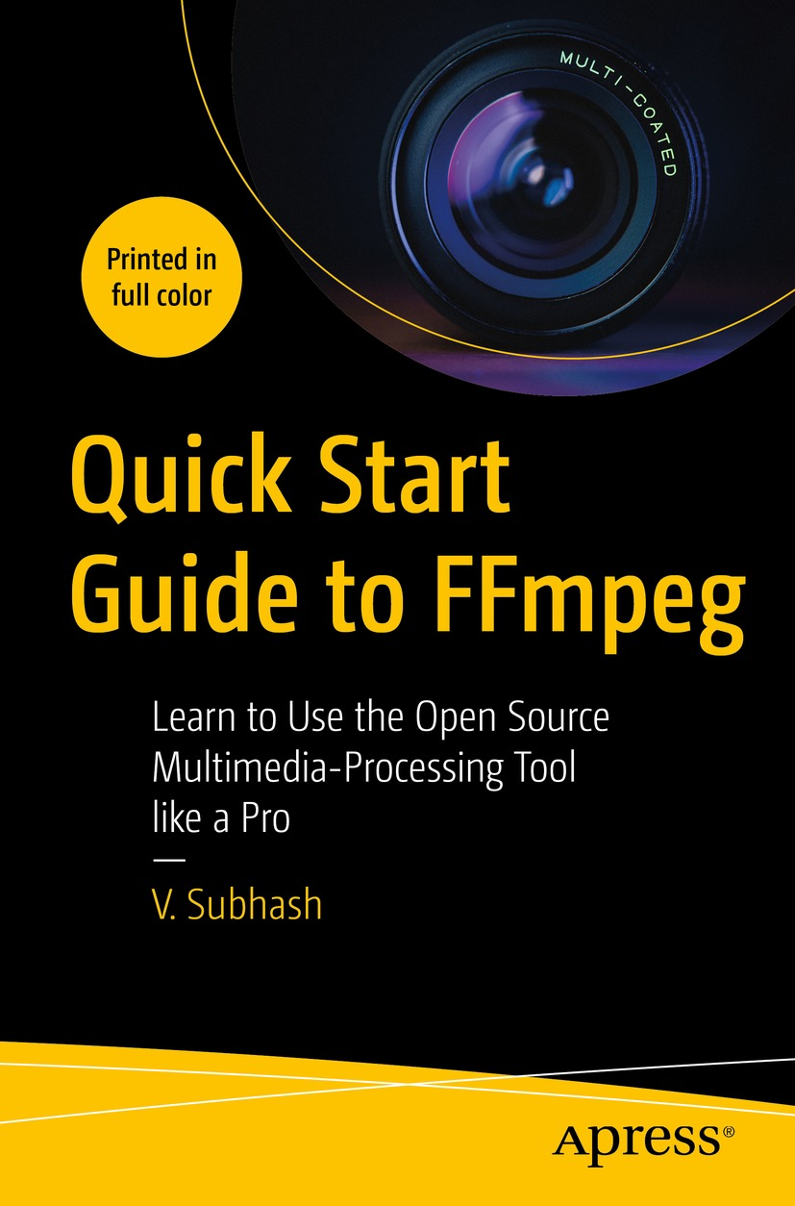

Table of Contents
Front Matter
1. Installing FFmpeg
2. Starting with FFmpeg
3. Formats and Codecs
4. Media Containers and FFmpeg Numbering
5. Format Conversion
6. Editing Videos
7. Using FFmpeg Filters
8. All About Audio
9. All About Subtitles
10. All About Metadata
11. FFmpeg Tips and Tricks
12. Annexures
Back Matter
V. Subhash

Quick Start Guide to FFmpeg

Learn to Use the Open Source Multimedia-Processing Tool like a Pro

V. Subhash
Chennai, Tamil Nadu, India
ISBN 978-1-4842-8700-2e-ISBN 978-1-4842-8701-9
https://doi.org/10.1007/978-1-4842-8701-9
© V. Subhash 2023
This work is subject to copyright. All rights are solely and exclusively licensed by the Publisher, whether the whole or part of the material is concerned, specifically the rights of translation, reprinting, reuse of illustrations, recitation, broadcasting, reproduction on microfilms or in any other physical way, and transmission or information storage and retrieval, electronic adaptation, computer software, or by similar or dissimilar methodology now known or hereafter developed.
The use of general descriptive names, registered names, trademarks, service marks, etc. in this publication does not imply, even in the absence of a specific statement, that such names are exempt from the relevant protective laws and regulations and therefore free for general use.
The publisher, the authors, and the editors are safe to assume that the advice and information in this book are believed to be true and accurate at the date of publication. Neither the publisher nor the authors or the editors give a warranty, expressed or implied, with respect to the material contained herein or for any errors or omissions that may have been made. The publisher remains neutral with regard to jurisdictional claims in published maps and institutional affiliations.
This Apress imprint is published by the registered company APress Media, LLC, part of Springer Nature.
The registered company address is: 1 New York Plaza, New York, NY 10004, U.S.A.
Dedicated to the creators and supporters of free and open source software
Introduction
FFmpeg is a free and open source program for editing audio and video files from the command line. You may have already known FFmpeg as a nifty program that can do simple conversions such as:
ffmpeg -i some-video.mov same-video.mp4
ffmpeg -i song-video.mp4 song-audio.mp3
FFmpeg is much more capable than this, but it is this intuitive interface and support for a wide variety of formats that has won it millions of users.
The FFmpeg project was originally started by a French programmer named Fabrice Bellard in the year 2000. It is now being developed by a large team of open source software developers spread around the world.
This book can serve as an easy FFmpeg tutorial, hack collection, and a ready reference. However, it is not possible for one book to cover everything that FFmpeg can do. FFmpeg has a very huge online documentation with which you may have to craft your commands. While this book may seem more than enough for most users, the documentation will open up vastly more possibilities. DO NOT avoid going through the documentation.
Before you go further into the book, you should be aware that the FFmpeg project creates two types of software:
1. | libav libraries: These are FFmpeg programming software or “libraries” that are used by programmers to create audio/video processing software such as media players, browser plug-ins, and audio/video editors. The libav libraries have been used to build some parts of popular software such as VLC, xine, Blender, and Kodi.
2. | ffmpeg command-line program: This is the FFmpeg end-user software that most people can use. The ffmpeg command-line program internally uses the libav libraries.
In this book, we will ignore the libav libraries and instead focus on the ffmpeg command-line program.

Extra Resources for This Book
All code snippets used in this book are available in a plain-text file, complete with chapter and section titles and comments. It is actually a MarkDown/CommonMark file. You can easily convert it to an HTML, ODT, DOCX, or PDF file. Conversion instructions are in the text file.
Videos of several code examples used in the book are available in an online video playlist.
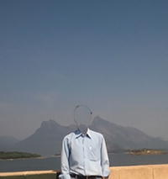
Links to these resources can be found at
www.apress.com/9781484287002 (domain + ISBN)
www.vsubhash.in/ffmpeg-book.html
Any source code or other supplementary material referenced by the author in this book is available to readers on GitHub (https://github.com/Apress). For more detailed information, please visit http://www.apress.com/source-code.
Acknowledgments
The author would like to thank:
The publisher Apress who insisted on not using any third-party video in the screenshots, as the author did in the original self-published book (FFmpeg Quick Hacks). Most screenshots in this Apress book were taken from the author’s own videos. The rest used videos and images that were in the public domain (Archive.org, Pixabay.com, and Unsplash.com). This led to a rewrite of most of the content, and in the process, several mistakes were eliminated.
The technical reviewer Gyan Doshi for pointing out several other mistakes and making valuable suggestions.
Creators and supporters of free and open source projects.
The author's family, friends, enemies and governments without whose help and encouragement this book would have been completed much ahead of its deadline.
Table of Contents
Chapter 1:​ Installing FFmpeg
FFmpeg for Microsoft Windows Users
FFmpeg for Linux Users
FFmpeg for Apple Mac Users
Summary
Chapter 2:​ Starting with FFmpeg
ffprobe
ffplay
ffmpeg
Other FFmpeg End-User Programs
Summary
Chapter 3:​ Formats and Codecs
Containers
Codecs, Encoders, and Decoders
Demuxers and Muxers
Summary
Chapter 4:​ Media Containers and FFmpeg Numbering
Containers
Container Internals
Input and Output Files
Maps
Metadata
Metadata Maps
Channel Maps
Do Not Use the -map_channel Option
Summary
Chapter 5:​ Format Conversion
No-Brainer Conversions
Conversion Options
Obsolete/​Incorrect Options
Codec Option
Sample Conversion with Custom Settings
Multi-pass Conversion
Conversion for Maximum Compression and Quality
Audio Conversion
Audio Extraction
Extract Stills from a Video (Video-to-Image Conversion)
Image-Conversion Settings
Create Video from Images (Image-to-Video Conversion)
Create a Slideshow from Several Images
Create a GIF from a Video
APNG
Create a Video Using an Image and an MP3
Convert Online Videos to Audio
Convert Text to Audio
Conversion Settings for Specific Storage Medium
Summary
Chapter 6:​ Editing Videos
Resize a Video
Editing Options
Cut a Portion of a Video
Cut Without Re-encoding
Append Videos (Concatenate)
Don’t Knock -codec copy
Summary
Chapter 7:​ Using FFmpeg Filters
Filter Construction
Filter Errors
Filter-Based Timeline Editing
Expressions in FFmpeg Filter Definitions
Inset Video (Picture-in-Picture Overlay)
Split Video (Side-by-Side Overlay)
Append Videos Using a Filter
Delete a Portion of a Video in the Middle
Rotate a Video
Flip a Video
Brighten a Video (Adjust Contrast)
Generate a Test Video
Remove Logo
Fade into Another Video (And in Audio Too)
Crop a Video
Blur or Sharpen a Video
Blur a Portion of a Video
Draw Text
Draw a Box
Speed Up a Video
Slow Down a Video
Summary
Chapter 8:​ All About Audio
Convert from One Audio Format to Another
Extract Audio from a Video
Convert a MIDI File to MP3 or Ogg
Change Volume
Change Volume in a Video File
Dynamic Range Compression/​Normalization
Channels
Swap Left and Right Channels
Turn Off a Channel
Move Channel to a Separate Audio Track
Fix Out-of-Phase Audio Channels
Change Stereo to Mono
Convert Mono to Stereo
Make Audio Comfortable for Headphone Listening
Downmix 5.​1 Audio to Stereo
Downmix Two Stereo Inputs to One Stereo Output
Render a Visual Waveform of the Audio
Detect Silence
Silence the Video
Convert Text to Speech
Apply a Low-Pass Filter
Summary
Chapter 9:​ All About Subtitles
Add Subtitles to a Video as an Extra Stream
Permanently Burn Subtitles to a Video
Add a Custom Font for Displaying Subtitles of a Video
About the Substation Alpha (SSA/​ASS) Subtitle Format
Add Subtitle Files in Different Languages
Extract Subtitles from a Video
Extract Subtitles from a DVD
Summary
Chapter 10:​ All About Metadata
Add Album Art to MP3
Set MP3 Tags
Export Metadata
Import Metadata
Extract Album Art
Remove All Metadata
Set Language Metadata for Audio Streams
Summary
Chapter 11:​ FFmpeg Tips and Tricks
Customize the Terminal
File Manager Automation
Hide the Banner
Add an espeak Intro to Your MP3 Files
Best MP3 (MPEG 2 Audio Layer 3) Conversion Settings
Colors in Hexadecimal
Colors in Literal
Streams Information from ffprobe
Extract Non-pixelated Images from a Video
Create a Thumbnail Gallery for a Video
Record from Microphone
Record from Webcam
Screen Capture
Render an Animated GIF on a Video
Show a Timer on the Video
Create a Silent Ringtone
Create a Countdown Beep Audio
Generate Noise of a Certain “Color”
Create a Bleep Audio
Add an Echo to Part of a Video
Reverse a Video
Fade into Another Video Using a Transition Effect
Create Waveform Video of Audio
Create a Waveform Image of Audio
Forensic Examination of Audio (Not Really)
Replace a Green-Screen Background with Another Video
Turn All Colors Gray Except One
How to Pan Across a Video
Using FFmpeg with Timeline-Based Video-Editing Software
Make ffmpeg -version More Meaningful
Hardware Acceleration
Finis
What Next…
Chapter 12:​ Annexures
Annexure 1:​ Sample List of Codecs
Annexure 2:​ Sample List of Decoders
Annexure 3:​ Sample List of Encoders
Annexure 4:​ Sample List of Filters
Annexure 5:​ Sample List of Formats
Index
About the Author
V. Subhash
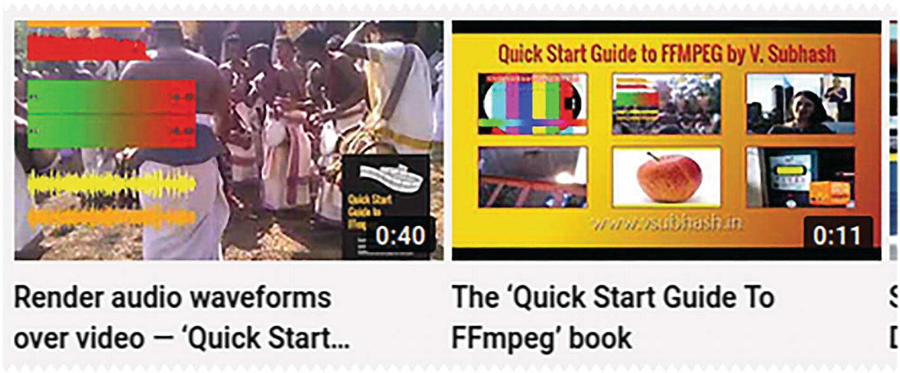
is an invisible Indian writer, programmer, and illustrator. In 2020, he wrote one of the biggest jokebooks of all time and then ended up with over two dozen mostly nonfiction books including Linux Command-Line Tips & Tricks, CommonMark Ready Reference, PC Hardware Explained, Cool Electronic Projects, and How To Install Solar. He wrote, illustrated, designed, and produced all of his books using only open source software. Subhash has programmed in more than a dozen languages (as varied as assembly and Java); published software for desktop (NetCheck), mobile (Subhash Browser & RSS Reader), and the Web (TweetsToRSS); and designed several websites. As of 2022, he is working on a portable JavaScript-free CMS using plain-jane PHP and SQLite. Subhash also occasionally writes for the Open Source For You magazine and CodeProject.com.

About the Technical Reviewer
Gyan Doshi
has been with the FFmpeg project as a developer and maintainer since 2018. During this time, he has focused on FFmpeg filters, formats, and command-line tools. From his experience in video postproduction stages such as editing and motion graphics, Gyan has learned how FFmpeg can be used in multimedia workflows as a valuable addition or as a substitute for expensive tools. Aside from being engaged as a multimedia/FFmpeg consultant, Gyan also troubleshoots FFmpeg issues on online forums such as Stack Exchange and Reddit.
Gyan builds the official Windows binary packages of FFmpeg (ffmpeg, ffprobe, and ffplay) and other tools (ffescape, ffeval, graph2dot, etc.) and offers them for download from his website at www.gyan.dev.

© The Author(s), under exclusive license to APress Media, LLC, part of Springer Nature 2023
V. SubhashQuick Start Guide to FFmpeg
https://doi.org/10.1007/978-1-4842-8701-9_1

1. Installing FFmpeg
V. Subhash1
(1)
Chennai, Tamil Nadu, India

In the Introduction, I mentioned that FFmpeg was an “end-user program.” It is actually three command-line end-user programs, or executables:
1. | ffprobe
2. | ffplay
3. | ffmpeg
The executables for these programs are available for Linux, Mac, Windows, and other operating systems (OSs). When you go to the FFmpeg website (www.ffmpeg.org), you will have two download options:
Either download pre-built FFmpeg executables to your computer
Or download FFmpeg source code to your computer and build your own customized FFmpeg executables
If you are unfamiliar with building executables from source code (as are most people), you should choose the first option.

FFmpeg for Microsoft Windows Users
The download options on the FFmpeg site for pre-built FFmpeg executables change frequently, so this book will not be specific with instructions. Just go to this page and navigate to one of the download sites.
https://ffmpeg.org/download.html
On the selected download site, you may be presented with a dizzying array of downloads. Spend some time reading the information given there, and pick the most appropriate download for you.
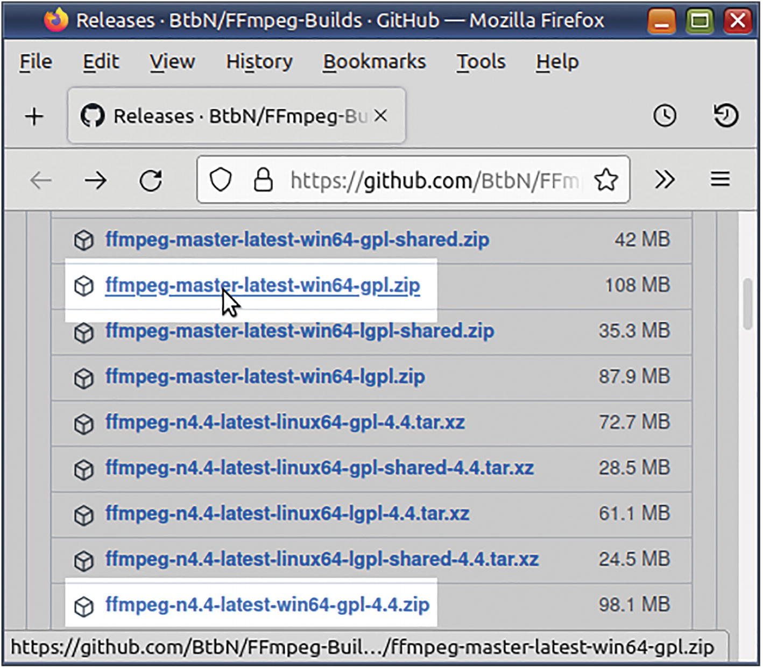
Figure 1-1This download page lists several download options for FFmpeg executables. Strangely, for FFmpeg, the latest master download is supposed to be more stable than the numbered release version
Sometimes, there may be an essentials build and a full build. The essentials build may be enough for most people. If you want to use certain unusual features such as frei0r filters, you should choose the latter. As you never know what you might need in the future, I suggest that you choose the full build.
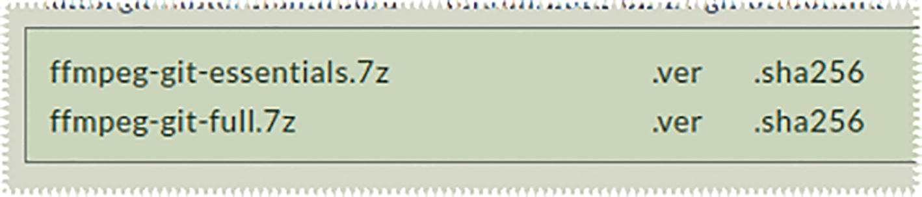
Figure 1-2There may be more than one “build” option for the downloads
In the downloaded archives (zip or 7z files), you will find the executables: ffprobe.exe, ffmpeg.exe, and ffplay.exe.
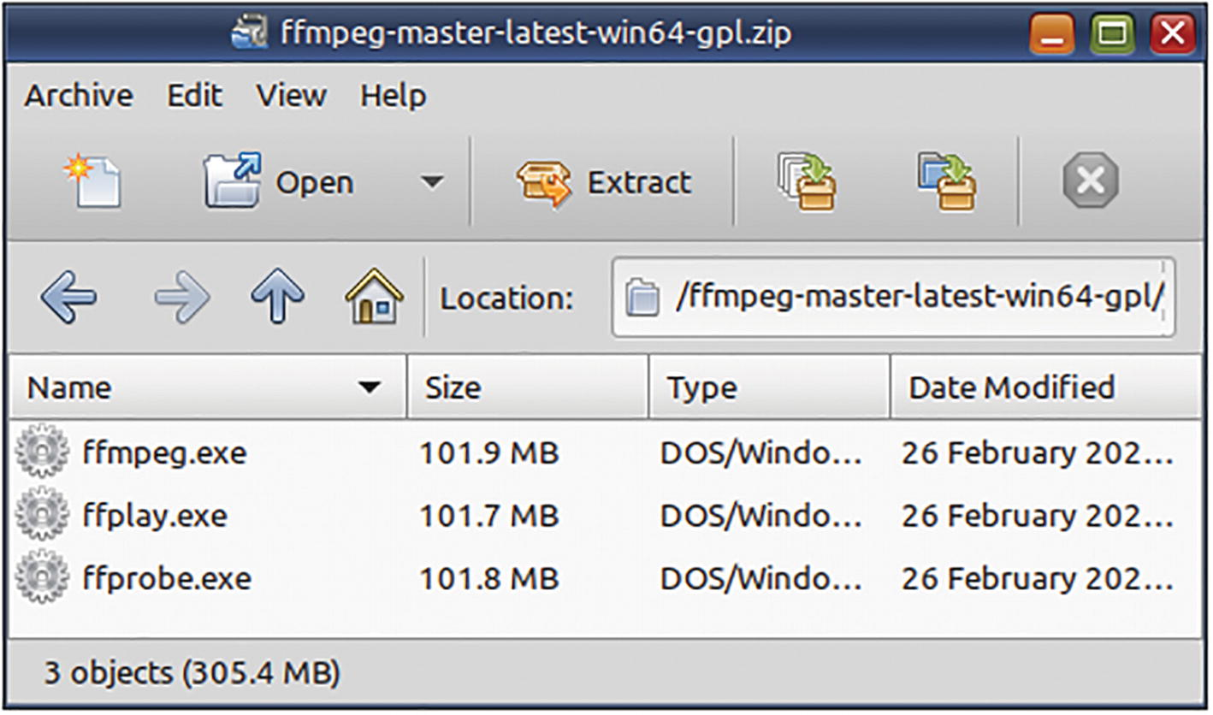
Figure 1-3The downloaded archive file contains three EXE files. Copy them to a folder specified in your PATH environment variable
Copy the EXE files to some folder that is already included in your operating system’s PATH environment variable. If you copy them to a new folder, then add the folder’s full location to the PATH variable.
If you do not do the above, you will need to type the full path of the executable in your commands in the Command Prompt window.
Before modifying the PATH environment variable, take a backup of its value. Open the Command Prompt window and type this command.
echo %PATH% > PATH-BAK.TXT
Let us assume that you have extracted the EXE files to the folder C:\MyInstalls\ffmpeg\bin. Launch the Command Prompt window with Administrator privileges. Then, permanently suffix this folder’s location to the PATH environment variable with this command.
SETX /M PATH "%PATH%;C:\MyInstalls\ffmpeg\bin"
Then, you should check whether the FFmpeg installation is accessible from the command-line without the full path. (Do this in a Command Prompt window with normal-user privileges.)
ffmpeg -version
If you do not modify the environment variable, then you will have to type the full path whenever you want to use the program.
C:\MyInstalls\ffmpeg\bin\ffmpeg -version
FFmpeg is case-sensitive so do not type FFMPEG -VERSION and hope to get a correct response. FFmpeg may have become platform-independent, but in its heart, it still beats like a Linux program. This means that FFmpeg will not support certain functionalities expected of native Windows/DOS programs. For example, you cannot type command switches (arguments) in uppercase (even if the command name can be typed in uppercase).
@ Causes error
FFMPEG -VERSION
@ Causes no error
FFMPEG -version
ffmpeg -version
Almost all command-line examples in this book assume a Linux environment. One-line commands will not require any change in Windows.
The Windows/DOS counterpart for the Linux null device (/dev/null) is NUL. This means that you should replace all instances of 2> /dev/null in this book with 2> NUL. This construct is used to prevent the commands from displaying text messages on the screen. ffmpeg outputs all its messages to standard error, which happens to be the screen. In case it outputs something to standard output, which also happens to be screen, and has to be blocked, the Linux remedy is to use > /dev/null. To do the same on your Windows computer, you will have to use > NUL instead.
In multiline commands, you will find a “\” (backslash) at the end of each line (except the last one), as is the practice in Linux.
# For 'nix users
ffmpeg -f
lavfi
\
-i "testsrc=size=320x260[out0];
anoisesrc=amplitude=0.06:color=white[out1]" \
-t 0:0:30 -pix_fmt yuv420p \
test.mp4
As a Windows user, you should use a caret ( ^ ) instead of the backslash ( \ ).
@ For Windows users
ffmpeg -f lavfi ^
-i "testsrc=size=320x260[out0]; ^
anoisesrc=amplitude=0.06:color=white[out1]" ^
-t 0:0:30 -pix_fmt yuv420p ^
test.mp4
You should avoid writing anything after the backslash or the caret. Invisible trailing space(s) can also make a command to fail. (This happens often with copy-pasted commands.)
In a Linux bash terminal, the backslash is not required after a double-quotation mark has been opened, and you can continue on like that for more lines until the quotation is closed. In a Windows cmd terminal, all wrapping lines will have to end with a caret.

FFmpeg for Linux Users
If your Linux distribution has not installed FFmpeg by default, then use its default software manager or package manager to do so. Beware that the FFmpeg installed from software repositories used by Linux distributions are usually out of date.
The download sites linked by FFmpeg.org provide the latest builds with maximum support for external libraries. However, some Linux users like to build their executables from source. If you have a fast machine or a few hours to spare, start with the instructions on the FFmpeg Wiki site. Check their source code compilation steps specific to the Linux distribution that you use.
https://trac.ffmpeg.org/wiki/CompilationGuide
You can customize your FFmpeg build by enabling/disabling several build options. Instead of just blindly following the wiki, spend some time studying the configure script or its help output.
configure --help
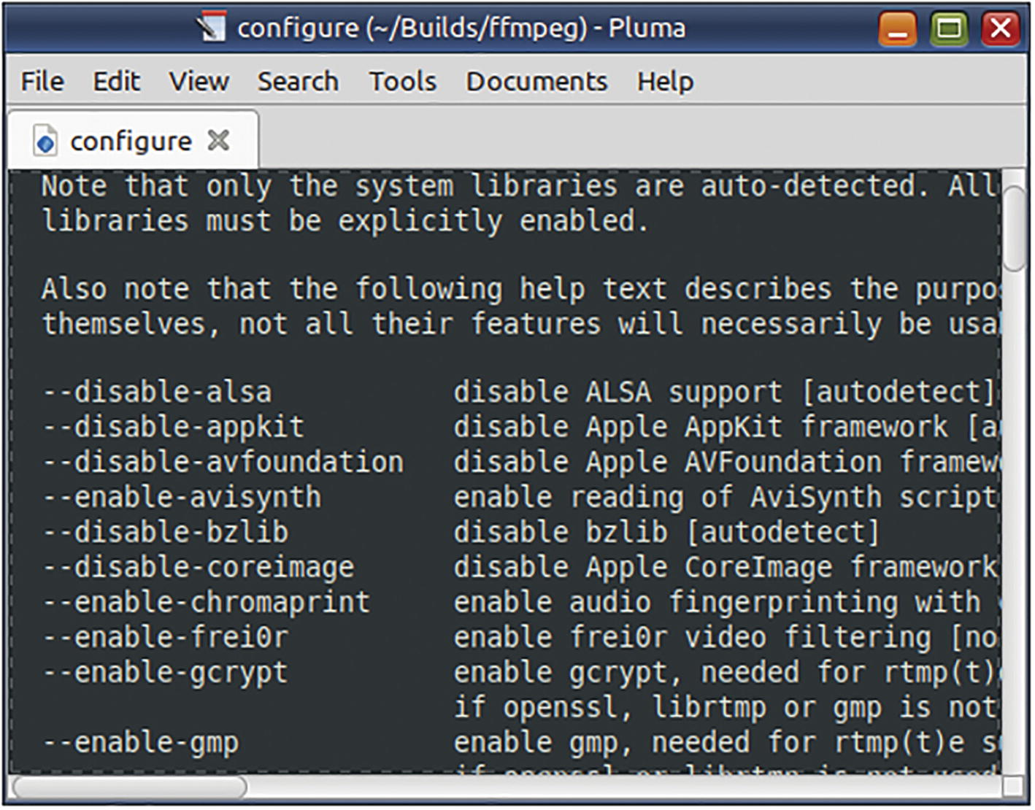
Figure 1-4The configure script, by default, will try to autodetect external libraries. You may have to manually enable those that are not autodetected
In your Linux package manager app, try to search and install (dev-suffixed) developmental packages with similar names as the external libraries. You may not be able to install developmental packages for all of the libraries. But, for whatever libraries that you can install or have them already installed, add relevant -enable options to the configure compilation step. Here are a few:
...
--enable-chromaprint --enable-frei0r \
--enable-libbluray --enable-libbs2b --enable-libcdio \
--enable-libflite --enable-libfontconfig \
--enable-libfreetype --enable-libfribidi \
--enable-libmp3lame --enable-libsmbclient \
--enable-libv4l2 --enable-libvidstab \
...
Run the FFmpeg build statement with these changes, and eventually all three binary executable files will be created in your $HOME/bin directory. Then, secure the copy of the documentation from the ffmpeg_build directory so that you can read it whenever it is required.
☞ When I built FFmpeg version 5.1, I encountered some errors with the official wiki guide. The guide uses one long stringified command to install the FFmpeg binary executable files. This command is a combination of several commands that downloads the source and then configures, compiles, builds, and installs the executable files. If the configuration and compilation commands encounter any errors and you fix it, the command will restart the whole drama beginning with downloading the source. You do not have to endure that. Just continue with the configure step.
If you have an old OS where the latest FFmpeg executable does not run or cannot be compiled, go to https://johnvansickle.com/ffmpeg/ and download pre-built statically linked executables (not including ffplay). On my old Ubuntu 10 Fiendish Frankenstein installation, I could not run the latest FFmpeg pre-built executable nor build the source, but these statically linked executables worked. (Even the C library is statically linked.) That is how I was able to finish the 2020 version of this book in the old OS.

FFmpeg for Apple Mac Users
With Apple moving from Intel x86 to ARM architecture, any specific instructions will be outdated when you read it. It is best that you consult the FFmpeg Wiki for the specific kind of Apple hardware that you are using.
https://trac.ffmpeg.org/wiki/CompilationGuide/macOS

Summary
Although originally designed as a Linux program, FFmpeg is also available for Windows and Mac operating systems. In this chapter, you learned how to obtain pre-built FFmpeg executables specific to your OS from the official FFmpeg site. You also learned how to build your own customized FFmpeg executables from source.
In the next chapter, you will learn how to start using the executables.
© The Author(s), under exclusive license to APress Media, LLC, part of Springer Nature 2023
V. SubhashQuick Start Guide to FFmpeg
https://doi.org/10.1007/978-1-4842-8701-9_2

2. Starting with FFmpeg
V. Subhash1
(1)
Chennai, Tamil Nadu, India

The FFmpeg project provides several end-user programs. This book will focus on three command-line programs – ffprobe, ffplay, and ffmpeg. You will be using ffmpeg most of the time, but ffprobe and ffplay can help you as well. In this chapter, you will gain an introduction to all three.
All three have an annoying “feature” – they display a build-information banner that is as big as the state of Texas. If you create the following aliases in your $HOME/.bashrc file, then you do not have to suffer the annoyance.
alias ffmpeg='ffmpeg -hide_banner '
alias ffplay='ffplay -hide_banner -autoexit '
alias ffprobe='ffprobe -hide_banner '
☞ The -autoexit option for the ffplay command ensures that it makes a clean exit after playing a file instead of sticking around like it has crashed.
Some command examples in this book will have the suffixes 2> /dev/null or > /dev/null. Such recourses were necessary to prevent information clutter.
ffprobe
If you want to find out useful information about an audio or video file, you need to use ffmpeg with the -i option. With ffprobe, you do not need the option.
ffmpeg -i tada.wav
ffprobe tada.wav
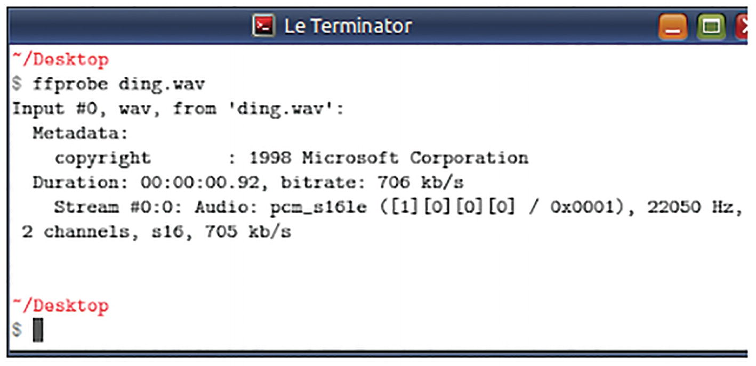
Figure 2-1ffprobe can be used to display information about what is contained in a multimedia file
ffprobe can reveal much more information than this if you use the -show_streams option. You can filter the output of this command for use in your shell scripts. In a later chapter, you will find a sample output of this command.
ffprobe -show_streams somefile.mp4
ffplay
If you want to play a video file directly from the command line, just type ffplay and the file name. ffplay is a tiny media player. It does not have a context menu system or other interface. It responds to some keys and mouse clicks but does nothing more.
ffplay solar.mp4
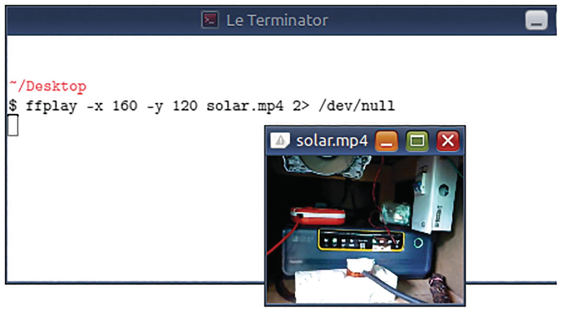
Figure 2-2ffplay can be used to play audio and video files
To play an audio file without the (windowed) interface, say, as an audio notification in a shell script, you can use ffplay like this:
ffplay -autoexit -nodisp ding.wav
ffmpeg
The executables ffprobe, ffplay, and ffmpeg have several common command-line options (arguments, switches, or parameters). You can list most of them with the -h option.
ffmpeg -h
ffmpeg -h long
ffmpeg -h full > ffmpeg-help-full.txt
If you want to review some of the features supported by your installation of FFmpeg, try these:
ffmpeg -formats
ffmpeg -
encoders
ffmpeg -
decoders
ffmpeg -codecs
ffmpeg -filters
The output of these commands will give you a good overview of what FFmpeg can do. Sample output of these commands is available as annexures in this book.
You can dig out more specific help information with commands such as these:
ffmpeg -h demuxer=mp3
ffmpeg -h encoder=libmp3lame
ffmpeg -h filter=
drawtext

Other FFmpeg End-User Programs
The FFmpeg project provides a few other command-line tools in addition to the three introduced in this chapter. Their purpose and usage are beyond the scope of this book. If you wish to do your own R&D, then you can find their files at www.gyan.dev/ffmpeg/builds/#tools.

Summary
In this chapter, you gained an introduction to the three FFmpeg executables. Before venturing into what FFmpeg can do for you, you need to learn a few things about multimedia formats and codecs. The next chapter will help you with that.
© The Author(s), under exclusive license to APress Media, LLC, part of Springer Nature 2023
V. SubhashQuick Start Guide to FFmpeg
https://doi.org/10.1007/978-1-4842-8701-9_3

3. Formats and Codecs
V. Subhash1
(1)
Chennai, Tamil Nadu, India

An MP3 audio file can be identified by its “.mp3” file extension. Similarly, an MP4 video file can be identified by the “.mp4” extension. The file extensions of multimedia files do not provide any kind of surety about the format. Even the format name is merely a notion. If you need to process audio and video content, you need to go beyond file extensions. You need to be familiar with multimedia concepts such as containers, codecs, encoders, and decoders. In this chapter, you will gain some basic information about all that and more.

Containers
Multimedia files such as MP4s or MP3s are just containers – containers for some audio and/or video content. An MP4 file is a container for some video content written using the H.264 codec and some audio content written using the AAC codec. It need not be like that for all MP4 files. Some MP4 files may have their video content written using the Xvid codec and the audio content written using the MP3 codec. Similarly, AVI, MOV WMV, and 3GP are popular containers for audio/video content. Codecs can differ from file to file even if their extensions are the same. A multimedia file may have the wrong extension because of some human error. You can expect all sorts of combinations in the wild.
When the codecs are not what is usually expected in a container, you may encounter annoying format errors in playback devices. Sometimes, you may be able to fix the error by simply renaming the file with the correct extension. At other times, you will have to re-encode the file using codecs supported by the device. So, what does it mean when a device says it only supports certain “codecs”?

Codecs, Encoders, and Decoders
When audio and video recordings transitioned from analog to digital, equipment manufacturers developed algorithms to store audio waveforms and video frames in a scheme retrievable by computer software. Initially, these storage schemes were proprietary, and their documentation was not publicly available. With the rise in the popularity of digital media devices, interoperability and open standards became necessary.
When multimedia (audio or video) content is written or stored in a computer file, it is written in a specific retrievable format developed by the manufacturer of the multimedia equipment. The algorithm used to read or write multimedia content in a specific format became known as a codec (coder-decoder). The software used for writing the content using the codec became known as an encoder. The software used to read the written content became known as a decoder. A camera uses an encoder chip to store captured video. A TV uses a decoder chip to play the video from a USB drive. On a personal computer, the logic of encoder and decoder chips is installed as a software codec.
Raw audio or video requires a lot of space when stored on a computer file. The multimedia industry, led by camera manufacturers and computer companies, has developed several compression techniques to squeeze multimedia content on to as few bytes of storage as possible. The efficiency of the compression techniques varies. When the compression discards some content (assuming that the human ear or the eye would not miss it) for a dramatic decrease in the size of the file, the technique would be known as lossy compression. When no content was discarded, the technique was known as lossless compression. Lossless compression techniques are not used everywhere because of the high file-space requirement.
To suit real-world requirements, most codecs provide options to their algorithm so that a balance between file size reduction and detail loss can be specified on a preset or ad hoc basis. You will do the same when you use FFmpeg. For example, in the following command, to convert an uncompressed audio from a microphone recording to a lossy compressed audio format, several settings such as bitrate, number of channels, and sampling frequency are specified.
ffmpeg -i uncompressed-stereo.wav \
-c:a libmp3lame -b:a 128k -ac 2 -ar 44100
\
compressed.mp3
☞ You will learn more about these settings in later chapters, but for now just be aware that they are often required.

Demuxers and Muxers
I have been using FFmpeg for years without knowing what demuxers and muxers were. Even now, I cannot care less. Well… maybe a little. A demuxer is a software component that can read a multimedia input file so that a decoder can work on it. Similarly, a muxer writes data to a multimedia output file after it has been processed by an encoder. Between a decoder and encoder, some processing work may be done, or it may even pass directly to the other end. Here is all that you need to know:
To write to a particular container format, the format’s muxer is required.
To read from a particular container format, a demuxer is required.
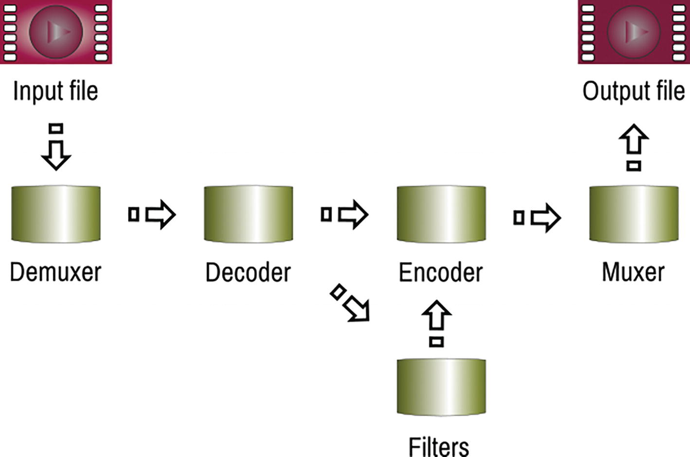
Figure 3-1This schematic shows how different components in FFmpeg work together to give the output you want
For example, to read and write to the MP4 format, an MP4 demuxer and an MP4 muxer are required. FFmpeg automatically takes care of muxers and demuxers so that you do not have to bother with them. However, there may come situations when you do have to explicitly address them.
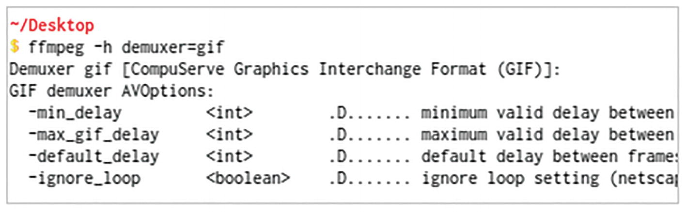
Figure 3-2This demuxer help output provides a clue as to how to create endlessly looping GIF animations

Summary
In this chapter, you learned some theoretical concepts about multimedia formats, containers, and codecs. In the next chapter, we will delve deeper into the container and learn how to refer to its constituents from the command line using index numbers.
© The Author(s), under exclusive license to APress Media, LLC, part of Springer Nature 2023
V. SubhashQuick Start Guide to FFmpeg
https://doi.org/10.1007/978-1-4842-8701-9_4

4. Media Containers and FFmpeg Numbering
V. Subhash1
(1)
Chennai, Tamil Nadu, India

In the previous chapter, you learned that a multimedia file is actually a container. On the inside, it encloses multimedia streams and metadata. In this chapter, you will learn what streams and metadata are and how you can access them from the command line. The sections in this chapter are arranged for easy access and completeness. It may not be possible for you to understand all of it on your first read. Return to this chapter a few times to get a full understanding.

Containers
A container can have several streams. A stream could be audio, video, subtitles, or a file attachment.
In an MP4 video file or container, you will usually find a video stream and an audio stream. In an MP3 file, you will find an audio stream and maybe some IDv3 tags (such as title, album, and artist) as metadata.
If you have one of those rare multi-angle DVDs, then each camera angle will be represented by a separate video stream. Multi-language videos will have an audio stream for each language. DVD subtitles for multiple languages are represented as individual subtitle streams. MKV files may have custom font files for displaying the subtitles. These font files will be represented as file-attachment streams.
In an audio stream, there can be several channels. A mono audio stream has only one channel. A stereo stream has two channels - left and right. A DVD movie’s 7.1 surround sound stream has eight channels - front left, front right, center left, center right, rear left, rear right, and one LFE (low frequency effects).
FFmpeg identifies these streams, channels, and metadata using index numbers so that you can refer to them from the command line.

Container Internals
Logically, the internals of a multimedia file look like this. A container needs to have at least one stream. Everything else is optional. It is all right for a video file to not have album art, subtitles, custom fonts, or tags (global metadata), but one video stream and one audio stream are usually expected.
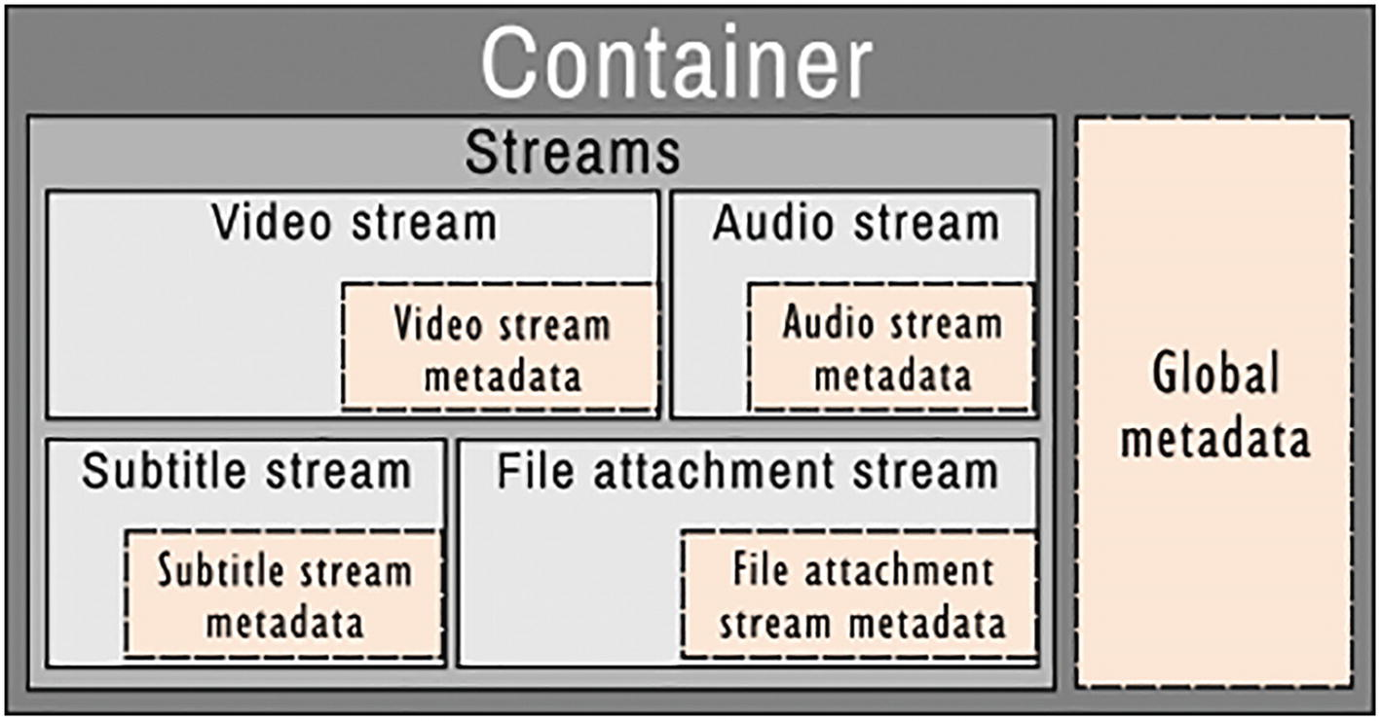
Figure 4-1Internals of a multimedia file container
From this logical representation, you will note that a multimedia file container may have some global metadata and that each stream in the container can have stream-specific metadata too.
You can use ffprobe to display these details for any multimedia file.
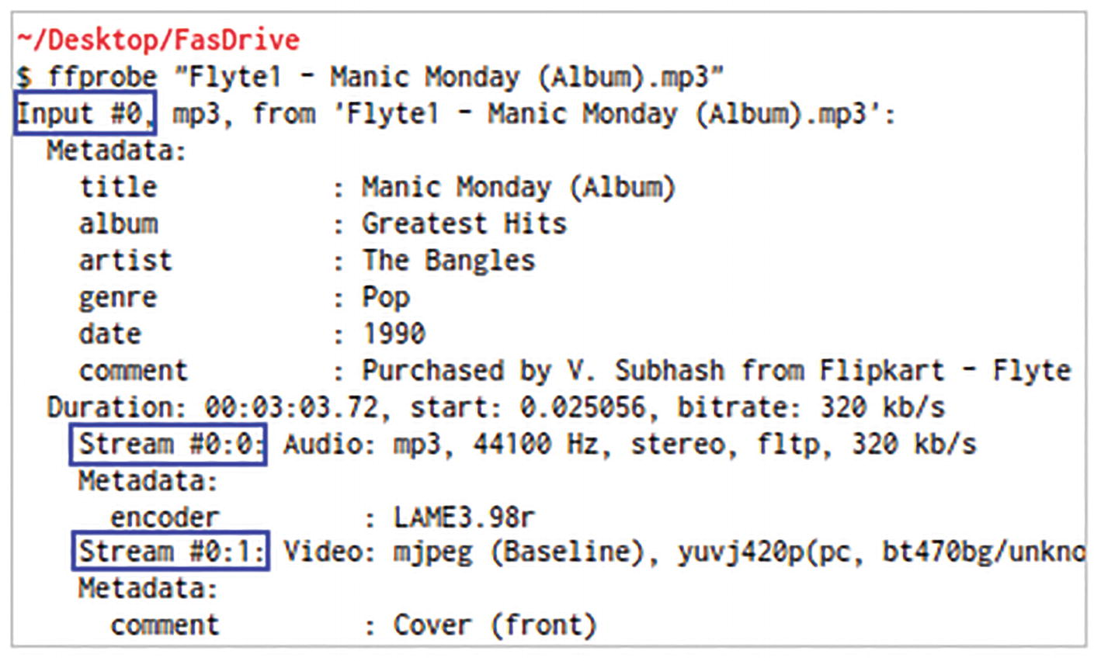
Figure 4-2This is a sample ffprobe output for an audio file
In this ffprobe output, the global metadata for the MP3 file shows ID3 tags such as title, album, and artist. It also includes a “comment” metadata that I added after I bought the music. The metadata for the audio stream shows that it was encoded using the LAME encoder by the music vendor. The album art is shown as a video stream but it has only one frame. More importantly, you should note that FFmpeg refers to the input files and streams using index numbers starting from 0 (zero), instead of 1 (one).
Here is another example; this one is for a video file.
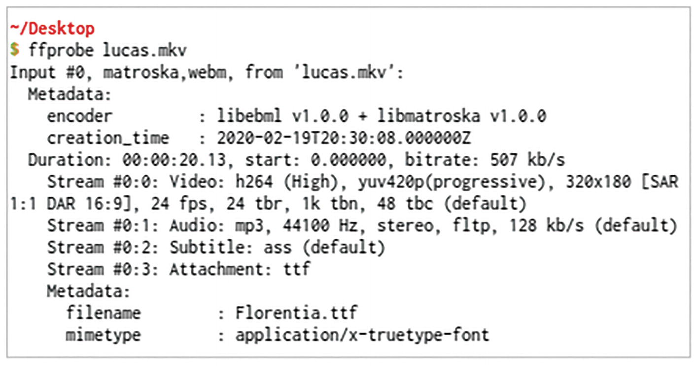
Figure 4-3This is a sample ffprobe output for a video file
What does this output say?
The MKV file is identified as the first input file (#0).
It has global metadata for creation time but none for title, copyright, comments, etc.
The first stream (#0:0) is a video stream and requires a H.264 decoder.
The second stream (#0:1) is an audio stream and requires an MP3 decoder. The audio is in stereo, that is, it has two channels.
The third stream (#0:2) is a subtitle stream and requires a decoder for the Substation Alpha (SSA) format.
The fourth stream (#0:3) is a custom font for displaying the subtitles. It is stored as a file-attachment stream.
The fourth stream also has some stream-specific metadata identifying the font file’s name and mimetype. This is important because the SSA subtitles may refer to the font by this name.
☞ Mimetype is a more rigorous file-type definition (than file extensions) and is usually used by websites to identify downloads to web browsers.

Input and Output Files
An ffmpeg command can have multiple input and output files. The following command has two input files and one output file. (For now, ignore the line with the filter. Filters are explained in Chapter 7.)
ffmpeg
-i solar.mp4 -i overlay.png
\
-filter_complex "overlay=370:260:" \
watermarked-solar.mp4
☞ When specifying multiple input files, place options specific to one input file on the left side of -i option. Whatever specified after the file name applies to the next input file (-i) or (in its absence) the next output file.
☞ ffmpeg can also read from streams and write to them. The streams can be piped from/to another command and also transported over a network protocol. For more information, read the official documentation on protocols.
A video of my solar inverter and the cover image of one of my books are the input files. The command renders the image at 370 pixels from the left edge and 260 pixels from the top edge of the video.
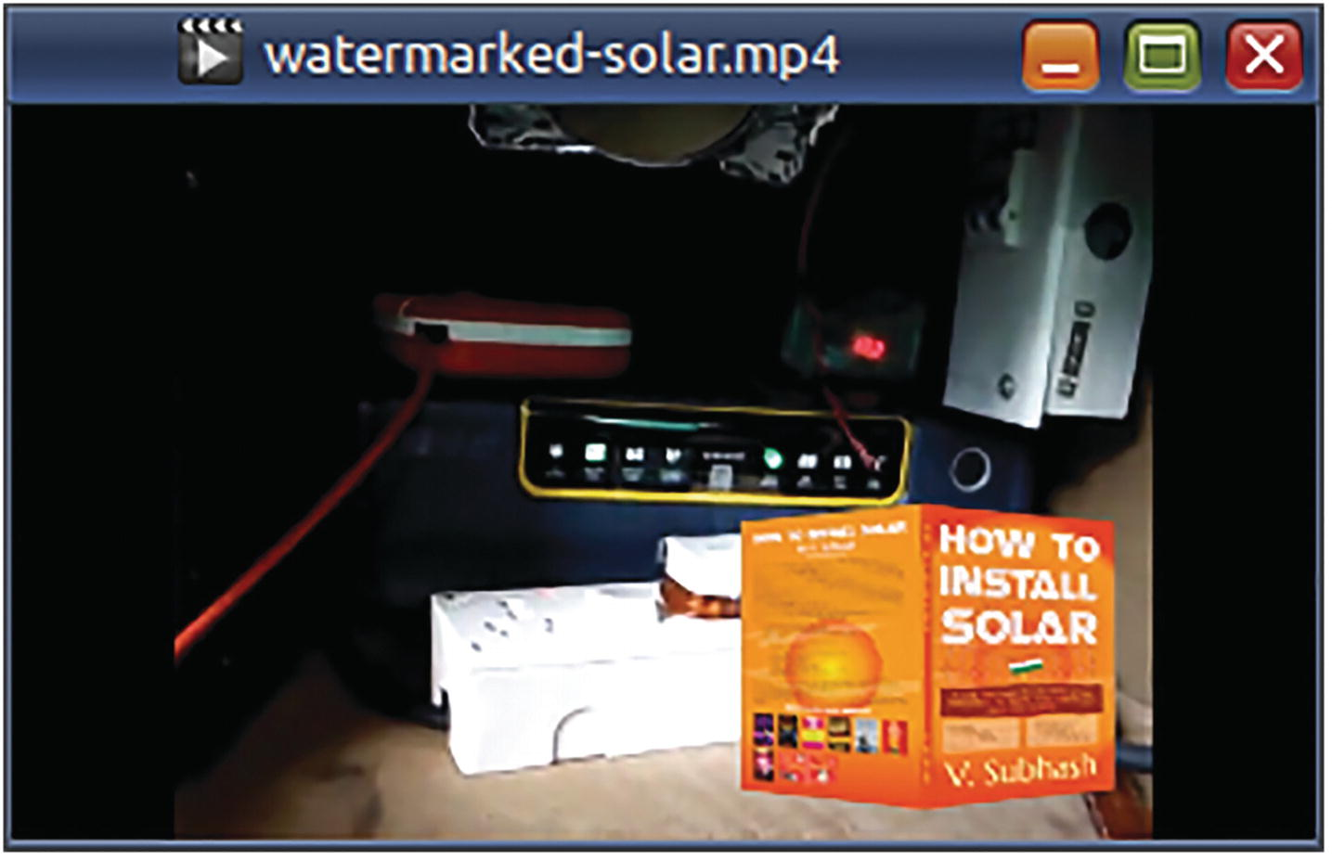
Figure 4-4The output video is the input video with the overlaid input image
The two input files were specified using the -i option. An MP4 video file is input file #0 and a PNG image file is input file #1. The output file, as is always, has been specified last.
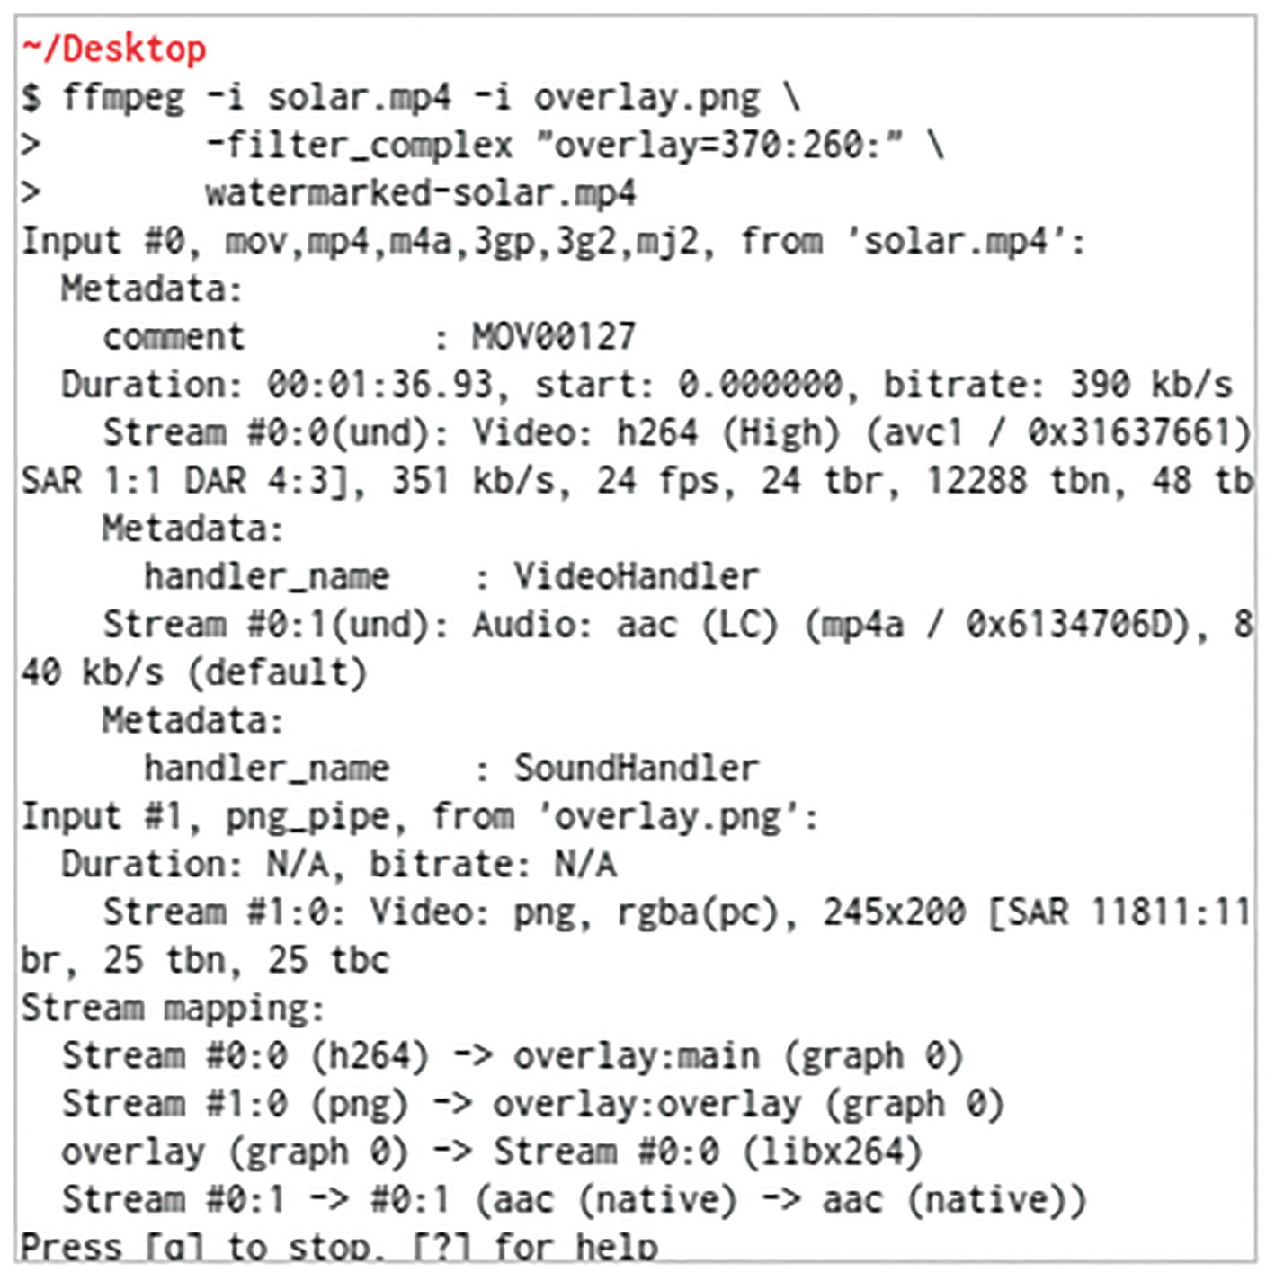
Figure 4-5The output of the command shows the index numbers used for the input files and streams
The output of the command shows that the first stream in the first input file is a video stream and is numbered #0:0. The second stream in that file is an audio stream and is numbered #0:1. The first stream in the second input file (the PNG image file) is considered as a video stream even though it has only one (image) frame and is identified as #1:0.
You can refer to streams by their type. In the previous command, the streams were as follows:
0:v:0 (first file’s first video stream) or 0:0 (first file’s first stream)
0:a:0 (first file’s first audio stream) or 0:1 (first file’s second stream)
1:v:0 (second file’s first video stream) or 1:0 (second file’s first stream)
For this to become clear, spend some time studying the screenshot in Figure 4-5.
Suppose that a multi-language DVD video file had one video stream and two audio language streams. The streams can be referred as follows:
0:v:0 (first video stream) or 0:0 (first stream)
0:a:0 (first audio stream) or 0:1 (second stream)
0:a:1 (second audio stream) or 0:2 (third stream)
☞ In the output of ffmpeg commands, you will encounter index numbers ignoring the stream type. To make your FFmpeg commands somewhat fail-safe, I recommend that you refer to streams by their type instead.
As you may have guessed, the stream-type identifier for video is v and a for audio. There are others as given in Table 4-1.
Table 4-1Stream-type identifiers
Stream type | Identifier
Audio | a
Video | v
Video (not images) | V
Subtitles | s
File attachments | t
Data | d
After displaying the information about the input files and streams, ffmpeg will list how the input streams will be processed and mapped to intermediate and final streams. Then, it will list the final output files and their streams. In a bash terminal, you can press the key combination Ctrl+S if you wish to pause and study this information. Otherwise, all of this information will quickly flash past your terminal as ffmpeg will then post a huge log of informational, warning, and error messages as it performs the actual processing of the input data.

Maps
With multiple input files, FFmpeg will use an internal logic to choose which input streams will end up in the output file. To override that, you can use the -map option. Maps enable you to specify your own selection and order of streams for the output file. You can specify stream mapping in several ways:
-map InputFileIndex
all streams in file with specified index
For example, -map 1 means
all streams in second (1) input file.
-map InputFileIndex:StreamIndex
the stream with specified index in file with specified index
For example, -map 0:2 means
third (2) stream in first (0) input file.
-map InputFileIndex:StreamTypeIdentifier
all streams of specified type in file with specified index
For example, -map 1:s means
all subtitle (s) streams in second (1) input file.
-map InputFileIndex:StreamTypeIdentifier:StreamIndex
among streams of specified type in file with specified index, the stream with specified index
For example, -map 2:s:1 means
second (1) subtitle (s) stream in third (2) input file.
Information overload? Let me explain with an example. When I created this stop-motion video a few years ago, I used a gramophone recording as the background music. Typical of old record music, it had a lot of sound artifacts. At that time, I did not know much about FFmpeg. So, I used FFmpeg to extract the audio as an MP3 file but used the free Audacity program to apply a low-pass filter. Then, I used FFmpeg again to swap the original audio with the MP3 fixed by Audacity.
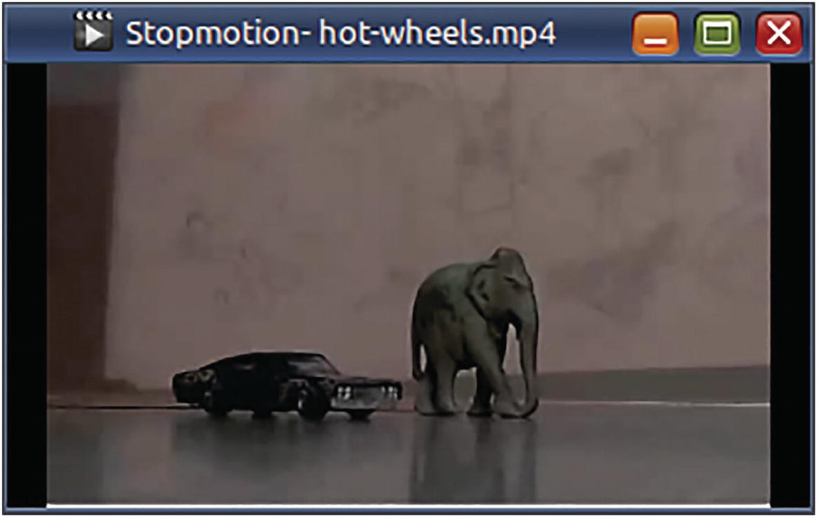
Figure 4-6The audio of this video had gramophone sound artifacts
# Extract the audio
ffmpeg -i Stopmotion-hot-wheels.mp4 \
-map 0:1
\
Stopmotion-hot-wheels.mp3
# Apply low-pass filter to Stopmotion-hot-wheels.mp3
# using Audacity and export to Stopmotion-hot-wheels-fixed.mp3
# Swap the existing audio track with the mp3 fixed by Audacity
ffmpeg -i Stopmotion-hot-wheels.mp4 \
-i Stopmotion-hot-wheels-fixed.mp3 \
-map 0:0 -map 1:0
\
-codec copy \
Stopmotion-hot-wheels-fixed.mp4
☞ -codec copy or -c copy copies the streams as they are, instead of unnecessarily re-encoding or converting them again. It saves a lot of time.
In the first command, I included a map for the second stream (0:1) in the MP4 file and saved it as an MP3 file. (I assumed that the second stream was an audio stream. It need not be.) I then corrected errors in the MP3 file using Audacity. In the second command, the first input file (the MP4 file) had two streams – (0:0) and (0:1) – same as in the first command. (More assumptions.) The second input file (the “fixed” MP3) had one stream (1:0). In the second command, I used the first file’s first stream (0:0) and the second file’s first and only stream (1:0). Alternatively, I could have typed the command by mapping to the first file’s first video stream (0:v:0) and the second file’s first audio stream (1:a:0).
ffmpeg -i Stopmotion-hot-wheels.mp4 \
-i Stopmotion-hot-wheels-fixed.mp3 \
-map 0:v:0 -map 1:a:0
\
-codec copy \
Stopmotion-hot-wheels-fixed.mp4
☞ This alternative fail-early approach is safer, as it can protect you from typing mistakes.
The audio stream in the original MP4 (0:1) or (0:a:0) gets discarded because it was not included in any of the maps. If I wanted to retain the original audio stream, I can add another map for it as a second audio stream. The fixed audio track will be played by default by media players. I can manually select the second audio track with the remote or a menu option to hear the unfixed original audio.
ffmpeg -i Stopmotion-hot-wheels.mp4 \
-i Stopmotion-hot-wheels-fixed.mp3 \
-map 0:v:0 -map 1:a:0 -map 0:a:0
\
-codec copy \
Stopmotion-hot-wheels-fixed-n-restored.mp4
You can use maps when generating multiple output files with one command.
ffmpeg -i solar.mp4 \
-map 0:1 -c:a libmp3lame
-b:a
128k solar-high.mp3
\
-map 0:1 -c:a libmp3lame -b:a 64k solar-low.mp3
The -map options provide a new set of streams available for options specified after them. Options such as -codec or -ac will only affect streams specified by the -map options before them, not the streams available in the input files.

Metadata
Metadata means data about data. When using FFmpeg, metadata is read by the demuxer and/or written by the muxer. The data is usually specified as key-value pairs. For a media file, the metadata can be global (for the entire file) or specific to a stream in the file. Each container format specifies a limited set of metadata keys. The MP3 format, for example, supports metadata keys such as title, artist, album, and copyright. You can specify metadata for individual streams as follows:
-metadata:s:StreamIndex or
-metadata:s:StreamTypeIdentifier:StreamIndex
This command sets metadata at the global/file/container level.
ffmpeg -i solar.mp4 -codec copy \
-metadata
title="Me Solar Inverter"
\
solarm.mp4
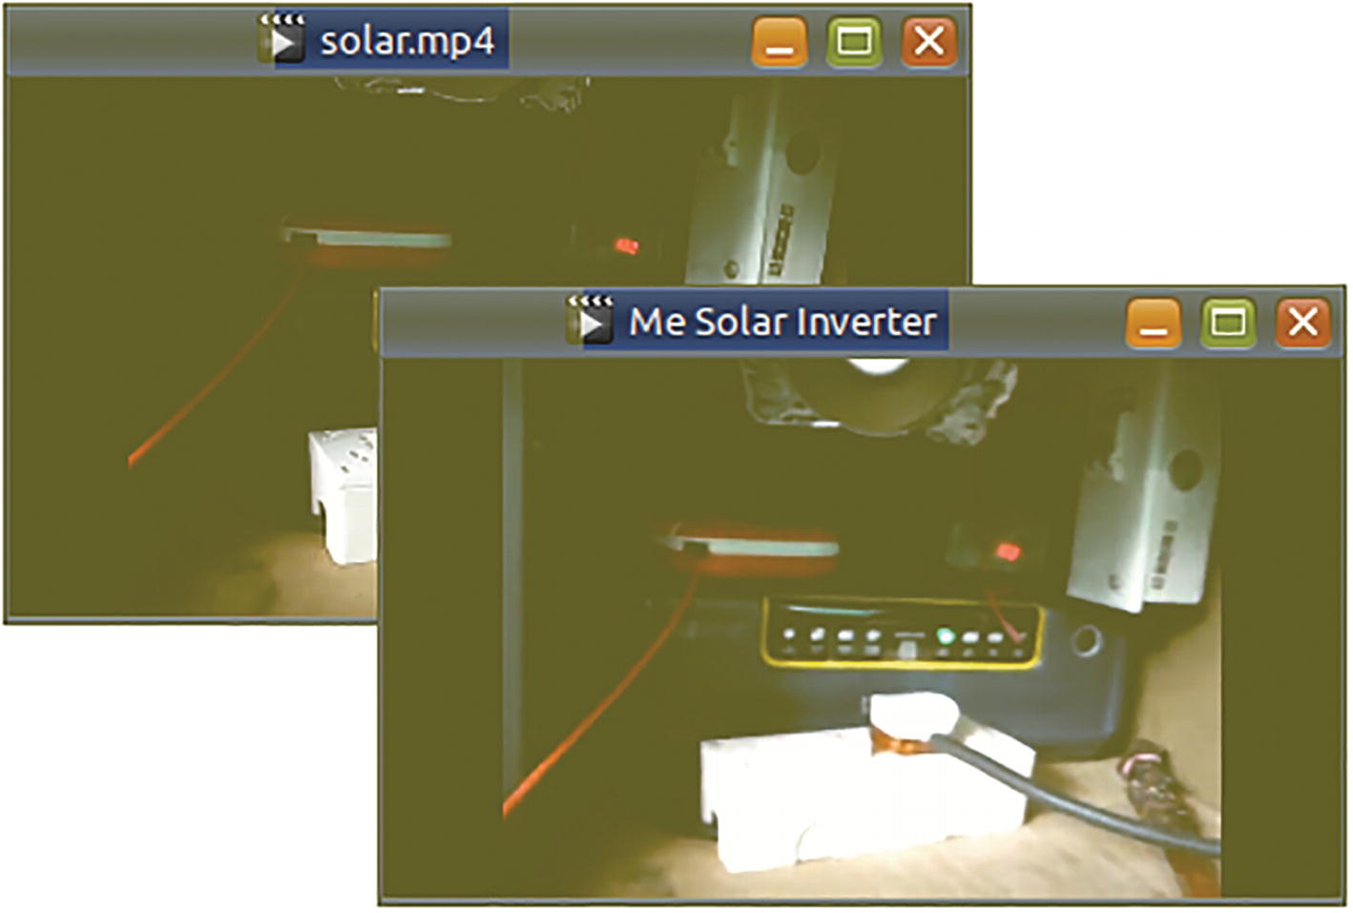
Figure 4-7The background video has no metadata, and the video player just displays the file name on the window title. In the foreground video, title metadata is available, and the video player displays that text instead of just the file name
The ffprobe output in Figure 4-8 shows potentially incriminating information about a moonshiner MP3.
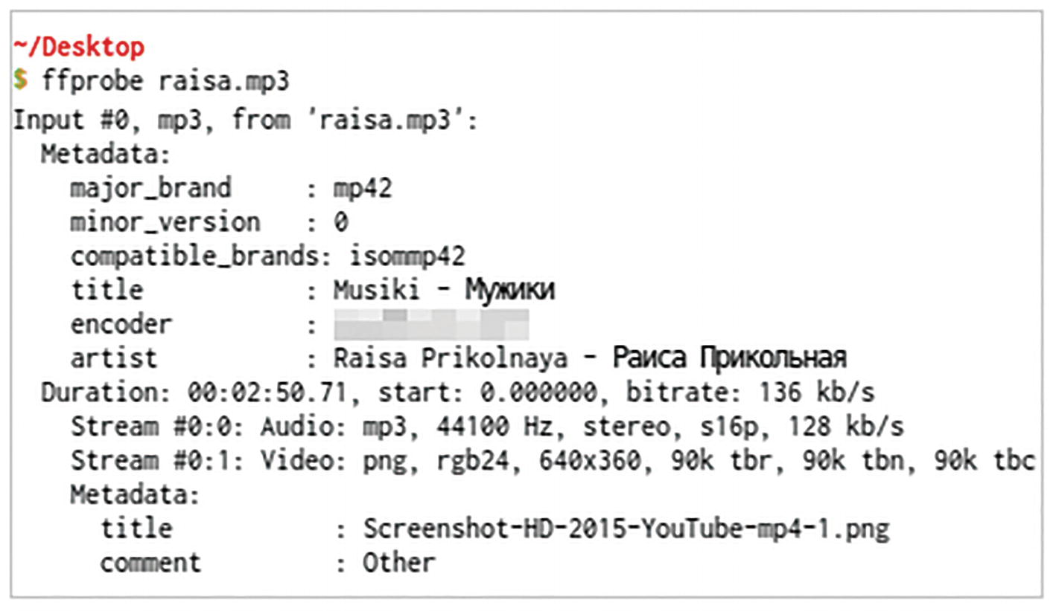
Figure 4-8This‌​ ffprobe output shows that this inveterate pirate had downloaded a music video from Youtube and ripped the audio!
ffmpeg -y -i raisa.mp3 \
-map 0 -c copy \
-metadata:s:v:0 title='raisa.png'
\
raisa2.mp3 # Smooth!
This command makes no changes to the MP3 except for the value of the incriminating title metadata of the album art.
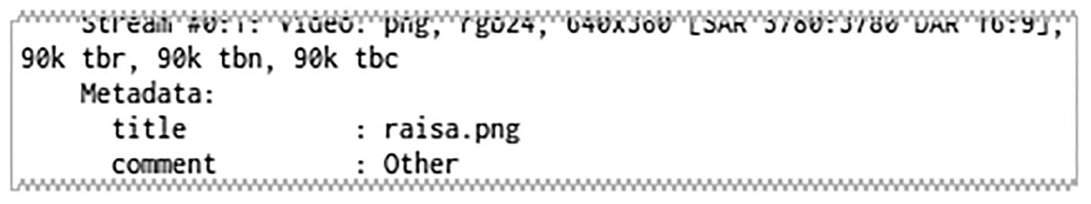
Figure 4-9This updated ffprobe output shows that the pirate has smoothly changed the metadata. Maybe he was doing researchez academique! Non? Nhyet?
Remember my stopmotion video with multitrack audio? I can use the -metadata option to give its audio streams an informative language name.
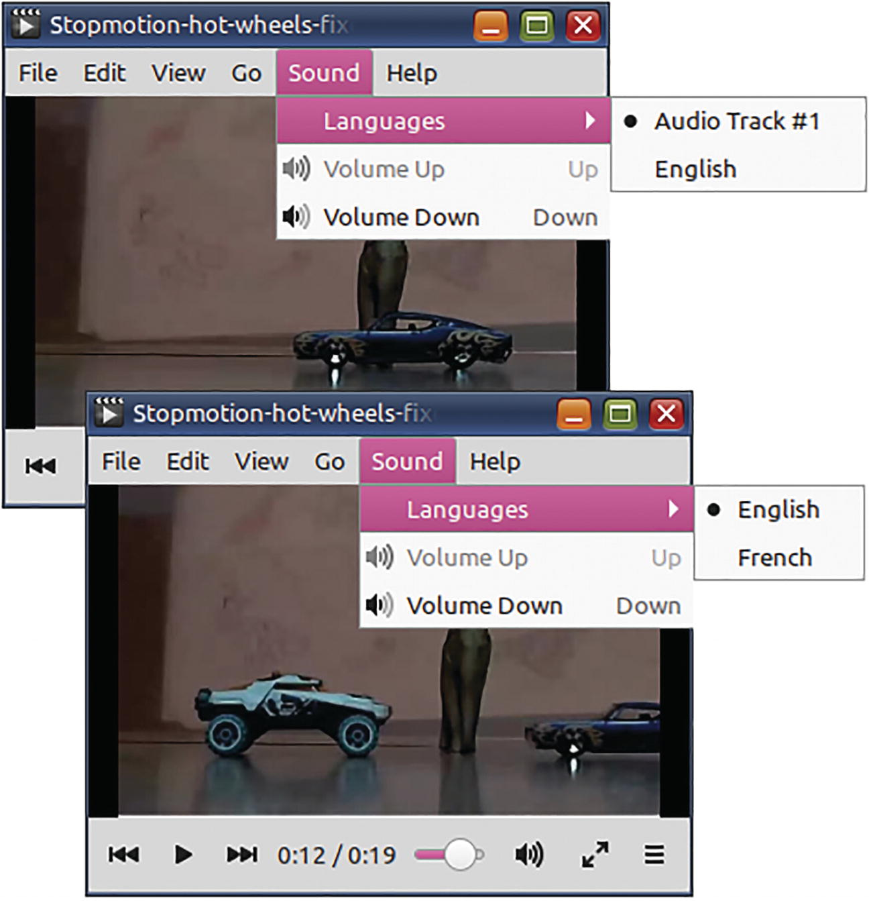
Figure 4-10If you do not specify a language name for an audio track, media players may make wrong assumptions
ffmpeg -i Stopmotion-hot-wheels.mp4 \
-i Stopmotion-hot-wheels-fixed.mp3 \
-map 0:v:0 -map 1:a:0 -map 0:a:0 \
-codec copy \
-metadata:
s:a
:0 language="eng" \
-metadata:
s:a
:1 language="fre" \
Stopmotion-hot-wheels-fixed-n-restored.mp4
Remember that to set the language names for subtitle streams, the -metadata option should refer to subtitle streams, not audio streams.
-metadata:
s:s
:0 language="eng" \
-metadata:
s:s
:1 language="fre" \
The StreamIndex refers to the index of the stream IN THE OUTPUT FILE. The s after -metadata: identifies itself as metadata for a stream. Do not mistake it for subtitles. Also, remember that metadata is all about the output file. Do not use any numbering from the input file(s).
☞ Apart from streams (-metadata:s), metadata can be specified for DVD chapters (-metadata:c) and DVD programs (-metadata:p). They are not covered by this book.
☞ You can learn more about metadata in Chapter 10.

Metadata Maps
Have you noticed that when you convert MP3 files, the album art or the meta tags get lost? This is because of improper or no metadata mapping. Metadata can get lost when you convert files or create new files from multiple input files. The -map_metadata option helps you correctly route metadata from input files to output files. Its value is specified in a rather twisted manner. The left is the destination and the right is the source.
-map_metadata InputFileIndex:MetadataSpecifier or
-map_metadata:g InputFileIndex:MetadataSpecifier or
-map_metadata:MetadataSpecifier InputFileIndex:⏎
MetadataSpecifier
Where
MetadataSpecifier is either g or s:StreamType (all streams) or s:StreamType:StreamIndex (some stream)
Yeah, it made my head spin too! Take your time. Nobody does metadata mapping on their first excursion into FFmpeg. Take the slow lane.
The following example copies global metadata from the second input file (-map 1) as the global metadata for the output file. This ensures that the MP3 tags are copied as the video’s metadata.
ffmpeg -y -i raisa.png -i raisa.mp3 \
-c:a copy -c:v mjpeg \
-map 0 -map 1 \
-map_metadata 1
\
raisa.mp4
The next example copies global metadata from the second input file both globally (:g) and to the audio stream (:s:a). The global metadata from the second input file can be specified either as 1:g or simply as 1. Global output metadata can be typed as -map_metadata:g (as below) or simply as -map_metadata (as above).
ffmpeg -y -i raisa.png -i raisa.mp3 \
-c:a copy -c:v mjpeg \
-map 0 -map 1 \
-map_metadata:g 1:g -map_metadata:s:a 1
\
raisa.mkv #Does not work with MP4
What is the advantage of this command? If someone decides to extract just the audio stream from the MKV, the metadata does not get omitted. The stream and the MKV (global) both have a copy of the metadata from the MP3 file. The original metadata will survive even in the extracted audio stream.
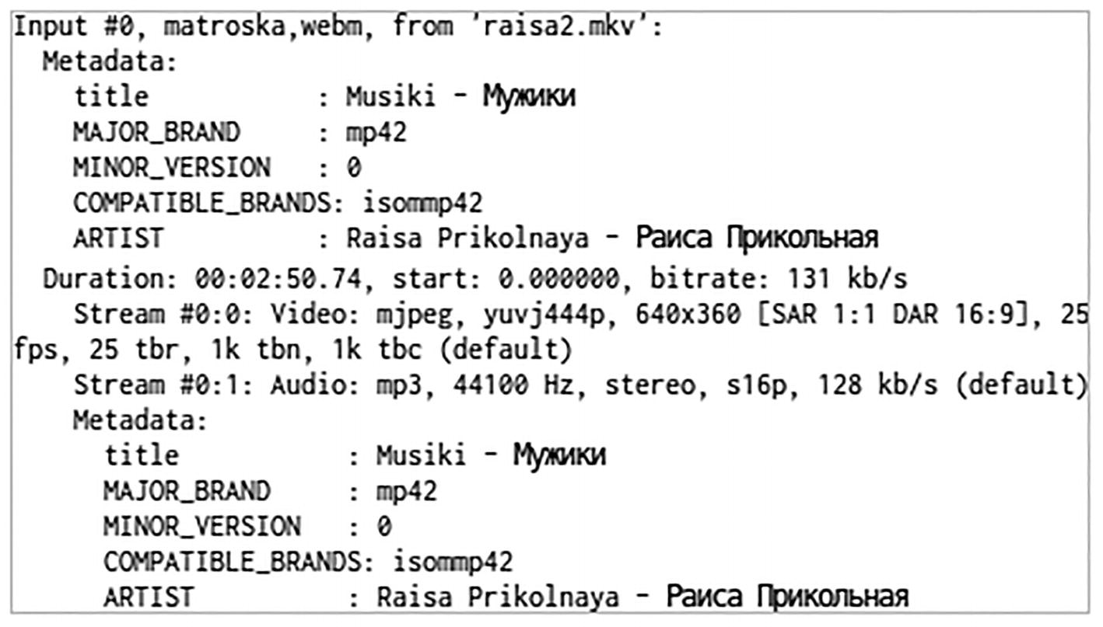
Figure 4-11The global metadata has been duplicated to the audio stream metadata as well
☞ The -metadata option overrides -map_metadata mapping.

Channel Maps
Audio streams can have one or more channels. Monaural audio has only one channel. Stereo music has two channels - left and right. DVD movies can have two or six or eight channels for playback on both stereo and surround speaker systems.
To pin down the channels exactly as you want in the output file, you need to use the -map_channel option. It can be specified as follows:
-map_channelInputFileIndex.StreamIndex.ChannelIndex
or as
-map_channel -1
if you want the channel muted.
The -map_channel options specify the input audio channels and the order in which they are placed in the output file.
Imagine that the audio channels in an MP4 file are mixed up. When you wear headphones, in either ear, the voices are heard for people on the opposite side in the video. You can fix it by the following:
ffmpeg -i wrong-channels.mp4 \
-c:v copy \
-map_channel 0.1.1 -map_channel 0.1.0
\
fine-channels.mp4
In a stereo audio stream, the channel order is 0.1.0 (left) followed by 0.1.1 (right). When you use a channel map of 0.1.1 followed by 0.1.0, the channels get switched.
For the next example, imagine that you are using headphones in a work environment. You want to have one ear for music and one ear for surroundings. You could mute one of the channels.
ffmpeg -i moosic.mp3 \
-map_channel 0.0.0 -map_channel -1
\
moosic4lefty.mp3
☞ No, you should not make it mono. Mono audio will be heard on both sides.
In some videos, the left and right audio channels are independent tracks. What these content creators do is place the original audio on one channel and the most annoying royalty-free music on the other. Instead of deleting the offending channel, you could move each channel to a separate audio stream while preserving the original stereo stream in a third stream.
ffmpeg -y -i zombie.mp4 \
-map 0:0
-map 0:1 -map 0:1 -map 0:1
\
-map_channel 0.1.0:0.1 -map_channel 0.1.1:0.2
\
-c:v copy \
zombie-tracks.mp4
The first stream in the output file will be the original video (0.0). The left channel (0.1.0) will be the second stream (0.1). The right channel (0.1.1) will be the third stream (0.2). The original stereo audio will become the fourth stream. (Yes, the second and third streams will be mono audio.)
What about the numbers after the colon? That is explained by the full definition for channel maps:
-map_channel InputFileIndex.InputFileStreamIndex.⏎
ChannelIndex:OutputFileIndex.OutputFileStreamIndex
How do you like them apples? The second part beginning with the colon is optional. It is for placing the mapped input audio channel on a specified output stream.
☞ Channel mapping numbers use dots, not colons. The colon is used only when you begin to specify the output stream.
☞ Channel mapping cannot be used to mix channels from multiple input files.
☞ When you make changes to the channels, the audio will be converted again and this takes time. It will not be done quickly like with -c:a copy.

Do Not Use the -map_channel Option
The -map_channel option, with its difficulties, is on its way out. The FFmpeg version 5.1 (released in July 2022) shows this warning.
The -map_channel option is deprecated
and will be removed.It can be replaced by the '
pan
' filter, or in some cases bycombinations of '
channelsplit
', '
channelmap
', '
amerge
' filters
.
With newer ffmpeg versions, the previous commands can be rewritten using filters, which you will learn in a later chapter.
# Switch right and left channels of stereo audio
ffmpeg -i wrong-channels.mp4 \
-c:v copy \
-filter_complex "
channelmap
=map=FR-FL|FL-FR" \
fine-channels.mp4
# Silence right channel
ffmpeg -i moosic.mp3 \
-c:v copy \
-filter_complex "
pan
=stereo|FL=FL|FR=0" \
moosic4lefty.mp3
# Split channels to separate audio streams
# and also preserve existing audio stream
ffmpeg -y -ss 0:0:20 -t 0:0:20 -i zombie.mp4 \
-c:v copy \
-filter_complex "channelsplit[L][R]" \
-map 0:v:0 -map '[L]' -map '[R]' -map 0:a:0 \
-codec:a:0 aac -ac:a:0 1 \
-codec:a:1 aac -ac:a:1 1 \
-codec:a:2 copy \
zombie-tracks.mp4
☞ The -codec and -ac options are limited to streams specified by the -map options specified before them.

Summary
In this chapter, you learned about how to access streams and metadata. You also learned how to pick and choose what streams and metadata you would like to have in the output file(s).
As mentioned in the beginning of this chapter, it is not necessary that you grasp every detail in this chapter on the first go. As you read forthcoming chapters, certain things mentioned in this chapter will become clearer. If not, you can always return to this chapter.
© The Author(s), under exclusive license to APress Media, LLC, part of Springer Nature 2023
V. SubhashQuick Start Guide to FFmpeg
https://doi.org/10.1007/978-1-4842-8701-9_5

5. Format Conversion
V. Subhash1
(1)
Chennai, Tamil Nadu, India

The main reason that so many people use ffmpeg is its amazing ability to convert files from one format to another. ffmpeg supports so many formats that I doubt there is any competition even from paid software. In this chapter, you will learn how to perform these conversions and customize them to extract the best quality from the source files.

No-Brainer Conversions
The default output format in many Linux multimedia programs is OGV and OGG files. Sadly, very few consumer electronic devices support these two formats. I use gtk-recordMyDesktop to screen capture my computer demos, and it creates OGV video files. Before I can play the files on my TV, I need to convert them to MP4 format.
ffmpeg -i video1.ogv video1.mp4
An Ogg ringtone will play fine on an Android phone but not on a feature phone, which usually only supports MP3 and MIDI ringtones. Converting Ogg to MP3 is easy with FFmpeg.
ffmpeg -i alarm.ogg alarm.mp3
FFmpeg can guess the output format based on the file extension you have used for the output file. It will automatically apply some good preset conversion settings (defaults). You can specify custom conversion settings too.

Conversion Options
Table 5-1 lists a few FFmpeg options that are useful when converting files. You will learn how to use them in the rest of this chapter.
Table 5-1Some FFmpeg conversion options
Option | For
-y | Prevent prompting before overwriting any existing output file
-b:a | Set audio bitrate
-c:a | Specify audio encoder or decoder
-ar | Set audio sampling rate
-ac | Set number of audio channels
-b:v | Set video bitrate
-c:v | Specify video encoder or decoder
-r | Set video frame rate
-pass | Specify number of the encoding pass
-passlogfile | Specify prefix for multi-pass encoding log files
-f | Force specified format  (or oss, alsa, rawvideo, concat, image2, null…)
-shortest | Stop all processing when any one output stream is completely processed
-vn | Do not process video
-an | Do not process audio
-sn | Do not process subtitles

Obsolete/Incorrect Options
FFmpeg is fault-tolerant to an extent but do not be sloppy in typing the options. You should avoid using -r:a instead of -ar (audio sampling rate). Instead of conventions such as -acodec and -vcodec, you should be using -c:a or -c:v instead. Support for such old practices may be removed in future.

Codec Option
The -codec option is used to specify an encoder (when used before an output file). When used before an input file, it refers to the decoder. (ffmpeg may have more than one decoder and encoder for a particular codec.) Choose the correct name from the output of the command ffmpeg -encoders or ffmpeg -decoders, and not from that of ffmpeg -codecs.
The -codec option can also be specified for all streams for a particular type, such as -codec:a for all audio streams or -codec:s for all subtitle streams or for a particular stream using its index. For each stream, only the last applicable -codec option will be considered. If you use the value copy for the encoder, ffmpeg will copy applicable streams as is without using an encoder.
How do you know which codec (encoder name) you need to use for a particular format? For an MP3 file, you could try the following:
ffmpeg -encoders | grep mp3
It may not be so straightforward with other formats. Browse through the full output of the command ffmpeg -encoders to become familiar with codec names. Sample output of this command is available in Annexure 3. Then, you will learn that H.264 and MPEG-4 codecs have something to do with MP4 files. You could also use ffprobe on existing file samples and find prospective codec names.
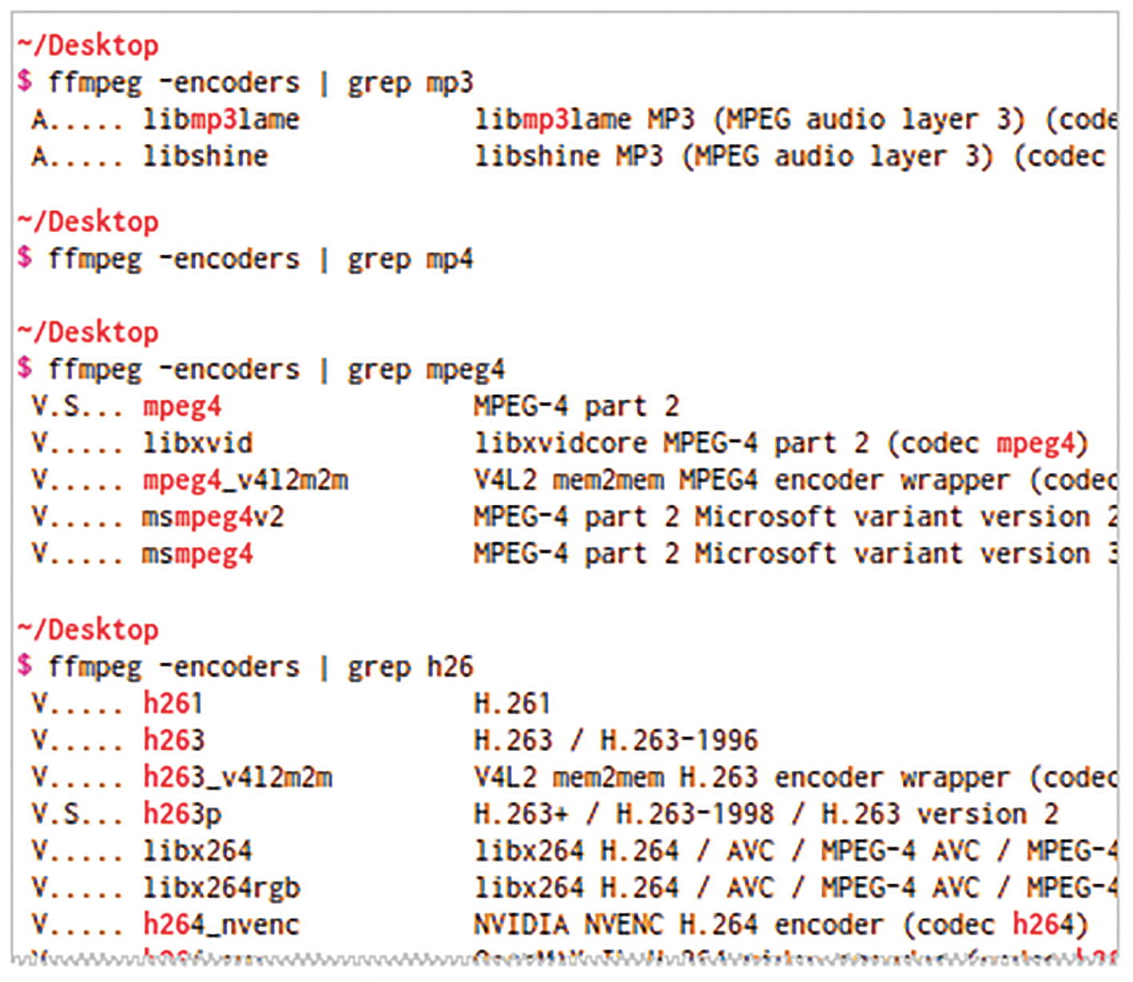
Figure 5-1ffmpeg lists a lots of encoders, several pages full. You may miss some important ones if you make assumptions and filter the output. Use the command ffmpeg -encoders | more to conveniently browse the full output

Sample Conversion with Custom Settings
If I wanted to convert a HD video downloaded from the Internet for playing on my old portable media player, I would use these settings.
ffmpeg -i net-video.mp4 \
-s 320x240 \
-c:v mpeg4
-b:v 200K -r 24 \
-c:a libmp3lame
-b:a 96K -ac 2 \
portable-video.mp4
The output video stream uses MPEG4 codec with qvga (320x240) dimensions, 200K bitrate, and a 24 frames-per-second rate. The output audio stream uses MP3 codec (Lame encoder) with two-channel audio (stereo) and 96K bitrate.
☞ You will know what values to use for each setting only if you make it a habit to use ffprobe on new types of files that you encounter.
☞ The bitrate is how densely the audio or video content is stored in the container. The greater the compression, the lesser is the bitrate and file size, and so is the quality. You need to find a balance between quality loss and file size reduction.

Multi-pass Conversion
In multi-pass encoding, ffmpeg processes the video stream multiple times to ensure the output video is close to the specified bitrate. ffmpeg creates a log file for each pass. In the initial passes, the audio is not processed and video output is not saved (dumped on null device). In the final pass, however, you will have to specify the audio conversion settings and the output file. In the next example, the conversion from the previous section is performed using two passes.
This is the first pass.
ffmpeg -y -i net-video.mp4 \
-s 320x240 -c:v mpeg4 -b:v 194k -r 24 \
-f mp4 -pass 1 -passlogfile /tmp/ffmpeg-log-net-video \
-an /dev/null
☞ Windows users should use NUL instead of /dev/null.
And, this is the last pass.
ffmpeg -y -i net-video.mp4 \
-s 320x240 -c:v mpeg4 -b:v 194k -r 24 \
-pass 2 -passlogfile /tmp/ffmpeg-log-net-video \
-c:a libmp3lame -ac 2 -b:a 96K \
portable-video.mp4
Multiple passes of the first kind may be required for achieving a particular bitrate. Use the same video conversion settings for all passes.
☞ When the streams meet the specified bitrates, you will also know exactly how big the file will be. Just multiply the bitrate with the duration of the video. The reverse is also true. You can target a particular file size (allowing for some deviation) by specifying a proportional bitrate for both the audio and video. Conversion with constant bitrate was popular when DVD videos were encoded (ripped off) to fit on a CD.

Conversion for Maximum Compression and Quality
Multimedia codecs provide a trade-off between speed, quality, and compression. Now that we have almost unlimited online and offline space, constant quality rather than constant bitrate is preferred. With the H.264 codec, you can achieve the required quality and compression in one pass using the -crf (CRF or Constant Rate Factor) option and by specifying a processing “preset.” The -crf option affects quality.
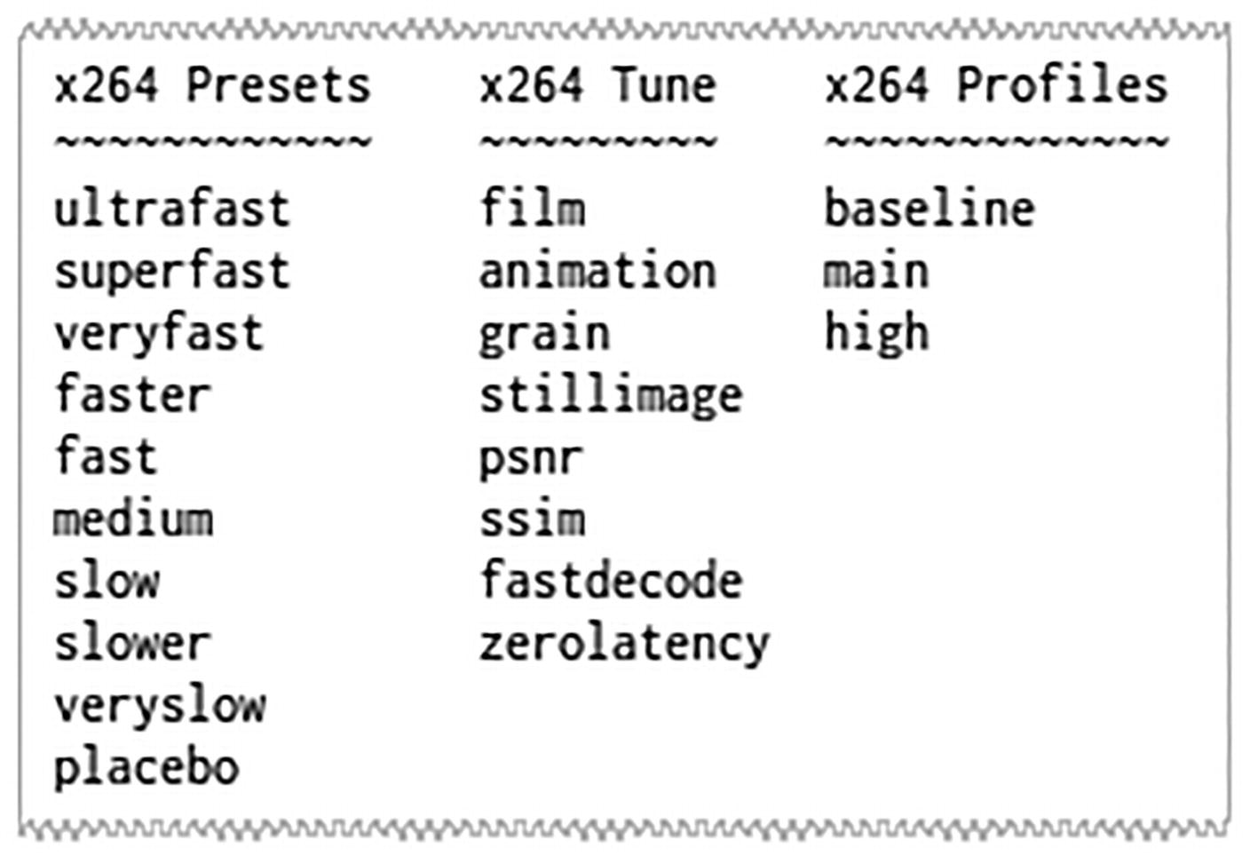
Figure 5-2This extract from the output of an old script shows preset and tuning variables supported by the H.264 encoder
ffmpeg -i solar.mp4 \
-c:v libx264
-crf 21 -preset fast
\
-c:a copy \
solar-CONVERTED.mp4
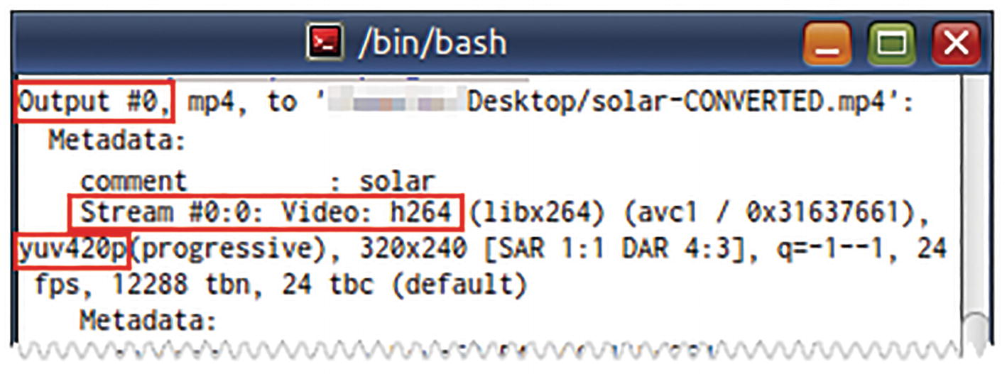
Figure 5-3The ffmpeg output stream details will tell you which pixel format has been used
The CRF range is from 0 (lossless) to 63 (worst) for 10-bit pixel formats (such as yuv420p10le) and 0 to 51 for 8-bit pixel formats (such as yuv420p). You can determine the pixel format from the ffmpeg output of a similar file conversion. The median can be 21 for 8-bit encoder and 31 for 10-bit encoder.
What the heck is a pixel format? All that you need to know about pixel format (at this stage) is that it is a data-encoding scheme used to specify the colors of each pixel (dots) in a video frame. FFmpeg supports these pixel formats: monob, rgb555be, rgb555le, rgb565be, rgb565le, rgb24, bgr24, 0rgb, bgr0, 0bgr, rgb0, bgr48be, uyvy422, yuva444p, yuva444p16le, yuv444p, yuv422p16, yuv422p10, yuv444p10, yuv420p, nv12, yuyv422, and gray.
In addition to the processing preset, you can also specify a -tune option depending on the kind of video that you have selected. The values psnr and ssim are used to generate video quality metrics and are not normally used in production. zerolatency output can be used for streaming. fastdecode can be used for devices that do not have a lot of processing power. grain is to prevent the encoder from being confused by grainy videos.

Audio Conversion
This command uses the Lame MP3 encoder to convert an Ogg audio file to a 128K-bitrate two-channel (stereo) MP3 file.
ffmpeg -i alarm.ogg \
-c:a libmp3lame \
-ac 2 \
-b:a 128K \
alarm.mp3
☞ There is a better method for converting to MP3 files. You will find it in Chapter 11.

Audio Extraction
Some video files have great sound. Music videos are good examples. How do you extract their audio? Well, drop the video stream and copy the audio stream to an audio file.
# Matroska audio
ffmpeg -i music-video.mp4
-c:a copy music-video.mka
# MPEG4 audio - FFmpeg flounders
ffmpeg -i music-video.mp4
-vn -c:a copy music-video.m4a
☞ Without -vn, the video stream will get copied to the m4a file! Hurray for redundant options! Le paranoid survive!
Matroska audio or “.mka” files support several audio codecs. The “.m4a” files support AAC (MPEG4 audio) codec.
If you already know that the audio stream in the MP4 file has been encoded with MP3 codec (as they do sometimes), you can -codec:a copy the audio stream to a “.mp3” file. Most of the time, however, you will have to encode it to MP3. Files with extension “.mka” and “.m4a” are not supported by many playback devices. The following command converts the audio stream of the video file using the Lame encoder to create a two-channel (stereo) MP3 file encoded at 128K bitrate.
ffmpeg -i music-video.mp4 \
-c:a libmp3lame -b:a 128K -ac 2 \
music-video.mp3
You can simultaneously output audio in different bitrates using multiple -map options.
ffmpeg -i music-video.mp4 \
-vn \
-map 0:a -c:a libmp3lame -b:a 128K music-high.mp3 \
-map 0:a -c:a libmp3lame -b:a 64K music-low.mp3
☞ As one understands, this is strictly for limited doomsday archival purposes…. Several films and music records have been lost to studio fires. Anything can happen. Cite the 2020 pandemic.


Extract Stills from a Video (Video-to-Image Conversion)
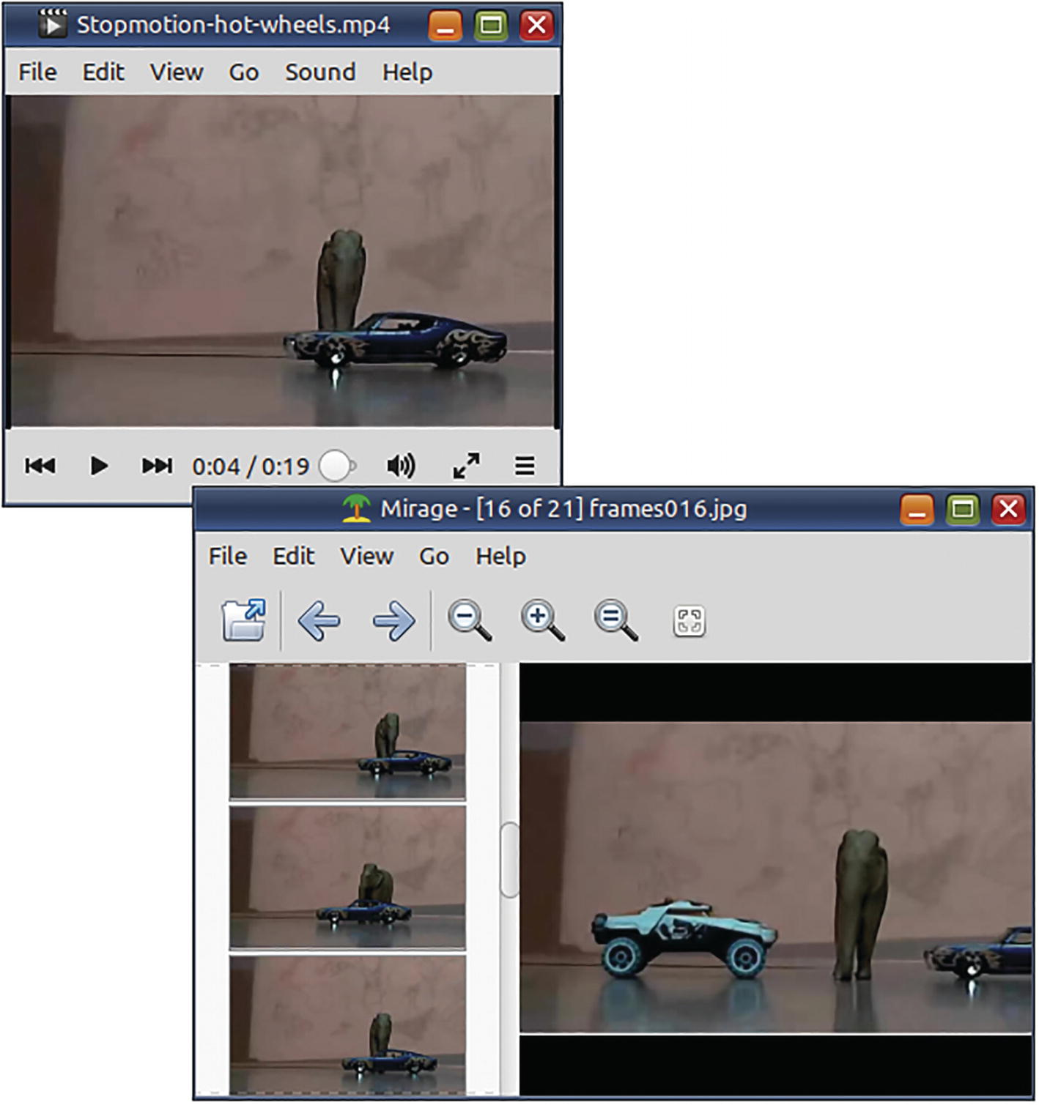
Figure 5-4A video and the still-image frames extracted from it
To extract video frames as image files, you need to use the -f image2 option. The numbering of the output images is specified in the name of the output file. The format mask of the output file is similar to that of the printf function in the C programming language. In the mask used in the next command, % is for character output, 0 is for padding with zeros instead of spaces, 3 is for the total number of digits, and d is for integer numbers.
# Extract images at the rate of 1 frame per second from the video
ffmpeg -y -i Stopmotion-hot-wheels.mp4 \
-r 1 \
-f image2 \
frames%03d.jpg
2> /dev/null
☞ Most videos are encoded with a frame rate of 24, 25, 30, or even 60 frames per second. Be careful with your extraction rate and length of the video, or you will quickly run out of space.
Use the -r option to restrict the number of images generated for each second of the source video. You can omit the -r option to extract all frames (and let it be determined by the frame rate of the source video) but
Use small video clips as the source
Use -t and -ss options (described in Chapter 6) to restrict the extracted duration of the source video

Image-Conversion Settings
Table 5-2 lists some FFmpeg conversion options that are useful when working with image files. Although this book will describe how to use them, more comprehensive information will be found in the official FFmpeg documentation.
Table 5-2ffmpeg image-conversion options and examples
Option | Purpose
-f image2 | Force conversion to and from images
-f image2pipe | Force image conversion for output piped over to another command
-loop 1 | Repeat the processing of the input image indefinitely
-pix_fmt yuv420p | Use yuv420p pixel format when converting to image formats

Create Video from Images (Image-to-Video Conversion)
FFmpeg can also do the reverse by creating a video from several images (when they are numbered serially). The duration of the video depends on the number of images available and frame rate you have specified. If the -r option in the video-to-image conversion was higher (in the previous command), say between 12 and 30, a lot more images would have been extracted, and this video would have been smoother.
ffmpeg -r 1
-i frames%03d.jpg
\
-s qvga
-pix_fmt yuv420p
\
Stopmotion-hot-wheels-reconstituted.mp4 2>
/dev/null
ffplay -autoexit \
Stopmotion-hot-wheels-reconstituted.mp4 2>
/dev/null
☞ All input images should be of the same format and dimensions.
☞ The -pix_fmt yuv420p option is necessary to ensure such unusual video files play all right in most media player devices.

Create a Slideshow from Several Images
In the previous section, the output video ran out quickly because there were not many input images. If you want each input image to appear for longer than a second, then you need to specify a -framerate option for them as well. An input frame rate of 1/3 ensures that a frame plays for 3 seconds.
ffmpeg -y
-framerate 1/3 -i image%02d.jpg \
-filter:v \
"scale=eval=frame:w=640:h=480:
force_original_aspect_ratio=decrease,
pad=640:480:(ow-iw)/2:(oh-ih)/2:yellow" \
-pix_fmt yuv420p
-r 24 \
slide.mp4
☞ You will learn more about filters in Chapter 7.
The preceding command also takes care of images with irregular dimensions and ensures that they are resized appropriately.
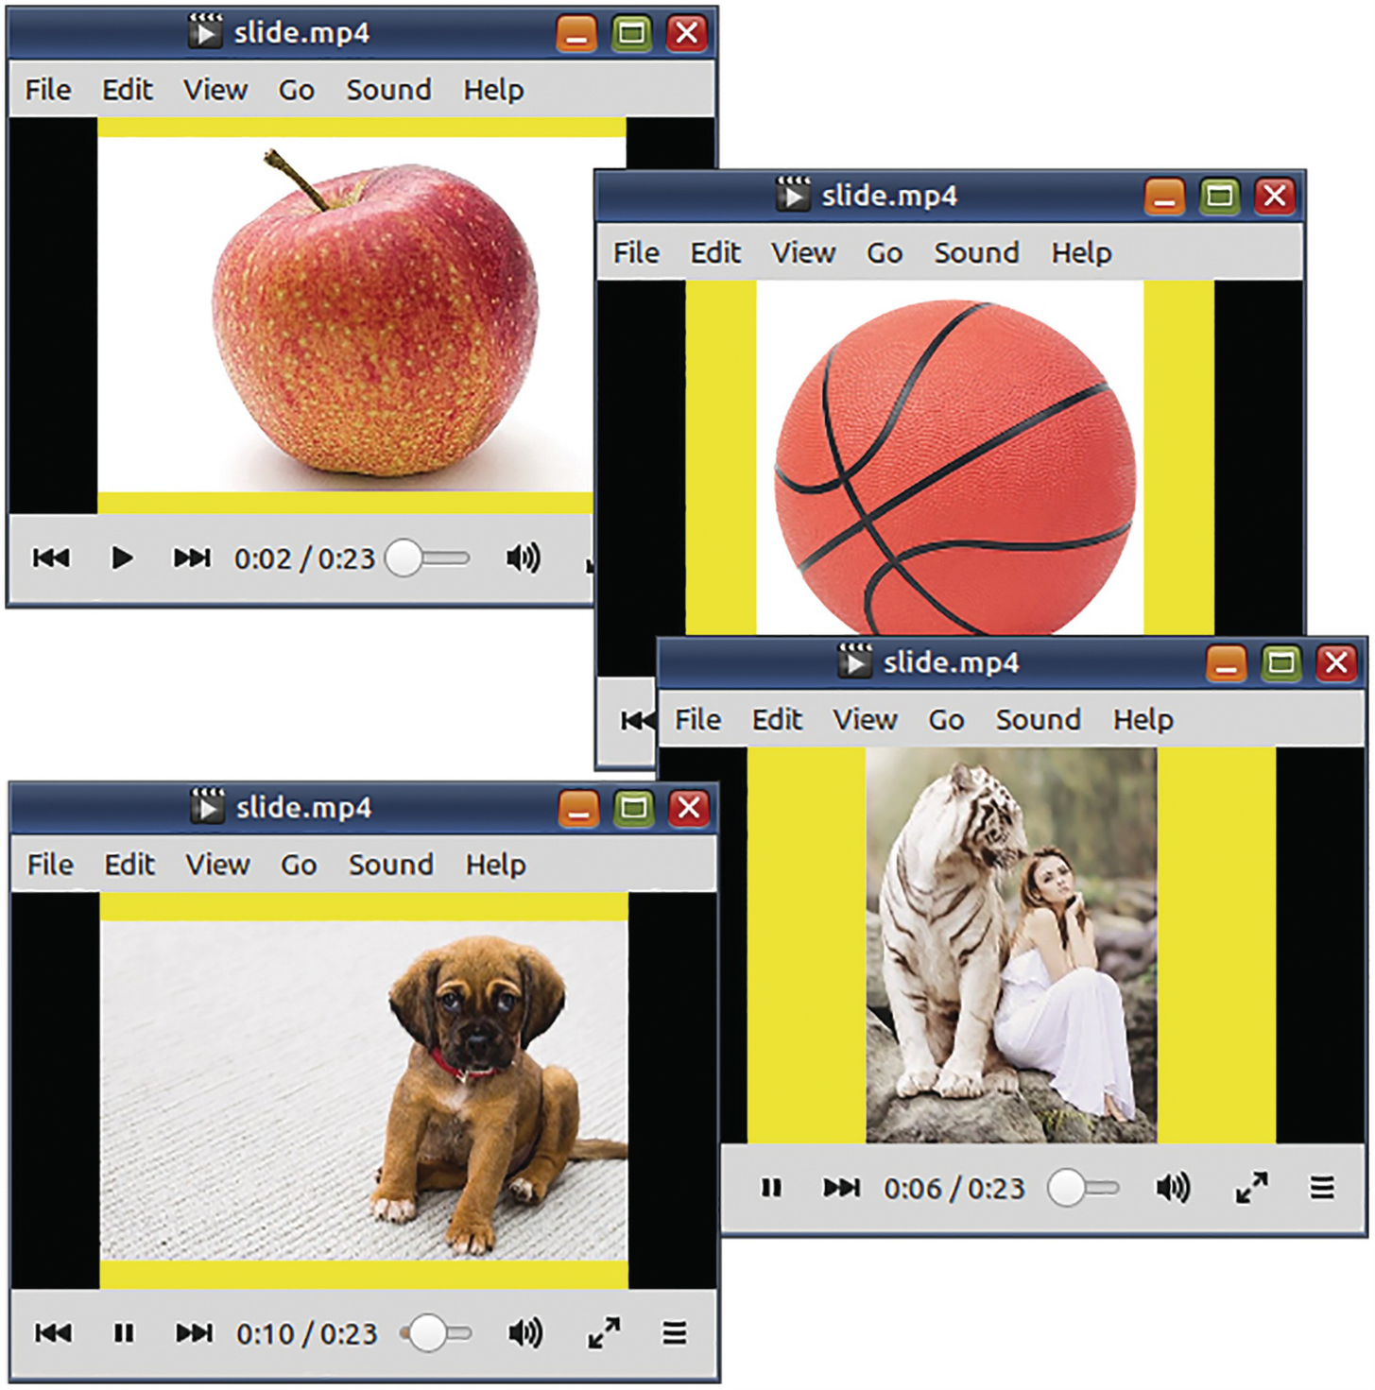
Figure 5-5This video was created from several disproportionate images
When you have input images in no particular naming sequence, then you can pipe them like this:
cat *.png | \
ffmpeg -y -f image2pipe \
-framerate 1/3 -i - \
-filter:v \
"scale=eval=frame:w=640:h=360:
force_original_aspect_ratio=decrease,
pad=640:360:(ow-iw)/2:(oh-ih)/2:black" \
-c:v libx264 -r 24 -s nhd -pix_fmt yuv420p \
slide2.mp4

Create a GIF from a Video
The ancient GIF format supports only 256 colors. You need to use palettegen and paletteuse filters to downsample the source video to this limited number of colors.
ffmpeg -y -i bw.m4v \
-filter_complex \
"fps=7,scale=w=320:h=-1:flags=lanczos,split[v1][v2];
[v1]
palettegen
=stats_mode=diff[p];
[v2][p]
paletteuse
=dither=bayer:bayer_scale=4" \
bw-4.gif
You need to experiment a lot with the filters to understand what will work and what will not. A set of values that do well to optimize the file size for one source video may do poorly for another video. GIF optimization is extremely unpredictable. Learn more from this article:
https://engineering.giphy.com/how-to-make-gifs-with-ffmpeg/
In an experiment with the production of a GIF file from a video, I found that
With a bayer_scale of 0 (with the dither=bayer mode), the animation is smooth but suffers from the appearance of a dotted texture. The file size is on the higher side.
When moving to the highest value of 5 (default is 2), the frames are clearer but start to suffer from intermittent banding. The file size is smaller.
The results may be quite different for another video file.
If you are stuck with an older version of FFmpeg that does not have the palettegen and paletteuse filters, you can make FFmpeg output the frames to ImageMagick (convert or magick). (The hyphens in the following command refer to standard output and input.)
ffmpeg -y -i bw.m4v \
-filter:v "fps=10,scale=w=320:h=-1:flags=lanczos" \
-c:v ppm \
-f image2pipe - | \
convert -delay 10 - \
-loop 0 \
-layers optimize \
bw.
gif

APNG
A better alternative to GIF animations is APNG. This format has limited support from image-viewing and image-editing applications but has near-universal support from desktop and mobile web browsers. Like PNG and unlike GIF, APNG supports millions of colours. This means that its colours will not have to be downsampled and will be very close to those in the source content. APNG animation files are typically bigger than animated GIFs.
If you are converting GIF animations to APNGs, then ImageMagick is the tool you should use, not ffmpeg.
magick animated.gif animated.apng
The image frames in a GIF will already be downsampled to 256 colours. To create a richer animated PNG, try to use the source frames in PNG format.
magick -delay 200 -loop 0 \
chapter-image-*.png \
-units PixelsPerInch -density 72 -resize '>x300' \
animation-unlikely-stories.apng
If you are converting a video to APNG, then you can use ffmpeg.
ffmpeg -i bw.m4v \
-vf "scale=w=250:h=-2, hqdn3d, fps=6" \
-dpi 72 -plays 0 \
bw.apng
In this command, -dpi is an APNG encoder option and -plays is an APNG muxer option. The high-quality denoise 3d filter reduces blemishes introduced by the scaling filter. Learn more about these options from the official documentation or by typing:
ffmpeg -help muxer=apng
ffmpeg -help encoder=png
ffmpeg -help filter=hqdn3d

Create a Video Using an Image and an MP3
How do you play an MP3 in a media player that will only play MP4 files? Find a thumbnail or album art for the MP3 and churn it out as a video. The following command uses an image as a video stream encoded with MJPEG codec.
ffmpeg -i Blobfish_face.jpg -i blobfish.mp3 \
-c:v mjpeg -c:a copy \
-map 0:v:0 -map 1:a:0 \
-disposition:v:0 attached_pic \
"Weird Fins - 17 - The Blobfish.mp4"
This command generates only one image frame in the MP4. The image frame is not encoded as a regular video stream for the entire duration of the audio.
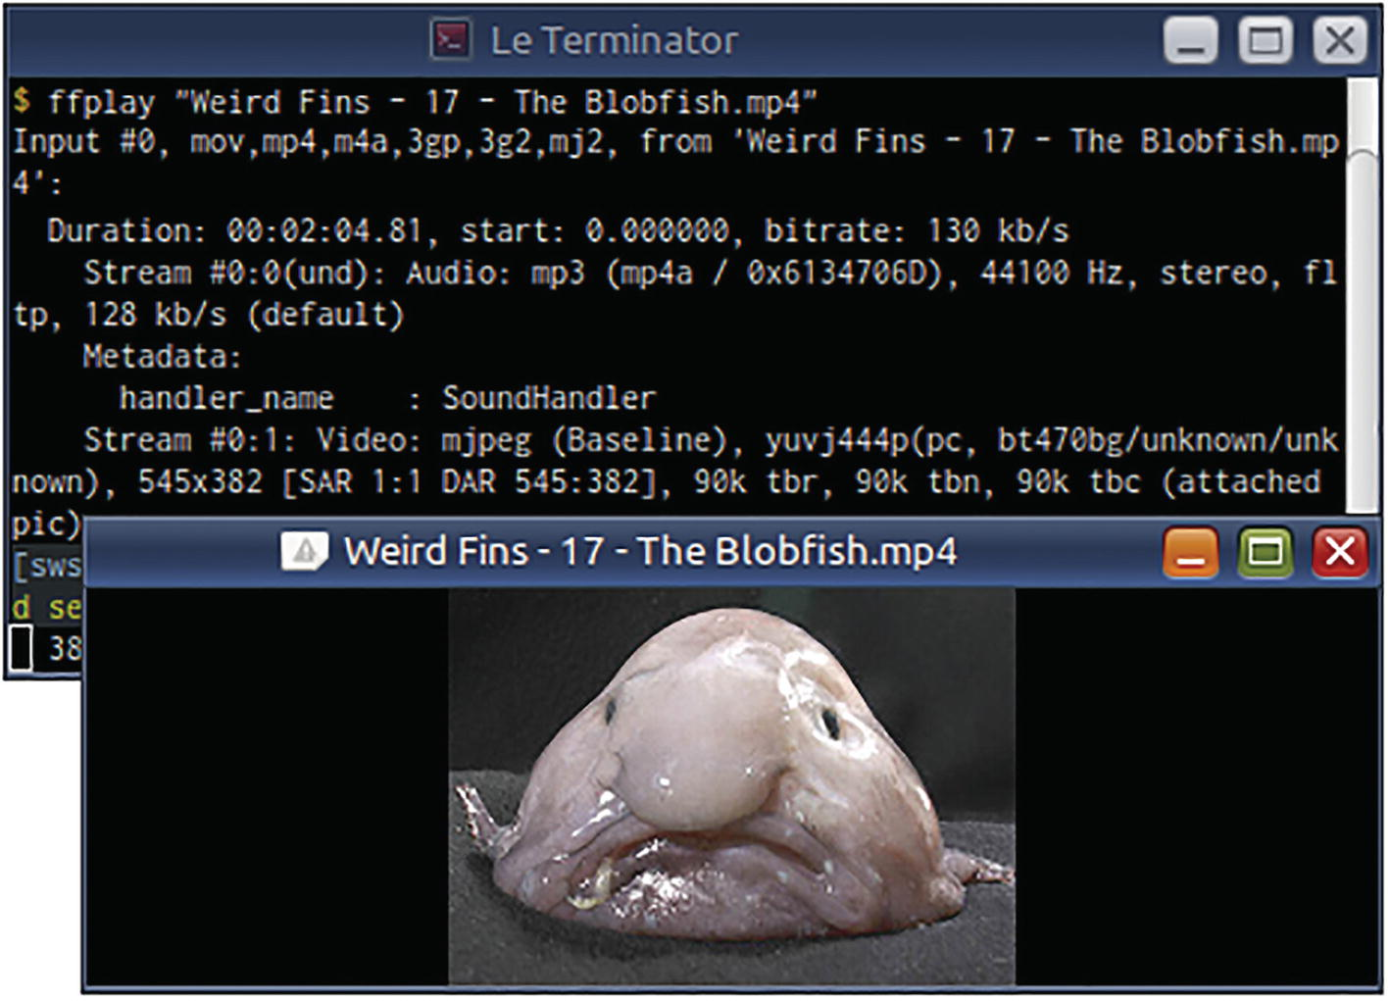
Figure 5-6This video does not really have any video, just one frame from an image
However, not all media players will accept this trickery. On my computer, Totem media player does not show the image at all and plays it like a regular audio file. VLC displays the image because it uses FFmpeg internally. If your player shirks its duty, you will have to encode the image for the full duration of the audio.
ffmpeg -y -i blobfish.mp3 \
-loop 1 -framerate 12 -i Blobfish_face.jpg \
-shortest -s qvga -c:a copy \
-c:v libx264 -pix_fmt yuv420p
\
"Weird Fins - 17 - The Blobfish (no tricks).mp4"
# The album art image loops forever so the
# podcast audio creates the shortest output stream
☞ This MP3 was part of 18 MP3 files of the “Weird Fins” podcast published by the US NOAA. It got lost and buried when they redesigned their site. Some years ago, I recovered these files, tagged them and uploaded them to Archive.org.

Convert Online Videos to Audio
YouTube-DL is an open source command-line program that can download online videos for offline use. It supports several online video sites. Many journalists use it to grab still images for their articles about Internet videos. However, the entertainment industry has decided to challenge the legal status of this utility. The Electronic Frontier Foundation (EFF) and surprisingly GitHub (owned by Microsoft) have come up with a defense initiative for its survival.
https://youtube-dl.org
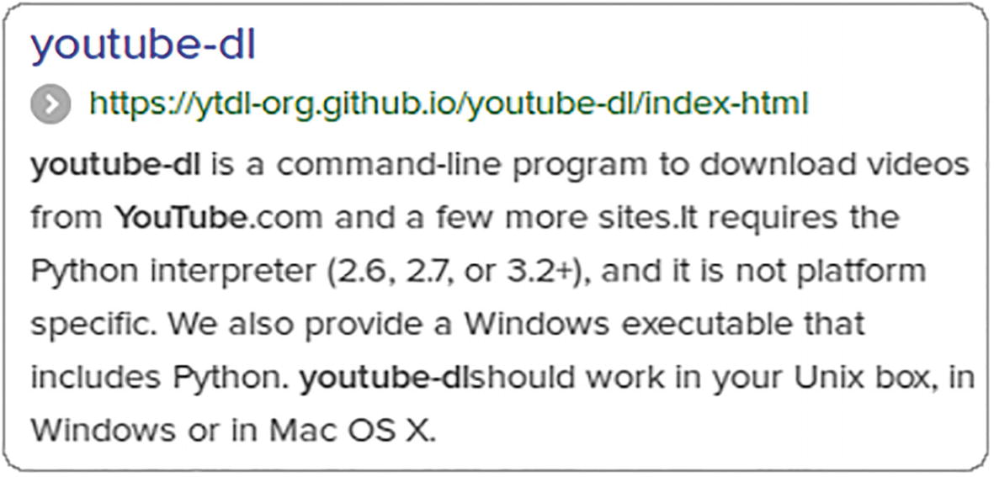
Figure 5-7This is a description of youtube-dl published by a search engine
Assuming that your ~/bin directory is in the $PATH environment variable, you can install youtube-dl locally using the following:
wget https://yt-dl.org/downloads/latest/youtube-dl \
-O ~/bin/youtube-dl
chmod +x ~/bin/youtube-dl
youtube-dl --version
☞ YouTube-DL will run from anywhere. You do not have to install the file to a privileged location like the site says.
☞ If youtube-dl does not run, maybe Python 3 is not in the PATH. Start it with /usr/bin/python3 youtube-dl ....
You can make youtube-dl use ffmpeg to convert the downloaded files. Many audio podcasts are posted to online video sites. To only listen to them in the Audacious media player, I use a command like this:
youtube-dl
-f 140 -x \
--audio-format mp3 \
--exec 'audacious
{}
& ' \
https://www.youtube.com/watch?v=yypDkqAErx0
youtube-dl will not only download and convert the audio (from AAC) to MP3 (using ffmpeg), but it will also launch a command when the conversion process is complete. That command can be for your media player. youtube-dl will replace {} in the command string with the name of the output (MP3) file.

Convert Text to Audio
If your ffmpeg executable has been built-in with support for the libflite text-to-speech synthesizer library, then you can convert text content to spoken words.
ffmpeg -f lavfi \
-i "
flite
=textfile=speech.txt:voice=slt" \
speech.mp3
This speech filter supports several voices. On my computer, it lists awb, kal, kal16, rms, and slt as available voices. Unfortunately, the female voice sounds a bit dopey.
ffprobe -f lavfi "flite=list_voices=1"
I like the male-only espeak utility better. The defaults are good, and you can change several settings.

Conversion Settings for Specific Storage Medium
If you use the -target option, certain conversion settings appropriate for the specified storage option will be applied. The values for this option can be vcd, svcd, dvd, dv, and dv50. They can be prefixed with ntsc, pal, or film for more specific targets. For the actual settings used by these targets, refer the official FFmpeg documentation.
ffmpeg -i movie.avi -target ntsc-dvd movie.mpg
☞ VCD (MPEG-1), DVD (MPEG-2), and DV (digital tape) are very old targets and consume more space than MPEG-4.
☞ If you want to extract still images from movies, optical media is usually the best source.

Summary
In this chapter, you learned how to convert multimedia content in the form of audio, video, image, and text. You also learned to customize conversion settings to suit different formats, coder/decoders, and mediums. In the next chapter, you will learn how to edit videos using ffmpeg.
© The Author(s), under exclusive license to APress Media, LLC, part of Springer Nature 2023
V. SubhashQuick Start Guide to FFmpeg
https://doi.org/10.1007/978-1-4842-8701-9_6

6. Editing Videos
V. Subhash1
(1)
Chennai, Tamil Nadu, India

I used to save DVDs as ISO files (whole-DVD backups) so that I could play them on my media player box. Each ISO took up several gigabytes (GBs) on my hard disk that I eventually ran out of space. Now, I use FFmpeg and store DVDs as MP4s of around just one GB.
While FFmpeg makes it very easy to convert multimedia files, as you learned in the previous chapter, storing them in their entity is not always feasible or required. Sometimes, you need just a few clips, not the whole shebang. You may want to combine parts of one video with parts of other videos. You can also downsize the videos to conserve space. In ffmpeg terms, you want to cut, concatenate, and resize videos. In this chapter, you will learn to do just that.

Resize a Video
You can resize a video using the -s option. The dimension of a video is usually specified as WidthxHeight. That is an “x” as in “x-mas” in the middle. When editing or converting videos, you will have to specify the video dimension using this syntax. The next command resizes a VGA-size (640x480) video to a VCD-size (352x288) video.
ffmpeg -i dialup.mp4 \
-s 352x288
\
dialup.mpg
FFmpeg supports certain easy-to-remember literals that you can use in place of the actual numbers for the -s option. They are listed in Table 6-1.
Table 6-1FFmpeg option and values for setting the dimensions of a video
Option | For
-s | Video dimensions (literal or actual)
Literal | Dimensions | Literal | Dimensions | Literal | Dimensions
ntsc | 720x480 | uxga | 1600x1200 | hd1080 | 1920x1080
pal | 720x576 | qxga | 2048x1536 | 2k | 2048x1080
qntsc | 352x240 | sxga | 1280x1024 | 2kflat | 1998x1080
qpal | 352x288 | qsxga | 2560x2048 | 2kscope | 2048x858
sntsc | 640x480 | hsxga | 5120x4096 | 4k | 4096x2160
spal | 768x576 | wvga | 852x480 | 4kflat | 3996x2160
film | 352x240 | wxga | 1366x768 | 4kscope | 4096x1716
ntsc-film | 352x240 | wsxga | 1600x1024 | nhd | 640x360
sqcif | 128x96 | wuxga | 1920x1200 | hqvga | 240x160
qcif | 176x144 | woxga | 2560x1600 | wqvga | 400x240
cif | 352x288 | wqsxga | 3200x2048 | fwqvga | 432x240
4cif | 704x576 | wquxga | 3840x2400 | hvga | 480x320
16cif | 1408x1152 | whsxga | 6400x4096 | qhd | 960x540
qqvga | 160x120 | whuxga | 7680x4800 | 2kdci | 2048x1080
qvga | 320x240 | cga | 320x200 | 4kdci | 4096x2160
vga | 640x480 | ega | 640x350 | uhd2160 | 3840x2160
svga | 800x600 | hd480 | 852x480 | uhd4320 | 7680x4320
xga | 1024x768 | hd720 | 1280x720
A video’s horizontal dimension divided by the vertical dimension is sometimes referred to as the aspect ratio. This is further influenced by the dimensions of individual pixels that make up the video. (Remember that a video frame is a matrix of dots or pixels in lines and columns.) This pixel-level aspect ratio is known as the sample aspect ratio (SAR).
When a video is resized, ffmpeg (or whichever video authoring software that is used) would have automatically adjusted the pixel dimensions (or the SAR) from square to rectangular so that the video will be played with the proper aspect ratio.
If you want a video to be played at a particular aspect ratio, you need to set the display aspect ratio (DAR). This value is calculated from the width-and-height ratio multiplied by the SAR. If for some reason, the SAR value is not present in the video, it is assumed to be 1. If this makes the video distorted, set the desired DAR using the setdar filter and let ffmpeg figure out the internal SAR.
ffmpeg -i "distorted.mpg" \
-vf
setdar=dar=4/3
\
restored.mpg
☞ You will learn more about filters in Chapter 7.
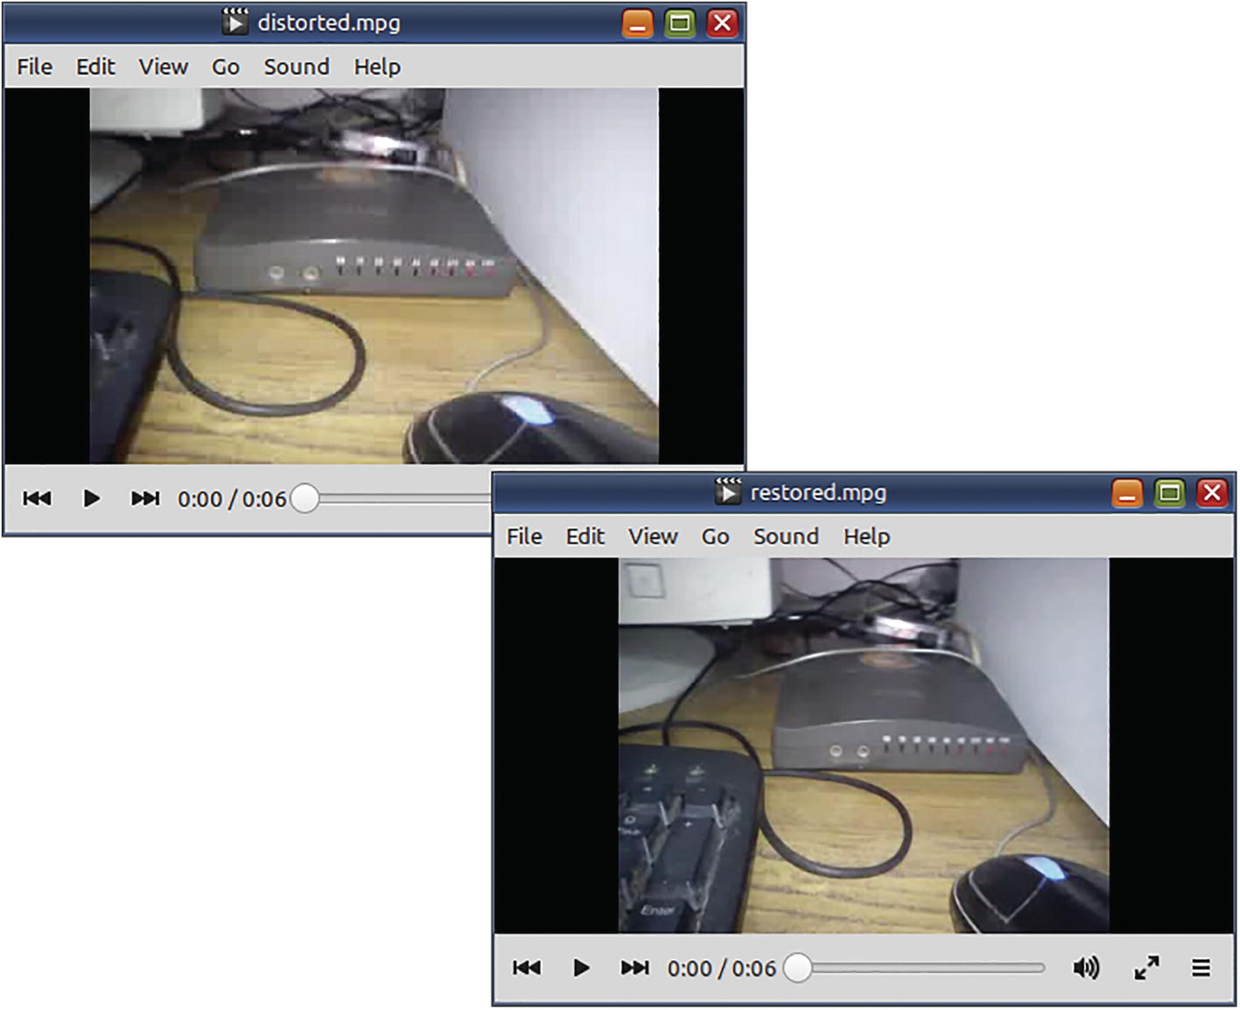
Figure 6-1The distortion in the background video was fixed using a filter that changed the DAR (display aspect ratio)
These ratios may seem similar but there are subtle differences, as presented in Table 6-2.
Table 6-2Terms related to video dimensions
Term | Description
Aspect ratio | = video width ÷ video height_____________________________________  Standard definition ratio is 4:3. For widescreen, it is 16:9
Sample aspect ratio (SAR)  a.k.a  pixel aspect ratio | = pixel width ÷ pixel height  _____________________________________  For square pixels, it is 1. For rectangular pixels, it will be a fraction
Display aspect ratio (DAR) | = (video width ÷ video height) × sample aspect ratio  or  = video aspect ratio × sample aspect ratio

Editing Options
Some often used video- and audio-editing options are listed in Table 6-3.
Table 6-3More ffmpeg options for editing
Option | For
-t | Duration (in hh:mm:ss[.xxx] format or in seconds) of the output file
-ss | Timestamp of playback location (in hh:mm:ss[.xxx] format or in seconds) from which processing needs to be performed
-c:v, -c:a, -c:s | Use specified encoder (not codec) for specific type of stream  _____________________________________  If you use the value copy as in -c copy, ffmpeg will not use an encoder and just copy the stream(s)

Cut a Portion of a Video
If the video segment that you want to remove is the beginning, then use the -ss option to specify the timestamp from which the content needs to be copied.
ffmpeg
-ss 00:01:00
-i sponsored-video.mp4 \
the-video.mp4
☞ Use the -ss option before the -i option so that ffmpeg can quickly jump to the location of the specified timestamp. If you place it after the input file and before the output file, there will be a delay as ffmpeg decodes all the data from the beginning to the timestamp and then discards it (as it is not wanted)!
The timestamp values can be specified in the format hh:mm:ss.ms. Parts that are zero in the beginning can be omitted, as shown in Table 6-4.
Table 6-4Examples of time or duration values
Usage | Implication
20 | 20 seconds
1:20 | One minute and 20 seconds
02:01:20 | Two hours, 1 minute, and 20 seconds
02:01:20.220 | Two hours, 1 minute, 20 seconds, and 220 milliseconds
20.020 | 20 seconds and 20 milliseconds
☞ Before the milliseconds value, there needs to be a dot, not a colon.
If the video segment that you want to remove is the ending, then use -t option to specify the duration of the content that needs to be copied from the beginning.
ffmpeg -i long-tail.mp4 \
-t 00:01:00
\
no-monkey.mp4
If you want to cut from the middle, then you need to use both options.
ffmpeg
-ss 00:01:00
-i side-burns.mp4 \
-t 00:1:10
\
clean-shaved.mp4
In this case, ffmpeg starts cutting -t duration of content from the timestamp specified by the -ss option, not from the beginning.
All of these commands will re-encode the video. Because the (raw) source video (from which the input video was created) is not being used, the output video will have lesser quality and have freshly introduced blemishes and artifacts.
You may encounter another problem here. When you do not specify conversion settings, then FFmpeg will use its own default encoder settings. If your uncut video had better quality than encoder defaults, then you may end up with lesser quality. If the input file had lower quality, then the encoder defaults may result in increased file size.
To avoid such problems, run ffprobe on the input file and use similar conversion settings with ffmpeg.
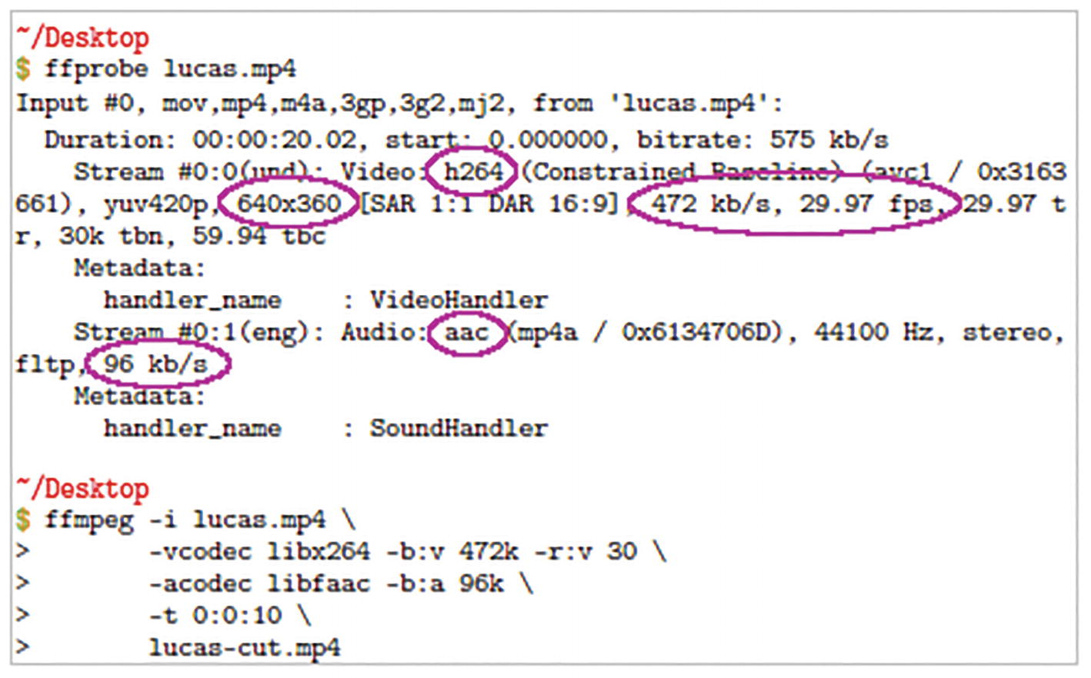
Figure 6-2The ffprobe output shows settings that you can use for the next ffmpeg task

Cut Without Re-encoding
Apart from losing quality, re-encoding takes time. Cutting without re-encoding does not have these disadvantages. Use the option -codec copy to ensure there is no re-encoding and the original quality is retained.
ffmpeg -ss 00:01:00 -i dog-eared.mp4 \
-t 00:1:10 \
-codec copy
\
clean-cut.mp4
There are disadvantages with this option too. The entirety of the audio and video information may not be present at the timestamps you have specified for FFmpeg to make a clean cut. A few seconds of the video may have to be sacrificed or go out of sync. Out-of-sync audio by one or two seconds is not really a problem in videos where the speaker remains in the background.
Use -codec copy only when the container of the output file supports the existing codec of the input stream you are trying to copy. You cannot copy streams from an OGV file to a MP4 file, but you can do that with an MKV output file. First, check whether input codecs are among the default codecs listed by the muxer of the output container.
ffmpeg -help muxer=matroska | head -5 ; \
ffmpeg -help muxer=ogv | head -5; \
ffmpeg -help muxer=avi | head -5 ; \
ffmpeg -help muxer=mp4 | head -5
These commands list the default extensions and codecs used by some popular containers.
Muxer matroska [Matroska]:
Common extensions: mkv.
Mime type: video/x-matroska.
Default video codec: h264.
Default audio codec: vorbis.
Muxer ogv [Ogg Video]:
Common extensions: ogv.
Mime type: video/ogg.
Default video codec: theora.
Default audio codec: vorbis.
Muxer avi [AVI (Audio Video Interleaved)]:
Common extensions: avi.
Mime type: video/x-msvideo.
Default video codec: mpeg4.
Default audio codec: mp3.
Muxer mp4 [MP4 (MPEG-4 Part 14)]:
Common extensions: mp4.
Mime type: video/mp4.
Default
video codec: h264.
Default audio codec: aac.

Append Videos (Concatenate)
If you need to put together several videos to create one big video containing all of them, then you can use the concat demuxer. To use it, you need to first create a text file containing file names or full pathnames of the input videos. The file details should be formatted like this:
One line should be used for each input file.
The relative or absolute pathname of a file should be wrapped in quotation marks and preceded by the word “file.”
file '/tmp/video.mp4'
file '/home/yourname/Desktop/video1.mp4'
file '/media/USB1/DCIM/DS00002.mp4'
Ideally, the file locations should be relative to the current directory and have simple file names. Because these files do not satisfy that condition, I have used the option -safe 0 in this ffmpeg command. The next command will re-encode the preceding input files using the specified MP4 settings.
ffmpeg -f concat \
-safe 0 \
-i list.txt
\
-c:v libx264 -r 24 -b:v 266k -s qvga \
-c:a libmp3lame -r:a 44000 -b:a 64k -ac 2 \
mixology.mp4
☞ The default for the -safe option is 1. In production environments, it prevents rogue users from using files that would otherwise crash FFmpeg-based software systems.
☞ Use the -f concat option setting before the -i option.
I advise against the use -f concat demuxer. The output files have a tendency to confuse and crash media players. If input videos are not of the same type, the concatenation will fail or the output file will not be playable. The same thing can happen if some of the input files are -codec copy veterans. You are lucky if conversion starts at all. If you are forced to use the concat demuxer, then read about it in the official documentation. The text file supports other directives (not just file) to make it more informative to the demuxer.
For more resilient concatenations, use the concat filter as described in Chapter 7.
ffmpeg -i engine.mp4 -i coach.mp4 \
-filter_complex \
"[0:v:0][0:a:0][1:v:0][1:a:0]concat=n=2:v=1:a=1[v][a]" \
-map '[v]' -map '[a]' \
-c:v libx264 -r 24 -b:v 266k -s qvga \
-c:a libmp3lame -b:a 64k -ac 2 \
-f mp4 \
train.mp4
Whether you use -codec copy or the concat filter, all the input files should be of the same type (same dimensions, codecs, frame rates, etc.).

Don’t Knock -codec copy
After spending considerable time with FFmpeg, you will realize that a lot of multimedia software generate audio/video files that seem to play fine but have a lot of internal encoding errors. Strangely enough, FFmpeg’s notorious -codec copy option fixes a good many of these container errors.
ffmpeg -i smugly.mp4 -codec copy smooth.mp4

Summary
FFmpeg provides some very neat options to edit multimedia files from the command line. With some files, you may be able to -codec copy the streams. With others, you will have to re-encode them. Both methods have advantages and disadvantages.
In the next chapter, you will finally learn about the ffmpeg filters that I have been all along teasing you with.
© The Author(s), under exclusive license to APress Media, LLC, part of Springer Nature 2023
V. SubhashQuick Start Guide to FFmpeg
https://doi.org/10.1007/978-1-4842-8701-9_7

7. Using FFmpeg Filters
V. Subhash1
(1)
Chennai, Tamil Nadu, India

In the previous chapters, you would have encountered several filters. A great deal of FFmpeg functionality is hidden in them. Most users avoid filters or use them sparingly because the online examples of filters tend to be cryptic. There is a method to the madness. You can crack it. In this chapter, you will learn what filters are and how to use them.

Filter Construction
In an ffmpeg command, a filter is used to perform advanced processing on the multimedia and metadata data decoded from the input file(s). A simple filter consumes an input stream, processes it, and generates an output stream. The input and output will be of the same type. An audio filter (used with the option -filter:a or -af) consumes an audio stream and outputs an audio stream. A video filter (specified by a filter:v or -vf option) consumes a video stream and outputs a video stream.
You can daisy-chain multiple simple filters to create a filter chain. In such a filter chain, the output of one filter is consumed by a subsequent filter. Thus, as a whole, the filter chain will also have one input and one output.
When such a linear filter chain is not possible, you need to use a complex filtergraph (with the option -filter_complex). A complex filtergraph can contain several filters or filter chains. The constituent filters can have zero to several inputs. They can consume streams of different types and output streams of different types. The number of inputs need not match the number of outputs. It is not necessary for a filter to consume the output of the previous filter.
Some filters known as source filters do not have inputs. There are also sink filters that do not generate any outputs.
In an ffmpeg command, you specify a filter in this fashion:
[input label1][input label2]...[input_labelN]filter=key1=value1:key2=value2...keyN=valueN[output label1][output label2]...[output labelN];
You need to follow these rules when using filters:
When a filter is expected to create an output stream, label it with a name in square brackets ([ ]).
Use these labeled output streams as inputs for other filters or use them in -map options. ffmpeg automatically names the unlabeled input of the first filter as [in] and the unlabeled output of the last filter as [out].
Between two filters that are part of a linear filter chain (when you daisy-chain them), use a comma (,) as a delimiter. This implies that the output of the first filter is to be consumed as input by the second filter.
Between two filters that are part of a nonlinear complex filtergraph, use a semicolon (;) as a delimiter. Specify the inputs and outputs using stream identifiers or labels for each filter. If you do not specify input streams, ffmpeg will select streams using an internal logic. (Read the official FFmpeg documentation about it.) If the selected input stream cannot be used by the filter, ffmpeg will encounter an error. Similarly, when you do not label the output streams, ffmpeg will attempt to dump them in the next output file. If the container of the next output file does not support those output streams, ffmpeg will encounter an error.
Specify filter-specific options as key-value pairs. You need to use a colon (:) as a delimiter between them. You can omit the option names (keys) and only use values if you specify them in the same order as specified in the official FFmpeg documentation or help output. This cryptic style is error-prone, difficult to understand, and therefore not recommended.
☞ There are lots of filters and you need to pore over pages of documentation to find the one that will work for you.

Filter Errors
Sometimes, you will encounter a “No such filter” error. This is probably because (out of habit) you placed a semicolon after the last filter. Some filters have an exact number of inputs or outputs. If you fail to identify one of them, ffmpeg will throw an error. Other common filter errors are caused when a labeled input or output is not consumed. If you use an output label more than once, you will get an ‘Invalid stream specifier’ error. An output stream can only be labelled once and used once. If you want to use a filter output stream as input for more than one filter, use the split or asplit filters to duplicate the stream.

Filter-Based Timeline Editing
Many filters support a generic enable option. It can be used to specify the start and end timestamps when the filter should be applied. For example, the option enable='between(t, 6, 12)' would ensure that the filter is applied on the video between 6th and 12th seconds of the audio or video.
☞ In the output for ffmpeg -filters command, the filters with the flag “T” support timeline editing.

Expressions in FFmpeg Filter Definitions
In the values of some filter options, you can specify algebraic expressions that combine explicit numbers, functions, and some constants. (The last two are listed in Table 7-1.) The section Expression Evaluation in the documentation describes several functions that can be used in the expressions. FFmpeg defines three constants that can be used in any filter.
Table 7-1Functions and constants used in ffmpeg filter expressions
Functions
abs(x) | floor(expr) | log(x) | sin(x)
acos(x) | gauss(x) | lt(x, y) | sinh(x)
asin(x) | gcd(x, y) | lte(x, y) | sqrt(expr)
atan(x) | gt(x, y) | max(x, y) | squish(x)
atan2(x, y) | gte(x, y) | min(x, y) | st(var, expr)
between(x, min, max) | hypot(x, y) | mod(x, y) | tan(x)
bitand(x, y) | if(x, y) | not(expr) | tanh(x)
bitor(x, y) | if(x, y, z) | pow(x, y) | taylor(expr, x)
ceil(expr) | ifnot(x, y) | print(t) | taylor(expr, x, id)
clip(x, min, max) | ifnot(x, y, z) | print(t, l) | time(0)
cos(x) | isinf(x) | random(x) | trunc(expr)
cosh(x) | isnan(x) | root(expr, max) | while(cond, expr)
eq(x, y) | ld(var) | round(expr)
exp(x) | lerp(x, y, z) | sgn(x)
Constants
PI  (22/7) | E  (Euler’s number or exp(1) ~ 2.718) | PHI  (golden ratio or (1+sqrt(5))/2 ~ 1.618) | QP2LAMBDA  118
Several filters define their own constants. These are actually real-time variables whose values can change depending on the input files, the processing options, or even time. You need to look at the documentation for each filter to see what these filter constants represent.
☞ You should try to become proficient in the use of filter expressions. They are force multipliers.
☞ When you specify a filter within double quotes (" "), the commas separating the parameters of a function will have to be escaped as \, to prevent ffmpeg from interpreting them as delimiters used to separate two filters.

Inset Video (Picture-in-Picture Overlay)
Sometimes, people in news media need to use a sign-language inset video. The following ffmpeg command scales down a video containing the sign-language track and positions it over the right corner of a news report.
ffmpeg -y -i Delphine.mp4 -i accessibility.mp4 \
-filter_complex \
"[1:v]
scale
=w=150:h=150[inset];
[0:v][inset]
overlay
=x=W-w-20:y=20[v]" \
-map '[v]' -map 0:a:0 \
Delphine-with-accessibility.mp4
This command may also be written without the names and only the values of the filter options.
ffmpeg -y -i Delphine.mp4 -i accessibility.mp4 \
-filter_complex \
"[1:v]
scale
=150:150[inset];
[0:v][inset]
overlay
=W-w-20:20[v]" \
-map '[v]' -map 0:a:0 \
Delphine-with-accessibility.mp4
☞ If you encounter such commands, they will seem very cryptic. You will have to look up the filter in the official documentation or the help output (ffmpeg -help filter=scale) and ascertain the order of the used filter options.
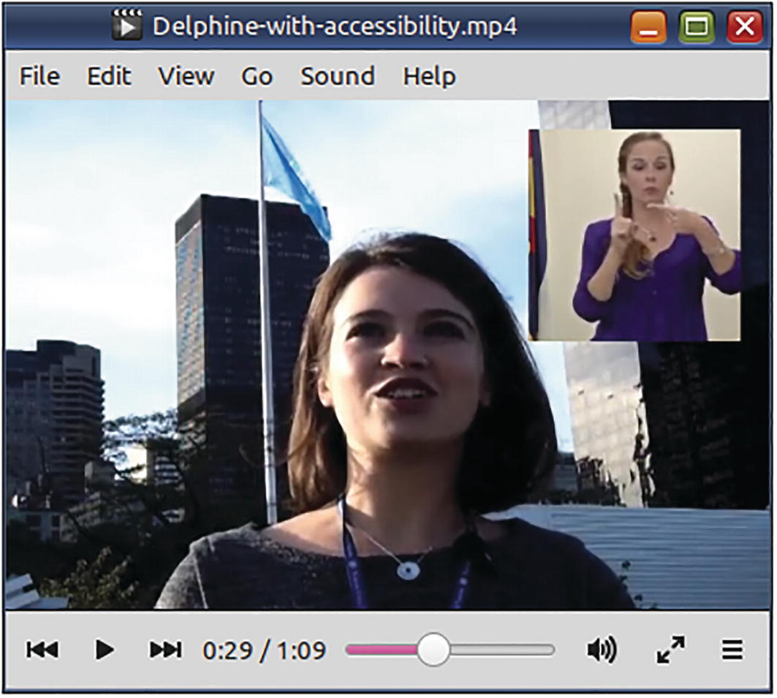
Figure 7-1The overlay filter has been used to place the sign-language video track in the top-right corner of a news report video
The scale filter specifies actual width and height values (150:150) to which the inset video needs to be resized. The overlay filter specifies x- and y-coordinates of the top-left corner of the inset video on the news report video. The x-coordinate uses a filter expression (W-w-20) with filter constants W (width of the background video) and w (width of the inset video) to correctly inset the video 20 pixels away from the right edge of the background video. The y-coordinate is specified with the actual value, that is, 20 pixels from the top edge.
The input for the scale filter is the inset video ([1:v] or the video stream of the second input file). Its output is labeled [inset]. The inputs for the overlay filter are the news report ([0:v] or the video stream of the first file) and the output of the scale filter labeled previously as [inset]. The overlay filter has one output and it is labeled [v]. This overlaid video and the original audio of the news report (0:a:0) are then mapped into the output file.
To construct a filter expression with useful filter constants, you need to refer to the documentation of the filter. If these expressions try to hurt your brain (they will initially), you can specify explicit values. The preceding command can be rewritten as follows:
ffmpeg -y -i Delphine.mp4 -i accessibility.mp4 \
-filter_complex \
"[1:v]
scale
=150:150[inset];
[0:v][inset]
overlay
=370:20[v]" \
-map '[v]' -map 0:a:0 \
Delphine-with-accessibility.mp4

Split Video (Side-by-Side Overlay)
When you place two videos side-by-side, their heights should be the same. If you place them one above the other, their widths should be the same. Else, there will be some empty space in the final video.
The sign-language video in the previous section is a 332×332-pixel video. It is smaller than the news report video. If we want them placed side-by-side, the news report video’s height needs to be reduced to the height of the sign-language video.
This scale filter in this ffmpeg command does that. To maintain the same aspect ratio (width ÷ height) of the scaled video, the new width is specified using the filter expression 332*iw/ih. (The value -2 would have worked as well. As to how it would, Refer The Fine Manual. ☺) This multiplies the aspect ratio with the new height. (iw and ih represent filter constants for the width and height of the input video.)
ffmpeg -y -i Delphine.mp4 -i accessibility.mp4 \
-filter_complex "[0:v]
scale
=332*iw/ih:332[sv];
[sv]
pad
=(iw+332):332:0:0[frame];
[frame][1:v]
overlay
=W-w:0[v]" \
-map '[v]' -map 0:a:0 \
Delphine-et-accessibility.mp4
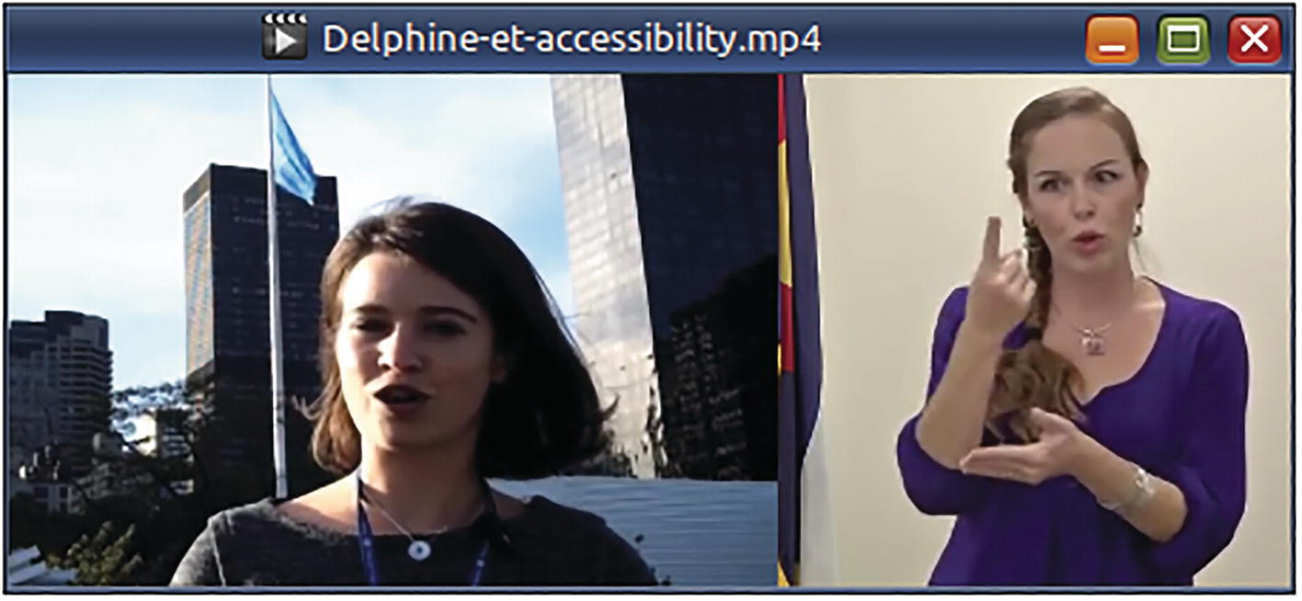
Figure 7-2The scale filter was used to reduce the height of the first video. The pad filter has been used to expand the frame of the scaled video. The overlay filter has been used to place the second video in the empty area of the expanded frame
☞ Because the second video is a sign-language video, I discarded its audio. If it were needed, I would have mixed the two audio streams or assigned them to the left and right speaker channels, as described in Chapter 8.
After the scale filter, the frame size of the scaled video is expanded sideways so that the second video can be placed in the new empty area. The pad filter uses the expression iw+332 to arrive at the new expanded size of the frame. It then places the scaled video at the top-left corner (0:0) of the new frame. That is, the scaled video will be on the left side of the expanded frame.
In the empty area on the right side of the expanded frame ([frame]), we place the second input file ([1:v]) using the overlay filter.
Without using filter expression, the last ffmpeg command can be rewritten with actual values as follows:
ffmpeg -y -i Delphine.mp4 -i accessibility.mp4 \
-filter_complex "[0:v]
scale
=498:332[sv];
[sv]
pad
=830:332:0:0[frame];
[frame][1:v]
overlay
=498:0[v]" \
-map '[v]' -map 0:a:0 \
Delphine-et-accessibility.mp4
☞ When you want to use the same command on another set of files with different dimensions, you will have to recalculate and re-specify the values. Filter expressions can eliminate a lot of this hassle so use them when you can.
If you do not want the news video to be downscaled, then you could put some white space… (in this case) yellow space around the second video. In the next command, filter expressions and actual values have been used to correctly position the second video in the middle of the expanded frame.
ffmpeg -y -i Delphine.mp4 -i accessibility.mp4 \
-filter_complex
"[0:v:0]
pad
=w=(iw+360):h=ih:x=0:y=0:color=yellow[frame];
[frame][1:v:0]
overlay
=x=W-360+(360-w)/2:y=(H-h)/2[v]" \
-map '[v]' -map 0:a:0 \
-t 0:0:12 -pix_fmt yuv420p \
Delphine-et-accessibility-et-margin.mp4
☞ It is much more easier and faster to use the filters hstack and vstack. However, these filters require the input videos to have the same pixel format (data encoding scheme of pixel color) and the same dimensions (height for hstack and width for vstack.)
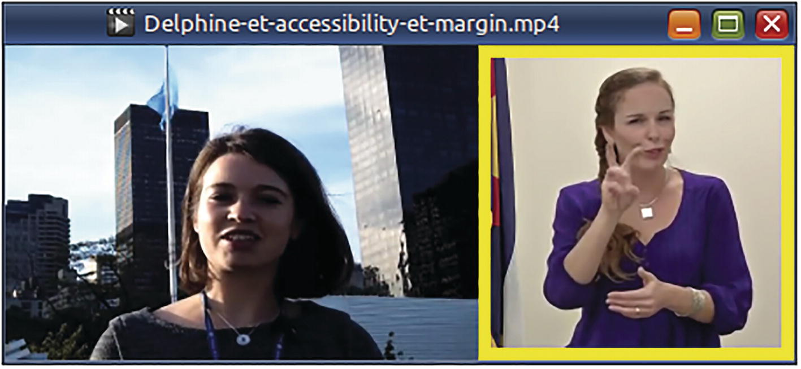
Figure 7-3The pad filter was used to expand the width of original frame by 360 pixels while maintaining the same height. The expanded area was given a yellow background that was 360×360 pixels. Using filter expressions with the overlay filter, the 332×332-pixel second video was placed right in the middle of the yellow background

Append Videos Using a Filter
In Chapter 6, you learned to concatenate several videos using the concat demuxer. The concat filter provides more control if you have only a few input files.
ffmpeg -i engine.mp4 -i coach.mp4 \
-filter_complex \
'[0:v:0][0:a:0][1:v:0][1:a:0]
concat
=n=2:v=1:a=1[vo][ao]' \
-map '[vo]' -map '[ao]' \
-c:v libx264 -r 24 -b:v 266k -s qvga \
-f mp4 train.mp4
☞ This will re-encode the input files, as will any other filter.
Specify the video and audio streams of the input clips or segments in the order that they need to be appended by the filter. [0:v:0][0:a:0] refers to the video and audio streams of the first input clip. [1:v:0][1:a:0] refers to the video and audio streams of the second clip. The filter option n refers to the number of input clips. v refers to the number of output video streams, and a refers to the number of output audio streams. The concatenated video and audio streams are the filter outputs labeled as [vo] and [ao]. These labeled outputs are then mapped to the output file.

Delete a Portion of a Video in the Middle
Sometimes, you need to delete part of a video. For that, you can use the trim, atrim, and concat filters. In this command, the second scene (between seconds 16 and 36) is deleted by eliminating it using trim and atrim filters.
ffmpeg -y -i barbara.mp4 \
-filter_complex \
"[0:v:0]
trim
=start=0:end=16, setpts=PTS-STARTPTS[lv];
[0:v:0]
trim
=start=36:end=44, setpts=PTS-STARTPTS[rv];
[0:a:0]
atrim
=start=0:end=16, asetpts=PTS-STARTPTS[la];
[0:a:0]
atrim
=start=36:end=44, asetpts=PTS-STARTPTS[ra];
[lv][rv]
concat
=n=2:v=1:a=0[v];
[la][ra]
concat
=n=2:v=0:a=1[a]" \
-map '[v]' -map '[a]' barb-cut.mp4
☞ I have used seconds instead of timestamps because the “hh:mm:ss” format requires a lot of nonintuitive escaping.
The concat filter is prone to timestamp errors. The setpts and asetpts filters may be able to fix them. A filter setting with asetpts=N/SAMPLE_RATE/TB will generate new timestamps by counting actual samples in the processed audio segments, but it can be used only with constant frame rate videos. A better value is to use PTS-STARTPTS (similar to the video filter), as it will also remove empty regions in the audio.

Rotate a Video
Some videos that people take from a mobile phone are rotated by 90 or 180 degrees from normal. You can manually fix them by specifying a transpose filter.
# Rotate to right
ffmpeg -i slt.mp4 \
-filter:v "
transpose
=1" \
slt-rotated-1.mp4
# Rotate to left
ffmpeg -i slt.mp4 \
-filter:v "
transpose
=2" \
slt-rotated-2.mp4
# Rotate to left and flip vertically
ffmpeg -i slt.mp4 \
-filter:v "
transpose
=0" \
slt-rotated-0.mp4
# Rotate to right and flip vertically
ffmpeg -i slt.mp4 \
-filter:v "
transpose
=3" \
slt-rotated-3.mp4
For the transpose filter option dir, a value of 1 or 2 turns the video 90 degrees right or left. Values 0 and 3 turn the video left or right and also vertically flip them. Mobile phone users should stick with the first two values.
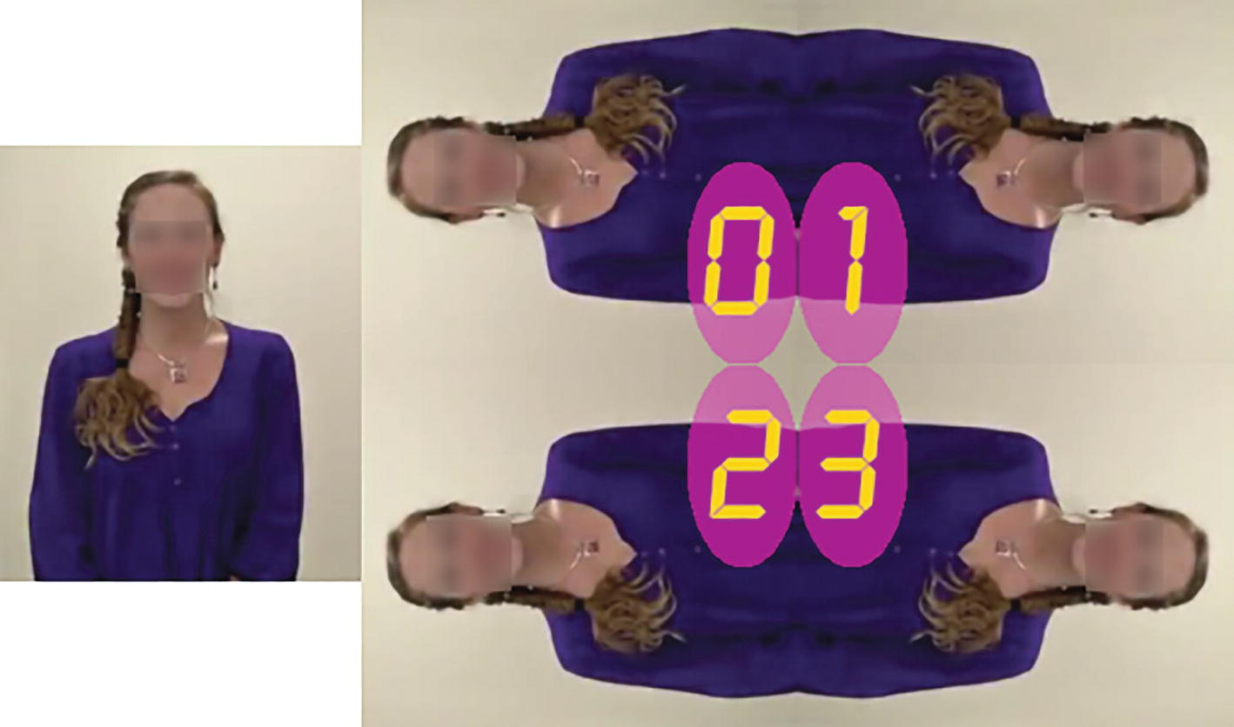
Figure 7-4These still images show dir values that can be used with the transpose filter
The transpose filter option passthrough can have values none, portrait, and landscape. The value none is default. One of the last two values will be particularly useful in automated scripts to prevent unnecessary rotation, that is, when the video is already in the orientation specified by the passthrough filter option. It will also prevent ffmpeg from autorotating a video and then applying your transpose setting (causing further rotation).
You can rotate videos by more discrete levels than multiples of 90 degrees. The rotate filter accepts values in radians rather than degrees. The following ffmpeg command rotates a video by 16 degrees.
ffmpeg -y -i malampuzha-lake.mp4 \
-filter_complex \
"
rotate
=angle=16*PI/180:fillcolor=brown" \
malampuzha-lake-tilt-16-chopped.mp4
# Rotates video but corners get cut off
☞ If the video becomes distorted, correct it using setdar filter.
☞ To convert degrees to radians, it has to be multiplied with π/180.
To prevent the corners from getting chopped off, the frame dimensions need to be increased. You can use the rotw and roth functions for determining these new dimensions. The two functions use these formulas internally.
rotw(θ) = Height×Sine(θ) + Width×Cosine(θ)
roth(θ) = Width×Sine(θ) + Height×Cosine(θ)
# Rotate video and enlarge the frame to prevent
# corners from getting cut off
ffmpeg -y -i malampuzha-lake.mp4 \
-filter_complex \
"
rotate
=angle=16*PI/180:
ow=trunc(rotw(16*PI/180)/2)*2:
oh=trunc(roth(16*PI/180)/2)*2:
fillcolor=brown" \
malampuzha-lake-tilt-16.mp4
As FFmpeg requires that the new width and height be even numbers, that is, divisible by 2, the calculated dimensions are first divided by 2, truncated off, and then multiplied by 2.
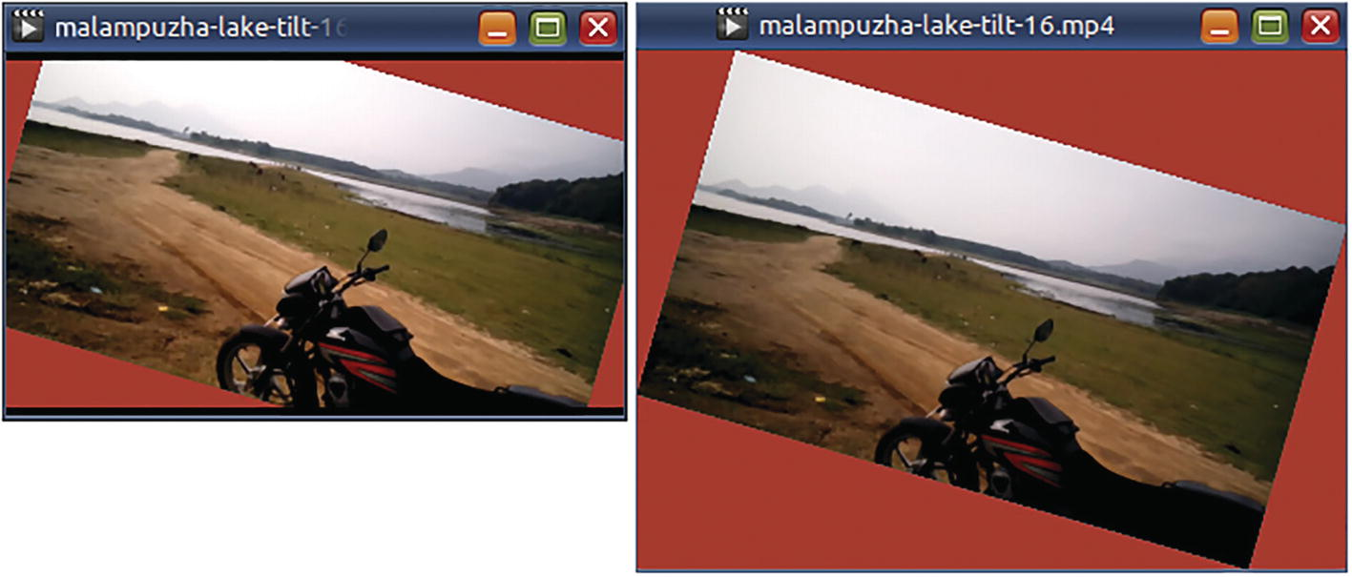
Figure 7-5The first video has the original dimensions, but the rotated content has chopped-off corners. The second video has bigger dimensions to accommodate the extruding corners

Flip a Video
Some videos are flipped for some reason. Use vflip or hflip to set them right.
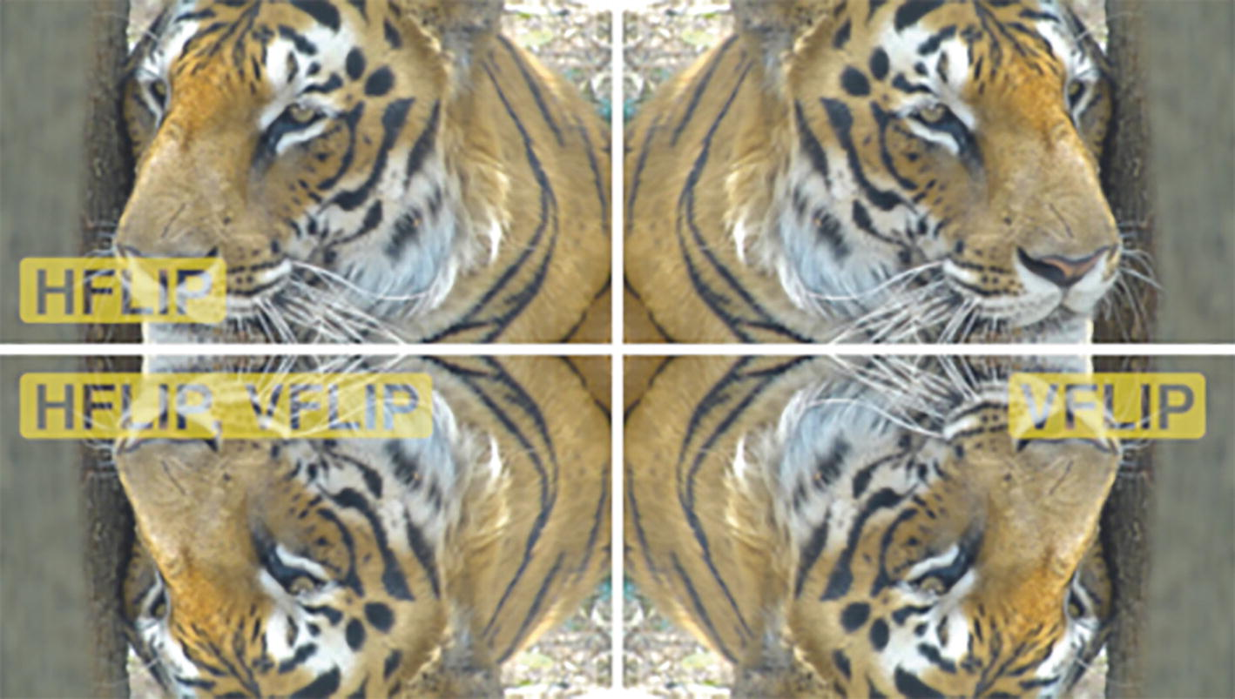
Figure 7-6These still images show which filter to us for what effect
ffmpeg -i exhibit.mp4 \
-filter:v "
vflip
" \
exhibit-upside-down.mp4
ffmpeg -i exhibit.mp4 \
-filter:v "
hflip
" \
exhibit-half-crazy.mp4
ffmpeg -i exhibit.mp4 \
-filter:v "
hflip,vflip
" \
exhibit-totally-flipped.mp4

Brighten a Video (Adjust Contrast)
It is inevitable that some of your videos are dark, even when they were captured in broad daylight. You can use the eq filter to adjust the brightness. However, adjusting the brightness requires a subsequent adjustment of the contrast. The ranges for the options of this filter are listed in Table 7-2.
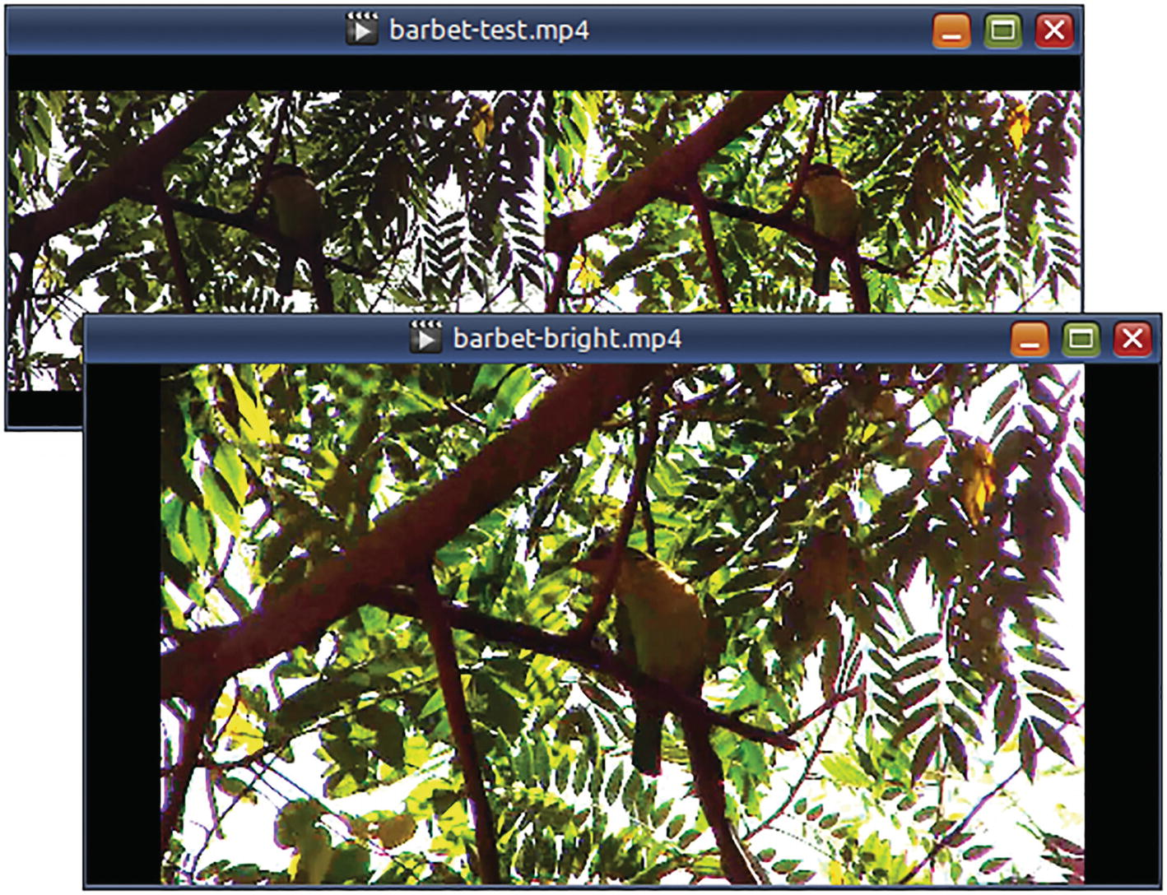
Figure 7-7After cumulative applications of brightness, saturation, and contrast filters, more detail of the green barbet is visible. Forget the background
First, I decided to do a side-by-side comparison.
ffmpeg -y -i barbet.mp4 \
-filter_complex \
"[0:v]
pad
=(iw*2):ih:0:0[frame];
[0:v]
eq
=brightness=0.2[bright];
[bright]
eq
=saturation=3[color];
[color]
eq
=contrast=2[dark];
[frame][dark]
overlay
=W/2:0[out]" \
-map '[out]' -map 0:a \
barbet-test.mp4
Table 7-2Options for filter eq
Filter option | Lowest | Highest | Default
Brightness | -1 | 1.0 | 0
Contrast | -1000 | 1000 | 1
Saturation | 0 | 3 | 1
Gamma | 0.1 | 10 | 1
After some trial-and-error attempts, I applied the filters to the original video.
ffmpeg -y -i barbet.mp4 \
-filter_complex \
"[0:v]
eq
=brightness=0.2[bright];
[bright]
eq
=saturation=3[color];
[color]
eq
=contrast=2[dark]" \
-map '[dark]' -map 0:a \
barbet-bright.mp4

Generate a Test Video
In the good old days, when there was just one TV channel in India, the transmission began in the evening with a 30-minute video test – something like this!
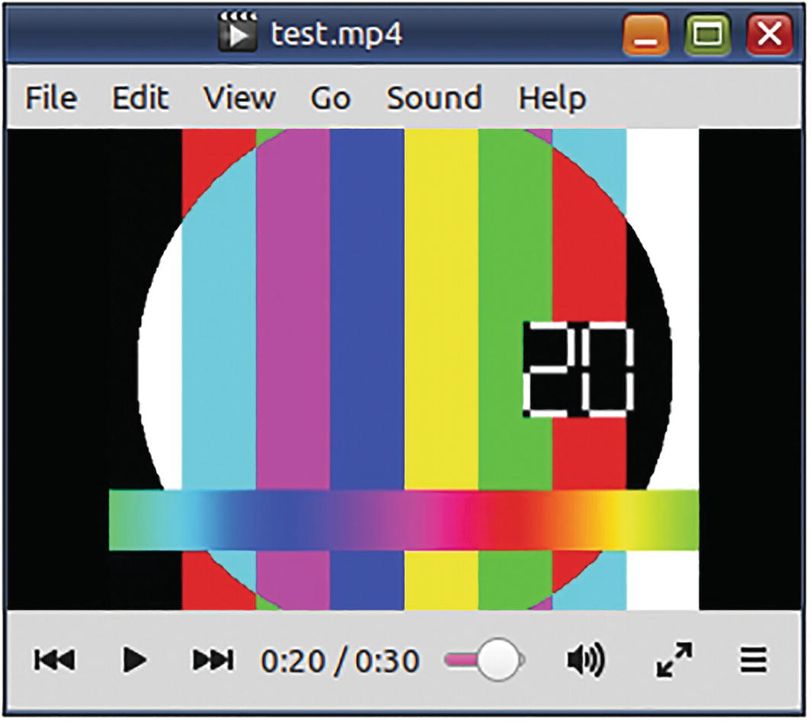
Figure 7-8The testsrc filter is a source filter that generates a test video stream
The test video has a color pattern, a scrolling gradient, and a changing timestamp. The audio is a low white noise. I do not know who needs this video, but if it floats your boat, then here is the command to create it.
ffmpeg -f lavfi \
-i "
testsrc
=size=320x260[out0];
anoisesrc=amplitude=0.06:color=white
[out1]" \
-t 0:0:30 -pix_fmt yuv420p \
test.mp4
☞ This command uses a set of filters as a pseudo file source (-f lavfi). It requires that the filter outputs be labeled out0, out1, out2,….
☞ Filters whose name end in “src” are source filters. They do not require an input stream.

Remove Logo
In 2019, a newspaper in New York published an opinion alleging bias against women in government experiments. NASA’s Apollo Space Program was then celebrating its 50th anniversary.
ffmpeg -i apollo-program.mp4 \
-filter:v "
delogo
=x=520:y=10:w=100:h=50" \
apollo-program-you-are-dead.mp4
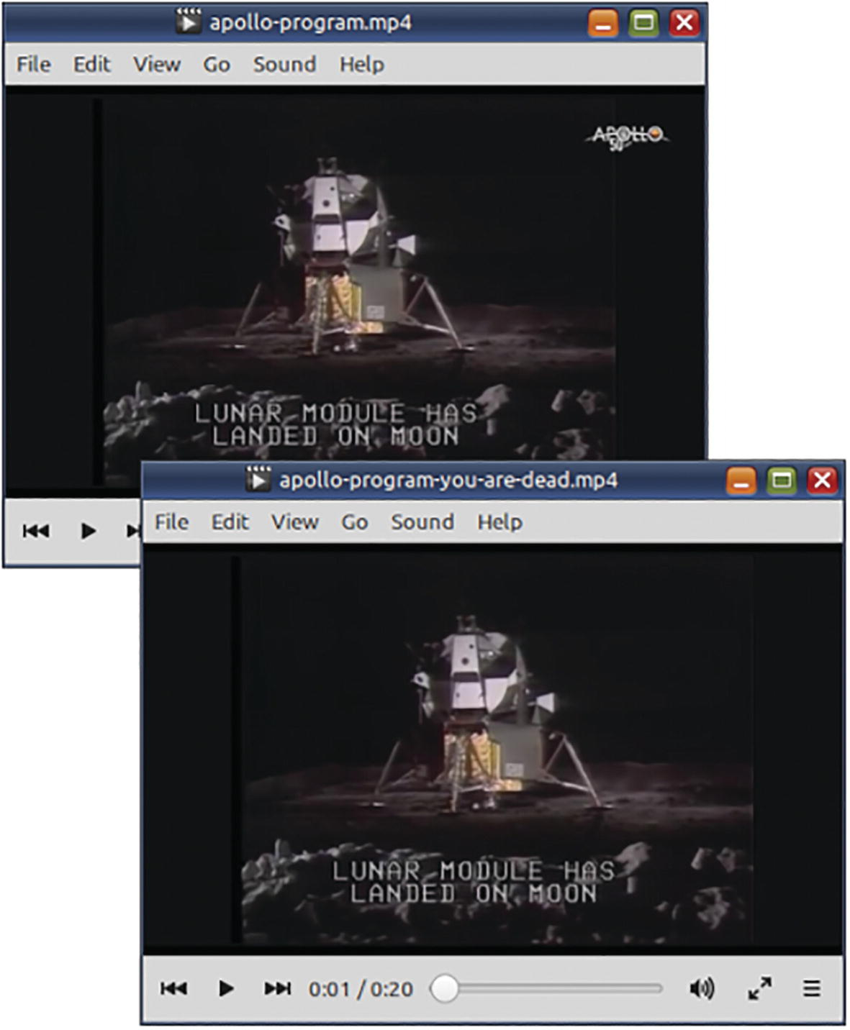
Figure 7-9With the delogo filter, it is very easy to remove an unwanted logo from a video
☞ After applying the filter, the logo has disappeared from the top-right corner.
☞ This video is only a simulation.

Fade into Another Video (And in Audio Too)
In order to prove aliens do not exist and have fun while doing that, I took videos from two authoritative US government agencies – NASA and IRS. The videos are in public domain, as the agencies are taxpayer-funded. The NASA video clearly states that there are no aliens, but I am not interested in their explanation. The IRS video is a tax advisory for noncitizens, also known as aliens. That is the fun part. In the output video, the first video plays fine until six seconds after which it fades out in three seconds. As the first video fades away, the second video starts fading in for three seconds. After that, it plays for six seconds.
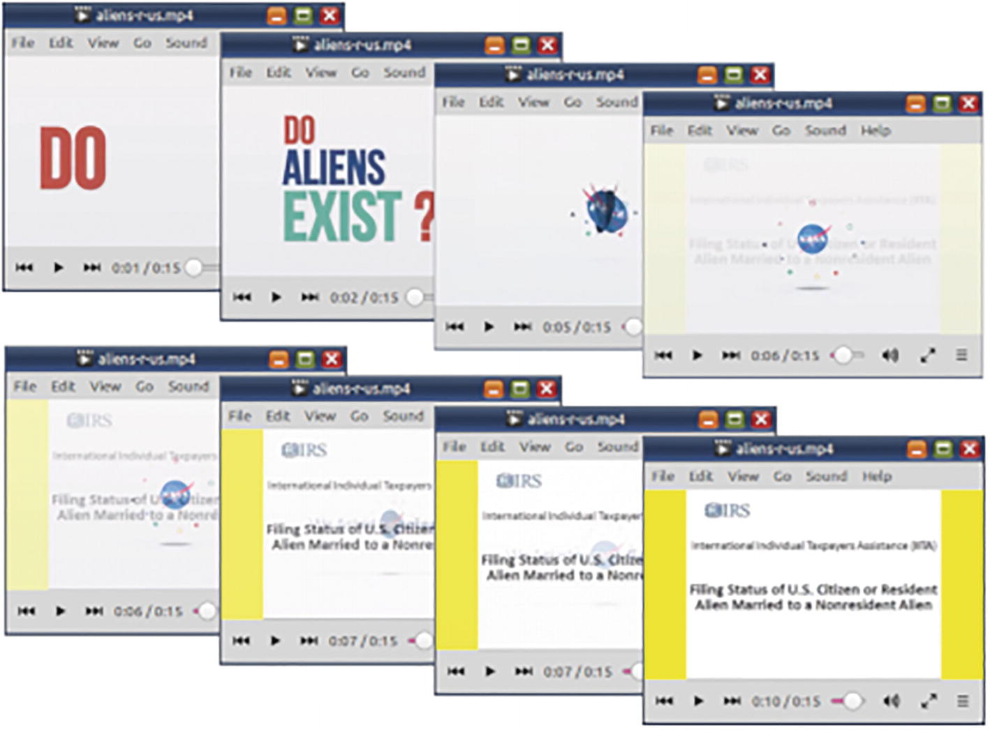
Figure 7-10These screenshots show the crossfade sequence involving the two input videos
Mixing these two videos can be done with one command, but for clarity, I have split it into four commands. (You should combine the filters to avoid multiple re-encoding.) The crossfade effect is performed by the fade filter for video and the afade filter for audio. The trim and atrim filters are used to divide the video and audio tracks into two parts – one where the stream plays normally and another where the fade filters take effect. I used overlay and amix filters to mix the second parts. After that, the concat filter was used to put three segments together – normal playback from the first file, crossfade effect from both files, and then normal playback from the second file.
# Make the second video same size as the first
ffmpeg -y -i irs-tax-advice-for-alien-mates.mp4 \
-filter:v
"pad=w=640:h=ih:x=(ow-iw)/2:y=0:color=yellow, fps=24" \
-t 0:0:20 -pix_fmt yuv420p \
irs-tax-advice-for-alien-mates2.mp4
# Create the fade-in-fade-out video
ffmpeg -y -i Do-Aliens-Exist-We-Asked-a-NASA-Scientist.mp4 \
-i irs-tax-advice-for-alien-mates2.mp4 \
-filter_complex \
"[0:v:0]trim=start=0:end=6, setpts=PTS-STARTPTS, fps=24[v1];
[1:v:0]trim=start=3:end=9, setpts=PTS-STARTPTS, fps=24[v2];
[0:v:0]trim
=start=6:end=9, setpts=PTS-STARTPTS, fps=24[v3];
[1:v:0]trim=start=0:end=3, setpts=PTS-STARTPTS, fps=24[v4];
[v3]
fade
=t=out:d=3:alpha=1, setpts=PTS-STARTPTS, fps=24[nasafade];
[v4]
fade
=t=in:d=3:alpha=1, setpts=PTS-STARTPTS, fps=24[irsfade];
[nasafade][irsfade]
overlay
, setpts=PTS-STARTPTS, fps=24[fading];
[v1][fading][v2]concat=n=3:v=1:a=0[v]" \
-map '[v]' -pix_fmt yuv420p \
aliens-r-us-v.mp4
# Create the fade-in-fade-out audio
ffmpeg -y -i Do-Aliens-Exist-We-Asked-a-NASA-Scientist.mp4 \
-i irs-tax-advice
-for-alien-mates2.mp4 \
-vn \
-filter_complex \
"[0:a:0]atrim=start=0:end=9, asetpts=PTS-STARTPTS[a1];
[1:a:0]atrim=start=0:end=9, asetpts=PTS-STARTPTS[a2];
[a1][a2]acrossfade=duration=3" \
aliens-r-us-a.m4a
# Mix the video and audio
ffmpeg -i aliens-r-us
-v.mp4 -i aliens-r-us-a.m4a \
-codec copy \
aliens-r-us.mp4

Crop a Video
For some screenshots in the beginning of this chapter, I needed a public-domain video of a sign-language translator. I found one but it was too big. I grabbed a still image from the video using a media player and edited it in GIMP.
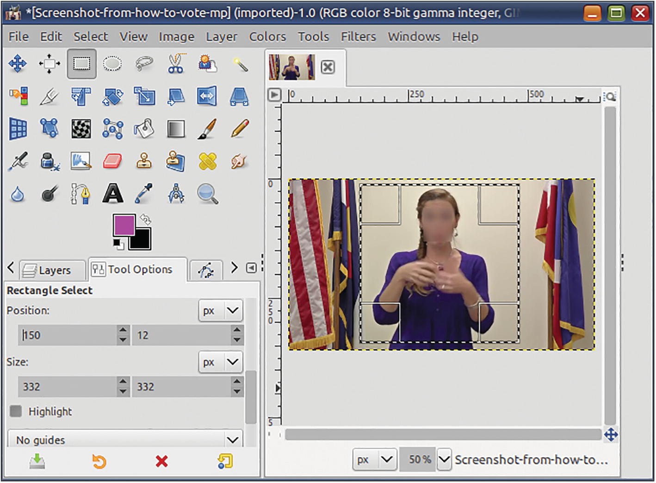
Figure 7-11First, take a screengrab from the video. Then, use an image-editing program to identify the location (150,12) and dimensions (332,332) of the region you want to cut out
I then selected the region that I wanted cut into. I noted down the coordinates and dimensions of the region from GIMP’s Tool Options panel. I used the details from GIMP in the options for a crop filter that I used on the video.
ffmpeg -i how-to-vote.mp4 \
-filter:v "
crop
=332:332:150:12" \
accessibility.mp4
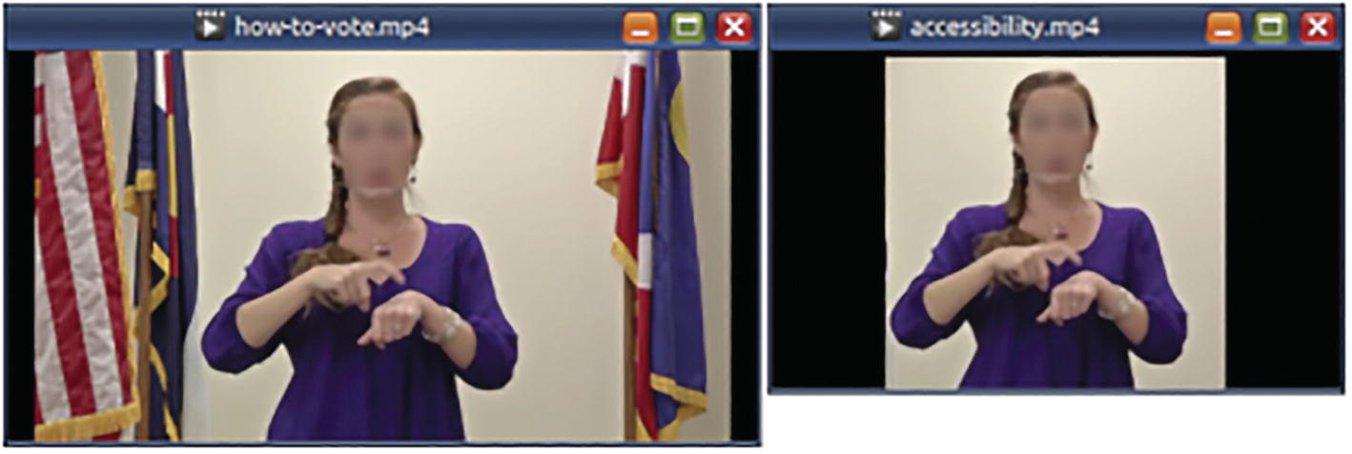
Figure 7-12The crop filter cut into a portion of a video

Blur or Sharpen a Video
When this video was shot, there was a lot of camera refocusing and the action was blurry. The smartblur filter almost fixes this when it is set to sharpen the video.
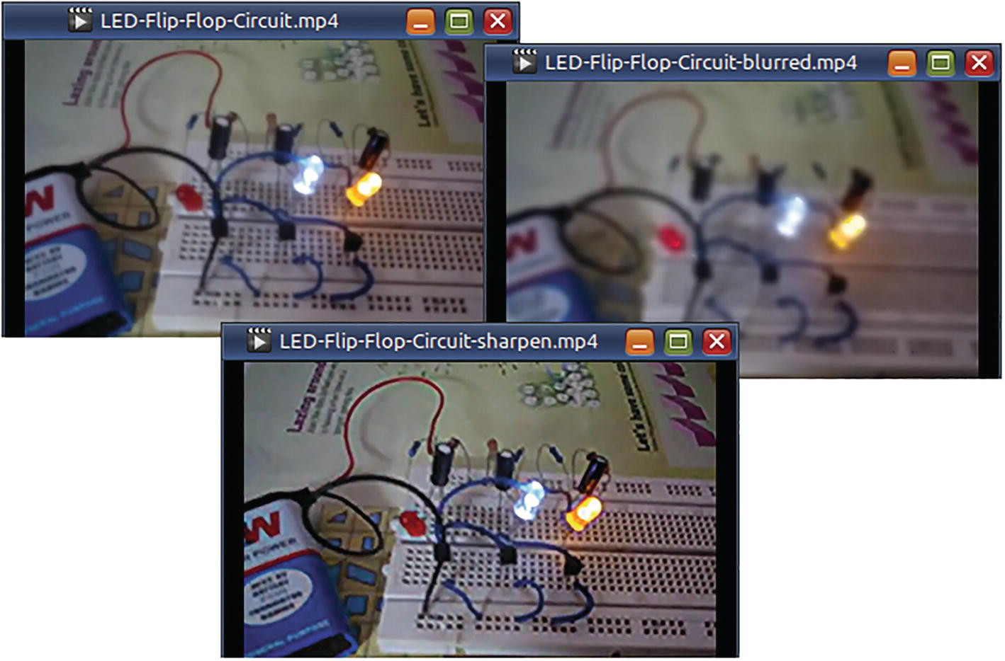
Figure 7-13With the smartblur filter, you can blur or sharpen a video
ffmpeg -i LED-Flip-Flop-Circuit.mp4 \
-filter:v
"
smartblur
=luma_radius=5:luma_strength=1.0:
luma_threshold=30" \
LED-Flip-Flop-Circuit-blurred.mp4
ffmpeg -i LED-Flip-Flop-Circuit.mp4 \
-filter:v
"
smartblur
=luma_radius=5.0:luma_strength=-1.0:
luma_threshold=30" \
LED-Flip-Flop-Circuit-sharpen.mp4
The smartblur filter can blur or sharpen videos without affecting the outlines. It works on the brightness of the pixels. The luma_radius (0.1 to 5) represents the variance of the Gaussian blur filter. luma_strength (-1 to 1) varies between sharpness to blurring. luma_threshold (-30 to 30) varies the focus of the filter from the edges to interior flatter areas.

Blur a Portion of a Video
Sometimes, you need to protect the identity of some people (e.g., bystanders) who are not really the focus of a video. Use the boxblur filter. This command tries to blur two regions in a video where human faces appear.
ffmpeg -y -i stilt.mp4 \
-filter_complex \
"[0:v]
crop
=260:80:400:550[c1];
[0:v]
crop
=100:60:1:550[c2];
[c1]
boxblur
=6:6[b1];
[c2]
boxblur
=6:6[b2];
[0:v][b1]
overlay
=400:550[v1];
[v1][b2]
overlay
=1:550[v]" \
-map '[v]' -map 0:a -c:a copy \
stilt-masked.mp4
Unlike smartblur, it does not respect object outlines. And, contrary to its name, boxblur does not blur inside the box or a part of the video. It affects the whole frame of the input video stream.
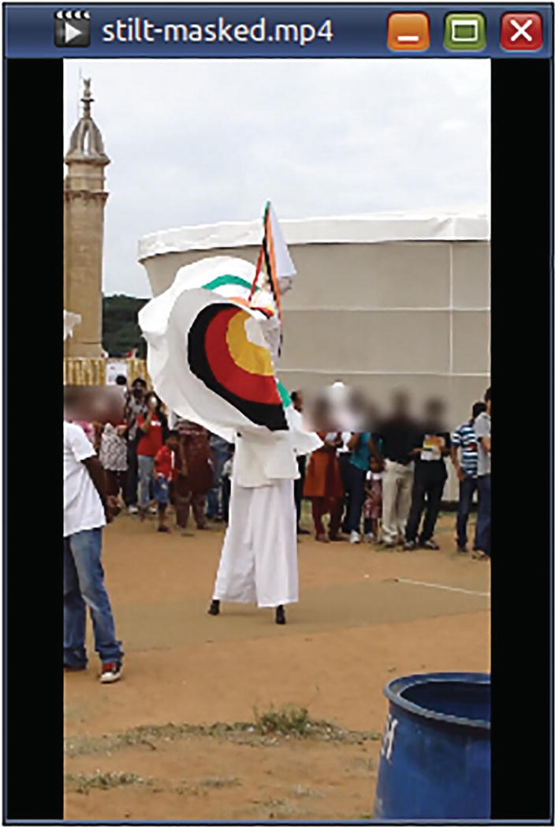
Figure 7-14With the boxblur filter, you can blur content without discrimination of any outlines
☞ To avoid any doubt or confusion, I would like to state that I have masked faces of private individuals (even in public-domain content) in several screenshots using an image-editing program. In this screenshot, however, the effect was achieved using the ffmpeg filter boxblur.

Draw Text
To draw text on video, you need to use the drawtext filter and also specify the location of the font file. When you are drawing several pieces of text, it is better to daisy-chain your texts (using commas, not semicolons).
ffmpeg -y -i color-test.mp4 \
-filter_complex \
"[0:v:0]
drawtext
=x=(w-tw)/2:y=10:fontcolor=white: \
shadowx=1:shadowy=1:text='Detonation Sequence': \
fontsize=25: fontfile=AllertaStencil.ttf, \
drawtext
=x=(w-tw)/2:y=60:fontcolor=white: \
shadowx=1:shadowy=1: \
text='This TV will self-destruct in t seconds.': \
fontsize=15:fontfile=Exo-Black.ttf[v]" \
-map '[v]' -map 0:a:0 -pix_fmt yuv420p \
idiot-box-1.mp4
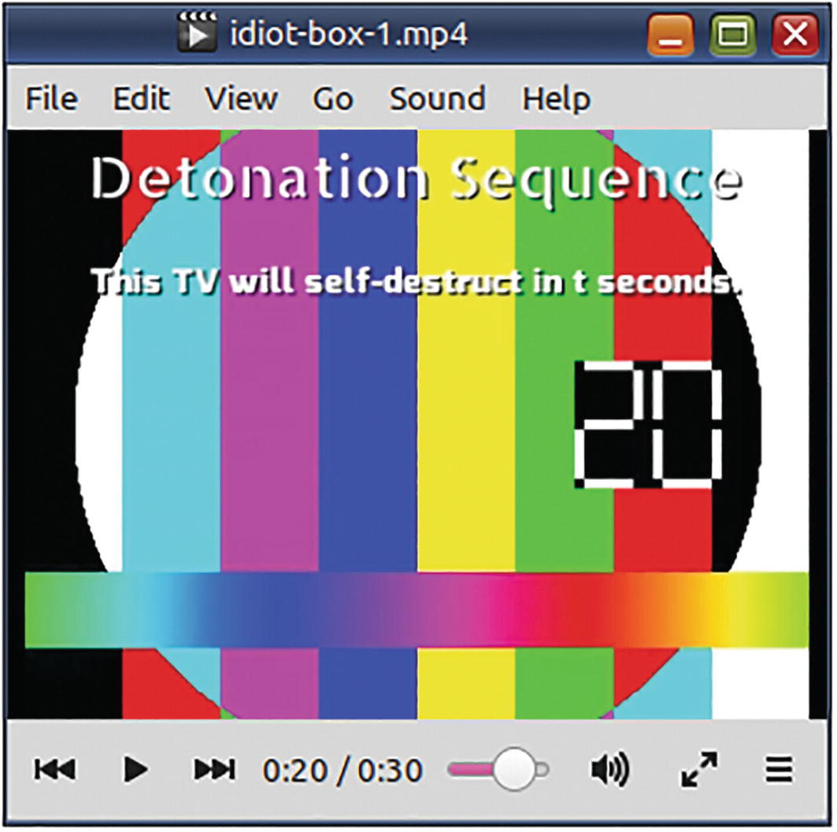
Figure 7-15With the drawtext filter, you can draw text formatted with fonts, styles, shadows, transparencies, etc. on video

Draw a Box
You can use the drawbox filter to render all kinds of boxes, filled or bound, with all sorts of colors and transparencies.
ffmpeg -y -i color-test.mp4 \
-filter_complex \
"[0:v:0]
drawbox
=x=20:y=3:w=280:h=36:color=tomato@0.4:t=fill, \
drawbox
=x=11:y=49:w=294:h=40:color=lime:t=1, \
drawtext=x=(w-tw)/2:y=10:fontcolor=white: \
shadowx=1:shadowy=1:text='Detonation Sequence': \
fontsize=25: fontfile=AllertaStencil.ttf, \
drawtext=x=(w-tw)/2:y=60:fontcolor=white: \
shadowx=1:shadowy=1: \
text='This TV will self-destruct in t seconds.': \
fontsize=15:fontfile=Exo-Black.ttf[v]" \
-map '[v]' -map 0:a:0 -pix_fmt yuv420p \
idiot-box-2.mp4
The part of the color value after the @ symbol refers to the transparency level. It ranges from 0 (fully transparent) to 1 (opaque). If you specify the value fill for the filter option t or thickness, then the box will be filled with that color. Otherwise, it applies to the border.
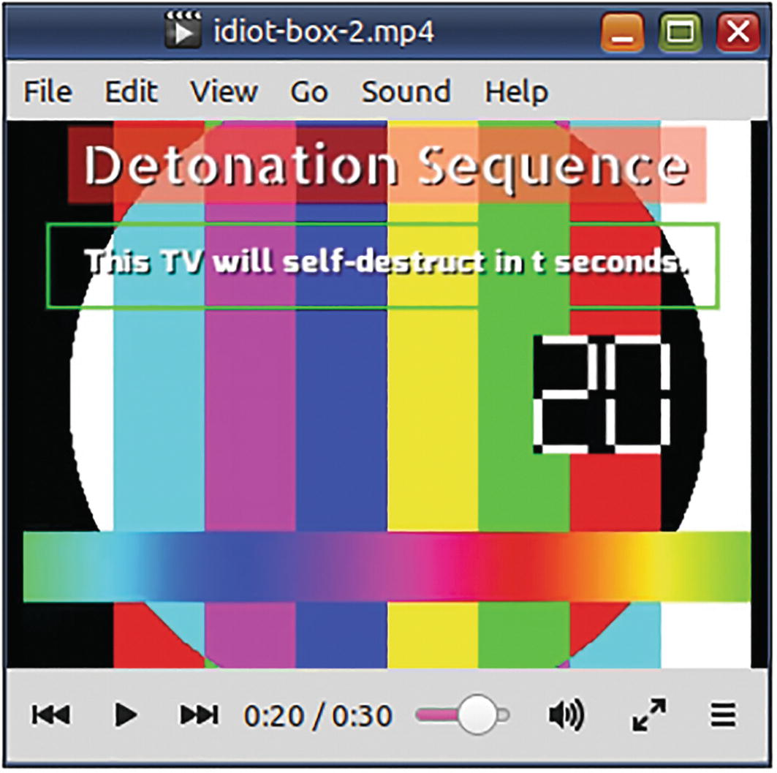
Figure 7-16With the drawbox filter, two rectangles around the text. (See original video in previous section.) The first rectangle is filled with red. The second rectangle is bordered green

Speed Up a Video
When you increase the playback speed of a video, its duration decreases. When you slow down a video, its duration increases. There is no one filter that changes the speed of both the audio and the video. You need to use two different filters – one for video and one for audio. The two filters do not work in the same way. The two need to be calibrated correctly so that the same effect is achieved on both the audio and the video.
For the video, you need to set the setpts video filter to a fraction of the PTS filter constant. If you want to double the speed of the video, divide PTS by 2. If you want the video to be four times fast, then divide PTS by 4. For the audio, you need to use the atempo filter. The range of this filter is from half the speed to 100 times. The following command fast-forwards a video by four times (4x).
ffmpeg -y -i barb.mp4 \
-filter_complex \
"[0:v]
setpts
=PTS/4[v];
[0:a]
atempo
=4[a]" \
-map '[v]' -map '[a]' \
barb-speed.mp4
☞ In older versions of FFmpeg, the maximum limit of the atempo filter was just 2. To go beyond that limit, multiple filters had to be daisy-chained: atempo=2, atempo=2

Slow Down a Video
In the Tom & Jerry film Baby Puss, one of the alley cats tries to dance with a seemingly innocuous doll. In the middle of it, I thought, the doll had become possessed and slammed the cat down on the floor! I slowed the video down with Ffmpeg, and my suspicions were confirmed.
To slow down a video, you need to use the same filters as in the previous section, but the multipliers will have to be different.
This command slows down the video and the audio to one-fourth.
ffmpeg -y -i tom.mp4 \
-filter_complex \
"[0:v]
setpts
=PTS*4[v];
[0:a]
atempo
=0.5,
atempo
=0.5[a]" \
-map '[v]' -map '[a]' \
possessed-doll.mp4
☞ Note the different multiples used for video and audio to achieve the same effect. The audio filter has been used twice because of the limitation in its range.
☞ Read previous section for more information on these two filters.
Laurie Lennon, from the Lennon Sisters family, has published a tribute video for the Merrie Melodies number “Oh, Wolfie!”. When I saw it for the first time some years ago, I felt the tempo was too high. I slowed the audio down in Audacity. (I have all songs featuring Lou as MP3 files, complete with Wolfie’s and Droopy’s crazy antics.) For my 2020 book, I tried to do the same using FFmpeg and apply the change to the video as well. My calculation became easier when I used seconds. The original video was 114 seconds, and my slowed-down audio was 128 seconds.
# 128/114 and 114/128
ffmpeg -y -i Laurie-Lennon-Original.mp4 \
-filter_complex \
"[0:v]
setpts
=PTS*(128/114)[v];
[0:a]
atempo
=(114/128)[a]" \
-map '[v]' -map '[a]' \
Laurie-Lennon-Slow.mp4
The links to these videos and those used in other examples in this book are available online:
www.vsubhash.in/ffmpeg-book.html

Summary
The examples in this chapter would have amply demonstrated that a lot of useful and powerful multimedia-processing abilities are hidden in the filters functionality. You need to read the relevant documentation to make full use of a filter. Filter expressions using built-in real-time variables (filter constants) and functions provide a lot of versatility and extensibility to command-line users that would have otherwise been limited to programmers who use the libav libraries.
In this book, the teaching portion about FFmpeg functionality ends here. The subsequent chapters are topic-specific for those who want quick answers to a particular type of problem and do not want to read through dense explanatory text before finding the answer. You will find some information repeated or not mentioned at all.
© The Author(s), under exclusive license to APress Media, LLC, part of Springer Nature 2023
V. SubhashQuick Start Guide to FFmpeg
https://doi.org/10.1007/978-1-4842-8701-9_8

8. All About Audio
V. Subhash1
(1)
Chennai, Tamil Nadu, India

In this chapter, you will learn to perform several tasks related to audio content. While it is convenient to have a separate chapter just for audio, you will find some information repeated from other chapters. If there is no explanation, then it must be self-explanatory.
Most audio-related tasks can be performed using audio filters. If any of the filters used in this chapter seem too complicated, find out what the official FFmpeg documentation has to say on them. If you are unfamiliar with using filters, read Chapter 7.

Convert from One Audio Format to Another
ffmpeg -i alarm.
ogg
\
-c:a libmp3lame \
-ac 2 \
-b:a 128K \
alarm.
mp3
# Ogg to MP3

Extract Audio from a Video
ffmpeg -i music-video.
mp4
\
-c:a libmp3lame \
-ac 2 \
-b:a 128K \
music-video.
mp3
# Audio saved as MP3

Convert a MIDI File to MP3 or Ogg
You may have noted that there are no codecs for MIDI. That is because MIDI files are quite different from ordinary sound files. Ordinary sound files contain the wave form encoded in a predefined format. In contrast, MIDI files are merely a collection of references to a common sound bank.
Timidity is the Linux way of playing MIDI files. You can use Timidity to playback MIDI files in WAVE format and write it to its standard output. Simultaneously, FFmpeg can be made to consume the wave output as its input file (from its standard input over a pipe) and convert it as a regular sound file.
timidity yamaha.midi -Ow -o - | ffmpeg -i - -b:a 128k yamaha.ogg
The -Ow makes Timidity to output the playback in WAVE format. Its -o option is used to specify the output file. Instead of an output file, we use - to make it write to the standard output. The Timidity output is then piped over to an FFmpeg command, where it is captured from the standard input with yet another - (hyphen).

Change Volume
FFmpeg can increase the loudness of an audio file using its volume filter. The filter accepts a multiple either as a number (scalar) or in decibels (logarithmic).
ffmpeg -i sarah.mp3 -af '
volume
=3' sarah-more.mp3
I had an audio file that continued to have low volume, even after trebling the levels. I opened it in Audacity and found the reason.
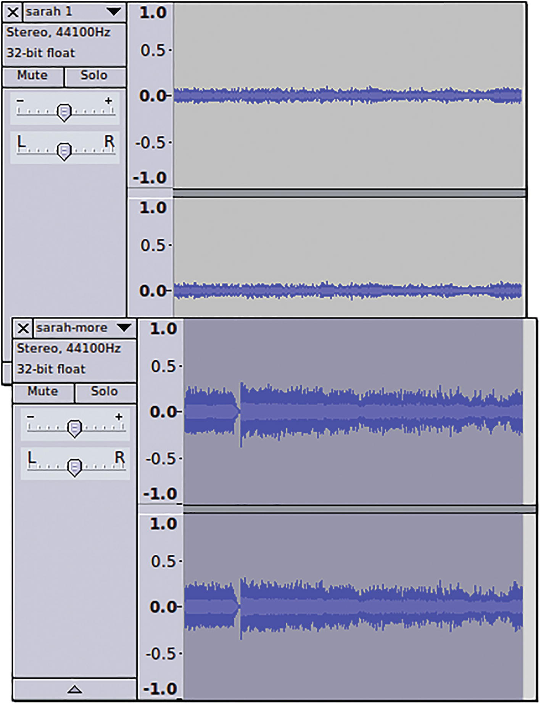
Figure 8-1Audacity confirms that irrationally increasing the volume is not making much of a difference
Increasing sound like this is based on guesswork. It might work. It may also damage your hearing and/or your speaker system. The correct approach is to normalize the sound after observing the decibel levels in the current waveform.
ffmpeg -i sarah.mp3 -af "
volumedetect
" -f null -
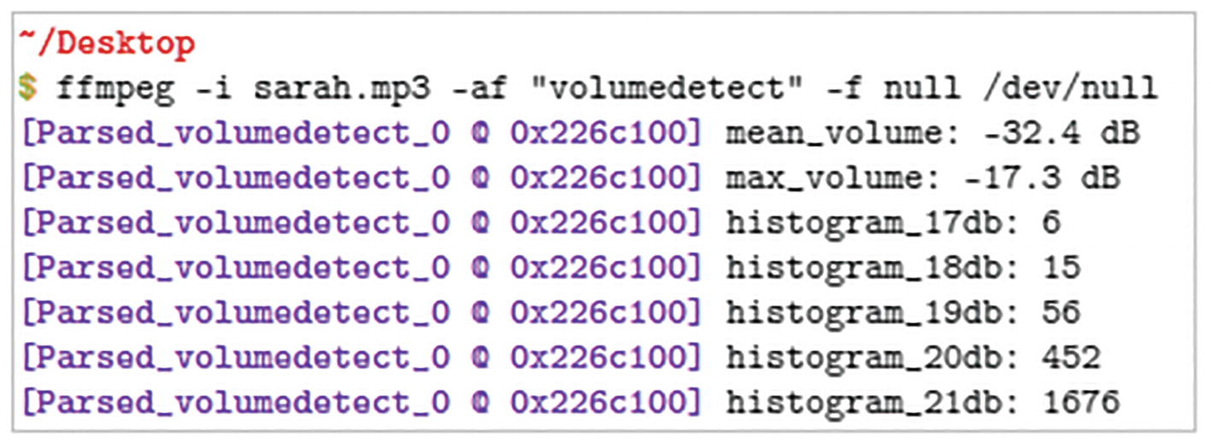
Figure 8-2Run the volumedetect filter before increasing the volume. It helps you in determining the highest number of decibels to which the volume can be increased without cutting into the waveform
☞ The volumedetect filter outputs text data to the standard output. It does not create an audio stream.
The volumedetect filter shows that we can safely increase the volume to 16db. If we raised the volume to 17dB or higher, normalization would cut into the waveform, and the peaks would get attenuated or chopped off. At 17dB, six sound samples (the loudest) in the waveform would be lost.
ffmpeg -i sarah.mp3 \
-af '
volume=16dB
' -f ogg \
sarah-normalized.ogg
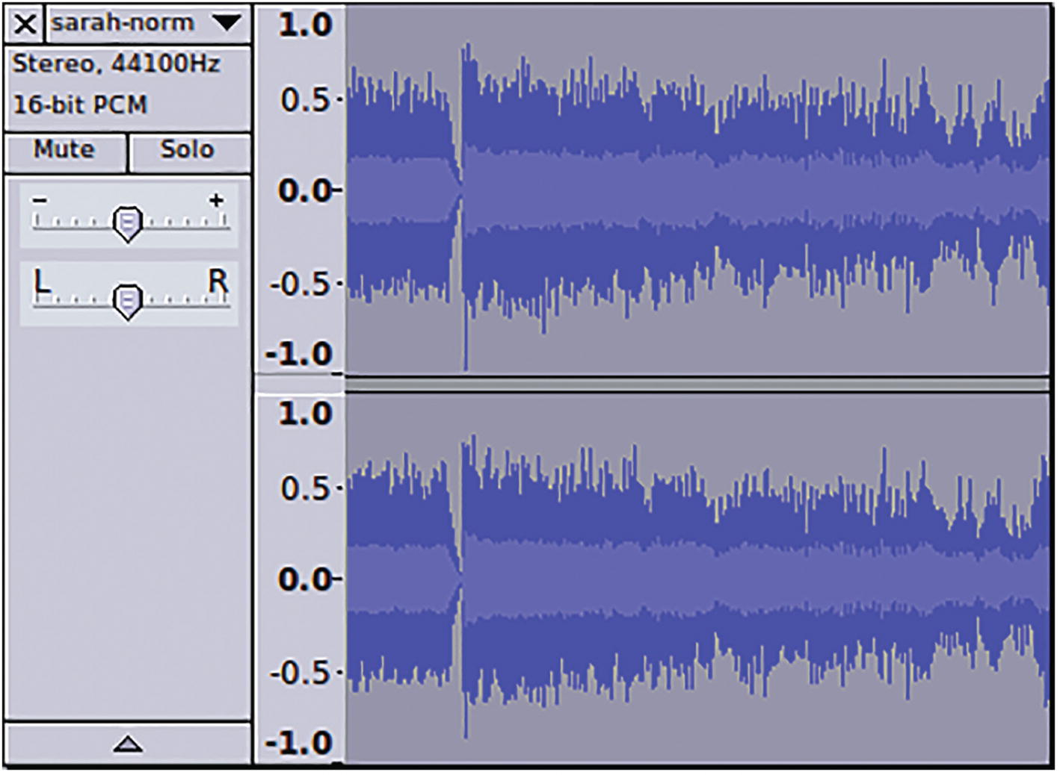
Figure 8-3Audacity confirms that the volume has been increased without cutting into the waveform
This is fine. Now, how do you decrease the volume? Well, choose a fraction between 0 and 1 for the volume filter. For example, to decrease the volume by two-thirds, you should set the multiple at 0.33. (You know 1/3 = 0.33?)
ffmpeg -i sarah-normalized.ogg -af ’
volume
=0.33’ sarah-less.mp3

Change Volume in a Video File
Say, to irrationally increase the volume by three times,
ffmpeg -i sarah.mp4 \
-c:v copy \
-af ’
volume
=3’ \
-c:a libmp3lame -b:a 128k \
sarah-more.mp4
To safely and intelligently increase the volume in a video file,
ffmpeg -i sarah.mp4 \
-af ’
volumedetect
’ \
-vn \
-f null \
/dev/null
# Displays that the loudest samples are at 17dB
# Increase the volume to 16dB (to safely normalize the audio)
ffmpeg -i sarah.mp4 \
-c:v copy \
-af ’
volume
=16dB’ \
-c:a libmp3lame -b:a 128k \
sarah-normalized.mp4
To decrease volume by two-thirds in a video file, you need to use fractions:
# Reduces volume by two-thirds (or to one-thirds)
ffmpeg -i sarah-normalized.mp4 \
-c:v copy \
-af ’
volume
=0.33’ \
-c:a libmp3lame -b:a 128k \
sarah-less.mp4

Dynamic Range Compression/Normalization
Sometimes, normalization does not make any difference. The volume seems to be unchanged. Examining the audio in Audacity can show you the problem. There are volume spikes in some locations while much of the file is at low volume. (These spikes usually occur when the mic is shaken or bumped while it is recording.) Normalization cannot proceed as long as the spikes remain. The solution is to identify the low-volume regions and expand the waveform. This more selective normalization is known as Dynamic Range Normalization. Alternatively, you could bring down the high-volume regions to the level of the rest of the audio. This selective compression of the waveform is known as Dynamic Range Compression (DRC).
Both techniques make irreversible changes to the waveform, so do not use them indiscriminately. DRC is the bane of popular music today and makes it very boring.
In Carl Orff’s composition of O Fortuna or Ryuichi Sakamoto’s score for the end credits of the movie Femme Fatale, the music starts on a low note, building slowly in a steady crescendo and abruptly drops off a high cliff. Applying DRC on such an audio would ruin the composer’s intent. However, a recording of a teleconferencing session where multiple participants are heard speaking at different volumes would be an ideal candidate for DRC.
The dynaudnorm filter can perform both functions, but the default is normalization. When the guasssize option is set at the lower end of 3, it behaves like a typical compressor. At the other end of 300, it becomes a traditional normalizer.
ffmpeg -y -i train-trip-low.mp3 \
-filter:a dynaudnorm=gausssize=3 \
train-trip-low-dynaudnormalized.mp3
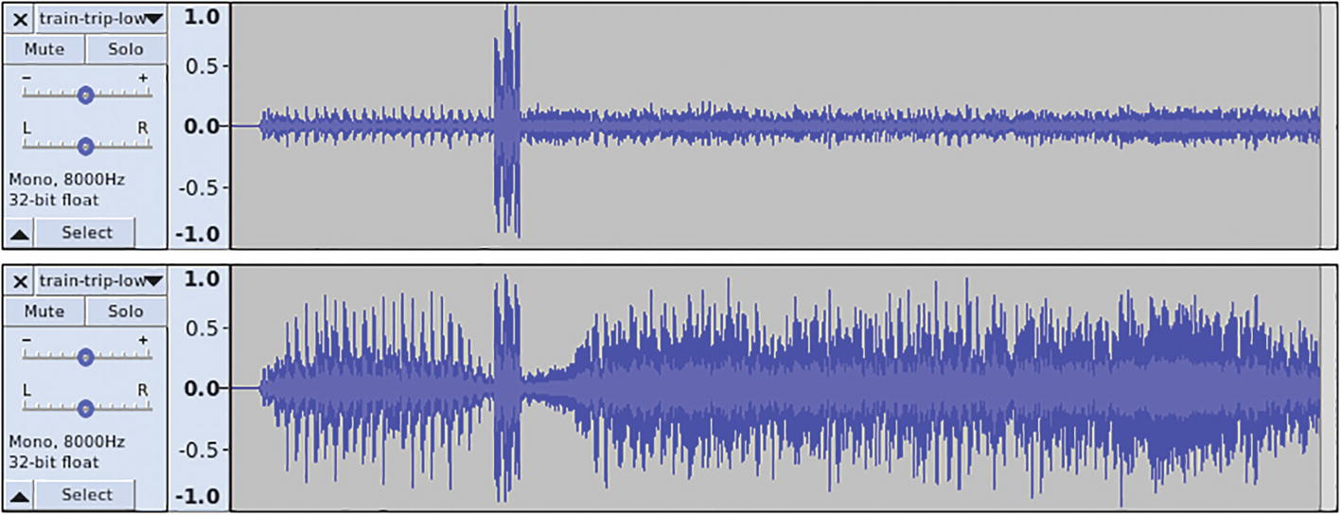
Figure 8-4A few unexplained spikes in volume can prevent normalization from happening on the rest of the waveform. Dynamic Range Compression and Dynamic Range Normalization are not affected by these spikes and change the entire waveform

Channels
An audio stream can have one or more channels. A channel is an independent sequence of audio. All channels in an audio stream are of the same length, and they are played back simultaneously. The idea of having a separate channel is to have a different choice of musical instruments or sounds to play in different speakers. Audio content creators may move back and forth sounds between different channels at different volume levels. This can be useful in creating a 2D or 3D effect to the sound. Typically, each channel in an audio stream is assigned to a particular speaker. This composition of channels in a multichannel stream is known as its channel layout. When the number of speakers is less than the number of channels, then that particular channel may not be heard, or the device may downmix the channels so that the excess channels will be heard on the existing speakers.
Monaural audio has only one channel. Stereo music has two channels – left and right. Movies can have two, six, seven, eight, or more channels.
When working with channels, you will need to use filters such as amerge, channelmap, channelsplit, and pan. These filters make use of certain IDs for channels and channel layouts. Table 8-1 and Table 8-2 list these IDs.
Table 8-1Channels
ID | Channel
FL | Front left
FR | Front right
FC | Front center
LFE | Low frequency
BL | Back left
BR | Back right
FLC | Front left-of-center
FRC | Front right-of-center
BC | Back center
SL | Side left
SR | Side right
TC | Top center
TFL | Top front left
TFC | Top front center
TFR | Top front right
TBL | Top back left
TBC | Top back center
TBR | Top back right
DL | Downmix left
DR | Downmix right
WL | Wide left
WR | Wide right
SDL | Surround direct left
SDR | Surround direct right
LFE2 | Low frequency 2
Table 8-2Channel layouts
ID | Layout composition
Mono | FC
Stereo | FL+FR
2.1 | FL+FR+LFE
3.0 | FL+FR+FC
3.0(back) | FL+FR+BC
4.0 | FL+FR+FC+BC
Quad | FL+FR+BL+BR
Quad(side) | FL+FR+SL+SR
3.1 | FL+FR+FC+LFE
5.0 | FL+FR+FC+BL+BR
5.0(side) | FL+FR+FC+SL+SR
4.1 | FL+FR+FC+LFE+BC
5.1 | FL+FR+FC+LFE+BL+BR
5.1(side) | FL+FR+FC+LFE+SL+SR
6.0 | FL+FR+FC+BC+SL+SR
6.0(front) | FL+FR+FLC+FRC+SL+SR
Hexagonal | FL+FR+FC+BL+BR+BC
6.1 | FL+FR+FC+LFE+BC+SL+SR
6.1 | FL+FR+FC+LFE+BL+BR+BC
6.1(front) | FL+FR+LFE+FLC+FRC+SL+SR
7.0 | FL+FR+FC+BL+BR+SL+SR
7.0(front) | FL+FR+FC+FLC+FRC+SL+SR
7.1 | FL+FR+FC+LFE+BL+BR+SL+SR
7.1(wide) | FL+FR+FC+LFE+BL+BR+FLC+FRC
7.1(wide-side) | FL+FR+FC+LFE+FLC+FRC+SL+SR
Octagonal | FL+FR+FC+BL+BR+BC+SL+SR
Hexadecagonal | FL+FR+FC+BL+BR+BC+SL+SR+WL+  WR+TBL+TBR+TBC+TFC+TFL+TFR
Downmix | DL+DR
22.2 | FL+FR+FC+LFE+BL+BR+FLC+FRC+BC+  SL+SR+TC+TFL+TFC+TFR+TBL+TBC+TBR+  LFE2+TSL+TSR+BFC+BFL+BFR

Swap Left and Right Channels
In some videos, sounds from the left side of the video are heard on the right channel and those from the right side are on the left channel. In such a case, you can do a switcheroo.
# Switch right and left channels of stereo audio
ffmpeg -i wrong-channels.mp4 \
-c:v copy \
-filter_complex "
channelmap
=map=FR-FL|FL-FR" \
fine-channels.mp4
You can specify the channel settings using the map filter option in this format:
input_channel_id-output_channel_id|input_channel⏎ _id-output_channel_id|...
This filter also has a channel_layout option.

Turn Off a Channel
In some video files, the narration or commentary is on one channel, and the ambient noise or background music is on the other. If what you want is on the left, you can turn the right channel off by setting its gain to zero (0).
# Silence right channel
ffmpeg -i moosic.mp3 \
-c:v copy \
-filter_complex "
pan
=stereo|FL=FL|FR=0" \
moosic4lefty.mp3
☞ Changing the audio to mono (single-channel audio) is not an option because mono audio is played on both front and left speakers.
You can specify the channel settings in this format:
l|output_channel_id=gain*input_channel_id|output⏎ _channel_id=gain*input_channel_id...
The filter option l is used to specify the channel layout. After that, you have to specify how much of what channel (in the input stream) you need for each channel in the output audio stream. For specifying that proportion or the gain, you can specify a multiple or a fraction. If you omit the gain, it implies that you want that channel as is or that the gain is equal to 1 (one). If you use 0 (zero), it means that you want that channel totally attenuated.

Move Channel to a Separate Audio Track
In some videos, the left and right audio channels are independent tracks. What these content creators do is place the original audio on one channel and the most annoying royalty-free music on the other. Instead of deleting the offending channel, you could move each channel to a separate audio stream while preserving the original stereo stream in a third stream.
The channesplit filter has a channel_layout filter option which by default assumes the input audio stream is stereo. Because of that, this command splits the left and right channels of the audio stream in the video to two mono streams, which I have labeled as L and R.
# Split channels to separate audio streams
# and also preserve existing audio stream
ffmpeg -y -ss 0:0:20 -t 0:0:20 -i zombie.mp4 \
-c:v copy \
-filter_complex "
channelsplit
[L][R]" \
-map 0:v:0 -map ’[L]’ -map ’[R]’ -map 0:a:0 \
-c:a:0 aac -ac:a:0 1 \
-c:a:1 aac -ac:a:1 1 \
-c:a:2 copy \
zombie-tracks.mp4
Because the first two of the mapped output audio streams need to be freshly encoded as mono streams and the last mapped audio stream just needs to be copied without re-encoding, encoder (-c) and channel count (-ac) need to be specified on a per-stream basis.
☞ The -c and -ac options are limited to the streams specified by the -map options specified before them.

Fix Out-of-Phase Audio Channels
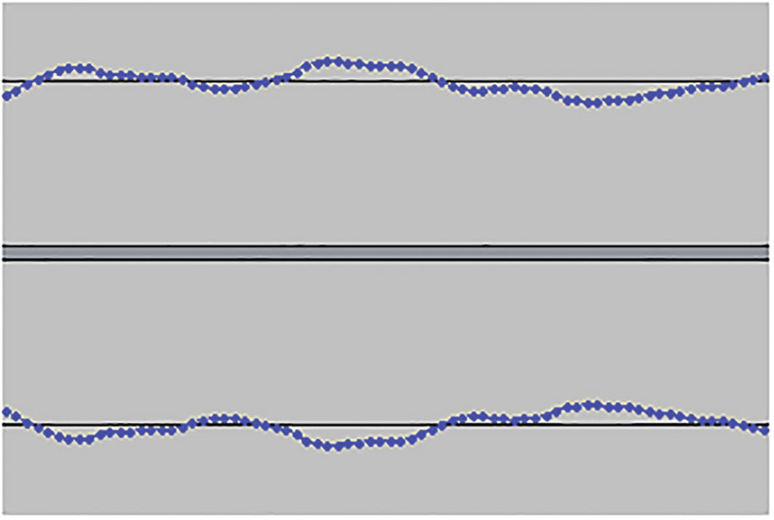
Figure 8-5This zoomed-in waveform shows out-of-phase left and right channels
Rarely, when you downmix to mono sound, out-of-phase audio in the channels may cancel each other out. The audio will sound muted. You can fix it by saving either the left or the right channel in the input file as the only (mono) channel in the output file. (Monaural audio is played the same on both sides.)

Change Stereo to Mono
Stereo audio has two channels – left and right. Most of the time, both channels have the same audio. However, in many cases, the left channel will have some sounds that are not available in the right channel. The loudness of certain sounds may also differ. This difference will be lost when you convert to mono. Remember this before converting to mono. Mono audio cannot be converted back to stereo. It can only be made to look like stereo. You can convert stereo to mono either by downmixing both left and right channels to a mono channel or dropping one of the channels.
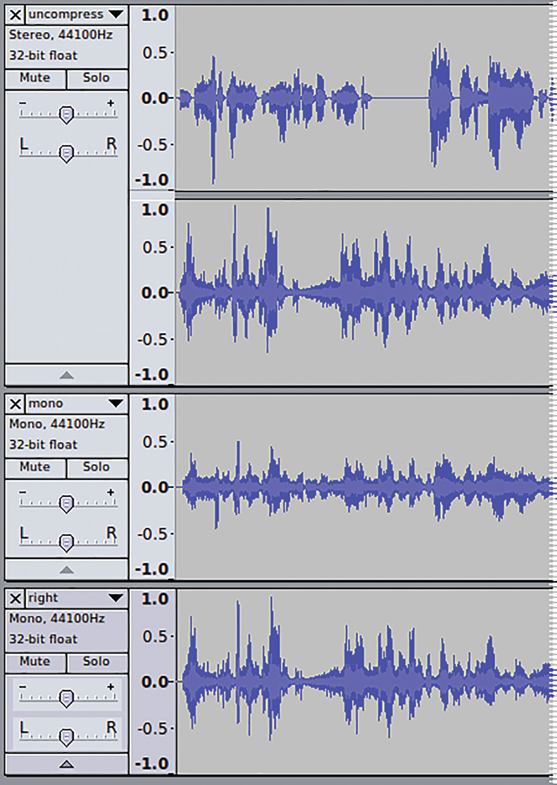
Figure 8-6To convert from stereo to mono, you can downmix left and right channels to a single mono channel or drop one of the channels. In either case, if the two channels are different, there will be some irreversible loss of the waveform
# Downmix to mono
ffmpeg -i uncompressed-stereo.
wav
\
-ac 1
\
mono.mp3
# Drop left channel
ffmpeg -i uncompressed-stereo.wav \
-filter
channelmap
=FR-FC:mono \
right.mp3

Convert Mono to Stereo
Mono audio has only one channel. On a stereo audio output device, the same channel will anyway be played on the left and right speakers. Hence, it does not make any difference to convert mono to stereo. If at all this needs to be done, then the audio can be split with a second channel.
ffmpeg -i mono.mp3 \
-ac 2
\
stereo-kind-of.mp3

Make Audio Comfortable for Headphone Listening
When wearing headphones, the sounds feel like they are arising inside your head and between your ears. The earwax filter makes the sound feel like it is outside and in front of your head.
ffmpeg -i in-head.flac
-filter "earwax"
out-head.mp3
ffmpeg -i tl.mp4
-filter:a "earwax"
-c:v copy tl-head.mp4

Downmix 5.1 Audio to Stereo
Using the -ac (audio channels) option with the necessary number of channels is enough for most downmixing operations.
ffmpeg -i AAC-LC-Channel-ID.mp4 \
-ac 2
\
stereo.mp3

Downmix Two Stereo Inputs to One Stereo Output
When you place two videos side-by-side each other, you need to do something about their two audio streams.
ffmpeg -y -i beto.mp4 -i fallon.mp4 \
-filter_complex \
"[0:v]pad=1280:360:0:0 [frame];
[frame][1:v]overlay=640:0 [overlaid];
[0:a]
channelsplit=channel_layout=mono
[beto];
[1:a]
channelsplit=channel_layout=mono
[fallon];
[beto][fallon]
join=inputs=2:channel_layout=stereo
[audio]" \
-map ’[overlaid]’ -map ’[audio]’ \
fallon-aces-beto.mp4
ffmpeg -y -i beto.mp4 -i fallon.mp4 \
-filter_complex \
"[0:v]pad=1280:360:0:0 [frame];
[frame][1:v]overlay=640:0 [overlaid];
[0:a][1:a]
amerge=inputs=2
[audio]" \
-map ’[overlaid]’ -map ’[audio]’ \
-ac 2
\
fallon-aces-beto2.mp4
The first command uses channelsplit filter to convert stereo audio from the two input files to mono streams. It then uses the join filter to use the two mono streams to create a stereo stream where the mono audio from the first file is the left channel and the mono audio from the second file becomes the right channel.
The second command uses amerge filter to create a four-channel audio stream from the two input stereo (two-channel) streams. The -ac 2 conversion setting downmixes the four-channel audio to a two-channel stereo output.
In the first command, the input audio streams are assumed to be of equal length. If they are not of equal length, then the apad filter needs to be used to add silence to last till the end of the video stream.
For the Laurie Lennon video mentioned in an earlier chapter, I had also created a video with both the original version and the slowed-down version side-by-side for comparison. The slowed-down video was of greater duration. Without adding the extra silence, FFmpeg would continue adding duplicate data at the end of the shorter stream. The process would never complete, and my computer would have run out of space.
// Slow MP4 was 128 seconds. The original was 114 seconds.
ffmpeg -i Laurie-Lennon-Slow.mp4 \
-i Laurie-Lennon-Original.mp4 \
-loop 1 -i bg.png \
-filter_complex \
"[0:v:0]scale=320:180[v1];
[1:v:0]scale=320:180[v2];
[2:v:0][v1]overlay=320:90[v3];
[v3][v2]overlay=0:90[v];
[0:a:0]channelsplit=channel_layout=mono[right];
[1:a:0]channelsplit=channel_layout=mono,
apad
[left];
[left][right]join=inputs=2:channel_layout=stereo[a]" \
-map ’[v]’ -map
’[a]’ \
-t 0:2:08 \
-y laurie-lennon-comparison.mp4

Render a Visual Waveform of the Audio
The showwaves filter renders a visual waveform of the input audio.
ffmpeg -y -i dialup-modem.mp4 \
-filter_complex \
"[0:a]
showwaves=s=160x90:mode=line[waves];
[0:v]drawbox=x=(iw-20-w):y=(ih-20-h):w=160:h=90:
color=yellow@0.6:t=fill[bg];
[bg][waves]overlay=x=(W-20-w):y=(H-20-h)[over]" \
-map ’[over]’ -map 0:1 \
dialup-modem-handshake.mp4
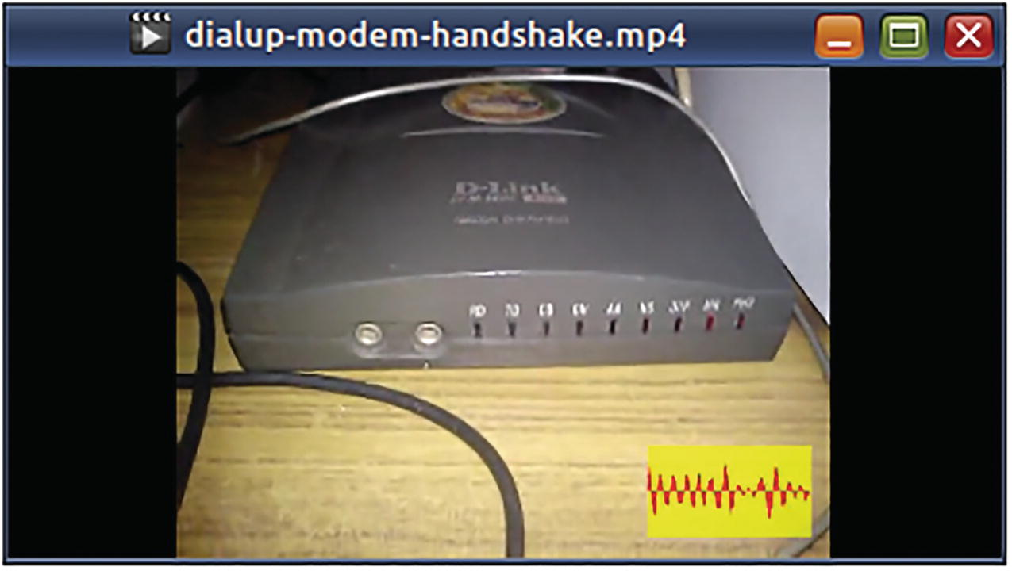
Figure 8-7This command draws a waveform of the dialup modem handshake tones on the video. To make the waveform easily visible, the command has drawn a translucent yellow box behind it
In 2021, I wrote a book on electronics. In that, I described how to create the most annoying-sounding alarm noise using a blinking LED. I wanted to publish an online video of the alarm but felt queasy about posting a video of the ceiling where the alarm was installed. FFmpeg to the rescue! I used the showfreqs filter to generate the “power spectrum” of the audio recording.
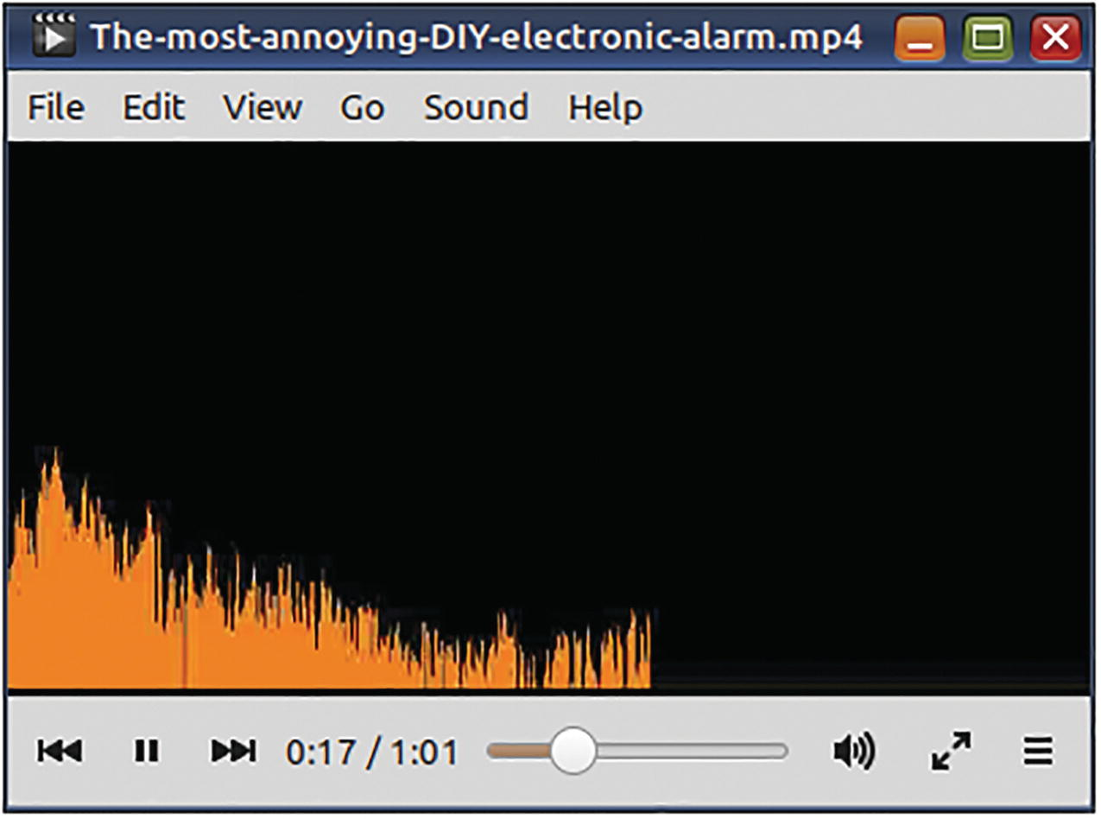
Figure 8-8The showfreqs filter shows how energy in an audio signal is spread across the range of frequencies that are audible to the human ear
ffmpeg -i The-most-annoying-DIY-electronic-alarm.mp3 \
-filter_complex \
"showfreqs=s=640x320:mode=bar[v]" \
-map ’[v]’ -map 0:a:0 \
-c:v mpeg4 -b:v 466k -r 24 \
The-most-annoying-DIY-electronic-alarm.mp4
There are a few other filters similar to this one. Check the documentation. These filters are very interesting.

Detect Silence
I have a shell script for censoring movies. (It uses FFmpeg, of course.) I use it to protect kids from foul dialog and unsuitable scenes. It asks for timestamps where the audio needs to be silenced and the video needs to be blacked out. After it does the job, I need to double-check these locations before the grand première on the TV. I use this command:
ffmpeg -i edited-movie.mp4 \
-filter:a "silencedetect"
\
-vn -f null -
This command outputs timestamps wherever silence is detected. This helps me to directly skip to the censored locations using my media player on my computer.

Silence the Video
Heck, you do not want sound at all! Just remove the audio stream.
ffmpeg -i music-video.mp4 \
-an
\
-c:v copy \
sound-of-silence.mp4

Convert Text to Speech
If your ffmpeg executable has been built-in with support for the libflite text-to-speech synthesizer library, then you can convert text content to spoken words.
ffmpeg -f lavfi \
-i "
flite
=textfile=speech.txt:voice=slt" \
speech.mp3
This library has an option for a female voice, but I like the male-only espeak better. You can find other options for the flite filter option voice by typing the following:
ffprobe -f lavfi "flite=list_voices=1"
On my computer, this command lists awb, kal, kal16, rms, and slt as voices that are supported.

Apply a Low-Pass Filter
In an earlier chapter, I mentioned that I used Audacity to apply a low-pass filter. A low-pass filter makes all frequencies above a certain level to steeply drop to a zero while not disturbing all frequencies below that level. There is also a high-pass filter which does the opposite and attenuates frequencies below a certain level.
The audio recording in my example had a lot of noise typical of old gramophone recordings. When the low-pass filter was applied, the noise disappeared. At that time, I did not know much about FFmpeg filters. If I did, I could have fixed the audio in just one step.
ffmpeg -i Stopmotion-hot-wheels.mp4 \
-filter:a "lowpass=frequency=1000" \
-codec:v copy \
Stopmotion-hot-wheels-audio-passed-low.mp4
The default option in Audacity was 1000 Hz for the frequency and 6 dB per octave for the roll-off. The roll-off specifies how steeply the frequencies are attenuated. The lowpass filter can apply a 3 dB roll-off if you set its poles option to 1. The default 2 applies a 6 dB roll-off, and I did not have to explicitly specify it in the above command.

Summary
In this chapter, you learned how to perform several tasks with audio content. You may find it helpful to initially use Audacity to understand audio problems. As you get more familiar with what ails audio content, you can rely on FFmpeg entirely. FFmpeg has a ton of audio filters, and this chapter used just a few of them. Check the FFmpeg documentation on audio filters, and you will find more exciting things you can do with audio.
© The Author(s), under exclusive license to APress Media, LLC, part of Springer Nature 2023
V. SubhashQuick Start Guide to FFmpeg
https://doi.org/10.1007/978-1-4842-8701-9_9

9. All About Subtitles
V. Subhash1
(1)
Chennai, Tamil Nadu, India

In this chapter, you will learn to perform several tasks related to subtitles. Subtitles are dialogs that are displayed as text on a video. The subtitles may be burned into the video or be available as a separate content stream in the multimedia file. In case of the former, the subtitles cannot be turned off as they have become part of the video. In case of the latter, the subtitles can be turned on or off using a remote button or by selecting an onscreen menu option.
Videos on streaming media, optical media, and broadcast TV can have subtitles in multiple languages. Some websites maintain a crowd-sourced library of subtitles (in multiple languages) of a wide variety of movies, popular and obscure. Several video-hosting sites also display subtitles. They do not let you download subtitles separate from the video. However, there are some other websites that will fetch the subtitles if you give them the address where the original video is hosted.
Subtitles are available in many formats. Subrip (.srt) files are the most popular. Advanced Substation Alpha (.ass or .ssa) is very versatile. WebVTT (Web Video Text Tracks Format) is used by browsers for online videos. TTML is used by the broadcast industry and online applications. DVDs use .dvdsub files.
I prefer SSA because I can specify a custom display font with it. For use with FFmpeg, subtitles should be a stream in a media file or an external text file. Subtitles that are already burned into a video (not as a separate stream) cannot be processed by FFmpeg (or rather not covered by this book). However, FFmpeg can be used to burn subtitles permanently on a video.

Add Subtitles to a Video as an Extra Stream
To add a subtitle file to a video, you need to use a subtitle format that is compatible with the video file’s container. Or, you should use a suitable encoder that will convert your subtitle file in a format that is supported by the container. The subtitle format for MP4, MOV, and 3GPP containers is known as “MPEG4 Timed Text.” You will have to encode your SRT or SSA subtitle files with the encoder mov_text for these containers. For the versatile Matroska (MKV) format, you can straightaway use SRT and SSA subtitle files.
Suppose that you have a DVD without subtitles in your favorite language and the DVD seller released a new updated collector’s edition DVD that has subtitles in that language. If you were able to download the new subtitles as an SRT file from somewhere, then you can add it to your DVD backup file as an extra stream. If you are saving the DVD as an MKV file, convert the SRT file beforehand to the Substation Alpha (SSA) format to take advantage of the ability of the latter to use a custom font.
ffmpeg -i dvd-movie.srt dvd-movie.ass
# Edit the SSA file in some subtitle editor
# and add your custom styles and fonts
ffmpeg -i dvd-movie.ogv -i dvd-movie.ass \
-map 0:v -map 0:a -map 1:s \
-c:s mov_text \
-metadata:s:s:0 language=eng \
dvd-movie-subtitled.mp4 \
\
-map 0:v -map 0:a -map 1:s \
-codec copy \
-metadata:s:s:0 language=eng \
dvd-movie-subtitled.mkv
☞ When you add subtitles as an additional stream like this, the viewer can turn them on/off with the device remote or a screen menu option.
Did you notice something else with the above command? I subtitled the movie in two formats (MP4 and MKV) using one command. With the MP4, I had to encode the OGV streams because its codecs are not native to the MP4 container. With the MKV, I could use -codec copy. The MKV container supports a wide variety of codecs including those supported by OGV and MP4. If you are backing up DVDs for long-term storage, choose MKV. It is the best.

Permanently Burn Subtitles to a Video
When I was about to publish my first book, I wanted to upload a book-read video in which I read a few pages. I recorded the OGV video using the webcam program Cheese, but there were some issues with audio recording. So, I transcribed my narration using another program called Gnome Subtitles and saved the subtitles as a Substation Alpha (.ass) file. I did not want to upload the subtitles to the video-hosting sites because they use very tiny fonts. I wanted the subtitles to look bigger and with my own selection of the font. I then decided to use FFmpeg to permanently burn the subtitles on the video. I specified the font and subtitles location on the video in the subtitle file, NOT in the ffmpeg command. The SSA format let me do that. Using a filter, I drew a black box behind the subtitles so that they could be easily read against any background.
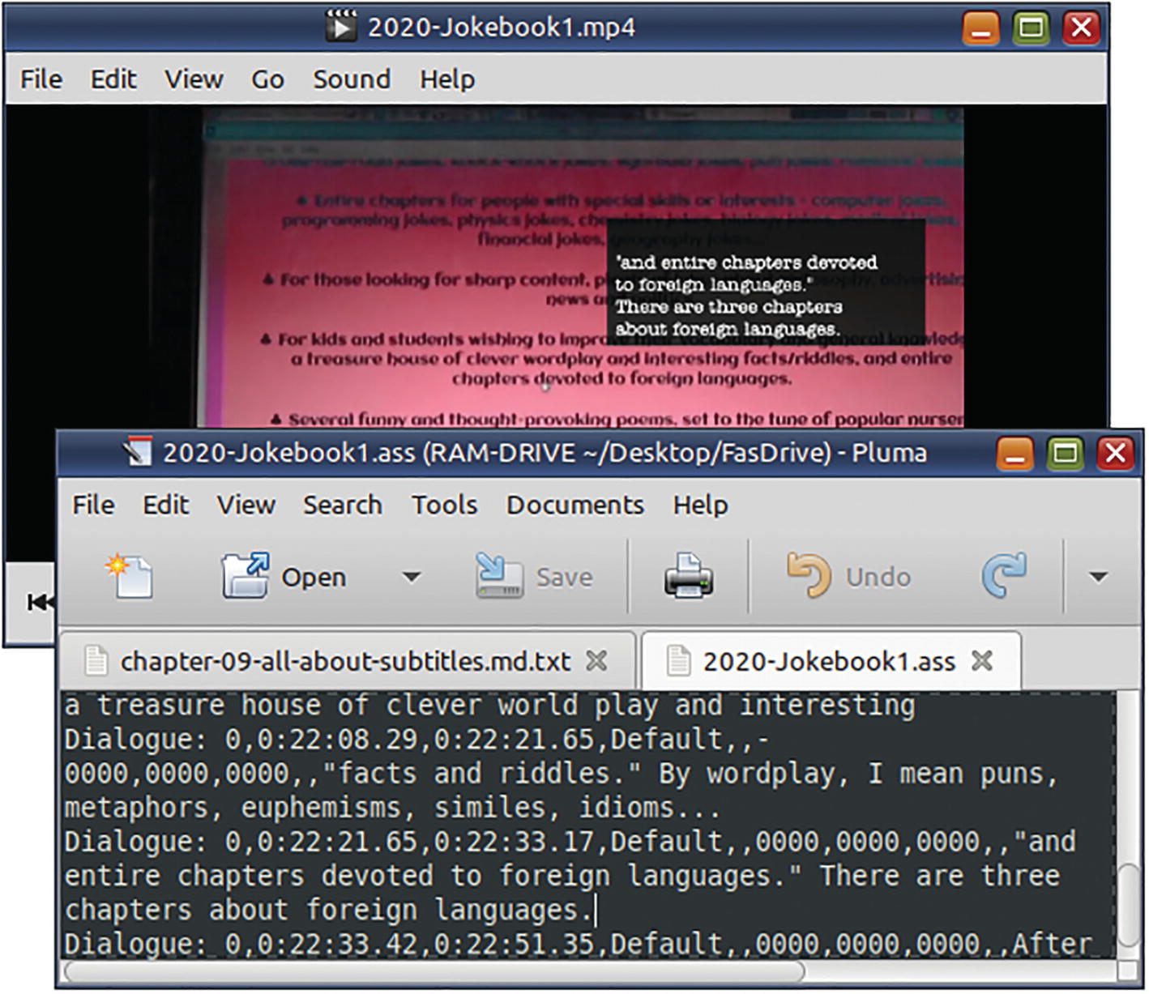
Figure 9-1Subtitles burned into a video cannot be turned off with the remote or a menu option
ffmpeg -i 2020-Jokebook1.ogv \
-filter_complex \
"drawbox=w=250:h=100:x=360:y=90:color=black@0.7:t=fill,
subtitles=2020-Jokebook1.ass
" \
-c:v libx264 -r 24 \
2020-Jokebook1.mp4
☞ The subtitles filter has a force_style option to specify an SSA style for use with a subtitle format (such as SRT) that does not support styles.
☞ The black box was unnecessary. SSA has built-in support for dynamic background boxes, as you will learn later.

Add a Custom Font for Displaying Subtitles of a Video
If I wanted the subtitles in my book-read video to be optional, I could have created an MKV like this:
ffmpeg -i 2020-Jokebook1.ogv
-i 2020-Jokebook1.ass
\
-codec copy \
-metadata:s:s:0 language=eng \
-attach Headline.ttf \
-metadata:s:t:0 mimetype=application/x-truetype-font
\
2020-Jokebook1.
mkv
☞ Font embedding increases subtitles portability and toggleability, but support is not universal.
☞ You should place the font file in the current directory or specify its full path.
This command adds the subtitles as an additional stream in the video. It also specifies a custom subtitle display font and embeds that font. On my PC, Totem and VLC display the subtitles with that font. However, my WDTV HD media player box, which I used for many years, always played the subtitles with its own built-in font.
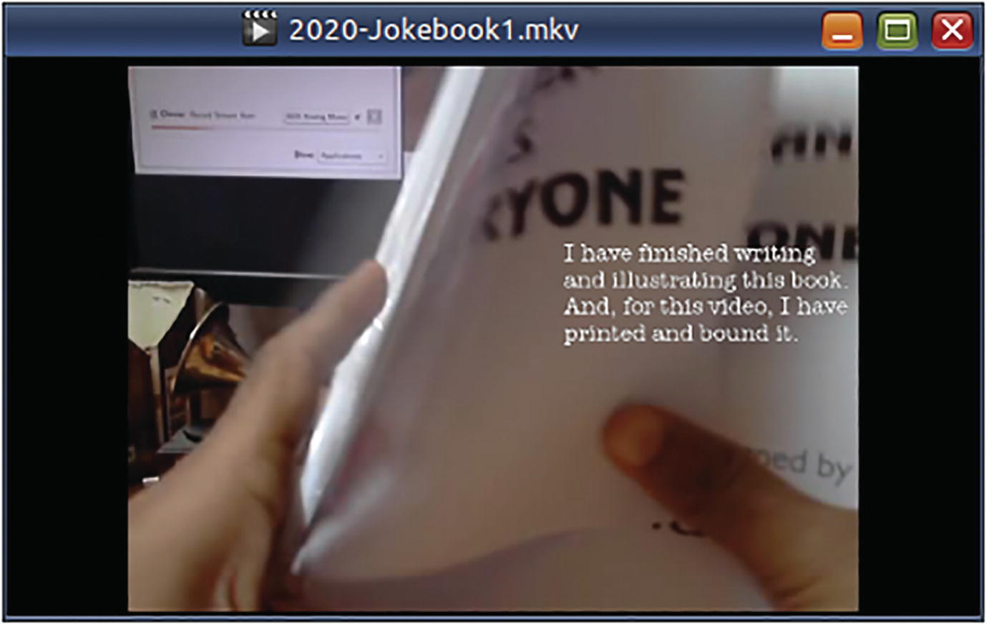
Figure 9-2When subtitles are added as a stream, the viewer can turn them on/off using the remote or with a menu option

About the Substation Alpha (SSA/ASS) Subtitle Format
Although SRT is the popular subtitle format, I prefer the Substation Alpha (.ass or .ssa) because it supports fonts and several other cool features. You can convert SRT to SSA using ffmpeg.
ffmpeg -i dvd-movie.srt dvd-movie.ass
However, I prefer not to do that. I download the SRT file, let it open in a GUI program called Gnome Subtitles, and save it as a SSA file. After this, I run a BASH script on the .ass file to change its style statement. The style statement generated by ffmpeg and Gnome Subtitles refers to Windows fonts. These fonts are not available in Linux and the resultant subtitles do not look cool. My script uses a better style statement with a font I already have installed in Linux.
ffmpeg version:
Style: Default,Arial,16,&Hffffff,&Hffffff,&H0,&H0,⏎
0,0,0,0,100,100,0,0,1,1,0,2,10,10,10,0
Gnome Subtitles version:
Style: Default,Tahoma,24,&H00FFFFFF,&H00FFFFFF,⏎
&H00FFFFFF,&H00C0C0C0,-1,0,0,0,100,100,0,0.00,⏎
1,2,3,2,20,20,20,1
My version:
Style: Default,Headline,20,&H00FFFFFF,&H006666EE,⏎
&H00000000,&HAA00EEEE,-1,-1,0,0,100,100,0,0.00,⏎
1,4,0,2,20,20,20,1
When I used this style in the book-read video, the subtitles…
ffmpeg -y -i 2020-Jokebook1.ogv \ -i 2020-Jokebook1-shadows.ass \
-map 0:v -map 0:a -map 1:s \
-c:v copy -c:a copy -c:s ass \
-metadata:s:s:0 language=eng \
-attach Headline.ttf \
-metadata:s:3 mimetype=application/x-truetype-font \
2020-Jokebook1-shadows.mkv
... look like this:
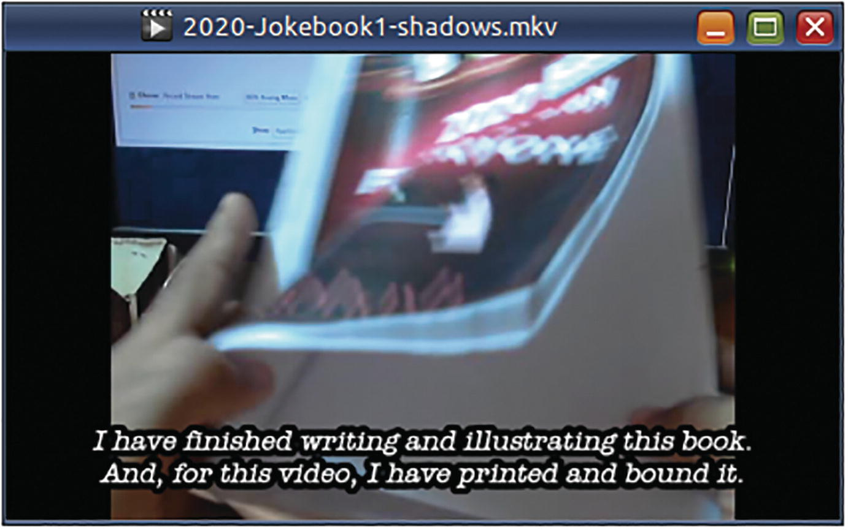
Figure 9-3In this video, the subtitles have a text outline. (This eliminated the need to render a black box behind the subtitles using an FFmpeg filter. SSA subtitles support multiple such styles in the same file.) The subtitle shadow has been zeroed
The specification of the wonderfully useful but screwed-up SSA format is available on the matroska.org website (Technical Info » Subtitles » SSA). However, I will risk a description here for the style statement.
Style: Name, Fontname, Fontsize, PrimaryColour, SecondaryColour, OutlineColour, BackColour, Bold, Italic, Underline, StrikeOut, ScaleX, ScaleY, Spacing, Angle, BorderStyle, Outline, Shadow, Alignment, MarginL, MarginR, MarginV, Encoding
Name refers to a subtitle display style. You can define and use many different styles, not just the Default. The colors are in hexadecimal AABBGGRR format. (Ese, are they loco? No. It is allegedly to help with video-to-text conversion.) PrimaryColour is the color of the subtitle text. OutlineColour is for the outline of the text. BackColour is the color of the shadow behind the text. SecondaryColour and OutlineColour will be automatically used when timestamps collide. Bold, italic, et al. are -1 for true and 0 for false. (Yeah, I know. The bash shell does the same.) ScaleX and ScaleY specify magnification (1-100). Spacing is additional pixel space between letters. Angle is about rotation (0-360) and controlled by Alignment. BorderStyle uses 1 (outlined and drop-shadowed text), 3 (outline box and shadow box), and 4 (outlined text and drop-shadow box). Outline represents the border width (1-4) of the outline or the padding around the text in the outline box. Shadow represents the offset (1-4) of the shadow from the text or the space around the text in the shadow box. Alignment takes 1 (left), 2 (center), and 3 (right). If you add 4 to them, the subtitle appears at the top of the screen. If you add 8, it goes to the middle. Then, we have margin from the left, right, and bottom edges of the screen. Encoding is 0 for ANSI Latin and 1 for Unicode (I think).
To really go bonkers with subtitles, I say we render subtitles with a miasma of colors, location, and tilt.
Style: Default,Headline,22,&H6600FFFF,&H006666EE,⏎
&H660000FF,&H220066EE,-1,-1,0,0,100,100,0,25.00,⏎
3,4,4,2,20,20,120,1
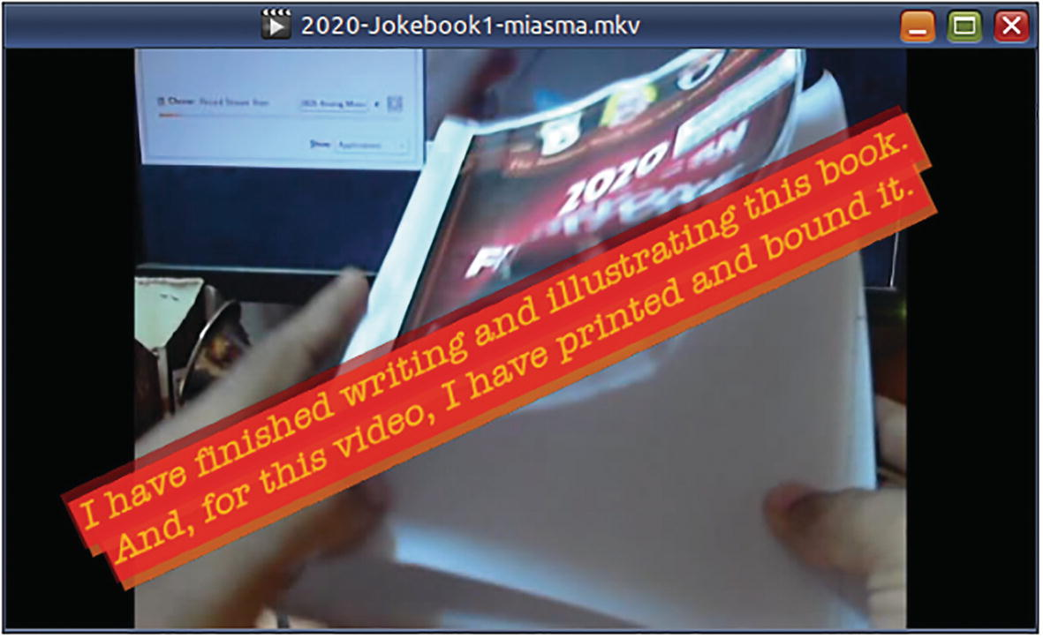
Figure 9-4This is truly subtitles gone wild. SSA subtitle format offers the most control and options. There is a yellow shadow to the red outline. Because the colors are translucent, their intersection appears orange

Add Subtitle Files in Different Languages
When adding multiple subtitles, it is obligatory on your part to specify metadata identifying the language of each output subtitle stream.
Let us pretend that I am trying to corner the French jokebook market and have a French transcript ready as well:
# Multi-language subtitled MP4
ffmpeg -i 2020-Jokebook1.ogv \
-i 2020-Jokebook1-en.ass -i 2020-Jokebook1-fr.ass \
-map 0:v -map 0:a -map 1:s -map 2:s \
-c:s mov_text \
-metadata:s:s:0 language=eng \
-metadata:s:s:1 language=fre \
2020-Jokebook1-subtitled-en-fr.mp4
# Multi-language subtitled MKV
ffmpeg -i 2020-Jokebook1.ogv \
-i 2020-Jokebook1-en.ass -i 2020-Jokebook1-fr.ass \
-map 0:v -map 0:a -map 1:s -map 2:s \
-c:v copy -c:a
copy -c:s copy \
-metadata:s:s:0 language=eng \
-metadata:s:s:1 language=fre \
2020-Jokebook1-subtitled-en-fr.mkv
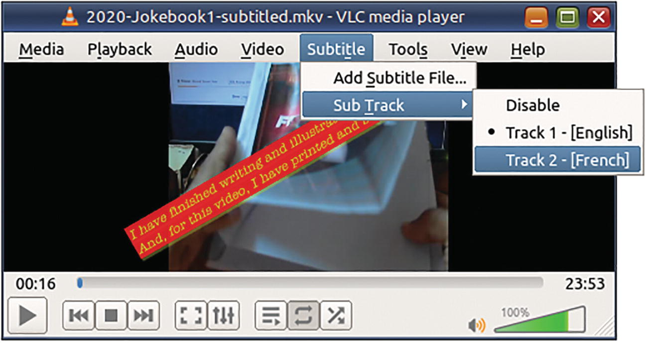
Figure 9-5Do not forget to specify metadata for the subtitles
☞ The codes that you can use for setting the language are further described in Chapter 10.

Extract Subtitles from a Video
Use ffprobe to check if a video file has a subtitle stream.
ffprobe 2020-Jokebook1-subtitled-en-fr.mkv
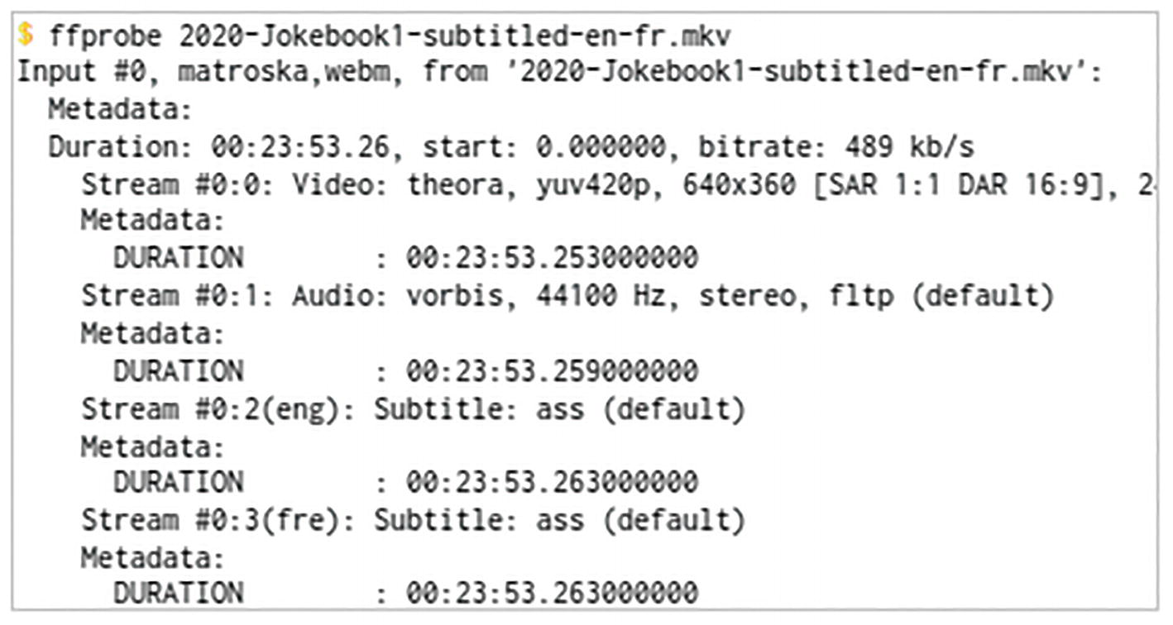
Figure 9-6Use ffprobe output to identify the subtitle formats and any metadata they might have. und stands for “undetermined”
If the file has only one subtitle stream, you can extract it using FFmpeg just by specifying the correct extension.
ffmpeg -i dvd-movie-subtitled.mp4 \
dvd-movie-subtitle-default.ass
If the video has multiple subtitle streams, you need to specify mapping. The next command saves the second subtitle stream in the input file as an SSA file.
ffmpeg -i 2020-Jokebook1-subtitled-en-fr.mkv \
-map 0:s:1 \
2020-Jokebook1-subtitle-fr.ass

Extract Subtitles from a DVD
The files in a DVD are usually encrypted or obfuscated to prevent bootlegging. There are several free DVD-ripping applications that will decrypt the VOB files and quickly extract subtitle files. Forcing ffprobe to find subtitle streams on big VOB files is not worth the trouble.

Summary
Subtitles are available in several formats including SRT, Substation Alpha, and MPEG4 Timed Text. The Substation Alpha is the most versatile subtitle format, and MKV seems to be the best container for it. The style specification for the Substation Alpha format may seem intimidating at first but will be accommodative in customizing subtitles for a variety of use cases.
© The Author(s), under exclusive license to APress Media, LLC, part of Springer Nature 2023
V. SubhashQuick Start Guide to FFmpeg
https://doi.org/10.1007/978-1-4842-8701-9_10

10. All About Metadata
V. Subhash1
(1)
Chennai, Tamil Nadu, India

In this chapter, you will learn to perform several tasks related to metadata. Metadata means to data about data. Multimedia metadata refers to information such as title, artist, album, subject, genre, year, copyright, producer, software creator, comments, lyrics, and even album art images that are used to describe the video and/or audio content.
An audio or video file can have global metadata (i.e., at the file level) and stream-specific metadata too. You can use ffprobe and ffmpeg -i commands to display metadata that a file already has. You use the -metadata option to add new metadata.

Add Album Art to MP3
You can add several pieces of album art to an MP3 file. However, each image will need to have a unique title and comment metadata. There can be one for front cover, another for the back, and yet another for the inlay art. FFmpeg will treat all album art images as video streams, as if they were single-frame videos.
ffmpeg -y \
-i Uthralikavu-Pooram.mp3 \
-i Uthralikavu-Pooram-festival-fireworks.png
\
-i Uthralikavu-Pooram-festival-crowds.png
\
-map 0
-map 1 -map 2
\
-metadata:s:1 title="pooram-fireworks.png" \
-metadata:s:1 comment="Cover (front)" \
-metadata:s:2 title="pooram-crowds.png" \
-metadata:s:2 comment="Cover (back)" \
-codec copy \
-f mp3 \
Uthralikavu-Pooram-festival-fireworks.mp3
☞ Album art are added as single-frame video streams, not metadata. The metadata you add for album art will apply to the video streams of those images.
There are several options for the comment key, as defined in the ID3 tag specification.
https://id3.org/id3v2.3.0
There is no uniform implementation among media players. When there are more than one album art images, ffplay chooses the first cover image that is mapped. Some other players follow a different pecking order.
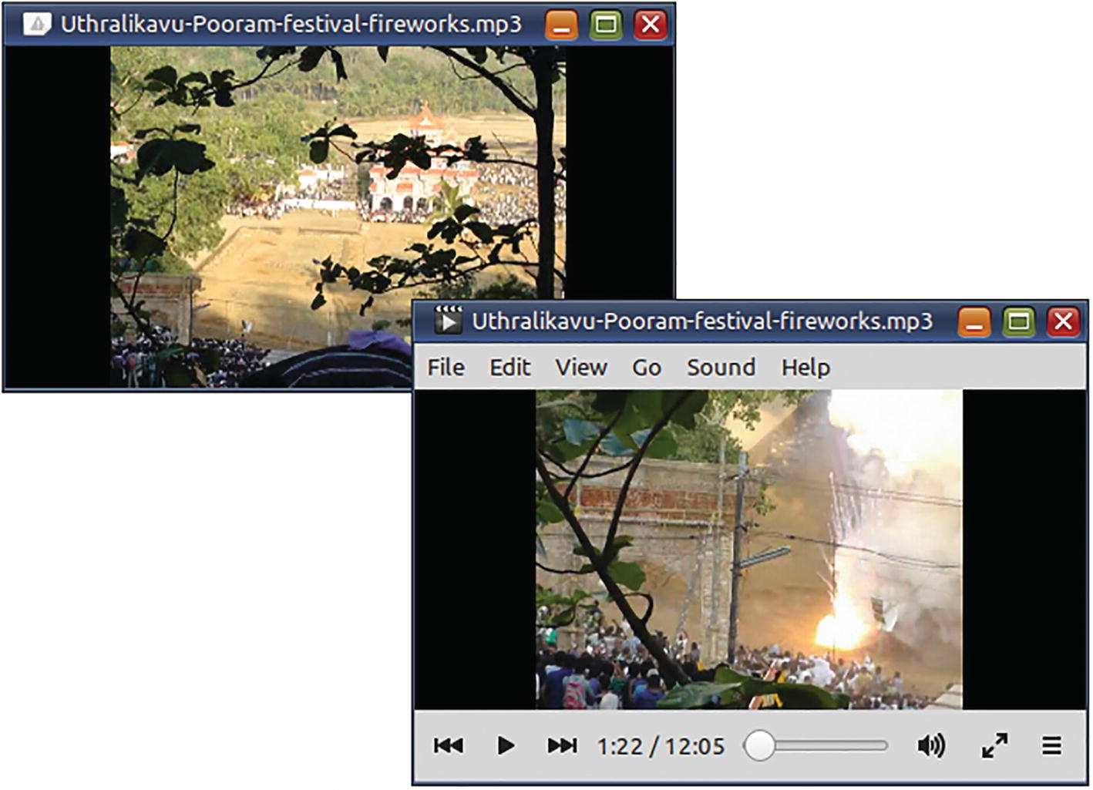
Figure 10-1The album art displayed by different media players for the same MP3 file can be different

Set MP3 Tags
How do I add metadata to an MP3 file?
ffmpeg -y -i Uthralikavu-Pooram-festival-fireworks.mp3 \
-map 0 \
-metadata title="Uthralikavu Pooram Festival" \
-metadata artist="V. Subhash" \
-metadata \
subject="Fireworks and crowds" \
-metadata album="Pooram festival fireworks" \
-metadata date="2013-12-26" \
-metadata genre="Event" \
-metadata comment
="Best outdoor event I ever attended" \
-metadata \
copyright="© 2013 V. Subhash. All rights reserved" \
-id3v2_version 3 \
-codec copy \
Kerala-Uthralikavu-Pooram-festival-fireworks.mp3
☞ MP3 tags metadata get added at the global level. They are not stream-specific.
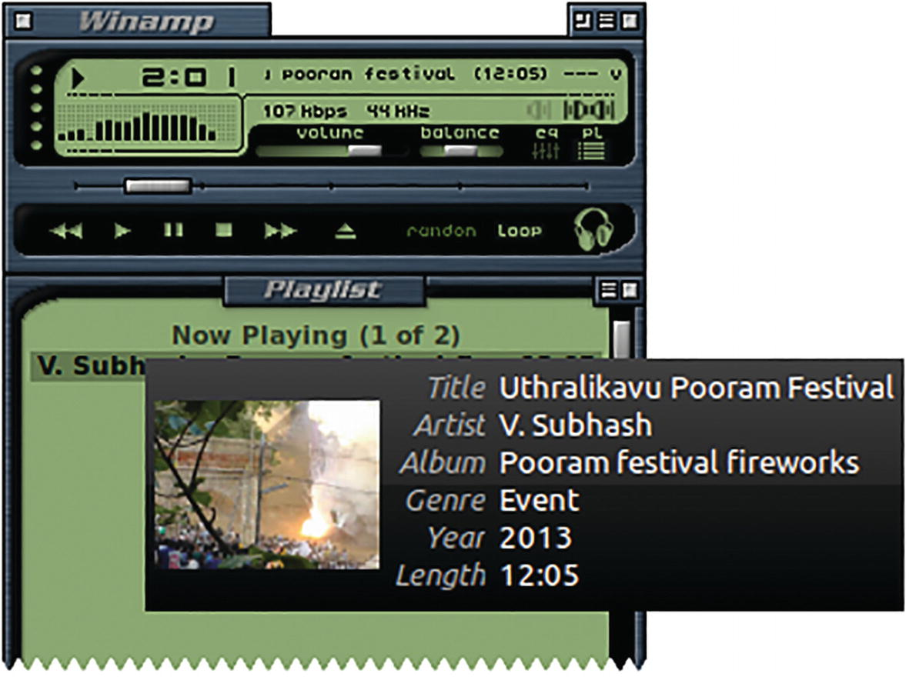
Figure 10-2Media player support for MP3 tags may be buggy or not 100%. Do not break your head just because some tags do not get displayed by a media player

Export Metadata
You can export metadata to a text file using the -f ffmetadata option.
ffmpeg -i Kerala-Uthralikavu-Pooram-festival-fireworks.mp3 \
-f ffmetadata \
mp3-meta.txt
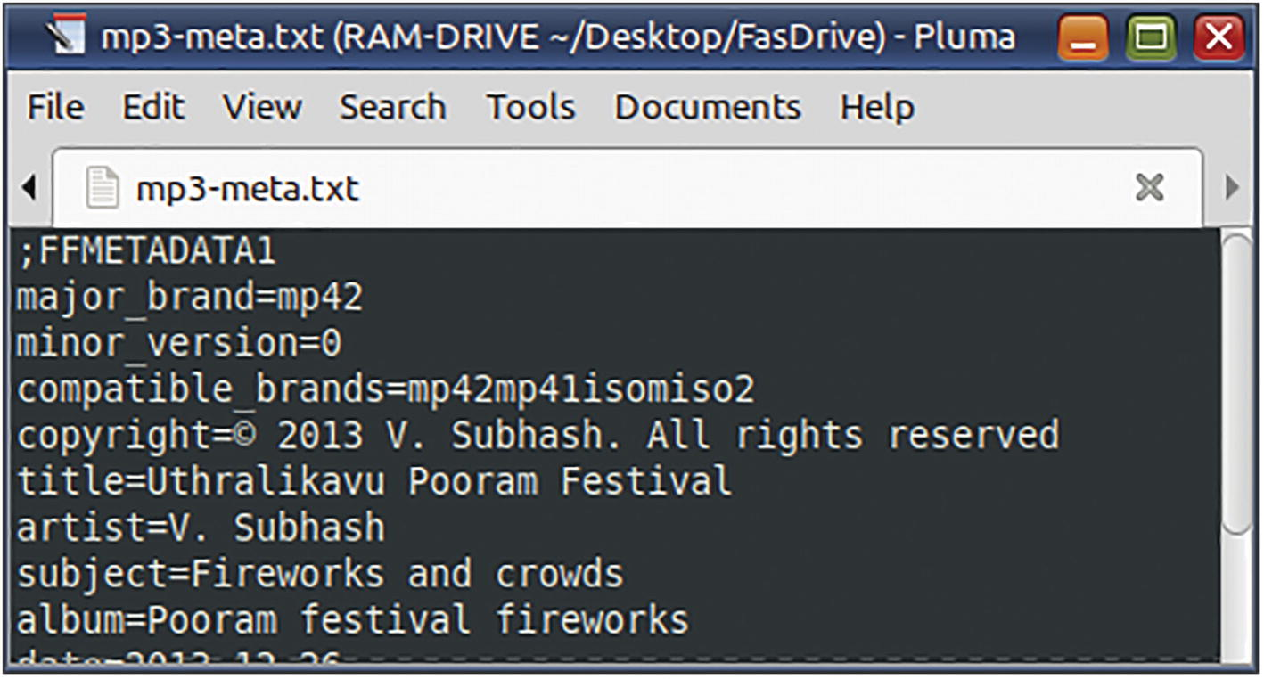
Figure 10-3ffmpeg exported this text file containing name-value pairs representing the metadata of an MP3 file

Import Metadata
Let us imagine that I modified the metadata in the text file (from the previous section) using a text editor. Now, I want the updated metadata to be imported back into the audio file. How can I do it?
ffmpeg -y \
-i Kerala-Uthralikavu-Pooram-festival-fireworks.mp3 \
-i mp3-meta-modified.txt \
-codec copy \
-map_metadata 1
\
Kerala-Uthralikavu-Pooram.mp3
Here, -map_metadata 1 refers to the second input file, that is, the modified metadata file. (-map_metadata 0 would have simply copied the metadata from the first input file, that is, the MP3 file. We did not want that.)

Extract Album Art
You downloaded an MP3 and you like the album art? If the audio file has only one album art, you can extract the image easily.
ffmpeg -i Blobfish.mp3 blobfish-album-art.png
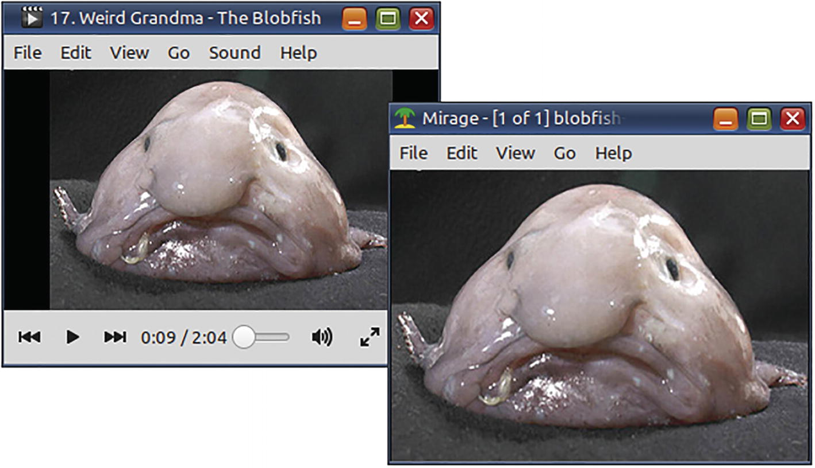
Figure 10-4An MP3 audio file and the album art extracted from it
If there are more than one album art, you need to check the ffprobe output and then extract the album art using a map.
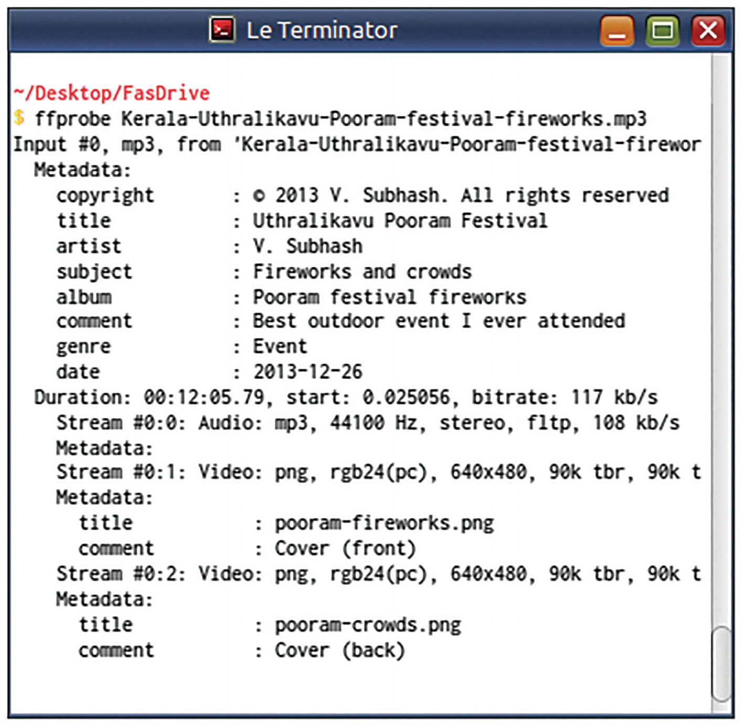
Figure 10-5This‌​ ffprobe output shows the index of the streams containing the album art images
The crowds image is identified as a video stream with index 0:2 (third among all streams). To extract it, I should use the map 0:2. To be safer, I refer to it as 0:v:1 (second video stream).
ffmpeg -i Kerala-Uthralikavu
-Pooram-festival-fireworks.mp3 \
-map 0:v:1
\
crowds.png

Remove All Metadata
When working on an earlier chapter, I found that the Mate Screenshot app was unable to work with the video of the sign-language translator. The app names its screenshot after the title of the subject window. I noted that this video had a URL displayed in the title of the video player window. The URL came from the title metadata of the video. Because the Linux file system does not allow a file name to include a URL (because of the backslash and other illegal characters), the screenshot app may have been unable to save the image to file. When I removed the metadata, I realized that my hunch was right and I was able to take the screenshots from the metadata-free video.
To remove the metadata, I pretended to import metadata from a nonexistent input file (with index -1).
ffmpeg -i "Sign_Language_-_How_To_Vote.mp4" \
-codec copy \
-map_metadata -1
\
how-to-vote.mp4
I have had portable media players that do not play MP3 files if they have album art. Album art cannot be removed as metadata because they are encoded as video streams. So, I use -codec copy and specify a -map for the audio stream. By omitting video streams, the output file will not have any album art.
ffmpeg -i Kerala-Uthralikavu-Pooram.mp3 \
-map 0:a \
-codec copy \
pooram.mp3
# You can also use -vn instead of the -map option

Set Language Metadata for Audio Streams
Let us imagine that I created audio instructions in English, Malayalam, and Tamil for this DIY electronics video. While media players could switch between the language tracks, they would have assigned generic or confusing names to them.
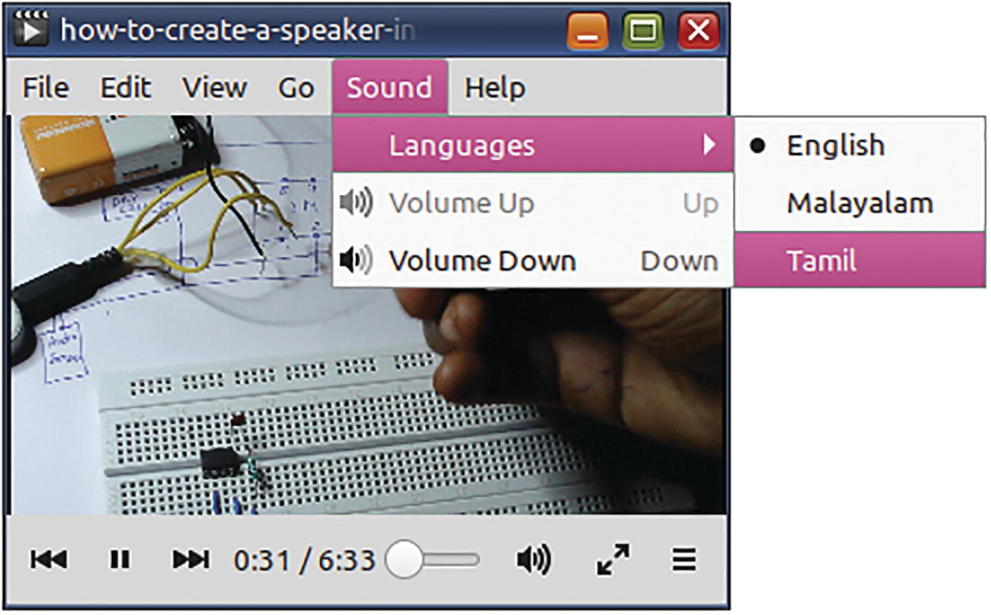
Figure 10-6This video has audio tracks in three languages. The metadata for the audio streams helps identify the languages
The following command sets the language names using ISO codes and makes the menus a lot more informative.
ffmpeg -i how-to-create-a-speaker-instructions.mp4 \
-map 0 \
-metadata:s:a:0
language=eng
\
-metadata:s:a:1
language=mal
\
-metadata:s:a:2
language=tam
\
-codec copy \
how-to-create-a-speaker-instructions-multilang.mp4
map 0 includes all streams in the first input file (#0), that is, including the video stream and the three audio streams. (If not used, there will be just one video stream and one audio stream in the output file.) -metadata:s: is used to set metadata for a stream, not a subtitle.
☞ Apart from s identifier for streams, FFmpeg uses identifiers p and c for DVD programs and chapters of the VOB file container. These are not covered by this book.
-metadata:s:a is used to set metadata for an audio stream specified by its index. language is the metadata key, and what follows after the = sign is the value in the metadata key-value pair. -codec copy ensures that the streams are not re-encoded – only the metadata is added.
The three-letter language codes (such as eng, mal, and tam) are specified in the ISO 639-2 standard. Although the standard allows codes for exceptional situations (mis for “uncoded languages,” mul for “multiple languages,” qaa-qtz for “reserved for local use,” und for “undetermined,” and zxx for “no linguistic content” or “not applicable”), many software and hardware remain ignorant of them.
www.loc.gov/standards/iso639-2/php/code_list.php

Summary
In this chapter, you learned to use ffmpeg to easily add, examine, edit, export, import, and remove metadata. Metadata can be specified at the container level (global) and for individual streams. This information can greatly enrich the experience with media players. In their absence, media players will try to make guesses and/or frustrate you with generic or wrong interface choices. Media formats and software/hardware applications may be picky and choosy about the kind of metadata they support.
With the end of this chapter, all that remains is a set of tips and tricks that could not be accommodated anywhere else.
© The Author(s), under exclusive license to APress Media, LLC, part of Springer Nature 2023
V. SubhashQuick Start Guide to FFmpeg
https://doi.org/10.1007/978-1-4842-8701-9_11

11. FFmpeg Tips and Tricks
V. Subhash1
(1)
Chennai, Tamil Nadu, India

I like tips and tricks, and I cannot lie. I have written an entire book titled Linux Command-Line Tips and Tricks. The tips and tricks in this chapter are mostly about FFmpeg. If you spend a lot of time with FFmpeg, these tips will be useful. Some advanced FFmpeg solutions, which could not be accommodated elsewhere, are also included.

Customize the Terminal
FFmpeg commands tend to be very long. Modify the ~/.bashrc file to ensure that you have enough real estate at the prompt.
PS1="\a\n\n\[\e[31;1m\]\u@\h on \d at \@\n\[\e[33;1m\]⏎
\w\[\e[0m\]\n\[\e[32;1m\]\$ \[\e[0m\]"
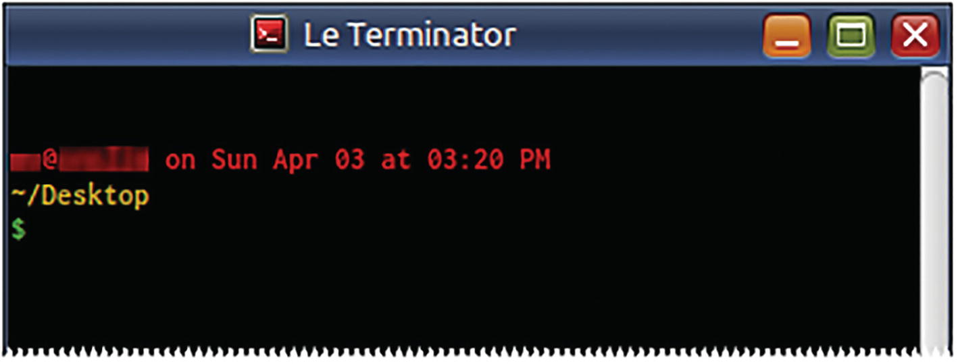
Figure 11-1This is a very informative terminal prompt with almost the entire length of the window available for your epic ffmpeg commands
☞ For this prompt to work effectively, you need to change the background of the terminal to black.
For a minimal style of the prompt, use the following:
PS1="\a\n\n\[\e[31;1m\]\w\n\[\e[33;1m\]\$ \[\e[0m\]"
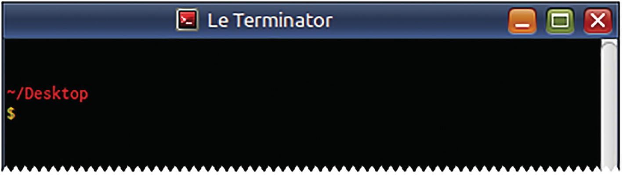
Figure 11-2Same as in the previous screenshot but with less information overload

File Manager Automation
The first rule of software development is “Give what the user wants.” This rule implies another thing – “Do not give what the user does not want.” But, it was not to be… When the Chrome browser was released, it lacked options to change important settings. Apologists claimed that most users did not need them or know how to use them. This was no accident. For several years, there had been a shift away from “More power to users” objective to “The user is stupid” mantra. In the open source community, Gnome 3 desktop environment project became plagued with this attitude. The project decided that users of their glorious touch-me-not desktop should not be allowed to customize or personalize anything. (Linus Torvalds finds GNOME 3.4 to be a “total user experience design failure”; 2012; ZDnet.com) Customization and changing default settings were compared to the tragedy that was known as Myspace personal pages. They claimed that users did not need extra features. Windows 8 developers also justified the destruction of their desktop in similar terms. They removed features and claimed it was an improvement. All kinds of snake oil was used to sell this deprivation of usability – “This is the new way of doing things,” “Don’t be stuck in old ways,” “You are unwilling to change,” “Embrace change,” and the dreaded “Change is goooooooood.”
Fortunately, not all developers succumbed to this impairment of judging faculties. Some of them developed the Mate (pronounced “mah-tay”) desktop environment that continued support for the intuitive and user-friendly Gnome 2.
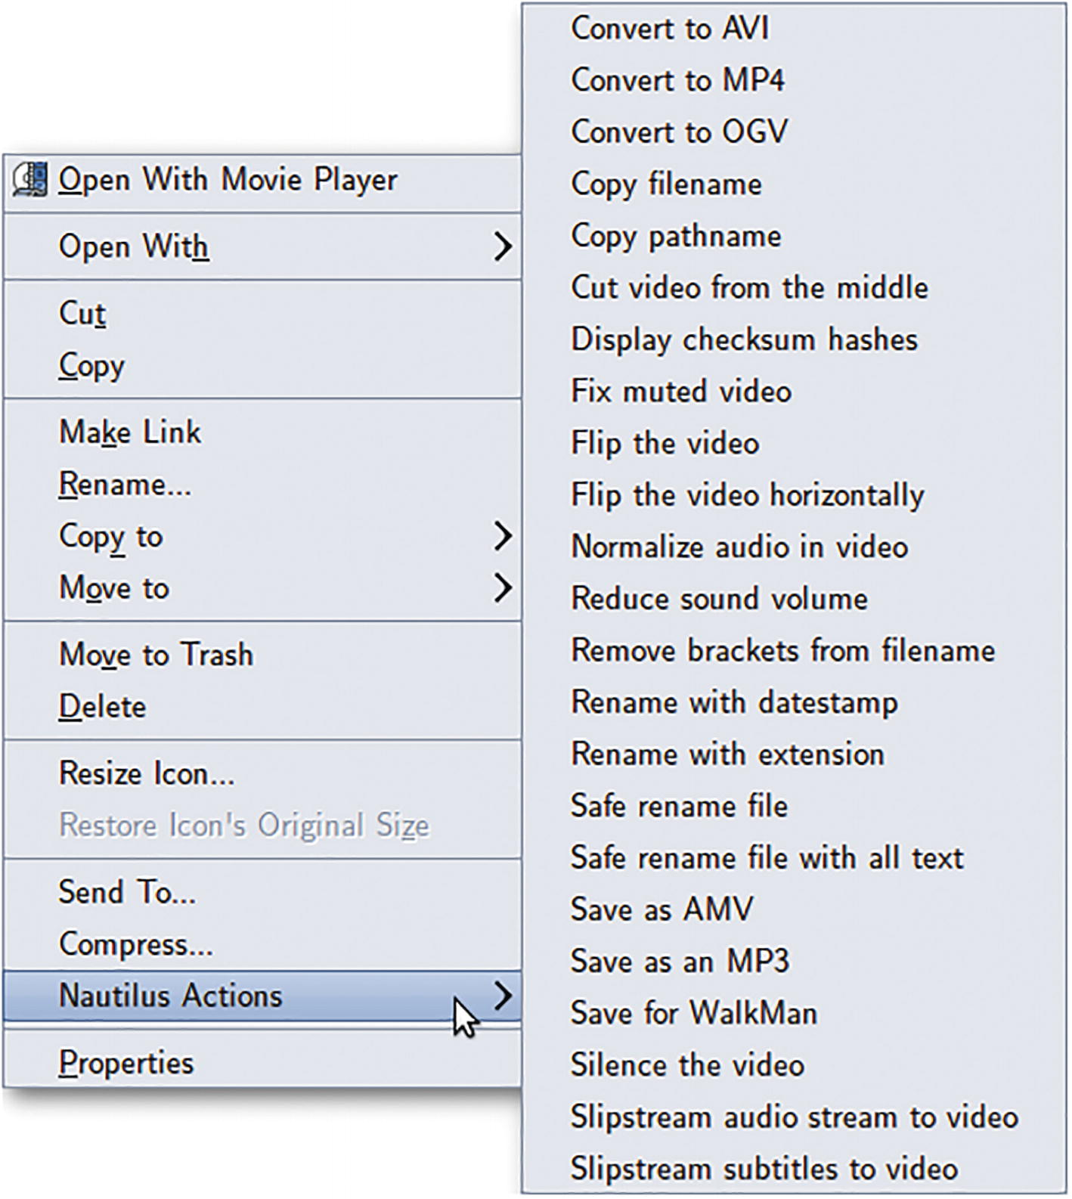
Figure 11-3In the year 2020, the context menu options in the file manager of my desktop became so heavy with FFmpeg automation scripts that I decided to write this book
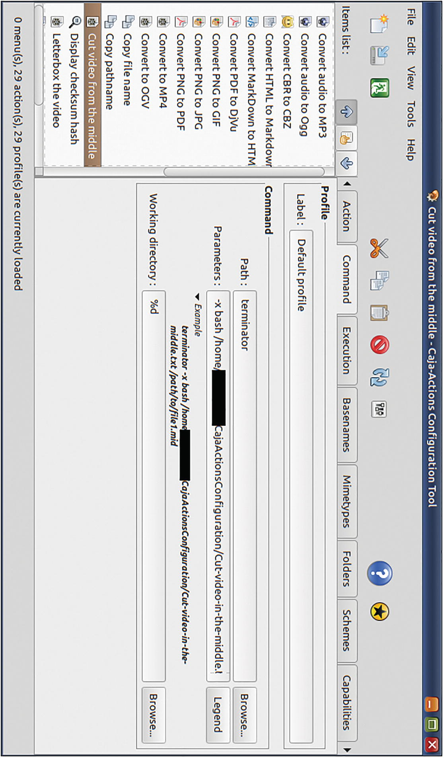
Figure 11-4In the Mate desktop, the file manager is called Caja. You can use the app Caja Actions Configuration to add your own custom context-sensitive menu options inside Caja
In Gnome 2, you could install Nautilus Actions Configuration to add custom context menu options to Nautilus, the default file and desktop manager. In Gnome 3, Nautilus lost most of its features and became frustratingly useless. Thankfully, however, the Mate desktop project continued support for Nautilus and forked it as Caja. Caja has a fork of the Nautilus Actions Configuration called Caja Actions Configuration.
Now, stop fighting with your desktop and switch to Mate. Write your own context menus and automate routine FFmpeg tasks. Writing long FFmpeg poems should be for greater things.

Hide the Banner
In older versions of FFmpeg, you could hide the big banner that it displays by redirecting it to the null device (2> /dev/null or 2> NUL). In new versions of FFmpeg, you can use the new -hide_banner option. Typing this option is a hassle, so it is better if you create command aliases as described in Chapter 2.
The log output of FFmpeg is classified into several types of information. You can use the -loglevel option to specify what types you would like to see. You can also choose to see nothing. Check the documentation for what you would like.
ffplay can be prevented from displaying a window or console output using the option -nodisp. This is useful when playing audio files in shell scripts.

Add an espeak Intro to Your MP3 Files
I have lots of vintage radio shows as MP3 files. My DIY boombox does not display any tags or filenames - only file numbers.
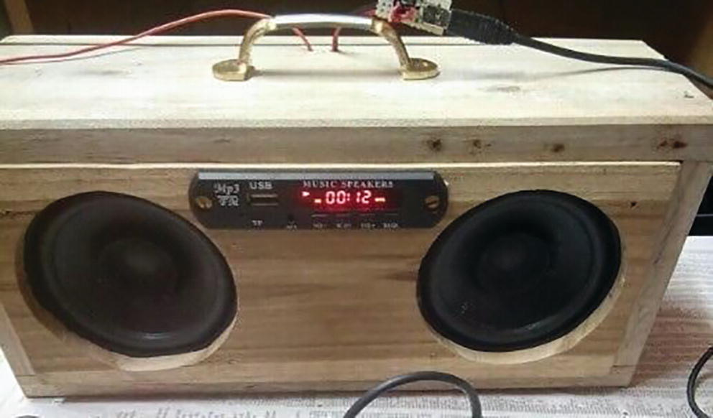
Figure 11-5I built this boombox. The MP3 player module’s display is limited to song numbers
I use a script that iterates through the MP3 files in a directory and adds an espeak intro to the files. If a file is named “Fibber-n-Molly-Fibber-Makes-His-Own-Chili-Sauce.mp3,” then espeak intelligently reads it out as “Fibber n Molly Fibber Makes His Own Chili Sauce.” This audio is first saved to a wave file and then concatenated to the MP3 file.
cd "$1" # Moves to a directory with MP3 files
if [ ! -d AnnD ]; then
mkdir AnnD
fi
for sFile in *.mp3
do
sFileName=${sFile%.*}
espeak -w "${sFileName}.wav" "$sFileName"
echo "Processing ${sFile}..."
ffmpeg -i "${sFileName}.wav" -i "$sFile" \
-filter_complex \
"[0:a:0][1:a:0]concat=n=2:v=0:a=1[outa]" \
-map_metadata 1 -
id3v2
_version 3 \
-map "[outa]" \
-c:a libmp3lame \
"AnnD/${sFileName}-AnnD.mp3" 2>
/dev/null
echo -e "\tsaved to AnnD/${sFileName}-AnnD.mp3"
rm "${sFileName}.wav"
done
Although FFmpeg can be used to tag MP3 files, I prefer to use EasyTAG instead. It has sophisticated options to mass-rename files and set MP3 tags. (I am not an FFmpeg fanatic and neither should you be one.) After I neatly tag and name the MP3 files, I let this FFmpeg script do its thing.
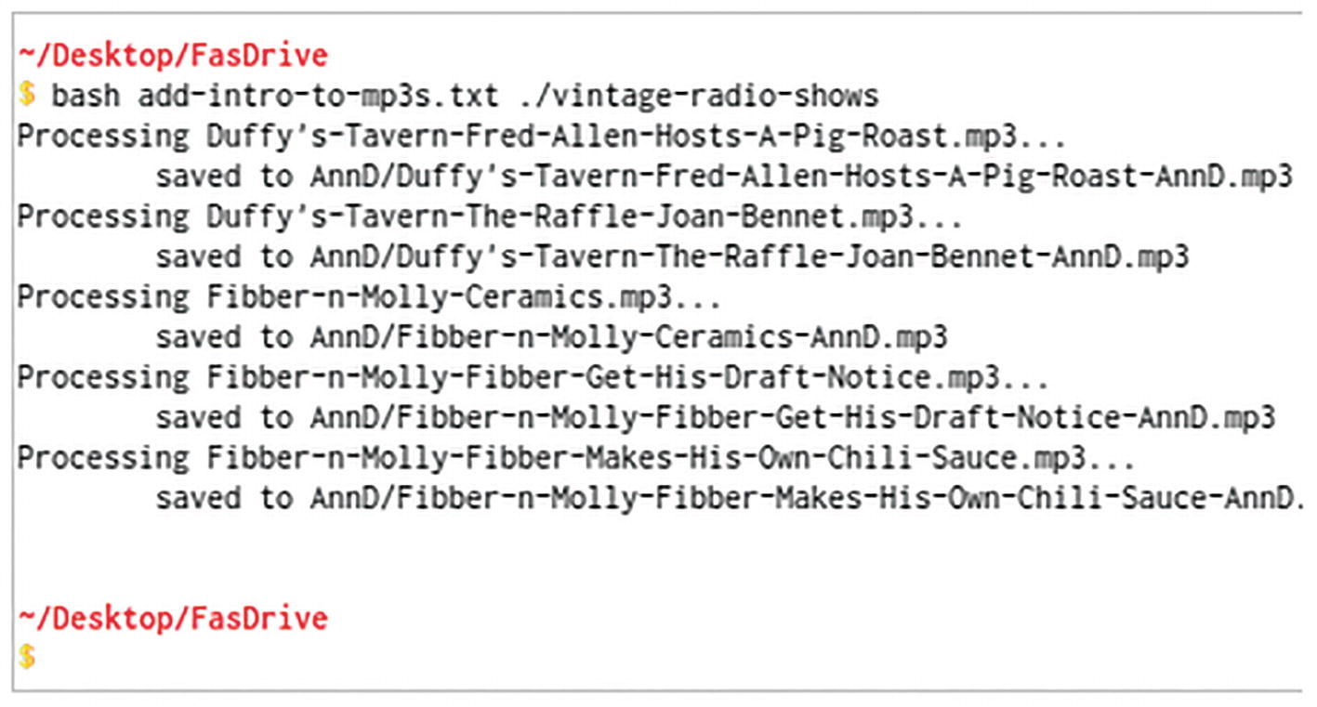
Figure 11-6If an MP3 file is informatively named, then this script can add a useful spoken introduction to it
I prefer espeak to libflite. However, unlike espeak, libflite has a female voice option.
ffmpeg -f lavfi -i "flite=textfile=speech.txt:voice=slt" \
speech.mp3

Best MP3 (MPEG 2 Audio Layer 3) Conversion Settings
MP3 is a lossy compression scheme for audio. When the bitrate is higher, the loss is minimized. This applies only when the source is of high quality. However, most people are unable to discern the difference between a song encoded at 64kbps and the same encoded at 320kbps. (It also depends on the equipment used to play the music.)
There are two popular methods of encoding MP3s - VBR (variable bitrate) and CBR (constant bitrate). With VBR, the bitrate rate changes over the length of playback and file size is optimized. CBR maintains the same bitrate throughout the length of the audio. When the same amount of data is used to encode data that is not much different, file size may be on the higher side.
MP3 processing (decoding and encoding) is a mature technology now and does not require a lot of processing power. There is no reason to use CBR. VBR is better because it focuses on quality.
To create a VBR MP3 file, use the -qscale:a option with the Lame MP3 encoder. The option’s range is 0 to 9. For close resemblance to the original, use a value from 0 to 3. For most people, however, a -qscale:a value of 4 is good enough.
ffmpeg -i uncompressed.wav \
-c:a libmp3lame \
-qscale:a 4
\
good.mp3
To create an old-school CBR MP3 file, use the b:a (bitrate) option.
ffmpeg -i uncompressed.wav \
-c:a libmp3lame \
-b:a 128k
\
goot.mp3

Colors in Hexadecimal
Any color can be represented as a combination of three color channels - red (R), green (G), and blue (B). Sometimes, a fourth value called alpha or transparency is also specified. When alpha is present, the colors can range from totally transparent to totally opaque. When alpha is not present, the color can range from black to the full color.
Colors are often represented in hexadecimal. This is a numbering system with a base of 16. It uses the numerals 0 to 9 and A to F.
When one hexadecimal digit is used, the values can range from 0 to 15.
With two digits (00 to FF), the range is 0 to 255.
Using these digit combinations,
Red can be represented as F00 (RGB), F00F (RGBA), FF0000 (RRGGBB), and FF0000FF (RRGGBBAA).
Blue can be represented as 00F, 00FF, 0000FF, and 0000FFFF.
Black is represented as 000, 000F, 000000, and 000000FF.
White is represented as FFF, FFFF, FFFFFF, and FFFFFFFF.
Half-transparent red can be represented as F007 or FF000077.
The alpha channel affects all the other three channels. It needs to be at its maximum value (F, FF) for a color to be totally opaque. If it is any less, the entire color will have some transparency, and any object below the color will show through it. If there are not more than one layer of colors, then alpha value has no relevance and will be ignored.
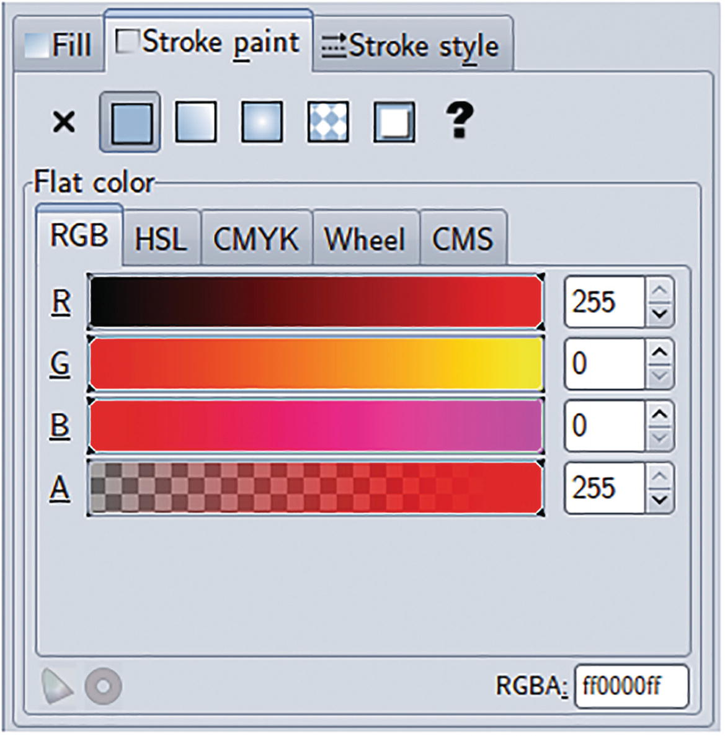
Figure 11-7Any image-editing application will have a color palette. This one is from Inkscape
For ffmpeg, colors are specified in the form of 0xRRGGBBAA. The AA part, standing for the alpha channel, is optional.

Colors in Literal
While you can specify colors in hexadecimal, FFmpeg also supports some literal names, as listed in Table 11-1. These are the same nonstandard color names that Microsoft introduced into Internet Explorer and forced Firefox to adopt them to maintain compatibility. In addition to these color names, you can also use the literal random and let FFmpeg choose a color by random.
Table 11-1Color names supported by FFmpeg
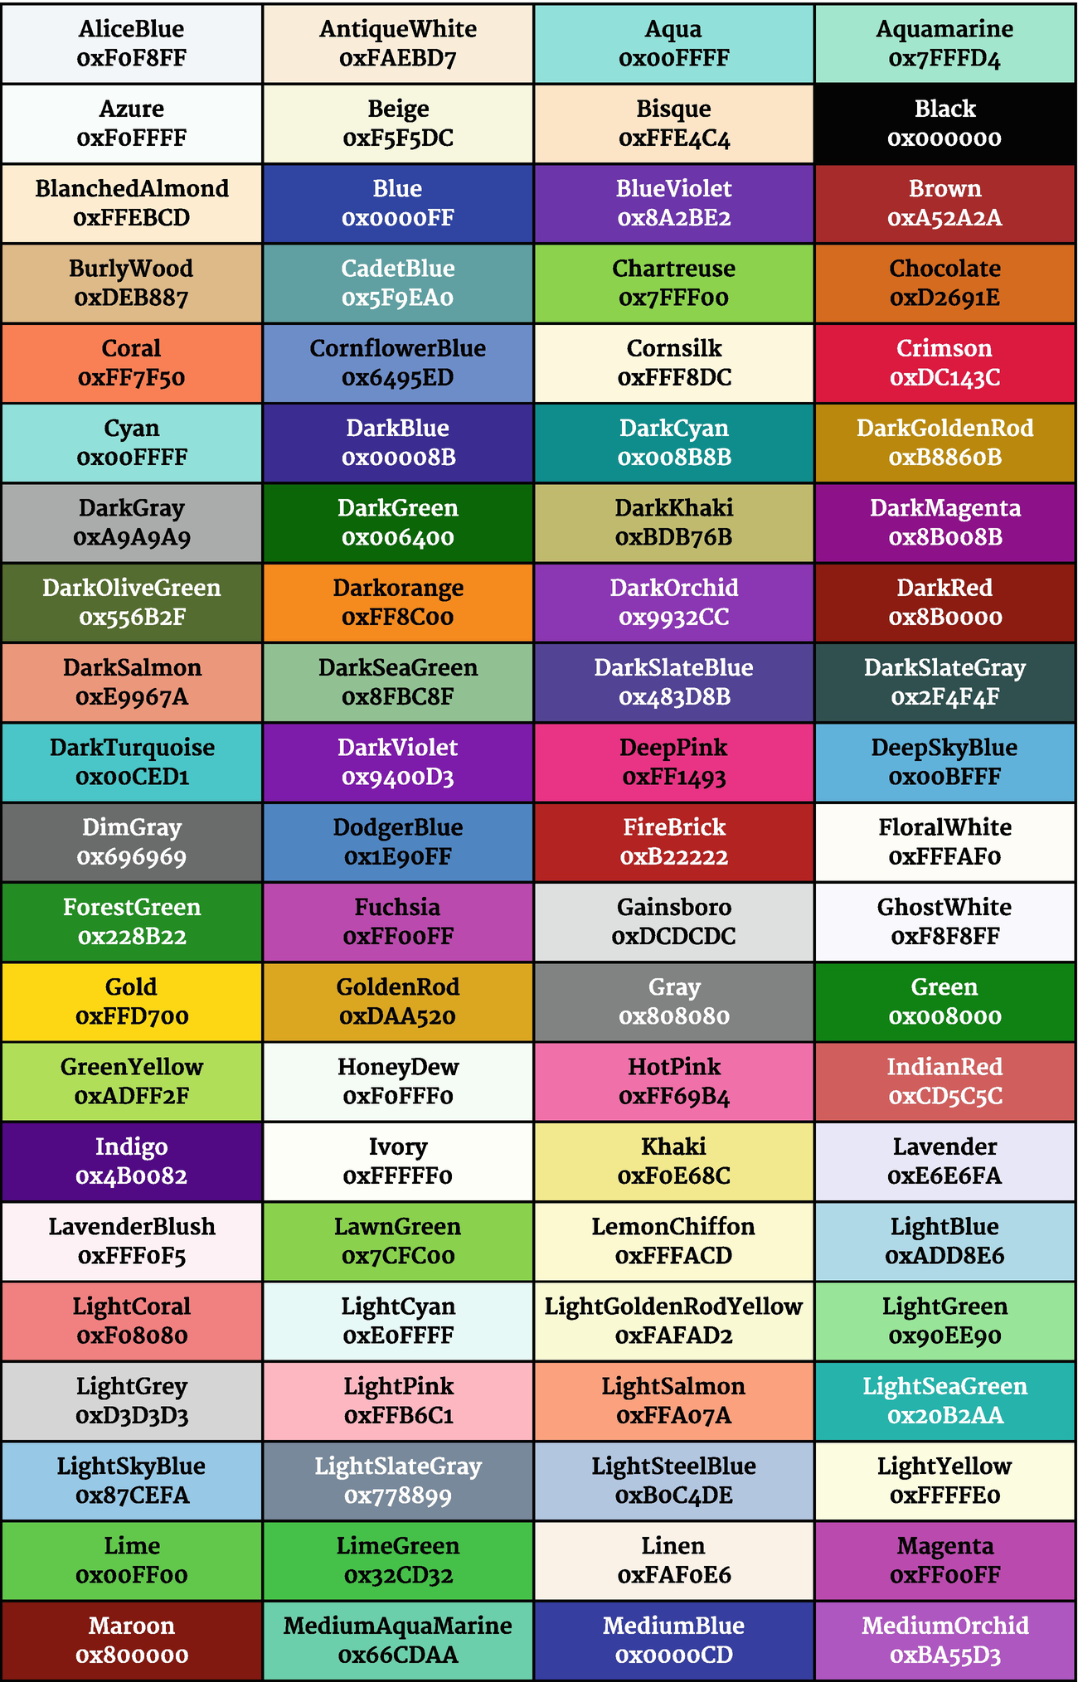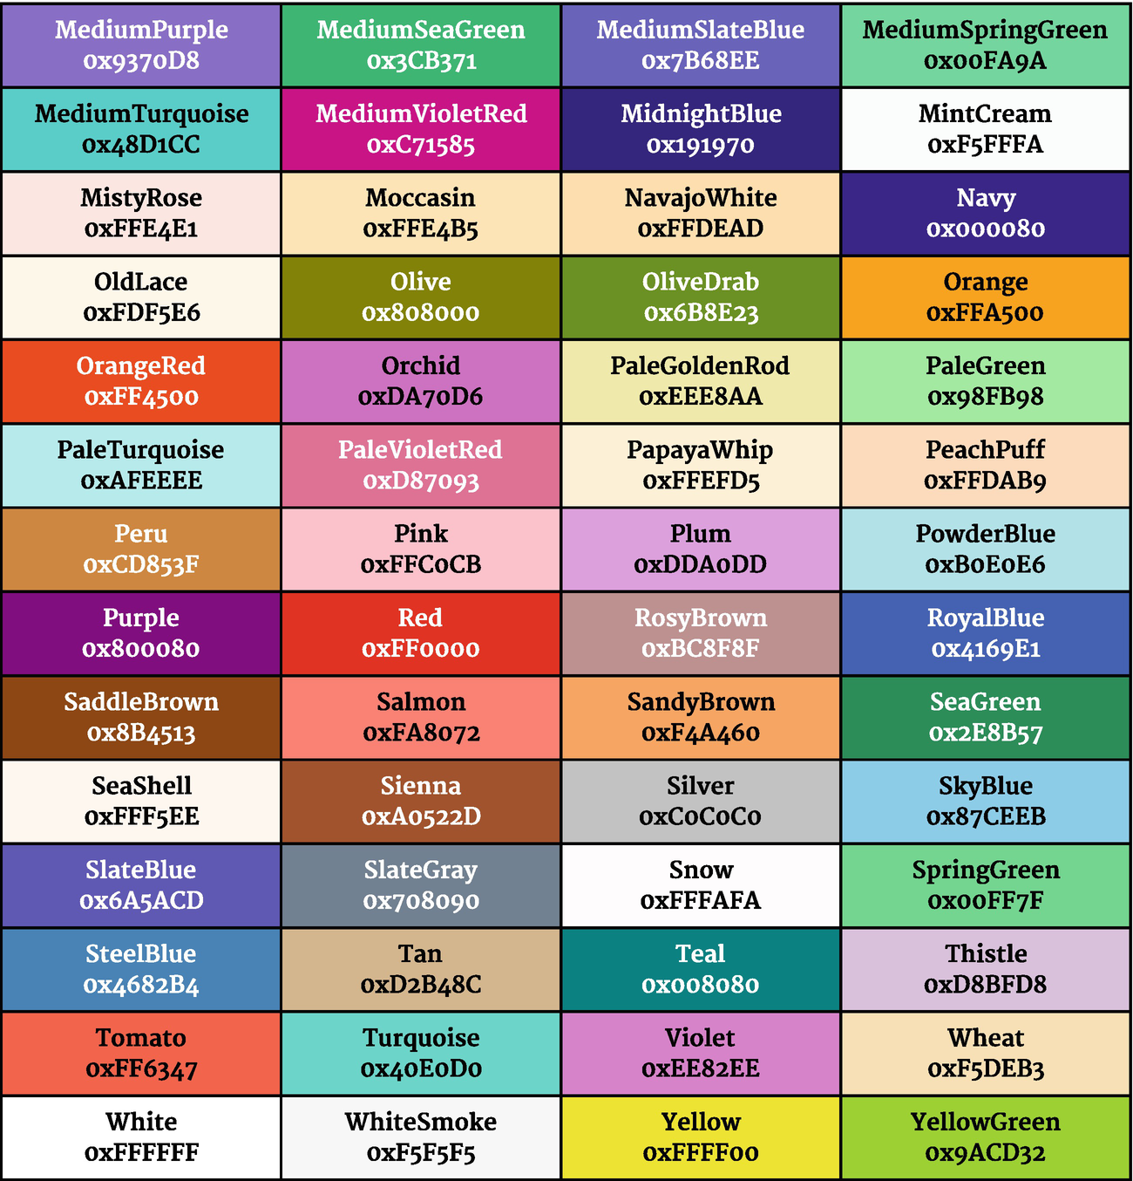

Streams Information from ffprobe
ffprobe can display precise and structured information about a media file that can be filtered by your shell scripts or software programs for further processing.
ffprobe
-show_streams
-i somefile.mp4
The output of the preceding command is as printed in the following.
[STREAM]
index=0
codec_name=h264
codec_long_name=H.264 / AVC / MPEG-4 AVC / MPEG-4 part 10
profile=High
codec_type=video
codec_tag_string=avc1
codec_tag=0x31637661
width=640
height=480
coded_width=640
coded_height=480
closed_captions=0
film_grain=0
has_b_frames=2
sample_aspect_ratio=4:3
display_aspect_ratio=16:9
pix_fmt=yuv420p
level=30
color_range=unknown
color_space=unknown
color_transfer=unknown
color_primaries=unknown
chroma_location=left
field_order=progressive
refs=1
is_avc=true
nal_length_size=4
id=0x1
r_frame_rate=90000/2999
avg_frame_rate=90000/2999
time_base=1/90000
start_pts=0
start_time=0.000000
duration_ts=1802399
duration=20.026656
bit_rate=488521
max_bit_rate=N/A
bits_per_raw_sample=8
nb_frames=601
nb_read_frames=N/A
nb_read_packets=N/A
extradata_size=40
DISPOSITION:default=1
DISPOSITION:dub=0
DISPOSITION:original=0
DISPOSITION:comment=0
DISPOSITION:lyrics=0
DISPOSITION:karaoke=0
DISPOSITION:forced=0
DISPOSITION:hearing_impaired=0
DISPOSITION:visual_impaired=0
DISPOSITION:clean_effects=0
DISPOSITION:attached_pic=0
DISPOSITION:timed_thumbnails=0
DISPOSITION:captions=0
DISPOSITION:descriptions=0
DISPOSITION:metadata=0
DISPOSITION:dependent=0
DISPOSITION:still_image=0
TAG:language=eng
TAG:handler_name=VideoHandle
TAG:vendor_id=[0][0][0][0]
[/STREAM]
[STREAM]
index=1
codec_name=aac
codec_long_name=AAC (Advanced Audio Coding)
profile=LC
codec_type=audio
codec_tag_string=mp4a
codec_tag=0x6134706d
sample_fmt=fltp
sample_rate=48000
channels=2
channel_layout=stereo
bits_per_sample=0
id=0x2
r_frame_rate=0/0
avg_frame_rate=0/0
time_base=1/48000
start_pts=0
start_time=0.000000
duration_ts=960000
duration=20.000000
bit_rate=129267
max_bit_rate=N/A
bits_per_raw_sample=N/A
nb_frames=939
nb_read_frames=N/A
nb_read_packets=N/A
extradata_size=5
DISPOSITION:default=1
DISPOSITION:dub=0
DISPOSITION:original=0
DISPOSITION:comment=0
DISPOSITION:lyrics=0
DISPOSITION:karaoke=0
DISPOSITION:forced=0
DISPOSITION:hearing_impaired=0
DISPOSITION:visual_impaired=0
DISPOSITION:clean_effects=0
DISPOSITION:attached_pic=0
DISPOSITION:timed_thumbnails=0
DISPOSITION:captions=0
DISPOSITION:descriptions=0
DISPOSITION:metadata=0
DISPOSITION:dependent=0
DISPOSITION:still_image=0
TAG:language=eng
TAG:handler_name=SoundHandle
TAG:vendor_id=[0][0][0][0]
[/STREAM]
This output can be narrowed down to a particular stream using the select_streams option.
ffprobe -show_streams -select_streams v:0 \
-i somefile.mp4 2>
/dev/null
This option can also be output in several other formats such as ini and CSV. For more information, check the documentation that came with your version of FFmpeg.
ffprobe -show_streams
-select_streams
v:0 \
-print_format csv
\
-i somefile.mp4 > somefile-videostream-info.csv
With the -sections option, you can find out how the streams information is organized.
ffprobe -sections
This is the output:
Sections:
W.. = Section is a wrapper (contains other sections,⏎
no local entries)
.A. = Section contains an array of elements of the⏎
same type
..V = Section may contain a variable number of fields⏎
with variable keys
FLAGS NAME/UNIQUE_NAME
---
W.. root
.A. chapters
... chapter
..V tags/chapter_tags
... format
..V tags/format_tags
.A. frames
... frame
..V tags/frame_tags
.A. side_data_list/frame_side_data_list
... side_data/frame_side_data
.A. timecodes
... timecode
.A. components
... component
.A. pieces
... section
.A. logs
... log
... subtitle
.A. programs
... program
..V tags/program_tags
.A. streams/program_streams
... stream/program_stream
... disposition/program_stream_disposition
..V tags/program_stream_tags
.A. streams
... stream
... disposition/stream_disposition
..V tags/stream_tags
.A. side_data_list/stream_side_data_list
... side_data/stream_side_data
.A. packets
... packet
..V tags/packet_tags
.A. side_data_list/packet_side_data_list
... side_data/packet_side_data
... error
... program_version
.A. library_versions
... library_version
.A. pixel_formats
... pixel_format
... flags/pixel_format_flags
.A. components/pixel_format_components
... component
To display a particular key, say “duration,” I can use the -show_entries option.
ffprobe
-select_streams
v:0 \
-show_entries "stream=duration"
\
-i somefile.mp4 2>
/dev/null
[STREAM]
duration=20.026656
[/STREAM]
To eliminate section headers and key name, I use the -print_format option.
ffprobe -select_streams v:0 \
-show_entries "stream=duration" \
-print_format "default=nokey=1:noprint_wrappers=1"
\
-i somefile.mp4 2> /dev/null
Cue heavenly music!
20.026656
Now, the command output contains just the duration value. Similarly, other details about an input file can be atomized. Your shell script or some other program can capture these values for further processing.
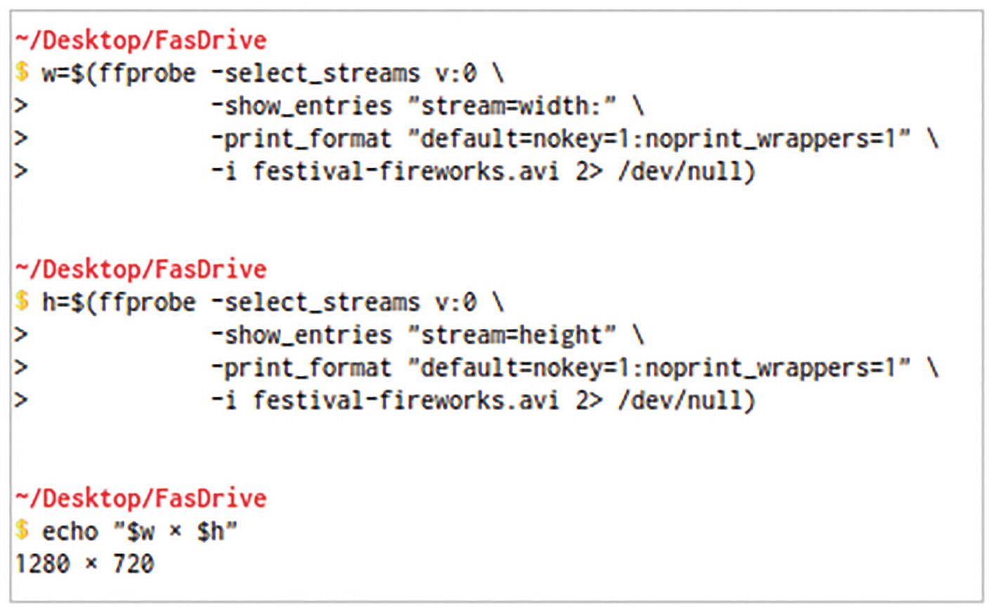
Figure 11-8ffprobe output can be filtered for obtaining precise information about a multimedia file. This information can be stored in memory variables for further use in shell scripts

Extract Non-pixelated Images from a Video
When a video undergoes lossy compression, there are bound to be some artifacts in any still images that you extract from it. If the bitrate is low or there is a lot of fast-paced action, the artifacts can be impossible to ignore. You have a better chance at obtaining high-quality stills if you extract only the I frames in the video. I frames or key frames in a video stream have all the data to form a full image. There are other frames, known as P frames, that are immediately before and after an I frame that do not have all the data. Their data is limited to those regions of the frame that are different from the nearest I frame. When you extract still images, FFmpeg tries to recreate a full frame using data from several frames. As not all of them are likely to be I frames, there may be some inevitable pixelation.
ffmpeg -y -i train.mp4 \
-r 1 \
-f image2 \
nofilter-still%02d.jpg
ffmpeg -y -skip_frame nokey -i train.mp4 \
-r 1 \
-f image2 \
filter-still%02d.jpg
The preceding first command tries to extract frames as usual without any discrimination. The second command picks only I frames, which are most likely to be without much pixelation.
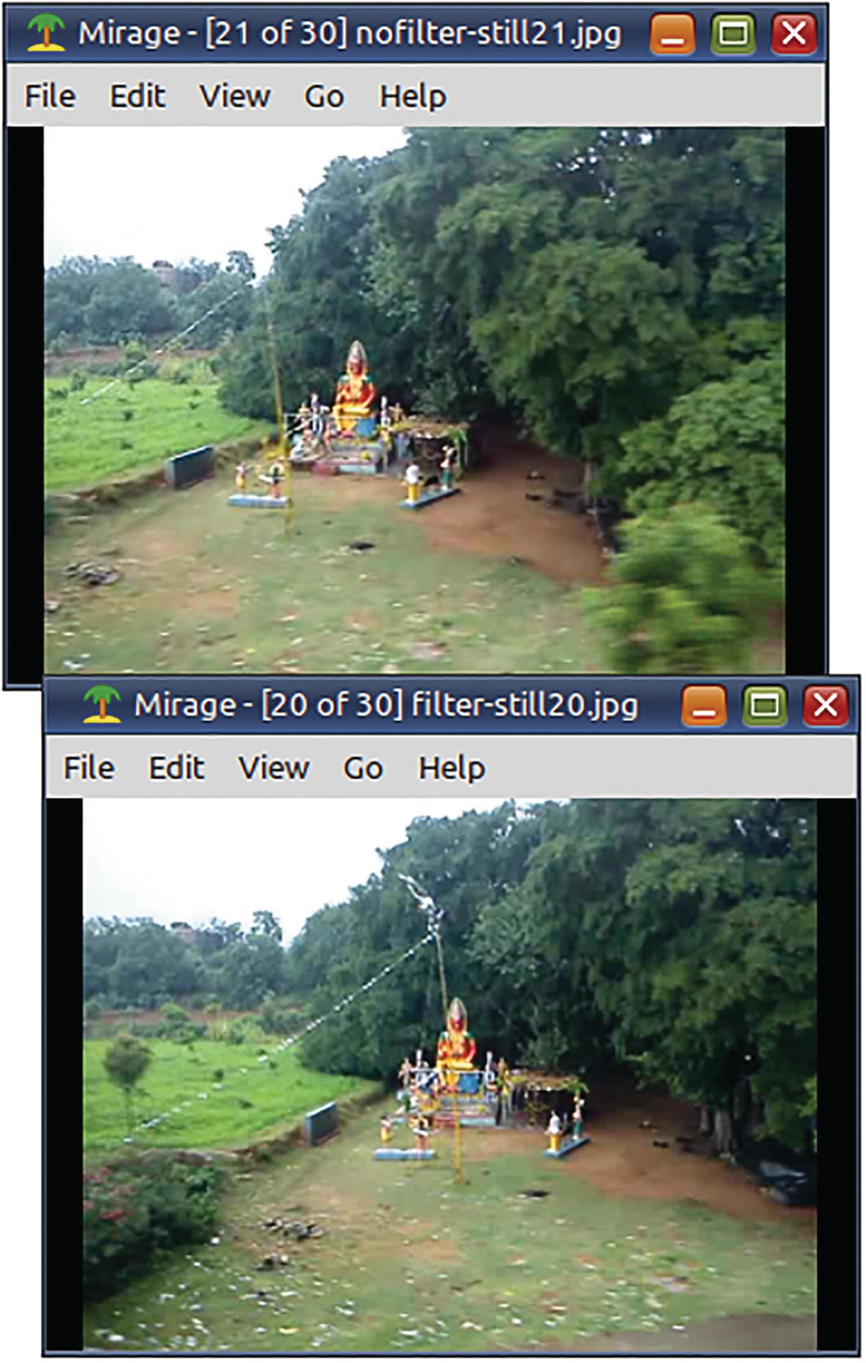
Figure 11-9The source video was taken from a moving train. The first command took still images at regular intervals without consideration for image quality. The second command only took the I frames with maximal detail and less pixelation
If you want a good-quality still from a particular timestamp, try something like this:
ffmpeg -y -ss 0:0:20 -skip_frame nokey -i aero-india.mp4 \
-frames:v 1 -f image2 \
still20.jpg
This command takes a still after the 20-second mark. When there is a lot of action at that timestamp, ffmpeg may not be able to find an I frame there, and this may result in some inevitable pixelation.

Create a Thumbnail Gallery for a Video
This shell script creates a 3x3 tiled gallery of thumbnails at one-third of the dimensions of the original video.
#!/bin/bash
# BASH script to create a 3x3 thumbnail gallery for a video
# Accepts the pathname of the video as argument ($1)
###########################################################
# Floating point number functions by Mitch Frazier
# Adapted from
# https://www.linuxjournal.com/content/floating-point-math-bash
###########################################################
# Default scale
used by float functions
float_scale=2
# Evaluate a floating point number expression.
function float_eval() {
local stat=0
local result=0.0
if [[ $# -gt 0 ]]; then
result=$(echo "scale
=$float_scale; $*" | bc -q 2>/dev/null)
stat=$?
if [[ $stat -eq 0 && -z "$result" ]]; then
stat=1
fi
fi
echo $result
return $stat
}
# Evaluate a floating point number conditional expression.
function float_cond() {
local cond=0
if [[ $# -gt 0 ]]; then
cond=$(echo "$*" | bc -q 2>/dev/null)
if [[ -z "$cond" ]]; then
cond=0
fi
if [[ "$cond" != 0 && "$cond" != 1 ]]; then
cond=0
fi
fi
local stat=$((cond == 0))
return $stat
}
###########################################################
# Floating point number functions end
# Prefix for images
FILE_NAME=${1%.*}
#echo $FILE_NAME
NUMBER_OF_THUMBNAILS=9
MOVIE="$1"
COUNTER=0
# Number of seconds
MOVIE_DURATION=$(ffprobe \
-show_entries "format=duration" \
-of "default=nokey=1:noprint_wrappers=1" \
-i $MOVIE 2> /dev/null)
#echo $MOVIE_DURATION
MOVIE_WIDTH=$(
ffprobe
-select_streams
v:0 \
-show_entries "stream=width:" \
-print_format \
"default=nokey=1:noprint_wrappers=1" \
-i $MOVIE 2> /dev/null)
MOVIE_HEIGHT
=$(
ffprobe
-select_streams v:0 \
-show_entries "stream=height" \
-print_format \
"default=nokey=1:noprint_wrappers=1" \
-i $MOVIE 2> /dev/null)
#echo "$MOVIE_WIDTH x $MOVIE_HEIGHT"
TW=$(float_eval "$MOVIE_WIDTH/3")
TH=$(float_eval "$MOVIE_HEIGHT/3")
THUMB_WIDTH=${TW%.*}
THUMB
_HEIGHT=${TH%.*}
#echo "$THUMB_WIDTH x $THUMB_HEIGHT"
for i in $(seq $NUMBER_OF_THUMBNAILS)
do
let COUNTER=COUNTER+1
#echo $COUNTER
LOCATION_FLOAT=$(float_eval \
"($i-0.5)*$MOVIE_DURATION/$NUMBER_OF_THUMBNAILS")
#echo $LOCATION_FLOAT
LOCATION_INT=${LOCATION_FLOAT%.*}
#echo $LOCATION_INT
# Create the thumbnails
ffmpeg
-y -skip_frame nokey
-ss $LOCATION_INT -i $MOVIE \
-frames:v 1 \
-s ${THUMB_WIDTH}x${THUMB_HEIGHT} \
"${FILE_NAME}_${COUNTER}.jpg"
done
# Create the gallery
montage
-density 96 -tile 3x3 -geometry +4+4 \
-border 1 "${FILE_NAME}*.jpg" \
"${FILE_NAME}-thumbnail.jpg“
☞ This script is my implementation of a pseudocode found at https://superuser.com/a/821680.
The last command in the shell script uses ImageMagick, which is a powerful open source program for processing images.
This script can be easily modified for greater grid sizes. It is also very fast, as it quickly skips to different locations in the file to take the thumbnail snapshots. It does not parse through the entire file.
The script only picks I-frame images from the file. Totem media player creates a thumbnail gallery similar to this. It is very fast but its thumbnails are just equidistant in time. They are not necessarily high-quality images.
When you run this script on a video file, pass its pathname as the first argument:
bash create-thumbnail-gallery.txt festival-fireworks.avi
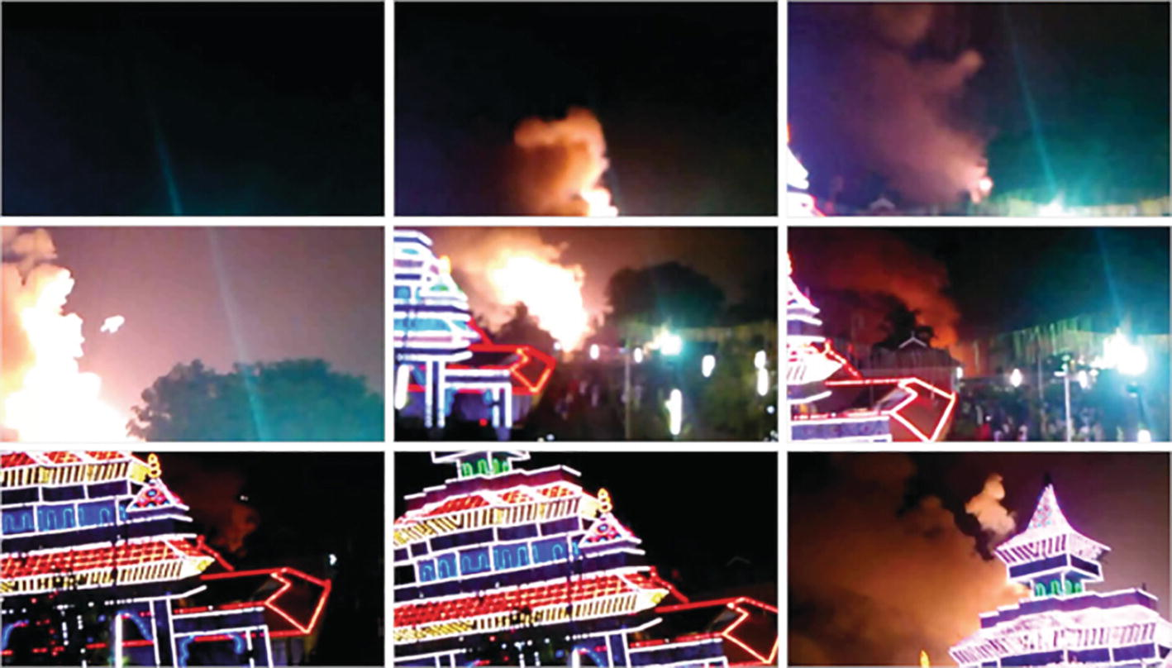
Figure 11-10The Totem media player creates a thumbnail gallery much faster than this script. However, it does not find I frames like this script does. With I frames, you get more detail

Record from Microphone
A PC may have more than one sound device - built-in sound card, the webcam, HDMI output audio, and sometimes even a USB microphone. In Linux, these sound cards are identified as hw:0, hw:1…. You have to find which one you are using or what can record audio through its microphone. Check your desktop sound configuration utility, and ensure that it is responding to noises in your room. After this,
Type alsamixer in Terminal.
Press F6 key to display the list of cards. Make a note of the number of the card, as you will need it later.
After selecting the card, press the F2 to display the list of devices on that card. Select /proc/sound/devices to check if you have an audio capture device on that card.
Exit alsamixer by pressing the Esc key.
If you are then able to record from the device using the number of the card with this command, then you are all set to record from the microphone.
ffmpeg -f alsa -i
hw:1
-t 10 microphone-test.mp3
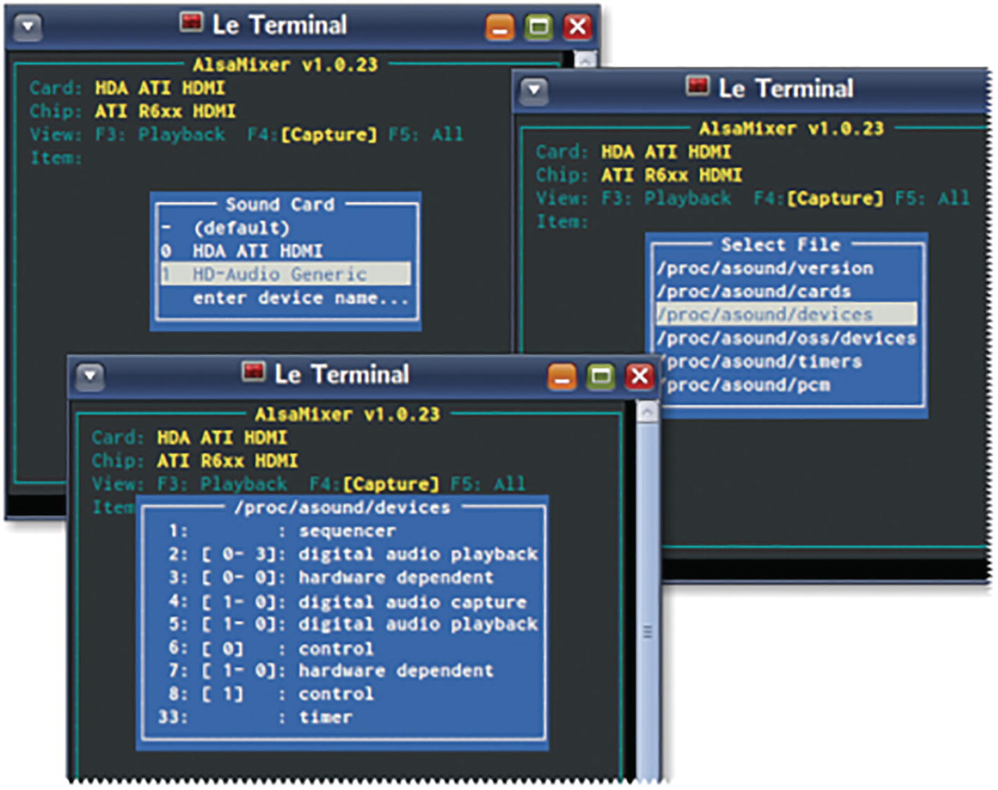
Figure 11-11A console-based volume control utility for the ALSA sound system
If you are still unable to record, then audio capture may have been disabled.
Type the command amixer -c followed by the number of the sound card.
Note the name of the device for the microphone. Usually, it is named Mic or Internal Mic.
Type a command like amixer -c 1 sset Mic,0 mute cap. This ensures that the sound captured from the second sound card (1) is not played back (mute) but is available for recording (cap).
If you have made changes to your audio configuration, it is best if you restart the OS and try again. If nothing works, then try the PulseAudio (-i pulse) hack.
ffmpeg -f alsa -i pulse -t 10 microphone-pulse-test.mp3

Record from Webcam
Recording from a webcam or grabbing the screen output in Windows is not easy. There is a FOSS tool called CamStudio that internally uses FFmpeg. If you are able to use it, then follow the FFmpeg Wiki on the topic.
In Linux, things are very easy. Even then, install Cheese or a similar webcam application before you use ffmpeg. Ensure that the device is working properly. Check the preferences and leave it at the best settings. Then, close it and try this ffmpeg command:
ffmpeg -y
-f v4l2 \
-i /dev/video0
\
-s vga -r 12 -b:v 466k \
-t 0:0:10 \
webcam.ogv
☞ Where did I get this /dev/video0 thingy? Install v4l-ctl or v4l-utils and type the command v4l2-ctl --list-devices.
☞ To tell you the truth, I do not use webcams anymore. This command was tested on an ancient Logitech cam that still works fine. Check the settings supported by your hi-res Hasselblad, and update the size and bitrate options accordingly.
You can simultaneously capture from your webcam and microphone.
ffmpeg -
f v4l2
-r 12 -s qvga
-i /dev/video0
\
-f alsa -i hw:1
\
-t 0:0:6 \
webcam2.ogv
On my old laptop (with a new OS), this command struggles to record the audio. With the PulseAudio hack, it magically starts working fine.
ffmpeg
-f v4l2
-r 12 -s qvga -
i /dev/video0
\
-f alsa -i pulse
\
-t 0:0:6 \
webcam3.ogv

Screen Capture
The -f x11grab format option can be used to capture the video display (-i :0.0, known as X in Linux). You need to specify the capture settings in the order given here, that is, -f, -s, -i, and -b. The frame rate can be 12 at the minimum. Otherwise, the output capture file will be very big.
ffmpeg -y
-f x11grab -s 1366x768
-r 12 \
-i :0.0 \
-b:v 1024k \
-t 0:0:10 \
screen.ogv
☞ Replace the value for the -s option with the pixel resolution of the screen you are trying to grab.
While screen capturing, use a high bitrate so that as much data is captured. The capture will be lag-free if the CPU is not tied up with real-time compression (encoding). You can compress the file to your heart’s content after the capture but not during it.
To capture a part of the screen, add the x- and y-offsets of the region in the -i option.
# Records a 600×600 region at 100,100 pixels
# from the top-left corner.
ffmpeg -y -f x11grab
-s 600x600
-r 12 \
-i :0.0
+100,100
\
-b:v 1024k \
-t 0:0:10 \
screen-region.ogv
You can capture sound playing on the speakers while you grab the screen. The input to capture (sound mixer) is not easy to nail down on my computer, so this command uses the PulseAudio hack (-i pulse) again.
ffmpeg -f x11grab -s 1366x768 -r 12 -i :0.0 \
-f alsa -i pulse \
-b:v 2024K -b:a 128K \
-ac 2 \
-t 0:0:10 \
-y screen2.ogv

Render an Animated GIF on a Video
Humble as it is, an animated GIF can be more dramatic than a static JPEG or PNG. For this example, I rendered a GIF animation that I use on my website over a demo video that I created for my Android browser.
ffmpeg -y -i subhash-browser-rss-demo.mp4 \
-ignore_loop 0 -i animation-download.gif \
-filter_complex \
"[0:v:0]overlay=(W-w-10):(H-h)/2:shortest=1[v]" \
-map '[v]' -map 0:a:0 \
-c:v libx264 -c:a copy \
subhash-browser-rss-demo-with-download-button.mp4
If I were to upload this demo to a video-hosting site, I could add an interactive download link to the region where the animated GIF is playing on the video. When I used the overlay filter with a GIF on a video, the animation played once and then stopped. I found a solution to this problem, that is, -ignore_loop 0, hidden in the help output of the GIF demuxer (ffmpeg -h demuxer=gif). This however had a limitation in that the looping is limited to whatever value the GIF image is set to. This could be infinite or 1 to 65535 times. If it was set to a finite number, then the looping would have stopped eventually.
A better approach is to use the -stream_loop option so that you can specify the looping instead of the GIF image. You can set this option to the number of loops, 0 for no looping or -1 for indefinite looping.
ffmpeg -y -i subhash-browser-rss-demo.mp4 \
-stream_loop -1 -i animation-download.gif \
-filter_complex \
"[0:v:0]overlay=(W-w-10):(H-h)/2:shortest=1[v]" \
-map '[v]' -map 0:a:0 \
-c:v libx264 -c:a copy \
subhash-browser-rss-demo-with-download-button.mp4
The -shortest option in the overlay filter ensures that the filter processing ends when the output from the video file has been completed. Otherwise, the endlessly looping GIF animation will continue the processing forever.
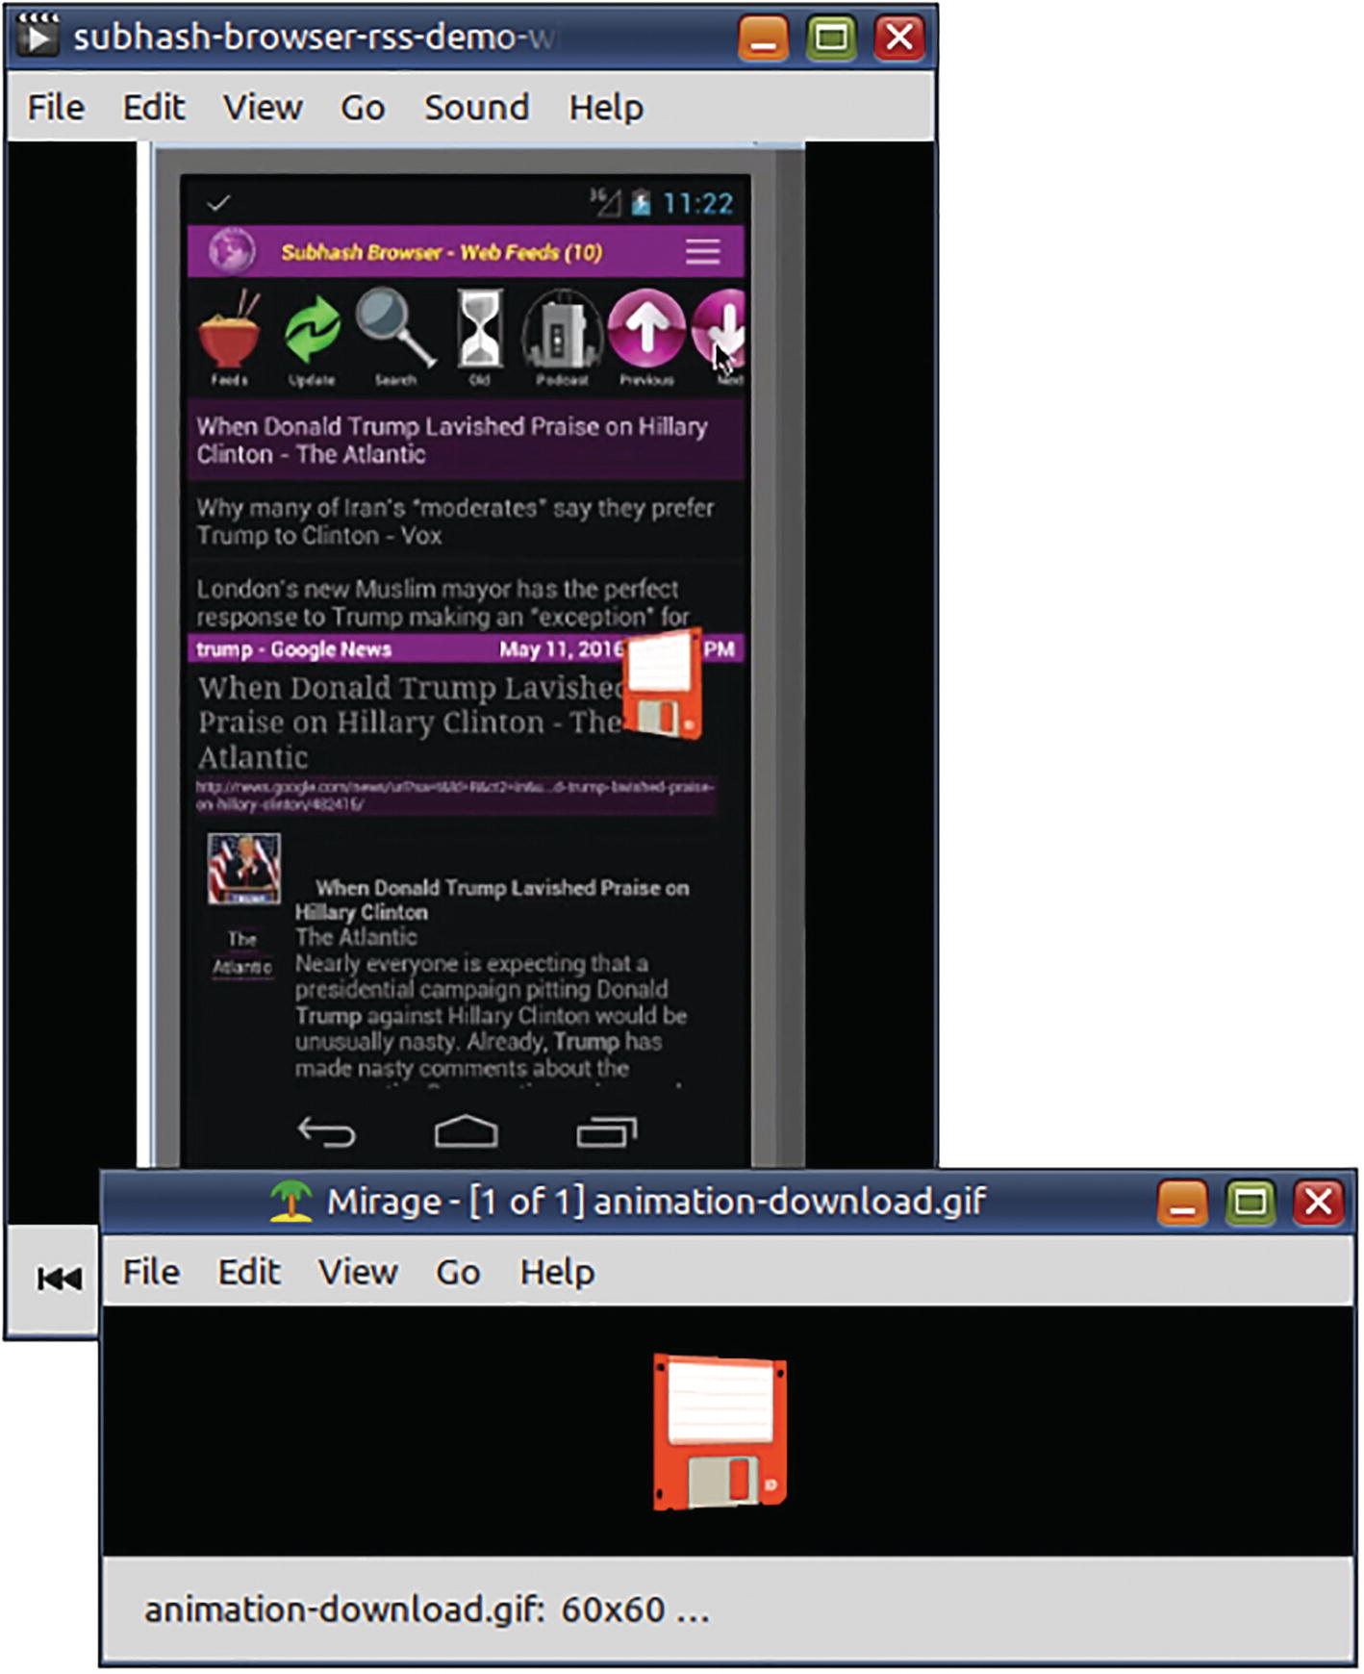
Figure 11-12This GIF is also animated over the video in the background window

Show a Timer on the Video
The drawtext filter has a timecode option that can be used in place of the text option. To ensure that the timer is accurate, the timecode_rate should be the same as the frame rate of the video. (Use ffprobe for obtaining the exact value.)
ffmpeg -y -i rollcage-video.mp4 \
-filter:v \
"drawtext=:x=100:y=h-lh-100:
shadowcolor=FFFFFF66:shadowx=1:shadowy=2:
fontfile=Time.ttf:fontcolor=00000066:fontsize=70:
timecode=\'00\:00\:00\:00\':timecode_rate=29.91
" \
race-timer.mp4
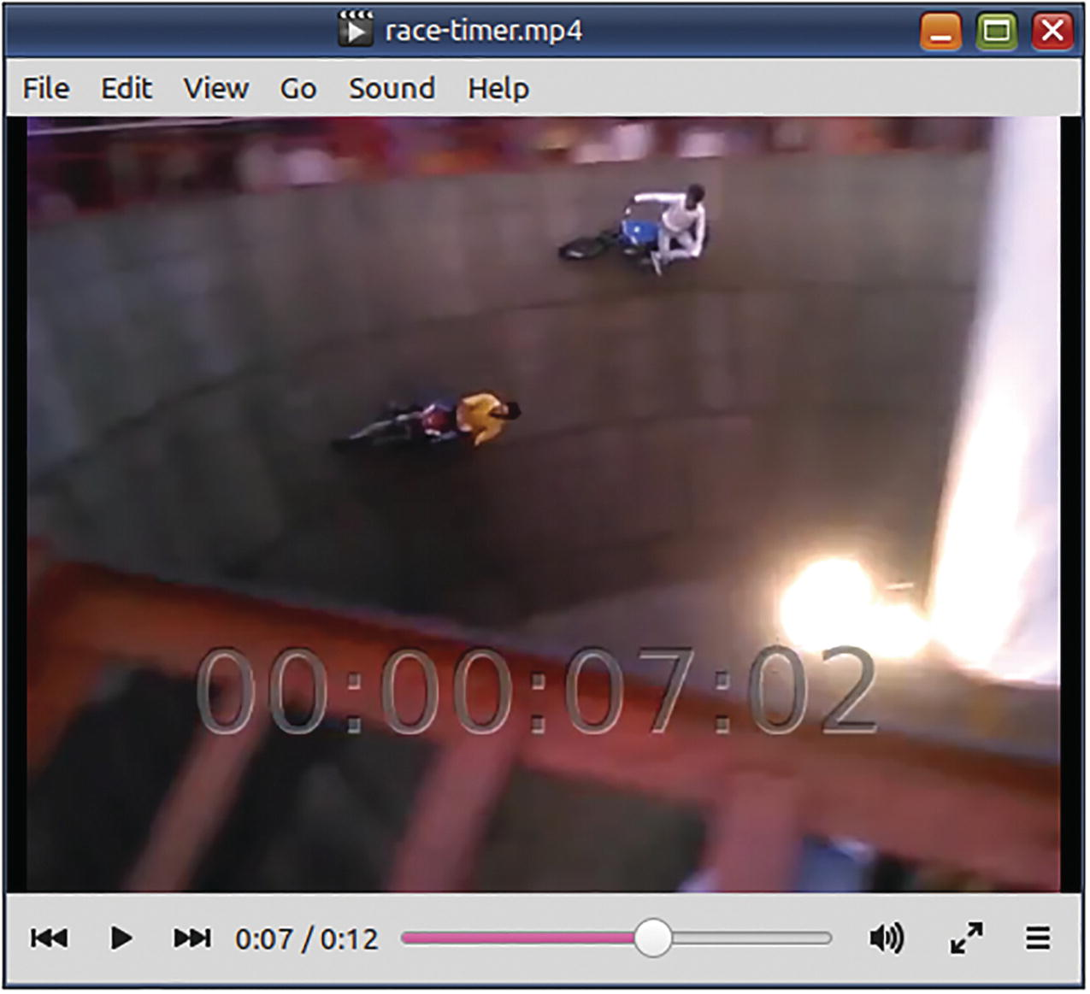
Figure 11-13This command uses an option of the drawtext filter to render a timer on the video

Create a Silent Ringtone
Some mobile phones do not have a silent ringtone. This can prevent you from silencing certain obnoxious contacts. You can use the anullsrc filter to create a silent ringtone.
ffmpeg -f lavfi \
-i
anullsrc
\
-vn -t 0:0:12 -b:a 128k -c:a libmp3lame \
silent.mp3
This command uses the filter as a virtual input file. The anullsrc filter does not require an input file. By default, it generates a 44100 Hz wave as output. This one will have no sound though.

Create a Countdown Beep Audio
Television quiz shows usually play a timer-countdown audio with a beep every second. Can you create it using FFmpeg?
ffplay
-f lavfi \-i "
sine=frequency=220:beep_factor=3:duration=20
"
ffmpeg -f
lavfi
\
-i "
sine=frequency=220:beep_factor=3:duration=20
" \sine.
wav
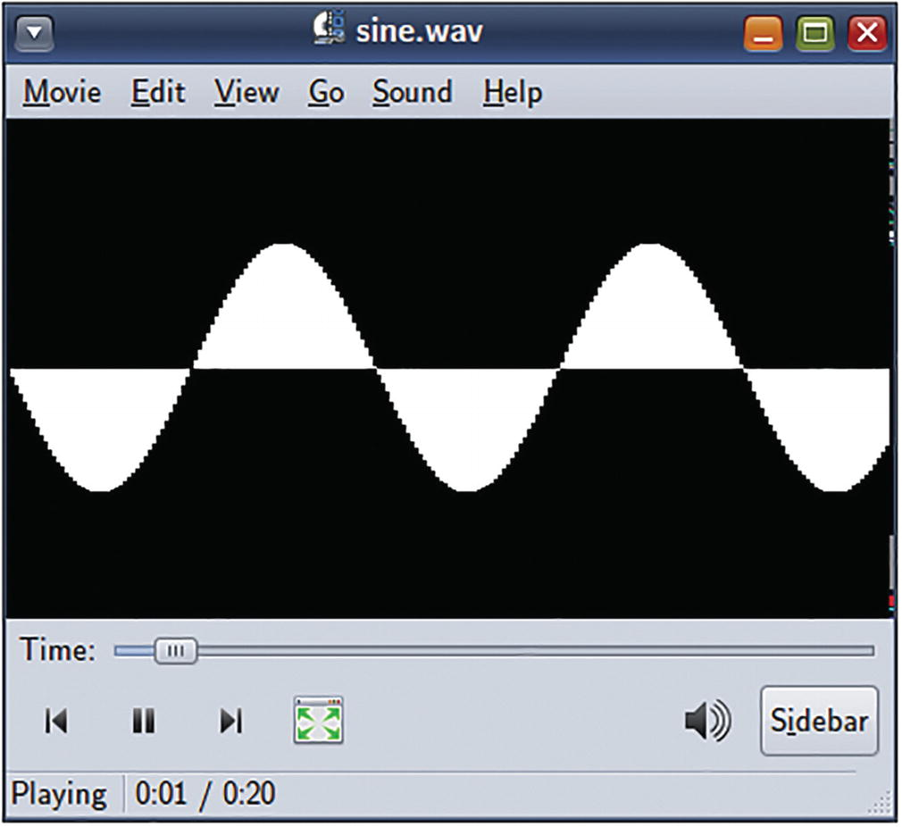
Figure 11-14The visualization feature of this media player confirms that the audio is a sine wave
For more customized waveforms, the aevalsrc filter can be used.
ffmpeg -f
lavfi
\
-i
aevalsrc='sin(1000*PI*t*lt(t-trunc(t)\,0.1))'
\
-t 0:0:20
sine.
wav

Generate Noise of a Certain “Color”
FFmpeg can generate noise in several “colors” - white, pink, brown, blue, violet, and velvet.
ffplay -f
lavfi
-showmode 0 -i 'anoisesrc=color=brown'
The “brown” noise is closer to the sound that a TV generates when its CATV signal cable is unplugged.
ffmpeg -y -i barbara.mp4 \
-filter_complex \
"[0:v:0]
noise
=alls=100:allf=a+t:
enable='between(t,6,12)
'[v];
[0:a:0]atrim=start=0:end=6, asetpts=N/SAMPLE_RATE/TB[fa];
anoisesrc
=color=brown:d=6[ma];
[0:a:0]atrim=start=12:end=20, asetpts=N/SAMPLE_RATE/TB[la];
[fa][ma][la]concat=n=3:v=0:a=1[a]" \
-map "[v]" -map "[a]" \
-t 0:0:20 \
barb-intermission.mp4
This command uses a video noise filter between seconds 6 and 12. In the same interval, the aforementioned brown noise is used in place of the original audio.

Create a Bleep Audio
A few months ago, I created a video where I needed to bleep out some segments of a speaker’s audio. I did not have an audio file containing the bleep sound. I then found that there were several programs including FFmpeg that could be used to create the bleep sound. This example uses a 1000 Hz wave of a continuous bleep sound instead of the original audio for seconds 6 and 7.
ffmpeg -y -i barbara.mp4 \
-filter_complex \
"[0:a:0]atrim=start=0:end=5, asetpts=N/SAMPLE_RATE/TB[a1];
sine=frequency=1000:duration=2
[a2];
[0:a:0]atrim=start=7:end=10, asetpts=N/SAMPLE_RATE/TB[a3];
[a1][a2][a3]concat=n=3:v=0:a=1[a]" \
-map 0:v:0 -map '[a]' \
-t 0:0:10 \
barb-bleep.mp4

Add an Echo to Part of a Video
This command adds a six-second echo in the middle of playback using the aecho filter.
ffmpeg -y -i barbara.mp4 \
-filter_complex \
"[0:a:0]atrim=start=0:end=5, asetpts=N/SR/TB[a1];
[0:a:0]atrim=start=6:end=12, asetpts=N/SR/TB,
aecho=0.8:0.9:1000:0.3
[a2];
[0:a:0]atrim=start=13:end=16, asetpts=N/SR/TB[a3];
[a1][a2][a3]concat=n=3:v=0:a=1[a]" \
-map 0:v:0 -map '[a]' \
-t 0:0:16 \
barb-echo.mp4
☞ The atrim and concat filters were used because aecho does not support timeline editing.

Reverse a Video
In some of his movies, Jim Carrey does a live rewind of a shot. Does he sound intelligible if you rewind that footage?
☞ This routine is actually copied from another movie (whose name I forget), and it involves a mentally disturbed prisoner who thinks he is trapped in a film camera!
ffmpeg -y -i ace-ventura-reverse.mp4 \
-filter_complex \
"[0:v:0]
reverse
[v]; [0:a:0]
areverse
[a]" \
-map '[v]' -map '[a]' \
ace-ventura-reverse-reversed.mp4
# Place the videos side-by-side
ffmpeg -y -i ace-ventura-reverse.mp4 \
-i ace-ventura-reverse-reversed.mp4 \
-filter_complex \
"[0:v:0]pad=1280:360:0:0[frame];
[frame][1:v:0]overlay
=640:0[fullvideo];
[fullvideo]drawtext=x=30:y=60:fontcolor=yellow:
text='Original audio on left speaker':fontsize=30:
fontfile=Florentia.ttf[lefttext];
[lefttext]drawtext=x=670:y=60:fontcolor=yellow:
text='Reversed audio on right speaker':
fontsize=30:fontfile=Florentia.ttf[v];
[0:a:0]channelsplit=channel_layout=mono[leftaudio];
[1:a:0]channelsplit=channel_layout=mono[rightaudio];
[leftaudio][rightaudio]join=inputs=2: \
channel_layout=stereo[a]" \
-map '[v]' -map '[a]' ace-ventura-reversal-truth.mp4
The documentation warns that the reverse filter consumes a lot of memory, so use small clips.

Fade into Another Video Using a Transition Effect
The xfade filter can be used to transition between two video files. By default, it starts at the beginning of the file, so you need to offset it to the end of the first video. Check the documentation for the different kinds of transitions that are supported. The audio filter acrossfade works as expected at the end of the first file. You just need to set it to the same duration as the xfade video filter.
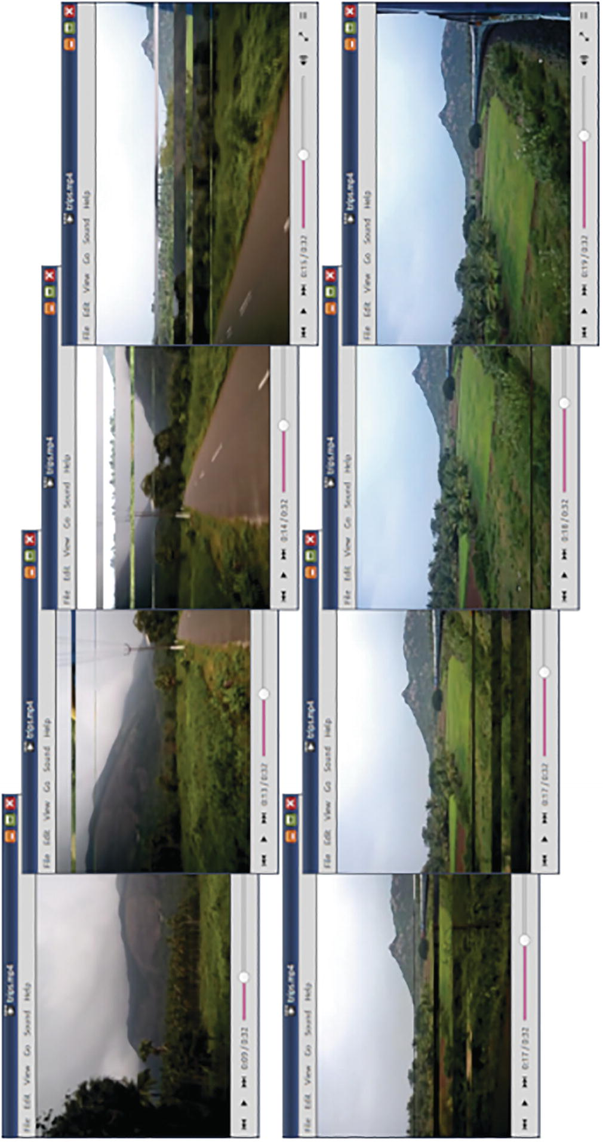
Figure 11-15Use xfade filter transition from one video to another. Use crossfade to do the same for audio
ffmpeg -y -i bike-trip.mp4 -i train-trip.mp4 \
-filter_complex \
"[0:v:0][1:v:0]
xfade
=transition=vdslice:
duration=8:offset=12[v];
[0:a:0][1:a:0]acrossfade=d=8[a]" \
-c:v libx264 -crf 21 -tune film -pix_fmt yuv420p \
-map '[v]' -map '[a]' \
trips.mp4
If you get any time base or frame rate errors because of differences in the videos, try this instead:
ffmpeg -y -i bike-trip.mp4 -i train-trip.mp4 \
-filter_complex \
"[0:v:0]
settb
=AVTB,
framerate
=24[v1];
[1:v:0]
settb
=AVTB,
framerate
=24[v2];
[v1][v2]xfade=transition=vdslice:duration=8:offset=12[v];
[0:a:0][1:a:0]acrossfade=d=8[a]" \
-c:v libx264 -crf 21 -tune film -pix_fmt yuv420p \
-map '[v]' -map '[a]' \
trips.mp4

Create Waveform Video of Audio
In an earlier section, you learned how to create a sine wave tone. In my old OS, the media player’s visualization confirmed that it is indeed a sine wave. In my new OS, the media player has no audio visualization support. How do I know that it is indeed a sine wave? Use the showwaves filter! This filter can read an audio stream and generate a video stream containing visual waveform data.
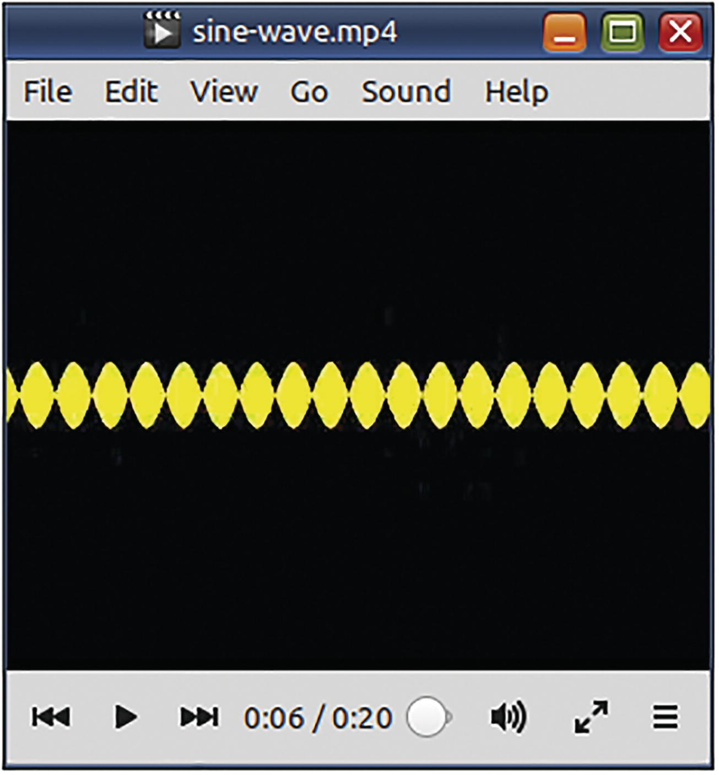
Figure 11-16The showwaves filter confirms that the audio is a sine wave
ffmpeg -i sine.wav \
-filter_complex \
"
showwaves
=s=vga:mode=cline:draw=full:
colors=yellow[v]" \
-map '[v]' -map 0:a:0 \
-c:v mpeg4 -b:v 300K -r 24 \
sine-wave.mp4

Create a Waveform Image of Audio
Some audio-hosting sites use waveform images as the background for their audio player controls. How can you create similar images? Use the showwavespic filter.
ffmpeg -y -i ace-ventura-reverse.mp4 \
-lavfi "showwavespic=s=600x120:split_channels=1:
colors=yellow|red:scale=sqrt" \
ace-waveform.png
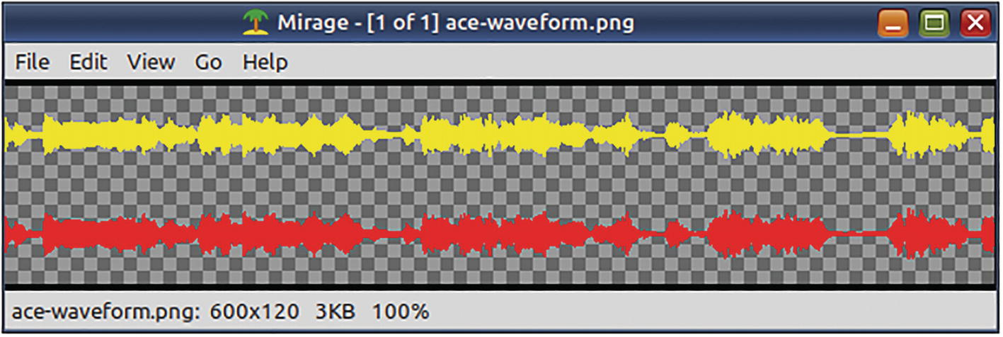
Figure 11-17The showwavespic filter can generate an image containing the waveform of an audio stream

Forensic Examination of Audio (Not Really)
Browsing through the FFmpeg documentation, I found several filters that generate visual waveform data from audio streams. I used them on the audio stream of a music recording and then rendered the generated visuals on the input video stream.
ffmpeg -y -i chenda-music.mp4 \
-filter_complex \
"[0:a:0]
showfreqs
=s=250x100:mode=bar:cmode=separate:
colors=orange|red[chartf];
[0:a:0]
showvolume
=w=250:h=50:p=0.6:dm=2:dmc=red[chartv];
[0:a:0]
showwaves
=s=250x100:mode=cline:draw=full:
colors=yellow|orange:split_channels=1[chartw];
color=color=black@0:size=vga[bg];
[bg][chartf]overlay=x=20:y=20[v1];
[v1][chartv]overlay=x=20:y=150[v2];
[v2][chartw]overlay=x=20:y=280[v3];
[0:v:0][v3]overlay[v]" \
-map '[v]' -map 0:a:0 -shortest \
chenda-music-sound-levels.mp4
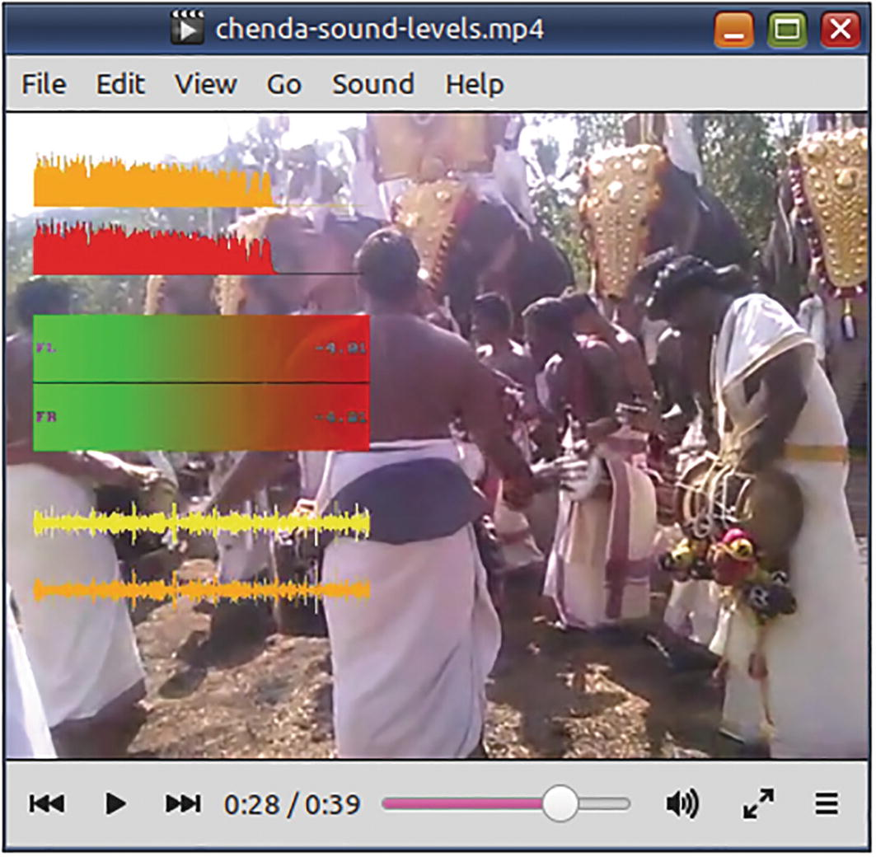
Figure 11-18Several filters were used to generate visual waveform data from the audio stream and render it on the video stream

Replace a Green-Screen Background with Another Video
Do you have a green-screen video? Do you wish to place some other video in place of the green background? The colorkey filter is your friend. It replaces a color of your choice with transparency.
ffmpeg -y -i festival-fireworks.avi -i van-damme.mp4 \
-filter_complex \
"[1:v]
colorkey
=0x008000:0.2:0.2[v1];
[0:v:0][v1]overlay=(W-w)/2:(H-h)[v];
[0:a:0][1:a:0]amerge=inputs=2[a]" \
-map "[v]" -map '[a]' \
-s nhd -ac 2 -t 0:2:0 \
green-screen-eliminated.mp4
The colorkey filter requires three keys - the color, how strictly shades of colors closer to the one specified are also made transparent, and by how much the transparent pixels should blend with the background.
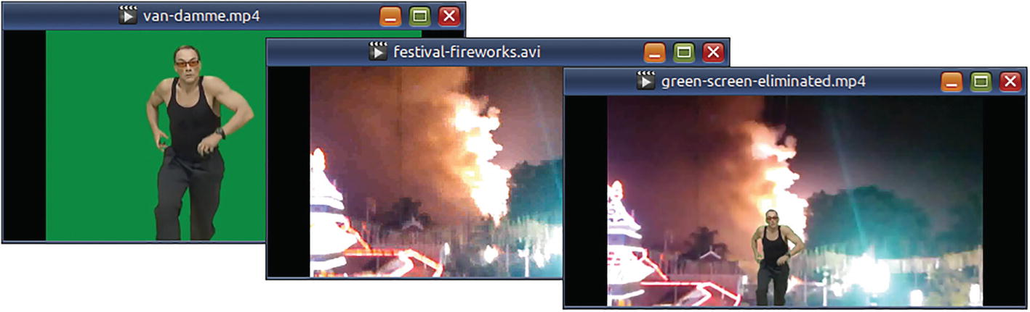
Figure 11-19The green-screen video has been rendered on the fireworks video
☞ Jean-Claude Van Damme produced and donated this green-screen video to the public.

Turn All Colors Gray Except One
How do some commercials and music videos eliminate all colors except a few? With the colorhold filter!
ffmpeg -i color-test.mp4 \
-filter:v "colorhold=yellow:similarity=0.2" \
hold-yellow.mp4
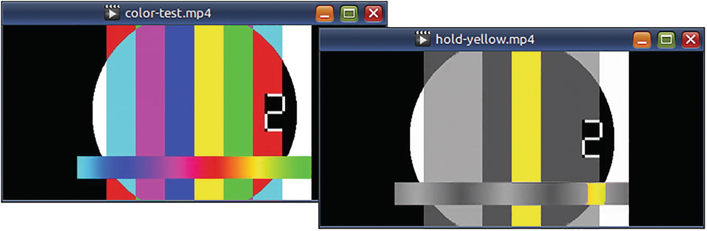
Figure 11-20Using the colorhold filter, all colors in the original video have been removed except yellow

How to Pan Across a Video
Can you create the effect of a camera panning from top-left corner across to a particular region on the video? The next command tries to pan to a region that is 332x332 with the top-left coordinates at 150,12. The effect starts from the 20th second and lasts just 5 seconds. After the panning effect, this video continues with the rest of the cropped video without any panning.
ffmpeg -y -ss 20 -i how-to-vote.mp4 \
-filter_complex \
"[0:v:0]crop=w=332:h=332:
x=(150*min(t\,5)/5):y=(12*min(t\,5)/5)" \
-codec:a copy \
how-to-vote-panned.mp4
In this command, the filter constant t representing the seconds is used to move the x-y coordinates of the crop region to its ultimate location at 150,12. For this, the coordinate is multiplied by t and divided by the total duration of the effect (five seconds). The min function expires the offsets of the crop filter after it has reached the destination at the end of five seconds.

Using FFmpeg with Timeline-Based Video-Editing Software
This tip comes from Apress author Seth Kenlon who mentioned it in his podcast some years ago. A lot of content creators record their videos in high definition. Editing these videos is quite a hassle in timeline-based video editing software. His trick was to downsize the video to say qvga (320x240) and then import that smaller video into his video-editing software. Because the video was so small, the editing software was more responsive, and he could finish the editing quickly. After he saved the project, he would close the editor. He would then manually overwrite the smaller video file with the original video. He would then start the editor again, open the project file, and only render (export) the video.
Your video editor must have built-in support for this kind of proxy editing. If not, it is likely to suffer from synchronization and scaling issues. Alternatively, you could reduce the frame rate to 12. This can make quite a difference if the source was recorded at say 60.

Make ffmpeg -version More Meaningful
If you had installed the pre-built ffmpeg executable and checked the -version option, ffmpeg displays the version like any other command-line program. If you build from source, then ffmpeg will display the label of the source code snapshot on the FFmpeg git repository.
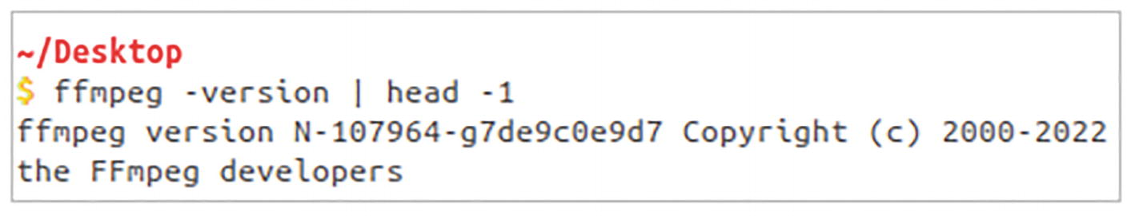
Figure 11-21This git label is likely to be meaningless to most users. Is ffmpeg trying to be anonymous?
I studied the build script and made a few changes to one of the files extracted from the tarball (the downloaded compressed source code).
# Backup the file containing the git label
cp VERSION VERSION.bak
# Suffix the current date and release version number to # the label
echo -e \
"$(cat VERSION.bak) [$(date +%Y-%m-%d)] [$(cat RELEASE)] " \ > VERSION
Then, I ran the make and make install commands to build the binaries. Now, the version number is more meaningful. If I have to deal with multiple ffmpeg binaries sometime in the future, this information will be useful.
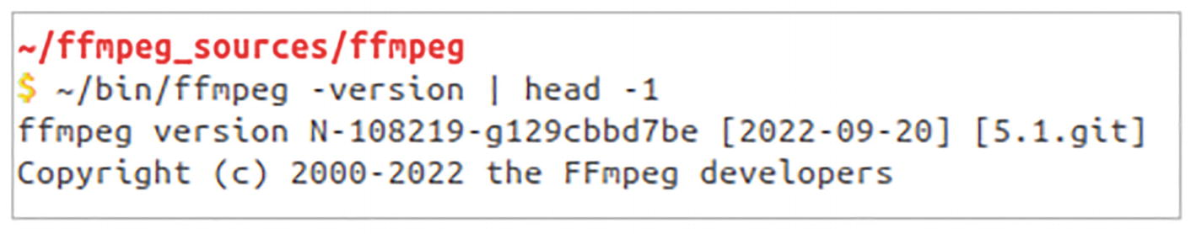
Figure 11-22The -version option displays the git label for whatever it is worth, YOUR build date, and the number of the last release version
This of course assumes that you will build the binaries on the same day you downloaded the source.

Hardware Acceleration
Computer video cards have encoders and decoders of some popular codecs in their chips. These hardware encoders and decoders are faster than the CPU running software-based encoders and decoders. You can offload the encoding and decoding operations of supported codecs from the processor (CPU) on your computer’s motherboard to the processor chip (GPU) on your graphics card. (AMD calls ’em GPUs as APUs.)
What the heck is all that? Well, instead of encoding the video using your CPU with a software encoder like this,
ffmpeg -i raw-video.avi
-codec:v libx264
compressed-video.mp4
… you can offload the processing to your video card like this:
# If you are on the red team
ffmpeg -i raw-video.avi
-codec:v h264_amf
compressed-video.mp4
# or
# if you are green with nv
ffmpeg -i raw-video.avi
-codec:v h264_nvenc
\compressed-video.mp4
Is that not cool? Well, to use such an exotic option, you need to build the FFmpeg source code forked by one of the participating video card manufacturers. You can find more information on this topic from the following:
https://docs.nvidia.com/video-technologies/video-codec-sdk/ffmpeg-with-nvidia-gpu/
https://trac.ffmpeg.org/wiki/HWAccelIntro
Beware that not all GPU models are supported. In some cases, performance may be inferior or have additional restrictions. nVidia seems to have shown more interest and openness in this field than AMD or Intel. I have AMD hardware and could not find enough documentation to build from source.
It is better if you can get statically linked builds created by someone else. For Windows users, the builds provided by the reviewer on his website (www.gyan.dev) had support for hardware-accelerated encoders and decoders in AMD and nVidia GPUs.
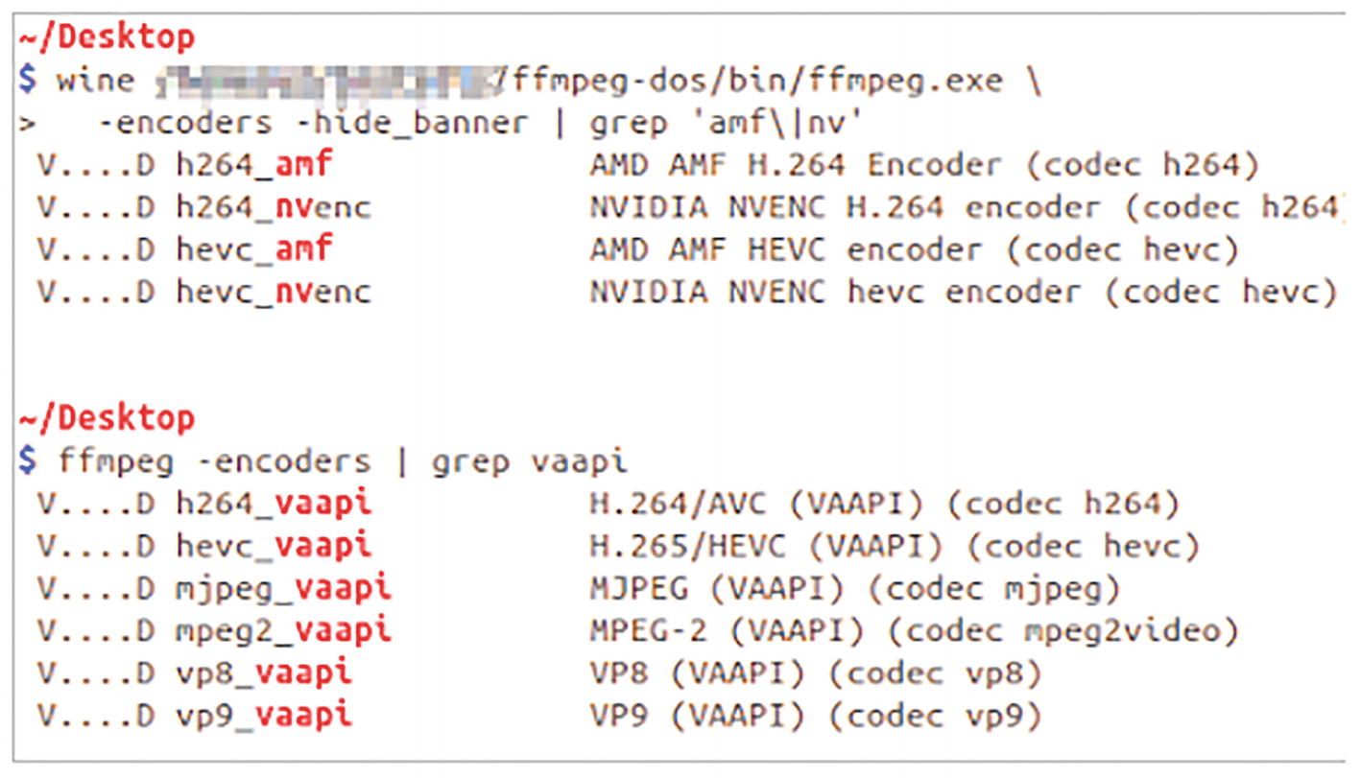
Figure 11-23Some hardware-accelerated encoders available in a Windows build and a Linux build have been listed
☞ No, wine will not work. I used it only to take this screenshot of the encoder listing.
☞ The hevc encoders are for the newer H265 codec. Try ffmpeg -hwaccels to see what hardware-accelerated options you have.
☞ The libva library (Video Acceleration API) is supported in some Intel and AMD GPUs.
Apart from encoders and decoders, you can install some hardware-accelerated filters when you build from source.
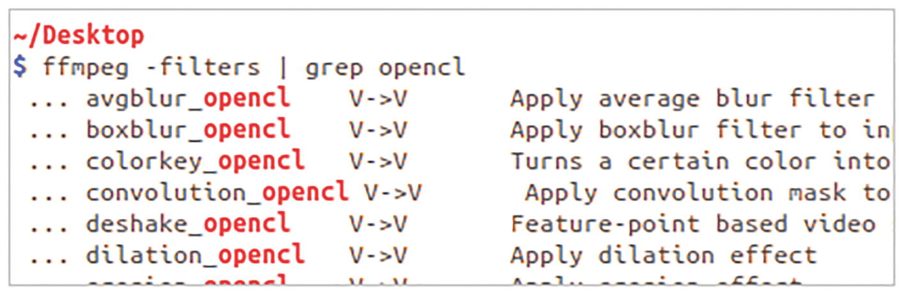
Figure 11-24Several OpenCL-enabled filters were installed after adding the --enable-opencl option in the configure script when I built FFmpeg version 5.1 from source

Finis
All right! What does this command do?
ffmpeg \
-f image2 -loop 1 -i BG-Collage.png \
-f mp4 -i idiot-box-2.mp4 -i chenda-music-sound-levels.mp4 \
-i Delphine-with-accessibility.mp4 \
-i race-timer.mp4 -i slide.mp4 \
-i watermarked-solar.mp4 \
-filter_complex \
"[0:v:0]drawtext=x=(w-tw)/2:y=15:
fontcolor=red:alpha=0.6:shadowx=1:shadowy=2:
text='Quick Start Guide To FFmpeg by V. Subhash':
fontsize=30:fontfile=Oswald.ttf[banner1];
[banner1]drawtext=x=(w-tw)/2:y=270:
fontcolor=white:alpha=0.6:shadowx=1:shadowy=2:
text='www.Apress.com':fontsize=30:
fontfile=Merriweather.ttf[banner];
[1:v:0]scale=160:90[scale1];
[banner][scale1]overlay=40:60[over1];
[2:v:0]scale=160:90[scale2];
[over1][scale2]overlay=240:60[over2];
[3:v:0]scale=160:90[scale3];
[over2][scale3]overlay=440:60[over3];
[4:v:0]scale=160:90[scale4];
[over3][scale4]overlay=40:170[over4];
[5:v:0]scale=160:90[scale5];
[over4][scale5]overlay=240:170[over5];
[6:v:0]scale=160:90[scale6];
[over5][scale6]overlay=440:170[video];
[1:a:0][2:a:0][3:a:0][4:a:0][6:a:0]amerge=inputs=5[audio]" \
-map '[video]' -map '[audio]' \
-ac 2 \
-t 0:0:10 \
thank-you.mp4
This command creates a video that has six downscaled videos playing simultaneously on a background image. The audio from the five input files were downmixed to stereo. (The slideshow had no audio.) Even the texts on the background were rendered by ffmpeg.
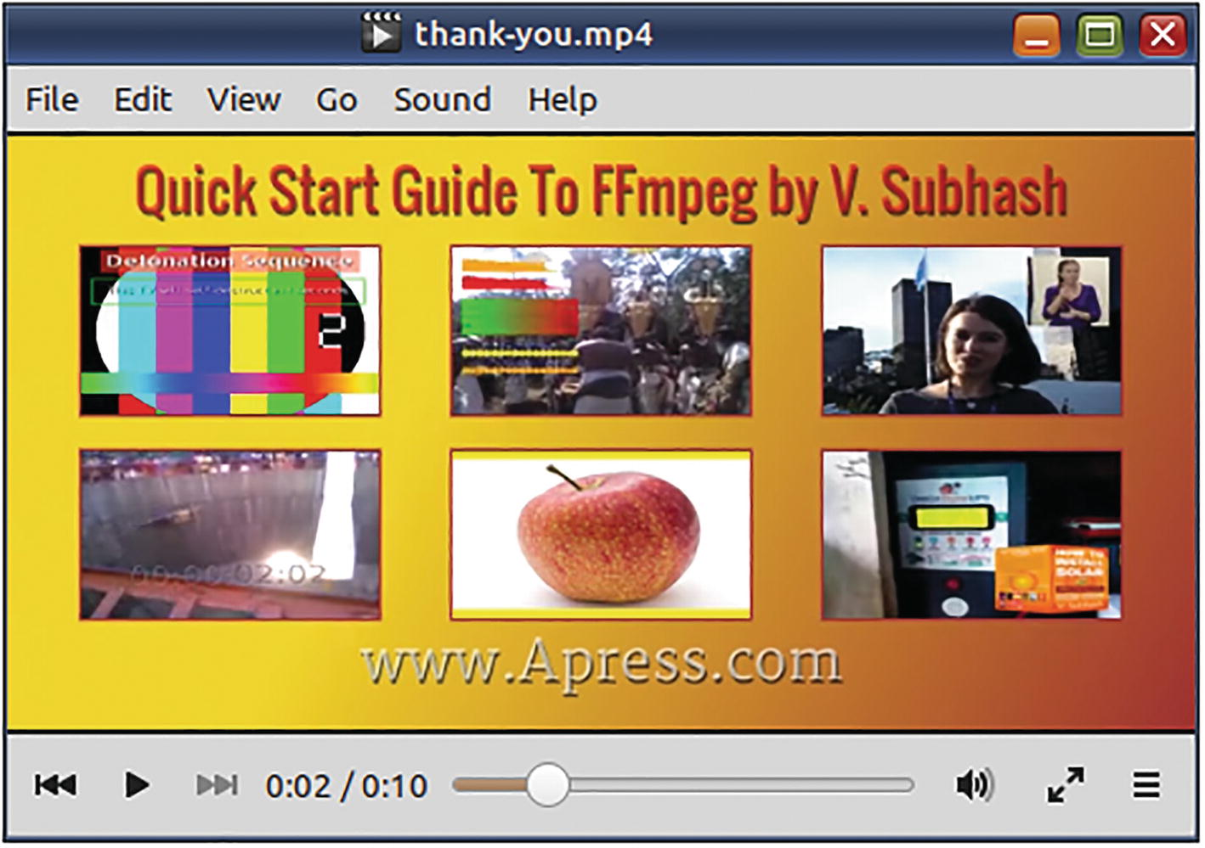
Figure 11-25This video collage was created using several FFmpeg techniques described in this book
This video and several others used in this book are available in an online video playlist. You can find its link on these sites:
www.apress.com/9781484287002
www.vsubhash.in/ffmpeg-book.html

What Next…
Well, you have finished the book. What else can you do?
Check the extra resources provided for this book.
Spend some time reading the relevant sections of the FFmpeg documentation and online wiki when you are trying out the commands.
If you have an FFmpeg-related problem, you may be able to find answers by simply doing an online search of its error message (within quotation marks). When you post FFmpeg-related questions on a forum, post the error messages as text rather than as screenshots. The recommended forums are as follows:
- https://superuser.com/questions/tagged/ffmpeg
- https://video.stackexchange.com/questions/tagged/ffmpeg
If FFmpeg made a valuable contribution to you or your organization, you could show your appreciation of the favor:
http://ffmpeg.org/donations.html
If you give this book a good rating or review online, that will also be appreciated… by me… and other current/future FFmpeg users.
If you have any corrections or suggestions, write to info@vsubhash.​com.
© The Author(s), under exclusive license to APress Media, LLC, part of Springer Nature 2023
V. SubhashQuick Start Guide to FFmpeg
https://doi.org/10.1007/978-1-4842-8701-9_12

12. Annexures
V. Subhash1
(1)
Chennai, Tamil Nadu, India

Annexure 1: Sample List of Codecs
This annexure contains sample output for the command ffmpeg -codecs.
Codecs:
D..... = Decoding supported
.E.... = Encoding supported
..V... = Video codec
..A... = Audio codec
..S... = Subtitle codec
..D... = Data codec
..T... = Attachment codec
...I.. = Intra frame-only codec
....L. = Lossy compression
.....S =
Lossless
compression
-------
D.VI.S 012v Uncompressed 4:2:2 10-bit
D.V.L. 4xm 4X Movie
D.VI.S 8bps QuickTime 8BPS video
.EVIL. a64_multi Multicolor charset for Commodore 64 (encoders: ↳ a64multi)
.EVIL. a64_multi5 Multicolor charset for Commodore 64, extended with ↳ 5th color (colram) (encoders: a64multi5)
D.V..S aasc Autodesk RLE
D.V.L. agm Amuse Graphics Movie
D.VIL. aic Apple Intermediate Codec
DEVI.S alias_pix Alias/Wavefront PIX image
DEVIL. amv AMV Video
D.V.L. anm Deluxe Paint Animation
D.V.L. ansi ASCII/ANSI art
DEV..S apng APNG (Animated Portable Network Graphics) image
D.V.L. arbc Gryphon's Anim Compressor
D.V.L. argo Argonaut Games Video
DEVIL. asv1 ASUS V1
DEVIL. asv2 ASUS V2
D.VIL. aura Auravision AURA
D.VIL. aura2 Auravision Aura 2
DEV.L. av1 Alliance for Open Media AV1 (decoders: libda v1d ↳ libaom-av1 av1) (encoders: libaom-av1 libsvtav1)
D.V... avrn Avid AVI Codec
DEVI.S avrp Avid 1:1 10-bit RGB Packer
D.V.L. avs AVS (Audio Video Standard) video
..V.L. avs2 AVS2-P2/IEEE1857.4
..V.L. avs3 AVS3-P2/IEEE1857.10
DEVI.S avui Avid Meridien Uncompressed
DEVI.S ayuv Uncompressed packed MS 4:4:4:4
D.V.L. bethsoftvid Bethesda VID video
D.V.L. bfi Brute Force & Ignorance
D.V.L. binkvideo Bink video
D.VI.. bintext Binary text
DEVI.S bitpacked Bitpacked
DEVI.S bmp BMP (Windows and OS/2 bitmap)
D.V..S bmv_video Discworld II BMV video
D.VI.S brender_pix BRender PIX image
D.V.L. c93 Interplay C93
D.V.L. cavs Chinese AVS (Audio Video Standard) (AVS1-P2, JiZhun ↳ profile)
D.V.L. cdgraphics CD Graphics video
D.V..S cdtoons CDToons video
D.VIL. cdxl Commodore CDXL video
DEV.L. cfhd GoPro CineForm HD
DEV.L. cinepak Cinepak
D.V.L. clearvideo Iterated Systems ClearVideo
DEVIL. cljr Cirrus Logic AccuPak
D.VI.S cllc Canopus Lossless Codec
D.V.L. cmv Electronic Arts CMV video (decoders: eacmv)
D.V... cpia CPiA video format
D.VILS cri Cintel RAW
D.V..S cscd CamStudio (decoders: camstudio)
D.VIL. cyuv Creative YUV (CYUV)
..V.LS daala Daala
D.VILS dds DirectDraw Surface image decoder
D.V.L. dfa Chronomaster DFA
DEV.LS dirac Dirac (encoders: vc2)
DEVIL. dnxhd VC3/DNxHD
DEVI.S dpx DPX (Digital Picture Exchange) image
D.V.L. dsicinvideo Delphine Software International CIN video
DEVIL. dvvideo DV (Digital Video)
D.V..S dxa Feeble Files/ScummVM DXA
D.VI.S dxtory Dxtory
D.VIL. dxv Resolume DXV
D.V.L. escape124 Escape 124
D.V.L. escape130 Escape 130
DEVILS exr OpenEXR image
DEV..S ffv1 FFmpeg video codec #1
DEVI.S ffvhuff Huffyuv FFmpeg variant
D.V.L. fic Mirillis FIC
DEVI.S fits FITS (Flexible Image Transport System)
DEV..S flashsv Flash Screen Video v1
DEV.L. flashsv2 Flash Screen Video v2
D.V..S flic Autodesk Animator Flic video
DEV.L. flv1 FLV / Sorenson Spark / Sorenson H.263 (Flash Video) ↳ (decoders: flv) (encoders: flv)
D.V..S fmvc FM Screen Capture Codec
D.VI.S fraps Fraps
D.VI.S frwu Forward Uncompressed
D.V.L. g2m Go2Meeting
D.V.L. gdv Gremlin Digital Video
D.V.L. gem GEM Raster image
DEV..S gif CompuServe GIF (Graphics Interchange Format)
DEV.L. h261 H.261
DEV.L. h263 H.263 / H.263-1996, H.263+ / H.263-1998 / H.263
↳ version 2 (decoders: h263 h263_v4l2m2m)
↳ (encoders: h263 h263_v4l2m2m)
D.V.L. h263i Intel H.263
DEV.L. h263p H.263+ / H.263-1998 / H.263 version 2
DEV.LS h264 H.264 / AVC / MPEG-4 AVC / MPEG-4 part 10
↳ (decoders: h264 h264_v4l2m2m) (encoders: libx264
↳ libx264rgb h264_v4l2m2m h264_vaapi)
DEVIL. hap Vidvox Hap
DEVIL. hdr HDR (Radiance RGBE format) image
DEV.L. hevc H.265 / HEVC (High Efficiency Video Coding)
↳ (decoders: hevc hevc_v4l2m2m) (encoders:
↳ libx265 hevc_v4l2m2m hevc_vaapi)
D.V.L. hnm4video HNM 4 video
D.VIL. hq_hqa Canopus HQ/HQA
D.VIL. hqx Canopus HQX
DEVI.S huffyuv HuffYUV
D.VI.S hymt HuffYUV MT
D.V.L. idcin id Quake II CIN video (decoders: idcinvideo)
D.VI.. idf iCEDraw text
D.V.L. iff_ilbm IFF ACBM/ANIM/DEEP/ILBM/PBM/RGB8/ RGBN (decoders: iff)
D.V.L. imm4 Infinity IMM4
D.V.L. imm5 Infinity IMM5
D.V.L. indeo2 Intel Indeo 2
D.V.L. indeo3 Intel Indeo 3
D.V.L. indeo4 Intel Indeo Video Interactive 4
D.V.L. indeo5 Intel Indeo Video Interactive 5
D.V.L. interplayvideo Interplay MVE video
D.VIL. ipu IPU Video
DEVILS jpeg2000 JPEG 2000 (decoders: jpeg2000 libopenjpeg) (encoders:
↳ jpeg2000 libopenjpeg)
DEVILS jpegls JPEG-LS
DEVILS jpegxl JPEG XL (decoders: libjxl) (encoders: libjx l)
D.VIL. jv Bitmap Brothers JV video
D.V.L. kgv1 Kega Game Video
D.V.L. kmvc Karl Morton's video codec
D.VI.S lagarith Lagarith lossless
.EVI.S ljpeg Lossless JPEG
D.VI.S loco LOCO
D.V.L. lscr LEAD Screen Capture
D.VI.S m101 Matrox Uncompressed SD
D.V.L. mad Electronic Arts Madcow Video (decoders: eamad)
DEVI.S magicyuv MagicYUV video
D.VIL. mdec Sony PlayStation MDEC (Motion DECoder)
D.V.L. mimic Mimic
DEVIL. mjpeg Motion JPEG (encoders: mjpeg mjpeg_vaapi)
D.VIL. mjpegb Apple MJPEG-B
D.V.L. mmvideo American Laser Games MM Video
D.V.L. mobiclip MobiClip Video
D.V.L. motionpixels Motion Pixels video
DEV.L. mpeg1video MPEG-1 video (decoders: mpeg1video mpeg1_v4l 2m2m)
DEV.L. mpeg2video MPEG-2 video (decoders: mpeg2video mpegvideo
↳ mpeg2_v4l2m2m) (encoders: mpeg2video mpeg2_vaapi)
DEV.L. mpeg4 MPEG-4 part 2 (decoders: mpeg4 mpeg4_v4l2m2m) ↳ (encoders: mpeg4 libxvid mpeg4_v4l2m2m)
D.V.L. msa1 MS ATC Screen
D.VI.S mscc Mandsoft Screen Capture Codec
D.V.L. msmpeg4v1 MPEG-4 part 2 Microsoft variant version 1
DEV.L. msmpeg4v2 MPEG-4 part 2 Microsoft variant version 2
DEV.L. msmpeg4v3 MPEG-4 part 2 Microsoft variant version 3
↳ (encoders: msmpeg4) (decoders: msmpeg4)
D.VI.S msp2 Microsoft Paint (MSP) version 2
D.V..S msrle Microsoft RLE
D.V.L. mss1 MS Screen 1
D.VIL. mss2 MS Windows Media Video V9 Screen
DEV.L. msvideo1 Microsoft Video 1
D.VI.S mszh LCL (LossLess Codec Library) MSZH
D.V.L. mts2 MS Expression Encoder Screen
D.V.L. mv30 MidiVid 3.0
D.VIL. mvc1 Silicon Graphics Motion Video Compressor 1
D.VIL. mvc2 Silicon Graphics Motion Video Compressor 2
D.V.L. mvdv MidiVid VQ
D.VIL. mvha MidiVid Archive Codec
D.V..S mwsc MatchWare Screen Capture Codec
D.V.L. mxpeg Mobotix MxPEG video
D.VIL. notchlc NotchLC
D.V.L. nuv NuppelVideo/RTJPEG
D.V.L. paf_video Amazing Studio Packed Animation File Video
DEVI.S pam PAM (Portable AnyMap) image
DEVI.S pbm PBM (Portable BitMap) image
DEVI.S pcx PC Paintbrush PCX image
DEVI.S pfm PFM (Portable FloatMap) image
DEVI.S pgm PGM (Portable GrayMap) image
DEVI.S pgmyuv PGMYUV (Portable GrayMap YUV) image
D.VI.S pgx PGX (JPEG2000 Test Format)
DEVI.S phm PHM (Portable HalfFloatMap) image
D.V.L. photocd Kodak Photo CD
D.VIL. pictor Pictor/PC Paint
D.VIL. pixlet Apple Pixlet
DEV..S png
PNG
(Portable Network Graphics) image
DEVI.S ppm PPM (Portable PixelMap) image
DEVIL. prores Apple ProRes (iCodec Pro) (encoders: prores
↳ prores_aw prores_ks)
D.VIL. prosumer Brooktree ProSumer Video
D.VI.S psd Photoshop PSD file
D.VIL. ptx V.Flash PTX image
D.VI.S qdraw Apple QuickDraw
DEVI.S qoi QOI (Quite OK Image)
D.V.L. qpeg Q-team QPEG
DEV..S qtrle QuickTime Animation (RLE) video
DEVI.S r10k AJA Kona 10-bit RGB
Codec
DEVI.S r210 Uncompressed RGB 10-bit
D.V.L. rasc RemotelyAnywhere Screen Capture
DEVI.S rawvideo raw video
D.VIL. rl2 RL2 video
DEV.L. roq id RoQ video (decoders: roqvideo) (encoders: roqvideo)
DEV.L. rpza QuickTime video (RPZA)
D.V..S rscc innoHeim/Rsupport Screen Capture Codec
DEV.L. rv10 RealVideo 1.0
DEV.L. rv20 RealVideo 2.0
D.V.L. rv30 RealVideo 3.0
D.V.L. rv40 RealVideo 4.0
D.V.L. sanm LucasArts SANM/SMUSH video
D.V.LS scpr ScreenPressor
D.V..S screenpresso Screenpresso
D.V.L. sga Digital Pictures SGA Video
DEVI.S sgi SGI image
D.VI.S sgirle SGI RLE 8-bit
D.VI.S sheervideo BitJazz SheerVideo
D.V.L. simbiosis_imx Simbiosis Interactive IMX Video
D.V.L. smackvideo Smacker video (decoders: smackvid)
DEV.L. smc QuickTime Graphics (SMC)
D.VIL. smvjpeg Sigmatel Motion Video
DEV.LS snow Snow
D.VIL. sp5x Sunplus JPEG (SP5X)
DEVIL. speedhq NewTek SpeedHQ
D.VI.S srgc Screen Recorder Gold Codec
DEVI.S sunrast Sun Rasterfile image
..V..S svg Scalable Vector Graphics
DEV.L. svq1 Sorenson Vector Quantizer 1 / Sorenson Video 1 / SVQ1
D.V.L. svq3 Sorenson Vector Quantizer 3 / Sorenson Video 3 / SVQ3
DEVI.S targa Truevision Targa image
D.VI.S targa_y216 Pinnacle TARGA CineWave YUV16
D.V.L. tdsc TDSC
D.V.L. tgq Electronic Arts TGQ video (decoders: eatgq)
D.V.L. tgv Electronic Arts TGV video (decoders: eatgv)
DEV.L. theora Theora (encoders: libtheora)
D.VIL. thp Nintendo Gamecube THP video
D.V.L. tiertexseqvideo Tiertex Limited SEQ video
DEVI.S tiff TIFF image
D.VIL. tmv 8088flex TMV
D.V.L. tqi Electronic Arts TQI video (decoders: eatqi)
D.V.L. truemotion1 Duck TrueMotion 1.0
D.V.L. truemotion2 Duck TrueMotion 2.0
D.VIL. truemotion2rt Duck TrueMotion 2.0 Real Time
D.V..S tscc TechSmith Screen Capture Codec (decoders: camtasia)
D.V.L. tscc2 TechSmith Screen Codec 2
D.VIL. txd Renderware TXD (TeXture Dictionary) image
D.V.L. ulti IBM UltiMotion (decoders: ultimotion)
DEVI.S utvideo Ut Video
DEVI.S v210 Uncompressed 4:2:2 10-bit
D.VI.S v210x Uncompressed 4:2:2 10-bit
DEVI.S v308 Uncompressed packed 4:4:4
DEVI.S v408 Uncompressed packed QT 4:4:4:4
DEVI.S v410 Uncompressed 4:4:4 10-bit
D.V.L. vb Beam Software VB
D.VI.S vble VBLE Lossless Codec
DEV.L. vbn Vizrt Binary Image
D.V.L. vc1 SMPTE VC-1 (decoders: vc1 vc1_v4l2m2m)
D.V.L. vc1image Windows Media Video 9 Image v2
D.VIL. vcr1 ATI VCR1
D.VIL. vixl Miro VideoXL (decoders: xl)
D.V.L. vmdvideo Sierra VMD video
D.V..S vmnc VMware Screen Codec / VMware Video
D.V.L. vp3 On2 VP3
D.V.L. vp4 On2 VP4
D.V.L. vp5 On2 VP5
D.V.L. vp6 On2 VP6
D.V.L. vp6a On2 VP6 (Flash version, with alpha channel)
D.V.L. vp6f On2 VP6 (Flash version)
D.V.L. vp7 On2 VP7
DEV.L. vp8 On2 VP8 (decoders: vp8 vp8_v4l2m2m libvpx)
↳ (encoders: libvpx vp8_v4l2m2m vp8_vaapi)
DEV.L. vp9 Google VP9 (decoders: vp9 vp9_v4l2m2m libvpx-vp9)
↳ (encoders: libvpx-vp9 vp9_vaapi)
..V.L. vvc H.266 / VVC (Versatile Video Coding)
DEVI.S wbmp WBMP (Wireless Application Protocol Bitmap) image
D.V..S wcmv WinCAM Motion Video
DEVILS webp WebP (encoders: libwebp_animlibwebp)
DEV.L. wmv1 Windows Media Video 7
DEV.L. wmv2 Windows Media Video 8
D.V.L. wmv3 Windows Media Video 9
D.V.L. wmv3image Windows Media Video 9 Image
D.VIL. wnv1 Winnov WNV1
DEV..S wrapped_avframe AVFrame to AVPacket passthrough
D.V.L. ws_vqa Westwood Studios VQA (Vector Quantized Animation) video
↳ (decoders: vqavideo)
D.V.L. xan_wc3 Wing Commander III / Xan
D.V.L. xan_wc4 Wing Commander IV / Xxan
D.VI.. xbin eXtended BINary text
DEVI.S xbm XBM (X BitMap) image
DEVIL. xface X-face image
D.VI.S xpm XPM (X PixMap) image
DEVI.S xwd XWD (X Window Dump) image
DEVI.S y41p Uncompressed YUV 4:1:1 12-bit
D.VI.S ylc YUY2 Lossless Codec
D.V.L. yop Psygnosis YOP Video
DEVI.S yuv4 Uncompressed packed 4:2:0
D.V..S zerocodec ZeroCodec Lossless Video
DEVI.S zlib LCL (LossLess Codec Library) ZLIB
DEV..S zmbv Zip Motion Blocks Video
..AIL. 4gv 4GV (Fourth Generation Vocoder)
D.AIL. 8svx_exp 8SVX exponential
D.AIL. 8svx_fib 8SVX fibonacci
DEAIL. aac AAC (Advanced Audio Coding) (decoders: aac aac_fixed
↳ libfdk_aac) (encoders: aac libfdk_aac)
D.AIL. aac_latm AAC LATM (Advanced Audio Coding LATM syntax)
DEAIL. ac3 ATSC A/52A (AC-3) (decoders: ac3 ac3_fixed)
↳ (encoders: ac3 ac3_fixed)
D.AIL. acelp.kelvin Sipro ACELP.KELVIN
D.AIL. adpcm_4xm ADPCM 4X Movie
DEAIL. adpcm_adx SEGA CRI ADX ADPCM
D.AIL. adpcm_afc ADPCM Nintendo Gamecube AFC
D.AIL. adpcm_agm ADPCM AmuseGraphics Movie AGM
D.AIL. adpcm_aica ADPCM Yamaha AICA
DEAIL. adpcm_argo ADPCM Argonaut Games
D.AIL. adpcm_ct ADPCM Creative Technology
D.AIL. adpcm_dtk ADPCM Nintendo Gamecube DTK
D.AIL. adpcm_ea ADPCM Electronic Arts
D.AIL. adpcm_ea_maxis_xa ADPCM Electronic Arts Maxis CDROM XA
D.AIL. adpcm_ea_r1 ADPCM Electronic Arts R1
D.AIL. adpcm_ea_r2 ADPCM Electronic Arts R2
D.AIL. adpcm_ea_r3 ADPCM Electronic Arts R3
D.AIL. adpcm_ea_xas ADPCM Electronic Arts XAS
DEAIL. adpcm_g722 G.722 ADPCM (decoders: g722) (encoders: g722)
DEAIL. adpcm_g726 G.726 ADPCM (decoders: g726) (encoders: g726)
DEAIL. adpcm_g726le G.726 ADPCM little-endian (decoders: g726le)
↳ (encoders: g726le)
D.AIL. adpcm_ima_acorn ADPCM IMA Acorn Replay
DEAIL. adpcm_ima_alp ADPCM IMA High Voltage Software ALP
DEAIL. adpcm_ima_amv ADPCM IMA AMV
D.AIL. adpcm_ima_apc ADPCM IMA CRYO APC
DEAIL. adpcm_ima_apm ADPCM IMA Ubisoft APM
D.AIL. adpcm_ima_cunning ADPCM IMA Cunning Developments
D.AIL. adpcm_ima_dat4 ADPCM IMA Eurocom DAT4
D.AIL. adpcm_ima_dk3 ADPCM IMA Duck DK3
D.AIL. adpcm_ima_dk4 ADPCM IMA Duck DK4
D.AIL. adpcm_ima_ea_eacs ADPCM IMA Electronic Arts EACS
D.AIL. adpcm_ima_ea_sead ADPCM IMA Electronic Arts SEAD
D.AIL. adpcm_ima_iss ADPCM IMA Funcom ISS
D.AIL. adpcm_ima_moflex ADPCM IMA MobiClip MOFLEX
D.AIL. adpcm_ima_mtf ADPCM IMA Capcom's MT Framework
D.AIL. adpcm_ima_oki ADPCM IMA Dialogic OKI
DEAIL. adpcm_ima_qt ADPCM IMA QuickTime
D.AIL. adpcm_ima_rad ADPCM IMA Radical
D.AIL. adpcm_ima_smjpeg ADPCM IMA Loki SDL MJPEG
DEAIL. adpcm_ima_ssi ADPCM IMA Simon & Schuster Interactive
DEAIL. adpcm_ima_wav ADPCM IMA WAV
DEAIL. adpcm_ima_ws ADPCM IMA Westwood
DEAIL. adpcm_ms ADPCM Microsoft
D.AIL. adpcm_mtaf ADPCM MTAF
D.AIL. adpcm_psx ADPCM Playstation
D.AIL. adpcm_sbpro_2 ADPCM Sound Blaster Pro 2-bit
D.AIL. adpcm_sbpro_3 ADPCM Sound Blaster Pro 2.6-bit
D.AIL. adpcm_sbpro_4 ADPCM Sound Blaster Pro 4-bit
DEAIL. adpcm_swf ADPCM Shockwave Flash
D.AIL. adpcm_thp ADPCM Nintendo THP
D.AIL. adpcm_thp_le ADPCM Nintendo THP (Little-Endian)
D.AIL. adpcm_vima LucasArts VIMA audio
D.AIL. adpcm_xa ADPCM CDROM XA
DEAIL. adpcm_yamaha ADPCM Yamaha
D.AIL. adpcm_zork ADPCM Zork
DEAI.S alac ALAC (Apple Lossless Audio Codec)
DEAIL. amr_nb AMR-NB (Adaptive Multi-Rate NarrowBand) (decoders: amrnb
↳ libopencore_amrnb) (encoders: libopencore_amrnb)
DEAIL. amr_wb AMR-WB (Adaptive Multi-Rate WideBand) (decoders: amrwb
↳ libopencore_amrwb) (encoders: libvo_amrwbenc)
D.AI.S ape Monkey's Audio
DEAIL. aptx aptX (Audio Processing Technology for Bluetooth)
DEAIL. aptx_hd aptX HD (Audio Processing Technology for Bluetooth)
D.AIL. atrac1 ATRAC1 (Adaptive TRansform Acoustic Coding)
D.AIL. atrac3 ATRAC3 (Adaptive TRansform Acoustic Coding 3)
D.AI.S atrac3al ATRAC3 AL (Adaptive TRansform Acoustic Coding 3
↳ Advanced Lossless)
D.AIL. atrac3p ATRAC3+ (Adaptive TRansform Acoustic Coding 3+)
↳ (decoders: atrac3plus)
D.AI.S atrac3pal ATRAC3+ AL (Adaptive TRansform Acoustic Coding 3+
↳ Advanced Lossless) (decoders: atrac3 plusal)
D.AIL. atrac9 ATRAC9 (Adaptive TRansform Acoustic Coding 9)
D.AIL. avc On2 Audio for Video Codec (decoders: on2avc)
D.AIL. binkaudio_dct Bink Audio (DCT)
D.AIL. binkaudio_rdft Bink Audio (RDFT)
D.AIL. bmv_audio Discworld II BMV audio
..AIL. celt Constrained Energy Lapped Transform (CELT)
..AIL. codec2 codec2 (very low
bitrate
speech codec)
DEAIL. comfortnoise RFC 3389 Comfort Noise
D.AIL. cook Cook / Cooker / Gecko (RealAudio G2)
D.AIL. derf_dpcm DPCM Xilam DERF
DEA.L. dfpwm DFPWM (Dynamic Filter Pulse Width Modulation)
D.AIL. dolby_e Dolby E
D.AIL. dsd_lsbf DSD (Direct Stream Digital), least significant bit first
D.AIL. dsd_lsbf_planar DSD (Direct Stream Digital), least significant bit
↳ first, planar
D.AIL. dsd_msbf DSD (Direct Stream Digital), most significant bit first
D.AIL. dsd_msbf_planar DSD (Direct Stream Digital), most significant bit
↳ first, planar
D.AIL. dsicinaudio Delphine Software International CIN audio
D.AIL. dss_sp Digital Speech Standard - Standard Play mode (DSS SP)
D.AI.S dst DST (Direct Stream Transfer)
DEAILS dts DCA (DTS Coherent Acoustics) (decoders: dca)
↳ (encoders: dca)
D.AIL. dvaudio DV audio
DEAIL. eac3 ATSC A/52B (AC-3, E-AC-3)
D.AIL. evrc EVRC (Enhanced Variable Rate Codec)
D.AIL. fastaudio MobiClip FastAudio
DEAI.S flac
FLAC
(Free Lossless Audio Codec)
DEAIL. g723_1 G.723.1
D.AIL. g729 G.729
D.AIL. gremlin_dpcm DPCM Gremlin
D.AIL. gsm GSM
D.AIL. gsm_ms GSM Microsoft variant
D.AIL. hca CRI HCA
D.AIL. hcom HCOM Audio
D.AIL. iac IAC (Indeo Audio Coder)
D.AIL. ilbc iLBC (Internet Low Bitrate Codec)
D.AIL. imc IMC (Intel Music Coder)
D.AIL. interplay_dpcm DPCM Interplay
D.AIL. interplayacm Interplay ACM
D.AIL. mace3 MACE
(Macintosh Audio Compression/Expansion) 3:1
D.AIL. mace6 MACE (Macintosh Audio Compression/Expansion) 6:1
D.AIL. metasound Voxware MetaSound
DEA..S mlp MLP (Meridian Lossless Packing)
D.AIL. mp1 MP1 (MPEG audio layer 1) (decoders: mp1 mp1float)
DEAIL. mp2 MP2 (MPEG audio layer 2) (decoders: mp2 mp2float)
↳ (encoders: mp2 mp2fixed libtwolame)
DEAIL. mp3 MP3 (MPEG audio layer 3) (decoders: mp3float mp3)
↳ (encoders: libmp3lame libshine)
D.AIL. mp3adu ADU (Application Data Unit) MP3 (MPEG audio layer 3)
↳ (decoders: mp3adufloat mp3adu)
D.AIL. mp3on4 MP3onMP4 (decoders
: mp3on4float mp3on4)
D.AI.S mp4als MPEG-4 Audio Lossless Coding (ALS) (decoders: als)
..A.L. mpegh_3d_audio MPEG-H 3D Audio
D.AIL. msnsiren MSN Siren
D.AIL. musepack7 Musepack SV7 (decoders: mpc7)
D.AIL. musepack8 Musepack SV8 (decoders: mpc8)
DEAIL. nellymoser Nellymoser Asao
DEAIL. opus Opus (Opus Interactive Audio Codec) (decoders: opus
↳ libopus) (encoders: opus libopus)
D.AIL. paf_audio Amazing Studio Packed Animation File Audio
DEAIL. pcm_alaw PCM A-law / G.711 A-law
DEAI.S pcm_bluray PCM signed 16|20|24-bit big-endian for Blu-ray media
DEAI.S pcm_dvd PCM signed 20|24-bit big-endian
D.AI.S pcm_f16le PCM 16.8 floating point little-endian
D.AI.S pcm_f24le PCM 24.0 floating point little-endian
DEAI.S pcm_f32be PCM 32-bit floating point big-endian
DEAI.S pcm_f32le PCM 32-bit floating point little-endian
DEAI.S pcm_f64be PCM 64-bit floating point big-endian
DEAI.S pcm_f64le PCM 64-bit floating point little-endian
D.AI.S pcm_lxf PCM signed 20-bit little-endian planar
DEAIL. pcm_mulaw PCM mu-law / G.711 mu-law
DEAI.S pcm_s16be PCM signed 16-bit big-endian
DEAI.S pcm_s16be_planar PCM signed 16-bit big-endian planar
DEAI.S pcm_s16le PCM signed 16-bit little-endian
DEAI.S pcm_s16le_planar PCM signed 16-bit little-endian planar
DEAI.S pcm_s24be PCM signed 24-bit big-endian
DEAI.S pcm_s24daud PCM D-Cinema audio signed 24-bit
DEAI.S pcm_s24le PCM signed 24-bit little-endian
DEAI.S pcm_s24le_planar PCM signed 24-bit little-endian planar
DEAI.S pcm_s32be PCM signed 32-bit big-endian
DEAI.S pcm_s32le PCM signed 32-bit little-endian
DEAI.S pcm_s32le_planar PCM signed 32-bit little-endian planar
DEAI.S pcm_s64be PCM signed 64-bit big-endian
DEAI.S pcm_s64le PCM signed 64-bit little-endian
DEAI.S pcm_s8 PCM signed 8-bit
DEAI.S pcm_s8_planar PCM signed 8-bit planar
D.AI.S pcm_sga PCM SGA
DEAI.S pcm_u16be PCM unsigned 16-bit big-endian
DEAI.S pcm_u16le PCM unsigned 16-bit little-endian
DEAI.S pcm_u24be PCM unsigned 24-bit big-endian
DEAI.S pcm_u24le PCM unsigned 24-bit little-endian
DEAI.S pcm_u32be PCM unsigned 32-bit big-endian
DEAI.S pcm_u32le PCM unsigned 32-bit little-endian
DEAI.S pcm_u8 PCM unsigned 8-bit
DEAIL. pcm_vidc PCM Archimedes VIDC
D.AIL. qcelp QCELP / PureVoice
D.AIL. qdm2 QDesign Music Codec 2
D.AIL. qdmc QDesign Music
DEAIL. ra_144 RealAudio 1.0 (14.4K) (decoders: real_144)
↳ (encoders: real_144)
D.AIL. ra_288 RealAudio 2.0 (28.8K) (decoders: real_288)
D.AI.S ralf RealAudio Lossless
DEAIL. roq_dpcm DPCM id RoQ
DEAI.S s302m SMPTE 302M
DEAIL. sbc SBC (low-complexity subband codec)
D.AIL. sdx2_dpcm DPCM Squareroot-Delta-Exact
D.AI.S shorten Shorten
D.AIL. sipr RealAudio SIPR / ACELP.NET
D.AIL. siren Siren
D.AIL. smackaudio Smacker audio (decoders: smackaud)
..AIL. smv SMV (Selectable Mode Vocoder)
D.AIL. sol_dpcm DPCM Sol
DEAI.. sonic Sonic
.EAI.. sonicls Sonic lossless
DEAIL. speex Speex (decoders: speex libspeex) (encoders: libspeex)
D.A..S tak TAK (Tom's lossless Audio Kompressor)
DEA..S truehd TrueHD
D.AIL. truespeech DSP Group TrueSpeech
DEAI.S tta TTA (True Audio)
D.AIL. twinvq VQF TwinVQ
D.AIL. vmdaudio Sierra VMD audio
DEAIL. vorbis Vorbis (decoders: vorbis libvorbis)
↳ (encoders: vorbis libvorbis)
D.AI.. wavesynth Wave synthesis pseudo-codec
DEAILS wavpack WavPack
D.AIL. westwood_snd1 Westwood Audio (SND1) (decoders: ws_snd1)
D.AI.S wmalossless Windows Media Audio Lossless
D.AIL. wmapro Windows Media Audio 9 Professional
DEAIL. wmav1 Windows Media Audio 1
DEAIL. wmav2 Windows Media Audio 2
D.AIL. wmavoice Windows Media Audio Voice
D.AIL. xan_dpcm DPCM Xan
D.AIL. xma1 Xbox Media Audio 1
D.AIL. xma2 Xbox Media Audio 2
..D... bin_data binary data
..D... dvd_nav_packet DVD Nav packet
..D... epg Electronic Program Guide
..D... klv SMPTE 336M Key-Length-Value (KLV) metadata
..D... mpegts raw MPEG-TS stream
..D... otf OpenType font
..D... scte_35 SCTE 35 Message Queue
..D... timed_id3 timed ID3 metadata
..D... ttf TrueType font
..S... arib_caption ARIB STD-B24 caption
DES... ass ASS (Advanced SSA) subtitle (decoders: ssa ass)
↳ (encoders: ssa ass)
DES... dvb_subtitle DVB subtitles (decoders: dvbsub) (encoders: dvbsub)
D.S... dvb_teletext DVB teletext (decoders: libzvbi_teletextdec)
DES... dvd_subtitle DVD subtitles (decoders: dvdsub) (encoders: dvdsub)
D.S... eia_608 EIA-608 closed captions (decoders: cc_dec)
D.S... hdmv_pgs_subtitle HDMV Presentation Graphic Stream
↳ subtitles (decoders: pgssub)
..S... hdmv_text_subtitle HDMV Text subtitle
D.S... jacosub JACOsub subtitle
D.S... microdvd MicroDVD subtitle
DES... mov_text MOV text
D.S... mpl2 MPL2 subtitle
D.S... pjs PJS (Phoenix Japanimation Society) subtitle
D.S... realtext RealText subtitle
D.S... sami SAMI subtitle
..S... srt
SubRip subtitle with embedded timing
..S... ssa SSA (SubStation Alpha) subtitle
D.S... stl Spruce subtitle format
DES... subrip SubRip subtitle (decoders: srt
↳ subrip) (enc oders: srt subrip)
D.S... subviewer SubViewer subtitle
D.S... subviewer1 SubViewer v1 subtitle
DES... text raw UTF-8 text
.ES... ttml Timed Text Markup Language
D.S... vplayer VPlayer subtitle
DES... webvtt WebVTT subtitle
DES... xsub XSUB

Annexure 2: Sample List of Decoders
This annexure contains sample output for the command ffmpeg -decoders.
Decoders:
V..... = Video
A..... = Audio
S..... = Subtitle
.F.... = Frame-level multithreading
..S... = Slice-level multithreading
...X.. = Codec is experimental
....B. = Supports draw_horiz_band
.....D = Supports direct rendering method 1
------
V....D 012v Uncompressed 4:2:2 10-bit
V....D 4xm 4X Movie
V....D 8bps QuickTime 8BPS video
V....D aasc Autodesk RLE
V....D agm Amuse Graphics Movie
VF...D aic Apple Intermediate Codec
V....D alias_pix Alias/Wavefront PIX image
V....D amv AMV Video
V....D anm Deluxe Paint Animation
V....D ansi ASCII/ANSI art
VF...D apng APNG (Animated Portable Network Graphics) image
V....D arbc Gryphon's Anim Compressor
V....D argo Argonaut Games Video
V....D asv1 ASUS V1
V....D asv2 ASUS V2
V....D aura Auravision AURA
V....D aura2 Auravision Aura 2
V..... libdav1d dav1d AV1 decoder by VideoLAN (codec av1)
V....D libaom-av1 libaom AV1 (codec av1)
V....D av1 Alliance for Open Media AV1
V..... av1_cuvid Nvidia CUVID AV1 decoder (codec av1)
V....D av1_qsv AV1 video (Intel Quick Sync Video
↳ acceleration) (codec av1)
V....D avrn Avid AVI Codec
V....D avrp Avid 1:1 10-bit RGB Packer
V....D avs AVS (Audio Video Standard) video
V..... libdavs2 libdavs2 AVS2-P2/IEEE1857.4 (codec avs2)
V....D libuavs3d libuavs3d AVS3-P2/IEEE1857.10 (codec avs3)
V....D avui Avid Meridien Uncompressed
V....D ayuv Uncompressed packed MS 4:4:4:4
V....D bethsoftvid Bethesda VID video
V....D bfi Brute Force & Ignorance
V....D binkvideo Bink video
V....D bintext Binary text
VF.... bitpacked Bitpacked
V....D bmp BMP (Windows and OS/2 bitmap)
V....D bmv_video Discworld II BMV video
V....D brender_pix BRender PIX image
V....D c93 Interplay C93
V....D cavs Chinese AVS (Audio Video Standard)
↳ (AVS1-P2, JiZhun profile)
V....D cdgraphics CD Graphics video
V....D cdtoons CDToons video
V....D cdxl Commodore CDXL video
VF...D cfhd GoPro CineForm HD
V....D cinepak Cinepak
V....D clearvideo Iterated Systems ClearVideo
V....D cljr Cirrus Logic AccuPak
VF...D cllc Canopus Lossless Codec
V....D eacmv Electronic Arts CMV video (codec cmv)
V....D cpia CPiA video format
VF...D cri Cintel RAW
V....D camstudio CamStudio (codec cscd)
V....D cyuv Creative YUV (CYUV)
V.S..D dds DirectDraw Surface image decoder
V....D dfa Chronomaster DFA
V.S..D dirac BBC Dirac VC-2
VFS..D dnxhd VC3/DNxHD
V....D dpx DPX (Digital Picture Exchange) image
V....D dsicinvideo Delphine Software International CIN video
VFS..D dvvideo DV (Digital Video)
V....D dxa Feeble Files/ScummVM DXA
VF...D dxtory Dxtory
VFS..D dxv Resolume DXV
V....D escape124 Escape 124
V....D escape130 Escape 130
VFS..D exr OpenEXR image
VFS..D ffv1 FFmpeg video codec #1
VF..BD ffvhuff Huffyuv FFmpeg variant
V.S..D fic Mirillis FIC
V....D fits Flexible Image Transport System
V....D flashsv Flash Screen Video v1
V....D flashsv2 Flash Screen Video v2
V....D flic Autodesk Animator Flic video
V...BD flv FLV / Sorenson Spark / Sorenson
↳ H.263 (Flash Video) (codec flv1)
V....D fmvc FM Screen Capture Codec
VF...D fraps Fraps
V....D frwu Forward Uncompressed
V....D g2m Go2Meeting
V....D gdv Gremlin Digital Video
V....D gem GEM Raster image
V....D gif GIF (Graphics Interchange Format)
V....D h261 H.261
V...BD h263 H.263 / H.263-1996, H.263+ /
↳ H.263-1998 / H.263 version 2
V..... h263_v4l2m2m V4L2 mem2mem H.263 decoder wrapper (codec h263)
V...BD h263i Intel H.263
V...BD h263p H.263 / H.263-1996, H.263+ /
↳ H.263-1998 / H.263 version 2
VFS..D h264 H.264 / AVC / MPEG-4 AVC / MPEG-4 part 10
V..... h264_v4l2m2m V4L2 mem2mem H.264 decoder wrapper (codec h264)
V....D h264_qsv
H264
video (Intel Quick Sync Video
↳ acceleration) (codec h264)
V..... h264_cuvid Nvidia CUVID H264 decoder (codec h264)
VFS..D hap Vidvox Hap
VF...D hdr HDR (Radiance RGBE format) image
VFS..D hevc HEVC (High Efficiency Video Coding)
V..... hevc_v4l2m2m V4L2 mem2mem HEVC decoder wrapper (codec hevc)
V....D hevc_qsv HEVC video (Intel Quick Sync Video
↳ acceleration) (codec hevc)
V..... hevc_cuvid Nvidia CUVID HEVC decoder (codec hevc)
V....D hnm4video HNM 4 video
V....D hq_hqa Canopus HQ/HQA
VFS..D hqx Canopus HQX
VF..BD huffyuv Huffyuv / HuffYUV
VF..BD hymt HuffYUV MT
V....D idcinvideo id Quake II CIN video (codec idcin)
V....D idf iCEDraw text
V....D iff IFF ACBM/ANIM/DEEP/ILBM/PBM/RGB8/
↳ RGBN (codeciff_ilbm)
V....D imm4 Infinity IMM4
V..... imm5 Infinity IMM5
V....D indeo2 Intel Indeo 2
V....D indeo3 Intel Indeo 3
V....D indeo4 Intel Indeo Video Interactive 4
V....D indeo5 Intel Indeo Video Interactive 5
V....D interplayvideo Interplay MVE video
V....D ipu IPU Video
VFS..D jpeg2000 JPEG 2000
VF...D libopenjpeg OpenJPEG JPEG 2000 (codec jpeg2000)
V....D jpegls JPEG-LS
V....D libjxl libjxl JPEG XL (codec jpegxl)
V....D jv Bitmap Brothers JV video
V....D kgv1 Kega Game Video
V....D kmvc Karl Morton's video codec
VF...D lagarith Lagarith lossless
V....D loco LOCO
V....D lscr LEAD Screen Capture
V....D m101 Matrox Uncompressed SD
V....D eamad Electronic Arts Madcow Video (codec mad)
VFS..D magicyuv MagicYUV video
VF...D mdec Sony PlayStation MDEC (Motion DECoder)
VF...D mimic Mimic
V....D mjpeg MJPEG (Motion JPEG)
V..... mjpeg_cuvid Nvidia CUVID MJPEG decoder (codec mjpeg)
V....D mjpeg_qsv MJPEG video (Intel Quick Sync Video acceleration)
↳ (codec mjpeg)
V....D mjpegb Apple MJPEG-B
V....D mmvideo American Laser Games MM Video
V....D mobiclip MobiClip Video
V....D motionpixels Motion Pixels video
V.S.BD mpeg1video MPEG-1 video
V..... mpeg1_v4l2m2m V4L2 mem2mem MPEG1 decoder wrapper (codec mpeg1video)
V..... mpeg1_cuvid Nvidia CUVID MPEG1VIDEO decoder (codec mpeg1video)
V.S.BD mpeg2video MPEG-2 video
V.S.BD mpegvideo MPEG-1 video (codec mpeg2video)
V..... mpeg2_v4l2m2m V4L2 mem2mem MPEG2 decoder wrapper (codec mpeg2video)
V....D mpeg2_qsv MPEG2VIDEO video (Intel Quick Sync Video acceleration)
↳ (codec mpeg2video)
V..... mpeg2_cuvid Nvidia CUVID MPEG2VIDEO decoder (codec mpeg2video)
VF..BD mpeg4 MPEG-4 part 2
V..... mpeg4_v4l2m2m V4L2 mem2mem MPEG4 decoder wrapper (codec mpeg4)
V..... mpeg4_cuvid Nvidia CUVID MPEG4 decoder (codec mpeg4)
V....D msa1 MS ATC Screen
V....D mscc Mandsoft Screen Capture Codec
V...BD msmpeg4v1 MPEG-4 part 2 Microsoft variant version 1
V...BD msmpeg4v2 MPEG-4 part 2 Microsoft variant version 2
V...BD msmpeg4 MPEG-4 part 2 Microsoft variant version 3
↳ (codec msmpeg4v3)
V....D msp2 Microsoft Paint (MSP) version 2
V....D msrle Microsoft RLE
V....D mss1 MS Screen 1
V....D mss2 MS Windows Media Video V9 Screen
V....D msvideo1 Microsoft Video 1
VF...D mszh LCL (LossLess Codec Library) MSZH
V....D mts2 MS Expression Encoder Screen
V....D mv30 MidiVid 3.0
V....D mvc1 Silicon Graphics Motion Video Compressor 1
V....D mvc2 Silicon Graphics Motion Video Compressor 2
V....D mvdv MidiVid VQ
V....D mvha MidiVid Archive Codec
V....D mwsc MatchWare Screen Capture Codec
V....D mxpeg Mobotix MxPEG video
VF...D notchlc NotchLC
V....D nuv NuppelVideo/RTJPEG
V....D paf_video Amazing Studio Packed Animation File Video
V....D pam PAM (Portable AnyMap) image
V....D pbm PBM (Portable BitMap) image
V....D pcx PC Paintbrush PCX image
V....D pfm PFM (Portable FloatMap) image
V....D pgm PGM (Portable GrayMap) image
V....D pgmyuv PGMYUV (Portable GrayMap YUV) image
V....D pgx PGX (JPEG2000 Test Format)
V....D phm PHM (Portable HalfFloatMap) image
VF...D photocd Kodak Photo CD
V....D pictor Pictor/PC Paint
VF...D pixlet Apple Pixlet
VF...D png
PNG
(Portable Network Graphics) image
V....D ppm PPM (Portable PixelMap) image
VFS..D prores Apple ProRes (iCodec Pro)
V....D prosumer Brooktree ProSumer Video
VF...D psd Photoshop PSD file
V....D ptx V.Flash PTX image
V....D qdraw Apple QuickDraw
VF...D qoi QOI (Quite OK Image format) image
V....D qpeg Q-team QPEG
V....D qtrle QuickTime Animation (RLE) video
V....D r10k AJA Kona 10-bit RGB Codec
V....D r210 Uncompressed RGB 10-bit
V....D rasc RemotelyAnywhere Screen Capture
V..... rawvideo raw video
V....D rl2 RL2 video
V....D roqvideo id RoQ video (codec roq)
V....D rpza QuickTime video (RPZA)
V....D rscc innoHeim/Rsupport Screen Capture Codec
V....D rv10 RealVideo 1.0
V....D rv20 RealVideo 2.0
VF...D rv30 RealVideo 3.0
VF...D rv40 RealVideo 4.0
V....D sanm LucasArts SANM/Smush video
V....D scpr ScreenPressor
V....D screenpresso Screenpresso
V....D sga Digital Pictures SGA Video
V....D sgi SGI image
V....D sgirle Silicon Graphics RLE 8-bit video
VF...D sheervideo BitJazz SheerVideo
V....D simbiosis_imx Simbiosis Interactive IMX Video
V....D smackvid Smacker video (codec smackvideo)
V....D smc QuickTime Graphics (SMC)
V....D smvjpeg SMV JPEG
V....D snow Snow
V....D sp5x Sunplus JPEG (SP5X)
V....D speedhq NewTek SpeedHQ
V....D srgc Screen Recorder Gold Codec
V....D sunrast Sun Rasterfile image
V....D svq1 Sorenson Vector Quantizer 1 / Sorenson Video 1 / SVQ1
V...BD svq3 Sorenson Vector Quantizer 3 / Sorenson Video 3 / SVQ3
V....D targa Truevision Targa image
V....D targa_y216 Pinnacle TARGA CineWave YUV16
V....D tdsc TDSC
V....D eatgq Electronic Arts TGQ video (codec tgq)
V....D eatgv Electronic Arts TGV video (codec tgv)
VF..BD theora Theora
V....D thp Nintendo Gamecube THP video
V....D tiertexseqvideo Tiertex Limited SEQ video
VF...D tiff TIFF image
V....D tmv 8088flex TMV
V....D eatqi Electronic Arts TQI Video (codec tqi)
V....D truemotion1 Duck TrueMotion 1.0
V....D truemotion2 Duck TrueMotion 2.0
V....D truemotion2rt Duck TrueMotion 2.0 Real Time
V....D camtasia TechSmith Screen Capture Codec (codec tscc)
V....D tscc2 TechSmith Screen Codec 2
V....D txd Renderware TXD (TeXture Dictionary) image
V....D ultimotion IBM UltiMotion (codec ulti)
VF...D utvideo Ut Video
VFS..D v210 Uncompressed 4:2:2 10-bit
V....D v210x Uncompressed 4:2:2 10-bit
V....D v308 Uncompressed packed 4:4:4
V....D v408 Uncompressed packed QT 4:4:4:4
VFS..D v410 Uncompressed 4:4:4 10-bit
V....D vb Beam Software VB
VF...D vble VBLE Lossless Codec
V.S..D vbn Vizrt Binary Image
V....D vc1 SMPTE VC-1
V..... vc1_v4l2m2m V4L2 mem2mem VC1 decoder wrapper (codec vc1)
V....D vc1_qsv VC1 video (Intel Quick Sync Video
↳ acceleration) (codec vc1)
V..... vc1_cuvid Nvidia CUVID VC1 decoder (codec vc1)
V....D vc1image Windows Media Video 9 Image v2
V....D vcr1 ATI VCR1
V....D xl Miro VideoXL (codec vixl)
V....D vmdvideo Sierra VMD video
V....D vmnc VMware Screen Codec / VMware Video
VF..BD vp3 On2 VP3
VF..BD vp4 On2 VP4
V....D vp5 On2 VP5
V....D vp6 On2 VP6
V.S..D vp6a On2 VP6 (Flash version, with alpha channel)
V....D vp6f On2 VP6 (Flash version)
V....D vp7 On2 VP7
VFS..D vp8 On2 VP8
V..... vp8_v4l2m2m V4L2 mem2mem VP8 decoder wrapper (codec vp8)
V....D libvpx libvpx VP8 (codec vp8)
V..... vp8_cuvid Nvidia CUVID VP8 decoder (codec vp8)
V....D vp8_qsv VP8 video (Intel Quick Sync Video
↳ acceleration) (codec vp8)
VFS..D vp9 Google VP9
V..... vp9_v4l2m2m V4L2 mem2mem VP9 decoder wrapper (codec vp9)
V..... libvpx-vp9 libvpx VP9 (codec vp9)
V..... vp9_cuvid Nvidia CUVID VP9 decoder (codec vp9)
V....D vp9_qsv VP9 video (Intel Quick Sync Video acceleration)
↳ (codec vp9)
VF...D wbmp WBMP (Wireless Application Protocol Bitmap) image
V....D wcmv WinCAM Motion Video
VF...D webp WebP image
V...BD wmv1 Windows Media Video 7
V...BD wmv2 Windows Media Video 8
V....D wmv3 Windows Media Video 9
V....D wmv3image Windows Media Video 9 Image
V....D wnv1 Winnov WNV1
V..... wrapped_avframe AVPacket to AVFrame passthrough
V....D vqavideo Westwood Studios VQA (Vector Quantized Animation) video
↳ (codec ws_vqa)
V....D xan_wc3 Wing Commander III / Xan
V....D xan_wc4 Wing Commander IV / Xxan
V....D xbin eXtended BINary text
V....D xbm XBM (X BitMap) image
V....D xface X-face image
V....D xpm XPM (X PixMap) image
V....D xwd XWD (X Window Dump) image
V....D y41p Uncompressed YUV 4:1:1 12-bit
VF...D ylc YUY2 Lossless Codec
V..... yop Psygnosis YOP Video
V....D yuv4 Uncompressed packed 4:2:0
V....D zerocodec ZeroCodec Lossless Video
VF...D zlib LCL (LossLess Codec Library) ZLIB
V....D zmbv Zip Motion Blocks Video
A....D 8svx_exp 8SVX exponential
A....D 8svx_fib 8SVX fibonacci
A....D aac AAC (Advanced Audio Coding)
A....D aac_fixed AAC (Advanced Audio Coding) (codec aac)
A....D libfdk_aac Fraunhofer FDK AAC (codec aac)
A....D aac_latm AAC LATM (Advanced Audio Coding LATM syntax)
A....D ac3 ATSC A/52A (AC-3)
A....D ac3_fixed ATSC A/52A (AC-3) (codec ac3)
A....D acelp.kelvin Sipro ACELP.KELVIN
A....D adpcm_4xm ADPCM 4X Movie
A....D adpcm_adx SEGA CRI ADX ADPCM
A....D adpcm_afc ADPCM Nintendo Gamecube AFC
A....D adpcm_agm ADPCM AmuseGraphics Movie
A....D adpcm_aica ADPCM Yamaha AICA
A....D adpcm_argo ADPCM Argonaut Games
A....D adpcm_ct ADPCM Creative Technology
A....D adpcm_dtk ADPCM Nintendo Gamecube DTK
A....D adpcm_ea ADPCM Electronic Arts
A....D adpcm_ea_maxis_xa ADPCM Electronic Arts Maxis CDROM XA
A....D adpcm_ea_r1 ADPCM Electronic Arts R1
A....D adpcm_ea_r2 ADPCM Electronic Arts R2
A....D adpcm_ea_r3 ADPCM Electronic Arts R3
A....D adpcm_ea_xas ADPCM Electronic Arts XAS
A....D g722 G.722 ADPCM (codec adpcm_g722)
A....D g726 G.726 ADPCM (codec adpcm_g726)
A....D g726le G.726 ADPCM little-endian (codec adpcm_g726le)
A....D adpcm_ima_acorn ADPCM IMA Acorn Replay
A....D adpcm_ima_alp ADPCM IMA High Voltage Software ALP
A....D adpcm_ima_amv ADPCM IMA AMV
A....D adpcm_ima_apc ADPCM IMA CRYO APC
A....D adpcm_ima_apm ADPCM IMA Ubisoft APM
A....D adpcm_ima_cunning ADPCM IMA Cunning Developments
A....D adpcm_ima_dat4 ADPCM IMA Eurocom DAT4
A....D adpcm_ima_dk3 ADPCM IMA Duck DK3
A....D adpcm_ima_dk4 ADPCM IMA Duck DK4
A....D adpcm_ima_ea_eacs ADPCM IMA Electronic Arts EACS
A....D adpcm_ima_ea_sead ADPCM IMA Electronic Arts SEAD
A....D adpcm_ima_iss ADPCM IMA Funcom ISS
A....D adpcm_ima_moflex ADPCM IMA MobiClip MOFLEX
A....D adpcm_ima_mtf ADPCM IMA Capcom's MT Framework
A....D adpcm_ima_oki ADPCM IMA Dialogic OKI
A....D adpcm_ima_qt ADPCM IMA QuickTime
A....D adpcm_ima_rad ADPCM IMA Radical
A....D adpcm_ima_smjpeg ADPCM IMA Loki SDL MJPEG
A....D adpcm_ima_ssi ADPCM IMA Simon & Schuster Interactive
A....D adpcm_ima_wav ADPCM IMA WAV
A....D adpcm_ima_ws ADPCM IMA Westwood
A....D adpcm_ms ADPCM Microsoft
A....D adpcm_mtaf ADPCM MTAF
A....D adpcm_psx ADPCM Playstation
A....D adpcm_sbpro_2 ADPCM Sound Blaster Pro 2-bit
A....D adpcm_sbpro_3 ADPCM Sound Blaster Pro 2.6-bit
A....D adpcm_sbpro_4 ADPCM Sound Blaster Pro 4-bit
A....D adpcm_swf ADPCM Shockwave Flash
A....D adpcm_thp ADPCM Nintendo THP
A....D adpcm_thp_le ADPCM Nintendo THP (little-endian)
A....D adpcm_vima LucasArts VIMA audio
A....D adpcm_xa ADPCM CDROM XA
A....D adpcm_yamaha ADPCM Yamaha
A....D adpcm_zork ADPCM Zork
AF...D alac ALAC (Apple Lossless Audio Codec)
A....D amrnb AMR-NB (Adaptive Multi-Rate NarrowBand) (codec amr_nb)
A....D libopencore_amrnb OpenCORE AMR-NB (Adaptive Multi-Rate Narrow-Band)
↳ (codec amr_nb)
A....D amrwb AMR-WB (Adaptive Multi-Rate WideBand) (codec amr_wb)
A....D libopencore_amrwb OpenCORE AMR-WB (Adaptive Multi-Rate Wide-Band)
↳ (codec amr_wb)
A....D ape Monkey's Audio
A....D aptx aptX (Audio Processing Technology for Bluetooth)
A....D aptx_hd aptX HD (Audio Processing Technology for Bluetooth)
A....D atrac1 ATRAC1 (Adaptive TRansform Acoustic Coding)
A....D atrac3 ATRAC3 (Adaptive TRansform Acoustic Coding 3)
A....D atrac3al ATRAC3 AL (Adaptive TRansform Acoustic Coding 3
↳ Advanced Lossless)
A....D atrac3plus ATRAC3+ (Adaptive TRansform Acoustic Coding 3+)
↳ (codec atrac3p)
A....D atrac3plusal ATRAC3+ AL (Adaptive TRansform Acoustic Coding 3+
↳ Advanced Lossless) (codec atrac3pal)
A....D atrac9 ATRAC9 (Adaptive TRansform Acoustic Coding 9)
A....D on2avc On2 Audio for Video Codec (codec avc)
A....D binkaudio_dct Bink Audio (DCT)
A....D binkaudio_rdft Bink Audio (RDFT)
A....D bmv_audio Discworld II BMV audio
A....D comfortnoise RFC 3389 comfort noise generator
A....D cook Cook / Cooker / Gecko (RealAudio G2)
A....D derf_dpcm DPCM Xilam DERF
A....D dfpwm DFPWM1a audio
A....D dolby_e Dolby E
A.S..D dsd_lsbf DSD (Direct Stream Digital), least
↳ significant bit first
A.S..D dsd_lsbf_planar DSD (Direct Stream Digital), least
↳ significant bit first, planar
A.S..D dsd_msbf DSD (Direct Stream Digital), most
↳ significant bit first
A.S..D dsd_msbf_planar DSD (Direct Stream Digital), most
↳ significant bit first, planar
A....D dsicinaudio Delphine Software International CIN audio
A....D dss_sp Digital Speech Standard - Standard Play mode (DSS SP)
A....D dst DST (Digital Stream Transfer)
A....D dca DCA (DTS Coherent Acoustics) (codec dts)
A....D dvaudio Ulead DV Audio
A....D eac3 ATSC A/52B (AC-3, E-AC-3)
A....D evrc EVRC (Enhanced Variable Rate Codec)
A....D fastaudio MobiClip FastAudio
AF...D flac
FLAC
(Free Lossless Audio Codec)
A....D g723_1 G.723.1
A....D g729 G.729
A....D gremlin_dpcm DPCM Gremlin
A....D gsm GSM
A....D libgsm libgsm GSM (codec gsm)
A....D gsm_ms GSM Microsoft variant
A....D libgsm_ms libgsm GSM Microsoft variant (codec gsm_ms)
A....D hca CRI HCA
A....D hcom HCOM Audio
A....D iac IAC (Indeo Audio Coder)
A....D ilbc iLBC (Internet Low
Bitrate
Codec)
A....D libilbc iLBC (Internet Low Bitrate Codec) (codec ilbc)
A....D imc IMC (Intel Music Coder)
A....D interplay_dpcm DPCM Interplay
A....D interplayacm Interplay ACM
A....D mace3 MACE (Macintosh Audio Compression/Expansion) 3:1
A....D mace6 MACE (Macintosh Audio
Compression
/Expansion) 6:1
A....D metasound Voxware MetaSound
A....D mlp MLP (Meridian Lossless Packing)
A....D mp1 MP1 (MPEG audio layer 1)
A....D mp1float MP1 (MPEG audio layer 1) (codec mp1)
A....D mp2 MP2 (MPEG audio layer 2)
A....D mp2float MP2 (MPEG audio layer 2) (codec mp2)
A....D mp3float MP3 (MPEG audio layer 3) (codec mp3)
A....D mp3 MP3 (MPEG audio layer 3)
A....D mp3adufloat ADU (Application Data Unit) MP3 (MPEG audio layer 3)
↳ (codec mp3adu)
A....D mp3adu ADU (Application Data Unit) MP3 (MPEG audio layer 3)
A....D mp3on4float MP3onMP4 (codec mp3on4)
A....D mp3on4 MP3onMP4
A....D als MPEG-4 Audio Lossless Coding (ALS) (codec mp4als)
A....D msnsiren MSN Siren
A....D mpc7 Musepack SV7 (codec musepack7)
A....D mpc8 Musepack SV8 (codec musepack8)
A....D nellymoser Nellymoser Asao
A....D opus Opus
A....D libopus libopus Opus (codec opus)
A....D paf_audio Amazing Studio Packed Animation File Audio
A....D pcm_alaw PCM A-law / G.711 A-law
A....D pcm_bluray PCM signed 16|20|24-bit big-endian for Blu-ray media
A....D pcm_dvd PCM signed 16|20|24-bit big-endian for DVD media
A....D pcm_f16le PCM 16.8 floating point little-endian
A....D pcm_f24le PCM 24.0 floating point little-endian
A....D pcm_f32be PCM 32-bit floating point big-endian
A....D pcm_f32le PCM 32-bit floating point little-endian
A....D pcm_f64be PCM 64-bit floating point big-endian
A....D pcm_f64le PCM 64-bit floating point little-endian
A....D pcm_lxf PCM signed 20-bit little-endian planar
A....D pcm_mulaw PCM mu-law / G.711 mu-law
A....D pcm_s16be PCM signed 16-bit big-endian
A....D pcm_s16be_planar PCM signed 16-bit big-endian planar
A....D pcm_s16le PCM signed 16-bit little-endian
A....D pcm_s16le_planar PCM signed 16-bit little-endian planar
A....D pcm_s24be PCM signed 24-bit big-endian
A....D pcm_s24daud PCM D-Cinema audio signed 24-bit
A....D pcm_s24le PCM signed 24-bit little-endian
A....D pcm_s24le_planar PCM signed 24-bit little-endian planar
A....D pcm_s32be PCM signed 32-bit big-endian
A....D pcm_s32le PCM signed 32-bit little-endian
A....D pcm_s32le_planar PCM signed 32-bit little-endian planar
A....D pcm_s64be PCM signed 64-bit big-endian
A....D pcm_s64le PCM signed 64-bit little-endian
A....D pcm_s8 PCM signed 8-bit
A....D pcm_s8_planar PCM signed 8-bit planar
A....D pcm_sga PCM SGA
A....D pcm_u16be PCM unsigned 16-bit big-endian
A....D pcm_u16le PCM unsigned 16-bit little-endian
A....D pcm_u24be PCM unsigned 24-bit big-endian
A....D pcm_u24le PCM unsigned 24-bit little-endian
A....D pcm_u32be PCM unsigned 32-bit big-endian
A....D pcm_u32le PCM unsigned 32-bit little-endian
A....D pcm_u8 PCM unsigned 8-bit
A....D pcm_vidc PCM Archimedes VIDC
A....D qcelp QCELP / PureVoice
A....D qdm2 QDesign Music Codec 2
A....D qdmc QDesign Music Codec 1
A....D real_144 RealAudio 1.0 (14.4K) (codec ra_144)
A....D real_288 RealAudio 2.0 (28.8K) (codec ra_288)
A....D ralf RealAudio Lossless
A....D roq_dpcm DPCM id RoQ
A....D s302m SMPTE 302M
A....D sbc SBC (low-complexity subband codec)
A....D sdx2_dpcm DPCM Squareroot-Delta-Exact
A....D shorten Shorten
A....D sipr RealAudio SIPR / ACELP.NET
A....D siren Siren
A....D smackaud Smacker audio (codec smackaudio)
A....D sol_dpcm DPCM Sol
A..X.D sonic Sonic
A....D speex Speex
A....D libspeex libspeex Speex (codec speex)
AF...D tak TAK (Tom's lossless Audio Kompressor)
A....D truehd TrueHD
A....D truespeech DSP Group TrueSpeech
AF...D tta TTA (True Audio)
A....D twinvq VQF TwinVQ
A....D vmdaudio Sierra VMD audio
A....D vorbis Vorbis
A..... libvorbis libvorbis (codec vorbis)
A....D wavesynth Wave synthesis pseudo-codec
AFS..D wavpack WavPack
A....D ws_snd1 Westwood Audio (SND1) (codec westwood_snd1)
A....D wmalossless Windows Media Audio Lossless
A....D wmapro Windows Media Audio 9 Professional
A....D wmav1 Windows Media Audio 1
A....D wmav2 Windows Media Audio 2
A....D wmavoice Windows Media Audio Voice
A....D xan_dpcm DPCM Xan
A....D xma1 Xbox Media Audio 1
A....D xma2 Xbox Media Audio 2
S..... ssa
ASS (Advanced SubStation Alpha) subtitle (codec ass)
S..... ass
ASS (Advanced SubStation Alpha) subtitle
S..... dvbsub DVB subtitles (codec dvb_subtitle)
S..... libzvbi_teletextdec Libzvbi DVB teletext decoder (codec dvb_tele text)
S..... dvdsub DVD subtitles (codec dvd_subtitle)
S..... cc_dec Closed Caption (EIA-608 / CEA-708) (codec eia_608)
S..... pgssub HDMV Presentation Graphic Stream subtitles (codec
↳ hdmv_pgs_subtitle)
S..... jacosub JACOsub subtitle
S..... microdvd MicroDVD subtitle
S..... mov_text 3GPP Timed Text subtitle
S..... mpl2 MPL2 subtitle
S..... pjs PJS subtitle
S..... realtext RealText subtitle
S..... sami SAMI subtitle
S..... stl Spruce subtitle format
S..... srt
SubRip subtitle (codec subrip)
S..... subrip SubRip subtitle
S..... subviewer SubViewer subtitle
S..... subviewer1 SubViewer1 subtitle
S..... text Raw text subtitle
S..... vplayer VPlayer subtitle
S..... webvtt WebVTT subtitle
S..... xsub XSUB

Annexure 3: Sample List of Encoders
This annexure contains sample output for the command ffmpeg -encoders.
Encoders:
V..... = Video
A..... = Audio
S..... = Subtitle
.F.... = Frame-level multithreading
..S... = Slice-level multithreading
...X.. = Codec is experimental
....B. = Supports draw_horiz_band
.....D = Supports direct rendering method 1
------
V....D a64multi Multicolor charset for Commodore 64 (codec a 64_multi)
V....D a64multi5 Multicolor charset for Commodore 64, extended with
↳ 5th color (colram) (codec a64_multi 5)
V....D alias_pix Alias/Wavefront PIX image
V..... amv AMV Video
V....D apng APNG (Animated Portable Network Graphics) image
V....D asv1 ASUS V1
V....D asv2 ASUS V2
V....D libaom-av1 libaom AV1 (codec av1)
V....D librav1e librav1e AV1 (codec av1)
V..... libsvtav1 SVT-AV1(Scalable Video Technology for AV1)
↳ encoder (codec av1)
V....D avrp Avid 1:1 10-bit RGB Packer
V....D libxavs2 libxavs2 AVS2-P2/IEEE1857.4 (codec avs2)
V..X.D avui Avid Meridien Uncompressed
V....D ayuv Uncompressed packed MS 4:4:4:4
VF...D bitpacked Bitpacked
V....D bmp BMP (Windows and OS/2 bitmap)
VF...D cfhd GoPro CineForm HD
V....D cinepak Cinepak
V....D cljr Cirrus Logic AccuPak
V.S..D vc2 SMPTE VC-2 (codec dirac)
VFS..D dnxhd VC3/DNxHD
V....D dpx DPX (Digital Picture Exchange) image
VFS..D dvvideo DV (Digital Video)
VF...D exr OpenEXR image
V.S..D ffv1 FFmpeg video codec #1
VF...D ffvhuff Huffyuv FFmpeg variant
V....D fits Flexible Image Transport System
V....D flashsv Flash Screen Video
V....D flashsv2 Flash Screen Video Version 2
V..... flv FLV / Sorenson Spark / Sorenson H.263 (Flash Video)
↳ (codec flv1)
V....D gif GIF (Graphics Interchange Format)
V..... h261 H.261
V..... h263 H.263 / H.263-1996
V..... h263_v4l2m2m V4L2 mem2mem H.263 encoder wrapper (codec h263)
V.S... h263p H.263+ / H.263-1998 / H.263 version 2
V....D libx264 libx264 H.264 / AVC / MPEG-4 AVC
↳ / MPEG-4 part 10 (codec h264)
V....D libx264rgb libx264 H.264 / AVC / MPEG-4 AVC
↳ / MPEG-4 part 10 RGB (codec h264)
V..... h264_v4l2m2m V4L2 mem2mem H.264 encoder wrapper (codec h264)
V....D h264_vaapi H.264/AVC (VAAPI) (codec h264)
V....D h264_amf AMD AMF H.264 Encoder (codec h264)
V....D h264_mf H264 via MediaFoundation (codec h264)
V....D h264_nvenc NVIDIA NVENC H.264 encoder (codec h264)
V..... h264_qsv H.264 / AVC / MPEG-4 AVC / MPEG-4 part 10 (Intel Quick
↳ Sync Video acceleration) (codec h264)
V.S..D hap Vidvox Hap
VF...D hdr HDR (Radiance RGBE format) image
V....D libx265 libx265 H.265 / HEVC (codec hevc)
V..... hevc_v4l2m2m V4L2 mem2mem HEVC encoder wrapper (codec hevc)
V....D hevc_vaapi H.265/HEVC (VAAPI) (codec hevc)
V....D hevc_amf AMD AMF HEVC encoder (codec hevc)
V....D hevc_mf HEVC via MediaFoundation (codec hevc)
V....D hevc_nvenc NVIDIA NVENC hevc encoder (codec hevc)
V..... hevc_qsv HEVC (Intel Quick Sync Video
↳ acceleration) (codec hevc)
VF...D huffyuv Huffyuv / HuffYUV
V....D jpeg2000 JPEG 2000
VF.... libopenjpeg OpenJPEG JPEG 2000 (codec jpeg2000)
VF...D jpegls JPEG-LS
V..... libjxl libjxl JPEG XL (codec jpegxl)
VF...D ljpeg Lossless JPEG
VF...D magicyuv MagicYUV video
VFS... mjpeg MJPEG (Motion JPEG)
V....D mjpeg_vaapi MJPEG (VAAPI) (codec mjpeg)
V..... mjpeg_qsv MJPEG (Intel Quick Sync Video acceleration) (codec mjpeg)
V.S... mpeg1video MPEG-1 video
V.S... mpeg2video MPEG-2 video
V....D mpeg2_vaapi MPEG-2 (VAAPI) (codec mpeg2video)
V..... mpeg2_qsv MPEG-2 video (Intel Quick Sync Video acceleration)
↳ (codec mpeg2video)
V.S... mpeg4 MPEG-4 part 2
V....D libxvid libxvidcore MPEG-4 part 2 (codec mpeg4)
V..... mpeg4_v4l2m2m V4L2 mem2mem MPEG4 encoder wrapper (codec mpeg4)
V..... msmpeg4v2 MPEG-4 part 2 Microsoft variant version 2
V..... msmpeg4 MPEG-4 part 2 Microsoft variant version 3 ↳ (codec msmpeg4v3)
V..... msvideo1 Microsoft Video-1
V....D pam PAM (Portable AnyMap) image
V....D pbm PBM (Portable BitMap) image
V....D pcx PC Paintbrush PCX image
V....D pfm PFM (Portable FloatMap) image
V....D pgm PGM (Portable GrayMap) image
V....D pgmyuv PGMYUV (Portable GrayMap YUV) image
V....D phm PHM (Portable HalfFloatMap) image
VF...D png
PNG
(Portable Network Graphics) image
V....D ppm PPM (Portable PixelMap) image
VF...D prores Apple ProRes
VF...D prores_aw Apple ProRes (codec prores)
VFS... prores_ks Apple ProRes (iCodec Pro) (codec prores)
VF...D qoi QOI (Quite OK Image format) image
V....D qtrle QuickTime Animation (RLE) video
V....D r10k AJA Kona 10-bit RGB Codec
V....D r210 Uncompressed RGB 10-bit
VF...D rawvideo raw video
V....D roqvideo id RoQ video (codec roq)
V....D rpza QuickTime video (RPZA)
V..... rv10 RealVideo 1.0
V..... rv20 RealVideo 2.0
V....D sgi SGI image
V....D smc QuickTime Graphics (SMC)
V....D snow Snow
V..... speedhq NewTek SpeedHQ
V....D sunrast Sun Rasterfile image
V....D svq1 Sorenson Vector Quantizer 1 / Sorenson Video 1 / SVQ1
V....D targa Truevision Targa image
V....D libtheora libtheora Theora (codec theora)
VF...D tiff TIFF image
VF...D utvideo Ut Video
VF...D v210 Uncompressed 4:2:2 10-bit
V....D v308 Uncompressed packed 4:4:4
V....D v408 Uncompressed packed QT 4:4:4:4
V....D v410 Uncompressed 4:4:4 10-bit
V.S..D vbn Vizrt Binary Image
V....D libvpx libvpx VP8 (codec vp8)
V..... vp8_v4l2m2m V4L2 mem2mem VP8 encoder wrapper (codec vp8)
V....D vp8_vaapi VP8 (VAAPI) (codec vp8)
V....D libvpx-vp9 libvpx VP9 (codec vp9)
V....D vp9_vaapi VP9 (VAAPI) (codec vp9)
V..... vp9_qsv VP9 video (Intel Quick Sync Video
↳ acceleration) (codec vp9)
VF...D wbmp WBMP (Wireless Application Protocol Bitmap) image
V....D libwebp_anim libwebp WebP image (codec webp)
V....D libwebp libwebp WebP image (codec webp)
V..... wmv1 Windows Media Video 7
V..... wmv2 Windows Media Video 8
V..... wrapped_avframe AVFrame to AVPacket passthrough
V....D xbm XBM (X BitMap) image
V....D xface X-face image
V....D xwd XWD (X Window Dump) image
V....D y41p Uncompressed YUV 4:1:1 12-bit
V....D yuv4 Uncompressed packed 4:2:0
VF...D zlib LCL (LossLess Codec Library) ZLIB
V....D zmbv Zip Motion Blocks Video
A....D aac AAC (Advanced Audio Coding)
A....D libfdk_aac Fraunhofer FDK AAC (codec aac)
A....D aac_mf AAC via MediaFoundation (codec aac)
A....D ac3 ATSC A/52A (AC-3)
A....D ac3_fixed ATSC A/52A (AC-3) (codec ac3)
A....D ac3_mf AC3 via MediaFoundation (codec ac3)
A....D adpcm_adx SEGA CRI ADX ADPCM
A....D adpcm_argo ADPCM Argonaut Games
A....D g722 G.722 ADPCM (codec adpcm_g722)
A....D g726 G.726 ADPCM (codec adpcm_g726)
A....D g726le G.726 little endian ADPCM ("right-justified")
↳ (codec adpcm_g726le)
A....D adpcm_ima_alp ADPCM IMA High Voltage Software ALP
A....D adpcm_ima_amv ADPCM IMA AMV
A....D adpcm_ima_apm ADPCM IMA Ubisoft APM
A....D adpcm_ima_qt ADPCM IMA QuickTime
A....D adpcm_ima_ssi ADPCM IMA Simon & Schuster Interactive
A....D adpcm_ima_wav ADPCM IMA WAV
A....D adpcm_ima_ws ADPCM IMA Westwood
A....D adpcm_ms ADPCM Microsoft
A....D adpcm_swf ADPCM Shockwave Flash
A....D adpcm_yamaha ADPCM Yamaha
A....D alac ALAC (Apple Lossless Audio Codec)
A....D libopencore_amrnb OpenCORE AMR-NB (Adaptive Multi-Rate Narrow-Band)
↳ (codec amr_nb)
A....D libvo_amrwbenc Android VisualOn AMR-WB (Adaptive Multi-Rate Wide-Band)
↳ (codec amr_wb)
A....D aptx aptX (Audio Processing Technology for Bluetooth)
A....D aptx_hd aptX HD (Audio Processing Technology for Bluetooth)
A....D comfortnoise RFC 3389 comfort noise generator
A....D dfpwm DFPWM1a audio
A..X.D dca DCA (DTS Coherent Acoustics) (codec dts)
A....D eac3 ATSC A/52 E-AC-3
A....D flac FLAC (Free Lossless Audio Codec)
A....D g723_1 G.723.1
A....D libgsm libgsm GSM (codec gsm)
A....D libgsm_ms libgsm GSM Microsoft variant (codec gsm_ms)
A....D libilbc iLBC (Internet Low
Bitrate
Codec) (codec ilbc)
A..X.D mlp MLP (Meridian Lossless Packing)
A....D mp2 MP2 (MPEG audio layer 2)
A....D mp2fixed MP2 fixed point (MPEG audio layer 2) (codecmp2)
A....D libtwolame libtwolame MP2 (MPEG audio layer 2) (codec mp2)
A....D libmp3lame libmp3lame MP3 (MPEG audio layer 3) (codec mp3)
A....D libshine libshine MP3 (MPEG audio layer 3) (codec mp3)
A....D mp3_mf MP3 via MediaFoundation (codec mp3)
A....D nellymoser Nellymoser Asao
A..X.D opus Opus
A....D libopus libopus Opus (codec opus)
A....D pcm_alaw PCM A-law / G.711 A-law
A....D pcm_bluray PCM signed 16|20|24-bit big-endian for Blu-ray media
A....D pcm_dvd PCM signed 16|20|24-bit big-endian for DVD media
A....D pcm_f32be PCM 32-bit floating point big-endian
A....D pcm_f32le PCM 32-bit floating point little-endian
A....D pcm_f64be PCM 64-bit floating point big-endian
A....D pcm_f64le PCM 64-bit floating point little-endian
A....D pcm_mulaw PCM mu-law / G.711 mu-law
A....D pcm_s16be PCM signed 16-bit big-endian
A....D pcm_s16be_planar PCM signed 16-bit big-endian planar
A....D pcm_s16le PCM signed 16-bit little-endian
A....D pcm_s16le_planar PCM signed 16-bit little-endian planar
A....D pcm_s24be PCM signed 24-bit big-endian
A....D pcm_s24daud PCM D-Cinema audio signed 24-bit
A....D pcm_s24le PCM signed 24-bit little-endian
A....D pcm_s24le_planar PCM signed 24-bit little-endian planar
A....D pcm_s32be PCM signed 32-bit big-endian
A....D pcm_s32le PCM signed 32-bit little-endian
A....D pcm_s32le_planar PCM signed 32-bit little-endian planar
A....D pcm_s64be PCM signed 64-bit big-endian
A....D pcm_s64le PCM signed 64-bit little-endian
A....D pcm_s8 PCM signed 8-bit
A....D pcm_s8_planar PCM signed 8-bit planar
A....D pcm_u16be PCM unsigned 16-bit big-endian
A....D pcm_u16le PCM unsigned 16-bit little-endian
A....D pcm_u24be PCM unsigned 24-bit big-endian
A....D pcm_u24le PCM unsigned 24-bit little-endian
A....D pcm_u32be PCM unsigned 32-bit big-endian
A....D pcm_u32le PCM unsigned 32-bit little-endian
A....D pcm_u8 PCM unsigned 8-bit
A....D pcm_vidc PCM Archimedes VIDC
A....D real_144 RealAudio 1.0 (14.4K) (codec ra_144)
A....D roq_dpcm id RoQ DPCM
A..X.D s302m SMPTE 302M
A....D sbc SBC (low-complexity subband codec)
A..X.D sonic Sonic
A..X.D sonicls Sonic lossless
A....D libspeex libspeex Speex (codec speex)
A..X.D truehd TrueHD
A....D tta TTA (True Audio)
A..X.D vorbis Vorbis
A....D libvorbis libvorbis (codec vorbis)
A....D wavpack WavPack
A....D wmav1 Windows Media Audio 1
A....D wmav2 Windows Media Audio 2
S..... ssa ASS (Advanced SubStation Alpha) subtitle (codec ass)
S..... ass ASS (Advanced SubStation Alpha) subtitle
S..... dvbsub DVB subtitles (codec dvb_subtitle)
S..... dvdsub DVD
subtitles
(codec dvd_subtitle)
S..... mov_text 3GPP Timed Text subtitle
S..... srt
SubRip subtitle (codec subrip)
S..... subrip SubRip subtitle
S..... text Raw text subtitle
S..... ttml TTML subtitle
S..... webvtt WebVTT subtitle
S..... xsub DivX subtitles (XSUB)

Annexure 4: Sample List of Filters
This annexure contains sample output for the command ffmpeg -filters.
Filters:
T.. = Timeline support
.S. = Slice threading
..C = Command support
A = Audio input/output
V = Video input/output
N = Dynamic number and/or type of input/output
| = Source or sink filter
... abench A->A Benchmark part of a filtergraph
..C acompressor A->A Audio compressor
... acontrast A->A Simple audio dynamic range compression/
↳ expansion filter
... acopy A->A Copy the input audio unchanged to the output
... acue A->A Delay filtering to match a cue
... acrossfade AA->A Cross fade two input audio streams
.S. acrossover A->N Split audio into per-bands streams
T.C acrusher A->A Reduce audio bit resolution
TS. adeclick A->A Remove impulsive
noise
from input audio
TS. adeclip A->A Remove clipping from input audio
TS. adecorrelate A->A Apply decorrelation to input audio
T.C adelay A->A Delay one or more audio channels
TSC adenorm A->A Remedy denormals by adding extremely low-level noise
T.. aderivative A->A Compute derivative of input audio
TSC adynamicequalizer A->A Apply Dynamic Equalization of input audio
T.C adynamicsmooth A->A Apply Dynamic Smoothing of input audio
... aecho A->A Add echoing
to the audio
TSC aemphasis A->A Audio emphasis
T.. aeval A->A Filter audio signal according to a specified
↳ expression
T.C aexciter A->A Enhance high frequency part of audio
T.C afade A->A Fade in/out input audio
TSC afftdn A->A Denoise audio samples using FFT
TS. afftfilt A->A Apply arbitrary expressions to samples in
↳ frequency domain
.SC afir N->N Apply Finite Impulse Response filter with supplied
↳ coefficients in additional stream(s)
... aformat A->A Convert the input audio to one of the
↳ specified formats
TSC afreqshift A->A Apply frequency shifting to input audio
TSC afwtdn A->A Denoise audio stream using Wavelets
T.C agate A->A Audio gate
.S. aiir A->N Apply Infinite Impulse Response filter
↳ with supplied coefficients
T.. aintegral A->A Compute integral of input audio
... ainterleave N->A Temporally interleave audio inputs
T.. alatency A->A Report audio filtering latency
T.C alimiter A->A Audio lookahead limiter
TSC allpass A->A Apply a two-pole all-pass filter
... aloop A->A Loop audio samples
... amerge N->A Merge two or more audio
streams
into a
↳ single
multi-channel
stream
T.. ametadata A->A Manipulate audio frame metadata
..C amix N->A Audio mixing
... amultiply AA->A Multiply two audio streams
TSC anequalizer A->N Apply high-order audio parametric multiband
↳ equalizer
TSC anlmdn A->A Reduce broadband noise from
↳ stream using Non-Local Means
TSC anlmf AA->A Apply Normalized Least-Mean-Fourth algorithm to
↳ first audio stream
TSC anlms AA->A Apply Normalized Least-Mean-Squares algorithm to
↳ first audio stream
... anull A->A Pass the source unchanged to the output
T.. apad A->A Pad audio with
silence
T.C aperms A->A Set permissions for the output audio frame
... aphaser A->A Add a phasing effect to the audio
TSC aphaseshift A->A Apply phase shifting to input audio
TSC apsyclip A->A Audio Psychoacoustic Clipper
... apulsator A->A Audio pulsator
..C arealtime A->A
Slow down
filtering to match realtime
... aresample A->A Resample audio data
... areverse A->A
Reverse
an audio clip
TSC arnndn A->A Reduce noise from speech using Recurrent Neural
↳ Networks
... asdr AA->A Measure Audio Signal-to-Distortion Ratio
... asegment A->N Segment audio stream
... aselect A->N Select audio frames to pass in output
... asendcmd A->A Send commands to filters
... asetnsamples A->A Set the number of samples for each output audio
↳ frames
... asetpts A->A Set PTS for the output audio frame
... asetrate A->A Change the sample rate without altering the data
... asettb A->A Set timebase for the audio output link
... ashowinfo A->A Show textual information for each audio frame
T.. asidedata A->A Manipulate audio frame side data
TSC asoftclip A->A Audio Soft Clipper
.S. aspectralstats A->A Show frequency domain statistics about audio frames
... asplit A->N Pass on the audio input to N audio outputs
.S. astats A->A Show time domain statistics about audio frames
..C astreamselect N->N Select audio
streams
TSC asubboost A->A Boost subwoofer frequencies
TSC asubcut A->A Cut subwoofer frequencies
TSC asupercut A->A Cut super frequencies
TSC asuperpass A->A Apply high order Butterworth band-pass filter
TSC asuperstop A->A Apply high order Butterworth band-stop filter
..C atempo A->A Adjust audio tempo
TSC atilt A->A Apply spectral tilt to audio
... atrim A->A Pick one continuous section from the in put,
↳ drop the rest
... axcorrelate AA->A Cross-correlate two audio
streams
... azmq A->A Receive commands through ZMQ and broker
↳ them to filters
TSC bandpass A->A Apply a two-pole Butterworth band-pass filter
TSC bandreject A->A Apply a two-pole Butterworth band-reject filter
TSC bass A->A Boost or cut lower frequencies
TSC biquad A->A Apply a biquad IIR filter with the given
↳ coefficients
... bs2b A->A Bauer stereo-to-binaural filter
... channelmap A->A Remap audio channels
... channelsplit A->N Split audio into per-channel streams
... chorus A->A Add a chorus effect to the audio
... compand A->A Compress or expand audio dynamic range
T.C compensationdelay A->A Audio Compensation Delay Line
T.C crossfeed A->A Apply headphone crossfeed filter
TSC crystalizer A->A Simple audio
noise
sharpening filter
T.. dcshift A->A Apply a DC shift to the audio
T.. deesser A->A Apply de-essing to the audio
T.C dialoguenhance A->A Audio Dialogue Enhancement
... drmeter A->A Measure audio dynamic range
T.C dynaudnorm A->A Dynamic Audio Normalizer
... earwax A->A Widen the stereo image
... ebur128 A->N EBU R128 scanner
TSC equalizer A->A Apply two-pole peaking equalization (EQ) filter
T.C extrastereo A->A Increase difference between stereo audio channels
..C firequalizer A->A Finite Impulse Response Equalizer
... flanger A->A Apply a flanging effect to the audio
... haas A->A Apply Haas Stereo Enhancer
... hdcd A->A Apply High Definition Compatible Digital (HDCD)
↳ decoding
.S. headphone N->A Apply headphone binaural spatialization with HRTFs
↳ in additional streams
TSC highpass A->A Apply a high-pass filter with 3dB point frequency
TSC highshelf A->A Apply a high shelf filter
... join N->A Join multiple audio streams into multi-channel
↳ output
..C ladspa N->A Apply LADSPA effect
... loudnorm A->A EBU R128 loudness normalization
TSC lowpass A->A Apply a low-pass filter with 3dB point frequency
TSC lowshelf A->A Apply a low shelf filter
... mcompand A->A Multiband Compress or expand audio dynamic range
... pan A->A Remix channels with coefficients (panning)
... replaygain A->A ReplayGain scanner
..C rubberband A->A Apply time-stretching and pitch-shifting
..C sidechaincompress AA->A Sidechain compressor
T.C sidechaingate AA->A Audio sidechain gate
... silencedetect A->A Detect silence
... silenceremove A->A Remove silence
.S. sofalizer A->A SOFAlizer (Spatially Oriented Format for Acoustics)
T.C speechnorm A->A Speech Normalizer
T.C stereotools A->A Apply various stereo tools
T.C stereowiden A->A Apply stereo widening effect
... superequalizer A->A Apply 18 band equalization filter
.S. surround A->A Apply audio surround upmix filter
TSC tiltshelf A->A Apply a tilt shelf filter
TSC treble A->A Boost or cut upper frequencies
T.. tremolo A->A Apply tremolo effect
T.. vibrato A->A Apply vibrato effect
T.C virtualbass A->A Audio Virtual Bass
T.C volume A->A Change input volume
... volumedetect A->A Detect audio
volume
... aevalsrc |->A Generate an audio signal generated by an expression
... afirsrc |->A Generate a FIR coefficients audio stream
... anoisesrc |->A Generate a
noise
audio signal
... anullsrc |->A Null audio source, return empty audio frames
... flite |->A Synthesize voice from text using libflite
... hilbert |->A Generate a Hilbert transform FIR coefficients
... sinc |->A Generate a sinc kaiser-windowed low-pass, high-pass,
↳ band-pass, or band-reject FIR coefficients
... sine |->A Generate
sine wave
audio signal
... anullsink A->| Do absolutely nothing with the input audio
... addroi V->V Add region of interest to frame
... alphaextract V->V Extract an alpha channel as a grayscale image
↳ component
T.. alphamerge VV->V Copy the luma value of the second input into the
↳ alpha channel of the first input
TSC amplify V->V Amplify changes between successive video frames
... ass
V->V Render ASS subtitles onto input video using the
↳ libass library
TSC atadenoise V->V Apply an Adaptive Temporal Averaging Denoiser
T.C avgblur V->V Apply Average Blur filter
... avgblur_opencl V->V Apply average blur filter
... avgblur_vulkan V->V Apply avgblur mask to input video
T.C bbox V->V Compute bounding box for each frame
... bench V->V Benchmark part of a filtergraph
TSC bilateral V->V Apply Bilateral filter
T.. bitplanenoise V->V Measure bit plane noise
.S. blackdetect V->V Detect video intervals that are (almost) black
... blackframe V->V Detect frames that are (almost) black
TSC blend VV->V Blend two video frames into each other
..C blend_vulkan VV->V Blend two video frames in Vulkan
... blockdetect V->V Blockdetect filter
... blurdetect V->V Blurdetect filter
TS. bm3d N->V Block-Matching 3D denoiser
T..
boxblur
V->V Blur the input
... boxblur_opencl V->V Apply boxblur filter to input video
TS. bwdif V->V Deinterlace the input image
TSC cas V->V Contrast Adaptive Sharpen
... chromaber_vulkan V->V Offset chroma of input video
↳ (chromatic aberration)
TSC chromahold V->V Turns a certain color range into gray
TSC chromakey V->V Turns a certain color into transparency.
↳ Operates on YUV colors
... chromakey_cuda V->V GPU accelerated chromakey filter
TSC chromanr V->V Reduce chrominance noise
TSC chromashift V->V Shift chroma
... ciescope V->V Video CIE scope
T.. codecview V->V Visualize information about some codecs
TSC colorbalance V->V Adjust the color balance
TSC colorchannelmixer V->V Adjust colors by mixing color channels
TSC colorcontrast V->V Adjust color contrast between RGB
components
TSC colorcorrect V->V Adjust color white balance selectively for blacks
↳ and whites
TSC colorize V->V
Overlay
a solid color on the video stream
TSC colorkey V->V Turns a certain color into transparency. Operates
↳ on RGB
colors
... colorkey_opencl V->V Turns a certain color into transparency. Operates
↳ on RGB colors
TSC colorhold V->V Turns a certain color range into gray. Operates on
↳ RGB colors
TSC colorlevels V->V Adjust the color levels
TSC colormap VVV->V Apply custom Color Maps to video stream
TS. colormatrix V->V Convert color matrix
TS. colorspace V->V Convert between colorspaces
TSC colortemperature V->V Adjust color temperature of video
TSC convolution V->V Apply convolution filter
... convolution_opencl V->V Apply convolution mask to input video
TS. convolve VV->V Convolve first video stream
↳ with second video stream
... copy V->V Copy the input video unchanged to the output
... cover_rect V->V Find and cover a user specified object
..C crop V->V Crop the input video
T.. cropdetect V->V Auto-detect crop size
... cue V->V Delay filtering to match a cue
TSC curves V->V Adjust components curves
.SC datascope V->V Video data analysis
T.C dblur V->V Apply Directional Blur filter
TS. dctdnoiz V->V Denoise frames using 2D DCT
TSC deband V->V Debands video
T.C deblock V->V Deblock video
... decimate N->V Decimate frames (post field matching filter)
TS. deconvolve VV->V Deconvolve first video stream
↳ with second video stream
TS. dedot V->V Reduce cross-luminance and cross-color
TSC deflate V->V Apply deflate effect
... deflicker V->V Remove temporal frame luminance variations
... deinterlace_vaapi V->V Deinterlacing of VAAPI surfaces
... deinterlace_qsv V->V QuickSync video deinterlacing
... dejudder V->V Remove judder produced by pullup
T.. delogo V->V Remove logo from input video
... denoise_vaapi V->V VAAPI VPP for de-noise
T.. derain V->V Apply derain filter to the input
... deshake V->V Stabilize shaky video
... deshake_opencl V->V Feature-point based video stabilization filter
TSC despill V->V Despill video
... detelecine V->V Apply an inverse telecine pattern
TSC dilation V->V Apply dilation effect
... dilation_opencl V->V Apply dilation effect
T.. displace VVV->V Displace pixels
... dnn_classify V->V Apply DNN classify filter to the input
... dnn_detect V->V Apply DNN detect filter to the input
... dnn_processing V->V Apply DNN processing filter to the input
.S. doubleweave V->V Weave input video fields into
↳ double number of frames
T.C drawbox V->V Draw a colored box on the input video
... drawgraph V->V Draw a graph using input video metadata
T.C drawgrid V->V Draw a colored grid on the input video
T.C drawtext V->V Draw text on top of video frames using libfreetype
↳ library
T.. edgedetect V->V Detect and draw edge
... elbg V->V Apply posterize effect, using the ELBG algorithm
T.. entropy V->V Measure video frames entropy
.S. epx V->V Scale the input using EPX algorithm
T.C eq V->V Adjust brightness, contrast
, gamma, and saturation
TSC erosion V->V Apply erosion effect
... erosion_opencl V->V Apply erosion effect
TSC estdif V->V Apply Edge Slope Tracing deinterlace
TSC exposure V->V Adjust exposure of the video stream
... extractplanes V->N Extract planes as grayscale frames
TS. fade V->V Fade in/out input video
..C feedback VV->VV Apply feedback video filter
TSC fftdnoiz V->V Denoise frames using 3D FFT
TS. fftfilt V->V Apply arbitrary expressions to pixels in frequency
↳ domain
... field V->V Extract a field from the input video
... fieldhint V->V Field matching using hints
... fieldmatch N->V Field matching for inverse telecine
T.. fieldorder V->V Set the field order
T.C fillborders V->V Fill borders of the input video
... find_rect V->V Find a user specified object
... flip_vulkan V->V Flip both horizontally and vertically
T.. floodfill V->V Fill area with same color with another color
... format V->V Convert the input video to one of the specified
↳
pixel formats
... fps V->V Force constant framerate
... framepack VV->V Generate a frame packed stereoscopic video
.S. framerate V->V Upsamples or downsamples progressive source
↳ between specified frame rates
T.. framestep V->V Select one frame every N frames
... freezedetect V->V Detects frozen video input
... freezeframes VV->V Freeze video frames
T.C frei0r V->V Apply a frei0r effect
T.. fspp V->V Apply Fast Simple Post-processing filter
TSC gblur V->V Apply Gaussian Blur filter
... gblur_vulkan V->V Gaussian Blur in Vulkan
TS. geq V->V Apply generic equation to each pixel
T.. gradfun V->V Debands video quickly using gradients
... graphmonitor V->V Show various filtergraph stats
TS. grayworld V->V Adjust white balance using LAB gray world algorithm
TS. greyedge V->V Estimates scene illumination by grey edge
↳ assumption
TSC guided N->V Apply Guided filter
TSC haldclut VV->V Adjust colors using a Hald CLUT
TS. hflip V->V Horizontally flip the input video
... hflip_vulkan V->V Horizontally flip the input video in Vulkan
T.. histeq V->V Apply global color histogram equalization
... histogram V->V Compute and draw a histogram
TSC hqdn3d V->V Apply a High Quality 3D Denoiser
.S. hqx V->V Scale the input by 2, 3 or 4 using the
↳ hq*x magnification algorithm
.S. hstack N->V Stack video inputs horizontally
TSC hsvhold V->V Turns a certain HSV range into gray
TSC hsvkey V->V Turns a certain HSV range into transparency.
↳ Operates on YUV colors
T.C hue V->V Adjust the hue and saturation of the input video
TSC huesaturation V->V Apply hue-saturation-intensity adjustments
... hwdownload V->V Download a hardware frame to a normal frame
... hwmap V->V Map hardware frames
... hwupload V->V Upload a normal frame to a hardware frame
... hwupload_cuda V->V Upload a system memory frame to a CUDA device
T.. hysteresis VV->V Grow first stream into second stream by
↳ connecting components
TS. identity VV->V Calculate the Identity between two video streams
... idet V->V Interlace detect Filter
T.C il V->V Deinterleave or interleave fields
TSC inflate V->V Apply inflate effect
... interlace V->V Convert progressive video into interlaced
... interleave N->V Temporally interleave video inputs
... kerndeint V->V Apply kernel deinterlacing to the input
TSC kirsch V->V Apply kirsch operator
TSC lagfun V->V Slowly update darker pixels
T.. latency V->V Report video filtering latency
TSC lenscorrection V->V Rectify the image by correcting for lens distortion
TS. lensfun V->V Apply correction to an image based on info
↳ derived from the lensfun database
..C libplacebo V->V Apply various GPU filters from libplacebo
... libvmaf VV->V Calculate the VMAF between two video streams
TSC limitdiff N->V Apply filtering with limiting difference
TSC limiter V->V Limit pixels components to the specified range
... loop V->V Loop video frames
TSC lumakey V->V Turns a certain luma into transparency
TSC lut V->V Compute and apply a lookup table to the RGB/YUV
↳ input video
TSC lut1d V->V Adjust colors using a 1D LUT
TSC lut2 VV->V Compute and apply a lookup table from two
↳ video inputs
TSC lut3d V->V Adjust colors using a 3D LUT
TSC lutrgb V->V Compute and apply a lookup table to the RGB
↳ input video
TSC lutyuv V->V Compute and apply a lookup table to the YUV
↳ input video
TSC maskedclamp VVV->V Clamp first stream with second stream and
↳ third stream
TSC maskedmax VVV->V Apply filtering with maximum difference of
↳ two streams
TSC maskedmerge VVV->V Merge first stream with second stream using third
↳ stream as mask
TSC maskedmin VVV->V Apply filtering with minimum difference
↳ of two streams
TSC maskedthreshold VV->V Pick pixels comparing absolute difference of two
↳ streams with threshold
TSC maskfun V->V Create Mask
TSC median V->V Apply Median filter
... mergeplanes N->V Merge planes
... mestimate V->V Generate motion vectors
T.. metadata V->V Manipulate video frame metadata
T.. midequalizer VV->V Apply Midway Equalization
... minterpolate V->V Frame rate conversion using Motion Interpolation
TSC mix N->V Mix video inputs
TSC monochrome V->V Convert video to gray using custom color filter
T.C morpho VV->V Apply Morphological filter
... mpdecimate V->V Remove near-duplicate frames
TS. msad VV->V Calculate the MSAD between two video streams
TSC multiply VV->V Multiply first video stream with second video stream
TSC negate V->V Negate input video
TS. nlmeans V->V Non-local means denoiser
... nlmeans_opencl V->V Non-local means denoiser through OpenCL
TSC nnedi V->V Apply neural network edge directed inte rpolation
↳ intra-only deinterlacer
... noformat V->V Force libavfilter not to use any of the specified
↳
pixel formats
for the input to the next filter
TS. noise V->V Add noise
T.C normalize V->V Normalize RGB video
... null V->V Pass the source unchanged to the output
T.C oscilloscope V->V 2D Video Oscilloscope
TSC overlay VV->V
Overlay
a video source on top of the input
... overlay_opencl VV->V Overlay one video on top of another
... overlay_vaapi VV->V Overlay one video on top of another
... overlay_qsv VV->V Quick Sync Video overlay
... overlay_vulkan VV->V Overlay a source on top of another
... overlay_cuda VV->V Overlay one video on top of another using CUDA
T.. owdenoise V->V Denoise using wavelets
... pad V->V Pad the input video
... pad_opencl V->V Pad the input video
... palettegen V->V Find the optimal palette for a given stream
... paletteuse VV->V Use a palette to downsample an input video stream
T.C perms V->V Set permissions for the output video frame
TS. perspective V->V Correct the perspective of video
T.C phase V->V Phase shift fields
... photosensitivity V->V Filter out photosensitive epilepsy seizure-inducing
↳ flashes
... pixdesctest V->V Test
pixel format
definitions
TSC pixelize V->V Pixelize video
T.C pixscope V->V Pixel data analysis
T.C pp V->V Filter video using libpostproc
T.. pp7 V->V Apply Postprocessing 7 filter
TS. premultiply N->V PreMultiply first stream with first plane of
↳ second stream
TSC prewitt V->V Apply prewitt operator
... prewitt_opencl V->V Apply prewitt operator
... procamp_vaapi V->V ProcAmp (color balance) adjustments for hue,
↳ saturation, brightness, contrast
... program_opencl N->V Filter video using an OpenCL program
TSC pseudocolor V->V Make pseudocolored video frames
TS. psnr VV->V Calculate the PSNR between two video streams
... pullup V->V Pullup from field sequence to frames
T.. qp V->V Change video quantization parameters
... random V->V Return random frames
TSC readeia608 V->V Read EIA-608 Closed Caption codes from input video
↳ and write them to frame metadata
... readvitc V->V Read vertical interval timecode and write it to
↳ frame metadata
..C realtime V->V Slow down filtering to match realtime
.S. remap VVV->V Remap pixels
... remap_opencl VVV->V Remap pixels using OpenCL
TS. removegrain V->V Remove grain
T.. removelogo V->V Remove a TV logo based on a mask image
... repeatfields V->V Hard repeat fields based on MPEG repeat field flag
... reverse V->V Reverse a clip
TSC rgbashift V->V Shift RGBA
TSC roberts V->V Apply roberts cross operator
... roberts_opencl V->V Apply roberts operator
TSC rotate V->V Rotate the input image
T.. sab V->V Apply shape adaptive blur
..C scale V->V Scale the input video size and/or convert the
↳ image format
... scale_vaapi V->V Scale to/from VAAPI surfaces
... scale_cuda V->V GPU accelerated video resizer
... scale_qsv V->V QuickSync video scaling and format conversion
... scale_vulkan V->V Scale Vulkan frames
..C scale2ref VV->VV Scale the input video size and/or convert the
↳ image format to the given reference
... scdet V->V Detect video scene change
TSC scharr V->V Apply scharr operator
TSC scroll V->V Scroll input video
... segment V->N Segment video stream
... select V->N Select video frames to pass in output
TS. selectivecolor V->V Apply CMYK adjustments to specific color ranges
... sendcmd V->V Send commands to filters
... separatefields V->V Split input video frames into fields
... setdar V->V Set the frame display aspect ratio
... setfield V->V Force field for the output video frame
... setparams V->V Force field, or color property for the output
↳ video frame
... setpts V->V Set PTS for the output video frame
... setrange V->V Force color range for the output video frame
...
setsar
V->V Set the pixel sample aspect ratio
... settb V->V Set timebase for the video output link
... sharpness_vaapi V->V VAAPI VPP for sharpness
TSC shear V->V Shear transform the input image
... showinfo V->V Show textual information for each video frame
... showpalette V->V Display frame palette
T.. shuffleframes V->V Shuffle video frames
TS. shufflepixels V->V Shuffle video pixels
T.. shuffleplanes V->V Shuffle video planes
T.. sidedata V->V Manipulate video frame side data
.S. signalstats V->V Generate statistics from video analysis
... signature N->V Calculate the MPEG-7 video signature
... siti V->V Calculate spatial information (SI) and temporal
↳ information (TI)
T..
smartblur
V->V Blur the input video without impacting the outlines
TSC sobel V->V Apply sobel operator
... sobel_opencl V->V Apply sobel operator
... split V->N Pass on the input to N video outputs
T.C spp V->V Apply a simple post processing filter
... sr V->V Apply DNN-based image super resolution to the input
TS. ssim VV->V Calculate the SSIM between two video streams
.S. stereo3d V->V Convert video stereoscopic 3D view
..C streamselect N->N Select video streams
... subtitles V->V Render text subtitles onto input video using the
↳ libass library
.S. super2xsai V->V Scale the input by 2x using the Super2x SaI
↳ pixel art algorithm
T.C swaprect V->V Swap 2 rectangular objects in video
T.. swapuv V->V Swap U and V components
TSC tblend V->V Blend successive frames
... telecine V->V Apply a telecine pattern
... thistogram V->V Compute and draw a temporal histogram
TSC threshold VVVV->V Threshold first video stream using other video
↳ streams
T.. thumbnail V->V Select the most representative frame in a given
↳ sequence of consecutive frames
... thumbnail_cuda V->V Select the most representative frame in a given
↳ sequence of consecutive frames
... tile V->V Tile several successive frames together
... tinterlace V->V Perform temporal field interlacing
TSC tlut2 V->V Compute and apply a lookup table from two successive
↳ frames
TSC tmedian V->V Pick median pixels from successive frames
T.. tmidequalizer V->V Apply Temporal Midway Equalization
TSC tmix V->V Mix successive video frames
.S. tonemap V->V Conversion to/from different dynamic ranges
... tonemap_opencl V->V Perform HDR to SDR conversion with tone mapping
... tonemap_vaapi V->V VAAPI VPP for tone-mapping
... tpad V->V Temporarily pad video frames
.S. transpose V->V Transpose input video
... transpose_opencl V->V Transpose input video
... transpose_vaapi V->V VAAPI VPP for transpose
... transpose_vulkan V->V Transpose Vulkan Filter
... trim V->V Pick one continuous section from the in put, drop
↳ the rest
TS. unpremultiply N->V UnPreMultiply first stream with first plane of
↳ second stream
TS. unsharp V->V Sharpen or blur the input video
... unsharp_opencl V->V Apply unsharp mask to input video
... untile V->V Untile a frame into a sequence of frames
.SC v360 V->V Convert 360 projection of video
T.. vaguedenoiser V->V Apply a Wavelet based Denoiser
TSC varblur VV->V Apply Variable Blur filter
..C vectorscope V->V Video vectorscope
T.. vflip V->V Flip the input video vertically
... vflip_vulkan V->V Vertically flip the input
↳ video in Vulk an
... vfrdet V->V Variable frame rate detect filter
TSC vibrance V->V Boost or alter saturation
... vidstabdetect V->V Extract relative transformations, pass 1 of 2 for
↳ stabilization (see vidstab transform for pass 2)
... vidstabtransform V->V Transform the frames, pass 2 of 2 for
↳ stabilization (see vidstabdetect for pass 1)
TS. vif VV->V Calculate the VIF between two video streams
T.. vignette V->V Make or reverse a vignette effect
... vmafmotion V->V Calculate the VMAF Motion score
... vpp_qsv V->V Quick Sync Video VPP
.S. vstack N->V Stack video inputs vertically
TSC w3fdif V->V Apply Martin Weston three field deinterlace
.SC waveform V->V Video waveform monitor
.S. weave V->V Weave input video fields into frames
.S. xbr V->V Scale the input using xBR algorithm
TS. xcorrelate VV->V Cross-correlate first video stream with second video
↳ stream
.S. xfade VV->V Cross fade one video with another video
... xfade_opencl VV->V Cross fade one video with another video
TSC xmedian N->V Pick median pixels from several video inputs
.S. xstack N->V Stack video inputs into custom layout
TS. yadif V->V Deinterlace the input image
T.. yadif_cuda V->V Deinterlace CUDA frames
TSC yaepblur V->V Yet another edge preserving blur filter
... zmq V->V Receive commands through ZMQ
↳ and broker them to filters
... zoompan V->V Apply Zoom & Pan effect
.SC zscale V->V Apply resizing, colorspace
↳ and bit depth conversion
... allrgb |->V Generate all RGB
colors
... allyuv |->V Generate all yuv colors
... cellauto |->V Create pattern generated by an elementary cellular
↳ automaton
..C color |->V Provide an uniformly colored input
... colorchart |->V Generate color checker chart
... colorspectrum |->V Generate colors spectrum
... ddagrab |->V Grab Windows Desktop images
↳ using Desktop Duplication API
... frei0r_src |->V Generate a frei0r source
.S. gradients |->V Draw a gradients
... haldclutsrc |->V Provide an identity Hald CLUT
... life |->V Create life
... mandelbrot |->V Render a Mandelbrot fractal
... mptestsrc |->V Generate various
test pattern
... nullsrc |->V Null video source, return
↳ unprocessed video frames
... openclsrc |->V Generate video using an OpenCL program
... pal75bars |->V Generate PAL 75% color bars
... pal100bars |->V Generate PAL 100% color bars
... rgbtestsrc |->V Generate RGB test pattern
.S. sierpinski |->V Render a Sierpinski fractal
... smptebars |->V Generate SMPTE color bars
... smptehdbars |->V Generate SMPTE HD color bars
... testsrc |->V Generate test pattern
... testsrc2 |->V Generate another test pattern
... yuvtestsrc |->V Generate YUV test pattern
... nullsink V->| Do absolutely nothing with the input video
... abitscope A->V Convert input audio to audio
↳ bitscope video output
... adrawgraph A->V Draw a graph using input audio
metadata
... agraphmonitor A->V Show various filtergraph stats
... ahistogram A->V Convert input audio to histogram video output
... aphasemeter A->N Convert input audio to phase meter video output
.SC avectorscope A->V Convert input audio to vectorscope video output
..C concat N->N
Concatenate
audio and video streams
... showcqt A->V Convert input audio to a CQT (Constant/Clamped Q
↳ Transform) spectrum video output
... showfreqs A->V Convert input audio to a frequencies video output
.S. showspatial A->V Convert input audio to a spatial video output
.S. showspectrum A->V Convert input audio to a spectrum video output
.S. showspectrumpic A->V Convert input audio to a spectrum video output
↳ single picture
... showvolume
A->V Convert input audio
volume
to video output
... showwaves A->V Convert input audio to a video output
... showwavespic A->V Convert input audio to a video output single picture
... spectrumsynth VV->A Convert input spectrum videos to audio output
... avsynctest |->AV Generate an Audio Video Sync Test
..C amovie |->N Read audio from a movie source
..C movie |->N Read from a movie source
... afifo A->A Buffer input frames and send them when they are
↳ requested
... fifo V->V Buffer input images and send them when they are
↳ requested
... abuffer |->A Buffer audio frames, and make them accessible to the
↳ filterchain
... buffer |->V Buffer video frames, and make them accessible to the
↳ filterchain
... abuffersink A->| Buffer audio frames, and make them available to the
↳ end of the filter graph
... buffersink V->| Buffer video frames, and make them available
↳ to the end of the filter graph

Annexure 5: Sample List of Formats
This annexure contains sample output for the command ffmpeg -formats.
File formats:
D. = Demuxing supported
.E = Muxing supported
--
D 3dostr 3DO STR
E 3g2 3GP2 (3GPP2 file format)
E 3gp 3GP (3GPP file format)
D 4xm 4X Technologies
E a64 a64 - video for Commodore 64
D aa Audible AA format files
D aac raw ADTS AAC (Advanced Audio Coding)
D aax CRI AAX
DE ac3 raw AC-3
D ace tri-Ace Audio
Container
D acm Interplay ACM
D act ACT Voice file format
D adf Artworx Data Format
D adp ADP
D ads Sony PS2 ADS
E adts ADTS AAC (Advanced Audio Coding)
DE adx CRI ADX
D aea MD STUDIO audio
D afc AFC
DE aiff Audio IFF
D aix CRI AIX
DE alaw PCM A-law
D alias_pix Alias/Wavefront PIX image
DE alp LEGO Racers ALP
DE alsa ALSA audio output
DE amr 3GPP AMR
D amrnb raw AMR-NB
D amrwb raw AMR-WB
E amv AMV
D anm Deluxe Paint Animation
D apc CRYO APC
D ape Monkey's Audio
DE apm Ubisoft Rayman 2 APM
DE apng Animated Portable Network Graphics
DE aptx raw aptX (Audio Processing Technology for Bluetooth)
DE aptx_hd raw aptX HD (Audio Processing Technology for Bluetooth)
D aqtitle AQTitle subtitles
DE argo_asf Argonaut Games ASF
D argo_brp Argonaut Games BRP
DE argo_cvg Argonaut Games CVG
DE asf ASF (Advanced / Active Streaming Format)
D asf_o ASF (Advanced / Active Streaming Format)
E asf_stream ASF (Advanced / Active Streaming Format)
DE ass SSA (SubStation Alpha) subtitle
DE ast AST (Audio Stream)
DE au Sun AU
D av1 AV1 Annex B
DE avi AVI (Audio Video Interleaved)
E avif AVIF
D avisynth AviSynth script
E avm2 SWF (ShockWave Flash) (AVM2)
D avr AVR (Audio Visual Research)
D avs Argonaut Games Creature Shock
DE avs2 raw AVS2-P2/IEEE1857.4 video
DE avs3 AVS3-P2/IEEE1857.10
D bethsoftvid Bethesda Softworks VID
D bfi Brute Force & Ignorance
D bfstm BFSTM (Binary Cafe Stream)
D bin Binary text
D bink Bink
D binka Bink Audio
DE bit G.729 BIT file format
D bitpacked Bitpacked
D bmp_pipe piped bmp sequence
D bmv Discworld II BMV
D boa Black Ops Audio
D brender_pix BRender PIX image
D brstm BRSTM (Binary Revolution Stream)
D c93 Interplay C93
E caca caca (color ASCII art) output device
DE caf Apple CAF (Core Audio Format)
DE cavsvideo raw Chinese AVS (Audio Video Standard) video
D cdg CD Graphics
D cdxl Commodore CDXL video
E chromaprint Chromaprint
D cine Phantom Cine
DE codec2 codec2 .c2 muxer
DE codec2raw raw codec2 muxer
D concat Virtual concatenation script
E crc CRC testing
D cri_pipe piped cri sequence
DE dash DASH Muxer
DE data raw data
DE daud D-Cinema audio
D dcstr Sega DC STR
D dds_pipe piped dds sequence
D derf Xilam DERF
D dfa Chronomaster DFA
DE dfpwm raw DFPWM1a
D dhav Video DAV
DE dirac raw Dirac
DE dnxhd raw DNxHD (SMPTE VC-3)
D dpx_pipe piped dpx sequence
D dsf DSD Stream File (DSF)
D dshow DirectShow capture
D dsicin Delphine Software International CIN
D dss Digital Speech Standard (DSS)
DE dts raw DTS
D dtshd raw DTS-HD
DE dv DV (Digital Video)
D dvbsub raw dvbsub
D dvbtxt dvbtxt
E dvd MPEG-2 PS (DVD VOB)
D dxa DXA
D ea Electronic Arts Multimedia
D ea_cdata Electronic Arts cdata
DE eac3 raw E-AC-3
D epaf Ensoniq Paris Audio File
D exr_pipe piped exr sequence
DE f32be PCM 32-bit floating-point big-endian
DE f32le PCM 32-bit floating-point little-endian
E f4v F4V Adobe Flash Video
DE f64be PCM 64-bit floating-point big-endian
DE f64le PCM 64-bit floating-point little-endian
DE fbdev Linux framebuffer
DE ffmetadata FFmpeg metadata in text
E fifo FIFO queue pseudo-muxer
E fifo_test Fifo test muxer
DE film_cpk Sega FILM / CPK
DE filmstrip Adobe Filmstrip
DE fits Flexible Image Transport System
DE flac raw FLAC
D flic FLI/FLC/FLX animation
DE flv FLV (Flash Video)
E framecrc framecrc testing
E framehash Per-frame hash testing
E framemd5 Per-frame MD5 testing
D frm Megalux Frame
D fsb FMOD Sample Bank
D fwse Capcom's MT Framework sound
DE g722 raw G.722
DE g723_1 raw G.723.1
DE g726 raw big-endian G.726 ("left-justified")
DE g726le raw little-endian G.726 ("right-justified")
D g729 G.729 raw format demuxer
D gdigrab GDI API Windows frame grabber
D gdv Gremlin Digital Video
D gem_pipe piped gem sequence
D genh GENeric Header
DE gif CompuServe Graphics Interchange Format (GIF)
D gif_pipe piped gif sequence
DE gsm raw GSM
DE gxf GXF (General eXchange Format)
DE h261 raw H.261
DE h263 raw H.263
DE h264 raw H.264 video
E hash Hash testing
D hca CRI HCA
D hcom Macintosh HCOM
D hdr_pipe piped hdr sequence
E hds HDS Muxer
DE hevc raw HEVC video
DE hls Apple HTTP Live Streaming
D hnm Cryo HNM v4
DE ico Microsoft Windows ICO
D idcin id Cinematic
D idf iCE Draw File
D iff IFF (Interchange File Format)
D ifv IFV CCTV DVR
DE ilbc iLBC storage
DE image2 image2 sequence
DE image2pipe piped image2 sequence
D imf IMF (Interoperable Master Format)
D ingenient raw Ingenient MJPEG
D ipmovie Interplay MVE
E ipod iPod H.264 MP4 (MPEG-4 Part 14)
D ipu raw IPU Video
DE ircam Berkeley/IRCAM/CARL Sound Format
E ismv ISMV/ISMA (Smooth Streaming)
D iss Funcom ISS
D iv8 IndigoVision 8000 video
DE ivf On2 IVF
D ivr IVR (Internet Video Recording)
D j2k_pipe piped j2k sequence
DE jacosub JACOsub subtitle format
D jpeg_pipe piped jpeg sequence
D jpegls_pipe piped jpegls sequence
D jpegxl_pipe piped jpegxl sequence
D jv Bitmap Brothers JV
D kux KUX (YouKu)
DE kvag Simon & Schuster Interactive VAG
E latm LOAS/LATM
D lavfi Libavfilter virtual input device
D libcdio
D libgme Game Music Emu demuxer
D libmodplug ModPlug demuxer
D libopenmpt Tracker formats (libopenmpt)
D live_flv live RTMP FLV (Flash Video)
D lmlm4 raw lmlm4
D loas LOAS AudioSyncStream
DE lrc LRC lyrics
D luodat Video CCTV DAT
D lvf LVF
D lxf VR native stream (LXF)
DE m4v raw MPEG-4 video
E matroska Matroska
D matroska,webm Matroska / WebM
D mca MCA Audio Format
D mcc MacCaption
E md5 MD5 testing
D mgsts Metal Gear Solid: The Twin Snakes
DE microdvd MicroDVD subtitle format
DE mjpeg raw MJPEG video
D mjpeg_2000 raw MJPEG 2000 video
E mkvtimestamp_v2 extract pts as timecode v2 format, as ↳ defined by mkv toolnix
DE mlp raw MLP
D mlv Magic Lantern Video (MLV)
D mm American Laser Games MM
DE mmf Yamaha SMAF
D mods MobiClip MODS
D moflex MobiClip MOFLEX
E mov QuickTime / MOV
D mov,mp4,m4a,3gp,3g2,mj2 QuickTime / MOV
E mp2 MP2 (MPEG audio layer 2)
DE mp3 MP3 (MPEG audio layer 3)
E mp4 MP4 (MPEG-4 Part 14)
D mpc Musepack
D mpc8 Musepack SV8
DE mpeg MPEG-1 Systems / MPEG program stream
E mpeg1video raw MPEG-1 video
E mpeg2video raw MPEG-2 video
DE mpegts MPEG-TS (MPEG-2 Transport Stream)
D mpegtsraw raw MPEG-TS (MPEG-2 Transport Stream)
D mpegvideo raw MPEG video
DE mpjpeg MIME multipart JPEG
D mpl2 MPL2 subtitles
D mpsub MPlayer subtitles
D msf Sony PS3 MSF
D msnwctcp MSN TCP Webcam stream
D msp Microsoft Paint (MSP)
D mtaf Konami PS2 MTAF
D mtv MTV
DE mulaw PCM mu-law
D musx Eurocom MUSX
D mv Silicon Graphics Movie
D mvi Motion Pixels MVI
DE mxf MXF (Material eXchange Format)
E mxf_d10 MXF (Material eXchange Format) D-10 Mapping
E mxf_opatom MXF (Material eXchange Format) Operational Pattern Atom
D mxg MxPEG clip
D nc NC camera feed
D nistsphere NIST SPeech HEader REsources
D nsp Computerized Speech Lab NSP
D nsv Nullsoft Streaming Video
E null raw null video
DE nut NUT
D nuv NuppelVideo
DE obu AV1 low overhead OBU
E oga Ogg Audio
DE ogg Ogg
E ogv Ogg Video
DE oma Sony OpenMG audio
E opengl OpenGL output
E opus Ogg Opus
DE oss OSS (Open Sound System) playback
D paf Amazing Studio Packed Animation File
D pam_pipe piped pam sequence
D pbm_pipe piped pbm sequence
D pcx_pipe piped pcx sequence
D pfm_pipe piped pfm sequence
D pgm_pipe piped pgm sequence
D pgmyuv_pipe piped pgmyuv sequence
D pgx_pipe piped pgx sequence
D phm_pipe piped phm sequence
D photocd_pipe piped photocd sequence
D pictor_pipe piped pictor sequence
D pjs PJS (Phoenix Japanimation Society) subtitles
D pmp Playstation Portable PMP
D png_pipe piped png sequence
D pp_bnk Pro Pinball Series Soundbank
D ppm_pipe piped ppm sequence
D psd_pipe piped psd sequence
E psp PSP MP4 (MPEG-4 Part 14)
D psxstr Sony Playstation STR
DE pulse Pulse audio output
D pva TechnoTrend PVA
D pvf PVF (Portable Voice Format)
D qcp QCP
D qdraw_pipe piped qdraw sequence
D qoi_pipe piped qoi sequence
D r3d REDCODE R3D
DE rawvideo raw video
D realtext RealText subtitle format
D redspark RedSpark
D rl2 RL2
DE rm RealMedia
DE roq raw id RoQ
D rpl RPL / ARMovie
D rsd GameCube RSD
DE rso Lego Mindstorms RSO
DE rtp RTP output
E rtp_mpegts RTP/mpegts output format
DE rtsp RTSP output
DE s16be PCM signed 16-bit big-endian
DE s16le PCM signed 16-bit little-endian
DE s24be PCM signed 24-bit big-endian
DE s24le PCM signed 24-bit little-endian
DE s32be PCM signed 32-bit big-endian
DE s32le PCM signed 32-bit little-endian
D s337m SMPTE 337M
DE s8 PCM signed 8-bit
D sami SAMI subtitle format
DE sap SAP output
DE sbc raw SBC
D sbg SBaGen binaural beats script
DE scc Scenarist Closed Captions
D scd Square Enix SCD
E sdl,sdl2 SDL2 output device
D sdp SDP
D sdr2 SDR2
D sds MIDI Sample Dump Standard
D sdx Sample Dump eXchange
E segment segment
D ser SER (Simple uncompressed video format for astronomical capturing)
D sga Digital Pictures SGA
D sgi_pipe piped sgi sequence
D shn raw Shorten
D siff Beam Software SIFF
D simbiosis_imx Simbiosis Interactive IMX
D sln Asterisk raw pcm
DE smjpeg Loki SDL MJPEG
D smk Smacker
E smoothstreaming Smooth Streaming Muxer
D smush LucasArts Smush
DE sndio sndio audio playback
D sol Sierra SOL
DE sox SoX native
DE spdif IEC 61937 (used on S/PDIF - IEC958)
E spx Ogg Speex
DE srt SubRip subtitle
D stl Spruce subtitle format
E stream_segment,ssegment streaming segment muxer
E streamhash Per-stream hash testing
D subviewer SubViewer subtitle format
D subviewer1 SubViewer v1 subtitle format
D sunrast_pipe piped sunrast sequence
DE sup raw HDMV Presentation Graphic Stream subtitles
D svag Konami PS2 SVAG
E svcd MPEG-2 PS (SVCD)
D svg_pipe piped svg sequence
D svs Square SVS
DE swf SWF (ShockWave Flash)
D tak raw TAK
D tedcaptions TED Talks captions
E tee Multiple muxer tee
D thp THP
D tiertexseq Tiertex Limited SEQ
D tiff_pipe piped tiff sequence
D tmv 8088flex TMV
DE truehd raw TrueHD
DE tta TTA (True Audio)
E ttml TTML subtitle
D tty Tele-typewriter
D txd Renderware TeXture Dictionary
D ty TiVo TY Stream
DE u16be PCM unsigned 16-bit big-endian
DE u16le PCM unsigned 16-bit little-endian
DE u24be PCM unsigned 24-bit big-endian
DE u24le PCM unsigned 24-bit little-endian
DE u32be PCM unsigned 32-bit big-endian
DE u32le PCM unsigned 32-bit little-endian
DE u8 PCM unsigned 8-bit
E uncodedframecrc uncoded framecrc testing
D v210 Uncompressed 4:2:2 10-bit
D v210x Uncompressed 4:2:2 10-bit
D vag Sony PS2 VAG
D vbn_pipe piped vbn sequence
DE vc1 raw VC-1 video
DE vc1test VC-1 test bitstream
E vcd MPEG-1 Systems / MPEG program stream (VCD)
D vfwcap VfW video capture
DE vidc PCM Archimedes VIDC
DE video4linux2,v4l2 Video4Linux2 output device
D vividas Vividas VIV
D vivo Vivo
D vmd Sierra VMD
E vob MPEG-2 PS (VOB)
D vobsub VobSub subtitle format
DE voc Creative Voice
D vpk Sony PS2 VPK
D vplayer VPlayer subtitles
D vqf Nippon Telegraph and Telephone Corporation (NTT) TwinVQ
DE w64 Sony Wave64
DE wav WAV / WAVE (Waveform Audio)
D wc3movie Wing Commander III movie
E webm WebM
E webm_chunk WebM Chunk Muxer
DE webm_dash_manifest WebM DASH Manifest
E webp WebP
D webp_pipe piped webp sequence
DE webvtt WebVTT subtitle
DE wsaud Westwood Studios audio
D wsd Wideband Single-bit Data (WSD)
D wsvqa Westwood Studios VQA
DE wtv Windows Television (WTV)
DE wv raw WavPack
D wve Psion 3 audio
D x11grab X11 screen capture, using XCB
D xa Maxis XA
D xbin eXtended BINary text (XBIN)
D xbm_pipe piped xbm sequence
D xmv Microsoft XMV
D xpm_pipe piped xpm sequence
E xv XV (XVideo) output device
D xvag Sony PS3 XVAG
D xwd_pipe piped xwd sequence
D xwma Microsoft xWMA
D yop Psygnosis YOP
DE yuv4mpegpipe YUV4MPEG pipe
Index
A
Apple Mac
download, installation
Audacity
Audio
album art
beep
bitrate
bleep
capture
channels
channel maps
downmix
filters
merge
mix
move
mute
out-of-phase
split
swap
codec
compression
concatenate
conversion
5.1 to stereo
from MIDI
mono to stereo
stereo to mono
from text
two stereo to one stereo
from video
visual waveforms
copy
cut
decoder
downmix
SeeChannels, downmix
echo
encoder
espeak
Seelibflite
extraction
fading
hardware
libflite
Seeespeak
metadata
microphone
MIDI
mono
multi-channel
noise
normalization
podcasts
recording
SeeMicrophone
reverse
sampling rate
silence
silence detection
sine wave
slow down
speed up
stereo
stream metadata
streams
text-to-speech
tracks
volume
waveform
SeeFilters, showfreqs; Filters, showvolume; Filters, showwaves
B
bash
aliases
multi-line commands
terminal prompt
See alsoFFmpeg, automation
Bitrate
Blurring
boxblur
grainy videos
smartblur
video noise
Building executables
SeeSource code
C
Caja
SeeFFmpeg, automation
Channels
SeeAudio, channels
Clip
without re-encoding
See alsoFilters, concat; Muxers, concat
cmd (Command Prompt in MS Windows)
/dev/null
SeeNUL
execute/run FFmpeg commands
install FFmpeg
multi-line commands
NUL
PATH environment variable
upper-case typing
Codecs
codec-copy
See alsoEncoders; Formats; Maps; Muxers
Color
brightness, contrast, saturation
in hexadecimal
literals
replace a colour
replace green screen
RGB values
test pattern
Command line
Seebash; cmd
Container
Conversion
audio
CBR
from text
VBR
from video
constant bitrate
constant rate factor (CRF)
DVD
images
image2
image2pipe
from video
to video
multi-pass
settings
subtitles
VCD
video
from audio
from images
See alsoEncoders; FFmpeg, options; FFmpeg,-target; Input files; Maps; Metadata; Output files; Pixel formats
Cut videos
SeeClip
D
Desktop
SeeFFmpeg, automation
/dev/null
Download
online videos
pre-built executables
source code
subtitles
Duration
SeeFFmpeg,-ss; FFmpeg,-t; Filters, apad; Filters, atrim; Filters, pad; Filters, trim; Time values
DVD
backups
conversion
subtitles
E
Encoders
espeak
Executables
SeeInstallation
F
FFmpeg
banner hiding
codecs
command-line program
decoders
demuxers
download executables
encoders
executables
installing in Windows
filters
aecho
aevalsrc
afade
amerge
amix
anoisesrc
anullsrc
apad
areverse
asetpts
atempo
atrim
boxblur
channelmap
channelsplit
colorkey
concat
crop
drawbox
drawtext
eq
errors
escaping
expressions
fade
fps
framerate
hflip
hstack
join
online video examples
options
overlay
pad
palettegen
paletteuse
pan
reverse
rotate
scale
select
setdar
setpts
setsar
settb
showfreqs
showvolume
showwaves
sine
sink filters
smartblur
source filters
testsrc
timeline-based editing
transpose
trim
vflip
volume
volumedetect
vstack
xfade
formats
SeeConversion
installation
lavfi
libav libraries
muxers
numbering
channel maps
input files
maps
metadata
metadata maps
output files
options
-ac
-an
-ar
-b
-b:a
-b:v
-c
-c:a
-codec
-c:s
-c:v
-f
-filter:a
-filter_complex
-filter:v
-framerate
-h
-hide_banner
-i
-id3v2_version
-loop
-map
-map_metadata
-metadata
obsolete/incorrect options
-pass
-passlogfile
-pix_fmt
-preset
-print_format
-r
-s
-select_streams
-shortest
-show_entries
-show_streams
-ss
-t
-target
-tune
-version
-vn
-y
website, official
website, wiki
See alsoFormats
ffplay
-autoexit
lavfi
ffprobe
-sections
-show_streams
Filters
SeeFFmpeg, filters
Formats
audio
flac
MP3
wav
codecs
lossless
lossy
See alsoHEVC; MPEG4
compression
containers
conversion
decoders
demuxers
encoders
image
GIF
JPEG
PNG
muxers
video
MKV
MOV
MP3
MP4
VOB
SeeDVD
See alsoFFmpeg, options,-f; Pixel formats
Frame rate
G
GIF
conversion from video
conversion to video
Green screen
H
H264
SeeFormats
Hardware
microphone
screen capture
webcam
Hardware acceleration
compilation
encoders and decoders
filters
See alsoFormats
Help
display
extra resources
forums
official documentation
HEVC
Hexadecimal
SeeColors, hexadecimal
I, J, K
I frames
Image
conversion
slideshow
video-to-image
gallery
GIF
render GIF animation over video
render static image over video
thumbnails
See alsoBlurring; Formats; I frames; P frames
Input files
numbering
See alsoFFmpeg, options,-i; FFmpeg, options,-map
Installation
Apple Mac
Linux
Windows
See alsoHardware acceleration; Source code
L
LAME MP3
conversion
ID3v2
tag
libflite
Linux
desktop
SeeFFmpeg, automation
download, compiling source code, installation
SeeSource code
See alsobash
Logo
SeeFilters, delogo
M
Maps
SeeFFmpeg, filters,-channelmap; FFmpeg, options,-map; FFmpeg, options,-metadata_map
Mate
SeeFFmpeg, automation
Matroska
SeeMKV
Metadata
adding
album art
for audio stream language
export
global
import
ISO codes
map
MP3 tags
metadata maps
numbering
remove
stream-specific
for subtitle stream language
See alsoFFmpeg, schematic; Containers
Microphone
MIDI
SeeAudio, MIDI
MKV
container
conversion
subtitles
MP3
SeeLAME MP3
MP4
SeeMPEG4
MPEG4
codecs
constant bitrate
constant quality
constant rate factor
encoders
presets
subtitle format
tuning
Muxers
concat
GIF
See alsoFilters, concat; Help
N
Nautilus
SeeFFmpeg, automation
Noise
in audio
high-pass filter
in video
NUL
O
OGG
Output file
P, Q, R
PATH
SeeFFmpeg, executables, installing in Windows
P frames
Pixelation
SeeBlurring
Pixel formats
PNG
S
Sine wave
Source code
compilation guide, wiki
for Apple Mac users
for Linux users
download, configure script, compilation, building executable
extra resources
version
See alsoHardware acceleration
Streams
addressing (index)
numbering (index)
types (identifiers)
See alsoffprobe; Filters; FFmpeg, options,-i; FFmpeg, options-map; Metadata
Subtitles
add stream
.ass
burn into video stream
convert
DVD
extract
fonts
metadata for language
mov_text
.srt
.ssa
substation alpha
styles
T, U
Terminal
Seebash; cmd
Time values
Timidity
SeeAudio, MIDI
V, W, X, Y, Z
Video
add subtitles
add timer
adjust brightness/contrast
append (concatenate)
aspect ratio
from audio (waveforms)
blur
change colors to grayscale
create thumbnail gallery
crop video
cut without re-encoding
delete a portion
display aspect ratio (DAR)
SeeFFmpeg, filters, setdar
distortion
draw boxes
edit
extract images
extract still frames (images)
extract subtitles
fade into another
flip
green-screen elimination
I frames
from images
inset (picture-in-picture)
noise
overlay
pixel aspect ratio (PAR)
record
remove logo
render audio waveform
resize
reverse
rotate
sample aspect ratio (SAR)
sharpen
side-by-side split
slow down
speed up
test
from text
from webcam

