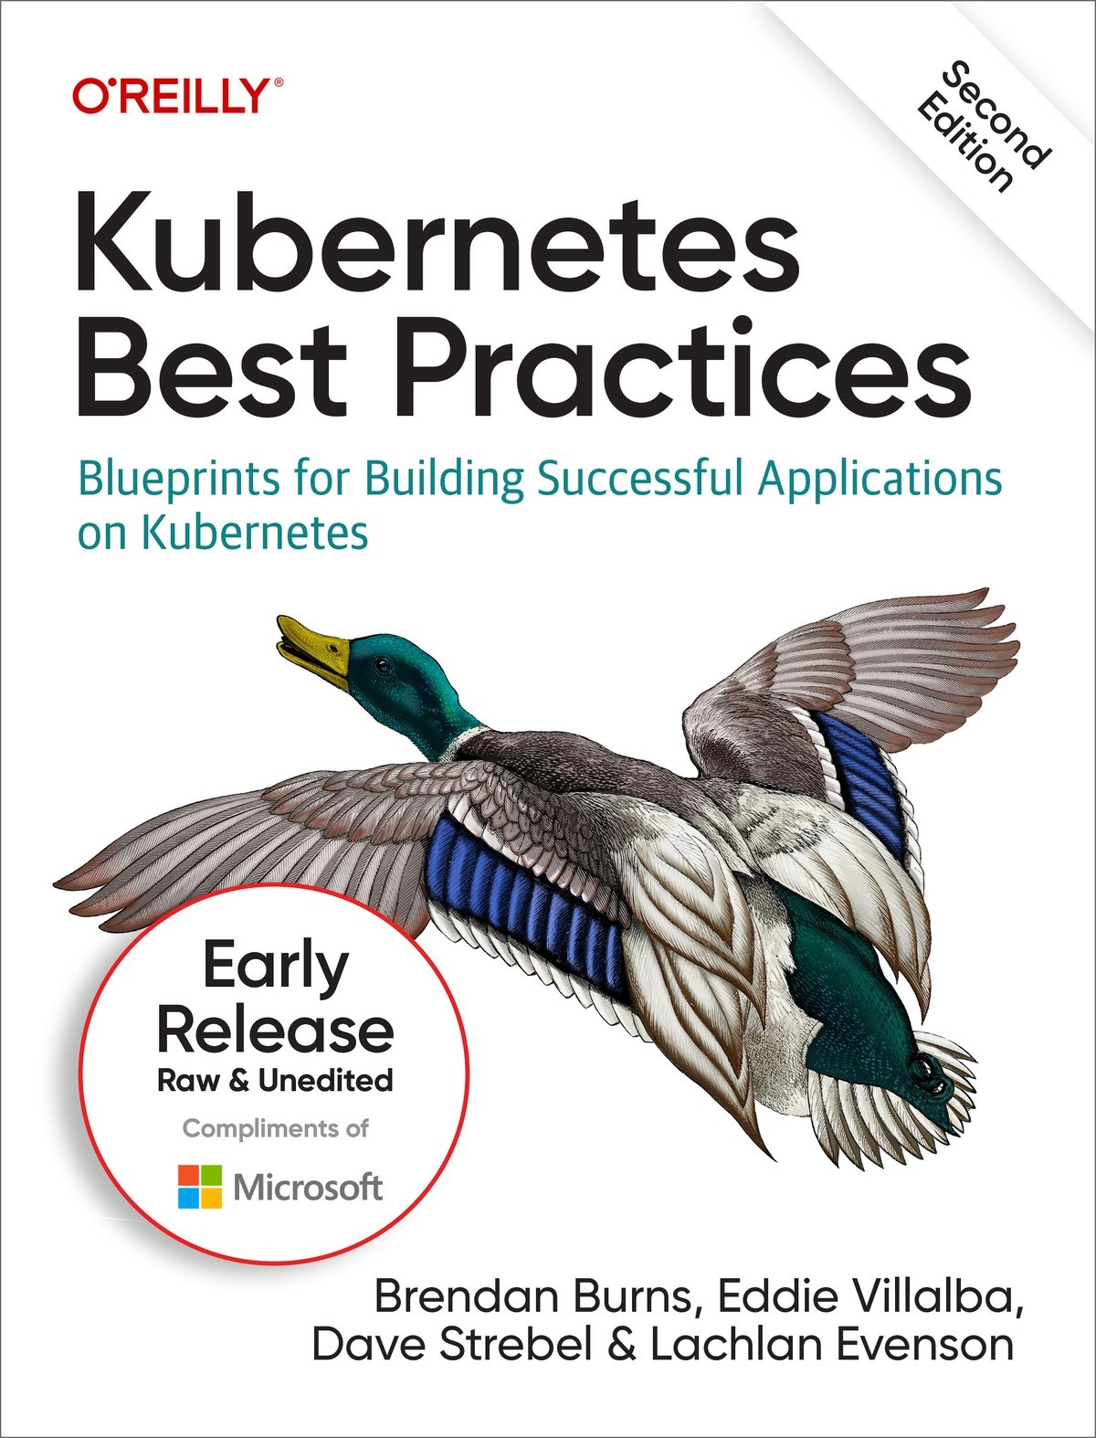

Table of Contents
1. Setting Up a Basic Service
Application Overview
Managing Configuration Files
Creating a Replicated Service Using Deployments
Best Practices for Image Management
Creating a Replicated Application
Setting Up an External Ingress for HTTP Traffic
Configuring an Application with ConfigMaps
Managing Authentication with Secrets
Deploying a Simple Stateful Database
Creating a TCP Load Balancer by Using Services
Using Ingress to Route Traffic to a Static File Server
Parameterizing Your Application by Using Helm
Deploying Services Best Practices
Summary
2. Developer Workflows
Goals
Building a Development Cluster
Setting Up a Shared Cluster for Multiple Developers
Onboarding Users
Creating and Securing a Namespace
Managing Namespaces
Cluster-Level Services
Enabling Developer Workflows
Initial Setup
Enabling Active Development
Enabling Testing and Debugging
Setting Up a Development Environment Best Practices
Summary
3. Monitoring and Logging in Kubernetes
Metrics Versus Logs
Monitoring Techniques
Monitoring Patterns
Kubernetes Metrics Overview
cAdvisor
Metrics Server
kube-state-metrics
What Metrics Do I Monitor?
Monitoring Tools
Monitoring Kubernetes Using Prometheus
Logging Overview
Tools for Logging
Logging by Using a Loki-Stack
Alerting
Best Practices for Monitoring, Logging, and Alerting
Monitoring
Logging
Alerting
Summary
4. Configuration, Secrets, and RBAC
Configuration Through ConfigMaps and Secrets
ConfigMaps
Secrets
Common Best Practices for the ConfigMap and Secrets APIs
RBAC
RBAC Primer
RBAC Best Practices
Summary
5. Continuous Integration, Testing, and Deployment
Version Control
Continuous Integration
Testing
Container Builds
Container Image Tagging
Continuous Deployment
Deployment Strategies
Testing in Production
Setting Up a Pipeline and Performing a Chaos Experiment
Setting Up CI
Setting Up CD
Performing a Rolling Upgrade
A Simple Chaos Experiment
Best Practices for CI/CD
Summary
6. Versioning, Releases, and Rollouts
Versioning
Releases
Rollouts
Putting It All Together
Best Practices for Versioning, Releases, and Rollouts
Summary
7. Worldwide Application Distribution and Staging
Distributing Your Image
Parameterizing Your Deployment
Load-Balancing Traffic Around the World
Reliably Rolling Out Software Around the World
Pre-Rollout Validation
Canary Region
Identifying Region Types
Constructing a Global Rollout
When Something Goes Wrong
Worldwide Rollout Best Practices
Summary
8. Networking, Network Security, and Service Mesh
Kubernetes Network Principles
Network Plug-ins
Kubenet
Kubenet Best Practices
The CNI Plug-in
CNI Best Practices
Services in Kubernetes
Service Type ClusterIP
Service Type NodePort
Service Type ExternalName
Service Type LoadBalancer
Ingress and Ingress Controllers
Gateway API
Services and Ingress Controllers Best Practices
Network Security Policy
Network Policy Best Practices
Service Meshes
Service Mesh Best Practices
Summary
9. Policy and Governance for Your Cluster
Why Policy and Governance Are Important
How Is This Policy Different?
Cloud-Native Policy Engine
Introducing Gatekeeper
Example Policies
Gatekeeper Terminology
Defining Constraint Templates
Defining Constraints
Data Replication
UX
Using Enforcement Action and Audit
Mutation
Testing Policies
Becoming Familiar with Gatekeeper
Policy and Governance Best Practices
Summary
10. Admission Control and Authorization
Admission Control
What Are They?
Why Are They Important?
Admission Controller Types
Configuring Admission Webhooks
Admission Control Best Practices
Authorization
Authorization Modules
Authorization Best Practices
Don’t use webhook modules
Summary
About the Authors

Microsoft Azure
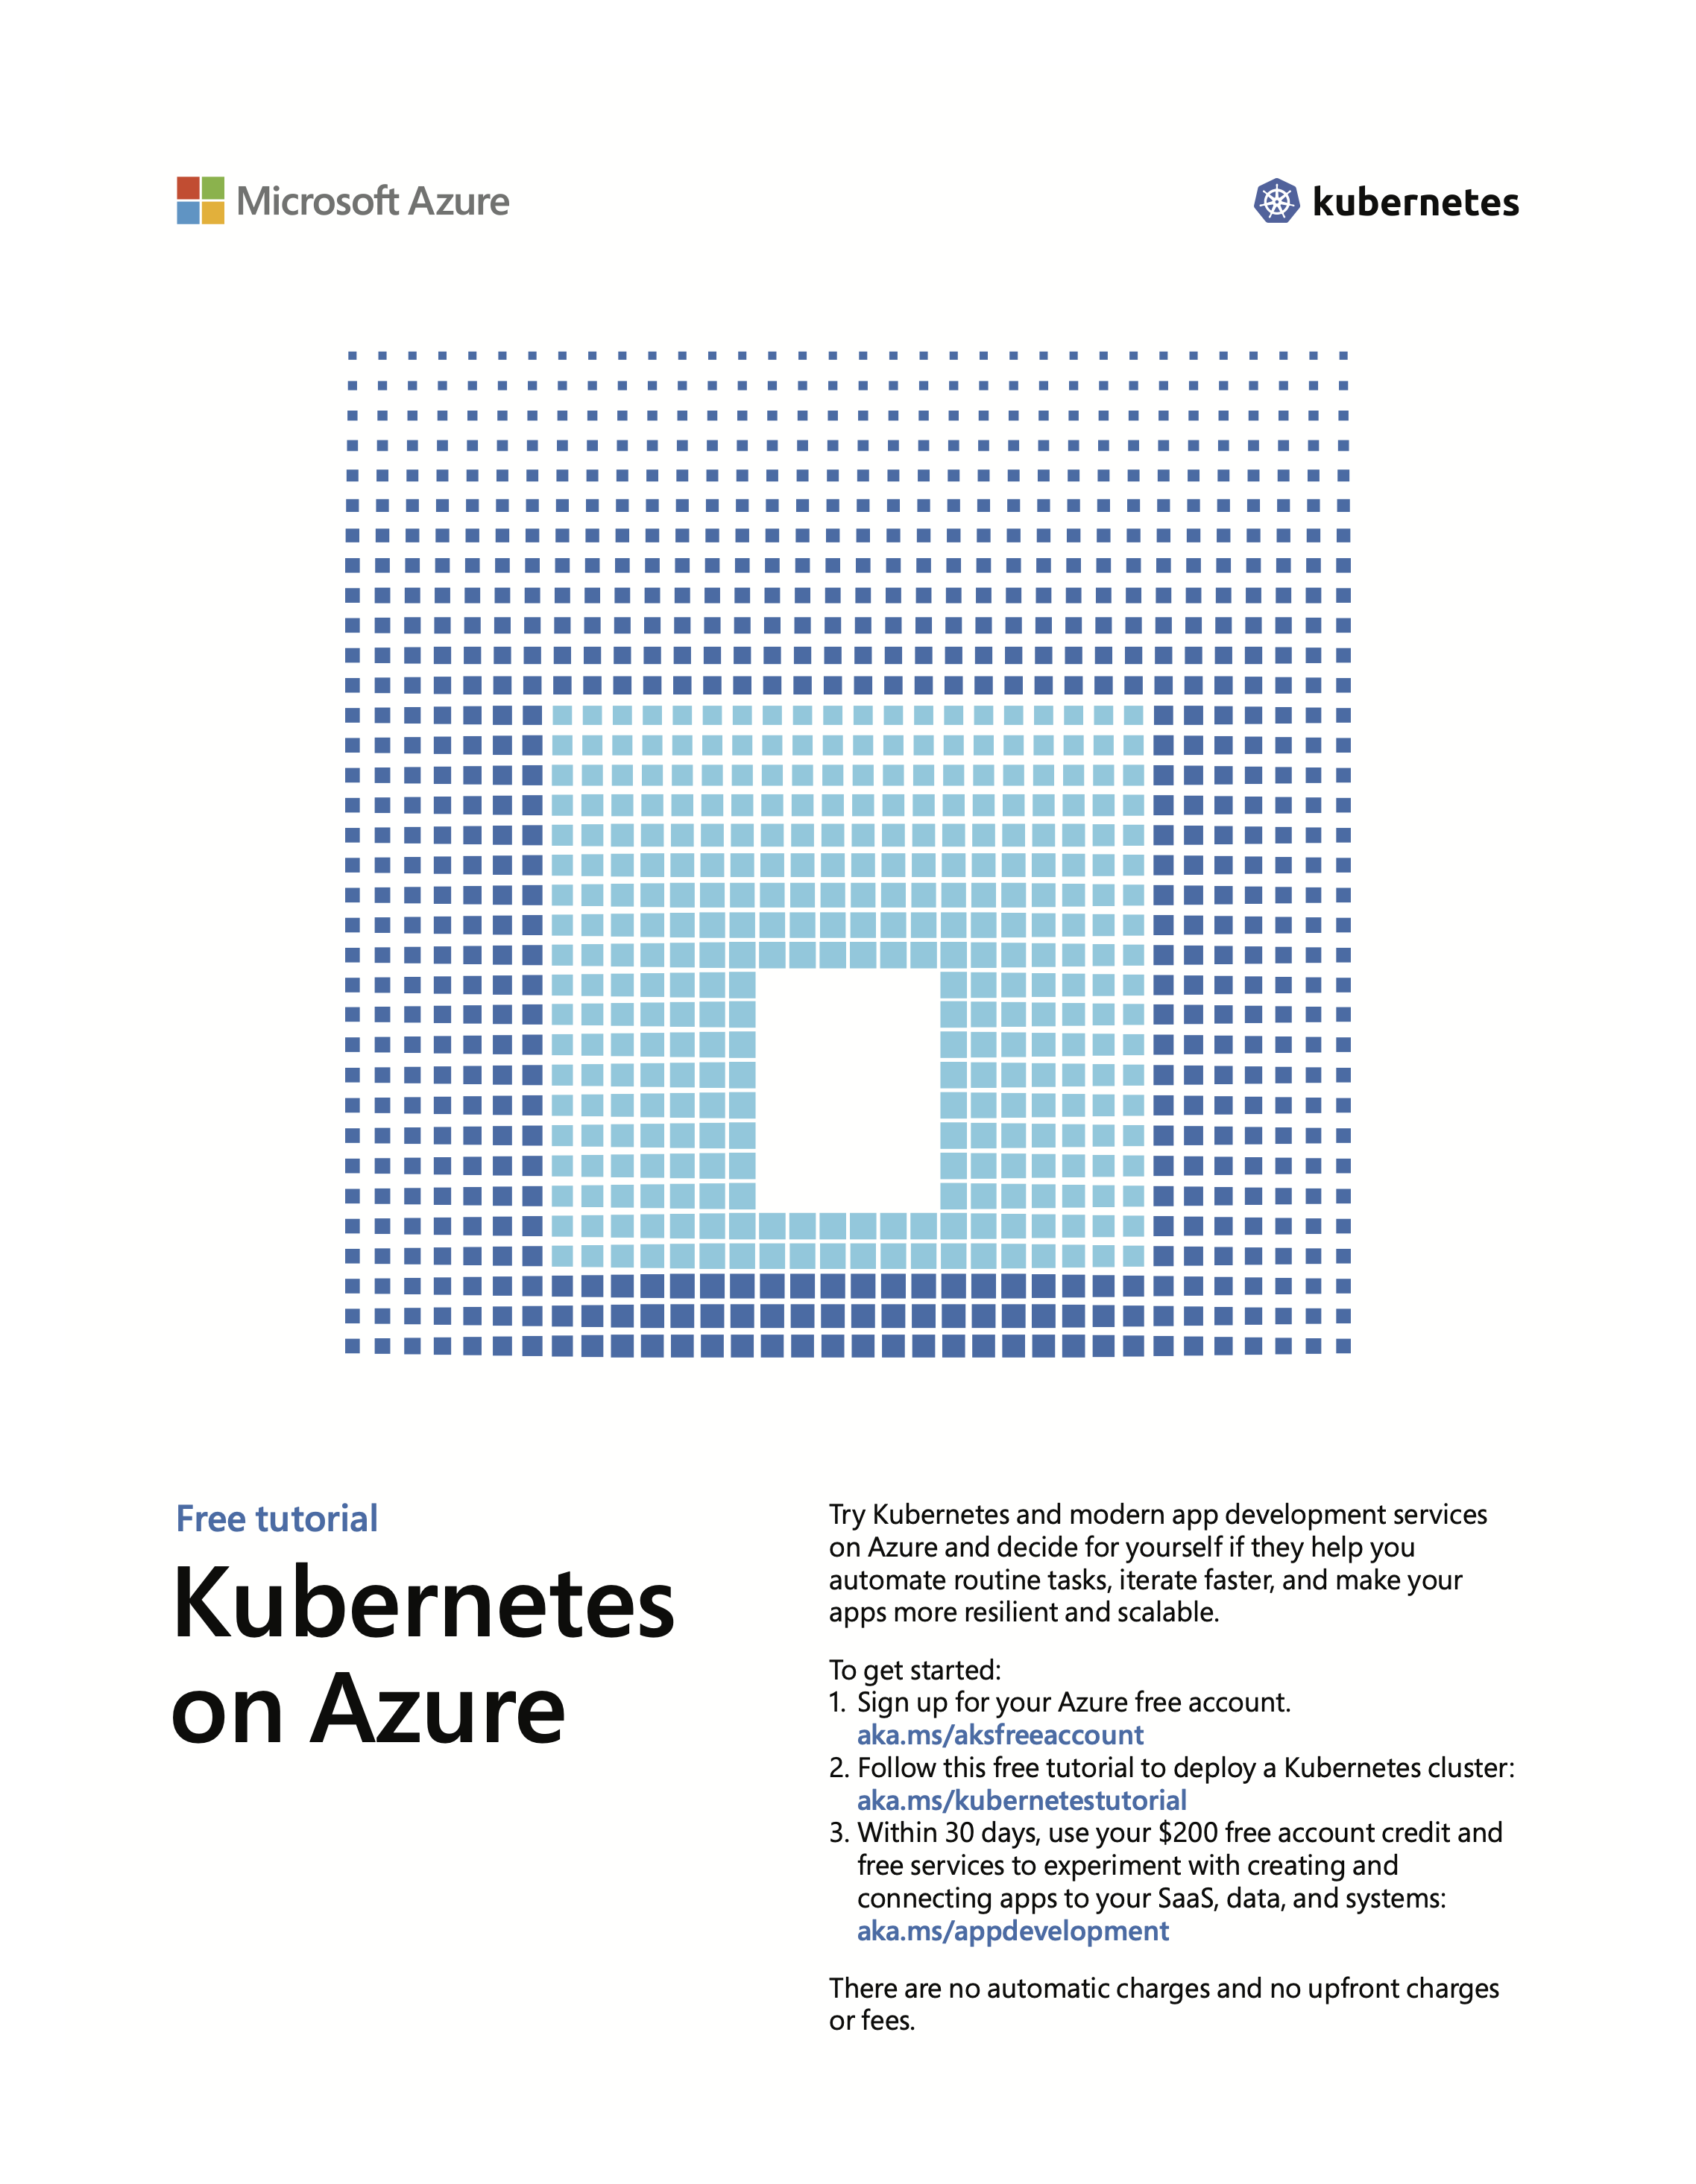

Kubernetes Best Practices
Second Edition
Blueprints for Building Successful Applications on Kubernetes
With Early Release ebooks, you get books in their earliest form—the author’s raw and unedited content as they write—so you can take advantage of these technologies long before the official release of these titles.
Brendan Burns, Eddie Villalba, Dave Strebel, and Lachlan Evenson

Kubernetes Best Practices
by Brendan Burns, Eddie Villalba, Dave Strebel, and Lachlan Evenson
Copyright © 2023 Brendan Burns, Eddie Villalba, Dave Strebel, and Lachlan Evenson. All rights reserved.
Printed in the United States of America.
Published by O’Reilly Media, Inc., 1005 Gravenstein Highway North, Sebastopol, CA 95472.
O’Reilly books may be purchased for educational, business, or sales promotional use. Online editions are also available for most titles (http://oreilly.com). For more information, contact our corporate/institutional sales department: 800-998-9938 or corporate@oreilly.com.
- Acquisitions Editor: John Devins
- Development Editor: Jill Leonard
- Production Editor: Beth Kelly
- Copyeditor:
- Proofreader:
- Indexer:
- Interior Designer: David Futato
- Cover Designer: Karen Montgomery
- Illustrator: Kate Dullea
- October 2023: Second Edition

Revision History for the Early Release
- 2023-01-26: First Release
- 2023-02-15: Second Release
- 2023-07-07: Third Release
See https://www.oreilly.com/catalog/errata.csp?isbn=0636920805021 for release details.
The O’Reilly logo is a registered trademark of O’Reilly Media, Inc. Kubernetes Best Practices, the cover image, and related trade dress are trademarks of O’Reilly Media, Inc.
The views expressed in this work are those of the authors, and do not represent the publisher’s views. While the publisher and the authors have used good faith efforts to ensure that the information and instructions contained in this work are accurate, the publisher and the authors disclaim all responsibility for errors or omissions, including without limitation responsibility for damages resulting from the use of or reliance on this work. Use of the information and instructions contained in this work is at your own risk. If any code samples or other technology this work contains or describes is subject to open source licenses or the intellectual property rights of others, it is your responsibility to ensure that your use thereof complies with such licenses and/or rights.
978-1-098-14211-7
[TO COME]

Chapter 1. Setting Up a Basic Service
A Note for Early Release Readers
With Early Release ebooks, you get books in their earliest form—the author’s raw and unedited content as they write—so you can take advantage of these technologies long before the official release of these titles.
This will be the 1st chapter of the final book. Please note that the GitHub repo will be made active later on.
If you have comments about how we might improve the content and/or examples in this book, or if you notice missing material within this chapter, please reach out to the editor at jleonard@oreilly.com.
This chapter describes the practices for setting up a simple multitier application in Kubernetes. The application consists of a simple web application and a database. Though this might not be the most complicated application, it is a good place to start to orient to managing an application in Kubernetes.

Application Overview
The application that we will use for our sample isn’t particularly complex. It’s a simple journal service that stores its data in a Redis backend. It has a separate static file server using NGINX. It presents two web paths on a single URL. The paths are one for the journal’s RESTful application programming interface (API), https://my-host.io/api, and a file server on the main URL, https://my-host.io. It uses the Let’s Encrypt service for managing Secure Sockets Layer (SSL) certificates. Figure 1-1 presents a diagram of the application. Throughout this chapter, we build up this application, first using YAML configuration files and then Helm charts.
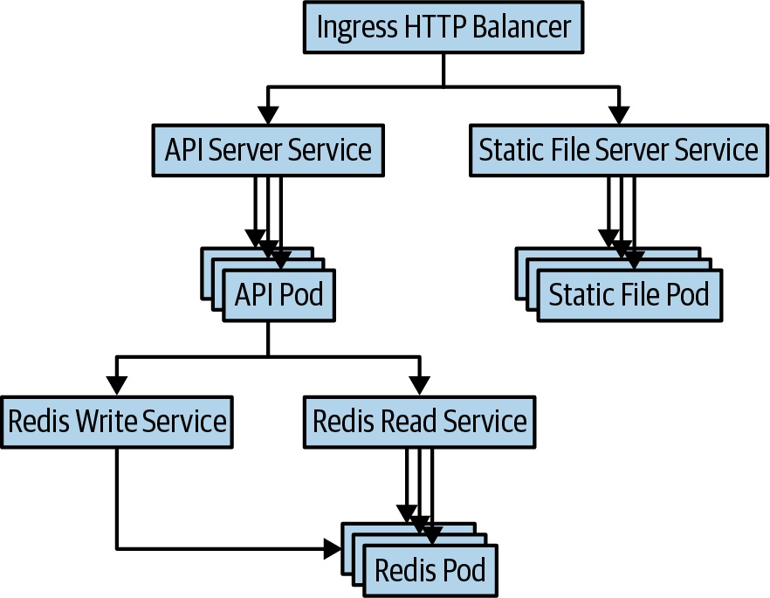

Figure 1-1. An application diagram

Managing Configuration Files
Before we get into the details of how to construct this application in Kubernetes, it is worth discussing how we manage the configurations themselves. With Kubernetes, everything is represented declaratively. This means that you write down the desired state of the application in the cluster (generally in YAML or JSON files), and these declared desired states define all of the pieces of your application. This declarative approach is far preferable to an imperative approach in which the state of your cluster is the sum of a series of changes to the cluster. If a cluster is configured imperatively, it is very difficult to understand and replicate how the cluster came to be in that state. This makes it very challenging to understand or recover from problems with your application.
When declaring the state of your application, people typically prefer YAML to JSON, though Kubernetes supports them both. This is because YAML is somewhat less verbose and more human editable than JSON. However, it’s worth noting that YAML is indentation sensitive; often errors in Kubernetes configurations can be traced to incorrect indentation in YAML. If things aren’t behaving as expected, indentation is a good thing to check. Most editors have syntax highlighting support for both JSON and YAML, when working with these files it is a good idea to install such tools to make it easier to both author and files errors in your configurations. There is also an excellent extension for Visual Studio Code that supports richer error checking for Kubernetes files.
Because the declarative state contained in these YAML files serves as the source of truth for your application, correct management of this state is critical to the success of your application. When modifying your application’s desired state, you will want to be able to manage changes, validate that they are correct, audit who made changes, and possibly roll things back if they fail. Fortunately, in the context of software engineering, we have already developed the tools necessary to manage both changes to the declarative state as well as audit and rollback. Namely, the best practices around both version control and code review directly apply to the task of managing the declarative state of your application.
These days most people store their Kubernetes configurations in Git. Though the specific details of the version control system are unimportant, many tools in the Kubernetes ecosystem expect files in a Git repository. For code review there is much more heterogeneity, though clearly GitHub is quite popular, others use on-premises code review tools or services. Regardless of how you implement code review for your application configuration, you should treat it with the same diligence and focus that you apply to source control.
When it comes to laying out the filesystem for your application, it’s generally worthwhile to use the directory organization that comes with the filesystem to organize your components. Typically, a single directory is used to encompass an Application Service for whatever definition of Application Service is useful for your team. Within that directory, subdirectories are used for subcomponents of the application.
For our application, we lay out the files as follows:
journal/
frontend/
redis/
fileserver/
Within each directory are the concrete YAML files needed to define the service. As you’ll see later on, as we begin to deploy our application to multiple different regions or clusters, this file layout will become more complicated.

Creating a Replicated Service Using Deployments
To describe our application, we’ll begin at the frontend and work downward. The frontend application for the journal is a Node.js application implemented in TypeScript. The complete application is slightly too large to include in the book. The application exposes an HTTP service on port 8080 that serves requests to the /api/* path and uses the Redis backend to add, delete, or return the current journal entries. This application can be built into a container image using the included Dockerfile and pushed to your own image repository. Then, substitute this image name in the YAML examples that follow.

Best Practices for Image Management
Though in general, building and maintaining container images is beyond the scope of this book, it’s worthwhile to identify some general best practices for building and naming images. In general, the image build process can be vulnerable to “supply-chain attacks.” In such attacks, a malicious user injects code or binaries into some dependency from a trusted source that is then built into your application. Because of the risk of such attacks, it is critical that when you build your images you base them on only well-known and trusted image providers. Alternately, you can build all your images from scratch. Building from scratch is easy for some languages (e.g., Go) that can build static binaries, but it is significantly more complicated for interpreted languages like Python, JavaScript, or Ruby.
The other best practices for images relate to naming. Though the version of a container image in an image registry is theoretically mutable, you should treat the version tag as immutable. In particular, some combination of the semantic version and the SHA hash of the commit where the image was built is a good practice for naming images (e.g., v1.0.1-bfeda01f). If you don’t specify an image version, latest is used by default. Although this can be convenient in development, it is a bad idea for production usage because latest is clearly being mutated every time a new image is built.

Creating a Replicated Application
Our frontend application is stateless; it relies entirely on the Redis backend for its state. As a result, we can replicate it arbitrarily without affecting traffic. Though our application is unlikely to sustain large-scale usage, it’s still a good idea to run with at least two replicas so that you can handle an unexpected crash or roll out a new version of the application without downtime.
In Kubernetes, the ReplicaSet resource is the one that directly manages replicating a specific version of your containerized application. Since the version of all applications changes over time as you modify the code, it is not a best practice to use a ReplicaSet directly. Instead, you use the Deployment resource. A Deployment combines the replication capabilities of ReplicaSet with versioning and the ability to perform a staged rollout. By using a Deployment you can use Kubernetes’ built-in tooling to move from one version of the application to the next.
The Kubernetes Deployment resource for our application looks as follows:
apiVersion
:
apps/v1
kind
:
Deployment
metadata
:
labels
:
# All pods in the Deployment will have this label
app
:
frontend
name
:
frontend
namespace
:
default
spec
:
# We should always have at least two replicas for reliability
replicas
:
2
selector
:
matchLabels
:
app
:
frontend
template
:
metadata
:
labels
:
app
:
frontend
spec
:
containers
:
-
image
:
my-repo/journal-server:v1-abcde
imagePullPolicy
:
IfNotPresent
name
:
frontend
# TODO: Figure out what the actual resource needs are
resources
:
request
:
cpu
:
"1.0"
memory
:
"1G"
limits
:
cpu
:
"1.0"
memory
:
"1G"
There are several things to note in this Deployment. First is that we are using Labels to identify the Deployment as well as the ReplicaSets and the pods that the Deployment creates. We’ve added the app: frontend label to all of these resources so that we can examine all resources for a particular layer in a single request. You’ll see that as we add other resources, we’ll follow the same practice.
Additionally, we’ve added comments in a number of places in the YAML. Although these comments don’t make it into the Kubernetes resource stored on the server, just like comments in code, they serve to help guide people who are looking at this configuration for the first time.
You should also note that for the containers in the Deployment we have specified both Request and Limit resource requests, and we’ve set Request equal to Limit. When running an application, the Request is the reservation that is guaranteed on the host machine where it runs. The Limit is the maximum resource usage that the container will be allowed. When you are starting out, setting Request equal to Limit will lead to the most predictable behavior of your application. This predictability comes at the expense of resource utilization. Because setting Request equal to Limit prevents your applications from overscheduling or consuming excess idle resources, you will not be able to drive maximal utilization unless you tune Request and Limit very, very carefully. As you become more advanced in your understanding of the Kubernetes resource model, you might consider modifying Request and Limit for your application independently, but in general most users find that the stability from predictability is worth the reduced utilization. Often times, as our comment suggests, it is difficult to know the right values for these resource limits. Starting by over-estimating the estimates and then using monitoring to tune to the right values is a pretty good approach. However, if you are launching a new service, remember that the first time you see large scale traffic, your resources needs will likely increase significantly. Additionally, there are some languages, especially garbage collected languages, which will happily consume all available memory, which can make it difficult to determine the correct minimum for memory. In this case, some form of binary search may be necessary, but remember to do this in a test environment so that it doesn’t affect your production!
Now that we have the Deployment resource defined, we’ll check it into version control, and deploy it to Kubernetes:
git
add
frontend/deployment.yaml
git
commit
-m
"Added deployment"
frontend/deployment.yaml
kubectl
apply
-f
frontend/deployment.yaml
It is also a best practice to ensure that the contents of your cluster exactly match the contents of your source control. The best pattern to ensure this is to adopt a GitOps approach and deploy to production only from a specific branch of your source control, using Continuous Integration (CI)/Continuous Delivery (CD) automation. In this way you’re guaranteed that source control and production match. Though a full CI/CD pipeline might seem excessive for a simple application, the automation by itself, independent of the reliability it provides, is usually worth the time taken to set it up. And CI/CD is extremely difficult to retrofit into an existing, imperatively deployed application.
There are also some pieces of this application description YAML (e.g., the ConfigMap and secret volumes) as well as pod Quality of Service that we examine in later sections.

Setting Up an External Ingress for HTTP Traffic
The containers for our application are now deployed, but it’s not currently possible for anyone to access the application. By default, cluster resources are available only within the cluster itself. To expose our application to the world, we need to create a Service and load balancer to provide an external IP address and to bring traffic to our containers. For the external exposure we are actually going to use two Kubernetes resources. The first is a Service that load-balances Transmission Control Protocol (TCP) or User Datagram Protocol (UDP) traffic. In our case, we’re using the TCP protocol. And the second is an Ingress resource, which provides HTTP(S) load balancing with intelligent routing of requests based on HTTP paths and hosts. With a simple application like this, you might wonder why we choose to use the more complex Ingress, but as you’ll see in later sections, even this simple application will be serving HTTP requests from two different services. Furthermore, having an Ingress at the edge enables flexibility for future expansion of our service.
Note
The Ingress resource is one of the older resources in Kubernetes and over the years numerous issues have been raised with the way that it models HTTP access to microservices. This has led to the development of the Gateway API for Kubernetes. The Gateway API has been designed as an extension to Kubernetes and requires additional components to be installed in your cluster. If you find that Ingress doesn’t meet your needs consider moving to the Gateway API.
Before the Ingress resource can be defined, there needs to be a Kubernetes Service for the Ingress to point to. We’ll use Labels to direct the Service to the pods that we created in the previous section. The Service is significantly simpler to define than the Deployment and looks as follows:
apiVersion
:
v1
kind
:
Service
metadata
:
labels
:
app
:
frontend
name
:
frontend
namespace
:
default
spec
:
ports
:
-
port
:
8080
protocol
:
TCP
targetPort
:
8080
selector
:
app
:
frontend
type
:
ClusterIP
After you’ve defined the Service, you can define an Ingress resource. Unlike Service resources, Ingress requires an Ingress controller container to be running in the cluster. There are a number of different implementations you can choose from, either provided by your cloud provider, or implemented using open source servers. If you choose to install an open source ingress provider, it’s a good idea to use the Helm package manager to install and maintain it. The nginx or haproxy Ingress providers are popular choices:
apiVersion
:
networking.k8s.io/v1
kind
:
Ingress
metadata
:
name
:
frontend-ingress
spec
:
rules
:
-
http
:
paths
:
-
path
:
/testpath
pathType
:
Prefix
backend
:
service
:
name
:
test
port
:
number
:
8080

Configuring an Application with ConfigMaps
Every application needs a degree of configuration. This could be the number of journal entries to display per page, the color of a particular background, a special holiday display, or many other types of configuration. Typically, separating such configuration information from the application itself is a best practice to follow.
There are a couple of different reasons for this separation. The first is that you might want to configure the same application binary with different configurations depending on the setting. In Europe you might want to light up an Easter special, whereas in China you might want to display a special for Chinese New Year. In addition to this environmental specialization, there are agility reasons for the separation. Usually a binary release contains multiple different new features; if you turn on these features via code, the only way to modify the active features is to build and release a new binary, which can be an expensive and slow process.
The use of configuration to activate a set of features means that you can quickly (and even dynamically) activate and deactivate features in response to user needs or application code failures. Features can be rolled out and rolled back on a per-feature basis. This flexibility ensures that you are continually making forward progress with most features even if some need to be rolled back to address performance or correctness problems.
In Kubernetes this sort of configuration is represented by a resource called a ConfigMap. A ConfigMap contains multiple key/value pairs representing configuration information or a file. This configuration information can be presented to a container in a pod via either files or environment variables. Imagine that you want to configure your online journal application to display a configurable number of journal entries per page. To achieve this, you can define a ConfigMap as follows:
kubectl
create
configmap
frontend-config
--from-literal
=
journalEntries
=
10
To configure your application, you expose the configuration information as an environment variable in the application itself. To do that, you can add the following to the container resource in the Deployment that you defined earlier:
...
# The containers array in the PodTemplate inside the Deployment
containers
:
-
name
:
frontend
...
env
:
-
name
:
JOURNAL_ENTRIES
valueFrom
:
configMapKeyRef
:
name
:
frontend-config
key
:
journalEntries
...
Although this demonstrates how you can use a ConfigMap to configure your application, in the real world of Deployments, you’ll want to roll out regular changes to this configuration with weekly rollouts or even more frequently. It might be tempting to roll this out by simply changing the ConfigMap itself, but this isn’t really a best practice. There are several reasons for this: the first is that changing the configuration doesn’t actually trigger an update to existing pods. Only when the pod is restarted is the configuration applied. Because of this, the rollout isn’t health based and can be ad hoc or random. Another is that the only versioning for the ConfigMap is in your version control and it can be very difficult to perform a rollback.
A better approach is to put a version number in the name of the ConfigMap itself. Instead of calling it frontend-config, call it frontend-config-v1. When you want to make a change, instead of updating the ConfigMap in place, you create a new v2 ConfigMap, and then update the Deployment resource to use that configuration. When you do this, a Deployment rollout is automatically triggered, using the appropriate health checking and pauses between changes. Furthermore, if you ever need to rollback, the v1 configuration is sitting in the cluster and rollback is as simple as updating the Deployment again.

Managing Authentication with Secrets
So far, we haven’t really discussed the Redis service to which our frontend is connecting. But in any real application we need to secure connections between our services. In part this is to ensure the security of users and their data, and in addition, it is essential to prevent mistakes like connecting a development frontend with a production database.
The Redis database is authenticated using a simple password. It might be convenient to think that you would store this password in the source code of your application, or in a file in your image, but these are both bad ideas for a variety of reasons. The first is that you have leaked your secret (the password) into an environment where you aren’t necessarily thinking about access control. If you put a password into your source control, you are aligning access to your source with access to all secrets. This is probably not correct. You probably will have a broader set of users who can access your source code than should really have access to your Redis instance. Likewise, someone who has access to your container image shouldn’t necessarily have access to your production database.
In addition to concerns about access control, another reason to avoid binding secrets to source control and/or images is parameterization. You want to be able to use the same source code and images in a variety of environments (e.g., development, canary, and production). If the secrets are tightly bound in source code or image, you need a different image (or different code) for each environment.
Having seen ConfigMaps in the previous section, you might immediately think that the password could be stored as a configuration and then populated into the application as an application-specific configuration. You’re absolutely correct to believe that the separation of configuration from application is the same as the separation of secrets from application. But the truth is that a secret is an important concept by itself. You likely want to handle access control, handling, and updates of secrets in a different way than a configuration. More important, you want your developers thinking differently when they are accessing secrets than when they are accessing configuration. For these reasons, Kubernetes has a built-in Secret resource for managing secret data.
You can create a secret password for your Redis database as follows:
kubectl
create
secret
generic
redis-passwd
--from-literal
=
passwd
=
${
RANDOM
}
Obviously, you might want to use something other than a random number for your password. Additionally, you likely want to use a secret/key management service, either via your cloud provider, like Microsoft Azure Key Vault, or an open source project, like HashiCorp’s Vault. When you are using a key management service, they generally have tighter integration with Kubernetes secrets.
Note
Secrets in Kubernetes are stored unecrypted by default. If you want to store secrets encrypted, you can integrate with a key provider to give you a key that Kubernetes will use to encrypt all of the secrets in the cluster. Note that although this secures the keys against direct attacks to the etcd database, you still need to ensure that access via the Kubernetes API server is properly secured.
After you have stored the Redis password as a secret in Kubernetes, you then need to bind that secret to the running application when deployed to Kubernetes. To do this, you can use a Kubernetes Volume. A Volume is effectively a file or directory that can be mounted into a running container at a user-specified location. In the case of secrets, the Volume is created as a tmpfs RAM-backed filesystem and then mounted into the container. This ensures that even if the machine is physically compromised (quite unlikely in the cloud, but possible in the datacenter), the secrets are much more difficult to obtain by the attacker.
To add a secret volume to a Deployment, you need to specify two new entries in the YAML for the Deployment. The first is a volume entry for the pod that adds the volume to the pod:
...
volumes
:
-
name
:
passwd-volume
secret
:
secretName
:
redis-passwd
Many secret providers have Container Storage Interface (CSI) drivers that enable you to mount them directly into a Pod without using Kubernetes secrets at all. If you use one of these CSI drivers your volume would instead look like:
...
volumes
:
-
name
:
passwd-volume
csi
:
driver
:
secrets-store.csi.k8s.io
readOnly
:
true
volumeAttributes
:
secretProviderClass
:
"azure-sync"
...
Regardles of which, with the volume defined in the pod, you need to mount it into a specific container. You do this via the volumeMounts field in the container description:
...
volumeMounts
:
-
name
:
passwd-volume
readOnly
:
true
mountPath
:
"/etc/redis-passwd"
...
This mounts the secret volume into the redis-passwd directory for access from the client code. Putting this all together, you have the complete Deployment as follows:
apiVersion
:
apps/v1
kind
:
Deployment
metadata
:
labels
:
app
:
frontend
name
:
frontend
namespace
:
default
spec
:
replicas
:
2
selector
:
matchLabels
:
app
:
frontend
template
:
metadata
:
labels
:
app
:
frontend
spec
:
containers
:
-
image
:
my-repo/journal-server:v1-abcde
imagePullPolicy
:
IfNotPresent
name
:
frontend
volumeMounts
:
-
name
:
passwd-volume
readOnly
:
true
mountPath
:
"/etc/redis-passwd"
resources
:
requests
:
cpu
:
"1.0"
memory
:
"1G"
limits
:
cpu
:
"1.0"
memory
:
"1G"
volumes
:
-
name
:
passwd-volume
secret
:
secretName
:
redis-passwd
At this point we have configured the client application to have a secret available to authenticate to the Redis service. Configuring Redis to use this password is similar; we mount it into the Redis pod and load the password from the file.

Deploying a Simple Stateful Database
Although conceptually deploying a stateful application is similar to deploying a client like our frontend, state brings with it more complications. The first is that in Kubernetes a pod can be rescheduled for a number of reasons, such as node health, an upgrade, or rebalancing. When this happens, the pod might move to a different machine. If the data associated with the Redis instance is located on any particular machine or within the container itself, that data will be lost when the container migrates or restarts. To prevent this, when running stateful workloads in Kubernetes its important to use remote PersistentVolumes to manage the state associated with the application.
There is a wide variety of different implementations of PersistentVolumes in Kubernetes, but they all share common characteristics. Like secret volumes described earlier, they are associated with a pod and mounted into a container at a particular location. Unlike secrets, PersistentVolumes are generally remote storage mounted through some sort of network protocol, either file based, such as Network File System (NFS) or Server Message Block (SMB), or block based (iSCSI, cloud-based disks, etc.). Generally, for applications such as databases, block-based disks are preferable because they generally offer better performance, but if performance is less of a consideration, file-based disks can sometimes offer greater flexibility.
Note
Managing state in general is complicated, and Kubernetes is no exception. If you are running in an environment that supports stateful services (e.g., MySQL as a service, Redis as a service), it is generally a good idea to use those stateful services. Initially, the cost premium of a stateful Software as a Service (SaaS) might seem expensive, but when you factor in all the operational requirements of state (backup, data locality, redundancy, etc.), and the fact that the presence of state in a Kubernetes cluster makes it difficult to move applications between clusters, it becomes clear that, in most cases, storage SaaS is worth the price premium. In on-premises environments where storage SaaS isn’t available, having a dedicated team provide storage as a service to the entire organization is definitely a better practice than allowing each team to roll its own.
To deploy our Redis service, we use a StatefulSet resource. Added after the initial Kubernetes release as a complement to ReplicaSet resources, a StatefulSet gives slightly stronger guarantees such as consistent names (no random hashes!) and a defined order for scale-up and scale-down. When you are deploying a singleton, this is somewhat less important, but when you want to deploy replicated state, these attributes are very convenient.
To obtain a PersistentVolume for our Redis, we use a PersistentVolumeClaim. You can think of a claim as a “request for resources.” Our Redis declares abstractly that it wants 50 GB of storage, and the Kubernetes cluster determines how to provision an appropriate PersistentVolume. There are two reasons for this. The first is so that we can write a StatefulSet that is portable between different clouds and on-premises, where the details of disks might be different. The other reason is that although many PersistentVolume types can be mounted to only a single pod, we can use volume claims to write a template that can be replicated and yet have each pod assigned its own specific PersistentVolume.
The following example shows a Redis StatefulSet with PersistentVolumes:
apiVersion
:
apps/v1
kind
:
StatefulSet
metadata
:
name
:
redis
spec
:
serviceName
:
"redis"
replicas
:
1
selector
:
matchLabels
:
app
:
redis
template
:
metadata
:
labels
:
app
:
redis
spec
:
containers
:
-
name
:
redis
image
:
redis:5-alpine
ports
:
-
containerPort
:
6379
name
:
redis
volumeMounts
:
-
name
:
data
mountPath
:
/data
volumeClaimTemplates
:
-
metadata
:
name
:
data
spec
:
accessModes
:
[
"ReadWriteOnce"
]
resources
:
requests
:
storage
:
10Gi
This deploys a single instance of your Redis service, but suppose you want to replicate the Redis cluster for scale-out of reads and resiliency to failures. To do this you need to obviously increase the number of replicas to three, but you also need to ensure that the two new replicas connect to the write master for Redis.
When you create the headless Service for the Redis StatefulSet, it creates a DNS entry redis-0.redis; this is the IP address of the first replica. You can use this to create a simple script that can launch in all of the containters:
#!/bin/sh
PASSWORD
=
$(
cat
/etc/redis-passwd/passwd
)
if
[[
"
${
HOSTNAME
}
"
==
"redis-0"
]]
;
then
redis-server
--requirepass
${
PASSWORD
}
else
redis-server
--slaveof
redis-0.redis
6379
--masterauth
${
PASSWORD
}
--requirepass
${
PASSWORD
}
fi
You can create this script as a ConfigMap:
kubectl
create
configmap
redis-config
--from-file
=
./launch.sh
You then add this ConfigMap to your StatefulSet and use it as the command for the container. Let’s also add in the password for authentication that we created earlier in the chapter.
The complete three-replica Redis looks as follows:
apiVersion
:
apps/v1
kind
:
StatefulSet
metadata
:
name
:
redis
spec
:
serviceName
:
"redis"
replicas
:
3
selector
:
matchLabels
:
app
:
redis
template
:
metadata
:
labels
:
app
:
redis
spec
:
containers
:
-
name
:
redis
image
:
redis:5-alpine
ports
:
-
containerPort
:
6379
name
:
redis
volumeMounts
:
-
name
:
data
mountPath
:
/data
-
name
:
script
mountPath
:
/script/launch.sh
subPath
:
launch.sh
-
name
:
passwd-volume
mountPath
:
/etc/redis-passwd
command
:
-
sh
-
-c
-
/script/launch.sh
volumes
:
-
name
:
script
configMap
:
name
:
redis-config
defaultMode
:
0777
-
name
:
passwd-volume
secret
:
secretName
:
redis-passwd
volumeClaimTemplates
:
-
metadata
:
name
:
data
spec
:
accessModes
:
[
"ReadWriteOnce"
]
resources
:
requests
:
storage
:
10Gi

Creating a TCP Load Balancer by Using Services
Now that we’ve deployed the stateful Redis service, we need to make it available to our frontend. To do this, we create two different Kubernetes Services. The first is the Service for reading data from Redis. Because Redis is replicating the data to all three members of the StatefulSet, we don’t care which read our request goes to. Consequently, we use a basic Service for the reads:
apiVersion
:
v1
kind
:
Service
metadata
:
labels
:
app
:
redis
name
:
redis
namespace
:
default
spec
:
ports
:
-
port
:
6379
protocol
:
TCP
targetPort
:
6379
selector
:
app
:
redis
sessionAffinity
:
None
type
:
ClusterIP
To enable writes, you need to target the Redis master (replica #0). To do this, create a headless Service. A headless Service doesn’t have a cluster IP address; instead, it programs a DNS entry for every pod in the StatefulSet. This means that we can access our master via the redis-0.redis DNS name:
apiVersion
:
v1
kind
:
Service
metadata
:
labels
:
app
:
redis-write
name
:
redis-write
spec
:
clusterIP
:
None
ports
:
-
port
:
6379
selector
:
app
:
redis
Thus, when we want to connect to Redis for writes or transactional read/write pairs, we can build a separate write client connected to the redis-0.redis-write server.

Using Ingress to Route Traffic to a Static File Server
The final component in our application is a static file server. The static file server is responsible for serving HTML, CSS, JavaScript, and image files. It’s both more efficient and more focused for us to separate static file serving from our API serving frontend described earlier. We can easily use a high-performance static off-the-shelf file server like NGINX to serve files while we allow our development teams to focus on the code needed to implement our API.
Fortunately, the Ingress resource makes this source of mini-microservice architecture very easy. Just like the frontend, we can use a Deployment resource to describe a replicated NGINX server. Let’s build the static images into the NGINX container and deploy them to each replica. The Deployment resource looks as follows:
apiVersion
:
apps/v1
kind
:
Deployment
metadata
:
labels
:
app
:
fileserver
name
:
fileserver
namespace
:
default
spec
:
replicas
:
2
selector
:
matchLabels
:
app
:
fileserver
template
:
metadata
:
labels
:
app
:
fileserver
spec
:
containers
:
# This image is intended as an example, replace it with your own
# static files image.
-
image
:
my-repo/static-files:v1-abcde
imagePullPolicy
:
Always
name
:
fileserver
terminationMessagePath
:
/dev/termination-log
terminationMessagePolicy
:
File
resources
:
requests
:
cpu
:
"1.0"
memory
:
"1G"
limits
:
cpu
:
"1.0"
memory
:
"1G"
dnsPolicy
:
ClusterFirst
restartPolicy
:
Always
Now that there is a replicated static web server up and running, you will likewise create a Service resource to act as a load balancer:
apiVersion
:
v1
kind
:
Service
metadata
:
labels
:
app
:
fileserver
name
:
fileserver
namespace
:
default
spec
:
ports
:
-
port
:
80
protocol
:
TCP
targetPort
:
80
selector
:
app
:
fileserver
sessionAffinity
:
None
type
:
ClusterIP
Now that you have a Service for your static file server, extend the Ingress resource to contain the new path. It’s important to note that you must place the / path after the /api path, or else it would subsume /api and direct API requests to the static file server. The new Ingress looks like this:
apiVersion
:
networking.k8s.io/v1
kind
:
Ingress
metadata
:
name
:
frontend-ingress
spec
:
rules
:
-
http
:
paths
:
-
path
:
/api
pathType
:
Prefix
backend
:
service
:
name
:
fileserver
port
:
number
:
8080
# NOTE: this should come after /api or else it will hijack requests
-
path
:
/
pathType
:
Prefix
backend
:
service
:
name
:
fileserver
port
:
number
:
80

Parameterizing Your Application by Using Helm
Everything that we have discussed so far focuses on deploying a single instance of our service to a single cluster. However, in reality, nearly every service and every service team is going to need to deploy to multiple different environments (even if they share a cluster). Even if you are a single developer working on a single application, you likely want to have at least a development version and a production version of your application so that you can iterate and develop without breaking production users. After you factor in integration testing and CI/CD, it’s likely that even with a single service and a handful of developers, you’ll want to deploy to at least three different environments, and possibly more if you consider handling datacenter-level failures.
An initial failure mode for many teams is to simply copy the files from one cluster to another. Instead of having a single frontend/ directory, have a frontend-production/ and frontend-development/ pair of directories. The reason this is so dangerous is because you are now in charge of ensuring that these files remain synchronized with one another. If they were intended to be entirely identical, this might be easy, but some skew between development and production is expected because you will be developing new features; it’s critical that the skew is both intentional, and easily managed.
Another option to achieve this would be to use branches and version control, with the production and development branches leading off from a central repository, and the differences between the branches clearly visible. This can be a viable option for some teams, but the mechanics of moving between branches are challenging when you want to simultaneously deploy software to different environments (e.g., a CI/CD system that deploys to a number of different cloud regions).
Consequently, most people end up with a templating system. A templating system combines templates, which form the centralized backbone of the application configuration, with parameters that specialize the template to a specific environment configuration. In this way, you can have a generally shared configuration, with intentional (and easily understood) customization as needed. There are a variety of different template systems for Kubernetes, but the most popular by far is a system called Helm.
In Helm, an application is packaged in a collection of files called a chart (nautical jokes abound in the world of containers and Kubernetes).
A chart begins with a chart.yaml file, which defines the metadata for the chart itself:
apiVersion
:
v1
appVersion
:
"1.0"
description
:
A Helm chart for our frontend journal server.
name
:
frontend
version
:
0.1.0
This file is placed in the root of the chart directory (e.g., frontend/). Within this directory, there is a templates directory, which is where the templates are placed. A template is basically a YAML file from the previous examples, with some of the values in the file replaced with parameter references. For example, imagine that you want to parameterize the number of replicas in your frontend. Previously, here’s what the Deployment had:
...
spec
:
replicas
:
2
...
In the template file (frontend-deployment.tmpl), it instead looks like the following:
...
spec
:
replicas
:
{{
.replicaCount
}}
...
This means that when you deploy the chart, you’ll substitute the value for replicas with the appropriate parameter. The parameters themselves are defined in a values.yaml file. There will be one values file per environment where the application should be deployed. The values file for this simple chart would look like this:
replicaCount
:
2
Putting this all together, you can deploy this chart using the helm tool, as follows:
helm
install
path/to/chart
--values
path/to/environment/values.yaml
This parameterizes your application and deploys it to Kubernetes. Over time these parameterizations will grow to encompass the variety of different environments for your application.

Deploying Services Best Practices
Kubernetes is a powerful system that can seem complex. But setting up a basic application for success can be straightforward if you use the following best practices:
- Most services should be deployed as Deployment resources. Deployments create identical replicas for redundancy and scale.
- Deployments can be exposed using a Service, which is effectively a load balancer. A Service can be exposed either within a cluster (the default) or externally. If you want to expose an HTTP application, you can use an Ingress controller to add things like request routing and SSL.
- Eventually you will want to parameterize your application to make its configuration more reusable in different environments. Packaging tools like Helm are the best choice for this kind of parameterization.

Summary
The application built in this chapter is a simple one, but it contains nearly all of the concepts you’ll need to build larger, more complicated applications. Understanding how the pieces fit together and how to use foundational Kubernetes components is key to successfully working with Kubernetes.
Laying the correct foundation via version control, code review, and continuous delivery of your service ensures that no matter what you build, it is built in a solid manner. As we go through the more advanced topics in subsequent chapters, keep this foundational information in mind.

Chapter 2. Developer Workflows
A Note for Early Release Readers
With Early Release ebooks, you get books in their earliest form—the author’s raw and unedited content as they write—so you can take advantage of these technologies long before the official release of these titles.
This will be the 2nd chapter of the final book. Please note that the GitHub repo will be made active later on.
If you have comments about how we might improve the content and/or examples in this book, or if you notice missing material within this chapter, please reach out to the editor at jleonard@oreilly.com.
Kubernetes was built for reliably operating software. It simplifies deploying and managing applications with an application-oriented API, self-healing properties, and useful tools like Deployments for zero downtime rollout of software. Although all of these tools are useful, they don’t do much to make it easier to develop applications for Kubernetes. Furthermore, even though many clusters are designed to run production applications and thus are rarely accessed by developer workflows, it is also critical to enable development workflows to target Kubernetes, and this typically means having a cluster or at least part of a cluster that is intended for development. Setting up such a cluster to facilitate easy development of applications for Kubernetes is a critical part of ensuring success with Kubernetes. Clearly if there is no code being built for your cluster, the cluster itself isn’t accomplishing much.

Goals
Before we describe the best practices for building out development clusters, it is worth stating our goals for such clusters. Obviously, the ultimate goal is to enable developers to rapidly and easily build applications on Kubernetes, but what does that really mean in practice and how is that reflected in practical features of the development cluster?
It is useful to identify phases of developer interaction with the cluster.
The first phase is onboarding. This is when a new developer joins the team. This phase includes giving the user a login to the cluster as well as getting them oriented to their first deployment. The goal for this phase is to get a developer’s feet wet in a minimal amount of time. You should set a key performance indicator (KPI) goal for this process. A reasonable goal would be that a user could go from nothing to the current application at HEAD running in less than half an hour. Every time someone is new to the team, test how you are doing against this goal.
The second phase is developing. This is the day-to-day activity of the developer. The goal for this phase is to ensure rapid iteration and debugging. Developers need to quickly and repeatedly push code to the cluster. They also need to be able to easily test their code and debug it when it isn’t operating properly. The KPI for this phase is more challenging to measure, but you can estimate it by measuring the time to get a pull request (PR) or change up and running in the cluster, or with surveys of the user’s perceived productivity, or both. You will also be able to measure this in the overall productivity of your teams.
The third phase is testing. This phase is interleaved with developing and is used to validate the code before submission and merging. The goals for this phase are two-fold. First, the developer should be able to run all tests for their environment before a PR is submitted. Second, all tests should automatically run before code is merged into the repository. In addition to these goals you should also set a KPI for the length of time the tests take to run. As your project becomes more complex, it’s natural for more and more tests to take a longer time. As this happens, it might become valuable to identify a smaller set of smoke tests that a developer can use for initial validation before submitting a PR. You should also have a very strict KPI around test flakiness. A flaky test is one that occasionally (or not so occasionally) fails. In any reasonably active project, a flakiness rate of more than one failure per one thousand runs will lead to developer friction. You need to ensure that your cluster environment does not lead to flaky tests. Whereas sometimes flaky tests occur due to problems in the code, they can also occur because of interference in the development environment (e.g., running out of resources and noisy neighbors). You should ensure that your development environment is free of such issues by measuring test flakiness and acting quickly to fix it.

Building a Development Cluster
When people begin to think about developing on Kubernetes, one of the first choices that occurs is whether to build a single large development cluster or to have one cluster per developer. Note that this choice only makes sense in an environment in which dynamic cluster creation is easy, such as the public cloud. In physical environments, its possible that one large cluster is the only choice.
If you do have a choice you should consider the pros and cons of each option. If you choose to have a development cluster per user, the significant downside of this approach is that it will be more expensive and less efficient, and you will have a large number of different development clusters to manage. The extra costs come from the fact that each cluster is likely to be heavily underutilized. Also, with developers creating different clusters, it becomes more difficult to track and garbage-collect resources that are no longer in use. The advantage of the cluster-per-user approach is simplicity: each developer can self-service manage their own cluster, and from isolation, it’s much more difficult for different developers to step on one another’s toes.
On the other hand, a single development cluster will be significantly more efficient; you can likely sustain the same number of developers on a shared cluster for one-third the price (or less). Plus, it’s much easier for you to install shared cluster services, for example, monitoring and logging, which makes it significantly easier to produce a developer-friendly cluster. The downside of a shared development cluster is the process of user management and potential interference between developers. Because the process of adding new users and namespaces to the Kubernetes cluster isn’t currently streamlined, you will need to activate a process to onboard new developers. Although Kubernetes resource management and Role-Based Access Control (RBAC) can reduce the probability that two developers conflict, it is always possible that a user will brick the development cluster by consuming too many resources so that other applications and developers won’t schedule. Additionally, you will still need to ensure that developers don’t leak and forget about resources they’ve created. This is somewhat easier, though, than the approach in which developers each create their own clusters.
Even though both approaches are feasible, generally, our recommendation is to have a single large cluster for all developers. Although there are challenges in interference between developers, they can be managed and ultimately the cost efficiency and ability to easily add organization-wide capabilities to the cluster outweigh the risks of interference. But you will need to invest in a process for onboarding developers, resource management, and garbage collection. Our recommendation would be to try a single large cluster as a first option. As your organization grows (or if it is already large), you might consider having a cluster per team or group (10 to 20 people) rather than a giant cluster for hundreds of users. This can make both billing and management easier.

Setting Up a Shared Cluster for Multiple Developers
When setting up a large cluster, the primary goal is to ensure that multiple users can simultaneously use the cluster without stepping on one another’s toes. The obvious way to separate your different developers is with Kubernetes namespaces. Namespaces can serve as scopes for the deployment of services so that one user’s frontend service doesn’t interfere with another user’s frontend service. Namespaces are also scopes for RBAC, ensuring that one developer cannot accidentally delete another developer’s work. Thus, in a shared cluster it makes sense to use a namespace as a developer’s workspace. The processes for onboarding users and creating and securing a namespace are described in the following sections.

Onboarding Users
Before you can assign a user to a namespace, you have to onboard that user to the Kubernetes cluster itself. To achieve this, there are two options. You can use certificate-based authentication to create a new certificate for the user and give them a kubeconfig file that they can use to log in, or you can configure your cluster to use an external identity system (for example, Microsoft Azure Active Directory or AWS Identity and Access Management [IAM]) for cluster access.
In general, using an external identity system is a best practice because it doesn’t require that you maintain two different sources of identity, additionally most external systems use short-lived tokens rather than long lived certificates so the accidental disclosure of a token has a time bound security impact. If at all possible you should restrict your developers to proving their identity via an external identity provider.
Unfortunately, in some cases this isn’t possible and you need to use certificates. Fortunately, you can use the Kubernetes certificate API for creating and managing such certificates. Here’s the process for adding a new user to an existing cluster.
First, you need to generate a certificate signing request to generate a new certificate. Here is a simple Go program to do this:
package
main
import
(
"crypto/rand"
"crypto/rsa"
"crypto/x509"
"crypto/x509/pkix"
"encoding/asn1"
"encoding/pem"
"os"
)
func
main
()
{
name
:=
os
.
Args
[
1
]
user
:=
os
.
Args
[
2
]
key
,
err
:=
rsa
.
GenerateKey
(
rand
.
Reader
,
1024
)
if
err
!=
nil
{
panic
(
err
)
}
keyDer
:=
x509
.
MarshalPKCS1PrivateKey
(
key
)
keyBlock
:=
pem
.
Block
{
Type
:
"RSA PRIVATE KEY"
,
Bytes
:
keyDer
,
}
keyFile
,
err
:=
os
.
Create
(
name
+
"-key.pem"
)
if
err
!=
nil
{
panic
(
err
)
}
pem
.
Encode
(
keyFile
,
&
keyBlock
)
keyFile
.
Close
()
commonName
:=
user
// You may want to update these too
emailAddress
:=
"someone@myco.com"
org
:=
"My Co, Inc."
orgUnit
:=
"Widget Farmers"
city
:=
"Seattle"
state
:=
"WA"
country
:=
"US"
subject
:=
pkix
.
Name
{
CommonName
:
commonName
,
Country
:
[]
string
{
country
},
Locality
:
[]
string
{
city
},
Organization
:
[]
string
{
org
},
OrganizationalUnit
:
[]
string
{
orgUnit
},
Province
:
[]
string
{
state
},
}
asn1
,
err
:=
asn1
.
Marshal
(
subject
.
ToRDNSequence
())
if
err
!=
nil
{
panic
(
err
)
}
csr
:=
x509
.
CertificateRequest
{
RawSubject
:
asn1
,
EmailAddresses
:
[]
string
{
emailAddress
},
SignatureAlgorithm
:
x509
.
SHA256WithRSA
,
}
bytes
,
err
:=
x509
.
CreateCertificateRequest
(
rand
.
Reader
,
&
csr
,
key
)
if
err
!=
nil
{
panic
(
err
)
}
csrFile
,
err
:=
os
.
Create
(
name
+
".csr"
)
if
err
!=
nil
{
panic
(
err
)
}
pem
.
Encode
(
csrFile
,
&
pem
.
Block
{
Type
:
"CERTIFICATE REQUEST"
,
Bytes
:
bytes
})
csrFile
.
Close
()
}
You can run this as follows:
go
run
csr-gen.go
client
<user-name>
;
This creates files called client-key.pem and client.csr. You then can run the following script to create and download a new certificate:
#!/bin/bash
csr_name
=
"my-client-csr"
name
=
"
${
1
:-
my
-user
}
"
csr
=
"
${
2
}
"
cat
<<EOF | kubectl create -f -
apiVersion: certificates.k8s.io/v1
kind: CertificateSigningRequest
metadata:
name: ${csr_name}
spec:
groups:
- system:authenticated
request: $(cat ${csr} | base64 | tr -d '\n')
usages:
- key encipherment
- client auth
EOF
echo
echo
"Approving signing request."
kubectl
certificate
approve
${
csr_name
}
echo
echo
"Downloading certificate."
kubectl
get
csr
${
csr_name
}
-o
jsonpath
=
'{.status.certificate}'
\
|
base64
--decode
>
$(
basename
${
csr
}
.csr
)
.crt
echo
echo
"Cleaning up"
kubectl
delete
csr
${
csr_name
}
echo
echo
"Add the following to the 'users' list in your kubeconfig file:"
echo
"- name:
${
name
}
"
echo
" user:"
echo
" client-certificate:
${
PWD
}
/
$(
basename
${
csr
}
.csr
)
.crt"
echo
" client-key:
${
PWD
}
/
$(
basename
${
csr
}
.csr
)
-key.pem"
echo
echo
"Next you may want to add a role-binding for this user."
This script prints out the final information that you can add to a kubeconfig file to enable that user. Of course, the user has no access privileges, so you will need to apply Kubernetes RBAC for the user in order to grant them privileges to a namespace.

Creating and Securing a Namespace
The first step in provisioning a namespace is actually just creating it. You can do this using kubectl create namespace my-namespace.
But the truth is that when you create a namespace, you want to attach a bunch of metadata to that namespace, for example, the contact information for the team that builds the component deployed into the namespace. Generally, this is in the form of annotations; you can either generate the YAML file using some templating, such as Jinja or others, or you can create and then annotate the namespace. A simple script to do this looks like:
ns
=
'my-namespace'
team
=
'some team'
kubectl
create
namespace
${
ns
}
kubectl
annotate
namespace
${
ns
}
team
=
${
team
}
When the namespace is created, you want to secure it by ensuring that you can grant access to the namespace to a specific user. To do this, you can bind a role to a user in the context of that namespace. You do this by creating a RoleBinding object within the namespace itself. The RoleBinding might look like this:
apiVersion
:
rbac.authorization.k8s.io/v1
kind
:
RoleBinding
metadata
:
name
:
example
namespace
:
my-namespace
roleRef
:
apiGroup
:
rbac.authorization.k8s.io
kind
:
ClusterRole
name
:
edit
subjects
:
-
apiGroup
:
rbac.authorization.k8s.io
kind
:
User
name
:
myuser
To create it, you simply run kubectl create -f role-binding.yaml. Note that you can reuse this binding as much as you want so long as you update the namespace in the binding to point to the correct namespace. If you ensure that the user doesn’t have any other role bindings, you can be assured that this namespace is the only part of the cluster to which the user has access. A reasonable practice is to also grant reader access to the entire cluster; in this way developers can see what others are doing in case it is interfering with their work. Be careful in granting such read access, however, because it will include access to secret resources in the cluster. Generally, in a development cluster this is OK because everyone is in the same organization and the secrets are used only for development; however, if this is a concern, then you can create a more fine-grained role that eliminates the ability to read secrets.
If you want to limit the amount of resources consumed by a particular namespace, you can use the ResourceQuota resource to set a limit to the total number of resources that any particular namespace consumes. For example, the following quota limits the namespace to 10 cores and 100 GB of memory for both Request and Limit for the pods in the namespace:
apiVersion
:
v1
kind
:
ResourceQuota
metadata
:
name
:
limit-compute
namespace
:
my-namespace
spec
:
hard
:
# These look a little odd because they're not nested
# but they refer to the requests and limit fields in
# a Pod
requests.cpu
:
"10"
requests.memory
:
100Gi
limits.cpu
:
10
limits.memory
:
100Gi

Managing Namespaces
Now that you have seen how to onboard a new user and how to create a namespace to use as a workspace, the question remains how to assign a developer to the namespace. As with many things, there is no single perfect answer; rather, there are two approaches. The first is to give each user their own namespace as part of the onboarding process. This is useful because after a user is onboarded, they always have a dedicated workspace in which they can develop and manage their applications. However, making the developer’s namespace too persistent encourages the developer to leave things lying around in the namespace after they are done with them, and garbage-collecting and accounting individual resources is more complicated. An alternate approach is to temporarily create and assign a namespace with a bounded time to live (TTL). This ensures that the developer thinks of the resources in the cluster as transient and that it is easy to build automation around the deletion of entire namespaces when their TTL has expired.
In this model, when the developer wants to begin a new project, they use a tool to allocate a new namespace for the project. When they create the namespace, it has a selection of metadata associated with the namespace for management and accounting. Obviously, this metadata includes the TTL for the namespace, but it also includes the developer to which it is assigned, the resources that should be allocated to the namespace (e.g., CPU and memory), and the team and purpose of the namespace. This metadata ensures that you can both track resource usage and delete the namespace at the right time.
Developing the tooling to allocate namespaces on demand can seem like a challenge, but simple tooling is relatively simple to develop. For example, you can achieve the allocation of a new namespace with a simple script that creates the namespace and prompts for the relevant metadata to attach to the namespace.
If you want to get more integrated with Kubernetes, you can use custom resource definitions (CRDs) to enable users to dynamically create and allocate new namespaces using the kubectl tool. If you have the time and inclination, this is definitely a good practice because it makes namespace management declarative and also enables the use of Kubernetes RBAC.
After you have tooling to enable the allocation of namespaces, you also need to add tooling to reap namespaces when their TTL has expired. Again, you can accomplish this with a simple script that examines the namespaces and deletes those that have an expired TTL.
You can build this script into a container and use a ScheduledJob to run it at an interval like once per hour. Combined together, these tools can ensure that developers can easily allocate independent resources for their project as needed, but those resources will also be reaped at the proper interval to ensure that you don’t have wasted resources and that old resources don’t get in the way of new development.

Cluster-Level Services
In addition to tooling to allocate and manage namespaces, there are also useful cluster-level services, and it’s a good idea to enable them in your development cluster. The first is log aggregation to a central Logging as a Service (LaaS) system. One of the easiest things for a developer to do to understand the operation of their application is to write something to STDOUT. Although you can access these logs via kubectl logs, that log is limited in length and is not particularly searchable. If you instead automatically ship those logs to a LaaS system such as a cloud service or an Elasticsearch cluster, developers can easily search through logs for relevant information as well as aggregate logging information across multiple containers in their service.

Enabling Developer Workflows
Now that we succesfully have a shared cluster setup and we can onboard new application developers to the cluster itself, we need to actually get them developing their application. Remember that one of the key KPIs that we are measuring is the time from onboarding to an initial application running in the cluster. It’s clear that via the just-described onboarding scripts we can quickly authenticate a user to a cluster and allocate a namespace, but what about getting started with the application? Unfortunately, even though there are a few techniques that help with this process, it generally requires more convention than automation to get the initial application up and running. In the following sections, we describe one approach to achieving this; it is by no means the only approach or the only solution. You can optionally apply the approach as is or be inspired by the ideas to arrive at your own solution.

Initial Setup
One of the main challenges to deploying an application is the installation of all of the dependencies. In many cases, especially in modern microservice architectures, to even get started developing on one of the microservices requires the deployment of multiple dependencies, either databases or other microservices. Although the deployment of the application itself is relatively straightforward, the task of identifying and deploying all of the dependencies to build the complete application is often a frustrating case of trial and error married with incomplete or out-of-date instructions.
To address this issue, it is often valuable to introduce a convention for describing and installing dependencies. This can be seen as the equivalent of something like npm install, which installs all of the required JavaScript dependencies. Eventually, there is likely to be a tool similar to npm that provides this service for Kubernetes-based applications, but until then, the best practice is to rely on convention within your team.
One such option for a convention is the creation of a setup.sh script within the root directory of all project repositories. The responsibility of this script is to create all dependencies within a particular namespace to ensure that all of the application’s dependencies are correctly created. For example, a setup script might look like the following:
kubectl
create
my-service/database-stateful-set-yaml
kubectl
create
my-service/middle-tier.yaml
kubectl
create
my-service/configs.yaml
You then could integrate this script with npm by adding the following to your package.json:
{
...
"scripts"
:
{
"setup"
:
"./setup.sh"
,
...
}
}
With this setup, a new developer can simply run npm run setup and the cluster dependencies will be installed. Obviously, this particular integration is Node.js/npm specific. In other programming languages, it will make more sense to integrate with the language-specific tooling. For example, in Java you might integrate with a Maven pom.xml file instead.
For more generic workflows, recently both Github and Visual Studio Code have standardized on “devcontainers” which are containers that are described by a Dockerfile stored in the .devcontainer/ folder in the repository and when built construct a complete environment for starting development on that repository.

Enabling Active Development
Having set up the developer workspace with required dependencies, the next task is to enable them to iterate on their application quickly. The first prerequisite for this is the ability to build and push a container image. Let’s assume that you have this already set up; if not, you can read how to do this in a number of other online resources and books.
After you have built and pushed a container image, the task is to roll it out to the cluster. Unlike traditional rollouts, in the case of developer iteration, maintaining availability is really not a concern. Thus, the easiest way to deploy new code is to simply delete the Deployment object associated with the previous Deployment and then create a new Deployment pointing to the newly built image. It is also possible to update an existing Deployment in place, but this will trigger the rollout logic in the Deployment resource. Although it is possible to configure a Deployment to roll out code quickly, doing so introduces a difference between the development environment and the production environment that can be dangerous or destabilizing. Imagine, for example, that you accidentally push the development configuration of the Deployment into production; you will suddenly and accidentally deploy new versions to production without appropriate testing and delays between phases of the rollout. Because of this risk and because there is an alternative, the best practice is to delete and re-create the Deployment.
Just like installing dependencies, it is also a good practice to make a script for performing this deployment. An example deploy.sh script might look like the following:
kubectl
delete
-f
./my-service/deployment.yaml
perl
-pi
-e
's/${old_version}/${new_version}/'
./my-service/deployment.yaml
kubectl
create
-f
./my-service/deployment.yaml
As before, you can integrate this with existing programming language tooling so that (for example) a developer can simply run npm run deploy to deploy their new code into the cluster.
As you build this automation it is often useful to integrated it into a continuous integration and development (CI/CD) tool such as Github Actions, Azure DevOps or Jenkins. Integration with a CI/CD tool makes it much easier to enable further automation like automatic deployment on merging a developers PR.

Enabling Testing and Debugging
After a user has successfully deployed their development version of their application, they need to test it and, if there are problems, debug any issues with the application. This can also be a hurdle when developing in Kubernetes because it is not always clear how to interact with your cluster. The kubectl command line is a veritable Swiss army knife of tools to achieve this, from kubectl logs to kubectl exec and kubectl port-forward, but learning how to use all of the different options and achieving familiarity with the tool can take a considerable amount of experience. Furthermore, because the tool runs in the terminal, it often requires the composition of multiple windows to simultaneously examine both the source code for the application and the running application itself.
To streamline the testing and debugging experience, Kubernetes tooling is increasingly being integrated into development environments, for example, the open source extension for Visual Studio (VS) Code for Kubernetes. The extension is easily installed for free from the VS Code marketplace. When installed, it automatically discovers any clusters that you already have in your kubeconfig file, and it provides a tree-view navigation pane for you to see the contents of your cluster at a glance.
In addition to being able to see your cluster state at a glance, the integration allows a developer to use the tools available via kubectl in an intuitive, discoverable way. From the tree view, if you right-click a Kubernetes pod, you can immediately use port forwarding to bring a network connection to the pod directly to the local machine. Likewise, you can access the logs for the pod or even get a terminal within the running container.
The integration of these commands with prototypical user interface expectations (e.g., right-click shows a context menu), as well as the integration of these experiences alongside the code for the application itself, enable developers with minimal Kubernetes experience to rapidly become productive in the development cluster.
Of course this VS Code extension isn’t the only integration between Kubernetes and a devlopment environment; there are several others that you can install depending on your choice of programming environment and style (vi, emacs, etc.).

Setting Up a Development Environment Best Practices
Setting up successful workflows on Kubernetes is key to productivity and happiness. Following these best practices will help to ensure that developers are up and running quickly:
- Think about developer experience in three phases: onboarding, developing, and testing. Make sure that the development environment you build supports all three of these phases.
- When building a development cluster, you can choose between one large cluster and a cluster per developer. There are pros and cons to each, but generally a single large cluster is a better approach.
- When you add users to a cluster, add them with their own identity and access to their own namespace. Use resource limits to restrict how much of the cluster they can use.
- When managing namespaces, think about how you can reap old, unused resources. Developers will have bad hygiene about deleting unused things. Use automation to clean it up for them.
- Think about cluster-level services like logs and monitoring that you can set up for all users. Sometimes, cluster-level dependencies like databases are also useful to set up on behalf of all users using templates like Helm charts.

Summary
We’ve reached a place where creating a Kubernetes cluster, especially in the cloud, is a relatively straightforward exercise, but enabling developers to productively use such a cluster is significantly less obvious and easy. When thinking about enabling developers to successfully build applications on Kubernetes, it’s important to think about the key goals around onboarding, iterating, testing, and debugging applications. Likewise, it pays to invest in some basic tooling specific to user onboarding, namespace provisioning, and cluster services like basic log aggregation. Viewing a development cluster and your code repositories as an opportunity to standardize and apply best practices will ensure that you have happy and productive developers, successfully building code to deploy to your production Kubernetes clusters.

Chapter 3. Monitoring and Logging in Kubernetes
A Note for Early Release Readers
With Early Release ebooks, you get books in their earliest form—the author’s raw and unedited content as they write—so you can take advantage of these technologies long before the official release of these titles.
This will be the 3rd chapter of the final book. Please note that the GitHub repo will be made active later on.
If you have comments about how we might improve the content and/or examples in this book, or if you notice missing material within this chapter, please reach out to the editor at jleonard@oreilly.com.
In this chapter, we discuss best practices for monitoring and logging in Kubernetes. We’ll dive into the details of different monitoring patterns, important metrics to collect, and building dashboards from these raw metrics. We then wrap up with examples of implementing monitoring for your Kubernetes cluster.

Metrics Versus Logs
You first need to understand the difference between log collection and metrics collection. They are complementary to each other but serve different purposes.
Metrics
A series of numbers measured over a period of time
Logs
Used for exploratory analysis of a system
An example of where you would need to use both metrics and logging is when an application is performing poorly. Our first indication of the issue might be an alert of high latency on the pods hosting the application, but the metrics might not give a good indication of the issue. We then can look into our logs to perform an investigation of errors that are being emitted from the application.

Monitoring Techniques
Black-box monitoring focuses on monitoring from the outside of an application and is what’s been used traditionally when monitoring systems for components like CPU, memory, storage, and so on. Black-box monitoring can still be useful for monitoring at the infrastructure level, but it lacks insights and context into how the application is operating. For example, to test whether a cluster is healthy, we might schedule a pod, and if it’s successful, we know that the scheduler and service discovery are healthy within our cluster, so we can assume the cluster components are healthy.
White-box monitoring focuses on the details in the context of the application state, such as total HTTP requests, number of 500 errors, latency of requests, and so on. With white-box monitoring, we can begin to understand the “Why” of our system state. It allows us to ask, “Why did the disk fill up?” and not just, “The disk filled up.”

Monitoring Patterns
You might look at monitoring and say, “How difficult can this be? We’ve always monitored our systems.” Yes, some of your typical monitoring patterns in place today also fit into how you monitor Kubernetes. The difference is that platforms like Kubernetes are much more dynamic and transient, and you’ll need to change your thinking about how to monitor these environments. For example, when monitoring a virtual machine (VM) you expect that VM to be up 24/7 and all its state preserved. In Kubernetes, pods can be very dynamic and short-lived, so you need to have monitoring in place that can handle this dynamic and transient nature.
There are a couple of different monitoring patterns to focus on when monitoring distributed systems.
The USE method, popularized by Brendan Gregg, focuses on the following:
- U—Utilization
- S—Saturation
- E—Errors
This method is focused on infrastructure monitoring because there are limitations on using it for application-level monitoring. The USE method is described as, “For every resource, check utilization, saturation, and error rates.” This method lets you quickly identify resource constraints and error rates of your systems. For example, to check the health of the network for your nodes in the cluster, you will want to monitor the utilization, saturation, and error rate to be able to easily identify any network bottlenecks or errors in the network stack. The USE method is a tool in a larger toolbox and is not the only method you will utilize to monitor your systems.
Another monitoring approach, called the RED method, was popularized by Tom Willke. The RED method approach is focused on the following:
- R—Rate
- E—Errors
- D—Duration
The philosophy was taken from Google’s Four Golden Signals:
- Latency (how long it takes to serve a request)
- Traffic (how much demand is placed on your system)
- Errors (rate of requests that are failing)
- Saturation (how utilized your service is)
As an example, you could use this method to monitor a frontend service running in Kubernetes to calculate the following:
- How many requests is my frontend service processing?
- How many 500 errors are users of the service receiving?
- Is the service overutilized by requests?
As you can see from the previous example, this method is more focused on the experience of the users and their experience with the service.
The USE and RED methods are complementary to each other given that the USE method focuses on the infrastructure components and the RED method focuses on monitoring the end-user experience for the application.

Kubernetes Metrics Overview
Now that we know the different monitoring techniques and patterns, let’s look at what components you should be monitoring in your Kubernetes cluster. A Kubernetes cluster consists of control-plane components and worker-node components. The control-plane components consist of the API Server, etcd, scheduler, and controller manager. The worker nodes consist of the kubelet, container runtime, kube-proxy, kube-dns, and pods. You need to monitor all these components to ensure a healthy cluster and application.
Kubernetes exposes these metrics in a variety of ways, so let’s take a look at different components that you can use to collect metrics within your cluster.

cAdvisor
Container Advisor, or cAdvisor, is an open source project that collects resources and metrics for containers running on a node. cAdvisor is built into the Kubernetes kubelet, which runs on every node in the cluster. It collects memory and CPU metrics through the Linux control group (cgroup) tree. If you are not familiar with cgroups, it’s a Linux kernel feature that allows isolation of resources for CPU, disk I/O, or network I/O. cAdvisor will also collect disk metrics through statfs, which is built into the Linux kernel. These are implementation details you don’t really need to worry about, but you should understand how these metrics are exposed and the type of information you can collect. You should consider cAdvisor as the source of truth for all container metrics.

Metrics Server
The Kubernetes metrics server and Metrics Server API are a replacement for the deprecated Heapster. Heapster had some architectural disadvantages with how it implemented the data sink, which caused a lot of vendored solutions in the core Heapster code base. This issue was solved by implementing a resource and Custom Metrics API as an aggregated API in Kubernetes. This allows implementations to be switched out without changing the API.
There are two aspects to understand in the Metrics Server API and metrics server.
First, the canonical implementation of the Resource Metrics API is the metrics server. The metrics server gathers resource metrics such as CPU and memory. It gathers these metrics from the kubelet’s API and then stores them in memory. Kubernetes uses these resource metrics in the scheduler, Horizontal Pod Autoscaler (HPA), and Vertical Pod Autoscaler (VPA).
Second, the Custom Metrics API allows monitoring systems to collect arbitrary metrics. This allows monitoring solutions to build custom adapters that will allow for extending outside the core resource metrics. For example, Prometheus built one of the first custom metrics adapters, which allows you to use the HPA based on a custom metric. This opens up better scaling based on your use case because now you can bring in metrics like queue size and scale based on a metric that might be external to Kubernetes.
Now that there is a standardized Metrics API, this opens up many possibilities to scale outside the plain old CPU and memory metrics.

kube-state-metrics
kube-state-metrics is a Kubernetes add-on that monitors the object stored in Kubernetes. Where cAdvisor and metrics server are used to provide detailed metrics on resource usage, kube-state-metrics is focused on identifying conditions on Kubernetes objects deployed to your cluster.
Following are some questions that kube-state-metrics can answer for you:
- Pods
    - How many pods are deployed to the cluster?
    - How many pods are in a pending state?
    - Are there enough resources to serve a pods request?
- Deployments
    - How many pods are in a running state versus a desired state?
    - How many replicas are available?
    - What deployments have been updated?
- Nodes
    - What’s the status of my worker nodes?
    - What are the allottable CPU cores in my cluster?
    - Are there any nodes that are unschedulable?
- Jobs
    - When did a job start?
    - When did a job complete?
    - How many jobs failed?
As of this writing, there are 22 object types that kube-state-metrics tracks. These are always expanding, and you can find the documentation in the Github repository.

What Metrics Do I Monitor?
The easy answer is “Everything,” but if you try to monitor too much, you can create too much noise that filters out the real signals into which you need to have insight. When we think about monitoring in Kubernetes, we want to take a layered approach that takes into account the following:
- Physical or virtual nodes
- Cluster components
- Cluster add-ons
- End-user applications
Using this layered approach to monitoring allows you to more easily identify the correct signals in your monitoring system. It allows you to approach issues with a more targeted approach. For example, if you have pods going into a pending state, you can start with resource utilization of the nodes, and if all is OK, you can target cluster-level components.
Following are metrics you would want to target in your system:
- Nodes
    - CPU utilization
    - Memory utilization
    - Network utilization
    - Disk utilization
- Cluster components
    - etcd latency
- Cluster add-ons
    - Cluster Autoscaler
    - Ingress controller
- Application
    - Container memory utilization and saturation
    - Container CPU utilization
    - Container network utilization and error rate
    - Application framework-specific metrics

Monitoring Tools
There are many monitoring tools that can integrate with Kubernetes, and more arriving every day, building on their feature set to have better integration with Kubernetes. Following are a few popular tools that integrate with Kubernetes:
Prometheus
Prometheus is an open source systems monitoring and alerting toolkit originally built at SoundCloud. Since its inception in 2012, many companies and organizations have adopted Prometheus, and the project has a very active developer and user community. It is now a standalone open source project and maintained independent of any company. To emphasize this, and to clarify the project’s governance structure, Prometheus joined the Cloud Native Computing Foundation (CNCF) in 2016 as the second hosted project, after Kubernetes.
InfluxDB
InfluxDB is a time-series database designed to handle high write and query loads. It is an integral component of the TICK (Telegraf, InfluxDB, Chronograf, and Kapacitor) stack. InfluxDB is meant to be used as a backing store for any use case involving large amounts of timestamped data, including DevOps monitoring, application metrics, IoT sensor data, and real-time analytics.
Datadog
Datadog provides a monitoring service for cloud-scale applications, providing monitoring of servers, databases, tools, and services through a SaaS-based data analytics platform.
Sysdig
Sysdig Monitor is a commercial tool that provides Docker monitoring and Kubernetes monitoring for container-native apps. Sysdig also allows you to collect, correlate, and query Prometheus metrics with direct Kubernetes integration.
Cloud provider tools
GCP Stackdriver
Stackdriver Kubernetes Engine Monitoring is designed to monitor Google Kubernetes Engine (GKE) clusters. It manages monitoring and logging services together and features an interface that provides a dashboard customized for GKE clusters. Stackdriver Monitoring provides visibility into the performance, uptime, and overall health of cloud-powered applications. It collects metrics, events, and metadata from Google Cloud Platform (GCP), Amazon Web Services (AWS), hosted uptime probes, and application instrumentation.
Microsoft Azure Monitor for containers
Azure Monitor for containers is a feature designed to monitor the performance of container workloads deployed to either Azure Container Instances or managed Kubernetes clusters hosted on Azure Kubernetes Service. Monitoring your containers is critical, especially when you’re running a production cluster, at scale, with multiple applications. Azure Monitor for containers gives you performance visibility by collecting memory and processor metrics from controllers, nodes, and containers that are available in Kubernetes through the Metrics API. Container logs are also collected. After you enable monitoring from Kubernetes clusters, metrics and logs are automatically collected for you through a containerized version of the Log Analytics agent for Linux.
AWS Container Insights
If you use Amazon Elastic Container Service (ECS), Amazon Elastic Kubernetes Service, or other Kubernetes platforms on Amazon EC2, you can use CloudWatch Container Insights to collect, aggregate, and summarize metrics and logs from your containerized applications and microservices. The metrics include utilization for resources such as CPU, memory, disk, and network. Container Insights also provides diagnostic information, such as container restart failures, to help you isolate issues and resolve them quickly.
One important aspect when looking at implementing a tool to monitor metrics is to look at how the metrics are stored. Tools that provide a time-series database with key/value pairs will give you a higher degree of attributes for the metric.
Tip
Always evaluate monitoring tools you already have, because taking on a new monitoring tool has a learning curve and a cost due to the operational implementation of the tool. Many of the monitoring tools now have integration into Kubernetes, so evaluate which ones you have today and whether they will meet your requirements.

Monitoring Kubernetes Using Prometheus
In this section we focus on monitoring metrics with Prometheus, which provides good integrations with Kubernetes labeling, service discovery, and metadata. The high-level concepts we implement throughout the chapter will also apply to other monitoring systems.
Prometheus is an open source project that is hosted by the CNCF. It was originally developed at SoundCloud, and a lot of its concepts are based on Google’s internal monitoring system, BorgMon. It implements a multidimensional data model with keypairs that work much like how the Kubernetes labeling system works. Prometheus exposes metrics in a human-readable format, as in the following example:
# HELP node_cpu_seconds_total Seconds the CPU is spent in each mode.
# TYPE node_cpu_seconds_total counter
node_cpu_seconds_total{cpu="0",mode="idle"} 5144.64
node_cpu_seconds_total{cpu="0",mode="iowait"} 117.98
To collect metrics, Prometheus uses a pull model in which it scrapes a metrics endpoint to collect and ingest the metrics into the Prometheus server. Systems like Kubernetes already expose their metrics in a Prometheus format, making it simple to collect metrics. Many other Kubernetes ecosystem projects (NGINX, Traefik, Istio, LinkerD, etc.) also expose their metrics in a Prometheus format. Prometheus also can use exporters, which allow you to take emitted metrics from your service and translate them to Prometheus-formatted metrics.
Prometheus has a very simplified architecure, as depicted in Figure 3-1.
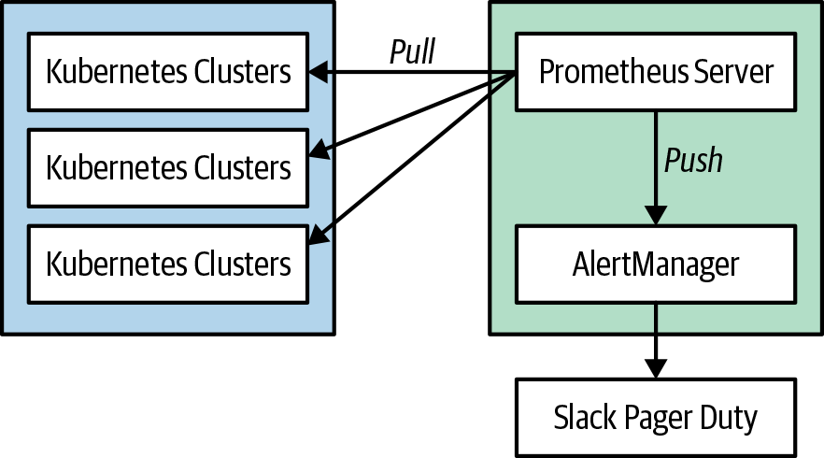

Figure 3-1. Prometheus architecture
Tip
You can install Prometheus within the cluster or outside the cluster. It’s a good practice to monitor your cluster from a “utility cluster” to avoid a production issue also affecting your monitoring system. There are tools like Thanos that provide high availability for Prometheus and allow you to export metrics into an external storage system.
A deep dive into the Prometheus architecture is beyond the scope of this book, and you should refer to another one of the dedicated books on this topic. Prometheus: Up & Running (O’Reilly) is a good in-depth book to get you started.
So, let’s dive in and get Prometheus set up on our Kubernetes cluster. There are many different ways to do this, and the deployment will depend on your specific implementation. In this chapter we install the Prometheus Operator:
Prometheus Server
Pulls and stores metrics being collected from systems.
Prometheus Operator
Makes the Prometheus configuration Kubernetes native, and manages and operates Prometheus and Alertmanager clusters. Allows you to create, destroy, and configure Prometheus resources through native Kubernetes resource definitions.
Node Exporter
Exports host metrics from Kubernetes nodes in the cluster.
kube-state-metrics
Collects Kubernetes-specific metrics.
Alertmanager
Allows you to configure and forward alerts to external systems.
Grafana
Provides visualization on dashboard capabilities for Prometheus.
First, we’ll start be getting minkube setup to deploy prometheus to. We are using Mac’s so we’ll use brew to install minikube. You can also install minikube from the minikube website.
brew
install
minikube
Now we’ll install kube-prometheus-stack (formerly Prometheus Operator) and prepare our cluster to start monitoring the Kubernetes API server for changes:
Create a namespace for monitoring:
kubectl
create
ns
monitoring
Add the prometheus-community Helm chart repository:
helm
repo
add
prometheus-community
https://prometheus-community.github.io/helm-charts
Add the Helm Stable chart repository:
helm
repo
add
stable
https://charts.helm.sh/stable
Let’s now update the chart repository:
helm
repo
update
Now we’ll install the kube-prometheus-stack chart:
helm
install
--namespace
monitoring
prometheus
prometheus-community/kube-prometheus-stack
Let’s check to ensure that all the pods are running:
kubectl
get
pods
-n
monitoring
If installed correctly you should see the following pods:
kubectl
get
pods
-n
monitoring
NAME READY STATUS RESTARTS AGE
alertmanager-prometheus-kube-prometheus-alertmanager-0 2/2 Running 1 79s
prometheus-grafana-6f7cf9b968-xtnzj 3/3 Running 0 97s
prometheus-kube-prometheus-operator-7bdb94567b-kt5td 1/1 Running 0 97s
prometheus-kube-state-metrics-6bdd65d76-s5r5j 1/1 Running 0 97s
prometheus-prometheus-kube-prometheus-prometheus-0 2/2 Running 0 78s
prometheus-prometheus-node-exporter-dgrlf 1/1 Running 0 98s
Now we’ll create a tunnel to the Grafana instance that is included with kube-prometheus-stack. This will allow us to connect to Grafana from our local machine.
This creates a tunnel to our localhost on port 3000. Now, we can open a web browser and connect to Grafana on http://127.0.0.1:3000.
We talked earlier in the chapter about employing the USE method, so let’s gather some node metrics on CPU utilization and saturation. Prometheus-kube-stack provides visualizations for these common USE method metrics we want to track. The great thing about the prometheus-kube-stack you installed is that it comes withsome prebuilt Grafana dashboards that you can use.
Now we’ll create a tunnel to the Grafana instance that is included with kube-prometheus-stack. This will allow us to connect to Grafana from our local machine.
kubectl
port-forward
-n
monitoring
svc/prometheus-grafana
3000
:80
Now, point your web browser at http://localhost:3000 and log in using the following credentials:
- Username: admin
- Password: prom-operator
Under the Grafana dashboards you’ll find a dashboard called Kubernetes / USE Method / Cluster. This dashboard gives you a good overview of the utilization and saturation of the Kubernetes cluster, which is at the heart of the USE method. Figure 3-2 presents an example of the dashboard.
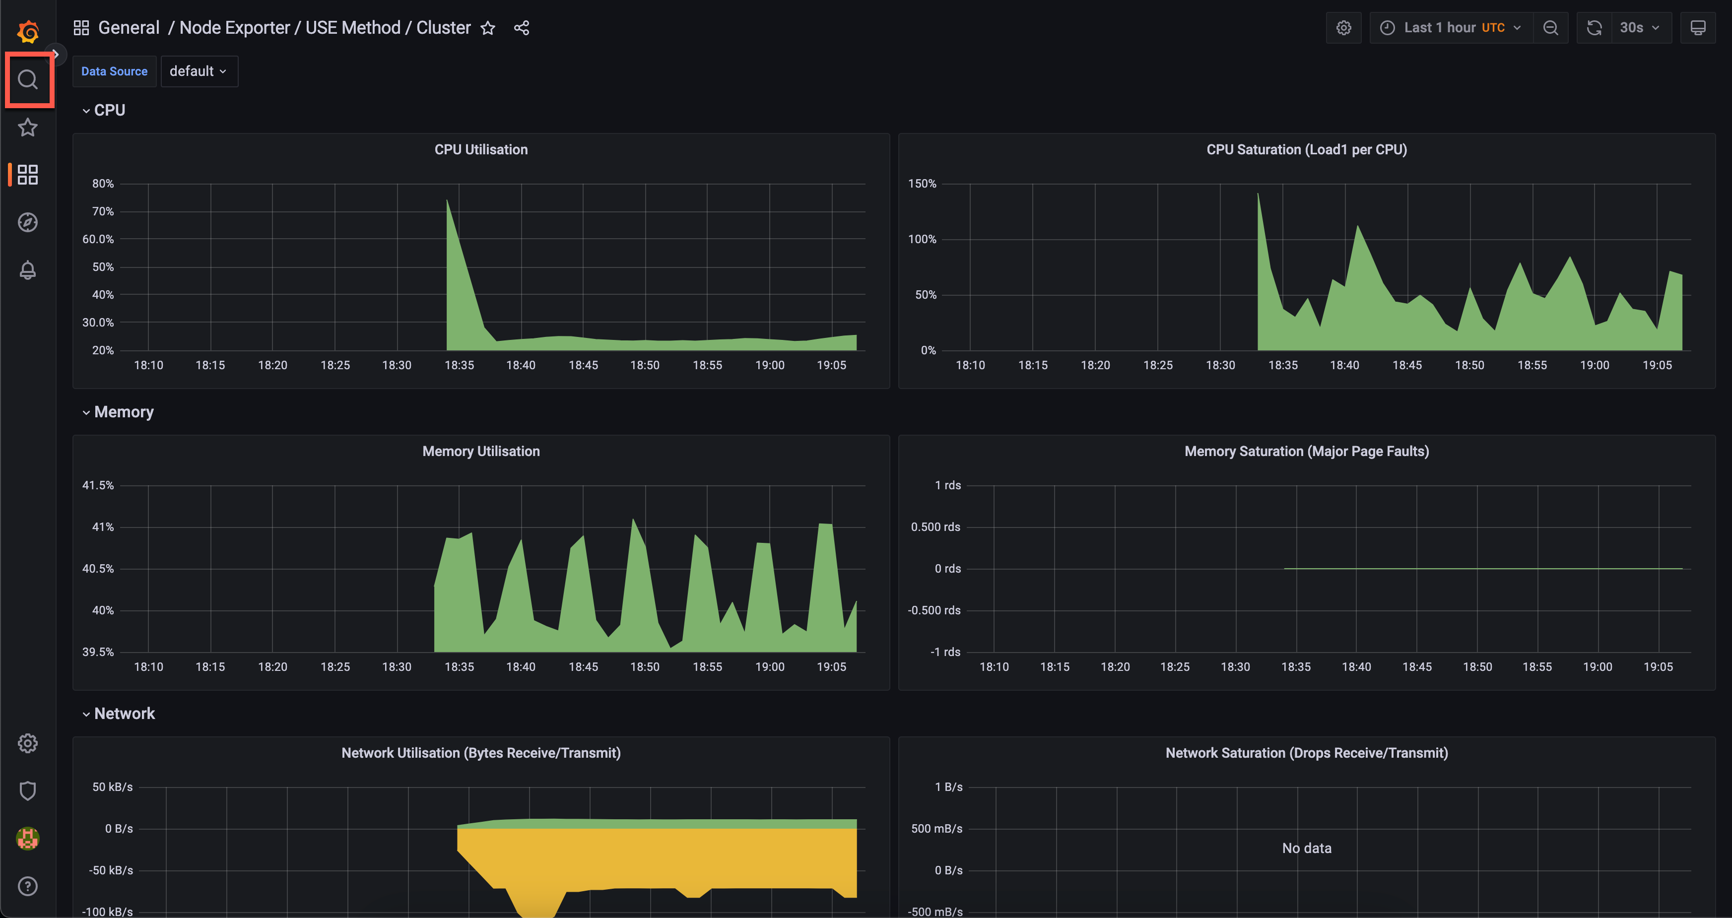

Figure 3-2. A Grafana dashboard
Go ahead and take some time to explore the different dashboards and metrics that you can visualize in Grafana.
Tip
Avoid creating too many dashboards (aka “The Wall of Graphs”) because this can be difficult for engineers to reason with in troubleshooting situations. You might think having more information in a dashboard means better monitoring, but the majority of the time it causes more confusion for a user looking at the dashboard. Focus your dashboard design on outcomes and time to resolution.

Logging Overview
Up to this point, we have discussed a lot about metrics and Kubernetes, but to get the full picture of your environment, you also need to collect and centralize logs from the Kubernetes cluster and the applications deployed to your cluster.
With logging, it might be easy to say, “Let’s just log everything,” but this can cause two issues:
- There is too much noise to find issues quickly.
- Logs can consume a lot of resources and come with a high cost.
There is no clear-cut answer to what exactly you should log because debug logs become a necessary evil. Over time you’ll start to understand your environment better and learn what noise you can tune out from the logging system. Also, to address the ever-increasing amount of logs stored, you will need to implement a retention and archival policy. From an end-user experience, having somewhere between 30 and 45 days worth of historical logs is a good fit. This allows for investigation of problems that manifest over a longer period of time, but also reduces the amount of resources needed to store logs. If you require longer-term storage for compliance reasons, you’ll want to archive the logs to more cost-effective resources.
In a Kubernetes cluster, there are multiple components to log. Following is a list of components from which you should be collecting metrics:
- Node logs
- Kubernetes control-plane logs
    - API server
    - Controller manager
    - Scheduler
- Kubernetes audit logs
- Application container logs
With node logs, you want to collect events that happen to essential node services. For example, you will want to collect logs from the Docker daemon running on the worker nodes. A healthy Docker daemon is essential for running containers on the worker node. Collecting these logs will help you diagnose any issues that you might run into with the Docker daemon, and it will give you information into any underlying issues with the daemon. There are also other essential services that you will want to log from the underlying node.
The Kubernetes control plane consists of several components from which you’ll need to collect logs to give you more insight into underlying issues within it. The Kubernetes control plane is core to a healthy cluster, and you’ll want to aggregate the logs that it stores on the host in /var/log/kube-APIserver.log, /var/log/kube-scheduler.log, and /var/log/kube-controller-manager.log. The controller manager is responsible for creating objects defined by the end user. As an example, as a user you create a Kubernetes service with type LoadBalancer and it just sits in a pending state; the Kubernetes events might not give all the details to diagnose the issue. If you collect the logs in a centralized system, it will give you more detail into the underlying issue and a quicker way to investigate the issue.
You can think of Kubernetes audit logs as security monitoring because they give you insight into who did what within the system. These logs can be very noisy, so you’ll want to tune them for your environment. In many instances these logs can cause a huge spike in your logging system when first initialized, so make sure that you follow the Kubernetes documentation guidance on audit log monitoring.
Application container logs give you insight into the actual logs your application is emitting. You can forward these logs to a central repository in multiple ways. The first and recommended way is to send all application logs to STDOUT because this gives you a uniform way of application logging, and a monitoring daemon set can gather the logs directly from the Docker daemon. The other way is to use a sidecar pattern and run a log forwarding container next to the application container in a Kubernetes pod. You might need to use this pattern if your application logs to the filesystem.
Note
There are many options and configurations for managing Kubernetes audit logs. These audit logs can be very noisy and it can be expensive to log all actions. You should consider looking at the audit logging documentation, so that you can fine-tune these logs for your environment.

Tools for Logging
Like collecting metrics there are numerous tools to collect logs from Kubernetes and applications running in the cluster. You might already have tooling for this, but be aware of how the tool implements logging. The tool should have the capability to run as a Kubernetes DaemonSet and also have a solution to run as a sidecar for applications that don’t send logs to STDOUT. Utilizing an existing tool can be advantageous because you will already have a lot of operational knowledge of the tool.
Some of the more popular tools with Kubernetes integration are:
- Loki
- Elastic Stack
- Datadog
- Sumo Logic
- Sysdig
- Cloud provider services (GCP Stackdriver, Azure Monitor for containers, and Amazon CloudWatch)
When looking for a tool to centralize logs, hosted solutions can provide a lot of value because they offload a lot of the operational cost. Hosting your own logging solution seems great on day N, but as the environment grows, it can be very time consuming to maintain the solution.

Logging by Using a Loki-Stack
For the purposes of this book, we use an Loki Stack with prom-tail for logging for our cluster. Implementing an Loki Stack can be a good way to get started, but at some point you’ll probably ask yourself, “Is it really worth managing my own logging platform?” Typically it’s not worth the effort because self-hosted logging solutions are great on day one, but they become overly complex by day 365. Self-hosted logging solutions become more operationally complex as your environment scales. There is no one correct answer, so evaluate whether your business requirements need you to host your own solution. There is also a hosted Loki solution (provided by Grafana), so you can always move pretty easily if you choose not to host it yourself.
We will use the following for the logging stack:
- Loki
- prom-tail
- Grafana (visualization tool to search, view, and interact with logs stored in Loki)
Deploy Loki-Stack with Helm to your Kubernetes cluster:
Add Loki-Stack Helm repo
helm
repo
add
grafana
https://grafana.github.io/helm-charts
Update Helm rep:
helm
repo
update
helm
upgrade
--install
loki
--namespace
=
monitoring
grafana/loki-stack
This deploys Loki with prom-tail, which will allow us to forward logs to Loki and visualize the logs using Grafana
You should see the following pods deployed to your cluster:
kubectl
get
pods
-n
monitoring
NAME
READY
STATUS
RESTARTS
AGE
loki-0
1
/1
Running
0
93s
loki-promtail-x7nw8
1
/1
Running
0
93s
After all pods are “Running,” let’s go ahead and connect to Grafana through port forwarding to our localhost:
kubectl
port-forward
-n
monitoring
svc/prometheus-grafana
3000
:80
Now, point your web browser at http://localhost:3000 and log in using the following credentials:
- Username: admin
- Password: prom-operator
Under the Grafana configuration you’ll find datasources. We’ll then add Loki as a Data Source:
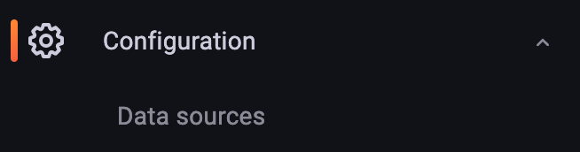

Figure 3-3. The Grafana datasource
We will then add a new data sorce and add Loki as the data source
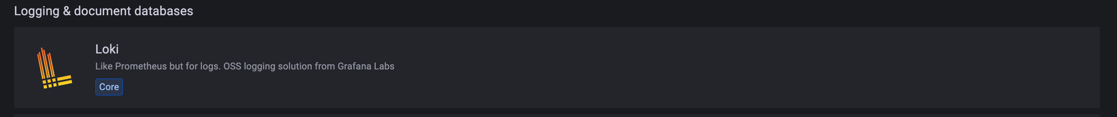

Figure 3-4. Loki datasource
In the Loki settings page, fill in the URL with http://loki:3100 and then click Save & Test button.
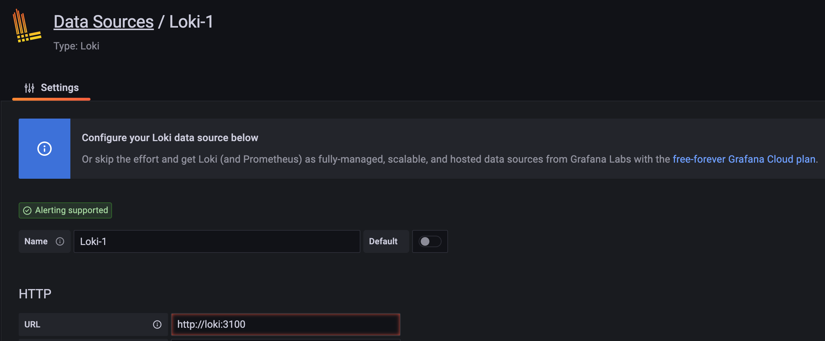

Figure 3-5. Loki configuration
In Grafana, you can perform ad hoc queries on the logs, and you can build out dashboards to give you an overview of the environment.
To explore the logs that the Loki stack has collected we can use the Explore function in Grafana. This will allow us to run a query against the logs that have been collected.
For the label filter you will need the following filter:
namespace = kube-system
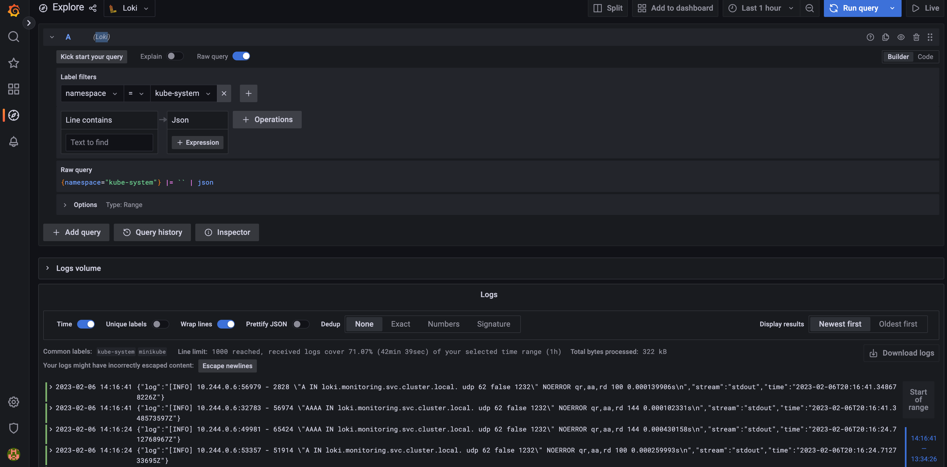

Figure 3-6. Explore Loki logs
Go ahead and take some time to explore the different logs that you can visualize in from Loki and Grafana.

Alerting
Alerting is a double-edged sword, and you need to strike a balance on what you alert on versus what should just be monitored. Alerting on too much causes alert fatigue, and important events will be lost in all the noise. An example would be generating an alert any time a pod fails. You might be asking, “Why wouldn’t I want to monitor for a pod failure?” Well, the beauty of Kubernetes is that it provides features to automatically check the health of a container and restart the container automatically. You really want to focus alerting on events that affect your Service-Level Objectives (SLOs). SLOs are specific measurable characteristics such as availability, throughput, frequency, and response time that you agree upon with the end user of your service. Setting SLOs sets expectations with your end users and provides clarity on how the system should behave. Without an SLO, users can form their opinion, which might be an unrealistic expectation of the service. Alerting in a system like Kubernetes needs an entirely new approach from what we are typically accustomed to and needs to focus on how the end user is experiencing the service. For example, if your SLO for a frontend service is a 20-ms response time and you are seeing higher latency than average, you want to be alerted on the problem.
You need to decide what alerts are good and require intervention. In typical monitoring, you might be accustomed to alerting on high CPU usage, memory usage, or processes not responding. These might seem like good alerts, but probably don’t indicate an issue that someone needs to take immediate action on and requires notifying an on-call engineer. An alert to an on-call engineer should be an issue that needs immediate human attention and is affecting the UX of the application. If you have ever experienced a “That issue resolved itself” scenario, then that is a good indication that the alert did not need to contact an on-call engineer.
One way to handle alerts that don’t need immediate action is to focus on automating the remediation of the cause. For example, when a disk fills up, you could automate the deletion of logs to free up space on the disk. Also, utilizing Kubernetes liveness probes in your app deployment can help autoremediate issues with a process that is not responding in the application.
When building alerts, you also need to consider alert thresholds; if you set thresholds too short, then you can get a lot of false positives with your alerts. It’s generally recommended to set a threshold of at least five minutes to help eliminate false positives. Coming up with standard thresholds can help define a standard and avoid micromanaging many different thresholds. For example, you might want to follow a specific pattern of 5 minutes, 10 minutes, 30 minutes, 1 hour, and so on.
When building notifications for alerts you want to ensure that you provide relevant information in the notification, for example, providing a link to a “playbook” that gives troubleshooting or other helpful information on resolving the issue. You should also include information on the datacenter, region, app owner, and affected system in notifications. Providing all this information will allow engineers to quickly formalize a theory around the issue.
You also need to build notification channels to route alerts that are fired. When thinking about “Who do I notify when an alert is triggered?” you should ensure that notifications are not just sent to a distribution list or team emails. What tends to happen if alerts are sent to larger groups is that they end up getting filtered out because users see these as noise. You should route notifications to the user who is going to take responsibility for the issue.
With alerting, you’ll never get it perfect on day one, and we could argue it might never be perfect. You just want to make sure that you incrementally improve on alerting to preclude alert fatigue, which can cause many issues with staff burnout and your systems.
Note
For further insight on how to approach alerting on and managing systems, read “My Philosophy on Alerting” by Rob Ewaschuk, which is based on Rob’s observations as a site reliability engineer (SRE) at Google.

Best Practices for Monitoring, Logging, and Alerting
Following are the best practices that you should adopt regarding monitoring, logging, and alerting.

Monitoring
- Monitor nodes and all Kubernetes components for utilization, saturation, and error rates, and monitor applications for rate, errors, and duration.
- Use black-box monitoring to monitor for symptoms and not predictive health of a system.
- Use white-box monitoring to inspect the system and its internals with instrumentation.
- Implement time-series-based metrics to gain high-precision metrics that also allow you to gain insight within the behavior of your application.
- Utilize monitoring systems like Prometheus that provide key labeling for high dimensionality; this will give a better signal to symptoms of an impacting issue.
- Use average metrics to visualize subtotals and metrics based on factual data. Utilize sum metrics to visualize the distribution across a specific metric.

Logging
- You should use logging in combination with metrics monitoring to get the full picture of how your environment is operating.
- Be cautious of storing logs for more than 30 to 45 days and, if needed, use cheaper resources for long-term archiving.
- Limit usage of log forwarders in a sidecar pattern, as they will utilize a lot more resources. Opt for using a DaemonSet for the log forwarder and sending logs to STDOUT.

Alerting
- Be cautious of alert fatigue because it can lead to bad behaviors in people and processes.
- Always look at incrementally improving upon alerting and accept that it will not always be perfect.
- Alert for symptoms that affect your SLO and customers and not for transient issues that don’t need immediate human attention.

Summary
In this chapter we discussed the patterns, techniques, and tools that can be used for monitoring our systems with metric and log collection. The most important piece to take away from this chapter is that you need to rethink how you perform monitoring and do it from the outset. Too many times we see this implemented after the fact, and it can get you into a very bad place in understanding your system. Monitoring is all about having better insight into a system and being able to provide better resiliency, which in turn provides a better end-user experience for your application. Monitoring distributed applications and distributed systems like Kubernetes requires a lot of work, so you must be ready for it at the beginning of your journey.

Chapter 4. Configuration, Secrets, and RBAC
A Note for Early Release Readers
With Early Release ebooks, you get books in their earliest form—the author’s raw and unedited content as they write—so you can take advantage of these technologies long before the official release of these titles.
This will be the 4th chapter of the final book. Please note that the GitHub repo will be made active later on.
If you have comments about how we might improve the content and/or examples in this book, or if you notice missing material within this chapter, please reach out to the editor at jleonard@oreilly.com.
The composable nature of containers allows us as operators to introduce configuration data into a container at runtime. This makes it possible for us to decouple an application’s function from the environment it runs in. By means of the conventions allowed in the container runtime to pass through either environment variables or mount external volumes into a container at runtime, you can effectively change the configuration of the application upon its instantiation. As a developer, it is important to take into consideration the dynamic nature of this behavior and allow for the use of environment variables or the reading of configuration data from a specific path available to the application runtime user.
When moving sensitive data such as secrets into a native Kubernetes API object, it is important to understand how Kubernetes secures access to the API. The most commonly implemented security method in use in Kubernetes is Role-Based Access Control (RBAC) to implement a fine-grained permission structure around actions that can be taken against the API by specific users or groups. This chapter covers some of the best practices regarding RBAC and also provides a small primer.

Configuration Through ConfigMaps and Secrets
Kubernetes allows you to natively provide configuration information to our applications through ConfigMaps or secret resources. The main differentiator between the two is the way a pod stores the receiving information and how the data is stored in the etcd data store.

ConfigMaps
It is very common to have applications consume configuration information through some type of mechanism such as command-line arguments, environment variables, or files that are available to the system. Containers allow the developer to decouple this configuration information from the application, which allows for true application portability. The ConfigMap API allows for the injection of supplied configuration information. ConfigMaps are very adaptable to the application’s requirements and can provide key/value pairs or complex bulk data such as JSON, XML, or proprietary configuration data.
The ConfigMaps not only provide configuration information for pods, but can also provide information to be consumed for more complex system services such as controllers, CRDs, operators, and so on. As mentioned earlier, the ConfigMap API is meant more for string data that is not really sensitive data. If your application requires more sensitive data, the Secrets API is more appropriate.
For your application to use the ConfigMap data, it can be injected as either a volume mounted into the pod or as environment variables.

Secrets
Many of the attributes and reasons for which you would want to use a ConfigMap apply to secrets. The main differences lie in the fundamental nature of a Secret. Secret data should be stored and handled in a way that can be easily hidden and possibly encrypted at rest if the environment is configured as such. The Secret data is represented as base64-encoded information, and it is critical to understand that this is not encrypted. As soon as the secret is injected into the pod, the pod itself can see the secret data in plain text.
Secret data is meant to be small amounts of data, limited by default in Kubernetes to 1 MB in size, for the base64-encoded data, so ensure that the actual data is approximately 750 KB because of the overhead of the encoding. There are three types of secrets in Kubernetes:
generic
This is typically just regular key/value pairs that are created from a file, a directory, or from string literals using the --from-literal= parameter, as follows:
kubectl
create
secret
generic
mysecret
--from-literal
=
key1
=
$3
cr3t1
--from-literal
=
key2
=
@3cr3t2
docker-registry
This is used by the kubelet when passed in a pod template if there is an imagePullsecret to provide the credentials needed to authenticate to a private Docker registry:
kubectl
create
secret
docker-registry
registryKey
--docker-server
myreg.azurecr.io
--docker-username
myreg
--docker-password
$up3r$3
cr3tP@ssw0rd
--docker-email
ignore@dummy.com
tls
This creates a Transport Layer Security (TLS) secret from a valid public/private key pair. As long as the cert is in a valid PEM format, the key pair will be encoded as a secret and can be passed to the pod to use for SSL/TLS needs:
kubectl
create
secret
tls
www-tls
--key
=
./path_to_key/wwwtls.key
--cert
=
./path_to_crt/wwwtls.crt
Secrets are also mounted into tmpfs only on the nodes that have a pod that requires the secret and are deleted when the pod that needs it is gone. This prevents any secrets from being left behind on the disk of the node. Although this might seem secure, it is important to know that by default, secrets are stored in the etcd datastore of Kubernetes in plain text, and it is important that the system administrators or cloud service provider take efforts to ensure that the security of the etcd environment, including mTLS between the etcd nodes and enabling encryption at rest for the etcd data. More recent versions of Kubernetes use etcd3 and have the ability to enable etcd native encryption; however, this is a manual process that must be configured in the API server configuration by specifying a provider and the proper key media to properly encrypt secret data held in etcd. As of Kubernetes v1.10 (it has been promoted to beta in v1.12), we have the KMS provider, which promises to provide a more secure key process by using third-party KMS systems to hold the proper keys.

Common Best Practices for the ConfigMap and Secrets APIs
The majority of issues that arise from the use of a ConfigMap or secret are incorrect assumptions on how changes are handled when the data held by the object is updated. By understanding the rules of the road and adding a few tricks to make it easier to abide by those rules, you can steer away from trouble:
- To support dynamic changes to your application without having to redeploy new versions of the pods, mount your ConfigMaps/Secrets as a volume and configure your application with a file watcher to detect the changed file data and reconfigure itself as needed. The following code shows a Deployment that mounts a ConfigMap and a Secret file as a volume:
apiVersion
:
v1
kind
:
ConfigMap
metadata
:
name
:
nginx-http-config
namespace
:
myapp-prod
data
:
config
:
|
http {
server {
location / {
root /data/html;
}
location /images/ {
root /data;
}
}
}
apiVersion
:
v1
kind
:
Secret
metadata
:
name
:
myapp-api-key
type
:
Opaque
data
:
myapikey
:
YWRtd5thSaW4=
apiVersion
:
apps/v1
kind
:
Deployment
metadata
:
name
:
mywebapp
namespace
:
myapp-prod
spec
:
containers
:
-
name
:
nginx
image
:
nginx
ports
:
-
containerPort
:
8080
volumeMounts
:
-
mountPath
:
/etc/nginx
name
:
nginx-config
-
mountPath
:
/usr/var/nginx/html/keys
name
:
api-key
volumes
:
-
name
:
nginx-config
configMap
:
name
:
nginx-http-config
items
:
-
key
:
config
path
:
nginx.conf
-
name
:
api-key
secret
:
name
:
myapp-api-key
secretname
:
myapikey
Note
There are a couple of things to consider when using volumeMounts. First, as soon as the ConfigMap/Secret is created, add it as a volume in your pod’s specification. Then mount that volume into the container’s filesystem. Each property name in the ConfigMap/Secret will become a new file in the mounted directory, and the contents of each file will be the value specified in the ConfigMap/Secret. Second, avoid mounting ConfigMaps/Secrets using the volumeMounts.subPath property. This will prevent the data from being dynamically updated in the volume if you update a ConfigMap/Secret with new data.
- ConfigMap/Secrets must exist in the namespace for the pods that will consume them prior to the pod being deployed. The optional flag can be used to prevent the pods from not starting if the ConfigMap/Secret is not present.
- Use an admission controller to ensure specific configuration data or to prevent deployments that do not have specific configuration values set. An example would be if you require all production Java workloads to have certain JVM properties set in production environments.
- If you’re using Helm to release applications into your environment, you can use a life cycle hook to ensure the ConfigMap/Secret template is deployed before the Deployment is applied.
- Some applications require their configuration to be applied as a single file such as a JSON or YAML file. ConfigMap/Secrets allows an entire block of raw data by using the | symbol, as demonstrated here:
apiVersion
:
v1
kind
:
ConfigMap
metadata
:
name
:
config-file
data
:
config
:
|
{
"iotDevice": {
"name": "remoteValve",
"username": "CC:22:3D:E3:CE:30",
"port": 51826,
"pin": "031-45-154"
}
}
- If the application uses system environment variables to determine its configuration, you can use the injection of the ConfigMap data to create an environment variable mapping into the pod. There are two main ways to do this: mounting every key/value pair in the ConfigMap as a series of environment variables into the pod using envFrom and then using configMapRef or secretRef, or assigning individual keys with their respective values using the configMapKeyRef or secretKeyRef.
- If you’re using the configMapKeyRef or secretKeyRef method, be aware that if the actual key does not exist, this will prevent the pod from starting.
- If you’re loading all of the key/value pairs from the ConfigMap/Secret into the pod using envFrom, any keys that are considered invalid environment values will be skipped; however, the pod will be allowed to start. The event for the pod will have an event with reason InvalidVariableNames and the appropriate message about which key was skipped. The following code is an example of a Deployment with a ConfigMap and Secret reference as an environment variable:
apiVersion
:
v1
kind
:
ConfigMap
metadata
:
name
:
mysql-config
data
:
mysqldb
:
myappdb1
user
:
mysqluser1
apiVersion
:
v1
kind
:
Secret
metadata
:
name
:
mysql-secret
type
:
Opaque
data
:
rootpassword
:
YWRtJasdhaW4=
userpassword
:
MWYyZDigKJGUyfgKJBmU2N2Rm
apiVersion
:
apps/v1
kind
:
Deployment
metadata
:
name
:
myapp-db-deploy
spec
:
selector
:
matchLabels
:
app
:
myapp-db
template
:
metadata
:
labels
:
app
:
myapp-db
spec
:
containers
:
-
name
:
myapp-db-instance
image
:
mysql
resources
:
limits
:
memory
:
"128Mi"
cpu
:
"500m"
ports
:
-
containerPort
:
3306
env
:
-
name
:
MYSQL_ROOT_PASSWORD
valueFrom
:
secretKeyRef
:
name
:
mysql-secret
key
:
rootpassword
-
name
:
MYSQL_PASSWORD
valueFrom
:
secretKeyRef
:
name
:
mysql-secret
key
:
userpassword
-
name
:
MYSQL_USER
valueFrom
:
configMapKeyRef
:
name
:
mysql-config
key
:
user
-
name
:
MYSQL_DB
valueFrom
:
configMapKeyRef
:
name
:
mysql-config
key
:
mysqldb
- If there is a need to pass command-line arguments to your containers, environment variable data can be sourced using $(ENV_KEY) interpolation syntax:
[
...
]
spec
:
containers
:
-
name
:
load-gen
image
:
busybox
command
:
[
"/bin/sh"
]
args
:
[
"-c"
,
"while
true;
do
curl
$(WEB_UI_URL);
sleep
10;done"
]
ports
:
-
containerPort
:
8080
env
:
-
name
:
WEB_UI_URL
valueFrom
:
configMapKeyRef
:
name
:
load-gen-config
key
:
url
- When consuming ConfigMap/Secret data as environment variables, it is very important to understand that updates to the data in the ConfigMap/Secret will not update in the pod and will require a pod restart either through deleting the pods and letting the ReplicaSet controller create a new pod, or triggering a Deployment update, which will follow the proper application update strategy as declared in the Deployment specification.
- It is easier to assume that all changes to a ConfigMap/Secret require an update to the entire deployment; this ensures that even if you’re using environment variables or volumes, the code will take the new configuration data. To make this easier, you can use a CI/CD pipeline to update the name property of the ConfigMap/Secret and also update the reference in the deployment, which will then trigger an update through normal Kubernetes update strategies of your deployment. We will explore this in the following example code. If you’re using Helm to release your application code into Kubernetes, you can take advantage of an annotation in the Deployment template to check the sha256 checksum of the ConfigMap/Secret. This triggers Helm to update the Deployment using the helm upgrade command when the data within a ConfigMap/Secret is changed:
apiVersion
:
apps/v1
kind
:
Deployment
[
...
]
spec
:
template
:
metadata
:
annotations
:
checksum/config
:
{{
include (print $.Template.BasePath "/configmap.yaml") . | sha256sum
}}
[
...
]

Best practices specific to secrets
Because of the nature of sensitive data of the Secrets API, there are naturally more specific best practices, which are mainly around the security of the data itself:
- If your workload does not need to access the Kubernete API directly it is good practice to block the automounting of the API Credential for the Service Account (Default or operator created). This will reduce the API calls to the API server as a watch is used to updated the API credential data upon the credential expiring. In very large clusters or clusters with alot of pods this will reduce the calls to the Control Plane which can casue performance degredation. This can be defined on the ServiceAccount or the Pod Spec itslef:
apiVersion
:
v1
kind
:
ServiceAccount
metadata
:
name
:
app1-svcacct
automountServiceAccountToken
:
false
[
...
]
apiVersion
:
v1
kind
:
Pod
metadata
:
name
:
app1-pod
spec
:
serviceAccountName
:
app1-svcacct
automountServiceAccountToken
:
false
[
...
]
- The original specification for the Secrets API outlined a pluggable architecture to allow the actual storage of the secret to be configurable based on requirements. Solutions such as HashiCorp Vault, Aqua Security, Twistlock, AWS Secrets Manager, Google Cloud KMS, or Azure Key Vault allow the use of external storage systems for secret data using a higher level of encryption and auditability than what is offered natively in Kubernetes. The Linux Foundation project ExternalSecrets Operator provides a native way to provide this functionality.
- Assign an imagePullSecrets to a serviceaccount that the pod will use to automatically mount the secret without having to declare it in the pod.spec. You can patch the default service account for the namespace of your application and add the imagePullSecrets to it directly. This automatically adds it to all pods in the namespace:
Create
the
docker-registry
secret
first
kubectl
create
secret
docker-registry
registryKey
--docker-server
myreg.azurecr.io
--docker-username
myreg
--docker-password
$up3r$3
cr3tP@ssw0rd
--docker-email
ignore@dummy.com
patch
the
default
serviceaccount
for
the
namespace
you
wish
to
configure
kubectl
patch
serviceaccount
default
-p
'{"imagePullSecrets": [{"name":
"registryKey"}]}'
- Use CI/CD capabilities to get secrets from a secure vault or encrypted store with a Hardware Security Module (HSM) during the release pipeline. This allows for separation of duties. Security management teams can create and encrypt the secrets, and developers just need to reference the names of the secret expected. This is also the preferred DevOps process to ensure a more dynamic application delivery process.

RBAC
When working in large, distributed environments, it is very common that some type of security mechanism is needed to prevent unauthorized access to critical systems. There are numerous strategies around how to limit access to resources in computer systems, but the majority all go through the same phases. Using an analogy of a common experience such as flying to a foreign country can help explain the processes that happen in systems like Kubernetes. We can use the common travler’s experience with a passport, travel visa, and customs or border guards to show the process:
Passport (subject authentication): Usually you need to have a passport issued by some government agency that will offer some sort of verification as to who you are. This would be equivalent to a user account in Kubernetes. Kubernetes relies on an external authority to authenticate users; however, service accounts are a type of account that is managed directly by Kubernetes.
Visa or travel policy (authorization): Countries will have formal agreements to accept travelers holding passports from other countries through formal short-term agreements such as visas. The visas will also outline what the visitor may do and for how long they may stay in the visiting country, depending on the specific type of visa. This would be equivalent to authorization in Kubernetes. Kubernetes has different authorization methods, but the most used is RBAC. This allows very granular access to different API capabilities.
Border patrol or customs (admission control): When entering a foreign country, usually there is a body of authority that will check the requisite documents, including the passport and visa, and, in many cases, inspect what is being brought into the country to ensure it abides by that country’s laws. In Kubernetes this is equivalent to admission controllers. Admission controllers can allow, deny, or change the requests into the API based upon rules and policies that are defined. Kubernetes has many built-in admission controllers such as PodSecurity, ResourceQuota, and ServiceAccount controllers. Kubernetes also allows for dynamic controllers through the use of validating or mutating admission controllers.
The focus of this section is the least understood and the most avoided of these three areas: RBAC. Before we outline some of the best practices, we first must present a primer on Kubernetes RBAC.

RBAC Primer
The RBAC process in Kubernetes has three main components that need to be defined: the subject, the rule, and the role binding.

Subjects
The first component is the subject, the item that is actually being checked for access. The subject is usually a user, a service account, or a group. As mentioned earlier, users as well as groups are handled outside of Kubernetes by the authorization module used. We can categorize these as basic authentication, x.509 client certificates, or bearer tokens. The most common implementations use either x.509 client certificates or some type of bearer token using something like an OpenID Connect system such as Azure Active Directory (Azure AD), Salesforce, or Google.
Note
Service accounts in Kubernetes are different than user accounts in that they are namespace bound, internally stored in Kubernetes; they are meant to represent processes, not people, and are managed by native Kubernetes controllers.

Rules
Simply stated, this is the actual list of actions that can be performed on a specific object (resource) or a group of objects in the API. Verbs align to typical CRUD (Create, Read, Update, and Delete) type operations but with some added capabilities in Kubernetes such as watch, list, and exec. The objects align to the different API components and are grouped together in categories. Pod objects, as an example, are part of the core API and can be referenced with apiGroup: "" whereas deployments are under the app API Group. This is the real power of the RBAC process and probably what intimidates and confuses people when creating proper RBAC controls.

Roles
Roles allow the definition of scope of the rules defined. Kubernetes has two types of roles, role and clusterRole, the difference being that role is specific to a namespace, and clusterRole is a cluster-wide role across all namespaces. An example Role definition with namespace scope would be as follows:
kind
:
Role
apiVersion
:
rbac.authorization.k8s.io/v1
metadata
:
namespace
:
default
name
:
pod-viewer
rules
:
-
apiGroups
:
[
""
]
# "" indicates the core API group
resources
:
[
"pods"
]
verbs
:
[
"get"
,
"watch"
,
"list"
]

RoleBindings
The RoleBinding allows a mapping of a subject like a user or group to a specific role. Bindings also have two modes: roleBinding, which is specific to a namespace, and clusterRoleBinding, which is across the entire cluster. Here’s an example RoleBinding with namespace scope:
kind
:
RoleBinding
apiVersion
:
rbac.authorization.k8s.io/v1
metadata
:
name
:
noc-helpdesk-view
namespace
:
default
subjects
:
-
kind
:
User
name
:
helpdeskuser@example.com
apiGroup
:
rbac.authorization.k8s.io
roleRef
:
kind
:
Role
#this must be Role or ClusterRole
name
:
pod-viewer
# this must match the name of the Role or ClusterRole to bind to
apiGroup
:
rbac.authorization.k8s.io

RBAC Best Practices
RBAC is a critical component of running a secure, dependable, and stable Kubernetes environment. The concepts underlying RBAC can be complex; however, adhering to a few best practices can ease some of the major stumbling blocks:
- Applications that are developed to run in Kubernetes rarely ever need an RBAC role and role binding associated to it. Only if the application code actually interacts directly with the Kubernetes API directly does the application require RBAC configuration.
- If the application does need to directly access the Kubernetes API to perhaps change configuration depending on endpoints being added to a service, or if it needs to list all of the pods in a specific namespace, the best practice is to create a new service account that is then specified in the pod specification. Then, create a role that has the least amount of privileges needed to accomplish its goal.
- Use an OpenID Connect service that enables identity management and, if needed, two-factor authentication. This will allow for a higher level of identity authentication. Map user groups to roles that have the least amount of privileges needed to accomplish the job.
- Along with the aforementioned practice, you should use Just in Time (JIT) access systems to allow site reliability engineers (SREs), operators, and those who might need to have escalated privileges for a short period of time to accomplish a very specific task. Alternatively, these users should have different identities that are more heavily audited for sign-on, and those accounts should have more elevated privileges assigned by the user account or group bound to a role.
- Specific service accounts should be used for CI/CD tools that deploy into your Kubernetes clusters. This ensures for auditability within the cluster and an understanding of who might have deployed or deleted any objects in a cluster.
- If you’re still using Helm v2 to deploy applications, the default service account is Tiller, deployed to kube-system. It is better to deploy Tiller into each namespace with a service account specifically for Tiller that is scoped for that namespace. In the CI/CD tool that calls the Helm install/upgrade command, as a prestep, initialize the Helm client with the service account and the specific namespace for the deployment. The service account name can be the same for each namespace, but the namespace should be specific. It is advised to move to Helm v3 as one of its core principles is that Tiller is no longer needed to run in a cluster. The new architecture is completely client based and uses the RBAC access of the user calling the helm commands. This is in alignment of the preferred approach of client based tooling to the Kubernetes API.
- Limit any applications that require watch and list on the Secrets API. This basically allows the application or the person who deployed the pod to view the secrets in that namespace. If an application needs to access the Secrets API for specific secrets, limit using get on any specific secrets that the application needs to read outside of those that it is directly assigned.

Summary
Principles for developing applications for cloud native delivery is a topic for another day, but it is universally accepted that strict separation of configuration from code is a key principal for success. With native objects for nonsensitive data, the ConfigMap API, and for sensitive data, the Secrets API, Kubernetes can now manage this process in a declarative approach. As more and more critical data is represented and stored natively in the Kubernetes API, it is critical to secure access to those APIs through proper gated security processes such as RBAC and integrated authentication systems.
As you’ll see throughout the rest of this book, these principles permeate every aspect of the proper deployment of services into a Kubernetes platform to build a stable, reliable, secure, and robust system.

Chapter 5. Continuous Integration, Testing, and Deployment
A Note for Early Release Readers
With Early Release ebooks, you get books in their earliest form—the author’s raw and unedited content as they write—so you can take advantage of these technologies long before the official release of these titles.
This will be the 5th chapter of the final book. Please note that the GitHub repo will be made active later on.
If you have comments about how we might improve the content and/or examples in this book, or if you notice missing material within this chapter, please reach out to the editor at jleonard@oreilly.com.
In this chapter, we look at the key concepts of how to integrate a continuous integration/continuous deployment (CI/CD) pipeline to deliver your applications to Kubernetes. Building a well-integrated pipeline will enable you to deliver applications to production with confidence, so here we look at the methods, tools, and processes to enable CI/CD in your environment. The goal of CI/CD is to have a fully automated process, from a developer checking in code to rolling out the new code to production. You want to avoid manually rolling out updates to your apps deployed to Kubernetes because it can be very error prone. Manually managing application updates in Kubernetes leads to configuration drift and fragile deployment updates, and overall agility delivering an application is lost.
We cover the following topics in this chapter:
- Version control
- CI
- Testing
- Tagging images
- CD
- Deployment strategies
- Testing Deployments
- Chaos testing
We also go through an example CI/CD pipeline, which consists of the following tasks:
- Pushing code changes to the Git repository
- Running a build of the application code
- Running test against the code
- Building a container image on a successful test
- Pushing the container image to a container registry
- Deploying the application to Kubernetes
- Running a test against a deployed application
- Performing rolling upgrades on Deployments

Version Control
Every CI/CD pipeline starts with version control, which maintains a running history of application and configuration code changes. Git has become the industry standard as a source-control management platform, and every Git repository will contain a master branch. A master branch contains your production code. You will have other branches for feature and development work that eventually will also be merged to your master branch. There are many ways to set up a branching strategy, and the setup will be very dependent on the organization structure and separation of duties. We find that including both application code and configuration code, such as a Kubernetes manifest or Helm charts, helps promote good DevOps principles of communication and collaboration. Having both application developers and operation engineers collaborate in a single repository builds confidence in a team to deliver an application to production.

Continuous Integration
CI is the process of integrating code changes continuously into a version-control repository. Instead of committing large changes less often, you commit smaller changes more often. Each time a code change is committed to the repository, a build is kicked off. This allows you to have a quicker feedback loop into what might have broken the application if problems indeed arise. At this point you might be asking, “Why do I need to know about how the application is built, isn’t that the application developer’s role?” Traditionally, this might have been the case, but as companies move toward embracing a DevOps culture, the operations team comes closer to the application code and software development workflows.
There are many solutions that provide CI, with Jenkins being one of the more popular tools.

Testing
The goal of running tests in the pipeline is to quickly provide a feedback loop for code changes that break the build. The language that you’re using will determine the testing framework you use. For example, Go applications can use go test for running a suite of unit tests against your code base. Having an extensive test suite helps to avoid delivering bad code into your production environment. You’ll want to ensure that if tests fail in the pipeline, the build fails after the test suite runs. You don’t want to build the container image and push it to a registry if you have failing tests against your code base.
Again, you might be asking, “Isn’t creating tests a developer’s job?” As you begin automating the delivery of infrastructure and applications to production, you need to think about running automated tests against all of the pieces of the code base. For example, in Chapter 2, we talked about using Helm to package applications for Kubernetes. Helm includes a tool called helm lint, which runs a series of tests against a chart to examine any potential issues with the chart provided. There are many different tests that need to be run in an end-to-end pipeline. Some are the developer’s responsibility, like unit testing for the application, but others, like smoke testing, will be a joint effort. Testing the code base and its delivery to production is a team effort and needs to be implemented end to end.

Container Builds
When building your images, you should optimize the size of the image. Having a smaller image decreases the time it takes to pull and deploy the image, and also increases the security of the image. There are multiple ways of optimizing the image size, but some do have trade-offs. The following strategies will help you build the smallest image possible for your application:
Multistage builds
These allow you to remove the dependencies not needed for your applications to run. For example, with Golang, we don’t need all the build tools used to build the static binary, so multistage builds allow you in a single Dockerfile to run a build step with the final image containing only the static binary that’s needed to run the application.
Distroless base images
These remove all the unneeded binaries and shells from the image. This really reduces the size of the image and increases the security. The trade-off with distroless images is you don’t have a shell, so you can’t attach a debugger to the image. You might think this is great, but it can be a pain to debug an application. Distroless images contain no package manager, shell, or other typical OS packages, so you might not have access to the debugging tools you are accustomed to with a typical OS.
Optimized base images
These are images that focus on removing the cruft out of the OS layer and provide a slimmed-down image. For example, Alpine provides a base image that starts at just 10 MB, and it also allows you to attach a local debugger for local development. Other distros also typically offer an optimized base image, such as Debian’s Slim image. This might be a good option for you because its optimized images give you capabilities you expect for development while also optimizing for image size and lower security exposure.
Optimizing your images is extremely important and often overlooked by users. You might have reasons due to company standards for OSes that are approved for use in the enterprise, but push back on these so that you can maximize the value of containers.
We have found that companies starting out with Kubernetes tend to be successful with using their current OS but then choose a more optimized image, like Debian Slim. After you mature in operationalizing and developing against a container environment, you’ll be comfortable with distroless images.

Container Image Tagging
Another step in the CI pipeline is to build a Docker image so that you have an image artifact to deploy to an environment. It’s important to have an image tagging strategy so that you can easily identify the versioned images you have deployed to your environments. One of the most important things we can’t preach enough about is not to use “latest” as an image tag. Using that as an image tag is not a version and will lead to not having the ability to identify what code change belongs to the rolled-out image. Every image that is built in the CI pipeline should have a unique tag for the built image.
There are multiple strategies we’ve found to be effective when tagging images in the CI pipeline. The following strategies allow you to easily identify the code changes and the build with which they are associated:
BuildID
When a CI build kicks off, it has a buildID associated with it. Using this part of the tag allows you to reference which build assembled the image.
Build System-BuildID
This one is the same as BuildID but adds the Build System for users who have multiple build systems.
Git Hash
On new code commits, a Git hash is generated, and using the hash for the tag allows you to easily reference which commit generated the image.
githash-buildID
This allows you to reference both the code commit and the buildID that generated the image. The only caution here is that the tag can be kind of long.

Continuous Deployment
CD is the process by which changes that have passed successfully through the CI pipeline are deployed to production without human intervention. Containers provide a great advantage for deploying changes into production. Container images become an immutable object that can be promoted through dev and staging and into production. For example, one of the major issues we’ve always had has been maintaining consistent environments. Almost everyone has experienced a Deployment that works fine in staging, but when it gets promoted to production, it breaks. This is due to having configuration drift, with libraries and versioning of components differing in each environment. Kubernetes gives us a declarative way to describe our Deployment objects that can be versioned and deployed in a consistent manner.
One thing to keep in mind is that you need to have a solid CI pipeline set up before focusing on CD. If you don’t have a robust set of tests to catch issues early in the pipeline, you’ll end up rolling bad code to all your environments.

Deployment Strategies
Now that we learned the principles of CD, let’s take a look at the different rollout strategies that you can use. Kubernetes provides multiple strategies to roll out new versions of your application. And even though it has a built-in mechanism to provide rolling updates, you can also utilize some more advanced strategies. Here, we examine the following strategies to deliver updates to your application:
- Rolling updates
- Blue/green deployments
- Canary deployments
Rolling updates are built into Kubernetes and allow you to trigger an update to the currently running application without downtime. For example, if you took your frontend app that is currently running frontend:v1 and updated the Deployment to frontend:v2, Kubernetes would update the replicas in a rolling fashion to frontend:v2. Figure 5-1 depicts a rolling update.
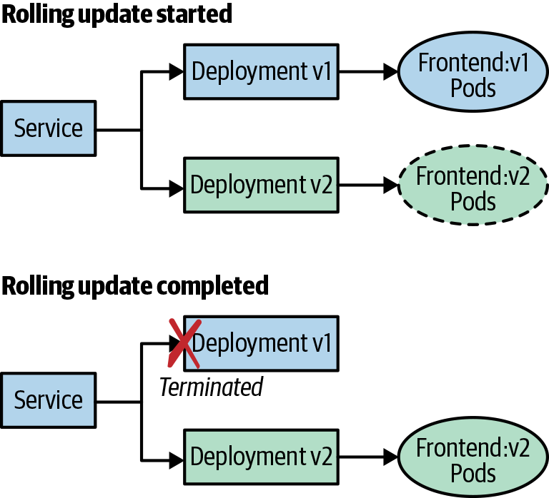

Figure 5-1. A Kubernetes rolling update
A Deployment object also lets you configure the maximum amount of replicas to be updated and the maximum unavailable pods during the rollout. The following manifest is an example of how you specify the rolling update strategy:
kind
:
Deployment
apiVersion
:
v1
metadata
:
name
:
frontend
spec
:
replicas
:
3
template
:
spec
:
containers
:
-
name
:
frontend
image
:
brendanburns/frontend:v1
strategy
:
type
:
RollingUpdate
rollingUpdate
:
maxSurge
:
1
# Maximum amount of replicas to update at one time
maxUnavailable
:
1
# Maximum amount of replicas unavailable during rollout
You need to be cautious with rolling updates because using this strategy can cause dropped connections. To deal with this issue, you can utilize readiness probes and preStop life cycle hooks. The readiness probe ensures that the new version deployed is ready to accept traffic, whereas the preStop hook can ensure that connections are drained on the current deployed application. The life cycle hook is called before the container exits and is synchronous, so it must complete before the final termination signal is given. The following example implements a readiness probe and life cycle hook:
kind
:
Deployment
apiVersion
:
v1
metadata
:
name
:
frontend
spec
:
replicas
:
3
template
:
spec
:
containers
:
-
name
:
frontend
image
:
brendanburns/frontend:v1
livenessProbe
:
# ...
readinessProbe
:
httpGet
:
path
:
/readiness
# probe endpoint
port
:
8888
lifecycle
:
preStop
:
exec
:
command
:
[
"/usr/sbin/nginx"
,
"-s"
,
"quit"
]
strategy
:
# ...
The preStop life cycle hook in this example will gracefully exit NGINX, whereas a SIGTERM conducts a nongraceful, quick exit.
Another concern with rolling updates is that you now have two versions of the application running at the same time during the rollover. Your database schema needs to support both versions of the application. You can also use a feature flag strategy in which your schema indicates the new columns created by the new app version. After the rolling update has completed, the old columns can be removed.
We have also defined a readiness and liveness probe in our Deployment manifest. A readiness probe will ensure that your application is ready to serve traffic before putting it behind the service as an endpoint. The liveness probe ensures that your application is healthy and running, and restarts the pod if it fails its liveness probe. Kubernetes can automatically restart a failed pod only if the pod exits on error. For example, the liveness probe can check its endpoint and restart it if we had a deadlock from which the pod did not exit.
Blue/green deployments allow you to release your application in a predictable manner. With blue/green deployments, you control when the traffic is shifted over to the new environment, so it gives you a lot of control over the rollout of a new version of your application. With blue/green deployments, you are required to have the capacity to deploy both the existing and new environment at the same time. These types of deployments have a lot of advantages, such as easily switching back to your previous version of the application. There are some things that you need to consider with this deployment strategy, however:
- Database migrations can become difficult with this deployment option because you need to consider in-flight transactions and schema update compatibility.
- There is the risk of accidental deletion of both environments.
- You need extra capacity for both environments.
- There are coordination issues for hybrid deployments in which legacy apps can’t handle the deployment.
Figure 5-2 depicts a blue/green deployment.
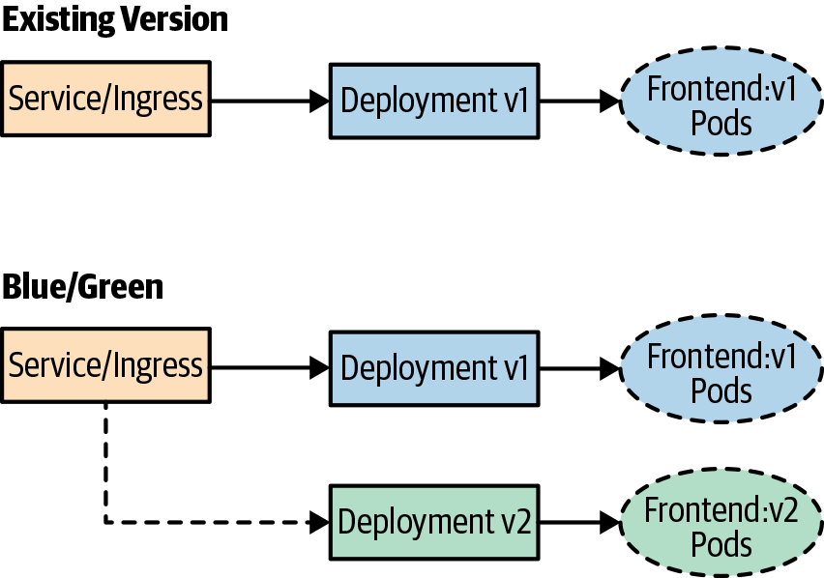

Figure 5-2. A blue/green deployment
Canary deployments are very similar to blue/green deployments, but they give you much more control over shifting traffic to the new release. Most modern ingress implementations will give you the ability to release a percentage of traffic to a new release, but you can also implement a service mesh technology, like Istio, Linkerd, or HashiCorp Consul, which give you a number of features that help implement this deployment strategy.
Canary deployments allow you to test new features for only a subset of users. For example, you might roll out a new version of an application and only want to test the deployment for 10% of your user base. This allows you to reduce the risk of a bad deployment or broken features to a much smaller subset of users. If there are no errors with the deployment or new features, you can begin shifting a greater percentage of traffic to the new version of the application. There are also some more advanced techniques that you can use with canary deployments in which you release to only a specific region of users or just target only users with a specific profile. These types of releases are often referred to as A/B or dark releases because users are unaware they are testing new feature deployments.
With canary deployments, you have some of the same considerations that you have with blue/green deployments, but there are some additional considerations as well. You must have:
- The ability to shift traffic to a percentage of users
- A firm knowledge of steady state to compare against a new release
- Metrics to understand whether the new release is in a “good” or “bad” state
Figure 5-3 provides an example of a canary deployment.
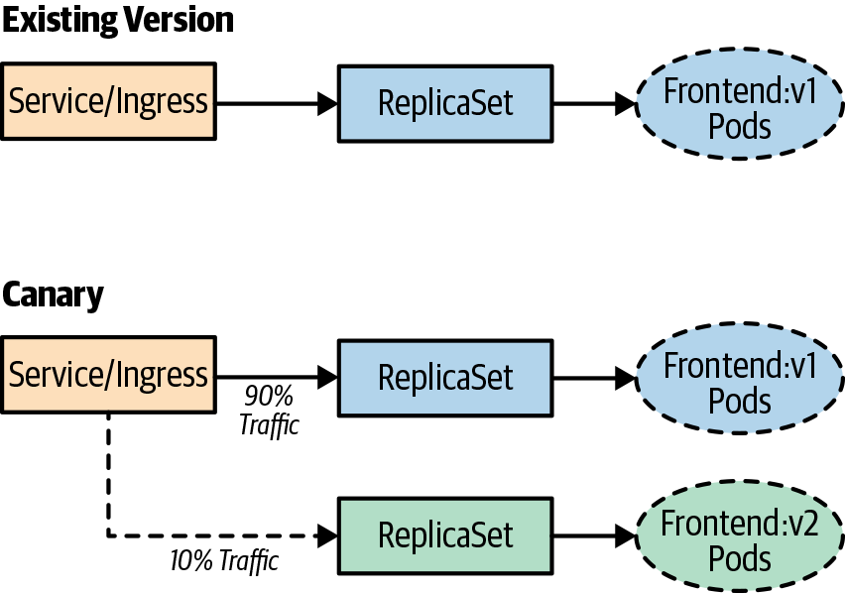

Figure 5-3. A canary deployment
Note
Canary releases also suffer from having multiple versions of the application running at the same time. Your database schema needs to support both versions of the application. When using these strategies, you’ll need to really focus on how to handle dependent services and having multiple versions running. This includes having strong API contracts and ensuring that your data services support the multiple versions you have deployed at the same time.

Testing in Production
Testing in production helps you to build confidence in the resiliency, scalability, and UX of your application. This comes with the caveat that testing in production doesn’t come without challenges and risk, but it’s worth the effort to ensure reliability in your systems. There are important aspects you need to address up front when embarking on the implementation. You need to ensure that you have an in-depth observability strategy in place, in which you have the ability to identify the effects of testing in production. Without being able to observe metrics that affect the end users’ experience of your applications, you won’t have a clear indication of what to focus on when trying to improve the resiliency of your system. You also need a high degree of automation in place to be able to automatically recover from failures that you inject into your systems.
There are many tools that you’ll need to implement to reduce risk and effectively test your systems when they’re in production. Some of the tools we have already discussed in this chapter, but there are a few new ones, like distributed tracing, instrumentation, chaos engineering, and traffic shadowing. To recap, here are the tools we have already mentioned:
- Canary deployments
- A/B testing
- Traffic shifting
- Feature flags
Chaos engineering was developed by Netflix. It is the practice of deploying experiments into live production systems to discover weaknesses within those systems. Chaos engineering allows you to learn about the behavior of your system by observing it during a controlled experiment. Following are the steps that you want to implement before doing a “game-day” experiment:
Build a hypothesis and learn about your steady state.
Have a varying degree of real-world events that can affect the system.
Build a control group and experiment to compare to steady state.
Perform experiments to form the hypothesis.
It’s extremely important that when you’re running experiments, you minimize the “blast radius” to ensure that the issues that might arise are minimal. You’ll also want to ensure that when you’re building experiments, you focus on automating them, given that running experiments can be labor intensive.
By this point, you might be asking, “Why wouldn’t I just test in staging?” We find there are some inherent problems when testing in staging, such as the following:
- Nonidentical deployment of resources.
- Configuration drift from production.
- Traffic and user behavior tend to be generated synthetically.
- The number of requests generated don’t mimic a real workload.
- Lack of monitoring implemented in staging.
- The data services deployed contain differing data and load than in production.
We can’t stress this enough: ensure that you have solid confidence in the monitoring you have in place for production, because this practice tends to fail users who don’t have adequate observability of their production systems. Also, starting with smaller experiments to first learn about your experiments and their effects will help build confidence.

Setting Up a Pipeline and Performing a Chaos Experiment
The first step in the process is to get a GitHub repository forked so that you can have your own repository to use through the chapter. You will need to use the GitHub interface to fork the repository.

Setting Up CI
Now that you have learned about CI, you will set up a build of the code that we cloned previously.
For this example, we use the hosted drone.io. You’ll need to sign up for a free account. Log in with your GitHub credentials (this registers your repositories in Drone and allows you to synchronize the repositories). After you’re logged in to Drone, select Activate on your forked repository. The first thing that you need to do is add some secrets to your settings so that you can push the app to your Docker Hub registry and also deploy the app to your Kubernetes cluster.
Under your repository in Drone, click Settings and add the following secrets (see Figure 5-4):
- docker_username
- docker_password
- kubernetes_server
- kubernetes_cert
- kubernetes_token
The Docker username and password will be whatever you used to register on Docker Hub. The following steps show you how to create a Kubernetes service account and certificate and retrieve the token.
For the Kubernetes server, you will need a publicly available Kubernetes API endpoint.
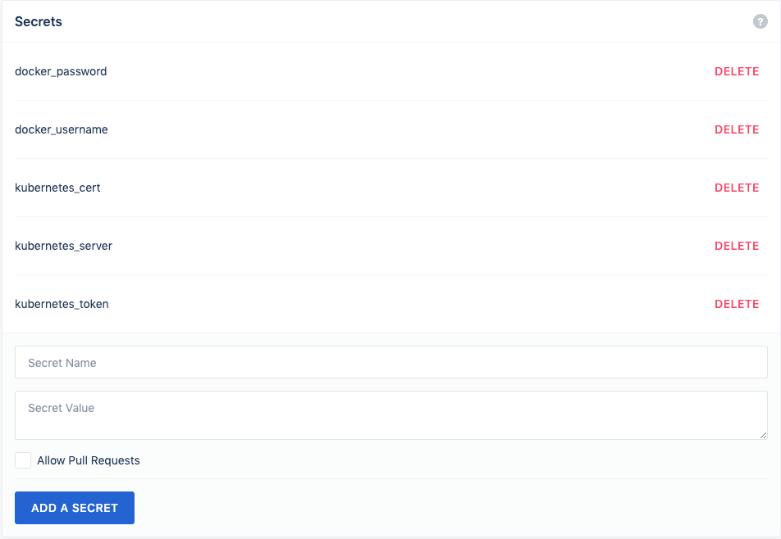

Figure 5-4. Drone secrets configuration
Note
You will need cluster-admin privileges on your Kubernetes cluster to perform the steps in this section.
You can retrieve your API endpoint by using the following command:
kubectl cluster-info
You should see something like the following: Kubernetes master is running at https://kbp.centralus.azmk8s.io:443. You’ll store this in the kubernetes_server secret.
Now let’s create a service account that Drone will use to connect to the cluster. Use the following command to create the serviceaccount:
kubectl create serviceaccount drone
Now use the following command to create a clusterrolebinding for the serviceaccount:
kubectl create clusterrolebinding drone-admin \
--clusterrole=cluster-admin \
--serviceaccount=default:drone
Next, retrieve your serviceaccount token:
TOKENNAME=`kubectl -n default get serviceaccount/drone -o jsonpath='{.secrets[0].name}'`
TOKEN=`kubectl -n default get secret $TOKENNAME -o jsonpath='{.data.token}' | base64 -d`
echo $TOKEN
You’ll want to store the output of the token in the kubernetes_token secret.
You will also need the user certificate to authenticate to the cluster, so use the following command and paste the ca.crt for the kubernetes_cert secret:
kubectl get secret $TOKENNAME -o yaml | grep 'ca.crt:'
Now, build your app in a Drone pipeline and then push it to Docker Hub.
The first step is the build step, which will build your Node.js frontend. Drone utilizes container images to run its steps, which gives you a lot of flexibility in what you can do with it. For the build step, use a Node.js image from Docker Hub:
pipeline
:
build
:
image
:
node
commands
:
-
cd frontend
-
npm i redis --save
When the build completes, you’ll want to test it, so we include a test step, which will run npm against the newly built app:
test
:
image
:
node
commands
:
-
cd frontend
-
npm i redis --save
-
npm test
Now that you have successfully built and tested your app, you next move on to a publish step to create a Docker image of the app and push it to Docker Hub.
In the .drone.yml file, make the following code change:
repo: <your-registry>/frontend
publish
:
image
:
plugins/docker
dockerfile
:
./frontend/Dockerfile
context
:
./frontend
repo
:
dstrebel/frontend
tags
:
[
latest
,
v2
]
secrets
:
[
docker_username
,
docker_password
]
After the Docker build step finishes, it will push the image to your Docker registry.

Setting Up CD
For the deployment step in your pipeline, you will push your application to your Kubernetes cluster. You will use the deployment manifest that is under the frontend app folder in your repository:
kubectl
:
image
:
dstrebel/drone-kubectl-helm
secrets
:
[
kubernetes_server
,
kubernetes_cert
,
kubernetes_token
]
kubectl
:
"apply
-f
./frontend/deployment.yaml"
After the pipeline finishes its deployment, you will see the pods running in your cluster. Run the following command to confirm that the pods are running:
kubectl get pods
You can also add a test step that will retrieve the status of the deployment by adding the following step in your Drone pipeline:
test-deployment:
image: dstrebel/drone-kubectl-helm
secrets: [ kubernetes_server, kubernetes_cert, kubernetes_token ]
kubectl: "get deployment frontend"

Performing a Rolling Upgrade
Let’s demonstrate a rolling upgrade by changing a line in the frontend code. In the server.js file, change the following line and then commit the change:
console.log('api server is running.');
You will see the deployment rolling out and rolling updates happening to the existing pods. After the rolling update finishes, you’ll have the new version of the application deployed.

A Simple Chaos Experiment
There are a variety of tools in the Kubernetes ecosystem that can help with performing chaos experiments in your environment. They range from sophisticated hosted Chaos as a Service solutions to basic chaos experiment tools that kill pods in your environment. Following are some of the tools with which we’ve seen users have success:
Gremlin
Hosted chaos service that provides advanced features for running chaos experiments
PowerfulSeal
Open source project that provides advanced chaos scenarios
Chaos Toolkit
Open source project with a mission to provide a free, open, and community-driven toolkit and API to all the various forms of chaos engineering tools
KubeMonkey
Open source tool that provides basic resiliency testing for pods in your cluster
Let’s set up a quick chaos experiment to test the resiliency of your application by automatically terminating pods. For this experiment, we’ll use Chaos Toolkit:
pip
install
-U
chaostoolkit
pip
install
chaostoolkit-kubernetes
export
FRONTEND_URL
=
"http://
$(
kubectl
get
svc
frontend
-o
jsonpath
=
"{.status.loadBalancer.ingress[*].ip}"
)
:8080/api/"
chaos
run
experiment.json

Best Practices for CI/CD
Your CI/CD pipeline won’t be perfect on day one, but consider some of the following best practices to iteratively improve on the pipeline:
- With CI, focus on automation and providing quick builds. Optimizing the build speed will provide developers quick feedback if their changes have broken the build.
- Focus on providing reliable tests in your pipeline. This will give developers rapid feedback on issues with their code. The faster the feedback loop to developers, the more productive they’ll become in their workflow.
- When deciding on CI/CD tools, ensure that the tools allow you to define the pipeline as code. This will allow you to version-control the pipeline with your application code.
- Ensure that you optimize your images so that you can reduce the size of the image and also reduce the attack surface when running the image in production. Multistage Docker builds allow you to remove packages not needed for the application to run. For example, you might need Maven to build the application, but you don’t need it for the actual running image.
- Avoid using “latest” as an image tag, and utilize a tag that can be referenced back to the buildID or Git commit.
- If you are new to CD, utilize Kubernetes rolling upgrades to start out. They are easy to use and will get you comfortable with deployment. As you become more comfortable and confident with CD, look at utilizing blue/green and canary deployment strategies.
- With CD, ensure that you test how client connections and database schema upgrades are handled in your application.
- Testing in production will help you build reliability into your application, and ensure that you have good monitoring in place. With testing in production, also start at a small scale and limit the blast radius of the experiment.

Summary
In this chapter, we discussed the stages of building a CI/CD pipeline for your applications, which let you reliably deliver software with confidence. CI/CD pipelines help reduce risk and increase throughput of delivering applications to Kubernetes. We also discussed the different deployment strategies that can be utilized for delivering applications.

Chapter 6. Versioning, Releases, and Rollouts
A Note for Early Release Readers
With Early Release ebooks, you get books in their earliest form—the author’s raw and unedited content as they write—so you can take advantage of these technologies long before the official release of these titles.
This will be the 6th chapter of the final book. Please note that the GitHub repo will be made active later on.
If you have comments about how we might improve the content and/or examples in this book, or if you notice missing material within this chapter, please reach out to the editor at jleonard@oreilly.com.
One of the main complaints of traditional monolithic applications is that over time they begin to grow too large and unwieldy to properly upgrade, version, or modify at the speed the business requires. Many can argue that this is one of the main critical factors that led to more Agile development practices and the advent of microservice architectures. Being able to quickly iterate on new code, solve new problems, or fix hidden problems before they become major issues, as well as the promise of zero-downtime upgrades, are all goals that development teams strive for in this ever-changing internet economy world. Practically, these issues can be solved with proper processes and procedures in place, no matter the type of system, but this usually comes at a much higher cost of both technology and human capital to maintain.
The adoption of containers as the runtime for application code allows for the isolation and composability that was helpful in designing systems that could get close, but still required a high level of human automation or system management to maintain at a dependable level over large system footprints. As the system grew, more brittleness was introduced, and systems engineers began to build complex automation processes to deliver on complex release, upgrade, and failure detection mechanisms. Service orchestrators such as Apache Mesos, HashiCorp Nomad, and even specialized container-based orchestrators such as Kubernetes and Docker Swarm evolved this into more primitive components to their runtime. Now, systems engineers can solve more complex system problems as the table stakes have been elevated to include the versioning, release, and deployment of applications into the system.

Versioning
This section is not meant to be a primer on software versioning and the history behind it; there are countless articles and computer science course books on the subject. The main thing is to pick a pattern and stick with it. The majority of software companies and developers have agreed that some form of semantic versioning is the most useful, especially in a microservice architecture in which a team that writes a certain microservice will depend on the API compatibility of other microservices that make up the system.
For those new to semantic versioning, the basics are that it follows a three-part version number in a pattern of major version, minor version, and patch, usually expressed in a dot notation such as 1(major).2(minor).3(patch). The patch signifies an incremental release that includes a bug fix or very minor change that has no API changes. The minor version signifies updates that might have new API changes but is backward compatible with the previous version. This is a key attribute for developers working with other microservices they might not be involved in developing. Knowing that I have my service written to communicate with version 1.4.7 of another microservice that has been recently upgraded to 1.5.7 should signify that I might not need to change my code unless I want to take advantage of any new API features. The major version is a breaking change increment to the code. In most cases, the API is no longer compatible between major versions of the same code. There are many slight modifications to this process, including a “4” version to indicate the stage of the software in its development life cycle, such as 1.4.7.0 for alpha code, and 1.4.7.3 for release. The most important thing is that there is consistency across the system.

Releases
In truth, Kubernetes does not really have a release controller, so there is no native concept of a release. This is usually added to a Deployment metadata.labels specification and/or in the pod.spec.template.metadata.label specification. When to include either is very important, and based on how CD is used to update changes to deployments, it can have varied effects. When Helm for Kubernetes was introduced, one of its main concepts was the notion of a release to differentiate the running instance of the same Helm chart in a cluster. This concept is easily reproducible without Helm; however, Helm natively keeps track of releases and their history, so many CD tools integrate Helm into their pipelines to be the actual release service. Again, the key here is consistency in how versioning is used and where it is surfaced in the system state of the cluster.
Release names can be quite useful if there is institutional agreement as to the definition of certain names. Often labels such as stable or canary are used, which helps to also give some kind of operational control when tools such as service meshes are added to make fine-grained routing decisions. Large organizations that drive numerous changes for different audiences will also adopt a ring architecture that can also be denoted such as ring-0, ring-1, and so on.
This topic requires a little side trip into the specifics of labels in the Kubernetes declarative model. Labels themselves are very much free form and can be any key/value pair that follows the syntactical rules of the API. The key is not really the content but how each controller handles labels, changes to labels, and selector matching of labels. Jobs, Deployments, ReplicaSets, and DaemonSets support selector-based matching of pods via labels through direct mapping or set-based expressions. It is important to understand that label selectors are immutable after they are created, which means if you add a new selector and the pod’s labels have a corresponding match, a new ReplicaSet is made, not an upgrade to an existing ReplicaSet. This becomes very important to understand when dealing with rollouts, which we discuss next.

Rollouts
Prior to the Deployment controller being introduced in Kubernetes, the only mechanism that existed to control how applications were rolled out by the Kubernetes controller process was using the command-line interface (CLI) command kubectl rolling-update on the specific replicaController that was to be updated. This was very difficult for declarative CD models because this was not part of the state of the original manifest. One had to carefully ensure that manifests were updated correctly, versioned properly so as to not accidentally roll the system back, and archived when no longer needed. The Deployment controller added the ability to automate this update process using a specific strategy and then allowing the system to read the declarative new state based on changes to the spec.template of the deployment. This last fact is often misunderstood by early users of Kubernetes and causes frustration when they change a label in the Deployment metadata fields, reapply a manifest, and no update has been triggered. The Deployment controller is able to determine changes to the specification and will take action to update the Deployment based on a strategy that is defined by the specification. Kubernetes deployments support two strategies, rollingUpdate and recreate, the former being the default.
If a rolling update is specified, the deployment will create a new ReplicaSet to scale to the number of required replicas, and the old ReplicaSet will scale down to zero based on specific values for maxUnavailble and maxSurge. In essence, those two values will prevent Kubernetes from removing older pods until a sufficient number of newer pods have come online, and will not create new pods until a certain number of old pods have been removed. The nice thing is that the Deployment controller will keep a history of the updates, and through the CLI, you can roll back deployments to previous versions.
The recreate strategy is a valid strategy for certain workloads that can handle a complete outage of the pods in a ReplicaSet with little to no degradation of service. In this strategy the Deployment controller will create a new ReplicaSet with the new configuration and will delete the prior ReplicaSet before bringing the new pods online. Services that sit behind queue-based systems are an example of a service that could handle this type of disruption, because messages will queue while waiting for the new pods to come online, and message processing will resume as soon as the new pods come online.

Putting It All Together
Within a single service deployment, a few key areas are affected by versioning, release, and rollout management. Let’s examine an example deployment and then break down the specific areas of interest as they relate to best practices:
# Web Deployment
apiVersion
:
apps/v1
kind
:
Deployment
metadata
:
name
:
gb-web-deploy
labels
:
app
:
guest-book
appver
:
1.6.9
environment
:
production
release
:
guest-book-stable
release number
:
34e57f01
spec
:
strategy
:
type
:
rollingUpdate
rollingUpdate
:
maxUnavailbale
:
3
maxSurge
:
2
selector
:
matchLabels
:
app
:
gb-web
ver
:
1.5.8
matchExpressions
:
-
{
key
:
environment
,
operator
:
In
,
values
:
[
production
]}
template
:
metadata
:
labels
:
app
:
gb-web
ver
:
1.5.8
environment
:
production
spec
:
containers
:
-
name
:
gb-web-cont
image
:
evillgenius/gb-web:v1.5.5
env
:
-
name
:
GB_DB_HOST
value
:
gb-mysql
-
name
:
GB_DB_PASSWORD
valueFrom
:
secretKeyRef
:
name
:
mysql-pass
key
:
password
resources
:
limits
:
memory
:
"128Mi"
cpu
:
"500m"
ports
:
-
containerPort
:
80
---
# DB Deployment
apiVersion
:
apps/v1
kind
:
Deployment
metadata
:
name
:
gb-mysql
labels
:
app
:
guest-book
appver
:
1.6.9
environment
:
production
release
:
guest-book-stable
release number
:
34e57f01
spec
:
selector
:
matchLabels
:
app
:
gb-db
tier
:
backend
strategy
:
type
:
Recreate
template
:
metadata
:
labels
:
app
:
gb-db
tier
:
backend
ver
:
1.5.9
environment
:
production
spec
:
containers
:
-
image
:
mysql:5.6
name
:
mysql
env
:
-
name
:
MYSQL_PASSWORD
valueFrom
:
secretKeyRef
:
name
:
mysql-pass
key
:
password
ports
:
-
containerPort
:
3306
name
:
mysql
volumeMounts
:
-
name
:
mysql-persistent-storage
mountPath
:
/var/lib/mysql
volumes
:
-
name
:
mysql-persistent-storage
persistentVolumeClaim
:
claimName
:
mysql-pv-claim
---
# DB Backup Job
apiVersion
:
batch/v1
kind
:
Job
metadata
:
name
:
db-backup
labels
:
app
:
guest-book
appver
:
1.6.9
environment
:
production
release
:
guest-book-stable
release number
:
34e57f01
annotations
:
"helm.sh/hook"
:
pre-upgrade
"helm.sh/hook"
:
pre-delete
"helm.sh/hook"
:
pre-rollback
"helm.sh/hook-delete-policy"
:
hook-succeeded
spec
:
template
:
metadata
:
labels
:
app
:
gb-db-backup
tier
:
backend
ver
:
1.6.1
environment
:
production
spec
:
containers
:
-
name
:
mysqldump
image
:
evillgenius/mysqldump:v1
env
:
-
name
:
DB_NAME
value
:
gbdb1
-
name
:
GB_DB_HOST
value
:
gb-mysql
-
name
:
GB_DB_PASSWORD
valueFrom
:
secretKeyRef
:
name
:
mysql-pass
key
:
password
volumeMounts
:
-
mountPath
:
/mysqldump
name
:
mysqldump
volumes
:
-
name
:
mysqldump
hostPath
:
path
:
/home/bck/mysqldump
restartPolicy
:
Never
backoffLimit
:
3
Upon first inspection, things might look a little off. How can a deployment have a version tag and the container image the deployment uses have a different version tag? What will happen if one changes and the other does not? What does release mean in this example, and what effect on the system will that have if it changes? If a certain label is changed, when will it trigger an update to my deployment? We can find the answers to these questions by looking at some of the best practices for versioning, releases, and rollouts.

Best Practices for Versioning, Releases, and Rollouts
Effective CI/CD and the ability to offer reduced or zero downtime deployments are both dependent on using consistent practices for versioning and release management. The best practices noted below can help to define consistent parameters that can assist DevOps teams in delivering smooth software deployments:
- Use semantic versioning for the application in its entirety that differs from the version of the containers and the version of the pods deployment that make up the entire application. This allows for independent life cycles of the containers that make up the application and the application as a whole. This can become quite confusing at first, but if a principled hierarchical approach is taken to when one changes the other, you can easily track it. In the previous example, the container itself is currently on v1.5.5; however, the pod specification is a 1.5.8, which could mean that changes were made to the pod specification, such as new ConfigMaps, additional secrets, or updated replica values, but the specific container used has not changed its version. The application itself, the entire guestbook application and all of its services, is at 1.6.9, which could mean that operations made changes along the way that were beyond just this specific service, such as other services that make up the entire application.
- Use a release and release version/number label in your deployment metadata to track releases from CI/CD pipelines. The release name and release number should coordinate with the actual release in the CI/CD tool records. This allows for traceability through the CI/CD process into the cluster and allows for easier rollback identification. In the previous example, the release number comes directly from the release ID of the CD pipeline that created the manifest.
- If Helm is being used to package services for deployment into Kubernetes, take special care to bundle together those services that need to be rolled back or upgraded together into the same Helm chart. Helm allows for easy rollback of all components of the application to bring the state back to what it was before the upgrade. Because Helm actually processes the templates and all of the Helm directives before passing a flattened YAML configuration, the use of life cycle hooks allows for proper ordering of the application of specific templates. Operators can use proper Helm life cycle hooks to ensure that upgrades and rollback will happen correctly. The previous example for the Job specification uses Helm life cycle hooks to ensure that the template runs a backup of the database before a rollback, upgrade, or delete of the Helm release. It also ensures that the Job is deleted after the job is run successfully, which, until the TTL Controller comes out of alpha in Kubernetes, would require manual cleanup.
- Agree on a release nomenclature that makes sense for the operational tempo of the organization. Simple stable, canary, and alpha states are quite adequate for most situations.

Summary
Kubernetes has allowed for more complex, Agile development processes to be adopted within companies large and small. The ability to automate much of the complex processes that would usually require large amounts of human and technical capital has now been democratized to allow for even startups to take advantage of this cloud pattern with relative ease. The true declarative nature of Kubernetes really shines when planning the proper use of labels and using native Kubernetes controller capabilities. By properly identifying operational and development states within the declarative properties of the applications deployed into Kubernetes, organizations can tie in tooling and automation to more easily manage the complex processes of upgrades, rollouts, and rollbacks of capabilities.

Chapter 7. Worldwide Application Distribution and Staging
A Note for Early Release Readers
With Early Release ebooks, you get books in their earliest form—the author’s raw and unedited content as they write—so you can take advantage of these technologies long before the official release of these titles.
This will be the 7th chapter of the final book. Please note that the GitHub repo will be made active later on.
If you have comments about how we might improve the content and/or examples in this book, or if you notice missing material within this chapter, please reach out to the editor at jleonard@oreilly.com.
To this point in the book, we have seen a number of different practices for building, developing, and deploying applications, but there is a whole different set of concerns when it comes to deploying and managing an application with a worldwide footprint.
There are many different reasons why an application might need to scale to a global deployment. The first and most obvious one is simply scale. It might be that your application is so successful or mission critical that it simply needs to be deployed around the world in order to provide the capacity needed for its users. Examples of such applications include a worldwide API gateway for a public cloud provider, a large-scale IoT product with a worldwide footprint, a highly successful social network, and more.
Although there are relatively few of us who will build out systems that require worldwide scale, many more applications require a worldwide footprint for latency. Even with containers and Kubernetes there is no getting around the speed of light. To minimize latency between clients and our applications, it is sometimes necessary to distribute our applications around the world to minimize the physical distance between the application and its users.
Finally, an even more common reason for global distribution is locality. Either for reasons of bandwidth (e.g., a remote sensing platform) or data privacy (geographic restrictions), it is sometimes necessary to deploy an application in specific locations for the application to be possible or successful. As more and more countries and regions implement data privacy and sovereignty laws and regulations, it is becoming a common business necessity to deploy your application in specific locations to serve users who reside in that location.
In all of these cases, your application is no longer simply present in a small handful of production clusters. Instead it is distributed across tens to hundreds of different geographic locations. The management of these locations, as well as the demands of rolling out a globally reliable service, is a significant challenge. This chapter covers approaches and practices for doing this successfully.

Distributing Your Image
Before you can even consider running your application around the world, you need to have that image available to clusters located around the globe. The first thing to consider is whether your image registry has automatic geo-replication. Many image registries provided by cloud providers will automatically distribute your image around the world and resolve a request for that image to the storage location nearest to the cluster from which you are pulling the image. Many clouds enable you to decide where you want to replicate the image; for example, you might know of locations where you are not going to be present. An example of such a registry is the Microsoft Azure container registry, but others provide similar services. If you use a cloud-provided registry that supports geo-replication, distributing your image around the world is simple. You push the image into the registry, select the regions for geo-distribution, and the registry takes care of the rest.
If you are not using a cloud registry, or your provider does not support automatic geo-distribution of images, you will need to solve that problem yourself. One option is to use a registry located in a specific location. There are several concerns about such an approach. Image pull latency often dictates the speed with which you can launch a container in a cluster. This in turn can determine how quickly you can respond to a machine failure, given that generally in the case of a machine failure, you will need to pull the container image down to a new machine.
Another concern about a single registry is that it can be a single point of failure. If the registry is located in a single region or a single datacenter, it’s possible that the registry could go offline due to a large-scale incident in that datacenter. If your registry goes offline, your CI/CD pipeline will stop working, and you’ll be unable to deploy new code. This obviously has a significant impact on both developer productivity and application operations. Additionally, a single registry can be much more expensive because you will be using significant bandwidth each time you launch a new container, and even though container images are generally fairly small, the bandwidth can add up. Despite these negatives, a single registry solution can be the appropriate answer for small-scale applications running in only a few global regions. It certainly is simpler to set up than full-scale image replication.
If you cannot use cloud-provided geo-replication and you need to replicate your image, you are on your own to craft a solution for image replication. To implement such a service, you have two options. The first is to use geographic names for each image registry (e.g., us.my-registry.io, eu.my-registry.io, etc.). The advantage of this approach is that it is simple to set up and manage. Each registry is entirely independent, and you can simply push to all registries at the end of your CI/CD pipeline. The downside is that each cluster will require a slightly different configuration to pull the image from the nearest geographic location. However, given that you likely will have geographic differences in your application configurations anyway, this downside is relatively easy to manage and likely already present in your environment.
The second option is to use some sort of networking configuration to connect your image pulls to a specific repository. In this approach you still push your image to multiple different registries, but instead of giving them each a unique name, you give them all a single DNS endpoint (e.g. my-registry.io) You can use geography-aware DNS (GeoDNS) which will respond to DNS requests from different geographic regions with different IP addresses, or if you have the right networking infrastructure, you can use multi-cast IP addresses. In multi-cast, all of your registries share the same IP address but it is advertised to the internet in multiple physical locations and shortest-path network routing is relied on to take traffic to the server which provides the nearest image registry. Both of these network configurations are tricky to do correctly. The best answer is definitely to use a cloud-based registry, even if you are pulling to on-premises servers. If you really want to run your own registry (and take on the operational burden that implies) then we strongly suggest you use the regional server approach in the previous paragraph unless you have previous network experience with replicated services. The next section describes how you can parameterize your deployment to, for example, use different registries in different regions.

Parameterizing Your Deployment
When you have replicated your image everywhere, you need to parameterize your deployments for different global locations. Whenever you are deploying to a variety of different regions, there are bound to be differences in the configuration of your application in the different regions. For example, if you don’t have a geo-replicated registry, you might need to tweak the image name for different regions, but even if you have a geo-replicated image, it’s likely that different geographic locations will present different load on your application, and thus the size (e.g., the number of replicas) as well as other configuration can be different between regions. Managing this complexity in a manner that doesn’t incur undue toil is key to successfully managing a worldwide application.
The first thing to consider is how to organize your different configurations on disk. A common way to achieve this is by using a different directory for each global region. Given these directories, it might be tempting to simply copy the same configurations into each directory, but doing this is guaranteed to lead to drift and changes between configurations in which some regions are modified and other regions are forgotten. Instead, using a template-based approach is the best idea so that most of the configuration is retained in a single template that is shared by all regions, and then parameters are applied to that template to produce the region-specific templates. Helm is a commonly used tool for this sort of templating (for details, see Chapter 2).

Load-Balancing Traffic Around the World
Now that your application is running around the world, the next step is to determine how to direct traffic to the application. In general, you want to take advantage of geographic proximity to ensure low-latency access to your service. But you also want to failover across geographic regions in case of an outage or any other source of service failure. Correctly setting up the balancing of traffic to your various regional deployments is key to the establishment of both a performant and reliable system.
Let’s begin with the assumption that you have a single hostname that you want to serve as your service. For example, myapp.myco.com. One initial decision that you need to make is whether you want to use the Domain Name System (DNS) protocol to implement load balancing across your regional endpoints. If you use DNS for load balancing, the IP address that is returned when a user makes a DNS query to myapp.myco.com is based on both the location of the user accessing your service as well as the current availability of your service. The other alternative is multi-cast IP addresses, where the same IP address is advertised from multiple locations on the internet. When a user looks up myapp.myco.com the DNS always returns this fixed IP address, but the actual routing of packets varies depending on where the connection is in the network.

Reliably Rolling Out Software Around the World
After you have templatized your application so that you have proper configurations for each region, the next important problem is how to deploy these configurations around the world. It might be tempting to simultaneously deploy your application worldwide so that you can efficiently and quickly iterate your application, but this, although Agile, is an approach that can easily leave you with a global outage. Any errors that you accidentally roll out to the world are immediately present for all users in all regions. Instead, for most production applications, a more carefully staged approach to rolling out your software around the world is more appropriate. When combined with things like global load balancing, these approaches can maintain high availability even in the face of major application failures.
Overall, when approaching the problem of a global rollout, the goal is to roll out software as quickly as possible, while simultaneously detecting issues quickly—ideally before they affect many users. Let’s assume that by the time you are performing a global rollout, your application has already passed basic functional and load testing. Before a particular image (or images) is certified for a global rollout, it should have gone through enough testing that you believe the application is operating correctly. It is important to note that this does not mean that your application is operating correctly. Though testing catches many problems, in the real world, application problems are often first noticed when they are rolled out to production traffic. This is because the true nature of production traffic is often difficult to simulate with perfect fidelity. For example, you might test with only English language inputs, whereas in the real world, you see input from a variety of languages. Or your set of test inputs may not be comprehensive for the real-world data your application ingests. Of course, any time that you do see a failure in production that wasn’t caught by testing, it is a strong indicator that you need to extend and expand your testing. Nonetheless, it is still true that many problems are caught during a production rollout.
With this in mind, each region that you roll out to is an opportunity to discover a new problem. And, because the region is a production region, it is also a potential outage to which you will need to react. These factors combine to set the stage for how you should approach regional rollouts.
Note
Throughout this discussion we talk about rolling out software to a geographic region, but this sort of progressive rollout is only one form of progressive exposure control. An alternative way to rollout a feature is to use feature flags to do progressive exposure. With feature flags, a new feature is first rolled out via a release that follows a geographc rollout as described below, however the feature is flagged “off” by default. Once the release is in all regions, the flag is gradually turned on by (for example) activating the feature for 10% of all users, followed by 20% and so on until the feature is fully rolled out. There are numerous configuration systems for doing flagged based experiements and progressive rollouts. And combining flags with geographic releases is a very stable way to release new features while being able to quickly respond to failures.

Pre-Rollout Validation
Before you even consider rolling out a particular version of your software around the world, it’s critically important to validate that software in some sort of synthetic testing environment. If you have your CD pipeline set up correctly, all code prior to a particular release build will have undergone some form of unit testing, and possibly limited integration testing. However, even with this testing in place, it’s important to consider two other sorts of tests for a release before it begins its journey through the release pipeline. The first is complete integration testing. This means that you assemble the entirety of your stack into a full-scale deployment of your application but without any real-world traffic. This complete stack generally will include either a copy of your production data or simulated data on the same size and scale as your true production data. If in the real world, the data in your application is 500 GB, it’s critical that in preproduction testing your dataset is roughly the same size (and possibly even literally the same dataset).
Generally speaking, setting up a complete integration test environment. Often, production data is really present only in production, and generating a synthetic dataset of the same size and scale is quite difficult. Because of this complexity, setting up a realistic integration testing dataset is a great example of a task that it pays to do early on in the development of an application. If you set up a synthetic copy of your dataset early, when the dataset itself is quite small, your integration test data grows gradually at the same pace as your production data. This is generally significantly more manageable than if you attempt to duplicate your production data when you are already at scale.
Sadly, many people don’t realize that they need a copy of their data until they are already at a large scale and the task is difficult. In such cases it might be possible to deploy a read/write-deflecting layer in front of your production data store. Obviously, you don’t want your integration tests writing to production data, but it is often possible to set up a proxy in front of your production data store that reads from production but stores writes in a side table that is also consulted on subsequent reads.
Of course it is also extremely important that if you use your production data for testing and development that you are very careful with the security of that data. There have been numerous data leaks associated with developers accidentally placing their production user data in insecure locations.
Regardless of how you manage to set up your integration testing environment, the goal is the same: to validate that your application behaves as expected when given a series of test inputs and interactions. There are a variety of ways to define and execute these tests—from the most manual, a worksheet of tests and human effort (not recommended because it is fairly error prone), through tests that simulate browsers and user interactions, like clicks and so forth. In the middle are tests that probe RESTful APIs but don’t necessarily test the web UI built on top of those APIs. Regardless of how you define your integration tests, the goal should be the same: an automated test suite that validates the correct behavior of your application in response to a complete set of real-world inputs. For simple applications it may be possible to perform this validation in premerge testing, but for most large-scale real-world applications, a complete integration environment is required.
Integration testing will validate the correct operation of your application, but you should also load-test the application. It is one thing to demonstrate that the application behaves correctly, it is quite another to demonstrate that it stands up to real-world load. In any reasonably high-scale system, a significant regression in performance—for example, a 20% increase in request latency—has a significant impact on the UX of the application and, in addition to frustrating users, can cause an application to completely fail. Thus, it is critical to ensure that such performance regressions do not happen in production.
Like integration testing, identifying the correct way to load-test an application can be a complex proposition; after all, it requires that you generate a load similar to production traffic but in a synthetic and reproduceable way. One of the easiest ways to do this is to simply replay the logs of traffic from a real-world production system. Doing this can be a great way to perform a load-test whose characteristics match what your application will experience when deployed. However, using replay isn’t always foolproof. For example, if your logs are old, and your application or dataset has changed, it’s possible that the performance on old, replayed logs will be different that the performance on fresh traffic. Additionally, if you have real-world dependencies that you haven’t mocked, it’s possible that the old traffic will be invalid when sent over to the dependencies (e.g., the data might no longer exist).
As with production data it is critical to safe-guard the security of any recorded real-world requests, just like the production databases, production requests often contain private information or secure credentials (or both!) and it is critical that the security of any recordings be treated the same as the actual user requests.
Because of the challenges associated with saving, securing and managing this test data, many systems, even critical systems, are developed for a long time without a load test. Like modeling your production data, this is a clear example of something that is easier to maintain if you start earlier. If you build a load-test when your application has only a handful of dependencies, and improve and iterate the load-test as you adapt your application, you will have a far easier time than if you attempt to retrofit load-testing onto an existing large-scale application.
Assuming that you have crafted a load test, the next question is the metrics to watch when load-testing your application. The obvious ones are requests per second and request latency because those are clearly the user-facing metrics.
When measuring latency, it’s important to realize that this is actually a distribution, and you need to measure both the mean latency as well as the outlier percentiles (like the 90th and 99th percentile) since they represent the “worst” UX of your application. Problems with very long latencies can be hidden if you just look at the averages, but if 10% of your users are having a bad time, it can have a significant impact on the success of your product.
In addition, it’s worth looking at the resource usage (CPU, memory, network, disk) of the application under load test. Though these metrics do not directly contribute to the UX, large changes in resource usage for your application should be identified and understood in preproduction testing. If your application is suddenly consuming twice as much memory, it’s something you will want to investigate, even if you pass your load test, because eventually such significant resource growth will affect the quality and availability of your application. Depending on the circumstances, you might continue bringing a release to production, but at the same time, you need to understand why the resource footprint of your application is changing.

Canary Region
When your application appears to be operating correctly, the first step should be a canary region. A canary region is a deployment that receives real-world traffic from people and teams who want to validate your release. These can be internal teams that depend on your service, or they might be external customers who are using your service. Canaries exist to give a team some early warning about changes that you are about to roll out that might break them. No matter how good your integration and load testing, it’s always possible that a bug will slip through that isn’t covered by your tests, but is critical to some user or customer. In such cases, it is much better to catch these issues in a space where everyone using or deploying against the service understands that there is a higher probability of failure. This is what the canary region is.
Note
Canary is also a great place for your team or company to dogfood or self-test the early release before it goes further in production. A great best-practice is to set up an HTTP redirector so that requests from within your company are redirected to an instance of your product that is running in canary. That way every person on your team becomes an end-to-end tester before the release proceeds to external users.
Canaries must be treated as a production region in terms of monitoring, scale, features, and so on. However, because it is the first stop on the release process, it is also the location most likely to see a broken release. This is OK; in fact it is precisely the point. Your customers will knowingly use a canary for lower-risk use cases (e.g., development or internal users) so that they can get an early indication of any breaking changes that you might be rolling out as part of a release.
Because the goal of a canary is to get early feedback on a release, it is a good idea to leave the release in the canary region for a few days. This enables a broad collection of customers to access it before you move on to additional regions. The need for this length of time is that sometimes a bug is probabilistic (e.g., 1% of requests) or it manifests only in an edge case that takes some time to present itself. It might not even be severe enough to trigger automated alerts, but there might be a problem in business logic that is visible only via customer interactions.

Identifying Region Types
When you begin thinking about rolling out your software across the world, it’s important to think about the different characteristics of your different regions. After you begin rolling out software to production regions, you need to run it through integration testing as well as initial canary testing. This means that any issues you find will be issues that did not manifest in either of these settings. Think about your different regions. Do some get more traffic than others? Are some accessed in a different way? An example of a difference might be that in the developing world, traffic is more likely to come from mobile web browsers. Thus, a region that is geographically close to more developing countries might have significantly more mobile traffic than your test or canary regions.
Another example might be input language. Regions in non-English speaking areas of the world might send more Unicode characters that could manifest bugs in string or character handling. If you are building an API-driven service, some APIs might be more popular in some regions versus others. All of these things are examples of differences that might be present in your application and might be different than your canary traffic. Each of these differences is a possible source of a production incident. Build a table of different characteristics that you think are important. Identifying these characteristics will help you plan your global rollout.

Constructing a Global Rollout
Having identified the characteristics of your regions, you want to identify a plan for rolling out to all regions. Obviously, you want to minimize the impact of a production outage, so a great first region to start with is a region that looks mostly like your canary and has light user traffic. Such a region is very unlikely to have problems, but if they do occur, the impact is also smaller because the region receives less traffic.
With a successful rollout to the first production region, you need to decide how long to wait before moving on to the next region. The reason for waiting is not to artificially delay your release; rather, it’s to wait long enough for a fire to send up smoke. This time-to-smoke period is a measure of generally how long it takes between a rollout completing and your monitoring seeing some sign of a problem. Clearly if a rollout contains a problem, the minute the rollout completes, the problem is present in your infrastructure. But even though it is present, it can take some time to manifest. For example, a memory leak might take an hour or more before the impact of the leaked memory is clearly discernible in monitoring or is affecting users. The time-to-smoke is the probability distribution that indicates how long you should wait in order to have a strong probability that your release is operating correctly. Generally speaking, a decent rule of thumb is doubling the average time it took for a problem to manifest in the past.
If, over the past six months, each outage took an average of an hour to show up, waiting two hours between regional rollouts gives you a decent probability that your release is successful. If you want to derive richer (and more meaningful) statistics based on the history of your application, you can estimate this time-to-smoke even more closely.
Having successfully rolled out to a canary-like, low-traffic region, it’s time to roll out to a canary-like, high-traffic region. This is a region where the input data looks like that in your canary, but it receives a large volume of traffic. Because you successfully rolled out to a similar looking region with lower traffic, at this point the only thing you are testing is your application’s ability to scale. If you safely perform this rollout, you can have strong confidence in the quality of your release.
After you have rolled out to a high-traffic region receiving canary-like traffic, you should follow the same pattern for other potential differences in traffic. For example, you might roll out to a low-traffic region in Asia or Europe next. At this point, it might be tempting to accelerate your rollout, but it is critically important to roll out only to a single region that represents any significant change in either input or load to your release. After you are confident that you have tested all of the potential variability in the production input to your application, you then can start parallizing the release to speed it up with strong confidence that it is operating correctly and your rollout can complete successfully.

When Something Goes Wrong
So far, we have seen the pieces that go into setting up a worldwide rollout for your software system, and we have seen the ways that you can structure this rollout to minimize the chances that something goes wrong. But what do you do when something actually does go wrong? All emergency responders know that in the heat and panic of a crisis, your brain is significantly stressed and it is much more difficult to remember even the simplest processes. Add to this pressure the knowledge that when an outage happens, everyone in the company from the CEO down is going to be feverishly waiting for the “all clear” signal, and you can see how easy it is to make a mistake under this pressure. Additionally, in such circumstances, a simple mistake, like forgetting a particular step in a recovery process, or rolling out a “fixed” build that actually has more problems, can make a bad situation an order of magnitude worse.
For all of these reasons, it is critical that you are capable of responding quickly, calmly, and correctly when a problem happens with a rollout. To ensure that everything necessary is done, and done in the correct order, it pays to have a clear checklist of tasks organized in the order in which they are to be executed as well as the expected output for each step. Write down every step, no matter how obvious it might seem. In the heat of the moment, even the most obvious and easy steps can be the ones that are forgotten and accidentally skipped.
The way that other first responders ensure a correct response in a high-stress situation is to practice that response without the stress of the emergency. The same practice applies to all the activities that you might take in response to a problem with your rollout. You begin by identifying all of the steps needed to respond to an issue and perform a rollback. Ideally, the first response is to “stop the bleeding,” to move user traffic away from the impacted region(s) and into a region where the rollout hasn’t happened and your system is operating correctly. This is the first thing you should practice. Can you successfully direct traffic away from a region? How long does it take?
The first time you attempt to move traffic using a DNS-based traffic load balancer, you will realize just how long and in how many ways our computers cache DNS entries. It can take nearly a day to fully drain traffic away from a region using a DNS-based traffic shaper. Regardless of how your first attempt to drain traffic goes, take notes. What worked well? What went poorly? Given this data, set a goal for how long a traffic drain should take in terms of time to drain a percentage of traffic, for example, being able to drain 99% of traffic in less than 10 minutes. Keep practicing until you can achieve that goal. You might need to make architectural changes to make this possible. You might need to add automation so that humans aren’t cutting and pasting commands. Regardless of necessary changes, practice will ensure that you are more capable at responding to an incident and that you will learn where your system design needs to be improved.
The same sort of practice applies to every action that you might take on your system. Practice a full-scale data recovery. Practice a global rollback of your system to a previous version. Set goals for the length of time it should take. Note any places where you made mistakes, and add validation and automation to eliminate the possibility of mistakes. Achieving your incident reaction goals in practice gives you confidence that you will be able to respond correctly in a real incident. But just like every emergency responder continues to train and learn, you too need to set up a regular cadence of practice to ensure that everyone on a team stays well versed in the proper responses and (perhaps more important) that your responses stay up to date as your system changes.

Worldwide Rollout Best Practices
- Distribute each image around the world. A successful rollout depends on the release bits (binaries, images, etc.) being nearby to where they will be used. This also ensures reliability of the rollout in the presence of networking slowdowns or irregularities. Geographic distribution should be a part of your automated release pipeline for guaranteed consistency.
- Shift as much of your testing as possible to the left by having as much extensive integration and replay testing of your application as possible. You want to start a rollout only with a release that you strongly believe to be correct.
- Begin a release in a canary region, which is a preproduction environment in which other teams or large customers can validate their use of your service before you begin a larger-scale rollout.
- Identify different characteristics of the regions where you are rolling out. Each difference can be one that causes a failure and a full or partial outage. Try to roll out to low-risk regions first.
- Document and practice your response to any problem or process (e.g., a rollback) that you might encounter. Trying to remember what to do in the heat of the moment is a recipe for forgetting something and making a bad problem worse.

Summary
It might seem unlikely today, but most of us will end up running a worldwide scale system sometime during our careers. This chapter described how you can gradually build and iterate your system to be a truly global design. It also discussed how you can set up your rollout to ensure minimal downtime of the system while it is being updated. Finally, we covered setting up and practicing the processes and procedures necessary to react when (note that we didn’t say “if”) something goes wrong.

Chapter 8. Networking, Network Security, and Service Mesh
A Note for Early Release Readers
With Early Release ebooks, you get books in their earliest form—the author’s raw and unedited content as they write—so you can take advantage of these technologies long before the official release of these titles.
This will be the 9th chapter of the final book. Please note that the GitHub repo will be made active later on.
If you have comments about how we might improve the content and/or examples in this book, or if you notice missing material within this chapter, please reach out to the editor at jleonard@oreilly.com.
Kubernetes is effectively a manager of distributed systems across a cluster of connected systems. This immediately puts critical importance on how the connected systems communicate with one another, and networking is the key to this. Understanding how Kubernetes facilitates communication among the distributed services it manages is important for the effective application of interservice communication.
This chapter focuses on the principles that Kubernetes places on the network and best practices around applying these concepts in different situations. With any discussion of networking, security is usually brought along for the ride. The traditional models of network security boundaries being controlled at the network layer are not absent in this new world of distributed systems in Kubernetes, but how they are implemented and the capabilities offered change slightly. Kubernetes brings along a native API for network security policies that will sound eerily similar to firewall rules of old.
The last section of this chapter delves into the new and scary world of service meshes. The term “scary” is used in jest, but it is quite the Wild West when it comes to service mesh technology in Kubernetes.

Kubernetes Network Principles
Understanding how Kubernetes uses the underlying network to facilitate communication among services is critical to understanding how to effectively plan application architectures. Usually, networking topics start to give most people major headaches. We are going to keep this rather simple because this is more of a best practice guidance than a lesson on container networking. Luckily for us, Kubernetes has laid down some rules of the road for networking that help to give us a start. The rules outline how communication is expected to behave between different components. Let’s take a closer look at each of these rules:
Container-to-container communication in the same pod
All containers in the same pod share the same network space. This effectively allows localhost communication between the containers. It also means that containers in the same pod need to expose different ports. This is done using the power of Linux namespaces and Docker networking to allow these containers to be on the same local network through the use of a paused container in every pod that does nothing but host the networking for the pod. Figure 8-1 shows how Container A can communicate directly with Container B using localhost and the port number that the container is listening on.
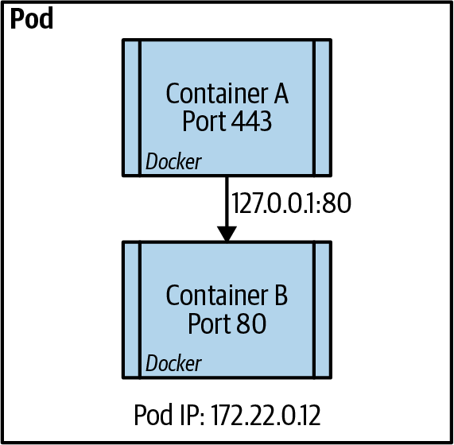

Figure 8-1. Intrapod communication between containers
Pod-to-pod communication
All pods need to communicate with one another without any network address translation (NAT). This means that the IP address that a pod is seen as by the receiving pod is the sender’s actual IP address. This is handled in different ways, depending on the network plug-in used, which we discuss in more detail later in the chapter. This rule is true between pods on the same node and pods that are on different nodes in the same cluster. This also extends to the node being able to communicate directly to the pod with no NAT involved. This allows host-based agents or system daemons to communicate to the pods as needed. Figure 8-2 is a representation of the communication processes between pods in the same node and pods in different nodes of the cluster.
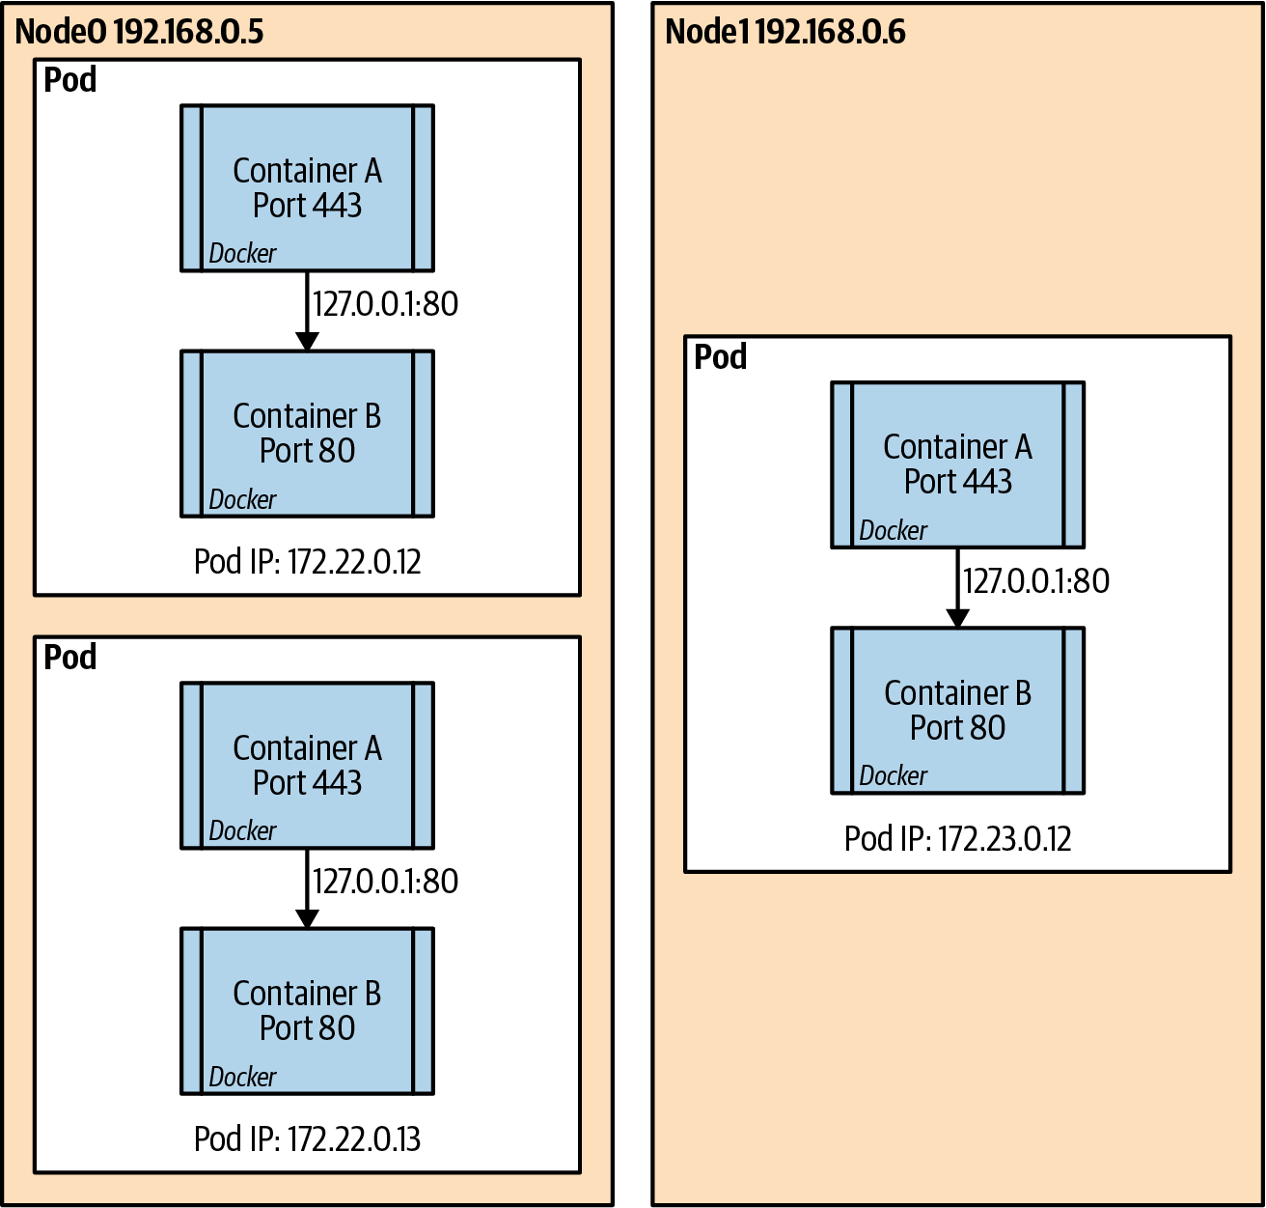

Figure 8-2. Pod to pod communication intra- and internode
Service-to-pod communication
Services in Kubernetes represent a durable IP address and port that is found on each node that will forward all traffic to the endpoints that are mapped to the service. Over the different iterations of Kubernetes, the method in favor of enabling this has changed, but the two main methods are via the use of iptables or the newer IP Virtual Server (IPVS) and some cloud providers and more advanced implementations allow for a new eBPF based dataplane. Most implementations today use the iptables implementation to enable a pseudo-Layer 4 load balancer on each node. Figure 8-3 is a visual representation of how the service is tied to the pods via label selectors.
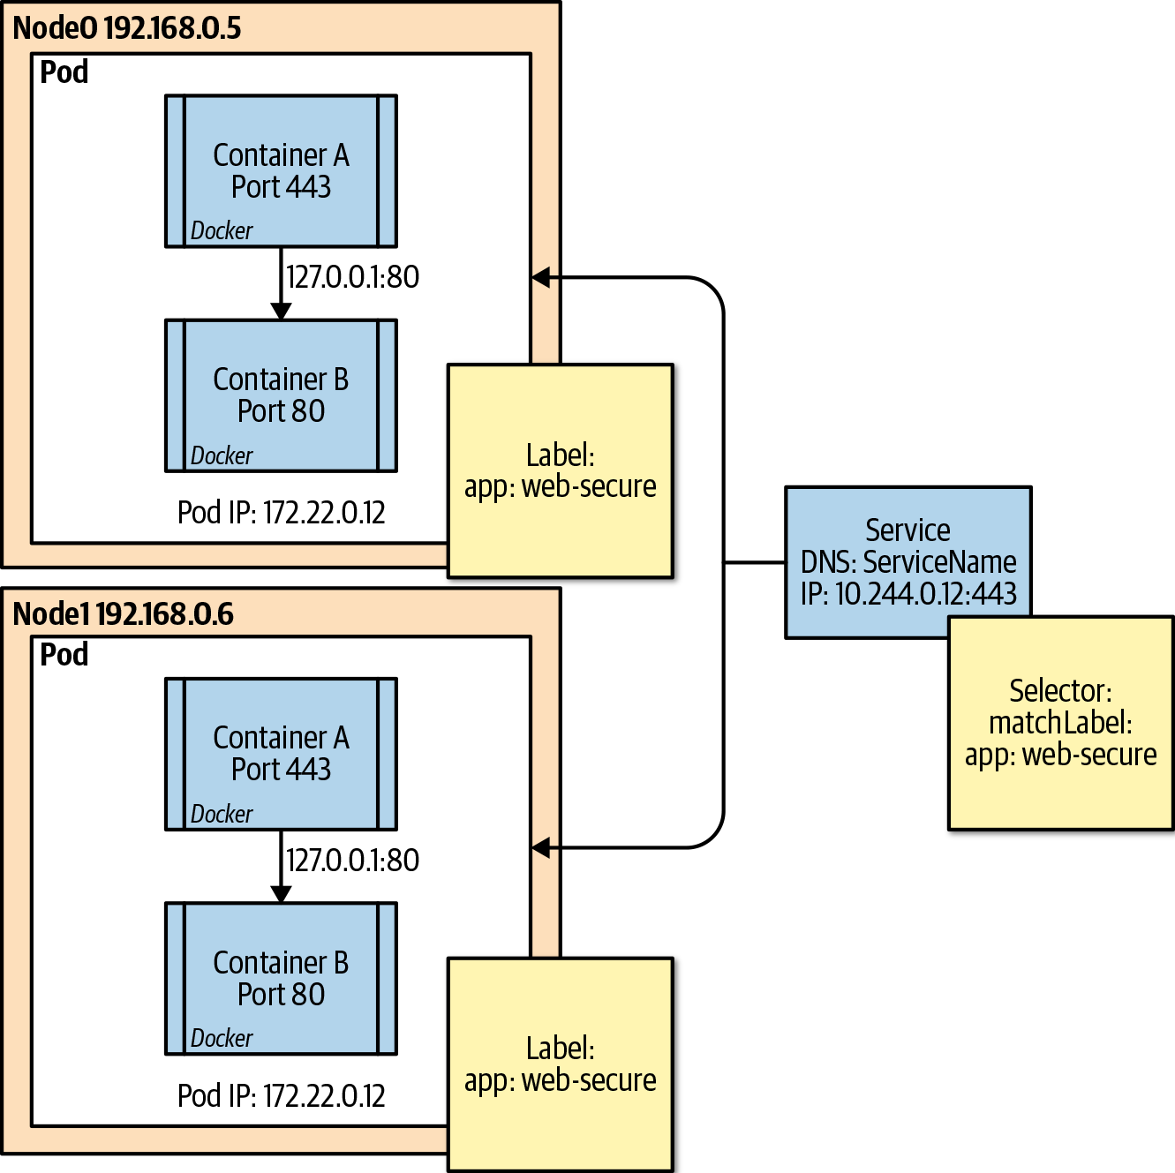

Figure 8-3. Service to pod communication

Network Plug-ins
Early on, the Special Interest Group (SIG) guided the networking standards to more of a pluggable architecture, which opened the door for numerous third-party networking projects, which in many cases injected value-added capabilities into Kubernetes workloads. These network plug-ins come in two flavors. The most basic is called Kubenet and is the default plug-in provided by Kubernetes natively. The second type of plug-in follows the Container Network Interface (CNI) specification, which is a generic plug-in network solution for containers.

Kubenet
Kubenet is the most basic network plug-in that comes out of the box in Kubernetes. It is the simplest of the plug-ins and provides a Linux bridge, cbr0, that’s a virtual Ethernet pair for the pods connected to it. The pod then gets an IP address from a Classless Inter-Domain Routing (CIDR) range that is distributed across the nodes of the cluster. There is also an IP masquerade flag that should be set to allow traffic destined to IPs outside the pod CIDR range to be masqueraded. This obeys the rules of pod-to-pod communication because only traffic destined outside the pod CIDR undergoes network address translation (NAT). After the packet leaves a node to go to another node, some kind of routing is put in place to facilitate the process to forward the traffic to the correct node.

Kubenet Best Practices
- Kubenet allows for a simplistic network stack and does not consume precious IP addresses on already crowded networks. This is especially true of cloud networks that are extended to on-premises datacenters.
- Ensure that the pod CIDR range is large enough to handle the potential size of the cluster and the pods in each cluster. The default pods per node set in kubelet is 110, but you can adjust this.
- Understand and plan accordingly for the route rules to properly allow traffic to find pods in the proper nodes. In cloud providers, this is usually automated, but on-premises or edge cases will require automation and solid network management.

The CNI Plug-in
The CNI plug-in has some basic requirements set aside by the specification. These specifications dictate the interfaces and minimal API actions that the CNI offers and how it will interface with the container runtime that is used in the cluster. The network management components are defined by the CNI, but they all must include some type of IP address management and minimally allow for the addition and deletion of a container to a network. The full original specification that was originally derived from the rkt networking proposal is available.
The Core CNI project provides libraries that you can use to write plug-ins that provide the basic requirements and that can call other plug-ins that perform various functions. This adaptability led to numerous CNI plug-ins that you can use in container networking from cloud providers like the Microsoft Azure native CNI and the Amazon Web Services (AWS) VPC CNI plug-in, to traditional network providers such as Nuage CNI, Juniper Networks Contrail/Tunsten Fabric, and VMware NSX.

CNI Best Practices
Networking is a critical component of a functioning Kubernetes environment. The interaction between the virtual components within Kubernetes and the physical network environment should be carefully designed to ensure dependable application communication:
Evaluate the feature set needed to accomplish the overall networking goals of the infrastructure. Some CNI plug-ins provide native high availability, multicloud connectivity, Kubernetes network policy support, and various other features.
If you are running clusters via public cloud providers, verify that any CNI plug-ins that are not native to the cloud provider’s Software-Defined Network (SDN) are actually supported.
Verify that any network security tools, network observability, and management tools are compatible with the CNI plug-in of choice, and if not, research which tools can replace the existing ones. It is important to not lose either observability or security capabilities because the needs will be expanded when moving to a large-scale distributed system such as Kubernetes. You can add tools like Weaveworks Weave Scope, Dynatrace, and Sysdig to any Kubernetes environment, and each offers its own benefits. If you’re running in a cloud provider’s managed service, such as Azure AKS, Google GCE, or AWS EKS, look for native tools like Azure Container Insights and Network Watcher, Google Logging and Monitoring, and AWS CloudWatch. Whatever tool you use, it should at least provide insight into the network stack and the Four Golden signals, made popular by the amazing Google SRE team and Rob Ewashuck: Latency, Traffic, Errors, and Saturation.
If you’re using CNIs that do not provide an overlay network separate from the SDN network space, ensure that you have proper network address space to handle node IPs, pod IPs, internal load balancers, and overhead for cluster upgrade and scale out processes.

Services in Kubernetes
When pods are deployed into a Kubernetes cluster, because of the basic rules of Kubernetes networking and the network plug-in used to facilitate these rules, pods can directly communicate only with other pods within the same cluster. Some CNI plug-ins give the pods IPs on the same network space as the nodes, so technically, after the IP of a pod is known, it can be accessed directly from outside the cluster. This, however, is not an efficient way to access services being served by a pod, because of the ephemeral nature of pods in Kubernetes. Imagine that you have a function or system that needs to access an API that is running in a pod in Kubernetes. For a while, that might work with no issue, but at some point there might be a voluntary or involuntary disruption that will cause that pod to disappear. Kubernetes will potentially create a replacement pod with a new name and IP address, so naturally there needs to be some mechanism to find the replacement pod. This is where the service API comes to the rescue.
The service API allows for a durable IP and port to be assigned within the Kubernetes cluster and automatically mapped to the proper pods as endpoints to the service. This magic happens through the aforementioned iptables or IPVS on Linux nodes to create a mapping of the assigned service IP and port to the endpoint’s or pod’s actual IPs. The controller that manages this is called the kube-proxy service, which actually runs on each node in the cluster. It is responsible for manipulating the iptables rules on each node.
When a service object is defined, the type of service needs to be defined. The service type will dictate whether the endpoints are exposed only within the cluster or outside of the cluster. There are four basic service types that we will discuss briefly in the following sections.

Service Type ClusterIP
ClusterIP is the default service type if one is not declared in the specification. ClusterIP means that the service is assigned an IP from a designated service CIDR range. This IP is as long lasting as the service object, so it provides an IP and port and protocol mapping to backend pods using the selector field; however, as we will see, there are cases for which you can have no selector. The declaration of the service also provides for a Domain Name System (DNS) name for the service. This facilitates service discovery within the cluster and allows for workloads to easily communicate to other services within the cluster by using DNS lookup based on the service name. As an example, if you have the service definition shown in the following example and need to access that service from another pod inside the cluster via an HTTP call, the call can simply use http://web1-svc if the client is in the same namespace as the service:
apiVersion
:
v1
kind
:
Service
metadata
:
name
:
web1-svc
spec
:
selector
:
app
:
web1
ports
:
-
port
:
80
targetPort
:
8081
If it is required to find services in other namespaces, the DNS pattern would be <service_name>.<namespace_name>.svc.cluster.local.
If no selector is given in a service definition, the endpoints can be explicitly defined for the service by using an endpoint API definition. This will basically add an IP and port as a specific endpoint to a service instead of relying on the selector attribute to automatically update the endpoints from the pods that are in scope by the selector match. This can be useful in a few scenarios in which you have a specific database that is not in a cluster that is to be used for testing but you will change the service later to a Kubernetes-deployed database. This is sometimes called a headless service because it is not managed by kube-proxy as other services are, but you can directly manage the endpoints, as shown in Figure 8-4.
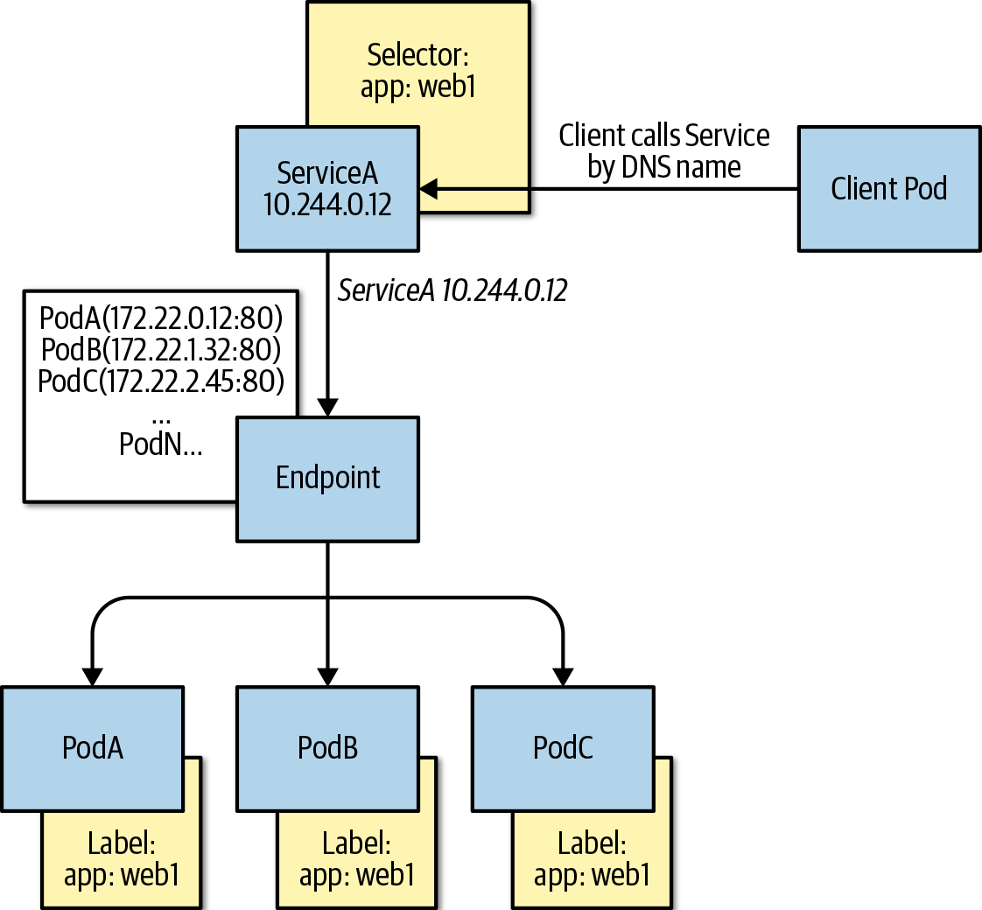

Figure 8-4. ClusterIPPod and Service visualization

Service Type NodePort
The NodePort service type assigns a high-level port on each node of the cluster to the Service IP and port on each node. The high-level NodePorts fall within the 30,000 through 32,767 ranges and can either be statically assigned or explicitly defined in the service specification. NodePorts are usually used for on-premises clusters or bespoke solutions that do not offer automatic load-balancing configuration. To directly access the service from outside the cluster, use NodeIP:NodePort, as depicted in Figure 8-5.
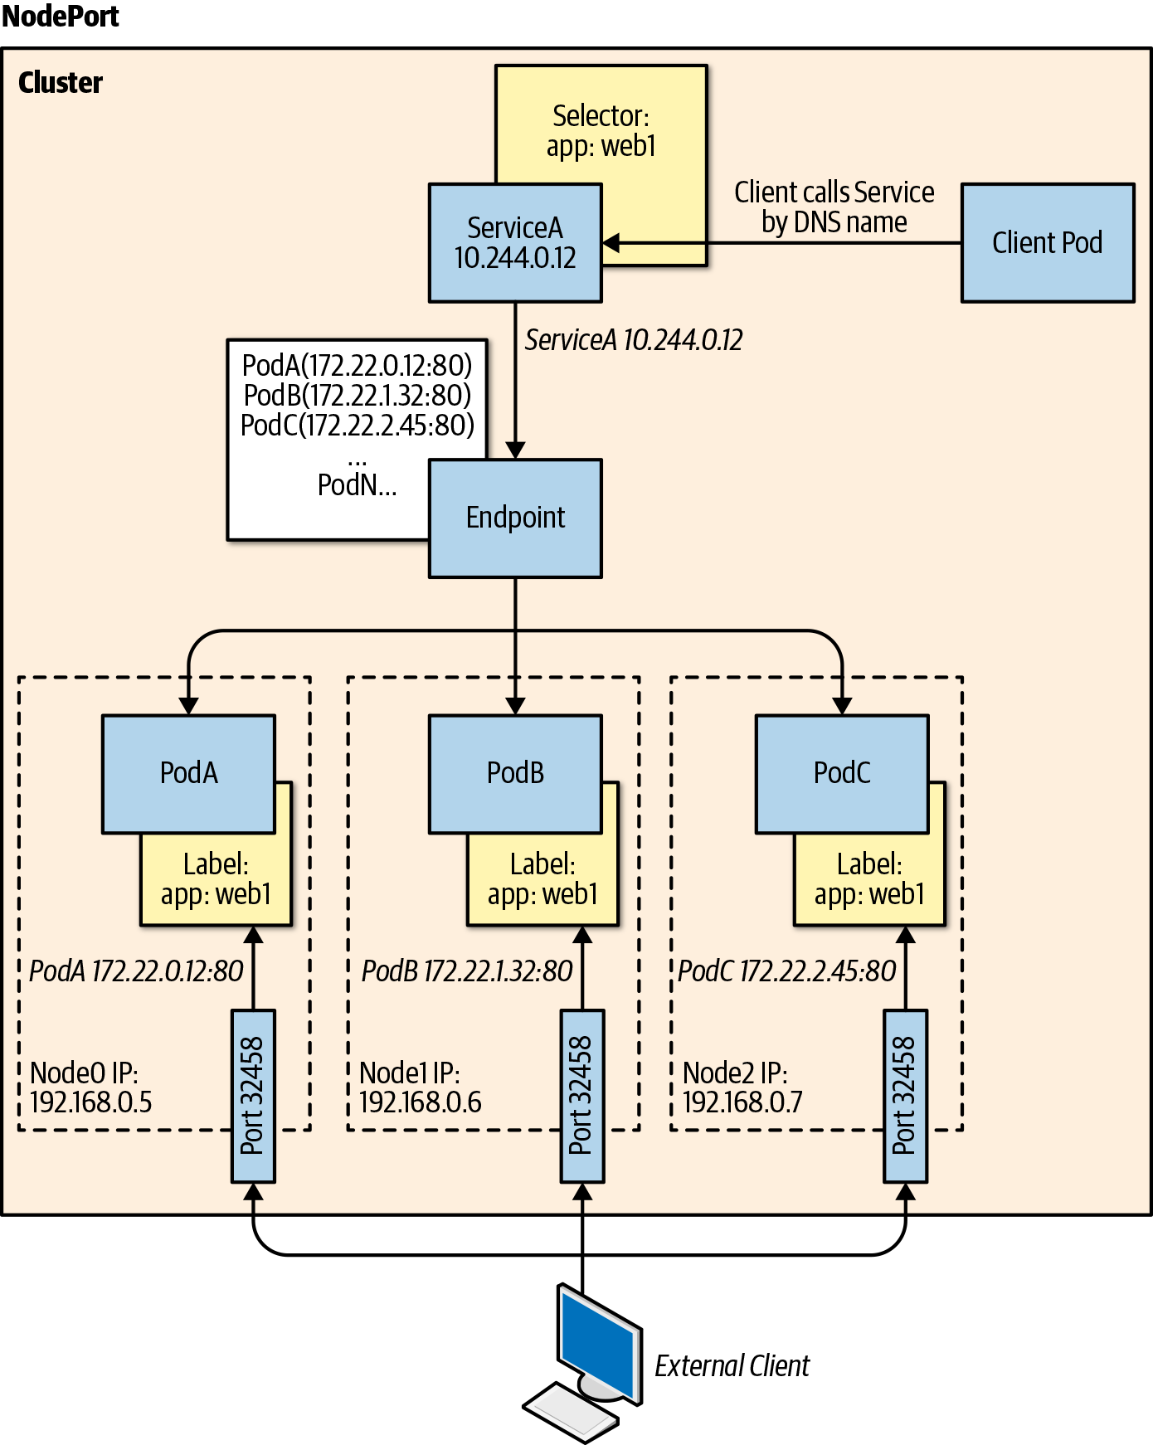

Figure 8-5. NodePort–Pod, Service and Host network visualization

Service Type ExternalName
The ExternalName service type is seldom used in practice, but it can be helpful for passing cluster-durable DNS names to external DNS named services. A common example is an external database service from a cloud provider that has a unique DNS provided by the cloud provider, such as mymongodb.documents.azure.com. Technically, this can be added very easily to a pod specification using an Environment variable, as discussed in Chapter 6; however, it might be more advantageous to use a more generic name in the cluster, such as prod-mongodb, which enables the change of the actual database it points to by just changing the service specification instead of having to recycle the pods because the Environment variable has changed:
kind
:
Service
apiVersion
:
v1
metadata
:
name
:
prod-mongodb
namespace
:
prod
spec
:
type
:
ExternalName
externalName
:
mymongodb.documents.azure.com

Service Type LoadBalancer
LoadBalancer is a very special service type because it enables automation with cloud providers and other programmable cloud infrastructure services. The LoadBalancer type is a single method to ensure the deployment of the load-balancing mechanism that the infrastructure provider of the Kubernetes cluster provides. This means that in most cases, LoadBalancer will work roughly the same way in AWS, Azure, GCE, OpenStack, and others. In most cases, this entry will create a public-facing load-balanced service; however, each cloud provider has some specific annotations that enable other features, such as internal-only load balancers, AWS ELB configuration parameters, and so on. You can also define the actual load-balancer IP to use and the source ranges to allow within the service specification, as seen in the code sample that follows and the visual representation in Figure 8-6:
kind
:
Service
apiVersion
:
v1
metadata
:
name
:
web-svc
spec
:
type
:
LoadBalancer
selector
:
app
:
web
ports
:
-
protocol
:
TCP
port
:
80
targetPort
:
8081
loadBalancerIP
:
13.12.21.31
loadBalancerSourceRanges
:
-
"142.43.0.0/16"
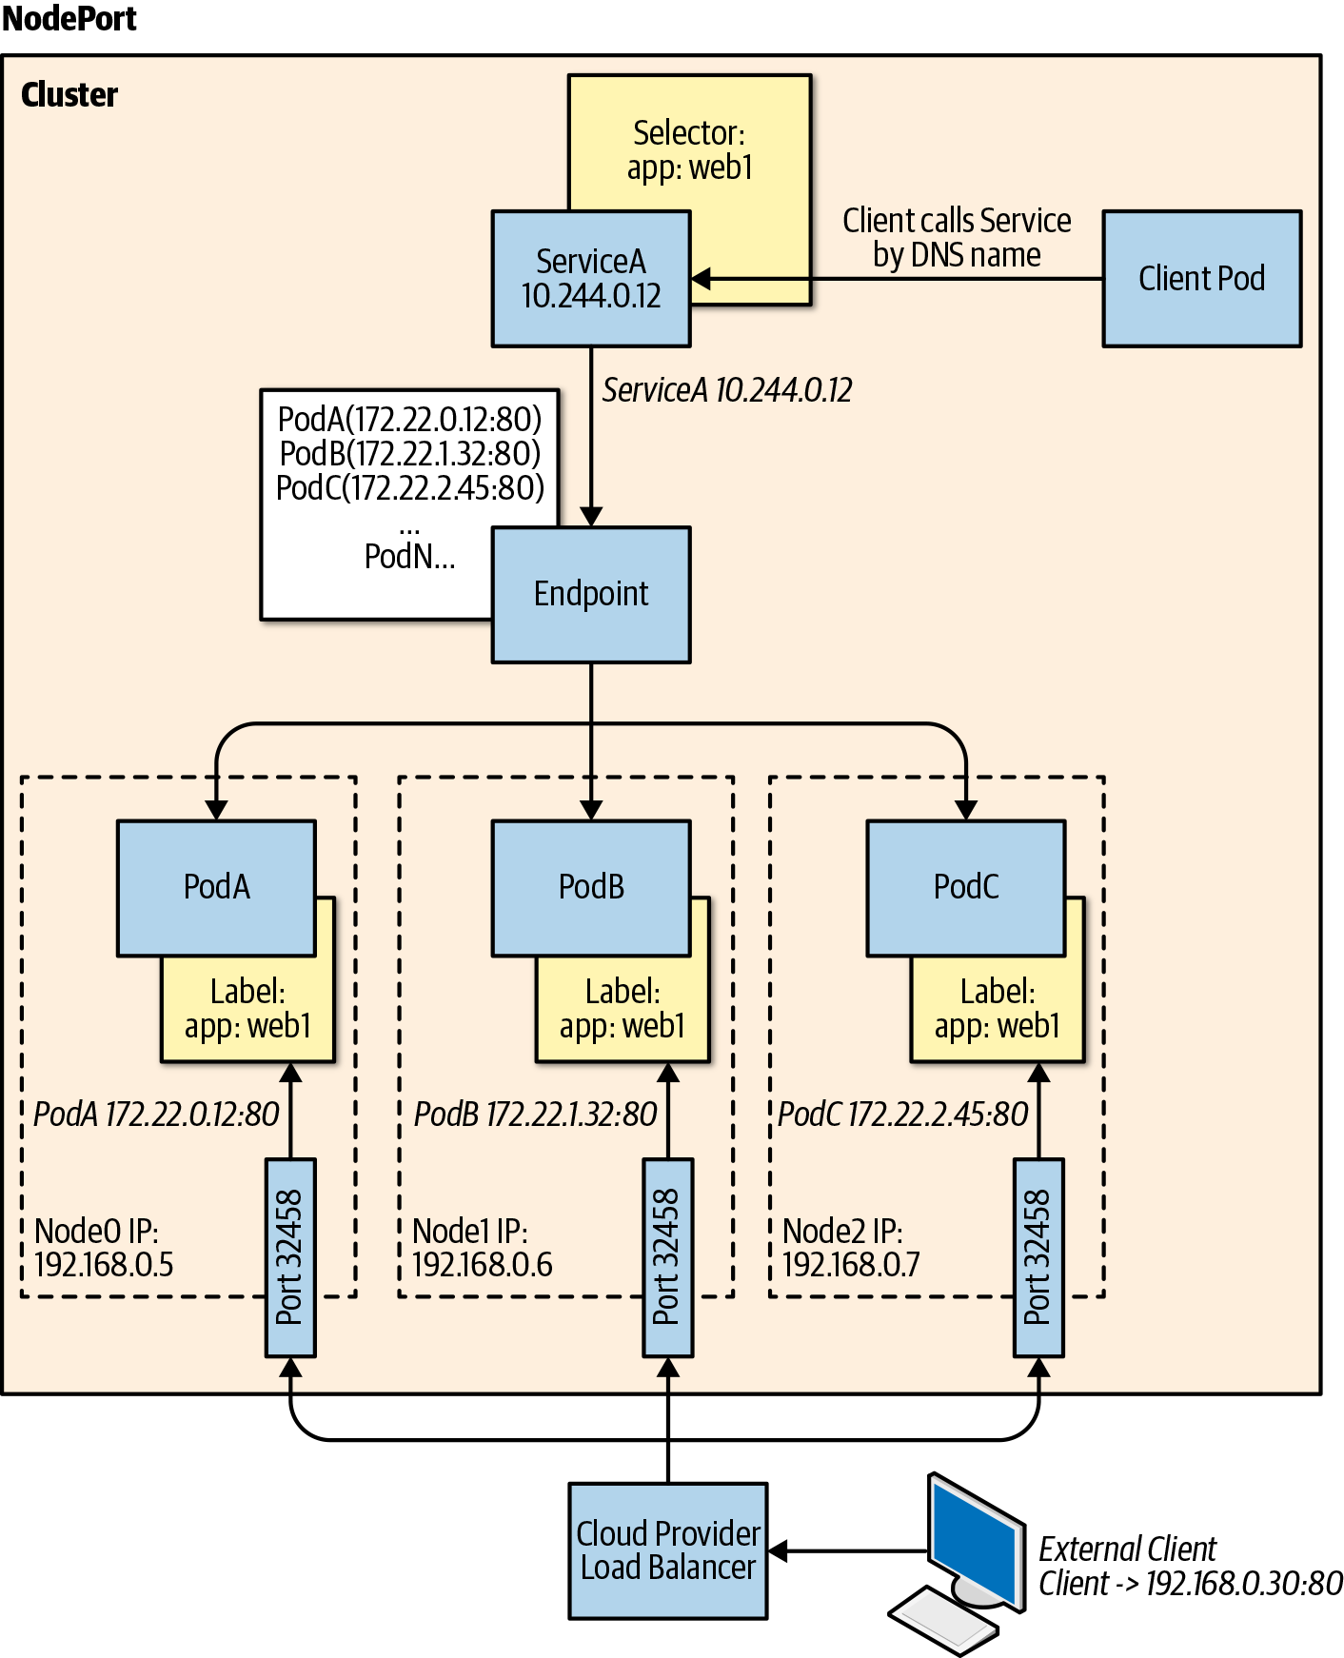

Figure 8-6. LoadBalancer–Pod, Service, Node, and Cloud Provider network visualization

Ingress and Ingress Controllers
Although not technically a service type in Kubernetes, the Ingress specification is an important concept for ingress to workloads in Kubernetes. Services, as defined by the Service API, allow for a basic level of Layer 3/4 load balancing. The reality is that many of the stateless services that are deployed in Kubernetes require a high level of traffic management and usually require application-level control: more specifically, HTTP protocol management.
The Ingress API is basically an HTTP-level router that allows for host- and path-based rules to direct to specific backend services. Imagine a website hosted on www.evillgenius.com and two different paths that are hosted on that site, /registration and /labaccess, that are served by two different services hosted in Kubernetes, reg-svc and labaccess-svc. You can define an ingress rule to ensure that requests to www.evillgenius.com/registration are forwarded to the reg-svc service and the correct endpoint pods, and, similarly, that requests to www.evillgenius.com/labaccess are forwarded to the correct endpoints of the labaccess-svc service. The Ingress API also allows for host-based routing to allow for different hosts on a single ingress. An additional feature is the ability to declare a Kubernetes secret that holds the certificate information for Transport Layer Security (TLS) termination on port 443. When a path is not specified, there is usually a default backend that can be used to give a better user experience than the standard 404 error.
The details around the specific TLS and default backend configuration are actually handled by what is known as the Ingress controller. The Ingress controller is decoupled from the Ingress API and allows for operators to deploy an Ingress controller of choice, such as NGINX, Traefik, HAProxy, and others. An Ingress controller, as the name suggests, is a controller, just like any Kubernetes controller, but it’s not part of the system and is instead a third-party controller that understands the Kubernetes Ingress API for dynamic configuration. The most common implementation of an Ingress controller is NGINX because it is partly maintained by the Kubernetes project; however, there are numerous examples of both open source and commercial Ingress controllers:
apiVersion
:
networking.k8s.io/v1
kind
:
Ingress
metadata
:
name
:
labs-ingress
annotations
:
nginx.ingress.kubernetes.io/rewrite-target
:
/
spec
:
tls
:
-
hosts
:
-
www.evillgenius.com
secretName
:
secret-tls
rules
:
-
host
:
www.evillgenius.com
http
:
paths
:
-
path
:
/registration
pathType
:
ImplementationSpecific
backend
:
service
:
name
:
reg-svc
port
:
number
:
8088
-
path
:
/labaccess
pathType
:
ImplementationSpecific
backend
:
service
:
name
:
labaccess-svc
port
:
number
:
8089

Gateway API
The Ingress API has had some challenges over the years it was in beta and following its v1 promotion. These challenges have led to other network services offering different abstractions through the use of Custom Resource Defintions and controllers to create their own APIs that fill some of the gaps Ingress has had. Some of the most common challenges with the Ingress API have been:
- The lack of expresiveness in the definition as it represents the lowest common denominator for the capabilities of the particular Ingress implmentation.
- A general lack of extensibility in the architecture. Vendors have used countless annotations to expose specific implementation capabilities however this has some limitations.
- The use of vendor specific annotations have removed some of the portability promised by the API. An annotation to expose a capability in an NGINX based Ingress Controller may be different or expressed differently from a Kong based controller implementation.
- There is no formal way to do multi-tenancy with the current Ingress API and DevOps teams have to create very tight controls to prevent path conflicts between Ingress definitions that could impact other tenants in the same cluster.
The Gateway API was introduced in 2019 and is currently managed as a project by the SIG Network team under the Kubernetes Project. The Gateway API does not intend to replace the Ingress API as it primarily targets exposing HTTP applications with a declarative syntax. Gateway API exposes a more general API for proxying for many types of protocols, and fits a more role based management process because it models more closely the infrastructure components in the environment.
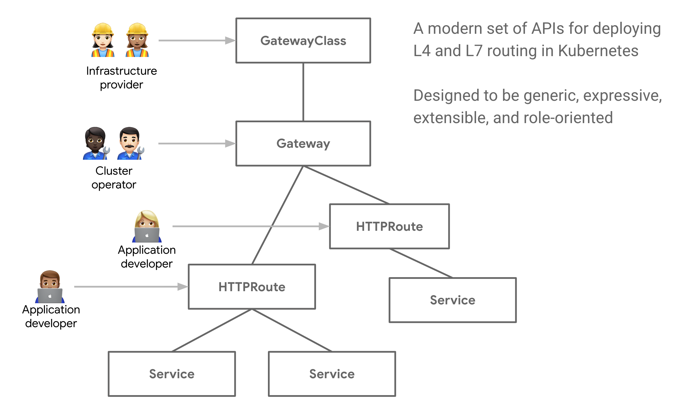

Figure 8-7. Gateway API Structure
This role based paradigm is very important in answering some of the shortcomings of the existing Ingress API. The separate components allow for infrastructure providers such as cloud providers, proxy ISVs, to define the infrastructure and platform operators to define through policy what infrastructure can be used and the developers to worry about how they want to expose their services within the constraints that are given to them. This abstracts away from the developer the infrastructure services and capabilities and allows them to focus on their specific service needs.
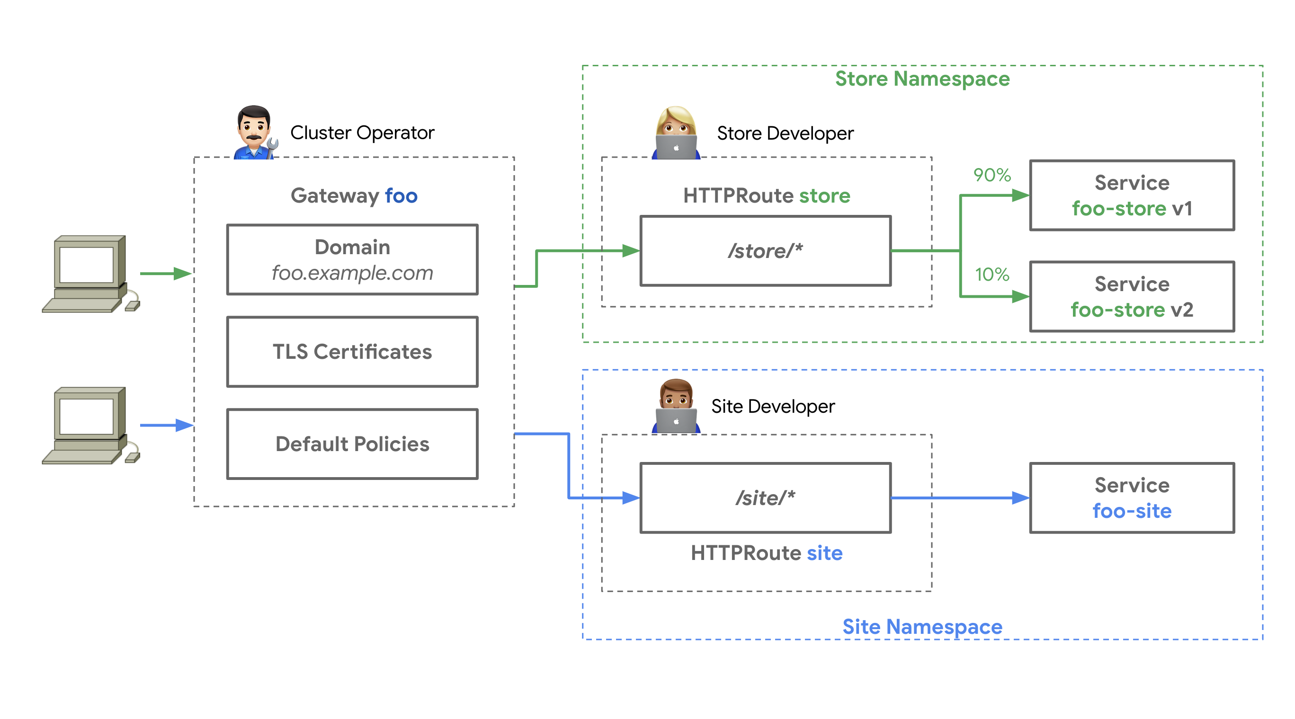

Figure 8-8. Gateway API Structure
The specification is very promising and many of the leading providers of proxies and services meshes as well as Cloud Providers have begun to implement into their stack the Gateway API. Google’s GKE, Acnodeal EPIC, Contour, Apache APISIX and others have begun to offer limited preview or alpha support and the API itself is in beta for the GatewayClass, Gateway and HTTPRoute resources as of this writing and others are in Alpha support. Unlike the Ingress API this is a custom resource that can be added to any cluster and therefore does not follow the Kubernetes Alpha or beta release process.

Services and Ingress Controllers Best Practices
Creating a complex virtual network environment with interconnected applications requires careful planning. Effectively managing how the different services of the application communicate with one another and to the outside world requires constant attention as the application changes. These best practices will help make the management easier:
- Limit the number of services that need to be accessed from outside the cluster. Ideally, most services will be ClusterIP, and only external-facing services will be exposed externally to the cluster.
- If the services that need to be exposed are primarily HTTP/HTTPS-based services, it is best to use an Ingress API and Ingress controller to route traffic to backing services with TLS termination. Depending on the type of Ingress controller used, features such as rate limiting, header rewrites, OAuth authentication, observability, and other services can be made available without having to build them into the applications themselves.
- Choose an Ingress controller that has the needed functionality for secure ingress of your web-based workloads. Standardize on one and use it across the enterprise because many of the specific configuration annotations vary between implementations and prevent the deployment code from being portable across enterprise Kubernetes implementations.
- Evaluate cloud service provider-specific Ingress controller options to move the infrastructure management and load of the ingress out of the cluster, but still allow for Kubernetes API configuration.
- When serving mostly APIs externally, evaluate API-specific Ingress controllers, such as Kong or Ambassador, that have more fine-tuning for API-based workloads. Although NGINX, Traefik, and others might offer some API tuning, it will not be as fine-grained as specific API proxy systems.
- When deploying Ingress controllers as pod-based workloads in Kubernetes, ensure that the deployments are designed for high availability and aggregate performance throughput. Use metrics observability to properly scale the ingress, but include enough cushion to prevent client disruptions while the workload scales.

Network Security Policy
The NetworkPolicy API built into Kubernetes allows for network-level ingress and egress access control defined with your workload. Network policies allow you to control how groups of pods are allowed to communicate with one another and with other endpoints. If you want to dig deeper into the NetworkPolicy specification, it might sound confusing, especially given that it is defined as a Kubernetes API, but it requires a network plug-in that supports the NetworkPolicy API.
Network policies have a simple YAML structure that can look complicated, but if you think of it as a simple East-West traffic firewall, it might help you to understand it a little better. Each policy specification has podSelector, ingress, egress, and policyType fields. The only required field is podSelector, which follows the same convention as any Kubernetes selector with a matchLabels. You can create multiple NetworkPolicy definitions that can target the same pods, and the effect is additive in nature. Because NetworkPolicy objects are namespaced objects, if no selector is given for a podSelector, all pods in the namespace fall into the scope of the policy. If there are any ingress or egress rules defined, this creates a whitelist of what is allowed to or from the pod. There is an important distinction here: if a pod falls into the scope of a policy because of a selector match, all traffic, unless explicitly defined in an ingress or egress rule, is blocked. This little, nuanced detail means that if a pod does not fall into any policy because of a selector match, all ingress and egress is allowed to the pod. This was done on purpose to allow for ease of deploying new workloads into Kubernetes without any blockers.
The ingress and egress fields are basically a list of rules based on source or destination and can be specific CIDR ranges, podSelectors, or namespaceSelectors. If you leave the ingress field empty, it is like a deny-all inbound. Similarly, if you leave the egress empty, it is deny-all outbound. Port and protocol lists are also supported to further tighten down the type of communications allowed.
The policyTypes field specifies to which network policy rule types the policy object is associated. If the field is not present, it will just look at the ingress and egress lists fields. The difference again is that you must explicitly call out egress in policyTypes and also have an egress rule list for this policy to work. Ingress is assumed, and defining it explicitly is not needed.
Let’s use a prototypical example of a three-tier application deployed to a single namespace where the tiers are labeled as tier: "web", tier: "db", and tier: "api". If you want to ensure that traffic is limited to each tier properly, create a NetworkPolicy manifest like this:
Default deny rule:
apiVersion
:
networking.k8s.io/v1
kind
:
NetworkPolicy
metadata
:
name
:
default-deny-all
spec
:
podSelector
:
{}
policyTypes
:
-
Ingress
Web layer network policy:
apiVersion
:
networking.k8s.io/v1
kind
:
NetworkPolicy
metadata
:
name
:
webaccess
spec
:
podSelector
:
matchLabels
:
tier
:
"web"
policyTypes
:
-
Ingress
ingress
:
-
{}
API layer network policy:
apiVersion
:
networking.k8s.io/v1
kind
:
NetworkPolicy
metadata
:
name
:
allow-api-access
spec
:
podSelector
:
matchLabels
:
tier
:
"api"
policyTypes
:
-
Ingress
ingress
:
-
from
:
-
podSelector
:
matchLabels
:
tier
:
"web"
Database layer network policy:
apiVersion
:
networking.k8s.io/v1
kind
:
NetworkPolicy
metadata
:
name
:
allow-db-access
spec
:
podSelector
:
matchLabels
:
tier
:
"db"
policyTypes
:
-
Ingress
ingress
:
-
from
:
-
podSelector
:
matchLabels
:
tier
:
"api"

Network Policy Best Practices
Securing network traffic in an enterprise system was once the domain of physical hardware devices with complex networking rule sets. Now, with Kubernetes network policy, a more application-centric approach can be taken to segment and control the traffic of the applications hosted in Kubernetes. Some common best practices apply no matter which policy plug-in used:
Start off slow and focus on traffic ingress to pods. Complicating matters with ingress and egress rules can make network tracing a nightmare. As soon as traffic is flowing as expected, you can begin to look at egress rules to further control flow to sensitive workloads. The specification also favors ingress because it defaults many options even if nothing is entered into the ingress rules list.
Ensure that the network plug-in used either has some of its own interface to the NetworkPolicy API or supports other well-known plug-ins. Example plug-ins include Calico, Cilium, Kube-router, Romana, and Weave Net.
If the network team is used to having a “default-deny” policy in place, create a network policy such as the following for each namespace in the cluster that will contain workloads to be protected. This ensures that even if another network policy is deleted, no pods are accidentally “exposed”:
apiVersion
:
networking.k8s.io/v1
kind
:
NetworkPolicy
metadata
:
name
:
default-deny-all
spec
:
podSelector
:
{}
policyTypes
:
-
Ingress
If there are pods that need to be accessed from the internet, use a label to explicitly apply a network policy that allows ingress. Be aware of the entire flow in case the actual IP that a packet is coming from is not the internet, but the internal IP of a load balancer, firewall, or other network device. For example, to allow traffic from all (including external) sources for pods having the allow-internet=true label, do this:
apiVersion
:
networking.k8s.io/v1
kind
:
NetworkPolicy
metadata
:
name
:
internet-access
spec
:
podSelector
:
matchLabels
:
allow-internet
:
"true"
policyTypes
:
-
Ingress
ingress
:
-
{}
Try to align application workloads to single namespaces for ease of creating rules because the rules themselves are namespace specific. If cross-namespace communication is needed, try to be as explicit as possible and perhaps use specific labels to identify the flow pattern:
apiVersion
:
networking.k8s.io/v1
kind
:
NetworkPolicy
metadata
:
name
:
namespace-foo-2-namespace-bar
namespace
:
bar
spec
:
podSelector
:
matchLabels
:
app
:
bar-app
policyTypes
:
-
Ingress
ingress
:
-
from
:
-
namespaceSelector
:
matchLabels
:
networking/namespace
:
foo
podSelector
:
matchLabels
:
app
:
foo-app
Have a test bed namespace that has fewer restrictive policies, if any at all, to allow time to investigate the correct traffic patterns needed.

Service Meshes
It is easy to imagine a single cluster hosting hundreds of services that load-balance across thousands of endpoints that communicate with one another, access external resources, and potentially are being accessed from external sources. This can be quite daunting when trying to manage, secure, observe, and trace all of the connections between these services, especially with the dynamic nature of the endpoints coming and going from the overall system. The concept of a service mesh, which is not unique to Kubernetes, allows for control over how these services are connected and secured with a dedicated date plane and control plane. Service meshes all have different capabilities, but usually they all offer some of the following:
- Load balancing of traffic with potentially fine-grained traffic-shaping policies that are distributed across the mesh.
- Service discovery of services that are members of the mesh, which might include services within a cluster or in another cluster, or an outside system that is a member of the mesh.
- Observability of the traffic and services, including tracing across the distributed services using tracing systems like Jaeger or Zipkin that follow the OpenTracing standards.
- Security of the traffic in the mesh using mutual authentication. In some cases, not only pod-to-pod or East-West traffic is secured, but an Ingress controller is also provided that offers North-South security and control.
- Resiliency, health, and failure-prevention capabilities that allow for patterns such as circuit breaker, retries, deadlines, and so on.
The key here is that all of these features are integrated into the applications that take part in the mesh with little or no application changes. How can all of these amazing features come for free? Sidecar proxies are usually the way this is done. The majority of service meshes available today inject a proxy that is part of the data plane into each pod that is a member of the mesh. This allows for policies and security to be synchronized across the mesh by the control-plane components. This really hides the network details from the container that holds the workload and leaves it to the proxy to handle the complexity of the distributed network. To the application, it just talks via localhost to its proxy. In many cases, the control plane and data plane might be different technologies but complementary to each other.
In many cases, the first service mesh that comes to mind is Istio, a project by Google, Lyft, and IBM that uses Envoy as its data-plane proxy and uses proprietary control-plane components Mixer, Pilot, Galley, and Citadel. There are other service meshes that offer varying levels of capabilities, such as Linkerd2, which uses its own data-plane proxy built using Rust. HashiCorp has recently added more Kubernetes-centric service mesh capabilities to Consul, which allows you to choose between Consul’s own proxy or Envoy, and offers commercial support for its service mesh.
The topic of service meshes in Kubernetes is a fluid one—if not overly emotional in many social media tech circles—so a detailed explanation of each mesh has no value here. I would be remiss if I did not mention the promising efforts lead by Microsoft, Linkerd, HashiCorp, Solo.io, Kinvolk, and Weaveworks around the Service Mesh Interface (SMI). The SMI hopes to set a standard interface for basic feature sets that are expected of all service meshes. The specification as of this writing covers traffic policy such as identity and transport-level encryption, traffic telemetry that captures key metrics between services in the mesh, and traffic management to allow for traffic shifting and weighting between different services. This project hopes to take some of the variability out of the service meshes yet allow for service mesh vendors to extend and build value-added capabilities into their products to differentiate themselves from others.

Service Mesh Best Practices
The service mesh community continues to grow every day, and as more and more enterprises help define their needs, the service mesh ecosystem will change dramatically. These best practices are, as of this writing, based on common necessities that service meshes try to solve today:
- Rate the importance of the key features service meshes offer and determine which current offerings provide the most important features with the least amount of overhead. Overhead here is both human technical debt and infrastructure resource debt. If all that is really required is mutual TLS between certain pods, would it be easier to perhaps find a CNI that offers that integrated into the plug-in?
- Is the need for a cross-system mesh such as multicloud or hybrid scenarios a key requirement? Not all service meshes offer this capability, and if they do, it is a complicated process that often introduces fragility into the environment.
- Many of the service mesh offerings are open source community-based projects, and if the team that will be managing the environment is new to service meshes, commercially supported offerings might be a better option. There are companies that are beginning to offer commercially supported and managed service meshes based on Istio, which can be helpful because it is almost universally agreed upon that Istio is a complicated system to manage.

Summary
In addition to application management, one of the most important things that Kubernetes provides is the ability to link different pieces of your application together. In this chapter, we looked at the details of how Kubernetes works, including how pods get their IP addresses through CNI plug-ins, how those IPs are grouped together to form services, and how more application or Layer 7 routing can be implemented via Ingress resources (which in turn use services). You also saw how to limit traffic and secure your network using networking policies, and, finally, how service mesh technologies are transforming the ways in which people connect and monitor the connections between their services. In addition to setting up your application to run and be deployed reliably, setting up the networking for your application is a crucial piece of using Kubernetes successfully. Understanding how Kubernetes approaches networking and how that intersects optimally with your application is a critical piece of its ultimate success.

Chapter 9. Policy and Governance for Your Cluster
A Note for Early Release Readers
With Early Release ebooks, you get books in their earliest form—the author’s raw and unedited content as they write—so you can take advantage of these technologies long before the official release of these titles.
This will be the 11th chapter of the final book. Please note that the GitHub repo will be made active later on.
If you have comments about how we might improve the content and/or examples in this book, or if you notice missing material within this chapter, please reach out to the editor at jleonard@oreilly.com.
Have you ever wondered how you might ensure that all containers running on a cluster come only from an approved container registry? Or maybe you’ve been asked by the security team to enforce that services are never exposed to the internet. These are precisely the challenges that policy and governance for your cluster set out to address. As Kubernetes continues to mature and becomes adopted by more enterprises, the question of how to apply policy and governance to Kubernetes resources is becoming increasingly frequent. In this chapter we share what you can do and the tools to use to make sure that your cluster is in compliance with the defined policies whether your work at a startup or enterprise.

Why Policy and Governance Are Important
Whether you operate in a highly regulated environment—for example, health care or financial services—or you simply want to make sure that you maintain a level of control over what’s running on your clusters, you’re going to need a way to implement the company specific policies. Once defined, you will need to determine how to implement policy and maintain clusters that are compliant to these policies. These policies may be required to meet regulatory compliance or simply to enforce best practices. Whatever the reason, you must be sure that you do not sacrifice developer agility and self-service when implementing these policies.

How Is This Policy Different?
In Kubernetes, policy is everywhere. Whether it be network policy or pod security, we’ve all come to understand what policy is and when to use it. We trust that whatever is declared in Kubernetes resource specifications is implemented as per the policy definition. Both network policy and pod security are implemented at runtime. However, what policy restricts the field values in these Kubernetes resource specifications? That’s the job for policy and governance. Rather than implementing policy at runtime, when we talk about policy in the context of governance, what we mean is defining policy that controls the fields and values in the Kubernetes resource specifications themselves. Only Kubernetes resource specifications that are compliant when evaluated by policies are allowed and committed to the cluster state.

Cloud-Native Policy Engine
To be able to evalute which resources are compliant, we need a policy engine that is flexible enough to meet a variety of needs. The Open Policy Agent (OPA) is an open source, flexible, lightweight policy engine that has become increasingly popular in the cloud-native ecosystem. Having OPA in the ecosystem has allowed many implementations of different Kubernetes governance tools to appear. One such Kubernetes policy and governance project the community is rallying around is called Gatekeeper. For the rest of this chapter, we use Gatekeeper as the canonical example to illustrate how you might achieve policy and governance for your cluster. Although there are other implementations of policy and governance tools in the ecosystem, they all seek to provide the same user experience (UX) by allowing only compliant Kubernetes resource specifications to be committed to the cluster.

Introducing Gatekeeper
Gatekeeper is an open source customizable Kubernetes admission webhook for cluster policy and governance. Gatekeeper takes advantage of the OPA constraint framework to enforce custom resource definition (CRD)-based policies. Using CRDs allows for an integrated Kubernetes experience that decouples policy authoring from implementation. Policy templates are referred to as constraint templates, which can be shared and reused across clusters. Gatekeeper enables resource validation and audit functionality. One of the great things about Gatekeeper is that it’s portable, which means that you can implement it on any Kubernetes clusters, and if you are already using OPA, you might be able to port that policy over to Gatekeeper.
Note
Gatekeeper is a production ready open source project. For the latest stable version, please visit the official upstream repository.

Example Policies
Before diving into how to configure Gatekeeper, it’s important to keep the problem we are trying to solve in focus. Let’s take a look at some policies that solve some of the most common compliance issues for context:
- Services must not be exposed publicly on the internet.
- Allow containers only from trusted container registries.
- All containers must have resource limits.
- Ingress hostnames must not overlap.
- Ingresses must use only HTTPS.

Gatekeeper Terminology
Gatekeeper has adopted much of the same terminology as OPA. It’s important that we cover what that terminology is so that you can understand how Gatekeeper operates. Gatekeeper uses the OPA constraint framework. Here, we introduce three new terms:
- Constraint
- Rego
- Constraint template

Constraint
The best way to think about constraints is as restrictions that you apply to specific fields and values of Kubernetes resource specifications. This is really just a long way of saying policy. This means that when constraints are defined, you are effectively stating that you DO NOT want to allow this. The implications of this approach mean that resources are implicitly allowed without a constraint that issues a deny. This is an important nuance because rather then allowing the Kubernetes resources specification fields and values you want, you are denying only the ones you DO NOT want. This architectural decision suits Kubernetes resource specifications nicely because they are ever changing.

Rego
Rego is an OPA-native query language. Rego queries are assertions on the data stored in OPA. Gatekeeper stores rego in the constraint template.

Constraint template
You can think of this as a policy template. It’s portable and reusable. Constraint templates consist of typed parameters and the target rego that is parameterized for reuse.

Defining Constraint Templates
Constraint templates are a Custom Resource Definition (CRD) that provide a means of templating policy so that it can be shared or reused. In addition, parameters for the policy can be validated. Let’s take a look at a constraint template (from the upstream Gatekeeper policy library - https://github.com/open-policy-agent/gatekeeper-library) in the context of the earlier examples. In the following example, we share a constraint template that provides the policy “Only allow containers from trusted container registries”:
apiVersion
:
templates.gatekeeper.sh/v1
kind
:
ConstraintTemplate
metadata
:
name
:
k8sallowedrepos
annotations
:
metadata.gatekeeper.sh/title
:
"Allowed
Repositories"
metadata.gatekeeper.sh/version
:
1.0.0
description
:
>-
Requires container images to begin with a string from the specified list.
spec
:
crd
:
spec
:
names
:
kind
:
K8sAllowedRepos
validation
:
# Schema for the `parameters` field
openAPIV3Schema
:
type
:
object
properties
:
repos
:
description
:
The list of prefixes a container image is allowed to have.
type
:
array
items
:
type
:
string
targets
:
-
target
:
admission.k8s.gatekeeper.sh
rego
:
|
package k8sallowedrepos
violation[{"msg": msg}] {
container := input.review.object.spec.containers[_]
satisfied := [good | repo = input.parameters.repos[_] ; good = startswith(container.image, repo)]
not any(satisfied)
msg := sprintf("container <%v> has an invalid image repo <%v>, allowed repos are %v", [container.name, container.image, input.parameters.repos])
}
violation[{"msg": msg}] {
container := input.review.object.spec.initContainers[_]
satisfied := [good | repo = input.parameters.repos[_] ; good = startswith(container.image, repo)]
not any(satisfied)
msg := sprintf("initContainer <%v> has an invalid image repo <%v>, allowed repos are %v", [container.name, container.image, input.parameters.repos])
}
violation[{"msg": msg}] {
container := input.review.object.spec.ephemeralContainers[_]
satisfied := [good | repo = input.parameters.repos[_] ; good = startswith(container.image, repo)]
not any(satisfied)
msg := sprintf("ephemeralContainer <%v> has an invalid image repo <%v>, allowed repos are %v", [container.name, container.image, input.parameters.repos])
}
The constraint template consists of three main components:
Kubernetes-required CRD metadata
The name is the most important part. We reference this later.
Schema for input parameters
Indicated by the validation field, this section defines the input parameters and their associated types. In this example, we have a single parameter called repo that is an array of strings.
Policy definition
Indicated by the target field, this section contains templated rego (the language to define policy in OPA). Using a constraint template allows the templated rego to be reused and means that generic policy can be shared. If the rule matches, the constraint is violated.

Defining Constraints
To use the previous constraint template, we must create a constraint resource. The purpose of the constraint resource is to provide the necessary parameters to the constraint template that we created earlier. You can see that the kind of the resource defined in the following example is K8sAllowedRepos, which maps to the constraint template defined in the previous section:
apiVersion
:
constraints.gatekeeper.sh/v1beta1
kind
:
K8sAllowedRepos
metadata
:
name
:
prod-repo-is-openpolicyagent
spec
:
enforcementAction
:
deny
match
:
kinds
:
-
apiGroups
:
[
""
]
kinds
:
[
"Pod"
]
namespaces
:
-
"production"
parameters
:
repos
:
-
"openpolicyagent/"
The constraint consists of two main sections:
Kubernetes metadata
Notice that this constraint is of kind K8sAllowedRepos, which matches the name of the constraint template.
The spec
The match field defines the scope of intent for the policy. In this example, we are matching pods only in the production namespace.
The parameters define the intent for the policy. Notice that they match the type from the constraint template schema from the previous section. In this case, we allow only container images that start with openpolicyagent/.
Constraints have the following operational characteristics:
- Logically AND-ed together
    - When multiple policies validate the same field, if one violates then the whole request is rejected
- Schema validation that allows early error detection
- Selection criteria
    - Can use label selectors
    - Constrain only certain kinds
    - Constrain only in certain namespaces

Data Replication
In some cases, you might want to compare the current resource against other resources that are in the cluster, for example, in the case of “Ingress hostnames must not overlap.” OPA needs to have all of the other Ingress resources in its cache in order to evaluate the rule. Gatekeeper uses a config resource to manage which data is cached in OPA in order to perform evaluations such as the one previously mentioned. In addition, config resources are also used in the audit functionality, which we explore a bit later on.
The following example config resource caches v1 service, pods, and namespaces:
apiVersion
:
config.gatekeeper.sh/v1alpha1
kind
:
Config
metadata
:
name
:
config
namespace
:
gatekeeper-system
spec
:
sync
:
syncOnly
:
-
kind
:
Service
version
:
v1
-
kind
:
Pod
version
:
v1
-
kind
:
Namespace
version
:
v1

UX
Gatekeeper enables real-time feedback to cluster users for resources that violate defined policy. If we consider the example from the previous sections, we allow containers only from repositories that start with openpolicyagent/.
Let’s try to create the following resource; it is not compliant given the current policy:
apiVersion
:
v1
kind
:
Pod
metadata
:
name
:
opa
namespace
:
production
spec
:
containers
:
-
name
:
opa
image
:
quay.io/opa:0.9.2
This gives you the violation message that’s defined in the constraint template:
$
kubectl
create
-f
bad_resources/opa_wrong_repo.yaml
Error
from
server
(
Forbidden
)
:
error
when
creating
"STDIN"
:
admission
webhook
"validation.gatekeeper.sh"
denied
the
request:
[
repo-is-openpolicyagent
]
container
<opa>
has
an
invalid
image
repo
<quay.io/opa:0.9.2>,
allowed
repos
are
[
"openpolicyagent/"
]

Using Enforcement Action and Audit
Thus far, we have discussed only how to define policy and have it enforced as part of the request admission process. Constraints include the ability to configure an enforcementAction which, by default is set to deny. In addition to deny, enforcementAction also allows accepted values of warn and dryrun. When we think about rolling out policy, it’s not always the case that you are applying to a cluster or namespace without resources already deployed. It’s therefore important to understand how do you deploy policy to a cluster that already has resources deployed with the confidence that you can identify and remediate policy violations without necessarily breaking deployed workloads. The enforcementAction field allows you to define the behavior. When set to deny, a resource that violates policy will not be created and an error message will both be audit logged and sent back to the user. If set to warn the resource will be created however a warning message will be audit logged and sent back to the user. Finally, if dryrun is set, the resource will be created and resources that violate the policy will be available in the audit log.
Whatever enforcementAction you decide to use, Gatekeeper will periodically evaluate resources against any configured policy and provide an audit log. This helps with the detection of misconfigured resources according to policy and allows for remediation. The audit results are stored in the status field of the constraint, making them easy to find by simply using kubectl. To use audit, the resources to be audited must be replicated. For more details, refer to “Data Replication”.
Let’s take a look at the constraint called prod-repo-is-openpolicyagent that you defined in the previous section. In this case, imagine we already had a pod called nginx running in the production namespace and we would like to check it’s compliance to the policy using audit:
$
kubectl
get
k8sallowedrepos
NAME
ENFORCEMENT-ACTION
TOTAL-VIOLATIONS
prod-repo-is-openpolicyagent
deny
1
$
kubectl
get
k8sallowedrepos
prod-repo-is-openpolicyagent
-o
yaml
apiVersion:
constraints.gatekeeper.sh/v1beta1
kind:
K8sAllowedRepos
metadata:
annotations:
kubectl.kubernetes.io/last-applied-configuration:
...
creationTimestamp:
"..."
generation:
1
name:
prod-repo-is-openpolicyagent
resourceVersion:
"..."
uid:
...
spec:
match:
kinds:
-
apiGroups:
-
""
kinds:
-
Pod
namespaces:
-
production
parameters:
repos:
-
openpolicyagent/
status:
auditTimestamp:
"2022-11-27T23:37:42Z"
totalViolations:
1
violations:
-
enforcementAction:
deny
group:
""
kind:
Pod
message:
container
<nginx>
has
an
invalid
image
repo
<nginx>,
allowed
repos
are
[
"openpolicyagent/"
]
name:
nginx
namespace:
production
version:
v1
Upon inspection, you can see the last time the audit ran in the auditTimestamp field. We also see all of the resources that violate this constraint, only the nginx pod in this case, under the violations along with the enforcementAction.

Mutation
In addition to resource validation, Gatekeeper also allows you to configure mutation policies. Mutation policies allow you to modify Kubernetes resources at admission time. Generally, mutating resources at admission time is not considered best practice. Having resources “magically” modified by Gatekeeper is a cloud native anti-pattern as this is counter to the declarative nature of Kubernetes. Mutation policies are simply mentioned here to provide guidance to avoid them unless you feel your use-case absolutely requires them and that you have exhausted other best practices. Refer to the GitOps chapter for more details on how to implement declarative best practices for Kubernetes resources.

Testing Policies
As the GitOps philosophy has become widely adopted, testing policy and evaluation as part of local testing or CI/CD pipelines has become a must have. Gatekeeper ships with a gator CLI which enables you to take the constraint templates and constraints and run a local evaluation. This is a great tool for building new policies, testing them against your resources and remediating any issues prior to deploying them to your production clusters. The Gatekeeper documentation provides a practical guide to using the gator cli to test policy.

Becoming Familiar with Gatekeeper
The Gatekeeper repository ships with fantastic demonstration content that walks you through a detailed example of building policies to meet compliance for a bank. We would strongly recommend walking through the demonstration for a hands-on approach to how Gatekeeper operates. You can find the demonstration in this Git repository. Gatekeeper also maintains a public library of policies that you can apply to your cluster wit h easy installation guidance via ArtifactHub.

Policy and Governance Best Practices
You should consider the following best practices when implementing policy and governance on your clusters:
- If you want to enforce a specific field in a pod, you need to make a determination of which Kubernetes resource specification you want to inspect and enforce. Let’s consider the case of Deployments, for example. Deployments manage ReplicaSets, which manage pods. We could enforce at all three levels, but the best choice is the one that is the lowest handoff point before the runtime, which in this case is the pod. This decision, however, has implications. The user-friendly error message when we try to deploy a noncompliant pod, as seen in “UX”, is not going to be displayed. This is because the user is not creating the noncompliant resource, the ReplicaSet is. This experience means that the user would need to determine that the resource is not compliant by running a kubectl describe on the current ReplicaSet associated with the Deployment. Although this might seem cumbersome, this is consistent behavior with other Kubernetes features, such as pod security.
- Constraints can be applied to Kubernetes resources on the following criteria: kinds, namespaces, and label selectors. We would strongly recommend scoping the constraint to the resources to which you want it to be applied as tightly as possible. This ensures consistent policy behavior as the resources on the cluster grow, and means that resources that don’t need to be evaluated aren’t being passed to OPA, which can result in other inefficiencies.
- On clusters with resources already deployed, utilize warn and dryrun along with audit to remediate resources that violate policy before setting the enforcementAction to deny.
- Don’t use mutation policies, instead consider other declarative approaches including GitOps.
- Synchronizing and enforcing on potentially sensitive data such as Kubernetes secrets is not recommended. Given that OPA will hold this in its cache (if it is configured to replicate that data) and resources will be passed to Gatekeeper, it leaves surface area for a potential attack vector.
- If you have many constraints defined, a deny of constraint means that the entire request is denied. There is no way to make this function as a logical OR.

Summary
In this chapter, we covered why policy and governance are important and walked through a project that’s built upon OPA, a cloud-native ecosystem policy engine, to provide a Kubernetes-native approach to policy and governance. You should now be prepared and confident the next time the security teams asks, “Are our clusters in compliance with our defined policy?”

Chapter 10. Admission Control and Authorization
A Note for Early Release Readers
With Early Release ebooks, you get books in their earliest form—the author’s raw and unedited content as they write—so you can take advantage of these technologies long before the official release of these titles.
This will be the 17th chapter of the final book. Please note that the GitHub repo will be made active later on.
If you have comments about how we might improve the content and/or examples in this book, or if you notice missing material within this chapter, please reach out to the editor at jleonard@oreilly.com.
Controlling access to the Kubernetes API is key to ensuring that your cluster is not only secured but also can be used as a means to impart policy and governance for all users, workloads, and components of your Kubernetes cluster. In this chapter, we share how you can use admission controllers and authorization modules to enable specific features and how you can customize them to suit your specific needs.
Figure 10-1 provides insight on how and where admission control and authorization take place. It depicts the end-to-end request flow through the Kubernetes API server until the object, if accepted, is saved to storage. Follow the API request from left to right through the API server paying specific attention to the ordering admission control and authorization. We will be covering best practices for those in this chapter.
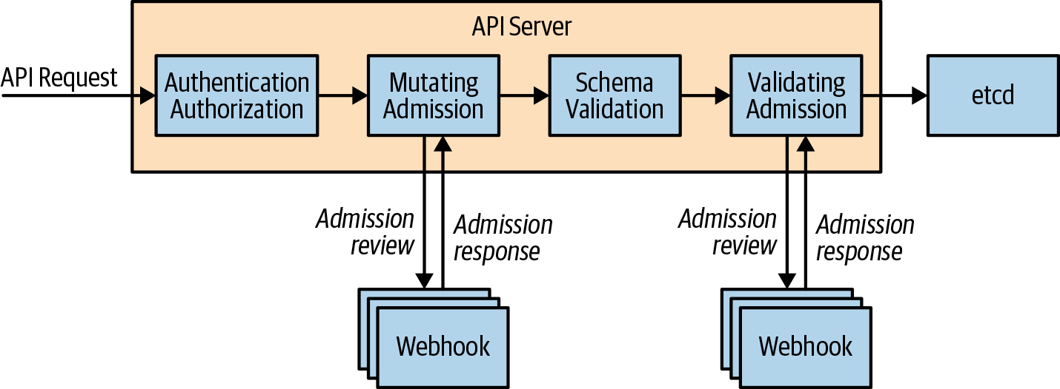

Figure 10-1. Kubernetes API request flow

Admission Control
Have you ever wondered how namespaces are automatically created when you define a resource in a namespace that doesn’t already exist? Maybe you’ve wondered how a default storage class is selected? These changes are powered by a feature called admission controllers. In this section, we take a look at how you can use admission controllers to implement Kubernetes best practices server side on behalf of the user and how we can utilize admission control to govern how a Kubernetes cluster is used.

What Are They?
Admission controllers sit in the path of the Kubernetes API server request flow and receive requests following the authentication and authorization phases. They are used to either validate or mutate (or both) the request object before saving it to storage. The difference between validating and mutating admission controllers is that mutating can modify the request object they admit, whereas validating cannot.

Why Are They Important?
Given that admission controllers sit in the path of all API server requests, you can use them in a variety of different ways. Most commonly, admission controller usage can be grouped into the following three groups:
Policy and governance
Admission controllers allow policy to be enforced in order to meet business requirements; for example:
- Only internal cloud load balancers can be used when in the dev namespace.
- All containers in a pod must have resource limits.
- Add predefined standard labels or annotations to all resources in order to make them discoverable to existing tools.
- All Ingress resources only use HTTPS. For more details on how to use admission webhooks in this context, see Chapter 9.
Security
You can use admission controllers to enforce a consistent security posture across your cluster. A canonical example is the PodSecurity admission controller, which determines whether a pod should be admitted based on the configuration of security-sensitive fields defined in the pod. You can enforce more granular or custom security rules using admission webhooks.
Resource management
Admission controllers allow you to validate in order to provide best practices for your cluster users, for example:
- Ensure all ingress fully qualified domain names (FQDN) fall within a specific suffix.
- Ensure ingress FQDNs don’t overlap.
- All containers in a pod must have resource limits.

Admission Controller Types
There are two classes of admission controllers: standard and dynamic. Standard admission controllers are compiled into the API server and are shipped as plug-ins with each Kubernetes release; they need to be configured when the API server is started. Dynamic controllers, on the other hand, are configurable at runtime and are developed outside the core Kubernetes codebase. The only type of dynamic admission control is admission webhooks, which receive admission requests via HTTP callbacks.
By default, the recommended admission controllers are enabled. You may enable additional admission controllers using the following flag on the Kubernetes API server:
--enable-admission-plugins
In the current version of Kubernetes, the following admission controllers are enabled by default:
CertificateApproval, CertificateSigning, CertificateSubjectRestriction, DefaultIngressClass, DefaultStorageClass, DefaultTolerationSeconds, LimitRanger, MutatingAdmissionWebhook, NamespaceLifecycle, PersistentVolumeClaimResize, PodSecurity, Priority, ResourceQuota, RuntimeClass, ServiceAccount, StorageObjectInUseProtection, TaintNodesByCondition, ValidatingAdmissionWebhook
You can find the list of Kubernetes admission controllers and their functionality in the Kubernetes documentation.
You might have noticed the following from the list of recommended admission controllers to enable: “MutatingAdmissionWebhook,ValidatingAdmissionWebhook.” These standard admission controllers don’t implement any admission logic themselves; rather, they are used to configure a webhook endpoint running in-cluster to forward the admission request object.

Configuring Admission Webhooks
As previously mentioned, one of the main advantages of admission webhooks is that they are dynamically configurable. It is important that you understand how to effectively configure admission webhooks because there are implications and trade-offs when it comes to consistency and failure modes.
The snippet that follows is a ValidatingWebhookConfiguration resource manifest. This manifest is used to define a validating admission webhook. The snippet provides detailed descriptions on the function of each field ():
apiVersion
:
admissionregistration.k8s.io/v1
kind
:
ValidatingWebhookConfiguration
metadata
:
name
:
## Resource name
webhooks
:
-
name
:
## Admission webhook name, which will be shown to the user when any admission reviews are denied
clientConfig
:
service
:
namespace
:
## The namespace where the admission webhook pod resides
name
:
## The service name that is used to connect to the admission webhook
path
:
## The webhook URL
caBundle
:
## The PEM encoded CA bundle which will be used to validate the webhook's server certificate
rules
:
## Describes what operations on what resources/subresources the API server must send to this webhook
-
operations
:
-
## The specific operation that triggers the API server to send to this webhook (e.g., create, update, delete, connect)
apiGroups
:
-
""
apiVersions
:
-
"*"
resources
:
-
## Specific resources by name (e.g., deployments, services, ingresses)
failurePolicy
:
## Defines how to handle access issues or unrecognized errors, and must be Ignore or Fail
admissionReviewVersions
:
[
"v1"
]
## Specify what versions of AdmissionReview objects are accepted
sideEffects
:
## Signal whether the webhook may out-of-band changes that need to be handled
timeoutSeconds
:
5
## How long the API server should wait for a response before treating the request as a failure
For completeness, let’s take a look at a MutatingWebhookConfiguration resource manifest. This manifest defines a mutating admission webhook. The snippet provides detailed descriptions on the function of each field:
apiVersion
:
admissionregistration.k8s.io/v1
kind
:
MutatingWebhookConfiguration
metadata
:
name
:
## Resource name
webhooks
:
-
name
:
## Admission webhook name, which will be shown to the user when any admission reviews are denied
clientConfig
:
service
:
namespace
:
## The namespace where the admission webhook pod resides
name
:
## The service name that is used to connect to the admission webhook
path
:
## The webhook URL
caBundle
:
## The PEM encoded CA bundle which will be used to validate the webhook's server certificate
rules
:
## Describes what operations on what resources/subresources the API server must send to this webhook
-
operations
:
-
## The specific operation that triggers the API server to send to this webhook (e.g., create, update, delete, connect)
apiGroups
:
-
""
apiVersions
:
-
"*"
resources
:
-
## Specific resources by name (e.g., deployments, services, ingresses)
failurePolicy
:
## Defines how to handle access issues or unrecognized errors, and must be Ignore or Fail
admissionReviewVersions
:
[
"v1"
]
## Specify what versions of AdmissionReview objects are accepted
sideEffects
:
## Signal whether the webhook may out-of-band changes that need to be handled
reinvocationPolicy
:
## Control whether mutating webhooks are reinvoked another mutation to an object occurs
timeoutSeconds
:
5
## How long the API server should wait for a response before treating the request as a failure
You might have noticed that both resources are identical, with the exception of the kind field. There is one difference on the backend, however: MutatingWebhookConfiguration allows the admission webhook to return a modified request object, whereas ValidatingWebhookConfiguration does not. Even still, it is acceptable to define a MutatingWebhookConfiguration and simply validate; there are security considerations that come into play, and you should consider following the least-privilege rule.
Note
It is also likely that you thought to yourself, “What happens if I define a ValidatingWebhookConfiguration or MutatingWebhookConfiguration with the resource field under the rule object to be either ValidatingWebhookConfiguration or MutatingWebhookConfiguration?” The good news is that ValidatingAdmissionWebhooks and MutatingAdmissionWebhooks are never called on admission requests for ValidatingWebhookConfiguration and MutatingWebhookConfiguration objects. This is for good reason: you don’t want to accidentally put the cluster in an unrecoverable state.

Admission Control Best Practices
Now that we’ve covered the power of admission controllers, here are our best practices to help you make the most of using them:

Admission plug-in ordering doesn’t matter
In earlier versions ofKubernetes, the ordering of the admission plug-ins was specific to the processing order; hence it mattered. In current supported Kubernetes versions, the ordering of the admission plug-ins as specified as API server flags via --enable-admission-plugins no longer matters. Ordering does, however, play a small role when it comes to admission webhooks, so it’s important to understand the request flow in this case. Request admittance or rejection operates as a logical AND, meaning if any of the admission webhooks reject a request, the entire request is rejected and an error is sent back to the user. It’s also important to note that mutating admission controllers are always run prior to running validating admission controllers. If you think about it, this makes good sense: you probably don’t want to validate objects that you are going to subsequently modify. Figure 10-2 illustrates a request flow via admission webhooks.
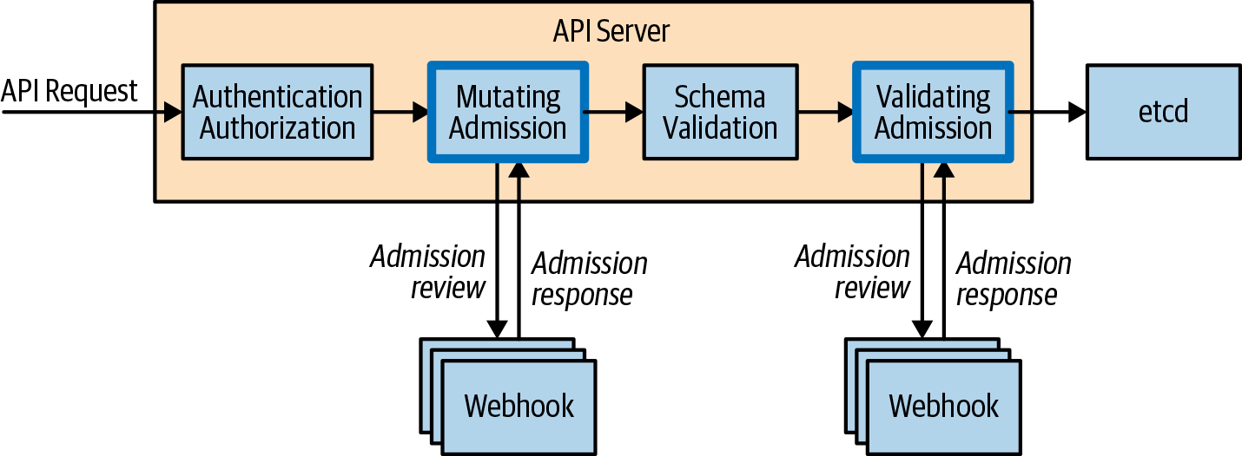

Figure 10-2. An API request flow via admission webhooks

Don’t mutate the same fields
Configuring multiple mutating admission webhooks also presents challenges. There is no way to order the request flow through multiple mutating admission webhooks, so it’s important to not have mutating admission controllers modify the same fields, because this can result in inconsistent behavior. In the case where you have multiple mutating admission webhooks, we generally recommend configuring validating admission webhooks to confirm that the final resource manifest is what you expect post-mutation because it’s guaranteed to be run following mutating webhooks.

Mutating admission webhooks must be idempotent
This means that they must be able to process and admit and object that has already been processed and may have already been modified.

Fail open/fail closed
You might recall seeing the failurePolicy field as part of both the mutating and validating webhook configuration resources. This field defines how the API server should proceed in the case where the admission webhooks have access issues or encounter unrecognized errors. You can set this field to either Ignore or Fail. Ignore essentially fails to open, meaning that processing of the request will continue, whereas Fail denies the entire request. This might seem obvious, but the implications in both cases require consideration. Ignoring a critical admission webhook could result in policy that the business relies on not being applied to a resource without the user knowing.
+ One potential solution to protect against this would be to raise an alert when the API server logs that it cannot reach a given admission webhook. Fail can be even more devastating by denying all requests if the admission webhook is experiencing issues. To protect against this you can scope the rules to ensure that only specific resource requests are set to the admission webhook. As a tenet, you should never have any rules that apply to all resources in the cluster.

Admission webhooks must respond quickly
If you have written your own admission webhook, it’s important to remember that user/system requests can be directly affected by the time it takes for your admission webhook to make a decision and respond. All admission webhook calls are configured with a 30-second timeout, after which time the failurePolicy takes effect. Even if it takes several seconds for your admission webhook to make an admit/deny decision, it can severely affect user experience when working with the cluster. Avoid having complex logic or relying on external systems such as databases in order to process the admit/deny logic. ===== Correctly scope admission webhooks Scoping admission webhooks. There is an optional field that allows you to scope the namespaces in which the admission webhooks operate on via the NamespaceSelector field. This field defaults to empty, which matches everything, but can be used to match namespace labels via the use of the matchLabels field. We recommend that you always use this field because it allows for an explicit opt-in per namespace.

Always deploy in a separate namespace use NamespaceSelector
When self-hosting a webhook admission controller, deploy the webhook admission controller to a separate namespace and use the NamespaceSelector field to exclude resources deployed to that namespace from being processed.

Don’t touch the kube-system namespace
The kube-system namespace is a reserved namespace that’s common across all Kubernetes clusters. It’s where all system-level services operate. We recommend never running admission webhooks against the resources in this namespace specifically, and you can achieve this by using the NamespaceSelector field and simply not matching the kube-system namespace. You should also consider it on any system-level namespaces that are required for cluster operation.

Lock down admission webhook configurations with RBAC
Now that you know about all the fields in the admission webhook configuration, you have probably thought of a really simple way to break access to a cluster. It goes without saying that the creation of both a MutatingWebhookConfiguration and ValidatingWebhookConfiguration is a root-level operation on the cluster and must be locked down appropriately using RBAC. Failure to do so can result in a broken cluster or, even worse, an injection attack on your application workloads.

Don’t send sensitive data
Admission webhooks are essentially black boxes that accept AdmissionRequests and output AdmissionResponses. How they store and manipulate the request is opaque to the user. It’s important to think about what request payloads you are sending to the admission webhook. In the case of Kubernetes secrets or ConfigMaps, they might contain sensitive information and require strong guarantees about how that information is stored and shared. Sharing these resources with an admission webhook can leak sensitive information, which is why you should scope your resource rules to the minimum resource needed to validate and/or mutate.

Authorization
We often think about authorization in the context of answering the following question: “Is this user able to perform these actions on these resources?” In Kubernetes, the authorization of each request is performed after authentication but before admission. In this section, we explore how you can configure different authorization modules and better understand how you can create the appropriate policy to serve the needs of your cluster. Figure 10-3 illustrates where authorization sits in the request flow.
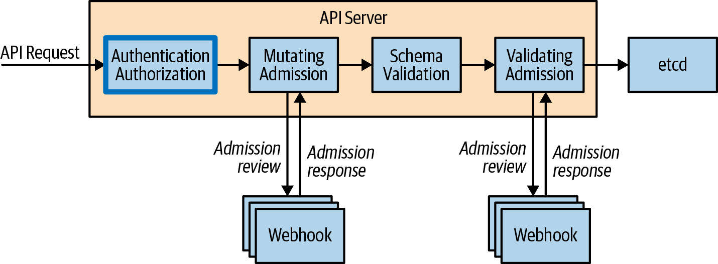

Figure 10-3. API request flow via authorization modules

Authorization Modules
Authorization modules are responsible for either granting or denying permission to access. They determine whether to grant access based on policy that must be explicitly defined; otherwise all requests will be implicitly denied.
Kubernetes ships with the following authorization modules out of the box:
Attribute-Based Access Control (ABAC)
Allows authorization policy to be configured via local files
RBAC
Allows authorization policy to be configured via the Kubernetes API (refer to Chapter 4 for more detail)
Webhook
Allows the authorization of a request to be handled via a remote REST endpoint
Node
Specialized authorization module that authorizes requests from kubelets
The modules are configured by the cluster administrator via the following flag on the API server: --authorization-mode. Multiple modules can be configured and are checked in order. Unlike admission controllers, if a single authorization module admits the request, the request can proceed. Only for the case in which all modules deny the request will an error be returned to the user.

ABAC
Let’s take a look at a policy definition in the context of using the ABAC authorization module. The following grants user Mary read-only access to a pod in the kube-system namespace:
apiVersion
:
abac.authorization.kubernetes.io/v1beta1
kind
:
Policy
spec
:
user
:
mary
resource
:
pods
readonly
:
true
namespace
:
kube-system
If Mary were to make the following request, it would be denied because Mary doesn’t have access to get pods in the demo-app namespace:
apiVersion
:
authorization.k8s.io/v1
kind
:
SubjectAccessReview
spec
:
resourceAttributes
:
verb
:
get
resource
:
pods
namespace
:
demo-app
This example introduced a new API group, authorization.k8s.io. This set of APIs exposes API server authorization to external services and has the following APIs, which are great for debugging:
SelfSubjectAccessReview
Access review for the current user
SubjectAccessReview
Like SelfSubjectAccessReview but for any user
LocalSubjectAccessReview
Like SubjectAccessReview but namespace specific
SelfSubjectRulesReview
Returns a list of actions a user can perform in a given namespace
The really cool part is that you can query these APIs by creating resources as you typically would. Let’s actually take the previous example and test this for ourselves using the SelfSubjectAccessReview. The status field in the output indicates that this request is allowed:
$
cat
<< EOF | kubectl create -f - -o yaml
apiVersion: authorization.k8s.io/v1
kind: SelfSubjectAccessReview
spec:
resourceAttributes:
verb: get
resource: pods
namespace: demo-app
EOF
apiVersion:
authorization.k8s.io/v1
kind:
SelfSubjectAccessReview
metadata:
creationTimestamp:
null
spec:
resourceAttributes:
namespace:
kube-system
resource:
pods
verb:
get
status:
allowed:
true
In fact, Kubernetes ships with tooling built into kubectl to make this even easier. The kubectl auth can-i command operates by querying the same API as the previous example:
$
kubectl
auth
can-i
get
pods
--namespace
demo-app
yes
With administrator credentials, you can also run the same command to check actions as another user:
$
kubectl
auth
can-i
get
pods
--namespace
demo-app
--as
mary
yes

RBAC
Kubernetes role-based access control is covered in depth in Chapter 4.

Webhook
Using the webhook authorization module allows a cluster administrator to configure an external REST endpoint to delegate the authorization process to. This would run off cluster and be reachable via URL. The configuration of the REST endpoint is found in a file on the control plane host filesystem and configured on the API server via --authorization-webhook-config-file=SOME_FILENAME. After you’ve configured it, the API server will send SubjectAccessReview objects as part of the request body to the authorization webhook application, which processes and returns the object with the status field complete.

Authorization Best Practices
Consider the following best practices before making changes to the authorization modules configured on your cluster:

Don’t use ABAC on multi control plane clusters
Given that the ABAC policies need to be placed on the filesystem of each control plane host and kept synchronized, we generally recommend against using ABAC in multi control plane clusters. The same can be said for the webhook module because the configuration is based on a file and a corresponding flag being present. Furthermore, changes to these policies in the files require a restart of the API server to take effect, which is effectively a control plane outage in a single control plane cluster or inconsistent configuration in a multi control plane cluster. Given these details, we recommend using only the RBAC module for user authorization because the rules are configured and stored in Kubernetes itself.

Don’t use webhook modules
Webhook modules, although powerful, are potentially very dangerous. Given that every request is subject to the authorization process, a failure of a webhook service would be devastating for a cluster. Therefore, we generally recommend not using external authorization modules unless you completely vet and are comfortable with your cluster failure modes if the webhook service becomes unreachable or unavailable.

Summary
In this chapter, we covered the foundational topics of admission and authorization and covered best practices. Put these skills to use by determining the best admission and authorization configuration that allows you to customize the controls and policies needed for the life of your cluster.

About the Authors
Brendan Burns is a distinguished engineer at Microsoft Azure and cofounder of the Kubernetes open source project. He’s been building cloud applications for more than a decade.
Eddie Villalba is a software engineer with Microsoft’s Commercial Software Engineering division, focusing on open source cloud and Kubernetes. He’s helped many real-world users adopt Kubernetes for their applications.
Dave Strebel is a global cloud native architect at Microsoft Azure focusing on open source cloud and Kubernetes. He’s deeply involved in the Kubernetes open source project, helping with the Kubernetes release team and leading SIG-Azure.
Lachlan Evenson is a principal program manager on the container compute team at Microsoft Azure. He’s helped numerous people onboard to Kubernetes through both hands-on teaching and conference talks.

