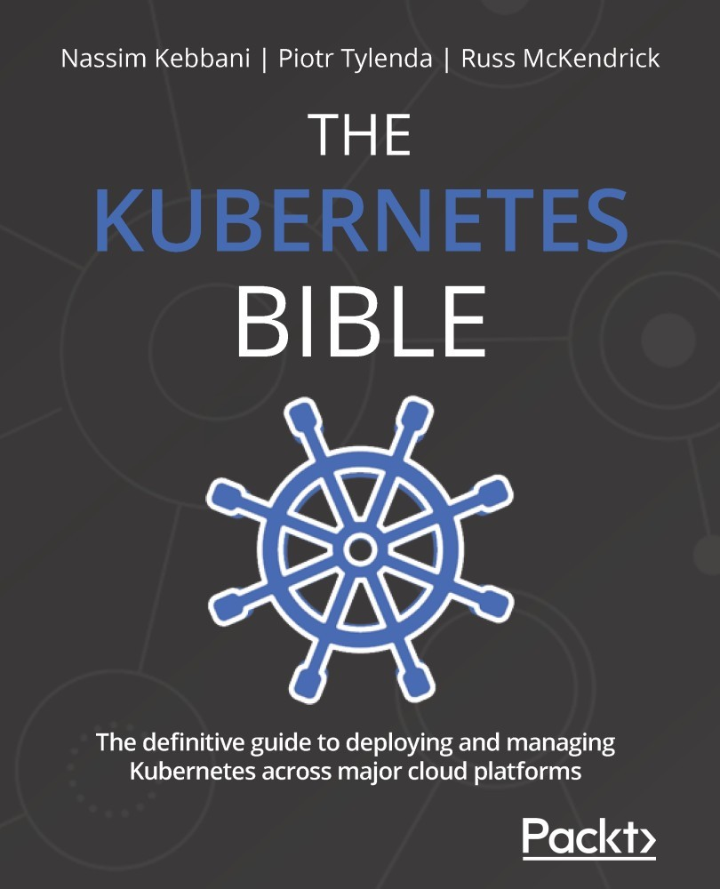

Table of Contents
THE KUBERNETES BIBLE
Contributors
About the authors
About the reviewer
Preface
Who this book is for
What this book covers
To get the most out of this book
Download the example code files
Download the color images
Conventions used
Get in touch
Share Your Thoughts
Section 1: Introducing Kubernetes
Chapter 1: Kubernetes Fundamentals
Understanding monoliths and microservices
Understanding the growth of the internet since the late 1990s
Understanding the need for more frequent software releases
Understanding the organizational shift to agile methodologies
Understanding the shift from on-premises to the cloud
Understanding why the cloud is well suited for scalability
Exploring the monolithic architecture
Exploring the microservices architecture
Choosing between monolithic and microservices architectures
Understanding containers and Docker
Understanding why Docker is good for microservices
Understanding the benefit of Docker container isolation
How can Kubernetes help you to manage your Docker containers?
Understanding that Kubernetes is meant to use Docker in production
Exploring the problems that Kubernetes solves
Ensuring high availability
Release management and container deployment
Autoscaling containers
When and where is Kubernetes not the solution?
Understanding the history of Kubernetes
Understanding how and where Kubernetes started
Who manages Kubernetes today?
Where is Kubernetes today?
Summary
Chapter 2: Kubernetes Architecture – From Docker Images to Running Pods
Understanding the difference between the master and worker nodes
The kube-apiserver component
The role of kube-apiserver
How do you install kube-apiserver?
Where do you install kube-apiserver?
Exploring the kubectl command-line tool and YAML syntax
The role of kubectl
How does kubectl work?
The YAML syntax
kubectl should be installed on any machine that needs to interact with the cluster
The Etcd datastore
The role of the Etcd datastore
Where do you install Etcd?
The Kubelet and worker node components
The Kubelet agent
The kube-proxy component
The kube-scheduler component
The role of the kube-scheduler component
Where do you install kube-scheduler?
The kube-controller-manager component
The role of the kube-controller-manager component
Where do you install kube-controller-manager?
How to make Kubernetes highly available
The single-node cluster
The single-master cluster
The multi-master multi-node cluster
Summary
Chapter 3: Installing Your First Kubernetes Cluster
Technical requirements
Installing a single-node cluster with Minikube
Launching a single-node Kubernetes cluster using Minikube
Stopping and deleting the local Minikube cluster
Launching a multi-node Kubernetes cluster with Kind
Installing Kind onto your local system
Stopping and deleting the local Kind cluster
Installing a Kubernetes cluster using Google GKE
Launching a multi-node Kubernetes cluster on Google GKE
Stopping and deleting a Kubernetes cluster on Google GKE
Installing a Kubernetes cluster using Amazon EKS
Launching a multi-node Kubernetes cluster on Amazon EKS
Deleting the Kubernetes cluster on Amazon EKS
Installing a Kubernetes cluster using Azure AKS
Launching a multi-node Kubernetes cluster on Azure AKS
Stopping and deleting a Kubernetes cluster on Azure AKS
Summary
Section 2: Diving into Kubernetes Core Concepts
Chapter 4: Running Your Docker Containers
Technical requirements
Let's explain the notion of Pods
Each Pod gets an IP address
How you should design your Pods
Launching your first Pods
Creating a Pod with imperative syntax
Creating a Pod with declarative syntax
Reading the Pod's information and metadata
Listing the objects in JSON or YAML
Backing up your resource using the list operation
Getting more information from the list operation
Accessing a Pod from the outside world
Entering a container inside a Pod
Deleting a Pod
Labeling and annotating the Pods
What are labels and why do we need them?
What are annotations and how do they differ from labels?
Adding a label
Listing labels attached to a Pod
Adding or updating a label to/of a running Pod
Deleting a label attached to a running Pod
Adding an annotation
Launching your first job
What are jobs?
Creating a job with restartPolicy
Understanding the job's backoffLimit
Running a task multiple times using completions
Running a task multiple times in parallel
Terminating a job after a specific amount of time
What happens if a job succeeds?
Deleting a job
Launching your first Cronjob
What are Cronjobs?
Creating your first Cronjob
Understanding the schedule
Understanding the role of the jobTemplate section
Controlling the Cronjob execution deadline
Managing the history limits of jobs
Creating a Cronjob
Deleting a Cronjob
Summary
Chapter 5: Using Multi-Container Pods and Design Patterns
Technical requirements
Understanding what multi-container Pods are
Concrete scenarios where you need multi-container Pods
When not to create a multi-container Pod
Creating a Pod made up of two containers
What happens when Kubernetes fails to launch one container in a Pod?
Deleting a multi-container Pod
Understanding the Pod deletion grace period
Accessing a specific container inside a multi-container Pod
Running commands in containers
Overriding the default commands run by your containers
Introducing initContainers
Accessing the logs of a specific container
Sharing volumes between containers in the same Pod
What are Kubernetes volumes?
Creating and mounting an emptyDir volume
Creating and mounting a hostPath volume
The ambassador design pattern
What is the ambassador design pattern?
A simple example of an ambassador multi-container Pod
The sidecar design pattern
What is the sidecar design pattern?
A simple example of a sidecar multi-container Pod
The adapter design pattern
What is the adapter design pattern?
A simple example of an adapter multi-container Pod
Summary
Chapter 6: Configuring Your Pods Using ConfigMaps and Secrets
Technical requirements
Understanding what ConfigMaps and Secrets are
Decoupling your application and your configuration
Understanding how Pods consume ConfigMaps and Secrets
Configuring your Pods using ConfigMaps
Listing ConfigMaps
Creating a ConfigMap
Creating a ConfigMap from literal values
Storing entire configuration files in a ConfigMap
Creating a ConfigMap from an env file
Reading values inside a ConfigMap
Linking ConfigMaps as environment variables
Mounting a ConfigMap as a volume mount
Deleting a ConfigMap
Updating a ConfigMap
Managing sensitive configuration with the Secret object
Listing Secrets
Creating a Secret imperatively with --from-literal
Creating a Secret declaratively with a YAML file
Creating a Secret with content from a file
Reading a Secret
Consuming a Secret as an environment variable
Consuming a Secret as a volume mount
Deleting a Secret
Updating a Secret
Summary
Chapter 7: Exposing Your Pods with Services
Technical requirements
Why would you want to expose your Pods?
Understanding Pod IP assignment
Understanding Pod IP assignment is dynamic
Never hardcode a pod's IP addresses in your application code
Understanding how services route traffic to Pods
Understanding round-robin load balancing in Kubernetes
Understanding how to call a service in Kubernetes
Understanding how DNS names are generated for services
How services get a list of the Pods they service traffic to
Using the dnsutils Docker image to debug your services
Why you shouldn't use the --expose flag
Understanding how DNS names are generated for services
Understanding the different types of services
The NodePort service
Why do you need NodePort services?
Creating two containous/whoami Pods
Understanding NodePort YAML definition
Making sure NodePort works as expected
Is this setup production-ready?
Listing NodePort services
Adding more Pods to NodePort services
Describing NodePort services
Deleting NodePort services
NodePort or kubectl port-forward?
The ClusterIP service
Why do you need ClusterIP services?
How do I know if I need NodePort or ClusterIP services to expose my Pods?
Listing ClusterIP services
Creating ClusterIP services using the imperative way
Describing ClusterIP services
Creating ClusterIP services using the declarative way
Deleting ClusterIP services
Understanding headless services
The LoadBalancer service
Explaining the LoadBalancer services
Should I use the LoadBalancer service type?
Implementing ReadinessProbe
Why do you need ReadinessProbe?
Implementing ReadinessProbe
What is LivenessProbe and why do you need it?
Implementing LivenessProbe
Using ReadinessProbe and LivenessProbe together
Securing your Pods using the NetworkPolicy object
Why do you need NetworkPolicy?
Understanding Pods are not isolated by default
Configuring NetworkPolicy with labels and selectors
Summary
Chapter 8: Managing Namespaces in Kubernetes
Technical requirements
Introduction to Kubernetes namespaces
Why do you need namespaces?
How namespaces are used to split resources into chunks
Understanding default namespaces
How namespaces impact your resources and services
Listing namespaces inside your cluster
Retrieving the data of a specific namespace
Creating a namespace using imperative syntax
Creating a namespace using declarative syntax
Deleting a namespace
Creating a resource inside a namespace with the -n option
Listing resources inside a specific namespace
Listing all the resources inside a specific namespace
Understanding that names are scoped to a namespace
Understanding that not all resources are in a namespace
Resolving a service using namespaces
Switching between namespaces with kubectl
Displaying the current namespace with kubectl
Configuring ResourceQuota and Limit at the namespace level
Understanding why you should set ResourceQuota
Understanding how Pods consume these resources
Understanding how Pods can require computing resources
Understanding how you can limit resource consumption
Understanding why you need ResourceQuota
Creating a ResourceQuota
Listing ResourceQuota
Deleting ResourceQuota
Introducing LimitRange
Listing LimitRange
Deleting LimitRange
Summary
Chapter 9: Persistent Storage in Kubernetes
Technical requirements
Why you would want to use PersistentVolume
Introducing PersistentVolumes
Introducing PersistentVolume types
The benefits brought by PersistentVolume
Introducing access modes
Understanding that not all access modes are available to all PersistentVolume types
Creating our first PersistentVolume
How does Kubernetes PersistentVolumes handle cloud-based storage?
Amazon EBS PersistentVolume YAML
GCE PersistentDisk PersistentVolume YAML
NFS PersistentVolume YAML
Can Kubernetes handle the provisioning or creation of the resource itself?
Understanding how to mount a PersistentVolume to your Pod claims
Introducing PersistentVolumeClaim
Splitting storage creation and storage consumption
The summarized PersistentVolume workflow
Creating a Pod with a PersistentVolumeClaim object
Understanding the life cycle of a PersistentVolume object in Kubernetes
Understanding that PersistentVolume objects are not bound to namespaces
Reclaiming a PersistentVolume object
Updating a reclaim policy
Understanding PersistentVolume and PersistentVolumeClaims statuses
Static and dynamic PersistentVolume provisioning
Static versus dynamic provisioning
Introducing dynamic provisioning
Introducing StorageClasses
Understanding the role of PersistentVolumeClaim for dynamic storage provisioning
Summary
Section 3: Using Managed Pods with Controllers
Chapter 10: Running Production-Grade Kubernetes Workloads
Technical requirements
Ensuring HA and FT on Kubernetes
High Availability
Fault Tolerance
HA and FT for Kubernetes applications
What is ReplicationController?
Creating a ReplicationController object
Testing the behavior of ReplicationController
Scaling ReplicationController
Deleting ReplicationController
What is ReplicaSet and how does it differ from ReplicationController?
Creating a ReplicaSet object
Testing the behavior of ReplicaSet
Scaling ReplicaSet
Using Pod liveness probes together with ReplicaSet
Deleting a ReplicaSet object
Summary
Further reading
Chapter 11: Deployment – Deploying Stateless Applications
Technical requirements
Introducing the Deployment object
Creating a Deployment object
Exposing Deployment Pods using Service objects
Scaling a Deployment object
Deleting a Deployment object
How does a Deployment object manage revisions and version rollout?
Updating a Deployment object
Rolling back a Deployment object
Deployment object best practices
Use declarative object management for Deployments
Do not use the Recreate strategy for production workloads
Do not create Pods that match an existing Deployment label selector
Carefully set up your container probes
Use meaningful and semantic image tags
Migrating from older versions of Kubernetes
Summary
Further reading
Chapter 12: StatefulSet – Deploying Stateful Applications
Technical requirements
Introducing the StatefulSet object
Managing state in containers
Managing state in Kubernetes Pods
StatefulSet and how it differs from a Deployment object
Managing StatefulSet
Creating a StatefulSet
Using the headless Service and stable network identities
State persistence
Scaling StatefulSet
Deleting a StatefulSet
Releasing a new version of an app deployed as a StatefulSet
Updating StatefulSet
Rolling back StatefulSet
StatefulSet best practices
Use declarative object management for StatefulSets
Do not use the TerminationGracePeriodSeconds Pod with a 0 value for StatefulSets
Scale down StatefulSets before deleting
Ensure state compatibility during StatefulSet rollbacks
Do not create Pods that match an existing StatefulSet label selector
Summary
Further reading
Chapter 13: DaemonSet – Maintaining Pod Singletons on Nodes
Technical requirements
Introducing the DaemonSet object
Creating and managing DaemonSets
Creating a DaemonSet
Modifying a DaemonSet
Deleting a DaemonSet
Common use cases for DaemonSets
Alternatives to DaemonSets
Summary
Further reading
Section 4: Deploying Kubernetes on the Cloud
Chapter 14: Kubernetes Clusters on Google Kubernetes Engine
Technical requirements
What are GCP and GKE?
Google Cloud Platform
Google Kubernetes Engine
Preparing your environment
Signing up for a GCP account
Creating a project
Installing the GCP command-line interface
Launching your first GKE cluster
Deploying a workload and interacting with your cluster
Configuring your local client
Launching an example workload
Exploring Google Cloud Console
Deleting your cluster
More about cluster nodes
Summary
Further reading
Chapter 15: Launching a Kubernetes Cluster on Amazon Web Services with Amazon Elastic Kubernetes Service
Technical requirements
What are AWS and Amazon EKS?
AWS
Amazon EKS
Preparing your local environment
Signing up for an AWS account
Installing the AWS command-line interface
Installing eksctl, the official CLI for Amazon EKS
Launching your Amazon EKS cluster
Deploying a workload and interacting with your cluster
Deploying the workload
Exploring the AWS console
Deleting your Amazon EKS cluster
Summary
Further reading
Chapter 16: Kubernetes Clusters on Microsoft Azure with Azure Kubernetes Service
Technical requirements
What are Microsoft Azure and AKS?
Microsoft Azure
AKS
Preparing your local environment
The Azure CLI
Launching your AKS cluster
Deploying a workload and interacting with your cluster
Launching the workload
Exploring the Azure portal
Deleting your AKS cluster
Summary
Further reading
Section 5: Advanced Kubernetes
Chapter 17: Working with Helm Charts
Technical requirements
Understanding Helm
Releasing software to Kubernetes using Helm
Installing Helm on Ubuntu
Installing Helm on Windows
Installing Helm on macOS
Deploying an example chart
Helm chart anatomy
Installing popular solutions using Helm charts
Kubernetes Dashboard
Elasticsearch with Kibana
Prometheus with Grafana
Summary
Further reading
Chapter 18: Authentication and Authorization on Kubernetes
Technical requirements
Authentication and user management
Static token files
ServiceAccount tokens
X.509 client certificates
OpenID Connect tokens
Other methods
Authorization and introduction to RBAC
RBAC mode in Kubernetes
Azure Kubernetes Service and Azure Active Directory integration
Prerequisites
Deploying a managed AKS cluster with AAD and Azure RBAC integration
Accessing the AKS cluster with AAD integration enabled
Using Azure RBAC for an AKS cluster
Summary
Further reading
Chapter 19: Advanced Techniques for Scheduling Pods
Technical requirements
Refresher – What is kube-scheduler?
Managing Node affinity
Pod Node name
Pod Node selector
Node affinity configuration for Pods
Using Node taints and tolerations
Scheduling policies
Summary
Further reading
Chapter 20: Autoscaling Kubernetes Pods and Nodes
Technical requirements
Pod resource requests and limits
Autoscaling Pods vertically using a Vertical Pod Autoscaler
Enabling a VPA in GKE
Enabling a VPA for other Kubernetes clusters
Using a VPA
Autoscaling Pods horizontally using a Horizontal Pod Autoscaler
Using an HPA
Autoscaling Kubernetes Nodes using a Cluster Autoscaler
Enabling the cluster autoscaler in GKE
Enabling the cluster autoscaler in the Amazon Elastic Kubernetes Service
Enabling the cluster autoscaler in the Azure Kubernetes Service
Using the cluster autoscaler
Summary
Further reading
Chapter 21: Advanced Traffic Routing with Ingress
Technical requirements
Refresher: Kubernetes services
The ClusterIP Service
NodePort service
The LoadBalancer service
Introducing the Ingress object
Using nginx as an Ingress Controller
Azure Application Gateway Ingress Controller for AKS
Summary
Further reading
Why subscribe?
Other Books You May Enjoy
Packt is searching for authors like you
Share Your Thoughts


BIRMINGHAM—MUMBAI

THE KUBERNETES BIBLE
Copyright © 2022 Packt Publishing
All rights reserved. No part of this book may be reproduced, stored in a retrieval system, or transmitted in any form or by any means, without the prior written permission of the publisher, except in the case of brief quotations embedded in critical articles or reviews.
Every effort has been made in the preparation of this book to ensure the accuracy of the information presented. However, the information contained in this book is sold without warranty, either express or implied. Neither the authors, nor Packt Publishing or its dealers and distributors, will be held liable for any damages caused or alleged to have been caused directly or indirectly by this book.
Packt Publishing has endeavored to provide trademark information about all of the companies and products mentioned in this book by the appropriate use of capitals. However, Packt Publishing cannot guarantee the accuracy of this information.
Group Product Manager: Rahul Nair
Publishing Product Manager: Shrilekha Malpani
Senior Editor: Athikho Sapuni Rishana
Content Development Editor: Nihar Kapadia
Technical Editor: Shruthi Shetty
Copy Editor: Safis Editing
Project Coordinator: Neil D'mello
Proofreader: Safis Editing
Indexer: Tejal Daruwale Soni
Production Designer: Alishon Mendonca
Marketing Coordinator: Sanjana Gupta
First published: February 2022
Production reference: 1130122
Published by Packt Publishing Ltd.
Livery Place
35 Livery Street
Birmingham
B3 2PB, UK.
ISBN 978-1-83882-769-4
www.packt.com

Contributors

About the authors
Nassim Kebbani is an experienced software engineer with in-depth expertise in Kubernetes and the Amazon Web Services cloud provider. He has an extensive background both in software development and operations teams, having implemented the entire spectrum of a DevOps life cycle chain, from application code to pipelines, and carried out monitoring in various industries such as e-commerce, media, and financial services.
He has implemented numerous cloud-native architectures and containerized applications on Docker and AWS and holds both Kubernetes CKA and CKAD certifications.
Piotr Tylenda is an experienced DevOps and software engineer with a passion for Kubernetes and Azure technologies. In his projects, he has focused on the adoption of microservices architecture for monolithic applications, developing big data pipelines for e-commerce, and architecting solutions for scalable log and telemetry analytics for hardware. His most notable contribution to Kubernetes' open source ecosystem is the development of Ansible automation for provisioning and deploying hybrid Windows/Linux Kubernetes clusters. Currently, he works at Microsoft Development Center Copenhagen in Denmark as part of a team developing a Microsoft Dynamics 365 Business Central SaaS offering.
Russ McKendrick is an experienced DevOps practitioner and system administrator with a passion for automation and containers. He has been working in IT and related industries for the better part of 27 years. During his career, he has had varied responsibilities in many different sectors, including first-line, second-line, and senior support in both client-facing and internal teams for small and large organizations. He works almost exclusively with Linux, using open source systems and tools across both dedicated hardware and virtual machines hosted in public and private clouds at N4Stack, which is a Node4 company, where he holds the title of practice manager (SRE and DevOps). He also buys way too many records!

About the reviewer
Dushyant Nathalal Dubaria pursued a Master of Science degree in network and telecommunication engineering from Southern Methodist University, USA, in December 2019. He is passionate about DevOps, the cloud, networking, virtualization, and automation, and has a keen interest in technologies such as Docker and Kubernetes. He has published articles in three international journal publications in IEEE, held at Columbia University, New York, and at the University of Nevada, Las Vegas. He was a teaching assistant and lecturer at Southern Methodist University and loves teaching DevOps for networking, network automation, and programmability to graduate students. He likes contributing to open source projects and was a speaker at the Linux Foundation Event: Open Networking Summit, San Jose, April 2019, and at the Open Source Summit, San Diego, August 2019.
Reviewing a book is harder than I thought and more rewarding than I could have ever imagined. I would like to thank my friend, Jay Ashok Shah, who introduced me to the world of DevOps and Kubernetes.
To my caring parents for always encouraging me to accomplish my goals.
To my loving wife, Monika, for her continued support with everything I do.
Finally, my sincere appreciation to the Packt committee for the learning opportunities they have afforded me, especially Kajol Pawar and Neil D'mello.

Table of Contents
Preface

Section 1: Introducing Kubernetes

Chapter 1: Kubernetes Fundamentals

Understanding monoliths and microservices

Understanding the growth of the internet since the late 1990s

Understanding the need for more frequent software releases

Understanding the organizational shift to agile methodologies

Understanding the shift from on-premises to the cloud

Understanding why the cloud is well suited for scalability

Exploring the monolithic architecture

Exploring the microservices architecture

Choosing between monolithic and microservices architectures

Understanding containers and Docker

Understanding why Docker is good for microservices

Understanding the benefit of Docker container isolation

How can Kubernetes help you to manage your Docker containers?

Understanding that Kubernetes is meant to use Docker in production

Exploring the problems that Kubernetes solves

Ensuring high availability

Release management and container deployment

Autoscaling containers

When and where is Kubernetes not the solution?

Understanding the history of Kubernetes

Understanding how and where Kubernetes started

Who manages Kubernetes today?

Where is Kubernetes today?

Summary

Chapter 2: Kubernetes Architecture – From Docker Images to Running Pods

Understanding the difference between the master and worker nodes

The kube-apiserver component

The role of kube-apiserver

How do you install kube-apiserver?

Where do you install kube-apiserver?

Exploring the kubectl command-line tool and YAML syntax

The role of kubectl

How does kubectl work?

The YAML syntax

kubectl should be installed on any machine that needs to interact with the cluster

The Etcd datastore

The role of the Etcd datastore

Where do you install Etcd?

The Kubelet and worker node components

The Kubelet agent

The kube-proxy component

The kube-scheduler component

The role of the kube-scheduler component

Where do you install kube-scheduler?

The kube-controller-manager component

The role of the kube-controller-manager component

Where do you install kube-controller-manager?

How to make Kubernetes highly available

The single-node cluster

The single-master cluster

The multi-master multi-node cluster

Summary

Chapter 3: Installing Your First Kubernetes Cluster

Technical requirements

Installing a single-node cluster with Minikube

Launching a single-node Kubernetes cluster using Minikube

Stopping and deleting the local Minikube cluster

Launching a multi-node Kubernetes cluster with Kind

Installing Kind onto your local system

Stopping and deleting the local Kind cluster

Installing a Kubernetes cluster using Google GKE

Launching a multi-node Kubernetes cluster on Google GKE

Stopping and deleting a Kubernetes cluster on Google GKE

Installing a Kubernetes cluster using Amazon EKS

Launching a multi-node Kubernetes cluster on Amazon EKS

Deleting the Kubernetes cluster on Amazon EKS

Installing a Kubernetes cluster using Azure AKS

Launching a multi-node Kubernetes cluster on Azure AKS

Stopping and deleting a Kubernetes cluster on Azure AKS

Summary

Section 2: Diving into Kubernetes Core Concepts

Chapter 4: Running Your Docker Containers

Technical requirements

Let's explain the notion of Pods

Each Pod gets an IP address

How you should design your Pods

Launching your first Pods

Creating a Pod with imperative syntax

Creating a Pod with declarative syntax

Reading the Pod's information and metadata

Listing the objects in JSON or YAML

Backing up your resource using the list operation

Getting more information from the list operation

Accessing a Pod from the outside world

Entering a container inside a Pod

Deleting a Pod

Labeling and annotating the Pods

What are labels and why do we need them?

What are annotations and how do they differ from labels?

Adding a label

Listing labels attached to a Pod

Adding or updating a label to/of a running Pod

Deleting a label attached to a running Pod

Adding an annotation

Launching your first job

What are jobs?

Creating a job with restartPolicy

Understanding the job's backoffLimit

Running a task multiple times using completions

Running a task multiple times in parallel

Terminating a job after a specific amount of time

What happens if a job succeeds?

Deleting a job

Launching your first Cronjob

What are Cronjobs?

Creating your first Cronjob

Understanding the schedule

Understanding the role of the jobTemplate section

Controlling the Cronjob execution deadline

Managing the history limits of jobs

Creating a Cronjob

Deleting a Cronjob

Summary

Chapter 5: Using Multi-Container Pods and Design Patterns

Technical requirements

Understanding what multi-container Pods are

Concrete scenarios where you need multi-container Pods

When not to create a multi-container Pod

Creating a Pod made up of two containers

What happens when Kubernetes fails to launch one container in a Pod?

Deleting a multi-container Pod

Understanding the Pod deletion grace period

Accessing a specific container inside a multi-container Pod

Running commands in containers

Overriding the default commands run by your containers

Introducing initContainers

Accessing the logs of a specific container

Sharing volumes between containers in the same Pod

What are Kubernetes volumes?

Creating and mounting an emptyDir volume

Creating and mounting a hostPath volume

The ambassador design pattern

What is the ambassador design pattern?

A simple example of an ambassador multi-container Pod

The sidecar design pattern

What is the sidecar design pattern?

A simple example of a sidecar multi-container Pod

The adapter design pattern

What is the adapter design pattern?

A simple example of an adapter multi-container Pod

Summary

Chapter 6: Configuring Your Pods Using ConfigMaps and Secrets

Technical requirements

Understanding what ConfigMaps and Secrets are

Decoupling your application and your configuration

Understanding how Pods consume ConfigMaps and Secrets

Configuring your Pods using ConfigMaps

Listing ConfigMaps

Creating a ConfigMap

Creating a ConfigMap from literal values

Storing entire configuration files in a ConfigMap

Creating a ConfigMap from an env file

Reading values inside a ConfigMap

Linking ConfigMaps as environment variables

Mounting a ConfigMap as a volume mount

Deleting a ConfigMap

Updating a ConfigMap

Managing sensitive configuration with the Secret object

Listing Secrets

Creating a Secret imperatively with --from-literal

Creating a Secret declaratively with a YAML file

Creating a Secret with content from a file

Reading a Secret

Consuming a Secret as an environment variable

Consuming a Secret as a volume mount

Deleting a Secret

Updating a Secret

Summary

Chapter 7: Exposing Your Pods with Services

Technical requirements

Why would you want to expose your Pods?

Understanding Pod IP assignment

Understanding Pod IP assignment is dynamic

Never hardcode a pod's IP addresses in your application code

Understanding how services route traffic to Pods

Understanding round-robin load balancing in Kubernetes

Understanding how to call a service in Kubernetes

Understanding how DNS names are generated for services

How services get a list of the Pods they service traffic to

Using the dnsutils Docker image to debug your services

Why you shouldn't use the --expose flag

Understanding how DNS names are generated for services

Understanding the different types of services

The NodePort service

Why do you need NodePort services?

Creating two containous/whoami Pods

Understanding NodePort YAML definition

Making sure NodePort works as expected

Is this setup production-ready?

Listing NodePort services

Adding more Pods to NodePort services

Describing NodePort services

Deleting NodePort services

NodePort or kubectl port-forward?

The ClusterIP service

Why do you need ClusterIP services?

How do I know if I need NodePort or ClusterIP services to expose my Pods?

Listing ClusterIP services

Creating ClusterIP services using the imperative way

Describing ClusterIP services

Creating ClusterIP services using the declarative way

Deleting ClusterIP services

Understanding headless services

The LoadBalancer service

Explaining the LoadBalancer services

Should I use the LoadBalancer service type?

Implementing ReadinessProbe

Why do you need ReadinessProbe?

Implementing ReadinessProbe

What is LivenessProbe and why do you need it?

Implementing LivenessProbe

Using ReadinessProbe and LivenessProbe together

Securing your Pods using the NetworkPolicy object

Why do you need NetworkPolicy?

Understanding Pods are not isolated by default

Configuring NetworkPolicy with labels and selectors

Summary

Chapter 8: Managing Namespaces in Kubernetes

Technical requirements

Introduction to Kubernetes namespaces

Why do you need namespaces?

How namespaces are used to split resources into chunks

Understanding default namespaces

How namespaces impact your resources and services

Listing namespaces inside your cluster

Retrieving the data of a specific namespace

Creating a namespace using imperative syntax

Creating a namespace using declarative syntax

Deleting a namespace

Creating a resource inside a namespace with the -n option

Listing resources inside a specific namespace

Listing all the resources inside a specific namespace

Understanding that names are scoped to a namespace

Understanding that not all resources are in a namespace

Resolving a service using namespaces

Switching between namespaces with kubectl

Displaying the current namespace with kubectl

Configuring ResourceQuota and Limit at the namespace level

Understanding why you should set ResourceQuota

Understanding how Pods consume these resources

Understanding how Pods can require computing resources

Understanding how you can limit resource consumption

Understanding why you need ResourceQuota

Creating a ResourceQuota

Listing ResourceQuota

Deleting ResourceQuota

Introducing LimitRange

Listing LimitRange

Deleting LimitRange

Summary

Chapter 9: Persistent Storage in Kubernetes

Technical requirements

Why you would want to use PersistentVolume

Introducing PersistentVolumes

Introducing PersistentVolume types

The benefits brought by PersistentVolume

Introducing access modes

Understanding that not all access modes are available to all PersistentVolume types

Creating our first PersistentVolume

How does Kubernetes PersistentVolumes handle cloud-based storage?

Amazon EBS PersistentVolume YAML

GCE PersistentDisk PersistentVolume YAML

NFS PersistentVolume YAML

Can Kubernetes handle the provisioning or creation of the resource itself?

Understanding how to mount a PersistentVolume to your Pod claims

Introducing PersistentVolumeClaim

Splitting storage creation and storage consumption

The summarized PersistentVolume workflow

Creating a Pod with a PersistentVolumeClaim object

Understanding the life cycle of a PersistentVolume object in Kubernetes

Understanding that PersistentVolume objects are not bound to namespaces

Reclaiming a PersistentVolume object

Updating a reclaim policy

Understanding PersistentVolume and PersistentVolumeClaims statuses

Static and dynamic PersistentVolume provisioning

Static versus dynamic provisioning

Introducing dynamic provisioning

Introducing StorageClasses

Understanding the role of PersistentVolumeClaim for dynamic storage provisioning

Summary

Section 3: Using Managed Pods with Controllers

Chapter 10: Running Production-Grade Kubernetes Workloads

Technical requirements

Ensuring HA and FT on Kubernetes

High Availability

Fault Tolerance

HA and FT for Kubernetes applications

What is ReplicationController?

Creating a ReplicationController object

Testing the behavior of ReplicationController

Scaling ReplicationController

Deleting ReplicationController

What is ReplicaSet and how does it differ from ReplicationController?

Creating a ReplicaSet object

Testing the behavior of ReplicaSet

Scaling ReplicaSet

Using Pod liveness probes together with ReplicaSet

Deleting a ReplicaSet object

Summary

Further reading

Chapter 11: Deployment – Deploying Stateless Applications

Technical requirements

Introducing the Deployment object

Creating a Deployment object

Exposing Deployment Pods using Service objects

Scaling a Deployment object

Deleting a Deployment object

How does a Deployment object manage revisions and version rollout?

Updating a Deployment object

Rolling back a Deployment object

Deployment object best practices

Use declarative object management for Deployments

Do not use the Recreate strategy for production workloads

Do not create Pods that match an existing Deployment label selector

Carefully set up your container probes

Use meaningful and semantic image tags

Migrating from older versions of Kubernetes

Summary

Further reading

Chapter 12: StatefulSet – Deploying Stateful Applications

Technical requirements

Introducing the StatefulSet object

Managing state in containers

Managing state in Kubernetes Pods

StatefulSet and how it differs from a Deployment object

Managing StatefulSet

Creating a StatefulSet

Using the headless Service and stable network identities

State persistence

Scaling StatefulSet

Deleting a StatefulSet

Releasing a new version of an app deployed as a StatefulSet

Updating StatefulSet

Rolling back StatefulSet

StatefulSet best practices

Use declarative object management for StatefulSets

Do not use the TerminationGracePeriodSeconds Pod with a 0 value for StatefulSets

Scale down StatefulSets before deleting

Ensure state compatibility during StatefulSet rollbacks

Do not create Pods that match an existing StatefulSet label selector

Summary

Further reading

Chapter 13: DaemonSet – Maintaining Pod Singletons on Nodes

Technical requirements

Introducing the DaemonSet object

Creating and managing DaemonSets

Creating a DaemonSet

Modifying a DaemonSet

Deleting a DaemonSet

Common use cases for DaemonSets

Alternatives to DaemonSets

Summary

Further reading

Section 4: Deploying Kubernetes on the Cloud

Chapter 14: Kubernetes Clusters on Google Kubernetes Engine

Technical requirements

What are GCP and GKE?

Google Cloud Platform

Google Kubernetes Engine

Preparing your environment

Signing up for a GCP account

Creating a project

Installing the GCP command-line interface

Launching your first GKE cluster

Deploying a workload and interacting with your cluster

Configuring your local client

Launching an example workload

Exploring Google Cloud Console

Deleting your cluster

More about cluster nodes

Summary

Further reading

Chapter 15: Launching a Kubernetes Cluster on Amazon Web Services with Amazon Elastic Kubernetes Service

Technical requirements

What are AWS and Amazon EKS?

AWS

Amazon EKS

Preparing your local environment

Signing up for an AWS account

Installing the AWS command-line interface

Installing eksctl, the official CLI for Amazon EKS

Launching your Amazon EKS cluster

Deploying a workload and interacting with your cluster

Deploying the workload

Exploring the AWS console

Deleting your Amazon EKS cluster

Summary

Further reading

Chapter 16: Kubernetes Clusters on Microsoft Azure with Azure Kubernetes Service

Technical requirements

What are Microsoft Azure and AKS?

Microsoft Azure

AKS

Preparing your local environment

The Azure CLI

Launching your AKS cluster

Deploying a workload and interacting with your cluster

Launching the workload

Exploring the Azure portal

Deleting your AKS cluster

Summary

Further reading

Section 5: Advanced Kubernetes

Chapter 17: Working with Helm Charts

Technical requirements

Understanding Helm

Releasing software to Kubernetes using Helm

Installing Helm on Ubuntu

Installing Helm on Windows

Installing Helm on macOS

Deploying an example chart

Helm chart anatomy

Installing popular solutions using Helm charts

Kubernetes Dashboard

Elasticsearch with Kibana

Prometheus with Grafana

Summary

Further reading

Chapter 18: Authentication and Authorization on Kubernetes

Technical requirements

Authentication and user management

Static token files

ServiceAccount tokens

X.509 client certificates

OpenID Connect tokens

Other methods

Authorization and introduction to RBAC

RBAC mode in Kubernetes

Azure Kubernetes Service and Azure Active Directory integration

Prerequisites

Deploying a managed AKS cluster with AAD and Azure RBAC integration

Accessing the AKS cluster with AAD integration enabled

Using Azure RBAC for an AKS cluster

Summary

Further reading

Chapter 19: Advanced Techniques for Scheduling Pods

Technical requirements

Refresher – What is kube-scheduler?

Managing Node affinity

Pod Node name

Pod Node selector

Node affinity configuration for Pods

Using Node taints and tolerations

Scheduling policies

Summary

Further reading

Chapter 20: Autoscaling Kubernetes Pods and Nodes

Technical requirements

Pod resource requests and limits

Autoscaling Pods vertically using a Vertical Pod Autoscaler

Enabling a VPA in GKE

Enabling a VPA for other Kubernetes clusters

Using a VPA

Autoscaling Pods horizontally using a Horizontal Pod Autoscaler

Using an HPA

Autoscaling Kubernetes Nodes using a Cluster Autoscaler

Enabling the cluster autoscaler in GKE

Enabling the cluster autoscaler in the Amazon Elastic Kubernetes Service

Enabling the cluster autoscaler in the Azure Kubernetes Service

Using the cluster autoscaler

Summary

Further reading

Chapter 21: Advanced Traffic Routing with Ingress

Technical requirements

Refresher: Kubernetes services

The ClusterIP Service

NodePort service

The LoadBalancer service

Introducing the Ingress object

Using nginx as an Ingress Controller

Azure Application Gateway Ingress Controller for AKS

Summary

Further reading
Other Books You May Enjoy

Preface
Containers have allowed a real leap forward since their massive adoption in the world of virtualization because they have allowed greater flexibility, especially these days, when buzzwords such as cloud, agile, and DevOps are on everyone's lips.
Today, almost no one questions the use of containers and they're basically everywhere, especially since the success of Docker.
Containers have brought tremendous flexibility to organizations, but they have remained questionable for a very long time when organizations went to face the challenge of deploying them in production. For years, companies were using containers for proof-of-concept projects, local development, and suchlike, but the use of containers for real production workloads was inconceivable for many organizations.
Container orchestrators were the game-changer, with Kubernetes in the lead.
Originally built by Google, Kubernetes is today the leading container orchestrator that is providing you with all the features you need in order to deploy containers in production at scale. Kubernetes is popular, but it is also complex. This tool is so versatile that getting started with it and progressing to advanced usages is not an easy task: it is not an easy tool to learn and operate.
As an orchestrator, Kubernetes has its own concepts independent of those of a container engine, such as Docker. But when both are used together, you get a very strong platform ready to deploy your cloud-native applications in production. As engineers working with Kubernetes daily, we were convinced, like many, that it was a technology to master and we decided to share our knowledge in order to make Kubernetes accessible by covering most of this orchestrator.
This book is entirely dedicated to Kubernetes and is the result of our work: it provides a broad view of Kubernetes and covers a lot of aspects of the orchestrators, from pure container Pod creation to deploying the orchestrator on the public cloud. We didn't want this book to be a Getting started guide.
We hope this book will teach you everything you want to learn about Kubernetes!

Who this book is for
This book is for people who intend to use Kubernetes with Docker. Although Kubernetes can be used together with a lot of different container engines and is not tied to Docker, the combination between the two remains the most frequent use case of Kubernetes.
This book is very technical. It mainly focuses on Kubernetes and Docker from an engineering perspective, and thus, it is dedicated to engineers, whether they come from a developer or a system background, and not to project managers. It is a Kubernetes bible for people who are going to use Kubernetes daily, or for people who wish to discover this tool. You shouldn't be afraid of typing some commands on a terminal.
Being a total beginner to Kubernetes or having an intermediate level is not a problem, but you must already have some technical ability with Docker to follow this book. Containers should be familiar to you. This book can also serve as a guide if you are in the process of migrating an existing application to Kubernetes.
The book incorporates content that will allow readers to deploy Kubernetes on public cloud offerings such as Amazon EKS or Google GKE. Cloud users who wish to add Kubernetes to their stack on the cloud will appreciate this book.

What this book covers
Chapter 1, Kubernetes Fundamentals, is an introduction to Kubernetes. We're going to explain what Kubernetes is, why it was created, who created it, who is making this project alive, and when and why you should use it as part of your stack.
Chapter 2, Kubernetes Architecture – from Docker Images to Running Pods, covers how Kubernetes is built as a distributed software, and is technically not a single monolith binary but built as a set of microservices interacting with each other. We're going to explain this architecture and how Kubernetes proceeds to translate your instructions into running Docker containers.
Chapter 3, Installing Your First Kubernetes Cluster, explains that Kubernetes is really difficult to install due to its distributed nature, so to make the process easier, it is possible to install by using one of its distributions. Kind and Minikube are two options we're going to discover in this chapter to have a Kubernetes cluster working on your machine.
Chapter 4, Running Your Docker Containers, is an introduction to the concept of Pods.
Chapter 5, Using Multi-Container Pods and Design Patterns, introduces multi-container Pods and the design patterns, such as a proxy or sidecar that you can build when running several containers as part of the same Pod.
Chapter 6, Configuring Your Pods Using ConfigMaps and Secrets, explains how, in Kubernetes, we separate Kubernetes applications from their configurations. Both applications and configurations have their own life cycle thanks to the ConfigMap and Secret resources. This chapter will be dedicated to these two objects and how to mount data in ConfigMap and Secret as environment variables or volumes mounted on your Pod.
Chapter 7, Exposing Your Pods with Services, teaches you the notion of services in Kubernetes. Each Pod in Kubernetes gets assigned its own IP address dynamically. Services are extremely useful if you want to provide a consistent one to expose Pods within your cluster to other Pods or to the outside world, with a single static DNS name. You'll learn here that there are three main service types, called ClusterIp, NodePort, and LoadBalancer, which are all dedicated to a single use case in terms of Pod exposition.
Chapter 8, Managing Namespaces in Kubernetes, explains how using namespaces is a key aspect of cluster management and forcibly, you'll have to deal with namespaces during your journey with Kubernetes. Though it's a simple notion, it is a key one, and you'll have to master namespaces perfectly in order to be successful with Kubernetes.
Chapter 9, Persistent Storage in Kubernetes, covers how, by default, Pods are not persistent. As they're just managing raw Docker containers in the end, destroying them will result in the loss of your data. The solution to that is the usage of persistent storage thanks to the PersistentVolume and PersistentVolumeClaim resource kinds. This chapter is dedicated to these two objects and the StorageClass object: it will teach you that Kubernetes is extremely versatile in terms of storage and that your Pods can be interfaced with a lot of different storage technologies.
Chapter 10, Running Production-Grade Kubernetes Workloads, takes a deep dive into high availability and fault tolerance in Kubernetes using ReplicationController and ReplicaSet.
Chapter 11, Deployment – Deploying Stateless Applications, is a continuation of the previous chapter and explains how to manage multiple versions of ReplicaSets using the Deployment object. This is the basic building block for stateless applications running on Kubernetes.
Chapter 12, StatefulSet – Deploying Stateful Applications, takes a look at the next important Kubernetes object: StatefulSet. This object is the backbone of running stateful applications on Kubernetes. We explain the most important differences between running stateless and stateful applications using Kubernetes.
Chapter 13, DaemonSet – Maintaining Pod Singletons on Nodes, covers DaemonSet, which is a special Kubernetes object that can be used for running operational or supporting workloads on Kubernetes clusters. Whenever you need to run precisely one container Pod on a single Kubernetes node, DaemonSet is what you need.
Chapter 14, Kubernetes Clusters on Google Kubernetes Engine, looks at how we can move our Kubernetes workload to Google Cloud using both the native command-line client and the Google Cloud console.
Chapter 15, Launching a Kubernetes Cluster on Amazon Web Services with Amazon Elastic Kubernetes Service, looks at moving the workload we launched in the previous chapter to Amazon's Kubernetes offering.
Chapter 16, Kubernetes Clusters on Microsoft Azure with Azure Kubernetes Service, looks at launching a cluster in Microsoft Azure.
Chapter 17, Working with Helm Charts, covers Helm Charts, which is a dedicated packaging and redistribution tool for Kubernetes applications. Armed with knowledge from this chapter, you will be able to quickly set up your Kubernetes development environment or even plan for the redistribution of your Kubernetes application as a dedicated Helm Chart.
Chapter 18, Authentication and Authorization on Kubernetes, covers authorization using built-in role-based access control and authorization schemes together with user management.
Chapter 19, Advanced Techniques for Scheduling Pods, takes a deeper look at Node affinity, Node taints and tolerations, and advanced scheduling policies in general.
Chapter 20, Autoscaling Kubernetes Pods and Nodes, introduces the principles behind autoscaling in Kubernetes and explains how to use Vertical Pod Autoscaler, Horizontal Pod Autoscaler, and Cluster Autoscaler.
Chapter 21, Advanced Traffic Routing with Ingress, covers Ingress objects and IngressController in Kubernetes. We explain how to use nginx as an implementation of IngressController and how you can use Azure Application Gateway as a native IngressController in Azure environments.

To get the most out of this book
It is necessary to have some prior knowledge to get the most out of this book. Indeed, this book is dedicated to Kubernetes, and although this orchestrator can be used with many container engines, this book will be about using Kubernetes in combination with Docker. It is therefore necessary to know Docker as much as possible. You don't have to be an expert, but you should be able to launch and manage applications on Docker before reading this book.
While it is possible to run Windows containers with Kubernetes, most of the topics covered in this book will be Linux-based. Having a good knowledge of Linux will be helpful, but not required. Again, you don't have to be an expert: knowing how to use a terminal session and basic Bash scripting should be enough.
Lastly, having some general knowledge of software architecture such as REST APIs will be beneficial.
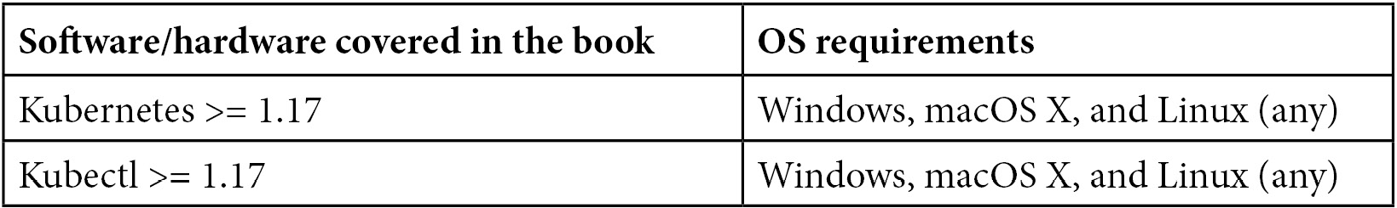
We strongly advise you to not attempt to install Kubernetes or Kubectl on your machine for now. Kubernetes is not a single binary but is a distributed software composed of several components and as such, it is really complex to install a complete Kubernetes cluster from scratch. Instead, we recommend that you follow the third chapter of this book, which is dedicated to the setup of Kubernetes.
If you are using the digital version of this book, we advise you to type the code yourself or access the code via the GitHub repository (link available in the next section). Doing so will help you avoid any potential errors related to the copying and pasting of code.
Please note that Kubernetes and Kubectl are the two tools we're going to use most frequently in this book, but there is a huge ecosystem around Kubernetes and we might install additional software not mentioned in this section. This book is also about using Kubernetes in the cloud, and we're going to discover how to provision Kubernetes clusters on public cloud platforms such as Amazon Web Services and Google Cloud Platform. As part of this setup, we might install additional software dedicated to these platforms that are not strictly bound to Kubernetes, but also to other services provided by these platforms.

Download the example code files
You can download the example code files for this book from GitHub at https://github.com/PacktPublishing/The-Kubernetes-Bible. In case there's an update to the code, it will be updated on the existing GitHub repository.
We also have other code bundles from our rich catalog of books and videos available at https://github.com/PacktPublishing/. Check them out!

Download the color images
We also provide a PDF file that has color images of the screenshots/diagrams used in this book. You can download it here: https://static.packt-cdn.com/downloads/9781838827694_ColorImages.pdf.

Conventions used
There are a number of text conventions used throughout this book.
Code in text: Indicates code words in the text, database table names, folder names, filenames, file extensions, pathnames, dummy URLs, user input, and Twitter handles. Here is an example: "Now, we need to create a kubeconfig file for our local Kubectl CLI."
A block of code is set as follows:
apiVersion: v1
kind: Pod
metadata:
name: nginx-Pod
When we wish to draw your attention to a particular part of a code block, the relevant lines or items are set in bold:
apiVersion: v1
kind: ReplicationController
metadata:
name: nginx-replicationcontroller-example
Any command-line input or output is written as follows:
$ kubectl get nodes
Bold: Indicates a new term, an important word, or words that you see on screen. For example, words in menus or dialog boxes appear in the text like this. Here is an example: "On this screen, you should see an Enable Billing button."
Tips or Important Notes
Appear like this.

Get in touch
Feedback from our readers is always welcome.
General feedback: If you have questions about any aspect of this book, mention the book title in the subject of your message and email us at customercare@packtpub.com.
Errata: Although we have taken every care to ensure the accuracy of our content, mistakes do happen. If you have found a mistake in this book, we would be grateful if you would report this to us. Please visit www.packtpub.com/support/errata, selecting your book, clicking on the Errata Submission Form link, and entering the details.
Piracy: If you come across any illegal copies of our works in any form on the internet, we would be grateful if you would provide us with the location address or website name. Please contact us at copyright@packt.com with a link to the material.
If you are interested in becoming an author: If there is a topic that you have expertise in and you are interested in either writing or contributing to a book, please visit authors.packtpub.com.

Share Your Thoughts
Once you've read The Kubernetes Bible, we'd love to hear your thoughts! Please click here to go straight to the Amazon review page for this book and share your feedback.
Your review is important to us and the tech community and will help us make sure we're delivering excellent quality content.

Section 1: Introducing Kubernetes
Kubernetes is a fantastic container orchestrator tool that can manage Docker containers at a large scale. Let's discover what Kubernetes is exactly, how it started as an internal project at Google to become a leading solution, and how it can help you today to manage Docker containers in production.
This part of the book comprises the following chapters:
Chapter 1, Kubernetes Fundamentals
Chapter 2, Kubernetes Architecture – From Docker Images to Running Pods
Chapter 3, Installing Your First Kubernetes Cluster

Chapter 1: Kubernetes Fundamentals
Welcome to The Kubernetes Bible. This is the first chapter of this book, and I'm happy to accompany you on your journey with Kubernetes. If you are working in the software development industry, you have probably heard about Kubernetes. This is normal because the popularity of Kubernetes has grown a lot in recent years.
Built by Google, Kubernetes is the leading container orchestrator solution in terms of popularity and adoption: it's the tool you need if you are looking for a solution to manage containerized applications in production at scale, whether it's on-premises or on a public cloud. Be focused on the word. Deploying and managing containers at scale is extremely difficult because, by default, container engines such as Docker do not provide any way on their own to maintain the availability and scalability of containers at scale.
Kubernetes first emerged as a Google project, and they put a lot of effort into building a solution to deploy a huge number of containers on their massively distributed infrastructure. By adopting Kubernetes as part of your stack, you'll get an open source platform that was built by one of the biggest companies on the internet, with the most critical needs in terms of stability.
Although Kubernetes can be used with a lot of different container runtimes, this book is going to focus on the Kubernetes + Docker combination.
Perhaps you are already using Docker on a daily basis, but the world of container orchestration might be completely unknown to you. It is even possible that you do not even see the benefits of using such technology because everything looks fine to you with just raw Docker. That's why, in this first chapter, we're not going to look at Kubernetes in detail. Instead, we will focus on explaining what Kubernetes is and how it can help you to manage your Docker containers in production. It will be easier for you to learn a new technology if you already understand why it was built.
In this chapter, we're going to cover the following main topics:
Understanding monoliths and microservices
Understanding containers and Docker
What is Kubernetes?
How can Kubernetes help you to manage Docker containers?
What problem does Kubernetes solve?
Understanding the story of Kubernetes

Understanding monoliths and microservices
Let's put Kubernetes and Docker to one side for the moment, and instead, let's talk a little bit about how internet and software development evolved together over the past 20 years. This will help you to gain a better understanding of where Kubernetes sits and what problem it solves.

Understanding the growth of the internet since the late 1990s
Since the late 1990s, the popularity of the internet has grown rapidly. Back in the 1990s, and even in the early 2000s, the internet was only used by a few hundred thousand people in the world. Today, almost 2 billion people are using the internet, whether for email, web browsing, video games, or more.
There are now a lot of people on the internet, and we're using it to answer tons of different needs, and these needs are adressed by dozens of applications deployed on dozens of devices.
Additionally, the number of connected devices has increased, as each person can now have several devices of a different nature connected to the internet: laptops, computers, smartphones, TVs, tablets, and more.
Today, we can use the internet to shop, to work, to entertain, to read, or to do whatever. It has entered almost every part of our society and has led to a profound paradigm shift for the last 20 years. All of this has given the utmost importance to software development.

Understanding the need for more frequent software releases
To cope with this ever-increasing number of users who are always demanding more in terms of features, the software development industry had to evolve in order to make new software releases faster and more frequent.
Indeed, back in the 1990s, you could build an application, deploy it to production, and simply update it once or twice a year. Today, companies must be able to update their software in production, sometimes several times a day, whether to deploy a new feature, to integrate with a social media platform, to support the resolution of the latest fashionable smartphone, or even to release a patch to a security breach identified the day before. Everything is far more complex today, and you must go faster than before.
We constantly need to update our software, and in the end, the survival of many companies directly depends on how often they are able to offer releases to their users. But how do we accelerate software developments life cycles so that we can deliver new versions of our software to our users more frequently?
IT departments of companies had to evolve, both in an organizational sense and a technical sense. Organizationally, they changed the way they managed projects and teams in order to shift to agile methodologies, and technically, technologies such as cloud computing platforms, containers, virtualization were adopted widely and helped a lot to align technical agility with organizational agility. All of this to ensure more frequent software releases! So, let's focus on this evolution next.

Understanding the organizational shift to agile methodologies
From a purely organizational point of view, agile methodologies such as Scrum, Kanban, and DevOps became the standard way to organize IT teams.
Typical IT departments that do not apply agile methodologies are often made of three different teams, each of them having a single responsibility toward the development and release process life cycle.
Before the adoption of agile methodologies, there was very strong opposition between them:
The business team: These teams are in charge of explaining the need for a new feature to other teams, especially the developers. Their job is hard because they need to translate business needs into concrete technical features that can be understood by the developers.
The development team: These teams are in charge of writing the code. First, they take the specs from the business team, and then they implement the software and features. If they do not understand the need, the development of new features can go back and forth between them and the business team, which can lead to a massive loss of time. Even worse, back in the old days, these guys had no clear vision of the type of environment their code would ultimately run on because it was kept at the sole discretion of the operation team.
The operation team: These teams are in charge of deploying the software to the production servers and operating it. Often, they are not happy when they hear that a new version of a piece of software, which includes new features, has to be deployed because the management judges them on their ability to provide stability to the app. In general, they are here to deploy something that was developed by another team without having a clear vision of what it contains and how it is configured since they did not participate in its development.
These are what we call silos. The roles are clearly defined, people do not work together that much, and when something goes wrong, everyone loses time in an attempt to find the right information from the proper person.
This kind of siloed organization has led to major issues:
A significantly longer development time
Greater risk in the deployment of a release that might not work at all in production
And that's essentially what agile methodologies and DevOps broke. The change agile methodologies wrought was to make people work together by creating multidisciplinary teams.
An agile team consists of a product owner describing concrete features by writing them as user stories that are readable by the developers who are working in the same team as them. Developers should have visibility over the production environment and the ability to deploy on top of it, preferably using a continuous integration and continuous deployment (CI/CD) approach. Testers should also be part of agile teams in order to write tests.
Simply put, by adopting agile methodologies and DevOps, these silos were broken and multidisciplinary teams capable of formalizing a need, implementing it, testing it, releasing it, and maintaining it in the production environment were created.
Important Note
Rest assured, even though we are currently discussing agile methodologies and the whole internet in a lot of detail, this book is really about Kubernetes! We just need to explain some of the problems that we have faced before introducing Kubernetes for real!
Agile development teams are complete operational units that are capable of handling all development steps on their own. An agile team should understand the business value brought by a new feature. They should have a minimal view of the software architecture, understand how to build it, how to test it, and the production environment it will run on.
That's the purpose of the expression You Build It, You Run It that you'll see everywhere when reading about this subject: an agile team should be able to cover all aspects of an app's development, release, and maintenance life cycles.
You just have to bear in mind that before this, teams were siloed and each had its own scope and working process. So, we've covered the organizational transition brought by the adoption of the agile methodologies, now let's discuss the technical evolution that we've gone through over the past several years.

Understanding the shift from on-premises to the cloud
Having agile teams is very nice. But agility must also be applied to how the software is built and hosted.
With the aim to always achieve faster and more recurrent releases, agile software development teams had to revise two important aspects of software development and release:
Hosting
Software architecture
Today, apps are not just for a few hundred users but potentially for millions of users concurrently. Having more users on the internet also means having more computing power capable of handling them. And indeed, hosting an application became a very big challenge.
Back in the old days, there were two ways to get machines to host your apps. We call this on-premises hosting:
Renting servers from established hosting providers
Building your own data center, only for companies willing to invest a large amount of money in data centers
When your user base grows, the need to get more powerful machines to handle the load. The solution is to purchase a more powerful server and install your app on it from the start or to order and rack new hardware if you manage your data center. This is not very flexible. Today, a lot of companies are still using an on-premises solution, and often, it's not super flexible.
The game-changer was the adoption of the public cloud, which is the opposite of on-premises. The whole idea behind cloud computing is that big companies such as Amazon, Google, and Microsoft, which own a lot of data centers, decided to build virtualization on top of their massive infrastructure to ensure the creation and management of virtual machines was accessible by APIs. In other words, you can get virtual machines with just a few clicks or just a few commands.

Understanding why the cloud is well suited for scalability
Today, virtually anyone can get hundreds or thousands of servers, in just a few clicks, in the form of virtual machines or instances created on physical infrastructure maintained by cloud providers such as Amazon Web Services, Google Cloud Platform, and Microsoft Azure. A lot of companies decided to migrate their workload from on-premises to a cloud provider, and their adoption has been massive over these last years.
Thanks to that, now, computing power is one of the simplest things you can get.
Cloud computing providers are now typical hosting solutions that agile teams possess in their arsenal. The main reason for this is that the cloud is extremely well suited to modern development.
Virtual machine configurations, CPUs, OSes, network rules, and more are publicly displayed and fully configurable, so there are no secrets for your team in terms of what the production environment is made of. Because of the programmable nature of cloud providers, it is very easy to replicate a production environment in a development or testing environment, providing more flexibility to teams and helping them face their challenges when developing software.
That's a useful advantage for an agile development team built around the DevOps philosophy that needs to manage development, release, and application maintenance in production.
Cloud providers have brought many benefits, as follows:
Offering elasticity and scalability
Helping to break up silos and enforcing agile methodologies
Fitting well with agile methodologies and DevOps
Offering low costs and flexible billing models
Ensuring there is no need to manage physical servers
Allowing virtual machines to be destroyed and recreated at will
More flexible compared to renting a bare-metal machine monthly
Due to these benefits, the cloud is a wonderful asset in the arsenal of an agile development team. Essentially, you can build and replicate a production environment over and over without the hassle of managing the physical machine by yourself. The cloud enables you to scale your app based on the number of users using it or the computing resources they are consuming. You'll make your app highly available and fault-tolerant. The result is a better user experience for your end users.
Important Note
Please note that Kubernetes can run both on the cloud and on-premises. Kubernetes is very versatile, and you can even run it on a Raspberry Pi. However, you'll discover that it's better to run it on a cloud due to the benefits they provide. Kubernetes and the public cloud are a good match, but you are not required or forced to run it on the cloud.
Now that we have explained what the cloud brought, let's move on to software architecture, as over the years, a few things have also changed there.
Essentially, software architecture consists of design paradigms that you can choose when developing software. In the 2020s, we can name two architectures:
Monolithic architecture
Microservices architecture

Exploring the monolithic architecture
In the past, applications were mostly composed as monoliths. A typical monolith application consists of a simple process, a single binary, or a single package.
This unique component is responsible for the entire implementation of the business logic, to which the software must respond. Monoliths are a good choice if you want to develop fairly simple applications that might not necessarily be updated frequently in production. Why? Well, because monoliths have one major drawback. If your monolith becomes unstable or crashes for some reason, your entire application will become unavailable:
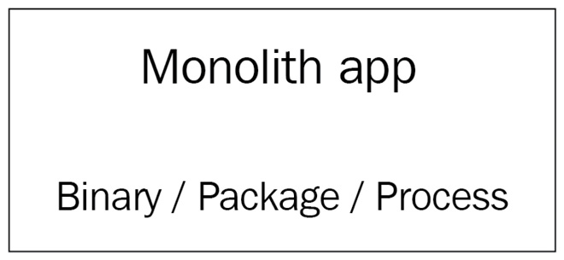
Figure 1.1 – A monolith application consists of one big component that contains all your software
The monolithic architecture can allow you to gain a lot of time during your development and that's perhaps the only benefit you'll find by choosing this architecture. However, it also has many disadvantages. Here are a few of them:
A failed deployment to production can break your whole application.
Scaling activities become difficult to achieve; if you fail to scale, all your applications might become unavailable.
A failure of any kind on a monolith can lead to the complete outage of your app.
In the 2010s, these drawbacks started to cause real problems. With the increase in the frequency of deployments, it became necessary to think of a new architecture that would be capable of supporting frequent deployments and closer update cycles, while reducing the risk or general unavailability of the application. This is why the microservices architecture was designed.

Exploring the microservices architecture
The microservices architecture consists of developing your software application as a suite of independent micro-applications. Each of these applications, which is called a microservice, has its own versioning, life cycle, environment, and dependencies. Additionally, it can have its own deployment life cycle. Each of your microservices must only be responsible for a limited number of business rules, and all of your microservices, when used together, make up the application. Think of a microservice as real full-featured software on its own, with its own life cycle and versioning process.
Since microservices are only supposed to hold a subset of all the features that the entire application has, they have to be accessible to expose their functions. You have to get data from a microservice, but you might also want to push data into it. You can make your microservice accessible through widely supported protocols such as HTTP or AMQP, and they need to be able to communicate with each other if needed.
That's why microservices are generally built as web services that are accessible through HTTP REST APIs. This is something that greatly differs from the monolithic architecture:
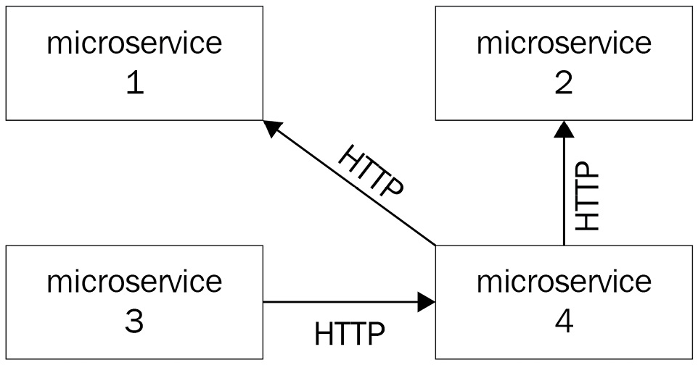
Figure 1.2 – A microservice architecture where different microservices communicate with the HTTP protocol
Another key aspect of the microservice architecture is that microservices need to be decoupled: if a microservice becomes unavailable or unstable, it must not affect the other microservices nor the entire application's stability. You must be able to provision, scale, start, update, or stop each microservice independently without affecting anything else. If your microservices need to work with a database engine, bear in mind that even the database must be decoupled. Each microservice should have its own SQL database and so on. So, if the database of microservice A crashes, it won't affect microservice B:
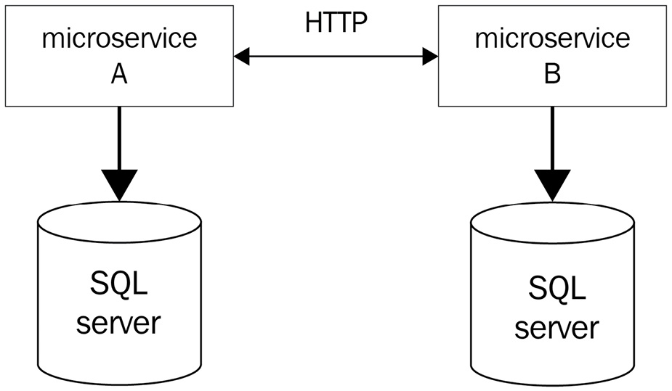
Figure 1.3 – A microservice architecture where different microservices communicate with the HTTP protocol and also with a dedicated SQL server; this way, the microservices are isolated and have no common dependencies
The key rule is to decouple as much as possible so that your microservices are fully independent. Because they are meant to be independent, microservices can also have completely different technical environments and be implemented in different languages. You can have one microservice implemented in Go, another one in Java, and another one in PHP, and all together they form one application. In the context of a microservice architecture, this is not a problem. Because HTTP is a standard, they will be able to communicate with each other even if their underlying technologies are different.
Microservices must be decoupled from other microservices, but they must also be decoupled from the operating system running them. Microservices should not operate at the host system level but at the upper level. You should be able to provision them, at will, on different machines without needing to rely on a strong dependency with the host system; that's why microservice architectures and containers are a good combination.
If you need to release a new feature in production, you simply deploy the microservices that are impacted by the new feature version. The others can remain the same.
As you can imagine, the microservice architecture has tremendous advantages in the context of modern application development:
It is easier to enforce recurring production deliveries with minimal impact on the stability of the whole application.
You can only upgrade to a specific microservice each time, not the whole application.
Scaling activities are smoother since you might only need to scale specific services.
However, on the other hand, the microservice architecture has a few disadvantages, too:
The architecture requires more planning and is considered to be hard to develop.
There are problems in managing each microservice's dependencies.
Indeed, microservice applications are considered hard to develop, and it is easy to just do it incorrectly. This approach might be hard to understand, especially for junior developers. On the other hand, dependency management also becomes complex since all microservices can potentially have different dependencies.

Choosing between monolithic and microservices architectures
Presented in this way, you might think that microservices are the better of the two architectures. However, this is not always the case.
Although the monolithic architecture is older than microservice architecture, monolithic applications are not dead yet, and they can still be a good choice in certain situations. Microservices are not necessarily the ideal answer to all projects. If your application is simple, if there are only a few developers on your team working on your project, or if you can tolerate outages when you deploy a new version in production, then you can still opt for an application architecture that is a monolith.
On the other hand, if your application is more complex, if there are many developers with different skills on your team, or if you have a high level of requirements in terms of operational quality in production, scalability, and availability, then you should opt for a microservice architecture.
The problem is that microservices are slightly more complex to develop and manage in production since managing microservices essentially consists of managing multiple applications that each have their own dependencies and life cycles. Thankfully, the rise of Docker has enabled a lot of developers to adopt the microservice architecture.

Understanding containers and Docker
Following this comparison between monolithic and microservice architectures, you should have understood that the architecture that best combines with agility and DevOps is the microservice architecture. It is this architecture that we will discuss throughout the book because this is the architecture that Kubernetes manages well.
Now, we will move on to discuss how Docker, which is a container engine for Linux, is a good option in which to manage microservices. If you already know a lot about Docker, you can skip this section. Otherwise, I suggest that you read through it carefully.

Understanding why Docker is good for microservices
Recall the two important aspects of the microservice architecture:
Each microservice can have its own technical environment and dependency.
At the same time, it must be decoupled from the operating system it's running on.
Let's put the latter point aside for the moment and discuss the first one: two microservices of the same app can be developed in two different languages or be written in the same language but as two different versions. Now, let's say that you want to deploy these two microservices inside the same Linux machine. That would be a nightmare.
The reason for this is that you'll have to install all the multiple versions of the different runtimes, as well as the dependencies, and there might also be different versions or overlaps between the two microservices. Additionally, all of this will be on the same host operating system. Now, let's imagine you want to remove one of these two microservices from the machine to deploy it on another server and clean the former machine of all the dependencies used by that microservice. Of course, if you are a talented Linux engineer, you'll succeed in doing this. However, for most people, the risk of conflict between the dependencies is huge, and in the end, you might just make your app unavailable while running such a nightmarish infrastructure.
There is a solution to this: you could build a machine image for each microservice and then put each microservice on a dedicated virtual machine. In other words, you refrain from deploying multiple microservices on the same machine. However, in this example, you will need as many machines as you have microservices. Of course, with the help of AWS or GCP, it's going to be easy to bootstrap tons of servers, each of them tasked to run one and only one microservice, but it would be a huge waste of money to not mutualize the computing power offered by the host.
That's why the second requirement exists: microservices should be decoupled from the microservice they are running on. To achieve this, we use Docker containers.

Understanding the benefit of Docker container isolation
Docker allows you to manage containers that are, in fact, isolated Linux namespaces. Docker's job is to expose a user-friendly API to manage containers, which are like small virtual machines that run on top of the Linux kernel, not at the hypervisor level. By installing Docker on top of your Linux system, you, therefore, add an additional layer of virtualization on top of your host machine. Your microservices are going to be launched on top of this layer, not directly on the host system, whose sole role will be to run Docker.
Since containers are isolated, you can run as many containers as you want and have them run applications written in different languages without any conflict. Microservice relocation becomes as easy as stopping a running container and launching another one from the same image on another machine.
The usage of Docker with microservices offers three main benefits:
It reduces the footprint on the host system.
It mutualizes the host system without the conflict between different microservices.
It removes coupling between the microservice and the host system.
Once a microservice has been containerized, you can eliminate its coupling with the host operating system. The microservice will only depend on the container in which it will operate. Since a container is much lighter than a real full-featured Linux operating system, it will be easy to share and deploy on many different machines. Therefore, the container and your microservice will work on any machine that is running Docker.
The following diagram shows a microservice architecture where each microservice is actually wrapped by a Docker container:
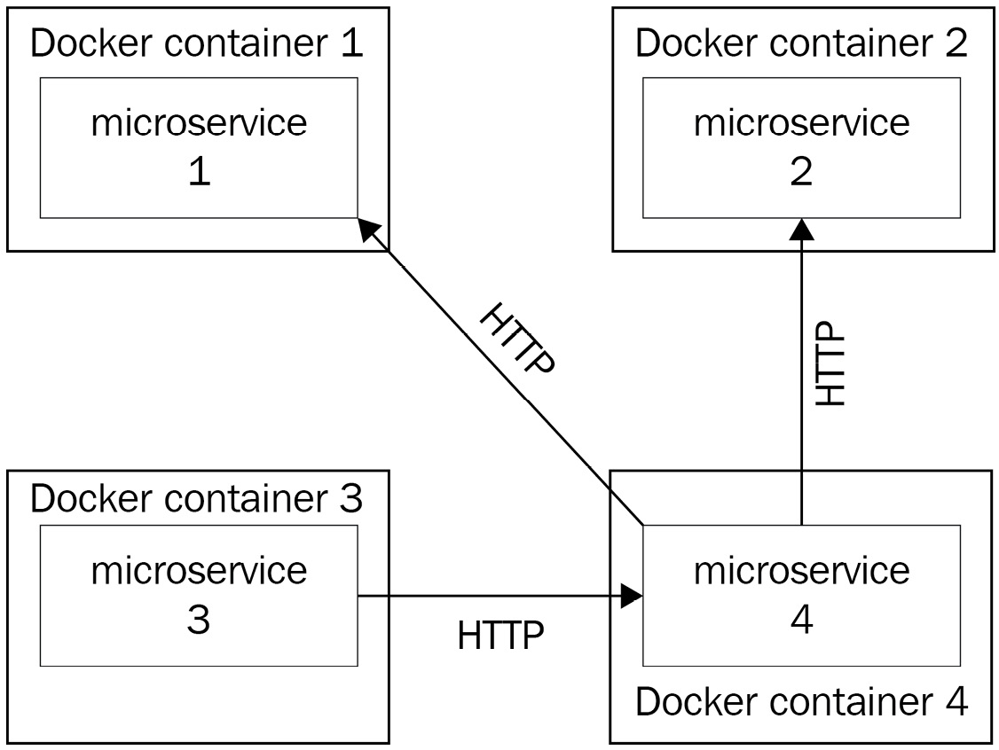
Figure 1.4 – A microservice application where all microservices are wrapped by a Docker container; the life cycle of the app becomes tied to the container, and it is easy to deploy it on any machine that is running Docker
Docker fits well with the DevOps methodology, too. By developing locally in a Docker container, which would be later be built and deployed in production, you ensure you develop in the same environment as the one that will eventually run the application.
Docker is not only capable of managing the life cycle of a container, it is actually an entire ecosystem around containers. It can manage networks, the intercommunication between different containers, and all of these features respond particularly well to the properties of the microservice architecture that we mentioned earlier.
By using the cloud and Docker together, you can build a very strong infrastructure to host your microservice. The cloud will give you as many machines as you want. You simply need to install Docker on each of them, and you'll be able to deploy multiple containerized microservices on each of these machines.
Docker is a very nice tool on its own. However, you'll discover that it's hard to run it in production alone, just as it is. The reason is that Docker was built in order to be an ecosystem around Linux containers, not a production platform. When it comes to production, everything is particular, because it is the concrete environment where everything happens for real. This environment deserves special treatment, and deploying Docker on it is risky. This is because Docker cannot alone address the particular needs that are related to production.
There are a number of questions, such as how to relaunch a container that failed automatically and how to autoscale my container based on its CPU utilization, that Docker alone cannot answer. This is the reason why some people were afraid to run Docker-based workloads in production a few years ago.
To answer these questions, we will need a container orchestrator, such as the one discussed in this book: Kubernetes.

How can Kubernetes help you to manage your Docker containers?
Now, we will focus a little bit more on Kubernetes, which is the purpose of this book. Here, we're going to discover that Kubernetes was meant to use container runtimes in production, by answering operational needs mandatory for production.

Understanding that Kubernetes is meant to use Docker in production
If you open the official Kubernetes website (at https://kubernetes.io), the title you will see is Production-Grade Container Orchestration:
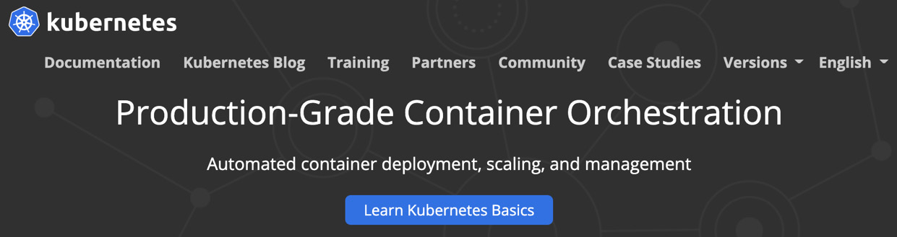
Figure 1.5 – The Kubernetes home page showing the header and introducing Kubernetes as a production container orchestration platform
These four words perfectly sum up what Kubernetes is: it is a container orchestration platform for production. Kubernetes does not aim to replace Docker nor any of the features of Docker; rather, it aims to help us to manage clusters of machines running Docker. When working with Kubernetes, you use both Kubernetes and the full-featured standard installations of Docker.
The title refers to production. Indeed, the concept of production is absolutely central to Kubernetes: it was thought and designed to answer modern production needs. Managing production workloads is different today compared to what it was in the 2000s. Back in the 2000s, your production workload would consist of just a few bare metal servers, if not a single one on-premises. These servers mostly ran monoliths directly installed on the host Linux system. However, today, thanks to public cloud platforms such as Amazon Web Services (AWS) or Google Cloud Platform (GCP), anyone can now get hundreds or even thousands of machines in the form of instances or virtual machines with just a few clicks. Even better, we no longer deploy our applications on the host system but as containerized microservices on top of the Docker engine instead, thereby reducing the footprint of the host system.
A problem will arise when you have to manage Docker installations on each of these virtual machines on the cloud. Let's imagine that you have 10 (or 100 or 1,000) machines launched on your preferred cloud and you want to achieve a very simple task: deploy a containerized Docker app on each of these machines.
You could do this by running the docker run command on each of your machines. It would work, but of course, there is a better way to do it. And that's by using a container orchestrator such as Kubernetes. To give you an extremely simplified vision of Kubernetes, it is actually a REST API that keeps a registry of your machines executing a Docker daemon.
Again, this is an extremely simplified definition of Kubernetes. In fact, it's not made of a single centralized REST API, because as you might have gathered, Kubernetes itself was built as a suite of microservices.

Exploring the problems that Kubernetes solves
You can imagine that launching containers on your local machine or a development environment is not going to require the same level of planning as launching these same containers on remote machines, which could face millions of users. Problems specific to production will arise, and Kubernetes is a top solution with which to address these problems when using containers in production:
Ensuring high availability
Handling release management and container deployments
Autoscaling containers

Ensuring high availability
High availability is the central principle of production. This means that your application should always remain accessible and should never be down. Of course, it's utopian. Even the biggest companies such as Google or Amazon are experiencing outages. However, you should always bear in mind that this is your goal. Microservice architecture is a way to mitigate the risk of a total outage in the event of a failure. Using microservices, the failure of a single microservice will not affect the overall stability of the application. Kubernetes includes a whole battery of functionality to make your Docker containers highly available by replicating them on several host machines and monitoring their health on a regular and frequent basis.
When you deploy Docker containers, the accessibility of your application will directly depend on the health of your containers. Let's imagine that for some reason, a container containing one of your microservice becomes inaccessible; how can you automatically guarantee that the container is terminated and recreated using only Docker without Kubernetes? This is impossible because, by default, Docker cannot do it alone. With Kubernetes, it becomes possible. Kubernetes will help you design applications that can automatically repair themselves by performing automating tasks such as health checking and container replacement.
If one machine in your cluster were to fail, all of the containers running on it would disappear. Kubernetes would immediately notice that and reschedule all of the containers on another machine. In this way, your applications will become highly available and fault-tolerant as well.

Release management and container deployment
Deployment management is another of these production-specific problems that Kubernetes answers. The process of deployment consists of updating your application in production in order to replace an old version of a given microservice with a new version.
Deployments in production are always complex because you have to update the containers that are responding to requests from end users. If you miss them, the consequences can be great for your application because it could become unstable or inaccessible, which is why you should always be able to quickly revert to the previous version of your application by running a rollback. The challenge of deployment is that it needs to be performed in the least visible way to the end user, with as little friction as possible.
When using Docker, each release is preceded by a build process. Indeed, before releasing a new container, you have to build a new Docker image containing the new version. A Docker image is a kind of template used by Docker to launch containers. A container can be considered a running instance of a Docker image.
Important Note
The Docker build process has absolutely nothing to do with Kubernetes: it's pure Docker. Kubernetes will come into play later when you'll have to deploy new containers based on a newly built image.
Triggering a build is straightforward. Perform the following steps:
You just need to run the docker build command:
$ docker build .
Docker reads build instructions from the Dockerfile file inside the . directory and starts the build process.
The build completes.
The resulting image is stored on the local machine where the build ran.
Then, you push the new image to a Docker repository with a specific tag to identify the software version included in the new image.
Once the push has been completed, another process starts, that is, the deployment. To deploy a containerized Docker app, you simply need to pull the image from the machine where you want to run it and then run a docker run command.
This is what you'll need to do to release a new version of your containerized software, and this is exactly where things can become hard if you don't use an orchestrator such as Kubernetes.
The next step to achieve the release is to delete the existing container and replace it with new containers created from this new image.
Without Kubernetes, you'll have to run a docker run command on the machine where you want to deploy a new version of the container and destroy the container containing the old version of the application. Then, you will have to repeat this operation on each server that runs a copy of the container. It should work, but it is extremely tedious since it is not automated. And guess what? Kubernetes can automate this for you.
Kubernetes has features that allow it to manage deployments and rollbacks of Docker containers, and this will make your life a lot easier when responding to this problem. With a single command, you can ask Kubernetes to update your containers on all of your machines. Here is the command, which we'll learn later, that allows you to do that:
$ kubectl set image deploy/myapp myapp_container=myapp:1.0.0
# Meaning of the command
# kubectl set image <deployment_name> <container_name>=<docker_image>:<docker_tag>
On a real Kubernetes cluster, this command will update the container called myapp_container, which is running as part of the application called myapp, on every single machine where myapp_container runs to the 1.0.0 tag.
Whether it has to update one container running on one machine or millions over multiple data centers, this command works the same. Even better, it ensures high availability.
Remember that the goal is always to meet the requirement of high availability; a deployment should not cause your application to crash or cause a service disruption. Kubernetes is natively capable of managing deployment strategies such as rolling updates aimed at avoiding service interruptions.
Additionally, Kubernetes keeps in memory all the revisions of a specific deployment and allows you to revert to a previous version with just one command. It's an incredibly powerful tool that allows you to update a cluster of Docker containers with just one command.

Autoscaling containers
Scaling is another production-specific problem that has been widely democratized through the use of public clouds such as Amazon Web Services (AWS) and Google Cloud Platform (GCP). Scaling is the ability to adapt your computing power to the load you are facing – again to meet the requirement of high availability. Never forget that the goal is to avoid outages and downtime.
When your production machines are facing a traffic spike and one of your containers is no longer able to cope with the load, you need to find a way in which to identify the failing container. Decide whether you wish to scale it vertically or horizontally; otherwise, if you don't act and the load doesn't decrease, your container or even the host machine will eventually fail, and your application might become inaccessible:
Vertical scaling: This allows your container to use more computing power offered by the host machine.
Horizontal scaling: You can duplicate your container to another machine, and you can load balance the traffic between the two containers.
Again, Docker is not able to respond to this problem alone; however, when you manage your Docker with Kubernetes, it becomes possible. Kubernetes is capable of managing both vertical and horizontal scaling automatically. It does this by letting your containers consume more computing power from the host or by creating additional containers that can be deployed on another node on the cluster. And if your Kubernetes cluster is not capable of handling more containers because all your nodes are full, Kubernetes will even be able to launch new virtual machines by interfacing with your cloud provider in a fully automated and transparent manner by using a component called a Cluster Autoscaler.
Important Note
The Cluster Autoscaler only works if the Kubernetes cluster is deployed on a cloud provider.
These goals cannot be achieved without using a container orchestrator. The reason for this is simple. You can't afford to do these tasks; you need to think about DevOps' culture and agility and seek to automate these tasks so that your applications can repair themselves, be fault-tolerant, and be highly available.
Contrary to scaling out your containers or cluster, you must also be able to decrease the number of containers if the load starts to decrease in order to adapt your resources to the load, whether it is rising or falling. Again, Kubernetes can do this, too.

When and where is Kubernetes not the solution?
Kubernetes has undeniable benefits; however, it is not always advisable to use it as a solution. Here, we have listed several cases where another solution might be more appropriate:
Container-less architecture: If you do not use a container at all, Kubernetes won't be of any use to you.
Monolithic architecture: While you can use Kubernetes to deploy containerized monoliths, Kubernetes shows all of its potential when it has to manage a high number of containers. A monolithic application, when containerized, often consists of a very small number of containers. Kubernetes won't have much to manage, and you'll find a better solution for your use case.
A very small number of microservices or applications: Kubernetes stands out when it has to manage a large number of containers. If your app consists of two to three microservices, a simpler orchestrator might be a better fit.
No cluster: Are you only running one machine and only one Docker installation? Kubernetes is good at managing a cluster of computers that executes a Docker daemon. If you do not plan to manage a real cluster, then Kubernetes is not for you.

Understanding the history of Kubernetes
To finish this chapter, let's discuss the history of the Kubernetes project. It will be really useful for you to understand the context in which the Kubernetes project started and the people who are keeping this project alive.

Understanding how and where Kubernetes started
Kubernetes started as an internal project at Google. Since its founding in 1998, Google gained huge experience in managing high-demanding workloads at scale, especially container-based workloads. Today, in addition to Google, Amazon and Microsoft are also releasing a lot of open source and commercial software to allow smaller companies to benefit from their experience of managing cloud-native applications. Kubernetes is one example of this open source software that has been released by Google.
At Google, everything has been developed as Linux containers since the mid-2000s. The company understood the benefit of using containers long before Docker made them simple to use for the general public. Essentially, everything at Google runs as a container. And they are undoubtedly the first to have felt the need to develop an orchestrator that would allow them to manage their container-based resources along with the machines that launch them. This project is called Borg, and you can consider it to be the ancestor of Kubernetes. Another container orchestrator project, called Omega, was then started by Google in order to improve the architecture of Borg to make it easier to extend and become more robust. Many of the improvements brought by Omega were later merged into Borg.
Important Note
Borg is actually not the ancestor of Kubernetes because the project is not dead and is still in use at Google. It would be more appropriate to say that a lot of ideas from Borg were actually reused to make Kubernetes. Bear in mind that Kubernetes is not Borg nor Omega. Borg was built in C++ and Kubernetes in Go. In fact, they are two entirely different projects, but one is heavily inspired by the other. This is important to understand: Borg and Omega are two internal Google projects. They were not built for the public.
As the interest in containers became greater during the early 2010s, Google decided to develop and release a third container orchestrator. This time, it was meant to be an open source one that was built for the public. Therefore, Kubernetes was born and would eventually be released in 2014.
Kubernetes was developed with the experience gained by Google to manage containers in production. Most importantly, it inherited Borg and Omega's ideas, concepts, and architectures. Here is a brief list of ideas and concepts taken from Borg and Omega, which have now been implemented in Kubernetes:
The concept of pods to manage your containers: Kubernetes uses a logical object, called a pod, to create, update, and delete your containers.
Each pod has its own IP address in the cluster.
There are distributed components that all watch the central Kubernetes API in order to retrieve the cluster state.
There is internal load balancing between pods and services.
Labels and selectors are two metadata used together to build interaction between Kubernetes
That's why Kubernetes is so powerful when it comes to managing containers in production at scale: in fact, the concepts you'll learn in Kubernetes are older than Kubernetes itself. They have existed for more than a decade, running Google's entire infrastructure as part of Borg and Omega. So, although Kubernetes is a young project, it was built on solid foundations.

Who manages Kubernetes today?
Kubernetes is no longer maintained by Google. They gave Kubernetes to an organization called Cloud Native Computing Foundation (CNCF), which is a big consortium whose goal is to promote the usage of container technologies. This happened in 2018.
Google is a founding member of CNCF along with companies such as Cisco, Red Hat, and Intel. The Kubernetes source code itself is hosted on GitHub and is an extremely active project on the platform. The code is under License Apache version 2.0, which is a permissive open source license. You won't have to pay in order to use Kubernetes, as the software is available for free, and if you are good at coding with Go, you can even contribute to the code.

Where is Kubernetes today?
Kubernetes has a lot of competitors, and some of them are open source, too. Others are bound to a specific cloud provider. We can name a few, as follows:
Apache Mesos
Hashicorp Nomad
Docker Swarm
Amazon ECS
These container orchestrators all have their pros and cons, but it's fair to say that Kubernetes is, by far, the most popular of them all.
Kubernetes has won the fight of popularity and adoption and is really about to become the de facto standard way of deploying container-based workloads in production. As its immense growth made it one of the hottest topics in IT industry, it has become crucial for cloud providers to come up with a Kubernetes offering as part of their services. Therefore, Kubernetes is supported almost everywhere now.
The following Kubernetes-based services can help you to get a Kubernetes cluster up and running with just a few clicks:
Google GKE
Amazon EKS
Microsoft Azure AKS
Alibaba ACK
It's not just about the cloud offerings. It's also about the Platform-as-a-Service market. Recently, Red Hat OpenShift decided to rewrite their entire platform to rebuild it on Kubernetes. Now they are offering a complete set of enterprise tools to build, deploy, and manage Docker containers entirely on top of Kubernetes. In addition to this, other projects such as Rancher were built as Kubernetes distributions to offer a complete set of tools around the Kubernetes orchestrator, whereas projects such as Knative offers to manage serverless workloads with the Kubernetes orchestrator.
Important Note
AWS is an exception because it has two container orchestrator services. The first one is Amazon ECS, which is entirely made by AWS and is a competitor to Kubernetes. The second one is Amazon EKS, which was released later than the first one and is a complete Kubernetes offering on AWS. These services are not the same, so do not be misguided by their similar names.
Learning Kubernetes today is one of the smartest decisions you can take if you are into managing cloud-native applications in production. Kubernetes is evolving rapidly, and there is no reason to think why its growth would stop.
By mastering this wonderful tool, you'll get one of the hottest skills being searched for in the IT industry today. I hope you are now convinced!

Summary
This first chapter gave us room for a big introduction. We covered a lot of subjects, such as monoliths, microservices, Docker containers, cloud computing, and Kubernetes. We also discussed how this project came to life. You should now have a global vision of how Kubernetes can be used to manage your containers in production.
In the next chapter, we will discuss the process Kubernetes follows to launch a Docker container. You will discover that you can issue commands to Kubernetes, and these commands will be interpreted by Kubernetes as instructions to run containers. We will list and explain each component of Kubernetes and its role in the whole cluster. There are a lot of components that make up a Kubernetes cluster, and we will discover all of them. We will explain how Kubernetes was technically built with a focus on the distinction between master nodes, worker nodes, and control plane components.

Chapter 2: Kubernetes Architecture – From Docker Images to Running Pods
In the previous chapter, we laid the groundwork regarding what Kubernetes is from a functional point of view. You should now have a better idea of how Kubernetes can help you to manage clusters of machines running containerized microservices. Now, let's go a little deeper into the technical details. In this chapter, we will examine how Kubernetes enables you to manage containers that are distributed on different machines. Following this chapter, you should have a better understanding of the anatomy of a Kubernetes cluster; in particular, you will have a better understanding of Kubernetes components and know the responsibility of each of them in the execution of your containers.
Kubernetes is made up of several distributed components, each of which plays a specific role in the execution of Docker containers. To understand the role of each Kubernetes component, we will follow the life cycle of a Docker container as it is created and managed by Kubernetes: that is, from the moment you execute the command to create the container to the point when it is actually executed on a machine that is part of your Kubernetes cluster.
In this chapter, we're going to cover the following main topics:
Understanding the difference between the master and worker nodes
The kube-apiserver component
The kubectl command-line tool and YAML syntax
The Etcd datastore
The kubelet and worker node components
The kube-scheduler component
The kube-controller-manager component
How to make Kubernetes highly available

Understanding the difference between the master and worker nodes
To run Kubernetes, you will require Linux machines, which are called nodes in Kubernetes. A node could be a physical machine or a virtual machine on a cloud provider, such as an EC2 instance. There are two types of nodes in Kubernetes:
Master nodes
Worker nodes
Master nodes are responsible for maintaining the state of the Kubernetes cluster, whereas worker nodes are responsible for executing your Docker containers.
While using Linux, you will have probably used commands such as apt-get install or yum install to get a new, fully functional software preconfigured that just works out of the box. With Kubernetes, things are a slightly more complex.
The good news is that you can also use Windows-based nodes to launch Windows-based containers in your Kubernetes cluster. The thing to know is that you can mix Linux and Windows machines on your cluster and it will work the same, but you cannot launch a Windows container on a Linux worker node and vice versa.
By nature, Kubernetes is a distributed application. What we call Kubernetes is not a single monolithic app released as a single build that you would install on a dedicated machine. What we mean by Kubernetes is a collection of small projects. Each project is written in Go and forms part of the overall project that is Kubernetes.
To get a fully functional Kubernetes cluster, you need to set up each of these components by installing and configuring them separately and have them communicate with each other. When these two requirements are met, you can start running your containers using the Kubernetes orchestrator.
For development or local testing, it is fine to install all of the Kubernetes components on the same machine; however, in production, these components should be spread across different hosts. This will help you to make your Kubernetes cluster highly available. By spreading the different components across multiple machines, you gain two benefits:
You make your cluster highly available and fault-tolerant.
You make your cluster a lot more scalable. Components have their own lifecycle, they can be scaled without impacting others.
In this way, having one of your servers down will not break the entire cluster but just a small part of it, and adding more machines to your servers becomes easy.
Each Kubernetes component has its own clearly defined responsibility. It is important for you to understand each component's responsibility and how it articulates with the other components to understand how Kubernetes works overall.
Depending on its role, a component will have to be deployed on a master node or a worker node. While some components are responsible for maintaining the state of a whole cluster and operating the cluster itself, others are responsible for running our application containers by interacting with Docker daemons directly. Therefore, the components of Kubernetes can be grouped into two families:
Components belonging to the Control Plane:
These components are responsible for maintaining the state of the cluster. They should be installed on a master node. These are the components that will keep the list of containers executed by your Kubernetes cluster or the number of machines that are part of the cluster. As an administrator, when you interact with Kubernetes, you actually interact with the control plane components.
Components belonging to the Worker Nodes:
These components are responsible for interacting with the Docker daemon in order to launch containers according to the instructions they receive from the control plane components. Worker node components must be installed on a Linux machine running a Docker daemon. You are not supposed to interact with these components directly. It's possible to have hundreds or thousands of worker nodes in a Kubernetes cluster.
Clustering technologies use this architecture a lot. They define two types of nodes: masters and workers. The master(s) nodes are responsible for the management of the cluster and all operational tasks according to the instructions received from the administrator. The worker(s) nodes are responsible for the execution of the actual workload based on instructions received from the master(s).
Kubernetes works in relatively the same way. You are not supposed to launch your Docker containers by yourself, and therefore, you do not interact directly with the worker nodes. Instead, you send your instructions to the control plane. Then, it will delegate the actual container creation and maintenance to the worker node on your behalf. You never run a docker command directly:
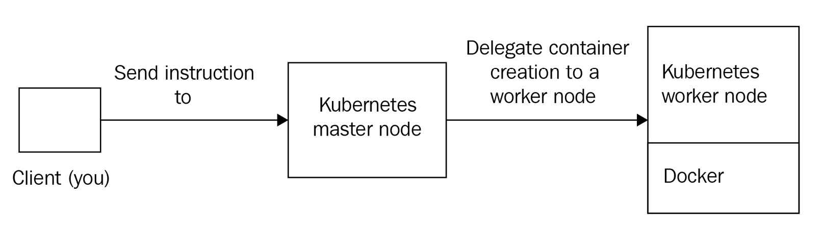
Figure 2.1 – A typical Kubernetes workflow. The client interacts with the master node/control plane components, which delegate container creation to a worker node. There is no communication between the client and the worker node
When using Kubernetes you'll notice here and there the concepts of control plane and the master node. They're almost the same: both expressions are meant to designate the Kubernetes components responsible of cluster administration, and by extension, the machines (or nodes) on which these components have been installed. In Kubernetes, we generally try to avoid talking about master nodes. Instead, we talk about the control plane.
The reason is because saying "master node" supposes the components allowing the management of the cluster are installed on the same machine and have a strong coupling with the machine that is running them. However, due to the distributed nature of Kubernetes, its master node components can actually be spread across multiple machines. This is quite tricky, but there are, in fact, two ways in which to set up the control plane components:
You run all of them on the same machine, and you have a master node.
You run them on different machines, and you no longer have a master node.
Master node terminology tends to imply that all control plane components are running on the same machine, but not the case. To achieve maximum fault tolerance, it's a good idea to spread them across different machines. Kubernetes is so distributed that even its master node can be broken into multiple machines, where each of them has the responsibility to execute a single component that allows the management of the cluster.
The idea is that control plane components must be able to communicate with each other, and this can be achieved by installing them onto different hosts. In fact, later, you'll discover that the control plane components can even be launched as Docker containers on worker node machines. This is a very advanced topic, but it's possible. That's why the master node terminology is not that accurate to Kubernetes, and we prefer the control plane terminology instead.
However, for the sake of simplicity, I'll consider, in this chapter, and also for a huge part of this book, that we are using dedicated master node machines to execute all of the control plane components in the same place. Throughout the different examples listed here, control plane components will be tightly coupled with the machine that is executing them. This will help you to understand the role of each component. Later, we will explore the advanced techniques related to the management of control plane components, such as launching them as Docker containers and more.
That being said, things are simpler when it comes to worker nodes: you start from a standard machine running Docker, and you install the worker node components next to the Docker runtime. These components will interface with the local container engine that is installed on the said machine and execute containers based on the instructions you send to the control plane components. You can control all the aspects of Docker from Kubernetes thanks to this worker nodes mechanics: container creation, network management, scaling containers, and so on. Adding more computing power to your cluster is easy; you just need to add more worker nodes and have them join the cluster to make room for more containers.
Important Note
By splitting the control plane and worker node components of different machines, you are making your cluster highly available and scalable. Kubernetes was built with all of the cloud-native concerns in mind; its components are stateless, easy to scale, and built to be distributed across different hosts. The whole idea is to avoid having a single point of failure by grouping all of the components onto the same host.
Here is a simplified diagram of a full-featured Kubernetes cluster with all the components listed. In this chapter, we're going to explain all of the components listed on this diagram, their roles, and their responsibilities. Here, all of the control plane components are installed on a single master node machine:
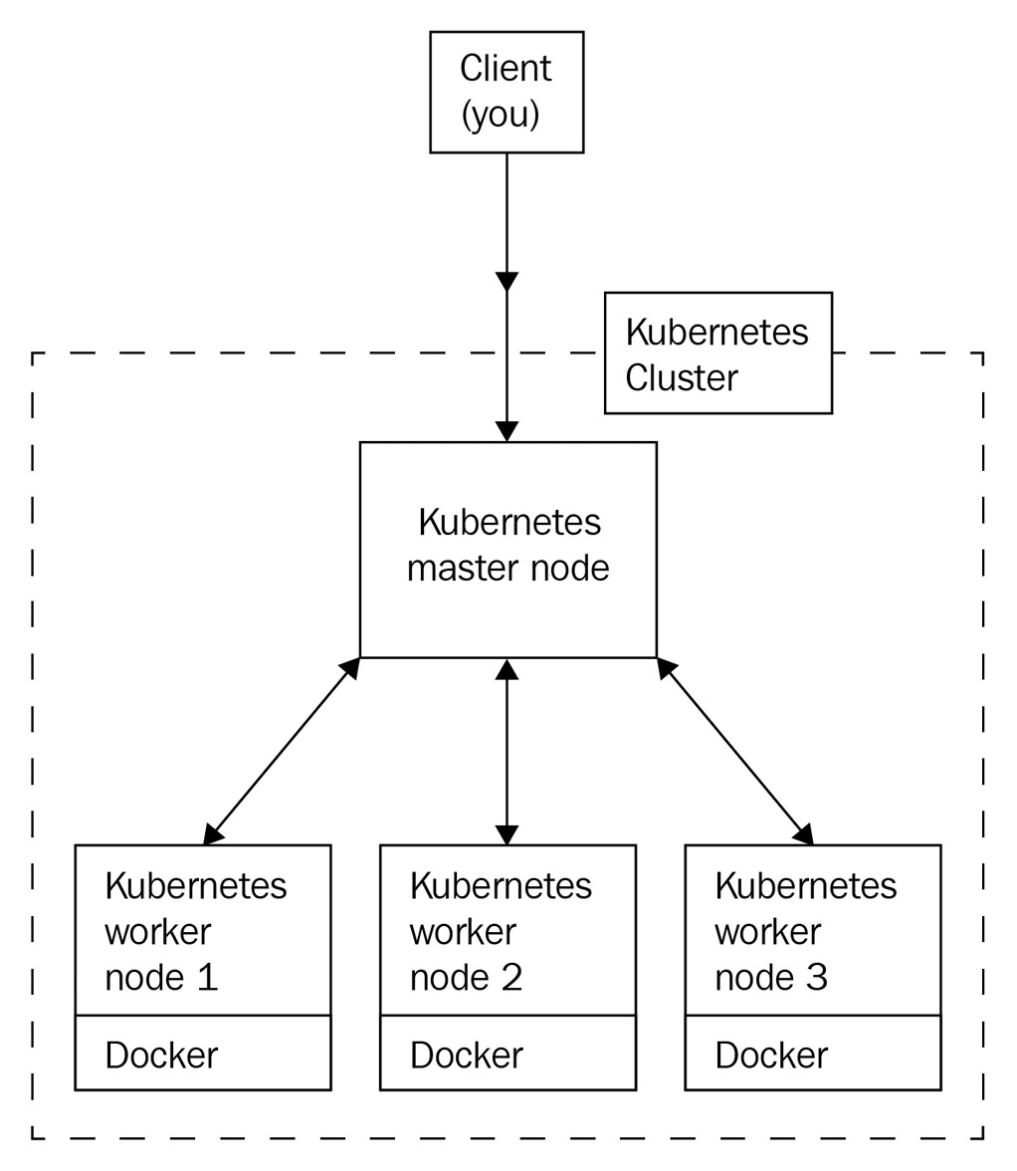
Figure 2.2 – A full-featured Kubernetes cluster with one master node and three worker nodes
The preceding diagram displays a 4-node Kubernetes cluster with all of the necessary components. As you can see, there are quite a few components.
The following is a table that lists all of the Kubernetes components that we will discuss in this chapter. In addition to all of these components, we will also examine the kubectl client that will allow you to interact with your Kubernetes clusters:
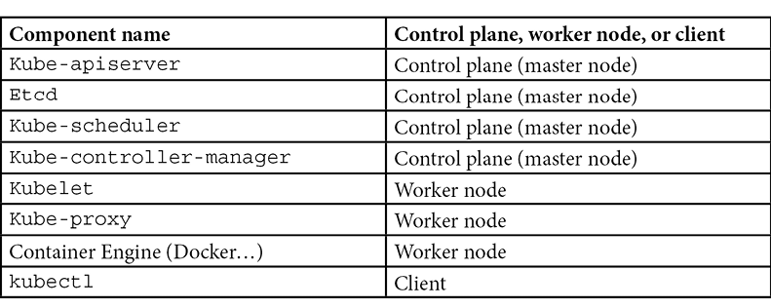
Bear in mind that Kubernetes is modified and, therefore, can be modified to fit a given environment. When Kubernetes is deployed and used as part of a distribution such as Amazon EKS or Red Hat Openshift, additional components could be present, or the behavior of the default ones might differ. In this book, for the most part, we will discuss bare Kubernetes. The components discussed in this chapter, and which are listed here, are the default ones. You will find them everywhere; they are the backbone of Kubernetes.
You might have noticed that the majority of these components have a name starting with Kube: these are the components that are part of the Kubernetes project. Additionally, you might have noticed that there are two components with a name that does not start with Kube. The other two (Etcd and Container Engine) components are two external dependencies that are not strictly part of the Kubernetes project, but which Kubernetes needs in order to work:
Etcd is a third-party database used by the Kubernetes project. Don't worry; you won't have to master it in order to use Kubernetes.
The container runtime is also a third-party engine. For us, it's going to be Docker because Kubernetes forcibly needs to manage something.
Rest assured, you will not have to install and configure these components all by yourself. Almost no one bothers with managing the components by themselves, and, in fact, it's super easy to get a working Kubernetes without having to install the components.
For development purposes, you can use Minikube, which will install all of the Kubernetes components on your local machine and run them as a single virtual machine. This is absolutely NOT recommended for production, but it is incredibly useful for development and tests.
For production purposes, you can use a cloud offering such as Amazon EKS or Google GKE. This will give you a production-grade Kubernetes cluster that is fully integrated with your preferred cloud provider along with all of the scaling mechanics that you are already familiar with. If you don't have access to such platforms, you can use Kubeadm. This is a Kubernetes installation utility that is capable of installing and configuring all Kubernetes components with just one command.
For educational purposes, you can install them, one by one, from scratch. A very famous tutorial, called Kubernetes the Hard Way, is available on the internet. It teaches you how to install and configure the components of Kubernetes from scratch. From public key infrastructure (PKI) management to networking and computing provisioning, this tutorial teaches you how to install Kubernetes on bare Linux machines in Google Cloud. Do not try to follow this tutorial if you are still new to Kubernetes as it's quite advanced.
You will observe many references to this tutorial on the internet because it's very famous. Bear in mind that installing, securing, configuring, and managing a production-grade Kubernetes cluster is time-consuming and not easy at all. You should avoid using the result of the Kubernetes the Hard Way tutorial in production.

The kube-apiserver component
Kubernetes' most important component is a REST API called kube-apiserver, Essentially, this is an API that exposes all Kubernetes features. You interact with Kubernetes by calling this REST API through the kubectl command-line tool.

The role of kube-apiserver
This is a component that is part of the control plane, meaning it's something to install and run on a master node. The kube-apiserver component is so important in Kubernetes that, sometimes, people believe it is Kubernetes itself. However, it's not. kube-apiserver is simply one component of the orchestrator. It's the most important, yes, but it's just one of them.
It's implemented in Go. Its code is open source, under the Apache 2.0 license, and you can find it hosted on GitHub.
When working with Kubernetes, the workflow is simple. When you want to give an instruction to Kubernetes, you will always have to send an HTTP request to kube-apiserver. When you want to tell Kubernetes to create, delete, or update a container, you should always do so by calling the correct kube-apiserver endpoint with the correct HTTP verb. This is how we will work all of the time with Kubernetes; kube-apiserver is the single entry point for all operations issued to the orchestrator. This best practice consists of never having to interact with one of the Docker daemons by yourself. You do run containers by sending instructions to the kube-apiserver component through the HTTP(S) protocol, and you let the Kubernetes components update the state of the Docker daemons for you.
Let's update the previous architecture diagram to make it a little more accurate with what happens in the real world:
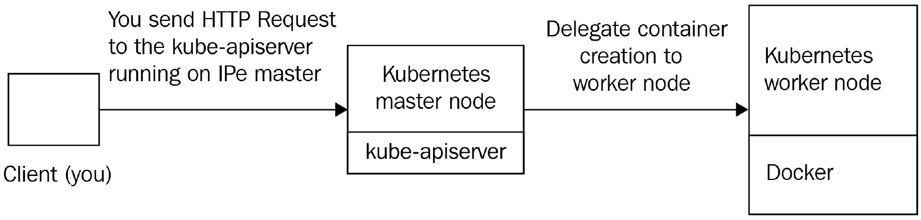
Figure 2.3 – When interacting with Kubernetes, you are actually issuing HTTP requests to a kube-apiserver component running on a master node; that's the only component you will interact with directly
The kube-apiserver component is built according to the REST standard. REST is very effective at exposing features via HTTP endpoints that you can request through the various methods of the HTTP protocol (for example, GET, POST, PUT, PATCH, and DELETE). To illustrate this, consider a dummy API that is managing users. You would have a path called /users. By sending HTTP requests to this /users path, you can command different operations against the users resource:
The following request will retrieve a list of all the users on an API running on localhost:
GET https://127.0.0.1/users
This request would delete the users with an ID of 1 on an API running on my.api.com:
DELETE https://my.api.com/users/1
POST https://127.0.0.1:8080/users
As you might have gathered, the REST standard relies entirely on the HTTP protocol. By combining HTTP methods and paths, you can run different operations defined by the method, against resources defined by the path.
Additionally, the REST standard brings a lot of flexibility. Because adding new resources means adding new paths, any REST API can be extended. To bring things to life, REST APIs generally use a datastore to maintain the state of the objects or resources they are managing. With our dummy API, it could, for example, use a MySQL database and a users table to keep the users created by calling the API in the long term.
There are two ways in which such an API can enable data retention:
The REST API keeps its data in its own memory:
This could work; however, in this case, the API is stateful and impossible to scale.
By using a full-featured database engine such as MariaDB or PostgreSQL:
This is the go-to way; delegating the storage to a third-party engine on another host makes the API stateless. In this scenario, the API is scalable horizontally; you can add a lot of instances of your API as long as they can retrieve the state in the common database.
Any REST API can be easily upgraded or extended to do more than its initial intent. To sum up, here are the essential properties of a REST API:
It relies on the HTTP protocol.
It defines a set of resources identified by URL paths.
It defines a set of actions identified by HTTP methods.
It can run actions against resources based on a properly forged HTTP request.
It keeps the state of their resources on a datastore.
Just like this dummy users API, kube-apiserver is nothing more than a REST API, which is at the heart of any Kubernetes cluster you will set up, no matter if it's local, on the cloud, or on-premises. It is also stateless; that is, it keeps the state of the resources by relying on a database engine called Etcd. This means you can horizontally scale the kube-apiserver component by deploying it onto multiple machines and load balance request issues to it using a layer 7 load balancer without losing data.
Important Note
By default, HTTP servers listen to port 80, whereas HTTPS services listen to port 443. This is not the case with kube-apiserver. By default, the port it listens to is port 6443. However, this configuration data can be overridden.
Because HTTP is supported almost everywhere, it is very easy to communicate with and issue instructions to a Kubernetes cluster. However, most of the time, we interact with Kubernetes thanks to a command-line utility named kubectl, which is the HTTP client that is officially supported as part of the Kubernetes project. This book will also focus on how to communicate with the API server through the use of the kubectl command-line tool. In this chapter, we will explore this tool, too.
When you download kube-apiserver, you'll end up with a Go-compiled binary that is ready to be executed on any Linux machine. The Kubernetes developers defined a set of resources for us that are directly bundled within the binary. These resources are the ones that Kubernetes manages. Unlike the dummy users API mentioned earlier, Kubernetes does not describe a Users resource. This is simply because Kubernetes was not meant to manage users but containers. So, do expect that all of the resources you will find in kube-apiserver are related to container management, networking, and computing in general.
Let's name a few of these resources, as follows:
Pod
ReplicaSet
PersistentVolume
NetworkPolicy
Deployment
Of course, this list of resources is not exhaustive. If you want a full list of the Kubernetes components, you can access it from the official Kubernetes documentation API reference page at https://kubernetes.io/docs/reference/generated/kubernetes-api/v1.18/.
You might be wondering why there are no Containers resources here. As mentioned in Chapter 1, Kubernetes Fundamentals, Kubernetes makes use of a resource called a pod to manage the containers. For now, you can think of pods as though they were containers. We will learn a lot about them in the coming chapters. Each of these resources is associated with a dedicated URL path, and just as we witnessed earlier, changing the HTTP method when calling the URL path will have a different effect. All of these behaviors are defined in kube-apiserver; note that these behaviors are not something you have to develop, they are directly implemented as part of the kube-apiserver.
After the Kubernetes objects are stored on the Etcd database, other Kubernetes components will convert these objects into raw Docker instructions. This way, multiple Docker daemon can mirror the state of the cluster as it is stored in the Etcd datastore and described by kube-apiserver.
Another important point to bear in mind is that kube-apiserver is the single entry point and the single source of truth for the whole cluster. Everything in Kubernetes has been designed to revolve around kube-apiserver. You'll see that other Kubernetes components also have to read or change the state of the cluster: even they will do so by calling kube-apiserver through HTTP and never directly. As an administrator, aside from very rare occasions, you must never interact directly with the other components of the cluster. So, ensure you refrain from using SSH to sign in to a machine that is part of the cluster and start doing things manually.
The is because kube-apiserver does not just manage the state of the cluster, it also has tons of different mechanisms related to authentication, authorization, and HTTP response formatting. That's why doing things manually is really bad.

How do you install kube-apiserver?
In Chapter 3, Installing Your First Kubernetes Cluster, we will focus on how to install and configure a Kubernetes cluster locally. However, I would like you to know that all of the components of Kubernetes are available to download for free from Google's servers. You can download a specific version of kube-apiserver, along with any component of Kubernetes, using a simple wget command:
$ wget -q --show-progress --https-only –timestamping \
https://storage.googleapis.com/kubernetes-release/release/v1.14.0/bin/linux/amd64/kube-apiserver
By calling this command, you will get the official build of kube-apiserver in version 1.14. However, running this binary won't be enough to have a fully working Kubernetes cluster. This is because, again, Kubernetes is not just the kube-apiserver component. You will require the other components of Kubernetes to make it work.
If you are wondering how to run kube-apiserver, essentially, there are two ways to proceed:
From a Docker image on a worker node
From a systemd unit file on a dedicated master node
Let's put aside the Docker method because it's a little bit more advanced. Instead, let's explain the simpler solution and run it as a systemd service. Essentially, systemd is a daemon management tool that is available by default on Linux and will be helpful to run kube-apiserver. I don't recommend you do that as it's going to be useless, but let me show you how easy it is to run a Kubernetes component on Linux thanks to systemd:
We need to create a file at the following path: /etc/systemd/system/kube-apiserver.service.
We need to put the following content inside the file. Essentially, this systemd unit file executes the kube-apiserver binary that was downloaded earlier with some arguments to configure it.
Once the unit file has been created, reload the systemd daemon, enable the new service, and start it using the following commands:
$ systemctl daemon-reload
$ systemctl enable kube-apiserver
$ systemctl start kube-apiserver
Ensure that the following file exists in the directory with the following content. As you might have gathered, it's just a basic systemd unit file, /etc/systemd/system/kube-apiserver.service:
[Unit]
Description=Kubernetes API Server
Documentation=https://github.com/kubernetes/kubernetes
[Service]
ExecStart=/usr/local/bin/kube-apiserver
--advertise-address=${INTERNAL_IP}
--allow-privileged=true
--apiserver-count=3
--audit-log-path=/var/log/audit.log
--authorization-mode=Node,RBAC
--bind-address=0.0.0.0
--client-ca-file=/var/lib/kubernetes/ca.pem
--enable-admission-plugins=NamespaceLifecycle,NodeRestriction,LimitRanger,ServiceAccount,DefaultStorageClass,ResourceQuota
--etcd-cafile=/var/lib/kubernetes/ca.pem
--etcd-certfile=/var/lib/kubernetes/kubernetes.pem
--etcd-keyfile=/var/lib/kubernetes/kubernetes-key.pem
--etcd-servers=https://10.240.0.10:2379,https://10.240.0.11:2379,https://10.240.0.12:2379
--encryption-provider-config=/var/lib/kubernetes/encryption-config.yaml
--kubelet-certificate-authority=/var/lib/kubernetes/ca.pem
--kubelet-client-certificate=/var/lib/kubernetes/kubernetes.pem
--kubelet-client-key=/var/lib/kubernetes/kubernetes-key.pem
--kubelet-https=true \\
--runtime-config=api/all \\
--service-account-key-file=/var/lib/kubernetes/service-account.pem \\
--service-cluster-ip-range=10.32.0.0/24
--service-node-port-range=30000-32767
--tls-cert-file=/var/lib/kubernetes/kubernetes.pem
--tls-private-key-file=/var/lib/kubernetes/kubernetes-key.pem
--v=2
Restart=on-failure
RestartSec=5
[Install]
WantedBy=multi-user.target
Don't attempt to run this example by yourself, as there are some missing parts for now. In the next chapter, we are going to set up a local Kubernetes, but at least now you know that it is easy to launch Kubernetes components as systemd: in the end, they are plain old Linux-compiled binaries.

Where do you install kube-apiserver?
Cloud services such as Amazon EKS or Google GKE, or other similar cloud offerings, will install and configure all the components of Kubernetes properly and expose you to a Kubernetes endpoint (or, if you prefer, the kube-apiserver endpoint) without giving you too much information regarding the underlying machines or load balancers provisioned. The following is a screenshot of a Kubernetes cluster that was created on the Amazon EKS service:
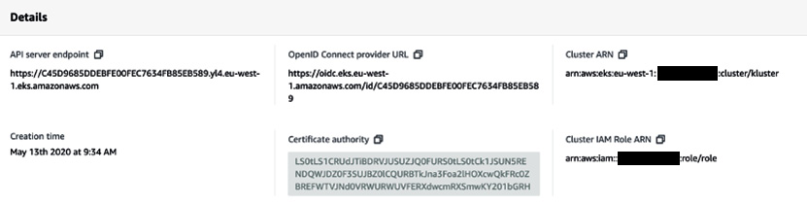
Figure 2.4 – The UI console showing details of a Kubernetes cluster provisioned on Amazon EKS
Note that the kube-apiserver component should be installed on a sufficiently powerful machine dedicated to its execution. Indeed, it is a very sensitive component. If your kube-apiserver component becomes inaccessible, your Docker containers will continue to run, but you won't be able to interact with them through Kubernetes. Instead, they become "orphan" containers running on isolated machines that are no longer managed by a Kubernetes cluster.
You want to avoid this situation; that's why you should pay special attention to your kube-apiserver instance(s).
In addition to this, be aware that the other Kubernetes components, as we'll discover a little later, constantly send HTTP requests to kube-apiserver in order to understand the state of the cluster or to update it. Because these components need to know the state of the cluster at any moment, they are running a lot of HTTP requests against the kube-apiserver component. And the more worker nodes you have, the more HTTP requests that will be issued against kube-apiserver. That's why kube-apiserver should be independently scaled as the cluster itself scales out.
As mentioned earlier, kube-apiserver is a stateless component that does not directly maintain the state of the Kubernetes cluster itself and relies on a third-party database to do so. You can scale it horizontally by hosting it on group of machines that are behind a load balancer such as an HTTP API. When using such a setup, you interact with kube-apiserver by calling your load balancer endpoint.
We have mentioned a lot of things about kube-apiserver. Now, let's take a look at the kubectl client. This is the official HTTP client that will allow you to interact with Kubernetes, or more exactly, with the kube-apiserver component of your Kubernetes cluster.

Exploring the kubectl command-line tool and YAML syntax
kubectl is the official command-line tool used by Kubernetes. You must install it on your local machine; we will learn how to install it properly in the next chapter. For now, we need to understand its role. This is an HTTP client that is fully optimized to interact with Kubernetes and allows you to issue commands to your Kubernetes cluster. You can install it right now since you are going to need it in the coming chapters:
In Linux, use the following commands:
$ curl -LO https://storage.googleapis.com/kubernetes-release/release/v1.14.10/bin/linux/amd64/kubectl
$ chmod +x ./kubectl
$ sudo mv ./kubectl /usr/local/bin/kubectl
$ kubectl version # Should output kubectl version
On macOS, use the following commands:
$ curl -LO https://storage.googleapis.com/kubernetes-release/release/v1.14.10/bin/darwin/amd64/kubectl
$ chmod +x ./kubectl
$ sudo mv ./kubectl /usr/local/bin/kubectl
$ kubectl version # Should output kubectl version
In Windows, use the following commands
curl -LO https://storage.googleapis.com/kubernetes-release/release/v1.14.10/bin/windows/amd64/kubectl.exe
kubectl version # Should output kubectl version
This last example for Windows users requires you to add kubectl.exe to your PATH variable before being able to call kubectl.

The role of kubectl
Since kube-apiserver is nothing more than an HTTP API, any HTTP client will work to interact with a Kubernetes cluster. You can even use CURL to manage your Kubernetes cluster, but of course, there is a better way to do that.
The developers of Kubernetes have developed a client for the kube-apiserver component. This client comes in the form of a command-line tool called kubectl. So, why would you want to use such a client and not go directly with CURL calls? Well, the reason is simplicity. Indeed, kube-apiserver manages a lot of different resources and each of them has its own URL path.
Calling kube-apiserver constantly through CURL would be possible but extremely time-consuming. This is because remembering the path of each resource, and how to call it is not user-friendly. Essentially, CURL is not the way to go since kubectl also manages different aspects related to authentication against Kubernetes authentication layer, managing cluster contexts and more.
You would have to go to the documentation all of the time to remember which URL path, HTTP header, or query string. kubectl will do that for you by letting you call kube-apiserver through commands that are easy to remember, secure, and entirely dedicated to Kubernetes management.
When you call kubectl, it reads the parameters you pass to it, and based on them, will forge and issue HTTP requests to the kube-apiserver component of your Kubernetes cluster:
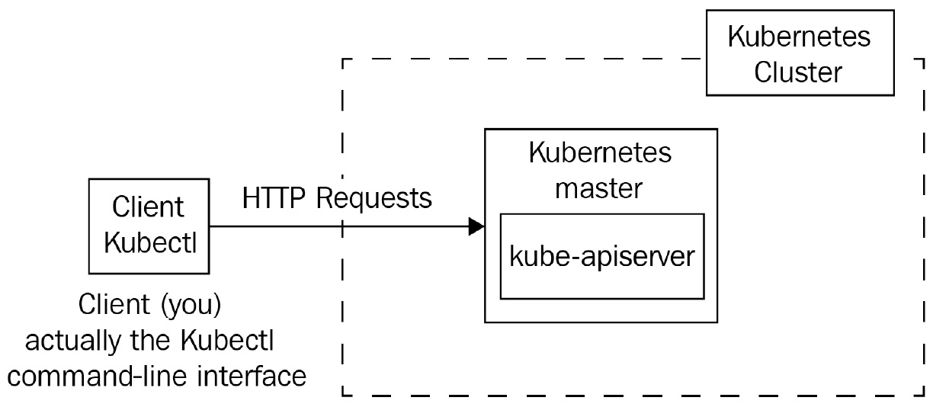
Figure 2.5 – The kubectl command line will call kube-apiserver with the HTTP protocol; you'll interact with your Kubernetes cluster through kubectl all of the time
This is the general workflow with Kubernetes: you will always interact with Kubernetes through kubectl. Once the kube-apiserver component receives a valid HTTP request coming from you, it will read or update the state of the cluster in Etcd based on the request you submitted. If it's a write operation, for example, to update the image of a running container, kube-apiserver will update the state of the cluster in Etcd. Then, the components running on the worker node where the said container is being hosted will issue the proper Docker commands in which to launch a new container based on the new image. This is so that the actual state of the Docker daemons always reflects what's in Etcd.
Given that you won't have to interact with Docker yourself, or with Etcd, we can say that the mastery of Kubernetes is largely based on your knowledge of the kubectl commands. To be effective with Kubernetes, you must master kubectl because it is the command that you will type constantly. You won't have to interact with any other components than kube-apiserver and the kubectl command-line tool that allows you to call it.
kubectl is available to download for free directly from Google's servers. This is an Apache 2.0 licensed project that is officially part of the Kubernetes project. Its source code is available on GitHub at https://github.com/kubernetes/kubectl.
Important Note
Since the kube-apiserver component is accessible through the HTTP(S) protocol, you could interact with any Kubernetes cluster with any HTTP-based library and even programmatically through your favorite programming language. Tons of kubectl alternatives exist. However, kubectl, being the official tool of the Kubernetes project, is the tool you'll systematically see in action in the documentation, and most of the examples you will find use kubectl.

How does kubectl work?
When you call the kubectl command, it will try to read a configuration file that must be created in $HOME/.kube/config. This configuration file is called kubeconfig.
All of the information, such as the kube-apiserver endpoint, its port, and the client certificate used to authenticate against kube-apiserver, must be written in this file. Its path can be overridden on your system by setting an environment variable, called KUBECONFIG, or by using the --kubeconfig parameter when calling kubectl:
$ export KUBECONFIG="/custom/path/.kube/config"
$ kubectl --kubeconfig="/custom/path/.kube/config"
Each time you run a kubectl command, the kubectl command-line tool will look for a kubeconfig file in which to load its configuration in the following order:
First, it checks whether the --kubeconfig parameter has been passed and loads the config file.
At that point, if no kubeconfig file is found, kubectl looks for the KUBECONFIG environment variable.
Ultimately, it falls back to the default one in $HOME/.kube/config.
To view the config file currently used by your local kubectl installation, you can run this command:
$ kubectl config view
The kubeconfig file contains different information about the Kubernetes cluster it communicates with. That information includes the URL of kube-apiserver, the configured user for authenticating against the said kube-apiserver, and more. The role of the kubectl tool is to forge an HTTP request based on the arguments you pass to the kubectl command and to execute it against the cluster specified on its loaded kubeconfig file. Then, the HTTP request is actually sent to kube-apiserver, which produces an HTTP response that kubectl will reformat in a human-readable format and output to your Terminal.
The following command is probably one that you'll type almost every day when working with Kubernetes:
$ kubectl get pods
This command lists the Pods. Essentially, it will issue a GET request to kube-apiserver to retrieve the list of containers (pods) on your cluster. Internally, kubectl associates the pods parameter passed to the command to the /api/v1/pods URL path, which is the path that kube-apiserver uses to expose the pod resource.
Here is another command:
$ kubectl run nginx --restart Never --image nginx
This one is slightly trickier because run is not an HTTP method. In fact, this command will issue a POST request against the kube-apiserver component, which will result in the creation of a container called nginx, based on the nginx image hosted on Docker Hub.
Important Note
In fact, this command won't create a container but a Pod. We will discuss the pod resource extensively in Chapter 4, Running Your Docker Containers. Let's try not to talk about containers anymore; instead, let's move on to pods and familiarize ourselves with Kubernetes concepts and wordings. From now on, if you come across the word container, it means a real container from a Docker perspective. Additionally, pods refer to the Kubernetes resource.

The YAML syntax
kubectl supports two kinds of syntaxes:
The imperative syntax
The declarative syntax
Almost every instruction that you send to kube-apiserver through kubectl can be written using one of these two forms.
Essentially, the imperative form runs kubectl commands on a shell session. By passing in correct sub-commands and arguments, you can forge instructions for the kube-apiserver component. Let me give you a few examples of the imperative syntax. All of the following commands, once executed, issue HTTP requests against a given kube-apiserver endpoint:
This command creates a pod, called my-pod, based on the busybox:latest Docker image:
$ kubectl run my-pod --restart Never --image busybox:latest
This command lists all the ReplicaSet resources in the my-namespace namespace created on the Kubernetes cluster:
$ kubectl get rs -n my-namespace
This command deletes a pod, called my-pod, in the default namespace:
$ kubectl delete pods my-pod
Imperative syntax has multiple benefits. If you already understand what kind of instructions to send to Kubernetes and the proper command to achieve this, you are going to be incredibly fast. The imperative syntax is easy to type, and you can do a lot with just a few commands. Some operations are only accessible with imperative syntax, too. For example, listing existing resources in the cluster is only possible with the imperative syntax.
However, the imperative syntax has a big problem. It is very complicated having to keep records of what you did previously in the cluster. If for some reason, you were to lose the state of your cluster and need to recreate it from scratch, it's going to be incredibly hard to remember all of the imperative commands that you typed in earlier to bring your cluster back to the state you want. You could read your .bash_history file but of course, there is a better way to do this.
So, let's move on to declarative syntax now. The declarative syntax is about writing a JSON or YAML file on disk first and then applying it against the cluster using the kubectl command line. Both JSON and YAML formats are supported; however, by convention, Kubernetes users prefer YAML syntax because of its simplicity. YAML is not a programming language. There is no real logic behind it. It's simply a kind of key:value configuration syntax that is used by a lot of projects nowadays, and Kubernetes is one of them.
Using kubectl in the declarative way requires you to create a file on your disk and to write some key:value pairs, in YAML format, inside of it. Each key:value pair represents the configuration data that you want to set to the Kubernetes resource you want to create.
The following is the imperative command that created the pod named my-pod using the busybox:latest Docker image we used earlier:
$ kubectl run my-pod --restart Never --image busybox:latest
We will now do the same but with the declarative syntax instead:
apiVersion: v1
kind: Pod
metadata:
name: my-pod
spec:
containers:
- name: busybox-container
image: busybox:latest
Let's say this file is saved on disk with the name of pod.yaml. To create the actual pod, you'll need to run the following command:
$ kubectl create -f pod.yaml
This result will be the equivalent of the previous command.
Each YAML file that is created for Kubernetes must contain four mandatory keys:
apiVersion:
This field tells you in which API version the resource is declared. Each resource type has an apiVersion key that must be set in this field. The pod resource type is in API version v1.
Kind:
This Kind field indicated the resource type the YAML file will create. Here, it is a pod that is going to be created.
Metadata:
This field tells Kubernetes about the name of the actual resource. Here, the pod is named my-pod. This field describes the Kubernetes resource, not the Docker one. This metadata is for Kubernetes, not for Docker.
Spec:
This field tells Kubernetes what the object is made of. In the preceding example, the pod is made of one container that will be named busybox-container based on the busybox:latest image. These are the containers that are going to be created on Docker.
Another important aspect of the declarative syntax is that it enables you to declare multiple resources in the same file using three dashes as a separator between the resources. Here is a revised version of the YAML file, which will create two pods:
apiVersion: v1
kind: Pod
metadata:
name: my-pod
spec:
containers:
- name: busybox-container
image: busybox:latest
---
apiVersion: v1
kind: Pod
metadata:
name: my-second-pod
spec:
containers:
- name: nginx-container
image: nginx:latest
You should be able to read this file by yourself and understand it; it just creates two pods. The first one uses the busybox image, and the second one uses the nginx image.
Of course, you don't have to memorize all of the syntaxes and what value to set for each key. It would be useless for you, so just use copy and paste from the documentation when needed.
The declarative syntax offers a lot of benefits, too. With it, you'll be slower because writing these YAML files is a lot more time-consuming than just issuing a command in the imperative way. However, it offers two major benefits:
Infrastructure as Code (IaC) management:
You'll be able to keep the configuration stored somewhere and use Git to version your Kubernetes resources, just as you would do with IaC. If you were to lose the state of your cluster, keeping the YAML files versioned in Git will enable you to recreate it in a clean and effective manner.
Create multiple resources at the same time:
Since you can declare multiple resources in the same YAML file, you can have entire applications and all of their dependencies in the same place. Additionally, you get to create and recreate complex applications with just one command. Later, you'll discover a tool called Helm that can achieve templating on top of the Kubernetes YAML files. Thanks to this tool, it's going to be easier to manage resources through YAML files.
There is no better way to use kubectl; these are just two ways to interact with it, and you need to master both. This is because some features are not available with the imperative syntax, while some others are not available with the declarative syntax. For example, you cannot create a multi-container pod from the imperative syntax, and you cannot list running pods from the declarative syntax. That's why you need to master both.
Remember that, in the end, both call the kube-apiserver component by using the HTTP protocol.

kubectl should be installed on any machine that needs to interact with the cluster
From a technical point of view, you must install and configure a kubectl runtime whenever and wherever you want to interact with a Kubernetes cluster.
Of course, it should be on your local machine, since this is where you are going to work with Kubernetes because you have to be able to communicate with your cluster from your own workstation. However, in larger projects, it's also a good idea to install kubectl in the agents/runner of your continuous integration platform.
Indeed, you will probably want to automate maintenance or deployment tasks to run against your Kubernetes cluster, and you will probably use a continuous integration (CI) platform such as GitLab CI or Jenkins to do that.
If you want to be able to run Kubernetes commands in a CI pipeline, you will need to install kubectl on your CI agents and have a properly configured kubeconfig file written on the CI agent filesystem. This way, your CI/CD pipelines will be able to issue commands against your Kubernetes cluster and update the state of your cluster, too.
Just to add, kubectl should not be seen as a Kubernetes client for human users only. It should be viewed as a generic tool to communicate with Kubernetes: install it wherever you want to communicate with your cluster.
Remember that the golden rule is very simple: you never do anything in Kubernetes without going through kubectl. It doesn't matter if it's made by you as a human administrator or as part of an automation script: make use of kubectl.

The Etcd datastore
We explained that kube-apiserver is a stateless API that can be scaled horizontally. However, it is necessary for kube-apiserver to store the state of the cluster somewhere, such as the number of containers created, on which machines, the names of the pods, which Docker images they use, and more. To achieve that, it uses the Etcd database.

The role of the Etcd datastore
Etcd is part of the control plane. The kube-apiserver component relies on a distributed NoSQL database called Etcd. Strictly speaking, Etcd is not a component of the Kubernetes project. As you might have gathered, Etcd is not named according to the same nomenclature as the other components (kube*). This is because Etcd is not actually a Kubernetes project but a project completely independent of Kubernetes.
Instead of using a full-featured relational database such as MySQL or PostgreSQL, Kubernetes relies on this NoSQL distributed datastore called Etcd to store its state persistently. Etcd can be used independently on any project, but Kubernetes cannot work without Etcd. This is something that you have to understand: Kubernetes has an external dependence. Instead of rewriting a database engine from scratch, Kubernetes developers decided to use Etcd. The good news is that Etcd is an open source project too, which is available on GitHub under license Apache 2.0, written in Go (just like Kubernetes). You can locate it at https://github.com/etcd-io/etcd. It's also a project incubated by the Cloud Native Computing Foundation (CNCF), which is the organization that maintains Kubernetes.
Important Note
Don't expect to be able to use another database engine with Kubernetes. It is not possible to replace Etcd with MySQL or another datastore. Kubernetes was really built to rely specifically on Etcd.
So, to sum up, Etcd is the database that Kubernetes uses to keep its state. When you call the kube-apiserver, each time you implement a read or write operation by calling the Kubernetes API, you will read or write data from or to Etcd. So, this is the main memory of your Kubernetes cluster, and the kube-apiserver can be seen as a proxy in front of Etcd.
Let's zoom into what is inside the master node:
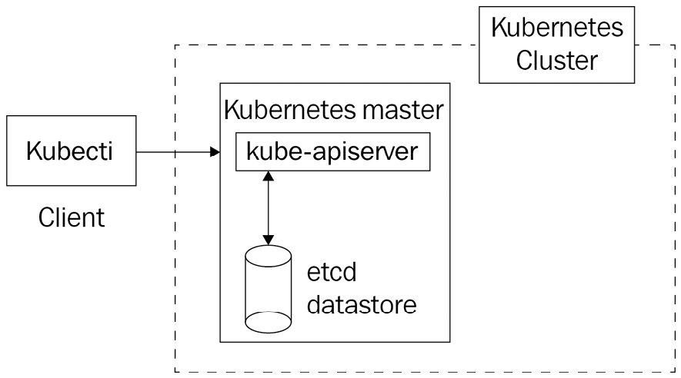
Figure 2.6 – The kube-apiserver component is in front of the Etcd datasore and acts as a proxy in front of it; kube-apiserver is the only component that can read or write from and to etcd
Etcd is the most sensitive point of your cluster. This is because if you were to lose the data inside it, your Kubernetes cluster would become completely unusable. It's even more sensitive than the kube-apiserver component. The reason is simple; after all, if kube-apiserver crashes, you can still relaunch it. However, if you lose the data in your Etcd datastore, or it somehow gets corrupted, and you don't have a backup to restore it, your Kubernetes cluster is dead.
Fortunately, you do not need to master Etcd in depth to use Kubernetes. It is even strongly recommended that you do not touch it at all if you do not know what you are doing. This is because a bad operation could corrupt the data stored in Etcd and, therefore, the state of your cluster.
Remember, the general rule in Kubernetes architecture says that every component has to go through the kube-apiserver to read or write in Etcd. This is because, from a technical point of view, the kubectl authenticates itself against the kube-apiserver through a TLS client certificate that only the kube-apiserver has. Therefore, it is the only component of Kubernetes that has the right to read or write in Etcd. This is a very important notion in the architecture of Kubernetes. All of the other components won't be able to read or write anything to or from Etcd without calling the kube-apiserver endpoints through HTTP.
Important Note
Please note that Etcd is also designed as a REST API. By default, it listens to port 2379.
Let's go back to the command that we mentioned earlier:
$ kubectl run nginx --restart Never --image nginx
When you execute the preceding command, the kubectl tool will forge an HTTP POST request that will be executed against the kube-apiserver specified in the kubeconfig file. The kube-apiserver will write a new entry in Etcd, which will be persistently stored on disk.
At that point, the state of the Kubernetes changes: it will then be the responsibility of the other Kubernetes component to reconcile the actual state of the cluster to the desired state of the cluster (that is, the one in Etcd).
Unlike Redis or Memcached, Etcd is not in-memory storage. If you reboot your machine, you do not lose the data because it is kept on disk.

Where do you install Etcd?
As with the kube-apiserver, cloud services such as Amazon EKS or Google GKE will install and configure a pool of servers running Etcd for you, without giving you much information about the machines. They offer you a working Kubernetes cluster without letting you know too much about the underlying resources.
If you were to run an Etcd datastore on-premises, or if you intend to manage it by yourself, you should know that Etcd is part of the Kubernetes control plane and should run on a master node.
It can be run as part of a systemd unit file, just as we saw with the kube-apiserver, but also as a Docker container, too. Etcd has the ability to natively include features, allowing you to deploy them in a distributed way. Therefore, it is also natively ready to be scaled horizontally since it's capable of spreading its dataset through multiple servers: Etcd is built as a clustering solution on its own.
In general, you can decide on the following:
Install Etcd on a machine that is dedicated to it.
Group Etcd on the same machines running other control plane components.
The first solution is better because you reduce the risk of the unavailability of your cluster in the event of an outage. Having a set of machines dedicated to running Etcd also reduces any security risks.
The problem is that it will always cost more than the first solution since it involves more machines, more planning, and also more maintenance. It's fine to run Etcd on the same machines as the kube-apiserver; however, if you can afford it, don't hesitate to use dedicated machines for Etcd.

The Kubelet and worker node components
So far, we have described key Kubernetes control plane components: the kube-apiserver component and the Etcd datastore. You also know that in order to communicate with the kube-apiserver component, you have to use the kubectl command-line utility to get data to and from the Etcd datastore through the help of kube-apiserver.
However, all of this is not telling us where and how these instructions result in running containers on worker nodes. We will dedicate this part of the chapter to explain the anatomy of a worker node by explaining the three components running on it:
The container engine
The first component that should be installed on a worker node is the Docker daemon. Kubernetes is not limited to Docker; it can manage other container engines, such as rkt. However, in this book, we will be using Kubernetes with Docker, which is the most common setup.
Therefore, any Linux machine running Docker can be used as a base on which to build a Kubernetes worker node. Please note that a Kubernetes worker node can also run Docker containers that were not launched by Kubernetes. That is no problem.
The Docker daemon running on a Kubernetes worker node is a plain old Docker installation; it has nothing special compared to the one you might run on your local machine.

The Kubelet agent
As its name suggests (Kube*), the Kubelet is a component of Kubernetes, which is part of the worker node. In fact, it is the most important component of the worker node since it is the one that will interact with the local Docker daemon installed on the worker node.
The Kubelet is a daemon running on the system. It cannot run as a Docker container itself. Running it on the host system is mandatory; that's why we usually set up using systemd. The Kubelet differs from the other Kubernetes components because it is the only one that cannot run as a Docker container. The Kubelet strictly requires you to run on the host machine.
When the Kubelet gets started, by default, it reads a configuration file located at /etc/kubernetes/kubelet.conf.
This configuration specifies two values that are really important for the Kubelet to work:
The endpoint of the kube-apiserver component
The local Docker daemon UNIX socket
When the worker node launches, it will join the cluster by issuing an HTTP request against the kube-apiserver component to add a Node entry to the Etcd datastore. After that, running this kubectl command should list the new worker node:
$ kubectl get nodes
Note that kube-apiserver keeps a registry of all the worker nodes that are part of the Kubernetes cluster. You can retrieve a list of all your nodes by simply running this command.
Once the machine has joined the cluster, the Kubelet will act as a bridge between kube-apiserver and the local Docker daemon. Kubelet is constantly running HTTP requests against kube-apiserver to retrieve pods it has to launch. By default, every 20 seconds, the Kubelet runs a GET request against the kube-apiserver component to list the pods created on Etcd that are destined to it.
Once it receives a pod specification in the body of an HTTP response from kube-apiserver, it can convert this into Docker containers specification that will be executed against the specified UNIX socket. The result is the creation of your containers on your local Docker daemon.
Important note
Remember that Kubelet does not read directly from Etcd, rather it interacts with the kube-apiserver that exposes what is inside the Etcd data layer. Kubelet is not even aware that an Etcd server runs behind the kube-apiserver it polls.
These polling mechanisms, called watch mechanisms in Kubernetes terminology are precisely how Kubernetes proceeds to run and delete containers against your worker nodes at scale. Each Kubelet instance on each worker node is watching kube-apiserver to get noticed when a change occurs in the Etcd datastore. And once a change is noticed, Kubelet is capable of converting the changes into corresponding Docker instructions and communicating with the local Docker daemon using the Docker UNIX socket specified in the Kubelet configuration file. There are two things to pay attention to here:
Kubelet and the kube-apiserver must be able to communicate with each other through HTTP. That's why HTTPS port 6443 must be opened between the worker and master nodes.
Because they are both running on the same machine, Kubelet and the Docker daemon are interfaced through the usage of UNIX sockets.
Each worker node must have its own Kubelet, which means more HTTP polling against the kube-apiserver as you add more worker nodes to your cluster. If your Kubernetes cluster has hundreds of machines, it could result in a negative performance impact on the kube-apiserver. Ultimately, you can even DDoS your kube-apiserver by having too many worker nodes. That's why it's important to make the kube-apiserver and the other control plane component highly available by scaling them efficiently.
If you create Docker containers manually on a worker node, the Kubelet won't be able to manage it. You can completely bypass Kubernetes and create containers on your worker nodes without having to use the Kubelet. Running a plain old docker run command would work. Just bear in mind that the Kubelet is only capable of managing the Docker containers it created. The reason for this is that the containers won't be created as part of a pod in the Etcd datastore, and the sole job of Kubelet is that its local Docker daemon reflects the configuration that is stored in Ectd.
Important Note
Please note that the container engine running on the worker node has no clue that it is managed by Kubernetes through a local Kubelet agent. A worker node is nothing more than a Linux machine running a Docker daemon with a Kubelet agent installed next to it, executing raw Docker instructions. You can execute the same with the Docker client manually.

The kube-proxy component
This is the last of the three components running on a worker node. An important part of Kubernetes is networking. We will have to opportunity to dive into networking later; however, you need to understand that Kubernetes has tons of mechanics when it comes to exposing pods to the outside world or exposing pods to one another in the Kubernetes cluster.
These mechanics are implemented at the kube-proxy level; that is, each worker node requires an instance of a running kube-proxy so that the pods running on them are accessible. We will explore a Kubernetes feature called Service, which is implemented at the level of the kube-proxy component. Just like the Kubelet, the kube-proxy component also communicates with the kube-apiserver component.
There are also several other sub-components or extensions that are operating at the worker node level, such as cAdvisor or Container Network Interface (CNI). However, they are advanced topics that we will discuss later.

The kube-scheduler component
The kube-scheduler component is a control plane component. It should run on the master node.
This is a component that is responsible for electing a worker node out of those available to run a newly created pod.

The role of the kube-scheduler component
Similar to the Kubelet, kube-scheduler queries the kube-apiserver at regular intervals in order to list the pods that have not been scheduled. At creation, pods are not scheduled, which means that no worker node has been elected to run them. A pod that is not scheduled will be registered in Etcd but without any worker node assigned to it. Therefore, no running Kubelet will ever be aware that this pod needs to get launched, and ultimately, no container described in the pod specification will ever run.
Internally, the pod object, as it is stored in Etcd, has a property called nodeName. As the name suggests, this property should contain the name of the worker node that will host the pod. When this property is set, we say that the pod has been scheduled; otherwise, the pod is pending for schedule.
We need to find a way to fill this value, and that is the role of the kube-scheduler. To do this, the kube-scheduler poll continues the kube-apiserver at regular intervals. It searches for pod resources with an empty nodeName property. Once it finds such pods, it will execute an algorithm to elect a worker node. Then, it will update the nodeName property in the pod by issuing an HTTP request to the kube-apiserver component. While electing a worker node, the kube-scheduler component will take into account some configuration values that you can pass:
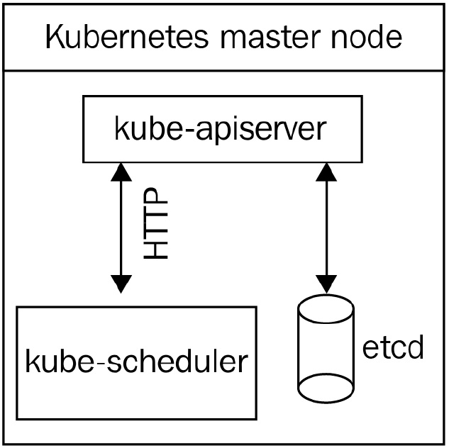
Figure 2.7 – The kube-scheduler component polls the kube-apiserver component to find unscheduled pods; it then schedules the pods by setting a nodeName property and updates the entry. Then, the pod gets launched on the proper worker node by the local Kubelet
The kube-scheduler component will take into account some configuration values that you can pass optionally. By using these configurations, you can precisely control how the kube-scheduler component will elect a worker node. Here are some of the features to bear in mind when scheduling pods on your preferred node:
Node selector
Node affinity and anti-affinity
Taint and toleration
There are also advanced techniques for scheduling that will completely bypass the kube-scheduler component. We will examine these features later.
Important Note
The kube-scheduler component can be replaced by a custom one. You can implement your own kube-scheduler component with your own custom logic to select a node and use it on your cluster. It's one of the strengths of the distributed nature of the Kubernetes components.

Where do you install kube-scheduler?
Cloud providers such as Amazon EKS and Google GKE will create a highly available installation of the kube-scheduler component without exposing you to much information regarding the underlying machines that execute it.
Since the kube-scheduler component is part of the Kubernetes control plane, you should not install it on a worker node. Again, you can choose to install kube-scheduler on a dedicated machine or the same machine as kube-apiserver. It's a short process and won't consume many resources, but there are some things to pay attention to.
The kube-scheduler component should be highly available. That's why you should install it on at least two different machines. If your cluster does not have a working kube-scheduler component, new pods won't be scheduled, and the result will be a lot of pending pods. If no kube-scheduler component is present, it won't have an impact on the already scheduled pods. However, newly created pods won't result in new containers.

The kube-controller-manager component
This is the last Kubernetes component that we will review in this chapter. We will go through it very quickly because some notions might appear too abstract to you at that point.
The kube-controller-manager component is part of the Kubernetes control plane, too. It's a binary that runs what we call the reconciliation loop . It tries to maintain the actual state of the cluster with the one described in the Etcd so that there are no differences between the states.

The role of the kube-controller-manager component
Historically, the kube-controller-manager component is a big binary that implements a lot of things. Essentially, it embeds what is called a Controller. Kubernetes developers tend to break the different controllers being executed as part of the kube-controller-manager component into multiple smaller binaries. This is because, with time, kube-controller-manager holds multiple and diverse responsibilities that are not compliant with the microservice philosophy.
Sometimes, the actual state of the cluster differs from the desired state that is stored on Etcd. The reason for this could be because of a pod failure and more. Therefore, the role of the kube-controller-manager component is to reconcile the actual state with the desired state.
For example, let's take ReplicationController, which is one of the controllers running as part of the kube-controller-manager binary.
Later, you'll observe that it's possible to tell Kubernetes to create and maintain a specific number of pods across the different worker nodes. If for some reason, the actual number of pods differs from the number you asked for, ReplicationController will start running requests against the kube-apiserver component in order to recreate a new pod in Etcd so that the failed one is replaced on a worker node.
Here is a list of the few controllers that are part of it:
NodeController
NamespaceController
EndpointsController
ServiceaccountController
As you can gather, the kube-controller-manager component is quite big. But essentially, it's a binary that is responsible for reconciling the actual state of the cluster with the desired state of the cluster that is stored in etcd.

Where do you install kube-controller-manager?
The kube-controller-manager component is part of the Kubernetes control plane. Cloud providers such as Amazon EKS or Google GKE will create and configure a kube-controller-manager component for you.
Since it's a control plane component, it should run on a master node. The kube-controller-manager component can run as a Docker container or a systemd service similarly to kube-apiserver. Additionally, you can decide to install the kube-controller-manager component on a dedicated machine.

How to make Kubernetes highly available
As you've observed earlier, Kubernetes is a clustering solution. Its distributed nature allows it to run on multiple machines. By splitting the different components across different machines, you'll be able to make your Kubernetes cluster highly available. Next, we will have a brief discussion on the different Kubernetes setups.

The single-node cluster
Installing all Kubernetes components on the same machine is the worst possible idea if you want to deploy Kubernetes in production. However, it is perfectly fine for testing your development. The single-node way consists of grouping all of the different Kubernetes components on the same host or a virtual machine:
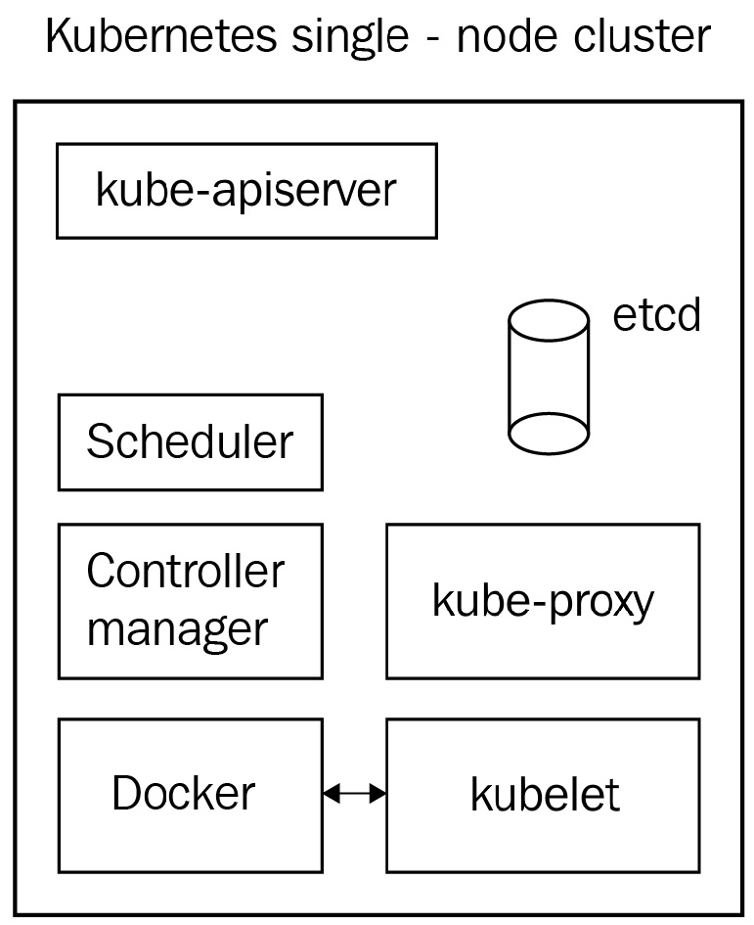
Figure 2.8 – All of the components are working on the same machine
In general, this setup is considered a good way to start your journey with Kubernetes using local testing. There is a project called Minikube that will help you set up a single-node Kubernetes on your local machine by running a virtual machine from a pre-built image with all of the components properly configured inside it. Minikube is good for testing locally, but of course, all of the features requiring multiple nodes won't be available with Minikube. Please note that it is, in fact, possible to run Minikube as a multi-node cluster but should absolutely not be used in production. However, still, it's a good way to start. Just remember to never deploy such clusters in production since it's a really terrible idea:
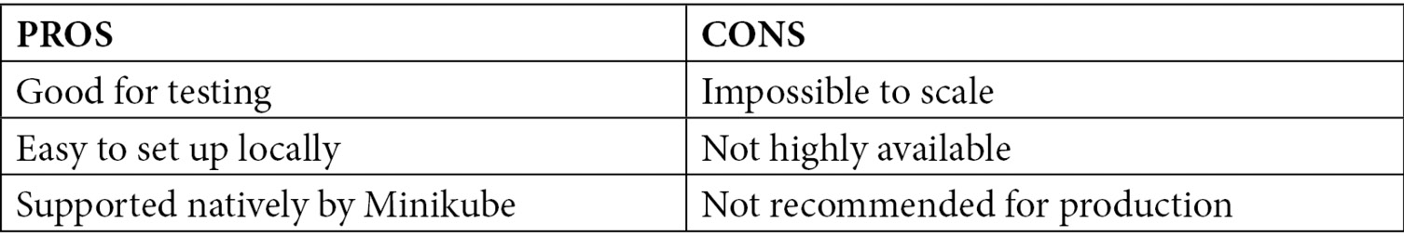
Overall, this setup is the best way to start experimenting with Kubernetes, although it prevents us from experimenting with multi-node scenarios. However, it's the worst process for production. We recommend that you do not ever deploy such a setup for a production workload.

The single-master cluster
This setup consists of having one node executing all of the control plane components with as many worker nodes as you want:
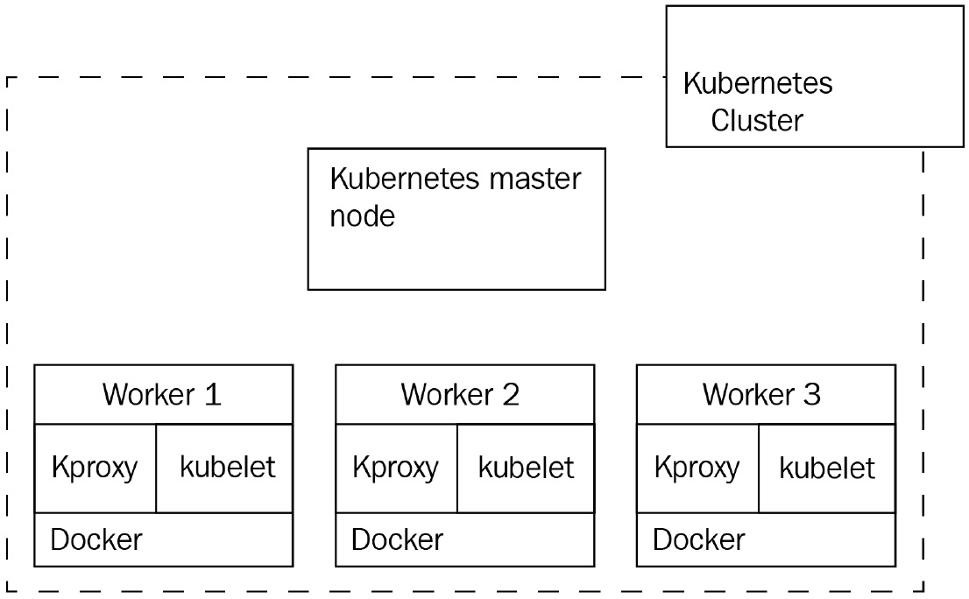
Figure 2.9 – A single master node rules all of the worker nodes (here, it is three)
This setup is quite good, and the fact that there are multiple worker nodes will enable high availability for your containerized application. However, there is still room for improvement.
There is a single point of failure since there is only one master node. If this single master node fails, you won't be able to manage your running Docker containers in a Kubernetes way anymore. Your containers will become orphans, and the only way to stop/update them would be to SSH on the worker node and run plain old Docker commands.
Also, there is a major problem here: by using a single Etcd instance, there is a huge risk that you lose your dataset if the master node gets corrupted. If this happens, your cluster will be impossible to recover.
Lastly, your cluster will encounter an issue if you start scaling your worker nodes. Each worker node brings its own Kubelet agent, and periodically, Kubelet polls the kube-apiserver every 20 seconds. If you start adding dozens of servers, you might DDoS your kube-apiserver, resulting in an outage of your control plane. Remember that your master node/control plane must be able to scale in parallel with your worker nodes:
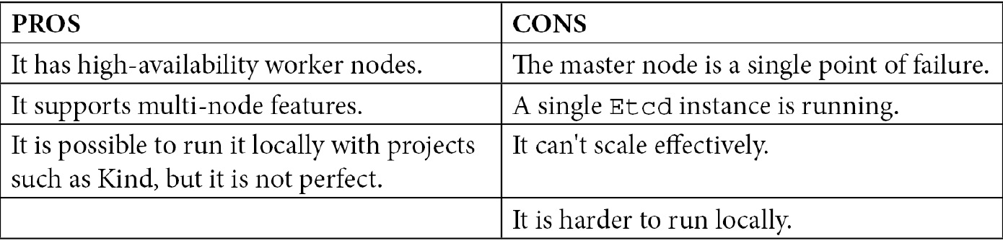
Overall, this setup will always be better than a single-node Kubernetes; however, it's still not highly available.

The multi-master multi-node cluster
This is the best way to achieve a highly available Kubernetes cluster. Both your running containers and your control plane are replicated to avoid a single point of failure.
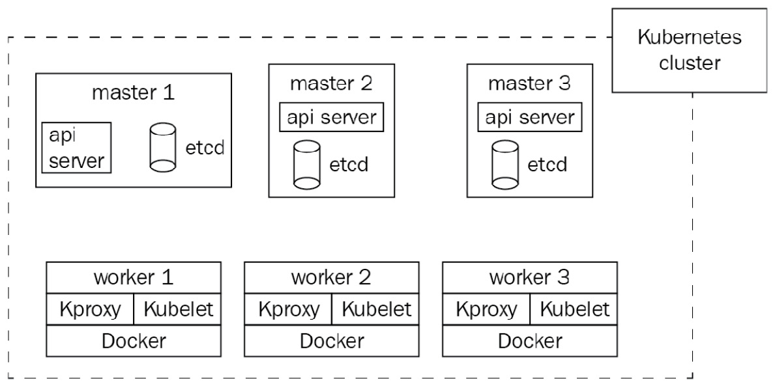
Figure 2.10 – This time, the cluster is highly available
By using such a cluster, you are eliminating all the risks because you are running multiple instances of your worker nodes and your master nodes. Both of the control plane components that are your running containers will be scalable, and since the kube-apiserver component is a stateless API, it's also ready to be scaled.
You will need a load balancer on top of your kube-apiserver instances in order to spread the load evenly between all of them, which will require a little bit more planning. Even though we don't have much information about this, it is almost certain that cloud providers such as Amazon EKS or Google GKE are provisioning Kubernetes clusters that are multi-master multi-worker clusters. If you wish to take it a step further, you can also split all of the different control plane components across a dedicated host. It's better but not mandatory, though. The cluster described in the preceding diagram is perfectly fine.
Before we end this chapter, I'd like to sum up all of the Kubernetes components. This table will help you to memorize all of their responsibilities:
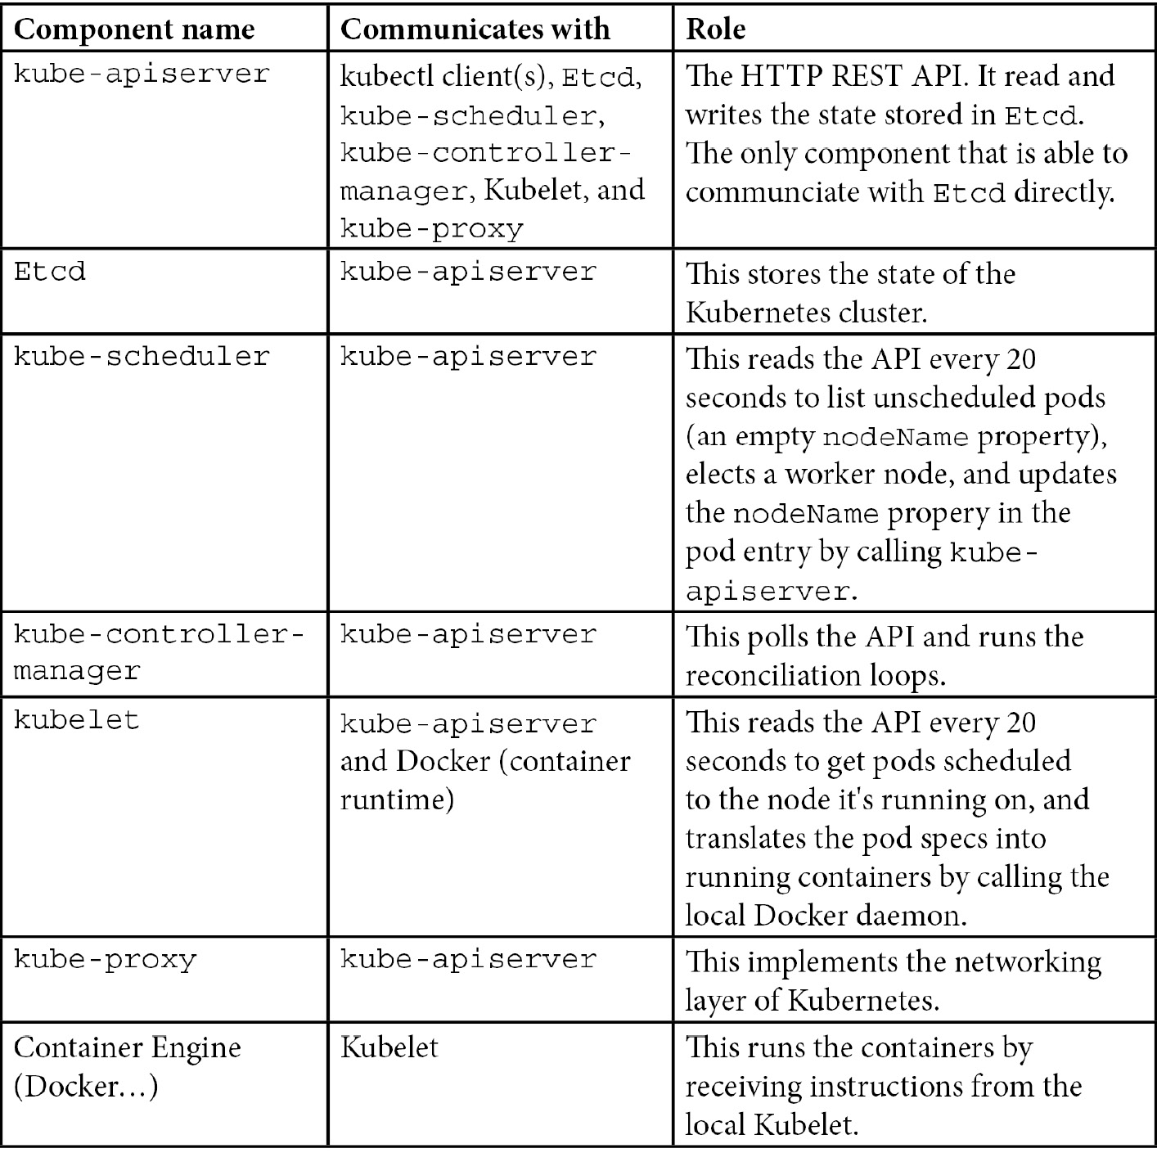
These components are the default ones and are officially supported as part of the Kubernetes project. Remember that other Kubernetes distributions might bring additional components, or they might change the behavior of these ones.
These components are the strict minimum that you need to have a working Kubernetes cluster.

Summary
This was quite a big chapter, but at least, now, you have a list of all of the Kubernetes components. Everything we will do later on will be related to these components: they are the core of Kubernetes. This chapter was full of technical details too, but it was still relatively theoretical. Don't worry if things are still not very clear to you. You will gain a better understanding through practice.
The good news is that you are now completely ready to install your first Kubernetes cluster locally and things are going to be a lot more practical from now on. It is the next step, and that's what we will do in the next chapter. After the next chapter, you'll have a running Kubernetes cluster locally on your workstation, and you will be ready to run your first pods using Kubernetes!

Chapter 3: Installing Your First Kubernetes Cluster
In the previous chapter, we had the opportunity to explain what Kubernetes is, its distributed architecture, the anatomy of a working cluster, and how it can manage your Docker containers on multiple Linux machines. Now, we are going to get our hands dirty because it's time to install Kubernetes. The main objective of this chapter is to get you a working Kubernetes for the coming chapters. This is so that you have your own cluster to work on, practice with, and learn about while reading this book.
All Kubernetes installations require two steps. First, you need to install the Kubernetes cluster itself, and second, you need to configure your kubectl HTTP client so that it can perform API calls to the kube-apiserver component installed on your master node.
Installing Kubernetes means that you have to get the different components to work together. Of course, we won't do that the hard way with systemd; instead, we will use automated tools.These tools have the benefit of launching and configuring all of the components for us locally.
If you don't want to have a Kubernetes cluster on your local machine, we're also going to set up a minimalist yet full-featured production-ready Kubernetes cluster on Google Kubernetes Engine (GKE), Amazon Elastic Kubernetes Service (EKS), and Azure Kubernetes Service (AKS). These are cloud-based and production-ready solutions. In this way, you will be able to practice and learn on a real-world Kubernetes cluster hosted on the cloud.
Whether you want to go local or on the cloud, it is your choice. You'll have to choose the one that suits you best by considering each solution's benefits and drawbacks. In both cases, however, you'll require a working Kubectl installed on your local workstation to communicate with the resulting Kubernetes cluster. Installation instructions for Kubectl are available in the previous chapter, Chapter 2, Kubernetes Architecture – From Docker Images to Running Pods.
In this chapter, we're going to cover the following main topics:
Installing a single-node cluster using Minikube
Installing a multi-node local cluster using Kind
Installing a full-featured Kubernetes cluster on GKE
Installing a full-featured Kubernetes cluster on Amazon EKS
Installing a full-featured Kubernetes cluster on AKS

Technical requirements
To follow along with the examples in this chapter, you will require the following:
Kubectl installed on your local machine
Reliable internet access
A Google Cloud Platform (GCP) account with a valid payment method to follow the Installing a full-featured Kubernetes cluster on Google GKE section
An AWS account with a valid payment method to follow the Installing a full-featured Kubernetes cluster on Amazon EKS section
An Azure account with a valid payment method to follow the Installing a full-featured Kubernetes cluster on Azure AKS section

Installing a single-node cluster with Minikube
In this section, we are going to learn how to install a local Kubernetes cluster using Minikube. It's probably the easiest way to get a working Kubernetes installation locally. By the end of this section, you're going to have a working single-node Kubernetes installation on your local machine.
Minikube is easy to use and completely free. It's going to install all of the Kubernetes components on your local machine and configure all of them. Uninstalling all of the components through Minikube is easy too, so you won't be stuck with it if, one day, you want to destroy your local cluster.
Minikube has one big advantage: it's a super useful tool in which to test Kubernetes scenarios quickly. However, its major drawback is that it prevents you from running a multi-node Kubernetes cluster and, therefore, all of the multi-node scenarios we will discuss later won't be testable for you. That being said, if you do not wish to use Minkube, you can completely skip this section and choose another method described in this chapter.

Launching a single-node Kubernetes cluster using Minikube
The main purpose of Minikube is to launch the Kubernetes components on your local system and have them communicate with each other. To do this, Minikube can work with two different methods:
A virtual machine
A Docker container
The first method requires you to install a hypervisor on top of your local system. Then, Minikube will wrap all of the Kubernetes components onto a virtual machine that will be launched. This method is fine, but it requires you to install a hypervisor such as KVM on Linux or HyperKit on macOS to work.
The other method is simpler. Instead of using a virtual machine, Minikube uses a local Docker daemon to launch the Kubernetes components inside a big Docker container. This method is simpler since you just need to have Docker installed on your system. That's the solution we will use.
If you do not have Docker installed on your system, make sure that you install it following the instructions at https://docs.docker.com/get-docker/. The installation process is easy, but the steps are slightly different depending on your operating system.
After Docker has been installed, we need to install Minikube itself. Here, again, the process is slightly different depending on your operating system:
Use the following commands for Linux:
$ curl -Lo minikube https://storage.googleapis.com/minikube/releases/latest/minikube-linux-amd64
$ chmod +x minikube
$ mkdir -p /usr/local/bin
$ sudo install minikube /usr/local/bin
Use the following commands for macOS:
$ curl -Lo minikube https://storage.googleapis.com/minikube/releases/latest/minikube-linux-amd64
$ chmod +x minikube
$ mkdir -p /usr/local/bin
$ sudo install minikube /usr/local/bin
You can also install it from Homebrew using the following command:
$ brew install minikube
For Windows, once Minikube has been installed on your system, you can immediately run your first Kubernetes cluster using the following command:
$ minikube start --driver="docker"
minikube v1.8.2 on Darwin 10.14.5
Using the docker driver based on user configuration
Appending --driver might not be required. If you do not have any hypervisor such as VirtualBox or HyperKit, then Minikube should automatically fall back to Docker. However, if you do have multiple hypervisors on your system, you can set the Docker value explicitly, as shown in the previous example. The result of this command will be a working Kubernetes cluster on your localhost. It's actually as simple as that; you now have a Kubernetes cluster on your system with literally just one command.
Once the command is complete, you can run the following command to check the state of the Kubernetes components installed by Minikube:
$ minikube status
host: Running
kubelet: Running
apiserver: Running
kubeconfig: Configured
The preceding output shows that the cluster is up and running, and we can now start interacting with it.
Now, we need to create a kubeconfig file for our local Kubectl CLI to be able to communicate with this new Kubernetes installation. The good news is that Minikube also generated one on the fly for us when we launched the minikube start command. The kubeconfig file generated by Minikube is pointing to the local kube-apiserver endpoint, and your local Kubectl was configured to call this cluster by default. So, essentially, there is nothing to do: the kubeconfig file is already formatted and in the proper location.
Use the following command to display the current kubeconfig file. You should observe a cluster, named minikube, that points to a local IP address:
$ kubectl config view
Following this, you can run this command, which will show the Kubernetes cluster your Kubectl is pointing to right now:
$ kubectl config current-context
minikube
Now, let's try to issue a real Kubectl command to list the nodes that are part of our Minikube cluster. If everything is okay, this command should reach the kube-apiserver component launched by Minikube, which will return only one node since Minikube is a single-node solution. Let's list the nodes with the following command:
$ kubectl get nodes
NAME STATUS ROLES AGE VERSIO
m01 Ready master 2m41 v1.17.3
If you don't view any errors when running this command, it means that your Minikube cluster is ready to be used and is fully working!
This is the very first real kubectl command you ran as part of this book. Here, a real kube-apiserver component received your API call and answered back with an HTTP response containing data coming from a real Etcd datastore. In our scenario, this is the list of the nodes in our cluster. Good job! You just set up your first ever Kubernetes cluster!
Important note
Since Minikube creates a single-node Kubernetes cluster, this command only outputs one node. This node is both a master node and a worker node at the same time. It will run both Kubelet and the control plane components. It's good for local testing, but do not deploy such a setup in production.
What we can do now is list the status of the control plane components so that you can start familiarizing yourself with kubectl. In fact, they are both the same; the second one is just an alias for the first one. There are a lot of aliases in kubectl along with more than one way to type the same command:
$ kubectl get componentstatuses
$ kubectl get cs # The exact same command, "cs" is an alias
NAME STATUS MESSAGE ERROR
scheduler Healthy ok
controller-manager Healthy ok
etcd-0 Healthy {"health":"true"}
This command should output the status of the control plane components. You should see the following:
A running Etcd datastore
A running kube-scheduler component
A running kube-controller-manager component

Stopping and deleting the local Minikube cluster
You might want to stop or delete your local Minikube installation. To proceed, do not kill the Docker container directly, but rather, use the Minikube command-line utility. Here are the two commands to do so:
$ minikube stop
Stopping "minikube" in docker ...
Node "m01" stopped.
The preceding command will stop the cluster. However, it will continue to exist; its state will be kept, and you will be able to resume it later using the following minikube start command again. You can check it by calling the minikube status command again:
$ minikube status
host: Stopped
kubelet: Stopped
apiserver: Stopped
kubeconfig: Stopped
If you want to completely destroy the cluster, use the following command:
$ minikube delete
If you use this command, the cluster will be completely destroyed. Its state will be lost and impossible to recover.
Now that your Minikube cluster is operational, it's up to you to decide whether you want to use it to follow the next chapters or pick another solution. Minikube is fine, but you won't be able to practice when we get to multi-node scenarios. If you are fully aware of this and you still wish to continue, you can skip the next sections of this chapter. Otherwise, let's examine another tool in which to set up a local Kubernetes cluster, called Kind.

Launching a multi-node Kubernetes cluster with Kind
In this section, we are going to discuss another tool called Kind, which is far less known than Minikube, but which resembles it a lot. This tool is also designed to run a Kubernetes cluster locally just like Minikube. The main difference is that Kind is capable of launching multi-node Kubernetes clusters contrary to Minikube, which is a single-node solution.
The whole idea behind Kind is to use Docker containers such as Kubernetes worker nodes thanks to the Docker-in-Docker (DIND) model. By launching Docker containers, which themselves contain the Docker daemon and the Kubelet, you can manage to make them behave as Kubernetes worker nodes.
This is exactly the same as when you use the Docker driver for Minikube, except that there, it will not be done in a single container but in several. The result is a local multi-node cluster. Similar to Minikube, Kind is free, and you don't have to pay to use it.
Important Note
Similar to Minikube, Kind is a tool that is used for local development and testing. Please never use it in production because it is not designed for it.

Installing Kind onto your local system
Since Kind is a tool entirely built around Docker, you need to have the Docker daemon installed and working on your local system. If you do not have Docker installed on your system, make sure that you install it by following the instructions at https://docs.docker.com/get-docker/. The installation process is easy, but the steps are slightly different depending on your operating system.
After Docker has been installed, we need to install Kind itself. Again, the process will be different depending on your operating system:
Use the following commands for Linux:
$ curl -Lo ./kind https://kind.sigs.k8s.io/dl/v0.8.1/kind-$(uname)-amd64
$ chmod +x ./kind
$ mv ./kind /usr/local/bin/kind
Use the following commands for macOS:
$ curl -Lo ./kind https://kind.sigs.k8s.io/dl/v0.8.1/kind-$(uname)-amd64
$ chmod +x ./kind
$ mv ./kind /usr/local/bin/kind
You can also install it with Homebrew:
$ brew install kind
Use the following commands for Windows:
$ curl.exe -Llo kind-windows-amd64.exe https
You can also install it with Chocolatey:
$ choco install kind
Once Kind has been installed on your system, you can immediately proceed to launch a new Kubernetes cluster using the following command:
$ kind create cluster
Creating cluster "kind" ...
When you run this command, Kind will start to build a Kubernetes cluster locally by pulling a Docker image containing all of the control plane components. The result will be a single-node Kubernetes cluster with a Docker container acting as a master node. That being said, we do not want this setup since we can already achieve it with Minikube. What we want is a multi-node cluster. To do this, we must write a very small configuration file and tell Kind to use it as a template to build the local Kubernetes cluster. So, let's get rid of the single-node Kind cluster that we just built, and let's rebuild it as a multi-node cluster:
Run this command to delete the cluster:
$ kind delete cluster
Deleting cluster "kind" ...
Then, we need to create a config file that will serve as a template for Kind to build our cluster. Simply copy the following content to a local file in this directory, for example, ~/.kube/kind_cluster:
Kind: Cluster
apiVersion: kind.sigs.k8s.io/v1alpha3
nodes:
- role: control-plane
- role: worker
- role: worker
- role: worker
Please note that this file is in YAML format. Pay attention to the nodes array, which is the most important part of the file. This is where you tell Kind how many nodes you want in your cluster. The role key can take two values: control plane and worker.
Depending on which role you chose, a different node will be created.
Let's relaunch the kind create command with this config file to build our multi-node cluster. For the given file, the result will be a one-master three-worker Kubernetes cluster:
$ kind create cluster --config ~/.kube/kind_cluster
Creating cluster "kind" ...
Following this, you should have four new Docker containers: one running as a master node and the other three as worker nodes of the same Kubernetes cluster.
Now, as always with Kubernetes, we need to write a kubeconfig file in order for our Kubectl utility to be able to interact with the new cluster. And guess what, Kind already generated the proper configuration and appended it to our ~/.kube/config file, too. Additionally, Kind set the current context to our new cluster, so there is essentially nothing left to do. We can immediately start querying our new cluster. Let's list the node using the kubectl get nodes command. If everything is okay, we should view four nodes:
$ kubectl get nodes
Everything seems to be perfect. Your Kind cluster is working!
Just as we did with Minikube, you can also check for the component's statuses using the following command:
$ kubectl get cs

Stopping and deleting the local Kind cluster
You might want to stop or remove everything Kind created on your local system to clean the place after your practice. To do so, you can use the following command:
$ kind stop
This command will stop the Docker containers that Kind is managing. You will achieve the same result if you run the Docker stop command on your containers manually. Doing this will stop the containers but will keep the state of the cluster. That means your cluster won't be destroyed, and simply relaunching it using the following command will get the cluster back to its state before you stopped it.
If you want to completely remove the cluster from your system, use the following command. Running this command will result in removing the cluster and its state from your system. You won't be able to recover the cluster:
$ kind delete cluster
Now that your Kind cluster is operational, it's up to you to decide whether you want to use it to practice while reading the coming chapters. You can also decide whether to pick another solution described in the following sections of this chapter. Kind is particularly nice because it's free to use and allows you to install a multi-node cluster. However, it's not designed for production and remains a development and testing solution for a non-production environment. Kind makes use of Docker containers to create Kubernetes nodes, which, in the real world, are supposed to be Linux machines.

Installing a Kubernetes cluster using Google GKE
Google GKE is a cloud offering that is part of GCP, which is Google's cloud offering. If you do not want to install anything on your local system, this solution might be good for you. Indeed, Google GKE is a cloud-based solution, meaning that the resulting Kubernetes won't run on your own system.
Google GKE allows you to set up a full-featured Kubernetes cluster on the cloud that is built for production. The result of the service will be a Kubernetes cluster that runs on Google's machines on their cloud platform, not on your own local machine. Your local machine will only serve as a Kubernetes client thanks to Kubectl pointing to a remote endpoint exposed by Google.
The main advantage is that you will have a real production-ready and full-featured Kubernetes cluster to practice with, which is ideal in which to train and improve your skill. However, Google GKE is a commercial product, so you'll have to spend some dollars in order to use it, as well as having a valid payment method linked to your GCP account. Indeed, Google requires you to link your credit card to your GCP account prior to accessing any of their services.
Here, we assume you already have a GCP account with a valid payment method linked, and you are ready to set up a Kubernetes cluster on Google GKE.

Launching a multi-node Kubernetes cluster on Google GKE
There are different ways in which to set up a Kubernetes cluster on Google GKE. The easiest way is through the gcloud command-line utility. Indeed, GCP exposes all its cloud services as a command-line utility called gcloud. This tool can literally set up a Kubernetes cluster on the GCP cloud using just one command. So, let's proceed to install the gcloud utility onto your local system:
Use the following commands for Linux:
$ curl https://sdk.cloud.google.com | bash
$ exec -l $SHELL
$ gcloud init
Use the following commands for macOS:
$ curl https://sdk.cloud.google.com | bash
$ exec -l $SHELL
$ gcloud init
On Windows, you need to download the ZIP file at https://dl.google.com/dl/cloudsdk/channels/rapid/google-cloud-sdk.zip. Then, unzip it, run the google-cloud-sdk\install.bat script, and follow the instructions. Restart your command line and run the following command:
C:\> gcloud init
The gcloud init command is an interactive command. Simply follow the instructions it outputs and it should be fine. At some point, gcloud will require you to authenticate to your GCP account by opening your default web browser. Simply proceed, and gcloud should notice that you are successfully authenticated.
Then, gcloud will require you to create a new project. To explain a little bit about how GCP works, the platform is divided into projects that are logical units used to organize your workloads.
With GCP, the first thing to do is create a project that will contain your resources. So, let's create a project that will host our Kubernetes cluster on GKE. There is a little problem here: project IDs are meant to be unique across all GCP accounts. That means if someone in the world ever uses a project ID, you can't use it anymore. In order to find a free project ID, you can add some random values to it. I named mine gke-cluster-0123456789:
Use the following command to create your project:
$ gcloud create projects gke-cluster-0123456789
Please choose a unique name, and then try to append some random characters to it to find a free project ID. Use this command and replace my gke-cluster-0123456789 ID with your own project ID.
Once the project has been created, select it from the drop-down menu on the GCP web console:
Figure 3.1 – The GCP web console
Now that the project is ready, let's define it as our current project at the gcloud level, too:
$ gcloud config set project gke-cluster-0123456789
Updated property [core/project].
The last thing you need to do is to enable billing on your GCP account. To do that, open the Google GKE console on the menu on the left-hand side and select Clusters:
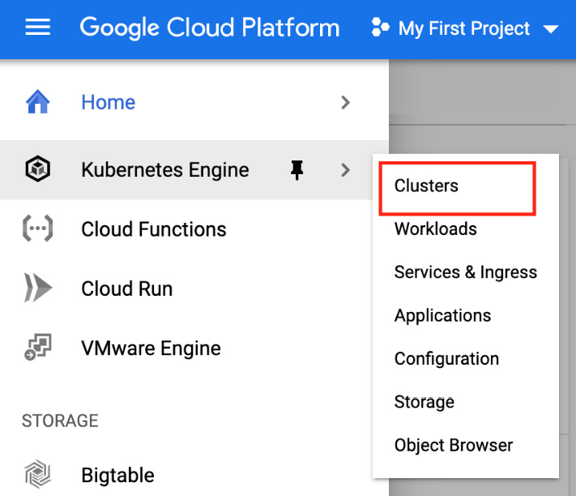
Figure 3.2 – The GCP web console GKE clusters menu
On this screen, you should see an Enable Billing button. Click on this button and enter your billing information. Once done, GCP will proceed in enabling the Kubernetes Engine API for your project. This can take a few minutes, but after that, you will be able to create your first cluster on GKE.
To create the cluster, there are two ways you can use, as follows:
You can use the web console.
You can use the gcloud command-line tool.
Let's use the gcloud command line. The good news is that gcloud can literally bootstrap a GKE cluster and configure Kubectl afterward in just one command:
Run the following command:
$ gcloud container clusters create mygkecluster --num-nodes 3 --machine-type e2-medium --europe-west1
This command will create a Kubernetes cluster on GKE, called mygkecluster, that will have three worker nodes. These worker nodes will be run as e2-medium instances, which are two CPU virtual machines.
The cluster is going to be created in the europe-west1 region of the GCP cloud. You should pick the nearest region to where you are in order to reduce network latency. In my case, europe-west-1 is fine, but you should pick us-west-1 if you live in the US, for example. The complete list of available regions for GCP is available at https://cloud.google.com/compute/docs/regions-zones.
After you have launched the command, the new cluster should appear on the Google GKE screen, as shown in Figure 3.3:
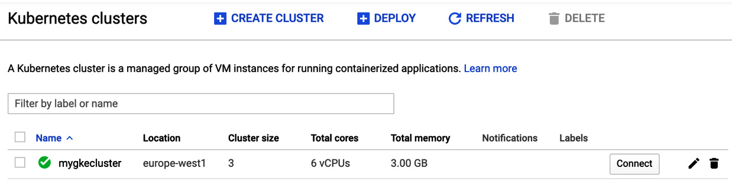
Figure 3.3 – The GCP web console
Good job! Wait a little bit for the cluster creation to complete; it can take a few minutes. Bear in mind that you will be billed the moment the cluster gets launched!
After a few minutes, the Kubernetes cluster is launched on Google GKE and is ready to use. Remember, the gcloud command we ran also generated a kubeconfig file for our local environment. So, we will not have to write the configuration file by ourselves.
Run the following command to make sure your Kubernetes cluster is up and running and the Kubectl command line is properly configured to query it:
$ kubectl get nodes
This command should authenticate against the Kubernetes cluster running on Google GKE and retrieve the list of the nodes running as part of the cluster. Good job! You have successfully set up a Kubernetes cluster on GKE!

Stopping and deleting a Kubernetes cluster on Google GKE
Cloud providers bill you when you use their services. Every second a Kubernetes cluster is in the running state in GKE is a second that you will be charged for at the end of the month. So, it's a good idea to stop cloud services when they are not being used and resume them when needed.
Unfortunately, you can't stop a GKE cluster the way you can with Minikube or Kind. We are forced to completely destroy it and recreate it, meaning that we will lose the state of the cluster each time. It's not a big deal, though, as, for now, we're just looking for a practice cluster that we can break and recreate at will. To proceed with cluster removal, type in the following command:
$ gcloud container clusters delete mygkecluster --region europe-west-1
You are all set to go! If you are happy with GKE, you can proceed to the next chapter and use your brand-new cluster to practice while reading this book. Otherwise, you can pick another solution. Bear in mind that GKE is not free; you are charged $0.1 per hour to use it, resulting in a $72/month if the cluster is running the whole month. Add to this price the cost of the worker nodes, which are instances that are billed independently based on their instance types.

Installing a Kubernetes cluster using Amazon EKS
If you do not wish to have a local Kubernetes cluster nor use Google GKE, you can also set up a remote cluster on the AWS cloud. This solution is ideal if AWS is your preferred cloud provider. This section will demonstrate how to get a Kubernetes cluster using Amazon EKS, which is the public cloud offering by AWS.
Using this solution is not free. Amazon EKS is a commercial product that is a competitor to Google GKE. Amazon EKS offers to manage a Kubernetes control plane just for you. That means the service will set up some nodes running all of the control plane components without exposing you to these machines. You will get an endpoint for a remote kube-apiserver component and that's all.
Once done, you'll have to set up a few Amazon EC2 instances (which are virtual machines), and you'll have them join the control plane. These Amazon EC2 instances will be your worker nodes. In this way, you'll have a multi-node Kubernetes cluster with a multi-worker setup. This result of this lab will be a full-featured multi-node Kubernetes cluster, which is an ideal solution with which to enter the coming chapters. Of course, we won't set up all of this ourselves; a lot of solutions exist in which to provision a fully configured Amazon EKS instance, and we will examine one of these solutions. Additionally, we will try not to spend a lot money on AWS ideally.
The cost of the infrastructure will depend on the AWS region where your cluster is going to be deployed:
The control plane, which costs $0.74/hour
3 x t3.medium worker nodes (around 0.42 USD per instance depending on the AWS region where you'll deploy your cluster)
Because it's an hourly pricing model, remember to destroy everything from your AWS account when you are not using it in order to save money.
There is a prerequisite when it comes to working with Amazon EKS. You need to have an AWS account with a properly linked payment method. Indeed, similarly to GCP, AWS requires you to link a valid payment method prior to gaining access to their services. In this section, we assume that you already have an AWS account with a valid payment method linked to it.

Launching a multi-node Kubernetes cluster on Amazon EKS
There are multiple ways in which to get a working cluster with Amazon EKS. You can use CloudFormation, Terraform, AWS CLI commands, or even the web AWS console. Additionally, AWS offers a CLI tool to communicate with the Amazon EKS service, called eksctl, which can be used to set up Kubernetes clusters on Amazon EKS with just one or two commands. However, we're not going to use this solution because it would require you to install another tool on your machine dedicated to AWS, which is not the purpose of our discussion here.
Instead, in this tutorial, we are going to use AWS CloudFormation for the sake of simplicity. AWS has already put together a working CloudFormation template that allows you to deploy a Kubernetes cluster. You can find this template on the GitHub repository, called AWS Quickstart, at https://github.com/aws-quickstart/quickstart-amazon-eks.
AWS makes use of something called virtual private clouds (VPCs). In fact, everything you deploy on AWS is deployed inside of a VPC, and Amazon EKS is no exception. There are two possible solutions, as follows:
You deploy your EKS cluster onto an existing VPC.
You deploy your EKS cluster in a new VPC.
The first choice will work, but there is a risk that deploying the cluster into an existing VPC will overlap with existing resources. To not impact any applications that might already exist on your AWS account, we are going to deploy the Amazon EKS cluster on a new VPC. Fortunately for us, the CloudFormation template allows us to create a new VPC while provisioning the Amazon EKS cluster. I encourage you to create a new VPC since VPC creation is free. Bear in mind that you are still limited to five VPCs per AWS region when using them.
Let's sum up all of the different steps required to bootstrap a cluster on Amazon EKS:
Create a key pair on the Amazon EC2 service.
Launch the CloudFormation template in the Amazon CloudFormation service.
Create an IAM user in the Amazon IAM service.
Install and configure the AWS CLI with the IAM user created earlier.
Generate a kubeconfig file with the AWS CLI.
First, you need to create an EC2 key pair:
Please sign in to the AWS web console and open the Amazon EC2 service. You can find the service by searching for it in the search bar under the Compute menu on the home page:
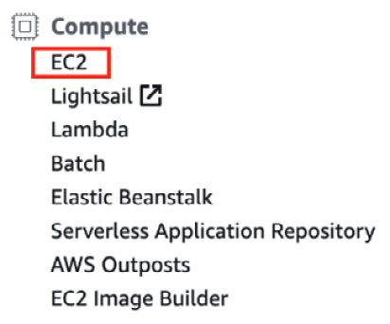
Figure 3.4 – The EC2 menu in the AWS web console
Once you have opened the EC2 service, select the Key Pairs tab on the left-hand side:
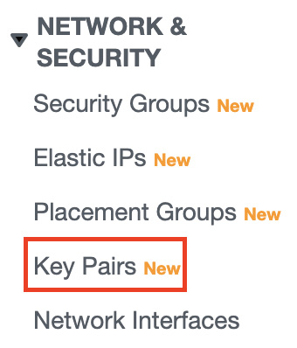
Figure 3.5 – The Key Pairs menu in the EC2 web console
From this screen, click on the Create Key button. Give the new key pair an arbitrary name and then download the .pem file. This key pair is going to be useful for you to SSH to your worker nodes later.
The next step is to create the Kubernetes cluster itself. We are going to do that through the CloudFormation template that we talked about earlier. To do that, enter the CloudFormation web console that is accessible under the Management & Governance menu on the home page:
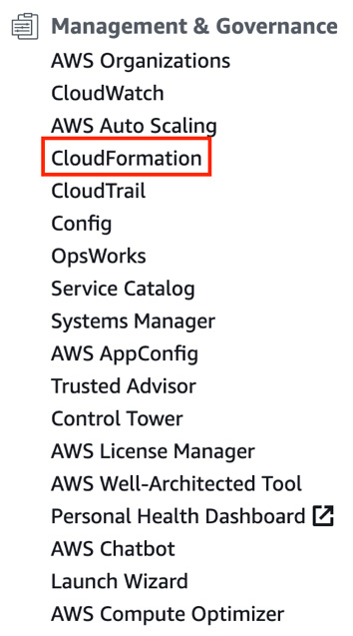
Figure 3.6 – The CloudFormation menu in the AWS web console
Select Create a stack from an Amazon S3 URL and enter the following URL into the input: https://s3.amazonaws.com/aws-quickstart/quickstart-amazon-eks/templates/amazon-eks-entrypoint-new-vpc.template.yaml. Please refer to the following screenshot:
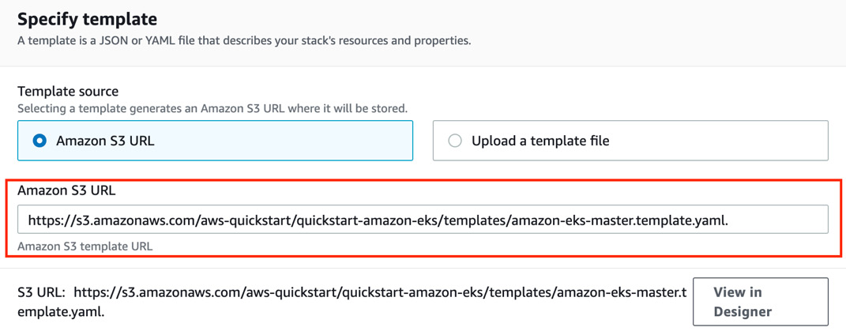
Figure 3.7 – The S3 URL displayed in the CloudFormation stack creation web view
The next screen will enable you to define some variables and parameters that are needed by the CloudFormation template to launch your Amazon EKS cluster. You'll observe that a lot of variables are declared with a default value, but some of them must be set by you. Pay attention to the following input that should be displayed in the console:
- Stack name: Set a logical name for CloudFormation to keep track of the resources created by the template. For example, you can set eks_cluster.
- Availability Zone: Pick at least two availability zones available in your current AWS region.
- Allowed external access CIDR: You can define your own IP address followed by a /32 to allow your IP address to communicate with the EKS cluster. Otherwise, you can set 0.0.0.0/0 to allow remote communication from the whole internet if you do not know your IP address.
- Number of Availability Zones: Set 2 or 3 availability zones so that your EKS cluster will be highly available.
- Provision bastion host: You should set enabled if you do want to deploy a bastion host on your VPC. The bastion host will be an SSH jump machine to access the instances that will be launched deeper into your VPC.
- SSH key name: Select the name of the SSH key pair that you created in the previous step.
After you have filled in all of these options, select the Next button until you are asked to start the new stack creation. CloudFormation will begin provisioning your new Amazon EKS cluster; it can take approximately 15 minutes to complete, as the process is quite long. There is nothing left to do in CloudFormation. Please wait for the cluster to be fully provisioned before going any further.
After a few minutes, your new clusters will enter the ready state. We need to generate a new kubeconfig file in our local machine to be able to interact with the Amazon EKS cluster. Unfortunately for us, CloudFormation cannot do that. There are additional steps to take, and they require the usage of the AWS CLI command-line utility in order to generate a kubeconfig file. That's why we must install the AWS CLI:
- Use the following commands for Linux:
$ sudo apt-get update
$ sudo apt-get install awscli
- Use the following commands for macOS:
$ sudo apt-get update
$ sudo apt-get install awscli
- On Windows, download and launch the MSI installer accessible at https://awscli.amazonaws.com/AWSCLIV2.msi.
Once the AWS CLI has been installed, we need to retrieve AWS access keys from the AWS console in order to configure the AWS CLI. To get those keys, we must create a new IAM user in the Amazon IAM web console. Go to the AWS web console and open the IAM service that is underneath the Security, Identity, & Compliance category:
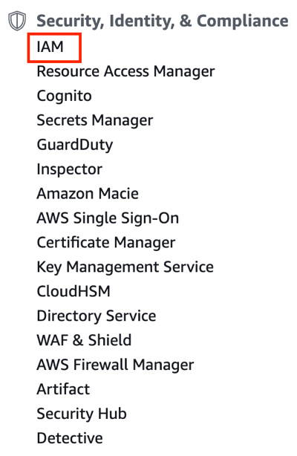
Figure 3.8 – The IAM menu in the AWS web console
Once you are in the AWS IAM console, select Users from the tab on the left-hand side:
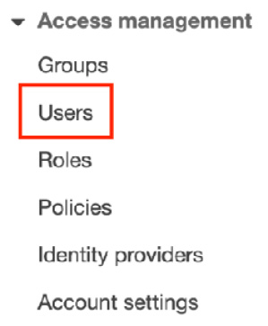
Figure 3.9 – The Users menu in the IAM web console
In this new screen, click on the Add user button and fill in the different options as follows:
- User Name: Select an arbitrary name. Let's name it eks_user.
- Access Type: Select programmatic access.
Now you should be at the permission selection screen. AWS recommends that you respect the least privileged principle: that is, each user should strictly have access to the resource it needs to interact with. However, for the sake of simplicity, we will violate this principle and grant the AdministratorAccess policy to our eks_user.
Pick the Attach existing policy directly option and select AdministratorAccess, which should be displayed first in the drop-down list. From the next screen, you can set tags for the new user. Following this, review and create it.
When the user has been created, AWS gives you an access key ID and a secret access key. Grab these two values because we are going to need them. Run the following command to start the configuration of the AWS CLI:
$ aws configure –profile eks_user
AWS Access Key ID [None]: [Access Key ID]
AWS Secret Access Key [None]: [Secret access key]
Default region name [None]: [Your current AWS region]
Default output format [None]: json
Once you have configured the AWS CLI, export a new variable in your local shell to authenticate AWS CLI calls against your AWS account:
$ export AWS_PROFILE=eks_user
Now, you can run your first AWS CLI command. Let's list the Kubernetes clusters created in the Amazon EKS service. You should see the Kubernetes cluster created by the CloudFormation template:
$ aws eks list-clusters
{
"clusters": [
"EKS-XXXXXX"
]
}
Now that the AWS CLI has been fully configured, we can use it to generate the kubeconfig file. Run the following command. The name of the cluster required is the value that was outputted in the previous command:
$ aws eks update-kubeconfig --name EKS-XXXXX
Added new context arn:aws:eks:eu-west-1:XXX:cluster/EKS-XXX to /root/.kube/config
As you can see, this command generates a kubeconfig file and directly places it in the correct directory, which is $HOME/.kube/config. You can now run your first kubectl command, which will list the nodes that are part of the Amazon EKS clusters:
$ kubectl get nodes
The preceding command should output the master and worker nodes running on the Amazon EKS cluster. This was challenging! But you have successfully set up a Kubernetes cluster using Amazon EKS.
This cluster is a production-ready, multi-node cluster. You can use it to practice on a real-world Kubernetes setup. However, bear in mind that it is not free, and you are spending money each second the service is running. That is why you should understand how to delete the Kubernetes cluster when it is not being used. We will explore this next.

Deleting the Kubernetes cluster on Amazon EKS
Unfortunately for us, there is no way to stop and resume a Kubernetes cluster running on the Amazon EKS service. The feature does not exist. The only thing we can do is to completely destroy it and then recreate it. This will work, but destroying it will result in a state loss. This means that you won't be able to restore the cluster to the state it had before its removal.
Deleting a cluster is super easy since we created it with a CloudFormation template. The easiest way to get rid of the cluster is to go to the stack list in the CloudFormation web console and remove the stack. As a result, CloudFormation will remove all of the resources that were created.
If you want to recreate the cluster, you can simply recreate it using the CloudFormation template once more. You won't have to reconfigure the AWS CLI since you have already done it once, but of course, you will need to regenerate a new kubeconfig file using the aws eks update-kubeconfig command, as demonstrated earlier in this chapter.
Bear in mind that you should destroy the cluster when you are not using it, for example, during nighttime. Removing the resources that you are not using is the best way to save money on your cloud bill.

Installing a Kubernetes cluster using Azure AKS
Lastly, I'd like to show you how you can provision a Kubernetes cluster on the Azure AKS service. Azure AKS is a service that is part of the Azure cloud provider, which is offered by Microsoft. AKS is the third major Kubernetes cloud offering around and is a competitor to Amazon EKS and Google GKE. Mostly, the service does the same job as the other two: it allows you to create Kubernetes clusters in just a few clicks directly on the Azure cloud. This solution might be good for you if you are willing to install a Kubernetes cluster without using your own machine or if Azure is simply your preferred cloud provider.

Launching a multi-node Kubernetes cluster on Azure AKS
Bootstrapping a cluster on Azure AKS is very easy. Similar to Google GKE, it has a command-line utility, called az, which can start a Kubernetes cluster in just one command. The az command line can also generate a kubeconfig file for us to allow Kubectl to communicate with our Kubernetes cluster on AKS:
Let's install the AKS command-line utility:
- Use the following commands for Linux:
$ sudo apt-get update
$ sudo apt-get install ca-certificates curl apt-transport-https lsb-release gnupg
$ curl -sL https://packages.microsoft.com/keys/microsoft.asc | gpg --dearmor |sudo tee /etc/apt/trusted.gpg.d/microsoft.gpg > /dev/null
$ AZ_REPO=$(lsb_release -cs)
$ echo "deb [arch=amd64] https://packages.microsoft.com/repos/azure-cli/ $AZ_REPO main" | sudo tee /etc/apt/sources.list.d/azure-cli.list
$ sudo apt-get update
$ sudo apt-get install azure-cli
- Use the following commands for macOS:
$ brew update && brew install azure-cli
- On Windows, you need to download and launch the MSI installer that is available in the official documentation from Microsoft. You can locate it at https://docs.microsoft.com/fr-fr/cli/azure/install-azure-cli-windows?view=azure-cli-latest&tabs=azure-cli.
Once the az command line has been installed, you need to configure it. The first thing to do is to configure authentication against your Azure account so that the az command line can issue a query against your Azure cloud:
$ az login
This command will open your default web browser and ask you to authenticate your Azure web console again. Once authenticated, the az command line will detect it. The next step is to create a resource group.
The Azure cloud works in the following way: everything you create in Azure must be created inside a logical unit called a resource group. Resource groups are a bit like projects in GCP. Additionally, the AWS cloud has something called resource groups, but they have a less important role in the AWS world.
Let's create a resource group in our Azure cloud in order to create our AKS cluster. Run the following command to create a resource group that is called az_cluster:
$ az group create --name az_cluster --location francecentral
This command will create a resource, called az_cluster, at the francecentral location. This location is fine to me, but you should pick one that is closer to your location. If you need to access all of the possible locations that Azure has, run the following command:
$ az account list-locations
Once the resource group has been created, you can check for its presence in the Azure web console:

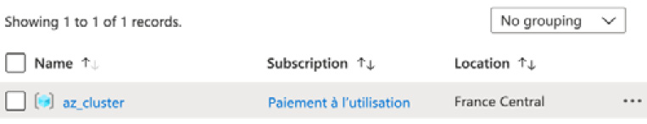
Figure 3.10 – The az_cluster resource group displayed in the Azure web console
Now, we are ready to create the AKS cluster. Again, the az command line can achieve that with just one command:
$ az aks create --resource-group aks_cluster --name my_aks_cluster --node-count 3 --generate-ssh-keys
The following command will create an AKS cluster, called my_aks_cluster, with three nodes in the resource group, called az_cluster, that we created earlier. We also ask Azure to generate SSH keys for us to SSH to our nodes. That command can take a few minutes to complete. However, after its completion, you will have a working Kubernetes cluster created on Azure AKS:
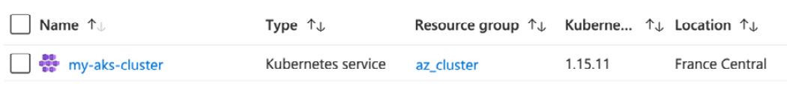
Figure 3.11 – The AKS cluster displayed in the Azure web console
The last thing to do now is to configure a kubeconfig file in order to get Kubectl to communicate with the cluster on the AKS cluster. Fortunately for us, the az command line can do that easily. Run the following command to generate a kubeconfig file and place it in the correct directory:
$ az aks get-credentials --resource-group az_cluster --name my_aks_cluster
Now, everything is ready for us to issue our first command to the AKS cluster. Let's run the following command to list the nodes that are part of the cluster:
$ kubectl get nodes
If everything is okay, you should be able to view the three nodes that we created earlier.

Stopping and deleting a Kubernetes cluster on Azure AKS
Like all cloud offerings, Azure AKS is not free. It's a commercial product. You should stop it and resume it when you are not using your cluster in order to avoid being billed too much. Unfortunately, it is impossible to stop and resume a cluster on AKS without losing its state. You must destroy it and then recreate it.
To remove an AKS cluster, we prefer to remove the resource group itself since a resource's life cycle is bound to its parent resource group. Deleting the resource group should delete the cluster. The following command will get rid of the AKS cluster:
$ az group delete --name az_cluster --yes --no-wait

Summary
This chapter was quite intense! You require a Kubernetes cluster to follow this book, and so, we examined five ways in which to set up Kubernetes clusters on different platforms. You learned about Minikube, which is the most common way to set up a cluster on a local machine. You also discovered Kind, which is a tool that can set up multi-node local clusters, which is a limitation of Minikube. Then, we looked at the three major Kubernetes cloud services, which are Google GKE, Amazon EKS, and Azure AKS. These three services allow you to create a Kubernetes cluster on the cloud for your practice and train with. This was just a quick introduction to these services, and we will have the opportunity to dive deeper into these services later. For the moment, simply pick the solution that is the best for you. Personally, I use both Kind and Amazon EKS, as they are my preferred tools.
In the next chapter, we are going to dive into Kubernetes by exploring the concept of Pods. The Pod resource is the most important resource that Kubernetes manages. We will learn how to create, update, and delete Pods. Additionally, we will look at how to provision them, how to get information from them, and how to update the containers they are running. We will deploy an NGINX Pod on a Kubernetes cluster and examine how we can access it from the outside. By the end of the next chapter, you will be capable of launching your first containers on your Kubernetes cluster through the usage of Pods. The cluster that you installed here will be very useful when you follow the real-world examples that are coming in the next chapter.

Section 2: Diving into Kubernetes Core Concepts
This section is the most important one since it is the first time that you will be introduced to Kubernetes core objects, also called primitives. You are going to be taught how Kubernetes manages its containerized applications. At the end of this section, you should be able to run Kubernetes-based workloads.
This part of the book comprises the following chapters:
Chapter 4, Running Your Docker Containers
Chapter 5, Using Multi-Container Pods and Design Patterns
Chapter 6, Configuring Your Pods Using ConfigMaps and Secrets
Chapter 7, Exposing Your Pods with Services
Chapter 8, Managing Namespaces in Kubernetes
Chapter 9, Persistent Storage in Kubernetes

Chapter 4: Running Your Docker Containers
This chapter is probably the most important one in this book. Here, we are going to discuss the concept of Pods, which are the objects Kubernetes uses to launch your Docker containers. Pods are at the heart of Kubernetes and mastering them is essential.
In Chapter 3, Installing Your First Kubernetes Cluster, we said that the Kubernetes API defines a set of resources representing a computing unit. Pods are resources that are defined in the Kubernetes API that represent one or several Docker containers. We never create containers directly with Kubernetes, but we always create Pods, which will be converted into Docker containers on a worker node in our cluster.
At first, it can be a little difficult to understand the connection between Kubernetes Pods and Docker containers, which is why we are going to explain what Pods are and why we use them rather than Docker containers directly. A Kubernetes Pod can contain one or more Docker containers. In this chapter, however, we will focus on Kubernetes Pods, which contain only one Docker container. We will then have the opportunity to discover the Pods that contain several containers in the next chapter.
We will create, delete, and update Pods using the BusyBox image, which is a Linux-based image containing many utilities useful for running tests. We will also launch a Pod based on the NGINX Docker image to launch an HTTP server, before accessing the default NGINX home page via a feature kubectl exposes called port forwarding. It's going to be useful to access and test the Pods running on your Kubernetes cluster from your web browser.
Then, we will discover how to label and annotate our Pods to make them easily accessible. This will help us organize our Kubernetes cluster so that it's as clean as possible. Finally, we will discover two additional resources, which are jobs and Cronjobs. By the end of this chapter, you will be able to launch your first Docker containers managed by Kubernetes, which is the first step in becoming a Kubernetes master!
In this chapter, we're going to cover the following main topics:
Let's explain the notion of Pods
Launching your first BusyBox Pod
Labeling and annotating your Pods
Launching your first job
Launching your first Cronjob

Technical requirements
Having a properly configured Kubernetes cluster is recommended to follow this chapter so that you can practice the commands shown as you read. Whether it's a minikube, Kind, GKE, EKS, or AKS cluster is not important. You also need a working kubectl installation on your local machine. Running the kubectl get nodes commands should output you at least one node:
$ kubectl get nodes
NAME STATUS ROLES AGE VERSION
10.0.103.186.internal Ready <none> 6m v1.17.12
You can have more than one node if you want, but at least one Ready node is required to have a working Kubernetes setup.

Let's explain the notion of Pods
In this section, we will explain the concept of Pods from a theoretical point of view. Pods have certain peculiarities that must be understood if you wish to master them well.
What are Pods?
When you want to create, update, or delete a container through Kubernetes, you do so through a Pod – you never interact with the containers directly. A Pod is a group of one or more containers that you want to launch on the same machine, in the same Linux namespace. That's the first rule to understand about Pods: they can be made up of one or more containers but all the containers that belong to the same Pod will be launched on the same worker node. A Pod cannot and won't ever span across multiple worker nodes: that's an absolute rule.
But why do we bother delegating the management of our Docker containers to this intermediary resource? After all, Kubernetes could have a container resource that would just launch a single container. The reason is that containerization invites you to think in terms of Linux processes rather than in terms of virtual machines. You may already know about the biggest and most recurrent Docker anti-pattern, which consists of using Docker containers as virtual machine replacements: in the past, you used to install and deploy all your processes on top of a virtual machine. But Docker containers are no virtual machine replacements, and they are not meant to run multiple processes.
Docker invites you to follow one golden rule: there should be a one-to-one relationship between a Docker container and a Linux process. That being said, modern applications are often made up of multiple processes, not just one, so in most cases, using only one Docker container won't suffice to run a full-featured microservice. This implies that the processes, and thus the containers, should be able to communicate with each other by sharing filesystems, networking, and so on. That's what Kubernetes Pods offer you: the ability to group your containers logically. All the containers/processes that make up a microservice should be grouped in the same Pod. That way, they'll be launched together and benefit from all the features when it comes to facilitating inter-process and inter-container communications.
To help you understand this, imagine you have a working WordPress blog on a virtual machine and you want to convert that virtual machine into a WordPress Pod to deploy your blog on your Kubernetes cluster. WordPress is one of the most common pieces of software and is a perfect example to illustrate the need for Pods. This is because WordPress requires multiple processes to work properly.
WordPress is a PHP application that requires both an HTTP server and a PHP interpreter to work. Let's list what Linux processes WordPress needs to work on:
An NGINX HTTP server: It's a web application, so it needs an HTTP server running as a process to receive and serve server blog pages. NGINX is a good HTTP server that will do the job perfectly.
The FPM PHP interpreter: It's a blog engine written in PHP, so it needs a PHP interpreter to work.
NGINX and PHP-FPM are two processes: they are two binaries that you need to launch separately, but they need to be able to work together. On a virtual machine, the job is simple: you just install NGINX and PHP-Fast CGI Process Manager (FPM) on the virtual machine and have both of them communicate through UNIX sockets. You can do this by telling NGINX that the Linux socket PHP-FPM is accessible thanks to the /etc/nginx.config configuration file.
In the Docker world, things become harder because running these two processes in the same container is an anti-pattern: you have to run two containers, one for each process, and you must have them communicate with each other and share a common directory so that they can both access the application code. To solve this problem, you have to use the Docker networking layer to have the NGINX container able to communicate with the PHP-FPM one. Then, you must use a volume mount to share the WordPress code between the two containers. You can do this with some Docker commands but imagine it now in production at scale, on multiple machines, on multiple environments, and so on. As you can imagine, that's the kind of problem the Kubernetes Pod resource solves.
Achieving inter-process communication is possible with bare Docker, but that's difficult to achieve at scale while keeping all the production-related requirements in mind. With tons of microservices to manage and spread on different machines, it would become a nightmare to manage all these Docker networks, volume mounts, and so on. That's why Kubernetes has the Pod resource. Pods are very useful because they wrap multiple containers and enable easy inter-process communication. The following are the core benefits Pods brings you:
All the containers in the same Pod can reach each other through localhost.
All the containers in the same Pod share the same network namespace.
All the containers in the same Pod share the same port space.
You can attach a volume to a Pod, and then mount the volume to underlying containers, allowing them to share directories and file locations.
With these benefits Kubernetes brings you, it would become super easy to provision your WordPress blog as you can create a Pod that will run two containers: NGINX and PHP-FPM. Since they both can access each other on localhost, having them communicating is super easy. You can then use a volume to expose WordPress's code to both containers.
The most complex applications will forcibly require several containers, so it's a good idea to group them in the same Pod to have Kubernetes launch them together. Keep in mind that the Pod is here for only one reason: to ease inter-container (or inter-process) communications at scale.
Important Note
That being said, it is not uncommon at all to have Pods that are only made up of one container. But in any case, you'll always have to use the Pod Kubernetes object to be able to interact with your containers in Kubernetes.
Lastly, please note that a Docker container that was launched manually on a machine managed by a Kubernetes cluster won't be seen by Kubernetes as a container it manages. It becomes a kind of orphan container outside of the scope of the orchestrator. Kubernetes only manages the container it has launched through its Pod object.

Each Pod gets an IP address
Containers inside a single Pod are capable of communicating with each other through localhost, but Pods are also capable of communicating with each other. At launch time, each Pod gets a single private IP address. Each Pod can communicate with any other Pod in the cluster by calling it through its IP address.
Kubernetes networking models allow Pods to communicate with each other directly without the need for a Network Address Translation (NAT) device. Keep in mind that they are not NAT gateways between Pods in your cluster.
Kubernetes uses a flat network model that is implemented by components called Container Network Interface (CNIs).

How you should design your Pods
Here is the second golden rule about Pods: they are meant to be destroyed and recreated easily. Pods can be destroyed voluntarily or not. For example, if a given worker node running four Pods were to fail, each of the underlying containers would become inaccessible. Because of this, you should be able to destroy and recreate your Pods at will, without it affecting the stability of your application. The best way to achieve this is to respect two simple design rules when building your Pods:
A Pod should contain everything required to launch a microservice.
A Pod should be stateless (when possible).
When you start designing Pods on Kubernetes, it's hard to know exactly what a Pod should and shouldn't contain. It's pretty straightforward to explain: a Pod has to contain an application or a microservice. Take the example of our WordPress Pod, which we mentioned earlier: the Pod should contain the NGINX and PHP FPM containers, which are required to launch WordPress. If such a Pod were to fail, our WordPress would become inaccessible, but recreating the Pod would make WordPress accessible again because the Pod contains everything necessary to run WordPress.
That being said, every modern application makes use of database storage, such as Redis or MySQL. WordPress on its own does that too – it uses MySQL to store and retrieve your post. So, you'll also have to run a MySQL container somewhere. Two solutions are possible here:
You run the MySQL container as part of the WordPress Pod.
You run the MySQL container as part of a dedicated MySQL Pod.
Both solutions can be used, but the second is preferred. It's a good idea to decouple your application (here, this is WordPress, but tomorrow, it could be a microservice) from its database layer by running them in two separate Pods. Remember that Pods are capable of communicating with each other. You can benefit from this by dedicating a Pod to running MySQL and then giving its IP address to your WordPress blog.
By separating the database layer from the application, you improve the stability of the setup: the application Pod crashing will not affect the database.
To summarize, grouping the layers in the same Pods would cause three problems:
Data durability
Availability
Stability
That's why you should keep your application Pods stateless, by storing their states in an independent Pod. The data layer can be considered an application on its own and has its own treatment decoupled from the application code itself. To achieve that, you should run them in separate Pods.
Now, let's launch our first Pod. Creating a WordPress Pod would be too complex for now, so let's start easy by launching some NGINX Pods and see how Kubernetes manages the Docker container.

Launching your first Pods
In this section, we will explain how to create our first Pods in our Kubernetes cluster. Pods have certain peculiarities that must be understood to master them well.
We are not going to create a resource on your Kubernetes cluster at the moment; instead, we are simply going to explain what Pods are. In the next section, we'll start building our first Pods.

Creating a Pod with imperative syntax
In this section, we are going to create a Pod based on the NGINX image. We need two parameters to create a Pod:
The Pod's name, which is arbitrarily defined by you
The Docker image(s) to build its underlying container(s)
As with almost everything on Kubernetes, you can create Pods using either of the two syntaxes available: the imperative syntax and the declarative syntax. As a reminder, the imperative syntax is to run kubectl commands directly from a terminal, while with declarative syntax, you must write a YAML file containing the configuration information for your Pod, and then apply it with the kubectl create -f command.
To create a Pod on your Kubernetes cluster, you have to use the kubectl run command. That's the simplest and fastest way to get a Pod running on your Kubernetes cluster. Here is how the command can be called:
$ kubectl run nginx-Pod --image nginx:latest
In this command, the Pod's name is set to nginx-Pod. This name is important because it is a pointer to the Pod: when you need to run the update or delete command on this Pod, you'll have to specify that name to tell Kubernetes which Pod the action should run on. The --image flag will be used to build the Docker container that this Pod will run.
Here, you are telling Kubernetes to build a Pod based on the nginx:latest Docker image hosted on Docker Hub. This nginx-Pod Pod contains only one container based on this nginx:latest image: you cannot specify multiple images here; this is a limitation of the imperative syntax.
If you want to build a Pod containing multiple containers built from several different Docker images, then you will have to go through the declarative syntax and write a YAML file.

Creating a Pod with declarative syntax
Creating a Pod with declarative syntax is simple too. You have to create a YAML file containing your Pod definition and apply it against your Kubernetes cluster using the kubectl create -f command.
Here is the content of the nginx-Pod.yaml file, which you can create on your local workstation:
apiVersion: v1
kind: Pod
metadata:
name: nginx-Pod
spec:
containers:
- name: nginx-container
image: nginx:latest
Try to read this file and understand its content. YAML files are only key/value pairs. The Pod's name is nginx-Pod, and then we have an array of containers in the spec: part of the file containing only one container created from the nginx:latest image. The container itself is named nginx-container.
Once the nginx-Pod.yaml file has been saved, run the following command to create the Pod:
$ kubectl create -f nginx-Pod.yaml
Pod/nginx-Pod created
$ kubectl apply -f nginx-Pod.yaml # this command works too!
If a Pod called nginx-Pod already exists in your cluster, this command will fail. Remember that Kubernetes cannot run two Pods with the same name: the Pod's name is the unique identifier and is used to identify the Pods. Try to edit the YAML file to update the Pod's name and then apply it again.

Reading the Pod's information and metadata
At this point, you should have a running Pod on your Kubernetes cluster. Here, we are going to try to read its information. At any time, we need to be able to retrieve and read information regarding the resources that were created on your Kubernetes cluster; this is especially true for Pods. Reading the Kubernetes cluster can be achieved using two kubectl commands: kubectl get and kubectl describe. Let's take a look at them:
kubectl get: The kubectl get command is a list operation; you use this command to list a set of objects. Do you remember when we listed the nodes of your cluster after all the installation procedures described in the previous chapter? We did this using kubectl get nodes. The command works by requiring you to pass the object type you want to list. In our case, it's going to be the kubectl get Pods operation. In the upcoming chapters, we will discover other objects, such as configmaps. To list them, you'll have to type kubectl get configmaps; the same goes for the other object types. kubectl get does not require you to know the name of a precise resource, because it's intended to list.
kubectl describe: The kubectl describe command is quite different. It's intended to retrieve a complete set of information for one specific object that's been identified from both its kind and object name. You can retrieve the information of our previously created Pod by using kubectl describe Pods nginx-Pod.
Calling this command will return a full set of information available about that specific Pod, such as its IP address and so on.
Now, let's look at some more advanced options about listing and describing objects in Kubernetes.

Listing the objects in JSON or YAML
The -o option is one of the most useful options offered by the kubectl command line. This one has some benefits you must be aware of. That option allows you to customize the output of the kubectl command line. By default, using the kubectl get Pods command will return a list of the Pods in your Kubernetes cluster in a formatted way so that the end user can see it easily. You can also retrieve this information in JSON format or YAML format by using the -o option:
$ kubectl get Pods -o yaml # In YAML format
$ kubectl get Pods -o json # In JSON format
# If you know the Pod name, you can also get a specific Pod
$ kubectl get Pods <POD_NAME> -o yaml
# OR
$ kubectl get Pods <POD_NAME> -o json
This way, you can retrieve and export data from your Kubernetes cluster in a scripting-friendly format.

Backing up your resource using the list operation
You can also use these flags to back up your Kubernetes cluster. Imagine a situation where you created a Pod using the imperative way, so you don't have the YAML declaration file stored in your computer. If the Pod fails, it's going to be hard to recreate it. The -o option helps us retrieve the YAML declaration file of a resource that's been created in Kubernetes, even if we created it using the imperative way. To do this, run the following command:
$ kubectl get Pods/nginx-Pod -o yaml > nginx-Pod.yaml
This way, you have a YAML backup of the nginx-Pod resource as it is running on your cluster. If someone goes wrong, you'll be able to recreate your Pod easily. Pay attention to the nginx-Pod section of this command. To retrieve the YAML declaration, you need to specify which resource you are targeting. By redirecting the output of this command to a file, you get a nice way to retrieve and back up the configuration of the object inside your Kubernetes cluster.

Getting more information from the list operation
It's also worth mentioning the -o wide format, which is going to be very useful for you: using this option allows you to expand the default output to add more data. By using it on the Pods object, for example, you'll get the name of the worker node where the Pod is running:
$ kubectl get Pods -o wide
# The worker node name is displayed
Keep in mind that the -o option can take a lot of different parameters and that some of them are much more advanced, such as jsonpath, which allows you to directly execute kind of sort operations on top of a JSON body document to retrieve only specific information, just like the jq library you used previously if you have already written some Bash scripts that deal with JSON parsing.

Accessing a Pod from the outside world
At this point, you should have a Pod containing an NGINX HTTP server on your Kubernetes cluster. You should now be able to access it from your web browser. However, this is a bit complicated.
By default, your Kubernetes cluster does not expose the Pod it runs to the internet. For that, you will need to use another resource called a service, which we will cover in more detail in Chapter 7, Exposing Your Pods with Services. However, kubectl does offer a command for quickly accessing a running container on your cluster called kubectl port-forward. This is how you can use it:
$ kubectl port-forward Pod/nginx-Pods 8080:80
Forwarding from 127.0.0.1:8080 -> 80
Forwarding from [::1]:8080 -> 80
This command is quite easy to understand: I'm telling kubectl to forward port 8080 on my local machine (the one running kubectl) to port 80 on the Pod identified by Pod/nginx-Pod.
Kubectl then outputs a message, telling me that it started to forward my local 8080 port to the 80 one of the Pod. If you get an error message, it's probably because your local port 8080 is currently being used. Try to set a different port or simply remove the local port from the command to let kubectl choose a local port randomly:
$ kubectl port-forward Pod/nginx-Pods :80
Now, you can launch your browser and try to reach the http://localhost:<localport> address, which in my case is http://localhost:80:
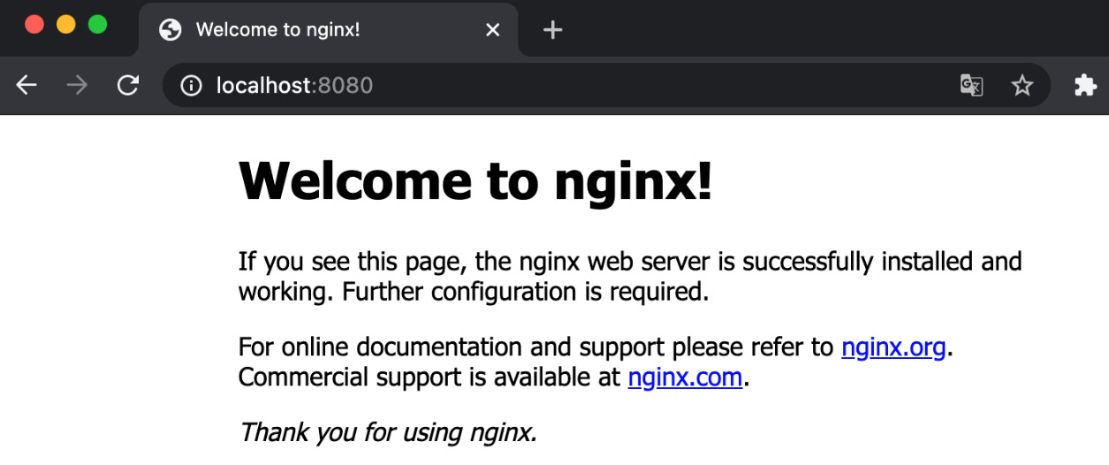
Figure 4.1 – The NGINX default page running in a Pod and accessible on localhost, which indicates the port-forward command worked!

Entering a container inside a Pod
When a Pod is launched, you can access the Pods it contains. Under Docker, the command to execute a command in a running container is called docker exec. Kubernetes copies this behavior via a command called kubectl exec. Use the following command to access our NGINX container inside nginx-Pod, which we launched earlier:
$ kubectl exec -ti Pods nginx-Pod bash
After running this command, you will be inside the NGINX container. You can do whatever you want here, just like with any other container. The preceding command assumes that the bash binary is installed in the container you are trying to access. Otherwise, the sh binary is generally installed on a lot of containers and might be used to access the container. Don't be afraid to path a full binary path, like so:
$ kubectl exec -ti Pods nginx-Pod /bin/bash
Now, let's discover how to delete a Pod from a Kubernetes cluster.

Deleting a Pod
Deleting a Pod is super easy. You can do so using the kubectl delete command. You need to know the name of the Pod you want to delete. In our case, the Pod's name is nginx-Pod. Run the following command:
$ kubectl delete Pods nginx-Pod
$ # or...
$ kubectl delete Pods/nginx-Pod
If you do not know the name of the Pod, remember to run the kubectl get Pods command to retrieve the list of the Pod and find the one you want to delete.
There is also something you must know: if you have built your Pod with declarative syntax and you still have its YAML configuration file, you can delete your Pod without having to know the name of the container because it is contained in the YAML file.
Run the following command to delete the Pod using the declarative syntax:
$ kubectl delete -f nginx-Pod.yaml
After you run this command, the Pod will be deleted in the same way.
Important Note
Remember that all containers belonging to the Pod will be deleted. The container's life cycle is bound to the life cycle of the Pod that launched it. If the Pod is deleted, the containers it manages will be deleted. Remember to always interact with the Pods and not with the containers directly.
With that, we have reviewed the most important aspects of Pod management, such as launching a Pod with the imperative or declarative syntax, deleting a Pod, and also listing and describing them. Now, I will introduce one of the most important aspects of Pod management in Kubernetes: labeling and annotating.

Labeling and annotating the Pods
We will now discuss another key concept of Kubernetes: labels and annotations. Labels are key/value pairs that you can attach to your Kubernetes objects. Labels are meant to tag your Kubernetes objects with key/value pairs defined by you. Once your Kubernetes objects have been labeled, you can build a custom query to retrieve specific Kubernetes objects based on the labels they hold. In this section, we are going to discover how to interact with labels through kubectl by assigning some labels to our Pods.

What are labels and why do we need them?
Labels are key/value pairs that you can attach to your created objects, such as Pods. What label you define for your objects is up to you – there is no specific rule regarding this. These labels are attributes that will allow you to organize your objects in your Kubernetes cluster: once your objects have been labeled, you can list and query them using the labels they hold. To give you a very concrete example, you could attach a label called environment = prod to some of your Pods, and then use the kubectl get Pods command to list all the Pods within that environment. So, you could list all the Pods that belong to your production environment in one command:
$ kubectl get Pods --label "environment=production"
As you can see, it can be achieved using the --label parameter, which can be shortened using its -l equivalent:
$ kubectl get Pods --l "environment=production"
This command will list all the Pods holding a label called environment with a value of production. Of course, in our case, no Pods will be found since none of the ones we created earlier are holding this label. You'll have to be very disciplined about labels and not forget to set them every time you create a Pod or another object, and that's why we are introducing them quite early in this book: not only Pods but almost every object in Kubernetes can be labeled, and you should take advantage of this feature to keep your cluster organized and clean.
You use labels not only to organize your cluster but also to build relationships between your different Kubernetes objects: you will notice that some Kubernetes objects will read the labels that are carried by certain Pods and perform certain operations on them based on the labels they carry. If your Pods don't have labels or they are misnamed or contain the wrong values, some of these mechanisms might not work as you expect.
On the other hand, using labels is completely arbitrary: there is no particular naming rule, nor any convention Kubernetes expects you to follow. Thus, it is your responsibility to use the labels as you wish and build your own convention. If you are in charge of the governance of a Kubernetes cluster, you should enforce the usage of mandatory labels and build some monitoring rules to quickly identify non-labeled resources.
Keep in mind that labels are limited to 63 characters: they are intended to be short. Here are some label ideas you could use:
environment (prod, dev, uat, and so on)
stack (blue, green, and so on)
tier (frontend and backend)
app_name (wordpress, magento, mysql, and so on)
team (business and developers)
Labels are not intended to be unique between objects. For example, perhaps you would like to list all the Pods that are part of the production environment. Here, several Pods with the same label key and value pair can exist in the cluster at the same time without posing any problem – it's even recommended if you want your list query to work. For example, if you want to list all the resources that are part of the prod environment, a label environment such as = prod should be created on multiple resources. Now, let's look at annotations, which are another way we can assign metadata to our Pods.

What are annotations and how do they differ from labels?
Kubernetes also uses another type of metadata called annotations. Annotations are very similar to labels as they are also key/value pairs. However, annotations do not have the same use as labels. Labels are intended to identify resources and build relationships between them, while annotations are used to provide contextual information about the resource that they are defined on.
For example, when you create a Pod, you could add an annotation containing the email of the support team to contact if this app does not work. This information has its place in an annotation but has nothing to do with a label.
While it is highly recommended that you define labels wherever you can, you can omit annotations: they are less important to the operation of your cluster than labels. Be aware, however, that some Kubernetes objects or third-party applications often read annotations and use them as configuration. In this case, their usage of annotations will be explained explicitly in their documentation.

Adding a label
In this section, we will learn how to add and remove labels and annotations from Pods. We will also learn how to modify the labels of a Pod that already exists on a cluster.
You can add a label when creating a Pod. Let's take the Pod based on the NGINX image that we used earlier. We will recreate it here with a label called tier, which will contain the frontend value. Here is the kubectl command to run for that:
$ kubectl run nginx-Pod --image nginx --label "tier=frontend"
As you can see, a label can be assigned using the --label parameter. You can add multiple labels by repeatedly using the --label parameter, like this:
$ kubectl run nginx-Pod --image nginx --label "tier=frontend" --label "environment=prod"
Here, the nginx Pod will be created with two labels.
The --label flag has a short version called -l. You can use this to make your command shorter and easier to read. Here is the same command with the -l parameter used instead of --label:
$ kubectl run nginx-Pod --image nginx -l "tier=frontend" -l "environment=prod"
Another important thing to notice is that labels can be defined with declarative syntax. Labels can be appended to a YAML Pod definition. Here is the same Pod, holding the two labels we created earlier, but this time, it's been created with the declarative syntax:
# ~/labelled_Pod.yaml
apiVersion: v1
kind: Pod
metadata:
name: nginx-Pod
labels:
environment: prod
tier: frontend
spec:
containers:
- name: nginx-container
image: nginx:latest
Consider the file that was created at ~/labelled_Pod.yaml. The following kubectl command would create the Pod the same way as it was created previously:
$ kubectl create -f ~/labelled_Pod.yaml
Consider the file created at ~/labelled_Pod.yaml. The following kubectl command would create the Pod the same way as it was created previously. This time, running the command we used earlier should return at least one Pod – the one we just created:
$ kubectl get Pods --label "environment=production"
Now, let's learn how we can list the labels attached to our Pod.

Listing labels attached to a Pod
$ kubectl get Pods --show-labels
There is no dedicated command to list the labels attached to a Pod, but you can make the output of kubectl get Pods a little bit more verbose. By using the --show-labels parameter, the output of the command will include the labels attached to the Pods.
This command does not run any kind of query based on the labels; instead, it displays the labels themselves as part of the output. It can be useful for debugging. Of course, this option can be chained with other options, such as -o wide:
$ kubectl get Pods --show-labels -o wide
This command would then show you the list of the Pods and their labels, as well as the node that the Pod has been scheduled to run on.

Adding or updating a label to/of a running Pod
Now that we've learned how to create Pods with labels, we'll learn how to add labels to a running Pod. You can add, create, or modify the labels of a resource at any time using the kubectl label command. Here, we are going to add another label to our nginx Pod. This label will be called stack and will have a value of blue:
$ kubectl label Pods nginx-Pod stack=blue
This command only works if the Pod has no label called stack. When the command is executed, it can only add a new tag and not update it. This command will update the Pod by adding a label called stack with a value of blue. Run the following command to see that the change was applied:
$ kubectl get Pods nginx-Pod --show-labels
To update an existing label, you must append the --overwrite parameter to the preceding command. Let's update the stack=blue label to make it stack=green; pay attention to the overwrite parameter:
$ kubectl label Pods nginx-Pod stack=green --overwrite
Here, the label should be updated. The stack label should now be equal to green. Run the following command to show the Pod and its labels again:
$ kubectl get Pods nginx-Pod --show-labels
That command will only list nginx-Pod and display its label as part of the output in the terminal.
Important Note
Adding or updating labels using the kubectl label command might be dangerous. As we mentioned earlier, you'll build relationships between different Kubernetes objects based on labels. By updating them, you might break some of these relationships and your resources might start to behave not as expected. That's why it's better to add labels when a Pod is created and keep your Kubernetes configuration immutable. It's always better to destroy and recreate rather than update an already running configuration.
The last thing we must do is learn how to delete a label attached to a running Pod.

Deleting a label attached to a running Pod
Just like we added and updated labels of a running Pod, we can also delete them. The command is a little bit trickier. Here, we are going to remove the label called stack, which we can do by adding a minus symbol (-) right after the label name:
$ kubectl label nginx-Pod stack-
Adding that minus symbol at the end of the command might be quite strange, but running kubectl get Pods --show-labels again should show that the stack label is now gone:
$ kubectl get Pods nginx-Pod --show-labels

Adding an annotation
Let's learn how to add annotations to a Pod. It won't take long to cover this because it works just like it does with labels:
# ~/annotated_Pod.yaml
apiVersion: v1
kind: Pod
metadata:
annotations:
tier: webserver
name: nginx-Pod
labels:
environment: prod
tier: frontend
spec:
containers:
- name: nginx-container
image: nginx:latest
Here, I simply added the tier=webserver annotation, which can help me identify that this Pod is running an HTTP server. Just keep in mind that it's a way to add additional metadata.
The name of an annotation can be prefixed by a DNS name. This is the case for Kubernetes components such as kube-scheduler, which must indicate to cluster users that this component is part of the Kubernetes core. The prefix can be omitted completely, as shown in the preceding example.

Launching your first job
Now, let's discover another Kubernetes resource that is derived from Pods: the Job resource. In Kubernetes, a computing resource is a Pod, and everything else is just an intermediate resource that manipulates Pods.
This is the case for the Job object, which is an object that will create one or multiple Pods to complete a specific computing task, such as running a Linux command.

What are jobs?
A job is another kind of resource that's exposed by the Kubernetes API. In the end, a job will create one or multiple Pods to execute a command defined by you. That's how jobs work: they launch Pods. You have to understand the relationship between the two: jobs are not independent of Pods, and they would be useless without Pods. In the end, the two things they are capable of are launching Pods and managing them. Jobs are meant to handle a certain task and then exit. Here are some examples of typical use cases for a Kubernetes job:
Taking a backup of a database
Sending an email
Consuming some messages in a queue
These are tasks you do not want to run forever. You expect the Pods to be terminated once they have completed their task. This is where the Jobs resource will help you.
But why bother using another resource to execute a command? After all, we can create one or multiple Pods directly that will run our command and then exit.
This is true. You can use a Pod based on a Docker image to run the command you want and that would work fine. However, jobs have mechanisms implemented at their level that allow them to manage Pods in a more advanced way. Here are some things that jobs are capable of:
Running Pods multiple times
Running Pods multiple times in parallel
Retrying to launch the Pods if they encountered any errors
Killing a Pod after a specified number of seconds
Another good point is that a job manages the labels of the Pods it will create so that you won't have to manage the labels on those Pods directly.
All of this can be done without using jobs, but this would be very difficult to manage. Fortunately for us, the Jobs resource exists, and we are going to learn how to use it now.

Creating a job with restartPolicy
Since creating a job might require some advanced configurations, we are going to focus on declarative syntax here. This is how you can create a Kubernetes job through YAML. We are going to make things simple here; the job will just echo Hello world:
# ~/hello-world-job.yaml
apiVersion: batch/v1
kind: Job
metadata:
name: hello-world-job
spec:
template:
metadata:
name: hello-world-job
spec:
restartPolicy: OnFailure
containers:
- name: hello-world-container
image: busybox
command: ["/bin/sh", "-c"]
args: ["echo 'Hello world'"]
Pay attention to the kind resource, which tells Kubernetes that we need to create a job and not a Pod, as we did previously. Also, notice apiVersion:, which also differs from the one that's used to create the Pod. You can create the job with the following command:
$ kubectl create -f hello-world-job.yaml
As you can see, this job will create a Pod based on the Docker busybox image. This will run the echo 'Hello World' command. Lastly, the restartPolicy option is set to OnFailure, which tells Kubernetes to restart the Pod or the container in case it fails. If the entire Pod fails, a new Pod will be relaunched. If the container fails (the memory limit has been reached or a non-zero exit code occurs), the individual container will be relaunched on the same node because the Pod will remain untouched, which means it's still scheduled on the same machine.
The restartPolicy parameter can take two options:
Never
OnFailure
Setting it to Never will prevent the job from relaunching the Pods, even if it fails. When debugging a failing job, it's a good idea to set restartPolicy to Never to help with debugging. Otherwise, new Pods might be recreated over and over, making your life harder when it comes to debugging.
In our case, there is little chance that our job was not successful since we only want to run a simple Hello world. To make sure that our job worked well, we can read its log. To do that, we need to retrieve the name of the Pod it created using the kubectl get Pods command. Then., we can use the kubectl logs command, as we would do with any Pods:
$ kubectl logs
Here, we can see that our job has worked well since we can see the Hello world message displayed in the log of our Pod. However, what if it had failed? Well, this depends on restartPolicy – if it's set to Never, then nothing would happen and Kubernetes wouldn't try to relaunch the Pods.
However, if restartPolicy was set to OnFailure, Kubernetes would try to restart the job after 10 seconds and then double that time on each new failure. 10 seconds, then 20 seconds, then 40 seconds, then 80 seconds, and so on. After 6 minutes, Kubernetes would give up.

Understanding the job's backoffLimit
By default, the Kubernetes job will try to relaunch the failing Pod 6 times during the next 6 minutes after its failure. You can change this limitation by changing the backoffLimit option. Here is the updated YAML file:
# ~/hello-world-job.yaml
apiVersion: batch/v1
kind: Job
metadata:
name: hello-world-job
spec:
backoffLimit: 3
template:
metadata:
name: hello-world-job
spec:
restartPolicy: OnFailure
containers:
- name: hello-world-container
image: busybox
command: ["/bin/sh", "-c"]
args: ["echo 'Hello world'"]
This way, the job will only try to relaunch the Pods twice after its failure.

Running a task multiple times using completions
You can also instruct Kubernetes to launch a job multiple times using the Job object.
You can do this by using the completions option to specify the number of times you want a command to be executed. The number of completions will create five different Pods that will be launched one after the other. Once one Pod has finished, the next one will be started. Here is the updated YAML file:
apiVersion: batch/v1
kind: Job
metadata:
name: hello-world-job
spec:
completions: 10
template:
metadata:
name: hello-world-job
spec:
restartPolicy: OnFailure
containers:
- name: hello-world-container
image: busybox
command: ["/bin/sh", "-c"]
args: ["echo 'Hello world'; sleep 3"]
The completions option was added here. Also, please notice that the args section was updated by us adding the sleep 3 option. Using this option will make the task sleep for 3 seconds before completing, giving us enough time to notice the next Pod being created. Once you've applied this configuration file to your Kubernetes cluster, you can run the following command:
$ kubectl get Pods --watch
The watch mechanism will update your kubectl output when something new arrives, such as the creation of the new Pods being managed by your Kubernetes. If you want to wait for the job to finish, you'll see 10 Pods being created with a 3-second delay between each.

Running a task multiple times in parallel
The completions option ensures that the Pods are created one after the other. You can also enforce parallel execution using the parallelism option. If you do that, you can get rid of the completions option. Here is the updated YAML file:
apiVersion: batch/v1
kind: Job
metadata:
name: hello-world-job
spec:
parallelism: 5
template:
metadata:
name: hello-world-job
spec:
restartPolicy: OnFailure
containers:
- name: hello-world-container
image: busybox
command: ["/bin/sh", "-c"]
args: ["echo 'Hello world'; sleep 3"]
Please notice that the completions option is now gone and that we replaced it with parallelism. The job will now launch five Pods at the same time and will have them run in parallel.

Terminating a job after a specific amount of time
You can also decide to terminate a Pod after a specific amount of time. This can be very useful when you are running a job that is meant to consume a queue, for example. You could poll the messages for 1 minute and then automatically terminate the processes. You can do that using the activeDeadlineSeconds parameter. Here is the updated YAML file:
apiVersion: batch/v1
kind: Job
metadata:
name: hello-world-job
spec:
backoffLimit: 3
activeDeadlineSeconds: 60
template:
metadata:
name: hello-world-job
spec:
restartPolicy: OnFailure
containers:
- name: hello-world-container
image: busybox
command: ["/bin/sh", "-c"]
args: ["echo 'Hello world'"]
Here, the job will terminate after 60 seconds, no matter what happens. It's a good idea to use this feature if you want to keep a process running for an exact amount of time and then terminate it.

What happens if a job succeeds?
If your job is completed, it will remain created in your Kubernetes cluster and will not be deleted automatically: that's the default behavior. The reason for this is that you can read its logs a long time after its completion. However, keeping your jobs created on your Kubernetes cluster that way might not suit you. You can delete the jobs automatically and the Pods they created by using the ttlSecondsAfterFinished option, but keep in mind that this feature is still in alpha as of Kubernetes version 1.12. Here is the updated YAML file for implementing this solution:
apiVersion: batch/v1
kind: Job
metadata:
name: hello-world-job
spec:
ttlSecondsAfterFinished: 30
template:
metadata:
name: hello-world-job
spec:
restartPolicy: OnFailure
containers:
- name: hello-world-container
image: busybox
command: ["/bin/sh", "-c"]
args: ["echo 'Hello world'"]
Here, the jobs are going to be deleted 30 seconds after their completion. If you do not want to use this option or it's not available in your Kubernetes version – for example, you are running a Kubernetes version before 1.12 – then you'll need to delete them manually. This is what we are going to discover now.

Deleting a job
Let's learn how to delete a Kubernetes job manually. Keep in mind that the Pods that are created are bound to the life cycle of their parent. Deleting a job will result in deleting the Pods they manage.
Start by getting the name of the job you want to destroy. In our case, it's hello-world-job. Otherwise, use the kubectl get jobs command to retrieve the correct name. Then, run the following command:
$ kubectl delete jobs hello-world-job
If you want to delete the jobs but not the Pods it created, you need to add the --cascade=false parameter to the delete command:
$ kubectl delete jobs hello-world-job --cascade=false
Thanks to this command, you can get rid of all the jobs that will be kept on your Kubernetes cluster once they've been completed.

Launching your first Cronjob
To close this first chapter on Pods, I suggest that we discover another new Kubernetes resource called Cronjob.

What are Cronjobs?
The name Cronjob can mean two different things and it is important to not get confused:
The UNIX cron feature
The Kubernetes Cronjob resource
Historically, Cronjobs are command scheduled using the cron UNIX feature, which is the most robust way to schedule the execution of a command in UNIX systems. This idea was later taken up in Kubernetes.
In Kubernetes, you are not going to schedule the execution of a command but the execution of a Pod. You can do that using the Cronjob resource.
Be careful because even though the two ideas are similar, they don't work the same at all. On UNIX and other derived systems such as UNIX, you schedule commands by editing a file called Crontab, which is usually found in /etc/crontab. In the world of Kubernetes, things are different: you are not going to schedule the execution of commands but the execution of Job resources, which themselves will create Pod resources. You can achieve this by manipulating a new kind of resource called Cronjob. Keep in mind that the Cronjob object you'll create will create Jobs objects.
Think of it as a kind of wrapper around the Job resource: in Kubernetes, we call that a controller. Cronjob can do everything the Job resource is capable of because it is nothing more than a wrapper around the Job resource, according to the cron expression specified.
The good news is that the Kubernetes Cronjob resource is using the cron format inherited from UNIX. So, if you have already written some Cronjobs on a Linux system, mastering Kubernetes Cronjobs will be super straightforward.
But first, why would you want to execute a Pod? The answer is simple; here are some concrete use cases:
Taking database backups regularly every Sunday at 1 A.M.
Clearing cached data every Monday at 4 P.M.
Sending a queued email every 5 minutes
Various maintenance operations to be executed regularly
The use cases of Kubernetes Cronjobs do not differ much from their UNIX counterparts – they are used to answer the same need, but they do provide the massive benefit of allowing you to use your already configured Kubernetes cluster to schedule regular jobs using your Docker images and your already existing Kubernetes cluster. In the end, the whole idea is to schedule the execution of your commands thanks to Jobs and Pods in a Kubernetes way.

Creating your first Cronjob
It's time to create your first Cronjob. Let's do this using declarative syntax. First, let's create a cronjob.yaml file and place the following YAML content into it:
apiVersion: batch/v1beta1
kind: CronJob
metadata:
name: hello-world-cronjob
spec:
schedule:
ttlSecondsAfterFinished: 30
template:
metadata:
name: hello-world-job
spec:
restartPolicy: OnFailure
containers:
- name: hello-world-container
image: busybox
command: ["/bin/sh", "-c"]
args: ["echo 'Hello world'"]
Before applying this file to the Kubernetes cluster, let's start to explain it. There are two important things to notice here:
The schedule key, which lets you input the cron expression
The jobTemplate section, which is exactly what you would input in a job YAML manifest
Let's explain these two keys quickly before applying the file.

Understanding the schedule
The schedule key allows you to insert an expression in a cron format such as Linux. Let's explain how these expressions work: if you already know these expressions, you can skip these explanations.
A cron expression is made up of five entries separated by white space. From left to right, these entries correspond to the following:
Minutes
Hour
Day of the month
Month
Day of the week
Each entry can be filled with an asterisk, which means every. You can also set several values for one entry by separating them with a ,. You can also use a – to input a range of values. Let me show you some examples:
"10 11 * * *" means "At 11:10 every day of every month."
"10 11 * 12 *" means "At 11:10 every day of December."
"10 11 * 12 1" means "At 11:10 of every Monday of December."
"10 11 * * 1,2" means "At 11:10 of every Monday and Tuesday of every month."
"10 11 * 2-5 *" means "At 11:10 every day from February to May."
Here are some examples that should help you understand how cron works. Of course, you don't have to memorize the syntax: most people help themselves with documentation or cron expression generators online. If this is too complicated, feel free to use this kind of tool; it can help you confirm that your syntax is valid before you deploy the object to Kubernetes.

Understanding the role of the jobTemplate section
We will cover this shortly to make you understand an important concept regarding Kubernetes. If you've been paying attention to the structure of the YAML file, you may have noticed that the jobTemplate key contains the definition of a Job object. The reason is simple: when we use the Cronjob object, we are simply delegating the creation of a Job object to the Cronjob object. This is why the YAML file of the Cronjob object requests that we provide it with a jobTemplate.
Therefore, the Cronjob object is a resource that only manipulates another resource.
In Kubernetes, a lot of things work like this, and this is important to remember. Later, we will discover many objects that will allow us to create Pods so that we don't have to do it ourselves. These special objects are called controllers: they manipulate other Kubernetes resources by obeying their own logic. Moreover, when you think about it, the Job object is itself a controller since, in the end, it only manipulates Pods by providing them with its own features, such as the possibility of running Pods in parallel.
In a real context, you should always try to create Pods using these intermediate objects as they provide additional and more advanced management features.
Try to remember this rule: the basic unit in Kubernetes is a Pod, but you can delegate the creation of Pods to many other objects. In the rest of this section, we will continue to discover naked Pods. Later, we will learn how to manage their creation and management via controllers.

Controlling the Cronjob execution deadline
For some reason, a Cronjob may fail to execute. In this case, Kubernetes cannot execute the Job at the moment it is supposed to start.

Managing the history limits of jobs
When a Cronjob completes, whether it's successful or not, history is kept on your Kubernetes cluster. The history setting can be set at the Cronjob level, so you can decide whether to keep the history of each Cronjob or not, and in case you want to keep it, how many entries should be kept for succeeded and failed jobs.
Let's learn how to do this.

Creating a Cronjob
If you already have the YAML manifest file, creating a Cronjob object is easy. You can do so using the kubectl create command:
$ kubectl create -f ~/cronjob.yaml
cronjob/hello-world-cronjob created
With that, the Cronjob has been created on your Kubernetes cluster. It will launch a scheduled Pod, as configured in the YAML file.

Deleting a Cronjob
Like any other Kubernetes resource, deleting a Cronjob can be achieved through the kubectl delete command. Like before, if you have the YAML manifest, it's easy:
$ kubectl delete -f ~/cronjob.yaml
cronjob/hello-world-cronjob deleted
With that, the Cronjob has been destroyed by your Kubernetes cluster. No scheduled jobs will be launched anymore.

Summary
We have come to the end of this chapter on Pods and how to create them; I hope you enjoyed it. You've learned how to use the most important objects in Kubernetes: Pods.
The knowledge you've developed in this chapter is part of the essential basis for mastering Kubernetes: all you will do in Kubernetes is manipulate Pods, label them, and access them. In addition, you saw that Kubernetes behaves like a traditional API, in that it executes CRUD operations to interact with the resources on the cluster. In this chapter, you learned how to launch Docker containers on Kubernetes, how to access these containers using kubectl port forwarding, how to add labels and annotations to Pods, how to delete Pods, and how to launch and schedule jobs using the Cronjob resource.
Just remember this rule about Docker container management: any container that will be launched in Kubernetes will be launched through the object. Mastering this object is like mastering most of Kubernetes: everything else will consist of automating things around the management of Pods, just like we did with the Cronjob object; you have seen that the Cronjob object only launches Job objects that launch Pods. If you've understood that some objects can manage others, but in the end, all containers are managed by Pods, then you've understood the philosophy behind Kubernetes, and it will be very easy for you to move forward with this orchestrator.
Also, I invite you to add labels and annotations to your Pods, even if you don't see the need for them right away. Know that it is essential to label your objects well to keep a clean, structured, and well-organized cluster.
However, you still have a lot to discover when it comes to managing Pods because so far, we have only seen Pods that are made up of only one Docker container. The greatest strength of Pods is that they allow you to manage multiple containers at the same time, and of course, to do things properly, there are several design patterns that we can follow to manage our Pods when they are made of several containers.
In the next chapter, we will learn how to manage Pods that are composed of several containers. While this will be very similar to the Pods we've seen so far, you'll find that some little things are different and that some are worth knowing. First, you will learn how to launch multi-container Pods using kubectl (hint: kubectl will not work), then how to get the containers to communicate with each other. After that, you will learn how to access a specific container in a multi-container Pod, as well as how to access logs from a specific container. Finally, you will learn how to share volumes between containers in the same Pod.
As you read the next chapter, you will learn about the rest of the fundamentals of Pods in Kubernetes. So, you'll get an overview of Pods while we keep moving forward by discovering additional objects in Kubernetes that will be useful for deploying applications in our clusters.

Chapter 5: Using Multi-Container Pods and Design Patterns
Running complex applications on Kubernetes will require that you run not one but several containers in the same Pods. The strength of Kubernetes lies in its ability to create Pods made up of several containers: these Pods are capable of managing multiple containers at once. We will focus on those Pods in this chapter by studying the different aspects of hosting several containers in the same Pod, as well as having these different containers communicate with each other.
So far, we've only created Pods running a single container: those were the simplest forms of Pods, and you'll use them Pods to manage the simplest of applications. We also discovered how to update and delete them by running simple Create, Read, Update, Delete (CRUD) operations against those Pods using the kubectl command-line tool.
Besides mastering the basics of CRUD operations, you also learned how to access a running Pod inside a Kubernetes cluster.
In this chapter, we will push all of this one step forward and discover how to manage Pods when they are meant to launch not one but several containers: the good news is that everything you learned previously will also be valid for multi-container Pods. Things won't differ much in terms of raw Pod management because updating and deleting Pods is not different, no matter how many containers the Pod contains.
Besides those basic operations, we are also going to cover how to access a specific container inside a multi-container Pod and how to access its logs. When a given Pod contains more than one container, you'll have to run some specific commands with specific arguments to access it, and that's something we are going to cover in this chapter.
We will also discover some important design patterns such as ambassador, sidecar, and adapter containers. You'll need to learn these architectures to effectively manage multi-container Pods. You'll also learn how to deal with volumes from Kubernetes. Docker also provides volumes, but in Kubernetes, they are used to share data between containers launched by the same Pod, and this is going to be an important part of this chapter. After this chapter, you're going to be able to launch complex applications inside Kubernetes Pods.
In this chapter, we're going to cover the following main topics:
Understanding what multi-container Pods are
Sharing volumes between containers in the same pod
The ambassador design pattern
The sidecar design pattern
The adapter design pattern

Technical requirements
You will require the following prerequisites for this chapter:
A working kubectl command-line utility
A local or cloud-based Kubernetes cluster to practice with

Understanding what multi-container Pods are
In this section, we'll learn about the core concepts of Pods for managing several containers at once by discussing some concrete examples of multi-container Pods.
Then, we will create and delete a Pod made up of at least two and discover how to access its logs. After that, we'll learn how to access a specific container within a Pod containing multiple containers. Finally, we will learn how to access the logs of a specific container within a running Pod.

Concrete scenarios where you need multi-container Pods
You should group your containers into a Pod when they need to be tightly linked. More broadly, a Pod must correspond to an application or a process running in your Kubernetes cluster. If your application requires multiple containers to function properly, then those containers should be launched and managed through a single Pod.
When the containers are supposed to work together, you should group them into a single Pod. Keep in mind that a Pod cannot span across multiple worker nodes. So, if you create a Pod containing several containers, then all these containers will be created on the same worker node and the same Docker daemon installation.
To understand where and when to use multi-container Pods, take the example of two simple applications:
A log forwarder: In this example, imagine that you have deployed a web server such as NGINX that stores its logs in a dedicated directory. You might want to collect and forward these logs. For that, you could deploy something like a Splunk forwarder as a container within the same Pod as your NGINX server. These log forwarding tools are used to forward logs from a source to a destination location, and it is very common to deploy agents such as Splunk, Fluentd, or Filebeat to grab logs from a container and forward them to a central location such as an ElasticSearch cluster. In the Kubernetes world, this is generally achieved by running a multi-container Pod with one container dedicated to running the application, and another one dedicated to grabbing the logs and sending them elsewhere. Having these two containers managed by the same Pod would ensure that they are launched on the same node as the log forwarder and at the same time.
A proxy server: Another typical use case of a multi-container Pod would be an application where you have an NGINX web server acting as a reverse proxy in front of an application. It is very common to use middleware such as NGINX to route web traffic to your actual web application by following some custom rules. By bundling the two containers in the same Pod, you'll get two Pods running in the same node. You could also run a third container in the same Pod to forward the logs that are emitted by the two others to a central logging location! This is because Kubernetes has no limit on the number of containers you can have in the same Pod, so long as you have enough computing resources to run them all.
In general, every time several of your containers work together and are tightly coupled, you should have them in a multi-container Pod. Just with these two examples, it's easy to understand why such Pods as so powerful. Most of the Pods you'll launch in while working with Kubernetes will probably handle more than one container.
Now, let's discover when to not create a multi-container Pod.

When not to create a multi-container Pod
Pods are especially useful when they are managing several containers, but they should not be seen as the go-to solution every time you need to set up a container.
The really basic golden rule when designing a multi-container is to keep in mind that all the containers that are declared in the Pod will be scheduled on the same worker node.
Now, let's discover how to create multi-container Pods. As you can imagine, we will have to use the kubectl command-line tool!

Creating a Pod made up of two containers
In the previous chapter, we discovered two syntaxes for manipulating Kubernetes in the past:
The imperative syntax
The declarative syntax
Most of the Kubernetes objects we are going to discover in this book can be created or updated using these two methods, but unfortunately, this is not the case for multi-container Pods.
When you need to create a Pod containing multiple containers, you will need to go through the declarative syntax. This means that you will have to create a YAML file containing the declaration of your Pods and all the containers it will manage, and then apply it through kubectl create -f file.yaml or kubectl apply -f file.yaml.
You cannot create Pods with multiple containers with kubectl create or kubectl run.
Consider the following YAML manifest file stored in ~/multi-container-Pod.yaml:
# ~/multi-container-Pod.yaml
apiVersion: v1
kind: Pod
metadata:
name: nginx-Pod
spec:
containers:
- name: nginx-container
image: nginx:latest
- name: busybox-container
image: busybox:latest
This YAML manifest will create a Kubernetes Pod made up of two containers: one based on the nginx:latest image and the other one based on the busybox:latest image.
As you can see, there is no dedicated kind: resource for multi-container Pods – just like when we created a single-container Pod, we are only using kind: Pod.
To create it, use the following command:
$ kubectl create -f multi-container-Pod.yaml
Pods/multi-container-Pod created
This will result in the Pod being created. The kubelet on the elected worker node will have the Docker daemon to pull both images and instantiate two Docker containers.
To check if the Pod was correctly created, we can run kubectl get Pods:
$ kubectl get Pods
Do you remember the role of kubelet from Chapter 2, Kubernetes Architecture – From Docker Images to Running Pods? This component runs on each node that is part of your Kubernetes cluster and is responsible for converting pod manifests received from kube-apiserver into actual containers.
This kubelet launches your actual Docker containers on the worker nodes, and it is the only component of Kubernetes that is directly interacting with the Docker daemon.
Important Note
Keep this important note in mind because this is one is extremely important: all the containers that are declared in the same Pod will be scheduled, or launched, on the same worker node or Docker daemon. Pods cannot span multiple machines. All containers that are part of a Pod will be launched on the same worker node!
This is something extremely important: containers in the same Pod are meant to live together. If you terminate a Pod, all its containers will be killed together, and when you create a Pod, Kubelet will, at the very least, attempt to create all its containers together.
High availability is generally achieved by replicating multiple Pods over multiple nodes.
From a Kubernetes perspective, applying this file results in a fully working multi-container Pod made up of two containers, and we can make sure that the Pod is running with the two containers by running a standard kubectl get Pods command to fetch the Pod list from kube-apiserver.
Do you see the column that states 2/2? This is the number of containers inside the Pod. Here, this is saying that the two containers that are part of this Pod were successfully launched!

What happens when Kubernetes fails to launch one container in a Pod?
Kubernetes keeps track of all the containers that are launched in the same Pod. But it often happens that a specific container cannot be launched. One of the most popular causes for this issue is when a typo is introduced on one of the Docker images or tags specified in the Pod definition. Let's introduce such a typo in the YAML manifest to demonstrate how Kubernetes reacts when some containers of a specific Pod cannot be launched.
In the following example, I have defined a Docker image that does not exist at all for the NGINX container; note the nginx:i-do-not-exist Docker tag:
# ~/failed-multi-container-Pod.yaml
apiVersion: v1
kind: Pod
metadata:
name: failed-multi-container-Pod
spec:
containers:
- name: nginx-container
image: nginx:i-do-not-exist
- name: busybox-container
image: busybox:latest
Now, we can apply the following container using the kubectl create -f failed-multi-container-Pod.yaml command:
$ kubectl create -f failed-multi-container-Pod.yaml
Pod/failed-multi-container-Pod created
Here, you can see that the Pod was effectively created. This is because even if there's a failing Docker tag, the YAML remains valid from a Kubernetes perspective. So, Kubernetes simply creates the Pod and persists the entry into etcd, but we can easily imagine that kubelet will encounter an error when it launches the docker pull command to retrieve the image from Docker Hub.
Let's check the status of the Pod using kubectl get Pods:
$ kubectl create -f failed-multi-container-Pod.yaml
NAME READY STATUS RESTARTS AGE
failed-multi-container-Pod 0/2 CrashLoopBackOff 4 2m23s
As you can see, the status of the pod is CrashLoopBackOff. This means that Kubernetes is constantly crashing when trying to launch the pod and retries again and again. To find out why it's crashing, you have to describe the Pod using the kubectl describe Pods/failed-multi-container-Pod command:
$ kubectl describe Pods/failed-multi-container-Pod
Warning Failed 3m59s (x2 over 4m19s) kubelet Failed to pull image "nginx:i-do-not-exist": rpc error: code = Unknown desc = Error response from daemon: manifest for nginx:i-do-not-exist not found: manifest unknown: manifest unknown
Warning Failed 3m59s (x2 over 4m19s) kubelet Error: ErrImagePull
Normal Pulling 3m59s (x3 over 4m19s) kubelet Pulling image "busybox:latest"
Normal Created 3m58s (x3 over 4m17s) kubelet Created container busybox-container
It's a little bit hard to read, but by following this log, you can see that busybox-container is okay since kubelet has succeeded in creating it, as shown by the last line of the preceding output. But there's a problem with the other container; that is, nginx-container.
Here, you can see that the output error is ErrImagePull and as you can guess, it's saying that the container cannot be launched because the docker pull command fails to retrieve the nginx:i-do-not-exist Docker tag.
So, Kubernetes does the following:
First, it creates the entry in etcd if the Pod of the YAML file is valid.
Then, it simply tries to launch the container.
If an error is encountered, it will try to launch the failing container again and again.
If any other container works properly, it's fine. But your Pod will never enter the Running status because of the crashing container. After all, your app certainly needs the failing container to work properly; otherwise, that container should not be there at all!
Now, let's learn how to delete a multi-container Pod.

Deleting a multi-container Pod
When you want to delete a Pod containing multiple containers, you have to go through the kubectl delete command, just like you would for a single-container Pod.
Them, you have two choices:
You specify the path to the YAML manifest file that's used by using the -f option.
You delete the Pod without using its YAML path if you know its name.
The first way consists of specifying the path to the YAML manifest file. You can do so using the following command:
$ kubectl delete -f multi-container-Pod.yaml
Otherwise, if you already know the Pod's name, you can do this as follows:
$ kubectl delete Pods/multi-Pod
$ # or equivalent
$ kubectl delete Pods multi-Pod
To figure out the name of the Pods, you can use the kubectl get commands:
$ kubectl get Pods
NAME READY STATUS RESTARTS AGE
failed-multi-container-Pod 0/2 CrashLoopBackOff 9 22m
When I ran them, only failed-multi-container-Pod was created in my cluster, so that's why you can just see one line in my output. Keep in mind that these commands are working at the Pods level, not the containers level. Do not pass the name of a container as this wouldn't work at all.
Here is how you can delete failed-multi-container-Pod imperatively without specifying the YAML file that created it:
$ kubectl delete Pods/failed-multi-container-Pod
Pod "failed-multi-container-Pod" deleted
After a few seconds, the Pod is removed from the Kubernetes cluster and all its containers are removed from the Docker daemon and the worker node.
The amount of time that's spent before the command is issued and the Pod's name being deleted and released is called the grace period. Let's discover how to deal with it!

Understanding the Pod deletion grace period
One important concept related to deleting Pods is what is called the grace period. It is a concept that has something to do with how Kubernetes releases the name of the Pod during Pod deletion. Both single-container Pods and multi-container Pods have this grace period, which can be observed when you delete them. This grace period can be ignored by passing the --grace-period=0 --force option to the delete command.
The whole idea is that you cannot have two Pods with the same name running at the same time on your cluster, because the Pods' names are unique identifiers: that's why we use this as a parameter to identify a specific Pod when running the kubectl delete command, for example.
When the deletion is forced by setting a grace period to 0 with the --force flag, the Pod's name is immediately released and becomes available for another Pod to take it. While during an unforced deletion, the grace period is respected, and the Pod's name is released after it is effectively deleted:
$ kubectl delete Pods/multi-container-Pods --grace-period=0 –force
warning: Immediate deletion does not wait for confirmation that the running resource has been terminated. The resource may continue to run on the cluster indefinitely.
Pod "multi-container-Pod" force deleted
Keep in mind that this command should be used carefully if you don't know what you are doing. Forcefully deleting a Pod shouldn't be seen as the norm because as the output states, kubectl you cannot be sure that the Pod was effectively deleted. If, for some reason, the Pod could not be deleted, it might run indefinitely, so do not run this command if you are not sure of what to do.
Now, let's discover how to access a specific container that is running inside a multi-container Pod.

Accessing a specific container inside a multi-container Pod
When you have several containers in the same Pod, you can access each of them individually. Here, we will access the NGINX container of our multi-container Pods. Let's start by recreating it because we deleted it in our previous example:
$ kubectl create -f multi-container-Pod.yaml
Pod/multi-container-Pod created
To access a running container, you need to use the kubectl exec command, just like you need to use docker exec to launch a command in an already created container when using Docker without Kubernetes.
This command will ask for two important parameters:
The Pod that wraps the container you want to target
The name of the container itself, as entered in the YAML manifest file
We already know the name of the Pod because we can easily retrieve it with the kubectl get command. In our case, the Pod is named multi-container-Pod.
However, we don't have the container's name because there is no kubectl get containers command that would allow us to list the running containers. This is why we will have to use the kubectl describe Pods/multi-container-Pod command to find out what is contained in this Pod:
$ kubectl describe Pods/multi-container-Pod
This command will show the names of all the containers contained in the targeted Pod. Here, we can see that our Pod is running two containers: one called busybox-container and another called nginx-container. The one we need is nginx-container.
Additionally, the following is a little command for listing all the container names contained in a dedicated Pod:
$ kubectl get Pods/multi-container-Pod -o jsonpath="{.items[*].spec.containers[*].name}"
This command will spare you from using the describe command. However, it makes use of jsonpath, which is an advanced feature of kubectl: this command might look strange but it mostly consists of a sort filter that's applied against the command.
jsonpath filters are not easy to get right, so feel free to add this command as a bash alias or note it somewhere because it's a useful one.
In any case, we can now see that we have those two containers inside the multi-container-Pod Pod:
nginx-container
busybox-container
Now, let's access nginx-container. You have the name of the targeted container in the targeted Pod, so use the following command to access the Pod:
$ kubectl exec -ti multi-container-Pod --container nginx-container -- /bin/bash
#
After running this command, you'll be inside nginx-container. Let's explain this command a little bit. kubectl exec does the same as docker exec.
When you run this command, you get the shell of the container, called nginx-container, inside the multi-container Pod, at which point you will be ready to run commands inside this very specific container on your Kubernetes cluster.
The main difference from the single container Pod situation is the --container option (the -c short option works too). You need to pass this option to tell kubectl what container you want to reach.
Now, let's discover how to run commands in the containers running in your Pods!

Running commands in containers
One powerful aspect of Kubernetes is that you can, at any time, access the containers running on your Pods to execute some commands. We did this previously, but did you know you can also execute any command you want directly from the kubectl command-line tool?
First, we are going to recreate the Pod containing the NGINX and Busybox containers:
$ kubectl create -f multi-container-Pod.yaml
Pod/multi-container-Pod created
To run a command in a container, you need to use kubectl exec, just like we did previously. But this time, you have to remove the -ti parameter to prevent kubectl from attaching to your running terminal session.
Here, I'm running the ls command to list files in nginx-container from the multi-container-Pod Pod:
$ kubectl exec Pods/multi-container-Pod --container nginx-container-1 -- ls
This command will ask for two important parameters:
The name of the container, as specified in the YAML file
The name of the Pod that contains it
You can omit the container name but if you do so, kubectl will use the default first one. In our case, the default one will be nginx-container because it was the first one to be declared in the YAML manifest file.
Once you have entered all these parameters, you have to input the command you want to run from the rest with a double dash (--).
The name of the container, as well as the name of the Pod that contains it, will need to be provided. We already know the name of the Pod because we can easily retrieve it with the kubectl get command. In our case, the Pod is called multi-container-Pod.
We will now discover how to override the commands that are run by your containers.

Overriding the default commands run by your containers
When using Docker, you have the opportunity to write files called Dockerfile to build Docker images. Dockerfile makes use of two keywords to tell us what commands and arguments the containers that were built with this image will launch when they're created using the docker run command.
These two keywords are ENTRYPOINT and CMD:
ENTRYPOINT is the main command the Docker container will launch.
CMD is used to replace the parameters that are passed to the ENTRYPOINT command.
For example, a classic Dockerfile that should be launched to run the sleep command for 30 seconds would be written like this:
# ~/Dockerfile
FROM busybox:latest
ENTRYPOINT ["sleep"]
CMD ["30"]
This is just plain old Docker and you should be familiar with these concepts. As you may already know, the CMD argument is what you can pass to the docker run command. If you build this image using this Dockerfile using the docker build command, you'll end up with a Busybox image that just runs the sleep command (ENTRYPOINT) when docker run for 30 seconds (the CMD argument).
Thanks to the CMD instruction, you can override the default 30 seconds like so:
$ docker run my-custom-ubuntu:latest 60
$ docker run my-custom-ubuntu:latest # Just sleep for 30 seconds
Kubernetes, on the other hand, allows us to override both ENTRYPOINT and CMD thanks to YAML pod definition files. To do so, you must append two optional keys to your YAML configuration file: command and args.
This is a very big benefit Kubernetes brings you because you can decide to append arguments to the command that's run by your container's Dockerfile, just like the CMD arguments does with bare Docker, or completely override ENTRYPOINT!
Here, I'm going to write a new manifest file that will override the default ENTRYPOINT and CMD parameters of the busybox image to make the busybox container sleep for 60 seconds. Here is how to proceed:
# ~/nginx-busybox-with-custom-command-and-args.yaml
apiVersion: v1
kind: Pod
metadata:
name: nginx-busybox-with-custom-command-and-args
spec:
initContainers:
- name: my-init-container
image: busybox:latest
command: ["sleep", "15"]
containers:
- name: nginx-container
image: nginx:latest
- name: busybox-container
image: busybox:latest
command: ["sleep"] # Corresponds to the ENTRYPOINT
args: ["60"] # Corresponds to CMD
This is a bit tricky to understand because what Dockerfile calls ENTRYPOINT corresponds to the command argument in the YAML manifest file, and what Dockerfile calls CMD corresponds to the args configuration key in the YAML manifest file.
What if you omit one of them? Kubernetes will default to what is inside the Docker image. If you omit the args key in the YAML, then Kubernetes will go for the CMD provided in the Dockerfile , while if you omit the command key, Kubernetes will go for the ENTRYPOINT declated in the Dockerfile. Most of the time, or at least if you're comfortable with your container's ENTRYPOINT, you're just going to override the args file (the CMD Dockerfile instruction).
Now, let's discover another feature: initContainers! In the next section, you'll see another way to execute some additional side containers in your Pod to configure the main ones.

Introducing initContainers
initContainers is a feature provided by Kubernetes Pods to run setup scripts before the actual containers start. You can think of them as additional sides containers you can define in your Pod YAML manifest file: they will run first when the Pod is created. Then, once they complete, the Pod starts creating its main containers.
You can execute not one but several initContainers in the same Pod, but when you define lots of them, keep in mind that they will run one after another, not in parallel. Once an initContainer completes, the next one starts, and so on. In general, initContainers are used to pull application code from a Git repository and expose it to the main containers using volume mounts or to run start-up scripts.
Since initContainers can have their own Docker images. You can offload some configuration to them by keeping your main containers images as small as possible, thus increasing the whole security of your setup by removing unnecessary tools from your main container images. Here is a YAML manifest that introduces an initContainer:
# ~/nginx-with-init-container.yaml
apiVersion: v1
kind: Pod
metadata:
name: nginx-with-init-container
spec:
initContainers:
- name: my-init-container
image: busybox:latest
command: ["sleep", "15"]
containers:
- name: nginx-container
image: nginx:latest
As you can see from this YAML file, initContainer runs the busybox:latest image, which will sleep for 15 seconds before completing. Once the execution of initContainer is complete, Kubernetes will create the NGINX container.
Important Note
Note that Kubernetes cannot launch the main containers if initContainer fails. That's why it is really important to not see initContainer as something optional or that could fail. They will be forcibly executed if they are specified in the YAML manifest file, and if they fail, the main containers will never be launched!
Let's create the Pod. After, we will run the kubectl get Pods -w command for kubectl to watch for a change in the Pod list. The output of the command will be updated regularly, showing the change in the Pod's status. Please note the status command, which is saying that an initContainer is running!
$ kubectl create -f nginx-with-init-container.yaml
Pod/nginx-with-init-container created
$ kubectl get Pods -w
NAME READY STATUS RESTARTS AGE
nginx-with-init-container 0/1 Init:0/1 0 3s
nginx-with-init-container 0/1 PodInitializing 0 17s
nginx-with-init-container 1/1 Running 0 19s
As you can see, Init:0/1 indicates that initContainer is being launched. After its completion, the Init: prefix disappears for the next statuses, indicating that we are done with initContainer and that Kubernetes is now creating the main container – in our case, the NGINX one!
Use initContainer wisely when you're building your Pods! And remember: if you can avoid using them, do so. You are not forced to use them, but they can be really helpful for running configuration scripts or to pull something from external servers before you launch your actual containers! Now, let's learn how to access the logs of a specific container inside a running Pod!

Accessing the logs of a specific container
When using multiple containers in a single Pod, you can retrieve the logs of a dedicated container inside the Pod. The proper way to proceed is by using the kubectl logs command.
The most common way a containerized application exposes its logs is by sending them to stdout, which is basically what Docker displays when you run the kubectl logs command.
The kubectl logs command is capable of streaming the stdout property of a dedicated container in a dedicated Pod and retrieving the application logs from the container. For it to work, you will need to know the name of both the precise container and its parent Pod, just like when we used kubectl exec to access a specific container.
Please read the previous section, Accessing a specific container inside a multi-container Pod, to discover how:
$ kubectl logs -f Pods/multi-container-Pods --container nginx-container
Please note the --container option (the -c short option works too), which specifies the container you want to retrieve the logs for. Note that it also works the same for initContainers: you have to pass its name to this option to retrieve its logs.
Important Note
Remember that if you do not pass the --container option, you will retrieve all the logs from all the containers that have been launched inside the Pod. Not passing this option is useful in the case of a single-container Pod, but you should consider this option every time you use a multi-container Pod.
There are other multiple useful options you need to be aware of when it comes to accessing the logs of a container in a Pod. You can decide to retrieve the logs written in the last 2 hours by using the following command:
$ kubectl logs --since=2h Pods/multi-container-Pods --container nginx-container
Also, you can use the --tail option to retrieve the most recent lines of a log's output. Here's how to do this:
$ kubectl logs --tail=30 Pods/multi-container-Pods --container nginx-container
Here, we are retrieving the 30 most recent lines in the log output of nginx-container.
Now, you are ready to read and retrieve the logs from your Kubernetes Pods, regardless of whether they are made up of one or several containers!
In this section, we discovered how to create, update, and delete multi-container Pods. We also discovered how to force the deletion of a Pod. We then discovered how to access a specific container in a Pod, as well as how to retrieve the logs of a specific container in a Pod. Though we created an NGINX and a Busybox container in our Pod, they are relatively poorly linked since they don't do anything together. To remediate that, we will now learn how to deal with volumes so that we can share files between our two containers.

Sharing volumes between containers in the same Pod
In this section, we'll learn what volumes are from a Kubernetes point of view and how to use them. Docker also has a notion of volumes but it differs from Kubernetes volumes: they answer the same need but they are not the same.
In this section, we will discover what Kubernetes volumes are, why they are useful, and how they can help us when it comes to Kubernetes volumes.

What are Kubernetes volumes?
We are going to answer a simple problem. Our multi-container Pods are currently made up of two containers: an NGINX one and a Busybox one. We are going to try to share the log directory in the NGINX container with the Busybox container by mounting the log directory of NGINX in the directory of the Busybox container. This way, we will create a relationship between the two containers to have them share a directory.
Kubernetes has two kinds of volumes:
Volumes, which we will discuss here.
PersistentVolume, which is a more advanced feature we will discuss later in Chapter 9, Persistent Storage in Kubernetes.
Keep in mind that these two are not the same. PersistentVolume is a resource of its own, whereas "volumes" is a Pod configuration. As the name suggests, PersistentVolume is persistent, whereas volumes are not supposed to be. But keep in mind that this is not always the case!
Simply put, volumes are storage-bound to the Pod's life cycle: when you create a Pod, you'll have the opportunity to create volumes and attach them to the container(s) inside the Pods. Volumes are nothing more than storage attached to the life cycle of the Pod. As soon as the Pod is deleted, the volumes that were created with it are deleted too.
Even though they are not limited to this use case and this is not always true, you can consider volumes as a particularly great way to share a directory and files between containers running in the same Pod.
Important Note
Remember that volumes are bound to the Pod's life cycle, not the container's life cycle. If a container crashes, the volume would survive because if a container crashes, it won't cause its parent Pod to crash, and thus, no volume will be deleted. So long as a Pod is alive, its volumes are too.
When Docker introduced the concept of volumes, it was just shared directories you could mount to a container. Kubernetes also built its volume feature around this idea and used volumes as shared directories.
But Kubernetes also brought support for a lot of drivers, which helps integrate Pods' volumes with external solutions. For example, an AWS EBS volume can be used as a Kubernetes volume. Here are some solutions among the most common ones that can be used as Kubernetes volumes:
awsElasticBlockStore
azureDisk
gcePersistentDisk
glusterfs
hostPath
emptyDir
nfs
persistentVolumeClaim (when you need to use a PersistentVolume, which is outside the scope of this chapter)
That is why I said it is not true to say that a volume is fully bound to the life cycle of a Pod. For example, a pod volume backed by an AWS EBS could survive a Pod being deleted because the backend provider (here, this is AWS) might have its own way of managing the storage life cycle. That is why we are going to purely focus on the simplest form of volumes for now.
Important Note
Please note that using external solutions to manage your Kubernetes volumes will require you to follow those external solutions' requirements. For example, using an AWS EBS volume as a Kubernetes volume will require your Pods to be executed on a Kubernetes worker node, which would be an EC2 instance. The reason for this is that AWS EBS volumes can only be attached to EC2 instances. Thus, a Pod exploiting such a volume would need to be launched on an EC2 instance.
We are going to discover the two most common volume drivers here: emptyDir and hostPath. We will also talk about persistentVolumeClaim because this one is going to a little be special compared to the other volumes and will be fully discovered in Chapter 9, Persistent Storage in Kubernetes
Now, let's start discovering how to share files between containers in the same Pod using volumes with the emptyDir volume type!

Creating and mounting an emptyDir volume
The emptyDir volume type is certainly the most common volume type that's used. As the name suggests, it is simply an empty directory that is initialized at Pod creation that you can mount to the location of each container running in the Pod.
It is certainly the easiest and simplest way to have your container share data between them. Let's create a Pod that will manage two containers.
In the following example, I am creating a Pod that will launch two containers, and just like we had previously, it's going to be an NGINX container and a Busybox container. I'm going to override the command that's run by the Busybox container when it starts to prevent it from completing. That way, we will get it running indefinitely as a long process and we will be able to launch additional commands to check if our emptyDir has been initialized correctly.
Both containers will have a common volume mounted at /var/i-am-empty-dir-volume/, which will be our emptyDir volume, initialized in the same Pod. Here is the YAML file for creating the Pod:
# ~/two-nginx-with-emptydir-Pod.yaml
apiVersion: v1
kind: Pod
metadata:
name: two-containers-with-empty-dir
spec:
containers:
- name: nginx-container
image: nginx:latest
volumeMounts:
- mountPath: /var/i-am-empty-dir-volume
name: empty-dir-volume
- name: busybox-container
image: busybox:latest
command: ["/bin/sh"]
args: ["-c", "while true; do sleep 30; done;"] # Prevents busybox from exiting after completion
volumeMounts:
- mountPath: /var/i-am-empty-dir-volume
name: empty-dir-volume
volumes:
- name: empty-dir-volume # name of the volume
emptyDir: {} # Initialize an empty directory # The path on the worker node.
Note that the object we will create in our Kubernetes cluster will become more and more complex as we go through this example, and as you can imagine, most complex things cannot be achieved with just imperative commands. That's why you are going to see more and more examples relying on the YAML manifest file: you should start to take up the habit of trying to read them to figure out what they do.
That being said, we can now apply the manifest file using the following kubectl create -f command:
$ kubectl create -f two-containers-with-emptydir-Pod.yaml
Pod/two-containers-with-empty-dir created
Now, we can check that the Pod is successfully running by issuing the kubectl get Pods command:
$ kubectl get Pods
NAME READY STATUS RESTARTS AGE
two-containers-with-empty-dir 2/2 Running 0 47s
Now that we are sure the Pod is running and that both the NGINX and Busybox containers have been launched, we can check that the directory can be accessed in both containers by issuing the ls command.
If the command is not failing, as we saw previously, we can run the ls command in the containers by simply running the kubectl exec command. As you may recall, the command takes the Pod's name and the container's name as arguments. We are going to run it twice to make sure the volume is mounted in both containers:
$ kubectl exec two-containers-with-empty-dir --container nginx-container -- ls /var
i-am-empty-dir-volume
$ kubectl exec two-containers-with-empty-dir --container busybox-container -- ls /var
i-am-empty-dir-volume
As you can see, the ls /var command is showing the name in both containers! This means that emptyDir was initialized and mounted in both containers correctly.
Now, let's create a file in one of the two containers. The file should be immediately visible in the other container, proving that the volume mount is working properly!
In the following command, I am simply creating a .txt file called hello-world.txt in the mounted directory:
$ kubectl exec two-containers-with-empty-dir --container nginx-container -- /bin/sh -c "echo 'hello world' >> /var/i-am-empty-dir-volume/hello-world.txt"
$ kubectl exec two-containers-with-empty-dir --container nginx-container -- cat /var/i-am-empty-dir-volume/hello-world.txt
hello world
$ kubectl exec two-containers-with-empty-dir --container busybox-container -- cat /var/i-am-empty-dir-volume/hello-world.txt
hello world
As you can see, I used nginx-container to create the /var/i-am-empty-dir-volume/hello-world.txt file, which contains the hello-world string. Then, I simply used the cat command to access the file from both containers; you can see that the file is accessible in both cases. Again, remember that emptyDir volumes are completely tied to the life cycle of the Pod. If the Pod declaring it is destroyed, then the volume is destroyed too, along with all its content, and it will become impossible to recover!
Now, we will discover another volume type: the hostPath volume. As you can imagine, it's going to be a directory that you can mount on your containers that is backed by a path on the host machine – the worker node running the Pod!

Creating and mounting a hostPath volume
The hostPath volume is also a common volume type. As its name suggests, it will allow you to mount a directory in the host machine to containers in your Pod! The host machine is the Kubernetes worker node executing the Pod. Here are some examples:
If your cluster is based on Minikube (a single-node cluster), the host is your local machine.
On Amazon EKS, the host machine will be an EC2 instance.
In a Kubeadm cluster, the host machine is generally a standard Linux machine.
The host machine is the machine running the Pod, and you can mount a directory from the filesystem of the host machine to the Kubernetes Pod!
In the following example, I'll be working on a Kubernetes cluster based on Minikube, so hostPath will be a directory that's been created on my computer that will then be mounted in a Kubernetes Pod.
Important Note
Using the hostPath volume type can be useful, but you have to keep in mind that it creates a strong relationship between the worker node and the Pods running on top of it. In the Kubernetes world, you can consider it as an anti-pattern.
The whole idea behind Pods is that they are supposed to be easy to delete and rescheduled on another worker node without problems. Using hostPath will create a tight relationship between the Pod and the worker node, and that could lead to major issues if your Pod were to fail and be rescheduled on a node where the required path on the host machine is not present.
Now, let's discover how to create hostPath.
Let's imagine that I have a file on my worker node on worker-node/nginx.conf and I want to mount it on /var/config/nginx.conf on the nginx container.
Here is the YAML file to create the setup. As you can see, I declared a hostPath volume at the bottom of the file that defines a path that should be present on my host machine. Now, I can mount it on any container that needs to deal with the volume in the containers block:
# ~/multi-container-Pod-with-host-path.yaml
apiVersion: v1
kind: Pod
metadata:
name: multi-container-Pod-with-host-path
spec:
containers:
- name: nginx-container
image: nginx:latest
volumeMounts:
- mountPath: /var/config
name: my-host-path-volume
- name: busybox-container
image: busybox:latest
command: ["/bin/sh"]
args: ["-c", "while true; do sleep 30; done;"] # Prevents busybox from exiting after completion
volumes:
- name: my-host-path-volume
hostPath:
path: /tmp # The path on the worker node.
As you can see, mounting the value is just like what we did with the emptyDir volume in the previous section regarding the emptyDir volume type. By using a combination of volumes at the Pod level and volumeMounts at the container level, you can mount a volume on your containers.
You can also mount the directory on the busybox container so that it gets access to the directory on the host.
Before running the YAML manifest file, though, you need to create the path on your host and create the necessary file:
$ echo "Hello World" >> /tmp/hello-world.txt
Now that the path exists on the host machine, we can apply the YAML file to our Kubernetes cluster and, immediately after, launch a kubectl get Pods command to check that the Pod was created correctly:
$ kubectl create -f multi-container-Pod-with-host-path.yaml
Pod/multi-container-Pod-with-host-path
$ kubectl get Pods
NAME READY STATUS RESTARTS AGE
multi-container-Pod-with-host-path 2/2 Running 0 92s
Everything seems good! Now, let's echo the file that should be mounted at /var/config/hello-world.txt.
At beginning of this chapter, we discovered the different aspects of multi-container Pods! We discovered how to create, update, and delete multi-container Pods, as well as initContainers, access logs, override Docker commands directly from the pod's resources, and how to share directories between containers using the most two basic volumes. Now, we are going to put a few architecting principles together and discover some notions related to multi-container Pods called "patterns."

The ambassador design pattern
When designing a multi-container Pod, you can decide to follow some architectural principles to build your Pod. Some typical needs are answers by these design principles, and the ambassador pattern is one of them.
Here, we are going to discover what the ambassador design pattern is, how to build an ambassador container in Kubernetes Pods, and look at a concrete example of them.

What is the ambassador design pattern?
In essence, the ambassador design pattern applies to multi-container Pods. We can define two containers in the same Pod:
The first container will be called the main container.
The other container will be called the ambassador container.
In this design pattern, we assume that the main container might have to access external services to communicate with them. For example, you can have an application that must interact with a SQL database that is living outside of your Pod, and you need to reach this database to retrieve data from it.
This is the typical use case where you can deploy an adapter container alongside the main container, next to it, in the same Pod. The whole idea is to get the ambassador to proxy the requests ran by the main container to the database server. The ambassador container will be essentially a SQL proxy. Every time the main container wants to access the database, it won't access it directly but rather create a connection to the ambassador container that will play the role of a SQL proxy.
Important Note
Running an ambassador container is fine, but only if the external API is not living in the same Kubernetes cluster. To run requests on another pod, Kubernetes provides strong mechanics called services. We will have the opportunity to discover them in Chapter 7, Exposing Your Pods with Services.
But why would you need a proxy to access external databases? Here are some concrete benefits this design pattern can bring you:
Offloading SQL configuration
Management of SSL/TLS certificates
Please note that having an ambassador proxy is not limited to a SQL proxy but this example is demonstrative of what this design pattern can bring you. Note that the ambassador proxy is only supposed to be called for outbound connections from your main container to something else, such as data storage or an external API. It should not be seen as an entry point to your cluster! Now, let's quickly discover how to create an ambassador SQL with a YAML file.

A simple example of an ambassador multi-container Pod
Note that we know about ambassador containers, let's learn how to create one with Kubernetes. The following YAML manifest file creates a Pod that makes creates two containers:
nginx-app, derived from the nginx:latest image
Sql-ambassador-proxy, created from the mysql-proxy:latest Docker image:
# ~/ nginx-with-ambassador.yaml
apiVersion: v1
kind: Pod
metadata:
name: nginx-with-ambassador
spec:
containers:
- name: mysql-proxy-ambassador-container
image: mysql-proxy:latest
ports:
- containerPort: 3306
env:
- name: DB_HOST
value: mysql.xxx.us-east-1.rds.amazonaws.com
- name: nginx-container
image: nginx:latest
As you can imagine, it's going to be the developer's job to get the application code running in the NGINX container to query the ambassador instead of the Amazon RDS endpoint. As the ambassador container can be configured from environment variables, it's going to be easy for you to just input the configuration variables in ambassador-container.
Important Note
Do not get tricked by the order of the containers in the YAML file. The fact that the ambassador container appears first does not make it the main container of the Pod. This notion of the main container does not exist at all from a Kubernetes perspective – both are plain Docker containers that run in parallel with no concept of a hierarchy between them. Here, we just access the Pod from the NGINX container, which makes it the most important one.
Remember that the ambassador running in the same Pod as the NGINX container makes it accessible from NGINX on localhost:3306!

The sidecar design pattern
The sidecar design pattern is an extremely useful one. It is good for when you want to extend the features of your main containers with features it would normally not be able to achieve on its own.
Just like we did for the ambassador container, we're going to explain exactly what it is by covering some examples. Then, we're going to discover some concrete examples.

What is the sidecar design pattern?
Think of the sidecar container as an extension or a helper for your main container. Its main purpose is to extend the main container to bring it a new feature, but without changing anything about it. Unlike the ambassador design pattern, the main container may even not be aware of the presence of a sidecar.
Just like the ambassador design pattern, the sidecar design pattern makes use of at least two containers:
The main container, the one that is running the application
The sidecar container, the one that is bringing something additional to the first one
You may have already guessed, but this pattern is especially useful when you want to run monitoring or log forwarder agents.
There are three things to understand when you want to build a sidecar that is going to forward your logs to another location:
You must locate the directory where your main containers write their logs.
You must create a volume to make this directory accessible to the log forwarder sidecar.
You must launch the sidecar container with the proper configuration.
Based on these concepts, the main container remains unchanged, and even if the sidecar fails, it wouldn't have an impact on the main container, which could continue to work.
Now, we're going to use an example YAML file for the sidecar design pattern.

A simple example of a sidecar multi-container Pod
Just like the ambassador design pattern, the sidecar makes use of multi-container Pods. We will define two containers in the same Pod.

The adapter design pattern
The last design pattern that we are going to discover here is the adapter design pattern. As its name suggests, it's going to adapt an entry from a source format to a target format.

What is the adapter design pattern?
The adapter design pattern is the last paradigm we are going to discover in this chapter. As with the ambassador and sidecar design patterns, this one expects that you run at least two containers:
The first one is the main container.
The second one is the adapter container.
This design pattern is helpful and should be used whenever the main containers emit data in a format, A, that should be sent to another application that is expecting the data in another format, B. As the name suggests, the adapter container is here to adapt.
Again, this design pattern is especially well-suited for log or monitoring management. Imagine a Kubernetes cluster where you have dozens of applications running; they are writing logs in Apache format that you need to convert into JSON so that they can be indexed by a search engine. This is exactly where the adapter design pattern comes into play. Running an adapter container next to the application containers will help you get these logs adapted to the source format before they are sent somewhere else.
Just like for the sidecar design pattern, this one can only work if both the containers in your Pod are accessing the same directory using volumes.

A simple example of an adapter multi-container Pod
In this example, I'm going to use a Pod that is using an adapter container with a shared directory mounted as a Kubernetes volume.
This Pod is going to run two containers:
nginx-app, derived from the nginx:latest image
adapter-container, created from the ubuntu:latest Docker image:
# ~/ nginx-with-ambassador.yaml
apiVersion: v1
kind: Pod
metadata:
name: nginx-with-ambassador
spec:
containers:
- name: mysql-proxy-ambassador-container
image: mysql-proxy:latest
ports:
- containerPort: 3306
env:
- name: DB_HOST
value: mysql.xxx.us-east-1.rds.amazonaws.com
- name: nginx-container
image: nginx:latest
Please note that the container is mounting the same directory to provide access to both containers.

Summary
This chapter was quite a big one, but you should now have a good understanding of what pods are and how to use them, especially when it comes to managing multiple Docker containers in the same Pod. Since microservice applications are often made up of several containers and not just one, it's going to be difficult to manage only a single-container Pod in your cluster.
I recommend that you focus on mastering the declarative way of creating Kubernetes resources. As you have noticed in this chapter, the key to achieving the most complex things with Kubernetes resides in writing YAML files. One example is that you simply cannot create a multi-container Pod without writing YAML files.
This chapter completes the previous one: Chapter 4, Running Your Docker Containers. You need to understand that everything we will do with Kubernetes will be Pod management because everything in Kubernetes revolves around them. Keep in mind that containers are never created directly, but always through a pod object, and that all the containers within the same Pod are created on the same worker node. If you understand that, then you can continue to the next chapter!
The next chapter is going to introduce two of the most important objects, ConfigMaps and Secrets, as we continue to dig into the core concepts of Kubernetes. In Kubernetes, we consider that applications and their configurations should be treated as two completely distinct things to improve application portability: that is why we have the pod resource, which lets us create the application container, and the ConfigMaps and Secrets objects, which are there to help us inject configuration data into our pods.

Chapter 6: Configuring Your Pods Using ConfigMaps and Secrets
The last two chapters, entitled Chapter 4, Running Your Docker Containers, and Chapter 5, Using Multi-Container Pods and Design Patterns, introduced you to launching Docker containers using Kubernetes. At this point, you know that whenever you need to launch a container on Kubernetes, you will need to do so using Pods. This was the key concept for you to understand and assimilate. We also learned that Kubernetes is nothing more than a REST API that describes resources types we call Kind. When created against an API, each instance of a Kind will result in a computing resource being provisioned on a worker node. A Pod is one of these resources, and when they're created against the worker node, this results in Docker containers.
In this chapter, we'll learn about two new Kubernetes objects: ConfigMaps and Secrets.
These are two very important objects or resources that allow you to configure the apps that run in your Pods. ConfigMaps and Secrets enable you to decouple the applications running in your Pods from their configuration values. Kubernetes has its own way of managing configuration values and that's what we will learn in this chapter. We will also explain why it is so important to treat application code and configuration values as two different and independent things, and the benefit you'll gain from doing so.
ConfigMaps and Secrets have a ton of mechanisms, such as being able to be injected into containers running in Pods in the form of environment variables or volumes to mount on your Pods. That's what we're going to look at in this chapter. Modern applications require you to treat application configuration as a first-class citizen to make applications blind to the environment they are running on. This way, you'll be able to build super-portable applications in a Kubernetes-friendly way by discovering how to expose configuration values to your running Pods.
In this chapter, we're going to cover the following main topics:
Understanding what ConfigMaps and Secrets are
Configuring your Pods using the ConfigMap object
Managing sensitive configuration with the Secret object

Technical requirements
For this chapter, you will need the following:
A working Kubernetes cluster (local or cloud-based, though this is not important)
A working kubectl CLI configured to communicate with the Kubernetes cluster
You can get these two prerequisites by following Chapter 2, Kubernetes Architecture – From Docker Images to Running Pods, and Chapter 3, Installing Your First Kubernetes Cluster, to get a working Kubernetes cluster and a properly configured kubectl client, respectively.

Understanding what ConfigMaps and Secrets are
Configuration management is a consideration that must always be taken seriously in any IT project. Kubernetes has made configuration a first-class passenger by creating two resources specifically designed to manage configuration: ConfigMaps and Secrets.
In the next section, we will explain what ConfigMaps and Secrets are and how they are used to manage configuration in Kubernetes.

Decoupling your application and your configuration
When we use Kubernetes, we want our applications to be as portable as possible. A good way to achieve this is to decouple the application from its configuration. Back in the old days, configuration and application were the same things: since the application code was designed to work only on one environment, configuration values were often bundled within the application code itself, so the configuration and application code were tightly coupled.
Having both application code and configuration values treated as the same thing reduces the portability of an application. Nowadays, things have changed a little bit and we must be able to update the application configuration because we want to make our application as portable as possible, enabling us to deploy applications in multiple environments flawlessly.
Consider the following problem:
You deploy a Java application to the development environment for testing.
After the tests, the app is ready for production, and you need to deploy it. However, the MySQL endpoint for production is different from the one in development.
There are two possibilities here:
The configuration and application code are not decoupled, and the MySQL is hardcoded and bundled within the application code: you are stuck and need to rebuild the whole app after editing the application code.
The configuration and application code are decoupled. That's good news for you as you can simply override the MySQL endpoint as you deploy to production.
That's the key to the concept of portability: the application code should be independent of the infrastructure it is running on. The best way to achieve this is to decouple the application code from its configuration.
Let's look at some typical examples of the types of configuration values you should decouple from the app:
API keys to access an Amazon S3 bucket
The password of the MySQL server used by your application
The endpoint of a Redis cluster used by your application
Pre-computed values such as JWT token private keys
All of these values are likely to change from one environment to another, and the applications that are launched in your Pods should be able to load a different configuration, depending on the environment they are launched on. This is why we will seek to systematically maintain a barrier between our applications and the configurations they consume. By doing this, we can treat them as two completely different entities in our Kubernetes cluster. The best way to achieve this is by considering our application and the configurations it uses as two different entities.
This is why Kubernetes suggests using the ConfigMap and Secrets objects, which are designed to carry your configuration data. Then, you will need to attach these ConfigMaps and Secrets when you create your Pods.
Important Note
Please avoid including your configuration values as part of your Docker images. Your Dockerfile should build your application but not configure it. By including the container configuration at build time, you create a strong relationship between your application and how it's configured, which reduces the portability of your container.
ConfigMaps are meant to hold non-critical configuration values, whereas Secrets are globally the same but meant to hold sensitive configuration values, such as database passwords and so on.
So, you can imagine a ConfigMap and Secret for each environment and for each application, which would contain the parameters that the application needs to function in a specific context and environment. The whole idea to understand is that ConfigMaps and Secrets behave like repositories for key/value pairs. These key/value pairs can contain plain values called literal or full configuration files such as YAML, TOML, and so on. Then, on Pod creation, you can pick the name of a ConfigMap or a Secret and link it to your Pod so that the configuration values are exposed to the containers running into it.
You always proceed in this order:
Create a ConfigMap or a Secret.
Fill it with your configuration values.
Create a Pod referencing the ConfigMap or Secret.
By following these steps, you can make your Pods portable between environments, which means you are fully compliant with a common DevOps good practice.
Now that we've explained why it is important to decouple application code and configuration values, it is time to explain why and how to achieve this in a Kubernetes-friendly way.

Understanding how Pods consume ConfigMaps and Secrets
Outside of Kubernetes, modern containerized applications consume their configuration in two ways:
As OS environment variables
As configuration files
The reason for this is that overriding an environment variable is super easy with Docker and all programming languages offer functions to easily read environment variables. Configuration files can easily be shared and mounted as Docker volumes between containers.
Back in the Kubernetes world, ConfigMaps and Secrets are following these two methods. Once created in your Kubernetes cluster, these items can be consumed in one of two ways:
Included as environment variables in the container running in your Pods
Mounted as Kubernetes volumes, just like any other volume
You can decide to inject one value from a ConfigMap or a Secret as an environment variable or inject all the values into a ConfigMap as environment variables; the same goes for Secrets.
ConfigMap and Secrets can also behave as volume mounts. When you mount a ConfigMap as a volume, you can inject all the values it contains in a directory into your container. If you store the full configuration files in your ConfigMap, using this feature to override a configuration directory becomes incredibly easy.
After this introduction to ConfigMap and Secrets, you should now understand why they are so important when it comes to configuring an application. Mastering them is crucial if you intend to work with Kubernetes cleanly and solidly. As we mentioned earlier in this chapter, ConfigMaps are used to store unsecured configuration values, whereas Secrets are used for more sensitive configuration data such as hashes or database passwords.
Since the two objects don't behave the same, let's look at them separately. First, we are going to discover how ConfigMaps work. We will discover Secrets after.

Configuring your Pods using ConfigMaps
In this section, we will learn how to list, create, delete, and read ConfigMaps. Then, we will learn how to attach them to our Pods so that their values are injected into our Pods in the form of environment variables or volumes.

Listing ConfigMaps
Listing the ConfigMaps that were created in your cluster is fairly straightforward and can be accomplished using kubectl , just like any other object in Kubernetes. You can do this by using the full resource name, which is configmaps:
$ kubectl get configmaps
Alternatively, you can use the shorter alias, which is cm:
$ kubectl get cm
These two commands are equivalent. At this point, kubectl may return a few default ConfigMaps or an error message saying that no configmaps were found. This is because some cloud services create default ConfigMaps for internal operations while others don't – it depends on where your Kubernetes cluster is running.

Creating a ConfigMap
Like other Kubernetes objects, ConfigMaps can be created imperatively or declaratively. Just like we did to create Pods, imperative methods consist of issuing a command, whereas declarative methods consist of creating a YAML file and then applying it to the cluster to create the resource. Nothing changes here.
You can decide to create an empty ConfigMap and then add values to it, or create a ConfigMap directly initialized with values. The following command will create an empty ConfigMap called my-first-configmap via the imperative method:
$ kubectl create configmap my-first-configmap
configmap/my-first-configmap created
$ # kubectl create cm my-first-configmap also works...
Once this command has been executed, you can type the kubectl get cm command once again to see your new configmap:
$ kubectl get cm
NAME DATA AGE
my-first-configmap 0 42s
Now, we are going to create a new empty ConfigMap, but this time, we are going to create it with the declarative method. This way, we're going to have to create a YAML file and apply it through kubectl .
The following content should be placed in a file called ~/my-second-configmap.yaml:
# ~/my-second-configmap.yaml
apiVersion: v1
kind: ConfigMap
metadata:
name: my-second-configmap
Once this file has been created, you can apply it to your Kubernetes cluster using the kubectl create -f command:
$ kubectl create -f ~/my-second-configmap.yaml
configmap/my-second-configmap created
You can type the kubectl get cm command once more to see your new configmap added next to the one you created earlier:
$ kubectl get cm
NAME DATA AGE
my-fist-configmap 0 106s
my-second-configmap 0 18s
Please note that the output of the kubectl get cm command also returns the number of keys each configmap contains in the DATA column. For now, it's zero, but in the following examples, you'll see that we can fill a configmap when it's created, so DATA will reflect the number of keys we put in configmap.

Creating a ConfigMap from literal values
Having an empty ConfigMap is quite useless, so let's learn how to create a ConfigMap with values inside it. Let's do this imperatively: adding the –from-literal flag to the kubectl create cm command.
Here, I'm going to create a ConfigMap called my-third-configmap with a key named color and its value set to blue:
$ kubectl create cm my-third-configmap --from-literal=color=blue
configmap/my-third-configmap created
Also, be aware that you can create a ConfigMap with multiple parameters at once: you just need to add as much configuration data as you want to configmap by chaining several from-literals as you need in your command:
$ kubectl create cm my-fourth-configmap --from-literal=color=blue --from-literal=version=1 --from-literal=environment=prod
configmap/my-fourth-configmap created
Here, we are creating a ConfigMap with three configuration values inside it. Now, you can list your ConfigMaps once more using this command. You should see the few additional ones you just created.
Please note that the DATA column in the return of kubectl get cm is now reflecting the number of configuration values inside each configmap:
$ kubectl get cm
NAME DATA AGE
my-first-configmap 0 9m30s
my-fourth-configmap 3 6m23s
my-second-configmap 0 8m2s
my-third-configmap 1 7m9s
It is also possible to create the same configmap declaratively. Here is the equivalent of this as a YAML configuration file that is ready to be applied against the cluster. Please note the new data YAML key, which contains all the configuration values:
# ~/my-fifth-configmap.yaml
apiVersion: v1
kind: ConfigMap
metadata:
name: my-fifth-configmap
data:
color: "blue"
version: "1"
environment: "prod"
Now, let's learn how to store entire configuration files inside a ConfigMap.

Storing entire configuration files in a ConfigMap
As we mentioned earlier, it's also possible to store complete files inside a ConfigMap – you are not restricted to literal values. The trick is to give the path of a file stored in your filesystem to the kubectl command line. The content of the file will then be taken by kubectl and used to populate a parameter in configmap.
Having the content of a configuration file stored in a ConfigMap is super useful because you'll be able to mount your ConfigMaps in your Pods, just like you can do with volumes.
The good news is that you can mix literal values and files inside a ConfigMap. Literal values are meant to be short strings, whereas files are just treated as longer strings: they are not two different data types. Here, a sixth ConfigMap is created with a literal value, just like it was previously, but now, we are also going to store the content of a file in it.
Let's create a file called configfile.txt in the $HOME/configfile.txt location with arbitrary content:
$ echo "I'm just a dummy config file" >> $HOME/configfile.txt
Here, that configuration file has the .txt extension but it could be a .yaml, .toml, .rb, or any other configuration format your application can use.
Now, we need to import that file into a ConfigMap, so let's create a brand new ConfigMap to demonstrate this. You can do this using the --from-file flag, which can be used together with the --from-literal flag in the same command:
$ kubectl create cm my-sixth-configmap --from-literal=color=yellow --from-file=$HOME/configfile.txt
configmap/my-sixth-configmap created
Let's run the kubectl get cm command once more to make sure our sixth configmap is created. The command will show that it contains two configurations values; in our case, the one created from a literal and the other one created from the content of a file:
$ kubectl get cm
NAME DATA AGE
my-fifth-configmap 3 11m
my-first-configmap 0 25m
my-fourth-configmap 3 16m
my-second-configmap 0 24m
my-sixth-configmap 2 38s
my-third-configmap 1 23m
As you can see, my-sixth-configmap contains two pieces of data: the literal and the file.
Now, let's create a seventh ConfigMap. Just like the sixth one, it's going to contain a literal and a file, but this time, we're going to create it declaratively.
The YAML format allows you to use multiple lines with the | symbol. We're using this syntax as part of our declaration file:
# ~/my-seventh-configmap.yaml
apiVersion: v1
kind: ConfigMap
metadata:
name: my-seventh-configmap
data:
color: "green"
configfile.txt: |
I'm another configuration file.
Let's apply this YAML file to create our configmap with the kubectl create command:
$ kubectl create -f my-seventh-configmap.yaml
configmap/my-seventh-configmap created
Just to make sure, let's list the ConfigMaps in our cluster using kubectl get cm to make sure our seventh configmap has been created and contains two values. So, let's run the kubectl get cm command once more:
$ kubectl get cm
NAME DATA AGE
my-fifth-configmap 3 91m
my-first-configmap 0 105m
my-fourth-configmap 3 96m
my-second-configmap 0 104m
my-seventh-configmap 2 49s
my-sixth-configmap 2 80m
my-third-configmap 1 103m
Now, let's discover the last possible way to create a ConfigMap; that is, from an env file.

Creating a ConfigMap from an env file
As you can guess, you can create a ConfigMap from an env file imperatively using the --from-env-file flag.
An env file is a key=value format file where each key is separated by a line break. This is a configuration format that's used by some applications, so Kubernetes brought a way to generate a ConfigMap from an existing env file. This is especially useful if you have an already existing application you want to migrate into Kubernetes.
Here is a typical env file:
# ~/my-env-file.txt
hello=world
color=blue
release=1.0production=true
By convention, env files are named .env, but it's not mandatory. So long as the file is formatted correctly, Kubernetes will be able to generate a ConfigMap based on the parameters.
You can use the following command to import the configuration in the env file as a ConfigMap into your Kubernetes cluster:
$ kubectl create cm my-eigth-configmap --from-env-file=my-env-file.txt
configmap/my-eight-configmap created
Lastly, let's list the ConfigMaps in our cluster to check that our new ConfigMap was created with three configuration values:
$ kubectl get cm my-eight-configmap
NAME DATA AGE
My-eight-configmap 3 1m
my-fifth-configmap 3 91m
my-first-configmap 0 105m
my-fourth-configmap 3 96m
my-second-configmap 0 104m
my-seventh-configmap 2 49s
my-sixth-configmap 2 80m
my-third-configmap 1 103m
As you can see, the new configmap is now available in the cluster, and it was created with the three parameters that were present in the env file. That's a solid way to import your env files into Kubernetes ConfigMaps.
Important Note
Remember that ConfigMaps are not meant to contain sensitive values. Data in ConfigMaps are not encrypted and that's why you can view them with just a kubectl describe cm command. For anything that requires privacy, you'll have to use the Secret object and not the ConfigMap one.
Now, let's discover how to read the values inside a ConfigMap.

Reading values inside a ConfigMap
So far, we've only listed the ConfigMaps to retrieve the number of keys in them. Let's take this a little bit further: you can read actual data inside a ConfigMap, not just get the number of them. This is useful if you want to debug a ConfigMap or if you're not confident about what kind of data is stored in them.
The data in a ConfigMap is not meant to be sensitive so that you can read and retrieve it easily from kubectl: it will be displayed in the terminal's output.
You can read the value in a ConfigMap with the kubectl describe command. I will run this command against the my-fourth-configmap ConfigMap since it's the one that contains the most data. The output is quite big, but as you can see, the two pieces of configuration data are displayed clearly:
$ kubectl describe cm my-fourth-configmap
Name: my-fourth-configmap
Namespace: default
Labels: <none>
Annotations: <none>
Data
====
color:
----
blue
environment:
----
prod
version:
----
1
Events: <none>
The kubectl describe cm command returns these kinds of results. Expect to receive results similar to this one and not results in a computer-friendly format such as JSON or YAML.
As the data is displayed clearly in the terminal output, keep in mind that any user of the Kubernetes cluster will be able to retrieve this data directly by typing the kubectl describe cm command, so be careful to not set any sensitive value into a ConfigMap.
Now, let's discover how we can inject ConfigMap data into running Pods as environments variables.

Linking ConfigMaps as environment variables
In this section, we're going to bring our ConfigMaps to life by linking them to Pods. First, we will focus on injecting ConfigMaps as environment variables. Here, we want the environment variables of a container within a Pod to come from the values of a ConfigMap.
You can do this in two different ways:
One given value in a given ConfigMap: You can set the value of an environment variable based on the parameters contained in one or multiple ConfigMaps.
All the values contained in a given ConfigMap: You take one ConfigMap and inject all the values it contains into an environment at once.
The first method brings you flexibility, but it can become more difficult to manage and harder to keep things organized.
The second way is good if you are creating one ConfigMap per Pod specification or application so that each app has a ConfigMap ready to be deployed with.
Important Note
Please note that it's impossible to link a ConfigMap to a Pod with the kubectl imperative method. The reason is that it's impossible to create a Pod referencing a ConfigMap directly from the kubectl run command. You will have to write some YAML files to use your ConfigMaps in your Pods.
Earlier in this chapter, we created a ConfigMap called my-third-configmap that contains a parameter called color with a value of blue. In this example, we will create a Pod with the nginx:latest image, and we will link my-third-configmap to the Pod so that the NGINX container is created with an environment variable called COLOR with a value set to blue, according to what we have in the ConfigMap. Here is the YAML manifest to achieve that. Pay attention to the env: key in the container spec:
# ~/nginx-Pod-with-configmap.yaml
apiVersion: v1
kind: Pod
metadata:
name: nginx-Pod-with-configmap
spec:
containers:
- name: nginx-container-with-configmap
image: nginx:latest
env:
- name: COLOR #Any other name works here.
valueFrom:
configMapKeyRef:
name: my-third-configmap
key: color
Now, we can create this Pod using the kubectl create command:
$ kubectl create -f ~/nginx-Pod-with-configmap.yaml
Pod/nginx-Pod-with-configmap created
Now that our NGINX Pod has been created, let's launch the env command in it to list all the environments variables that are available in the container. As you may have guessed, we will issue the env Linux command in this specific container by calling the kubectl exec command. Here is the command and the output to expect:
$ kubectl exec Pods/nginx-Pod-with-configmap -- env
PATH=/usr/local/sbin:/usr/local/bin:/usr/sbin:/usr/bin:/sbin:/bin
HOSTNAME=nginx-Pod-with-configmap
COLOR=blue
KUBERNETES_PORT_443_TCP_PROTO=tcp
KUBERNETES_PORT_443_TCP_PORT=443
KUBERNETES_PORT_443_TCP_ADDR=172.20.0.1
KUBERNETES_SERVICE_HOST=172.20.0.1
KUBERNETES_SERVICE_PORT=443
KUBERNETES_SERVICE_PORT_HTTPS=443
KUBERNETES_PORT=tcp://172.20.0.1:443
KUBERNETES_PORT_443_TCP=tcp://172.20.0.1:443
NGINX_VERSION=1.19.2
NJS_VERSION=0.4.3
PKG_RELEASE=1~buster
HOME=/root
You should see the COLOR environment variable in the output if your ConfigMap has been linked to your Pod correctly.
Now, we are going to remove the Pod and discover the second way of injecting configmaps as environment variables. We're going to inherit all the parameters from a ConfigMap, not a single one. Start by removing the nginx-Pod-with-configmap Pod:
$ kubectl delete Pods/nginx-Pod-with-configmap
Pod/nginx-Pod-with-configmap deleted
Now, we are going to link another ConfigMap, the one called my-fourth-configmap. This time, we don't want to retrieve a single value in this ConfigMap, but all the values inside of it. Here is the updated YAML Pod manifest. This time, we don't use individual env keys, but an envFrom key in our container spec:
# ~/nginx-Pod-with-configmap.yaml
apiVersion: v1
kind: Pod
metadata:
name: nginx-Pod-with-configmap
spec:
containers:
- name: nginx-container-with-configmap
image: nginx:latest
envFrom:
- configMapRef:
name: my-fourth-configmap
Once the manifest file is ready, you can recreate the NGINX Pod:
$ kubectl create -f nginx-Pod-with-configfile.yaml
Pod/nginx-Pod-with-configmap created
Now, let's run the env command once more in the nginx container using the kubectl exec command to list the environment variables:
$ kubectl exec Pods/nginx-Pod-with-configmap -- env
PATH=/usr/local/sbin:/usr/local/bin:/usr/sbin:/usr/bin:/sbin:/bin
HOSTNAME=nginx-Pod-with-configmap
color=blue
environment=prod
version=1
KUBERNETES_PORT=tcp://172.20.0.1:443
KUBERNETES_PORT_443_TCP=tcp://172.20.0.1:443
KUBERNETES_PORT_443_TCP_PROTO=tcp
KUBERNETES_PORT_443_TCP_PORT=443
KUBERNETES_PORT_443_TCP_ADDR=172.20.0.1
KUBERNETES_SERVICE_HOST=172.20.0.1
KUBERNETES_SERVICE_PORT=443
KUBERNETES_SERVICE_PORT_HTTPS=443
NGINX_VERSION=1.19.2
NJS_VERSION=0.4.3
PKG_RELEASE=1~buster
HOME=/root
Note that the three parameters that were declared in the my-fourth-configmap ConfigMap have been set as environment variables in the container, but this time, you don't have control over how the environment variables are named in the container: their names are directly inherited from the parameter key names in the ConfigMap.
Now, it's time to learn how to mount a ConfigMap as a volume in a container.

Mounting a ConfigMap as a volume mount
Earlier in this chapter, we created two ConfigMaps that store dummy configuration files. Kubectl allows you to mount a ConfigMap inside a Pod as a volume. This is especially useful when the ConfigMap contains the content of a file that you want to inject into a container's filesystem.
Just like when we injected environment variables, we can't do this imperatively: we need to write a YAML manifest file. Here, we are going to mount a ConfigMap called my-sixth-configmap as a volume mount to the nginx-Pod-with-configmap Pod we used earlier.
Start by deleting the Pod from the cluster, if it still exists:
$ kubectl delete Pods/nginx-Pod-with-configmap
Pod "nginx-Pod-with-configmap" deleted
Now, let's update our Pod manifest file and add the ConfigMap as a volume mount to our nginx Pod:
# ~/nginx-Pod-with-configmap-volume.yaml
apiVersion: v1
kind: Pod
metadata:
name: nginx-Pod-with-configmap-volume
spec:
volumes:
- name: configuration-volume
configMap:
name: my-sixth-configmap # Configmap name goes here
containers:
- name: nginx-container-with-configmap
image: nginx:latest
volumeMounts:
- name: configuration-volume # match the volume name
mountPath: /etc/conf
Here, we declared a volume named configuration volume at the same level as the containers, and we told Kubernetes that this volume was built from a ConfigMap. The referenced ConfigMap (here, my-sixth-configmap) must be present in the cluster when we apply this file. Then, at the container level, we mounted the volume we declared earlier on path /etc/conf:. The parameter in the ConfigMap should be present at the specified location.
Let's apply this file to create a new ConfigMap with the volume attached to our cluster:
$ kubectl create -f nginx-Pod-with-configmap-volume.yaml
Pod "nginx-Pod-with-configmap-volume" created
Run the ls command in the container to make sure that the directory has been mounted:
$ kubectl exec Pods/nginx-Pod-with-configmap-volume -- ls /etc/conf
color
configfile.txt
Here, the directory has been successfully mounted and both parameters that were created in the ConfigMap are available in the directory as plain files.
Let's run the cat command to make sure both files hold the correct values:
$ kubectl exec Pods/nginx-Pod-with-configmap-volume -- cat /etc/conf/color
yellow
$ kubectl exec Pods/nginx-Pod-with-configmap-volume -- cat /etc/conf/configfile.txt
I'm just a dummy config file
Good! Both files contain the values that were declared earlier when we created the ConfigMap! For example, you could store a virtual host NGINX configuration file and have them mounted to the proper directory so that NGINX could serve your website based on the configuration values hosted in a ConfigMap. That's how you can override the default configuration and cleanly manage your app in Kubernetes. Now, you have a really strong and consistent interface for managing and configuring the containers running in Kubernetes.
Next, we will learn how to delete and update a ConfigMap.

Deleting a ConfigMap
Deleting a ConfigMap is very easy. However, be aware that you can delete a ConfigMap even if its values are used by a container. Once the Pod has been launched, it's independent of the ConfigMap object:
$ kubectl delete cm my-first-configmap
configmap "my-first-configmap" deleted
Regardless of whether the ConfigMap's values are used by the container, it will be deleted as soon as this command is entered. Note that the ConfigMap cannot be recovered, so please think twice before removing a ConfigMap you have created imperatively since you won't be able to recreate it. Unlike declaratively created ConfigMaps, its content is not stored in a YAML file.
Also, I recommend that you are careful when removing your ConfigMaps, especially if you delete ConfigMaps that are used by running Pods. If your Pod were to crash, you won't be able to relaunch it without updating the manifest file: the Pods would look for the missing ConfigMap you deleted.

Updating a ConfigMap
There is no real way to update a ConfigMap once it's been created. To update a ConfigMap, you'll have to delete it, update its declarative YAML file by adding or removing the parameters you want, and then recreate it.
We are now done with ConfigMaps. You should be able to manage them like a pro now!

Managing sensitive configuration with the Secret object
The Secret object is a resource that allows you to configure applications running on Kubernetes. Secrets are extremely similar to ConfigMaps and can be used together. The difference is that Secrets are encoded and intended to host sensitive data such as passwords, tokens, or private API keys, while ConfigMaps are intended to host non-sensitive configuration data. Other than that, Secrets and ConfigMaps mostly behave the same.
Let's start by discovering how to list the Secrets that are available in your Kubernetes cluster.

Listing Secrets
Like any other Kubernetes resource, you can list secrets using the kubectl get command. The resource identifier is a secret here:
$ kubectl get secret
Just like with ConfigMaps, the DATA column tells you the number of sensitive parameters that have been hashed and saved in your secret.
The --from-literal flag can be used to fill a Secret object at creation time, the same as for ConfigMaps.

Creating a Secret imperatively with --from-literal
You can create a Secret imperatively or declaratively – both methods are supported. Let's start by discovering how to create a Secret imperatively. Here, we want to store a database password, my-db-password, in a Secret object in our Kubernetes cluster. You can achieve that imperatively with kubectl by adding the --from-literal flag to the kubectl create secret command:
$ kubectl create secret generic my-first-secret --from-literal='db_password=my-db-password'
Now, run on the kubectl get secrets command to retrieve the list of Secrets in your Kubernetes cluster. The new Secret should be displayed:
$ kubectl create secret generic my-first-secret --from-literal='db_password=my-db-password'
Now, let's figure out how to create a Secret declaratively.

Creating a Secret declaratively with a YAML file
It is also possible to create a secret declaratively from a YAML file. However, you will have to include an additional step: you will have to encode your secret parameter in a base64. The reason is we would need to include your secret value in a YAML file, and since these values are supposed to be sensitive, we do not want the hardcoded value to appear in the YAML file.
When you use --from-literal, Kubernetes will encode your strings in base64 itself, but when you create a Secret from a YAML manifest file, you will have to handle this step yourself.
So, let's start by converting the my-db-password string into base64:
$ echo 'my-db-password' | base64
bXktZGItcGFzc3dvcmQK
bXktZGItcGFzc3dvcmQK is the base64 representation of the my-db-password string. And that's what we will need to write in our YAML file. Here is the content of the YAML file for creating the Secret object properly:
# ~/secret-from-file.yaml
apiVersion: v1
kind: Secret
metadata:
name: my-second-secret
type: Opaque
data:
db_password: bXktZGItcGFzc3dvcmQK
Once this file has been stored on your system, you can create the secret using the kubectl create command:
$ kubectl create -f ~/secret-from-file.yaml
Now, we can make sure that the secret has been created properly by listing the secrets in our Kubernetes cluster:
$ kubectl get secret
Now, let's discover another Kubernetes feature: the ability to create a secret with values from a file.

Creating a Secret with content from a file
We can create a Secret with values from a file, the same as we did with ConfigMaps. We start by creating a file that will contain our secret value. Let's say that we have to store a password in a file and import it as a Secret object in Kubernetes:
echo -n 'mypassword' > ./password.txt
After running this command, we have a file called password.txt that contains a string, mypassword, that is supposed to be our secret value. The -n flag is being used here to ensure that password.txt does not contain any extra blank lines at the end of the text.
Now, let's run the kubectl create secret command by passing the location of password.txt to the --from-file flag. This will result in a new secret containing a base64 representation of the mypassword string being created:
$ kubectl create secret generic mypassword –from-file=./password.txt
secret/mypassword created
This new secret is now available in your Kubernetes cluster! Now, let's learn how to read a Kubernetes Secret.

Reading a Secret
Because Secrets are supposed to host sensitive data, the kubectl output won't show you the secret decoded data. You'll simply have access to the key. Why? Let's take a look:
To prevent the secret from being accidentally opened by someone who shouldn't be able to open it
To prevent the secret from being displayed as part of a terminal output, which could result in it being logged somewhere
Because of these securities, you simply won't be able to retrieve the actual content of a secret, but you can still grab information about its size and so on.
You can do this using the kubectl describe command, just like we did earlier for ConfigMaps. As we mentioned previously, ConfigMaps and Secrets are very similar; they almost behave the same:
$ kubectl describe secret/mypassword
Name: db-user-pass
Namespace: default
Type: Opaque
Data
===
password: 10 bytes
Do not get confused if your output is a little different than this one. If you receive something similar, it means that the new secret is available in your Kubernetes cluster and that you successfully retrieved its data!
Now that we know how to create and read a secret, let's learn how to inject one into our Pods.

Consuming a Secret as an environment variable
In the same way that we could inject the values of a ConfigMap into a Pod in the form of environment variables, we can do the same with secrets. Returning to the example with our NGINX container, we are going to retrieve the db_password value of the my-first-secret secret and inject it as an environment variable into the Pod. Here is the updated YAML manifest. Again, everything occurs under env: key:
# ~/nginx-Pod-with-secret-env-variable.yaml
apiVersion: v1
metadata:
name: nginx-Pod-with-secret-env-variable
namespace: default
spec:
containers:
- name: nginx-container
image: nginx:latest
env:
- name: PASSWORD_ENV_VAR # Name of env variable
valueFrom:
secretKeyRef:
name: mypassword # Name of secret object
key: password # Name of key in secret object
Now, you can apply this file using the kubectl create command:
kubectl create -f nginx-Pod-with-secret-env-variable.yaml
Pod/nginx-Pod-with-secret-env-variable created
Now, run the env command to list the environment variables in your container:
$ kubectl exec Pods/nginx-Pod-with-secret-env-variable – env /
...
PASSWORD_ENV_VAR=mypassword
...
As you can see, the mypassword string is available as the environment variable. Now, let's how to consume a secret as a volume mount.
Another example to know about when reading a secret from a Pod is the envFrom YAML key. When using this key, you'll read all the values from a Secret and get them as environment variables in the Pod all at once. It works the same as for the ConfigMap object. Here is the preceding example but updated with an envFrom key:
# ~/nginx-Pod-with-secret-envfrom.yaml
apiVersion: v1
metadata:
name: nginx-Pod-with-secret-env-variable
namespace: default
spec:
containers:
- name: nginx-container
image: nginx:latest
envFrom:
- secretRef:
name: mysecret # Name of the secret object
Using this, all the keys in the Secret object will be used as environment variables within the Pod. Note that if a key name cannot be used as an environment variable name, then it will be simply ignored!

Consuming a Secret as a volume mount
You can mount secrets as volume to your Pods, but you can only do so declaratively. So, you'll have to write some YAML files to do this successfully.
You have to start from a YAML manifest file that will create a Pod. Here is a YAML file that mounts a secret called mypassword in the /etc/passwords-mounted-path/password location:
# ~/nginx-Pod-with-secret-volume.yaml
ApiVersion: v1
Metadata:
Name: nginx-Pod-with-secret-volume
Spec:
containers:
- name: nginx-container
Image: nginx:latest
VolumeMounts:
- name: mysecretVolume # Name of the volume
MountPath: /etc/password-mounted-path
Volumes:
- name: mysecretVolume # Name of the volume
Secret:
SecretName: mypassword # name of secret
Once you have created this file on your filesystem, you can apply the YAML file using kubectl:
kubectl create -f nginx-Pod-with-secret-volume.yaml
Pod/nginx-Pod-with-secret-volume created
Please make sure that the mypassword secret exists before you attempt to create the secret.
Finally, you can run a command inside nginx-container using the kubectl exec command to check if the volume containing the secret was set up correctly:
$ kubectl exec Pods/nginx-Pod-with-secret-volume -- cat /etc/password-mounted-path/password
mypassword
As you can see, the mypassword string is displayed correctly: the secret was correctly mounted as a volume!

Deleting a Secret
Deleting a secret is very simple and can be done via the kubectl delete command:
$ kubectl delete secret my-first-secret
secret "my-first-secret" deleted
Now, let's learn how to update an existing secret in a Kubernetes cluster.

Updating a Secret
Lastly, note that there is no clean and consistent way to modify a secret once it has been created through kubectl.
To update a secret, you will need to delete it and then recreate it with the new values you need by following the examples given previously. Make sure that the volume is not referenced by the YAML manifest file as it may result in an error when you create Pods.

Summary
This chapter was one of the most important ones because we discovered how to properly configure our contained applications in Kubernetes.
In particular, we explained why it is so important to decouple your applications from their configuration. Kubernetes in particular emphasizes this principle by differentiating the applications, which are Pods, and their configurations, which are ConfigMaps and Secrets. Use these three objects wisely to build portable applications between environments.
In the next chapter, we will continue discovering Kubernetes by tackling another central concept of Kubernetes, which are Services. Services are Kubernetes objects that allow you to expose your Pods to each other, but also the internet: this is a very important network concept for Kubernetes, and mastering it is essential to use the orchestrator correctly. Fortunately, mastering Services is not very complicated and the next chapter will explain how to achieve this. You will learn how to associate ports of the container with the ports of the worker node it is running on, and also how to associate a static IP with your Pods so that they can always be reached at the same address for other Pods in the cluster.

Chapter 7: Exposing Your Pods with Services
After reading the previous chapters, you now know how to deploy Docker applications on Kubernetes by building Pods that can contain one container or multiple containers for more complex applications. You also know that it is possible to decouple applications from their configuration by using Pods and configmaps together, and Kubernetes is also capable of storing your sensitive configurations thanks to Secret objects.
The good news is that with these three resources, you can start deploying applications on Kubernetes properly and get your first app running on Kubernetes. However, you are still missing something important: you need to be able to expose Pods to end users or even to other Pods within the Kubernetes cluster. This is where Kubernetes services come in, and that's the concept we're going to discover now!
In this chapter, we'll learn about a new Kubernetes resource kind called Service. Since Kubernetes services are a quite big topic with a lot of things to cover, this chapter is going to be quite big with a lot of information. But after you master these services, you're going to be able to expose your Pods and get your end users to your apps!
Services are also a key concept to master high availability (HA) and redundancy in your Kubernetes setup. In a word: it is crucial to master them to be effective with Kubernetes!
In this chapter, we're going to cover the following main topics:
Why would you want to expose your Pods?
The NodePort service
The ClusterIP service
The LoadBalancer service
Implementing ReadinessProbe
Securing your Pods using the NetworkPolicy object

Technical requirements
To follow along with the examples in this chapter, make sure you have the following:
A working Kubernetes cluster (whether this is local or cloud-based has no importance)
A working kubectl command-line interface (CLI) configured to communicate with the Kubernetes cluster

Why would you want to expose your Pods?
In the previous chapters, we discussed the microservice architecture, which offers to expose your functionality through REpresentational State Transfer (REST) application programming interfaces (APIs). These APIs rely completely on the HyperText Transfer Protocol (HTTP) protocol, which means that your microservices must be accessible via the web, and thus via an Internet Protocol (IP) address on the network.
In this section, we will explain what Services are in Kubernetes. Next, we'll explain what they're used for and how they can help you expose your Pod-launched microservices.

Understanding Pod IP assignment
To understand what Services are, we need to talk about Pods for a moment once again. On Kubernetes, everything is Pod management: Pods host your applications, and they have a special property. Kubernetes assigns them a private IP address as soon as they are created on your cluster. Keep that in mind because it is super important: each Pod created in your cluster has its unique IP address assigned by Kubernetes.
To illustrate this, we'll start by creating an nginx Pod. We're using an nginx Pod here, but in fact, it would be the same for any type of Pod, no matter which Docker image is used to create it.
Let's do that using the declarative way with the following YAML Ain't Markup Language (YAML) definition:
# ~/new-nginx-pod.yaml
apiVersion: v1
kind: Pod
metadata:
name: new-nginx-pod
spec:
containers:
- image: nginx:latest
name: new-nginx-container
ports:
- containerPort: 80
As you can see from the previous YAML, this Pod called new-nginx-pod has nothing special and will just launch a container named new-nginx-container based on the nginx:latest Docker image.
Once we have this YAML file, we can apply it using the following command to get the Pod running on our cluster:
$ kubectl create -f ~/new-nginx-pod.yaml
pod/new-nginx-pod.yaml created
As soon as this command is called, the Pod gets created on the cluster, and as soon as the Pod is created on the cluster, Kubernetes will assign it an IP address that will be unique.
Let's now retrieve the IP address Kubernetes assigned to our Pod. To do that, we can use the kubectl get pods command to list the Pods. In the following code snippet, please note the usage of the -o wide option that will display the IP address as part of the output:
$ kubectl get pods -o wide
NAME READY STATUS AGE IP NODE
new-nginx-pod 1/1 Running 5s 10.0.102.212 wkn1
Please note that the IP address is added to the output of the command only because we're adding the -o wide option. Otherwise, the IP address is not present in the shorter output version. In our case, the IP address is 10.0.102.212. This IP will be unique on my cluster and is assigned to this unique Pod.
Of course, if you're following along on your cluster, you will have a different IP. This IP is a private IP version 4 (v4). It only exists in the Kubernetes cluster. If you try to type this IP into your web browser, you won't get anything because this idea does not exist on the public internet—it only exists within your Kubernetes cluster.
Depending on the cloud platform and container network interface (CNI) you use, this network might be an Amazon Web Services (AWS), Google Cloud Platform (GCP), or Azure virtual private cloud (VPC), or the basic flat network used by Kubernetes. In all cases, this principle is the same: each Pod is assigned its own IP address, and that is an absolute rule.
At this point, you must understand that all Pods get a unique IP address as soon as they are created on the cluster and that this IP address is a private one. If that sounds clear to you, we can move on with this important topic: we will now discover that this IP address assignment is dynamic, and the issues it can cause at scale.

Understanding Pod IP assignment is dynamic
Now that you're aware that Kubernetes assigns an IP address to each Pod when it is created, you must know that its IP address assignment is a dynamic one.
Indeed, these IP addresses are not static, and if you delete and recreate a Pod, you're going to see that the Pod will get a new IP address that's totally different from the one used before. And if that is the case, even if the Pod is recreated with the exact same YAML configuration.
To demonstrate that, let's delete the Pod and recreate it using the same YAML file, as follows:
$ kubectl delete -f ~/new-nginx-pod.yaml
pod/new-nginx-pod.yaml deleted
$ kubectl create -f ~/new-nginx-pod.yaml
pod/new-nginx-pod.yaml created
We can now run once more the kubectl get pods -o wide command to figure out that the new IP address is not the same as before, as follows:
$ kubectl get pods -o wide
NAME READY STATUS AGE IP NODE
new-nginx-pod 1/1 Running 5s 10.0.102.104 wkn1
Now, the IP address is 10.0.102.104. This IP is different from the one we had before, 10.0.102.212.
As you can see, when a Pod is destroyed and then recreated, even if you recreate it with the same name and the same configuration, it's going to have a different IP address.
The reason is that technically, it is not really the same Pod but two different Pods: that is why Kubernetes assigns two completely different IP addresses. Now, imagine you wrote a script to do some actions on that nginx Pod using its IP address to communicate with it. If that Pod gets deleted and recreated for some reason, then your script is broken.

Never hardcode a pod's IP addresses in your application code
In a world where you were in a production environment, this would be a real problem: microservice applications are designed to interact with each other through the HTTP protocol, which relies on Transmission Control Protocol (TCP)/IP.
So, in any form, you need to be able to find a way to establish a reliable way to retrieve a pod's IP addresses at any time.
The golden rule here is to never rely on the IP address of a Pod to access it directly. As Pods can be easily deleted, recreated, or rescheduled to another worker node, hardcoding IP addresses is a bad idea: if a Pod is destroyed and then recreated, any application that needs to communicate with it would no longer be able to call it because the IP assigned would resolve nothing.
There are very concrete cases that we can give where this problem can arise, as follows:
A Pod running an A microservice has a dependency and calls a B microservice that is running as another Pod on the same Kubernetes cluster.
An application running as a Pod needs to retrieve some data from a MySQL server also running as a Pod on the same Kubernetes cluster.
An application uses a Redis cluster as a caching engine deployed in multiple Pods on the same cluster.
Your end users access an application by calling an IP address, and that IP changes because of a Pod failure.
You set up a Domain Name System (DNS) server that uses a pod's IP address as DNS entries.
Any time you have an interconnection between services or—more widely—any network communication, this problem will arise.
The solution to this issue is the usage of the Service resource kind.
This new object will act as an intermediate object that will remain on your cluster. Services are not meant to be destroyed, and they recreate often. In fact, they can remain on your cluster long-term without causing any issue. They are meant to act as a proxy in between. In fact, they are the core object for networking and load balancing in Kubernetes.

Understanding how services route traffic to Pods
Kubernetes services are not Docker containers or Pods. Kubernetes services are resources running within your Kubernetes cluster, and they are used to create appropriate IPTABLES to ensure the traffic is properly redirected to backend Pods.
The idea is simple: just as Pods get a dynamic IP address at creation time, each service gets a static DNS that can be resolved from anywhere on the cluster. That static DNS entry will never change if the service remains on the cluster. You'll simply tell each service which Pod they should serve traffic to, and that's pretty much it.
In one word: you can consider a service as a proxy with a static DNS name you place in front of your Pods to serve traffic to. This way, you get a static and reliable way to access your Pods, as depicted in the following screenshot:
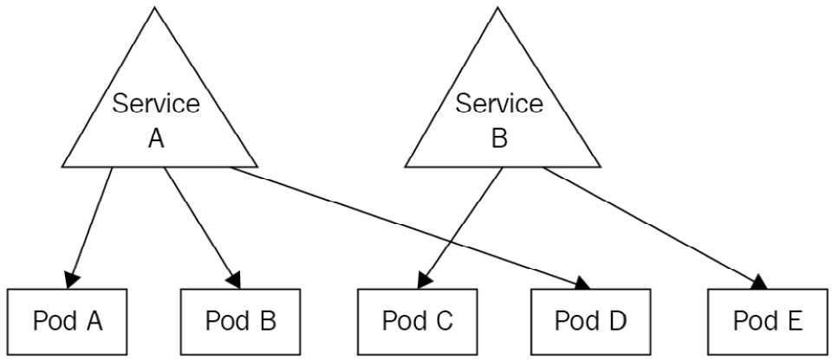
Figure 7.1 – Service A is exposing Pods A, B, and D, whereas Service B is exposing Pods C and E
In fact, Services are deployed to Kubernetes as a resource kind, and just as with most Kubernetes objects, you can deploy them to your cluster using interactive commands or declarative YAML files.
To keep things simple and to sum up: you can consider Services to be load balancers internal to your Kubernetes cluster, built to provide a consistent and static network gateway to your Pod.
When you create a Service, you'll have to give it a name. This name will be used by Kubernetes to build a DNS name that all Pods on your cluster will be able to call. This DNS entry will resolve to your Service, which is supposed to remain on your cluster. The only part that is quite tricky at your end will be to give a list of Pods to expose to your services: we will discover how to do that in this chapter. Don't worry—it's just configuration based on labels and selectors.
Once everything is set up, you can just reach the Pods by calling the service. This service will receive the requests and forward them to the Pods. And that's pretty much it!

Understanding round-robin load balancing in Kubernetes
Kubernetes services, once configured properly, can expose one or several Pods. When multiple Pods are exposed by the same Pod, the requests are evenly load-balanced to the Pods behind the service using the round-robin algorithm, as illustrated in the following screenshot:
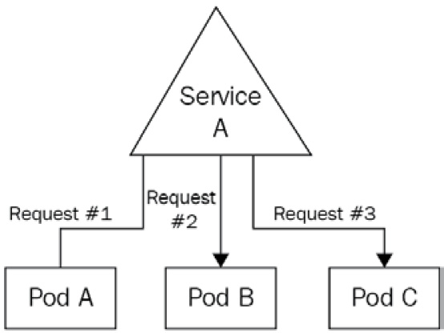
Figure 7.2 – Service A proxies three requests to the three Pods behind it. At scale, each service will receive 33% of the requests received by the service
Scaling applications becomes easy. Adding more Pods behind the service will be enough. As the Kubernetes service has round-robin logic implemented, it can proxy requests evenly to the Pods behind it.
If the preceding Pod had four Pods, then, each of them would receive roughly 25% of all the requests the service received. If 50 Pods were behind the service, each of them would receive roughly 2% of all the requests received by the service. That's pretty much it. All you need to understand is that services are behaving like load balancers you can find on the cloud by following the round-robin algorithm.
Let's now discover how you can call a service in Kubernetes from another Pod.

Understanding how to call a service in Kubernetes
When you create a Service in Kubernetes, it will be attached two very important things, as follows:
An IP address that will be unique and specific to it (just as Pods get their own IP)
An automatically generated DNS name that won't change and is static
You'll be able to use any of the two in order to reach the service, which will then forward your request to the Pod it is attached to. Most of the time, though, you'll call the service by its generated domain, which is easy to determine and predictable. Let's discover how Kubernetes assigns DNS names to services.

Understanding how DNS names are generated for services
The DNS name generated for a service is derived from its name. For example, if you create a Service named my-app-service, its DNS name will be my-app-service.default.svc.cluster.local.
This one is quite complicated, so let's break it into smaller parts, as follows:
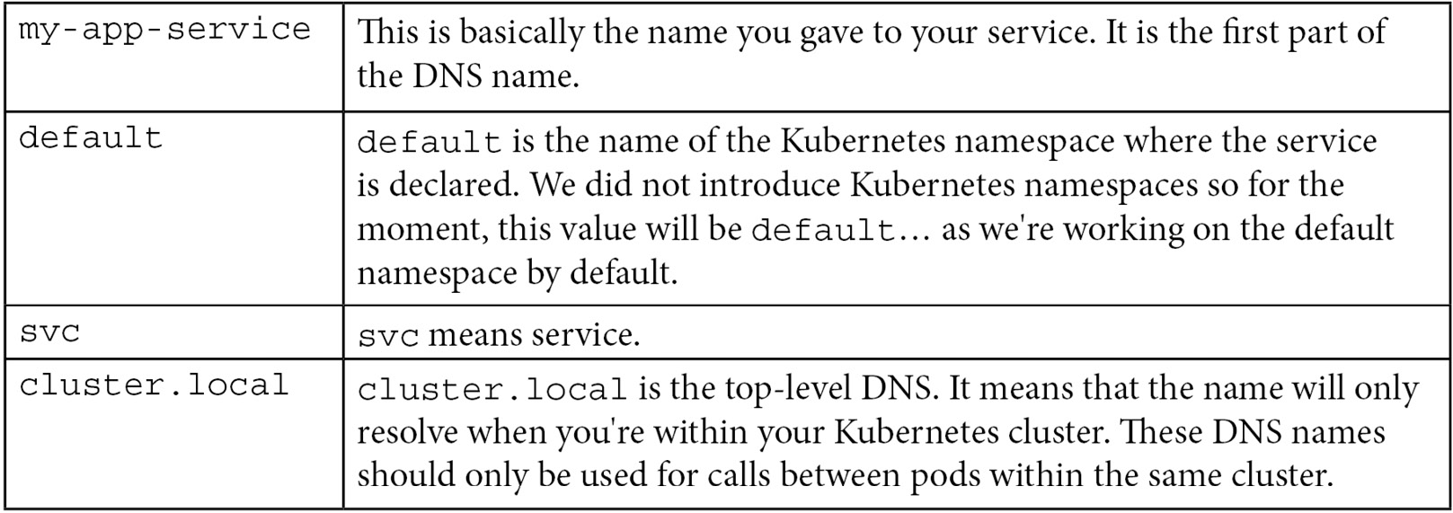
This table should help you distinguish all the parts of the domain name. The two moving parts are the two first ones, which are basically the service name and the namespace where it lives. The DNS name will always end with the .svc.local string.
So, at any moment, from anywhere on your cluster, if you try to use curl or wget to call the my-app-service.default.svc.cluster.local address, you know that you'll reach your service.
That name will resolve to the service as soon as it's executed from a Pod within your cluster. But by default, services won't proxy to anything if they are not configured to retrieve a list of Pods they will proxy. We will now discover how to do that!

How services get a list of the Pods they service traffic to
When working with services in Kubernetes, you will often come across the idea of exposing your Pods.
Indeed, this is the terminology Kubernetes uses to tell that a service is proxying network traffic to Pods. We say a service is exposing Pods. That terminology is everywhere: your colleagues may ask you one day: "Which service is exposing that Pod?" The following screenshot shows Pods being exposed:
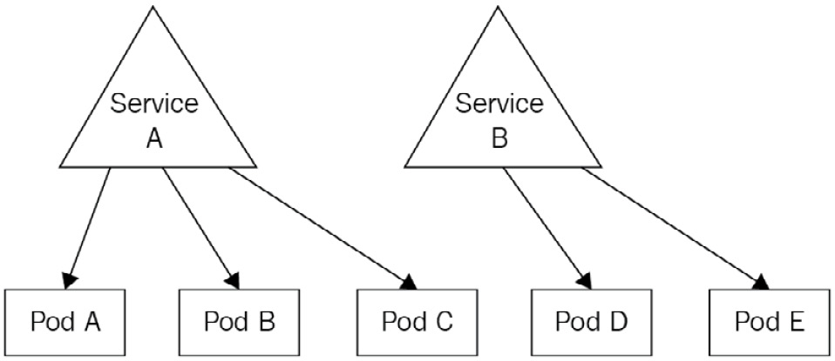
Figure 7.3 – Here, Pods A, B, and C are exposed by service A, whereas Pods D and E are exposed by service B
That terminology is also the one used by kubectl and the one used in Kubernetes official documentation in general. You can successfully create a Pod and a service to expose it using kubectl in literally one command, using the --expose parameter. The following example will create an nginx Pod with a service exposing it.
For the sake of this example, we will also need to provide a port to the command to tell on which port the service will be accessible:
$ kubectl run nginx --image nginx:latest --expose --port 80
service/nginx created
pod/nginx created
Let's now list the Pods and the services using kubectl to demonstrate that the following command created both objects:
$ kubectl get pods
NAME READY STATUS RESTARTS AGE
nginx 1/1 Running 0 2m44s
$ kubectl get services
NAME TYPE CLUSTER-IP EXTERNAL-IP PORT(S) AGE
nginx ClusterIP 10.98.191.187 <none> 80/TCP 2m28s
nginx ClusterIP 10.98.191.187 <none> 80/TCP 2m9s
As you can see based on the output of the command, both objects were created.
We've said earlier that Services can find Pods they have to expose based on Pods' labels. That being said, the nginx Pod we just created surely has some labels. To show them, let's run the kubectl get pods nginx --show-labels command. In the following snippet, pay attention to the --show-labels parameter, which will display the labels as part of the output:
$ kubectl get pods nginx --show-labels
NAME READY STATUS RESTARTS AGE LABELS
nginx 1/1 Running 0 3m27s run=nginx
As you can see, an nginx Pod was created with a label called run, with a value of nginx. Let's now describe the nginx service. It should have a selector that matches this label. The code is illustrated here:
$ kubectl describe svc nginx
Name: nginx
Namespace: default
Labels: <none>
Annotations: <none>
Selector: run=nginx
Type: ClusterIP
IP: 10.98.191.187
Port: <unset> 80/TCP
TargetPort: 80/TCP
Endpoints: 172.17.0.8:80
I did remove some lines of the output to make it shorter. But you can clearly see that the service has a line called Selector that matches the label assigned to the nginx Pod. This way, the link between the two objects is made. We're now 100% sure that the service can reach the nginx Pod and that everything should work normally.
Though it works, I strongly advise you to never do that in production. Indeed, services are very customizable objects, and the --expose parameter is hiding a lot of their features. Instead, you should really use declarative syntax and tweak the YAML to fit precise needs.
Let's demonstrate that by using the dnsutils Docker image.

Using the dnsutils Docker image to debug your services
One very nice image to discover is the dnsutils one. It is extremely useful to debug your service.
Indeed, as your services are created within your cluster, it is often hard to access them, especially if our Pod is meant to remain accessible only within your cluster, or if your cluster has no internet connectivity, and so on.
In this case, it is good to deploy a Pod in your cluster with just some binaries installed into it to run basic networking commands such as wget, nslookup, and so on. One image that meets this need well is the dnsutils one. You can easily test your services using this image.
Here, we're going to curl the nginx Pod home page by calling the service that is exposing the Pod. That service's name is just nginx. Hence, we can forge the DNS name Kubernetes assigned to it: nginx.default.svc.cluster.local.
If you try to reach this Uniform Resource Locator (URL) from a Pod with your cluster, you should successfully reach the nginx home page. Let's run the following command to launch the dnsutils Pod on our cluster:
$ kubectl apply -f https://k8s.io/examples/admin/dns/dnsutils.yaml
pod/dnsutils created
Let's now run a kubectl get pods command in order to verify the Pod was launched successfully, as follows:
$ kubectl get pods/dnsutils
NAME READY STATUS RESTARTS AGE
dnsutils 1/1 Running 0 56s
That's perfect! Let's now run a nslookup command against the service DNS name, as follows:
$ kubectl exec -ti dnsutils -- nslookup nginx.default.svc.cluster.local
Server: 10.96.0.10
Address: 10.96.0.10 # This address is only resolvable from within the Kubernetes cluster, via local kube-dns or CoreDNS.
Name: nginx.default.svc.cluster.local
Address: 10.98.191.187
Everything looks good. Let's now run a wget command to check if we can retrieve the nginx home page, as follows:
$ kubectl exec -ti dnsutils -- wget nginx.default.svc.cluster.local
Connecting to nginx.default.svc.cluster.local (10.98.191.187:80)
index.html 100% |*******************************| 615 0:00:00 ETA
The wget command seems to have downloaded the index.html file properly. I can now display its content using cat, like this:
$ kubectl exec -ti dnsutils -- cat index.html
<html>
<head>
<title>Welcome to nginx!</title>
<style>
html { color-scheme: light dark; }
body { width: 35em; margin: 0 auto;
font-family: Tahoma, Verdana, Arial, sans-serif; }
</style>
</head>
<body>
<h1>Welcome to nginx!</h1>
Everything is perfect here! We successfully called the nginx service by using the dnsutils service, as illustrated in the following screenshot:
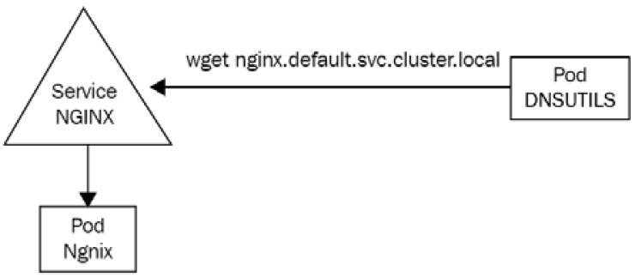
Figure 7.4 – The dnsutils Pod is used to run wget against the nginx service to communicate with the nginx Pod behind the service
Keep in mind that you need to deploy a dnsutils Pod inside the cluster to be able to debug the service. Indeed, the nginx.default.svc.cluster.local DNS name is not a public one and can be only accessible from within the cluster.
Let's explain why you should not use the --expose flag to expose your Pods now.

Why you shouldn't use the --expose flag
The --expose flag should not be used to create services because you won't get much control over how the service gets created. By default, --expose will create a ClusterIP service, but you may want to create a NodePort service.
Defining the service type is also possible using the imperative syntax, but in the end, the command you'll have to issue is going to be very long and complex to understand. That's why I encourage you to not use the --expose flag and stick with declarative syntax for complex objects such as services.
Let's now discuss how DNS names are generated in Kubernetes when using services.

Understanding how DNS names are generated for services
If you understood everything we said before, you now know that Kubernetes services-to-pod communication relies entirely on labels on the Pod side and selectors on the service side.
If you don't use both correctly, communication cannot be established between the two.
The workflow goes like this:
You create some Pods and you set some labels arbitrarily.
You create a service and configure its selector to match the Pods' labels.
The service starts and looks for Pods that match its selector.
You call the service through its DNS or its IP (DNS is way easier).
The service forwards the traffic to one of the Pods that matches its labels.
If you look at the previous example achieved using the imperative style with the --expose parameter, you'll notice that the Pod and the services were respectively configured with proper labels (on the Pod side) and selector (on the service side), which is why the Pod is successfully exposed.
We're almost done with Services theory, but I strongly advise you to not use the --expose parameter. The reason is that services are complex objects with a lot of configurations accessible behind the scenes, and to access all the possible options, it is better to write YAML files.
Besides that, you must understand now that there is not one but several types of services in Kubernetes. Indeed, the Service object can be configured to achieve different types of Pod exposure, and the --expose parameter only allows for the simplest one. Using the --expose parameter is good for tests, but do remember that you should always use YAML files to really have access to all features of Kubernetes.
That being said, let's now explain the different types of services in Kubernetes.

Understanding the different types of services
There are several types of services in Kubernetes.
Although there is only one kind called Service in Kubernetes, that kind can be configured differently to achieve different results.
Fortunately for us, no matter which type of service you choose, the goal remains the same: to expose your Pods using a single static interface.
Each type of service has its own function and its own use, so basically, there's one service for each use case. A service cannot be of multiple types at once, but you can still expose the same Pods by two services' objects with different types… as long as the services' objects are named differently so that Kubernetes can assign different DNS names.
In this chapter, we will discover the three main types of services, as follows:
NodePort: This one binds a port from an ephemeral port range of the host machine (the worker node) to a port on the Pod, making it available publicly. By calling the port of the host machine, you'll reach the associated Kubernetes Pod. That's the way to reach your Pods for traffic coming from outside your cluster.
ClusterIP: The ClusterIP service is the one that should be used for private communication between Pods within the Kubernetes cluster. This is the one we experimented with in this chapter and is the one created by the --expose flag by default. This is certainly the most used of them all because it allows inter-communication between Pods: as its name suggests, it has a static IP that is set cluster-wide. By reaching its IP address, you'll be redirected to the Pod behind it. If more than one Pod is behind it, the ClusterIP service will provide a load-balancing mechanism following the round-robin algorithm. Even if this service type is called ClusterIP, we generally call it by its generated DNS name.
LoadBalancer: The service of the LoadBalancer type is quite complex. It will detect the cloud computing platform the Kubernetes cluster is running on and will create a load balancer on the cloud. If you're running on AWS, it will create an Elastic Load Balancer (ELB). If you run vanilla Kubernetes, it will just create nothing… This service is useless outside of a cloud platform. In general, people tend to prefer to use other services such as Terraform to provision their cloud infrastructure, making this service certainly the least used of them all.
As all of this might seem a little bit unclear to you, let's immediately dive into the first type of service—the NodePort one.
As mentioned earlier, this one is going to be super useful to access our Pods from outside the cluster, by attaching Pods to the worker node's port.

The NodePort service
Now that we are aware of the theory behind the concept of services in Kubernetes, we will start by discovering the first type, which is NodePort.
NodePort is a Kubernetes service type designed to make Pods reachable from a port available on the host machine, the worker node. In this section, we're going to discover this type of port and be fully focused on NodePort services!

Why do you need NodePort services?
We're now going to discover exactly where the NodePort services sit and what they do in your Kubernetes cluster.
The first thing to understand is that NodePort services allow us to access a Pod running on a worker node, on a port of the worker node itself. After you expose Pods using the worker node, you'll be able to reach the Pods if you know the IP address of your worker node and the port of the NodePort service in this format:
<WORKER_NODE_IP_ADDRESS>:<PORT_DECLARED_IN_NODE_PORT_SVC>.
Let's illustrate all of this by declaring some Kubernetes objects.
Most of the time, the NodePort service is used as an entry point to your Kubernetes cluster. In the following example, I will create two Pods based on the containous/whoami Docker image available on the Docker Hub, which is a very nice Docker image that will simply print the container hostname.
I'll create two Pods so that I get two containers with different hostnames, and I'll expose them using a NodePort service.

Creating two containous/whoami Pods
Let's start by creating two Pods without forgetting about adding one or more labels because we will need labels to tell the service which Pods it's going to expose.
I'm also going to open the port on the Pod side. That won't make it exposed on its own, but it will open a port the service will be able to reach. The code is illustrated here:
$ kubectl run whoami1 –image=containous/whoami –port 80 –labels="app=whoami"
pod/whoami1 created
$ kubectl run whoami1 –image=containous/whoami –port 80 –labels="app=whoami"
pod/whoami2 created
Now, I can run a kubectl get pods command in order to verify that our two Pods are correctly running. I can also add the --show-labels parameter in order to display the labels as part of the command output, as follows:
$ kubectl get pods --show-labels
NAME READY STATUS RESTARTS AGE LABELS
whoami1 1/1 Running 0 5m4s app=whoami
whoami2 1/1 Running 0 4m59s app=whoami
Everything seems to be okay! Now that we have two Pods created with a label set for each of them, we will be able to expose them using a service. We're now going to discover the YAML manifest file that will create the NodePort service to expose these two Pods.

Understanding NodePort YAML definition
Unlike most Kubernetes clusters, it is impossible to create services of the NodePort type using the declarative way. And since services are quite complex resources, it is better to create them using a YAML file rather than direct command input.
Here is the YAML file that will expose the whoami1 and whoamo2 Pods using a NodePort service:
# ~/nodeport-whoami.yaml
apiVersion: v1
kind: Service
metadata:
name: nodeport-whoami
spec:
type: NodePort
selector:
app: whoami
ports:
- nodePort: 30001
port: 80
targetPort: 80
This YAML can be difficult to understand because it refers to three different ports as well as a selector block.
Before explaining the YAML file, let's apply it and check if the service was correctly created afterward, as follows:
$ kubectl create -f nodeport-whoami.yaml
service/nodeport-whoami created
$ kubectl get services
NAME TYPE CLUSTER-IP EXTERNAL-IP PORT(S) AGE
nodeport-whoami NodePort 10.98.159.88 <none> 80:30001/TCP 77s
The previous kubectl get services command indicated that the service was properly created!
Now, let's discuss the selector block, which is an important one: it basically instructs the NodePort service which Pods it will expose. selector stands for label selector. Without it, your service won't do anything. Here, we're telling the service to expose all the Pods that have a label with an key app containing the whoami value, which makes our two whoami1 and whoami2 Pods exposed through this service.
Then, we have under the key type as a child key of spec. This is where we specify the type of our service. When we create ClusterIP or LoadBalancer services, we will have to update this line. Here, we're creating a NodePort service, so that's fine for us.
The last thing that is quite hard to understand is that ports block. Here, we define a map of multiple port combinations. We indicated three ports, as follows:
nodePort
port
targetPort
The first one is the easiest one to understand. It is basically the port on the host machine/worker node you want this NodePort service to be accessible from. Here, we're specifying port 30001, which makes this NodePort service accessible from port 30001 on the IP address of the worker node. You'll be reaching this NodePort service and the Pods it exposes by calling the following address: <WORKER_NODE_IP_ADDRESS>:30001.
This NodePort setting cannot be set arbitrarily. Indeed, on default Kubernetes installation, it can be a port from the 30000 - 32767 range.
The second port specified in YAML is just called port: this setting indicates the port of the NodePort service itself. It can be hard to understand, but NodePort services do have a port of their own too, and this is where you specify it. You can put whatever you want here if it is a valid port.
The third and last one is called targetPort. As you can imagine, targetPort is the port of the targeted Pods. It is where the application runs: the port where the NodePort will forward traffic to the Pod found by the selector mentioned previously.
Here is a quick diagram to sum all of this up:
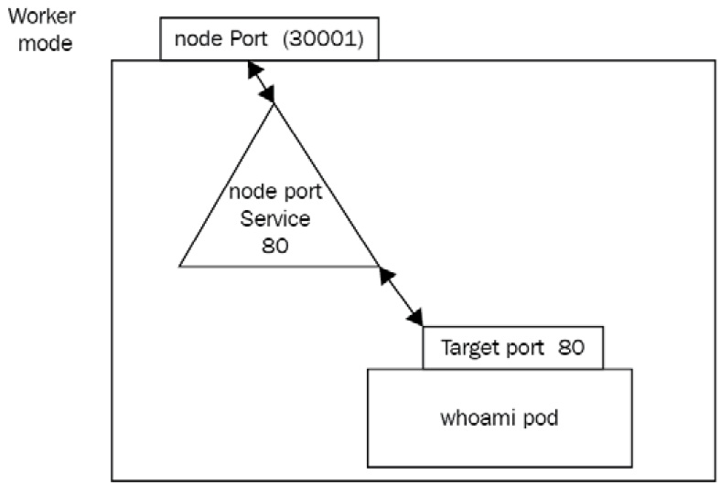
Figure 7.5 – The three ports involved for NodePort setup—nodePort is on the worker node, port is on the service itself, whereas targetPort is on the top
That setup is complex because of the naming. Pay attention to where the three open ports sit to make sure to not confuse the three of them.
For convenience and to reduce complexity, the NodePort service port and target port (the Pods' port) are often defined to the same value.

Making sure NodePort works as expected
To try out your NodePort setup, the first thing to do is to retrieve the public IP of your machine running it. In my example, I'm running a single-machine Kubernetes setup with minikube locally. On AWS, GCP, or Azure, your worker node might have a public IP address or a private one if you access your node with a virtual private network (VPN).
Based on your setup, keep in mind that the IP address you use must be the one of the worker nodes directly.
On minikube, the easiest way to retrieve the IP address is to issue the following command:
$ minikube ip
192.168.64.2
Now that I have the IP address of my worker node, I must retrieve the worker node's port used by the NodePort service.
Now that I have all the information, I can open a web browser and enter the following URL to access the NodePort service and the Pods running. You should see the round-robin algorithm in place and reaching whoami1 and then whoami2, and so on. The NodePort service is doing its job!

Is this setup production-ready?
There's no answer to this question because it depends on your setup.
NodePort provides a way to expose Pods to the outside world by exposing them on a worker node port. With the current setup, you have no HA: if our two Pods were to fail, you have no way to relaunch them automatically, so your service won't be able to forward traffic to anything, resulting in a poor experience for your end user.
Another problem is the fact that the choice of port is limited. Indeed, by default, you are just forced to use a port in the 30000-32767 range, and as it's forced, it will be inconvenient for a lot of people. Indeed, if you want to expose an HTTP application, you'll want to use port 80 or 443 of your frontal machine and not a port for 30000-32767, because all web browsers are configured with port 80 and 443 as standard HTTP and HTTP Secure (HTTPS) ports.
The solution to this consists of using a tiered architecture. Indeed, a lot of Kubernetes architects tend to not expose a NodePort service as the first layer in an architecture but to put the Kubernetes cluster behind a reverse proxy, such as the AWS Application Load Balancer, and so on. Two other concepts of Kubernetes are Ingress and IngressController objects: these two objects allow you to configure a reverse proxy such as nginx or HAProxy directly from Kubernetes objects and help you in making your application publicly accessible as the first layer of entry to Kubernetes. But this is way beyond the scope of Kubernetes services.

Listing NodePort services
Listing NodePort services is achieved through the usage of the kubectl command-line tool. You must simply issue a kubectl get services command to fetch the services created within your cluster.
Please note that the plural form services, as well as the shorter alias svc, works too for all operations related to services. Unfortunately, there is currently no command that allows us to fetch services based on their type.
That being said, let's now discover how we can update NodePort services to have them do what we want.

Adding more Pods to NodePort services
If you want to add a Pod to the pool served by your Services, things are very easy. In fact, you just need to add a new Pod that matches the label selector defined on the Service—Kubernetes will take care of the rest. The Pod will be part of the pool served by the Service. In case you delete a Pod, it will be deleted from the pool of services as soon as it enters the Terminating state.
Kubernetes handles service traffic based on Pods' availability—for example, if you have three replicas of a web server and one goes down, creating an additional replica that matches the label selector on the service will be enough. You'll discover later in Chapter 11, Deployment – Deploying Stateless Applications, that this behavior can be entirely automated.

Describing NodePort services
Describing NodePort services is super easy and is achieved with the kubectl describe command, just as with any other Kubernetes object.

Deleting NodePort services
Deleting a service, whether it is a NodePort service or not, should not be done recurrently. Indeed, whereas Pods are supposed to be easy to delete and recreate, services are supposed to be for the long term. Indeed, they provide a consistent way to expose your Pod, and deleting them will impact how your applications can be reached.
Therefore, you should be careful when deleting services: it won't delete the Pods behind it, but they won't be accessible anymore!
Here is the command to delete the service created to expose the whoami1 and whoami2 Pods:
$ kubectl delete svc/nodeport-whoami
deleted
You can run a kubectl get svc command now to check that the service was properly destroyed, and then access it once more through the web browser by refreshing it. You'll notice that the application is not reachable anymore, but the Pods will remain on the cluster. Pods and services have completely independent life cycles. If you want to delete Pods, then you'll need to delete them separately.
You probably remember the kubectl port-forward command we already used when we created an nginx Pod and tested it to display the home page. You may think NodePort and kubectl port-forward are the same thing, but they are not. Let's explain quickly the difference between the two.

NodePort or kubectl port-forward?
It might be tempting to compare NodePort services with the kubectl port-forward command because so far, we used these two methods to access a running Pod in our cluster using a web browser. But still, these two methods are completely different things—they have nothing to do one with another and shouldn't be confused.
The kubectl port-forward command is a testing tool, whereas NodePort services are for real use cases and are a production-ready feature.
Keep in mind that kubectl port-forward must be kept open in your terminal session for it to work. As soon as the command is killed, the port forwarding is stopped too, and your application becomes inaccessible from outside the cluster once more. It is only a testing tool meant to be used by the kubectl user and is just one of the useful tools bundled into the kubectl CLI.
NodePort, on the other hand, is really meant for production use and is a long-term production-ready solution. It doesn't require kubectl to work and makes your application accessible to anyone calling the service, provided the service is properly configured and Pods correctly labeled.
Simply put: if you just need to test your app, go for kubectl port-forward. If you need to expose your Pod to the outside world for real, go for NodePort. Don't create NodePort for testing, and don't try to use kubectl port-forward for production! Stick with one tool for each use case!
Now, we will discover another type of Kubernetes service called ClusterIP. This one is probably the most used of them all, even more than the NodePort type!

The ClusterIP service
We're now going to discover another type of service called ClusterIP.
ClusterIP is, in fact, the simplest type of service Kubernetes provides. With a ClusterIP service, you can expose your Pod so that other Pods in Kubernetes can communicate with it via its IP address or DNS name.

Why do you need ClusterIP services?
The ClusterIP service type greatly resembles the NodePort service type, but they have one big difference: NodePort services are meant to expose Pods to the outside world, whereas ClusterIP services are meant to expose Pods to other Pods inside the Kubernetes cluster.
Indeed, ClusterIP services are the services that allow different Pods in the same cluster to communicate with each other through a static interface: the ClusterIP Service object itself.
ClusterIP answers the exact same need for static DNS name or IP address we had with the NodePort service: if a Pod fails, is recreated, deleted, relaunched, and so on, then Kubernetes will assign it another IP address. ClusterIP services are here to remediate this issue, by providing an internal DNS name only accessible from within your cluster that will resolve to the Pods defined by the label selector.
As the name ClusterIP suggests, this service grants a static IP within the cluster! Let's now discover how to expose our Pods using ClusterIP! Keep in mind that ClusterIP services are not accessible from outside the cluster—they are only meant for inter-Pod communication.

How do I know if I need NodePort or ClusterIP services to expose my Pods?
Choosing between the two types of services is extremely simple, basically because they are not meant for the same thing.
If you need your app to be accessible from outside the cluster, then you'll need a NodePort service, but if you need your app to be accessible from inside the cluster, then you'll need a ClusterIP service. It's as simple as that! ClusterIP services are also good for stateless applications that can be scaled, destroyed, recreated, and so on. The reason is that the ClusterIP service will maintain a static entry point to a whole pool of Pods without being constrained by a port on the worker node, unlike the NodePort service.
Contrary to NodePort services, ClusterIP services will not take one port of the worker node, and thus it is impossible to reach it from outside the Kubernetes cluster.
Keep in mind that nothing prevents you from using both types of services for the same pool of Pods. Indeed, if you have an app, that should be publicly accessible, but also privately exposed to other Pods, then you can simply create two services, one NodePort service and one ClusterIP service.
In this specific use case, you'll simply have to name the two services differently so that they won't conflict when creating them against kube-apiserver. Nothing else prevents you from doing so!

Listing ClusterIP services
Listing ClusterIP services is easy. It's basically the same command as the one used for NodePort services. Here is the command to run:
$ kubectl get svc
As always, this command lists the services with their type added to the output.

Creating ClusterIP services using the imperative way
Creating ClusterIP services can be achieved with a lot of different methods. Since it is an extremely used feature, there are lots of ways to create these, as follows:
Using the --expose parameter (the imperative way)
Using a YAML manifest file (the declarative way)
The imperative way consists of using the –expose method. This will create a ClusterIP service directly from a kubectl run command, for example. In the following example, I will create an nginx-clusterip Pod as well as a ClusterIP Pod to expose them both at the same time. Using the –expose parameter will also require defining a ClusterIP port. ClusterIP will listen to make the Pod reachable. The code is illustrated here:
$ kubectl run nginx-clusterip --image nginx --expose --port 80
service/nginx-clusterip created
pod/nginx-clusterip created
As you can see, I get both a Pod and a service to expose it. Let's describe the service.

Describing ClusterIP services
Describing ClusterIP services is the same process as describing any type of object in Kubernetes and is achieved using the kubectl describe command. You just need to know the name of the service to describe to achieve that.
Here, I'm going to the ClusterIP service created previously:
$ kubectl describe svc/nginx-clusterip
Name: nginx-clusterip
Namespace: default
Labels: <none>
Annotations: <none>
Selector: run=nginx-clusterip
Type: ClusterIP
IP Family Policy: SingleStack
IP Families: IPv4
IP: 10.96.89.255
IPs: 10.96.89.255
Port: <unset> 80/TCP
TargetPort: 80/TCP
Endpoints: 10.244.120.79:80
Session Affinity: None
Events: <none>
What I really like here is that the output of this command shows us the Selector block, which shows that the ClusterIP service was created by the --expose parameter with the proper label configured. This label matches the nginx-clusterip Pod we created at the same time. To be sure about that, let's display the labels of the said Pod, as follows:
$ kubectl get pods/nginx-clusterip --show-labels
NAME READY STATUS RESTARTS AGE LABELS
nginx-clusterip 1/1 Running 0 4m1s run=nginx-clusterip
As you can see, the selector on the service matches the labels defined on the Pod. Communication is thus established between the two. I'll now call the ClusterIP service directly from another Pod on my cluster.
Since my ClusterIP service is named nginx-clusterip, I know that it is reachable at this address: nginx-clusterip.default.svc.cluster.local.
Let's reuse the dnsutils container, as follows:
$ kubectl exec -ti dnsutils -- wget nginx.default.svc.cluster.local
Connecting to nginx.default.svc.cluster.local (10.98.191.187:80)
index.html 100% |*******************************| 615 0:00:00 ETA
Using the wget command, we have downloaded the index.html file properly. I can now display its content using cat, as follows:
$ kubectl exec -ti dnsutils -- cat index.html
<html>
<head>
<title>Welcome to nginx!</title>
<style>
html { color-scheme: light dark; }
body { width: 35em; margin: 0 auto;
font-family: Tahoma, Verdana, Arial, sans-serif; }
</style>
</head>
<body>
<h1>Welcome to nginx!</h1>
Looks good! The ClusterIP service correctly forwarded my request to the nginx Pod, and I do have the nginx default home page. The service is working!
We did not use containous/whoami as a web service this time, but keep in mind that the ClusterIP service is also doing load balancing internally following the round robin algorithm. If you have 10 Pods behind a ClusterIP service and your service received 1,000 requests, then each Pod is going to receive 100 requests.
Let's now discover how to create a ClusterIP service using YAML.

Creating ClusterIP services using the declarative way
ClusterIP services can also be created using the declarative way by applying YAML configuration files against kube-apiserver.
Here's a YAML manifest file we can use to create the exact same ClusterIP service we created before using the imperative way:
# ~/clusterip-service.yaml
apiVersion: v1
kind: Service
metadata:
name: nginx-clusterip
spec:
type: ClusterIP # Indicates that the service is a ClusterIP
ports:
- port: 80 # The port exposed by the service
protocol: TCP
targetPort: 80 # The destination port on the pods
selector:
run: nginx-clusterip
Take some time to read the comments in the YAML, especially the port and targetPort ones.
Indeed, ClusterIP services have their own port independent of the one exposed on the Pod side. You reach the ClusterIP service by calling its DNS name and its port, and the traffic is going to be forwarded to the destination port on the Pods matching the labels and selectors.
Keep in mind that no worker node port is involved here. The ports we are mentioning when it comes to ClusterIP scenarios have absolutely nothing to do with the host machine!

Deleting ClusterIP services
Deleting ClusterIP services is the same process as deleting any type of object in Kubernetes. You just need to know the name of the service and to pass it to the kubectl delete svc command, as follows:
$ kubectl delete svc/my-service
service/my-service deleted
This way, the service gets deleted from the Kubernetes cluster. Keep in mind that deleting the cluster won't delete the Pods exposed by it. It is a different process; you'll need to delete Pods separately. We will now discover one additional resource related to ClusterIP services, which are headless services.

Understanding headless services
Headless services are derived from the ClusterIP service. They are not technically a dedicated type of service (such as NodePort), but they are an option from ClusterIP.
Headless services can be configured by setting the .spec.clusterIP option to None in a YAML configuration file for the ClusterIP service. Here is an example derived from our YAML file previously:
# ~/clusterip-headless.yaml
apiVersion: v1
kind: Service
metadata:
name: nginx-clusterip-headless
spec:
clusterIP: None
type: ClusterIP # Indicates that the service is a ClusterIP
ports:
- port: 80 # The port exposed by the service
protocol: TCP
targetPort: 80 # The destination port on the pods
selector:
run: nginx-clusterip
A headless service roughly consists of a ClusterIP service without load balancing and without a pre-allocated ClusterIP address. Thus, the load-balancing logic and the interfacing with the Pod are not defined by Kubernetes.
Since a headless service has no IP, you are going to reach the Pod behind it directly, without the proxying and the load-balancing logic. What the headless service does is return you the DNS names of the Pods behind it so that you can reach them directly. There is still a little load-balancing logic here, but it is implemented at the DNS level, not as a Kubernetes logic.
When you use a normal ClusterIP service, you'll always reach one static IP address allocated to the service and this is going to be your proxy to communicate with the Pod behind it. With a headless service, the ClusterIP service will just return the DNS names of the Pods behind it and the client will have the responsibility to establish a connection with the DNS name of its choosing.
It can be hard to think of a concrete use case for this, and honestly, headless services are not used as much as normal ClusterIP services. They are still helpful when you want to build connectivity with clustered stateful services such as Lightweight Directory Access Protocol (LDAP). In that case, you may want to use an LDAP client that will have access to the different DNS names of the Pods hosting the LDAP server, and this can't be done with a normal ClusterIP service since it will bring both a static IP and Kubernetes' implementation of load balancing. That's the kind of scenario when headless services are helpful.
Let's now briefly introduce another type of service called LoadBalancer.

The LoadBalancer service
LoadBalancer services are a very interesting service to explain because this service relies on the cloud platform where the Kubernetes cluster is provisioned. For it to work, it is thus required to use Kubernetes on a cloud platform that supports the LoadBalancer service type.

Explaining the LoadBalancer services
Not all cloud providers support the LoadBalancer service type, but we can name a few that do support it, as follows:
AWS
GCP
Azure
OpenStack
The list is not exhaustive, but it's good to know that all three major public cloud providers are supported.
If your cloud provider is supported, keep in mind that the load-balancing logic will be the one implemented by the cloud provider: you cannot control how the traffic will be routed to your Pods from Kubernetes; you will have to know how the load-balancer component of your cloud provider works. Consider it as a third-party component implemented as a Kubernetes kind.

Should I use the LoadBalancer service type?
This question is difficult to answer but a lot of people tend to not use a LoadBalancer service type for a few reasons.
The main reason is that LoadBalancer services are near impossible to configure from Kubernetes. Indeed, if you must use a cloud provider, it is better to configure it from the tooling provided by the provider rather than from Kubernetes.
The LoadBalancer service type is a generic way to provision a LoadBalancer service but does not expose all the advanced features that the cloud provider may provide. Let's take the example of AWS. This cloud provider has three LoadBalancer components, as follows:
Classic Load Balancer
Application Load Balancer
Network Load Balancer
All these three offerings differ. Their usage, configurations, and behaviors are not the same from one to another. The LoadBalancer service type, when used on an AWS-backed Kubernetes cluster, will create a Classic Load Balancer: you have no way to create an Application Load Balancer or a Network Load Balancer from the Kubernetes Service object.
Just to Say
A lot of configurations are hidden, and you won't have access to all the features your cloud provider offers. That's why you should avoid using the LoadBalancer service and stick to different tooling such as Terraform or the CLI.

Implementing ReadinessProbe
ReadinessProbe, along with LivenessProbe, is an important aspect to master if you want to provide the best possible experience to your end user. We will first discover how to implement ReadinessProbe and how it can help you to ensure your containers are fully ready to serve traffic.

Why do you need ReadinessProbe?
Readiness probes are technically not part of services, but I think it is important to discover this feature alongside Kubernetes services.
Just as with everything in Kubernetes, ReadinessProbe was implemented to bring a solution to a problem. This problem is this: how to ensure a Pod is fully ready before it can receive traffic, possibly from a service?
Indeed, Services obey a simple rule: they serve traffic to every Pod that matches their label selector. As soon as a Pod gets provisioned, if this pod's labels match the selector of a service in your cluster, then this service will immediately start forwarding traffic to it. This can lead to a simple problem: if the app is not fully launched, because it has a slow launch process or requires some configuration from a remote API, and so on, then it might receive traffic from services before being ready for it. The result would be a poor user experience (UX).
To make sure this scenario never happens, we can use what we call a readiness probe, which is an additional configuration to add to Pods' configuration.
When a Pod is configured with a readiness probe, it can send a signal to the control plane that it is not ready to receive traffic, and when a Pod is not ready, services won't forward any traffic to it. Let's see how we can implement a readiness probe.

Implementing ReadinessProbe
ReadinessProbe implementation is achieved by adding some configuration data to a Pod YAML manifest. It has nothing to do with the Service object itself. By adding some configuration to the container spec in the Pod object, you can basically tell Kubernetes to wait for the Pod to be fully ready before it can receive traffic from services.
ReadinessProbe can be of three different types, as outlined here:
Command—You issue a command that should complete with exit code 0, indicating the Pod is ready.
HTTP—You issue an HTTP request that should complete with a response code >= 200 and < 400, which indicates the Pod is ready.
TCP—You issue a TCP connection attempt. If the connection is established, the Pod is ready.
Here is a YAML file configuring a nginx Pod with a readiness probe of type HTTP:
# ~/nginx-pod-with-readiness-http.yaml # ~/nginx-pod-with-readiness-http.yaml
apiVersion: v1
kind: Pod
metadata:
name: nginx-pod-with-readiness-http
spec:
containers:
- name: nginx-pod-with-readiness-http
image: nginx
readinessProbe:
initialDelaySeconds: 5
periodSeconds: 5
httpGet:
path: /ready
port: 80
As you can see, we have two important inputs under the readinessProbe key, as follows:
initialDelaySeconds, which indicates the number of seconds the probe will wait before running the first health check.
periodSeconds, which indicates the number of seconds the probe will wait between two consecutive health checks.
Indeed, the readiness probe will be replayed regularly, and the interval between two checks will be defined by the periodSeconds parameter.
In our case, our ReadinessProbe will run an HTTP call against the /ready path. If this request receives an HTTP response code >= 200 and < 400, then the probe will be a success and the Pod will be considered healthy.
ReadinessProbe is important. In our example, the endpoint being called should really test that the application is really in such a state that it can receive traffic. So, try to call an endpoint that is relevant to the state of the actual application. For example, you can try to call a page that will open a MySQL connection internally to make sure the application is capable of communicating with its database if it is using one, and so on. If you're a developer, do not hesitate to create a dedicated endpoint that will just open connections to the different backends to be fully sure that the application is ready for real.
The Pod will then join the pool being served by the service and will start receiving traffic. ReadinessProbe can also be configured as TCP and commands, but we will keep these examples for LivenessProbe. Let's discover them now!

What is LivenessProbe and why do you need it?
LivenessProbe resembles ReadinessProbe a lot. In fact, if you already used some cloud providers before, you might already have heard about something called health checks. So, in other words, LivenessProbe is basically a health check.
Basically, liveness probes are used to determine whether a Pod is in a broken state or not, and the usage of LivenessProbe is especially suited for long-running processes such as web services. Indeed, imagine a situation where you have a service forwarding traffic to three Pods and one of them is broken. Services cannot detect that on their own, and they will just continue to serve traffic to the three Pods, including the broken one. In such situations, 33% of your request will inevitably lead to an error response, resulting in a poor UX, as illustrated in the following screenshot:
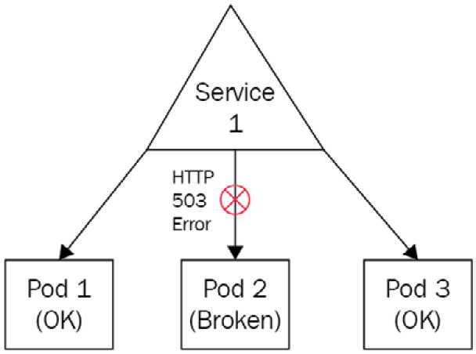
Figure 7.6 – One of the Pods is broken but the service will still forward traffic to it
You want to avoid such situations, and to do that, you need a way to detect situations where Pods are broken, plus a way to kill such a container so that it goes out of the pool of Pods being targeted by the service.
LivenessProbe is the solution to this problem and is implemented at the Pod level. Be careful because LivenessProbe cannot repair a Pod: it can only detect that a Pod is not healthy and command its termination. Let's see how we can implement a Pod with LivenessProbe.

Implementing LivenessProbe
LivenessProbe is a health check that will be executed on a regular schedule to keep track of the application state in the long run. These health checks are executed by the kubelet component and can be of three types, as outlined here:
Command, where you issue a command in the container and its result will tell whether the Pod is healthy or not (exit code = 0 means healthy)
HTTP, where you run an HTTP request against the Pod, and its result tells whether the Pod is healthy or not (HTTP response code >= 200 and < 400 means the Pod is healthy)
TCP, where you define a TCP call (a successful connection means the Pod is healthy)
Each of these three liveness probes will require you to input a parameter called periodSeconds, which must be an integer. This will tell the kubelet component the number of seconds to wait before performing a new health check. You can also use another parameter called initialDelaySeconds, which will indicate the number of seconds to wait before performing the very first health check. Indeed, in some common situations, a health check might lead to flagging an application as unhealthy just because it was performed too early. That's why it might be a good idea to wait a little bit before performing the first health check, and that parameter is here to help.
LivenessProbe configuration is achieved at the Pod YAML configuration manifest, not at the service one. Each container in the Pod can have its own livenessProbe.
Here is a configuration file that checks if a Pod is healthy by running an HTTP call against a /healthcheck endpoint in an nginx container:
# ~/nginx-pod-with-liveness-http.yaml
apiVersion: v1
kind: Pod
metadata:
name: nginx-pod-with-liveness-http
spec:
containers:
- name: nginx-pod-with-liveness-http
image: nginx
livenessProbe:
initialDelaySeconds: 5
periodSeconds: 5
httpGet:
path: /healthcheck
port: 80
httpHeaders:
- name: My-Custom-Header
value: My-Custom-Header-Value
Please pay attention to all sections after the livenessProbe blocks. If you understand this well, you can see that we will wait 5 seconds before performing the first health check, and then, we will run one HTTP call against the /healthcheck path on port 80 every 5 seconds. One custom HTTP header was added. Adding such a header will be useful to identify our health checks in the access logs. Be careful because the /healthcheck path probably won't exist in our nginx container and thus, this container will never be considered healthy because the liveness probe will result in a 404 HTTP response. Keep in mind that for an HTTP health check to succeed, it must answer an HTTP >= 200 and < 400. 404 being out of this range, the answer Pod won't be healthy.
You can also use a command to check if a Pod is healthy or not. Let's grab the same YAML configuration, but now, we will use a command instead of an HTTP call in the liveness probe, as follows:
# ~/nginx-pod-with-liveness-command.yaml
apiVersion: v1
kind: Pod
metadata:
name: nginx-pod-with-liveness-command
spec:
containers:
- name: nginx-pod-with-liveness-command
image: nginx
livenessProbe:
initialDelaySeconds: 5
periodSeconds: 5
exec:
command:
- cat
- /hello/world
If you check this example, you can see that this one is much simpler than the HTTP one. Here, we are basically running a cat /hello/world command every 5 seconds. If the file exists and the cat command completes with an exit code equal to 0, then the health check will succeed. Otherwise, if the file is not present, the health check will fail, and the Pod will never be considered healthy and will be terminated.
We will now complete this section by discovering one last example with a TCP livenessProbe. In this situation, we will attempt a connection to a TCP socket on port 80. If the connection is successfully established, then the health check will pass, and the container will be considered ready. Otherwise, the health check will fail, and the Pod will be terminated eventually. The code is illustrated in the following snippet:
# ~/nginx-pod-with-liveness-tcp.yaml
apiVersion: v1
kind: Pod
metadata:
name: nginx-pod-with-liveness-tcp
spec:
containers:
- name: nginx-pod-with-liveness-tcp
image: nginx
livenessProbe:
initialDelaySeconds: 5
periodSeconds: 5
tcpSocket:
port: 80
Using TCP health checks greatly resembles HTTP ones since HTTP is based on TCP anyway. But having TCP as a liveness probe is nice especially if you want to keep track of an application that is not based on using HTTP as protocol and using that command is irrelevant to you, such as health-checking an LDAP connection, for example.

Using ReadinessProbe and LivenessProbe together
You can use ReadinessProbe and LivenessProbe together in the same Pod. There is nothing wrong with that since ReadinessProbe is here for you to prevent a Pod from joining a service before being ready to serve traffic, and LivenessProbe is here to kill a Pod that has become unhealthy.
So, they are configured almost the same way—they don't have the exact same purpose, and it is fine to use them together. Please note that both probes share these parameters:
initialDelaySeconds: The number of seconds to wait before the first probe execution
periodSeocnds: The number of seconds between two probes
timeoutSeconds: The number of seconds to wait before timeout
successThreshold: The number of successful attempts to consider a Pod is ready (for ReadinessProbe) or healthy (for LivenessProbe)
failureThreshold : The number of failed attempts to consider a Pod is not ready (for ReadinessProbe) or ready to be killed (for LivenessProbe)
We now have discovered ReadinessProbe and LivenessProbe, and we can now move on to our final section, which introduces the control of network flow in Kubernetes using the NetworkPolicy object. You will see that you can build a kind of network firewall directly in Kubernetes so that you can prevent Pods from being able to reach one another.

Securing your Pods using the NetworkPolicy object
The NetworkPolicy object is the last resource kind we need to discover as part of this chapter to have an overview of services in this chapter. NetworkPolicy will allow you to define network firewalls directly implemented in your cluster.

Why do you need NetworkPolicy?
When you have to manage a real Kubernetes workload in production, you'll have to deploy more and more applications onto it, and it is possible that these applications will have to communicate with each other.
Achieving communication between applications is really one of the fundamental objectives of a microservice architecture. Most of this communication will be done through the network, and the network is forcibly something that you want to secure by using firewalls.
Kubernetes has its own implementation of network firewalls called NetworkPolicy. This is a new resource kind we are going to discover. Say that you want one nginx resource to be accessible on port 80 from a particular IP address and to block any other traffic that doesn't match these requirements. To do that, you'll need to use NetworkPolicy and attach it to that Pod.
NetworkPolicy brings three benefits, as follows:
You can build egress/ingress rules based on Classless Inter-Domain Routing (CIDR) blocks.
You can build egress/ingress rules based on Pods labels and selectors (just as we've seen before with services' and Pods' association).
You can build egress/ingress rules based on namespaces (a notion we will discover in the next chapter).
Lastly, keep in mind that for NetworkPolicy to work, you'll need to have a Kubernetes cluster with a CNI plugin installed. CNI plugins are generally not installed by default on Kubernetes. If you're using minikube, the good news is that it has an integration with Calico, which is a CNI plugin with NetworkPolicy support implemented out of the box. You just need to relaunch minikube this way:
$ minikube start --network-plugin=cni --cni=calico
If you're using Kubernetes on top of a cloud platform, I suggest you read the documentation of your cloud provider in order to verify which CNI options your cloud platform offers and whether it implements NetworkPolicy support.

Understanding Pods are not isolated by default
This is something extremely important to understand. By default, in Kubernetes, Pods are not isolated. It means that any Pod can be reached by any other Pod without any constraint.
All Pods you have deployed so far can be reached by any other Pod in the cluster. If you don't use NetworkPolicy, Pods will remain just like that: accessible by everything without any constraint. Once you attach the NetworkPolicy to a Pod, the rules described on the NetworkPolicy will be applied to the Pod.
To establish communication between two Pods associated with network policies, both sides must be open. It means Pod A must have an egress rule to Pod B, and Pod B must have an ingress rule from Pod A; otherwise, the traffic will be denied. The following screenshot illustrates this:
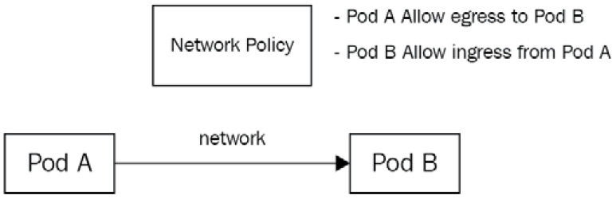
Figure 7.7 – One of the Pods is broken but the service will still forward traffic to it
Keep that in mind that you'll have to troubleshoot NetworkPolicy because it can be the root cause of a lot of issues. Let's now configure a NetworkPolicy between two Pods by using labels and selectors.

Configuring NetworkPolicy with labels and selectors
First, let's create two nginx Pods to demonstrate our example. I'll create the two Pods with two distinct labels so that they become easier to target with the NetworkPolicy, as follows:
$ kubectl run nginx-1 --image nginx --labels 'app=nginx-1'
pod/nginx-1 created
$ kubectl run nginx-2 --image nginx --labels 'app=nginx-2'
pod/nginx-2 created
$ kubectl get pods -o wide
nginx-1 1/1 Running 0 30s 172.17.0.12 minikube
nginx-2 1/1 Running 0 30s 172.17.0.13 minikube
Now that the two Pods are created with distinct labels. I could use the -o wide flag to get the IP address of both Pods. If you follow along, your IP addresses will be different. Now, I can run a curl command from the nginx-1 Pod to reach the nginx-2 Pod, to confirm that by default, network traffic is allowed because no NetworkPolicy is created at this point. The code is illustrated here:
$ kubectl exec nginx-1 -- curl 172.17.0.13
<html>
<head>
<title>Welcome to nginx!</title>
<style>
html { color-scheme: light dark; }
body { width: 35em; margin: 0 auto;
font-family: Tahoma, Verdana, Arial, sans-serif; }
</style>
</head>
<body>
<h1>Welcome to nginx!</h1>
…
As you can see, I correctly receive the nginx home page from the nginx-2 Pod. Now, I'll add NetworkPolicy to nginx-2 to explicitly allow traffic coming from nginx-1. Here is how to proceed with the YAML code:
# ~/nginx-2-networkpolicy.yaml
apiVersion: networking.k8s.io/v1
kind: NetworkPolicy
metadata:
name: nginx-2-networkpolicy
spec:
podSelector:
matchLabels:
app: nginx-2 # Applies to which pod
policyTypes:
- Ingress
ingress:
- from:
- podSelector:
matchLabels:
app: nginx-1 # Allows calls from which pod
ports:
- protocol: TCP
port: 80
Let's apply this NetworkPolicy, as follows:
$ kubectl create -f nginx-2-networkpolicy.yaml
networkpolicy.networking.k8s.io/nginx-2-networkpolicy created
Now, let's run the same curl command we did before, as follows:
$ kubectl exec nginx-1 -- curl 172.17.0.13
<html>
<head>
<title>Welcome to nginx!</title>
<style>
html { color-scheme: light dark; }
body { width: 35em; margin: 0 auto;
font-family: Tahoma, Verdana, Arial, sans-serif; }
</style>
</head>
<body>
<h1>Welcome to nginx!</h1>
…
As you can see, it works just like it did before. Why? For the following two reasons:
nginx-2 now explicitly allows ingress traffic on port 80 from nginx-1; everything else is denied.
nginx-1 has no NetworkPolicy, and thus, egress traffic to everything is allowed for it.
Keep in mind that if no NetworkPolicy is set on the Pod, the default behavior applies—everything is allowed for the Pod. Now, let's update the NetworkPolicy attached to the Pod to change the allowed port from 80 to 8080 by updating the file and applying it against the cluster, as follows:
$ kubectl apply -f nginx-2-networkpolicy.yaml
networkpolicy.networking.k8s.io/nginx-2-networkpolicy configured
Now, let's run the curl command from the nginx-1 Pod once more, as follows:
$ kubectl exec nginx-1 -- curl 172.17.0.13:80
curl: (28) Failed to connect to 10.244.120.77 port 80: Connection timed out
command terminated with exit code 28
As you can see, the curl command failed with a timeout. The reason is that the traffic is blocked by the NetworkPolicy, and thus, the curl command never reaches the nginx-2 Pod.
Again, there are two reasons for that, as outlined here:
There is still no NetworkPolicy set to the nginx-1 Pod, so egress is opened.
We have a NetworkPolicy on the nginx-2 Pod, allowing ingress traffic on port 8080 from Pod nginx-1.
Since curl is trying to reach the nginx-2 Pod on port 80, the traffic is blocked. Let's now try to run curl to make a call against port 8080, which is the one allowed by the NetworkPolicy, to see what happens. Here's the code we need to execute:
$ kubectl exec nginx-1 -- curl 172.17.0.13:8080
curl: (7) Failed to connect to 172.17.0.13 port 8080: Connection refused
command terminated with exit code 7
As you can see, no timeout this time. The traffic reaches the nginx-2 Pod, but since nothing is listening on port 8080 on nginx-2, then we have a Connection refused error.
I strongly encourage you to take the habit of using NetworkPolicy along with your Pod. Lastly, please be aware that NetworkPolicy can also be used to build firewalls based on CIDR blocks. It might be useful especially if your Pods are called from outside the cluster. Otherwise, when you need to configure firewalls between Pods, it is recommended to proceed with labels and selectors as you already did with the services' configuration.

Summary
This chapter was dense and contained a huge amount of information on networking in general when applied to Kubernetes. Services are just like Pods: they are the foundation of Kubernetes, and mastering them is crucial to being successful with the orchestrator.
Overall, in this chapter, we discovered that Pods have dynamic IP assignment, and they get a unique IP address when they're created. To establish a reliable way to connect to your Pods, you need a proxy called Service in Kubernetes. We've also discovered that Kubernetes services can be of multiple types and that each type of service is designed to address a specific need. We've also discovered what ReadinessProbe and LivenessProbe are and how they can help you in designing health checks to ensure your pods gets traffic when they are ready and live.
Lastly, we discovered how to control traffic flow between Pods by using an additional object called NetworkPolicy that behaves like a networking firewall within the cluster.
We've now discovered most of the Kubernetes fundamentals, but there are still some missing pieces that you need to discover. In the next chapter, we're going to cover another important aspect of Kubernetes called namespaces. We've already discussed them a little bit during this chapter, and if you've read it carefully, you should be aware that up to now, we have somehow used a namespace called default.

Chapter 8: Managing Namespaces in Kubernetes
So far, we've learned about Kubernetes' key concepts by launching objects into our clusters and observing their behavior. As you deployed all of these objects, such as Pods, ConfigMaps, Secrets, and more, you may have noticed that, in the long run, it would be difficult to maintain a cleanly organized cluster. As your clusters grow, it's going to become more and more difficult to maintain the ever-increasing number of resources that are managed in your cluster. That's when Kubernetes namespaces come into play.
In this chapter, we will learn about namespaces. They help us keep our clusters well organized by grouping our resources by application or environment. Kubernetes namespaces are another key aspect of Kubernetes management and it's really important to master them!
In this chapter, we're going to cover the following main topics:
Introduction to Kubernetes namespaces
How namespaces impact your resources and services
Configuring ResourceQuota at the namespace level

Technical requirements
For this chapter, you will need the following:
A working Kubernetes cluster (local or cloud-based, but this is not important)
A working Kubectl CLI configured to communicate with the cluster
If you do not have these technical requirements, please read Chapter 2, Kubernetes Architecture – from Docker Images to Running Pods, and Chapter 3, Installing Your First Kubernetes Cluster, to get them.

Introduction to Kubernetes namespaces
The more applications you deploy on your Kubernetes clusters, the more you will feel the need to keep your cluster organized. You can already use labels and annotations to tidy up the objects inside your cluster, but you can go even further by using namespaces, which are presented by Kubernetes as virtual clusters within your cluster.
Using namespaces in Kubernetes allows you to split your cluster into smaller parts that will be logically isolated. Once namespaces have been created, you can launch Kubernetes objects such as Pods, which will only exist in that namespace. So, all the operations that are run against the cluster with kubectl will be scoped to that individual namespace: you can perform as many operations as possible while eliminating the risk of impacting resources that are in another namespace.
Lastly, namespaces allow you to define resources limits and quotas for the Pods running in them.
Let's start by finding out what exactly namespaces are and why they were created.

Why do you need namespaces?
As we mentioned previously, namespaces in Kubernetes are a way to help the cluster administrator keep everything clean and organized, while providing resource isolation when running kubectl commands.
The biggest Kubernetes clusters can run hundreds or even thousands of applications in Pods. Very often, those Pods come with services, ConfigMaps, volumes, and more. When everything is deployed in the same namespace, it can become very complex to know which particular resource belongs to which application.
If, by misfortune, you update the wrong resource using kubectl, you might end up breaking an app running in your cluster. To resolve that, you can use labels and selectors but even then, as the number of resources grows, managing the cluster will quickly become chaotic if you don't start using namespaces.
Let's learn how namespaces are used to split Kubernetes clusters.

How namespaces are used to split resources into chunks
Right after you've installed Kubernetes, when your cluster is brand new, it is created with namespaces. So, even if you didn't notice previously, you are already using namespaces.
You can freely add new namespaces: the whole idea is to deploy your Pods and other objects in Kubernetes, making sure to always define a namespace of your choosing. This way, you will maintain a clean and well-organized cluster. We will discover right after that by default, Kubernetes is created with a namespace, and it is the one that is used if you do not specify another explicitly.
A key architecting rule is that an application should not be aware of the Kubernetes namespace that it is running in. This means that you should think of Kubernetes namespaces as objects for cluster administrators, not developers or application users. It shouldn't have any impact on how the application works, and an application should be able to deploy on any namespace. If an app is running on namespace A and is then redeployed on namespace B, it should not have any impact on any of its features.
More generally, Kubernetes namespaces will help you achieve the following as an administrator:
Cluster partitioning to ease resource organization
Scoping resource names
Hardware sharing and consumption limitation
Permissions access
I recommend that you create one namespace per microservice and deploy all the resources that belong to a microservice within its namespace. However, be aware that Kubernetes does not impose any specific rules on you. For example, you could decide to use namespaces in these ways:
Differentiate environments
For example, one namespace for a production environment and another one for a development environment.
Differentiate the tiers
One namespace for databases, one for application Pods, and another for middleware deployment.
Just using the default namespaces
For the smallest clusters that only deploy a few resources, you can go for the simplest setup and just use one big default namespace and deploy everything into it.
Either way, keep in mind that even though two Pods are deployed in different namespaces and exposed through services, they can still interact and communicate with each other. Even though Kubernetes services are created in a given namespace, they'll receive a fully qualified domain name (FQDN) that will be accessible on the whole cluster. So, even if an application running on namespace A needs to interact with an application in namespace B, it will have to call the service exposing app B by its FQDN. You don't need to worry about cross-namespace communication.
Now, let's learn about the default namespace.

Understanding default namespaces
Most Kubernetes clusters are created with a few namespaces by default. You can list your namespaces using kubectl get namespaces, as follows:
$ kubectl get namespaces # Or kubectl get ns
# You can use "ns" as an alias for namespaces
NAME STATUS AGE
default Active 5m31s
kube-public Active 5m33s
kube-system Active 5m33s
For instance, I'm using a Minikube cluster. By reading this command's output, we can see that the cluster I'm currently using was set up with three namespaces from the start:
default
kube-public
kube-system
These namespaces are the ones provided by default in Kubernetes.
The most important of them is default: it is in this namespace that, up until now, all your resources have been created, and it is also the namespace that's used by default when no other one is specified.
The other default namespaces are also interesting, especially the one called kube-system. It is in this namespace that Kubernetes deploys the objects it needs to function. In most Kubernetes distributions, components such as kube-scheduler are deployed in the form of Pods and are themselves by the Kubernetes cluster that they are running for. They are then launched in this namespace. So, it is better to leave this namespace alone and not touch it because it is a very important namespace, and changing something could damage your cluster.
A third namespace is usually created by default when the cluster is set up, and this is called kube-public. It is a namespace where public objects are accessible. It is not used at the moment, so you can leave it alone.
Important Note
Depending on which Kubernetes distribution you use, the default namespaces can change. But most of the time, these three different ones will be created by default.
If your cluster is small, you can continue to use the default namespace – this is not a problem. However, let's leave this namespace aside for now because we are going to get to the heart of the matter a little more and start creating namespaces. We will look at the impacts that these can have on your Pods, particularly at the level of the DNS resolution of your services.

How namespaces impact your resources and services
Previously, we learned what namespaces are and we will continue to discover them. In this section, we'll learn how to create, update, and delete namespaces, as well as the impacts that namespaces have on services and Pods.
We will also learn how to create ConfigMaps and Pods by specifying a custom namespace so that we don't rely on the default one.

Listing namespaces inside your cluster
We saw this in the previous section but here is how to list the namespaces that have been created in your Kubernetes cluster:
$ kubectl get namespaces #kubectl get ns works too
NAME STATUS AGE
default Active 5m31s
kube-public Active 5m33s
kube-system Active 5m33s
Keep in mind that all the commands that make use of the namespaces resource Kind can also use the ns alias to benefit from a shorter format.

Retrieving the data of a specific namespace
Retrieving the data of a specific namespace can be achieved using the kubectl describe command. Here is how to grab the data from that command:
$ kubectl get namespaces default #kubectl get ns works too
NAME STATUS AGE
default Active 13m
You can also use the get command and redirect the YAML format to a file to get the data from a specific namespace. By reading the output of the describe command, you can see a field called STATUS. Please note that a namespace can be in one of two statuses:
Active: The namespace is active; it can be used to place new objects into it.
Terminating: The namespace is being deleted, along with all its objects. It can't be used to host new objects while in this status.
Now, let's learn how to create a new namespace imperatively.

Creating a namespace using imperative syntax
You can create a namespace with imperative or declarative syntax. To imperatively create a namespace, you can use the kubectl create namespaces command by specifying the name of the namespace to create. Here, I'm going to create a new namespace called custom-ns. Please notice that all the operations related to namespaces in kubectl can be written with the shorter ns alias:
$ kubectl create ns custom-ns #kubectl get ns works too
namespace/custom-ns created
The new namespace, called custom-ns, should now be created in your cluster. You can check it by running the kubectl get command once more:
$ kubectl get ns custom-ns
NAME STATUS AGE
custom-ns Active 35s
As you can see, the namespace has been created and is in the Active state. We can now place resources in it.
Important Note
Please do avoid naming your cluster with a name starting with the kube- prefix as this is the terminology for Kubernetes' objects and system namespaces.
Now, let's learn how to create another namespace using declarative syntax.

Creating a namespace using declarative syntax
Let's discover how to create a namespace using declarative syntax. As always, you must use a YAML (or JSON) file. Here is a basic YAML file for creating a new namespace in your cluster. Please pay attention to kind: Namespace in the file. Namespace is a resource kind, just like Pod:
# ~/custom-ns-2.yaml
apiVersion: v1
kind: Namespace
metadata:
name: custom-ns-2
Once this file has been created, you can apply it using the kubectl create command by defining the YAML file path:
$ kubectl create -f custom-ns.yaml
namespace/custom-ns-2 created
With that, we have created two custom namespaces. The first one, which was created imperatively, is called custom-ns, while the second one, which was created declaratively, is called custom-ns-2.
Now, let's remove these two namespaces using kubectl.

Deleting a namespace
You can delete a namespace using kubectl delete, as follows:
$ kubectl delete namespaces custom-ns
namespace "custom-ns" deleted
Please note this can also be achieved using declarative syntax. Let's delete the custom-ns-2 namespace that was created using the previous YAML file:
$ kubectl delete -f custom-ns-2.yaml
namespace "custom-ns-2" deleted
Running this command will take the namespace out of the Active status: it will enter the Terminating status. Right after the command, the namespace will be unable to host new objects, and after a few moments, it should completely disappear from the cluster.
However, I have to warn you about using this command as it is extremely dangerous. Deleting a namespace is permanent and definitive. All the resources that were created in the namespace will be destroyed. If you need to use this command, be sure to have YAML files to recreate the destroyed resources and even the destroyed namespace.
Now, let's discover how to create resources inside a specific namespace.

Creating a resource inside a namespace with the -n option
Creating a resource within a namespace is very easy. The following code shows how to create an NGINX Pod by specifying a custom namespace. Here, we are going to recreate a new custom-ns namespace and launch an NGINX Pod in it:
$ kubectl create ns custom-ns
$ kubectl run nginx --image nginx:latest -n custom-ns
Pod/nginx created
Pay attention to the -n option, which, in its long form, is the --namespace option. This is used to enter the name of the namespace where you want to create the resource. This option is supported by all the kind resources that can be scoped in a namespace.
Here is another command to demonstrate this. The following command will create a new configmap in the custom-ns namespace:
$ kubectl create configmap configmap-custom-ns --from-literal=Lorem=Ipsum -n custom-ns
configmap/configmap-custom-ns created
You can also specify a namespace when using declarative syntax. Here is how to create a Pod in a specific namespace with declarative syntax:
# ~/Pod-in-namespace.yaml
apiVersion: v1
kind: Pod
metadata:
name: nginx2
namespace: custom-ns
spec:
containers:
- name: nginx
image: nginx:latest
Please note the namespace key under the metadata section, just under the Pod's name. Now, we can apply this file using kubectl:
$ kubectl create -f Pod-in-namespace.yaml
Pod/nginx2 created
At this point, we should have a namespace called custom-ns that contains two nginx Pods, as well as a configmap called configmap-custom-ns.
Important Note
When you're using namespaces, you should always specify the -n flag to target the specific namespace of your choosing. Otherwise, you might end up running operations in the wrong namespace. This is a common mistake.
Now that we have created some resources in the custom-ns namespace, we will learn how to list the resources in a specific namespace using kubectl get Pods. We can do this by specifying the namespace using the -n option:
$ kubectl get Pods -n custom-ns
NAME READY STATUS RESTARTS AGE
nginx 1/1 Running 0 66m
nginx2 1/1 Running 0 36s

Listing resources inside a specific namespace
To be able to list the resources within a namespace, you must add the -n option, just like when creating a resource. Use the following command to list the Pods in the custom-ns namespace:
$ kubectl get Pods -n custom-ns
NAME READY STATUS RESTARTS AGE
nginx 1/1 Running 0 66m
nginx2 1/1 Running 0 36s
Here, you can see that the nginx Pod that we created earlier is present in the namespace. From now on, all the commands that target this particular Pod should contain the -n custom-ns option.
The reason for this is that the Pod does not exist in the default namespace, and if you omit passing the -n option, then the default namespace will be requested. Let's try to remove -n custom-ns from the get command. We will see that the nginx Pod is not here anymore:
$ kubectl get Pods -n custom-ns NAME READY STATUS RESTARTS AGE
nginx 1/1 Running 0 9m17s
$ kubectl get Pods
No resources found in default namespace.
Now, we can also run the get configmap command to check whether configmap is listed in the output. As you can see, the behavior is the same as when trying to list Pods. If you omit the -n option, the list operation will run against the default namespace that does not contain configmap:
$ kubectl get cm
No resources found in default namespace.
$ kubectl get cm -n custom-ns
NAME DATA AGE
configmap-custom-ns 1 76m
With all that has been said so far, the idea is to never forget to add the -n option when working on a cluster that has multiple namespaces. This little carelessness could waste your time because if you forget it, everything you do will be done on the default namespace.
You can also decide to remove the default namespace. So, if you forget to specify the namespace, an error will occur because if you try to work on a namespace that does not exist, Kubernetes will give you an explicit error.
Now, let's discover how to list all the resources inside a specific namespace.

Listing all the resources inside a specific namespace
If you want to list all the resources in a specific namespace, there is a very useful command that you can use called kubectl get all -n custom-ns:
$ kubectl get all -n custom-ns
As you can see, this command can help you retrieve all the resources that are created in the namespace specified in the -n flag.

Understanding that names are scoped to a namespace
You should know that namespaces bring an additional benefit: they provide scope to the names of the resources they contain.
Take the example of Pod names. When you work without namespaces, you are interacting with the default namespace: when you create two Pods with the same name, you get an error because Kubernetes uses the names of the Pods as their unique identifiers to distinguish them.
Let's try to create two Pods in the default namespace. Both will be called nginx. Here, we can simply run the same command twice in a row:
$ kubectl run nginx --image nginx:latest
Pod/nginx created
$ kubectl run nginx --image nginx:latest
Error from server (AlreadyExists): Pods "nginx" already exists
The second command produces an error, saying that the Pod already exists, which it does. If we run kubectl get Pods, we can see that only one Pod exists:
$ kubectl get Pods
NAME READY STATUS RESTARTS AGE
nginx 1/1 Running 0 64s
Now, let's try to list the Pods again, but this time in the custom-ns namespace:
$ kubectl get Pods --namespace custom-ns
NAME READY STATUS RESTARTS AGE
nginx 1/1 Running 0 89m
nginx2 1/1 Running 0 23m
As you can see, this namespace also has a Pod called nginx, and it's not the same Pod that is contained in the default namespace. This is one of the major advantages of namespaces. By using them, your Kubernetes cluster can now define multiple resources with the same names, so long as they are in different namespaces. You can easily duplicate microservices or applications by using this element.
Also, note that you can override the key to the namespaces of the resources that you create declaratively. By adding the -n option to the kubectl create command, you force a namespace as the context for your command: kubectl will take the namespace that was passed in the command into account, not the one present in the YAML file. By doing this, it becomes very easy to duplicate your resources between different namespaces; for example, a production environment in a production namespace and a test environment in a test namespace. The possibilities are endless!

Understanding that not all resources are in a namespace
In Kubernetes, not all objects belong to a namespace. This is the case, for example, with nodes, which are represented at the cluster level by an entry of the Node kind but that does not belong to any particular namespace. You can list resources that do not belong to a namespace using the following command:
$ kubectl api-resources --namespaced false
NAME SHORTNAMES APIGROUP NAMESPACED KIND
bindings true Binding
configmaps cm true ConfigMap
endpoints ep true Endpoints
events ev true Event
limitranges limits true LimitRange
…
You can also list all the resources that belong to a namespace by passing --namespaced to true:
$ kubectl api-resources --namespaced true
Now, let's learn how namespaces affect services DNSes.

Resolving a service using namespaces
As we discovered in Chapter 7, Exposing Your Pods with Services, Pods can be exposed through a type of object called Services. When created, services are assigned a DNS record that allows Pods in the cluster to access them.
However, when a Pod tries to call a service through DNS, it can only reach it if the service is in the same namespace as the Pod, which is limiting. Namespaces have a solution to this problem. When a service is created in a particular namespace, the name of its service is added to its DNS:
<service_name>.<namespace_name>.svc.cluster.local
By querying this domain name, you can easily query any service that is in any namespace in your Kubernetes cluster. So, you are not limited to that level. Pods are still capable of achieving inter-communication, even if they are not running in the same namespace.

Switching between namespaces with kubectl
When using kubectl to use Kubernetes, you saw that you have to use the -n or ---namespace option with your kubectl command to tell it the namespace you're targeting. But it is also possible to define a namespace at the configuration level. This way, you'll have kubectl always running requests against that namespace, even if you omit the -n parameter.
Let's create a few more namespaces. Then, we will demonstrate how to switch between them without the -n flag:
$ kubectl create ns another-ns
namespace/another-ns created
At the moment, we know that we have three namespaces in our cluster. You can use the following command to switch to another namespace:
$ kubectl config set-context $(kubectl config current-context) --namespace=another-ns
Context "minikube" modified.
Running this command will update the current configuration that kubectl is using to make it point to the specified namespace. At the moment, any command you run will be executed against the another-ns namespace.
Important Note
Running the kubectl config command and sub-commands will only trigger modification or read operations against the ~/.kube/config file, which is the configuration file that kubectl is using.
When you're using the kubectl config set-context command, you're just updating that file to make it point to another namespace.
Knowing how to switch between namespaces with kubectl is important, but before you run any write operations such as kubectl delete or kubectl create, make sure that you are in the correct namespace. Otherwise, you should continue to use the -n flag. As this switching operation might be executed a lot of times, Kubernetes users tend to create Linux aliases to make them easier to use. Do not hesitate to define a Linux alias if you think it can be useful to you.
Now, let's learn how to retrieve the current namespace we're in.

Displaying the current namespace with kubectl
There is no easy way to display the current namespace besides displaying the ~/.kube/config file where this information is stored, as we mentioned previously. You should avoid running cat ~/.kube/config and just go for the kubectl config view ~/.kube/config command.
However, the problem is that this command displays a lot of data we don't need because we're just searching for the current namespace that is in use. That's why I recommend that you simply run the grep command against the output of kubectl config view to retrieve just the namespace:
$ kubectl config view | grep -i "namespace"
namespace: another-ns
Let's launch an NGINX Pod in the another-ns namespace. My ~/kube/config is pointing to it, so I don't have to use the -n flag anymore:
$ kubectl run nginx-Pod -–image nginx # in another-ns
Pod/nginx created
Here, the command is telling me that I'm currently in the another-ns namespace. If I run kubectl get Pods, I should get no Pods at all:
$ kubectl get Pods
NAME READY STATUS RESTARTS AGE
nginx 1/1 Running 0 10s
Let's switch back to the default namespace. Immediately after, run grep against the kubectl config view output to see that the context in ~/kube/config was updated successfully to the default namespace:
$ kubectl config set-context $(kubectl config current-context) --namespace=default
Context "minikube" modified.
$ kubectl config view | grep -i "namespace"
namespace: default
Everything seems good. Now, let's run the kubectl get Pods command once more:
$ kubectl get Pods
No resources found in another-ns namespace.
Everything is good! I can't see nginx-Pod in the default namespace because it was created when the context was set to another-ns! Again, I strongly recommend that you define Linux aliases to switch and display namespaces quickly because you'll probably have to run these commands very often!
With that, we're done with the basics of namespaces in Kubernetes. We have learned what namespaces are, how to create and delete them, how to use them to keep a cluster clean and organized, and how to update the kubeconfig context to make kubectl point to a specific namespace. Now, we'll look at a few more advanced options related to namespaces. I think it is a good moment to introduce ResourceQuota and Limit, which you can use to limit the computing resources an application deployed on Kubernetes can access!

Configuring ResourceQuota and Limit at the namespace level
In this section, we're going to discover that namespaces can not only be used to sort resources in a cluster but also to limit the computing resources that Pods can access.
Using ResourceQuota and Limits with namespaces, you can create limits regarding the computing resources your Pods can access. We're going to learn how to proceed and exactly how to use these new concepts. In general, defining ResourceQuota and Limits is considered good practice for production clusters – that's why you should use them wisely.

Understanding why you should set ResourceQuota
Just like applications or systems, Kubernetes Pods will require a certain amount of computing resources to work properly. In Kubernetes, you can configure two types of computing resources:
CPU
Memory
All your worker nodes work together to provide CPU and memory, and in Kubernetes, adding more CPU and memory simply consists of adding more worker nodes to make room for more Pods. Depending on whether your Kubernetes cluster is based on-premises or in the cloud, adding more worker nodes can be achieved by purchasing the hardware and setup to do so or simply calling an API to create additional virtual machines.

Understanding how Pods consume these resources
When you launch a Pod on Kubernetes, a control plane component, known as kube-scheduler, will elect a worker node and assign the Pods to it. Then, the kubelet on the elected worker node will attempt to launch the containers defined in the Pod.
This process of worker node election is called Pod scheduling in Kubernetes.
When a Pod gets scheduled and launched on a worker node, it has, by default, access to all the resources the worker node has. Nothing is preventing it from accessing more and more CPU and memory as the application is used and ultimately, if the Pods run out of memory or CPU resources to work properly, then it simply crashes.
This can become a real problem because worker nodes can be used to run multiple applications – and so multiple Pods – at the same time. So, if 10 Pods are launched on the same worker node but one of them is consuming all the computing resources, then this will have an impact on all 10 Pods running on the worker node.
This problem means that you have two things you must consider:
Each Pod should be able to require some computing resource to work.
The cluster should be able to restrict the Pod's consumption so that it doesn't take all the resources available and share them with other Pods too.
It is possible to address these two problems in Kubernetes and we will discover how to use two options that are exposed to the Pod object. The first one is called resources, which is the option that's used to let a Pod indicate what amount of computing resources it needs, while the other one is called limit and will be used to indicate the maximum computing resources the Pod will have access to.
Let's discover these options now.

Understanding how Pods can require computing resources
The request and limit options will be declared within the YAML definition file of a Pod resource. Here, we're going to focus on the request option.
request is not a resource kind on its own – it is simply an option you can directly specify within your YAML definition file. request is simply the minimal amount of computing resource a Kubernetes Pod will need to work properly, and it is a really good practice to always define a request option for your Pods, at least for those that are meant to run in production.
Let's say that you want to launch an NGINX Pod on your Kubernetes cluster. By filling in the request option, you can tell Kubernetes that your NGINX Pod will need, at the bare minimum, 512 MiB of memory and 25% of a CPU core to work properly.
Here is the YAML definition file that will create this Pod:
# ~/Pod-in-namespace-with-request.yaml
apiVersion: v1
kind: Pod
metadata:
name: nginx-with-request
namespace: custom-ns
spec:
containers:
- name: nginx
image: nginx:latest
resources:
requests:
memory: "512Mi"
cpu: "250m"
As you can see, you can define request at the container level and set different ones for each container.
There are three things to notice about this Pod:
It is created inside the custom-ns namespace.
It requires 512Mi of memory.
It requires 250m of CPU.
But what do these metrics mean?
Memory is expressed in bytes, whereas CPU is expressed in millicores and allows fractional values. If you want your Pod to consume one entire CPU core, you can set the cpu key to 1000m. If you want two cores, you must set it to 2000m; for half of a core it will be 500m or 0.5, and so on. So, to explain, the preceding YAML definition is saying that the NGINX Pod we will create will forcibly need 512 MiB of memory since memory is expressed in bytes, and one-quarter of a CPU core of the underlying worker node. There is nothing related to the CPU or memory frequency here.
When you apply this YAML definition file to your cluster, the scheduler will look for a worker node that is capable of launching your Pods. This means that you need a worker node where there is enough room in terms of available CPU and memory to meet your Pods' requests.
But what if no worker node is capable of fulfilling these requirements? Here, the Pod will never be scheduled and never be launched. Unless you remove some running Pods to make room for this one, or unless you add a worker node that is capable of launching this Pod, it won't ever be launched.
Important Note
Keep in mind that Pods cannot span multiple nodes. So, if you set 8,000 m, which represents eight CPU cores, but your cluster is made up of two worker nodes with four cores each, then no worker node will be able to fulfill the request and your Pod won't be scheduled. That's why it's not good to set requests with really high values.
So, use the request option wisely – consider it as the minimum amount of resources your Pod will need to work. You have the risk that your Pod will never be scheduled if you set too high a request, but on the other hand, if your Pod is scheduled and launched successfully, this amount of resources is guaranteed.

Understanding how you can limit resource consumption
When you write a YAML definition file, you can define resource limits regarding what the Pod will be able to consume.
Setting a request won't suffice to do things properly. You should set a limit each time you set a resource. Setting a limit will tell Kubernetes to let the Pod consume resources up to that limit, and never above. This way, you're ensuring that your Pod won't take all the resources of the worker for itself.
Be careful, though – Kubernetes won't behave the same, depending on what kind of limit is reached. If the Pod reaches its CPU limit, it is going to be throttled and you'll notice performance degradation. But if your Pod reaches its memory limit, then it might be terminated. The reason for this is that memory is not something that can be throttled and Kubernetes still needs to ensure that other applications are not impacted and remain stable. So, be aware of that.
Without a limit, the Pod will be able to consume all the resources of the worker node. Here is an updated YAML file corresponding to the NGINX Pod we saw earlier, but now, it has been updated to define a limit on memory and CPU.
Here, the Pod will be able to consume up to 1 GiB of memory and up to 1 entire CPU core of the underlying worker node:
# ~/Pod-in-namespace-with-request-and-limit.yaml
apiVersion: v1
kind: Pod
metadata:
name: nginx-with-request-and-limit
namespace: custom-ns
spec:
containers:
- name: nginx
imaage: nginx:latest
resources:
requests:
memory: "512Mi"
cpu: "250m"
limits:
memory: "1Gi"
cpu: "1000m"
So, when you set a request, set a limit too. Now that you are aware of this request and limit consideration, don't forget to add it to your Pods!

Understanding why you need ResourceQuota
The good news is that you can entirely manage your Pod's consumptions by relying entirely on the Pod's request and limits options. All the applications in Kubernetes are just Pods, so setting these two options provides you with a strong and reliable way to manage resource consumption on your cluster, given that you never forget to set these.
It is super easy to forget these two options and deploy a Pod on your cluster that won't define any request or limit. Maybe it will be you, or maybe a member of your team, but the risk of deploying such a Pod is high because everyone can forget about these two options. And if you do so, the risk of application instability is high because a Pod without a limit can eat all the resources on the worker node is it launched on.
Kubernetes provides a way to mitigate this issue thanks to two objects called ResourceQuota and LimitRange. These two objects are extremely useful because they can enforce these constraints at the namespace level.
ResourceQuota is another resource kind, just like Pod or ConfigMap. The workflow is quite simple and consists of two steps:
First, you must create a new namespace.
Then, you must create a ResourceQuota and a LimitRange object inside that namespace.
Then, all the Pods that are launched in that namespace will be constrained by these two objects.
These quotas are used, for example, to ensure that all the containers that are accumulated in a namespace do not consume more than 4 GiB of RAM.
Therefore, it is possible and even recommended to set restrictions on what can and cannot run within Pods. It is strongly recommended that you always define a ResourceQuota and a LimitRange object for each namespace you create in your cluster!
Without these quotas, the deployed resources could consume as much CPU or RAM as they want, which could ultimately make your cluster and all the applications running on it unstable, given that the Pods don't hold requests and limits as part of their respective configuration.
In general, ResourceQuota is used to do the following:
Limit CPU consumption within a namespace
Limit memory consumption within a namespace
Limit the absolute number of Pods operating within a namespace
There are a lot of use cases and you can discover all of them directly in the Kubernetes documentation. Now, let's learn how to define ResourceQuota in a namespace.

Creating a ResourceQuota
To demonstrate the usefulness of ResourceQuota, we are going to create one for a namespace we are going to call custom-ns-with-resource-quota. This ResourceQuota will be used to create requests and limits that all the Pods within this namespace combined will be able to use. Here is the YAML file that will create ResourceQuota; please note the resource kind:
# ~/resourcequota.yaml
apiVersion: v1
kind: ResourceQuota
metadata:
name: my-resourcequota
spec:
hard:
requests.cpu: "1000m"
requests.memory: "1Gi"
limits.cpu: "2000m"
limits.memory "2Gi"
ResourceQuota is enforcing some requests and limits on all the Pods that will be launched in the namespace where it is created. Keep in mind that the ResourceQuota object is scoped to one namespace.
This one is stating that in this namespace, the following will occur:
All the Pods combined won't be able to request more than one CPU core.
All the Pods combined won't be able to request more than 1 GiB of memory.
All the Pods combined won't be able to consume more than two CPU cores.
All the Pods combined won't be able to consume more than 2 GiB of memory.
You can have as many Pods and containers in the namespace, so long as they are respecting these constraints. Most of the time, ResourceQuotas are used to enforce constraints on requests and limits, but they can also be used to enforce these limits per namespace.
In the following example, the preceding ResourceQuota has been updated to specify that the namespace where it is created cannot hold more than 10 ConfigMaps and 5 services, which is pointless but a good example to demonstrate the different possibilities with ResourceQuota:
# ~/resourcequota-with-object-count.yaml
apiVersion: v1
kind: ResourceQuota
metadata:
name: my-resourcequota
spec:
hard:
requests.cpu: "1000m"
requests.memory: "1Gi"
limits.cpu: "2000m"
limits.memory "2Gi"
configmaps: "10"
services: "5"
Lastly, when you apply a ResourceQuota YAML definition file, don't forget to add the --namespace setting to set the namespace where ResourceQuota will be applied:
$ kubectl create -f ~/resourcequota-with-object-count.yaml --namespace=custom-ns
Now, let's learn how to list ResourceQuotas.

Listing ResourceQuota
ResourceQuota objects can be accessed through kubectl using the quota's resource name option. The kubectl get command will do this for us:
$ kubectl get quotas -n custom-ns
Now, let's learn how to delete ResourceQuota from a Kubernetes cluster.

Deleting ResourceQuota
To remove a ResourceQuota object from your cluster, use the kubectl delete command:
$ kubectl delete -f quotas/resourcequota-with-object-count -n custom-ns
Now, let's introduce the notion of LimitRanges.

Introducing LimitRange
LimitRange is another object that is similar to ResourceQuota as it is created at the namespace level. The LimitRange object is used to enforce default requests and limit values to individual containers. Even by using the ResourceQuota object, you could create one object that consumes all the available resources in the namespace, so the LimitRange object is here to prevent you from creating too small or too large containers within a namespace.
Here is a YAML file that will create LimitRange:
# ~/limitrange.yaml
apiVersion: v1
kind: LimitRange
metadata:
name: my-limitrange
spec:
limits:
- default:
memory: 256Mi
cpu: 500m
defaultRequest:
memory: 128Mi
cpu: 250Mib
max:
memory: 1000Mi
cpu: 1Gib
min:
memory: 128Mi
cpu: 250m
type: Container
As you can see, the LimitRange object consists of four important keys that all contain memory and cpu configuration. These keys are as follows:
default: This helps you enforce default values for the memory and cpu limits of containers if you forget to apply them at the Pod level. Each container that is set up without limits will inherit these default ones from the LimitRange object.
defaultRequest: This is the same as default but for the request option. If you don't set a request option to one of your containers in a Pod, the ones from this key in the LimitRange object will be automatically used by default.
max: This value indicates the maximum limit (not request) a Pod can set. You cannot configure a Pod with a limit value that is higher than this one. It is the same as the default value in that it cannot be higher than the one defined here.
min: This value works like max but for requests. It is the minimum amount of computing resources a Pod can request, and the defaultRequest option cannot be lower than this one.
Finally, note that if you omit the default and defaultRequest keys, then the max key will be used as the default key, and the min key will be used as the default key.
Defining LimitRange is a good idea if you want to protect yourself from forgetting to set requests and limits on your Pods. At least with LimitRange, these objects will have default limits and requests!
Just like the ResourceQuota object, don't forget to set the -n option to create LimitRange inside a namespace:
$ kubectl create -f ~/limitrange.yaml --namespace=custom-ns
Now, let's learn how to list LimitRanges.

Listing LimitRange
The kubectl command line will help you list your LimitRanges. Don't forget to add the -n flag to scope your request to a specific namespace:
$ kubectl get limit -n custom-ns
Now, let's learn how to delete LimitRange from a namespace.

Deleting LimitRange
Deleting LimitRange can be achieved using the kubectl command-line tool. Here is how to proceed:
$ kubectl delete limit/my-limitrange -n custom-ns
As always, don't forget to add the -n flag to scope your request to a specific namespace; otherwise, you may target the wrong one!

Summary
This chapter introduced you to namespaces, which are extremely important in Kubernetes. You cannot manage your cluster effectively without using namespaces because they provide logical resource isolation in your cluster. Most people use production and development namespaces, for example, or one namespace for each application. It is generally not rare to see clusters where dozens of namespaces are created.
We discovered that most Kubernetes resources are scoped to a namespace, though some are not. Keep in mind that, by default, Kubernetes is set up with a few default namespaces, such as kube-system, and that it is generally a bad idea to change the things that run in these namespaces, especially if you do not know what you are doing.
We also discovered that namespaces can be used to set quotas and limit the resources that Pods can consume, and it is a really good practice to set these quotas and limits at the namespace level using the ResourceQuota and LimitRange objects to prevent your Pods from consuming too many computing resources. Overall, you'll improve the stability of all the applications running on your cluster by setting these options and using them wisely.
In the next chapter, we'll continue to discover the basics of Kubernetes by discovering the concepts of PersistentVolume and PersistentVolumeClaims, which are the methods Kubernetes uses to deal with persistent data. It is going to be a very interesting chapter if you want to build and provision stateful applications on your Kubernetes clusters, such as database or file storage solutions.

Chapter 9: Persistent Storage in Kubernetes
So far, we've learned about Kubernetes' key concepts, and this chapter is going to be the last one about Kubernetes' core concepts. So far, you've understood that Kubernetes is all about creating an object in the etcd datastore that will be converted into actual computing resources on the Nodes that are part of your cluster.
This chapter will focus on a concept called PersistentVolume. This is going to be another object that you will need to master in order to get persistent storage on your cluster. Persistent storage is achieved in Kubernetes by using the PersistentVolume resource kind, which has its own mechanics. Honestly, these can be relatively difficult to approach at first, but we are going to discover all of that!
In this chapter, we're going to cover the following main topics:
Why you would want to use PersistentVolume
Understanding how to mount PersistentVolume to your Pod claims
Understanding the life cycle of PersistentVolume in Kubernetes
Static and dynamic PersistentVolume provisioning

Technical requirements
A working Kubernetes cluster (either local or cloud-based)
A working kubectl CLI configured to communicate with the cluster
If you do not meet these technical requirements, you can follow Chapter 2, Kubernetes Architecture – From Docker Images to Running Pods, and Chapter 3, Installing Your Kubernetes Cluster, to get these two prerequisites.

Why you would want to use PersistentVolume
When you're creating your Pods, you have the opportunity to create volumes in order to share files between the containers created by them. However, these volumes can represent a massive problem: they are bound to the life cycle of the Pod that created them.
That is why Kubernetes offers another object called PersistentVolume, which is a way to create storage in Kubernetes that will not be bound to the life cycle of a Pod.

Introducing PersistentVolumes
Just like the Pod of ConfigMap, PersistentVolume is a resource kind that is exposed through kube-apiserver: you can create, update, and delete persistent volumes using YAML and kubectl just like any other Kubernetes object.
The following command will demonstrate how to list the PersistentVolume resource kind currently provisioned within your Kubernetes cluster:
$ kubectl get persistentvolume
No resource found
The persistentvolume object is also accessible with the plural form of persistentvolumes along with the alias of pv. The following three commands are essentially the same:
$ kubectl get persistentvolume
No resource found
$ kubectl get persistentvolumes
No resource found
$ kubectl get pv
No resource found
You'll find that the pv alias is very commonly used in the Kubernetes world, and a lot of people refer to persistent volumes as simply pv, so be aware of that. As of now, no PersistentVolume object has been created within my Kubernetes cluster, and that is why I don't see any resource listed in the output of the preceding command.
PersistentVolume is the object and, essentially, represents a piece of storage that you can attach to your Pod. That piece of storage is referred to as a Persistent one because it is not supposed to be tied with the life cycle of a Pod.
Indeed, as mentioned in Chapter 5, Using Multi-Container Pods and Design Patterns, Kubernetes Pods uses the notion of volumes. Additionally, we discovered the emptyDir and hostPath volumes, which, respectively, initiate an empty directory that your Pods can share. It also defines a path within the worker Node filesystem that will be exposed to your Pods. Both of these volumes were supposed to be attached to the life cycle of the Pod. This means that once the Pod is destroyed, the data stored within the volumes will be destroyed as well.
However, sometimes, you don't want the volume to be destroyed. You just want it to have its life cycle to keep both the volume and its data alive even if the Pod fails. That's where PersistentVolumes comes into play: essentially, they are volumes that are not tied to the life cycle of a Pod. Since they are a resource kind just like the Pods themselves, they can live on their own!
Important Note
Bear in mind that PersistentVolumes objects are just entries within the etcd datastore, and they are not an actual disk on their own.
PersistentVolume is just a kind of pointer within Kubernetes to an external piece of storage, such as an NFS, a disk, an Amazon EBS volume, and more. This is so that you can access these technologies from within Kubernetes and in a Kubernetes way.
Simply put, PersistentVolume is essentially made up of two different things:
A backend technology called a PersistentVolume type
An access mode, such as ReadWriteOnce
You need to master both concepts in order to understand how to use PersistentVolumes. Let's begin by explaining what PersistentVolume types are.

Introducing PersistentVolume types
Kubernetes is supposed to be able to run on as much infrastructure as possible, and even though it started as a Google project, it can be used on many platforms, whether they are public clouds or private solutions.
As you already know, the simplest Kubernetes setup consists of a simple minikube installation, whereas the most complex Kubernetes setup can be made of dozens of servers on massively scalable infrastructure. All of these different setups will forcibly have different ways in which to manage persistent storage. For example, the three biggest public cloud providers have a lot of different solutions. Let's name a few, as follows:
Amazon AWS EBS volumes
Amazon AWS EFS filesystems
Google GCE Persistent Disk (PD)
Microsoft Azure disks
These solutions have their own design and set of principles along with their own logic and mechanics. Kubernetes was built with the principle that all of these setups should be abstracted using just one object to abstract all of the different technologies. And that single object is the PersistentVolume resource kind. The PersistentVolume resource kind is the object that is going to be attached to a running Pod. Indeed, a Pod is a Kubernetes resource and does not know what an EBS or a PD is; Kubernetes Pods only play well with PersistentVolumes, which is also a Kubernetes resource.
Whether your Kubernetes cluster is running on Google GKE, Amazon EKS, or whether it is a single Minkube cluster on your local machine has no importance. When you wish to manage persistent storage, you are going to create, use, and deploy PersistentVolumes objects, and then bind them to your Pods!
Here are some of the backend technologies supported by Kubernetes out of the box:
awsElasticBlockStore: Amazon EBS volumes
gcePersistentDisk: Google Cloud PD
azureDisk: Azure Disk
azureFile: Azure File
cephfs: Ceph-based filesystems
csi: Container storage interface
glusterfs: GlusterFS-based filesystems
nfs: Regular network file storage
The preceding list is not exhaustive: Kubernetes is extremely versatile and can be used with many storage solutions that can be abstracted as PersistentVolume objects in your cluster.
When you create a PersistentVolume object, essentially, you are creating a YAML file. However, this YAML file is going to have a different key/value configuration based on the backend technology used by the PersistentVolume objects.

The benefits brought by PersistentVolume
There are three major benefits of PersistentVolume:
PersistentVolume is not bound to the life cycle of a Pod. If you want to remove a Pod that is attached to a PersistentVolume object, then the volume will survive.
The preceding statement is also valid when a Pod crashes: the PersistentVolume object will survive the fault and not be removed from the cluster.
PersistentVolume is cluster-wide; this means that it can be attached to any Pod running on any Node.
Bear in mind that these three statements are not always 100% valid. Indeed, sometimes, a PersistentVolume object can be affected by its underlying technology.
To demonstrate this, let's consider a PersistentVolume object that is, for example, a pointer to an Amazon EBS volume created on your AWS cloud. In this case, the worker Node will be an Amazon EC2 instance. In such a setup, PersistentVolume won't be available to any Node.
The reason is that AWS has some limitations around EBS volumes, which relates to the fact that an EBS volume can only be attached to one instance at a time, and that instance must be provisioned in the same availability zones as the EBS volume. From a Kubernetes perspective, this would only make PersistentVolume (EBS volumes) accessible from EC2 instances (that is, worker Nodes) in the same AWS availability zone, and several Pods running on different Nodes (EC2 instances) won't be able to access the PersistentVolume object at the same time.
However, if you take another example, such as an NFS setup, it wouldn't be the same. Indeed, you can access an NFS from multiple machines at once; therefore, a PersistentVolume object that is backed by an NFS would be accessible from several different Pods running on different Nodes without much problem. To understand how to make a PersistentVolume object on several different Nodes at a time, we need to consider the concept of access modes.

Introducing access modes
As the name suggests, access modes are an option you can set when you create a PersistentVolume type that will tell Kubernetes how the volume should be mounted.
PersistentVolumes supports three access modes, as follows:
ReadWriteOnce: This volume allows read/write by only one Node at the same time.
ReadOnlyMany: This volume allows read-only mode by many Nodes at the same time.
ReadWriteMany: This volume allows read/write by multiple Nodes at the same time.
It is necessary to set at least one access mode to a PersistentVolume type, even if said volume supports multiple access modes. Indeed, not all PersistentVolume types will support all access modes.

Understanding that not all access modes are available to all PersistentVolume types
As mentioned earlier, PersistentVolume types are only a pointer to an external piece of storage. And that piece of storage is constrained by the backend technology that is providing it.
As mentioned earlier, one good example that we can use to explain this is the Amazon EBS volume technology that is accessible within the AWS cloud. When you create a PersistentVolume in Kubernetes, which is a pointer to an Amazon EBS volume, then that PersistentVolume will only support the ReadWriteOnce access mode, whereas NFS supports all three. This is because of the hard limitation mentioned earlier: an EBS volume can only be attached to one Amazon EC2 instance at a time, and it is a hard limit set by AWS. So, in the Kubernetes world, it can only be represented by a PersistentVolume type with an access mode set to ReadWriteOnce.
Simply put, these PersistentVolume types, and the concepts surrounding them, are simply Kubernetes concepts that are only valid within the Kubernetes scope and have absolutely no meaning outside of Kubernetes.
Some PersistentVolume objects will be permissive, while others will have a lot of constraints. And all of this is determined by the underlying technology they are pointing to. No matter what you do with PersistentVolume, you'll have to deal with the restrictions set by your cloud provider or underlying infrastructure.
Now, let's create our first PersistentVolume object.

Creating our first PersistentVolume
So, let's create a PersistentVolume on your Kubernetes cluster using the declarative way. Since this is a kind of complex resource, I heavily recommend that you try not to use the imperative way to create such resources:
# ~/pv-hostpath.yaml
apiVersion: v1
kind: PersistentVolume
metadata:
name: pv-hostpath
spec:
volumeMode: Filesystem
accessModes:
- ReadWriteOnce
capacity:
storage: 1Gi
This is the simplest form of PersistentVolume. Essentially, this YAML file creates a PersistentVolume entry within the Kubernetes cluster. So, this PersistentVolume will be a hostPath type.
It could be a more complex volume such as a cloud-based disk, or an NFS, but in its simplest form, a PersistentVolume can simply be a hostPath type on the worker Node running your Pod.

How does Kubernetes PersistentVolumes handle cloud-based storage?
A bare PersistentVolume entry in our cluster can do nothing on its own and must be seen as a layer of abstraction on the Kubernetes level: outside Kubernetes, the PersistentVolume resource kind has no meaning.
That being said, the PersistentVolume resource kind is a pointer to something else, and that something else can be, for example, a disk, an NFS drive, a Google Cloud PD, or an Amazon EBS volume. All of these different technologies are managed differently. However, fortunately for us, in Kubernetes, they are all represented by the PersistentVolume object.
Simply put, the YAML file to build a PersistentVolume will be a little bit different depending on the backend technology that the PersistentVolume is backed by. For example, if you want your PersistentVolume to be a pointer to an Amazon EBS volume, you have to meet the following two conditions:
The Amazon EBS volume must already be provisioned in your AWS cloud.
The YAML file for your PersistentVolume must include the ID of the EBS volume, as it will be displayed in the AWS console.
And the same logic goes for everything else. For a PersistentVolume to work properly, it needs to forcibly be able to make the link between Kubernetes and the actual storage. So, you need to create a piece of storage or provision it outside of Kubernetes and then create the PersistentVolume entry by including the unique ID of the disk, or the volume, that is backed by a storage technology that is external to Kubernetes. Next, let's take a closer look at some examples of PersistentVolume YAML files.

Amazon EBS PersistentVolume YAML
This example displays a PersistentVolume object that is pointing to an Amazon EBS volume on AWS:
# ~/persistent-volume-ebs.yaml
apiVersion: v1
kind: PersistentVolume
metdata:
name: persistent-volume-ebs
spec:
capacity:
storage: 2Gi
accessModes:
- ReadWriteOnce
awsElasticBlockStore:
volumeId: vol-xxxx
fsType: ext4
As you can see, in this YAML file, awsElasticBlockStore is indicating that this PersistentVolume object is pointing to a volume on my AWS account. The exact Amazon EBS volume is identified by the volumeId key. And that's pretty much it. With this YAML file, Kubernetes is capable of finding the proper EBS volume and maintaining a pointer to it thanks to this PersistentVolume entry.
Of course, since EBS volumes are pure AWS, they can only be mounted on EC2 instances, which means this volume will never work if you attempt to attach it to something else. Now, let's examine a very similar YAML file; however, this time, it's going to point to a GCE PD.

GCE PersistentDisk PersistentVolume YAML
Here is the YAML file that is creating a PersistentVolume object that is pointing to an existing GCE PD:
# ~/persistent-volume-pd.yaml
apiVersion: v1
kind: PersistentVolume
metdata:
name: persistent-volume-pd
spec:
capacity:
storage: 2Gi
accessModes:
- ReadWriteOnce
gcePersistentDisk:
pdName: xxxx
fsType: ext4
Once again, please note that it is the same kind: PersistentVolume object as the one used by the Amazon EBS PersistentVolume object. In fact, it is the same object and the same interface from the Kubernetes side. The only difference is the configuration under gcePersistentDisk, which, this time, points to a PD created on Google Cloud. Kubernetes is so versatile that it can fetch and use different cloud storage solutions just like that.
Next, let's explore one last example in YAML, this time using NFS.

NFS PersistentVolume YAML
Here is an example YAML file that can create a PersistentVolume object that is backed by an NFS drive:
# ~/persistent-volume-nfs.yaml
apiVersion: v1
kind: PersistentVolume
metdata:
name: persistent-volume-nfs
spec:
capacity:
storage: 2Gi
accessModes:
- ReadWriteMany
nfs:
path: /opt/nfs
server: nfsxxxx
fsType: ext4
Again, note that this time, we're still using the kind: PersistentVolume entry. Additionally, we are now specifying an nfs path configuration with the path as well as the server address. Now, let's discuss a little bit about the provisioning of the storage resources.

Can Kubernetes handle the provisioning or creation of the resource itself?
The fact that you need to create the actual storage resource separately and then create a PersistentVolume in Kubernetes might be tedious.
Fortunately for us, Kubernetes is also capable of communicating with the APIs of your cloud provider in order to create the volumes or disk on the fly. There is something called dynamic provisioning that you can use when it comes to managing PersistentVolume. It makes things a lot simpler when dealing with PersistentVolume provisioning, but it only works on supported cloud providers.
However, this is an advanced topic, so we will discuss it, in more detail, later in this chapter.
Now that we know how to provision PersistentVolume objects inside our cluster, we can try to mount them. Indeed, in Kubernetes, once you create a PersistentVolume, you need to mount it to a Pod so that it becomes in use. Things will get slightly more advanced and conceptual here; this Kubernetes uses an intermediate object in order to mount a PersistentVolume to Pods. And this intermediate object is called PersistentVolumeClaim. Let's focus on it next.

Understanding how to mount a PersistentVolume to your Pod claims
So far, we've learned that Kubernetes makes use of two objects to deal with persistent storage technologies. The first one is PersistentVolumes, which represents a piece of storage, and we quoted Google Cloud PD and Amazon EBS volumes as possible backends for PersistentVolume. Additionally, we discovered that depending on the technology that PersistentVolume is relying on, it is going to be exposed to one or more Pods using access modes.
That being said, we can now try to mount a PersistentVolume object to a Pod. To do that, we will need to use another object, which is the second object we need to explore in this chapter, called PersistentVolumeClaim.

Introducing PersistentVolumeClaim
Just like PersistentVolume and ConfigMap, PersistentVolumeClaim is another independent resource kind living within your Kubernetes cluster and is the second resource kind that we're going to examine in this chapter.
This object can appear to be a little bit more complex to understand compared to the others. First, bear in mind that even if both names are almost the same, PersistentVolume and PersistentVolumeClaim are two distinct resources that represent two different things.
You can list the PersistentVolumeClaim resource kind created within your cluster using kubectl, as follows:
$ kubectl get persistentvolumeclaims
No resources found in default namespace.
The following output is telling me that I don't have any PersistentVolumeClaim resources created within my cluster. Please note that the pvc alias works, too:
$ kubectl get pvc
No resources found in default namespace.
You'll quickly find that a lot of people working with Kubernetes refer to the PersistentVolumeClaim resources simply with pvc. So, don't be surprised if you see the term pvc here and there while working with Kubernetes. That being said, let's explain what PersistentVolumeClaim resources are in Kubernetes.

Splitting storage creation and storage consumption
The key to understanding the difference between PersistentVolume and PersistentVolumeClaims is to understand that one is meant to represent the storage itself, whereas the other one represents the request for storage that a Pod makes to get the actual storage.
The reason is that Kubernetes is supposed to be used by two types of people:
Kubernetes administrator: This person is supposed to maintain the cluster, operate it, and also add computation resources and persistent storage.
Kubernetes application developer: This person is supposed to develop and deploy an application, so put simply, consume the computation resource and storage offered by the administrator.
In fact, there is no problem if you handle both roles in your organization; however, this information is crucial to understand the workflow to mount PersistentVolume to Pods.
Kubernetes was built with the idea that a PersistentVolume object should belong to the cluster administrator scope, whereas PersistentVolumeClaims objects belong to the application developer scope. It is up to the cluster administrator to add PersistentVolumes since they might be hardware resources, whereas developers have a better understanding of what amount of storage and what kind of storage is needed, and that's why the PersistentVolumeClaim object was built.
Essentially, a Pod cannot mount a PersistentVolume object directly. It needs to explicitly ask for it. And that asking action is achieved by creating a PersistentVolumeClaim object and attaching it to the Pod that needs a PersistentVolume object.
This is the only reason why this additional layer of abstractions exists.

The summarized PersistentVolume workflow
Once the developer has built the application, it is their responsibility to ask for a PersistentVolume object if needed. To do that, the developer will write two YAML manifest files:
One file is for the Pod application.
The other file is for PersistentVolumeClaim.
The Pod application must be written so that the PersistentVolumeClaim object is mounted as a volumeMount configuration key in the YAML file. Please note that for it to work, the PersistentVolumeClaim object needs to be in the same namespace as the application Pod that is mounting it. The PersistentVolume object is never mounted directly to the Pod.
When both YAML files are applied and both resources are created in the cluster, the PersistentVolumeClaim object will look for a PersistentVolume object that matches the criteria required in the claim. Supposing that a PersistentVolume object capable of fulfilling the claim is created and ready in the Kubernetes cluster, the PersistentVolume object will be attached to the PersistentVolumeClaim object.
If everything is okay, the claim is considered fulfilled, and the volume is correctly mounted to the Pod: if you understand this workflow, essentially, you understand everything related to PersistentVolume usage.
Let's summarize this as follows:
A Kubernetes administrator created a PersistentVolume object.
A Kubernetes developer requests a PersistentVolume object for their application using the PersistentVolumeClaim object.
The developer writes its YAML file so that the PersisentVolumeClaim object is configured as a volume mount to the Pod.
Once the Pod and its PersisentVolumeClaim are created, Kubernetes fetches a PersisentVolume object that answers what is requested in the PVC.
Then, the PersisentVolume object is accessible from the Pod and is ready to receive read or write operations based on the PersisentVolume access mode.
This setup might seem complex to understand at first, but you will quickly become used to it.

Creating a Pod with a PersistentVolumeClaim object
In this section, I will create a Pod that mounts PersisentVolume within a minikube cluster. This is going to be a kind of PersisentVolume object, but this time, it will not be bound to the life cycle of the Pod. Indeed, since it will be managed as a real PersisentVolume object, the hostPath type will get its life cycle independent of the Pod.
The very first thing to do is to create the PersisentVolume object that will be a hostPath type. Here is the YAML file to do that. Please note that I created this PersisentVolume object with some arbitrary labels in the metadata section. This is so that it will be easier to fetch it from the PersistentVolumeClaim object later:
# ~/pv.yaml
apiVersion: v1
kind: PersistentVolume
metadata:
name: my-hostpath-pv
labels:
type: hostpath
env: prod
spec:
capacity:
storage: 1Gi
accessModes:
- ReadWriteOnce
hostPath:
path: "/Users/me/test"
We can now list the PersisentVolume entries available in our cluster, and we should observe that this one exists. Please note that the pv alias works, too:
$ kubectl create -f pv.yaml
persistentvolume/my-hostpath-pv created
$ kubectl get pv
NAME CAPACITY ACCESS MODES RECLAIM POLICY STATUS CLAIM STORAGECLASS REASON AGE
my-hostpath-pv 1Gi RWO Retain Available 49s
We can see that the PersisentVolume was successfully created.
Now, we need to create two things in order to mount the PersisentVolume object:
A PersistentVolumeClaim object that targets this specific PersisentVolume object
A Pod to use the PersistentVolumeClaim object
Let's proceed, in order, with the creation of the PersistentVolumeClaim object:
# ~/pvc.yaml
apiVersion: v1
kind: PersistentVolumeClaim
metadata:
name: my-hostpath-pvc
spec:
resources:
requests:
storage: 1Gi
selector:
matchLabels:
type: hostpath
env: prod
The important aspect of this PersisentVolumeClaim object is that it is going to fetch the proper volume by using its labels, using the selector key. Let's create it and check that it was successfully created in the cluster. Please note that the pvc alias also works here:
$ kubectl create -f pvc.yaml
persistentvolumeclaim/my-hostpath-pvc created
$ kubectl get pvc
NAME STATUS VOLUME CAPACITY ACCESS MODES STORAGECLASS AGE
my-hostpath-pvc Pending standard 53s
Now that the PersisentVolume object and the PersistentVolumeClaim object exist, I can create a Pod that will mount the PV using the PVC.
Let's create an NGINX Pod that will do the job:
# ~/Pod.yaml
apiVersion: v1
kind: Pod
metadata:
name: nginx
spec:
containers
- image: nginx
name: nginx
volumeMounts:
- mountPath: "/var/www/html"
name: mypersistentvolume
volumes:
- name: mypersistentvolume
persistentVolumeClaim:
claimName: my-hostpath-pvc
As you can see, in the volumeMounts section, the PersistentVolumeClaim object is referenced as a volume, and we reference the PVC by its name. Note that the PVC must live in the same namespace as the Pod that mounts it. This is because PVCs are namespace-scoped resources, whereas PVs are not. There are no labels and selectors for this one; to bind a PVC to a Pod, you simply need to use the PVC name.
That way, the Pod will become attached to the PersistentVolumeClaim object, which will find the corresponding PersisentVolume object. This, in the end, will make the host path available and mounted on my NGINX Pod.
Now we can create the three objects in the following order:
The PersisentVolume object
The PersistentVolumeClaim object
The Pod object
Note that before you go any further, you need to make sure that the /Users/me/test directory exists on your host machine or your worker Node. This is because this is the path specified in the PV definition.
You can achieve that using the following commands if you have not already created these resources in your cluster:
$ kubectl create -f pvc.yaml
persistentvolumeclaim/my-hostpath-pvc created
$ kubectl create -f Pod.yaml
Pod/nginx created
Now, let's check that everything is okay by checking the status of our PersistentVolumeClaim object:
zEverything seems to be okay! We have just demonstrated a typical workflow. No matter what kind of storage you need, it's always going to be the same:
First, the storage must be provisioned.
Second, you create a PV entry in order to have a pointer to it in Kubernetes.
Third, you provision a PVC capable of fetching this PV.
Fourth, you mount the PVC (not the PV directly) as a volume mount to a Pod.
And that's it!
So far, we have learned what PersistentVolume and PersistentVolumeClaim objects are and how to use them to mount persistent storage on your Pods.
Next, we must continue our exploration of the PersistentVolume and PersistentVolumeClaim mechanics by explaining the life cycle of these two objects. Because they are independent of the Pods, their life cycles have some dedicated behaviors that you need to be aware of.

Understanding the life cycle of a PersistentVolume object in Kubernetes
PersistentVolume objects are good if you want to keep the state of your app without being constrained by the life cycle of the Pods or containers that are running them.
However, since PersistentVolume objects get their very own life cycle, they have some very specific mechanics that you need to be aware of when you're using them. We'll take a closer look at them next.

Understanding that PersistentVolume objects are not bound to namespaces
The first thing to be aware of when you're using PersistentVolume objects is that they are not namespaced resources, but PersistentVolumeClaims objects are.
That's something very important to know. This is because when a Pod is using a PersistentVolume object, it is only exposed to the PersistentVolumeClaims object. So, its one requirement is that it is created in the same namespace as the Pod that is using it.
That being said, PersistentVolume objects are constrained by namespaces, unlike PersistentVolumeClaim objects. Indeed, they are created cluster-wide. So, do bear that in mind: PersistentVolumeClaim needs to be created in the same namespace resource as the Pods using them, but they are able to fetch PersistentVolume resources that are not in any namespace resource at all.
To figure this out, I invite you to create the following PersistentVolume object using the following YAML file, which will create a PersistentVolume called new-pv-hostpath:
# ~/new-pv-hostpath.yaml
apiVersion: v1
kind: PersistentVolume
metadata:
name: new-pv-hostpath
spec:
accessModes:
- ReadWriteOnce
capacity:
storage: 1Gi
hostPath:
path: "/home/user/mydirectory"
Once the file has been created, we can apply it against our cluster using the kubectl create -f new-pv-hostpath.yaml command:
$ kubectl create -f new-pv-hostpath
persistentvolume/new-pv-hostpath created
Then, we will run the kubectl get pv/new-hostpath-pv -o yaml | grep -i "namespace" command, which will output nothing. This means the PersistentVolume object is not a namespace:
$ kubectl get api-resources –namespaced=false #kubectl
Olala…
As you can see, the PersistentVolume object appears in the output of the command, which means it is not living in any namespace!
Now, let's examine another important aspect of PersistentVolume known as reclaiming a policy. This is something that is going to be important when you want to unmount a PVC from a running Pod.

Reclaiming a PersistentVolume object
When it comes to PersistentVolume, there is a very important option that you need to understand, which is the reclaim policy. But what does this option do?
This option will tell Kubernetes what treatment it should give to your PersistentVolume object when you delete the corresponding PersistentVolumeClaim object that was attaching it to the Pods.
Indeed, deleting a PersistentVolumeClaim object consists of deleting the link between the Pod(s) and your PersistentVolume object, so it's like you unmount the volume and then the volume becomes available again for another application to use. However, in some cases, you don't want that behavior; instead, you want your PersistentVolume object to be automatically removed when its corresponding PersistentVolumeClaim object has been deleted. That's why the reclaim policy option exists and it is what you should configure.
The reclaim policy can be set to three statuses, as follows:
Delete
Retain
Recycle
Let's explain these three reclaim policies.
The delete one is the simplest of the three. When you set your reclaim policy to delete, the PersistentVolume object will be wiped out and the PersistentVolume entry will be removed from the Kubernetes cluster when the corresponding PersistentVolumeClaim object is deleted. That's the behavior for sensitive data. So, use this when you want your data to be deleted and not used by any other application. Bear in mind that this is a permanent option, so you might want to build a backup strategy with your underlying storage provider if you need to recover anything.
The retain policy is the second policy and is contrary to the delete policy. If you set this reclaim policy, the PersistentVolume object won't be deleted if you delete its corresponding PersistentVolumeClaim object. Instead, the PersistentVolume object will enter the released status, which means it is still available in the cluster, and all of its data can be manually retrieved by the cluster administrator.
The third policy is the recycle reclaim policy, which is a kind of combination of the previous two policies. First, the volume is wiped of all its data, such as a basic rm -rf volume/* volume. However, the volume itself will remain accessible in the cluster, so you can mount it again on your application.
The reclaim policy can be set in your cluster directly in the YAML definition file at the PersistentVolume level.

Updating a reclaim policy
The good news with a reclaim policy is that you can change it after the PersistentVolume object has been created; it is a mutable setting. To do that, you can simply list the PVs in your cluster and then issue a kubectl patch command to update the PV of your choice:
$ kubectl get pv
NAME CAPACITY ACCESS MODES RECLAIM POLICY STATUS CLAIM STORAGECLASS REASON AGE
my-hostpath-pv 1Gi RWO Retain Available 24m
As you can see, this PV has a Retain reclaim policy. I'll now update it to Delete using the kubectl patch command against the my-hostpath-pv PersistentVolume:
$ kubectl patch pv/my-hostpath-pv -p '{"spec":{"persistentVolumeReclaimPolicy":"Delete"}}'
persistentvolume/my-hostpath-pv patched
$ kubectl get pv
NAME CAPACITY ACCESS MODES RECLAIM POLICY STATUS CLAIM STORAGECLASS REASON AGEpath-pv 1Gi RWO Delete Available 3h13m
We can observe that the reclaim policy was updated from Retain to Delete!
Now, let's discuss the different statuses that PVs and PVCs can have.

Understanding PersistentVolume and PersistentVolumeClaims statuses
Just like Pods can be in a different state, such as Pending, ContainerCreating, Running, and more, PersistentVolume and PersistentVolumeClaim can also hold different states. You can identify their state by issuing the kubectl get pv and kubectl get pvc commands.
PersistentVolume has the following different states that you need to be aware of:
Available
Bound
Terminating
On their side, PersistentVolumeClaim can hold one additional status, which is the Terminating one.
Let's explain these different states in more detail.
The Available status indicates that the PersistentVolume object is created and ready to be mounted by a PersistentVolumeClaim object. There's nothing wrong with it, and the PV is just ready to be used.
The Bound status indicates that the PersistentVolume object is currently mounted to one or several Pods. The PersistentVolume is bound to a PersistentVolumeClaim object. Essentially, it indicates that the volume is currently in use. When this status is applied to a PersistentVolumeClaim object, this indicates that the PVC is currently in use: that is, a Pod is using it and has access to a PV through it.
The Terminating status applies to a PersistentVolumeClaim object. This is the status the PVC enters after you issue a kubectl delete pvc command. It is during this phase that the PV the PVC is bound to is destroyed and wiped out. This happens if its reclaim policy is set to Retain and is destroyed when it is then set to Delete.
We now have all the basics relating to PersistentVolume and PersistentVolumeClaim that should be enough to start using persistent storage in Kubernetes. However, there's still something important to know about this topic, and it is called dynamic provisioning. This is a very impressive aspect of Kubernetes that makes it able to communicate with cloud provider APIs to create persistent storage on the cloud. Additionally, it can make this storage available on the cluster by dynamically creating PV objects. In the next section, we will compare static and dynamic provisioning.

Static and dynamic PersistentVolume provisioning
So far, we've only provisioned PersistentVolume by doing static provisioning. Now we're going to discover dynamic PersistentVolume provisioning, which enables PersistentVolume provisioning directly from the Kubernetes cluster.

Static versus dynamic provisioning
So far, when using static provisioning, you have learned that you have to follow this workflow:
You create the piece of storage against the cloud provider or the backend technology.
Then, you create the PersistentVolume object to serve as a Kubernetes pointer to this actual storage.
Following this, you create a Pod and a PVC to bind the PV to the Pod.
That is called static provisioning. It is static because you have to create the piece of storage before creating the PV and the PVC in Kubernetes. It works well; however, at scale, it can become more and more difficult to manage, especially if you are managing dozens of PV and PVC. Let's say you are creating an Amazon EBS volume to mount it as a PersistentVolume object, and you would do it like this with static provisioning:
Authenticate against the AWS console.
Create an EBS volume.
Copy/paste its unique ID to a PersistentVolume YAML definition file.
Create the PV using your YAML file.
Create a PVC to fetch this PV.
Mount the PVC to the Pod object.
Again, it should work, but it would become extremely time-consuming to do at scale, with possibly dozens and dozens of PVs and PVCs.
That's why Kubernetes developers decided that it would be better if Kubernetes was capable of provisioning the piece of actual storage on your behalf along with the PersistentVolume object to serve as a pointer to it. This is known as dynamic provisioning.

Introducing dynamic provisioning
When using dynamic provisioning, you configure your Kubernetes cluster so that it authenticates for you on your AWS account. Then, you issue a command to provision an EBS volume and automatically create a PersistentVolume claim to bind it to a Pod.
That way, you can save a huge amount of time by getting things automated. Dynamic provisioning is so useful because Kubernetes supports a wide range of storage technologies. We already introduced a few of them earlier in this chapter, when we mentioned NFS, Google PD, Amazon EBS volumes, and more.
But how does Kubernetes achieve this versatility? Well, the answer is that it makes use of a third resource kind, which we're going to discover in this chapter, that is the StorageClass object.

Introducing StorageClasses
StorageClass is another resource kind exposed by kube-apiserver. This resource kind is the one that grants Kubernetes the ability to deal with several underlying technologies transparently.
You can access and list the storageclasse resources created within your Kubernetes cluster by using kubectl. Here is the command to list the storage classes:
$ kubectl get storageclass
NAME PROVISIONER RECLAIMPOLICY VOLUMEBINDINGMODE ALLOWVOLUMEEXPANSION AGE
standard (default) k8s.io/minikube-hostpath Delete Immediate false 24d
Additionally, you can use the plural form of storageclasses along with the sc alias. The following three commands are essentially the same:
$ kubectl get storageclass
$ kubectl get storageclasses
$ kubectl get sc
Note that I haven't included the output of the command for simplicity, but it is essentially the same for the three commands. There are two fields within the command output that are important to us:
NAME: This is the name and the unique identifier of the storageclass object.
PROVISIONNER: This is the name of the underlying storage technology: this is basically a piece of code the Kubernetes cluster uses to interact with the underlying technology.
Important Note
Note that you can create multiple StorageClass objects that use the same provisioner.
As I'm currently using a minikube cluster, I have a storageclass resource called standard that is using the k8s.io/minikube-hostpath provisioner.
This provider deals with my host filesystem to automatically create provisioned host path volumes for my Pods, but it could be the same for Amazon EBS volumes or Google PDs.
Here is the same output for a Kubernetes cluster based on Google GKE:
$ kubectl get sc
And here is the same output for a Kubernetes cluster based on Amazon EKS:
$ kubectl get sc
As you might have gathered, by default, we get different storage because all of these clusters need to access different kinds of storage. In GKE, Google built a storage class with a provisioner that was capable of interacting with the Google PD's API, which is a pure Google Cloud feature, In contrast, in AWS, we have a storageclass object with a provisioner that is capable of dealing with EBS volume APIs. These provisioners are just libraries that interact with the APIs of these different cloud providers.
The storageclass objects are the reason why Kubernetes is capable of dealing with so many different storage technologies. From a Pod perspective, no matter if it is an EBS volume, NFS drive, or GKE volume, the Pod will only see a PersistentVolume object. All the underlying logic dealing with the actual storage technology is implemented by the provisioner the storageclass object uses.
The good news is that you can add as many storageclass objects with their provisioner as you want to your Kubernetes cluster in a plugin-like fashion. As of writing, the following is a list of PersistentVolume types that are supported in Kubernetes:
awsElasticBlockStore: Amazon EBS volumes
gcePersistentDisk: Google Cloud PD
azureDisk: Azure Disk
azureFile: Azure File
cephfs: Ceph-based filesystems
csi: Container storage interface
glusterfs: GlusterFS-based filesystems
nfs: Regular network file storage
By the way, nothing is preventing you from expanding your cluster by adding storageclasses to your cluster. You'll simply add the ability to deal with different storage technologies from your cluster. For example, I can add an Amazon EBS storageclass object to my minikube cluster. But while it is possible, it's going to be completely useless. Indeed, since my minikube setup is not running on an EC2 instance but my local machine, I won't be able to attach an EBS.

Understanding the role of PersistentVolumeClaim for dynamic storage provisioning
When using dynamic storage provisioning, the PersistentVolumeClaim object will get an entirely new role. Since PersistentVolume is gone in this use case, the only object that will be left for you to manage is the PersistentVolumeClaim one.
Let's demonstrate this by creating an NGINX Pod that will mount a hostPath type dynamically. In this example, the administrator won't have to provision a PersistentVolume object at all. This is because the PersistentVolumeClaim object and the StorageClass object will be able to create and provision it together.
Let's start by creating a new namespace, called dynamicstorage, where we will run our examples:
$ kubectl create ns dynamicstorage
namespace/dynamicstorage created
Now, let's run a kubectl get sc command to check that we have a storage class that is capable of dealing with the hostPath that is provisioned in our cluster.
For this specific storageclass object in this specific Kubernetes setup (minikube) we don't have to do anything to get the storageclass object as it is created by default at cluster installation. However, this might not be the case depending on your Kubernetes distribution.
Bear that in mind because it is very important: clusters that have been set up on GKE might have default storage classes that are capable of dealing with Google's storage offerings, whereas an AWS-based cluster might have storageclass to communicate with Amazon's storage offerings and more. With minikube, we have at least one default storageclass object that is capable of dealing with a hostPath-based PersistentVolume object. If you understand that, you should understand that the output of the kubectl get sc command will be different depending on where your cluster has been set up:
$ kubectl get sc
NAME PROVISIONER RECLAIMPOLICY VOLUMEBINDINGMODE ALLOWVOLUMEEXPANSION AGE
standard (default) k8s.io/minikube-hostpath Delete Immediate false 11h
As you can see, we do have a storage class called standard on our cluster that is capable of dealing with hostPath.
Important Note
Some complex clusters spanning across multiple clouds and or on-premises might be provisioned with a lot of different storageclass objects to be able to communicate with a lot of different storage technologies. Bear in mind that Kubernetes is not tied to any cloud provider and, therefore, does not force or limit you in your usage of backing storage solutions.
Now, we will create a PersistentVolumeClaim object that will dynamically create a hostPath type. Here is the YAML file to create the PVC. Please note that storageClassName is set to standard:
# ~/pvc-dynamic.yaml
apiVersion: v1
kind: PersistentVolumeClaim
metadata:
name: my-dynamic-hostpath-pvc
spec:
accessModes:
- ReadWriteOnce
storageClassName: standard # VERY IMPORTANT !
resources:
requests:
storage: 1Gi
selector:
matchLabels:
type: hostpath
env: prod
Following this, we can create it in the proper namespace:
$ kubectl create -f pvc-dynamic.yaml -n dynamicstorage
persistentvolumeclaim/my-dynamic-hostpath-pvc created
Now that this PVC has been created, we can add a new Pod that will mount this PersistentVolumeClaim object. As soon as this claim has been mounted, it will create a PersistentVolume object using the provisioner and then bind to it.
That's how dynamic provisioning works, and it is the same behavior no matter if it is on-premise or in the cloud. Here is a YAML definition file of a Pod that will mount the PersistentVolumeClaim object created earlier:
# ~/pvc-dynamic.yaml
apiVersion: v1
kind: Pod
metadata:
name: nginx-dynamic-storage
spec:
containers
- image: nginx
name: nginx
volumeMounts:
- mountPath: "/var/www/html"
name: mypersistentvolume
volumes:
- name: mypersistentvolume
persistentVolumeClaim:
claimName: my-dynamic-hostpath-pvc
Now let's create it in the correct namespace:
$ kubectl create -f Pod-dynamic.yaml -n dynamicstorage
Pod/nginx-dynamic-storage created
Next, let's list the PersistentVolume object. If everything worked, we should get a brand new PersistentVolume object that has been dynamically created and is in the bound state:
$ kubectl get pv
NAME CAPACITY ACCESS MODES RECLAIM POLICY STATUS CLAIM STORAGECLASS REASON AGE
pvc-56b79a65-86f6-4db5-b800-2ec415156097 1Gi RWO Delete Bound dynamicstorage/my-dynamic-hostpath-pvc standard 7m19s
Everything is OK! We're finally done with dynamic provisioning! Please note, by default, the reclaim policy will be set to Delete so that the PV is removed when the PVC that created it is removed, too. Don't hesitate to change the reclaim policy if you need to retain sensitive data.

Summary
We have arrived at the end of this chapter, which taught you how to manage persistent storage on Kubernetes. You discovered that PersistentVolume is a resource kind that acts as a point to an underlying resource technology, such as hostPath and NFS, along with cloud-based solutions such as Amazon EBS and Google PDs.
Additionally, you discovered that you cannot use your PersistentVolume object without PersistentVolumeClaim, and that PersistentVolumeClaim acts as an object to fetch and mount PersistentVolume to your Pods. You learned that PersistentVolume can hold different reclaim policies, which makes it possible to remove, recycle, or retain them when their corresponding PersistentVolumeClaim object gets removed.
Finally, we discovered what dynamic provisioning is and how it can help us. Bear in mind that you need to be aware of this feature because if you create and retain too many volumes, it can have a negative impact on your cloud bill at the end of the month.
We're now done with the basics of Kubernetes, and this chapter is also the end of this section. In the next section, you're going to discover Kubernetes controllers, which are objects designed to automate certain tasks in Kubernetes, such as maintaining a number of replicas of your Pods, either using the Deployment resource kind or the StatefulSet resource kind. There are still a lot of things to learn!

Section 3: Using Managed Pods with Controllers
At this point in the book, you know how to use Kubernetes. But now, we want to familiarize you with cloud excellence. The header was introduced as part of Kubernetes basics in the previous chapters; we now want it to be able to run Kubernetes workloads in production for real. You will be taught the concepts and objectives of high availability, fault tolerance, elasticity, and scaling as well as application life cycle management.
This part of the book comprises the following chapters:
Chapter 10, Running Production-Grade Kubernetes Workloads
Chapter 11, Deployment – Deploying Stateless Applications
Chapter 12, StatefulSet – Deploying Stateful Applications
Chapter 13, DaemonSet – Maintaining Pod Singletons on Nodes

Chapter 10: Running Production-Grade Kubernetes Workloads
In the previous chapters, we have focused on containerization concepts and the fundamental Kubernetes building blocks, such as Pods, Jobs, and ConfigMaps. Our journey so far has covered mostly single-machine scenarios, where the application requires only one container host or Kubernetes Node. For production-grade Kubernetes container workloads, you have to consider different aspects, such as scalability, high availability (HA), and load balancing, and this always requires orchestrating containers running on multiple hosts.
Briefly, container orchestration is a way of managing multiple containers' life cycles in large, dynamic environments—this can range from provisioning and deploying containers to managing networks, providing redundancy and HA of containers, automatically scaling up and down container instances, automated health checks, and telemetry (log and metrics) gathering. Solving the problem of efficient container orchestration at cloud scale is not straightforward—this is why Kubernetes exists!
In this chapter, we will cover the following topics:
Ensuring HA and fault tolerance (FT) on Kubernetes
What is ReplicationController?
What is ReplicaSet and how does it differ from ReplicationController?

Technical requirements
For this chapter, you will need the following:
A Kubernetes cluster deployed. You can use either a local or a cloud-based cluster, but in order to fully understand the concepts, we recommend using a multi-node, cloud-based Kubernetes cluster.
The Kubernetes command-line interface (CLI) (kubectl) installed on your local machine and configured to manage your Kubernetes cluster.
Kubernetes cluster deployment (local and cloud-based) and kubectl installation have been covered in Chapter 3, Installing Your First Kubernetes Cluster.
You can download the latest code samples for this chapter from the official GitHub repository at https://github.com/PacktPublishing/The-Kubernetes-Bible/tree/master/Chapter10.

Ensuring HA and FT on Kubernetes
First, let's quickly recap on how we define HA and FT and how they differ. These are key concepts in cloud applications that describe the ability of a system or a solution to be continuously operational for a desirably long length of time. From a system end user perspective, the aspect of availability, alongside data consistency, is usually the most important requirement.

High Availability
In short, the term availability in systems engineering describes the percentage of time when the system is fully functional and operation for the end user. In other words, it is a measure of system uptime divided by the sum of uptime and downtime (which is basically total time). For example, if, in the last 30 days (720 hours), your cloud application had 1 hour of unplanned maintenance and was not available to the end user, it means that the availability measure of your application is 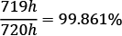. Usually, to simplify the notation when designing systems, the availability will be expressed in so-called nines: for example, if we say that a system has availability of five nines, it means it is available at least 99.999% of the total time. To put this into perspective, such a system can have only up to 26 seconds per month of downtime! These measures are often the base indicators for defining service-level agreements (SLAs) for billed cloud services.
The definition of HA, based on that, is relatively straightforward, although not precise— a system is highly available if it is operational (available) without interruption for long periods of time. Usually, we can say that five nines availability is considered the gold standard of HA.
Achieving HA in your system usually involves one or a combination of the following techniques:
Eliminating single points of failure (SPOF) in the system: Usually achieved by components' redundancy.
Failover setup, which is a mechanism that can automatically switch from the currently active (possibly unhealthy) component to a redundant one.
Load balancing, which means managing traffic coming into the system and routing it to redundant components that can serve the traffic. This will, in most cases, involve proper failover setup and component monitoring and telemetry.
Let's introduce a related concept of FT, which is also important in distributed systems such as applications running on Kubernetes.

Fault Tolerance
Now, FT can be presented as a complement to the HA concept: a system is fault-tolerant if it can continue to be functional and operating in the event of the failure of one or more of its components. Achieving full FT means achieving 100% HA, which in many cases requires complex solutions actively detecting faults and remediating the issues in the components without interruptions. Depending on the implementation, the fault may result in a graceful degradation of performance that is proportional to the severity of the fault. This means that a small fault in the system will have a small impact on the overall performance of the system while serving requests from the end user.

HA and FT for Kubernetes applications
In the previous chapters, you have learned about the concept of Pods and how you can expose them to external traffic using Services (Chapter 7, Exposing Your Pods with Services). Services are Kubernetes objects that expose a set of healthy Pods using a single network address that remains fixed and stable for the lifetime of the Service. Internally, inside the Kubernetes cluster, the Service will make its Pods addressable using a cluster Internet Protocol (IP) address. These cluster-internal IP addresses are virtual IPs managed by a kube-proxy component on each node as a set of iptables rules on Linux Nodes or Host Networking Service (HNS) policies on Windows Nodes. Externally, there are multiple approaches offered by Kubernetes that are described in Chapter 7, Exposing Your Pods with Services, but in cloud environments, you will most often expose a service behind a cloud load balancer (LB). An external LB integrates with your cluster using a plugin implementation specific to each cloud service provider, in the Kubernetes cloud-controller-manager component. In this way, the microservices or workloads running on Kubernetes can achieve request load balancing to healthy Pods, which is a necessary building block to HA.
Services are required for load balancing requests to Pods, but we haven't yet covered how to maintain multiple replicas of the same Pod object definition that are possibly redundant and allocated on different nodes. Kubernetes offers multiple building blocks to achieve this goal, outlined as follows:
A ReplicationController object—the original form of defining Pod replication in Kubernetes.
A ReplicaSet object—the successor to ReplicationController. The main difference is that ReplicaSet has support for set-based requirement selectors for Pods.
A Deployment object—another level of abstraction on top of ReplicaSet. Provides declarative updates for Pods and ReplicaSets, including rollouts and rollbacks. Used for managing stateless microservices and workloads.
A StatefulSet object—similar to Deployment but used to manage stateful microservices and workloads in the cluster. Managing state inside a cluster is usually the toughest challenge to solve in distributed systems design.
A DaemonSet object—used for running a singleton copy of a Pod on all (or some) of the nodes in the cluster. These objects are usually used for managing internal services for log aggregation or Node monitoring.
In the next sections, we will cover ReplicationController and ReplicaSets. The more advanced objects, such as Deployment, StatefulSet, and DaemonSet, will be covered in the next chapters.
Important note
This chapter covers HA and FT for Kubernetes workloads and applications. If you are interested in how to ensure HA and FT for Kubernetes itself, please refer to the official documentation at https://kubernetes.io/docs/tasks/administer-cluster/highly-available-master/. Please note that in managed Kubernetes offerings in the cloud, such as Azure Kubernetes Service (AKS), Amazon Elastic Kubernetes Service (EKS), or Google Kubernetes Engine (GKE), you are provided with highly available clusters and you do not need to manage the master nodes yourself.

What is ReplicationController?
Achieving HA and FT requires providing redundancy of components and proper load balancing of incoming traffic between the replicas of components. Let's take a look at the first Kubernetes object that allows you to create and maintain multiple replicas of the Pods in your cluster: ReplicationController. Please note that we are discussing ReplicationController mainly for historical reasons as it was the initial way of creating multiple Pod replicas in Kubernetes. We advise you to use ReplicaSet whenever possible, which is basically the next generation of ReplicationController with an extended specification API.
Tip
The Controller objects in Kubernetes have one main goal: to observe the current and the desired cluster state that is exposed by the Kubernetes API server and command changes that attempt to change the current state to the desired one. They serve as continuous feedback loops, doing all they can to bring clusters to the desired state described by your object templates.
ReplicationController has a straightforward task—it needs to ensure that a specified number of Pod replicas (defined by a template) are running and healthy in a cluster at any time. This means that if ReplicationController is configured to maintain three replicas of a given Pod, it will try to keep exactly three Pods by creating and terminating Pods when needed. For example, right after you create a ReplicationController object, it will create three new Pods based on its template definition. If, for some reason, there are four such Pods in the cluster, ReplicationController will terminate one Pod, and if by any chance a Pod gets deleted or becomes unhealthy, it will be replaced by a new, hopefully healthy, one.
Tip
You can think of ReplicationController as a container analog of process or service supervisors from operating systems, such as systemd or supervisor on Linux systems. You just define how many Pod replicas you want to have in the cluster, and let the ReplicationController object do the job of keeping them running in all circumstances!

Creating a ReplicationController object
In order to create a ReplicationController object, we will need to use declarative management of objects using the kubectl command. Imperative commands for creating ReplicationController objects are not available and even if they were, it would be not advised to use them—declarative management using YAML files (manifests) for object configuration is much easier for more complex Kubernetes objects. Additionally, it perfectly fits all recommended paradigms such as Infrastructure-as-Code (IaC).
Let's first create an example YAML manifest file for our example ReplicationController object. This ReplicationController object will have a simple task: maintain three replicas of an nginx Pod with specific metadata labels. The nginx-replicationcontroller.yaml example file should have the following content:
apiVersion: v1
kind: ReplicationController
metadata:
name: nginx-replicationcontroller-example
spec:
replicas: 3
selector:
app: nginx
environment: test
template:
metadata:
labels:
app: nginx
environment: test
spec:
containers:
- name: nginx
image: nginx:1.17
ports:
- containerPort: 80
There are three main components of the ReplicationController specification, as outlined here:
replicas: Defines the number of Pod replicas that should run using the given template and matching label selector. Pods may be created or deleted in order to maintain the required number.
selector: A label selector, which defines how to identify Pods that the ReplicationController object owns or acquires. Note that this may have a consequence of acquiring existing bare Pods by ReplicationController if they match the selector! By bare Pods, we mean any Pods in the cluster that were created directly using the kubectl run command.
template: Defines the template for Pod creation—this has exactly the same structure as you have already learned about in Chapter 4, Running Your Docker Containers. Labels used in metadata must match selector.
Now, let's apply the ReplicationController manifest to the cluster using the kubectl apply command, as follows:
$ kubectl apply -f ./nginx-replicationcontroller.yaml
You can immediately observe the status of your new ReplicationController object named nginx-replicationcontroller-example using the following command:
$ kubectl get replicationcontroller/nginx-replicationcontroller-example
NAME DESIRED CURRENT READY AGE
nginx-replicationcontroller-example 3 3 2 8s
Tip
When using the kubectl commands, you can use the rc abbreviation instead of typing replicationcontroller.
As you can see, the ReplicationController object has already created three Pods, and two of them are already in a Ready state.
Similarly, you can describe the state of your ReplicationController object to get more details by using the kubectl describe command, as follows:
$ kubectl describe rc/nginx-replicationcontroller-example
And if you would like to get the Pods in your cluster, use the following command:
$ kubectl get pods
NAME READY STATUS ...
nginx-replicationcontroller-example-btz5t 1/1 Running ...
nginx-replicationcontroller-example-c6sl6 1/1 Running ...
nginx-replicationcontroller-example-xxl7f 1/1 Running ...
You will see that the ReplicationController object has indeed created three new Pods. If you are interested, you can use the kubectl describe pod <podId> command in order to inspect the labels of the Pods and also see that it contains a Controlled By: ReplicationController/nginx-replicationcontroller-example property that identifies our example ReplicationController object.
Tip
If you would like to know how the Pods are distributed among the Kubernetes Nodes, you can use the kubectl get pods -o wide command.

Testing the behavior of ReplicationController
To demonstrate the agility of our ReplicationController object, let's now delete one of the Pods that are owned by the example ReplicationController object. You can find the names using the usual kubectl get pods command. In our case, we will be deleting the nginx-replicationcontroller-example-btz5t Pod using the following kubectl delete command:
$ kubectl delete pod/nginx-replicationcontroller-example-btz5t
Now, if you are quick enough, you will be able to see from using the kubectl get pods command that the nginx-replicationcontroller-example-btz5t Pod is being terminated and ReplicationController is immediately creating a new one in order to match the target number of replicas!
If you want to see more details about events that happened in relation to our example ReplicationController object, you can use the kubectl describe command, as illustrated in the following code snippet:
$ kubectl describe rc/nginx-replicationcontroller-example
...
Type Reason Age From Message
---- ------ ---- ---- -------
Normal SuccessfulCreate 33m replication-controller Created pod: nginx-replicationcontroller-example-c6sl6
Normal SuccessfulCreate 33m replication-controller Created pod: nginx-replicationcontroller-example-btz5t
Normal SuccessfulCreate 33m replication-controller Created pod: nginx-replicationcontroller-example-xxl7f
Normal SuccessfulCreate 112s replication-controller Created pod: nginx-replicationcontroller-example-gf27c
The nginx-replicationcontroller-example-gf27c Pod is a new pod that was created in place of the terminated nginx-replicationcontroller-example-btz5t Pod.

Scaling ReplicationController
It is possible to modify an existing ReplicationController object and change the replicas property in the specification to a different number. This process is called scaling—if you increase the number of replicas, you are scaling up (or, more precisely, scaling out), and if you decrease the number of replicas, you are scaling down. This is a basic building block of rolling upgrades and rollbacks—you will learn more about this in the next chapters. More generally, this is how horizontal scaling of your component (packaged as a pod) can be performed.
To illustrate how horizontal scaling of Pods works at a high level, please take a look at the following diagram:
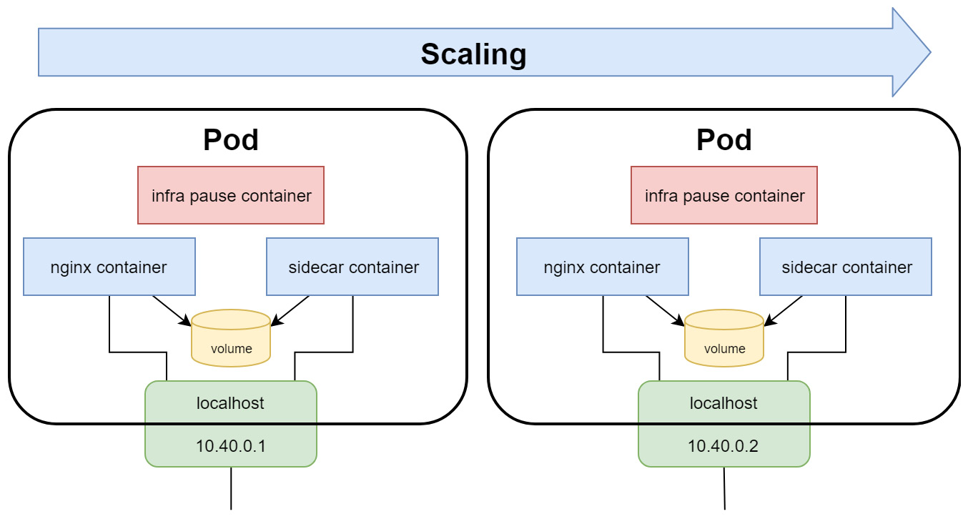
Figure 10.1 – Horizontal scaling of Kubernetes Pods
Let's first scale up our example ReplicationController object. Open the nginx-replicationcontroller.yaml file and modify the replicas property to 5, as follows:
...
spec:
replicas: 5
...
Now, we need to declaratively apply the changes to the cluster state. Use the following kubectl apply command to do this:
$ kubectl apply -f ./nginx-replicationcontroller.yaml
To see that the number of Pods controlled by the ReplicationController object has changed, you can use the kubectl get pods or kubectl describe rc/nginx-replicationcontroller-example commands.
Tip
You can achieve similar results using the kubectl scale rc/nginx-replicationcontroller-example --replicas=5 imperative command. In general, such imperative commands are recommended only for development or learning scenarios.
Similarly, if you want to scale down, you need to open the nginx-replicationcontroller.yaml file and modify the replicas property to 2, as follows:
...
spec:
replicas: 2
...
Again, declaratively apply the changes to the cluster state. Use the following kubectl apply command to do this:
$ kubectl apply -f ./nginx-replicationcontroller.yaml
At this point, you can use the kubectl get pods or kubectl describe rc/nginx-replicationcontroller-example commands to verify that the number of Pods has been reduced to just 2.
Important note
In real-world scenarios, if you would like to roll out a new version of your component (Pod), you would need to have two ReplicationController objects (one for the old version of the component, and another one for the new version) and scale them up and down in a coordinated manner. As this process is quite complex, Kubernetes provides more advanced abstractions, such as Deployment and StatefulSet objects.

Deleting ReplicationController
Lastly, let's take a look at how you can delete a ReplicationController object. There are two possibilities, outlined as follows:
Delete ReplicationController together with Pods that it owns—this is performed by first scaling down automatically.
Delete ReplicationController and leave the Pods unaffected.
To delete the ReplicationController object together with Pods, you can use the regular kubectl delete command, as follows:
$ kubectl delete rc/nginx-replicationcontroller-example
You will see that the Pods will first get terminated, and then the ReplicationController object is deleted.
Now, if you would like to delete just the ReplicationController object, you need to use the --cascade=orphan option for kubectl delete, as follows:
$ kubectl delete rc/nginx-replicationcontroller-example --cascade=orphan
After this command, if you inspect which Pods are in the cluster, you will still see all the Pods that were owned by the nginx-replicationcontroller-example replication controller. These Pods can now, for example, be acquired by another ReplicationController object that has a matching label selector.
Congratulations — you have successfully created your first ReplicationController object in a Kubernetes cluster! Now, it is time to introduce a close relative of ReplicationController, called ReplicaSet.

What is ReplicaSet and how does it differ from ReplicationController?
Let's introduce another Kubernetes object: ReplicaSet. This is very closely related to ReplicationController, which we have just discussed. In fact, this is a successor to ReplicationController, which has a very similar specification API and capabilities. The purpose of ReplicaSet is also the same—it aims to maintain a fixed number of healthy, identical Pods (replicas) that fulfill certain conditions. So, again, you just specify a template for your Pod, along with appropriate label selectors and the desired number of replicas, and Kubernetes ReplicaSetController (this is the actual name of the controller responsible for maintaining ReplicaSet objects) will carry out the necessary actions to keep the Pods running.
Now, what are the differences between ReplicaSet and ReplicationController? We have summarized these here:
Most importantly, ReplicaSet allows more advanced, set-based (inclusion, exclusion) label selectors. For example, you can easily define a selector so that it matches when a Pod has environment=test or environment=dev labels, but exclude those that have an environment=prod label. For ReplicationController, it is only possible to use simple equality-based label selectors.
ReplicaSet is a powerful building block of other Kubernetes objects such as Deployment and HorizontalPodAutoscaler (HPA) objects. Deployment objects provide a way of declarative management of ReplicaSets, doing staged rollouts and rollbacks.
For ReplicationController, you could achieve a similar Pod update rollout using the kubectl rolling-update imperative command. However, this command is now deprecated.
In general, you can expect that in the future, ReplicationController will be eventually deprecated.
The bottom line—always choose ReplicaSet over ReplicationController. However, you should also remember that using bare ReplicaSets is generally not useful in production clusters, and you should use higher-level abstractions such as Deployment objects for managing ReplicaSets. We will introduce this concept in the next chapter.

Creating a ReplicaSet object
First, let's take a look at the structure of an nginx-replicaset.yaml example YAML manifest file that maintains three replicas of an nginx Pod, as follows:
apiVersion: apps/v1
kind: ReplicaSet
metadata:
name: nginx-replicaset-example
spec:
replicas: 3
selector:
matchLabels:
app: nginx
environment: test
template:
metadata:
labels:
app: nginx
environment: test
spec:
containers:
- name: nginx
image: nginx:1.17
ports:
- containerPort: 80
There are three main components of the ReplicaSet specification, as follows:
replicas: Defines the number of Pod replicas that should run using the given template and matching label selector. Pods may be created or deleted in order to maintain the required number.
selector: A label selector that defines how to identify Pods that the ReplicaSet object owns or acquires. Again, similar to the case of ReplicationController, please take note that this may have a consequence of existing bare Pods being acquired by ReplicaSet if they match the selector!
template: Defines a template for Pod creation. Labels used in metadata must match the selector label query.
These concepts have been visualized in the following diagram:
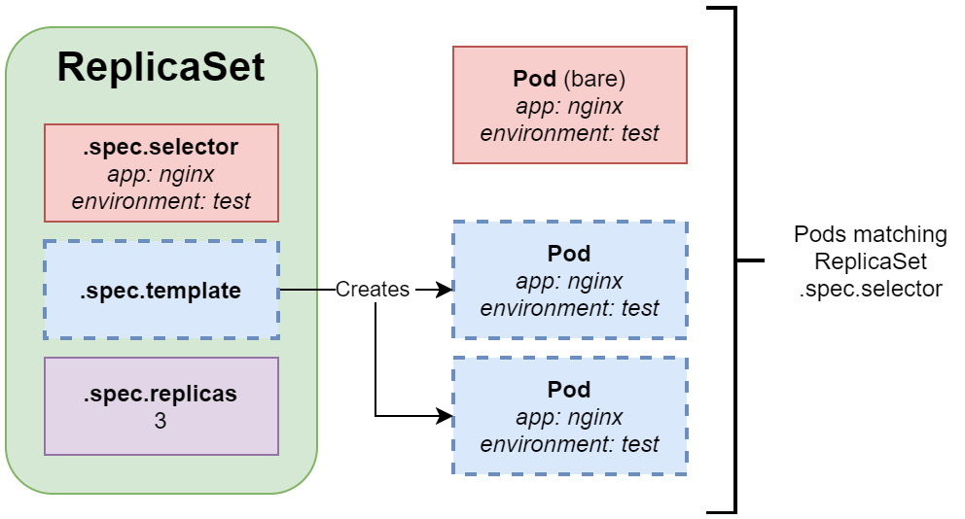
Figure 10.2 – Kubernetes ReplicaSet
As you can see, the ReplicaSet object uses .spec.template in order to create Pods. These Pods must match the label selector configured in .spec.selector. Please note that it is also possible to acquire existing bare Pods that have labels matching the ReplicaSet object. In the case shown in Figure 10.2, the ReplicaSet object only creates two new Pods, whereas the third Pod is a bare Pod that was acquired.
In the preceding example, we have used a simple, equality-based selector specified by spec.selector.matchLabels. A more advanced, set-based selector can be defined using spec.selector.matchExpressions—for example, like this:
...
spec:
replicas: 3
selector:
matchLabels:
app: nginx
matchExpressions:
- key: environment
operator: In
values:
- test
- dev
...
This specification would make ReplicaSet still match only Pods with app=nginx, and environment=test or environment=dev.
Important note
When defining ReplicaSet, .spec.template.metadata.labels must match spec.selector, or it will be rejected by the API.
Now, let's apply the ReplicaSet manifest to the cluster using the kubectl apply command, as follows:
$ kubectl apply -f ./nginx-replicaset.yaml
You can immediately observe the status of your new ReplicaSet object named nginx-replicaset-example using the following command:
$ kubectl describe replicaset/nginx-replicaset-example
...
Replicas: 3 current / 3 desired
Pods Status: 3 Running / 0 Waiting / 0 Succeeded / 0 Failed
...
Similarly, as in the case of ReplicationController, you can use the kubectl get pods command to observe the Pods that are managed by the ReplicaSet object. If you are interested, you can use the kubectl describe pod <podId> command in order to inspect the labels of the Pods and also see that it contains a Controlled By: ReplicaSet/nginx-replicaset-example property that identifies our example ReplicaSet object.
Tip
When using kubectl commands, you can use an rs abbreviation instead of typing replicaset.

Testing the behavior of ReplicaSet
Just as in the previous section about ReplicationController, you can experiment with the kubectl delete pod command to observe how ReplicaSet reacts to the sudden termination of a Pod that matches its label selector.
Now, let's try something different and create a bare Pod that matches the label selector of our ReplicaSet object. You can expect that the number of Pods that match the ReplicaSet will be four, so ReplicaSet is going to terminate one of the Pods to bring the replica count back to three.
First, let's create a simple bare Pod manifest file named nginx-pod-bare.yaml, as follows:
apiVersion: v1
kind: Pod
metadata:
name: nginx-pod-bare-example
labels:
app: nginx
environment: test
spec:
containers:
- name: nginx
image: nginx:1.17
ports:
- containerPort: 80
The metadata of Pod must have labels matching the ReplicaSet selector. Now, apply the manifest to your cluster using the following command:
$ kubectl apply -f nginx-pod-bare.yaml
Immediately after that, check the events for our example ReplicaSet object using the kubectl describe command, as follows:
$ kubectl describe rs/nginx-replicaset-example
...
Events:
Type Reason Age From Message
---- ------ ---- ---- -------
...
Normal SuccessfulDelete 29s replicaset-controller Deleted pod: nginx-pod-bare-example
As you can see, the ReplicaSet object has immediately detected that there is a new Pod created matching its label selector and has terminated the Pod.
Tip
Similarly, it is possible to remove Pods from a ReplicaSet object by modifying their labels so that they no longer match the selector. This is useful in various debugging or incident-investigation scenarios.

Scaling ReplicaSet
For ReplicaSet, we can do a similar scaling operation as for ReplicationController in the previous section. In general, you will not perform manual scaling of ReplicaSets in usual scenarios. Instead, the size of the ReplicaSet object will be managed by another, higher-level object such as Deployment.
Let's first scale up our example ReplicaSet object. Open the nginx-replicaset.yaml file and modify the replicas property to 5, as follows:
...
spec:
replicas: 5
...
Now, we need to declaratively apply the changes to the cluster state. Use the following kubectl apply command to do this:
$ kubectl apply -f ./nginx-replicaset.yaml
To see that the number of Pods controlled by the ReplicaSet object has changed, you can use the kubectl get pods or kubectl describe rs/nginx-replicaset-example commands.
Tip
Exactly as in the case of ReplicationController, you can achieve similar results using the kubectl scale rs/nginx-replicaset-example --replicas=5 imperative command. In general, such imperative commands are recommended only for development or learning scenarios.
Similarly, if you would like to scale down, you need to open the nginx-replicaset.yaml file and modify the replicas property to 2, as follows:
...
spec:
replicas: 2
...
Again, declaratively apply the changes to the cluster state. Use the following kubectl apply command to do this:
$ kubectl apply -f ./nginx-replicaset.yaml
At this point, you can use the kubectl get pods or kubectl describe rs/nginx-replicaset-example commands to verify that the number of Pods has been reduced to just 2.

Using Pod liveness probes together with ReplicaSet
Sometimes, you may want to consider a Pod unhealthy and requiring a container restart, even if the main process in the container has not crashed. For such cases, Kubernetes offers different types of probes for containers to determine whether they need to be restarted or whether they can serve the incoming traffic. We will quickly demonstrate how you can use liveness probes together with ReplicaSet to achieve even greater resilience to failures of containerized components.
Tip
Kubernetes provides more container probes, such as readiness probes and startup probes. If you want to learn more about them and when to use them, please refer to the official documentation at https://kubernetes.io/docs/concepts/workloads/pods/pod-lifecycle/#container-probes.
In our example, we will create a ReplicaSet object that runs nginx Pods with an additional liveness probe on the main container, which checks whether an HTTP GET request to the / path responds with a successful HTTP status code. You can imagine that, in general, your nginx process running in the container will always be healthy (until it crashes), but it doesn't mean that the Pod can be considered healthy. If the web server is not able to successfully provide content, it means that the web server process is running but something else might have gone wrong, and this Pod should no longer be used. We will simulate this situation by simply deleting the /index.html file in the container, which will cause the liveness probe to fail.
First, let's create a YAML manifest file named nginx-replicaset-livenessprobe.yaml for our new nginx-replicaset-livenessprobe-example ReplicaSet object with the following content:
apiVersion: apps/v1
kind: ReplicaSet
metadata:
name: nginx-replicaset-livenessprobe-example
spec:
replicas: 3
selector:
matchLabels:
app: nginx
environment: test
template:
metadata:
labels:
app: nginx
environment: test
spec:
containers:
- name: nginx
image: nginx:1.17
ports:
- containerPort: 80
livenessProbe:
httpGet:
path: /
port: 80
initialDelaySeconds: 2
periodSeconds: 2
The highlighted part of the preceding code block contains the liveness probe definition and is the only difference between our earlier ReplicaSets examples. The liveness probe is configured to execute an HTTP GET request to the / path at port 80 for the container every 2 seconds (periodSeconds). The first probe will start after 2 seconds (initialDelaySeconds) from the container start.
Tip
If you are modifying an existing ReplicaSet object, you need to first delete it and recreate it in order to apply changes to the Pod template.
Now, apply the manifest file to the cluster using the following command:
$ kubectl apply -f ./nginx-replicaset-livenessprobe.yaml
Verify that the Pods have been successfully started using the following command:
$ kubectl get pods
Now, you need to choose one of the ReplicaSet Pods in order to simulate the failure inside the container that will cause the liveness probe to fail. In the case of our example, we will be using a Pod with the name nginx-replicaset-livenessprobe-example-2qbhk.
To simulate the failure, run the following command. This command will remove the index.html file served by the nginx web server and will cause the HTTP GET request to fail with a non-successful HTTP status code:
$ kubectl exec -it nginx-replicaset-livenessprobe-example-2qbhk -- rm /usr/share/nginx/html/index.html
Inspect the events for this Pod using the kubectl describe command, as follows:
$ kubectl describe pod/nginx-replicaset-livenessprobe-example-2qbhk
...
Events:
Type Reason Age From Message
---- ------ ---- ---- -------
...
Normal Created 20s (x2 over 3m53s) kubelet Created container nginx
Warning Unhealthy 20s (x3 over 24s) kubelet Liveness probe failed: HTTP probe failed with statuscode: 403
Normal Killing 20s kubelet Container nginx failed liveness probe, will be restarted
Normal Started 19s (x2 over 3m53s) kubelet Started container nginx
As you can see, the liveness probe has correctly detected that the web server became unhealthy and restarted the container inside the Pod.
However, please note that the ReplicaSet object itself did not take part in the restart in any way—the action was performed at a Pod level. This demonstrates how individual Kubernetes objects provide different features that can work together to achieve improved FT. Without the liveness probe, the end user could be served by a replica that is not able to provide content, and this would go undetected!

Deleting a ReplicaSet object
Lastly, let's take a look at how you can delete a ReplicaSet object. There are two possibilities, outlined as follows:
Delete the ReplicaSet object together with the Pods that it owns—this is performed by first scaling down automatically.
Delete the ReplicaSet object and leave the Pods unaffected.
To delete the ReplicaSet object together with the Pods, you can use the regular kubectl delete command, as follows:
$ kubectl delete rs/nginx-replicaset-livenessprobe-example
You will see that the Pods will first get terminated and then the ReplicaSet object is deleted.
Now, if you would like to delete just the ReplicaSet object, you need to use the --cascade=orphan option for kubectl delete, as follows:
$ kubectl delete rs/nginx-replicaset-livenessprobe-example --cascade=orphan
After this command, if you inspect which Pods are in the cluster, you will still see all the Pods that were owned by the nginx-replicaset-livenessprobe-example ReplicaSet object. These Pods can now, for example, be acquired by another ReplicaSet object that has a matching label selector.

Summary
In this chapter, you have learned about the key building blocks for providing High Availability (HA) and Fault Tolerance (FT) for applications running in Kubernetes clusters. First, we have explained why HA and FT are important. Next, you have learned more details about providing component replication and failover using ReplicationController and ReplicaSet, which are used in Kubernetes in order to provide multiple copies (replicas) of identical Pods. We have demonstrated the differences between ReplicationController and ReplicaSet and eventually explained why using ReplicaSet is currently the recommended way to provide multiple replicas of Pods.
The next chapters in this part of the book will give you an overview of how to use Kubernetes to orchestrate your container applications and workloads. You will familiarize yourself with concepts of the most important Kubernetes objects, such as ReplicaSet, Deployment, StatefulSet, or DaemonSet, and in the next chapter, we will focus on the next level of abstraction over ReplicaSets: Deployment objects. You will learn how to deploy and easily manage rollouts and rollbacks of new versions of your application.

Further reading
For more information regarding ReplicationController and ReplicaSet, please refer to the following Packt Publishing books:
The Complete Kubernetes Guide, by Jonathan Baier, Gigi Sayfan, and Jesse White (https://www.packtpub.com/virtualization-and-cloud/complete-kubernetes-guide)
Getting Started with Kubernetes – Third Edition, by Jonathan Baier and Jesse White (https://www.packtpub.com/virtualization-and-cloud/getting-started-kubernetes-third-edition)
Kubernetes for Developers, by Joseph Heck (https://www.packtpub.com/virtualization-and-cloud/kubernetes-developers)
Hands-On Kubernetes on Windows, by Piotr Tylenda (https://www.packtpub.com/product/hands-on-kubernetes-on-windows/9781838821562)
You can also refer to the excellent official Kubernetes documentation (https://kubernetes.io/docs/home/), which is always the most up-to-date source of knowledge about Kubernetes in general.

Chapter 11: Deployment – Deploying Stateless Applications
The previous chapter introduced two important Kubernetes objects: ReplicationController and ReplicaSet. At this point, you already know that they serve similar purposes in terms of maintaining identical, healthy replicas (copies) of Pods. In fact, ReplicaSet is a successor of ReplicationController and, in the most recent versions of Kubernetes, ReplicaSet should be used in favor of ReplicationController.
Now, it is time to introduce the Deployment object, which provides easy scalability, rolling updates, and versioned rollbacks for your stateless Kubernetes applications and services. Deployment objects are built on top of ReplicaSets and they provide a declarative way of managing them – just describe the desired state in the Deployment manifest and Kubernetes will take care of orchestrating the underlying ReplicaSets in a controlled, predictable manner. Alongside StatefulSet, which will be covered in the next chapter, it is the most important workload management object in Kubernetes. This will be the bread and butter of your development and operations on Kubernetes! The goal of this chapter is to make sure that you have all the tools and knowledge you need to deploy your stateless application components using Deployment objects, as well as to safely release new versions of your components using rolling updates of deployments.
This chapter will cover the following topics:
Introducing the Deployment object
How does a Deployment object manage revisions and version rollout?
Deployment object best practices

Technical requirements
For this chapter, you will need the following:
A Kubernetes cluster that's been deployed. You can use either a local or cloud-based cluster, but to fully understand the concepts shown in this chapter, we recommend using a multi-node, cloud-based Kubernetes cluster.
The Kubernetes CLI (kubectl) must be installed on your local machine and configured to manage your Kubernetes cluster.
Kubernetes cluster deployment (local and cloud-based) and kubectl installation were covered in Chapter 3, Installing Your First Kubernetes Cluster.
You can download the latest code samples for this chapter from the official GitHub repository: https://github.com/PacktPublishing/The-Kubernetes-Bible/tree/master/Chapter11.

Introducing the Deployment object
Kubernetes gives you out-of-the-box flexibility when it comes to running different types of workloads, depending on your use cases. Let's have a brief look at the supported workloads to understand where the Deployment object fits, as well as its purpose. When implementing cloud-based applications, you will generally need the following types of workloads:
Stateless: Applications and services that are stateless, by definition, do not have any modifiable client data (state) that is needed for further operations or sessions. In the container-based world, what we mean by stateless containers or Pods is that they do not store any application state inside the container or attached volume. Imagine that you have two different nginx containers serving the same purpose: the first one stores some data coming from user requests in a JSON file inside the container, while the second one stores data in MongoDB that's running in a separate container. Both serve the same purpose, but the first one is stateless and the second one is not stateless (in other words, it's stateful). However, our small application, as a whole, is not stateless because some of its components are stateful. In the first case, the nginx container is the stateful component, while in the second case, the MongoDB container is the stateful component. Stateless workloads are easy to orchestrate, scale up and down, and, in general, are simple to manage. In Kubernetes, Deployment objects are used to manage stateless workloads.
Stateful: In the case of containers and Pods, we call them stateful if they store any modifiable data inside themselves. A good example of such a Pod is a MySQL or MongoDB Pod that reads and writes the data to a persistent volume. Stateful workloads are much harder to manage – you need to carefully manage sticky sessions or data partitions during rollouts, rollbacks, and when scaling. As a rule of thumb, try to keep stateful workloads outside your Kubernetes cluster if possible, such as by using cloud-based Software-as-a-Service database offerings. In Kubernetes, StatefulSet objects are used to manage stateful workloads. Chapter 12, StatefulSet – Deploying Stateful Applications, provides more details about these types of objects.
Batch: This type of workload is anything that performs job or task processing, either scheduled or on demand. Depending on the type of application, batch workloads may require thousands of containers and a lot of nodes – this can be anything that happens in the background. Containers that are used for batch processing should also be stateless, to make it easier to resume interrupted jobs. In Kubernetes, Job and CronJob objects are used to manage batch workloads. Chapter 4, Running Your Docker Containers, provides more details about these types of objects.
Node-local: In many cases, Kubernetes cluster operations require periodic maintenance of Nodes or system log aggregation for each Node. Usually, such workloads are not user-facing but are crucial to the proper functionality of each Node in the cluster. In Kubernetes, DaemonSet objects are used to manage node-local workloads. Chapter 13, DaemonSet – Maintaining Pod Singletons on Nodes, provides more details about these types of objects.
With this brief summary regarding the different types of workloads in Kubernetes, we can dive deeper into managing stateless workloads using Deployment objects. In short, they provide declarative and controlled updates for Pods and ReplicaSets. You can declaratively perform operations such as the following by using them:
Perform a rollout of a new ReplicaSet.
Change the Pod template and perform a controlled rollout. The old ReplicaSet will be gradually scaled down, whereas the new ReplicaSet will scale up at the same rate.
Perform a rollback to an earlier version of the Deployment object.
Scale ReplicaSet up or down, without needing to make any changes to the Pod definition.
Pause and resume the rollout of the new ReplicaSet, if there is a need to introduce fixes.
In this way, Deployment objects provide an end-to-end pipeline for managing your stateless components running in Kubernetes clusters. Usually, you will combine them with Service objects, as presented in Chapter 7, Exposing Your Pods with Services, to achieve high fault tolerance, health monitoring, and intelligent load balancing for traffic coming into your application.
Now, let's have a closer look at the anatomy of the Deployment object specification and how to create a simple example deployment in our Kubernetes cluster.

Creating a Deployment object
First, let's take a look at the structure of an example Deployment YAML manifest file, nginx-deployment.yaml, that maintains three replicas of an nginx pod:
apiVersion: apps/v1
kind: Deployment
metadata:
name: nginx-deployment-example
spec:
replicas: 3
selector:
matchLabels:
app: nginx
environment: test
minReadySeconds: 10
strategy:
type: RollingUpdate
rollingUpdate:
maxUnavailable: 1
maxSurge: 1
template:
metadata:
labels:
app: nginx
environment: test
spec:
containers:
- name: nginx
image: nginx:1.17
ports:
- containerPort: 80
As you can see, the structure of the Deployment spec is almost identical to ReplicaSet, although it has a few extra parameters for configuring the strategy for rolling out new versions. The specification has four main components:
replicas: Defines the number of Pod replicas that should run using the given template and matching label selector. Pods may be created or deleted to maintain the required number. This property is used by the underlying ReplicaSet.
selector: A label selector, which defines how to identify Pods that the underlying ReplicaSet owns. This can include set-based and equality-based selectors. In the case of Deployments, the underlying ReplicaSet will also use a generated pod-template-hash label to ensure that there are no conflicts between different child ReplicaSets when you're rolling out a new version. Additionally, this generally prevents accidental acquisitions of bare Pods, which could easily happen with simple ReplicaSets. Nevertheless, Kubernetes does not prevent you from defining overlapping pod selectors between different Deployments or even other types of controllers. However, if this happens, they may conflict and behave unexpectedly.
template: Defines the template for Pod creation. Labels used in metadata must match our selector.
strategy: Defines the details of the strategy that will be used to replace existing Pods with new ones. You will learn more about such strategies in the following sections. In this example, we showed the default RollingUpdate strategy. In short, this strategy works by slowly replacing the Pods of the previous version, one by one, by using the Pods of the new version. This ensures zero downtime and, together with Service objects and readiness probes, provides traffic load balancing to pods that can serve the incoming traffic.
Important Note
The Deployment spec provides a high degree of reconfigurability to suit your needs. We recommend referring to the official documentation for all the details: https://kubernetes.io/docs/reference/generated/kubernetes-api/v1.19/#deploymentspec-v1-apps.
To better understand the relationship of Deployment, its underlying child ReplicaSet, and Pods, please look at the following diagram:
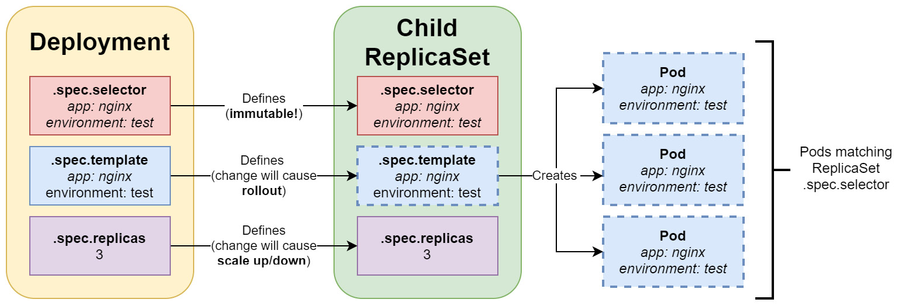
Figure 11.1 – Kubernetes Deployment
As you can see, once you have defined and created a Deployment, it is not possible to change its selector. This is desired because otherwise, you could easily end up with orphaned ReplicaSets. There are two important actions that you can perform on existing Deployment objects:
Modify template: Usually, you would like to change the Pod definition to a new image version of your application. This will cause a rollout to begin, according to the rollout strategy.
Modify replicas number: Just changing the number will cause ReplicaSet to gracefully scale up or down.
Now, let's declaratively apply our example Deployment YAML manifest file, nginx-deployment.yaml, to the cluster using the kubectl apply command:
$ kubectl apply -f ./nginx-deployment.yaml --record
Using the --record flag is useful for tracking the changes that are made to the objects, as well as to inspect which commands caused these changes. You will then see an additional automatic annotation, kubernetes.io/change-cause, which contains information about the command.
Immediately after the Deployment object has been created, use the kubectl rollout command to track the status of your Deployment in real time:
$ kubectl rollout status deployment nginx-deployment-example
Waiting for deployment "nginx-deployment-example" rollout to finish: 0 of 3 updated replicas are available...
Waiting for deployment "nginx-deployment-example" rollout to finish: 0 of 3 updated replicas are available...
Waiting for deployment "nginx-deployment-example" rollout to finish: 0 of 3 updated replicas are available...
deployment "nginx-deployment-example" successfully rolled out
This is a useful command that can give us a lot of insight into what is happening with an ongoing Deployment rollout. You can also use the usual kubectl get or kubectl describe commands:
$ kubectl get deploy nginx-deployment-example
NAME READY UP-TO-DATE AVAILABLE AGE
nginx-deployment-example 3/3 3 3 6m21s
As you can see, the Deployment has been successfully created and all three Pods are now in the ready state.
Tip
Instead of typing deployment, you can use the deploy abbreviation when using kubectl commands.
You may also be interested in seeing the underlying ReplicaSets:
$ kubectl get rs
NAME DESIRED CURRENT READY AGE
nginx-deployment-example-5549875c78 3 3 3 8m7s
Please take note of the additional generated hash, 5549875c78, in the name of our ReplicaSet, which is also the value of the pod-template-hash label, which we mentioned earlier.
Lastly, you can see the pods in the cluster that were created by the Deployment object using the following command:
$ kubectl get pods
NAME READY STATUS RESTARTS AGE
nginx-deployment-example-5549875c78-5srkn 1/1 Running 0 11m
nginx-deployment-example-5549875c78-h5n76 1/1 Running 0 11m
nginx-deployment-example-5549875c78-mn5zn 1/1 Running 0 11m
Congratulations – you have created and inspected your first Kubernetes Deployment! Next, we will take a look at how Service objects are used to expose your Deployment to external traffic coming into the cluster.

Exposing Deployment Pods using Service objects
Service objects were covered in detail in Chapter 7, Exposing Your Pods with Services, so in this section, we will provide a brief recap about the role of Services and how they are usually used with Deployments. Services are Kubernetes objects that allow you to expose your Pods, whether this is to other Pods in the cluster or end users. They are the crucial building blocks for highly available and fault-tolerant Kubernetes applications, since they provide a load balancing layer that actively routes incoming traffic to ready and healthy Pods.
The Deployment objects, on the other hand, provide Pod replication, automatic restarts when failures occur, easy scaling, controlled version rollouts, and rollbacks. But there is a catch: Pods that are created by ReplicaSets or Deployments have a finite life cycle. At some point, you can expect them to be terminated; then, new Pod replicas with new IP addresses will be created in their place. So, what if you have a Deployment running web server Pods that need to communicate with Pods that have been created as a part of another Deployment such as backend Pods? Web server Pods cannot assume anything about the IP addresses or the DNS names of backend Pods, as they may change over time. This issue can be resolved with Service objects, which provide reliable networking for a set of Pods.
In short, Services target a set of Pods, and this is determined by label selectors. These label selectors work on the same principle that you have learned about for ReplicaSets and Deployments. The most common scenario is exposing a Service for an existing Deployment by using the same label selector. The Service is responsible for providing a reliable DNS name and IP address, as well as for monitoring selector results and updating the associated Endpoint object with the current IP addresses of the matching Pods. For internal cluster communication, this is usually achieved using simple ClusterIP Services, whereas to expose them to external traffic, you can use the NodePort Service or, more commonly in cloud deployments, the LoadBalancer Service.
To visualize how Service objects interact with Deployment objects in Kubernetes, please look at the following diagram:
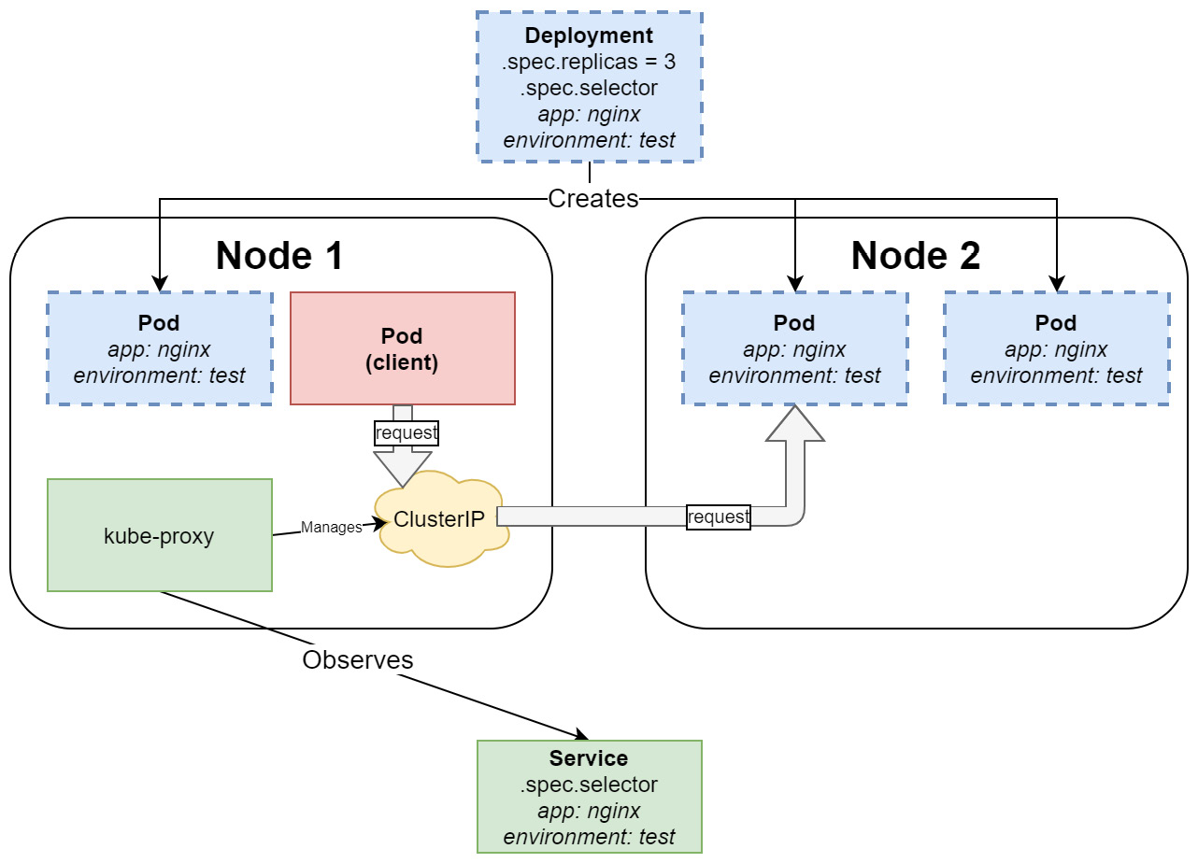
Figure 11.2 – Client Pod performing requests to the Kubernetes Deployment, exposed by the ClusterIP Service
This diagram visualizes how any client Pod in the cluster can transparently communicate with the nginx Pods that are created by our Deployment object and exposed using the ClusterIP Service. ClusterIPs are essentially virtual IP addresses that are managed by the kube-proxy service (process) that is running on each Node. kube-proxy is responsible for all the clever routing logic in the cluster and ensures that the routing is entirely transparent to the client Pods – they do not need to be aware if they are communicating with the same Node, a different Node, or even an external component. The role of the Service object is to define a set of ready Pods that should be hidden behind a stable ClusterIP. Usually, the internal clients will not be calling the Service pods using the ClusterIP, but they will use a DNS short name, which is the same as Service name; for example, nginx-service-example. This will be resolved to the ClusterIP by the cluster's internal DNS service. Alternatively, they may use a DNS Fully Qualified Domain Name (FQDN) in the form of <serviceName>.<namespaceName>.svc.<clusterDomain>; for example, nginx-service-example.default.svc.cluster.local.
Important Note
For LoadBalancer or NodePort Services that expose Pods to external traffic, the principle is similar as internally, they also provide a ClusterIP for internal communication. The difference is that they also configure more components so that external traffic can be routed to the cluster.
Now that you're equipped with the necessary knowledge about Service objects and their interactions with Deployment objects, let's put what we've learned into practice!
Creating a Service declaratively
In this section, we are going to expose our nginx-deployment-example Deployment using the nginx-service-example Service object, which is of the LoadBalancer type, by performing the following steps:
Create an nginx-service.yaml manifest file with the following content:
apiVersion: v1
kind: Service
metadata:
name: nginx-service-example
spec:
selector:
app: nginx
environment: test
type: LoadBalancer
ports:
- port: 80
protocol: TCP
targetPort: 80
The label selector of the Service is the same as the one we used for our Deployment object. The specification of the Service instructs us to expose our Deployment on port 80 of the cloud load balancer, and then route the traffic from target port 80 to the underlying Pods.
Important Note
Depending on how your Kubernetes cluster is deployed, you may not be able to use the LoadBalancer type. In that case, you may need to use the NodePort type for this exercise or stick to the simple ClusterIP type and skip the part about external access. For local development deployments such as minikube, you will need to use the minikube service command to access your Service. You can find more details in the documentation: https://minikube.sigs.k8s.io/docs/commands/service/.
Now, use the kubectl get or kubectl describe command to gather information about, and the status of, our new service and associated load balancer:
$ kubectl describe service nginx-service-example
...
LoadBalancer Ingress: 40.88.196.15
…
Events:
Type Reason Age From Message
---- ------ ---- ---- -------
Normal EnsuringLoadBalancer 10m service-controller Ensuring load balancer
Normal EnsuredLoadBalancer 11m service-controller Ensured load balancer
Please note that creating the external cloud load balancer may take a bit of time, so you may not see an external IP address immediately. In this case, the external IP is 40.88.196.15.
Tip
You can use the svc abbreviation in the kubectl commands instead of typing service.
Now, navigate to your favorite web browser and open the address for your Service; for example http://40.88.196.15 (your address will be different, depending on the output of the kubectl describe command). With that, we have exposed port 80, which is a simple HTTP endpoint, not HTTPS, which is a secure version of HTTP. For demonstration purposes, this is enough, but for production workloads, you need to ensure you have set up properly HTTPS for your load balancer and inside the cluster. You should see the default nginx welcome page, served by one of the three Pods in our Deployment object:
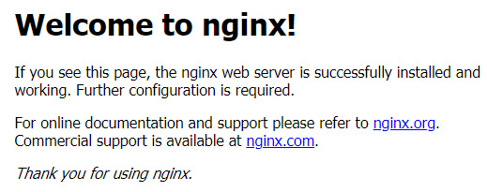
Figure 11.3 – Web page served by nginx running in Deployment pods
This shows how Services are used to expose Deployment Pods to external traffic. Now, let's perform an experiment that demonstrates how internal traffic is handled by Services for other client Pods:
Create an interactive busybox Pod and start the Bourne shell process. The following command will create the Pod and immediately attach it to your terminal so that you can interact with it from within the Pod:
$ kubectl run -i --tty busybox --image=busybox --rm --restart=Never -- sh
When the container shell prompt appears, download the default web page served by nginx Pods in the deployment. Use the nginx-deployment-example Service name as the short DNS name:
$ wget http://nginx-service-example && cat index.html
Alternatively, you can use DNS FQDN:
$ rm ./index.html
$ wget http://nginx-service-example.default.svc.cluster.local && cat index.html
In both cases, you will see the same HTML source code for our default web page.
Use the exit command to exit the session and automatically remove the busybox Pod.
Now, we will quickly show you how to achieve a similar result using imperative commands to create a Service for our Deployment object.
Creating a Service imperatively
A similar effect can be achieved using the imperative kubectl expose command – a Service will be created for our Deployment object named nginx-deployment-example. Use the following command:
$ kubectl expose deployment --type=LoadBalancer nginx-deployment-example
service/nginx-deployment-example exposed
This will create a Service with the same name as the Deployment object; that is, nginx-deployment-example. If you would like to use a different name, as shown in the declarative example, you can use the --name=nginx-service-example parameter. Additionally, port 80, which will be used by the Service, will be the same as the one that was defined for the Pods. If you want to change this, you can use the --port=<number> and --target-port=<number> parameters.
Please note that this imperative command is recommended for use in development or debugging scenarios only. For production environments, you should leverage declarative Infrastructure-as-Code and Configuration-as-Code approaches as much as possible.
Role of readiness, liveness, and startup probes
In Kubernetes, there are three types of probes that you can configure for each container running in a Pod:
Readiness probe: This is used to determine whether a given container is ready to accept traffic. A Pod is considered ready only if all its containers are ready. Pods that are not ready will be removed from Service Endpoints until they become ready again. In other words, such Pods will not be considered while load balancing traffic via Service. This is the most important probe from the Service object's perspective – setting it up properly ensures that the end users will experience zero downtime during rollouts and rollbacks, and also during any failures of individual Pods.
Liveness probe: This is used to detect whether a container needs to be restarted. This can help in situations where a container has been stuck in a deadlock or other issues, where the container process is alive but unable to operate properly. Restarting the container may increase the availability of Pods in that case. We briefly covered this probe in Chapter 10, Running Production-Grade Kubernetes Workloads, as it complements the role of ReplicaSet.
Startup probe: This is an additional probe that's used for determining whether a container has been fully started – the readiness and liveness probes are disabled until this probe returns successfully. This is especially useful for containers that have a long startup time due to some initialization. In this way, you can avoid premature kills being made by the liveness probe.
All these probes are incredibly useful when you're configuring your Deployments – always try to predict possible life cycle scenarios for the processes running in your containers and configure the probes accordingly for your Deployments.
Probes can have different forms. For example, they can be running a command (exec) inside the container and verifying whether the exit code is successful. Alternatively, they can be HTTP GET requests (httpGet) to a specific endpoint of the container or attempting to open a TCP socket (tcpSocket) and checking if a connection could be established. Usually, httpGet probes are used on dedicated health endpoints (for liveness) or ready endpoints (for readiness) that are exposed by the process running in the container. These endpoints would encapsulate the logic of the actual health or readiness check.
Please note that, by default, no probes are configured on containers running in Pods. Kubernetes will serve traffic to Pod containers behind the Service, but only if the containers have successfully started, and restart them if they have crashed using the default always-restart policy. This means that it is your responsibility to figure out what type of probes and what settings you need for your particular case. You will also need to understand the possible consequences and caveats of incorrectly configured probes – for example, if your liveness probe is too restrictive and has timeouts that are too small, it may wrongfully restart your containers and decrease the availability of your application.
Now, let's demonstrate how you can configure a readiness probe on our Deployment and how it works in real time.
Important Note
If you are interested in the configuration details for other types of probes, please refer to the official documentation: https://kubernetes.io/docs/tasks/configure-pod-container/configure-liveness-readiness-startup-probes/. We have only covered the readiness probe in this section as it is the most important for interactions between Service objects and Deployment objects.
The nginx Deployment that we use is very simple and does not need any dedicated readiness probe. Instead, we will arrange the container's setup so that we can have the container's readiness probe fail or succeed on demand. The idea is to create an empty file called /usr/share/nginx/html/ready during container setup, which will be served on the /ready endpoint by nginx (just like any other file) and configure a readiness probe of the httpGet type to query the /ready endpoint for a successful HTTP status code. Now, by deleting or recreating the ready file using the kubectl exec command, we can easily simulate failures in our Pods that cause the readiness probe to fail or succeed.
Please follow these steps to configure and test the readiness probe:
Delete the existing Deployment using the following command:
$ kubectl delete deployment nginx-deployment-example
Copy our previous YAML manifest for the Deployment:
$ cp nginx-deployment.yaml nginx-deployment-readinessprobe.yaml
Open the file and modify the following parts of the manifest:
apiVersion: apps/v1
kind: Deployment
metadata:
name: nginx-deployment-example
spec:
...
template:
...
spec:
containers:
- name: nginx
image: nginx:1.17
ports:
- containerPort: 80
command:
- /bin/sh
- -c
- |
touch /usr/share/nginx/html/ready
echo "You have been served by Pod with IP address: $(hostname -i)" > /usr/share/nginx/html/index.html
nginx -g "daemon off;"
readinessProbe:
httpGet:
path: /ready
port: 80
initialDelaySeconds: 5
periodSeconds: 2
timeoutSeconds: 10
successThreshold: 1
failureThreshold: 2
There are multiple parts changing in the Deployment manifest, all of which have been highlighted. First, we overridden the default container entry point command using command and passed additional arguments. command is set to /bin/sh to execute a custom shell command. The additional arguments are constructed in the following way:
-c is an argument for /bin/sh that instructs it that what follows is a command to be executed in the shell.
touch /usr/share/nginx/html/ready is the first command that's used in the container shell. This will create an empty ready file that can be served by nginx on the /ready endpoint.
echo "You have been served by Pod with IP address: $(hostname -i)" > /usr/share/nginx/html/index.html is the second command that sets the content of index.html to information about the internal cluster Pod's IP address. hostname -i is the command that's used to get the container IP address. This value will be different for each Pod running in our Deployment.
nginx -g "daemon off;". Finally, we execute the default entrypoint command for the nginx:1.17 image. This will start the nginx web server as the main process in the container.
Important Note
Usually, you would perform such customization using a new Docker image, which inherits from the nginx:1.17 image as a base. The method shown here is being used for demonstration purposes and shows how flexible the Kubernetes runtime is.
The second set of changes we made in the YAML manifest for the Deployment were for the definition of readinessProbe, which is configured as follows:
The probe is of the httpGet type and executes an HTTP GET request to the /ready HTTP endpoint on port 80 of the container.
initialDelaySeconds: This is set to 5 seconds and configures the probe to start querying after 5 seconds from container start.
periodSeconds: This is set to 2 seconds and configures the probe to query in 2-second intervals.
timeoutSeconds: This is set to 10 seconds and configures a number of seconds, after which the HTTP GET request times out.
successThreshold: This is set to 1 and configures the minimum number of consecutive success queries of the probe before it is considered to be successful once it has failed.
failureThreshold: This is set to 2 and configures the minimum number of consecutive failed queries of the probe before it is considered to have failed. Setting it to a value that's greater than 1 ensures that the probe is not providing false positives.
To create the deployment, follow these steps:
Apply the new YAML manifest file to the cluster using the following command:
$ kubectl apply -f ./nginx-deployment-readinessprobe.yaml --record
Use the kubectl describe command to get the external load balancer IP address of the nginx-deployment-example Service, which we created at the beginning of this section and is still running (if you are recreating the Service, you may need to wait until it has been configured):
$ kubectl describe svc nginx-service-example
...
LoadBalancer Ingress: 52.188.43.251
...
Endpoints: 10.244.0.43:80,10.244.1.50:80,10.244.1.51:80
We will use 52.188.43.251 as the IP address in our examples. You can also see that the service has three Endpoints that map to our Deployment Pods, all of which are ready to serve traffic.
Navigate to http://52.188.43.251 in your favorite web browser. Please turn off web browser caching while making these requests to avoid any cached responses to your queries. In Chrome, you can simply do this for your current tab by opening Developer Tools by pressing F12 and checking the Disable Cache checkbox. Press F5 to refresh. You will notice that the responses iterate over three different Pod IP addresses. This is, because our Deployment has been configured to have three Pod replicas. Each time you perform a request, you may hit a different Pod:
You have been served by Pod with IP address: 10.244.0.43
... (a few F5 hits later)
You have been served by Pod with IP address: 10.244.1.51
... (a few F5 hits later)
You have been served by Pod with IP address: 10.244.1.50
You can cross-check this with the kubectl get pod command to see the actual addresses of the Pods:
$ kubectl get pod -o wide
NAME READY STATUS RESTARTS AGE IP ...
nginx-deployment-example-85cd4b66f-94r4q 1/1 Running 0 11m 10.244.1.51 ...
nginx-deployment-example-85cd4bb66f-95bwd 1/1 Running 0 11m 10.244.1.50 ...
nginx-deployment-example-85cd4bb66f-ssccm 1/1 Running 0 11m 10.244.0.43 ...
Now, let's simulate a readiness failure for the first Pod. In our case, this is nginx-deployment-example-85cd4bb66f-94r4q, which has an IP address of 10.244.1.51. To do this, we need to simply delete the ready file inside the container using the kubectl exec command:
$ kubectl exec -it nginx-deployment-example-85cd4bb66f-94r4q -- rm /usr/share/nginx/html/ready
The readiness probe will now start to fail, but not immediately! We have set it up so that it needs to fail at least two times, and each check is performed in 2-second intervals. So, if you are quick, you can go to your web browser and try refreshing the external address of our Service a few times. However, you may still see that you were served by 10.244.1.51. Later, you will notice that you are only served by two other Pods that are still ready.
Now, if you describe the nginx-service-example Service, you will see that it only has two Endpoints available, as expected:
$ kubectl describe svc nginx-service-example
...
Endpoints: 10.244.0.43:80,10.244.1.50:80
In the events for the Pod, you can also see that it is considered not ready:
$ kubectl describe pod nginx-deployment-example-85cd4bb66f-94r4q
...
Events:
Type Reason Age From Message
---- ------ ---- ---- -------
Warning Unhealthy 2m21s (x151 over 7m21s) kubelet Readiness probe failed: HTTP probe failed with statuscode: 404
We can push this even further. Delete the ready files in the other two Pods (nginx-deployment-example-85cd4bb66f-95bwd and nginx-deployment-example-85cd4bb66f-ssccm, in our case) to make the whole Service fail:
$ kubectl exec -it nginx-deployment-example-85cd4bb66f-95bwd -- rm /usr/share/nginx/html/ready
$ kubectl exec -it nginx-deployment-example-85cd4bb66f-ssccm -- rm /usr/share/nginx/html/ready
Now, when you refresh the web page, you will see that the request is pending and that eventually, it will fail with a timeout. We are now in a pretty bad state – we have a total readiness failure for all the Pod replicas in our Deployment!
Finally, let's make one of our Pods ready again by recreating the file. You can refresh the web page so that the request is pending and, at the same time, execute the necessary command to create the ready file:
$ kubectl exec -it nginx-deployment-example-85cd4bb66f-ssccm -- touch /usr/share/nginx/html/ready
After about 2 seconds (this is the probe interval), the pending request in the web browser should succeed and you will be presented with a nice response from nginx:
You have been served by Pod with IP address: 10.244.0.43
Congratulations – you have successfully configured and tested the readiness probe for your Deployment Pods! This should give you a good insight into how the probes work and how you can use them with Services that expose your Deployments.
Next, we will take a brief look at how you can scale your Deployments.

Scaling a Deployment object
The beauty of Deployments is that you can almost instantly scale them up or down, depending on your needs. When the Deployment is exposed behind a Service, the new Pods will be automatically discovered as new Endpoints when you scale up, or automatically removed from the Endpoints list when you scale down. The steps for this are as follows:
First, let's scale up our Deployment declaratively. Open the nginx-deployment-readinessprobe.yaml YAML manifest file and modify the number of replicas:
apiVersion: apps/v1
kind: Deployment
metadata:
name: nginx-deployment-example
spec:
replicas: 10
...
Apply these changes to the cluster using the kubectl apply command:
$ kubectl apply -f ./nginx-deployment-readinessprobe.yaml --record
deployment.apps/nginx-deployment-example configured
Now, if you check the Pods using the kubectl get pods command, you will immediately see that new Pods are being created. Similarly, if you check the output of the kubectl describe command for the Deployment, you will see the following in the events:
$ kubectl describe deploy nginx-deployment-example
...
Events:
Type Reason Age From Message
---- ------ ---- ---- -------
Normal ScalingReplicaSet 21s deployment-controller Scaled up replica set nginx-deployment-example-85cd4bb66f to 10
You can achieve the same result using the imperative command, which is only recommended for development scenarios:
$ kubectl scale deploy nginx-deployment-example --replicas=10
deployment.apps/nginx-deployment-example scaled
To scale down our Deployment declaratively, simply modify the nginx-deployment-readinessprobe.yaml YAML manifest file and change the number of replicas:
apiVersion: apps/v1
kind: Deployment
metadata:
name: nginx-deployment-example
spec:
replicas: 2
...
Apply the changes to the cluster using the kubectl apply command:
$ kubectl apply -f ./nginx-deployment-readinessprobe.yaml --record
You can achieve the same result using imperative commands. For example, you can execute the following command:
$ kubectl scale deploy nginx-deployment-example --replicas=2
If you describe the Deployment, you will see that this scaling down is reflected in the events:
$ kubectl describe deploy nginx-deployment-example
...
Events:
Type Reason Age From Message
---- ------ ---- ---- -------
Normal ScalingReplicaSet 5s deployment-controller Scaled down replica set nginx-deployment-example-85cd4bb66f to 2
Deployment events are very useful if you want to know the exact timeline of scaling and the other operations that can be performed with the Deployment object.
Important Note
It is possible to autoscale your deployments using HorizontalPodAutoscaler. This will be covered in Chapter 20, Autoscaling Kubernetes Pods and Nodes.
Next, you will learn how to delete a Deployment from your cluster.

Deleting a Deployment object
To delete a Deployment object, you can do two things:
Delete the Deployment object, along with the Pods that it owns. This can be done by first scaling down automatically.
Delete the Deployment object and leave the other Pods unaffected.
To delete the Deployment object and its Pods, you can use the regular kubectl delete command:
$ kubectl delete deploy nginx-deployment-example
You will see that the Pods get terminated and that the Deployment object is then deleted.
Now, if you would like to delete just the Deployment object, you need to use the --cascade=orphan option for kubectl delete:
$ kubectl delete deploy nginx-deployment-example --cascade=orphan
After executing this command, if you inspect what pods are in the cluster, you will still see all the Pods that were owned by the nginx-deployment-example Deployment.

How does a Deployment object manage revisions and version rollout?
So far, we have only covered making one possible modification to a living Deployment – we have scaled up and down by changing the replicas parameter in the specification. However, this is not all we can do! It is possible to modify the Deployment's Pod template (.spec.template) in the specification and, in this way, trigger a rollout. This rollout may be caused by a simple change, such as changing the labels of the Pods, but it may be also a more complex operation when the container images in the Pod definition are changed to a different version. This is the most common scenario as it enables you, as a Kubernetes cluster operator, to perform a controlled, predictable rollout of a new version of your image and effectively create a new revision of your Deployment.
Your Deployment uses a rollout strategy, which can be specified in a YAML manifest using .spec.strategy.type. Kubernetes supports two strategies out of the box:
RollingUpdate: This is the default strategy and allows you to roll out a new version of your application in a controlled way. This type of strategy uses two ReplicaSets internally. When you perform a change in the Deployment spec that causes a rollout, Kubernetes will create a new ReplicaSet with a new Pod template scaled to zero Pods initially. The old, existing ReplicaSet will remain unchanged at this point. Next, the old ReplicaSet will be scaled down gradually, whereas the new ReplicaSet will be scaled up gradually at the same time. The number of Pods that may be unavailable (readiness probe failing) is controlled using the .spec.strategy.rollilngUpdate.maxUnavailable parameter. The maximum number of extra Pods that can be scheduled above the desired number of Pods in the Deployment is controlled by the .spec.strategy.rollilngUpdate.maxSurge parameter. Additionally, this type of strategy offers automatic revision history, which can be used for quick rollbacks in case of any failures.
Recreate: This is a simple strategy that's useful for development scenarios where all the old Pods have been terminated and replaced with new ones. This instantly deletes any existing underlying ReplicaSet and replaces it with a new one. You should not use this strategy for production workloads unless you have a specific use case.
Tip
Consider the Deployment strategies as basic building blocks for more advanced Deployment scenarios. For example, if you are interested in Blue/Green Deployments, you can easily achieve this in Kubernetes by using a combination of Deployments and Services while manipulating label selectors. You can find out more about this in the official Kubernetes blog post: https://kubernetes.io/blog/2018/04/30/zero-downtime-deployment-kubernetes-jenkins/.
Now, we will perform a rollout using the RollingUpdate strategy. The Recreate strategy, which is much simpler, can be exercised similarly.

Updating a Deployment object
First, let's recreate the Deployment that we used previously for our readiness probe demonstration:
Make a copy of the previous YAML manifest file:
$ cp nginx-deployment-readinessprobe.yaml nginx-deployment-rollingupdate.yaml
Ensure that you have a strategy of the RollingUpdate type, called readinessProbe, set up and an image version of nginx:1.17. This should already be set up in the nginx-deployment-readinessprobe.yaml manifest file, if you completed the previous sections:
apiVersion: apps/v1
kind: Deployment
metadata:
name: nginx-deployment-example
spec:
replicas: 3
...
minReadySeconds: 10
strategy:
type: RollingUpdate
rollingUpdate:
maxUnavailable: 1
maxSurge: 1
template:
...
spec:
containers:
- name: nginx
image: nginx:1.17
...
readinessProbe:
...
In this example, we are using maxUnavailable set to 1, which means that we allow only one Pod out of three, which is the target number, to be unavailable (not ready). This means that, at any time, there must be at least two Pods ready to serve traffic. Similarly, maxSurge set to 1 means that we allow one extra Pod to be created above the target number of three Pods during the rollout. This effectively means that we can have up to four Pods (ready or not) present in the cluster during the rollout. Please note that it is also possible to set up these parameters as percentage values (such as 25%), which is very useful in autoscaling scenarios. Additionally, minReadySeconds (which is set to 10) provides an additional time span for which the Pod has to be ready before it can be announced as successful during the rollout.
Apply the manifest file to the cluster:
$ kubectl apply -f ./nginx-deployment-rollingupdate.yaml --record
With the deployment ready in the cluster, we can start rolling out a new version of our application. We will change the image in the Pod template for our Deployment to a newer version and observe what happens during the rollout. To do this, follow these steps:
Modify the container image that was used in the Deployment to nginx:1.18:
apiVersion: apps/v1
kind: Deployment
metadata:
name: nginx-deployment-example
spec:
...
template:
...
spec:
containers:
- name: nginx
image: nginx:1.18
Apply the changes to the cluster using the following command:
$ kubectl apply -f ./nginx-deployment-rollingupdate.yaml --record
deployment.apps/nginx-deployment-example configured
Immediately after that, use the kubectl rollout status command to see the progress in real time:
$ kubectl rollout status deployment nginx-deployment-example
Waiting for deployment "nginx-deployment-example" rollout to finish: 2 out of 3 new replicas have been updated...
Waiting for deployment "nginx-deployment-example" rollout to finish: 2 of 3 updated replicas are available...
deployment "nginx-deployment-example" successfully rolled out
The rollout will take a bit of time because we have configured minReadySeconds on the Deployment specification and initialDelaySeconds on the Pod container readiness probe.
Similarly, using the kubectl describe command, you can see the events for the Deployment that inform us of how the ReplicaSets were scaled up and down:
$ kubectl describe deploy nginx-deployment-example
...
Events:
Type Reason Age From Message
---- ------ ---- ---- -------
Normal ScalingReplicaSet 3m56s deployment-controller Scaled up replica set nginx-deployment-example-85cd4bb66f to 3
Normal ScalingReplicaSet 3m22s deployment-controller Scaled up replica set nginx-deployment-example-54769f6df8 to 1
Normal ScalingReplicaSet 3m22s deployment-controller Scaled down replica set nginx-deployment-example-85cd4bb66f to 2
Normal ScalingReplicaSet 3m22s deployment-controller Scaled up replica set nginx-deployment-example-54769f6df8 to 2
Normal ScalingReplicaSet 3m5s deployment-controller Scaled down replica set nginx-deployment-example-85cd4bb66f to 0
Normal ScalingReplicaSet 3m5s deployment-controller Scaled up replica set nginx-deployment-example-54769f6df8 to 3
Now, let's take a look at the ReplicaSets in the cluster:
$ kubectl get rs
NAME DESIRED CURRENT READY AGE
nginx-deployment-example-54769f6df8 3 3 3 6m44s
nginx-deployment-example-85cd4bb66f 0 0 0 7m18s
You will see something interesting here: the old ReplicaSet remains in the cluster but has been scaled down to zero pods! The reason for this is that we're keeping the Deployment revision history – each revision has a matching ReplicaSet that can be used if we need to roll back. The number of revisions that are kept for each Deployment is controlled by the .spec.revisionHistoryLimit parameter – by default, it is set to 10. Revision history is important, especially if you are making imperative changes to your Deployments. If you are using the declarative model and always committing your changes to a source code repository, then the revision history may be less relevant.
Lastly, we can check if the Pods were indeed updated to a new image version. Use the following command and verify one of the Pods in the output:
$ kubectl describe pods
...
Containers:
nginx:
Container ID: docker://a3ff03abf8f76e0d128f5561b6b8fd0c7a355f0fb8a4d3d9ef45ed9 ee8adf23c
Image: nginx:1.18
This shows that we have indeed performed a rollout of the new nginx container image version!
Tip
You can change the Deployment container image imperatively using the kubectl set image deployment nginx-deployment-example nginx=nginx:1.18 --record command. This approach is only recommended for non-production scenarios, and it works well with imperative rollbacks.
Next, you will learn how to roll back a deployment.

Rolling back a Deployment object
If you are using a declarative model to introduce changes to your Kubernetes cluster and are committing each change to your source code repository, performing a rollback is very simple and involves just reverting the commit and applying the configuration again. Usually, the process of applying changes is performed as part of the CI/CD pipeline for the source code repository, instead of the changes being manually applied by an operator. This is the easiest way to manage Deployments, and this is generally recommended in the Infrastructure-as-Code and Configuration-as-Code paradigms.
Tip
One very good example of using a declarative model in practice is Flux (https://fluxcd.io/), which is a project that's currently incubating at CNCF. Flux is the core of the approach known as GitOps, which is a way of implementing continuous deployment for cloud-native applications. It focuses on a developer-centric experience when operating the infrastructure by using tools developers are already familiar with, including Git and continuous deployment tools.
The Kubernetes CLI still provides an imperative way to roll back a deployment using revision history. Imperative rollbacks can also be performed on Deployments that have been updated declaratively. Now, we will demonstrate how to use kubectl for rollbacks. Follow these steps:
First, let's imperatively roll out another version of our Deployment. This time, we will update the nginx image to version 1.19:
$ kubectl set image deployment nginx-deployment-example nginx=nginx:1.19 --record
deployment.apps/nginx-deployment-example image updated
Using kubectl rollout status, wait for the end of the deployment:
$ kubectl rollout status deployment nginx-deployment-example
...
deployment "nginx-deployment-example" successfully rolled out
Now, let's suppose that the new version of the application image, 1.19, is causing problems and that your team decides to roll back to the previous version of the image, which was working fine.
Use the following kubectl rollout history command to see all the revisions that are available for the Deployment:
$ kubectl rollout history deploy nginx-deployment-example
deployment.apps/nginx-deployment-example
REVISION CHANGE-CAUSE
1 kubectl apply --filename=./nginx-deployment-rollingupdate.yaml --record=true
2 kubectl apply --filename=./nginx-deployment-rollingupdate.yaml --record=true
3 kubectl set image deployment nginx-deployment-example nginx=nginx:1.19 --record=true
As you can see, we have three revisions. The first revision is our initial creation of the Deployment. The second revision is the declarative update of the Deployment to the nginx:1.18 image. Finally, the third revision is our last imperative update to the Deployment that caused the nginx:1.19 image to be rolled out. CHANGE-CAUSE is the contents of the kubernetes.io/change-cause annotation, which is added when you use the --record flag for your kubectl commands.
The revisions that were created as a declarative change do not contain too much information in CHANGE-CAUSE. To find out more about the second revision, you can use the following command:
$ kubectl rollout history deploy nginx-deployment-example --revision=2
deployment.apps/nginx-deployment-example with revision #2
Pod Template:
...
Containers:
nginx:
Image: nginx:1.18
Now, let's perform a rollback to this revision. Because it is the previous revision, you can simply execute the following command:
$ kubectl rollout undo deploy nginx-deployment-example
deployment.apps/nginx-deployment-example rolled back
This would be equivalent of executing a rollback to a specific revision number:
$ kubectl rollout undo deploy nginx-deployment-example --to-revision=2
Again, as in the case of a normal rollout, you can use the following command to follow the rollback:
$ kubectl rollout status deploy nginx-deployment-example
Please note that you can also perform rollbacks on currently ongoing rollouts. This can be done in both ways; that is, declaratively and imperatively.
Tip
If you need to pause and resume the ongoing rollout of a Deployment, you can use the kubectl rollout pause deployment nginx-deployment-example and kubectl rollout resume deployment nginx-deployment-example commands.
Congratulations – you have successfully rolled back your Deployment. In the next section, we will provide you with a set of best practices for managing Deployment objects in Kubernetes.

Deployment object best practices
This section will summarize known best practices when working with Deployment objects in Kubernetes. This list is by no means complete, but it is a good starting point for your journey with Kubernetes.

Use declarative object management for Deployments
In the DevOps world, it is a good practice to stick to declarative models when introducing updates to your infrastructure and applications. This is atthe core of the Infrastructure-as-Code and Configuration-as-Code paradigms. In Kubernetes, you can easily perform declarative updates using the kubectl apply command, which can be used on a single file or even a whole directory of YAML manifest files.
Tip
To delete objects, it is still better to use imperative commands. It is more predictable and less prone to errors. Declaratively deleting resources in your cluster is only useful in CI/CD scenarios, where the whole process is entirely automated.
The same principle also applies to Deployment objects. Performing a rollout or rollback when your YAML manifest files are versioned and kept in a source control repository is easy and predictable. Using the kubectl rollout undo and kubectl set image deployment commands is generally not recommended in production environments. Using these commands gets much more complicated when more than one person is working on operations in the cluster.

Do not use the Recreate strategy for production workloads
Using the Recreate strategy may be tempting as it provides instantaneous updates for your Deployments. However, at the same time, this will mean downtime for your end users. This is because all the existing Pods for the old revision of the Deployment will be terminated at once and replaced with the new Pods. There may be a significant delay before the new pods become ready, and this means downtime. This downtime can be easily avoided by using the RollingUpdate strategy in production scenarios.

Do not create Pods that match an existing Deployment label selector
It is possible to create Pods with labels that match the label selector of some existing Deployment. This can be done using bare Pods or another Deployment or ReplicaSet. This leads to conflicts, which Kubernetes does not prevent, and makes the existing deployment believe that it has created the other Pods. The results may be unpredictable and in general, you need to pay attention to how you label the resources in your cluster. We advise you to use semantic labeling here, which you can learn more about in the official documentation: https://kubernetes.io/docs/concepts/configuration/overview/#using-labels.

Carefully set up your container probes
The liveness, readiness, and startup probes of your Pod containers can provide a lot of benefits but at the same time, if they have been misconfigured, they can cause outages, including cascading failures. You should always be sure that you understand the consequences of each probe going into a failed state and how it affects other Kubernetes resources, such as Service objects.
There are a couple of established best practices for readiness probes that you should consider:
Use this probe whenever your containers may not be ready to serve traffic as soon as the container is started.
Ensure that you check things such as cache warm-ups or your database migration status during readiness probe evaluation. You may also consider starting the actual process of a warm-up if it has not been started yet, but use this approach with caution – a readiness probe will be executed constantly throughout the life cycle of a pod, which means you shouldn't perform any costly operations for every request. Alternatively, you may want to use a startup probe for this purpose.
For microservice applications that expose HTTP endpoints, consider configuring the httpGet readiness probe. This will ensure that every basis is covered when a container is successfully running but the HTTP server has not been fully initialized.
It is a good idea to use a separate, dedicated HTTP endpoint for readiness checks in your application. For example, a common convention is using /health.
If you are checking the state of your dependencies (external database, logging services, and so on) in this type of probe, be careful with shared dependencies, such as databases. In this case, you should consider using a probe timeout, which is greater than the maximum allowed timeout for the external dependency – otherwise, you may get cascading failures and lower availability instead of occasionally increased latency.
Similar to readiness probes, there are a couple of guidelines on how and when you should use liveness probes:
Liveness probes should be used with caution. Incorrectly configuring this probe can result in cascading failures in your services and container restart loops.
Do not use liveness probes unless you have a good reason to do so. A good reason may be, for example, if there's a known issue with a deadlock in your application that has an unknown root cause.
Execute simple and fast checks that determine the status of the process, not its dependencies. In other words, you do not want to check you status of your external dependencies in the liveness probe, since this can lead to cascading failures due to an avalanche of container restarts and overloading a small subset of Service Pods.
If the process running in your container can crash or exit whenever it encounters an unrecoverable error, you probably do not need a liveness probe at all.
Use conservative settings for initialDelaySeconds to avoid any premature container restarts and falling into a restart loop.
These are the most important points concerning probes for Pods. Now, let's discuss how you should tag your container images.

Use meaningful and semantic image tags
Managing deployment rollbacks and inspecting the history of rollouts requires that we use good tagging for the container images. If you rely on the latest tag, performing a rollback will not be possible because this tag points to a different version of the image as time goes on. It is a good practice to use semantic versioning for your container images. Additionally, you may consider tagging the images with a source code hash, such as a Git commit hash, to ensure that you can easily track what is running in your Kubernetes cluster.

Migrating from older versions of Kubernetes
If you are working on workloads that were developed on older versions of Kubernetes, you may notice that, starting with Kubernetes 1.16, you can't apply the Deployment to the cluster because of the following error:
error: unable to recognize "deployment": no matches for kind "Deployment" in version "extensions/v1beta1"
The reason for this is that in version 1.16, the Deployment object was removed from the extensions/v1beta1 API group, according to the API versioning policy. You should use the apps/v1 API group instead, which Deployment has been part of since 1.9. It is becoming a stable feature.
This also shows an important rule to follow when you work with Kubernetes: always follow the API versioning policy and try to upgrade your resources to the latest API groups when you migrate to a new version of Kubernetes. This will save you unpleasant surprises when the resource is eventually deprecated in older API groups.

Summary
In this chapter, you learned how to work with stateless workloads and applications on Kubernetes using Deployment objects. First, you created an example Deployment and exposed its Pods using a Service object of the LoadBalancer type for external traffic. Next, you learned how to scale and manage Deployment objects in the cluster. The management operations we covered included rolling out a new revision of a Deployment and rolling back to an earlier revision in case of a failure. Lastly, we equipped you with a set of known best practices when working with Deployment objects.
The next chapter will extend this knowledge with details about managing stateful workloads and applications. While doing so, we will introduce a new Kubernetes object: StatefulSet.

Further reading
For more information regarding Deployments and Services, please refer to the following Packt books:
The Complete Kubernetes Guide, by Jonathan Baier, Gigi Sayfan, Jesse White (https://www.packtpub.com/virtualization-and-cloud/complete-kubernetes-guide).
Getting Started with Kubernetes – Third Edition, by Jonathan Baier, Jesse White (https://www.packtpub.com/virtualization-and-cloud/getting-started-kubernetes-third-edition).
Kubernetes for Developers, by Joseph Heck (https://www.packtpub.com/virtualization-and-cloud/kubernetes-developers).
Hands-On Kubernetes on Windows, by Piotr Tylenda (https://www.packtpub.com/product/hands-on-kubernetes-on-windows/9781838821562).
You can also refer to the excellent official Kubernetes documentation (https://kubernetes.io/docs/home/), which is always the most up-to-date source of knowledge for Kubernetes in general.

Chapter 12: StatefulSet – Deploying Stateful Applications
In the previous chapter, we explained how you can use a Kubernetes cluster to run stateless workloads and applications and how to use Deployment objects for this purpose. Running stateless workloads in the cloud is generally easier to handle, as any container replica can handle the request without taking any dependencies on the results of previous operations by the end user. In other words, every container replica would handle the request in an identical way; all you need to care about is proper load balancing.
However, stateless workloads are only the easier part of running cloud applications. The main complexity is in managing the state of applications. By state, we mean any stored data that the application or component needs to serve the requests and it can be modified by these requests. The most common example of a stateful component in applications is a database – for example, it can be a relational MySQL database or a NoSQL MongoDB database. In Kubernetes, you can use a dedicated object to run stateful workloads and applications: StatefulSet. When managing StatefulSet objects, you will usually need to work with PVs which have been covered in Chapter 9, Persistent Storage in Kubernetes. This chapter will provide you with knowledge about the role of StatefulSet in Kubernetes and how to create and manage StatefulSet objects to release new versions of your stateful applications.
In this chapter, we will cover the following topics:
Introducing the StatefulSet object
Managing StatefulSet
Releasing a new version of an app deployed as a StatefulSet
StatefulSet best practices

Technical requirements
For this chapter, you will need the following:
Kubernetes cluster deployed. You can use either a local or a cloud-based cluster, but to fully understand the concepts, we recommend using a multi-node, cloud-based Kubernetes cluster. The cluster must support the creation of PersistentVolumeClaims – any cloud-based cluster will be sufficient, or locally, for example, minikube with a k8s.io/minikube-hostpath provisioner.
A Kubernetes CLI (kubectl) installed on your local machine and configured to manage your Kubernetes cluster.
Kubernetes cluster deployment (local and cloud-based) and kubectl installation have been covered in Chapter 3, Installing Your First Kubernetes Cluster.
You can download the latest code samples for this chapter from the official GitHub repository at https://github.com/PacktPublishing/The-Kubernetes-Bible/tree/master/Chapter12.

Introducing the StatefulSet object
You may wonder why running stateful workloads in the distributed cloud is generally considered harder than stateless ones. In classic three-tier applications, all the states would be stored in a database (data tier or persistence layer) and there would be nothing special about it. For SQL servers, you would usually add a failover setup with data replication, and in case you require superior performance, you would scale vertically by simply purchasing better hardware for hosting. Then, at some point, you might think about clustered SQL solutions, introducing data sharding (horizontal data partitions). But still, from the perspective of a web server running your application, the database would be just a single connection string to read and write the data. The database would be responsible for persisting a mutable state.
Important note
Remember that every application as a whole is, in some way, stateful unless it serves static content only or just transforms user input. But this does not mean that every component in the application is stateful. A web server that runs the application logic will be a stateless component, but the database where this application stores user input and user sessions will be a stateful component.
We will first explain how you approach managing state in containers and what we actually consider an application or system state.

Managing state in containers
Now, imagine how this could work if you deployed your SQL server (single instance) in a container. The first thing you would notice is that after restarting the container, you would lose the data stored in the database – each time it is restarted, you get a fresh instance of the SQL server. Containers are ephemeral. This doesn't sound too useful for our use case. Fortunately, containers come with the option to mount data volumes. A volume can be, for example, a host's directory, which will be mounted to a specific path in the container's filesystem. Whatever you store in this path will be kept in the host filesystem even after the container is terminated or restarted. In a similar way, you can use NFS share or a cloud-managed disk instance as a volume. Now, if you configure your SQL server to put its data files in the path where the volume is mounted, you achieve data persistence even if the container restarts. The container itself is still ephemeral, but the data (state) is not.
This is a high-level overview of how the state can be persisted for plain containers, without involving Kubernetes. But before we move on to Kubernetes, we need to clarify what we actually regard as a state.
If you think about it, when you have a web server that serves just simple static content (which means it is always the same, as a simple HTML web page), there is still some data that is persisted, for example, the HTML files. However, this is not state: user requests cannot modify this data, so previous requests from the user will not influence what is the result of the current request. In the same way, configuration files for your web server are not their state or log files written on the disk (well, that is arguable, but from the end user's perspective, it is not).
Now, if you have a web server that keeps user sessions and stores information about whether the user is logged in, then this is indeed the state. Depending on this information, the web server will return different web pages (responses) based on whether the user is logged in. Let's say that this web server runs in a container – there is a catch whether it is the stateful component in your application. If the web server process stores user sessions as a file in the container (warning: this is probably quite a bad design), then the web server container is a stateful component. But if it stores user sessions in a database or a Redis cache running in separate containers, then the web server is stateless, and the database or Redis container becomes the stateful component.
This is briefly how it looks from a single container perspective. We need now to zoom out a bit and take a look at state management in Kubernetes Pods.

Managing state in Kubernetes Pods
In Kubernetes, the concept of container volumes is extended by PersistentVolumes (PVs), PersistentVolumeClaims (PVCs), and StorageClasses (SCs), which are dedicated, storage-related objects. PVC aims to decouple Pods from the actual storage. PVC is a Kubernetes object that models a request for the storage of a specific type, class, or size – think of saying I would like 10 GB of read/write-once SSD storage. To fulfill such a request, a PV object is required, which is a piece of real storage that has been provisioned by the cluster's automation process – think of this as a directory on the host system or cloud-managed disk. PV types are implemented as plugins, similarly to volumes in Docker. Now, the whole process of provisioning PV can be dynamic – it requires the creation of an SC object and for this to be used when defining PVCs. When creating a new SC, you provide a provisioner (or plugin) with specific parameters, and each PVC using the given SC will automatically create a PV using the selected provisioner. The provisioners may, for example, create cloud-managed disks to provide the backing storage. On top of that, containers of a given Pod can share data using the same PV and mount it to their filesystem.
This is just a brief overview of what Kubernetes provides for state storage. We have covered this in more detail in Chapter 9, Persistent Storage in Kubernetes.
On top of the management of state in a single Pod and its containers, there is the management of state in multiple replicas of a Pod. Let's think about what would happen if we used a Deployment object to run multiple Pods with MySQL Server. First, you would need to ensure that the state is persisted on a volume in a container – for this, you can use PVs in Kubernetes. But then you actually get multiple, separate MySQL servers, which is not very useful if you would like to have high availability and fault tolerance. If you expose such a deployment using a service, it will also be useless because each time, you may hit a different Pod and get different data. So, you arrive either at designing a multi-node failover setup with replication between the master and replicas or a complex cluster with data sharding. In any case, your individual MySQL Server Pod replicas need to have a unique identity and, preferably, predictable network names so that the Nodes and clients can communicate.
Tip
When designing your cloud-native application for the Kubernetes cluster, always analyze all the pros and cons of storing the state of the application as stateful components running in Kubernetes. Generally, it is easier to outsource the hard part of managing such components to dedicated, cloud-managed services (for example, Amazon S3, Azure CosmosDB, or Google Cloud SQL). Then, the Kubernetes cluster can be used just for running stateless components.
This is where StatefulSet comes in. Let's take a closer look at this Kubernetes object.

StatefulSet and how it differs from a Deployment object
Kubernetes StatefulSet is a similar concept to a Deployment object – it also provides a way of managing and scaling a set of Pods, but it provides guarantees about the ordering and uniqueness (unique identity) of the Pods. In the same way as Deployment, it uses a Pod template to define what each replica should look like. You can scale it up and down and perform rollouts of new versions. But now, in StatefulSet, the individual Pod replicas are not interchangeable. The unique, persistent identity for each Pod is maintained during any rescheduling or rollouts – this includes Pod name and its cluster DNS names. This unique, persistent identity can be used for clearly identifying PVs that are assigned to each Pod, even if replaced following a failure. For this, StatefulSet provides another type of template in its specification named volumeClaimTemplates. This template can be used for the dynamic creation of the PVCs of a given SC. By doing this, the whole process of storage provisioning is fully dynamic – you just create a StatefulSet and the underlying storage objects are managed by the StatefulSet controller.
Tip
Cluster DNS names of individual Pods in StatefulSet remain the same, but their cluster IP addresses are not guaranteed to stay the same. This means that if you need to connect to individual Pods in the StatefulSet, you should use cluster DNS names.
Basically, you can use StatefulSet for applications that require the following:
Persistent storage managed by the Kubernetes cluster (this is the main use case, but not the only one)
Stable and unique network identifiers (usually DNS names) for each Pod replica
Ordered deployment and scaling
Ordered, rolling updates
As you can see, StatefulSets can be seen as a more predictable version of a Deployment object, with the possibility to use persistent storage provided by PVCs. To summarize, the key differences between StatefulSet and Deployment are as follows:
StatefulSet ensures a deterministic (sticky) name for Pods, which consists of <statefulSetName>-<ordinal>. For Deployments, you would have a random name consisting of <deploymentName>-<podTemplateHash>-<randomHash>.
For StatefulSet objects, the Pods are started and terminated in a specific and predictable order while scaling the ReplicaSet.
In terms of storage, Kubernetes creates PVCs based on volumeClaimTemplates of the StatefulSet specification for each Pod in the StatefulSet and always attaches this to the Pod with the same name. For Deployment, if you choose to use persistentVolumeClaim in the Pod template, Kubernetes will create a single PVC and attach the same to all the Pods in the deployment. This may be useful in certain scenarios, but is not a common use case.
You need to create a headless Service object that is responsible for managing the deterministic network identity (cluster DNS names) for Pods. The headless Service allows us to return all Pods IP addresses behind the service as DNS A records instead of a single DNS A record with a ClusterIP Service. A headless Service is only required if you are not using a regular service. The specification of StatefulSet requires having the Service name provided in .spec.serviceName.
Now, let's take a look at a concrete example of StatefulSet that deploys nginx Pods with the backing of persistent storage.

Managing StatefulSet
To demonstrate how StatefulSet objects work, we will modify our nginx deployment and adapt it to be a StatefulSet. A significant part of the StatefulSet specification is the same as for Deployments. As we would like to demonstrate how automatic management of PVCs works in StatefulSet objects, we will use volumeClaimTemplates in the specification to create PVCs and PVs, which the Pods will consume. Each Pod will internally mount its assigned PV under the /usr/share/nginx/html path in the container filesystem, which is the default location of nginx files that are served over HTTP. In this way, we can demonstrate how the state is persisted, even if we forcefully restart Pods.
Important note
The example that we are going to use in this chapter is for demonstration purposes only and is meant to be as simple as possible. If you are interested in complex examples, such as deploying and managing distributed databases in StatefulSets, please take a look at the official Kubernetes blog post about deploying the Cassandra database: https://kubernetes.io/docs/tutorials/stateful-application/cassandra/. Usually, the main source of complexity in such cases is handling the joining and removal of Pod replicas when scaling the StatefulSet.
We will now go through all the YAML manifests required to create our StatefulSet and apply them to the cluster.

Creating a StatefulSet
First, let's take a look at the StatefulSet YAML manifest file named nginx-statefulset.yaml (the full version is available in the official GitHub repository for the book: https://github.com/PacktPublishing/Kubernetes-for-Beginners/blob/master/Chapter12/01_statefulset-example/nginx-statefulset.yaml):
apiVersion: apps/v1
kind: StatefulSet
metadata:
name: nginx-statefulset-example
spec:
replicas: 3
serviceName: nginx-headless
selector:
matchLabels:
app: nginx-stateful
environment: test
# (to be continued in the next paragraph)
The first part of the preceding file is very similar to the Deployment object specification, where you need to provide the number of replicas and a selector for Pods. There is one new parameter, serviceName, that we will explain shortly.
The next part of the file concerns specification of the Pod template that is used by the StatefulSet:
# (continued)
template:
metadata:
labels:
app: nginx-stateful
environment: test
spec:
containers:
- name: nginx
image: nginx:1.17
ports:
- containerPort: 80
volumeMounts:
- name: nginx-data
mountPath: /usr/share/nginx/html
command:
- /bin/sh
- -c
- |
echo "You have been served by Pod with IP address: $(hostname -i)" > /usr/share/nginx/html/index.html
nginx -g "daemon off;"
# (to be continued in the next paragraph)
If you look closely, you can observe that the structure is the same as for Deployments. Also, the last part of the file contains volumeClaimTemplates, which is used to define templates for PVC used by the Pod:
# (continued)
volumeClaimTemplates:
- metadata:
name: nginx-data
spec:
accessModes: [ "ReadWriteOnce" ]
resources:
requests:
storage: 1Gi
As you can see, in general, the structure of the StatefulSet spec is similar to Deployment, although it has a few extra parameters for configuring PVCs and associated Service objects. The specification has five main components:
replicas: Defines the number of Pod replicas that should run using the given template and the matching label selector. Pods may be created or deleted to maintain the required number.
serviceName: The name of the service that governs StatefulSet and provides the network identity for the Pods. This Service must be created before StatefulSet is created. We will create the nginx-headless Service in the next step.
selector: A label selector, which defines how to identify Pods that the StatefulSet owns. This can include set-based and equality-based selectors.
template: Defines the template for Pod creation. Labels used in metadata must match the selector. Pod names are not random and follow the <statefulSetName>-<ordinal> convention.
volumeClaimTemplates: Defines the template for PVC that will be created for each of the Pods. Each Pod in the StatefulSet object will get its own PVC that is assigned to a given Pod name persistently. In our case, it is a 1 GB volume with the ReadWriteOnce access mode. This access mode allows the volume to be mounted for reads and writes by a single Node only. We did not specify storageClassName, so the PVCs will be provisioned using the default SC in the cluster. PVC names are not random and follow the <volumeClaimTemplateName>-<statefulSetName>-<ordinal> convention.
Tip
The default SC in your cluster is marked with the storageclass.kubernetes.io/is-default-class annotation. Whether you have a default SC, and how it is defined, depends on your cluster deployment. For example, in the Azure Kubernetes Service cluster, it will be an SC named default that uses the kubernetes.io/azure-disk provisioner. In minikube, it will be an SC named standard that uses the k8s.io/minikube-hostpath provisioner.
The specification also contains other fields that are related to rolling out new revisions of StatefulSet – we will explain these in more detail in the next section.
Apart from that, in our Pod template, we have used a similar override of the command for the nginx container, as in the case of Deployment in the previous chapter. The command creates an index.html file in /usr/share/nginx/html/ with information about what the IP address of the Pod is that serves the request. After that, it starts the nginx web server with the standard entry point command for the image.
Next, let's have a look at our headless Service named nginx-headless. Create a nginx-headless-service.yaml file with the following content:
apiVersion: v1
kind: Service
metadata:
name: nginx-headless
spec:
selector:
app: nginx-stateful
environment: test
clusterIP: None
ports:
- port: 80
protocol: TCP
targetPort: 80
The specification is very similar to the normal Service that we created previously for the Deployment, the only difference is that it has the value None for the clusterIP field. This will result in the creation of a headless Service, nginx-headless. A headless Service allows us to return all Pods' IP addresses behind the Service as DNS A records instead of a single DNS A record with a clusterIP Service. We will demonstrate what this means in practice in the next steps.
Lastly, let's create a LoadBalancer Service YAML manifest file, nginx-client-service.yaml. This Service will allow us to reach the StatefulSet from an external network using a web browser:
apiVersion: v1
kind: Service
metadata:
name: nginx-client
spec:
selector:
app: nginx-stateful
environment: test
type: LoadBalancer
ports:
- port: 80
protocol: TCP
targetPort: 80
The preceding specification is the same as we previously used for the Deployment demonstration. The only difference is the name, which is now nginx-client.
With all the YAML manifest files, we can start deploying our example StatefulSet! Perform the following steps:
Create a headless Service, nginx-headless, using the following command:
$ kubectl apply -f ./nginx-headless-service.yaml
Create a LoadBalancer Service, nginx-client, using the following command:
$ kubectl apply -f ./nginx-client-service.yaml
Create a StatefulSet object, nginx-stateful-example, using the following command:
$ kubectl apply -f ./nginx-statefulset.yaml
Now, you can use the kubectl describe command to observe the creation of the StatefulSet object:
$ kubectl describe statefulset nginx-statefulset-example
Alternatively, you can use sts as an abbreviation for StatefulSet when using the kubectl commands.
If you use the kubectl get pods command, you can see that the three desired Pod replicas have been created. Note that this can take a bit of time as the Pods have to get the PVs provisioned based on their PVCs:
$ kubectl get pods
NAME READY STATUS RESTARTS AGE
nginx-statefulset-example-0 1/1 Running 0 7m
nginx-statefulset-example-1 1/1 Running 0 5m
nginx-statefulset-example-2 1/1 Running 0 4m
Please note the ordered, deterministic Pod naming – this is the key for providing a unique identity to the Pods in the StatefulSet object.
If you describe one of the Pods, you will see more details about the associated PV and PVC:
$ kubectl describe pod nginx-statefulset-example-1
...
Volumes:
nginx-data:
Type: PersistentVolumeClaim (a reference to a PersistentVolumeClaim in the same namespace)
ClaimName: nginx-data-nginx-statefulset-example-1
...
Events:
Type Reason Age From Message
---- ------ ---- ---- -------
Normal Scheduled 7m default-scheduler Successfully assigned default/nginx-statefulset-example-1 to aks-nodepool1-77120516-vmss000001
Normal SuccessfulAttachVolume 7m attachdetach-controller AttachVolume.Attach succeeded for volume "pvc-6b2b1ad8-5b08-4d3e-bac9-6f7ec7de7d40"
Normal Pulled 6m kubelet Container image "nginx:1.17" already present on machine
Normal Created 6m kubelet Created container nginx
Normal Started 6m kubelet Started container nginx
As you can see, the PVC used by this Pod is named nginx-data-nginx-statefulset-example-1. Additionally, right after the Pod was scheduled on its target Node, the PV, pvc-6b2b1ad8-5b08-4d3e-bac9-6f7ec7de7d40, has been provisioned based on the PVC and attached to the Pod. After that, the actual container, which internally mounts this PV, has been created.
Using the kubectl get command, we can reveal more details about the PVC:
$ kubectl get pvc nginx-data-nginx-statefulset-exaNAME STATUS VOLUME CAPACITY ACCESS MODES STORAGECLASS AGE
nginx-data-nginx-statefulset-example-1 Bound pvc-6b2b1ad8-5b08-4d3e-bac9-6f7ec7de7d40 1Gi RWO default 43m
And finally, let's take a look at the PV that was provisioned:
$ kubectl describe pv pvc-6b2b1ad8-5b08-4d3e-bac9-6f7ec7de7d40
...
Source:
Type: AzureDisk (an Azure Data Disk mount on the host and bind mount to the pod)
DiskName: kubernetes-dynamic-pvc-6b2b1ad8-5b08-4d3e-bac9-6f7ec7de7d40
DiskURI: /subscriptions/cc9a8166-829e-401e-a004-76d1e3733b8e/resourceGroups/mc_k8sforbeginners-rg_k8sforbeginners-aks_eastus/providers/Microsoft.Compute/disks/kubernetes-dynamic-pvc-6b2b1ad8-5b08-4d3e-bac9-6f7ec7de7d40
...
In our example, as we are demonstrating this using Azure Kubernetes Service, the PV was provisioned using AzureDisk, and you can also see the actual resource ID that you can find in Azure Portal.
We have successfully created the StatefulSet object and now it is time to verify whether it works as expected in a basic scenario. Please follow these steps:
Get the external IP address of the nginx-client Service so that we can use it to access via a web browser:
$ kubectl describe svc nginx-client
...
LoadBalancer Ingress: 104.45.176.241
...
In our example, it is 104.45.176.241, and we will use it in subsequent steps. Navigate to http://104.45.176.241 in your favorite web browser:
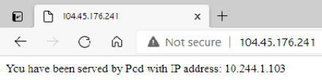
Figure 12.1 – Successful request to the nginx web server running in StatefulSet
If you refresh the page a few times (with the browser cache disabled), you will notice that you are served by three different Pods. This is as expected – we are currently running three Pod replicas in our StatefulSet object.
We will now take a quick look at how the headless Service behaves.

Using the headless Service and stable network identities
Let's do an experiment that demonstrates how the headless Service is used to provide stable and predictable network identities for our Pods:
Create an interactive busybox Pod and start the Bourne shell process. The following command will create the Pod and immediately attach your terminal so that you can interact from within the Pod:
$ kubectl run -i --tty busybox --image=busybox:1.28 --rm --restart=Never -- sh
First, we need to check how our normal service, nginx-client, with ClusterIP assigned, is resolved by the cluster DNS:
$ nslookup nginx-client
Server: 10.0.0.10
Address 1: 10.0.0.10 kube-dns.kube-system.svc.cluster.local
Name: nginx-client
Address 1: 10.0.147.198 nginx-client.default.svc.cluster.local
As you would expect, the response from DNS is that we have A record that points to the service ClusterIP 10.0.147.198.
Perform a similar check for the headless Service, nginx-headless:
$ nslookup nginx-headless
Server: 10.0.0.10
Address 1: 10.0.0.10 kube-dns.kube-system.svc.cluster.local
Name: nginx-headless
Address 1: 10.244.1.103 nginx-statefulset-example-0.nginx-headless.default.svc.cluster.local
Address 2: 10.244.0.77 nginx-statefulset-example-1.nginx-headless.default.svc.cluster.local
Address 3: 10.244.1.104 nginx-statefulset-example-2.nginx-headless.default.svc.cluster.local
In this case, we have received three A records that point directly to Pod IP addresses. Additionally, they have CNAME records in the form of <podName>-<serviceName>.<namespace>.svc.cluster.local. So, the difference here is that a Service that has ClusterIP will get load balancing to a virtual IP level (which, on Linux, is usually handled at a kernel level by iptables rules configured by kube-proxy) whereas, in the case of the headless Service, the responsibility for load balancing or choosing the target Pod is on the client making the request.
Having predictable FQDNs for Pods in the StatefulSet gives us the option to send the requests directly to individual Pods, without guessing their IP addresses or names. Let's try getting the contents served by the nginx-statefulset-example-0 Pod using its short DNS name provided by the headless Service:
$ wget http://nginx-statefulset-example-0.nginx-headless && cat index.html
Connecting to nginx-statefulset-example-0.nginx-headless (10.244.1.103:80)
...
You have been served by Pod with IP address: 10.244.1.103
As expected, you have connected directly to the Pod IP address and have been served by the proper Pod.
Now, we will show that this DNS name remains unchanged even if a Pod is restarted. The IP of the Pod will change, but the DNS name will not. What is more, the PV that is mounted will also stay the same, but we will investigate this in the next paragraphs. In another shell window, outside of the container, execute the following command to force a restart of the nginx-statefulset-example-0 Pod:
$ kubectl delete pod nginx-statefulset-example-0
In the busybox shell, execute the same command for getting contents served by the nginx-statefulset-example-0 Pod:
$ rm index.html && wget http://nginx-statefulset-example-0.nginx-headless && cat index.html
Connecting to nginx-statefulset-example-0.nginx-headless (10.244.1.113:80)
...
You have been served by Pod with IP address: 10.244.1.113
You can see that we used the same DNS name to call the Pod. We have been served by a Pod with the same name, but now with a different IP address.
This explains how the headless Services can be leveraged to get a stable and predictable network identity that will not change when a Pod is restarted. You may wonder what the actual use of this is and why it is important for StatefulSet objects. There are a couple of possible use cases:
Deploying clustered databases, such as etcd or MongoDB, requires specifying network addresses of other Nodes in the database cluster. This is especially necessary if there are no automatic discovery capabilities provided by the database. In such cases, stable DNS names provided by headless Services help to run such clusters on Kubernetes as StatefulSets. There is still the problem of changing the configuration when Pod replicas are added or removed from the StatefulSet during scaling. In some cases, this is solved by the sidecar container pattern, which monitors the Kubernetes API to dynamically change the database configuration.
If you decide to implement your own storage solution running as StatefulSet with advanced data sharding, you will most likely need mappings of logical shards to physical Pod replicas in the cluster. Then, the stable DNS names can be used as part of this mapping. They will guarantee that queries for each logical shard are performed against a proper Pod, irrespective of whether it was rescheduled to another Node or restarted.
Finally, let's take a look at the state persistence for Pods running in StatefulSet.

State persistence
To demonstrate how persisting state in StatefulSets works, we will use the kubectl exec commands to introduce changes to the mounted PV. This is the easiest way in which we can show that the files are persisted during Pod restarts or reschedules – in real-world use cases, changes to the state would be done by the actual application, for example, a database container writing files to the container filesystem. Perform the following steps:
Use the kubectl exec command to create a file named state.html in the /usr/share/nginx/html directory in each of three nginx Pod containers. This path is where the PV is mounted based on volumeClaimTemplates of the StatefulSet object:
$ kubectl exec -it nginx-statefulset-example-0 -- /bin/sh -c "echo State of Pod 0 > /usr/share/nginx/html/state.html"
$ kubectl exec -it nginx-statefulset-example-1 -- /bin/sh -c "echo State of Pod 1 > /usr/share/nginx/html/state.html"
$ kubectl exec -it nginx-statefulset-example-2 -- /bin/sh -c "echo State of Pod 2 > /usr/share/nginx/html/state.html"
Navigate in your web browser to the external IP of the Service and the state.html file. In our example, it is http://104.45.176.241/state.html. You will see that you have been served one of the files that we created, depending on which Pod you have hit. If you refresh the page, with the cache disabled, you will see that the contents change depending on the Pod:
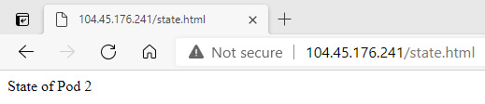
Figure 12.2 – Accessing the state.html file persisted in StatefulSet
Use the kubectl get pods command to see the current IP addresses of the Pods in the StatefulSet object:
$ kubectl get pods -o wide
NAME ... IP ...
nginx-statefulset-example-0 ... 10.244.1.113 ...
nginx-statefulset-example-1 ... 10.244.0.77 ...
nginx-statefulset-example-2 ... 10.244.1.104 ...
Now, let's simulate failure to our Pods and use the kubectl delete command in order to delete all three of them. This will cause them to be recreated by StatefulSet:
$ kubectl delete pod nginx-statefulset-example-0 nginx-statefulset-example-1 nginx-statefulset-example-2
pod "nginx-statefulset-example-0" deleted
pod "nginx-statefulset-example-1" deleted
pod "nginx-statefulset-example-2" deleted
StatefulSet object will recreate the Pods in an ordered fashion, waiting for each of them to be ready. You can use the kubectl get command with an additional -w flag to follow the process in real time and eventually, you will be presented with all Pods being ready:
$ kubectl get pods -o wide -w
NAME ... AGE IP ...
nginx-statefulset-example-0 ... 3m58s 10.244.1.115 ...
nginx-statefulset-example-1 ... 3m49s 10.244.0.79 ...
nginx-statefulset-example-2 ... 92s 10.244.1.116 ...
As you can see, the Pods have received new IPs. The containers that they are running are freshly created, but the existing PVC was used to mount PV to the containers. Once PVC is created by StatefulSet, it will not be deleted when you delete or scale the StatefulSet object. This ensures that data is not lost, unless you explicitly delete the PVC and PV yourself. If you navigate to the external IP of the Service for the StatefulSet object to get state.html, you will see that the file is still being served, even though it is not present in the original container image:
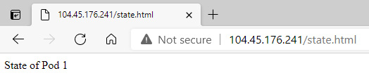
Figure 12.3 – Accessing the state.html file persisted in StatefulSet after the Pods restart
Lastly, let's show that when accessing the state.html file via the headless Service, we are getting the same result:
$ kubectl run -i --tty busybox --image=busybox:1.28 --rm --restart=Never -- sh
If you don't see a command prompt, try pressing enter.
/ # wget http://nginx-statefulset-example-0.nginx-headless/state.html && cat state.html
Connecting to nginx-statefulset-example-0.nginx-headless (10.244.1.115:80)
...
State of Pod 0
This demonstration shows how StatefulSet can provide state and data persistence for your containerized applications using stable network identities and PVCs. Next, we will take a look at scaling the StatefulSet object.

Scaling StatefulSet
In the case of StatefulSets, you can do similar scaling operations as for Deployment objects by changing the number of replicas in the specification or using the kubectl scale imperative command. The new Pods will be automatically discovered as new Endpoints for the Service when you scale up, or automatically removed from the Endpoints list when you scale down.
However, there are a few differences when compared to Deployment objects:
When you deploy a StatefulSet object of N replicas, the Pods during deployment are created sequentially, in order from 0 to N-1. In our example, during the creation of a StatefulSet object of three replicas, the first nginx-statefulset-example-0 Pod is created, followed by nginx-statefulset-example-1, and finally nginx-statefulset-example-2.
When you scale up the StatefulSet, the new Pods are also created sequentially and in an ordered fashion.
When you scale down the StatefulSet, the Pods are terminated sequentially, in reverse order, from N-1 to 0. In our example, while scaling down the StatefulSet object to zero replicas, the first nginx-statefulset-example-2 Pod is terminated, followed by nginx-statefulset-example-1, and finally nginx-statefulset-example-0.
During scaling up of the StatefulSet object, before the next Pod is created in the sequence, all its predecessors must be running and ready.
During scaling down of the StatefulSet object, before the next Pod is terminated in the reverse sequence, all its predecessors must be completely terminated and deleted.
Also, in general, before any scaling operation is applied to a Pod in a StatefulSet object, all its predecessors must be running and ready. This means that if, during scaling down from four replicas to one replica, the nginx-statefulset-example-0 Pod were to suddenly fail, then no further scaling operation would be performed on nginx-statefulset-example-1, nginx-statefulset-example-2, and nginx-statefulset-example-3 Pods. Scaling would resume when the nginx-statefulset-example-0 Pod becomes ready again.
Tip
This sequential behavior of scaling operations can be relaxed by changing the .spec.podManagementPolicy field in the specification. The default value is OrderedReady. If you change it to Parallel, the scaling operations will be performed on Pods in parallel, similar to what you know from Deployment objects. Note that this affects only scaling operations. The way of updating StatefulSet object with updateStrategy of the RollingUpdate type does not change.
Equipped with this knowledge, let's scale up our StatefulSet declaratively:
Open the nginx-statefulset.yaml manifest file and modify the number of replicas:
apiVersion: apps/v1
kind: StatefulSet
metadata:
name: nginx-statefulset-example
spec:
replicas: 5
...
Apply the changes to the cluster using the kubectl apply command:
$ kubectl apply -f ./nginx-statefulset.yaml –record
statefulset.apps/nginx-statefulset-example configured
If you now check the Pods using the kubectl get pods -w command, you will see the sequential, ordered creation of new Pods. The nginx-statefulset-example-4 Pod will not start creating until nginx-statefulset-example-3 has been created and becomes ready.
Similarly, if you check the output of the kubectl describe command for the StatefulSet object, you will see the following in the events:
$ kubectl describe sts nginx-statefulset-example
...
Events:
Type Reason Age From Message
---- ------ ---- ---- -------
Normal SuccessfulCreate 2m31s statefulset-controller create Pod nginx-statefulset-example-3 in StatefulSet nginx-statefulset-example successful
Normal SuccessfulCreate 117s statefulset-controller create Claim nginx-data-nginx-statefulset-example-4 Pod nginx-statefulset-example-4 in StatefulSet nginx-statefulset-example success
Normal SuccessfulCreate 117s statefulset-controller create Pod nginx-statefulset-example-4 in StatefulSet nginx-statefulset-example successful
You can achieve the same result using the imperative command, which is recommended only for development scenarios:
$ kubectl scale sts nginx-statefulset-example --replicas=5
statefulset.apps/nginx-statefulset-example scaled
To perform the scaling down of our StatefulSet object declaratively, simply modify the nginx-statefulset.yaml manifest file and change the number of replicas:
apiVersion: apps/v1
kind: StatefulSet
metadata:
name: nginx-statefulset-example
spec:
replicas: 2
...
Apply the changes to the cluster using the kubectl apply command:
$ kubectl apply -f ./nginx-statefulset.yaml --record
You can achieve the same result using imperative commands by executing the following command:
$ kubectl scale sts nginx-statefulset-example --replicas=2
If you describe the StatefulSet object, you will see in the events that the scaling down is reflected:
$ kubectl describe sts nginx-statefulset-example
...
Events:
Type Reason Age From Message
---- ------ ---- ---- -------
Normal SuccessfulDelete 61s (x2 over 32m) statefulset-controller delete Pod nginx-statefulset-example-3 in StatefulSet nginx-statefulset-example successful
Normal SuccessfulDelete 30s statefulset-controller delete Pod nginx-statefulset-example-2 in StatefulSet nginx-statefulset-example successful
Of course, if you scale the StatefulSet object back to three replicas, and attempt to get state.html for the nginx-statefulset-example-2 Pod replica, you will get the expected, persisted file contents. PVs and PVCs are not deleted during any Pod operations in the StatefulSet object.
Next, we will demonstrate how you can delete a StatefulSet object.

Deleting a StatefulSet
To delete a StatefulSet object, there are two possibilities:
Delete the StatefulSet together with Pods that it owns.
Delete the StatefulSet and leave the Pods unaffected.
In both cases, the PVCs and PVs that were created for the Pods using volumeClaimTemplates will not be deleted. This ensures that state data is not lost accidentally unless you explicitly clean up the PVCs and PVs.
Important note
Currently, there is a Kubernetes Enhancement Proposal (KEP) 1847 that proposes a way of requesting the automatic deletion of PVCs for StatefulSet object. This KEP is likely to appear in future releases. You can find more details at https://github.com/kubernetes/enhancements/tree/33e16e4d192153d8b41d1e5d91659612d6d633f4/keps/sig-apps/1847-autoremove-statefulset-pvcs.
To delete the StatefulSet object together with Pods, you can use the regular kubectl delete command:
$ kubectl delete sts nginx-statefulset-example
You will see that the Pods will be terminated first, followed by the StatefulSet object. Please note that this operation is different from scaling down the StatefulSet object to zero replicas and then deleting it. If you delete StatefulSet object with existing Pods, there are no guarantees regarding the order of termination of the individual Pods. In most cases, they will be terminated at once.
Optionally, if you would like to delete just the StatefulSet object, you need to use the --cascade=orphan option for kubectl delete:
$ kubectl delete sts nginx-statefulset-example --cascade=orphan
After this command, if you inspect what Pods are in the cluster, you will still see all the Pods that were owned by the nginx-statefulset-example StatefulSet.
Lastly, if you would like to clean up PVCs and PVs after deleting the StatefulSet object, you need to perform this step manually.
Important note
Please note that if you want to perform verifications of state persistence after exercising the new version rollout in the next section, you should not yet delete the PVCs. Otherwise, you will lose the state.html files stored in the PVs.
Use the following command:
$ kubectl delete pvc nginx-data-nginx-statefulset-example-0 nginx-data-nginx-statefulset-example-1 nginx-data-nginx-statefulset-example-2
This command will delete PVCs and associated PVs.
Next, let's take a look at releasing new versions of apps deployed as StatefulSets and how StatefulSet revisions are managed.

Releasing a new version of an app deployed as a StatefulSet
We have just covered the scaling of StatefulSets in the previous section by making changes to the .spec.replicas number in the specification. Everything you have learned about sequential and ordered changes to the Pods plays an important role in rolling out a new revision of a StatefulSet object when using the RollingUpdate strategy. There are many similarities between StatefulSets and Deployment objects – we have covered the details of Deployment updates in Chapter 11, Deployment – Deploying Stateless Applications. Making changes to the StatefulSet Pod template (.spec.template) in the specification will also cause the rollout of a new revision for StatefulSet. Usually, you will change the image used by the Pod container to a new version – this is how you perform the release of a new version of an app deployed as StatefulSet.
StatefulSets support two types of update strategies that you define using the .spec.updateStrategy.type field in the specification:
RollingUpdate: The default strategy, which allows you to roll out a new version of your application in a controlled way. This is slightly different to the RollingUpdate strategy known from Deployment objects. For StatefulSet, this strategy will terminate and recreate Pods in a sequential and ordered fashion and make sure that the Pod is recreated and in a ready state before proceeding to the next one.
OnDelete: This strategy implements the legacy behavior of StatefulSet updates prior to Kubernetes 1.7. However, it is still useful! In this type of strategy, the StatefulSet will not automatically update the Pod replicas by recreating them. You need to manually delete a Pod replica to get the new Pod template applied. This is useful in scenarios when you need to perform additional manual actions or verifications before proceeding to the next Pod replica. For example, if you are running a Cassandra cluster or etcd cluster in a StatefulSet, you may want to verify whether the new Pod has correctly joined the existing cluster following removal of the previous version of the Pod. Of course, it is possible to perform similar checks using the Pod template life cycle postStart and preStop hooks while using the RollingUpdate strategy, but this requires more sophisticated error handling in the hooks.
Let's now take a closer look at the RollingUpdate strategy, as it is the most important and the most commonly used update strategy for StatefulSets. The key thing about this is that the strategy respects all the StatefulSet guarantees that we explained in the previous section regarding scaling. The rollout is done in reverse order, for example, the first Pod, nginx-statefulset-example-2, is recreated with the new Pod template, followed by nginx-statefulset-example-1, and finally nginx-statefulset-example-0.
If the process of rollout fails (not necessarily the Pod that was currently recreated), the StatefulSet controller is going to restore any failed Pod to its current version. This means that Pods that have already received a successful update to the current version will remain at the current version, whereas the Pods that have not yet received the update will remain at the previous version. In this way, the StatefulSet attempts to always keep applications healthy and consistent. However, this can also lead to broken rollouts of StatefulSets. If one of the Pod replicas never becomes running and ready, then the StatefulSet will stop the rollout and wait for manual intervention. Applying the template again to the previous revision of StatefulSet is not enough – this operation will not proceed as StatefulSet will wait for the failed Pod to become ready. The only resolution is manual deletion of the failed Pod and then the StatefulSet can apply the previous revision of the Pod template.
Lastly, the RollingUpdate strategy also provides the option to execute staged rollouts using the .spec.updateStrategy.rollingUpdate.partition field. This field defines a number for which all the Pod replicas that have a lesser ordinal number will not be updated, and, even if they are deleted, they will be recreated at the previous version. So, in our example, if partition were to be set to 1, this means that during the rollout, only nginx-statefulset-example-1 and nginx-statefulset-example-2 would be updated, whereas nginx-statefulset-example-0 would remain unchanged and running on the previous version. By controlling the partition field, you can easily roll out a single canary replica and perform phased rollouts. Please note that the default value is 0, which means that all Pod replicas will be updated.
Now, we will release a new version of our nginx web server using the RollingUpdate strategy.

Updating StatefulSet
We will now demonstrate how to do a rollout of a new image version for a Pod container using the StatefulSet YAML manifest file that we created previously:
Make a copy of the previous YAML manifest file:
$ cp nginx-statefulset.yaml nginx-statefulset-rollingupdate.yaml
Ensure that you have RollingUpdate strategy type and partition set to 0. Please note that if you have attempted to create the StatefulSet object with a different strategy first, you will not be able to modify it without deleting the StatefulSet beforehand:
apiVersion: apps/v1
kind: StatefulSet
metadata:
name: nginx-statefulset-example
spec:
replicas: 3
serviceName: nginx-headless
podManagementPolicy: OrderedReady
updateStrategy:
type: RollingUpdate
rollingUpdate:
partition: 0
...
template:
...
spec:
containers:
- name: nginx
image: nginx:1.17
These values are the default ones, but it is worth specifying them explicitly to understand what is really happening.
Apply the manifest file to the cluster:
$ kubectl apply -f ./nginx-statefulset-rollingupdate.yaml --record
When the StatefulSet is ready in the cluster, we can now roll out a new version of the nginx container image for our StatefulSet object. To do that, please perform the following steps:
Modify the container image used in the StatefulSet Pod template to nginx:1.18:
apiVersion: apps/v1
kind: StatefulSet
metadata:
name: nginx-statefulset-example
spec:
...
template:
...
spec:
containers:
- name: nginx
image: nginx:1.18
Apply the changes to the cluster using the following command:
$ kubectl apply -f ./nginx-statefulset-rollingupdate.yaml --record
statefulset.apps/nginx-statefulset-example configured
Immediately after that, use the kubectl rollout status command to see the progress in real time. This process will be a bit longer than in the case of Deployment objects because the rollout is performed in a sequential and ordered fashion:
$ kubectl rollout status sts nginx-statefulset-example
Waiting for partitioned roll out to finish: 0 out of 3 new pods have been updated...
Waiting for 1 pods to be ready...
Waiting for 1 pods to be ready...
Waiting for partitioned roll out to finish: 1 out of 3 new pods have been updated...
Waiting for 1 pods to be ready...
Waiting for 1 pods to be ready...
Waiting for partitioned roll out to finish: 2 out of 3 new pods have been updated...
Waiting for 1 pods to be ready...
Waiting for 1 pods to be ready...
partitioned roll out complete: 3 new pods have been updated...
Similarly, using the kubectl describe command, you can see events for the StatefulSet that demonstrate precisely what the order of Pod replica recreation was:
$ kubectl describe sts nginx-statefulset-example
...
Events:
Type Reason Age From Message
---- ------ ---- ---- -------
Normal SuccessfulDelete 3m12s statefulset-controller delete Pod nginx-statefulset-example-2 in StatefulSet nginx-statefulset-example successful
Normal SuccessfulCreate 2m34s (x2 over 12m) statefulset-controller create Pod nginx-statefulset-example-2 in StatefulSet nginx-statefulset-example successful
Normal SuccessfulDelete 2m25s statefulset-controller delete Pod nginx-statefulset-example-1 in StatefulSet nginx-statefulset-example successful
Normal SuccessfulCreate 105s (x2 over 13m) statefulset-controller create Pod nginx-statefulset-example-1 in StatefulSet nginx-statefulset-example successful
Normal SuccessfulDelete 99s statefulset-controller delete Pod nginx-statefulset-example-0 in StatefulSet nginx-statefulset-example successful
Normal SuccessfulCreate 64s (x2 over 13m) statefulset-controller create Pod nginx-statefulset-example-0 in StatefulSet nginx-statefulset-example successful
As expected, the rollout was done in reverse order. The first Pod to recreate was nginx-statefulset-example-2, followed by nginx-statefulset-example-1, and finally nginx-statefulset-example-0. Also, because we have used the default partition value of 0, all the Pods were updated. This is because all ordinal numbers of Pod replicas are greater than or equal to 0.
Now we can verify that the Pods were recreated with the new image. Execute the following command to verify the first Pod replica in the StatefulSet object:
$ kubectl describe pod nginx-statefulset-example-0
...
Containers:
nginx:
Container ID: docker://031627cbea4c60194f7a2774ef965 ad52f6460f07bc44f7b426ff74a4ccad479
Image: nginx:1.18
And finally, we can verify that the state was persisted because the existing PVCs were used for the new Pods. Please note that this will only work properly if you haven't deleted the PVCs for the StatefulSet manually in the previous section:
$ kubectl run -i --tty busybox --image=busybox:1.28 --rm --restart=Never -- sh
If you don't see a command prompt, try pressing enter.
/ # wget http://nginx-statefulset-example-0.nginx-headless/state.html && cat state.html
Connecting to nginx-statefulset-example-0.nginx-headless (10.244.1.135:80)
...
State of Pod 0
As you can see, the rollout of a new version of nginx was completed successfully and the state has been persisted even though the Pods were recreated.
Tip
You can change the StatefulSet container image imperatively using the kubectl set image sts nginx-statefulset-example nginx=nginx:1.18 --record command. This approach is only recommended for non-production scenarios. In general, StatefulSets are much easier to manage declaratively than imperatively.
Now, we will show how you can use the partition field to do a phased rollout with a canary. Assume we would like to update the nginx image version to 1.19. You would like to make sure that the change is working properly in your environment, using a canary deployment, which is a single Pod replica updated to the new image version. Please refer to the following steps:
Modify the nginx-statefulset-rollingupdate.yaml manifest file so that the Pod container image version is nginx:1.19 and the partition number is equal to current replicas, in our case 3:
apiVersion: apps/v1
kind: StatefulSet
metadata:
name: nginx-statefulset-example
spec:
replicas: 3
serviceName: nginx-headless
podManagementPolicy: OrderedReady
updateStrategy:
type: RollingUpdate
rollingUpdate:
partition: 3
...
template:
...
spec:
containers:
- name: nginx
image: nginx:1.19
When the partition number is the same as the number of replicas, we can apply the YAML manifest to the cluster and no changes to the Pods will be introduced yet. This is called staging a rollout.
Apply the manifest file to the cluster:
$ kubectl apply -f ./nginx-statefulset-rollingupdate.yaml --record
statefulset.apps/nginx-statefulset-example configured
Now, let's create a canary for our new version. Decrease the partition number by one to 2 in the manifest file. This means that all Pod replicas with an ordinal number of less than 2 will not be updated – in our case, the nginx-statefulset-example-2 Pod only, and all others will remain unchanged:
apiVersion: apps/v1
kind: StatefulSet
metadata:
name: nginx-statefulset-example
spec:
replicas: 3
serviceName: nginx-headless
podManagementPolicy: OrderedReady
updateStrategy:
type: RollingUpdate
rollingUpdate:
partition: 2
...
Apply the manifest file to the cluster again:
$ kubectl apply -f ./nginx-statefulset-rollingupdate.yaml --record
statefulset.apps/nginx-statefulset-example configured
Use the kubectl rollout status command to follow the process. As expected, only one Pod will be recreated:
$ kubectl rollout status sts nginx-statefulset-example
Waiting for 1 pods to be ready...
partitioned roll out complete: 1 new pods have been updated...
If you describe the nginx-statefulset-example-1 and nginx-statefulset-example-2 Pods, you can see that the first one is using the old version of the image, whereas the second is using the new one:
$ kubectl describe pod nginx-statefulset-example-1
...
Containers:
nginx:
Container ID: docker://031627cbea4c60194f7a2774ef965 ad52f6460f07bc44f7b426ff74a4ccad479
Image: nginx:1.18
...
$ kubectl describe pod nginx-statefulset-example-2
...
Containers:
nginx:
Container ID: docker://1c3b1e4dc7bb048d407f8aef2da91 8bf8ef2a8e8c2258b53b847c06bff2efbc5
Image: nginx:1.19
...
At this point, you would like to perform verifications and smoke tests on your canary. For that, we will try getting the state.html file directly via the headless Service:
$ kubectl run -i --tty busybox --image=busybox:1.28 --rm --restart=Never -- sh
If you don't see a command prompt, try pressing enter.
/ # wget http://nginx-statefulset-example-2.nginx-headless/state.html && cat state.html
Connecting to nginx-statefulset-example-2.nginx-headless (10.244.1.139:80)
...
State of Pod 2
Canary looks good, so we can continue with a phased rollout of our new version. For a phased rollout, you may use any lower partition number in the manifest. You can do a few small, phased rollouts or just proceed with a full rollout. Let's do a full rollout by decreasing partition to 0:
apiVersion: apps/v1
kind: StatefulSet
metadata:
name: nginx-statefulset-example
spec:
replicas: 3
serviceName: nginx-headless
podManagementPolicy: OrderedReady
updateStrategy:
type: RollingUpdate
rollingUpdate:
partition: 0
...
Apply the manifest file to the cluster again:
$ kubectl apply -f ./nginx-statefulset-rollingupdate.yaml --record
statefulset.apps/nginx-statefulset-example configured
Observe the next phase of the rollout using the kubectl rollout status command:
$ kubectl rollout status sts nginx-statefulset-example
Waiting for partitioned roll out to finish: 1 out of 3 new pods have been updated...
Waiting for 1 pods to be ready...
Waiting for 1 pods to be ready...
Waiting for partitioned roll out to finish: 2 out of 3 new pods have been updated...
Waiting for 1 pods to be ready...
Waiting for 1 pods to be ready...
partitioned roll out complete: 3 new pods have been updated...
As you can see, the phased rollout to the nginx:1.19 image version was completed successfully.
Tip
It is possible to do phased rollouts imperatively. To do that, you need to control the partition number using the kubectl patch command, for example, kubectl patch sts nginx-statefulset-example -p '{"spec":{"updateStrategy":{"type":"RollingUpdate","rollingUpdate":{"partition":3}}}}'. However, this is much less readable and error prone than declarative changes.
We will now take a look at how you can do rollbacks of StatefulSets.

Rolling back StatefulSet
In the previous Chapter 11, Deployment – Deploying Stateless Applications, we have described how you can do imperative rollbacks to Deployments. For StatefulSets, you can do exactly the same operations. To do that, you need to use the kubectl rollout undo commands. However, especially for StatefulSets, we recommend using a declarative model for introducing changes to your Kubernetes cluster. In this model, you usually commit each change to the source code repository, and performing rollback is very simple and involves just reverting the commit and applying the configuration again. Usually, the process of applying changes is performed as part of the CI/CD pipeline for the source code repository, instead of manually applying the changes by an operator. This is the easiest way to manage StatefulSets, and generally recommended in Infrastructure-as-Code and Configuration-as-Code paradigms.
Important note
When performing rollbacks to StatefulSets, you must be fully aware of the consequences of operations such as downgrading to an earlier version of the container image while persisting the state. For example, if your rollout to a new version has introduced data schema changes to the state, then you will not be able to safely roll back to an earlier version unless you ensure that the downward migration of state data is implemented!
In our example, if you would like to roll back to the nginx:1.18 image version for our StatefulSet, you would either modify the YAML manifest file manually or revert the commit in your source code repository if you use one. Then, all you would need to do is execute the kubectl apply command to the cluster.
In the last section, we will provide you with a set of best practices for managing StatefulSets in Kubernetes.

StatefulSet best practices
This section summarizes known best practices when working with StatefulSet objects in Kubernetes. The list is by no means complete, but is a good starting point for your journey with Kubernetes.

Use declarative object management for StatefulSets
It is a good practice in DevOps world to stick to declarative models for introducing updates to your infrastructure and applications. Using the declarative way of updates is the core concept for paradigms such as Infrastructure-as-Code and Configuration-as-Code. In Kubernetes, you can easily perform declarative updates using the kubectl apply command, which can be used on a single file or even a whole directory of YAML manifest files.
Tip
To delete objects, it is still better to use imperative commands. It is more predictable and less prone to errors. The declarative deletion of resources in the cluster is useful only in CI/CD scenarios, where the whole process is entirely automated.
The same principle applies also to StatefulSets. Performing a rollout or rollback when your YAML manifest files are versioned and kept in a source control repository is easy and predictable. Using the kubectl rollout undo and kubectl set image deployment commands is generally not recommended in production environments. Using these commands gets much more complicated when more than one person is working on operations in the cluster.

Do not use the TerminationGracePeriodSeconds Pod with a 0 value for StatefulSets
The specification of Pod allows you to set TerminationGracePeriodSeconds, which informs kubelet how much time it should allow for a Pod to gracefully terminate when it attempts to terminate it. If you set TerminationGracePeriodSeconds to 0, this will effectively make Pods terminate immediately, which is strongly discouraged for StatefulSets. StatefulSets often need graceful cleanup or preStop life cycle hooks to run before the container is removed, otherwise there is a risk that the state of StatefulSet will become inconsistent.

Scale down StatefulSets before deleting
When you delete a StatefulSet and you intend to reuse the PVCs later, you need to ensure that the StatefulSet terminates gracefully, in an ordered manner, so that any subsequent redeployment will not fail because of an inconsistent state in PVCs. If you perform the kubectl delete operation on your StatefulSet, all the Pods will be terminated at once. This is often not desired and you should first scale down the StatefulSet gracefully to zero replicas and then delete the StatefulSet itself.

Ensure state compatibility during StatefulSet rollbacks
If you ever intend to use StatefulSet rollbacks, you need to be aware of the consequences of operations such as downgrading to an earlier version of the container image while persisting the state. For example, if your rollout to a new version has introduced data schema changes in the state, then you will not be able to safely roll back to an earlier version unless you ensure that the downward migration of state data is implemented. Otherwise, your rollback will just recreate Pods with the older versions of the container image and they will fail to start properly because of incompatible state data.

Do not create Pods that match an existing StatefulSet label selector
It is possible to create Pods with labels that match the label selector of some existing StatefulSet. This can be done using bare Pods or another Deployment or ReplicaSet. This leads to conflicts, which Kubernetes does not prevent, and makes the existing StatefulSet believe that it has created the other Pods. The results may be unpredictable and, in general, you need to pay attention to how you organize your labeling of resources in the cluster. It is advised to use semantic labeling – you can learn more about this approach in the official documentation: https://kubernetes.io/docs/concepts/configuration/overview/#using-labels.

Summary
This chapter has demonstrated how to work with stateful workloads and applications on Kubernetes using StatefulSets. You first learned what the approaches to persisting state in containers and in Kubernetes Pods are and, based on that, we have described how a StatefulSet object can be used to persist the state. Next, we created an example StatefulSet, together with a headless Service. Based on that, you learned how PVCs and PVs are used in StatefulSets to ensure that the state is persisted between Pod restarts. Next, you learned how you can scale the StatefulSet and how to introduce updates using canary and phased rollouts. And finally, we provided you with a set of known best practices when working with StatefulSets.
In the next chapter, you will learn more about managing special workloads where you need to maintain exactly one Pod per each Node in Kubernetes – we will introduce a new Kubernetes object: DaemonSet.

Further reading
For more information regarding StatefulSets and persistent storage management in Kubernetes, please refer to the following Packt books:
The Complete Kubernetes Guide, by Jonathan Baier, Gigi Sayfan, Jesse White (https://www.packtpub.com/virtualization-and-cloud/complete-kubernetes-guide)
Getting Started with Kubernetes – Third Edition, by Jonathan Baier, Jesse White (https://www.packtpub.com/virtualization-and-cloud/getting-started-kubernetes-third-edition)
Kubernetes for Developers, by Joseph Heck (https://www.packtpub.com/virtualization-and-cloud/kubernetes-developers)
Hands-On Kubernetes on Windows, by Piotr Tylenda (https://www.packtpub.com/product/hands-on-kubernetes-on-windows/9781838821562)
You can also refer to the excellent official Kubernetes documentation (https://kubernetes.io/docs/home/), which is always the most up-to-date source of knowledge regarding Kubernetes in general.

Chapter 13: DaemonSet – Maintaining Pod Singletons on Nodes
The previous chapters have explained and demonstrated how to use the most common Kubernetes controllers for managing Pods, such as ReplicaSet, Deployment, and StatefulSet. Generally, when running cloud application components that contain the actual business logic you will need either Deployments or StatefulSets for controlling your Pods. In some cases, when you need to run batch workloads as part of your application, you will use Jobs and CronJobs.
However, in some cases, you will need to run components that have a supporting function and, for example, execute maintenance tasks or aggregate logs and metrics. More specifically, if you have any tasks that need to be executed for each Node in the cluster, they can be performed using a DaemonSet. This is the last type of Pod management controller that we are going to introduce in this part of the book. The purpose of a DaemonSet is to ensure that each Node (unless specified otherwise) runs a single replica of a Pod. If you add a new Node to the cluster, it will automatically get a Pod replica scheduled. Similarly, if you remove a Node from the cluster, the Pod replica will be terminated – the DaemonSet will execute all required actions.
In this chapter, we will cover the following topics:
Introducing the DaemonSet object
Creating and managing DaemonSets
Common use cases for DaemonSets
Alternatives to DaemonSets

Technical requirements
For this chapter, you will need the following:
A Kubernetes cluster deployed. You can use either a local or cloud-based cluster, but in order to fully understand the concepts we recommend using a multi-node, cloud-based Kubernetes cluster.
The Kubernetes CLI (kubectl) installed on your local machine and configured to manage your Kubernetes cluster.
Kubernetes cluster deployment (local and cloud-based) and kubectl installation were covered in Chapter 3, Installing Your First Kubernetes Cluster.
You can download the latest code samples for this chapter from the official GitHub repository: https://github.com/PacktPublishing/The-Kubernetes-Bible/tree/master/Chapter13.

Introducing the DaemonSet object
The term daemon in operating systems has a long history and, in short, is used to describe a program that runs as a background process, without interactive control from the user. In many cases, daemons are responsible for handling maintenance tasks, serving network requests, or monitoring hardware activities. These are often processes that you want to run reliably, all the time, in the background, from the time you boot the operating system to when you shut it down.
Tip
Daemons are associated in most cases with Unix-like operating systems. In Windows, you will more commonly encounter the term Windows service.
In Kubernetes, you may need a similar functionality where your Pods behave like classic operating system daemons on each of the Nodes in the cluster. For this, Kubernetes offers a dedicated Pod management controller named DaemonSet. The role of a DaemonSet is straightforward: run a single Pod replica on each of the Nodes in the cluster and manage them automatically. There are variety of use cases that require such Node-local facilities and usually they serve important and fundamental roles for the whole cluster – we will discuss some common use cases in the sections coming up, but generally you need them for the following:
Node monitoring in the cluster.
Logs and telemetry gathering from individual Nodes and sometimes Pods running on a Node.
Managing cluster storage – this is especially important for handling requests from provisioners for PersistentVolumeClaims and PersistentVolumes.
All you have learned in the previous chapters about ReplicaSets, Deployments, and StatefulSets applies more or less to the DaemonSet. Its specification requires you to provide a Pod template, Pod label selectors, and optionally Node selectors if you want to schedule the Pods only on a subset of Nodes.
Depending on the case, you may not need to communicate with the DaemonSet from other Pods or from an external network. For example, if the job of your DaemonSet is just to perform a periodic cleanup of the filesystem on the Node, it is unlikely you would like to communicate with such Pods. If your use case requires any ingress or egress communication with the DaemonSet Pods, then you have the following common patterns:
Map container ports to host ports: Since the DaemonSet Pods are guaranteed to be singletons on cluster Nodes, it is possible to use mapped host ports. The clients must know the Node IP addresses.
Pushing data to a different service: In some cases, it may be enough that the DaemonSet is responsible for sending updates to other services without needing to allow ingress traffic.
Headless service matching DaemonSet Pod label selectors: This is a similar pattern to the case of StatefulSets, where you can use the cluster DNS to retrieve multiple A records for Pods using the DNS name of the headless service.
Normal service matching DaemonSet Pod label selectors: Less commonly, you may need to reach any Pod in the DaemonSet. Using a normal Service object, for example of the ClusterIP type, will allow you to communicate with a random Pod in the DaemonSet.
We will now show how you can create and manage an example DaemonSet in your cluster.

Creating and managing DaemonSets
In order to demonstrate how DaemonSets work, we will use nginx running in a Pod container that returns simple information about the Node IP address where it is currently scheduled. The IP address will be provided to the container using an environment variable and based on that, a modified version of index.html in /usr/share/nginx/html will be created. To access the DaemonSet endpoints, we will use a headless service, similar to what we did for StatefulSet in Chapter 12, StatefulSet – Deploy Stateful Applications. Most of the real use cases of DaemonSets are rather complex and involve mounting various system resources to the Pods. We will keep our DaemonSet example as simple as possible to show the principles.
Important note
If you would like to work on a real example of a DaemonSet, we have provided a working version of Prometheus node-exporter deployed as a DaemonSet behind a headless Service: https://github.com/PacktPublishing/Kubernetes-for-Beginners/blob/master/Chapter13/02_daemonset-prometheus-nodeexporter/node-exporter.yaml. When following the guide in this section, the only difference is that you need to use node-exporter as the Service name, use port 9100 and append the /metrics path for requests sent using wget. This DaemonSet exposes Node metrics in Prometheus data model format on port 9100 under the /metrics path.
We will now go through all the YAML manifests required to create our DaemonSet and apply them to the cluster.

Creating a DaemonSet
First, let's take a look at the StatefulSet YAML manifest file named nginx-daemonset.yaml (full version available in the official GitHub repository for the book: https://github.com/PacktPublishing/Kubernetes-for-Beginners/blob/master/Chapter13/01_daemonset-example/nginx-daemonset.yaml):
apiVersion: apps/v1
kind: DaemonSet
metadata:
name: nginx-daemonset-example
spec:
selector:
matchLabels:
app: nginx-daemon
environment: test
# (to be continued in the next paragraph)
The first part of the preceding file contains the metadata and Pod label selector for the DaemonSet, quite similar to what you have seen in Deployments and StatefulSets. In the second part of the file, we present the Pod template that will be used by the DaemonSet:
# (continued)
template:
metadata:
labels:
app: nginx-daemon
environment: test
spec:
containers:
- name: nginx
image: nginx:1.17
ports:
- containerPort: 80
env:
- name: NODE_IP
valueFrom:
fieldRef:
fieldPath: status.hostIP
command:
- /bin/sh
- -c
- |
echo "You have been served by Pod running on Node with IP address: $(NODE_IP)" > /usr/share/nginx/html/index.html
nginx -g "daemon off;"
As you can see, the structure of DaemonSet spec is similar to what you know from Deployments and StatefulSets. The general idea is the same, you need to configure the Pod template and use a proper label selector to match the Pod labels. Note that you do not see the replicas field here, as the number of Pods running in the cluster will be dependent on the number of Nodes in the cluster. The specification has two main components:
selector: A label selector, which defines how to identify Pods that the DaemonSet owns. This can include set-based and equality-based selectors.
template: This defines the template for Pod creation. Labels used in metadata must match the selector.
It is also common to specify .spec.template.spec.nodeSelector or .spec.template.spec.tolerations in order to control the Nodes where the DaemonSet Pods are deployed. We cover Pod scheduling in detail in Chapter 19, Advanced Techniques for Scheduling Pods. Additionally, you can specify .spec.updateStrategy, .spec.revisionHistoryLimit, and .spec.minReadySeconds, which are similar to what you have learned about Deployment objects.
Tip
If you run hybrid Linux-Windows Kubernetes clusters, one of the common use cases for Node selectors or Node affinity for DaemonSets is ensuring that the Pods are scheduled only on Linux Nodes or only on Windows Nodes. This makes sense as the container runtime and operating system are very different between such Nodes.
Apart from that, in our Pod template we have used a similar override of command for the nginx container as we did in the cases of Deployments and StatefulSets in the previous chapters. The command creates index.html in /usr/share/nginx/html/ with information about the IP address of the Node that runs the Pod serving the request. After that, it starts the nginx web server with the standard entrypoint command for the image. To provide the information about the Node IP address, we use an additional NODE_IP environment variable populated by status.hostIP of the Pod object (at runtime).
Next, let's take a quick look at the headless Service named nginx-daemon-headless. Create an nginx-daemon-headless-service.yaml file with the following YAML manifest:
apiVersion: v1
kind: Service
metadata:
name: nginx-daemon-headless
spec:
selector:
app: nginx-daemon
environment: test
clusterIP: None
ports:
- port: 80
protocol: TCP
targetPort: 80
As we explained in the case of the StatefulSet example, the specification is very similar to a normal Service, the only difference is that it has the None value for the clusterIP field. This will result in the creation of an nginx-daemon-headless headless Service. A headless Service allows us to return all Pods' IP addresses behind the Service as DNS A records instead of a single DNS A record with a Service clusterIP.
We have all the required YAML manifest files for our demonstration and we can proceed with applying the manifests to the cluster. Please follow these steps:
Create the nginx-daemon-headless headless Service using the following command:
$ kubectl apply -f ./nginx-daemon-headless-service.yaml
Create an nginx-daemonset-example DaemonSet using the following command:
$ kubectl apply -f ./nginx-daemonset.yaml
Now, you can use the kubectl describe command to observe the creation of the DaemonSet:
$ kubectl describe daemonset nginx-daemonset-example
Alternatively, you can use ds as an abbreviation for daemonset when using the kubectl commands.
If you use the kubectl get pods command, you can see that there will be one Pod scheduled for each of the Nodes in the cluster:
$ $ kubectl get pods -o wide
NAME ... IP NODE ...
nginx-daemonset-example-5w8jx ... 10.244.1.144 aks-nodepool1-77120516-vmss000000 ...
nginx-daemonset-example-tzqmc ... 10.244.0.90 aks-nodepool1-77120516-vmss000001 ...
In our case, we have two Nodes in the cluster, so exactly two Pods have been created.
We have successfully deployed the DaemonSet and we can now verify that it works as expected. To do that, follow the given steps:
First, we need to know the IP addresses of the individual Nodes in order to cross-check the output of further commands:
$ kubectl get node -o wide
NAME ... INTERNAL-IP ...
aks-nodepool1-77120516-vmss000000 ... 10.240.0.4 ...
aks-nodepool1-77120516-vmss000001 ... 10.240.0.5 ...
Create an interactive busybox Pod and start the Bourne shell process. The following command will create the Pod and immediately attach your terminal so that you can interact from within the Pod:
$ kubectl run -i --tty busybox --image=busybox:1.28 --rm --restart=Never -- sh
We need to check how our nginx-daemon-headless headless Service is resolved by the cluster DNS:
$ nslookup nginx-daemon-headless
Server: 10.0.0.10
Address 1: 10.0.0.10 kube-dns.kube-system.svc.cluster.local
Name: nginx-daemon-headless
Address 1: 10.244.1.144 10-244-1-144.nginx-daemon-headless.default.svc.cluster.local
Address 2: 10.244.0.90 10-244-0-90.nginx-daemon-headless.default.svc.cluster.local
We have been provided with two DNS names for the individual Pods in the DaemonSet: 10-244-1-144.nginx-daemon-headless.default.svc.cluster.local, which belongs to the aks-nodepool1-77120516-vmss000000 Node, and 10-244-0-90.nginx-daemon-headless.default.svc.cluster.local, which belongs to the aks-nodepool1-77120516-vmss000001 Node.
We can now use the DNS names (also in short-name form) to communicate with the Pods of the DaemonSet. First, we will try to connect to the 10-244-1-144.nginx-daemon-headless Pod:
$ wget http://10-244-1-144.nginx-daemon-headless && cat index.html
Connecting to 10-244-1-144.nginx-daemon-headless (10.244.1.144:80)
...
You have been served by Pod running on Node with IP address: 10.240.0.4
As expected, the Pod is scheduled on the aks-nodepool1-77120516-vmss000000 Node, which has an IP address of 10.240.0.4 (you can cross-check this with earlier commands' output).
Let's do a similar check for the other Pod in the cluster, 10-244-0-90.nginx-daemon-headless:
$ rm index.html && wget http://10-244-0-90.nginx-daemon-headless && cat index.html
Connecting to 10-244-0-90.nginx-daemon-headless (10.244.0.90:80)
...
You have been served by Pod running on Node with IP address: 10.240.0.5
And again, as expected, we have been served by a Pod running on the aks-nodepool1-77120516-vmss000001 Node.
This demonstrates the most important principles underlying how DaemonSet Pods are scheduled and how you can interact with them using headless Services. We will now show how you can modify the DaemonSet to roll out a new version of a container image for the Pods.

Modifying a DaemonSet
Updating a DaemonSet can be done in a similar way as for Deployments. If you modify the Pod template of the DaemonSet, this will trigger a rollout of a new revision of DaemonSet according to its updateStrategy. There are two strategies available:
RollingUpdate: The default strategy, which allows you to roll out a new version of your daemon in a controlled way. It is similar to rolling updates in Deployments in that you can define .spec.updateStrategy.rollingUpdate.maxUnavailable to control how many Pods in the clusters are unavailable at most during the rollout (defaults to 1) and .spec.minReadySeconds (defaults to 0). It is guaranteed that at most one Pod of DaemonSet will be in running state on each node in the cluster during the rollout process.
OnDelete: This strategy implements the legacy behavior of StatefulSet updates prior to Kubernetes 1.6. In this type of strategy, the DaemonSet will not automatically update the Pod by recreating them. You need to manually delete a Pod on a Node in order to get the new Pod template applied. This is useful in scenarios when you need to do additional manual actions or verifications before proceeding to the next Node.
The rollout of a new DaemonSet revision can be controlled in similar ways as for a Deployment object. You can use the kubectl rollout status command and perform imperative rollbacks using the kubectl rollout undo command. Let's demonstrate how you can declaratively update the container image in a DaemonSet Pod to a newer version:
Modify the nginx-daemonset.yaml YAML manifest file so that it uses nginx:1.18 container image in the template:
apiVersion: apps/v1
kind: DaemonSet
metadata:
name: nginx-daemonset-example
spec:
...
template:
...
spec:
containers:
- name: nginx
image: nginx:1.18
Apply the manifest file to the cluster:
$ kubectl apply -f ./nginx-daemonset.yaml --record
Immediately after that, use the kubectl rollout status command to see the progress in real time:
$ kubectl rollout status ds nginx-daemonset-example
Waiting for daemon set "nginx-daemonset-example" rollout to finish: 0 out of 2 new pods have been updated...
Waiting for daemon set "nginx-daemonset-example" rollout to finish: 1 out of 2 new pods have been updated...
daemon set "nginx-daemonset-example" successfully rolled out
Similarly, using the kubectl describe command, you can see events for the DaemonSet that exactly show what the order was of the Pod recreation:
$ kubectl describe ds nginx-daemonset-example
...
Events:
Type Reason Age From Message
---- ------ ---- ---- -------
Normal SuccessfulDelete 113s daemonset-controller Deleted pod: nginx-daemonset-example-5w8jx
Normal SuccessfulCreate 74s daemonset-controller Created pod: nginx-daemonset-example-jsh7x
Normal SuccessfulDelete 73s daemonset-controller Deleted pod: nginx-daemonset-example-tzqmc
Normal SuccessfulCreate 41s daemonset-controller Created pod: nginx-daemonset-example-kgqbj
You can see that the Pods were replaced one by one. This is because we had the default value of .spec.updateStrategy.rollingUpdate.maxUnavailable, which is 1.
Tip
You can change the DaemonSet container image imperatively using the kubectl set image ds nginx-daemonset-example nginx=nginx:1.18 --record command. This approach is recommended only for non-production scenarios.
Additionally, DaemonSet will automatically create Pods if a new Node joins the cluster (providing that it matches the selector and affinity parameters). If a Node is removed from the cluster, the Pod will be terminated also. The same will happen if you modify the labels or taints on a Node so that it matches the DaemonSet – a new Pod will be created for that Node. If you modify the labels or taints for a Node in a way that it no longer matches the DaemonSet, the existing Pod will be terminated.
Next, we will show how you can delete a DaemonSet.

Deleting a DaemonSet
In order to delete a DaemonSet object, there are two possibilities:
Delete the DaemonSet together with Pods that it owns.
Delete the DaemonSet and leave the Pods unaffected.
To delete the DaemonSet together with Pods, you can use the regular the kubectl delete command:
$ kubectl delete ds nginx-daemonset-example
You will see that the Pods will first get terminated and then the DaemonSet will be deleted.
Now, if you would like to delete just the DaemonSet, you need to use the --cascade=orphan option with kubectl delete:
$ kubectl delete ds nginx-daemonset-example --cascade=orphan
After this command, if you inspect what Pods are in the cluster, you will still see all the Pods that were owned by the nginx-daemonset-example DaemonSet.
Important note
If you are draining a node using the kubectl drain command and this node is running Pods owned by a DaemonSet, you need to pass the --ignore-daemonsets flag to drain the node completely.
Let's now take a look at the most common use cases for DaemonSets in Kubernetes.

Common use cases for DaemonSets
At this point, you may wonder what is the actual use of the DaemonSet and what are the real-life use cases for this Kubernetes object? In general, DaemonSets are used either for very fundamental functions of the cluster, without which it is not useable, or for helper workloads performing maintenance or data collection. We have summarized the common and interesting use cases for DaemonSets in the following points:
Depending on your cluster deployment, the kube-proxy core service may be deployed as a DaemonSet instead of a regular operating system service. For example, in the case of Azure Kubernetes Service (AKS), you can see the definition of this DaemonSet using the kubectl describe ds -n kube-system kube-proxy command. This is a perfect example of a backbone service that needs to run as a singleton on each Node in the cluster. You can also see an example YAML manifest for kube-proxy here: https://github.com/kubernetes/kubernetes/blob/master/cluster/addons/kube-proxy/kube-proxy-ds.yaml.
Another example of fundamental services running as DaemonSets is running an installation of Container Network Interface (CNI) plugins and agents for maintaining the network in a Kubernetes cluster. A good example of such a DaemonSet is the Flannel agent (https://github.com/flannel-io/flannel/blob/master/Documentation/kube-flannel.yml), which runs on each Node and is responsible for allocating a subnet lease to each host out of a larger, preconfigured address space. This of course depends on what type of networking is installed on the cluster.
Cluster storage daemons will be often deployed as DaemonSets. A good example of a commonly used daemon is Object Storage Daemon (OSD) for Ceph, which is a distributed object, block, and file storage platform. OSD is responsible for storing objects on the local filesystem of each Node and providing access to them over the network. You can find an example manifest file here (as part of a Helm Chart template): https://github.com/ceph/ceph-container/blob/master/examples/helm/ceph/templates/osd/daemonset.yaml.
Ingress controllers in Kubernetes are sometimes deployed as DaemonSets. We will take a closer look at Ingress in Chapter 21, Advanced Traffic Routing with Ingress. For example, when you deploy nginx as an Ingress controller in your cluster, you have an option to deploy it as a DaemonSet: https://github.com/nginxinc/kubernetes-ingress/blob/master/deployments/daemon-set/nginx-ingress.yaml. Deploying an Ingress controller as a DaemonSet is especially common if you do Kubernetes cluster deployments on bare-metal servers.
Log gathering and aggregation agents are often deployed as DaemonSets. For example, fluentd can be deployed as a DaemonSet in a cluster. You can find multiple YAML manifest files with examples in the official repository: https://github.com/fluent/fluentd-kubernetes-daemonset.
Agents for collecting Node metrics make a perfect use case for deployment as DaemonSets. A well-known example of such an agent is Prometheus node-exporter: https://github.com/prometheus-operator/kube-prometheus/blob/main/manifests/node-exporter-daemonset.yaml.
And the list goes on – as you can see, DaemonSet is another building block provided for engineers designing the workloads running on Kubernetes clusters. In many cases, DaemonSets are the hidden backbone of a cluster that makes it fully operational.
Next, let's discuss what possible alternatives there are to using DaemonSets.

Alternatives to DaemonSets
The reason for using DaemonSets is quite simple – you would like to have exactly one Pod with a particular function on each Node in the cluster. However, sometimes you should consider different approaches that may fit your needs better:
In log-gathering scenarios, you need to evaluate if you want to design your log pipeline architecture based on DaemonSets or the sidecar container pattern. Both have their advantages and disadvantages, but in general, running sidecar containers may be easier to implement and be more robust, even though it may require more system resources.
If you just want to run periodic tasks, and you do not need to do it on each Node in the cluster, a better solution can be using Kubernetes CronJobs. Again, it is important to know what the actual use case is and whether running a separate Pod on each Node is a must-have requirement.
Operating system daemons (for example, provided by systemd in Ubuntu) can be used to do similar tasks as DaemonSets. The drawback of this approach is that you cannot manage these native daemons using the same tools as you manage Kubernetes clusters with, for example kubectl. But at the same time, you do not have the dependency on any Kubernetes service, which may be a good thing in some cases.
Static Pods (https://kubernetes.io/docs/tasks/configure-pod-container/static-pod/) can be used to achieve a similar result. This type of Pod is created based on a specific directory watched by kubelet for static manifest files. Static Pods cannot be managed using kubectl and they are most useful for cluster bootstraping functions.
Finally, we can now summarize our knowledge about DaemonSets.

Summary
In this chapter, you have learned how to work with DaemonSets in Kubernetes, and how they are used to manage special types of workloads or processes that must run as a singleton on each Node in the cluster. You first created an example DaemonSet and learned what the most important parts of its specification are. Next, you practiced how to roll out a new revision of a DaemonSet to the cluster and saw how you can monitor the deployment. Additionally, we discussed what the most common use cases are for this special type of Kubernetes object and what alternatives there are that you could consider.
This was the last type of Pod management controller that we discuss in this part of the book. In the next part, you will learn all the details required to effectively deploy Kubernetes clusters in different cloud environments. We will first take a look at working with clusters deployed on Google Kubernetes Engine.

Further reading
For more information regarding DaemonSets and their use cases in Kubernetes, please refer to the following Packt books:
The Complete Kubernetes Guide, by Jonathan Baier, Gigi Sayfan, Jesse White (https://www.packtpub.com/virtualization-and-cloud/complete-kubernetes-guide).
Getting Started with Kubernetes – Third Edition, by Jonathan Baier, Jesse White (https://www.packtpub.com/virtualization-and-cloud/getting-started-kubernetes-third-edition).
Kubernetes for Developers, by Joseph Heck (https://www.packtpub.com/virtualization-and-cloud/kubernetes-developers).
Hands-On Kubernetes on Windows, by Piotr Tylenda (https://www.packtpub.com/product/hands-on-kubernetes-on-windows/9781838821562).
You can also refer to the excellent official Kubernetes documentation (https://kubernetes.io/docs/home/), which is always the most up-to-date source of knowledge about Kubernetes in general.

Section 4: Deploying Kubernetes on the Cloud
The easiest way to run Kubernetes in production is to use one of the top major cloud providers. Google Cloud Platform, Amazon Web Services, and Microsoft Azure offer top services that can automate the management of a Kubernetes cluster for you at scale.
This part of the book comprises the following chapters:
Chapter 14, Kubernetes Clusters on Google Kubernetes Engine
Chapter 15, Launching a Kubernetes Cluster on Amazon Web Services with Amazon Elastic Kubernetes Service
Chapter 16, Kubernetes Clusters on Microsoft Azure with Azure Kubernetes Service

Chapter 14: Kubernetes Clusters on Google Kubernetes Engine
In this chapter, we are going to look at launching our very own Kubernetes cluster in the first of the three public cloud providers that we will be covering in this title: Google Cloud Platform (GCP).
By the end of the chapter, we will have signed up to GCP and launched a Kubernetes workload using Google Kubernetes Engine (GKE), as well as having discussed some of the features that GKE has to offer.
We will be covering the following topics:
What are GCP and GKE?
Preparing your local environment
Launching your first GKE cluster
Deploying a workload and interacting with your cluster
More about cluster nodes

Technical requirements
To follow along with this chapter, you will need a GCP account with a valid payment method attached to it.
Important note
Following the instructions in this chapter will incur a financial cost. It is therefore important that you terminate any resources you launch once you have finished using them.
All prices quoted in this chapter are correct at the time of writing this book, and we recommend that you review the current costs before you launch any resources.

What are GCP and GKE?
Before we roll up our sleeves and look at signing up for a GCP account and installing the tools, we will need to launch our GKE-powered cluster. We should also discuss GCP and how it came to be.

Google Cloud Platform
Of the big three public cloud providers, GCP is the newest. We will look at Amazon Web Services (AWS) and Microsoft Azure over the next two chapters.
Google's foray into public cloud technology started very differently from the other two providers. In April of 2008, Google launched the public preview of its Google App Engine, which was the first component of its cloud offering. Google App Engine, as a service, is still available to this day. The service allows developers to deploy their applications into Google-managed runtimes – these include PHP, Java, Ruby, Python, Node.js, and .NET, along with Google's own programming language, Go.
The next service under the GCP banner didn't arrive until May 2010, and this was Google Cloud Storage, followed by Google BigQuery and a preview version of its Prediction API. A year later, October 2011 saw the launch of Google Cloud SQL. Then, in June 2012, the Google Compute Engine preview was launched.
As you can see, 4 years had passed, and we then had what most would consider the core services that go into making a public cloud service. However, the majority of the services were still in preview – in fact, it wouldn't be until 2013 that a lot of these core services would move out of preview and into generally available (GA), which meant that it was possible to safely run production workloads at scale.
All of this was just a year before Google would launch Kubernetes. Towards the end of 2014, Google would bring out the first alpha of GKE.

Google Kubernetes Engine
Given that Kubernetes was developed at Google, and also given Google's vast experience of running container workloads at scale with the Borg project (as we discussed in Chapter 1, Kubernetes Fundamentals), it came as no surprise that Google was one of the first of the public cloud providers to offer its own Kubernetes offering in GKE.
In fact, after Kubernetes v1 came out and was then handed over to the Cloud Native Computing Foundation (CNCF) to maintain in July 2015, it was only a month later that the GKE service went GA.
The GKE service allows you to launch and manage a CNCF certified Kubernetes cluster powered by the compute, storage, and network services of GCP, and also allows for deep integration with the monitoring, identity, and access management functions of the platform.
Now that we know a little bit of the history behind the service, we can sign up and install some of the management tools we will be using to launch our cluster.

Preparing your environment
The first thing we need to do is get you access to GCP. To do this, you will either need to sign up for an account or log in to your existing one. Let's learn how.

Signing up for a GCP account
To sign up for a GCP account, you will need to visit https://cloud.google.com/. Here you should be greeted by a page that looks like the following:

Figure 14.1 – The GCP welcome page
If you are already using a Google service such as Gmail, YouTube, or have an Android phone, then you will possess a Google account. You can use this account to enroll for GCP. As you can see in Figure 14.1, I am already logged into my own Google account, as indicated by the avatar on the top right-hand side of the screenshot.
At the time of writing, Google is offering $300 of credits for you to use over 90 days.
Important note
If you choose to take advantage of the free credits, you will still need to enter a valid payment method. Google does this to ensure that it is not an automated bot signing up for the account to abuse the credits they are offering. Once the credits have been used or expired, you will be given the option to upgrade your account to a paid account.
If you want to take advantage of this, then click on the Get started for free button and follow the onscreen prompts, making sure you read the terms and conditions. Once you have enrolled, you will be taken to the GCP console.
If you already have a GCP account, then log in to the GCP console directly at the following URL: https://console.cloud.google.com/.
Now that we have an account in place, let's learn how to create a project using the platform.

Creating a project
GCP has a concept whereby resources are launched into projects. if you have just signed up for an account, then a project called My First Project will have been created for you as part of the enrollment process.
If you are using an existing account, then I would recommend creating a new project to launch your GKE cluster in. To do this, click on the Select menu, which can be found in the top bar next to the GCP logo.
This will display all of your projects, as well as giving you the option to create a new project. To do so, follow these steps:
Click on NEW PROJECT.
You will be asked to give your new project a name, select the billing account you would like to attach the project to, and finally select the organization or folder you would like to place the project in. Fill in the required details.
Once these details have been entered, then you simply need to click on the CREATE button.
Important note
If you are using the automatically provided My First Project, you will need to make sure that the project is attached to a billing account before you proceed. To do this, click on the burger menu icon in the top left of the Google Cloud Console page, and select the Billing option. From here, follow the onscreen instructions to link the project to the billing account.
Now that we have a place to launch our resources, we can look at installing the GCP command-line tool.

Installing the GCP command-line interface
Here we are going to cover the GCP Command-Line Interface (CLI) on your local machine. Don't worry if you do not want to or are unable to install it, as there is a way that you can run the CLI in the cloud. But let's start with my operating system of choice, macOS.
Installing on macOS
If you are like me and you do a lot of work on macOS using Terminal, there is a high likelihood that you have installed and used Homebrew at some point.
Important note
Homebrew is a package manager for macOS that simplifies the installation of software on your machine. It works exclusively on the command line via the brew command.
If you don't have Homebrew installed, then you can install it by opening a Terminal session and running the following command:
$ /bin/bash -c "$(curl -fsSL https://raw.githubusercontent.com/Homebrew/install/master/install.sh)zz
Once installed, you will be able to install the GCP CLI using the following command:
$ brew tap homebrew/cask
$ brew cask install google-cloud-sdk
You can test the installation by running the following command:
$ gcloud --version
If everything goes as planned, you should see something like the following output:
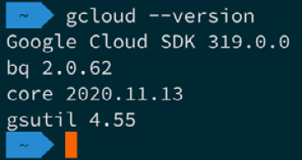
Figure 14.2 – Checking the version number on macOS
If you are having problems, you can check the documentation by running this code:
$ brew cask info google-cloud-sdk
Once Homebrew is installed and working, you can move onto the Initialization section of this chapter.
Installing on Windows
There are a few options to install the GCP CLI on Windows. The first is to open a PowerShell session and run the following command in order to install it using Chocolatey.
Important note
Like Homebrew on macOS, Chocolatey is a package manager that lets you easily and consistently install a wide variety of packages on Windows via PowerShell, using the same command syntax rather than having to worry about the numerous installation methods that exist on Windows.
If you don't have Chocolatey installed, then you can run the following command in a PowerShell session that has been launched with administrative privileges:
$ Set-ExecutionPolicy Bypass -Scope Process -Force; [System.Net.ServicePointManager]::SecurityProtocol = [System.Net.ServicePointManager]::SecurityProtocol -bor 3072; iex ((New-Object System.Net.WebClient).DownloadString('https://chocolatey.org/install.ps1'))
Once Chocolatey is installed, or if you already have it installed, simply run the following:
$ choco install --ignore-checksum gcloudsdk
The other way you can install it is to download the installer from the following URL: https://dl.google.com/dl/cloudsdk/channels/rapid/GoogleCloudSDKInstaller.exe.
Once downloaded, run the executable by double-clicking on it and following the onscreen prompts.
Once installed, open a new PowerShell window and run the following command:
$ gcloud --version
If everything goes as planned, you should see something like the following output:
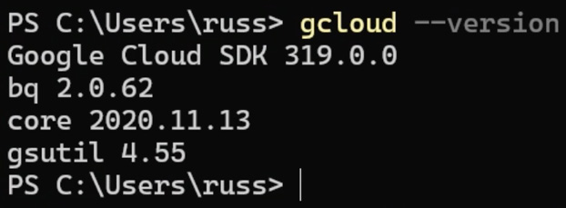
Figure 14.3 – Checking the version number in PowerShell
Once installed and working, you can move onto the Initialization section of this chapter.
Installing on Linux
While the Google Cloud CLI packages are available for most distributions, we don't have the space to cover all of the various package managers here. Instead, we will use the install script provided by Google. To run this, you simply need to use the following commands:
$ curl https://sdk.cloud.google.com | bash
$ exec -l $SHELL
The script will ask you several questions during the installation. For most people, answering Yes will be fine. Once installed as per the macOS and Windows installations, you can run the following command:
$ gcloud –version
You should then see the following output:
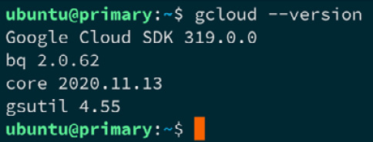
Figure 14.4 – Checking the version number on Linux
The one thing you might have noticed from the three installations is that, while the install method differs, once the package has been installed, we are using the same gcloud command, and also getting the same results back. From here, it shouldn't matter which operating system you are running, as the commands will apply to all three.
Cloud Shell
Before we started installing the Google Cloud CLI, I did mention that there was a fourth option. That option is Google Cloud Shell, which is built into Google Cloud Console. To access this, click on the Shell icon, which can be found on the right of the top menu.
Once configured, you should see what looks to be a web-based terminal from which you can run the following:
$ gcloud –version
The output differs slightly here as Google has provided the full suite of supporting tools. However, you will notice from the following screen that the versions do match the ones we installed locally:
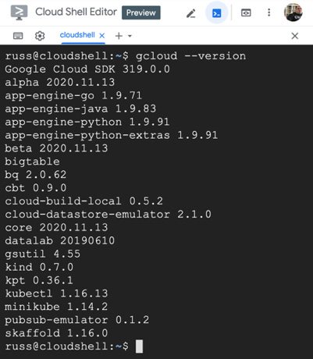
Figure 14.5 – Checking the version number in Google Cloud Shell
If you are using Google Cloud Shell, then you can skip the initialization step, as this has already been done for you.
Initialization
If you have chosen to install the client locally, then we will need to do one final step to link it to your GCP account. To do this, run the following command:
$ gcloud init
This will immediately run a quick network diagnostic to ensure that the client has the connectivity it needs to run. Once the diagnostic has passed, you will be prompted with the following question:
You must log in to continue. Would you like to log in (Y/n)?
Answering Y will open a browser window. If it doesn't, then copy and paste the provided URL into your browser where, once you have selected the account you wish to use, you will be presented with an overview of the permissions the client is requesting, as seen in the following figure:
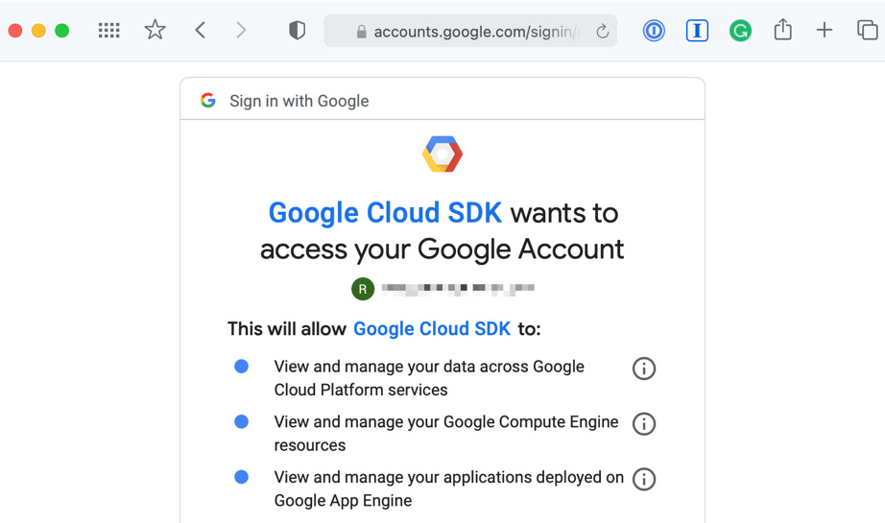

Figure 14.6 – Reviewing the permissions
If you are happy to grant the permissions, then click the Allow button. Back on your terminal, you will get confirmation of the user you are logged in as. Then you will be asked to pick a cloud project to use. The list will only contain the unique ID of the project, and not the friendly name that you saw or set up in Google Cloud Console earlier. If you have more than one project, please make sure you pick the correct project.
Should you need to update the project the client is using at any point, you can run the following command:
$ gcloud config set project PROJECT_ID
Make sure you replace PROJECT_ID with the unique ID of the project you wish to switch to.
Now that you have installed the Google Cloud CLI and have configured your account, we are ready to launch your GKE cluster.

Launching your first GKE cluster
As it is going to take a few minutes to launch the cluster, let's run the command to initiate the process and then talk through in a little more detail what is happening while it launches.
Before we launch our cluster, we need to make sure that the container.googleapis.com service is enabled. To do this, run the following command:
$ gcloud services enable container.googleapis.com
Once the service has been enabled, the command to launch a two-node cluster called k8sforbeginners, which will be hosted in a single zone in the Central US region, is as follows:
$ gcloud container clusters create k8sforbeginners --num-nodes=2 --zone=us-central1-a
After about 5 minutes, you should see something that looks like the following output:
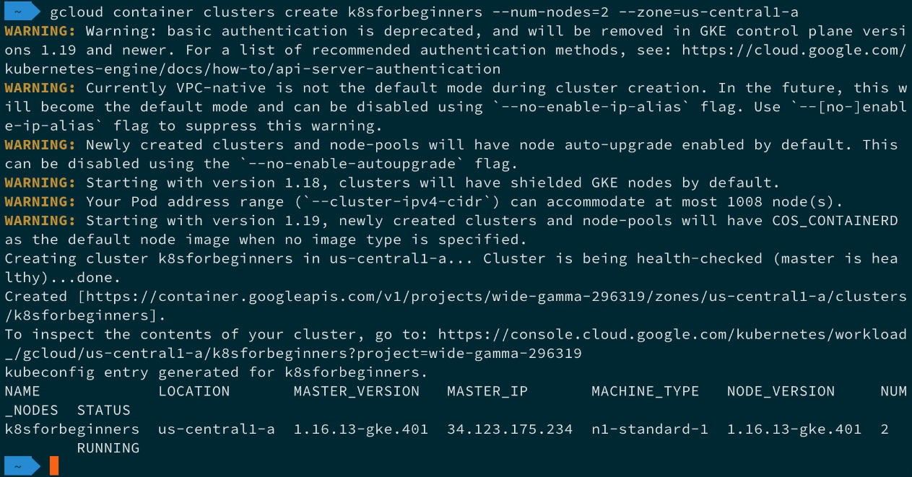
Figure 14.7 – Launching the cluster
Once the cluster has launched, you should be able to follow the URL in the output and view it in Google Cloud Console, as seen in the following figure:
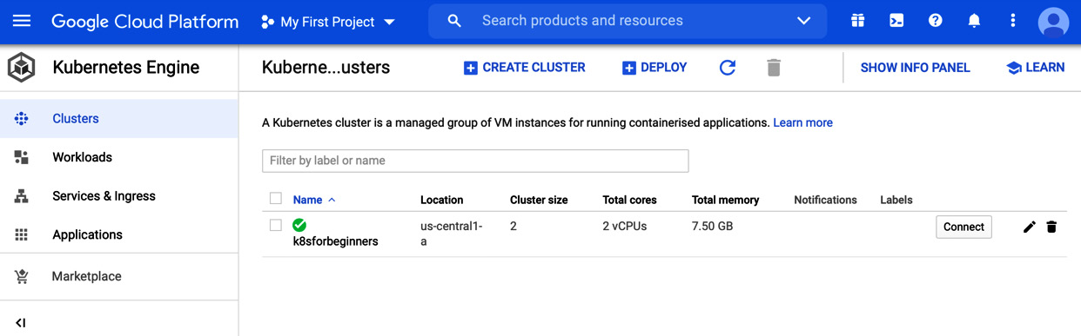

Figure 14.8 – Viewing the cluster in Google Cloud Console
Now that we have our cluster up and running, we can look at deploying a workload, then take a look at Google Cloud Console in a little more detail.

Deploying a workload and interacting with your cluster
One of the things to note from the feedback when we launched our cluster is the following output:
kubeconfig entry generated for k8sforbeginners.
As you may have already guessed, this has downloaded and configured all of the necessary information to connect the kubectl instance that you used to launch the cluster. You can confirm this by running the following command:
$ kubectl get nodes
The output you get from the command should show two nodes with a prefix of gke, so should appear something like the following Terminal output:
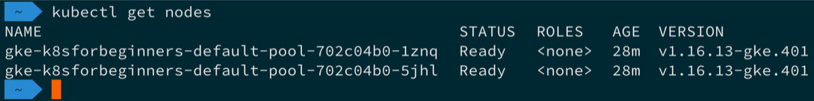

Figure 14.9 – Using kubectl to list the nodes
If you saw the preceding output and you are happy to proceed with the kubectl instance you are using, then you can skip the next section of the chapter and move straight onto Launching an example workload.
You can also find a link to the official GKE documentation in the Further reading section at the end of this chapter.

Configuring your local client
Should you need to configure another kubectl instance to connect to your cluster, then the GCP CLI has a command to do just that.
Important note
Running the command that follows assumes you have the GCP CLI installed and configured. If you don't have this, then please follow the instructions from the Installing the Google Cloud Platform CLI section of this chapter.
The command you need to run to download the credentials and configure kubectl is as follows:
$ gcloud container clusters get-credentials k8sforbeginners --zone=us-central1-a
Should you need to switch to or from another configuration (or context as it is known), you can run the following commands. The first command lists the current context:
$ kubectl config current-context
The next command lists the names of all of the contexts that you have configured:
$ kubectl config get-contexts -o name
Once you know the name of the context that you need to use, you can run the following command, making sure to replace context_name with the name of the context that you change it to, as in the following:
$ kubectl config use-context context_name
So now that we have your kubectl control configured to talk to and interact with your GKE cluster, we can launch an example workload.

Launching an example workload
The example workload we are going to launch is the PHP / Redis Guestbook example, which is used throughout the official Kubernetes documentation:
The first step in launching the workload is to create the Redis Leader deployment and service. To do this, we use the following commands:
$ kubectl apply -f https://raw.githubusercontent.com/GoogleCloudPlatform/kubernetes-engine-samples/master/guestbook/redis-leader-deployment.yaml
$ kubectl apply -f https://raw.githubusercontent.com/GoogleCloudPlatform/kubernetes-engine-samples/master/guestbook/redis-leader-service.yaml
Next up, we need to repeat the process, but this time to launch the Redis Follower deployment and service, as shown here:
$ kubectl apply -f https://raw.githubusercontent.com/GoogleCloudPlatform/kubernetes-engine-samples/master/guestbook/redis-follower-deployment.yaml
$ kubectl apply -f https://raw.githubusercontent.com/GoogleCloudPlatform/kubernetes-engine-samples/master/guestbook/redis-follower-service.yaml
Now that we have Redis up and running, it is time to launch the frontend deployment and service – this is the application itself:
$ kubectl apply -f https://raw.githubusercontent.com/GoogleCloudPlatform/kubernetes-engine-samples/master/guestbook/frontend-deployment.yaml
$ kubectl apply -f https://raw.githubusercontent.com/GoogleCloudPlatform/kubernetes-engine-samples/master/guestbook/frontend-service.yaml
After a few minutes, you should be able to run the following command to get information on the service you have just launched:
$ kubectl get service frontend
The output of the command should give you an external IP address that looks like the following Terminal output:
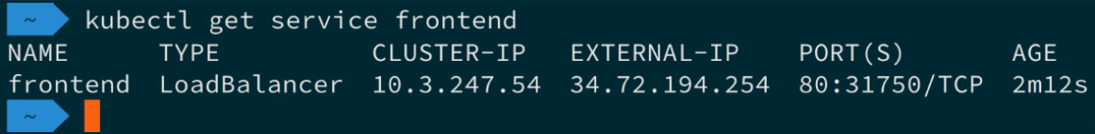
Figure 14.10 – Getting information on the frontend service
Now that we have launched our application, copy the EXTERNAL-IP value and put the IP address into your browser. Here you should be presented with the Guestbook application. Try submitting a few messages, as shown in the following figure:
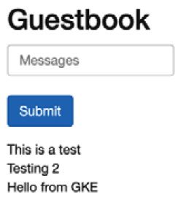
Figure 14.11 – The Guestbook application with a few test messages
So, now that we have our workload launched, let's return to and explore Google Cloud Console.

Exploring Google Cloud Console
We have already seen our cluster in Google Cloud Console, so next, click on the Workloads link, which can be found in the left-hand-side menu of the Kubernetes Engine section in Google Cloud Console.
Workloads
Once the page loads, you should see something that resembles the following screen:
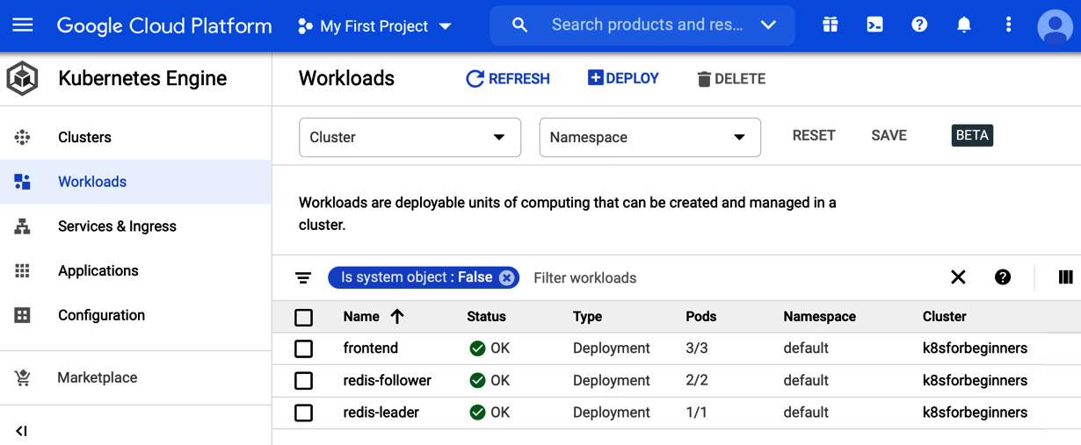
Figure 14.12 – Viewing the workload in the console
As you can see from the preceding screen, the three deployments are listed along with confirmation of the namespace they are in, as well as the cluster that the workload belongs to.
If we had more than one cluster with multiple namespaces and deployments, we would be able to use the filter to drill down into our GKE workloads.
Clicking on the frontend deployment will let you view more information:
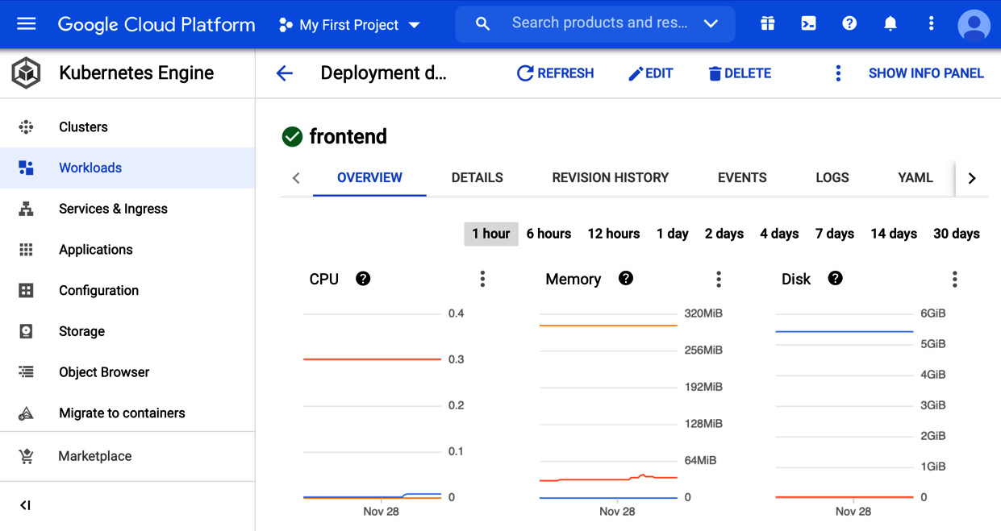
Figure 14.13 – Getting insights into a deployment
On this page, you will be able to drill further down into your deployment using the tabs below the deployment name, as follows:
OVERVIEW: This view gives you, well, an overview of your deployment – as you can see from the previous screenshot, you can see the CPU, memory, and disk utilization, along with other information.
DETAILS: This lists more details about the environment and deployment itself. Here, you can find out when it was created, annotations, labels (as well as details about the replicas), the update strategy, and pod information.
REVISION HISTORY: Here, you will find a list of all of the revisions to the deployment. This is useful if your deployment is updated frequently and you need to keep track of when the deployment was updated.
EVENTS: If you have any problems with your deployment, then this is the place you should look. All events – such as scaling, pod availability, and other errors – will be logged here.
LOGS: This is a searchable list of the logs from all containers running the pod.
YAML: This is an exportable YAML file containing the full deployment configuration.
This information is available for all deployments across all GKE clusters you have launched within the project.
Services & Ingress
In this section, we are going to look at the Services & Ingress section. As you may have already guessed, this lists all the services that are launched across all of your GKE clusters.
After clicking on Services & Ingress, you will be presented with a screen that looks similar to the following:
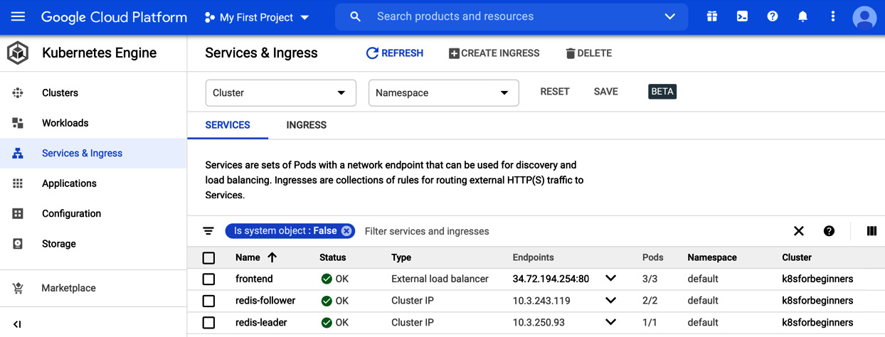
Figure 14.14 – Viewing the services in the console
As you can see, we have the three services we launched listed. However, the frontend service has a type of External load balancer and a public IP address listed, as opposed to the redis-leader and redis-follower services, which only have a Cluster IP. This is because, of the three services, we only want the frontend service to be accessible publicly as only our frontend service uses the two Redis ones.
When the external load balancer was launched (and as we are running our cluster in a public cloud provider), the Kubernetes scheduler knew to contact the Google Cloud API and launch a load balancer for use, and then configure it to talk back to our cluster nodes, exposing the deployment. This deployment is running on port 80 internally.
As before, clicking on one of the three running services will give you several bits of information:
OVERVIEW: This view gives you a summary of the service configuration and utilization.
DETAILS: Here you can find more detail on the service along with a link to view the load balancer resource that has been launched within our Google Cloud project.
EVENTS: As before, here you can find any events that have affected the service. This is useful for troubleshooting.
LOGS: This is a repeat of the logs shown in the Workloads section.
YAML: Again, this is a way for you to export the full configuration for the service as a YAML file.
Although we are not going to use the other menu items, we should quickly discuss them.
Other menu options
There are five more options for us to discuss. So far, we haven't really launched a workload that would utilize them.

Applications
With no applications launched, this links you to a marketplace where you can choose and deploy pre-configured applications into your environment – at the time of writing, there are over 100 applications, which range from free and open source to commercial offerings:
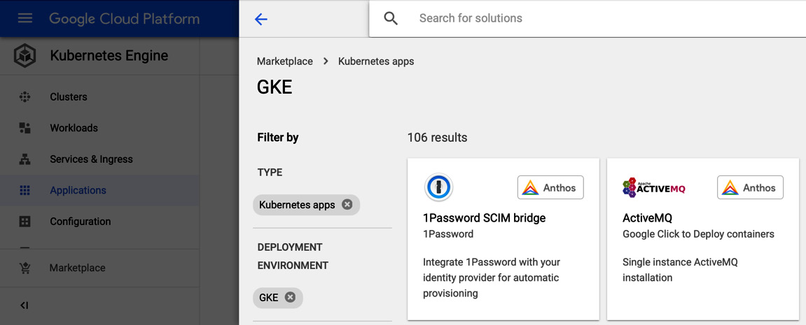
Figure 14.15 – Just a couple of the hundreds of applications available
The applications are categorized. They cover everything from Blog and CMS, databases, and analytics, all the way through to development tools and stacks. The applications are based on the Application Custom Resource Definition, which is being worked on by the Kubernetes Application Special Interest Group.

Configuration
Here you can manage ConfigMaps, such as environment variables, as well as Secrets, and share them amongst your GKE clusters.

Storage
From this section, you can manage, monitor, and review your persistent volume claims as well as storage classes associated with your GKE clusters.

Object browser
This allows you to browse all of the objects running in your clusters using a graphical representation of the Kubernetes API. From here you can generate YAML for any part of your GKE cluster.

Migrate to containers
This is an interesting tool; it inspects your virtual machine workload (which could be running on either Linux or Windows) and then figures out the critical parts of the application. It then attempts to containerize it. In the end, you will be left with a Dockerfile, along with all of the necessary data files and configurations.

Deleting your cluster
Once you have finished with your cluster, you can remove it by running the following commands. The first removes the service we created and the second removes the cluster itself:
$ kubectl delete service frontend
$ gcloud container clusters delete k8sforbeginners --zone=us-central1-a
It will take a few minutes to remove the cluster.
Important note
This should also delete any services that were launched by your workloads, such as load balancers. However, I do recommend checking Google Cloud Console for any orphaned services, to ensure that you do not get any unexpected costs.
So far throughout this chapter, we have been using the --zone=us-central1-a zone. This has been launching our cluster in a single availability zone in the US Central region. Let's discuss what other cluster options are available.

More about cluster nodes
At the end of the previous section, I mentioned availability zones and regions. Before we discuss some of the cluster deployment options, we should get a bit of a better understanding of what we mean by availability zones and regions:
Region: A region is made up of zones. Zones have great low-latency network connectivity to other zones within the same region. This gives you a way of deploying highly available always-on fault-tolerant workloads.
Availablity zone: Think of availability zones as separate data centers within a region. The zones have diverse networks and power, meaning that, should a single zone have an issue and you are running your workload across multiple zones, then your workload shouldn't be impacted.
The one thing to note with zones is that you might find that not all machine types are available across all zones within a region. Therefore, please check before attempting to deploy your workload.
Google best practice recommends that, for optimum performance and availability, you should deploy your workload across the maximum number of zones within a single region. However, it is possible to split your workloads across multiple regions – all you have to do is take into account and allow for the increased latency between regions.
With that in mind, let's take a look at the command we used to launch the test cluster at the start of the chapter:
$ gcloud container clusters create k8sforbeginners --num-nodes=2 --zone=us-central1-a
As we know, it will launch two nodes, but only in a single zone, as we have only passed one using the --zone flag, which in our case was the us-central1 region and zone a.
Run the following command, but use the --region flag rather than the --zone one:
$ gcloud container clusters create k8sforbeginners --num-nodes=2 --region=us-central1
Once launched, run the following:
$ kubectl get nodes
This will produce something that looks like the following output:
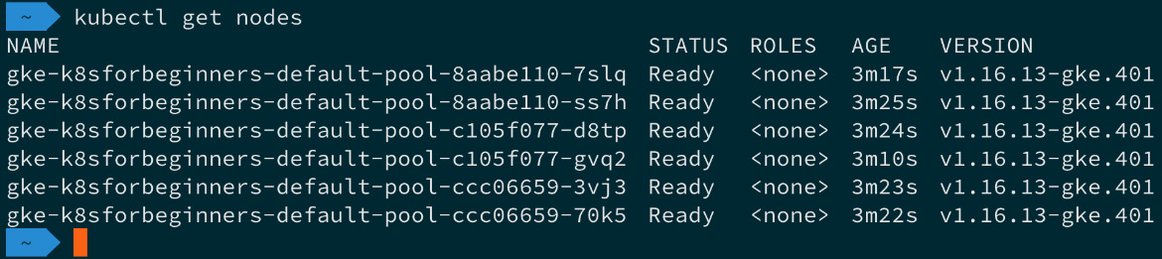
Figure 14.16 – Viewing the nodes running in a region
As you can see, we have two nodes in each zone, giving us a total cluster size of six nodes. The reason for this is that when you define a region by default, your cluster is spread across three zones. You can override this behavior by using the --node-locations flag.
This makes our command look like the following:
$ gcloud container clusters create k8sforbeginners --num-nodes=2 --region=us-central1 --node-locations us-central1-a,us-central1-b,us-central1-c,us-central1-f
We are still using the us-central1 region, but deploying to the a,b,c, and f zones. Running the kubectl get nodes command now shows the following:
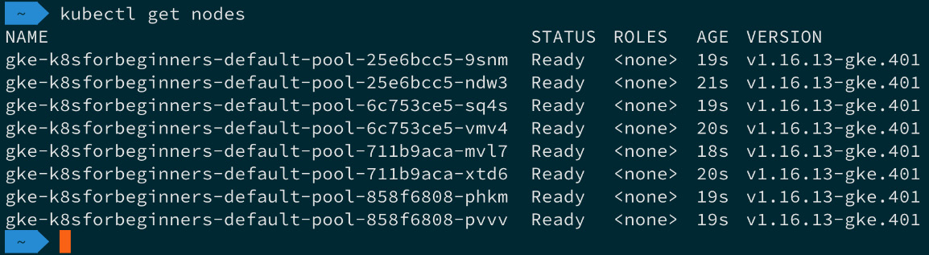
Figure 14.17 – Our cluster across four zones
As you can see, Google has made it straightforward to deploy your clusters across multiple zones. This means that you can deploy your workload across a fully redundant cluster with very little effort required.
To remove clusters deployed using the --region flag, you should use the following command:
$ gcloud container clusters delete k8sforbeginners --region=us-central1
At the time of writing, the simple two-node cluster we launched at the start of the chapter has a cost of around $49 per month, with the price increasing to around $270 per month for the eight-node cluster we have just launched. For more information on cost, see the link to the Google Cloud Pricing Calculator in the Further reading section.
That concludes our look at GKE. Before we move onto the next public cloud provider, let's summarize what we have covered.

Summary
In this chapter, we discussed the origins of GCP and the GKE service, before walking through how to sign up for an account and how to install and configure the Google Cloud command-line tool.
We then launched a simple two-node cluster using a single command, then deployed and interacted with a workload using both the kubectl command and Google Cloud Console.
Finally, and again only using a single command, we redeployed our cluster to take advantage of multiple availability zones, quickly scaling to a fully redundant and highly available eight-node cluster running across four availability zones.
I am sure you will agree that Google has done an excellent job in making deploying and maintaining what is a complex infrastructure configuration a relatively trivial and quick task.
Also, once your workloads are deployed, managing them is exactly the same as you would if your cluster was deployed elsewhere – we really haven't had to make any allowances for our cluster being run on GCP.
In the next chapter, we are going to be looking at deploying a Kubernetes cluster in Amazon Web Services using Amazon Elastic Kubernetes Service. This is Amazon's fully managed Kubernetes offering.

Further reading
Here are links to more information on some of the topics and tools that we have covered in this chapter:
Google Kubernetes Engine: https://cloud.google.com/kubernetes-engine/
Google Kubernetes Engine Documentation: https://cloud.google.com/kubernetes-engine/docs
Google Cloud Pricing Calculator: https://cloud.google.com/products/calculator
The Guestbook Sample Application: https://github.com/GoogleCloudPlatform/kubernetes-engine-samples/tree/master/guestbook
Migrate your VM workloads to Kubernetes: https://cloud.google.com/migrate/anthos/docs/getting-started
The Kubernetes Application SIG: https://github.com/kubernetes-sigs/application
The Google Cloud Kubernetes comic: https://cloud.google.com/kubernetes-engine/kubernetes-comic

Chapter 15: Launching a Kubernetes Cluster on Amazon Web Services with Amazon Elastic Kubernetes Service
In the previous chapter, we took our first steps with launching a Kubernetes cluster in a public cloud. Now we know what the Google Cloud Platform (GCP) Kubernetes offering looks like, we are going to move on to the Amazon Elastic Kubernetes Service (EKS) by Amazon Web Services (AWS).
In this chapter, you will learn what is needed to do to set up an AWS account, installing the supporting toolsets on macOS, Windows, and also Linux before finally launching and interacting with an Amazon EKS cluster.
We will be covering the following topics:
What are AWS and Amazon EKS?
Preparing your local environment
Launching your Amazon EKS cluster
Deploying a workload and interacting with your cluster
Deleting your Amazon EKS cluster

Technical requirements
To following along with this chapter, you will need an AWS account with a valid payment attached to it.
Important note
Following the instructions in this chapter will incur a cost and it is important that you terminate any resources you launch once you have finished with them.
All prices quoted in this chapter are correct at the time of writing this book, and we recommend that you review the current costs before you launch any resources.

What are AWS and Amazon EKS?
There is a very good chance you have already heard of AWS, as not only is it one of the first public cloud providers, but also, at the time of writing, it has the largest market share.

AWS
As you may have already guessed, AWS is owned and operated by Amazon. Amazon, the retailer, first started to dabble with cloud services way back in 2000 when they started to develop and deploy application programming interfaces (APIs) for their retail partners to consume.
Off the back of this work, Amazon realized that they would need to build a better and more standardized infrastructure platform to not only host the services they had been developing but to also ensure that they could quickly scale, as more of the Amazon retail outlet was consuming more of the software services and was growing at an expediential rate.
Chris Pinkham and Benjamin Black wrote a white paper in 2003 that was approved by Jeff Bezos in 2004, which described an infrastructure platform where compute and storage resources can all be deployed programmatically.
The first public acknowledgment of AWS's existence was made in late 2004; however, the term was used to describe a collection of tools and APIs that would allow third parties to interact with Amazon's retail product catalog rather than what we know today.
It wasn't until 2006 that a rebranded AWS was launched, starting in March with the Simple Storage Service, or S3 for short, which was a service that allowed developers to write and serve individual files using a web API rather having to write and read from a traditional local filesystem.
The next service to launch, Amazon Simple Queue Service (SQS), had formed part of the original AWS collection of tools—this was a distributed message system that again could be controlled and consumed by developers using an API.
The final service launched in 2006 was a beta of the Amazon Elastic Compute Cloud service, or Amazon EC2 for short, which was limited to existing AWS customers—again, you could use the APIs developed by Amazon to launch resources.
This was the final piece of the puzzle for Amazon, and they now had the foundations of a public cloud platform they could use not only their own retail platform on but also sell space to other companies and the public, such as you and me.
If we fast forward from 2006, when there were three services, to the time of writing, which is late 2020, there are now over 170 services available. All of these 170+ services stick to the core principles that were laid out in the white paper written in 2003 each service is software-defined, meaning that all a developer has to do is to make a simple API request to launch, configure, and in some cases consume before finally being able to make a request terminate the service.
Tip
Services that are prefixed with Amazon are services that are standalone, unlike ones that are prefixed with AWS, which are services that are designed to be used alongside other AWS services.
Long gone are the days of having to order a service, have someone build and deploy, then hand it over to you—this takes deployment times down to seconds from what sometimes could take weeks.
Rather than discuss all 170+ services, which would be a collection of books all by itself, we should discuss the service we are going to be looking at in this chapter.

Amazon EKS
While AWS was the first of the major public cloud providers, it was one of the last to launch a standalone Kubernetes service. Amazon EKS was first announced in late 2017 and became generally available in the United States (US) East (N. Virginia) and US West (Oregon) regions in June 2018.
The service is built to work with and take advantage of other AWS services and features, such as the following:
AWS Identity and Access Management (IAM): This service allows you to take control of and manage both end-user and programmatic access to other AWS services.
Amazon Route 53: This is Amazon's Domain Name System (DNS) service. EKS can use it as a source of DNS for clusters, which means that service discovery and routing can easily be managed within your cluster.
Amazon Elastic Block Storage (EBS): If you need persistent block storage for the containers running within your Amazon EKS instance, then it is provided by the same service used to provide block storage for the rest of your EC2 compute resources.
EC2 Auto Scaling: Should your cluster need to scale, then the same technology to scale your EC2 instances is employed.
Multi Availability Zones (AZs): The Amazon EKS management layer, as well as cluster nodes, can be configured to be spread across multiple AZs within a given region to bring high availability (HA) and resilience to your deployment.
Before we launch our Amazon EKS cluster, we are going to have to download, install, and configure a few tools.

Preparing your local environment
There are two sets of command-line tools we are going to install, but before we do, we should quickly discuss the steps to sign up for a new AWS account. If you already have an AWS account, then you can skip this task and move straight on to the Installing the AWS command-line interface section.

Signing up for an AWS account
Signing up for an AWS account is a straightforward process, as detailed here:
Head over to https://aws.amazon.com/ and then click on the Create an AWS account button, which can be found in the top right of the page.
Important note
While Amazon offers a free tier for new users, it is limited to certain services, instance sizing, and also for 12 months. For information on the AWS Free Tier, see https://aws.amazon.com/free/.
Fill out the initial form that asks for an email address, your preferred password, and the AWS account name.
Once done, click on Continue and follow the onscreen instructions. These will involve you confirming both your payment details and also confirming your identity via an automated phone call.
Once you have your account created and enabled, you will be able to start using AWS services. In our case, we now need to install the command-line tools we will be using to launch our Amazon EKS cluster.

Installing the AWS command-line interface
Next on our list of tasks is to install the AWS command-line interface (CLI). As with the previous chapter, Chapter 14, Kubernetes Clusters on Google Kubernetes Engine, we will be targeting Windows, Linux, and also macOS, which we will be looking at first.
Installing on macOS
Installing the AWS CLI on macOS using Homebrew is as simple as running the following command:
$ brew install awscli
Once it's installed, running the following command:
$ aws --version
This will output the version of the AWS CLI, along with some of the support services it needs, as illustrated in the following screenshot:
Figure 15.1 – Checking the AWS CLI version number on macOS
Once it's installed, we can move on to the AWS CLI configuration section.
Installing on Windows
As with macOS, you can use a package manager to install the AWS CLI. As in Chapter 14, Kubernetes Clusters on Google Kubernetes Engine, we will be using Chocolatey. The command you need to run is shown here:
$ choco install awscli
Once using Chocolatey, running aws --version will give you similar output to what we saw on macOS, as illustrated in the following screenshot:
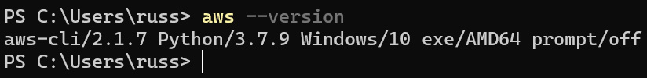
Figure 15.2 – Checking the AWS CLI version number on Windows
Once it's installed, we can move on to the AWS CLI configuration section.
Installing on Linux
While there are packages available for each distribution, the easiest way of installing the AWS CLI on Linux is to download and run the installer.
Important note
These instructions assume that you have the curl and unzip packages installed, if you don't, please install them using your distribution's package manager—for example, on Ubuntu, you would need to run sudo apt install unzip curl to install both packages.
To download and install the AWS CLI, run the following commands:
$ curl "https://awscli.amazonaws.com/awscli-exe-linux-x86_64.zip" -o "awscliv2.zip"
$ unzip awscliv2.zip
$ sudo ./aws/install
Once it's installed, you should be able to run aws --version, and you will get something like this:
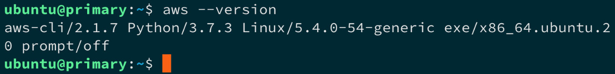
Figure 15.3 – Checking the AWS CLI version number on Linux
Once installed, we can move on to the AWS CLI configuration section.
AWS CLI configuration
Once you have the AWS CLI installed and you have checked that it is running okay by issuing the aws --version command, you will need to link the CLI to your AWS account.
To do this, you will need to log in to the AWS console—this can be accessed at http://console.aws.amazon.com/. Once logged in, type IAM into the Find Services search box and click on the link to be taken to the Identity and Access Management (IAM) page. We need to create a user with programmatic access; to do this, follow these steps:
Once the page has loaded, click on Users, which can be found under the Access Management section of the left-hand side menu.
Enter the username—I will be using ekscluster—then select both the Programmatic access and AWS Management Console access types. If you select the latter option, you will be given the option of setting an autogenerated or custom password and can decide whether the password should be reset after the user logs in.
Personally, I set a custom password and unticked the option of resetting the password after the first login. To proceed to the next step, once you have set the details, click on the Next: Permissions button.
Rather than create a group, we are going to simply grant our user an existing policy. To do this, select Attach existing policies directly and select the AdministratorAccess policy, then click on Next: Tags to proceed to the next step.
As we are going to be removing this user at the end of the chapter, I am not going to enter any tags; however, you can, if you like. Click on the Next: Review button to move on to the final step.
Once you have reviewed the information presented to you, click on the Create user button.
Once the user has been created, click on the Download .csv button—this is the only time that the secret will be displayed, and once you close the page, you will have to generate a new one.
Once you have the secret, click on the Close button. We now have the credentials we can use to authenticate our AWS CLI against our AWS account.
Return to your terminal and then run the following command to create a default profile:
$ aws configure
This will ask for a few bits of information, as follows:
AWS access key identifier (ID): This is the access key ID from the comma-separated values (CSV) file we downloaded.
AWS secret access key: This is the key from the CSV file.
Default region name: I entered us-east-1.
Default output format: I left this blank.
To test that everything is working, you can run the following command:
$ aws ec2 describe-regions
This will list the AWS regions that are available, and the output should look like something like this:
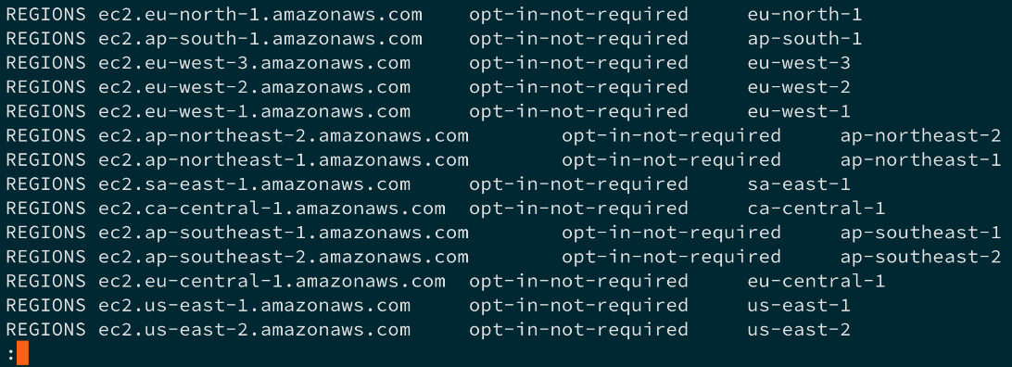
Figure 15.4 – Testing the AWS CLI
Now we have the AWS CLI installed and configured to talk to our account, we need to install the next command-line tool.

Installing eksctl, the official CLI for Amazon EKS
While it is possible to launch an Amazon EKS cluster using the AWS CLI, it is complicated and there are a lot of steps. To get around this, Weaveworks have created a simple command-line tool that generates an AWS CloudFormation template and then launches your cluster.
Tip
AWS CloudFormation is Amazon's Infrastructure-as-Code (IaC) definition language that lets you define your AWS resources in such a way that they be can be deployed across multiple accounts or repeatedly in the same one. This is useful if you have to keep spinning up an environment—for example, as part of a continuous integration (CI) build.
Installation couldn't be easier—macOS users can run the following commands to install using Homebrew:
$ brew tap weaveworks/tap
$ brew install weaveworks/tap/eksctl
Windows users can use the following command:
$ choco install eksctl
All Linux users have to do is download the precompiled binaries and copy them into place, as follows:
$ curl --silent --location "https://github.com/weaveworks/eksctl/releases/latest/download/eksctl_$(uname -s)_amd64.tar.gz" | tar xz -C /tmp
$ sudo mv /tmp/eksctl /usr/local/bin
Once installed, you should be able to run eksctl version to get the version number. We are now ready to launch our cluster.

Launching your Amazon EKS cluster
For our test, we are going to use the defaults built into the eksctl command. These will launch an Amazon EKS cluster with the following attributes:
In the us-west-1 region.
With two worker nodes, using the m5.large instance type.
Uses the official AWS EKS Amazon Machine Image (AMI).
In its own virtual private cloud (VPC), which is Amazon's networking service.
With an automatically generated random name.
So, without further ado, let's launch our cluster by running the following command:
$ eksctl create cluster
You might want to go and make a drink or catch up on emails, as this process can take around 30 minutes to complete.
If you are not following along, here is the output I got when running the command. First of all, some basic information is displayed about the version of eksctl and which region will be used:
[i] eksctl version 0.33.0
[i] using region us-east-1
Now, by default, eksctl uses the us-west-2 region; however, as we set us-east-1 as the default when we configured the AWS CLI, it has used that setting. Next up, it will give some information on the networking and AZs it will be deploying resources into, as illustrated in the following code snippet:
[i] setting availability zones to [us-east-1e us-east-1a]
[i] subnets for us-east-1e - public:192.168.0.0/19 private:192.168.64.0/19
[i] subnets for us-east-1a - public:192.168.32.0/19 private:192.168.96.0/19
It will now give details of which version of the AMI it is going to use, along with the Kubernetes version that image supports, as follows:
[i] nodegroup "ng-6cd00965" will use "ami-0f4cae6ae56be18ee" [AmazonLinux2/1.18]
[i] using Kubernetes version 1.18
Now it knows all of the elements, it is going to create a cluster and with it make a start on the deployment, as follows:
[i] creating EKS cluster "attractive-sheepdog-1607259336" in "us-east-1" region with un-managed nodes
[i] will create 2 separate CloudFormation stacks for cluster itself and the initial nodegroup
[i] if you encounter any issues, check CloudFormation console or try 'eksctl utils describe-stacks --region=us-east-1 --cluster=attractive-sheepdog-1607259336'
As you can see, it has called my cluster attractive-sheepdog-1607259336; this will be referenced throughout the build. By default, logging is not enabled, as we can see here:
[i] CloudWatch logging will not be enabled for cluster "attractive-sheepdog-1607259336" in "us-east-1"
[i] you can enable it with 'eksctl utils update-cluster-logging --enable-types={SPECIFY-YOUR-LOG-TYPES-HERE (e.g. all)} --region=us-east-1 --cluster=attractive-sheepdog-1607259336'
Now is the point where we wait, and the following messages are displayed:
[i] Kubernetes API endpoint access will use default of {publicAccess=true, privateAccess=false} for cluster "attractive-sheepdog-1607259336" in "us-east-1"
[i] 2 sequential tasks: { create cluster control plane "attractive-sheepdog-1607259336", 3 sequential sub-tasks: { no tasks, create addons, create nodegroup "ng-6cd00965" } }
[i] building cluster stack "eksctl-attractive-sheepdog-1607259336-cluster"
[i] deploying stack "eksctl-attractive-sheepdog-1607259336-cluster"
Once deployed, it will download the cluster credentials and configure kubectl, as follows:
[✓] saved kubeconfig as "/Users/russ.mckendrick/.kube/config"
[i] no tasks
[✓] all EKS cluster resources for "attractive-sheepdog-1607259336" have been created
[i] adding identity "arn:aws:iam::687011238589:role/eksctl-attractive-sheepdog-160725-NodeInstanceRole-1FZFP968TXZG9" to auth ConfigMap
The final step is to wait for the nodes to become available, as is happening here:
[i] nodegroup "ng-6cd00965" has 0 node(s)
[i] waiting for at least 2 node(s) to become ready in "ng-6cd00965"
[i] nodegroup "ng-6cd00965" has 2 node(s)
[i] node "ip-192-168-23-50.ec2.internal" is ready
[i] node "ip-192-168-50-107.ec2.internal" is ready
Now we have both nodes online and ready, it is time to display a message confirming that everything is ready, as follows:
[i] kubectl command should work with "/Users/russ.mckendrick/.kube/config", try 'kubectl get nodes'
[✓] EKS cluster "attractive-sheepdog-1607259336" in "us-east-1" region is ready0
Now that the cluster is ready, let's do as the output suggests and run kubectl get nodes. As expected, this gives us details on the two nodes that make up our cluster, as illustrated in the following screenshot:
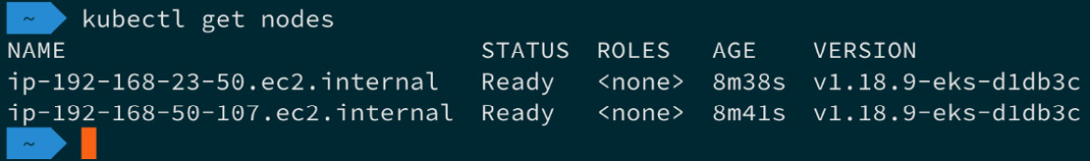
Figure 15.5 – Viewing the two cluster nodes
Now we have a cluster up and running, let's launch the same workload we launched when we launched our Google Kubernetes Engine (GKE) cluster.

Deploying a workload and interacting with your cluster
If you recall from the last chapter, we used the Guestbook example from the GCP GKE examples' GitHub repository.
First, we are going to deploy the workload before we then explore the web-based AWS console. Let's make a start on our Guestbook deployment.

Deploying the workload
Even though we are our cluster is running on AWS using Amazon EKS, we are going to be using the same set of YAML Ain't Markup Language (YAML) files we used to launch our workload in GKE. Follow these next steps:
As before, our first step is launching the Redis Leader deployment and service using the following commands:
$ kubectl apply -f https://raw.githubusercontent.com/GoogleCloudPlatform/kubernetes-engine-samples/master/guestbook/redis-leader-deployment.yaml
$ kubectl apply -f https://raw.githubusercontent.com/GoogleCloudPlatform/kubernetes-engine-samples/master/guestbook/redis-leader-service.yaml
Once the Redis Leader deployment and service have been created, we need to launch the Redis Follower deployment, as follows:
$ kubectl apply -f https://raw.githubusercontent.com/GoogleCloudPlatform/kubernetes-engine-samples/master/guestbook/redis-follower-deployment.yaml
$ kubectl apply -f https://raw.githubusercontent.com/GoogleCloudPlatform/kubernetes-engine-samples/master/guestbook/redis-follower-service.yaml
Once Redis is up and running, it's time to launch the frontend deployment and service using the following commands:
$ kubectl apply -f https://raw.githubusercontent.com/GoogleCloudPlatform/kubernetes-engine-samples/master/guestbook/frontend-deployment.yaml
$ kubectl apply -f https://raw.githubusercontent.com/GoogleCloudPlatform/kubernetes-engine-samples/master/guestbook/frontend-service.yaml
After a few minutes, we will be able to run the following command to get information on the service we have just launched, which should include details on where to access our workload:
$ kubectl get service frontend
You will notice that this time, the output is slightly different from the output we got when running the workload on GKE, as we can see in the following screenshot:
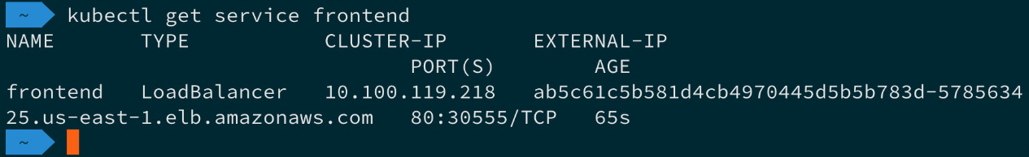
Figure 15.6 – Getting information on the frontend service
As you can see, rather than an Internet Protocol (IP) address, we get a Uniform Resource Locator (URL). Copy that into your browser.
Once you have opened the URL, given that we have used exactly the same work, you won't be surprised to see the Guestbook application, as shown in the following screenshot:
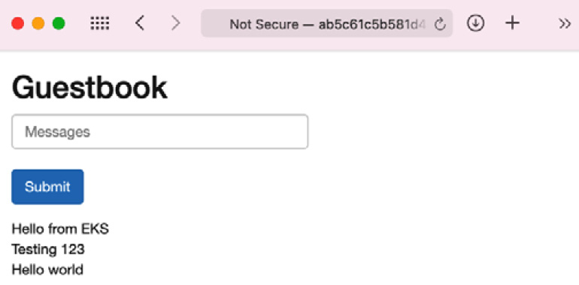
Figure 15.7 – The Guestbook application with a few test messages
Now we have our workload up and running, let's take a look at what we can see through the AWS console.

Exploring the AWS console
In this section, we are going to try to take a look at our newly deployed workload using the AWS console. First, we need to log in, as follows:
Open https://console.aws.amazon.com/. If you are still logged in from when we generated the IAM credentials, you will need to log out as we will not be using our main AWS user for this part of the chapter.
Once logged out, open the CSV file that we downloaded during the AWS CLI configuration section of the chapter and then copy and paste the console login link into your browser. Enter the credentials for the ekscluster user we created earlier in the AWS CLI configuration section of this chapter. If you selected the option to reset the password when the user first logs in, then you will be prompted to do so now.
Important note
You may be thinking to yourself: Why are we using a different user to log in to the AWS console, as my main user has full access? There is a good reason for this—when eksctl launched our cluster, there was a line that said adding identity. This granted permissions to the user that were used to create a cluster to be able to interact with the cluster using AWS services. This means that we will be able to view workloads and the like within the AWS console. If you were to use your regular user, then you would not have permission to see any of the details we are about to look at within the AWS console, due to the cluster not knowing about your main user.
Next, make sure that the region we have launched our cluster in is selected. The region selector can be found in the top right next to the Support drop-down menu—make sure that US East (N. Virginia) us-east-1 is selected.
Once you have the region selected, enter EKS into the Services menu and you will be taken to the Amazon Container Services page, as illustrated in the following screenshot:
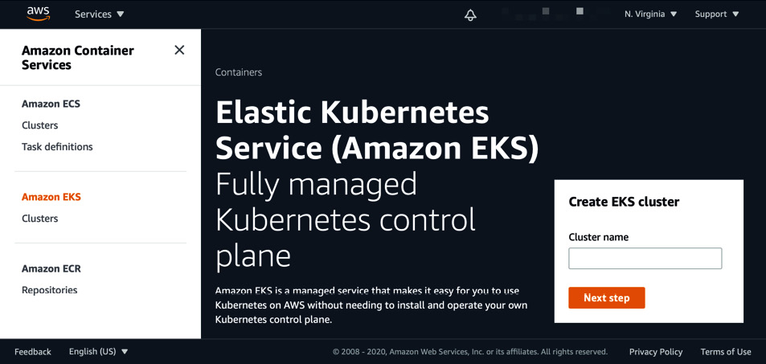
Figure 15.8 – The Amazon Container Services page
Next, click on the Clusters link underneath the Amazon EKS entry in the left-hand side menu, as illustrated in the following screenshot:
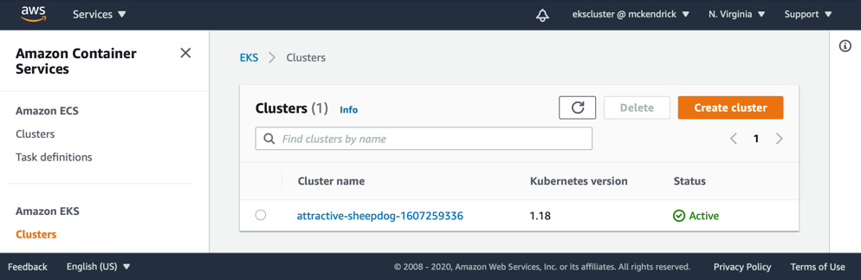
Figure 15.9 – Listing the Amazon EKS clusters
Clicking on the cluster name, which in my case is attractive-sheepdog-1607259336, will take you to the cluster view.
The initial Overview tab will show you the nodes within the cluster. The next option is Workloads—clicking this will take you to the workloads view.
By default, it will show you all of the Kubernetes namespaces, including the system ones—selecting the default namespace in the All Namespaces dropdown will display just the workloads we have launched, as illustrated in the following screenshot:
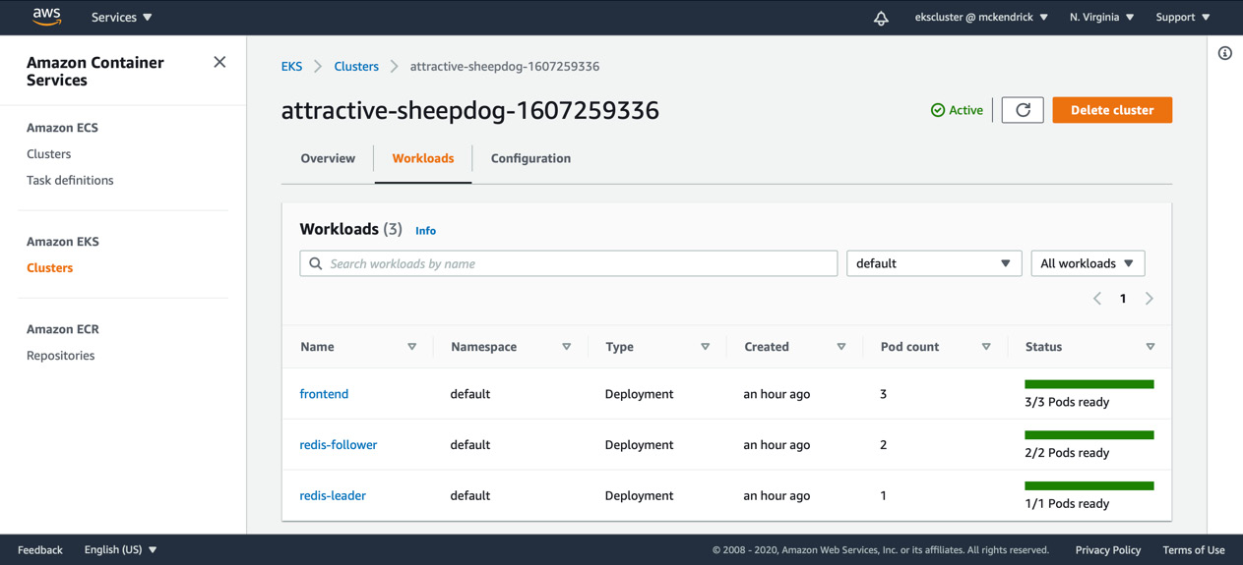
Figure 15.10 – Viewing the workloads in the default namespace
Clicking on one of the deployments will give you more information on the deployment—this includes details of the pods, configuration, and so on. However, as you click around, you will find that all you can really do is view information on the services; there are no graphs, logging output, or anything that gives more than a basic overview of our workloads.
The final section is Configuration; again, this gives basic information on our cluster and not a lot more.
Moving away from the EKS service page and going to the EC2 service section of the AWS console will display the two nodes, as illustrated in the following screenshot:

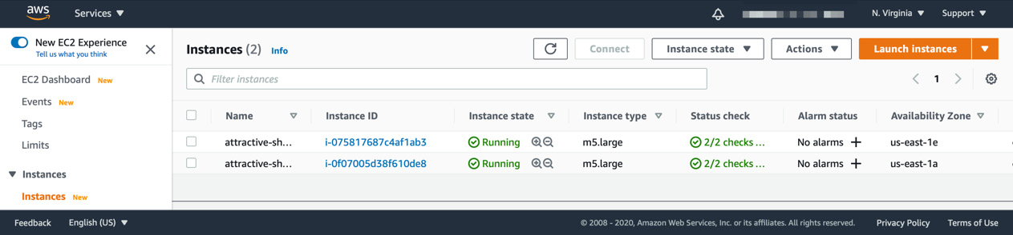
Figure 15.11 – Viewing the EC2 instances
Here, you will be able to drill down and find out more information on the instance, including its central processing unit (CPU), random-access memory (RAM), and network utilization; however, this is only for the instance itself and not for our Kubernetes workload.
Selecting Load Balancers from the Load Balancing section of the left-hand side menu will show you the elastic load balancer that was launched and configured when we applied the frontend service, as illustrated in the following screenshot:
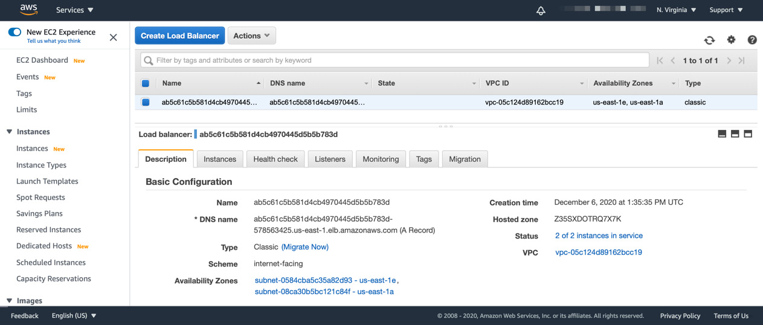
Figure 15.12 – Viewing the elastic load balancer
The final AWS service we are using is AWS CloudFormation, so entering CloudFormation in the Services menu and clicking on the link will take you to the CloudFormation service page.
Here, you will see two stacks, one for the EKS nodes—these are our two EC2 instances—and then one for the EKS cluster, which is our Kubernetes management plane. These stacks are illustrated in the following screenshot:
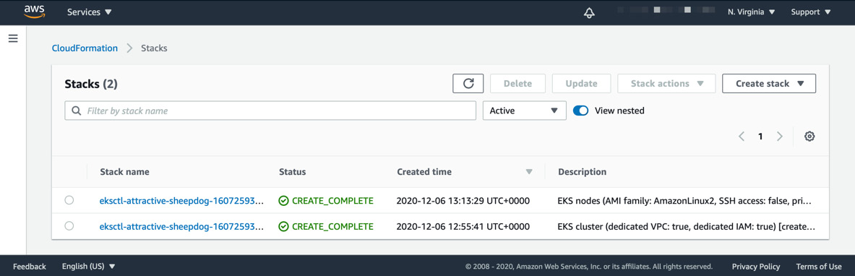
Figure 15.13 – Viewing the AWS CloudFormation stacks
Selecting one of the stacks will give you details on what happened when the stack was launched. It will list all of the many resources that were created during the launch of the Amazon EKS cluster using eksctl.
If you select a template and then view it in the designer, you can even see the template that was generated by eksctl with a visual representation. The following screenshot gives a view of the simpler of the two stacks:
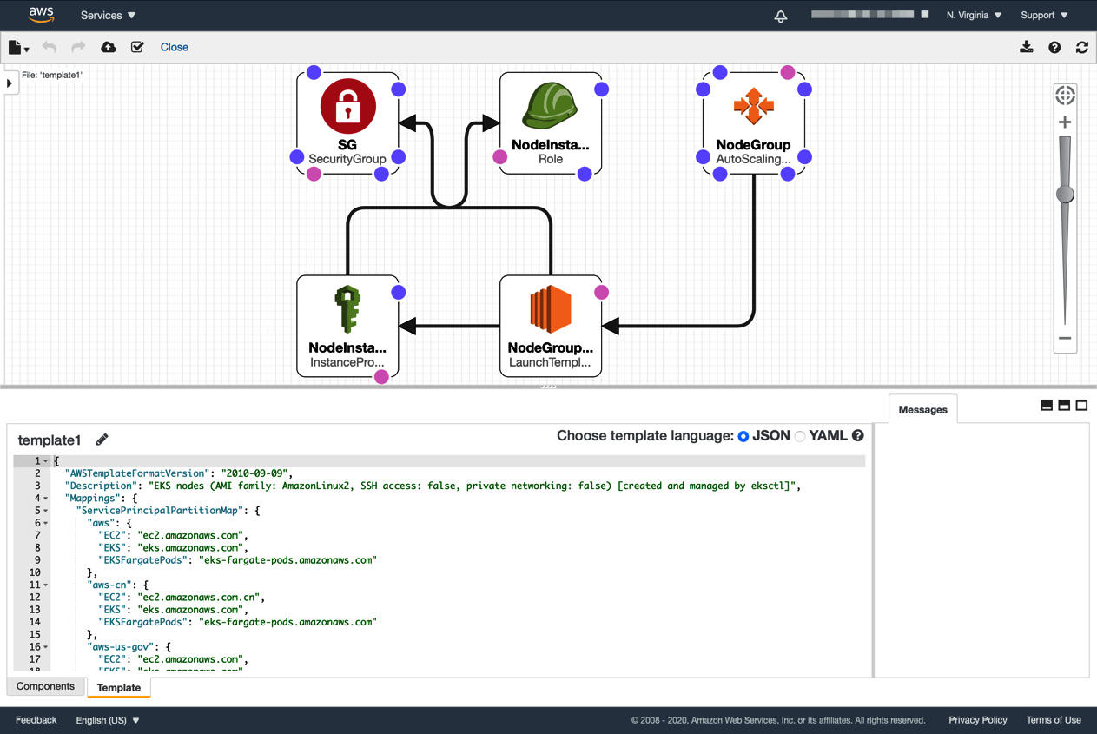
Figure 15.14 – Viewing the AWS CloudFormation template in the designer
That is about all we can see in the AWS console. As we have seen, while Amazon EKS is relatively simple to launch using eksctl, its level of integration with the AWS console is somewhat lacking compared to the GKE cluster we launched in the previous chapter.
While we were able to explore and view our workload, we could not interact with too much; also, the feedback on the cluster is tied into the basic monitoring offered by the Amazon EC2 service.
Once you have finished your Amazon EKS cluster, you can delete it.

Deleting your Amazon EKS cluster
You can delete your cluster by running the following command, making sure to replace the cluster name with that of your own:
$ eksctl delete cluster --name attractive-sheepdog-1607259336
Deleting the cluster does not take as long to run as when we launched it; in fact, it takes around 5 minutes. As before, eksctl gives you details on what it is doing as it deletes the resources, starting with the same details on when we launched the cluster, as illustrated in the following code snippet:
[i] eksctl version 0.33.0
[i] using region us-east-1
Then, it provides details on the cluster, as follows:
[i] deleting EKS cluster "attractive-sheepdog-1607259336"
[i] deleted 0 Fargate profile(s)
The first thing that is updated is the local kubectl configuration, as we can see here:
[✓] kubeconfig has been updated
Then, any resources that have been launched as part of deploying workloads onto our cluster are removed, as follows:
[i] cleaning up AWS load balancers created by Kubernetes objects of Kind Service or Ingress
Then, the two AWS CloudFormation stacks are removed, which in turn removes all of the resources they created and configured, as illustrated in the following code snippet:
[i] 2 sequential tasks: { delete nodegroup "ng-6cd00965", delete cluster control plane "attractive-sheepdog-1607259336" [async] }
[i] will delete stack "eksctl-attractive-sheepdog-1607259336-nodegroup-ng-6cd00965"
[i] waiting for stack "eksctl-attractive-sheepdog-1607259336-nodegroup-ng-6cd00965" to get deleted
[i] will delete stack "eksctl-attractive-sheepdog-1607259336-cluster"
[✓] all cluster resources were deleted
At this point, our cluster has been completely deleted.
Important note
Please double-check the EC2, EKS, and CloudFormation sections in the AWS console to ensure that all services have been correctly deleted as you will be charged for any orphaned or idle resources that have been left behind. While this is an unlikely scenario, it is best to double-check now rather than receive an unexpected bill at the end of the month.
So, how much would our Amazon EKS cluster have cost us to run for a month?
There are two sets of costs that we need to take into account—the first is for the Amazon EKS cluster itself. It is US Dollars (USD) $0.10 per hour for each Amazon EKS cluster you create; however, each Amazon EKS cluster can run multiple node groups, so you shouldn't have to launch more than one per region—so, the cluster itself comes in around $72 per month.
Now, added to the EC2 cluster nodes, which in our case would have cost around $70 each, this means that the total cost to run our cluster for a month would be around $212—and I say around because there are then charges for bandwidth and also for the AWS Elastic Load Balancing (ELB) service, which will increase the cost of our workload further.

Summary
In this chapter, we discussed the origins of AWS and also Amazon EKS before walking through how to sign up for an account and how to install and configure the two command-line tools required to easily launch an Amazon EKS cluster.
Once our cluster was up and running, we deployed the same workload as when we launched our GKE cluster. We did not have to make any allowances for the workload running on a different cloud provider—it just worked, even deploying a load balancer using the AWS native load balancing service.
We did, however, find that EKS is not as integrated with the AWS console as the Google service we looked at, and also learned that we had to install a second command-line tool to easily launch our cluster due to the complications of trying to do so using the AWS CLI. This would have been around eight steps, and that assumes that the Amazon VPC configuration and IAM roles had been created and deployed.
Personally, this lack of integration and complexity when it comes to launching and maintaining clusters compared to other providers would put me off running my Kubernetes workloads on Amazon EKS.
In the next chapter, we are going to look at launching an Azure Kubernetes Service (AKS) cluster on Microsoft Azure, which will be the last of the three public providers we will be covering.

Further reading
Here are links to more information on some of the topics and tools we have covered in this chapter:
AWS: https://aws.amazon.com/
Amazon EKS: https://aws.amazon.com/eks/
The AWS CLI: https://aws.amazon.com/cli/
eksctl: https://eksctl.io/
Weaveworks: https://www.weave.works/
Official documentation: https://docs.aws.amazon.com/eks/latest/userguide/what-is-eks.html

Chapter 16: Kubernetes Clusters on Microsoft Azure with Azure Kubernetes Service
The last of the three public cloud Kubernetes services we are going to look at is Azure Kubernetes Service (AKS), which is hosted on what most people consider to be one of the "big three" public cloud providers, Microsoft Azure.
By the end of this chapter, you will have configured your local environment with the tools needed to interact with your Microsoft Azure account and launch your AKS cluster. From there we will launch the same workload we launched in the previous two chapters, and then explore the level of integration that your AKS cluster has with the Microsoft Azure portal.
To do this, we will be covering the following topics:
What are Microsoft Azure and AKS?
Preparing your local environment
Launching your AKS cluster
Deploying a workload and interacting with your cluster
Deleting your AKS cluster

Technical requirements
To following along with this chapter, you will need a Microsoft Azure account with a valid payment method attached to it.
Important note
Following the instructions in this chapter will incur a cost and it is important that you terminate any resources you launch once you have finished with them to avoid unwanted expenses.
All prices quoted in this chapter are correct at the time of print and we recommend that you review the current costs before you launch any resources.

What are Microsoft Azure and AKS?
Before we start to look at installing the supporting tools, let's quickly discuss the origins of the services we'll be looking at, starting with Microsoft Azure.

Microsoft Azure
In 2008, Microsoft announced a new service called Windows Azure, which it had been working on since 2004. This service was part of a project known internally as Project Red Dog. This project focused on delivering data center services using core Windows components. The five core components that Microsoft announced at their 2008 developer conference were as follows:
Microsoft SQL Data Services: This was a cloud version of the Microsoft SQL Database service running as a Platform as a Service (PaaS), which aimed to remove the complexity of hosting your own SQL services.
Microsoft .NET Services: Another PaaS service that allowed developers to deploy their .NET-based applications into a Microsoft-managed .NET runtime.
Microsoft SharePoint: A Software as a Service (SaaS) version of the popular intranet product.
Microsoft Dynamics: A SaaS version of Microsoft's CRM product.
Windows Azure: An Infrastructure as a Service (IaaS) offering similar to other cloud providers that allowed users to spin up virtual machines, storage, and the networking services needed to support their compute workloads.
All of the services that Microsoft announced were built on top of the Red Dog operating system, which was a specialized operating system with a cloud layer built in.
In 2014, Windows Azure was renamed Microsoft Azure, which reflected both the name of the underlying operating system powering the cloud services and also the fact that Azure was running a large number of Linux-based workloads – in fact, in 2020, it was revealed that more than 50% of VM cores are running Linux workloads, as well as 60% of the Azure Marketplace images now being Linux-based.
This is largely due to Microsoft embracing both Linux and open source projects such as Kubernetes.

AKS
Microsoft provided its own container-based service called Azure Container Service (ACS). This allowed you to deploy container workloads backed by three different orchestrators: Docker Swarm, DC/OS, and Kubernetes.
It soon became apparent that Kubernetes was the most popular of the three orchestrators, so ACS was gradually replaced by AKS, which was a CNCF-compliant, purely Kubernetes-based service. The transition took about 2 years, with AKS becoming generally available in 2018 and ACS being retired in early 2020.
The AKS service is closely integrated with Azure Active Directory, Policies, and other key Microsoft Azure services.
Alongside AKS, Microsoft also offer a pure container service called Azure Container Instances (ACI) as well as the ability to launch container workloads in Azure App Services.
Rather than carrying on discussing the background of the services, I have always found it much easier to roll up your sleeves and get hands-on with a service, so without further delay, let's look at getting the tools installed we will need to launch and manage our AKS cluster.

Preparing your local environment
Before we look at launching our cluster, there are a few tasks we need to complete. First of all, if you don't already have one, you will need to sign up for an Azure account.
If you don't already have an account, then you can head to https://azure.microsoft.com/free/. You will be taken to the following page where you can sign up for a free account:
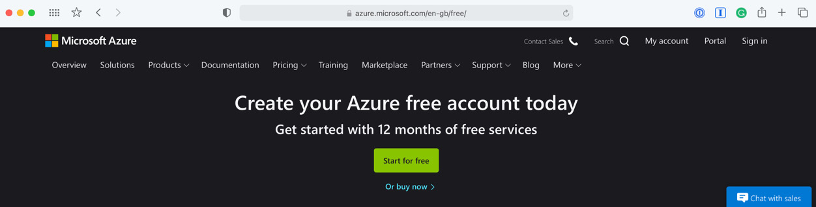
Figure 16.1 – Creating your Azure free account
At the time of writing, your free account includes 12 months of popular services, $200 of credit that can be used to explore and test the different Azure services, and access to over 25 services that will always be free.
Click on the Start for free button and follow the onscreen instructions. The sign-up process will take about 15 minutes and you will need to provide valid credit or debit card information to complete the process and gain access to your free account.
Once you have access to your account, the next step is to install the Azure CLI.

The Azure CLI
Microsoft provides a powerful cross-platform command-line tool for managing your Microsoft Azure resources. Installing it on the three main operating systems couldn't be simpler.
Installing on macOS
If you have been following along with the previous two chapters, then you may have already guessed that we will be using Homebrew to install the Azure CLI on macOS. To do this, simply run the following command:
$ brew install azure-cli
Once installed, run the following command:
$ az –version
This should return something similar to the following screenshot:
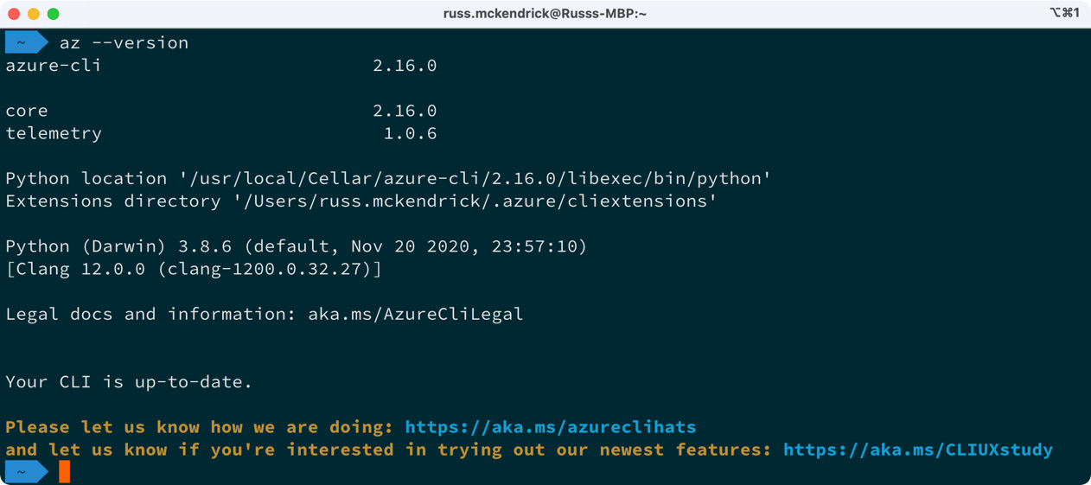
Figure 16.2 – Checking the Azure CLI version on macOS
Once installed, you can move on to the Configuring the Azure CLI section of this chapter.
Installing on Windows
There are few ways you can install the Azure CLI on Windows:
The first is to download a copy of the installer from https://aka.ms/installazurecliwindows and then execute it by double-clicking on it.
The next option is to use the following PowerShell command, which will download the installer from the preceding URL and install it:
$ Invoke-WebRequest -Uri https://aka.ms/installazurecliwindows -OutFile .\AzureCLI.msi; Start-Process msiexec.exe -Wait -ArgumentList '/I AzureCLI.msi /quiet'; rm .\AzureCLI.msi
The third option is to use the Chocolatey package manager and run the following command:
$ choco install azure-cli
Whichever way you choose to install the package, run the following command once it has been installed to find out the version number:
$ az –version
You should see something like the following screen:
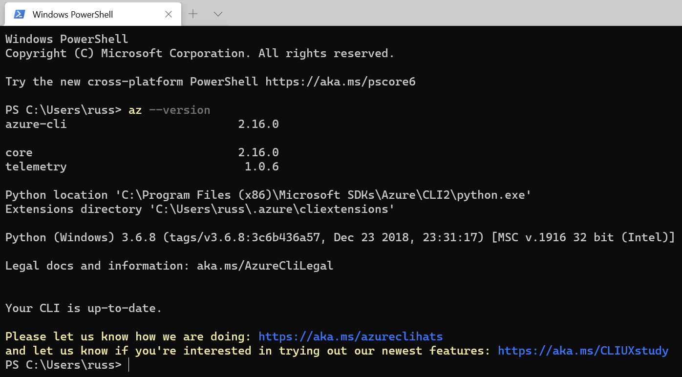
Figure 16.3 – Checking the Azure CLI version on Windows
Once installed, you can move on to the Configuring the Azure CLI section.
Installing on Linux
Microsoft provides an installation script that covers the most common Linux distributions. To run the script, use the following command:
$ curl -L https://aka.ms/InstallAzureCli | bash
Once installed, you will need to restart your session. You can do this by logging out and then back in, or on some distributions by running the following command:
$ source ~/.profile
Once you have restarted your session, run the following command:
$ az –version
This will return information on the version of the Azure CLI installed:
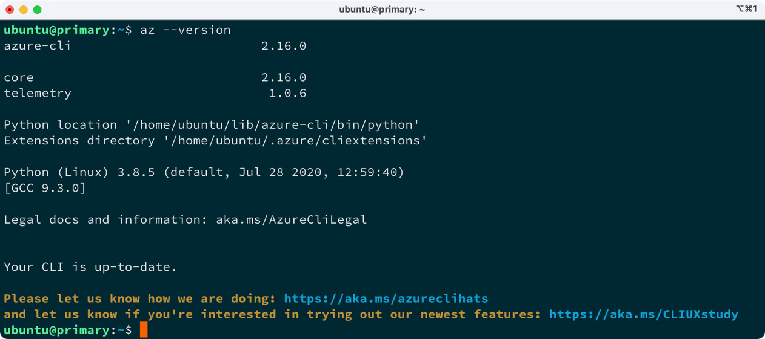
Figure 16.4 – Checking the Azure CLI version on Linux
Now we have the Azure CLI installed, we can configure it.
Configuring the Azure CLI
Configuring the Azure CLI is a really straightforward process; you just need to run the following command:
$ az login
This will open up your default browser where you will be asked to log in. If you are having problems or running a command-line-only installation of the Azure CLI (on a remote Linux server for example), then running the following command will give you a URL and unique sign-in code to use:
$ az login –use-device-code
Once logged in, your command-line session should return some information on your Azure account. You can view this again by using the following command:
$ az account show
If, for any reason, you are not able to install the Azure CLI locally, all is not lost, as there is a web-based terminal with the Azure CLI you can use in the Azure portal. We are going to look at this next.
Accessing Azure Cloud Shell
To get access to Azure Cloud Shell, open https://portal.azure.com/ and log in with your credentials. Once logged in, you can click on the Cloud Shell icon in the menu bar, which can be found at the top of the page – it is the first icon next to the central search box.
If you have previously opened a Cloud Shell session, then it will launch straight away. If you receive a message saying You have no storage mounted, resolve this by making sure that your subscription is selected correctly from the drop-down box:
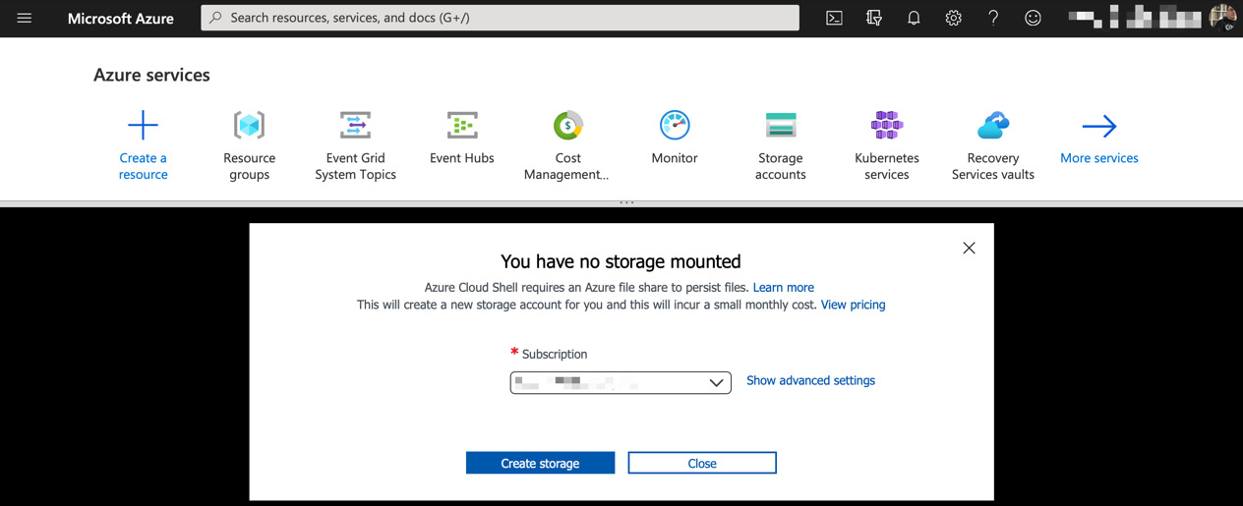
Figure 16.5 – Setting up Cloud Shell
Then, click on the Create storage button. After about a minute, your Cloud Shell should open, and you will be presented with a command prompt:
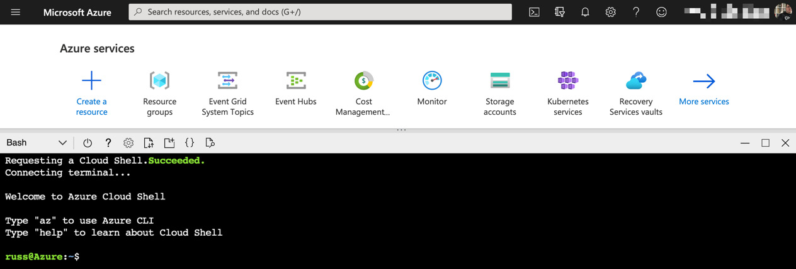
Figure 16.6 – Your Cloud Shell command prompt
Now that you have a command prompt, running the following command, as we did on the local Azure CLI installation, will give you information on the version of the Azure CLI installed:
$ az --version
You will not need to run the az login command as the Azure portal took care of that for you in the background when your Cloud Shell instance launched.
Now that you have access to a configured Azure CLI, in one form or another, we can look at launching our AKS cluster.

Launching your AKS cluster
Launching your AKS cluster requires two commands. The first command creates an Azure resource group:
$ az group create --name k8sforbeginners-rg --location eastus -o table
In the preceding command, we are creating a resource group called k8sforbeginners-rg in the eastus region and setting the output to be formatted as a table rather than JSON, which is the default output type for the Azure CLI.
Information
A resource group is a logical container used to group related Azure resources. Services launched within the resource group can inherit settings such as role-based access controls, locks, and even the location.
Once the resource group has been created, you should see something like the following output:
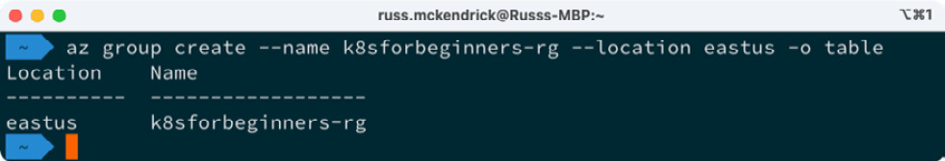
Figure 16.7 – Creating the resource group
Now that we have our resource group, we can launch our AKS cluster by running the following command:
$ az aks create --resource-group k8sforbeginners-rg --name k8sforbeginners-aks --node-count 2 --enable-addons monitoring --generate-ssh-keys -o yaml
Launching the cluster will take about 5 minutes, so while that is running I will work through the options we passed to the preceding az aks create command:
--resource-group is the name of the resource group you want to launch your AKS cluster in. The cluster will inherit the resource group's location. In our example, we are using the k8sforbeginners-rg resource group we created in the command before last.
--name is the name of the cluster you are launching. We are calling ours k8sforbeginners-aks.
--node-count is the number of nodes you want to launch. We are launching 2. At the time of writing, the default instance type for nodes is Standard_DS2_v2, meaning that each node will have 2 vCPUs and 7 GB of RAM.
--enable-addons is used to supply a list of add-ons to enable while the cluster is being launched – we are just enabling the monitoring add-on.
--generate-ssh-keys will generate SSH public and private key files for the cluster.
-o determines the output. At this time, we are outputting the results returned when we run the command as yaml because the output is more readable than both the JSON and table options.
Once your cluster has launched, you should see something like the following output:
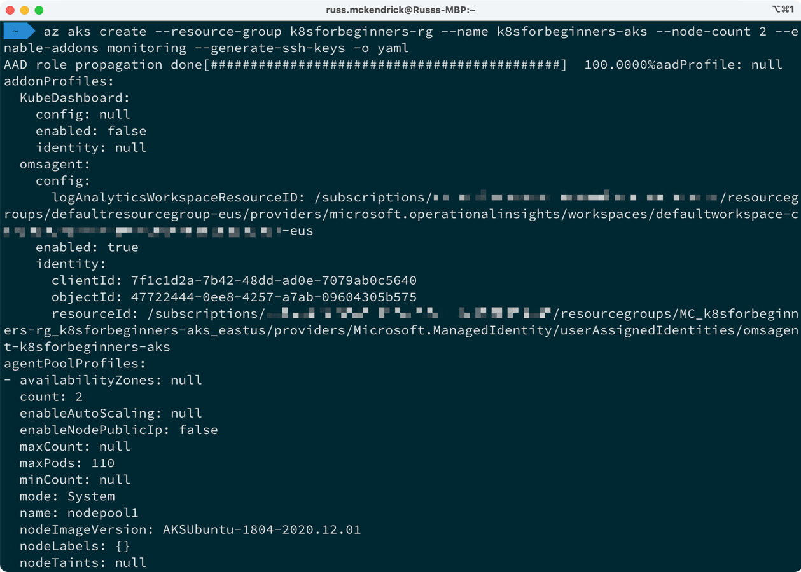
Figure 16.8 – Viewing the output of the cluster launch
As you can see, there is a lot of information. We are not going to worry about any of this though, as we will be using the Azure CLI and portal to interact with the cluster.
Now that our cluster has launched, we need to configure our kubectl client so that it can interact with the cluster. To do this, run the following command:
$ az aks get-credentials --resource-group k8sforbeginners-rg --name k8sforbeginners-aks
Once run, you should see something like the following:
Figure 16.9 – Grabbing the credentials and configuring kubectl
This now means that you can start to interact with your cluster, for example, by running the following command:
$ kubectl get nodes
This will return the nodes within the cluster, as seen in the following screenshot:
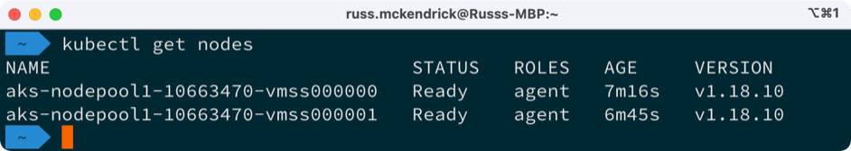
Figure 16.10 – Viewing the nodes in the cluster
Now that we have our cluster launched and our local kubectl client configured with the cluster details and credentials, we can launch our test workload.

Deploying a workload and interacting with your cluster
We are going to be using the same workload we launched in Chapter 14, Kubernetes Clusters on Google Kubernetes Engine, and Chapter 15, Launching a Kubernetes Cluster on Amazon Web Services with Amazon Elastic Kubernetes Service, so I am not going to go into detail here other than to cover the commands.

Launching the workload
As per the previous chapters, there are three main steps to launching our workload:
Create the Redis leader deployment and service:
$ kubectl apply -f https://raw.githubusercontent.com/GoogleCloudPlatform/kubernetes-engine-samples/master/guestbook/redis-leader-deployment.yaml
$ kubectl apply -f https://raw.githubusercontent.com/GoogleCloudPlatform/kubernetes-engine-samples/master/guestbook/redis-leader-service.yaml
Create the Redis follower deployment and service:
$ kubectl apply -f https://raw.githubusercontent.com/GoogleCloudPlatform/kubernetes-engine-samples/master/guestbook/redis-follower-deployment.yaml
$ kubectl apply -f https://raw.githubusercontent.com/GoogleCloudPlatform/kubernetes-engine-samples/master/guestbook/redis-follower-service.yaml
Create the Guestbook frontend deployment and service:
$ kubectl apply -f https://raw.githubusercontent.com/GoogleCloudPlatform/kubernetes-engine-samples/master/guestbook/frontend-deployment.yaml
$ kubectl apply -f https://raw.githubusercontent.com/GoogleCloudPlatform/kubernetes-engine-samples/master/guestbook/frontend-service.yaml
The final command to run gets the address of the frontend service:
$ kubectl get service frontend
This should return something like the following screenshot:
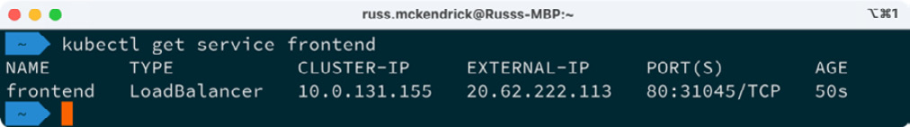
Figure 16.11 – Getting the external IP address of the frontend service
Direct your browser to the IP address and you should be greeted with the Guestbook application. As before, I have added a few test entries:
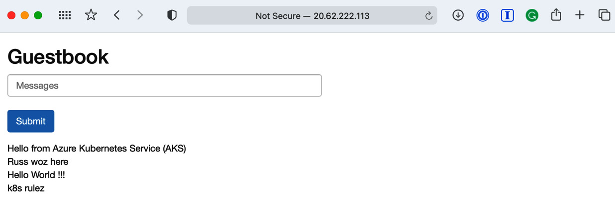
Figure 16.12 – Viewing the Guestbook application
Now that the workload is up and running, we can move to the Azure portal.

Exploring the Azure portal
If you haven't already, log in to the Azure portal found at https://portal.azure.com/. Once logged in, enter kube into the Search resources, services, and docs search box at the very top of the page.
Under the list of services, you will see Kubernetes services – click on this service and you will be be presented with a list of Kubernetes services you have launched within your subscription.
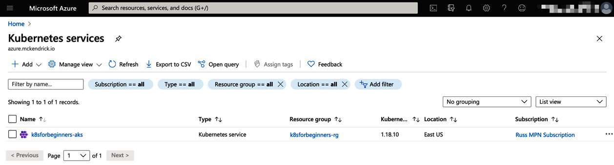
Figure 16.13 – Listing the Kubernetes services
Clicking on k8sforbeginners-aks will take you to an overview page. This will be our jumping-off point for viewing information about our workload and cluster.
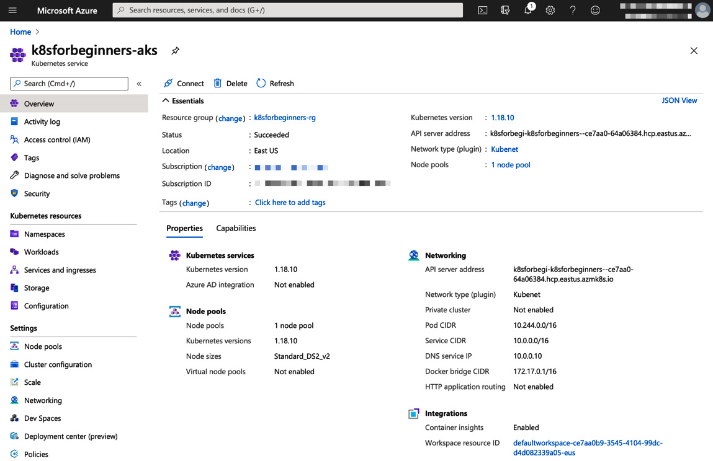
Figure 16.14 – The cluster overview
Under the Kubernetes resources menu on the left, you will see several options. Let's work through them one by one:
Namespaces: Here you will find all the namespaces active within the cluster. As we didn't define a namespace when we launched our workload, our deployments and services will be listed under the default namespace.
As well as the default namespace, there are also the ones deployed as part of the cluster, namely, kube-node-lease, kube-public, and kube-system. I would recommend leaving these alone.
If you were to click on the default namespace, you would be presented with the Overview page, where you can edit the YAML that defines the namespaces, along with an Events log.
Workloads | Deployments: Here, as you may have already guessed, is where you can view information on your workloads. In the following screenshot, I have filtered the list to only show the workloads in the default namespace:
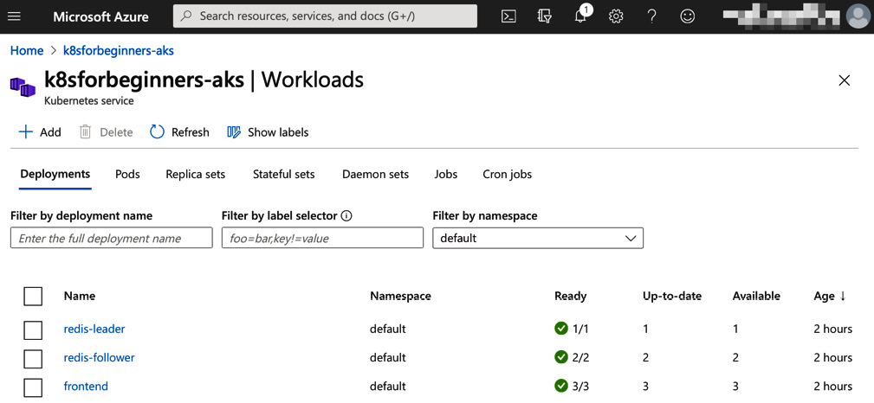
Figure 16.15 – Viewing the deployments
Clicking on one of the deployments will give you a more detailed view of the deployment. For example, selecting the frontend deployment shows the following:
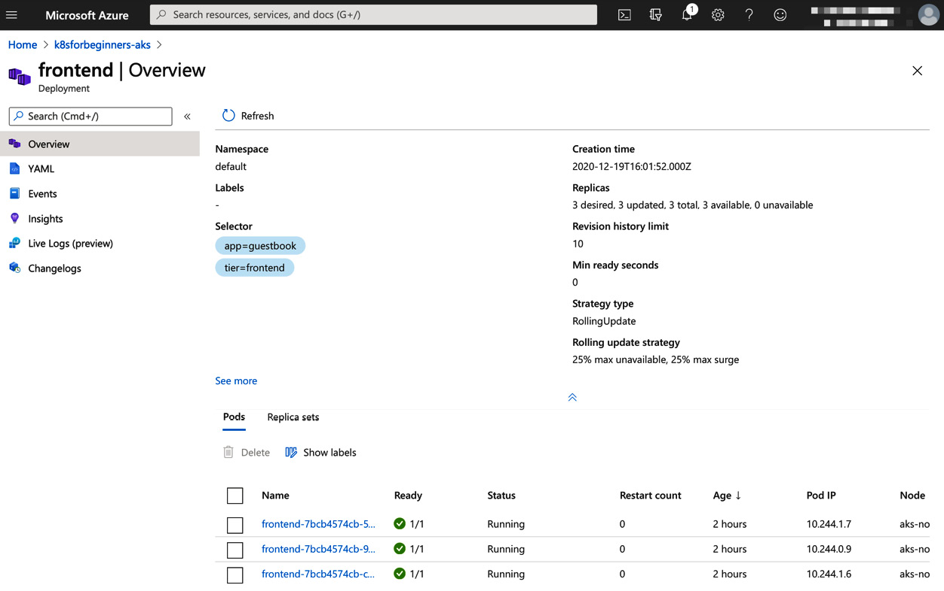
Figure 16.16 – An overview of the frontend deployment
As you can see from the menu on the left, there are a few additions to the options: as well as YAML and Events, we also have the option to view Insights. We will take a closer look at this at the end of this section when we cover Insights in more detail.
The next option is Live Logs, which, at the time of writing, is in preview. Here, you can select one of the deployed pods and stream the logs in real time.
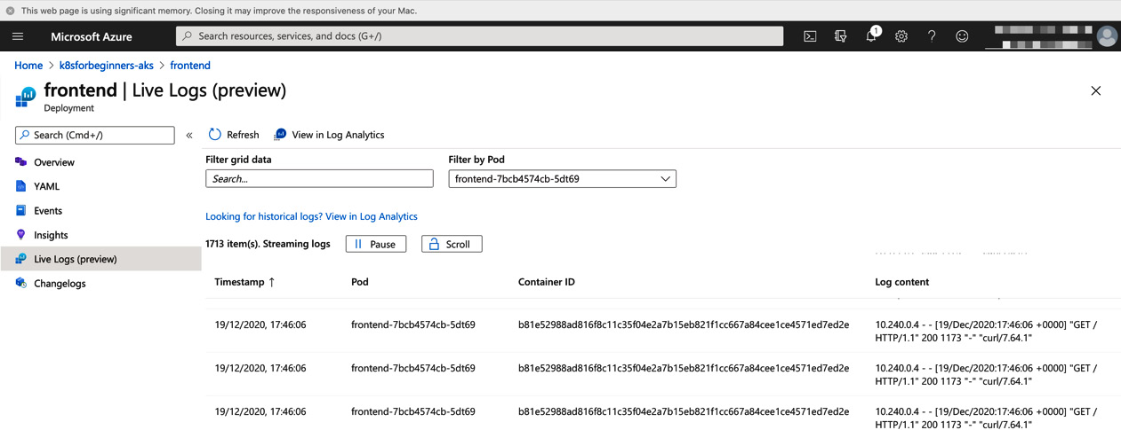
Figure 16.17 – Viewing the pod logs in real time
The Changelogs option displays any changelogs available as part of your deployment.
Workloads | Pods: Here, you can view a list of the pods that make up your workload. The IP address along with the node the pod is active on are listed. This is a useful view to get a quick overview of all of your running pods.
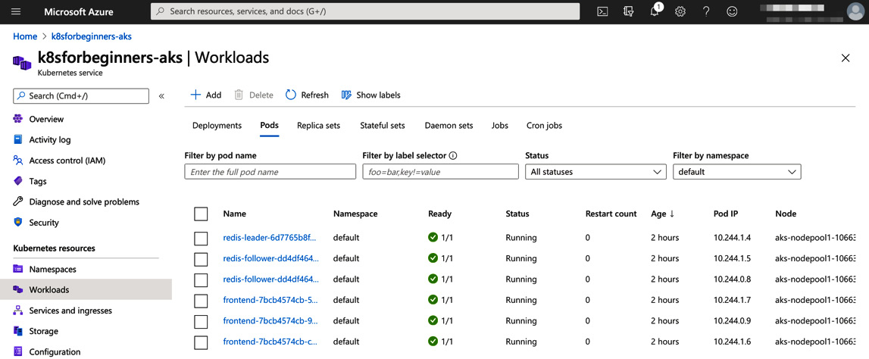
Figure 16.18 – Viewing all of your pods
Clicking on one of the pods will give you an Overview, and show you the YAML and also any Events for the pod.
Workloads | Replica sets is another useful view for getting an at-a-glance view of the replica sets deployed as part of your workload.
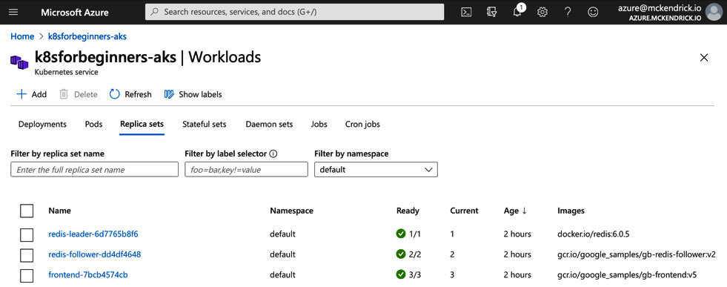
Figure 16.19 – Viewing the replica sets
Clicking on one of the replica sets gives you the now-familiar options of Overview, YAML, and Events.
Workloads | Stateful sets: While we don't have any stateful sets deployed as part of our workload, clicking to view all of the namespaces will show the stateful sets deployed by Microsoft as part of the cluster. These are the Azure OMS Agent (omsagent) used for monitoring our cluster – there is one of these deployed per node at all times – and the Proxy service (kube-proxy).
Workloads | Jobs and Cron jobs: Under these tabs, you will find details of any jobs and cron jobs you have deployed within the cluster.
Services and ingresses: Here, you will be able to find a list of all of the services you have deployed in your cluster. As you can see from the following screenshot, you can get an overview of the Cluster IP used for the service along with any External IP you have configured:
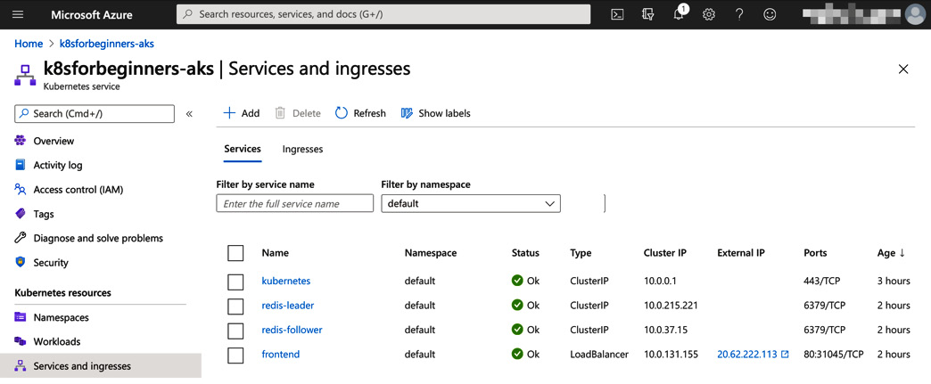
Figure 16.20 – Viewing the services
Clicking on one of the services listed will provide the now-familiar view and allow you to drill deeper into the configuration of the services.
Storage: If we had any persistent storage configured within the cluster, you would be able to view the details here.
Configuration: The final option under the Kubernetes resources menu allows you to view and edit any Config maps or Secrets you have configured within the cluster. As we don't have any of these configured in our workload, the ones listed are for the cluster itself, so I wouldn't recommend making any changes to the items present.
As you can see, there is a wealth of options available to get information about all of the parts that make up your Kubernetes workload.
The next section in the left-hand menu covers the settings of the cluster itself. Here is a quick overview of what you can find:
Node pools: Here you will find details of the node pool you have, along with the options to Upgrade the Kubernetes version running within the pool. This option is only available if you upgrade the version of Kubernetes running on the control plane.
You can also Scale the pool and have the option to Add a node pool. In the following screenshot, we can see what the scale option looks like:
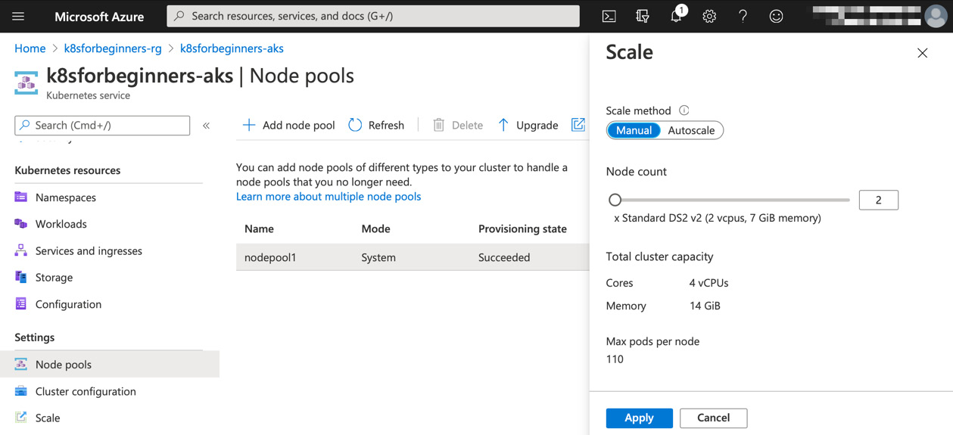
Figure 16.21 – Node pool scale options
Cluster configuration: In the last point, I mentioned that you can only upgrade the Kubernetes version running within your node pools if you upgrade the control plane, and this option is where you do that. The control plane is managed by Microsoft and is separate to your node pools. The Kubernetes control plane offers backward compatibility by up to three releases, so normally you would only be able to upgrade within three releases of the version you are currently running.
Scale: While, at the time of writing, this option is still listed as its own option, the page does mention that the scale functions have been moved to the Node pool section and that this page will be removed at some point.
Networking: Here you will find both information and configuration options for the networking of your cluster. This is quite a dense subject and I recommend following the link on the page for more information on the options available when it comes to networking and your AKS cluster.
Dev Spaces: Like the Scale option, this has again been deprecated. Microsoft at one point offered an IDE based on Visual Studio Code called Dev Spaces, but this service is due to be retired and Microsoft are now recommending you use Bridge to Kubernetes in Visual Studio and Visual Studio Code.
Deployment center: This service is still in preview, but here you can add and configure an Azure DevOps pipeline to deploy your application straight into your cluster.
Policies: One of the big selling points of Microsoft Azure is the centralized means it offers for managing policies. Enabling this add-on will extend the Azure policy service into your AKS cluster, giving you a way to centrally manage and report on policies.
Properties: This provides a quick overview of your AKS cluster.
Locks: Here, you can add a resource lock that will protect your cluster from accidental deletion or from any configuration changes that may affect the running of your AKS cluster.
The last part of the Azure portal we are going to look at is the Insights option found under the Monitoring menu in the cluster view. As you may recall, when we deployed our cluster, we enabled the monitoring add-on using the --enable-addons monitoring flag.
What this did was enable the OMS Agent stateful set, which we saw when we looked at the Stateful set page under the Workloads section. The OMS Agent is the tool used by Microsoft to ship data from a resource to the Azure Log Analytics service. Once the data has been shipped to this service, Microsoft then presents this information back to you, most commonly as Insights. Most Azure services have an Insights option and the data here can be used by Azure Monitor to create and generate alerts.
Clicking on Insights will bring up a page similar to the following:
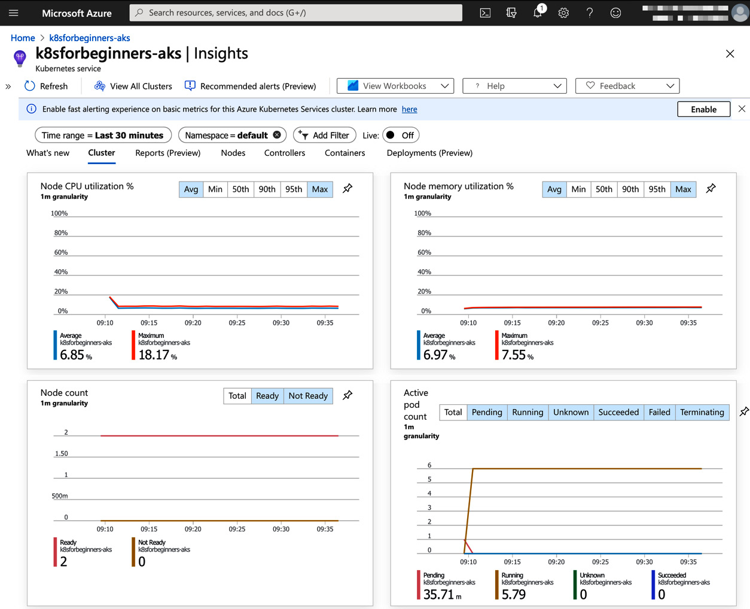
Figure 16.22 – Viewing some of the cluster insights
There are a few options under Insights – let's take a look:
Cluster: This is shown in the preceding screenshot and gives you a quick view of the CPU and memory utilization across the whole cluster. It also shows both Node and pod counts.
Reports: At the time of writing, this is in preview. Here you can find pre-written reports around Node monitoring (performance), Resource monitoring (availability), Billing, and also Networking. As the service matures, more reports will be added.
Nodes: Here you can get an overview of your Nodes.
Controllers: This is where you will find details on the controllers launched within your cluster – for example, the Replica and Daemon sets.
Containers: Here you can find details of all the containers running on the pods you have deployed.
Deployments: This option shows a list of your deployments.
Now you may think there is a lot of repetition in the preceding sections – and there is a little bit of that; however, if you need to see what is going on within your cluster quickly, you now have a way of getting that information without having to drill through a lot of pages to find it.
I recommend having a look around and clicking on as many options as you can to explore the level of integration of your cluster and the Azure portal. Once you have finished, it is time for us to remove the cluster.

Deleting your AKS cluster
The final thing we are going to look at is how to delete the cluster. Moving back to the Azure CLI, all we need to run to delete the cluster is the following command:
$ az aks delete --resource-group k8sforbeginners-rg --name k8sforbeginners-aks
You will be asked if you are sure – answering yes will proceed to delete the cluster.
The process takes about 5 minutes. The preceding command only deletes the cluster itself and not the resource group. To delete the latter, run the following command:
$ az group delete --name k8sforbeginners-rg
Again, you will be asked if you want to delete the group – just answer yes.
So how much would our cluster cost to run?
Unlike the other two cloud services we looked at in the previous two chapters, there is no charge for cluster management, and all that you need to pay for is the compute resource.
So, in our case, 2 x Standard_DS2_v2 instances in US East would cost around $213 per month. There are other options, such as new generations of instances that could give us a similar-sized cluster for less money. For example, we could launch a different cluster using the following commands:
$ az group create --name k8sforbeginners-rg --location eastus -o table
$ az aks create --resource-group k8sforbeginners-rg --name k8sforbeginners-aks --node-count 2 --enable-addons monitoring --generate-ssh-keys --node-vm-size standard_ds3_v2 -o yaml
This will give us a two-node cluster with a total of 4 vCPUs and 16 GB of RAM for around $140 per month.

Summary
In this chapter, we looked at how Microsoft Azure came to be, along with a little bit of the history behind some of the container services offered by Microsoft, and how they eventually settled on AKS.
We then signed up for an Azure account and installed and configured the Azure CLI before launching our own AKS cluster. Once launched, we deployed the same workload we deployed to our Google Kubernetes Engine and Amazon Elastic Kubernetes Service clusters.
Once the workload was deployed, we moved onto the Azure portal and looked at the options for gaining insights into our workload and cluster as well as some of the cluster management options.
We then finally deleted the resources we launched, and discussed how much the cluster would cost to run.
Out of the three public cloud services we have looked at over the last three chapters, I personally believe that Microsoft has come up with the most rounded and feature-rich offering.
I would put Google's offering, which we discussed in Chapter 14, Kubernetes Clusters on Google Kubernetes Engine, at a close second, as technically it is good, but their pricing makes it difficult to recommend. This leaves Amazon's service, covered in Chapter 15, Launching a Kubernetes Cluster on Amazon Web Services with Amazon Elastic Kubernetes Service. AWS comes in as my least recommend service – it simply doesn't feel as polished as the offerings by Microsoft and Google in that it should feel like you are launching a service to complement other services offered by the cloud provider, but instead it really feels like you just happen to be running a Kubernetes cluster in AWS.
Personal opinion aside, the key takeaway from having launched a Kubernetes cluster in three very different public cloud services is that once you have your cluster up and running, and your kubectl client configured to interact with it, the experience is pretty much the same and your workload really doesn't care where it is launched. You also don't have to take into consideration the differences between the three providers – only just a few years ago, this seemed like an unthinkable situation, and truly cloud-agnostic workloads were just a pipe dream.
In the next section of this book, we are going to look at some more advanced Kubernetes usage, starting with Helm charts – all of which can be applied to clusters launched in the public clouds we have discussed in this and the previous two chapters.

Further reading
Here are links to more information on some of the topics and tools covered in this chapter:
Microsoft Azure: https://azure.microsoft.com/
AKS: https://azure.microsoft.com/services/kubernetes-service/
AKS official documentation: https://docs.microsoft.com/en-us/azure/aks/
Azure DevOps: https://azure.microsoft.com/services/devops/
Bridge to Kubernetes documentation: https://code.visualstudio.com/docs/containers/bridge-to-kubernetes
Bridge to Kubernetes (Visual Studio): https://marketplace.visualstudio.com/items?itemName=ms-azuretools.mindaro
Bridge to Kubernetes (Visual Studio Code): https://marketplace.visualstudio.com/items?itemName=mindaro.mindaro

Section 5: Advanced Kubernetes
There is still a lot to say about Kubernetes. In this section, we are going to discuss some other advanced Kubernetes topics. These topics are not forcibly linked together, but it's nice to discuss all of them. We will discover the Helm package manager, advanced techniques for scheduling, the Ingress resource, and more.
This part of the book comprises the following chapters:
Chapter 17, Working with Helm Charts
Chapter 18, Authentication and Authorization on Kubernetes
Chapter 19, Advanced Techniques for Scheduling Pods
Chapter 20, Autoscaling Kubernetes Pods and Nodes
Chapter 21, Advanced Traffic Routing with Ingress

Chapter 17: Working with Helm Charts
As part of the application development process, you need to think about application redistribution and dependency management. You may want this as part of your final product offering – the application needs to be easily downloaded and installed by the customers. But you may also want to redistribute the application or a component internally for other teams working on the same product. In the non-container world, you have a variety of package management systems (or package managers). If you work on Ubuntu, you can use the Advanced Package Tool (APT) to install software. On Windows, you can use Chocolatey (https://chocolatey.org/), and if you are interested in libraries or applications specific to JavaScript, you can use npm.
Kubernetes is no exception, and it has its own dedicated package managers implemented by the community, the most popular of which is currently Helm (https://helm.sh/). In general, Helm is currently regarded as the industry standard for internal and external redistribution of your Kubernetes applications, with the largest repository of stable Helm charts (currently available as part of Artifact Hub: https://artifacthub.io/). You can use Helm charts to quickly deploy different components in your Kubernetes cluster. For example, if you need to have a scalable Elasticsearch cluster for your logs, no problem – you can deploy a fully functional cluster in a matter of minutes!
By the end of this chapter, you will know the most important principles behind Helm and Helm chart development, and additionally, we will demonstrate how you can install some popular components and solutions using the official stable Helm charts. With this knowledge, you will be able to quickly set up your Kubernetes development environment or even plan for redistribution of your Kubernetes application as a dedicated Helm chart.
In this chapter, we will cover the following topics:
Understanding Helm
Releasing software to Kubernetes using Helm
Helm chart anatomy
Installing popular solutions using Helm charts

Technical requirements
For this chapter, you will need the following:
A Kubernetes cluster deployed. We recommend using a multi-node, cloud-based Kubernetes cluster. It is possible to run Helm on minikube, but you may encounter limitations as not all functionalities of real clusters are supported.
The Kubernetes command-line interface (CLI) (kubectl) installed on your local machine and configured to manage your Kubernetes cluster.
Basic Kubernetes cluster deployment (local and cloud-based) and kubectl installation have been covered in Chapter 3, Installing Your First Kubernetes Cluster.
The following previous chapters can give you an overview of how to deploy a fully functional Kubernetes cluster on different cloud platforms:
Chapter 14, Kubernetes Clusters on Google Kubernetes Engine
Chapter 15, Launching a Kubernetes Cluster on Amazon Web Services with the Amazon Elastic Kubernetes Service
Chapter 16, Kubernetes Cluster on Microsoft Azure with Azure Kubernetes Service
You can download the latest code samples for this chapter from the official GitHub repository: https://github.com/PacktPublishing/The-Kubernetes-Bible/tree/master/Chapter17.

Understanding Helm
The simplest way to distribute your Kubernetes application to others so that they can deploy it on their cluster is by sharing the Kubernetes objects' YAML manifest files, for example using a public source repository such as https://github.com/. This approach is often used as a basic showcase of how you can run a given application as a container on Kubernetes. However, sharing raw YAML manifests has quite a few disadvantages:
All values in YAML templates are hardcoded. This means that if you want to change the number of replicas of a Service object or a value stored in the ConfigMap object, you need to go through the manifest files, find the values you want to configure, and then edit them. Similarly, if you want to deploy the manifests to a different namespace in the cluster than the creators intended, you need to edit all YAML files. On top of that, you do not really know which values in the YAML templates are intended to be configurable by the creator unless they document this.
The Deployment process may be different for each application. There is no standardization in which YAML manifests the creator would provide and which components you need to deploy yourself.
No dependency management. For example, if your application requires a MySQL server running as a StatefulSet in the cluster, you either need to deploy it yourself or rely on the creator of the application to provide YAML manifests for the MySQL server.
This is a bit similar to what you see with desktop applications in the Windows ecosystem if you do not use Windows Store or a package manager such as Chocolatey. Some applications that you download will come with an installer as a .exe file, some as a .msi, and others will be just .zip files that you need to extract and configure yourself.
In Kubernetes, you can use Helm, which is the most popular package manager for Kubernetes applications and services. If you are familiar with popular package managers such as APT, yum, npm, or Chocolatey, you will find many concepts in Helm similar and easy to understand. The following are the three most important concepts in Helm:
A chart is a Helm package. This is what you install when you use the Helm CLI. A Helm chart contains all Kubernetes YAML manifests required to deploy the application on the cluster. Please note that these YAML manifests may be parametrized, so that you can easily inject configuration values provided by the user that installs the chart.
A repository is a storage location for Helm charts that is used for collecting and sharing charts. They can be public or private – there are multiple public repositories that are available, which you can browse on Artifact Hub (https://artifacthub.io/packages/search?page=1&kind=0). Up until recently, there was one main, official Helm charts repository (https://github.com/helm/charts). This gathered all stable and incubating charts and was maintained by Google. This repository is now deprecated and using Artifact Hub is the recommended way to discover charts and repositories. Private repositories are usually used for distributing components running on Kubernetes between teams working on the same product.
A release is an instance of a Helm chart that was installed and is running in a Kubernetes cluster. This is what you manage with the Helm CLI, for example by upgrading or uninstalling it. You can install one chart many times on the same cluster and have multiple releases of it that are identified uniquely by release names.
Tip
In short, Helm charts contain parametrizable YAML manifests that you store in a Helm repository for distribution. When you install a Helm chart, a Helm release is created in your cluster that you can further manage.
Let's quickly summarize the most common use cases for Helm:
Deploying popular software to your Kubernetes cluster. This makes development on Kubernetes much easier – you can deploy third-party components to the cluster in a matter of seconds. The same approach may be used in production clusters. You do not need to rely on writing your own YAML manifest for such third-party components.
Helm charts provide dependency management capabilities. If chart A requires chart B to be installed first with specific parameters, Helm supports syntax for this out of the box.
Sharing your own applications as Helm charts. This can include packaging a product for consumption by the end users or using Helm as an internal package and dependency manager for microservices in your product.
Ensuring that the applications receive proper upgrades. Helm has its own process for upgrading Helm releases.
Configuring software deployments for your needs. Helm charts are basically generic YAML templates for Kubernetes object manifests that can be parametrized. Helm uses Go templates (https://godoc.org/text/template) for parametrization. If you are familiar with Go then you will be at home; if not, you will find it pretty similar to other templating systems, such as Mustache (https://mustache.github.io/).
Currently, Helm is distributed as a binary client (library) that has a CLI similar to kubectl. All operations that you perform using Helm do not require any additional components to be installed on the Kubernetes cluster. Please note that this has changed with the release of version 3.0.0 of Helm. Previously, the architecture of Helm was different, and it required a special, dedicated service running on Kubernetes named Tiller. This was causing various problems such as security around role-based access control (RBAC) and elevated-privilege Pods running inside the cluster. You can read more about the differences between the latest major version of Helm and previous ones in the official FAQ: https://helm.sh/docs/faq/#changes-since-helm-2. This is useful to know if you find any online guides that still mention Tiller – they are most likely intended for older versions of Helm.
Now, we are going to install Helm and deploy a simple Helm chart from Artifact Hub to verify that it works correctly on your cluster.

Releasing software to Kubernetes using Helm
In this section, you will learn how to install Helm and how to test the installation by deploying an example Helm chart. Helm is provided as binary releases (https://github.com/helm/helm/releases) available for multiple platforms. You can use them or refer to the following guides for installation using a package manager on your desired operating system.

Installing Helm on Ubuntu
To install Helm on Ubuntu, you need to first add the official APT repository using the following commands:
$ curl https://baltocdn.com/helm/signing.asc | sudo apt-key add –
$ sudo apt-get install apt-transport-https –yes
$ echo "deb https://baltocdn.com/helm/stable/debian/ all main" | sudo tee /etc/apt/sources.list.d/helm-stable-debian.list
$ sudo apt-get update
After that, the installation is straightforward using APT – use the following command:
$ sudo apt-get install helm
Verify that the installation was successful by trying to get the Helm version from the command line:
$ helm version
version.BuildInfo{Version:"v3.5.3", GitCommit:"041ce5a2c17a58be0fcd5f5e16fb3e7e95fea622", GitTreeState:"dirty", GoVersion:"go1.15.8"}
Once installed, you can move on to Deploying an example chart in this section.

Installing Helm on Windows
To install Helm on Windows, the easiest way is to use the Chocolatey package manager. If you have not used Chocolatey before, you can find more details and the installation guide in the official documentation: https://chocolatey.org/install.
Execute the following command to install Helm:
$ choco install kubernetes-helm
Verify that the installation was successful by trying to get the Helm version from the command line:
$ helm version
version.BuildInfo{Version:"v3.5.3", GitCommit:"041ce5a2c17a58be0fcd5f5e16fb3e7e95fea622", GitTreeState:"dirty", GoVersion:"go1.15.8"}
Once installed, you can move on to Deploying an example chart in this section.

Installing Helm on macOS
To install Helm on macOS, you can use the standard Homebrew package manager. Use the following command to install the Helm formula:
$ brew install helm
Verify that the installation was successful by trying to get the Helm version from the command line:
$ helm version
version.BuildInfo{Version:"v3.5.3", GitCommit:"041ce5a2c17a58be0fcd5f5e16fb3e7e95fea622", GitTreeState:"dirty", GoVersion:"go1.15.8"}
Once installed, we can deploy an example chart to verify that Helm works properly on your Kubernetes cluster.

Deploying an example chart
By default, Helm comes with no repositories configured. One possibility, which is no longer recommended, is to add the stable repository so that you can browse the most popular Helm charts:
$ helm repo add stable https://charts.helm.sh/stable
Please note that most charts are now in a process of deprecation as they are moved to different Helm repositories where they will be maintained by the original creators. You can see this if you try to search for available Helm charts using the helm search repo command:
$ $ helm search repo stable
NAME CHART VERSION APP VERSION DESCRIPTION
stable/acs-engine-autoscaler 2.2.2 2.1.1 DEPRECATED Scales worker nodes within agent pools
stable/aerospike 0.3.5 v4.5.0.5 DEPRECATED A Helm chart for Aerospike in Kubern...
stable/airflow 7.13.3 1.10.12 DEPRECATED - please use: https://github.com/air...
...
Instead, the new recommended way is to use the helm search hub command, which allows you to browse the Artifact Hub directly from the CLI:
$ helm search hub
URL CHART VERSION APP VERSION DESCRIPTION
https://artifacthub.io/packages/helm/gabibbo97/... 0.1.0 fedora-32 389 Directory Server
https://artifacthub.io/packages/helm/aad-pod-id... 3.0.3 1.7.4 Deploy components for aad-pod-identity
https://artifacthub.io/packages/helm/arhatdev/a... 0.1.0 latest Network Manager Living at Edge
...
Now, let's try searching for one of the most popular Helm charts that we can use for testing our installation – we would like to deploy WordPress on our Kubernetes cluster. First, let's check what the available charts are for WordPress on Artifact Hub:
$ helm search hub wordpress
URL CHART VERSION APP VERSION DESCRIPTION
https://artifacthub.io/packages/helm/groundhog2... 0.3.0 5.7.0-apache A Helm chart for Wordpress on Kubernetes
https://artifacthub.io/packages/helm/bitnami/wo... 10.7.1 5.7.0 Web publishing platform for building blogs and ...
https://artifacthub.io/packages/helm/seccurecod... 2.5.2 4.0 Insecure & Outdated Wordpress Instance: Never e...
...
Similarly, you can directly use the Artifact Hub web UI (https://artifacthub.io/packages/search?page=1&ts_query_web=wordpress&kind=0) and search for WordPress Helm charts:
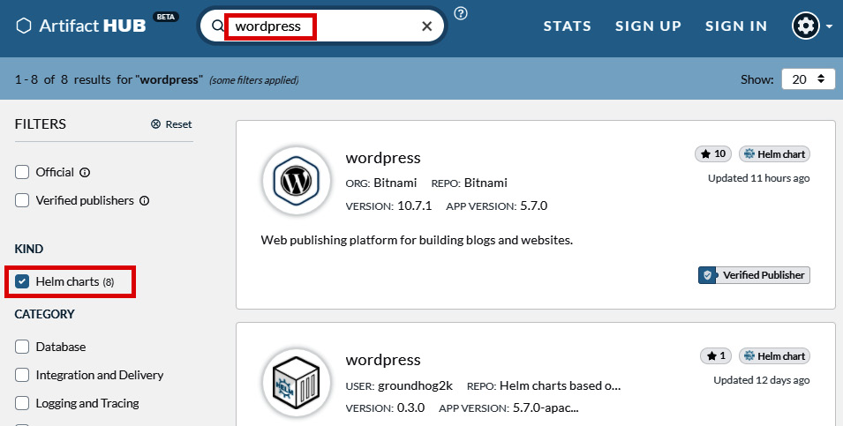
Figure 17.1 – Artifact Hub search results for WordPress Helm charts
We recommend using the Helm chart provided and maintained by Bitnami (https://bitnami.com/stacks/helm), a company specializing in distributing open source software on various platforms, such as Kubernetes. They were also maintainers of multiple charts in the deprecated stable repository. If you navigate to the search result for WordPress charts by Bitnami (https://artifacthub.io/packages/helm/bitnami/wordpress) you will see the following:
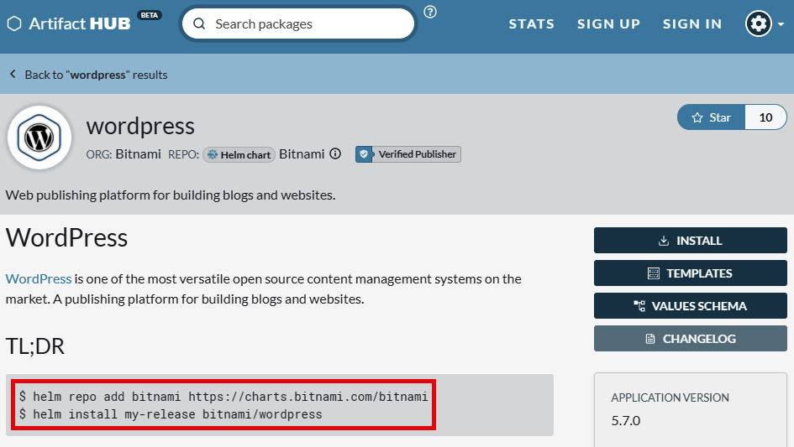
Figure 17.2 – Bitnami WordPress Helm chart on Artifact Hub with install instructions
The page gives you detailed information about how you can add the bitnami repository and how to install the Helm chart for WordPress. Additionally, you will find a lot of details about available configuration, known limitations, and troubleshooting. You can also navigate to the home page of each of the charts in order to see the YAML templates that make up the chart (https://github.com/bitnami/charts/tree/master/bitnami/wordpress).
We can now do the installation by following the instructions on the web page. First, add the bitnami repository to your Helm installation:
$ helm repo add bitnami https://charts.bitnami.com/bitnami
"bitnami" has been added to your repositories
With the repository present, we can install the bitnami/wordpress Helm chart as a wordpress-test-release Helm release with the default configuration:
$ helm install wordpress-test-release bitnami/wordpress
...
** Please be patient while the chart is being deployed **
Your WordPress site can be accessed through the following DNS name from within your cluster:
wordpress-test-release.default.svc.cluster.local (port 80)
To access your WordPress site from outside the cluster follow the steps below:
1. Get the WordPress URL by running these commands:
NOTE: It may take a few minutes for the LoadBalancer IP to be available.
Watch the status with: 'kubectl get svc --namespace default -w wordpress-test-release'
export SERVICE_IP=$(kubectl get svc --namespace default wordpress-test-release --template "{{ range (index .status.loadBalancer.ingress 0) }}{{.}}{{ end }}")
echo "WordPress URL: http://$SERVICE_IP/"
echo "WordPress Admin URL: http://$SERVICE_IP/admin"
2. Open a browser and access WordPress using the obtained URL.
3. Login with the following credentials below to see your blog:
echo Username: user
echo Password: $(kubectl get secret --namespace default wordpress-test-release -o jsonpath="{.data.wordpress-password}" | base64 --decode)
After a while, you will be provided with all the information required to monitor your Deployment of WordPress and how to log in to the WordPress instance. This is the beauty of Helm – you have executed a single helm install command and you are presented with a detailed guide of how to use the deployed component on your cluster. And meanwhile, the WordPress instance deploys without any intervention from you!
Tip
It is a good practice to first inspect what will be the Kubernetes objects' YAML manifests that were produced by Helm. You can do that by running the helm install command with additional flags: helm install wordpress-test-release bitnami/wordpress --dry-run --debug. The output will contain joint output of YAML manifests, and they will not be applied to the cluster.
Let's now follow the instructions from the Helm chart installation output:
Wait for the wordpress-test-release Service object (of the LoadBalancer type) to acquire external IP:
$ kubectl get svc --namespace default -w wordpress-test-release
NAME TYPE CLUSTER-IP EXTERNAL-IP PORT(S) AGE
wordpress-test-release LoadBalancer 10.0.62.91 52.226.146.38 80:32049/TCP,443:30351/TCP 9m18s
In our case, this will be 52.226.146.3. You may additionally verify that Pods are ready by checking the output of the kubectl get pods command.
You can also use further commands in the instruction to get the information in an automated way:
$ export SERVICE_IP=$(kubectl get svc --namespace default wordpress-test-release --template "{{ range (index .status.loadBalancer.ingress 0) }}{{.}}{{ end }}")
$ echo "WordPress URL: http://$SERVICE_IP/"
WordPress URL: http://52.226.146.38/
$ echo "WordPress Admin URL: http://$SERVICE_IP/admin"
WordPress Admin URL: http://52.226.146.38/admin
Now open your web browser and navigate to the WordPress admin URL:
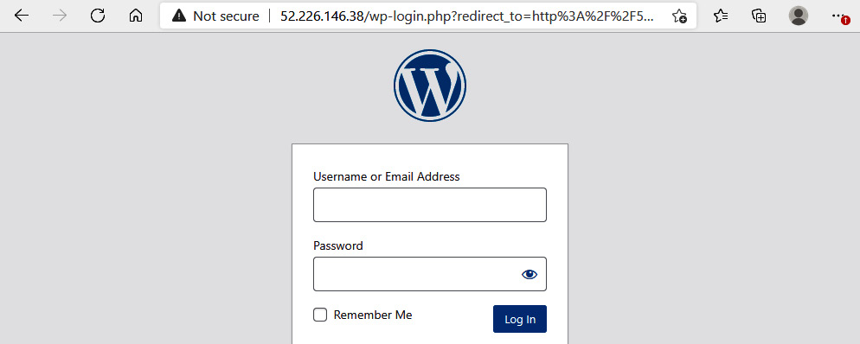
Figure 17.3 – WordPress chart deployed on Kubernetes – admin login page
Use the following commands to obtain the credentials that are stored in a dedicated wordpress-test-release Secret object deployed as part of the chart:
$ echo Username: user
Username: user
$ echo Password: $(kubectl get secret --namespace default wordpress-test-release -o jsonpath="{.data.wordpress-password}" | base64 --decode)
Password: <hidden>
Use the credentials to log in as the WordPress admin:
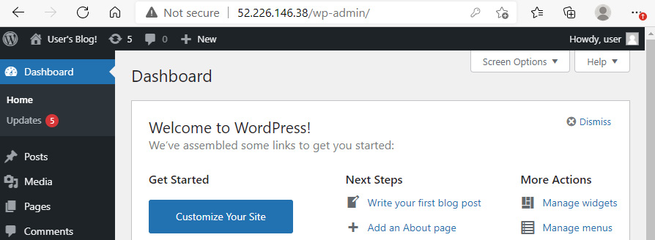
Figure 17.4 – WordPress chart deployed on Kubernetes – admin dashboard
You can enjoy your WordPress now, congratulations! If you are interested, you can inspect the Pods, Services, Deployments, and StatefulSets that were deployed as part of this Helm chart. This will give you a lot of insight into what the components of the chart are and how they interact.
Tip
The Helm CLI offers autocompletion for various shells. You can run the helm completion command to learn more.
If you want to get information about all Helm releases that are deployed in your Kubernetes cluster, use the following command:
$ helm list
NAME NAMESPACE REVISION UPDATED STATUS CHART APP VERSION
wordpress-test-release default 1 2021-03-23 23:47:18.6285679 +0100 CET deployed wordpress-10.7.1 5.7.0
When you are ready, you can clean up the cluster by uninstalling the Helm release using the following command:
$ helm uninstall wordpress-test-release
release "wordpress-test-release" uninstalled
This will delete all Kubernetes objects that the release has created. Please note though that PersistentVolumes and PersistentVolumeClaims created by Helm chart will not be cleaned up – you need to clean them up manually. Currently there is a proposal for Helm v4 to include an option of deleting PersistentVolumeClaims while executing the helm uninstall command.
We will now take a closer look at how Helm charts are structured internally.

Helm chart anatomy
As an example, we will take the WordPress Helm chart by Bitnami (https://github.com/bitnami/charts/tree/master/bitnami/wordpress) that we have just used to perform a test Deployment in the cluster. Helm charts are simply directories with a specific structure (convention) that can live either in your local filesystem or in a Git repository. The directory name is at the same time the name of the chart, in this case, wordpress. The structure of files in the chart directory is as follows:
Chart.yaml: YAML file that contains metadata about the chart such as version, keywords, and references to dependent charts that must be installed.
LICENSE: Optional, plain-text file with license information.
README.md: End user README file that will be visible on Artifact Hub.
values.yaml: The default configuration values for the chart that will be used as YAML template parameters. These values can be overridden by the Helm user, either one by one in the CLI or as a separate YAML file with values.
values.schema.json: Optionally, you can provide a JSON schema that values.yaml must follow.
charts/: Optional directory with additional, dependent charts.
crds/: Optional Kubernetes custom resource definitions.
templates/: The most important directory that contains all YAML templates for generating Kubernetes YAML manifest files. The YAML templates will be combined with provided values. The resulting YAML manifest files will be applied to the cluster.
templates/NOTES.txt: Optional file with short usage notes.
For example, if you inspect Chart.yaml in the WordPress Helm chart, you can see that it depends on the MariaDB chart by Bitnami, if an appropriate value of mariadb.enabled is set to true in the provided values:
...
appVersion: 5.7.0
dependencies:
- condition: mariadb.enabled
name: mariadb
repository: https://charts.bitnami.com/bitnami
version: 9.x.x
...
Now, if you take a look at the values.yaml file with the default values, which is quite verbose, you can see that by default MariaDB is enabled:
...
##
## MariaDB chart configuration
## ref: https://github.com/bitnami/charts/blob/master/bitnami/mariadb/values.yaml
##
mariadb:
## Whether to deploy a mariadb server to satisfy the applications database requirements. To use an external database set this to false and configure the externalDatabase parameters
##
enabled: true
...
And lastly, let's check what one of the YAML templates looks like – open the deployment.yaml file (https://github.com/bitnami/charts/blob/master/bitnami/wordpress/templates/deployment.yaml), which is a template for the Kubernetes Deployment object for Pods with WordPress containers. For example, you can see how the number of replicas is referenced from the provided values:
kind: Deployment
...
spec:
...
replicas: {{ .Values.replicaCount }}
...
This will be replaced by the replicaCount value (for which the default value of 1 you can find in the values.yaml file). The details about how to use Go templates can be found at https://pkg.go.dev/text/template. You can also learn by example by analyzing existing Helm charts – most of them are using similar patterns for processing provided values.
Tip
The detailed documentation on Helm chart structure can be found at https://helm.sh/docs/topics/charts/.
In most cases, you will need to override some of the default values from the values.yaml file during the installation of a chart. Let's say we want to set a wordpressBlogName value to Kubernetes for Beginners Blog. To do that, you have two options:
Use Helm CLI parameters, where the syntax is as follows:
$ helm install wordpress-test-release --set wordpressBlogName="Kubernetes for Beginners Blog" bitnami/wordpress
You can use the --set parameter multiple times to set other values.
Create your own values.yaml file that has exactly the same structure as the original one. You need to specify only the values that you override, which in this case would be as follows:
wordpressBlogName: Kubernetes for Beginners Blog
Then you can use it as a parameter to the helm install command:
$ helm install wordpress-test-release -f values.yaml bitnami/wordpress
This approach is much more scalable if you have multiple values to override. Additionally, you can do versioning of these files in your own repository.
Now, when you know the most important details about the Helm chart structure, we can deploy some selected, popular solutions on Kubernetes using Helm charts.

Installing popular solutions using Helm charts
In this section, we will demonstrate how you can quickly install the following software for your Kubernetes cluster. They can be useful in your development scenarios or as building blocks of your cloud-native applications:
Kubernetes Dashboard: Provides an overview of the cluster with a nice web UI.
Elasticsearch with Kibana: Popular full-text search engine, commonly used in log analytics. Kibana is used as a visualizations UI.
Prometheus with Grafana: Popular monitoring system with a time series database. Grafana is used as a visualizations UI.
Let's begin by installing Kubernetes Dashboard.

Kubernetes Dashboard
Kubernetes Dashboard is the official web UI for providing an overview of your cluster. The Helm chart for this component is officially maintained by the Kubernetes community (https://artifacthub.io/packages/helm/k8s-dashboard/kubernetes-dashboard). We are going to install it with the default parameters, as there is no need for any customizations at this point. First, add the kubernetes-dashboard repository to Helm:
$ helm repo add kubernetes-dashboard https://kubernetes.github.io/dashboard/
"kubernetes-dashboard" has been added to your repositories
Now, we can install the Helm chart as a kubernetes-dashboard-test release in the cluster:
$ helm install kubernetes-dashboard-test kubernetes-dashboard/kubernetes-dashboard
...
Get the Kubernetes Dashboard URL by running:
export POD_NAME=$(kubectl get pods -n default -l "app.kubernetes.io/name=kubernetes-dashboard,app.kubernetes.io/instance=kubernetes-dashboard-test" -o jsonpath="{.items[0].metadata.name}")
echo https://127.0.0.1:8443/
kubectl -n default port-forward $POD_NAME 8443:8443
Use the following command to verify that the Pod with Kubernetes Dashboard is running and ready:
$ kubectl get pods -n default -l "app.kubernetes.io/name=kubernetes-dashboard,app.kubernetes.io/instance=kubernetes-dashboard-test"
NAME READY STATUS RESTARTS AGE
kubernetes-dashboard-test-84fb9b495f-rfpm8 1/1 Running 0 64s
Now, you can use the commands for accessing the dashboard. The kubectl port-forward command will make it possible to connect to a Pod running inside your cluster from your local machine in a safe way, without exposing the dashboard as a LoadBalancer Service. You can find more details in the official documentation: https://kubernetes.io/docs/tasks/access-application-cluster/port-forward-access-application-cluster/. Execute the following commands:
$ export POD_NAME=$(kubectl get pods -n default -l "app.kubernetes.io/name=kubernetes-dashboard,app.kubernetes.io/instance=kubernetes-dashboard-test" -o jsonpath="{.items[0].metadata.name}")
$ echo https://127.0.0.1:8443/
https://127.0.0.1:8443/
$ kubectl -n default port-forward $POD_NAME 8443:8443
Forwarding from 127.0.0.1:8443 -> 8443
Forwarding from [::1]:8443 -> 8443
The kubectl port-forward command will do the forwarding as long as it is running. If you terminate the process with Ctrl + C, forwarding will be stopped.
Before we can access the dashboard, we need to create a ServiceAccount and ClusterRoleBinding, which we can use for the dashboard. The exact steps are documented in https://github.com/kubernetes/dashboard/blob/master/docs/user/access-control/creating-sample-user.md. Follow the given steps:
Run the following command to create an admin-user service account in the cluster:
$ cat <<EOF | kubectl apply -f -
apiVersion: v1
kind: ServiceAccount
metadata:
name: admin-user
namespace: default
EOF
Create ClusterRoleBinding between the service account and built into the cluster-admin cluster role:
$ cat <<EOF | kubectl apply -f -
apiVersion: rbac.authorization.k8s.io/v1
kind: ClusterRoleBinding
metadata:
name: admin-user
roleRef:
apiGroup: rbac.authorization.k8s.io
kind: ClusterRole
name: cluster-admin
subjects:
- kind: ServiceAccount
name: admin-user
namespace: default
EOF
Get the bearer token that we can use for logging in to the dashboard:
$ kubectl -n default get secret $(kubectl -n default get sa/admin-user -o jsonpath="{.secrets[0].name}") -o go-template="{{.data.token | base64decode}}"
Now, you can use the pretty long token to log in to the dashboard in the browser. Navigate to https://127.0.0.1:8443/, select Token, and copy and paste the value of your bearer token:
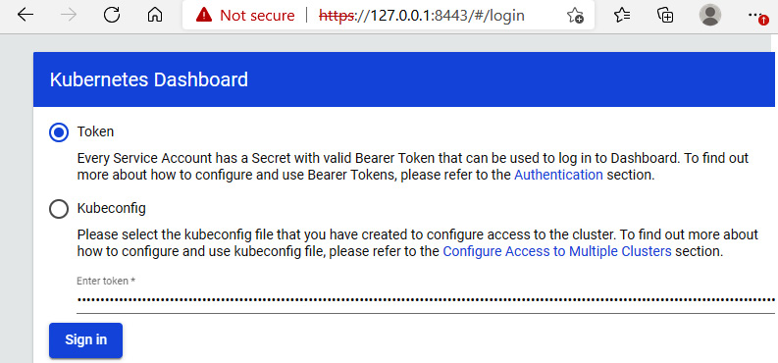
Figure 17.5 – Kubernetes Dashboard chart – login page
At this point, you have access to the dashboard and you can browse its functionalities:
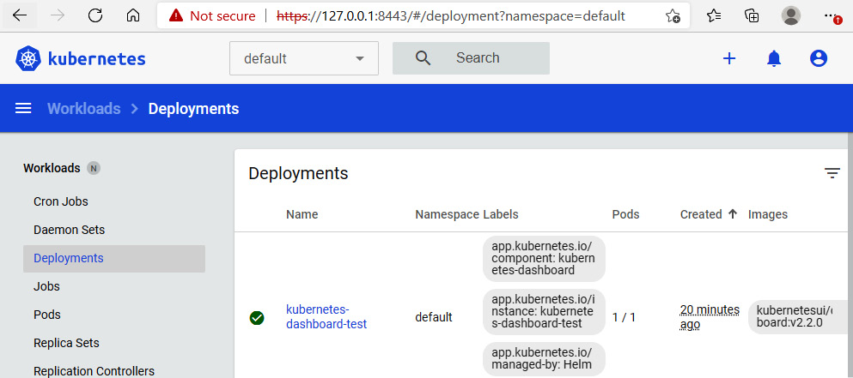
Figure 17.6 – Kubernetes Dashboard chart – Deployments page
The bearer token is for a user with the cluster-admin role, so be careful, as you can perform any operations, including deleting resources.

Elasticsearch with Kibana
Elasticsearch is a popular full-text search engine that is commonly used for log indexing and log analytics. Kibana, which is part of the Elasticsearch ecosystem, is a visualization UI for the Elasticsearch database. To install this stack, we will need to use two charts, both of which are maintained by Elasticsearch creators:
Elasticsearch chart (https://artifacthub.io/packages/helm/elastic/elasticsearch)
Kibana chart (https://artifacthub.io/packages/helm/elastic/kibana)
First, we need to add the elastic repository to Helm:
$ helm repo add elastic https://helm.elastic.co
"elastic" has been added to your repositories
After that, we can install Elasticsearch in our cluster:
$ helm install elasticsearch-test --set replicas=1 elastic/elasticsearch
By default, the chart deploys a three-node cluster of Elasticsearch. Depending on your Deployment, it may not be possible to have three Nodes of Elasticsearch, as each of them needs to run on a separate Kubernetes Node. We adjusted the replicas value for the template to 1.
With Elasticsearch being deployed, we can already continue with installing Kibana using the following command:
$ helm install kibana-test --set service.type=LoadBalancer elastic/kibana
The chart default values are configured in such a way that by default Kibana will connect to http://elasticsearch-master:9200, which is also the instance that we have just deployed using the Helm chart. Additionally, we need to override the service.type value to LoadBalancer to be able to access Kibana externally.
Wait for the Kibana Service object to get the external IP address:
$ kubectl get svc
NAME TYPE CLUSTER-IP EXTERNAL-IP PORT(S) AGE
kibana-test-kibana LoadBalancer 10.0.28.100 20.62.189.45 5601:32212/TCP 10m
In our case, it is 20.62.189.45.
Now, open the web browser and navigate to http://20.62.189.45:5601/. When your Elasticsearch instance and Kibana are ready, you will see the following:
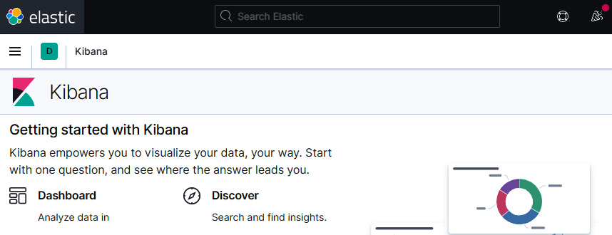
Figure 17.7 – Elasticsearch and Kibana charts – Kibana UI
You can now explore the functionalities of Elasticsearch and Kibana. If you are interested in working on sample data, you can follow the official guide: https://www.elastic.co/guide/en/kibana/current/get-started.html.
The next chart that we will take a look at is the Prometheus stack chart, which installs Prometheus together with Grafana.

Prometheus with Grafana
Prometheus is a popular monitoring system with a time series database that is widely used in the Kubernetes community. Grafana is commonly used as a visualizations UI for Prometheus. This combination is so common that the Prometheus community has prepared an official Helm chart (https://artifacthub.io/packages/helm/prometheus-community/kube-prometheus-stack) that deploys both Prometheus and Grafana as a single chart, together with a set of useful Prometheus rules for basic monitoring.
Let's begin by adding the prometheus-community repository to Helm:
$ helm repo add prometheus-community https://prometheus-community.github.io/helm-charts
"prometheus-community" has been added to your repositories
Next, the installation is as simple as running this single command:
$ helm install prometheus-stack-test prometheus-community/kube-prometheus-stack
You can monitor whether Pods are running using the kubectl get pods command:
$ kubectl get pods
NAME READY STATUS RESTARTS AGE
prometheus-prometheus-stack-test-kube-prometheus-0 2/2 Running 1 11m
prometheus-stack-test-grafana-97b7cd8c4-fx56l 2/2 Running 0 11m
prometheus-stack-test-kube-operator-5f46876fcc-5dnkp 1/1 Running 0 11m
prometheus-stack-test-kube-state-metrics-b845577bb-tp99s 1/1 Running 0 11m
prometheus-stack-test-prometheus-node-exporter-jg85x 1/1 Running 0 11m
prometheus-stack-test-prometheus-node-exporter-ks5bn 1/1 Running 0 11m
To access Prometheus and Grafana, we will use the kubectl port-forward command again. In this case, we have not exposed the Pods using the LoadBalancer service. Feel free to do so after inspecting the default values.yaml file. Execute the following two commands in separate shells – the kubectl process must be running at the same time as you want to forward the ports:
$ kubectl port-forward prometheus-prometheus-stack-test-kube-prometheus-0 9090
$ kubectl port-forward prometheus-stack-test-grafana-97b7cd8c4-fx56l 3000
Of course, you need to use a proper Pod name for Grafana, and in your case it may be different.
Next, let's navigate to the Prometheus UI in a web browser. Open the http://127.0.0.1:9090/ address:
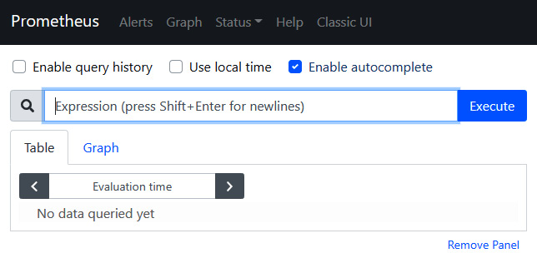
Figure 17.8 – Prometheus stack chart – Prometheus web UI
Similarly, you can navigate to http://127.0.0.1:3000/ in order to access the Grafana UI:
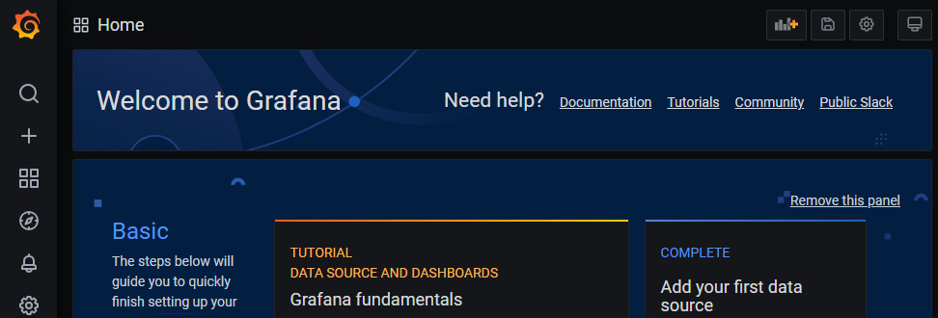
Figure 17.9 – Prometheus stack chart – Grafana web UI
Congratulations, you have successfully deployed the Prometheus stack on your Kubernetes cluster! As you can see, working with Helm charts, even for complex, multi-component solutions, is easy and can provide a lot of benefits for your development and production environments.

Summary
This chapter has covered the details of working with Helm and Helm charts. First, you have learned what the purpose of package management is and how Helm works as a package manager for Kubernetes. We have demonstrated how you can install Helm on your local machine, and how you can deploy the WordPress chart to test the installation. Then, we went through the structure of Helm charts, and we have shown how the YAML templates in charts can be configured using user-provided values. Lastly, we have shown the installation of a few popular solutions on a Kubernetes cluster using Helm. We have installed Kubernetes Dashboard, Elasticsearch together with Kibana, and the Prometheus Stack including Grafana.
In the next chapter, we are going to explore authentication and authorization on Kubernetes. We will dive deeper into RBAC available in Kubernetes – which you got a sneak-peek of in this chapter while creating ServiceAccount for accessing Kubernetes Dashboard!

Further reading
For more information regarding Helm and Helm charts, please refer to the following Packt Publishing book:
Learn Helm, by Andrew Block, Austin Dewey (https://www.packtpub.com/product/learn-helm/9781839214295)
You can learn more about Elasticsearch and Prometheus in the following Packt Publishing books:
Learning Elasticsearch, by Abhishek Andhavarapu (https://www.packtpub.com/product/learning-elasticsearch/9781787128453)
Hands-On Infrastructure Monitoring with Prometheus, by Joel Bastos, Pedro Ara√∫jo (https://www.packtpub.com/product/hands-on-infrastructure-monitoring-with-prometheus/9781789612349)
You can also refer to the official Helm documentation: https://helm.sh/docs/.

Chapter 18: Authentication and Authorization on Kubernetes
In software systems, authentication and authorization play a significant role in providing security. These terms may seem similar but they are very different security processes that work together to provide identity and access management. In short, authentication determines whether a given user of a system is indeed who they claim to be – the easiest way to visualize this is using a username and password to complete an authentication process. Authorization, on the other hand, determines what the user can and cannot do or access in the system. This also means that in secure systems, authentication is the first step and authorization must always follow authentication. One of the approaches of modeling authorization in systems is using role-based access control (RBAC), where you organize access control and management with roles and privileges. Roles can be assigned to users in the system, which gives them certain privileges and access. In this way, you can achieve very fine-grained access management that can be used to enforce the principle of least privilege.
Kubernetes, as a mature and widely adopted container orchestration system, is no exception – it has been designed with security as a first-class citizen. Authentication and authorization in Kubernetes are extensible and can fulfill the needs of enterprise systems.
For authentication, you can use one of the built-in strategies, such as X509 client certificates or OpenID Connect tokens, which are considered industry standards. If there is a need for less common authentication providers such as LDAP, you can use an authenticating proxy or authentication webhook. We will discuss this in the first section of the chapter and extend this knowledge by demonstrating how you can integrate Azure Kubernetes Service (AKS) with Azure Active Directory (AAD) for authentication, and even use Azure RBAC for providing authorization in AKS.
For authorization, Kubernetes comes with a built-in RBAC mechanism that allows you to configure fine-grained sets of permissions and assign them to users, groups, and ServiceAccounts (subjects). In this way, as a cluster administrator, you can control how cluster users (internal and external) interact with the Kubernetes API server, which API resources they can access, and which actions (verbs) they can perform. We will discuss the details in the second section of this chapter.
In this chapter, we will cover the following topics:
Authentication and user management
Authentication – AKS and AAD integration
Authorization – introduction to RBAC

Technical requirements
For this chapter, you will need the following:
A Kubernetes cluster to be deployed. We recommend using a multi-node, cloud-based Kubernetes cluster. To be able to follow the section regarding AKS and, AAD you need to have a managed AKS cluster deployed and the Azure CLI installed.
The Kubernetes CLI (kubectl) installed on your local machine and configured to manage your Kubernetes cluster.
Basic Kubernetes cluster deployment (local and cloud-based) and kubectl installation were covered in Chapter 3, Installing Your First Kubernetes Cluster.
The following chapters can give you an overview of how to deploy a fully functional Kubernetes cluster on different cloud platforms:
Chapter 14, Kubernetes Clusters on Google Kubernetes Engine
Chapter 15, Launching a Kubernetes Cluster on Amazon Web Services with the Amazon Elastic Kubernetes Service
Chapter 16, Kubernetes Clusters on Microsoft Azure with the Azure Kubernetes Service.
You can download the latest code samples for this chapter from the official GitHub repository: .

Authentication and user management
The Kubernetes API server provides RESTful endpoints for managing Kubernetes cluster and acts as the frontend to the shared state of the cluster. All users and all internal components interact with the cluster via the Kubernetes API server. Requests to the API are always one of the following:
Associated with an external, normal user or a ServiceAccount defined in the Kubernetes cluster
Treated as anonymous requests if the cluster has been configured to allow anonymous requests
This is determined in the authentication process – the entire HTTP request is used as input to the process, but usually only request hearers or the client certificate is analyzed. Authentication is carried out by authentication modules that depend on the cluster configuration. Your cluster may have multiple authentication modules enabled and then each of them is executed in sequence until one succeeds. If the request fails to authenticate, the API server will either respond with an HTTP status code of 401 (unauthorized) or, if anonymous requests are enabled, treat it as anonymous.
Tip
Anonymous requests are essentially mapped to a special username called system:anonymous and a group called system:unauthenticated. This means that you can organize your authorization to resources for such requests, just as you can for other users or ServiceAccounts.
Since all operations inside and outside the cluster must go through the Kubernetes API server, this means that all of them must go through the authentication process. This includes the operations of internal cluster components and Pods, which query the API server. For you, as an external user of the cluster, any requests that you make using kubectl commands or directly to the Kubernetes API server will also go through the authentication process:
Normal users: Such users are managed externally, independent from the Kubernetes cluster. Currently, Kubernetes does not provide any objects to represent such users. The external management of users may be as simple (but not recommended) as static user-password files passed to the API server using the token-auth-file argument during startup. In real production scenarios, you should use cloud services such as AAD or AWS Identity and Access Management to manage the users and integrate with your Kubernetes cluster using OpenID Connect (https://openid.net/connect/) tokens to seamlessly authenticate. Note that normal user accounts are global and do not have cluster namespaces.
Service accounts: These are managed by Kubernetes cluster and modeled as ServiceAccount objects. You can create and manage service accounts just like any other resource in Kubernetes; for example, using kubectl and YAML manifest files. This type of account is intended for processes in cluster components or running in Pods. The credentials for ServiceAccounts are stored as Secrets in the cluster that are mounted into Pods so that the container process can use them to talk to the Kubernetes API server. When a process authenticates using a ServiceAccount token, it is seen as a user called system:serviceaccount:<namespace>:<serviceAccountName>. Note that ServiceAccounts are namespaced.
As you can see, user management in Kubernetes is a mixture of different approaches that should fit all the needs of different organizations. The key takeaway here is that after the authentication process, the request will be either rejected (optionally treated as anonymous) or will be treated as coming from a particular user. The username attribute may be provided by the external user management system, as in the case of normal users, or it will be system:serviceaccount:<namespace>:<serviceAccountName> for ServiceAccounts. Additionally, the request will have more attributes associated with it, such as User ID (UID), groups, and extra fields. This information is used for authorization processes based on RBAC, which we will explain in the next section.
Now, let's look at the authentication methods that you can use with Kubernetes.

Static token files
This method is the most basic one that Kubernetes offers for managing normal users. The approach somewhat resembles the /etc/shadow and /etc/passwd files, which were used in the early days of Unix systems. Note, however, that it is not recommended and is considered unsecure for production clusters.
In this method, you define a .csv file where each line has the following format:
token,user,uid,"group1,group2,group3"
Then, you pass the file when starting the Kubernetes API server process using the token-auth-file parameter. To authenticate against the API server, you need to use a standard HTTP bearer authentication scheme for your requests. This means that your requests will need to use an additional header that's in the following form:
Authorization: Bearer <token>
Based on this request information, the Kubernetes API server will match the token against the static token file and assign user attributes based on the matched record.
When using kubectl, you must modify your kubeconfig. You can do this using the kubectl command:
$ kubectl config set-credentials <contextUser> --token=<token>
After that, you need to create and use context with this user for your requests using the kubectl config use-context command.
Important note
In Kubernetes versions prior to 1.19, there was a similar authentication method that allowed us to use an HTTP basic authentication scheme and a file passed by the basic-auth-file parameter to the API server. This method is no longer supported due to security reasons.
The following diagram visualizes the principles behind this method of authentication:
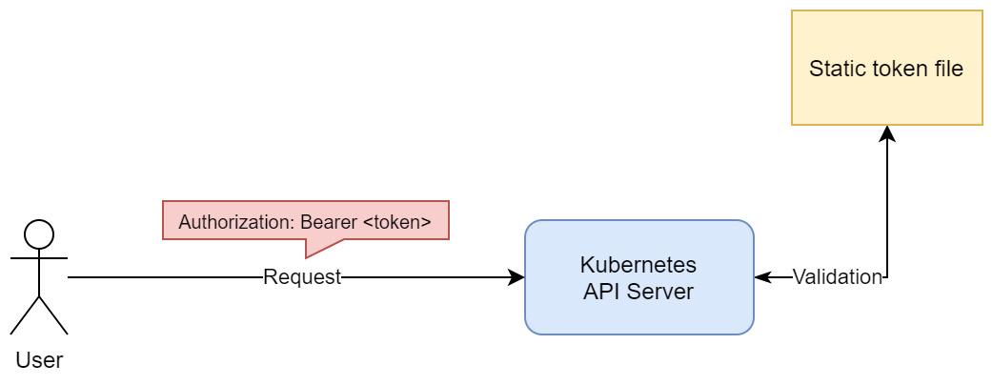
Figure 18.1 – Static token file authentication in Kubernetes
We can now summarize the advantages and disadvantages of using static token file method for authentication.
The advantages are as follows:
Easy to configure
Easy to understand
The disadvantages are as follows:
Unsecure; exposing a token file compromises all cluster users.
Requires that we manually manage users.
Adding new users or removing existing ones requires that we restart the Kubernetes API server.
Rotating any tokens requires that we restart the Kubernetes API server.
In short, this method is good for development environments and learning the principles behind authentication in Kubernetes, but it is not recommended for production use cases. Next, we will take a look at authenticating users using ServiceAccount tokens.

ServiceAccount tokens
As we mentioned in the introduction to this section, ServiceAccounts are meant for in-cluster identities for processes running in Pod containers or for cluster components. However, they can be used for authenticating external requests as well.
ServiceAccounts are Kubernetes objects and can be managed like any other resource in the cluster; that is, by using kubectl or raw HTTP requests to the API server. The tokens for ServiceAccounts are JSON Web Tokens (JWTs) and are stored as Kubernetes Secret objects. Secrets were covered in Chapter 6, Configuring Your Pods Using ConfigMaps and Secrets. Usually, when defining a Pod, you will specify what ServiceAccount should be used for processes running in the containers. You can do this using .spec.serviceAccountName in the Pod specification. The JWT token will be injected into the container; then, the process inside can use it in the HTTP bearer authentication scheme to authenticate to the Kubernetes API server. This is only necessary if it interacts with the API server in any way, for example, if it needs to discover other Pods in the cluster. We have summarized this authentication method in the following diagram:
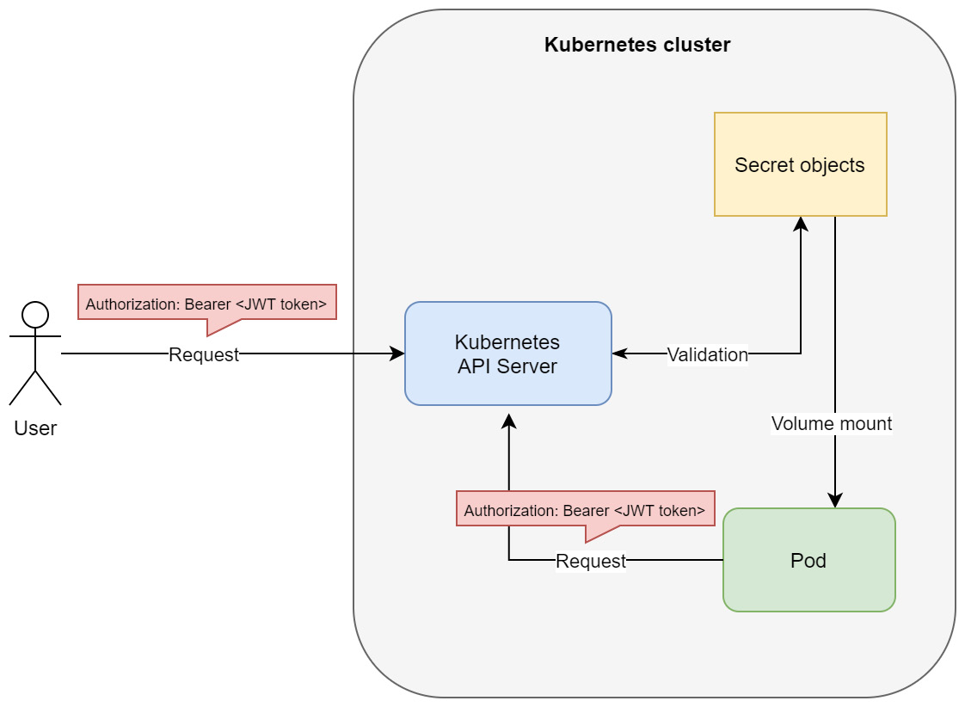
Figure 18.2 – ServiceAccount authentication in Kubernetes
This also shows why ServiceAccount tokens can be used for external requests – the API server does not care about the origin of the request; all it is interested in is the bearer token that comes with the request header. Again, you can use this token in kubectl or in raw HTTP requests to the API server. Please note that this is generally not a recommended way to use ServiceAccounts, but it can be used in some scenarios, especially when you are unable to use an external authentication provider for normal users.
We will now demonstrate how you can create and manage ServiceAccounts and how you can use JWT tokens to authenticate when using kubectl. This will also give a sneak peek into RBAC, which we are going to look at in more detail in the next section. Please follow the following steps:
Create a YAML manifest for a new ServiceAccount named example-account. We will configure RBAC for this account so that it can only read Pods in the default namespace. The example-account-serviceaccount.yaml YAML manifest file has the following contents:
apiVersion: v1
kind: ServiceAccount
metadata:
name: example-account
namespace: default
Note that applying the preceding manifest has the same effect as the imperative kubectl create serviceaccount example-account command.
Create a YAML manifest for a Role object named pod-reader in the default namespace. This role will allow you to get, watch, and list Pods in this namespace. The pod-reader-role.yaml YAML manifest file has the following contents:
apiVersion: rbac.authorization.k8s.io/v1
kind: Role
metadata:
namespace: default
name: pod-reader
rules:
- apiGroups: [""]
resources: ["pods"]
verbs: ["get", "watch", "list"]
Create a YAML manifest for RoleBinding named reads-pods. This is what associates the role that we created with our example-account ServiceAccount – the account will now have the privilege of read-only access to Pods, and nothing more. The read-pods-rolebinding.yaml YAML manifest file has the following contents:
apiVersion: rbac.authorization.k8s.io/v1
kind: RoleBinding
metadata:
name: read-pods
namespace: default
subjects:
- kind: ServiceAccount
name: example-account
namespace: default
roleRef:
kind: Role
name: pod-reader
apiGroup: rbac.authorization.k8s.io
Now, we can apply all the manifest files to the cluster at once using the kubectl apply command:
$ kubectl apply -f ./
serviceaccount/example-account created
role.rbac.authorization.k8s.io/pod-reader created
rolebinding.rbac.authorization.k8s.io/read-pods created
We need to retrieve the JWT for the service account. To do that, use the following command, which retrieves it from the associated Secret object and decodes it from Base64 encoding:
$ kubectl -n default get secret $(kubectl -n default get sa/example-account -o jsonpath="{.secrets[0].name}") -o go-template="{{.data.token | base64decode}}"
Copy the token; we will need it for further operations. If you are interested, you can inspect the contents of the JWT using https://jwt.io/:
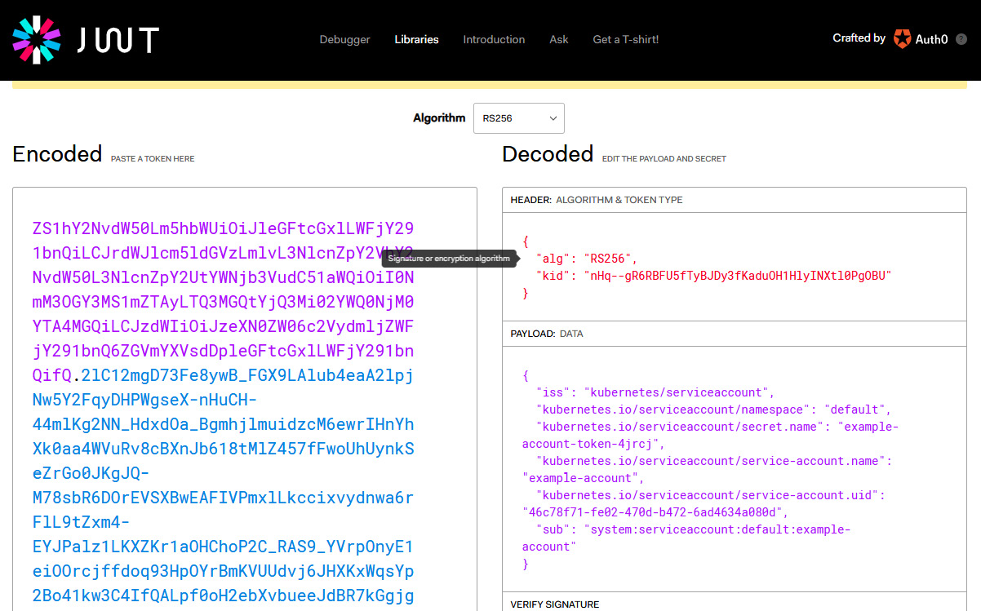
Figure 18.3 – Inspecting a JWT for ServiceAccount
As you can see, the JWT maps to the example-account ServiceAccount. Additionally, you can identify that the actual username (marked as subject in the payload) it will be mapped to in Kubernetes is system:serviceaccount:default:example-account, as we explained previously.
With this JWT, we can set up kubectl to test it. First, you need to create a user in your kubeconfig using the following command:
$ kubectl config set-credentials example-account—token=<jwtToken>
Create a new context that uses this user. You also need to know the cluster name that you are connecting to right now – you can check it using the kubectl config view command. Use the following command to create a new context named example-account-context:
$ kubectl config set-context example-account-context—user=example-account—cluster=<clusterName>
You may want to check the name of the context that you are currently using by using the kubectl config current-context command. This will make it easier to go back to your old cluster admin context. Switch to the new context using the following command:
$ kubectl config use-context example-account-context
Switched to context "example-account-context".
We are now ready to verify that our authentication works and that the RBAC roles allow read-only access to Pods in the default namespace. First, try getting Pods:
$ kubectl get pods
NAME READY STATUS RESTARTS AGE
alertmanager-prometheus-stack-test-kube-alertmanager-0 2/2 Running 0 47h
elasticsearch-master-0 1/1 Running 0 47h
...
This has worked as expected! Now, try getting Pods from the kube-system namespace:
$ kubectl get pods -n kube-system
Error from server (Forbidden): pods is forbidden: User "system:serviceaccount:default:example-account" cannot list resource "pods" in API group "" in the namespace "kube-system"
We have authenticated correctly, but the action was forbidden by RBAC authorization, which is what we expected. Lastly, let's try getting Service objects:
$ kubectl get svc
Error from server (Forbidden): services is forbidden: User "system:serviceaccount:default:example-account" cannot list resource "services" in API group "" in the namespace "default"
As you can see, we have successfully used our ServiceAccount JWT as a bearer token for authentication and we have verified that our privileges work correctly. You can now switch back to your old kubectl context using the kubectl config use-context command.
Tip
The preceding procedure of configuring the kubectl context with a bearer token can be used for the static token file authentication method as well.
Let's summarize what are the advantages and disadvantages of using ServiceAccount tokens for authentication are.
The advantages are as follows:
Easy to configure and use, similar to static token files.
Entirely managed by the Kubernetes cluster, so there's no need for external authentication providers.
ServiceAccounts are namespaced.
The disadvantages are as follows:
ServiceAccounts are intended for processes running in Pod containers to give them identity and let them use Kubernetes RBAC.
Any Pod that has access to reading Secrets can discover all tokens for ServiceAccounts! This is an important security implication, especially if you are thinking about having high-privilege service accounts in your cluster. This would also violate the principle of least privilege.
Rotation of ServiceAccount tokens is cumbersome and there is no automated way to do this out of the box. This makes any mitigations to security incidents much harder.
ServiceAccount tokens do not expire, which is another security concern. There is a design proposal to make this possible, though; you can read more here: https://github.com/kubernetes/community/blob/master/contributors/design-proposals/auth/bound-service-account-tokens.md.
In general, using ServiceAccount tokens for external authentication is good for development and test scenarios when you cannot integrate with external authentication providers. But for production clusters, it is not the best option, mainly due to security concerns. Now, let's take a look at using X.509 client certificates.

X.509 client certificates
Using X.509 client certificates is one of the industry standards for authentication processes. There is one important catch, however – you need to have good means of managing certificate signing, revoking, and rotation – otherwise, you may hit very similar security issues as with using ServiceAccount tokens. You can learn more about X.509 certificates and the processes around them here: https://www.ssl.com/faqs/what-is-an-x-509-certificate/.
This method works in Kubernetes as follows:
The Kubernetes API server is started with the client-ca-file argument. This provides certificate authority (CA) information to be used to validate client certificates presented to the API server.
Users that want to authenticate against the API server need to request an X.509 client certificate from the CA. This should be a secure and audited process. The subject common name (the CN attribute in the subject) of the certificate is used as the username attribute when authentication is successful. Note that as of Kubernetes 1.19, you can use the Certificates API to manage signing requests. More information is available in the official documentation: https://kubernetes.io/docs/reference/access-authn-authz/certificate-signing-requests/.
The user must present the client certificate during authentication to the API server, which validates the certificate against the CA. Based on that, the request goes through the authentication process successfully or is rejected.
While using the kubectl commands, you can configure this method of authentication for your user using the kubectl config set-credentials command. We have summarized this process in the following diagram:
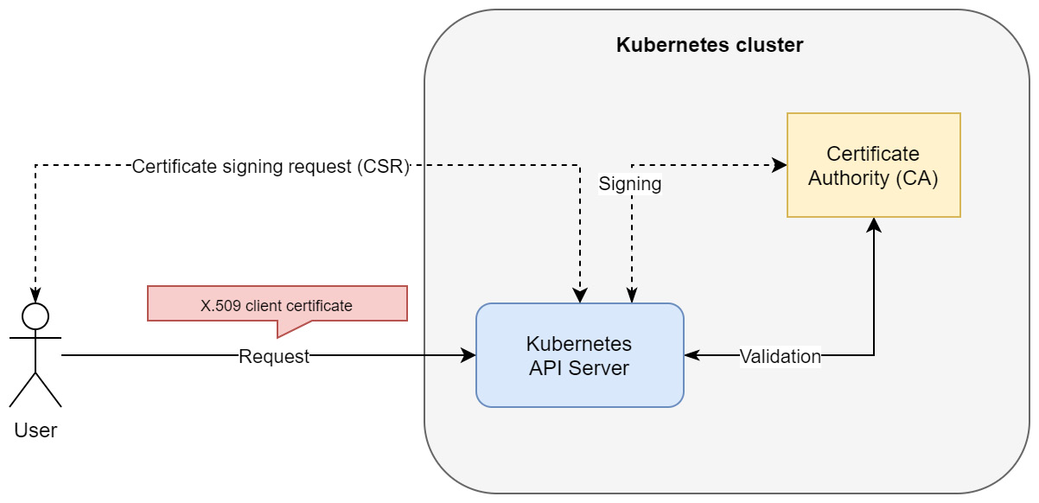
Figure 18.4 – X.509 client certificate authentication in Kubernetes
Please note that this visualizes the case when initial CSR by the user is handled by the Certificate API in a Kubernetes cluster. This does not need to be the case as CA may be external to the cluster, and the Kubernetes API server can rely on a copy of the CA .pem file.
We can summarize the advantages of this method as follows:
It's a much more secure process than using ServiceAccount tokens or static token files.
Being unable to store certificates in the cluster means that it is not possible to compromise all certificates, as was the case of using ServiceAccount tokens. X.509 client certificates can be used for high-privileged user accounts.
X.509 client certificates can be revoked on demand. This is very important in case of security incidents.
The disadvantages of X.509 client certificate authentication are as follows:
Certificates have an expiry date, which means they cannot be valid indefinitely. For simple use cases in development, this is a disadvantage. From a security perspective, in production clusters, this is a huge advantage.
Monitoring certificate expiration, revocation, and rotation must be handled. This should be an automated process so that we can quickly react in the case of security incidents.
The built-in Certificate API has limited functionality.
Using client certificates in the browser for authentication is troublesome, for example, when you would like to authenticate to Kubernetes Dashboard.
The key takeaway is that using X.509 client certificates is secure but requires sophisticated certificate management so that we have all the benefits. Now, we will take a look at OpenID Connect tokens, which is the recommended method for cloud environments.

OpenID Connect tokens
Using OpenID Connect (OIDC), you can achieve a single sign-on (SSO) experience for your Kubernetes cluster (and possibly other resources in your organization). OIDC is an authentication layer that's created on top of OAuth 2.0, which allows third-party applications to verify the identity of the end user and obtain basic user profile information. OIDC uses JWTs, which you can obtain using flows that conform to the OAuth 2.0 specifications. The most significant issue with using OIDC for authenticating in Kubernetes is the limited availability of OpenID providers. But if you are deploying in a cloud environment, all tier 1 cloud service providers such as Microsoft Azure, Amazon Web Services, and Google Cloud Platform have their versions of OpenID providers. The beauty of managed Kubernetes cluster deployments in the cloud, such as, AKS Amazon EKS, and Google Kubernetes Engine, is that they provide integration with their native OpenID provider out of the box or by a simple flip of a configuration switch. In other words, you do not need to worry about reconfiguring the Kubernetes API server and making it work with your chosen OpenID provider – you get it alongside the managed solution. In the last section of this chapter, we will demonstrate how you can do that for AKS throughout.
If you are interested in learning more about the OpenID Connect protocol, you can refer to the official web page: https://openid.net/connect/. For more details and more specific flows, such as in the context of AAD please take a look here: https://docs.microsoft.com/en-us/azure/active-directory/develop/v2-protocols-oidc. In the following diagram, you can see the basics of the OIDC authentication flow on Kubernetes:
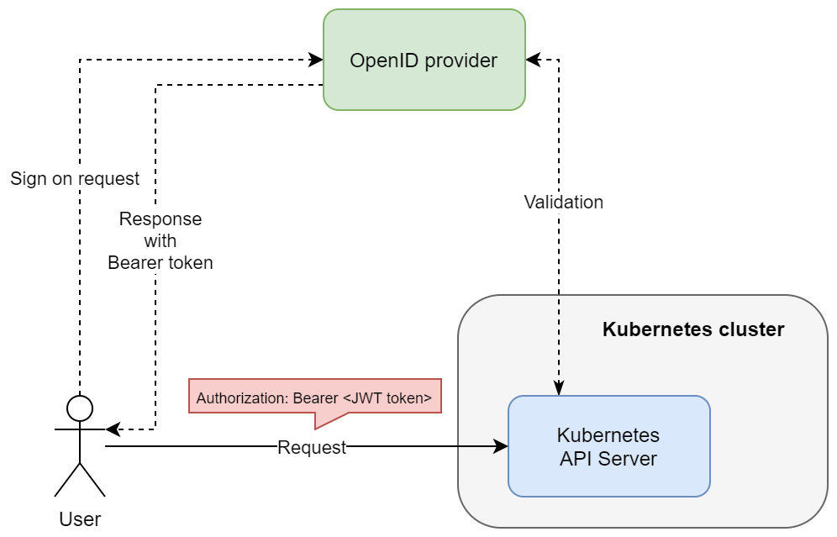
Figure 18.5 – OpenID Connect authentication in Kubernetes
The most important thing is that the OpenID provider is responsible for the SSO experience and managing the bearer tokens. Additionally, the Kubernetes API server must validate the bearer token that's received against the OpenID provider.
Using OIDC has the following advantages:
You get SSO experience, which you can use with other services in your organization.
Tier 1 cloud service providers have their own OpenID providers that easily integrate with their managed Kubernetes offerings.
It can be also used with other OpenID providers and non-cloud deployments – this requires a bit more configuration though.
It's a secure and scalable solution.
The disadvantages of this approach can be summarized as follows:
Kubernetes has no web interface where you can trigger the authentication process. This means that you need to get the credentials by manually requesting them from the identity provider. In managed cloud Kubernetes offerings, this is often solved by additional simple tooling to generate kubeconfig with credentials.
Tokens cannot be revoked, so they are set to expire in a short time. This requires the tokens to be frequently renewed.
The key takeaway about OIDC is that this is your best bet when configuring authentication for Kubernetes, especially if you are deploying production clusters in the cloud. Lastly, let's take a quick look at the other available authentication methods.

Other methods
Kubernetes offers a few other authentication methods that you can use. They are mainly intended for advanced use cases, such as integrating with LDAP or Kerberos. The first one is authenticating proxy.
When you use authenticating proxy in front of the Kubernetes API server, you can configure the API server to use certain HTTP headers to extract authentication user information from them. In other words, your authenticating proxy is doing the job of authenticating the user and passing down this information alongside the request in the form of additional headers.
You can find more information in the official documentation: https://kubernetes.io/docs/reference/access-authn-authz/authentication/#authenticating-proxy.
Another approach is known as webhook token authentication, where the Kubernetes API server uses an external service to verify the bearer tokens. The external service receives the information in the form of a TokenReview object from the API server via an HTTP POST request, performs verification, and sends back a TokenReview object with additional information about the result.
You can find more information in the official documentation: https://kubernetes.io/docs/reference/access-authn-authz/authentication/#webhook-token-authentication.
In general, you only need these two methods in special cases where you want to integrate with existing identity providers in your organization that are not supported by Kubernetes out of the box.
In the next section, we will look at RBAC.

Authorization and introduction to RBAC
While authentication is about determining whether a given user of a system is indeed who they claim to be, authorization determines what the user can and cannot do or access. As such, authorization usually complements authentication – these two processes are used together to provide security for the system. Authentication is the first step in determining the identity of the user, whereas authorization is the next step when verifying if the user can perform the action they want to.
In the Kubernetes API server, authenticating a request results in a set of additional request attributes such as user, group, API request verb, or HTTP request verb. These are then passed further to authorization modules that, based on these attributes, answer whether the user is allowed to do the action or not. If the request is denied by any of the modules, the user will be presented with an HTTP status code of 403 (Forbidden).
Tip
This is an important difference between HTTP status codes. If you receive 401 (Unauthorized), this means that you have been not recognized by the system; for example, you have provided incorrect credentials or the user does not exist. If you receive 403 (Forbidden), this means that authentication has been successful, you have been recognized, but you are not allowed to do the action you requested. This is useful when debugging issues regarding access to a Kubernetes cluster.
Kubernetes has a few authorization modes available that can be enabled by using the authorization-mode argument when starting the Kubernetes API server:
RBAC: Allows you to organize access control and management with roles and privileges. RBAC is one of the industry standards for access management, also outside of Kubernetes. Roles can be assigned to users in the system, which gives them certain privileges and access. In this way, you can achieve very fine-grained access management that can be used to enforce the principle of least privilege. For example, you can define a role in the system that allows you to access certain files on a network share. Then, you can assign such roles to individual users on groups in the system to allow them to access these files. This can be done by associating the user with a role – in Kubernetes, you model this using the RoleBinding and ClusterRoleBinding objects. In this way, multiple users can be assigned a role and a single user can have multiple roles assigned. Please note that in Kubernetes, RBAC is permissive, which means that there are no deny rules. Everything is denied by default, and you have to define allow rules instead.
Attribute-Based Access Control (ABAC): This is part of the access control paradigm, used not only in Kubernetes, which uses policies based on the attributes of the user, resource, and environment. This is a very fine-grained access control approach – you can, for example, define that the user can access a given file, but only if the user has clearance to access confidential data (user attribute), the owner of the file is Mike (resource attribute), and the user tries to access the file from an internal network (environment attribute). So, policies are sets of attributes that must be present together for the action to be performed. In Kubernetes, this is modeled using Policy objects. For example, you can define that the authenticated user, mike, can read any Pods in the default Namespace. If you want to give the same access to user bob, then you need to create a new Policy for user bob.
Node: A special-purpose authorization mode used for authorizing API requests made by kubelet in the cluster.
Webhook: This mode is similar to webhooks for authentication. You can define an external service that needs to handle HTTP POST requests with an SubjectAccessReview object that's sent by the Kubernetes API server. This service must process the request and determine if the request should be allowed or denied. The response from the service should contain SubjectAccessReview, along with information, whether the subject is allowed the access. Based on that, the Kubernetes API server will either proceed with the request or reject it with an HTTP status code of 403. This approach is useful when you are integrating with existing access control solutions in the organization.
Currently, RBAC is considered an industry standard in Kubernetes due to its flexibility and ease of management. For this reason, RBAC is the only authentication mode we are going to describe in more detail.

RBAC mode in Kubernetes
Using RBAC in Kubernetes involves two types of API resources that belong to the rbac.authorization.k8s.io API group:
Role and ClusterRole: They define a set of permissions. Each rule in Role says which verb(s) are allowed for which API resource(s). The only difference between Role and ClusterRole is that Role is namespace-scoped, whereas ClusterRole is global.
RoleBinding and ClusterRoleBinding: They associate users or a set of users (alternatively, groups or ServiceAccounts) with a given Role. Similarly, RoleBinding is namespace-scoped, while ClusterRoleBinding is cluster-wide. Please note that ClusterRoleBinding works with ClusterRole, but RoleBinding works with both ClusterRole and Role.
All these Kubernetes objects can be managed using kubectl and YAML manifests, just as you do with Pods, Services, and so on.
We will now demonstrate this in practice. In the previous section, we showed a basic RBAC configuration for a service account that was being used for authentication using kubectl. The example that we are going to use here will be a bit different and will involve creating a Pod that runs under a dedicated service account and periodically queries the Kubernetes API server for a list of Pods. In general, having dedicated service accounts for running your Pods is a good practice and makes it possible to ensure the principle of least privilege. For example, if your Pod needs to get the list of Pods in the cluster but does not need to create a new Pod, the ServiceAccount for this Pod should have a role assigned that allows you to list read-only Pods, nothing more. Please follow these steps to configure this example:
Begin by creating a dedicated ServiceAccount named pod-logger. Create a YAML manifest named pod-logger-serviceaccount.yaml:
apiVersion: v1
kind: ServiceAccount
metadata:
name: pod-logger
namespace: default
Apply the manifest to the cluster using the following command:
$ kubectl apply -f ./pod-logger-serviceaccount.yaml
Create a role named pod-reader. This role will only allow the get, watch, and list verbs on pods resources in the Kubernetes RESTful API. In other words, this translates into an /api/v1/namespaces/default/pods endpoint in the API. Note that apiGroups specified as "" mean the core API group. The structure of the pod-reader-role.yaml YAML manifest file is as follows:
apiVersion: rbac.authorization.k8s.io/v1
kind: Role
metadata:
namespace: default
name: pod-reader
rules:
- apiGroups: [""]
resources: ["pods"]
verbs: ["get", "watch", "list"]
Apply the manifest to the cluster using the following command:
$ kubectl apply -f ./pod-reader-role.yaml
Now, we would normally create a RoleBinding object to associate the service account with the role. But to make this demonstration more interesting, we willcreate a Pod that's running under the pod-logger service account. This will essentially make the Pod unable to query the API for Pods because it will be unauthorized (remember that everything is denied by default in RBAC). Create a YAML manifest named pod-logger-static-pod.yaml for a static Pod called pod-logger-static, running without any additional controllers:
apiVersion: v1
kind: Pod
metadata:
name: pod-logger-static
spec:
serviceAccountName: pod-logger
containers:
- name: logger
image: radial/busyboxplus:curl
command:
- /bin/sh
- -c
- |
SERVICEACCOUNT=/var/run/secrets/kubernetes.io/serviceaccount
TOKEN=$(cat ${SERVICEACCOUNT}/token)
while true
do
echo "Querying Kubernetes API Server for Pods in default namespace..."
curl—cacert $SERVICEACCOUNT/ca.crt—header "Authorization: Bearer $TOKEN" -X GET https://kubernetes/api/v1/namespaces/default/pods
sleep 10
done
Here, the most important fields are .spec.serviceAccountName, which specifies the service account that the Pod should run under, and command in the container definition, which we have overridden to periodically query the Kubernetes API. Assigning the pod-logger service account, as explained in the previous section, will result in a Secret with a bearer JWT for this account to be mounted in the container filesystem under /var/run/secrets/kubernetes.io/serviceaccount/token. The overridden commands run an infinite loop in a Bourne shell in 10-second intervals. In each iteration, we query the Kubernetes API endpoint (https://kubernetes/api/v1/namespaces/default/pods) for Pods in the default namespace with the HTTP GET method using the curl command. To properly authenticate, we need to pass the contents of /var/run/secrets/kubernetes.io/serviceaccount/token as a bearer token in the Authorization header for the request. Additionally, we need to pass a CA certificate path to verify the remote server using the cacert argument. The certificate is injected into /var/run/secrets/kubernetes.io/serviceaccount/ca.crt by the Kubernetes runtime.
When you create this Pod and inspect its logs, you should expect to see just a bunch of messages with an HTTP status code of 403 (Forbidden). This is because the ServiceAccount does not have a RoleBinding type that associates it with the pod-reader Role yet. First, apply the manifest to the cluster:
$ kubectl apply -f ./pod-logger-static-pod.yaml
Start following the logs of the pod-logger-static Pod using the following command:
$ kubectl logs pod-logger-static -f
Querying Kubernetes API Server for Pods in default namespace...
...
{
"kind": "Status",
"apiVersion": "v1",
"metadata": {
},
"status": "Failure",
"message": "pods is forbidden: User \"system:serviceaccount:default:pod-logger\" cannot list resource \"pods\" in API group \"\" in the namespace \"default\"",
"reason": "Forbidden",
"details": {
"kind": "pods"
},
"code": 403
}
In a new console window, we will create and apply a RoleBinding that associates the ServiceAccount with the pod-reader Role. Create a YAML manifest named read-pods-rolebinding.yaml that contains the following contents:
apiVersion: rbac.authorization.k8s.io/v1
kind: RoleBinding
metadata:
name: read-pods
namespace: default
subjects:
- kind: ServiceAccount
name: pod-logger
namespace: default
roleRef:
kind: Role
name: pod-reader
apiGroup: rbac.authorization.k8s.io
There are three key components in the RoleBinding manifest: name, which is used to identify the user, subjects, which reference the users, groups, or service accounts, and roleRef, which references the role.
Apply the manifest file using the following command:
$ kubectl apply -f ./read-pods-rolebinding.yaml
In the previous console window, which still follows the logs of the Pod, you will see that the Pod was able to successfully retrieve the list of Pods in the cluster. In other words, the request was successfully authorized:
$ kubectl logs pod-logger-static -f
...
Querying Kubernetes API Server for Pods in default namespace...
...
{
"kind": "PodList",
"apiVersion": "v1",
"metadata": {
"selfLink": "/api/v1/namespaces/default/pods",
"resourceVersion": "4052324"
},
"items": [
{
"metadata": {
"name": "alertmanager-prometheus-stack-test-kube-alertmanager-0",
"generateName": "alertmanager-prometheus-stack-test-kube-alertmanager-",
"namespace": "default",
...
Lastly, you can delete the RoleBinding type using the following command:
$ kubectl delete rolebinding read-pods
Now, if you inspect the logs of the Pod again, you will see that the requests are denied with an HTTP status code of 403 again.
Congratulations! You have successfully used RBAC in Kubernetes to be able to read the Pods in the cluster for a Pod running under ServiceAccount. Next, we will take a look at how to practically integrate AKS with AAD for authentication and authorization.

Azure Kubernetes Service and Azure Active Directory integration
Tier 1 cloud service providers such as Microsoft Azure, Google Cloud Platform, and Amazon Web Services have their own managed Kubernetes cluster offerings. We covered the Kubernetes deployments for these three cloud platforms in the previous chapters. What is important here is that managed Kubernetes clusters come with a lot of additional integrations with other cloud services. In this section, we will show you how to use AAD integrations for AKS to provide authentication using OpenID Connect and authorization using Azure RBAC. This approach unifies user management and access control across Azure resources, AKS, and Kubernetes resources.
Important note
At the time of writing, integration with AAD for authentication in AKS is in general availability and may be enabled on demand. Azure RBAC for Kubernetes authorization is currently in preview and can be enabled only when creating a new cluster. It will be possible to enable it on demand when the feature reaches general availability. For this reason, we will demonstrate these two features by deploying a new cluster from scratch.
Let's begin this demonstration by taking care of the prerequisites.

Prerequisites
First, we need to ensure that the prerequisites have been installed and enabled (these steps must be fulfilled when the feature is still in preview; otherwise, a standard Azure CLI installation should be sufficient):
Using the Azure CLI, register the EnableAzureRBACPreview feature flag using the az feature register command:
$ az feature register—namespace "Microsoft.ContainerService"—name "EnableAzureRBACPreview"
Wait for the flag to be registered; this can take a few minutes. You can query the status using the following command:
$ az feature list -o table | grep EnableAzureRBACPreview
Microsoft.ContainerService/EnableAzureRBACPreview Registered
When the status turns into Registered, perform a registration refresh of the Microsoft.ContainerService resource provider:
$ az provider register—namespace Microsoft.ContainerService
Install the aks-preview CLI extension and update it to the latest version (0.4.55 or higher, if required):
$ az extension add—name aks-preview
$ az extension update—name aks-preview
With all the prerequisites ready, we can deploy the managed AKS cluster with AAD integration and Azure RBAC integration.

Deploying a managed AKS cluster with AAD and Azure RBAC integration
To deploy the cluster, follow these steps:
If you haven't created a resource group named k8sforbeginners-rg yet, you need to create it using the following command:
$ az group create—name k8sforbeginners-rg—location eastus
Start provisioning a cluster named k8sforbeginners-aks-aad with the AAD and Azure RBAC integration features:
$ az aks create—resource-group k8sforbeginners-rg—name k8sforbeginners-aks-aad—node-count 2 --enable-aad—enable-azure-rbac
This will take a few minutes. In the end, you should see that the following section is present in the response body:
"aadProfile": {
"adminGroupObjectIds": null,
"clientAppId": null,
"enableAzureRbac": true,
"managed": true,
"serverAppId": null,
"serverAppSecret": null,
"tenantId": ...
},
We now have a managed AKS cluster with AAD and Azure RBAC integration ready. Next, we are going to access the cluster using kubectl to verify the AAD integration.

Accessing the AKS cluster with AAD integration enabled
In the previous sections, we explained what the available authentication modes in Kubernetes are. One of them is OpenID Connect integration, which is an identity layer built on top of the OAuth 2.0 protocol to provide single sign-on (SSO) capabilities. AKS cluster with AAD integration internally relies on this authentication mode. The most important benefit of such an integration is that you can manage users and groups in AAD, just like with any Azure service. Your AKS cluster will seamlessly use AAD to authenticate normal users! This means you can build RBAC policies on top of that.
To access the newly deployed AKS cluster with kubectl, please follow these steps:
The AAD user that you use for the Azure CLI needs to have the Azure Kubernetes Service Cluster User role (https://docs.microsoft.com/en-us/azure/role-based-access-control/built-in-roles#azure-kubernetes-service-cluster-user-role). Of course, if you are the owner of the subscription, this is enough.
Execute the following Azure CLI command, which will generate kubeconfig for accessing the cluster. If you are presented with any SSO instructions, please follow them:
$ az aks get-credentials—resource-group k8sforbeginners-rg—name k8sforbeginners-aks-aad
Now, attempt to get Pods in the cluster:
$ kubectl get pods
To sign in, use a web browser to open the page https://microsoft.com/devicelogin and enter the code ... to authenticate.
You need to complete the SSO process using the provided code. Eventually, you will see the following in your browser (provided that you have the correct AAD role assigned):
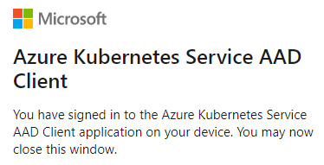
Figure 18.6 – Signing into AKS integrated with AAD
However, you will be presented with, maybe surprisingly, a message stating that listing Pods is forbidden:
$ kubectl get pods
...
Error from server (Forbidden): pods is forbidden: User "9b3fde3b-4059-40fa-9e93-4147cc93164d" cannot list resource "pods" in API group "" in the namespace "default": User does not have access to the resource in Azure. Update role assignment to allow access.
This is expected. The message is coming from the Kubernetes API server authorization module, which means that authentication using AAD SSO was successful! The reason that we have been forbidden access is that we are also using Azure RBAC integration and by default, our user does not have any Kubernetes Roles assigned. Take note of the AAD user principal ID (in this example, 9b3fde3b-4059-40fa-9e93-4147cc93164d) as it will be needed in the next steps. Alternatively, you can use the az ad signed-in-user show command and check objectId.
Tip
AAD offers various solutions for managing access to resources. You can read the following documentation if you are interested in providing conditional access and just in time (JIT) access to an AKS cluster: https://docs.microsoft.com/en-us/azure/aks/managed-aad#use-conditional-access-with-azure-ad-and-aks, https://docs.microsoft.com/en-us/azure/aks/managed-aad#configure-just-in-time-cluster-access-with-azure-ad-and-aks. JIT access is the most secure way to allow elevated access to the cluster for a limited time and with full auditing capabilities. This is regarded as an industry standard for securely managing production clusters.
Now, let's learn how to work with Azure RBAC integration for AKS.

Using Azure RBAC for an AKS cluster
To make it possible for our AAD user to list and manage the Pods in the cluster, we will do two things. First, we are going to use the built-in Azure Kubernetes Service RBAC Admin role in Azure RBAC, which is essentially a superuser administration role that allows you to perform any action on any resource. This role should rarely be used as it violates the principle of least privilege. If you are going to use such a highly privileged role for production systems, you need to consider using JIT cluster access. The alternative way of going about this would be to create AAD custom roles, where you can create your own role that allows you to manage Pods in the default namespace. Such a role is defined in Azure RBAC, but because we have Azure RBAC integration turned on for an AKS cluster, this will be effective for Kubernetes resources.
To use the built-in Azure Kubernetes Service RBAC Admin role, follow these steps:
Get the resource ID of your AKS cluster using the following command and store it in the AKS_ID environment variable:
$ AKS_ID=$(az aks show—resource-group k8sforbeginners-rg—name k8sforbeginners-aks-aad—query id -o tsv)
$ echo $AKS_ID
/subscriptions/.../resourcegroups/k8sforbeginners-rg/providers/Microsoft.ContainerService/managedClusters/k8sforbeginners-aks-aad
Using your user principal ID from the previous steps (in our case, 9b3fde3b-4059-40fa-9e93-4147cc93164d), create an Azure RBAC role assignment for your user and the Azure Kubernetes Service RBAC Admin role:
$ az role assignment create—role "Azure Kubernetes Service RBAC Admin"—assignee 9b3fde3b-4059-40fa-9e93-4147cc93164d—scope $AKS_ID
After a while, attempt to get the Pods from all the namespaces using the kubectl command:
$ kubectl get pods -A
NAMESPACE NAME READY STATUS RESTARTS AGE
kube-system coredns-748cdb7bf4-kjbxb 1/1 Running 0 58m
kube-system coredns-748cdb7bf4-ww4gg 1/1 Running 0 60m
...
Since we want to demonstrate using an Azure RBAC custom role, delete the role assignment. First, you need to get the ID of the assignment and then pass it to the second command, like so:
$ az role assignment list—scope $AKS_ID—query [].id -o tsv
/subscriptions/.../resourcegroups/k8sforbeginners-rg/providers/Microsoft.ContainerService/managedClusters/k8sforbeginners-aks-aad/providers/Microsoft.Authorization/roleAssignments/9d67b507-7f87-44dc-a3f1-7fd053b308f6
$ az role assignment delete—ids /subscriptions/cc9a8166-829e-401e-a004-76d1e3733b8e/resourcegroups/k8sforbeginners-rg/providers/Microsoft.ContainerService/managedClusters/k8sforbeginners-aks-aad/providers/Microsoft.Authorization/roleAssignments/9d67b507-7f87-44dc-a3f1-7fd053b308f6
Lastly, you can verify that kubectl get pods returns forbidden again.
The alternative solution would be to create an Azure RBAC custom role that allows you to manage Pods. You can check the full list of available actions for roles in the official documentation: https://docs.microsoft.com/en-us/azure/role-based-access-control/resource-provider-operations#microsoftcontainerservice. We are interested in the following actions:
Microsoft.ContainerService/managedClusters/pods/read
Microsoft.ContainerService/managedClusters/pods/write
Microsoft.ContainerService/managedClusters/pods/delete
To create the custom role and assign it to your AAD user, follow these steps:
Determine your subscription ID using the az account show command. The subscription ID will be present under the id property in the output.
Create an aks-pod-writer.json file that contains a role definition that allows you to read, write, and delete Pods in the AKS cluster. Replace <subscriptionId> with your subscription ID:
{
"Name": "AKS Pods Writer",
"Description": "Allows read-write management of Pods in cluster/namespace.",
"Actions": [],
"NotActions": [],
"DataActions": [
"Microsoft.ContainerService/managedClusters/pods/read",
"Microsoft.ContainerService/managedClusters/pods/write",
"Microsoft.ContainerService/managedClusters/pods/delete"
],
"NotDataActions": [],
"assignableScopes": [
"/subscriptions/<subscriptionId>"
]
}
Use the following command to create a custom role definition:
$ az role definition create—role-definition @aks-pod-writer.json
Now, you can assign the new role to your user (in our example, 9b3fde3b-4059-40fa-9e93-4147cc93164d):
$ az role assignment create—role "AKS Pods Writer"—assignee 9b3fde3b-4059-40fa-9e93-4147cc93164d—scope $AKS_ID
After a while, you can check the Pods in the cluster using the kubectl get pods -A command. Note that the new role assignments can take up to 5 minutes to propagate:
$ kubectl get pods -A
NAMESPACE NAME READY STATUS RESTARTS AGE
kube-system coredns-748cdb7bf4-kjbxb 1/1 Running 0 89m
kube-system coredns-748cdb7bf4-ww4gg 1/1 Running 0 90m
Now, try to list all the deployments in the cluster – you will get a Forbidden result, as expected:
$ kubectl get deploy -A
Error from server (Forbidden): deployments.apps is forbidden: User "9b3fde3b-4059-40fa-9e93-4147cc93164d" cannot list resource "deployments" in API group "apps" at the cluster scope: User does not have access to the resource in Azure. Update role assignment to allow access.
Lastly, we need to verify whether we can create Pods. Run a simple static Pod with the busybox container image:
$ kubectl run -i—tty busybox—image=busybox:1.28 --rm—restart=Never—sh
If you don't see a command prompt, try pressing enter.
/ #
As you can see, we have successfully used Azure RBAC roles to manage authorization in an AKS cluster. What's more, we haven't manually managed the Role and RoleBinding objects in the Kubernetes cluster itself. Please note that most of the actions that we have executed in the Azure CLI can be also done in the Azure portal.
Important note
If you do not need the AKS resources, remember to clean them up to avoid any unnecessary costs.
Congratulations! You have successfully deployed a managed AKS cluster with AAD and Azure RBAC integration. Now, let's summarize what you have learned in this chapter.

Summary
This chapter covered authentication and authorization in Kubernetes. First, we provided an overview of the available authentication methods in Kubernetes and explained how you can use ServiceAccount tokens for external user authentication. Next, we focused on RBAC in Kubernetes. You learned how to use Roles, ClusterRoles, RoleBindings, and ClusterRoleBindings to manage authorization in your cluster. We demonstrated a practical use case of RBAC for ServiceAccounts by creating a Pod that can list Pods in the cluster using the Kubernetes API (respecting the principle of least privilege). Finally, we provided an overview of how easily you can integrate your AKS with AAD for single sign-on authentication and Azure RBAC for authorization.
In the next chapter, we are going to dive deep into advanced techniques for scheduling Pods.

Further reading
For more information regarding authorization and authentication in Kubernetes, please refer to the following PacktPub books:
The Complete Kubernetes Guide, by Jonathan Baier, Gigi Sayfan, Jesse White (https://www.packtpub.com/virtualization-and-cloud/complete-kubernetes-guide)
Getting Started with Kubernetes – Third Edition, by Jonathan Baier, Jesse White (https://www.packtpub.com/virtualization-and-cloud/getting-started-kubernetes-third-edition)
Kubernetes for Developers, by Joseph Heck (https://www.packtpub.com/virtualization-and-cloud/kubernetes-developers)
You can also refer to the official documentation:
The Kubernetes documentation (https://kubernetes.io/docs/home/), which is always the most up-to-date source of knowledge about Kubernetes in general.
AKS authentication and authorization best practices are available in the official Microsoft documentation: https://docs.microsoft.com/en-us/azure/aks/operator-best-practices-identity.
Details about Azure RBAC for Kubernetes are documented at https://docs.microsoft.com/en-us/azure/aks/manage-azure-rbac.
More advanced use cases for Azure RBAC for Kubernetes are covered in this guide: https://docs.microsoft.com/en-us/azure/aks/azure-ad-rbac.

Chapter 19: Advanced Techniques for Scheduling Pods
At the beginning of the book, in Chapter 2, Kubernetes Architecture – From Docker Images to Running Pods, we explained the principles behind the Kubernetes scheduler (kube-scheduler) control plane component and its crucial role in the cluster. In short, its responsibility is to schedule container workloads (Kubernetes Pods) and assign them to healthy worker Nodes that fulfill the criteria required for running a particular workload.
This chapter will cover how you can control the criteria for scheduling Pods in the cluster. We will especially dive deeper into Node affinity, taints, and tolerations for Pods. We will also take a closer look at scheduling policies, which give kube-scheduler flexibility in how it prioritizes Pod workloads. You will find all of these concepts important in running production clusters at cloud scale.
In this chapter, we will cover the following topics:
Refresher – What is kube-scheduler?
Managing Node affinity
Using Node taints and tolerations
Scheduling policies

Technical requirements
For this chapter, you will need the following:
Kubernetes cluster deployed. We recommend using a multi-node, cloud-based Kubernetes cluster. Having a multi-node cluster will make understanding Node affinity, taints, and tolerations much easier.
Kubernetes CLI (kubectl) installed on your local machine and configured to manage your Kubernetes cluster.
Basic Kubernetes cluster deployment (local and cloud-based) and kubectl installation have been covered in Chapter 3, Installing Your First Kubernetes Cluster.
The following previous chapters can give you an overview of how to deploy a fully functional Kubernetes cluster on different cloud platforms:
Chapter 14, Kubernetes Clusters on Google Kubernetes Engine
Chapter 15, Launching a Kubernetes Cluster on Amazon Web Services with the Amazon Elastic Kubernetes Service
Chapter 16, Kubernetes Clusters on Microsoft Azure with the Azure Kubernetes Service
You can download the latest code samples for this chapter from the official GitHub repository: https://github.com/PacktPublishing/The-Kubernetes-Bible/tree/master/Chapter19.

Refresher – What is kube-scheduler?
In Kubernetes clusters, kube-scheduler is a component of the control plane that runs on Master Nodes. The main responsibility of this component is scheduling container workloads (Pods) and assigning them to healthy worker Nodes that fulfill the criteria required for running a particular workload. To recap, a Pod is a group of one or more containers with a shared network and storage and is the smallest deployment unit in the Kubernetes system. You usually use different Kubernetes controllers, such as Deployment objects and StatefulSet objects, to manage your Pods, but it is kube-scheduler that eventually assigns the created Pods to particular Nodes in the cluster.
Important note
For managed Kubernetes clusters in the cloud, such as the managed Azure Kubernetes Service or the Amazon Elastic Kubernetes Service, you normally do not have access to the Master Nodes, as they are managed by the cloud service provider for you. This means you will not have access to kube-scheduler itself, and usually, you cannot control its configuration, such as scheduling policies. But you can control all parameters for Pods that influence their scheduling.
Kube-scheduler queries the Kubernetes API Server (kube-apiserver) at a regular interval in order to list the Pods that have not been scheduled. At creation, Pods are marked as not scheduled – this means no worker Node was elected to run them. A Pod that is not scheduled will be registered in the etcd cluster state but without any worker Node assigned to it, and thus, no running kubelet will be aware of this Pod. Ultimately, no container described in the Pod specification will run at this point.
Internally, the Pod object, as it is stored in etcd, has a property called nodeName. As the name suggests, this property should contain the name of the worker Node that will host the Pod. When this property is set, we say the Pod is in a scheduled state, otherwise, the Pod is in a pending state.
We need to find a way to fill this value, and this is the role of the kube-scheduler. For this, the kube-scheduler poll continues the kube-apiserver at a regular interval. It looks for Pod resources with an empty nodeName property. Once it finds such Pods, it will execute an algorithm to elect a worker Node and will update the nodeName property in the Pod object, by issuing an HTTP request to the kube-apiserver. When electing a worker Node, the kube-scheduler will take into account its internal scheduling policies and criteria that you defined for the Pods. Finally, the kubelet which is responsible for running Pods on the selected worker Node will notice that there is a new Pod in the scheduled state for the Node and will attempt starting the Pod. These principles have been visualized in the following diagram:
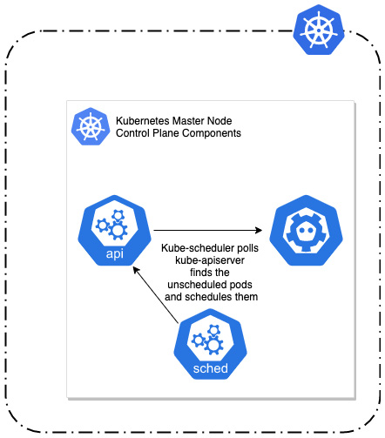
Figure 19.1 – Interactions of kube-scheduler and Kubernetes API server
The scheduling process for a Pod is performed in two phases:
Filtering: Kube-scheduler determines the set of Nodes that are capable of running a given Pod. This includes checking the actual state of the Nodes and verifying any resource requirements and criteria specified by the Pod definition. At this point, if there are no Nodes that can run a given Pod, the Pod cannot be scheduled and remains pending.
Scoring: Kube-scheduler assigns scores for each Node based on a set of scheduling policies. Then, the Pod is assigned by the scheduler to the Node with the highest score. We will cover scheduling policies in the last section of this chapter.
The kube-scheduler will consider criteria and configuration values you can optionally pass in the Pod specification. By using these configurations, you can control precisely how the kube-scheduler will elect a worker Node.
Important note
The decisions of kube-scheduler are valid precisely at the point in time of scheduling the Pod. When the Pod gets scheduled and is running, kube-scheduler will not do any rescheduling operations while it is running (which can be days or even months). So even if this Pod no longer matches the Node according to your rules, it will remain running. Rescheduling will only happen if the Pod is terminated and a new Pod needs to be scheduled.
In the next sections, we will discuss the following configurations to control the scheduling of Pods:
Node name and Node selector, which are the simplest forms of static scheduling.
Node affinity and inter-Pod affinity/anti-affinity.
Taints and tolerations.
Let's first take a look at Node affinity, together with Node name and Node selector.

Managing Node affinity
To better understand how Node affinity works in Kubernetes, we need first to take a look at the most basic scheduling options, which are using Node name and Node selector for Pods.

Pod Node name
As we mentioned before, each Pod object has a nodeName field which is usually controlled by the kube-scheduler. Nevertheless, it is possible to set this property directly in the YAML manifest when you create a Pod or create a controller that uses a Pod template. This is the simplest form of statically scheduling Pods on a given Node and is generally not recommended – it is not flexible and does not scale at all. The names of Nodes can change over time and you risk running out of resources on the Node.
Tip
You may find setting nodeName explicitly useful in debugging scenarios when you want to run a Pod on a specific Node.
We are going to demonstrate all scheduling principles on an example Deployment object that we introduced in Chapter 11, Deployment – Deploying Stateless Applications. This is a simple Deployment that manages five Pod replicas of an nginx webserver running in a container. Create the following YAML manifest named nginx-deployment.yaml:
apiVersion: apps/v1
kind: Deployment
metadata:
name: nginx-deployment-example
spec:
replicas: 5
selector:
matchLabels:
app: nginx
environment: test
template:
metadata:
labels:
app: nginx
environment: test
spec:
containers:
- name: nginx
image: nginx:1.17
ports:
- containerPort: 80
At this point, the Pod template in .spec.template.spec does not contain any configuration that affects the scheduling of the Pod replicas. Before we apply the manifest to the cluster, we need to know what Nodes we have in the cluster so that we can understand how they are scheduled and how we can influence the scheduling of Pods. You can get the list of Nodes using the kubectl get nodes command:
$ kubectl get nodes
NAME STATUS ROLES AGE VERSION
aks-nodepool1-77120516-vmss000000 Ready agent 1d v1.18.14
aks-nodepool1-77120516-vmss000001 Ready agent 1d v1.18.14
aks-nodepool1-77120516-vmss000002 Ready agent 1d v1.18.14
In our example, we are running a three-Node cluster. For simplicity, we will refer to aks-nodepool1-77120516-vmss000000 as Node 0, aks-nodepool1-77120516-vmss000001 as Node 1, and aks-nodepool1-77120516-vmss000002 as Node 2.
Now, let's apply the nginx-deployment.yaml YAML manifest to the cluster:
$ kubectl apply -f ./nginx-deployment.yaml
deployment.apps/nginx-deployment-example created
The Deployment object will create five Pod replicas. You can get their statuses, together with the Node names that they were scheduled for, using the following command:
$ kubectl get pods --namespace default --output=custom-columns="NAME:.metadata.name,STATUS:.status.phase,NODE:.spec.nodeName"
NAME STATUS NODE
nginx-deployment-example-5549875c78-nndb4 Running aks-nodepool1-77120516-vmss000001
nginx-deployment-example-5549875c78-ps7pd Running aks-nodepool1-77120516-vmss000000
nginx-deployment-example-5549875c78-s824f Running aks-nodepool1-77120516-vmss000002
nginx-deployment-example-5549875c78-xfbkj Running aks-nodepool1-77120516-vmss000002
nginx-deployment-example-5549875c78-zg2w7 Running aks-nodepool1-77120516-vmss000000
As you can see, by default the Pods have been distributed uniformly – Node 0 has received two Pods, Node 1 one Pod, and Node 2 two Pods. This is a result of the default scheduling policies enabled in the kube-scheduler for filtering and scoring.
Tip
If you are running a non-managed Kubernetes cluster, you can inspect the logs for the kube-scheduler Pod using the kubectl logs command, or even directly at the master Nodes in /var/log/kube-scheduler.log. This may also require increased verbosity of logs for the kube-scheduler process. You can read more at https://kubernetes.io/docs/reference/command-line-tools-reference/kube-scheduler/.
We will now forcefully assign all Pods in the Deployment to Node 0 in the cluster using the nodeName field in the Pod template. Change the nginx-deployment.yaml YAML manifest so that it has this property set with the correct Node name for your cluster:
apiVersion: apps/v1
kind: Deployment
metadata:
name: nginx-deployment-example
spec:
...
template:
...
spec:
nodeName: aks-nodepool1-77120516-vmss000000
...
Apply the manifest to the cluster using the kubectl apply -f ./nginx-deployment.yaml command and inspect the Pod status and Node assignment again:
$ kubectl get pods --namespace default --output=custom-columns="NAME:.metadata.name,STATUS:.status.phase,NODE:.spec.nodeName"
NAME STATUS NODE
nginx-deployment-example-6977595df5-95sfh Running aks-nodepool1-77120516-vmss000000
nginx-deployment-example-6977595df5-cxgqb Running aks-nodepool1-77120516-vmss000000
nginx-deployment-example-6977595df5-h5wwk Running aks-nodepool1-77120516-vmss000000
nginx-deployment-example-6977595df5-pww9g Running aks-nodepool1-77120516-vmss000000
nginx-deployment-example-6977595df5-q5xxs Running aks-nodepool1-77120516-vmss000000
As expected, all five Pods are now running on Node 0. These are all new Pods – when you change the Pod template in the Deployment specification, it causes internally a rollout using a new ReplicaSet object, while the old ReplicaSet object is scaled down, as explained in Chapter 11, Deployment – Deploying Stateless Applications.
Important note
In this way, we have actually bypassed kube-scheduler. If you inspect events for one of the Pods using the kubectl describe pod command, you will see that it lacks any events with Scheduled as a reason.
Next, we are going to take a look at another basic method of scheduling Pods, which is the Node selector.

Pod Node selector
Pod specification has a special field, .spec.nodeSelector, that gives you the ability to schedule your Pod only on Nodes that have certain label values. This concept is similar to label selectors that you know from Deployments or StatefulSets, but the difference is that it allows only simple equality-based comparisons for labels. You cannot do advanced set-based logic.
A very common use case for scheduling Pods using nodeSelector is managing Pods in hybrid Windows/Linux clusters. Every Kubernetes Node comes by default with a set of labels, which include the following:
kubernetes.io/arch: Describes the Node's processor architecture, for example, amd64 or arm. This is also defined as beta.kubernetes.io/arch.
kubernetes.io/os: Has a value of linux or windows. This is also defined as beta.kubernetes.io/os.
If you inspect the labels for one of the Nodes, you will see that there are plenty of them – in our case some of them are specific to Azure Kubernetes Service (AKS) clusters only:
$ kubectl describe node aks-nodepool1-77120516-vmss000000
...
Labels: agentpool=nodepool1
beta.kubernetes.io/arch=amd64
beta.kubernetes.io/instance-type=Standard_DS2_v2
beta.kubernetes.io/os=linux
failure-domain.beta.kubernetes.io/region=eastus
failure-domain.beta.kubernetes.io/zone=0
kubernetes.azure.com/cluster=MC_k8sforbeginners-rg_k8sforbeginners-aks_eastus
kubernetes.azure.com/mode=system
kubernetes.azure.com/node-image-version=AKSUbuntu-1804gen2-2021.02.17
kubernetes.azure.com/role=agent
kubernetes.io/arch=amd64
kubernetes.io/hostname=aks-nodepool1-77120516-vmss000000
kubernetes.io/os=linux
kubernetes.io/role=agent
node-role.kubernetes.io/agent=
node.kubernetes.io/instance-type=Standard_DS2_v2
storageprofile=managed
storagetier=Premium_LRS
topology.kubernetes.io/region=eastus
topology.kubernetes.io/zone=0
...
Of course, you can define your own labels for the Nodes and use them to control scheduling. Please note that in general you should use semantic labeling for your resources in Kubernetes, rather than give them special labels just for the purpose of scheduling. Let's demonstrate how to do that by following these steps:
Use the kubectl label nodes command to add a node-type label with a superfast value to Node 1 and Node 2 in the cluster:
$ kubectl label nodes aks-nodepool1-77120516-vmss000001 node-type=superfast
node/aks-nodepool1-77120516-vmss000001 labeled
$ kubectl label nodes aks-nodepool1-77120516-vmss000002 node-type=superfast
node/aks-nodepool1-77120516-vmss000002 labeled
Edit the ./nginx-deployment.yaml deployment manifest so that it has nodeSelector in the Pod template set to node-type: superfast (nodeName that we used previously should be removed):
apiVersion: apps/v1
kind: Deployment
metadata:
name: nginx-deployment-example
spec:
...
template:
...
spec:
nodeSelector:
node-type: superfast
...
Apply the manifest to the cluster using the kubectl apply -f ./nginx-deployment.yaml command and inspect the Pod status and Node assignment again. You may need to wait a while for the deployment rollout to finish:
$ kubectl get pods --namespace default --output=custom-columns="NAME:.metadata.name,STATUS:.status.phase,NODE:.spec.nodeName"
NAME STATUS NODE
nginx-deployment-example-8485bc9569-2pm5h Running aks-nodepool1-77120516-vmss000001
nginx-deployment-example-8485bc9569-79gn9 Running aks-nodepool1-77120516-vmss000002
nginx-deployment-example-8485bc9569-df6x8 Running aks-nodepool1-77120516-vmss000001
nginx-deployment-example-8485bc9569-fd4gv Running aks-nodepool1-77120516-vmss000002
nginx-deployment-example-8485bc9569-tlxgl Running aks-nodepool1-77120516-vmss000002
As you can see, Node 1 has been assigned with two Pods and Node 2 with three Pods. The Pods have been distributed among Nodes that have the node-type=superfast label.
In contrast, if you change the ./nginx-deployment.yaml manifest so that it has nodeSelector in the Pod template set to node-type: slow, which no Node in the cluster has assigned, we will see that Pods could not be scheduled and the deployment will be stuck. Edit the manifest:
apiVersion: apps/v1
kind: Deployment
metadata:
name: nginx-deployment-example
spec:
...
template:
...
spec:
nodeSelector:
node-type: slow
...
Apply the manifest to the cluster using the kubectl apply -f ./nginx-deployment.yaml command and inspect the Pod status and Node assignment again:
$ kubectl get pods --namespace default --output=custom-columns="NAME:.metadata.name,STATUS:.status.phase,NODE:.spec.nodeName"
NAME STATUS NODE
nginx-deployment-example-54dbf4699f-jdx42 Pending <none>
nginx-deployment-example-54dbf4699f-sk2jd Pending <none>
nginx-deployment-example-54dbf4699f-xjdp2 Pending <none>
nginx-deployment-example-8485bc9569-2pm5h Running aks-nodepool1-77120516-vmss000001
nginx-deployment-example-8485bc9569-df6x8 Running aks-nodepool1-77120516-vmss000001
nginx-deployment-example-8485bc9569-fd4gv Running aks-nodepool1-77120516-vmss000002
nginx-deployment-example-8485bc9569-tlxgl Running aks-nodepool1-77120516-vmss000002
The reason why three new Pods are pending and four old Pods are still running is the default configuration of rolling updates in the Deployment object. By default, maxSurge is set to 25% of Pod replicas (absolute number is rounded up), so in our case, it is two Pods allowed to be created above the desired number of five Pods. In total, we now have seven Pods. At the same time, maxUnavailable is also 25% of Pod replicas (but absolute number is rounded down), so in our case, one Pod out of five can be not available. In other words, four Pods must be Running. And because the new Pending Pods cannot get a Node in the process of scheduling, the Deployment is stuck waiting and not progressing. Normally, in this case you need to either perform a rollback to the previous version for the Deployment or change nodeSelector to one that matches existing Nodes properly. Of course, there is also an alternative of adding a new Node with matching labels or adding missing labels to the existing ones, without performing a rollback.
We will now continue the topic of scheduling Pods with the first of more advanced techniques: Node affinity.

Node affinity configuration for Pods
The concepts of Node affinity expand the nodeSelector approach and provide a richer language for defining which Nodes are preferred or avoided for your Pod. In everyday life, the word affinity describes a natural liking for and understanding of someone or something, and this best describes the purpose of Node affinity for Pods. That is, you can control which Nodes your Pod will be attracted to or repelled by.
With Node affinity, represented in .spec.affinity.nodeAffinity for the Pod, you get the following enhancements over simple nodeSelector:
You get a richer language for expressing the rules for matching Pods to Nodes. For example, you can use In, NotIn, Exists, DoesNotExist, Gt, and Lt operators for labels.
Similarly to nodeAffinity, it is possible to do scheduling using inter-Pod affinity (podAffinity) and additionally anti-affinity (podAntiAffinity). Anti-affinity has an opposite effect to affinity – you can define rules that repel the Pods. In this way, you can make your Pods be attracted to Nodes that already run certain Pods. This is especially useful if you want to collocate Pods to decrease latency.
It is possible to define soft affinity and anti-affinity rules that represent a preference instead of a hard rule. In other words, if the scheduler can still schedule the Pod, even if it cannot match the soft rule. Soft rules are represented by the preferredDuringSchedulingIgnoredDuringExecution field in specification, whereas hard rules are represented by the requiredDuringSchedulingIgnoredDuringExecution field.
Soft rules can be weighted.
Tip
Even though there is no Node anti-affinity field provided by a separate field in spec, as in the case of inter-Pod anti-affinity you can still achieve similar results by using the NotIn and DoesNotExist operators. In this way, you can make Pods be repelled from Nodes with specific labels, also in a soft way.
The use cases and scenarios for defining the Node affinity and inter-Pod affinity/anti-affinity rules are unlimited. It is possible to express all kinds of requirements in this way, provided that you have enough labeling on the Nodes. For example, you can model requirements like scheduling the Pod only on a Windows Node with an Intel CPU and premium storage in the West Europe region but currently not running Pods for MySQL, or try not to schedule the Pod in availability Zone 1, but if it is not possible, then availability Zone 1 is still OK.
To demonstrate Node affinity, we will try to model the following requirements for our Deployment: "Try to schedule the Pod only on Nodes with a node-type label with a fast or superfast value, but if it this not possible, use any Node but strictly not with a node-type label with an extremelyslow value." For this, we need to use:
Soft Node affinity rule of type preferredDuringSchedulingIgnoredDuringExecution to match fast and superfast Nodes.
Hard Node affinity rule of type requiredDuringSchedulingIgnoredDuringExecution to repel the Pod strictly from Nodes with node-type as extremelyslow. We need to use the NotIn operator to get the anti-affinity effect.
In our cluster we are going to first have the following labeling for Nodes:
Node 0: slow
Node 1: fast
Node 2: superfast
As you can see, according to our requirements the Deployment Pods should be scheduled on Node 1 and Node 2, unless there is something preventing them from being allocated there, like a lack of CPU or memory resources. In that case, Node 0 would also be allowed as we use the soft affinity rule.
Next, we will relabel the Nodes in the following way:
Node 0: slow
Node 1: extremelyslow
Node 2: extremelyslow
Subsequently, we will need to redeploy our Deployment (for example, scale it down to zero and up to the original replica count, or use the kubectl rollout restart command) to reschedule the Pods again. After that, looking at our requirements, kube-scheduler should assign all Pods to Node 0 (because it is still allowed by the soft rule) but avoid at all costs Node 1 and Node 2. If by any chance Node 0 has no resources to run the Pod, then the Pods would be stuck in the Pending state.
Tip
To solve the issue of rescheduling already running Pods (in other words, to make kube-scheduler consider them again), there is an incubating Kubernetes project named Descheduler. You can find out more here: https://github.com/kubernetes-sigs/descheduler.
To do the demonstration, please follow these steps:
Use the kubectl label nodes command to add a node-type label with a slow value for Node 0, a fast value for Node 1, and a superfast value for Node 2:
$ kubectl label nodes --overwrite aks-nodepool1-77120516-vmss000000 node-type=slow
node/aks-nodepool1-77120516-vmss000000 labeled
$ kubectl label nodes --overwrite aks-nodepool1-77120516-vmss000001 node-type=fast
node/aks-nodepool1-77120516-vmss000001 labeled
$ kubectl label nodes --overwrite aks-nodepool1-77120516-vmss000002 node-type=superfast
node/aks-nodepool1-77120516-vmss000002 not labeled # Note that this label was already present with this value
Edit the ./nginx-deployment.yaml Deployment manifest (the full file is available in the official GitHub repository for the book: https://github.com/PacktPublishing/Kubernetes-for-Beginners/blob/master/Chapter19/03_affinity/nginx-deployment.yaml), and remove nodeSelector. Instead, define the soft Node affinity rule as follows:
apiVersion: apps/v1
kind: Deployment
metadata:
name: nginx-deployment-example
spec:
...
template:
...
spec:
affinity:
nodeAffinity:
requiredDuringSchedulingIgnoredDuringExecution:
nodeSelectorTerms:
- matchExpressions:
- key: node-type
operator: NotIn
values:
- extremelyslow
preferredDuringSchedulingIgnoredDuringExecution:
- weight: 1
preference:
matchExpressions:
- key: node-type
operator: In
values:
- fast
- superfast
...
As you can see, we have used nodeAffinity (not podAffinity or podAntiAffinity) with preferredDuringSchedulingIgnoredDuringExecution set so that it has only one soft rule: node-type should have a fast value or a superfast value. This means that if there are no resources on such Nodes, they can still be scheduled on other Nodes. Additionally, we specify one hard anti-affinity rule in requiredDuringSchedulingIgnoredDuringExecution, which says that node-type must not be extremelyslow. You can find the full specification of Pod's .spec.affinity in the official documentation: https://kubernetes.io/docs/reference/generated/kubernetes-api/v1.19/#affinity-v1-core.
Apply the manifest to the cluster using the kubectl apply -f ./nginx-deployment.yaml command and inspect the Pod status and Node assignment again. You may need to wait a while for the Deployment rollout to finish:
$ kubectl get pods --namespace default --output=custom-columns="NAME:.metadata.name,STATUS:.status.phase,NODE:.spec.nodeName"
NAME STATUS NODE
nginx-deployment-example-7ff6c65bd4-8z7z5 Running aks-nodepool1-77120516-vmss000002
nginx-deployment-example-7ff6c65bd4-ps9md Running aks-nodepool1-77120516-vmss000002
nginx-deployment-example-7ff6c65bd4-pszkq Running aks-nodepool1-77120516-vmss000001
nginx-deployment-example-7ff6c65bd4-qpv5d Running aks-nodepool1-77120516-vmss000001
nginx-deployment-example-7ff6c65bd4-vh6dx Running aks-nodepool1-77120516-vmss000002
Our Node affinity rules were defined to prefer Nodes that have node-type set to either fast or superfast, and indeed the Pods were scheduled for Node 1 and Node 2 only.
Now we will do an experiment to demonstrate how the soft part of Node affinity together with the hard part of Node anti-affinity work. We will relabel the Nodes as described in the introduction, redeploy the Deployment, and observe what happens. Please follow these steps:
Use the kubectl label nodes command to add a node-type label with a slow value for Node 0, an extremelyslow value for Node 1, and an extremelyslow value for Node 2:
$ kubectl label nodes --overwrite aks-nodepool1-77120516-vmss000000 node-type=slow
node/aks-nodepool1-77120516-vmss000000 not labeled
$ kubectl label nodes --overwrite aks-nodepool1-77120516-vmss000001 node-type=extremelyslow
node/aks-nodepool1-77120516-vmss000001 labeled
$ kubectl label nodes --overwrite aks-nodepool1-77120516-vmss000002 node-type=extremelyslow
node/aks-nodepool1-77120516-vmss000002 labeled
At this point, if you were to check Pods assignments using kubectl get pods, there would be no difference. This is because, as we explained before, a Pod's assignment to Nodes is valid only at the time of scheduling, and after that, it is not changed unless they are restarted. To force the restart of Pods, we could scale the Deployment down to zero replicas and then back to five. But there is an easier way, which is to use an imperative kubectl rollout restart command. This approach has the benefit of not making the Deployment unavailable, and it performs a rolling restart of Pods without a decrease in the number of available Pods. Execute the following command:
$ kubectl rollout restart deploy nginx-deployment-example
deployment.apps/nginx-deployment-example restarted
Inspect the Pod status and Node assignment again. You may need to wait a while for the Deployment rollout to finish:
$ kubectl get pods --namespace default --output=custom-columns="NAME:.metadata.name,STATUS:.status.phase,NODE:.spec.nodeName"
NAME STATUS NODE
nginx-deployment-example-6c4fdd447d-4mjfm Running aks-nodepool1-77120516-vmss000000
nginx-deployment-example-6c4fdd447d-qgqmc Running aks-nodepool1-77120516-vmss000000
nginx-deployment-example-6c4fdd447d-qhrtf Running aks-nodepool1-77120516-vmss000000
nginx-deployment-example-6c4fdd447d-tnvpm Running aks-nodepool1-77120516-vmss000000
nginx-deployment-example-6c4fdd447d-ttfnk Running aks-nodepool1-77120516-vmss000000
The output shows that, as expected, all Pods have been scheduled to Node 0, which is labeled with node-type=slow. We allow such Nodes if there is nothing better, and in this case Node 1 and Node 2 have label node-type=extremelyslow, which is prohibited by the hard Node anti-affinity rule.
Tip
To achieve even higher granularity and control of Pod scheduling, you can use Pod topology spread constraints. More details are available in the official documentation: https://kubernetes.io/docs/concepts/workloads/pods/pod-topology-spread-constraints/.
Congratulations, you have successfully configured Node affinity for our Deployment Pods! We will now explore another way of scheduling Pods – taints and tolerations.

Using Node taints and tolerations
Using the Node and inter-Pod affinity mechanism for scheduling Pods is very powerful, but sometimes you need a simpler way of specifying which Nodes should repel Pods. Kubernetes offers a slightly older and simpler feature for this purpose – taints and tolerations. You apply a taint to a given Node (which describes some kind of limitation) and the Pod must have a specific toleration defined to be schedulable on the tainted Node. If the Pod has a toleration, it does not mean that the taint is required on the Node. The real-life definition of taint is "a trace of a bad or undesirable substance or quality," and this reflects the idea pretty well – all Pods will avoid a Node if there is a taint set for them, but we can instruct Pods to tolerate a specific taint.
Tip
If you look closely at how taints and tolerations are described, you can see that you can achieve similar results with Node labels and Node hard and soft affinity rules with the NotIn operator. There is one catch – you can define taints with a NoExecute effect which will result in the termination of the Pod if it cannot tolerate it. You cannot get similar results with affinity rules unless you restart the Pod manually.
Taints for Nodes have the following structure: <key>=<value>:<effect>. The key and value pair identifies the taint and can be used for more granular tolerations, for example tolerating all taints with a given key and any value. This is similar to labels, but please bear in mind that taints are separate properties, and defining a taint does not affect Node labels. In our example demonstration, we will use our own taint with a machine-check-exception key and a memory value. This is, of course, a theoretical example where we want to indicate that there is a hardware issue with memory on the host, but you could also have a taint with the same key and instead a cpu or disk value. In general, your taints should semantically label the type of issue that the Node is experiencing. There is nothing preventing you from using any keys and values for creating taints, but if they make semantic sense, it is much easier to manage them and define tolerations.
The taint can have different effects:
NoSchedule – kube-scheduler will not schedule Pods to this Node. Similar behavior can be achieved using a hard Node affinity rule.
PreferNoSchedule – kube-scheduler will try to not schedule Pods to this Node. Similar behavior can be achieved using a soft Node affinity rule.
NoExecute – kube-scheduler will not schedule Pods to this Node and evict (terminate and reschedule) running Pods from this Node. You cannot achieve similar behavior using Node affinity rules. Note that when you define a toleration for a Pod for this type of taint, it is possible to control how long the Pod will tolerate the taint before it gets evicted, using tolerationSeconds.
Kubernetes manages quite a few NoExecute taints automatically by monitoring the Node hosts. The following taints are built-in and managed by NodeController or the kubelet:
node.kubernetes.io/not-ready: Added when NodeCondition Ready has a false status.
node.kubernetes.io/unreachable: Added when NodeCondition Ready has an Unknown status. This happens when NodeController cannot reach the Node
node.kubernetes.io/out-of-disk: Node has no disk available.
node.kubernetes.io/memory-pressure: Node is experiencing memory pressure.
node.kubernetes.io/disk-pressure: Node is experiencing disk pressure.
node.kubernetes.io/network-unavailable: Network is currently down on the Node.
node.kubernetes.io/unschedulable: Node is currently in an unschedulable state.
node.cloudprovider.kubernetes.io/uninitialized: Intended for Nodes that are prepared by an external cloud provider. When the Node gets initialized by cloud-controller-manager, this taint is removed.
To add a taint on a Node, you use the kubectl taint node command in the following way:
$ kubectl taint node <nodeName> <key>=<value>:<effect>
So, for example, if we want to use key machine-check-exception and a memory value with a NoExecute effect for Node 1, we will use the following command:
$ kubectl taint node aks-nodepool1-77120516-vmss000001 machine-check-exception=memory:NoExecute
To remove the same taint, you need to use the following command (bear in mind the - character at the end of the taint definition):
$ kubectl taint node aks-nodepool1-77120516-vmss000001 machine-check-exception=memory:NoExecute-
You can also remove all taints with a specified key:
kubectl taint node aks-nodepool1-77120516-vmss000001 machine-check-exception:NoExecute-
To counteract the effect of the taint on a Node for specific Pods, you can define tolerations in their specification. In other words, you can use tolerations to ignore taints and still schedule the Pods to such Nodes. If a Node has multiple taints applied, the Pod must tolerate all of its taints. Tolerations are defined under .spec.tolerations in the Pod specification and have the following structure:
tolerations:
- key: <key>
operator: <operatorType>
value: <value>
effect: <effect>
The operator can be either Equal or Exists. Equal means that both key and value of taint must match exactly, whereas Exists means that just key must match and value is not considered. In our example, if we want to ignore the taint, the toleration will need to look like this:
tolerations:
- key: machine-check-exception
operator: Equal
value: memory
effect: NoExecute
You can define multiple tolerations for a Pod.
In the case of NoExecute tolerations, it is possible to define an additional field called tolerationSeconds, which specifies how long the Pod will tolerate the taint until it gets evicted. So, this is a way of having partial toleration of taint with a timeout. Please note that if you use NoExecute taints, you usually also need to add a NoSchedule taint. In this way, you can prevent any eviction loops happening when the Pod has a NoExecute toleration with tolerationSeconds set. This is because the taint has no effect for a specified number of seconds, which also includes not preventing the Pod from being scheduled for the tainted Node.
Important Note
When Pods are created in the cluster, Kubernetes automatically adds two Exists tolerations for node.kubernetes.io/not-ready and node.kubernetes.io/unreachable with tolerationSeconds set to 300.
We will now put this knowledge into practice with a few demonstrations. Please follow the next steps:
If you have the nginx-deployment-example Deployment with Node affinity defined still running from the previous section, it will currently have all Pods running on Node 0. The Node affinity rules are constructed in such a way that the Pods cannot be scheduled on Node 1 and Node 2. Let's see what happens if you taint Node 0 with machine-check-exception=memory:NoExecute:
$ kubectl taint node aks-nodepool1-77120516-vmss000000 machine-check-exception=memory:NoExecute
node/aks-nodepool1-77120516-vmss000000 tainted
Check the Pod status and Node assignment:
$ kubectl get pods --namespace default --output=custom-columns="NAME:.metadata.name,STATUS:.status.phase,NODE:.spec.nodeName"
NAME STATUS NODE
nginx-deployment-example-6c4fdd447d-c42z2 Pending <none>
nginx-deployment-example-6c4fdd447d-dstbl Pending <none>
nginx-deployment-example-6c4fdd447d-ktfzh Pending <none>
nginx-deployment-example-6c4fdd447d-ptcwc Pending <none>
nginx-deployment-example-6c4fdd447d-wdmb9 Pending <none>
All Deployment Pods are now in the Pending state because kube-scheduler is unable to find a Node that can run them.
Edit the ./nginx-deployment.yaml Deployment manifest and remove affinity. Instead, define taint toleration for machine-check-exception=memory:NoExecute with a timeout of 60 seconds:
apiVersion: apps/v1
kind: Deployment
metadata:
name: nginx-deployment-example
spec:
...
template:
...
spec:
tolerations:
- key: machine-check-exception
operator: Equal
value: memory
effect: NoExecute
tolerationSeconds: 60
...
When this manifest is applied to the cluster, the old Node affinity rules which prevented scheduling to Node 1 and Node 2 will be gone. The Pods will be able to schedule on Node 1 and Node 2, but Node 0 has taint machine-check-exception=memory:NoExecute. So, the Pods should not be scheduled to Node 0, as NoExecute implies NoSchedule, right? Let's check that.
Apply the manifest to the cluster using the kubectl apply -f ./nginx-deployment.yaml command and inspect the Pod status and Node assignment again. You may need to wait a while for the Deployment rollout to finish:
$ kubectl get pods -o wide
NAME ... AGE IP NODE
nginx-deployment-example-6b774d7f6c-95ttq ... 14s 10.244.1.230 aks-nodepool1-77120516-vmss000000
nginx-deployment-example-6b774d7f6c-hthwj ... 16m 10.244.0.110 aks-nodepool1-77120516-vmss000001
nginx-deployment-example-6b774d7f6c-lskr7 ... 14s 10.244.1.231 aks-nodepool1-77120516-vmss000000
nginx-deployment-example-6b774d7f6c-q94kw ... 16m 10.244.2.19 aks-nodepool1-77120516-vmss000002
nginx-deployment-example-6b774d7f6c-wszfn ... 16m 10.244.0.109 aks-nodepool1-77120516-vmss000001
This result may be a bit surprising. As you can see, we got two Pods scheduled on Node 1 and one Pod on Node 2, but at the same time Node 0 has received two Pods, and they are in eviction loop every 60 seconds! The explanation for this is that tolerationSeconds for the NoExecute taint implies that the whole taint is ignored for 60 seconds. So kube-scheduler can schedule the Pod on Node 0, even though it will get evicted later.
Let's fix this behavior by applying a recommendation to use a NoSchedule taint whenever you use a NoExecute taint. In this way, the evicted Pods will have no chance to be scheduled on the tainted Node again, unless of course they start tolerating this type of taint too. Execute the following command to taint Node 0:
$ kubectl taint node aks-nodepool1-77120516-vmss000000 machine-check-exception=memory:NoSchedule
node/aks-nodepool1-77120516-vmss000000 tainted
Inspect the Pod status and Node assignment again:
$ kubectl get pods --namespace default --output=custom-columns="NAME:.metadata.name,STATUS:.status.phase,NODE:.spec.nodeName"
NAME STATUS NODE
nginx-deployment-example-6b774d7f6c-hthwj Running aks-nodepool1-77120516-vmss000001
nginx-deployment-example-6b774d7f6c-jfvqn Running aks-nodepool1-77120516-vmss000001
nginx-deployment-example-6b774d7f6c-q94kw Running aks-nodepool1-77120516-vmss000002
nginx-deployment-example-6b774d7f6c-wszfn Running aks-nodepool1-77120516-vmss000001
nginx-deployment-example-6b774d7f6c-z8jx2 Running aks-nodepool1-77120516-vmss000002
In the output you can see that the Pods are now distributed between Node 1 and Node 2 – exactly as we wanted.
Now, remove both taints from the Node 0:
$ kubectl taint node aks-nodepool1-77120516-vmss000000 machine-check-exception-
node/aks-nodepool1-77120516-vmss000000 untainted
Restart the Deployment to reschedule the Pods using the following command:
$ kubectl rollout restart deploy nginx-deployment-example
deployment.apps/nginx-deployment-example restarted
Inspect the Pod status and Node assignment again:
$ kubectl get pods --namespace default --output=custom-columns="NAME:.metadata.name,STATUS:.status.phase,NODE:.spec.nodeName"
NAME STATUS NODE
nginx-deployment-example-56f4d4d96d-nf82h Running aks-nodepool1-77120516-vmss000002
nginx-deployment-example-56f4d4d96d-v8m9c Running aks-nodepool1-77120516-vmss000000
nginx-deployment-example-56f4d4d96d-vzqn4 Running aks-nodepool1-77120516-vmss000000
nginx-deployment-example-56f4d4d96d-wpv78 Running aks-nodepool1-77120516-vmss000001
nginx-deployment-example-56f4d4d96d-x7x92 Running aks-nodepool1-77120516-vmss000001
The Pods are again distributed evenly between all three Nodes.
And finally, let's see how the combination of NoExecute and NoSchedule taints work, with tolerationSeconds for NoExecute set to 60. Apply two taints to Node 0 again:
$ kubectl taint node aks-nodepool1-77120516-vmss000000 machine-check-exception=memory:NoSchedule
node/aks-nodepool1-77120516-vmss000000 tainted
$ kubectl taint node aks-nodepool1-77120516-vmss000000 machine-check-exception=memory:NoExecute
node/aks-nodepool1-77120516-vmss000000 tainted
Immediately after that, start watching Pods with their Node assignments. Initially, you will see that the Pods are still running on Node 0 for some time. But after 60 seconds, you will see:
$ kubectl get pods --namespace default --output=custom-columns="NAME:.metadata.name,STATUS:.status.phase,NODE:.spec.nodeName"
NAME STATUS NODE
nginx-deployment-example-56f4d4d96d-44zvt Running aks-nodepool1-77120516-vmss000002
nginx-deployment-example-56f4d4d96d-9rg2p Running aks-nodepool1-77120516-vmss000001
nginx-deployment-example-56f4d4d96d-nf82h Running aks-nodepool1-77120516-vmss000002
nginx-deployment-example-56f4d4d96d-wpv78 Running aks-nodepool1-77120516-vmss000001
nginx-deployment-example-56f4d4d96d-x7x92 Running aks-nodepool1-77120516-vmss000001
As we expected, the Pods have been evicted after 60 seconds and there were no eviction-schedule loops.
This has demonstrated a more advanced use case for taints which you cannot easily substitute with Node affinity rules. In the next section, we will give a short overview of kube-scheduler scheduling policies.

Scheduling policies
kube-scheduler decides for which Node a given Pod should be scheduled, in two phases: filtering and scoring. To quickly recap, filtering is the first phase when kube-scheduler finds a set of Nodes that can be used for the running of a Pod. For example, if a Pod tolerates Node taints. In the second phase, scoring, the filtered Nodes are ranked using a scoring system to find the most suitable Node for the Pod.
The way the default kube-scheduler executes these two phases is defined by the scheduling policy. This policy is configurable and can be passed to the kube-scheduler process using the additional arguments --policy-config-file <filename> or --policy-configmap <configMap>.
Important note
In managed Kubernetes clusters, such as the managed Azure Kubernetes Service, you will not be able to change scheduling policy of kube-scheduler, as you do not have access to Kubernetes master Node.
There are two configuration fields that are most important in scheduling policy:
Predicates: Implement the rules for filtering
Priorities: Implement the scoring system
The full list of currently supported predicates and priorities is available in the official documentation: https://kubernetes.io/docs/reference/scheduling/policies/. We will give an overview of a few of the most interesting ones that show how flexible the default kube-scheduler is. Some of the selected predicates are shown in the following list:
PodToleratesNodeTaints: As the name suggests, implements a basic check if a Pod has defined a toleration for current Node taints
PodFitsResources: Implements a check if the Node has enough free resources to meet the requirements specified by a Pod
CheckNodePIDPressure: Implements a check if the Node has enough available process IDs to safely continue running Pods
CheckVolumeBinding: Implements a check if the Node is compatible with PVCs that the Pod requires
Some of the interesting available priorities are as follows:
SelectorSpreadPriority: Ensures that Pods that belong to the same ReplicationController, StatefulSet, and ReplicaSet objects (this includes Deployments) are evenly spread across the Nodes. This ensures better fault tolerance in case of Node failures.
NodeAffinityPriority and InterPodAffinityPriority: Implements the soft Node affinity and inter-Pod affinity/anti-affinity.
ImageLocalityPriority: Prioritizes the Nodes that already have the container images required by a Pod in the local cache to reduce start up time and decrease unnecessary network traffic.
ServiceSpreadingPriority: Attempts to spread the Pods by minimizing the number of Pods belonging to the same Service object running on the same Node. This ensures better fault tolerance in case of Node failures.
The preceding examples are just a subset of the available predicates and priorities, but this already gives an overview of how many complex use cases and scenarios are supported out of the box in kube-scheduler.

Summary
This chapter has given an overview of advanced techniques for Pod scheduling in Kubernetes. First, we recapped the theory behind kube-scheduler implementation. We have explained the process of scheduling Pods. Next, we introduced the concept of Node affinity in Pod scheduling. You learned the basic scheduling methods which use Node names and Node selectors, and based on that we have explained how more advanced Node affinity works. We also explained how you can use the affinity concept to achieve anti-affinity, and what inter-Pod affinity/anti-affinity is. After that, we discussed taints for Nodes and tolerations specified by Pods. You learned about some different effects of the taints, and have put the knowledge into practice in an advanced use case involving NoExecute and NoSchedule taints on a Node. Lastly, we discussed the theory behind scheduler policies that can be used to configure the default kube-scheduler.
In the next chapter, we are going to discuss autoscaling of Pods and Nodes in Kubernetes – this will be a topic that will show how flexibly Kubernetes can run workloads in cloud environments.

Further reading
For more information regarding Pod scheduling in Kubernetes, please refer to the following PacktPub books:
The Complete Kubernetes Guide, by Jonathan Baier, Gigi Sayfan, Jesse White (https://www.packtpub.com/virtualization-and-cloud/complete-kubernetes-guide)
Getting Started with Kubernetes – Third Edition, by Jonathan Baier, Jesse White (https://www.packtpub.com/virtualization-and-cloud/getting-started-kubernetes-third-edition)
Kubernetes for Developers, by Joseph Heck (https://www.packtpub.com/virtualization-and-cloud/kubernetes-developers)
You can also refer to official documents:
Kubernetes documentation (https://kubernetes.io/docs/home/), which is always the most up-to-date source of knowledge about Kubernetes in general.
Node affinity is covered at https://kubernetes.io/docs/concepts/scheduling-eviction/assign-pod-node/.
Taint and tolerations are covered at https://kubernetes.io/docs/concepts/scheduling-eviction/taint-and-toleration/.
Pod priorities and preemption (which we have not covered in this chapter) are described at https://kubernetes.io/docs/concepts/configuration/pod-priority-preemption/.
Advanced kube-scheduler configuration using scheduling profiles (which we have not covered in this chapter) is described at https://kubernetes.io/docs/reference/scheduling/config.

Chapter 20: Autoscaling Kubernetes Pods and Nodes
Needless to say, having autoscaling capabilities for your cloud-native application is considered the holy grail of running applications in cloud. In short, by autoscaling, we mean a method to automatically and dynamically adjust the amount of computational resources, such as CPU and RAM memory, available to your application. The goal of it is to cleverly add or remove available resources based on the activity and demand of end users. So, for example, the application may require more CPU and RAM memory during daytime hours, when users are most active, but much less during the night. Similarly, if you are running an e-commerce business, you can expect a huge spike in demand during so-called Black Friday. In this way, you can not only provide a better, highly available service to users but also reduce your cost of goods sold (COGS) for the business. The fewer resources you consume in the cloud, the less you pay, and the business can invest the money elsewhere – this is a win-win situation. There is, of course, no single rule that fits all use cases, hence good autoscaling needs to be based on critical usage metrics and should have predictive features to anticipate the workloads based on history.
Kubernetes, as the most mature container orchestration system available, comes with a variety of built-in autoscaling features. Some of these features are natively supported in every Kubernetes cluster and some require installation or specific type of cluster deployment. There are also multiple dimensions of scaling that you can have:
Vertical for Pods: This involves adjusting the amount of CPU and memory resources available to a Pod. Pods can run under limits specified for CPU and memory, to prevent excessive consumption, but these limits may require automatic adjustment rather than a human operator guessing. This is implemented by a VerticalPodAutoscaler (VPA).
Horizontal for Pods: This involves dynamically changing the number of Pod replicas for your Deployment or StatefulSet. These objects come with nice scaling features out of the box, but adjusting the number of replicas can be automated using a HorizontalPodAutoscaler (HPA).
Horizontal for Nodes: Another dimension of horizontal scaling (scaling out), but this time at the level of a Kubernetes Node. You can scale your whole cluster by adding or removing the Nodes. This requires, of course, a Kubernetes Deployment that runs in an environment that supports the dynamic provisioning of machines, such as a cloud environment. This is implemented by a Cluster Autoscaler (CA), available for some cloud vendors.
In this chapter, we will cover the following topics:
Pod resource requests and limits
Autoscaling Pods vertically using a Vertical Pod Autoscaler
Autoscaling Pods horizontally using a Horizontal Pod Autoscaler
Autoscaling Kubernetes Nodes using a Cluster Autoscaler

Technical requirements
For this chapter, you will need the following:
A Kubernetes cluster deployed. We recommend using a multi-node, cloud-based Kubernetes cluster.
Having a multi-node Google Kubernetes Engine (GKE) cluster is a recommended prerequisite to follow the second section relating to the Vertical Pod Autoscaler (VPA). AKS and EKS currently require the manual installation of a VPA, which we are going to demonstrate, but GKE has support for it out of the box.
Having a multi-node AKS, EKS, or GKE cluster is a prerequisite for following the final section regarding a CA.
A Kubernetes CLI (kubectl) installed on your local machine and configured to manage your Kubernetes cluster.
Basic Kubernetes cluster deployment (local and cloud-based) and kubectl installation have been covered in Chapter 3, Installing Your First Kubernetes Cluster.
The following chapters can provide you with an overview of how to deploy a fully functional Kubernetes cluster on different cloud platforms and install the requisite CLIs to manage them:
Chapter 14, Kubernetes Clusters on Google Kubernetes Engine
Chapter 15, Launching a Kubernetes Cluster on Amazon Web Services with the Amazon Elastic Kubernetes Service
Chapter 16, Kubernetes Clusters on Microsoft Azure with the Azure Kubernetes Service
You can download the latest code samples for this chapter from the official GitHub repository at https://github.com/PacktPublishing/The-Kubernetes-Bible/tree/master/Chapter20.

Pod resource requests and limits
Before we dive into the topics of autoscaling in Kubernetes, we need to explain a bit more about how you can control the CPU and memory resource (known as compute resources) usage by Pod containers in Kubernetes. Controlling the use of compute resources is important since, in this way, you can enforce resource governance – this allows better planning of the cluster capacity and, most importantly, prevents situations when a single container can consume all compute resources and prevent other Pods from serving the requests.
When you create a Pod, it is possible to specify how much compute resources its containers require and what the limits are in terms of permitted consumption. The Kubernetes resource model provides an additional distinction between two classes of resources: compressible and incompressible. In short, a compressible resource can be easily throttled, without severe consequences. A perfect example of such a resource is the CPU – if you need to throttle CPU usage for a given container, the container will operate normally, just slower. On the other hand, we have incompressible resources that cannot be throttled without sever consequences – RAM memory allocation is an example of such a resource. If you do not allow a process running in a container to allocate more memory, the process will crash and result in container restart.
Important Note
If you want to know more about the philosophy and design decisions for the Kubernetes resource governance model, we recommend reading the official design proposal documents. Resource model: https://github.com/kubernetes/community/blob/master/contributors/design-proposals/scheduling/resources.md. Resource quality of service: https://github.com/kubernetes/community/blob/master/contributors/design-proposals/node/resource-qos.md.
To control the resources for a Pod container, you can specify two values in its specification:
requests: This specifies the guaranteed amount of a given resource provided by the system. You can also think the other way round – this is the amount of a given resource that the Pod container requires from the system in order to function properly. This is important as Pod scheduling is dependent on the requests value (not limits), namely, the PodFitsResources predicate and the BalancedResourceAllocation priority.
limits: This specifies the maximum amount of a given resource provided by the system. If specified together with requests, this value must be greater than or equal to requests. Depending on whether the resource is compressible or incompressible, exceeding the limit has different consequences – compressible resources (CPU) will be throttled, whereas incompressible resources (RAM) may result in container kill and restart.
If you use different values for requests and limits, you can allow for resource overcommit. This technique is useful for efficiently handling short bursts of resource usage while allowing better resource usage on average. The reasoning behind this is that you will rarely have all containers on the Node requiring maximum resources, as they specify in limits, at the same time. This gives you better bin packing of your Pods for the majority of the time. The concept is similar to overprovisioning for virtual machine hypervisors or, in the real world, overbooking for airplane flights.
If you do not specify limits at all, the container can consume as much of the resource on a Node as it wants. This can be controlled by namespace resource quotas and limit ranges – you can read more about these objects in the official documentation: https://kubernetes.io/docs/concepts/policy/limit-range/.
Tip
In more advanced scenarios, you can also control huge pages and ephemeral storage requests and limits.
Before we dive into the configuration details, we need to look at what are the units for measuring CPU and memory in Kubernetes. For CPU, the base unit is Kubernetes CPU (KCU), where 1 is equivalent to, for example, 1 vCPU on Azure, 1 core on GCP, or 1 hyperthreaded core on a bare-metal machine. Fractional values are allowed: 0.1 can be also specified as 100m (milliKCUs). For memory, the base unit is byte; you can, of course, specify standard unit prefixes, such as M, Mi, G, or Gi.
To enable compute resource requests and limits for Pod containers in our nginx Deployment that we used in the previous chapters, you can make the following changes to the YAML manifest, nginx-deployment.yaml:
apiVersion: apps/v1
kind: Deployment
metadata:
name: nginx-deployment-example
spec:
replicas: 5
selector:
matchLabels:
app: nginx
environment: test
template:
metadata:
labels:
app: nginx
environment: test
spec:
containers:
- name: nginx
image: nginx:1.17
ports:
- containerPort: 80
resources:
limits:
cpu: 200m
memory: 60Mi
requests:
cpu: 100m
memory: 50Mi
For each container that you have in the Pod, you can specify the .spec.template.spec.containers[*].resources field. In this case, we have set limits at 200m KCU and 60Mi for RAM, and requests at 100m KCU and 50Mi for RAM.
When you apply the manifest to the cluster using kubectl apply -f ./nginx-deployment.yaml, you can describe one of the Nodes in the cluster that run Pods for this Deployment and you will see detailed information about compute resources quotas and allocation:
$ kubectl describe node aks-nodepool1-77120516-vmss000000
...
Non-terminated Pods: (5 in total)
Namespace Name CPU Requests CPU Limits Memory Requests Memory Limits AGE
--------- ---- ------------ ---------- --------------- ------------- ---
default nginx-deployment-example-5d8b9979d4-9sd9x 100m (5%) 200m (10%) 50Mi (1%) 60Mi (1%) 8m12s
default nginx-deployment-example-5d8b9979d4-rbwv2 100m (5%) 200m (10%) 50Mi (1%) 60Mi (1%) 8m10s
default nginx-deployment-example-5d8b9979d4-sfzx9 100m (5%) 200m (10%) 50Mi (1%) 60Mi (1%) 8m10s
kube-system kube-proxy-q6xdq 100m (5%) 0 (0%) 0 (0%) 0 (0%) 10d
kube-system omsagent-czm6q 75m (3%) 500m (26%) 225Mi (4%) 600Mi (13%) 17d
Allocated resources:
(Total limits may be over 100 percent, i.e., overcommitted.)
Resource Requests Limits
-------- -------- ------
cpu 475m (25%) 1100m (57%)
memory 375Mi (8%) 780Mi (17%)
ephemeral-storage 0 (0%) 0 (0%)
hugepages-1Gi 0 (0%) 0 (0%)
hugepages-2Mi 0 (0%) 0 (0%)
attachable-volumes-azure-disk 0 0
Now, based on this information, you could experiment, and set requests for CPU for the container to a value higher than the capacity of a single Node in the cluster, in our case, 2000m KCU. When you do that and apply the changes to the Deployment, you will notice that new Pods hang in the Pending state because they cannot be scheduled on a matching Node. In such cases, inspecting the Pod will reveal the following:
$ kubectl describe pod nginx-deployment-example-56868549b-5n6lj
...
Events:
Type Reason Age From Message
---- ------ ---- ---- -------
Warning FailedScheduling 25s default-scheduler 0/3 nodes are available: 3 Insufficient cpu.
There were no Nodes that could accommodate a Pod that has a container requiring 2000m KCU, and therefore the Pod cannot be scheduled at this moment.
With knowledge of how to manage compute resources, we will move on to autoscaling topics: first, we are going to explain the vertical autoscaling of Pods.

Autoscaling Pods vertically using a Vertical Pod Autoscaler
In the previous section, we have been managing requests and limits for the compute resources manually. Setting these values correctly requires some accurate human guessing, observing metrics, and performing benchmarks to adjust. Using overly high requests values will result in a waste of compute resources, whereas setting it too low may result in Pods being packed too densely and having performance issues. Also, in some cases, the only way to scale the Pod workload is to do it vertically by increasing the amount of compute resources it can consume. For bare-metal machines, this would mean upgrading the CPU hardware and adding more physical RAM memory. For containers, it is as simple as allowing them more of the compute resource quotas. This works, of course, only up to the capacity of a single Node. You cannot scale vertically beyond that unless you add more powerful Nodes to the cluster.
To help resolve these issues, Kubernetes offers a Vertical Pod Autoscaler (VPA), which can increase and decrease CPU and memory resource requests for Pod containers dynamically. The goal is to better match the actual usage rather than rely on hardcoded, predefined values. Controlling limits within specified ratios is also supported.
The VPA is created by a Custom Resource Definition (CRD) object named VerticalPodAutoscaler. This means that this object is not part of standard Kubernetes API groups and needs to be installed in the cluster. The VPA is developed as part of an autoscaler project (https://github.com/kubernetes/autoscaler) in the Kubernetes ecosystem.
There are three main components of a VPA:
Recommender: Monitors the current and past resource consumption and provides recommended CPU and memory request values for a Pod container.
Updater: Checks for Pods with incorrect resources and deletes them, so that the Pods can be recreated with the updated requests and limits values
Admission plugin: Sets the correct resource requests and limits on new Pods created or recreated by their controller, for example, a Deployment object, due to changes made by the updater
The reason why the updater needs to terminate Pods and the VPA has to rely on the admission plugin is that Kubernetes does not support dynamic changes to the resource requests and limits. The only way is to terminate the Pod and create a new one with new values. In-place modifications of values are tracked in KEP1287 (https://github.com/kubernetes/enhancements/pull/1883) and, when implemented, will make the design of the VPA much simpler, thereby ensuring improved high availability.
Important note
A VPA can run in recommendation-only mode where you see the suggested values in the VPA object, but the changes are not applied to the Pods. A VPA is currently considered experimental and using it in a mode that recreates the Pods may lead to downtimes of your application. This should change when in-place updates of Pod requests and limits are implemented.
Some Kubernetes offerings come with one-click support for installing a VPA. Two good examples are OpenShift and GKE. We will now quickly explain how you can do that if you are running a GKE cluster.

Enabling a VPA in GKE
Assuming that your GKE cluster is named k8sforbeginners, as in Chapter 14, Kubernetes Clusters on Google Kubernetes Engine, enabling a VPA is as simple as running the following command:
$ gcloud container clusters update k8sforbeginners --enable-vertical-pod-autoscaling
Note that this operation causes a restart to the Kubernetes control plane.
If you want to enable a VPA for a new cluster, you can use the additional argument --enable-vertical-pod-autoscaling, for example:
$ gcloud container clusters create k8sforbeginners --num-nodes=2 --zone=us-central1-a --enable-vertical-pod-autoscaling
The GKE cluster will have a VPA CRD available, and you can use it to control the vertical autoscaling of Pods.

Enabling a VPA for other Kubernetes clusters
In the case of different platforms such as AKS or EKS (or even local deployments for testing), you need to install a VPA manually by adding a VPA CRD to the cluster. The exact, most recent steps are documented in the corresponding GitHub repository: https://github.com/kubernetes/autoscaler/tree/master/vertical-pod-autoscaler#installation.
To install a VPA in your cluster, please perform the following steps:
Clone the Kubernetes autoscaler repository (https://github.com/kubernetes/autoscaler):
$ git clone https://github.com/kubernetes/autoscaler
Navigate to the VPA component directory:
$ cd autoscaler/vertical-pod-autoscaler
Begin installation using the following command. This assumes that your current kubectl context is pointing to the desired cluster:
$ ./hack/vpa-up.sh
This will create a bunch of Kubernetes objects. You can verify that the main component Pods are started correctly using the following command:
$ kubectl get pods -n kube-system
NAME READY STATUS RESTARTS AGE
vpa-admission-controller-688857d5c4-4l9c2 1/1 Running 0 10s
vpa-recommender-74849cc845-qbfpg 1/1 Running 0 11s
vpa-updater-6dbd6569d6-9np22 1/1 Running 0 12s
The VPA components are running, and we can now proceed to testing a VPA on real Pods.

Using a VPA
For demonstration purposes, we need a Deployment with Pods that cause actual consumption of CPU. The Kubernetes autoscaler repository has a good, simple example that has predictable CPU usage: https://github.com/kubernetes/autoscaler/blob/master/vertical-pod-autoscaler/examples/hamster.yaml. We are going to modify this example a bit and do a step-by-step demonstration. Let's prepare the Deployment first:
Create the hamster-deployment.yaml YAML manifest file:
apiVersion: apps/v1
kind: Deployment
metadata:
name: hamster
spec:
selector:
matchLabels:
app: hamster
replicas: 5
template:
metadata:
labels:
app: hamster
spec:
containers:
- name: hamster
image: ubuntu:20.04
resources:
requests:
cpu: 100m
memory: 50Mi
command:
- /bin/sh
- -c
- while true; do timeout 0.5s yes >/dev/null; sleep 0.5s; done
It's a real hamster! The command that is used in the Pod's ubuntu container consumes the maximum available CPU of 0.5 seconds and does nothing for 0.5 seconds, all the time. This means that the actual CPU usage will stay, on average, at around 500m KCU. However, the requests for resources specify that it requires 100m KCU. This means that the Pod will consume more than it declares, but since there are no limits set, Kubernetes will not throttle the container CPU. This could potentially lead to incorrect scheduling decisions by Kubernetes Scheduler.
Apply the manifest to the cluster using the following command:
$ kubectl apply -f ./hamster-deployment.yaml
deployment.apps/hamster created
Let's verify what the CPU usage of the Pod is. The simplest way is to use the kubectl top command:
$ kubectl top pod
NAME CPU(cores) MEMORY(bytes)
hamster-779cfd69b4-5bnbf 475m 1Mi
hamster-779cfd69b4-8dt5h 497m 1Mi
hamster-779cfd69b4-mn5p5 492m 1Mi
hamster-779cfd69b4-n7nss 496m 1Mi
hamster-779cfd69b4-rl29j 484m 1Mi
As we expected, the CPU consumption for each Pod in the deployment oscillates at around 500m KCU.
With that, we can move on to creating a VPA for our Pods. VPAs can operate in four modes that you specify by means of the .spec.updatePolicy.updateMode field:
Recreate: Pod container limits and requests are assigned on Pod creation and dynamically updated based on calculated recommendations. To update the values, the Pod must be restarted. Please note that this may be disruptive to your application.
Auto: Currently equivalent to Recreate, but when in-place updates for Pod container requests and limits are implemented, this can automatically switch to the new update mechanism.
Initial: Pod container limits and requests are assigned on Pod creation only.
Off: A VPA runs in recommendation-only mode. The recommended values can be inspected in the VPA object, for example, by using kubectl.
We are going to first create a VPA for hamster Deployment, which runs in Off mode, and later we will enable Auto mode. To do this, please perform the following steps:
Create a VPA YAML manifest named hamster-vpa.yaml:
apiVersion: autoscaling.k8s.io/v1
kind: VerticalPodAutoscaler
metadata:
name: hamster-vpa
spec:
targetRef:
apiVersion: apps/v1
kind: Deployment
name: hamster
updatePolicy:
updateMode: "Off"
resourcePolicy:
containerPolicies:
- containerName: '*'
minAllowed:
cpu: 100m
memory: 50Mi
maxAllowed:
cpu: 1
memory: 500Mi
controlledResources:
- cpu
- memory
This VPA is created for a Deployment object with the name hamster, as specified in .spec.targetRef. The mode is set to "Off" in .spec.updatePolicy.updateMode ("Off" needs to be specified in quotes to avoid being interpreted as a Boolean) and the container resource policy is configured in .spec.resourcePolicy.containerPolicies. The policy that we used allows Pod container requests for CPU to be adjusted automatically between 100m KCU and 1000m KCU, and for memory between 50Mi and 500Mi.
Apply the manifest file to the cluster:
$ kubectl apply -f ./hamster-vpa.yaml
verticalpodautoscaler.autoscaling.k8s.io/hamster-vpa created
You need to wait a while for the recommendation to be calculated for the first time. Then, you can check what the recommendation is by describing the VPA:
$ kubectl describe vpa hamster-vpa
...
Status:
Conditions:
Last Transition Time: 2021-03-28T14:33:33Z
Status: True
Type: RecommendationProvided
Recommendation:
Container Recommendations:
Container Name: hamster
Lower Bound:
Cpu: 551m
Memory: 262144k
Target:
Cpu: 587m
Memory: 262144k
Uncapped Target:
Cpu: 587m
Memory: 262144k
Upper Bound:
Cpu: 1
Memory: 378142066
The VPA has recommended allocating a bit more than the expected 500m KCU and 262144k memory. This makes sense, as the Pod should have a safe buffer for CPU consumption.
Now we can check the VPA in practice and change its mode to Auto. Modify hamster-vpa.yaml:
apiVersion: autoscaling.k8s.io/v1
kind: VerticalPodAutoscaler
metadata:
name: hamster-vpa
spec:
...
updatePolicy:
updateMode: Auto
...
Apply the manifest to the cluster:
$ kubectl apply -f ./hamster-vpa.yaml
verticalpodautoscaler.autoscaling.k8s.io/hamster-vpa configured
After a while, you will notice that the Pods for the Deployment are being restarted by the VPA:
$ kubectl get pod
NAME READY STATUS RESTARTS AGE
hamster-779cfd69b4-5bnbf 1/1 Running 0 45m
hamster-779cfd69b4-8dt5h 1/1 Terminating 0 45m
hamster-779cfd69b4-9tqfx 1/1 Running 0 60s
hamster-779cfd69b4-n7nss 1/1 Running 0 45m
hamster-779cfd69b4-wdz8t 1/1 Running 0 60s
We can inspect one of the restarted Pods to see the current requests for resources:
$ kubectl describe pod hamster-779cfd69b4-9tqfx
...
Annotations: vpaObservedContainers: hamster
vpaUpdates: Pod resources updated by hamster-vpa: container 0: cpu request, memory request
...
Containers:
hamster:
...
Requests:
cpu: 587m
memory: 262144k
...
As you can see, the newly started Pod has CPU and memory requests set to the values recommended by the VPA!
Important note
A VPA should not be used with an HPA running on CPU/memory metrics at this moment. However, you can use a VPA in conjunction with an HPA running on custom metrics.
Next, we are going to discuss how you can horizontally autoscale Pods using a Horizontal Pod Autoscaler (HPA).

Autoscaling Pods horizontally using a Horizontal Pod Autoscaler
While a VPA acts like an optimizer of resource usage, the true scaling of your Deployments and StatefulSets that run multiple Pod replicas can be done using a Horizontal Pod Autoscaler (HPA). At a high level, the goal of the HPA is to automatically scale the number of replicas in Deployment or StatefulSets depending on the current CPU utilization or other custom metrics (including multiple metrics at once). The details of the algorithm that determines the target number of replicas based on metric values can be found here: https://kubernetes.io/docs/tasks/run-application/horizontal-Pod-autoscale/#algorithm-details. HPAs are highly configurable and, in this chapter, we will cover a standard scenario in which we would like to autoscale based on target CPU usage.
Important note
An HPA is represented by a built-in HorizontalPodAutoscaler API resource in Kubernetes in the autoscaling API group. The current stable version that supports CPU autoscaling only can be found in the autoscaling/v1 API version. The beta version that supports autoscaling based on RAM and custom metrics can be found in the autoscaling/v2beta2 API version.
The role of the HPA is to monitor the configured metric for Pods, for example, CPU usage, and determine whether there is a change to the number of replicas needed. Usually, the HPA will calculate the average of the current metric value from all Pods and determine whether adding or removing replicas will bring the metric value closer to the specified target value. For example, you set the target CPU usage to be 50%. At some point, increased demand for the application causes the Deployment Pods to have 80% CPU usage. The HPA will decide to add more Pod replicas so that the average usage across all replicas will fall and be closer to 50%. And the cycle repeats. In other words, the HPA tries to maintain the average CPU usage to be as close to 50% as possible. This is like a continuous, closed-loop controller – in real life, a thermostat reacting to temperature changes in the building is a good, similar example. HPA additionally uses mechanisms such as a stabilization window to prevent the replicas from scaling down too quickly and causing unwanted replica flapping.
Tip
GKE has added support for multidimensional Pod autoscaling that combines horizontal scaling using CPU metrics and vertical scaling based on memory usage at the same time. You can read more about this feature in the official documentation: https://cloud.google.com/kubernetes-engine/docs/how-to/multidimensional-pod-autoscaling.
As an HPA is a built-in feature of Kubernetes, there is no need to perform any installation. We just need to prepare a Deployment for testing and create a HorizontalPodAutoscaler API object.

Using an HPA
To test an HPA, we are going to rely on the standard CPU usage metric. This means that we need to configure requests for CPU on the Deployment Pods, otherwise autoscaling is not possible as there is no absolute number that is needed to calculate the percentage metric. On top of that, we again need a Deployment that can consume a predictable amount of CPU resources. Of course, in real use cases, the varying CPU usage would be coming from actual demand for your application from end users.
Unfortunately, there is no simple way to have predictable and varying CPU usage in a container out of the box, so we have to prepare a Deployment with a Pod template that will do that. We will modify our hamster Deployment approach and create an elastic-hamster Deployment. The small shell script running continuously in the container will behave slightly differently. We will assign the total desired work by hamsters in all Pods together. Each Pod will query the Kubernetes API to check how many replicas there are currently running for the Deployment. Then, we will divide the total desired work by the number of replicas to get the amount of work that a single hamster needs to do. So, for example, we will say that all hamsters together should do 1.0 of work, which roughly maps to the total consumption of KCU in the cluster. Then, if you deploy five replicas for the Deployment, each of the hamsters will do 1.0/5 = 0.2 work, so they will work for 0.2 seconds and sleep for 0.8 seconds. Now, if we scale the Deployment manually to 10 replicas, the amount of work per hamster will fall to 0.1 seconds, and they will sleep for 0.9 seconds. As you can see, they collectively always work for 1.0 second, no matter how many replicas we use. This kind of reflects a real-life scenario where end users cause some amount of traffic to handle, and you distribute it among the Pod replicas. The more Pod replicas you have, the less traffic they have to handle and, in the end, the CPU usage metric will be lower on average.
Querying Deployments via the Kubernetes API will require some additional RBAC setup. You can find more details in Chapter 18, Authentication and Authorization on Kubernetes. To create the deployment for the demonstration, please perform the following steps:
Create an elastic-hamster ServiceAccount manifest file named elastic-hamster-serviceaccount.yaml:
apiVersion: v1
kind: ServiceAccount
metadata:
name: elastic-hamster
namespace: default
Create a deployment-reader Role manifest file named deployment-reader-role.yaml. This role allows Deployments to obtain information from the Kubernetes API:
apiVersion: rbac.authorization.k8s.io/v1
kind: Role
metadata:
namespace: default
name: deployment-reader
rules:
- apiGroups: ["apps"]
resources: ["deployments"]
verbs: ["get", "watch", "list"]
Create a read-deployments RoleBinding manifest file named read-deployments-rolebinding.yaml. This RoleBinding associates the ServiceAccount with the role:
apiVersion: rbac.authorization.k8s.io/v1
kind: RoleBinding
metadata:
name: read-deployments
namespace: default
subjects:
- kind: ServiceAccount
name: elastic-hamster
namespace: default
roleRef:
kind: Role
name: deployment-reader
apiGroup: rbac.authorization.k8s.io
Finally, create an elastic-hamster Deployment manifest file named elastic-hamster-deployment.yaml, which will have Pods running on the elastic-hamster ServiceAccount. Let's take a look at the first part, without the shell command (the full file is also available in the book's GitHub repository: https://github.com/PacktPublishing/Kubernetes-for-Beginners/blob/master/Chapter20/03_hpa/elastic-hamster-deployment.yaml):
apiVersion: apps/v1
kind: Deployment
metadata:
name: elastic-hamster
spec:
selector:
matchLabels:
app: elastic-hamster
replicas: 5
template:
metadata:
labels:
app: elastic-hamster
spec:
serviceAccountName: elastic-hamster
containers:
- name: hamster
image: ubuntu:20.04
resources:
requests:
cpu: 200m
memory: 50Mi
env:
- name: TOTAL_HAMSTER_USAGE
value: "1.0"
command:
- /bin/sh
- -c
- |
... shell command available in the next step ...
While it is not a good practice to have long shell scripts in the YAML manifest definitions, it is easier for demonstration purposes than creating a dedicated container image, pushing it to the image repository, and consuming it. Let's take a look at what is happening in the manifest file. Initially, we need to have five replicas. Each Pod container has requests with cpu set to 200m KCU and memory set to 50Mi. We also define an environment variable, TOTAL_HAMSTER_USAGE, with an initial value of "1.0" for more readability. This variable defines the total collective work that the hamsters are expected to do.
Now, let's take a look at the continuation of the file, at the part with the shell script for the container (the indentation has been removed and, in the YAML file, you need to correctly indent the script, as in the GitHub repository):
# Install curl and jq
apt-get update && apt-get install -y curl jq || exit 1
SERVICEACCOUNT=/var/run/secrets/kubernetes.io/serviceaccount
TOKEN=$(cat ${SERVICEACCOUNT}/token)
while true
# Calculate CPU usage by hamster. This will dynamically adjust to be 1.0 / num_replicas. So for initial 5 replicas, it will be 0.2
HAMSTER_USAGE=$(curl -s --cacert $SERVICEACCOUNT/ca.crt --header "Authorization: Bearer $TOKEN" -X GET https://kubernetes/apis/apps/v1/namespaces/default/deployments/elastic-hamster | jq ${TOTAL_HAMSTER_USAGE}/'.spec.replicas')
# Hamster sleeps for the rest of the time, with a small adjustment factor
HAMSTER_SLEEP=$(jq -n 1.2-$HAMSTER_USAGE)
echo "Hamster uses $HAMSTER_USAGE and sleeps $HAMSTER_SLEEP"
do timeout ${HAMSTER_USAGE}s yes >/dev/null
sleep ${HAMSTER_SLEEP}s
done
The shell script, as the very first step, installs curl and jq packages from the APT repository. We define SERVICEACCOUNT and TOKEN variables, which we need to query the Kubernetes API. Then, we retrieve the elastic-hamster Deployment from the API using https://kubernetes/apis/apps/v1/namespaces/default/deployments/elastic-hamster. The result is parsed using the jq command, we extract the .spec.replicas field, and use it to divide the total work between all hamsters. Based on this number, we make the hamster work for a calculated period of time and then sleep for the rest. As you can see, if the number of replicas for the Deployment changes, either by means of a manual action or autoscaling, the amount of work to be done by an individual hamster will change. And therefore, the CPU usage will decrease the more Pod replicas we have.
We are now ready to apply all manifest files in the directory with the following command:
$ kubectl apply -f ./
role.rbac.authorization.k8s.io/deployment-reader created
deployment.apps/elastic-hamster created
serviceaccount/elastic-hamster created
rolebinding.rbac.authorization.k8s.io/read-deployments created
When the Pods are fully started, you will be able to see in the logs that the hamster work and sleep cycle has begun:
$ kubectl logs elastic-hamster-5897858459-26bdd
...
Running hooks in /etc/ca-certificates/update.d...
done.
Hamster uses 0.2 and sleeps 1
Hamster uses 0.2 and sleeps 1
...
After a while, you will see in the output of the kubectl top command that the CPU usage is about the expected 200m KCU. Of course, this method is not precise because there is more CPU usage by the container than just the work and sleep cycle:
$ kubectl top pods
NAME CPU(cores) MEMORY(bytes)
elastic-hamster-5897858459-26bdd 229m 40Mi
elastic-hamster-5897858459-f2856 210m 40Mi
elastic-hamster-5897858459-lmphl 236m 40Mi
elastic-hamster-5897858459-m6j58 225m 40Mi
elastic-hamster-5897858459-qfh76 227m 41Mi
We can test how it reacts to change in a number of replicas. Scale down the Deployment imperatively to two replicas using the kubectl scale command:
$ kubectl scale deploy elastic-hamster --replicas=2
deployment.apps/elastic-hamster scaled
You can inspect the Pod logs again and, after a while, when metrics are processed, you will see the CPU usage change in the kubectl top command output, which is, as expected, around 500m KCU per Pod:
$ kubectl top pods
NAME CPU(cores) MEMORY(bytes)
elastic-hamster-5897858459-m6j58 462m 40Mi
elastic-hamster-5897858459-qfh76 474m 40Mi
With the Deployment ready, we can start using the HPA to automatically adjust the number of replicas, which will target 75% of average CPU utilization across individual Pods. To do that, perform the following steps:
Create an elastic-hamster-hpa.yaml YAML manifest file for the HPA:
apiVersion: autoscaling/v1
kind: HorizontalPodAutoscaler
metadata:
name: elastic-hamster-hpa
spec:
minReplicas: 1
maxReplicas: 10
targetCPUUtilizationPercentage: 75
scaleTargetRef:
apiVersion: apps/v1
kind: Deployment
name: elastic-hamster
The HPA targets elastic-hamster deployment, which we have provided using .spec.scaleTargetRef. The configuration that we specified ensures that the HPA will always keep the number of replicas between minReplicas: 1 and maxReplicas: 10. The most important parameter in the HPA targeting the CPU metric is targetCPUUtilizationPercentage, which we have set to 75%. This means that the HPA will try to target 75% of the container requests value for cpu, which we set to be 200m KCU. As a result, the HPA will try to keep the CPU consumption at around 150m KCU. Our current Deployment with two replicas only is consuming much more, on average, 500m KCU.
Apply the manifest file to the cluster:
$ kubectl apply -f ./elastic-hamster-hpa.yaml
horizontalpodautoscaler.autoscaling/elastic-hamster-hpa created
After a while, the HPA will start adjusting the number of replicas to match the target CPU usage. Describe the HPA using the kubectl command to see the details:
$ kubectl describe hpa elastic-hamster-hpa
...
Metrics: ( current / target )
resource cpu on pods (as a percentage of request): 79% (159m) / 75%
...
Events:
Type Reason Age From Message
---- ------ ---- ---- -------
Normal SuccessfulRescale 15m horizontal-pod-autoscaler New size: 4; reason: cpu resource utilization (percentage of request) above target
Normal SuccessfulRescale 14m horizontal-pod-autoscaler New size: 6; reason: cpu resource utilization (percentage of request) above target
Normal SuccessfulRescale 13m horizontal-pod-autoscaler New size: 8; reason: cpu resource utilization (percentage of request) above target
Normal SuccessfulRescale 11m horizontal-pod-autoscaler New size: 9; reason: cpu resource utilization (percentage of request) above target
In the output, you can see that the Deployment was gradually scaled up over time as it eventually stabilized at 9 replicas. Note that for you, the numbers may vary slightly. If you hit the maximum number of allowed replicas (10), you may try increasing the number or adjust the targetCPUUtilizationPercentage parameter.
Tip
It is possible to use an imperative command to achieve a similar result: kubectl autoscale deploy elastic-hamster --cpu-percent=75 --min=1 --max=10.
Congratulations! You have successfully configured horizontal autoscaling for your Deployment using an HPA. In the next section, we will take a look at autoscaling Kubernetes Nodes using a CA which gives even more flexibility when combined with an HPA.

Autoscaling Kubernetes Nodes using a Cluster Autoscaler
So far, we have discussed scaling at the level of individual Pods, but this is not the only way in which you can scale your workloads on Kubernetes. It is possible to scale the cluster itself to accommodate changes in demand for compute resources – at some point, we will need more Nodes to run more Pods. This is solved by the CA, which is part of the Kubernetes autoscaler repository (https://github.com/kubernetes/autoscaler/tree/master/cluster-autoscaler). The CA must be able to provision and deprovision Nodes for the Kubernetes cluster, so this means that vendor-specific plugins must be implemented. You can find the list of supported cloud service providers here: https://github.com/kubernetes/autoscaler/tree/master/cluster-autoscaler#deployment.
The CA periodically checks the status of Pods and Nodes and decides whether it needs to take action:
If there are Pods that cannot be scheduled and are in the Pending state because of insufficient resources in the cluster, CA will add more Nodes, up to the predefined maximum size.
If Nodes are under-utilized and all Pods could be scheduled even with a smaller number of Nodes in the cluster, the CA will remove the Nodes from the cluster, unless it has reached the predefined minimum size. Nodes are gracefully drained before they are removed from the cluster.
For some cloud service providers, the CA can also choose between different SKUs for VMs to better optimize the cost of operating the cluster.
Important note
Pod containers must specify requests for the compute resources to make the CA work properly. Additionally, these values should reflect real usage, otherwise the CA will not be able to take correct decisions for your type of workload.
As you can see, the CA can complement HPA capabilities. If the HPA decides that there should be more Pods for a Deployment or StatefulSet, but no more Pods can be scheduled, then the CA can intervene and increase the cluster size.
Enabling the CA entails different steps depending on your cloud service provider. Additionally, some configuration values are specific for each of them. We will first take a look at GKE.

Enabling the cluster autoscaler in GKE
For GKE, it is easiest to create a cluster with CA enabled from scratch. To do that, you need to run the following command to create a cluster named k8sforbeginners:
$ gcloud container clusters create k8sforbeginners --num-nodes=2 --zone=us-central1-a --enable-autoscaling --min-nodes=2 --max-nodes=10
You can control the minimum number of Nodes in autoscaling by using the --min-nodes parameter, and the maximum number of Nodes by using the --max-nodes parameter.
In the case of an existing cluster, you need to enable the CA on an existing Node pool. For example, if you have a cluster named k8sforbeginners with one Node pool named nodepool1, then you need to run the following command:
$ gcloud container clusters update k8sforbeginners --enable-autoscaling --min-nodes=2 --max-nodes=10 --zone=us-central1-a --node-pool=nodepool1
The update will take a few minutes.
You can learn more in the official documentation: https://cloud.google.com/kubernetes-engine/docs/concepts/cluster-autoscaler.
Once configured, you can move on to Using the cluster autoscaler.

Enabling the cluster autoscaler in the Amazon Elastic Kubernetes Service
Setting up the CA in Amazon EKS cannot currently be realized in a one-click or one-command action. You need to create an appropriate IAM policy and role, deploy the CA resources to the Kubernetes cluster, and undertake manual configuration steps. For this reason, we will not cover this in the book and we request that you refer to the official instructions: https://docs.aws.amazon.com/eks/latest/userguide/cluster-autoscaler.html.
Once configured, you can move on to Using the cluster autoscaler.

Enabling the cluster autoscaler in the Azure Kubernetes Service
AKS provides a similar CA setup experience to GKE – you can use a one-command procedure to either deploy a new cluster with CA enabled or update the existing one to use the CA. To create a new cluster named k8sforbeginners-aks from scratch in the k8sforbeginners-rg resource group, execute the following command:
$ az aks create --resource-group k8sforbeginners-rg --name k8sforbeginners-aks --node-count 2 --enable-cluster-autoscaler --min-count 2 --max-count 10
You can control the minimum number of Nodes in autoscaling by using the --min-count parameter, and the maximum number of Nodes by using the --max-count parameter.
To enable the CA on an existing AKS cluster named k8sforbeginners-aks, execute the following command:
$ az aks update --resource-group k8sforbeginners-rg --name k8sforbeginners-aks --enable-cluster-autoscaler --min-count 2 --max-count 10
The update will take a few minutes.
You can learn more in the official documentation: https://docs.microsoft.com/en-us/azure/aks/cluster-autoscaler. Additionally, the CA in AKS has more parameters that you can configure using autoscaler profile. Further details are provided in the official documentation at https://docs.microsoft.com/en-us/azure/aks/cluster-autoscaler#using-the-autoscaler-profile.
Now, let's take a look at how you can use the CA.

Using the cluster autoscaler
We have just configured the CA for the cluster and now it may take a bit of time until the CA performs its first actions. This depends on the CA configuration, which may be vendor-specific. For example, in the case of AKS, the cluster will be evaluated every 10 seconds (scan-interval), whether it needs to be scaled up or down. If scaling down needs to happen after scaling up, there is a 10-minute delay (scale-down-delay-after-add). Scaling down will be triggered if the sum of requested resources divided by capacity is below 0.5 (scale-down-utilization-threshold).
As a result, the cluster may automatically scale up, scale down, or remain unchanged after the CA was enabled. If you are using exactly the same cluster setup as we did in the examples, you will have the following situation:
There are three Nodes, each with a capacity of 2000m KCU, which means that the total KCU in the cluster is 6000m.
elastic-hamster Deployment is currently automatically scaled by the HPA to 9 replicas, each consuming 200m KCU, which gives us the total 1800m KCU requested.
There is a bit of KCU consumed by the kube-system namespace Pods.
Roughly, the current usage should be around 40%-50% of KCU. You can check the exact number using the kubectl top nodes command.
This means that the cluster with the current workload will either scale down by one Node or remain unchanged.
But instead, we can do some modifications to our elastic-hamster Deployment to trigger a more firm decision from CA. We will increase the total amount of work requested from the elastic-hamster Deployment and also increase the requests for CPU by its Pods. Additionally, we will allow more replicas to be created by the HPA. This will result in quickly exceeding the cluster capacity of 6000m KCU and cause the CA to scale the cluster up. To do the demonstration, please perform the following steps:
In elastic-hamster-deployment.yaml, introduce the following changes. Set the number of replicas to 7 and TOTAL_HAMSTER_USAGE to "7.0" (the second value should be greater than the number of replicas). Set requests for cpu to 500m:
apiVersion: apps/v1
kind: Deployment
metadata:
name: elastic-hamster
spec:
...
replicas: 7
template:
...
spec:
serviceAccountName: elastic-hamster
containers:
- name: hamster
image: ubuntu:20.04
resources:
requests:
cpu: 500m
memory: 50Mi
env:
- name: TOTAL_HAMSTER_USAGE
value: "7.0"
...
In the elastic-hamster-hpa.yaml file, change the number of maxReplicas to 25:
apiVersion: autoscaling/v1
kind: HorizontalPodAutoscaler
metadata:
name: elastic-hamster-hpa
spec:
minReplicas: 1
maxReplicas: 25
...
Apply all YAML manifests in the directory to the cluster again:
$ kubectl apply -f ./
role.rbac.authorization.k8s.io/deployment-reader unchanged
deployment.apps/elastic-hamster configured
horizontalpodautoscaler.autoscaling/elastic-hamster-hpa configured
serviceaccount/elastic-hamster unchanged
rolebinding.rbac.authorization.k8s.io/read-deployments unchanged
If you soon check the status of the Pods in the cluster, you will see that some of them are pending because of insufficient resources:
$ kubectl get pods
NAME READY STATUS RESTARTS AGE
...
elastic-hamster-5854d5f967-cjsmg 0/1 Pending 0 23s
elastic-hamster-5854d5f967-nsnqd 0/1 Pending 0 23s
...
Check the status of the Nodes in the cluster. The CA should already start provisioning new Nodes by that time. In our case, Node 3 has been provisioned successfully, and Node 4 is in the process of provisioning:
$ kubectl get node
NAME STATUS ROLES AGE VERSION
aks-nodepool1-77120516-vmss000000 Ready agent 22d v1.18.14
aks-nodepool1-77120516-vmss000001 Ready agent 22d v1.18.14
aks-nodepool1-77120516-vmss000002 Ready agent 29h v1.18.14
aks-nodepool1-77120516-vmss000003 Ready agent 2m47s v1.18.14
aks-nodepool1-77120516-vmss000004 NotReady <none> 5s v1.18.14
If you inspect some of the Pods that were in the Pending state, you will see that their events contain information about the CA trigger to create a new Node:
$ kubectl describe pod elastic-hamster-5854d5f967-grjbj
...
Events:
Type Reason Age From Message
---- ------ ---- ---- -------
Warning FailedScheduling 5m28s default-scheduler 0/7 nodes are available: 7 Insufficient cpu.
Warning FailedScheduling 3m6s default-scheduler 0/8 nodes are available: 1 node(s) had taint {node.kubernetes.io/not-ready: }, that the pod didn't tolerate, 7 Insufficient cpu.
Normal Scheduled 2m55s default-scheduler Successfully assigned default/elastic-hamster-5854d5f967-grjbj to aks-nodepool1-77120516-vmss000007
Normal TriggeredScaleUp 4m55s cluster-autoscaler pod triggered scale-up: [{aks-nodepool1-77120516-vmss 7->8 (max: 10)}]
Eventually, scaling up using the HPA will be finished, all Pods will become ready, and the CA will not need to autoscale to more Nodes. In our example, we ended at 16 Pod replicas running on 8 Nodes in total, and this resulted in the stabilization of average CPU usage at 82%:
$ kubectl describe hpa elastic-hamster-hpa
...
Metrics: ( current / target )
resource cpu on pods (as a percentage of request): 82% (410m) / 75%
Min replicas: 1
Max replicas: 25
Deployment pods: 16 current / 16 desired
Node CPU usage is not distributed evenly though – the reason for this is that scaling to new Nodes does not trigger any rescheduling of Pods:
$ kubectl top nodes
NAME CPU(cores) CPU% MEMORY(bytes) MEMORY%
aks-nodepool1-77120516-vmss000000 981m 51% 2212Mi 48%
aks-nodepool1-77120516-vmss000001 1297m 68% 2121Mi 46%
aks-nodepool1-77120516-vmss000002 486m 25% 883Mi 19%
aks-nodepool1-77120516-vmss000003 475m 25% 933Mi 20%
aks-nodepool1-77120516-vmss000004 507m 26% 945Mi 20%
aks-nodepool1-77120516-vmss000005 902m 47% 987Mi 21%
aks-nodepool1-77120516-vmss000006 1304m 68% 1028Mi 22%
aks-nodepool1-77120516-vmss000007 1263m 66% 1018Mi 22%
This shows how the CA has worked together with the HPA to seamlessly scale the Deployment and cluster at the same time to accommodate the workload. We will now show what automatic scaling down looks like. Perform the following steps:
To decrease the load in the cluster, we can simply change the value of the TOTAL_HAMSTER_USAGE environment variable, for example, to "1.0". This will cause a rapid decrease in the load on Pods – if we currently have 16 replicas, the CPU utilization will be roughly 63m KCU per Pod, which gives 13% average CPU usage per Pod. This will cause the HPA to scale down after the stabilization window time has passed, which is, by default, 5 minutes. Introduce the changes to the elastic-hamster-deployment.yaml manifest file:
apiVersion: apps/v1
kind: Deployment
metadata:
name: elastic-hamster
spec:
...
template:
...
spec:
...
containers:
- name: hamster
...
env:
- name: TOTAL_HAMSTER_USAGE
value: "7.0"
...
Apply the manifest file to the cluster:
$ kubectl apply -f ./elastic-hamster-deployment.yaml
deployment.apps/elastic-hamster configured
Now, you have to wait patiently for a bit. First, the HPA must get past the stabilization window, which can take around 5 minutes, and after the Deployment is scaled down to around 3 replicas, you will still have to wait around 10 minutes for the cluster to scale down following the recent scale-up. It's time for a good cup of coffee!
The HPA has eventually scaled down the Deployment to three Pods and stabilized the CPU usage at 66%:
$ kubectl describe hpa elastic-hamster-hpa
...
Metrics: ( current / target )
resource cpu on pods (as a percentage of request): 66% (331m) / 75%
Min replicas: 1
Max replicas: 25
Deployment pods: 3 current / 3 desired
At some point, you will notice that the Nodes are being deprovisioned:
$ kubectl get nodes
NAME STATUS ROLES AGE VERSION
aks-nodeool1-77120516-vmss000000 Ready agent 22d v1.18.14
aks-nodepool1-77120516-vmss000001 Ready agent 22d v1.18.14
aks-nodepool1-77120516-vmss000003 NotReady agent 56m v1.18.14
aks-nodepool1-77120516-vmss000004 Ready agent 53m v1.18.14
aks-nodepool1-77120516-vmss000005 NotReady agent 51m v1.18.14
aks-nodepool1-77120516-vmss000006 NotReady agent 47m v1.18.14
aks-nodepool1-77120516-vmss000007 NotReady agent 42m v1.18.14
And finally, you will end up with a cluster with only two Nodes, which is the minimum number that we preconfigured:
$ kubectl get nodes
NAME STATUS ROLES AGE VERSION
aks-nodepool1-77120516-vmss000000 Ready agent 22d v1.18.14
aks-nodepool1-77120516-vmss000001 Ready agent 22d v1.18.14
This shows how efficiently the CA can react to a decrease in the load in the cluster when the HPA has scaled down the Deployment. Earlier, without any intervention, the cluster scaled to eight Nodes for a short period of time, and then scaled down to just two Nodes. Imagine the cost difference between having an eight-Node cluster running all the time and using the CA to cleverly autoscale on demand!
Tip
To ensure that you are not charged for any unwanted cloud resources, you need to clean up the cluster or disable cluster autoscaling to be sure that you are not running too many Nodes.
This demonstration concludes our chapter about autoscaling in Kubernetes. Let's summarize what we have learned in this chapter.

Summary
In this chapter, you have learned about autoscaling techniques in Kubernetes clusters. We first explained the basics behind Pod resource requests and limits and why they are crucial for the autoscaling and scheduling of Pods. Next, we introduced the VPA, which can automatically change requests and limits for Pods based on current and past metrics. After that, you learned about the HPA, which can be used to automatically change the number of Deployment or StatefulSet replicas. The changes are done based on CPU, memory, or custom metrics. Lastly, we explained the role of the CA in cloud environments. We also demonstrated how you can efficiently combine using the HPA with the CA to achieve the scaling of your workload together with the scaling of the cluster.
There is much more that can be configured in the VPA, HPA, and CA, so we have just scratched the surface of powerful autoscaling in Kubernetes!
In the last chapter, we will explain how you can use Ingress in Kubernetes for advanced traffic routing.

Further reading
For more information regarding autoscaling in Kubernetes, please refer to the following PacktPub books:
The Complete Kubernetes Guide, by Jonathan Baier, Gigi Sayfan, Jesse White (https://www.packtpub.com/virtualization-and-cloud/complete-kubernetes-guide)
Getting Started with Kubernetes – Third Edition, by Jonathan Baier, Jesse White (https://www.packtpub.com/virtualization-and-cloud/getting-started-kubernetes-third-edition)
Kubernetes for Developers, by Joseph Heck (https://www.packtpub.com/virtualization-and-cloud/kubernetes-developers)
Hands-On Kubernetes on Windows, by Piotr Tylenda (https://www.packtpub.com/product/hands-on-kubernetes-on-windows/9781838821562)
You can also refer to the official documentation:
Kubernetes documentation (https://kubernetes.io/docs/home/), which is always the most up-to-date source of knowledge regarding Kubernetes in general.
General installation instructions for the Vertical Pod Autoscaler are available here: https://github.com/kubernetes/autoscaler/tree/master/vertical-pod-autoscaler#installation. EKS documentation offers its own version of the instructions: https://docs.aws.amazon.com/eks/latest/userguide/vertical-pod-autoscaler.html.

Chapter 21: Advanced Traffic Routing with Ingress
This last chapter will give an overview of advanced traffic routing in Kubernetes using Ingress resources. In short, Ingress can be used to expose your Pods running behind a Service object to the external world using HTTP and HTTPS routes. We have already discussed ways to expose your application using Service objects directly, especially the LoadBalancer Service. But this approach works fine only in cloud environments where you have cloud-controller-manager running and byconfiguring external load balancers to be used with this type of Service. And what is more, each LoadBalancer Service requires a separate instance of the cloud load balancer, which brings additional costs and maintenance overhead. We are going to introduce Ingress and Ingress Controller, which can be used in any type of environment to provide routing and load-balancing capabilities for your application. You will also learn how to use the nginx web server as Ingress Controller and how you can configure the dedicated Azure Application Gateway Ingress Controller for your AKS cluster.
In this chapter, we will cover the following topics:
Refresher: Kubernetes services
Introducing the Ingress object
Using nginx as an Ingress Controller
Azure Application Gateway Ingress Controller for AKS

Technical requirements
For this chapter, you will need the following:
A Kubernetes cluster deployed. We recommend using a multi-node, cloud-based Kubernetes cluster. It is possible to use Ingress in minikube after enabling the required add-ons.
An AKS cluster is required to follow the last section about Azure Application Gateway Ingress Controller.
The Kubernetes CLI (kubectl) needs to be installed on your local machine and configured to manage your Kubernetes cluster.
Basic Kubernetes cluster deployment (local and cloud-based) and kubectl installation have been covered in Chapter 3, Installing Your First Kubernetes Cluster.
The following previous chapters can provide you with an overview of how to deploy a fully functional Kubernetes cluster on different cloud platforms and install the requisite CLIs to manage them:
Chapter 14, Kubernetes Clusters on Google Kubernetes Engine.
Chapter 15, Launching a Kubernetes Cluster on Amazon Web Services with the Amazon Elastic Kubernetes Service.
Chapter 16, Kubernetes Clusters on Microsoft Azure with the Azure Kubernetes Service.
You can download the latest code samples for this chapter from the official GitHub repository at https://github.com/PacktPublishing/The-Kubernetes-Bible/tree/master/Chapter21.

Refresher: Kubernetes services
In the previous chapters, you have learned about Service objects, which can be used to expose Pods to load-balanced traffic, both internal as well as external. Internally, they are implemented as virtual IP addresses managed by kube-proxy at each of the Nodes. We are going to do a quick recap of different types of services:
ClusterIP
NodePort
LoadBalancer
To make it easier to explain, we will assume that we have a Deployment running three replicas of Pods running the nginx container, which has the following YAML manifest:
apiVersion: apps/v1
kind: Deployment
metadata:
name: nginx-deployment-example
spec:
replicas: 3
selector:
matchLabels:
environment: test
template:
metadata:
labels:
environment: test
spec:
containers:
- name: nginx
image: nginx:1.17
ports:
- containerPort: 80
The Pod exposes TCP port 80, which is used by the nginx process to serve the requests, and we will now discuss the details of using the ClusterIP Service to expose this Deployment internally.

The ClusterIP Service
Let's now take a look at the ClusterIP Service type. This type of Service exposes Pods using internally visible virtual IP addresses managed by kube-proxy on each Node. This means that the Service will be reachable from within the cluster only. Consider the following manifest for the service:
apiVersion: v1
kind: Service
metadata:
name: nginx-deployment-example-clusterip
spec:
selector:
environment: test
type: ClusterIP
ports:
- port: 8080
protocol: TCP
targetPort: 80
The ClusterIP Service is configured in such a way that it will map requests coming from its IP and TCP port 8080 to the container's TCP port 80. The actual ClusterIP address is assigned dynamically, unless you specify one explicitly in the specifications. The internal DNS Service in a Kubernetes cluster is responsible for resolving the nginx-deployment-example name to the actual ClusterIP address as a part of service discovery.
Important note
In the rest of the section, we will provide diagrams that represent how the Service types are implemented logically. In fact, under the hood, kube-proxy is responsible for managing the virtual IP addresses on the Nodes and modifying all forwarding rules. So, services exist only as a logical concept inside the cluster. There is no physical process that runs inside the cluster for each Service and does the proxying.
We have visualized the ClusterIP Service principles in the following diagram:
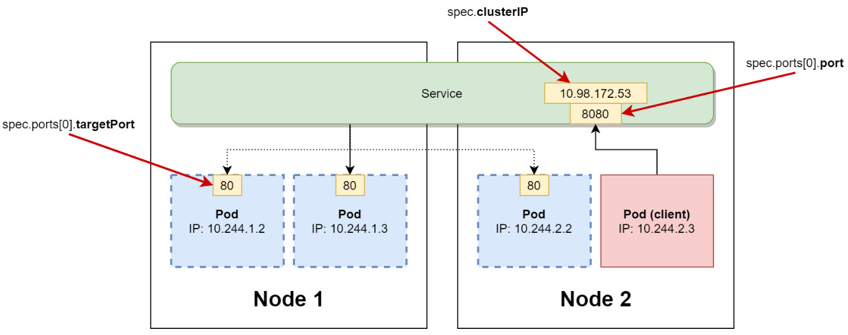
Figure 21.1 – ClusterIP Service
The diagram includes references to the Kubernetes objects specifications to make it easier to understand the connections. ClusterIP Services are the most basic type of Service in Kubernetes and they are part of other Service types that allow Pods to be exposed to external traffic: NodePort and LoadBalancer.

NodePort service
This type of Service is similar to the ClusterIP Service but additionally, it can be reached by any cluster node IP address and specified port. To achieve that, kube-proxy exposes the same port on each Node in the range 30000-32767 (which is configurable) and sets up forwarding so that any connections to this port will be forwarded to ClusterIP.
Let's take a look at an example YAML manifest of the NodePort Service:
apiVersion: v1
kind: Service
metadata:
name: nginx-deployment-example-nodeport
spec:
selector:
environment: test
type: NodePort
ports:
- port: 8080
nodePort: 31001
protocol: TCP
targetPort: 80
In this case, TCP port 31001 is used as the external port on each Node. If you do not specify nodePort, it will be allocated dynamically using the range. For internal communication, this Service still behaves like a simple ClusterIP Service, and you can use its ClusterIP address.
These principles have been visualized in the following diagram:
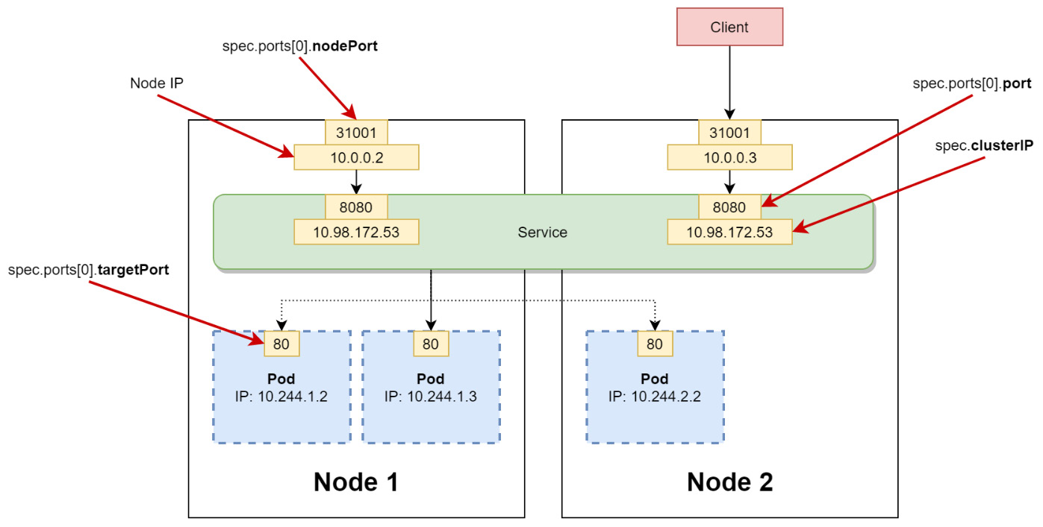
Figure 21.2 – NodePort service
You will need the NodePort Service if you want to set up load balancing externally, without using any Kubernetes constructs. They can also be used for communicating directly with the Pods, but exposing the external IP addresses of Nodes is usually not a good idea in terms of security. Please note that many other components rely on NodePort Services; for example, they are used in LoadBalancer Service implementations or when exposing Ingress Controller, which we are going to discuss in this chapter.
We will now do a quick recap of the LoadBalancer Service.

The LoadBalancer service
This is the second type of Service that allows external traffic to the Pods. The LoadBalancer Service is usually used in cloud environments where you have software-defined networking (SDN), and you can configure load balancers on demand that redirect traffic to your cluster. The automatic provisioning of load balancers in the cloud is done by vendor-specific plugins in cloud-controller-manager. This type of service combines the approach of the NodePort Service with an additional external load balancer in front of it, which routes traffic to NodePorts.
Let's take a look at an example YAML manifest of the LoadBalancer Service:
apiVersion: v1
kind: Service
metadata:
name: nginx-deployment-example-lb
spec:
selector:
environment: test
type: LoadBalancer
ports:
- port: 8080
protocol: TCP
targetPort: 80
When you create such a Service, it will behave as a NodePort Service with a randomly assigned port and a cloud load balancer that serves requests at TCP port 8080 and forwards them to NodePorts. The external IP address of the service is provided by the load balancer and is also available in the Service object in .status.loadBalancer.ingress[0].ip. These principles have been visualized in the following diagram:
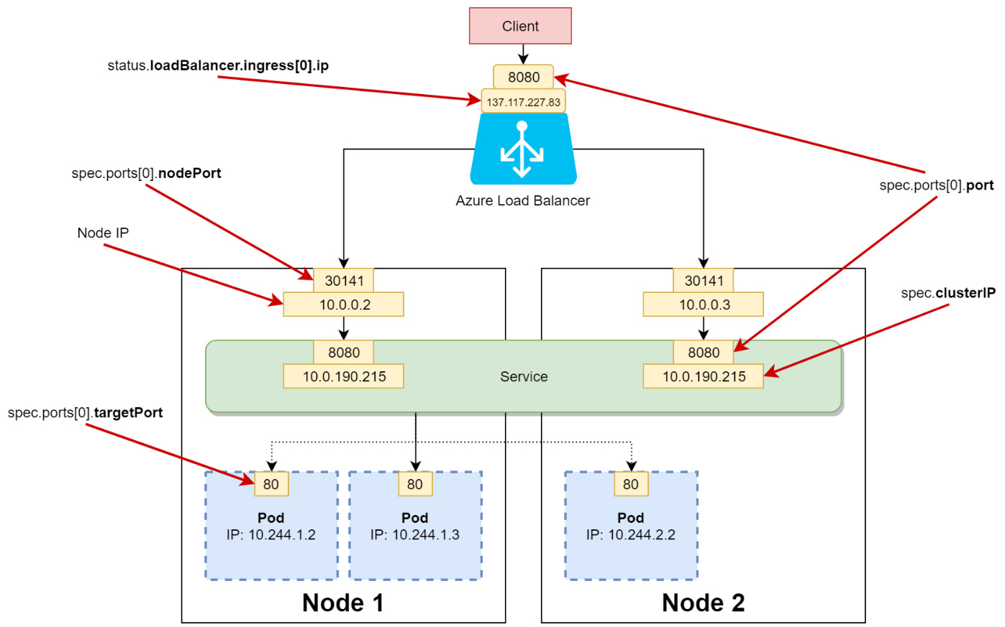
Figure 21.3 – LoadBalancer service
You can still, of course, use the service internally via its ClusterIP.
It may seem appealing to always use Kubernetes services for allowing external traffic to the cluster, but there are a few disadvantages of using them all the time. We will now introduce the Ingress object and discuss why it is needed and when it should be used instead of Services to manage external traffic.

Introducing the Ingress object
In the previous section, we did a short recap of Service objects in Kubernetes and their role in routing traffic. From the perspective of external traffic, the most important are the NodePort Service and the LoadBalancer Service. In general, the NodePort Service can only be used in conjunction with a different routing and load balancing component, as exposing multiple external endpoints on all Kubernetes Nodes is not secure. This leaves us with the LoadBalancer Service, which, under the hood, relies on NodePort. There are a few problems with this type of Service in some use cases:
The LoadBalancer Service is used for L4 load balancing, which means it is done at OSI layer 4 (transport). The load balancer can make the decisions based on the TCP/UDP protocol. Applications that use HTTP or HTTPS protocols often require L7 load balancing, which is done at OSI layer 7 (application).
The L4 load balancer cannot do HTTPS traffic termination and offloading.
You cannot implement name-based virtual hosting using the same L4 load balancer for multiple domain names.
You need an L7 load balancer to implement path-based routing. For example, configuring requests to https://<loadBalancerIp>/service1 to be redirected to the Kubernetes Service named service1, and requests to https://<loadBalancerIp>/service2 to be redirected to the Kubernetes Service named service2 is not possible with the L4 load balancer – it is not aware of the HTTP(S) protocol.
You need an L7 load balancer if you want to implement features such as sticky sessions or cookie affinity.
In Kubernetes, you can solve these problems using an Ingress object, which can be used for implementing and modeling L7 load balancing. The Ingress object is used for defining the routing and balancing rules only, for example, which path should be routed to which Kubernetes Service. Let's take a look at an example YAML manifest file, example-ingress.yaml, for Ingress:
apiVersion: networking.k8s.io/v1beta1
kind: Ingress
metadata:
name: example-ingress
annotations:
nginx.ingress.kubernetes.io/rewrite-target: /
spec:
rules:
- http:
paths:
- path: /service1
pathType: Prefix
backend:
serviceName: example-service1
servicePort: 80
- path: /service2
pathType: Prefix
backend:
serviceName: example-service2
servicePort: 80
Simply put, Ingress is an abstract definition of routing rules for your Services. Alone, it is not doing anything; it requires Ingress Controller to actually process and implement these rules – you can apply the manifest file, but at this point, it will have no effect. But first, we will explain how the Ingress HTTP routing rules are built. Each of these rules in the specification contains the following:
Optional host: In the example, we are not using this field, so the rule that we defined is applied to all incoming traffic. If the field value is provided, then the rule applies only to requests that have this host as the destination – you can have multiple hostnames resolving to the same IP address. The host field supports wildcards.
List of path routings: Each of the paths has an associated Ingress backend that you define by providing serviceName and servicePort. In the preceding example, all requests arriving at the path with the prefix /service1 will be routed to Pods of the example-service1 Service, and all requests arriving at the path with the prefix /service2 will be routed to Pods of the example-service2 Service. The path fields support prefixes and exact matching, and it is also possible to use implementation-specific matching, which is carried out by the underlying Ingress Controller.
In this way, you can configure complex routing rules that involve multiple Services in the cluster, but externally they will be visible as a single endpoint with multiple paths available. This is especially useful when you create API gateways in microservice architecture for frontend or client applications.
Important note
In Kubernetes 1.19, Ingress has become a networking.k8s.io/v1 resource. There are a few changes compared to networking.k8s.io/v1beta1; for example, the backend is defined differently: https://v1-19.docs.kubernetes.io/docs/reference/generated/kubernetes-api/v1.19/#ingressbackend-v1-networking-k8s-io.
To materialize Ingress objects, we need to have an Ingress Controller installed in the cluster.

Using nginx as an Ingress Controller
An Ingress Controller is a Kubernetes controller that is deployed manually to the cluster, most often as a DaemonSet or a Deployment object that runs dedicated Pods for handling incoming traffic load balancing and smart routing. It is responsible for processing the Ingress objects (which specify that they especially want to use the Ingress Controller) and dynamically configuring real routing rules. A commonly used Ingress controller for Kubernetes is ingress-nginx (https://www.nginx.com/products/nginx/kubernetes-ingress-controller), which is installed in the cluster as a Deployment of an nginx web host with a set of rules for handling Ingress API objects. The Ingress Controller is exposed as a Service with a type that depends on the installation – in cloud environments, this will be LoadBalancer.
Important note
In cloud environments, you will often see dedicated Ingress Controllers that leverage vendor-specific features that allow direct communication from the external load balancer to the Pods. In such cases, there are no additional Pods involved and there may even be no need for NodePort Services. The routing is handled at SDN and CNI levels and the load balancer can use private IPs of the Pods. We will show an example of such an approach in the next section when we discuss the Application Gateway ingress controller for AKS.
The installation of ingress-nginx is described for different environments in the official documentation: https://kubernetes.github.io/ingress-nginx/deploy/. Note that it is also possible to use Helm to install this Ingress Controller, which makes management and upgrades a bit easier. For cloud environments, the installation is usually very simple and involves applying a single YAML manifest file, which creates multiple Kubernetes objects. Let's demonstrate this in AKS. Please execute the following command:
$ kubectl apply -f https://raw.githubusercontent.com/kubernetes/ingress-nginx/controller-v0.44.0/deploy/static/provider/cloud/deploy.yaml
namespace/ingress-nginx created
serviceaccount/ingress-nginx created
configmap/ingress-nginx-controller created
...
Now, we can also create our example Services together with the Ingress object that defines routings for them. First, we will create the Service objects and Deployment objects. There is no need to explain the YAML manifests as they are simple web servers printing out a welcome message with information on which Service you have reached:
$ kubectl apply -f https://raw.githubusercontent.com/PacktPublishing/Kubernetes-for-Beginners/master/Chapter21/02_ingress/example-services.yaml
deployment.apps/example-service1 created
deployment.apps/example-service2 created
service/example-service1 created
service/example-service2 created
Next, we can apply the Ingress object to the cluster that we created earlier:
$ kubectl apply -f ./example-ingress.yaml
ingress.networking.k8s.io/example-ingress created
By this time, the LoadBalancer Service that is running as part of Ingress Controller should already be functional and have an external IP address available. You can get it using the following command:
$ kubectl describe svc -n ingress-nginx ingress-nginx-controller
...
LoadBalancer Ingress: 137.117.227.83
...
At this point, we can visualize what is happening behind Ingress Controller in the following diagram:
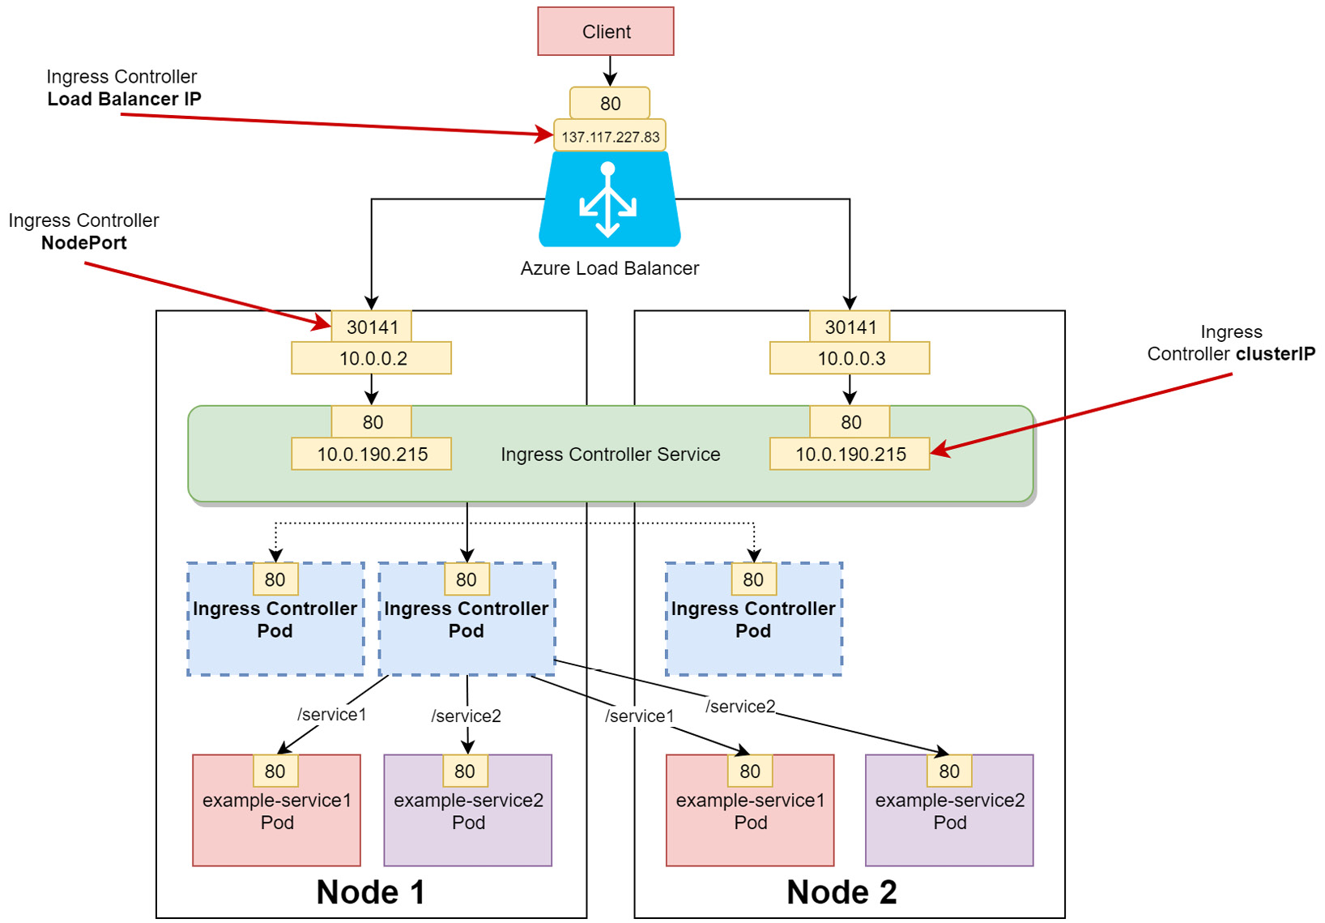
Figure 21.4 – Using nginx as Ingress Controller in a cloud environment
When you perform an HTTP request to http://<ingressServiceLoadBalancerIp>/service1, the traffic will be routed by nginx to example-service1. Similarly, when you use the /service2 path, the traffic will be routed to example-service2. Note that you are using only one cloud load balancer for this operation, and that the actual routing to Kubernetes Services is performed by the Ingress Controller Pods using path-based routing.
Important note
In practice, you need to set up SSL certificates for your HTTP endpoints to ensure proper security. In our examples, we are not doing that for simplicity and to make the demonstrations clearer.
Let's verify this in practice. In your web browser, navigate to the /service1 path. In our case, this will be http://137.117.227.83/service1. You will see that you are served by example-service1 Pods:
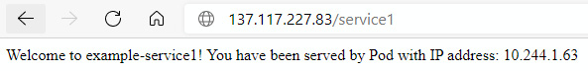
Figure 21.5 – Routing to example-service1 via the nginx Ingress Controller
Now, navigate to the /service2 path. In our case, this will be http://137.117.227.83/service2. You will see that you are served by example-service2 Pods:
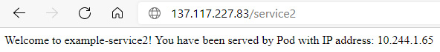
Figure 21.6 – Routing to example-service2 via the nginx Ingress Controller
Congratulations! You have successfully configured Ingress and Ingress Controller in your cluster. We are now going to explore a special type of Ingress Controller for AKS named Azure Application Gateway Ingress Controller.

Azure Application Gateway Ingress Controller for AKS
The Ingress Controller based on the nginx web server that we showed in the last section is a type of generic Ingress Controller that can be used in almost any environment. It relies on standard Kubernetes objects such as Deployments, Pods, and Services, and does not require any external components. If any external components are provisioned, this is done by cloud-controller-manager, and not the Ingress Controller itself.
This approach has a few drawbacks if you use it in a cloud environment such as Azure Kubernetes Service:
You have an Azure load balancer just to proxy the requests to nginx Ingress Controller Pods via NodePorts. Then, there is another level of load balancing after the request reaches the Node, performed by kube-proxy as part of the Service object for Ingress Controller. Request routing based on paths is done by Ingress Controller Pods. And eventually, the last level of kube-proxy load balancing is at the target Service (in our demo, example-service1 or example-service2).
There are more points of failure, especially if you scale cluster Nodes, drain Nodes, and so on.
Instead, it is possible to leverage a native L7 load balancer service in Azure named Application Gateway (https://docs.microsoft.com/en-us/azure/application-gateway/overview). AKS offers Application Gateway Ingress Controller (AGIC), which uses Application Gateway to directly communicate with Pods using their private IP addresses. This is achieved by AGIC Pods monitoring the Kubernetes API and instructing Azure Resource Manager to make changes to Application Gateway depending on Pods and services changes. Application Gateway can communicate directly with Pods thanks to Azure SDN features such as VNet peering (https://docs.microsoft.com/en-us/azure/virtual-network/virtual-network-peering-overview). This design is shown in the following diagram:
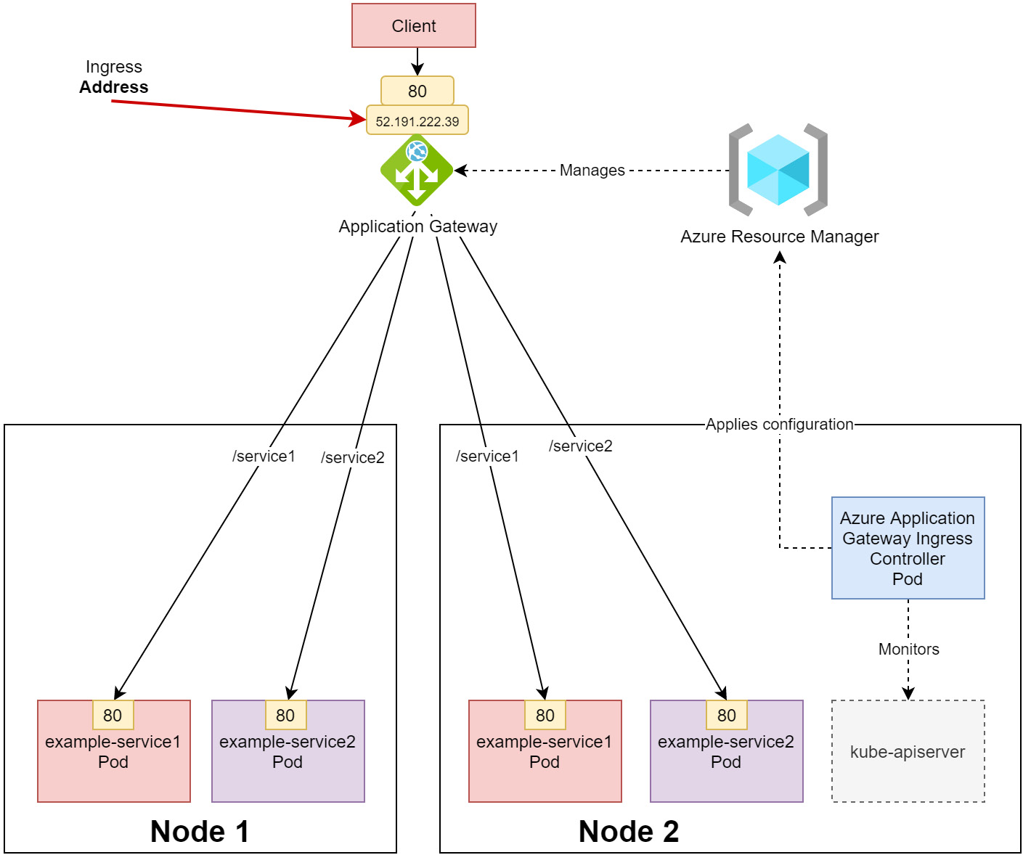
Figure 21.7 – Application Gateway ingress controller in AKS
It is possible to configure AGIC on an existing AKS cluster, and this is described in the official documentation: https://docs.microsoft.com/en-us/azure/application-gateway/tutorial-ingress-controller-add-on-existing. For simplicity, we will create a new AKS cluster with AGIC enabled – this is a one-command action. To deploy the two-node cluster named k8sforbeginners-aks-agic in the k8sforbeginners-rg resource group, execute the following command:
$ az aks create --resource-group k8sforbeginners-rg --name k8sforbeginners-aks-agic --node-count 2 --network-plugin azure --enable-managed-identity -a ingress-appgw --appgw-name AksApplicationGateway --appgw-subnet-cidr "10.2.0.0/16" --generate-ssh-keys
This will create an Azure Application Gateway named AksApplicationGateway with the subnet CIDR 10.2.0.0/16.
When the cluster finishes deploying, we need to generate kubeconfig to use it with kubectl. Run the following command (it will switch to a new context so you will still have the old context available later):
$ az aks get-credentials --resource-group k8sforbeginners-rg --name k8sforbeginners-aks-agic
Merged "k8sforbeginners-aks-agic" as current context in .kube/config
Now, we can apply the same YAML manifest for Deployments and Services as in the previous section:
$ kubectl apply -f https://raw.githubusercontent.com/PacktPublishing/Kubernetes-for-Beginners/master/Chapter21/03_aks-agic/example-services.yaml
deployment.apps/example-service1 created
deployment.apps/example-service2 created
service/example-service1 created
service/example-service2 created
The final step will involve creating an Ingress object. We need to modify the YAML manifest slightly – the reason for this is that AGIC 1.4 does not yet support apiVersion: networking.k8s.io/v1beta1, and we need to use apiVersion: extensions/v1beta1, which can use kubernetes.io/ingress.class annotation instead of the ingressClassName field in the specification. Create an example-ingress.yaml file with the following content:
apiVersion: extensions/v1beta1
kind: Ingress
metadata:
name: example-ingress
annotations:
kubernetes.io/ingress.class: azure/application-gateway
appgw.ingress.kubernetes.io/backend-path-prefix: "/"
spec:
rules:
- http:
paths:
- path: /service1
backend:
serviceName: example-service1
servicePort: 80
- path: /service2
backend:
serviceName: example-service2
servicePort: 80
For AGIC to pick up this Ingress object, it must define the kubernetes.io/ingress.class annotation with the value azure/application-gateway. We additionally need to ensure that the prefix for requests to the backend service is simply "/". After that, we can apply the manifest to the cluster:
$ kubectl apply -f ./example-ingress.yaml
ingress.extensions/example-ingress configured
You will need to wait a few minutes for Application Gateway to reconfigure. To get the external IP address of the Ingress, execute the following command:
$ kubectl get ingress
NAME CLASS HOSTS ADDRESS PORTS AGE
example-ingress <none> * 52.191.222.39 80 36m
In our case, the IP address is 52.191.222.39.
Let's verify whether AGIC works correctly. In your web browser, navigate to the /service1 path. In our case, this will be http://52.191.222.39/service1. You will see that you are served by example-service1 Pods:
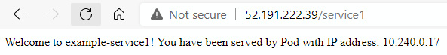
Figure 21.8 – Routing to example-service1 via Application Gateway Ingress Controller in AKS
Now, navigate to the /service2 path. In our case, this will be http://52.191.222.39/service2. You will see that you are served by example-service2 Pods:
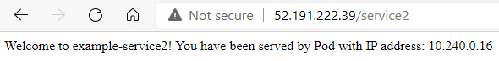
Figure 21.9 – Routing to example-service2 via Application Gateway Ingress Controller in AKS
Congratulations! You have successfully configured and tested Application Gateway Ingress Controller in AKS! This was the last practical demonstration in this book, so let's now summarize what you have learned.

Summary
In this last chapter, we have explained advanced traffic routing approaches in Kubernetes using Ingress objects and Ingress Controllers. At the beginning, we did a brief recap of Kubernetes Service types. We refreshed our knowledge regarding ClusterIP, NodePort, and LoadBalancer Service objects. Based on that, we introduced Ingress objects and Ingress Controller and explained how they fit into the landscape of traffic routing in Kubernetes. Now, you know that simple Services are commonly used when L4 load balancing is required, but if you have HTTP or HTTPS endpoints in your applications, it is better to use L7 load balancing offered by Ingress and Ingress Controllers. You learned how to deploy the nginx web server as Ingress Controller and we tested this on example Deployments. Lastly, we explained how you can approach Ingress and Ingress Controllers in cloud environments where you have native support for L7 load balancing outside of the Kubernetes cluster. As a demonstration, we deployed an AKS cluster with Application Gateway Ingress Controller (AGIC) to handle Ingress objects.
Congratulations! This has been a long journey into the exciting territory of Kubernetes and container orchestration. Good luck with your further Kubernetes journey and thanks for reading.

Further reading
For more information regarding autoscaling in Kubernetes, please refer to the following Packt books:
The Complete Kubernetes Guide, by Jonathan Baier, Gigi Sayfan, Jesse White (https://www.packtpub.com/virtualization-and-cloud/complete-kubernetes-guide)
Getting Started with Kubernetes – Third Edition, by Jonathan Baier, Jesse White (https://www.packtpub.com/virtualization-and-cloud/getting-started-kubernetes-third-edition)
Kubernetes for Developers, by Joseph Heck (https://www.packtpub.com/virtualization-and-cloud/kubernetes-developers)
Hands-On Kubernetes on Windows, by Piotr Tylenda (https://www.packtpub.com/product/hands-on-kubernetes-on-windows/9781838821562)
You can also refer to the following official documentation:
Kubernetes documentation (https://kubernetes.io/docs/home/), which is always the most up-to-date source of knowledge regarding Kubernetes in general.
A list of many available Ingress Controllers can be found at the following link: https://kubernetes.io/docs/concepts/services-networking/ingress-controllers/.
Similar to AKS, GKE offers a built-in, managed Ingress Controller called GKE Ingress. You can learn more in the official documentation: https://cloud.google.com/kubernetes-engine/docs/concepts/ingress. You can also check the Ingress features that are implemented in GKE here: https://cloud.google.com/kubernetes-engine/docs/how-to/ingress-features.
For Amazon EKS, there is AWS Load Balancer Controller. You can find more information in the official documentation: https://docs.aws.amazon.com/eks/latest/userguide/alb-ingress.html.

Packt.com
Subscribe to our online digital library for full access to over 7,000 books and videos, as well as industry leading tools to help you plan your personal development and advance your career. For more information, please visit our website.

Why subscribe?
Spend less time learning and more time coding with practical eBooks and Videos from over 4,000 industry professionals
Improve your learning with Skill Plans built especially for you
Get a free eBook or video every month
Fully searchable for easy access to vital information
Copy and paste, print, and bookmark content
Did you know that Packt offers eBook versions of every book published, with PDF and ePub files available? You can upgrade to the eBook version at packt.com and as a print book customer, you are entitled to a discount on the eBook copy. Get in touch with us at customercare@packtpub.com for more details.
At www.packt.com, you can also read a collection of free technical articles, sign up for a range of free newsletters, and receive exclusive discounts and offers on Packt books and eBooks.

Other Books You May Enjoy
If you enjoyed this book, you may be interested in these other books by Packt:
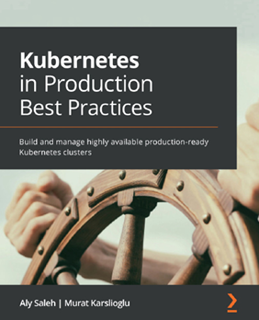
Kubernetes in Production Best Practices
Aly Saleh, Murat Karslioglu
ISBN: 9781800202450
Explore different infrastructure architectures for Kubernetes deployment
Implement optimal open source and commercial storage management solutions
Apply best practices for provisioning and configuring Kubernetes clusters, including infrastructure as code (IaC) and configuration as code (CAC)
Configure the cluster networking plugin and core networking components to get the best out of them
Secure your Kubernetes environment using the latest tools and best practices
Deploy core observability stacks, such as monitoring and logging, to fine-tune your infrastructure
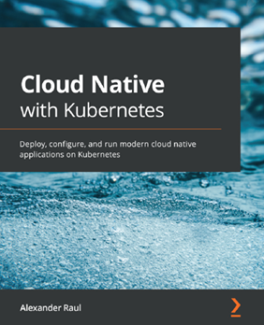
Cloud Native with Kubernetes
Alexander Raul
ISBN: 9781838823078
Set up Kubernetes and configure its authentication
Deploy your applications to Kubernetes
Configure and provide storage to Kubernetes applications
Expose Kubernetes applications outside the cluster
Control where and how applications are run on Kubernetes
Set up observability for Kubernetes
Build a continuous integration and continuous deployment (CI/CD) pipeline for Kubernetes
Extend Kubernetes with service meshes, serverless, and more

Packt is searching for authors like you
If you're interested in becoming an author for Packt, please visit authors.packtpub.com and apply today. We have worked with thousands of developers and tech professionals, just like you, to help them share their insight with the global tech community. You can make a general application, apply for a specific hot topic that we are recruiting an author for, or submit your own idea.

Share Your Thoughts
Now you've finished The Kubernetes Bible, we'd love to hear your thoughts! If you purchased the book from Amazon, please click here to go straight to the Amazon review page for this book and share your feedback or leave a review on the site that you purchased it from.
Your review is important to us and the tech community and will help us make sure we're delivering excellent quality content.

